Senator Mazie Hirono

Grants Assistance Information Newsletter

DECEMBER 2017

G.A.I.N. INDEX

Click on Index Links below to read summaries of the announcements by agency in this document. Once you reach the item, if you cannot open the links for further information, copy the selected URL website address into your browser.

Modified sections from previous listings are shown in a GREY background

Notices is Teal are items with immediate deadline dates.

Notices in Yellow are of special interest.

Notices is Green are items of special interest with immediate deadline dates.

Items in this type color are aimed at Small Businesses

Items in this type color have a Faith-Based Organization component

Special Federal Program Notices

Grant Writing Resources

SAM and Grants.Gov Information

SBIR – Small Business Innovation Research

Programs specific to Hawaii

Current Notices

Department of Interior
Bureau of Reclamation
WaterSMART Cooperative Watershed Management Program Phase I Grants for Fiscal Year 2018

Reminders

See Individual Departments for information and webpages representing the best and most accessible information on the agency funding opportunities

Federal Grant and Cooperative Agreement Program Summaries

U.S. Department of Agriculture

Grants and Loans Overview

Programs

National Institute of Food and Agriculture
Beginning Farmer and Rancher Development Program
National Institute of Food and Agriculture
Enhancing Agricultural Opportunities for Military Veterans Competitive Grants Program
Research

National Institute of Food and Agriculture
Biotechnology Risk Assessment Grants Program
Modifications

Reminders

Utilities Programs
Assistance to High Energy Cost Communities

Food and Nutrition Service
FY 18 Farm to school Grant

Forest Service
2018 Wood Innovations Funding Opportunity

Utilities Programs
TAT Grant Program FY18

Utilities Programs
Solid Waste Management Grant Program

National Institute of Food and Agriculture
Food Insecurity Nutrition Incentive Competitive Grant Program

Business and Cooperative Programs
VALUE ADDED PRODUCER GRANT

Deleted:

Department of Commerce

Grants at Commerce

Programs

Environmental Literacy Grants: Supporting the education of K-12 students and the public for community resilience

National Sea Grant College Program 2018-19 Special Projects
Fiscal Year 2019 National Sea Grant College Program Dean John A. Knauss Marine Policy Fellowship

Modifications

Round 3 of Research to Operations Initiative: NGGPS and HFIP
FY18 Coral Reef Conservation Program, Domestic Coral Reef Conservation Grants
Round 3 of Research to Operations Initiative: NOAA Testbeds

Research

Coastal Hypoxia Research Program (CHRP)
Round 3 of Research to Operations Initiative: NGGPS and HFIP (Synopsis 1
National Institute of Standards and Technology
Precision Measurement Grant Program

National Institute of Standards and Technology
Summer Undergraduate Research Fellowship (SURF) Program
National Institute of Standards and Technology
Summer Undergraduate Research Fellowship (SURF) Program
Reminders

FY18 Saltonstall Kennedy Competition

FY2018 Marine Debris Prevention

National Telecommunications and Information Admin
State and Local Implementation Grant Program (SLIGP) 2.0

FY18-19 CRCP International Coral Reef Conservation Cooperative Agreements

Economic Development Administration
FY 2017 Economic Development Assistance Programs ­ Application submission and program requirements for EDA’s Public Works and Economic Adjustment Assistance programs.

National Institute of Standards and Technology
Embedding MEP in Manufacturing USA Institutes Pilot Projects – Round 3

National Institute of Standards and Technology
Measurement Science and Engineering (MSE) Research Grant Programs

FY 2016 – FY 2019 EDA Planning Program and Local Technical Assistance Program Grant

Economic Development Administration
Planning Program and Local Technical Assistance Program Grant

Deleted

Corporation for National and Community Service

General Program Overview

Programs

Reminders

AmeriCorps State and National Grants FY2018

National Service in Hawaii

Department of Defense

Doing Business with the Department of Defense

DoD Small Business Opportunities and Forecasting

Research Grants

Modifications

Deleted

Reminders

Department of Education

Grant Programs Overview

Programs

Research

Modifications

Reminders

Deleted

US Department of Energy

Grants Overview

Research

Modifications

Reminders

Environmental Protection Agency

Grants and Contracts Overview

Programs

Environmental Justice Collaborative Problem-Solving (EJCPS) Cooperative Agreement (Program)
Modifications

FY 2018 National Environmental Information Exchange Network Grant Program

Research

Reminders

FY18 Environmental Workforce Development And Job Training (EWDJT) Grants

Department of Health and Human Services

Grants Overview

Program

Administration for Children and Families - ACYF/CB (Program)
Strengthening Child Welfare Systems to Achieve Expected Child and Family Outcomes

Research Grants

Modifications

Deleted

Reminders

Department of Homeland Security
Grants Overview

Programs

Modifications

Reminders

Department of Housing and Urban Development

HUD - Notice of Funds Available

Programs

Modifications

Deleted

Reminders

Self-Help Homeownership Opportunity Program (SHOP)

Institute of Museum and Library Services

Grants Overview

IMLS is on Facebook!

Programs

National Leadership Grants for Libraries

Modifications

Reminders

Deleted

Department of Interior

Grants and Contract Overview

Programs

Modifications

Reminders

National Park Service
2018 Preservation Technology and Training Grants

National Park Service
FY 18 American Battlefield Protection Program Battlefield Preservation Planning Project Grants

Deleted

Department of Justice

Grants and Contract Overview

Programs

Office on Violence Against Women
OVW FY 2018 Training and Services to End Violence Against Women with Disabilities Grant Program
Research

Modifications

Deleted

Reminders

________________________________________________________________________

Department of Labor

Grants and Contract General Overview

Programs

Modifications

Reminders

The Millennium Challenge Corporation
NOFO Annual Program Statement (APS) PARTNERSHIPS with MCC Program

National Aeronautics and Space Administration

Research Grant and Contract General Overview

Programs

Modifications

_______________________________________________________________
National Archives and Records Administration

Grant Opportunities General Overview

Programs

Publishing Historical Records in Documentary Editions

State Board Programming Grants
Reminders

Access to Historical Records: Major Initiatives (Preliminary)

Access to Historical Records: Major Initiatives

_______________________________________________________________
National Endowment for the Arts

Grant Opportunities General Overview

Programs

NEA Literature Fellowships: Creative Writing, FY2019

Modifications

Reminders

_______________________________________________________________

National Endowment for the Humanities

Grant Opportunities General Overview

Programs

Digital Humanities Advancement Grants

Media Projects Grants

National Digital Newspaper Program

Public Humanities Projects

Reminders

_______________________________________________________________
National Science Foundation

Grant Opportunities General Overview

Research and Program Grants

Modifications

Reminders

Deleted

Nuclear Regulatory Commission

Reminders

Small Business Administration

General Overview Finding Loans & Grants

Programs

Veterans Business Outreach Center Program (VBOC)

Modifications

Reminders

Deleted

Upcoming Trainings

Links Specific to Hawaii

State Department

General Overview and Resources for Program Administrators

Programs

Modifications

Reminders

U.S. Department of Transportation

General Grant Program Overview

Programs

Research

Modifications

Reminders

DOT - Office of Aviation Analysis
Small Community Air Service Development Program

DOT Federal Aviation Administration
DOT - FAA Aviation Research Grants
FAA Aviation Research and Development Grants
Modifications 3,4& 6

Deleted

Department of the Treasury

Programs

Modifications

Reminders

Community Development Financial Institutions
FY 2017 Bank Enterprise Award Program Application

US Agency for International Development

General Funding Opportunity Overview

Programs
Modifications

Deleted

Department of Veterans Affairs

Special Federal Program Notices

Grant Writing Resources

The following links are a great resource for faith-based non-profits and other community organizations :

- Center for Faith-Based and Community Initiatives (link is external) , U.S. Department of Labor

- http://www.usaid.gov/partnership-opportunities/fbci. U.S. Agency for International Development

- Faith-Based and Other Community Initiatives (link is external) , Corporation for National Community Service

- Task Force for Faith-Based and Community Initiatives (link is external) , U.S. Department of Justice

- Proposal Writing Short Course (link is external) Foundation Center.
- General Tips on Writing a Competitive Grant Proposal (link is external) U.S. Environmental Protection Agency.
- How to Write a Grant Proposal (link is external) Appalachian Regional Commission.
- A Guide to Funding Resources USDA Rural Information Center.

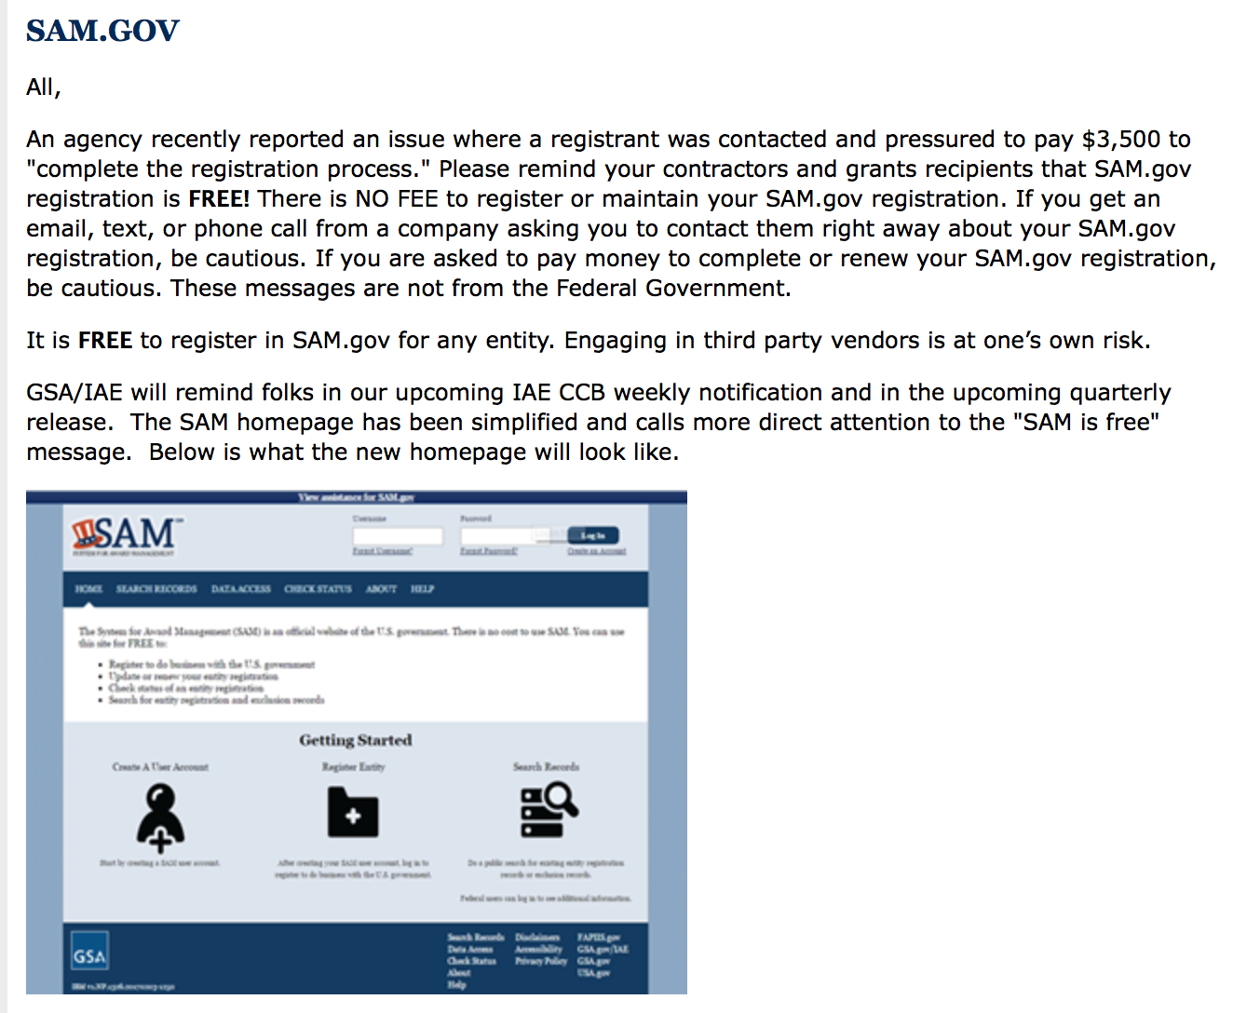

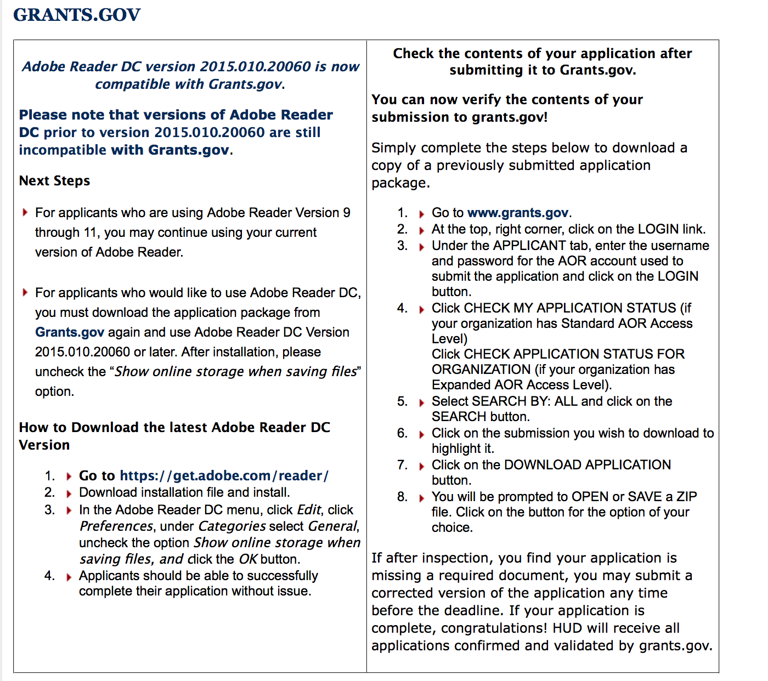

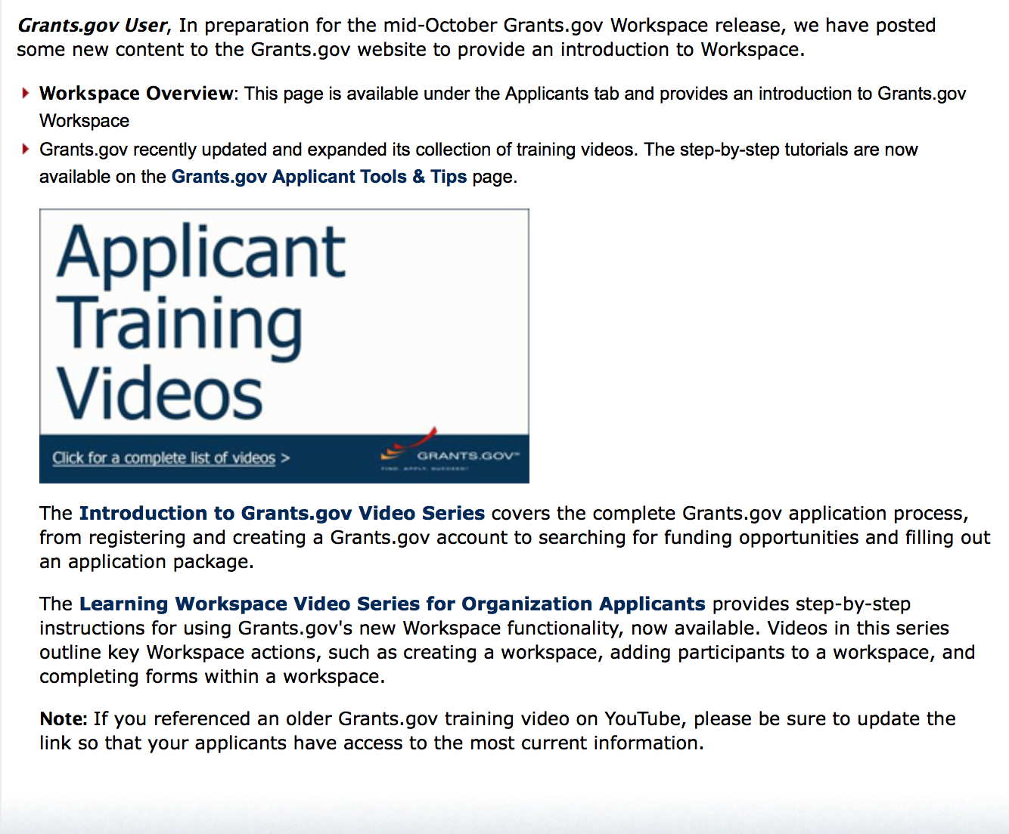
https://portal.hud.gov/hudportal/HUD?src=/program_offices/administration/grants/fundsavail

The Small Business Innovative Research Program - SBIR Program

The Small Business Innovation Research (SBIR) program is a highly competitive program that encourages domestic small businesses to engage in Federal Research/Research and Development (R/R&D) that has the potential for commercialization. Through a competitive awards-based program, SBIR enables small businesses to explore their technological potential and provides the incentive to profit from its commercialization. By including qualified small businesses in the nation's R&D arena, high-tech innovation is stimulated and the United States gains entrepreneurial spirit as it meets its specific research and development needs.

SBIR Mission and Program Goals
The mission of the SBIR program is to support scientific excellence and technological innovation through the investment of Federal research funds in critical American priorities to build a strong national economy.
The program’s goals are four-fold:
- Stimulate technological innovation
- Meet Federal research and development needs.
- Foster and encourage participation in innovation and entrepreneurship by socially and economically disadvantaged persons.
- Increase private-sector commercialization of innovations derived from Federal research and development funding.

SBIR-Participating Agencies
Each year, Federal agencies with extramural research and development (R&D) budgets that exceed $100 million are required to allocate 2.5 percent of their R&D budget to these programs. Currently, eleven Federal agencies participate in the program:
- Department of Agriculture
- Department of Commerce - National Institute of Standards and Technology
- Department of Commerce - National Oceanic and Atmospheric Administration
- Department of Defense
- Department of Education
- Department of Energy
- Department of Health and Human Services
- Department of Homeland Security
- Department of Transportation
- Environmental Protection Agency
- National Aeronautics and Space Administration
- National Science Foundation
Each agency administers its own individual program within guidelines established by Congress. These agencies designate R&D topics in their solicitations and accept proposals from small businesses. Awards are made on a competitive basis after proposal evaluation.

Three-Phase Program
The SBIR Program is structured in three phases:
Phase I. The objective of Phase I is to establish the technical merit, feasibility, and commercial potential of the proposed R/R&D efforts and to determine the quality of performance of the small business awardee organization prior to providing further Federal support in Phase II. SBIR Phase I awards normally do not exceed $150,000 total costs for 6 months.
Phase II. The objective of Phase II is to continue the R/R&D efforts initiated in Phase I. Funding is based on the results achieved in Phase I and the scientific and technical merit and commercial potential of the project proposed in Phase II. Only Phase I awardees are eligible for a Phase II award. SBIR Phase II awards normally do not exceed $1,000,000 total costs for 2 years.
Phase III. The objective of Phase III, where appropriate, is for the small business to pursue commercialization objectives resulting from the Phase I/II R/R&D activities. The SBIR program does not fund Phase III. Some Federal agencies, Phase III may involve follow-on non-SBIR funded R&D or production contracts for products, processes or services intended for use by the U.S. Government
SBIR NewsLetter

- SBIR Newsletter
Sign up for e-mail updates

HAWAII APPLICANTS ENCOURAGED

Current Notices:

Department of Interior

Bureau of Reclamation
WaterSMART Cooperative Watershed Management Program Phase I Grants for Fiscal Year 2018
Synopsis 1

Document Type: | Grants Notice
Funding Opportunity Number: | BOR-DO-18-F005
Funding Opportunity Title: | WaterSMART Cooperative Watershed Management Program Phase I Grants for Fiscal Year 2018
Opportunity Category: | Discretionary

Opportunity Category Explanation:
Funding Instrument Type: | Grant
Category of Funding Activity: | Natural Resources

Category Explanation:

Expected Number of Awards:
CFDA Number(s): | 15.554 -- Cooperative Watershed Management
Cost Sharing or Matching Requirement: | No
Version: | Synopsis 1
Posted Date: | Nov 15, 2017
Last Updated Date: | Nov 15, 2017
Original Closing Date for Applications: | Jan 31, 2018
Current Closing Date for Applications: | Jan 31, 2018
Archive Date: | Feb 02, 2018

Estimated Total Program Funding:
Award Ceiling: | $100,000
Eligible Applicants: | Others (see text field entitled "Additional Information on Eligibility" for clarification)
Additional Information on Eligibility: | New Watershed Group: States, Indian tribes, local and special districts (e.g., irrigation and water districts, etc.), local governmental entities, interstate organizations, and non-profit organizations. Existing Watershed Groups: In order to be eligible to receive an award for funding as an Existing Watershed Group, the applicant must be an eligible entity as described immediately above for New Watershed Groups, and must be either be: (1) An existing watershed group, (i.e., a grassroots, non-regulatory legal entity that otherwise meets the definition of a watershed group as described in Section A.2., Objective of this Funding Opportunity Announcement; or (2) a participant in an existing watershed group.
Agency Name: | Bureau of Reclamation
Description: | Entities not eligible include, but are not limited to: • Federal Governmental entities • Institutes of higher education, except cooperative watershed management organizations sponsored by institutes of higher education • 501(c)(4) organizations • 501(c)(6) organizations • Individuals

Link to Additional Information:
Grantor Contact Information: | If you have difficulty accessing the full announcement electronically, please contact:  Darren Olson Grants Management Specialist Phone 303 445-3697  Grants Management Specialist

http://www.grants.gov/web/grants/view-opportunity.html?oppId=298735

Reminders:

Please review each department’s General Grant and Funding Overview. These overviews are the key web pages on each departmental website dedicated to the agency’s funding opportunities. Check back often to note the department updates and use these sources to assist you in your planning.

Federal Grant and Cooperative Agreement Program Summaries

U.S. Department of Agriculture

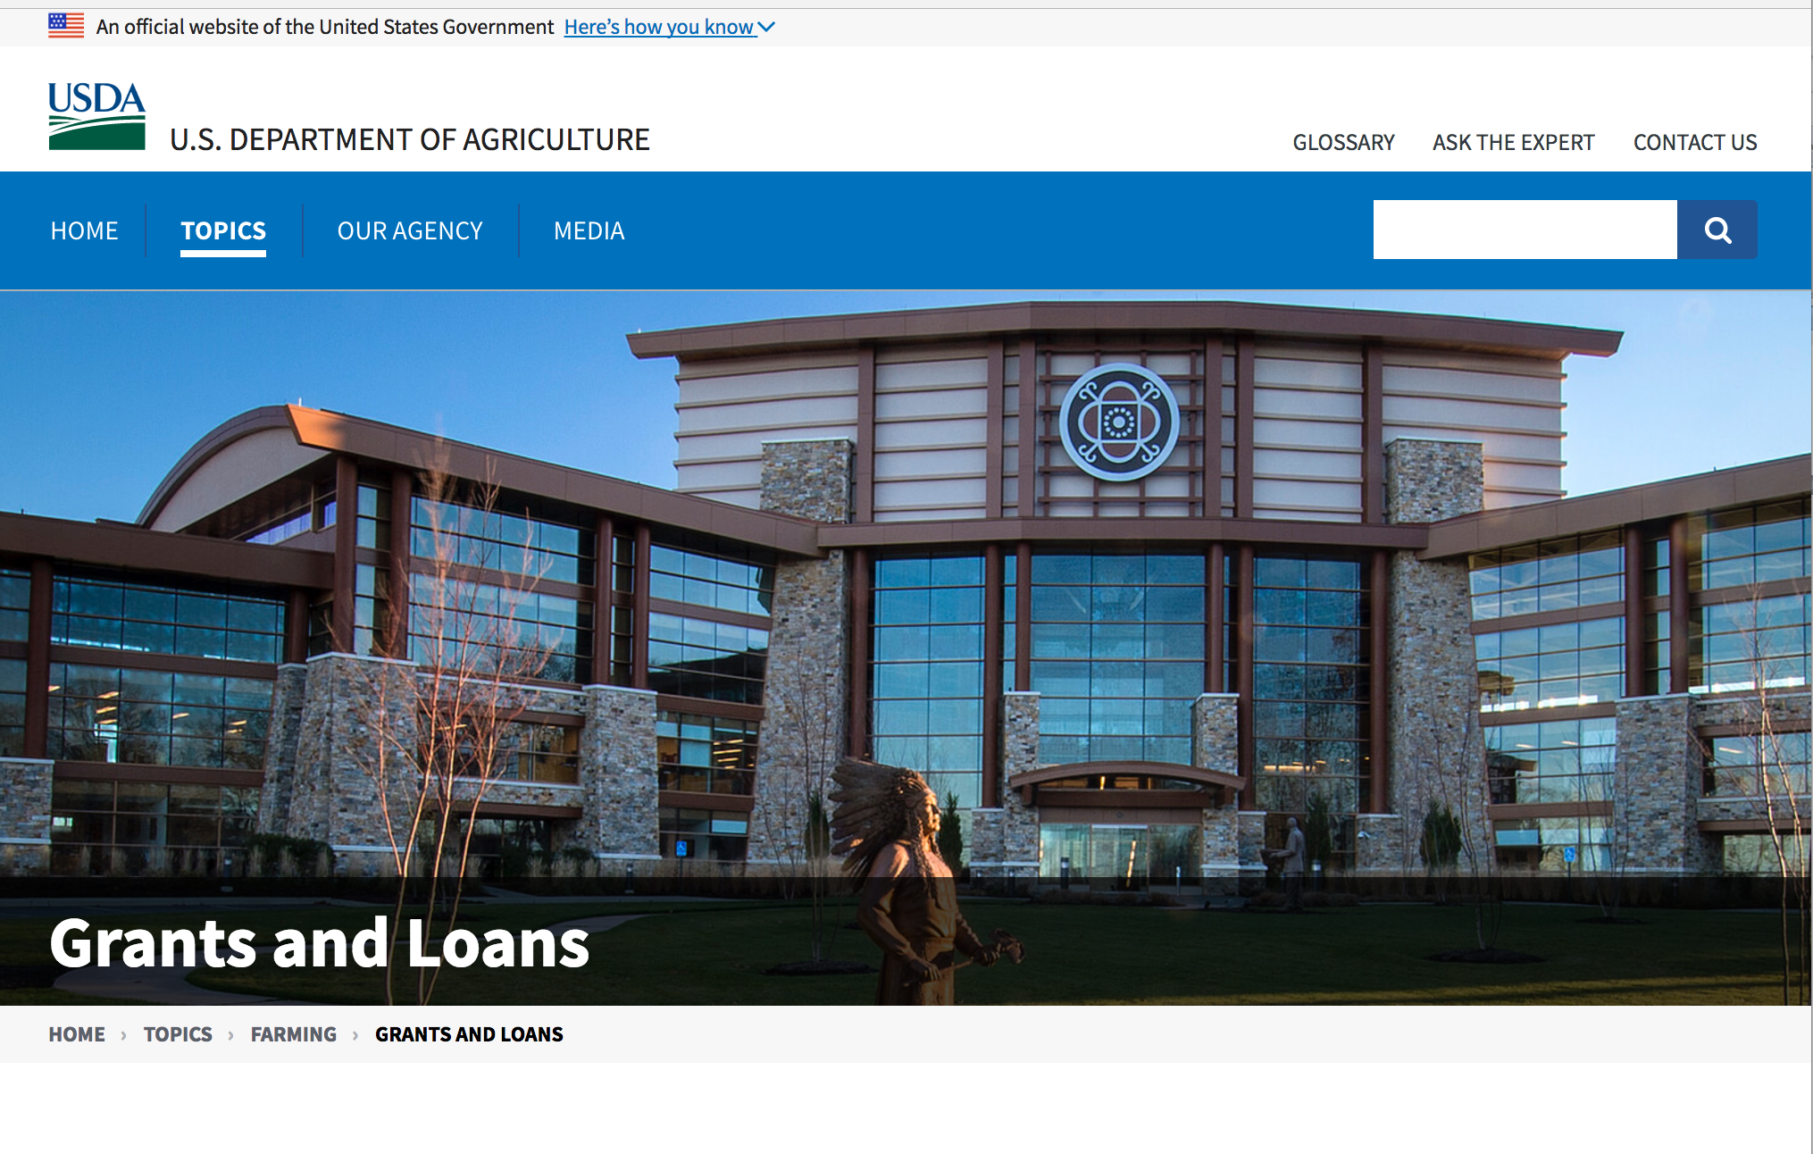

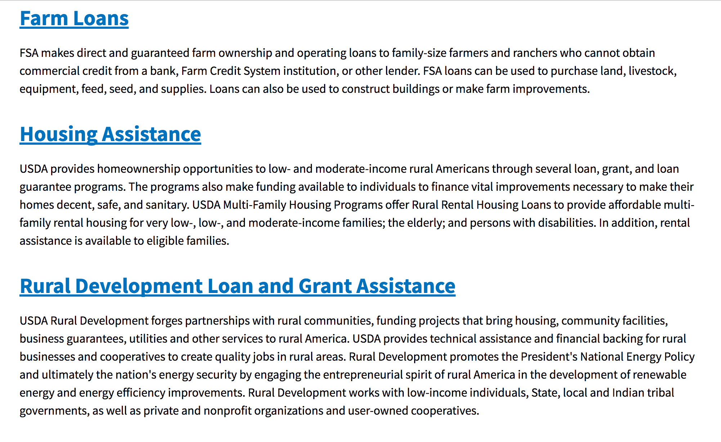

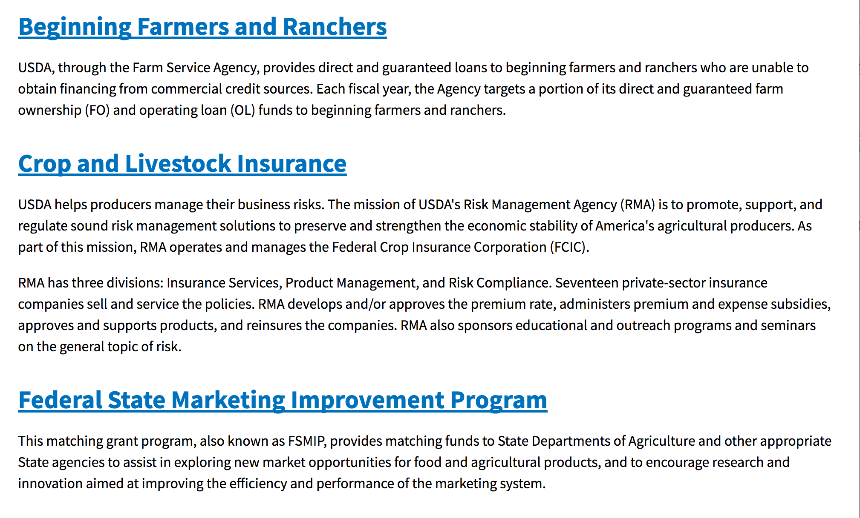
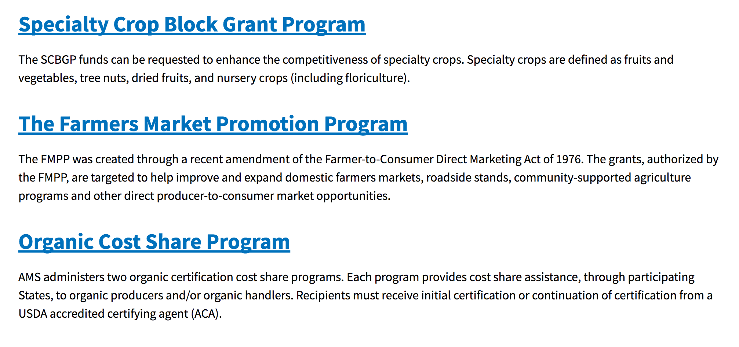
https://www.usda.gov/topics/farming/grants-and-loans

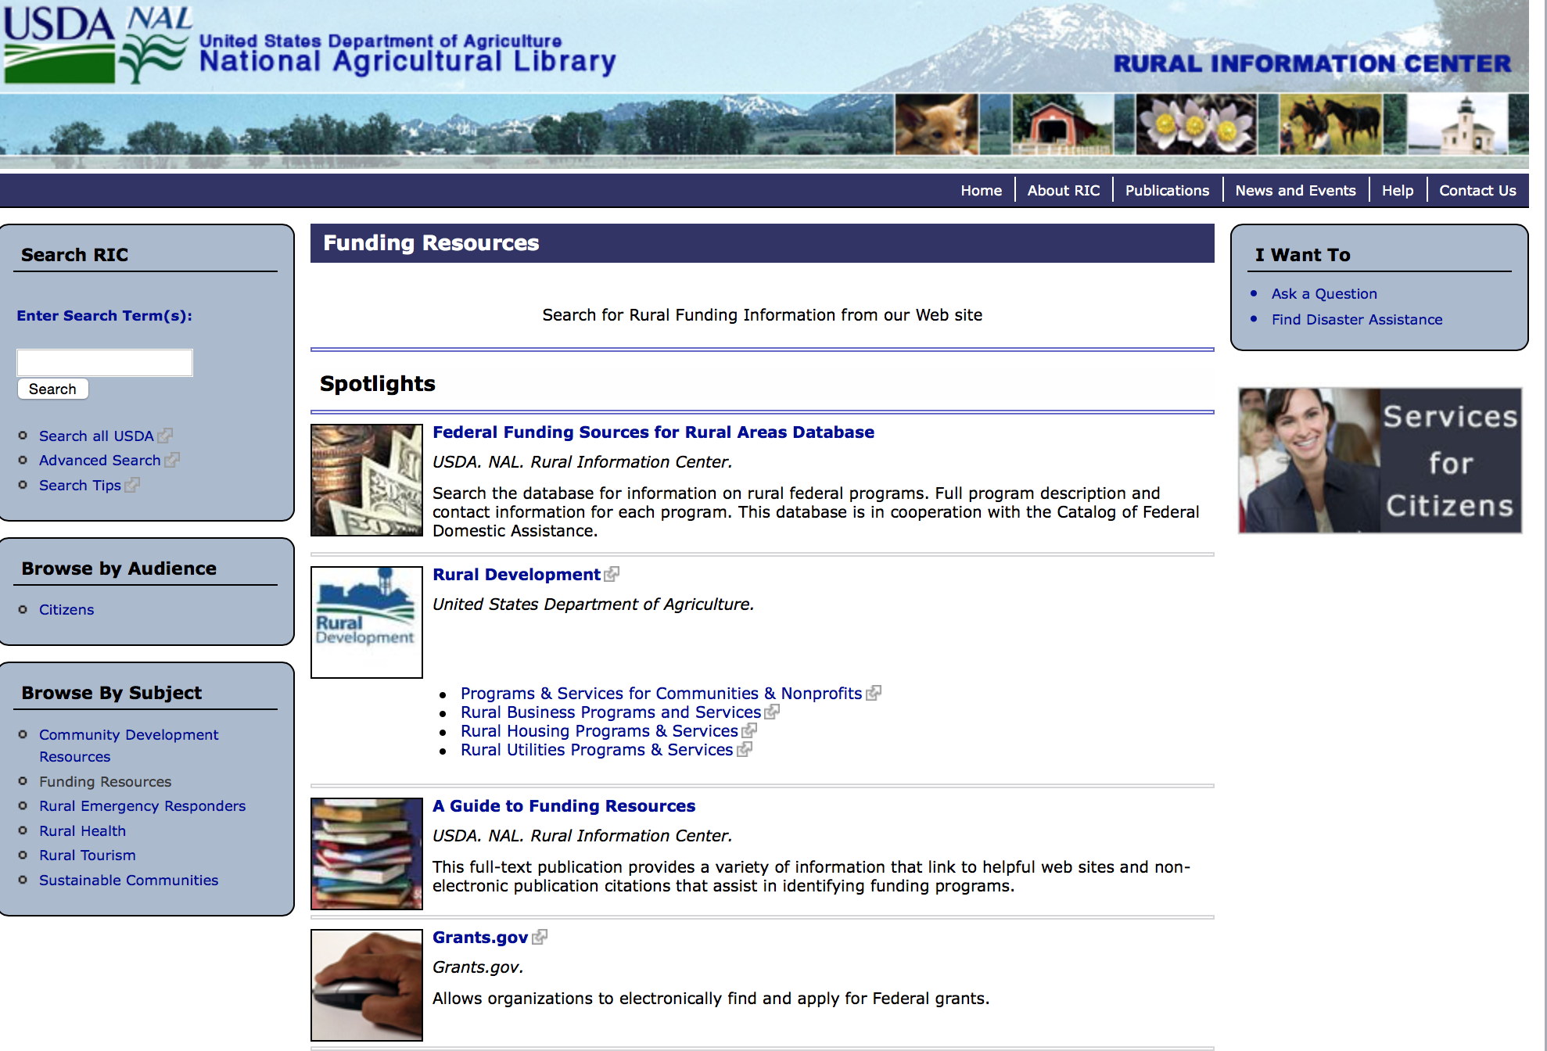

http://ric.nal.usda.gov/funding-resources

Programs:

National Institute of Food and Agriculture
Beginning Farmer and Rancher Development Program
Synopsis 1
Document Type: | Grants Notice
Funding Opportunity Number: | USDA-NIFA-BFR-006411
Funding Opportunity Title: | Beginning Farmer and Rancher Development Program
Opportunity Category: | Discretionary
Opportunity Category Explanation:
Funding Instrument Type: | Grant
Category of Funding Activity: | Agriculture
Category Explanation:
Expected Number of Awards: | 35
CFDA Number(s): | 10.311 -- Beginning Farmer and Rancher Development Program
Cost Sharing or Matching Requirement: | No
Version: | Synopsis 1
Posted Date: | Nov 24, 2017
Last Updated Date: | Nov 24, 2017
Original Closing Date for Applications: | Feb 08, 2018
Current Closing Date for Applications: | Feb 08, 2018
Archive Date: | Mar 10, 2018
Estimated Total Program Funding: | $17,700,000
Award Ceiling: | $600,000
Award Floor: | $300,000
Eligible Applicants: | Others (see text field entitled "Additional Information on Eligibility" for clarification)
Additional Information on Eligibility: | Applications may only be submitted by a collaborative state, tribal, local, or regionally-based network or partnership of qualified public and/or private entities. These collaborations may include the following entities: State Cooperative Extension Services; Federal, State, or tribal agencies; community based organizations (CBOs); nongovernmental organizations (NGOs); junior and four-year colleges or universities or foundations maintained by a college or university; and private for-profit organizations. Inclusion of beginning and/or non-beginning farmers and ranchers as part of the collaborative group is strongly encouraged. Applications submitted by individuals, or by organizations that do not involve other entities in a network or partnership, are not eligible for consideration under any category applicable to the BFRDP and will be excluded from review.
Agency Name: | National Institute of Food and Agriculture
Description: | Beginning farmer education for adult and young audiences in the United States can generally be traced back to the advent of the 1862 and 1890 Morrill Land Grant Acts. But for the first time, the Food, Conservation, and Energy Act of 2008 (Pub .L. No. 110-234, Section 7410) appropriated $75 million for FY 2009 to FY 2012 to develop and offer education, training, outreach and mentoring programs to enhance the sustainability of the next generation of farmers. The Agriculture Act of 2014 provided an additional $20 million per year for 2014 through 2018. The reasons for the renewed interest in beginning farmer and rancher programs are as follows: the rising average age of U.S. farmers; the 8% projected decrease in the number of farmers and ranchers between 2008 and 2018; and the growing recognition that new programs are needed to address the needs of the next generation of beginning farmers and ranchers.
Link to Additional Information: | FY 2018 Beginning Farmer and Rancher Development Program RFA
Grantor Contact Information: | If you have difficulty accessing the full announcement electronically, please contact:  NIFA Help Desk Phone: 202-401-5048 Business hours are M-F, 7:00 am - 5:00 om ET, excluding Federal holidays  If you have any questions related to preparing application content.
https://www.grants.gov/web/grants/view-opportunity.html?oppId=298993

National Institute of Food and Agriculture
Enhancing Agricultural Opportunities for Military Veterans Competitive Grants Program
Synopsis 1
Document Type: | Grants Notice
Funding Opportunity Number: | USDA-NIFA-OP-006410
Funding Opportunity Title: | Enhancing Agricultural Opportunities for Military Veterans Competitive Grants Program
Opportunity Category: | Discretionary
Opportunity Category Explanation:
Funding Instrument Type: | Grant
Category of Funding Activity: | Agriculture
Category Explanation:
Expected Number of Awards:
CFDA Number(s): | 10.334 -- Enhancing Agricultural Opportunities for Military Veterans Competitive Grants Program
Cost Sharing or Matching Requirement: | No
Version: | Synopsis 1
Posted Date: | Nov 21, 2017
Last Updated Date: | Nov 21, 2017
Original Closing Date for Applications: | Feb 08, 2018 Letters of Intent must be received by 5 p.m. Eastern Time on January 11, 2018.
Current Closing Date for Applications: | Feb 08, 2018 Letters of Intent must be received by 5 p.m. Eastern Time on January 11, 2018.
Archive Date: | Mar 10, 2018
Estimated Total Program Funding: | $4,797,500
Eligible Applicants: | Others (see text field entitled "Additional Information on Eligibility" for clarification)
Additional Information on Eligibility: | AgVets applicants must be nonprofit organizations. The Uniform Administrative Requirements, Cost Principles, and Audit Requirements for Federal Awards, 2 CFR part 200, defines the term “nonprofit organization” as follows: Nonprofit organization means any corporation, trust, association, cooperative, or other organization, not including institutions of higher education (IHEs), that: (a) Is operated primarily for scientific, educational, service, charitable, or similar purposes in the public interest; (b) Is not organized primarily for profit; and (c) Uses net proceeds to maintain, improve, or expand the operations of the organization.
Agency Name: | National Institute of Food and Agriculture
Description: | NIFA requests applications for the AgVets for fiscal year 2017 (FY17) to provide grants to nonprofit organizations for training programs and services to establish and enhance farming and ranching opportunities for military veterans.
Link to Additional Information: | Enhancing Agricultural Opportunities for Military Veterans Competitive Grants Program
Grantor Contact Information: | If you have difficulty accessing the full announcement electronically, please contact:  NIFA Help Desk Phone: 202-401-5048 Business hours are M-F, 7:00 am -5:00 pm ET, excluding Federal holidays  If you have any questions related to preparing application content
https://www.grants.gov/web/grants/view-opportunity.html?oppId=298885

Research:

National Institute of Food and Agriculture
Biotechnology Risk Assessment Grants Program
Synopsis 1
http://www.grants.gov/web/grants/view-opportunity.html?oppId=298508

Modifications:

Reminders:

Utilities Programs
Assistance to High Energy Cost Communities
Synopsis 1 & 2
Document Type: | Grants Notice
Funding Opportunity Number: | RD-RUS-HECG17
Funding Opportunity Title: | Assistance to High Energy Cost Communities
Opportunity Category: | Discretionary
Opportunity Category Explanation:
Funding Instrument Type: | Grant
Category of Funding Activity: | Business and Commerce  Community Development  Energy
Category Explanation:
Expected Number of Awards: | 10
CFDA Number(s): | 10.859 -- Assistance to High Energy Cost Rural Communities
Cost Sharing or Matching Requirement: | No
Version: | Synopsis 2
Posted Date: | Oct 20, 2017
Last Updated Date: | Oct 23, 2017
Original Closing Date for Applications: | Dec 13, 2017
Current Closing Date for Applications: | Dec 11, 2017
Archive Date: | Jan 12, 2018
Estimated Total Program Funding: | $10,000,000
Award Ceiling: | $3,000,000
Award Floor: | $100,000
Eligible Applicants: | Special district governments  Public and State controlled institutions of higher education  Native American tribal organizations (other than Federally recognized tribal governments)  Native American tribal governments (Federally recognized)  Individuals  City or township governments  State governments  Nonprofits having a 501(c)(3) status with the IRS, other than institutions of higher education  Independent school districts  Others (see text field entitled "Additional Information on Eligibility" for clarification)  County governments  Public housing authorities/Indian housing authorities  Private institutions of higher education  Small businesses  Nonprofits that do not have a 501(c)(3) status with the IRS, other than institutions of higher education  For profit organizations other than small businesses
Additional Information on Eligibility: | Individuals may apply on behalf of unincorporated community organizations. Awards will not be made directly to individuals. Eligible applicants also include sole proprietorships, legally organized for-profit or nonprofit organizations such as, but not limited to, a corporation, association, partnership (including a limited liability partnership), cooperative or trust. Applicant must be located in the United States, a U.S. Territory or other area authorized by law to participate in programs of the Rural Utilities Service or under the Rural Electrification Act.
Agency Name: | Utilities Programs
Description: | The Rural Utilities Service (RUS), an agency of the United States Department of Agriculture (USDA), announces the availability of up to $10 million in competitive grants to assist communities with extremely high-energy costs. The grant funds may be used to acquire, construct, or improve energy generation, transmission, or distribution facilities serving communities where the average annual residential expenditure for home energy exceeds 275% of the national average. Eligible projects also include on-grid and off-grid renewable energy projects and the implementation of energy efficiency and energy conservation projects for eligible communities. Projects cannot be for the primary benefit of a single household or business. Grant funds may not be used for the preparation of the grant application, payment of utility bills, fuel purchases, routine maintenance or other routine operating costs, or for the purchase of any equipment, structures, or real estate not directly associated with the provision of community energy services. See the Notice of Solicitation of Applications published October 12, 2017 at 82 FR 47446.
Link to Additional Information: | Homepage for the USDA High Energy Cost Grant Program
Grantor Contact Information: | If you have difficulty accessing the full announcement electronically, please contact:  Robin Meigel Finance Specialist Phone 202 720 9452  USDA Washington, DC

http://www.grants.gov/web/grants/view-opportunity.html?oppId=298063

Food and Nutrition Service
FY 18 Farm to school Grant
Synopsis 1
Document Type: | Grants Notice
Funding Opportunity Number: | USDA-FNS-F2S-2018
Funding Opportunity Title: | FY 18 Farm to school Grant
Opportunity Category: | Discretionary
Opportunity Category Explanation:
Funding Instrument Type: | Grant
Category of Funding Activity: | Food and Nutrition
Category Explanation:
Expected Number of Awards: | 70
CFDA Number(s): | 10.575 -- Farm to School Grant Program
Cost Sharing or Matching Requirement: | Yes
Version: | Synopsis 1
Posted Date: | Oct 04, 2017
Last Updated Date: | Oct 04, 2017
Original Closing Date for Applications: | Dec 08, 2017
Current Closing Date for Applications: | Dec 08, 2017
Archive Date: | Jan 07, 2018
Estimated Total Program Funding: | $5,000,000
Award Ceiling: | $100,000
Award Floor: | $20,000
Eligible Applicants: | Others (see text field entitled "Additional Information on Eligibility" for clarification)
Additional Information on Eligibility: | Planning and Implementation Grant Eligibility: Eligible schools, state and local agencies, Indian tribal organizations, small- and medium-sized agricultural producers or groups of small- and medium-sized agricultural producers, and non-profit entities are eligible to receive planning and implementation grants. Eligible schools are defined as pre-K-12 School Food Authorities (SFAs), non-profit private schools, charter schools, Indian tribal schools, and others that participate in the National School Lunch or Breakfast Programs. Eligible SFAs may apply for funding that spans the entire SFA, for a specific group of schools (e.g. only K-5 schools within an SFA), or for an individual school. In the case where an SFA exists, the application must come from the SFA, and only one application per SFA is allowed. Funding is available to support school-based programs only. If a proposal seeks to increase local foods in the Child and Adult Care Program or the Summer Food Service Program, target sites must be located at a school. Training Grant Eligibility: Only state and local agencies, Indian Tribal Organizations, small- and medium-sized agricultural producers or groups of small- and medium-sized agricultural producers, and non-profit entities are eligible to receive training grant funds. Training grants may support projects that impact CACFP and SFSP operators that have sites beyond schools.
Agency Name: | Food and Nutrition Service
Description: | The Healthy, Hunger-Free Kids Act of 2010 (HHFKA) amended Section 18 of the Richard B. Russell National School Lunch Act (NSLA) to establish a Farm to School Program in order to assist eligible entities, through grants and technical assistance, in implementing farm to school programs that improve access to local foods in eligible schools. To fulfill the farm to school mandate in the HHFKA, $5 million is provided to the United States Department of Agriculture (USDA) on an annual basis to support grants, technical assistance, and the Federal administrative costs related to USDA’s Farm to School Program. The USDA Farm to School Program is housed within the Food and Nutrition Services’ (FNS) Office of Community Food Systems (OCFS). This request for applications (RFA) provides additional details regarding the grants component of the USDA Farm to School Program. Authorizing language in the HHFKA directed the Secretary of Agriculture to award competitive grants for: (i) Training; (ii) Supporting operations; (iii) Planning; (iv) Purchasing equipment; (v) Developing school gardens; (vi) Developing partnerships; and, (vii) Implementing farm to school programs. The Secretary of Agriculture was also directed through the HHFKA to ensure geographical diversity and equitable treatment of urban, rural, and tribal communities, as well as give the highest priority to funding projects that, as determined by the Secretary – (a) Make local food products available on the menu of the eligible school; (b) Serve a high proportion of children who are eligible for free or reduced price lunches; (c) Incorporate experiential nutrition education activities in curriculum planning that encourage the participation of school children in farm and garden-based activities; (d) Demonstrate collaboration between eligible schools, nongovernmental and community-based organizations, agricultural producer groups, and other community partners; (e) Include adequate and participatory evaluation plans; (f) Demonstrate the potential for long-term program sustainability; and, (g) Meet any other criteria that the Secretary determines appropriate. Authorizing language also states that as a condition of receiving a USDA Farm to School Program Grant, each grant recipient shall provide matching support in the form of cash or in-kind contributions, and agree to cooperate in an evaluation of the program carried out using grant funds. Grant Tracks: Grant funds will be made available on a competitive basis, subject to availability of Federal funds, using three grants tracks: Implementation grants are intended to help schools, school districts, state and local agencies, Indian tribal organizations, small- and medium-sized agricultural producers or groups of small- and medium-sized agricultural producers, and non-profit entities working with schools or school districts to scale or further develop existing farm to school initiatives. Implementation awards range from $50,000 - $100,000. Planning grants are for schools or school districts, state and local agencies, Indian tribal organizations, small- and medium-sized agricultural producers or groups of small- and medium-sized agricultural producers, and non-profit entities working with schools or school districts that are just getting started on farm to school activities. These funds are intended to help these entities organize and structure their efforts for maximum impact by embedding known best practices into early design considerations. Planning awards range from $20,000 - $50,000. Training grants are intended for state and local agencies, Indian tribal organizations, small- and medium-sized agricultural producers or groups of small- and medium-sized agricultural producers, and non-profit entities to support trainings that strengthen farm to school supply chains, or trainings that provide technical assistance in the area of local procurement, food safety, culinary education, and/or integration of agriculture‐based curriculum. Training awards range from $20,000 - $50,000.
Link to Additional Information: | Farm to School Grants - FY 2018
Grantor Contact Information: | If you have difficulty accessing the full announcement electronically, please contact:  Anna Arrowsmith Grants Officer Phone 703-305-2998  anna.arrowsmith@fns.usda.gov

http://www.grants.gov/web/grants/view-opportunity.html?oppId=297858

Forest Service
2018 Wood Innovations Funding Opportunity
Synopsis 1

Document Type: | Grants Notice
Funding Opportunity Number: | USDA-FS-WERC-2018
Funding Opportunity Title: | 2018 Wood Innovations Funding Opportunity
Opportunity Category: | Discretionary
Opportunity Category Explanation:
Funding Instrument Type: | Grant
Category of Funding Activity: | Natural Resources
Category Explanation:
Expected Number of Awards: | 28
CFDA Number(s): | 10.674 -- Wood Utilization Assistance
Cost Sharing or Matching Requirement: | Yes
Version: | Synopsis 1
Posted Date: | Oct 18, 2017
Last Updated Date: | Oct 18, 2017
Original Closing Date for Applications: | Jan 22, 2018
Current Closing Date for Applications: | Jan 22, 2018
Archive Date: | Feb 21, 2018
Estimated Total Program Funding: | $7,000,000
Award Ceiling: | $250,000
Award Floor: | $10,000
Eligible Applicants: | Others (see text field entitled "Additional Information on Eligibility" for clarification)
Additional Information on Eligibility: | Eligible applicants are for-profit entities; State, local, and Tribal governments; school districts; communities; not-for-profit organizations; institutions of higher education; and special purpose districts (e.g., public utilities districts, fire districts, conservation districts, and ports).
Agency Name: | Forest Service
Description: | Important Dates: October 18, 2017 - Issuance of Request for Proposals. January 22, 2018 - Proposal submission deadline. May 1, 2018 - Approximate date to notify applicants of results. July 1, 2018 - Approximate date of award. Synopsis of Funding Opportunity: The U.S. Forest Service requests proposals to substantially expand and accelerate wood energy and wood products markets throughout the United States to support forest management needs on National Forest System and other forest lands. This Request for Proposals focuses on the following priorities to: • Reduce hazardous fuels and improve forest health on National Forest System and other forest lands. • Reduce costs of forest management on all land types. • Promote economic and environmental health of communities. Funding will be awarded in two separate categories. Grant Category 1: Expansion of Wood Energy Markets - The intent of this category is to: 1. Stimulate, expand, or support wood energy markets that depend on forest residues or forest byproducts generated from all land types. Projects can include, but are not limited to: a. Develop a cluster of wood energy projects in a geographic area or specific sector (e.g., prisons, hospitals, universities, manufacturing sector, or industrial sector). b. Overcome market barriers and stimulate expansion of wood energy in the commercial sector. 2. Complete requirements, such as engineering designs, cost analyses, and permitting, necessary in the later stages of wood energy project development to secure financing. Grant Category 2: Expansion of Wood Products Markets - The intent of this category is to promote markets that create or expand the demand for non-energy based wood products. Preference will be given to projects that support commercial building markets or other markets that use innovative wood products. Wood energy projects will not be considered under this category because those projects can apply for funding under Grant Category 1. Demonstration projects and applied research will be considered, but applicants are strongly encouraged to first consult with their designed Forest Service Regional Biomass Coordinator to determine whether such projects will be competitive. Specific details, including the application and instructions, can be viewed and downloaded at the website listed below.
Link to Additional Information: | U.S. Forest Service web site
Grantor Contact Information: | If you have difficulty accessing the full announcement electronically, please contact:  Edward Cesa Deputy Director - WERC Phone 304-285-1530  U.S. Forest Service email address

http://www.grants.gov/web/grants/view-opportunity.html?oppId=298037

Utilities Programs
TAT Grant Program FY18
Synopsis 1
Document Type: | Grants Notice
Funding Opportunity Number: | TATFY18
Funding Opportunity Title: | TAT Grant Program FY18
Opportunity Category: | Discretionary
Opportunity Category Explanation:
Funding Instrument Type: | Grant
Category of Funding Activity: | Other (see text field entitled "Explanation of Other Category of Funding Activity" for clarification)
Category Explanation: | The Technical Assistance and Training (TAT) Grant Program has been established to communities with water or wastewater systems through free technical assistance and/or training provided by the grant recipients. Qualified private non-profit organizations will receive TAT grant funds to identify and evaluate solutions to water and waste disposal problems in rural areas, assist applicants in preparing applications for water and waste grants made at the State level offices, and improve operation and maintenance of existing water and waste disposal facilities in rural areas.
Expected Number of Awards: | 17
CFDA Number(s): | 10.761 -- Technical Assistance and Training Grants
Cost Sharing or Matching Requirement: | No
Version: | Synopsis 1
Posted Date: | Oct 02, 2017
Last Updated Date: | Oct 02, 2017
Original Closing Date for Applications: | Jan 02, 2018 Close date has been changed to 1/1/2018 since 12/31/17 deadline falls on a Sunday and next available day is a federal holiday.
Current Closing Date for Applications: | Jan 02, 2018 Close date has been changed to 1/1/2018 since 12/31/17 deadline falls on a Sunday and next available day is a federal holiday.
Archive Date: | Feb 01, 2018
Estimated Total Program Funding: | $20,000,000
Eligible Applicants: | Others (see text field entitled "Additional Information on Eligibility" for clarification)
Additional Information on Eligibility: | Eligibility criteria for TAT grants is as follows: (a) Entities eligible for grants must be private nonprofit organizations with tax exempt status, designated by the Internal Revenue Service. A nonprofit organization is defined as any corporation, trust, association, cooperative, or other organization that: (1) Is operated primarily for scientific, education, service, charitable, or similar purposes in the public interest. (2) Is not organized primarily for profit. (3) Uses its net proceeds to maintain, improve, and/or expand its operations. (b) Entities must be legally established and located within a state as defined inï¿½ 1775.2. (c) Organizations must be incorporated by December 31 of the year the application period occurs to be eligible for funds. (d)Private businesses, Federal agencies, public bodies, and individuals are ineligible for these grants.(e) Applicants must also have the proven ability, background, experience (as evidenced by the organization's satisfactory completion of project(s)similar to those proposed), legal authority, and actual capacity to provide technical assistance and/or training on a regional basis to associations as provided in 7 CFR 1775.33. To meet the requirement of actual capacity, an applicant must either:(1) Have the necessary resources to provide technical assistance and/or training to associations in rural areas through its staff, or (2) Be assisted by an affiliate or member organization which has such background and experience and which agrees, in writing, that it will provide the assistance, or (3) Contract with a non-affiliated organization for not more than 49 percent of the grant to provide the proposed assistance.
Agency Name: | Utilities Programs
Description: | Funds may be used to pay expenses associated with providing technical assistance and/or training (TAT) to identify and evaluate solutions to water problems relating to source, storage, treatment, and distribution, and to waste disposal problems relating to collection, treatment, and disposal; assist applicants that have filed an preapplication with RUS in the preparation of water and/or waste disposal loan and/or grant applications; and to provide training that will improve the management, operation and maintenance of water and waste disposal facilities. Grant funds may not be used to recruit applications, duplicate current services such as those performed by a consultant in developing a project, fund political activities, pay for capital assets, purchase real estate or vehicles, improve and renovate office space or repair and maintain privately owned property, pay construction or O&M costs, and pay costs incurred prior to the effective date of grants made.
Link to Additional Information:
Grantor Contact Information: | If you have difficulty accessing the full announcement electronically, please contact:  Anita OBrien Loan Specialist Phone 202-690-3789  Government Email Address

http://www.grants.gov/web/grants/view-opportunity.html?oppId=297811

Utilities Programs
Solid Waste Management Grant Program
Synopsis 1

Document Type: | Grants Notice
Funding Opportunity Number: | SWMFY2018
Funding Opportunity Title: | Solid Waste Management Grant Program
Opportunity Category: | Discretionary
Opportunity Category Explanation:
Funding Instrument Type: | Grant
Category of Funding Activity: | Community Development  Environment
Category Explanation: | The Solid Waste Management (SWM) Grant Program has been established to assist communities through free technical assistance and/or training provided by the grant recipients. Qualified organizations will receive SWM grant funds to reduce or eliminate pollution of water resources in rural areas, and improve planning and management of solid waste sites in rural areas.
Expected Number of Awards: | 33
CFDA Number(s): | 10.762 -- Solid Waste Management Grants
Cost Sharing or Matching Requirement: | No
Version: | Synopsis 1
Posted Date: | Oct 02, 2017
Last Updated Date: | Oct 02, 2017
Original Closing Date for Applications: | Jan 02, 2018 Close date for FY 2018 has been changed to January 2, 2018 due to normal close date (12/31) falling on Sunday. Applications must be submitted by 11:59pm (Eastern Time) on Jan, 2, 2018
Current Closing Date for Applications: | Jan 02, 2018 Close date for FY 2018 has been changed to January 2, 2018 due to normal close date (12/31) falling on Sunday. Applications must be submitted by 11:59pm (Eastern Time) on Jan, 2, 2018
Archive Date: | Feb 01, 2018
Estimated Total Program Funding: | $4,000,000
Award Ceiling: | $1,000,000
Eligible Applicants: | Others (see text field entitled "Additional Information on Eligibility" for clarification)
Additional Information on Eligibility: | An organization is eligible to receive a SWM grant if it: a. Is a private, non-profit organization that has tax-exempt status from the United States Internal Revenue Service (IRS);b. Is a Public body; c. Is a federally acknowledged or State-recognized Native American tribe or group; d. Is an Academic institution; e. Is legally established and located within one of the following: a state within the United States; the District of Columbia; the Commonwealth of Puerto Rico; a United States territory. Has the legal capacity and authority to carry out the grant purpose; g. Has a proven record of successfully providing technical assistance and/or training to rural areas; h. Has capitalization acceptable to the Agency, and is composed of at least 51 percent of the outstanding interest or membership being citizens of the United States or individuals who reside in the United States after being legally admitted for permanent residence; i. Has no delinquent debt to the Federal Government or no outstanding judgments to repay a Federal debt; j. Demonstrates that it possesses the financial, technical, and managerial capability to comply with Federal and State laws and requirements. k. Contracts with a nonaffiliated organization for not more than 49 percent of the grant to provide the proposed assistance.
Agency Name: | Utilities Programs
Description: | Funds may be used to: Evaluate current landfill conditions to determine threats to water resources in rural areas; provide technical assistance and/or training to enhance operator skills in the maintenance and operation of active landfills in rural areas; provide technical assistance and/or training to help associations reduce the solid waste stream; and provide technical assistance and/or training for operators of landfills in rural areas which are closed or will be closed in the near future with the development/implementation of closure plans, future land use plans, safety and maintenance planning, and closure scheduling within permit requirements. Grant funds may not be used to: Recruit pre-applications/applications for any loan and/or grant program including RUS Water and Waste Disposal Loan and/or Grant Program; duplication of current services, replacement or substitution of support previously provided such as those performed by an association's consultant in developing a project; fund political activities; pay for capital assets, the purchase of real estate or vehicles, improve and renovate office space, or repair and maintain privately-owned property; pay for construction or operation and maintenance costs of water and waste facilities; and pay costs incurred prior to the effective date of grants made under 7 CFR 1775.
Link to Additional Information: | government website
Grantor Contact Information: | If you have difficulty accessing the full announcement electronically, please contact:  LAVONDA PERNELL Community Programs Specialist Phone 202-720-9635  Grant Manager

http://www.grants.gov/web/grants/view-opportunity.html?oppId=297812

National Institute of Food and Agriculture
Food Insecurity Nutrition Incentive Competitive Grant Program
Synopsis 1

 | Document Type: | Grants Notice
 | Funding Opportunity Number: | USDA-NIFA-FINI-006393
 | Funding Opportunity Title: | Food Insecurity Nutrition Incentive Competitive Grant Program
 | Opportunity Category: | Mandatory
 | Opportunity Category Explanation:
 | Funding Instrument Type: | Grant
 | Category of Funding Activity: | Agriculture
 | Category Explanation:
 | Expected Number of Awards:
 | CFDA Number(s): | 10.331 -- Food Insecurity Nutrition Incentive Grants Program
 | Cost Sharing or Matching Requirement: | Yes
 | Version: | Synopsis 1
 | Posted Date: | Sep 22, 2017
 | Last Updated Date: | Sep 22, 2017
 | Original Closing Date for Applications: | Dec 13, 2017
 | Current Closing Date for Applications: | Dec 13, 2017
 | Archive Date: | Jan 12, 2018
 | Estimated Total Program Funding: | $21,000,000
 | Award Ceiling: | $500,000
 | Award Floor: | $100,000
 | Eligible Applicants: | Others (see text field entitled "Additional Information on Eligibility" for clarification)
 | Additional Information on Eligibility: | Applications may only be submitted by government agencies and non-profit organizations.
Agency Name: |  | National Institute of Food and Agriculture
Description: |  | The Food Insecurity Nutrition Incentive (FINI) Grant Program for fiscal year (FY) 2018 to support projects to increase the purchase of fruits and vegetables among low-income consumers participating in the Supplemental Nutrition Assistance Program (SNAP) by providing incentives at the point of purchase.
Link to Additional Information: |  | Error! Hyperlink reference not valid.
Grantor Contact Information: |  | If you have difficulty accessing the full announcement electronically, please contact:  NIFA Help Desk Phone: 202-401-5048 Business hours are M-F, 7:00 am -5:00 pm ET, excluding Federal holidays  If you have any questions related to preparing application content

http://www.grants.gov/web/grants/view-opportunity.html?oppId=297637

Business and Cooperative Programs
VALUE ADDED PRODUCER GRANT
Synopsis 3
Document Type: | Grants Notice
Funding Opportunity Number: | RDBCP-VAPG-2017
Funding Opportunity Title: | VALUE ADDED PRODUCER GRANT
Opportunity Category: | Discretionary
Opportunity Category Explanation:
Funding Instrument Type: | Grant
Category of Funding Activity: | Agriculture
Category Explanation:
Expected Number of Awards: | 200
CFDA Number(s): | 10.352 -- Value-Added Producer Grants
Cost Sharing or Matching Requirement: | Yes
Version: | Synopsis 3
Posted Date: | Aug 29, 2017
Last Updated Date: | Aug 29, 2017
Original Closing Date for Applications: | Jan 31, 2018
Current Closing Date for Applications: | Jan 24, 2018
Archive Date: | Mar 02, 2018
Estimated Total Program Funding:
Award Ceiling: | $250,000
Eligible Applicants: | Others (see text field entitled "Additional Information on Eligibility" for clarification)
Additional Information on Eligibility: | Independent Producers, Agricultural Producer Groups, Farmer or Rancher Cooperatives, or Majority-Controlled Producer-Based Business
Agency Name: | Business and Cooperative Programs
Description: | This Notice announces that the Rural Business-Cooperative Service (Agency) is accepting applications for the Value-Added Producer Grant (VAPG) program. Approximately $18 million is currently available. The Agency may also utilize any funding that become available after publishing this notice. Enactment of a continuing resolution or an appropriations act may affect the availability or level of funding for this program. The Agency will publish the program funding level on the Rural Development website (https://www.rd.usda.gov/programs-services/value-added-producer-grants ). Section VII also announces solicitation of non-Federal independent grant reviewers to evaluate and score applications submitted under this Notice.
Link to Additional Information: | Link to Federal Register
Grantor Contact Information: | If you have difficulty accessing the full announcement electronically, please contact:  Shantelle Gordon Management Analyst Phone 2026901374  CPGrants@wdc.usda.gov

http://www.grants.gov/web/grants/view-opportunity.html?oppId=296903

Deleted:

Department of Commerce

Grants, Contracting, and Trade Opportunities at Commerce
Learn more information about grants, contracting and trade opportunities at the Department of Commerce using the information below.

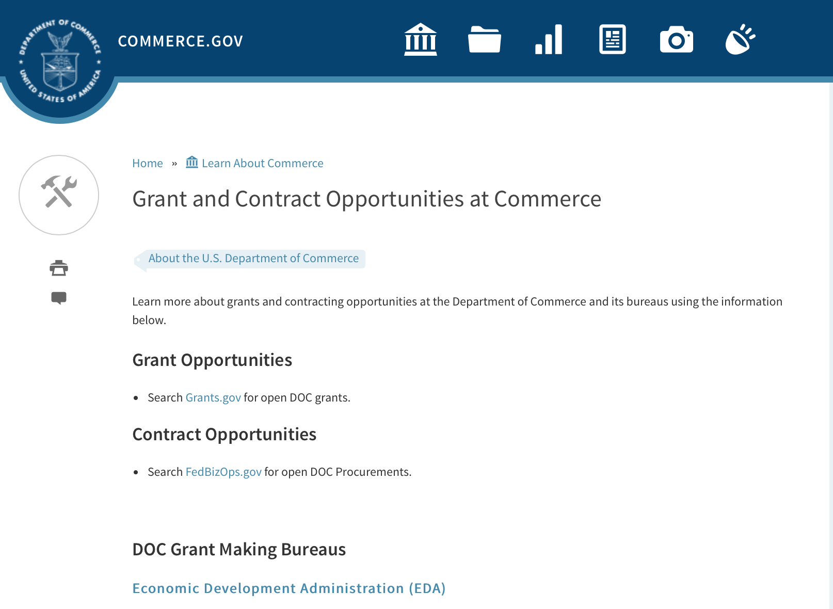
Grants at Commerce
DOC Grant Making Bureaus
Economic Development Administration (EDA)
International Trade Administration (ITA)
- Market Development Cooperator Program
- Special American Business Internship Training Program (SABIT). A technical assistance initiative of the International Trade Administration of the U.S. Department of Commerce, SABIT offers organizations competitive grants and an opportunity to host industry-specific delegations. SABIT serves as an initial entry point for U.S. businesses seeking funding to establish long-term relationships with potential customers, distributors, or partners in the former Soviet Union. The program trains Eurasian managers and scientists in commonly accepted business practices as a means of facilitating cross border relationships. In turn, these personal relationships serve as a basis for business development and reduce market access barriers for U.S. businesses
National Institute of Standards & Technology (NIST)
- Funding Opportunities
National Telecommunications & Information Administration (NTIA)
- Telecommunications Grants
National Oceanic & Atmospheric Administration (NOAA)
- Coastal Ocean Program Grant Information
- Fisheries Saltonstall Kennedy Grant Program
- National Undersea Research Program Funding Opportunities
- Grants Management Division
- Fisheries Grants Program
- National Sea Grant
- Office of Global Programs
Contracting Resources for Contractors
- Office of Small and Disadvantaged Business Utilization (OSDBU) - he Office of Small and Disadvantaged Business Utilization (OSDBU) is an advocacy and advisory office responsible for promoting the use of small, small disadvantaged, 8(a), women-owned, veteran-owned, service-disabled veteran-owned, and HUBZone small businesses within the U.S. Department of Commerce's (DOC) acquisition process.
- Business.USA.gov's Find Opportunities Wizard where in a few quick steps, it will guide you towards federal government contracting programs and opportunities for your business!
- Planned Acquisitions: the Department of Commerce's search tool for our planned acquisitions over $100,000. As requirements change, these acquisition plans are updated by department personnel and this search tool is automatically updated.
- Small Business Administration's Contracting section of their web site where you can learn about how to "Get Started" and "Contracting Support for Small Business"
- The General Services Administration (GSA) has implemented a system for vendors doing business with the Federal Government to manage their entity information in one central location. This new database is the System for Award Management (SAM).

DOC Contracting Offices
- Patent and Trademark Office (PTO)
  - Office of Procurement
- National Institute of Standards & Technology (NIST)
NIST Acquisition Management Group
Contracting Opportunities with Commerce
Trade Opportunities through Commerce
http://www.commerce.gov/about-commerce/grants-contracting-trade-opportunities

Programs:

Environmental Literacy Grants: Supporting the education of K-12 students and the public for community resilience
Synopsis 1
Document Type: | Grants Notice
Funding Opportunity Number: | NOAA-SEC-OED-2018-2005455
Funding Opportunity Title: | Environmental Literacy Grants: Supporting the education of K-12 students and the public for community resilience
Opportunity Category: | Discretionary
Opportunity Category Explanation:
Funding Instrument Type: | Cooperative Agreement
Category of Funding Activity: | Environment  Natural Resources  Science and Technology and other Research and Development
Category Explanation:
Expected Number of Awards: | 6
CFDA Number(s): | 11.008 -- NOAA Mission-Related Education Awards
Cost Sharing or Matching Requirement: | No
Version: | Synopsis 1
Posted Date: | Nov 07, 2017
Last Updated Date: | Nov 07, 2017
Original Closing Date for Applications: | Apr 06, 2018
Current Closing Date for Applications: | Apr 06, 2018
Archive Date: | May 06, 2018
Estimated Total Program Funding: | $2,000,000
Award Ceiling: | $500,000
Award Floor: | $250,000
Eligible Applicants: | Others (see text field entitled "Additional Information on Eligibility" for clarification)
Additional Information on Eligibility: | Eligible applicants for this funding opportunity are limited to institutions of higher education; K-12 public and independent schools and school systems, other nonprofits, including informal education institutions such as museums, zoos, and aquariums; state and local government agencies; and Indian tribal governments in the United States. For-profit organizations, foreign institutions, and individuals are not eligible to apply; however, for-profit organizations, foreign institutions, and individuals may participate with an eligible applicant as a project partner. Likewise, federal agencies are not eligible to receive federal assistance under this announcement, but may be project partners. It is strongly encouraged that an individual serve as a Principal Investigator (PI) on only one application submitted to this funding opportunity. Institutions may submit more than one application and individuals may serve as co-PIs or key personnel on more than one application. Federal employees may not serve as PIs or co-PIs on any application, although they may be included as key personnel.
Agency Name: | Department of Commerce
Description: | The goal of this Federal Funding Opportunity (FFO) is to support the education of K-12 students and the public so they are knowledgeable of the ways in which their community can become more resilient to extreme weather events and/or other environmental hazards, and become involved in achieving that resilience. Many U.S. communities are increasingly contending with issues related to preventing, withstanding, and recovering from disruptions caused by extreme weather and other environmental hazards (U.S. Department of Commerce FY2014-FY2018 Strategic Plan). These hazards include but are not limited to severe storms, tornadoes, hurricanes, flooding, heavy precipitation events, persistent drought, heat waves, increased global temperatures, acidification of the ocean, and sea level rise (Weather-ready Nation: NOAA’s National Weather Service Strategic Plan 2011; Melillo et al., 2014). These extreme weather and climate events put stress on infrastructure, ecological systems, and the humans that live in the impacted places. U.S. communities can become more resilient to such events by exploring the hazards they face, assessing their specific vulnerabilities and risks, considering options, prioritizing and planning, and finally taking action (U.S. Climate Resilience Toolkit). This process is typically performed by scientists and municipal planners, but in order for resilience to occur, other members of a community must have some understanding of the hazards they face and how to mitigate them, both at the individual and the community level. Education projects focused on resilience enable and empower community members, including children and youth, to protect themselves and their communities from these hazards. Projects should build the environmental literacy necessary for communities to become more resilient to extreme weather and other environmental hazards they face. In order for communities to become more resilient, their members must have the ability to reason about the ways that human and natural systems function and interact; to understand the scientific process and uncertainty; to reason about the ways that people and places are connected to each other across time and space; and to weigh the potential impacts of their decisions systematically. Projects should leverage and incorporate relevant state and local hazard mitigation and/or adaptation plans and collaborate with institutions that are involved in efforts to develop or implement those plans. Projects may focus on a single type of environmental hazard or a range of hazards that may impact a community or communities. Projects will be based on the established scientific evidence about current and future natural hazards and stresses facing communities and should consider relevant socio-economic and ecological factors in the targeted geographic area(s). Projects should engage participants in active learning activities. In addition, projects must utilize NOAA’s scientific data, data access tools, data visualizations, and/or other physical and intellectual assets available on these topics. In order to facilitate the use of NOAA’s assets, projects are strongly encouraged to partner with relevant NOAA entities (offices, programs, etc.) and/or NOAA employees and affiliates. Applicants are also strongly encouraged to review the resilience education projects funded by this program since 2015 and proposed projects should be informed by the lessons learned by these current grantees. Projects must be implemented within the United States and its territories. Projects will likely be implemented at the local level, but may occur in more than one locality. Project topics must relate to NOAA's mission in the areas of ocean, coastal, Great Lakes, weather, and climate sciences and stewardship and should focus on one or more of the goals of NOAA's Next Generation Strategic Plan: healthy oceans; weather-ready nation; climate adaptation and mitigation; and resilient coastal communities and economies. Eligible applicants for this funding opportunity are limited to institutions of higher education; other nonprofits, including informal education institutions such as museums, zoos, and aquariums; K-12 public and independent schools and school systems; and state, local and Indian tribal governments in the United States. Federal agencies, for-profit organizations, foreign institutions, and individuals are not eligible to apply. Proposed projects must be between 2 and 5 years in duration and have total federal requests of $250,000 to $500,000 for all years of the project. It is anticipated that awards funded under this announcement during this fiscal year will be made by September 30, 2018 and that the projects funded under this announcement will have a start date no earlier than October 1, 2018. Note: Links to helpful information for applying to this opportunity are available at http://www.noaa.gov/office-education/elp/grants/apply.
Link to Additional Information:
Grantor Contact Information: | If you have difficulty accessing the full announcement electronically, please contact:  Environmental Literacy Program Grants Team  Work group email
http://www.grants.gov/web/grants/view-opportunity.html?oppId=298495

National Sea Grant College Program 2018-19 Special Projects
Synopsis 1
Document Type: | Grants Notice
Funding Opportunity Number: | NOAA-OAR-SG-2018-2005457
Funding Opportunity Title: | National Sea Grant College Program 2018-19 Special Projects
Opportunity Category: | Discretionary
Opportunity Category Explanation:
Funding Instrument Type: | Cooperative Agreement  Grant
Category of Funding Activity: | Environment  Natural Resources  Science and Technology and other Research and Development
Category Explanation:
Expected Number of Awards:
CFDA Number(s): | 11.417 -- Sea Grant Support
Cost Sharing or Matching Requirement:

Version: | Synopsis 1
Posted Date: | Nov 15, 2017
Last Updated Date: | Nov 15, 2017
Original Closing Date for Applications: | Sep 30, 2019
Current Closing Date for Applications: | Sep 30, 2019
Archive Date: | Oct 30, 2019
Estimated Total Program Funding:
Award Ceiling: | $1
Award Floor: | $1
Eligible Applicants: | Others (see text field entitled "Additional Information on Eligibility" for clarification)
Additional Information on Eligibility: | Eligible applicants are: Sea Grant Programs (Sea Grant Colleges, Institutions, or Coherent Area Programs), the National Sea Grant Law Center, and the National Sea Grant Library. Individual competition announcements may restrict eligibility to a subset of these applicants.
Agency Name: | Department of Commerce
Description: | The purpose of this notice is to request proposals for special projects consistent with the focus areas outlined in the National Sea Grant College Program’s (Sea Grant) strategic plan, and to provide the general public with information and guidelines on how Sea Grant will select proposals and administer Federal assistance under this announcement. This announcement is a mechanism to encourage research or other projects that are not normally funded through Sea Grant national competitions. This opportunity is open only to Sea Grant Programs. Section III of this announcement describes eligibility requirements in more detail. Funding has not yet been made available to support applications submitted to this Federal Funding Opportunity (FFO), but such funding may become available during the year. Section II.A. below describes individual competition announcements that will be used to announce when funding is available, any restrictions or requirements such as cost share, and other funding details. Awards will be made under this FFO only to applications that are responsive to individual competition announcements; unsolicited applications will not be reviewed.
Link to Additional Information:
Grantor Contact Information: | If you have difficulty accessing the full announcement electronically, please contact:  Special Projects Competition Manager NOAA R/SG, National Sea Grant Office 1315 East-West Highway, Rm 11839 Silver Spring, MD 20910 Telephone: 301-734-1066 oar.hq.sg.competitions@noaa.gov  Work
http://www.grants.gov/web/grants/view-opportunity.html?oppId=298706

Fiscal Year 2019 National Sea Grant College Program Dean John A. Knauss Marine Policy Fellowship
Synopsis 1
Document Type: | Grants Notice
Funding Opportunity Number: | NOAA-OAR-SG-2019-2005447
Funding Opportunity Title: | Fiscal Year 2019 National Sea Grant College Program Dean John A. Knauss Marine Policy Fellowship
Opportunity Category: | Discretionary
Opportunity Category Explanation:
Funding Instrument Type: | Cooperative Agreement
Category of Funding Activity: | Environment  Natural Resources  Science and Technology and other Research and Development
Category Explanation:
Expected Number of Awards:
CFDA Number(s): | 11.417 -- Sea Grant Support
Cost Sharing or Matching Requirement: | No
Version: | Synopsis 1
Posted Date: | Nov 15, 2017
Last Updated Date: | Nov 15, 2017
Original Closing Date for Applications: | Apr 06, 2018
Current Closing Date for Applications: | Apr 06, 2018
Archive Date: | May 06, 2018
Estimated Total Program Funding:
Award Ceiling: | $61,500
Award Floor: | $61,500
Eligible Applicants: | Others (see text field entitled "Additional Information on Eligibility" for clarification)
Additional Information on Eligibility: | An eligible applicant is any student, regardless of citizenship, who, on February 21, 2018, is enrolled towards a degree in a graduate program, that has an interest in ocean, coastal and Great Lakes resources and in the national policy decisions affecting those resources. The graduate degree must be awarded through an accredited institution of higher education in the United States or U.S. Territories.
Agency Name: | Department of Commerce
Description: | This notice announces that applications may be submitted for the 2019 National Sea Grant College Program Dean John A. Knauss Marine Policy Fellowship (Sea Grant Knauss Fellowship Program). The National Sea Grant College Program anticipates funding not less than 35 selected applicants, of which those assigned to the Legislative branch will be approximately 12. Each award will be funded at a total of $61,500 in federal funding, with the option to add additional funds for fellowship related travel.
Link to Additional Information:
Grantor Contact Information: | If you have difficulty accessing the full announcement electronically, please contact:  Sea Grant Knauss Fellowship Program Manager National Sea Grant College Program 1315 East-West Highway, R/SG, Room 11861 Silver Spring, MD 20910 Tel: (301) 734-1088 E-mail: oar.sg.fellows@noaa.gov  Work
http://www.grants.gov/web/grants/view-opportunity.html?oppId=298724

Round 3 of Research to Operations Initiative: NGGPS and HFIP
Synopsis 1 & 2
http://www.grants.gov/web/grants/view-opportunity.html?oppId=298565

Modifications:
Coastal Hypoxia Research Program (CHRP)
Synopsis 1
http://www.grants.gov/web/grants/view-opportunity.html?oppId=298562
FY18 Coral Reef Conservation Program, Domestic Coral Reef Conservation Grants
Synopsis 2
http://www.grants.gov/web/grants/view-opportunity.html?oppId=298661
Round 3 of Research to Operations Initiative: NOAA Testbeds
Synopsis 2
http://www.grants.gov/web/grants/view-opportunity.html?oppId=298673

Research:

Coastal Hypoxia Research Program (CHRP)
Synopsis 1
http://www.grants.gov/web/grants/view-opportunity.html?oppId=298562
Round 3 of Research to Operations Initiative: NGGPS and HFIP (Synopsis 1
http://www.grants.gov/web/grants/view-opportunity.html?oppId=298565

National Institute of Standards and Technology
Precision Measurement Grant Program
Synopsis 1
http://www.grants.gov/web/grants/view-opportunity.html?oppId=298752

National Institute of Standards and Technology
Summer Undergraduate Research Fellowship (SURF) Program
Synopsis 1
https://www.grants.gov/web/grants/view-opportunity.html?oppId=299040

Reminders:

FY18 Saltonstall Kennedy Competition
Synopsis 2
Document Type: | Grants Notice
Funding Opportunity Number: | NOAA-NMFS-FHQ-2018-2005332
Funding Opportunity Title: | FY18 Saltonstall Kennedy Competition
Opportunity Category: | Discretionary
Opportunity Category Explanation:
Funding Instrument Type: | Cooperative Agreement  Grant
Category of Funding Activity: | Environment  Natural Resources  Science and Technology and other Research and Development
Category Explanation:
Expected Number of Awards: | 50
CFDA Number(s): | 11.427 -- Fisheries Development and Utilization Research and Development Grants and Cooperative Agreements Program
Cost Sharing or Matching Requirement: | No
Version: | Synopsis 2
Posted Date: | Aug 11, 2017
Last Updated Date: | Oct 12, 2017
Original Closing Date for Applications: | Oct 10, 2017
Current Closing Date for Applications: | Jan 08, 2018
Archive Date: | Feb 07, 2018
Estimated Total Program Funding: | $10,000,000
Award Ceiling: | $300,000
Award Floor: | $25,000
Eligible Applicants: | Others (see text field entitled "Additional Information on Eligibility" for clarification)
Additional Information on Eligibility: | You are eligible to apply for a grant or a cooperative agreement under the Saltonstall-Kennedy Grant Program if:1. You are a citizen or national of the United States;2. You represent an entity that is a corporation, partnership, association, or other non-Federal entity, non-profit or otherwise (including Indian tribes), if such entity is a citizen of the United States within the meaning of section 2 of the Shipping Act, 1916, as amended (46 U.S.C. app. 802); or3. You are a citizen of the Republic of the Marshall Islands, Republic of Palau, or the Federated States of Micronesia. We recognize the interest of the Secretaries of Commerce and Interior in defining appropriate fisheries policies and programs that meet the needs of the U.S. insular areas, so we encourage applications from individuals, government entities, and businesses in U.S. insular areas. We support cultural and gender diversity in our programs and encourage women and minority individuals and groups to submit applications. We are also committed to broadening the participation of Minority Serving Institutions (MSIs), which include Historically Black Colleges and Universities, Hispanic Serving Institutions, and Tribal Colleges and Universities, in our grant programs. To find out more about MSIs go to http://www2.ed.gov/about/offices/list/ocr/edlite-minorityinst.html.We encourage applications from members of the fishing community and applications that involve fishing community cooperation and participation. We will consider the extent of fishing community involvement when evaluating the potential benefit of funding a proposal. Eligible Applicants must submit a pre-proposal that meets the submission requirements listing in this FFO by the established due date. Full proposals will not be reviewed or evaluated if a pre-proposal was not received on time and ranked. Non Eligible Applicants You are not eligible to submit an application under this program if you are an employee of any Federal agency; a Regional Fishery Management Council (Council); or an employee of a Council. However, Council members who are not Federal employees can submit an application to the S-K Program.
Agency Name: | Department of Commerce
Description: | The Saltonstall-Kennedy Act established a fund (known as the S-K fund) used by the Secretary of Commerce to provide grants or cooperative agreements for fisheries research and development projects addressing aspects of U.S. fisheries, including, but not limited to, harvesting, processing, marketing, and associated business infrastructures. Under this authority, grants and cooperative agreements are made on a competitive basis (subject to availability of funding) to assist in carrying out projects related to U.S. commercial and recreational fisheries. The term “fisheries” encompasses wild capture, marine aquaculture and recreational fishing. The objective of the S-K Grant Program is to address the needs of the fisheries and fishing communities in optimizing economic benefits by building and maintaining sustainable fisheries and practices, dealing with the impacts of conservation and management measures, and increasing other opportunities to use existing infrastructure to support keeping working waterfronts viable. U.S. fisheries include any fishery, commercial or recreational, that is, or may be, engaged in by citizens or nationals of the United States. Proposals submitted to this competition must address at least one of the following priorities: Marine Aquaculture; Adapting to Environmental Change and Other Long Term Ecosystem Change; Promotion, Development and Marketing; or Territorial Science. This Federal Funding Opportunity includes information on application and criteria for research proposals requesting a maximum of $300,000 in Federal funding for up to a two-year period. Matching funds are not required, nor will they be considered during the evaluation process. Awards are anticipated to start no earlier than September 1, 2018.Grant awards are dependent on the availability of Federal funding as provided in enacted Appropriations Acts. This FFO is being released prior to final appropriations due to award process time frames. While the FY 2018 President's budget proposed $0 for this program, final Congressional direction has not been determined. Applicants are not guaranteed any level of funding. Should funds not be available in FY2018 submitted applications may be carried over to subsequent fiscal year for review and obligation should funds be available and the Agency deems this the most appropriate administrative process.
Link to Additional Information:
Grantor Contact Information: | If you have difficulty accessing the full announcement electronically, please contact:  Daniel Namur, telephone (301) 427-8730 email: Dan.Namur@noaa.gov  Work

http://www.grants.gov/web/grants/view-opportunity.html?oppId=296392

FY2018 Marine Debris Prevention
Synopsis 4

Document Type: | Grants Notice
Funding Opportunity Number: | NOAA-NOS-ORR-2018-2005333
Funding Opportunity Title: | FY2018 Marine Debris Prevention
Opportunity Category: | Discretionary
Opportunity Category Explanation:
Funding Instrument Type: | Cooperative Agreement
Category of Funding Activity: | Environment  Natural Resources  Science and Technology and other Research and Development
Category Explanation:
Expected Number of Awards: | 10
CFDA Number(s): | 11.999 -- Marine Debris Program
Cost Sharing or Matching Requirement: | Yes
Version: | Synopsis 4
Posted Date: | Aug 23, 2017
Last Updated Date: | Sep 26, 2017
Original Closing Date for Applications: | Dec 16, 2017
Current Closing Date for Applications: | Dec 16, 2017
Archive Date: | Jan 15, 2018
Estimated Total Program Funding: | $1,500,000
Award Ceiling: | $250,000
Award Floor: | $50,000
Eligible Applicants: | Others (see text field entitled "Additional Information on Eligibility" for clarification)
Additional Information on Eligibility: | NOTICE: The Letter of Intent (LOI) due date has been changed to October 5, 2017. Please note: to apply for marine debris prevention funding through this opportunity, applicants must first submit a Letter of Intent (LOI), via email, to grants.marinedebris@noaa.gov, in accordance with the guidelines described in Section IV.B. of the funding opportunity announcement. The deadline for LOI submission is October 5, 2017. After NOAA reviews all submitted LOIs, only those invited to submit a full proposal will be considered for funding. Applicants will be notified by November 1, 2017 if they have been invited to submit a full proposal. In accordance with the Marine Debris Act, eligible applicants are state, local, and tribal governments whose activities affect research or regulation of marine debris and any institution of higher education, nonprofit organization, or commercial (for-profit) organization with expertise in a field related to marine debris. Applications from federal agencies or employees of federal agencies will not be considered. Interested federal agencies may collaborate with eligible applicants but may not receive funds through this competition. All projects must take place within the United States or territories or their respective waterways. Foreign organizations and foreign public entities are not eligible to apply as the primary applicant but can be listed as a sub-awardee or contractor. NOAA is strongly committed to broadening the participation of veterans, minority-serving institutions, and entities that work in underserved areas. The NOAA MDP encourages proposals from, or involving any of the above types of institutions. Applications that have been submitted to other NOAA grant programs or as part of another NOAA grant may be considered under this solicitation.
Agency Name: | Department of Commerce
Description: | The NOAA Marine Debris Program, authorized in the Marine Debris Act (33 U.S.C. 1951-1958), provides funding to prevent the introduction of marine debris into the marine and coastal environment. Projects awarded through this grant competition will encourage changes in behavior of a target audience (such as students, teachers, industries, or the public) to address a specific marine debris issue, and will actively engage these groups in hands-on personal participation. Successful proposals through this solicitation will be funded through cooperative agreements. Funding of up to $1,500,000 is expected to be available for Marine Debris Prevention grants in FY2018. Typical awards will range from $50,000 - $150,000. Funding for this purpose comes through the NOAA Marine Debris Program as appropriations to the Office of Response and Restoration, National Ocean Service. This solicitation is focused on efforts to prevent marine debris from entering the environment through targeted behavior change. It is not intended for large-scale debris removal projects, deployment of catchment basins, or scientific research.
Link to Additional Information:
Grantor Contact Information: | If you have difficulty accessing the full announcement electronically, please contact:  Tom Barry (tom.barry@noaa.gov, 240-533-0425).  Work

http://www.grants.gov/web/grants/view-opportunity.html?oppId=296756

National Telecommunications and Information Admin
State and Local Implementation Grant Program (SLIGP) 2.0
Synopsis 1

Document Type: | Grants Notice
Funding Opportunity Number: | 2018-NTIA-SLIGP-2
Funding Opportunity Title: | State and Local Implementation Grant Program (SLIGP) 2.0
Opportunity Category: | Discretionary
Opportunity Category Explanation:
Funding Instrument Type: | Grant
Category of Funding Activity: | Other (see text field entitled "Explanation of Other Category of Funding Activity" for clarification)
Category Explanation: | State and Local Implementation Grant Program
Expected Number of Awards:
CFDA Number(s): | 11.549 -- State and Local Implementation Grant Program
Cost Sharing or Matching Requirement: | Yes
Version: | Synopsis 2
Posted Date: | Sep 27, 2017
Last Updated Date: | Sep 29, 2017
Original Closing Date for Applications: | Applications will be accepted from September 27, 2017 until December 28, 2017 at 11:59 p.m. Eastern Time; or from September 27, 2017 until 11:59 p.m. Eastern Time on the 91st calendar day from the date that the Governor of an applicant State receives notice from FirstNet of its final State Plan, whichever is later.
Current Closing Date for Applications: | Applications will be accepted from September 27, 2017 until December 28, 2017 at 11:59 p.m. Eastern Time; or from September 27, 2017 until 11:59 p.m. Eastern Time on the 91st calendar day from the date that the Governor of an applicant State receives notice from FirstNet of its final State Plan, whichever is later.
Archive Date: | Jan 31, 2018
Eligible Applicants: | Others (see text field entitled "Additional Information on Eligibility" for clarification)
Additional Information on Eligibility: | Any State, territory, or the District of Columbia is eligible for a grant under the SLIGP 2.0
Agency Name: | National Telecommunications and Information Admin
Description: | The National Telecommunications and Information Administration (NTIA) issues this NOFO to describe the requirements under which NTIA will award grants for the State and Local Implementation Grant Program 2.0 (SLIGP 2.0), authorized by section 6302 of the Middle Class Tax Relief and Job Creation Act of 2012 (Act), to assist state, local and tribal governments with planning activities for the nationwide interoperable public safety broadband network.
Link to Additional Information: | 2018-NTIA-SLIGP-2 NOFO
Grantor Contact Information: | If you have difficulty accessing the full announcement electronically, please contact:  Michael Dame Program Director Phone 202 482-1181  Agency Contact

http://www.grants.gov/web/grants/view-opportunity.html?oppId=297692

FY18-19 CRCP International Coral Reef Conservation Cooperative Agreements
Synopsis 1

Document Type: | Grants Notice
Funding Opportunity Number: | NOAA-NOS-OCM-2018-2005319
Funding Opportunity Title: | FY18-19 CRCP International Coral Reef Conservation Cooperative Agreements
Opportunity Category: | Discretionary
Opportunity Category Explanation:
Funding Instrument Type: | Cooperative Agreement
Category of Funding Activity: | Environment  Natural Resources  Science and Technology and other Research and Development
Category Explanation:
Expected Number of Awards: | 10
CFDA Number(s): | 11.482 -- Coral Reef Conservation Program
Cost Sharing or Matching Requirement: | Yes
Version: | Synopsis 1
Posted Date: | Aug 30, 2017
Last Updated Date: | Aug 30, 2017
Original Closing Date for Applications: | Feb 15, 2018
Current Closing Date for Applications: | Feb 15, 2018
Archive Date: | Mar 17, 2018
Estimated Total Program Funding: | $600,000
Award Ceiling: | $300,000
Award Floor: | $75,000
Eligible Applicants: | Others (see text field entitled "Additional Information on Eligibility" for clarification)
Additional Information on Eligibility: | Eligible applicants are institutions of higher education, non-profit organizations, non-U.S. government natural resource management agencies, foreign public entities and foreign organizations, and for-profit organizations. An eligible organization may include proposed sub-recipients, contractors, or other collaborators, which may include governmental authorities, effectively forming a team. Federal agencies and employees may participate in projects as collaborative project partners at the agency’s expense, as this announcement does not cover their funding. Federal agencies’ and employees’ in-kind services and equipment are generally not allowed as part of an applicant’s match on shared costs. If an applicant proposes federal agency collaborators, applicants should provide detail on the expected level of federal engagement in the application. Examples might include, but are not limited to partnership services; serving in a review capacity; or participating in priority task teams, working groups, or leadership teams. Proposals are expected to target the following specific countries: 1) For proposals that address the NOAA-GCFI Assessment, projects must be conducted in at least two of the following Non-US countries and territories of the Wider Caribbean: Bahamas, Belize, British Virgin Islands, Grenada, Honduras, Mexico, Saba and St. Eustatius, St. Lucia, St. Vincent and the Grenadines, and Turks and Caicos Islands. For eligible MPA sites in each country please refer to the above Section B., Program Priorities. 2) Proposals for the South East Asia and South Pacific regions must be conducted in one or more of the following countries: Cook Islands, Federated States of Micronesia, Fiji, Indonesia, Kiribati, Malaysia, Nauru, Niue, Palau, Papua New Guinea, Philippines, Republic of the Marshall Islands, Samoa, Solomon Islands, Timor-Leste, Tonga, Tuvalu, and Vanuatu. 3) For Micronesia proposals, the project must only be conducted in all of the following independent countries under compacts of free association with the United States: the Republic of the Marshall Islands; the Republic of Palau; and the Federated States of Micronesia.
Agency Name: | Department of Commerce
Description: | The NOAA Coral Reef Conservation Program (CRCP) provides matching grants for international coral reef conservation projects. CRCP solicits proposals that will support the NOAA Coral Reef Conservation Program’s International Strategy 2010-2015 (International Strategy). The International Strategy focuses on supporting existing regional efforts in four priority regions based on their interconnections with U.S. reef ecosystems and existing initiatives and partnerships. The following three priority regions will be considered under this Federal Funding Opportunity: the Wider Caribbean, South East Asia and South Pacific, and Micronesia. Funding for the Fiscal Year 2018 competition is subject to the availability of Congressional appropriations and is expected to be approximately $600,000. NOAA expects each applicant will request between $75,000 and $300,000 annually for an award with a project period up to two years. Funding after the first year generally depends on future Congressional appropriations, NOAA/CRCP priorities, and recipient performance in the first year(s) of the award.
Link to Additional Information:
Grantor Contact Information: | If you have difficulty accessing the full announcement electronically, please contact:  Scot Frew NOAA/OCM Corel Reef Program 1305 East West Highway 10th Floor, N/OCM6 Silver Spring, MD 20910 (240) 533-0774  Work email

http://www.grants.gov/web/grants/view-opportunity.html?oppId=296927

Economic Development Administration
FY 2017 Economic Development Assistance Programs ­ Application submission and program requirements for EDA’s Public Works and Economic Adjustment Assistance programs.
Synopsis 1
Document Type: | Grants Notice
Funding Opportunity Number: | EDAP-2017
Funding Opportunity Title: | FY 2017 Economic Development Assistance Programs Application submission and program requirements for EDA’s Public Works and Economic Adjustment Assistance programs.
Opportunity Category: | Discretionary
Opportunity Category Explanation:
Funding Instrument Type: | Cooperative Agreement  Grant
Category of Funding Activity: | Other (see text field entitled "Explanation of Other Category of Funding Activity" for clarification)
Category Explanation: | The Economic Development Administration's (EDA's) mission is to lead the Federal economic development agenda by promoting innovation and competitiveness, preparing American regions for economic growth and success in the worldwide economy. EDA fulfills this mission through strategic investments and partnerships that create the regional economic ecosystems required to foster globally competitive regions throughout the United States. EDA supports development in economically distressed areas of the United States by fostering job creation and attracting private investment. Specifically, under the Economic Development Assistance programs (EDAP) Notice of Funding Availability (NOFA), EDA will make construction, non-construction, and revolving loan fund investments under the Public Works and Economic Adjustment Assistance (EAA) Programs. Through this NOFA, EDA will also designate a portion of its EAA funding to support communities and regions that have been negatively impacted by changes in the coal economy (Assistance to Coal Communities, or ACC 2017). Grants made under these programs will leverage regional assets to support the implementation of regional economic development strategies designed to create jobs, leverage private capital, encourage economic development, and strengthen America's ability to compete in the global marketplace. Through the EDAP NOFA, EDA solicits applications from rural and urban communities to develop initiatives that advance new ideas and creative approaches to address rapidly evolving economic conditions.
Expected Number of Awards:
CFDA Number(s): | 11.300 -- Investments for Public Works and Economic Development Facilities  11.307 -- Economic Adjustment Assistance
Cost Sharing or Matching Requirement: | Yes
Version: | Synopsis 1
Posted Date: | Jun 19, 2017
Last Updated Date: | Jun 19, 2017
Original Closing Date for Applications: | There are no submission deadlines under this opportunity. Proposals and applications will be accepted on an ongoing basis until the publication of a new EDAP NOFA.
Current Closing Date for Applications: | There are no submission deadlines under this opportunity. Proposals and applications will be accepted on an ongoing basis until the publication of a new EDAP NOFA.
Archive Date:
Estimated Total Program Funding:
Award Ceiling: | $3,000,000
Award Floor: | $100,000
Eligible Applicants: | Native American tribal organizations (other than Federally recognized tribal governments)  Special district governments  Others (see text field entitled "Additional Information on Eligibility" for clarification)  Private institutions of higher education  County governments  Native American tribal governments (Federally recognized)  City or township governments  Nonprofits that do not have a 501(c)(3) status with the IRS, other than institutions of higher education  State governments  Nonprofits having a 501(c)(3) status with the IRS, other than institutions of higher education  Public and State controlled institutions of higher education
Additional Information on Eligibility: | Eligible applicants for EDA financial assistance under the Public Works and EAA programs (including ACC 2017 funding) include a(n): (i) District Organization of a designated Economic Development District; (ii) Indian Tribe or a consortium of Indian Tribes; (iii) State, county, city, or other political subdivision of a State, including a special purpose unit of a State or local government engaged in economic or infrastructure development activities, or a consortium of political subdivisions; (iv) institution of higher education or a consortium of institutions of higher education; or (v) public or private non-profit organization or association acting in cooperation with officials of a political subdivision of a State. See Section 3 of the Public Works and Economic Development Act of 1965 (PWEDA) (42 U.S.C. § 3122) and 13 C.F.R. § 300.3. EDA is not authorized to provide grants or cooperative agreements to individuals or to for profit entities. Requests from such entities will not be considered for funding. For ACC 2017 funding, projects must be located within and targeted to communities or regions that have been impacted, or can reasonably demonstrate that they will be impacted, by coal mining or coal power plant employment loss, or employment loss in the supply chain industries of either.
Agency Name: | Economic Development Administration
Description: | Under this NOFA, EDA solicits applications from applicants in rural and urban areas to provide investments that support construction, non-construction, technical assistance, and revolving loan fund projects under EDA’s Public Works and EAA programs. Grants and cooperative agreements made under these programs are designed to leverage existing regional assets and support the implementation of economic development strategies that advance new ideas and creative approaches to advance economic prosperity in distressed communities, including communities and regions that have been impacted, or can reasonably demonstrate that they will be impacted, by coal mining or coal power plant employment loss, or employment loss in the supply chain industries of either. EDA provides strategic investments on a competitive- merit-basis to support economic development, foster job creation, and attract private investment in economically distressed areas of the United States. This EDAP NOFA supersedes the EDAP Federal Funding Opportunity dated December 23, 2016.
Link to Additional Information: | Economic Development Administration
Grantor Contact Information: | If you have difficulty accessing the full announcement electronically, please contact:  If you have difficulty accessing the full announcement electronically, please contact: the EDA representative for your state. A complete list of EDA representatives is available on EDA's website at http://www.eda.gov/contact/  http://www.eda.gov/contact/

http://www.grants.gov/web/grants/view-opportunity.html?oppId=294771

National Institute of Standards and Technology
Measurement Science and Engineering (MSE) Research Grant Programs

Document Type: | Grants Notice
Funding Opportunity Number: | 2016-NIST-MSE-01
Funding Opportunity Title: | Measurement Science and Engineering (MSE) Research Grant Programs
Opportunity Category: | Discretionary
Opportunity Category Explanation:
Funding Instrument Type: | Cooperative Agreement  Grant
Category of Funding Activity: | Science and Technology and other Research and Development
Category Explanation:
Expected Number of Awards:
CFDA Number(s):
Cost Sharing or Matching Requirement: | No
Posted Date: | Feb 19, 2016
Last Updated Date: | Feb 19, 2016
Original Closing Date for Applications: | Applications will be accepted and considered on a rolling basis as they are received. See Section IV.4. in the text of the Full Announcement/FFO document. Applications may be submitted by paper or electronically through Grants.gov. Carefully read Section IV. of the Full Announcement/FFO document for details applying to electronic submissions and to paper submissions.
Current Closing Date for Applications: | Applications will be accepted and considered on a rolling basis as they are received. See Section IV.4. in the text of the Full Announcement/FFO document. Applications may be submitted by paper or electronically through Grants.gov. Carefully read Section IV. of the Full Announcement/FFO document for details applying to electronic submissions and to paper submissions.
Eligible Applicants: | Others (see text field entitled "Additional Information on Eligibility" for clarification)
Additional Information on Eligibility: | Eligibility for all programs listed in this FFO is open to all non-Federal entities. Eligible applicants include institutions of higher education, non-profit organizations, for-profit organizations, state and local governments, Indian tribes, hospitals, foreign public entities, and foreign governments. Applicants selected for awards under 15 U.S.C. § 278g-1 are encouraged, but not required, to select underrepresented minorities for participation. In addition, NIST is not able to accept an application from an individual unaffiliated with a sponsoring applicant organization.
Agency Name: | National Institute of Standards and Technology
Description: | NIST is soliciting applications for financial assistance for Fiscal Year 2016 (FY16) within the following NIST Laboratory grant programs: (1) the Material Measurement Laboratory (MML) Grant Program; (2) the Physical Measurement Laboratory (PML) Grant Program; (3) the Engineering Laboratory (EL) Grant Program; (4) the Fire Research (FR) Grant Program; (5) the Information Technology Laboratory (ITL) Grant Program; (6) the Communications Technology Laboratory (CTL) Grant Program; (7) the NIST Center for Neutron Research (NCNR) Grant Program; (8) the Center for Nanoscale Science and Technology (CNST) Grant Program; (9) the Special Programs Office (SPO) Grant Program; (10) the Standards Coordination Office (SCO) Grant Program; (11) the International and Academic Affairs Office (IAAO) Grant Program; and (12) the Associate Director for Laboratory Programs (ADLP) Grant Program.
Link to Additional Information: | 2016-NIST-MSE-01 Full Announcement/FFO document
Contact Information: | If you have difficulty accessing the full announcement electronically, please contact:  Christopher Hunton Management and Program Analyst Phone 301-975-5718  Agency Contact

http://www.grants.gov/web/grants/view-opportunity.html?oppId=281689

FY 2016 – FY 2019 EDA Planning Program and Local Technical Assistance Program Grant

Document Type: | Grants Notice
Funding Opportunity Number: | EDA-HDQ-TA-HDQ-2016-2004759
Funding Opportunity Title: | FY 2016 – FY 2019 EDA Planning Program and Local Technical Assistance Program
Opportunity Category: | Discretionary
Funding Instrument Type: | Cooperative Agreement  Grant
Category of Funding Activity: | Other (see text field entitled "Explanation of Other Category of Funding Activity" for clarification)  Regional Development
Category Explanation: | Regional planning and local technical assistance
Expected Number of Awards:
CFDA Number(s): | 11.302 -- Economic Development Support for Planning Organizations  11.303 -- Economic Development Technical Assistance
Cost Sharing or Matching Requirement: | No
Posted Date: | Dec 10, 2015
Creation Date: | Dec 10, 2015
Original Closing Date for Applications: | Applications are accepted on a continuing basis and processed as received. This Planning and Local Technical Assistance opportunity will remain in effect until superseded by a future announcement.
Current Closing Date for Applications: | Applications are accepted on a continuing basis and processed as received. This Planning and Local Technical Assistance opportunity will remain in effect until superseded by a future announcement.
Archive Date:
Estimated Total Program Funding:
Award Ceiling: | $300,000
Award Floor: | $0
Eligible Applicants: | Nonprofits having a 501(c)(3) status with the IRS, other than institutions of higher education  City or township governments  Nonprofits that do not have a 501(c)(3) status with the IRS, other than institutions of higher education  Others (see text field entitled "Additional Information on Eligibility" for clarification)  Private institutions of higher education  Native American tribal governments (Federally recognized)  Public and State controlled institutions of higher education  State governments  Special district governments  County governments
Additional Information on Eligibility: | Pursuant to section 3 of the Public Works and Economic Development Act of 1965 (42 U.S.C. § 3122) (PWEDA) and EDA’s regulation at 13 C.F.R. § 300.3, the following types of entities are eligible to receive funding assistance from EDA: 1. District Organizations (as defined in 13 C.F.R. § 300.3); 2. Indian Tribes or a consortium of Indian Tribes; 3. States, cities, or other political subdivisions of a State, including a special purpose unit of a State or local government engaged in economic or infrastructure development activities, or a consortium of political subdivisions; 4. Institutions of higher education or a consortium of institutions of higher education; or 5. Public or private non-profit organizations or associations acting in cooperation with officials of a political subdivision of a State.
Agency Name: | Department of Commerce
Description: | Pursuant to PWEDA, EDA announces general policies and application procedures for grant-based investments under the Planning and Local Technical Assistance programs. Under the Planning program EDA assists eligible recipients in creating regional economic development plans designed to build capacity and guide the economic prosperity and resiliency of an area or region. As part of this program, EDA supports Partnership Planning investments to facilitate the development, implementation, revision, or replacement of Comprehensive Economic Development Strategies (CEDS), which articulate and prioritize the strategic economic goals of recipients’ respective regions. In general, EDA provides Partnership Planning grants to the designated planning organization (e.g., District Organization) serving EDA designated Economic Development Districts to enable these organizations to develop and implement relevant CEDS. In addition, EDA provides Partnership Planning grants to Indian Tribes to help develop and implement CEDS and associated economic development activities. The Planning program also helps support organizations, including District Organizations, Indian Tribes, and other eligible recipients, with Short Term and State Planning investments designed to guide the eventual creation and retention of high-quality jobs, particularly for the unemployed and underemployed in the Nation’s most economically distressed regions. The Local Technical Assistance program strengthens the capacity of local or State organizations, institutions of higher education, and other eligible recipients to undertake and promote effective economic development programs through projects such as feasibility analyses and impact studies.
Link to Additional Information: | www.eda.gov
Contact Information: | If you have difficulty accessing the full announcement electronically, please contact:  The EDA representative for your state. A complete list of EDA representatives is available on EDA's website at http://www.eda.gov/contact/

http://www.grants.gov/web/grants/view-opportunity.html?oppId=280447

Economic Development Administration
Planning Program and Local Technical Assistance Program Grant

Document Type: | Grants Notice
Funding Opportunity Number: | EDAPLANNING2012
Opportunity Category: | Discretionary
Posted Date: | Aug 03, 2012
Creation Date: | Aug 03, 2012
Original Closing Date for Applications: | Applications are accepted on a continuing basis and processed as received. This Planning and Local Technical Assistance opportunity will remain in effect until superseded by a future announcement.
Current Closing Date for Applications: | Applications are accepted on a continuing basis and processed as received. This Planning and Local Technical Assistance opportunity will remain in effect until superseded by a future announcement.
Archive Date:
Funding Instrument Type: | Cooperative Agreement  Grant
Category of Funding Activity: | Other (see text field entitled "Explanation of Other Category of Funding Activity" for clarification)  Regional Development
Category Explanation: | Regional planning and local technical assistance
Expected Number of Awards: | 425
Estimated Total Program Funding:
Award Ceiling: | $100,000
Award Floor:
CFDA Number(s): | 11.302 -- Economic Development Support for Planning Organizations
 | 11.303 -- Economic Development Technical Assistance
Cost Sharing or Matching Requirement: | Yes

Eligible Applicants
State governments
County governments
City or township governments
Public and State controlled institutions of higher education
Native American tribal governments (Federally recognized)
Nonprofits having a 501(c)(3) status with the IRS, other than institutions of higher education
Nonprofits that do not have a 501(c)(3) status with the IRS, other than institutions of higher education
Private institutions of higher education
Others (see text field entitled "Additional Information on Eligibility" for clarification)

Additional Information on Eligibility:
Pursuant to section 3 of the Public Works and Economic Development Act of 1965 (42 U.S.C. § 3122) (PWEDA) and EDA’s regulation at 13 C.F.R. § 300.3, the following types of entities are eligible to receive funding assistance from EDA: 1. District Organizations (as defined in 13 C.F.R. § 300.3); 2. Indian Tribes or a consortium of Indian Tribes; 3. States, cities, or other political subdivisions of a State, including a special purpose unit of a State or local government engaged in economic or infrastructure development activities, or a consortium of political subdivisions; 4. Institutions of higher education or a consortium of institutions of higher education; or 5. Public or private non-profit organizations or associations acting in cooperation with officials of a political subdivision of a State.

Agency Name
Economic Development Administration

Description
Pursuant to PWEDA, EDA announces general policies and application procedures for grant-based investments under the Planning and Local Technical Assistance programs. Under the Planning program EDA assists eligible recipients in creating regional economic development plans designed to stimulate and guide the economic development efforts of a community or region. As part of this program, EDA supports Partnership Planning investments to facilitate the development, implementation, revision, or replacement of Comprehensive Economic Development Strategies (CEDS), which articulate and prioritize the strategic economic goals of recipients' respective regions. In general, EDA provides Partnership Planning grants to the designated planning organization (e.g., District Organization) serving EDA-designated Economic Development Districts to enable these organizations to develop and implement relevant CEDS. In addition, EDA provides Partnership Planning grants to Indian Tribes to help develop and implement CEDS and associated economic development activities. The Planning program also helps support planning organizations, including District Organizations, Indian Tribes, and other eligible Recipients, with Short Term and State Planning investments designed to guide the eventual creation and retention of higher-skill, higher-wage jobs, particularly for the unemployed and underemployed in the Nation’s most economically distressed regions. The Local Technical Assistance program strengthens the capacity of local or State organizations, institutions of higher education, and other eligible recipients to undertake and promote effective economic development programs through projects such as feasibility analyses and impact studies.

Link to Additional Information

If you have difficulty accessing the full announcement electronically, please contact:
David Ives Planning and Local TA email

http://www.grants.gov/web/grants/view-opportunity.html?oppId=189193

Deleted:

ITA-INA-OPCM-2017-2004912 - Market Development Cooperator Program 2017
Deletion Comments: Opportunity deleted. Per the Program Officer email dated 3/22/17 this FFO is being deleted.

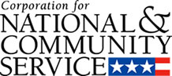

Corporation for National and Community Service

General Program Overview
AmeriCorps provides resources, both human and financial, to organizations that engage Americans in intensive service to meet our country’s critical needs.
Grantees use the funding to support AmeriCorps members for intensive service in their community. AmeriCorps grants partially cover the expense of operating an AmeriCorps program and do not cover general organizational expenses. A cash and in-kind match is required.

The main website can be accessed here: http://www.nationalservice.gov

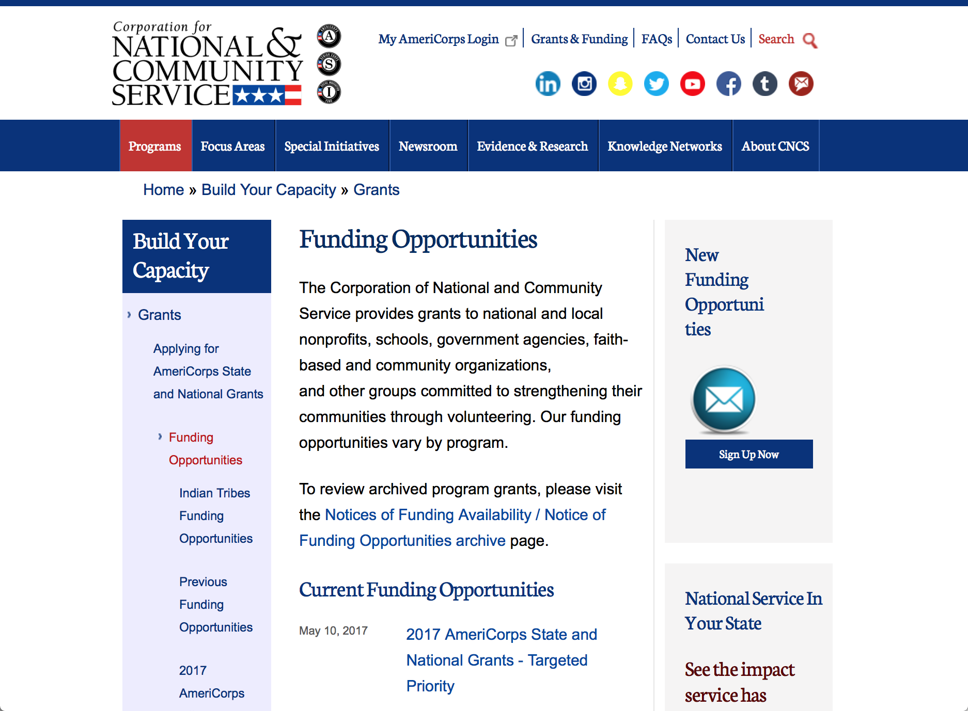

Current Funding Opportunities
There are no current funding opportunities.

For access to further funding information: click here

http://www.nationalservice.gov/build-your-capacity/grants/funding-opportunities

Programs:

Research:

Reminders:

AmeriCorps State and National Grants FY2018
Synopsis 1
Document Type: | Grants Notice
Funding Opportunity Number: | CNCS-08-24-17
Funding Opportunity Title: | AmeriCorps State and National Grants FY2018
Opportunity Category: | Discretionary
Opportunity Category Explanation:
Funding Instrument Type: | Grant
Category of Funding Activity: | Community Development  Disaster Prevention and Relief  Education  Employment, Labor and Training  Environment  Food and Nutrition  Health  Housing  Natural Resources
Category Explanation:
Expected Number of Awards:
CFDA Number(s): | 94.006 -- AmeriCorps
Cost Sharing or Matching Requirement: | Yes
Version: | Synopsis 1
Posted Date: | Aug 24, 2017
Last Updated Date: | Aug 24, 2017
Original Closing Date for Applications: | Jan 17, 2018
Current Closing Date for Applications: | Jan 17, 2018
Archive Date: | Jan 18, 2018
Eligible Applicants: | Private institutions of higher education  City or township governments  State governments  Nonprofits that do not have a 501(c)(3) status with the IRS, other than institutions of higher education  Nonprofits having a 501(c)(3) status with the IRS, other than institutions of higher education  Native American tribal organizations (other than Federally recognized tribal governments)  Public housing authorities/Indian housing authorities  Public and State controlled institutions of higher education  Native American tribal governments (Federally recognized)  County governments  Special district governments  Independent school districts
Additional Information on Eligibility:
Agency Name: | Corporation for National and Community Service
Description: | AmeriCorps grants are awarded to eligible organizations proposing to engage AmeriCorps members in evidence-based or evidence-informed interventions to strengthen communities. An AmeriCorps member is an individual who engages in community service through an approved national service position. Members may receive a living allowance and other benefits while serving. Upon successful completion of their service, members earn a Segal AmeriCorps Education Award from the National Service Trust that members can use to pay for higher education expenses or apply to qualified student loans.
Link to Additional Information: | Full competition information and resources.
Grantor Contact Information: | If you have difficulty accessing the full announcement electronically, please contact:  (202) 606-7508  Competition inbox

http://www.grants.gov/web/grants/view-opportunity.html?oppId=296773

National Service In Hawaii
National Service in Your State - Hawaii
2015-2016

Meeting Community Needs in Hawaii: More than 3,100 people of all ages and backgrounds are helping to meet local needs, strengthen communities, and increase civic engagement through national service in Hawaii. Serving at more than 450 locations throughout the state, these citizens tutor and mentor children, support veterans and military families, provide health services, restore the environment, respond to disasters, increase economic opportunity, and recruit and manage volunteers. This year, the Corporation for National and Community Service (CNCS) will commit more than $6,260,000 to support Hawaii communities through national service initiatives. Through a unique public-private partnership, this federal investment will leverage an additional $9,060,000 in other resources to strengthen community impact, build local support, and increase return on taxpayer dollars. Nationwide, CNCS, its grantees, and project sponsors generated more than $1.25 billion in outside resources from businesses, foundations, public agencies, and other sources in FY 2015.

AmeriCorps
This year, AmeriCorps will provide more than 560 individuals the opportunity to provide intensive, results-driven service to meet education, environmental, health, economic, and other pressing needs in communities across Hawaii. Most AmeriCorps grant funding goes to the Hawaii Commission on National & Community Service, which in turn awards grants to nonprofit groups to respond to local needs. Most of the remainder of the grant funding is distributed by CNCS directly to multi-state and national organizations through a competitive grants process. Other individuals serve through AmeriCorps VISTA, whose members help bring individuals and communities out of poverty by serving full-time to fight illiteracy, improve health services, create businesses, and increase housing opportunities, and AmeriCorps NCCC (National Civilian Community Corps), a 10-month, full time residential program for men and women between the ages of 18 and 24. In exchange for their service, AmeriCorps members earn an education award that can be used to pay for college or to pay back qualified student loans. Since 1994, more than 5,900 Hawaii residents have served more than 6.4 million hours and have qualified for Segal AmeriCorps Education Awards totaling more than $14,980,000.
Download: AmeriCorps in Hawaii (PDF)
Senior Corps
More than 2,500 seniors in Hawaii contribute their time and talents in one of three Senior Corps programs. Foster Grandparents serve one-on-one as tutors and mentors to more than 310 young people who have special needs. Senior Companions help more than 220 homebound seniors and other adults maintain independence in their own homes. RSVP volunteers conduct safety patrols, renovate homes, protect the environment, tutor and mentor youth, respond to natural disasters, and provide other services through more than 250 groups across Hawaii.
Download: Senior Corps in Hawaii (PDF)

The Corporation for National and Community Service is a federal agency that improves lives, strengthens communities, and fosters civic engagement through service and volunteering. CNCS annually engages more than five million Americans in service to meet local needs through Senior Corps, AmeriCorps, and national days of service; improves communities through the Social Innovation Fund, and leads President Obama's national call to service initiative, United We Serve. To learn more visit NationalService.gov or Serve.gov or call 202-606-5000 or TTY 1-800-833-3722.

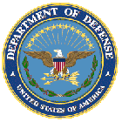

U.S. Department of Defense

Doing Business with the Department of Defense

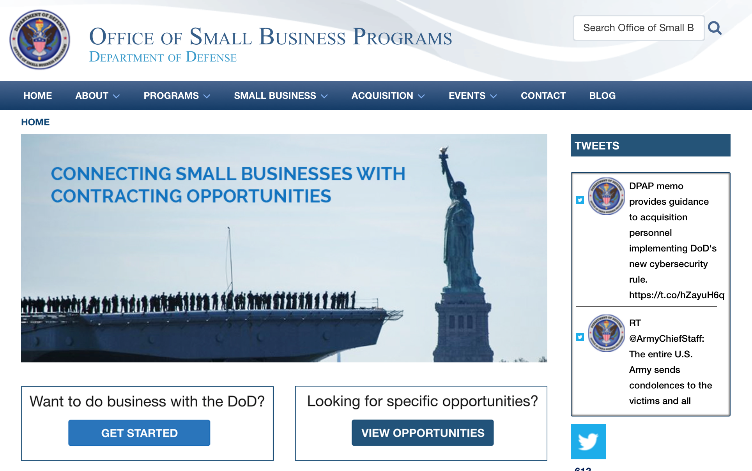

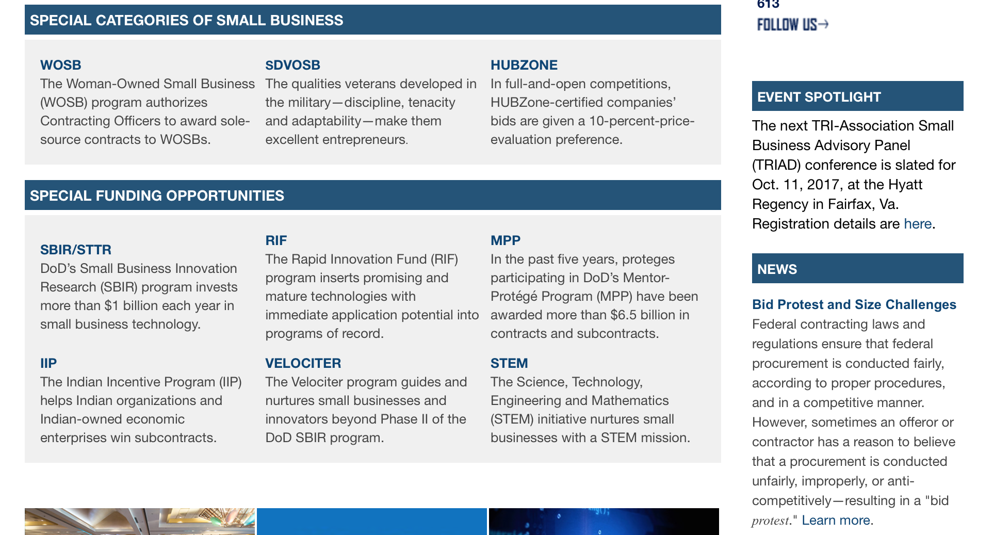

http://business.defense.gov

http://www.acq.osd.mil/osbp/

Doing Business with the DoD

Resources

Procurement Technical Assistance Centers (PTACs)

Procurement Technical Assistance Centers (PTACs) are charged with assisting businesses in learning how to do business with federal, state, and local governments. PTACs are a local resource available at no or nominal cost that can provide assistance to business firms in marketing their products and services. They offer training to businesses on how to research and bid on contracts, assist with registration requirements, provide bid-matching services, and assist with pre and post contracting issues.

Prime Contractors with Subcontracting Plans [xlsx]

Directory last updated 6/2017

This FY 2014 directory is intended for small business concerns seeking opportunities with DoD prime contractors. The directory is a listing of large business prime contractors who are required to establish subcontracting plans with goals. The report is generated from data contained in the Individual Subcontract Reports (ISRs) submitted in the Electronic Subcontracting Reporting System (eSRS) by contractors and from data contained in the Federal Procurement Data System (FPDS). The directory includes the name of the prime contractor; the major product/service code (PSC) provided to DoD; the major NAICS of the company; name, telephone number and email address of the company’s point of contact; contract number with the effective date and completion date, ultimate contract value and obligated dollars. In addition, many companies have websites with additional information which may be useful in your search for subcontracting opportunities or teaming arrangements.

Locate a Small Business Professional

Non-Appropriated Fund Customers

Non-appropriated fund customers operate similar to non-profit organizations and include commissaries, exchanges, recreation and fitness centers, dining at officer/enlisted/civilian clubs, and barber/beauty services, just to name a few.

For more information click here.

Research:

Air Force Office of Scientific Research
Department of Defense (DoD) Defense Enterprise Science Initiative (DESI)
Synopsis 1
https://www.grants.gov/web/grants/view-opportunity.html?oppId=299112

Air Force Office of Scientific Research (Research)
Research Interests of the Air Force Office of Scientific Research
Synopsis 1
http://www.grants.gov/web/grants/view-opportunity.html?oppId=298498

Air Force -- Research Lab
Methods and Technologies for Personalized Learning, Modeling and Assessment
Synopsis 2
http://www.grants.gov/web/grants/view-opportunity.html?oppId=271531

DARPA - Biological Technologies Office
Advanced Plant Technologies (APT)
Synopsis 1
https://www.grants.gov/web/grants/view-opportunity.html?oppId=298953

Dept. of the Army -- USAMRAA
DoD Accelerating Innovation in Military Medicine Research Award
Synopsis 1
https://www.grants.gov/web/grants/view-opportunity.html?oppId=298930

Office of Naval Research (Research)
FY18 Funding Opportunity Announcement (FOA) for the Office of Naval Research (ONR) Navy and Marine Corps Science, Technology, Engineering & Mathematics (STEM), Education and Workforce Program
Synopsis 1
http://www.grants.gov/web/grants/view-opportunity.html?oppId=298739

Uniformed Services Univ. of the Health Sciences
TriService Nursing Research Program "B Call"
Synopsis 1
https://www.grants.gov/web/grants/view-opportunity.html?oppId=299188

Modifications:

Air Force -- Research Lab (Research)
Methods and Technologies for Personalized Learning, Modeling and Assessment
Synopsis 2
http://www.grants.gov/web/grants/view-opportunity.html?oppId=271531

DARPA - Tactical Technology Office (Research)
OFFensive Swarm Enabled Tactics (OFFSET)
Synopsis 2
http://www.grants.gov/web/grants/view-opportunity.html?oppId=291825

DARPA - Defense Sciences Office
Nascent Light-Matter Interactions (NLM)
Synopsis 2
https://www.grants.gov/web/grants/view-opportunity.html?oppId=299131

Office of Naval Research (Research)
Office of Naval Research (ONR) Navy and Marine Corps Department of Defense University Research-to-Adoption (DURA) Initiative
Synopsis 2
http://www.grants.gov/web/grants/view-opportunity.html?oppId=298558

Deleted:

Reminders:



Department of Education
Grant Programs Overview at the Department of Education

The general information page for Education Grant funding is an excellent resource describing the three types of grants awarded by the Department of Education. See the screen shot of the Department of Education web page below:

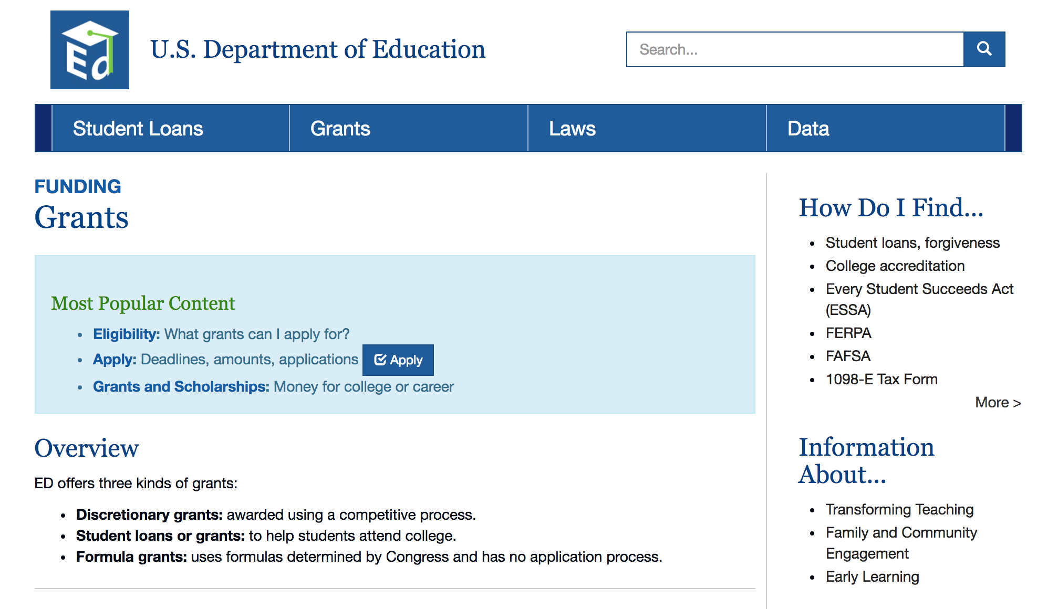
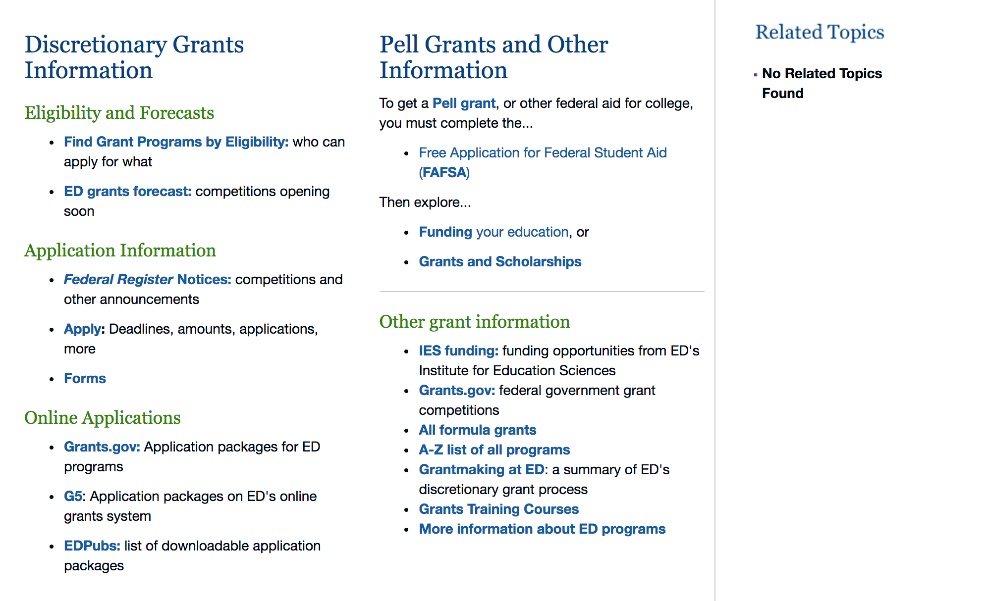

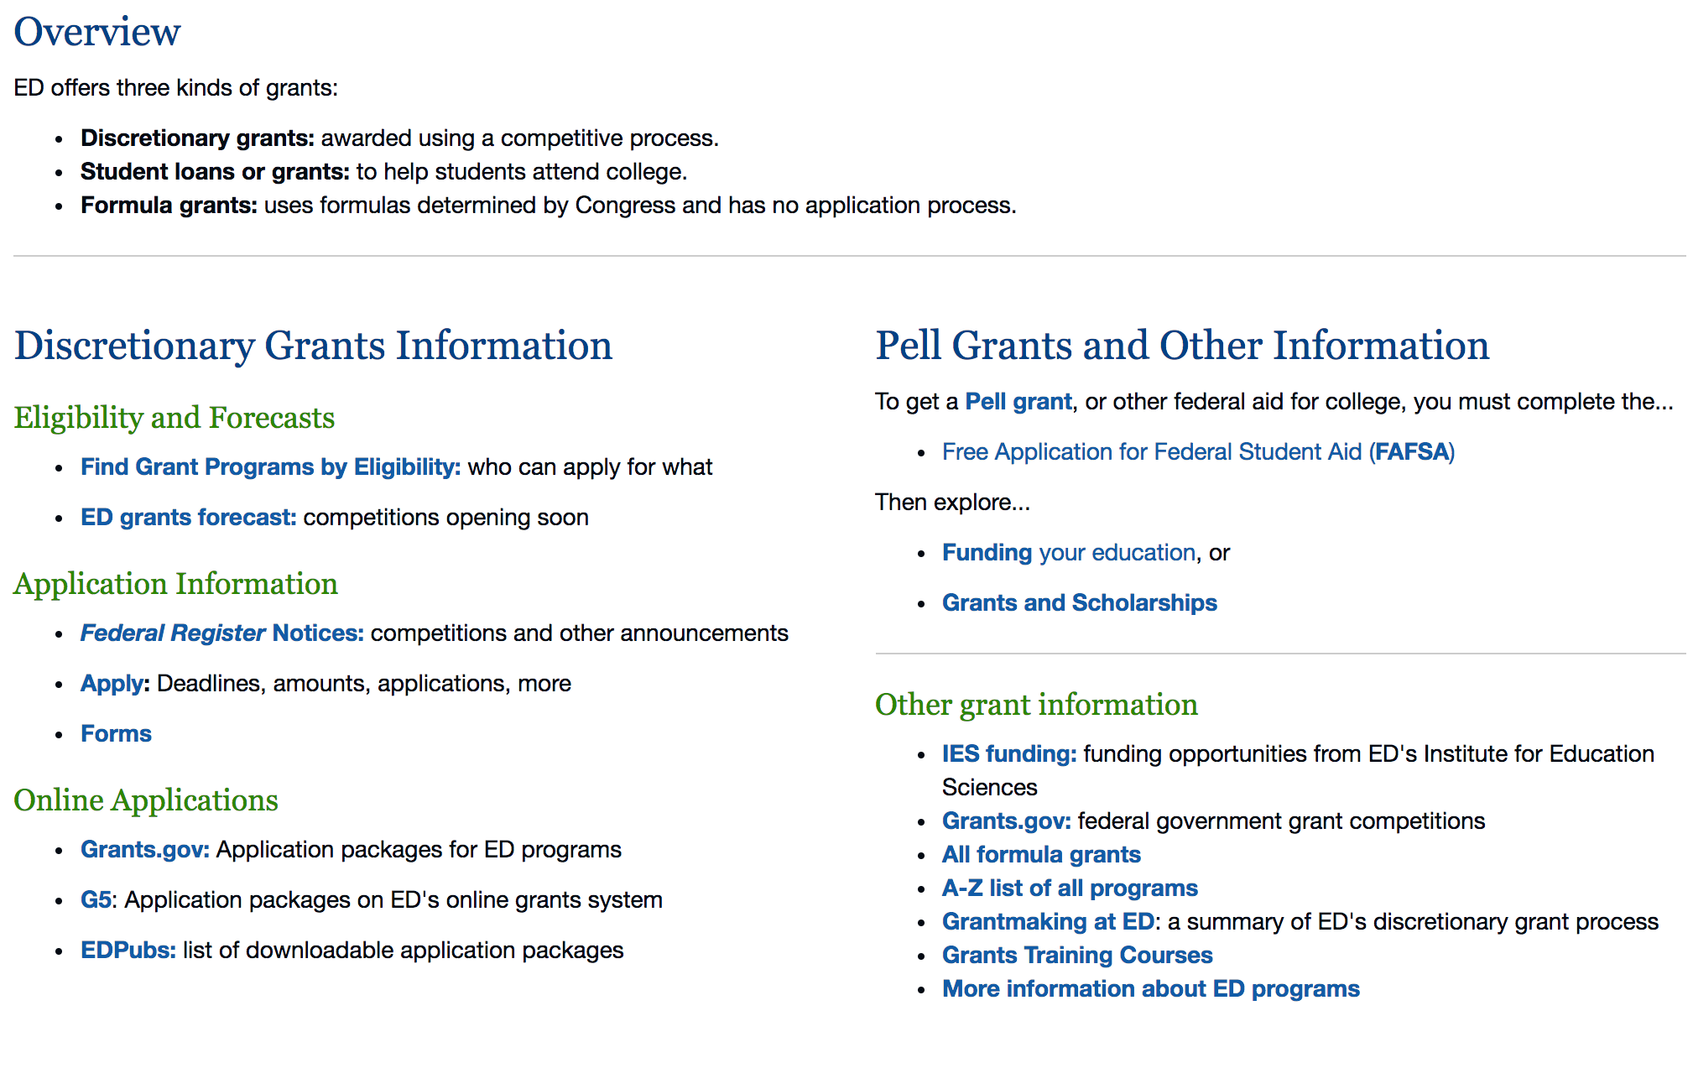

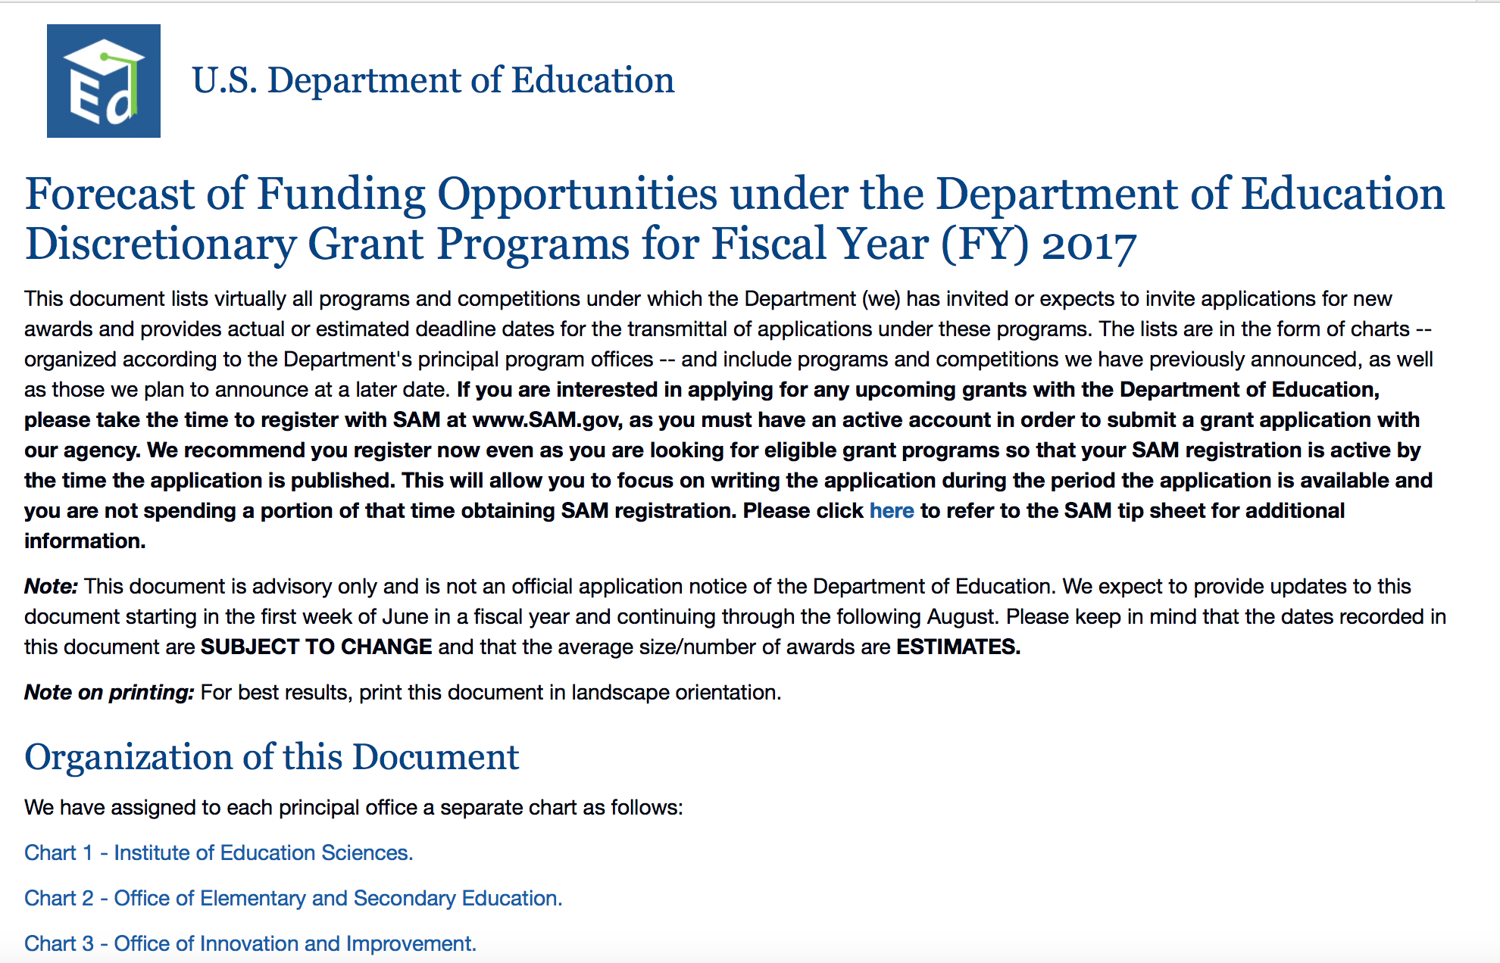
https://www2.ed.gov/fund/grants-apply.html?src=pn

https://www2.ed.gov/fund/grant/find/edlite-forecast.html

Programs:

Research:

Modifications:

Reminders:

Deleted:

U.S. Department of Energy

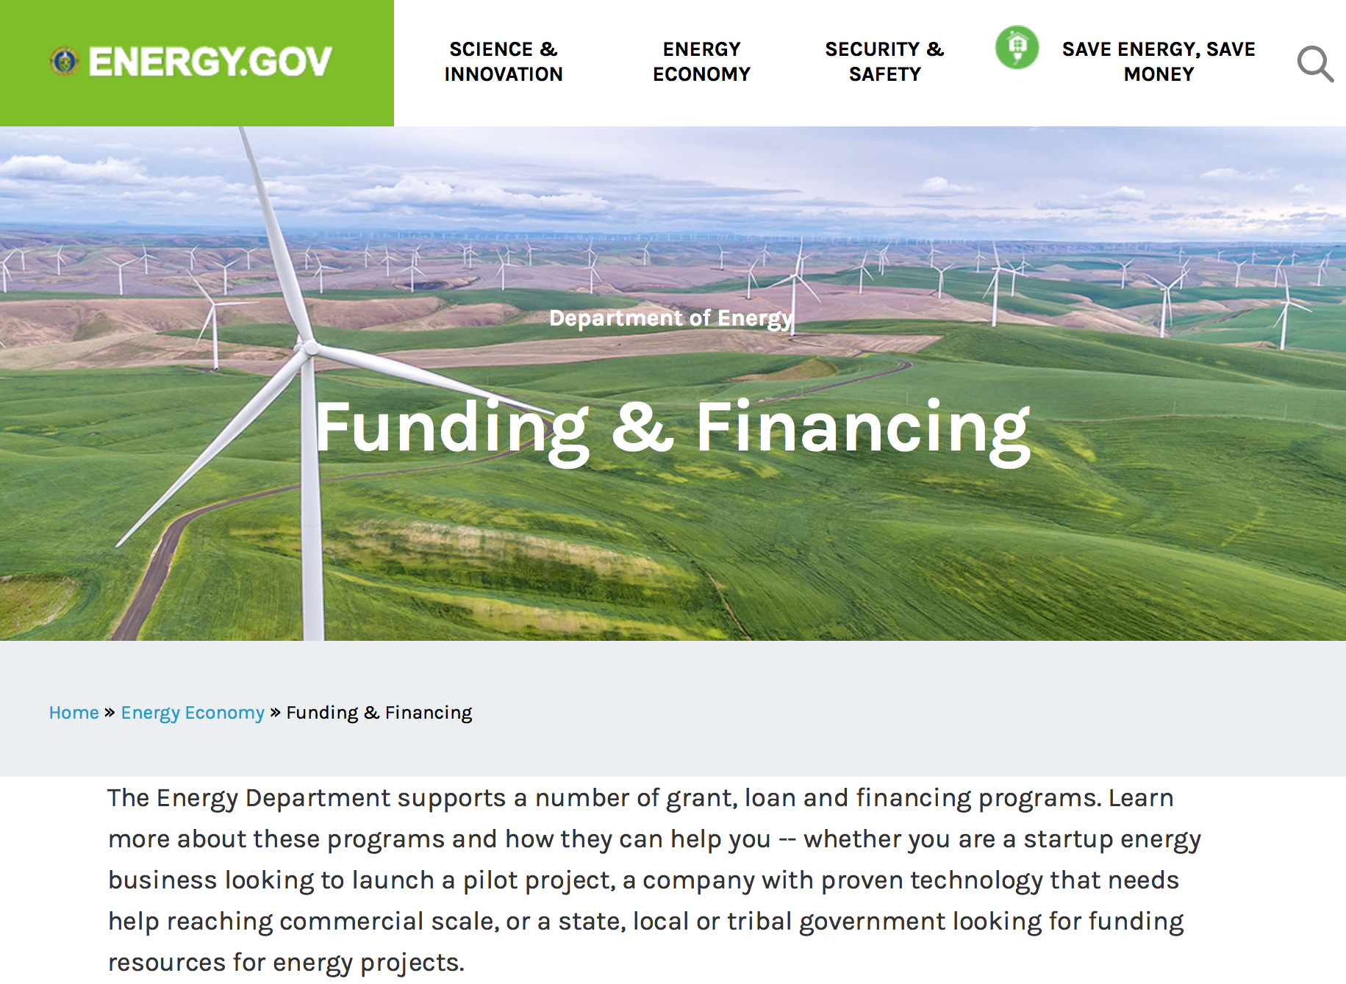

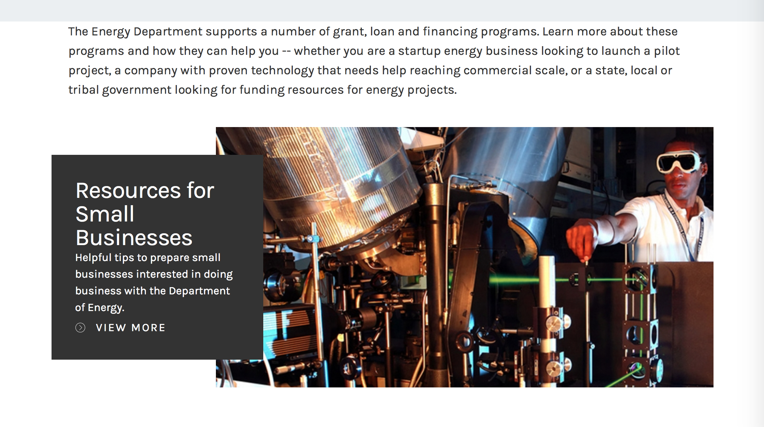

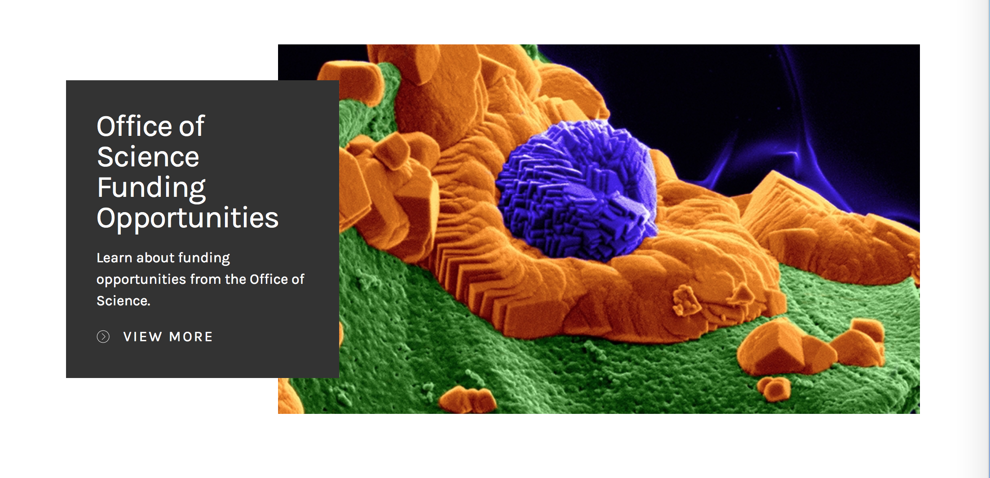

https://www.energy.gov/energy-economy/funding-financing

Research:

National Energy Technology Laboratory (Research)
Advanced Components for 65% Combined-Cycle Efficiency, SCO2 Power Cycles and Advanced Modular Hybrid Heat Engines
Synopsis 1
http://www.grants.gov/web/grants/view-opportunity.html?oppId=298755

National Energy Technology Laboratory
Research Needs Related to Developing Technologies for Advancement of Geologic Storage in Basinal Geo-laboratories
Synopsis 1
https://www.grants.gov/web/grants/view-opportunity.html?oppId=298927

Office of Science
Earth System Model Development and Analysis
Synopsis 1
https://www.grants.gov/web/grants/view-opportunity.html?oppId=299044
Office of Science (Research)
Environmental System Science
Synopsis 1
http://www.grants.gov/web/grants/view-opportunity.html?oppId=298742
Office of Science
FY 2018 Research and Development for Next Generation Nuclear Physics Accelerator Facilities
Synopsis 1
https://www.grants.gov/web/grants/view-opportunity.html?oppId=299187

Modifications:
National Energy Technology Laboratory
FY2017 Vehicle Technologies Office Batteries and Electrification to Enable Extreme Fast Charging Funding Opportunity Announcement
Synopsis 2
http://www.grants.gov/web/grants/view-opportunity.html?oppId=298059

Office of Science
Environmental System Science
Synopsis 1
http://www.grants.gov/web/grants/view-opportunity.html?oppId=298742

Office of Science (Research)
Atmospheric System Research
Synopsis 2
http://www.grants.gov/web/grants/view-opportunity.html?oppId=298743

Reminders:

Environmental Protection Agency

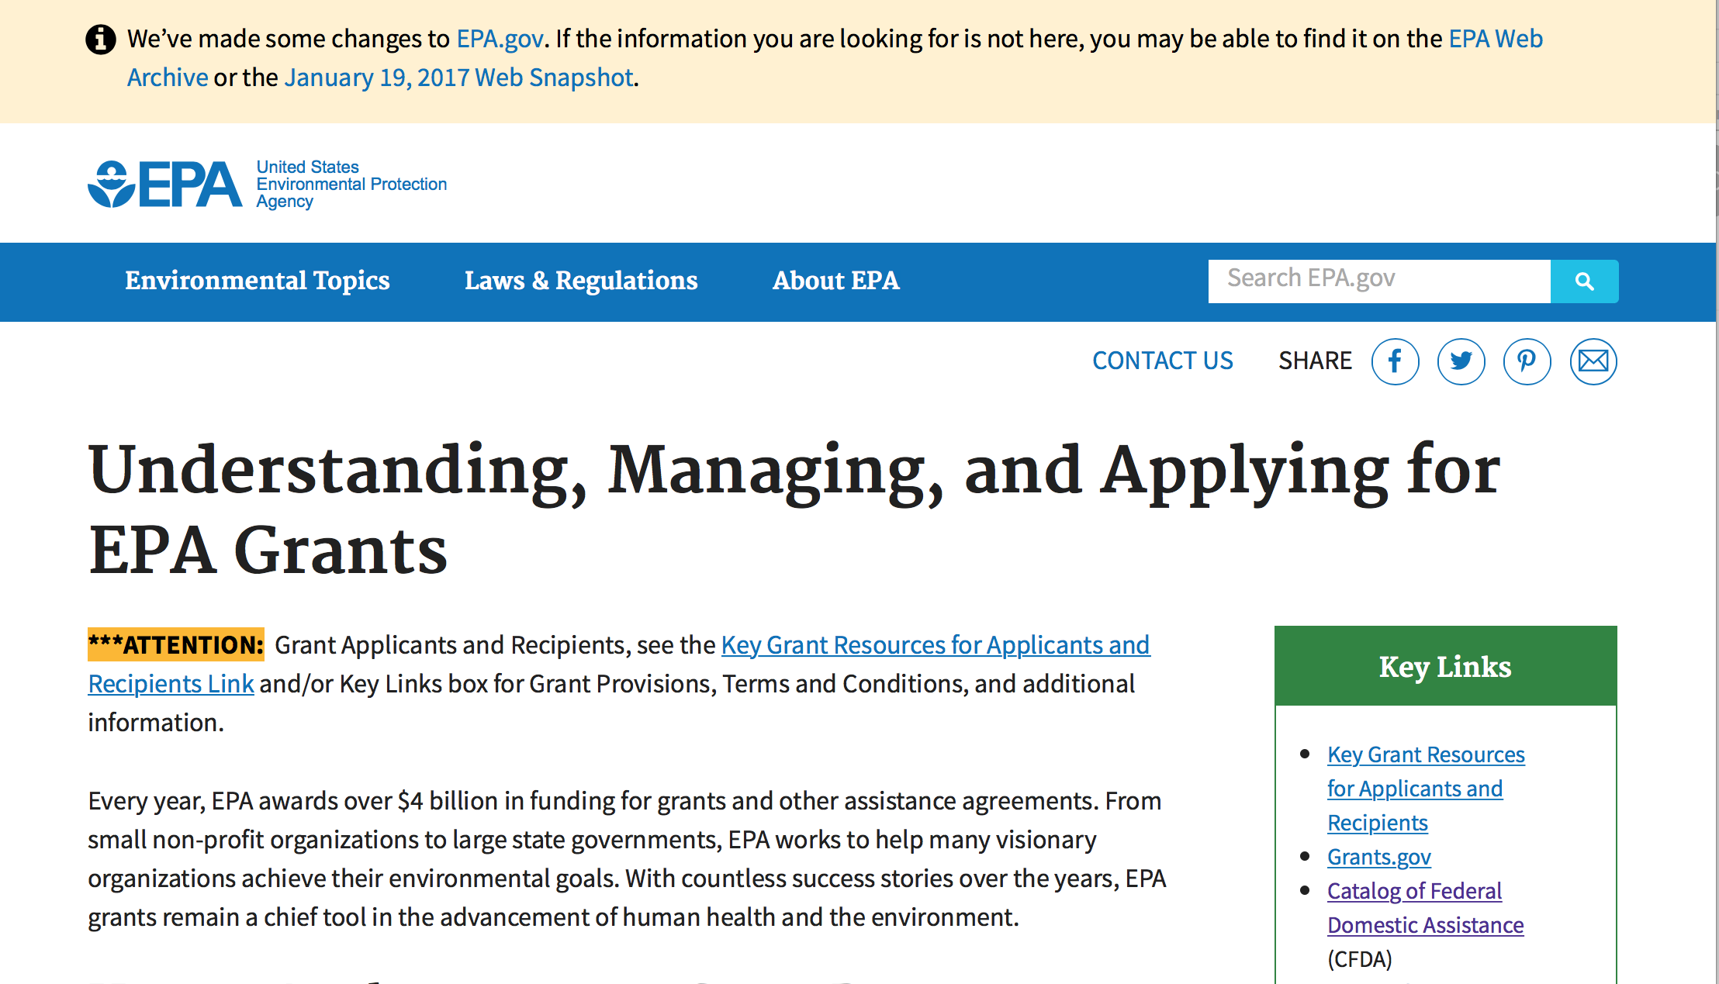
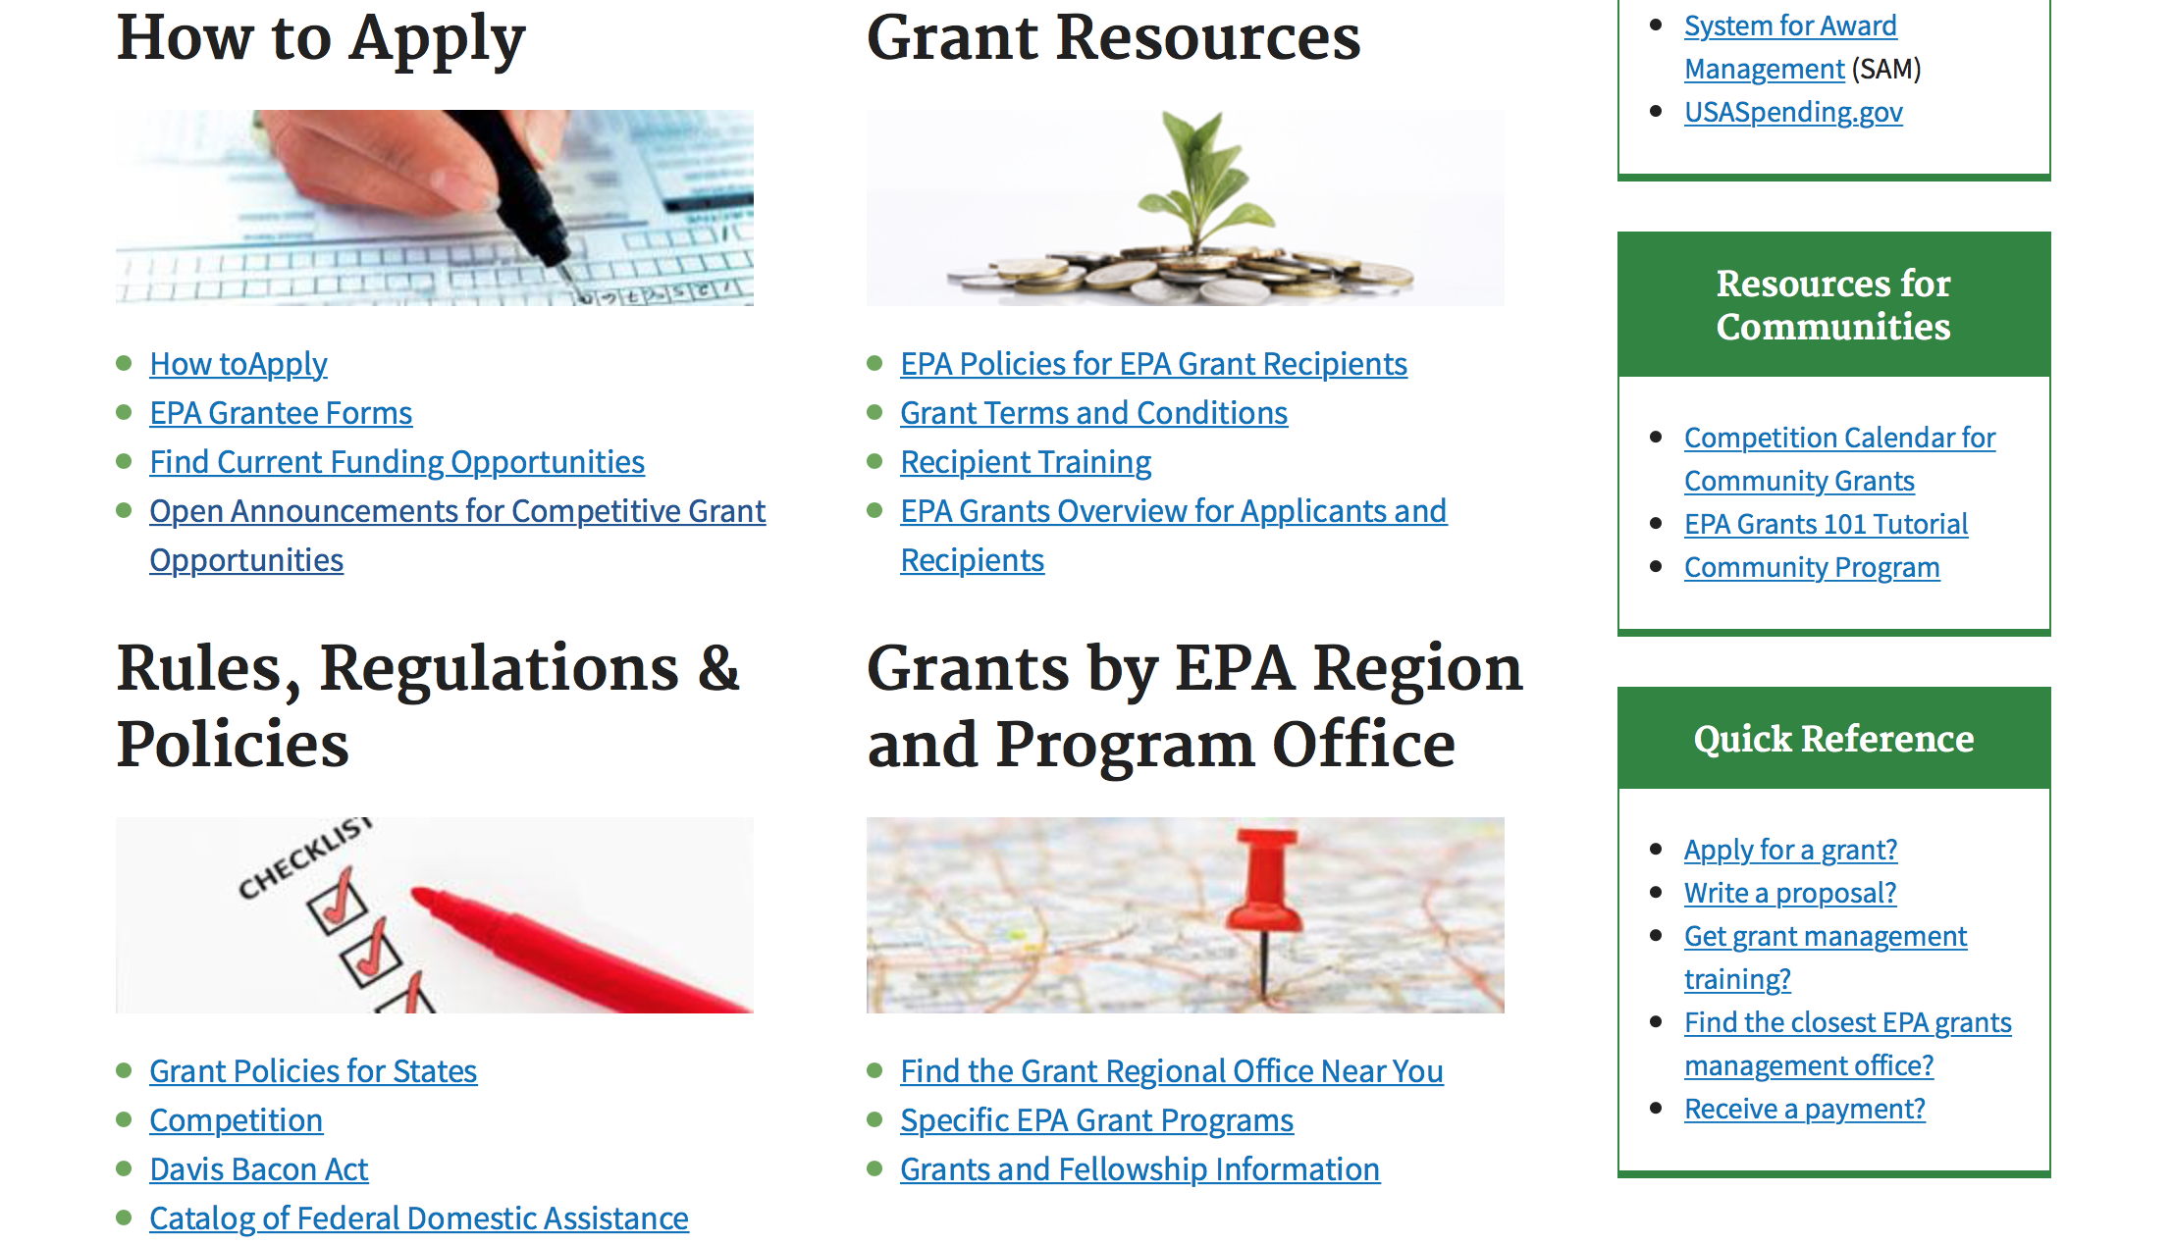

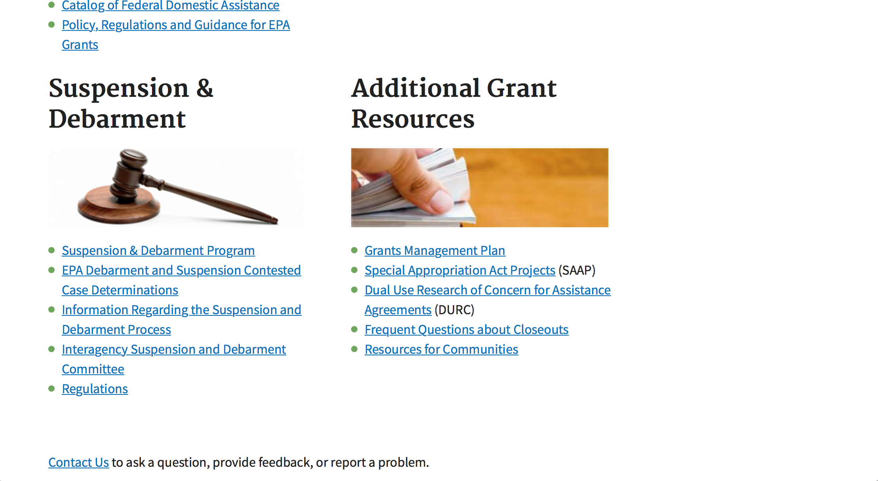

http://www.epa.gov/epahome/grants.htm

Programs:

Environmental Justice Collaborative Problem-Solving (EJCPS) Cooperative Agreement (Program)
Synopsis 1
Document Type: | Grants Notice
Funding Opportunity Number: | EPA-OP-OEJ-18-01
Funding Opportunity Title: | Environmental Justice Collaborative Problem-Solving (EJCPS) Cooperative Agreement
Opportunity Category: | Discretionary
Opportunity Category Explanation:
Funding Instrument Type: | Cooperative Agreement
Category of Funding Activity: | Environment
Category Explanation:
Expected Number of Awards: | 10
CFDA Number(s): | 66.306 -- Environmental Justice Collaborative Problem-Solving Cooperative Agreement Program
Cost Sharing or Matching Requirement: | No
Version: | Synopsis 1
Posted Date: | Nov 15, 2017
Last Updated Date: | Nov 15, 2017
Original Closing Date for Applications: | Feb 16, 2018 Please see the announcement for additional submission information.
Current Closing Date for Applications: | Feb 16, 2018 Please see the announcement for additional submission information.
Archive Date: | Mar 18, 2018
Estimated Total Program Funding: | $1,200,000
Award Ceiling: | $120,000
Award Floor: | $0
Eligible Applicants: | Others (see text field entitled "Additional Information on Eligibility" for clarification)
Additional Information on Eligibility: | Please see the announcement including Section III for additional eligibility information.
Agency Name: | Environmental Protection Agency
Description: | The Environmental Justice Collaborative Problem-Solving (EJCPS) Cooperative Agreement Program provides funding to support community-based organizations in their efforts to collaborate and partner with local stakeholder groups (e.g., local businesses and industry, local government, medical providers, and academia) as they develop and implement solutions that address environmental and/or public health issues for underserved communities. For purposes of this announcement, the term “underserved community” refers to a community with environmental justice concerns and/or vulnerable populations, including minority, low income, rural, tribal, and indigenous populations. Eligible projects must demonstrate use of the Environmental Justice Collaborative Problem-Solving Model to support their collaborative efforts during the project period. Applying organizations should have a direct connection to the underserved community impacted by the environmental harms and risks detailed in the workplan.
Link to Additional Information: | Environmental Justice Collaborative Problem-Solving (EJCPS) Cooperative Agreement
Grantor Contact Information: | If you have difficulty accessing the full announcement electronically, please contact:  Jacob Burney, 202-564-2907  Jacob Burney

http://www.grants.gov/web/grants/view-opportunity.html?oppId=298732

Research:

Modifications:
FY 2018 NATIONAL ENVIRONMENTAL INFORMATION EXCHANGE NETWORK GRANT PROGRAM
Synopsis 2
Document Type: | Grants Notice
Funding Opportunity Number: | EPA-OEI-18-01
Funding Opportunity Title: | FY 2018 NATIONAL ENVIRONMENTAL INFORMATION EXCHANGE NETWORK GRANT PROGRAM
Opportunity Category: | Discretionary
Opportunity Category Explanation:
Funding Instrument Type: | Cooperative Agreement  Grant
Category of Funding Activity: | Environment
Category Explanation:
Expected Number of Awards: | 25
CFDA Number(s): | 66.608 -- Environmental Information Exchange Network Grant Program and Related Assistance
Cost Sharing or Matching Requirement: | No
Version: | Synopsis 2
Posted Date: | Nov 16, 2017
Last Updated Date: | Nov 16, 2017
Original Closing Date for Applications: | Jan 26, 2018 Please refer to the announcement, including Section IV, for additional information on submission methods and due dates.
Current Closing Date for Applications: | Jan 26, 2018 Please refer to the announcement, including Section IV, for additional information on submission methods and due dates.
Archive Date: | Feb 25, 2018
Estimated Total Program Funding: | $6,000,000
Award Ceiling: | $400,000
Award Floor: | $50,000
Eligible Applicants: | Others (see text field entitled "Additional Information on Eligibility" for clarification)
Additional Information on Eligibility: | Please see Section III of the announcement for eligibility information.
Agency Name: | Environmental Protection Agency
Description: | The Exchange Network Grant Program provides funding for projects that develop the Network and enable timely, on-demand access to environmental data through innovative technologies, improved support systems, and expanded collaboration using shared tools and services.
Link to Additional Information: | FY 2018 National Environmental Information Exchange Network Grant Program
Grantor Contact Information: | If you have difficulty accessing the full announcement electronically, please contact:  Salena Reynolds, Phone: 202-566-0466  Salena Reynolds

http://www.grants.gov/web/grants/view-opportunity.html?oppId=298738

Reminders:

FY18 ENVIRONMENTAL WORKFORCE DEVELOPMENT AND JOB TRAINING (EWDJT) GRANTS
Synopsis 1
Document Type: | Grants Notice
Funding Opportunity Number: | EPA-OLEM-OBLR-17-10
Funding Opportunity Title: | FY18 ENVIRONMENTAL WORKFORCE DEVELOPMENT AND JOB TRAINING (EWDJT) GRANTS
Opportunity Category: | Discretionary
Opportunity Category Explanation:
Funding Instrument Type: | Cooperative Agreement
Category of Funding Activity: | Environment
Category Explanation:
Expected Number of Awards: | 16
CFDA Number(s): | 66.815 -- Environmental Workforce Development and Job Training Cooperative Agreements
Cost Sharing or Matching Requirement: | No
Version: | Synopsis 1
Posted Date: | Oct 17, 2017
Last Updated Date: | Oct 17, 2017
Current Closing Date for Applications: | Dec 15, 2017 See Section IV of the solicitation for additional close date information.
Archive Date: | Jan 14, 2018
Estimated Total Program Funding: | $3,000,000
Award Ceiling: | $200,000
Eligible Applicants: | Others (see text field entitled "Additional Information on Eligibility" for clarification)
Additional Information on Eligibility: | See Section III of the solicitation for eligibility information.
Agency Name: | Environmental Protection Agency
Description: | This notice announces the availability of funds and solicits proposals from eligible entities, including nonprofit organizations, to deliver Environmental Workforce Development and Job Training programs that recruit, train, and place local, unemployed and under-employed residents with the skills needed to secure full-time employment in the environmental field. Please note that eligible entities that received an EWDJT grant in Fiscal Year 2017 (FY17) are not eligible to apply for funding in FY18.
Link to Additional Information: | FY 2018 Environmental Workforce Development and Job Training (EWDJT) Grants
Grantor Contact Information: | If you have difficulty accessing the full announcement electronically, please contact:  Rachel Congdon 1200 Pennsylvania Ave. N.W. Mail Code: 5105T Washington, D.C. 20460 Phone: (202) 566-1564  congdon.rachel@epa.gov

http://www.grants.gov/web/grants/view-opportunity.html?oppId=298017

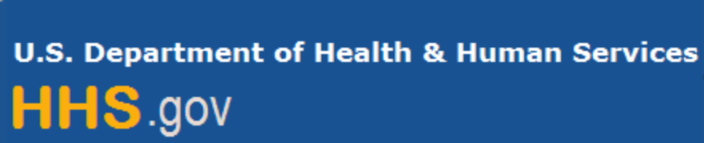

Department of Health and Human Services

Grants Forecast and Overview

The Department of Health and Human Services’ Grants Forecast is a database of planned grant opportunities proposed by its agencies. Each Forecast record contains actual or estimated dates and funding levels for grants that the agency intends to award during the fiscal year. Forecast opportunities are subject to change based on enactment of congressional appropriations.

For more general information about HHS Grants and Funding go to the website below at:

https://www.hhs.gov/grants/grants/index.html

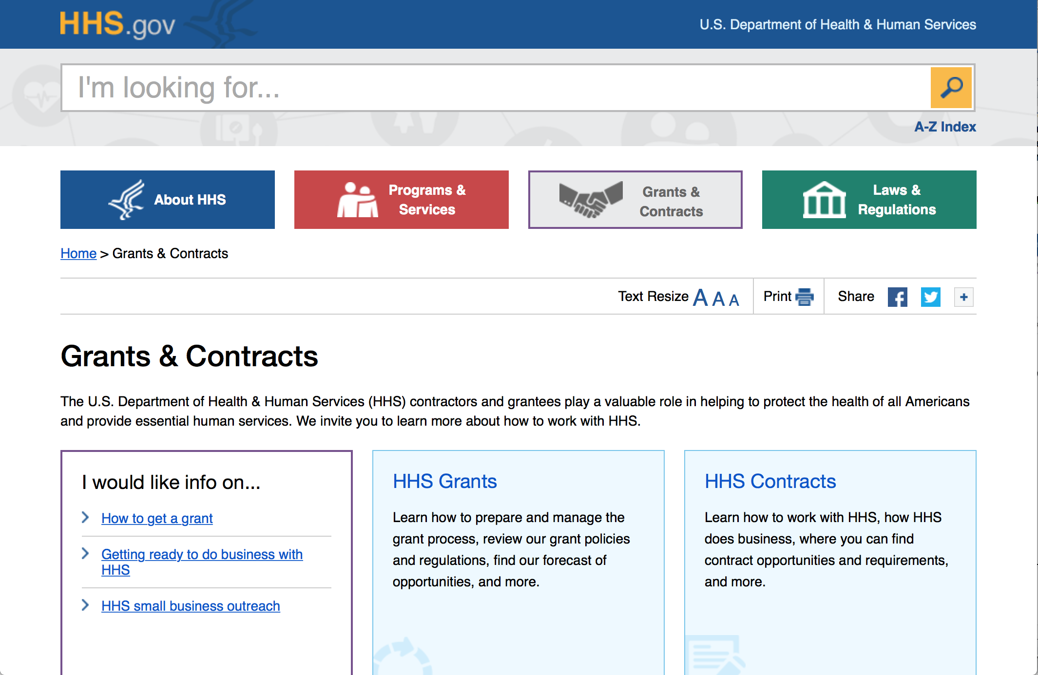

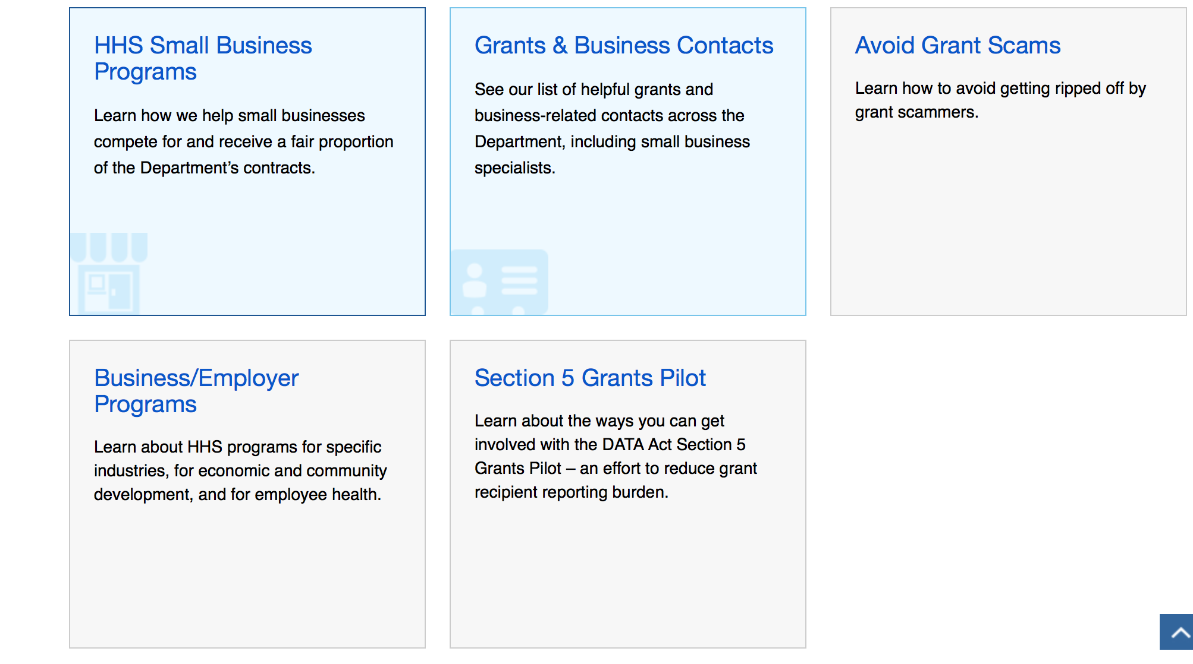

Programs:

Administration for Children and Families - ACYF/CB (Program)
Strengthening Child Welfare Systems to Achieve Expected Child and Family Outcomes
Forecast 1
Document Type: | Grants Notice
Opportunity Number: | HHS-2018-ACF-ACYF-CO-1360
Opportunity Title: | Strengthening Child Welfare Systems to Achieve Expected Child and Family Outcomes
Opportunity Category: | Discretionary
Opportunity Category Explanation:
Funding Instrument Type: | Cooperative Agreement
Category of Funding Activity: | Income Security and Social Services
Category Explanation:
Expected Number of Awards: | 5
CFDA Number(s): | 93.652 -- Adoption Opportunities
Cost Sharing or Matching Requirement: | No
Version: | Forecast 1
Posted Date: | Nov 07, 2017
Last Updated Date: | Nov 07, 2017
Estimated Synopsis Post Date: | Feb 07, 2018
Estimated Application Due Date: | Apr 08, 2018 Electronically submitted applications must be submitted no later than 11:59 p.m., ET, on the listed application due date.
Estimated Award Date: | Sep 29, 2018
Estimated Project Start Date: | Sep 30, 2018
Fiscal Year: | 2018
Archive Date:
Estimated Total Program Funding: | $8,750,000
Award Ceiling: | $1,750,000
Award Floor: | $1,000,000
Eligible Applicants: | County governments  State governments
Additional Information on Eligibility: | Courts are required partners. Partnerships with other public and private child and family serving agencies and organizations are encouraged. Applications from individuals (including sole proprietorships) and foreign entities are not eligible and will be disqualified from competitive review and from funding under this announcement.
Agency Name: | Administration for Children and Families - ACYF/CB
Description: | Child and Family Services Reviews have consistently found that many child welfare agencies are not achieving substantial conformity on permanency outcomes, including failure to make concerted efforts towards timely permanency for adoption and preserving family connections. Findings related to child and family outcomes, include, but are not limited to, lack of service provision, child and parent engagement in case planning, and child visitations; delays in establishing the goal of adoption; inadequate concurrent permanency goal planning; and lengthy appeal processes for contested termination of parental rights. These outcomes relate to basic social work practices that also have effects on the safety and well-being of children in care. The purpose of this funding opportunity is to award up to five 5-year cooperative agreements for the development, implementation, and evaluation of strategies that focus on improving basic social work practices, policies, and procedures in order to improve outcomes and eliminate systemic barriers to adoption and other forms of permanency. Due to the intersection of permanency, safety, and well-being, an effective system reform effort focused on improving concurrent planning and reducing time to permanency will also require attention to safety and well-being outcomes. Therefore, through these grant awards, the Children's Bureau (CB) aims to support states with resources to implement and sustain child welfare system improvement efforts, including technical assistance support, in order to assist grantees in strengthening outcomes related to permanency, safety, and well-being. Using Child and Family Services Review findings, as well as Program Improvement Plans, Child and Family Services Plans, and/or Annual Progress and Services Reports, applicants will identify barriers, challenges, and potential solutions to: ensuring child safety; enhanced engagement with and service delivery to children and families, including fathers; maintaining family relationships and connections; supporting placement of children in kinship care arrangements, preadoptive, or adoptive homes; and/or permanency planning and achievement. During the project period, grantees will address these barriers and challenges through the development, implementation, and evaluation of intervention strategies that focus on improving basic child welfare practices - including family-focused approaches - and systemic factors. Applicants will be required to partner with courts and other systems that are involved with state or county-level child welfare initiatives and must demonstrate buy-in from appropriate leadership.
Link to Additional Information:
Grantor Contact Information: | Serena L. Parks  (202) 205-8175  Serena.Parks@acf.hhs.gov
http://www.grants.gov/web/grants/view-opportunity.html?oppId=298470

Centers for Disease Control – NCTP (Program)
National Center for HIV/AIDS, Viral Hepatitis, Sexually Transmitted Diseases and Tuberculosis Prevention (NCTP) Public Health Conference Support
Forecast 1
http://www.grants.gov/web/grants/view-opportunity.html?oppId=298667

Health Resources and Services Administration (Program)
Nurse Education, Practice, Quality and Retention (NEPQR) – Registered Nurses in Primary Care (RNPC) Training Program
Synopsis 1
http://www.grants.gov/web/grants/view-opportunity.html?oppId=298592

Health Resources and Services Administration (Program)
Preventive Medicine Residency Program
Synopsis 1
http://www.grants.gov/web/grants/view-opportunity.html?oppId=298595
Health Resources and Services Administration (Program)
Primary Care Training and Enhancement: Training Primary Care Champions
Synopsis 1
http://www.grants.gov/web/grants/view-opportunity.html?oppId=298677
Health Resources and Services Administration (Program)
Regional Public Health Training Centers (PHTC) Program
Synopsis 1
http://www.grants.gov/web/grants/view-opportunity.html?oppId=298666

Research:

Administration for Community Living (Research)
Small Business Innovation Research Program (SBIR) Phase I
Forecast 1
http://www.grants.gov/web/grants/view-opportunity.html?oppId=298536
Administration for Community Living (Research)
Switzer Research Fellowships Program
Forecast 1
http://www.grants.gov/web/grants/view-opportunity.html?oppId=298653
Administration for Community Living (Research)
Small Business Innovation Research Program (SBIR) Phase I
Synopsis 1
http://www.grants.gov/web/grants/view-opportunity.html?oppId=298536
Centers for Disease Control and Prevention – ERA (Research)
Health Promotion and Disease Prevention Research Centers: Special Interest Project Competitive Supplements (SIPS)
Forecast 1
http://www.grants.gov/web/grants/view-opportunity.html?oppId=298669
Centers for Disease Control – OSTLTS (Program)
Technical Assistance for Response to Public Health or Healthcare Crises
Forecast 1
http://www.grants.gov/web/grants/view-opportunity.html?oppId=298696
Health Resources and Services Administration (Research)
R40 Maternal and Child Health (MCH) Secondary Data Analysis Research (SDAR) Program
Synopsis 1
http://www.grants.gov/web/grants/view-opportunity.html?oppId=295206
National Institutes of Health (Research)
Innovative Questions in Symptom Science and Genomics (R01 Clinical Trial Optional)
Synopsis 1
http://www.grants.gov/web/grants/view-opportunity.html?oppId=298457
National Institutes of Health (Research)
Mechanisms, Models, Measurement, and Management in Pain Research (R01 Clinical Trial Optional)
Synopsis 1
http://www.grants.gov/web/grants/view-opportunity.html?oppId=298458

National Institutes of Health (Research)
Bioengineering Research Grants (BRG) (R01 Clinical Trial Optional)
Synopsis 1
http://www.grants.gov/web/grants/view-opportunity.html?oppId=298460
National Institutes of Health (Research)
Addressing Unmet Needs in Persons with Dementia to Decrease Behavioral Symptoms and Improve Quality of Life (R01 Clinical Trial Optional)
Synopsis 1
http://www.grants.gov/web/grants/view-opportunity.html?oppId=298461
National Institutes of Health (Research)
Improving Individual and Family Outcomes through Continuity and Coordination of Care in Hospice (R01 Clinical Trial Optional)
Synopsis 1
http://www.grants.gov/web/grants/view-opportunity.html?oppId=298462
National Institutes of Health (Research)
Personalized Strategies to Manage Symptoms of Chronic Illness (R21 Clinical Trial Optional)
Synopsis 1
http://www.grants.gov/web/grants/view-opportunity.html?oppId=298463
National Institutes of Health (Research)
Mechanisms, Models, Measurement, and Management in Pain Research (R21 Clinical Trial Optional)
Synopsis 1
http://www.grants.gov/web/grants/view-opportunity.html?oppId=298464
Substance Abuse and Mental Health Services Adminis (Program)
Collegiate Behavioral Health Prevention, Identification, and Intervention Grant Program
Forecast 1
http://www.grants.gov/web/grants/view-opportunity.html?oppId=298747
National Institutes of Health (Research)
Environmental Exposures and Health: Exploration of Non-Traditional Settings (R21 Clinical Trial Optional)
Synopsis 1
http://www.grants.gov/web/grants/view-opportunity.html?oppId=298465
National Institutes of Health (Research)
Symptom Management in HIV-Infected Individuals with Comorbid Conditions (R21 Clinical Trial Optional)
Synopsis 1
http://www.grants.gov/web/grants/view-opportunity.html?oppId=298466
National Institutes of Health (Research)
Health Promotion Among Racial and Ethnic Minority Males (R21 Clinical Trial Optional)
Synopsis 1
http://www.grants.gov/web/grants/view-opportunity.html?oppId=298467
National Institutes of Health (Research)
Use of Technology to Enhance Patient Outcomes and Prevent Illness (R21 Clinical Trial Optional)
Synopsis 1
http://www.grants.gov/web/grants/view-opportunity.html?oppId=298468
National Institutes of Health (Research)
Addressing Unmet Needs in Persons with Dementia to Decrease Behavioral Symptoms and Improve Quality of Life (R21 Clinical Trial Optional)
Synopsis 1
http://www.grants.gov/web/grants/view-opportunity.html?oppId=298469
National Institutes of Health (Research)
Personalized Strategies to Manage Symptoms of Chronic Illness (R01 Clinical Trial Optional)
Synopsis 1
http://www.grants.gov/web/grants/view-opportunity.html?oppId=298471
National Institutes of Health (Research)
Environmental Exposures and Health: Exploration of Non-Traditional Settings (R01 Clinical Trial Optional)
Synopsis 1
http://www.grants.gov/web/grants/view-opportunity.html?oppId=298473
National Institutes of Health (Research)
Symptom Management in HIV-Infected Individuals with Comorbid Conditions (R01 Clinical Trial Optional)
Synopsis 1
http://www.grants.gov/web/grants/view-opportunity.html?oppId=298474

National Institutes of Health (Research)
Health Promotion Among Racial and Ethnic Minority Males (R01 Clinical Trial Optional)
Synopsis 1
http://www.grants.gov/web/grants/view-opportunity.html?oppId=298476
National Institutes of Health (Research)
Use of Technology to Enhance Patient Outcomes and Prevent Illness (R01 Clinical Trial Optional)
Synopsis 1
http://www.grants.gov/web/grants/view-opportunity.html?oppId=298477

National Institutes of Health (Research)
Self-Management Interventions and Technologies to Sustain Health and Optimize Functional Capabilities (R01 Clinical Trial Optional)
Synopsis 1
http://www.grants.gov/web/grants/view-opportunity.html?oppId=298479
National Institutes of Health (Research)
Palliative Care Needs of Individuals with Advanced Rare Diseases and Their Family Caregivers (R01 Clinical Trial Optional)
Synopsis 1
http://www.grants.gov/web/grants/view-opportunity.html?oppId=298480
National Institutes of Health (Research)
Innovative Questions in Symptom Science and Genomics (R21 Clinical Trial Optional)
Synopsis 1
http://www.grants.gov/web/grants/view-opportunity.html?oppId=298481
National Institutes of Health (Research)
Self-Management Interventions and Technologies to Sustain Health and Optimize Functional Capabilities (R21 Clinical Trial Optional)
Synopsis 1
http://www.grants.gov/web/grants/view-opportunity.html?oppId=298482
National Institutes of Health (Research)
NIMH Exploratory/Developmental Research Grant (R21 - Clinical Trial Not Allowed)
Synopsis 1
http://www.grants.gov/web/grants/view-opportunity.html?oppId=298484
National Institutes of Health (Research)
Altered neuronal circuits, receptors and networks in HIV-induced Central Nervous System (CNS) dysfunction (R21- Clinical Trial Not Allowed)
Synopsis 1
http://www.grants.gov/web/grants/view-opportunity.html?oppId=298486

National Institutes of Health (Research)
Improving Individual and Family Outcomes through Continuity and Coordination of Care in Hospice (R21 Clinical Trial Optional)
Synopsis 1
http://www.grants.gov/web/grants/view-opportunity.html?oppId=298491
National Institutes of Health (Research)
Palliative Care Needs of Individuals with Rare Advanced Diseases and Their Family Caregivers (R21 Clinical Trial Optional)
Synopsis 1
http://www.grants.gov/web/grants/view-opportunity.html?oppId=298492
National Institutes of Health (Research)
Bioengineering Research Partnerships (U01 Clinical Trial Optional)
Synopsis 1
http://www.grants.gov/web/grants/view-opportunity.html?oppId=298493
National Institutes of Health (Research)
Short-term Mentored Career Enhancement Awards for Mid-Career Investigators to Integrate Basic Behavioral and Social Sciences (K18 - No Independent Clinical Trials)
Synopsis 1
http://www.grants.gov/web/grants/view-opportunity.html?oppId=298496
National Institutes of Health (Research)
Altered neuronal circuits, receptors and networks in HIV-induced Central Nervous System (CNS) dysfunction (R01)-Clinical Trial Not Allowed
Synopsis 1
http://www.grants.gov/web/grants/view-opportunity.html?oppId=298497
National Institutes of Health (Research)
BRAIN Initiative Fellows: Ruth L. Kirschstein National Research Service Award (NRSA) Individual Postdoctoral Fellowship (F32)
Synopsis 1
http://www.grants.gov/web/grants/view-opportunity.html?oppId=298499
National Institutes of Health (Research)
Environmental Health Sciences Core Centers (EHS CC) (P30 Clinical Trial Optional)
Synopsis 1
http://www.grants.gov/web/grants/view-opportunity.html?oppId=298500
National Institutes of Health (Research)
Linking the Provider Recommendation to Adolescent HPV Vaccine Uptake (R01 Clinical Trial Optional)
Synopsis 1
http://www.grants.gov/web/grants/view-opportunity.html?oppId=298509
National Institutes of Health (Research)
Metabolic Contributions to the Neurocognitive Complications of Diabetes: Ancillary Studies (R01 Clinical Trial Optional)
Synopsis 1
http://www.grants.gov/web/grants/view-opportunity.html?oppId=298510

National Institutes of Health (Research)
Linking the Provider Recommendation to Adolescent HPV Vaccine Uptake (R21 Clinical Trial Optional)
Synopsis 1
http://www.grants.gov/web/grants/view-opportunity.html?oppId=298533
National Institutes of Health (Research)
Transition to Independent Environmental Health Research (TIEHR) Career Transition Award (K01 Clinical Trial Required)
Synopsis 1
http://www.grants.gov/web/grants/view-opportunity.html?oppId=298540
National Institutes of Health (Research)
Transition to Independent Environmental Health Research (TIEHR) Career Transition Award (K01 Clinical Trial Not Allowed)
Synopsis 1
http://www.grants.gov/web/grants/view-opportunity.html?oppId=298541
National Institutes of Health (Research)
Selected Topics in Transfusion Medicine (R01 Clinical Trial Optional)
Synopsis 1
http://www.grants.gov/web/grants/view-opportunity.html?oppId=298542
National Institutes of Health (Research)
Promoting Caregiver Health Using Self-Management (R01 Clinical Trial Optional)
Synopsis 1
http://www.grants.gov/web/grants/view-opportunity.html?oppId=298543
National Institutes of Health (Research)
Chronic Condition Self-Management in Children and Adolescents (R01 Clinical Trial Optional)
Synopsis 1
http://www.grants.gov/web/grants/view-opportunity.html?oppId=298544
National Institutes of Health (Research)
Reducing Health Disparities Among Minority and Underserved Children (R01 Clinical Trial Optional)
Synopsis 1
http://www.grants.gov/web/grants/view-opportunity.html?oppId=298545
National Institutes of Health (Research)
Chronic Condition Self-Management in Children and Adolescents (R21 Clinical Trial Optional)
Synopsis 1
http://www.grants.gov/web/grants/view-opportunity.html?oppId=298546
National Institutes of Health (Research)
Reducing Health Disparities Among Minority and Underserved Children (R21 Clinical Trial Optional)
Synopsis 1
http://www.grants.gov/web/grants/view-opportunity.html?oppId=298547
National Institutes of Health (Research)
Mechanism for Time-Sensitive Drug Abuse Research (R21 Clinical Trial Optional)
Synopsis 1
http://www.grants.gov/web/grants/view-opportunity.html?oppId=298553
National Institutes of Health (Research)
Alzheimer's Drug-Development Program (U01 Clinical Trial Optional)
Synopsis 1
http://www.grants.gov/web/grants/view-opportunity.html?oppId=298554
National Institutes of Health (Research)
Selected Topics in Transfusion Medicine (R21 Clinical Trial Optional)
Synopsis 1
http://www.grants.gov/web/grants/view-opportunity.html?oppId=298555
National Institutes of Health (Research)
Translational Neural Devices (UG3/UH3 - Clinical Trial Required)
Synopsis 1
http://www.grants.gov/web/grants/view-opportunity.html?oppId=298556
National Institutes of Health (Research)
Translational Neural Devices (U44 - Clinical Trial Required)
Synopsis 1
http://www.grants.gov/web/grants/view-opportunity.html?oppId=298561

National Institutes of Health (Research)
Human Subjects Mechanistic and Minimal Risk Studies (R01 Clinical Trial Optional)
Synopsis 1
http://www.grants.gov/web/grants/view-opportunity.html?oppId=298571
National Institutes of Health (Research)
Mentored Career Development Award to Promote Faculty Diversity in Biomedical Research (K01) (Clinical Trial Required)
Synopsis 1
http://www.grants.gov/web/grants/view-opportunity.html?oppId=298569

National Institutes of Health (Research)
Studies of HIV in Digestive Diseases Limited to Gastrointestinal Mucosal Immunology and Liver Diseases (R01- Clinical Trial Optional)
Synopsis 1
http://www.grants.gov/web/grants/view-opportunity.html?oppId=298573
National Institutes of Health (Research)
Exploratory/Developmental Bioengineering Research Grants (EBRG) (R21 Clinical Trial Optional)
Synopsis 1
http://www.grants.gov/web/grants/view-opportunity.html?oppId=298654

National Institutes of Health (Research)
NIDCD Clinical Trials in Communication Disorders (R01-Clinical Trial Required)
Synopsis 1
http://www.grants.gov/web/grants/view-opportunity.html?oppId=298658
National Institutes of Health (Research)
Pathogenesis of Age-Related HIV Neurodegeneration (R01 Clinical Trial Not Allowed)
Synopsis 1
http://www.grants.gov/web/grants/view-opportunity.html?oppId=298660
National Institutes of Health (Research)
NINDS Research Education Programs for Residents and Fellows in Neurological Disorders and Stroke (R25 - Clinical Trial Not Allowed)
Synopsis 1
http://www.grants.gov/web/grants/view-opportunity.html?oppId=298671

National Institutes of Health (Research)
NIDCD Cooperative Agreement for Clinical Trials in Communication Disorders (U01-Clinical Trial Required)
Synopsis 1
http://www.grants.gov/web/grants/view-opportunity.html?oppId=298674

National Institutes of Health (Research)
Clinical Trials to Test the Effectiveness of Treatment, Preventive, and Services Interventions (R01- Clinical Trial Required)
Synopsis 1
http://www.grants.gov/web/grants/view-opportunity.html?oppId=298663

National Institutes of Health (Research)
Confirmatory Efficacy Clinical Trials of Non-Pharmacological Interventions for Mental Disorders (R01- Clinical Trial Required)
Synopsis 1
http://www.grants.gov/web/grants/view-opportunity.html?oppId=298665
National Institutes of Health (Research)
Early Stage Testing of Pharmacologic or Device -based Interventions for the Treatment of Mental Health Disorders (R33- Clinical Trial Required)
Synopsis 1
http://www.grants.gov/web/grants/view-opportunity.html?oppId=298668

National Institutes of Health (Research)
Development of Psychosocial Therapeutic and Preventive Interventions for Mental Disorders (R33- Clinical Trial Required)
Synopsis 1
http://www.grants.gov/web/grants/view-opportunity.html?oppId=298680
National Institutes of Health (Research)
Development of Psychosocial Therapeutic and Preventive Interventions for Mental Disorders (R61/R33- Clinical Trial Required)
Synopsis 1
http://www.grants.gov/web/grants/view-opportunity.html?oppId=298681
National Institutes of Health (Research)
Pilot Effectiveness Trials for Treatment, Preventive and Services Interventions (R34- Clinical Trial Required)
Synopsis 1
http://www.grants.gov/web/grants/view-opportunity.html?oppId=298683
National Institutes of Health (Research)
Early Stage Testing of Pharmacologic or Device-based Interventions for the Treatment of Mental Disorders (R61/R33-Clinical Trial Required)
Synopsis 1
http://www.grants.gov/web/grants/view-opportunity.html?oppId=298684
National Institutes of Health (Research)
Clinical Trials to Test the Effectiveness of Treatment, Preventive, and Services Interventions (Collaborative R01-Clinical Trial Required)
Synopsis 1
http://www.grants.gov/web/grants/view-opportunity.html?oppId=298685
National Institutes of Health (Research)
The NCI Predoctoral to Postdoctoral Fellow Transition Award (F99/K00)
Synopsis 1
http://www.grants.gov/web/grants/view-opportunity.html?oppId=298691
National Institutes of Health (Research)
Fertility Status as a Marker for Overall Health (R21 Clinical Trial Optional)
Synopsis 1
http://www.grants.gov/web/grants/view-opportunity.html?oppId=298690
National Institutes of Health (Research)
Trophoblast Differentiation and Function (R21 Clinical Trial Optional)
Synopsis 1
http://www.grants.gov/web/grants/view-opportunity.html?oppId=298698

National Institutes of Health (Research)
Zika Virus (ZIKV) Complications (R21 Clinical Trial Optional)
Synopsis 1
http://www.grants.gov/web/grants/view-opportunity.html?oppId=298699
National Institutes of Health (Research)
Secondary Analyses in Obesity, Diabetes and Digestive and Kidney Diseases (R21 Clinical Trial Optional)
Synopsis 1
http://www.grants.gov/web/grants/view-opportunity.html?oppId=298700
National Institutes of Health (Research)
International Research Collaboration on Drug Abuse and Addiction Research (R03 Clinical Trial Optional)
Synopsis 1
http://www.grants.gov/web/grants/view-opportunity.html?oppId=298701
National Institutes of Health (Research)
Pilot and Feasibility Studies in Preparation for Drug and Alcohol Abuse Prevention Trials (R34 Clinical Trial Optional)
Synopsis 1
http://www.grants.gov/web/grants/view-opportunity.html?oppId=298702
National Institutes of Health (Research)
Development and Testing of Novel Interventions to Improve HIV Prevention, Care, and Program Implementation (R34 Clinical Trial Optional)
Synopsis 1
http://www.grants.gov/web/grants/view-opportunity.html?oppId=298703
National Institutes of Health (Research)
AIDS-Science Track Award for Research Transition (R03 Clinical Trial Optional)
Synopsis 1
http://www.grants.gov/web/grants/view-opportunity.html?oppId=298704
National Institutes of Health (Research)
Oocyte Mitochondrial Function in Relation to Fertility, Aging, and Mitochondrial Diseases (R21 Clinical Trial Optional)
Synopsis 1
http://www.grants.gov/web/grants/view-opportunity.html?oppId=298705
National Institutes of Health (Research)
Stimulating Innovations in Behavioral Intervention Research for Cancer Prevention and Control (R21 Clinical Trial Optional)
Synopsis 1
http://www.grants.gov/web/grants/view-opportunity.html?oppId=298707
National Institutes of Health (Research)
Pilot and Feasibility Clinical Research Grants in Kidney Diseases (R21 Clinical Trial Optional)
Synopsis 1
http://www.grants.gov/web/grants/view-opportunity.html?oppId=298708
National Institutes of Health (Research)
NINDS Exploratory Neuroscience Research Grant (R21 Clinical Trial Optional)
Synopsis 1
http://www.grants.gov/web/grants/view-opportunity.html?oppId=298709
National Institutes of Health (Research)
International Research Collaboration on Drug Abuse and Addiction Research (R21 Clinical Trial Optional)
Synopsis 1
http://www.grants.gov/web/grants/view-opportunity.html?oppId=298711
National Institutes of Health (Research)
Pilot Health Services and Economic Research on the Treatment of Drug, Alcohol, and Tobacco Abuse (R34 Clinical Trial Optional)
Synopsis 1
http://www.grants.gov/web/grants/view-opportunity.html?oppId=298713
National Institutes of Health (Research)
Health Services and Economic Research on the Prevention and Treatment of Drug, Alcohol, and Tobacco Abuse (R03 Clinical Trial Optional)
Synopsis 1
http://www.grants.gov/web/grants/view-opportunity.html?oppId=298714

National Institutes of Health (Research)
Health Services and Economic Research on the Prevention and Treatment of Drug, Alcohol, and Tobacco Abuse (R21 Clinical Trial Optional)
Synopsis 1
http://www.grants.gov/web/grants/view-opportunity.html?oppId=298715

National Institutes of Health (Research)
Pilot and Feasibility Clinical and Translational Research Studies in Digestive Diseases and Nutrition (R21 Clinical Trial Optional)
Synopsis 1
http://www.grants.gov/web/grants/view-opportunity.html?oppId=298717
National Institutes of Health (Research)
Exploratory/Developmental Clinical Research Grants in Obesity (R21 Clinical Trial Optional)
Synopsis 1
http://www.grants.gov/web/grants/view-opportunity.html?oppId=298718
National Institutes of Health (Research)
Pilot and Feasibility Clinical Research Grants in Urologic Disorders (R21 Clinical Trial Optional)
Synopsis 1
http://www.grants.gov/web/grants/view-opportunity.html?oppId=298719
National Institutes of Health (Research)
NIDCR Mentored Career Development Award to Promote Diversity in the Dental, Oral and Craniofacial Research Workforce (K01-Clinical Trial Required)
Synopsis 1
http://www.grants.gov/web/grants/view-opportunity.html?oppId=298728
National Institutes of Health (Research)
NIDCR Dentist Scientist Career Transition Award for Intramural Investigators (K22-Clinical Trial Required)
Synopsis 1
http://www.grants.gov/web/grants/view-opportunity.html?oppId=298729

National Institutes of Health (Research)
Comprehensive Partnerships to Advance Cancer Health Equity (CPACHE) (U54)
Synopsis 1
http://www.grants.gov/web/grants/view-opportunity.html?oppId=298751

National Institutes of Health (Research)
Getting to Zero: Understanding HIV Viral Suppression and Transmission in the United States (R01 Clinical Trial Not Allowed)
Synopsis 1
http://www.grants.gov/web/grants/view-opportunity.html?oppId=298759
National Institutes of Health (Research)
Behavioral Interventions for Prevention of Opioid Use Disorder or Adjunct to Medication Assisted Treatment-SAMHSA Opioid STR Grants (R21/R33)
Synopsis 1
http://www.grants.gov/web/grants/view-opportunity.html?oppId=298760

National Institutes of Health (Research)
Tobacco Regulatory Science (R21 Clinical Trial Optional)
Synopsis 1
https://www.grants.gov/web/grants/view-opportunity.html?oppId=298880
National Institutes of Health (Research)
Mentored Research Scientist Development Award (Parent K01 -Independent Clinical Trial Not Allowed)
Synopsis 1
https://www.grants.gov/web/grants/view-opportunity.html?oppId=298900

National Institutes of Health (Research)
NCI Transition Career Development Award to Promote Diversity (K22 Clinical Trial Required)
Synopsis 1
https://www.grants.gov/web/grants/view-opportunity.html?oppId=298897
National Institutes of Health (Research)
Tobacco Regulatory Science Small Grant Program for New Investigators (R03 Clinical Trial Optional)
Synopsis 1
https://www.grants.gov/web/grants/view-opportunity.html?oppId=298898

National Institutes of Health (Research)
Mentored Research Scientist Development Award (Parent K01 - Clinical Trial Required)
Synopsis 1
https://www.grants.gov/web/grants/view-opportunity.html?oppId=298899
National Institutes of Health (Research)
Innovative Molecular and Cellular Analysis Technologies for Basic and Clinical Cancer Research (R21 - Clinical Trial Not Allowed)
Synopsis 1
https://www.grants.gov/web/grants/view-opportunity.html?oppId=298876
National Institutes of Health (Research)
Advanced Development and Validation of Emerging Molecular and Cellular Analysis Technologies for Basic and Clinical Cancer Research (R33 - Clinical Trial Not Allowed)
Synopsis 1
https://www.grants.gov/web/grants/view-opportunity.html?oppId=298877
National Institutes of Health (Research)
Tobacco Regulatory Science (R01 Clinical Trial Optional)
Synopsis 1
https://www.grants.gov/web/grants/view-opportunity.html?oppId=298878

National Institutes of Health (Research)
NCI Transition Career Development Award to Promote Diversity (K22 - No Clinical Trials)
Synopsis 1
https://www.grants.gov/web/grants/view-opportunity.html?oppId=298875
National Institutes of Health
Avenir Award Program for Genetics or Epigenetics of Substance Use Disorders (DP1 Clinical Trial Optional)
Synopsis 1
https://www.grants.gov/web/grants/view-opportunity.html?oppId=299155

National Institutes of Health
Building Evidence: Effective Palliative/End of Life Care Interventions (R01 Clinical Trial Optional)
Synopsis 1
https://www.grants.gov/web/grants/view-opportunity.html?oppId=299142

National Institutes of Health
Centers of Biomedical Research Excellence (COBRE) (P20 Clinical Trial Optional)
Synopsis 1
https://www.grants.gov/web/grants/view-opportunity.html?oppId=299161

National Institutes of Health
Centers of Excellence for Translational Research (CETR) (U19 Clinical Trial Not Allowed)
Synopsis 1
https://www.grants.gov/web/grants/view-opportunity.html?oppId=299165

National Institutes of Health
Exploratory/Developmental Surgical Disparities Research (R21 Clinical Trial Optional)
Synopsis 1
https://www.grants.gov/web/grants/view-opportunity.html?oppId=299149

National Institutes of Health
High Impact, Interdisciplinary Science in NIDDK Research Areas (RC2 Clinical Trial Optional)
Synopsis 1
https://www.grants.gov/web/grants/view-opportunity.html?oppId=299127

National Institutes of Health
Image-guided Drug Delivery (R01 Clinical Trial Optional)
Synopsis 1
https://www.grants.gov/web/grants/view-opportunity.html?oppId=299148

National Institutes of Health
Improving Smoking Cessation in Socioeconomically Disadvantaged Populations via Scalable Interventions (R21 Clinical Trial Optional)
Synopsis 1
https://www.grants.gov/web/grants/view-opportunity.html?oppId=299156

National Institutes of Health
Improving Smoking Cessation in Socioeconomically Disadvantaged Populations via Scalable Interventions (R01 Clinical Trial Optional)
Synopsis 1
https://www.grants.gov/web/grants/view-opportunity.html?oppId=299157

National Institutes of Health
Institutional Development Award (IDeA) Program Infrastructure for Clinical and Translational Research (IDeA-CTR)(U54 Clinical Trial Optional)
Synopsis 1
https://www.grants.gov/web/grants/view-opportunity.html?oppId=299160

National Institutes of Health
Limited Competition: Renewal of Centers of Biomedical Research Excellence (COBRE)(P20 Clinical Trial Optional)
Synopsis 1
https://www.grants.gov/web/grants/view-opportunity.html?oppId=299159
National Institutes of Health
Mobile Health: Technology and Outcomes in Low and Middle Income Countries (R21 Clinical Trial Optional)
Synopsis 1
https://www.grants.gov/web/grants/view-opportunity.html?oppId=299143

National Institutes of Health
Multi-Site Pilot and Feasibility Studies for System-Level Implementation of Substance Use Prevention and Treatment Services (R34 Clinical Trial Optional)
Synopsis 1
https://www.grants.gov/web/grants/view-opportunity.html?oppId=299146

National Institutes of Health
Multi-Site Studies for System-Level Implementation of Substance Use Prevention and Treatment Services (R01 Clinical Trial Optional)
Synopsis 1
https://www.grants.gov/web/grants/view-opportunity.html?oppId=299153

National Institutes of Health
NCCIH Natural Product Phase II Clinical Trial Cooperative Agreement (U01 Clinical Trial Required)
Synopsis 1
https://www.grants.gov/web/grants/view-opportunity.html?oppId=299128

National Institutes of Health
NHLBI Clinical Trial Pilot Studies (R34 - Clinical Trial Optional)
Synopsis 1
https://www.grants.gov/web/grants/view-opportunity.html?oppId=299186

National Institutes of Health
NIBIB Research Project Grant (R01 Clinical Trial Required)
Synopsis 1
https://www.grants.gov/web/grants/view-opportunity.html?oppId=299175

National Institutes of Health
NIDA Core "Center of Excellence" Grant Program (P30 Clinical Trial Optional)
Synopsis 1
https://www.grants.gov/web/grants/view-opportunity.html?oppId=299151

National Institutes of Health
NIDA Research Center of Excellence Grant Program (P50 Clinical Trial Optional)
Synopsis 1
https://www.grants.gov/web/grants/view-opportunity.html?oppId=299150

National Institutes of Health
NIH-CASIS Coordinated Microphysiological Systems Program for Translational Research in Space (UG3/UH3) (Clinical Trials Not Allowed)
Synopsis 1
https://www.grants.gov/web/grants/view-opportunity.html?oppId=299176

National Institutes of Health
Paul Calabresi Career Development Award for Clinical Oncology (K12 Clinical Trial Optional)
Synopsis 1
https://www.grants.gov/web/grants/view-opportunity.html?oppId=299144

National Institutes of Health
Research on Autism Spectrum (R21- Clinical Trial Optional)
Synopsis 1
https://www.grants.gov/web/grants/view-opportunity.html?oppId=299152

National Institutes of Health
Research on Autism Spectrum (R03-Clinical Trial Optional)
Synopsis 1
https://www.grants.gov/web/grants/view-opportunity.html?oppId=299173
National Institutes of Health
Research on Autism Spectrum (R01- Clinical Trial Optional)
Synopsis 1
https://www.grants.gov/web/grants/view-opportunity.html?oppId=299174

National Institutes of Health
Research on Pre-Exposure Prophylaxis (PrEP) to Prevent HIV in Health Disparity Populations (R01-Clinical Trial Not Allowed)
Synopsis 1
https://www.grants.gov/web/grants/view-opportunity.html?oppId=299179

National Institutes of Health
Strategies to Increase Delivery of Guideline-Based Care to Populations with Health Disparities (R01 Clinical Trial Optional)
Synopsis 1
https://www.grants.gov/web/grants/view-opportunity.html?oppId=299129

National Institutes of Health
Surgical Disparities Research (R01 Clinical Trial Optional)
Synopsis 1
https://www.grants.gov/web/grants/view-opportunity.html?oppId=299158

National Institutes of Health
Youth Violence Prevention Interventions that Incorporate Racism/Discrimination Prevention (R01-Clinical Trial Required)
Synopsis 1
https://www.grants.gov/web/grants/view-opportunity.html?oppId=299162

Office of the Assistant Secretary for Health (Research)
FY18 Office of Population Affairs Research Grant Priorities
Forecast 1
http://www.grants.gov/web/grants/view-opportunity.html?oppId=298552

Substance Abuse and Mental Health Services Adminis
Offender Reentry Program
Synopsis 1
https://www.grants.gov/web/grants/view-opportunity.html?oppId=298782

National Institutes of Health
Ancillary Studies to Identify Behavioral and/or Psychological Phenotypes Contributing to Obesity (R01 Clinical Trial Optional)
Synopsis 1
https://www.grants.gov/web/grants/view-opportunity.html?oppId=298884

National Institutes of Health
Pragmatic Research in Healthcare Settings to Improve Diabetes and Obesity Prevention and Care (R18 Clinical Trial Required)
Synopsis 1
https://www.grants.gov/web/grants/view-opportunity.html?oppId=298886
National Institutes of Health
Planning Grants for Pragmatic Research in Healthcare Settings to Improve Diabetes and Obesity Prevention and Care (R34 Clinical Trial Required)
Synopsis 1
https://www.grants.gov/web/grants/view-opportunity.html?oppId=298887
National Institutes of Health
The Role of the Microbiome in the Developmental Origins of Health and Disease (DOHaD) (R01 Clinical Trial Not Allowed)
Synopsis 1
https://www.grants.gov/web/grants/view-opportunity.html?oppId=298881
National Institutes of Health
Elucidating HIV and HIV-treatment Associated Metabolic/Endocrine Dysfunction (R01 Clinical Trial Optional)
Synopsis 1
https://www.grants.gov/web/grants/view-opportunity.html?oppId=298882
National Institutes of Health
NCI Small Grants Program for Cancer Research (NCI Omnibus R03 Clinical Trial Optional)
Synopsis 1
https://www.grants.gov/web/grants/view-opportunity.html?oppId=298883
National Institutes of Health
Reducing the Duration of Untreated Psychosis in the United States (R01 Clinical Trial Required)
Synopsis 1
https://www.grants.gov/web/grants/view-opportunity.html?oppId=298892
National Institutes of Health
NCMRR Early Career Research Award (R03 Clinical Trial Optional)
Synopsis 1
https://www.grants.gov/web/grants/view-opportunity.html?oppId=298888
National Institutes of Health
Research To Address Sleep Disorders in the Context of Medical Rehabilitation (R01 Clinical Trial Optional)
Synopsis 1
https://www.grants.gov/web/grants/view-opportunity.html?oppId=298889

National Institutes of Health
Human-Animal Interaction (HAI) Research (R01 Clinical Trial Optional)
Synopsis 1
https://www.grants.gov/web/grants/view-opportunity.html?oppId=298890
National Institutes of Health
National Cooperative Drug/Device Discovery/Development Groups (U01 Clinical Trial Optional)
Synopsis 1
https://www.grants.gov/web/grants/view-opportunity.html?oppId=298891

National Institutes of Health
Reducing the Duration of Untreated Psychosis in the United States (R34 Clinical Trial Required)
Synopsis 1
https://www.grants.gov/web/grants/view-opportunity.html?oppId=298908
National Institutes of Health
Collaborative Innovation Award, Clinical and Translational Science Award (CTSA) Program (U01 Clinical Trial Optional)
Synopsis 1
https://www.grants.gov/web/grants/view-opportunity.html?oppId=298909
National Institutes of Health
Limited Competition: Exploratory CTSA Collaborative Innovation Awards (R21 Clinical Trial Optional)
Synopsis 1
https://www.grants.gov/web/grants/view-opportunity.html?oppId=298910

National Institutes of Health
Strategic Alliances for Medications Development to Treat Substance Use Disorders (R01 Clinical Trial Optional)
Synopsis 1
https://www.grants.gov/web/grants/view-opportunity.html?oppId=298906
National Institutes of Health
Grand Opportunity in Medications Development for Substance-Use Disorders (U01 Clinical Trial Optional)
Synopsis 1
https://www.grants.gov/web/grants/view-opportunity.html?oppId=298907

National Institutes of Health
Pilot and Feasibility Therapeutic Clinical Trials in Diabetes, and Endocrine and Metabolic Diseases (R21- Clinical Trial Required)
Synopsis 1
https://www.grants.gov/web/grants/view-opportunity.html?oppId=298917
National Institutes of Health
Independent Scientist Award (Parent K02 - Independent Clinical Trial Required)
Synopsis 1
https://www.grants.gov/web/grants/view-opportunity.html?oppId=298918
National Institutes of Health
Independent Scientist Award (Parent K02 - Independent Clinical Trials Not Allowed)
Synopsis 1
https://www.grants.gov/web/grants/view-opportunity.html?oppId=298919

National Institutes of Health
National Cooperative Drug/Device Discovery/Development Groups (NCDDG) for the Treatment of Mental or Substance Use Disorders or Alcohol Addiction (U19 Clinical Trial Optional)
Synopsis 1
https://www.grants.gov/web/grants/view-opportunity.html?oppId=298913
National Institutes of Health
IDeA Networks of Biomedical Research Excellence (INBRE) (P20 Clinical Trial Optional)
Synopsis 1
https://www.grants.gov/web/grants/view-opportunity.html?oppId=298914
National Institutes of Health
Novel Assays to Address Translational Gaps in Treatment Development (UG3/UH3 Clinical Trial Optional)
Synopsis 1
https://www.grants.gov/web/grants/view-opportunity.html?oppId=298915
National Institutes of Health
Ruth L. Kirschstein National Research Service Award (NRSA) Short-Term Institutional Research Training Grant (Parent T35)
Synopsis 1
https://www.grants.gov/web/grants/view-opportunity.html?oppId=298924
National Institutes of Health
Ruth L. Kirschstein National Research Service Award (NRSA) Institutional Research Training Grant (Parent T32)
Synopsis 1
https://www.grants.gov/web/grants/view-opportunity.html?oppId=298925
National Institutes of Health
A Family-Centered Self-Management of Chronic Conditions (R01 Clinical Trial Optional)
Synopsis 1
https://www.grants.gov/web/grants/view-opportunity.html?oppId=298926

National Institutes of Health
Mentored Clinical Scientist Research Career Development Award (Parent K08 - Independent Clinical Trial Required)
Synopsis 1
https://www.grants.gov/web/grants/view-opportunity.html?oppId=298920
National Institutes of Health
Mentored Clinical Scientist Research Career Development Award (Parent K08 - No Independent Clinical Trials)
Synopsis 1
https://www.grants.gov/web/grants/view-opportunity.html?oppId=298921
National Institutes of Health
Population Health Interventions: Integrating Individual and Group Level Evidence (R21)- Clinical Trials Not Allowed
Synopsis 1
https://www.grants.gov/web/grants/view-opportunity.html?oppId=298922
National Institutes of Health
Methodology and Measurement in the Behavioral and Social Sciences (R21) Clinical Trials Optional
Synopsis 1
https://www.grants.gov/web/grants/view-opportunity.html?oppId=298923
National Institutes of Health
mHealth Tools for Individuals with Chronic Conditions to Promote Effective Patient-Provider Communication, Adherence to Treatment and Self-Management (R21 Clinical Trial Optional)
Synopsis 1
https://www.grants.gov/web/grants/view-opportunity.html?oppId=298932
National Institutes of Health
Mentored Patient-Oriented Research Career Development Award (Parent K23 - Clinical Trial Required)
Synopsis 1
https://www.grants.gov/web/grants/view-opportunity.html?oppId=298935

National Institutes of Health
mHealth Tools for Individuals with Chronic Conditions to Promote Effective Patient-Provider Communication, Adherence to Treatment and Self-Management (R01 Clinical Trial Optional)
Synopsis 1
https://www.grants.gov/web/grants/view-opportunity.html?oppId=298931

National Institutes of Health
Mentored Patient-Oriented Research Career Development Award (Parent K23 - Independent Clinical Trials Not Allowed)
Synopsis 1
https://www.grants.gov/web/grants/view-opportunity.html?oppId=298936
National Institutes of Health
Population Health Interventions: Integrating Individual and Group Level Evidence (R01) Clinical Trials Not Allowed
Synopsis 1
https://www.grants.gov/web/grants/view-opportunity.html?oppId=298937
National Institutes of Health
Methodology and Measurement in the Behavioral and Social Sciences (R01) Clinical Trials Optional
Synopsis 1
https://www.grants.gov/web/grants/view-opportunity.html?oppId=298938
National Institutes of Health
Family-Centered Self-Management of Chronic Conditions (R21 Clinical Trial Optional)
Synopsis 1
https://www.grants.gov/web/grants/view-opportunity.html?oppId=298939

National Institutes of Health
Education and Health: New Frontiers (R01)- Clinical Trial Optional
Synopsis 1
https://www.grants.gov/web/grants/view-opportunity.html?oppId=298948
National Institutes of Health
Midcareer Investigator Award in Patient-Oriented Research (Parent K24 - No Independent Clinical Trials)
Synopsis 1
https://www.grants.gov/web/grants/view-opportunity.html?oppId=298949
National Institutes of Health
Midcareer Investigator Award in Patient-Oriented Research (Parent K24 - Clinical Trial Required)
Synopsis 1
https://www.grants.gov/web/grants/view-opportunity.html?oppId=298950
National Institutes of Health
Population Health Interventions: Integrating Individual and Group Level Evidence (R21) - Clinical Trials Optional
Synopsis 1
https://www.grants.gov/web/grants/view-opportunity.html?oppId=298944

National Institutes of Health
Education and Health: New Frontiers (R03) - Clinical Trial Optional
Synopsis 1
https://www.grants.gov/web/grants/view-opportunity.html?oppId=298947
National Institutes of Health
Healthy Habits: Timing for Developing Sustainable Healthy Behaviors in Children and Adolescents (R21 Clinical Trial Optional)
Synopsis 1
https://www.grants.gov/web/grants/view-opportunity.html?oppId=298956

National Institutes of Health
Healthy Habits: Timing for Developing Sustainable Healthy Behaviors in Children and Adolescents (R01 Clinical Trial Optional)
Synopsis 1
https://www.grants.gov/web/grants/view-opportunity.html?oppId=298959

National Institutes of Health
Advancing the Science of Multipurpose Technology for the Prevention of HIV and Unintended Pregnancy (R43/R44)
Synopsis 1
https://www.grants.gov/web/grants/view-opportunity.html?oppId=298964
National Institutes of Health
Mentored Quantitative Research Development Award (Parent K25 - Clinical Trial Required)
Synopsis 1
https://www.grants.gov/web/grants/view-opportunity.html?oppId=298965

National Institutes of Health
Education and Health: New Frontiers (R21)- Clinical Trial Optional
Synopsis 1
https://www.grants.gov/web/grants/view-opportunity.html?oppId=298961

National Institutes of Health
Advancing the Science of Multipurpose Technology for the Prevention of HIV and Unintended Pregnancy (R41/R42)
Synopsis 1
https://www.grants.gov/web/grants/view-opportunity.html?oppId=298963

National Institutes of Health
Mentored Quantitative Research Development Award (Parent K25 - No Independent Clinical Trials)
Synopsis 1
https://www.grants.gov/web/grants/view-opportunity.html?oppId=298975

National Institutes of Health
Population Health Interventions: Integrating Individual and Group Level Evidence (R01) - Clinical Trial Optional
Synopsis 1
https://www.grants.gov/web/grants/view-opportunity.html?oppId=298943

Administration for Children and Families - OCSE
Using Digital Marketing to Increase Participation in the Child Support Program
Forecast 1
https://www.grants.gov/web/grants/view-opportunity.html?oppId=299061

National Institutes of Health
Epidemiology and Prevention in Alcohol Research (R01 - Clinical Trial Optional)
Synopsis 1
https://www.grants.gov/web/grants/view-opportunity.html?oppId=299056

National Institutes of Health
Epidemiology and Prevention in Alcohol Research (R21 - Clinical Trial Optional)
Synopsis 1
https://www.grants.gov/web/grants/view-opportunity.html?oppId=299057

National Institutes of Health
Epidemiology and Prevention in Alcohol Research (R03 - Clinical Trial - Optional)
Synopsis 1
https://www.grants.gov/web/grants/view-opportunity.html?oppId=299035

National Institutes of Health
NHLBI Career Transition Award for Intramural Fellows (K22) (Clinical Trials Required)
Synopsis 1
https://www.grants.gov/web/grants/view-opportunity.html?oppId=299076
National Institutes of Health
NIDDK Multi-Center Clinical Trial Cooperative Agreement (U01 Clinical Trial Required)
Synopsis 1
https://www.grants.gov/web/grants/view-opportunity.html?oppId=299077
National Institutes of Health
Innovative Research in HIV in Kidney, Urology, and Hematology (R01 Clinical Trial Optional)
Synopsis 1
https://www.grants.gov/web/grants/view-opportunity.html?oppId=299078

National Institutes of Health
NHLBI Career Transition Award for Intramural Fellows (K22) (No Independent Clinical Trials)
Synopsis 1
https://www.grants.gov/web/grants/view-opportunity.html?oppId=299072
National Institutes of Health
Intervening with Cancer Caregivers to Improve Patient Health Outcomes and Optimize Health Care Utilization (R21 Clinical Trial Optional)
Synopsis 1
https://www.grants.gov/web/grants/view-opportunity.html?oppId=299073
National Institutes of Health
Advancing Research on Alzheimer's Disease (AD) and Alzheimer's-Disease-Related Dementias (ADRD) (R43/R44 Clinical Trial Optional)
Synopsis 1
https://www.grants.gov/web/grants/view-opportunity.html?oppId=299074

National Institutes of Health
NIDDK Multi-Center Clinical Study Cooperative Agreement (U01 Clinical Trial Not Allowed)
Synopsis 1
https://www.grants.gov/web/grants/view-opportunity.html?oppId=299093
National Institutes of Health
Collaboratory on Research Definitions for Cognitive Reserve and Resilience to Alzheimer's Disease (R24 - Clinical Trial Not Allowed)
Synopsis 1
https://www.grants.gov/web/grants/view-opportunity.html?oppId=299095

National Institutes of Health
Tobacco Use and HIV in Low and Middle Income Countries (R01 Clinical Trial Optional)
Synopsis 1
https://www.grants.gov/web/grants/view-opportunity.html?oppId=299045
National Institutes of Health
NIDDK Exploratory Clinical Trials for Small Business (R44 Clinical Trial Required)
Synopsis 1
https://www.grants.gov/web/grants/view-opportunity.html?oppId=299046
National Institutes of Health
Translational Research in Pediatric and Obstetric Pharmacology and Therapeutics (R21 Clinical Trial Optional)
Synopsis 1
https://www.grants.gov/web/grants/view-opportunity.html?oppId=299047

National Institutes of Health
Tobacco Use and HIV in Low and Middle Income Countries (R21 Clinical Trial Optional)
Synopsis 1
https://www.grants.gov/web/grants/view-opportunity.html?oppId=299043
National Institutes of Health
Intervening with Cancer Caregivers to Improve Patient Health Outcomes and Optimize Health Care Utilization (R01 Clinical Trial Optional)
Synopsis 1
https://www.grants.gov/web/grants/view-opportunity.html?oppId=299052
National Institutes of Health
Evaluating the NIDA Standardized Research E-Cigarette in Risk Reduction and Related Studies (U01 Clinical Trial Optional)
Synopsis 1
https://www.grants.gov/web/grants/view-opportunity.html?oppId=299048
National Institutes of Health
Development and/or Validation of Devices or Electronic Systems to Monitor or Enhance Mind and Body Interventions (R43/R44 Clinical Trial Optional)
Synopsis 1
https://www.grants.gov/web/grants/view-opportunity.html?oppId=299049

National Institutes of Health
T2 Translational Research on Aging: Small Business Innovation Awards (R43/R44 Clinical Trial Optional)
Synopsis 1
https://www.grants.gov/web/grants/view-opportunity.html?oppId=299050
National Institutes of Health
Development of Socially-Assistive Robots (SARs) to Engage Persons with Alzheimer's Disease (AD) and AD-Related Dementias (ADRD), and their Caregivers (R43/R44 Clinical Trial Optional)
Synopsis 1
https://www.grants.gov/web/grants/view-opportunity.html?oppId=299051
National Institutes of Health
Wearable Alcohol Biosensors (R43/R44 Clinical Trial Optional)
Synopsis 1
https://www.grants.gov/web/grants/view-opportunity.html?oppId=299060

National Institutes of Health
Translational Research in Pediatric and Obstetric Pharmacology and Therapeutics (R01 Clinical Trial Optional)
Synopsis 1
https://www.grants.gov/web/grants/view-opportunity.html?oppId=299062
National Institutes of Health
Development and/or Validation of Devices or Electronic Systems to Monitor or Enhance Mind and Body Interventions (R41/R42 Clinical Trial Optional)
Synopsis 1
https://www.grants.gov/web/grants/view-opportunity.html?oppId=299063
National Institutes of Health
Predicting Behavioral Responses to Population-Level Cancer Control Strategies (R21 Clinical Trial Optional)
Synopsis 1
https://www.grants.gov/web/grants/view-opportunity.html?oppId=299059
National Institutes of Health
Advancing Research on Alzheimer's Disease (AD) and Alzheimer's-Disease-Related Dementias (ADRD) (R41/R42 Clinical Trial Optional)
Synopsis 1
https://www.grants.gov/web/grants/view-opportunity.html?oppId=299068

National Institutes of Health
Translational Research in Pediatric and Obstetric Pharmacology and Therapeutics (R01 Clinical Trial Optional)
Synopsis 1
https://www.grants.gov/web/grants/view-opportunity.html?oppId=299062
National Institutes of Health
Development and/or Validation of Devices or Electronic Systems to Monitor or Enhance Mind and Body Interventions (R41/R42 Clinical Trial Optional)
Synopsis 1
https://www.grants.gov/web/grants/view-opportunity.html?oppId=299063
National Institutes of Health
Predicting Behavioral Responses to Population-Level Cancer Control Strategies (R21 Clinical Trial Optional)
Synopsis 1
https://www.grants.gov/web/grants/view-opportunity.html?oppId=299059

National Institutes of Health
Strengthening the HIV Pre-Exposure Prophylaxis (PrEP) Care Continuum through Behavioral, Social, and Implementation Science (R21 Clinical Trial Optional)
Synopsis 1
https://www.grants.gov/web/grants/view-opportunity.html?oppId=299084
National Institutes of Health
Targeted basic behavioral and social science and intervention development for HIV prevention and care (R21 Clinical Trial Optional)
Synopsis 1
https://www.grants.gov/web/grants/view-opportunity.html?oppId=299085
National Institutes of Health
Targeted basic behavioral and social science and intervention development for HIV prevention and care (R01 Clinical Trial Optional)
Synopsis 1
https://www.grants.gov/web/grants/view-opportunity.html?oppId=299086

National Institutes of Health
Innovations in Mechanisms and Interventions to Address Mental Health in HIV Prevention and Care Continuum (R01 Clinical Trial Optional)
Synopsis 1
https://www.grants.gov/web/grants/view-opportunity.html?oppId=299087

National Institutes of Health
Quantitative Imaging Tools and Methods for Cancer Therapy Response Assessment (UG3/UH3 Clinical Trial Optional)
Synopsis 1
https://www.grants.gov/web/grants/view-opportunity.html?oppId=299092
National Institutes of Health
Innovations in Mechanisms and Interventions to Address Mental Health in HIV Prevention and Care Continuum (R21 Clinical Trial Optional)
Synopsis 1
https://www.grants.gov/web/grants/view-opportunity.html?oppId=299088
National Institutes of Health
Increased Knowledge and Innovative Strategies to Reduce HIV Incidence-iKnow Projects (R01 Clinical Trial Optional)
Synopsis 1
https://www.grants.gov/web/grants/view-opportunity.html?oppId=299090

National Institutes of Health
Multidisciplinary Studies of HIV/AIDS and Aging (R01 Clinical Trial Optional)
Synopsis 1
https://www.grants.gov/web/grants/view-opportunity.html?oppId=299100
National Institutes of Health
Multidisciplinary Studies of HIV/AIDS and Aging (R21 Clinical Trial Optional)
Synopsis 1
https://www.grants.gov/web/grants/view-opportunity.html?oppId=299101
National Institutes of Health
Formative and Pilot Intervention Research for Prevention and Treatment of HIV/AIDS (R34 Clinical Trial Optional)
Synopsis 1
https://www.grants.gov/web/grants/view-opportunity.html?oppId=299102
National Institutes of Health
Innovations in HIV Testing, Adherence, and Retention to Optimize HIV Care Continuum Outcomes (R21 Clinical Trial Optional)
Synopsis 1
https://www.grants.gov/web/grants/view-opportunity.html?oppId=299103

National Institutes of Health
NICHD Research Education Programs (R25 Clinical Trial Optional)
Synopsis 1
https://www.grants.gov/web/grants/view-opportunity.html?oppId=299099

National Institutes of Health
Strengthening the HIV Pre-Exposure Prophylaxis (PrEP) Care Continuum through Behavioral, Social, and Implementation Science (R01 Clinical Trial Optional)
Synopsis 1
https://www.grants.gov/web/grants/view-opportunity.html?oppId=299109
National Institutes of Health
Limited Competition: Centers of Biomedical Research Excellence (COBRE) Phase III - Transitional Centers (P30 Clinical Trial Optional)
Synopsis 1
https://www.grants.gov/web/grants/view-opportunity.html?oppId=299110
National Institutes of Health
Innovations in HIV Testing, Adherence, and Retention to Optimize HIV Care Continuum Outcomes (R01 Clinical Trial Optional)
Synopsis 1
https://www.grants.gov/web/grants/view-opportunity.html?oppId=299104
National Institutes of Health
Targeted Implementation Science to Achieve 90/90/90 Goals for HIV/AIDS Prevention and Treatment (R01 Clinical Trial Optional)
Synopsis 1
https://www.grants.gov/web/grants/view-opportunity.html?oppId=299105

National Institutes of Health
Targeted Implementation Science to Achieve 90/90/90 Goals for HIV/AIDS Prevention and Treatment (R21 Clinical Trial Optional)
Synopsis 1
https://www.grants.gov/web/grants/view-opportunity.html?oppId=299106

National Institutes of Health
NIDDK Mentored Research Scientist Development Award (K01-Clinical Trial Required)
Synopsis 1
https://www.grants.gov/web/grants/view-opportunity.html?oppId=299116
National Institutes of Health
NIDDK Mentored Research Scientist Development Award (K01-No Independent Clinical Trials)
Synopsis 1
https://www.grants.gov/web/grants/view-opportunity.html?oppId=299117
National Institutes of Health
NINDS Efficacy Clinical Trials (U01) - Clinical Trial Required
Synopsis 1
https://www.grants.gov/web/grants/view-opportunity.html?oppId=299119

National Institutes of Health
Quantitative Imaging Tools and Methods for Cancer Response Assessment (U01 Clinical Trial Optional)
Synopsis 1
https://www.grants.gov/web/grants/view-opportunity.html?oppId=299113
National Institutes of Health
Health Services Research on Minority Health and Health Disparities (R01 Clinical Trial Optional)
Synopsis 1
https://www.grants.gov/web/grants/view-opportunity.html?oppId=299114
National Institutes of Health
Health Services Research on Minority Health and Health Disparities (R21 Clinical Trial Optional)
Synopsis 1
https://www.grants.gov/web/grants/view-opportunity.html?oppId=299115
National Institutes of Health
NIH Pathway to Independence Award (Parent K99/R00 - Clinical Trial Required)
Synopsis 1
https://www.grants.gov/web/grants/view-opportunity.html?oppId=299124
National Institutes of Health
NIH Pathway to Independence Award (Parent K99/R00 - Independent Clinical Trial Not Allowed)
Synopsis 1
https://www.grants.gov/web/grants/view-opportunity.html?oppId=299125
National Institutes of Health
NINDS Exploratory Clinical Trials (U01 - Clinical Trials Required)
Synopsis 1
https://www.grants.gov/web/grants/view-opportunity.html?oppId=299120
National Institutes of Health
Feasibility Clinical Trials of Mind and Body Interventions for NCCIH High Priority Research Topics (R34 - Clinical Trials Required)
Synopsis 1
https://www.grants.gov/web/grants/view-opportunity.html?oppId=299121

National Institutes of Health
NIDA Program Project Grant Applications (P01, Clinical Trial Optional)
Synopsis 1
https://www.grants.gov/web/grants/view-opportunity.html?oppId=299123

Substance Abuse and Mental Health Services Adminis
Community-Based Coalition Enhancement Grants To Address Local Drug Crises
Synopsis 1
https://www.grants.gov/web/grants/view-opportunity.html?oppId=299136

Modifications:

Administration for Children and Families - OPRE
Early Care and Education Research Scholars: Child Care Research Scholars
Forecast 10
http://www.grants.gov/web/grants/view-opportunity.html?oppId=287555
Administration for Children and Families - OPRE
Early Care and Education Research Scholars: Head Start Graduate Student Research Grants
Forecast 6
http://www.grants.gov/web/grants/view-opportunity.html?oppId=287810

Administration for Children and Families - OFA
TANF Policy Academy for Innovative Employment Strategies-Coaching
Forecast 7
http://www.grants.gov/web/grants/view-opportunity.html?oppId=293925

Administration for Children and Families - OFA
TANF Policy Academy for Innovative Employment Strategies- Career Pathways
Forecast 3
http://www.grants.gov/web/grants/view-opportunity.html?oppId=298114

Administration for Community Living
Small Business Innovation Research Program (SBIR) Phase I
Forecast 3
http://www.grants.gov/web/grants/view-opportunity.html?oppId=298536
Administration for Community Living
Field Initiated Projects Program: Minority-Serving Institution (MSI) - Development
Forecast 3
http://www.grants.gov/web/grants/view-opportunity.html?oppId=298651
Administration for Community Living
Field Initiated Projects Program: Minority-Serving Institution (MSI) -Research
Forecast 2
http://www.grants.gov/web/grants/view-opportunity.html?oppId=298652

Centers for Disease Control - NCCDPHP
State Public Health Approaches to Addressing Arthritis
Forecast 3, 5 & 7
http://www.grants.gov/web/grants/view-opportunity.html?oppId=298290

Health Resources and Services Administration
Emergency Medical Services for Children State Partnership Program
Synopsis 3
http://www.grants.gov/web/grants/view-opportunity.html?oppId=298737

National Institutes of Health
Emerging Global Leader Award (K43)
Synopsis 3
http://www.grants.gov/web/grants/view-opportunity.html?oppId=289341

National Institutes of Health
Environmental Health Sciences Core Centers (EHS CC) (P30)
Synopsis 2
http://www.grants.gov/web/grants/view-opportunity.html?oppId=292076
National Institutes of Health
Advancing the Science of Multipurpose Technology for the Prevention of HIV and Unintended Pregnancy (R41/R42)
Synopsis 2
http://www.grants.gov/web/grants/view-opportunity.html?oppId=298425
National Institutes of Health
Advancing the Science of Multipurpose Technology for the Prevention of HIV and Unintended Pregnancy (R43/R44)
Synopsis 2
http://www.grants.gov/web/grants/view-opportunity.html?oppId=298443

National Institutes of Health
Development of Psychosocial Therapeutic and Preventive Interventions for Mental Disorders (R33)
Synopsis 2
http://www.grants.gov/web/grants/view-opportunity.html?oppId=290625
National Institutes of Health
Early Stage Testing of Pharmacologic or Device-based Interventions for the Treatment of Mental Disorders (R33)
Synopsis 2
http://www.grants.gov/web/grants/view-opportunity.html?oppId=290627

National Institutes of Health
Pilot Effectiveness Trials for Treatment, Preventive and Services Interventions (R34)
Synopsis 2
http://www.grants.gov/web/grants/view-opportunity.html?oppId=290630
National Institutes of Health
Early Stage Testing of Pharmacologic or Device-based Interventions for the Treatment of Mental Disorders (R61/R33)
Synopsis 2
http://www.grants.gov/web/grants/view-opportunity.html?oppId=290644
National Institutes of Health
Development of Psychosocial Therapeutic and Preventive Interventions for Mental Disorders (R61/R33)
Synopsis 2
http://www.grants.gov/web/grants/view-opportunity.html?oppId=290646
National Institutes of Health
Clinical Trials to Test the Effectiveness of Treatment, Preventive, and Services Interventions (R01)
Synopsis 2
http://www.grants.gov/web/grants/view-opportunity.html?oppId=290647
National Institutes of Health
Clinical Trials to Test the Effectiveness of Treatment, Preventive, and Services Interventions (Collaborative R01)
Synopsis 2
http://www.grants.gov/web/grants/view-opportunity.html?oppId=290649

National Institutes of Health
Confirmatory Efficacy Clinical Trials of Non-Pharmacological Interventions for Mental Disorders (R01)
Synopsis 2
http://www.grants.gov/web/grants/view-opportunity.html?oppId=290650

National Institutes of Health
Advancing the Science of Multipurpose Technology for the Prevention of HIV and Unintended Pregnancy (R41/R42)
Synopsis 3
http://www.grants.gov/web/grants/view-opportunity.html?oppId=298425
National Institutes of Health
Advancing the Science of Multipurpose Technology for the Prevention of HIV and Unintended Pregnancy (R43/R44)
Synopsis 3
http://www.grants.gov/web/grants/view-opportunity.html?oppId=298443

Deleted:

Reminders:

Department of Homeland Security

The Department of Homeland Security enhances the ability of states, local and tribal jurisdictions, and other regional authorities in the preparation, prevention, and response to terrorist attacks and other disasters, by distributing grant funds. Localities can use grants for planning, equipment, training and exercise needs.

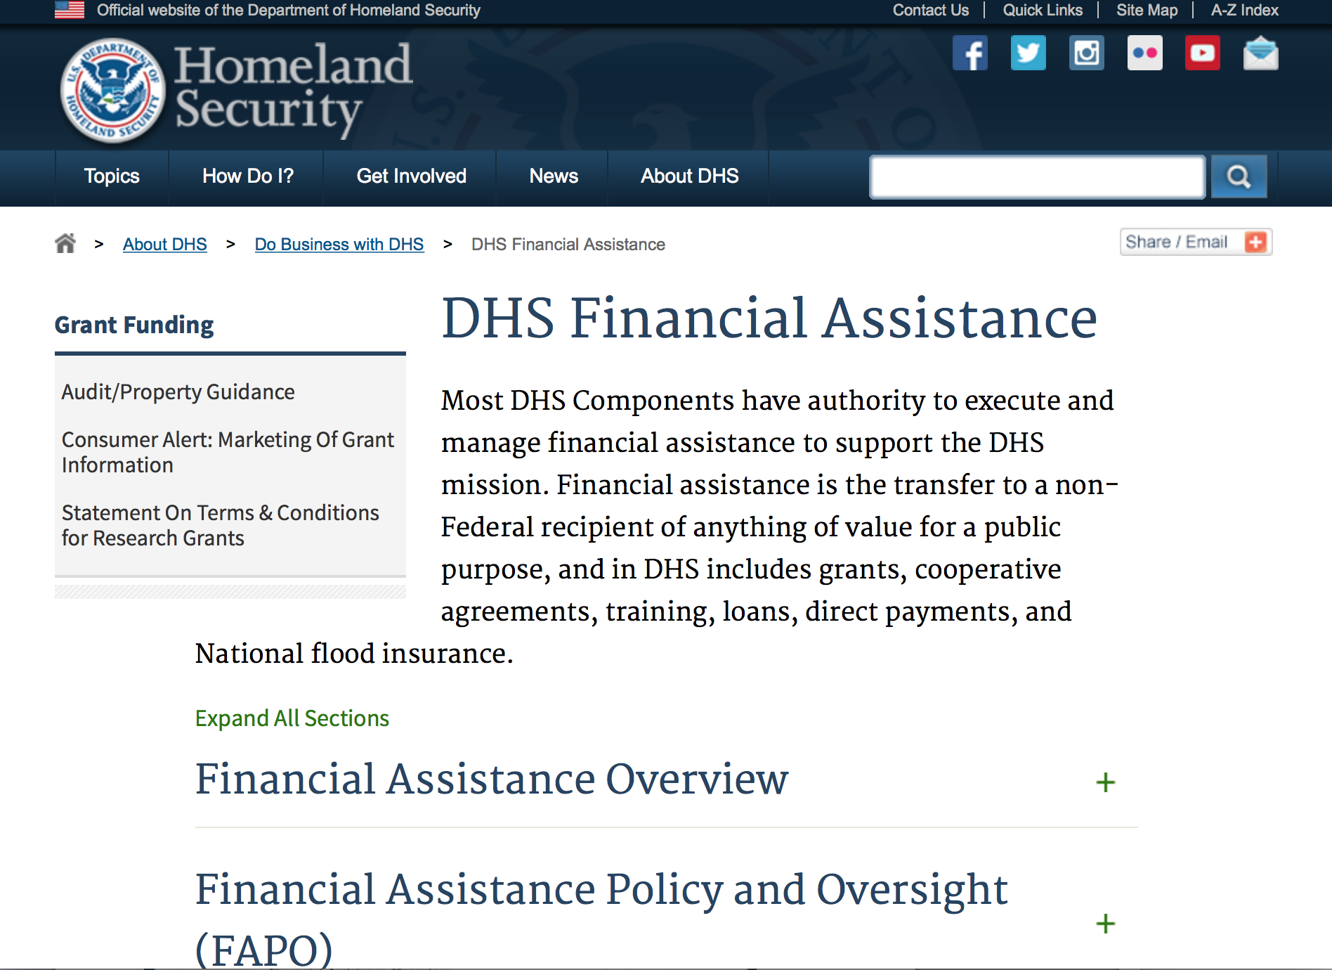
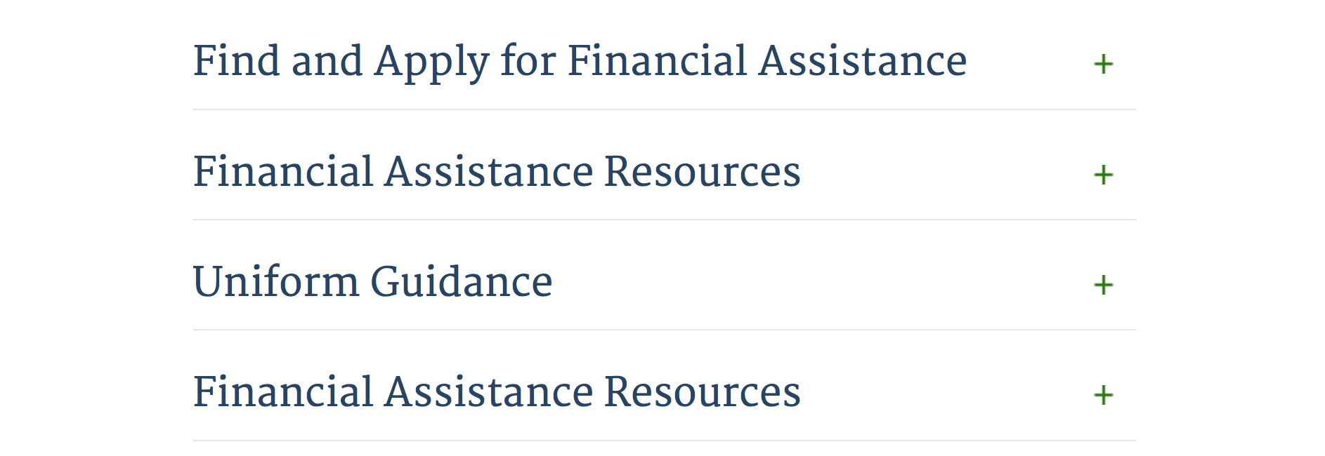

Webpage can be viewed at: http://www.dhs.gov/xopnbiz/grants/index.shtm#2

Information about 2016 for reference only
The FY 2016 Assistance to Firefighters Grants (AFG)
FY 2016 ASSISTANCE TO FIREFIGHTERS (AFG) GRANTS IS CLOSED AT THIS TIME
- FY 2016 Application Workshop Schedule
- FY 2016 AFG Application Guidance Materials The following documents are now available:
  - FY 2016 Notice of Funding Opportunity (NOFO) – Available Now
  - FY 2016 AFG Grant Application Get Ready Guide
  - FY 2016 AFG Narrative Get Ready Guide
  - FY 2016 AFG Self-Evaluation - Operations and Safety
  - FY 2016 AFG Self-Evaluation - Vehicle Acquisition
  - FY 2016 AFG Application Checklist
  - FY 2016 AFG Cost Share Calculator
FY 2016 AFG FAQs
For AFG program guidance materials, please visit our Documents page.

Resources

AFG Help Desk
Contact the AFG Program Help Desk toll-free at 866-274-0960, or email us at firegrants@dhs.gov.
The AFG Program has Fire Program Specialists in 10 federal regional centers. These Regional Fire Program Specialists respond to questions about the AFG program and carry out grant monitoring activities. View regional contacts

Popular AFG links
- AFG Workshop Schedule
- Assistance to Firefighters Grants (AFG)
- AFG Awards List
- AFG Success Stories
- Staffing for Adequate Fire & Emergency Response (SAFER) Grants (SAFER)
- SAFER Awards List
- SAFER Success Stories
- Fire Prevention & Safety (FP&S) Grants
- FP&S Awards List
- FP&S Success Stories
- Grant Closeout Tutorial
- Assistance to Firefighters Grant (AFG) Email Alert Archive
- Frequently Asked Questions
Contact Information For The Assistance to Firefighters Grant (AFG) Program and Help Desk

Federal Funding Alternative To AFG

State Administrative Agencies (SAA) apply for and administer Federal grants on behalf of their States, including FEMA Preparedness Grants. The SAA will work with eligible organizations to comply with the general requirements of grant programs or cooperative agreements. Contact your State’s SAA to find out what current Federal funding opportunities may be available to your organization. A listing of the SAAs and points of contact can be found at http://www.fema.gov/library/viewRecord.do?id=6363.

Programs:

Modifications:

Reminders:

Department of Housing and Urban Development

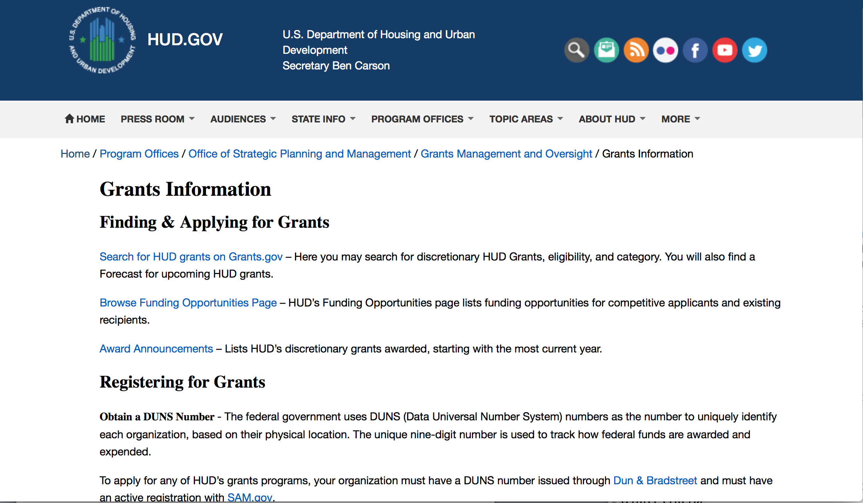
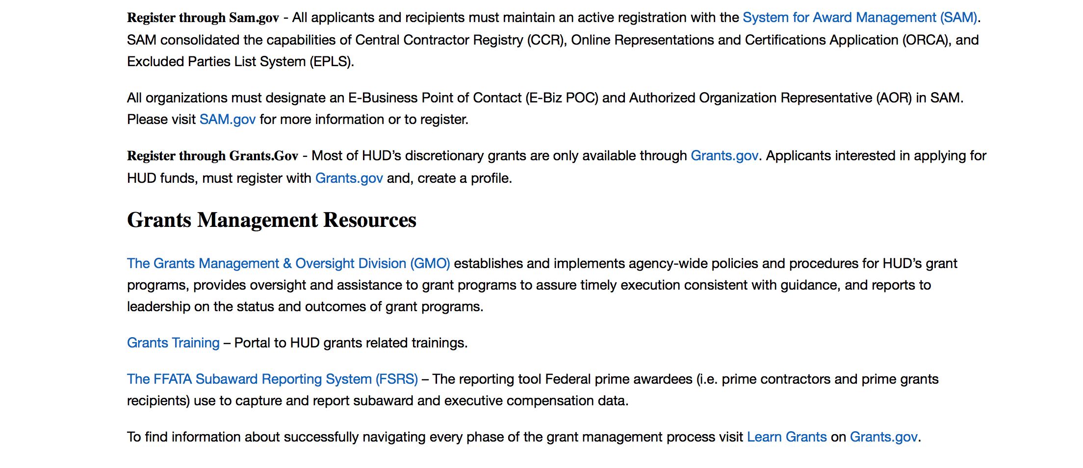
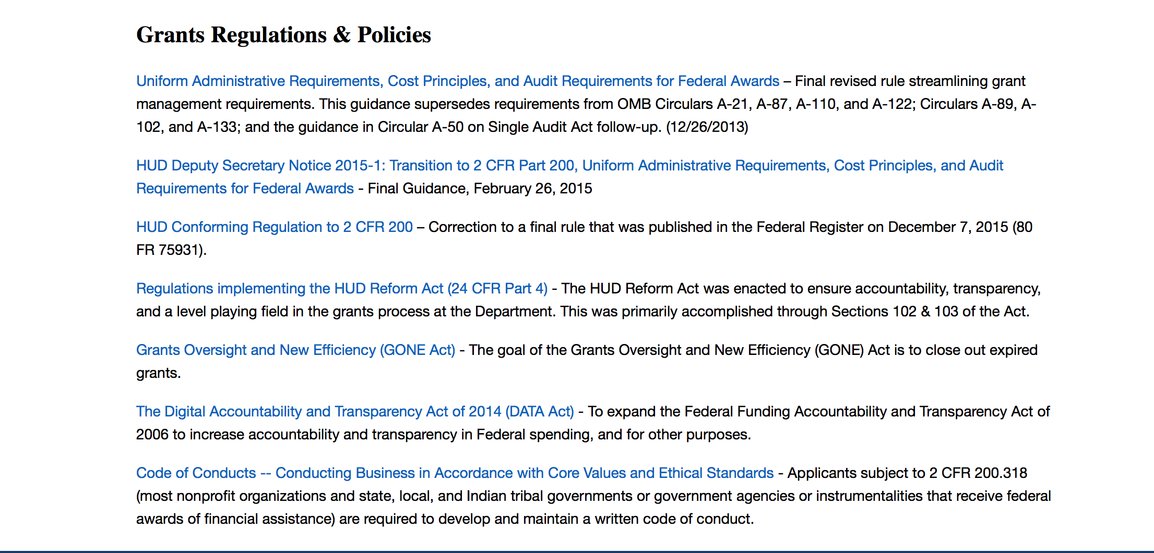

http://portal.hud.gov/hudportal/HUD?src=/topics/grants

HUD - Notice of Funds Available
For detailed information click here

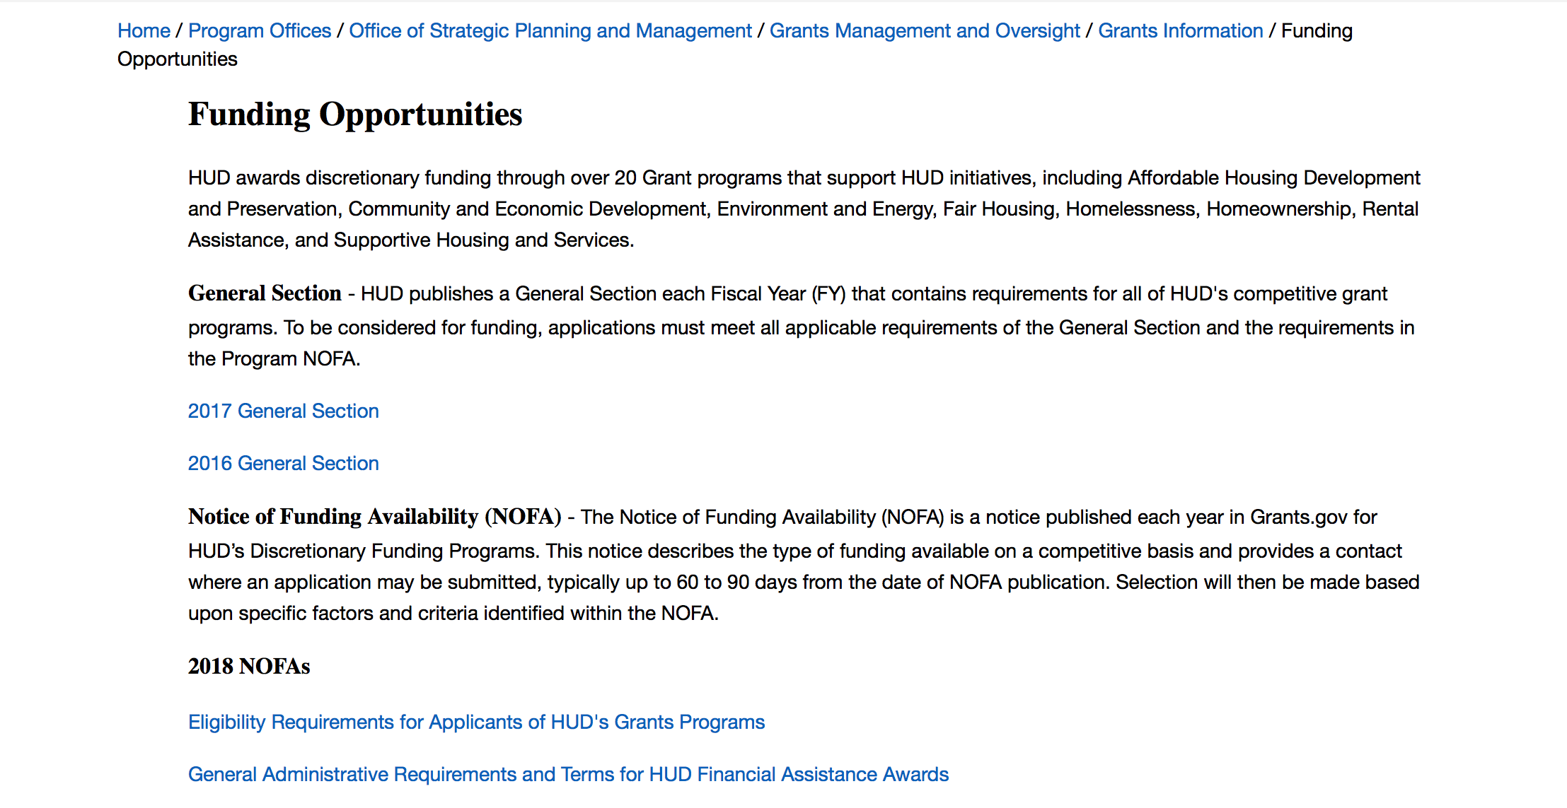

http://portal.hud.gov/hudportal/HUD?src=/program_offices/administration/grants/fundsavail

HUD NOFA FORECAST
The Department of Housing and Urban Development NOFA Forecast lists competitive grant opportunities that may be available for FY2016. The inclusion or exclusion of an opportunity in this list does not constitute a guarantee that a specific opportunity will become available or not be available. Forecast opportunities are subject to change based on enactment of Congressional appropriations and other considerations.
When funding is available, HUD will issue a Notice of Funding Availability (NOFA), which will be available on Grants.gov

Programs:

Modifications:

Deleted:

Reminders:

Self-Help Homeownership Opportunity Program (SHOP)
Synopsis 1

Document Type: | Grants Notice
Funding Opportunity Number: | FR-6100-N-19
Funding Opportunity Title: | Self-Help Homeownership Opportunity Program (SHOP)
Opportunity Category: | Discretionary
Opportunity Category Explanation:
Funding Instrument Type: | Grant
Category of Funding Activity: | Housing
Category Explanation:
Expected Number of Awards: | 4
CFDA Number(s): | 14.247 -- Self-Help Homeownership Opportunity Program
Cost Sharing or Matching Requirement: | Yes
Version: | Synopsis 1
Posted Date: | Oct 25, 2017
Last Updated Date: | Oct 25, 2017
Original Closing Date for Applications: | Jan 25, 2018 Electronically submitted applications must be submitted no later than 11:59 p.m., ET, on the listed application due date.
Current Closing Date for Applications: | Jan 25, 2018 Electronically submitted applications must be submitted no later than 11:59 p.m., ET, on the listed application due date.
Archive Date: | Feb 24, 2018
Estimated Total Program Funding: | $10,000,000
Award Ceiling: | $10,000,000
Award Floor: | $450,000
Eligible Applicants: | Nonprofits having a 501(c)(3) status with the IRS, other than institutions of higher education
Additional Information on Eligibility: | Eligible applicants include public or private non-profit organizations, or a consortium of public or private non-profit organizations, that have the capacity and experience to provide or facilitate self-help homeownership opportunities on a national or regional basis. Grantees must directly undertake eligible SHOP activities and/or enter into a written agreement with one or more non-profit affiliate organizations to carry out eligible SHOP activities. Individuals, foreign entities, and sole proprietorship organizations are not eligible to compete for, or receive, awards made under this announcement.
Agency Name: | Department of Housing and Urban Development
Description: | This SHOP NOFA announces the availability of $10,000,000 in FY2017 SHOP Grant funds to be awarded to national and regional non-profit organizations and consortia to facilitate and encourage innovative homeownership opportunities on a national, geographically diverse basis through the provision of self-help homeownership housing programs. Applicants must propose to use a significant amount of SHOP Grant funds in at least two states. Individuals are not eligible to apply for SHOP Grant funds. SHOP Grant funds must be used for land acquisition, infrastructure improvements, and for reasonable and necessary planning, administration and management costs (not to exceed 20 percent). The construction or rehabilitation costs of each SHOP unit must be funded with other leveraged public and private funds. The average SHOP Grant expenditure for the combined costs of land acquisition and infrastructure improvements must not exceed $15,000 per SHOP unit. SHOP units must be decent, safe, and sanitary non-luxury dwellings that comply with state and local codes, ordinances, and zoning requirements, and with all other SHOP requirements, including but not limited to, the requirements for energy-efficiency, water conservation and accessibility). The SHOP units must be sold to homebuyers at prices below the prevailing market price. Homebuyers must be low-income and must contribute a significant amount of sweat equity towards the development of the SHOP units. A homebuyer's sweat equity contribution must not be mortgaged or otherwise restricted upon future sale of the SHOP unit. Volunteer labor is also required SHOP Grantees may award SHOP Grant funds to local non-profit affiliate organizations to carry out the Grantee's SHOP program. These affiliate organizations must be located within the Grantee's service area.
Link to Additional Information: | https://hud.gov/program_offices/spm/gmomgmt/grantsinfo/fundingopps
Grantor Contact Information: | If you have difficulty accessing the full announcement electronically, please contact:  Thann Young Thann.Young@hud.gov  Grants Policy

http://www.grants.gov/web/grants/view-opportunity.html?oppId=298120

Institute of Museum and Library Services

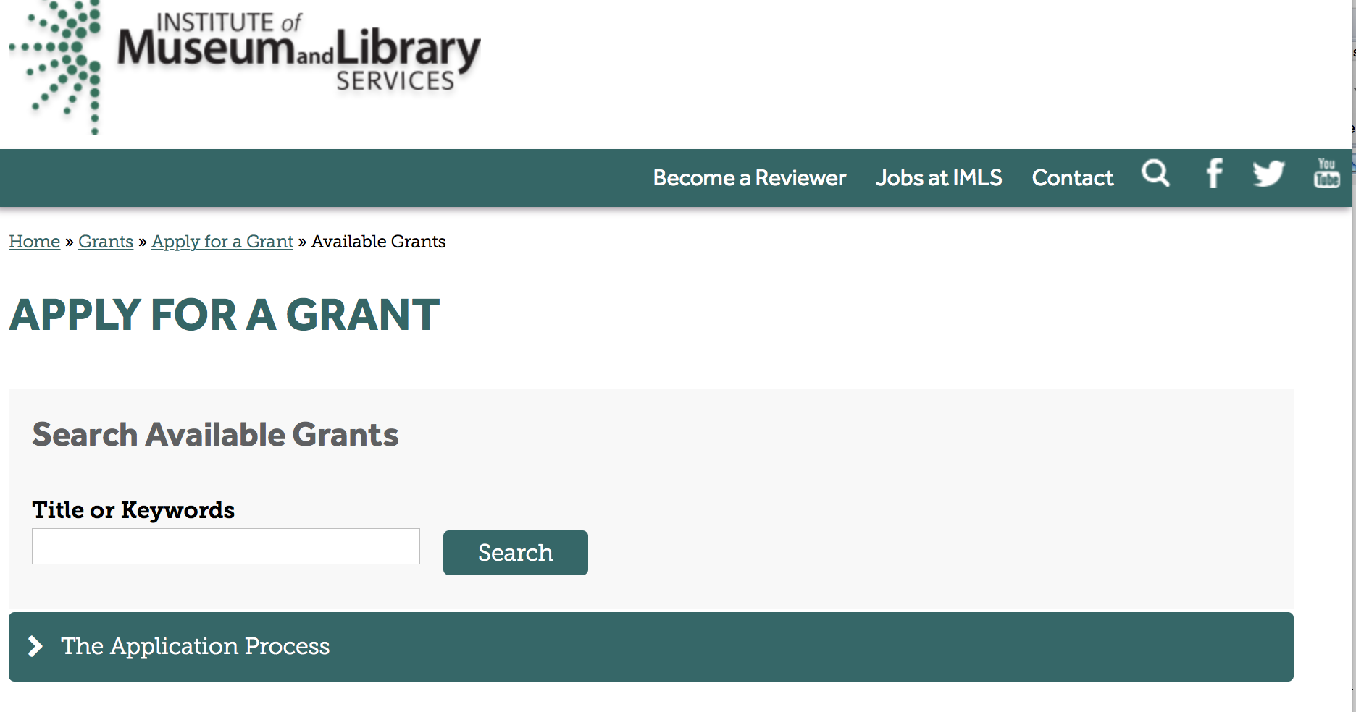

https://www.imls.gov/grants/apply-grant/available-grants

Each grant program has specific eligibility requirements. The links below provide general eligibility criteria for museums, libraries, and tribal organizations, but please note that additional organizations may be eligible for grants under certain programs. Additionally, ineligible organizations may still be able to participate in grant programs through partnerships with eligible organizations. Please click on the links below to see general criteria and review Applications and Guidelines for specific information.
Museums Libraries

Institutions: Archives, Federally Recognized Native American Tribe, Historical Society, Library, Nonprofits that serve Native Hawaiians, Professional Association, Public or Private Non-profit Institutions of Higher Education, Regional Organization, State Library Administrative Agency, State or Local Government

Check out IMLS's Facebook page at:
https://www.facebook.com/USIMLS/

Programs:

National Leadership Grants for Libraries
Synopsis 1
Document Type: | Grants Notice
Funding Opportunity Number: | NLG-LIBRARIES-FY18-2
Funding Opportunity Title: | National Leadership Grants for Libraries
Opportunity Category: | Discretionary
Opportunity Category Explanation:
Funding Instrument Type: | Grant
Category of Funding Activity: | Arts (see "Cultural Affairs" in CFDA)  Humanities (see "Cultural Affairs" in CFDA)
Category Explanation:
Expected Number of Awards: | 12
CFDA Number(s): | 45.312 -- National Leadership Grants
Cost Sharing or Matching Requirement: | Yes
Version: | Synopsis 1
Posted Date: | Nov 29, 2017
Last Updated Date: | Nov 29, 2017
Original Closing Date for Applications: | Jun 08, 2018
Current Closing Date for Applications: | Jun 08, 2018
Archive Date: | Jul 08, 2018
Estimated Total Program Funding: | $5,700,000
Award Ceiling: | $2,000,000
Award Floor: | $25,000
Eligible Applicants: | Others (see text field entitled "Additional Information on Eligibility" for clarification)
Additional Information on Eligibility: | Please see Notice of Funding Opportunity for eligibility specifics.
Agency Name: | Institute of Museum and Library Services
Description: | National Leadership Grants for Libraries (NLG-L) support projects that address significant challenges and opportunities facing the library and archives fields and that have the potential to advance theory and practice. Successful proposals will generate results such as new tools, research findings, models, services, practices, or alliances that will be widely used, adapted, scaled, or replicated to extend the benefits of federal investment. We have two FY18 NLG-L funding opportunities, each with two separate deadlines. In addition to the opportunity described in this Notice of Funding Opportunity, a separate NLG-L funding opportunity was announced in July 2017 with a preliminary proposal application submission due date in September 2017. Both opportunities are subject to the availability of funds and IMLS discretion and procedures.
Link to Additional Information: | https://www.imls.gov/grants/available/national-leadership-grants-libraries
Grantor Contact Information: | If you have difficulty accessing the full announcement electronically, please contact:  Tim Carrigan, Senior Program Officer 202-653-4639 tcarrigan@imls.gov Sarah Fuller, Senior Program Officer 202-653-4783 sfuller@imls.gov James Neal, Senior Program Officer 202-653-4740 jneal@imls.gov Emily Reynolds, Senior Program Officer 202-635-4665 ereynolds@imls.gov Ashley Sands, PhD, Senior Program Officer 202-653-4730 asands@imls.gov Sandra Toro, PhD, Senior Program Officer 202-653-4662 storo@imls.gov  Emily Reynolds, Senior Program Officer
https://www.grants.gov/web/grants/view-opportunity.html?oppId=299122

Modifications:

Reminders:

Deleted:

Department of the Interior
Working with Interior

The Interior Department provides assistance to the public, local governments and businesses through a number of programs. For a general overview see: http://www.doi.gov/index.cfm

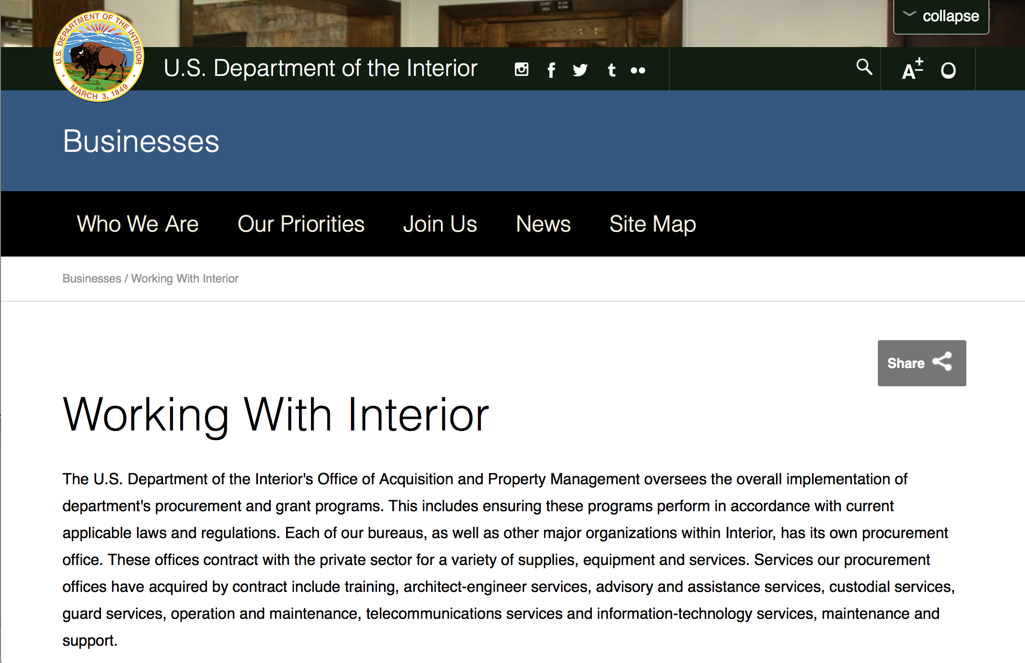

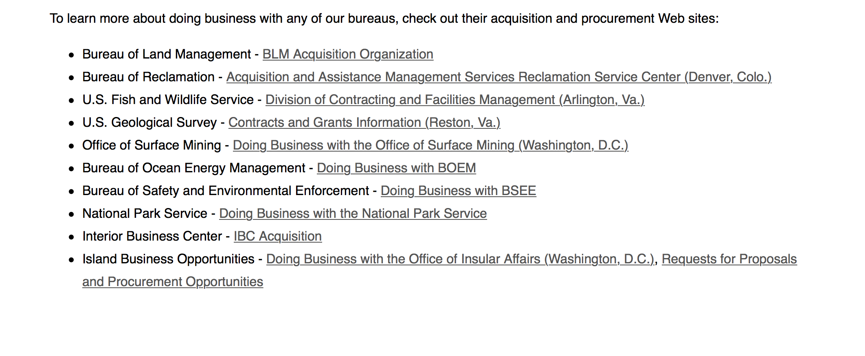
http://www.doi.gov/businesses/working-with-interior.cfm

Programs:

Modifications:

Reminders:

National Park Service
2018 Preservation Technology and Training Grants
Synopsis 1
Document Type: | Grants Notice
Funding Opportunity Number: | P18AS00006
Funding Opportunity Title: | 2018 Preservation Technology and Training Grants
Opportunity Category: | Discretionary
Opportunity Category Explanation:
Funding Instrument Type: | Grant
Category of Funding Activity: | Other (see text field entitled "Explanation of Other Category of Funding Activity" for clarification)
Category Explanation: | National Park Service
Expected Number of Awards: | 10
CFDA Number(s): | 15.923 -- National Center for Preservation Technology and Training
Cost Sharing or Matching Requirement: | No
Version: | Synopsis 1
Posted Date: | Oct 31, 2017
Last Updated Date: | Oct 31, 2017
Original Closing Date for Applications: | Jan 04, 2018
Current Closing Date for Applications: | Jan 04, 2018
Archive Date: | Jan 11, 2018
Estimated Total Program Funding: | $300,000
Award Ceiling: | $40,000
Award Floor: | $5,000
Eligible Applicants: | Others (see text field entitled "Additional Information on Eligibility" for clarification)
Additional Information on Eligibility: | In accordance with 54 U.S.C.305304(c). Preservation grants, eligible applicants may include (1) Federal and non-Federal laboratories (2) accredited museums (3) universities (4) nonprofit organizations (5) System units and offices and Cooperative Park Study Units of the System (6) State Historic Preservation Offices (7) tribal preservation offices (8) Native Hawaiian organizations
Agency Name: | National Park Service
Description: | 2018 Preservation Technology and Training Grants (PTT Grants) are intended to create better tools, better materials, and better approaches to conserving buildings, landscapes, sites, and collections. The PTT Grants are administered by the National Center for Preservation Technology and Training (NCPTT), the National Park Service innovation center for the preservation community. The competitive grants program will provide funding to federal agencies, states, tribes, local governments, and non-profit organizations. PTT Grants will support the following activities: â¿¢ Innovative research that develops new technologies or adapts existing technologies to preserve cultural resources (typically $25,000 to $40,000) â¿¢ Specialized workshops or symposia that identify and address national preservation needs (typically $15,000 to $25,000) â¿¢ How-to videos, mobile applications, podcasts, best practices publications, or webinars that disseminate practical preservation methods or provide better tools for preservation practice (typically $5,000 to $15,000) The maximum grant award is $40,000. The actual grant award amount is dependent on the scope of the proposed activity. NCPTT does not fund "bricks and mortar" grants.
Link to Additional Information: | http://www.grants.gov
Grantor Contact Information: | If you have difficulty accessing the full announcement electronically, please contact:  Todd Wilson Todd_Wilson@nps.gov  Email

http://www.grants.gov/web/grants/view-opportunity.html?oppId=298228

National Park Service
FY 18 American Battlefield Protection Program Battlefield Preservation Planning Project Grants
Synopsis 1
Document Type: | Grants Notice
Funding Opportunity Number: | P18AS00003
Funding Opportunity Title: | FY 18 American Battlefield Protection Program Battlefield Preservation Planning Project Grants
Opportunity Category: | Discretionary
Opportunity Category Explanation:
Funding Instrument Type: | Grant
Category of Funding Activity: | Other (see text field entitled "Explanation of Other Category of Funding Activity" for clarification)
Category Explanation: | Battlefield Planning Grant
Expected Number of Awards: | 25
CFDA Number(s): | 15.926 -- American Battlefield Protection
Cost Sharing or Matching Requirement: | No
Version: | Synopsis 1
Posted Date: | Oct 18, 2017
Last Updated Date: | Oct 18, 2017
Original Closing Date for Applications: | Jan 18, 2018 Applications can be submitted through Grants.gov, by mail, or by hand. All applications must be submitted to Grants.gov or be received in the ABPP office by 3:00PM EST on January 18, 2018. Late applications will be discarded without notification.
Current Closing Date for Applications: | Jan 18, 2018 Applications can be submitted through Grants.gov, by mail, or by hand. All applications must be submitted to Grants.gov or be received in the ABPP office by 3:00PM EST on January 18, 2018. Late applications will be discarded without notification.
Archive Date: | Oct 10, 2020
Estimated Total Program Funding: | $0
Award Ceiling: | $100,000
Award Floor: | $5,000
Eligible Applicants: | Nonprofits that do not have a 501(c)(3) status with the IRS, other than institutions of higher education  Public and State controlled institutions of higher education  County governments  State governments  Native American tribal governments (Federally recognized)  City or township governments
Agency Name: | National Park Service
Description: | A. Program Background Information The purpose of this grant program is to provide seed money for projects that lead directly to the identification, preservation, and interpretation of battlefield land or historic sites associated with battlefields. B. Program Objectives The ABPP encourages an interdisciplinary, holistic approach to battlefield preservation. Grant proposals for projects that fit into a larger vision for the site are favored. To maximize effectiveness of battlefield protection efforts, applicant organizations are encouraged to work with partner organizations and Federal, State and local government agencies as early as possible to integrate their efforts into a larger battle site protection strategy. C. Term of the Agreement terms for funded projects is estimated to range between one and two years, depending on the negotiated project scope. Agreements are not effective until fully executed with signature from the NPS Awarding Officer. In most cases an agreement will expire after five years from the effective date, unless terminated earlier in accordance with 2 CFR, Part 200, Sections 200.338 and 200.339.
Link to Additional Information:
Grantor Contact Information: | If you have difficulty accessing the full announcement electronically, please contact:  Historian Philip Bailey (202) 513-7126 Philip_Bailey@nps.gov  Philip_Bailey@nps.gov

http://www.grants.gov/web/grants/view-opportunity.html?oppId=298024

Deleted:

Department of Justice

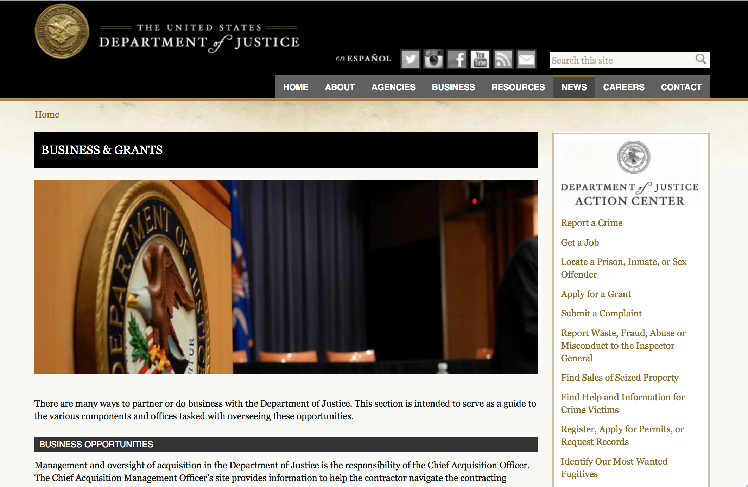

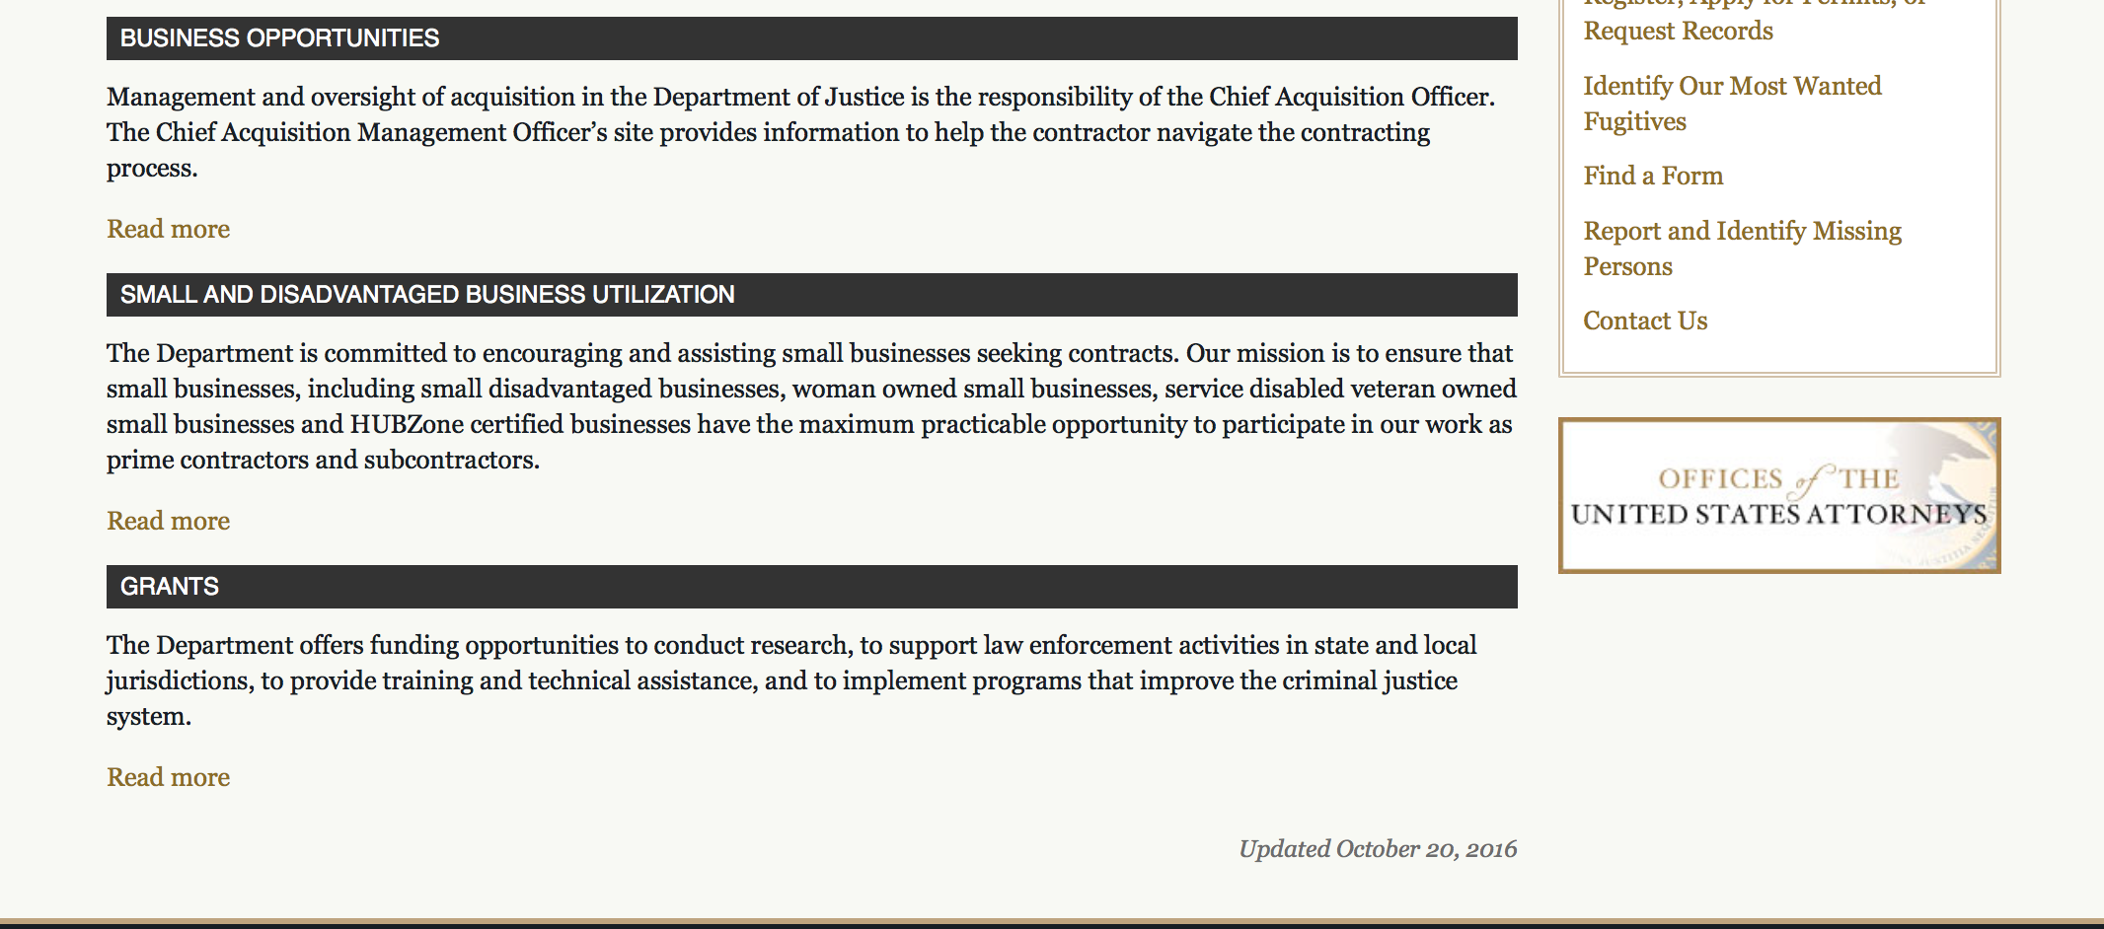

The DOJ agencies listed below also have sites that provide grant information specific to that agency. Examples of what can be found on these sites are programs, funding opportunities, application assistance, and other useful information.

Bureau of Justice Assistance (BJA)

Bureau of Justice Statistics (BJS)

National Criminal Justice Reference Service (NCJRS)

National Institute of Justice (NIJ)

Office of Sex Offender Sentencing, Monitoring, Apprehending, Registering, and Tracking (SMART)

http://www.justice.gov/business/

Programs:

Office on Violence Against Women
OVW FY 2018 Training and Services to End Violence Against Women with Disabilities Grant Program
Synopsis 1
Document Type: | Grants Notice
Funding Opportunity Number: | OVW-2018-13823
Funding Opportunity Title: | OVW FY 2018 Training and Services to End Violence Against Women with Disabilities Grant Program
Opportunity Category: | Discretionary
Opportunity Category Explanation:
Funding Instrument Type: | Cooperative Agreement
Category of Funding Activity: | Education  Other (see text field entitled "Explanation of Other Category of Funding Activity" for clarification)
Category Explanation: | Training; Disability, Deaf, Domestic Violence, Dating Violence, Sexual Violence and Stalking
Expected Number of Awards: | 10
CFDA Number(s): | 16.529 -- Education, Training, and Enhanced Services to End Violence Against and Abuse of Women with Disabilities
Cost Sharing or Matching Requirement: | No
Version: | Synopsis 1
Posted Date: | Nov 20, 2017
Last Updated Date: | Nov 20, 2017
Original Closing Date for Applications: | Jan 26, 2018
Current Closing Date for Applications: | Jan 26, 2018
Archive Date:
Estimated Total Program Funding: | $4,275,000
Award Ceiling: | $500,000
Award Floor: | $325,000
Eligible Applicants: | Nonprofits having a 501(c)(3) status with the IRS, other than institutions of higher education  County governments  State governments  Native American tribal governments (Federally recognized)  Native American tribal organizations (other than Federally recognized tribal governments)
Agency Name: | Office on Violence Against Women
Description: | This program is authorized by 34 U.S.C § 20122. The goal of the Disability Grant Program is to create sustainable change within and between organizations that results in increased capacity to respond to individuals with disabilities and Deaf individuals who are victims of sexual assault, domestic violence, dating violence, and stalking and to hold perpetrators of such crimes accountable. Disability Grant Program funds will be used to establish and strengthen multidisciplinary collaborative relationships; increase organizational capacity to provide accessible, safe, and effective services to individuals with disabilities and Deaf individuals who are victims of violence and abuse; and identify needs within the grantee’s organization and/or service area, and develop a plan to address those identified needs that builds a strong foundation for future work.
Link to Additional Information: | Full announcement
Grantor Contact Information: | If you have difficulty accessing the full announcement electronically, please contact:  Sylvia Pauling Grant Program Specialist 202-514-0748 sylvia.pauling@usdoj.gov  sylvia.pauling@usdoj.gov
https://www.grants.gov/web/grants/view-opportunity.html?oppId=298903

Research:

Modifications:

Deleted:

Reminders:



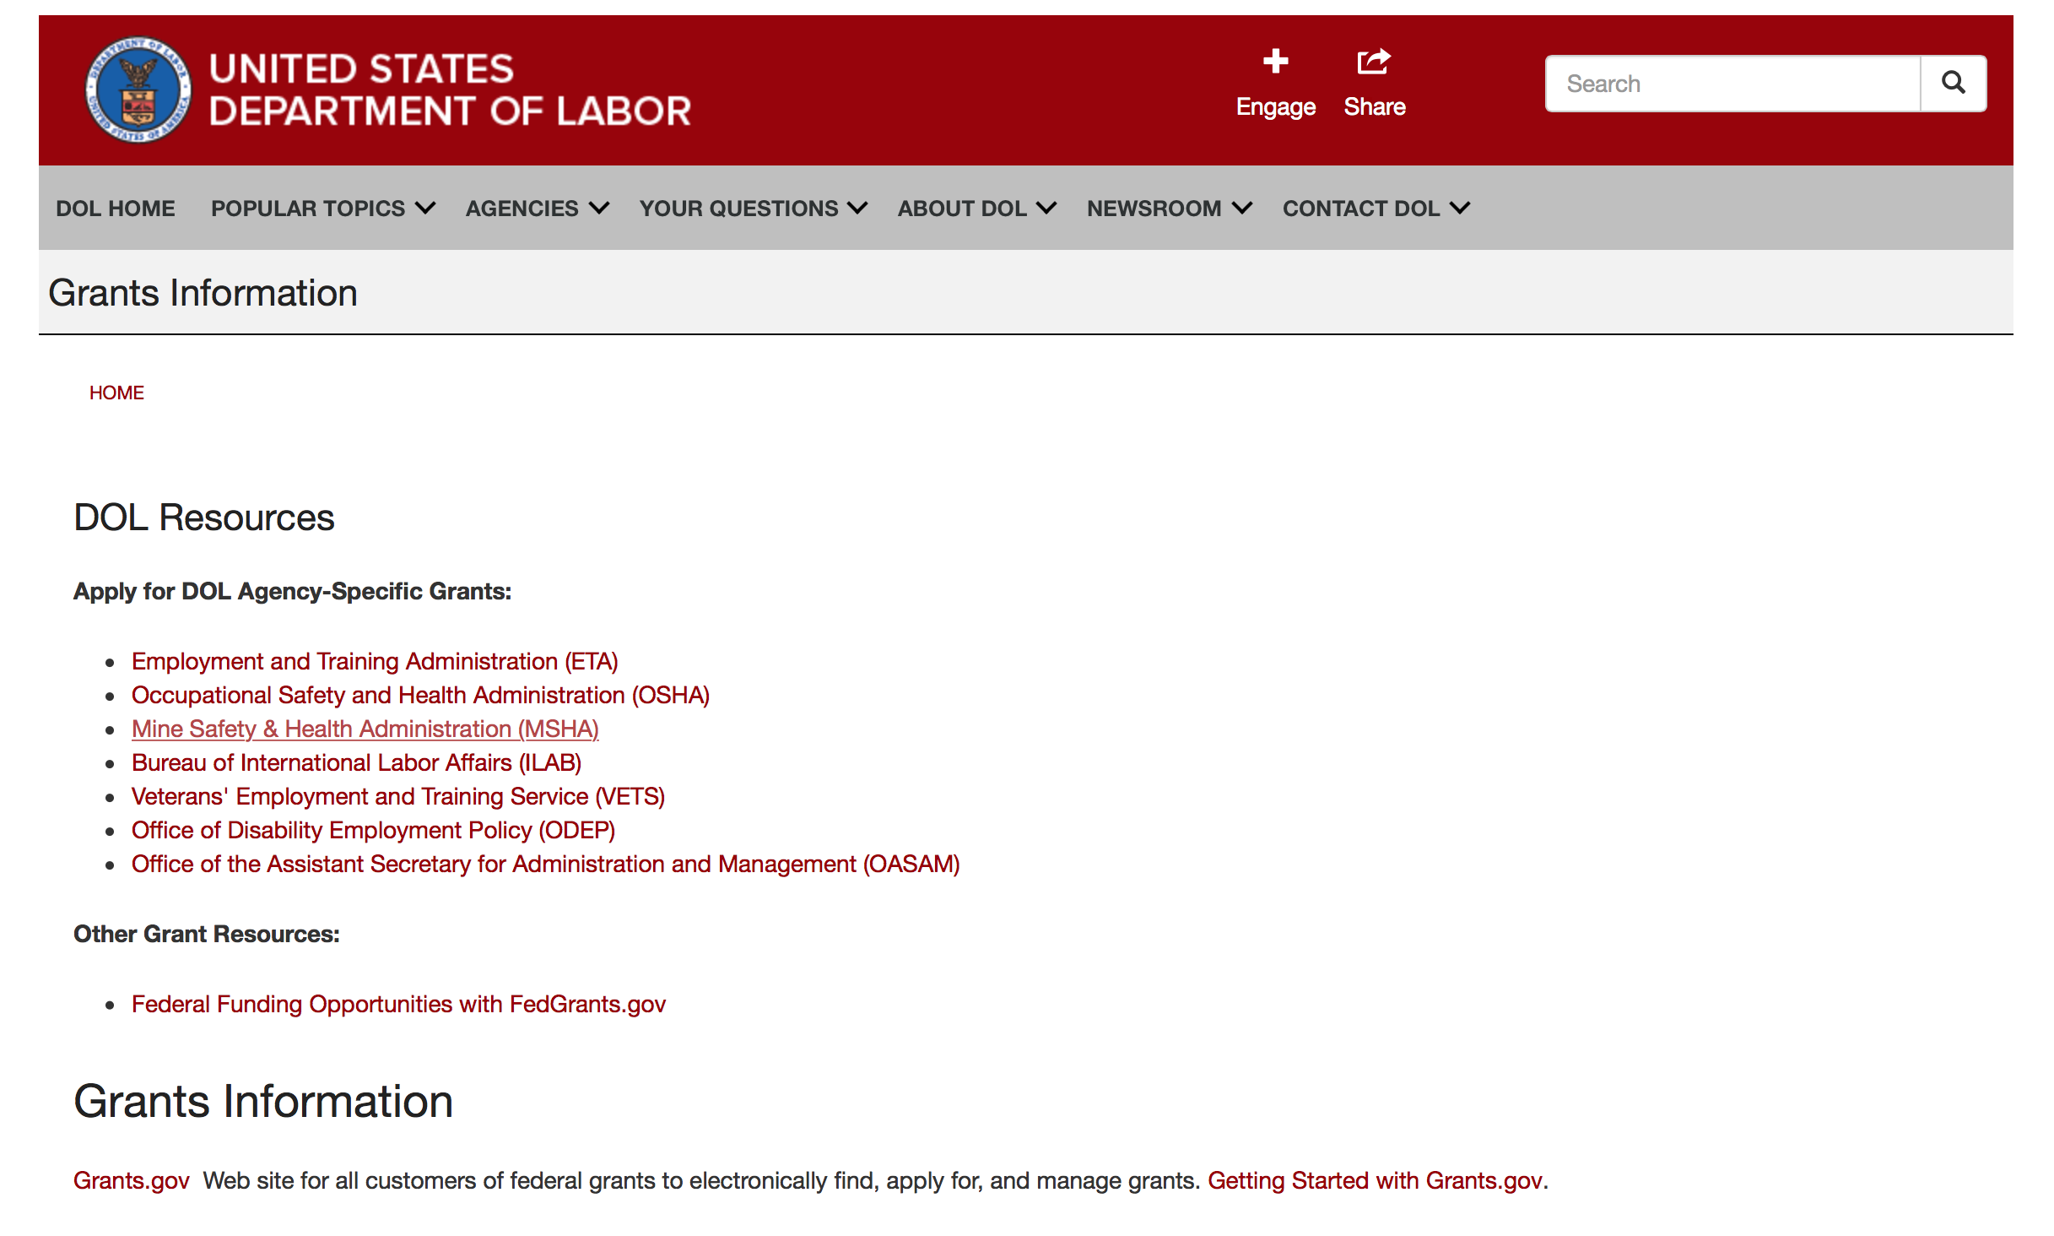

Agency Grants and Contract General Overview

DOL Resources
Apply for DOL Agency-Specific Grants:
- Employment and Training Administration (ETA)
- Occupational Safety and Health Administration (OSHA)
- Mine Safety & Health Administration (MSHA)
- Bureau of International Labor Affairs (ILAB)
- Veterans' Employment and Training Service (VETS)
- Office of Disability Employment Policy (ODEP)
- Office of the Assistant Secretary for Administration and Management (OASAM)

Other Grant Resources:
- Federal Funding Opportunities with FedGrants.gov
Grants Information
Grants.gov — Web site for all customers of federal grants to electronically find, apply for, and manage grants. Getting Started with Grants.gov.

DOL Resources and Instructions for Applying for a Grant
- DOL Guidance Clarifying the Effect of the Religious Freedom Restoration Act on Faith-Based Organizations
- Grant and Contract Information
- Contracting and Grant Program Overview
- Civil Rights Enforcement for Department of Labor Grant Recipients
- More Information About Grants
- Use of Contracts, Grants & Cooperative Agreements

Other Federal Government Grant Information
- Grant Opportunities (Catalog of Federal Domestic Assistance)

Department of Labor Grant Programs

- Bureau of International Labor Affairs (ILAB): provides grants (cooperative agreements) for the implementation of projects designed to assist developing countries combat the worse forms of child labor, forced labor, and human trafficking; and support worker rights and improve working conditions. http://www.dol.gov/general/business.
- Bureau of Labor Statistics (BLS): provides project grants (cooperative agreements) and the dissemination of technical statistical data and related information on labor force activities; provides data on prices (CPI) and cost of living; data on productivity and technology data; data on compensation and working conditions; data on employment projections.
- Employment and Training (ETA): ETA administers financial assistance programs pursuant to the Workforce Investment Act (WIA), administering State formula grant programs for youth, adults and dislocated workers, national emergency grants for workers affected by mass layoffs, plant closures, and disasters; grant programs for workers with disabilities, Indians and Native Americans, and for migrant and seasonal farmworkers. ETA also administers grant programs for older American workers, apprenticeship programs, Trade Adjustment Assistance (TAA) programs, and assistance for research and development of workforce programs. In addition, ETA is responsible for the operation and maintenance of a national system of public employment service offices and for the national unemployment insurance program.
- Mine Safety and Health (MSHA): provides grants for research, education and training programs to ensure an adequate and competent staff of trained inspectors; and assistance for establishing or improving State mine health and safety programs through technical assistance.
- Occupational Safety and Health (OSHA): provides grants to non-profit organizations to provide training, educational services, and technical assistance; assistance to states to administer and enforce state programs; assistance to states to provide occupational safety and health technical assistance and consultant services.
- Office of Disability Employment Policy (ODEP): The Office of Disability Employment Policy awards competitive grants establishing short-term pilot and technical assistance projects designed to identify, develop, test, evaluate, and disseminate policies to increase employment by expanding access to training, education, employment supports, assistive and systems technology, integrated employment, entrepreneurial development, and small business opportunities for adults and youth with disabilities. Current pilots projects focus on customized employment, Olmstead populations, and innovative demonstration youth grants, among others. Solicitations for grant applications are published in the Federal Register and announced at www.dol.gov/odep. ODEP grants are awarded by the OASAM grant office.
- Veterans' Employment and Training (VETS): provides special employment and training assistance for veterans through the Disabled Veterans' Outreach Program (DVOP) Solicitation for Grant Applications; the Local Veterans' Employment Representative Program (LVER); Veterans' Workforce Investment Program (VWIP); elaws Advisor on veterans' employment and reemployment rights; and the Homeless Veterans Reintegration Project (HVRP). VETS grants are awarded by the OASAM grant office.

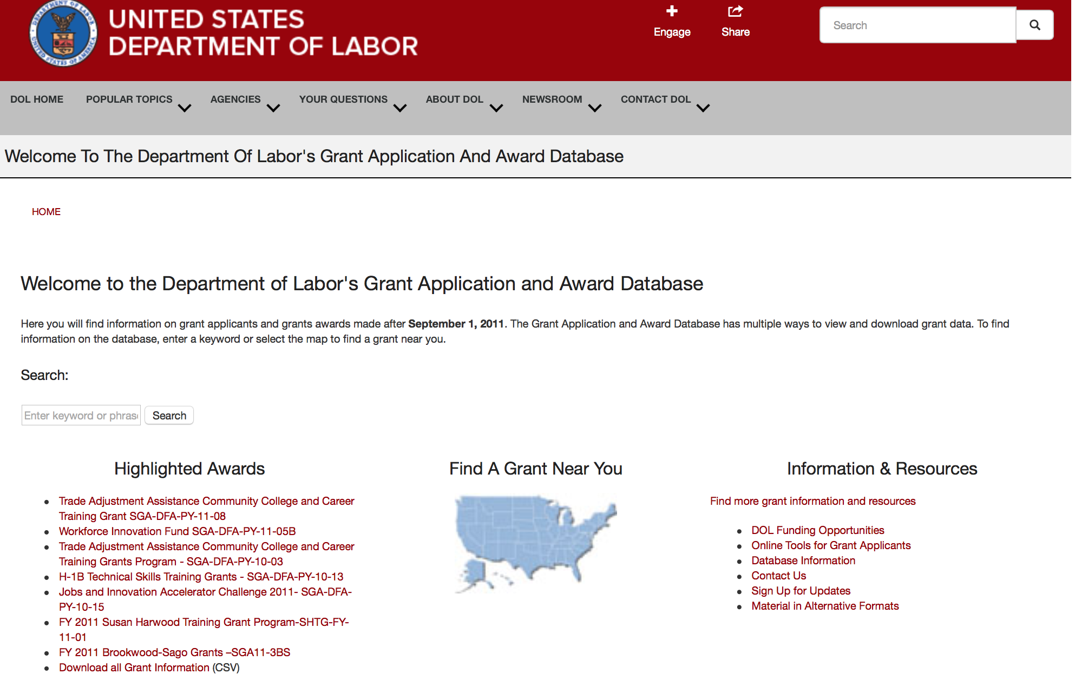

http://www.dol.gov/dol/grants/

Programs

Modifications

Reminders

The Millennium Challenge Corporation
NOFO Annual Program Statement (APS) PARTNERSHIPS with MCC Program
Synopsis 1

Document Type: | Grants Notice
Funding Opportunity Number: | 95332418N0002
Funding Opportunity Title: | NOFO Annual Program Statement (APS) PARTNERSHIPS with MCC Program
Opportunity Category: | Discretionary
Opportunity Category Explanation:
Funding Instrument Type: | Cooperative Agreement
Category of Funding Activity: | Business and Commerce
Category Explanation:
Expected Number of Awards: | 24
CFDA Number(s): | 85.002 -- MCC Foreign Assistance for Overseas Programs
Cost Sharing or Matching Requirement: | Yes
Version: | Synopsis 2
Posted Date: | Nov 09, 2017
Last Updated Date: | Nov 28, 2017
Original Closing Date for Applications: | Nov 08, 2018 The APS is posted for one year
Current Closing Date for Applications: | Nov 08, 2018 The APS is posted for one year
Archive Date: | Dec 08, 2018
Estimated Total Program Funding: | $1,500,000
Award Ceiling: | $500,000
Award Floor: | $50,000
Eligible Applicants: | Unrestricted (i.e., open to any type of entity above), subject to any clarification in text field entitled "Additional Information on Eligibility"
Additional Information on Eligibility: | MCC welcomes applications from many types of organizations including U.S. and non-U.S. private businesses, business and trade associations, foundations, U.S. and non-U.S. Non-Governmental Organizations (NGOs), international organizations, U.S. and non-U.S. colleges and universities, civic groups, regional organizations, etc. All applicants must be legally recognized organizational entities under applicable law. An individual cannot apply as an applicant. Other U.S. Government departments and agencies may not apply for MCC funding under this APS. Host country government agencies/entities are not eligible to apply. Furthermore, cost applications may not contain level of effort or related costs for host country government staff.
Agency Name: | Millennium Challenge Corporation
Description: | The Millennium Challenge Corporation (MCC) is pleased to launch this Notice of Funding Opportunity (NOFO) Annual Program Statement (APS) for opportunities to support MCC in achieving our mission of poverty reduction through growth. Specifically, this NOFO is reaching out to organizations with demonstrated interest, relevant experience, creativity and know-how to participate in Partnerships with MCC to achieve specific outcomes and optimize impact of our investments. MCC defines “Partnership” as a collaborative relationship between two or more entities -- governmental or nongovernmental -- in which the partners work together to achieve a common purpose or undertake a specific task and to share risks, responsibilities, resources, competencies, and benefits. The partners mutually determine the goals, structure, governance, roles, and responsibilities of their collaboration. This APS is aimed at fostering extensive collaboration and partnerships with external organizations, including but not limited to businesses, foundations, academic institutions, think tanks, and non-governmental organizations, to achieve a greater development impact. Through the APS, MCC aims to foster proactive collaboration and engagement among MCC and the partner(s) around specific areas for collaboration, co-financing, catalytic investment, and innovation that advance MCC’s mission. By partnering with other entities in the public, private, and civil sectors, MCC and its country counterparts can increase the scale, impact, and sustainability of MCC compact and threshold program investments.
Link to Additional Information:
Grantor Contact Information: | If you have difficulty accessing the full announcement electronically, please contact:  Nataliya Holl Senior Contracting Specialist Phone 2027726492 Andrew Lee Contracting Specialist Phone: 202-521-3669 E-mail: leeae@mcc.gov  main email
http://www.grants.gov/web/grants/view-opportunity.html?oppId=298597



National Aeronautics and Space Administration

Research and Contracting Opportunities

NASA Research Opportunities Online

- Various NASA offices publish their research announcements over the Internet, broadening the opportunity for researchers to apply for funding. This site provides access to current research announcements along with their specific due dates.

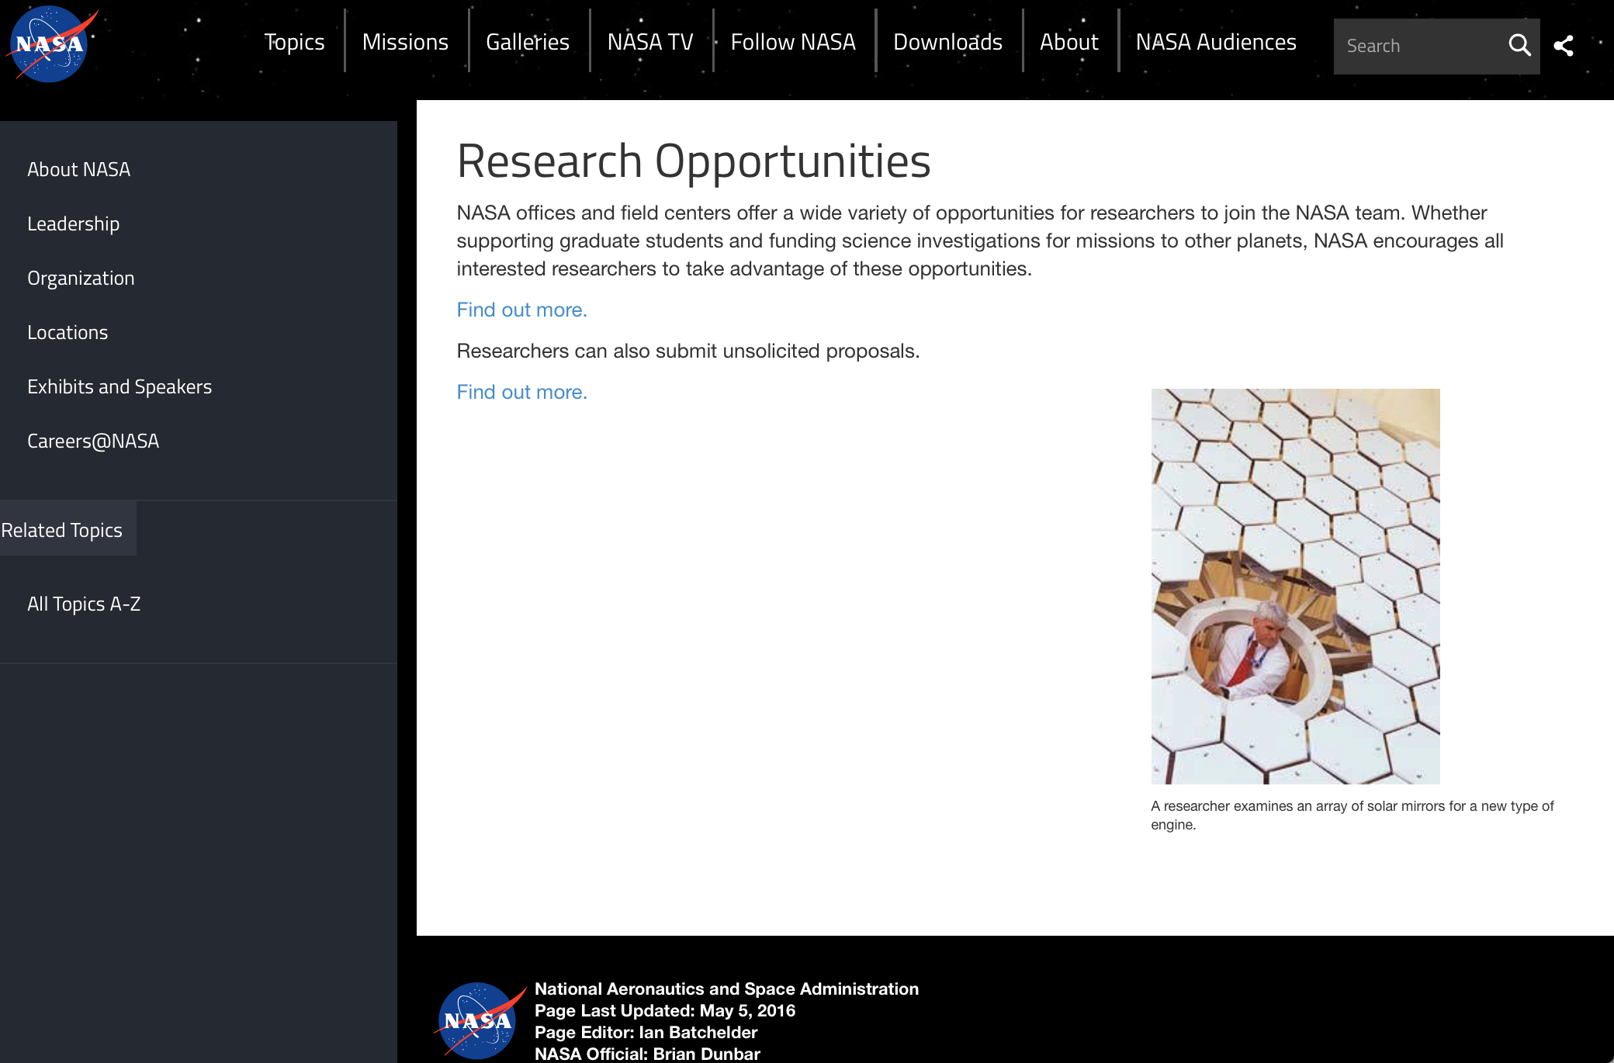

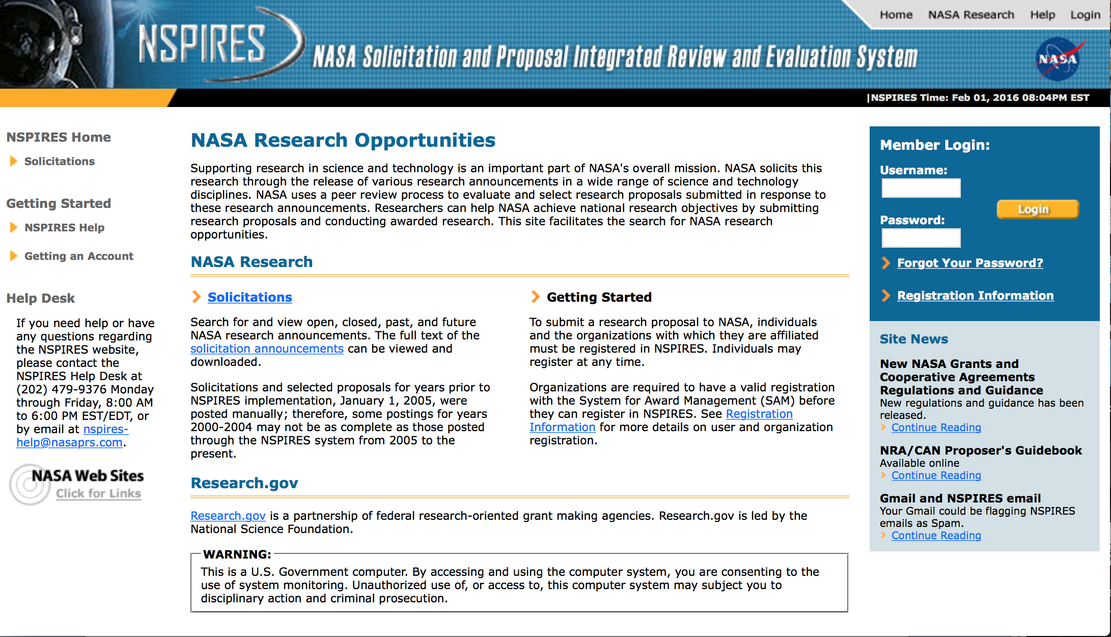
http://nspires.nasaprs.com/external/

Research Programs:

NASA Headquarters
ROSES 2017: Magnetospheric Multiscale Guest Investigators
Synopsis 1
http://www.grants.gov/web/grants/view-opportunity.html?oppId=297993

NASA Headquarters
ROSES 2017: Habitable Worlds
Synopsis 1
http://www.grants.gov/web/grants/view-opportunity.html?oppId=297994

Modifications:

NASA Headquarters
ROSES 2017: Ocean Vector Winds Science Team
Synopsis 2
http://www.grants.gov/web/grants/view-opportunity.html?oppId=296984

NASA Headquarters
ROSES 2017: Heliophysics Living With a Star Science
Synopsis 2
http://www.grants.gov/web/grants/view-opportunity.html?oppId=293759

NASA Headquarters
ROSES 2017: Discovery Data Analysis Program
Synopsis 3
http://www.grants.gov/web/grants/view-opportunity.html?oppId=296349

NASA Headquarters
ROSES 2017: Rosetta Data Analysis Program
Synopsis 3
http://www.grants.gov/web/grants/view-opportunity.html?oppId=296371

NASA Headquarters
ROSES 2017: X-ray Astronomy Recovery Mission (XARM) Participating Scientists
Synopsis 2
http://www.grants.gov/web/grants/view-opportunity.html?oppId=297335

NASA Headquarters
ROSBio Appendix G: Solicitation of Proposals for Flight and Ground Space Biology Research
Synopsis 3
http://www.grants.gov/web/grants/view-opportunity.html?oppId=298366

National Archives and Records Administration

Grant Opportunities General Overview

To access the information below: click here

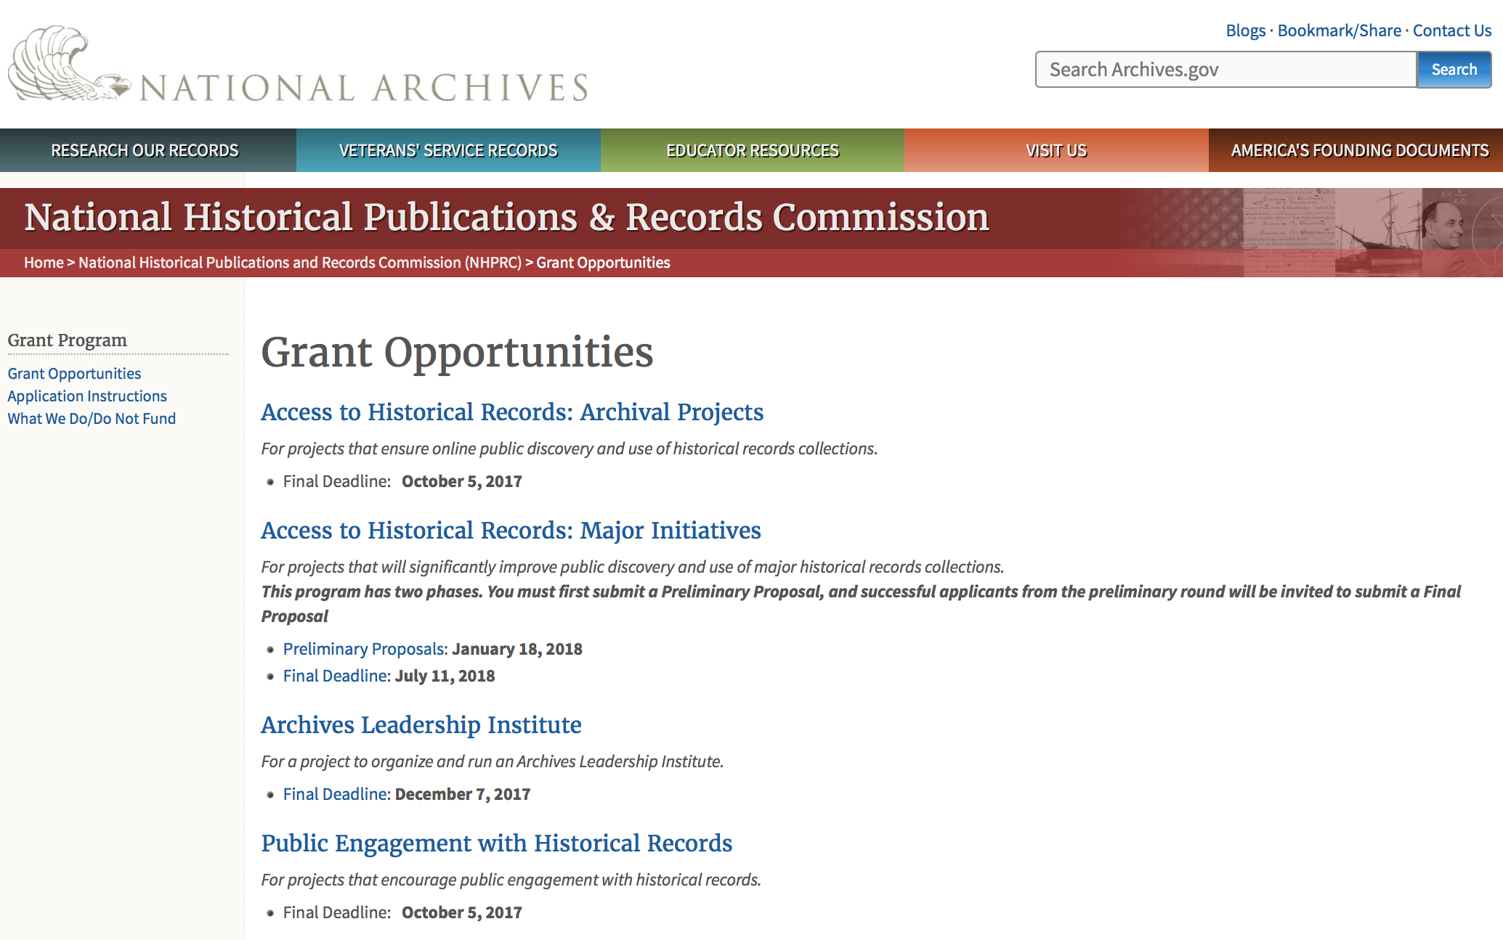

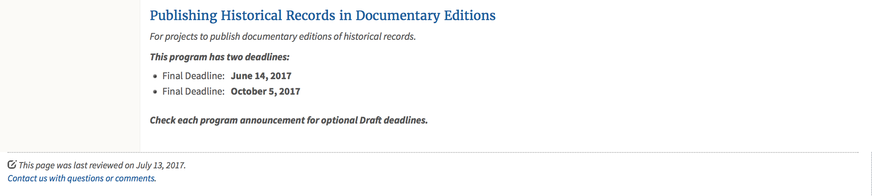
https://www.archives.gov/nhprc/announcement

Programs:

Publishing Historical Records in Documentary Editions
Synopsis 1
Document Type: | Grants Notice
Funding Opportunity Number: | EDITIONS-201810
Funding Opportunity Title: | Publishing Historical Records in Documentary Editions
Opportunity Category: | Discretionary
Opportunity Category Explanation:
Funding Instrument Type: | Grant
Category of Funding Activity: | Humanities (see "Cultural Affairs" in CFDA)
Category Explanation:
Expected Number of Awards: | 25
CFDA Number(s): | 89.003 -- National Historical Publications and Records Grants
Cost Sharing or Matching Requirement: | Yes
Version: | Synopsis 1
Posted Date: | Nov 29, 2017
Last Updated Date: | Nov 29, 2017
Original Closing Date for Applications: | Oct 04, 2018
Current Closing Date for Applications: | Oct 04, 2018
Archive Date:
Estimated Total Program Funding: | $2,500,000
Award Ceiling: | $200,000
Award Floor: | $1
Eligible Applicants: | Public and State controlled institutions of higher education  State governments  City or township governments  Nonprofits having a 501(c)(3) status with the IRS, other than institutions of higher education  Native American tribal governments (Federally recognized)  County governments  Private institutions of higher education
Agency Name: | National Archives and Records Administration
Description: | The National Historical Publications and Records Commission seeks proposals to publish documentary editions of historical records. Projects may focus on the papers of major figures from American history or cover broad historical movements in politics, social reform, business, military, the arts, and other aspects of the national experience. The historical value of the records and their expected usefulness to broad audiences must justify the costs of the project. The goal of this program is to provide access to, and editorial context for, the historical documents and records that tell the American story. Applicants should demonstrate familiarity with the best practices recommended by the Association for Documentary Editing or the Modern Language Association Committee on Scholarly Editions. All new projects (those which have never received NHPRC funding) must publish a digital edition, which provides online access to a searchable collection of all documents. (Ebooks or volumes in PDF do not qualify for the purposes of this grant program.) New projects may also prepare print editions as part of their overall publishing plan, but the contents of those volumes must be published online within a reasonable period of time following print publication. The NHPRC encourages projects to provide free access to online editions. Projects that do not have definitive plans for digital dissemination and preservation in place at the time of application will not be considered. Grants are awarded for collecting, describing, preserving, compiling, transcribing, annotating, editing, encoding, and publishing documentary source materials online and in print. Because of the focus on documentary sources, grants do not support preparation of critical editions of published works unless such works are just a small portion of the larger project. All applicants should be aware that the application process is highly competitive. For a comprehensive list of Commission's limitations on funding, please see What We Do and Do Not Fund. Applications that consist entirely of ineligible activities will not be considered. Ongoing projects: Applicants from ongoing projects must demonstrate that they have successfully achieved the performance objectives associated with previous NHPRC awards; provide updated, current information, including a description of the new activities; describe the content and historical significance of the specific materials to be edited during the proposed grant period; show progress towards completing the edition; and justify costs in a new budget. Award Information A grant is for one year and for up to $200,000. The Commission expects to make up to 25 grants in this category for a total of up to $2,500,000. Grants begin no earlier than January 1, 2019. The Commission requires that grant recipients acknowledge NHPRC grant assistance in all publications, publicity, and other products that result from its support. Eligibility • U.S. nonprofit organizations or institutions • U.S. colleges, universities, and other academic institutions • State or local government agencies • Federally-acknowledged or state-recognized Native American tribes or groups Cost Sharing The total costs of a project are shared between the NHPRC and the applicant organization. The Commission provides no more than 50 per cent of total direct project costs in the Publishing Historical Records in Documentary Editions category. NHPRC grant recipients are not permitted to use grant funds for indirect costs (as indicated in 2 CFR 2600.101). Cost sharing is required. The applicant’s financial contribution may include both direct and indirect expenses, in-kind contributions, non-Federal third-party contributions, and any income earned directly by the project. Indirect costs must be listed under the applicant’s cost sharing contribution. Other Requirements Applicant organizations must be registered in the System for Award Management (SAM) prior to submitting an application, maintain SAM registration throughout the application and award process, and include a valid DUNS number in their application. Details on SAM registration and requesting a DUNS number can be found at the System for Award Management website at https://sam.gov. Please refer to the User Guides section and the Grants Registrations PDF. A complete application includes the Application for Federal Assistance (Standard Form 424), Assurances -- Non-Construction Programs (Standard Form 424B), a Project Narrative, Summary, Supplementary Materials, and Budget. Applications lacking these items will not be considered. Ineligible applications will not be reviewed.
Link to Additional Information: | Link to full grant announcement, including additional requirements
Grantor Contact Information: | If you have difficulty accessing the full announcement electronically, please contact:  Jeff de la Concepcion Jeff.delaconcepcion@nara.gov  Grant Information Specialist
https://www.grants.gov/web/grants/view-opportunity.html?oppId=299091

Publishing Historical Records in Documentary Editions
Synopsis 1
Document Type: | Grants Notice
Funding Opportunity Number: | EDITIONS-201806
Funding Opportunity Title: | Publishing Historical Records in Documentary Editions
Opportunity Category: | Discretionary
Opportunity Category Explanation:
Funding Instrument Type: | Grant
Category of Funding Activity: | Humanities (see "Cultural Affairs" in CFDA)
Category Explanation:
Expected Number of Awards: | 25
CFDA Number(s): | 89.003 -- National Historical Publications and Records Grants
Cost Sharing or Matching Requirement: | No
Version: | Synopsis 1
Posted Date: | Nov 29, 2017
Last Updated Date: | Nov 29, 2017
Original Closing Date for Applications: | Jun 13, 2018
Current Closing Date for Applications: | Jun 13, 2018
Archive Date:
Estimated Total Program Funding: | $2,500,000
Award Ceiling: | $200,000
Award Floor: | $1
https://www.grants.gov/web/grants/view-opportunity.html?oppId=299108

State Board Programming Grants
Synopsis 1
Document Type: | Grants Notice
Funding Opportunity Number: | STATE-201806
Funding Opportunity Title: | State Board Programming Grants
Opportunity Category: | Discretionary
Opportunity Category Explanation:
Funding Instrument Type: | Grant
Category of Funding Activity: | Humanities (see "Cultural Affairs" in CFDA)
Category Explanation:
Expected Number of Awards: | 20
CFDA Number(s): | 89.003 -- National Historical Publications and Records Grants
Cost Sharing or Matching Requirement: | Yes
Version: | Synopsis 1
Posted Date: | Nov 29, 2017
Last Updated Date: | Nov 29, 2017
Original Closing Date for Applications: | Jun 13, 2018
Current Closing Date for Applications: | Jun 13, 2018
Archive Date:
Estimated Total Program Funding: | $625,000
Award Ceiling: | $80,000
Award Floor: | $1
Eligible Applicants: | Private institutions of higher education  State governments  Public and State controlled institutions of higher education  Nonprofits having a 501(c)(3) status with the IRS, other than institutions of higher education  Others (see text field entitled "Additional Information on Eligibility" for clarification)
Additional Information on Eligibility: | States also include the District of Columbia, the Commonwealth of Puerto Rico, and United States territories
Agency Name: | National Archives and Records Administration
Description: | The National Historical Publications and Records Commission seeks proposals that strengthen the nation’s archival network through activities undertaken by state historical records advisory boards. The purpose of this grant program is to assist state boards to broaden preservation of, and increased online access to, historical records; develop and promote best practices; support activities that put the American people in touch with primary sources in their communities and online; promote the institutional advancement of organizations in underserved communities; and assist locally based repositories with training and tools to improve their stewardship abilities. The Commission will award grants to state historical records advisory boards to: • Operate state-based regrant programs that preserve historical records and make them available online • Provide educational and outreach programs, workshops, and other activities that enhance citizen and student engagement with historical records • Offer scholarships, training opportunities, and other programs that support institutional advancement among records repositories, especially those in underserved communities • Collaborate on projects with other organizations to address common problems or shared opportunities within a state or among a consortium of state archives • Hold or participate in meetings and public forums on statewide or national archival issues. The NHPRC encourages organizations to actively engage the public in the work of the project. For a comprehensive list of Commission limitations on funding, please see: "What we do and do not fund" (http://www.archives.gov/nhprc/apply/eligibility.html). Applications that consist entirely of ineligible activities will not be considered. Award Information A grant is for one and for up to $40,000 or for two years and for up to $80,000. The Commission expects to make up to 20 grants in this category for a total of up to $625,000. Grants begin no earlier than January 1, 2019. The Commission requires that grant recipients acknowledge NHPRC grant assistance in all publicity, publications, and other products that result from its support. Eligibility These grants are awarded only to state historical records advisory boards in each state, or to the state agency responsible for the state board, ordinarily the state archives. Another state agency, or a non-profit organization, such as a foundation or university, acting on behalf of the designated state agency may apply. States also include the District of Columbia, the Commonwealth of Puerto Rico, and United States territories. Cost Sharing The total costs of a project are shared between the NHPRC and the applicant organization. The Commission provides no more than 75 per cent of total project costs in the State Board Programming Grants category. NHPRC grant recipients are not permitted to use grant funds for indirect costs (as indicated in 2 CFR 2600.101). Cost sharing is required. The applicant's financial contribution may include both direct and indirect expenses, in-kind contributions, non-Federal third-party contributions, and any income earned directly by the project. Indirect costs must be listed under the applicant's cost sharing contribution. Other Requirements Applicant organizations must be registered in the System for Award Management (SAM) prior to submitting an application, maintain SAM registration throughout the application and award process, and include a valid DUNS number in their application. Details on SAM registration and requesting a DUNS number can be found at the System for Award Management website at https://sam.gov. Please refer to the User Guides section and the Grants Registrations PDF. Ineligible applications will not be reviewed.
Link to Additional Information: | Link to full grant announcement, including additional requirements
Grantor Contact Information: | If you have difficulty accessing the full announcement electronically, please contact:  Jeff de la Concepcion Jeff.delaconcepcion@nara.gov  Grant Information Specialist
https://www.grants.gov/web/grants/view-opportunity.html?oppId=299107

Reminders:

Access to Historical Records: Major Initiatives (Preliminary)
Synopsis 1

Document Type: | Grants Notice
Funding Opportunity Number: | PRELIM-201801
Funding Opportunity Title: | Access to Historical Records: Major Initiatives (Preliminary)
Opportunity Category: | Discretionary
Opportunity Category Explanation:
Funding Instrument Type: | Grant
Category of Funding Activity: | Humanities (see "Cultural Affairs" in CFDA)
Category Explanation:
Expected Number of Awards: | 5
CFDA Number(s): | 89.003 -- National Historical Publications and Records Grants
Cost Sharing or Matching Requirement: | Yes
Version: | Synopsis 3
Posted Date: | Jul 14, 2017
Last Updated Date: | Jul 24, 2017
Original Closing Date for Applications: | Jan 18, 2018
Current Closing Date for Applications: | Jan 18, 2018
Archive Date:
Estimated Total Program Funding: | $1,000,000
Award Ceiling: | $350,000
Award Floor: | $100,000
Eligible Applicants: | State governments  County governments  Nonprofits having a 501(c)(3) status with the IRS, other than institutions of higher education  Private institutions of higher education  Native American tribal governments (Federally recognized)  Public and State controlled institutions of higher education  City or township governments
Agency Name: | National Archives and Records Administration
Description: | The National Historical Publications and Records Commission seeks projects that will significantly improve public discovery and use of major historical records collections. All types of historical records are eligible, including documents, photographs, born-digital records, and analog audio and moving images. Projects may: • Digitize historical records collections, or related collections, held by a single institution and make them freely available online• Provide access to born-digital records• Create new freely-available virtual collections drawn from historical records held by multiple institutions• Create new tools and methods for users to access records The NHPRC welcomes collaborative projects, particularly for bringing together related records from multiple institutions. Projects that address significant needs in the field and result in replicable and scalable approaches will be more competitive. We also encourage organizations to actively engage the public in the work of the project. Applicants should also consult Access to Historical Records: Archival Projects program, which has different requirements and award amounts. For a comprehensive list of Commission limitations on funding, please see: "What we do and do not fund" (http://www.archives.gov/nhprc/apply/eligibility.html). Applications that consist entirely of ineligible activities will not be considered. Award Information A grant is for one to three years and for between $100,000 and $350,000. We expect to make up to five grants in this category for a total of up to $1,000,000. Grants begin no earlier than January 1, 2019.The Commission requires that grant recipients acknowledge NHPRC grant assistance in all publications and other products that result from its support. Eligibility Eligible applicants:• Nonprofit organizations or institutions• Colleges, universities, and other academic institutions• State or local government agencies• Federally-acknowledged or state-recognized Native American tribes or groups Cost Sharing The total costs of a project are shared between the NHPRC and the applicant organization. The Commission provides no more than 50 per cent of total project costs in the Access to Historical Records: Major Initiatives category. NHPRC grant recipients are not permitted to use grant funds for indirect costs (as indicated in 2 CFR 2600.101).Cost sharing is required. The applicant's financial contribution may include both direct and indirect expenses, in-kind contributions, non-Federal third-party contributions, and any income earned directly by the project. Indirect costs must be listed under the applicant's cost sharing contribution. Other Requirements Applicant organizations must be registered in the System for Award Management (SAM) prior to submitting an application, maintain SAM registration throughout the application and award process, and include a valid DUNS number in their application. Details on SAM registration and requesting a DUNS number can be found at the System for Award Management website at https://sam.gov. Please refer to the User Guides section and the Grants Registrations PDF. Application Information You must use Grants.gov to submit a Preliminary Proposal. All information necessary to apply is included in this announcement, the Application Instructions, and the forms on Grants.gov. If you need the information supplied in an alternative format, please call the NHPRC at 202-357-5010.In order to ensure eligibility, applicants should first review the rules and regulations governing NHPRC grants under the Administering an NHPRC Grant section. Applying to the Access to Historical Records: Major Initiatives program is a two-phase process. Phase One• Using this announcement, all applicants must submit an Application Package that includes the Application for Federal Domestic Assistance Form SF424, a completed NHPRC Budget, and five-page Project Narrative via Grants.gov by January 18, 2018.• Preliminary proposals will then undergo peer and staff review. Based on those reviews, a selection of promising applicants will be invited by April 16, 2018 to participate in the second phase of the process. Phase Two• Invited applicants will then prepare and submit a complete application to the full Major Initiatives grant announcement via Grants.gov by July 11, 2018. • Applicants may consult with the Director of the Access Program, Alex Lorch (alexander.lorch@nara.gov), or with the Director for Technology Initiatives, Nancy Melley (nancy.melley@nara.gov), during both the preliminary and full proposal project phases. • In order to ensure eligibility, applicants should first review the rules and regulations governing NHPRC grants under the Administering an NHPRC Grant section.
Link to Additional Information: | Link to full grant announcement, including additional requirements
Grantor Contact Information: | If you have difficulty accessing the full announcement electronically, please contact:  Jeff de la Concepcion Jeff.delaconcepcion@Nara.gov  Grant Information Specialist

http://www.grants.gov/web/grants/view-opportunity.html?oppId=295495

Access to Historical Records: Major Initiatives
Synopsis 1

Document Type: | Grants Notice
Funding Opportunity Number: | MAJOR-201807
Funding Opportunity Title: | Access to Historical Records: Major Initiatives
Opportunity Category: | Discretionary
Opportunity Category Explanation:
Funding Instrument Type: | Grant
Category of Funding Activity: | Humanities (see "Cultural Affairs" in CFDA)
Category Explanation:
Expected Number of Awards: | 5
CFDA Number(s): | 89.003 -- National Historical Publications and Records Grants
Cost Sharing or Matching Requirement: | Yes
Version: | Synopsis 1
Posted Date: | Jul 14, 2017
Last Updated Date: | Jul 14, 2017
Original Closing Date for Applications: | Jul 11, 2018
Current Closing Date for Applications: | Jul 11, 2018
Archive Date:
Estimated Total Program Funding: | $1,000,000
Award Ceiling: | $350,000
Award Floor: | $100,000
Eligible Applicants: | Public and State controlled institutions of higher education  County governments  Nonprofits having a 501(c)(3) status with the IRS, other than institutions of higher education  State governments  City or township governments  Private institutions of higher education  Native American tribal governments (Federally recognized)
Agency Name: | National Archives and Records Administration
Description: | The National Historical Publications and Records Commission seeks projects that will significantly improve public discovery and use of major historical records collections. All types of historical records are eligible, including documents, photographs, born-digital records, and analog audio and moving images. Projects may: • Digitize historical records collections, or related collections, held by a single institution and make them freely available online • Provide access to born-digital records • Create new freely-available virtual collections drawn from historical records held by multiple institutions • Create new tools and methods for users to access records The NHPRC welcomes collaborative projects, particularly for bringing together related records from multiple institutions. Projects that address significant needs in the field and result in replicable and scalable approaches will be more competitive. We also encourage organizations to actively engage the public in the work of the project. Applicants should also consult Access to Historical Records: Archival Projects program, which has different requirements and award amounts. For a comprehensive list of Commission limitations on funding, please see: "What we do and do not fund" (http://www.archives.gov/nhprc/apply/eligibility.html). Applications that consist entirely of ineligible activities will not be considered. Award Information A grant is for one to three years and between $100,000 and $350,000. We expect to make up to five grants in this category for a total of up to $1,000,000. Grants begin no earlier than January 1, 2019. The Commission requires that grant recipients acknowledge NHPRC grant assistance in all publicity, publications, and other products that result from its support. Eligibility Eligible applicants: • U.S. nonprofit organizations or institutions • U.S. colleges, universities, and other academic institutions • State or local government agencies • Federally-acknowledged or state-recognized Native American tribes or groups Cost Sharing The total costs of a project are shared between the NHPRC and the applicant organization. The Commission provides no more than 50 per cent of total project costs in the Access to Historical Records: Major Initiatives category. NHPRC grant recipients are not permitted to use grant funds for indirect costs (as indicated in 2 CFR 2600.101). Cost sharing is required. The applicant's financial contribution may include both direct and indirect expenses, in-kind contributions, non-Federal third-party contributions, and any income earned directly by the project. Indirect costs must be listed under the applicant's cost sharing contribution. Other Requirements Applicant organizations must be registered in the System for Award Management (SAM) prior to submitting an application, maintain SAM registration throughout the application and award process, and include a valid DUNS number in their application. Details on SAM registration and requesting a DUNS number can be found at the System for Award Management website at https://sam.gov. Please refer to the User Guides section and the Grants Registrations PDF. Application Information You must use Grants.gov to submit your Full Proposal. All information necessary to apply is included in this announcement, the Application Instructions, and the forms on Grants.gov. If you need the information supplied in an alternative format, please call the NHPRC at 202-357-5010. In order to ensure eligibility, applicants should first review the rules and regulations governing NHPRC grants under the Administering an NHPRC Grant section. Applying to the Access to Historical Records: Major Initiatives program is a two-phase process. Phase One • All applicants must have submitted a Preliminary Proposal by January 18, 2018. • Only those applicants who have successfully completed Phase One and who have been invited by the Commission to submit a full proposal to the Access to Historical Records: Major Initiatives program are eligible to participate in the second phase of the process. Phase Two • If you have been invited, prepare and submit a complete application to the full Major Initiatives grant announcement via Grants.gov by July 11, 2018. • Applicants may consult with the Director of the Access Program, Alex Lorch (alexander.lorch@nara.gov), or with the Director for Technology Initiatives, Nancy Melley (nancy.melley@nara.gov), during both the preliminary and full proposal project phases.
Link to Additional Information: | Link to full grant announcement, including additional requirements
Grantor Contact Information: | If you have difficulty accessing the full announcement electronically, please contact:  Jeff de la Concepcion Jeff.delaconcepcion@nara.gov  Grant Information Specialist

http://www.grants.gov/web/grants/view-opportunity.html?oppId=295496

National Endowment for the Arts

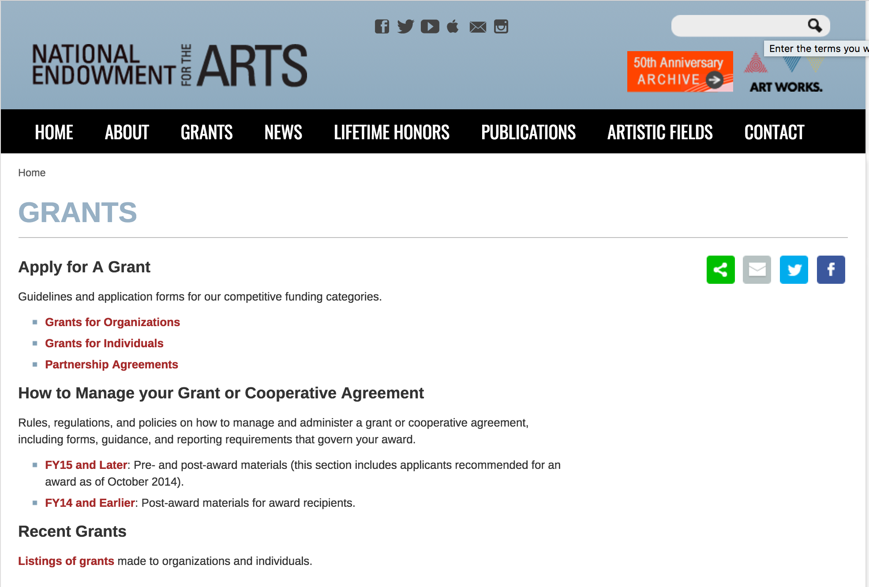

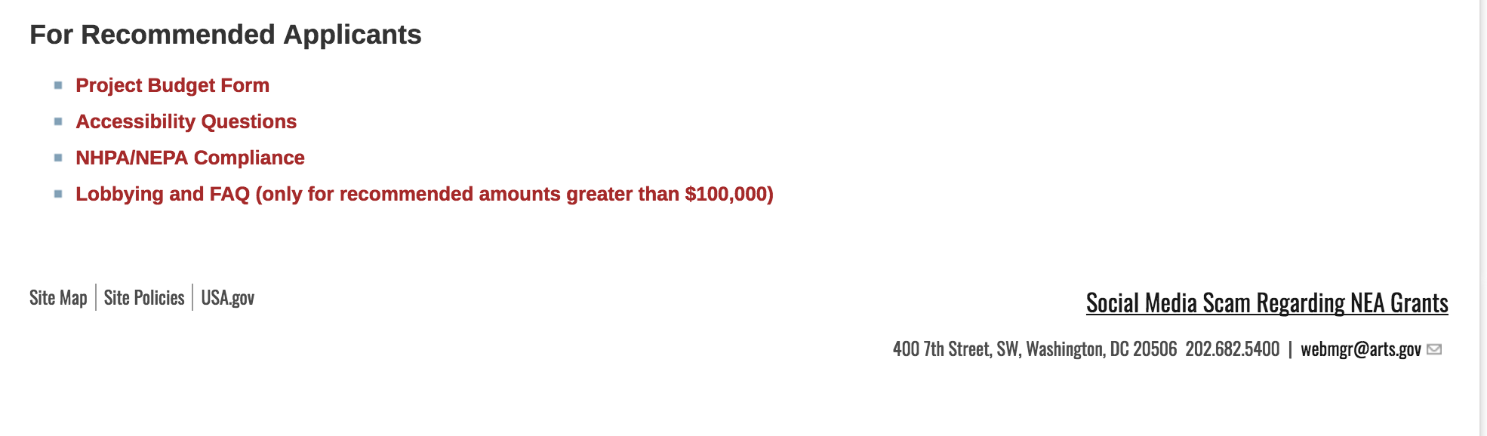
See more at: https://www.arts.gov/grants

Programs:

NEA Literature Fellowships: Creative Writing, FY2019
Synopsis 1
Document Type: | Grants Notice
Funding Opportunity Number: | 2018NEA03LFCW
Funding Opportunity Title: | NEA Literature Fellowships: Creative Writing, FY2019
Opportunity Category: | Discretionary
Opportunity Category Explanation:
Funding Instrument Type: | Grant
Category of Funding Activity: | Arts (see "Cultural Affairs" in CFDA)
Category Explanation:
Expected Number of Awards:
CFDA Number(s): | 45.024 -- Promotion of the Arts Grants to Organizations and Individuals
Cost Sharing or Matching Requirement: | No
Version: | Synopsis 1
Posted Date: | Nov 07, 2017
Last Updated Date: | Nov 08, 2017
Original Closing Date for Applications: | Mar 07, 2018
Current Closing Date for Applications: | Mar 07, 2018
Archive Date:
Estimated Total Program Funding:
Award Ceiling: | $25,000
Award Floor: | $25,000
Eligible Applicants: | Individuals
Agency Name: | National Endowment for the Arts
Description: | You may submit only one application for FY 2019 funding. You may not apply for both a Literature Fellowship under this deadline and a Translation Project under the December 5, 2017 deadline. Grant Program Description The National Endowment for the Arts Literature Fellowships program offers $25,000 grants in prose (fiction and creative nonfiction) and poetry to published creative writers that enable recipients to set aside time for writing, research, travel, and general career advancement. Applications are reviewed through an anonymous process in which the only criteria for review are artistic excellence and artistic merit. To review the applications, the National Endowment for the Arts assembles a different advisory panel every year, each diverse with regard to geography, race and ethnicity, and artistic points of view. The National Endowment for the Arts Literature Fellowships program operates on a two-year cycle with fellowships in prose and poetry available in alternating years. For FY 2019, which is covered by these guidelines, fellowships in poetry are available. Fellowships in prose (fiction and creative nonfiction) will be offered in FY 2020 and guidelines will be available in January 2019. You may apply only once each year. Competition for fellowships is extremely rigorous. We typically receive more than 1,000 applications each year in this category and award fellowships to fewer than 5% of applicants. You should consider carefully whether your work will be competitive at the national level.
Link to Additional Information: | NEA Complete Website Announcement
Grantor Contact Information: | If you have difficulty accessing the full announcement electronically, please contact:  NEA Web Manager webmgr@arts.gov  NEA Web Manager
http://www.grants.gov/web/grants/view-opportunity.html?oppId=298531

Modifications:

Reminders:

National Endowment for the Humanities

Grant Overview -

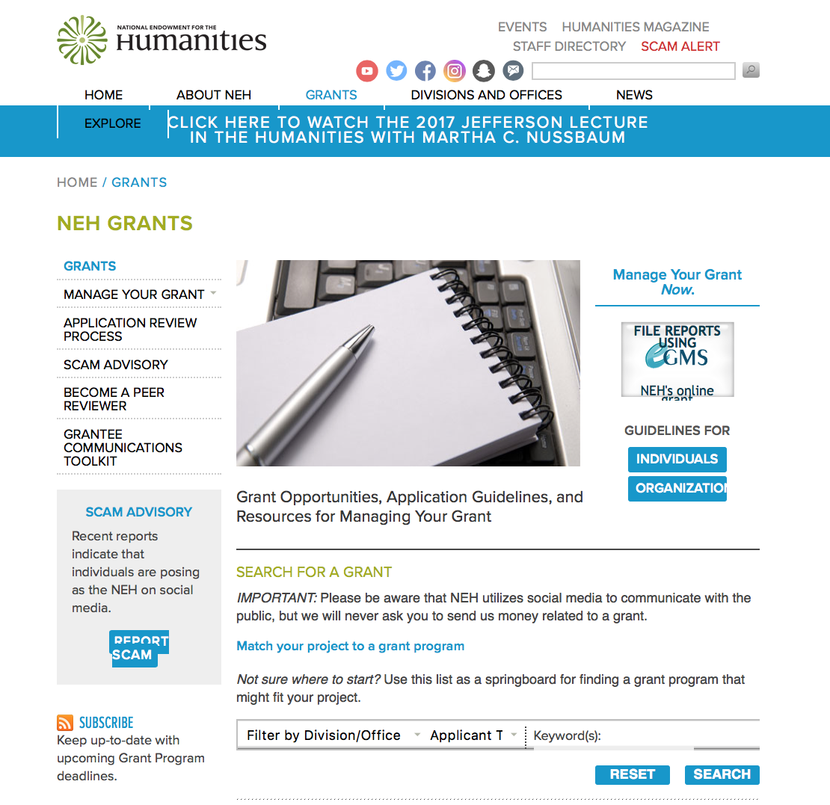

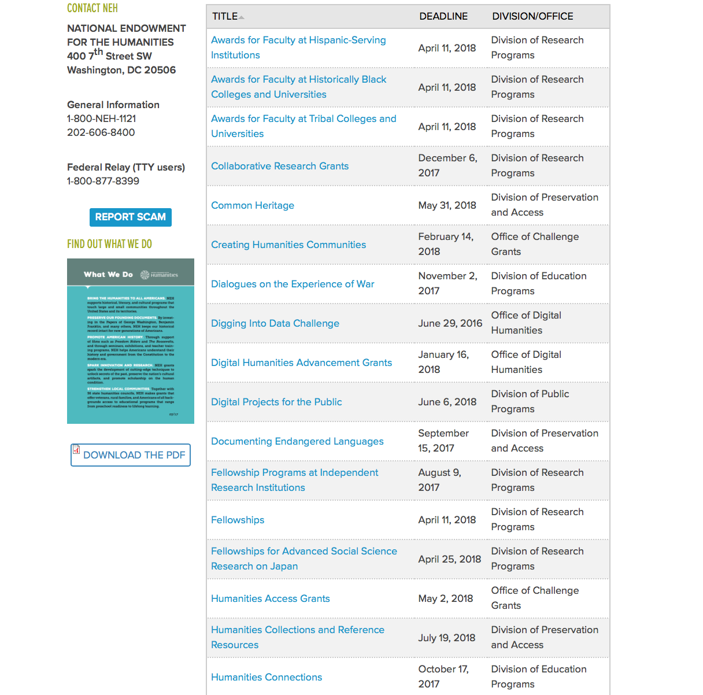

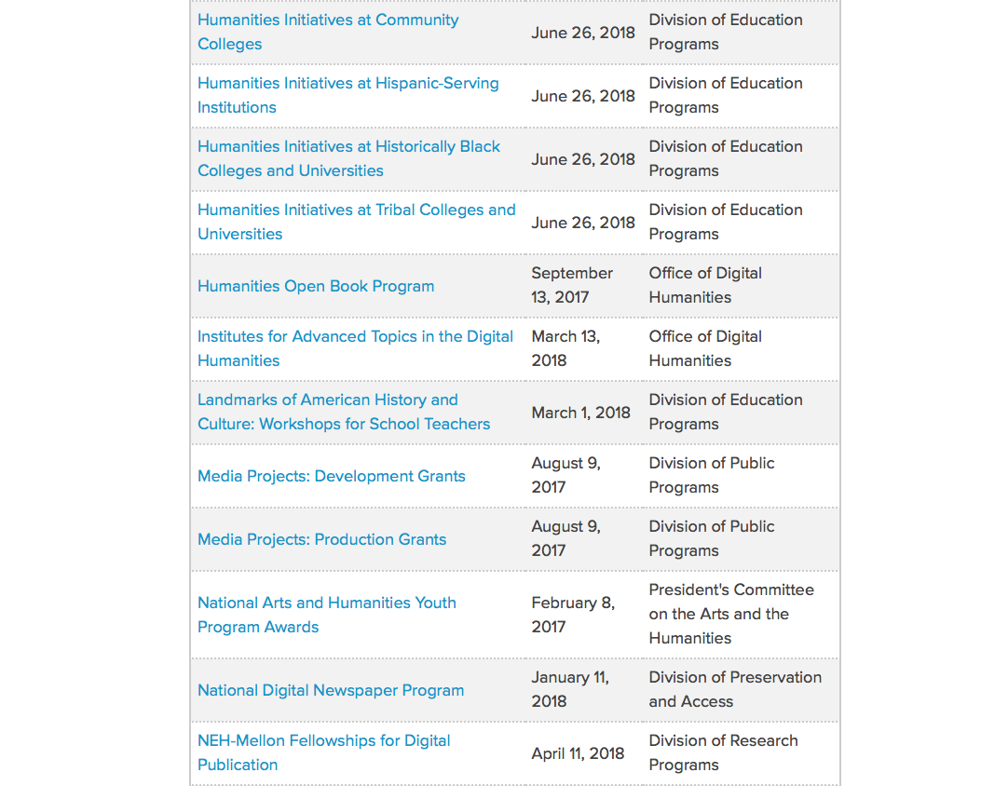

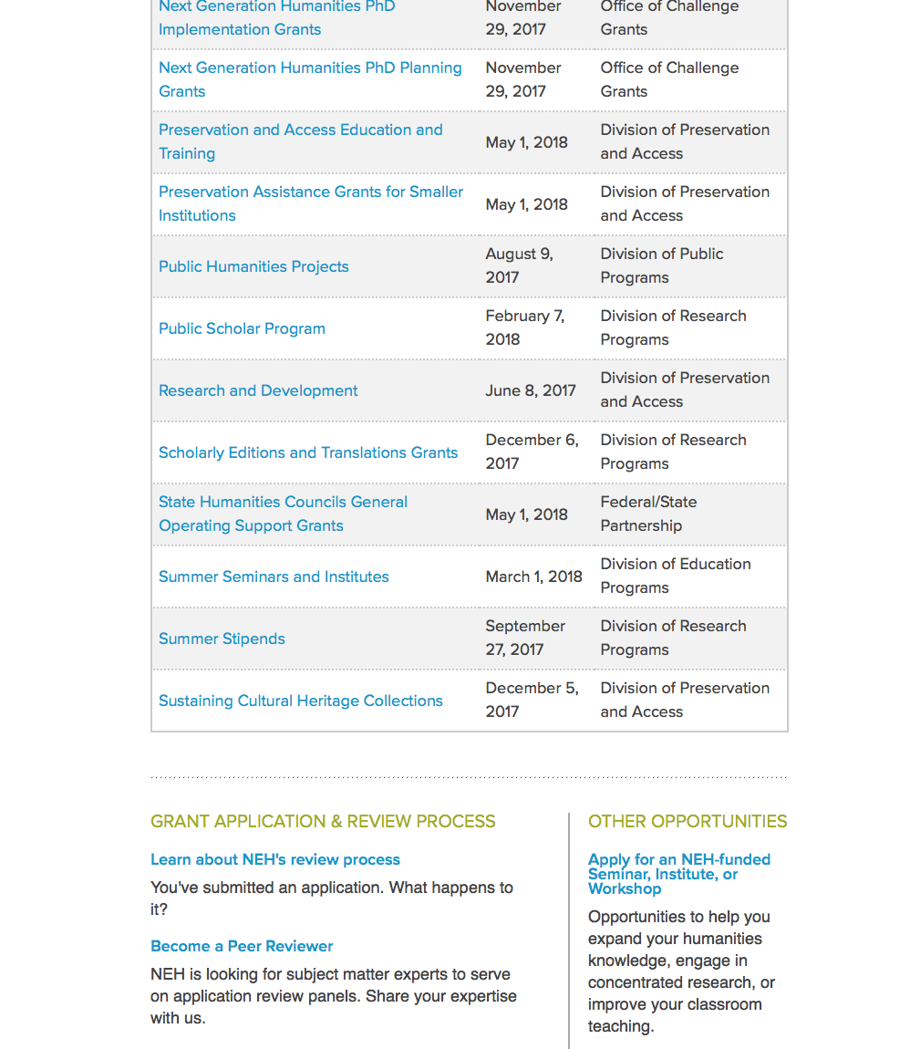

https://www.neh.gov/grants

Programs:

Digital Humanities Advancement Grants
Synopsis 1
Document Type: | Grants Notice
Funding Opportunity Number: | 20180116-HAA
Funding Opportunity Title: | Digital Humanities Advancement Grants
Opportunity Category: | Discretionary
Opportunity Category Explanation:
Funding Instrument Type: | Grant
Category of Funding Activity: | Humanities (see "Cultural Affairs" in CFDA)
Category Explanation:
Expected Number of Awards:
CFDA Number(s): | 45.169 -- Promotion of the Humanities Office of Digital Humanities
Cost Sharing or Matching Requirement: | No
Version: | Synopsis 1
Posted Date: | Nov 15, 2017
Last Updated Date: | Nov 15, 2017
Original Closing Date for Applications: | Jan 16, 2018
Current Closing Date for Applications: | Jan 16, 2018
Archive Date:
Estimated Total Program Funding:
Award Ceiling: | $375,000
Award Floor: | $10,000
Eligible Applicants: | Nonprofits having a 501(c)(3) status with the IRS, other than institutions of higher education  Special district governments  Private institutions of higher education  Public and State controlled institutions of higher education  City or township governments  County governments  State governments  Native American tribal governments (Federally recognized)
Agency Name: | National Endowment for the Humanities
Description: | Digital Humanities Advancement Grants (DHAG) support digital projects throughout their lifecycles, from early start-up phases through implementation and long-term sustainability. Experimentation, reuse, and extensibility are hallmarks of this grant category, leading to innovative work that can scale to enhance research, teaching, and public programming in the humanities. You can find a discussion of the forms that experimentation can take in the Frequently Asked Questions document, which is available on the program resource page. This program is offered twice per year. Proposals are welcome for digital initiatives in any area of the humanities. Through a special partnership, the Institute of Museum and Library Services (IMLS) anticipates providing additional funding to this program to encourage innovative collaborations between museum or library professionals and humanities professionals to advance preservation of, access to, use of, and engagement with digital collections and services. Through this partnership, IMLS and NEH may jointly fund some DHAG projects that involve collaborations with museums and/or libraries. Digital Humanities Advancement Grants may involve • creating or enhancing experimental, computationally-based methods, techniques, or infrastructure that contribute to the humanities; • pursuing scholarship that examines the history, criticism, and philosophy of digital culture and its impact on society, or explores the philosophical or practical implications and impact of digital humanities in specific fields or disciplines; or • revitalizing and/or recovering existing digital projects that promise to contribute substantively to scholarship, teaching, or public knowledge of the humanities.
Link to Additional Information: | https://www.neh.gov/grants/odh/digital-humanities-advancement-grants
Grantor Contact Information: | If you have difficulty accessing the full announcement electronically, please contact:  If you have questions about the program, contact the ODH staff at odh@neh.gov. Applicants wishing to speak to a staff member by telephone should provide in an e-mail message a telephone number and a preferred time to call. odh@neh.gov  odh@neh.gov
http://www.grants.gov/web/grants/view-opportunity.html?oppId=298688

Media Projects Grants
Synopsis 1
Document Type: | Grants Notice
Funding Opportunity Number: | 20180110-TD
Funding Opportunity Title: | Media Projects Grants
Opportunity Category: | Discretionary
Opportunity Category Explanation:
Funding Instrument Type: | Grant
Category of Funding Activity: | Humanities (see "Cultural Affairs" in CFDA)
Category Explanation:
Expected Number of Awards:
CFDA Number(s): | 45.164 -- Promotion of the Humanities Public Programs
Cost Sharing or Matching Requirement: | No
Version: | Synopsis 1
Posted Date: | Nov 09, 2017
Last Updated Date: | Nov 09, 2017
Original Closing Date for Applications: | Jan 10, 2018
Current Closing Date for Applications: | Jan 10, 2018
Archive Date:
Estimated Total Program Funding:
Award Ceiling: | $1,000,000
Award Floor: | $1
Eligible Applicants: | Nonprofits having a 501(c)(3) status with the IRS, other than institutions of higher education  Special district governments  City or township governments  Native American tribal governments (Federally recognized)  State governments  Public and State controlled institutions of higher education  County governments  Private institutions of higher education
Agency Name: | National Endowment for the Humanities
Description: | The Media Projects program supports film, television, and radio projects that engage public audiences with humanities ideas in creative and appealing ways. All projects must be grounded in humanities scholarship in disciplines such as history, art history, film studies, literature, drama, religious studies, philosophy, or anthropology. Projects must also demonstrate an approach that is thoughtful, balanced, and analytical (rather than celebratory). The approach to the subject matter must go beyond the mere presentation of factual information to explore its larger significance and stimulate critical thinking. NEH is a national funding agency, so the projects that we support must demonstrate the potential to attract a broad general audience. Film and television projects may be single programs or a series addressing significant figures, events, or ideas. Programs must be intended for national distribution, via traditional carriage or online distribution. The Division of Public Programs welcomes projects that range in length from short-form to broadcast-length video. The Division of Public Programs also encourages film and television projects that examine international themes and subjects in the humanities, in order to spark Americans’ engagement with the broader world beyond the United States. These projects should demonstrate international collaboration by enlisting scholars based both in the United States and abroad, and/or by working with an international media team. The collaborations should bring broad cross-cultural perspectives to the proposed topics and should be intended primarily for U.S. public audiences. Radio projects, including podcasts, may involve single programs, limited series, or segments within an ongoing program. They may also develop new humanities content to augment existing radio programming or add greater historical background or humanities analysis to the subjects of existing programs. They may be intended for regional or national distribution. NEH encourages projects that engage public audiences through multiple formats in the exploration of humanities ideas. Proposed projects might include complementary components to a film, television, or radio project. These components should deepen the audience’s understanding of the subject in a supplementary manner: for example, book/film discussion programs, supplementary educational websites, or museum exhibitions. Development grants enable media producers to collaborate with scholars to develop humanities content and to prepare programs for production. Grants should result in a script (for a film or television project) or a detailed treatment (for a radio or podcast project) and may also yield a plan for outreach and public engagement. Production grants support the production and distribution of films, television programs, and radio programs or podcasts that promise to engage a broad public audience.
Link to Additional Information: | https://www.neh.gov/grants/mp
Grantor Contact Information: | If you have difficulty accessing the full announcement electronically, please contact:  Division of Public Programs National Endowment for the Humanities 400 Seventh Street, SW Washington, DC 20506 202-606-8269 publicpgms@neh.gov publicpgms@neh.gov  publicpgms@neh.gov
http://www.grants.gov/web/grants/view-opportunity.html?oppId=298572

National Digital Newspaper Program
Synopsis 1

Document Type: | Grants Notice
Funding Opportunity Number: | 20180111-PJ
Funding Opportunity Title: | National Digital Newspaper Program
Opportunity Category: | Discretionary
Opportunity Category Explanation:
Funding Instrument Type: | Cooperative Agreement
Category of Funding Activity: | Humanities (see "Cultural Affairs" in CFDA)
Category Explanation:
Expected Number of Awards:
CFDA Number(s): | 45.149 -- Promotion of the Humanities Division of Preservation and Access
Cost Sharing or Matching Requirement: | No
Version: | Synopsis 1
Posted Date: | Nov 08, 2017
Last Updated Date: | Nov 08, 2017
Original Closing Date for Applications: | Jan 11, 2018
Current Closing Date for Applications: | Jan 11, 2018
Archive Date:
Estimated Total Program Funding:
Award Ceiling: | $325,000
Award Floor: | $1
Eligible Applicants: | City or township governments  Private institutions of higher education  Native American tribal governments (Federally recognized)  Public and State controlled institutions of higher education  Special district governments  State governments  Nonprofits having a 501(c)(3) status with the IRS, other than institutions of higher education  County governments
Agency Name: | National Endowment for the Humanities
Description: | The National Digital Newspaper Program (NDNP) is a partnership between NEH and the Library of Congress to create a national digital resource of historically significant newspapers published between 1690 and 1963, from all the states and U.S. territories. This searchable database will be permanently maintained at the Library of Congress (LC) and will be freely accessible via the Internet. (See the Chronicling America: Historic American Newspapers website.) An accompanying national newspaper directory of bibliographic and holdings information on the website directs users to newspaper titles available in all types of formats. During the course of its partnership with NEH, LC will also digitize and contribute to the NDNP database a significant number of newspaper pages drawn from its own collections. Forty-five states and one territory have joined the NDNP so far. Previous award recipients include Alaska, Arizona, Arkansas, California, Colorado, Connecticut, Delaware, Florida, Georgia, Hawaii, Idaho, Illinois, Indiana, Iowa, Kansas, Kentucky, Louisiana, Maine, Maryland, Michigan, Minnesota, Mississippi, Missouri, Montana, Nebraska, Nevada, New Jersey, New Mexico, New York, North Carolina, North Dakota, Ohio, Oklahoma, Oregon, Pennsylvania, Puerto Rico, South Carolina, South Dakota, Tennessee, Texas, Utah, Vermont, Virginia, Washington, West Virginia, and Wisconsin. NEH intends to support projects in all states and U.S. territories. Awards are made to an organization within each U.S. state or territory, which typically collaborates with relevant state partners in this effort. After their initial NDNP awards, state partners are encouraged to seek second and third awards, to produce a total of approximately 300,000 pages of digitized newspapers per state. Awardees may receive support for continued work beyond the third award, but the program gives priority to applications from those states and territories that have not received NDNP funding—as well as applications from states and territories that have received fewer than three awards.
Link to Additional Information: | https://www.neh.gov/grants/preservation/national-digital-newspaper-program
Grantor Contact Information: | If you have difficulty accessing the full announcement electronically, please contact:  preservation@neh.gov 202-606-8570 National Digital Newspaper Program Division of Preservation and Access National Endowment for the Humanities 400 Seventh Street, SW Washington, DC 20506 preservation@neh.gov  preservation@neh.gov
http://www.grants.gov/web/grants/view-opportunity.html?oppId=298539

Public Humanities Projects
Synopsis 1
Document Type: | Grants Notice
Funding Opportunity Number: | 20180110-GW
Funding Opportunity Title: | Public Humanities Projects
Opportunity Category: | Discretionary
Opportunity Category Explanation:
Funding Instrument Type: | Grant
Category of Funding Activity: | Humanities (see "Cultural Affairs" in CFDA)
Category Explanation:
Expected Number of Awards:
CFDA Number(s): | 45.164 -- Promotion of the Humanities Public Programs
Cost Sharing or Matching Requirement: | No
Version: | Synopsis 1
Posted Date: | Nov 09, 2017
Last Updated Date: | Nov 09, 2017
Original Closing Date for Applications: | Jan 10, 2018
Current Closing Date for Applications: | Jan 10, 2018
Archive Date:
Estimated Total Program Funding:
Award Ceiling: | $1,000,000
Award Floor: | $1
Eligible Applicants: | State governments  Nonprofits having a 501(c)(3) status with the IRS, other than institutions of higher education  City or township governments  Native American tribal governments (Federally recognized)  County governments  Private institutions of higher education  Public and State controlled institutions of higher education  Special district governments
Agency Name: | National Endowment for the Humanities
Description: | Public Humanities Projects grants support projects that bring the ideas and insights of the humanities to life for general audiences. Projects must engage humanities scholarship to analyze significant themes in disciplines such as history, literature, ethics, and art history. NEH encourages projects that involve members of the public in collaboration with humanities scholars or that invite contributions from the community in the development and delivery of humanities programming. This grant program supports a variety of forms of audience engagement. Applications should follow the parameters set out below for one of the following three formats: • Community Conversations: This format supports one- to two-year-long series of community-wide in-person public programs that are centered on one or more significant humanities resources, such as historic artifacts, artworks, literature, musical compositions, or films. These resources should be chosen to engage a diverse public audience. The programs must be anchored through perspectives drawn from humanities disciplines. Applicants must demonstrate prior experience conducting public dialogues. • Exhibitions: This format supports the creation of permanent exhibitions (on view for at least three years) and single-site temporary exhibitions (open to the public for a minimum of four to six months), as well as travelling exhibitions that will be available to public audiences in at least two venues in the United States (including the originating location). • Historic Places: This format supports long-term interpretive programs for historic sites, houses, neighborhoods, and regions that are intended to be presented to the public for at least three years. Such programs might include living history presentations, guided tours, exhibitions, and public programs. NEH encourages projects that explore humanities ideas through multiple formats. Proposed projects may include complementary components: for example, a museum exhibition might be accompanied by a website, mobile app, or discussion programs. Your application must identify one primary format for your project and follow the application instructions for that format.
Link to Additional Information: | https://www.neh.gov/grants/public/public-humanities-projects
Grantor Contact Information: | If you have difficulty accessing the full announcement electronically, please contact:  Division of Public Programs National Endowment for the Humanities 400 Seventh Street, SW Washington, DC 20506 202-606-8269 publicpgms@neh.gov publicpgms@neh.gov  publicpgms@neh.gov
http://www.grants.gov/web/grants/view-opportunity.html?oppId=298594

Modifications:

Reminders:



National Science Foundation

General Funding Overview

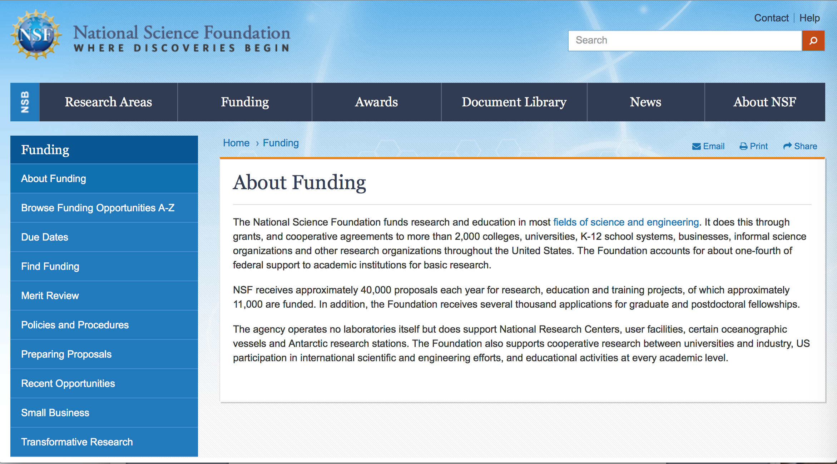

For assistance: https://nsf.gov/funding/aboutfunding.jsp

The National Science Foundation funds research and education in most fields of science and engineering. It does this through grants, and cooperative agreements to more than 2,000 colleges, universities, K-12 school systems, businesses, informal science organizations and other research organizations throughout the United States. The Foundation accounts for about one-fourth of federal support to academic institutions for basic research.
NSF receives approximately 40,000 proposals each year for research, education and training projects, of which approximately 11,000 are funded. In addition, the Foundation receives several thousand applications for graduate and postdoctoral fellowships.
The agency operates no laboratories itself but does support National Research Centers, user facilities, certain oceanographic vessels and Antarctic research stations. The Foundation also supports cooperative research between universities and industry, US participation in international scientific and engineering efforts, and educational activities at every academic level.

For details on active funding deadline dates: http://nsf.gov/funding/pgm_list.jsp?org=NSF&ord=date

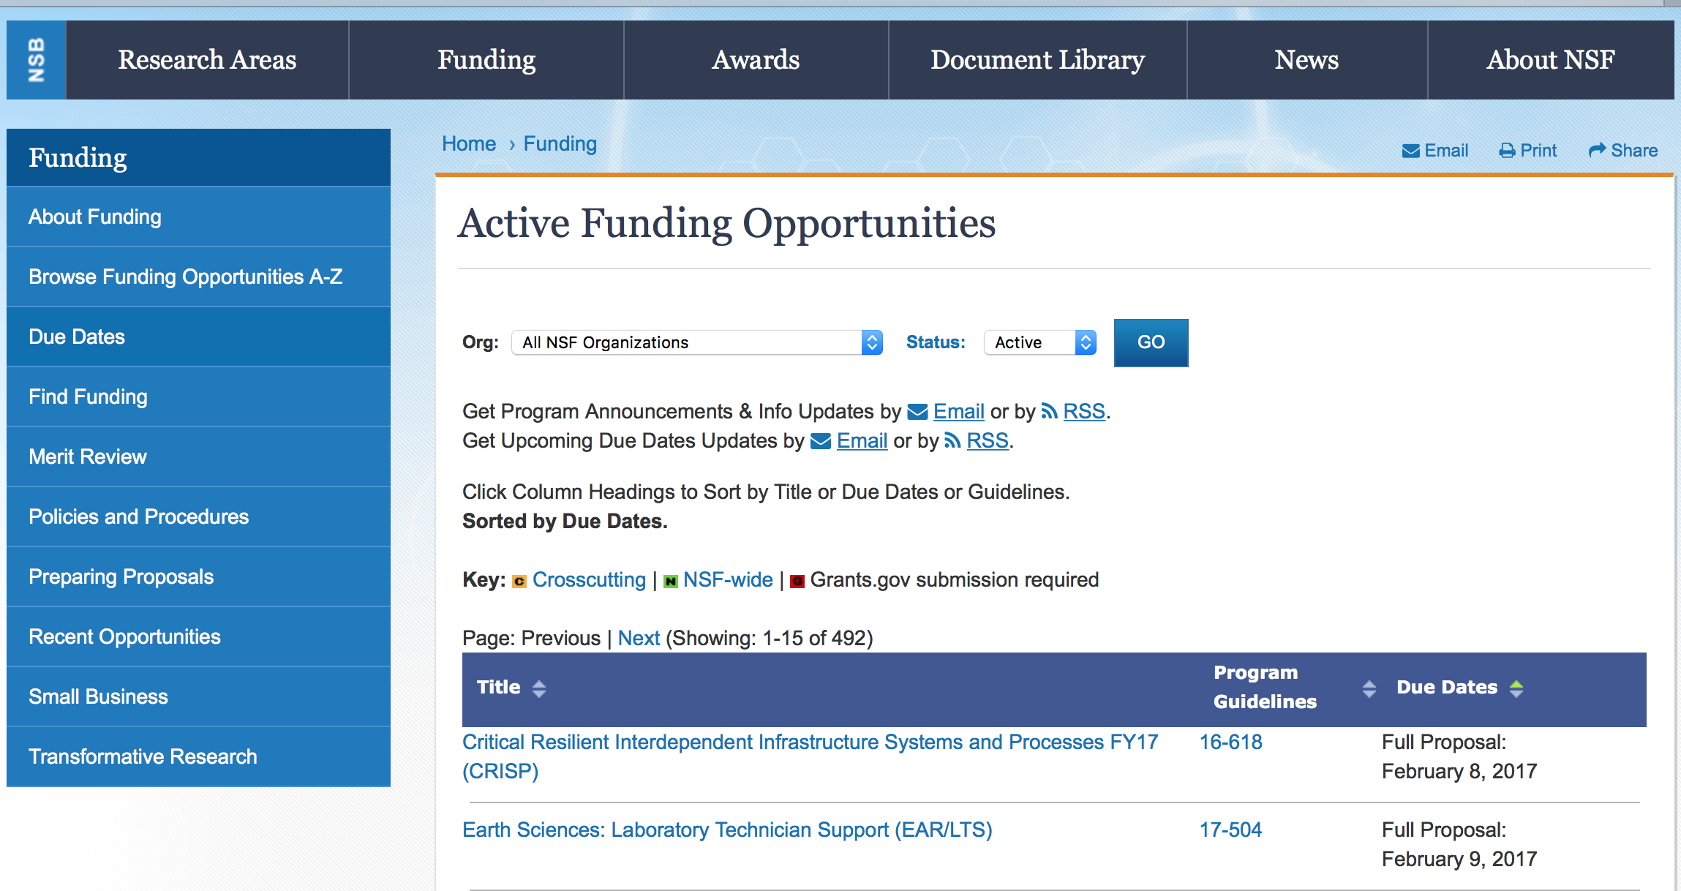

Fluid Dynamics and Particulate and Multiphase Processes Research at the International Space Station to Benefit Life on Earth
Synopsis 1
https://www.grants.gov/web/grants/view-opportunity.html?oppId=299082

Historically Black Colleges and Universities - Undergraduate Program
Synopsis 1
https://www.grants.gov/web/grants/view-opportunity.html?oppId=299139

Innovation Corps - National Innovation Network Teams Program (I-CorpsTM Teams)
Synopsis 1
http://www.grants.gov/web/grants/view-opportunity.html?oppId=298770

Major Research Instrumentation Program
Synopsis 1
http://www.grants.gov/web/grants/view-opportunity.html?oppId=298447

National Robotics Initiative 2.0: Ubiquitous Collaborative Robots
Synopsis 1
https://www.grants.gov/web/grants/view-opportunity.html?oppId=298941

NSF/CASIS Collaboration on Tissue Engineering on the International Space Station to Benefit Life on Earth
Synopsis 1
http://www.grants.gov/web/grants/view-opportunity.html?oppId=298507

Smart and Connected Communities
Synopsis 1
https://www.grants.gov/web/grants/view-opportunity.html?oppId=299083

Modifications:

NASA Headquarters (Research)
ROSBio Appendix G: Solicitation of Proposals for Flight and Ground Space Biology Research
Synopsis 3
http://www.grants.gov/web/grants/view-opportunity.html?oppId=298366

Reminders:

Deleted:

15-504 - Major Research Instrumentation Program
Deletion Comments: Opportunity deleted

17-552 - Computer and Information Science and Engineering (CISE) Research Initiation Initiative
Deletion Comments: Opportunity deleted

17-559 - Innovation Corps - National Innovation Network Teams Program (I-CorpsTM Teams)
Deletion Comments: Opportunity deleted

Nuclear Regulatory Commission

Reminders:

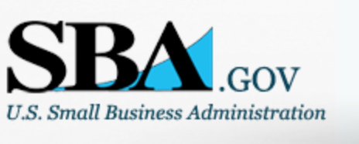

Small Business Administration

General Overview Finding Loans & Grants

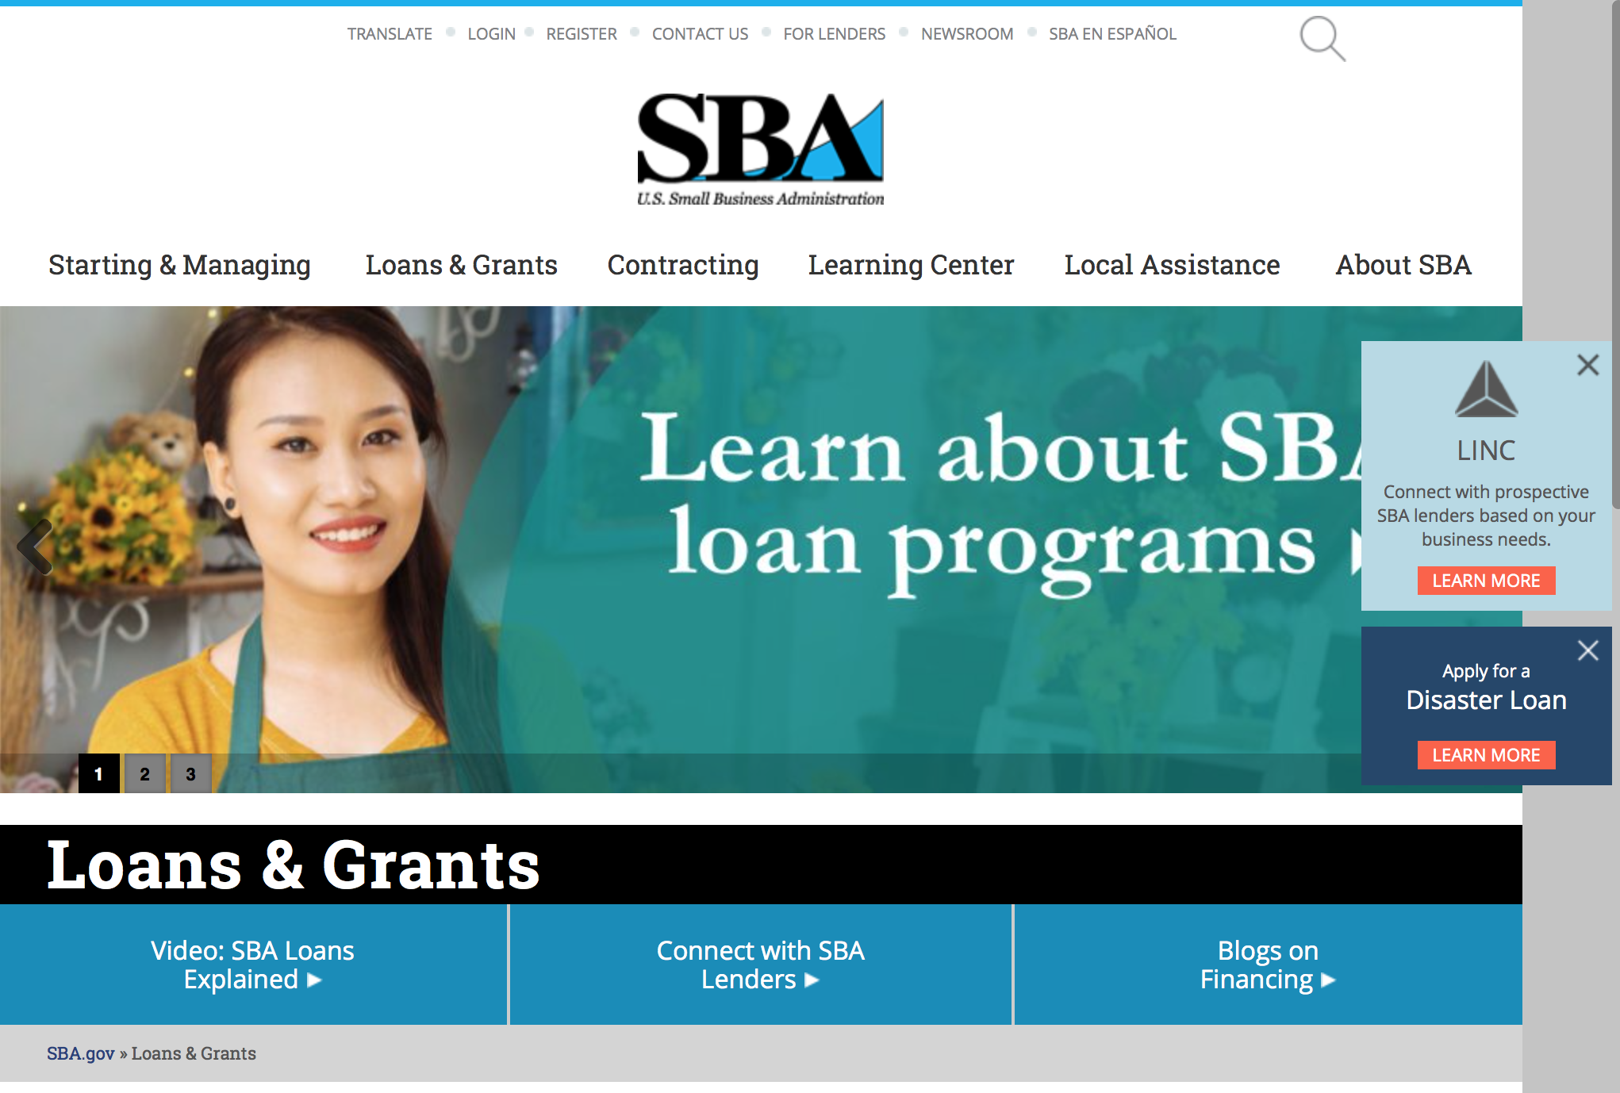
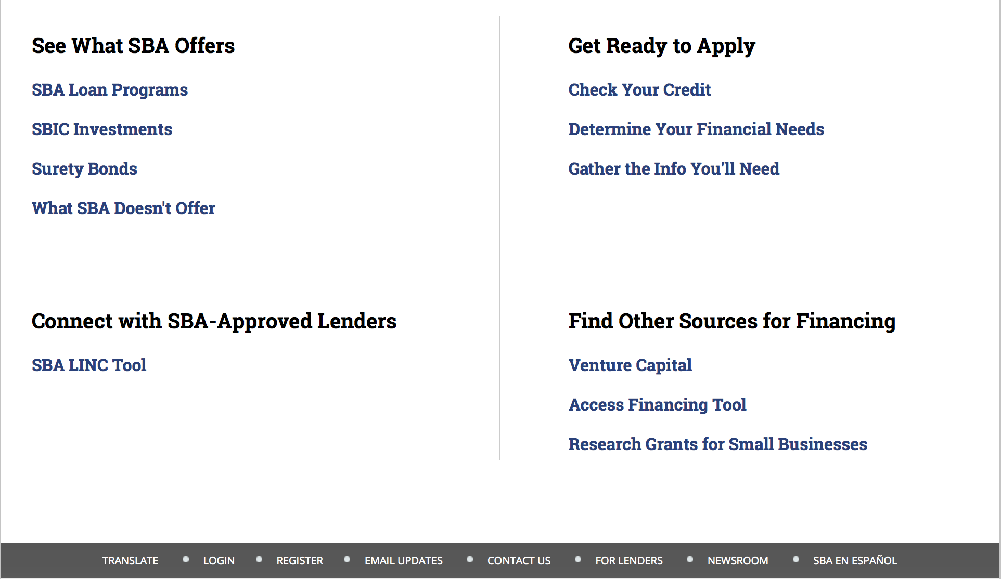

https://www.sba.gov/category/navigation-structure/loans-grants
Federal, state and local governments offer a wide range of financing programs to help small businesses start and grow their operations. These programs include low-interest loans, venture capital, and scientific and economic development grants.
Use SBA.gov's Loans and Grants Search Tool to get a list of financing programs for which you may qualify, or visit the resources below to learn more about small business financing programs.
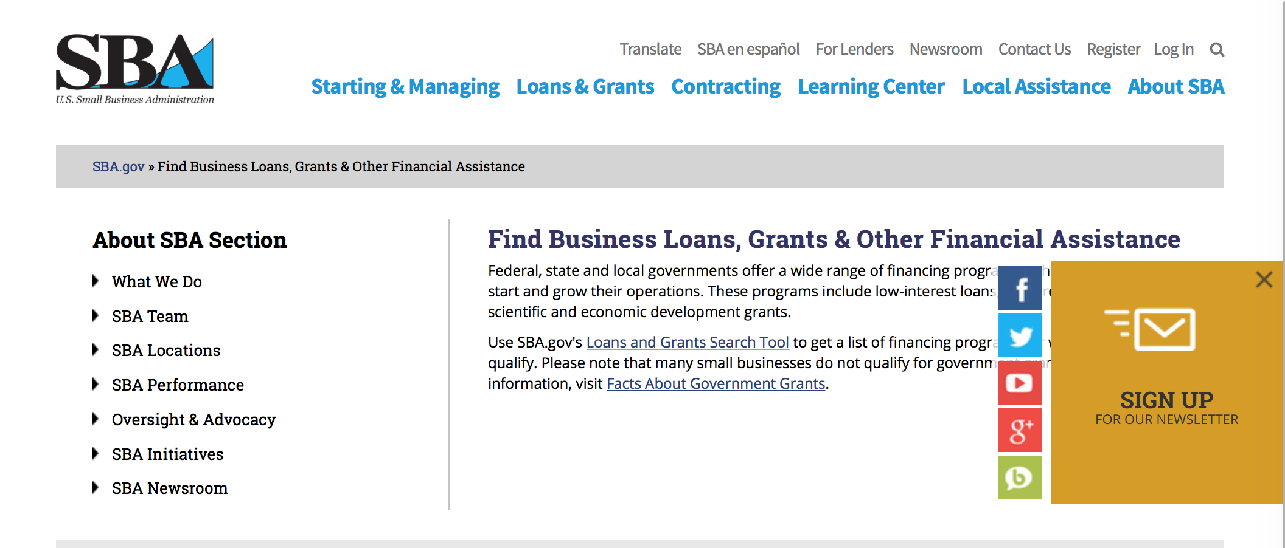
To get to the main SBA.gov funding page click here
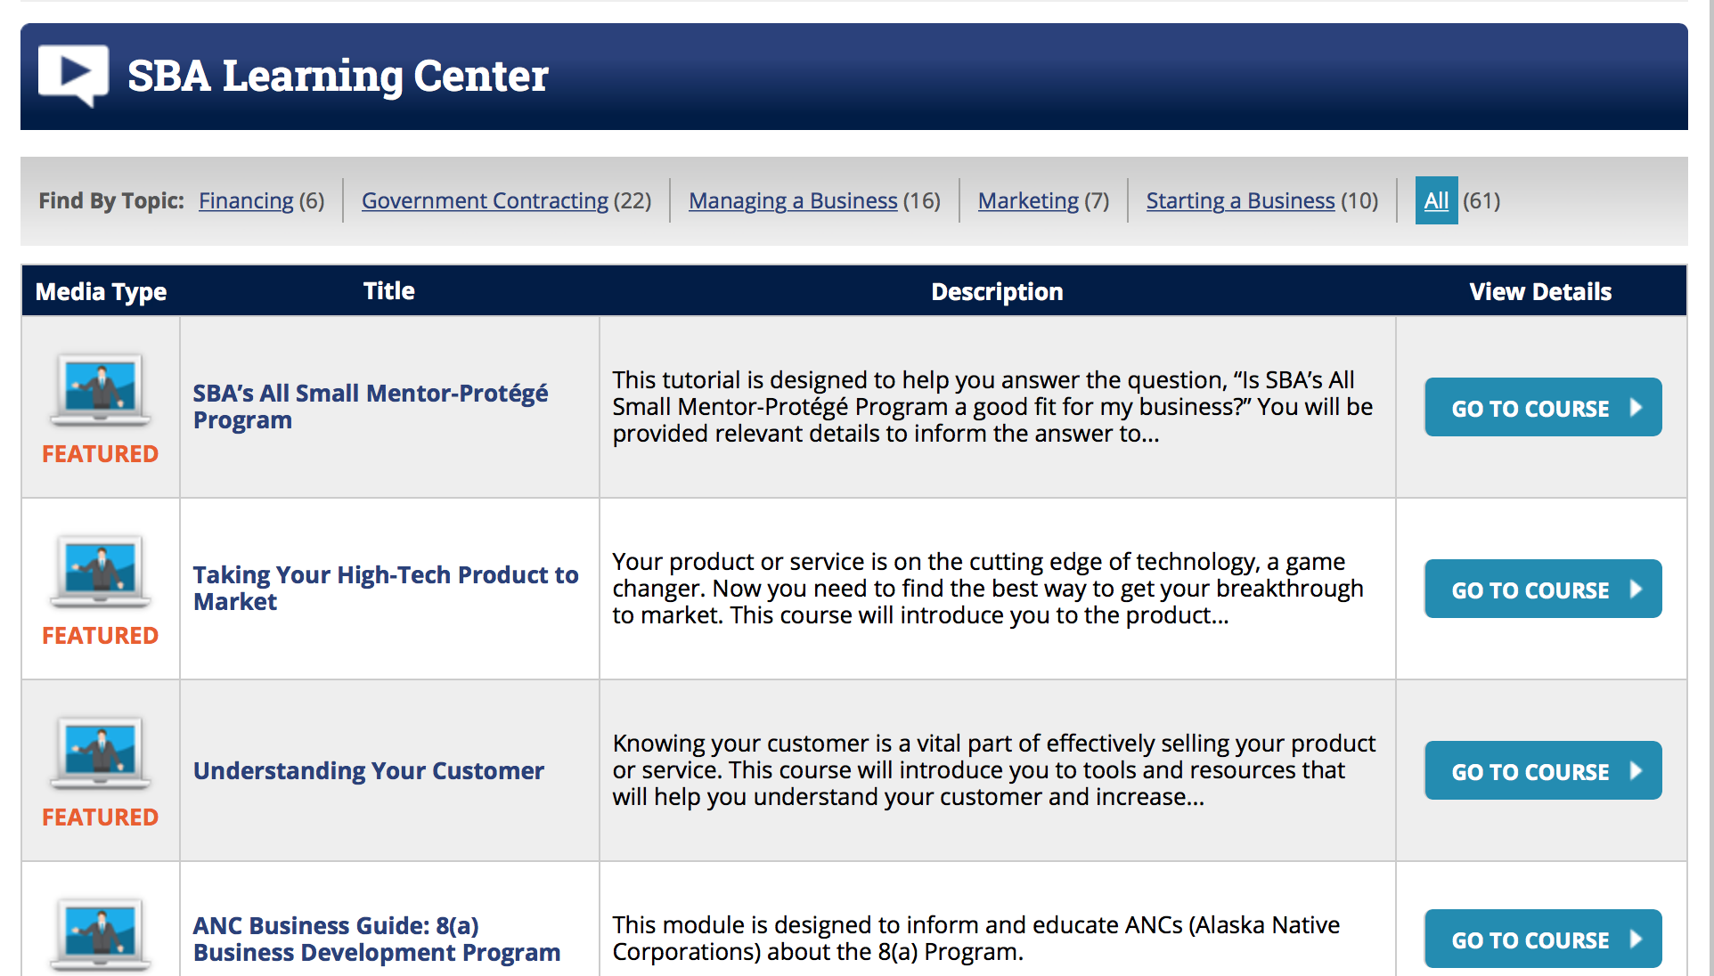
https://www.sba.gov/tools/sba-learning-center/search/training

Programs:

Veterans Business Outreach Center Program (VBOC)
Synopsis 1

Document Type: | Grants Notice
Funding Opportunity Number: | VBOC-2018-01
Funding Opportunity Title: | Veterans Business Outreach Center Program (VBOC)
Opportunity Category: | Discretionary
Opportunity Category Explanation:
Funding Instrument Type: | Cooperative Agreement
Category of Funding Activity: | Business and Commerce
Category Explanation:
Expected Number of Awards: | 23
CFDA Number(s): | 59.044 -- Veterans Outreach Program
Cost Sharing or Matching Requirement: | No
Version: | Synopsis 1
Posted Date: | Nov 20, 2017
Last Updated Date: | Nov 17, 2017
Original Closing Date for Applications: | Jan 08, 2018
Current Closing Date for Applications: | Jan 08, 2018
Archive Date:
Estimated Total Program Funding: | $6,000,000
Award Ceiling: | $375,000
Award Floor: | $225,000
Eligible Applicants: | County governments  Private institutions of higher education  Nonprofits having a 501(c)(3) status with the IRS, other than institutions of higher education  Others (see text field entitled "Additional Information on Eligibility" for clarification)  City or township governments  State governments
Additional Information on Eligibility: | • Be a nonprofit organization, local or state agencies, private sector firm or institute of higher learning. • Demonstrate a history of providing quality entrepreneurship and/or business management training to aspiring entrepreneurs or existing small business owners that are members of the following populations: veterans, service-disabled veterans, Reserve Component members or National Guard, transitioning service members, spouses of service members or veterans, and other beneficiaries interested in starting or growing a small enterprise. The quality of a program can be demonstrated by new business starts, business expansions or diversifications number of contracts awarded and loans approved, as well as jobs created and/or retained, and connection to other programs such as SBA resource partners.
Agency Name: | Small Business Administration
Description: | Eligible organizations (as defined in Section 3.2) may apply for an Initial Phase VBOC Award of financial assistance under this Funding Opportunity to fund implementation of a Veterans Business Outreach Center in the geographic coverage areas defined in Appendix A. Applicants are limited to the defined coverage areas and can apply for all, or part, of a defined coverage area. As a major component of the VBOC program Applicants are expected to provide entrepreneurship training through the Boots to Business (B2B) and Reboot Training programs to transitioning military personnel and veteran small business owners and entrepreneurs. VBOCs will be expected to cover 100% of the Boots to Business classes within their coverage area. Additionally, funds will be used to offer traditional business counseling and technical assistance to veterans, service-members, military spouses, and others interested in starting or growing a small business.
Link to Additional Information:
Grantor Contact Information: | If you have difficulty accessing the full announcement electronically, please contact:  Janet Moorman Program Officer Phone (202) 205-7419  janet.moorman@sba.gov

https://www.grants.gov/web/grants/view-opportunity.html?oppId=298820

Modifications

Reminders:

Deleted:

SBA Trainings

Contracting Opportunities for Veteran Entrepreneurs
This self-paced training exercise is an introduction to Federal contracting opportunities for Veterans.
Topics include basic information about Veteran-owned businesses and opportunities, services available to small Veteran-owned businesses, small business incentives, and government procurement methods.
Duration: 00:30:00

http://www.sba.gov/tools/sba-learning-center/training/contracting-opportunities-veteran-entrepreneurs

Interested in Exporting? These Four Resources Can Help
Did you know that two-thirds of the world’s purchasing power is in foreign countries? As the numbers show, the international marketplace is a big one. So if you’re interested in exploring the world of exporting – or have gotten started but could use some guidance – check out these resources to help.
- Read more

Upcoming Trainings: Check out SBA's Online Training!
- Financing Options for Small Businesses
How to Prepare Government Contract Proposals
Getting Started With Exporting: Training and Educational Resources
Exporting represents a big opportunity to tap in to new markets, expand your customer base and grow your business. But getting started with exporting can sometimes feel like a maze of regulations, policies, and other barriers. Here are some free training and educational resources to help.
- Read more

For Specific Information in Hawaii see the following links:
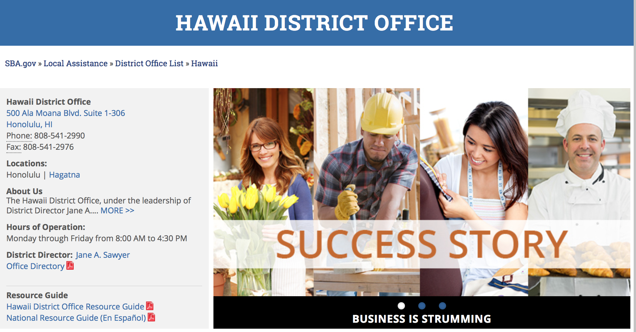

https://www.sba.gov/offices/district/hi/Honolulu

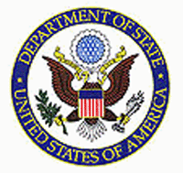

State Department General Overview and Resources for Program Administrators

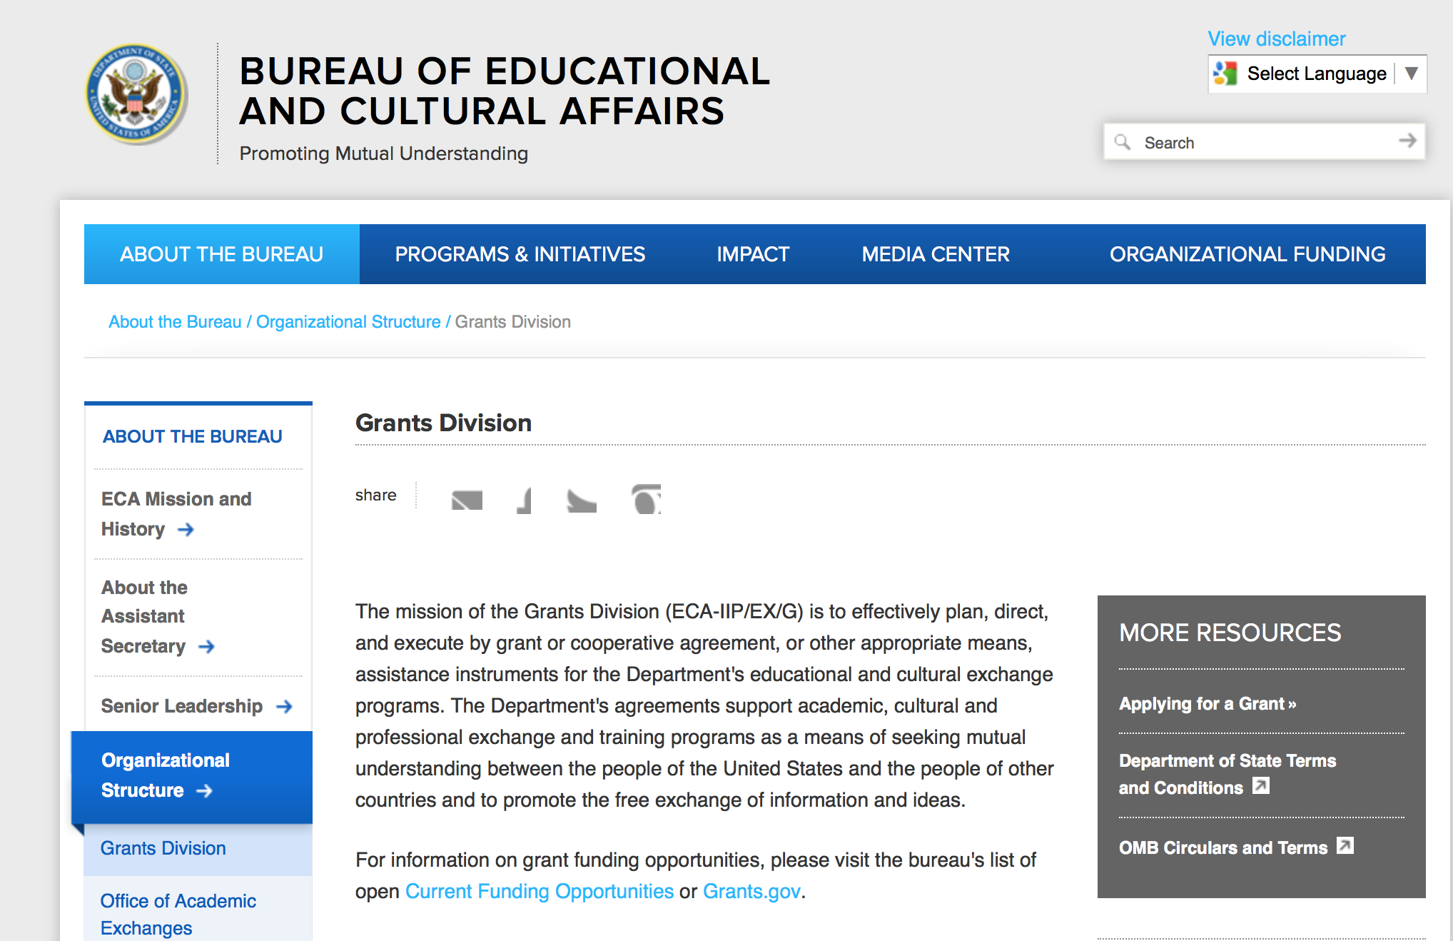

https://eca.state.gov/about-bureau/organizational-structure/grants-division

http://eca.state.gov/search/solr/grants?search_referrer=node/237

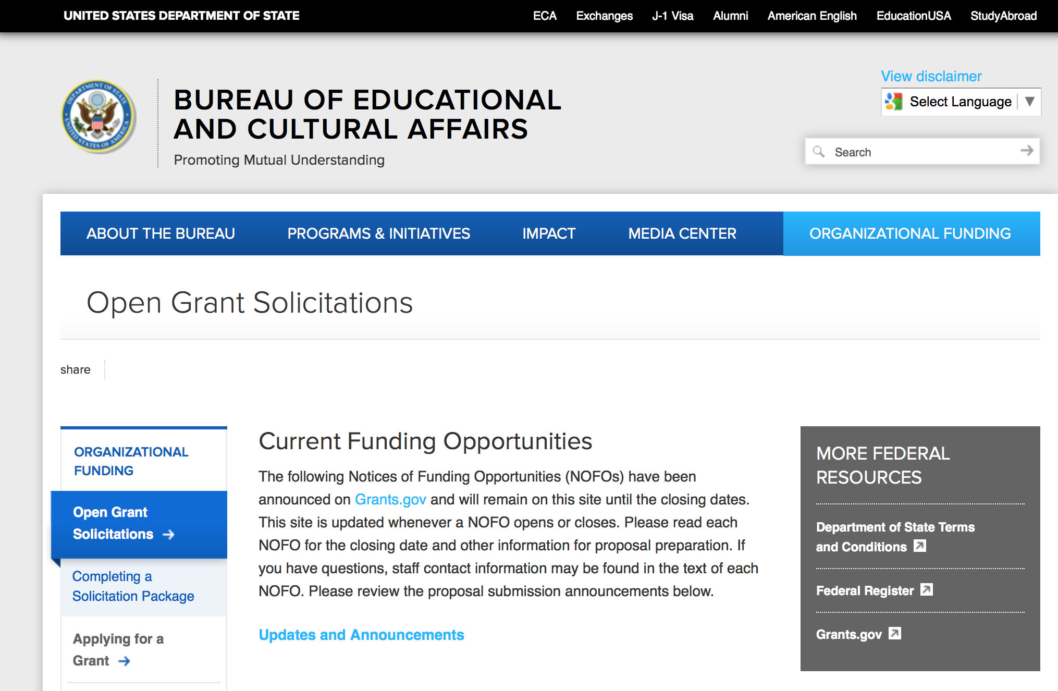
https://eca.state.gov/organizational-funding/open-grant-solicitations

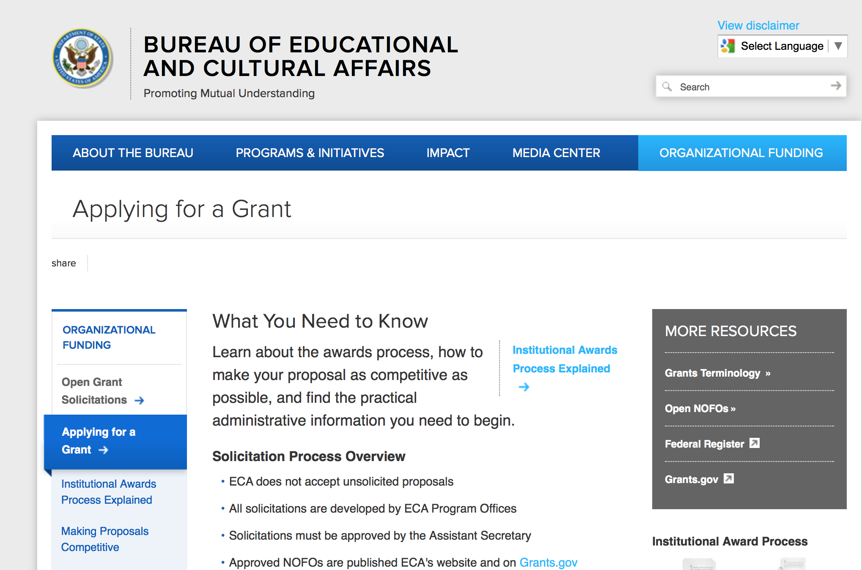
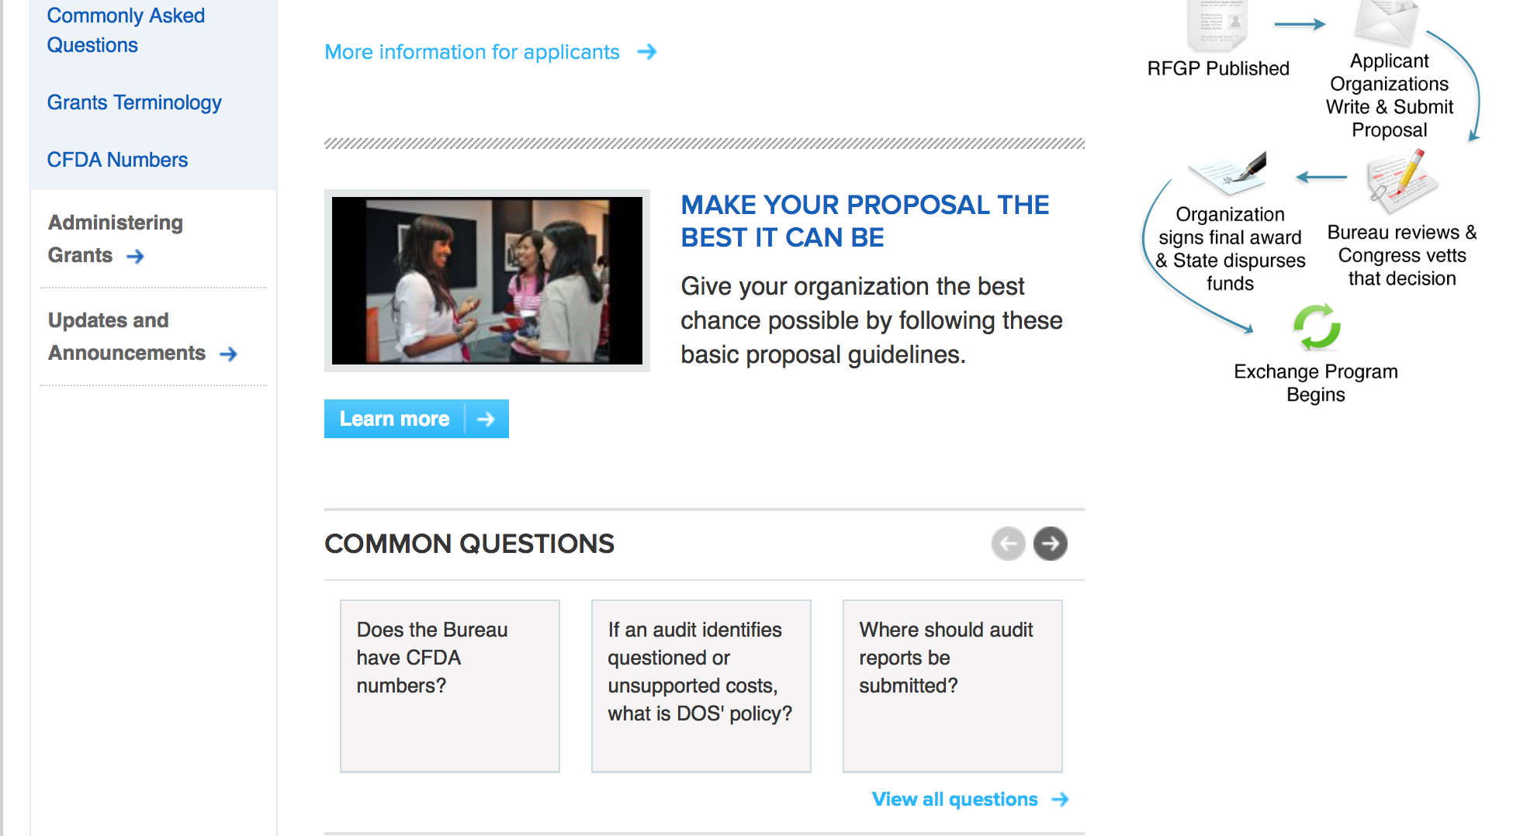
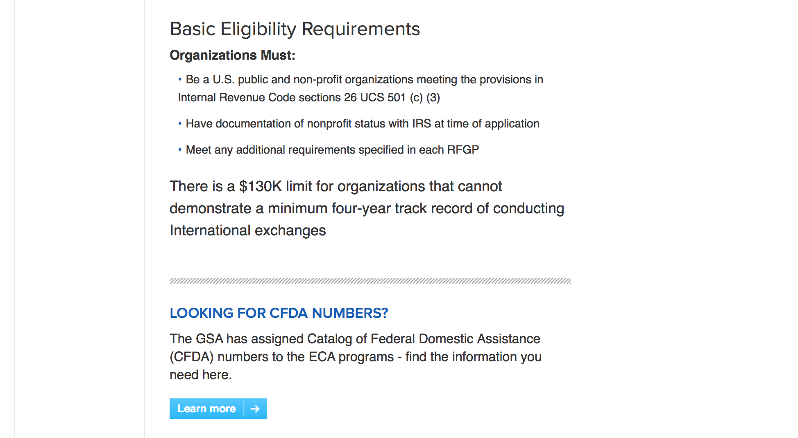
http://eca.state.gov/organizational-funding/applying-grant

General Information:
- Bureau of Educational and Cultural Affairs Grants Division
- Open Grant Opportunities (Requests for Grant Proposals)

For General Information click here

Program Grants:
Assistance Coordination
MEPI Local Grants Annual Program Statement
Synopsis 1
https://www.grants.gov/web/grants/view-opportunity.html?oppId=299178

U.S. Mission to Jordan (Program)
2018 Ambassadors Fund for Cultural Preservation Large Grant
Synopsis 1
http://www.grants.gov/web/grants/view-opportunity.html?oppId=298449
U.S. Mission to Jordan (Program)
2018 Ambassadors Fund for Cultural Preservation Small Grants
Synopsis 1
http://www.grants.gov/web/grants/view-opportunity.html?oppId=298455
Bureau of Democracy Human Rights and Labor (Program)t
Human Rights Curricula for Afghan Police Forces
Synopsis 1
http://www.grants.gov/web/grants/view-opportunity.html?oppId=298456

Bureau of Democracy Human Rights and Labor (Program)
Empowering Youth in India
Synopsis 1
http://www.grants.gov/web/grants/view-opportunity.html?oppId=298459
Bureau of Democracy Human Rights and Labor (Program)
Promoting Non-Discrimination With Respect to Persons with Disabilities in Saudi Arabian Civil Society and the Private Sector
Synopsis 1
http://www.grants.gov/web/grants/view-opportunity.html?oppId=298472

Bureau of Democracy Human Rights and Labor (Program)
Supporting Human Rights Defenders in Tajikistan
Synopsis 1
http://www.grants.gov/web/grants/view-opportunity.html?oppId=298475

Bureau of Democracy Human Rights and Labor (Program)
DRL Promoting Human Rights in Nicaragua Solicitation
Synopsis 1
http://www.grants.gov/web/grants/view-opportunity.html?oppId=298485

Bureau of Democracy Human Rights and Labor (Program)
Promoting Freedom of Expression in Ukraine
Synopsis 1
http://www.grants.gov/web/grants/view-opportunity.html?oppId=298489
Bureau of Democracy Human Rights and Labor (Program)
Supporting Objective Media in Hungary
Synopsis 1
http://www.grants.gov/web/grants/view-opportunity.html?oppId=298504

Bureau of International Security-Nonproliferation (Program)
Iraq CBW Threat Reduction Activities
Synopsis 1
http://www.grants.gov/web/grants/view-opportunity.html?oppId=298612
Bureau of International Security-Nonproliferation (Program)
Countering North Korea (DPRK) Missile and Nuclear Program
Synopsis 1
http://www.grants.gov/web/grants/view-opportunity.html?oppId=298631
Bureau of International Security-Nonproliferation (Program)
Global Chemical Security Engagement Activities
Synopsis 1
http://www.grants.gov/web/grants/view-opportunity.html?oppId=298632

Bureau Of Educational and Cultural Affairs (Program)
FY 2018 Study of the U.S. Institutes for Student Leaders from the Western Hemisphere
Synopsis 1
http://www.grants.gov/web/grants/view-opportunity.html?oppId=298655

Bureau Of Educational and Cultural Affairs (Program)
FY 2018 Professional Fellows On-Demand Program
Synopsis 1
http://www.grants.gov/web/grants/view-opportunity.html?oppId=298672

PM Weapons Removal and Abatement (Program)
2018 Cluster Munition Remnant Survey (CMRS) and Clearance in Eastern Cambodia
Synopsis 1
http://www.grants.gov/web/grants/view-opportunity.html?oppId=298764

U.S. Mission to Bosnia and Herzegovina (Program)
WOMEN’S EMPOWERMENT SMALL GRANTS PROGRAM
Synopsis 1
http://www.grants.gov/web/grants/view-opportunity.html?oppId=298695

U.S. Mission to Bosnia and Herzegovina (Program)
DEMOCRACY COMMISSION SMALL GRANTS PROGRAM
Synopsis 1
http://www.grants.gov/web/grants/view-opportunity.html?oppId=298761

U.S. Mission to Jamaica (Program)
2018 Ambassadors Fund for Cultural Preservation Large Grants Program
Synopsis 1
https://www.grants.gov/web/grants/view-opportunity.html?oppId=298874

U.S. Mission to Belgium (Program)
U.S. Embassy Brussels PAS Annual Program Statement (APS)
Synopsis 1
http://www.grants.gov/web/grants/view-opportunity.html?oppId=298567

U.S. Mission to Japan
U.S. Embassy Tokyo PAS Annual Program Statement
Synopsis 1
https://www.grants.gov/web/grants/view-opportunity.html?oppId=299185

Modifications:

Bureau of International Security-Nonproliferation (Program)
Global Nuclear Security Engagement Activities
Synopsis 2
http://www.grants.gov/web/grants/view-opportunity.html?oppId=298614

Bureau of International Security-Nonproliferation (Program)
Global Nuclear Security Engagement Activities
Synopsis 3
http://www.grants.gov/web/grants/view-opportunity.html?oppId=298614

Bureau of International Security-Nonproliferation (Program)
Global Biosecurity Engagement Activities
Synopsis 3
http://www.grants.gov/web/grants/view-opportunity.html?oppId=298611

Bureau of International Security-Nonproliferation (Program)
Global Nuclear Security Engagement Activities
Synopsis 3
http://www.grants.gov/web/grants/view-opportunity.html?oppId=298614

Reminders:

Deleted:

Bureau of Democracy Human Rights and Labor
DRLA-DRLAQM-18-020 - DRL Religious Freedom Programing in India and Sri Lanka
Deletion Comments: Opportunity deleted
Bureau of International Narcotics-Law Enforcement
INL18CA0004-EAARMENIA-11132017 - School of Advocates Anti-Corruption and Human Rights Curriculum Development in Armenia
Deletion Comments: Opportunity deleted

Bureau of International Narcotics-Law Enforcement
INL18CA0003-WHPMEXICO-JUSTSECTOPS-110617 - Securing Justice: Developing the Capacity of Mexican Justice Sector Operators within the New Criminal Justice System
Deletion Comments: Opportunity deleted

Department of Transportation

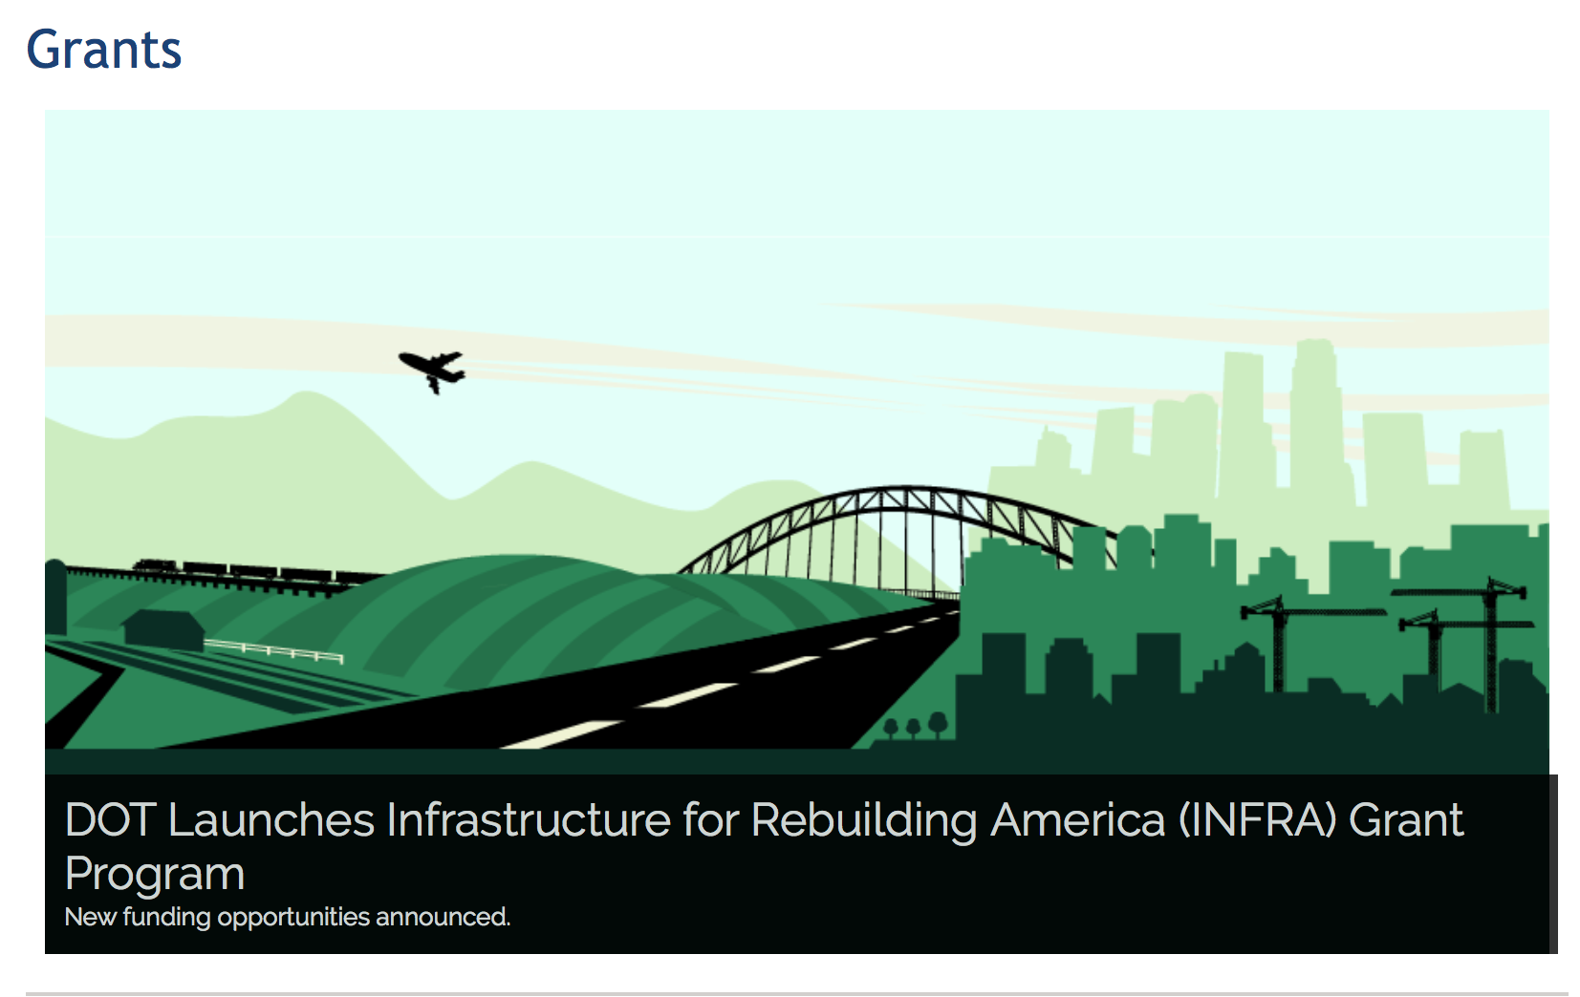

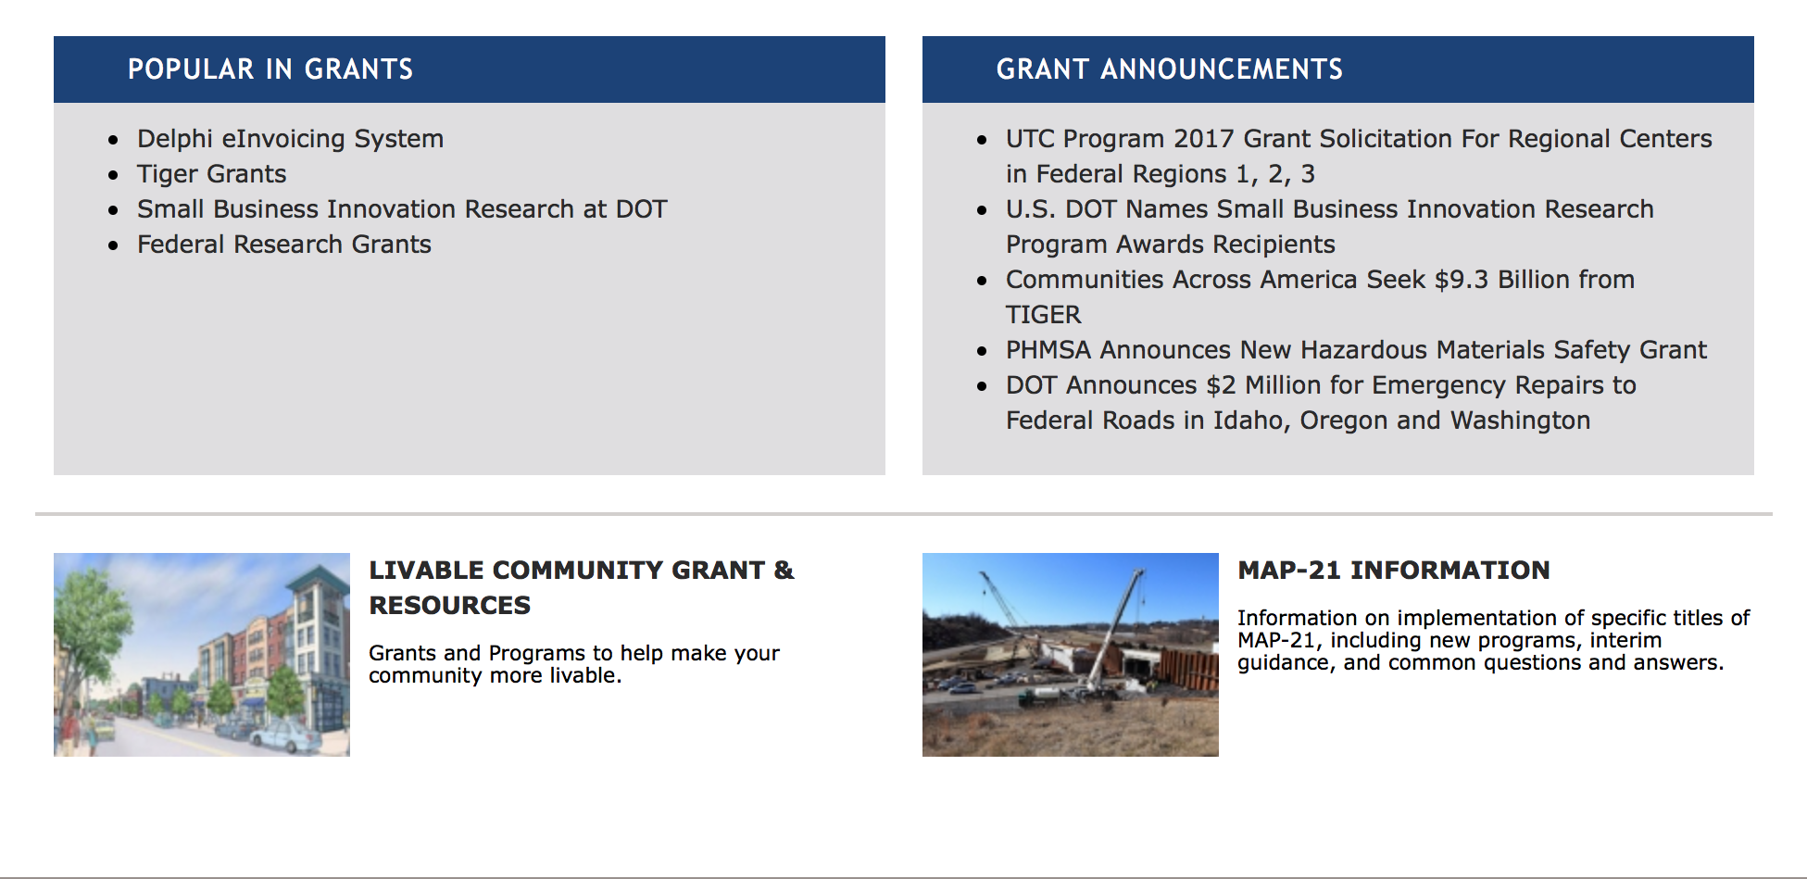

General Grant Program Overview https://www.transportation.gov/grants

Programs:

Modifications:

Research:

Reminders:

DOT - Office of Aviation Analysis
Small Community Air Service Development Program
Synopsis 1

Document Type: | Grants Notice
Funding Opportunity Number: | DOT-OST-2017-0155
Funding Opportunity Title: | Small Community Air Service Development Program
Opportunity Category: | Discretionary
Opportunity Category Explanation:
Funding Instrument Type: | Grant
Category of Funding Activity: | Transportation
Category Explanation:
Expected Number of Awards: | 40
CFDA Number(s): | 20.930 -- Payments for Small Community Air Service Development
Cost Sharing or Matching Requirement: | No
Version: | Synopsis 1
Posted Date: | Oct 18, 2017
Last Updated Date: | Oct 17, 2017
Original Closing Date for Applications: | Dec 15, 2017 Applications of no more than 20 one-sided pages each (excluding the completed Application for Federal Domestic Assistance (SF424), Summary Information schedule, and any letters from the community or an air carrier showing support for the application), including all required information, must be submitted to www.grants.gov no later than 4:00 PM EST on December 15, 2017.
Current Closing Date for Applications: | Dec 15, 2017 Applications of no more than 20 one-sided pages each (excluding the completed Application for Federal Domestic Assistance (SF424), Summary Information schedule, and any letters from the community or an air carrier showing support for the application), including all required information, must be submitted to www.grants.gov no later than 4:00 PM EST on December 15, 2017.
Archive Date: | Jan 14, 2018
Estimated Total Program Funding: | $10,000,000
Award Ceiling: | $10,000,000
Award Floor: | $0
Eligible Applicants: | Others (see text field entitled "Additional Information on Eligibility" for clarification)
Additional Information on Eligibility: | Eligible applicants are small communities that meet the following statutory criteria under 49 U.S.C. § 41743, as amended by Pub. L. No. 114-113: 1. (a) The airport serving the community or consortium is not larger than a small hub airport, according to FAA hub classifications effective on the date of service of this Order, or (b) As of calendar year 1997, the airport serving the community or consortium was not larger than a small hub airport, and 2. It has insufficient air carrier service or unreasonably high air fares; and 3. The airport serving the community presents characteristics, such as geographic diversity or unique circumstances that demonstrate the need for, and feasibility of, grant assistance from the Small Community Program. No more than four communities or consortia of communities, or a combination thereof, from the same State may be selected to participate in the program in any fiscal year. No more than 40 communities or consortia of communities, or a combination thereof, may be selected to participate in the program in each year for which the funds are appropriated. Consortium Applications: Both individual communities and consortia of communities are eligible for SCASDP funds. An application from a consortium of communities must be one that seeks to facilitate the efforts of the communities working together toward one joint grant project, with one joint objective, including the establishment of one entity to ensure that the joint objective is accomplished. Communities Without Existing Air Service: Communities that do not currently have commercial air service are eligible for SCASDP funds. Essential Air Service Communities: Small communities that currently receive subsidized air service under the Essential Air Service (“EAS”) or Alternate Essential Air Service (“AEAS”) program will not be considered for SCASDP funds. The EAS statute (49 U.S.C. § 41733(c)(E)) now includes a provision requiring that the Department consider whether an air carrier has included a marketing proposal in its proposal to provide subsidized EAS as part of the carrier selection criteria. In light of this and the scarcity of SCASDP funds, the Department will not consider awarding additional Federal support under SCASDP for the marketing of subsidized EAS air service. Applicants should also keep in mind the following statutory restrictions on eligible projects: • An applicant may not receive an additional grant to support the same project from a previous grant. • An applicant may not receive an additional grant, prior to the completion of its previous grant. See the full Order for more information on these 2 conditions.
Agency Name: | DOT - Office of Aviation Analysis
Description: | The Small Community Program was established by the Wendell H. Ford Aviation Investment and Reform Act for the 21st Century (Pub. L. No. 106-181), reauthorized by the Vision 100-Century of Aviation Reauthorization Act (Pub. L. No. 108-176), and subsequently reauthorized by the FAA Modernization and Reform Act of 2012 (Pub. L. No. 112-95) (FAA 2012), as amended. The program is designed to provide financial assistance to small communities in order to help them enhance their air service. The Department provides this assistance in the form of monetary grants that are disbursed on a reimbursable basis. Authorization for this program is codified at 49 U.S.C. § 41743. The Small Community Program is authorized to receive appropriations under 49 U.S.C. § 41743(e)(2), as amended. Appropriations are provided for this program for award selection in FY 2016 pursuant to FAA 2012, the Consolidated Appropriations Act, 2016 (Pub. L. No. 114-113), as extended through FY 2017 by the Continuing Appropriations and Military Construction, Veterans Affairs, and Related Agencies Appropriations Act, 2017, and Zika Response and Preparedness Act (Pub. L. No. 114-223). In addition, the FAA Extension, Safety, and Security Act of 2016 (Pub. L. No. 114-190) amended 49 U.S.C. § 41743(e)(2) to authorize the program to receive an additional $6 million in appropriations through FY 2017. The FY17 Continuing Appropriations Act (Pub. L. No. 115-31 (May 5, 2017)) then provided additional appropriations for the program.
Link to Additional Information: | SCASDP website
Grantor Contact Information: | If you have difficulty accessing the full announcement electronically, please contact:  Vince Corsaro Transportation Industry Analyst Phone 202-366-1842  vince.corsaro@dot.gov

http://www.grants.gov/web/grants/view-opportunity.html?oppId=298018

DOT - FAA Aviation Research Grants
FAA Aviation Research and Development Grants
Synopsis 3, 4 & 6

Document Type: | Grants Notice
Funding Opportunity Number: | 12-01
Funding Opportunity Title: | FAA Aviation Research and Development Grants
Opportunity Category: | Discretionary
Opportunity Category Explanation:
Funding Instrument Type: | Grant
Category of Funding Activity: | Transportation
Category Explanation:
Expected Number of Awards:
CFDA Number(s): | 20.108 -- Aviation Research Grants
Cost Sharing or Matching Requirement: | No
Version: | Synopsis 6
Posted Date: | Jan 01, 2012
Last Updated Date: | Oct 18, 2017
Original Closing Date for Applications: | Dec 31, 2019
Current Closing Date for Applications: | Dec 31, 2019
Archive Date: | Jan 30, 2020
Estimated Total Program Funding:
Award Ceiling: | $5,000,000
Eligible Applicants: | Private institutions of higher education  Nonprofits having a 501(c)(3) status with the IRS, other than institutions of higher education  Public and State controlled institutions of higher education
Agency Name: | DOT - FAA Aviation Research Grants
Description: | The FAA is soliciting proposals for research grants and cooperative agreements to pursue the long-term growth and short-term technical needs of civil aviation. In order to streamline the application process, it is recommended that all prospective grantees submit a white paper (letter of intent) for agency technical review before complete proposal submission. Please be sure to identify the specific area of interest (Solicitation FAA-12-01 – Chapter I. FAA Research Grants Program, Technical Areas of Research #1-#9). The white paper shall be no longer than three (3) pages and shall detail overall research objectives.
Link to Additional Information:
Grantor Contact Information: | If you have difficulty accessing the full announcement electronically, please contact:  Nicole Saiauskie Grants Officer Phone 609-485-4781  business

http://www.grants.gov/web/grants/view-opportunity.html?oppId=134953

Deleted:

Department of the Treasury

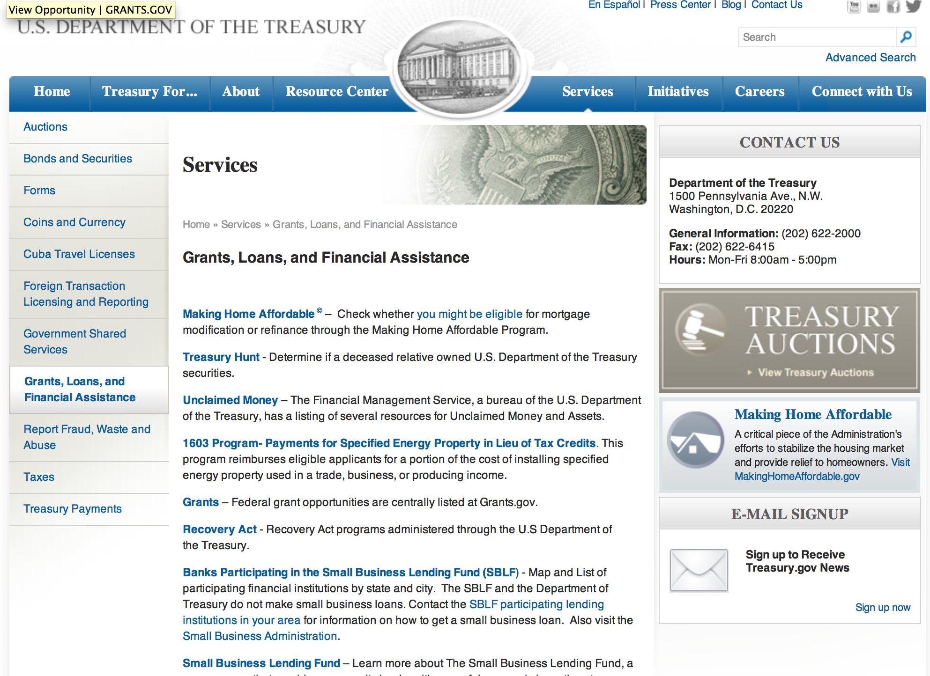

http://www.treasury.gov/services/Pages/Grants-Loans-and-Financial-Assistance.aspx

Programs:

Modifications:

Reminders:

U.S. Agency for International Development

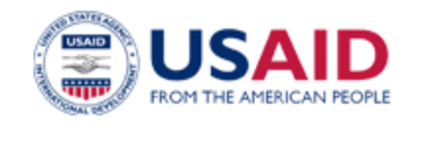

www.usaid.gov

General Overview Funding Opportunities

USAID has working relationships with thousands of American companies and hundreds of U.S.-based private voluntary organizations. For more information on our business and procurement opportunities, please visit our Business section.

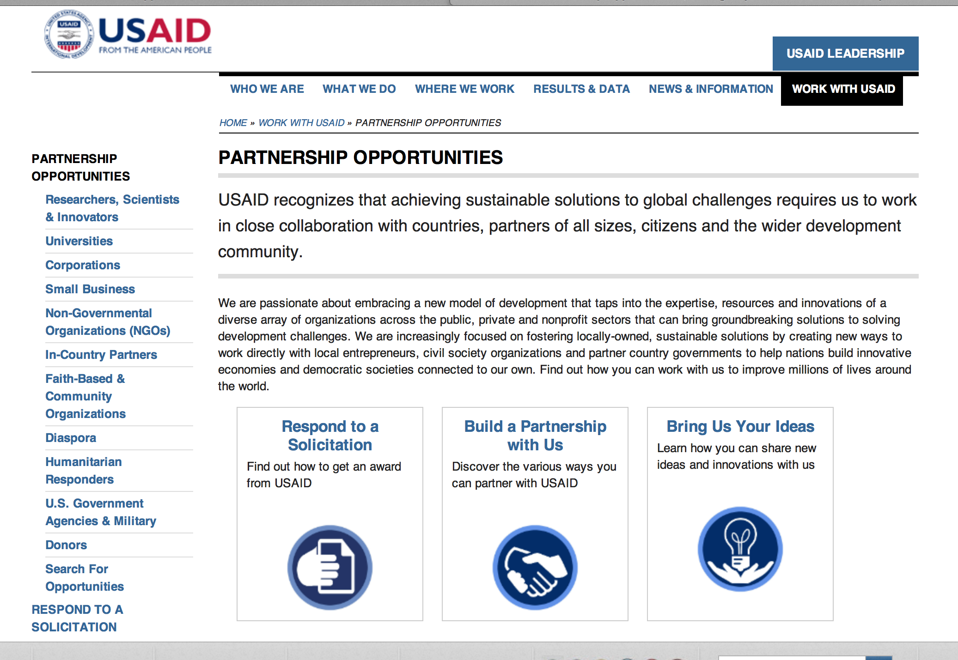
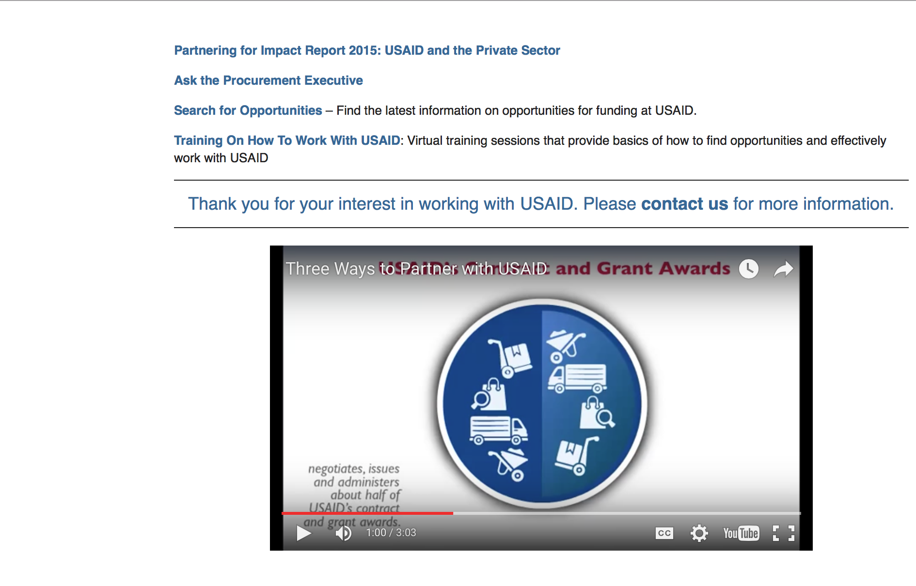

http://www.usaid.gov/partnerships

Programs:

South Africa USAID-Pretoria
Preventing HIV/AIDS in Vulnerable Populations in South Africa
Synopsis 1
https://www.grants.gov/web/grants/view-opportunity.html?oppId=299053

The USAID BAA for Sustainable Development in Sub-Saharan Africa (Research)
Synopsis 1
http://www.grants.gov/web/grants/view-opportunity.html?oppId=298727

U.S. Mission to Bosnia and Herzegovina
INTERETHNIC RECONCILIATION AND YOUTH SMALL GRANTS PROGRAM
Synopsis 1
https://www.grants.gov/web/grants/view-opportunity.html?oppId=299033

U.S. Mission to Bosnia and Herzegovina
INTERETHNIC RECONCILIATION AND YOUTH PROGRAM YOUTH CAMPS
Synopsis 1
https://www.grants.gov/web/grants/view-opportunity.html?oppId=299042

U.S. Mission to El Salvador
U.S. Ambassadors Fund for Cultural Preservation (AFCP) Large Grants, 2018, U.S. Embassy San Salvador
Synopsis 1
https://www.grants.gov/web/grants/view-opportunity.html?oppId=299134

Modifications:

RFI720FDA18APS0001 - Input into USAID/OFDA’s Infectious Disease (with Epidemic or Pandemic potential) Standby Capacity for Humanitarian Emergency Annual Program Statement (APS)
Deletion Comments: Opportunity deleted

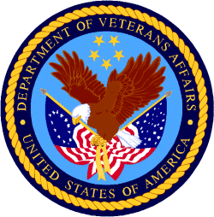

Department of Veterans Affairs

