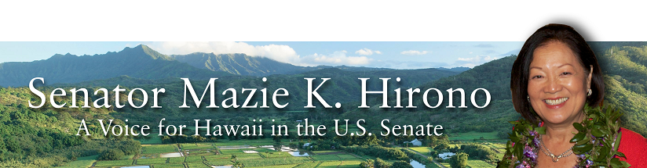Grants Assistance Information Newsletter
April 2015
Part 1

G.A.I.N. INDEX Part 1

Click on Index Links below to read summaries of the announcements by agency in this document.
Once you reach the item, if you cannot open the links for further information, copy the selected
URL website address into your browser.

Modified sections from previous listings are shown in a GREY background

Notices is Teal are items with immediate deadline dates.

Notices in Yellow are of special interest.

Notices is Green are items of special interest with immediate deadline dates.

Items in this type color are aimed at Small Businesses

Items in this type color have a Faith-Based Organization component

Special Federal Program Notices

SBIR – Small Business Innovation Research

Programs specific to Hawaii

Current Notices

Environmental Protection Agency
FY15 and FY16 Region 9 Wetland Program Development Grants

Health Resources and Services Administration
Native Hawaiian Health Care Improvement Act Grant

Administration for Community Living
U.S. Administration on Aging National Resource Centers on Older Indians, Alaska Natives and Native Hawaiians Grant

National Institute of Food and Agriculture
Alaska Native-Serving and Native Hawaiian-Serving Institutions Education Competitive Grants Program (ANNH) Grant

Natural Resources Conservation Service
Pacific Island Area State Office
Pacific Islands Area State Component CIG Grant

Reminders

Link to White House Faith-Based and Neighborhood Partnership Toolkit

See Individual Departments for information and webpages representing the best and most accessible information on the agency funding opportunities

Federal Grant and Cooperative Agreement Program Summaries

U.S. Department of Agriculture

Grants and Loans Overview

Programs

Business and Cooperative Programs
Renewable Energy Systems and Energy Efficiency Improvements Program Grant

Agricultural Marketing Service
2015 Federal-State Marketing Improvement Program Grant

Agricultural Marketing Service
2015 Local Food Promotion Program Grants

National Institute of Food and Agriculture
Specialty Crop Research Initiative/Citrus Disease Research and Extension Grant

National Institute of Food and Agriculture
Biomass Research and Development Initiative Grant

National Institute of Food and Agriculture
Organic Agriculture Research and Extension Initiative Grant

Modifications

Agriculture and Food Research Initiative - Childhood Obesity Prevention Challenge Area
Modification 3

National Institute of Food and Agriculture
Agriculture and Food Research Initiative - Food Safety Challenge Area
Modification 1

National Institute of Food and Agriculture
Agriculture and Food Research Initiative - Foundational Program
Modification 2

National Institute of Food and Agriculture
Supplemental and Alternative Crops Competitive Grants Program
Modification 1

National Institute of Food and Agriculture
Agriculture and Food Research Initiative - Agriculture and Natural Resources Science for Climate Variability and Change Challenge Area
Modification 1

National Institute of Food and Agriculture
Agriculture and Food Research Initiative - Water for Agriculture Challenge Area
Modifications 1 & 2

National Institute of Food and Agriculture
Secondary Education, Two-Year Postsecondary Education, and Agriculture in the K-12 Classroom Challenge Grants Program
Modification 1

Reminders

Utilities Programs
Revolving Fund Program Grant

DM-Office of Advocacy and Outreach
Outreach and Assistance for Socially Disadvantaged Farmers and Ranchers and Veteran Farmers and Ranchers Grant

National Institute of Food and Agriculture
Agriculture and Food Research Initiative - Foundational Program Grant

National Institute of Food and Agriculture
Agriculture and Food Research Initiative - Water for Agriculture Challenge Area Grant

National Institute of Food and Agriculture
Agriculture and Food Research Initiative - Childhood Obesity Prevention Challenge Area Grant

National Institute of Food and Agriculture
Agriculture and Food Research Initiative - Food Safety Challenge Area Grant

National Institute of Food and Agriculture

Agriculture and Food Research Initiative - Agriculture and Natural Resources Science for Climate Variability and Change Challenge Area Grant

National Institute of Food and Agriculture
Biotechnology Risk Assessment Grants Program

National Institute of Food and Agriculture
Crop Protection and Pest Management Grant

National Institute of Food and Agriculture
Biomass Research and Development Initiative Grant

National Institute of Food and Agriculture
Organic Transitions Grant

National Institute of Food and Agriculture
Agriculture and Food Research Initiative: Food Security Challenge Area Grant

Department of Commerce

Programs

Fisheries International Cooperation and Assistance Program Grant

2015 Sea Grant - NMFS “On Assignment” Exchange Program Grant

National Institute of Standards and Technology
FY 2015 Small Business Innovation Research (SBIR) Program Grant

National Institute of Standards and Technology
National Strategy for Trusted Identities in Cyberspace (NSTIC) Privacy Pilots Cooperative Agreement Program Grant

Modifications

Reminders

National Institute of Standards and Technology
NIST Center for Neutron Research (NCNR) Comprehensive Grant Program
Grant

FY 2016 Implementation of the U.S. Integrated Ocean Observing System (IOOSŪ) Grant

National Institute of Standards and Technology
NIST Standards Services Curricula Development (SSCD) Cooperative Agreement Program Grant

NOAA Sea Grant Aquaculture Extension and Technology Transfer 2015 Grant

Economic Development Administration
FY 2014 Economic Development Assistance Programs
And Modification 1

Economic Development Administration
Planning Program and Local Technical Assistance Program Grant

Economic Development Administration
FY 2013 Economic Development Assistance Programs Grant

Corporation for National and Community Service

General Program Overview

National Service in Hawaii

2015 September 11th National Day of Service and Remembrance Grants

Reminders

Department of Defense

Doing Business with the Department of Defense

DoD Small Business Opportunities and Forecasting

Research Grants

Modifications

Dept. of the Army -- Materiel Command
Army Research Office Broad Agency Announcement for Basic and Applied Scientific Research
Modification 8

Reminders

Department of Education

Grant Programs Overview

Programs

Office of Postsecondary Education (OPE): Fulbright-Hays Doctoral Dissertation Research Abroad Fellowship Program CFDA Number 84.022A Grant

HHS/ACL/NIDILRR: Research Fellowships Program CFDA Number 84.133F-1 Grant

HHS/ACL/NIDILRR: Small Business Innovation Research Program (SBIR) Phase I CFDA Number 84.133S-1 Grant

Asian American and Native American Pacific Islander-Serving Institutions (AANAPISI) Program CFDA Number 84.031L Grant

Technical Assistance and Dissemination to Improve Services and Results for Children With Disabilities: Model Demonstration Projects to Improve Adolescent Literacy for Students with Disabilities in Middle and High Schools, Grades 6-12 CFDA Number 84326M Grant

Ready-to-Learn Television CFDA Number 84.295A Grant

Rehabilitation Long-Term Training Program: Rehabilitation Specialty Areas: Rehabilitation of Individuals Who are deaf or Hard of Hearing CFDA Number 84.129Q Grant

Rehabilitation Long-Term Training Program: Rehabilitation Specialty Areas: Comprehensive System of Personnel Development CFDA Number 84.129W Grant

Training and Information for Parents of Children Disabilities: Parent Training and Information Centers - CDFA Number 84.328M Grant

Minority Science and Engineering Improvement Program (MSEIP) CFDA Number 84.120A
Grant

Graduate Assistance in Areas of National Need (GAANN) Program CFDA Number 84.200A
Grant

Modifications

Office of Innovation and Improvement Development grants Pre-Application CFDA Number 84.411P
Modification 1

Reminders

Office of Elementary and Secondary Education (OESE): Office of Indian Education (OIE): Indian education Formula Grants to Local Educational Agencies CFDA Number 84.060 Grant

US Department of Energy

Grants Overview

Programs

Modifications

Reminders

Environmental Protection Agency

Grants and Contracts Overview

Programs

Environmental Finance Center Grant Program Grant

Fiscal Year 2015 Pollution Prevention Information Network (PPIN) Grant Program

2015 EPA Greater Research Opportunities (GRO) Fellowships for Undergraduate Environmental Study

2015 EPA Greater Research Opportunities (GRO) Fellowships for Undergraduate Environmental Study

2015 EPA Greater Research Opportunities (GRO) Fellowships for Undergraduate Environmental Study

Modifications

2015 EPA Greater Research Opportunities (GRO) Fellowships for Undergraduate Environmental Study
Modifications

Reminders

Department of Health and Human Services

Grants Overview

Program

Research Grants

Modifications

Reminders

Administration for Children and Families
Administration for Children & Families - ACYF/FYSB
Street Outreach Program Grant

Administration for Children and Families
Administration for Children & Families - ACYF/FYSB
Basic Center Program Grant

Department of Homeland Security
Grants Overview

Programs

Office of Procurement Operations - Grants Division
FY 2015 Citizenship and Integration Direct Services Grant Program: Citizenship Instruction and Naturalization Application Services Grant

Department of Homeland Security - FEMA
Fiscal Year 2015 Intercity Bus Security Grant Program (IBSGP) Grant

Modifications

Reminders

Department of Homeland Security - FEMA
Fiscal Year (FY) 2014 Fire Prevention and Safety Grant Program (FP Grant

Department of Housing and Urban Development

HUD - Notice of Funds Available

Programs

Research and Evaluation, Demonstrations, and Data Analysis and Utilization Grant

Notice of Funding Availability (NOFA) for the Department's Fiscal Year 2015 Supplemental Comprehensive Housing Counseling Grant Program

Modifications

Reminders

SEE PART 2 of this newsletter for Agencies from Institute of Library and Museum Services – Veterans Administration

Special Federal Program Notices

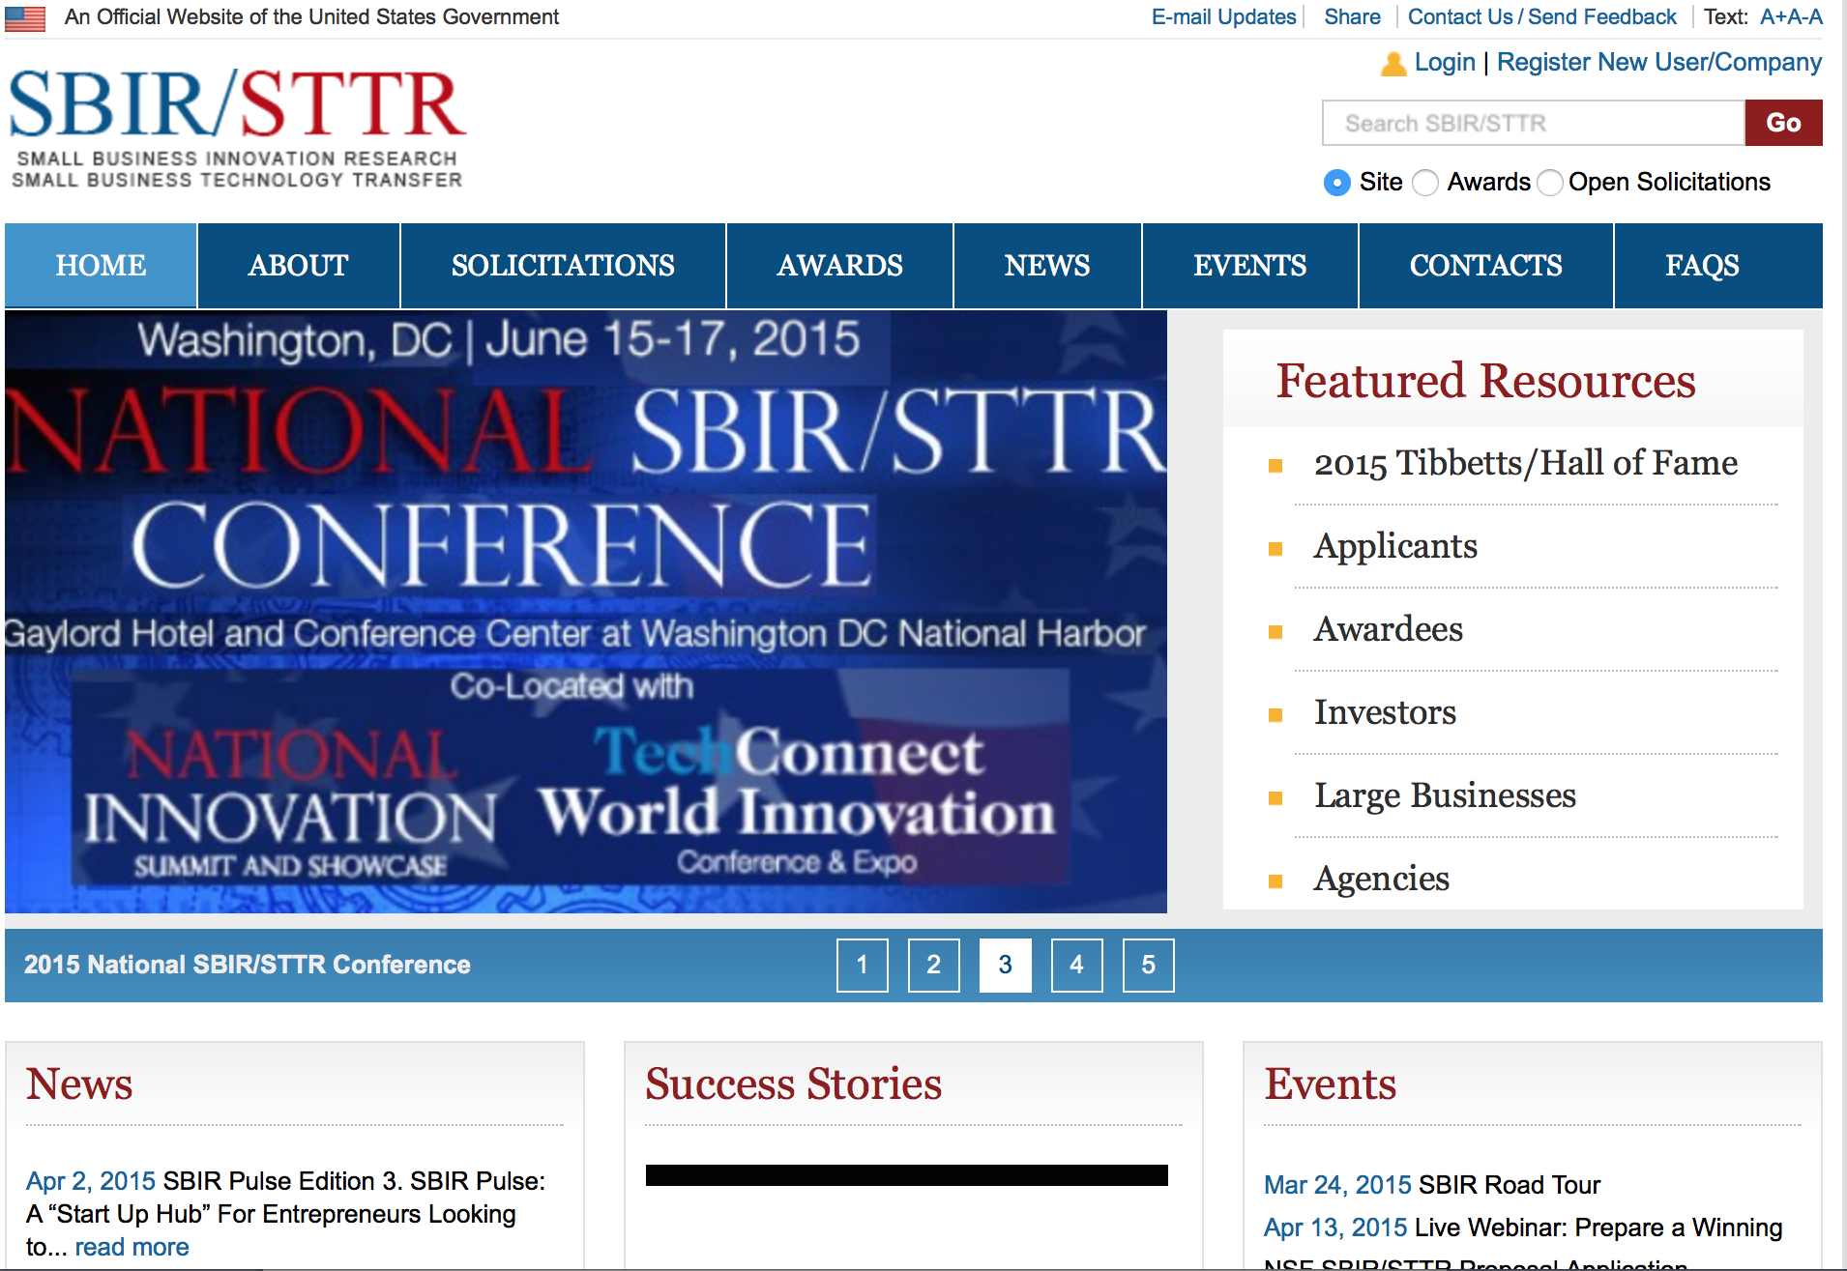

SBIR

The SBIR Program
The Small Business Innovation Research (SBIR) program is a highly competitive program that encourages domestic small businesses to engage in Federal Research/Research and Development (R/R&D) that has the potential for commercialization. Through a competitive awards-based program, SBIR enables small businesses to explore their technological potential and provides the incentive to profit from its commercialization. By including qualified small businesses in the nation's R&D arena, high-tech innovation is stimulated and the United States gains entrepreneurial spirit as it meets its specific research and development needs.

SBIR NewsLetter

- SBIR Newsletter
Sign up for e-mail updates

HAWAII APPLICANTS ENCOURAGED

Environmental Protection Agency

FY15 and FY16 Region 9 Wetland Program Development Grants

Document Type: | Grants Notice
Funding Opportunity Number: | EPA-REG9-WPDG-15-16
Funding Opportunity Title: | FY15 and FY16 Region 9 Wetland Program Development Grants
Opportunity Category: | Discretionary
Funding Instrument Type: | Grant
Category of Funding Activity: | Environment
Category Explanation:
Expected Number of Awards: | 25
CFDA Number(s): | 66.461 -- Regional Wetland Program Development Grants
Cost Sharing or Matching Requirement: | Yes
Posted Date: | Mar 31, 2015
Creation Date: | Mar 31, 2015
Original Closing Date for Applications: | May 15, 2015 Please see the announcement including Section IV for additional submission information.
Current Closing Date for Applications: | May 15, 2015 Please see the announcement including Section IV for additional submission information.
Archive Date: | Jun 14, 2015
Estimated Total Program Funding: | $3,151,750
Award Ceiling: | $500,000
Award Floor: | $50,000
Eligible Applicants: | Others (see text field entitled "Additional Information on Eligibility" for clarification)
Additional Information on Eligibility: | Please see the announcement including Section III for additional eligibility information
Agency Name: | Environmental Protection Agency
Description: | The U.S. Environmental Protection Agency is soliciting proposals from eligible applicants to build or refine state/tribal/local government wetland programs as described in Section I, FUNDING OPPORTUNITY DESCRIPTION, of this announcement. States, tribes, local government agencies, interstate agencies, and intertribal consortia are eligible to apply under this announcement, as further described herein. Universities that are agencies of a state government are eligible, but must include documentation demonstrating that they are chartered as part of a state government in the proposal submission. Non-profit organizations are not eligible to compete under this RFP.
Link to Additional Information: | FY15 and FY16 Region 9 Wetland Program Development Grants
Contact Information: | If you have difficulty accessing the full announcement electronically, please contact:  Leana Rosetti, (415) 972-3070 Rosetti.leana@epa.gov  Leana Rosetti

http://www.grants.gov/web/grants/view-opportunity.html?oppId=275563

Department of Health and Human Services

Health Resources and Services Administration
Native Hawaiian Health Care Improvement Act Grant
Document Type: | Grants Notice
Funding Opportunity Number: | HRSA-15-017
Funding Opportunity Title: | Native Hawaiian Health Care Improvement Act
Opportunity Category: | Discretionary
Funding Instrument Type: | Grant
Category of Funding Activity: | Health
Category Explanation: | https://grants3.hrsa.gov/2010/Web2External/Interface/FundingCycle/ExternalView.aspx?fCycleID=076cee3d-6c83-4545-997b-81937f3e5b24
Expected Number of Awards: | 6
CFDA Number(s): | 93.932 -- Native Hawaiian Health Care Systems
Cost Sharing or Matching Requirement: | Yes
Posted Date: | Apr 1, 2015
Creation Date: | Apr 1, 2015
Original Closing Date for Applications: | Jun 1, 2015
Current Closing Date for Applications: | Jun 1, 2015
Archive Date: | Jul 31, 2015
Estimated Total Program Funding: | $12,339,016
Award Ceiling: | $0
Award Floor: | $0

Eligible Applicants: | Others (see text field entitled "Additional Information on Eligibility"  for clarification)
Additional Information on Eligibility: | To be eligible for funding, an applicant must be one of the  following six organizations: Ho`ola Lahui Hawaii, Hui Malama  Ola Na Oiwi, Hui No Ke Ola Pono, Ke Ola Mamo, Na Pu’uwai,  and Papa Ola Lokahi.

Agency Name: | Health Resources and Services Administration
Description: | This announcement solicits applications for the Native Hawaiian Health  Care Improvement Act program. The Native Hawaiian Health Care  Improvement Act (NHHCIA), as amended (42 U.S.C. 11701 - 11714),  states that “it is the policy of the United States in fulfillment of its special  responsibilities and legal obligations to the indigenous people of Hawaii …  to (1) raise the health status of Native Hawaiians to the highest possible  health level; and (2) provide existing Native Hawaiian health care programs  with all resources necessary to effectuate this policy”  [see 42 U.S.C. 11702(a)]. The NHHCIA authorizes funding opportunities  for the following activities: · Service grant to Papa Ola Lokahi (POL)  for the activities described in the NHHCIA, including the coordination  of the health care programs and services provided to Native Hawaiians.  ·Service grants to the five recognized community-based Native Hawaiian  Health Care Systems (NHHCS) to provide a full range of services identified  by the legislation and tailored to fit the needs of their respective island  communities. This Congressional Special Initiative is a limited competition  program announcement. This FOA provides instructions to be used by  existing recipients under the NHHCIA in preparing applications for funding  for fiscal years 2015 through 2017.
Link to Additional Information:
Contact Information: | If you have difficulty accessing the full announcement electronically,  please contact:  Department of Health and Human Services, Health Resources and  Services Administration BPHCNH@hrsa.gov  Contact Amy Harbaugh at (301)594-4300 or email BPHCNH@hrsa.gov

http://www.grants.gov/web/grants/view-opportunity.html?oppId=275612

Department of Health and Human Services

Administration for Community Living
U.S. Administration on Aging National Resource Centers on Older Indians, Alaska Natives and Native Hawaiians Grant

Document Type: | Grants Notice
Funding Opportunity Number: | HHS-2015-ACL-AOA-OI-0098
Funding Opportunity Title: | U.S. Administration on Aging National Resource Centers on Older Indians, Alaska Natives and Native Hawaiians
Opportunity Category: | Discretionary
Funding Instrument Type: | Cooperative Agreement
Category of Funding Activity: | Income Security and Social Services
Category Explanation:
Expected Number of Awards: | 3
CFDA Number(s): | 93.048 -- Special Programs for the Aging Title Viand Title II Discretionary Projects
Cost Sharing or Matching Requirement: | Yes
Posted Date: | Mar 12, 2015
Creation Date: | Mar 12, 2015
Original Closing Date for Applications: | May 12, 2015 Electronically submitted applications must be submitted no later than 11:59 p.m., ET, on the listed application due date.
Current Closing Date for Applications: | May 12, 2015 Electronically submitted applications must be submitted no later than 11:59 p.m., ET, on the listed application due date.
Archive Date: | May 27, 2015
Estimated Total Program Funding: | $646,031
Award Ceiling: | $340,000
Award Floor: | $112,000
Eligible Applicants: | Public and State controlled institutions of higher education  Private institutions of higher education  Others (see text field entitled "Additional Information on Eligibility" for clarification)
Additional Information on Eligibility: | Eligible Applicants Institutions of higher education are eligible to apply. Applicants must have experience conducting research, assessing the needs of older individuals and developing best practices to be utilized by the Tribes. Current Resource Centers are also eligible to apply. Individuals, foreign entities, and sole proprietorship organizations are not eligible to compete for, or receive, awards made under this announcement.
Agency Name: | Administration for Community Living
Description: | Increased longevity continues to become more prevalent in Native American communities. This trend has placed greater demands on service delivery systems, which are even more complex and fragmented than in non-Indian communities. In recognition of this, under the Older Americans Act (OAA) Amendments of 2006, Congress mandated the support of at least two (2), and not more than four (4), Resource Centers that will focus on issues and concerns affecting individuals who are older Native Americans. The primary goal of these Centers is to enhance knowledge about older Native Americans and thereby to increase and improve the delivery of services to them. The National Resource Centers on Native American Elders (Centers) will concentrate on the development and provision of technical information and expertise and best practices to Indian tribal organizations, Native American communities, educational institutions including Tribal Colleges and Universities, and professionals and paraprofessionals in the field. Each Center must have a national focus and direct its resources to one or more of the areas of primary concern on which the center will focus which shall be; health issues, long-term care, including in-home care; elder abuse; and other problems and issues facing Native communities. Each Center is expected to incorporate the concepts and principles and cultural competencies into all aspects of their staffing, program, and activities. Additionally, each Center's activities will promote one or more of the AoA priority areas. These priority areas are; 1) make it easier for older people to access an integrated array of health and long-term care services, 2) help older people stay active and healthy, 3) support families in their efforts to care for their loved ones at home and in the community, 4) ensure the rights of older people and prevent their abuse, neglect and exploitation, 5) training and technical assistance, and 6) coordination within the university structure. Per the OAA, these funds shall be used to 1) gather information; 2) performance research; 3) provide for the dissemination of results of the research and 4) provide technical assistance and training to entities that provide services to the elderly Native American populations. Each Center is expected to develop special activities and best practices within its areas of primary concern which will address the special needs of different Indian communities. Each application must contain a description of anticipated outcomes for the activities, how these outcomes will be measured and how the overall success of the program/activity will be determined. For instance, staying active and healthy focuses on the identification and use of evidence-based health promotion and disease prevention interventions that can be applied by non-clinical personnel in a community setting. Statutory Authority The statutory authority for grants under this Program Announcement is contained in Title IV of the Older Americans Act (OAA) (42U.S.C. 3032), as amended by the Older Americans Act Amendments of 2006, P.L. 109-365. (Catalog of Federal Domestic Assistance 93.048, Title IV Discretionary Projects).
Link to Additional Information: | http://www.acl.gov/Funding_Opportunities/Index.aspx
Contact Information: | If you have difficulty accessing the full announcement electronically, please contact:  Cecelia Aldridge Cecelia.Aldridge@acl.gov  Grants Policy

http://www.grants.gov/web/grants/view-opportunity.html?oppId=275124

Department of Agriculture

National Institute of Food and Agriculture
Alaska Native-Serving and Native Hawaiian-Serving Institutions Education Competitive Grants Program (ANNH) Grant

Document Type: | Grants Notice
Funding Opportunity Number: | USDA-NIFA-AHSI-005015
Funding Opportunity Title: | Alaska Native-Serving and Native Hawaiian-Serving Institutions Education Competitive Grants Program (ANNH)
Opportunity Category: | Discretionary
Funding Instrument Type: | Grant
Category of Funding Activity: | Agriculture
Category Explanation:
Expected Number of Awards:
CFDA Number(s): | 10.228 -- Alaska Native Serving and Native Hawaiian Serving Institutions Education Grants
Cost Sharing or Matching Requirement: | No
Posted Date: | Mar 26, 2015
Creation Date: | Mar 26, 2015
Original Closing Date for Applications: | Apr 27, 2015
Current Closing Date for Applications: | Apr 27, 2015
Archive Date: | May 27, 2015
Estimated Total Program Funding: | $3,000,000
Award Ceiling: | $1,500,000
Award Floor: | $150,000
Eligible Applicants: | Others (see text field entitled "Additional Information on Eligibility" for clarification)
Additional Information on Eligibility: | Individual public or private, nonprofit Alaska Native-Serving and Native Hawaiian-Serving Institutions of higher education that meet the definitions of Alaska-Serving Institutions or Native Hawaiian-Serving Institution established in Title III, Part A of the Higher Education Act of 1965, as amended (20 U.S.C. 1059d.) are eligible institutions under this program.
Agency Name: | National Institute of Food and Agriculture
Description: | The purpose of this program is to promote and strengthen the ability of Alaska Native-Serving Institutions and Native Hawaiian-Serving Institutions to carry out education, applied research, and related community development programs. NIFA intends this program to address educational needs, as determined by each institution, within a broadly defined arena of food and agricultural sciences-related disciplines. Priority will be given to those projects that enhance educational equity for under represented students; strengthen institutional educational capacities; prepare students for careers related to the food, agricultural, and natural resource systems of the United States; and maximize the development and use of resources to improve food and agricultural sciences teaching programs.
Link to Additional Information: | Alaska Native-Serving and Native Hawaiian-Serving Institutions Education Competitive Grants Program (ANNH)
Contact Information: | If you have difficulty accessing the full announcement electronically, please contact:  NIFA Help Desk Phone: 202-401-5048 Business hours are M-F, 7:00 am -5:00 pm ET, excluding Federal holidays  If you have any questions related to preparing application content

http://www.grants.gov/web/grants/view-opportunity.html?oppId=275426

Natural Resources Conservation Service
Pacific Island Area State Office
Pacific Islands Area State Component CIG Grant

Document Type: | Grants Notice
Funding Opportunity Number: | USDA-NRCS-PIA-SLCIG-15-001
Funding Opportunity Title: | Pacific Islands Area State Component CIG
Opportunity Category: | Mandatory
Funding Instrument Type: | Grant
Category of Funding Activity: | Agriculture  Energy  Environment  Natural Resources
Category Explanation:
Expected Number of Awards: | 2
CFDA Number(s): | 10.912 -- Environmental Quality Incentives Program
Cost Sharing or Matching Requirement: | Yes
Posted Date: | Mar 30, 2015
Creation Date: | Mar 30, 2015
Current Closing Date for Applications: | Apr 24, 2015 DEPARTMENT OF AGRICULTURE AGENCY: Natural Resources Conservation Service, Commodity Credit Corporation ACTION: NOTICE Conservation Innovation Grants Fiscal Year (FY) 2015 Announcement for Program Funding – Pacific Islands Area (Hawaii, Guam, American Samoa and the Commonwealth of the Northern Mariana Islands). Catalog of Federal Domestic Assistance (CFDA) Number: 10.912 SUMMARY: The Natural Resources Conservation Service (NRCS), an agency under the United States Department of Agriculture (USDA), is announcing availability of Conservation Innovation  Grants (CIG) to stimulate the development and adoption of innovative  conservation approaches and technologies. Proposals will be accepted from Pacific Islands Area (Hawaii, Guam, American Samoa and the Commonwealth of the Northern Mariana Islands). NRCS anticipates that the amount available for support of this program in FY 2015 will be up to $150,000. Proposals are requested from  eligible governmental or non-governmental organizations or individuals for competitive consideration of grant awards for projects between 1 and 3 years in duration. Funds will be awarded through a two-phase Pacific Islands Area wide competitive grants process that will include (1) a pre-proposal process and  (2) a full proposal process. The full proposal process will only be open to  applicants whose pre-proposals are selected by NRCS. Both phases are  described in this announcement, but only pre-proposals are being solicited at this  time. This notice identifies the objectives, eligibility criteria, and application instructions for CIG projects. Proposals will be screened for completeness and compliance with the provisions of this notice. Incomplete and/or noncompliant proposals will be eliminated from competition, and notification of elimination will  be sent to the applicant. NRCS will request a full proposal package only from those applicants selected in the pre-proposal phase. DATES: Pre-proposals must be  received by NRCS before 12:00 p.m. noon, Hawaii Standard Time (HST) on Friday, April 24, 2015. NRCS will announce selected pre-proposals by May 15, 2015. Selected applicants will then be required to submit a full proposal package to  NRCS by 12:00 p.m. noon HST on Friday, June 19, 2015. ADDRESSES: Proposals may be sent via express mail or overnight courier service using one of the  following methods. Express Mail: USDA-NRCS, CIG Program, Nicola Giardina,  300 Ala Moana Blvd, Room 4-118, Honolulu, HI 96850 United States Postal  Service: USDA-NRCS, CIG Program Nicola Giardina P.O. Box 50004, Honolulu, HI 96850-0050 Applicants must submit three (3) paper copies of the application and  an electronic copy provided via e-mail address. The address for submitting an application by e-mail is: nicola.giardina@hi.usda.gov . FOR MORE I  NFORMATION CONTACT: Nicola Giardina, State EQIP Program Manager  300 Ala Moana Blvd., Room 4-118 Honolulu, HI 96850 Phone: (808) 541-2600  ext. 155 E-mail: nicola.giardina@hi.usda.gov
Archive Date: | May 24, 2015
Estimated Total Program Funding: | $150,000
Award Ceiling: | $75,000
Award Floor: | $10,000

http://www.grants.gov/web/grants/view-opportunity.html?oppId=275518

Reminders:

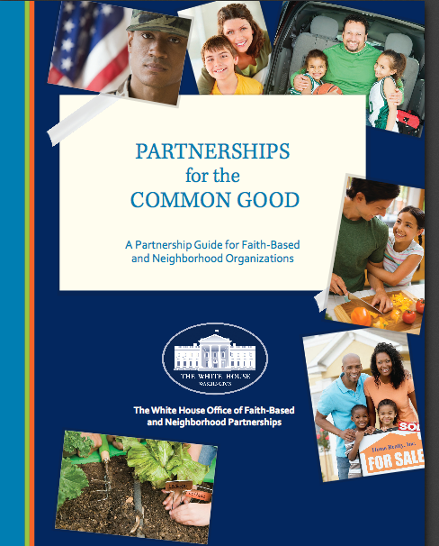
This Manual for faith-based organizations is an excellent guide to review and use.

http://www.whitehouse.gov/sites/default/files/faithbasedtoolkit.pdf

Reminders:

Please review each department’s General Grant and Funding Overview. These overviews are the key web pages on each departmental website dedicated to the agency’s funding opportunities. Check back often to note the department updates and use these sources to assist you in your planning.

Federal Grant and Cooperative Agreement Program Summaries

U.S. Department of Agriculture



Grants and Loans Overview

http://usda.gov/wps/portal/usda/usdahome?navid=GRANTS_LOANS

USDA posts rural funding guide for local governments
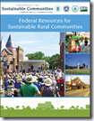
The U.S. Department of Agriculture (USDA) recently posted a useful guide outlining federal funding programs available to support rural communities.

Federal Resources for Sustainable Rural Communities (PDF 44p 6MB) is a guide to programs from the Partnership for Sustainable Communities and the U.S. Department of Agriculture (USDA) that rural communities can use to promote economic competitiveness, protect healthy environments, and enhance quality of life. It is a collaborative effort among USDA, the Department of Housing and Urban Development, the Department of Transportation and the Environmental Protection Agency.

The guide has key information on funding and technical assistance opportunities available from the four agencies, as well as examples of how rural communities across the country have benefitted from federal resources. The resource guide can be accessed here.

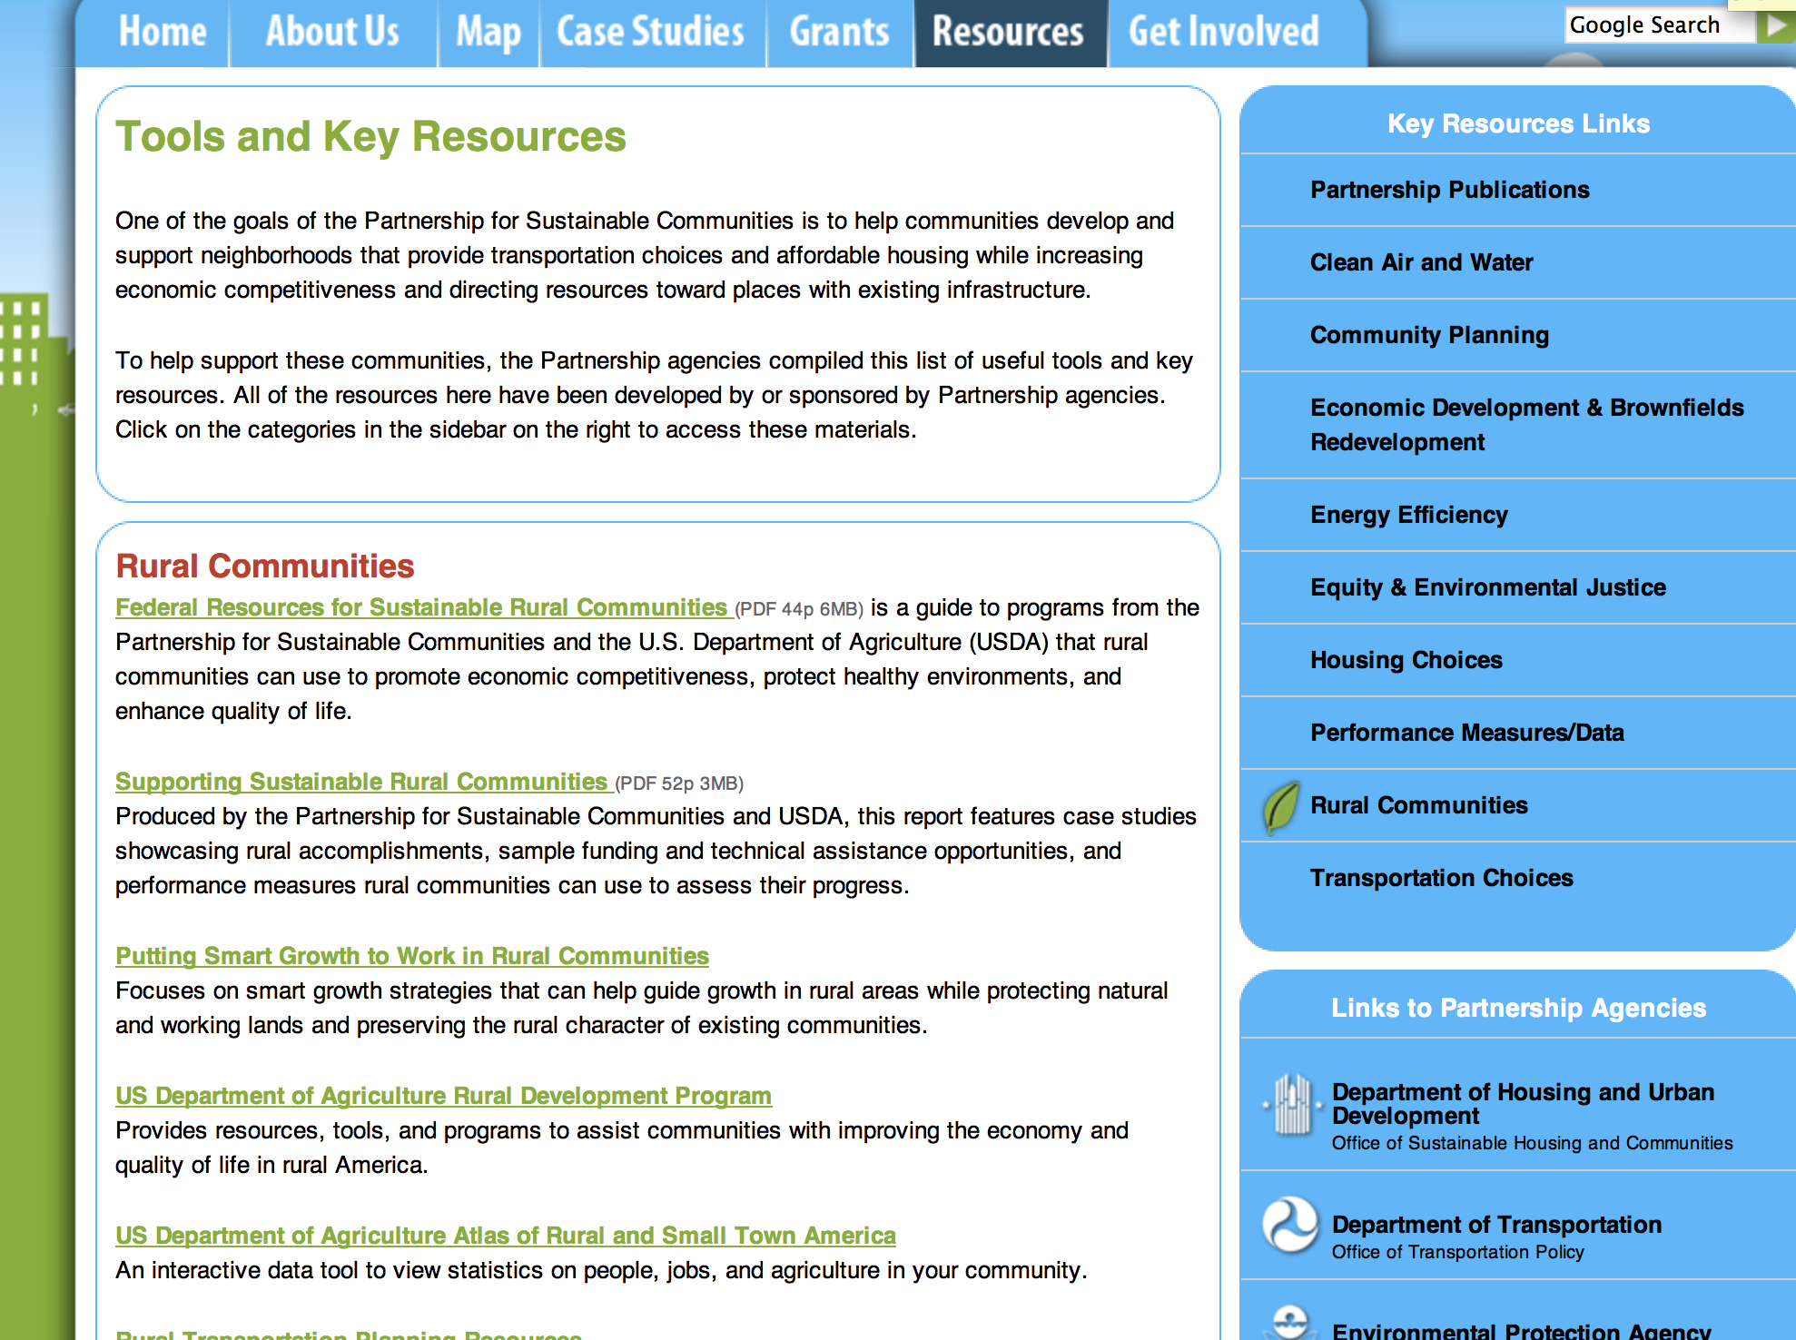
http://www.sustainablecommunities.gov/toolsKeyResources.html

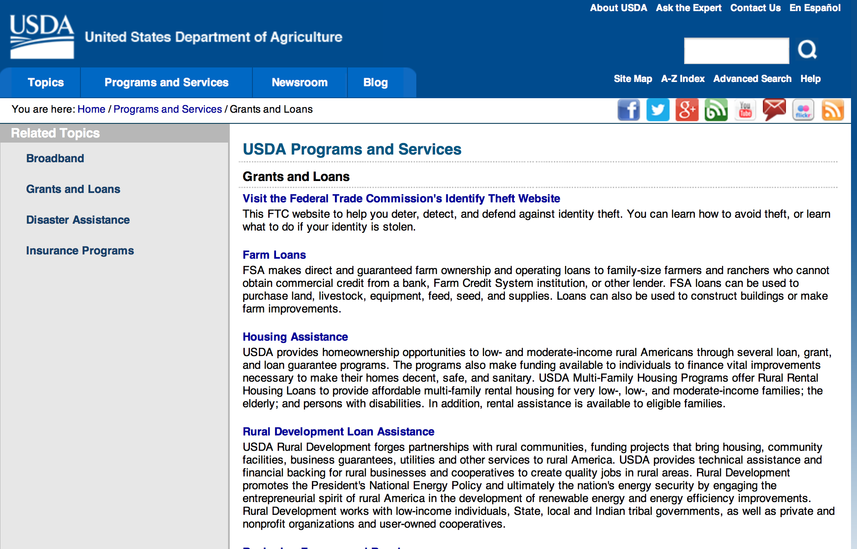

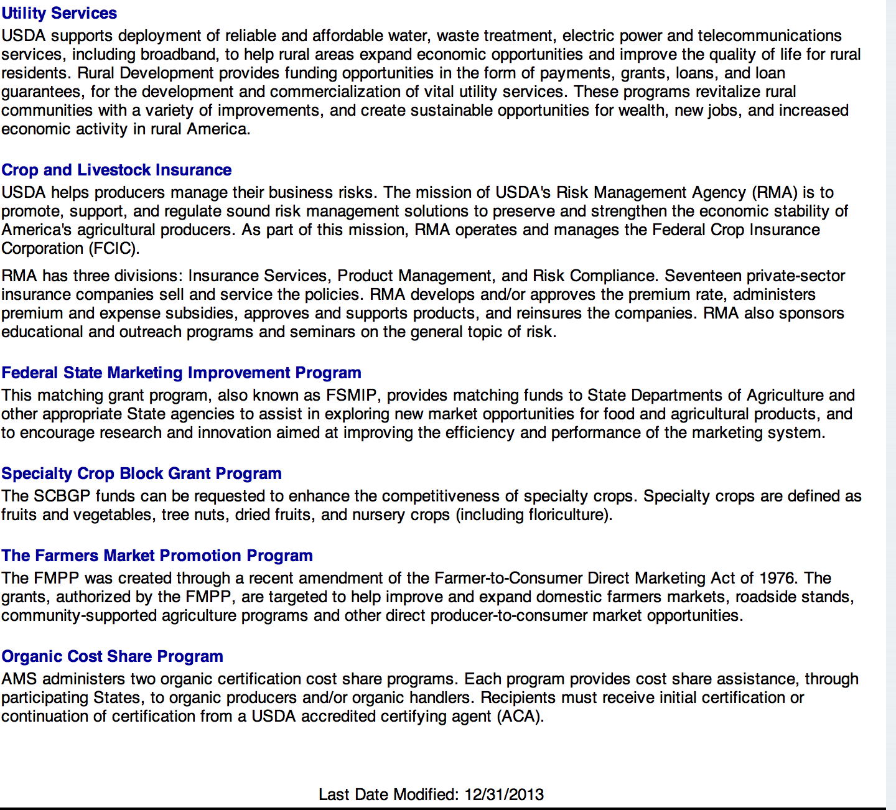

http://usda.gov/wps/portal/usda/usdahome?navid=GRANTS_LOANS

Programs:

Business and Cooperative Programs
Renewable Energy Systems and Energy Efficiency Improvements Program Grant
Document Type: | Grants Notice
Funding Opportunity Number: | RDBCP-REAP-RES-EEI-2015
Funding Opportunity Title: | Renewable Energy Systems and Energy Efficiency Improvements Program
Opportunity Category: | Mandatory
Funding Instrument Type: | Grant
Category of Funding Activity: | Agriculture  Business and Commerce  Energy
Category Explanation:
Expected Number of Awards: | 2000
CFDA Number(s): | 10.868 -- Rural Energy for America Program
Cost Sharing or Matching Requirement: | Yes
Posted Date: | Mar 4, 2015
Creation Date: | Mar 4, 2015
Original Closing Date for Applications: | REAP Applications are accepted year-round. Grant competition deadlines for Fiscal Year 2015 are: April 30, 2015 and June 30, 2015. For applicants requesting grants of $20,000 or less, that wish to have their application compete for the "Grants of $20,000 or less set aside", complete applications are due April 30, 2015.
Current Closing Date for Applications: | REAP Applications are accepted year-round. Grant competition deadlines for Fiscal Year 2015 are: April 30, 2015 and June 30, 2015. For applicants requesting grants of $20,000 or less, that wish to have their application compete for the "Grants of $20,000 or less set aside", complete applications are due April 30, 2015.
Archive Date:
Estimated Total Program Funding: | $78,000,000
Award Ceiling: | $500,000
Award Floor: | $1,500
Eligible Applicants: | Native American tribal organizations (other than Federally recognized tribal governments)  Small businesses  Others (see text field entitled "Additional Information on Eligibility" for clarification)
Additional Information on Eligibility: | Agricultural Producers
Agency Name: | Business and Cooperative Programs
Description: | REAP Renewable Energy Systems and Energy Efficiency Improvement Program. Refer to Application Package AND Application Instruction links to obtain all necessary forms for a complete application. Contact State Energy Coordinators with questions: http://www.rd.usda.gov/files/RBS_StateEnergyCoordinators.pdf
Link to Additional Information: | REAP Renewable Energy Systems and Energy Efficiency Improvement Program
Contact Information: | If you have difficulty accessing the full announcement electronically, please contact:  State Energy Coordinator http://www.rd.usda.gov/files/RBS_StateEnergyCoordinators.pdf  Refer to energy coordinator list via link posted above.

http://www.grants.gov/web/grants/view-opportunity.html?oppId=274942

Agricultural Marketing Service
2015 Federal-State Marketing Improvement Program Grant

Document Type: | Grants Notice
Funding Opportunity Number: | USDA-AMS-FSMIP-2015
Funding Opportunity Title: | 2015 Federal-State Marketing Improvement Program
Opportunity Category: | Discretionary
Funding Instrument Type: | Grant
Category of Funding Activity: | Agriculture
Category Explanation:
Expected Number of Awards:
CFDA Number(s): | 10.156 -- Federal-State Marketing Improvement Program
Cost Sharing or Matching Requirement: | Yes
Posted Date: | Mar 16, 2015
Creation Date: | Mar 16, 2015
Original Closing Date for Applications: | May 14, 2015
Current Closing Date for Applications: | May 14, 2015
Archive Date: | Jun 13, 2015
Estimated Total Program Funding: | $1,000,000
Award Ceiling: | $150,000
Award Floor: | $50,000
Eligible Applicants: | Public and State controlled institutions of higher education  State governments
Agency Name: | Agricultural Marketing Service
Description: | FSMIP provides matching funds on a competitive basis to assist eligible entities explore new market opportunities and to encourage research and innovation aimed at improving the efficiency and performance of the U.S. agricultural marketing system. The 2015 allocation for grants is approximately $1 million. Proposals may focus on addressing barriers, overcoming challenges or realizing opportunities manifesting at any stage of the marketing chain including direct, wholesale, and retail. Proposals must have a strong marketing focus, must involve research, and the primary beneficiaries must be agricultural producers and agribusinesses. Proposals that involve training or education programs must include a research component that tests the effects of the program on the marketing goals. Proposals may involve small, medium or large-scale agricultural entities but should benefit multiple producers or agribusinesses. Proposals that benefit one agribusiness or individual will not be considered. Proposals that address issues of importance at the State, multi-State, or national level are appropriate for FSMIP. Of particular interest are proposals that reflect a collaborative approach between the States, academia, the farm sector and other appropriate entities and stakeholders. FSMIP will also consider unique proposals on a smaller scale that may serve as pilot projects or case studies useful as models for others. Such proposals should include an objective to analyze opportunities and formulate recommendations with regard to how the project could be scaled up or expanded to other regions. FSMIP will hold a teleconference to review the Request for Applications and answer questions on Tuesday, March 31 at 2:00 pm Eastern time. If you would like to participate in the teleconference, please send an email to janise.zygmont@ams.usda.gov before the teleconference date to receive instructions.
Link to Additional Information: | FSMIP website - includes link to Request for Applications
Contact Information: | If you have difficulty accessing the full announcement electronically, please contact:  Janise Zygmont Staff Officer Phone 202-720-5024  FSMIP Office

http://www.grants.gov/web/grants/view-opportunity.html?oppId=275217

Agricultural Marketing Service
2015 Local Food Promotion Program Grants
And Modification 1

Document Type: | Grants Notice
Funding Opportunity Number: | USDA-AMS-LFPP-2015
Funding Opportunity Title: | 2015 Local Food Promotion Program Grants
Opportunity Category: | Discretionary
Funding Instrument Type: | Grant
Category of Funding Activity: | Agriculture
Category Explanation:
Expected Number of Awards: | 200
CFDA Number(s): | 10.172 -- Local Food Promotion Program
Cost Sharing or Matching Requirement: | Yes
Posted Date: | Mar 16, 2015
Creation Date: | Mar 26, 2015
Original Closing Date for Applications: | May 14, 2015
Current Closing Date for Applications: | May 14, 2015
Archive Date:
Estimated Total Program Funding: | $13,000,000
Award Ceiling: | $100,000
Award Floor: | $5,000
Eligible Applicants: | Others (see text field entitled "Additional Information on Eligibility" for clarification)
Additional Information on Eligibility: | 1. Agricultural Business. A business entity that provides, holds, delivers, transports, offers, or sells agricultural products or services.2. Agricultural Cooperative. A group-owned or member-owned entity or business that provides, offers, or sells agricultural products or services for the mutual benefit of their members. 3. Producer Network. A producer group- or member-owned organization or business that provides, offers, or sells agricultural products or services through a common distribution system for the mutual benefit of their members.4. Producer Associations. An organization or other business that assists, represents, or serves producers or a producer network. 5. Community Supported Agriculture (CSA) Network. A formal group of farms that work collectively to offer consumers regular (usually weekly) deliveries of locally-grown farm products during one or more harvest season(s), often on a subscription or membership basis. Customers have access to a selected share or range of farm products offered by the group of farmers based on partial or total advance payment of a subscription or membership fee.6. CSA Associations. An organization or other business that assists or serves, represents, or services CSAs or CSA networks.7. Local Government. Any unit of government within a state, including a county; borough; municipality; city; town; township; parish; local public authority, including any public housing agency under the United States Housing Act of 1937; special district; school district; intrastate district; council of governments, whether or not incorporated as a nonprofit corporation under state law; and any other agency or instrumentality of a multi-, regional, or intra-state or local government.8. Nonprofit Corporations: Any organization or institution, including nonprofits with State or IRS 501 (c) status and accredited institutions of higher education, where no part of the net earnings of which inure to the benefit of any private shareholder or individual. 9.Public Benefit Corporation. A corporation organized to construct or operate a public improvement, the profits from which inure to the benefit of a State(s) or to the people thereof. 10. Economic Development Corporation. An organization whose mission is the improvement, maintenance, development and/or marketing or promotion of a specific geographic area. 11. Regional Famers Market Authority. An entity that establishes and enforces regional, State, or county policies and jurisdiction over State, regional, or county farmers markets.12. Tribal Government. A governing body or a governmental agency of any Indian tribe, band, nation, or other organized group or community (including any native village as defined in section 3 of the Alaska Native Claims Settlement Act, 85 Stat. 688 (43 U.S.C. § 1602)) certified by the Secretary of the Interior as eligible for the special programs and services provided through the Bureau of Indian Affairs.
Agency Name: | Agricultural Marketing Service
Description: | Approximately $13 million in competitive grant funds in fiscal year (FY) 2015 is available for award through the Local Food Promotion Program (LFPP). LFPP is a component of the Farmers Marketing and Local Food Promotion Program, which is authorized by the Farmer-to-Consumer Direct Marketing Act of 1946, as amended (7 U.S.C. 3005). LFPP offers grant funds with a 25% match to support the development and expansion of local and regional food business enterprises to increase domestic consumption of, and access to, locally and regionally produced agricultural products, and to develop new market opportunities for farm and ranch operations serving local markets. Eligible entities may apply if they support local and regional food business enterprises that process, distribute, aggregate, or store locally or regionally produced food products. Such entities may include agricultural businesses, agricultural cooperatives, producer networks, producer associations, community supported agriculture networks, community supported agriculture associations, and other agricultural business entities (for-profit groups); nonprofit corporations; public benefit corporations; economic development corporations; regional farmers’ market authorities; and local and tribal governments. Two types of project applications are accepted under LFPP—planning grants and implementation grants. Applicants can apply for either but will receive only one type of grant in the same grant cycle. LFPP Planning Grants are used in the planning stages of establishing or expanding a local and regional food business enterprise. Activities can include but are not limited to market research, feasibility studies, and business planning. A minimum of $5,000 and a maximum of $25,000 will be awarded for any one proposal, and the grants must be completed within a 12 month period. LFPP Implementation Grants are used to establish a new local and regional food business enterprise, or to improve or expand an existing local or regional food business enterprise. Activities can include but are not limited to training and technical assistance for the business enterprise and/or for producers working with the business enterprise; outreach and marketing to buyers and consumers; and non-construction infrastructure improvements to business enterprise facilities or information technology systems. A minimum of $25,000 and a maximum of $100,000 will be awarded for any one proposal, and the grants must be completed within a 24 month grant period. LFPP will host a webinar to introduce the grant on March 25. For more information about LFPP including program background and webinar information, visit the AMS grants website: http://www.ams.usda.gov/AMSgrants.
Link to Additional Information: | LFPP website
Contact Information: | If you have difficulty accessing the full announcement electronically, please contact:  Nicole Nelson Miller Team Leader 202-720-2731  LFPP Application Questions

http://www.grants.gov/web/grants/view-opportunity.html?oppId=275218

National Institute of Food and Agriculture
Specialty Crop Research Initiative/Citrus Disease Research and Extension Grant
Document Type: | Grants Notice
Funding Opportunity Number: | USDA-NIFA-SCRI-004959
Funding Opportunity Title: | Specialty Crop Research Initiative/Citrus Disease Research and Extension
Opportunity Category: | Mandatory
Funding Instrument Type: | Grant
Category of Funding Activity: | Agriculture
Category Explanation:
Expected Number of Awards:
CFDA Number(s): | 10.309 -- Specialty Crop Research Initiative
Cost Sharing or Matching Requirement: | Yes
Posted Date: | Apr 1, 2015
Creation Date: | Apr 1, 2015
Original Closing Date for Applications: | Aug 14, 2015 Complete, pre-applications must be received by 5:00 pm Eastern Time on June 1, 2015. Complete, invited full applications must be received by 5:00 p.m. Eastern Time on August 14, 2015.
Current Closing Date for Applications: | Aug 14, 2015 Complete, pre-applications must be received by 5:00 pm Eastern Time on June 1, 2015. Complete, invited full applications must be received by 5:00 p.m. Eastern Time on August 14, 2015.
Archive Date: | Sep 13, 2015
Estimated Total Program Funding: | $23,000,000
Eligible Applicants: | Others (see text field entitled "Additional Information on Eligibility" for clarification)
Additional Information on Eligibility: | For SCRI/CDRE, applications may be submitted by Federal agencies, national laboratories, colleges and universities, research institutions and organizations, private organizations or corporations, State Agricultural Experiment Stations, individuals, or groups consisting of two or more of these entities.
Agency Name: | National Institute of Food and Agriculture
Description: | The Specialty Crop Research Initiative (SCRI) Citrus Disease Research and Extension Program (CDRE) is authorized in the Agricultural Act of 2014 (H.R. 2642) to award grants to eligible entities to conduct research and extension activities, technical assistance and development activities to: (a) combat citrus diseases and pests, both domestic and invasive and including huanglongbing and the Asian citrus psyllid, which pose imminent harm to United States citrus production and threaten the future viability of the citrus industry; and (b) provide support for the dissemination and commercialization of relevant information, techniques, and technologies discovered pursuant to research and extension activities funded through SCRI/CDRE and other research and extension projects targeting problems caused by citrus production diseases and invasive pests.
Link to Additional Information: | Specialty Crop Research Initiative/Citrus Disease Research and Extension
Contact Information: | If you have difficulty accessing the full announcement electronically, please contact:  NIFA Help Desk Phone: 202-401-5048 Business hours are M-F, 7:00 am -5:00 pm ET, excluding Federal holidays  If you have any questions related to preparing application content

http://www.grants.gov/web/grants/view-opportunity.html?oppId=275596

National Institute of Food and Agriculture
Biomass Research and Development Initiative Grant

Document Type: | Grants Notice
Funding Opportunity Number: | USDA-NIFA-9008-004957
Funding Opportunity Title: | Biomass Research and Development Initiative
Opportunity Category: | Mandatory
Funding Instrument Type: | Grant
Category of Funding Activity: | Agriculture  Science and Technology and other Research and Development
Category Explanation:
Expected Number of Awards:
CFDA Number(s): | 10.312 -- Biomass Research and Development Initiative Competitive Grants Program (BRDI)
Cost Sharing or Matching Requirement: | Yes
Posted Date: | Feb 26, 2015
Creation Date: | Feb 26, 2015
Original Closing Date for Applications: | Jul 27, 2015 Concept Paper Due Date: 03/27/2015, 5:00 PM Eastern Time. Full Application Due Date: 7/27/2015, 5:00 PM Eastern Time.
Current Closing Date for Applications: | Jul 27, 2015 Concept Paper Due Date: 03/27/2015, 5:00 PM Eastern Time. Full Application Due Date: 7/27/2015, 5:00 PM Eastern Time.
Archive Date: | Aug 26, 2015
Estimated Total Program Funding: | $8,700,000
Eligible Applicants: | Others (see text field entitled "Additional Information on Eligibility" for clarification)
Additional Information on Eligibility: | All entities listed under Section 9008(e)(5) of FSRIA, as amended (7 U.S.C. 8108(e)(5)), are eligible to apply. Eligible entities are: (A) An institution of higher education; (B) A National Laboratory; (C) A Federal research agency; (D) A State research agency; (E) A private sector entity; (F) A nonprofit organization; or (G) A consortium of 2 or more entities described in (A) through (F) above.
Agency Name: | National Institute of Food and Agriculture
Description: | The USDA's, National Institute of Food and Agriculture (NIFA), Institute of Bioenergy, Climate, and Environment (IBCE) and the Department of Energy's Energy Efficiency and Renewable Energy Golden Field Office, Bioenergy Technologies Office announce the interagency Program to support the development of a biomass-based industry in the United States, as originally established in Section 9001(a) of the Food, Conservation, and Energy Act of 2008 (FCEA) (Pub. L. 110-246), re-authorized the Biomass Research and Development Initiative (BRDI) financial assistance program by amending section 9008 of the Farm Security and Rural Investment Act of 2002 (FSRIA), as amended, (Pub. L. 107-171) (7 U.S.C. 8108). Collaboration between DOE and USDA on BRDI is directed under section 9008(e)(1) of FSRIA, as amended. Additionally, DOE provides funds guided by certain administrative provisions of the Energy Independence and Security Act of 2007 and the Energy Policy Act of 2005. Section 9008(e)(3) of FSRIA provides direction and guidance on the technical areas as described in BRDI. The technical areas are: (A) Feedstocks development, (B) Biofuels and biobased products development, and (C) Biofuels development analysis.
Link to Additional Information: | Biomass Research and Development Initiative
Contact Information: | If you have difficulty accessing the full announcement electronically, please contact:  NIFA Help Desk Phone: 202-401-5048 Business hours are M-F, 7:00 am -5:00 pm ET, excluding Federal holidays  If you have any questions related to preparing application content

http://www.grants.gov/web/grants/view-opportunity.html?oppId=274814

National Institute of Food and Agriculture
Organic Agriculture Research and Extension Initiative Grant

Document Type: | Grants Notice
Funding Opportunity Number: | USDA-NIFA-ICGP-004960
Funding Opportunity Title: | Organic Agriculture Research and Extension Initiative
Opportunity Category: | Mandatory
Funding Instrument Type: | Grant
Category of Funding Activity: | Agriculture
Category Explanation:
Expected Number of Awards:
CFDA Number(s): | 10.307 -- Organic Agriculture Research and Extension Initiative
Cost Sharing or Matching Requirement: | Yes
Posted Date: | Mar 6, 2015
Creation Date: | Mar 6, 2015
Original Closing Date for Applications: | Apr 30, 2015 Notification of Intent to Submit (NOI) emails are due by 5:00 p.m. Eastern Time on April 1, 2015. Applications must be received by 5:00 p.m. Eastern Time on April 30, 2015.
Current Closing Date for Applications: | Apr 30, 2015 Notification of Intent to Submit (NOI) emails are due by 5:00 p.m. Eastern Time on April 1, 2015. Applications must be received by 5:00 p.m. Eastern Time on April 30, 2015.
Archive Date: | May 30, 2015
Estimated Total Program Funding: | $17,500,000
Eligible Applicants: | Others (see text field entitled "Additional Information on Eligibility" for clarification)
Additional Information on Eligibility: | The following entities are eligible to apply for and receive a grant under this program. 1. State agricultural experiment stations; 2. Colleges and universities; 3. University research foundations; 4. Other research institutions and organizations; 5. Federal agencies; 6. National laboratories; 7. Private organizations, foundations, or corporations; 8. Individuals who are United States citizens or nationals; or 9. A group consisting of two or more of the entities described in subparagraphs (1) through (8).
Agency Name: | National Institute of Food and Agriculture
Description: | The OREI seeks to solve critical organic agriculture issues, priorities, or problems through the integration of research, education, and extension activities. The purpose of this program is to fund projects that will enhance the ability of producers and processors who have already adopted organic standards to grow and market high quality organic agricultural products. Priority concerns include biological, physical, and social sciences, including economics. The OREI is particularly interested in projects that emphasize research, education and outreach that assist farmers and ranchers with whole farm planning by delivering practical research-based information. Projects should plan to deliver applied production information to producers. Fieldwork must be done on certified organic land or on land in transition to organic certification, as appropriate to project goals and objectives. Refer to the USDA National Organic Program (http://www.ams.usda.gov/nop) for organic production standards.
Link to Additional Information: | Organic Agriculture Research and Extension Initiative
Contact Information: | If you have difficulty accessing the full announcement electronically, please contact:  NIFA Help Desk Phone: 202-401-5048 Business hours are M-F, 7:00 am -5:00 pm ET, excluding Federal holidays  If you have any questions related to preparing application content

http://www.grants.gov/web/grants/view-opportunity.html?oppId=274996

Modifications:

Agriculture and Food Research Initiative - Childhood Obesity Prevention Challenge Area
Modifications 2 & 3

Document Type: | Grants Notice
Funding Opportunity Number: | USDA-NIFA-AFRI-004917
Funding Opportunity Title: | Agriculture and Food Research Initiative - Childhood Obesity Prevention Challenge Area
Opportunity Category: | Discretionary
Funding Instrument Type: | Grant
Category of Funding Activity: | Agriculture  Food and Nutrition  Health
Category Explanation:
Expected Number of Awards:
CFDA Number(s): | 10.310 -- Agriculture and Food Research Initiative (AFRI)
Cost Sharing or Matching Requirement: | Yes
Posted Date: | Feb 18, 2015
Creation Date: | Mar 9, 2015
Original Closing Date for Applications: | Apr 23, 2015
Current Closing Date for Applications: | Apr 30, 2015
Archive Date: | Jun 1, 2015
Estimated Total Program Funding: | $6,000,000
Eligible Applicants: | Others (see text field entitled "Additional Information on Eligibility" for clarification)
Additional Information on Eligibility: | Eligibility is described in Part III, A.
Agency Name: | National Institute of Food and Agriculture
Description: | This Challenge Area Focuses on the societal challenge to end obesity among children, the number one nutrition-related problem in the US. Food is an integral part of the process that leads to obesity and USDA has a unique responsibility for the food system in the United States. This program is designed to achieve the long-term outcome of reducing the prevalence of overweight and obesity among children and adolescents 2-19 years. The Childhood Obesity Prevention Program supports Multi-function Integrated Research, Education, and/or Extension Projects and Food and Agricultural Science Enhancement (FASE) Grants.
Link to Additional Information: | Agriculture and Food Research Initiative - Childhood Obesity Prevention Challenge Area
Contact Information: | If you have difficulty accessing the full announcement electronically, please contact:  NIFA Help Desk Phone: 202-401-5048 Business hours are M-F, 7:00 am -5:00 pm ET, excluding Federal holidays  If you have any questions related to preparing application content

http://www.grants.gov/web/grants/view-opportunity.html?oppId=274624

National Institute of Food and Agriculture
Agriculture and Food Research Initiative - Food Safety Challenge Area
Modification 1

Document Type: | Grants Notice
Funding Opportunity Number: | USDA-NIFA-AFRI-004916
Funding Opportunity Title: | Agriculture and Food Research Initiative - Food Safety Challenge Area
Opportunity Category: | Discretionary
Funding Instrument Type: | Grant
Category of Funding Activity: | Food and Nutrition  Health
Category Explanation:
Expected Number of Awards:
CFDA Number(s): | 10.310 -- Agriculture and Food Research Initiative (AFRI)
Cost Sharing or Matching Requirement: | Yes
Posted Date: | Feb 18, 2015
Creation Date: | Mar 31, 2015
Original Closing Date for Applications: | May 18, 2015 APPLICATION DEADLINE for “Enhancing Food Safety through Improved Processing Technologies” (A4131): May 18, 2015. APPLICATION DEADLINE for “Effective Mitigation Strategies for Antimicrobial Resistance” (A4171): May 13, 2015.
Current Closing Date for Applications: | May 18, 2015 APPLICATION DEADLINE for “Enhancing Food Safety through Improved Processing Technologies” (A4131): May 18, 2015.APPLICATION DEADLINE for “Effective Mitigation Strategies for Antimicrobial Resistance” (A4171): May 13, 2015.
Archive Date: | Jun 17, 2015
Estimated Total Program Funding: | $6,000,000
Eligible Applicants: | Others (see text field entitled "Additional Information on Eligibility" for clarification)
Additional Information on Eligibility: | Eligibility is linked to the project type. All project types are described beginning in Part II, C.
Agency Name: | National Institute of Food and Agriculture
Description: | This AFRI Challenge Area promotes and enhances the scientific discipline of food safety, with an overall aim of protecting consumers from microbial and chemical contaminants that may occur during all stages of the food chain, from production to consumption. This requires an understanding of the interdependencies of human, animal, and ecosystem health as it pertains to foodborne pathogens. The long-term outcome for this program is to reduce foodborne illnesses and deaths by improving the safety of the food supply, which will result in reduced impacts on public health and on our economy. In order to achieve this outcome, this program will support single-function Research Projects and multi-function Integrated Research, Education, and/or Extension Projects, and Food and Agricultural Science Enhancement (FASE) Grants that address one of the Program Area Priorities (see Food Safety RFA for details).
Link to Additional Information: | Agriculture and Food Research Initiative - Food Safety Challenge Area
Contact Information: | If you have difficulty accessing the full announcement electronically, please contact:  NIFA Help Desk Phone: 202-401-5048 Business hours are M-F, 7:00 am -5:00 pm ET, excluding Federal holidays  If you have any questions related to preparing application content

http://www.grants.gov/web/grants/view-opportunity.html?oppId=274625

National Institute of Food and Agriculture
Agriculture and Food Research Initiative - Foundational Program
Modifications 1& 2

Document Type: | Grants Notice
Funding Opportunity Number: | USDA-NIFA-AFRI-004915
Funding Opportunity Title: | Agriculture and Food Research Initiative - Foundational Program
Opportunity Category: | Discretionary
Funding Instrument Type: | Grant
Category of Funding Activity: | Agriculture
Category Explanation:
Expected Number of Awards:
CFDA Number(s): | 10.310 -- Agriculture and Food Research Initiative (AFRI)
Cost Sharing or Matching Requirement: | Yes
Posted Date: | Feb 18, 2015
Creation Date: | Mar 20, 2015
Original Closing Date for Applications: | Sep 30, 2015 A Letter of Intent (LOI) must be received by 5:00 p.m. Eastern Time (ET) on the deadline date indicated in the Program Area Descriptions section beginning in Part I.C (see Part IV A). Please note that a LOI is not required for conference grants. Applications must be received by 5:00 p.m. Eastern Time on the deadline date indicated in the Program Area Descriptions section beginning in Part 1.C.
Current Closing Date for Applications: | Sep 30, 2015 A Letter of Intent (LOI) must be received by 5:00 p.m. Eastern Time (ET) on the deadline date indicated in the Program Area Descriptions section beginning in Part I.C (see Part IV A). Please note that a LOI is not required for conference grants. Applications must be received by 5:00 p.m. Eastern Time on the deadline date indicated in the Program Area Descriptions section beginning in Part 1.C.
Archive Date: | Oct 30, 2015
Estimated Total Program Funding: | $116,000,000
Eligible Applicants: | Others (see text field entitled "Additional Information on Eligibility" for clarification)
Additional Information on Eligibility: | Eligibility is linked to the project type. All project types are described beginning in Part II, C.
Agency Name: | National Institute of Food and Agriculture
Description: | The AFRI Foundational Program is offered to support research grants in the six AFRI priority areas to continue building a foundation of knowledge critical for solving current and future societal challenges. The six priority areas are: Plant Health and Production and Plant Products; Animal Health and Production and Animal Products; Food Safety, Nutrition, and Health; Renewable Energy, Natural Resources, and Environment; Agriculture Systems and Technology; and Agriculture Economics and Rural Communities. Single-function Research Projects, multi-function Integrated Projects and Food and Agricultural Science Enhancement (FASE) Grants are expected to address one of the Program Area Priorities (see Foundational Program RFA for details).
Link to Additional Information: | Agriculture and Food Research Initiative - Foundational Program
Contact Information: | If you have difficulty accessing the full announcement electronically, please contact:  NIFA Help Desk Phone: 202-401-5048 Business hours are M-F, 7:00 am -5:00 pm ET, excluding Federal holidays  If you have any questions related to preparing application content

http://www.grants.gov/web/grants/view-opportunity.html?oppId=274648

National Institute of Food and Agriculture
Supplemental and Alternative Crops Competitive Grants Program
Modification 1
Document Type: | Grants Notice
Funding Opportunity Number: | USDA-NIFA-OP-004976
Funding Opportunity Title: | Supplemental and Alternative Crops Competitive Grants Program
Opportunity Category: | Discretionary
Funding Instrument Type: | Grant
Category of Funding Activity: | Agriculture
Category Explanation:
Expected Number of Awards:
CFDA Number(s): | 10.200 -- Grants for Agricultural Research, Special Research Grants
Cost Sharing or Matching Requirement: | Yes
Posted Date: | Mar 12, 2015
Creation Date: | Mar 12, 2015
Original Closing Date for Applications: | Apr 17, 2015
Current Closing Date for Applications: | Apr 17, 2015
Archive Date: | May 17, 2015
Estimated Total Program Funding: | $768,000
Eligible Applicants: | Others (see text field entitled "Additional Information on Eligibility" for clarification)
Additional Information on Eligibility: | Applications may only be submitted by colleges and universities (as defined in section 1404 of NARETPA, 7 U.S.C. 3103), other Federal agencies and private sector entities.
Agency Name: | National Institute of Food and Agriculture
Description: | The Supplemental and Alternative Crops Competitive (SACC) Grants Program will support the development of canola as a viable supplemental and alternative crop in the United States. The goal of the SACC program is to significantly increase crop production and/or acreage by developing and testing of superior germplasm, improving methods of planting, cultivation, and harvesting, and transferring new knowledge to producers (via Extension) as soon as practicable. Extension, education, and communication activities related to the research areas above must be addressed in the proposal.
Link to Additional Information: | Supplemental and Alternative Competitive Grants Program
Contact Information: | If you have difficulty accessing the full announcement electronically, please contact:  NIFA Help Desk Phone: 202-401-5048 Business hours are M-F, 7:00 am -5:00 pm ET, excluding Federal holidays  If you have any questions related to preparing application content

http://www.grants.gov/web/grants/view-opportunity.html?oppId=275099

National Institute of Food and Agriculture
Agriculture and Food Research Initiative - Agriculture and Natural Resources Science for Climate Variability and Change Challenge Area
Modification 1
Document Type: | Grants Notice
Funding Opportunity Number: | USDA-NIFA-AFRI-004919
Funding Opportunity Title: | Agriculture and Food Research Initiative - Agriculture and Natural Resources Science for Climate Variability and Change Challenge Area
Opportunity Category: | Discretionary
Funding Instrument Type: | Grant
Category of Funding Activity: | Agriculture  Energy  Natural Resources
Category Explanation:
Expected Number of Awards:
CFDA Number(s): | 10.310 -- Agriculture and Food Research Initiative (AFRI)
Cost Sharing or Matching Requirement: | Yes
Posted Date: | Feb 18, 2015
Creation Date: | Mar 16, 2015
Original Closing Date for Applications: | Jun 4, 2015 A Letter of Intent (LOI) must be received by (applications for conference grants are excluded from LOI requirement) 5:00 p.m. Eastern Time on April 2, 2015 (see Part IV, A. of this RFA). Applications must be received via Grants.gov by 5:00 p.m. Eastern Time on June 4, 2015.
Current Closing Date for Applications: | Jun 4, 2015 A Letter of Intent (LOI) must be received by (applications for conference grants are excluded from LOI requirement) 5:00 p.m. Eastern Time on April 2, 2015 (see Part IV, A. of this RFA). Applications must be received via Grants.gov by 5:00 p.m. Eastern Time on June 4, 2015.
Archive Date: | Jul 4, 2015
Estimated Total Program Funding: | $5,000,000
Eligible Applicants: | Others (see text field entitled "Additional Information on Eligibility" for clarification)
Additional Information on Eligibility: | Eligibility is linked to the project type requested in Program Area Descriptions beginning in Part I, C. All project types are described beginning in Part II, C.
Agency Name: | National Institute of Food and Agriculture
Description: | This AFRI Challenge Area focuses on the priority to mitigate and adapt to climate variability and change. It supports activities that reduce greenhouse gas emissions, increase carbon sequestration in agricultural and forest production systems, and prepare the nation's agriculture and forests to adapt to variable climates. The long-term outcome for this program is to reduce the use of energy, nitrogen fertilizer, and water by ten percent and increase carbon sequestration by fifteen percent through resilient agriculture and forest production systems. In order to achieve this outcome, this program will support multi-function Integrated Research, Education, and/or Extension Projects and Food and Agricultural Science Enhancement (FASE) Grants applications that address one of the Program Area Priorities (see Climate Variability and Change RFA for details).
Link to Additional Information: | Agriculture and Food Research Initiative - Agriculture and Natural Resources Science for Climate Variability and Change Challenge Area
Contact Information: | If you have difficulty accessing the full announcement electronically, please contact:  NIFA Help Desk Phone: 202-401-5048 Business hours are M-F, 7:00 am -5:00 pm ET, excluding Federal holidays  If you have any questions related to preparing application content

http://www.grants.gov/web/grants/view-opportunity.html?oppId=274626

National Institute of Food and Agriculture
Agriculture and Food Research Initiative - Water for Agriculture Challenge Area
Modifications 1 & 2

Document Type: | Grants Notice
Funding Opportunity Number: | USDA-NIFA-AFRI-004918
Funding Opportunity Title: | Agriculture and Food Research Initiative - Water for Agriculture Challenge Area
Opportunity Category: | Discretionary
Funding Instrument Type: | Grant
Category of Funding Activity: | Natural Resources
Category Explanation:
Expected Number of Awards:
CFDA Number(s): | 10.310 -- Agriculture and Food Research Initiative (AFRI)
Cost Sharing or Matching Requirement: | Yes
Posted Date: | Feb 18, 2015
Creation Date: | Apr 1, 2015
Original Closing Date for Applications: | Jul 16, 2015 Letters of Intent must be received by 5:00 p.m. Eastern Time on April 9, 2015. Applications must be received by 5:00 p.m. Eastern Time on July 16, 2015.
Current Closing Date for Applications: | Jul 16, 2015 Letters of Intent must be received by 5:00 p.m. Eastern Time on April 9, 2015. Applications must be received by 5:00 p.m. Eastern Time on July 16, 2015.
Archive Date: | Aug 15, 2015
Estimated Total Program Funding: | $30,000,000
Eligible Applicants: | Others (see text field entitled "Additional Information on Eligibility" for clarification)
Additional Information on Eligibility: | Eligibility is linked to the project type. All project types are described beginning in Part II, C.
Agency Name: | National Institute of Food and Agriculture
Description: | NIFA initiates a new challenge area to address critical water resources issues such as drought, excess soil moisture, flooding, quality and others in an agricultural context. Funding will be used to develop management practices, technologies, and tools for farmers, ranchers, forest owners and managers, public decision makers, public and private managers, and citizens to improve water resource quantity and quality. NIFA's approach will link social, economic, and behavioral sciences with traditional biophysical sciences and engineering to address regional-scale issues with shared hydrological processes and meteorological and basin characteristics.
Link to Additional Information: | Agriculture and Food Research Initiative - Water for Agriculture Challenge Area
Contact Information: | If you have difficulty accessing the full announcement electronically, please contact:  NIFA Help Desk Phone: 202-401-5048 Business hours are M-F, 7:00 am -5:00 pm ET, excluding Federal holidays  If you have any questions related to preparing application content

http://www.grants.gov/web/grants/view-opportunity.html?oppId=274621

Agricultural Marketing Service
2015 Farmers Market Promotion Program Grants
Modification 3
Document Type: | Grants Notice
Funding Opportunity Number: | USDA-AMS-FMPP-2015
Funding Opportunity Title: | 2015 Farmers Market Promotion Program Grants
Opportunity Category: | Discretionary
Funding Instrument Type: | Grant
Category of Funding Activity: | Agriculture
Category Explanation:
Expected Number of Awards: | 190
CFDA Number(s): | 10.168 -- Farmers' Market and Local Food Promotion Program
Cost Sharing or Matching Requirement: | No
Posted Date: | Mar 16, 2015
Creation Date: | Mar 26, 2015
Original Closing Date for Applications: | May 14, 2015
Current Closing Date for Applications: | May 14, 2015
Archive Date:
Estimated Total Program Funding: | $13,000,000
Award Ceiling: | $100,000
Award Floor: | $15,000
Eligible Applicants: | Others (see text field entitled "Additional Information on Eligibility" for clarification)
Additional Information on Eligibility: | All applicants must be domestic entities owned, operated, and located within the 50 United States, the District of Columbia, the Commonwealth of Puerto Rico, Guam, American Samoa, the United States Virgin Islands, and the Commonwealth of the Northern Mariana Islands. State Departments of Agriculture are eligible to if the State’s regulatory statutes identify the specific State Department of Agriculture as a regional farmers’ market authority. Eligible applicants include: 1. 1. Agricultural Businesses: Business entities that provide, hold, deliver, transport, offer, process or sell agricultural products or services.2. Agricultural Cooperatives: Group-owned or member-owned entities or businesses that provide, offer, or sell agricultural products or services for the mutual benefit of their members. 3. Producer Networks: Producer group- or member-owned organizations or businesses that provide, offer, or sell agricultural products or services through a common distribution system for the mutual benefit of their members.4. Producer Associations: Organizations or other businesses that assist, represent, or serve producers or producer networks. 5. Community Supported Agriculture (CSA) Networks: Formal groups of farms that work collectively to offer consumers regular (usually weekly) deliveries of locally-grown farm products during one or more harvest season(s) often on a subscription or membership basis. Customers have access to a selected share or range of farm products offered by the group of farmers based on partial or total advance payment of a subscription or membership fee.6. CSA Associations: Organizations or other businesses that assist, serve, or represent CSAs or CSA networks.7. Local Governments: Any unit of government within a state, including a county; borough; municipality; city; town; township; parish; local public authority, including any public housing agency under the United States Housing Act of 1937; special district; school district; intrastate district; council of governments, whether or not incorporated as a nonprofit corporation under state law; and any other agency or instrumentality of a multi-, regional, or intra-state or local government.8. Nonprofit Corporations: Any organization or institution, including nonprofits with State or IRS 501 (c) status and accredited institutions of higher education, where no part of the net earnings of which inure to the benefit of any private shareholder or individual.9. Public Benefit Corporations: Corporations organized to construct or operate a public improvement, the profits from which inure to the benefit of a State(s) or to the people thereof. 10. Economic Development Corporations: Organizations whose missions are to improve, maintain, develop and/or market or promote a specific geographic area. 11. Regional Farmers Market Authorities: Entities that establish and enforce regional, State, or county policies and jurisdiction over State, regional, or county farmers markets.12. Tribal Governments: Governing bodies or governmental agencies of any Indian tribe, band, nation, or other organized group or community (including any native village as defined in Section 3 of the Alaska Native Claims Settlement Act, 85 Stat. 688 (43 U.S.C. § 1602)) certified by the Secretary of the Interior as eligible for the special programs and services provided through the Bureau of Indian Affairs.
Agency Name: | Agricultural Marketing Service
Description: | Approximately $13 million in competitive grant funds in fiscal year (FY) 2015 is available to be awarded through the Farmers Market Promotion Program (FMPP). The Farmers Market Promotion Program (FMPP) is a component of the Farmers Marketing and Local Food Promotion Program, which is authorized by the Farmer-to-Consumer Direct Marketing Act of 1946, as amended (7 U.S.C. 3005). The goals of FMPP grants are to increase domestic consumption of and access to locally and regionally produced agricultural products, and to develop new market opportunities for farm and ranch operations serving local markets by developing, improving, expanding, and providing outreach, training, and technical assistance to, or assisting in the development, improvement, and expansion of domestic farmers’ markets, roadside stands, community-supported agriculture programs, agritourism activities, and other direct producer-to-consumer market opportunities. All projects must benefit two or more farmers, producers, or farm vendors who produce and sell directly to consumers. The minimum FY2015 FMPP award per grant is $15,000 and the maximum is $100,000. An applicant is limited to no more than one grant in a grant-funding year. FMPP funding will be available for use beginning on October 1, 2015. Project work should begin in September 30, 2015 and end not later than September 29, 2017. Matching funds are not required. FMPP will host a webinar to introduce FMPP on March 25. For more information about FMPP including program background and webinar information, visit the AMS grants website: http://www.ams.usda.gov/AMSgrants.
Link to Additional Information: | www.ams.usda.gov/FMPP
Contact Information: | If you have difficulty accessing the full announcement electronically, please contact:  John Miklozek Acting Team Lead Phone 202-720-0933  FMPP Questions

http://www.grants.gov/web/grants/view-opportunity.html?oppId=275198

National Institute of Food and Agriculture
Secondary Education, Two-Year Postsecondary Education, and Agriculture in the K-12 Classroom Challenge Grants Program
Modification 1

Reminders:

Utilities Programs
Revolving Fund Program Grant

Document Type: | Grants Notice
Funding Opportunity Number: | RDRUS-15-01-RFP
Funding Opportunity Title: | Revolving Fund Program
Opportunity Category: | Discretionary
Funding Instrument Type: | Grant
Category of Funding Activity: | Agriculture  Community Development  Environment  Health
Category Explanation:
Expected Number of Awards: | 3
CFDA Number(s): | 10.864 -- Grant Program to Establish a Fund for Financing Water and Wastewater Projects
Cost Sharing or Matching Requirement: | Yes
Posted Date: | Feb 20, 2015
Creation Date: | Feb 20, 2015
Original Closing Date for Applications: | Apr 13, 2015
Current Closing Date for Applications: | Apr 13, 2015
Archive Date: | May 13, 2015
Estimated Total Program Funding: | $1,000,000
Award Ceiling: | $100,000
Eligible Applicants: | Nonprofits that do not have a 501(c)(3) status with the IRS, other than institutions of higher education
Agency Name: | Utilities Programs
Description: | The Revolving Fund Program (RFP) has been established to assist communities with water or wastewater systems. Qualified private, non-profit organizations, who are selected for funding, will receive RFP grant funds to establish a lending program for eligible entities. Eligible entities for the revolving loan fund will be the same entities eligible to obtain a loan, loan guarantee, or grant from the Water and Waste Disposal loan and grant programs administered by RUS, under 7 U.S.C.1926(a)(1) and (2). As grant recipients, the non-profit organizations will set up a revolving loan fund to provide loans to finance predevelopment costs of water or wastewater projects, or short-term small capital projects not part of the regular operation and maintenance of current water and wastewater systems. The amount of financing to an eligible entity shall not exceed $100,000.00 and shall be repaid in a term not to exceed 10 years. The rate shall be determined in the approved grant work plan.
Link to Additional Information: | Revolving Fund Program Webpage
Contact Information: | If you have difficulty accessing the full announcement electronically, please contact:  Joyce Taylor Community Specialist 202-720-0499  email address

http://www.grants.gov/web/grants/view-opportunity.html?oppId=274685

DM-Office of Advocacy and Outreach
Outreach and Assistance for Socially Disadvantaged Farmers and Ranchers and Veteran Farmers and Ranchers Grant
Document Type: | Grants Notice
Funding Opportunity Number: | OAO-00008
Funding Opportunity Title: | Outreach and Assistance for Socially Disadvantaged Farmers and Ranchers and Veteran Farmers and Ranchers
Opportunity Category: | Mandatory
Funding Instrument Type: | Grant
Category of Funding Activity: | Agriculture  Education  Employment, Labor and Training  Food and Nutrition  Health  Natural Resources
Category Explanation:
Expected Number of Awards: | 40
CFDA Number(s): | 10.443 -- Outreach and Assistance for Socially Disadvantaged and Veteran Farmers and Ranchers
Cost Sharing or Matching Requirement: | No
Posted Date: | Feb 17, 2015
Creation Date: | Feb 17, 2015
Original Closing Date for Applications: | Apr 13, 2015
Current Closing Date for Applications: | Apr 13, 2015
Archive Date: | May 13, 2015
Estimated Total Program Funding: | $9,100,000
Award Ceiling: | $400,000
Award Floor: | $100
Eligible Applicants: | Public and State controlled institutions of higher education  Nonprofits that do not have a 501(c)(3) status with the IRS, other than institutions of higher education  Native American tribal governments (Federally recognized)  Private institutions of higher education  Nonprofits having a 501(c)(3) status with the IRS, other than institutions of higher education
Agency Name: | DM-Office of Advocacy and Outreach
Description: | The primary purpose of the Outreach Assistance for Socially Disadvantaged Farmers and Ranchers and Veteran Farmers and Ranchers Grant Program (2501 Program) is to enhance the coordination of outreach, technical assistance, and education efforts, to reach socially disadvantaged and veteran farmers and ranchers in a linguistically appropriate manner and to improve their participation in the full range of USDA programs. This program will assist eligible community-based and non-profit organizations, higher education institutions, and tribal entities in providing outreach and technical assistance to socially disadvantaged and veteran farmers and ranchers.
Link to Additional Information: | Website for Grant Information
Contact Information: | If you have difficulty accessing the full announcement electronically, please contact:  Kenya Nicholas Program Manager Phone: 202-720-6350  Email for Program Officials

http://www.grants.gov/web/grants/view-opportunity.html?oppId=274608

National Institute of Food and Agriculture
Agriculture and Food Research Initiative - Foundational Program Grant

Document Type: | Grants Notice
Funding Opportunity Number: | USDA-NIFA-AFRI-004915
Funding Opportunity Title: | Agriculture and Food Research Initiative - Foundational Program
Opportunity Category: | Discretionary
Funding Instrument Type: | Grant
Category of Funding Activity: | Agriculture
Category Explanation:
Expected Number of Awards:
CFDA Number(s): | 10.310 -- Agriculture and Food Research Initiative (AFRI)
Cost Sharing or Matching Requirement: | Yes
Posted Date: | Feb 18, 2015
Creation Date: | Feb 18, 2015
Original Closing Date for Applications: | Sep 30, 2015 A Letter of Intent (LOI) must be received by 5:00 p.m. Eastern Time (ET) on the deadline date indicated in the Program Area Descriptions section beginning in Part I.C (see Part IV A). Please note that a LOI is not required for conference grants. Applications must be received by 5:00 p.m. Eastern Time on the deadline date indicated in the Program Area Descriptions section beginning in Part 1.C.
Current Closing Date for Applications: | Sep 30, 2015 A Letter of Intent (LOI) must be received by 5:00 p.m. Eastern Time (ET) on the deadline date indicated in the Program Area Descriptions section beginning in Part I.C (see Part IV A). Please note that a LOI is not required for conference grants. Applications must be received by 5:00 p.m. Eastern Time on the deadline date indicated in the Program Area Descriptions section beginning in Part 1.C.
Archive Date: | Oct 30, 2015
Estimated Total Program Funding: | $116,000,000
Eligible Applicants: | Others (see text field entitled "Additional Information on Eligibility" for clarification)
Additional Information on Eligibility: | Eligibility is linked to the project type. All project types are described beginning in Part II, C.
Agency Name: | National Institute of Food and Agriculture
Description: | The AFRI Foundational Program is offered to support research grants in the six AFRI priority areas to continue building a foundation of knowledge critical for solving current and future societal challenges. The six priority areas are: Plant Health and Production and Plant Products; Animal Health and Production and Animal Products; Food Safety, Nutrition, and Health; Renewable Energy, Natural Resources, and Environment; Agriculture Systems and Technology; and Agriculture Economics and Rural Communities. Single-function Research Projects, multi-function Integrated Projects and Food and Agricultural Science Enhancement (FASE) Grants are expected to address one of the Program Area Priorities (see Foundational Program RFA for details).
Link to Additional Information: | Agriculture and Food Research Initiative - Foundational Program
Contact Information: | If you have difficulty accessing the full announcement electronically, please contact:  NIFA Help Desk Phone: 202-401-5048 Business hours are M-F, 7:00 am -5:00 pm ET, excluding Federal holidays  If you have any questions related to preparing application content

http://www.grants.gov/web/grants/view-opportunity.html?oppId=274648

National Institute of Food and Agriculture
Agriculture and Food Research Initiative - Water for Agriculture Challenge Area Grant

Document Type: | Grants Notice
Funding Opportunity Number: | USDA-NIFA-AFRI-004918
Funding Opportunity Title: | Agriculture and Food Research Initiative - Water for Agriculture Challenge Area
Opportunity Category: | Discretionary
Funding Instrument Type: | Grant
Category of Funding Activity: | Natural Resources
Category Explanation:
Expected Number of Awards:
CFDA Number(s): | 10.310 -- Agriculture and Food Research Initiative (AFRI)
Cost Sharing or Matching Requirement: | Yes
Posted Date: | Feb 18, 2015
Creation Date: | Feb 18, 2015
Original Closing Date for Applications: | Jul 16, 2015 Letters of Intent must be received by 5:00 p.m. Eastern Time on April 9, 2015. Applications must be received by 5:00 p.m. Eastern Time on July 16, 2015.
Current Closing Date for Applications: | Jul 16, 2015 Letters of Intent must be received by 5:00 p.m. Eastern Time on April 9, 2015. Applications must be received by 5:00 p.m. Eastern Time on July 16, 2015.
Archive Date: | Aug 15, 2015
Estimated Total Program Funding: | $30,000,000
Eligible Applicants: | Others (see text field entitled "Additional Information on Eligibility" for clarification)
Additional Information on Eligibility: | Eligibility is linked to the project type. All project types are described beginning in Part II, C.
Agency Name: | National Institute of Food and Agriculture
Description: | NIFA initiates a new challenge area to address critical water resources issues such as drought, excess soil moisture, flooding, quality and others in an agricultural context. Funding will be used to develop management practices, technologies, and tools for farmers, ranchers, forest owners and managers, public decision makers, public and private managers, and citizens to improve water resource quantity and quality. NIFA's approach will link social, economic, and behavioral sciences with traditional biophysical sciences and engineering to address regional-scale issues with shared hydrological processes and meteorological and basin characteristics.
Link to Additional Information: | Agriculture and Food Research Initiative - Water for Agriculture Challenge Area
Contact Information: | If you have difficulty accessing the full announcement electronically, please contact:  NIFA Help Desk Phone: 202-401-5048 Business hours are M-F, 7:00 am -5:00 pm ET, excluding Federal holidays  If you have any questions related to preparing application content

http://www.grants.gov/web/grants/view-opportunity.html?oppId=274621

National Institute of Food and Agriculture
Agriculture and Food Research Initiative - Childhood Obesity Prevention Challenge Area Grant

Document Type: | Grants Notice
Funding Opportunity Number: | USDA-NIFA-AFRI-004917
Funding Opportunity Title: | Agriculture and Food Research Initiative - Childhood Obesity Prevention Challenge Area
Opportunity Category: | Discretionary
Funding Instrument Type: | Grant
Category of Funding Activity: | Agriculture  Food and Nutrition  Health
Category Explanation:
Expected Number of Awards:
CFDA Number(s): | 10.310 -- Agriculture and Food Research Initiative (AFRI)
Cost Sharing or Matching Requirement: | Yes
Posted Date: | Feb 18, 2015
Creation Date: | Feb 18, 2015
Original Closing Date for Applications: | Apr 23, 2015
Current Closing Date for Applications: | Apr 23, 2015
Archive Date: | May 23, 2015
Estimated Total Program Funding: | $6,000,000
Eligible Applicants: | Others (see text field entitled "Additional Information on Eligibility" for clarification)
Additional Information on Eligibility: | Eligibility is described in Part III, A.
Agency Name: | National Institute of Food and Agriculture
Description: | This Challenge Area Focuses on the societal challenge to end obesity among children, the number one nutrition-related problem in the US. Food is an integral part of the process that leads to obesity and USDA has a unique responsibility for the food system in the United States. This program is designed to achieve the long-term outcome of reducing the prevalence of overweight and obesity among children and adolescents 2-19 years. The Childhood Obesity Prevention Program supports Multi-function Integrated Research, Education, and/or Extension Projects and Food and Agricultural Science Enhancement (FASE) Grants.
Link to Additional Information: | Agriculture and Food Research Initiative - Childhood Obesity Prevention Challenge Area
Contact Information: | If you have difficulty accessing the full announcement electronically, please contact:  NIFA Help Desk Phone: 202-401-5048 Business hours are M-F, 7:00 am -5:00 pm ET, excluding Federal holidays  If you have any questions related to preparing application content

http://www.grants.gov/web/grants/view-opportunity.html?oppId=274624

National Institute of Food and Agriculture
Agriculture and Food Research Initiative - Food Safety Challenge Area Grant

Document Type: | Grants Notice
Funding Opportunity Number: | USDA-NIFA-AFRI-004916
Funding Opportunity Title: | Agriculture and Food Research Initiative - Food Safety Challenge Area
Opportunity Category: | Discretionary
Funding Instrument Type: | Grant
Category of Funding Activity: | Food and Nutrition  Health
Category Explanation:
Expected Number of Awards:
CFDA Number(s): | 10.310 -- Agriculture and Food Research Initiative (AFRI)
Cost Sharing or Matching Requirement: | Yes
Posted Date: | Feb 18, 2015
Creation Date: | Feb 18, 2015
Original Closing Date for Applications: | May 18, 2015 APPLICATION DEADLINE for “Enhancing Food Safety through Improved Processing Technologies” (A4131): May 18, 2015. APPLICATION DEADLINE for “Effective Mitigation Strategies for Antimicrobial Resistance” (A4171): May 13, 2015.
Current Closing Date for Applications: | May 18, 2015 APPLICATION DEADLINE for “Enhancing Food Safety through Improved Processing Technologies” (A4131): May 18, 2015. APPLICATION DEADLINE for “Effective Mitigation Strategies for Antimicrobial Resistance” (A4171): May 13, 2015.
Archive Date: | Jun 17, 2015
Estimated Total Program Funding: | $6,000,000
Eligible Applicants: | Others (see text field entitled "Additional Information on Eligibility" for clarification)
Additional Information on Eligibility: | Eligibility is linked to the project type. All project types are described beginning in Part II, C.
Agency Name: | National Institute of Food and Agriculture
Description: | This AFRI Challenge Area promotes and enhances the scientific discipline of food safety, with an overall aim of protecting consumers from microbial and chemical contaminants that may occur during all stages of the food chain, from production to consumption. This requires an understanding of the interdependencies of human, animal, and ecosystem health as it pertains to foodborne pathogens. The long-term outcome for this program is to reduce foodborne illnesses and deaths by improving the safety of the food supply, which will result in reduced impacts on public health and on our economy. In order to achieve this outcome, this program will support single-function Research Projects and multi-function Integrated Research, Education, and/or Extension Projects, and Food and Agricultural Science Enhancement (FASE) Grants that address one of the Program Area Priorities (see Food Safety RFA for details).
Link to Additional Information: | Agriculture and Food Research Initiative - Food Safety Challenge Area
Contact Information: | If you have difficulty accessing the full announcement electronically, please contact:  NIFA Help Desk Phone: 202-401-5048 Business hours are M-F, 7:00 am -5:00 pm ET, excluding Federal holidays  If you have any questions related to preparing application content

http://www.grants.gov/web/grants/view-opportunity.html?oppId=274625

National Institute of Food and Agriculture
Agriculture and Food Research Initiative - Agriculture and Natural Resources Science for Climate Variability and Change Challenge Area Grant

Document Type: | Grants Notice
Funding Opportunity Number: | USDA-NIFA-AFRI-004919
Funding Opportunity Title: | Agriculture and Food Research Initiative - Agriculture and Natural Resources Science for Climate Variability and Change Challenge Area
Opportunity Category: | Discretionary
Funding Instrument Type: | Grant
Category of Funding Activity: | Agriculture  Energy  Natural Resources
Category Explanation:
Expected Number of Awards:
CFDA Number(s): | 10.310 -- Agriculture and Food Research Initiative (AFRI)
Cost Sharing or Matching Requirement: | Yes
Posted Date: | Feb 18, 2015
Creation Date: | Feb 18, 2015
Original Closing Date for Applications: | Jun 4, 2015 A Letter of Intent (LOI) must be received by (applications for conference grants are excluded from LOI requirement) 5:00 p.m. Eastern Time on April 2, 2015 (see Part IV, A. of this RFA). Applications must be received via Grants.gov by 5:00 p.m. Eastern Time on June 4, 2015.
Current Closing Date for Applications: | Jun 4, 2015 A Letter of Intent (LOI) must be received by (applications for conference grants are excluded from LOI requirement) 5:00 p.m. Eastern Time on April 2, 2015 (see Part IV, A. of this RFA). Applications must be received via Grants.gov by 5:00 p.m. Eastern Time on June 4, 2015.
Archive Date: | Jul 4, 2015
Estimated Total Program Funding: | $5,000,000
Eligible Applicants: | Others (see text field entitled "Additional Information on Eligibility" for clarification)
Additional Information on Eligibility: | Eligibility is linked to the project type requested in Program Area Descriptions beginning in Part I, C. All project types are described beginning in Part II, C.
Agency Name: | National Institute of Food and Agriculture
Description: | This AFRI Challenge Area focuses on the priority to mitigate and adapt to climate variability and change. It supports activities that reduce greenhouse gas emissions, increase carbon sequestration in agricultural and forest production systems, and prepare the nation's agriculture and forests to adapt to variable climates. The long-term outcome for this program is to reduce the use of energy, nitrogen fertilizer, and water by ten percent and increase carbon sequestration by fifteen percent through resilient agriculture and forest production systems. In order to achieve this outcome, this program will support multi-function Integrated Research, Education, and/or Extension Projects and Food and Agricultural Science Enhancement (FASE) Grants applications that address one of the Program Area Priorities (see Climate Variability and Change RFA for details).
Link to Additional Information: | Agriculture and Food Research Initiative - Agriculture and Natural Resources Science for Climate Variability and Change Challenge Area
Contact Information: | If you have difficulty accessing the full announcement electronically, please contact:  NIFA Help Desk Phone: 202-401-5048 Business hours are M-F, 7:00 am -5:00 pm ET, excluding Federal holidays  If you have any questions related to preparing application content

http://www.grants.gov/web/grants/view-opportunity.html?oppId=274626

National Institute of Food and Agriculture
Biotechnology Risk Assessment Grants Program

Document Type: | Grants Notice
Funding Opportunity Number: | USDA-NIFA-BRAP-004935
Funding Opportunity Title: | Biotechnology Risk Assessment Grants Program
Opportunity Category: | Discretionary
Funding Instrument Type: | Grant
Category of Funding Activity: | Agriculture
Category Explanation:
Expected Number of Awards:
CFDA Number(s): | 10.219 -- Biotechnology Risk Assessment Research
Cost Sharing or Matching Requirement: | Yes
Posted Date: | Feb 20, 2015
Creation Date: | Feb 20, 2015
Original Closing Date for Applications: | Apr 17, 2015
Current Closing Date for Applications: | Apr 17, 2015
Archive Date: | May 17, 2015
Estimated Total Program Funding: | $3,600,000
Award Ceiling: | $1,000,000
Award Floor: | $25,000
Eligible Applicants: | Others (see text field entitled "Additional Information on Eligibility" for clarification)
Additional Information on Eligibility: | Applications may only be submitted by United States public or private research or educational institution or organization.
Agency Name: | National Institute of Food and Agriculture
Description: | The purpose of the BRAG program is to support the generation of new information that will assist Federal regulatory agencies in making science-based decisions about the effects of introducing into the environment genetically engineered organisms (GE), including plants, microorganisms (including fungi, bacteria, and viruses), arthropods, fish, birds, mammals and other animals excluding humans. Investigations of effects on both managed and natural environments are relevant. The BRAG program accomplishes its purpose by providing Federal regulatory agencies with scientific information relevant to regulatory issues. See RFA for details.
Link to Additional Information: | Biotechnology Risk Assessment Grants Program
Contact Information: | If you have difficulty accessing the full announcement electronically, please contact:  NIFA Help Desk Phone: 202-401-5048 Business hours are M-F, 7:00 am -5:00 pm ET, excluding Federal holidays  If you have any questions related to preparing application content

http://www.grants.gov/web/grants/view-opportunity.html?oppId=274693

National Institute of Food and Agriculture
Crop Protection and Pest Management Grant

Document Type: | Grants Notice
Funding Opportunity Number: | USDA-NIFA-CPPM-004955
Funding Opportunity Title: | Crop Protection and Pest Management
Opportunity Category: | Discretionary
Funding Instrument Type: | Grant
Category of Funding Activity: | Agriculture  Environment
Category Explanation:
Expected Number of Awards:
CFDA Number(s): | 10.329 -- Crop Protection and Pest Management Competitive Grants Program
Cost Sharing or Matching Requirement: | Yes
Posted Date: | Feb 23, 2015
Creation Date: | Feb 23, 2015
Original Closing Date for Applications: | Apr 7, 2015
Current Closing Date for Applications: | Apr 7, 2015
Archive Date: | May 7, 2015
Estimated Total Program Funding: | $4,000,000
Eligible Applicants: | Others (see text field entitled "Additional Information on Eligibility" for clarification)
Additional Information on Eligibility: | Applications may only be submitted by colleges and universities (as defined in section 1404 of NARETPA) (7 U.S.C. 3103).
Agency Name: | National Institute of Food and Agriculture
Description: | The purpose of the Crop Protection and Pest Management program is to address high priority issues related to pests and their management using IPM approaches at the state, regional and national levels. The CPPM program supports projects that will increase food security and respond effectively to other major societal challenges with comprehensive IPM approaches that are economically viable, environmentally sound and will help protect human health. The CPPM program addresses IPM challenges for emerging issues and existing priority pest concerns that can be addressed more effectively with new and emerging technologies. The outcomes of the CPPM program are effective, affordable, and environmentally sound IPM practices and strategies supporting more vital communities.
Link to Additional Information: | Crop Protection and Pest Management
Contact Information: | If you have difficulty accessing the full announcement electronically, please contact:  NIFA Help Desk Phone: 202-401-5048 Business hours are M-F, 7:00 am -5:00 pm ET, excluding Federal holidays  If you have any questions related to preparing application content

http://www.grants.gov/web/grants/view-opportunity.html?oppId=274745

National Institute of Food and Agriculture
Biomass Research and Development Initiative Grant

Document Type: | Grants Notice
Funding Opportunity Number: | USDA-NIFA-9008-004957
Funding Opportunity Title: | Biomass Research and Development Initiative
Opportunity Category: | Mandatory
Funding Instrument Type: | Grant
Category of Funding Activity: | Agriculture  Science and Technology and other Research and Development
Category Explanation:
Expected Number of Awards:
CFDA Number(s): | 10.312 -- Biomass Research and Development Initiative Competitive Grants Program (BRDI)
Cost Sharing or Matching Requirement: | Yes
Posted Date: | Feb 26, 2015
Creation Date: | Feb 26, 2015
Original Closing Date for Applications: | Jul 27, 2015 Concept Paper Due Date: 03/27/2015, 5:00 PM Eastern Time. Full Application Due Date: 7/27/2015, 5:00 PM Eastern Time.
Current Closing Date for Applications: | Jul 27, 2015 Concept Paper Due Date: 03/27/2015, 5:00 PM Eastern Time. Full Application Due Date: 7/27/2015, 5:00 PM Eastern Time.
Archive Date: | Aug 26, 2015
Estimated Total Program Funding: | $8,700,000
Eligible Applicants: | Others (see text field entitled "Additional Information on Eligibility" for clarification)
Additional Information on Eligibility: | All entities listed under Section 9008(e)(5) of FSRIA, as amended (7 U.S.C. 8108(e)(5)), are eligible to apply. Eligible entities are: (A) An institution of higher education; (B) A National Laboratory; (C) A Federal research agency; (D) A State research agency; (E) A private sector entity; (F) A nonprofit organization; or (G) A consortium of 2 or more entities described in (A) through (F) above.
Agency Name: | National Institute of Food and Agriculture
Description: | The USDA's, National Institute of Food and Agriculture (NIFA), Institute of Bioenergy, Climate, and Environment (IBCE) and the Department of Energy's Energy Efficiency and Renewable Energy Golden Field Office, Bioenergy Technologies Office announce the interagency Program to support the development of a biomass-based industry in the United States, as originally established in Section 9001(a) of the Food, Conservation, and Energy Act of 2008 (FCEA) (Pub. L. 110-246), re-authorized the Biomass Research and Development Initiative (BRDI) financial assistance program by amending section 9008 of the Farm Security and Rural Investment Act of 2002 (FSRIA), as amended, (Pub. L. 107-171) (7 U.S.C. 8108). Collaboration between DOE and USDA on BRDI is directed under section 9008(e)(1) of FSRIA, as amended. Additionally, DOE provides funds guided by certain administrative provisions of the Energy Independence and Security Act of 2007 and the Energy Policy Act of 2005. Section 9008(e)(3) of FSRIA provides direction and guidance on the technical areas as described in BRDI. The technical areas are: (A) Feedstocks development, (B) Biofuels and biobased products development, and (C) Biofuels development analysis.
Link to Additional Information: | Biomass Research and Development Initiative
Contact Information: | If you have difficulty accessing the full announcement electronically, please contact:  NIFA Help Desk Phone: 202-401-5048 Business hours are M-F, 7:00 am -5:00 pm ET, excluding Federal holidays  If you have any questions related to preparing application content

http://www.grants.gov/web/grants/view-opportunity.html?oppId=274814

National Institute of Food and Agriculture
Organic Transitions Grant

Document Type: | Grants Notice
Funding Opportunity Number: | USDA-NIFA-ICGP-004958
Funding Opportunity Title: | Organic Transitions
Opportunity Category: | Discretionary
Funding Instrument Type: | Grant
Category of Funding Activity: | Agriculture
Category Explanation:
Expected Number of Awards:
CFDA Number(s): | 10.303 -- Integrated Programs
Cost Sharing or Matching Requirement: | Yes
Posted Date: | Feb 26, 2015
Creation Date: | Feb 26, 2015
Original Closing Date for Applications: | Apr 16, 2015 Prospective applicants are asked to email a Notice of Intent to Submit an Application by 5:00 p.m. Eastern Time on March 26, 2015. This notification is not required and does not enter into the review of a subsequent application, but will inform the review process. It will not be used for screening for project appropriateness or applicant eligibility, nor will feedback be offered.
Current Closing Date for Applications: | Apr 16, 2015 Prospective applicants are asked to email a Notice of Intent to Submit an Application by 5:00 p.m. Eastern Time on March 26, 2015. This notification is not required and does not enter into the review of a subsequent application, but will inform the review process. It will not be used for screening for project appropriateness or applicant eligibility, nor will feedback be offered.
Archive Date: | May 16, 2015
Estimated Total Program Funding: | $4,000,000
Eligible Applicants: | Others (see text field entitled "Additional Information on Eligibility" for clarification)
Additional Information on Eligibility: | Colleges and universities (as defined in section 1404 of NARETPA) (7 U.S.C. 3103) are eligible to submit applications to the ORG program. Section 1404 of NARETPA was amended by section 7101 of the Food, Conservation, and Energy Act of 2008 (Public Law 110-246) to define Hispanic-serving Agricultural Colleges and Universities (HSACUs) (defined in 7 CFR 3430, and referred to in Part VIII, E.), and to include research foundations maintained by eligible colleges or universities.
Agency Name: | National Institute of Food and Agriculture
Description: | The overall goal of the Organic Transitions Program (ORG) is to support the development and implementation of research, extension and higher education programs to improve the competitiveness of organic livestock and crop producers, as well as those who are adopting organic practices. In FY 2015, ORG will continue to prioritize environmental services provided by organic farming systems in the area of soil conservation and climate change mitigation, including greenhouse gases (GHG). Two new priorities have been added to support (1) the development of educational tools for Cooperative Extension personnel and other agricultural professionals who advise producers on organic practices and (2) the development of cultural practices and other allowable alternatives to substances recommended for removal from the National Organic Programs National List of Allowed and Prohibited Substances. Practices and systems to be addressed include those associated with organic crops, organic animal production, and organic systems integrating plant and animal production.
Link to Additional Information: | Organic Transitions Program
Contact Information: | If you have difficulty accessing the full announcement electronically, please contact:  NIFA Help Desk Phone: 202-401-5048 Business hours are M-F, 7:00 am -5:00 pm ET, excluding Federal holidays  If you have any questions related to preparing application content

http://www.grants.gov/web/grants/view-opportunity.html?oppId=274820

National Institute of Food and Agriculture
Agriculture and Food Research Initiative: Food Security Challenge Area Grant

Document Type: | Grants Notice
Funding Opportunity Number: | USDA-NIFA-AFRI-004875
Funding Opportunity Title: | Agriculture and Food Research Initiative: Food Security Challenge Area
Opportunity Category: | Discretionary
Funding Instrument Type: | Grant
Category of Funding Activity: | Agriculture
Category Explanation:
Expected Number of Awards:
CFDA Number(s): | 10.310 -- Agriculture and Food Research Initiative (AFRI)
Cost Sharing or Matching Requirement: | Yes
Posted Date: | Jan 30, 2015
Creation Date: | Feb 4, 2015
Original Closing Date for Applications: | Jun 4, 2015
Current Closing Date for Applications: | Jun 4, 2015
Archive Date: | Jun 5, 2015
Estimated Total Program Funding: | $16,800,000
Award Ceiling: | $4,000,000
Eligible Applicants: | Nonprofits having a 501(c)(3) status with the IRS, other than institutions of higher education  Others (see text field entitled "Additional Information on Eligibility" for clarification)  Small businesses  Individuals  Private institutions of higher education  Nonprofits that do not have a 501(c)(3) status with the IRS, other than institutions of higher education  For profit organizations other than small businesses  Public and State controlled institutions of higher education
Additional Information on Eligibility: | Please review Part III, A for more specific eligibility requirements.
Agency Name: | National Institute of Food and Agriculture
Description: | The goal of the Food Security Challenge Area for FY 2015 is to develop agricultural production research, education, and extension to develop more sustainable, productive, and economically viable plant and animal production systems. This program will also develop regionally adapted crop cultivars and livestock/breeds that contribute to rural economic development and prosperity while enhancing food security. These investments will increase food security by improving agricultural production systems at the regional and national levels and by encouraging diversification of agricultural production.
Link to Additional Information: | Agriculture and Food Research Initiative: Food Security Challenge Area
Contact Information: | If you have difficulty accessing the full announcement electronically, please contact:  NIFA Help Desk Phone: 202-401-5048 Business hours are M-F, 7:00 am -5:00 pm ET, excluding Federal holidays  If you have any questions related to preparing application content

http://www.grants.gov/web/grants/view-opportunity.html?oppId=272432

Department of Commerce

Grants, Contracting, and Trade Opportunities at Commerce
Learn more information about grants, contracting and trade opportunities at the Department of Commerce using the information below.

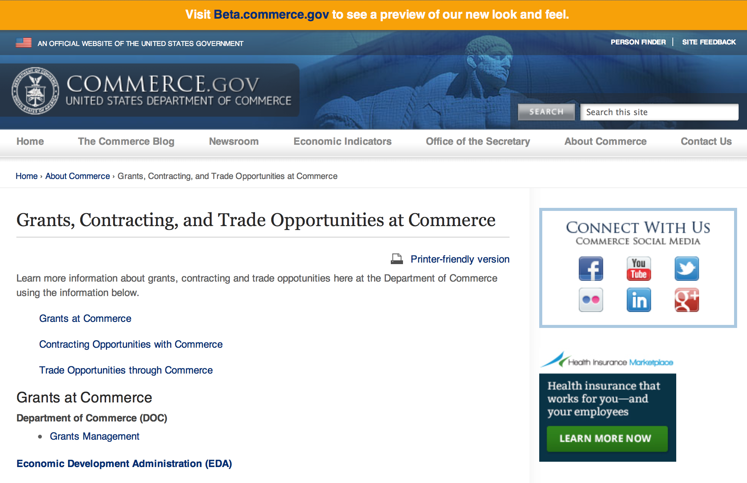
Grants at Commerce
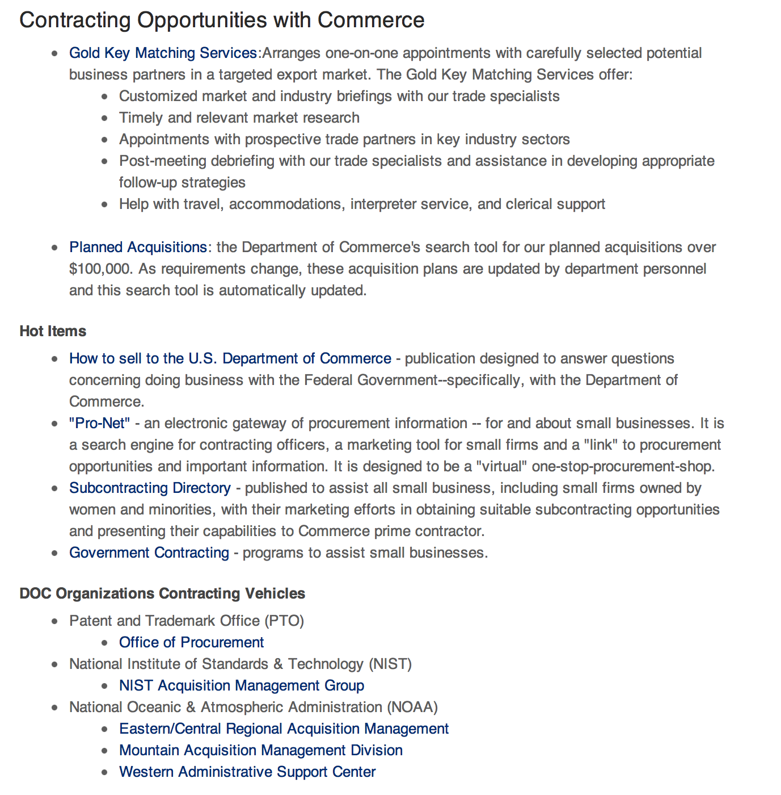

Contracting Opportunities with Commerce
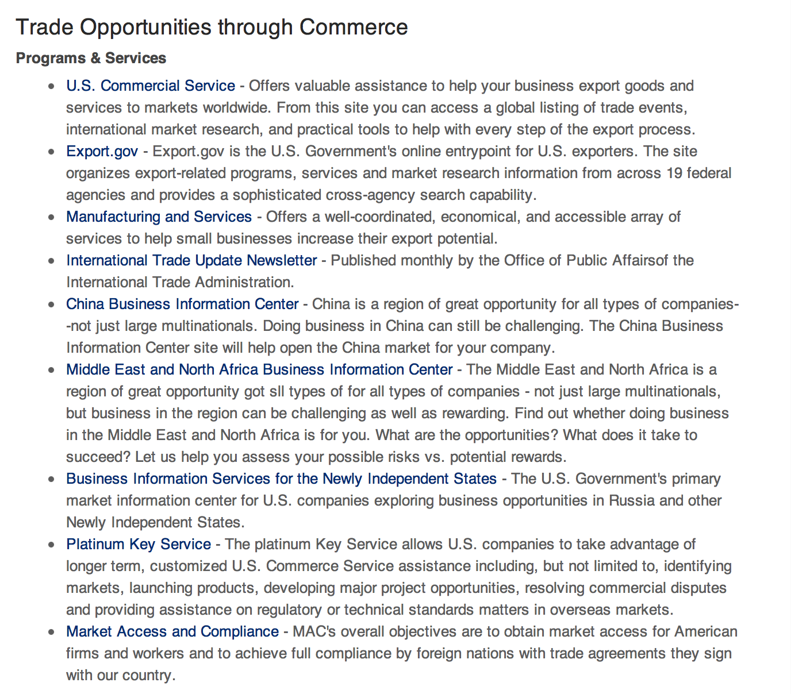

Trade Opportunities through Commerce
http://www.commerce.gov/about-commerce/grants-contracting-trade-opportunities

Programs:

Fisheries International Cooperation and Assistance Program Grant

Document Type: | Grants Notice
Funding Opportunity Number: | NOAA-NMFS-FHQ-2015-2004376
Funding Opportunity Title: | Fisheries International Cooperation and Assistance Program
Opportunity Category: | Discretionary
Funding Instrument Type: | Cooperative Agreement  Grant
Category of Funding Activity: | Environment  Natural Resources  Science and Technology and other Research and Development
Category Explanation:
Expected Number of Awards: | 20
CFDA Number(s): | 11.463 -- Habitat Conservation
Cost Sharing or Matching Requirement: | No
Posted Date: | Mar 25, 2015
Creation Date: | Mar 25, 2015
Original Closing Date for Applications: | May 25, 2015
Current Closing Date for Applications: | May 25, 2015
Archive Date: | Jun 24, 2015
Estimated Total Program Funding: | $1,750,000
Award Ceiling: | $200,000
Award Floor: | $10,000
Eligible Applicants: | Others (see text field entitled "Additional Information on Eligibility" for clarification)
Additional Information on Eligibility: | Eligible applicants are institutions of higher education, nonprofits, commercial organizations, international or foreign organizations or governments, organizations under the jurisdiction of foreign governments, individuals, and state, local and Indian Tribal governments. If the applicant is a university that has a NOAA Joint or Cooperative Institute (CI), the institution is encouraged to submit an application that will be associated with the CI. The application must specify the name of the CI, its most recent award number, and the NOAA- approved research theme applicable to the work to be performed in the project narrative. The application must use the facilities and administrative rate (F&A or Indirect Cost Rate) associated with most recent CI award. If the application is selected for funding, NMFS will notify the university that a separate competitive award will be issued with its own award number. However, the competitive award will include a Special Award Condition (SAC) that evidences the link between it and the CI award. The SAC will provide (1) that the university has submitted the proposal to be associated with the CI; (2) that any existing University/NOAA MOA will be incorporated by reference into the terms of the competitive award, and (3) that any progress report(s) for the competitive award must follow the timetable of and be submitted by the CI directly to the funding program. Copies of these progress reports will be attached to the CI's performance report as an appendix.
Agency Name: | Department of Commerce
Description: | The purpose of this notice is to request applications for special projects and programs associated with NMFS Office of International Affairs and Seafood Inspection (IASI) strategic plan and mission goals (http://www.nmfs.noaa.gov/ia/), as well as to provide the general public with information and guidelines on how IASI will select proposals and administer discretionary Federal assistance under this National Marine Fisheries Service Fisheries International Cooperation and Assistance Program (FICAP) - FY 2015 Announcement. This program is a mechanism to encourage research, education, policy, and outreach, innovative projects, or sponsorship that are not addressed through our competitive discretionary programs. Funding for potential projects in this notice is contingent upon the availability of Fiscal Year 2015 appropriations. Applicants are hereby given notice that funds have not yet been appropriated for any potential activities in this notice. Publication of this announcement does not oblige IASI to review an application, or to award any specific project, or to obligate any available funds.
Link to Additional Information:
Contact Information: | If you have difficulty accessing the full announcement electronically, please contact:  National Marine Fisheries Service (NMFS) Christopher Rogers Phone Number: 301-427-8375 Email: Christopher.Rogers@noaa.gov 1315 East-West Hwy Suite 10648 Silver Spring, MD 20910-3282  Work

http://www.grants.gov/web/grants/view-opportunity.html?oppId=275421

2015 Sea Grant - NMFS “On Assignment” Exchange Program Grant
And Modification 1

Document Type: | Grants Notice
Funding Opportunity Number: | NOAA-OAR-SG-2015-2004422
Funding Opportunity Title: | 2015 Sea Grant - NMFS “On Assignment” Exchange Program
Opportunity Category: | Discretionary
Funding Instrument Type: | Cooperative Agreement
Category of Funding Activity: | Environment  Natural Resources  Science and Technology and other Research and Development
Category Explanation:
Expected Number of Awards: | 10
CFDA Number(s): | 11.417 -- Sea Grant Support
Cost Sharing or Matching Requirement: | Yes
Posted Date: | Mar 20, 2015
Creation Date: | Mar 24, 2015
Original Closing Date for Applications: | May 27, 2015
Current Closing Date for Applications: | May 27, 2015
Archive Date: | Jun 26, 2015
Estimated Total Program Funding: | $200,000
Award Ceiling: | $60,000
Award Floor: | $1,000
Eligible Applicants: | Others (see text field entitled "Additional Information on Eligibility" for clarification)
Additional Information on Eligibility: | Sea Grant College Programs, Sea Grant Institutional Programs, and Sea Grant Coherent Area Programs
Agency Name: | Department of Commerce
Description: | The Sea Grant - National Marine Fisheries Service (NMFS) “On Assignment” Program (Exchange Program) is intended to expand the partnership between NMFS and Sea Grant and improve the services each provides to stakeholders. NMFS and Sea Grant are better able to leverage strengths of one another through the Exchange Program. The Exchange Program is designed to award funds for personnel exchanges or assignments between Sea Grant programs and a NMFS Science Center, Regional Office, or Laboratory (Lab). The duration of such an assignment can range between one and twelve months. Duties and locations should be proposed by the participant and approved by the Directors of the partnering Sea Grant program and partnering NMFS Science Center, Regional Office, or Lab.Up to $200,000 may be available for Sea Grant outreach (extension, communications, or education) professionals from Sea Grant programs. Funding for the Exchange Program is for travel support and project-related costs, not for salary and fringe benefits. Similar funding may be available for NMFS employees selected to participate in the Exchange Program through a separate selection process.
Link to Additional Information:
Contact Information: | If you have difficulty accessing the full announcement electronically, please contact:  Chris Hayes (301) 734-1066  work

http://www.grants.gov/web/grants/view-opportunity.html?oppId=275312

National Institute of Standards and Technology
FY 2015 Small Business Innovation Research (SBIR) Program Grant
Document Type: | Grants Notice
Funding Opportunity Number: | 2015-NIST-SBIR-01
Funding Opportunity Title: | FY 2015 Small Business Innovation Research (SBIR) Program
Opportunity Category: | Discretionary
Funding Instrument Type: | Cooperative Agreement
Category of Funding Activity: | Science and Technology and other Research and Development
Category Explanation:
Expected Number of Awards:
CFDA Number(s): | 11.620 -- Science, Technology, Business and/or Education Outreach
Cost Sharing or Matching Requirement: | No
Posted Date: | Mar 9, 2015
Creation Date: | Mar 9, 2015
Original Closing Date for Applications: | May 15, 2015 Electronic applications must be received no later than 11:59 p.m. Eastern Time, May 15, 2015. Paper applications must be received by NIST by 5:00 p.m. Eastern Time on May 15, 2015.
Current Closing Date for Applications: | May 15, 2015 Electronic applications must be received no later than 11:59 p.m. Eastern Time, May 15, 2015. Paper applications must be received by NIST by 5:00 p.m. Eastern Time on May 15, 2015.
Archive Date: | Jun 14, 2015
Eligible Applicants: | Others (see text field entitled "Additional Information on Eligibility" for clarification)
Additional Information on Eligibility: | Each applicant for both Phase I and Phase II must qualify as a small business concern for R/R&D purposes, as defined in Section 1.06 of this FFO, at the time of award. In addition, the primary employment of the principal investigator must be with the small business at the time of the award and during the conduct of the proposed research. Primary employment means that more than one-half of the principal investigator's time is spent working with the small business. Primary employment with a small business precludes full-time employment with another organization. Occasionally, deviations from this requirement may occur, and must be approved in writing by the NIST Grants Officer after consultation with the SBIR Program Manager. Further, a small business may replace the principal investigator on an SBIR Phase I or Phase II award, subject to approval in writing by the NIST Grants Officer. Personnel obtained through a Professional Employer Organization or other similar personnel leasing company may be considered employees of the awardee. Also see Section 1.03 of this FFO.
Agency Name: | National Institute of Standards and Technology
Description: | The National Institute of Standards and Technology (NIST) invites small businesses to submit Phase I research applications under this Federal Funding Opportunity (FFO). Firms with strong research capabilities in any of the areas listed in Section 9 of the Full Announcement/ FFO document are encouraged to participate. Applications not addressing one of the subtopics in Section 9 are not responsive to this FFO. The NIST FY 2015 SBIR program identifies and solicits applications in subtopics that fall within NIST’s mission and allow collaboration between NIST scientists and the SBIR awardees whenever possible. In order to ensure a greater strategic alignment between the NIST SBIR program and our laboratory research program, the SBIR topics are the priority areas identified in the NIST Programmatic Plan available at: http://www.nist.gov/director/planning/planning.cfm.
Link to Additional Information: | 2015-NIST-SBIR-01 Full Announcement/FFO document
Contact Information: | If you have difficulty accessing the full announcement electronically, please contact:  Christopher Hunton Grants Technical Assistant Phone 301-975-5718  Agency Contact

http://www.grants.gov/web/grants/view-opportunity.html?oppId=275010

National Institute of Standards and Technology
National Strategy for Trusted Identities in Cyberspace (NSTIC) Privacy Pilots Cooperative Agreement Program Grant

Document Type: | Grants Notice
Funding Opportunity Number: | 2015-NIST-NSTIC-02
Funding Opportunity Title: | National Strategy for Trusted Identities in Cyberspace (NSTIC) Privacy Pilots Cooperative Agreement Program
Opportunity Category: | Discretionary
Funding Instrument Type: | Cooperative Agreement
Category of Funding Activity: | Science and Technology and other Research and Development
Category Explanation:
Expected Number of Awards:
CFDA Number(s): | 11.619 -- Arrangements for Interdisciplinary Research Infrastructure
Cost Sharing or Matching Requirement: | No
Posted Date: | Mar 26, 2015
Creation Date: | Mar 26, 2015
Original Closing Date for Applications: | May 28, 2015 Applications must be received electronically through Grants.gov no later than 11:59 p.m. Eastern Time, Thursday, May 28, 2015.
Current Closing Date for Applications: | May 28, 2015 Applications must be received electronically through Grants.gov no later than 11:59 p.m. Eastern Time, Thursday, May 28, 2015.
Archive Date: | Jun 27, 2015
Eligible Applicants: | Others (see text field entitled "Additional Information on Eligibility" for clarification)
Additional Information on Eligibility: | Accredited institutions of higher education; non-profit organizations; and commercial organizations incorporated in the United States; and state, local, territorial and Indian tribal governments within the United States. While a non-governmental applicant must be incorporated in the United States, the applicant may have a parent organization outside the United States. An eligible organization may work individually or include proposed subawardees, contractors or other collaborators in a project, effectively forming a team or consortium. An organization may submit more than one application but each must be on a distinct topic. Federal agencies may participate in projects but may not receive NIST funding.
Agency Name: | National Institute of Standards and Technology
Description: | NIST is soliciting applications from eligible applicants to pilot privacy-enhancing technologies that embrace and advance the NSTIC vision and contribute to the maturity of the identity ecosystem the NSTIC envisions: Promote secure, user-friendly ways to give individuals and organizations confidence in their online interactions. Specifically, the Federal government seeks to initiate and support pilots that address the needs of individuals, private sector organizations, and all levels of government in accordance with the NSTIC guiding principles that identity solutions will be (1) privacy-enhancing and voluntary, (2) secure and resilient, (3) interoperable, and (4) cost-effective and easy-to-use. NIST will fund projects that are intended to demonstrate or deploy new solutions that either do not exist or are not widely adopted in the marketplace today.
Link to Additional Information: | 2015-NIST-NSTIC-02 Full Announcement/FFO document
Contact Information: | If you have difficulty accessing the full announcement electronically, please contact:  Christopher Hunton Grants Technical Assistant Phone 301-975-5718  Agency Contact

http://www.grants.gov/web/grants/view-opportunity.html?oppId=275464

Modifications:

Reminders:

National Institute of Standards and Technology
NIST Center for Neutron Research (NCNR) Comprehensive Grant Program

Document Type: | Grants Notice
Funding Opportunity Number: | 2015-NIST-NCNR-01
Funding Opportunity Title: | NIST Center for Neutron Research (NCNR) Comprehensive Grant Program
Opportunity Category: | Discretionary
Funding Instrument Type: | Cooperative Agreement
Category of Funding Activity: | Science and Technology and other Research and Development
Category Explanation:
Expected Number of Awards:
CFDA Number(s): | 11.609 -- Measurement and Engineering Research and Standards
Cost Sharing or Matching Requirement: | No
Posted Date: | Feb 3, 2015
Creation Date: | Feb 3, 2015
Original Closing Date for Applications: | Apr 17, 2015 Electronic applications must be received no later than 11:59 p.m. Eastern Time, Friday, April 17, 2015. Paper applications must be received by NIST by 5:00 p.m. Eastern Time, Friday, April 17, 2015. Applications received after the respective deadline will not be reviewed or considered.
Current Closing Date for Applications: | Apr 17, 2015 Electronic applications must be received no later than 11:59 p.m. Eastern Time, Friday, April 17, 2015. Paper applications must be received by NIST by 5:00 p.m. Eastern Time, Friday, April 17, 2015. Applications received after the respective deadline will not be reviewed or considered.
Archive Date: | May 17, 2015
Eligible Applicants: | Others (see text field entitled "Additional Information on Eligibility" for clarification)
Additional Information on Eligibility: | Institutions of higher education; hospitals; non-profit organizations; commercial organizations; State, Tribal and local governments; foreign governments; organizations under the jurisdiction of foreign governments; and international organizations.
Agency Name: | National Institute of Standards and Technology
Description: | NIST is soliciting applications to support research involving neutron scattering and spectroscopy specifically aimed at developing new instrumentation for neutron research, conducting collaborative research with NIST and visiting scientists, and to conduct other outreach and educational activities that advance the use of neutrons by U.S. academia and industrial scientists. This will entail awardee(s) stationing scientific staff at the NCNR to collaborate with NIST and other visiting scientists to advance these objectives.
Link to Additional Information: | 2015-NIST-NCNR-01 Full Announcement/FFO document
Contact Information: | If you have difficulty accessing the full announcement electronically, please contact:  Christopher Hunton Grants Technical Assistant Phone 301-975-5718  Agency Contact

http://www.grants.gov/web/grants/view-opportunity.html?oppId=272870

FY 2016 Implementation of the U.S. Integrated Ocean Observing System (IOOSŪ) Grant

Document Type: | Grants Notice
Funding Opportunity Number: | NOAA-NOS-IOOS-2016-2004378
Funding Opportunity Title: | FY 2016 Implementation of the U.S. Integrated Ocean Observing System (IOOS®)
Opportunity Category: | Discretionary
Funding Instrument Type: | Cooperative Agreement
Category of Funding Activity: | Environment  Natural Resources  Science and Technology and other Research and Development
Category Explanation:
Expected Number of Awards: | 12
CFDA Number(s): | 11.012 -- Integrated Ocean Observing System (IOOS)
Cost Sharing or Matching Requirement: | No
Posted Date: | Feb 11, 2015
Creation Date: | Feb 11, 2015
Original Closing Date for Applications: | Aug 31, 2015
Current Closing Date for Applications: | Aug 31, 2015
Archive Date: | Sep 30, 2015
Estimated Total Program Funding: | $29,000,000
Award Ceiling: | $4,000,000
Award Floor: | $1,000,000

http://www.grants.gov/web/grants/view-opportunity.html?oppId=273928

FY 2016 Implementation of the U.S. Integrated Ocean Observing System (IOOS®)

Document Type: | Grants Notice
Funding Opportunity Number: | NOAA-NOS-IOOS-2016-2004378
Funding Opportunity Title: | FY 2016 Implementation of the U.S. Integrated Ocean Observing System (IOOS®)
Opportunity Category: | Discretionary
Funding Instrument Type: | Cooperative Agreement
Category of Funding Activity: | Environment  Natural Resources  Science and Technology and other Research and Development
Category Explanation:
Expected Number of Awards: | 12
CFDA Number(s): | 11.012 -- Integrated Ocean Observing System (IOOS)
Cost Sharing or Matching Requirement: | No
Posted Date: | Feb 11, 2015
Creation Date: | Feb 11, 2015
Original Closing Date for Applications: | Aug 31, 2015
Current Closing Date for Applications: | Aug 31, 2015
Archive Date: | Sep 30, 2015
Estimated Total Program Funding: | $29,000,000
Award Ceiling: | $4,000,000
Award Floor: | $1,000,000
Eligible Applicants: | For profit organizations other than small businesses  Native American tribal governments (Federally recognized)  Public and State controlled institutions of higher education  Private institutions of higher education  State governments  Nonprofits having a 501(c)(3) status with the IRS, other than institutions of higher education  Nonprofits that do not have a 501(c)(3) status with the IRS, other than institutions of higher education  Special district governments  City or township governments  Small businesses  County governments
Agency Name: | Department of Commerce
Description: | The U.S. Integrated Ocean Observing System (IOOS®) is a national and regional partnership working to provide observations, data, and new tools and forecasts to improve safety, enhance the economy, and protect our environment. NOAA is requesting proposals for coordinated regional efforts that further the IOOS in two topic areas, 1) sustaining and enhancing comprehensive regional observing systems and 2) verification and validation of observing technologies for studying and monitoring coastal and ocean environments. NOAA invites applicants to submit proposals for one or both of these topic areas, described in detail below, and requests applicants submit separate applications for each topic area. For single topic proposals, clearly identify the topic area and present all required information such that merit reviewers can associate proposal elements (project description, partners, budgets) with the specific topic area. NOAA anticipates making multiple awards, subject to the availability of funds, in amounts ranging from $1,000,000 to $4,000,000 per year, for up to five years.
Link to Additional Information:
Contact Information: | If you have difficulty accessing the full announcement electronically, please contact:  Dave Easter, US IOOS Program 1100 Wayne Avenue Suite 1225 Silver Spring, MD 20910 301-427-2451  work

http://www.grants.gov/web/grants/view-opportunity.html?oppId=273468

National Institute of Standards and Technology
NIST Standards Services Curricula Development (SSCD) Cooperative Agreement Program Grant

Document Type: | Grants Notice
Funding Opportunity Number: | 2015-NIST-SSCD-01
Funding Opportunity Title: | NIST Standards Services Curricula Development (SSCD) Cooperative Agreement Program
Opportunity Category: | Discretionary
Funding Instrument Type: | Cooperative Agreement
Category of Funding Activity: | Science and Technology and other Research and Development
Category Explanation:
Expected Number of Awards:
CFDA Number(s): | 11.620 -- Science, Technology, Business and/or Education Outreach
Cost Sharing or Matching Requirement: | No
Posted Date: | Feb 11, 2015
Creation Date: | Feb 11, 2015
Original Closing Date for Applications: | Apr 13, 2015 Applications must be received electronically through Grants.gov no later than 11:59 p.m. Eastern Time, Monday, April 13, 2015. Applications received after this deadline will not be reviewed or considered.
Current Closing Date for Applications: | Apr 13, 2015 Applications must be received electronically through Grants.gov no later than 11:59 p.m. Eastern Time, Monday, April 13, 2015. Applications received after this deadline will not be reviewed or considered.
Archive Date: | May 13, 2015
Eligible Applicants: | Others (see text field entitled "Additional Information on Eligibility" for clarification)
Additional Information on Eligibility: | Accredited institutions of higher education; non-profit organizations; commercial organizations; state, local, and Indian tribal governments located in the United States and its territories. An eligible applicant may work individually or include proposed sub-awards or contracts with others in a project application, effectively forming a team or consortium.
Agency Name: | National Institute of Standards and Technology
Description: | The NIST SSCD Cooperative Agreement Program provides financial assistance to support curriculum development for the undergraduate and/or graduate level. These cooperative agreements support the integration of standards and standardization information and content into seminars, courses, and learning resources. The recipients will work with NIST to strengthen education and learning about standards and standardization.
Link to Additional Information: | 2015-NIST-SSCD-01 Full Announcement/FFO document
Contact Information: | If you have difficulty accessing the full announcement electronically, please contact:  Christopher Hunton Grants Technical Assistant Phone 301-975-5718  Agency Contact

http://www.grants.gov/web/grants/view-opportunity.html?oppId=273988

NOAA Sea Grant Aquaculture Extension and Technology Transfer 2015 Grant
Document Type: | Grants Notice
Funding Opportunity Number: | NOAA-OAR-SG-2015-2004399
Funding Opportunity Title: | NOAA Sea Grant Aquaculture Extension and Technology Transfer 2015
Opportunity Category: | Discretionary
Funding Instrument Type: | Cooperative Agreement  Grant
Category of Funding Activity: | Education  Environment  Science and Technology and other Research and Development
Category Explanation:
Expected Number of Awards: | 10
CFDA Number(s): | 11.417 -- Sea Grant Support
Cost Sharing or Matching Requirement: | Yes
Posted Date: | Feb 24, 2015
Creation Date: | Feb 24, 2015
Original Closing Date for Applications: | Apr 27, 2015
Current Closing Date for Applications: | Apr 27, 2015
Archive Date: | May 27, 2015
Estimated Total Program Funding: | $3,200,000
Award Ceiling: | $300,000
Award Floor: | $0
Eligible Applicants: | Others (see text field entitled "Additional Information on Eligibility" for clarification)
Additional Information on Eligibility: | The following entities are eligible to apply to this funding opportunity: Sea Grant College Programs, Sea Grant Institutional Programs, Sea Grant Coherent Area Programs, and the National Sea Grant Law Center. A given proposal can involve two or more of these Sea Grant Programs working in collaboration. In the case of proposals submitted jointly by multiple Sea Grant Programs, the project must be submitted as a single proposal with one Sea Grant Program designated as responsible for the proposal (awardee of record) and other Sea Grant Programs listed as sub-awards. Other interested parties are encouraged to work with the Sea Grant Programs in their region to explore opportunities for partnering. Contact information for all eligible state Sea Grant programs can be found at http://seagrant.noaa.gov/WhoWeAre/Leadership/SeaGrantDirectors.aspx or may also be obtained by contacting the Agency Contact listed in Section VII.
Agency Name: | Department of Commerce
Description: | Depending on availability of funds, NOAA Sea Grant expects to have available about $1,600,000 for each of FY 2015 and FY 2016 for a national competition to fund marine aquaculture extension and technology transfer efforts, as part of the overall plan to support the development of environmentally and economically sustainable ocean, coastal and Great Lakes aquaculture. Aquaculture that occurs in the Great Lakes or its coastal zone is considered marine aquaculture for this competition. This Federal Funding Opportunity includes information on application and criteria for aquaculture extension proposals requesting a maximum of $300,000 in total federal funding for up to a two-year period. Matching funds are required. Proposals are required to include a partnership (e.g., with local community governments, state and Federal agencies, regional management efforts, industry, non-governmental organizations). Awards are anticipated to start no later than September 1, 2015. Additional proposals from this competition may be selected for funding in subsequent fiscal years, subject to the availability of funds.
Link to Additional Information:
Contact Information: | If you have difficulty accessing the full announcement electronically, please contact:  Dorn Carlson, 301-734-1080 or Devin Brakob, 301-734-1085;  Program E-Mail Address

http://www.grants.gov/web/grants/view-opportunity.html?oppId=274777

Economic Development Administration
FY 2014 Economic Development Assistance Programs
And Modification 1

Document Type: | Grants Notice
Funding Opportunity Number: | EDAP2014
Funding Opportunity Title: | FY 2014 Economic Development Assistance Programs
Opportunity Category: | Discretionary
Funding Instrument Type: | Cooperative Agreement  Grant
Category of Funding Activity: | Other (see text field entitled "Explanation of Other Category of Funding Activity" for clarification)  Regional Development
Category Explanation: | The Economic Development Administration's (EDA’s) mission is to lead the Federal economic development agenda by promoting innovation and competitiveness, preparing American regions for economic growth and success in the worldwide economy. EDA fulfills this mission through strategic investments and partnerships that create the regional economic ecosystems required to foster globally competitive regions throughout the United States. EDA supports development in economically distressed areas of the United States by fostering job creation and attracting private investment. Specifically, under the Economic Development Assistance programs (EDAP) Federal Funding Opportunity (FFO) announcement, EDA will make construction, non-construction, and revolving loan fund investments under the Public Works and Economic Adjustment Assistance Programs. Grants made under these programs will leverage regional assets to support the implementation of regional economic development strategies designed to create jobs, leverage private capital, encourage economic development, and strengthen America's ability to compete in the global marketplace. Through the EDAP FFO, EDA solicits applications from rural and urban communities to develop initiatives that advance new ideas and creative approaches to address rapidly evolving economic conditions.
Expected Number of Awards:
CFDA Number(s): | 11.300 -- Investments for Public Works and Economic Development Facilities  11.307 -- Economic Adjustment Assistance
Cost Sharing or Matching Requirement: | Yes
Posted Date: | Nov 25, 2013
Creation Date: | Nov 26, 2013
Original Closing Date for Applications: | The deadlines for the remaining funding cycles of FY 2014 and the first funding cycle of FY 2015 are listed below. The first funding cycle of FY 2014 is covered under EDA’s FY 2013 Economic Development Assistance programs (EDAP) FFO dated November 26, 2012. EDA strongly encourages electronic submissions of applications through www.grants.gov (Grants.gov). To be considered during a particular funding cycle, completed applications must be validated and time-stamped by Grants.gov by 11:59 p.m. Eastern Time on the applicable funding cycle deadline. Alternatively, paper applications may be delivered to the applicable regional office listed in section VIII. of this FFO. Paper applications must be received no later than 5:00 p.m. local time in the applicable regional office on the funding cycle deadline and the applicant must use a delivery confirmation service from their selected carrier. If your application is received after the deadline, it will be considered late and will not be reviewed by EDA for that funding cycle. EDA will not accept facsimile or email transmissions of applications. The next four funding cycle deadlines are: December 13, 2012 for funding cycle 2 of FY 2014; March 14, 2014 for funding cycle 3 of FY 2014; June 13, 2014 for funding cycle 4 of FY 2014; and October 17, 2015 for funding cycle 1 of FY 2014. Please see section IV.C. of this FFO for more information on application deadlines under this announcement
Current Closing Date for Applications: | The deadlines for the remaining funding cycles of FY 2014 and the first funding cycle of FY 2015 are listed below. The first funding cycle of FY 2014 is covered under EDA's FY 2013 Economic Development Assistance programs (EDAP) FFO dated November 26, 2012. EDA strongly encourages electronic submissions of applications through www.grants.gov (Grants.gov). To be considered during a particular funding cycle, completed applications must be validated and time-stamped by Grants.gov by 11:59 p.m. Eastern Time on the applicable funding cycle deadline. Alternatively, paper applications may be delivered to the applicable regional office listed in section VIII. of this FFO. Paper applications must be received no later than 5:00 p.m. local time in the applicable regional office on the funding cycle deadline and the applicant must use a delivery confirmation service from their selected carrier. If your application is received after the deadline, it will be considered late and will not be reviewed by EDA for that funding cycle. EDA will not accept facsimile or email transmissions of applications. The next four funding cycle deadlines are: December 13, 2013 for funding cycle 2 of FY 2014; March 14, 2014 for funding cycle 3 of FY 2014; June 13, 2014 for funding cycle 4 of FY 2014 ; and October 17, 2015 for funding cycle 1 of FY 2014. Please see section IV.C. of this FFO for more information on application deadlines under this announcement
Eligible Applicants: | Others (see text field entitled "Additional Information on Eligibility" for clarification)  City or township governments  Private institutions of higher education  Nonprofits having a 501(c)(3) status with the IRS, other than institutions of higher education  Nonprofits that do not have a 501(c)(3) status with the IRS, other than institutions of higher education  Native American tribal governments (Federally recognized)  State governments  County governments
Additional Information on Eligibility: | Pursuant to EDA's authorizing statute, the Public Works and Economic Development Act of 1965 (PWEDA), eligible applicants for and eligible recipients of EDA investment assistance include a(n): (i) District Organization; (ii) Indian Tribe or a consortium of Indian Tribes; (iii) State, city, or other political subdivision of a State, including a special purpose unit of a State or local government engaged in economic or infrastructure development activities, or a consortium of political subdivisions; (iv) institution of higher education or a consortium of institutions of higher education; or (v) public or private non-profit organization or association acting in cooperation with officials of a political subdivision of a State. See section 3 of PWEDA (42 U.S.C. § 3122) and 13 C.F.R. § 300.3. EDA is not authorized to provide grants directly to individuals or to for-profit entities seeking to start or expand a private business. Such requests may be referred to State or local agencies, or to non-profit economic development organizations serving the region in which the project will be located.
Agency Name: | Economic Development Administration
Description: | The Economic Development Administration's (EDA's) mission is to lead the Federal economic development agenda by promoting innovation and competitiveness, preparing American regions for economic growth and success in the worldwide economy. EDA fulfills this mission through strategic investments and partnerships that create the regional economic ecosystems required to foster globally competitive regions throughout the United States. EDA supports development in economically distressed areas of the United States by fostering job creation and attracting private investment. Specifically, under the Economic Development Assistance programs (EDAP) Federal Funding Opportunity (FFO) announcement, EDA will make construction, non-construction, and revolving loan fund investments under the Public Works and Economic Adjustment Assistance Programs. Grants made under these programs will leverage regional assets to support the implementation of regional economic development strategies designed to create jobs, leverage private capital, encourage economic development, and strengthen America's ability to compete in the global marketplace. Through the EDAP FFO, EDA solicits applications from rural and urban communities to develop initiatives that advance new ideas and creative approaches to address rapidly evolving economic conditions.
Link to Additional Information: | EDA Website
Contact Information: | If you have difficulty accessing the full announcement electronically, please contact:  If you have difficulty accessing the full announcement electronically, please contact your state representative. Please direct any questions to the EDA representative for your state. A complete list of EDA representatives is available on EDA's website at http://eda.gov/contacts.htm

http://www.grants.gov/web/grants/view-opportunity.html?oppId=248297

Economic Development Administration
Planning Program and Local Technical Assistance Program Grant

Document Type: | Grants Notice
Funding Opportunity Number: | EDAPLANNING2012
Opportunity Category: | Discretionary
Posted Date: | Aug 03, 2012
Creation Date: | Aug 03, 2012
Original Closing Date for Applications: | Applications are accepted on a continuing basis and processed as received. This Planning and Local Technical Assistance opportunity will remain in effect until superseded by a future announcement.
Current Closing Date for Applications: | Applications are accepted on a continuing basis and processed as received. This Planning and Local Technical Assistance opportunity will remain in effect until superseded by a future announcement.
Archive Date:
Funding Instrument Type: | Cooperative Agreement  Grant
Category of Funding Activity: | Other (see text field entitled "Explanation of Other Category of Funding Activity" for clarification)  Regional Development
Category Explanation: | Regional planning and local technical assistance
Expected Number of Awards: | 425
Estimated Total Program Funding:
Award Ceiling: | $100,000
Award Floor:
CFDA Number(s): | 11.302 -- Economic Development Support for Planning Organizations
 | 11.303 -- Economic Development Technical Assistance
Cost Sharing or Matching Requirement: | Yes

Eligible Applicants
State governments
County governments
City or township governments
Public and State controlled institutions of higher education
Native American tribal governments (Federally recognized)
Nonprofits having a 501(c)(3) status with the IRS, other than institutions of higher education
Nonprofits that do not have a 501(c)(3) status with the IRS, other than institutions of higher education
Private institutions of higher education
Others (see text field entitled "Additional Information on Eligibility" for clarification)

Additional Information on Eligibility:
Pursuant to section 3 of the Public Works and Economic Development Act of 1965 (42 U.S.C. § 3122) (PWEDA) and EDA’s regulation at 13 C.F.R. § 300.3, the following types of entities are eligible to receive funding assistance from EDA: 1. District Organizations (as defined in 13 C.F.R. § 300.3); 2. Indian Tribes or a consortium of Indian Tribes; 3. States, cities, or other political subdivisions of a State, including a special purpose unit of a State or local government engaged in economic or infrastructure development activities, or a consortium of political subdivisions; 4. Institutions of higher education or a consortium of institutions of higher education; or 5. Public or private non-profit organizations or associations acting in cooperation with officials of a political subdivision of a State.

Agency Name
Economic Development Administration

Description
Pursuant to PWEDA, EDA announces general policies and application procedures for grant-based investments under the Planning and Local Technical Assistance programs. Under the Planning program EDA assists eligible recipients in creating regional economic development plans designed to stimulate and guide the economic development efforts of a community or region. As part of this program, EDA supports Partnership Planning investments to facilitate the development, implementation, revision, or replacement of Comprehensive Economic Development Strategies (CEDS), which articulate and prioritize the strategic economic goals of recipients' respective regions. In general, EDA provides Partnership Planning grants to the designated planning organization (e.g., District Organization) serving EDA-designated Economic Development Districts to enable these organizations to develop and implement relevant CEDS. In addition, EDA provides Partnership Planning grants to Indian Tribes to help develop and implement CEDS and associated economic development activities. The Planning program also helps support planning organizations, including District Organizations, Indian Tribes, and other eligible Recipients, with Short Term and State Planning investments designed to guide the eventual creation and retention of higher-skill, higher-wage jobs, particularly for the unemployed and underemployed in the Nation’s most economically distressed regions. The Local Technical Assistance program strengthens the capacity of local or State organizations, institutions of higher education, and other eligible recipients to undertake and promote effective economic development programs through projects such as feasibility analyses and impact studies.

Link to Additional Information

If you have difficulty accessing the full announcement electronically, please contact:
David Ives Planning and Local TA email

http://www.grants.gov/web/grants/view-opportunity.html?oppId=189193

Economic Development Administration
FY 2013 Economic Development Assistance Programs Grant
Document Type: | Modification to Previous Grants Notice
Funding Opportunity Number: | EDAP2013
Opportunity Category: | Discretionary
Posted Date: | Nov 26, 2012
Creation Date: | Nov 27, 2012
Original Closing Date for Applications: | The deadlines for the remaining funding cycles of FY 2013 and the first funding cycle of FY 2014 are listed below. The first funding cycle of FY 2013 is covered under EDA’s FY 2012 Economic Development Assistance programs (EDAP) FFO dated November 18, 2011. EDA strongly encourages electronic submissions of applications through www.grants.gov (Grants.gov). To be considered during a particular funding cycle, completed applications must be validated and time-stamped at Grants.gov by 11:59 p.m. Eastern Time on the applicable funding cycle deadline. Alternatively, paper applications may be delivered to the applicable regional office listed in section VIII. of this FFO. Paper applications must be received no later than 5:00 p.m. local time in the applicable regional office on the funding cycle deadline and the applicant must use a delivery confirmation service from their selected carrier. If your application is received after the deadline, it will be considered late and will not be reviewed by EDA for that funding cycle. EDA will not accept facsimile or email transmissions of applications. The next four funding cycle deadlines are: December 13, 2012 for funding cycle 2 of FY 2013; March 13, 2013 for funding cycle 3 of FY 2013; June 13, 2013 for funding cycle 4 of FY 2013; and September 13, 2013 for funding cycle 1 of FY 2014. Please see section IV.C. of this FFO for more information on application deadlines under this announcement.
Current Closing Date for Applications: | The deadlines for the remaining funding cycles of FY 2013 and the first funding cycle of FY 2014 are listed below. The first funding cycle of FY 2013 is covered under EDA’s FY 2012 Economic Development Assistance programs (EDAP) FFO dated November 18, 2011. EDA strongly encourages electronic submissions of applications through www.grants.gov (Grants.gov). To be considered during a particular funding cycle, completed applications must be validated and time-stamped at Grants.gov by 11:59 p.m. Eastern Time on the applicable funding cycle deadline. Alternatively, paper applications may be delivered to the applicable regional office listed in section VIII. of this FFO. Paper applications must be received no later than 5:00 p.m. local time in the applicable regional office on the funding cycle deadline and the applicant must use a delivery confirmation service from their selected carrier. If your application is received after the deadline, it will be considered late and will not be reviewed by EDA for that funding cycle. EDA will not accept facsimile or email transmissions of applications. The next four funding cycle deadlines are: December 13, 2012 for funding cycle 2 of FY 2013; March 13, 2013 for funding cycle 3 of FY 2013; June 13, 2013 for funding cycle 4 of FY 2013 ; and September 13, 2013 for funding cycle 1 of FY 2014. Please see section IV.C. of this FFO for more information on application deadlines under this announcement.
Archive Date: | Mar 31, 2014
Funding Instrument Type: | Cooperative Agreement  Grant
Category of Funding Activity: | Other (see text field entitled "Explanation of Other Category of Funding Activity" for clarification)  Regional Development
Category Explanation: | The Economic Development Administration’s (EDA’s) mission is to lead the Federal economic development agenda by promoting innovation and competitiveness, preparing American regions for economic growth and success in the worldwide economy. EDA fulfills this mission through strategic investments and partnerships that create the regional economic ecosystems required to foster globally competitive regions throughout the United States. EDA supports development in economically distressed areas of the United States by fostering job creation and attracting private investment. Specifically, under the Economic Development Assistance programs (EDAP) Federal Funding Opportunity (FFO) announcement, EDA will make construction, non-construction, and revolving loan fund investments under the Public Works and Economic Adjustment Assistance Programs. Grants made under these programs will leverage regional assets to support the implementation of regional economic development strategies designed to create jobs, leverage private capital, encourage economic development, and strengthen America’s ability to compete in the global marketplace. Through the EDAP FFO, EDA solicits applications from rural and urban communities to develop initiatives that advance new ideas and creative approaches to address rapidly evolving economic conditions.
Expected Number of Awards:
Estimated Total Program Funding:
Award Ceiling:
Award Floor:
CFDA Number(s): | 11.300 -- Investments for Public Works and Economic Development Facilities
 | 11.307 -- Economic Adjustment Assistance
Cost Sharing or Matching Requirement: | Yes

Eligible Applicants
State governments
County governments
City or township governments
Public and State controlled institutions of higher education
Native American tribal governments (Federally recognized)
Nonprofits having a 501(c)(3) status with the IRS, other than institutions of higher education
Nonprofits that do not have a 501(c)(3) status with the IRS, other than institutions of higher education
Private institutions of higher education
Others (see text field entitled "Additional Information on Eligibility" for clarification)

Additional Information on Eligibility:
Pursuant to EDA’s authorizing statute, the Public Works and Economic Development Act of 1965 (PWEDA), eligible applicants for and eligible recipients of EDA investment assistance include a (n): (i) District Organization; (ii) Indian Tribe or a consortium of Indian Tribes; (iii) State, city, or other political subdivision of a State, including a special purpose unit of a State or local government engaged in economic or infrastructure development activities, or a consortium of political subdivisions; (iv) institution of higher education or a consortium of institutions of higher education; or (v) public or private non-profit organization or association acting in cooperation with officials of a political subdivision of a State. See section 3 of PWEDA (42 U.S.C. § 3122) and 13 C.F.R. § 300.3. EDA is not authorized to provide grants directly to individuals or to for-profit entities seeking to start or expand a private business. Such requests may be referred to State or local agencies, or to non-profit economic development organizations serving the region in which the project will be located.

Agency Name
Economic Development Administration

Description
EDA provides strategic investments that foster job creation and attract private investment to support development in economically distressed areas of the United States. Under this FFO, EDA solicits applications from both rural and urban areas to provide investments that support construction, non-construction, technical assistance, and revolving loan fund projects under EDA’s Public Works and Economic Adjustment Assistance programs. Grants made under these programs are designed to leverage existing regional assets to support the implementation of economic development strategies that advance new ideas and creative approaches to advance economic prosperity in distressed communities.

Link to Additional Information
EDA's website

If you have difficulty accessing the full announcement electronically, please contact:
Kerstin Millius
Senior Program Analyst Kerstin Millius

Synopsis Modification History
The following files represent the modifications to this synopsis with the changes noted within the documents. The list of files is arranged from newest to oldest with the newest file representing the current synopsis. Changed sections from the previous document are shown in a light grey background.
File Name | Date
Original Synopsis | Nov 26, 2012

http://www.grants.gov/web/grants/view-opportunity.html?oppId=208353

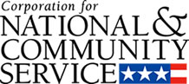

Corporation for National and Community Service

General Program Overview
AmeriCorps provides resources, both human and financial, to organizations that engage Americans in intensive service to meet our country’s critical needs.
Grantees use the funding to support AmeriCorps members for intensive service in their community. AmeriCorps grants partially cover the expense of operating an AmeriCorps program and do not cover general organizational expenses. A cash and in-kind match is required.

The main website can be accessed here: http://www.nationalservice.gov

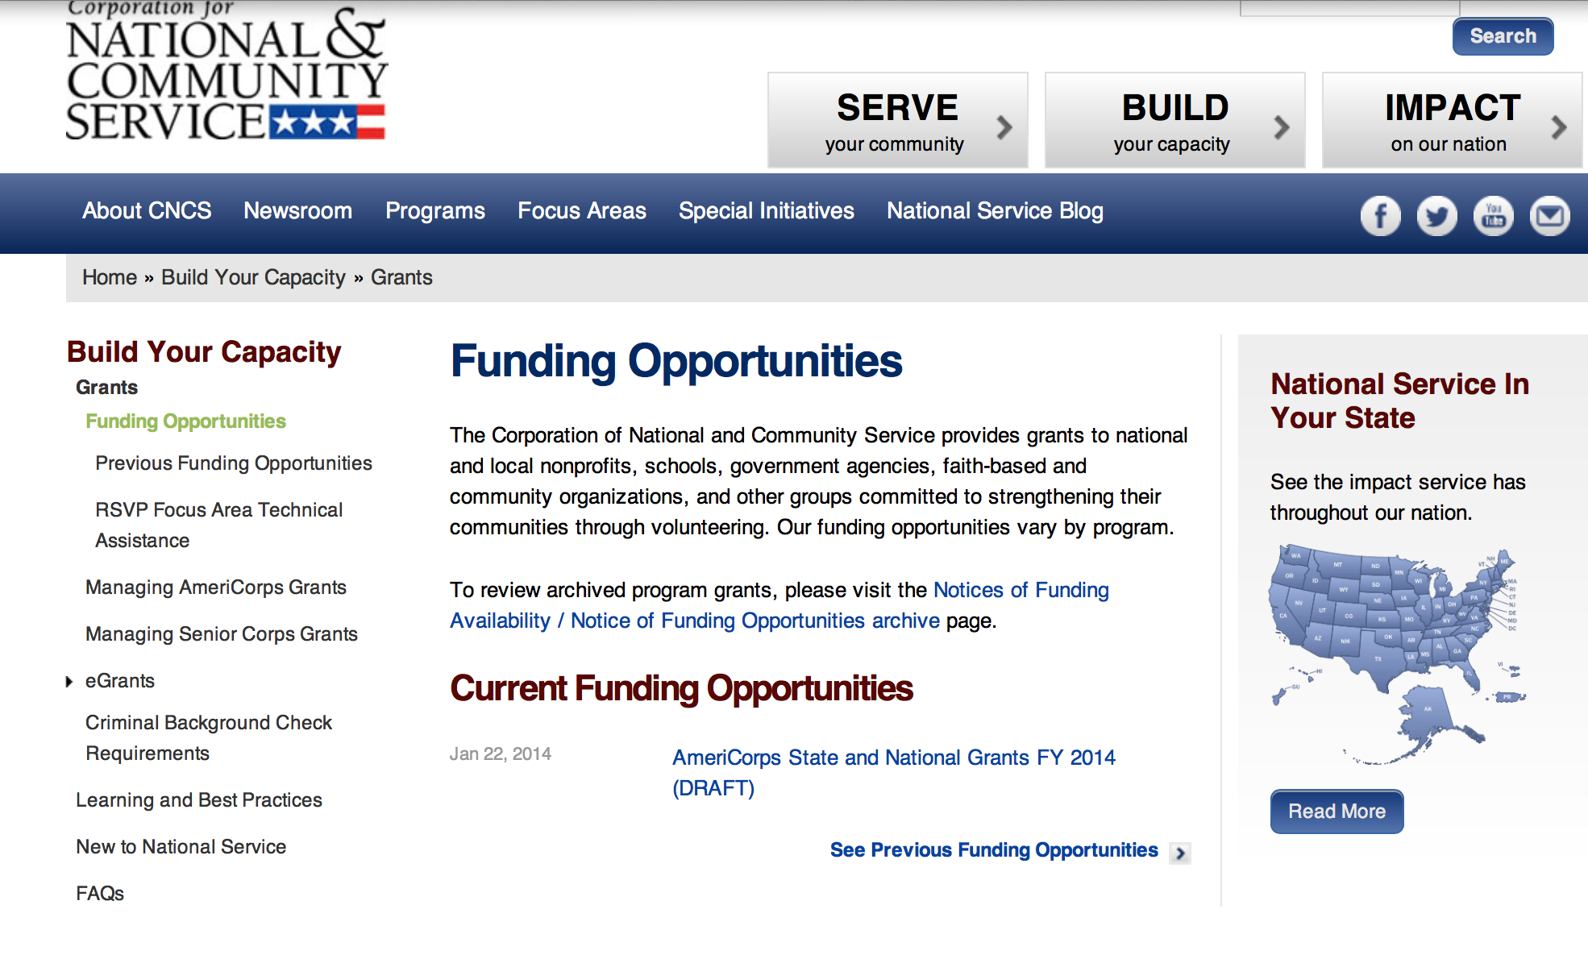

For access to further funding information: click here

http://www.nationalservice.gov/build-your-capacity/grants/funding-opportunities

National Service In Hawaii

Meeting Community Needs in Hawaii: More than 3,500 people of all ages and backgrounds are helping to meet local needs, strengthen communities, and increase civic engagement through national service in Hawaii. Serving at more than 490 locations throughout the state, these citizens tutor and mentor children, support veterans and military families, provide health services, restore the environment, respond to disasters, increase economic opportunity, and recruit and manage volunteers. This year, the Corporation for National and Community Service (CNCS) will commit more than $5,460,000 to support Hawaii communities through national service initiatives. Through a unique public-private partnership, this federal investment will leverage an additional $2,610,000 in other resources to strengthen community impact, build local support, and increase return on taxpayer dollars.
AmeriCorps
This year, AmeriCorps will provide more than 510 individuals the opportunity to provide intensive, results-driven service to meet education, environmental, health, economic, and other pressing needs in communities across Hawaii. Most AmeriCorps grant funding goes to the Hawaii Commission on National & Community Service, which in turn awards grants to nonprofit groups to respond to local needs. Most of the remainder of the grant funding is distributed by CNCS directly to multi-state and national organizations through a competitive grants process. Other individuals serve through AmeriCorps VISTA, whose members help bring individuals and communities out of poverty by serving full-time to fight illiteracy, improve health services, create businesses, and increase housing opportunities, and AmeriCorps NCCC (National Civilian Community Corps), a 10-month, full time residential program for men and women between the ages of 18 and 24. In exchange for their service, AmeriCorps members earn an education award that can be used to pay for college or to pay back qualified student loans. Since 1994, more than 4,900 Hawaii residents have served more than 5.1 million hours and have qualified for Segal AmeriCorps Education Awards totaling more than $11,250,000.
Download: AmeriCorps in Hawaii (PDF)

Senior Corps
More than 3,000 seniors in Hawaii contribute their time and talents in one of three Senior Corps programs. Foster Grandparents serve one-on-one as tutors and mentors to more than 480 young people who have special needs. Senior Companions help more than 250 homebound seniors and other adults maintain independence in their own homes. RSVP volunteers conduct safety patrols, renovate homes, protect the environment, tutor and mentor youth, respond to natural disasters, and provide other services through more than 290 groups across Hawaii.
Download: Senior Corps in Hawaii (PDF)

The Corporation for National and Community Service is a federal agency that improves lives, strengthens communities, and fosters civic engagement through service and volunteering. CNCS annually engages more than five million Americans in service to meet local needs through Senior Corps, AmeriCorps, and national days of service; improves communities through the Social Innovation Fund, and leads President Obama's national call to service initiative, United We Serve. To learn more visit NationalService.gov or Serve.gov or call 202-606-5000 or TTY 1-800-833-3722.

2015 September 11th National Day of Service and Remembrance Grants

Document Type: | Grants Notice
Funding Opportunity Number: | CNCS-03-24-15
Funding Opportunity Title: | 2015 September 11th National Day of Service and Remembrance Grants
Opportunity Category: | Discretionary
Funding Instrument Type: | Grant
Category of Funding Activity: | Disaster Prevention and Relief  Education  Other (see text field entitled "Explanation of Other Category of Funding Activity" for clarification)
Category Explanation: | Veterans and Military Families
Expected Number of Awards: | 12
CFDA Number(s): | 94.007 -- Program Development and Innovation Grants
Cost Sharing or Matching Requirement: | Yes
Posted Date: | Mar 24, 2015
Creation Date: | Mar 24, 2015
Original Closing Date for Applications: | Apr 29, 2015
Current Closing Date for Applications: | Apr 29, 2015
Archive Date: | May 29, 2015
Estimated Total Program Funding: | $600,000
Award Ceiling: | $300,000
Award Floor: | $50,000
Eligible Applicants: | Public and State controlled institutions of higher education  Private institutions of higher education  Independent school districts  Special district governments  County governments  Public housing authorities/Indian housing authorities  Native American tribal governments (Federally recognized)  City or township governments
Additional Information on Eligibility: | Eligible applicants are capable of carrying out multi-state, nationally focused (10 or more states), or comprehensive regional initiatives. Regional initiatives are multiple cities in a region or are state-wide. If necessary, applicants may engage with other partners to accomplish these geographic initiatives. If engaging with other partners, applicant organizations must have the capability to manage and provide partner oversight, report on project accomplishments and performance measures, and remain accountable to CNCS for the achievement of the intended results set forth in their proposals.
Agency Name: | Corporation for National and Community Service
Description: | • The purpose of the September 11th National Day of Service and Remembrance grant funding is to mobilize more Americans to engage in service and remembrance activities that meet vital community needs and honor the sacrifice of those who lost their lives on September 11, 2001, or who rose in service as a result of that tragedy. • CNCS will give priority consideration to organizations with applications that feature one or more of the following elements: o a focus on engaging and supporting Veterans and Military Families in September 11th National Day of Service and Remembrance activities o a proposal to develop educational materials or curriculum for youth, including a plan for curriculum distribution and educating youth about service to honor September 11th National Day of Service and Remembrance o expertise in representing families of victims of the September 11th terrorist attacks and other affected constituencies • All grants awarded will support activities that: o are directly connected to the September 11th National Day of Service and Remembrance, and occur on or near that day, as well as reflect the tone and tenor of a national day of reflection and remembrance; o focus on honoring those who lost their lives on September 11, 2001 and those who rose in service as a result of that tragedy; o demonstrate opportunities to engage new and diverse groups in service; o leverage public-private partnerships; o meet an identified community need; o ensure that grant-supported activities focus on September 11th National Day of Service and Remembrance and provide opportunities to connect to service beyond the holiday; o provide opportunities to connect to ongoing opportunities to serve; and/or emphasize community connections to Veteran Service Organizations and Military Service Organizations where they exist.
Link to Additional Information: | Link to announcement
Contact Information: | If you have difficulty accessing the full announcement electronically, please contact:  Patti Stengel Senior Program Officer  competition mailbox

http://www.grants.gov/web/grants/view-opportunity.html?oppId=275367
Reminder:

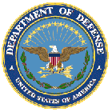

U.S. Department of Defense

Doing Business with the Department of Defense

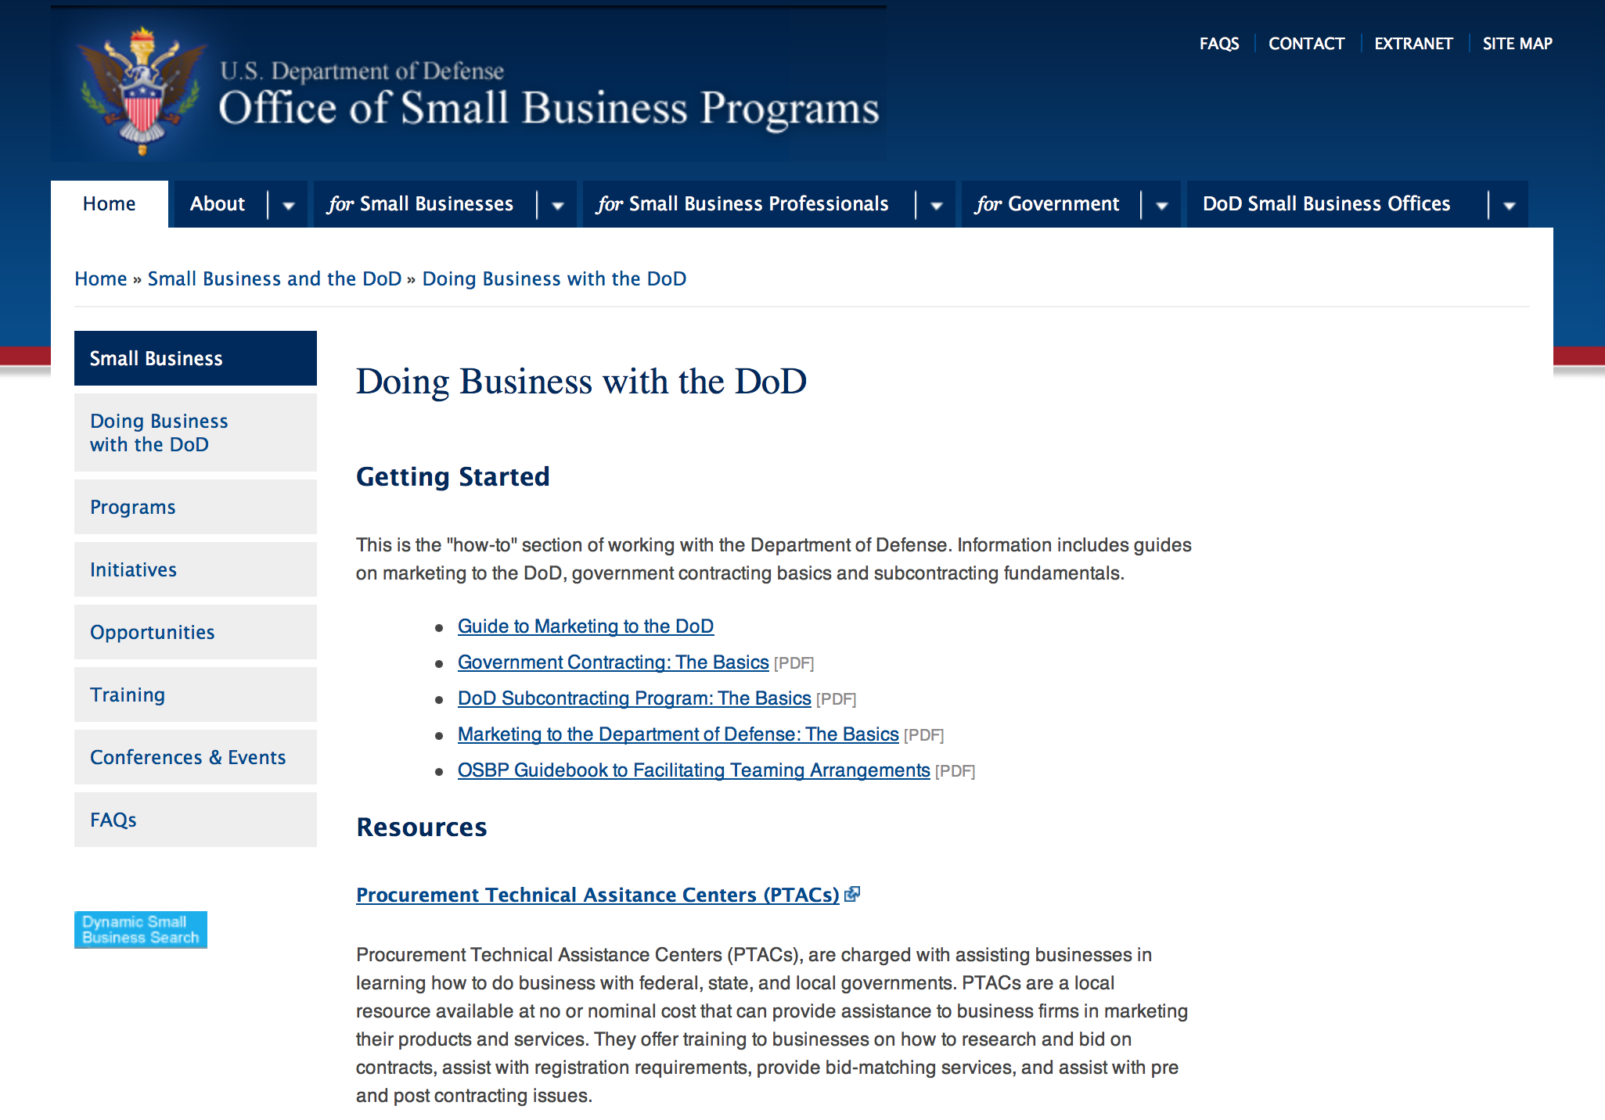

http://www.acq.osd.mil/osbp/doing_business/index.htm

Doing Business with DOD

- Air Force Contract Opportunities
  - Doing Business with the Air Force
- Army Contract Opportunities
  - Army Business Opportunities
- DOD Contract Opportunities
  - Doing Business with DOD
  - Guide to DOD Contracting Opportunities
  - DOD Office of Small Business Programs
  - Small Business Innovation Research Programs and Other Helpful Links
- DOD Contract Award Announcements
- Defense Acquisition University
- Defense Federal Acquisition Regulation (DFAR)
  - Procedures, Guidance, and Information
- Federal Acquisition Regulation (FAR)
  - FAR Documents, Information and Links
  - A list of quarterly video magazines that provides a discussion of recent changes to the FAR and DFARS, insights into the regulatory process, and news/issues on the horizon. DPAP and DAU have embarked on this joint venture to provide contracting personnel with the latest news regarding actions effecting the FAR and DFARS.
- Navy Contract Opportunities
  - Navy Acquisition One Source
  - Business Opportunities
- OSBP Programs
  - Small Business Innovation Research (SBIR) Program
  - Small Business Technology Transfer (STTR) Program
  - Indian Incentive Program
  - Women-Owned Small Business Program
  - Historically Black Colleges and Universities / Minority Institutions Technical Assistance Program
  - Comprehensive Subcontracting Test Program
  - DOD Regional Councils for Small Business Education and Advocacy
  - Service-Disabled Veteran-Owned Small Business Program
  - Historically Underutilized Business Zones Program (HUBZone)
- Recovery & Reinvestment Act Opportunities
  - Search Opportunities
- Subcontracting Opportunities
  - Subcontracting Opportunities with DOD Major Prime Contractors
Doing Business with DOD

http://www.defense.gov/landing/contract_resources.aspx

DoD Small Business Opportunities
The purpose of this section is to identify areas of potential small business growth that are new, developing, or have recently come to the attention of this office. The intent is not to duplicate information which exists through traditional acquisition tools.
DoD Service Forecasts
Future acquisition forecasts are prepared by a number of organizations within DoD. Forecasting methodologies vary by service but constitute the 'best estimate' of each.
ARMY
Navy
- MSC
- NAVAIR
- NAVAIR NAWCTSD
- NAVFAC
- NAVSUP
- NAVSUP WSS
- SPAWAR
- SSP
- USMC I&L

Air Force
- Air Force OSBP
- Hanscom AFB

Defense Logistics Agency

Research:

Dept. of the Army -- USAMRAA
DoD Breast Cancer Breakthrough Award Levels 1 and 2 Grant
http://www.grants.gov/web/grants/view-opportunity.html?oppId=274902

Defense Advanced Research Projects Agency
DARPA - Information Innovation Office Brandeis Grant
http://www.grants.gov/web/grants/view-opportunity.html?oppId=275070

Dept. of the Army -- USAMRAA
DoD Breast Cancer Breakthrough Award Levels 3 and 4 Grant
http://www.grants.gov/web/grants/view-opportunity.html?oppId=274904

Dept. of the Army -- USAMRAA
DoD Breast Cancer Era of Hope Scholar Award Grant
http://www.grants.gov/web/grants/view-opportunity.html?oppId=274907

Dept. of the Army -- USAMRAA
DoD Breast Cancer Distinguished Investigator Award Grant
http://www.grants.gov/web/grants/view-opportunity.html?oppId=274908

Dept. of the Army -- USAMRAA
DoD Amyotrophic Lateral Sclerosis Therapeutic Idea Award Grant
http://www.grants.gov/web/grants/view-opportunity.html?oppId=275280

Dept. of the Army -- USAMRAA
DoD Ovarian Cancer Clinical Translational Award Grant
http://www.grants.gov/web/grants/view-opportunity.html?oppId=275329

Dept. of the Army -- USAMRAA
DoD Ovarian Cancer Investigator-Initiated Research Award Grant
http://www.grants.gov/web/grants/view-opportunity.html?oppId=275331

Dept. of the Army -- USAMRAA
DoD Ovarian Cancer Pilot Award Grant
http://www.grants.gov/web/grants/view-opportunity.html?oppId=275333

Dept. of the Army -- USAMRAA
DoD Amyotrophic Lateral Sclerosis Therapeutic Idea Award Grant
http://www.grants.gov/web/grants/view-opportunity.html?oppId=275280

Dept. of the Army -- Corps of Engineers
Engineer Research and Development Center
Department of Defense Legacy Resource Management Program Grant
http://www.grants.gov/web/grants/view-opportunity.html?oppId=274914

Defense Advanced Research Projects Agency
DARPA - Biological Technologies Office
Technologies for Host Resilience (THoR)
And Modification 1
http://www.grants.gov/web/grants/view-opportunity.html?oppId=275568

Defense Logistics Agency
Procurement Technical Assistance Program (PTAP) Grant
http://www.grants.gov/web/grants/view-opportunity.html?oppId=275389

Office of Naval Research
FY16 Communications and Networks Discovery and Invention Grant
http://www.grants.gov/web/grants/view-opportunity.html?oppId=275056

Modifications:

Dept. of the Army -- Materiel Command
Army Research Office Broad Agency Announcement for Basic and Applied Scientific Research
Modification 8

Document Type: | Grants Notice
Funding Opportunity Number: | W911NF-12-R-0012
Funding Opportunity Title: | Army Research Office Broad Agency Announcement for Basic and Applied Scientific Research
Opportunity Category: | Discretionary
Funding Instrument Type: | Cooperative Agreement  Grant  Other  Procurement Contract
Category of Funding Activity: | Science and Technology and other Research and Development
Category Explanation:
Expected Number of Awards: | 1000
CFDA Number(s): | 12.431 -- Basic Scientific Research
Cost Sharing or Matching Requirement: | No
Posted Date: | Mar 27, 2015
Creation Date: | Mar 27, 2015
Original Closing Date for Applications: | Mar 31, 2017
Current Closing Date for Applications: | Mar 31, 2017
Archive Date: | Apr 30, 2017
Eligible Applicants: | Unrestricted (i.e., open to any type of entity above), subject to any clarification in text field entitled "Additional Information on Eligibility"
Agency Name: | Dept. of the Army -- Materiel Command
Description: | The purpose of this Broad Agency Announcement (BAA) is to solicit research proposals in the engineering, physical, life, and information sciences for submission to the Army Research Office (ARO) for consideration for possible funding. For ease of reference, this BAA is an extraction of the ARO sections of the Army Research Laboratory BAA. (www.arl.army.mil/www/default.cfm?page=8).
Link to Additional Information: | ARO CORE BAA-W911NF-12-R-0012-Mod 03
Contact Information: | If you have difficulty accessing the full announcement electronically, please contact:  ANDREW L. FISKE Procurement Analyst Army Contracting Command Aberdeen Proving Ground Research Triangle Park Division Phone: (919) 549-4338 FAX: (919) 549-4388 andrew.l.fiske.civ@mail.mil  Administrative POC

http://www.grants.gov/web/grants/view-opportunity.html?oppId=173593

Air Force -- Research Lab
Aerospace Medicine, Clinical Research, Human Performance Research, and Expeditionary Medicine
Modification 4
http://www.grants.gov/web/grants/view-opportunity.html?oppId=59893

Dept. of the Army -- USAMRAA
DoD Amyotrophic Lateral Sclerosis Therapeutic Idea Award
Modification 2
http://www.grants.gov/web/grants/view-opportunity.html?oppId=275280

Dept. of the Army -- Materiel Command
ACC-APG-Belvoir
Night Vision Technologies
Modification 3
http://www.grants.gov/web/grants/view-opportunity.html?oppId=262229

Dept. of the Army -- USAMRAA
DoD FY15 Bone Marrow Failure Research Program Idea Development Award
Modification 1
http://www.grants.gov/web/grants/view-opportunity.html?oppId=274909

Defense Threat Reduction Agency
Fundamental Research to Counter Weapons of Mass Destruction
Modification 1
http://www.grants.gov/web/grants/view-opportunity.html?oppId=275322

Defense Threat Reduction Agency
Fundamental Research to Counter Weapons of Mass Destruction
Modification 21
http://www.grants.gov/web/grants/view-opportunity.html?oppId=49658

Military-Connected Local Educational Agencies for Academic and Support Programs (MCASP)
Modification 1
http://www.grants.gov/web/grants/view-opportunity.html?oppId=274930

Office of Naval Research
Long Range BAA for Navy and Marine Corps Science and Technology
Modification 2
http://www.grants.gov/web/grants/view-opportunity.html?oppId=267270

Office of Naval Research
Naval Supply Systems Command
FY15 - FY16 Department of Defense HIV/AIDS Prevention Program: Military Specific HIV/AIDS Prevention, Care, and Treatment Program for non-PEPFAR (President's Emergency Plan for AIDS Relief
Modification 2
http://www.grants.gov/web/grants/view-opportunity.html?oppId=270443

Reminders:



Department of Education

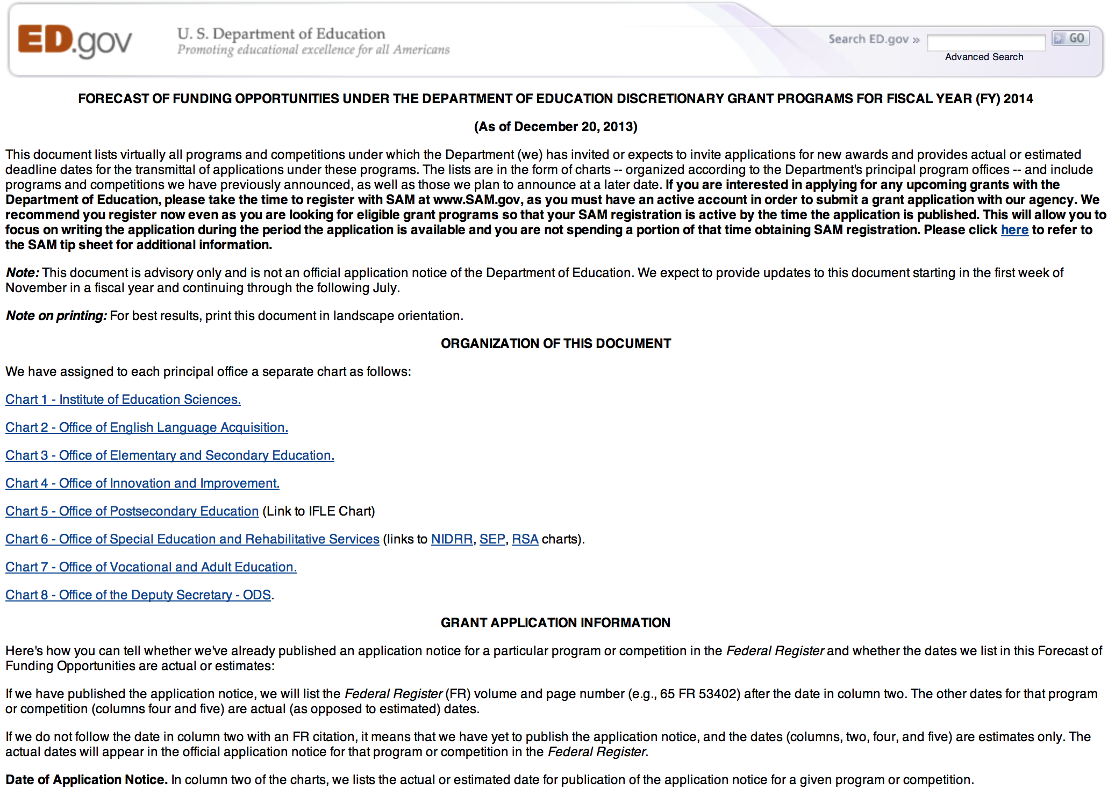
Grant Programs Overview at the Department of Education

To see the complete document click here: http://www2.ed.gov/fund/grant/find/edlite-forecast.html

The general information page for Education Grant funding is an excellent resource describing the three types of grants awarded by the Department of Education. See the screen shot of the Department of Education web page below:

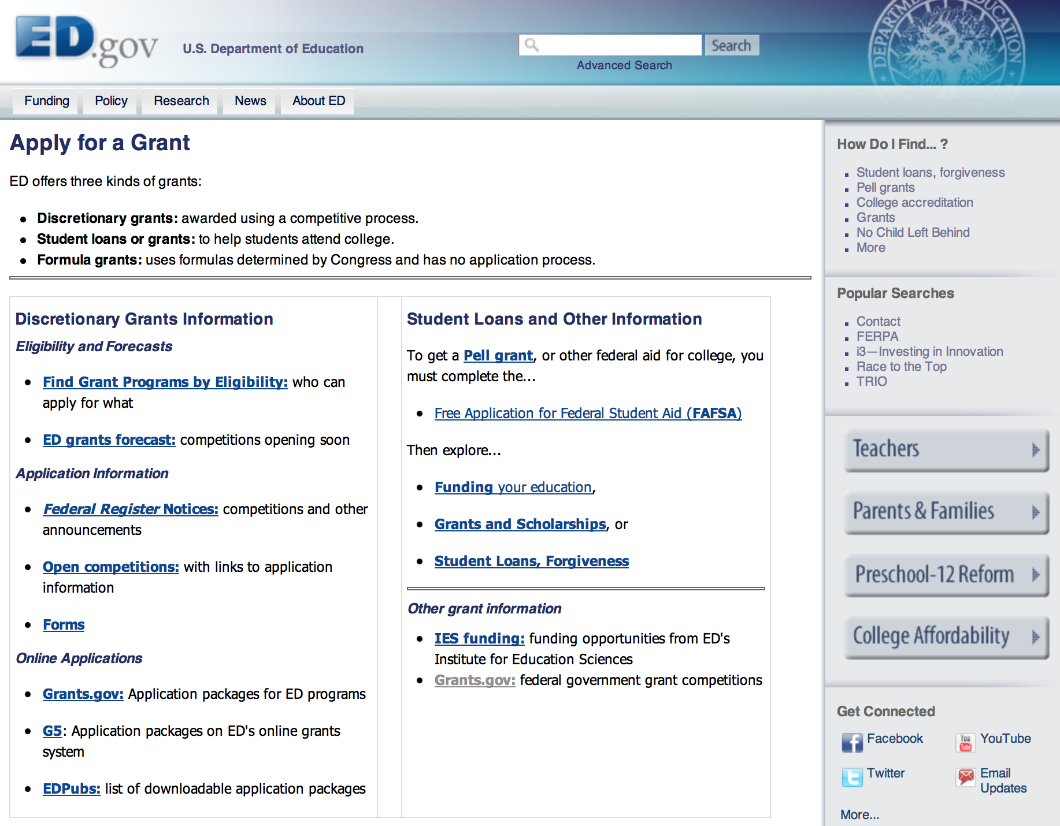

http://www.ed.gov/fund/grants-apply.html

Programs:

Office of Postsecondary Education (OPE): Fulbright-Hays Doctoral Dissertation Research Abroad Fellowship Program CFDA Number 84.022A Grant
Document Type: | Grants Notice
Funding Opportunity Number: | ED-GRANTS-022715-001
Funding Opportunity Title: | Office of Postsecondary Education (OPE): Fulbright-Hays Doctoral Dissertation Research Abroad Fellowship Program CFDA Number 84.022A
Opportunity Category: | Discretionary
Funding Instrument Type: | Grant
Category of Funding Activity: | Education
Category Explanation:
Expected Number of Awards: | 90
CFDA Number(s): | 84.022 -- Overseas Programs - Doctoral Dissertation Research Abroad
Cost Sharing or Matching Requirement: | No
Posted Date: | Feb 27, 2015
Creation Date: | Feb 27, 2015
Original Closing Date for Applications: | Apr 28, 2015 Applications Available: February 27, 2015. Deadline for Transmittal of Applications: April 28, 2015.
Current Closing Date for Applications: | Apr 28, 2015 Applications Available: February 27, 2015. Deadline for Transmittal of Applications: April 28, 2015.
Archive Date: | May 28, 2015
Estimated Total Program Funding: | $3,011,692
Eligible Applicants: | Private institutions of higher education  Others (see text field entitled "Additional Information on Eligibility" for clarification)  Public and State controlled institutions of higher education
Additional Information on Eligibility: | Eligible Applicants: IHEs. As part of the application process, students submit individual applications to the IHE. The IHE then officially submits all eligible individual student applications with its grant application to the Department. Note: As part of its FY 2015 budget request, the Administration proposed to continue to allow funds to be used to support the applications of individuals who plan both to utilize their language skills in world areas vital to United States national security and to apply their language skills and knowledge of these countries in the fields of government, international development, and the professions. Therefore, students planning to apply their language skills in such fields and those planning teaching careers are eligible to apply to IHEs for funds from this program.
Agency Name: | Department of Education
Description: | Note: Each funding opportunity description is a synopsis of information in the Federal Register application notice. For specific information about eligibility, please see the official application notice. The official version of this document is the document published in the Federal Register. Free Internet access to the official edition of the Federal Register and the Code of Federal Regulations is available on GPO Access at: http://www.access.gpo.gov/nara/index.html. Please review the official application notice for pre-application and application requirements, application submission information, performance measures, priorities and program contact information. Purpose of Program: The Fulbright-Hays DDRA Fellowship Program provides opportunities to doctoral candidates to engage in full-time dissertation research abroad in modern foreign languages and area studies. The program is designed to contribute to the development and improvement of the study of modern foreign languages and area studies in the United States. Catalog of Federal Domestic Assistance (CFDA) Number: 84.022A. Applications for grants under the Fulbright-Hays DDRA Fellowship Program, CFDA number 84.022A, must be submitted electronically using the G5 system, accessible through the Department's G5 site at: www.G5.gov. While completing the electronic application, both the IHE and the student applicant will be entering data online that will be saved into a database. Neither the IHE nor the student applicant may email an electronic copy of a grant application to us.
Link to Additional Information: | Office of Postsecondary Education (OPE): Fulbright-Hays Doctoral Dissertation Research Abroad Fellowship Program CFDA Number 84.022A; Notice inviting applications for new awards for fiscal year (FY) 2015
Contact Information: | If you have difficulty accessing the full announcement electronically, please contact:  Julius Cotton ED Grants.gov FIND Systems Admin. Phone 202-245-6288 EducationGrantInquiries@ed.gov Program Manager: Pamela J. Maimer, Ph.D., International and Foreign Language Education, U.S. Department of Education, 1990 K Street NW., Room 6106, Washington, DC 20006-6078. Telephone: (202) 502-7704 or by email: ddra@ed.gov.  e-Mail Program Mailbox

http://www.grants.gov/web/grants/view-opportunity.html?oppId=274793

HHS/ACL/NIDILRR: Research Fellowships Program CFDA Number 84.133F-1 Grant
Document Type: | Grants Notice
Funding Opportunity Number: | ED-ACL-GRANTS-031615-001
Funding Opportunity Title: | HHS/ACL/NIDILRR: Research Fellowships Program CFDA Number 84.133F-1
Opportunity Category: | Discretionary
Funding Instrument Type: | Grant
Category of Funding Activity: | Education
Category Explanation:
Expected Number of Awards: | 6
CFDA Number(s): | 84.133 -- National Institute on Disability and Rehabilitation Research
Cost Sharing or Matching Requirement: | No
Posted Date: | Mar 16, 2015
Creation Date: | Mar 16, 2015
Current Closing Date for Applications: | May 15, 2015 Applications Available: March 16, 2015. SUPPLEMENTARY INFORMATION: Note: On July 22, 2014, President Obama signed the Workforce Innovation Opportunity Act (WIOA). WIOA was effective immediately. One provision of WIOA transferred the National Institute on Disability and Rehabilitation Research (NIDRR) from the Department of Education to the Administration for Community Living (ACL) in the Department of Health and Human Services. In addition, NIDRR's name was changed to the Institute on Disability, Independent Living, and Rehabilitation Research (NIDILRR). For FY 2015, all NIDILRR priority notices will be published as ACL notices, and ACL will make all NIDILRR awards. During this transition period, however, NIDILRR will continue to review grant applications using Department of Education tools. NIDILRR will post previously-approved application kits to grants.gov, and NIDILRR applications submitted to grants.gov will be forwarded to the Department of Education's G-5 system for peer review. We are using Department of Education application kits and peer review systems during this transition year in order to provide for a smooth and orderly process for our applicants. Date of Pre-Application Meeting: April 6, 2015. Date of Pre-Application Meeting: Interested parties are invited to participate in a pre-application meeting and to receive information and technical assistance through individual consultation with NIDILRR staff. The pre-application meeting will be held on April 6, 2015. Interested parties may participate in this meeting by conference call with NIDILRR staff from the Administration for Community Living between 1:00 p.m. and 3:00 p.m., Washington, DC time. NIDILRR staff also will be available from 3:30 p.m. to 4:30 p.m., Washington, DC time, on the same day, by telephone, to provide information and technical assistance through individual consultation. For further information or to make arrangements to participate in the meeting via conference call or to arrange for an individual consultation, contact Carolyn Baron at Carolyn.Baron@ed.gov, or by telephone at 202-245-7244. Deadline for Transmittal of Applications: May 15, 2015.
Archive Date: | Jun 14, 2015
Estimated Total Program Funding: | $430,000
Award Ceiling: | $70,000
Eligible Applicants: | Others (see text field entitled "Additional Information on Eligibility" for clarification)
Additional Information on Eligibility: | 1. Eligible Applicants: Eligible individuals must: (1) Satisfy the requirements of 45 CFR part 75 and (2) have training and experience that indicate a potential for engaging in scientific research related to the solution of rehabilitation problems of individuals with disabilities. The program provides two categories of research fellowships: Merit Fellowships and Distinguished Fellowships. (a) To be eligible for a Merit Fellowship, an individual must be in the earlier stages of his or her career in research and have either advanced professional training or experience in independent study in an area which is directly pertinent to disability and rehabilitation. (b) To be eligible for a Distinguished Fellowship, an individual must have seven or more years of research experience in subject areas, methods, or techniques relevant to rehabilitation research and must have a doctorate, other terminal degree, or comparable academic qualifications. Note: Institutions are not eligible to be recipients of research fellowships. Applicants must submit an eligibility statement describing how they meet the requirements for one of the two eligibility classifications allowed under this program.
Agency Name: | Department of Education
Description: | Note: Each funding opportunity description is a synopsis of information in the Federal Register application notice. For specific information about eligibility, please see the official application notice. The official version of this document is the document published in the Federal Register. Free Internet access to the official edition of the Federal Register and the Code of Federal Regulations is available on GPO Access at: http://www.access.gpo.gov/nara/index.html. Please review the official application notice for pre-application and application requirements, application submission information, performance measures, priorities and program contact information. Purpose of Program: The purpose of the Research Fellowships Program is to build research capacity by providing support to highly qualified individuals, including those who are individuals with disabilities, to conduct research on the rehabilitation of individuals with disabilities. Fellows must conduct original research in an area authorized by section 204 of the Rehabilitation Act of 1973, as amended. Section 204 authorizes research, demonstration projects, training, and related activities, the purposes of which are to develop methods, procedures, and rehabilitation technology that maximize the full inclusion and integration into society, employment, independent living, family support, and economic and social self-sufficiency of individuals with disabilities, especially individuals with the most severe disabilities, and to improve the effectiveness of services authorized under the Act. Note: An applicant should consult NIDRR's Long-Range Plan for Fiscal Years 2013-2017 (78 FR 20299) (the Plan) when preparing its application. The Plan is organized around the following outcome domains: (1) Community living and participation; (2) health and function; and (3) employment and can be accessed on the Internet at the following site: www.ed.gov/about/offices/list/osers/nidrr/policy.html. Catalog of Federal Domestic Assistance (CFDA) Number: 84.133F-1. Applications for grants under the Research Fellowships Program, CFDA Number 84.133F-1, must be submitted electronically using the Governmentwide Grants.gov Apply site at www.Grants.gov. Through this site, you will be able to download a copy of the application package, complete it offline, and then upload and submit your application. You may not email an electronic copy of a grant application to us. You may access the electronic grant application for the Research Fellowships Program at www.Grants.gov. You must search for the downloadable application package for this competition by the CFDA number. Do not include the CFDA number's alpha suffix in your search (e.g., search for 84.133, not 84.133F).
Link to Additional Information: | HHS/ACL/NIDILRR: Research Fellowships Program CFDA Number 84.133F-1; Notice inviting applications for new awards for fiscal year (FY) 2015
Contact Information: | If you have difficulty accessing the full announcement electronically, please contact:  Julius Cotton ED Grants.gov FIND Systems Admin. Phone 202-245-6288 EducationGrantInquiries@ed.gov Program Manager: Patricia Barrett, U.S. Department of Health and Human Services, 400 Maryland Avenue SW., Room 5142, Potomac Center Plaza (PCP), Washington, DC 20202-2700. Telephone: (202) 245-6211 or by email: patricia.barrett@ed.gov  e-Mail: Program Manager

http://www.grants.gov/web/grants/view-opportunity.html?oppId=275200

HHS/ACL/NIDILRR: Small Business Innovation Research Program (SBIR) Phase I CFDA Number 84.133S-1 Grant

Document Type: | Grants Notice
Funding Opportunity Number: | ED-ACL-GRANTS-031315-001
Funding Opportunity Title: | HHS/ACL/NIDILRR: Small Business Innovation Research Program (SBIR) Phase I CFDA Number 84.133S-1
Opportunity Category: | Discretionary
Funding Instrument Type: | Grant
Category of Funding Activity: | Health
Category Explanation:
Expected Number of Awards: | 10
CFDA Number(s): | 84.133 -- National Institute on Disability and Rehabilitation Research
Cost Sharing or Matching Requirement: | No
Posted Date: | Mar 13, 2015
Creation Date: | Mar 13, 2015
Current Closing Date for Applications: | May 12, 2015 Applications Available: March 13, 2015. Note: On July 22, 2014, President Obama signed the Workforce Innovation Opportunity Act (WIOA). WIOA was effective immediately. One provision of WIOA transferred the National Institute on Disability and Rehabilitation Research (NIDRR) from the Department of Education to the Administration for Community Living (ACL) in the Department of Health and Human Services. In addition, NIDRR's name was changed to the Institute on Disability, Independent Living, and Rehabilitation Research (NIDILRR). For FY 2015, all NIDILRR priority notices will be published as ACL notices, and ACL will make all NIDILRR awards. During this transition period, however, NIDILRR will continue to review grant applications using Department of Education tools. NIDILRR will post previously-approved application kits to grants.gov, and NIDILRR applications submitted to grants.gov will be forwarded to the Department of Education's G-5 system for peer review. We are using Department of Education application kits and peer review systems during this transition year in order to provide for a smooth and orderly process for our applicants. Deadline for Transmittal of Applications: May 12, 2015.
Archive Date: | Jun 11, 2015
Estimated Total Program Funding: | $750,000
Award Ceiling: | $75,000
Eligible Applicants: | Others (see text field entitled "Additional Information on Eligibility" for clarification)  Small businesses
Additional Information on Eligibility: | Eligible Applicants: Entities that are, at the time of award, small business concerns as defined by the Small Business Administration (SBA). This definition is included in the application package. If it appears that an applicant organization does not meet the eligibility requirements, we will request an evaluation by the SBA. Under circumstances in which eligibility is unclear, we will not make an SBIR award until the SBA makes a determination that the applicant is eligible under its definition of small business concern. Technology, science, and engineering firms with strong research capabilities in any of the priority areas listed in this notice are encouraged to participate. Consultative or other arrangements between these firms and universities or other nonprofit organizations are permitted, but the small business concern must serve as the grantee. For Phase I projects, at least two-thirds of the research or analytic activities must be performed by the small business concern grantee.
Agency Name: | Department of Education
Description: | Note: Each funding opportunity description is a synopsis of information in the Federal Register application notice. For specific information about eligibility, please see the official application notice. The official version of this document is the document published in the Federal Register. Free Internet access to the official edition of the Federal Register and the Code of Federal Regulations is available on GPO Access at: http://www.access.gpo.gov/nara/index.html. Please review the official application notice for pre-application and application requirements, application submission information, performance measures, priorities and program contact information. The Small Business Innovation Development Act of 1982 (Act), Pub. L. 97-219, established the SBIR program. The Act requires certain agencies, including the Department, to reserve a statutory percentage of their extramural R&D budgets for two phases of the three-phase SBIR program (see http://sbir.gov/about/about-sbir for more information on the program). Phase I awards are to determine, insofar as possible, the scientific or technical merit, feasibility, and commercial potential of R&D projects submitted under the SBIR program. Phase I awards are for amounts up to $75,000 and for a period of up to six months. Phase II projects continue the development of Phase I projects. Funding is based on the results achieved in Phase I and the scientific and technical merit and commercial potential of the proposed Phase II project. Only Phase I grantees are eligible to apply for Phase II funding. Phase II awards are for amounts up to $575,500 over a period of two years. In Phase III, the small business grantee pursues commercial applications of the Phase I and II R&D. The SBIR program does not fund Phase III. All SBIR projects funded by NIDILRR must address the needs of individuals with disabilities. (See 29 U.S.C. 760.) Project activities may include: Conducting manufacturing-related R&D that encompasses improvements in existing methods or processes, or wholly new processes, machines, or systems, that benefit individuals with disabilities; Exploring the uses of technology to ensure equal access to education, employment, community environments, and information for individuals with disabilities; and Improving the quality and utility of disability and rehabilitation research. Note: An applicant should consult NIDRR's Long-Range Plan for Fiscal Years 2013-2017 (78 FR 20299, published April 4, 2013) (the Plan) when preparing its application. The Plan is organized around the following research domains: (1) Community Living and Participation; (2) Health and Function; and (3) Employment. Catalog of Federal Domestic Assistance (CFDA) Number: 84.133S-1. Applications for grants under the SBIR Program, CFDA number 84.133S-1, must be submitted electronically using the Government-wide Grants.gov Apply site at www.Grants.gov. Through this site, you will be able to download a copy of the application package, complete it offline, and then upload and submit your application. You may not email an electronic copy of a grant application to us. You may access the electronic grant application for the SBIR Program at www.Grants.gov. You must search for the downloadable application package for this competition by the CFDA number. Do not include the CFDA number's alpha suffix in your search (e.g., search for 84.133, not 84.133S).
Link to Additional Information: | HHS/ACL/NIDILRR: Small Business Innovation Research Program (SBIR) Phase I CFDA Number 84.133S-1; Notice inviting applications for new awards for fiscal year (FY) 2015
Contact Information: | If you have difficulty accessing the full announcement electronically, please contact:  Julius Cotton ED Grants.gov FIND Systems Admin. Phone 202-245-6288 EducationGrantInquiries@ed.gov Program Manager: Patricia Barrett, U.S. Department of Health and Human Services, 400 Maryland Avenue SW., Room 5142, Potomac Center Plaza (PCP), Washington, DC 20202-2700. Telephone: (202) 245-6211 or by email: patricia.barrett@ed.gov.  e-Mail: Program Manager

http://www.grants.gov/web/grants/view-opportunity.html?oppId=275130

Asian American and Native American Pacific Islander-Serving Institutions (AANAPISI) Program CFDA Number 84.031L Grant
And Modification 1

Document Type: | Grants Notice
Funding Opportunity Number: | ED-GRANTS-032015-003
Funding Opportunity Title: | Office of Postsecondary Education (OPE): Asian American and Native American Pacific Islander-Serving Institutions (AANAPISI) Program CFDA Number 84.031L
Opportunity Category: | Discretionary
Funding Instrument Type: | Grant
Category of Funding Activity: | Education
Category Explanation:
Expected Number of Awards: | 10
CFDA Number(s): | 84.031 -- Higher Education Institutional Aid
Cost Sharing or Matching Requirement: | No
Posted Date: | Mar 20, 2015
Creation Date: | Mar 23, 2015
Original Closing Date for Applications: | May 19, 2015 Applications Available: March 20, 2015. Deadline for Transmittal of Applications: May 19, 2015.
Current Closing Date for Applications: | May 19, 2015 Applications Available: March 20, 2015. Deadline for Transmittal of Applications: May 19, 2015.
Archive Date: | Jun 18, 2015
Estimated Total Program Funding: | $3,062,000
Eligible Applicants: | Others (see text field entitled "Additional Information on Eligibility" for clarification)
Additional Information on Eligibility: | Eligible Applicants: (a) An IHE is eligible to receive funds under the AANAPISI Program if it qualifies as an Asian American and Native American Pacific Islander-Serving Institution. At the time of application, IHEs applying for funds under the AANAPISI Program must have an enrollment of undergraduate students that is at least 10 percent Asian American or Native American Pacific Islander, as defined as follows: Asian American means a person having origins in any of the original peoples of the Far East, Southeast Asia, or the Indian subcontinent (including, for example, Cambodia, China, India, Japan, Korea, Malaysia, Pakistan, the Philippine Islands, Thailand, and Vietnam), as defined in the Office of Management and Budget's Standards for Maintaining, Collecting, and Presenting Federal Data on Race and Ethnicity as published in the Federal Register on October 30, 1997 (62 FR 58789).
Agency Name: | Department of Education
Description: | •Note: Each funding opportunity description is a synopsis of information in the Federal Register application notice. For specific information about eligibility, please see the official application notice. The official version of this document is the document published in the Federal Register. Free Internet access to the official edition of the Federal Register and the Code of Federal Regulations is available on GPO Access at: http://www.access.gpo.gov/nara/index.html. Purpose of Program: The AANAPISI Program provides grants to eligible institutions of higher education (IHEs) that have an undergraduate enrollment of at least 10 percent Asian American or Native American Pacific Islander students to assist such institutions to plan, develop, undertake, and carry out activities to improve and expand such institutions' capacity to serve Asian Americans and Native American Pacific Islanders and low-income individuals. Applications for grants under the AANAPISI Program, CFDA number 84.031L, must be submitted electronically using the Governmentwide Grants.gov Apply site at www.Grants.gov. You may access the electronic grant application for the AANAPISI Program at www.Grants.gov. You must search for the downloadable application package for this competition by the CFDA number. Do not include the CFDA number's alpha suffix in your search (e.g., search for 84.031, not 84.031L). The telephone number for the Grants.gov Helpdesk is 1-800-518-4726 or e-mail: support@grants.gov.
Link to Additional Information: | Asian American and Native American Pacific Islander-Serving Institutions (AANAPISI) Program CFDA Number 84.031L
Contact Information: | If you have difficulty accessing the full announcement electronically, please contact:  Joyce Mays Management Analyst Phone 202-245-6122 joyce.mays@ed.gov Program Manager: Pearson Owens or Don Crews U.S. Department of Education 1990 K Street NW., 6th Fl Washington, DC 20006-8513. addresses or telephone numbers:(202) 502-7804  Program Manager: email

http://www.grants.gov/web/grants/view-opportunity.html?oppId=275324

Technical Assistance and Dissemination to Improve Services and Results for Children With Disabilities: Model Demonstration Projects to Improve Adolescent Literacy for Students with Disabilities in Middle and High Schools, Grades 6-12 CFDA Number 84326M Grant
And Modification 2

Document Type: | Grants Notice
Funding Opportunity Number: | ED-GRANTS-031815-001
Funding Opportunity Title: | Technical Assistance and Dissemination to Improve Services and Results for Children With Disabilities: Model Demonstration Projects to Improve Adolescent Literacy for Students with Disabilities in Middle and High Schools, Grades 6-12 CFDA Number 84326M
Opportunity Category: | Discretionary
Funding Instrument Type: | Cooperative Agreement
Category of Funding Activity: | Education
Category Explanation:
Expected Number of Awards: | 3
CFDA Number(s): | 84.326 -- Special Education Technical Assistance and Dissemination to Improve Services and Results for Children with Disabilities
Cost Sharing or Matching Requirement: | No
Posted Date: | Mar 18, 2015
Creation Date: | Mar 27, 2015
Original Closing Date for Applications: | May 4, 2015 Applications Available: March 18, 2015. Deadline for Transmittal of Applications: May 4, 2015.
Current Closing Date for Applications: | May 4, 2015 Applications Available: March 18, 2015. Deadline for Transmittal of Applications: May 4, 2015.
Archive Date: | Jun 3, 2015
Estimated Total Program Funding: | $1,200,000
Award Ceiling: | $400,000
Eligible Applicants: | State governments  Private institutions of higher education  Nonprofits having a 501(c)(3) status with the IRS, other than institutions of higher education  Nonprofits that do not have a 501(c)(3) status with the IRS, other than institutions of higher education  Native American tribal governments (Federally recognized)  For profit organizations other than small businesses  Native American tribal organizations (other than Federally recognized tribal governments)  Special district governments  Independent school districts  Others (see text field entitled "Additional Information on Eligibility" for clarification)  Public and State controlled institutions of higher education  City or township governments  County governments
Additional Information on Eligibility: | Eligible Applicants: State educational agencies (SEAs); LEAs, including public charter schools that are considered LEAs under State law; IHEs; other public agencies; private nonprofit organizations; outlying areas; freely associated States; Indian tribes or tribal organizations; and for-profit organizations.
Agency Name: | Department of Education
Description: | Note: Each funding opportunity description is a synopsis of information in the Federal Register application notice. For specific information about eligibility, please see the official application notice. The official version of this document is the document published in the Federal Register. Free Internet access to the official edition of the Federal Register and the Code of Federal Regulations is available on GPO Access at: http://www.access.gpo.gov/nara/index.html. Please review the official application notice for pre-application and application requirements, application submission information, performance measures, priorities and program contact information. Purpose of Program: The purpose of the Technical Assistance and Dissemination to Improve Services and Results for Children with Disabilities program is to promote academic achievement and to improve results for children with disabilities by providing technical assistance (TA), supporting model demonstration projects, disseminating useful information, and implementing activities that are supported by scientifically based research. Catalog of Federal Domestic Assistance (CFDA) Number: 84.326M.Applications for grants under the Model Demonstration Projects on the Improvement of Adolescent Literacy for Students with Disabilities in Middle and High Schools in Grades 6-12 competition, CFDA number 84.326M, must be submitted electronically using the Government-wide Grants.gov Apply site at www.Grants.gov. Through this site, you will be able to download a copy of the application package, complete it offline, and then upload and submit your application. You may not email an electronic copy of a grant application to us. You may access the electronic grant application for the Model Demonstration Projects to Improve Adolescent Literacy for Students with Disabilities in Middle and High Schools, Grades 6-12 competition at www.Grants.gov. You must search for the downloadable application package for this competition by the CFDA number. Do not include the CFDA number's alpha suffix in your search (e.g., search for 84.326, not 84.326M).
Link to Additional Information: | Technical Assistance and Dissemination to Improve Services and Results for Children With Disabilities: Model Demonstration Projects to Improve Adolescent Literacy for Students with Disabilities in Middle and High Schools, Grades 6-12
Contact Information: | If you have difficulty accessing the full announcement electronically, please contact:  Julius Cotton ED Grants.gov FIND Systems Admin. Phone 202-245-6288 EducationGrantInquiries@ed.gov Program Manager: Greg Knollman, U.S. Department of Education, 400 Maryland Avenue SW., Room 4096, Potomac Center Plaza (PCP), Washington, DC 20202-2600. Telephone: (202) 245-6425 or e-Mail: Greg.Knollman@ed.gov.  e-Mail: Program Manager

http://www.grants.gov/web/grants/view-opportunity.html?oppId=275257

Ready-to-Learn Television CFDA Number 84.295A Grant
And Modification 1

Document Type: | Grants Notice
Funding Opportunity Number: | ED-GRANTS-032515-001
Funding Opportunity Title: | Office of Innovation and Improvement (OII): Ready-to-Learn Television CFDA Number 84.295A
Opportunity Category: | Discretionary
Funding Instrument Type: | Cooperative Agreement
Category of Funding Activity: | Education
Category Explanation:
Expected Number of Awards: | 3
CFDA Number(s): | 84.295 -- Ready-To-Learn Television
Cost Sharing or Matching Requirement: | No
Posted Date: | Mar 25, 2015
Creation Date: | Apr 2, 2015
Original Closing Date for Applications: | May 26, 2015 Applications Available: March 25, 2015 Deadline for Notice of Intent to Apply: April 9, 2015 e of Pre-Application Webinar: An informational Webinar will be announced on the Ready-to-Learn Television Web site at http://www2.ed.gov/programs/rtltv/index.html. Deadline for Transmittal of Applications: May 26, 2015
Current Closing Date for Applications: | May 26, 2015 Applications Available: March 25, 2015 Deadline for Notice of Intent to Apply: April 9, 2015 e of Pre-Application Webinar: An informational Webinar will be announced on the Ready-to-Learn Television Web site at http://www2.ed.gov/programs/rtltv/index.html. Deadline for Transmittal of Applications: May 26, 2015
Archive Date: | Jun 25, 2015
Estimated Total Program Funding: | $25,621,000
Eligible Applicants: | Others (see text field entitled "Additional Information on Eligibility" for clarification)
Additional Information on Eligibility: | Eligible Applicants: To receive a cooperative agreement under this competition, an entity must be a public telecommunications entity (as defined in this notice) that is able to demonstrate: (A) A capacity to develop and nationally distribute educational and instructional television programming of high quality that is accessible by a large majority of disadvantaged preschool and elementary school children; (B) A capacity to contract with the producers of children's television programming for the purpose of developing educational television programming of high quality; (C) A capacity, consistent with the entity's mission and nonprofit nature, to negotiate such contracts in a manner that returns to the entity an appropriate share of any ancillary income from sales of any program-related products; and (D) A capacity to localize programming and materials to meet specific State and local needs and to provide educational outreach at the local level.
Agency Name: | Department of Education
Description: | •Note: Each funding opportunity description is a synopsis of information in the Federal Register application notice. For specific information about eligibility, please see the official application notice. The official version of this document is the document published in the Federal Register. Free Internet access to the official edition of the Federal Register and the Code of Federal Regulations is available on GPO Access at: http://www.access.gpo.gov/nara/index.html. Purpose of Program: The Ready-to-Learn Television Program (Ready-to-Learn) is designed to: (1) Facilitate school readiness and academic achievement by supporting the development and national distribution of educational television and interactive media programming for preschool and elementary school children and their parents; (2) develop and disseminate educational outreach materials and programs that are designed to deepen and extend the effectiveness of the educational television and interactive media and (3) build social and virtual communities of parents, educators, and children devoted to using the media materials. Applications for grants under the Ready-to-Learn Television Program, CFDA Number 84.295A, must be submitted electronically using the Governmentwide Grants.gov Apply site at www.Grants.gov. You may access the electronic grant application for the Ready-to-Learn program at www.Grants.gov. You must search for the downloadable application package for this competition by the CFDA number. Do not include the CFDA number's alpha suffix in your search (e.g., search for 84.295, not 84.295A). The telephone number for the Grants.gov Helpdesk is 1-800-518-4726 or e-mail: support@grants.gov.
Link to Additional Information: | Ready-to-Learn Television CFDA Number 84.295A
Contact Information: | If you have difficulty accessing the full announcement electronically, please contact:  Joyce Mays Management Analyst Phone 202-245-6122 joyce.mays@ed.gov Program Manager: Brian Lekander U.S. Department of Education 400 Maryland Avenue SW., Room 4C133 Washington, DC 20202-5930 Telephone:(202) 205-5633 or by email:  Program Manager: email

http://www.grants.gov/web/grants/view-opportunity.html?oppId=275373

Rehabilitation Long-Term Training Program: Rehabilitation Specialty Areas: Rehabilitation of Individuals Who are deaf or Hard of Hearing CFDA Number 84.129Q Grant
And Modification 1

Document Type: | Grants Notice
Funding Opportunity Number: | ED-GRANTS-032515-003
Funding Opportunity Title: | OSERS/RSA: Rehabilitation Long-Term Training Program: Rehabilitation Specialty Areas: Rehabilitation of Individuals Who are deaf or Hard of Hearing CFDA Number 84.129Q
Opportunity Category: | Discretionary
Funding Instrument Type: | Grant
Category of Funding Activity: | Education
Category Explanation:
Expected Number of Awards: | 3
CFDA Number(s): | 84.129 -- Rehabilitation Long-Term Training
Cost Sharing or Matching Requirement: | Yes
Posted Date: | Mar 25, 2015
Creation Date: | Apr 2, 2015
Original Closing Date for Applications: | May 26, 2015 Applications Available: March 25, 2015. Date of Pre-Application Webinar: April 8, 2015. Deadline for Transmittal of Applications: May 26, 2015
Current Closing Date for Applications: | May 26, 2015 Applications Available: March 25, 2015. Date of Pre-Application Webinar: April 8, 2015. Deadline for Transmittal of Applications: May 26, 2015
Archive Date: | Jun 25, 2015
Estimated Total Program Funding: | $3,450,000
Eligible Applicants: | Others (see text field entitled "Additional Information on Eligibility" for clarification)
Additional Information on Eligibility: | Eligible Applicants: States and public or nonprofit agencies and organizations, including Indian tribes and IHEs.
Agency Name: | Department of Education
Description: | •Note: Each funding opportunity description is a synopsis of information in the Federal Register application notice. For specific information about eligibility, please see the official application notice. The official version of this document is the document published in the Federal Register. Free Internet access to the official edition of the Federal Register and the Code of Federal Regulations is available on GPO Access at: http://www.access.gpo.gov/nara/index.html. Please review the official application notice for pre-application and application requirements, application submission information, performance measures, priorities and program contact information. Purpose of Program: The Rehabilitation Long-Term Training program provides financial assistance for projects that provide--(1) Basic or advanced training leading to an academic degree in areas of personnel shortages in rehabilitation as identified by the Secretary;(2) A specified series of courses or program of study leading to the award of a certificate in areas of personnel shortages in rehabilitation as identified by the Secretary; and (3) Support for medical residents enrolled in residency training programs in the specialty of physical medicine and rehabilitation. Applications for grants under the Rehabilitation Training: Rehabilitation Long-Term Training--Rehabilitation Specialty Areas competition, CFDA numbers 84.129Q and W, must be submitted electronically using the Governmentwide Grants.gov Apply site at www.Grants.gov. You may access the electronic grant application for the Rehabilitation Training: Rehabilitation Long-Term Training Program-- Rehabilitation Specialty Areas competition at www.Grants.gov. You must search for the downloadable application package for this competition by the CFDA number. Do not include the CFDA number's alpha suffix in your search (e.g., search for 84.129, not 84.129Q). The telephone number for the Grants.gov Helpdesk is 1-800-518-4726 or e-mail: support@grants.gov.
Link to Additional Information: | Rehabilitation Long-Term Training Program: Rehabilitation Specialty Areas: Rehabilitation of Individuals Who are deaf or Hard of Hearing CFDA Number 84.129Q
Contact Information: | If you have difficulty accessing the full announcement electronically, please contact:  Joyce Mays Management Analyst Phone 202-245-6122 joyce.mays@ed.gov Program Manager: Don Bunuan Telephone: 202-245-6616 or email:  Program Manager: email

http://www.grants.gov/web/grants/view-opportunity.html?oppId=275405

Rehabilitation Long-Term Training Program: Rehabilitation Specialty Areas: Comprehensive System of Personnel Development CFDA Number 84.129W Grant
And Modification 1

Document Type: | Grants Notice
Funding Opportunity Number: | ED-GRANTS-032515-004
Funding Opportunity Title: | OSERS/RSA: Rehabilitation Long-Term Training Program: Rehabilitation Specialty Areas: Comprehensive System of Personnel Development CFDA Number 84.129W
Opportunity Category: | Discretionary
Funding Instrument Type: | Grant
Category of Funding Activity: | Education
Category Explanation:
Expected Number of Awards: | 15
CFDA Number(s): | 84.129 -- Rehabilitation Long-Term Training
Cost Sharing or Matching Requirement: | Yes
Posted Date: | Mar 25, 2015
Creation Date: | Apr 2, 2015
Original Closing Date for Applications: | May 26, 2015 Applications Available: March 25, 2015. Date of Pre-Application Webinar: April 8, 2015. Deadline for Transmittal of Applications: May 26, 2015
Current Closing Date for Applications: | May 26, 2015 Applications Available: March 25, 2015. Date of Pre-Application Webinar: April 8, 2015. Deadline for Transmittal of Applications: May 26, 2015
Archive Date: | Jun 25, 2015
Estimated Total Program Funding: | $3,450,000
Eligible Applicants: | Others (see text field entitled "Additional Information on Eligibility" for clarification)
Additional Information on Eligibility: | Eligible Applicants: States and public or nonprofit agencies and organizations, including Indian tribes and IHEs.
Agency Name: | Department of Education
Description: | •Note: Each funding opportunity description is a synopsis of information in the Federal Register application notice. For specific information about eligibility, please see the official application notice. The official version of this document is the document published in the Federal Register. Free Internet access to the official edition of the Federal Register and the Code of Federal Regulations is available on GPO Access at: http://www.access.gpo.gov/nara/index.html. Please review the official application notice for pre-application and application requirements, application submission information, performance measures, priorities and program contact information. Applications for grants under the Rehabilitation Training: Rehabilitation Long-Term Training--Rehabilitation Specialty Areas competition, CFDA numbers 84.129W, must be submitted electronically using the Governmentwide Grants.gov Apply site at www.Grants.gov. You may access the electronic grant application for the Rehabilitation Training: Rehabilitation Long-Term Training Program-Rehabilitation Specialty Areas competition at www.Grants.gov. You must search for the downloadable application package for this competition by the CFDA number. Do not include the CFDA number's alpha suffix in your search (e.g., search for 84.129, not 84.129W). The telephone number for the Grants.gov Helpdesk is 1-800-518-4726 or e-mail: support@grants.gov.
Link to Additional Information: | Rehabilitation Long-Term Training Program: Rehabilitation Specialty Areas: Comprehensive System of Personnel Development CFDA Number 84.129W
Contact Information: | If you have difficulty accessing the full announcement electronically, please contact:  Joyce Mays Management Analyst Phone 202-245-6122 joyce.mays@ed.gov Program Manager: Karen Holliday Telephone:(202) 245-7318 or email:  Program Manager: email

http://www.grants.gov/web/grants/view-opportunity.html?oppId=275417

Minority Science and Engineering Improvement Program (MSEIP) CFDA Number 84.120A
Grant
And Modification 1

Document Type: | Grants Notice
Funding Opportunity Number: | ED-GRANTS-040115-001
Funding Opportunity Title: | Office of Postsecondary Education (OPE): Minority Science and Engineering Improvement Program (MSEIP) CFDA Number 84.120A
Opportunity Category: | Discretionary
Funding Instrument Type: | Grant
Category of Funding Activity: | Education
Category Explanation:
Expected Number of Awards: | 12
CFDA Number(s): | 84.120 -- Minority Science and Engineering Improvement
Cost Sharing or Matching Requirement: | No
Posted Date: | Apr 1, 2015
Creation Date: | Apr 2, 2015
Original Closing Date for Applications: | Jun 1, 2015 Applications Available: April 1, 2015 Deadline for Transmittal of Applications: June 1, 2015
Current Closing Date for Applications: | Jun 1, 2015 Applications Available: April 1, 2015 Deadline for Transmittal of Applications: June 1, 2015
Archive Date: | Jul 1, 2015
Estimated Total Program Funding: | $2,800,918
Eligible Applicants: | Others (see text field entitled "Additional Information on Eligibility" for clarification)
Additional Information on Eligibility: | Eligible Applicants: The eligibility of an applicant is dependent on the type of MSEIP grant the applicant seeks. There are four types of MSEIP grants: Institutional project, special project, cooperative project, and design project.
Agency Name: | Department of Education
Description: | •Note: Each funding opportunity description is a synopsis of information in the Federal Register application notice. For specific information about eligibility, please see the official application notice. The official version of this document is the document published in the Federal Register. Free Internet access to the official edition of the Federal Register and the Code of Federal Regulations is available on GPO Access at: http://www.access.gpo.gov/nara/index.html. Purpose of Program: The MSEIP is designed to effect long-range improvement in science and engineering education at predominantly minority institutions and to increase the flow of underrepresented ethnic minorities, particularly minority women, into scientific and technological careers. Applications for grants under the MSEIP, CFDA Number 84.120A, must be submitted electronically using the Governmentwide Grants.gov Apply site at www.Grants.gov. You may access the electronic grant application for the MSEIP at www.Grants.gov. You must search for the downloadable application package for this competition by the CFDA number. Do not include the CFDA number's alpha suffix in your search (e.g., search for 84.120, not 84.120A). The telephone number for the Grants.gov Helpdesk is 1-800-518-4726 or e-mail: support@grants.gov.
Link to Additional Information: | Minority Science and Engineering Improvement Program (MSEIP) CFDA Number 84.120A
Contact Information: | If you have difficulty accessing the full announcement electronically, please contact:  Joyce Mays Management Analyst Phone 202-245-6122 joyce.mays@ed.gov Program Manager: Stacey Slijepcevic U.S.Department of Education 1990 K Street NW., Room 6014 Washington, DC 20006-8517 Telephone: (202) 219-7124, or by email:  Program Manager: email

http://www.grants.gov/web/grants/view-opportunity.html?oppId=275598

Graduate Assistance in Areas of National Need (GAANN) Program CFDA Number 84.200A
Grant
And Modification 1

Document Type: | Grants Notice
Funding Opportunity Number: | ED-GRANTS-040115-002
Funding Opportunity Title: | Office of Postsecondary Education (OPE): Graduate Assistance in Areas of National Need (GAANN) Program CFDA Number 84.200A
Opportunity Category: | Discretionary
Funding Instrument Type: | Grant
Category of Funding Activity: | Education
Category Explanation:
Expected Number of Awards: | 125
CFDA Number(s): | 84.200 -- Graduate Assistance in Areas of National Need
Cost Sharing or Matching Requirement: | No
Posted Date: | Apr 1, 2015
Creation Date: | Apr 2, 2015
Original Closing Date for Applications: | May 29, 2015 Applications Available: April 1, 2015 Deadline for Transmittal of Applications: May 29, 2015
Current Closing Date for Applications: | May 29, 2015 Applications Available: April 1, 2015 Deadline for Transmittal of Applications: May 29, 2015
Archive Date: | Jun 28, 2015
Estimated Total Program Funding: | $23,629,000
Eligible Applicants: | Others (see text field entitled "Additional Information on Eligibility" for clarification)
Additional Information on Eligibility: | Any academic department of an IHE that provides a course of study that-- (i) Leads to a graduate degree in an area of national need; and (ii) Has been in existence for at least four years at the time of an application for a grant under this competition. (b) An academic department of an IHE that-- (i) Satisfies the requirements of paragraph (a)(1) of this section; and (ii) Submits a joint application with one or more eligible non- degree-granting institutions that have formal arrangements for the support of doctoral dissertation research with one or more degree- granting institutions.
Agency Name: | Department of Education
Description: | •Note: Each funding opportunity description is a synopsis of information in the Federal Register application notice. For specific information about eligibility, please see the official application notice. The official version of this document is the document published in the Federal Register. Free Internet access to the official edition of the Federal Register and the Code of Federal Regulations is available on GPO Access at: http://www.access.gpo.gov/nara/index.html. Purpose of Program: The GAANN Program provides grants to academic departments and programs of institutions of higher education (IHEs) to support graduate fellowships for students with excellent academic records who demonstrate financial need and plan to pursue the highest degree available in their course of study at the institution. Applications for grants under the GAANN Program, CFDA number 84.200A, must be submitted electronically using the Governmentwide Grants.gov Apply site at www.Grants.gov. You may access the electronic grant application for the GAANN Program at www.Grants.gov. You must search for the downloadable application package for this program by the CFDA number. Do not include the CFDA number's alpha suffix in your search (e.g., search for 84.200, not 84.200A. The telephone number for the Grants.gov Helpdesk is 1-800-518-4726 or e-mail: support@grants.gov.
Link to Additional Information: | Graduate Assistance in Areas of National Need (GAANN) Program CFDA Number 84.200A
Contact Information: | If you have difficulty accessing the full announcement electronically, please contact:  Joyce Mays Management Analyst Phone 202-245-6122 joyce.mays@ed.gov Program Manager: Rebecca Ell U.S. Department of Education 1990 K Street NW., Room 7105, K-OPE-7-7063, Washington, DC 20006 Telephone: (202) 502-7779 or by email:  Program Manager: email

http://www.grants.gov/web/grants/view-opportunity.html?oppId=275600

Modifications:

Office of Innovation and Improvement Development grants Pre-Application CFDA Number 84.411P
Modification 1

Document Type: | Grants Notice
Funding Opportunity Number: | ED-GRANTS-033015-001
Funding Opportunity Title: | Office of Innovation and Improvement Development grants Pre-Application CFDA Number 84.411P
Opportunity Category: | Discretionary
Funding Instrument Type: | Cooperative Agreement
Category of Funding Activity: | Education
Category Explanation:
Expected Number of Awards: | 19
CFDA Number(s): | 84.411 -- Investing in Innovation (i3) Fund
Cost Sharing or Matching Requirement: | No
Posted Date: | Mar 31, 2015
Creation Date: | Mar 31, 2015
Original Closing Date for Applications: | Apr 29, 2015 Pre-Applications Available: April 1, 2015 Deadline for Notice of Intent To Submit Pre-Application: April 20,2015 Deadline for Transmittal of Pre-applications: April 29, 2015.
Current Closing Date for Applications: | Apr 29, 2015 Pre-Applications Available: April 1, 2015 Deadline for Notice of Intent To Submit Pre-Application: April 20,2015 Deadline for Transmittal of Pre-applications: April 29, 2015.
Archive Date: | May 29, 2015
Estimated Total Program Funding: | $112,400,000
Eligible Applicants: | Others (see text field entitled "Additional Information on Eligibility" for clarification)
Additional Information on Eligibility: | Innovations that Improve Achievement for High-Need Students: All grantees must implement practices that are designed to improve student achievement (as defined in this notice) or student growth (as defined in this notice), close achievement gaps, decrease dropout rates, increase high school graduation rates (as defined in this notice), or increase college enrollment and completion rates for high-need students (as defined in this notice).
Agency Name: | Department of Education
Description: | •Note: Each funding opportunity description is a synopsis of information in the Federal Register application notice. For specific information about eligibility, please see the official application notice. The official version of this document is the document published in the Federal Register. Free Internet access to the official edition of the Federal Register and the Code of Federal Regulations is available on GPO Access at: http://www.access.gpo.gov/nara/index.html. Purpose of Program: The Investing in Innovation Fund (i3), established under section 14007 of the American Recovery and Reinvestment Act of 2009 (ARRA), provides funding to support (1) local educational agencies (LEAs), and (2) nonprofit organizations in partnership with (a) one or more LEAs or (b) a consortium of schools. The i3 program is designed to generate and validate solutions to persistent educational challenges and to support the expansion of effective solutions to serve substantially larger numbers of students. Applications (both pre- and full applications) for Development grants under the i3 program, CFDA Number 84.411P (pre-applications) and CFDA Number 84.411C (full applications), must be submitted electronically using the Governmentwide Grants.gov Apply site at www.Grants.gov. You may access the electronic grant application for the i3 program at www.Grants.gov. You must search for the downloadable application package for this competition by the CFDA number. Do not include the CFDA number's alpha suffix in your search (e.g., search for 84.411, not 84.411P or 84.411C). The telephone number for the Grants.gov Helpdesk is 1-800-518-4726 or e-mail: support@grants.gov.
Link to Additional Information: | Office of Innovation and Improvement Development grants Pre-Application CFDA Number 84.411P
Contact Information: | If you have difficulty accessing the full announcement electronically, please contact:  Joyce Mays Management Analyst Phone 202-245-6122 joyce.mays@ed.gov Program Manager: Kelly Terpak U.S. Department of Education 400 Maryland Avenue SW., Room 4C107, Washington, DC 20202 Telephone:(202) 453-7122 or by email:  Program Manager: email

http://www.grants.gov/web/grants/view-opportunity.html?oppId=275524

Reminders:

Office of Elementary and Secondary Education (OESE): Office of Indian Education (OIE): Indian education Formula Grants to Local Educational Agencies CFDA Number 84.060 Grant

Document Type: | Grants Notice
Funding Opportunity Number: | ED-GRANTS-012315-001
Funding Opportunity Title: | Office of Elementary and Secondary Education (OESE): Office of Indian Education (OIE): Indian education Formula Grants to Local Educational Agencies CFDA Number 84.060
Opportunity Category: | Mandatory
Funding Instrument Type: | Grant
Category of Funding Activity: | Education
Category Explanation:
Expected Number of Awards: | 1300
CFDA Number(s): | 84.060 -- Indian Education Grants to Local Educational Agencies
Cost Sharing or Matching Requirement: | No
Posted Date: | Jan 26, 2015
Creation Date: | Jan 26, 2015
Original Closing Date for Applications: | May 15, 2015 Part I of the Formula Grant Electronic Application System for Indian Education (EASIE) Applications Available: January 26, 2015. Deadline for Transmittal of Part I Applications: February 27, 2015. Part II of the Formula Grant EASIE Applications Available: April 10, 2015. Deadline for Transmittal of Part II Applications: May 15, 2015. Note: Applicants must meet the deadlines for both EASIE Part I and Part II to receive a grant. Any application not meeting the Part I and Part II deadlines will not be considered for funding. Failure to submit the required supplemental documentation, described in section IV. 2 Content and Form of Application Submission, by the EASIE Parts I and II deadlines will result in an incomplete application that will not be considered for funding. The Office of Indian Education recommends uploading the documentation at least three days prior to each closing date to ensure that any potential submission issues are resolved prior to the deadlines.
Current Closing Date for Applications: | May 15, 2015 Part I of the Formula Grant Electronic Application System for Indian Education (EASIE) Applications Available: January 26, 2015. Deadline for Transmittal of Part I Applications: February 27, 2015. Part II of the Formula Grant EASIE Applications Available: April 10, 2015. Deadline for Transmittal of Part II Applications: May 15, 2015. Note: Applicants must meet the deadlines for both EASIE Part I and Part II to receive a grant. Any application not meeting the Part I and Part II deadlines will not be considered for funding. Failure to submit the required supplemental documentation, described in section IV. 2 Content and Form of Application Submission, by the EASIE Parts I and II deadlines will result in an incomplete application that will not be considered for funding. The Office of Indian Education recommends uploading the documentation at least three days prior to each closing date to ensure that any potential submission issues are resolved prior to the deadlines.
Archive Date: | Jun 14, 2015
Estimated Total Program Funding: | $100,381,000
Eligible Applicants: | Others (see text field entitled "Additional Information on Eligibility" for clarification)
Additional Information on Eligibility: | Eligible Applicants: Certain LEAs, including charter schools authorized as LEAs under State law, as prescribed by section 7112(b) of the ESEA, certain schools funded by the Bureau of Indian Education of the U.S. Department of the Interior, as prescribed by section 7113(d) of the ESEA, and Indian tribes under certain conditions, as prescribed by section 7112(c) of the ESEA.
Agency Name: | Department of Education
Description: | Note: Each funding opportunity description is a synopsis of information in the Federal Register application notice. For specific information about eligibility, please see the official application notice. The official version of this document is the document published in the Federal Register. Free Internet access to the official edition of the Federal Register and the Code of Federal Regulations is available on GPO Access at: http://www.access.gpo.gov/nara/index.html. Please review the official application notice for pre-application and application requirements, application submission information, performance measures, priorities and program contact information. Purpose of Program: The Indian Education Formula Grants to Local Educational Agencies (Formula Grants) program provides grants to support local educational agencies (LEAs) and other eligible entities described in this notice in reforming and improving elementary and secondary school programs that serve Indian students. The Department funds comprehensive programs that are designed to help Indian students meet the same State academic content and student academic achievement standards used for all students while addressing the language and cultural needs of Indian students. Such programs include supporting the professional development of teachers of Indian students. In addition, under section 7116 of the Elementary and Secondary Education Act of 1965, as amended (ESEA), the Secretary will, upon receipt of an acceptable plan for the integration of education and related services, and in cooperation with other relevant Federal agencies, authorize the entity receiving the funds under this program to consolidate all Federal formula funds that are to be used exclusively for Indian students. Instructions for submitting an integration of education and related services plan are included in the EASIE, which is described under Application Process and Submission Information in section IV of this notice. Note: Under the Formula Grants program, applicants are required to develop the project for which an application is made: (a) In open consultation with parents and teachers of Indian students and, if appropriate, Indian students from secondary schools, including through public hearings held to provide a full opportunity to understand the program and to offer recommendations regarding the program (section 7114(c)(3)(C) of the ESEA); (b) with the participation of a parent committee selected in accordance with section 7114(c)(4) of the ESEA; and (c) with the written approval of that parent committee (section 7114(c)(4) of the ESEA). Program Authority: 20 U.S.C. 7421 et seq. Catalog of Federal Domestic Assistance (CFDA) Number: 84.060A. Applications for grants under the Formula Grants program, CFDA number 84.060A, must be submitted electronically using EASIE. Applications submitted in paper format will be rejected unless you qualify for one of the exceptions to the electronic submission requirement described later in this section under Exception to Electronic Submission Requirement, and follow the submission rules outlined therein. EASIE Electronic Application System: EASIE is an easy-to-use, electronic application system. This system allows the Department to review applications and interact online with applicants during the application review and approval process.
Link to Additional Information: | Office of Elementary and Secondary Education (OESE): Office of Indian Education (OIE): Indian education Formula Grants to Local Educational Agencies CFDA Number 84.060A; Notice inviting applications for new awards for fiscal year (FY) 2015.
Contact Information: | If you have difficulty accessing the full announcement electronically, please contact:  Julius Cotton ED Grants.gov FIND Systems Admin. Phone 202-245-6288 EducationGrantInquiries@ed.gov Program Manager: Bernard Garcia U.S. Department of Education 400 Maryland Avenue SW., Room 3W115 Washington, DC 20202-6335. Telephone: (202) 260-1454 or by email: Bernard.Garcia@ed.gov.  e-Mail: Program Manager

http://www.grants.gov/web/grants/view-opportunity.html?oppId=272008



U.S. Department of Energy
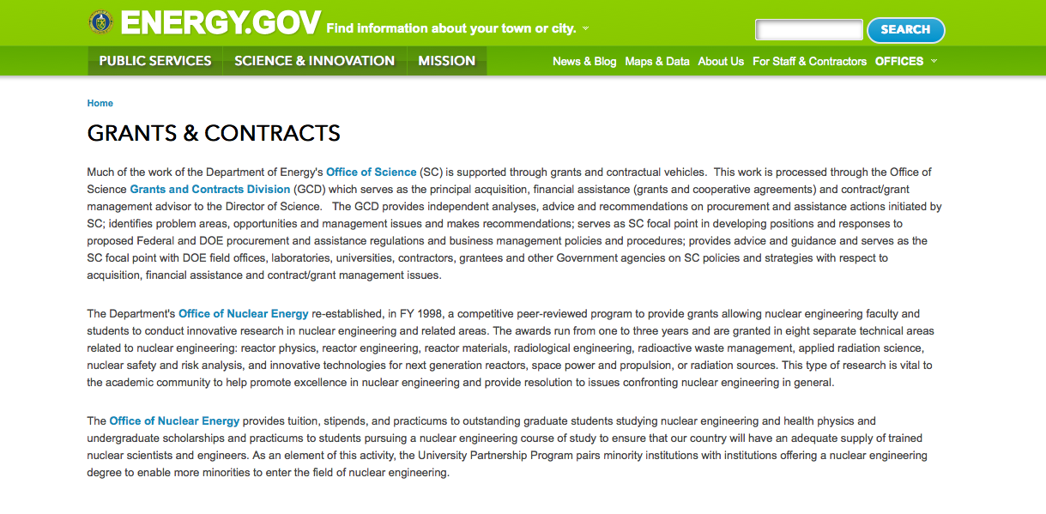
http://www.doe.gov/grants-contracts

Programs:

Golden Field Office
Funding Opportunity Announcement (FOA) DE-FOA-0001224 - Hydrogen & Fuel Cell Technologies Research, Development, and Demonstrations Grant
http://www.grants.gov/web/grants/view-opportunity.html?oppId=274869

Golden Field Office
NEXT GENERATION ELECTRIC MACHINES: MEGAWATT CLASS MOTORS Grant
http://www.grants.gov/web/grants/view-opportunity.html?oppId=275286

Golden Field Office
U.S. WIND MANUFACTURING: LARGER BLADES TO ACCESS GREATER WIND RESOURCES AND LOWER COSTS Grant
http://www.grants.gov/web/grants/view-opportunity.html?oppId=275205

Golden Field Office
NEXT GENERATION ELECTRIC MACHINES: MEGAWATT CLASS MOTORS Grant
http://www.grants.gov/web/grants/view-opportunity.html?oppId=275286

Golden Field Office
Research and Development Needs for Wind Systems Utilizing Controllable Grid Simulators and Full Scale Hardware in the Loop Testing Grant
http://www.grants.gov/web/grants/view-opportunity.html?oppId=275418

Golden Field Office
ASSISTING FEDERAL FACILITIES WITH ENERGY CONSERVATION TECHNOLOGIES (AFFECT), FY 2015 Grant
http://www.grants.gov/web/grants/view-opportunity.html?oppId=275004

Golden Field Office
RFI: Risk and Uncertainty Management in Geothermal Exploration Grant
http://www.grants.gov/web/grants/view-opportunity.html?oppId=275370

National Energy Technology Laboratory
Intelligent Monitoring Systems and Advanced Well Integrity and Mitigation Grant
http://www.grants.gov/web/grants/view-opportunity.html?oppId=275407

Golden Field Office
Building America Program Technology-to-Market Roadmaps Grant
http://www.grants.gov/web/grants/view-opportunity.html?oppId=275646

Modifications:

Funding Opportunity Announcement DE-FOA-0001260 Fit-for-Purpose Field Project: Developing and Validating Pressure Management and Plume Control Strategies through a Brine Extraction Storage Test (BEST)
Modification 2
http://www.grants.gov/web/grants/view-opportunity.html?oppId=271377

Advanced Research Projects Agency Energy
MOSIAC SBIR/STTR
Modification 2
http://www.grants.gov/web/grants/view-opportunity.html?oppId=270273

Advanced Research Projects Agency Energy
Micro-Scale Optimized Solar-Cell Arrays with Integrated Concentration (MOSAIC)
Modification 2
http://www.grants.gov/web/grants/view-opportunity.html?oppId=270274

Golden Field Office
Funding Opportunity Announcement (FOA) DE-FOA-0001224 - Hydrogen & Fuel Cell Technologies Research, Development, and Demonstrations
Modification 1
http://www.grants.gov/web/grants/view-opportunity.html?oppId=274869

National Energy Technology Laboratory
Funding Opportunity Announcement DE-FOA-0001260 Fit-for-Purpose Field Project: Developing and Validating Pressure Management and Plume Control Strategies through a Brine Extraction Storage Test (BEST)
Modification 1
http://www.grants.gov/web/grants/view-opportunity.html?oppId=271377

Golden Field Office
SUNSHOT TECHNOLOGY TO MARKET (INCUBATOR ROUND 10, SOLARMAT ROUND 3, SUNPATH ROUND 2)
Modification 2
http://www.grants.gov/web/grants/view-opportunity.html?oppId=272312

Reminders:

- 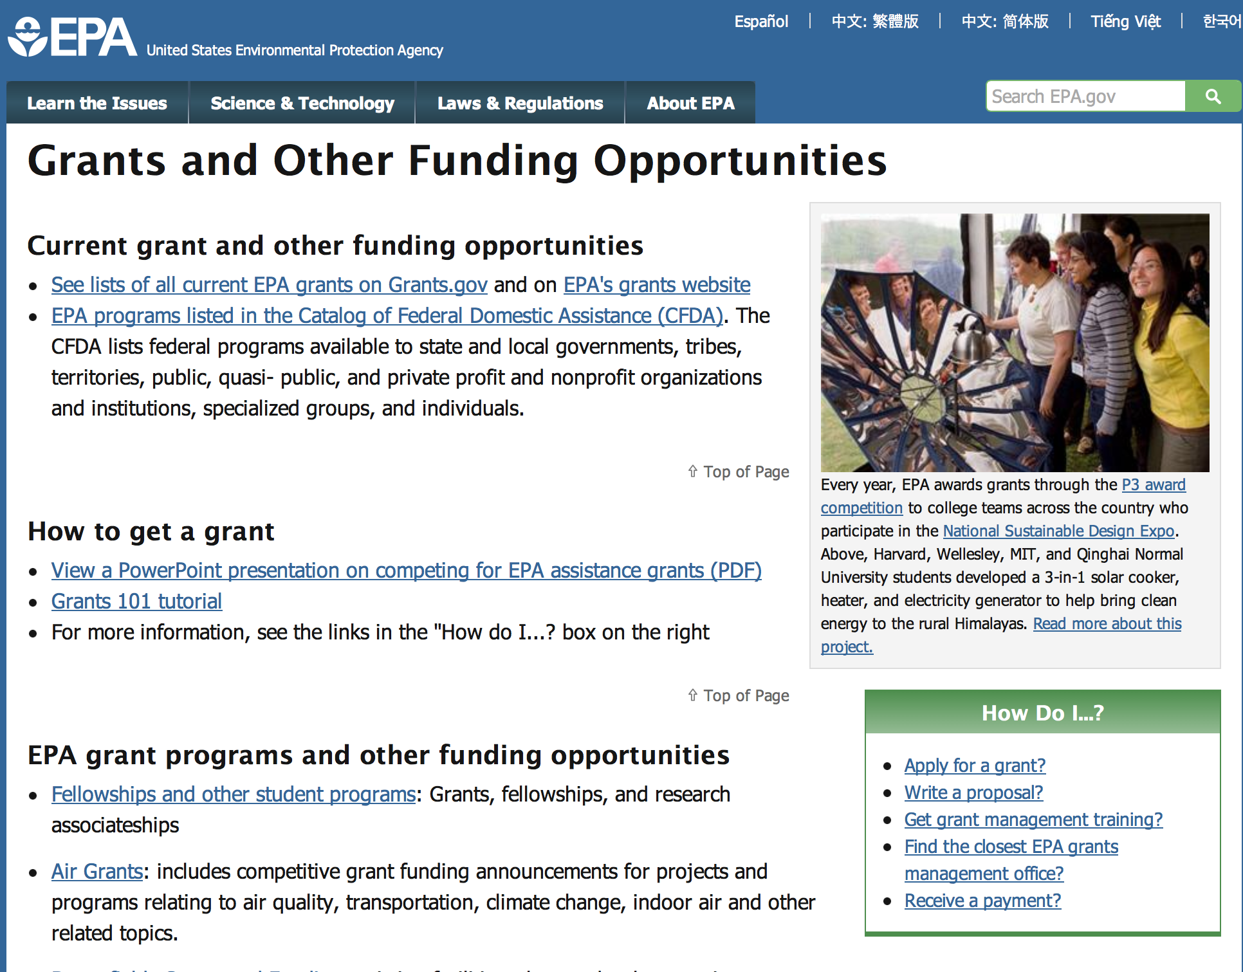

http://www.epa.gov/epahome/grants.htm

Programs:

Environmental Finance Center Grant Program
And Modification 1

Document Type: | Grants Notice
Funding Opportunity Number: | EPA-OCFO-CEF-15
Funding Opportunity Title: | ENVIRONMENTAL FINANCE CENTER GRANT PROGRAM
Opportunity Category: | Discretionary
Funding Instrument Type: | Cooperative Agreement
Category of Funding Activity: | Environment
Category Explanation:
Expected Number of Awards: | 10
CFDA Number(s): | 66.203 -- Environmental Finance Center Grants
Cost Sharing or Matching Requirement: | No
Posted Date: | Mar 3, 2015
Creation Date: | Mar 17, 2015
Original Closing Date for Applications: | Apr 30, 2015 Please refer to the announcement, including Section IV, for additional information on submission methods and due dates.
Current Closing Date for Applications: | Apr 30, 2015 Please refer to the announcement, including Section IV, for additional information on submission methods and due dates.
Archive Date: | May 30, 2015
Estimated Total Program Funding: | $48,000,000
Award Ceiling: | $8,000,000
Eligible Applicants: | Others (see text field entitled "Additional Information on Eligibility" for clarification)
Additional Information on Eligibility: | See Section III of the announcement for eligibility information.
Agency Name: | Environmental Protection Agency
Description: | The U.S. Environmental Protection Agency (EPA) announces the availability of funds and solicits applications from eligible entities for regional Environmental Finance Centers (EFCs) that provide multi-media environmental finance expertise and outreach to regulated communities. EPA recognizes that given the trends of growing costs and increasing resource pressures, the need to support the environmental work of regulated communities through vehicles such as the regional Environmental Finance Centers is as important and timely as ever. The EFC’s will be established and supported in EPA regions across the country to provide regulated parties with finance-related training, technical assistance, finance studies, and other analytical support (eligible services) to help them develop sustainable solutions to the critical “how-to-pay” issues associated with meeting environmental standards and goals.
Link to Additional Information: | Environmental Finance Center Grant Program
Contact Information: | If you have difficulty accessing the full announcement electronically, please contact:  Timothy McProuty  Email: Timothy McProuty

http://www.grants.gov/web/grants/view-opportunity.html?oppId=274919

Fiscal Year 2015 Pollution Prevention Grant Program

Document Type: | Grants Notice
Funding Opportunity Number: | EPA-HQ-OPPT-2015-002
Funding Opportunity Title: | Fiscal Year 2015 Pollution Prevention Grant Program
Opportunity Category: | Discretionary
Funding Instrument Type: | Cooperative Agreement  Grant
Category of Funding Activity: | Environment
Category Explanation:
Expected Number of Awards: | 40
CFDA Number(s): | 66.708 -- Pollution Prevention Grants Program
Cost Sharing or Matching Requirement: | Yes
Posted Date: | Mar 18, 2015
Creation Date: | Mar 18, 2015
Original Closing Date for Applications: | May 14, 2015 Please refer to the announcement, including Section IV, for additional information on submission methods and due dates.
Current Closing Date for Applications: | May 14, 2015 Please refer to the announcement, including Section IV, for additional information on submission methods and due dates.
Archive Date: | Jun 13, 2015
Estimated Total Program Funding: | $3,970,000
Award Ceiling: | $180,000
Award Floor: | $20,000
Eligible Applicants: | Others (see text field entitled "Additional Information on Eligibility" for clarification)
Additional Information on Eligibility: | See Section III of the announcement for eligibility information.
Agency Name: | Environmental Protection Agency
Description: | EPA’s Office of Pollution Prevention and Toxics, Chemistry, Economic and Sustainable Strategies Division oversees the Pollution Prevention (P2) Grant Program to support State and Tribal P2 Programs administer P2 projects that will help businesses identify better environmental strategies and solutions for reducing or eliminating waste at the source. EPA anticipates it will award approximately $3.97 million in P2 grant funding in Fiscal Year 2015. Grants will be awarded and managed by EPA's ten Regional P2 Program Offices. P2 grants are dependent on Congressional appropriation and the quality of proposals received.
Link to Additional Information: | Link to Announcement - Fiscal Year 2015 Pollution Prevention Grant Program
Contact Information: | If you have difficulty accessing the full announcement electronically, please contact:  Michele Amhaz, Phone: 202-564-8857  Michele Amhaz

http://www.grants.gov/web/grants/view-opportunity.html?oppId=275282

Fiscal Year 2015 Pollution Prevention Information Network (PPIN) Grant Program

Document Type: | Grants Notice
Funding Opportunity Number: | EPA-HQ-OPPT-2015-001
Funding Opportunity Title: | Fiscal Year 2015 Pollution Prevention Information Network (PPIN) Grant Program
Opportunity Category: | Discretionary
Funding Instrument Type: | Cooperative Agreement  Grant
Category of Funding Activity: | Environment
Category Explanation:
Expected Number of Awards: | 8
CFDA Number(s): | 66.708 -- Pollution Prevention Grants Program
Cost Sharing or Matching Requirement: | Yes
Posted Date: | Mar 23, 2015
Creation Date: | Mar 23, 2015
Original Closing Date for Applications: | May 22, 2015 Please refer to the announcement, including Section IV, for additional information on submission methods and due dates.
Current Closing Date for Applications: | May 22, 2015 Please refer to the announcement, including Section IV, for additional information on submission methods and due dates.
Archive Date: | Jun 21, 2015
Estimated Total Program Funding: | $800,000
Award Ceiling: | $170,000
Award Floor: | $60,000
Eligible Applicants: | Others (see text field entitled "Additional Information on Eligibility" for clarification)
Additional Information on Eligibility: | Please see Section III of the announcement for eligibility information.
Agency Name: | Environmental Protection Agency
Description: | This RFP seeks cost effective proposals from eligible applicants to support national pollution prevention (P2) information needs. In this RFP the Agency is directing P2 information center activities toward three national P2 emphasis areas to more effectively achieve measurable results and demonstrable impact in these targeted areas. Work in the national P2 emphasis areas (NEA) should support the P2 technical assistance work of state programs in promoting use of source reduction techniques by businesses. Applicants will collaborate with other grantees as part of their work in the national P2 information network. Applicants must propose work in one or more of the national P2 emphasis areas and must propose work that addresses one or more regional priorities.
Link to Additional Information: | Fiscal Year 2015 Pollution Prevention Information Network (PPIN) Grant Program
Contact Information: | If you have difficulty accessing the full announcement electronically, please contact:  Beth Anderson, Phone: (202) 564-8833  Beth Anderson

http://www.grants.gov/web/grants/view-opportunity.html?oppId=275343

2015 EPA Greater Research Opportunities (GRO) Fellowships for Undergraduate Environmental Study Grant

Document Type: | Grants Notice
Funding Opportunity Number: | EPA-F2015U-GRO-P2
Funding Opportunity Title: | 2015 EPA Greater Research Opportunities (GRO) Fellowships for Undergraduate Environmental Study
Opportunity Category: | Discretionary
Funding Instrument Type: | Other
Category of Funding Activity: | Environment
Category Explanation:
Expected Number of Awards: | 34
CFDA Number(s): | 66.513 -- Greater Research Opportunities (GRO) Fellowships For Undergraduate Environmental Study
Cost Sharing or Matching Requirement: | No
Posted Date: | Mar 31, 2015
Creation Date: | Mar 31, 2015
Original Closing Date for Applications: | May 19, 2015 Please see the announcement including Section IV for additional submission information.
Current Closing Date for Applications: | May 19, 2015 Please see the announcement including Section IV for additional submission information.
Archive Date: | Jun 18, 2015
Estimated Total Program Funding: | $1,700,000
Award Ceiling: | $50,000
Award Floor: | $0
Eligible Applicants: | Others (see text field entitled "Additional Information on Eligibility" for clarification)
Additional Information on Eligibility: | Please see the announcement including Section III for additional eligibility information.
Agency Name: | Environmental Protection Agency
Description: | The U.S. Environmental Protection Agency (EPA), as part of its Greater Research Opportunities (GRO) Fellowships program, is offering undergraduate fellowships for bachelor level students in environmental fields of study. The deadline for receipt of applications is May 19, 2015, at 11:59:59 PM ET. Subject to availability of funding and other applicable considerations, the Agency plans to award approximately 34 new fellowships. Eligible students will receive support for their junior and senior years of undergraduate study and for an internship at an EPA facility during the summer of their junior year. The fellowship provides up to $20,700 per academic year of support and $8,600 of support for a three-month summer internship.
Link to Additional Information: | 2015 EPA Greater Research Opportunities (GRO) Fellowships for Undergraduate Environmental Study
Contact Information: | If you have difficulty accessing the full announcement electronically, please contact:  Program Contact: Georgette Boddie, phone: 703-347-8049; Eligibility Contact: Ron Josephson, phone: 703-308-0442; Electronic Submissions Contact: Debra M. Jones, phone: 703-347-8081  Georgette Bodie, Ron Josephson, Debra M. Jones

http://www.grants.gov/web/grants/view-opportunity.html?oppId=275556

2015 EPA Greater Research Opportunities (GRO) Fellowships for Undergraduate Environmental Study Grant
Document Type: | Grants Notice
Funding Opportunity Number: | EPA-F2015U-GRO-Q1
Funding Opportunity Title: | 2015 EPA Greater Research Opportunities (GRO) Fellowships for Undergraduate Environmental Study
Opportunity Category: | Discretionary
Funding Instrument Type: | Other
Category of Funding Activity: | Environment
Category Explanation:
Expected Number of Awards: | 34
CFDA Number(s): | 66.513 -- Greater Research Opportunities (GRO) Fellowships For Undergraduate Environmental Study
Cost Sharing or Matching Requirement: | No
Posted Date: | Mar 31, 2015
Creation Date: | Mar 31, 2015
Original Closing Date for Applications: | May 19, 2015 Please see the announcement including Section IV for additional submission information.
Current Closing Date for Applications: | May 19, 2015 Please see the announcement including Section IV for additional submission information.
Archive Date: | Jun 18, 2015
Estimated Total Program Funding: | $1,700,000
Award Ceiling: | $50,000
Eligible Applicants: | Others (see text field entitled "Additional Information on Eligibility" for clarification)
Additional Information on Eligibility: | Please see the announcement including Section III for additional eligibility information.
Agency Name: | Environmental Protection Agency
Description: | The U.S. Environmental Protection Agency (EPA), as part of its Greater Research Opportunities (GRO) Fellowships program, is offering undergraduate fellowships for bachelor level students in environmental fields of study. The deadline for receipt of applications is May 19, 2015, at 11:59:59 PM ET. Subject to availability of funding and other applicable considerations, the Agency plans to award approximately 34 new fellowships. Eligible students will receive support for their junior and senior years of undergraduate study and for an internship at an EPA facility during the summer of their junior year. The fellowship provides up to $20,700 per academic year of support and $8,600 of support for a three-month summer internship.
Link to Additional Information: | 2015 EPA Greater Research Opportunities (GRO) Fellowships for Undergraduate Environmental Study
Contact Information: | If you have difficulty accessing the full announcement electronically, please contact:  Program Contact: Georgette Boddie, phone: 703-347-8049; Eligibility Contact: Ron Josephson, phone: 703-308-0442; Electronic Submissions Contact: Debra M. Jones, phone: 703-347-8081  Georgette Boddie; Ron Josephson; Debra M. Jones

http://www.grants.gov/web/grants/view-opportunity.html?oppId=275560

2015 EPA Greater Research Opportunities (GRO) Fellowships for Undergraduate Environmental Study Grant

Document Type: | Grants Notice
Funding Opportunity Number: | EPA-F2015U-GRO-Q2
Funding Opportunity Title: | 2015 EPA Greater Research Opportunities (GRO) Fellowships for Undergraduate Environmental Study
Opportunity Category: | Discretionary
Funding Instrument Type: | Other
Category of Funding Activity: | Environment
Category Explanation:
Expected Number of Awards: | 34
CFDA Number(s): | 66.513 -- Greater Research Opportunities (GRO) Fellowships For Undergraduate Environmental Study
Cost Sharing or Matching Requirement: | No
Posted Date: | Mar 31, 2015
Creation Date: | Mar 31, 2015
Original Closing Date for Applications: | May 19, 2015 Please see the announcement including Section IV for additional submission information
Current Closing Date for Applications: | May 19, 2015 Please see the announcement including Section IV for additional submission information
Archive Date: | Jun 18, 2015
Estimated Total Program Funding: | $1,700,000
Award Ceiling: | $50,000
Award Floor: | $0
Eligible Applicants: | Others (see text field entitled "Additional Information on Eligibility" for clarification)
Additional Information on Eligibility: | Please see the announcement including Section III for additional eligibility information
Agency Name: | Environmental Protection Agency
Description: | The U.S. Environmental Protection Agency (EPA), as part of its Greater Research Opportunities (GRO) Fellowships program, is offering undergraduate fellowships for bachelor level students in environmental fields of study. The deadline for receipt of applications is May 19, 2015, at 11:59:59 PM ET. Subject to availability of funding and other applicable considerations, the Agency plans to award approximately 34 new fellowships. Eligible students will receive support for their junior and senior years of undergraduate study and for an internship at an EPA facility during the summer of their junior year. The fellowship provides up to $20,700 per academic year of support and $8,600 of support for a three-month summer internship.
Link to Additional Information: | 2015 EPA Greater Research Opportunities (GRO) Fellowships for Undergraduate Environmental Study
Contact Information: | If you have difficulty accessing the full announcement electronically, please contact:  Program Contact: Georgette Boddie, phone: 703-347-8049; Eligibility Contact: Ron Josephson, phone: 703-308-0442; Electronic Submissions Contact: Debra M. Jones, phone: 703-347-8081  Georgette Boddie, Ron Josephson, Debra M. Jones

http://www.grants.gov/web/grants/view-opportunity.html?oppId=275561

Modifications:

2015 EPA Greater Research Opportunities (GRO) Fellowships for Undergraduate Environmental Study
Modification 2

Document Type: | Grants Notice
Funding Opportunity Number: | EPA-F2015U-GRO-P3
Funding Opportunity Title: | 2015 EPA Greater Research Opportunities (GRO) Fellowships for Undergraduate Environmental Study
Opportunity Category: | Discretionary
Funding Instrument Type: | Other
Category of Funding Activity: | Environment
Category Explanation:
Expected Number of Awards: | 34
CFDA Number(s): | 66.513 -- Greater Research Opportunities (GRO) Fellowships For Undergraduate Environmental Study
Cost Sharing or Matching Requirement: | No
Posted Date: | Mar 31, 2015
Creation Date: | Mar 31, 2015
Original Closing Date for Applications: | May 19, 2015 Please see the announcement including Section IV for additional submission information
Current Closing Date for Applications: | May 19, 2015 Please see the announcement including Section IV for additional submission information
Archive Date: | Jun 18, 2015
Estimated Total Program Funding: | $1,700,000
Award Ceiling: | $50,000
Eligible Applicants: | Others (see text field entitled "Additional Information on Eligibility" for clarification)
Additional Information on Eligibility: | Please see the announcement including Section III for additional eligibility information
Agency Name: | Environmental Protection Agency
Description: | The U.S. Environmental Protection Agency (EPA), as part of its Greater Research Opportunities (GRO) Fellowships program, is offering undergraduate fellowships for bachelor level students in environmental fields of study. The deadline for receipt of applications is May 19, 2015, at 11:59:59 PM ET. Subject to availability of funding and other applicable considerations, the Agency plans to award approximately 34 new fellowships. Eligible students will receive support for their junior and senior years of undergraduate study and for an internship at an EPA facility during the summer of their junior year. The fellowship provides up to $20,700 per academic year of support and$8,600 of support for a three-month summer internship.
Link to Additional Information: | 2015 EPA Greater Research Opportunities (GRO) Fellowships for Undergraduate Environmental Study
Contact Information: | If you have difficulty accessing the full announcement electronically, please contact:  Program Contact: Georgette Boddie, phone: 703-347-8049; Eligibility Contact: Ron Josephson, phone: 703-308-0442; Electronic Submissions Contact: Debra M. Jones, phone: 703-347-8081  Georgette Boddie; Ron Josephson, Debra M. Jones

http://www.grants.gov/web/grants/view-opportunity.html?oppId=275557

http://www.grants.gov/web/grants/view-opportunity.html?oppId=275558

http://www.grants.gov/web/grants/view-opportunity.html?oppId=275555

Reminders:



Department of Health and Human Services

Grants Forecast and Overview

The Department of Health and Human Services’ Grants Forecast is a database of planned grant opportunities proposed by its agencies. Each Forecast record contains actual or estimated dates and funding levels for grants that the agency intends to award during the fiscal year. Forecast opportunities are subject to change based on enactment of congressional appropriations.

Go to the webpage below for more information.
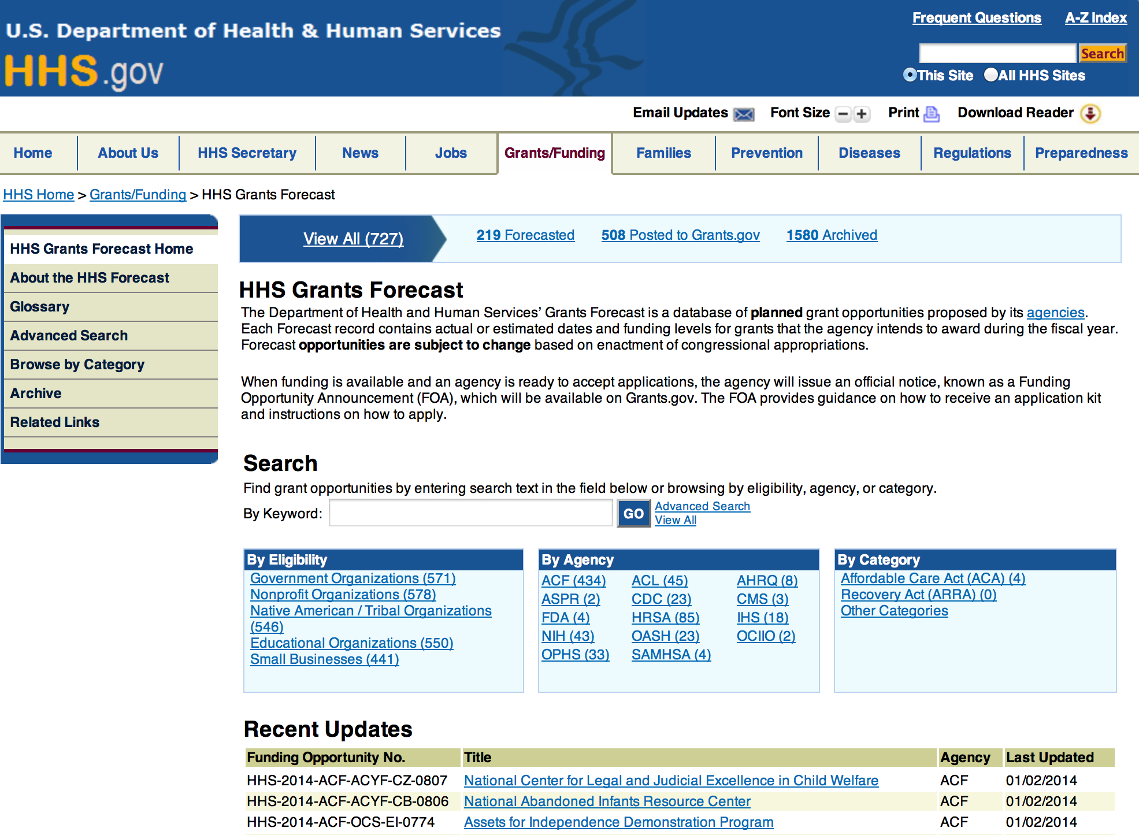

For more general information about HHS Grants and Funding go to the website below at: http://www.hhs.gov/grants/ .

Recent Updates
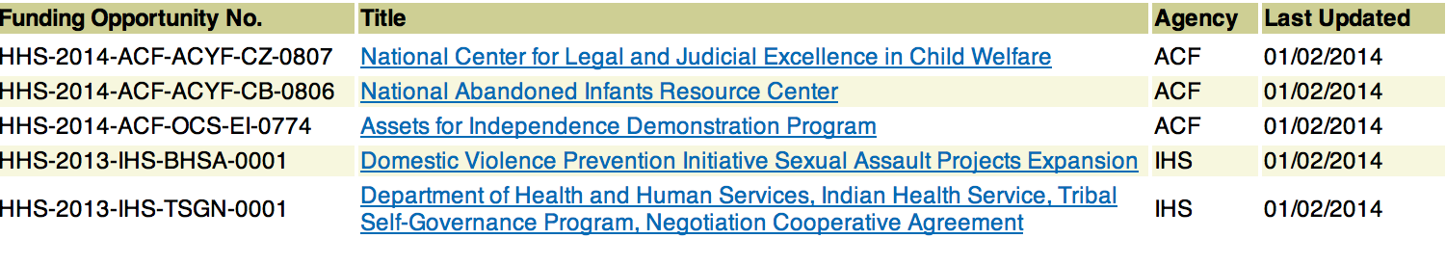

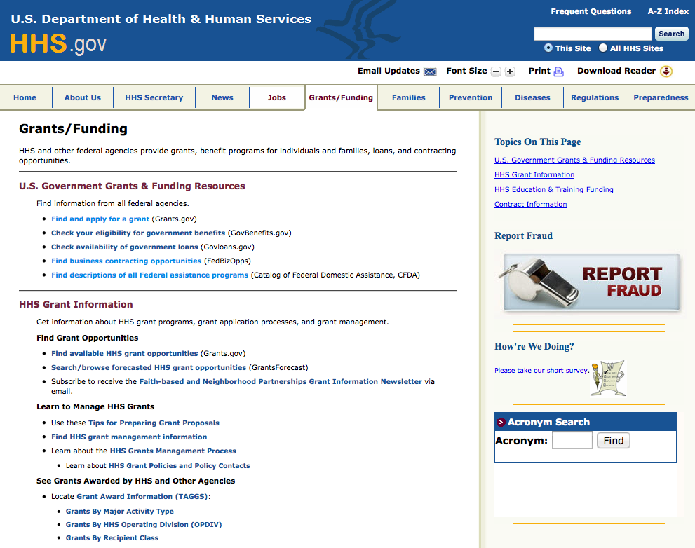

Programs:

Research:

Administration for Community Living
National Legal Resource Center Grant
http://www.grants.gov/web/grants/view-opportunity.html?oppId=275162

Administration for Children and Families - ORR
Refugee Individual Development Accounts (IDA) Program Grant
http://www.grants.gov/web/grants/view-opportunity.html?oppId=274941

Administration for Community Living
University Centers for Excellence in Developmental Disabilities Grant
http://www.grants.gov/web/grants/view-opportunity.html?oppId=275047

Administration for Community Living
PPHF - 2015 - Evidence-Based Falls Prevention Programs Financed Solely by 2015 Prevention and Public Health Funds (PPHF-2015) Grant
http://www.grants.gov/web/grants/view-opportunity.html?oppId=275599

Administration for Community Living
PPHF-2015-Empowering Older Adults and Adults with Disabilities through Chronic Disease Self-Management Education Programs Financed Solely by 2015 Prevention and Public Health Funds (PPHF-2015) Grant
http://www.grants.gov/web/grants/view-opportunity.html?oppId=275606

Centers for Disease Control and Prevention
Epicenters for the Prevention of Healthcare Associated Infections (HAI) - Cycle II Grant
http://www.grants.gov/web/grants/view-opportunity.html?oppId=275607

Centers for Disease Control and Prevention
Newborn Screening for Severe Combined Immunodeficiency (SCID) Grant
http://www.grants.gov/web/grants/view-opportunity.html?oppId=275098

Centers for Disease Control and Prevention
Paul Coverdell National Acute Stroke Prevention Grant
http://www.grants.gov/web/grants/view-opportunity.html?oppId=274876

Centers for Disease Control and Prevention
Establishment of Centers of Excellence in Refugee Health Grant
http://www.grants.gov/web/grants/view-opportunity.html?oppId=275345

Centers for Disease Control and Prevention
National Center for HIV/AIDS, Viral Hepatitis, Sexually Transmitted Diseases and Tuberculosis Prevention (NCHHSTP) Public Health Conference Support
Grant
http://www.grants.gov/web/grants/view-opportunity.html?oppId=275679

Centers for Disease Control and Prevention
Improving Response to and Programming in Humanitarian Emergencies Grant
http://www.grants.gov/web/grants/view-opportunity.html?oppId=275698

Food & Drug Administration
Minor Use Minor Species Development of Drugs; Research Project Grant (R01) Grant
http://www.grants.gov/web/grants/view-opportunity.html?oppId=275082

Health Resources and Services Administration
Ryan White HIV/AIDS Part C Capacity Development Program Grant
http://www.grants.gov/web/grants/view-opportunity.html?oppId=274823

Health Resources and Services Administration
Consolidated and Further Continuing Appropriations Act, 2015 Health Infrastructure Investment Program Grant
http://www.grants.gov/web/grants/view-opportunity.html?oppId=274920

Health Resources and Services Administration
Health Careers Opportunity Program Grant
http://www.grants.gov/web/grants/view-opportunity.html?oppId=275220

National Institutes of Health
Pilot and Feasibility Clinical Trials in Diabetes, and Endocrine and Metabolic Diseases (R21)
Grant
http://www.grants.gov/web/grants/view-opportunity.html?oppId=275675

National Institutes of Health
Molecular Imaging of the Lung - Phase 2 (R01) Grant
http://www.grants.gov/web/grants/view-opportunity.html?oppId=275244

National Institutes of Health
International Research Collaboration on Drug Abuse and Addiction Research (R21) Grant
http://www.grants.gov/web/grants/view-opportunity.html?oppId=275245

National Institutes of Health
Comparative Physiological Studies of Aging (R03) Grant
http://www.grants.gov/web/grants/view-opportunity.html?oppId=275239

National Institutes of Health
International Research Collaboration on Drug Abuse and Addiction Research (R03) Grant
http://www.grants.gov/web/grants/view-opportunity.html?oppId=275228

National Institutes of Health
International Research Collaboration on Drug Abuse and Addiction Research (R01) Grant
http://www.grants.gov/web/grants/view-opportunity.html?oppId=275229

National Institutes of Health
The Role of Exosomes in HIV Neuropathogenesis (R21) Grant
http://www.grants.gov/web/grants/view-opportunity.html?oppId=275323

National Institutes of Health
The Role of Exosomes in HIV Neuropathogenesis (R01) Grant
http://www.grants.gov/web/grants/view-opportunity.html?oppId=275301

National Institutes of Health
Advancing Mechanistic Probiotic/Prebiotic and Human Microbiome Research (R01) Grant
http://www.grants.gov/web/grants/view-opportunity.html?oppId=275035

National Institutes of Health
Functional Wellness in HIV: Maximizing the Treatment Cascade (R01) Grant
http://www.grants.gov/web/grants/view-opportunity.html?oppId=274960

National Institutes of Health
Supplements to Support Interoperability of NIH Funded Biomedical Data Repositories (Admin Supp) Grant
http://www.grants.gov/web/grants/view-opportunity.html?oppId=275258

National Institutes of Health
Functional Wellness in HIV: Maximizing the Treatment Cascade (R21) Grant
http://www.grants.gov/web/grants/view-opportunity.html?oppId=274961

National Institutes of Health
Availability of Administrative Supplements to NIGMS Predoctoral Training Grants (Admin Supp)
Grant
http://www.grants.gov/web/grants/view-opportunity.html?oppId=275043

National Institutes of Health
Biological and Physiological Effects of E-cigarette Aerosol Mixtures (R21) Grant
http://www.grants.gov/web/grants/view-opportunity.html?oppId=274965

National Institutes of Health
NEI Administrative Supplements to Small Business Innovative Research (SBIR) Grants for the Procurement of Expertise in the Federal Regulatory Approval Process for New Drugs and/or Devices (Admin Supp) Grant
http://www.grants.gov/web/grants/view-opportunity.html?oppId=274962

National Institutes of Health
Biological and Physiological Effects of E-cigarette Aerosol Mixtures (R01) Grant
http://www.grants.gov/web/grants/view-opportunity.html?oppId=274963

National Institutes of Health
Global Infectious Disease Research Administration Development Award for Low-and Middle-Income Country Institutions (G11) Grant
http://www.grants.gov/web/grants/view-opportunity.html?oppId=274927

National Institutes of Health
Limited Competition: Revisions to Add Phase 2 Clinical Trials Program to Experimental Therapeutics Clinical Trials Network (ETCTN)(UM1) Grant
http://www.grants.gov/web/grants/view-opportunity.html?oppId=275340

National Institutes of Health
Administrative Supplements for Research on HIV/AIDS and Aging (Admin Supp) Grant
http://www.grants.gov/web/grants/view-opportunity.html?oppId=275067

National Institutes of Health
Investigations on Primary Immunodeficiency Diseases (R01) Grant
http://www.grants.gov/web/grants/view-opportunity.html?oppId=274939

National Institutes of Health
Validation of Pediatric Patient Reported Outcomes in Chronic Diseases (PEPR) Consortium (U19) Grant
http://www.grants.gov/web/grants/view-opportunity.html?oppId=274973

National Institutes of Health
One-Year Administrative Supplements to NIMH-supported Research for FY2015 (Admin Supp) Grant
http://www.grants.gov/web/grants/view-opportunity.html?oppId=274828

National Institutes of Health
Developing Paradigm-Shifting Innovations for in vivo Human Placental Assessment in Response to Environmental Influences (U01) Grant
http://www.grants.gov/web/grants/view-opportunity.html?oppId=274783

National Institutes of Health
Early-life Factors and Cancer Development Later in Life (R01) Grant
http://www.grants.gov/web/grants/view-opportunity.html?oppId=274784

National Institutes of Health
Early-life Factors and Cancer Development Later in Life (R21) Grant
http://www.grants.gov/web/grants/view-opportunity.html?oppId=274785

National Institutes of Health
Advancing Translational and Clinical Probiotic/Prebiotic and Human Microbiome Research (R01) Grant
http://www.grants.gov/web/grants/view-opportunity.html?oppId=274808

National Institutes of Health
Children's Health Exposure Analysis Resource (CHEAR): National Exposure Assessment Laboratory Network (U2C) Grant
http://www.grants.gov/web/grants/view-opportunity.html?oppId=274810

National Institutes of Health
Early-life Factors and Cancer Development Later in Life (R03) Grant
http://www.grants.gov/web/grants/view-opportunity.html?oppId=274816

Substance Abuse & Mental Health Services Administration
National Consumer and Consumer Supporter Technical Assistance Centers (Short Title: Consumer and Consumer Supporter TA Centers) Grant
http://www.grants.gov/web/grants/view-opportunity.html?oppId=274813

National Institutes of Health
Summer Institute for Research Education in Biostatistics (R25) Grant
http://www.grants.gov/web/grants/view-opportunity.html?oppId=275132

National Institutes of Health
NIDDK Research Education Program Grants for Courses for Skills Development (R25) Grant
http://www.grants.gov/web/grants/view-opportunity.html?oppId=275133

National Institutes of Health
NIDDK Research Education Program Grants for Summer Research Experiences (R25) Grant
http://www.grants.gov/web/grants/view-opportunity.html?oppId=275134

National Institutes of Health
NIDDK Research Education Program Grants for Curriculum Development (R25) Grant
http://www.grants.gov/web/grants/view-opportunity.html?oppId=275135

National Institutes of Health
SBIR Phase IIB Bridge Awards to Accelerate the Development of Cancer Therapeutics, Imaging Technologies, Interventional Devices, Diagnostics and Prognostics Toward Commercialization (R44)
Grant
http://www.grants.gov/web/grants/view-opportunity.html?oppId=275137

National Institutes of Health
Secondary Analyses in Obesity, Diabetes and Digestive and Kidney Diseases (R21) Grant
http://www.grants.gov/web/grants/view-opportunity.html?oppId=275615

National Institutes of Health
Alzheimer's Drug-Development Program (U01) Grant
http://www.grants.gov/web/grants/view-opportunity.html?oppId=275590

National Institutes of Health
Diet and Physical Activity Assessment Methodology (R01) Grant
http://www.grants.gov/web/grants/view-opportunity.html?oppId=275619

National Institutes of Health
Diet and Physical Activity Assessment Methodology (R21) Grant
http://www.grants.gov/web/grants/view-opportunity.html?oppId=275620

National Institutes of Health
Collaborative Innovation Award, Clinical and Translational Science Award (CTSA) Program (U01) Grant
http://www.grants.gov/web/grants/view-opportunity.html?oppId=275635

National Institutes of Health
Oral Immune System Plasticity in Chronic HIV Infection Under Treatment and Oral Co-Infections (R01) Grant
http://www.grants.gov/web/grants/view-opportunity.html?oppId=275636

National Institutes of Health
Pre-Application for Collaborative Innovation Award, CTSA Program (X02) Grant
http://www.grants.gov/web/grants/view-opportunity.html?oppId=275637

National Institutes of Health
Regional Medical Libraries for the National Network of Libraries of Medicine (UG4)
Grant
http://www.grants.gov/web/grants/view-opportunity.html?oppId=275644

National Institutes of Health
NIBIB Research Education Programs for Residents and Clinical Fellows (R25) Grant
http://www.grants.gov/web/grants/view-opportunity.html?oppId=275578

National Institutes of Health
New Directions in Hematology Research (SHINE-II) (R01) Grant
http://www.grants.gov/web/grants/view-opportunity.html?oppId=275580

National Institutes of Health
Methods Development in Natural Products Chemistry (R41/R42) Grant
http://www.grants.gov/web/grants/view-opportunity.html?oppId=275648

National Institutes of Health
Methods Development in Natural Products Chemistry (R43/R44) Grant
http://www.grants.gov/web/grants/view-opportunity.html?oppId=275649

National Institutes of Health
Phenotypic and Functional Studies on FOXO3 Human Longevity Variants to Inform Potential Therapeutic Target Identification Research (R01) Grant
http://www.grants.gov/web/grants/view-opportunity.html?oppId=275650

Substance Abuse & Mental Health Services Administration
PPHF - 2015 Cooperative Agreements for State-Sponsored Youth Suicide Prevention and Early Intervention (PPHF-2015) Grant
http://www.grants.gov/web/grants/view-opportunity.html?oppId=275589

Substance Abuse & Mental Health Services Administration
Targeted Capacity Expansion: Substance Use Disorder Treatment for Racial/Ethnic Minority Populations at High-Risk for HIV/AIDS (Short Title: TCE-HIV: High Risk Populations) Grant
http://www.grants.gov/web/grants/view-opportunity.html?oppId=275181

Substance Abuse & Mental Health Services Administration
“Now is the Time” Project AWARE-Community Grant
http://www.grants.gov/web/grants/view-opportunity.html?oppId=274888

Substance Abuse & Mental Health Services Administration
Targeted Capacity Expansion: Medication Assisted Treatment-Prescription Drug and Opioid Addiction (MAT-PDOA) Grants
http://www.grants.gov/web/grants/view-opportunity.html?oppId=274809

Modifications:

Administration for Children and Families
Administration for Children and Families - OPRE
Early Care and Education Research Scholars: Head Start Graduate Student Research Grants
Modification 1
http://www.grants.gov/web/grants/view-opportunity.html?oppId=253868

Administration for Children and Families
Administration for Children and Families - OPRE
Early Care and Education Research Scholars: Child Care Research Scholars
Modification 1
http://www.grants.gov/web/grants/view-opportunity.html?oppId=253869

Centers for Disease Control and Prevention
Organized Approaches to Increase Colorectal Cancer Screening
Modification 17
http://www.grants.gov/web/grants/view-opportunity.html?oppId=274308

Centers for Disease Control and Prevention
Organized Approaches to Increase Colorectal Cancer Screening
Modification 2
http://www.grants.gov/web/grants/view-opportunity.html?oppId=274308

Centers for Disease Control and Prevention
The CDC National Centers of Excellence in Youth Violence Prevention: Building the Evidence for Community- and Policy-Level Prevention
Modification 3
http://www.grants.gov/web/grants/view-opportunity.html?oppId=272228

Centers for Disease Control and Prevention
Paul Coverdell National Acute Stroke Prevention
Modification 1
http://www.grants.gov/web/grants/view-opportunity.html?oppId=274876

Centers for Disease Control and Prevention
Conducting Operational Research to Identify Numbers and Rates, Determine Needs, and Integrate Services to Mitigate Morbidity and Mortality Among Internally Displaced Persons Affected by Emergencies
Modification 5
http://www.grants.gov/web/grants/view-opportunity.html?oppId=274702

Centers for Disease Control and Prevention
Organized Approaches to Increase Colorectal Cancer Screening ***AMENDMENT TO FAQs- Changes to Question and Answer 14***
Modification 13
http://www.grants.gov/web/grants/view-opportunity.html?oppId=274308

Centers for Disease Control and Prevention
Paul Coverdell National Acute Stroke Prevention
Modification 1
http://www.grants.gov/web/grants/view-opportunity.html?oppId=274876

Health Resources and Services Administration
Consolidated and Further Continuing Appropriations Act, 2015 Health Infrastructure Investment Program
Modification 1
http://www.grants.gov/web/grants/view-opportunity.html?oppId=274920

National Institutes of Health
Research to Advance Vaccine Safety (R01)
Modification 2
http://www.grants.gov/web/grants/view-opportunity.html?oppId=132013

National Institutes of Health
Research to Advance Vaccine Safety (R21)
Modification 2
http://www.grants.gov/web/grants/view-opportunity.html?oppId=132014

Office of the Assistant Secretary for Health
FY15 National Workforce Diversity Pipeline Program
Modification 1
http://www.grants.gov/web/grants/view-opportunity.html?oppId=275242

Office of the Assistant Secretary for Health
FY15 National Health Education Program on Lupus
Modification 1
http://www.grants.gov/web/grants/view-opportunity.html?oppId=275203

National Institutes of Health
Development of Novel and Emerging Technologies to Support Zebrafish Models for Biomedical Research (R41/R42)
Modification 1
http://www.grants.gov/web/grants/view-opportunity.html?oppId=271353

National Institutes of Health
International Research Collaboration on Drug Abuse and Addiction Research (R21)
Modification 2
http://www.grants.gov/web/grants/view-opportunity.html?oppId=132194

National Institutes of Health
Development of Novel and Emerging Technologies to Support Zebrafish Models for Biomedical Research (R43/R44)
Modification 1
http://www.grants.gov/web/grants/view-opportunity.html?oppId=271354

National Institutes of Health
Core Infrastructure and Methodological Research for Cancer Epidemiology Cohorts (U01)
Modification 1
http://www.grants.gov/web/grants/view-opportunity.html?oppId=252733

National Institutes of Health
Improving Diet and Physical Activity Assessment (R21)
Modification 1
http://www.grants.gov/web/grants/view-opportunity.html?oppId=174653

National Institutes of Health
Improving Diet and Physical Activity Assessment (R01)
Modification 1
http://www.grants.gov/web/grants/view-opportunity.html?oppId=174654

National Institutes of Health
Courses for Skills Development in Biomedical Big Data Science (R25)
Modification 1
http://www.grants.gov/web/grants/view-opportunity.html?oppId=250080

National Institutes of Health
Open Educational Resources for Biomedical Big Data (R25)
Modification 1
http://www.grants.gov/web/grants/view-opportunity.html?oppId=250081

National Institutes of Health
Courses for Skills Development in Biomedical Big Data Science (R25)
Modification 2
http://www.grants.gov/web/grants/view-opportunity.html?oppId=250080

National Institutes of Health
Open Educational Resources for Biomedical Big Data (R25)
Modification 2
http://www.grants.gov/web/grants/view-opportunity.html?oppId=250081

HHS - Office of the Secretary
Assistant Secretary for Preparedness and Response
Hospital Preparedness Program (HPP) Ebola Preparedness and Response Activities
Modification 1
http://www.grants.gov/web/grants/view-opportunity.html?oppId=274709

Office of the Assistant Secretary for Health
FY15 Announcement of the Anticipated Availability of Funds for Phase I Research on Research Integrity
Modification 1
http://www.grants.gov/web/grants/view-opportunity.html?oppId=271790

Substance Abuse & Mental Health Services Administration
Targeted Capacity Expansion: Medication Assisted Treatment-Prescription Drug and Opioid Addiction (MAT-PDOA) grants
Modification 1
http://www.grants.gov/web/grants/view-opportunity.html?oppId=274809

Substance Abuse & Mental Health Services Administration
Capacity Building Initiative for Substance Abuse (SA) and HIV Prevention Services for At-Risk Racial/Ethnic Minority Youth and Young Adults (HIV CBI)
Modification 1
http://www.grants.gov/web/grants/view-opportunity.html?oppId=274701

Office of the Assistant Secretary for Health
FY15 College Sexual Assault Policy and Prevention Initiative
Modification 1
http://www.grants.gov/web/grants/view-opportunity.html?oppId=274932

Office of the Assistant Secretary for Health
FY15 Announcement of Availability of Funds to Enroll Family Planning Clients into Health Insurance Programs
Modification 1
http://www.grants.gov/web/grants/view-opportunity.html?oppId=275157

Substance Abuse & Mental Health Services Administration
Minority Serving Institutions (MSIs) Partnerships with Community-Based Organizations (CBOs). Short Title: MSI CBO
Modification 1
http://www.grants.gov/web/grants/view-opportunity.html?oppId=275467

Substance Abuse & Mental Health Services Administration
Drug-Free Communities Mentoring Program
Modification 1
http://www.grants.gov/web/grants/view-opportunity.html?oppId=273588

Substance Abuse & Mental Health Services Administration
Offender Reentry Program (ORP)
Modification 1
http://www.grants.gov/web/grants/view-opportunity.html?oppId=275366

Reminders:

Administration for Children and Families
Administration for Children & Families - ACYF/FYSB
Street Outreach Program Grant

Document Type: | Grants Notice
Funding Opportunity Number: | HHS-2015-ACF-ACYF-YO-0956
Funding Opportunity Title: | Street Outreach Program
Opportunity Category: | Discretionary
Funding Instrument Type: | Grant
Category of Funding Activity: | Income Security and Social Services
Category Explanation:
Expected Number of Awards: | 38
CFDA Number(s): | 93.557 -- Education and Prevention Grants to Reduce Sexual Abuse of Runaway, Homeless and Street Youth
Cost Sharing or Matching Requirement: | Yes
Posted Date: | Feb 9, 2015
Creation Date: | Feb 9, 2015
Original Closing Date for Applications: | Apr 10, 2015 Electronically submitted applications must be submitted no later than 11:59 p.m., ET, on the listed application due date.
Current Closing Date for Applications: | Apr 10, 2015 Electronically submitted applications must be submitted no later than 11:59 p.m., ET, on the listed application due date.
Archive Date: | May 11, 2015
Estimated Total Program Funding: | $4,712,482
Award Ceiling: | $200,000
Award Floor: | $90,000
Eligible Applicants: | Special district governments  Independent school districts  Public housing authorities/Indian housing authorities  Native American tribal governments (Federally recognized)  Nonprofits that do not have a 501(c)(3) status with the IRS, other than institutions of higher education  Nonprofits having a 501(c)(3) status with the IRS, other than institutions of higher education  County governments  Private institutions of higher education  City or township governments  State governments  Native American tribal organizations (other than Federally recognized tribal governments)  Public and State controlled institutions of higher education
Additional Information on Eligibility: | Eligible applicants include public and non-profit private entities that include States, localities, and coordinated networks of such entities. Per RHY Act section 351, for-profit organizations are not eligible. In selecting eligible applicants to receive grants under this Funding Opportunity Announcement (FOA), priority will be given to entities that have experience in providing shelter and services to runaway, homeless, or street youth as required by the RHY Act. Faith-based and community organizations that meet the eligibility requirements are eligible to receive awards under this funding opportunity announcement. Faith-based organizations are encouraged to review the ACF Policy on Grants to Faith-Based Organizations at: http: //www.acf.hhs.gov/acf-policy-on-grants-to-faith-based-organizations. Applications from individuals (including sole proprietorships) and foreign entities are not eligible and will be disqualified from competitive review and from funding under this announcement.
Agency Name: | Administration for Children & Families - ACYF/FYSB
Description: | Today, in communities across the country, young people are living on the streets after running from or being asked to leave homes characterized by abuse, neglect, or parental drug and alcohol abuse. Once on the streets, such youth are at risk of being sexually exploited or abused by adults for pleasure or profit. In addition, youth may engage in shoplifting, survival sex, or drug dealing in order to provide for their basic needs. Since 1996, SOP has been aiding this population by funding grantees to provide street-based services to runaway, homeless, and street youth who have been subjected to, or are at risk of being subjected to, sexual abuse, prostitution, or sexual exploitation. These services, which are provided in areas where street youth congregate, are designed to assist such youth in making healthy choices regarding where they live and how they behave.
Link to Additional Information: | http://www.acf.hhs.gov/grants/open/foa/view/HHS-2015-ACF-ACYF-YO-0956
Contact Information: | If you have difficulty accessing the full announcement electronically, please contact:  ACF Applications Help Desk app_support@acf.hhs.gov  ACF Applications Help Desk

http://www.grants.gov/web/grants/view-opportunity.html?oppId=273648

Administration for Children and Families
Administration for Children & Families - ACYF/FYSB
Basic Center Program Grant

Document Type: | Grants Notice
Funding Opportunity Number: | HHS-2015-ACF-ACYF-CY-0957
Funding Opportunity Title: | Basic Center Program
Opportunity Category: | Discretionary
Funding Instrument Type: | Grant
Category of Funding Activity: | Income Security and Social Services
Category Explanation:
Expected Number of Awards: | 93
CFDA Number(s): | 93.623 -- Basic Center Grant
Cost Sharing or Matching Requirement: | Yes
Posted Date: | Feb 9, 2015
Creation Date: | Feb 9, 2015
Original Closing Date for Applications: | Apr 10, 2015 Electronically submitted applications must be submitted no later than 11:59 p.m., ET, on the listed application due date.
Current Closing Date for Applications: | Apr 10, 2015 Electronically submitted applications must be submitted no later than 11:59 p.m., ET, on the listed application due date.
Archive Date: | May 11, 2015
Estimated Total Program Funding: | $14,593,033
Award Ceiling: | $200,000
Award Floor: | $50,000
Eligible Applicants: | Nonprofits having a 501(c)(3) status with the IRS, other than institutions of higher education  Public housing authorities/Indian housing authorities  Public and State controlled institutions of higher education  City or township governments  Native American tribal governments (Federally recognized)  State governments  Special district governments  County governments  Private institutions of higher education  Native American tribal organizations (other than Federally recognized tribal governments)  Nonprofits that do not have a 501(c)(3) status with the IRS, other than institutions of higher education
Additional Information on Eligibility: | In selecting eligible applicants to receive grants under this Funding Opportunity Announcement, priority will be given to private entities that have experience in providing shelter and services to runaway, homeless and street youth as required by the RHY Act. Private institutions of higher education must be non-profit entities. In addition to both public and nonprofit private entities, a combination of such entities can receive grants per section 311(a)(1) of the RHY Act. (42 U.S.C. &sect; 5711(a)(1)) Faith-based and community organizations that meet the eligibility requirements are eligible to receive awards under this funding opportunity announcement. Faith-based organizations are encouraged to review the ACF Policy on Grants to Faith-Based Organizations at: http: //www.acf.hhs.gov/acf-policy-on-grants-to-faith-based-organizations. Applications from individuals (including sole proprietorships) and foreign entities are not eligible and will be disqualified from competitive review and from funding under this announcement.
Agency Name: | Administration for Children & Families - ACYF/FYSB
Description: | The Administration for Children and Families' (ACF), Administration on Children, Youth and Families' (ACYF), Family and Youth Services Bureau (FYSB) will award funding for the Basic Center Program (BCP). The purpose of the BCP is to provide an alternative for runaway and homeless youth who might otherwise end up with law enforcement or in the child welfare, mental health, or juvenile justice systems. The BCP works to establish or strengthen community-based programs that meet the immediate needs of runaway and homeless youth and their families. The programs provide youth up to age 18 years with emergency shelter, food, clothing, counseling and referrals for health care. Most basic centers can provide 21 days of shelter for up to 20 youth at a time. There are exceptions for jurisdictions that have different standards for licensing. Basic Centers seek to reunite young people with their families, whenever possible, or to locate appropriate alternative placements. Services will include: street-based services; home-based services for families with youth at risk of separation from the family; drug abuse education and prevention services; and at the request of runaway and homeless youth, testing for sexually transmitted infections.
Link to Additional Information: | http://www.acf.hhs.gov/grants/open/foa/view/HHS-2015-ACF-ACYF-CY-0957
Contact Information: | If you have difficulty accessing the full announcement electronically, please contact:  ACF Applications Help Desk app_support@acf.hhs.gov  ACF Applications Help Desk

http://www.grants.gov/web/grants/view-opportunity.html?oppId=273528

Department of Homeland Security

The Department of Homeland Security enhances the ability of states, local and tribal jurisdictions, and other regional authorities in the preparation, prevention, and response to terrorist attacks and other disasters, by distributing grant funds. Localities can use grants for planning, equipment, training and exercise needs.

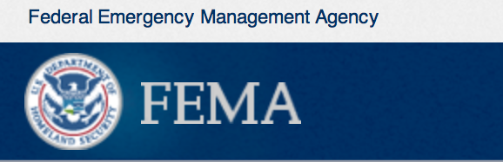

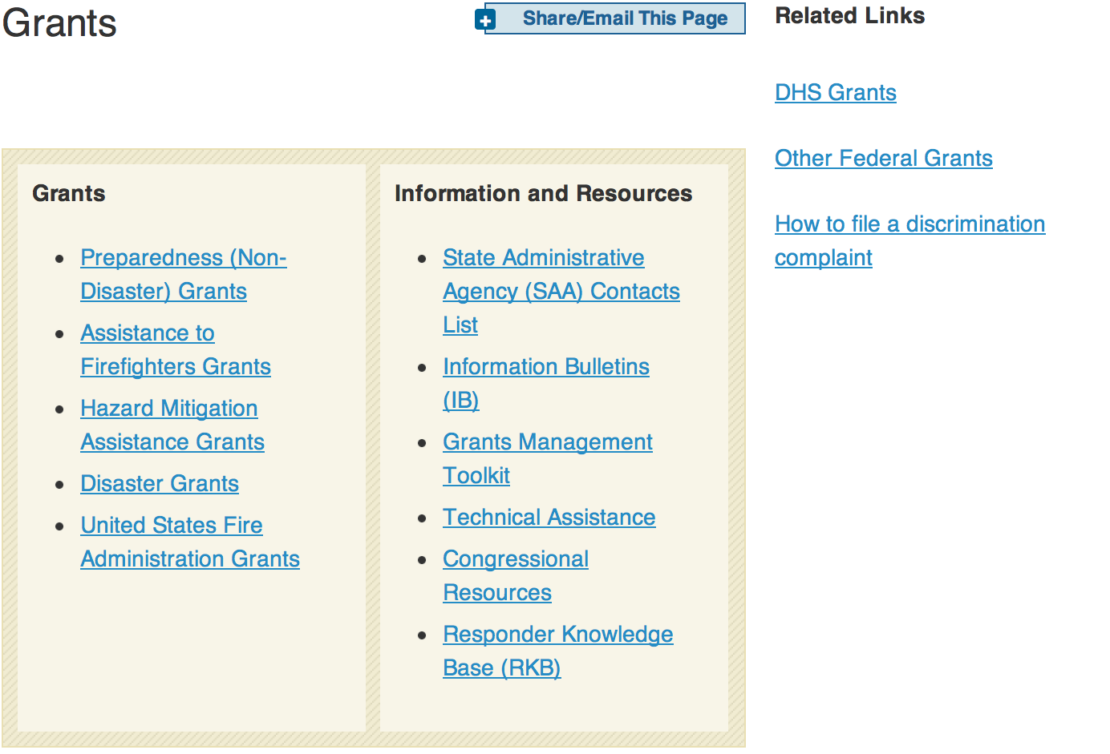
OMB Circulars
Assistance to State and Local Governments OMB Circular A-87 OMB Circular A-102
Assistance to Colleges and Universities OMB Circular A-21 OMB Circular A-110
Assistance to Non-profit Organizations OMB Circular A-110 OMB Circular A-122
Audit Guidance OMB Circular A-133
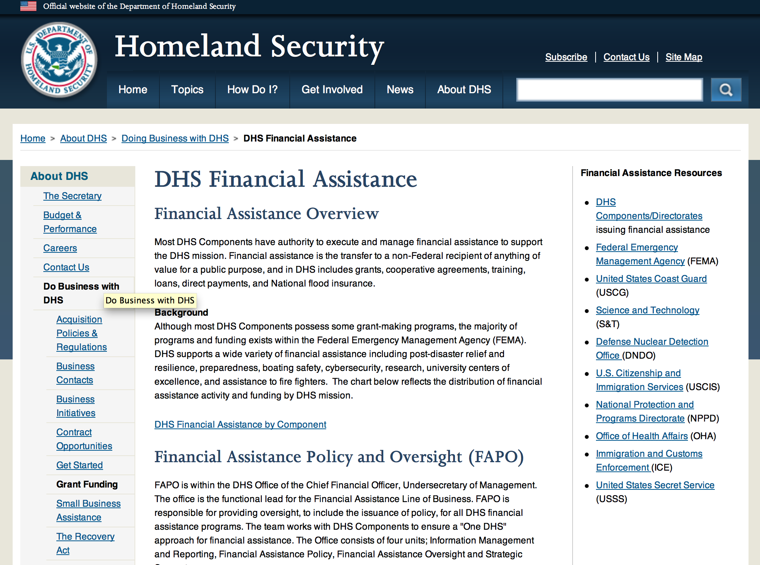

Webpage can be viewed at: http://www.dhs.gov/xopnbiz/grants/index.shtm#2

Download these updated grant application tools and start planning your grant request now.
- FY 2012 FP&S Grants Get Ready Guide. This short guide will help you kick-start your grant application. It identifies the most important elements of all the grant application questions.
- FY 2012 FP&S Grant Self-Evaluation Sheet. This tool is based on the application scoring dimensions used by the peer reviewers. It can help you assess your organization's readiness to apply for a grant and help you plan your application.
Video Resources
Two short Fire Prevention and Safety Program videos provide information that can help potential applicants.
- The FP&S Grants video gives an overview of the FP&S Grant Program, describing the purpose of the grants, eligible activities, and evaluation criteria.
- The Community Risk Assessment video describes the different types of risk assessments that applicants can use and explains how the risk assessment's information can support grant requests. Community risk assessments are critical to creating an effective fire prevention and safety project, and they are required to obtain a FP&S grant.
Website Resources
Visit the FP&S Grants home page on the Assistance to Firefighters Grants (AFG) website to find more information about recent awardees and models of successful FP&S projects.

Federal Funding Alternative To AFG

State Administrative Agencies (SAA) apply for and administer Federal grants on behalf of their States, including FEMA Preparedness Grants. The SAA will work with eligible organizations to comply with the general requirements of grant programs or cooperative agreements. Contact your State’s SAA to find out what current Federal funding opportunities may be available to your organization. A listing of the SAAs and points of contact can be found at http://www.fema.gov/library/viewRecord.do?id=6363.

Programs:

Office of Procurement Operations - Grants Division
FY 2015 Citizenship and Integration Direct Services Grant Program: Citizenship Instruction and Naturalization Application Services Grant

Document Type: | Grants Notice
Funding Opportunity Number: | DHS-15-CIS-010-002
Funding Opportunity Title: | FY 2015 Citizenship and Integration Direct Services Grant Program: Citizenship Instruction and Naturalization Application Services
Opportunity Category: | Discretionary
Funding Instrument Type: | Grant
Category of Funding Activity: | Education
Category Explanation:
Expected Number of Awards: | 40
CFDA Number(s): | 97.010 -- Citizenship Education and Training
Cost Sharing or Matching Requirement: | No
Posted Date: | Apr 1, 2015
Creation Date: | Apr 1, 2015
Original Closing Date for Applications: | May 15, 2015
Current Closing Date for Applications: | May 15, 2015
Archive Date: | Jun 14, 2015
Estimated Total Program Funding:
Award Ceiling: | $10,000,000
Eligible Applicants: | County governments  Nonprofits having a 501(c)(3) status with the IRS, other than institutions of higher education  Native American tribal organizations (other than Federally recognized tribal governments)  Native American tribal governments (Federally recognized)  Public and State controlled institutions of higher education  State governments  Special district governments  Independent school districts  City or township governments  Private institutions of higher education
Agency Name: | Office of Procurement Operations - Grants Division
Description: | The Office of Citizenship (OoC), within U.S. Citizenship and Immigration Services (USCIS), Department of Homeland Security (DHS), is charged with promoting instruction and training on the rights and responsibilities of citizenship. USCIS recognizes that naturalization is an important milestone in the civic integration of immigrants. Naturalization requirements, such as knowledge of English and of U.S. history and civics, encourage civic learning and build a strong foundation upon which immigrants can exercise their rights and responsibilities. Through preparing for naturalization, immigrants will gain the tools to become successful citizens—ready to exercise their rights and meet their responsibilities as United States citizens. The goal of the Citizenship and Integration Grant Program is to expand the availability of high quality citizenship preparation services for lawful permanent residents in communities across the nation. Additional activities that support this goal include making citizenship instruction and naturalization application services accessible to low-income and other underserved lawful permanent resident populations; developing, identifying, and sharing promising practices in citizenship preparation; supporting innovative and creative solutions to barriers faced by those seeking naturalization; increasing the use of and access to technology in citizenship preparation programs; working with local libraries, which serve as a vital resource for immigrant communities; and engaging receiving communities in the citizenship and civic integration process. The Citizenship and Integration Grant Program addresses the following DHS mission as specified in the Quadrennial Homeland Security Review (QHSR): Mission 3: Enforce and Administer Our Immigration Laws Goal 3.1: Strengthen and Effectively Administer the Immigration System • Promote lawful immigration; • Effectively administer the immigration services system; and • Promote the integration of lawful immigrants into American society. Request for Proposals In fiscal year (FY) 2015, a total of up to $10,000,000 in federal funding is available for eligible organizations to provide direct citizenship preparation services to lawful permanent residents. Proposed citizenship preparation activities must include the following two components: 1. Citizenship instruction to prepare lawful permanent residents for the civics (U.S. history and government) and English (reading, writing, and speaking) components of the naturalization test. Program design must include: • The use of a nationally normed standardized test of English proficiency for student placement and assessment of progress; • The provision of at least 40 hours of citizenship instruction over an 8-15 week class cycle for students at or below the NRS high intermediate level; • Enrolling a minimum of 200 non-duplicated lawful permanent residents in citizenship classes with a minimum of 40 hours of instruction over the two year period of performance; and • The use of citizenship teachers, whether a volunteer or paid, who have at least one year of experience teaching English as a Second Language (ESL) or citizenship to adults. 2. Naturalization application services, within the scope of the authorized practice of immigration law, to support lawful permanent residents in the naturalization application and interview process. Services must include: • The provision of naturalization eligibility screening; • The preparation and submission of a minimum of 200 Forms N-400, Application for Naturalization with Form G-28, Notice of Entry of Appearance as Attorney or Accredited Representative over the two year period of performance; • Ongoing case management; • The use of a BIA accredited representative or an attorney who is an employee at the applicant organization or at the sub-awardee organization. (Pro bono or volunteer attorneys may be used to supplement the program.) Attorneys and BIA accredited representatives must sign Form N-400 as the preparer, submit Form G-28 with each Form N-400 filed under this grant, and mail the naturalization application package to USCIS on behalf of the client. Services may also include interview preparation, a representative’s appearance at the naturalization interview, and filing of other forms or documents (such as Form N-648, Medical Certification for Disability Exceptions), if applicable. Partnerships Partnerships are encouraged. Applicants may include partnerships with other public or non-profit organizations in their proposal. The principal applicant must directly provide either citizenship instruction or naturalization application services, or both. A partner organization is considered a “sub-awardee” if the organization will receive a portion of the grant funding to provide additional or complementary direct citizenship instruction or naturalization application services. The applicant must complete a Memorandum of Understanding (MOU) with the prospective sub- awardee. The applicant must clearly demonstrate how it will monitor the prospective sub-awardee’s performance and ensure that the prospective sub-awardee complies with all grant award conditions and data reporting requirements. Prospective sub-awardees must have their own individual Data Universal Numbering System (DUNS) number and will be responsible for financial and performance reporting. Sub-awardees must submit their reports to the primary applicant for submission to DHS. If the partner organization will not receive a portion of the grant funds, then the partner is not considered a prospective sub-awardee, and would not be required to complete an MOU or obtain a DUNS number.
Link to Additional Information:
Contact Information: | If you have difficulty accessing the full announcement electronically, please contact:  Patty Mayo Grants Officer  Contact

http://www.grants.gov/web/grants/view-opportunity.html?oppId=275575

Department of Homeland Security - FEMA
Fiscal Year 2015 Intercity Bus Security Grant Program (IBSGP) Grant

Document Type: | Grants Notice
Funding Opportunity Number: | DHS-15-GPD-057-000-01
Funding Opportunity Title: | Fiscal Year 2015 Intercity Bus Security Grant Program (IBSGP)
Opportunity Category: | Discretionary
Funding Instrument Type: | Grant
Category of Funding Activity: | Other (see text field entitled "Explanation of Other Category of Funding Activity" for clarification)
Category Explanation: | Homeland Security Preparedness
Expected Number of Awards: | 100
CFDA Number(s): | 97.057 -- Intercity Bus Security Grants
Cost Sharing or Matching Requirement: | No
Posted Date: | Apr 2, 2015
Creation Date: | Apr 2, 2015
Original Closing Date for Applications: | May 19, 2015
Current Closing Date for Applications: | May 19, 2015
Archive Date: | Jun 18, 2015
Estimated Total Program Funding: | $3,000,000
Eligible Applicants: | Others (see text field entitled "Additional Information on Eligibility" for clarification)
Additional Information on Eligibility: | Owners and operators of fixed route intercity and charter buses
Agency Name: | Department of Homeland Security - FEMA
Description: | The IBSGP is one tool among a comprehensive set of measures authorized by Congress and implemented by the Administration to help strengthen the nation's critical infrastructure against risks associated with potential terrorist attacks. The vast bulk of America's critical infrastructure is owned and/or operated by State, local, and private sector partners. The funds provided by the IBSGP are primarily intended to support the work of operators of fixed route intercity and charter bus services.
Link to Additional Information: | www.grants.gov
Contact Information: | If you have difficulty accessing the full announcement electronically, please contact:  GPD Systems Branch (800) 865-4076 GMD-Systems-Branch@fema.gov  GMD-Systems-Branch@fema.gov

http://www.grants.gov/web/grants/view-opportunity.html?oppId=275584

Modifications:

Reminders:

Fire Prevention & Safety Grants
Main Content
This section contains eligible category information, grant awards, success stories, and program contacts. The information is for fire departments and eligible organizations interested in reducing death and injuries due to fire related hazards.

Overview
The Fire Prevention and Safety (FP&S) Grants are part of the Assistance to Firefighters Grants (AFG) and support projects that enhance the safety of the public and firefighters from fire and related hazards. The primary goal is to reduce injury and prevent death among high-risk populations. In 2005, Congress reauthorized funding for FP&S and expanded the eligible uses of funds to include Firefighter Safety Research and Development.

FP&S Program Update
The FY 2014 The Fire Prevention & Safety (FP&S) application period Ends on April 17, 2015 at 5:00 PM EST
- The FY 2014 Fire Prevention & Safety Funding Opportunity Announcement (FOA) is available now
- Additional application support tools coming soon
- FY 2014 FP&S Grant Award program information coming soon
- FY 2014 FP&S Application Assistance Tools coming soon
- FY 2013 FP & S grant award announcements. View award list.
- To receive an FP & S award, you must be registered and have up-to-date information in the online System for Award Management (Sam.gov) registration is required of all AFG Program applicants and awardees. Please go to SAM.gov/portal/public/SAM/ and follow the FAQs and User Guides for help in completing the registration process.
- FP & S Success Stories
- If you are not currently receiving AFG Program E-Mail Alerts, be sure to sign up now on the E-Mail Alert signup page
- Questions regarding the FP&S Grants can be directed to the Federal Emergency Management Agency's Grant Programs Directorate (GPD) AFG Program staff at 1-866-274-0960 or e-mail firegrants@dhs.gov.
FY 2014 FP&S Application Assistance Tools
- The FY 2014 Fire Prevention & Safety Funding Opportunity Announcement (FOA) is available now
- Additional application support tools coming soon

FP&S RESEARCH AND DEVELOPMENT (R&D) GRANT SECTION NOW AVAILABLE
Learn more about the research projects funded through AFG and how they are working to improve firefighter safety and health
Click here for more information

FP&S Program Tools
FIRE PREVENTION & SAFETY PROGRAM VIDEOS
- FP&S Grants Video. This video gives an overview of the FP&S Grant Program, describing the purpose of the grants, eligible activities and evaluation criteria.
Community Risk Assessment Video. This video describes the different types of risk assessments that applicants can use and explains how the risk assessment's information can support grant requests. Community risk assessments are critical to creating an effective fire prevention and safety project and they are required to obtain a FP&S grant.

Document Type: | Grants Notice
Funding Opportunity Number: | DHS-14-GPD-044-000-98
Funding Opportunity Title: | Fiscal Year (FY) 2014 Fire Prevention and Safety Grant Program (FP
Opportunity Category: | Discretionary
Funding Instrument Type: | Grant
Category of Funding Activity: | Other (see text field entitled "Explanation of Other Category of Funding Activity" for clarification)  Science and Technology and other Research and Development
Category Explanation: | Fire Prevention
Expected Number of Awards: | 100
CFDA Number(s): | 97.044 -- Assistance to Firefighters Grant
Cost Sharing or Matching Requirement: | Yes
Posted Date: | Jan 6, 2015
Creation Date: | Jan 6, 2015
Original Closing Date for Applications: | Close date will be provided when the application period is set.
Current Closing Date for Applications: | Close date will be provided when the application period is set.
Archive Date: | Sep 30, 2015
Estimated Total Program Funding: | $3,400,000
Award Ceiling: | $1,500,000
Eligible Applicants: | County governments  Nonprofits having a 501(c)(3) status with the IRS, other than institutions of higher education  Native American tribal governments (Federally recognized)  City or township governments  Private institutions of higher education  Public and State controlled institutions of higher education  Others (see text field entitled "Additional Information on Eligibility" for clarification)
Additional Information on Eligibility: | Fire Departments
Agency Name: | Department of Homeland Security - FEMA
Description: | The Department of Homeland Security (DHS) Federal Emergency Management Agency's (FEMA) Grants Programs Directorate is responsible for the implementation and administrations of the Assistance to Firefighters Grant (AFG) Program. The purpose of the AFG Program is to enhance the safety of the public and firefighters with respect to fire and fire-related hazards. The Grants Programs Directorate administers the Fire Prevention and Safety (FP&S) grants as part of the AFG Program. FP&S offers grants to support activities in two categories: (1) activities designed to reach high-risk target groups and mitigate incidences of death and injuries caused by fire and fire-related hazards ("Fire Prevention and Safety Activity") and (2) research and development activities aimed at improving firefighter safety ("Firefighter Safety Research and Development Activity"). The program guidance document provides potential applicants with the details of the requirements, processing, and evaluation of an application for financial assistance for both of these activity areas.
Link to Additional Information: | www.fema.gov/firegrants
Contact Information: | If you have difficulty accessing the full announcement electronically, please contact:  FP&S Help Desk (866) 274-0960 firegrants@fema.gov  firegrants@fema.gov

http://www.grants.gov/web/grants/view-opportunity.html?oppId=271072



Department of Housing and Urban Development

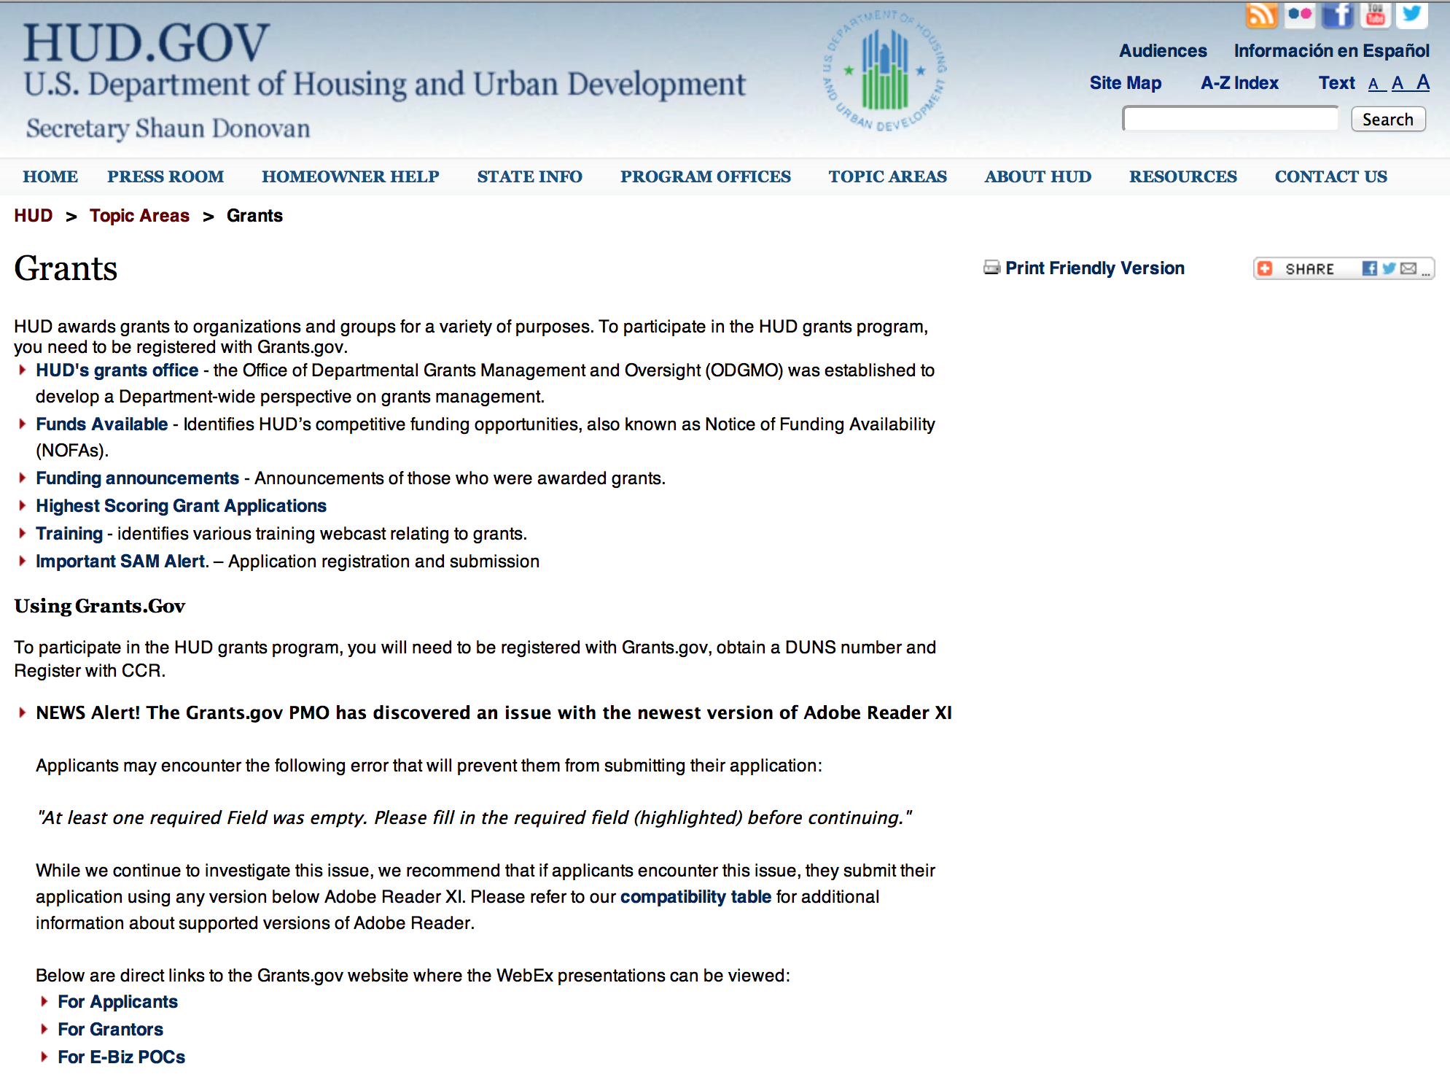

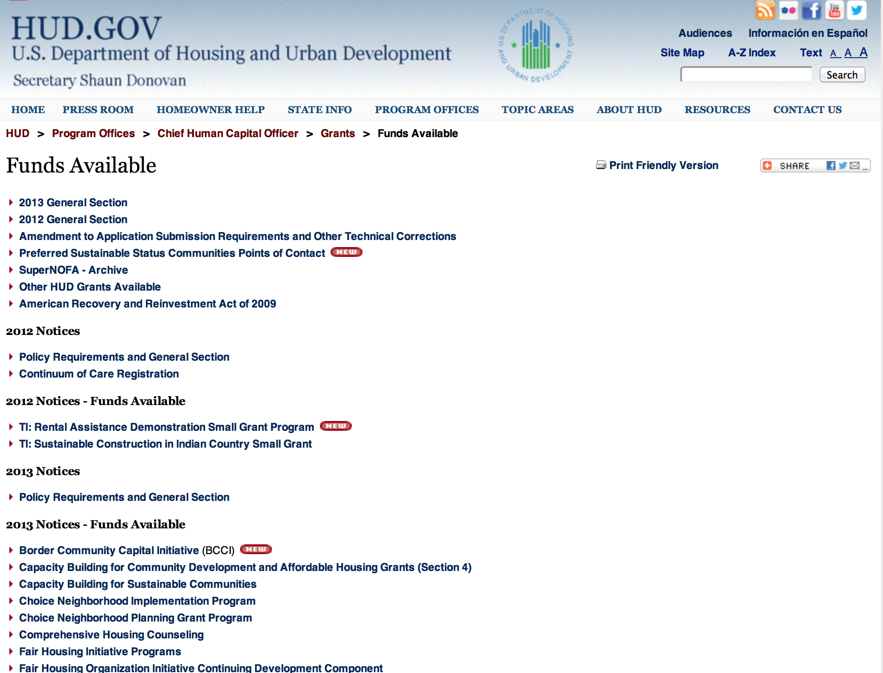

HUD - Notice of Funds Available

For detailed information click here

FY 2013 Notice of Funding Availability (NOFA) Policy Requirements and General Section to HUD’s FY2013 NOFAs for Discretionary Programs
This Notice provides prospective applicants for HUD's competitive funding with the opportunity to become familiar with the General Section to HUD's FY2013 Notices of Funding Availability (NOFAs) for Discretionary Funding (program NOFA), in advance of publication of any individual FY2013 program NOFAs. This General Section and the individual FY2013 program NOFA Sections comprise the entirety of the FY2013 NOFA instructions.
- General Section
- FONSI
- New Application Attachment Filename Requirement

Programs

Research and Evaluation, Demonstrations, and Data Analysis and Utilization Grant
And Modification 1

Document Type: | Grants Notice
Funding Opportunity Number: | FR-5800-N-26
Funding Opportunity Title: | Research and Evaluation, Demonstrations, and Data Analysis and Utilization
Opportunity Category: | Discretionary
Funding Instrument Type: | Cooperative Agreement
Category of Funding Activity: | Housing
Category Explanation:
Expected Number of Awards: | 4
CFDA Number(s): | 14.536 -- Research and Evaluations, Demonstrations, and Data Analysis and Utilization
Cost Sharing or Matching Requirement: | No
Posted Date: | Mar 16, 2015
Creation Date: | Apr 6, 2015
Original Closing Date for Applications: | Apr 30, 2015 Electronically submitted applications must be submitted no later than 11:59:59 p.m., ET, on the listed application due date.
Current Closing Date for Applications: | Apr 30, 2015 Electronically submitted applications must be submitted no later than 11:59:59 p.m., ET, on the listed application due date.
Archive Date: | May 11, 2015
Estimated Total Program Funding: | $5,200,000
Award Ceiling: | $2,175,000
Award Floor: | $50,000
Eligible Applicants: | Nonprofits that do not have a 501(c)(3) status with the IRS, other than institutions of higher education  Small businesses  Private institutions of higher education  For profit organizations other than small businesses  Public and State controlled institutions of higher education  Native American tribal governments (Federally recognized)  City or township governments  Nonprofits having a 501(c)(3) status with the IRS, other than institutions of higher education  County governments  Native American tribal organizations (other than Federally recognized tribal governments)  Public housing authorities/Indian housing authorities  State governments
Additional Information on Eligibility: | 1. Organizations may submit one application for each of the five projects for which funding is being made available. Subcontractors and consultants may be included in more than one application. However, if an organization submits an application for a project, then it may not be included as a subcontractor or consultant in any other application for the same project. HUD will not consider the application of an organization for any project if the organization or its staff members are listed as subcontractors or consultants on another application for that same project. 2. In accordance with the faith-based initiative, HUD welcomes the participation of eligible faith-based and other community organizations in these programs. Individuals, foreign entities, and sole proprietorship organizations are not eligible to compete for, or receive, awards made under this announcement.
Agency Name: | Department of Housing and Urban Development
Description: | This is a Notice of Funding Availability (NOFA) of up to $5.25 million in Fiscal Year 2013 and 2014 funds from the U.S. Department of Housing and Urban Development for research and evaluations. The funds are provided from HUD&rsquo;s Office of Policy Development and Research from the Transformation Initiative appropriations account. Funds will be awarded in the form of cooperative agreement. Eligible applicants include: public or private nonprofit organizations or intermediaries, including institutions of higher education and area-wide planning organizations; for profit organizations; States, units of general local government, or Indian tribes; public housing authorities; and small businesses.
Link to Additional Information: | http://portal.hud.gov/hudportal/HUD?src=/program_offices/administration/grants/fundsavail
Contact Information: | If you have difficulty accessing the full announcement electronically, please contact:  Sherone E. Ivey Sherone.E.Ivey@HUD.GOV  Grants Policy

http://www.grants.gov/web/grants/view-opportunity.html?oppId=275224

Notice of Funding Availability (NOFA) for the Department's Fiscal Year 2015 Supplemental Comprehensive Housing Counseling Grant Program

Document Type: | Grants Notice
Funding Opportunity Number: | FR-5800-N-33
Funding Opportunity Title: | Notice of Funding Availability (NOFA) for the Department's Fiscal Year 2015 Supplemental Comprehensive Housing Counseling Grant Program
Opportunity Category: | Discretionary
Funding Instrument Type: | Grant
Category of Funding Activity: | Housing
Category Explanation:
Expected Number of Awards: | 60
CFDA Number(s): | 14.169 -- Housing Counseling Assistance Program
Cost Sharing or Matching Requirement: | No
Posted Date: | Apr 2, 2015
Creation Date: | Apr 2, 2015
Original Closing Date for Applications: | May 7, 2015 Electronically submitted applications must be submitted no later than 11:59:59 p.m., ET, on the listed application due date.
Current Closing Date for Applications: | May 7, 2015 Electronically submitted applications must be submitted no later than 11:59:59 p.m., ET, on the listed application due date.
Archive Date: | Jun 7, 2015
Estimated Total Program Funding: | $3,500,000
Eligible Applicants: | Others (see text field entitled "Additional Information on Eligibility" for clarification)
Additional Information on Eligibility: | 1. Threshold Requirements: All Applicants and sub-grantees must meet the Threshold Requirements of the FY 2014 General Section. 2. Eligible Applicants. a. All housing counseling agencies (including LHCAs, Intermediaries and MSOs) that are directly approved by HUD prior to the NOFA issue date and were not awarded FY 2014 comprehensive housing counseling funds through the FY 2014; 2015 NOFA as a direct grant from HUD or as a sub-grant from an SHFA or Intermediary are eligible for this NOFA. SHFAs that were not awarded FY 2014 funds through the FY 2014; 2015 NOFA as a direct grant from HUD or as a sub-grant from an Intermediary are also eligible. Agencies that were awarded FY 2014 funds through the FY 2014; 2015 NOFA as a direct grant from HUD or as a sub-grant from an SHFA or Intermediary are not eligible for this NOFA, unless the agency was awarded FY 2014 funds as an LHCA or as a sub-grantee of an SHFA or Intermediary and the LHCA or sub-grantee received HUD approval as a newly approved MSO or Intermediary on or after March 4, 2014 and prior to publication of this NOFA. Agencies meeting these criteria are eligible to apply for this NOFA using the MSO or Intermediary designation. Agencies that choose to apply under this exception will not be eligible to receive additional FY 2015 funds through the FY 2014 &dash; 2015 NOFA as either a direct grantee from HUD or as a sub-grantee from an SHFA or Intermediary. Individuals, foreign entities, and sole proprietorship organizations are not eligible to compete for, or receive, awards made under this announcement.
Agency Name: | Department of Housing and Urban Development
Description: | The purpose of HUD's Housing Counseling Grant Program is to provide funds that shall be used for providing counseling and advice to tenants and homeowners, both current and prospective, with respect to property maintenance, financial management/ literacy, and such other matters as may be appropriate to assist them in improving their housing conditions, meeting their financial needs, and fulfilling the responsibilities of tenancy or homeownership. Funding provided by this NOFA is intended to support HUD-approved housing counseling agencies to respond flexibly to the needs of residents and neighborhoods, and deliver a wide variety of housing counseling services to homebuyers, homeowners, renters, and the homeless. This NOFA plays an integral role in the continued stabilization of our nation's housing market by helping individuals and families obtain housing and stay in their homes through responsible homeownership or affordable rental housing. Traditionally underserved populations, such as minorities, the elderly, veterans, persons with disabilities, persons with limited English proficiency and residents of rural areas, face additional housing and economic challenges. HUD's Comprehensive Housing Counseling Grant Program funds housing counselors who provide expert, unbiased guidance and information to help families and individuals meet their housing needs and improve their financial situations. Moreover, HUD grants assist housing counselors to act as an important safeguard against scams and discrimination, and to act as an important gateway to local, state, federal and private housing assistance.
Link to Additional Information: | www.hud.gov
Contact Information: | If you have difficulty accessing the full announcement electronically, please contact:  Ashley McAskill Ashley.A.McAskill@hud.gov  Grants Policy

http://www.grants.gov/web/grants/view-opportunity.html?oppId=275634

Modifications

Reminders

Senator Mazie Hirono

Grants Assistance Information Newsletter
April 2015
Part 2

G.A.I.N INDEX PART 2

Click on Index Links below to read summaries of the announcements by agency in this document. Once you reach the item, if you cannot open the links for further information, copy the selected URL website address into your browser.

Modified sections from previous listings are shown in a GREY background

Notices is Teal are items with immediate deadline dates.

Notices in Yellow are of special interest.

Notices is Green are items of special interest with immediate deadline dates.

Items in this type color are aimed at Small Businesses

Items in this type color have a Faith-Based Organization component

Institute of Museum and Library Services

Grants Overview

IMLS is on Facebook!

Museum Assessment Program

Modifications

Reminders

Department of Interior

Grants and Contract Overview

Programs

Geological Survey
2016 EHP External Research Support Grant

Fish and Wildlife Service
Wildlife Without Borders Latin America and the Caribbean (South America) Grant

Modifications

National Park Service
FY 2015 NAGPRA Grant Program
Modification 1

Fish and Wildlife Service
NAWCA-15-U.S. STANDARD GRANTS
Modification 2

National Park Service
Historic Preservation Fund Grants to Underrepresented Communities
Modification 1

Reminders

Fish and Wildlife Service
The Partners for Fish and Wildlife Program
Modification 3

Fish and Wildlife Service
The Coastal Program
Modification 2

Fish and Wildlife Service
Fiscal Year 2015 Recovery Implementation Fund Grant
Fish and Wildlife Service
Nature of Learning and Friends Grants

Fish and Wildlife Service
Cooperative Landscape Conservation and Science Support Grant

Department of Justice

Grants and Contract Overview

Programs

Office of Justice Programs
Bureau of Justice Assistance
BJA FY 15 Byrne Criminal Justice Innovation Training and Technical Assistance Program
Office of Justice Programs
Bureau of Justice Assistance
BJA FY 15 Justice Reinvestment Initiative: State-Level Technical Assistance Grant

Office of Justice Programs
Bureau of Justice Assistance
BJA FY 15 Second Chance Act Two-Phase Adult Reentry Demonstration Program: Planning and Implementation Grant

Office of Justice Programs
Bureau of Justice Assistance
BJA FY 15 National Sexual Assault Kit Initiative (SAKI) Grant

Office of Justice Programs
Bureau of Justice Assistance
BJA FY 15 Anti-Human Trafficking National Training and Technical Assistance Program for Law Enforcement Task Forces Grant

Office of Justice Programs
Bureau of Justice Assistance
BJA FY 15 Firearm Locks Distribution and Safe Storage Program Grant
Office of Justice Programs
National Institute of Justice
NIJ FY 15 Research and Evaluation on Trafficking in Persons Grant

Office of Justice Programs
National Institute of Justice
NIJ FY 15 Data Resources Program: Funding for Analysis of Existing Data Grant

Office of Justice Programs
Bureau of Justice Assistance
BJA FY 15 Second Chance Act Technology-Based Career Training Program for Incarcerated Adults and Juveniles Grant

Office of Justice Programs
Bureau of Justice Assistance
BJA FY 15 Joint Adult Drug Court Solicitation to Enhance Services, Coordination, and Treatment Grant

Office of Justice Programs
Bureau of Justice Assistance
BJA FY 15 Economic, Cyber, and High-Tech Crimes National Training and Technical Assistance (TTA) Program Grant

Office of Justice Programs
National Institute of Justice
NIJ FY 15 Comprehensive School Safety Initiative Grant

Modifications

Office of Justice Programs
Bureau of Justice Assistance
BJA FY 15 Visiting Fellows Program
Modification 1

Office of Justice Programs
Office for Victims of Crime
OVC FY 15 Enhanced Collaborative Model to Combat Human Trafficking Competitive Solicitation
Modification 3

Reminders

Office of Justice Programs
Bureau of Justice Assistance
BJA FY 15 Justice and Mental Health Collaboration Program Grant

Office of Justice Programs
Bureau of Justice Assistance
BJA FY 15 Byrne Criminal Justice Innovation Program Grant

Office of Justice Programs
Bureau of Justice Assistance
BJA FY 15 Justice Reinvestment Initiative: State-Level Technical Assistance Grant

Office of Justice Programs
Bureau of Justice Assistance
BJA FY 15 Smart Defense Initiative Answering Gideon’s Call: Improving Public Defense Delivery Systems Grant
Office of Justice Programs
National Institute of Justice
NIJ FY 15 Research and Evaluation on Firearms Violence Reduction Grant

Office of Justice Programs
National Institute of Justice
NIJ FY 15 Research and Evaluation on Justice Systems Grant

Office of Justice Programs
National Institute of Justice
NIJ FY 15 Research and Evaluation on Domestic Radicalization to Violent Extremism Grant

Office of Justice Programs
National Institute of Justice
NIJ FY 15 Building and Enhancing Criminal Justice Researcher-Practitioner Partnerships
Modification 1

Office of Justice Programs
National Institute of Justice
NIJ FY 15 Using DNA Technology to Identify the Missing
Modification 1

Office of Justice Programs
National Institute of Justice
NIJ FY 15 Postconviction Testing of DNA Evidence to Exonerate the Innocent
Modification 1

Department of Labor

Grants and Contract General Overview

Programs

Employment and Training Administration
YouthBuild Grant

Employment and Training Administration
Face Forward 3-Intermediary and Community Grants

Employment and Training Administration
Training to Work 3 – Adult Reentry Grant

Federal Mediation and Conciliation Service
Labor-Management Cooperation Grant Program

Modifications

Employment and Training Administration
American Apprenticeship Initiative
Modification 2

Reminders

National Aeronautics and Space Administration

Research Grant and Contract General Overview

Programs

Modifications

_______________________________________________________________
National Archives and Records Administration

Grant Opportunities General Overview
_______________________________________________________________
National Endowment for the Arts

Grant Opportunities General Overview

Programs

Modifications

Reminders

NEA Challenge America, FY2016 Grant

_______________________________________________________________

National Endowment for the Humanities

Grant Opportunities General Overview

Programs

Research and Development Grant

Bridging Cultures through Film: International Topics Grant

Modifications

Reminders

Challenge Grants

Fellowships for Advanced Social Science Research on Japan Grant

Fellowships Grant

Preservation Assistance Grants for Smaller Institutions Grant

Preservation and Access Education and Training Grant

Humanities Open Book Program Grant

National Science Foundation

Grant Opportunities General Overview

Research and Program Grants

Modifications

Reminders

Facilitating Research at Primarily Undergraduate Institutions: Grant

Nuclear Regulatory Commission

Small Business Administration

General Overview Finding Loans & Grants

Reminders

Upcoming Trainings

Links Specific to Hawaii

State Department

General Overview and Resources for Program Administrators

Programs

Modifications

U.S. Department of Transportation

General Grant Program Overview

Administration of the Dwight David Eisenhower Transportation Fellowship Program Local Competition Grant

DOT Federal Highway Administration
Dwight David Eisenhower Transportation Fellowship Program Graduate Fellowship Grant

Pipeline &Hazardous Material Safety Administration
PHMSA Hazmat Grants
FY15 ALERT Funding Opportunity Grant

Pipeline &Hazardous Material Safety Administration
Pipeline Safety Research Competitive Academic Agreement Program (CAAP) – FY 2015 Grant

Modifications

Reminders

Pipeline &Hazardous Material Safety Administration
Technical Assistance Grants (TAG)

Department of the Treasury

Modifications

Reminders

US Agency for International Development

General Funding Opportunity Overview

Programs
Modifications

Reminders

Department of Veterans Affairs

Reminders

Homeless Providers Grant and Per Diem Program
VA GPD TIP Renewal NOFA Grant

General Notice

The Small Business Innovative Research Program - SBIR Program



Institute of Museum and Library Services

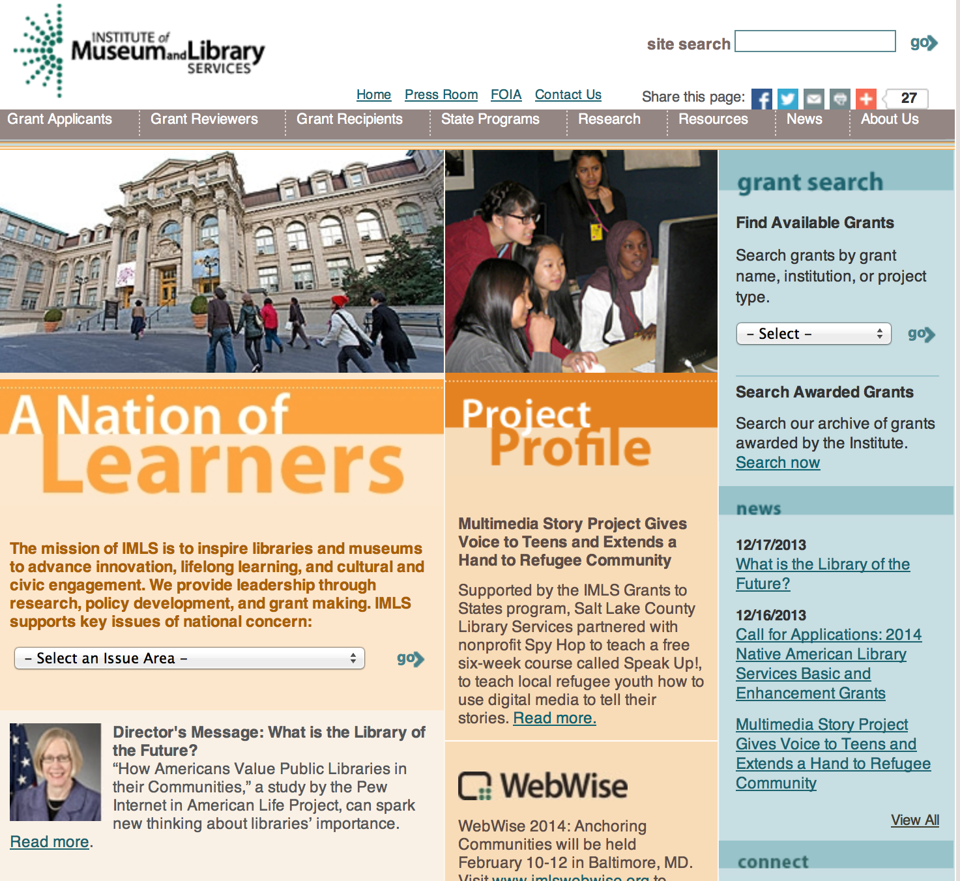

www.imls.gov

To search for awards see chart below:
Also, take advantage of the information with these links:

- Available Grants
  - By Grant Name
  - By Institution Type
  - By Project Type
- Eligibility Criteria
- Sample Applications
- Grants.gov
- Program Guidelines
- After You Apply

Outcome Based Evaluation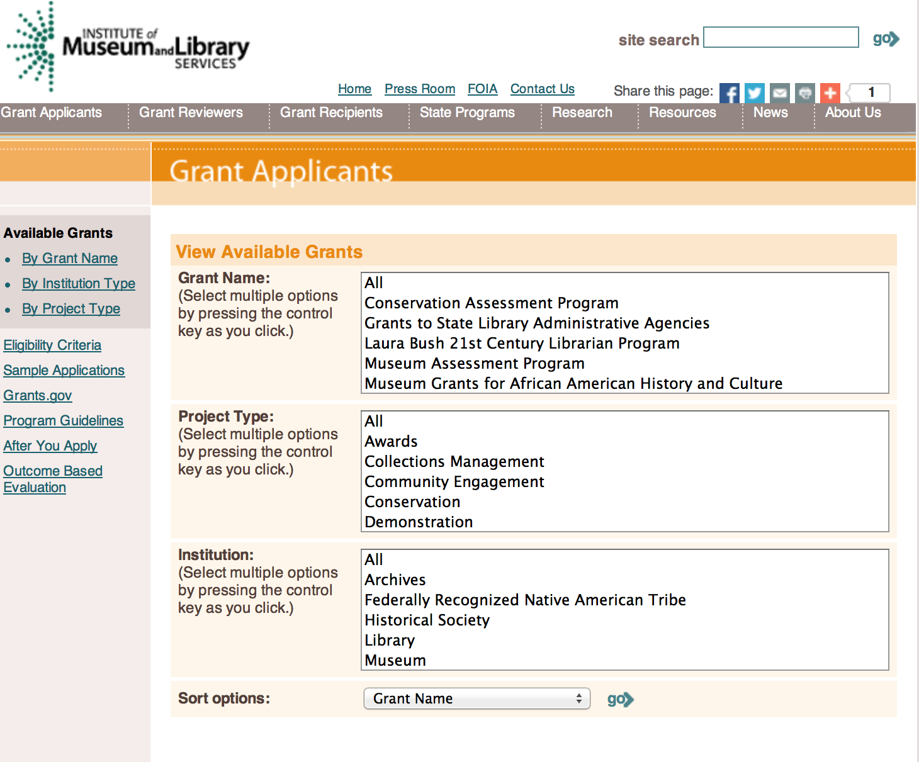

http://www.imls.gov/applicants/available_grants.aspx

Each grant program has specific eligibility requirements. The links below provide general eligibility criteria for museums, libraries, and tribal organizations, but please note that additional organizations may be eligible for grants under certain programs. Additionally, ineligible organizations may still be able to participate in grant programs through partnerships with eligible organizations. Please click on the links below to see general criteria and review Applications and Guidelines for specific information.
Museums Libraries Tribal Organizations

Institutions: Archives, Federally Recognized Native American Tribe, Historical Society, Library, Nonprofits that serve Native Hawaiians, Professional Association, Public or Private Non-profit Institutions of Higher Education, Regional Organization, State Library Administrative Agency, State or Local Government

Check out IMLS's new Facebook page at:
https://www.facebook.com/USIMLS

Museum Assessment Program
Application:
The next MAP application deadline will be July 1, 2015. Please contact MAP staff
to be added to the application notification e-mail list.
Deadline: | July 01, 2015
Program Overview:
The Museum Assessment Program (MAP) is supported through a cooperative agreement between
the Institute of Museum and Library Services and the American Alliance of Museums. It is designed
to help museums assess their strengths and weaknesses, and plan for the future.
A MAP assessment requires members of the museum staff and governing authority to complete
a self-study. After completion of the self-study, a site visit is conducted by one or more museum
professionals, who tour the museum and meet with staff, governing officials, and volunteers. The
reviewers work with the museum and MAP staff to produce a report evaluating the museum's
operations, making recommendations, and suggesting resources.
There are three types of MAP assessments:
- Organizational Assessment: Reviews all areas of operations.
- Collections Stewardship Assessment: Focuses on collections policies, planning access,
documentation, and collections care within the context of the museum's total operations.
- Community Engagement Assessment: Assesses the museum's understanding of and
relationship with its communities as well as its communities' perceptions of and
experiences with the museum.
Eligibility:
Eligible organizations should select one of the assessment types and prepare an application.
Application materials and additional information are located at www.aam-us.org/map.

Modifications:

Reminders:

Department of the Interior
Working with Interior

The Interior Department provides assistance to the public, local governments and businesses through a number of programs. For a general overview see: http://www.doi.gov/index.cfm

Businesses should go to: http://www.doi.gov/businesses/index.cfm

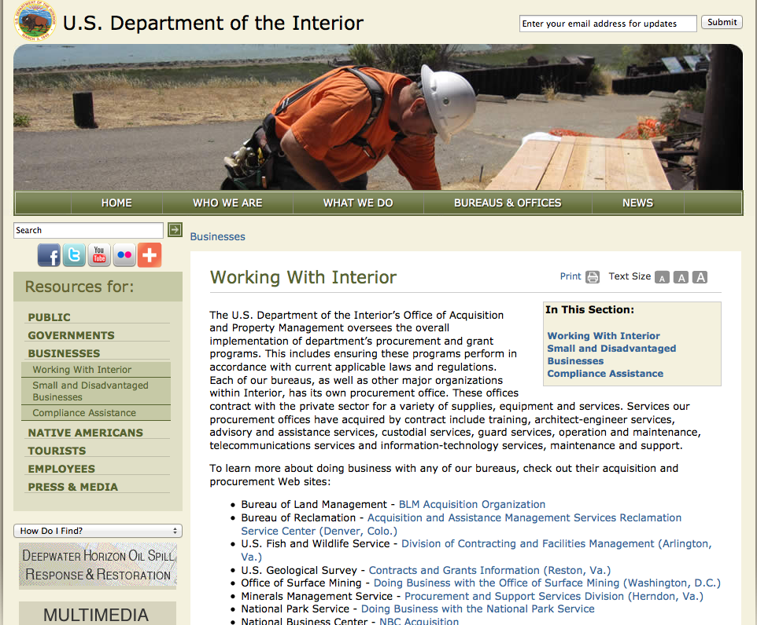

http://www.doi.gov/businesses/working-with-interior.cfm

Programs:

Geological Survey
2016 EHP External Research Support Grant

Document Type: | Grants Notice
Funding Opportunity Number: | G15AS00037
Funding Opportunity Title: | 2016 EHP External Research Support
Opportunity Category: | Discretionary
Funding Instrument Type: | Grant
Category of Funding Activity: | Natural Resources
Category Explanation:
Expected Number of Awards:
CFDA Number(s): | 15.807 -- Earthquake Hazards Research Grants
Cost Sharing or Matching Requirement: | No
Posted Date: | Mar 23, 2015
Creation Date: | Mar 23, 2015
Original Closing Date for Applications: | May 19, 2015
Current Closing Date for Applications: | May 19, 2015
Archive Date: | Jun 18, 2015
Estimated Total Program Funding:
Award Ceiling: | $0
Award Floor: | $0
Eligible Applicants: | Unrestricted (i.e., open to any type of entity above), subject to any clarification in text field entitled "Additional Information on Eligibility"
Agency Name: | Geological Survey
Description: | USGS Earthquake Hazards Program issues this annual Program Announcement for assistance to support research in earthquake hazards, in the physics of earthquakes, earthquake occurrence, and earthquake safety policy.
Link to Additional Information:
Contact Information: | If you have difficulty accessing the full announcement electronically, please contact:  Margaret Eastman Contract Specialist Phone 703-648-7366  mrussell@usgs.gov

http://www.grants.gov/web/grants/view-opportunity.html?oppId=275330

Fish and Wildlife Service
Wildlife Without Borders Latin America and the Caribbean (South America) Grant

Document Type: | Grants Notice
Funding Opportunity Number: | F15AS00118
Funding Opportunity Title: | Wildlife Without Borders Latin America and the Caribbean (South America)
Opportunity Category: | Discretionary
Funding Instrument Type: | Cooperative Agreement  Grant
Category of Funding Activity: | Environment  Natural Resources
Category Explanation:
Expected Number of Awards: | 11
CFDA Number(s): | 15.640 -- Wildlife Without Borders- Latin America and the Caribbean
Cost Sharing or Matching Requirement: | No
Posted Date: | Mar 4, 2015
Creation Date: | Mar 4, 2015
Original Closing Date for Applications: | May 15, 2015
Current Closing Date for Applications: | May 15, 2015
Archive Date: | May 16, 2015
Estimated Total Program Funding: | $500,000
Award Ceiling: | $50,000
Award Floor: | $20,000
Eligible Applicants: | Others (see text field entitled "Additional Information on Eligibility" for clarification)  Private institutions of higher education  Public and State controlled institutions of higher education  Nonprofits having a 501(c)(3) status with the IRS, other than institutions of higher education
Additional Information on Eligibility: | Applicants under this Initiative can be: multi-national secretariats, state and local government agencies; non-profit, non-governmental organizations; and public and private institutions of higher education. U.S. non-profit, non-governmental organizations must submit documentary evidence of their Section 501(c)(3) non-profit status.
Agency Name: | Fish and Wildlife Service
Description: | Program Goal: Conserve priority species, habitats and ecological processes in landscapes with high biodiversity value in South America. Program Objective: Support projects that address the underlying threats and human elements of biodiversity conservation according to the specific funding criteria for one or more of the following two focal programmatic themes: (i) threatened landscapes, and (ii) threatened species.
Link to Additional Information: | How to Apply
Contact Information: | If you have difficulty accessing the full announcement electronically, please contact:  Brian Hayum, 703-358-1885 WWB_LAC@fws.gov  Program inbox

http://www.grants.gov/web/grants/view-opportunity.html?oppId=274921

Modifications:

National Park Service
FY 2015 NAGPRA Grant Program
Modification 1

Document Type: | Grants Notice
Funding Opportunity Number: | P14AS00393
Funding Opportunity Title: | FY 2015 NAGPRA Grant Program
Opportunity Category: | Discretionary
Funding Instrument Type: | Grant
Category of Funding Activity: | Other (see text field entitled "Explanation of Other Category of Funding Activity" for clarification)
Category Explanation: | Assisting in consultation, documentation, and repatriation of Native American cultural items, including human remains, funerary objects, sacred objects, and objects of cultural patrimony.
Expected Number of Awards:
CFDA Number(s): | 15.922 -- Native American Graves Protection and Repatriation Act
Cost Sharing or Matching Requirement: | No
Posted Date: | Oct 1, 2014
Creation Date: | Mar 24, 2015
Original Closing Date for Applications: | Mar 11, 2015
Current Closing Date for Applications: | Jun 1, 2015 Extended the closing date to June 1, 2015
Archive Date: | Aug 1, 2015
Estimated Total Program Funding: | $1,600,000
Award Ceiling: | $90,000
Award Floor: | $1
Eligible Applicants: | Nonprofits that do not have a 501(c)(3) status with the IRS, other than institutions of higher education  Native American tribal organizations (other than Federally recognized tribal governments)  Native American tribal governments (Federally recognized)  State governments  Private institutions of higher education  City or township governments  Public and State controlled institutions of higher education  County governments
Agency Name: | National Park Service
Description: | The National NAGPRA Program assists the Secretary of the Interior with some responsibilities under NAGPRA. Section 10 of NAGPRA authorizes the Secretary of the Interior to make grants to museums, Indian tribes, and Native Hawaiian organizations for the purposes of assisting in consultation, documentation, and repatriation of Native American ¿cultural items,¿ including human remains, funerary objects, sacred objects, and objects of cultural patrimony.
Link to Additional Information: | FY15 NAGPRA Grant Guidelines and Application
Contact Information: | If you have difficulty accessing the full announcement electronically, please contact:  JAMES TUCKER, 202-354-2067 hampton_tucker@nps.gov  hampton_tucker@nps.gov

http://www.grants.gov/web/grants/view-opportunity.html?oppId=267268

Fish and Wildlife Service
NAWCA-15-U.S. STANDARD GRANTS
Modification 2

Document Type: | Grants Notice
Funding Opportunity Number: | F15AS00068
Funding Opportunity Title: | NAWCA-15-U.S. STANDARD GRANTS
Opportunity Category: | Discretionary
Funding Instrument Type: | Grant
Category of Funding Activity: | Natural Resources
Category Explanation:
Expected Number of Awards: | 50
CFDA Number(s): | 15.623 -- North American Wetlands Conservation Fund
Cost Sharing or Matching Requirement: | Yes
Posted Date: | Jan 13, 2015
Creation Date: | Mar 3, 2015
Original Closing Date for Applications: | Feb 27, 2015
Current Closing Date for Applications: | Jul 7, 2015
Archive Date: | Jul 8, 2015
Estimated Total Program Funding: | $50,000,000
Award Ceiling: | $1,000,000
Award Floor: | $75,001
Eligible Applicants: | Unrestricted (i.e., open to any type of entity above), subject to any clarification in text field entitled "Additional Information on Eligibility"
Agency Name: | Fish and Wildlife Service
Description: | The U.S. Standard Grants Program is a competitive, matching grants program that supports public-private partnerships carrying out projects in the United States that further the goals of the North American Wetlands Conservation Act. These projects must involve only long-term protection, restoration, enhancement and/or establishment of wetlands and associated uplands habitats for the benefit of all wetlands-associated migratory birds. A 1:1 match is required. Research funding is ineligible.
Link to Additional Information: | NAWCA U.S. Standard Grant application instructions
Contact Information: | If you have difficulty accessing the full announcement electronically, please contact:  David Buie, U.S. Standard Grant Coordinator, 301-497-5870 david_buie@fws.gov  david_buie@fws.gov

http://www.grants.gov/web/grants/view-opportunity.html?oppId=271374

National Park Service
Historic Preservation Fund Grants to Underrepresented Communities
Modification 1

Document Type: | Grants Notice
Funding Opportunity Number: | P15AS00078
Funding Opportunity Title: | Historic Preservation Fund Grants to Underrepresented Communities
Opportunity Category: | Discretionary
Funding Instrument Type: | Grant
Category of Funding Activity: | Other (see text field entitled "Explanation of Other Category of Funding Activity" for clarification)
Category Explanation: | Historic Preservation
Expected Number of Awards: | 15
CFDA Number(s): | 15.904 -- Historic Preservation Fund Grants-In-Aid
Cost Sharing or Matching Requirement: | No
Posted Date: | Apr 1, 2015
Creation Date: | Apr 1, 2015
Original Closing Date for Applications: | Jun 15, 2015
Current Closing Date for Applications: | Jun 15, 2015
Archive Date: | Jul 1, 2015
Estimated Total Program Funding: | $500,000
Award Ceiling: | $75,000
Award Floor: | $25,000
Eligible Applicants: | State governments  Others (see text field entitled "Additional Information on Eligibility" for clarification)  City or township governments  Native American tribal governments (Federally recognized)  County governments
Additional Information on Eligibility: | Native Alaska Organizations, Native Hawaiian Organizations as defined by 54 U.S.C. 300314. Only local governments that have been designated Certified Local Governments (CLG) by the NPS and their SHPO may apply. A list of CLGs is found here: http://grantsdev.cr.nps.gov/CLG_Review/search.cfm
Agency Name: | National Park Service
Description: | Grant projects must support the survey, inventory, and designation of historic properties that are associated with communities currently underrepresented in the National Register of Historic Places and among National Historic Landmarks, as determined by the National Park Service and the applicant.
Link to Additional Information: | http://www.nps.gov/preservation-grants/community-grants.html
Contact Information: | If you have difficulty accessing the full announcement electronically, please contact:  HAMPTON TUCKER, hampton_tucker@nps.gov  hampton_tucker@nps.gov

http://www.grants.gov/web/grants/view-opportunity.html?oppId=275597

Reminders:

Fish and Wildlife Service
The Partners for Fish and Wildlife Program
Modification 3
Document Type: | Grants Notice
Funding Opportunity Number: | F15AS00004
Funding Opportunity Title: | The Partners for Fish and Wildlife Program
Opportunity Category: | Discretionary
Funding Instrument Type: | Cooperative Agreement
Category of Funding Activity: | Environment  Natural Resources
Category Explanation:
Expected Number of Awards: | 5000
CFDA Number(s): | 15.631 -- Partners for Fish and Wildlife
Cost Sharing or Matching Requirement: | No
Posted Date: | Oct 7, 2014
Creation Date: | Jan 30, 2015
Original Closing Date for Applications: | Sep 30, 2015 For the full program announcement and applications, please click the "Full Announcement" link above.
Current Closing Date for Applications: | Sep 30, 2015 For the full program announcement and applications, please click the "Full Announcement" link above.
Archive Date: | Oct 7, 2015
Estimated Total Program Funding: | $52,000,000
Award Ceiling: | $500,000
Eligible Applicants: | State governments  Small businesses  Individuals  Public and State controlled institutions of higher education  Nonprofits that do not have a 501(c)(3) status with the IRS, other than institutions of higher education  Native American tribal organizations (other than Federally recognized tribal governments)  City or township governments  Private institutions of higher education  Native American tribal governments (Federally recognized)  For profit organizations other than small businesses  Nonprofits having a 501(c)(3) status with the IRS, other than institutions of higher education  County governments
Agency Name: | Fish and Wildlife Service
Description: | The Partners for Fish and Wildlife (PFW) Program is a voluntary, incentive-based program that provides direct technical assistance and financial assistance in the form of cooperative agreements to private landowners to restore and conserve fish and wildlife habitat for the benefit of federal trust resources. The PFW Program is delivered through more than 250 full-time staff, active in all 50 States and territories. Partners for Fish and Wildlife Program staff coordinate with project partners, stakeholders and other Service programs to identify geographic focus areas and develop habitat conservation priorities within these focus areas. Geographic focus areas are where the PFW Program directs resources to conserve habitat for federal trust species. Project work plans are developed strategically, in coordination with partners, and with substantial involvement from Service field staff. Projects must advance our mission, promote biological diversity, and be based upon sound scientific biological principles. Program strategic plans inform the types of projects funded under this opportunity. Applicants seeking funding under this program should review the program strategic plan and also contact the regional PFW Program office prior to submitting an application for funding.
Link to Additional Information: | http://www.grants.gov
Contact Information: | If you have difficulty accessing the full announcement electronically, please contact:  Michael Murray, 703 358 2031 michael_murray@fws.gov  michael_murray@fws.gov

http://www.grants.gov/web/grants/view-opportunity.html?oppId=268198

Fish and Wildlife Service
Fiscal Year 2015 Recovery Implementation Fund Grant

Document Type: | Grants Notice
Funding Opportunity Number: | F15AS00038
Funding Opportunity Title: | Fiscal Year 2015 Recovery Implementation Fund
Opportunity Category: | Discretionary
Funding Instrument Type: | Cooperative Agreement  Grant  Procurement Contract
Category of Funding Activity: | Environment  Natural Resources
Category Explanation:
Expected Number of Awards:
CFDA Number(s): | 15.657 -- Endangered Species Conservation - Recovery Implementation Funds
Cost Sharing or Matching Requirement: | No
Posted Date: | Dec 5, 2014
Creation Date: | Dec 5, 2014
Original Closing Date for Applications: | Jul 31, 2015 Applications are due by July 31, 2015. However, you may submit applications throughout the year. Consideration of applications ultimately will be based on the FWS budget cycle.
Current Closing Date for Applications: | Jul 31, 2015 Applications are due by July 31, 2015. However, you may submit applications throughout the year. Consideration of applications ultimately will be based on the FWS budget cycle.
Archive Date: | Oct 31, 2015
Eligible Applicants: | Unrestricted (i.e., open to any type of entity above), subject to any clarification in text field entitled "Additional Information on Eligibility"
Additional Information on Eligibility: | Applicants must have a demonstrated knowledge and understanding of the biology of the involved endangered or threatened species in the United States and their ecosystem, including preferably having worked with the species in the field and holding a currently valid Endangered Species Act permit, issued by the FWS, authorizing them to work with these species (or that have previously held a permit to do so). If funding is awarded, applicants that do not currently hold a valid permit for the proposed activity may need to apply for and obtain a permit (http://www.fws.gov/endangered/permits/index.html) before beginning the proposed activity. FWS Regional (or Field Office) contacts will discuss potential proposals with interested parties if needed, and review eligible applications. The FWS Regional Office will refer interested parties to the appropriate FWS Field Office for further consideration as appropriate. For potential proposals submitted directly to the Field Office, the Field Office will conduct the proposal review and selection process. A list of FWS Regional Office contacts is available in the Full Announcement under section VII. Agency Contacts.
Agency Name: | Fish and Wildlife Service
Description: | The FWS Ecological Services Program provides Federal financial assistance on a competitive basis to States, other Federal agencies, landowners, educators, non-profit organizations, researchers, and other partners to secure information about endangered, threatened or candidate species, to aid in the recovery of these species, to avert listing of species pursuant to the Endangered Species Act, and to help conserve the ecosystems upon which these species depend. The FWS and National Marine Fisheries Service (NMFS), which is part of the Department of Commerce’s NOAA Fisheries office, share Endangered Species Act responsibilities for several species such as sea turtles. We have responsibility for sea turtles when they are on land, and NMFS has responsibility for sea turtles when they are in the water. Projects for NMFS-managed species are not included in this funding opportunity. This Recovery Implementation funding opportunity is intended for projects that will contribute to the recovery of FWS-managed endangered and threatened species in the United States, and is limited to projects carrying out actions described in a species approved recovery plan, in the implementation schedule of a species approved recovery plan, actions recommended in a completed 5-year status review of the species or in a spotlight species action plan, or projects documenting species response to climate change. For example: securing scientific information about endangered or threatened species, implementing restoration actions that will lead to delisting of a species, help prevent extinction of a species, or aid in the recovery of a species. Projects that address species response to climate change will receive additional consideration.
Link to Additional Information: | Please visit http://www.grants.gov/ and search for CFDA Number 15.657 for the full announcement
Contact Information: | If you have difficulty accessing the full announcement electronically, please contact:  Kelly Niland, 703-358-2492 Kelly_Niland@fws.gov  Kelly_Niland@fws.gov

http://www.grants.gov/web/grants/view-opportunity.html?oppId=270169

Fish and Wildlife Service
The Coastal Program Grant

Document Type: | Grants Notice
Funding Opportunity Number: | F15AS00005
Funding Opportunity Title: | The Coastal Program
Opportunity Category: | Discretionary
Funding Instrument Type: | Cooperative Agreement
Category of Funding Activity: | Environment  Natural Resources
Category Explanation:
Expected Number of Awards: | 500
CFDA Number(s): | 15.630 -- Coastal Program
Cost Sharing or Matching Requirement: | No
Posted Date: | Oct 8, 2014
Creation Date: | Oct 8, 2014
Original Closing Date for Applications: | Sep 30, 2015 Please click on the "Full Announcement" link above or contact the local Coastal Program office at http://www.fws.gov/coastal/contactUs.html
Current Closing Date for Applications: | Sep 30, 2015 Please click on the "Full Announcement" link above or contact the local Coastal Program office at  http://www.fws.gov/coastal/contactUs.html
Archive Date: | Oct 1, 2015
Estimated Total Program Funding: | $6,000
Award Ceiling: | $500,000
Award Floor: | $0
Eligible Applicants: | Native American tribal organizations (other than Federally recognized tribal governments)  Nonprofits having a 501(c)(3) status with the IRS, other than institutions of higher education  Public and State controlled institutions of higher education  Native American tribal governments (Federally recognized)  Private institutions of higher education  State governments  Small businesses  Nonprofits that do not have a 501(c)(3) status with the IRS, other than institutions of higher education  City or township governments  Individuals  For profit organizations other than small businesses  County governments  Special district governments
Agency Name: | Fish and Wildlife Service
Description: | The Coastal Program is a voluntary, incentive-based program that provides direct technical assistance and financial assistance in the form of cooperative agreements to coastal communities and landowners to restore and protect fish and wildlife habitat on public and private lands. Coastal Program staff coordinate with project partners, stakeholders and other Service programs to identify geographic focus areas and develop habitat conservation priorities within these focus areas. Geographic focus areas are where the Coastal Program directs resources to conserve habitat for federal trust species. Project work plans are developed strategically, in coordination with partners, and with substantial involvement from Service field staff. Projects must advance our mission, promote biological diversity, and be based upon sound scientific biological principles. Program strategic plans inform the types of projects funded under this opportunity. Applicants seeking funding under this program should review the program strategic plan and also contact the regional Coastal Program office prior to submitting an application for funding.
Link to Additional Information: | http://www.grants.gov
Contact Information: | If you have difficulty accessing the full announcement electronically, please contact:  Gerri Watkins, Management Analyst, 7033582101 Gerri_Watkins@fws.gov  Gerri_Watkins@fws.gov

http://www.grants.gov/web/grants/view-opportunity.html?oppId=268288

Fish and Wildlife Service
Cooperative Landscape Conservation and Science Support Grant
Document Type: | Grants Notice
Funding Opportunity Number: | F15AS00000
Funding Opportunity Title: | Cooperative Landscape Conservation and Science Support
Opportunity Category: | Discretionary
Funding Instrument Type: | Cooperative Agreement
Category of Funding Activity: | Natural Resources
Category Explanation:
Expected Number of Awards:
CFDA Number(s): | 15.669 -- Cooperative Landscape Conservation  15.670 -- Adaptive Science
Cost Sharing or Matching Requirement: | No
Posted Date: | Oct 1, 2014
Creation Date: | Sep 30, 2014
Original Closing Date for Applications: | Sep 30, 2015
Current Closing Date for Applications: | Sep 30, 2015
Archive Date: | Oct 30, 2015
Estimated Total Program Funding:
Award Ceiling: | $1,000,000
Award Floor: | $1,000
Eligible Applicants: | Unrestricted (i.e., open to any type of entity above), subject to any clarification in text field entitled "Additional Information on Eligibility"
Agency Name: | Fish and Wildlife Service
Description: | The USFWS uses a science-based, adaptive framework for setting and achieving cross-program conservation objectives that strategically address the problems fish and wildlife will face in the future. This framework, called Strategic Habitat Conservation, is based on the principles of adaptive management and uses population and habitat data, ecological models, and focused monitoring and assessment efforts to develop and implement strategies that result in measurable fish and wildlife population outcomes. In addition, by leveraging resources and strategically targeting science to inform conservation decisions and actions, Landscape Conservation Cooperatives (LCCs) have created a network of partners working in unison to ensure the sustainability of America’s land, water, wildlife and cultural resources. Financial assistance may be awarded for science projects and LCC-prioritized biological planning, conservation design and adaptive management projects to include: research; inventory design and implementation; monitoring; goal and priority setting associated with efficient and effective conservation; development of implementation strategies; and projects supporting all other FWS organizational efforts, including planning, establishment maintenance, and general business operations. Proposals will be reviewed and evaluated on a rolling basis subject to available funding.
Link to Additional Information:
Contact Information: | If you have difficulty accessing the full announcement electronically, please contact:  Anna-Marie York Grants Management Specialist Phone 703-358-1881  Grant Specialist

http://www.grants.gov/web/grants/view-opportunity.html?oppId=267539

Department of Justice

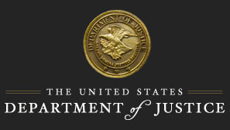

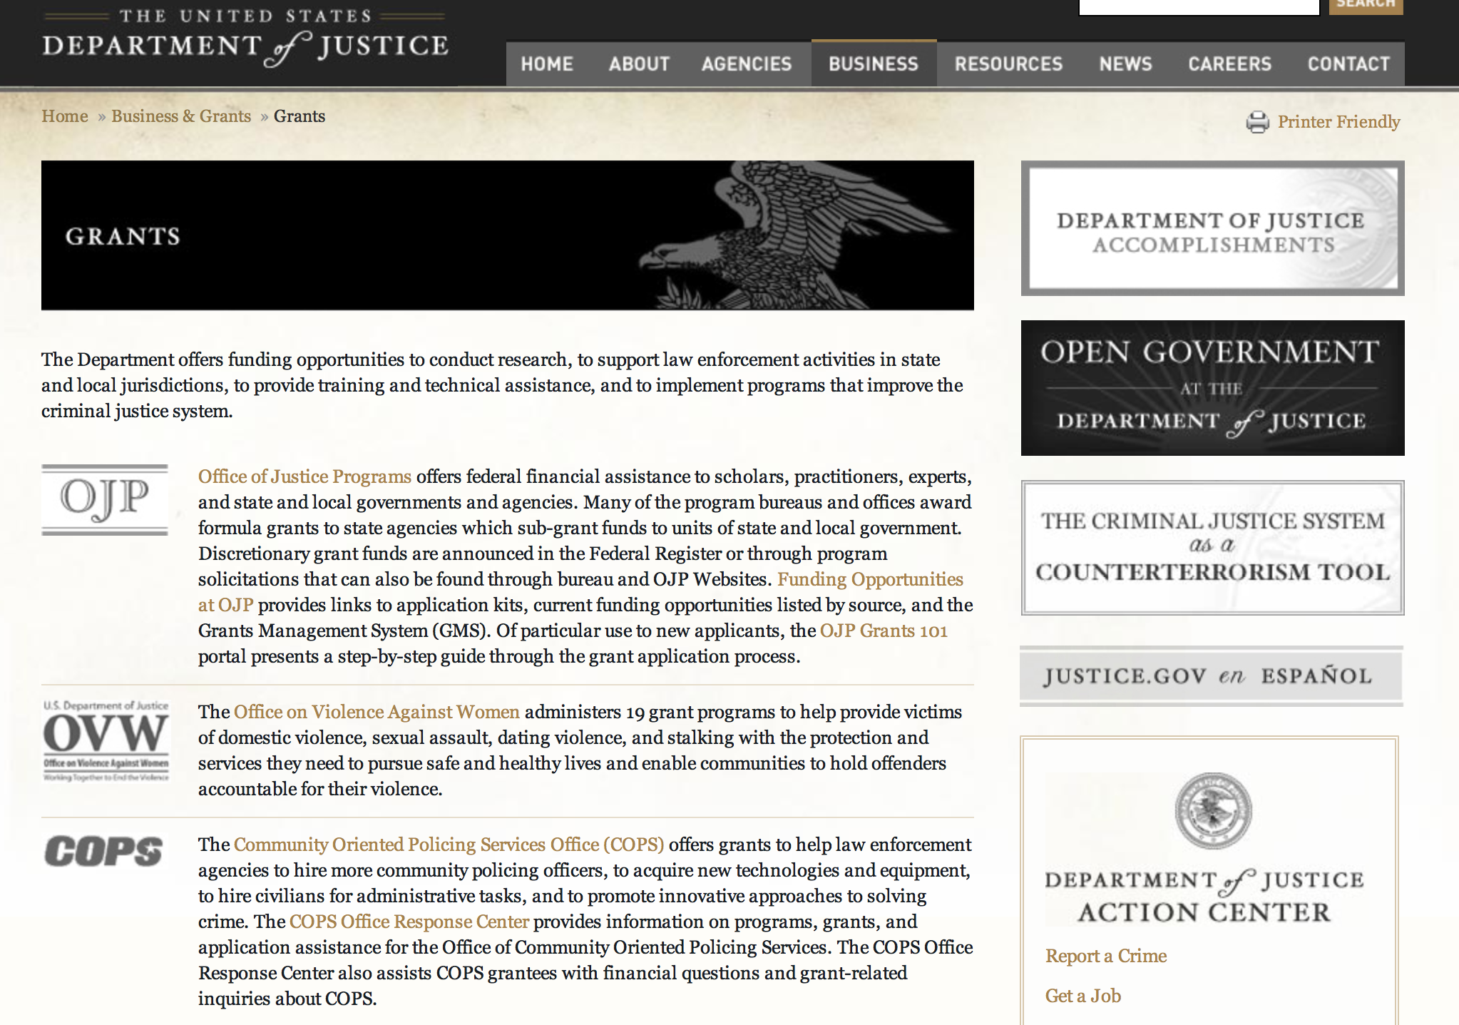

http://www.justice.gov/business/

Grants and Contract Overview

The Department offers funding opportunities to conduct research, to support law enforcement activities in state and local jurisdictions, to provide training and technical assistance, and to implement programs that improve the criminal justice system.

The DOJ agencies listed below also have sites that provide grant information specific to that agency. Examples of what can be found on these sites are programs, funding opportunities, application assistance, and other useful information.
- Bureau of Justice Assistance (BJA)
- Bureau of Justice Statistics (BJS)
- National Criminal Justice Reference Service (NCJRS)
- National Institute of Justice (NIJ)
- Office of Juvenile Justice and Delinquency Prevention (OJJDP)
- Office of Sex Offender Sentencing, Monitoring, Apprehending, Registering, and Tracking (SMART)
- Office for Victims of Crime (OVC)

Programs:

Office of Justice Programs
Bureau of Justice Assistance
BJA FY 15 Second Chance Act Two-Phase Adult Reentry Demonstration Program: Planning and Implementation Grant

Document Type: | Grants Notice
Funding Opportunity Number: | BJA-2015-4110
Funding Opportunity Title: | BJA FY 15 Second Chance Act Two-Phase Adult Reentry Demonstration Program: Planning and Implementation
Opportunity Category: | Discretionary
Funding Instrument Type: | Grant
Category of Funding Activity: | Law, Justice and Legal Services
Category Explanation:
Expected Number of Awards: | 10
CFDA Number(s): | 16.812 -- Second Chance Act Reentry Initiative
Cost Sharing or Matching Requirement: | Yes
Posted Date: | Mar 4, 2015
Creation Date: | Mar 4, 2015
Original Closing Date for Applications: | Apr 29, 2015
Current Closing Date for Applications: | Apr 29, 2015
Archive Date: | May 29, 2015
Estimated Total Program Funding:
Award Ceiling: | $1,000,000
Award Floor: | $0
Eligible Applicants: | Others (see text field entitled "Additional Information on Eligibility" for clarification)  City or township governments  State governments  Native American tribal governments (Federally recognized)  County governments
Additional Information on Eligibility: | Eligible applicants are limited to state and local government agencies and federally recognized Indian tribes (as determined by the Secretary of the Interior). Existing SCA Adult Reentry Demonstration Program grantees are eligible and may apply to expand or modify an existing program, including adding additional reentry services, a research partner and/or evaluation component.
Agency Name: | Bureau of Justice Assistance
Description: | There are currently over 2.2 million individuals serving time in federal and state prisons, and millions of people cycle through local jails every year. Of those in state and federal prison, approximately 95 percent will be released and return to communities across the nation. A majority of these individuals have needs that, if unaddressed in prison, during the reentry process, and after release, will negatively impact their ability to live productive, prosocial, crime-free lives in the community. When inmates are released from prison, they face a myriad of challenges, including finding housing and employment, combating substance abuse, and addressing physical and mental health problems. Without community-based support, they are less likely to return back to their communities with the means to address these challenges, and thus will be more likely to offend again. While members of Native American tribes who are incarcerated possess similar needs, addressing them successfully can be particularly challenging because members of tribal communities return from federal, Bureau of Indian Affairs (BIA), state, local, and tribal facilities. In addition to the difficulties associated with the coordination of services for individuals returning from these diverse facilities, services to address the various needs of the formerly incarcerated often do not exist on tribal lands. The Second Chance Act of 2007 (Pub. L. 110-199) helps to address these significant challenges by providing comprehensive responses to the significant number of incarcerated adults who are returning to communities from prison, jail, and juvenile residential facilities. Programs funded under the Second Chance Act help to promote public safety by ensuring that the transition individuals make from prison and jail to the community is successful. Section 101 of the Second Chance Act authorizes federal awards to state and local governments and federally recognized Indian tribes that may be used for demonstration projects to promote the safe and successful reintegration into the community of individuals who have been incarcerated or detained. Funding for this program is authorized under FY 2015 Department of Justice appropriation.
Link to Additional Information: | Full Announcement
Contact Information: | If you have difficulty accessing the full announcement electronically, please contact:  For technical assistance with submitting an application, contact the Grants.gov Customer Support Hotline at 800-518-4726 or 606-545-5035, or via e-mail to support@grants.gov. The Grants.gov Support Hotline hours of operation are 24 hours a day, 7 days a week, except federal holidays.  Technical Support

http://www.grants.gov/web/grants/view-opportunity.html?oppId=274937

Office of Justice Programs
Bureau of Justice Assistance
BJA FY 15 National Sexual Assault Kit Initiative (SAKI) Grant

Document Type: | Grants Notice
Funding Opportunity Number: | BJA-2015-4115
Funding Opportunity Title: | BJA FY 15 National Sexual Assault Kit Initiative (SAKI)
Opportunity Category: | Discretionary
Funding Instrument Type: | Grant
Category of Funding Activity: | Law, Justice and Legal Services
Category Explanation:
Expected Number of Awards: | 12
CFDA Number(s): | 16.833 -- National Sexual Assault Kit Initiative
Cost Sharing or Matching Requirement: | No
Posted Date: | Mar 9, 2015
Creation Date: | Mar 9, 2015
Original Closing Date for Applications: | May 7, 2015
Current Closing Date for Applications: | May 7, 2015
Archive Date: | Jun 6, 2015
Estimated Total Program Funding:
Award Ceiling: | $2,000,000
Eligible Applicants: | Others (see text field entitled "Additional Information on Eligibility" for clarification)
Additional Information on Eligibility: | Eligible applicants are state, local, and tribal law enforcement agencies, prosecutor’s offices, or a governmental non-law enforcement agency acting as fiscal agent for the applicant. BJA welcomes applications that involve two or more entities; however, one eligible entity must be the applicant and the others must be proposed as subrecipients. The lead applicant must be a state, local, or tribal law enforcement agency, prosecutor’s office, or a governmental non-law enforcement agency acting as fiscal agent for the applicant and the entity with primary responsibility for administering the funding and managing the entire program. Only one application per lead applicant will be considered; however, subrecipients may be part of multiple proposals.
Agency Name: | Bureau of Justice Assistance
Description: | The National Sexual Assault Kit Initiative (SAKI), administered by BJA, provides funding through a competitive grant program to support multidisciplinary community response teams engaged in the comprehensive reform of jurisdictions’ approaches to sexual assault cases resulting from evidence found in previously unsubmitted sexual assault kits (SAKs). Unsubmitted kits (those in in police custody that have never been submitted to a crime laboratory for testing) and untested kits (those that have been submitted to crime labs but are delayed for testing for longer than 30 days, e.g., as a result of a backlog of work in the laboratory) are separate and distinct issues. The focus of this effort is on those unsubmitted kits that have never been submitted to a crime laboratory. The goal of the SAKI is the creation of a coordinated community response that ensures just resolution to these cases whenever possible through a victim-centered approach, as well as to build jurisdictions’ capacity to prevent the development of conditions that lead to high numbers of unsubmitted SAKs in the future. This holistic program provides jurisdictions with resources to address their unsubmitted SAK issue, including support to inventory, test, and track SAKs; create and report performance metrics; access necessary training to increase effectiveness in addressing the complex issues associated with these cases and engage in multidisciplinary policy development, implementation, and coordination; and improve practices related to investigation, prosecution, and victim engagement and support in connection with evidence and cases resulting from the testing process. Research supported by the National Institute of Justice (NIJ) on unsubmitted SAKs at pilot sites in Detroit, Michigan and Houston, Texas supports the value of testing unsubmitted SAKs in solving sexual assault cases1. It has also highlighted the complexity of the issue. Unsubmitted SAKs in the custody of law enforcement agencies can be attributed to a wide range of factors, including poor evidence tracking, outdated and ineffective investigation practices, misunderstanding of crime lab case acceptance policies, and lack of understanding among law enforcement about the value of testing kits in various types of cases2.3 This recent research identified the need for more trained investigative and prosecutorial resources to deal with the increased number of investigations and prosecutions resulting from testing a high number of previously unsubmitted SAKs, as well as the importance of linking victims to needed services. Thus, the critical needs around this issue extend well beyond testing kits and increasing crime lab capacity; this program also addresses the investigative and prosecutorial aspects of sexual assault cases resulting from the testing and enhancing provision of victim services.
Link to Additional Information: | Full Announcement
Contact Information: | If you have difficulty accessing the full announcement electronically, please contact:  For technical assistance with submitting an application, contact the Grants.gov Customer Support Hotline at 800-518-4726 or 606-545-5035, or via e-mail to support@grants.gov. The Grants.gov Support Hotline hours of operation are 24 hours a day, 7 days a week, except federal holidays.  Technical Support

http://www.grants.gov/web/grants/view-opportunity.html?oppId=275012

Office of Justice Programs
Bureau of Justice Assistance
BJA FY 15 Anti-Human Trafficking National Training and Technical Assistance Program for Law Enforcement Task Forces Grant
And Modification 1

Document Type: | Grants Notice
Funding Opportunity Number: | BJA-2015-4114
Funding Opportunity Title: | BJA FY 15 Anti-Human Trafficking National Training and Technical Assistance Program for Law Enforcement Task Forces
Opportunity Category: | Discretionary
Funding Instrument Type: | Grant
Category of Funding Activity: | Law, Justice and Legal Services
Category Explanation:
Expected Number of Awards:
CFDA Number(s): | 16.320 -- Services for Trafficking Victims
Cost Sharing or Matching Requirement: | No
Posted Date: | Mar 5, 2015
Creation Date: | Mar 12, 2015
Original Closing Date for Applications: | Apr 20, 2015
Current Closing Date for Applications: | Apr 21, 2015
Archive Date: | May 21, 2015
Estimated Total Program Funding:
Award Ceiling: | $1,000,000
Eligible Applicants: | Nonprofits having a 501(c)(3) status with the IRS, other than institutions of higher education  Private institutions of higher education  For profit organizations other than small businesses  Public and State controlled institutions of higher education  Others (see text field entitled "Additional Information on Eligibility" for clarification)
Additional Information on Eligibility: | Eligible applicants are limited to for-profit organizations, nonprofit organizations (including tribal nonprofit or for-profit organizations), faith-based and community organizations, institutions of higher education (including tribal institutions of higher education), and consortiums with demonstrated experience providing national and local-level training and technical assistance to law enforcement agencies and prosecutors in the areas of human trafficking task force development, implementation, and operation. Demonstrated experience in delivering anti- human trafficking training to law enforcement agencies and their identified partners is required. For-profit organizations must agree to waive any profit or fees for services. BJA welcomes applications that involve two or more entities; however, one eligible entity must be the applicant and the others must be proposed as sub-recipients. The applicant must be the entity with primary responsibility for administering the funding and managing the project. Only one application per lead applicant will be considered; however, sub-recipients may be part of multiple proposals.
Agency Name: | Bureau of Justice Assistance
Description: | The Anti-Human Trafficking National Training and Technical Assistance Program for Law Enforcement Task Forces, administered by BJA, is designed to provide national support and improve the capacity of state, local, and tribal criminal justice systems to increase their capacity to create and effectively operate enhanced collaborative model (ECM) human trafficking task forces, formed to investigate and prosecute the crime of human trafficking, as defined by the Trafficking Victims Protection Act (TVPA) of 2000. BJA has provided anti-human trafficking training to law enforcement since 2005; state prosecutors and judges since 2011; and tribal entities since 2013. The statutory authority for this program is 22 U.S.C. § 7105(b)(2). This program is designed to provide training and technical assistance (TTA) resources that are critical to communities’ efforts to address all forms of human trafficking, through a victim- centered, enhanced collaborative approach. ECM task forces are required to be collaborative, working partnerships between local, state, and/or federal law enforcement agencies, victim service providers and other key stakeholders for the purpose of identifying victims of all forms of human trafficking, conducting proactive investigations, and effectively prosecuting the traffickers, while rescuing the victims and providing needed services. The goal of the Anti-Human Trafficking Training and Technical Assistance for Law Enforcement Task Forces Program is to provide assistance to state and local law enforcement, criminal justice professionals (e.g., academic, adjudication, judicial, etc.), and communities to improve the level of knowledge, communication, collaboration, and tactics involved in addressing human trafficking in communities throughout the nation. The program combines the leadership of DOJ and the expertise of nationally recognized criminal justice practitioners and action research experts to deliver a wide variety of TTA nationwide. Programs funded under this solicitation are intended to have a national impact. This grant announcement specifically requests applications for a nationwide TTA assistance provider; it does not solicit applications from individual jurisdictions to establish state and local anti-human trafficking task forces or training projects.
Link to Additional Information: | Full Announcement
Contact Information: | If you have difficulty accessing the full announcement electronically, please contact:  For technical assistance with submitting an application, contact the Grants.gov Customer Support Hotline at 800-518-4726 or 606-545-5035, or via e-mail to support@grants.gov. The Grants.gov Support Hotline hours of operation are 24 hours a day, 7 days a week, except federal holidays.  Technical Assistance

http://www.grants.gov/web/grants/view-opportunity.html?oppId=274955

Office of Justice Programs
Bureau of Justice Assistance
BJA FY 15 Firearm Locks Distribution and Safe Storage Program Grant

Document Type: | Grants Notice
Funding Opportunity Number: | BJA-2015-4122
Funding Opportunity Title: | BJA FY 15 Firearm Locks Distribution and Safe Storage Program
Opportunity Category: | Discretionary
Funding Instrument Type: | Grant
Category of Funding Activity: | Law, Justice and Legal Services
Category Explanation:
Expected Number of Awards:
CFDA Number(s): | 16.738 -- Edward Byrne Memorial Justice Assistance Grant Program
Cost Sharing or Matching Requirement: | No
Posted Date: | Mar 11, 2015
Creation Date: | Mar 11, 2015
Original Closing Date for Applications: | Apr 27, 2015
Current Closing Date for Applications: | Apr 27, 2015
Archive Date: | May 27, 2015
Estimated Total Program Funding:
Award Ceiling: | $2,600,000
Eligible Applicants: | Others (see text field entitled "Additional Information on Eligibility" for clarification)  For profit organizations other than small businesses  Nonprofits having a 501(c)(3) status with the IRS, other than institutions of higher education
Additional Information on Eligibility: | Eligible applicants are limited to for-profit organizations, nonprofit organizations (including tribal nonprofit or for-profit organizations), faith-based and community organizations, institutions of higher education (including tribal institutions of higher education), and consortiums. For-profit organizations must agree to waive any profit or fees for services. BJA welcomes applications that involve collaboration between two or more entities; however, one eligible entity must be the applicant and the others must be proposed as sub-recipients. The applicant must be the entity with primary responsibility for conducting and leading the program.
Agency Name: | Bureau of Justice Assistance
Description: | The FY 2015 Firearm Locks Distribution and Safe Storage Program, administered by BJA, is designed to provide national support and promote safe firearms storage practices through the distribution of free firearm locks and safety kits and promote a greater awareness of simple precautions every gun owner can take to ensure his or her firearms don't pose a danger to children or the community. This program is funded through the Consolidated and Further Continuing Appropriations Act, 2015 (P.L. 113-235),
Link to Additional Information: | Full Announcement
Contact Information: | If you have difficulty accessing the full announcement electronically, please contact:  For technical assistance with submitting an application, contact the Grants.gov Customer Support Hotline at 800-518-4726 or 606-545-5035, or via e-mail to support@grants.gov. The Grants.gov Support Hotline hours of operation are 24 hours a day, 7 days a week, except federal holidays.  Technical Assistance

http://www.grants.gov/web/grants/view-opportunity.html?oppId=275095

Office of Justice Programs
National Institute of Justice
NIJ FY 15 Research and Evaluation on Trafficking in Persons Grant

Document Type: | Grants Notice
Funding Opportunity Number: | NIJ-2015-3989
Funding Opportunity Title: | NIJ FY 15 Research and Evaluation on Trafficking in Persons
Opportunity Category: | Discretionary
Funding Instrument Type: | Grant
Category of Funding Activity: | Law, Justice and Legal Services
Category Explanation:
Expected Number of Awards: | 40
CFDA Number(s): | 16.560 -- National Institute of Justice Research, Evaluation, and Development Project Grants
Cost Sharing or Matching Requirement: | No
Posted Date: | Mar 27, 2015
Creation Date: | Mar 27, 2015
Original Closing Date for Applications: | May 27, 2015
Current Closing Date for Applications: | May 27, 2015
Archive Date: | Jun 26, 2015
Estimated Total Program Funding: | $4,000,000
Award Ceiling: | $4,000,000
Award Floor: | $1,000
Eligible Applicants: | Independent school districts  Public housing authorities/Indian housing authorities  City or township governments  For profit organizations other than small businesses  Individuals  Native American tribal organizations (other than Federally recognized tribal governments)  Private institutions of higher education  Small businesses  County governments  Native American tribal governments (Federally recognized)  Nonprofits having a 501(c)(3) status with the IRS, other than institutions of higher education  Public and State controlled institutions of higher education  Special district governments  Nonprofits that do not have a 501(c)(3) status with the IRS, other than institutions of higher education  State governments
Agency Name: | National Institute of Justice
Description: | NIJ is seeking proposals for research and evaluation projects that support and inform federal, State, local and tribal criminal justice agencies and victim service providers in responding to the challenges that trafficking in persons (hereinafter “trafficking in persons,” “human trafficking,” or “trafficking”) poses in their jurisdictions. NIJ is particularly interested in research responding to the following priority areas: • Fostering partnerships between researchers and trafficking survivors. • Evaluation of the Enhanced Collaborative Model Human Trafficking Task Forces. • Perception of human trafficking victimization in courts (judges, jurors, prosecutors). • The extent to which existing crime reporting and data systems capture the human trafficking victimization that occurs in a particular jurisdiction. • Trafficking and sex offender registries.
Link to Additional Information: | Full Solicitation
Contact Information: | If you have difficulty accessing the full announcement electronically, please contact:  Dr. John T. Picarelli, Program Manager 202-307-3213  Program Manager

http://www.grants.gov/web/grants/view-opportunity.html?oppId=275483

Office of Justice Programs
National Institute of Justice
NIJ FY 15 Data Resources Program: Funding for Analysis of Existing Data Grant

Document Type: | Grants Notice
Funding Opportunity Number: | NIJ-2015-3974
Funding Opportunity Title: | NIJ FY 15 Data Resources Program: Funding for Analysis of Existing Data
Opportunity Category: | Continuation
Funding Instrument Type: | Grant
Category of Funding Activity: | Law, Justice and Legal Services
Category Explanation:
Expected Number of Awards: | 5
CFDA Number(s): | 16.560 -- National Institute of Justice Research, Evaluation, and Development Project Grants
Cost Sharing or Matching Requirement: | No
Posted Date: | Mar 30, 2015
Creation Date: | Apr 1, 2015
Original Closing Date for Applications: | May 29, 2015
Current Closing Date for Applications: | May 29, 2015
Archive Date: | Jun 28, 2015
Estimated Total Program Funding: | $200,000
Award Ceiling: | $40,000
Award Floor: | $1,000
Eligible Applicants: | Nonprofits that do not have a 501(c)(3) status with the IRS, other than institutions of higher education  Nonprofits having a 501(c)(3) status with the IRS, other than institutions of higher education  Small businesses  Public housing authorities/Indian housing authorities  City or township governments  Independent school districts  Private institutions of higher education  Special district governments  Public and State controlled institutions of higher education  County governments  Native American tribal governments (Federally recognized)  State governments  Individuals  For profit organizations other than small businesses  Native American tribal organizations (other than Federally recognized tribal governments)
Agency Name: | National Institute of Justice
Description: | NIJ, in partnership with the Bureau of Justice Statistics (BJS) and the Office of Juvenile Justice and Delinquency Prevention (OJJDP), is seeking proposals under the Data Resources Program (DRP) for original research using existing data available from the National Archive of Criminal Justice Data (NACJD) and other public sources. NACJD houses quantitative and qualitative data from research funded by these three agencies. The data are made available online at no cost as downloadable, machine-readable files. Copies of documentation, such as user guides and codebooks, are also available at no charge. NACJD is maintained by the Inter-University Consortium for Political and Social Research at the University of Michigan and is supported by NIJ, BJS, and OJJDP. Highest priority will be given to research that addresses compelling crime and criminal justice questions involving juvenile and adult populations, and that uses NIJ, BJS, or OJJDP data at NACJD.
Link to Additional Information: | Full Solicitation
Contact Information: | If you have difficulty accessing the full announcement electronically, please contact:  Jennifer Scherer, Supervisory Social Science Analyst, (202) 305-7256  Program Manager

http://www.grants.gov/web/grants/view-opportunity.html?oppId=275516

Office of Justice Programs
Bureau of Justice Assistance
BJA FY 15 Second Chance Act Technology-Based Career Training Program for Incarcerated Adults and Juveniles Grant

Document Type: | Grants Notice
Funding Opportunity Number: | BJA-2015-4181
Funding Opportunity Title: | BJA FY 15 Second Chance Act Technology-Based Career Training Program for Incarcerated Adults and Juveniles
Opportunity Category: | Discretionary
Funding Instrument Type: | Cooperative Agreement
Category of Funding Activity: | Law, Justice and Legal Services
Category Explanation:
Expected Number of Awards:
CFDA Number(s): | 16.812 -- Second Chance Act Reentry Initiative
Cost Sharing or Matching Requirement: | No
Posted Date: | Mar 30, 2015
Creation Date: | Mar 30, 2015
Original Closing Date for Applications: | May 19, 2015
Current Closing Date for Applications: | May 19, 2015
Archive Date: | Jun 18, 2015
Estimated Total Program Funding:
Award Ceiling: | $750,000
Award Floor: | $0
Eligible Applicants: | State governments  City or township governments  Native American tribal governments (Federally recognized)  County governments
Agency Name: | Bureau of Justice Assistance
Description: | The Second Chance Act of 2007 (Pub. L. 110-199) provides a comprehensive response to the increasing number of incarcerated adults and juveniles who are released from prison, jail, and juvenile residential facilities and returning to communities. There are currently over 2.2 million individuals serving time in our federal and state prisons, and millions of people cycling through local jails every year. Ninety-five percent of all people incarcerated today will eventually be released and will return to communities. Programs funded under the Second Chance Act help ensure that the transition individuals make from prison and jail to the community is successful and promotes public safety. Securing employment can facilitate successful reentry for people leaving correctional facilities. However, there are many barriers people with criminal records encounter as they attempt to re-enter both the community and the workforce. Improving employment outcomes for this population can contribute to recidivism reduction and increased public safety. Section 115 of the Second Chance Act authorizes federal awards to states, units of local government, territories, and federally recognized Indian tribes to provide technology-based career training to persons confined in state prisons, local jails, tribal jails, and juvenile residential facilities. This program supports training for technology-related jobs and the continuum of reentry transition planning including education, training, support services, and building connections to local employers that will enable participants to secure employment prerelease.
Link to Additional Information: | Full Announcement
Contact Information: | If you have difficulty accessing the full announcement electronically, please contact:  For technical assistance with submitting an application, contact the Grants.gov Customer Support Hotline at 800-518-4726 or 606-545-5035, or via e-mail to support@grants.gov. The Grants.gov Support Hotline hours of operation are 24 hours a day, 7 days a week, except federal holidays.  Technical Assistance

http://www.grants.gov/web/grants/view-opportunity.html?oppId=275508

Office of Justice Programs
Bureau of Justice Assistance
BJA FY 15 Joint Adult Drug Court Solicitation to Enhance Services, Coordination, and Treatment Grant
Document Type: | Grants Notice
Funding Opportunity Number: | BJA-2015-4179
Funding Opportunity Title: | BJA FY 15 Joint Adult Drug Court Solicitation to Enhance Services, Coordination, and Treatment
Opportunity Category: | Discretionary
Funding Instrument Type: | Grant
Category of Funding Activity: | Law, Justice and Legal Services
Category Explanation:
Expected Number of Awards:
CFDA Number(s): | 16.585 -- Drug Court Discretionary Grant Program  93.243 -- Substance Abuse and Mental Health Services Projects of Regional and National Significance
Cost Sharing or Matching Requirement: | Yes
Posted Date: | Mar 31, 2015
Creation Date: | Mar 31, 2015
Original Closing Date for Applications: | Jun 1, 2015
Current Closing Date for Applications: | Jun 1, 2015
Archive Date: | Jul 1, 2015
Estimated Total Program Funding:
Award Ceiling: | $325,000
Eligible Applicants: | City or township governments  County governments  Native American tribal governments (Federally recognized)  State governments
Agency Name: | Bureau of Justice Assistance
Description: | BJA and SAMHSA are accepting applications for fiscal year (FY) 2015 for grants to enhance court services, coordination, and evidence-based substance abuse treatment and recovery support services of adult drug courts. The purpose of this joint initiative is to allow applicants to submit a comprehensive strategy for enhancing drug court services and substance abuse treatment. Through this solicitation, applicants are competing for two grant awards (a grant from SAMHSA and a separate grant from BJA) for both criminal justice and substance abuse treatment funds with one application. In order to fulfill all of the requirements for this grant program, applicants should comply with the requirements outlined in this announcement as well as those incorporated by reference in the Requirements Resource Guide. These grants are authorized under 42 U.S.C. § 3797u, et seq., and section 509 of the Public Health Service Act, as amended. This announcement addresses Healthy People 2020 Substance Abuse Topic Area HP 2020-SA and SAMHSA’s Strategic Initiative on Trauma and Justice. Drug courts funded through this grant may use federal funding and matched funding to serve only nonviolent offenders1 and must operate the adult drug court based on BJA’s and the National Association of Drug Court Professionals’ publication Defining Drug Courts: The Key Components, which addresses the statutory requirements. This opportunity provides drug court applicants the flexibility to identify the most appropriate evidence-based court (service/docket) model on which to base the drug court, in order to accommodate the needs and available resources of that jurisdiction, so long as the model conforms to the 10 key drug court components (see pages 9-11 of this solicitation), which describe the basic elements that define drug courts. (See page 8 for a definition of “evidence-based.”)
Link to Additional Information: | Full Announcement
Contact Information: | If you have difficulty accessing the full announcement electronically, please contact:  For technical assistance with submitting an application, contact the Grants.gov Customer Support Hotline at 800-518-4726 or 606-545-5035, or via e-mail to support@grants.gov. The Grants.gov Support Hotline hours of operation are 24 hours a day, 7 days a week, except federal holidays.  Technical Support

http://www.grants.gov/web/grants/view-opportunity.html?oppId=275528

Office of Justice Programs
Bureau of Justice Assistance
BJA FY 15 Economic, Cyber, and High-Tech Crimes National Training and Technical Assistance (TTA) Program Grant

Document Type: | Grants Notice
Funding Opportunity Number: | BJA-2015-4158
Funding Opportunity Title: | BJA FY 15 Economic, Cyber, and High-Tech Crimes National Training and Technical Assistance (TTA) Program
Opportunity Category: | Discretionary
Funding Instrument Type: | Grant
Category of Funding Activity: | Law, Justice and Legal Services
Category Explanation:
Expected Number of Awards:
CFDA Number(s): | 16.752 -- Economic High-Tech and Cyber Crime Prevention
Cost Sharing or Matching Requirement: | No
Posted Date: | Apr 1, 2015
Creation Date: | Apr 1, 2015
Original Closing Date for Applications: | May 18, 2015
Current Closing Date for Applications: | May 18, 2015
Archive Date: | Jun 17, 2015
Estimated Total Program Funding:
Award Ceiling: | $6,000,000
Eligible Applicants: | Nonprofits having a 501(c)(3) status with the IRS, other than institutions of higher education  For profit organizations other than small businesses  Private institutions of higher education  Public and State controlled institutions of higher education
Agency Name: | Bureau of Justice Assistance
Description: | The BJA Economic, Cyber, and High-Tech Crimes National TTA Program serves the nation’s communities by providing TTA to state, local, and tribal law enforcement officials; intelligence analysts; prosecutors; judges; fusion center staff; and other criminal justice entities on preventing, investigating, and responding to economic, cyber, and high-tech crimes. These crimes are committed using networked computers, handheld devices, and Internet technology; examples include various kinds of theft (financial, identify, etc.), selling illegal goods using the Internet, cyber stalking, hijacking accounts on social networking web sites, infrastructure intrusions, and hacking (i.e., reconfiguring or reprogramming a system to function in ways not approved by the owner, administrator, or designer). This program is funded under the Consolidated and Further Continuing Appropriations Act, 2015 (P.L. 113-235).
Link to Additional Information: | Full Announcement
Contact Information: | If you have difficulty accessing the full announcement electronically, please contact:  For technical assistance with submitting an application, contact the Grants.gov Customer Support Hotline at 800-518-4726 or 606-545-5035, or via e-mail to support@grants.gov. The Grants.gov Support Hotline hours of operation are 24 hours a day, 7 days a week, except federal holidays.  Technical Assistance

http://www.grants.gov/web/grants/view-opportunity.html?oppId=275574

Office of Justice Programs
National Institute of Justice
NIJ FY 15 Comprehensive School Safety Initiative Grant

Document Type: | Grants Notice
Funding Opportunity Number: | NIJ-2015-4163
Funding Opportunity Title: | NIJ FY 15 Comprehensive School Safety Initiative
Opportunity Category: | Discretionary
Funding Instrument Type: | Cooperative Agreement
Category of Funding Activity: | Law, Justice and Legal Services
Category Explanation:
Expected Number of Awards: | 36
CFDA Number(s): | 16.560 -- National Institute of Justice Research, Evaluation, and Development Project Grants
Cost Sharing or Matching Requirement: | No
Posted Date: | Apr 2, 2015
Creation Date: | Apr 2, 2015
Original Closing Date for Applications: | Jun 12, 2015
Current Closing Date for Applications: | Jun 12, 2015
Archive Date: | Jul 12, 2015
Estimated Total Program Funding: | $65,000,000
Award Ceiling: | $1,800,000
Award Floor: | $1,000
Eligible Applicants: | For profit organizations other than small businesses  Individuals  State governments  City or township governments  Native American tribal organizations (other than Federally recognized tribal governments)  Public and State controlled institutions of higher education  Nonprofits having a 501(c)(3) status with the IRS, other than institutions of higher education  County governments  Independent school districts  Nonprofits that do not have a 501(c)(3) status with the IRS, other than institutions of higher education  Public housing authorities/Indian housing authorities  Small businesses  Private institutions of higher education  Special district governments  Native American tribal governments (Federally recognized)
Agency Name: | National Institute of Justice
Description: | NIJ is seeking proposals for funding under the Comprehensive School Safety Initiative (CSSI) to support rigorous research that produces practical knowledge that can improve the safety of schools and students. The initiative is carried out through partnerships between researchers, educators and other stakeholders, including law enforcement and mental health professionals. Projects funded under the CSSI are designed to produce knowledge that can be applied to schools and school districts across the nation for years to come. This solicitation includes the following four funding categories, each with different expectations and requirements, to accomplish the purposes of the CSSI. • Category 1: Developing Knowledge About What Works to Make Schools Safe. • Category 2: Causes and Consequences of School Violence. • Category 3: Shorter Term Studies on School Safety. • Category 4: Developing and Evaluating a Comprehensive School Safety Framework.
Link to Additional Information: | Full Solicitation
Contact Information: | If you have difficulty accessing the full announcement electronically, please contact:  NIJschoolsafety@usdoj.gov  General information

http://www.grants.gov/web/grants/view-opportunity.html?oppId=275630

Modifications:

Office of Justice Programs
Bureau of Justice Assistance
BJA FY 15 Visiting Fellows Program
Modification 1

Document Type: | Grants Notice
Funding Opportunity Number: | BJA-2015-4079
Funding Opportunity Title: | BJA FY 15 Visiting Fellows Program
Opportunity Category: | Discretionary
Funding Instrument Type: | Grant
Category of Funding Activity: | Law, Justice and Legal Services
Category Explanation:
Expected Number of Awards: | 5
CFDA Number(s): | 16.320 -- Services for Trafficking Victims  16.735 -- PREA Program: Demonstration Projects to Establish 'Zero Tolerance' Cultures for Sexual Assault in Correctional Facilities  16.752 -- Economic High-Tech and Cyber Crime Prevention  16.812 -- Second Chance Act Reentry Initiative  16.828 -- Swift and Certain Sanctions/Replicating the Concepts Behind Project HOPE
Cost Sharing or Matching Requirement: | No
Posted Date: | Feb 3, 2015
Creation Date: | Apr 1, 2015
Original Closing Date for Applications: | Apr 2, 2015
Current Closing Date for Applications: | Apr 16, 2015 Closing extended to 4/16/15.
Archive Date: | May 2, 2015
Estimated Total Program Funding:
Award Ceiling: | $270,000
Eligible Applicants: | State governments  City or township governments  Native American tribal governments (Federally recognized)  County governments  Others (see text field entitled "Additional Information on Eligibility" for clarification)  Individuals
Additional Information on Eligibility: | Eligible applicants are limited to individuals, as well as state, tribal, or local government, organizations, or academic institutions seeking to provide federal-level experience for one of its staff members. Organizations seeking to place their employee as a Fellow under this program will not have programmatic oversight of the staff person for those activities conducted as part of the fellowship. For-profit organizations must agree to forgo any profit or management fee. Eligible applicants for the Second Chance Act Fellow position are limited to individuals who have formerly been incarcerated. All persons serving in the fellowship positions must be U.S. citizens at the time of application. The prospective Fellow should have all of the expertise needed to conduct the proposed activities in the fellowship, including at least 5 years of criminal justice expertise in the relevant area of practice or research, working in a policy or applied criminal justice setting (such as a criminal justice agency (law enforcement, criminal courts, prosecutor, corrections, or partner agency such as a social service provider), or an agency or office with responsibility for criminal justice and public policy (such as a governor’s office, mayor’s office, or other important policy setting pertinent to criminal justice). Researchers should apply only if they have expertise and specific skills in developing models and applied research tools for the field, implementation of evidence-based practices, and collection and analysis of data and performance management. Applicants must demonstrate the administrative capacity, particularly fiscal administrative capacity, to manage an agreement or award, as well as the knowledge and skills to successfully execute the proposed fellowship activities. Eligibility will be determined only after a review of a complete, submitted application.
Agency Name: | Bureau of Justice Assistance
Description: | BJA’s mission is to provide leadership and services through grant administration and criminal justice policy development to support local, state, and tribal justice strategies to achieve safer communities. Driving BJA's work in the field are the following principles: to reduce crime, recidivism, and unnecessary confinement; and to promote a safe and fair criminal justice system. To implement our strategies consistent with these principles, BJA supports effective criminal justice policy, programs, information sharing, and collaborations within state, local, and tribal agencies and communities, and promotes the use of data, research, and information to increase the effectiveness of criminal justice programs. BJA has four primary components: Policy, Programs, Planning, and the Public Safety Officers’ Benefits Office. The Fellows will work in the Policy Office, which provides national leadership in criminal justice policy, training, and technical assistance to further the administration of justice. It also acts as a liaison to national organizations that partner with BJA to set policy and help disseminate information on best and promising practices. To address emerging issues and build capacity to improve the administration of criminal justice, BJA launched the BJA Visiting Fellows Program in FY 2012. The intent is to leverage state, local, or tribal subject-matter expertise to assess areas of need and to develop strategies, tools, and policies in collaboration with BJA staff for the benefit of the criminal justice field. By hosting up to five Fellows with FY 2015 funds, BJA will collaborate with practitioners and researchers to build capacity to address gaps in priority and emerging issues in the criminal justice field. BJA encourages potential applicants from a broad range of disciplines to consider how their work in areas related to crime and justice might support work in the BJA Visiting Fellows Program’s priority issue areas outlined below. This program is likely to be funded under Economic High-Tech and Cyber Crime Prevention, Services for Trafficking Victims, Second Chance Act, Prison Rape Elimination Act, and Swift and Certain Sanctions/Replicating the Concepts Behind Project HOPE.
Link to Additional Information: | Full Announcement
Contact Information: | If you have difficulty accessing the full announcement electronically, please contact:  For technical assistance with submitting an application, contact the Grants.gov Customer Support Hotline at 800-518-4726 or 606-545-5035, or via e-mail to support@grants.gov. The Grants.gov Support Hotline hours of operation are 24 hours a day, 7 days a week, except federal holidays.  Technical Support

http://www.grants.gov/web/grants/view-opportunity.html?oppId=272868

Office of Justice Programs
Office for Victims of Crime
OVC FY 15 Enhanced Collaborative Model to Combat Human Trafficking Competitive Solicitation
Modification 3

Document Type: | Grants Notice
Funding Opportunity Number: | OVC-2015-4069
Funding Opportunity Title: | OVC FY 15 Enhanced Collaborative Model to Combat Human Trafficking Competitive Solicitation
Opportunity Category: | Discretionary
Funding Instrument Type: | Cooperative Agreement
Category of Funding Activity: | Income Security and Social Services  Law, Justice and Legal Services
Category Explanation:
Expected Number of Awards: | 30
CFDA Number(s): | 16.320 -- Services for Trafficking Victims
Cost Sharing or Matching Requirement: | Yes
Posted Date: | Mar 11, 2015
Creation Date: | Apr 2, 2015
Original Closing Date for Applications: | May 11, 2015
Current Closing Date for Applications: | May 11, 2015
Archive Date: | Jun 10, 2015
Estimated Total Program Funding: | $22,500,000
Award Ceiling: | $900,000
Award Floor: | $600,000
Eligible Applicants: | Others (see text field entitled "Additional Information on Eligibility" for clarification)
Additional Information on Eligibility: | By statute, grants under this program may be awarded to states, units of local government (including federally recognized Indian tribal governments, as determined by the Secretary of the Interior), and nonprofit, nongovernmental organizations (including tribal nonprofit and nongovernment organizations). For the purposes of this program, a unit of local government is any city, county, township, town borough, parish, village, or other general purpose political subdivision of a state, territory, or federally recognized Indian tribal government. Eligible applicants are law enforcement agencies and victim service providers located and operating within the community, jurisdiction, or geographic area of the human trafficking task force specified within the application. This funding announcement requires two separate but coordinated applications from every human trafficking task force seeking funding: one application from a lead state, local, or tribal law enforcement agency and one application from a lead victim service organization. The two applications must be developed in close collaboration with each other and must be submitted as a pair, with each applicant naming the other as the primary partner.
Agency Name: | Office for Victims of Crime
Description: | OVC and BJA will award between $600,000 and $900,000 to law enforcement agencies and victim service providers to work collaboratively to develop and enhance multidisciplinary human trafficking task forces that combat sex and labor trafficking of foreign nationals and U.S. citizens of all sexes and ages. Eligible applicants are law enforcement agencies and victim service providers who submit separate but coordinated proposals that outline how this funding will be used to implement the human trafficking task force specified within the application. Those applying are urged to begin in advance of the May 11, 2015, deadline.
Link to Additional Information: | OVC Funding Opportunity
Contact Information: | If you have difficulty accessing the full announcement electronically, please contact:  Mary Atlas-Terry, Victim Justice Program Specialist, at 202-353-8473.  Victim Justice Program Specialist

http://www.grants.gov/web/grants/view-opportunity.html?oppId=275073

Reminders:

Office of Justice Programs
Bureau of Justice Assistance
BJA FY 15 Justice and Mental Health Collaboration Program Grant

Document Type: | Grants Notice
Funding Opportunity Number: | BJA-2015-4081
Funding Opportunity Title: | BJA FY 15 Justice and Mental Health Collaboration Program
Opportunity Category: | Discretionary
Funding Instrument Type: | Grant
Category of Funding Activity: | Law, Justice and Legal Services
Category Explanation:
Expected Number of Awards: | 30
CFDA Number(s): | 16.745 -- Criminal and Juvenile Justice and Mental Health Collaboration Program
Cost Sharing or Matching Requirement: | Yes
Posted Date: | Feb 17, 2015
Creation Date: | Feb 17, 2015
Original Closing Date for Applications: | Apr 14, 2015
Current Closing Date for Applications: | Apr 14, 2015
Archive Date: | May 14, 2015
Estimated Total Program Funding:
Award Ceiling: | $250,000
Award Floor: | $0
Eligible Applicants: | State governments  County governments  Others (see text field entitled "Additional Information on Eligibility" for clarification)  Native American tribal governments (Federally recognized)  City or township governments
Additional Information on Eligibility: | Eligible applicants are limited to states, units of local government, federally recognized Indian tribes (as determined by the Secretary of the Interior), and tribal organizations. BJA will only accept applications that demonstrate that the proposed project will be administered jointly by an agency with responsibility for criminal or juvenile justice activities and a mental health agency. Only one agency is responsible for the submission of the application in Grants.gov. This lead agency must be a state agency, unit of local government, federally recognized Indian tribe, or tribal organization. Per Pub. L. 108-414, a “criminal or juvenile justice agency” is an agency of state or local government or its contracted agency that is responsible for detection, arrest, enforcement, prosecution, defense, adjudication, incarceration, probation, or parole relating to the violation of the criminal laws of that state or local government (sec. 2991(a)(3)). A “mental health agency” is an agency of state or local government or its contracted agency that is responsible for mental health services or co-occurring mental health and substance abuse services (sec. 2991(a)(5)). A substance abuse agency is considered an eligible applicant if that agency provides services to individuals suffering from co-occurring mental health and substance abuse disorders.
Agency Name: | Bureau of Justice Assistance
Description: | The Justice and Mental Health Collaboration Program (JMHCP) supports innovative cross- system collaboration for individuals with mental illnesses or co-occurring mental health and substance abuse disorders who come into contact with the justice system. BJA is seeking applications that demonstrate a collaborative project between criminal justice and mental health partners from eligible applicants to plan, implement, or expand a justice and mental health collaboration program. This program is authorized by the Mentally Ill Offender Treatment and Crime Reduction Act of 2004 (MIOTCRA) (Pub. L. 108-414) and the Mentally Ill Offender Treatment and Crime Reduction Reauthorization and Improvement Act of 2008 (Pub. L. 110- 416).
Link to Additional Information: | Full Announcement
Contact Information: | If you have difficulty accessing the full announcement electronically, please contact:  For technical assistance with submitting an application, contact the Grants.gov Customer Support Hotline at 800-518-4726 or 606-545-5035, or via e-mail to support@grants.gov. The Grants.gov Support Hotline hours of operation are 24 hours a day, 7 days a week, except federal holidays.  Technical Assistance

http://www.grants.gov/web/grants/view-opportunity.html?oppId=274610

Office of Justice Programs
Bureau of Justice Assistance
BJA FY 15 Byrne Criminal Justice Innovation Program Grant
And Modification 1
Document Type: | Grants Notice
Funding Opportunity Number: | BJA-2015-4095
Funding Opportunity Title: | BJA FY 15 Byrne Criminal Justice Innovation Program
Opportunity Category: | Discretionary
Funding Instrument Type: | Grant
Category of Funding Activity: | Law, Justice and Legal Services
Category Explanation:
Expected Number of Awards: | 18
CFDA Number(s): | 16.817 -- Byrne Criminal Justice Innovation Program
Cost Sharing or Matching Requirement: | No
Posted Date: | Feb 19, 2015
Creation Date: | Feb 19, 2015
Original Closing Date for Applications: | Apr 20, 2015
Current Closing Date for Applications: | Apr 20, 2015
Archive Date: | May 20, 2015
Estimated Total Program Funding:
Award Ceiling: | $175,000
Award Floor: | $0
Eligible Applicants: | City or township governments  Nonprofits having a 501(c)(3) status with the IRS, other than institutions of higher education  Others (see text field entitled "Additional Information on Eligibility" for clarification)  Native American tribal governments (Federally recognized)  County governments
Additional Information on Eligibility: | Eligible entities to serve as fiscal agent include states, units of local governments, non-profit organizations (including tribal non-profit organizations), and federally recognized Indian tribal governments as determined by the Secretary of the Interior. For this solicitation, community is defined broadly as a geographic area that has social meaning to residents. In urban areas, the term community may be used interchangeably with neighborhood to describe a specific geographic area that is delineated by major streets or physical topography. In urban areas, a community is typically less than two miles wide, while in rural and tribal areas it is often larger and part of an entire county. The BCJI application requires a consortium of partners (hereinafter referred to as “cross-sector partnership”) to plan or implement a targeted strategy addressing crime in a specific community. The cross-sector partnership must designate one eligible entity to serve as the fiscal agent.1 The fiscal agent must ensure that the cross-sector partnership is committed to and can successfully oversee key enforcement, prevention, intervention, and community engagement strategies AND access and analyze key data (crime and other) with regular input from the research and law enforcement agency partners. The fiscal agent will oversee coordination of the cross-sector partnership and manage any subawards for services. The fiscal agent will be legally responsible for complying with all applicable federal rules and regulations in receiving and expending federal funds. The application must demonstrate that the fiscal agent has the capacity, commitment, and community support to serve as fiscal agent. The fiscal agent must demonstrate such capacity by 1 Throughout this solicitation, “fiscal agent” and “applicant” are used interchangeably. BJA-2015-4095 2 showing experience engaging residents as well as core criminal justice and other partners in the implementation and sustainment of community justice strategies, especially in the targeted area. Jurisdictions are strongly encouraged to coordinate with and seek the support of their local U.S. Attorney and local policymakers. BJA may elect to make awards for applications submitted under this solicitation in future fiscal years, dependent on the merit of the applications and on the availability of appropriations.
Agency Name: | Bureau of Justice Assistance
Description: | Healthy, vibrant communities are places that provide the opportunities, resources, and an environment that children and adults need to maximize their life outcomes, including high-quality schools and cradle-to-career educational programs; high-quality and affordable housing; thriving commercial establishments; access to quality health care and health services; art and cultural amenities; parks and other recreational spaces; and the safety to take advantage of these opportunities. Unfortunately, millions of Americans live in distressed communities2 where a combination of crime, poverty, unemployment, poor health, struggling schools, inadequate housing, and disinvestment keep many residents from reaching their full potential. Research suggests that crime clustered in small areas, or crime “hot spots,” accounts for a disproportionate amount of crime and disorder in many communities. The complexity of these issues has led to the emergence of comprehensive place-based and community-oriented initiatives that involve service providers from multiple sectors, as well as community representatives from all types of organizations, to work together to reduce and prevent crime and to revitalize communities. In many ways, community safety and crime prevention are prerequisites to the transformation of distressed communities, including the revitalization of civic engagement. Addressing community safety is the role of criminal justice agencies, the community, and its partners as a whole. To improve and revitalize communities, all relevant stakeholders should be included: law enforcement and criminal justice, education, housing, health and human services, community and faith-based non-profits, local volunteers, residents, and businesses. Given the significant needs and limited resources of some of these communities, local and tribal leaders need tools and information about crime trends in their jurisdiction and assistance in assessing, planning, and implementing the most effective use of criminal justice resources to address these issues. The criminal justice field has been creating new evidence-informed and evidence-based strategies designed to prevent and deter future crime in hot spots. This program is funded pursuant to the “Consolidated and Further Continuing Appropriations Act, 2015” under the Edward Byrne Memorial criminal justice innovation program appropriation (P.L. 113-235). The Byrne Criminal Justice Innovation (BCJI) program was created as part of a larger, interagency effort across multiple federal agencies to assist distressed communities to both build capacity and revitalize neighborhoods. For more details on these interagency programs, see the section titled “How does BCJI fit within larger place-based and neighborhood revitalization efforts across federal agencies?” on page 7.
Link to Additional Information: | Full Announcement
Contact Information: | If you have difficulty accessing the full announcement electronically, please contact:  For technical assistance with submitting an application, contact the Grants.gov Customer Support Hotline at 800-518-4726 or 606-545-5035, or via e-mail to support@grants.gov. The Grants.gov Support Hotline hours of operation are 24 hours a day, 7 days a week, except federal holidays.  Technical Support

http://www.grants.gov/web/grants/view-opportunity.html?oppId=274664

Office of Justice Programs
Bureau of Justice Assistance
BJA FY 15 Justice Reinvestment Initiative: State-Level Technical Assistance Grant

Document Type: | Grants Notice
Funding Opportunity Number: | BJA-2015-4101
Funding Opportunity Title: | BJA FY 15 Justice Reinvestment Initiative: State-Level Technical Assistance
Opportunity Category: | Discretionary
Funding Instrument Type: | Grant
Category of Funding Activity: | Law, Justice and Legal Services
Category Explanation:
Expected Number of Awards: | 3
CFDA Number(s): | 16.827 -- Justice Reinvestment Initiative
Cost Sharing or Matching Requirement: | No
Posted Date: | Feb 23, 2015
Creation Date: | Feb 23, 2015
Original Closing Date for Applications: | Apr 23, 2015
Current Closing Date for Applications: | Apr 23, 2015
Archive Date: | May 23, 2015
Estimated Total Program Funding:
Award Ceiling: | $8,000,000
Award Floor: | $0
Eligible Applicants: | Public and State controlled institutions of higher education  Others (see text field entitled "Additional Information on Eligibility" for clarification)  Private institutions of higher education
Additional Information on Eligibility: | Eligible applicants are limited to national-scope private and non-profit organizations (including tribal nonprofit or for-profit organizations) and colleges and universities, both public and private (including tribal institutions of higher education). For-profit organizations must agree to forgo any profit or management fee. BJA welcomes applications that involve two or more entities; however, one eligible entity must be the applicant and the others must be proposed as subrecipients. The applicant must be the entity with primary responsibility for administering the funding and managing the entire project. Only one application per lead applicant will be considered; however, subrecipients may be part of multiple proposals.
Agency Name: | Bureau of Justice Assistance
Description: | Approximately 2.2 million people were incarcerated in federal, state, and local prisons and jails in 2013, a rate of 1 out of every 110 adults.1 After three years of declines, the prison population increased slightly in 2013, largely due to growth in state prison populations. These prisons face crowding and resource challenges. Accordingly, state spending on corrections has remained high. Over the last 25 years, state corrections expenditures have increased significantly—from $12 billion in 1988 to more than $55 billion in 2013. Justice reinvestment emerged as a way to address these issues through a targeted, datadriven policymaking process. BJA, in a public/private partnership with The Pew Charitable Trusts, launched the Justice Reinvestment Initiative (JRI) in 2010 as a multistaged process in which a jurisdiction increases the cost-effectiveness of its criminal justice system and reinvests savings into high-performing public safety strategies. JRI is a public-private partnership between BJA, the Pew Charitable Trusts, and JRI technical assistance (TA) and assessment providers. Funding from BJA is authorized under the Consolidated and Further Continuing Appropriations Act, 2015, Pub. L. 113-235.
Link to Additional Information: | Full Announcement
Contact Information: | If you have difficulty accessing the full announcement electronically, please contact:  For technical assistance with submitting an application, contact the Grants.gov Customer Support Hotline at 800-518-4726 or 606-545-5035, or via e-mail to support@grants.gov. The Grants.gov Support Hotline hours of operation are 24 hours a day, 7 days a week, except federal holidays.  Technical Support

http://www.grants.gov/web/grants/view-opportunity.html?oppId=274714

Office of Justice Programs
Bureau of Justice Assistance
BJA FY 15 Smart Defense Initiative Answering Gideon’s Call: Improving Public Defense Delivery Systems Grant

Document Type: | Grants Notice
Funding Opportunity Number: | BJA-2015-4080
Funding Opportunity Title: | BJA FY 15 Smart Defense Initiative Answering Gideon’s Call: Improving Public Defense Delivery Systems
Opportunity Category: | Discretionary
Funding Instrument Type: | Grant
Category of Funding Activity: | Law, Justice and Legal Services
Category Explanation:
Expected Number of Awards: | 5
CFDA Number(s): | 16.817 -- Byrne Criminal Justice Innovation Program
Cost Sharing or Matching Requirement: | No
Posted Date: | Feb 23, 2015
Creation Date: | Feb 23, 2015
Original Closing Date for Applications: | Apr 22, 2015
Current Closing Date for Applications: | Apr 22, 2015
Archive Date: | May 22, 2015
Estimated Total Program Funding:
Award Ceiling: | $400,000
Eligible Applicants: | Nonprofits having a 501(c)(3) status with the IRS, other than institutions of higher education  County governments  Others (see text field entitled "Additional Information on Eligibility" for clarification)  State governments  City or township governments
Additional Information on Eligibility: | Eligible applicants are state or local government agencies, independent boards or commissions, state or local public defender organizations, and other organizations, including nonprofit organizations (including tribal nonprofit organizations).
Agency Name: | Bureau of Justice Assistance
Description: | The Smart Defense Initiative, administered by BJA, is part of BJA’s “Smart Suite” of criminal justice programs including Smart Pretrial, Smart Policing, Smart Supervision, and Smart Prosecution. BJA established the Smart Suite over 5 years ago with the creation of the Smart Policing Initiative. The Smart Suite supports criminal justice professionals in building evidencebased, data-driven criminal justice strategies that are effective, efficient, and economical. BJA’s smart programs represent a strategic approach that brings more “science” into criminal justice operations by leveraging innovative applications of analysis, technology, and evidence-based practices. In many states, the public defense delivery system is in crisis, with too many defendants lacking access to quality advice and representation. In addition to being a matter of constitutional concern, this void can contribute to over-incarceration, reduced confidence in the justice system, and other inequities. Without quality effective representation, a defendant may not be treated fairly, may not understand the process, and may not get the benefit of available alternatives to incarceration for first-time or low-level offenses. Additionally, if these issues are not addressed, victims are ill served and the criminal justice system’s shared goals of justice and public safety go unmet. To help jurisdictions strengthen state and local public defense delivery systems, BJA is releasing this competitive grant announcement. Under Smart Defense, BJA is seeking applicants who are interested in developing innovative, data-driven approaches to improve their public defense delivery systems guided by the Ten Principles of a Public Defense Delivery System. This program is funded under the Consolidated Appropriations Act, 2014 (Pub. L. No. 113-76).
Link to Additional Information: | Full Announcement
Contact Information: | If you have difficulty accessing the full announcement electronically, please contact:  For technical assistance with submitting an application, contact the Grants.gov Customer Support Hotline at 800-518-4726 or 606-545-5035, or via e-mail to support@grants.gov. The Grants.gov Support Hotline hours of operation are 24 hours a day, 7 days a week, except federal holidays.  Technical Support

http://www.grants.gov/web/grants/view-opportunity.html?oppId=274716

Office of Justice Programs
National Institute of Justice
NIJ FY 15 Research and Evaluation on Firearms Violence Reduction Grant

Document Type: | Grants Notice
Funding Opportunity Number: | NIJ-2015-4052
Funding Opportunity Title: | NIJ FY 15 Research and Evaluation on Firearms Violence Reduction
Opportunity Category: | Discretionary
Funding Instrument Type: | Grant
Category of Funding Activity: | Information and Statistics
Category Explanation:
Expected Number of Awards: | 3
CFDA Number(s): | 16.560 -- National Institute of Justice Research, Evaluation, and Development Project Grants
Cost Sharing or Matching Requirement: | No
Posted Date: | Jan 27, 2015
Creation Date: | Jan 27, 2015
Original Closing Date for Applications: | Apr 27, 2015
Current Closing Date for Applications: | Apr 27, 2015
Archive Date: | May 27, 2015
Estimated Total Program Funding: | $1,500,000
Award Ceiling: | $500,000
Award Floor: | $1,000
Eligible Applicants: | Independent school districts  County governments  Special district governments  Public and State controlled institutions of higher education  Small businesses  Individuals  Public housing authorities/Indian housing authorities  Nonprofits having a 501(c)(3) status with the IRS, other than institutions of higher education  Native American tribal organizations (other than Federally recognized tribal governments)  City or township governments  Nonprofits that do not have a 501(c)(3) status with the IRS, other than institutions of higher education  Private institutions of higher education  State governments  Native American tribal governments (Federally recognized)  For profit organizations other than small businesses
Agency Name: | National Institute of Justice
Description: | NIJ seeks proposals for research and evaluation of programs, practices, and policies designed to reduce firearms violence. This solicitation aims to strengthen our knowledge base and improve public safety by supporting projects with a high potential for accurately measuring the effects of efforts to reduce firearms violence. Such firearms violence reduction efforts may take any of a variety of forms, including but not limited to, those that emphasize law enforcement, prosecution, prevention, public health, or public policy.
Link to Additional Information: | Full Solicitation
Contact Information: | If you have difficulty accessing the full announcement electronically, please contact:  Phelan Wyrick, Director of NIJ�s Crime and Crime Prevention Research Division, 202-353-9254  Program Contact

http://www.grants.gov/web/grants/view-opportunity.html?oppId=272148

Office of Justice Programs
National Institute of Justice
NIJ FY 15 Research and Evaluation on Justice Systems Grant

Document Type: | Grants Notice
Funding Opportunity Number: | NIJ-2015-3976
Funding Opportunity Title: | NIJ FY 15 Research and Evaluation on Justice Systems
Opportunity Category: | Discretionary
Funding Instrument Type: | Grant
Category of Funding Activity: | Law, Justice and Legal Services
Category Explanation:
Expected Number of Awards: | 13
CFDA Number(s): | 16.560 -- National Institute of Justice Research, Evaluation, and Development Project Grants
Cost Sharing or Matching Requirement: | No
Posted Date: | Jan 15, 2015
Creation Date: | Jan 15, 2015
Original Closing Date for Applications: | Apr 15, 2015
Current Closing Date for Applications: | Apr 15, 2015
Archive Date: | May 15, 2015
Estimated Total Program Funding: | $6,500,000
Award Ceiling: | $500,000
Award Floor: | $1,000
Eligible Applicants: | Small businesses  State governments  Native American tribal governments (Federally recognized)  Nonprofits having a 501(c)(3) status with the IRS, other than institutions of higher education  Independent school districts  Public housing authorities/Indian housing authorities  Nonprofits that do not have a 501(c)(3) status with the IRS, other than institutions of higher education  Special district governments  For profit organizations other than small businesses  Public and State controlled institutions of higher education  Individuals  Private institutions of higher education  City or township governments  County governments  Native American tribal organizations (other than Federally recognized tribal governments)
Agency Name: | National Institute of Justice
Description: | NIJ is seeking proposals for social and behavioral science research on, and evaluation related to, justice systems topics including policing, courts, and institutional and community corrections that bear directly and substantially upon federal, State, local, or tribal criminal and juvenile justice policy and practice.
Link to Additional Information: | Full Solicitation
Contact Information: | If you have difficulty accessing the full announcement electronically, please contact:  Brett Chapman, Program Manager 202-514-2187  Program Contact

http://www.grants.gov/web/grants/view-opportunity.html?oppId=271571

Office of Justice Programs
National Institute of Justice
NIJ FY 15 Research and Evaluation on Domestic Radicalization to Violent Extremism Grant

Document Type: | Grants Notice
Funding Opportunity Number: | NIJ-2015-3983
Funding Opportunity Title: | NIJ FY 15 Research and Evaluation on Domestic Radicalization to Violent Extremism
Opportunity Category: | Discretionary
Funding Instrument Type: | Grant
Category of Funding Activity: | Law, Justice and Legal Services
Category Explanation:
Expected Number of Awards: | 5
CFDA Number(s): | 16.560 -- National Institute of Justice Research, Evaluation, and Development Project Grants
Cost Sharing or Matching Requirement: | No
Posted Date: | Jan 14, 2015
Creation Date: | Jan 14, 2015
Original Closing Date for Applications: | Apr 21, 2015
Current Closing Date for Applications: | Apr 21, 2015
Archive Date: | May 21, 2015
Estimated Total Program Funding: | $2,000,000
Award Ceiling: | $400,000
Award Floor: | $1,000
Eligible Applicants: | Public housing authorities/Indian housing authorities  Special district governments  Nonprofits that do not have a 501(c)(3) status with the IRS, other than institutions of higher education  Nonprofits having a 501(c)(3) status with the IRS, other than institutions of higher education  Public and State controlled institutions of higher education  Independent school districts  Small businesses  Native American tribal governments (Federally recognized)  State governments  Individuals  Private institutions of higher education  Native American tribal organizations (other than Federally recognized tribal governments)
Agency Name: | National Institute of Justice
Description: | NIJ is seeking proposals for research targeted toward developing a better understanding of the domestic radicalization phenomenon, and advancing evidence-based strategies for effective intervention and prevention. The goal of this solicitation is to aid federal, State, local, and tribal criminal justice agencies and their attendant communities in implementing programs that prevent or counter radicalization to violent extremism. The solicitation focuses on all forms of radicalization that lead to violent extremism in the United States, but NIJ is particularly interested in responses to one or more of the following areas of focus: (1) radicalization to indigenous violent extremism; (2) NIJ partnership to translate findings for practitioners; (3) contemporary radicalization and (4) evaluation studies.
Link to Additional Information: | Full Solicitation
Contact Information: | If you have difficulty accessing the full announcement electronically, please contact:  John T. Picarelli 202-307-3213  Program Manager

http://www.grants.gov/web/grants/view-opportunity.html?oppId=271453

Office of Justice Programs
National Institute of Justice
NIJ FY 15 Building and Enhancing Criminal Justice Researcher-Practitioner Partnerships Grant
And Modification 1

Document Type: | Grants Notice
Funding Opportunity Number: | NIJ-2015-3990
Funding Opportunity Title: | NIJ FY 15 Building and Enhancing Criminal Justice Researcher-Practitioner Partnerships
Opportunity Category: | Discretionary
Funding Instrument Type: | Grant
Category of Funding Activity: | Law, Justice and Legal Services
Category Explanation:
Expected Number of Awards: | 6
CFDA Number(s): | 16.560 -- National Institute of Justice Research, Evaluation, and Development Project Grants
Cost Sharing or Matching Requirement: | No
Posted Date: | Jan 14, 2015
Creation Date: | Jan 23, 2015
Original Closing Date for Applications: | Apr 20, 2015
Current Closing Date for Applications: | Apr 20, 2015
Archive Date: | May 20, 2015
Estimated Total Program Funding: | $2,000,000
Award Ceiling: | $800,000
Award Floor: | $1,000
Eligible Applicants: | City or township governments  Native American tribal organizations (other than Federally recognized tribal governments)  Nonprofits having a 501(c)(3) status with the IRS, other than institutions of higher education  State governments  Nonprofits that do not have a 501(c)(3) status with the IRS, other than institutions of higher education  Native American tribal governments (Federally recognized)  For profit organizations other than small businesses  Public and State controlled institutions of higher education  Public housing authorities/Indian housing authorities  Special district governments  County governments  Private institutions of higher education  Independent school districts  Small businesses  Individuals
Agency Name: | National Institute of Justice
Description: | NIJ is seeking proposals for criminal justice research and evaluation that includes a researcher-practitioner partnership component. Through researcher-practitioner partnerships, criminal justice practitioners can gain new skills in assessing programs and measuring outcomes. Likewise, criminal justice researchers can better understand the goals and purposes criminal justice practitioners seek to achieve. Ultimately, these partnerships provide criminal justice practitioners with practice- and policy-relevant information while affording researchers the opportunity to contribute to the current body of knowledge. NIJ intends to support criminal justice research in the two following areas related to new and ongoing researcher-practitioner collaborations:• Junior Faculty/Research Associate Grant Program to Promote Criminal Justice Researcher-Practitioner Partnerships.• Criminal Justice Researcher-Practitioner Fellowship Placement Program.
Link to Additional Information: | Full Solicitation
Contact Information: | If you have difficulty accessing the full announcement electronically, please contact:  Bethany Backes 202-305-4419  Program Manager

http://www.grants.gov/web/grants/view-opportunity.html?oppId=271455

Office of Justice Programs
National Institute of Justice
NIJ FY 15 Using DNA Technology to Identify the Missing
Modification 1

Document Type: | Grants Notice
Funding Opportunity Number: | NIJ-2015-4055
Funding Opportunity Title: | NIJ FY 15 Using DNA Technology to Identify the Missing
Opportunity Category: | Discretionary
Funding Instrument Type: | Cooperative Agreement
Category of Funding Activity: | Law, Justice and Legal Services  Science and Technology and other Research and Development
Category Explanation:
Expected Number of Awards: | 10
CFDA Number(s): | 16.560 -- National Institute of Justice Research, Evaluation, and Development Project Grants
Cost Sharing or Matching Requirement: | No
Posted Date: | Feb 12, 2015
Creation Date: | Feb 12, 2015
Original Closing Date for Applications: | Apr 28, 2015
Current Closing Date for Applications: | Apr 28, 2015
Archive Date: | Jul 28, 2015
Estimated Total Program Funding: | $2,000,000
Award Ceiling: | $0
Eligible Applicants: | Unrestricted (i.e., open to any type of entity above), subject to any clarification in text field entitled "Additional Information on Eligibility"
Agency Name: | National Institute of Justice
Description: | The goal of the “Using DNA Technology to Identify the Missing” solicitation is threefold: 1. Assist eligible entities in performing DNA analysis on unidentified human remains and/or reference samples to support the efforts of States and units of local government to identify missing persons. 2. Enter the resulting DNA profiles into the FBI’s National DNA Index System using the Combined DNA Index System (CODIS) version 7.0. 3. Enter any relevant case information related to unidentified remains into the National Missing and Unidentified Persons System (NamUs), as deemed appropriate by the submitting agency (if a case is not entered, a justification will be required).
Link to Additional Information: | Solicitation announcement.
Contact Information: | If you have difficulty accessing the full announcement electronically, please contact:  For technical assistance with submitting an application, contact the Grants.gov Customer Support Hotline at 800-518-4726 or 606-545-5035, or via e-mail to support@grants.gov. The Grants.gov Support Hotline hours of operation are 24 hours a day, 7 days a week, except federal holidays. Applicants that experience unforeseen Grants.gov technical issues beyond their control that prevent them from submitting their application by the deadline must e-mail the NIJ contact identified below within 24 hours after the application deadline and request approval to submit their application. Additional information on reporting technical issues is found under “Experiencing Unforeseen Grants.gov Technical Issues” in the How To Apply section. For assistance with any other requirements of this solicitation, Charles Heurich, Program Manager, by telephone at 202-616-9264, or by e-mail at Charles.Heurich@usdoj.gov.  Point of contact e-mail address.

http://www.grants.gov/web/grants/view-opportunity.html?oppId=274129

Office of Justice Programs
National Institute of Justice
NIJ FY 15 Postconviction Testing of DNA Evidence to Exonerate the Innocent
Modification 1

Document Type: | Grants Notice
Funding Opportunity Number: | NIJ-2015-3980
Funding Opportunity Title: | NIJ FY 15 Postconviction Testing of DNA Evidence to Exonerate the Innocent
Opportunity Category: | Discretionary
Funding Instrument Type: | Grant
Category of Funding Activity: | Law, Justice and Legal Services
Category Explanation:
Expected Number of Awards: | 8
CFDA Number(s): | 16.820 -- Postconviction Testing of DNA Evidence to Exonerate the Innocent
Cost Sharing or Matching Requirement: | No
Posted Date: | Feb 4, 2015
Creation Date: | Feb 10, 2015
Original Closing Date for Applications: | May 4, 2015
Current Closing Date for Applications: | May 4, 2015
Archive Date: | Jun 3, 2015
Estimated Total Program Funding: | $3,600,000
Award Ceiling: | $3,600,000
Award Floor: | $1,000
Eligible Applicants: | Special district governments  State governments  County governments  Native American tribal organizations (other than Federally recognized tribal governments)  Native American tribal governments (Federally recognized)  City or township governments
Agency Name: | National Institute of Justice
Description: | NIJ seeks proposals for funding to assist in defraying the costs associated with postconviction DNA testing in cases of violent felony offenses (as defined by State law) in which actual innocence might be demonstrated. Funds may be used to identify and review such postconviction cases and to locate and analyze associated biological evidence.
Link to Additional Information: | Full Solicitation
Contact Information: | If you have difficulty accessing the full announcement electronically, please contact:  Gregory Dutton Program Manager  Program Contact

http://www.grants.gov/web/grants/view-opportunity.html?oppId=273149



Department of Labor

Agency Grants and Contract General Overview

Department of Labor Grant Programs

- Bureau of International Labor Affairs (ILAB): provides grants (cooperative agreements) for the implementation of projects designed to assist developing countries combat the worse forms of child labor, forced labor, and human trafficking; and support worker rights and improve working conditions. Solicitations for grant applications are announced on www.grants.gov/ and at www.dol.gov/ILAB/grants/main.htm. ILAB grants are awarded by the OASAM grant office.
- Bureau of Labor Statistics (BLS): provides project grants (cooperative agreements) and the dissemination of technical statistical data and related information on labor force activities; provides data on prices (CPI) and cost of living; data on productivity and technology data; data on compensation and working conditions; data on employment projections.
- Employment and Training (ETA): ETA administers financial assistance programs pursuant to the Workforce Investment Act (WIA), administering State formula grant programs for youth, adults and dislocated workers, national emergency grants for workers affected by mass layoffs, plant closures, and disasters; grant programs for workers with disabilities, Indians and Native Americans, and for migrant and seasonal farmworkers. ETA also administers grant programs for older American workers, apprenticeship programs, Trade Adjustment Assistance (TAA) programs, and assistance for research and development of workforce programs. In addition, ETA is responsible for the operation and maintenance of a national system of public employment service offices and for the national unemployment insurance program.
- Mine Safety and Health (MSHA): provides grants for research, education and training programs to ensure an adequate and competent staff of trained inspectors; and assistance for establishing or improving State mine health and safety programs through technical assistance.
- Occupational Safety and Health (OSHA): provides grants to non-profit organizations to provide training, educational services, and technical assistance; assistance to states to administer and enforce state programs; assistance to states to provide occupational safety and health technical assistance and consultant services.
- Office of Disability Employment Policy (ODEP): The Office of Disability Employment Policy awards competitive grants establishing short-term pilot and technical assistance projects designed to identify, develop, test, evaluate, and disseminate policies to increase employment by expanding access to training, education, employment supports, assistive and systems technology, integrated employment, entrepreneurial development, and small business opportunities for adults and youth with disabilities. Current pilots projects focus on customized employment, Olmstead populations, and innovative demonstration youth grants, among others. Solicitations for grant applications are published in the Federal Register and announced at www.dol.gov/odep. ODEP grants are awarded by the OASAM grant office.
- Veterans' Employment and Training (VETS): provides special employment and training assistance for veterans through the Disabled Veterans' Outreach Program (DVOP) Solicitation for Grant Applications; the Local Veterans' Employment Representative Program (LVER); Veterans' Workforce Investment Program (VWIP); elaws Advisor on veterans' employment and reemployment rights; and the Homeless Veterans Reintegration Project (HVRP). VETS grants are awarded by the OASAM grant office.

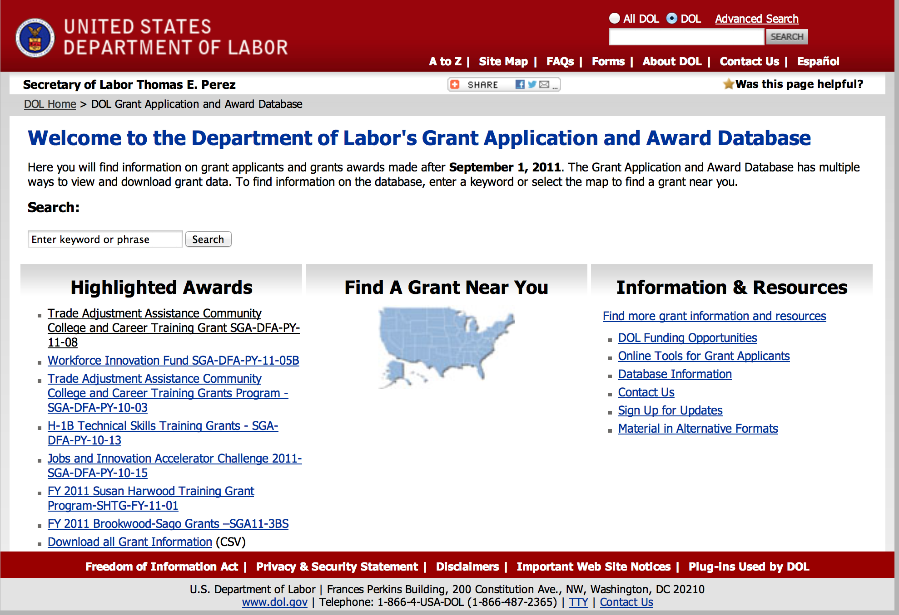

http://www.dol.gov/dol/grants/

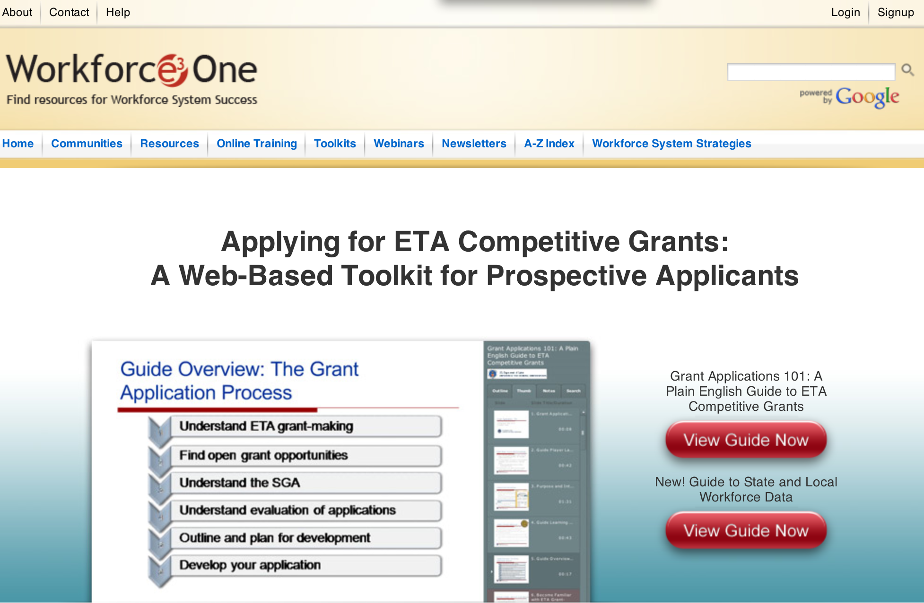

https://www.workforce3one.org/ws/www/pages/grants_toolkit.aspx?pparams=/

Programs

Employment and Training Administration
YouthBuild Grant

Document Type: | Grants Notice
Funding Opportunity Number: | FOA-ETA-15-05
Funding Opportunity Title: | YouthBuild
Opportunity Category: | Discretionary
Funding Instrument Type: | Grant
Category of Funding Activity: | Employment, Labor and Training
Category Explanation:
Expected Number of Awards: | 76
CFDA Number(s): | 17.274 -- Youthbuild
Cost Sharing or Matching Requirement: | Yes
Posted Date: | Apr 6, 2015
Creation Date: | Apr 6, 2015
Original Closing Date for Applications: | Jun 5, 2015 The closing date for receipt of applications under this announcement is June 5, 2015. Applications must be received no later than 4:00:00 p.m. Eastern Time.
Current Closing Date for Applications: | Jun 5, 2015 The closing date for receipt of applications under this announcement is June 5, 2015. Applications must be received no later than 4:00:00 p.m. Eastern Time.
Archive Date: | Jul 5, 2015
Estimated Total Program Funding: | $76,000,000
Award Ceiling: | $1,100,000
Award Floor: | $700,000
Eligible Applicants: | Others (see text field entitled "Additional Information on Eligibility" for clarification)
Additional Information on Eligibility: | Eligible applicants for these grants are public or private non-profit agencies or organizations including rural, urban, or Native American agencies that have previously served disadvantaged youth in a YouthBuild or other similar program. These agencies or organizations include, but are not limited to: • a community-based organization; • a faith-based organization; • an entity carrying out activities under the WIOA, such as a local workforce development board; • a community action agency; • a state or local housing development agency; • an Indian tribe or other agency primarily serving Native Americans, including those living on reservations; • a community development corporation; • a state or local youth service or conservation corps; • any other entity eligible to provide education or employment training under a federal program; or • an entity in an area designated as a Promise Zone or member of a Promise Zone collaboration, if applicable. For more information on about Promise Zones go to http://portal.hud.gov/hudportal/HUD?src=/program_offices/comm_planning/economicdevelopment/programs/pz Grantees who received funding from the FY 2014 YouthBuild competition [SGA/DFA PY 13-04] are funded through December 2017 and these grantees (based on their unique Employer Identification Numbers) are not eligible to participate in this competition.
Agency Name: | Employment and Training Administration
Description: | The Employment and Training Administration (ETA), U.S. Department of Labor (DOL or Department), announces the availability of approximately $76 million in grant funds authorized by the YouthBuild provisions of the Workforce Innovation and Opportunity Act (WIOA) (Pub. L. 113-128). It is the Department’s intention to align this Announcement with pending WIOA regulations. Under this Funding Opportunity Announcement (FOA) (formerly known as a Solicitation for Grant Applications), DOL will award grants through a competitive process to organizations to oversee the provision of education, occupational skills training, and employment services to disadvantaged youth in their communities while performing meaningful work and service to their communities. In Fiscal Year (FY) 2015, DOL hopes to serve approximately 4,950 participants during the grant period of performance, with approximately 76 projects awarded across the country. Individual grants will range from $700,000 to $1.1 million and require an exact 25 percent match from applicants, using sources other than federal funding. The grant period of performance for this FOA is 40 months, including a four-month planning period.
Link to Additional Information:
Contact Information: | If you have difficulty accessing the full announcement electronically, please contact:  Kia Mason Grants Management Specialist mason.kia@dol.gov  mason.kia@dol.gov

http://www.grants.gov/web/grants/view-opportunity.html?oppId=275699

Employment and Training Administration
Face Forward 3-Intermediary and Community Grants

Document Type: | Grants Notice
Funding Opportunity Number: | FOA-ETA-15-04
Funding Opportunity Title: | Face Forward 3-Intermediary and Community Grants
Opportunity Category: | Discretionary
Funding Instrument Type: | Grant
Category of Funding Activity: | Employment, Labor and Training
Category Explanation:
Expected Number of Awards: | 14
CFDA Number(s): | 17.270 -- Reintegration of Ex-Offenders
Cost Sharing or Matching Requirement: | No
Posted Date: | Mar 9, 2015
Creation Date: | Mar 9, 2015
Original Closing Date for Applications: | Apr 23, 2015 The closing date for receipt of applications under this announcement is April 23, 2015. Applications must be received no later than 4:00:00 p.m. Eastern Time.
Current Closing Date for Applications: | Apr 23, 2015 The closing date for receipt of applications under this announcement is April 23, 2015. Applications must be received no later than 4:00:00 p.m. Eastern Time.
Archive Date: | May 23, 2015
Estimated Total Program Funding: | $30,500,000
Award Ceiling: | $5,000,000
Eligible Applicants: | Nonprofits having a 501(c)(3) status with the IRS, other than institutions of higher education
Additional Information on Eligibility: | Community Grant Applicants Eligible applicants include any current or prior Face Forward grantees, any community or faith-based organization with 501(c)3 non-profit status (including women and minority-focused organizations), unit of state or local government, or any Indian and Native American entity eligible for grants under WIA Section 166. Intermediary Grant Applicants Eligible applicants include any current or prior Face Forward grantees, any community or faith-based organization with 501(c)3 non-profit status (including women’s and minority organizations) or any Indian and Native American entity eligible for grants under WIA Section 166. Only organizations that have an affiliate network or offices in at least two states are eligible to be intermediary applicants.
Agency Name: | Employment and Training Administration
Description: | The Employment and Training Administration (ETA) plans to award four intermediary organization grants of $5 million each and approximately 10 community organization grants of up to $1,050,000 million each, totaling approximately $30,500,000 million, to provide services to youth between the ages of 14 to 24 that have been involved in the JJS and never convicted in the adult criminal system. Applicants may only submit one application in response to this solicitation. Applicants must choose between submitting an intermediary or community grant application. Intermediary grantees must competitively select after grant award local sub-grantees to operate the program in a minimum of three communities in at least two states, with a priority to serving target areas in high-poverty, high-crime areas. Applicants submitting intermediary grants applications must have the capacity to implement multi-site, multi-state projects.
Link to Additional Information:
Contact Information: | If you have difficulty accessing the full announcement electronically, please contact:  Denise Roach Grants Management Specialist Phone 202-693-3820  roach.denise@dol.gov

http://www.grants.gov/web/grants/view-opportunity.html?oppId=275016

Employment and Training Administration
Training to Work 3 – Adult Reentry Grant

Document Type: | Grants Notice
Funding Opportunity Number: | FOA-ETA-15-07
Funding Opportunity Title: | Training to Work 3 – Adult Reentry
Opportunity Category: | Discretionary
Funding Instrument Type: | Grant
Category of Funding Activity: | Employment, Labor and Training
Category Explanation:
Expected Number of Awards: | 20
CFDA Number(s): | 17.270 -- Reintegration of Ex-Offenders
Cost Sharing or Matching Requirement: | No
Posted Date: | Mar 24, 2015
Creation Date: | Mar 24, 2015
Original Closing Date for Applications: | May 1, 2015 Applications must be received no later than 4:00:00 p.m. Eastern Time.
Current Closing Date for Applications: | May 1, 2015 Applications must be received no later than 4:00:00 p.m. Eastern Time.
Archive Date: | May 31, 2015
Estimated Total Program Funding: | $27,000,000
Award Ceiling: | $1,360,000
Award Floor: | $0
Eligible Applicants: | Others (see text field entitled "Additional Information on Eligibility" for clarification)
Additional Information on Eligibility: | Nonprofit Organization with IRS 501(c)(3) Status. Proof of 501(c)(3) status should be included as an attachment to the application (see Section IV.B.4 for more information). Applicants must also be located in an urbanized area or urban cluster, as defined by the U.S. Census Bureau.
Agency Name: | Employment and Training Administration
Description: | The Employment and Training Administration (ETA), U.S. Department of Labor (DOL, or the Department, or we), announces the availability of approximately $27 million in grant funds authorized by the Workforce Investment Act (WIA) and the Second Chance Act of 2007 for Training to Work 3 – Adult Reentry (T2W3). This Training to Work 3 – Adult Reentry (T2W3) Funding Opportunity Announcement (FOA) provides the opportunity for organizations to develop and implement career pathways programs in demand sectors and occupations for men and women, including veterans, and people with disabilities, who are at least 18 years old and who are enrolled in work release programs (WRP). Additionally, grantees must provide a strategy to prioritize services to veterans that are in these WRPs. Career pathways are frameworks that help to define and map out a sequence of education, training and workforce skills training resulting in skilled workers that meet employers’ needs. Career pathways link and coordinate education and training services in ways that enable workers to attain necessary credentials and, ultimately, employment. T2W3 is aligned with the Department’s goal to make our Federal employment and training programs more job-driven. Department of Labor Appropriations Act.
Link to Additional Information:
Contact Information: | If you have difficulty accessing the full announcement electronically, please contact:  Brinda Ruggles Grants Management Specialists  T2W3@dol.gov

http://www.grants.gov/web/grants/view-opportunity.html?oppId=275374

Federal Mediation and Conciliation Service
Labor-Management Cooperation Grant Program

Document Type: | Grants Notice
Funding Opportunity Number: | FMCS-2015
Funding Opportunity Title: | Labor-Management Cooperation Grant Program
Opportunity Category: | Discretionary
Funding Instrument Type: | Grant
Category of Funding Activity: | Business and Commerce  Employment, Labor and Training  Health  Other (see text field entitled "Explanation of Other Category of Funding Activity" for clarification)
Category Explanation: | To support the establishment, expansion, and activities conducted by committees at the company/plant level, area, industry-wide, and for public sector employees. Joint labor management committees to improve labor-management relations, economic development, and organizational effectiveness and productivity. Applicants must be covered by a formal collective bargaining agreement to be eligible.
Expected Number of Awards: | 15
CFDA Number(s): | 34.002 -- Labor Management Cooperation
Cost Sharing or Matching Requirement: | Yes
Posted Date: | Mar 2, 2015
Creation Date: | Feb 24, 2015
Original Closing Date for Applications: | May 31, 2015
Current Closing Date for Applications: | May 31, 2015
Archive Date: | Sep 25, 2015
Estimated Total Program Funding: | $800,000
Award Ceiling: | $125,000
Award Floor: | $65,000
Eligible Applicants: | Unrestricted (i.e., open to any type of entity above), subject to any clarification in text field entitled "Additional Information on Eligibility"
Additional Information on Eligibility: | Open to all EXCEPT individuals. See FMCS 2015 Application Solicitation for more information regarding eligibility.
Agency Name: | Federal Mediation and Conciliation Service
Description: | The Labor-Management Cooperation Act of 1978 identifies the following seven general areas for which financial assistance would be appropriate: (1) to improve communication between representatives of labor and management; (2) to provide workers and employers with opportunities to study and explore new and innovative joint approaches to achieving organizational effectiveness; (3) to assist workers and employers in solving problems of mutual concern not susceptible to resolution within the collective bargaining process; (4) to study and explore ways of eliminating potential problems which reduce the competitiveness and inhibit the economic development of the company/plant, area, or industry; (5) to enhance the involvement of workers in making decisions that affects their working lives; (6) to expand and improve working relationships between workers and managers; and (7) to encourage free collective bargaining by establishing continuing mechanisms for communication between employers and their employees through Federal assistance in the formation and operation of labor-management committees. The primary objective of this program is to encourage and support the establishment and operation of joint labor-management committees to carry out specific objectives that meet the aforementioned general criteria. The term "labor" refers to employees represented by a labor organization and covered by a formal collective bargaining agreement. These committees may be found at the plant (company), area, industry, or public sector levels. A plant or company committee is generally characterized as restricted to one or more organizational or productive units operated by a single employer. An area committee is generally composed of multiple employers of diverse industries as well as multiple labor unions operating within and focusing upon a particular city, county, contiguous multicounty, or statewide jurisdiction. An industry committee generally consists of a collection of agencies or enterprises and related labor union(s) producing a common product or service in the private sector on a local, state, regional, or nationwide level. A public sector committee consists of government employees and managers in one or more units of a local or state government, managers and employees of public institutions of higher education, or of employees and managers of public elementary and secondary schools. Those employees must be covered by a formal collective bargaining agreement or other enforceable labor-management agreement. In deciding whether an application is for an area or industry committee, consideration should be given to the above definitions as well as to the focus of the committee. In FY2015, competition will be open to company/plant, area, private industry, and public sector committees. Special consideration will be given to committee applications involving innovative or unique efforts. All application budget requests should focus directly on supporting the committee. Applicants should avoid seeking funds for activities that are clearly available under other Federal programs (e.g., job training, mediation of contract disputes, etc.)
Link to Additional Information: | FMCS Labor-Management Grant Program Main Page
Contact Information: | If you have difficulty accessing the full announcement electronically, please contact:  Linda Gray-Broughton Grants Management Specialist  Federal government

http://www.grants.gov/web/grants/view-opportunity.html?oppId=274774

Modifications

Employment and Training Administration
American Apprenticeship Initiative
Modifications 1 & 2

Document Type: | Grants Notice
Funding Opportunity Number: | FOA-ETA-15-02
Funding Opportunity Title: | American Apprenticeship Initiative
Opportunity Category: | Discretionary
Funding Instrument Type: | Grant
Category of Funding Activity: | Employment, Labor and Training
Category Explanation:
Expected Number of Awards: | 25
CFDA Number(s): | 17.268 -- H-1B Job Training Grants
Cost Sharing or Matching Requirement: | No
Posted Date: | Dec 11, 2014
Creation Date: | Mar 17, 2015
Original Closing Date for Applications: | Apr 30, 2015 Applications must be received no later than 4:00:00 p.m. Eastern Time.
Current Closing Date for Applications: | Apr 30, 2015 Applications must be received no later than 4:00:00 p.m. Eastern Time.
Archive Date: | May 30, 2015
Estimated Total Program Funding: | $100,000,000
Award Ceiling: | $5,000,000
Award Floor: | $2,500,000
Eligible Applicants: | Others (see text field entitled "Additional Information on Eligibility" for clarification)
Additional Information on Eligibility: | To be eligible for consideration, applications must include a partnership of private and public sector entities. The Department seeks a diversity of partners and partnership structures to support innovation and seed diverse approaches. To be eligible for consideration, applications must include at least one entity from: (1) the private sector; i.e. a business, a consortium of businesses, business-related nonprofit organization, or a private organization functioning as a workforce intermediary for the express purpose of serving the needs of businesses; and (2) the public sector; i.e. the workforce investment system; public education or training provider; or DOL-recognized State Apprenticeship Agency. A lead applicant must be a public or non-profit organization. For-profit private business, for-profit consortium of businesses, for-profit business organizations, and for-profit education/training providers cannot be the lead applicant; however, they may apply as part of the public/private partnership. See Section III of the FOA for more information.
Agency Name: | Employment and Training Administration
Description: | The Employment and Training Administration (ETA), U.S. Department of Labor (DOL, or the department, or we), announces the availability of approximately $100 million in grant funds authorized by Section 414(c) of the American Competitiveness and Workforce Improvement Act of 1998 (ACWIA), as amended (codified at 29 USC 2916a), for the American Apprenticeship Initiative. This initiative is intended to provide a catalyst in supporting a uniquely American Apprenticeship system that meets our country’s particular economic, industry and workforce needs. American Apprenticeships (also referred to as Registered Apprenticeships) are innovative work-based learning and post-secondary earn-and- learn models that meet national standards for registration with the U.S. Department of Labor (or federally recognized State Apprenticeship Agencies). Approximately $100 million is expected to be available to fund approximately 25 grants. Grant awards will range from $2.5 - 5 million. Grant awards will be made only to the extent that funds are available.
Link to Additional Information:
Contact Information: | If you have difficulty accessing the full announcement electronically, please contact:  Jeannette Flowers Grants Management Specialists  flowers.jeannette@dol.gov

http://www.grants.gov/web/grants/view-opportunity.html?oppId=270372

Reminders



National Aeronautics and Space Administration

Research and Contracting Opportunities

NASA Research Opportunities Online

- Various NASA offices publish their research announcements over the Internet, broadening the opportunity for researchers to apply for funding. This site provides access to current research announcements along with their specific due dates.

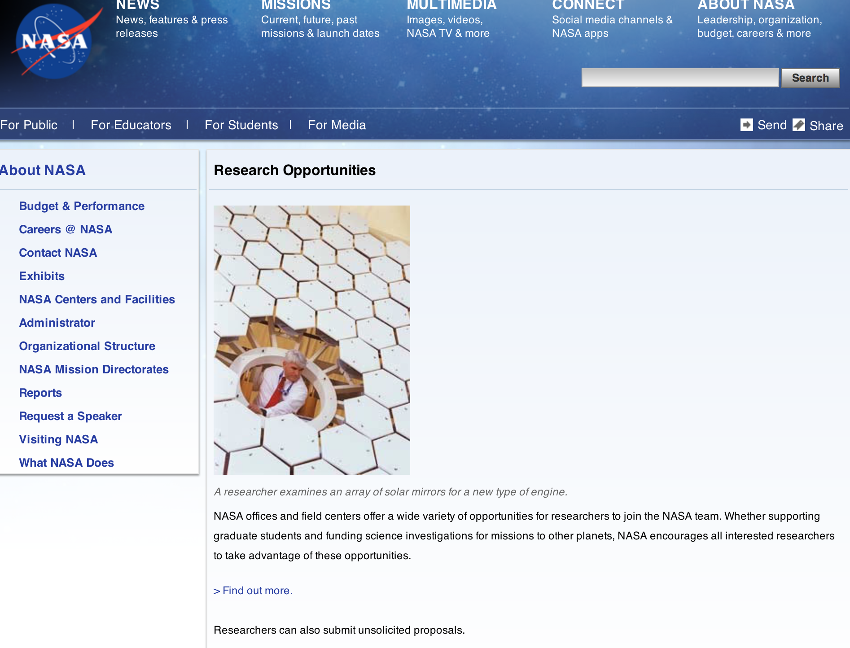

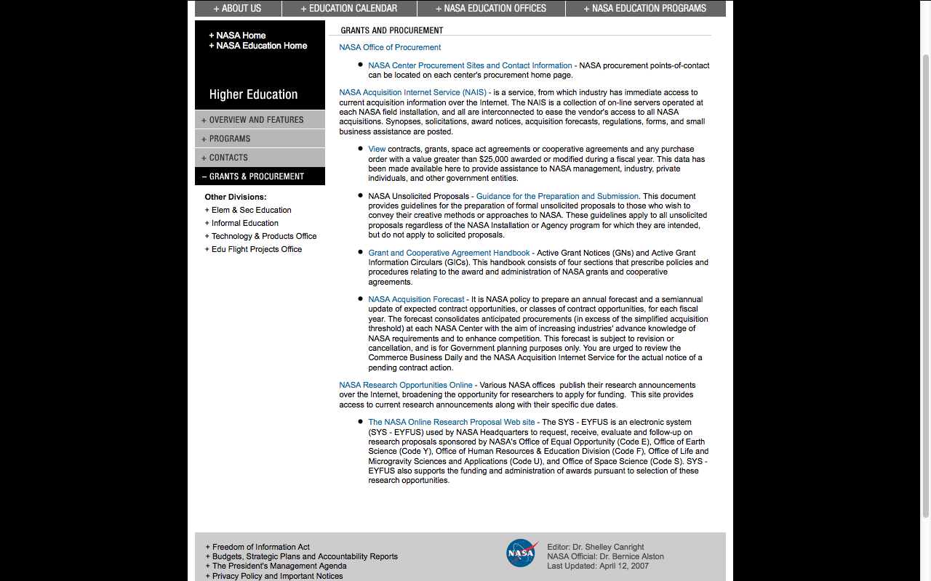

http://education1.nasa.gov/divisions/higher/grants/index.html

NASA Headquarters
ROSES 2015: Topical Workshops, Symposia, and Conferences Grant
http://www.grants.gov/web/grants/view-opportunity.html?oppId=274833

NASA Headquarters
EONS 2014 - APPENDIX J MUREP AEROSPACE ACADEMY Grant
http://www.grants.gov/web/grants/view-opportunity.html?oppId=275125

NASA Headquarters
Planetary Data System Discipline Nodes Grant
http://www.grants.gov/web/grants/view-opportunity.html?oppId=275429

NASA Headquarters
ROSES 2015: KORUS-AQ: An International Cooperative Air Quality Field Study in Korea
Grant
http://www.grants.gov/web/grants/view-opportunity.html?oppId=274954

NASA Headquarters
ROSES 2015: Rapid Response and Novel Research in Earth Science Grant
http://www.grants.gov/web/grants/view-opportunity.html?oppId=274875

NASA Headquarters
ROSES 2015: Advancing Collaborative Connections for Earth System Science Grant
http://www.grants.gov/web/grants/view-opportunity.html?oppId=274878

NASA Headquarters
ROSES 2015: In-Space Validation of Earth Science Technologies Grant
http://www.grants.gov/web/grants/view-opportunity.html?oppId=274879

NASA Headquarters
ROSES 2015: Physical Oceanography Grant
http://www.grants.gov/web/grants/view-opportunity.html?oppId=274862

NASA Headquarters
ROSES 2015: Precipitation Measurement Missions (PMM) Science Team Grant
http://www.grants.gov/web/grants/view-opportunity.html?oppId=274881

NASA Langley Research Center
NASA INNOVATIVE ADVANCED CONCEPTS {NIAC} PHASE II Grant
http://www.grants.gov/web/grants/view-opportunity.html?oppId=274972

NASA Headquarters
ROSES 2015: Modeling, Analysis, and Prediction Grant
http://www.grants.gov/web/grants/view-opportunity.html?oppId=274872

NASA Headquarters
ROSES 2015: Science Utilization of the Soil Moisture Active- Passive Mission Grant
http://www.grants.gov/web/grants/view-opportunity.html?oppId=274864

NASA Headquarters
ROSES 2015: Astrophysics Data Analysis Program Grant
http://www.grants.gov/web/grants/view-opportunity.html?oppId=274931

NASA Headquarters
EONS 2014 - APPENDIX L MUREP COMMUNITY COLLEGE CURRICULUM IMPROVEMENT Grant
http://www.grants.gov/web/grants/view-opportunity.html?oppId=275103

NASA Headquarters
ROSES 2015: IceBridge Observations Grant
http://www.grants.gov/web/grants/view-opportunity.html?oppId=275033

NASA Headquarters
ROSES 2015: Surface Water and Ocean Topography (SWOT) Science Team Grant
http://www.grants.gov/web/grants/view-opportunity.html?oppId=275045

NASA Headquarters
ROSES 2015: Cryospheric Science Grant
http://www.grants.gov/web/grants/view-opportunity.html?oppId=275054

NASA Headquarters
EONS 2014 — APPENDIX M MUREP AMERICAN INDIAN AND ALASKAN NATIVE STEM PARTNERSHIP Grant
http://www.grants.gov/web/grants/view-opportunity.html?oppId=275336

NASA Headquarters
EONS 2014 - APPENDIX M MUREP AMERICAN INDIAN AND ALASKAN NATIVE STEM PARTNERSHIP Grant
http://www.grants.gov/web/grants/view-opportunity.html?oppId=275355

NASA Headquarters
ROSES 2015: Laboratory Analysis of Returned Samples Grant
http://www.grants.gov/web/grants/view-opportunity.html?oppId=275240

NASA Headquarters
ROSES 2015: GRACE – GRACE-FO SCIENCE TEAM Grant
http://www.grants.gov/web/grants/view-opportunity.html?oppId=275469

NASA Headquarters
ROSES 2015: NASA ISRO Synthetic Aperture Radar (NISAR) mission Science Definition Team
Grant
http://www.grants.gov/web/grants/view-opportunity.html?oppId=275470

NASA Headquarters
ROSES 2015: Planetary Data Archiving, Restoration, and Tools Grant
http://www.grants.gov/web/grants/view-opportunity.html?oppId=275471

NASA Headquarters
EONS 2014 - APPENDIX O MUREP OTHER OPPORTUNITIES {MOO} Grant
http://www.grants.gov/web/grants/view-opportunity.html?oppId=275482

NASA Ames Research Center
ROBOTICS OUTREACH COMPETITION II
Modification 3
http://www.grants.gov/web/grants/view-opportunity.html?oppId=274674

NASA Johnson Space Center
HUMAN EXPLORATION RESEARCH OPPORTUNITIES NASA RESEARCH ANNOUNCEMENT
Modification 2
http://www.grants.gov/web/grants/view-opportunity.html?oppId=259312

NASA Headquarters
ROSES 2014: Extreme Precision Doppler Spectrometer Instrument
Modification 1
http://www.grants.gov/web/grants/view-opportunity.html?oppId=273225

NASA Headquarters
ROSES 2015: Advancing Collaborative Connections for Earth System Science
Modification 1
http://www.grants.gov/web/grants/view-opportunity.html?oppId=274878

NASA Ames Research Center
ROBOTICS OUTREACH COMPETITION II
Modification 2
http://www.grants.gov/web/grants/view-opportunity.html?oppId=274674

National Archives and Records Administration

Grant Opportunities General Overview

To access the information below: click here

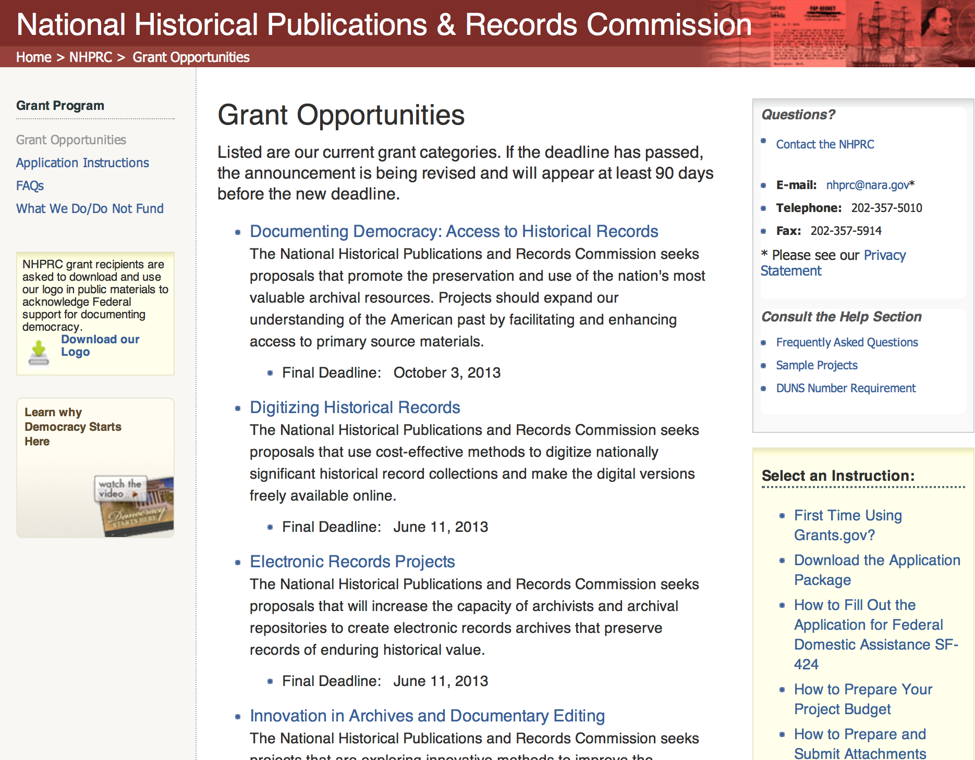

National Endowment for the Arts

Agency Grant Overview - http://nea.gov/grants/apply/index.html

For an overview of the NEA's funding opportunities, please see the NEA Grants Workshop presentation.
The series of Arts Works guidelines webinars for each discipline has now concluded. All of the sessions are archived on our YouTube channel.

http://arts.gov/grants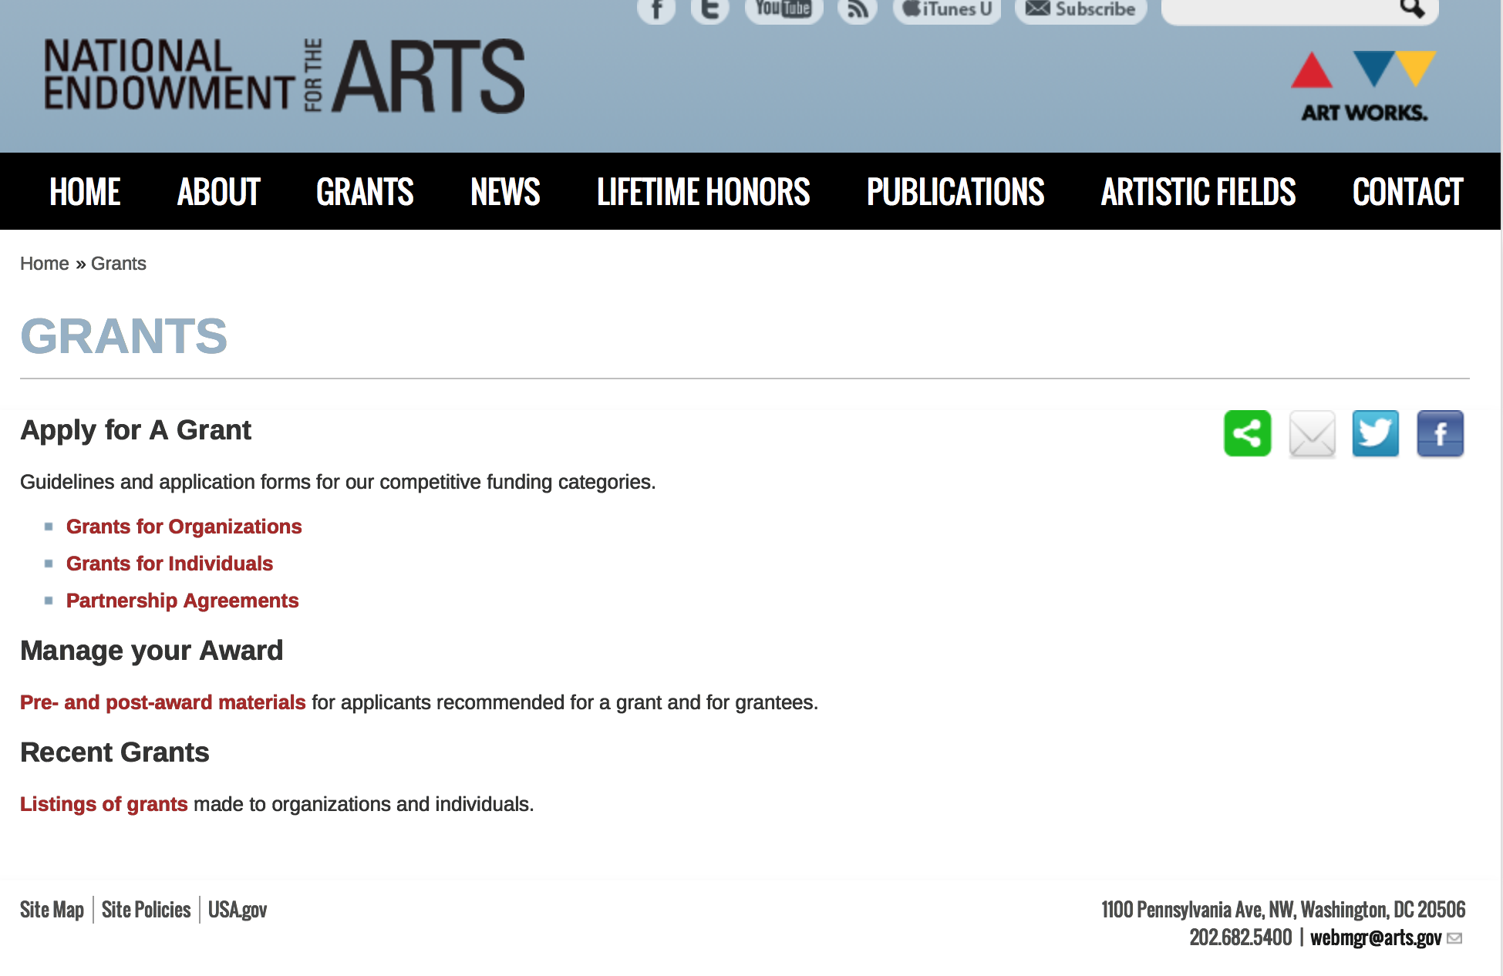
Grants for Organizations
We fund projects only. Projects may consist of one or more specific events or activities. Projects do not have to be new. Excellent existing projects can be just as competitive as new activities. Projects do not need to be big either; we welcome small projects that can make a difference in their community or field.

Art Works
To support the creation of art that meets the highest standards of excellence, public engagement with diverse and excellent art, lifelong learning in the arts, and the strengthening of communities through the arts.

Matching grants generally range from $10,000 to $100,000.
Deadline: February 19, 2015
Notification: November 2015
Earliest Start Date: January 1, 2016
Deadline: July 23, 2015
Notification: April 2016
Earliest Start Date: June 1, 2016

Challenge America
To support projects that extend the reach of the arts to underserved populations. Matching grants are for $10,000.
Deadline: April 16, 2015
Notification: December 2015
Earliest Start Date: January 1, 2016

Our Town
Organizations may apply for creative placemaking projects that contribute to the livability of communities and place the arts at their core. Our Town offers support for projects in two areas:
- Arts Engagement, Cultural Planning, and Design Projects that represent the distinct character and quality of their communities. Matching grants range from $25,000 to $200,000.
- Projects that Build Knowledge About Creative Placemaking. Matching grants range from $25,000 to $100,000.
Deadline: December 15, 2014 Notification: July 2015 Earliest Start Date: October 1, 2015

Research: Art Works
New guidelines will be available in August.

See more at: http://arts.gov/grants/apply-grant/grants-organizations - sthash.EquFoUvs.yLCIsZHu.dpuf

Programs:

Modifications:

Reminders:

NEA Challenge America, FY2016 Grant

Document Type: | Grants Notice
Funding Opportunity Number: | 2015NEA01CAFT
Funding Opportunity Title: | NEA Challenge America, FY2016
Opportunity Category: | Discretionary
Funding Instrument Type: | Grant
Category of Funding Activity: | Arts (see "Cultural Affairs" in CFDA)
Category Explanation:
Expected Number of Awards:
CFDA Number(s): | 45.024 -- Promotion of the Arts Grants to Organizations and Individuals
Cost Sharing or Matching Requirement: | Yes
Posted Date: | Dec 12, 2014
Creation Date: | Dec 12, 2014
Original Closing Date for Applications: | Apr 16, 2015 The Grants.gov system must receive your validated and accepted application no later than 11:59 p.m., Eastern Time, on April 16, 2015.
Current Closing Date for Applications: | Apr 16, 2015 The Grants.gov system must receive your validated and accepted application no later than 11:59 p.m., Eastern Time, on April 16, 2015.
Archive Date: | May 16, 2015
Estimated Total Program Funding:
Award Ceiling: | $10,000
Award Floor: | $10,000
Eligible Applicants: | State governments  Special district governments  County governments  Independent school districts  Private institutions of higher education  Nonprofits having a 501(c)(3) status with the IRS, other than institutions of higher education  City or township governments  Native American tribal governments (Federally recognized)  Public and State controlled institutions of higher education
Additional Information on Eligibility: | An organization may submit only one application through one of the following FY 2016 categories: Art Works or Challenge America. The Arts Endowment's support of a project may start on or after January 1, 2016. Grants awarded under these guidelines generally may cover a period of performance of up to two years. An organization that has received Challenge America grants in FY 2013, 2014, and 2015 may not apply for a Challenge America grant under these FY 2016 guidelines. Eligibility Nonprofit, tax-exempt 501(c)(3), U.S. organizations; units of state or local government; or federally recognized tribal communities or tribes may apply. Applicants may be arts organizations, local arts agencies, arts service organizations, local education agencies (school districts), and other organizations that can help advance the goals of the Arts Endowment. To be eligible, the applicant organization must: • Meet the Arts Endowment's "Legal Requirements" including nonprofit, tax-exempt status at the time of application. (All organizations must apply directly on their own behalf. Applications through a fiscal agent are not allowed.) • Have a three-year history of programming prior to the application deadline. • Have submitted acceptable Final Report packages by the due date(s) for all Arts Endowment grant(s) previously received. An organization whose primary purpose is to channel resources (financial, human, or other) to an affiliated organization is not eligible to apply if the affiliated organization submits its own application. This prohibition applies even if each organization has its own 501(c)(3) status. For example, the "Friends of ABC Museum" may not apply if the ABC Museum applies.
Agency Name: | National Endowment for the Arts
Description: | An organization may submit only one application through one of the following FY 2016 categories: Art Works or Challenge America. The Arts Endowment's support of a project may start on or after January 1, 2016. Grants awarded under these guidelines generally may cover a period of performance of up to two years. An organization that has received Challenge America grants in FY 2013, 2014, and 2015 may not apply for a Challenge America grant under these FY 2016 guidelines. Grant Program Description: The Challenge America category offers support primarily to small and mid-sized organizations for projects that extend the reach of the arts to underserved populations -- those whose opportunities to experience the arts are limited by geography, ethnicity, economics, or disability. Age alone (e.g., youth, seniors) does not qualify a group as underserved; at least one of the underserved characteristics noted above also must be present. Grants are available for professional arts programming and for projects that emphasize the potential of the arts in community development. This category encourages and supports the following two objectives: • Engagement: Engaging the public with diverse and excellent art. • Livability: The strengthening of communities through the arts. You will be asked to select the objective that is most relevant to your project. When making selections, you should identify the objective(s) that reflect the results expected to be achieved by your project. If you receive a grant, you also will be asked to provide evidence of those results. Challenge America grants: • Extend the reach of the arts to underserved populations. • Are limited to the specific types of projects outlined below. • Are for a fixed amount of $10,000 and require a minimum $10,000 match.
Link to Additional Information: | Complete NEA Website Announcement
Contact Information: | If you have difficulty accessing the full announcement electronically, please contact:  NEA Web Manager  NEA Web Manager

http://www.grants.gov/web/grants/view-opportunity.html?oppId=270429

National Endowment for the Humanities

Grant Overview -

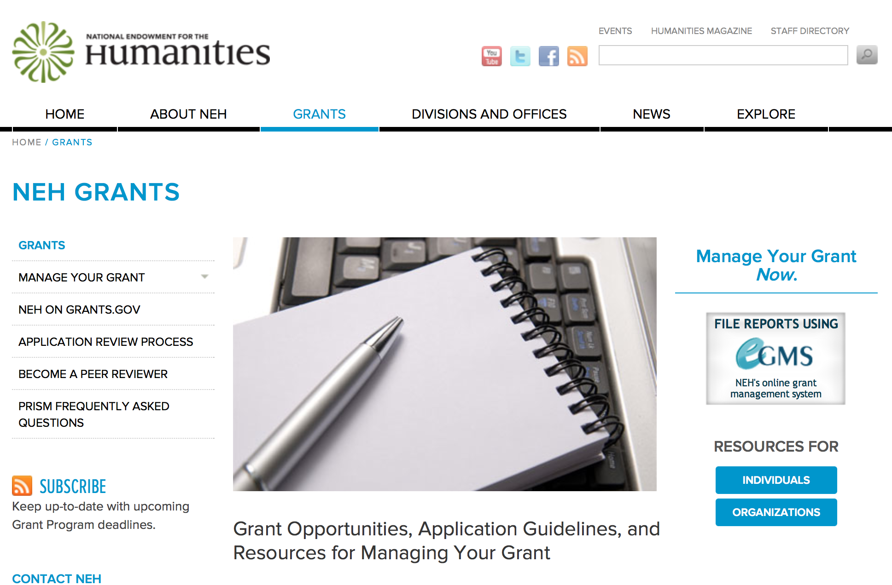

TITLE | DEADLINE | DIVISION/OFFICE
Awards for Faculty at Hispanic-Serving Institutions | April 15, 2015 | Division of Research Programs
Awards for Faculty at Historically Black Colleges and Universities | April 15, 2015 | Division of Research Programs
Awards for Faculty at Tribal Colleges and Universities | April 15, 2015 | Division of Research Programs
Bridging Cultures at Community Colleges | August 21, 2014 | Division of Education Programs
Bridging Cultures through Film: International Topics | June 10, 2015 | Division of Public Programs
Challenge Grants | May 5, 2015 | Office of Challenge Grants
Collaborative Research Grants | December 9, 2015 | Division of Research Programs
Digging Into Data Challenge | May 15, 2013 | Office of Digital Humanities
Digital Humanities Implementation Grants | February 18, 2015 | Office of Digital Humanities
Digital Humanities Start-Up Grants | September 16, 2015 | Office of Digital Humanities
Digital Projects for the Public | June 10, 2015 | Division of Public Programs
Documenting Endangered Languages | September 15, 2015 | Division of Preservation and Access
Enduring Questions | September 10, 2015 | Division of Education Programs
Fellowship Programs at Independent Research Institutions | August 13, 2015 | Division of Research Programs
Fellowships | April 30, 2015 | Division of Research Programs
Fellowships for Advanced Social Science Research on Japan | April 30, 2015 | Division of Research Programs
Humanities Collections and Reference Resources | July 21, 2015 | Division of Preservation and Access
Humanities Initiatives at Hispanic-Serving Institutions | June 25, 2015 | Division of Education Programs
Humanities Initiatives at Historically Black Colleges and Universities | June 25, 2015 | Division of Education Programs
Humanities Initiatives at Tribal Colleges and Universities | June 25, 2015 | Division of Education Programs
Institutes for Advanced Topics in the Digital Humanities | March 10, 2015 | Office of Digital Humanities
Landmarks of American History and Culture: Workshops for School Teachers | February 24, 2015 | Division of Education Programs
Media Projects: Development Grants | January 14, 2015 | Division of Public Programs
Media Projects: Production Grants | January 14, 2015 | Division of Public Programs
Museums, Libraries, and Cultural Organizations: Implementation Grants | January 14, 2015 | Division of Public Programs
Museums, Libraries, and Cultural Organizations: Planning Grants | January 14, 2015 | Division of Public Programs
National Arts and Humanities Youth Program Awards | February 2, 2015 | President's Committee on the Arts and the Humanities
National Digital Newspaper Program | January 15, 2015 | Division of Preservation and Access
NEH/DFG Bilateral Digital Humanities Program | September 25, 2014 | Office of Digital Humanities
Preservation and Access Education and Training | May 5, 2015 | Division of Preservation and Access
Preservation and Access Research and Development | May 1, 2014 | Division of Preservation and Access
Preservation Assistance Grants for Smaller Institutions | May 5, 2015 | Division of Preservation and Access
Public Scholar Program | March 3, 2015 | Division of Research Programs
Scholarly Editions and Translations Grants | December 9, 2015 | Division of Research Programs
Summer Seminars and Institutes | February 24, 2015 | Division of Education Programs
Summer Stipends | October 1, 2015 | Division of Research Programs
Sustaining Cultural Heritage Collections | December 1, 2015 | Division of Preservation and Access
Collaborative Research Grants | December 9, 2015 | Division of Research Programs
Scholarly Editions and Translations Grants | December 9, 2015 | Division of Research Programs

http://www.neh.gov/grants/grantsbydivision.html

Programs:

Research and Development Grant

Document Type: | Grants Notice
Funding Opportunity Number: | 20150625-PR
Funding Opportunity Title: | Research and Development
Opportunity Category: | Discretionary
Funding Instrument Type: | Grant
Category of Funding Activity: | Humanities (see "Cultural Affairs" in CFDA)
Category Explanation:
Expected Number of Awards:
CFDA Number(s): | 45.149 -- Promotion of the Humanities Division of Preservation and Access
Cost Sharing or Matching Requirement: | No
Posted Date: | Mar 4, 2015
Creation Date: | Mar 4, 2015
Original Closing Date for Applications: | Jun 25, 2015
Current Closing Date for Applications: | Jun 25, 2015
Archive Date:
Estimated Total Program Funding:
Award Ceiling: | $350,000
Award Floor: | $1
Eligible Applicants: | Private institutions of higher education  Nonprofits having a 501(c)(3) status with the IRS, other than institutions of higher education  Native American tribal governments (Federally recognized)  Nonprofits that do not have a 501(c)(3) status with the IRS, other than institutions of higher education  Special district governments  State governments  Public and State controlled institutions of higher education  County governments  City or township governments
Agency Name: | National Endowment for the Humanities
Description: | The Research and Development program supports projects that address major challenges in preserving or providing access to humanities collections and resources. These challenges include the need to find better ways to preserve materials of critical importance to the nation’s cultural heritage—from fragile artifacts and manuscripts to analog recordings and digital assets subject to technological obsolescence—and to develop advanced modes of organizing, searching, discovering, and using such materials. This program recognizes that finding solutions to complex problems often requires forming interdisciplinary project teams, bringing together participants with expertise in the humanities; in preservation; and in information, computer, and natural science. All projects must demonstrate how advances in preservation and access would benefit the cultural heritage community in supporting humanities research, teaching, or public programming.
Link to Additional Information: | http://www.neh.gov/grants/preservation/research-and-development
Contact Information: | If you have difficulty accessing the full announcement electronically, please contact:  Research and Development National Endowment for the Humanities 400 Seventh Street, SW Washington, DC 20506 202-606-8570 preservation@neh.gov preservation@neh.gov  preservation@neh.gov

http://www.grants.gov/web/grants/view-opportunity.html?oppId=274934

Bridging Cultures through Film: International Topics Grant

Document Type: | Grants Notice
Funding Opportunity Number: | 20150610-TW
Funding Opportunity Title: | Bridging Cultures through Film: International Topics
Opportunity Category: | Discretionary
Funding Instrument Type: | Grant
Category of Funding Activity: | Humanities (see "Cultural Affairs" in CFDA)
Category Explanation:
Expected Number of Awards:
CFDA Number(s): | 45.164 -- Promotion of the Humanities Public Programs
Cost Sharing or Matching Requirement: | No
Posted Date: | Mar 4, 2015
Creation Date: | Mar 4, 2015
Original Closing Date for Applications: | Jun 10, 2015
Current Closing Date for Applications: | Jun 10, 2015
Archive Date:
Estimated Total Program Funding:
Award Ceiling: | $650,000
Award Floor: | $1
Eligible Applicants: | State governments  Public and State controlled institutions of higher education  Nonprofits having a 501(c)(3) status with the IRS, other than institutions of higher education  Nonprofits that do not have a 501(c)(3) status with the IRS, other than institutions of higher education  Private institutions of higher education  County governments  Special district governments  City or township governments  Native American tribal governments (Federally recognized)
Agency Name: | National Endowment for the Humanities
Description: | NEH’s Division of Public Programs supports activities that engage millions of Americans in understanding significant humanities works and ideas. The Bridging Cultures through Film: International Topics program supports films that examine international themes and subjects in the humanities. The films are meant to spark Americans’ engagement with the broader world by exploring countries and cultures outside of the United States. The Division of Public Programs encourages innovative nonfiction storytelling that presents multiple points of view in creative formats. At the center of every NEH-funded film is a core set of humanities ideas developed with the input of scholars, matched to imaginative formats that bring the humanities alive for people of all ages and all walks of life. The proposed film must be analytical and deeply grounded in humanities scholarship. It may be as short as thirty minutes or as long as a feature-length film. We invite a wide range of approaches to international topics and themes, such as • an examination of a critical issue in ethics, religion, literature, or history, viewed through an international lens; • an exploration of a topic that transcends a single nation-state; • a biography of a foreign leader, writer, artist, or historical figure; or • an exploration of the history and culture(s) of a specific region, country, or community outside of the United States.
Link to Additional Information: | http://www.neh.gov/grants/public/bridging-cultures-through-film-international-topics
Contact Information: | If you have difficulty accessing the full announcement electronically, please contact:  Division of Public Programs National Endowment for the Humanities 400 Seventh Street, SW Washington, DC 20506 202-606-8269 publicpgms@neh.gov publicpgms@neh.gov  publicpgms@neh.gov

http://www.grants.gov/web/grants/view-opportunity.html?oppId=274913

Modifications:

Reminders:

Challenge Grants

Document Type: | Grants Notice
Funding Opportunity Number: | 20150505-CH
Funding Opportunity Title: | Challenge Grants
Opportunity Category: | Discretionary
Funding Instrument Type: | Grant
Category of Funding Activity: | Humanities (see "Cultural Affairs" in CFDA)
Category Explanation:
Expected Number of Awards:
CFDA Number(s): | 45.130 -- Promotion of the Humanities Challenge Grants
Cost Sharing or Matching Requirement: | Yes
Posted Date: | Feb 11, 2015
Creation Date: | Feb 11, 2015
Original Closing Date for Applications: | May 5, 2015
Current Closing Date for Applications: | May 5, 2015
Archive Date:
Estimated Total Program Funding:
Award Ceiling: | $500,000
Award Floor: | $1
Eligible Applicants: | Nonprofits that do not have a 501(c)(3) status with the IRS, other than institutions of higher education  Native American tribal governments (Federally recognized)  Private institutions of higher education  Nonprofits having a 501(c)(3) status with the IRS, other than institutions of higher education  Special district governments  City or township governments  County governments  Public and State controlled institutions of higher education  State governments
Agency Name: | National Endowment for the Humanities
Description: | The mission of the NEH Office of Challenge Grants is to advance knowledge and understanding in the humanities by strengthening the institutional base of humanities teaching, scholarly research, public programming, and other humanities activities. Challenge grants are capacity-building grants, intended to support significant humanities activities of high intellectual quality and to help institutions secure long-term support for their humanities programs. Through these grants many organizations and institutions have been able to increase their humanities capacity and secure the permanent support of an endowment. Grants may be used to establish or enhance endowments or spend-down funds that generate expendable earnings to support and enhance ongoing program activities. Challenge grants may also provide capital directly supporting the procurement of long-lasting objects, such as acquisitions for archives and collections, the purchase of equipment, and the construction or renovation of facilities needed for humanities activities. Funds spent directly must be shown to bring long-term benefits to the institution and to the humanities more broadly. Grantee institutions may also expend up to 10 percent of total grant funds (federal funds plus matching funds) to defray costs of fundraising to meet the NEH challenge. Because of the matching requirement, these NEH grants also strengthen the humanities by encouraging nonfederal sources of support. Applications are welcome from colleges and universities, museums, public libraries, research institutions, historical societies and historic sites, scholarly associations, state humanities councils, and other nonprofit humanities entities.
Link to Additional Information: | http://www.neh.gov/grants/challenge/challenge-grants
Contact Information: | If you have difficulty accessing the full announcement electronically, please contact:  Office of Challenge Grants National Endowment for the Humanities 400 Seventh Street, SW Washington, DC 20506 202-606-8309 challenge@neh.gov challenge@neh.gov  challenge@neh.gov

http://www.grants.gov/web/grants/view-opportunity.html?oppId=273828

Fellowships for Advanced Social Science Research on Japan Grant

Document Type: | Grants Notice
Funding Opportunity Number: | 20150430-FO
Funding Opportunity Title: | Fellowships for Advanced Social Science Research on Japan
Opportunity Category: | Discretionary
Funding Instrument Type: | Grant
Category of Funding Activity: | Humanities (see "Cultural Affairs" in CFDA)
Category Explanation:
Expected Number of Awards:
CFDA Number(s): | 45.160 -- Promotion of the Humanities Fellowships and Stipends
Cost Sharing or Matching Requirement: | No
Posted Date: | Feb 18, 2015
Creation Date: | Feb 18, 2015
Original Closing Date for Applications: | Apr 30, 2015
Current Closing Date for Applications: | Apr 30, 2015
Archive Date:
Estimated Total Program Funding:
Award Ceiling: | $50,400
Award Floor: | $25,200
Eligible Applicants: | Individuals
Agency Name: | National Endowment for the Humanities
Description: | The Fellowship Program for Advanced Social Science Research on Japan is a joint activity of the Japan-U.S. Friendship Commission (JUSFC) and the National Endowment for the Humanities. Awards support research on modern Japanese society and political economy, Japan's international relations, and U.S.-Japan relations. The program encourages innovative research that puts these subjects in wider regional and global contexts and is comparative and contemporary in nature. Research should contribute to scholarly knowledge or to the general public’s understanding of issues of concern to Japan and the United States. Appropriate disciplines for the research include anthropology, economics, geography, history, international relations, linguistics, political science, psychology, public administration, and sociology. Awards usually result in articles, monographs, books, digital materials, archaeological site reports, translations, editions, or other scholarly resources. The fellowships are designed for researchers with advanced language skills whose research will require use of data, sources, and documents in their original languages or whose research requires interviews onsite in direct one-on-one contact. Fellows may undertake their projects in Japan, the United States, or both, and may include work in other countries for comparative purposes. Projects may be at any stage of development.
Link to Additional Information: | http://www.neh.gov/grants/research/fellowships-advanced-social-science-research-japan
Contact Information: | If you have difficulty accessing the full announcement electronically, please contact:  Division of Research Programs National Endowment for the Humanities 400 Seventh Street, SW Washington, DC 20506 202-606-8200 fellowships@neh.gov fellowships@neh.gov  fellowships@neh.gov

http://www.grants.gov/web/grants/view-opportunity.html?oppId=274620

Fellowships Grant

Document Type: | Grants Notice
Funding Opportunity Number: | 20150430-FA
Funding Opportunity Title: | Fellowships
Opportunity Category: | Discretionary
Funding Instrument Type: | Grant
Category of Funding Activity: | Humanities (see "Cultural Affairs" in CFDA)
Category Explanation:
Expected Number of Awards:
CFDA Number(s): | 45.160 -- Promotion of the Humanities Fellowships and Stipends
Cost Sharing or Matching Requirement: | No
Posted Date: | Feb 18, 2015
Creation Date: | Feb 18, 2015
Original Closing Date for Applications: | Apr 30, 2015
Current Closing Date for Applications: | Apr 30, 2015
Archive Date:
Estimated Total Program Funding:
Award Ceiling: | $50,400
Award Floor: | $25,200
Eligible Applicants: | Individuals
Agency Name: | National Endowment for the Humanities
Description: | Fellowships support individuals pursuing advanced research that is of value to humanities scholars, general audiences, or both. Recipients usually produce articles, monographs, books, digital materials, archaeological site reports, translations, editions, or other scholarly resources in the humanities. Projects may be at any stage of development.
Link to Additional Information: | http://www.neh.gov/grants/research/fellowships
Contact Information: | If you have difficulty accessing the full announcement electronically, please contact:  Division of Research Programs National Endowment for the Humanities 400 Seventh Street, SW Washington, DC 20506 202-606-8200 fellowships@neh.gov fellowships@neh.gov  fellowships@neh.gov

http://www.grants.gov/web/grants/view-opportunity.html?oppId=274633

Preservation Assistance Grants for Smaller Institutions Grant

Document Type: | Grants Notice
Funding Opportunity Number: | 20150505-PG
Funding Opportunity Title: | Preservation Assistance Grants for Smaller Institutions
Opportunity Category: | Discretionary
Funding Instrument Type: | Grant
Category of Funding Activity: | Humanities (see "Cultural Affairs" in CFDA)
Category Explanation:
Expected Number of Awards:
CFDA Number(s): | 45.149 -- Promotion of the Humanities Division of Preservation and Access
Cost Sharing or Matching Requirement: | No
Posted Date: | Feb 25, 2015
Creation Date: | Feb 25, 2015
Original Closing Date for Applications: | May 5, 2015
Current Closing Date for Applications: | May 5, 2015
Archive Date:
Estimated Total Program Funding:
Award Ceiling: | $6,000
Award Floor: | $1
Eligible Applicants: | Native American tribal governments (Federally recognized)  Special district governments  City or township governments  Private institutions of higher education  County governments  Nonprofits that do not have a 501(c)(3) status with the IRS, other than institutions of higher education  Nonprofits having a 501(c)(3) status with the IRS, other than institutions of higher education  State governments  Public and State controlled institutions of higher education
Agency Name: | National Endowment for the Humanities
Description: | Preservation Assistance Grants help small and mid-sized institutions—such as libraries, museums, historical societies, archival repositories, cultural organizations, town and county records offices, and colleges and universities—improve their ability to preserve and care for their significant humanities collections. These may include special collections of books and journals, archives and manuscripts, prints and photographs, moving images, sound recordings, architectural and cartographic records, decorative and fine art objects, textiles, archaeological and ethnographic artifacts, furniture, historical objects, and digital materials. Applicants must draw on the knowledge of consultants whose preservation skills and experience are related to the types of collections and the nature of the activities on which their projects focus. Within the conservation field, for example, conservators usually specialize in the care of specific types of collections, such as objects, paper, or paintings. Applicants should therefore choose a conservator whose specialty is appropriate for the nature of their collections. Similarly, when assessing the preservation needs of library, museum, or archival holdings, applicants must seek a consultant specifically knowledgeable about the preservation of these types of collections. The program encourages applications from small and mid-sized institutions that have never received an NEH grant.
Link to Additional Information: | http://www.neh.gov/grants/preservation/preservation-assistance-grants-smaller-institutions
Contact Information: | If you have difficulty accessing the full announcement electronically, please contact:  Division of Preservation and Access National Endowment for the Humanities 400 Seventh Street, SW Washington, DC 20506 202-606-8570 preservation@neh.gov preservation@neh.gov  preservation@neh.gov

http://www.grants.gov/web/grants/view-opportunity.html?oppId=274794

Preservation and Access Education and Training Grant

Document Type: | Grants Notice
Funding Opportunity Number: | 20150505-PE
Funding Opportunity Title: | Preservation and Access Education and Training
Opportunity Category: | Discretionary
Funding Instrument Type: | Grant
Category of Funding Activity: | Humanities (see "Cultural Affairs" in CFDA)
Category Explanation:
Expected Number of Awards:
CFDA Number(s): | 45.149 -- Promotion of the Humanities Division of Preservation and Access
Cost Sharing or Matching Requirement: | No
Posted Date: | Feb 25, 2015
Creation Date: | Feb 25, 2015
Original Closing Date for Applications: | May 5, 2015
Current Closing Date for Applications: | May 5, 2015
Archive Date:
Estimated Total Program Funding:
Award Ceiling: | $350,000
Award Floor: | $1
Eligible Applicants: | Private institutions of higher education  City or township governments  Nonprofits having a 501(c)(3) status with the IRS, other than institutions of higher education  Nonprofits that do not have a 501(c)(3) status with the IRS, other than institutions of higher education  Special district governments  Native American tribal governments (Federally recognized)  Public and State controlled institutions of higher education  County governments  State governments
Agency Name: | National Endowment for the Humanities
Description: | The Preservation and Access Education and Training program is central to NEH’s efforts to preserve and establish access to cultural heritage collections. Thousands of libraries, archives, museums, and historical organizations across the country maintain important collections of books and manuscripts, photographs, sound recordings and moving images, archaeological and ethnographic artifacts, art and material culture collections, electronic records, and digital objects. The challenge of preserving and making accessible such large and diverse holdings is enormous, and the need for knowledgeable staff is significant and ongoing. Preservation and Access Education and Training grants are awarded to organizations that offer national or regional (multistate) education and training programs. Grants aim to help the staff of cultural institutions, large and small, obtain the knowledge and skills needed to serve as effective stewards of humanities collections. Grants also support educational programs that prepare the next generation of conservators and preservation professionals, as well as projects that introduce the staff of cultural institutions to new information and advances in preservation and access practices.
Link to Additional Information: | http://www.neh.gov/grants/preservation/preservation-and-access-education-and-training
Contact Information: | If you have difficulty accessing the full announcement electronically, please contact:  Preservation and Access Education and Training Division of Preservation and Access National Endowment for the Humanities 400 Seventh Street, SW Washington, DC 20506 202-606-8570 or preservation@neh.gov preservation@neh.gov  preservation@neh.gov

http://www.grants.gov/web/grants/view-opportunity.html?oppId=274795

Humanities Open Book Program Grant

Document Type: | Grants Notice
Funding Opportunity Number: | 20150610-HZ
Funding Opportunity Title: | Humanities Open Book Program
Opportunity Category: | Discretionary
Funding Instrument Type: | Grant
Category of Funding Activity: | Humanities (see "Cultural Affairs" in CFDA)
Category Explanation:
Expected Number of Awards:
CFDA Number(s): | 45.169 -- Promotion of the Humanities Office of Digital Humanities
Cost Sharing or Matching Requirement: | No
Posted Date: | Jan 15, 2015
Creation Date: | Jan 15, 2015
Original Closing Date for Applications: | Jun 10, 2015
Current Closing Date for Applications: | Jun 10, 2015
Archive Date:
Estimated Total Program Funding:
Award Ceiling: | $100,000
Award Floor: | $50,000
Eligible Applicants: | Nonprofits having a 501(c)(3) status with the IRS, other than institutions of higher education  State governments  Private institutions of higher education  Special district governments  Nonprofits that do not have a 501(c)(3) status with the IRS, other than institutions of higher education  Native American tribal governments (Federally recognized)  Public and State controlled institutions of higher education  City or township governments  County governments
Agency Name: | National Endowment for the Humanities
Description: | The Humanities Open Book Program is designed to make outstanding out-of-print humanities books available to a wide audience. By taking advantage of low-cost ebook technology, the program will allow teachers, students, scholars, and the public to read humanities books that have long been out of print. Humanities Open Book is jointly sponsored by NEH and the Andrew W. Mellon Foundation. Traditionally, printed books have been the primary medium for expressing, communicating, and debating humanistic ideas. However, the vast majority of humanities books sell a small number of copies and then quickly go out of print. Most scholarly books printed since 1923 are not in the public domain and are not easily available to the general public. As a result, there is a huge, mostly untapped resource of remarkable scholarship going back decades that is largely unused by today’s scholars, teachers, students, and members of the public, many of whom turn first to the Internet when looking for information. Modern ebook technology can make these books far more accessible than they are today. NEH and Mellon are soliciting proposals from academic presses, scholarly societies, museums, and other institutions that publish books in the humanities to participate in the Humanities Open Book Program. Applicants will provide a list of previously published humanities books along with brief descriptions of the books and their intellectual significance. Depending on the length and topics of the books, the number to be digitized may vary. However, NEH and Mellon anticipate that applicants may propose to digitize a total that ranges from less than fifty to more than one hundred books. Awards will be given to digitize these books and make them available as Creative Commons-licensed ebooks that can be read by the public at no charge on computers, mobile devices, and ebook readers. The final ebook files must be in EPUB version 3.0.1 (or later) format, to ensure that the text is fully searchable and reflowable and that fonts are resizable on any e-reading device.
Link to Additional Information: | http://www.neh.gov/grants/odh/humanities-open-book-program
Contact Information: | If you have difficulty accessing the full announcement electronically, please contact:  If you have questions about the program, contact the ODH staff at odh@neh.gov. Applicants wishing to speak to a staff member by telephone should provide in an e-mail message a telephone number and a preferred time to call. odh@neh.gov  odh@neh.gov

http://www.grants.gov/web/grants/view-opportunity.html?oppId=271529



National Science Foundation

General Funding Overview

The National Science Foundation funds research and education in most fields of science and engineering. It does this through grants, and cooperative agreements to more than 2,000 colleges, universities, K-12 school systems, businesses, informal science organizations and other research organizations throughout the United States. The Foundation accounts for about one-fourth of federal support to academic institutions for basic research.
NSF receives approximately 40,000 proposals each year for research, education and training projects, of which approximately 11,000 are funded. In addition, the Foundation receives several thousand applications for graduate and postdoctoral fellowships.
The agency operates no laboratories itself but does support National Research Centers, user facilities, certain oceanographic vessels and Antarctic research stations. The Foundation also supports cooperative research between universities and industry, US participation in international scientific and engineering efforts, and educational activities at every academic level.

For assistance in finding funding: http://nsf.gov/funding/

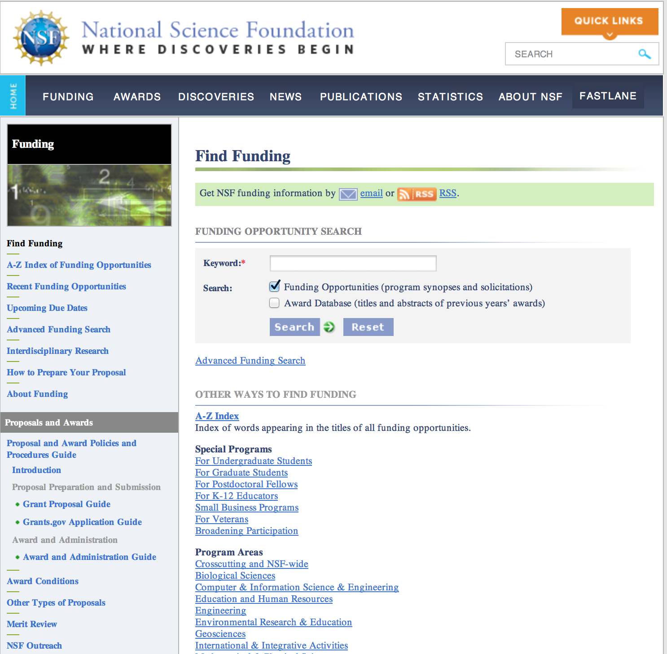

Research and Program Grants:

Aeronomy Grant
http://www.grants.gov/web/grants/view-opportunity.html?oppId=275143

Atmospheric Chemistry Grant
http://www.grants.gov/web/grants/view-opportunity.html?oppId=275146

Big Data Regional Innovation Hubs Grant
http://www.grants.gov/web/grants/view-opportunity.html?oppId=275501

Chemical Oceanography Grant
http://www.grants.gov/web/grants/view-opportunity.html?oppId=275150

Climate and Large-Scale Dynamics Grant
http://www.grants.gov/web/grants/view-opportunity.html?oppId=275110

Cracking the Olfactory Code Grant
http://www.grants.gov/web/grants/view-opportunity.html?oppId=274843

Critical Techniques and Technologies for Advancing Foundations and Applications of Big Data Science & Engineering Grant
http://www.grants.gov/web/grants/view-opportunity.html?oppId=274789

Cultural Anthropology Program - Doctoral Dissertation Research Improvement Grants
http://www.grants.gov/web/grants/view-opportunity.html?oppId=275093

Cybersecurity Innovation for Cyberinfrastructure Grant
http://www.grants.gov/web/grants/view-opportunity.html?oppId=274891

Decision, Risk and Management Sciences Grant
http://www.grants.gov/web/grants/view-opportunity.html?oppId=275142

Dynamics, Control and Systems Diagnostics Grant
http://www.grants.gov/web/grants/view-opportunity.html?oppId=275175

Enhancing Access to the Radio Spectrum Grant
http://www.grants.gov/web/grants/view-opportunity.html?oppId=274868

Faculty Early Career Development Program Grant
http://www.grants.gov/web/grants/view-opportunity.html?oppId=275046

Geomorphology and Land-use Dynamics (GLD) Grant
http://www.grants.gov/web/grants/view-opportunity.html?oppId=275362

Geospace Facilities Grant
http://www.grants.gov/web/grants/view-opportunity.html?oppId=275139

Historically Black Colleges and Universities - Undergraduate Program Grant
http://www.grants.gov/web/grants/view-opportunity.html?oppId=274984

Hydrologic Sciences (HS) Grant
http://www.grants.gov/web/grants/view-opportunity.html?oppId=275278

Improvement Awards Grant
http://www.grants.gov/web/grants/view-opportunity.html?oppId=274988

Infrastructure Management and Extreme Events Grant
http://www.grants.gov/web/grants/view-opportunity.html?oppId=275141

Lower Atmosphere Observing Facilities Grant
http://www.grants.gov/web/grants/view-opportunity.html?oppId=275138

Magnetospheric Physics Grant
http://www.grants.gov/web/grants/view-opportunity.html?oppId=275151

Manufacturing Machines and Equipment Grant
http://www.grants.gov/web/grants/view-opportunity.html?oppId=274826

Marine Geology and Geophysics Grant
http://www.grants.gov/web/grants/view-opportunity.html?oppId=275149

National Facilities Grant
http://www.grants.gov/web/grants/view-opportunity.html?oppId=275109

Paleoclimate Grant
http://www.grants.gov/web/grants/view-opportunity.html?oppId=275147

Petrology and Geochemistry Grant
http://www.grants.gov/web/grants/view-opportunity.html?oppId=275234

Physical and Dynamic Meteorology Grant
http://www.grants.gov/web/grants/view-opportunity.html?oppId=275144

Physical Oceanography Grant
http://www.grants.gov/web/grants/view-opportunity.html?oppId=275148

Plant Genome Research Program Grant
http://www.grants.gov/web/grants/view-opportunity.html?oppId=274844

Presidential Awards for Excellence in Science, Mathematics and Engineering Mentoring
Grant
http://www.grants.gov/web/grants/view-opportunity.html?oppId=274983

Sedimentary Geology and Paleobiology Grant
http://www.grants.gov/web/grants/view-opportunity.html?oppId=275473

Software Infrastructure for Sustained Innovation - S2I2 Grant
http://www.grants.gov/web/grants/view-opportunity.html?oppId=274987

Solar Terrestrial Grant
http://www.grants.gov/web/grants/view-opportunity.html?oppId=275145

Structural and Architectural Engineering Grant
http://www.grants.gov/web/grants/view-opportunity.html?oppId=275140

Modifications:

Reminders:

Facilitating Research at Primarily Undergraduate Institutions: Grant

Document Type: | Grants Notice
Funding Opportunity Number: | 14-579
Funding Opportunity Title: | Facilitating Research at Primarily Undergraduate Institutions:
Opportunity Category: | Discretionary
Funding Instrument Type: | Grant
Category of Funding Activity: | Science and Technology and other Research and Development
Category Explanation:
Expected Number of Awards: | 245
CFDA Number(s): | 47.041 -- Engineering Grants  47.049 -- Mathematical and Physical Sciences  47.050 -- Geosciences  47.070 -- Computer and Information Science and Engineering  47.074 -- Biological Sciences  47.075 -- Social, Behavioral, and Economic Sciences  47.076 -- Education and Human Resources  47.079 -- Office of International and Integrative Activities  47.081 -- Office of Experimental Program to Stimulate Competitive Research
Cost Sharing or Matching Requirement: | No
Posted Date: | Jul 2, 2014
Creation Date: | Jul 2, 2014
Original Closing Date for Applications: | Proposals Accepted Anytime. Submission deadlines vary by program and proposals must meet program-specific requirements to be considered for review. PIs should contact cognizant program officers for guidance.
Current Closing Date for Applications: | Proposals Accepted Anytime. Submission deadlines vary by program and proposals must meet program-specific requirements to be considered for review. PIs should contact cognizant program officers for guidance.
Archive Date: | Sep 30, 2015
Estimated Total Program Funding: | $56,000,000
Eligible Applicants: | Others (see text field entitled "Additional Information on Eligibility" for clarification)
Additional Information on Eligibility: | Who May Submit Proposals: Proposals may only be submitted by the following: Eligible predominantly undergraduate institutions (PUIs) are accredited colleges and universities (including two-year community colleges) that award Associate's degrees, Bachelor's degrees, and/or Master's degrees in NSF-supported fields, but have awarded 20 or fewer Ph.D./D.Sci. degrees in all NSF-supported fields during the combined previous two academic years. Who May Serve as PI: See Additional Eligibility Information in Section IV.B of this solicitation.
Agency Name: | National Science Foundation
Description: | The Research in Undergraduate Institutions (RUI) and Research Opportunity Awards (ROA) funding opportunities support research by faculty members at predominantly undergraduate institutions (PUIs). RUI proposals support PUI faculty in research that engages them in their professional field(s), builds capacity for research at their home institution, and supports the integration of research and undergraduate education. ROAs similarly support PUI faculty research, but these awards typically allow faculty to work as visiting scientists at research-intensive organizations where they collaborate with other NSF-supported investigators. Eligible PUIs are accredited colleges and universities (including two-year community colleges) that award Associate's degrees, Bachelor's degrees, and/or Master's degrees in NSF-supported fields, but have awarded 20 or fewer Ph.D./D.Sci. degrees in all NSF-supported fields during the combined previous two academic years. All NSF directorates may support RUI and ROA funding activities. Funding for these awards is contained within research and education program allocations and not held as a separate allocation. RUI and ROA proposals are evaluated and funded by NSF programs in the disciplinary areas of the proposed research and are funded at their discretion. Prospective PIs should contact disciplinary program officers to identify specific NSF programs and to determine the feasibility and timing of RUI/ROA requests. General RUI/ROA points of contact are available through the website http://www.nsf.gov/crssprgm/rui_roa/contacts.jsp. 1. Research in Undergraduate Institutions (RUI). An RUI proposal may be: A request to support an individual research project or a collaborative research project involving PUI faculty and students at their own or other institutions. A request involving shared research instrumentation. 2. Research Opportunity Awards (ROA). The types of ROA opportunities include: A supplement to an existing NSF award to support ROA activities for PUI faculty. Requests to rebudget funds in an existing NSF award to support ROA activities for PUI faculty. Submission of a new collaborative proposal between a PUI and another institution(s), with a ROA component as a subaward or as part of a linked collaborative proposal.
Link to Additional Information: | NSF Publication 14-579
Contact Information: | If you have difficulty accessing the full announcement electronically, please contact:  NSF grants.gov support grantsgovsupport@nsf.gov  If you have any problems linking to this funding announcement, please contact

http://www.grants.gov/web/grants/view-opportunity.html?oppId=258835

Nuclear Regulatory Commission



Small Business Administration

General Overview Finding Loans & Grants
Federal, state and local governments offer a wide range of financing programs to help small businesses start and grow their operations. These programs include low-interest loans, venture capital, and scientific and economic development grants.
Use SBA.gov's Loans and Grants Search Tool to get a list of financing programs for which you may qualify, or visit the resources below to learn more about small business financing programs. To get to the main SBA.gov funding page click here

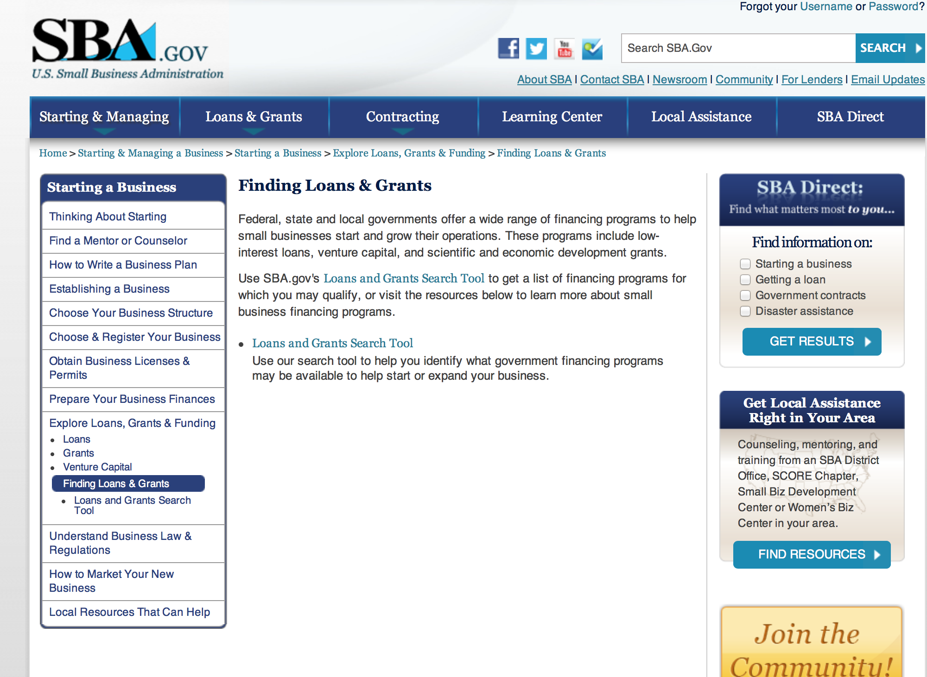
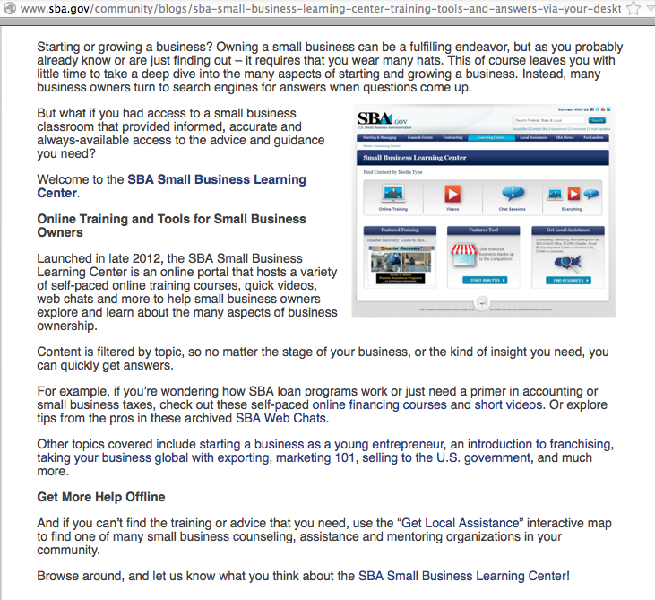

Reminders:

SBA Trainings

Small Business Resources at your Fingertips
http://content.govdelivery.com/accounts/USSBA/bulletins/d23b63

Contracting Opportunities for Veteran Entrepreneurs
This self-paced training exercise is an introduction to Federal contracting opportunities for Veterans.
Topics include basic information about Veteran-owned businesses and opportunities, services available to small Veteran-owned businesses, small business incentives, and government procurement methods.
Duration: 00:30:00

http://www.sba.gov/tools/sba-learning-center/training/contracting-opportunities-veteran-entrepreneurs

Interested in Exporting? These Four Resources Can Help
Did you know that two-thirds of the world’s purchasing power is in foreign countries? As the numbers show, the international marketplace is a big one. So if you’re interested in exploring the world of exporting – or have gotten started but could use some guidance – check out these resources to help.
- Read more

Upcoming Trainings:

Check out SBA's Online Training!
- Financing Options for Small Businesses
How to Prepare Government Contract Proposals

Getting Started With Exporting: Training and Educational Resources
Exporting represents a big opportunity to tap in to new markets, expand your customer base and grow your business. But getting started with exporting can sometimes feel like a maze of regulations, policies, and other barriers. Here are some free training and educational resources to help.
> Read more

For Specific Information in Hawaii see the following links:
Hawaii SBA Resource Guide

Hawaii Express Lenders List

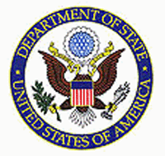

State Department

General Overview and Resources for Program Administrators
Advice on Funding Opportunities:
- The Bureau of Educational & Cultural Affairs Grant Process (PDF)
- Proposal Solicitation Eligibility and Process (PDF)
- Making Your Grant Proposal Competitive (PDF)
- Grantee Recipients - Alumni Outreach, Tracking and Engagement (PDF)
General Information:
- Bureau of Educational and Cultural Affairs Grants Division
- Open Grant Opportunities (Requests for Grant Proposals)

For General Information below click here
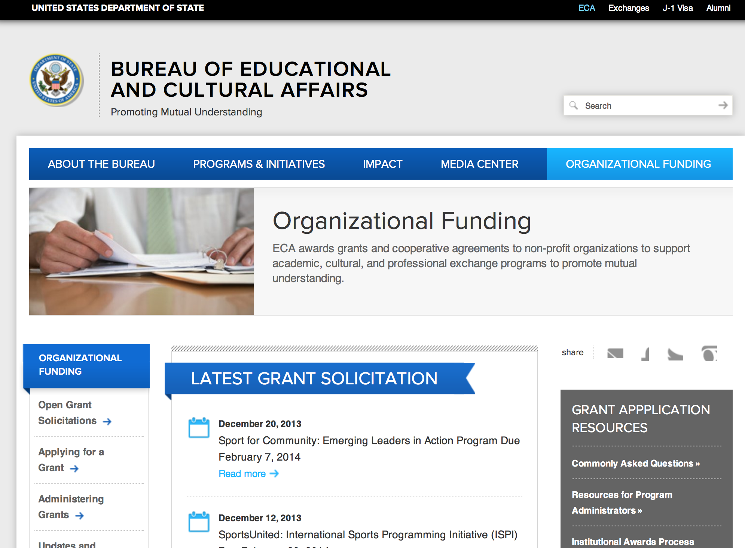

Program Grants:

Bureau Of Educational and Cultural Affairs
FY 2015 SportsUnited: International Sports Programming Initiative (ISPI) Grant
http://www.grants.gov/web/grants/view-opportunity.html?oppId=275029

Bureau Of Educational and Cultural Affairs
FY 2015 Ngwang Choephel Fellows Program Grant
http://www.grants.gov/web/grants/view-opportunity.html?oppId=274924

Bureau Of Educational and Cultural Affairs
FY 2015 EducationUSA Academy Grant
http://www.grants.gov/web/grants/view-opportunity.html?oppId=275457

Bureau Of Educational and Cultural Affairs
FY 2015 English Access Microscholarship Grant
http://www.grants.gov/web/grants/view-opportunity.html?oppId=275640

Bureau Of Educational and Cultural Affairs
FY 2015 International Exchange Alumni Enrichment Seminars Grant
http://www.grants.gov/web/grants/view-opportunity.html?oppId=275701

International Narcotics and Law Enforcement Affair
Improving Court Administration in Tunisia Grant
http://www.grants.gov/web/grants/view-opportunity.html?oppId=274926

International Narcotics and Law Enforcement Affair
Development of a Comprehensive Prison Inmate Reinsertion Methodology Grant
http://www.grants.gov/web/grants/view-opportunity.html?oppId=275441

International Narcotics and Law Enforcement Affair
Gang Resistance Education and Training Grant
http://www.grants.gov/web/grants/view-opportunity.html?oppId=275001

International Narcotics and Law Enforcement Affair
Drug Prevention Curriculum for the Atlantic Coast of Honduras Grant
http://www.grants.gov/web/grants/view-opportunity.html?oppId=275002

PM Weapons Removal and Abatement
15.PMWRA.Jordan.VA.NOFO Grant
http://www.grants.gov/web/grants/view-opportunity.html?oppId=275577

PM Weapons Removal and Abatement
FY15 Iraq Mine Risk Education-Notice of Funding Opportunity Grant
http://www.grants.gov/web/grants/view-opportunity.html?oppId=275651

PM Weapons Removal and Abatement
15.PMWRA.CWD Fellowship RFI Grant
http://www.grants.gov/web/grants/view-opportunity.html?oppId=275384

U.S. Mission to Costa Rica
Creating Social and Economic Opportunity to Strengthen Citizen Security; Promoting Transparency to Encourage a Culture that Resists Corruption Grant
http://www.grants.gov/web/grants/view-opportunity.html?oppId=275038

U.S. Mission to Belize
Job Creation and Alternative Activities for At-Risk Youth Grant
http://www.grants.gov/web/grants/view-opportunity.html?oppId=275213

U.S. Mission to Georgia
University Research Program Grant
http://www.grants.gov/web/grants/view-opportunity.html?oppId=275108

Bureau Of Educational and Cultural Affairs
FY 2015 EducationUSA Leadership Institutes Grant
http://www.grants.gov/web/grants/view-opportunity.html?oppId=275548

Bureau Of Educational and Cultural Affairs
FY 2015 Global Sports Mentoring Program Grant
http://www.grants.gov/web/grants/view-opportunity.html?oppId=275522

Modifications:

Bureau of Democracy, Human Rights and Labor Request for Proposals: Democracy, Human Rights, and Labor in Egypt
Modification 2
http://www.grants.gov/web/grants/view-opportunity.html?oppId=275313

Bureau Of Educational and Cultural Affairs
FY 2015 U.S. Building Study Abroad Capacity at U.S. Higher Education Institutions MOOC
Modification 1
http://www.grants.gov/web/grants/view-opportunity.html?oppId=275458

Bureau Of Educational and Cultural Affairs
FY 2015 Capacity-Building Program for U.S. Undergraduate Study Abroad
Modification 1
http://www.grants.gov/web/grants/view-opportunity.html?oppId=275453

Bureau of Population, Refugees and Migration
FY2015 Notice of Funding Opportunity for NGO Programs Benefitting Tibetan Refugees in South Asia
Modification 1
http://www.grants.gov/web/grants/view-opportunity.html?oppId=275512

Bureau of Population, Refugees and Migration
FY 2015 Notice of Funding Opportunity for NGO programs benefiting refugees in Ethiopia and Kenya
Modification 1
http://www.grants.gov/web/grants/view-opportunity.html?oppId=275230

Bureau of Population, Refugees and Migration
FY 2015 Notice of Funding Opportunity for NGO Programs Benefiting Burmese and Other Urban Refugees and Asylum Seekers in Malaysia and Thailand
Modification 1
http://www.grants.gov/web/grants/view-opportunity.html?oppId=275011

Bureau of Population, Refugees and Migration
FY 2015 Notice of Funding Opportunity for NGO programs benefiting Sri Lankan refugees and returnees in South Asia
Modification 1
http://www.grants.gov/web/grants/view-opportunity.html?oppId=275326

Bureau of Population, Refugees and Migration
FY 2015 Notice of Funding Opportunity for NGO programs benefiting Sri Lankan refugees and returnees in South Asia
Modification 3
http://www.grants.gov/web/grants/view-opportunity.html?oppId=275326

International Narcotics and Law Enforcement Affair
Alternatives to Drugs and Violence Annual Program Statement (ADVAPS)
Modification 7
http://www.grants.gov/web/grants/view-opportunity.html?oppId=272431

International Narcotics and Law Enforcement Affair
Alternatives to Drugs and Violence Annual Program Statement (ADVAPS)
Modifications 3 & 5
http://www.grants.gov/web/grants/view-opportunity.html?oppId=272431

International Narcotics and Law Enforcement Affair
Logistical Support for Violence Prevention Program
Modification 1
http://www.grants.gov/web/grants/view-opportunity.html?oppId=275001

U.S. Mission to Belize
Job Creation and Alternative Activities for At-Risk Youth
Modification 1
http://www.grants.gov/web/grants/view-opportunity.html?oppId=275213

U.S. Mission to Panama
Promoting Security and Accountability in Panama
Modification 1
http://www.grants.gov/web/grants/view-opportunity.html?oppId=275044

U.S. Mission to Panama
Promoting Security and Accountability in Panama
Modification 2
http://www.grants.gov/web/grants/view-opportunity.html?oppId=275044

Department of Transportation

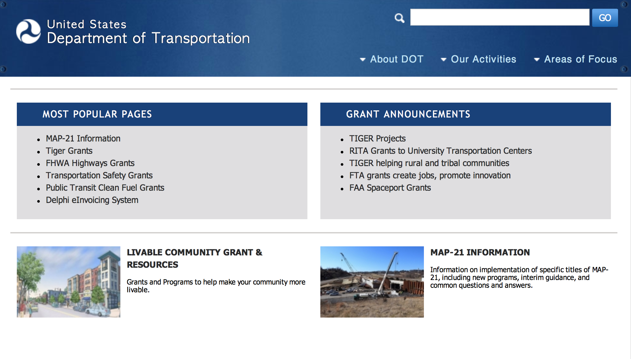
General Grant Program Overview ----- http://www.dot.gov/grants
Administration of the Dwight David Eisenhower Transportation Fellowship Program Local Competition Grant
Document Type: | Grants Notice
Funding Opportunity Number: | DTFH6115RA00007
Funding Opportunity Title: | Administration of the Dwight David Eisenhower Transportation Fellowship Program Local Competition
Opportunity Category: | Discretionary
Funding Instrument Type: | Grant
Category of Funding Activity: | Transportation
Category Explanation:
Expected Number of Awards: | 40
CFDA Number(s): | 20.215 -- Highway Training and Education
Cost Sharing or Matching Requirement: | No
Posted Date: | Mar 20, 2015
Creation Date: | Mar 20, 2015
Original Closing Date for Applications: | Apr 20, 2015
Current Closing Date for Applications: | Apr 20, 2015
Archive Date: | May 20, 2015
Estimated Total Program Funding: | $850,000
Award Ceiling: | $10,000
Award Floor: | $1,500
Eligible Applicants: | Others (see text field entitled "Additional Information on Eligibility" for clarification)
Additional Information on Eligibility: | Higher Education Institutions designated as: 1) Historically Black Colleges and Universities; or 2) Hispanic Serving Institutions; or 3) Tribal Colleges and Universities; or 4) Community Colleges; or 5) Those designated to serve People with Disabilities.
Agency Name: | DOT Federal Highway Administration
Description: | The U.S. Department of Transportation (DOT), Federal Highway Administration (FHWA), is soliciting applications for Educational Institutions that are designated as Historically Black Colleges and Universities, Hispanic Serving Institutions, Tribal Colleges and Universities, Community Colleges, and those that are designated to serve People with Disabilities to apply to administer the Dwight David Eisenhower Transportation Fellowship Program at their Institution.
Link to Additional Information: | FHWA Eisenhower Website
Contact Information: | If you have difficulty accessing the full announcement electronically, please contact:  Fawn Thompson Program Manager Phone 4045623917  program manager e-mail

http://www.grants.gov/web/grants/view-opportunity.html?oppId=275328

DOT Federal Highway Administration
Dwight David Eisenhower Transportation Fellowship Program Graduate Fellowship Grant

Document Type: | Grants Notice
Funding Opportunity Number: | DTFH6115RA00006
Funding Opportunity Title: | Dwight David Eisenhower Transportation Fellowship Program Graduate Fellowship
Opportunity Category: | Discretionary
Funding Instrument Type: | Grant
Category of Funding Activity: | Transportation
Category Explanation:
Expected Number of Awards: | 76
CFDA Number(s): | 20.215 -- Highway Training and Education
Cost Sharing or Matching Requirement: | No
Posted Date: | Mar 25, 2015
Creation Date: | Mar 25, 2015
Original Closing Date for Applications: | Apr 21, 2015
Current Closing Date for Applications: | Apr 21, 2015
Archive Date: | May 21, 2015
Estimated Total Program Funding: | $800,000
Award Ceiling: | $35,500
Award Floor: | $5,000
Eligible Applicants: | Individuals
Agency Name: | DOT Federal Highway Administration
Description: | The U.S. Department of Transportation (DOT), Federal Highway Administration (FHWA), is soliciting applications for the Eisenhower Transportation Fellowship Program to 1) to attract the nation's brightest minds to the field of transportation, 2) to enhance the careers of transportation professionals by encouraging them to seek advanced degrees, and 3) to retain top talent in the transportation industry of the United States.
Link to Additional Information:
Contact Information: | If you have difficulty accessing the full announcement electronically, please contact:  Fawn Thompson Program Manager Phone 4045623917  Program Manager e-mail address

http://www.grants.gov/web/grants/view-opportunity.html?oppId=275414

Pipeline &Hazardous Material Safety Administration
PHMSA Hazmat Grants
FY15 ALERT Funding Opportunity Grant

Document Type: | Grants Notice
Funding Opportunity Number: | HM-ALT-15-001
Funding Opportunity Title: | FY15 ALERT Funding Opportunity
Opportunity Category: | Discretionary
Funding Instrument Type: | Grant
Category of Funding Activity: | Transportation
Category Explanation:
Expected Number of Awards: | 5
CFDA Number(s): | 20.703 -- Interagency Hazardous Materials Public Sector Training and Planning Grants
Cost Sharing or Matching Requirement: | No
Posted Date: | Mar 27, 2015
Creation Date: | Mar 27, 2015
Original Closing Date for Applications: | May 15, 2015 No Explanation
Current Closing Date for Applications: | May 15, 2015 No Explanation
Archive Date: | Jun 14, 2015
Estimated Total Program Funding: | $3,500,000
Award Ceiling: | $3,500,000
Award Floor: | $100,000
Eligible Applicants: | Others (see text field entitled "Additional Information on Eligibility" for clarification)
Agency Name: | PHMSA Hazmat Grants
Description: | Funds are now available for the FY15 Assistance for Local Emergency Response Training (ALERT) Grant. The ALERT Grant is focused on response activities for the transportation of crude oil, ethanol and other flammable liquids by rail. In accordance with the Omnibus Consolidated and Further Continuing Appropriations Act, P.L.113-235 (the Act), PHMSA is authorized to use prior year recoveries from HMEP grant awards to provide funding for the ALERT Grant. This grant will be used to provide local emergency responders with additional training on hazardous materials transportation incidents. Grant funding will be sourced from prior year recoveries. As a result, PHMSA will apply existing resources toward its mission of protecting people and the environment from the risks inherent to the transportation of hazardous materials. Hazardous material training for volunteer or remote emergency responders has been identified as a top priority by PHMSA in FY15. This new competitive grant opportunity requests applications from nonprofit organizations that have the ability to provide direct or web-based hazardous materials training for volunteer or remote emergency responders. Ideally, PHMSA seeks applications from nonprofit organizations that represent public-private partnerships to improve regional emergency response.
Link to Additional Information: | FY15 ALERT Funding Opportunity
Contact Information: | If you have difficulty accessing the full announcement electronically, please contact:  Grants.gov Contact Center Phone Number: 1-800-518-4726 Hours of operation are 24 hours a day, 7 days a week. The contact center is closed on federal holidays. support@grants.gov  Grants.gov Customer Support

http://www.grants.gov/web/grants/view-opportunity.html?oppId=275494

Pipeline &Hazardous Material Safety Administration
Pipeline Safety Research Competitive Academic Agreement Program (CAAP) – FY 2015 Grant

Document Type: | Grants Notice
Funding Opportunity Number: | DTPH5615SN0003
Funding Opportunity Title: | Pipeline Safety Research Competitive Academic Agreement Program (CAAP) – FY 2015
Opportunity Category: | Discretionary
Funding Instrument Type: | Cooperative Agreement
Category of Funding Activity: | Science and Technology and other Research and Development
Category Explanation:
Expected Number of Awards: | 7
CFDA Number(s): | 20.724 -- Pipeline Safety Research Competitive Academic Agreement Program (CAAP)
Cost Sharing or Matching Requirement: | Yes
Posted Date: | Apr 3, 2015
Creation Date: | Apr 3, 2015
Original Closing Date for Applications: | May 18, 2015
Current Closing Date for Applications: | May 18, 2015
Archive Date: | Jun 17, 2015
Estimated Total Program Funding:
Award Ceiling: | $300,000
Award Floor: | $0
Eligible Applicants: | Private institutions of higher education  Public and State controlled institutions of higher education
Additional Information on Eligibility: | Applicants must be non-profit institutions of higher education located in the United States or a U.S. territory or possession.
Agency Name: | Pipeline &Hazardous Material Safety Administration
Description: | The Pipeline and Hazardous Materials Safety Administration (PHMSA), through the U.S. Department of Transportation (DOT), hereby requests applications from non-profit institutions of higher education to obtain funding to research innovative solutions to pipeline corrosion and other known pipeline integrity challenges. The CAAP initiative is intended to spur innovation by enabling an academic research focus on high-risk and high pay-off solutions for the many pipeline safety challenges. The authority for PHMSA’s Pipeline Safety Research and Development Program comes from the Pipeline Safety Improvement Act of 2002 (P. L. 107-355, December 17, 2002). Further, the authority to enter into cooperative agreements under the CAAP initiative is codified at 49 U.S.C. §60117(k), Authority for Cooperative Agreements. All questions regarding this FOA must be emailed to Saurabh Vasudeva (saurabh.vasudeva@dot.gov) with a copy to Mr. Warren Osterberg (warren.osterberg@dot.gov). Applicants may not contact any other PHMSA personnel during the solicitation phase. All questions must be received on or before Tuesday, April 17, 2015 to be considered. Answers to all questions will be posted in Grants.gov as an amendment to the initial announcement. Complete applications must be received electronically through Grants.gov and MIS by 11:59pm Eastern Time on Thursday, May 18, 2015. Applicants will receive an automated receipt from Grants.gov of the date and time of application submission. If the timeliness of a submission comes into question, the date and time recorded in Grants.gov will take precedence over that of MIS. REFER TO THE ATTACHMENT "FOA#DTPH5615SN0003 CAAP 2015 Package" UNDER THE "FULL ANNOUNCEMENT" TAB FOR DETAILS.
Link to Additional Information:
Contact Information: | If you have difficulty accessing the full announcement electronically, please contact:  Saurabh Vasudeva Agreement Specialist Phone 2025274195  saurabh.vasudeva@dot.gov

http://www.grants.gov/web/grants/view-opportunity.html?oppId=275654

Modifications:

Reminders:

Pipeline &Hazardous Material Safety Administration
Technical Assistance Grants (TAG)
Modification 2
Document Type: | Grants Notice
Funding Opportunity Number: | DTPH5615SN0002
Funding Opportunity Title: | Technical Assistance Grants (TAG)
Opportunity Category: | Discretionary
Funding Instrument Type: | Grant
Category of Funding Activity: | Science and Technology and other Research and Development
Category Explanation:
Expected Number of Awards:
CFDA Number(s): | 20.710 -- Technical Assistance Grants
Cost Sharing or Matching Requirement: | No
Posted Date: | Feb 2, 2015
Creation Date: | Mar 13, 2015
Original Closing Date for Applications: | Apr 22, 2015 **Closing Date: April 22, 2015 **Closing Time: 2:00 PM Eastern Time
Current Closing Date for Applications: | Apr 22, 2015 **Closing Date: April 22, 2015 **Closing Time: 2:00 PM Eastern Time
Archive Date: | May 31, 2015
Estimated Total Program Funding: | $1,500,000
Award Ceiling: | $100,000
Award Floor: | $0
Eligible Applicants: | Others (see text field entitled "Additional Information on Eligibility" for clarification)
Additional Information on Eligibility: | Applicants for Technical Assistance Grants must be local communities or groups of individuals (not including for-profit entities) relating to the safety of pipeline facilities in local communities, other than facilities regulated under Public Law 93-153 (43 U.S.C. 1651 et seq.). Eligible applicants include cities, towns, villages, counties, parishes, townships, and similar governmental subdivisions, or consortiums of such subdivisions.
Agency Name: | Pipeline &Hazardous Material Safety Administration
Description: | The Pipeline and Hazardous Materials Safety Administration (PHMSA), through the U.S. Department of Transportation (DOT), hereby requests applications from local communities and groups of individuals (not including for-profit entities) to obtain funding for technical assistance in the form of engineering or other scientific analysis of pipeline safety issues affecting the local community or to help promote public participation in official proceedings (excluding non-official proceedings) pertaining to pipeline safety issues. The Technical Assistance Grants (TAG) program, first authorized in the Pipeline Safety Improvement Act of 2002 (Act) (P. L. 107-355, codified at 49 U.S.C. 60130), offers new opportunities to strengthen the depth and quality of public participation in pipeline safety matters. Section 9 of the Act, titled: “Pipeline Safety Information Grants to Communities” authorized the Secretary of Transportation to make grants to local communities and organizations for technical assistance relating to pipeline safety issues. The TAG program has been amended by Section 5 of the Pipeline Inspection, Protection, Enforcement and Safety Act of 2006 (PIPES Act of 2006) (P.L. 109-468) and the Pipeline Safety, Regulatory Certainty, and Job Creation Act of 2011 (P.L. 112-90). *** Refer to the attachment titled “DTPH5615SN0002 TAG Funding Opportunity Announcement (FOA)” under the full announcement tab for complete details.***
Link to Additional Information:
Contact Information: | If you have difficulty accessing the full announcement electronically, please contact:  Saurabh Vasudeva Contract Specialist Phone 202 366 4429  saurabh.vasudeva@dot.gov

http://www.grants.gov/web/grants/view-opportunity.html?oppId=272688



Department of the Treasury

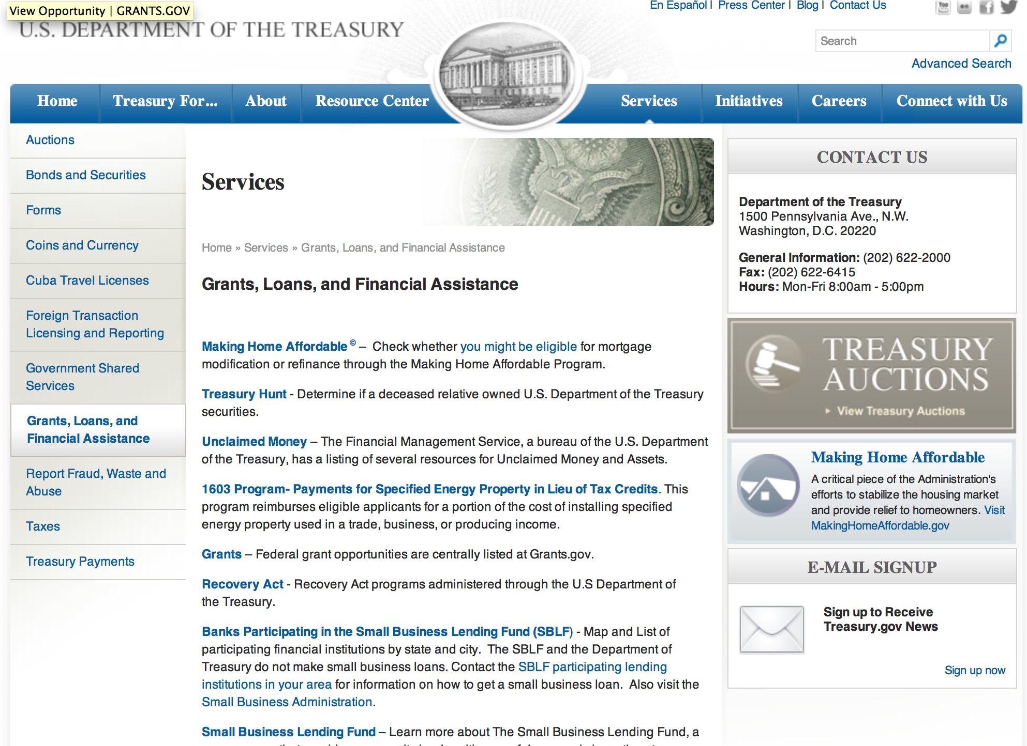

http://www.treasury.gov/services/Pages/Grants-Loans-and-Financial-Assistance.aspx

Modifications:

Reminders:

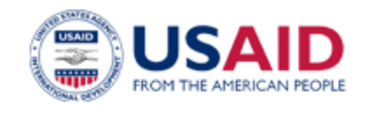

U.S. Agency for International Development

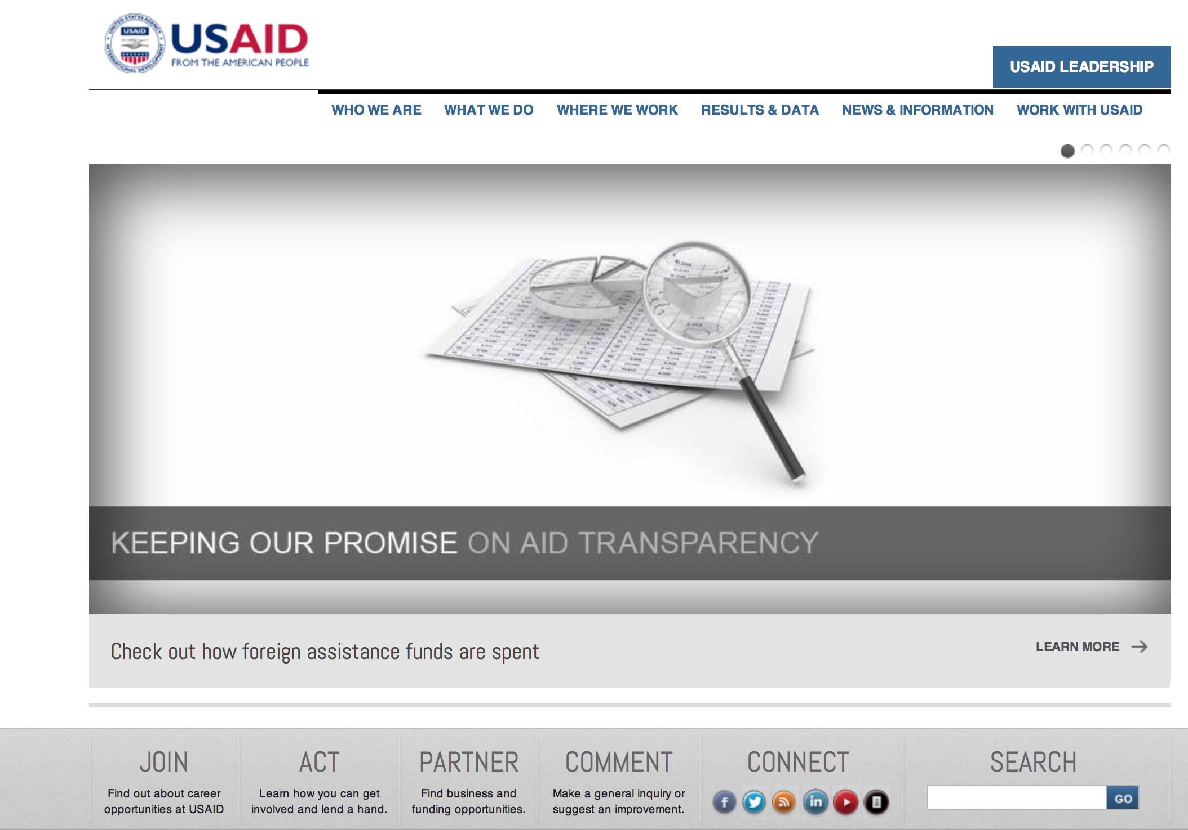
www.usaid.gov

General Overview Funding Opportunities

USAID has working relationships with thousands of American companies and hundreds of U.S.-based private voluntary organizations. For more information on our business and procurement opportunities, please visit our Business section.

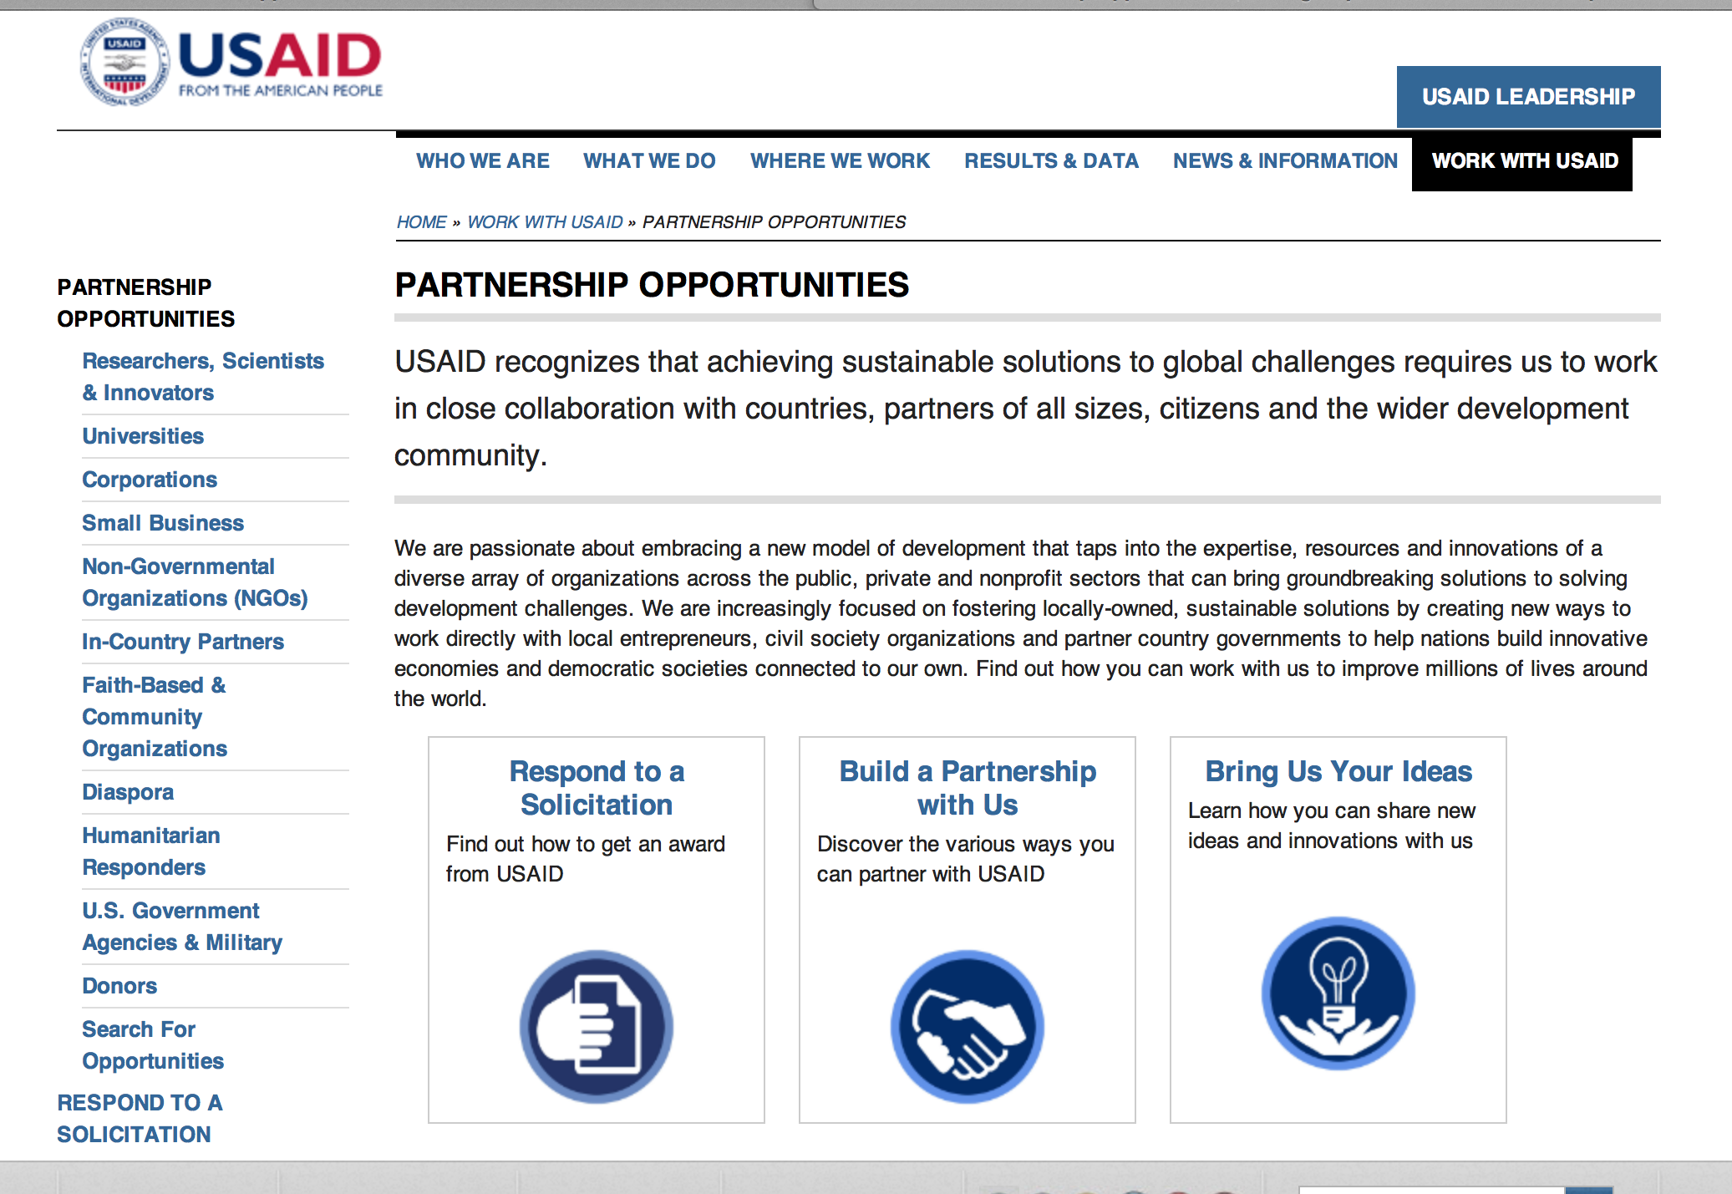
http://www.usaid.gov/partnerships

Programs:

2015 DRAFT IFRP RFA Grant
http://www.grants.gov/web/grants/view-opportunity.html?oppId=275371

Annual Program Statement - Policy, Advocacy, and Communication Enhanced for Population and Reproductive Health (PACE) Grant
http://www.grants.gov/web/grants/view-opportunity.html?oppId=275168

FY 2015 Conflict Mitigation and Reconciliation Programs and Activities Grant
http://www.grants.gov/web/grants/view-opportunity.html?oppId=274846

Peru USAID-Lima
Brazil Environment Program Grant
http://www.grants.gov/web/grants/view-opportunity.html?oppId=274944

SECURING WATER FOR FOOD (SWFF) Grant
http://www.grants.gov/web/grants/view-opportunity.html?oppId=275036

USAID/HAITI INCREASING WOMEN’S POLITICAL PARTICIPATION BROAD AGENCY ANNOUNCEMENT Grant
http://www.grants.gov/web/grants/view-opportunity.html?oppId=274975

USAID/DCHA/FFP International Emergency Food Assistance Grant
http://www.grants.gov/web/grants/view-opportunity.html?oppId=275353

Thailand USAID-Bangkok
Feed the Future Asia Innovative Farmers Activity Grant
http://www.grants.gov/web/grants/view-opportunity.html?oppId=275378

India USAID-New Delhi
Tuberculosis Health Action Learning Initiative (THALI) Grant
http://www.grants.gov/web/grants/view-opportunity.html?oppId=275572

Request for Applications for Title II Development Food Assistance Projects for Bangladesh and Mali Grant
http://www.grants.gov/web/grants/view-opportunity.html?oppId=275657

Agency for International Development
Request for Information for RFI-674-15-RHAP-001Grant
http://www.grants.gov/web/grants/view-opportunity.html?oppId=275554

Modifications

Afghanistan USAID-Kabul
The USAID/Afghanistan Development Innovation Accelerator
Modification 1
http://www.grants.gov/web/grants/view-opportunity.html?oppId=275080

Nepal USAID-Kathmandu
Office of American Schools and Hospitals Abroad (ASHA) Fiscal Year 2015 Program
Modification 7
http://www.grants.gov/web/grants/view-opportunity.html?oppId=268248

Thailand USAID-Bangkok
USAID/Vietnam Innovation in Higher Education Addendum to GDA APS-OAA-14-000001
Modification 7
http://www.grants.gov/web/grants/view-opportunity.html?oppId=271168

USAID Bureau for Food Security (BFS) Broad Agency Announcement (BAA) for Climate Smart Agriculture
Modification 2
http://www.grants.gov/web/grants/view-opportunity.html?oppId=275232

FY 2015 Conflict Mitigation and Reconciliation Programs and Activities
Modification 3
http://www.grants.gov/web/grants/view-opportunity.html?oppId=274846

Reminders

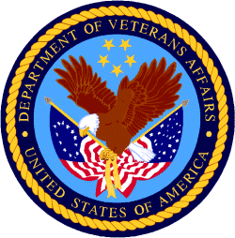

Department of Veterans Affairs

Reminders:

Homeless Providers Grant and Per Diem Program
VA GPD TIP Renewal NOFA Grant

Document Type: | Grants Notice
Funding Opportunity Number: | VA-GPD-FY15-TIP-NOFA
Funding Opportunity Title: | VA GPD TIP Renewal NOFA
Opportunity Category: | Discretionary
Funding Instrument Type: | Grant
Category of Funding Activity: | Housing
Category Explanation:
Expected Number of Awards: | 25
CFDA Number(s): | 64.024 -- VA Homeless Providers Grant and Per Diem Program
Cost Sharing or Matching Requirement: | No
Posted Date: | Jan 16, 2015
Creation Date: | Jan 16, 2015
Original Closing Date for Applications: | Apr 20, 2015
Current Closing Date for Applications: | Apr 20, 2015
Archive Date: | Apr 21, 2015
Estimated Total Program Funding: | $25,000,000
Award Ceiling: | $1,200,000
Eligible Applicants: | City or township governments  Native American tribal governments (Federally recognized)  Special district governments  County governments  Nonprofits having a 501(c)(3) status with the IRS, other than institutions of higher education  State governments
Agency Name: | Homeless Providers Grant and Per Diem Program
Description: | The U.S. Department of Veterans Affairs (VA) is announcing the availability of funds for assistance under the Per Diem Only (PDO) component of VA’s Homeless Providers Grant and Per Diem (GPD) Program. This Notice of Funding Availability (NOFA) is for those current "Transition in Place" (TIP) grantees who seek to renew their 2012 TIP PDO grants. Award Information: VA is pleased to issue this NOFA under VA’s Homeless Providers GPD Program as a part of the effort to end homelessness among our Nation’s Veterans. VA expects to fund approximately 500 beds over a 3-year period under this NOFA. The maximum award of $1.2 million will support an average of 25 beds per night, per project, at the current maximum per diem rate of $43.32; taking into consideration that the maximum per diem rate may increase in future years. Note: The final amount awarded may be adjusted based on any remaining funding from the previous award.
Link to Additional Information: | VA's Grant and Per Diem Program
Contact Information: | If you have difficulty accessing the full announcement electronically, please contact:  Chelsea Watson Deputy Director Phone 813-979-3570  Chelsea Watson

http://www.grants.gov/web/grants/view-opportunity.html?oppId=271590

REMINDER!

The Small Business Innovative Research Program - SBIR Program
The Small Business Innovation Research (SBIR) program is a highly competitive program that encourages domestic small businesses to engage in Federal Research/Research and Development (R/R&D) that has the potential for commercialization. Through a competitive awards-based program, SBIR enables small businesses to explore their technological potential and provides the incentive to profit from its commercialization. By including qualified small businesses in the nation's R&D arena, high-tech innovation is stimulated and the United States gains entrepreneurial spirit as it meets its specific research and development needs.

SBIR Mission and Program Goals
The mission of the SBIR program is to support scientific excellence and technological innovation through the investment of Federal research funds in critical American priorities to build a strong national economy.
The program’s goals are four-fold:
- Stimulate technological innovation
- Meet Federal research and development needs.
- Foster and encourage participation in innovation and entrepreneurship by socially and economically disadvantaged persons.
- Increase private-sector commercialization of innovations derived from Federal research and development funding.

SBIR-Participating Agencies
Each year, Federal agencies with extramural research and development (R&D) budgets that exceed $100 million are required to allocate 2.5 percent of their R&D budget to these programs. Currently, eleven Federal agencies participate in the program:
- Department of Agriculture
- Department of Commerce - National Institute of Standards and Technology
- Department of Commerce - National Oceanic and Atmospheric Administration
- Department of Defense
- Department of Education
- Department of Energy
- Department of Health and Human Services
- Department of Homeland Security
- Department of Transportation
- Environmental Protection Agency
- National Aeronautics and Space Administration
- National Science Foundation
Each agency administers its own individual program within guidelines established by Congress. These agencies designate R&D topics in their solicitations and accept proposals from small businesses. Awards are made on a competitive basis after proposal evaluation.

Three-Phase Program
The SBIR Program is structured in three phases:
Phase I. The objective of Phase I is to establish the technical merit, feasibility, and commercial potential of the proposed R/R&D efforts and to determine the quality of performance of the small business awardee organization prior to providing further Federal support in Phase II. SBIR Phase I awards normally do not exceed $150,000 total costs for 6 months.
Phase II. The objective of Phase II is to continue the R/R&D efforts initiated in Phase I. Funding is based on the results achieved in Phase I and the scientific and technical merit and commercial potential of the project proposed in Phase II. Only Phase I awardees are eligible for a Phase II award. SBIR Phase II awards normally do not exceed $1,000,000 total costs for 2 years.
Phase III. The objective of Phase III, where appropriate, is for the small business to pursue commercialization objectives resulting from the Phase I/II R/R&D activities. The SBIR program does not fund Phase III. Some Federal agencies, Phase III may involve follow-on non-SBIR funded R&D or production contracts for products, processes or services intended for use by the U.S. Government

