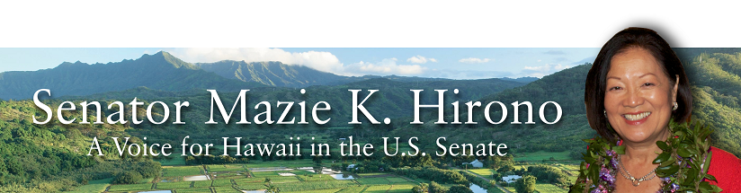

Grants Assistance Information
Newsletter
April 2016

G.A.I.N. INDEX

Click on Index Links below to read summaries of the announcements by agency in this document.
Once you reach the item, if you cannot open the links for further information, copy the selected
URL website address into your browser.

Modified sections from previous listings are shown in a GREY background

Notices is Teal are items with immediate deadline dates.

Notices in Yellow are of special interest.

Notices is Green are items of special interest with immediate deadline dates.

Items in this type color are aimed at Small Businesses

Items in this type color have a Faith-Based Organization component

Special Federal Program Notices

SBIR – Small Business Innovation Research

Programs specific to Hawaii

Current Notices

Department of Homeland Security

Department of Homeland Security - FEMA
Fiscal Year (FY) 2016 Cooperating Technical Partners (CTP) Program - Region 9
Modifications 2 & 4

Reminders

Department of Education

Office of Postsecondary Education (OPE): Asian American and Native American Pacific Islander-Serving Institutions Program CFDA Number 84.382B Grant
Office of Postsecondary Education (OPE): Native Hawaiian-Serving Institutions Program CFDA Number 84.031V Grant

Department of Interior

National Park Service
NAGPRA Consultation/Documentation Grants FY16
Modification 2

See Individual Departments for information and webpages representing the best and most accessible information on the agency funding opportunities

Federal Grant and Cooperative Agreement Program Summaries

U.S. Department of Agriculture

Grants and Loans Overview

Programs

Utilities Programs
Household Water Well Grant Program

National Institute of Food and Agriculture
Rural Health & Safety Education Grant

Business and Cooperative Programs
Rural Cooperative Development Grant

Agricultural Marketing Service
Farmers Market Promotion Program Grant

Agricultural Marketing Service
Local Food Promotion Program Grant

Natural Resources Conservation Service
Conservation Innovation Grants

Natural Resources Conservation Service
Regional Conservation Partnership Program
And Modification 1

National Institute of Food and Agriculture
Special Research Grants Program - Aquaculture Research Grant

Modifications

Reminders

National Institute of Food and Agriculture
Supplemental and Alternative Crops Competitive Grants Program

National Institute of Food and Agriculture
Higher Education Challenge Grants Program

Forest Service
2017 National Urban and Community Forestry Grant Program

National Institute of Food and Agriculture
FY '16 Farm Business Management and Benchmarking (FBMB) Competitive Grants Program RFA Grant

Farm Service Agency
Outreach and Education, Technical Assistance, and Financial Education for FSA Programs, Functions, and Activities Grant

Farm Service Agency
Outreach and Education, Technical Assistance, and Financial Education for FSA Programs, Functions, and Activities
Modification 2

Department of Commerce

Programs

National Institute of Standards and Technology
National Strategy for Trusted Identities in Cyberspace (NSTIC) Federated Identity in Healthcare Pilot Program Grant

Research

Modifications

Reminders

National Institute of Standards and Technology
FY 2016 Small Business Innovation Research (SBIR) Program Grant

National Institute of Standards and Technology
FY 2016 Small Business Innovation Research (SBIR) Program – Phase II Grant

National Institute of Standards and Technology
Replicable Smart City Technologies Cooperative Agreement Program Grant

FY 2016 Joint Technology Transfer Initiative Grant

National Institute of Standards and Technology
Measurement Science and Engineering (MSE) Research Grant Programs

National Institute of Standards and Technology
National Network for Manufacturing Innovation (NNMI) Institute Awards Grant

National Sea Grant College Program 2016-17 Special Projects Grant

FY 2016 – FY 2019 EDA Planning Program and Local Technical Assistance Program Grant

FY 2016 Economic Development Assistance Programs ­ Application submission and program requirements for EDA’s Public Works and Economic Adjustment Assistance Programs

Economic Development Administration
Planning Program and Local Technical Assistance Program Grant

Corporation for National and Community Service

General Program Overview

FY 2016 Social Innovation Fund Classic Cooperative Agreements Grant

Reminders

National Service in Hawaii

Department of Defense

Doing Business with the Department of Defense

DoD Small Business Opportunities and Forecasting

Research Grants

Modifications

Reminders

Dept. of the Army -- Materiel Command
Army Research Office Broad Agency Announcement for Basic and Applied Scientific Research
Modification 8

Department of Education

Grant Programs Overview

Programs

Office of Postsecondary Education (OPE): Fulbright-Hays Doctoral Dissertation Research Abroad Fellowship Program CFDA Number 84.022A Grant

Research

Institute of Education Sciences (IES): CFDA Number 84.305 Grant

Institute of Education Sciences (IES): Statistical and Research Methodology in Education CFDA Number 84.305D Grant

Institute of Education Sciences (IES): Partnerships and Collaborations Focused on Problems of Practice or Policy CFDA Number 84.305H Grant

Institute of Education Sciences (IES): Low-Cost, Short-Duration Evaluation of Education Interventions CFDA Number 84.305L Grant

Institute of Education Sciences (IES): Research Networks Focused on Critical Problem of Education Policy and Practice CFDA Number 84.305N Grant

Institute of Education Sciences (IES): Education Research CFDA Number 84.305A Grant
Institutes of Education Sciences (IES): Research Training Programs in the Education Sciences CFDA Number 84.305B Grant

Institute of Education Sciences (IES): CFDA Number 84.324

Institute of Education Sciences (IES): Special Education Research CFDA Number 84.324A Grant
Institute of Education Sciences (IES): Research Training Programs in Special Education CFDA Number 84.324B Grant
Institute of Education Sciences (IES): Low-Cost, Short-Duration Evaluation of Special Education Interventions CFDA Number 84.324L Grant

Modifications

Office of Elementary and Secondary Education (OESE): Carol M. White Physical Education Program CFDA Number 84.215F
Modification 1

Reminders

Under the Small, Rural School Achievement (SRSA) Program CFDA 84.358A Grant

Office of Postsecondary Education (OPE): Training Program for Federal TRIO Programs CFDA Number 84.103A Grant

Office of Special Education and Rehabilitative Services (OSERS): Office of Special Programs (OSEP): Training and Information for Parents of Children with Disabilities: Community Parent Resource Centers CFDA Number 84.328C Grant

Office of Special Education and Rehabilitative Services (OSERS): Office of Special Education Programs (OSEP): Educational Technology, Media, and Materials for Individuals with Disabilities: Stepping-up Technology Implementation CFDA Number 84.327S Grant

US Department of Energy

Grants Overview

Programs

Cities Leading through Energy Analysis and Planning (Cities-LEAP) Grant

Modifications

Reminders

Environmental Protection Agency

Grants and Contracts Overview

Programs

FY 2016 and FY 2017 Pollution Prevention Grant Program

FY 2016 and FY 2017 Pollution Prevention Information Network (PPIN) Grants Program

Modifications

Reminders

Clean Diesel Funding Assistance Program FY 2016 Grant

Early Career Awards: Integrating Human Health and Well-Being with Ecosystem Services Grant

Integrating Human Health and Well-Being with Ecosystem Services Grant

Department of Health and Human Services

Grants Overview

Program

Research Grants

Modifications

Reminders

Department of Homeland Security
Grants Overview

Programs

Modifications

Department of Homeland Security - FEMA
Fiscal Year (FY) 2016 Cooperating Technical Partners (CTP) Program
Modification 3

Office of Procurement Operations - Grants Division
Domestic Nuclear Detection Office: Academic Research Initiative (ARI
Modification 4

Reminders

Department of Homeland Security - FEMA
FY16 Pre-Disaster Mitigation Grant

Department of Homeland Security - FEMA
FY16 Flood Mitigation Assistance Grant

Department of Homeland Security - FEMA
Fiscal Year 2016 Port Security Grant Program (PSGP)
Modification 2

Department of Homeland Security - FEMA
Fiscal Year (FY) 2016 Intercity Bus Security Grant Program (IBSGP)
Modification 2

Department of Homeland Security - FEMA
Fiscal Year 2016 Transit Security Grant Program (TSGP)
Modification 2

Department of Housing and Urban Development

HUD - Notice of Funds Available

Programs

Lead Hazard Reduction Demonstration (LHRD) Grant Program

Lead-Based Paint Hazard Control (LBPHC) Grant Program

Family Self-Sufficiency Program Grant

Resident Opportunity & Self-Sufficiency Program Grant

Modifications

Choice Neighborhoods Implementation Grant Program
Modification 1

Reminders

Supportive Services Demonstration for Elderly Households in HUD-Assisted Multifamily Housing
Grant

General Section to HUD's Fiscal Year 2016 Notice[s] of Funding Availability for Discretionary Programs (General Section)
Modification 1

Institute of Museum and Library Services

Grants Overview

IMLS is on Facebook!

Modifications

Reminders

STEM Expert Facilitation of Family Learning in Libraries and Museums

National Leadership Grants for Libraries Grant

Laura Bush 21st Century Librarian Program Grant

Department of Interior

Grants and Contract Overview

Programs

Geological Survey
2017 Earthquake Hazards External Grants Program

National Park Service
Land and Water Conservation Fund Outdoor Recreation Legacy Partnership Program Grant

Fish and Wildlife Service
Youth Engagement, Education, and Employment Programs Grant

Modifications

Reminders

Fish and Wildlife Service
Combating Wildlife Trafficking Grant

Fish and Wildlife Service
Fiscal Year 2016 Recovery Implementation Fund Grant

Fish and Wildlife Service
Fiscal Year 2016 Candidate Conservation Action Funds Grant

Fish and Wildlife Service
National Fish Passage Program Grant

Department of the Interior
Fish and Wildlife Service
2016 National Fish Habitat Action Plan
Modification 1

Department of Justice

Grants and Contract Overview

Programs

Bureau of Justice Assistance
Justice and Mental Health Collaboration Program Grant

Office of Justice Programs
Bureau of Justice Assistance
Justice and Mental Health Collaboration Training and Technical Assistance Program Grant

Office of Justice Programs
Bureau of Justice Assistance
Body-Worn Camera Policy and Implementation Program Grant

Office of Justice Programs
Bureau of Justice Statistics
2016 Visiting Fellows: Criminal Justice Statistics Programs Grant

Office of Justice Programs
National Institute of Justice
Investigator-Initiated Research and Evaluation on Firearms Violence Grant

Office of Justice Programs
Office for Victims of Crime
OVC FY 16 Comprehensive Services for Victims of All Forms of Human Trafficking Grant

Office of Juvenile Justice Delinquency Prevention
OJJDP FY 16 Smart on Juvenile Justice: Statewide Juvenile Justice Reform Planning Training & Technical Assistance Grant

Office of Justice Programs
Department of Justice
SMART FY 16 Sex Offender Management Fellowship Program Grant

Office of Justice Programs
Office of Juvenile Justice Delinquency Prevention
OJJDP FY 16 Assessing the Impact of Juvenile Justice Reforms Program Grant

Office of Justice Programs
Office of Juvenile Justice Delinquency Prevention
OJJDP FY 16 Comprehensive Anti-Gang Strategies and Programs Grant

Office of Justice Programs
Office for Victims of Crime
OVC FY 16 Specialized Services for Victims of Human Trafficking Grant

Office of Justice Programs
Office of Juvenile Justice Delinquency Prevention
OJJDP FY 2016 Family Drug Court Implementation and Enhancement Program Grant

Office of Justice Programs
Office on Violence Against Women
OVW FY 2016 Research and Evaluation Program Grant

Office of Justice Programs
National Institute of Justice
Research on "Sentinel Events" and Criminal Justice System Errors Grant

Federal Bureau of Prisons
National Institute of Corrections
Diversion Symposium Grant

Office of Justice Programs
National Institute of Justice
Comprehensive School Safety Initiative Grant

Office of Justice Programs
National Institute of Justice
Research and Evaluation on Domestic Radicalization to Violent Extremism: Prevention and Intervention Demonstration Programs Grant

Office of Justice Programs
National Institute of Justice
Research and Evaluation on Identity Theft and Services to Victims of Identity Theft Grant

Office of Justice Programs
National Institute of Justice
Sexual Assault Forensic Evidence - Inventory, Tracking, and Reporting Grant

Modifications

Office of Justice Programs
Office of Juvenile Justice Delinquency Prevention
OJJDP FY 16 Mentoring Opportunities
Modification 2

Office of Justice Programs
Bureau of Justice Statistics
2016 Graduate Research Fellowship Program for Criminal Justice Statistics
Modifications 1 & 2

Office of Justice Programs
Bureau of Justice Assistance
Technology Innovation for Public Safety (TIPS)
Modification 1

Office of Justice Programs
Bureau of Justice Assistance
National Sexual Assault Kit Initiative (SAKI)
Modification 1

Reminders

Office of Justice Programs
National Institute of Justice
Research and Evaluation on Drugs and Crime Grant
And Modifications 1, 2 &3

Office of Justice Programs
Bureau of Justice Assistance
Smart Supervision: Reducing Prison Populations, Saving Money, and Creating Safer Communities
Grant

Office of Justice Programs
Bureau of Justice Assistance
Justice Reinvestment Initiative: Maximizing State Reforms Grant

Office of Justice Programs
National Institute of Justice
NIJ FY16 Visiting Fellows Program Grant

Office of Justice Programs
Bureau of Justice Statistics
FY 2016 NICS Act Record Improvement Program (NARIP) Grant
And Modification 1

Office of Justice Programs
National Institute of Justice
Research and Evaluation on Institutional Corrections Grant

Office of Justice Programs
National Institute of Justice
Research and Evaluation in Support of the Recommendations of the President's Task Force on 21st Century Policing Grant

Office of Justice Programs
Bureau of Justice Assistance
National Initiatives: Officer Safety and Wellness
And Modification 1

National Institute of Justice
W.E.B. DuBois Program of Research on Race and Crime Grant

Office of Justice Programs
National Institute of Justice
Developing Improved Means to Collect Digital Evidence Grant

Office of Justice Programs
National Institute of Justice
Postconviction Testing of DNA Evidence to Exonerate the Innocent Grant

Office of Justice Programs
National Institute of Justice
Research and Evaluation for the Testing and Interpretation of Physical Evidence in Publicly Funded Forensic Laboratories Grant

Office of Justice Programs
Bureau of Justice Assistance
Swift, Certain, and Fair Sanctions (SCF)/ Replicating the Concepts Behind Project HOPE
Modification 2

Office of Justice Programs
Bureau of Justice Assistance
Violent Gang And Gun Crime Reduction Program (PSN)
Modification 1

Office of Justice Programs
Bureau of Justice Assistance
Smart Policing Initiative
Modification 2

Office of Justice Programs
Bureau of Justice Assistance
Second Chance Act Comprehensive Community-Based Adult Reentry Program Utilizing Mentors
Modification 1

Office of Justice Programs
Bureau of Justice Assistance
Adult Drug Court Discretionary Grant Program
Modification 1

Office of Justice Programs
Bureau of Justice Assistance
Second Chance Act Technology-Based Career Training Program for Incarcerated Adults and Juveniles
Modification 1

Department of Labor

Grants and Contract General Overview

Programs

Department of Labor
Employment and Training Administration
REENTRY DEMONSTRATION PROJECTS FOR YOUNG ADULTS Grant

Employment and Training Administration
The National Farmworker Jobs Program (NFJP) Employment and Training Grants and Housing Assistance Grants

Employment and Training Administration
Senior Community Service Employment Program (SCSEP) National Grants for Program Year (PY) 2016 Grant
And Modification 1

Modifications

Reminders

National Aeronautics and Space Administration

Research Grant and Contract General Overview

Programs

Modifications

_______________________________________________________________
National Archives and Records Administration

Grant Opportunities General Overview

Reminders

State Board Programming Grants

Publishing Historical Records in Documentary Editions Grant

Access to Historical Records Grant

_______________________________________________________________
National Endowment for the Arts

Grant Opportunities General Overview

Programs

Modifications

Reminders

NEA Challenge America Application, FY2017 Grant

_______________________________________________________________

National Endowment for the Humanities

Grant Opportunities General Overview

Programs

Common Heritage Grant

Humanities Open Book Program Grant

Digital Projects for the Public Grant

Modifications

Reminders

Fellowships Grant

Fellowships for Advanced Social Science Research on Japan Grant

National Science Foundation

Grant Opportunities General Overview

Research and Program Grants

Modifications

Reminders

Nuclear Regulatory Commission

Reminders

Small Business Administration

General Overview Finding Loans & Grants

Programs

Portable Assistance Program Grant

Program for Investment in Microentrepreneurs (PRIME) Grant

Federal And State Technology Partnership Program
Modifications 2, 4 & 6

Federal And State Technology Partnership Program – SBTDC States
Modifications 2, 4, 6 & 8

Reminders

Upcoming Trainings

Links Specific to Hawaii

State Department

General Overview and Resources for Program Administrators

Programs

Modifications

Reminders

U.S. Department of Transportation

General Grant Program Overview

Programs

DOT - Office of Aviation Analysis
Small Community Air Service Development Program Grant

DOT/Federal Transit Administration
Solicitation of Project Proposals for the 5339(b) Grants for Buses and Bus Facilities (Bus) Program Grant

DOT/Federal Transit Administration
Low or No Emission Program (Low-No Program) - 2016 NOFO Grant

DOT/Federal Transit Administration
Innovative Coordinated Access and Mobility Grants Program - 2016 NOFO Grant

DOT Federal Highway Administration
Dwight David Eisenhower Transportation Fellowship Program Graduate Fellowship (DDETFP) Grant

FastLane Grants

University Transportation Centers Open Competition 2016 Grant

DOT Federal Highway Administration
Advanced Transportation and Congestion Management Technologies Deployment Initiative Grant

Modifications

Reminders

FY 2016 National Infrastructure Investments Grant

DOT Federal Aviation Administration
DOT - FAA Aviation Research Grants
FAA Aviation Research and Development Grants
Modification 3

Department of the Treasury

Programs

Modifications

Reminders

US Agency for International Development

General Funding Opportunity Overview

Programs
Modifications

Reminders

Department of Veterans Affairs

National Veterans Sports Programs
Grants for Adaptive Sports Programs for Disabled Veterans and Disabled Members of the Armed Forces
And Modification 1

Special Federal Program Notices

The Small Business Innovative Research Program - SBIR Program
The Small Business Innovation Research (SBIR) program is a highly competitive program that encourages domestic small businesses to engage in Federal Research/Research and Development (R/R&D) that has the potential for commercialization. Through a competitive awards-based program, SBIR enables small businesses to explore their technological potential and provides the incentive to profit from its commercialization. By including qualified small businesses in the nation's R&D arena, high-tech innovation is stimulated and the United States gains entrepreneurial spirit as it meets its specific research and development needs.

SBIR Mission and Program Goals
The mission of the SBIR program is to support scientific excellence and technological innovation through the investment of Federal research funds in critical American priorities to build a strong national economy.
The program’s goals are four-fold:
- Stimulate technological innovation
- Meet Federal research and development needs.
- Foster and encourage participation in innovation and entrepreneurship by socially and economically disadvantaged persons.
- Increase private-sector commercialization of innovations derived from Federal research and development funding.

SBIR-Participating Agencies
Each year, Federal agencies with extramural research and development (R&D) budgets that exceed $100 million are required to allocate 2.5 percent of their R&D budget to these programs. Currently, eleven Federal agencies participate in the program:
- Department of Agriculture
- Department of Commerce - National Institute of Standards and Technology
- Department of Commerce - National Oceanic and Atmospheric Administration
- Department of Defense
- Department of Education
- Department of Energy
- Department of Health and Human Services
- Department of Homeland Security
- Department of Transportation
- Environmental Protection Agency
- National Aeronautics and Space Administration
- National Science Foundation
Each agency administers its own individual program within guidelines established by Congress. These agencies designate R&D topics in their solicitations and accept proposals from small businesses. Awards are made on a competitive basis after proposal evaluation.

Three-Phase Program
The SBIR Program is structured in three phases:
Phase I. The objective of Phase I is to establish the technical merit, feasibility, and commercial potential of the proposed R/R&D efforts and to determine the quality of performance of the small business awardee organization prior to providing further Federal support in Phase II. SBIR Phase I awards normally do not exceed $150,000 total costs for 6 months.
Phase II. The objective of Phase II is to continue the R/R&D efforts initiated in Phase I. Funding is based on the results achieved in Phase I and the scientific and technical merit and commercial potential of the project proposed in Phase II. Only Phase I awardees are eligible for a Phase II award. SBIR Phase II awards normally do not exceed $1,000,000 total costs for 2 years.
Phase III. The objective of Phase III, where appropriate, is for the small business to pursue commercialization objectives resulting from the Phase I/II R/R&D activities. The SBIR program does not fund Phase III. Some Federal agencies, Phase III may involve follow-on non-SBIR funded R&D or production contracts for products, processes or services intended for use by the U.S. Government
SBIR NewsLetter

- SBIR Newsletter
Sign up for e-mail updates

HAWAII APPLICANTS ENCOURAGED

Current Notices:

Department of Homeland Security

Department of Homeland Security - FEMA
Fiscal Year (FY) 2016 Cooperating Technical Partners (CTP) Program - Region 9
Modifications 2 & 4

Document Type: | Grants Notice
Funding Opportunity Number: | DHS-16-MT-045-09-01
Funding Opportunity Title: | Fiscal Year (FY) 2016 Cooperating Technical Partners (CTP) Program - Region 9
Opportunity Category: | Discretionary
Opportunity Category Explanation:
Funding Instrument Type: | Cooperative Agreement
Category of Funding Activity: | Science and Technology and other Research and Development
Category Explanation:
Expected Number of Awards: | 14
CFDA Number(s): | 97.045 -- Cooperating Technical Partners
Cost Sharing or Matching Requirement: | No
Posted Date: | Mar 25, 2016
Last Updated Date: | Mar 31, 2016
Original Closing Date for Applications: | Jun 10, 2016
Current Closing Date for Applications: | Jun 10, 2016
Archive Date: | Jul 10, 2016
Estimated Total Program Funding: | $5,100,000
Eligible Applicants: | Special district governments  Nonprofits having a 501(c)(3) status with the IRS, other than institutions of higher education  County governments  Native American tribal governments (Federally recognized)  City or township governments  Public and State controlled institutions of higher education  State governments  Others (see text field entitled "Additional Information on Eligibility" for clarification)
Additional Information on Eligibility: | As approved by FEMA HQ
Agency Name: | Department of Homeland Security - FEMA
Description: | "The Cooperating Technical Partners Program (CTP Program) exists to strengthen and increase the effectiveness of the National Flood Insurance Program (NFIP) through fostering strong Federal, State, Tribal, regional and local partnerships for the purposes of reducing flood losses and promoting community resiliency. The CTP Program may provide federal assistance, through a grant or cooperative agreement, to an eligible Cooperating Technical Partner (herein referred to as CTP, partner, or grantee) to perform various projects and activities that stimulate and support the ability of NFIP State Coordinating Agencies and NFIP-participating communities (as defined in 44 CFR Part 59.1) to continue their ongoing regulatory NFIP responsibilities as well as support the ability of States, communities and the public and private sector to mitigate flood risk. The CTP Program seeks to enhance the existing capabilities of CTPs to increase local involvement in, and ownership of, the development and maintenance of flood risk data and products, such as the Flood Insurance Rate Maps (FIRMs) and other risk related products, as well as other support to advance the goals and objectives of the Risk Mapping Assessment and Planning (Risk MAP) program. Partnerships developed through FEMA¿s CTP Program are in the best interest of State and local communities, the NFIP and the public. CTPs may be able to perform activities related to program management, technical risk analysis and mapping, and communication of flood risk hazard data and information. Only qualified partners of the CTP Program are eligible for federal assistance awards through the CTP Program. Recipients must: be a CTP (i.e., have a signed Partnership Agreement with FEMA HQ or a FEMA Regional Office); ¿ either be or represent a National Flood Insurance Program (NFIP) community in good-standing, or a FEMA-approved non-profit agency whose primary mission supports the goals and objectives of the NFIP; ¿ have existing non-Federally funded processes and/or systems in place to support the collection, development, evaluation, dissemination and communication of flood hazard and risk assessment data and mapping;¿ have the capability to perform funded activities; demonstrate the ability to achieve the CTP Program performance metrics and provide timely and accurate reports to FEMA documenting performance and achievements; and¿ when applicable, agree to perform work in the Mapping Information Platform (MIP) and update the activities within the MIP every 30 days in the Studies Workflow (and more frequently within the Revisions Workflow).CTPs need to work with FEMA in advance of the application to understand FEMA program priorities, objectives and measures, and to identify specific tasks to undertake. In support of program objectives, FEMA may provide technical assistance, training, and/or data to a CTP to enhance the activities within the project categories. Any funds FEMA provides through a grant or cooperative agreement to complete project activities are in addition to the leveraged resources and data which may be provided by the CTP to complete the tasks agreed upon. When awarded a grant or cooperative agreement through the CTP Program in support of program objectives and to advance program measures, the CTP must comply with the requirements outlined in the announcement, the terms and conditions of the award, as well as the Partnership Agreement and the associated Statement of Work or Mapping Activity Statement approved by FEMA. These templates may be obtained from your granting organization, either the FEMA Region or FEMA Headquarters."
Link to Additional Information:
Contact Information: | If you have difficulty accessing the full announcement electronically, please contact:  System Branch  GMD-Systems-Branch@fema.gov

http://www.grants.gov/web/grants/view-opportunity.html?oppId=282551

Reminders:

Department of Education
Office of Postsecondary Education (OPE): Asian American and Native American Pacific Islander-Serving Institutions Program CFDA Number 84.382B Grant

Document Type: | Grants Notice
Funding Opportunity Number: | ED-GRANTS-022216-001
Funding Opportunity Title: | Office of Postsecondary Education (OPE): Asian American and Native American Pacific Islander-Serving Institutions Program CFDA Number 84.382B
Opportunity Category: | Discretionary
Opportunity Category Explanation:
Funding Instrument Type: | Grant
Category of Funding Activity: | Education
Category Explanation:
Expected Number of Awards: | 14
CFDA Number(s): | 84.382 -- Strengthening Minority-Serving Institutions
Cost Sharing or Matching Requirement: | No
Posted Date: | Feb 22, 2016
Last Updated Date: | Feb 22, 2016
Original Closing Date for Applications: | Apr 22, 2016 Applications Available: February 22, 2016. Deadline for Transmittal of Applications: April 22, 2016.
Current Closing Date for Applications: | Apr 22, 2016 Applications Available: February 22, 2016. Deadline for Transmittal of Applications: April 22, 2016.
Archive Date: | May 22, 2016
Estimated Total Program Funding: | $4,635,000
Award Ceiling: | $350,000
Eligible Applicants: | Public and State controlled institutions of higher education  Others (see text field entitled "Additional Information on Eligibility" for clarification)  Private institutions of higher education
Additional Information on Eligibility: | Eligible Applicants: An IHE is eligible to receive funds under the AANAPISI Program if it qualifies as an Asian American and Native American Pacific Islander-Serving Institution. At the time of application, IHEs applying for funds under the AANAPISI Program must have an enrollment of undergraduate students that is at least 10 percent Asian American or Native American Pacific Islander, as defined as follows: Asian American means a person having origins in any of the original peoples of the Far East, Southeast Asia, or the Indian subcontinent (including, for example, Cambodia, China, India, Japan, Korea, Malaysia, Pakistan, the Philippine Islands, Thailand, and Vietnam), as defined in OMB's Standards for Maintaining, Collecting, and Presenting Federal Data on Race and Ethnicity as published in the Federal Register on October 30, 1997 (62 FR 58789). Native American Pacific Islander means any descendant of the aboriginal people of any island in the Pacific Ocean that is a territory or possession of the United States. At the time of submission of their applications, applicants must certify their total undergraduate headcount enrollment and that 10 percent of the IHE's enrollment is Asian American or Native American Pacific Islander. An assurance form, which is included in the application materials for this competition, must be signed by an official for the applicant and submitted. To qualify as an eligible institution under the AANAPISI Program, an institution must also be-- (i) Accredited or pre-accredited by a nationally recognized accrediting agency or association that the Secretary has determined to be a reliable authority as to the quality of education or training offered; (ii) Legally authorized by the State in which it is located to be a community college or to provide an educational program for which it awards a bachelor's degree; and (iii) Designated as an ``eligible institution'' by demonstrating that it has: (A) An enrollment of needy students as described in 34 CFR 607.3; and (B) low average educational and general expenditures per full-time equivalent (FTE) undergraduate student as described in 34 CFR 607.4. Note: The notice announcing the FY 2016 process for designation of eligible institutions, and inviting applications for waiver of eligibility requirements, was published in the Federal Register on November 19, 2015 (80 FR 72422). Only institutions that the Department determines are eligible, or are granted a waiver, may apply for a grant in this program.
Agency Name: | Department of Education
Description: | Note: Each funding opportunity description is a synopsis of information in the Federal Register application notice. For specific information about eligibility, please see the official application notice. The official version of this document is the document published in the Federal Register. Free Internet access to the official edition of the Federal Register and the Code of Federal Regulations is available on GPO Access at: http://www.access.gpo.gov/nara/index.html. Please review the official application notice for pre-application and application requirements, application submission information, performance measures, priorities and program contact information. Purpose of Program: The AANAPISI Program provides grants to eligible institutions of higher education (IHEs) that have an undergraduate enrollment of at least 10 percent Asian American or Native American Pacific Islander students to allow such institutions to plan, develop, undertake, and carry out activities to improve and expand their capacity to serve Asian Americans and Native American Pacific Islanders and low-income individuals. Examples of authorized activities for the AANAPISI Program are in section 311(c) of the Higher Education Act of 1965, as amended (HEA). Catalog of Federal Domestic Assistance (CFDA) Number: 84.382B. Applications for grants under the AANAPISI Program, CFDA number 84.382B, must be submitted electronically using the Governmentwide Grants.gov Apply site at www.Grants.gov. Through this site, you will be able to download a copy of the application package, complete it offline, and then upload and submit your application. You may not email an electronic copy of a grant application to us. You may access the electronic grant application for the AANAPISI Program at www.Grants.gov. You must search for the downloadable application package for this program by the CFDA number. Do not include the CFDA number's alpha suffix in your search (e.g., search for 84.382, not 84.382B).
Link to Additional Information: | Office of Postsecondary Education (OPE): Asian American and Native American Pacific Islander-Serving Institutions Program CFDA Number 84.382B; Notice inviting applications for new awards for fiscal year (FY) 2016
Contact Information: | If you have difficulty accessing the full announcement electronically, please contact:  Julius Cotton ED Grants.gov FIND Systems Admin. Phone 202-245-6288 EducationGrantInquiries@ed.gov Program Managers: Pearson Owens or Don Crews, Office of Postsecondary Education, U.S. Department of Education, 400 Maryland Avenue SW., Room 7E311, Washington, DC 20202. You may contact these individuals at the following email addresses or telephone numbers: Pearson.Owens@ed.gov; (202) 502-7804 Don.Crews@ed.gov; (202) 502-7574  e-Mail: Program Manager

http://www.grants.gov/web/grants/view-opportunity.html?oppId=281701

Office of Postsecondary Education (OPE): Native Hawaiian-Serving Institutions Program CFDA Number 84.031V Grant

Document Type: | Grants Notice
Funding Opportunity Number: | ED-GRANTS-022616-004
Funding Opportunity Title: | Office of Postsecondary Education (OPE): Native Hawaiian-Serving Institutions Program CFDA Number 84.031V
Opportunity Category: | Discretionary
Opportunity Category Explanation: | Category Explanation
Funding Instrument Type: | Grant
Category of Funding Activity: | Education
Category Explanation:
Expected Number of Awards: | 3
CFDA Number(s): | 84.031 -- Higher Education Institutional Aid
Cost Sharing or Matching Requirement:
Posted Date: | Feb 26, 2016
Last Updated Date: | Feb 26, 2016
Original Closing Date for Applications: | Apr 26, 2016 Applications Available: February 26, 2016. Deadline for Transmittal of Applications: April 26, 2016.
Current Closing Date for Applications: | Apr 26, 2016 Applications Available: February 26, 2016. Deadline for Transmittal of Applications: April 26, 2016.
Archive Date: | May 26, 2016
Estimated Total Program Funding: | $1,500,000
Award Ceiling: | $500,000
Eligible Applicants: | Others (see text field entitled "Additional Information on Eligibility" for clarification)
Additional Information on Eligibility: | 1. Eligible Applicants: (a) An IHE is eligible to receive funds under the ANNH Program if it qualifies as an Alaska Native or Native Hawaiian-Serving Institution. At the time of application, an Alaska Native-Serving Institution must have an enrollment of undergraduate students that is at least 20 percent Alaska Native (34 CFR 607.2(e)); and a Native Hawaiian-Serving Institution must have an enrollment of undergraduate students that is at least 10 percent Native Hawaiian (34 CFR 607.2(f)). At the time of submission of their applications, applicants must certify their total undergraduate headcount enrollment and that either 20 percent of the IHE's enrollment is Alaska Native or 10 percent is Native Hawaiian. An assurance form, which is included in the application materials for this competition, must be signed by an official for the applicant and submitted. To qualify as an eligible institution under the ANNH Program, an institution must also be-- (i) Accredited or preaccredited by a nationally recognized accrediting agency or association that the Secretary has determined to be a reliable authority as to the quality of education or training offered; (ii) Legally authorized by the State in which it is located to be a junior college or to provide an educational program for which it awards a bachelor's degree; and (iii) Designated as an ``eligible institution'' by demonstrating that it: (1) Has an enrollment of needy students as described in 34 CFR 607.3; and (2) has low average educational and general expenditures per full-time equivalent (FTE) undergraduate student, as described in 34 CFR 607.4. Note: The notice announcing the FY 2016 process for designation of eligible institutions, and inviting applications for waiver of eligibility requirements, was published in the Federal Register on November 19, 2015 (80 FR 72422). Only institutions that the Department determines are eligible, or are granted a waiver, may apply for a grant in this program.
Agency Name: | Department of Education
Description: | Note: Each funding opportunity description is a synopsis of information in the Federal Register application notice. For specific information about eligibility, please see the official application notice. The official version of this document is the document published in the Federal Register. Free Internet access to the official edition of the Federal Register and the Code of Federal Regulations is available on GPO Access at: http://www.access.gpo.gov/nara/index.html. Please review the official application notice for pre-application and application requirements, application submission information, performance measures, priorities and program contact information. Purpose of Program: The ANNH Program provides grants to eligible institutions of higher education (IHEs) that have an undergraduate enrollment of at least 20 percent Alaska Native or 10 percent Native Hawaiian students to allow such institutions to plan, develop, undertake, and carry out activities to improve and expand their capacity to serve Alaska Native and Native Hawaiians. Examples of authorized activities for the ANNH Program are in section 317(c) of the Higher Education Act of 1965, as amended (HEA). Catalog of Federal Domestic Assistance (CFDA) Number: 84.031V. Applications for grants under the Alaska Native-Serving Institutions Program (CFDA number 84.031N) and the Native Hawaiian-Serving Institutions Program (CFDA number 84.031W) must be submitted electronically using the Governmentwide Grants.gov Apply site at www.Grants.gov. Through this site, you will be able to download a copy of the application package, complete it offline, and then upload and submit your application. You may not email an electronic copy of a grant application to us. You may access the electronic grant application for the ANNH Program at www.Grants.gov. You must search for the downloadable application package for this program by the CFDA number. Do not include the CFDA number's alpha suffix in your search (e.g., search for 84.031, not 84.031R or 84.031V).
Link to Additional Information: | Office of Postsecondary Education (OPE): Native Hawaiian-Serving Institutions Program CFDA Number 84.031V; Notice inviting applications for new awards for fiscal year (FY) 2016
Contact Information: | If you have difficulty accessing the full announcement electronically, please contact:  Julius Cotton ED Grants.gov FIND Systems Admin. Phone 202-245-6288 EducationGrantInquiries@ed.gov Program Managers: Robyn Wood or Don Crews, Office of Postsecondary Education, U.S. Department of Education, 400 Maryland Avenue SW., Room 7E311, Washington, DC 20202. You may contact these individuals at the following email addresses or telephone numbers: Robyn.Wood@ed.gov; (202) 502-7437 Don.Crews@ed.gov; (202) 502-7574  e-Mail: Program Manager

http://www.grants.gov/web/grants/view-opportunity.html?oppId=281796

National Park Service
NAGPRA Consultation/Documentation Grants FY16
Modification 2

Document Type: | Grants Notice
Funding Opportunity Number: | P16AS00002
Funding Opportunity Title: | NAGPRA Consultation/Documentation Grants FY16
Opportunity Category: | Discretionary
Funding Instrument Type: | Grant
Category of Funding Activity: | Other (see text field entitled "Explanation of Other Category of Funding Activity" for clarification)
Category Explanation: | Cultural Resources
Expected Number of Awards: | 20
CFDA Number(s): | 15.922 -- Native American Graves Protection and Repatriation Act
Cost Sharing or Matching Requirement: | No
Posted Date: | Dec 15, 2015
Creation Date: | Jan 6, 2016
Original Closing Date for Applications: | Mar 11, 2016
Current Closing Date for Applications: | Mar 11, 2016
Archive Date: | Apr 11, 2016
Estimated Total Program Funding: | $1,750,000
Award Ceiling: | $0
Award Floor: | $0
Eligible Applicants: | Private institutions of higher education  Nonprofits having a 501(c)(3) status with the IRS, other than institutions of higher education  Native American tribal organizations (other than Federally recognized tribal governments)  Native American tribal governments (Federally recognized)  Public and State controlled institutions of higher education
Agency Name: | National Park Service
Description: | Consultation. Museums and Federal agencies must consult with known Indian tribes and Native Hawaiian organizations in compiling a NAGPRA inventory and when responding to claims and interests of potential claimants to items in the NAGPRA summary. Consultation should lead to determining control, treatment and disposition of NAGPRA-related human remains and objects. The consultation process is outlined in 43 CFR 10.5, 10.8 (a),10.9 (b) and 10.11.Documentation. The term documentation refers to data that will lead to determining the geographical origin, cultural affiliation, and basic facts surrounding the acquisition of Native American human remains and cultural items to further the NAGPRA process.
Link to Additional Information: | http://www.nps.gov/nagpra/GRANTS/INDEX.HTM
Contact Information: | If you have difficulty accessing the full announcement electronically, please contact:  Melanie O'Brien, 202-354-2201 Nagpra_Grants@nps.gov  Nagpra_Grants@nps.gov

http://www.grants.gov/web/grants/view-opportunity.html?oppId=279655

Reminders:

Please review each department’s General Grant and Funding Overview. These overviews are the key web pages on each departmental website dedicated to the agency’s funding opportunities. Check back often to note the department updates and use these sources to assist you in your planning.

Federal Grant and Cooperative Agreement Program Summaries

U.S. Department of Agriculture



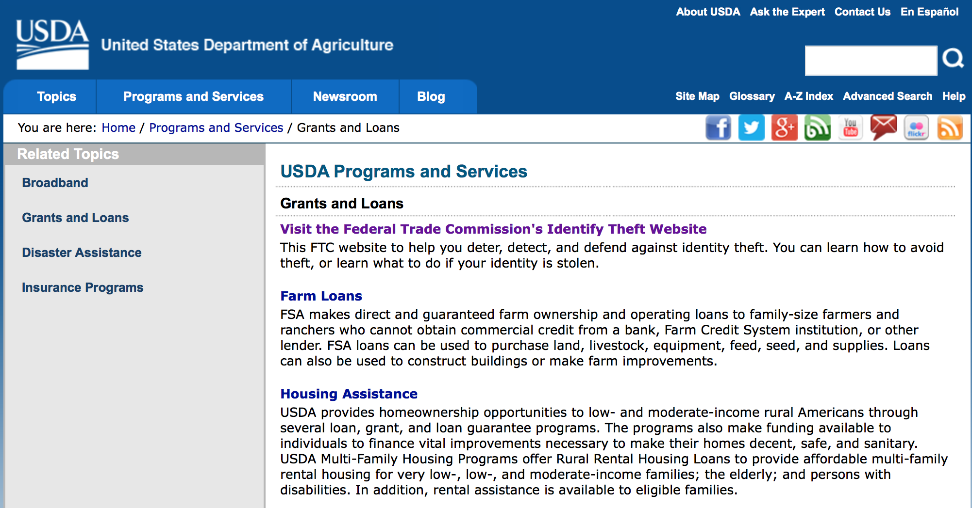
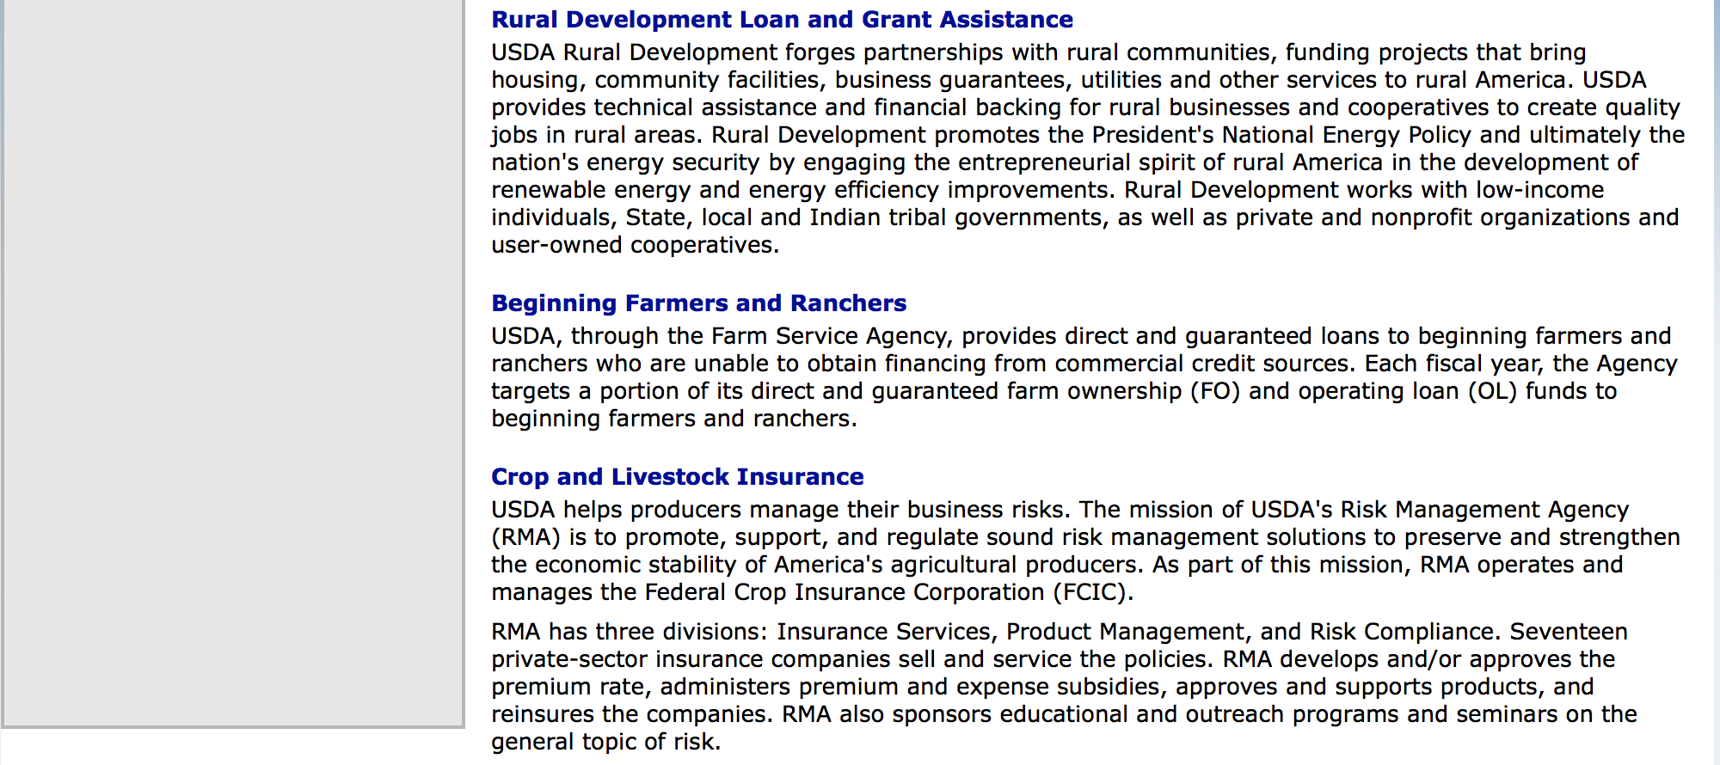

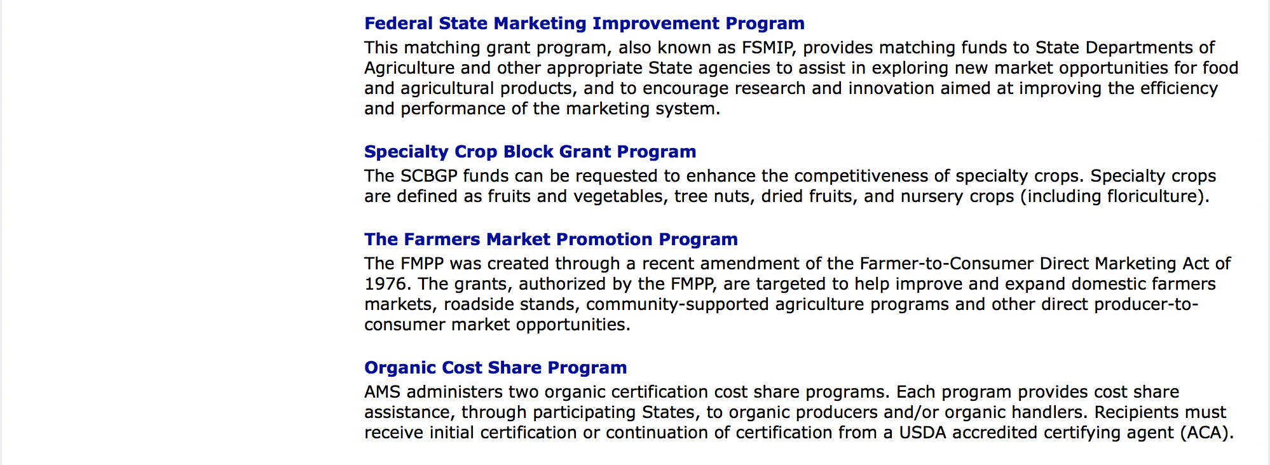

http://usda.gov/wps/portal/usda/usdahome?navid=GRANTS_LOANS

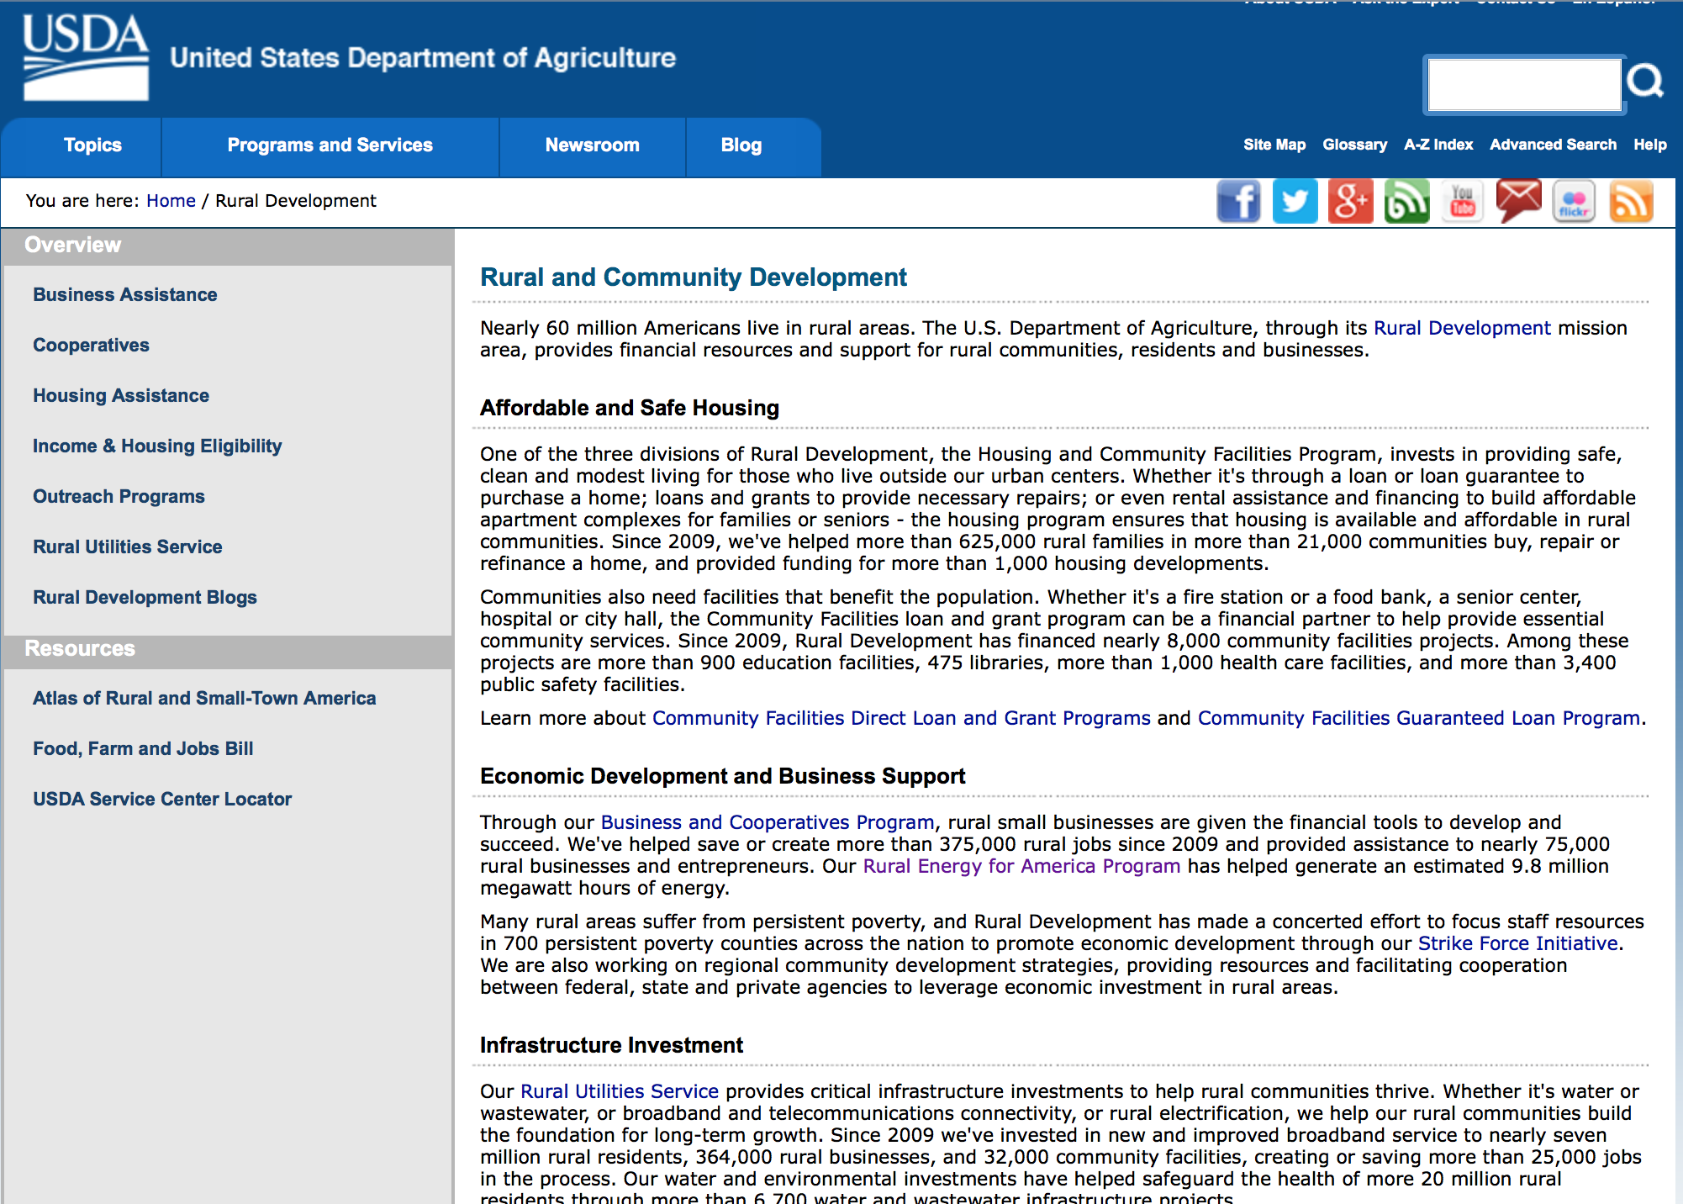

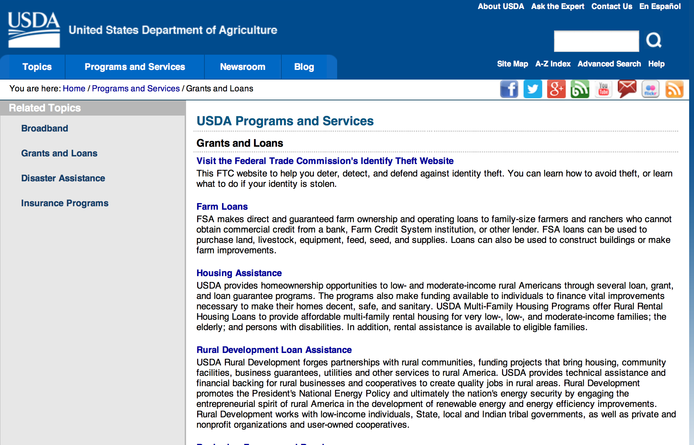

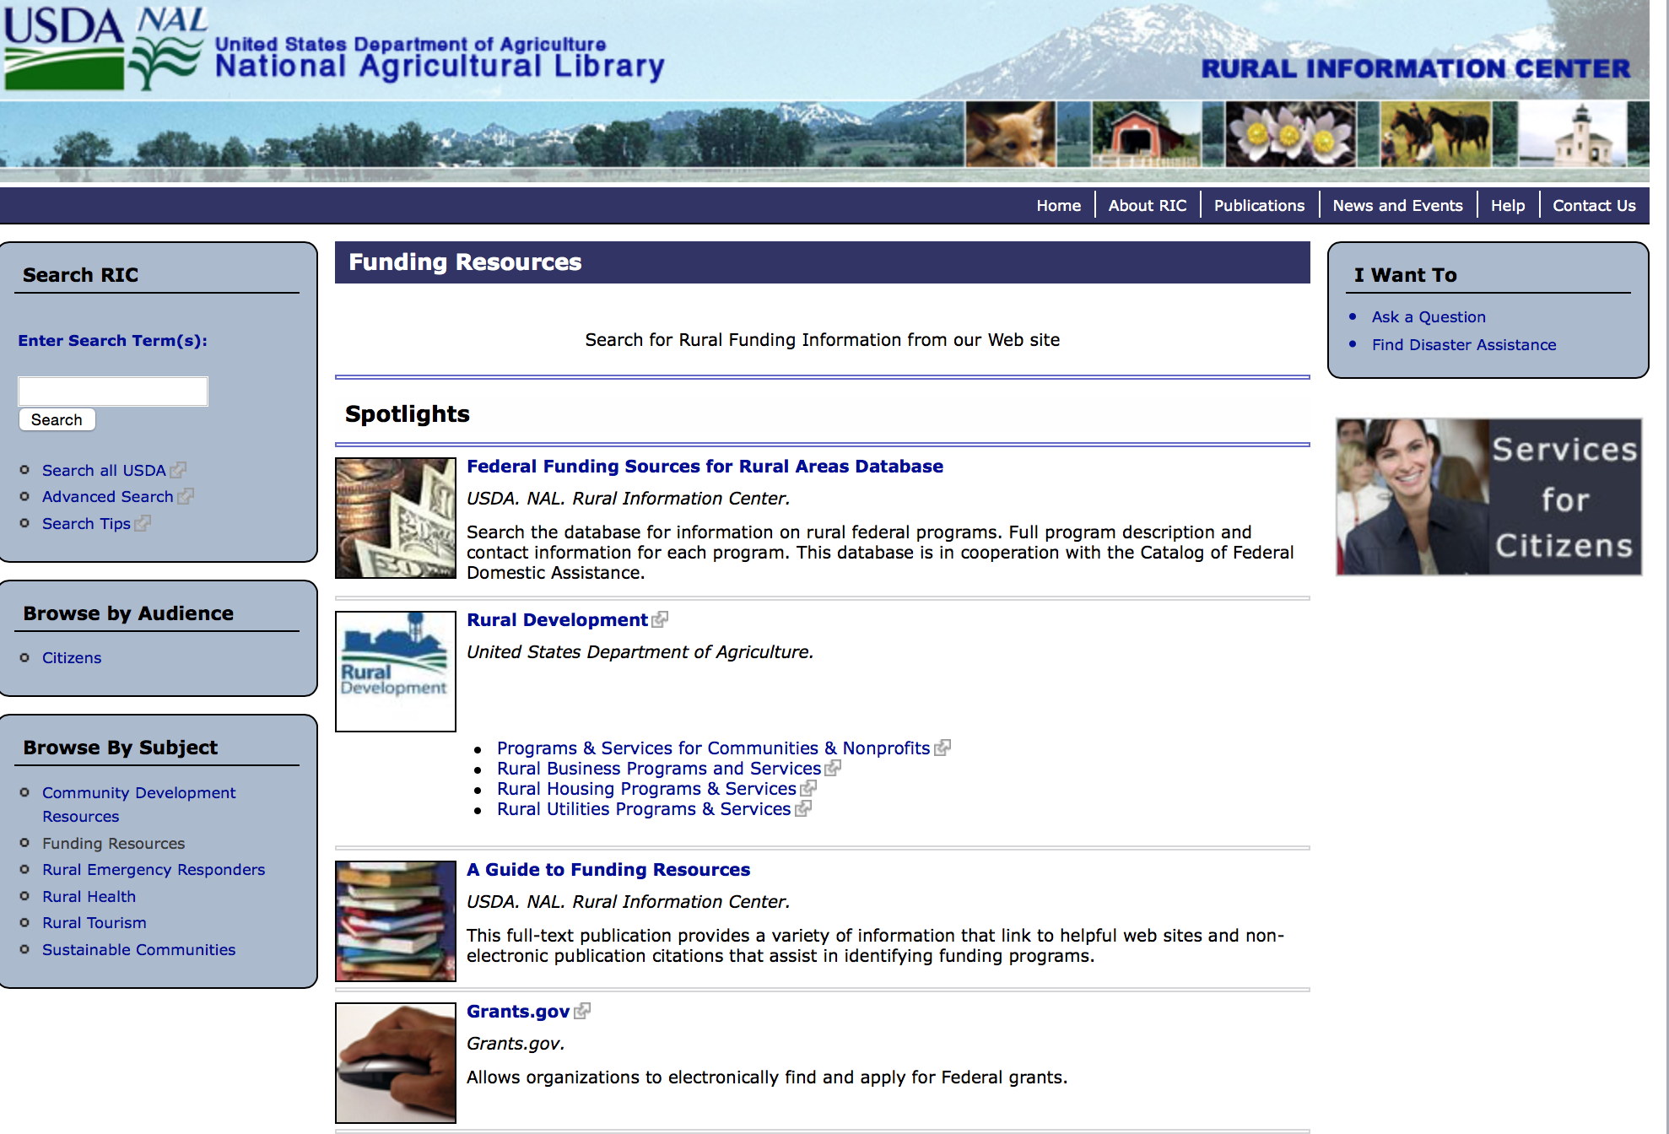

Federal Faith-Based Centers and Community Initiatives
USDA. NAL. Rural Information Center.
- Center for Faith-Based and Community Initiatives (link is external) , U.S. Department of Education
- Center for Faith-Based and Community Initiatives (link is external) , U.S. Department of Health and Human Services
- Center for Faith-Based and Community Initiatives (link is external) , U.S. Department of Labor
- Faith-Based and Community Initiatives (link is external) , U.S. Agency for International Development
- Faith-Based and Community Initiatives (link is external) , U.S. Department of Agriculture
- Faith-Based and Community Initiatives (link is external) , U.S. Department of Housing and Urban Development
- Faith-Based and Other Community Initiatives (link is external) , Corporation for National Community Service
- Task Force for Faith-Based and Community Initiatives (link is external) , U.S. Department of Justice

Grant Writing Resources
- Proposal Writing Short Course (link is external) Foundation Center.
- Data Universal Numbering System Fact sheet (link is external) [PDF | 302.2KB] USDA Rural Development.
- General Tips on Writing a Competitive Grant Proposal (link is external) U.S. Environmental Protection Agency.
- How to Write a Grant Proposal (link is external) Appalachian Regional Commission. <. li>

A Guide to Funding Resources USDA Rural Information Center.

http://ric.nal.usda.gov/funding-resources

http://usda.gov/wps/portal/usda/usdahome?navid=GRANTS_LOANS

Programs:

Utilities Programs
Household Water Well Grant Program

Document Type: | Grants Notice
Funding Opportunity Number: | RDRUS-16-01-HWWS
Funding Opportunity Title: | Household Water Well Grant Program
Opportunity Category: | Discretionary
Opportunity Category Explanation:
Funding Instrument Type: | Grant
Category of Funding Activity: | Agriculture  Environment  Health
Category Explanation:
Expected Number of Awards: | 10
CFDA Number(s): | 10.862 -- Household Water Well System Grant Program
Cost Sharing or Matching Requirement: | Yes
Posted Date: | Mar 11, 2016
Last Updated Date: | Mar 11, 2016
Original Closing Date for Applications: | May 09, 2016
Current Closing Date for Applications: | May 09, 2016
Archive Date: | Jun 08, 2016
Estimated Total Program Funding: | $1,192,081
Award Ceiling: | $0
Award Floor: | $0
Eligible Applicants: | Others (see text field entitled "Additional Information on Eligibility" for clarification)
Additional Information on Eligibility: | 1. An organization is eligible to receive a HWWS grant if it: a. Has an active registration with current information in the System for Award Management (SAM) and has a Dun and Bradstreet (D&B) Data Universal Numbering System (DUNS)number. b. Is a private, non-profit organization. c. Is legally established and located within one of the following: (1) A state within the United States (2) The District of Columbia (3) The Commonwealth of Puerto Rico (4) A United States territory. d. Has the legal capacity and authority to carry out the grant purpose. e. Has sufficient expertise and experience in lending activities. f. Has sufficient expertise and experience in promoting the safe and productive use of individually-owned HWWS and ground water. g. Has no delinquent debt to the federal government or no outstanding judgments to repay a Federal debt. h. Demonstrates that it possesses the financial, technical, and managerial capability to comply with Federal and State laws and requirements, and i. Is not a corporation that has been convicted of a felony (or had an officer or agent acting on behalf of the corporation convicted of a felony) within the past 24 months. Any Corporation that has any unpaid Federal tax liability that has been assessed, for which all judicial and administrative remedies have been exhausted or have lapsed, and that is not being paid in a timely manner pursuant to an agreement with the authority responsible for collecting the tax liability is not eligible. 2. An individual is ineligible to receive a Household Water Well grant. An individual may receive a loan from an organization receiving a grant award.
Agency Name: | Utilities Programs
Description: | The HWWS Grant Program has been established to help individuals with low to moderate incomes finance the costs of household water wells that they own or will own. Eligible Grant Purposes a. Grant funds must be used to establish and maintain a revolving loan fund to provide loans to eligible individuals for household water well systems. b. Individuals may use the loans to construct, refurbish, rehabilitate, or replace household water well systems up to the point of entry of a home. Point of entry for the well system is the junction where water enters into a home water delivery system after being pumped from a well. c. Grant funds may be used to pay administrative expenses associated with providing Household Water Well loans.
Link to Additional Information: | Website Address
Contact Information: | If you have difficulty accessing the full announcement electronically, please contact:  Derek Jones Community Program Specialist Phone 202-720-9640  Email Address

http://www.grants.gov/web/grants/view-opportunity.html?oppId=282162

National Institute of Food and Agriculture
Rural Health & Safety Education Grant

Document Type: | Grants Notice
Funding Opportunity Number: | USDA-NIFA-RHSE-005756
Funding Opportunity Title: | Rural Health & Safety Education
Opportunity Category: | Discretionary
Opportunity Category Explanation:
Funding Instrument Type: | Grant
Category of Funding Activity: | Agriculture  Education  Health
Category Explanation:
Expected Number of Awards:
CFDA Number(s): | 10.500 -- Cooperative Extension Service
Cost Sharing or Matching Requirement: | No
Posted Date: | Mar 23, 2016
Last Updated Date: | Mar 23, 2016
Original Closing Date for Applications: | Jun 01, 2016
Current Closing Date for Applications: | Jun 01, 2016
Archive Date: | Jul 01, 2016
Estimated Total Program Funding: | $1,400,000
Award Ceiling: | $350,000
Award Floor: | $250,000
Eligible Applicants: | Private institutions of higher education  Public and State controlled institutions of higher education  Others (see text field entitled "Additional Information on Eligibility" for clarification)
Additional Information on Eligibility: | See Part III of the RFA, "Eligibility Information" for details.
Agency Name: | National Institute of Food and Agriculture
Description: | The RHSE program proposals are expected to be community-based, outreach education programs, such as those conducted through Human Science extension outreach, that provides individuals and families with: Information as to the value of good health at any age; Information to increase individual or family’s motivation to take more responsibility for their own health; Information regarding rural environmental health issues that directly impact on human health; Information about and access to health promotion and educational activities; and Training for volunteers and health services providers concerning health promotion and health care services for individuals and families in cooperation with state, local and community partners.
Link to Additional Information: | Rural Health and Safety Education
Contact Information: | If you have difficulty accessing the full announcement electronically, please contact:  NIFA Help Desk Phone: 202-401-5048 Business hours are M-F, 7:00 am -5:00 pm ET, excluding Federal holidays  If you have any questions related to preparing application content

http://www.grants.gov/web/grants/view-opportunity.html?oppId=282423

Business and Cooperative Programs
Rural Cooperative Development Grant

Document Type: | Grants Notice
Funding Opportunity Number: | RDBCP-RCDG-2016
Funding Opportunity Title: | Rural Cooperative Development Grant
Opportunity Category: | Discretionary
Opportunity Category Explanation:
Funding Instrument Type: | Grant
Category of Funding Activity: | Agriculture  Business and Commerce
Category Explanation:
Expected Number of Awards: | 39
CFDA Number(s): | 10.771 -- Rural Cooperative Development Grants
Cost Sharing or Matching Requirement: | Yes
Posted Date: | Mar 29, 2016
Last Updated Date: | Mar 29, 2016
Original Closing Date for Applications: | Jun 20, 2016
Current Closing Date for Applications: | Jun 20, 2016
Archive Date: | Jul 20, 2016
Estimated Total Program Funding: | $5,800,000
Award Ceiling: | $200,000
Award Floor: | $0
Eligible Applicants: | Public and State controlled institutions of higher education  Private institutions of higher education  Nonprofits having a 501(c)(3) status with the IRS, other than institutions of higher education
Agency Name: | Business and Cooperative Programs
Description: | The primary objective of the RCDG program is to improve the economic condition of rural areas by assisting individuals or entities in the startup, expansion or operational improvement of rural cooperatives and other business entities. Grants are awarded competitively on an annual basis to Rural Cooperative Development Centers who in turn provide technical assistance to individuals and entities.
Link to Additional Information: | RCDG Program Website
Contact Information: | If you have difficulty accessing the full announcement electronically, please contact:  Grants Division Phone 2026901374  Grants Division

http://www.grants.gov/web/grants/view-opportunity.html?oppId=282595

Agricultural Marketing Service
Farmers Market Promotion Program Grant

Document Type: | Grants Notice
Funding Opportunity Number: | USDA-AMS-TM-FMPP-G-16-0002
Funding Opportunity Title: | Farmers Market Promotion Program
Opportunity Category: | Discretionary
Opportunity Category Explanation: | Category Explanation
Funding Instrument Type: | Grant
Category of Funding Activity: | Agriculture
Category Explanation:
Expected Number of Awards: | 160
CFDA Number(s): | 10.168 -- Farmers' Market and Local Food Promotion Program
Cost Sharing or Matching Requirement: | No
Posted Date: | Mar 08, 2016
Last Updated Date: | Mar 08, 2016
Original Closing Date for Applications: | May 12, 2016
Current Closing Date for Applications: | May 12, 2016
Archive Date: | Jun 11, 2016
Estimated Total Program Funding: | $13,000,000
Award Ceiling: | $500,000
Award Floor: | $50,000
Eligible Applicants: | Others (see text field entitled "Additional Information on Eligibility" for clarification)
Additional Information on Eligibility: | 1. Agricultural Business. A business entity that provides, holds, delivers, transports, offers, or sells agricultural products or services.2. Agricultural Cooperative. A group-owned or member-owned entity or business that provides, offers, or sells agricultural products or services for the mutual benefit of their members. 3. Producer Network. A producer group- or member-owned organization or business that provides, offers, or sells agricultural products or services through a common distribution system for the mutual benefit of their members.4. Producer Associations. An organization or other business that assists, represents, or serves producers or a producer network. 5. Community Supported Agriculture (CSA) Network. A formal group of farms that work collectively to offer consumers regular (usually weekly) deliveries of locally-grown farm products during one or more harvest season(s), often on a subscription or membership basis. Customers have access to a selected share or range of farm products offered by the group of farmers based on partial or total advance payment of a subscription or membership fee.6. CSA Associations. An organization or other business that assists or serves, represents, or services CSAs or CSA networks.7. Local Government. Any unit of government within a state, including a county; borough; municipality; city; town; township; parish; local public authority, including any public housing agency under the United States Housing Act of 1937; special district; school district; intrastate district; council of governments, whether or not incorporated as a nonprofit corporation under state law; and any other agency or instrumentality of a multi-, regional, or intra-state or local government.8. Nonprofit Corporations: Any organization or institution, including nonprofits with State or IRS 501 (c) status and accredited institutions of higher education, where no part of the net earnings of which inure to the benefit of any private shareholder or individual. 9.Public Benefit Corporation. A corporation organized to construct or operate a public improvement, the profits from which inure to the benefit of a State(s) or to the people thereof. 10. Economic Development Corporation. An organization whose mission is the improvement, maintenance, development and/or marketing or promotion of a specific geographic area. 11. Regional Famers Market Authority. An entity that establishes and enforces regional, State, or county policies and jurisdiction over State, regional, or county farmers markets.12. Tribal Government. A governing body or a governmental agency of any Indian tribe, band, nation, or other organized group or community (including any native village as defined in section 3 of the Alaska Native Claims Settlement Act, 85 Stat. 688 (43 U.S.C. § 1602)) certified by the Secretary of the Interior as eligible for the special programs and services provided through the Bureau of Indian Affairs.
Agency Name: | Agricultural Marketing Service
Description: | Approximately $13 million in competitive grant funds in fiscal year (FY) 2016 is available to be awarded through the Farmers Market Promotion Program (FMPP). The Farmers Market Promotion Program (FMPP) is a component of the Farmers Marketing and Local Food Promotion Program (FMLFPP), which is authorized by the Farmer-to-Consumer Direct Marketing Act of 1946, as amended (7 U.S.C. 3005). The goals of FMPP grants are to increase domestic consumption of and access to locally and regionally produced agricultural products, and to develop new market opportunities for farm and ranch operations serving local markets by developing, improving, expanding, and providing outreach, training, and technical assistance to, or assisting in the development, improvement, and expansion of domestic farmers’ markets, roadside stands, community-supported agriculture programs, agritourism activities, and other direct producer-to-consumer market opportunities. Eligible entities include agricultural businesses, agricultural cooperatives, producer networks, producer associations, community supported agriculture networks, community supported agriculture associations, and other agricultural business entities (for-profit groups); nonprofit corporations; public benefit corporations; economic development corporations; regional farmers’ market authorities; and local and tribal governments. FMPP offers both Capacity Building (CB) and Community Development, Training, and Technical Assistance (CTA) projects. For CB projects, the minimum grant award is $50,000 and maximum award is $250,000. For CTA projects, the minimum grant award is $250,000 and maximum award $500,000. The official performance period must begin on September 30, 2016. Both CB and CTA FMPP projects are awarded for up to 36 months (3 years) and are expected to be completed by September 29, 2019. Matching funds are not required. FMLFPP will host a webinar on March 24, 2016, at 2 p.m. (Eastern Time) for FMPP applicants (registration link). In addition, FMLFPP will host www.Grants.gov webinars on March 22 (registration link) and March 29 (registration link), both at 2 p.m. (Eastern Time), to explain how to submit grant applications via www.Grants.gov.
Link to Additional Information: | Grant program website
Contact Information: | If you have difficulty accessing the full announcement electronically, please contact:  Camia Lane Management Analyst Phone 202-720-0933  Application Questions

http://www.grants.gov/web/grants/view-opportunity.html?oppId=282046

Agricultural Marketing Service
Local Food Promotion Program Grant

Document Type: | Grants Notice
Funding Opportunity Number: | USDA-AMS-TM-LFPP-G-16-0001
Funding Opportunity Title: | Local Food Promotion Program
Opportunity Category: | Discretionary
Opportunity Category Explanation:
Funding Instrument Type: | Grant
Category of Funding Activity: | Agriculture
Category Explanation:
Expected Number of Awards: | 160
CFDA Number(s): | 10.172 -- Local Food Promotion Program
Cost Sharing or Matching Requirement: | Yes
Posted Date: | Mar 08, 2016
Last Updated Date: | Mar 08, 2016
Original Closing Date for Applications: | May 12, 2016
Current Closing Date for Applications: | May 12, 2016
Archive Date: | Jun 11, 2016
Estimated Total Program Funding: | $13,000,000
Award Ceiling: | $500,000
Award Floor: | $25,000
Eligible Applicants: | Others (see text field entitled "Additional Information on Eligibility" for clarification)
Additional Information on Eligibility: | 1. Agricultural Business. A business entity that provides, holds, delivers, transports, offers, or sells agricultural products or services.2. Agricultural Cooperative. A group-owned or member-owned entity or business that provides, offers, or sells agricultural products or services for the mutual benefit of their members. 3. Producer Network. A producer group- or member-owned organization or business that provides, offers, or sells agricultural products or services through a common distribution system for the mutual benefit of their members.4. Producer Associations. An organization or other business that assists, represents, or serves producers or a producer network. 5. Community Supported Agriculture (CSA) Network. A formal group of farms that work collectively to offer consumers regular (usually weekly) deliveries of locally-grown farm products during one or more harvest season(s), often on a subscription or membership basis. Customers have access to a selected share or range of farm products offered by the group of farmers based on partial or total advance payment of a subscription or membership fee.6. CSA Associations. An organization or other business that assists or serves, represents, or services CSAs or CSA networks.7. Local Government. Any unit of government within a state, including a county; borough; municipality; city; town; township; parish; local public authority, including any public housing agency under the United States Housing Act of 1937; special district; school district; intrastate district; council of governments, whether or not incorporated as a nonprofit corporation under state law; and any other agency or instrumentality of a multi-, regional, or intra-state or local government.8. Nonprofit Corporations: Any organization or institution, including nonprofits with State or IRS 501 (c) status and accredited institutions of higher education, where no part of the net earnings of which inure to the benefit of any private shareholder or individual. 9.Public Benefit Corporation. A corporation organized to construct or operate a public improvement, the profits from which inure to the benefit of a State(s) or to the people thereof. 10. Economic Development Corporation. An organization whose mission is the improvement, maintenance, development and/or marketing or promotion of a specific geographic area. 11. Regional Famers Market Authority. An entity that establishes and enforces regional, State, or county policies and jurisdiction over State, regional, or county farmers markets.12. Tribal Government. A governing body or a governmental agency of any Indian tribe, band, nation, or other organized group or community (including any native village as defined in section 3 of the Alaska Native Claims Settlement Act, 85 Stat. 688 (43 U.S.C. § 1602)) certified by the Secretary of the Interior as eligible for the special programs and services provided through the Bureau of Indian Affairs.
Agency Name: | Agricultural Marketing Service
Description: | Approximately $13 million in competitive grant funds in fiscal year (FY) 2016 is available for award through the Local Food Promotion Program (LFPP). LFPP is a component of the Farmers Marketing and Local Food Promotion Program (FMLFPP), which is authorized by the Farmer-to-Consumer Direct Marketing Act of 1946, as amended (7 U.S.C. 3005). LFPP offers grant funds with a 25% match to increase domestic consumption of and access to locally and regionally produced agricultural products, and to develop new market opportunities for farm and ranch operations serving local markets, by: developing, improving, expanding, and providing outreach, training, and technical assistance to Local and Regional Food Business Enterprises, or assisting in the development, improvement, and expansion of Local and Regional Food Business Enterprises. Eligible entities may apply if they support local and regional food business enterprises that process, distribute, aggregate, or store locally or regionally produced food products. Such entities may include agricultural businesses, agricultural cooperatives, producer networks, producer associations, community supported agriculture networks, community supported agriculture associations, and other agricultural business entities (for-profit groups); nonprofit corporations; public benefit corporations; economic development corporations; regional farmers’ market authorities; and local and tribal governments. Two types of project applications are accepted under LFPP—planning grants and implementation grants. Applicants can apply for either but will receive only one type of grant in the same grant cycle. LFPP Planning Grants are used in the planning stages of establishing or expanding a local and regional food business enterprise. Activities can include but are not limited to market research, feasibility studies, and business planning. A minimum of $25,000 and a maximum of $100,000 will be awarded for any one proposal, and the grants must be completed within a 18 month period. LFPP Implementation Grants are used to establish a new local and regional food business enterprise, or to improve or expand an existing local or regional food business enterprise. Activities can include but are not limited to training and technical assistance for the business enterprise and/or for producers working with the business enterprise; outreach and marketing to buyers and consumers; and non-construction infrastructure improvements to business enterprise facilities or information technology systems. A minimum of $100,000 and a maximum of $500,000 will be awarded for any one proposal, and the grants must be completed within a 36 month (3 years) grant period. FMLFPP will host a webinar on March 24, 2016, at 2 p.m. (Eastern Time) for FMPP applicants (registration link). In addition, FMLFPP will host www.Grants.gov webinars on March 22 (registration link) and March 29 (registration link), both at 2 p.m. (Eastern Time), to explain how to submit grant applications via www.Grants.gov.
Link to Additional Information: | Grant program website
Contact Information: | If you have difficulty accessing the full announcement electronically, please contact:  Camia Lane Management Analyst Phone 202-720-0933  Application Questions

http://www.grants.gov/web/grants/view-opportunity.html?oppId=282075

Natural Resources Conservation Service
Conservation Innovation Grants

Document Type: | Grants Notice
Funding Opportunity Number: | USDA-NRCS-NHQ-CIG-16-01
Funding Opportunity Title: | Conservation Innovation Grants
Opportunity Category: | Discretionary
Opportunity Category Explanation:
Funding Instrument Type: | Grant
Category of Funding Activity: | Agriculture  Environment  Natural Resources
Category Explanation:
Expected Number of Awards: | 75
CFDA Number(s): | 10.912 -- Environmental Quality Incentives Program
Cost Sharing or Matching Requirement: | Yes
Posted Date: | Mar 07, 2016
Last Updated Date: | Mar 07, 2016
Original Closing Date for Applications: | May 10, 2016
Current Closing Date for Applications: | May 10, 2016
Archive Date: | May 31, 2016
Estimated Total Program Funding: | $20,000,000
Award Ceiling: | $2,000,000
Award Floor: | $0
Eligible Applicants: | City or township governments  Private institutions of higher education  State governments  Special district governments  Individuals  Public and State controlled institutions of higher education  Small businesses  For profit organizations other than small businesses  Native American tribal governments (Federally recognized)  Nonprofits having a 501(c)(3) status with the IRS, other than institutions of higher education  County governments
Agency Name: | Natural Resources Conservation Service
Description: | Overview: The purpose of CIG is to stimulate the development and adoption of innovative conservation approaches and technologies, while leveraging the Federal investment in environmental enhancement and protection in conjunction with agricultural production. CIG projects are expected to lead to the transfer of conservation technologies, management systems, and innovative approaches (such as market-based systems) into NRCS technical manuals and guides or to the private sector. CIG is used to apply or demonstrate previously proven technology in order to increase adoption with an emphasis on opportunities to scale proven, emerging conservation strategies. CIG promotes sharing of skills, knowledge, technologies, and facilities among communities, governments, and other institutions to ensure that scientific and technological developments are accessible to a wider range of users. CIG funds projects targeting innovative on-the-ground conservation, including pilot projects, field demonstrations, and on-farm conservation research. On-farm conservation research is defined as an investigation conducted to answer a specific conservation-related question using a statistically valid design, while employing farm-scale equipment on farm fields. Specifically, a valid study design will use an appropriate number of replications and statistical analysis of results. To the extent NRCS funds research projects through CIG, the agency will only fund on-farm research projects that stimulate innovative approaches to natural resource management in conjunction with agricultural production. NRCS will accept proposals under this notice for single or multiyear projects, not to exceed three years, submitted by eligible entities from any of the 50 States, the District of Columbia, the Caribbean Area (Puerto Rico and the U.S. Virgin Islands), or the Pacific Islands Area (Guam, American Samoa, and the Commonwealth of the Northern Mariana Islands). Eligible entities include Indian Tribes, State and local units of government, non-governmental organizations, and individuals. Complete proposals received by the deadline will be evaluated through a two-tier review process. The first-tier review will be by a technical peer review panel based on the Proposal Evaluation Criteria identified in the instructions in section V.B. For the second-tier review, full proposals, along with their evaluations from the technical peer review and State Conservationist, will be forwarded to the Grants Review Board. The Grants Review Board will make its recommendations for project approval to the NRCS Chief who will make the final selections.
Link to Additional Information: | NRCS CIG Homepage
Contact Information: | If you have difficulty accessing the full announcement electronically, please contact:  Frankie Comfort Grants & Agreements Specialist Phone 202-720-0242  Administrative Contact

http://www.grants.gov/web/grants/view-opportunity.html?oppId=282011

Natural Resources Conservation Service
Regional Conservation Partnership Program
And Modification 1

Document Type: | Grants Notice
Funding Opportunity Number: | USDA-NRCS-NHQ-RCPP-17-01
Funding Opportunity Title: | Regional Conservation Partnership Program
Opportunity Category: | Discretionary
Opportunity Category Explanation:
Funding Instrument Type: | Other
Category of Funding Activity: | Agriculture  Environment  Natural Resources
Category Explanation: | This announcement will use Partnership Agreements and/or Cooperative Agreements for its competitive process.
Expected Number of Awards: | 85
CFDA Number(s): | 10.932 -- Regional Conservation Partnership Program
Cost Sharing or Matching Requirement: | Yes
Posted Date: | Mar 14, 2016
Last Updated Date: | Mar 24, 2016
Original Closing Date for Applications: | May 10, 2016 Closing date is for submission of "Pre-applications" only. Selected applications will be notified to submit "Full" applications.
Current Closing Date for Applications: | May 10, 2016 Closing date is for submission of "Pre-applications" only. Selected applications will be notified to submit "Full" applications.
Archive Date: | Oct 21, 2016
Estimated Total Program Funding: | $263,100,000
Award Ceiling: | $10,000,000
Award Floor: | $0
Eligible Applicants: | Native American tribal governments (Federally recognized)  Others (see text field entitled "Additional Information on Eligibility" for clarification)  Private institutions of higher education  Public and State controlled institutions of higher education
Additional Information on Eligibility: | For "Others" please see Section II.A Partners Eligibility for a more descriptive explanation.
Agency Name: | Natural Resources Conservation Service
Description: | EXECUTIVE SUMMARY:NRCS is the Department of Agriculture’s (USDA) conservation agency working with farmers, ranchers, and private forest landowners nationwide to identify and address natural resource objectives in balance with operational goals in order to benefit soil, water, wildlife, and related natural resources locally, regionally, and nationally. NRCS works in partnership with other entities to accelerate getting conservation on the ground. Through the Regional Conservation Partnership Program (RCPP), NRCS seeks to co-invest with partners in innovative, workable, and cost-effective approaches to benefit farming, ranching, and forest operations, local economies, and the communities and resources in a watershed or other geographic area. RCPP partners develop project applications, as described in this notice, to address specific natural resource objectives in a proposed area or region. Partnering organizations design, promote, implement, and evaluate the project outcomes. NRCS will select final RCPP projects following a two-phase application process that includes: (1) a pre- proposal application and (2) a full-proposal application. NRCS will assess and evaluate RCPP project applications against four criteria: solutions, contributions, innovation, and participation. The full-proposal process is only open to applicants whose pre-proposal applications are selected by the agency to go forward from the pre-proposal stage. All RCPP applications become the property of NRCS for use in the administration of the program and will not be returned to the applicant. RCPP Federal assistance is delivered in accordance with the authorities of the Environmental Quality Incentives Program (EQIP), Conservation Stewardship Program (CSP), Agricultural Conservation Easement Program (ACEP), Healthy Forests Reserve Program (HFRP), and in certain geographic areas, the Watershed Protection and Flood Prevention program. NRCS and partners implement RCPP projects by working with agricultural producers and owners of agricultural and forest land. The purpose of this notice is to announce the availability of CCC funding for RCPP and to solicit applications from potential partners. Subject to fiscal year (FY) 2017 appropriations action, NRCS anticipates the availability of up to $263 million in funding for RCPP. Applications will be accepted from all 50 States, the Caribbean Area (Puerto Rico and U.S. Virgin Islands), and U.S. territories in the Pacific Island Areas (Guam, American Samoa, and the Commonwealth of the Northern Mariana Islands).
Link to Additional Information: | NRCS RCPP Homepage
Contact Information: | If you have difficulty accessing the full announcement electronically, please contact:  Angella Greaves Grants & Agreements Specialist Phone 202-720-2307  Administrative Contact

http://www.grants.gov/web/grants/view-opportunity.html?oppId=282185

National Institute of Food and Agriculture
Special Research Grants Program - Aquaculture Research Grant

Document Type: | Grants Notice
Funding Opportunity Number: | USDA-NIFA-SRGP-005776
Funding Opportunity Title: | Special Research Grants Program - Aquaculture Research
Opportunity Category: | Discretionary
Opportunity Category Explanation:
Funding Instrument Type: | Grant
Category of Funding Activity: | Agriculture  Natural Resources
Category Explanation:
Expected Number of Awards:
CFDA Number(s): | 10.200 -- Grants for Agricultural Research, Special Research Grants
Cost Sharing or Matching Requirement: | Yes
Posted Date: | Apr 04, 2016
Last Updated Date: | Apr 04, 2016
Original Closing Date for Applications: | May 17, 2016
Current Closing Date for Applications: | May 17, 2016
Archive Date: | Jun 16, 2016
Estimated Total Program Funding: | $1,200,000
Award Ceiling: | $300,000
Eligible Applicants: | Others (see text field entitled "Additional Information on Eligibility" for clarification)
Additional Information on Eligibility: | See Part III of the RFA "Eligibility" for details
Agency Name: | National Institute of Food and Agriculture
Description: | The purpose of the Aquaculture Research program is to support the development of an environmentally and economically sustainable aquaculture industry in the U.S. and generate new science-based information and innovation to address industry constraints. Over the long term, results of projects supported by this program may help improve the profitability of the U.S. aquaculture industry, reduce the U.S. trade deficit, increase domestic food security, provide markets for U.S.-produced grain products, increase domestic aquaculture business investment opportunities, and provide more jobs for rural and coastal America. The Aquaculture Research program will fund projects that directly address major constraints to the U.S. aquaculture industry and focus on one or more of the following program priorities: (1) Genetics of commercial aquaculture species. (2) Critical disease issues impacting aquaculture species. (3) Design of environmentally and economically sustainable aquaculture production systems. (4) Economic research for increasing aquaculture profitability.
Link to Additional Information: | Special Research Grants Program Aquaculture Research
Contact Information: | If you have difficulty accessing the full announcement electronically, please contact:  NIFA Help Desk Phone: 202-401-5048 Business hours are M-F, 7:00 am -5:00 pm ET, excluding Federal holidays  If you have any questions related to preparing application content

http://www.grants.gov/web/grants/view-opportunity.html?oppId=282728

Modifications:

Reminders:

National Institute of Food and Agriculture
Supplemental and Alternative Crops Competitive Grants Program

Document Type: | Grants Notice
Funding Opportunity Number: | USDA-NIFA-OP-005676
Funding Opportunity Title: | Supplemental and Alternative Crops Competitive Grants Program
Opportunity Category: | Discretionary
Opportunity Category Explanation:
Funding Instrument Type: | Grant
Category of Funding Activity: | Agriculture
Category Explanation:
Expected Number of Awards:
CFDA Number(s): | 10.200 -- Grants for Agricultural Research, Special Research Grants
Cost Sharing or Matching Requirement: | Yes
Posted Date: | Feb 09, 2016
Last Updated Date: | Feb 09, 2016
Original Closing Date for Applications: | Apr 11, 2016
Current Closing Date for Applications: | Apr 11, 2016
Archive Date: | May 11, 2016
Estimated Total Program Funding: | $767,340
Award Ceiling: | $210,000
Eligible Applicants: | Others (see text field entitled "Additional Information on Eligibility" for clarification)
Additional Information on Eligibility: | Applications may only be submitted by colleges and universities (as defined in section 1404 of NARETPA, 7 U.S.C. 3103), other Federal agencies and private sector entities. Award recipients may subcontract to organizations not eligible to apply provided such organizations are necessary for the conduct of the project. Failure to meet an eligibility criterion by the time of application deadline may result in the application being excluded from consideration or, even though an application may be reviewed, will preclude NIFA from making an award.
Agency Name: | National Institute of Food and Agriculture
Description: | The Supplemental and Alternative Crops Competitive (SACC) Grants Program will support the development of canola as a viable supplemental and alternative crop in the United States. The goal of the SACC program is to significantly increase crop production and/or acreage by developing and testing of superior germplasm, improving methods of planting, cultivation, and harvesting, and transferring new knowledge to producers (via Extension) as soon as practicable. Extension, education, and communication activities related to the research areas above must be addressed in the proposal.
Link to Additional Information: | Supplemental and Alternative Crops (SACC)
Contact Information: | If you have difficulty accessing the full announcement electronically, please contact:  NIFA Help Desk Phone: 202-401-5048 Business hours are M-F, 7:00 am -5:00 pm ET, excluding Federal holidays  If you have any questions related to preparing application content

http://www.grants.gov/web/grants/view-opportunity.html?oppId=281444

National Institute of Food and Agriculture
Higher Education Challenge Grants Program

Document Type: | Grants Notice
Funding Opportunity Number: | USDA-NIFA-CGP-005716
Funding Opportunity Title: | Higher Education Challenge Grants Program
Opportunity Category: | Discretionary
Opportunity Category Explanation:
Funding Instrument Type: | Grant
Category of Funding Activity: | Agriculture
Category Explanation:
Expected Number of Awards:
CFDA Number(s): | 10.217 -- Higher Education - Institution Challenge Grants Program
Cost Sharing or Matching Requirement: | Yes
Posted Date: | Feb 23, 2016
Last Updated Date: | Feb 23, 2016
Original Closing Date for Applications: | Apr 22, 2016
Current Closing Date for Applications: | Apr 22, 2016
Archive Date: | May 22, 2016
Estimated Total Program Funding: | $4,500,000
Eligible Applicants: | Others (see text field entitled "Additional Information on Eligibility" for clarification)
Additional Information on Eligibility: | Applications may be submitted by: (a) U.S. public or private nonprofit colleges and universities offering a baccalaureate or first professional degree in at least one discipline or area of the food and agricultural sciences; (b) land-grant colleges and universities, (including land grant institutions in the Insular Areas); (c) colleges and universities having significant minority enrollments and a demonstrable capacity to carry out the teaching of food and agricultural sciences; and (d) other colleges and universities having a demonstrable capacity to carry out the teaching of food and agricultural sciences.
Agency Name: | National Institute of Food and Agriculture
Description: | Projects supported by the Higher Education Challenge Grants Program will: (1) address a State, regional, national, or international educational need; (2) involve a creative or non-traditional approach toward addressing that need that can serve as a model to others; (3) encourage and facilitate better working relationships in the university science and education community, as well as between universities and the private sector, to enhance program quality and supplement available resources; and (4) result in benefits that will likely transcend the project duration and USDA support.
Link to Additional Information: | Higher Education Challenge (HEC) Grants Program
Contact Information: | If you have difficulty accessing the full announcement electronically, please contact:  NIFA Help Desk Phone: 202-401-5048 Business hours are M-F, 7:00 am -5:00 pm ET, excluding Federal holidays  If you have any questions related to preparing application content

http://www.grants.gov/web/grants/view-opportunity.html?oppId=281746

Forest Service
2017 National Urban and Community Forestry Grant Program

Document Type: |  | Grants Notice
Funding Opportunity Number: |  | USDA-FS-UCF-01-2017
Funding Opportunity Title: |  | 2017 National Urban and Community Forestry Grant Program
Opportunity Category: |  | Discretionary
Opportunity Category Explanation:
Funding Instrument Type: |  | Grant
Category of Funding Activity: |  | Community Development  Disaster Prevention and Relief  Education  Environment  Health  Natural Resources  Science and Technology and other Research and Development
Category Explanation: |  | The National Urban and Community Forestry Advisory Council seeks innovative (new, cutting-edge or builds upon existing studies) grant proposals for program development, study, and collaboration that will address strategies in the National Ten Year Urban Forestry Action Plan (2016-2026). This Request for Proposals is to address the following priority issues: • Developing a National Urban Forestry Funding Assessment and Methodology • Understand Urban Forest Ecosystem/Ecological Services Detailed information about each category follows this section. Proposals are to meet the request and intent of each applicable category. Organizations, local governments, tribal agencies, and partnerships are encouraged to submit proposals that will demonstrate the reach, resources, and expertise needed to address the three priority issues in ways that will lead to meaningful, replicable results across the country. Potential Innovation grantees are should work collaboratively with other organizations and entities not traditionally involved in urban and community forestry. Applicants should consider multi-year projects and other sources of funds, which may include other Federal cooperative conservation sources. While other Federal dollars or technical support may contribute to the project, they may not be used to match these Federal grant program dollars. The grant review process takes about a year to review pre and full proposals once they are received. Applicants should state their start and end date accordingly on their SF424. Each category is separate. Please do not merge more than one category content or intent into one proposal, which can result in disqualification of the proposal. Applicants may submit separate pre-proposals for more than one category.
Expected Number of Awards: |  | 5
CFDA Number(s): |  | 10.675 -- Urban and Community Forestry Program
Cost Sharing or Matching Requirement: |  | Yes
Posted Date: |  | Feb 29, 2016
Last Updated Date: |  | Mar 01, 2016
Original Closing Date for Applications: |  | Jun 17, 2016
Current Closing Date for Applications: |  | Jun 17, 2016
Archive Date: |  | Jul 17, 2016
Estimated Total Program Funding: |  | $900,000
Award Ceiling: |  | $300,000
Award Floor: |  | $75,000
Eligible Applicants: |  | State governments  Public and State controlled institutions of higher education  Special district governments  Public housing authorities/Indian housing authorities  Independent school districts  City or township governments  Private institutions of higher education  County governments  Nonprofits that do not have a 501(c)(3) status with the IRS, other than institutions of higher education  Nonprofits having a 501(c)(3) status with the IRS, other than institutions of higher education  Native American tribal governments (Federally recognized)
Agency Name: | Forest Service
Description: | Available Funding: The U.S. Forest Service anticipates that the statutory authority (Sub Title 9 of the Cooperative Forestry Assistance Act) for the Fiscal Year 2017 Urban and Community Forestry (U&CF) Program may provide, approximately $900,000 in grant funds to be awarded through the 2017 National Urban and Community Forestry Challenge Cost-Share Grant Program. Funds are to support national urban and community forestry projects on nonfederal public land that have a national or multi-state impact and application. All awards are based on the availability of funding, which may be subject to change. Eligible Applicants: Any U.S. non-Federal organization and Tribal agencies, operating within the United States or its territories, may apply for the Challenge Cost-Share grant. While collaboration with Federal agencies is encouraged, a Federal agency may not receive funding or be used as match to the Federal funds being requested. Individuals and private land are not eligible. Proposals are required to address National or multi-state, multi-tribal land urban forestry issues. The Forest Service will address any conflicts of interest. Not Eligible: If an entity has a local/State tree-planting projects, capital improvements to property of any ownership, and/or projects that have only a local impact and applicability are not eligible and they should contact their State Urban and Community Forestry Coordinator for assistance in identifying funding alternatives at the local level. The list of State Coordinators may be found at the following website: State Urban Foresters' Contact List
Link to Additional Information: | National Urban and Community Forestry Advisory Council Website
Contact Information: | If you have difficulty accessing the full announcement electronically, please contact:  Nancy Stremple Urban Forestry Program Specialist Phone 202-309-9873  Forest Service Email address

http://www.grants.gov/web/grants/view-opportunity.html?oppId=281798

National Institute of Food and Agriculture
FY '16 Farm Business Management and Benchmarking (FBMB) Competitive Grants Program RFA Grant

Document Type: | Grants Notice
Funding Opportunity Number: | USDA-NIFA-FBMB-005638
Funding Opportunity Title: | FY '16 Farm Business Management and Benchmarking (FBMB) Competitive Grants Program RFA
Opportunity Category: | Discretionary
Funding Instrument Type: | Grant
Category of Funding Activity: | Agriculture
Category Explanation:
Expected Number of Awards:
CFDA Number(s): | 10.319 -- Farm Business Management and Benchmarking Competitive Grants Program
Cost Sharing or Matching Requirement: | Yes
Posted Date: | Feb 1, 2016
Creation Date: | Feb 1, 2016
Original Closing Date for Applications: | Apr 11, 2016
Current Closing Date for Applications: | Apr 11, 2016
Archive Date: | May 11, 2016
Estimated Total Program Funding: | $1,350,000
Eligible Applicants: | Others (see text field entitled "Additional Information on Eligibility" for clarification)
Additional Information on Eligibility: | Applications may be submitted by numerous entities. Pursuant to 7 U.S.C. 450i(b)(7), eligible applicants means: (A) State agricultural experiment stations; (B) Colleges and universities; (C) University research foundations; (D) Other research institutions and organizations; (E) Federal agencies; (F) National laboratories; (G) Private organizations or corporations: (H) Individuals; or (I) Any group consisting of two (2) or more of the entities described in subparagraphs (A) through (H).
Agency Name: | National Institute of Food and Agriculture
Description: | The Farm Business Management and Benchmarking (FBMB) Competitive Grants Program provides funds to (1) improve the farm management knowledge and skills of agricultural producers; and (2) establish and maintain a national, publicly available farm financial management database to support improved farm management
Link to Additional Information: | FY '16 Farm Business Management and Benchmarking Competitive Grants Program RFA
Contact Information: | If you have difficulty accessing the full announcement electronically, please contact:  NIFA Help Desk Phone: 202-401-5048 Business hours are M-F, 7:00 am -5:00 pm ET, excluding Federal holidays  If you have any questions related to preparing application content

http://www.grants.gov/web/grants/view-opportunity.html?oppId=281273

Farm Service Agency
Outreach and Education, Technical Assistance, and Financial Education for FSA Programs, Functions, and Activities Grant

Document Type: | Grants Notice
Funding Opportunity Number: | USDA-FSA-CA-2016-001
Funding Opportunity Title: | Outreach and Education, Technical Assistance, and Financial Education for FSA Programs, Functions, and Activities
Opportunity Category: | Discretionary
Funding Instrument Type: | Cooperative Agreement
Category of Funding Activity: | Agriculture
Category Explanation:
Expected Number of Awards: | 125
CFDA Number(s):
Cost Sharing or Matching Requirement: | No
Posted Date: | Sep 22, 2015
Creation Date: | Sep 22, 2015
Original Closing Date for Applications: | May 27, 2016
Current Closing Date for Applications: | May 27, 2016
Archive Date: | Jun 26, 2016
Estimated Total Program Funding: | $2,500,000
Award Ceiling: | $99,999
Award Floor: | $20,000
Eligible Applicants: | Nonprofits having a 501(c)(3) status with the IRS, other than institutions of higher education  Public and State controlled institutions of higher education
Additional Information on Eligibility:
Agency Name: | Farm Service Agency
Description: | As part of our mission supporting farmers and ranchers, the Farm Service Agency (FSA) provides extensive education and outreach for producers. This typically involves public meetings, mailings, news releases, and interactions with individual producers seeking additional information or to enroll in a program. However, there remains a need for additional outreach and education that could benefit potential participants in FSA’s portfolio of programs. This RFA seeks proposals to further support and expand FSA’s existing outreach and education efforts. The additional outreach and education could, for example, be public meetings, training sessions, and/or workshops for producers including new and beginning farmers, veterans, underserved communities, and/or established producers. Emphasis will be afforded to proposals that propose to address producers who are ethnic minorities, women, new and beginning, veterans, urban, or who grow non-commodity crops (e.g., fruits and vegetables or specialty crops). Proposals may include innovative outreach approaches that ease the learning curve for farmers and ranchers through training on best practices, common challenges and solutions, and local networking opportunities. The subject matter should include an introduction to FSA, its programs, and common provisions that generally apply. FSA’s common provisions include maintenance of producer-level records regarding payment eligibility and limitations, conservation compliance, and name and address, payments, and farm and tract information. Additional information regarding FSA is available at www.fsa.usda.gov.
Link to Additional Information: | FSA RFA Announcement 2016-001
Contact Information: | If you have difficulty accessing the full announcement electronically, please contact:  Robert Stephenson; Director, Office of Business and Program Integration; Phone 202-720-4019  Help Desk

http://www.grants.gov/web/grants/view-opportunity.html?oppId=279153

Farm Service Agency
Outreach and Education, Technical Assistance, and Financial Education for FSA Programs, Functions, and Activities
Modification 2

Document Type: | Grants Notice
Funding Opportunity Number: | USDA-FSA-CA-2016-001
Funding Opportunity Title: | Outreach and Education, Technical Assistance, and Financial Education for FSA Programs, Functions, and Activities
Opportunity Category: | Discretionary
Opportunity Category Explanation:
Funding Instrument Type: | Cooperative Agreement
Category of Funding Activity: | Agriculture
Category Explanation:
Expected Number of Awards: | 125
CFDA Number(s):
Cost Sharing or Matching Requirement: | No
Posted Date: | Oct 20, 2015
Last Updated Date: | Feb 26, 2016
Original Closing Date for Applications: | May 27, 2016
Current Closing Date for Applications: | Jul 11, 2016
Archive Date: | Aug 10, 2016
Estimated Total Program Funding: | $2,500,000
Award Ceiling: | $99,999
Award Floor: | $20,000
Eligible Applicants: | Public and State controlled institutions of higher education  Nonprofits having a 501(c)(3) status with the IRS, other than institutions of higher education
Agency Name: | Farm Service Agency
Description: | As part of our mission supporting farmers and ranchers, the Farm Service Agency (FSA) provides extensive education and outreach for producers. This typically involves public meetings, mailings, news releases, and interactions with individual producers seeking additional information or to enroll in a program. However, there remains a need for additional outreach and education that could benefit potential participants in FSA’s portfolio of programs. This RFA seeks proposals to further support and expand FSA’s existing outreach and education efforts. The additional outreach and education could, for example, be public meetings, training sessions, and/or workshops for producers including new and beginning farmers, veterans, underserved communities, and/or established producers. Emphasis will be afforded to proposals that propose to address producers who are ethnic minorities, women, new and beginning, veterans, urban, or who grow non-commodity crops (e.g., fruits and vegetables or specialty crops). Proposals may include innovative outreach approaches that ease the learning curve for farmers and ranchers through training on best practices, common challenges and solutions, and local networking opportunities. The subject matter should include an introduction to FSA, its programs, and common provisions that generally apply. FSA’s common provisions include maintenance of producer-level records regarding payment eligibility and limitations, conservation compliance, and name and address, payments, and farm and tract information. Additional information regarding FSA is available at www.fsa.usda.gov.
Link to Additional Information: | FSA Outreach Staff
Contact Information: | If you have difficulty accessing the full announcement electronically, please contact:  Robert Stephenson Director, Office of Business and Program Integration Phone: 202-720-4019  Help Desk

http://www.grants.gov/web/grants/view-opportunity.html?oppId=279761

Department of Commerce

Grants, Contracting, and Trade Opportunities at Commerce
Learn more information about grants, contracting and trade opportunities at the Department of Commerce using the information below.

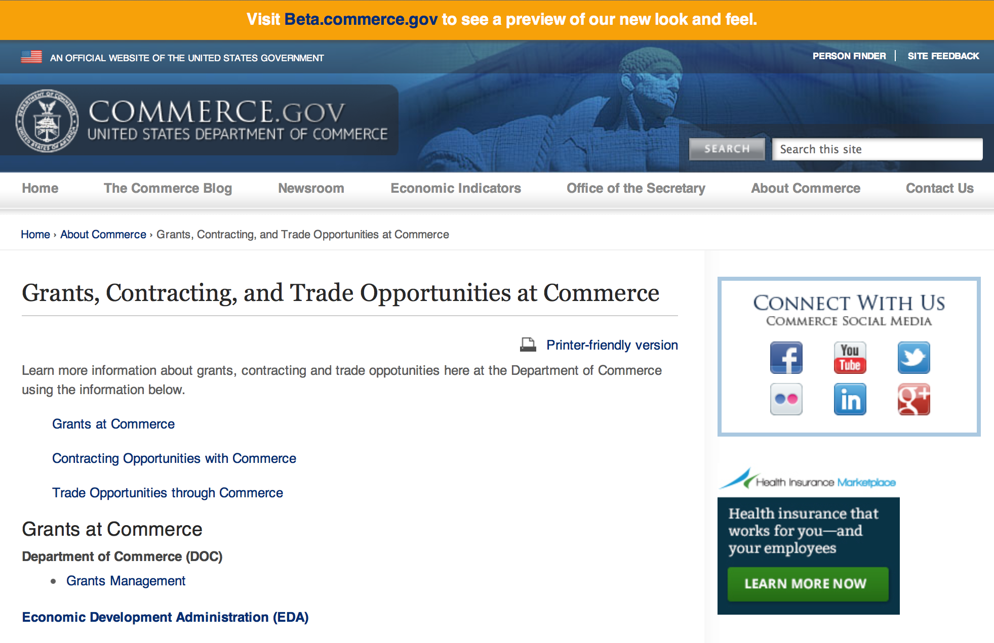
Grants at Commerce
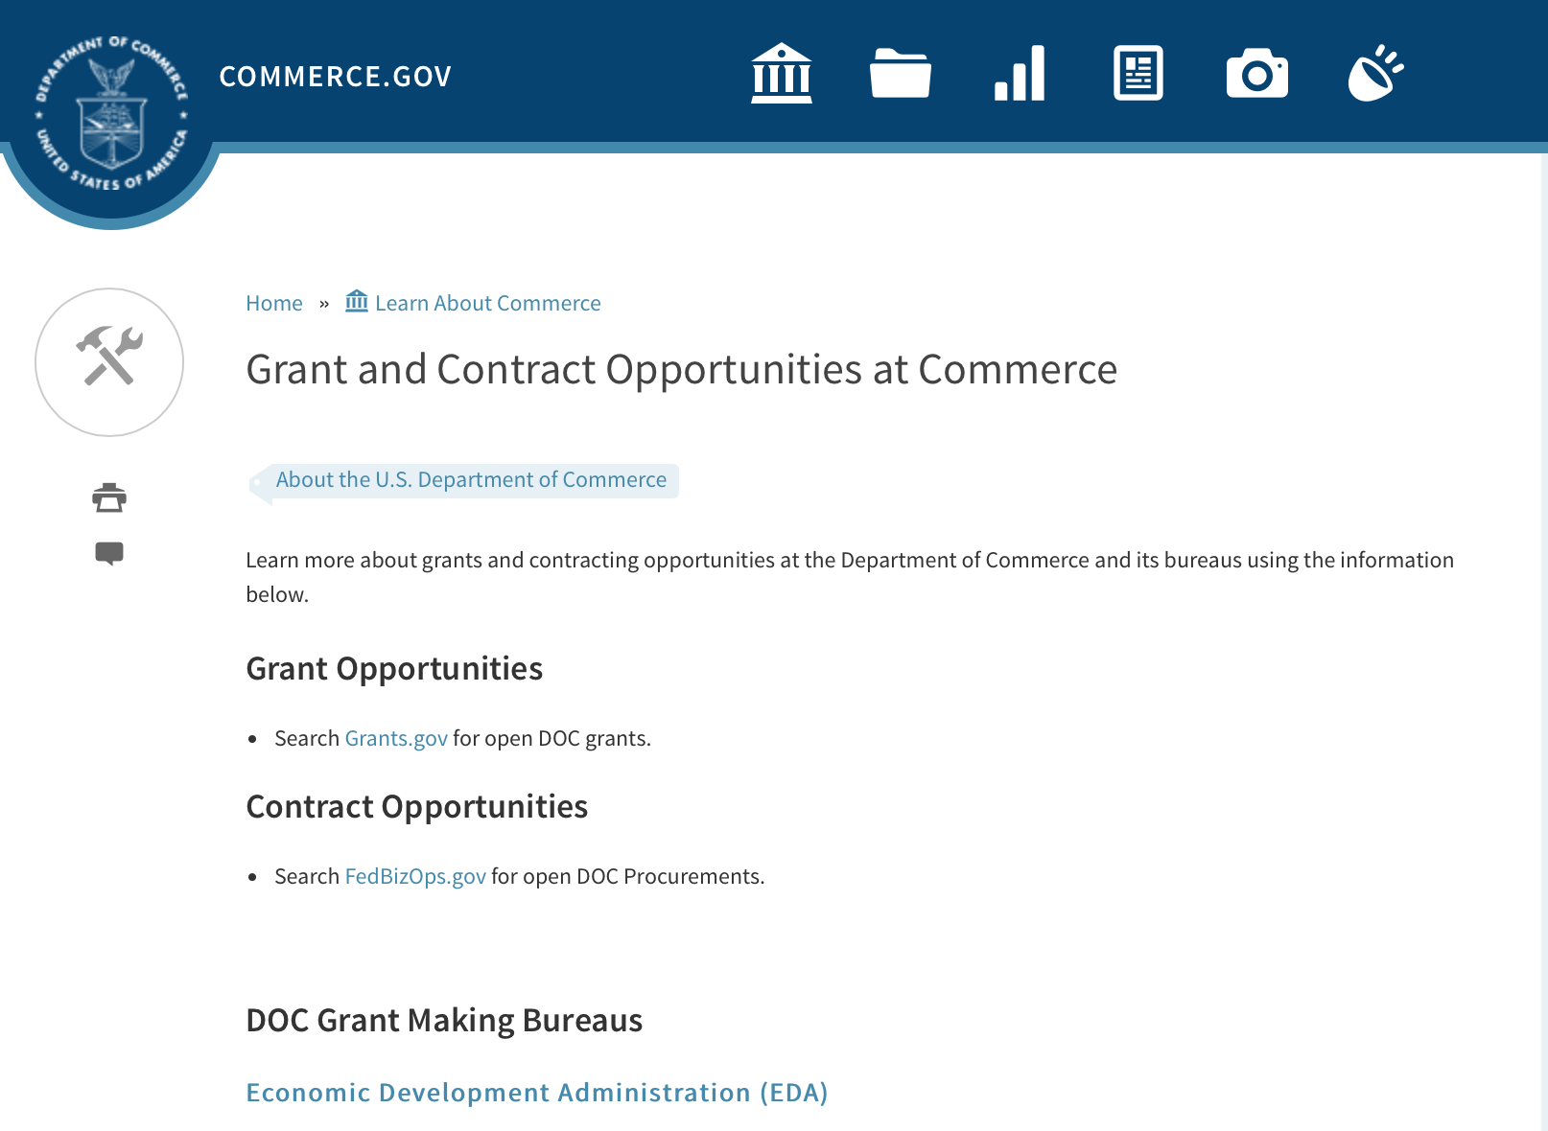

DOC Grant Making Bureaus
Economic Development Administration (EDA)
International Trade Administration (ITA)
- Market Development Cooperator Program
- Special American Business Internship Training Program (SABIT). A technical assistance initiative of the International Trade Administration of the U.S. Department of Commerce, SABIT offers organizations competitive grants and an opportunity to host industry-specific delegations. SABIT serves as an initial entry point for U.S. businesses seeking funding to establish long-term relationships with potential customers, distributors, or partners in the former Soviet Union. The program trains Eurasian managers and scientists in commonly accepted business practices as a means of facilitating cross border relationships. In turn, these personal relationships serve as a basis for business development and reduce market access barriers for U.S. businesses
National Institute of Standards & Technology (NIST)
- Funding Opportunities
National Telecommunications & Information Administration (NTIA)
- Telecommunications Grants
National Oceanic & Atmospheric Administration (NOAA)
- Coastal Ocean Program Grant Information
- Fisheries Saltonstall Kennedy Grant Program
- National Undersea Research Program Funding Opportunities
- Grants Management Division
- Fisheries Grants Program
- National Sea Grant
- Office of Global Programs
Contracting Resources for Contractors
- Office of Small and Disadvantaged Business Utilization (OSDBU) - he Office of Small and Disadvantaged Business Utilization (OSDBU) is an advocacy and advisory office responsible for promoting the use of small, small disadvantaged, 8(a), women-owned, veteran-owned, service-disabled veteran-owned, and HUBZone small businesses within the U.S. Department of Commerce's (DOC) acquisition process.
- Business.USA.gov's Find Opportunities Wizard where in a few quick steps, it will guide you towards federal government contracting programs and opportunities for your business!
- Planned Acquisitions: the Department of Commerce's search tool for our planned acquisitions over $100,000. As requirements change, these acquisition plans are updated by department personnel and this search tool is automatically updated.
- Small Business Administration's Contracting section of their web site where you can learn about how to "Get Started" and "Contracting Support for Small Business"
- The General Services Administration (GSA) has implemented a system for vendors doing business with the Federal Government to manage their entity information in one central location. This new database is the System for Award Management (SAM).

DOC Contracting Offices
- Patent and Trademark Office (PTO)
  - Office of Procurement
- National Institute of Standards & Technology (NIST)
NIST Acquisition Management Group
Contracting Opportunities with Commerce
Trade Opportunities through Commerce
http://www.commerce.gov/about-commerce/grants-contracting-trade-opportunities

Programs:

National Institute of Standards and Technology
National Strategy for Trusted Identities in Cyberspace (NSTIC) Federated Identity in Healthcare Pilot Program Grant
Document Type: | Grants Notice
Funding Opportunity Number: | 2016-NIST-NSTIC-02
Funding Opportunity Title: | National Strategy for Trusted Identities in Cyberspace (NSTIC) Federated Identity in Healthcare Pilot Program
Opportunity Category: | Discretionary
Opportunity Category Explanation:
Funding Instrument Type: | Cooperative Agreement
Category of Funding Activity: | Other (see text field entitled "Explanation of Other Category of Funding Activity" for clarification)
Category Explanation: | Arrangements for Interdisciplinary Research Infrastructure
Expected Number of Awards:
CFDA Number(s): | 11.619 -- Arrangements for Interdisciplinary Research Infrastructure
Cost Sharing or Matching Requirement: | No
Posted Date: | Mar 31, 2016
Last Updated Date: | Mar 31, 2016
Original Closing Date for Applications: | Jun 01, 2016
Current Closing Date for Applications: | Jun 01, 2016
Eligible Applicants: | Others (see text field entitled "Additional Information on Eligibility" for clarification)
Additional Information on Eligibility: | All applicants must meet all of the following requirements: • Applicants must be hospitals or healthcare systems consisting of multiple hospitals, ambulatory sites, clinics or similar healthcare facilities. • Applicants may be for-profit, not-for-profit or governmental (other than Federal government) entities located in the United States or its territories. • Applicants must partner with at least one other healthcare organization in their locality/region. The partner organization should have anticipated overlap with the applicant organization of patients, physicians and other clinical staff (such as a physician practice group(s), clinic(s) and hospital(s)). • The partner organization must be organizationally independent of the applicant and maintain a separate health information system from the applicant. Health information systems refer to any system that captures, stores, manages or transmits information related to the health of individuals or the activities of organizations that work within the health sector. NIST will not assist in matching organizations. Federal agencies (including facilities and components of the Veteran’s Integrated Service Network of the Veteran’s Health Administration) may participate in projects but may not receive NIST funding.
Agency Name: | National Institute of Standards and Technology
Description: | NIST is soliciting applications from eligible applicants to demonstrate the usage of federated online identity solutions for patients and providers across multiple healthcare providers (e.g., provider groups, regional healthcare systems, hospital systems).
Link to Additional Information: | 2016-NIST-NSTIC-02 Full Announcement/FFO document
Contact Information: | If you have difficulty accessing the full announcement electronically, please contact:  Christopher Hunton Management and Program Analyst Phone 301-975-5718  Agency Contact

http://www.grants.gov/web/grants/view-opportunity.html?oppId=282655

Research:

National Institute of Standards and Technology
Economic Impact of the Nation’s Precision Timing Infrastructure: The Global Positioning System Grant
http://www.grants.gov/web/grants/view-opportunity.html?oppId=282031

Modifications:

Reminders:

National Institute of Standards and Technology
FY 2016 Small Business Innovation Research (SBIR) Program Grant

Document Type: | Grants Notice
Funding Opportunity Number: | 2016-NIST-SBIR-01
Funding Opportunity Title: | FY 2016 Small Business Innovation Research (SBIR) Program
Opportunity Category: | Discretionary
Opportunity Category Explanation: | Category Explanation
Funding Instrument Type: | Cooperative Agreement
Category of Funding Activity: | Other (see text field entitled "Explanation of Other Category of Funding Activity" for clarification)
Category Explanation: | Science, Technology, Business and/or Education Outreach
Expected Number of Awards:
CFDA Number(s): | 11.620 -- Science, Technology, Business and/or Education Outreach
Cost Sharing or Matching Requirement: | No
Posted Date: | Feb 02, 2016
Last Updated Date: | Feb 02, 2016
Original Closing Date for Applications: | Apr 14, 2016 Phase I electronic applications must be received no later than 11:59 p.m. Eastern Time, April 14, 2016. Paper applications must be received by NIST by 5:00 p.m. Eastern Time, April 14, 2016.
Current Closing Date for Applications: | Apr 14, 2016 Phase I electronic applications must be received no later than 11:59 p.m. Eastern Time, April 14, 2016. Paper applications must be received by NIST by 5:00 p.m. Eastern Time, April 14, 2016.
Archive Date: | May 14, 2016
Eligible Applicants: | Others (see text field entitled "Additional Information on Eligibility" for clarification)
Additional Information on Eligibility: | Each applicant for both Phase I and Phase II must qualify as a small business concern for R/R&D purposes, as defined in Section 1.06 of this FFO, at the time of award. In addition, the primary employment of the principal investigator must be with the small business at the time of the award and during the conduct of the proposed research. Primary employment means that more than one-half of the principal investigator's time is spent working with the small business. Primary employment with a small business precludes full-time employment with another organization. Occasionally, deviations from this requirement may occur, which must be approved in writing by the NIST Grants Officer after consultation with the SBIR Program Manager. Further, a small business may only replace the principal investigator on an SBIR Phase I or Phase II award if the NIST Grants Officer provides prior written approval. Personnel obtained through a Professional Employer Organization or other similar personnel leasing company may be considered employees of the awardee.
Agency Name: | National Institute of Standards and Technology
Description: | The National Institute of Standards and Technology (NIST) invites small businesses to submit Phase I research applications under this Federal Funding Opportunity (FFO). Firms with strong research capabilities in any of the areas listed in Section 9 of this FFO are encouraged to participate. Applications not addressing one of the subtopics in Section 9 are not responsive to this FFO. The NIST FY 2016 SBIR program identifies and solicits applications in topics that fall within NIST’s mission and allow collaboration between NIST scientists and the SBIR awardees whenever possible. In order to ensure a greater strategic alignment between the SBIR program and NIST’s laboratory research program, the SBIR topics are the priority areas identified in the NIST Programmatic Plan FY 2016-2018 available at: http://www.nist.gov/director/planning/planning.cfm.
Link to Additional Information: | 2016-NIST-SBIR-01 Full Announcement/FFO document
Contact Information: | If you have difficulty accessing the full announcement electronically, please contact:  Christopher Hunton Management and Program Analyst Phone 301-975-5718  Agency Contact

http://www.grants.gov/web/grants/view-opportunity.html?oppId=281304

National Institute of Standards and Technology
FY 2016 Small Business Innovation Research (SBIR) Program – Phase II Grant

Document Type: | Grants Notice
Funding Opportunity Number: | 2016-NIST-SBIR-02
Funding Opportunity Title: | FY 2016 Small Business Innovation Research (SBIR) Program – Phase II
Opportunity Category: | Discretionary
Opportunity Category Explanation:
Funding Instrument Type: | Cooperative Agreement
Category of Funding Activity: | Other (see text field entitled "Explanation of Other Category of Funding Activity" for clarification)
Category Explanation: | Science, Technology, Business and/or Education Outreach
Expected Number of Awards:
CFDA Number(s): | 11.620 -- Science, Technology, Business and/or Education Outreach
Cost Sharing or Matching Requirement: | No
Posted Date: | Feb 18, 2016
Last Updated Date: | Feb 18, 2016
Original Closing Date for Applications: | May 05, 2016 Phase II electronic applications must be received no later than 11:59 p.m. Eastern Time, May 5, 2016. Paper applications must be received by NIST by 5:00 p.m. Eastern Time, May 5, 2016.
Current Closing Date for Applications: | May 05, 2016 Phase II electronic applications must be received no later than 11:59 p.m. Eastern Time, May 5, 2016. Paper applications must be received by NIST by 5:00 p.m. Eastern Time, May 5, 2016.
Archive Date: | Jun 04, 2016
Eligible Applicants: | Others (see text field entitled "Additional Information on Eligibility" for clarification)
Additional Information on Eligibility: | Under this FFO, only FY 2015 NIST SBIR Phase I awardees are eligible to submit applications. Applicants must qualify as a small business concern for R/R&D purposes, as defined in Section 1.06 of this FFO, at the time of award. In addition, the primary employment of the principal investigator must be with the small business at the time of the award and during the conduct of the proposed research. Primary employment means that more than one-half of the principal investigator's time is spent working with the small business. Primary employment with a small business precludes full-time employment with another organization. Occasionally, deviations from this requirement may occur, which must be approved in writing by the NIST Grants Officer after consultation with the SBIR Program Manager. Consult the Full Announcement/FFO document for more details on eligibility.
Agency Name: | National Institute of Standards and Technology
Description: | The National Institute of Standards and Technology (NIST) invites FY 2015 NIST SBIR Phase I awardees to submit Phase II research applications under this Federal Funding Opportunity (FFO). Only NIST SBIR FY 2015 Phase I awardees are eligible to submit applications for Phase II of their projects. In Phase II, work from Phase I that exhibits potential for commercial application is further developed. Phase II is the R&D or prototype development phase. To apply for a Phase II award, each Phase I awardee is required to submit a comprehensive application outlining the research. Each NIST Phase II award is for up to $300,000 and up to a 24 month period of performance. One year after completing Phase II R&D activity, the awardee shall be required to report on its commercialization activities.
Link to Additional Information: | 2016-NIST-SBIR-02 Full Announcement/FFO document
Contact Information: | If you have difficulty accessing the full announcement electronically, please contact:  Christopher Hunton Management and Program Analyst Phone 301-975-5718  Agency Contact

http://www.grants.gov/web/grants/view-opportunity.html?oppId=281629

National Institute of Standards and Technology
Replicable Smart City Technologies Cooperative Agreement Program Grant

Document Type: | Grants Notice
Funding Opportunity Number: | 2016-NIST-RSCT-01
Funding Opportunity Title: | Replicable Smart City Technologies Cooperative Agreement Program
Opportunity Category: | Discretionary
Opportunity Category Explanation:
Funding Instrument Type: | Cooperative Agreement
Category of Funding Activity: | Other (see text field entitled "Explanation of Other Category of Funding Activity" for clarification)
Category Explanation: | Arrangements for Interdisciplinary Research Infrastructure
Expected Number of Awards:
CFDA Number(s): | 11.619 -- Arrangements for Interdisciplinary Research Infrastructure
Cost Sharing or Matching Requirement: | No
Posted Date: | Feb 19, 2016
Last Updated Date: | Feb 19, 2016
Original Closing Date for Applications: | May 12, 2016
Current Closing Date for Applications: | May 12, 2016
Archive Date: | Jun 11, 2016
Eligible Applicants: | Others (see text field entitled "Additional Information on Eligibility" for clarification)
Additional Information on Eligibility: | Local governments located in the United States and its territories and participating as a Team member in NIST’s 2016 GCTC. For purposes of this program, a local government is defined as any incorporated political subdivision of a state that is composed of the citizens of a designated geographic area and which performs certain government functions on a local level; local governments include counties and municipalities such as cities, towns, villages, and boroughs. An eligible organization may work individually or propose subawards or contracts with others effectively forming a team or consortium. Only one application will be considered per GCTC Team. A GCTC Team that includes more than one eligible local government member must designate one of the eligible local government team member as the lead responsible for submitting the application and, if selected, for receiving and administering the award, with the other members participating through subawards or contracts. More information about the 2016 GCTC, including how to register to participate, can be found at http://www.nist.gov/cps/sagc.cfm.
Agency Name: | National Institute of Standards and Technology
Description: | NIST invites applications from eligible applicants (referred to below as City/Community Partners) for a program that will support cities and communities in team-based efforts under the 2016 Global City Teams Challenge (GCTC). The purpose of this funding opportunity is to enable cities and communities to take a lead role in the team-based GCTC efforts to advance the measurement science of replicable, standards-based smart city technologies that provide measurable performance metrics, meet the needs of cities and communities of all types and sizes, and provide platforms for entrepreneurship and innovation.
Link to Additional Information: | 2016-NIST-RSCT-01 Full Announcement/FFO document
Contact Information: | If you have difficulty accessing the full announcement electronically, please contact:  Christopher Hunton Management and Program Analyst Phone 301-975-5718  Agency Contact

http://www.grants.gov/web/grants/view-opportunity.html?oppId=281680

FY 2016 Joint Technology Transfer Initiative Grant
Document Type: | Grants Notice
Funding Opportunity Number: | NOAA-OAR-OWAQ-2016-2004824
Funding Opportunity Title: | FY 2016 Joint Technology Transfer Initiative
Opportunity Category: | Discretionary
Opportunity Category Explanation:
Funding Instrument Type: | Cooperative Agreement
Category of Funding Activity: | Environment  Natural Resources  Science and Technology and other Research and Development
Category Explanation:
Expected Number of Awards: | 10
CFDA Number(s): | 11.459 -- Weather and Air Quality Research
Cost Sharing or Matching Requirement: | No
Posted Date: | Feb 19, 2016
Last Updated Date: | Feb 19, 2016
Original Closing Date for Applications: | Apr 29, 2016
Current Closing Date for Applications: | Apr 29, 2016
Archive Date: | May 29, 2016
Estimated Total Program Funding: | $1,800,000
Award Ceiling: | $300,000
Award Floor: | $150,000
Eligible Applicants: | Others (see text field entitled "Additional Information on Eligibility" for clarification)
Additional Information on Eligibility: | Eligible applicants are institutions of higher education; other nonprofit organizations; commercial organizations.
Agency Name: | Department of Commerce
Description: | Through the U.S. Weather Research Program (USWRP), OAR’s Office of Weather and Air Quality (OWAQ) is soliciting proposals to conduct research and development activities related to advancing the storm-scale modeling and Integrated Water Prediction over the coming 1 to 2 years.
Link to Additional Information:
Contact Information: | If you have difficulty accessing the full announcement electronically, please contact:  Chandra.Kondragunta, R/WA; Office of Weather and Air Quality/OAR/NOAA; R.No. 10321, SSMC-3; 1315 East West Highway; Silver Spring; MD 20910; 301-734-1034  Work

http://www.grants.gov/web/grants/view-opportunity.html?oppId=281686

National Institute of Standards and Technology
Measurement Science and Engineering (MSE) Research Grant Programs

Document Type: | Grants Notice
Funding Opportunity Number: | 2016-NIST-MSE-01
Funding Opportunity Title: | Measurement Science and Engineering (MSE) Research Grant Programs
Opportunity Category: | Discretionary
Opportunity Category Explanation:
Funding Instrument Type: | Cooperative Agreement  Grant
Category of Funding Activity: | Science and Technology and other Research and Development
Category Explanation:
Expected Number of Awards:
CFDA Number(s):
Cost Sharing or Matching Requirement: | No
Posted Date: | Feb 19, 2016
Last Updated Date: | Feb 19, 2016
Original Closing Date for Applications: | Applications will be accepted and considered on a rolling basis as they are received. See Section IV.4. in the text of the Full Announcement/FFO document. Applications may be submitted by paper or electronically through Grants.gov. Carefully read Section IV. of the Full Announcement/FFO document for details applying to electronic submissions and to paper submissions.
Current Closing Date for Applications: | Applications will be accepted and considered on a rolling basis as they are received. See Section IV.4. in the text of the Full Announcement/FFO document. Applications may be submitted by paper or electronically through Grants.gov. Carefully read Section IV. of the Full Announcement/FFO document for details applying to electronic submissions and to paper submissions.
Eligible Applicants: | Others (see text field entitled "Additional Information on Eligibility" for clarification)
Additional Information on Eligibility: | Eligibility for all programs listed in this FFO is open to all non-Federal entities. Eligible applicants include institutions of higher education, non-profit organizations, for-profit organizations, state and local governments, Indian tribes, hospitals, foreign public entities, and foreign governments. Applicants selected for awards under 15 U.S.C. § 278g-1 are encouraged, but not required, to select underrepresented minorities for participation. In addition, NIST is not able to accept an application from an individual unaffiliated with a sponsoring applicant organization.
Agency Name: | National Institute of Standards and Technology
Description: | NIST is soliciting applications for financial assistance for Fiscal Year 2016 (FY16) within the following NIST Laboratory grant programs: (1) the Material Measurement Laboratory (MML) Grant Program; (2) the Physical Measurement Laboratory (PML) Grant Program; (3) the Engineering Laboratory (EL) Grant Program; (4) the Fire Research (FR) Grant Program; (5) the Information Technology Laboratory (ITL) Grant Program; (6) the Communications Technology Laboratory (CTL) Grant Program; (7) the NIST Center for Neutron Research (NCNR) Grant Program; (8) the Center for Nanoscale Science and Technology (CNST) Grant Program; (9) the Special Programs Office (SPO) Grant Program; (10) the Standards Coordination Office (SCO) Grant Program; (11) the International and Academic Affairs Office (IAAO) Grant Program; and (12) the Associate Director for Laboratory Programs (ADLP) Grant Program.
Link to Additional Information: | 2016-NIST-MSE-01 Full Announcement/FFO document
Contact Information: | If you have difficulty accessing the full announcement electronically, please contact:  Christopher Hunton Management and Program Analyst Phone 301-975-5718  Agency Contact

http://www.grants.gov/web/grants/view-opportunity.html?oppId=281689

National Institute of Standards and Technology
National Network for Manufacturing Innovation (NNMI) Institute Awards Grant

Document Type: | Grants Notice
Funding Opportunity Number: | 2016-NIST-NNMI-01
Funding Opportunity Title: | National Network for Manufacturing Innovation (NNMI) Institute Awards
Opportunity Category: | Discretionary
Opportunity Category Explanation: | Category Explanation
Funding Instrument Type: | Cooperative Agreement
Category of Funding Activity: | Other (see text field entitled "Explanation of Other Category of Funding Activity" for clarification)
Category Explanation: | Arrangements for Interdisciplinary Research Infrastructure
Expected Number of Awards:
CFDA Number(s): | 11.619 -- Arrangements for Interdisciplinary Research Infrastructure
Cost Sharing or Matching Requirement:
Current Closing Date for Applications: | Apr 20, 2016 Required Pre-Applications must be received electronically through Grants.gov no later than 11:59 p.m. Eastern Time, April 20, 2016. Pre-Applications received after this deadline will not be reviewed or considered. Paper Pre-Applications will not be accepted. Review of Pre-Applications, selection, and notification to applicants is expected to be complete on or about May 23, 2016. Selected Pre-applicants will then be invited to submit a Full Application. Full Applications must be received electronically through Grants.gov no later than 11:59 p.m. Eastern Time, July 22, 2016. Full Applications received after this deadline will not be reviewed or considered. Paper Full Applications will not be accepted.
Eligible Applicants: | Others (see text field entitled "Additional Information on Eligibility" for clarification)
Additional Information on Eligibility: | Eligible applicants are non-profit organizations; accredited institutions of higher education; State, local, and Tribal governments; and for-profit organizations that are organized and operated in the United States (including U.S. territories) with majority domestic ownership or control. Federal agencies and Federally Funded Research and Development Centers (FFRDCs) are not eligible to apply for this funding opportunity. Please refer to the Full Announcement/FFO document for further details on eligibility.
Agency Name: | National Institute of Standards and Technology
Description: | NIST is soliciting applications for National Network for Manufacturing Innovation (NNMI) Institute Awards from eligible applicants to establish and operate a Manufacturing Innovation Institute in an area of U.S. advanced manufacturing national need. Proposed Institutes in any area of advanced manufacturing will be considered so long as they do not duplicate the technical scope and programs of both existing programs of federally funded Institutes within the National Network for Manufacturing Innovation (NNMI), and technical focus area(s) that are identified within any in-progress Institute funding opportunity announced by a federal agency. Please consult the Full Announcement/FFO document for further details on the NNMI Institute Awards, the program’s public web site, FAQs, and informational webinars.
Link to Additional Information: | 2016-NIST-NNMI-01 Full Announcement/FFO document
Contact Information: | If you have difficulty accessing the full announcement electronically, please contact:  Christopher Hunton Management and Program Analyst Phone 301-975-0404  Agency Contact

http://www.grants.gov/web/grants/view-opportunity.html?oppId=281622

National Sea Grant College Program 2016-17 Special Projects Grant

Document Type: | Grants Notice
Funding Opportunity Number: | NOAA-OAR-SG-2016-2004772
Funding Opportunity Title: | National Sea Grant College Program 2016-17 Special Projects
Opportunity Category: | Discretionary
Funding Instrument Type: | Cooperative Agreement  Grant
Category of Funding Activity: | Environment  Natural Resources  Science and Technology and other Research and Development
Category Explanation:
Expected Number of Awards: | 30
CFDA Number(s): | 11.417 -- Sea Grant Support
Cost Sharing or Matching Requirement: | Yes
Posted Date: | Jan 7, 2016
Creation Date: | Jan 7, 2016
Original Closing Date for Applications: | Sep 30, 2017
Current Closing Date for Applications: | Sep 30, 2017
Archive Date: | Oct 30, 2017
Estimated Total Program Funding: | $4,000,000
Award Ceiling: | $1,000,000
Award Floor: | $1
Eligible Applicants: | Others (see text field entitled "Additional Information on Eligibility" for clarification)
Additional Information on Eligibility: | Sea Grant Programs (Sea Grant Colleges, Institutions, or Coherent Area Programs), the National Sea Grant Law Center, and the National Sea Grant Library.
Agency Name: | Department of Commerce
Description: | The purpose of this notice is to request proposals for special projects associated with the National Sea Grant College Program’s (Sea Grant) strategic focus areas, and to provide the general public with information and guidelines on how Sea Grant will select proposals and administer Federal assistance under this announcement. This announcement is a mechanism to encourage research or other projects that are not normally funded through Sea Grant national competitions. This opportunity is open only to Sea Grant Programs. Section III of this announcement describes eligibility requirements in more detail. Funding has not yet been made available to support applications submitted to this Federal Funding Opportunity (FFO), but such funding may become available during the year. Section II.A. below describes individual competition announcements that will be used to announce when funding is available; any restrictions or requirements on such funding, such as matching funds; and other funding details. Awards will be made under this FFO only if funds have been announced as provided in this FFO.
Link to Additional Information:
Contact Information: | If you have difficulty accessing the full announcement electronically, please contact:  Special Projects Competition Manager, NOAA R/SG National Sea Grant Office 1315 East-West Highway, Rm 11839 Silver Spring, MD 20910 301-734-1066  work

http://www.grants.gov/web/grants/view-opportunity.html?oppId=280846

FY 2016 – FY 2019 EDA Planning Program and Local Technical Assistance Program Grant

Document Type: | Grants Notice
Funding Opportunity Number: | EDA-HDQ-TA-HDQ-2016-2004759
Funding Opportunity Title: | FY 2016 – FY 2019 EDA Planning Program and Local Technical Assistance Program
Opportunity Category: | Discretionary
Funding Instrument Type: | Cooperative Agreement  Grant
Category of Funding Activity: | Other (see text field entitled "Explanation of Other Category of Funding Activity" for clarification)  Regional Development
Category Explanation: | Regional planning and local technical assistance
Expected Number of Awards:
CFDA Number(s): | 11.302 -- Economic Development Support for Planning Organizations  11.303 -- Economic Development Technical Assistance
Cost Sharing or Matching Requirement: | No
Posted Date: | Dec 10, 2015
Creation Date: | Dec 10, 2015
Original Closing Date for Applications: | Applications are accepted on a continuing basis and processed as received. This Planning and Local Technical Assistance opportunity will remain in effect until superseded by a future announcement.
Current Closing Date for Applications: | Applications are accepted on a continuing basis and processed as received. This Planning and Local Technical Assistance opportunity will remain in effect until superseded by a future announcement.
Archive Date:
Estimated Total Program Funding:
Award Ceiling: | $300,000
Award Floor: | $0
Eligible Applicants: | Nonprofits having a 501(c)(3) status with the IRS, other than institutions of higher education  City or township governments  Nonprofits that do not have a 501(c)(3) status with the IRS, other than institutions of higher education  Others (see text field entitled "Additional Information on Eligibility" for clarification)  Private institutions of higher education  Native American tribal governments (Federally recognized)  Public and State controlled institutions of higher education  State governments  Special district governments  County governments
Additional Information on Eligibility: | Pursuant to section 3 of the Public Works and Economic Development Act of 1965 (42 U.S.C. § 3122) (PWEDA) and EDA’s regulation at 13 C.F.R. § 300.3, the following types of entities are eligible to receive funding assistance from EDA: 1. District Organizations (as defined in 13 C.F.R. § 300.3); 2. Indian Tribes or a consortium of Indian Tribes; 3. States, cities, or other political subdivisions of a State, including a special purpose unit of a State or local government engaged in economic or infrastructure development activities, or a consortium of political subdivisions; 4. Institutions of higher education or a consortium of institutions of higher education; or 5. Public or private non-profit organizations or associations acting in cooperation with officials of a political subdivision of a State.
Agency Name: | Department of Commerce
Description: | Pursuant to PWEDA, EDA announces general policies and application procedures for grant-based investments under the Planning and Local Technical Assistance programs. Under the Planning program EDA assists eligible recipients in creating regional economic development plans designed to build capacity and guide the economic prosperity and resiliency of an area or region. As part of this program, EDA supports Partnership Planning investments to facilitate the development, implementation, revision, or replacement of Comprehensive Economic Development Strategies (CEDS), which articulate and prioritize the strategic economic goals of recipients’ respective regions. In general, EDA provides Partnership Planning grants to the designated planning organization (e.g., District Organization) serving EDA designated Economic Development Districts to enable these organizations to develop and implement relevant CEDS. In addition, EDA provides Partnership Planning grants to Indian Tribes to help develop and implement CEDS and associated economic development activities. The Planning program also helps support organizations, including District Organizations, Indian Tribes, and other eligible recipients, with Short Term and State Planning investments designed to guide the eventual creation and retention of high-quality jobs, particularly for the unemployed and underemployed in the Nation’s most economically distressed regions. The Local Technical Assistance program strengthens the capacity of local or State organizations, institutions of higher education, and other eligible recipients to undertake and promote effective economic development programs through projects such as feasibility analyses and impact studies.
Link to Additional Information: | www.eda.gov
Contact Information: | If you have difficulty accessing the full announcement electronically, please contact:  The EDA representative for your state. A complete list of EDA representatives is available on EDA's website at http://www.eda.gov/contact/

http://www.grants.gov/web/grants/view-opportunity.html?oppId=280447

FY 2016 Economic Development Assistance Programs ­ Application submission and program requirements for EDA’s Public Works and Economic Adjustment Assistance Programs Grant

Document Type: | Grants Notice
Funding Opportunity Number: | EDAP2016
Funding Opportunity Title: | FY 2016 Economic Development Assistance Programs ­ Application submission and program requirements for EDA’s Public Works and Economic Adjustment Assistance programs.
Opportunity Category: | Discretionary
Funding Instrument Type: | Cooperative Agreement  Grant
Category of Funding Activity: | Other (see text field entitled "Explanation of Other Category of Funding Activity" for clarification)
Category Explanation: | The Economic Development Administration's (EDA's) mission is to lead the Federal economic development agenda by promoting innovation and competitiveness, preparing American regions for economic growth and success in the worldwide economy. EDA fulfills this mission through strategic investments and partnerships that create the regional economic ecosystems required to foster globally competitive regions throughout the United States. EDA supports development in economically distressed areas of the United States by fostering job creation and attracting private investment. Specifically, under the Economic Development Assistance programs (EDAP) Federal Funding Opportunity (FFO) announcement, EDA will make construction, non-construction, and revolving loan fund investments under the Public Works and Economic Adjustment Assistance (EAA) Programs. Grants made under these programs will leverage regional assets to support the implementation of regional economic development strategies designed to create jobs, leverage private capital, encourage economic development, and strengthen America's ability to compete in the global marketplace. Through the EDAP FFO, EDA solicits applications from rural and urban communities to develop initiatives that advance new ideas and creative approaches to address rapidly evolving economic conditions.
Expected Number of Awards:
CFDA Number(s): | 11.300 -- Investments for Public Works and Economic Development Facilities  11.307 -- Economic Adjustment Assistance
Cost Sharing or Matching Requirement: | Yes
Posted Date: | Oct 26, 2015
Creation Date: | Oct 26, 2015
Original Closing Date for Applications: | There are no submission deadlines under this opportunity. Proposals and applications will be accepted on an ongoing basis until the publication of a new EDAP FFO.
Current Closing Date for Applications: | There are no submission deadlines under this opportunity. Proposals and applications will be accepted on an ongoing basis until the publication of a new EDAP FFO.
Archive Date:
Estimated Total Program Funding:
Award Ceiling: | $3,000,000
Award Floor: | $100,000
Eligible Applicants: | Others (see text field entitled "Additional Information on Eligibility" for clarification)  State governments  City or township governments  Native American tribal organizations (other than Federally recognized tribal governments)  Native American tribal governments (Federally recognized)  Private institutions of higher education  Special district governments  Nonprofits having a 501(c)(3) status with the IRS, other than institutions of higher education  County governments  Nonprofits that do not have a 501(c)(3) status with the IRS, other than institutions of higher education  Public and State controlled institutions of higher education
Additional Information on Eligibility: | Eligible applicants for EDA financial assistance under the Public Works and EAA programs include a(n): (i) District Organization of a designated Economic Development District; (ii) Indian Tribe or a consortium of Indian Tribes; (iii) State, county, city, or other political subdivision of a State, including a special purpose unit of a State or local government engaged in economic or infrastructure development activities, or a consortium of political subdivisions; (iv) institution of higher education or a consortium of institutions of higher education; or (v) public or private non-profit organization or association acting in cooperation with officials of a political subdivision of a State. See Section 3 of the Public Works and Economic Development Act of 1965 (PWEDA) (42 U.S.C. § 3122) and 13 C.F.R. § 300.3. EDA is not authorized to provide grants or cooperative agreements to individuals or to for profit entities. Requests from such entities will not be considered for funding.
Agency Name: | Economic Development Administration
Description: | Under this FFO, EDA solicits applications from applicants in rural and urban areas to provide investments that support construction, non-construction, technical assistance, and revolving loan fund projects under EDA’s Public Works and EAA programs. Grants and cooperative agreements made under these programs are designed to leverage existing regional assets and support the implementation of economic development strategies that advance new ideas and creative approaches to advance economic prosperity in distressed communities. EDA provides strategic investments on a competitive- merit-basis to support economic development, foster job creation, and attract private investment in economically distressed areas of the United States.
Link to Additional Information: | www.eda.gov
Contact Information: | If you have difficulty accessing the full announcement electronically, please contact:  the EDA representative for your state. A complete list of EDA representatives is available on EDA's website at http://www.eda.gov/contact/

http://www.grants.gov/web/grants/view-opportunity.html?oppId=279842

Economic Development Administration
Planning Program and Local Technical Assistance Program Grant

Document Type: | Grants Notice
Funding Opportunity Number: | EDAPLANNING2012
Opportunity Category: | Discretionary
Posted Date: | Aug 03, 2012
Creation Date: | Aug 03, 2012
Original Closing Date for Applications: | Applications are accepted on a continuing basis and processed as received. This Planning and Local Technical Assistance opportunity will remain in effect until superseded by a future announcement.
Current Closing Date for Applications: | Applications are accepted on a continuing basis and processed as received. This Planning and Local Technical Assistance opportunity will remain in effect until superseded by a future announcement.
Archive Date:
Funding Instrument Type: | Cooperative Agreement  Grant
Category of Funding Activity: | Other (see text field entitled "Explanation of Other Category of Funding Activity" for clarification)  Regional Development
Category Explanation: | Regional planning and local technical assistance
Expected Number of Awards: | 425
Estimated Total Program Funding:
Award Ceiling: | $100,000
Award Floor:
CFDA Number(s): | 11.302 -- Economic Development Support for Planning Organizations
 | 11.303 -- Economic Development Technical Assistance
Cost Sharing or Matching Requirement: | Yes

Eligible Applicants
State governments
County governments
City or township governments
Public and State controlled institutions of higher education
Native American tribal governments (Federally recognized)
Nonprofits having a 501(c)(3) status with the IRS, other than institutions of higher education
Nonprofits that do not have a 501(c)(3) status with the IRS, other than institutions of higher education
Private institutions of higher education
Others (see text field entitled "Additional Information on Eligibility" for clarification)

Additional Information on Eligibility:
Pursuant to section 3 of the Public Works and Economic Development Act of 1965 (42 U.S.C. § 3122) (PWEDA) and EDA’s regulation at 13 C.F.R. § 300.3, the following types of entities are eligible to receive funding assistance from EDA: 1. District Organizations (as defined in 13 C.F.R. § 300.3); 2. Indian Tribes or a consortium of Indian Tribes; 3. States, cities, or other political subdivisions of a State, including a special purpose unit of a State or local government engaged in economic or infrastructure development activities, or a consortium of political subdivisions; 4. Institutions of higher education or a consortium of institutions of higher education; or 5. Public or private non-profit organizations or associations acting in cooperation with officials of a political subdivision of a State.

Agency Name
Economic Development Administration

Description
Pursuant to PWEDA, EDA announces general policies and application procedures for grant-based investments under the Planning and Local Technical Assistance programs. Under the Planning program EDA assists eligible recipients in creating regional economic development plans designed to stimulate and guide the economic development efforts of a community or region. As part of this program, EDA supports Partnership Planning investments to facilitate the development, implementation, revision, or replacement of Comprehensive Economic Development Strategies (CEDS), which articulate and prioritize the strategic economic goals of recipients' respective regions. In general, EDA provides Partnership Planning grants to the designated planning organization (e.g., District Organization) serving EDA-designated Economic Development Districts to enable these organizations to develop and implement relevant CEDS. In addition, EDA provides Partnership Planning grants to Indian Tribes to help develop and implement CEDS and associated economic development activities. The Planning program also helps support planning organizations, including District Organizations, Indian Tribes, and other eligible Recipients, with Short Term and State Planning investments designed to guide the eventual creation and retention of higher-skill, higher-wage jobs, particularly for the unemployed and underemployed in the Nation’s most economically distressed regions. The Local Technical Assistance program strengthens the capacity of local or State organizations, institutions of higher education, and other eligible recipients to undertake and promote effective economic development programs through projects such as feasibility analyses and impact studies.

Link to Additional Information

If you have difficulty accessing the full announcement electronically, please contact:
David Ives Planning and Local TA email

http://www.grants.gov/web/grants/view-opportunity.html?oppId=189193

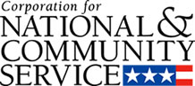

Corporation for National and Community Service

General Program Overview
AmeriCorps provides resources, both human and financial, to organizations that engage Americans in intensive service to meet our country’s critical needs.
Grantees use the funding to support AmeriCorps members for intensive service in their community. AmeriCorps grants partially cover the expense of operating an AmeriCorps program and do not cover general organizational expenses. A cash and in-kind match is required.

The main website can be accessed here: http://www.nationalservice.gov

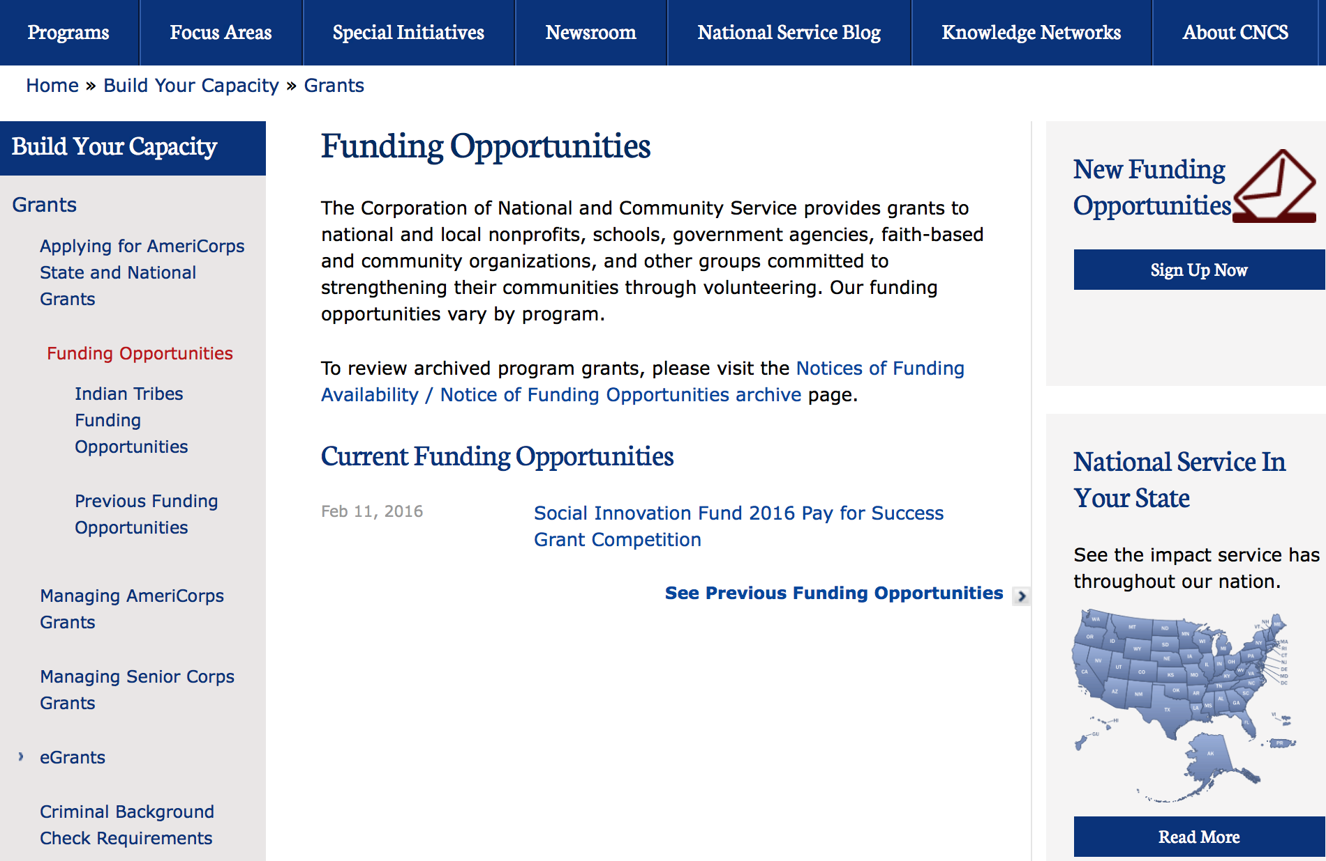

For access to further funding information: click here

http://www.nationalservice.gov/build-your-capacity/grants/funding-opportunities

FY 2016 Social Innovation Fund Classic Cooperative Agreements Grant

Document Type: | Grants Notice
Funding Opportunity Number: | CNCS-03-18-16
Funding Opportunity Title: | FY 2016 Social Innovation Fund Classic Cooperative Agreements
Opportunity Category: | Discretionary
Opportunity Category Explanation:
Funding Instrument Type: | Cooperative Agreement
Category of Funding Activity: | Education  Employment, Labor and Training  Food and Nutrition  Health  Housing  Income Security and Social Services  Law, Justice and Legal Services
Category Explanation:
Expected Number of Awards: | 10
CFDA Number(s): | 94.019 -- Social Innovation Fund
Cost Sharing or Matching Requirement: | Yes
Posted Date: | Mar 18, 2016
Last Updated Date: | Mar 18, 2016
Original Closing Date for Applications: | May 10, 2016
Current Closing Date for Applications: | May 10, 2016
Archive Date: | Jun 09, 2016
Estimated Total Program Funding: | $31,000,000
Award Ceiling: | $10,000,000
Award Floor: | $1,000,000
Eligible Applicants: | Private institutions of higher education  Nonprofits having a 501(c)(3) status with the IRS, other than institutions of higher education  Native American tribal governments (Federally recognized)  Native American tribal organizations (other than Federally recognized tribal governments)
Agency Name: | Corporation for National and Community Service
Description: | The Social Innovation awards grants to grantmaking institutions, referred to as “intermediaries.” These intermediaries in turn competitively select, provide grants to, and otherwise support high-performing community-based nonprofit organizations to implement evidence-based programs in the areas of healthy futures, economic opportunity and youth development. The intermediaries and the nonprofits must match the grant funds they receive one-to-one in cash from with non-federal sources.
Link to Additional Information: | Full notice of funding
Contact Information: | If you have difficulty accessing the full announcement electronically, please contact:  Social Innovation Fund (202) 606-3223  Competition mailbox

http://www.grants.gov/web/grants/view-opportunity.html?oppId=282317

Reminders:

National Service In Hawaii
National Service in Your State - Hawaii
2014-2015
Meeting Community Needs in Hawaii: More than 3,800 people of all ages and backgrounds are helping to meet local needs, strengthen communities, and increase civic engagement through national service in Hawaii. Serving at more than 350 locations throughout the state, these citizens tutor and mentor children, support veterans and military families, provide health services, restore the environment, respond to disasters, increase economic opportunity, and recruit and manage volunteers. This year, the Corporation for National and Community Service (CNCS) will commit more than $6,260,000 to support Hawaii communities through national service initiatives. Through a unique public-private partnership, this federal investment will leverage an additional $3,640,000 in other resources to strengthen community impact, build local support, and increase return on taxpayer dollars.

AmeriCorps
This year, AmeriCorps will provide more than 540 individuals the opportunity to provide intensive, results-driven service to meet education, environmental, health, economic, and other pressing needs in communities across Hawaii. Most AmeriCorps grant funding goes to the Hawaii Commission on National & Community Service, which in turn awards grants to nonprofit groups to respond to local needs. Most of the remainder of the grant funding is distributed by CNCS directly to multi-state and national organizations through a competitive grants process. Other individuals serve through AmeriCorps VISTA, whose members help bring individuals and communities out of poverty by serving full-time to fight illiteracy, improve health services, create businesses, and increase housing opportunities, and AmeriCorps NCCC (National Civilian Community Corps), a 10-month, full time residential program for men and women between the ages of 18 and 24. In exchange for their service, AmeriCorps members earn an education award that can be used to pay for college or to pay back qualified student loans. Since 1994, more than 5,600 Hawaii residents have served more than 5.8 million hours and have qualified for Segal AmeriCorps Education Awards totaling more than $13,510,000.

Senior Corps
More than 3,200 seniors in Hawaii contribute their time and talents in one of three Senior Corps programs. Foster Grandparents serve one-on-one as tutors and mentors to more than 340 young people who have special needs. Senior Companions help more than 200 homebound seniors and other adults maintain independence in their own homes. RSVP volunteers conduct safety patrols, renovate homes, protect the environment, tutor and mentor youth, respond to natural disasters, and provide other services through more than 170 groups across Hawaii.

The Corporation for National and Community Service is a federal agency that improves lives, strengthens communities, and fosters civic engagement through service and volunteering. CNCS annually engages more than five million Americans in service to meet local needs through Senior Corps, AmeriCorps, and national days of service; improves communities through the Social Innovation Fund, and leads President Obama's national call to service initiative, United We Serve. To learn more visit NationalService.gov or Serve.gov or call 202-606-5000 or TTY 1-800-833-3722.

http://www.nationalservice.gov/impact-our-nation/state-profiles/hi

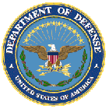

U.S. Department of Defense

Doing Business with the Department of Defense

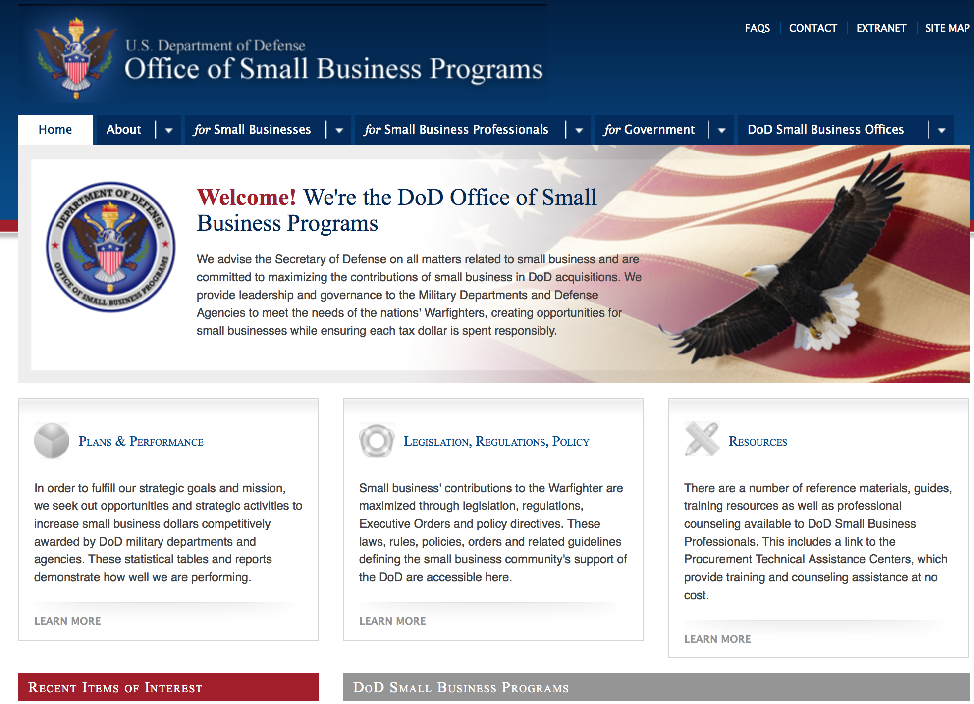

http://www.acq.osd.mil/osbp/

Doing Business with the DoD

Resources

Procurement Technical Assistance Centers (PTACs)

Procurement Technical Assistance Centers (PTACs) are charged with assisting businesses in learning how to do business with federal, state, and local governments. PTACs are a local resource available at no or nominal cost that can provide assistance to business firms in marketing their products and services. They offer training to businesses on how to research and bid on contracts, assist with registration requirements, provide bid-matching services, and assist with pre and post contracting issues.

Prime Contractors with Subcontracting Plans [xlsx]

Directory updated 4/19/11

This FY 2014 directory is intended for small business concerns seeking opportunities with DoD prime contractors. The directory is a listing of large business prime contractors who are required to establish subcontracting plans with goals. The report is generated from data contained in the Individual Subcontract Reports (ISRs) submitted in the Electronic Subcontracting Reporting System (eSRS) by contractors and from data contained in the Federal Procurement Data System (FPDS). The directory includes the name of the prime contractor; the major product/service code (PSC) provided to DoD; the major NAICS of the company; name, telephone number and email address of the company’s point of contact; contract number with the effective date and completion date, ultimate contract value and obligated dollars. In addition, many companies have websites with additional information which may be useful in your search for subcontracting opportunities or teaming arrangements.

Locate a Small Business Professional

Small Business Professionals serve as the primary liaison between private-sector small businesses seeking to do business with government agencies. Specialists advise small businesses regarding current acquisitions contracts available from the federal government.

Procurement Forecasts & the Department of Defense

The Department of Defense, due to its size and scope, does not have a single, comprehensive source for future procurements. Procurements are made locally and within the various services and agencies.

Business Intelligence, relative to future procurement planning, would be gathered at the local level.

For the purposes of forecasting, knowledge of past behavior is useful. Click here for a table of DoD acquisitions in FY10 summarized by NAICS code. The FY10 data has been validated but FPDS data is dynamic and changes continuously.

Non-Appropriated Fund Customers

Non-appropriated fund customers operate similar to non-profit organizations and include commissaries, exchanges, recreation and fitness centers, dining at officer/enlisted/civilian clubs, and barber/beauty services, just to name a few. For more information click here.

Research:

Air Force Office of Scientific Research
Defense University Research Instrumentation Program (DURIP) Grant
http://www.grants.gov/web/grants/view-opportunity.html?oppId=282081

Air Force Office of Scientific Research
CENTER OF EXCELLENCE: Multi-Fidelity Modeling of Combustion Instabilities Grant
http://www.grants.gov/web/grants/view-opportunity.html?oppId=282087

Air Force -- Research Lab
Autonomy for Loyal Wingman Testbed Grant
http://www.grants.gov/web/grants/view-opportunity.html?oppId=282316

Air Force Office of Scientific Research
Air Force Fiscal Year 2017 Young Investigator Research Program (YIP) Grant
http://www.grants.gov/web/grants/view-opportunity.html?oppId=282395

Dept. of the Army -- USAMRAA
Medical Simulation and Information Sciences
And Modifications 1 & 4
http://www.grants.gov/web/grants/view-opportunity.html?oppId=282568

Dept. of the Army -- USAMRAA
DoD Combat Casualty Care Prolonged Field Care Research Award Grant
http://www.grants.gov/web/grants/view-opportunity.html?oppId=282509

Dept. of the Army -- USAMRAA
Medical Simulation and Information Sciences - INter-professional TEam-based Learning in Early Stages of Learning (Team_INTEL) Grant
http://www.grants.gov/web/grants/view-opportunity.html?oppId=282543

Dept. of the Army -- USAMRAA
DoD Combat Casualty Care Prolonged Field Care Research Award
Grant
http://www.grants.gov/web/grants/view-opportunity.html?oppId=282509

Dept. of the Army -- USAMRAA
DoD Ovarian Cancer Clinical Development Award Grant
http://www.grants.gov/web/grants/view-opportunity.html?oppId=282236

Dept. of the Army -- USAMRAA
DoD Ovarian Cancer Investigator-Initiated Research Award Grant
http://www.grants.gov/web/grants/view-opportunity.html?oppId=282237

Dept. of the Army -- USAMRAA
DoD Ovarian Cancer Pilot Award Grant
http://www.grants.gov/web/grants/view-opportunity.html?oppId=282242

Dept. of the Army -- USAMRAA
Breast Cancer Breakthrough Award Levels 1 and 2 Grant
http://www.grants.gov/web/grants/view-opportunity.html?oppId=281875

Dept. of the Army -- USAMRAA
Breast Cancer Breakthrough Award Levels 3 and 4 Grant
http://www.grants.gov/web/grants/view-opportunity.html?oppId=281876

Dept. of the Army -- USAMRAA
DOD BREAST CANCER BREAKTHROUGH FELLOWSHIP AWARD Grant
http://www.grants.gov/web/grants/view-opportunity.html?oppId=281877

Dept. of the Army -- USAMRAA
Amyotrophic Lateral Sclerosis Research Program Therapeutic Idea Award Grant
http://www.grants.gov/web/grants/view-opportunity.html?oppId=281894

Dept. of the Army -- USAMRAA
Health Information Technologies and Informatics Grant
http://www.grants.gov/web/grants/view-opportunity.html?oppId=282758

Dept. of the Army -- USAMRAA
Health Information Technologies and Informatics Hands-Free Grant
http://www.grants.gov/web/grants/view-opportunity.html?oppId=282759

Dept of the Army -- Materiel Command
DEFENSE UNIVERSITY RESEARCH INSTRUMENTATION PROGRAM (DURIP) FISCAL YEAR 2017 - ARMY SUBMISSION
And Modification 1
http://www.grants.gov/web/grants/view-opportunity.html?oppId=282256

Uniformed Services Univ. of the Health Sciences
Wounded Warrior Service Dog Program Grant
http://www.grants.gov/web/grants/view-opportunity.html?oppId=282445

Defense Advanced Research Projects Agency
DARPA - Defense Sciences Office
Next Generation Social Science (NGS2) Grant
http://www.grants.gov/web/grants/view-opportunity.html?oppId=282334

Defense Advanced Research Projects Agency
DARPA - Biological Technologies Office
Targeted Neuroplasticity Training (TNT) Grant
http://www.grants.gov/web/grants/view-opportunity.html?oppId=282714

Modifications:

Air Force Office of Scientific Research
CENTER OF EXCELLENCE: Multi-Fidelity Modeling of Combustion Instabilities
Modification 1
http://www.grants.gov/web/grants/view-opportunity.html?oppId=282087

Air Force Office of Scientific Research
FISCAL YEAR 2017 DEFENSE UNIVERSITY RESEARCH INSTRUMENTATION PROGRAM
Modification 2
http://www.grants.gov/web/grants/view-opportunity.html?oppId=282081

Dept of the Army -- Materiel Command
DEFENSE UNIVERSITY RESEARCH INSTRUMENTATION PROGRAM (DURIP) FISCAL YEAR 2017 - ARMY SUBMISSION
Modification 1
http://www.grants.gov/web/grants/view-opportunity.html?oppId=282256

Defense Advanced Research Projects Agency
DARPA - MTO - BAA0718
Atomic Clock with Enhanced Stability (ACES)
Modifications 1& 2
http://www.grants.gov/web/grants/view-opportunity.html?oppId=281093

Defense Advanced Research Projects Agency
DARPA - MTO - BAA0718
Signal Processing at RF (SPAR)
Modifications 1, 2 & 3
http://www.grants.gov/web/grants/view-opportunity.html?oppId=281657

Dept. of the Army -- USAMRAA
DoD Combat Casualty Care Prolonged Field Care Research Award
Modification 2
http://www.grants.gov/web/grants/view-opportunity.html?oppId=282509

Dept. of the Army -- USAMRAA
Breast Cancer Breakthrough Award Levels 3 and 4
Modification 1
http://www.grants.gov/web/grants/view-opportunity.html?oppId=281876

Dept. of the Army -- USAMRAA
Medical Simulation and Information Sciences - INter-professional TEam-based Learning in Early Stages of Learning (Team_INTEL)
Modification 1
http://www.grants.gov/web/grants/view-opportunity.html?oppId=282543

Grants to Military-Connected Local Educational Agencies for Academic and Support Programs (MCASP)
Modification 1
http://www.grants.gov/web/grants/view-opportunity.html?oppId=281730

Missile Defense Agency STEM Outreach BEST Robotics Grant
Grant
http://www.grants.gov/web/grants/view-opportunity.html?oppId=282801

Office of Naval Research
Fiscal Year 2017 Defense University Research Instrumentation Program (DURIP)
Modification 1
http://www.grants.gov/web/grants/view-opportunity.html?oppId=282527

Office of Naval Research
Communications and Interoperability for Integrated Fires
Modification 2
http://www.grants.gov/web/grants/view-opportunity.html?oppId=281384

Office of Naval Research
Naval Supply Systems Command
FY15 - FY16 Department of Defense HIV/AIDS Prevention Program: Military Specific HIV/AIDS Prevention, Care, and Treatment Program for PEPFAR (President's Emergency Plan for AIDS Relief) Funded Countries
Modifications 17 & 18
http://www.grants.gov/web/grants/view-opportunity.html?oppId=270446

Office of Naval Research
Naval Supply Systems Command
FY15 - FY16 Department of Defense HIV/AIDS Prevention Program: Military Specific HIV/AIDS Prevention, Care, and Treatment Program for non-PEPFAR (President's Emergency Plan for AIDS Relief
Modifications 4 & 5
http://www.grants.gov/web/grants/view-opportunity.html?oppId=270443

Department of Defense
Dept. of the Army -- USAMRAA
Medical Simulation and Information Sciences - INter-professional TEam-based Learning in Early Stages of Learning (Team INTEL)
Modification 2

http://www.grants.gov/web/grants/view-opportunity.html?oppId=282543

Missile Defense Agency STEM Outreach BEST Robotics Grant
Modification 1
http://www.grants.gov/web/grants/view-opportunity.html?oppId=282796

Missile Defense Agency STEM Outreach BEST Robotics Grant
Modification 1
http://www.grants.gov/web/grants/view-opportunity.html?oppId=282798Office of Naval Research

Long Range Broad Agency Announcement (BAA) for Navy and Marine Corps Science and Technology
Modification 6
http://www.grants.gov/web/grants/view-opportunity.html?oppId=279380

Reminders:

Dept. of the Army -- Materiel Command
Army Research Office Broad Agency Announcement for Basic and Applied Scientific Research
Modification 8

Document Type: | Grants Notice
Funding Opportunity Number: | W911NF-12-R-0012
Funding Opportunity Title: | Army Research Office Broad Agency Announcement for Basic and Applied Scientific Research
Opportunity Category: | Discretionary
Funding Instrument Type: | Cooperative Agreement  Grant  Other  Procurement Contract
Category of Funding Activity: | Science and Technology and other Research and Development
Category Explanation:
Expected Number of Awards: | 1000
CFDA Number(s): | 12.431 -- Basic Scientific Research
Cost Sharing or Matching Requirement: | No
Posted Date: | Mar 27, 2015
Creation Date: | Mar 27, 2015
Original Closing Date for Applications: | Mar 31, 2017
Current Closing Date for Applications: | Mar 31, 2017
Archive Date: | Apr 30, 2017
Eligible Applicants: | Unrestricted (i.e., open to any type of entity above), subject to any clarification in text field entitled "Additional Information on Eligibility"
Agency Name: | Dept. of the Army -- Materiel Command
Description: | The purpose of this Broad Agency Announcement (BAA) is to solicit research proposals in the engineering, physical, life, and information sciences for submission to the Army Research Office (ARO) for consideration for possible funding. For ease of reference, this BAA is an extraction of the ARO sections of the Army Research Laboratory BAA. (www.arl.army.mil/www/default.cfm?page=8).
Link to Additional Information: | ARO CORE BAA-W911NF-12-R-0012-Mod 03
Contact Information: | If you have difficulty accessing the full announcement electronically, please contact:  ANDREW L. FISKE Procurement Analyst Army Contracting Command Aberdeen Proving Ground Research Triangle Park Division Phone: (919) 549-4338 FAX: (919) 549-4388 andrew.l.fiske.civ@mail.mil  Administrative POC

http://www.grants.gov/web/grants/view-opportunity.html?oppId=173593



Department of Education

Grant Programs Overview at the Department of Education

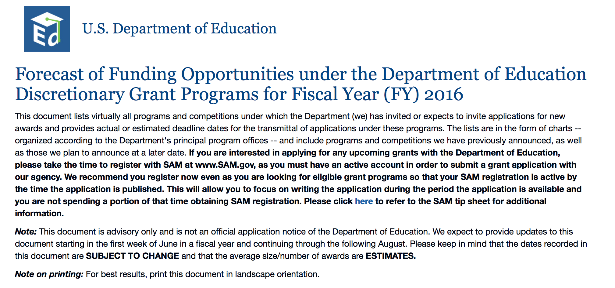To see the complete document click here: http://www2.ed.gov/fund/grant/find/edlite-forecast.html

The general information page for Education Grant funding is an excellent resource describing the three types of grants awarded by the Department of Education. See the screen shot of the Department of Education web page below:

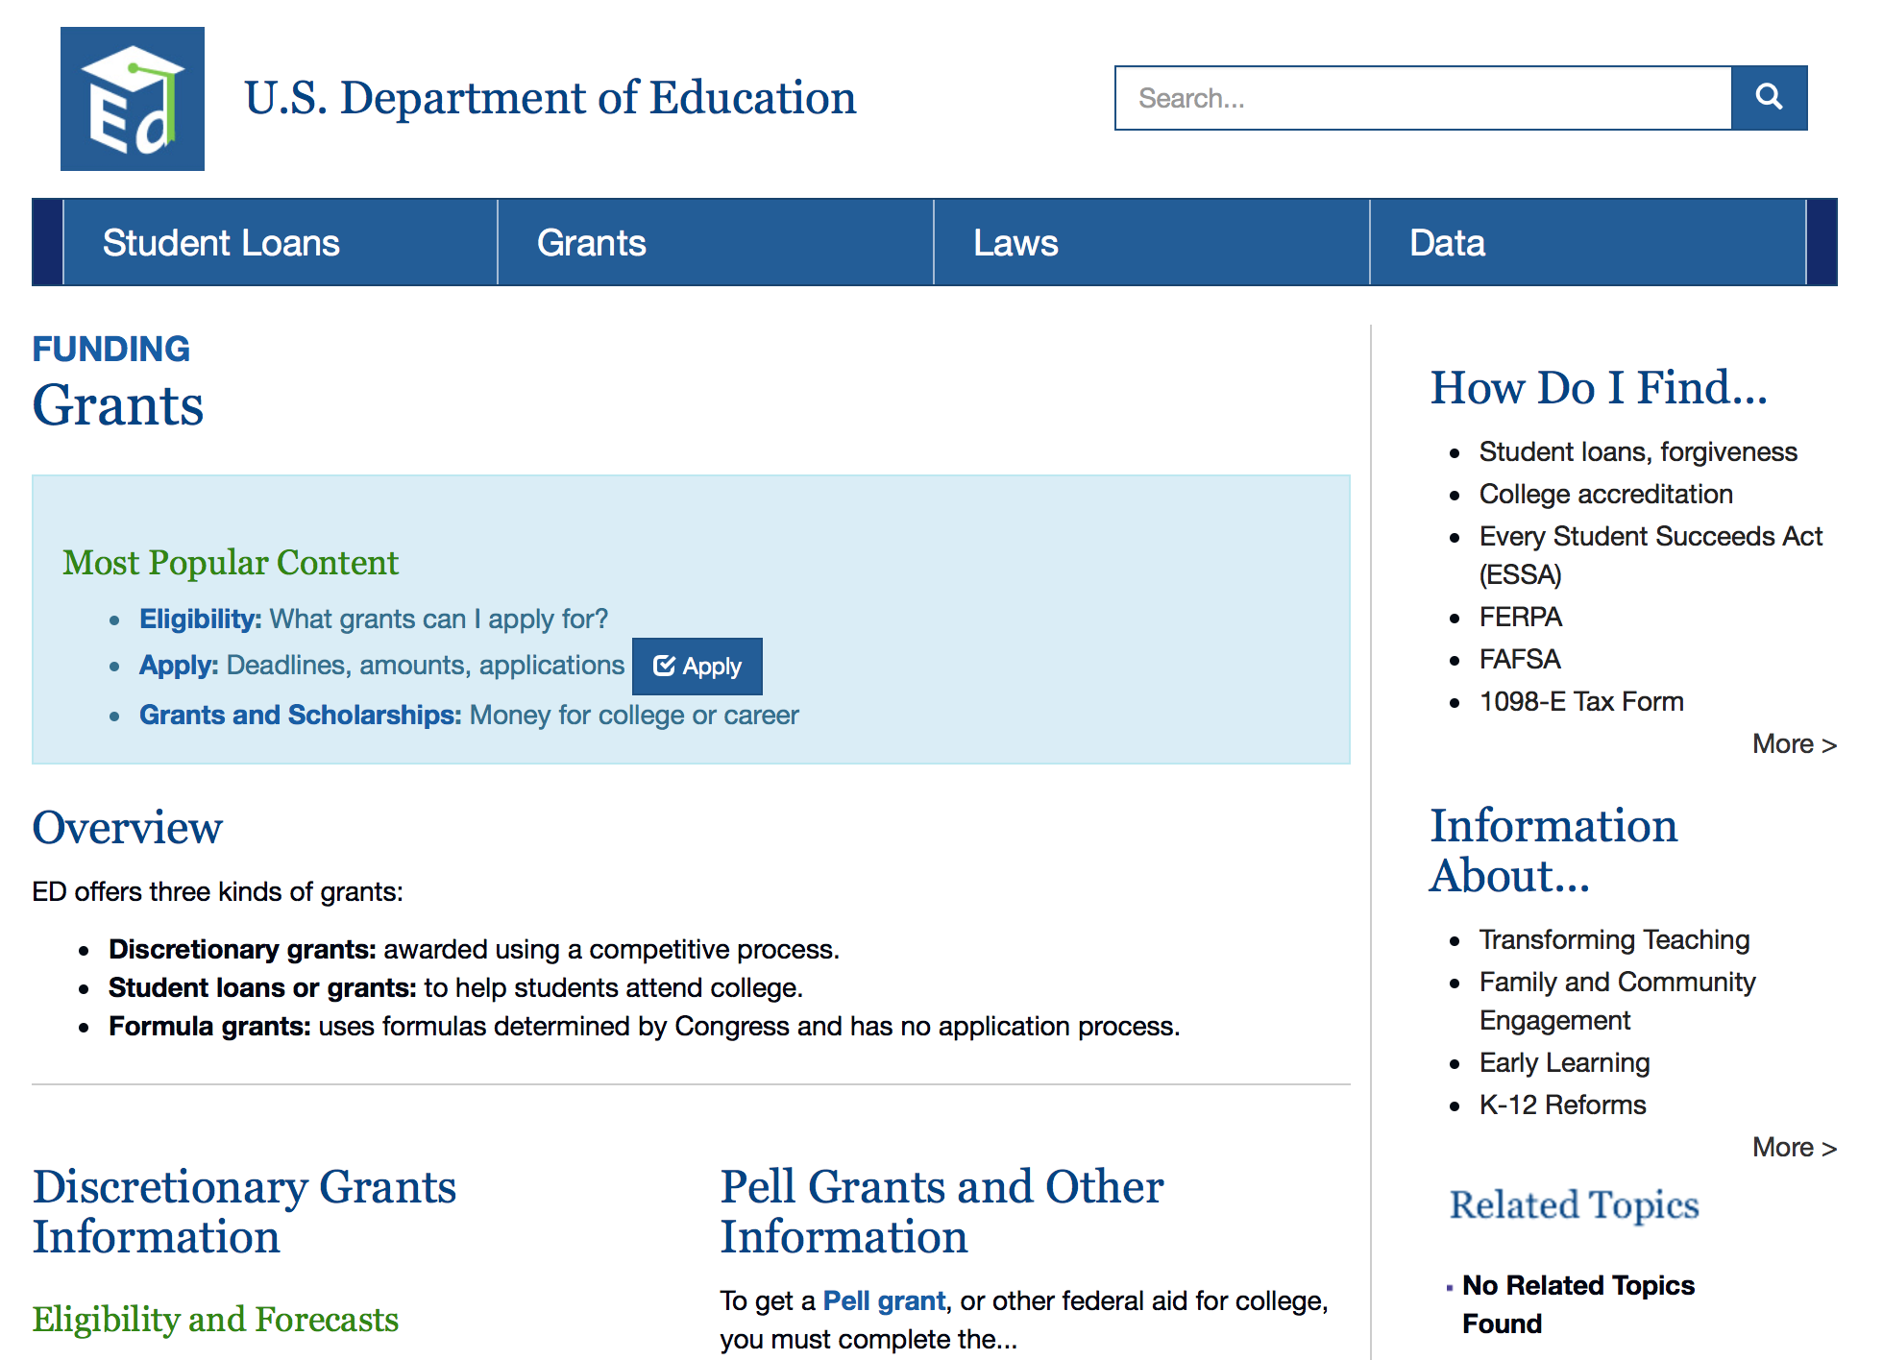

http://www.ed.gov/fund/grants-apply.html

Programs:

Office of Postsecondary Education (OPE): Fulbright-Hays Doctoral Dissertation Research Abroad Fellowship Program CFDA Number 84.022A Grant

Document Type: | Grants Notice
Funding Opportunity Number: | ED-GRANTS-032216-002
Funding Opportunity Title: | Office of Postsecondary Education (OPE): Fulbright-Hays Doctoral Dissertation Research Abroad Fellowship Program CFDA Number 84.022A
Opportunity Category: | Discretionary
Opportunity Category Explanation: | Category Explanation
Funding Instrument Type: | Grant
Category of Funding Activity: | Education
Category Explanation:
Expected Number of Awards: | 90
CFDA Number(s): | 84.022 -- Overseas Programs - Doctoral Dissertation Research Abroad
Cost Sharing or Matching Requirement: | No
Posted Date: | Mar 22, 2016
Last Updated Date: | Mar 22, 2016
Original Closing Date for Applications: | May 06, 2016 Applications Available: March 22, 2016. Deadline for Transmittal of Applications: May 6, 2016.
Current Closing Date for Applications: | May 06, 2016 Applications Available: March 22, 2016. Deadline for Transmittal of Applications: May 6, 2016.
Archive Date: | Jun 05, 2016
Estimated Total Program Funding: | $3,011,504
Eligible Applicants: | Others (see text field entitled "Additional Information on Eligibility" for clarification)  Private institutions of higher education  Public and State controlled institutions of higher education
Additional Information on Eligibility: | 1. Eligible Applicants: Institutions of higher education (IHEs). As part of the application process, students submit individual applications to the IHE. The IHE then officially submits all eligible individual student applications with its grant application to the Department. Note: As part of its FY 2016 budget request, the Administration proposed to continue to allow funds to be used to support the applications of individuals who plan both to utilize their language skills in world areas vital to United States national security and to apply their language skills and knowledge of these countries in the fields of government, international development, and the professions. Therefore, students planning to apply their language skills in such fields and those planning teaching careers are eligible to apply to IHEs for funds from this program.
Agency Name: | Department of Education
Description: | Note: Each funding opportunity description is a synopsis of information in the Federal Register application notice. For specific information about eligibility, please see the official application notice. The official version of this document is the document published in the Federal Register. Free Internet access to the official edition of the Federal Register and the Code of Federal Regulations is available on GPO Access at: http://www.access.gpo.gov/nara/index.html. Please review the official application notice for pre-application and application requirements, application submission information, performance measures, priorities and program contact information. Purpose of Program: The Fulbright-Hays DDRA Fellowship Program provides opportunities to doctoral candidates to engage in full-time dissertation research abroad in modern foreign languages and area studies. The program is designed to contribute to the development and improvement of the study of modern foreign languages and area studies in the United States. Catalog of Federal Domestic Assistance (CFDA) Number: 84.022A. Applications for grants under the Fulbright-Hays DDRA Fellowship Program, CFDA number 84.022A, must be submitted electronically using the G5 system, accessible through the Department's G5 site at: www.G5.gov. While completing your electronic application, both the IHE and the student applicant will be entering data online that will be saved into a database. Neither the IHE nor the student applicant may email an electronic copy of a grant application to us.
Link to Additional Information: | Office of Postsecondary Education (OPE): Fulbright-Hays Doctoral Dissertation Research Abroad Fellowship Program CFDA Number 84.022A; Notice inviting applications for new awards for fiscal year (FY) 2016
Contact Information: | If you have difficulty accessing the full announcement electronically, please contact:  Julius Cotton ED Grants.gov FIND Systems Admin. Phone 202-245-6288 EducationGrantInquiries@ed.gov Program Manager: Pamela J. Maimer, Ph.D., International and Foreign Language Education, U.S. Department of Education, 400 Maryland Ave. SW., Room 3E207, Washington, DC 20202. Telephone: (202) 453-6891 or by email: ddra@ed.gov.  e-Mail: Program Mailbox

http://www.grants.gov/web/grants/view-opportunity.html?oppId=282425

Research:

Institute of Education Sciences (IES CFDA Number 84.305

Original Closing Date for Applications: | Aug 04, 2016 Application Package Available: May 5, 2016 Deadline for Transmittal of Applications: August 4, 2016.
Current Closing Date for Applications: | Aug 04, 2016 Application Package Available: May 5, 2016 Deadline for Transmittal of Applications: August 4, 2016.
Eligible Applicants: | Others (see text field entitled "Additional Information on Eligibility" for clarification)  County governments  Nonprofits having a 501(c)(3) status with the IRS, other than institutions of higher education  City or township governments  State governments  Special district governments  Nonprofits that do not have a 501(c)(3) status with the IRS, other than institutions of higher education  Public and State controlled institutions of higher education  Independent school districts  For profit organizations other than small businesses  Private institutions of higher education
Additional Information on Eligibility: | Eligible Applicants: Applicants that have the ability and capacity to conduct scientifically valid research are eligible to apply. Eligible applicants include, but are not limited to, nonprofit and for-profit organizations and public and private agencies and institutions of higher education, such as colleges and universities.
Agency Name: | Department of Education
Description: | Note: Each funding opportunity description is a synopsis of information in the Federal Register application notice. For specific information about eligibility, please see the official application notice. The official version of this document is the document published in the Federal Register. Free Internet access to the official edition of the Federal Register and the Code of Federal Regulations is available on GPO Access at: http://www.access.gpo.gov/nara/index.html. Please review the official application notice for pre-application and application requirements, application submission information, performance measures, priorities and program contact information. Purpose of Program: The central purpose of the Institute's research grant programs is to provide interested individuals and the general public with reliable and valid information about education practices that support learning and improve academic achievement and access to education opportunities for all students. These interested individuals include parents, educators, students, researchers, and policymakers. In carrying out its grant programs, the Institute provides support for programs of research in areas of demonstrated national need. Competitions in This Notice: The Institute will conduct nine research competitions in FY 2017 through two of its centers: Catalog of Federal Domestic Assistance (CFDA) Numbers: 84.305A, 84.305B, 84.305D, 84.305H, 84.305L, 84.305N, 84.324A, 84.324B, and 84.324L. The Deputy Director for Policy and Research, Delegated the Duties of the Director, of the Institute of Education Sciences (Institute) announces the Institute's FY 2017 competitions for grants to support education research and special education research. The Delegated Director takes this action under the Education Sciences Reform Act of 2002. The Institute's purpose in awarding these grants is to provide national leadership in expanding fundamental knowledge and understanding of (1) developmental and school readiness outcomes for infants and toddlers with or at risk for disability, and (2) education outcomes for all students from early childhood education through postsecondary and adult education. Applications for grants under the Education Research, Research Training Programs in the Education Sciences, Statistical and Research Methodology in Education, Partnerships and Collaborations Focused on Problems of Practice or Policy, Low-Cost, Short-Duration Evaluation of Education Interventions, Research Networks Focused on Critical Problems of Education Policy and Practice, Special Education Research, Research Training Programs in Special Education, and Low-Cost, Short-Duration Evaluation of Special Education Interventions competitions, CFDA numbers 84.305A, 84.305B, 84.305D, 84.305H, 84.305L, 84.305N, 84.324A, 84.324B, and 84.324L must be submitted electronically using the Governmentwide Grants.gov Apply site at www.Grants.gov. Through this site, you will be able to download a copy of the application package, complete it offline, and then upload and submit your application. You may not email an electronic copy of a grant application to us. You may access the electronic grant applications for the Education Research, Research Training Programs in the Education Sciences, Statistical and Research Methodology in Education, Partnerships and Collaborations Focused on Problems of Practice or Policy, Low-Cost, Short-Duration Evaluation of Education Interventions, Research Networks Focused on Critical Problems of Education Policy and Practice, Special Education Research, Research Training Programs in Special Education, and Low-Cost, Short-Duration Evaluation of Special Education Interventions competitions at www.Grants.gov. You must search for the downloadable application package for each competition by the CFDA number. Do not include the CFDA number's alpha suffix in your search (e.g., search for 84.305, not 84.305A).
Link to Additional Information: | Institute of Education Sciences (IES): Statistical and Research Methodology in Education CFDA Number 84.305D; Notice inviting applications for new awards for fiscal year (FY) 2017
Contact Information: | If you have difficulty accessing the full announcement electronically, please contact:  Julius Cotton ED Grants.gov FIND Systems Admin. Phone 202-245-6288 EducationGrantInquiries@ed.gov Program Manager: Phill Gagne, Phill.Gagne@ed.gov.  e-Mail: Program Manager

Institute of Education Sciences (IES): Statistical and Research Methodology in Education CFDA Number 84.305D Grant
http://www.grants.gov/web/grants/view-opportunity.html?oppId=282062

Institute of Education Sciences (IES): Partnerships and Collaborations Focused on Problems of Practice or Policy CFDA Number 84.305H Grant
http://www.grants.gov/web/grants/view-opportunity.html?oppId=282063

Institute of Education Sciences (IES): Low-Cost, Short-Duration Evaluation of Education Interventions CFDA Number 84.305L Grant
http://www.grants.gov/web/grants/view-opportunity.html?oppId=282064

Institute of Education Sciences (IES): Research Networks Focused on Critical Problem of Education Policy and Practice CFDA Number 84.305N Grant
http://www.grants.gov/web/grants/view-opportunity.html?oppId=282065

Institute of Education Sciences (IES): Education Research CFDA Number 84.305A Grant
http://www.grants.gov/web/grants/view-opportunity.html?oppId=282041

Institutes of Education Sciences (IES): Research Training Programs in the Education Sciences CFDA Number 84.305B Grant
http://www.grants.gov/web/grants/view-opportunity.html?oppId=282060

Institute of Education Sciences (IES): CFDA Number 84.324

Institute of Education Sciences (IES): Special Education Research CFDA Number 84.324A Grant
http://www.grants.gov/web/grants/view-opportunity.html?oppId=282066

Institute of Education Sciences (IES): Research Training Programs in Special Education CFDA Number 84.324B Grant
http://www.grants.gov/web/grants/view-opportunity.html?oppId=282068

Institute of Education Sciences (IES): Low-Cost, Short-Duration Evaluation of Special Education Interventions CFDA Number 84.324L Grant
http://www.grants.gov/web/grants/view-opportunity.html?oppId=282069

Modifications:

Office of Elementary and Secondary Education (OESE): Carol M. White Physical Education Program CFDA Number 84.215F

Modification 1
Document Type: | Grants Notice
Funding Opportunity Number: | ED-GRANTS-032116-001
Funding Opportunity Title: | Office of Elementary and Secondary Education (OESE): Carol M. White Physical Education Program CFDA Number 84.215F
Opportunity Category: | Discretionary
Opportunity Category Explanation:
Funding Instrument Type: | Grant
Category of Funding Activity: | Education
Category Explanation:
Expected Number of Awards: | 15
CFDA Number(s): | 84.215 -- Fund for the Improvement of Education
Cost Sharing or Matching Requirement: | Yes
Posted Date: | Mar 21, 2016
Last Updated Date: | Mar 21, 2016
Original Closing Date for Applications: | May 20, 2016 Applications Available: March 21, 2016. Deadline for Transmittal of Applications: May 20, 2016.
Current Closing Date for Applications: | May 20, 2016 Applications Available: March 21, 2016. Deadline for Transmittal of Applications: May 20, 2016.
Archive Date: | Jun 19, 2016
Estimated Total Program Funding: | $23,000,000
Eligible Applicants: | Others (see text field entitled "Additional Information on Eligibility" for clarification)
Additional Information on Eligibility: | 1. Eligible Applicants: (a) LEAs, including charter schools that are considered LEAs under State law, and CBOs, including faith-based organizations provided that they meet the applicable statutory and regulatory requirements. (b) The Secretary limits eligibility under this discretionary grant competition to LEAs or CBOs that do not currently have an active grant under PEP. For the purpose of this eligibility requirement, a grant is considered active until the end of the grant's project or funding period, including any extensions of those periods that extend the grantee's authority to obligate funds. (See the notice of final eligibility requirements for the Office of Safe and Drug-Free Schools discretionary grant programs published in the Federal Register on December 4, 2006 (71 FR 70369)).
Agency Name: | Department of Education
Description: | Note: Each funding opportunity description is a synopsis of information in the Federal Register application notice. For specific information about eligibility, please see the official application notice. The official version of this document is the document published in the Federal Register. Free Internet access to the official edition of the Federal Register and the Code of Federal Regulations is available on GPO Access at: http://www.access.gpo.gov/nara/index.html. Please review the official application notice for pre-application and application requirements, application submission information, performance measures, priorities and program contact information. Purpose of Program: The Carol M. White Physical Education Program (PEP) provides grants to local educational agencies (LEAs) and community-based organizations (CBOs) to initiate, expand, and improve physical education for students in grades K-12. Grant recipients must implement programs that help students make progress toward meeting State physical education standards. Catalog of Federal Domestic Assistance (CFDA) Number: 84.215F. Applications for grants under the Carol M. White Physical Education Program, CFDA number 84.215F, must be submitted electronically using the Governmentwide Grants.gov Apply site at www.Grants.gov. Through this site, you will be able to download a copy of the application package, complete it offline, and then upload and submit your application. You may not email an electronic copy of a grant application to us. You may access the electronic grant application for the Carol M. White Physical Education Program at www.Grants.gov. You must search for the downloadable application package for this program by the CFDA number. Do not include the CFDA number's alpha suffix in your search (e.g., search for 84.215, not 84.215F).
Link to Additional Information: | Office of Elementary and Secondary Education (OESE): Carol M. White Physical Education Program CFDA NUmber 84.215F; Notice inviting applications for new awards for fiscal year (FY) 2016
Contact Information: | If you have difficulty accessing the full announcement electronically, please contact:  Julius Cotton ED Grants.gov FIND Systems Admin. Phone 202-245-6288 EducationGrantInquiries@ed.gov Program Manager: Carlette Kyser Pegram, U.S. Department of Education, 400 Maryland Avenue SW., Room 3E256, Washington, DC 20202-6450. Telephone: 202-453-6732 or by email: Carlette.KyserPegram@ed.gov.  e-Mail: Program Manager

http://www.grants.gov/web/grants/view-opportunity.html?oppId=282386

Reminders:

Under the Small, Rural School Achievement (SRSA) Program CFDA 84.358A Grant
And Modification 2  Document Type: | Grants Notice
Funding Opportunity Number: | ED-GRANTS-020516-001
Funding Opportunity Title: | Office of Elementary and Secondary Education (OESE): Small, Rural School Achievement (SRSA) Program CFDA 84.358A
Opportunity Category: | Mandatory
Opportunity Category Explanation:
Funding Instrument Type: | Grant
Category of Funding Activity: | Education
Category Explanation:
Expected Number of Awards:
CFDA Number(s): | 84.358 -- Rural Education
Cost Sharing or Matching Requirement: | No
Posted Date: | Feb 05, 2016
Last Updated Date: | Feb 08, 2016
Original Closing Date for Applications: | May 02, 2016
Current Closing Date for Applications: | May 02, 2016
Archive Date: | Jun 01, 2016
Eligible Applicants: | Others (see text field entitled "Additional Information on Eligibility" for clarification)
Additional Information on Eligibility: | Which LEAs are eligible for an award under the SRSA program? For FY 2016, an LEA (including a public charter school that is considered an LEA under State law) is eligible for an award under the SRSA program if-- (a) The total number of students in average daily attendance at all of the schools served by the LEA is fewer than 600, or each county in which a school served by the LEA is located has a total population density of fewer than 10 persons per square mile; and (b)(1) All of the schools served by the LEA are designated with a school locale code of 7 or 8 by the Department's National Center for Education Statistics (NCES); or (2) The Secretary has determined, based on a demonstration by the LEA and concurrence of the State educational agency, that the LEA is located in an area defined as rural by a governmental agency of the State.
Agency Name: | Department of Education
Description: | Note: Each funding opportunity description is a synopsis of information in the Federal Register application notice. For specific information about eligibility, please see the official application notice. The official version of this document is the document published in the Federal Register. Free Internet access to the official edition of the Federal Register and the Code of Federal Regulations is available on GPO Access at: http://www.access.gpo.gov/nara/index.html. Please review the official application notice for pre-application and application requirements, application submission information, performance measures, priorities and program contact information. Under the Small, Rural School Achievement (SRSA) program, the U.S. Department of Education (Department) awards grants on a formula basis to eligible local educational agencies (LEAs) to address the unique needs of rural school districts. In this notice, we establish the deadline for submission of fiscal year (FY) 2016 SRSA grant applications. Catalog of Federal Domestic Assistance (CFDA) Number: 84.358A. An eligible LEA that is required to submit an application to receive FY 2016 SRSA funds must submit an electronic application by May 2, 2016, 4:30:00 p.m., Washington, DC time. Any application received from an eligible LEA after this deadline will be funded only to the extent that funds are available after the Department awards grants to other eligible LEAs under the program. Submission of an electronic application involves the use of the Department's G5 System. Prospective applicants can access the electronic application for the SRSA Program at: www.g5.gov. When applicants access this site, they will receive specific instructions regarding the information to include in the SRSA application.
Link to Additional Information: | Office of Elementary and Secondary Education (OESE): Small, Rural School Achievement (SRSA) Program CFDA 84.358A; Application Deadline for Fiscal Year 2016
Contact Information: | If you have difficulty accessing the full announcement electronically, please contact:  Joyce Mays Management Analyst Phone 202-245-6122 joyce.mays@ed.gov Program Manager: David Cantrell U.S. Department of Education 400 Maryland Avenue SW., room 3E303, Washington, DC 20202 Telephone: (202) 453-5990 or by email:  Program Manager: email

http://www.grants.gov/web/grants/view-opportunity.html?oppId=281373

Office of Postsecondary Education (OPE): Training Program for Federal TRIO Programs CFDA Number 84.103A Grant

Document Type: | Grants Notice
Funding Opportunity Number: | ED-GRANTS-021616-001
Funding Opportunity Title: | Office of Postsecondary Education (OPE): Training Program for Federal TRIO Programs CFDA Number 84.103A
Opportunity Category: | Discretionary
Opportunity Category Explanation:
Funding Instrument Type: | Grant
Category of Funding Activity: | Education
Category Explanation:
Expected Number of Awards: | 9
CFDA Number(s): | 84.103 -- TRIO Staff Training Program
Cost Sharing or Matching Requirement: | No
Posted Date: | Feb 16, 2016
Last Updated Date: | Feb 16, 2016
Original Closing Date for Applications: | Apr 15, 2016 Applications Available: February 16, 2016. Deadline for Transmittal of Applications: April 15, 2016.
Current Closing Date for Applications: | Apr 15, 2016 Applications Available: February 16, 2016. Deadline for Transmittal of Applications: April 15, 2016.
Archive Date: | May 15, 2016
Estimated Total Program Funding: | $2,500,000
Award Ceiling: | $334,750
Eligible Applicants: | Others (see text field entitled "Additional Information on Eligibility" for clarification)  State governments  Nonprofits that do not have a 501(c)(3) status with the IRS, other than institutions of higher education  Private institutions of higher education  Nonprofits having a 501(c)(3) status with the IRS, other than institutions of higher education  Public and State controlled institutions of higher education  County governments  Special district governments  Independent school districts  City or township governments
Additional Information on Eligibility: | Eligible Applicants: IHEs and other public and private nonprofit institutions and organizations.
Agency Name: | Department of Education
Description: | Note: Each funding opportunity description is a synopsis of information in the Federal Register application notice. For specific information about eligibility, please see the official application notice. The official version of this document is the document published in the Federal Register. Free Internet access to the official edition of the Federal Register and the Code of Federal Regulations is available on GPO Access at: http://www.access.gpo.gov/nara/index.html. Please review the official application notice for pre-application and application requirements, application submission information, performance measures, priorities and program contact information. Purpose of Program: The Training Program provides grants to train the staff and leadership personnel employed in, participating in, or preparing for employment in, projects funded under the Federal TRIO Programs to improve the operation of these projects. Catalog of Federal Domestic Assistance (CFDA) Number: 84.103A. Applications for grants under the Training Program, CFDA number 84.103A, must be submitted electronically using the Governmentwide Grants.gov Apply site at www.Grants.gov. Through this site, you will be able to download a copy of the application package, complete it offline, and then upload and submit your application. You may not email an electronic copy of a grant application to us. You may access the electronic grant application for the Training Program at www.Grants.gov. You must search for the downloadable application package for this program by the CFDA number. Do not include the CFDA number's alpha suffix in your search (e.g., search for 84.103, not 84.103A).
Link to Additional Information: | Office of Postsecondary Education (OPE): Training Program for Federal TRIO Programs CFDA Number 84.103A; Notice inviting applications for new awards for fiscal year (FY) 2016
Contact Information: | If you have difficulty accessing the full announcement electronically, please contact:  Julius Cotton ED Grants.gov FIND Systems Admin. Phone 202-245-6288 EducationGrantInquiries@ed.gov Program Managers: Suzanne Ulmer or, if unavailable, Dr. Katie Blanding, OPE, U.S. Department of Education, 400 Maryland Avenue SW., Room 7E311, Washington, DC 20202. Telephone: (202) 502-7600 or by email: TRIO@ed.gov.  e-Mail: Program Mailbox

http://www.grants.gov/web/grants/view-opportunity.html?oppId=281540

Office of Special Education and Rehabilitative Services (OSERS): Office of Special Programs (OSEP): Training and Information for Parents of Children with Disabilities: Community Parent Resource Centers CFDA Number 84.328C Grant

Document Type: | Grants Notice
Funding Opportunity Number: | ED-GRANTS-022616-001
Funding Opportunity Title: | Office of Special Education and Rehabilitative Services (OSERS): Office of Special Programs (OSEP): Training and Information for Parents of Children with Disabilities: Community Parent Resource Centers CFDA Number 84.328C
Opportunity Category: | Discretionary
Opportunity Category Explanation:
Funding Instrument Type: | Grant
Category of Funding Activity: | Education
Category Explanation:
Expected Number of Awards: | 30
CFDA Number(s): | 84.328 -- Special Education Parent Information Centers
Cost Sharing or Matching Requirement: | No
Posted Date: | Feb 26, 2016
Last Updated Date: | Feb 26, 2016
Original Closing Date for Applications: | Apr 11, 2016 Applications Available: February 26, 2016. Deadline for Transmittal of Applications: April 11, 2016.
Current Closing Date for Applications: | Apr 11, 2016 Applications Available: February 26, 2016. Deadline for Transmittal of Applications: April 11, 2016.
Archive Date: | May 11, 2016
Estimated Total Program Funding: | $3,000,000
Award Ceiling: | $100,000
Eligible Applicants: | Others (see text field entitled "Additional Information on Eligibility" for clarification)
Additional Information on Eligibility: | 1. Eligible Applicants: Local parent organizations. Note: Section 671(a)(2) of IDEA defines a ``parent organization'' as a private nonprofit organization (other than an institution of higher education) that-- (a) Has a board of directors-- (1) The majority of whom are parents of children with disabilities ages birth through 26; (2) That includes-- (i) Individuals working in the fields of special education, related services, and early intervention; and (ii) Individuals with disabilities; and (3) The parent and professional members of which are broadly representative of the population to be served, including low-income parents and parents of limited English proficient children; and (b) Has as its mission serving families of children with disabilities who are ages birth through 26, and have the full range of disabilities described in section 602(3) of IDEA.
Agency Name: | Department of Education
Description: | Note: Each funding opportunity description is a synopsis of information in the Federal Register application notice. For specific information about eligibility, please see the official application notice. The official version of this document is the document published in the Federal Register. Free Internet access to the official edition of the Federal Register and the Code of Federal Regulations is available on GPO Access at: http://www.access.gpo.gov/nara/index.html. Please review the official application notice for pre-application and application requirements, application submission information, performance measures, priorities and program contact information. Purpose of Program: The purpose of this program is to ensure that parents of children with disabilities receive training and information to help improve results for their children. Priority: In accordance with 34 CFR 75.105(b)(2)(iv) and (v), this priority is from allowable activities specified in the statute, or otherwise authorized in the statute (see sections 671 and 681(d) of the Individuals with Disabilities Education Act (IDEA)). Absolute Priority: For FY 2016 and any subsequent year in which we make awards from the list of unfunded applications from this competition, this priority is an absolute priority. Under 34 CFR 75.105(c)(3), we consider only applications that meet this priority. This priority is: Community Parent Resource Centers. Background: The purpose of this priority is to fund 30 Community Parent Resource Centers (CPRCs) designed to meet the specific needs of parents of children with disabilities, and youth with disabilities, who experience significant isolation from available sources of information and support in the geographically defined communities served by the centers. These parents can include, for example, low-income parents, parents with limited English proficiency, and parents with disabilities. Youth can include, for example, youth living in low-income households and youth with limited English proficiency. More than 35 years of research and experience has demonstrated that the education of children with disabilities can be made more effective by strengthening the ability of parents to participate fully in the education of their children at school and at home (see section 601(c)(5)(B) of IDEA). Since the Department first funded CPRCs over 20 years ago, the CPRC program has helped parents in their communities set high expectations for children with disabilities and has provided parents with the information and training they need to help their children meet those expectations. Information about the Office of Special Education's parent training and information program can be found at: www.parentcenterhub.org. Catalog of Federal Domestic Assistance (CFDA) Number: 84.328C. Applications for grants under the Community Parent Resource Centers competition, CFDA number 84.328C, must be submitted electronically using the Governmentwide Grants.gov Apply site at www.Grants.gov. Through this site, you will be able to download a copy of the application package, complete it offline, and then upload and submit your application. You may not email an electronic copy of a grant application to us. You may access the electronic grant application for the Community Parent Resource Centers competition at www.Grants.gov. You must search for the downloadable application package for this competition by the CFDA number. Do not include the CFDA number's alpha suffix in your search (e.g., search for 84.328, not 84.328C).
Link to Additional Information: | Office of Special Education and Rehabilitative Services (OSERS): Office of Special Programs (OSEP): Training and Information for Parents of Children with Disabilities: Community Parent Resource Centers CFDA Number 84.328C; Notice
Contact Information: | If you have difficulty accessing the full announcement electronically, please contact:  Julius Cotton ED Grants.gov FIND Systems Admin. Phone 202-245-6288 EducationGrantInquiries@ed.gov Program Manager: Carmen Sanchez, U.S. Department of Education, 400 Maryland Avenue SW., Room 5175, Potomac Center Plaza (PCP), Washington, DC 20202-5076. Telephone: (202) 245-6595 or e-Mail: Carmen.Sanchez@ed.gov.  e-Mail: Program Manager

http://www.grants.gov/web/grants/view-opportunity.html?oppId=281791

Office of Special Education and Rehabilitative Services (OSERS): Office of Special Education Programs (OSEP): Educational Technology, Media, and Materials for Individuals with Disabilities: Stepping-up Technology Implementation CFDA Number 84.327S Grant

Document Type: | Grants Notice
Funding Opportunity Number: | ED-GRANTS-022916-001
Funding Opportunity Title: | Office of Special Education and Rehabilitative Services (OSERS): Office of Special Education Programs (OSEP): Educational Technology, Media, and Materials for Individuals with Disabilities: Stepping-up Technology Implementation CFDA Number 84.327S
Opportunity Category: | Discretionary
Opportunity Category Explanation:
Funding Instrument Type: | Cooperative Agreement
Category of Funding Activity: | Education
Category Explanation:
Expected Number of Awards: | 3
CFDA Number(s): | 84.327 -- Special Education Educational Technology Media, and Materials for Individuals with Disabilities
Cost Sharing or Matching Requirement: | No
Posted Date: | Feb 29, 2016
Last Updated Date: | Feb 29, 2016
Original Closing Date for Applications: | Apr 14, 2016 Applications Available: February 29, 2016. Deadline for Transmittal of Applications: April 14, 2016.
Current Closing Date for Applications: | Apr 14, 2016 Applications Available: February 29, 2016. Deadline for Transmittal of Applications: April 14, 2016.
Archive Date: | May 14, 2016
Estimated Total Program Funding: | $1,414,056
Award Ceiling: | $500,000
Eligible Applicants: | Nonprofits that do not have a 501(c)(3) status with the IRS, other than institutions of higher education  Public and State controlled institutions of higher education  State governments  Native American tribal governments (Federally recognized)  Nonprofits having a 501(c)(3) status with the IRS, other than institutions of higher education  Private institutions of higher education  Special district governments  Independent school districts  Others (see text field entitled "Additional Information on Eligibility" for clarification)  Native American tribal organizations (other than Federally recognized tribal governments)  City or township governments  County governments
Additional Information on Eligibility: | Eligible Applicants: SEAs; LEAs, including public charter schools that are considered LEAs under State law; IHEs; other public agencies; private nonprofit organizations; outlying areas; freely associated States; Indian tribes or tribal organizations; and for-profit organizations.
Agency Name: | Department of Education
Description: | Note: Each funding opportunity description is a synopsis of information in the Federal Register application notice. For specific information about eligibility, please see the official application notice. The official version of this document is the document published in the Federal Register. Free Internet access to the official edition of the Federal Register and the Code of Federal Regulations is available on GPO Access at: http://www.access.gpo.gov/nara/index.html. Please review the official application notice for pre-application and application requirements, application submission information, performance measures, priorities and program contact information. Purpose of Program: The purposes of the Educational Technology, Media, and Materials for Individuals with Disabilities Program are to: (1) improve results for students with disabilities by promoting the development, demonstration, and use of technology; (2) support educational activities designed to be of educational value in the classroom for students with disabilities; (3) provide support for captioning and video description that is appropriate for use in the classroom; and (4) provide accessible educational materials to students with disabilities in a timely manner. Catalog of Federal Domestic Assistance (CFDA) Number: 84.327S. Applications for grants under the Stepping-up Technology Implementation competition, CFDA number 84.327S, must be submitted electronically using the Governmentwide Grants.gov Apply site at www.Grants.gov. Through this site, you will be able to download a copy of the application package, complete it offline, and then upload and submit your application. You may not email an electronic copy of a grant application to us. You may access the electronic grant application for the Stepping-up Technology Implementation competition at www.Grants.gov. You must search for the downloadable application package for this competition by the CFDA number. Do not include the CFDA number's alpha suffix in your search (e.g., search for 84.327, not 84.327S).
Link to Additional Information: | Office of Special Education and Rehabilitative Services (OSERS): Office of Special Education Programs (OSEP): Educational Technology, Media, and Materials for Individuals with Disabilities: Stepping-up Technology Implementation CFDA Number 84.327S
Contact Information: | If you have difficulty accessing the full announcement electronically, please contact:  Julius Cotton ED Grants.gov FIND Systems Admin. Phone 202-245-6288 EducationGrantInquiries@ed.gov Program Manager: Terry Jackson, U.S. Department of Education, 400 Maryland Avenue SW., Room 5158, Potomac Center Plaza (PCP), Washington, DC 20202-5076. Telephone: (202) 245-6039 or e-Mail: Terry.Jackson@ed.gov.  e-Mail: Program Manager

http://www.grants.gov/web/grants/view-opportunity.html?oppId=281829



U.S. Department of Energy
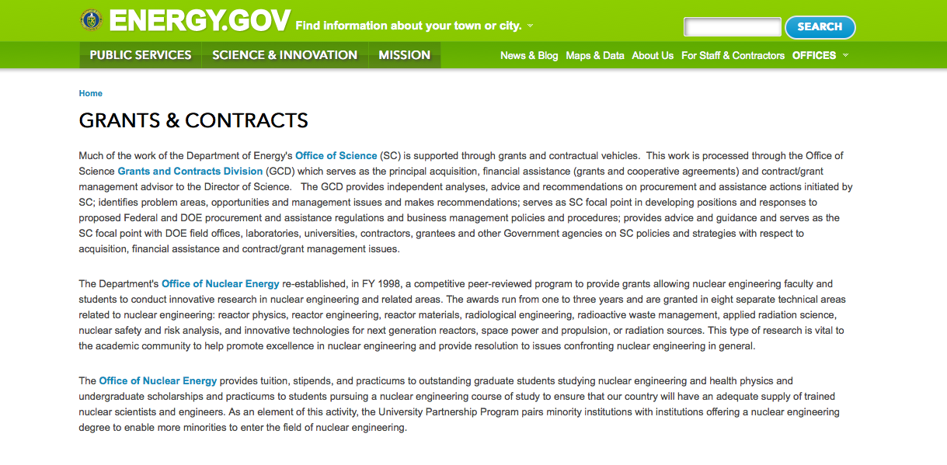
http://www.doe.gov/grants-contracts

Programs:

Cities Leading through Energy Analysis and Planning (Cities-LEAP) Grant
Document Type: | Grants Notice
Funding Opportunity Number: | DE-FOA-0001403
Funding Opportunity Title: | Cities Leading through Energy Analysis and Planning (Cities-LEAP)
Opportunity Category: | Discretionary
Opportunity Category Explanation:
Funding Instrument Type: | Cooperative Agreement
Category of Funding Activity: | Energy
Category Explanation:
Expected Number of Awards: | 0
CFDA Number(s): | 81.117 -- Energy Efficiency and Renewable Energy Information Dissemination, Outreach, Training and Technical Analysis/Assistance
Cost Sharing or Matching Requirement: | Yes
Posted Date: | Mar 23, 2016
Last Updated Date: | Mar 23, 2016
Original Closing Date for Applications: | Jun 17, 2016
Current Closing Date for Applications: | Jun 23, 2016
Archive Date: | Sep 30, 2016
Estimated Total Program Funding: | $0
Award Ceiling: | $500,000
Award Floor: | $100,000
Eligible Applicants: | County governments  City or township governments  Native American tribal governments (Federally recognized)  Native American tribal organizations (other than Federally recognized tribal governments)  Independent school districts  Special district governments
Agency Name: | Golden Field Office
Description: | The intent of this Funding Opportunity Announcement (FOA) is to support the development and piloting of data-driven decision frameworks by local and tribal governments. These frameworks should advance model practices and processes that improve the ability of local and tribal governments to integrate, analyze, and understand varied datasets, in order to pursue opportunities across all clean energy sectors such as sustainable transportation, energy efficiency, and renewable power. To develop and pilot such data-driven efforts, this FOA strongly encourages partnerships between local or tribal governments and entities such as academic institutions, technology companies, utilities, regional planning bodies, and non-governmental organizations. The full Funding Opportunity Announcement is posted on the EERE eXCHANGE website at https://eere-exchange.energy.gov. Applications must be submitted through the EERE eXCHANGE website to be considered for award. The applicant must first register and create an account on the EERE eXCHANGE website. A User Guide for the EERE eXCHANGE can be found on the EERE website https://eere-exchange.energy.gov/Manuals.aspx after logging in to the system. Information on where to submit questions regarding the content of the announcement and where to submit questions regarding submission of applications is found in the full FOA posted on the EERE eXCHANGE website.
Link to Additional Information: | https://eere-exchange.energy.gov
Contact Information: | If you have difficulty accessing the full announcement electronically, please contact:  Grants Management Specialist Brenda L. Dias Cities.LEAP@ee.doe.gov  Submit all questions to Cities.LEAP@ee.doe.gov

http://www.grants.gov/web/grants/view-opportunity.html?oppId=282452

National Energy Technology Laboratory
Synchrophasor applications and tools for reliability, market efficiency, and asset management Grant
http://www.grants.gov/web/grants/view-opportunity.html?oppId=282403

Golden Field Office
Notice of Intent to Issue Funding Opportunity Announcement: Industrial Assessment Centers Grant
http://www.grants.gov/web/grants/view-opportunity.html?oppId=281893

Golden Field Office
NEXT GENERATION ELECTRIC MACHINES: ENABLING TECHNOLOGIES Grant
http://www.grants.gov/web/grants/view-opportunity.html?oppId=282056

National Energy Technology Laboratory
Development of Technologies for Sensing, Analyzing, and Utilizing Novel Subsurface Signals in Support of the Subsurface Technology and Engineering (SubTER) Crosscut Initiative Grant
http://www.grants.gov/web/grants/view-opportunity.html?oppId=282005

Golden Field Office
Marine and Hydrokinetic Technology Development Grant
http://www.grants.gov/web/grants/view-opportunity.html?oppId=281963

National Energy Technology Laboratory
ADVANCED SYSTEMS LEVEL TECHNOLOGY DEVELOPMENT, INTEGRATION AND DEMONSTRATION FOR EFFICIENT CLASS 8 TRUCKS, SUPERTRUCK II
Grant
And Modification 1
http://www.grants.gov/web/grants/view-opportunity.html?oppId=281867

PAMS
Department of Energy - Office of Science
Office of Science
Research and Development for Next Generation Nuclear Physics Accelerator Facilities Grant
http://www.grants.gov/web/grants/view-opportunity.html?oppId=281934

Golden Field Office
RFI for Stakeholder Input on Outyear Marine and Hydrokinetic Program Strategy Grant
http://www.grants.gov/web/grants/view-opportunity.html?oppId=282701

Golden Field Office
Industrial Assessment Centers Grant
http://www.grants.gov/web/grants/view-opportunity.html?oppId=282791

National Energy Technology Laboratory
Addressing Risk and Uncertainty in the Future Power System
Modification 4
http://www.grants.gov/web/grants/view-opportunity.html?oppId=282405

PAMS
Department of Energy - Office of Science
Office of Science
Sustainable Ammonia Synthesis Grant
http://www.grants.gov/web/grants/view-opportunity.html?oppId=282707

PAMS
Department of Energy - Office of Science
Office of Science
Experimental Program to Stimulate Competitive Research (EPSCoR) Building EPSCoR-State/National Laboratory Partnerships: Sustainable Ammonia Synthesis Grant
http://www.grants.gov/web/grants/view-opportunity.html?oppId=282709

Modifications:

Golden Field Office
Request for Information (RFI) DE-FOA-0001510: Research, Development and Business Strategies Needs for Hydrogen and Automotive Polymer Electrolyte Membrane (PEM) Fuel Cells
Modification 1
http://www.grants.gov/web/grants/view-opportunity.html?oppId=281988

National Energy Technology Laboratory
Addressing Risk and Uncertainty in the Future Power System
Modifications 1,2 & 3
http://www.grants.gov/web/grants/view-opportunity.html?oppId=282405

Golden Field Office
SOLAR ENERGY EVOLUTION AND DIFFUSION STUDIES II - STATE ENERGY STRATEGIES (SEEDSII-SES)
Modification 3
http://www.grants.gov/web/grants/view-opportunity.html?oppId=281385

Golden Field Office
Marine and Hydrokinetic Technology Development
Modification 1
http://www.grants.gov/web/grants/view-opportunity.html?oppId=281963

National Energy Technology Laboratory
General Service Lamps Research and Development
And Modification 1
http://www.grants.gov/web/grants/view-opportunity.html?oppId=282300

Reminders:

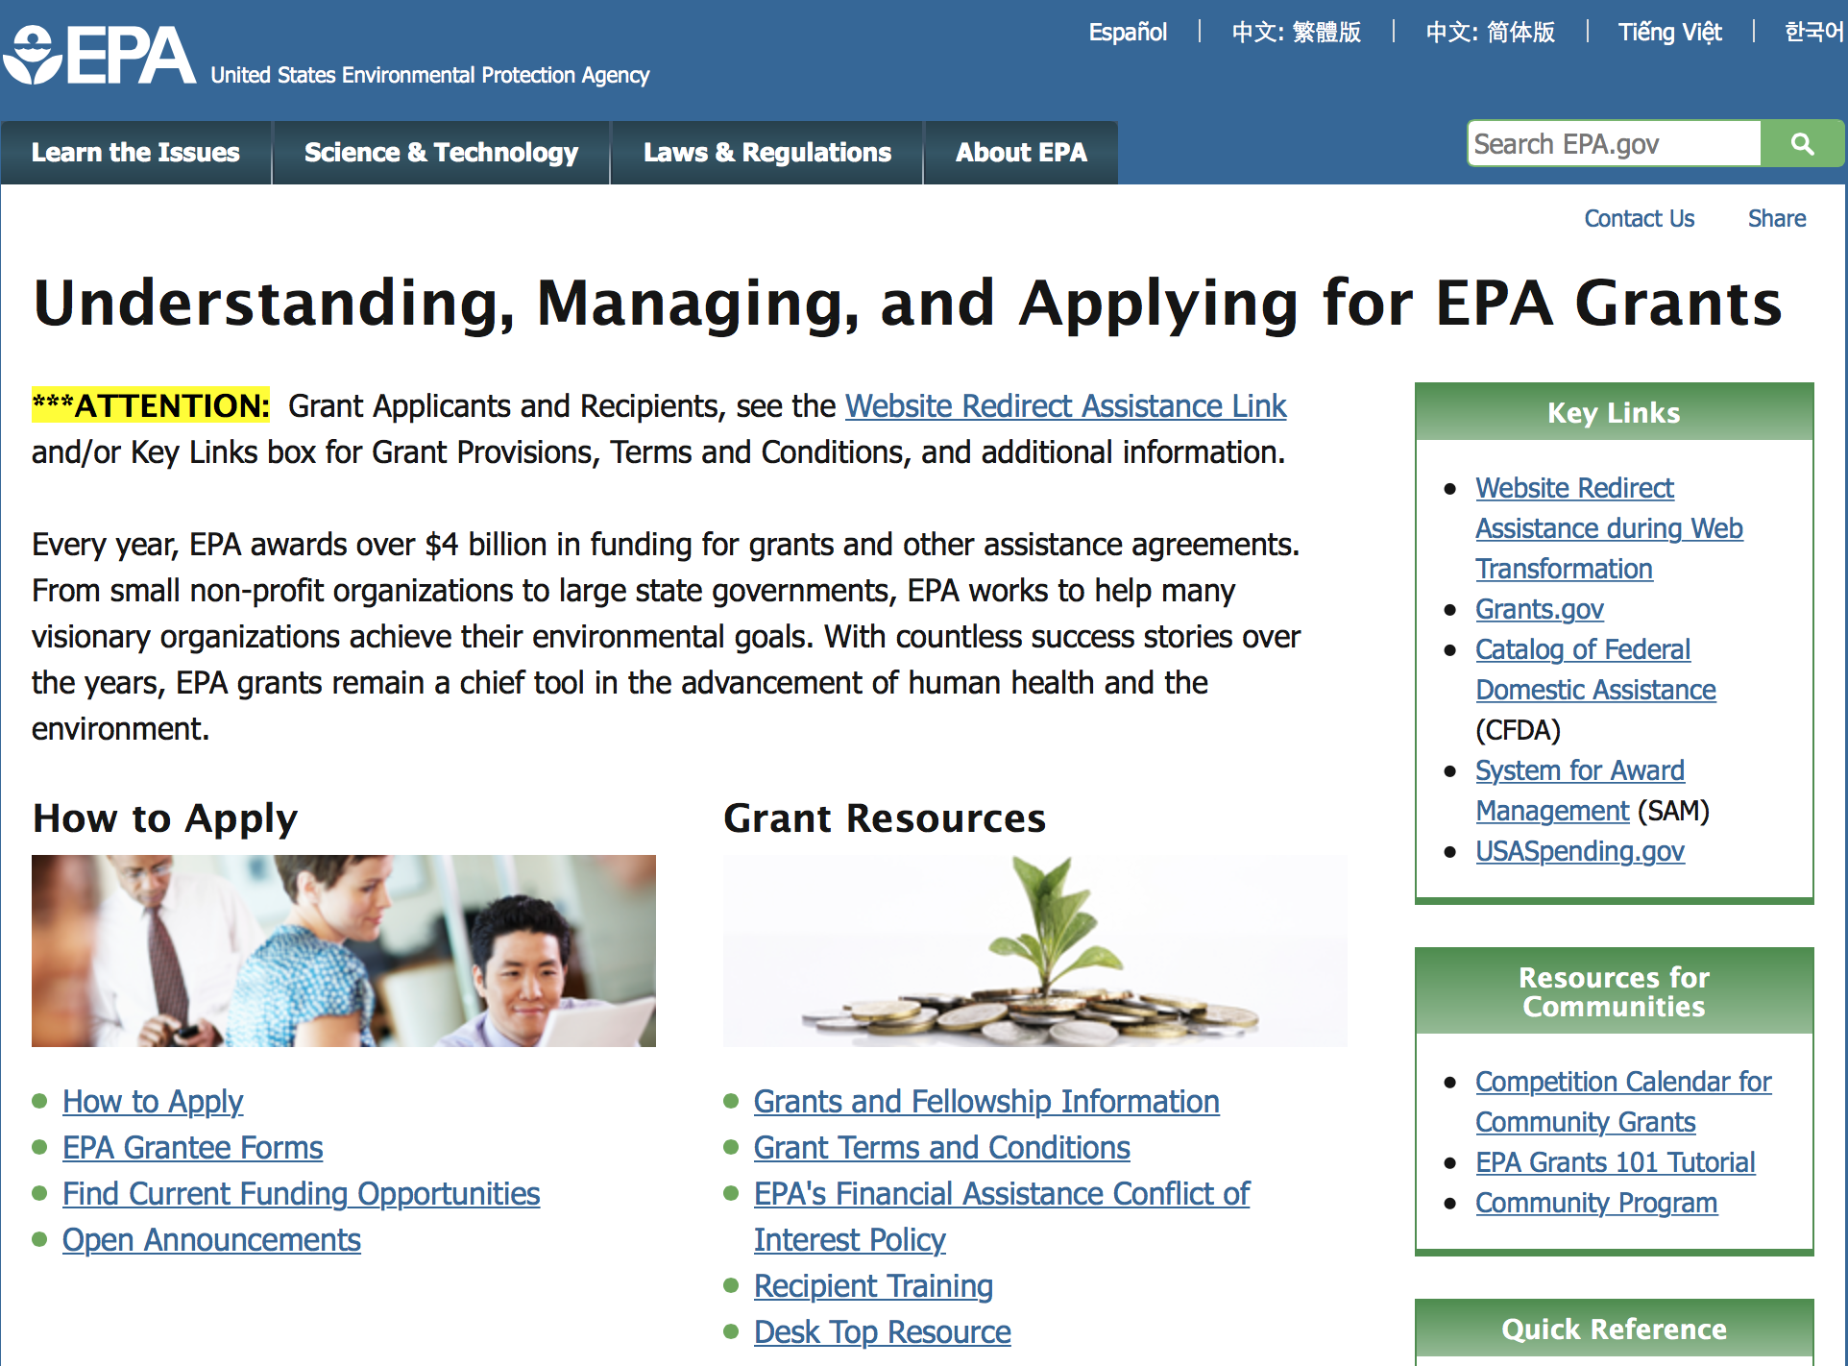

http://www.epa.gov/epahome/grants.htm

Programs:

Environmental Protection Agency
FY 2016 and FY 2017 Pollution Prevention Grant Program

Document Type: | Grants Notice
Funding Opportunity Number: | EPA-HQ-OPPT-2016-002
Funding Opportunity Title: | FY 2016 and FY 2017 Pollution Prevention Grant Program
Opportunity Category: | Discretionary
Opportunity Category Explanation:
Funding Instrument Type: | Cooperative Agreement  Grant
Category of Funding Activity: | Environment
Category Explanation:
Expected Number of Awards: | 60
CFDA Number(s): | 66.708 -- Pollution Prevention Grants Program
Cost Sharing or Matching Requirement: | Yes
Posted Date: | Mar 11, 2016
Last Updated Date: | Mar 11, 2016
Original Closing Date for Applications: | May 09, 2016 Please refer to the announcement, including Section IV, for additional information on submission methods and due dates.
Current Closing Date for Applications: | May 09, 2016 Please refer to the announcement, including Section IV, for additional information on submission methods and due dates.
Archive Date: | Jun 08, 2016
Estimated Total Program Funding: | $7,940,000
Award Ceiling: | $360,000
Award Floor: | $40,000
Eligible Applicants: | Others (see text field entitled "Additional Information on Eligibility" for clarification)
Additional Information on Eligibility: | See Section III of the announcement for eligibility information.
Agency Name: | Environmental Protection Agency
Description: | EPA’s Office of Pollution Prevention and Toxics, Chemistry, Economic and Sustainable Strategies Division oversees the Pollution Prevention (P2) Grant Program to support State and Tribal P2 Programs administer P2 projects that will help businesses identify better environmental strategies and solutions for reducing or eliminating waste at the source. EPA anticipates it will award approximately $7.94 million in federal P2 grant funding ($3.97 million in FY 2016 and $3.97 million in FY 2017) to support two-year grant agreements. Grants will be awarded and managed by EPA's ten Regional P2 Program Offices. P2 grants are dependent on Congressional appropriation and the quality of proposals received.
Link to Additional Information: | FY 2016 and FY 2017 Pollution Prevention Grant Program
Contact Information: | If you have difficulty accessing the full announcement electronically, please contact:  Michele Amhaz, Phone: (202) 564 -8857  Michele Amhaz

http://www.grants.gov/web/grants/view-opportunity.html?oppId=282166

FY 2016 and FY 2017 Pollution Prevention Information Network (PPIN) Grants Program
And Modification 1

Document Type: | Grants Notice
Funding Opportunity Number: | EPA-HQ-OPPT-2016-001
Funding Opportunity Title: | FY 2016 and FY 2017 Pollution Prevention Information Network (PPIN) Grants Program
Opportunity Category: | Discretionary
Opportunity Category Explanation:
Funding Instrument Type: | Cooperative Agreement
Category of Funding Activity: | Environment
Category Explanation:
Expected Number of Awards: | 8
CFDA Number(s): | 66.708 -- Pollution Prevention Grants Program
Cost Sharing or Matching Requirement: | Yes
Posted Date: | Mar 18, 2016
Last Updated Date: | Mar 24, 2016
Original Closing Date for Applications: | May 17, 2016 Please refer to the announcement, including Section IV, for additional information on submission methods and due dates.
Current Closing Date for Applications: | May 17, 2016 Please refer to the announcement, including Section IV, for additional information on submission methods and due dates.
Archive Date: | Jun 16, 2016
Estimated Total Program Funding: | $1,600,000
Award Ceiling: | $220,000
Award Floor: | $0
Eligible Applicants: | Others (see text field entitled "Additional Information on Eligibility" for clarification)
Additional Information on Eligibility: | See Section III of the announcement for eligibility information.
Agency Name: | Environmental Protection Agency
Description: | EPA is announcing a two-year grant competition cycle to support two-year PPIN grant or cooperative agreements. EPA anticipates awarding approximately $1.6 million in federal P2 grant funding (about $800,000 in FY 2016 and $800,000 in FY 2017) to state entities. The grants will support the development and delivery of pollution prevention (P2) information resources, tools, training and related services to meet the needs of businesses and technical assistance providers working in one or more of the three P2 national emphasis areas (NEAs). The three areas referred to as the NEAs are: 1) climate change mitigation/prevention of greenhouse gas emissions, 2) pollution prevention practices in the food manufacturing and processing sector, and 3) state or community approaches to hazardous materials source reduction. Applicants must demonstrate how their activities increase the adoption of pollution prevention practices by reporting outcome measures. Pollution prevention refers to practices that: 1) reduce or eliminate the creation of pollutants through increased efficiency in the use of raw materials, energy, water, or other resources; or 2) reduce the amount of hazardous substance, pollutant or contaminate entering any waste stream or released to the environment. The cooperative agreements will be issued and managed through EPA’s regional P2 programs. The amount of grant funding released each year is dependent upon Congressional appropriation and the quality of proposals received.
Link to Additional Information: | FY 2016 and FY 2017 Pollution Prevention Information Network (PPIN) Grants Program
Contact Information: | If you have difficulty accessing the full announcement electronically, please contact:  Beth Anderson, (202) 564-8833  Beth Anderson

http://www.grants.gov/web/grants/view-opportunity.html?oppId=282347

Modifications:

Reminders:

Clean Diesel Funding Assistance Program FY 2016 Grant

Document Type: | Grants Notice
Funding Opportunity Number: | EPA-OAR-OTAQ-16-02
Funding Opportunity Title: | Clean Diesel Funding Assistance Program FY 2016
Opportunity Category: | Discretionary
Opportunity Category Explanation:
Funding Instrument Type: | Cooperative Agreement
Category of Funding Activity: | Environment
Category Explanation:
Expected Number of Awards: | 40
CFDA Number(s): | 66.039 -- National Clean Diesel Emissions Reduction Program
Cost Sharing or Matching Requirement: | Yes
Posted Date: | Feb 25, 2016
Last Updated Date: | Feb 25, 2016
Original Closing Date for Applications: | Apr 26, 2016 Please see the announcement including Section IV for additional submission information.
Current Closing Date for Applications: | Apr 26, 2016 Please see the announcement including Section IV for additional submission information.
Archive Date: | May 26, 2016
Estimated Total Program Funding: | $26,000,000
Award Ceiling: | $4,400,000
Award Floor: | $100,000
Eligible Applicants: | Others (see text field entitled "Additional Information on Eligibility" for clarification)
Additional Information on Eligibility: | Please see the announcement including Section III for additional eligibility information.
Agency Name: | Environmental Protection Agency
Description: | EPA’s Office of Transportation and Air Quality is soliciting proposals nationwide for projects that achieve significant reductions in diesel emissions in terms of tons of pollution produced by diesel engines and diesel emissions exposure, particularly from fleets operating at or servicing goods movement facilities located in areas designated as having poor air quality. Further, priority for funding may be given to projects which result in outcomes that benefit affected communities, those that engage local communities with respect to the design and performance of the project, and those which can demonstrate the ability to promote and continue efforts to reduce emissions after the project has ended.
Link to Additional Information: | Clean Diesel Funding Assistance Program FY 2016
Contact Information: | If you have difficulty accessing the full announcement electronically, please contact:  Faye Swift, 202-343-9147  Faye Swift

http://www.grants.gov/web/grants/view-opportunity.html?oppId=281782

Early Career Awards: Integrating Human Health and Well-Being with Ecosystem Services Grant
Document Type: | Grants Notice
Funding Opportunity Number: | EPA-G2016-STAR-A2
Funding Opportunity Title: | Early Career Awards: Integrating Human Health and Well-Being with Ecosystem Services
Opportunity Category: | Discretionary
Opportunity Category Explanation:
Funding Instrument Type: | Grant
Category of Funding Activity: | Environment
Category Explanation:
Expected Number of Awards: | 3
CFDA Number(s): | 66.509 -- Science To Achieve Results (STAR) Research Program
Cost Sharing or Matching Requirement: | No
Posted Date: | Feb 22, 2016
Last Updated Date: | Feb 22, 2016
Original Closing Date for Applications: | Apr 21, 2016 See Section IV of the announcement for due dates and additional information.
Current Closing Date for Applications: | Apr 21, 2016 See Section IV of the announcement for due dates and additional information.
Archive Date: | May 21, 2016
Estimated Total Program Funding: | $3,000,000
Award Ceiling: | $400,000
Award Floor: | $0
Eligible Applicants: | Others (see text field entitled "Additional Information on Eligibility" for clarification)
Additional Information on Eligibility: | See Section III for eligibility information.
Agency Name: | Environmental Protection Agency
Description: | The U.S. Environmental Protection Agency (U.S. EPA or EPA), through its Science to Achieve Results (STAR) program, seeks applications for collaborative, community-based research that will foster better understanding of how ecosystems support human health and well-being. Specifically, this research should examine how communities can integrate ecosystem services with human health and well-being to inform their decision making and management practices. It should also develop information that allows communities to integrate environmental, societal and economic information and to better manage multiple stressors and their cumulative impacts on humans and ecosystems. The ultimate goal is to help communities achieve their own objectives.
Link to Additional Information: | Early Career Awards: Integrating Human Health and Well-Being with Ecosystem Services
Contact Information: | If you have difficulty accessing the full announcement electronically, please contact:  Debra M. Jones, Phone: 703-347-8081  Debra M. Jones

http://www.grants.gov/web/grants/view-opportunity.html?oppId=281713

Integrating Human Health and Well-Being with Ecosystem Services Grant

Document Type: | Grants Notice
Funding Opportunity Number: | EPA-G2016-STAR-A1
Funding Opportunity Title: | Integrating Human Health and Well-Being with Ecosystem Services
Opportunity Category: | Discretionary
Opportunity Category Explanation:
Funding Instrument Type: | Grant
Category of Funding Activity: | Environment
Category Explanation:
Expected Number of Awards: | 3
CFDA Number(s): | 66.509 -- Science To Achieve Results (STAR) Research Program
Cost Sharing or Matching Requirement: | No
Posted Date: | Feb 22, 2016
Last Updated Date: | Feb 22, 2016
Original Closing Date for Applications: | Apr 21, 2016 See Section IV of the announcement for due dates and additional information.
Current Closing Date for Applications: | Apr 21, 2016 See Section IV of the announcement for due dates and additional information.
Archive Date: | May 21, 2016
Estimated Total Program Funding: | $3,000,000
Award Ceiling: | $600,000
Award Floor: | $0
Eligible Applicants: | Others (see text field entitled "Additional Information on Eligibility" for clarification)
Additional Information on Eligibility: | See Section III of the announcement for eligibility information.
Agency Name: | Environmental Protection Agency
Description: | The U.S. Environmental Protection Agency (U.S. EPA or EPA), through its Science to Achieve Results (STAR) program, seeks applications for collaborative, community-based research that will foster better understanding of how ecosystems support human health and well-being. Specifically, this research should examine how communities can integrate ecosystem services with human health and well-being to inform their decision making and management practices. It should also develop information that allows communities to integrate environmental, societal and economic information and to better manage multiple stressors and their cumulative impacts on humans and ecosystems. The ultimate goal is to help communities achieve their own objectives.
Link to Additional Information: | Integrating Human Health and Well-Being with Ecosystem Services
Contact Information: | If you have difficulty accessing the full announcement electronically, please contact:  Debra M. Jones, Phone: 703-347-8081  Debra M. Jones

http://www.grants.gov/web/grants/view-opportunity.html?oppId=281731

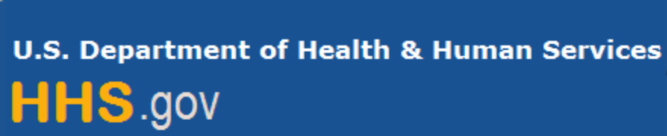

Department of Health and Human Services

Grants Forecast and Overview

The Department of Health and Human Services’ Grants Forecast is a database of planned grant opportunities proposed by its agencies. Each Forecast record contains actual or estimated dates and funding levels for grants that the agency intends to award during the fiscal year. Forecast opportunities are subject to change based on enactment of congressional appropriations. Go to the webpage below for more information.

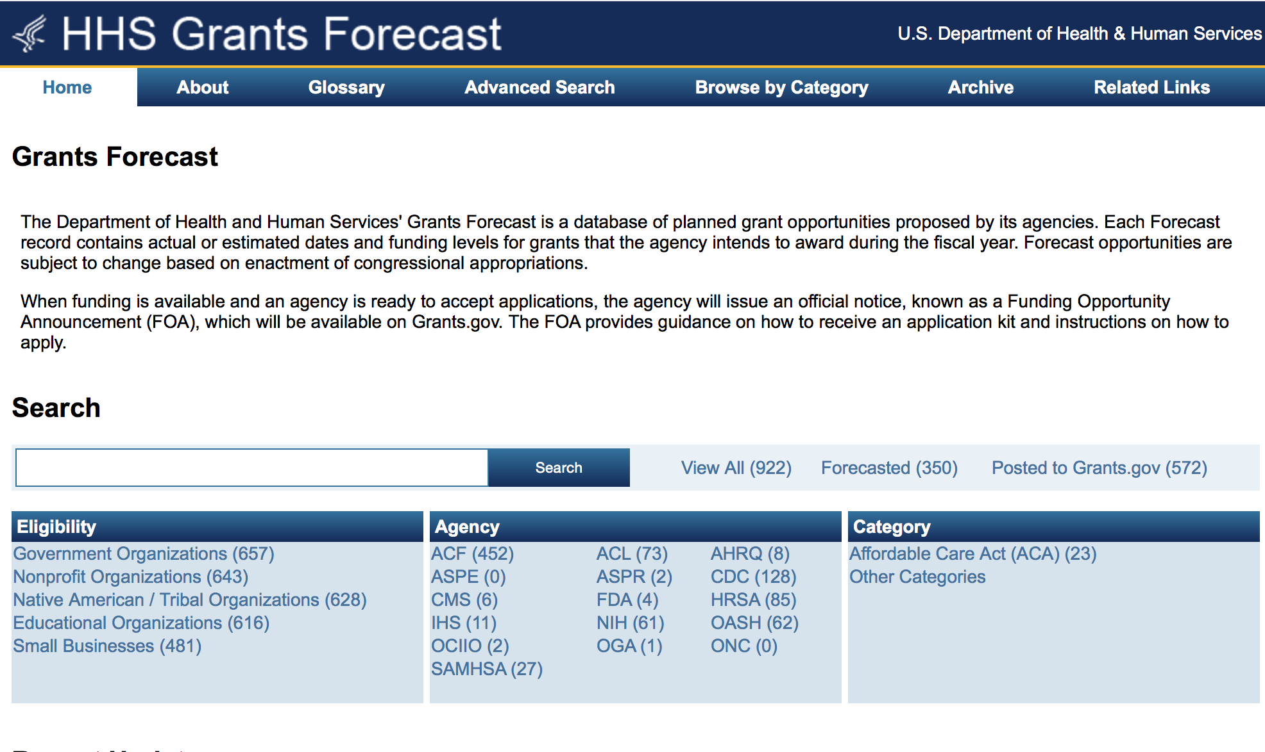
For more general information about HHS Grants and Funding go to the website below at: http://www.hhs.gov/grants/ .

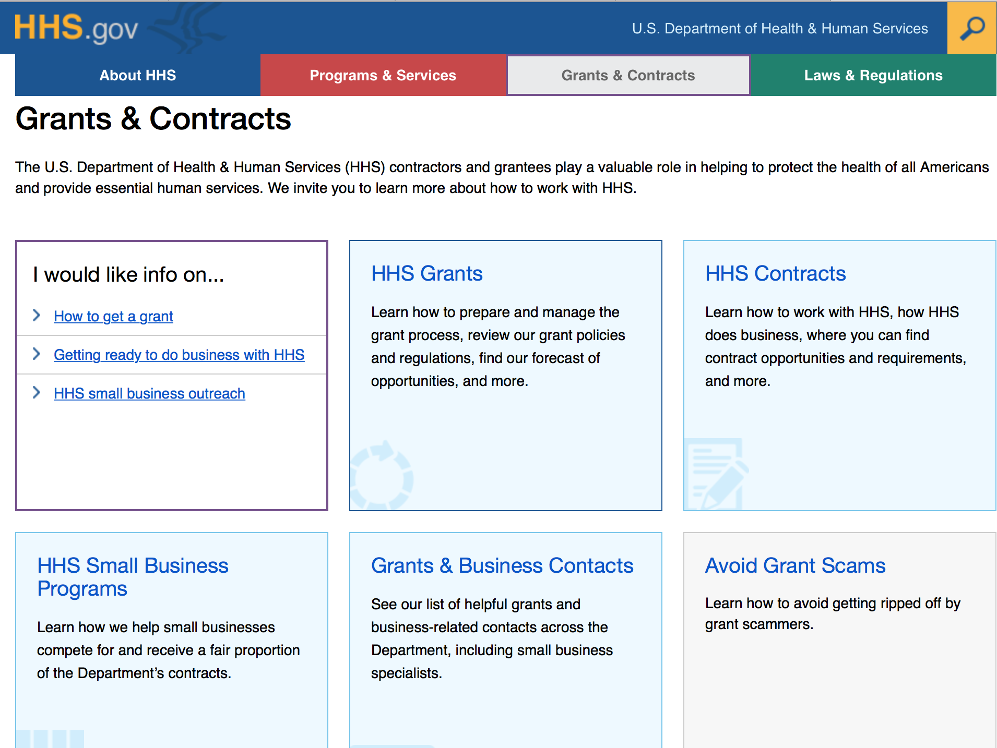

Programs:

Research:

Administration for Children and Families
Family Violence Prevention and Services Discretionary Grants: National and Special Issue Resource Centers - Culturally Specific Special Issue Resource Center (CSSIRC) Grant
http://www.grants.gov/web/grants/view-opportunity.html?oppId=282629

Administration for Children and Families - ORR
Ethnic Community Self Help Program Grant
http://www.grants.gov/web/grants/view-opportunity.html?oppId=282715

Administration for Children and Families - ANA
Native Language Community Coordination Demonstration Project (NLCC) Grant
http://www.grants.gov/web/grants/view-opportunity.html?oppId=282363

Administration for Children and Families
Administration for Children and Families - ANA
Native Youth Initiative for Leadership, Empowerment, and Development (I-LEAD)
Grant
http://www.grants.gov/web/grants/view-opportunity.html?oppId=282436

Administration for Community Living
Assistive Technology Alternative Financing Program Grant
http://www.grants.gov/web/grants/view-opportunity.html?oppId=282802

Centers for Disease Control and Prevention
Centers for Disease Control - NCEH
Building Public Health Capacity for Drought Response Grant
http://www.grants.gov/web/grants/view-opportunity.html?oppId=282828

Centers for Disease Control and Prevention
Grants for Injury Prevention and Control
http://www.grants.gov/web/grants/view-opportunity.html?oppId=282258

Centers for Disease Control and Prevention
Centers for Disease Control - NCTP
Viral Hepatitis Networking, Capacity Building, and Training Grant
http://www.grants.gov/web/grants/view-opportunity.html?oppId=281866

Centers for Disease Control and Prevention
Cooperative Research Agreements Related to the World Trade Center Health Program (U01)
Grant
http://www.grants.gov/web/grants/view-opportunity.html?oppId=282051

Centers for Disease Control and Prevention
Centers for Disease Control - NCIPC
Preventing Teen Dating and Youth Violence by Addressing Shared Risk and Protective Factors
Grant
http://www.grants.gov/web/grants/view-opportunity.html?oppId=282610

Food and Drug Administration
Therapeutic Areas for Data Standards Development (U01) Grant
http://www.grants.gov/web/grants/view-opportunity.html?oppId=282710

Food and Drug Administration
Evaluation of Aberrant Observations and Their Impact on Bioequivalence Assessment (U01)
Grant
http://www.grants.gov/web/grants/view-opportunity.html?oppId=282697

Health Resources and Services Administration
Innovation in Care Integration for Children and Youth with Autism Spectrum Disorders and Other Developmental Disabilities Program Grant
http://www.grants.gov/web/grants/view-opportunity.html?oppId=282073

Health Resources and Services Administration
Dental Faculty Development and Loan Repayment Program Grant
http://www.grants.gov/web/grants/view-opportunity.html?oppId=282618

National Institutes of Health
Partnerships for Countermeasures against Select Pathogens (R01) Grant
http://www.grants.gov/web/grants/view-opportunity.html?oppId=282598

National Institutes of Health
Advances in Polycystic Kidney Disease (R01) Grant
http://www.grants.gov/web/grants/view-opportunity.html?oppId=282619

National Institutes of Health
Adult Maturational Changes and Dysfunctions in Emotion Regulation (R21) Grant
http://www.grants.gov/web/grants/view-opportunity.html?oppId=282615

National Institutes of Health
New Technologies for the Glycosciences (R43/R44) Grant
http://www.grants.gov/web/grants/view-opportunity.html?oppId=282617

National Institutes of Health
Prevention Innovation Program III (PIP) (R01) Grant
http://www.grants.gov/web/grants/view-opportunity.html?oppId=282580

National Institutes of Health
Adult Maturational Changes and Dysfunctions in Emotion Regulation (R01) Grant
http://www.grants.gov/web/grants/view-opportunity.html?oppId=282581

National Institutes of Health
NIDCR Dual Degree Dentist Scientist Pathway to Independence Award (K99/R00) Grant
http://www.grants.gov/web/grants/view-opportunity.html?oppId=282582

National Institutes of Health
Increased Knowledge and Innovative Strategies to Reduce HIV Incidence-iKnow Projects (R01)
Grant
http://www.grants.gov/web/grants/view-opportunity.html?oppId=281961

Health Resources and Services Administration
International AIDS Education and Training Center Grant
http://www.grants.gov/web/grants/view-opportunity.html?oppId=282471

National Institutes of Health
Archiving and Documenting Child Health and Human Development Data Sets (R03)
Grant
http://www.grants.gov/web/grants/view-opportunity.html?oppId=282464

National Institutes of Health
Research Initiative for Scientific Enhancement (RISE) (R25) Grant
http://www.grants.gov/web/grants/view-opportunity.html?oppId=281965

National Institutes of Health
Learning Disabilities Innovation Hubs (P20) Grant
http://www.grants.gov/web/grants/view-opportunity.html?oppId=281968

National Institutes of Health
Early-Stage Preclinical Validation of Therapeutic Leads for Diseases of Interest to the NIDDK (R01) Grant
http://www.grants.gov/web/grants/view-opportunity.html?oppId=282090

National Institutes of Health
Systems Biology of Aging (R01) Grant
http://www.grants.gov/web/grants/view-opportunity.html?oppId=282091

National Institutes of Health
Physical Activity and Weight Control Interventions Among Cancer Survivors: Effects on Biomarkers of Prognosis and Survival (R01) Grant
http://www.grants.gov/web/grants/view-opportunity.html?oppId=282092

National Institutes of Health
Physical Activity and Weight Control Interventions Among Cancer Survivors: Effects on Biomarkers of Prognosis and Survival (R21) Grant
http://www.grants.gov/web/grants/view-opportunity.html?oppId=282093

National Institutes of Health
Methods for Prevention Packages Program IV (MP3 IV) (R01) Grant
http://www.grants.gov/web/grants/view-opportunity.html?oppId=282094

National Institutes of Health
Network for Emergency Care Clinical Trials: Strategies to Innovate EmeRgENcy Care Clinical Trials Network (SIREN) - Network Clinical Center (Hub) (U24) Grant
http://www.grants.gov/web/grants/view-opportunity.html?oppId=282050

National Institutes of Health
The Application of Big Data Analytics to Drug Abuse Research (R01) Grant
http://www.grants.gov/web/grants/view-opportunity.html?oppId=282053

National Institutes of Health
NIDDK Program Projects (P01) Grant
http://www.grants.gov/web/grants/view-opportunity.html?oppId=282059

National Institutes of Health
Intramural NIGMS Postdoctoral Research Associate (PRAT) Program (Fi2) Grant
http://www.grants.gov/web/grants/view-opportunity.html?oppId=282153

National Institutes of Health
Emerging Questions in Cancer Systems Biology (U01) Grant
http://www.grants.gov/web/grants/view-opportunity.html?oppId=282154

National Institutes of Health
Immunity in Neonates and Infants (U01) Grant
http://www.grants.gov/web/grants/view-opportunity.html?oppId=282022

National Institutes of Health
High Impact, Interdisciplinary Science in NIDDK Research Areas (RC2) Grant
http://www.grants.gov/web/grants/view-opportunity.html?oppId=282097

National Institutes of Health
NIGMS Program of Administrative Supplements for Equipment (Admin Supp) Grant
http://www.grants.gov/web/grants/view-opportunity.html?oppId=282098

National Institutes of Health
Maximizing Investigator's Research Award (R35) Grant
http://www.grants.gov/web/grants/view-opportunity.html?oppId=282100

National Institutes of Health
NIH Director's Early Independence Awards (DP5) Grant
http://www.grants.gov/web/grants/view-opportunity.html?oppId=282101

National Institutes of Health
Population Health Interventions: Integrating Individual and Group Level Evidence (R01) Grant
http://www.grants.gov/web/grants/view-opportunity.html?oppId=282438

National Institutes of Health
Ruth L. Kirschstein National Research Service Award (NRSA) Short-Term Institutional Research Training Grant (Parent T35) Grant
http://www.grants.gov/web/grants/view-opportunity.html?oppId=282526

National Institutes of Health
Ruth L. Kirschstein National Research Service Award (NRSA) Institutional Research Training Grant (Parent T32) Grant
http://www.grants.gov/web/grants/view-opportunity.html?oppId=282528

National Institutes of Health
Role of Astrocytes and Astrocytic Networks in Drug Abuse (R21) Grant
http://www.grants.gov/web/grants/view-opportunity.html?oppId=282441

National Institutes of Health
Tailoring Dental Treatment for Individuals with Systemic Diseases that Compromise Oral Health (R01) Grant
http://www.grants.gov/web/grants/view-opportunity.html?oppId=282501

National Institutes of Health
Tailoring Dental Treatment for Individuals with Systemic Diseases that Compromise Oral Health (R21) Grant
http://www.grants.gov/web/grants/view-opportunity.html?oppId=282502

National Institutes of Health
Collaborative Supplements for Cryo-Electron Microscopy Technology Transfer (Admin Supp)
Grant
http://www.grants.gov/web/grants/view-opportunity.html?oppId=282195

National Institutes of Health
NIDCR Dentist Scientist Career Transition Award for Intramural Investigators (K22)
Grant
http://www.grants.gov/web/grants/view-opportunity.html?oppId=282328

National Institutes of Health
Development of Animal Models and Related Biological Materials for Research (R21)
Grant
http://www.grants.gov/web/grants/view-opportunity.html?oppId=282315

National Institutes of Health
Research Centers for Barretts Esophagus Translational Research Network (BETRNet)(U54)
Grant
http://www.grants.gov/web/grants/view-opportunity.html?oppId=282297

National Institutes of Health
Population Health Interventions: Integrating Individual and Group Level Evidence (R21)
Grant
http://www.grants.gov/web/grants/view-opportunity.html?oppId=282415

National Institutes of Health
Role of Astrocytes and Astrocytic Networks in Drug Abuse (R01) Grant
http://www.grants.gov/web/grants/view-opportunity.html?oppId=282416

National Institutes of Health
Administrative Supplements to NIGMS Predoctoral Training Grants for Research Curriculum Development (Admin Supp) Grant
http://www.grants.gov/web/grants/view-opportunity.html?oppId=282412

National Institutes of Health
Complex Integrated Multi-Component Projects in Aging Research (U19)
Grant
http://www.grants.gov/web/grants/view-opportunity.html?oppId=282409

National Institutes of Health
Using the NIMH Research Domain Criteria (RDoC) Approach to Understand Psychosis (R21)
Grant
http://www.grants.gov/web/grants/view-opportunity.html?oppId=282299

National Institutes of Health
Tissue Chip Testing Centers: Validating Microphysiological Systems (U24) Grant
http://www.grants.gov/web/grants/view-opportunity.html?oppId=282308

National Institutes of Health
Oral Immune System Plasticity in Chronic HIV Infection Under Treatment and Oral Co-Infections (R01) Grant
http://www.grants.gov/web/grants/view-opportunity.html?oppId=282313

National Institutes of Health
Using the NIMH Research Domain Criteria (RDoC) Approach to Understand Psychosis (R01) Grant
http://www.grants.gov/web/grants/view-opportunity.html?oppId=282320

National Institutes of Health
The Early Detection Research Network: Biomarker Developmental Laboratories (U01) Grant
http://www.grants.gov/web/grants/view-opportunity.html?oppId=282322

National Institutes of Health
Limited Competition: Small Grant Program for NIDDK K01/K08/K23 Recipients (R03)
Grant
http://www.grants.gov/web/grants/view-opportunity.html?oppId=282435

National Institutes of Health
Cancer Research Education Grants Program to Promote Diversity - Courses for Skills Development (R25) Grant
http://www.grants.gov/web/grants/view-opportunity.html?oppId=282323

National Institutes of Health
Cancer Research Education Grants Program to Promote Diversity - Research Experiences (R25)
Grant
http://www.grants.gov/web/grants/view-opportunity.html?oppId=282324
National Institutes of Health
Administrative Supplements to NIGMS Predoctoral Training Grants for Career Curriculum Development (Admin Supp) Grant
http://www.grants.gov/web/grants/view-opportunity.html?oppId=282188

National Institutes of Health
Discovery of the Genetic Basis of Childhood Cancers and of Structural Birth Defects: Gabriella Miller Kids First Pediatric Research Program (X01) Grant
http://www.grants.gov/web/grants/view-opportunity.html?oppId=282516

National Institutes of Health
NeuroNEXT Clinical Trials (U01) Grant
http://www.grants.gov/web/grants/view-opportunity.html?oppId=282540

National Institutes of Health
NIH Director's New Innovator Award Program (DP2) Grant
http://www.grants.gov/web/grants/view-opportunity.html?oppId=282691

National Institutes of Health
NIH Pioneer Award Program (DP1) Grant
http://www.grants.gov/web/grants/view-opportunity.html?oppId=282680

National Institutes of Health
NIH Director's Transformative Research Awards (R01) Grant
http://www.grants.gov/web/grants/view-opportunity.html?oppId=282686

National Institutes of Health
NIH Exploratory/Developmental Research Grant Program (Parent R21) Grant
http://www.grants.gov/web/grants/view-opportunity.html?oppId=282651

National Institutes of Health
NIH Research Project Grant (Parent R01) Grant
http://www.grants.gov/web/grants/view-opportunity.html?oppId=282652

National Institutes of Health
NIH Small Research Grant Program (Parent R03) Grant
http://www.grants.gov/web/grants/view-opportunity.html?oppId=282674

National Institutes of Health
Administrative Supplements for Research on Sleep Disturbances and Impact on Chronic Pain (Admin Supp) Grant
http://www.grants.gov/web/grants/view-opportunity.html?oppId=282749

National Institutes of Health
Indo-U.S. Vaccine Action Program (VAP) Small Research Grant Program (R03) Grant
http://www.grants.gov/web/grants/view-opportunity.html?oppId=282732

National Institutes of Health
Establishment of Resource Centers for Dental, Oral and Craniofacial Tissue Regeneration Consortium (U24) Grant
http://www.grants.gov/web/grants/view-opportunity.html?oppId=282757

National Institutes of Health
Integrating Biospecimen Science into Clinical Assay Development (U01) Grant
http://www.grants.gov/web/grants/view-opportunity.html?oppId=282768

National Institutes of Health
Obesity Policy Evaluation Research (R01) Grant
http://www.grants.gov/web/grants/view-opportunity.html?oppId=282733

National Institutes of Health
Novel Strategies for Targeting HIV-CNS Reservoirs without Reactivation (R21)
Grant
http://www.grants.gov/web/grants/view-opportunity.html?oppId=282803

National Institutes of Health
NEI Research Grant for Vision Related Secondary Data Analysis (R21)
Grant
http://www.grants.gov/web/grants/view-opportunity.html?oppId=282804

National Institutes of Health
Novel Strategies for Targeting HIV-CNS Reservoirs without Reactivation (R01)
Grant
http://www.grants.gov/web/grants/view-opportunity.html?oppId=282806

National Institutes of Health
Diet and Physical Activity Assessment Methodology (R01)
Grant
http://www.grants.gov/web/grants/view-opportunity.html?oppId=282782

National Institutes of Health
Understanding Factors in Infancy and Early Childhood (Birth to 24 months) That Influence Obesity Development (R01)
Grant
http://www.grants.gov/web/grants/view-opportunity.html?oppId=282794

Substance Abuse and Mental Health Services Adminis
National Child Traumatic Stress Initiative (NCTSI) - Category II, Treatment and Service Adaptation (TSA) Centers Grant
http://www.grants.gov/web/grants/view-opportunity.html?oppId=282072

Substance Abuse and Mental Health Services Administration
Targeted Capacity Expansion HIV: Substance Use Disorder Treatment for Racial/Ethnic Minority Women at High Risk for HIV/AIDS (Short Title: TCE-HIV: Minority Women) Grant
http://www.grants.gov/web/grants/view-opportunity.html?oppId=281848

Substance Abuse and Mental Health Services Admin
Grants to Prevent Prescription Drug/Opioid Overdose-Related Deaths (PDO) Grant
http://www.grants.gov/web/grants/view-opportunity.html?oppId=282594

Substance Abuse and Mental Health Services Admin
Strategic Prevention Framework for Prescription Drugs (SPF Rx) Grant
http://www.grants.gov/web/grants/view-opportunity.html?oppId=282577

Substance Abuse and Mental Health Services Admin
Cooperative Agreements for Tribal Behavioral Health Grant
http://www.grants.gov/web/grants/view-opportunity.html?oppId=282640

Substance Abuse and Mental Health Services Admin
Targeted Capacity Expansion: Medication Assisted Treatment - Prescription Drug and Opioid Addiction (MAT-PDOA) Grant
http://www.grants.gov/web/grants/view-opportunity.html?oppId=282576

Modifications:

Administration for Community Living
Spinal Cord Injury Model Systems
Modification 2
http://www.grants.gov/web/grants/view-opportunity.html?oppId=281922

Administration for Children and Families - OCS
Assets for Independence Demonstration Program
Modification 5
http://www.grants.gov/web/grants/view-opportunity.html?oppId=275744

Administration for Children and Families
Administration for Children and Families - OPRE
Early Care and Education Research Scholars: Head Start Graduate Student Research Grants
Modification 2
http://www.grants.gov/web/grants/view-opportunity.html?oppId=253868

Administration for Children and Families
Administration for Children and Families - OPRE
Early Care and Education Research Scholars: Child Care Research Scholars
Modification 2
http://www.grants.gov/web/grants/view-opportunity.html?oppId=253869

Administration for Children and Families
Administration for Children and Families - ORR
Ethnic Community Self Help Program
Modification 1
http://www.grants.gov/web/grants/view-opportunity.html?oppId=282715

Centers for Medicare & Medicaid Services
Accountable Health Communities
Modification 1
http://www.grants.gov/web/grants/view-opportunity.html?oppId=280812

Centers for Disease Control and Prevention
Cooperative Research Agreements Related to the World Trade Center Health Program (U01)
Modification 2
http://www.grants.gov/web/grants/view-opportunity.html?oppId=282342

Centers for Disease Control and Prevention
Planning, Implementation and Evaluation of Comprehensive HIV Prevention Programs in the Republic of South Africa under the President’s Emergency Plan for AIDS Relief (PEPFAR)
Modification 3
http://www.grants.gov/web/grants/view-opportunity.html?oppId=72615

Centers for Disease Control and Prevention
Comprehensive Facility-Based Technical Assistance in the Context of Health Systems Strengthening in South Africa under the Presidents Emergency Plan for AIDS Relief (PEPFAR)
Modification 1
http://www.grants.gov/web/grants/view-opportunity.html?oppId=160773

Centers for Disease Control and Prevention
Provision of Medical Male Circumcision (MMC) for HIV Prevention in the Republic of South Africa under the President’s Emergency Plan for AIDS Relief (PEPFAR)
Modification 5
http://www.grants.gov/web/grants/view-opportunity.html?oppId=72633

Centers for Disease Control and Prevention
NIOSH Exploratory/Developmental Grant Program (R21)
Modification 9
http://www.grants.gov/web/grants/view-opportunity.html?oppId=188173

Centers for Disease Control and Prevention
Evaluating Practice-based Sexual Violence Primary Prevention Approaches from CDC's Rape Prevention and Education (RPE) Program
Modification 1
http://www.grants.gov/web/grants/view-opportunity.html?oppId=282468

Centers for Disease Control and Prevention
NIOSH Exploratory/Developmental Grant Program (R21)
Modification 8
http://www.grants.gov/web/grants/view-opportunity.html?oppId=188173

Centers for Disease Control and Prevention
NIOSH Exploratory/Developmental Grant Program (R21)
Modification 10
http://www.grants.gov/web/grants/view-opportunity.html?oppId=188173

Centers for Disease Control and Prevention
NIOSH Small Research Program (R03)
Modifications 10 & 11
http://www.grants.gov/web/grants/view-opportunity.html?oppId=188233

Centers for Disease Control and Prevention
Mentored Research Scientist Development Award (K01)
Modification 15
http://www.grants.gov/web/grants/view-opportunity.html?oppId=237453

Centers for Disease Control and Prevention
Centers for Disease Control - NIOSH
Cooperative Research Agreements Related to the World Trade Center Health Program (U01)
Modification 3
http://www.grants.gov/web/grants/view-opportunity.html?oppId=282049

National Institutes of Health
NIDCR Dentist Scientist Career Transition Award for Intramural Investigators (K22)
Modification 1
http://www.grants.gov/web/grants/view-opportunity.html?oppId=271170

National Institutes of Health
Ruth L. Kirschstein National Research Service Award (NRSA) Institutional Research Training Grant (Parent T32)
Modification 3
http://www.grants.gov/web/grants/view-opportunity.html?oppId=249041

National Institutes of Health
NIDCR Dentist Scientist Pathway to Independence Award (K99/R00)
Modification 1
http://www.grants.gov/web/grants/view-opportunity.html?oppId=249657

National Institutes of Health
Advances in Polycystic Kidney Disease (R01)
Modification 2
http://www.grants.gov/web/grants/view-opportunity.html?oppId=212613

National Institutes of Health
Mechanism for Time-Sensitive Research Opportunities in Environmental Health Sciences (R21)
Modification 1
http://www.grants.gov/web/grants/view-opportunity.html?oppId=225553

National Institutes of Health
Academic-Industrial Partnerships for Translation of Technologies for Cancer Diagnosis and Treatment (R01)
Modification 1
http://www.grants.gov/web/grants/view-opportunity.html?oppId=270550

National Institutes of Health
Accelerating Research on Intervertebral Disc (ARID) (R21)
Modification 1
http://www.grants.gov/web/grants/view-opportunity.html?oppId=281478

National Institutes of Health
Accelerating Research on Intervertebral Disc (ARID) (R01)
Modification 1
http://www.grants.gov/web/grants/view-opportunity.html?oppId=281479

National Institutes of Health
Mechanism for Time-Sensitive Research Opportunities in Environmental Health Sciences (R21)
Modification 3
http://www.grants.gov/web/grants/view-opportunity.html?oppId=225553

National Institutes of Health
Translational Programs in Lung Diseases (P01)
Modification 1
http://www.grants.gov/web/grants/view-opportunity.html?oppId=256594

National Institutes of Health
NICHD Consortium for Research on Pediatric Trauma and Injury Prevention (R24)
Modification 1
http://www.grants.gov/web/grants/view-opportunity.html?oppId=261949

National Institutes of Health
Assessing Human Placental Development and Function Using Existing Data (R21)
Modification 1
http://www.grants.gov/web/grants/view-opportunity.html?oppId=281443

National Institutes of Health
Drug Abuse Dissertation Research (R36)
Modification 1
http://www.grants.gov/web/grants/view-opportunity.html?oppId=229414

National Institutes of Health
Research Project Grant (Parent R01)
Modification 1
http://www.grants.gov/web/grants/view-opportunity.html?oppId=239080

National Institutes of Health
NIH Small Research Grant Program (Parent R03)
Modification 1
http://www.grants.gov/web/grants/view-opportunity.html?oppId=239082

National Institutes of Health
NIH Exploratory/Developmental Research Grant Program (Parent R21)
Modification 1
http://www.grants.gov/web/grants/view-opportunity.html?oppId=239083

National Institutes of Health
Partnerships for Countermeasures against Select Pathogens (R01)
Modification 1
http://www.grants.gov/web/grants/view-opportunity.html?oppId=282598

Office of the Assistant Secretary for Health
Communities Addressing Childhood Trauma (ACT)
Modification 2
http://www.grants.gov/web/grants/view-opportunity.html?oppId=281316

Office of the Assistant Secretary for Health
Announcement of the Availability of Funds for Phase I Research on Research Integrity
Modification 7
http://www.grants.gov/web/grants/view-opportunity.html?oppId=280999

Substance Abuse and Mental Health Services Admin
Program Supplements for Minority Fellowship Program-Addiction Counselors (MFP–AC)
Modification 2
http://www.grants.gov/web/grants/view-opportunity.html?oppId=282252

Reminders:

Department of Homeland Security

The Department of Homeland Security enhances the ability of states, local and tribal jurisdictions, and other regional authorities in the preparation, prevention, and response to terrorist attacks and other disasters, by distributing grant funds. Localities can use grants for planning, equipment, training and exercise needs.

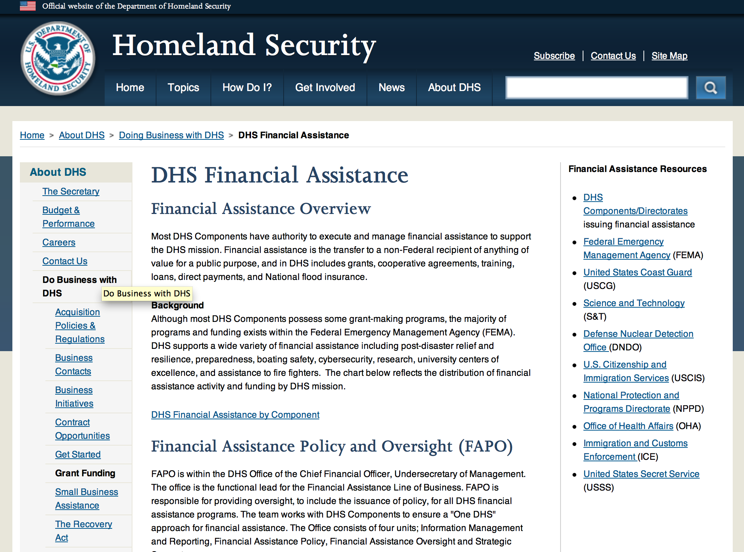

Webpage can be viewed at: http://www.dhs.gov/xopnbiz/grants/index.shtm#2

The FY 2015 Assistance to Firefighters Grants (AFG) Application Period Has Closed.
For AFG program guidance materials, please visit our Documents page.
FY 2015 FIRE PREVENTION & SAFETY (FP&S) Grants
- FY 2015 Application Information Coming Soon
- FP&S Success Stories
FY 2014 FIRE PREVENTION & SAFETY (FP&S) Grants
- FY 2014 FP&S Award Announcements - View Awards List
FY 2015 STAFFING FOR ADEQUATE FIRE and EMERGENCY RESPONSE (SAFER) Grants
- FY 2015 Application Information Coming Soon
- SAFER Success Stories
FY 2014 STAFFING FOR ADEQUATE FIRE and EMERGENCY RESPONSE (SAFER) Grants
- FY 2014 FP&S Award Announcements - View Awards List
FP&S Success Stories

Resources

AFG Help Desk
Contact the AFG Program Help Desk toll-free at 866-274-0960, or email us at firegrants@dhs.gov.
The AFG Program has Fire Program Specialists in 10 federal regional centers. These Regional Fire Program Specialists respond to questions about the AFG program and carry out grant monitoring activities. View regional contacts

Popular AFG links
- AFG Workshop Schedule
- Assistance to Firefighters Grants (AFG)
- AFG Awards List
- AFG Success Stories
- Staffing for Adequate Fire & Emergency Response (SAFER) Grants (SAFER)
- SAFER Awards List
- SAFER Success Stories
- Fire Prevention & Safety (FP&S) Grants
- FP&S Awards List
- FP&S Success Stories
- Grant Closeout Tutorial
- Assistance to Firefighters Grant (AFG) Email Alert Archive
- Frequently Asked Questions
Contact Information For The Assistance to Firefighters Grant (AFG) Program and Help Desk

Federal Funding Alternative To AFG

State Administrative Agencies (SAA) apply for and administer Federal grants on behalf of their States, including FEMA Preparedness Grants. The SAA will work with eligible organizations to comply with the general requirements of grant programs or cooperative agreements. Contact your State’s SAA to find out what current Federal funding opportunities may be available to your organization. A listing of the SAAs and points of contact can be found at http://www.fema.gov/library/viewRecord.do?id=6363.

Programs:

Modifications:

Department of Homeland Security - FEMA
Fiscal Year (FY) 2016 Cooperating Technical Partners (CTP) Program
Modification 3

Document Type: | Grants Notice
Funding Opportunity Number: | DHS-16-MT-045-00-01
Funding Opportunity Title: | Fiscal Year (FY) 2016 Cooperating Technical Partners (CTP) Program
Opportunity Category: | Discretionary
Opportunity Category Explanation:
Funding Instrument Type: | Cooperative Agreement
Category of Funding Activity: | Science and Technology and other Research and Development
Category Explanation:
Expected Number of Awards: | 11
CFDA Number(s): | 97.045 -- Cooperating Technical Partners
Cost Sharing or Matching Requirement: | No
Posted Date: | Mar 25, 2016
Last Updated Date: | Mar 31, 2016
Original Closing Date for Applications: | Jun 10, 2016
Current Closing Date for Applications: | Jun 10, 2016
Archive Date: | Jul 10, 2016
Estimated Total Program Funding: | $2,450,000
Eligible Applicants: | Native American tribal governments (Federally recognized)  Others (see text field entitled "Additional Information on Eligibility" for clarification)  Special district governments  State governments  City or township governments  Nonprofits having a 501(c)(3) status with the IRS, other than institutions of higher education  Public and State controlled institutions of higher education  County governments
Additional Information on Eligibility: | As approved by FEMA HQ
Agency Name: | Department of Homeland Security - FEMA
Description: | "The Cooperating Technical Partners Program (CTP Program) exists to strengthen and increase the effectiveness of the National Flood Insurance Program (NFIP) through fostering strong Federal, State, Tribal, regional and local partnerships for the purposes of reducing flood losses and promoting community resiliency. The CTP Program may provide federal assistance, through a grant or cooperative agreement, to an eligible Cooperating Technical Partner (herein referred to as ¿CTP¿, ¿partner¿ or ¿grantee¿) to perform various projects and activities that stimulate and support the ability of NFIP State Coordinating Agencies and NFIP-participating communities (as defined in 44 CFR Part 59.1) to continue their ongoing regulatory NFIP responsibilities as well as support the ability of States, communities and the public and private sector to mitigate flood risk. The CTP Program seeks to enhance the existing capabilities of CTPs to increase local involvement in, and ownership of, the development and maintenance of flood risk data and products, such as the Flood Insurance Rate Maps (FIRMs) and other risk related products, as well as other support to advance the goals and objectives of the Risk Mapping Assessment and Planning (Risk MAP) program. Partnerships developed through FEMA¿s CTP Program are in the best interest of State and local communities, the NFIP and the public. CTPs may be able to perform activities related to program management, technical risk analysis and mapping, and communication of flood risk hazard data and information. Only qualified partners of the CTP Program are eligible for federal assistance awards through the CTP Program. Recipients must:¿ be a CTP (i.e., have a signed Partnership Agreement with FEMA HQ or a FEMA Regional Office);¿ either be or represent a National Flood Insurance Program (NFIP) community in good-standing, or a FEMA-approved non-profit agency whose primary mission supports the goals and objectives of the NFIP;¿ have existing non-Federally funded processes and/or systems in place to support the collection, development, evaluation, dissemination and communication of flood hazard and risk assessment data and mapping;¿ have the capability to perform funded activities; demonstrate the ability to achieve the CTP Program performance metrics and provide timely and accurate reports to FEMA documenting performance and achievements; and¿ when applicable, agree to perform work in the Mapping Information Platform (MIP) and update the activities within the MIP every 30 days in the Studies Workflow (and more frequently within the Revisions Workflow).CTPs need to work with FEMA in advance of the application to understand FEMA program priorities, objectives and measures, and to identify specific tasks to undertake. In support of program objectives, FEMA may provide technical assistance, training, and/or data to a CTP to enhance the activities within the project categories. Any funds FEMA provides through a grant or cooperative agreement to complete project activities are in addition to the leveraged resources and data which may be provided by the CTP to complete the tasks agreed upon. When awarded a grant or cooperative agreement through the CTP Program in support of program objectives and to advance program measures, the CTP must comply with the requirements outlined in the announcement, the terms and conditions of the award, as well as the Partnership Agreement and the associated Statement of Work or Mapping Activity Statement approved by FEMA. These templates may be obtained from your granting organization, either the FEMA Region or FEMA Headquarters."
Link to Additional Information:
Contact Information: | If you have difficulty accessing the full announcement electronically, please contact:  System Branch  GMD-Systems-Branch@fema.gov

http://www.grants.gov/web/grants/view-opportunity.html?oppId=282549

Office of Procurement Operations - Grants Division
Domestic Nuclear Detection Office: Academic Research Initiative (ARI
Modifications 2,3 & 4

Document Type: | Grants Notice
Funding Opportunity Number: | DHS-16-DNDO-077-001
Funding Opportunity Title: | Domestic Nuclear Detection Office: Academic Research Initiative (ARI
Opportunity Category: | Mandatory
Opportunity Category Explanation:
Funding Instrument Type: | Grant
Category of Funding Activity: | Science and Technology and other Research and Development
Category Explanation:
Expected Number of Awards: | 8
CFDA Number(s): | 97.077 -- Homeland Security Research, Development, Testing, Evaluation, and Demonstration of Technologies Related to Nuclear Threat
Cost Sharing or Matching Requirement: | No
Posted Date: | Mar 02, 2016
Last Updated Date: | Apr 04, 2016
Original Closing Date for Applications: | May 02, 2016
Current Closing Date for Applications: | May 02, 2016
Archive Date: | Jun 01, 2016
Estimated Total Program Funding: | $3,250,000
Award Ceiling: | $3,250,000
Award Floor: | $3,250,000
Eligible Applicants: | Private institutions of higher education  Public and State controlled institutions of higher education
Agency Name: | Office of Procurement Operations - Grants Division
Description: | Domestic Nuclear Detection - Academic Research Initiative (ARI)
Link to Additional Information:
Contact Information: | If you have difficulty accessing the full announcement electronically, please contact:  Arvette Leake-Davis Grants Specialist Phone 202 447-5537  Grants Officer

http://www.grants.gov/web/grants/view-opportunity.html?oppId=281912

Reminders:

Department of Homeland Security - FEMA
FY16 Pre-Disaster Mitigation Grant

Document Type: | Grants Notice
Funding Opportunity Number: | DHS-16-MT-047-000-99
Funding Opportunity Title: | FY16 Pre-Disaster Mitigation
Opportunity Category: | Discretionary
Opportunity Category Explanation:
Funding Instrument Type: | Grant
Category of Funding Activity: | Other (see text field entitled "Explanation of Other Category of Funding Activity" for clarification)
Category Explanation: | The Robert T. Stafford Disaster Relief and Emergency Assistance Act, Public Law 93-288, as amended, (42 U.S.C. 5133), Section 203 authorizes FEMA to make grants for the purpose of implementing a sustained pre-disaster natural hazard mitigation program to reduce overall risk to the population and structures from future hazard events, while also reducing reliance on Federal funding from future disasters.
Expected Number of Awards: | 200
CFDA Number(s): | 97.047 -- Pre-Disaster Mitigation
Cost Sharing or Matching Requirement: | Yes
Posted Date: | Feb 10, 2016
Last Updated Date: | Feb 10, 2016
Original Closing Date for Applications: | Jun 15, 2016
Current Closing Date for Applications: | Jun 15, 2016
Archive Date: | Jul 15, 2016
Estimated Total Program Funding: | $90,000,000
Award Ceiling: | $15,000,000
Eligible Applicants: | State governments  Others (see text field entitled "Additional Information on Eligibility" for clarification)  Native American tribal governments (Federally recognized)
Additional Information on Eligibility: | District of Columbia; U.S. Territories. Local governments must apply through their state.
Agency Name: | Department of Homeland Security - FEMA
Description: | The Pre-Disaster Mitigation (PDM) program makes available Federal funds to State, Local and Tribal Governments to implement and sustain cost-effective measures designed to reduce the risk to individuals and property from natural hazards, while also reducing reliance on Federal funding from future disasters. FEMA will provide allocations of $575,000 as required by the Stafford Act to states and territories; and a tribal set aside of $10 million for allocations up to $575,000 for Native American Indian tribal governments to support overall mitigation planning and projects. The remaining PDM funds will be awarded on a competitive basis with a focus on Climate Resilient Mitigation Activities. Applicants must submit applications via the Mitigation eGrants system on the FEMA Grants Portal: https://portal.fema.gov. Applicants may submit a maximum of 19 sub-applications, including 1 management cost sub-application for Applicant management costs. Of the 18 sub-applications for mitigation activities, a maximum of 8 projects may be included.
Link to Additional Information: | Program Guidance
Contact Information: | If you have difficulty accessing the full announcement electronically, please contact:  Mitigation eGrants System Helpdesk Phone: 1-855-228-3362  MTeGrants@fema.dhs.gov

http://www.grants.gov/web/grants/view-opportunity.html?oppId=281453

Department of Homeland Security - FEMA
FY16 Flood Mitigation Assistance Grant

Document Type: | Grants Notice
Funding Opportunity Number: | DHS-16-MT-029-000-99
Funding Opportunity Title: | FY16 Flood Mitigation Assistance
Opportunity Category: | Discretionary
Opportunity Category Explanation:
Funding Instrument Type: | Grant
Category of Funding Activity: | Other (see text field entitled "Explanation of Other Category of Funding Activity" for clarification)
Category Explanation: | The Flood Mitigation Assistance (FMA) program is authorized by the National Flood Insurance Reform Act (NFIRA) of 1994 with the goal of reducing or eliminating claims under the NFIP.
Expected Number of Awards: | 200
CFDA Number(s): | 97.029 -- Flood Mitigation Assistance
Cost Sharing or Matching Requirement: | Yes
Posted Date: | Feb 10, 2016
Last Updated Date: | Feb 10, 2016
Original Closing Date for Applications: | Jun 15, 2016
Current Closing Date for Applications: | Jun 15, 2016
Archive Date: | Jul 15, 2016
Estimated Total Program Funding: | $199,000,000
Award Ceiling: | $0
Award Floor: | $0
Eligible Applicants: | Native American tribal governments (Federally recognized)  Others (see text field entitled "Additional Information on Eligibility" for clarification)  State governments
Additional Information on Eligibility: | District of Columbia; U.S. Territories. Local governments must apply through their state.
Agency Name: | Department of Homeland Security - FEMA
Description: | The Flood Mitigation Assistance (FMA) Program makes available federal funds to State, Local and Tribal Governments to implement and sustain cost-effective measures that reduce or eliminate risk of flood damage to buildings insured under the National Flood Insurance Program (NFIP). FEMA will fund planning up to $100,000 per applicant with a maximum of $50,000 for state plans and $25,000 for local plans. FEMA will fund technical assistance up to $50,000 for states who were awarded FMA Grant Program funds totaling at least $1 million in FY 2015. The remaining FMA funds will be awarded on a competitive basis for projects that will reduce or eliminate claims under the NFIP with a focus on mitigation of severe repetitive loss and repetitive loss properties as well as projects that will reduce the risk profile in communities through mitigation of the largest number of NFIP-insured properties on a neighborhood level. Applicants must apply for FMA funding through the Mitigation eGrants system on the FEMA Grants Portal accessible on the Internet at https:/portal.fema.gov
Link to Additional Information: | Program Guidance
Contact Information: | If you have difficulty accessing the full announcement electronically, please contact:  Mitigation eGrants System Helpdesk Phone: 1-855-228-3362  MTeGrants@fema.dhs.gov

http://www.grants.gov/web/grants/view-opportunity.html?oppId=281474

Department of Homeland Security - FEMA
Fiscal Year 2016 Port Security Grant Program (PSGP)
Modification 2

Document Type: | Grants Notice
Funding Opportunity Number: | DHS-16-GPD-056-00-01
Funding Opportunity Title: | Fiscal Year 2016 Port Security Grant Program (PSGP)
Opportunity Category: | Discretionary
Opportunity Category Explanation:
Funding Instrument Type: | Grant
Category of Funding Activity: | Other (see text field entitled "Explanation of Other Category of Funding Activity" for clarification)
Category Explanation: | Homeland Security Preparedness Grant
Expected Number of Awards: | 210
CFDA Number(s): | 97.056 -- Port Security Grant Program
Cost Sharing or Matching Requirement: | Yes
Posted Date: | Feb 16, 2016
Last Updated Date: | Feb 16, 2016
Original Closing Date for Applications: | Apr 25, 2016
Current Closing Date for Applications: | Apr 25, 2016
Archive Date: | May 25, 2016
Estimated Total Program Funding: | $100,000,000
Award Ceiling: | $0
Award Floor: | $0
Eligible Applicants: | Others (see text field entitled "Additional Information on Eligibility" for clarification)
Additional Information on Eligibility: | All entities subject to an Area Maritime Transportation Security Plan (AMSP), as defined by 46 U.S.S Section 7013(b), may apply for PSGP funding. Eligible applicants include, but are not limited to: port authorities, facility operators, and state and local government agencies.
Agency Name: | Department of Homeland Security - FEMA
Description: | The Department of Homeland Security Fiscal Year (FY) 2016 Port Security Grant Program (PSGP) plays an important role in the implementation of the National Preparedness System by supporting the building, sustainment, and delivery of core capabilities essential to achieving the National Preparedness Goal (the Goal) of a secure and resilient Nation. Delivering core capabilities requires the combined effort of the whole community, rather than the exclusive effort of any single organization or level of government. The FY 2016 PSGP's allowable costs support efforts to build and sustain core capabilities across Prevention, Protection, Mitigation, Response, and Recovery mission areas, with specific focus on addressing the security needs of our Nation's maritime ports. The PSGP supports the Quadrennial Homeland Security Review Mission to Strengthen National Preparedness and Resilience.
Link to Additional Information: | http://www.grants.gov
Contact Information: | If you have difficulty accessing the full announcement electronically, please contact:  GPD Systems Branch (800) 865-4076 GMD-Systems-Branch@fema.gov  GMD-Systems-Branch@fema.gov

http://www.grants.gov/web/grants/view-opportunity.html?oppId=281568

Department of Homeland Security - FEMA
Fiscal Year (FY) 2016 Intercity Bus Security Grant Program (IBSGP)
Modification 2
Document Type: | Grants Notice
Funding Opportunity Number: | DHS-16-GPD-057-00-01
Funding Opportunity Title: | Fiscal Year (FY) 2016 Intercity Bus Security Grant Program (IBSGP)
Opportunity Category: | Discretionary
Opportunity Category Explanation:
Funding Instrument Type: | Grant
Category of Funding Activity: | Other (see text field entitled "Explanation of Other Category of Funding Activity" for clarification)
Category Explanation: | Homeland Security - Preparedness
Expected Number of Awards: | 100
CFDA Number(s): | 97.057 -- Intercity Bus Security Grants
Cost Sharing or Matching Requirement: | No
Posted Date: | Feb 16, 2016
Last Updated Date: | Feb 16, 2016
Original Closing Date for Applications: | Apr 25, 2016
Current Closing Date for Applications: | Apr 25, 2016
Archive Date: | May 25, 2016
Estimated Total Program Funding: | $3,000,000
Eligible Applicants: | Others (see text field entitled "Additional Information on Eligibility" for clarification)
Additional Information on Eligibility: | Owners and operators of fixed route intercity and charter buses. See Notice of Funding Opportunity for details.
Agency Name: | Department of Homeland Security - FEMA
Description: | The FY 2016 Intercity Bus Security Grant Program (IBSGP) is one of DHS's FY 2016 grant programs that directly support transportation infrastructure security activities. IBSGP is one tool in the comprehensive set of measures authorized by Congress and implemented by the Administration to strengthen the Nation's critical infrastructure against risks associated with potential terrorist attacks. IBSGP provides funding support for critical infrastructure hardening and other physical security enhancements to operators serving the Nation's highest-risk metropolitan areas. The IBSGP supports the Quadrennial Homeland Security Review Mission to Strengthen National Preparedness and Resilience.
Link to Additional Information: | http://www.grants.gov
Contact Information: | If you have difficulty accessing the full announcement electronically, please contact:  GPD Systems Branch (800) 865-4076 GMD-Systems-Branch@fema.gov  GMD-Systems-Branch@fema.gov

http://www.grants.gov/web/grants/view-opportunity.html?oppId=281549

Department of Homeland Security - FEMA
Fiscal Year 2016 Transit Security Grant Program (TSGP)
Modification 2

Document Type: | Grants Notice
Funding Opportunity Number: | DHS-16-GPD-075-00-02
Funding Opportunity Title: | Fiscal Year 2016 Transit Security Grant Program (TSGP)
Opportunity Category: | Discretionary
Opportunity Category Explanation:
Funding Instrument Type: | Grant
Category of Funding Activity: | Other (see text field entitled "Explanation of Other Category of Funding Activity" for clarification)
Category Explanation: | Homeland Security Preparedness Grant
Expected Number of Awards: | 45
CFDA Number(s): | 97.075 -- Rail and Transit Security Grant Program
Cost Sharing or Matching Requirement: | No
Posted Date: | Feb 16, 2016
Last Updated Date: | Feb 16, 2016
Original Closing Date for Applications: | Apr 25, 2016
Current Closing Date for Applications: | Apr 25, 2016
Archive Date: | May 25, 2016
Estimated Total Program Funding: | $87,000,000
Eligible Applicants: | Others (see text field entitled "Additional Information on Eligibility" for clarification)
Additional Information on Eligibility: | Transportation Agencies
Agency Name: | Department of Homeland Security - FEMA
Description: | The FY 2016 TSGP is one of DHS/FEMA's FY 2016 grant programs that directly support transportation infrastructure security activities. TSGP is one tool in the comprehensive set of measures authorized by Congress and implemented by the Administration to strengthen the Nation's critical infrastructure against risks associated with potential terrorist attacks. The TSGP provides funds to eligible publicly owned operators of public transportation systems (which include intra-city bus, commuter bus, ferries, and all forms of passenger rail) to protect critical surface transportation infrastructure and the traveling public from acts of terrorism and to increase the resilience of transit infrastructure. The TSGP supports the Quadrennial Homeland Security Review Mission to Strengthen National Preparedness and Resilience.
Link to Additional Information: | https://www.grants.gov
Contact Information: | If you have difficulty accessing the full announcement electronically, please contact:  GPD Systems Branch (800) 865-4076 GMD-Systems-Branch@fema.gov  GMD-Systems-Branch@fema.gov

http://www.grants.gov/web/grants/view-opportunity.html?oppId=281550

Department of Housing and Urban Development

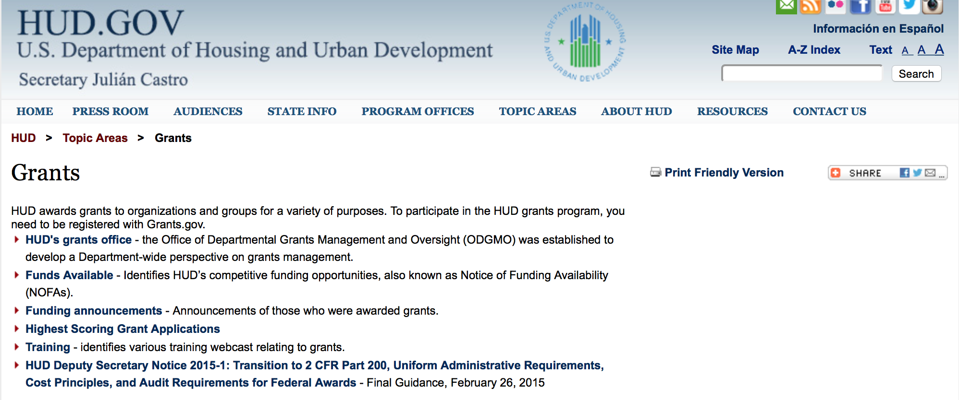

http://portal.hud.gov/hudportal/HUD?src=/topics/grants

HUD - Notice of Funds Available

For detailed information click here

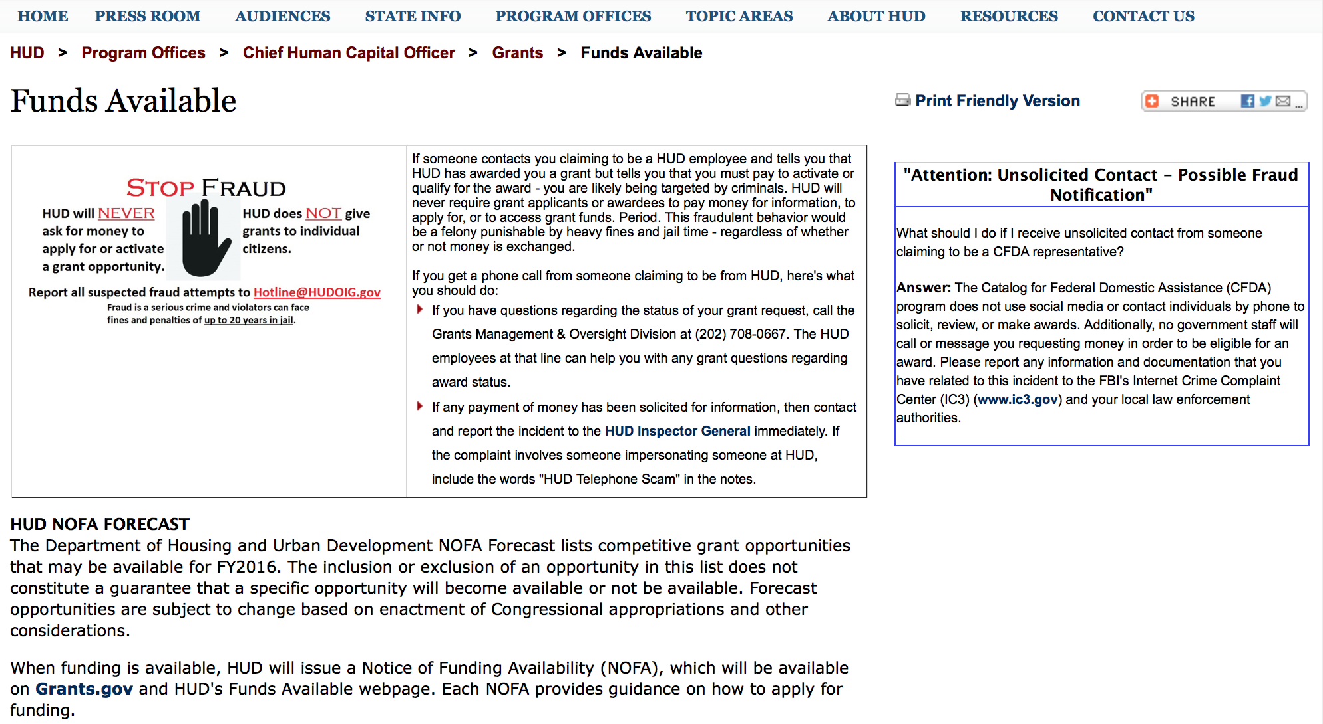

http://portal.hud.gov/hudportal/HUD?src=/program_offices/administration/grants/fundsavail

FY 2013 Notice of Funding Availability (NOFA) Policy Requirements and General Section to HUD’s FY2013 NOFAs for Discretionary Programs
This Notice provides prospective applicants for HUD's competitive funding with the opportunity to become familiar with the General Section to HUD's FY2013 Notices of Funding Availability (NOFAs) for Discretionary Funding (program NOFA), in advance of publication of any individual FY2013 program NOFAs. This General Section and the individual FY2013 program NOFA Sections comprise the entirety of the FY2013 NOFA instructions.
- General Section
- FONSI
- New Application Attachment Filename Requirement

Programs

Lead Hazard Reduction Demonstration (LHRD) Grant Program

Document Type: | Grants Notice
Funding Opportunity Number: | FR-6000-N-13
Funding Opportunity Title: | Lead Hazard Reduction Demonstration (LHRD) Grant Program
Opportunity Category: | Discretionary
Opportunity Category Explanation:
Funding Instrument Type: | Grant
Category of Funding Activity: | Housing
Category Explanation:
Expected Number of Awards: | 15
CFDA Number(s): | 14.905 -- Lead Hazard Reduction Demonstration Grant Program
Cost Sharing or Matching Requirement: | Yes
Posted Date: | Mar 14, 2016
Last Updated Date: | Mar 14, 2016
Original Closing Date for Applications: | Apr 28, 2016 Electronically submitted applications must be submitted no later than 11:59:59 p.m., ET, on the listed application due date.
Current Closing Date for Applications: | Apr 28, 2016 Electronically submitted applications must be submitted no later than 11:59:59 p.m., ET, on the listed application due date.
Archive Date: | May 28, 2016
Estimated Total Program Funding: | $45,000,000
Award Ceiling: | $3,000,000
Award Floor: | $1,000,000
Eligible Applicants: | County governments  Native American tribal governments (Federally recognized)  Others (see text field entitled "Additional Information on Eligibility" for clarification)  Special district governments  City or township governments  State governments
Additional Information on Eligibility: | If your organization is established under section 501(c) (including any subsidiary sections) of the Internal Revenue Code, you are not eligible to apply for funding under this NOFA. Under the authorizing statute for this grant program, only cities, counties/parishes, and other units of local government, and certain States and Native American Tribes (see below) are eligible to receive funding under this NOFA. Multiple agencies within a local government, or multiple units of local government, or a state and one or more units of local government may apply as a consortium; however, an eligible principal (lead) applicant that will be responsible for ensuring compliance with all requirements in this NOFA must be identified. Where an application involves multiple entities, each entity must meet the civil rights threshold requirement of Resolution of Civil Rights Matters. State government and Native American tribal applicants (whether they are the principal applicant or partner applicants in a consortium) are eligible to apply for funding under this NOFA only if they have an Environmental Protection Agency (EPA) authorized lead-based paint training and certification program as of the submission deadline date (see www.epa.gov/lead/pubs/traincert.htm). The LHRD Grant Program is targeted to urban jurisdictions. In addition to the requirements in Section III.A., above, applicant MUST have at least 3,500 pre-1940 occupied rental housing units (either alone or through a consortium), as listed at the Census website (http://factfinder.census.gov/faces/nav/jsf/pages/index.xhtml). Individuals, foreign entities, and sole proprietorship organizations are not eligible to compete for, or receive, awards made under this announcement.
Agency Name: | Department of Housing and Urban Development
Description: | The LHRD program helps units of local government create and implement programs to address lead-based paint hazards and make homes lead safe.
Link to Additional Information: | http://portal.hud.gov/hudportal/HUD?src=/program_offices/administration/grants/fundsavail
Contact Information: | If you have difficulty accessing the full announcement electronically, please contact:  Mark Sorbo Mark.F.Sorbo@hud.gov  Grants Policy

http://www.grants.gov/web/grants/view-opportunity.html?oppId=282182

Lead-Based Paint Hazard Control (LBPHC) Grant Program

Document Type: | Grants Notice
Funding Opportunity Number: | FR-6000-N-12
Funding Opportunity Title: | Lead-Based Paint Hazard Control (LBPHC) Grant Program
Opportunity Category: | Discretionary
Opportunity Category Explanation:
Funding Instrument Type: | Grant
Category of Funding Activity: | Housing
Category Explanation:
Expected Number of Awards: | 20
CFDA Number(s): | 14.900 -- Lead-Based Paint Hazard Control in Privately-Owned Housing
Cost Sharing or Matching Requirement: | Yes
Posted Date: | Mar 14, 2016
Last Updated Date: | Mar 14, 2016
Original Closing Date for Applications: | Apr 28, 2016 Electronically submitted applications must be submitted no later than 11:59:59 p.m., ET, on the listed application due date.
Current Closing Date for Applications: | Apr 28, 2016 Electronically submitted applications must be submitted no later than 11:59:59 p.m., ET, on the listed application due date.
Archive Date: | May 28, 2016
Estimated Total Program Funding: | $43,000,000
Award Ceiling: | $2,500,000
Award Floor: | $1,000,000
Eligible Applicants: | Others (see text field entitled "Additional Information on Eligibility" for clarification)  Special district governments  City or township governments  County governments  State governments  Native American tribal governments (Federally recognized)
Additional Information on Eligibility: | If your organization is established under section 501(c) (including any subsidiary sections) of the Internal Revenue Code, you are not eligible to apply for funding under this NOFA. Under the authorizing statute for this grant program, only cities, counties/parishes, and other units of local government, and certain States and Native American Tribes (see below) are eligible to receive funding under this NOFA. Multiple agencies within a local government, or multiple units of local government, or a state and one or more units of local government may apply as a consortium; however, an eligible principal (lead) applicant that will be responsible for ensuring compliance with all requirements in this NOFA must be identified. Where an application involves multiple entities, each entity must meet the civil rights threshold requirement of Resolution of Civil Rights Matters. State government and Native American tribal applicants (whether they are the principal applicant or partner applicants in a consortium) are eligible to apply for funding under this NOFA only if they have an Environmental Protection Agency (EPA) authorized lead-based paint training and certification program as of the submission deadline date (see www.epa.gov/lead/pubs/traincert.htm). Individuals, foreign entities, and sole proprietorship organizations are not eligible to compete for, or receive, awards made under this announcement.
Agency Name: | Department of Housing and Urban Development
Description: | The LBPHC program helps units of local government create and implement programs to address lead-based paint hazards and make homes lead safe.
Link to Additional Information: | http://portal.hud.gov/hudportal/HUD?src=/program_offices/administration/grants/fundsavail
Contact Information: | If you have difficulty accessing the full announcement electronically, please contact:  Mark Sorbo Mark.F.Sorbo@hud.gov  Grants Policy

http://www.grants.gov/web/grants/view-opportunity.html?oppId=282200

Family Self-Sufficiency Program Grant

Document Type: | Grants Notice
Funding Opportunity Number: | FR-6000-N-04
Funding Opportunity Title: | Family Self-Sufficiency Program
Opportunity Category: | Discretionary
Opportunity Category Explanation:
Funding Instrument Type: | Grant
Category of Funding Activity: | Housing
Category Explanation:
Expected Number of Awards: | 700
CFDA Number(s): | 14.896 -- Family Self-Sufficiency Program
Cost Sharing or Matching Requirement: | No
Posted Date: | Mar 21, 2016
Last Updated Date: | Mar 21, 2016
Original Closing Date for Applications: | Apr 20, 2016 Electronically submitted applications must be submitted no later than 11:59:59 p.m., ET, on the listed application due date.
Current Closing Date for Applications: | Apr 20, 2016 Electronically submitted applications must be submitted no later than 11:59:59 p.m., ET, on the listed application due date.
Archive Date: | May 20, 2016
Estimated Total Program Funding: | $75,000,000
Award Ceiling: | $69,000
Award Floor: | $0
Eligible Applicants: | Public housing authorities/Indian housing authorities
Additional Information on Eligibility: | 1. Additional Information on Eligibility: eligible applicants are PHAs (including Moving to Work (MTW) PHAs) and Indian tribes/TDHEs currently administering an FSS program, that have served at least the minimum number of families required by this NOFA (as described in Section III.C.3.c below; "Eligibility Requirement: Number of FSS families served") and have met all other funding requirements. Due to the level of funding available under this NOFA, you will only be eligible for funding under this NOFA if you meet one of the following criteria: you were funded under any of the FY 2013, FY 2014, and/or the FY 2015 FSS NOFAs, or you received an FSS program through a transfer or consolidation from a PHA that was funded under such NOFAs. See Appendix D for a list of applicants who meet the criteria set forth in the bullet points above. 2. Funding Distribution. Funding will be awarded in the following order, as funds allow: Category 1 - Renewal positions (i.e., positions funded under any of the FY 2013, FY 2014, and/or the FY 2015 FSS NOFAs). Category 2 - A small set of PHAs will be eligible to apply for funding to increase from a part-time renewal position to a full-time position. Applicants who are eligible to apply under this category are identified under the Cat. 2 Eligible; column in Appendix D. However, please note that some applicants which may be identified in Appendix D as ineligible under this funding category may become eligible after PIC data is re-pulled 60 days after publication of this NOFA as explained in Section V.B.3 "Funding Priority Categories" of this NOFA. Category 3 - New FSS coordinator positions (positions that were not funded in FY 2013, FY 2014, or FY 2015) for renewal applicants. For more information, see Section V.B.3 of this NOFA "Funding Priority Categories". Individuals, foreign entities, and sole proprietorship organizations are not eligible to compete for, or receive, awards made under this announcement.
Agency Name: | Department of Housing and Urban Development
Description: | This NOFA announces the availability of funding of approximately $75 million for salaries of program coordinators for the Department of Housing and Urban Development's (HUD’s) Fiscal Year (FY) 2016 Family Self-Sufficiency (FSS) Program. Due to the level of funding available, the Department will only fund applicants currently administering an FSS program that also meet one of the following criteria: a. you were funded under any of the FY 2013, FY 2014, and/or the FY 2015 FSS NOFAs; or b. you received an FSS program through a transfer or consolidation from a Public Housing Agency (PHA) that was funded under these NOFAs. See Section V.B.3 "Funding Priority Categories" for more information on the order in which funding will be awarded. Starting in FY2014, funding for FSS coordinators that serve Housing Choice Voucher (HCV) participants and/or Public Housing (PH) participants is made available under one NOFA; there are no longer two separate NOFAs for the HCV FSS program and the PH FSS program. This means that if you submitted two separate applications in previous years, (one for HCV FSS and one for PH FSS) you will only submit one application under this NOFA. As stated in the General Section, applicants that fail to submit their application through Grants.gov for whatever reason, including failure to update their DUNS, SAM or Grants.gov registration or Authorized Organizational Representatives (AORs) will not be considered for funding.
Link to Additional Information: | http://portal.hud.gov/hudportal/HUD?src=/program_offices/administration/grants/fundsavail
Contact Information: | If you have difficulty accessing the full announcement electronically, please contact:  Anice Chenault fss@hud.gov  Grants Policy

http://www.grants.gov/web/grants/view-opportunity.html?oppId=282399

Resident Opportunity & Self-Sufficiency Program Grant

Document Type: | Grants Notice
Funding Opportunity Number: | FR-6000-N-05
Funding Opportunity Title: | Resident Opportunity & Self-Sufficiency Program
Opportunity Category: | Discretionary
Opportunity Category Explanation:
Funding Instrument Type: | Grant
Category of Funding Activity: | Housing
Category Explanation:
Expected Number of Awards: | 110
CFDA Number(s): | 14.870 -- Resident Opportunity and Supportive Services - Service Coordinators
Cost Sharing or Matching Requirement: | Yes
Posted Date: | Mar 31, 2016
Last Updated Date: | Mar 31, 2016
Original Closing Date for Applications: | May 16, 2016 Electronically submitted applications must be submitted no later than 11:59:59 p.m., ET, on the listed application due date.
Current Closing Date for Applications: | May 16, 2016 Electronically submitted applications must be submitted no later than 11:59:59 p.m., ET, on the listed application due date.
Archive Date: | Jun 15, 2016
Estimated Total Program Funding: | $35,000,000
Award Ceiling: | $738,000
Award Floor: | $0
Eligible Applicants: | Public housing authorities/Indian housing authorities  Nonprofits having a 501(c)(3) status with the IRS, other than institutions of higher education  Nonprofits that do not have a 501(c)(3) status with the IRS, other than institutions of higher education
Additional Information on Eligibility: | Native American tribes as defined at 4(13) of NAHASDA, Tribally Designated Housing Entities (TDHEs) as defined at 4(22) of NAHASDA. Resident associations of all kinds must have either locally-incorporated nonprofit status (usually designated by the state or tribal government) or 501(c)(3) nonprofit status designated by the IRS. Applicants must provide documentation with their application attesting to their designation as a locally-incorporated non-profit organization or a federally designated 501(c)(3) nonprofit. Such documentation must include a copy of the 2015 federal annual information return submitted to the IRS (for 501(c)(3) applicants) or the state or tribal equivalent for locally-incorporated nonprofits. If this information is not submitted as part of the application, it will be requested during the deficiency period. Please see Section IV.B. "Content and Form of Application Submission" for more information. EDSC Provision. PHA applicants that are currently eligible to receive annual renewal funding under the Elderly/Disabled Service Coordinator (EDSC) program from the Public Housing Operating Fund that apply to serve elderly/disabled residents through this NOFA will forgo all future eligibility for EDSC funding through the Operating Fund. These applicants may apply and receive funding to serve families only without risking their EDSC funding. To confirm if your PHA is affected by this EDSC provision. When completing your ROSS-SC application, please pay special attention to the EDSC section on the HUD form 52768;ROSS Service Coordinators Funding Request; For-profit entities are not eligible to apply. Individuals, foreign entities, and sole proprietorship organizations are not eligible to compete for, or receive, awards made under this announcement.
Agency Name: | Department of Housing and Urban Development
Description: | The purpose of the Resident Opportunity & Self Sufficiency (ROSS) Service Coordinator (SC) program is to assist residents of public and Indian housing in making progress towards economic and housing self-sufficiency. To accomplish this goal, ROSS provides grant funding to eligible applicants to hire Service Coordinators to assess the needs of public and Indian housing residents and link them to supportive services that enable participants to increase earned income, reduce or eliminate the need for welfare assistance, and make progress toward achieving economic independence and housing self-sufficiency. In the case of elderly/disabled residents, the Service Coordinator links participants to supportive services which enable them to age/remain in place thereby avoiding more costly forms of care.
Link to Additional Information: | http://portal.hud.gov/hudportal/HUD?src=/program_offices/administration/grants/fundsavail
Contact Information: | If you have difficulty accessing the full announcement electronically, please contact:  Dina Lehmann-Kim Dina.Lehmann-Kim@hud.gov  Grants Policy

http://www.grants.gov/web/grants/view-opportunity.html?oppId=282668

Modifications:

Choice Neighborhoods Implementation Grant Program
Modification 1

Document Type: | Grants Notice
Funding Opportunity Number: | FR-6000-N-34
Funding Opportunity Title: | Choice Neighborhoods Implementation Grant Program
Opportunity Category: | Discretionary
Opportunity Category Explanation:
Funding Instrument Type: | Grant
Category of Funding Activity: | Housing
Category Explanation:
Expected Number of Awards: | 4
CFDA Number(s): | 14.889 -- Choice Neighborhoods Implementation Grants
Cost Sharing or Matching Requirement: | Yes
Posted Date: | Mar 31, 2016
Last Updated Date: | Mar 31, 2016
Original Closing Date for Applications: | Jun 28, 2016 Electronically submitted applications must be submitted no later than 11:59:59 p.m., ET, on the listed application due date.
Current Closing Date for Applications: | Jun 28, 2016 Electronically submitted applications must be submitted no later than 11:59:59 p.m., ET, on the listed application due date.
Archive Date: | Jul 28, 2016
Estimated Total Program Funding: | $120,000,000
Award Ceiling: | $30,000,000
Award Floor: | $0
Eligible Applicants: | Others (see text field entitled "Additional Information on Eligibility" for clarification)
Additional Information on Eligibility: | Eligible applicants are Public Housing Authorities (PHAs), local governments, tribal entities, nonprofits, and for-profit developers that apply jointly with a public entity. Refer to section I.A.4 for definitions of these terms as applicable to this program. Individuals, foreign entities, and sole proprietorship organizations are not eligible to compete for, or receive, awards made under this announcement.
Agency Name: | Department of Housing and Urban Development
Description: | Choice Neighborhoods Implementation Grants support the implementation of comprehensive neighborhood revitalization plans that are expected to achieve the following three core goals: 1. Housing: Replace distressed public and assisted housing with high-quality mixed-income housing that is well-managed and responsive to the needs of the surrounding neighborhood; 2. People: Improve educational outcomes and intergenerational mobility for youth with services and supports delivered directly to youth and their families; and 3. Neighborhood: Create the conditions necessary for public and private reinvestment in distressed neighborhoods to offer the kinds of amenities and assets, including safety, good schools, and commercial activity, that are important to families; choices about their community.
Link to Additional Information: | http://portal.hud.gov/hudportal/HUD?src=/program_offices/administration/grants/fundsavail
Contact Information: | If you have difficulty accessing the full announcement electronically, please contact:  Please send inquiries to email below  Grants Policy

http://www.grants.gov/web/grants/view-opportunity.html?oppId=282659

Reminders

Supportive Services Demonstration for Elderly Households in HUD-Assisted Multifamily Housing
Grant
And Modification 1

Document Type: | Grants Notice
Funding Opportunity Number: | FR-5900-N-22
Funding Opportunity Title: | Supportive Services Demonstration for Elderly Households in HUD-Assisted Multifamily Housing
Opportunity Category: | Discretionary
Funding Instrument Type: | Cooperative Agreement
Category of Funding Activity: | Housing
Category Explanation:
Expected Number of Awards: | 80
CFDA Number(s): | 14.191 -- Multifamily Housing Service Coordinators
Cost Sharing or Matching Requirement: | No
Posted Date: | Jan 20, 2016
Creation Date: | Jan 20, 2016
Original Closing Date for Applications: | Apr 18, 2016 Electronically submitted applications must be submitted no later than 11:59:59 p.m., ET, on the listed application due date.
Current Closing Date for Applications: | Apr 22, 2016 Electronically submitted applications must be submitted no later than 11:59:59 p.m., ET, on the listed application due date.
Archive Date: | May 18, 2016
Estimated Total Program Funding: | $15,000,000
Eligible Applicants: | Others (see text field entitled "Additional Information on Eligibility" for clarification)
Additional Information on Eligibility: | Applicants must be owners of existing eligible federally assisted multifamily properties. 1. Eligible Multifamily Property: a. Must be a HUD-assisted development with at least 50 assisted housing units - Unit count may be a combined count of total number in a campus setting. The development must be occupied by Eligible Tenants as defined below. b. HUD-Assisted housing types are limited to: (1) Housing that is assisted under section 202 of the Housing Act of 1959 (12 U.S.C. 1701q), including housing that is assisted under section 202 as such section existed before the enactment of the National Affordable Housing Act (Public Law 101-625); (2) Housing for which project-based assistance is provided under section 8 of the United States Housing Act of 1937 (42 U.S.C. 1437f), including Section 515 rural housing projects, as authorized under section 515 of the Housing Act of 1949 (42 U.S.C. 1485), receiving Section 8 rental assistance; (3) Housing financed by a loan or mortgage insured under section 221(d)(3) of the National Housing Act (12 U.S.C. 1715) that bears interest at a rate determined under section 221(d)(5) of such Act; or (4) Housing insured, assisted, or held by the Secretary, a State, or a state agency under section 236 of the National Housing Act (12 U.S.C. 1715z&ndash;1); c. Properties meeting the requirements of 1.a. and 1.b. of this subsection with an existing service coordinator on staff may apply for funding under this NOFA in order to hire the Wellness Nurse and implement this enhanced supportive service model. Acceptance of funding under this NOFA will require the Owner to comply with the requirements as detailed in this NOFA. Individuals, foreign entities, and sole proprietorship organizations are not eligible to compete for, or receive, awards made under this announcement.
Agency Name: | Department of Housing and Urban Development
Description: | HUD’s investment under this Demonstration program is intended to facilitate aging in place by providing a supportive services subsidy to certain elderly restricted HUD assisted independent housing developments. The supportive service subsidy will (1) cover all reasonable cost related to the provision of a full-time enhanced service coordinator and part-time preventive health nurse as well as (2) allocate a nominal amount towards eligible services expenses for our aging residents. Elderly persons who have access to affordable, safe and accessible housing, who practice healthy behaviors, take advantage of wellness, preventive and long-term care services and supports, and those who continue to engage with family and friends are more likely to achieve better health outcomes, live independently, age in place and incur fewer health-related costs. Under this NOFA, HUD will evaluate the extent to which the selected housing plus supportive service models allow elderly persons to live independently and age in place, including improving general well being, improving health outcomes and health-care utilization, and preventing or delaying institutionalization. Funding priority will be given to those sponsors that evidence the ability to accomplish the following three goals: Strengthen the Availability of Supportive Services by effectively using the Service Coordinator to create and support partnerships between housing and supportive service providers to support aging in place; Support Aging-in-Place by fostering an environment that allows for elderly persons to live independently by accessing home and community-based supportive services that are designed to promote general well being, improved health outcomes; and Improve the evidence base on the effectiveness of Section 202 housing as a platform to improve health outcomes by participating in an effort led by HUD (or its contractors and/or grantees) to develop standard procedures to be implemented by all sponsors/owners for (1) measurement of outcomes related to general well being; health and health-care utilization; and costs to the health care system; (2) implementation of the enhanced service coordinator model in the same way in all sites; and (3) enrollment of eligible applicants into a random assignment study. To achieve these goals, Sponsors/Owners must have a comprehensive approach to strategically implement a supportive services model that can support the needs of all residents. As a condition of the receipt of financial assistance under this program NOFA, all Sponsors/Owners will be required to cooperate with HUD staff, contractors, or grantees who perform HUD-funded evaluation of the 202 housing program. HUD envisions the study will be undertaken by independent researchers in collaboration with Sponsors/Owners.
Link to Additional Information: | http://portal.hud.gov/hudportal/HUD?src=/program_offices/administration/grants/fundsavail
Contact Information: | If you have difficulty accessing the full announcement electronically, please contact:  Alicia Anderson Alicia.Anderson@hud.gov  Grants Policy

http://www.grants.gov/web/grants/view-opportunity.html?oppId=281074

General Section to HUD's Fiscal Year 2016 Notice[s] of Funding Availability for Discretionary Programs (General Section)
Modification 1

Document Type: | Grants Notice
Funding Opportunity Number: | FR-6000-N-01
Funding Opportunity Title: | General Section to HUD's Fiscal Year 2016 Notice[s] of Funding Availability for Discretionary Programs (General Section)
Opportunity Category: | Discretionary
Funding Instrument Type: | Grant
Category of Funding Activity: | Community Development
Category Explanation:
Expected Number of Awards: | 0
CFDA Number(s):
Cost Sharing or Matching Requirement: | No
Posted Date: | Sep 24, 2015
Creation Date: | Sep 24, 2015
Original Closing Date for Applications: | Dec 30, 2016 Electronically submitted applications must be submitted no later than 11:59:59 p.m., ET, on the listed application due date published in the individual program NOFA.
Current Closing Date for Applications: | Dec 30, 2016 Electronically submitted applications must be submitted no later than 11:59:59 p.m., ET, on the listed application due date published in the individual program NOFA.
Archive Date: | Jan 29, 2017
Eligible Applicants: | Others (see text field entitled "Additional Information on Eligibility" for clarification)
Additional Information on Eligibility: | This Document is a policy document only. The individual program Notices of Funds Available (NOFA) will identify eligible applicants for each competition. Each Program NOFA will describe additional eligibility requirements for applicants. All applicants must have valid, active Registration in the System for Award Management (SAM) prior to submission of applications for financial assistance. HUD does not provide direct services or products to individuals through its formula-based programs or its competitive Program NOFA process. Individuals seeking financial assistance should refer to www.GovBenefits.gov. Individuals, foreign entities, and sole proprietorship organizations are not eligible to compete for, or receive, awards made under this announcement.
Agency Name: | Department of Housing and Urban Development
Description: | The General Section describes the requirements that are applicable to all HUD FY 2015 Program NOFAs. The General Section also provides information on HUD’s priorities and strategic goals. Each Program NOFA will describe additional applicable procedures and requirements, including a description of the eligible applicants, eligible activities, threshold requirements, cross-program requirements such as nondiscrimination, environmental protection, and any additional program requirements or limitations. To adequately address all of the application requirements for any program, please carefully read and respond to both this General Section and any applicable Program NOFA.
Link to Additional Information: | http://portal.hud.gov/hudportal/HUD?src=/program_offices/administration/grants/fundsavail
Contact Information: | If you have difficulty accessing the full announcement electronically, please contact:  Loyd LaMois loyd.lamois@hud.gov  Grants Policy

http://www.grants.gov/web/grants/view-opportunity.html?oppId=279206



Institute of Museum and Library Services

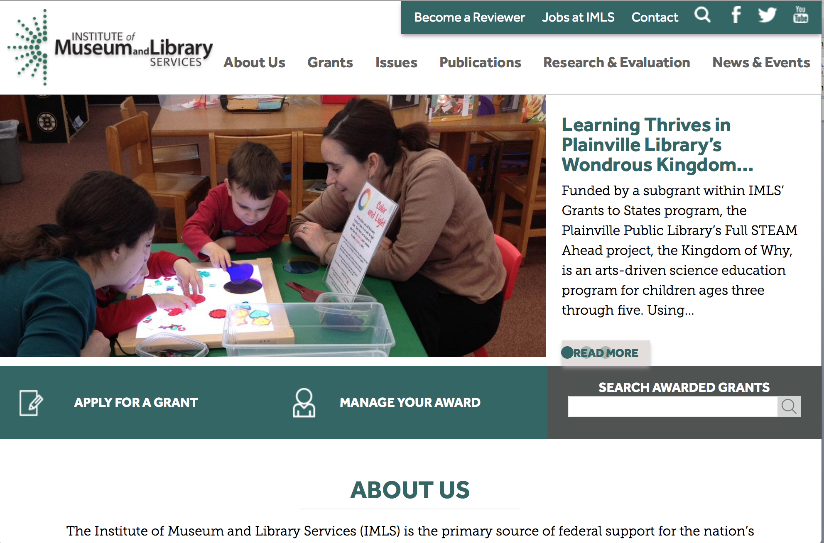

www.imls.gov

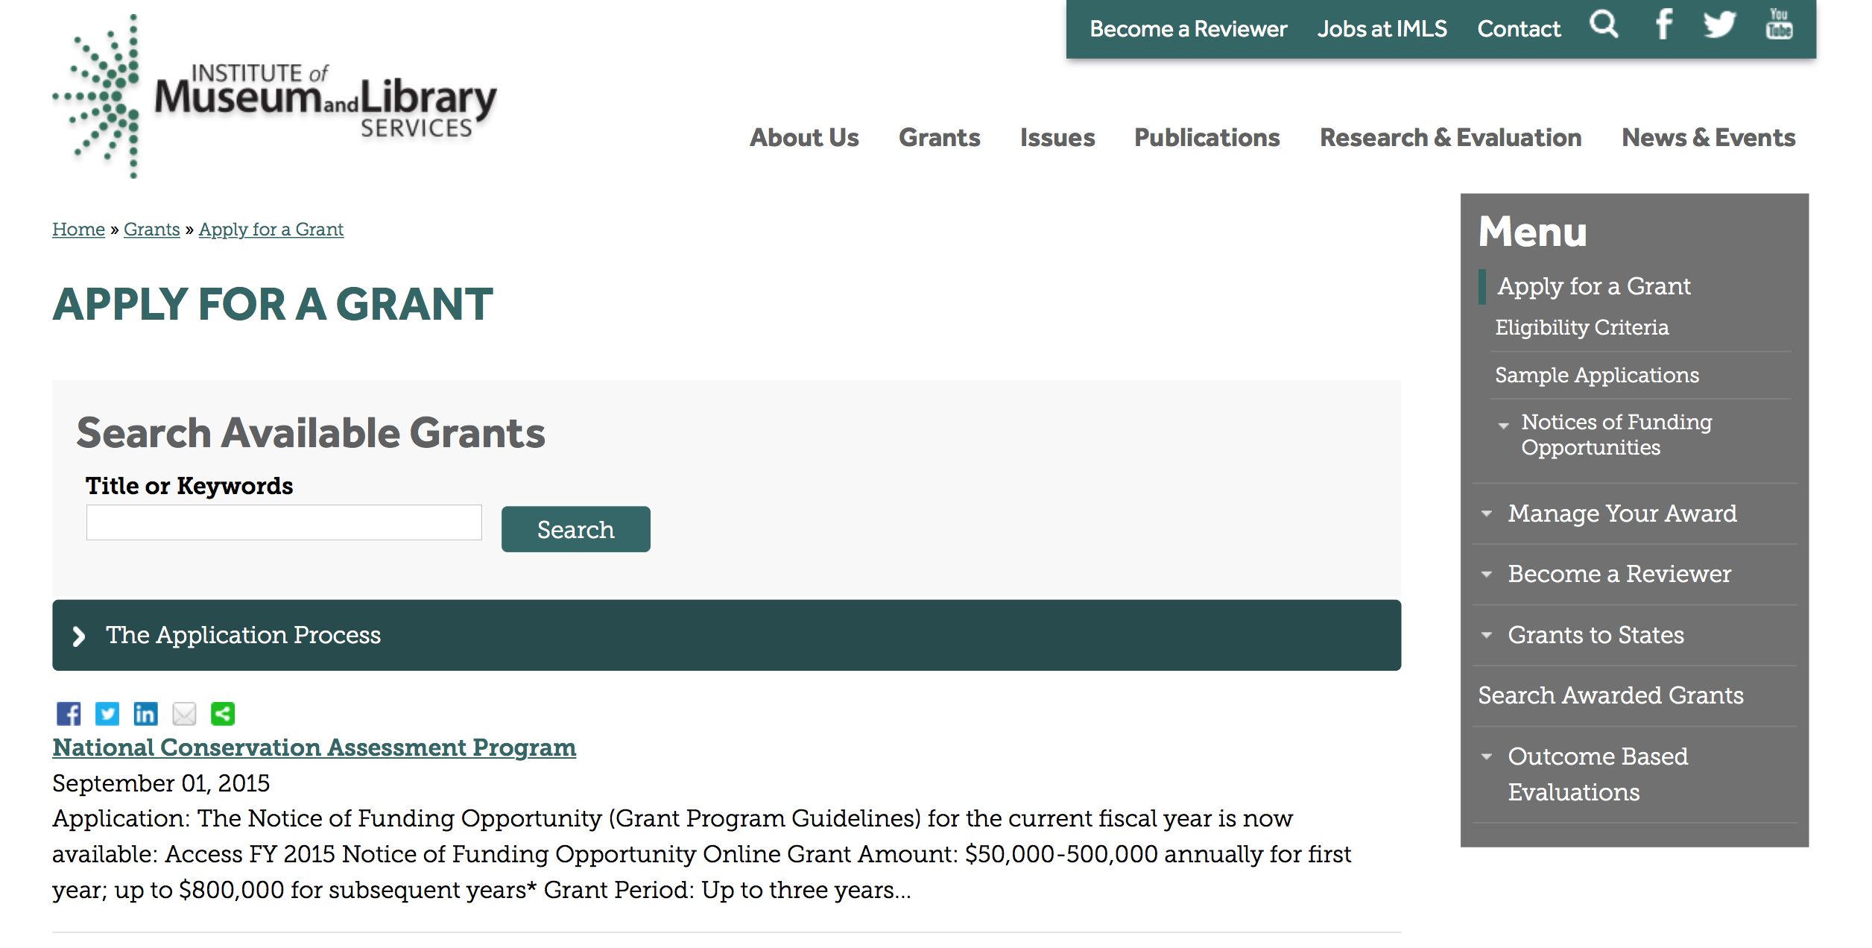
http://www.imls.gov/applicants/available_grants.aspx

Each grant program has specific eligibility requirements. The links below provide general eligibility criteria for museums, libraries, and tribal organizations, but please note that additional organizations may be eligible for grants under certain programs. Additionally, ineligible organizations may still be able to participate in grant programs through partnerships with eligible organizations. Please click on the links below to see general criteria and review Applications and Guidelines for specific information.
Museums Libraries

Institutions: Archives, Federally Recognized Native American Tribe, Historical Society, Library, Nonprofits that serve Native Hawaiians, Professional Association, Public or Private Non-profit Institutions of Higher Education, Regional Organization, State Library Administrative Agency, State or Local Government

Check out IMLS's Facebook page at:
https://www.facebook.com/USIMLS/

Modifications:

Reminders:

STEM Expert Facilitation of Family Learning in Libraries and Museums (STEMeX) – A National Leadership Grants Special Initiative – FY16 Notice of Funding Opportunity Grant

Document Type: | Grants Notice
Funding Opportunity Number: | NLGSPECIALINITIATIVE-STEMEX-FY16
Funding Opportunity Title: | STEM Expert Facilitation of Family Learning in Libraries and Museums (STEMeX) – A National Leadership Grants Special Initiative – FY16 Notice of Funding Opportunity
Opportunity Category: | Discretionary
Funding Instrument Type: | Grant
Category of Funding Activity: | Arts (see "Cultural Affairs" in CFDA)  Humanities (see "Cultural Affairs" in CFDA)
Category Explanation:
Expected Number of Awards: | 3
CFDA Number(s): | 45.312 -- National Leadership Grants
Cost Sharing or Matching Requirement: | No
Posted Date: | Feb 1, 2016
Creation Date: | Feb 1, 2016
Original Closing Date for Applications: | May 1, 2016
Current Closing Date for Applications: | May 1, 2016
Archive Date: | May 31, 2016
Estimated Total Program Funding: | $2,500,000
Award Ceiling: | $1,000,000
Award Floor: | $500,000
Eligible Applicants: | Others (see text field entitled "Additional Information on Eligibility" for clarification)
Additional Information on Eligibility: | The information below outlines eligibility requirements for a museum entity or library entity, and some institutions may be eligible as both. An institution will not be asked to identify as a museum or library, but will be asked to identify the organization type on the SF424S and the organization unit type on the Program Information Sheet (Section f). To be eligible as library entity, you must: be either a unit of State or local government or be a private nonprofit organization that has tax-exempt status under the Internal Revenue Code; be located in one of the 50 States of the United States of America, the District of Columbia, the Commonwealth of Puerto Rico, the U.S. Virgin Islands, Guam, American Samoa, the Commonwealth of the Northern Mariana Islands, the Republic of the Marshall Islands, the Federated States of Micronesia, or the Republic of Palau; and qualify as one of the following: a library or a parent organization, such as a school district, a municipality, a State agency, or an academic institution, that is responsible for the administration of a library. Eligible libraries include public libraries, public elementary and secondary school libraries, college and university libraries, research libraries and archives that are not an integral part of an institution of higher education and that make publicly available library services and materials that are suitable for scholarly research and not otherwise available. Research libraries must be under the supervision of at least one permanent professional staff librarian and be either generally recognized as possessing unique, scholarly research materials and services that are made available to the public, or able to demonstrate that such is the case when submitting an application to IMLS a private library or other special library, but only if the State in which it is located determines that the library should be considered a library for purposes of Library Services and Technology (see 20 U.S.C. 9121-9165) an academic or administrative unit, such as a graduate school of library and information science that is part of an institution of higher education through which it would make application a digital library, if it makes library materials publicly available and provides library services, including selection, organization, description, reference, and preservation, under the supervision of at least one permanent professional staff librarian a library agency that is an official agency of a State or other unit of government and is charged by the law governing it with the extension and development of public library services within its jurisdiction a library consortium that is a local, statewide, regional, interstate, or international cooperative association of library entities that provides for the systematic and effective coordination of the resources of eligible libraries, as defined above, and information centers that work to improve the services delivered to the clientele of these libraries or a library association that exists on a permanent basis; serves libraries or library professionals on a national, regional, State, or local level; and engages in activities designed to advance the well-being of libraries and the library profession To be eligible as a museum entity, you must meet all three of the following criteria: You must be either a unit of State or local government or be a private nonprofit organization that has tax-exempt status under the Internal Revenue Code; You must be located in one of the 50 States of the United States of America, the District of Columbia, the Commonwealth of Puerto Rico, the U.S. Virgin Islands, Guam, American Samoa, the Commonwealth of the Northern Mariana Islands, the Republic of the Marshall Islands, the Federated States of Micronesia, or the Republic of Palau; and You must qualify as one of the following: (a) A museum that, using a professional staff,
Agency Name: | Institute of Museum and Library Services
Description: | This special joint NLG-Libraries and NLG-Museums initiative invites proposals for research on informal educational approaches that leverage community Science, Technology, Engineering, and Math (STEM) professionals in the broadest sense. Funded research projects will create a foundation for reaching children and families from diverse economic, social, and cultural backgrounds, with different levels of knowledge about STEM. We are interested in proposals for design-based research projects that develop and explore models for inquiry-based STEM programs delivered by scientists, engineers, and related technical practitioners (STEM experts) to children ages 6-10 and their families. In particular, proposals should address the role of expert oral narratives (e.g., storytelling, personal histories, and analogies) as part of object-based science inquiry. Proposals should include information about how findings from this research will be applicable in both museum and library settings.
Link to Additional Information: | https://www.imls.gov/grants/available/stem-expert-facilitation-family-learning-libraries-and-museums-stemex
Contact Information: | If you have difficulty accessing the full announcement electronically, please contact:  Libraries: Sandra Toro Senior Library Program Officer 202-653-4662 storo@imls.gov Trevor Owens Senior Library Program Officer 202-653-4654 tjowens@imls.gov Museums: Helen Wechsler Supervisory Grants Management Specialist 202-653-4779 hwechsler@imls.gov Sandra Narva Senior Program Officer 202-653-4634 snarva@imls.gov  storo@imls.gov

STEM Expert Facilitation of Family Learning in Libraries and Museums

IMLS is inviting proposals for special grants for research on informal educational approaches that leverage Science, Technology, Engineering, and Math (STEM) expertise within communities in the broadest sense. The STEM Expert Facilitation of Family Learning in Libraries and Museums, or STEMeX, initiative will provide grants up to $1,000,000 for projects of up to two years. The deadline for applications is May 1, 2016.

Through STEMeX, IMLS seeks design-based research projects that develop and explore models for inquiry-based STEM programs delivered by scientists, engineers, and related technical practitioners (STEM experts) to children ages 6-10 and their families. In particular, proposals should address the role of experts’ oral narratives (e.g., storytelling, personal histories, and analogies) as part of object-based science inquiry. Proposals should include information about how findings from this research will be applicable in both museum and library settings. Funded research projects will create a foundation for reaching children and families from diverse geographic, economic, social, and cultural backgrounds, who have different levels of knowledge about STEM.

This special initiative falls jointly under the National Leadership Grants for Libraries (NLG-Libraries) and National Leadership Grants for Museums (NLG-Museums) programs. National Leadership grants support projects that address challenges faced by the library and museum fields and that have the potential to advance practice in those fields with new tools, research findings, models, services, practices, or alliances that can be widely used, adapted, scaled, or replicated.

“There is an opportunity to further define best practice models about how scientific and technical experts--whether medical researchers and road engineers or art conservators and dental hygienists--can successfully engage young children and their families in STEM activities and inspire interest in STEM-based careers. Every community has those experts to draw upon to enhance their informal educational STEM efforts. That is why I am particularly excited to announce this special funding initiative,” said IMLS Director Dr. Kathryn K. Matthew. “There has already been fruitful and substantive work in this area, enabled by IMLS and others, and this effort will build on those prior investments. The research from this initiative will focus on maximizing the stories and narratives provided by STEM experts as part of programs offered by museums and libraries."

Eligibility: Museums; libraries; public or private nonprofit agencies, organizations, or associations that engage in activities designed to advance libraries and museums may apply. In addition, institutions of higher education, including public and non-profit universities, are eligible.
See the Notice of Funding Opportunity (NOFO) for FY 2016 for full details.
Program Contacts:
You may also contact any of the staff listed under the category that best fits your project.

Office of Library Services
Dr. Sandra Toro, Senior Program Officer, storo@imls.gov
202-653-4662
Dr. Trevor Owens, Senior Program Officer, towens@imls.gov
(link sends e-mail)
202-653-4654

Office of Museum Services
Helen Wechsler, Supervisory Grants Management Specialist, hwechsler@imls.gov
202-653-4779
Sandra Narva, Senior Program Officer, snarva@imls.gov
202-653-4634

Issues:
STEM (Science, Technology, Engineering, Math)

21st Century Skills

National Leadership Grants for Libraries
National Leadership Grants for Museums

http://www.grants.gov/web/grants/view-opportunity.html?oppId=281271

National Leadership Grants for Libraries Grant

Document Type: | Grants Notice
Funding Opportunity Number: | NLG-LIBRARIES-FY16-2
Funding Opportunity Title: | National Leadership Grants for Libraries
Opportunity Category: | Discretionary
Funding Instrument Type: | Grant
Category of Funding Activity: | Arts (see "Cultural Affairs" in CFDA)  Humanities (see "Cultural Affairs" in CFDA)
Category Explanation:
Expected Number of Awards: | 20
CFDA Number(s): | 45.312 -- National Leadership Grants
Cost Sharing or Matching Requirement: | Yes
Posted Date: | Dec 21, 2015
Creation Date: | Dec 21, 2015
Original Closing Date for Applications: | Jun 1, 2016
Current Closing Date for Applications: | Jun 1, 2016
Archive Date: | Jul 1, 2016
Estimated Total Program Funding: | $12,000,000
Award Ceiling: | $2,000,000
Award Floor: | $10,000
Eligible Applicants: | Others (see text field entitled "Additional Information on Eligibility" for clarification)
Additional Information on Eligibility: | To be eligible as an applicant for this National Leadership Grants for Libraries Program, you must: be either a unit of State or local government or be a private nonprofit organization that has tax-exempt status under the Internal Revenue Code; be located in one of the 50 States of the United States of America, the District of Columbia, the Commonwealth of Puerto Rico, the U.S. Virgin Islands, Guam, American Samoa, the Commonwealth of the Northern Mariana Islands, the Republic of the Marshall Islands, the Federated States of Micronesia, or the Republic of Palau; and qualify as one of the following: a library or a parent organization, such as a school district, a municipality, a State agency, or an academic institution, that is responsible for the administration of a library. Eligible libraries include public libraries, public elementary and secondary school libraries, college and university libraries, research libraries and archives that are not an integral part of an institution of higher education and that make publicly available library services and materials that are suitable for scholarly research and not otherwise available. Research libraries must be under the supervision of at least one permanent professional staff librarian and be either generally recognized as possessing unique, scholarly research materials and services that are made available to the public, or able to demonstrate that such is the case when submitting an application to IMLS a private library or other special library, but only if the State in which it is located determines that the library should be considered a library for purposes of Library Services and Technology (see 20 U.S.C. 9121-9165) an academic or administrative unit, such as a graduate school of library and information science that is part of an institution of higher education through which it would make application a digital library, if it makes library materials publicly available and provides library services, including selection, organization, description, reference, and preservation, under the supervision of at least one permanent professional staff librarian a library agency that is an official agency of a State or other unit of government and is charged by the law governing it with the extension and development of public library services within its jurisdiction a library consortium that is a local, statewide, regional, interstate, or international cooperative association of library entities that provides for the systematic and effective coordination of the resources of eligible libraries, as defined above, and information centers that work to improve the services delivered to the clientele of these libraries or a library association that exists on a permanent basis; serves libraries or library professionals on a national, regional, State, or local level; and engages in activities designed to advance the well-being of libraries and the library profession Note to applicants: In order to receive an IMLS award, you must be in compliance with applicable requirements and be in good standing on all active IMLS awards.
Agency Name: | Institute of Museum and Library Services
Description: | National Leadership Grants for Libraries (NLG) support projects that address challenges faced by the library and archive fields and that have the potential to advance practice in those fields. Successful proposals will generate results such as new tools, research findings, models, services, practices, or alliances that can be widely used, adapted, scaled, or replicated to extend the benefits of federal investment. For FY16, there are two National Leadership Grants for Libraries funding opportunities with two separate deadlines. In addition to the opportunity described in this Notice of Funding Opportunity, an additional NLG funding opportunity was announced in September 2015 with an application submission due date in October 2015.
Link to Additional Information: | https://www.imls.gov/grants/available/national-leadership-grants-libraries
Contact Information: | If you have difficulty accessing the full announcement electronically, please contact:  Tim Carrigan Senior Library Program Officer 202-653-4639 tcarrigan@imls.gov Trevor Owens Senior Library Program Officer 202-653-4654 tjowens@imls.gov Sandra Toro Senior Library Program Officer 202-653-4662 storo@imls.gov Sarah Fuller Library Program Officer 202-653-4783 sfuller@imls.gov  tcarrigan@imls.gov

http://www.grants.gov/web/grants/view-opportunity.html?oppId=280677

Laura Bush 21st Century Librarian Program Grant

Document Type: | Grants Notice
Funding Opportunity Number: | LB21-FY16-2
Funding Opportunity Title: | Laura Bush 21st Century Librarian Program
Opportunity Category: | Discretionary
Funding Instrument Type: | Grant
Category of Funding Activity: | Arts (see "Cultural Affairs" in CFDA)  Humanities (see "Cultural Affairs" in CFDA)
Category Explanation:
Expected Number of Awards: | 22
CFDA Number(s): | 45.313 -- Laura Bush 21st Century Librarian Program
Cost Sharing or Matching Requirement: | Yes
Posted Date: | Dec 21, 2015
Creation Date: | Dec 21, 2015
Original Closing Date for Applications: | Jun 1, 2016
Current Closing Date for Applications: | Jun 1, 2016
Archive Date: | Jul 1, 2016
Estimated Total Program Funding: | $10,000,000
Award Ceiling: | $1,000,000
Award Floor: | $50,000
Eligible Applicants: | Others (see text field entitled "Additional Information on Eligibility" for clarification)
Additional Information on Eligibility: | To be eligible for LB21, you must be either a unit of State or local government or a private nonprofit organization that has tax-exempt status under the Internal Revenue Code and be located in one of the 50 States of the United States of America, the District of Columbia, the Commonwealth of Puerto Rico, Guam, American Samoa, the U.S. Virgin Islands, the Commonwealth of the Northern Mariana Islands, the Republic of the Marshall Islands, the Federated States of Micronesia, or the Republic of Palau. In addition, you must be one of the following six types of organizations: A library or a parent organization, such as a school district, a municipality, a State agency, or an academic institution, that is responsible for the administration of a library. Eligible libraries include the following: Public libraries Public elementary and secondary school libraries College and university libraries Research libraries and archives that are not an integral part of an institution of higher education and that make publicly available library services and materials that are suitable for scholarly research and not otherwise available (Research libraries must be under the supervision of at least one permanent professional staff person and must be either generally recognized as possessing unique scholarly research materials and services that are made available to the public, or able to demonstrate that such is the case when submitting an application to IMLS.) Private or special libraries that have been deemed eligible to participate in this program by the State in which the library is located An academic or administrative unit, such as a graduate school of library and information science that is part of an institution of higher education through which it would make application (See below for additional conditions of eligibility that might apply to such applicants) A digital library, if it makes library materials publicly available and provides library services, including selection, organization, description, reference, and preservation, under the supervision of at least one permanent professional staff person A library agency that is an official agency of a State or other unit of government and is charged by the law governing it with the extension and development of public library services within its jurisdiction A library consortium that is a local, statewide, regional, interstate, or international cooperative association of library entities that provides for the systematic and effective coordination of the resources of eligible libraries, as defined above, and information centers that work to improve the services delivered to the clientele of these libraries A library association that exists on a permanent basis; serves libraries or library professionals on a national, regional, state, or local level; and engages in activities designed to advance the well-being of libraries and the library profession We recognize the potential for valuable contributions to the overall goals of the LB21 program by entities that do not meet the eligibility requirements above. Although such entities may not serve as the official applicants, they are encouraged to participate in projects. Federally operated libraries and museums may not apply for LB21 grants, but they may participate with applicants. Contact us before submitting a proposal involving a federal agency or federal collection. Non-Federal entities may serve as subrecipients or contractors and may receive IMLS grant funds as a result of the project. Consult with us about any eligibility questions before submitting an application.
Agency Name: | Institute of Museum and Library Services
Description: | The Laura Bush 21st Century Librarian Program (LB21) supports professional development, graduate education and continuing education to help libraries and archives develop the human capital capacity they need to meet the changing learning and information needs of the American public. For FY16, there are two Laura Bush 21st Century Librarian Program funding opportunities with two separate deadlines. In addition to the opportunity described in this Notice of Funding Opportunity, an additional LB21 funding opportunity was announced in September 2015 with an application submission due date in October 2015.
Link to Additional Information: | https://www.imls.gov/grants/available/laura-bush-21st-century-librarian-program
Contact Information: | If you have difficulty accessing the full announcement electronically, please contact:  Mary Alice Ball Senior Library Program Officer 202-653-4730 mball@imls.gov Tim Carrigan Senior Library Program Officer 202-653-4639 tcarrigan@imls.gov Trevor Owens Senior Library Program Officer 202-653-4654 tjowens@imls.gov Sandra Toro Senior Library Program Officer 202-653-4662 storo@imls.gov Emily Reynolds Library Program Officer 202-653-4665 ereynolds@imls.gov  mball@imls.gov

http://www.grants.gov/web/grants/view-opportunity.html?oppId=280678

Department of the Interior
Working with Interior

The Interior Department provides assistance to the public, local governments and businesses through a number of programs. For a general overview see: http://www.doi.gov/index.cfm

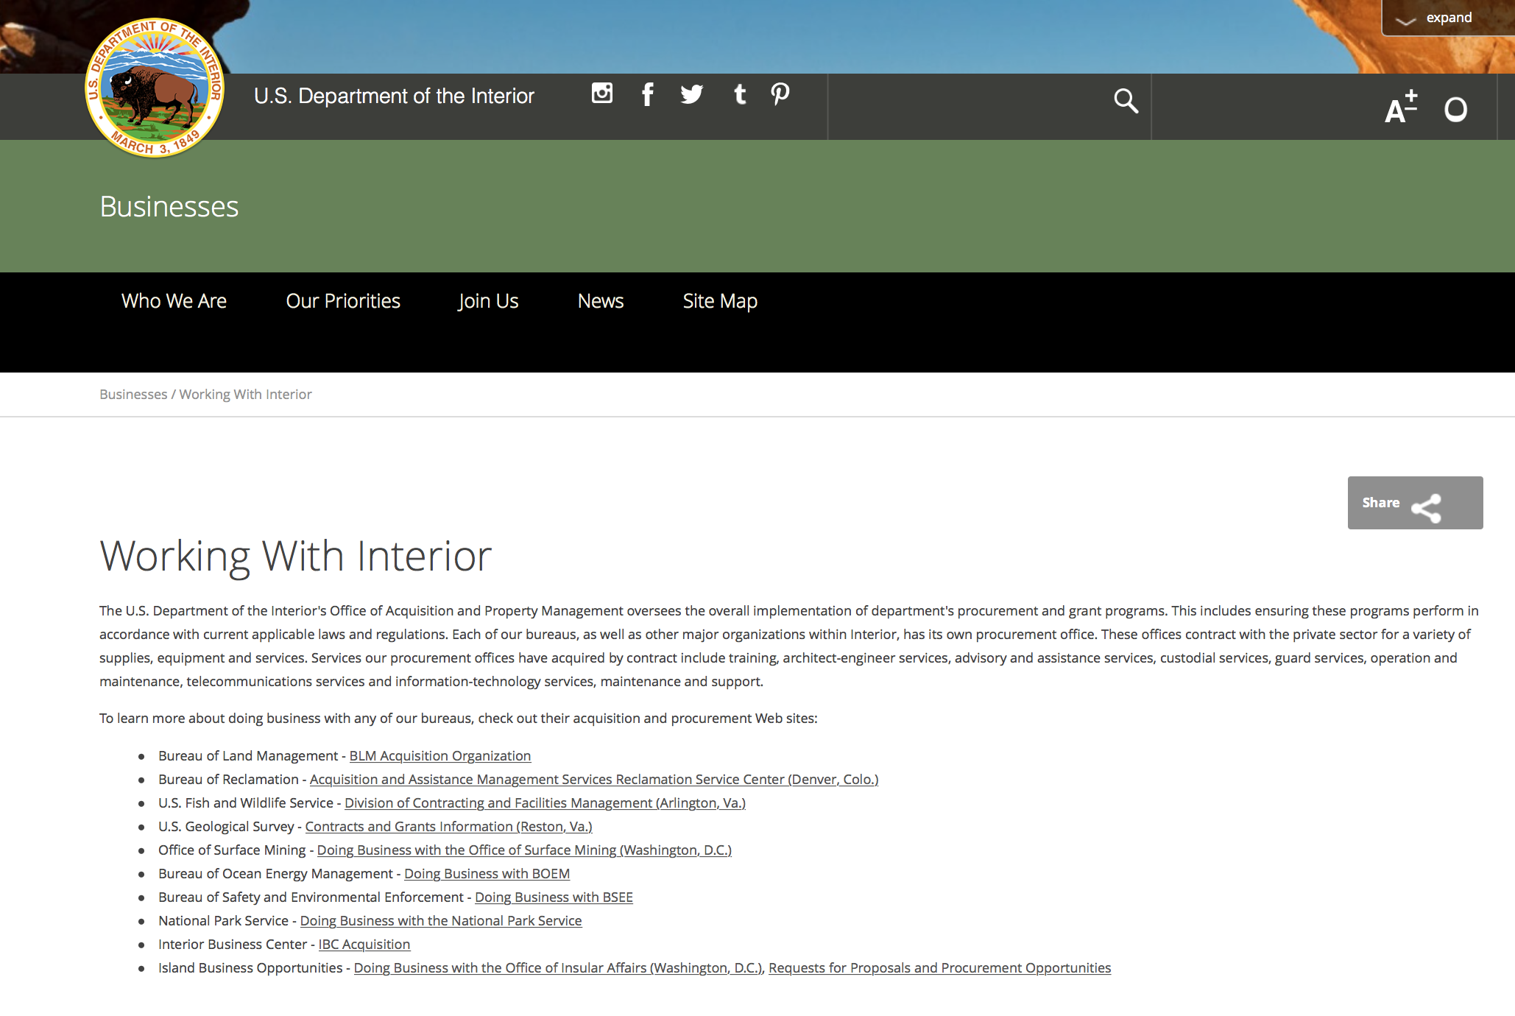

http://www.doi.gov/businesses/working-with-interior.cfm

Programs:

Geological Survey
2017 Earthquake Hazards External Grants Program

Document Type: | Grants Notice
Funding Opportunity Number: | G16AS00024
Funding Opportunity Title: | 2017 Earthquake Hazards External Grants Program
Opportunity Category: | Discretionary
Opportunity Category Explanation:
Funding Instrument Type: | Grant
Category of Funding Activity: | Natural Resources
Category Explanation:
Expected Number of Awards:
CFDA Number(s): | 15.807 -- Earthquake Hazards Research and Monitoring Assistance
Cost Sharing or Matching Requirement: | No
Posted Date: | Mar 11, 2016
Last Updated Date: | Mar 11, 2016
Original Closing Date for Applications: | May 25, 2016
Current Closing Date for Applications: | May 25, 2016
Archive Date: | Jun 24, 2016
Eligible Applicants: | Unrestricted (i.e., open to any type of entity above), subject to any clarification in text field entitled "Additional Information on Eligibility"
Agency Name: | Geological Survey
Description: | USGS Earthquake Hazards Program (EHP) annual Announcement for assistance to support research in earthquake hazards, the physics of earthquakes, earthquake occurrence, and earthquake safety policy. This activity is authorized by the Earthquake Hazards Reduction Act of 1977.
Link to Additional Information:
Contact Information: | If you have difficulty accessing the full announcement electronically, please contact:  Margaret Eastman Contract Specialist Phone 703-648-7366  Contracting Officer

http://www.grants.gov/web/grants/view-opportunity.html?oppId=282164

National Park Service
Land and Water Conservation Fund Outdoor Recreation Legacy Partnership Program Grant

Document Type: | Grants Notice
Funding Opportunity Number: | P16AS00065
Funding Opportunity Title: | Land and Water Conservation Fund Outdoor Recreation Legacy Partnership Program
Opportunity Category: | Discretionary
Opportunity Category Explanation:
Funding Instrument Type: | Grant
Category of Funding Activity: | Environment  Natural Resources  Other (see text field entitled "Explanation of Other Category of Funding Activity" for clarification)
Category Explanation: | Outdoor recreation
Expected Number of Awards: | 30
CFDA Number(s): | 15.916 -- Outdoor Recreation Acquisition, Development and Planning
Cost Sharing or Matching Requirement: | Yes
Posted Date: | Mar 09, 2016
Last Updated Date: | Mar 09, 2016
Original Closing Date for Applications: | May 20, 2016
Current Closing Date for Applications: | May 20, 2016
Archive Date: | Jun 01, 2016
Estimated Total Program Funding: | $15,000,000
Award Ceiling: | $750,000
Award Floor: | $250,000
Eligible Applicants: | Special district governments  State governments  City or township governments  County governments  Native American tribal governments (Federally recognized)
Agency Name: | National Park Service
Description: | The National Park Service State and Local Assistance Division announces the availability of $15 million (total) set aside in FY 2015 and FY 2016 appropriations for Land and Water Conservation Fund State Assistance grants for a nationally competitive grant program. Eligible U.S. state and local government agencies and federally recognized Indian tribes are invited to submit proposals for matching grants to support projects that would acquire or develop public land for outdoor recreation purposes located within or serving Census-delineated "urbanized areas": places with a population of 50,000 or more people that are densely settled.
Link to Additional Information: | www.grants.gov
Contact Information: | If you have difficulty accessing the full announcement electronically, please contact:  Branch Chief for Recreation Grants Programs Elisabeth Fondriest 202 354-6916 Elisabeth_Fondriest@nps.gov  Elisabeth_Fondriest@nps.gov

http://www.grants.gov/web/grants/view-opportunity.html?oppId=282085

Fish and Wildlife Service
Youth Engagement, Education, and Employment Programs Grant

Document Type: | Grants Notice
Funding Opportunity Number: | F16AS00108
Funding Opportunity Title: | Youth Engagement, Education, and Employment Programs
Opportunity Category: | Discretionary
Opportunity Category Explanation:
Funding Instrument Type: | Cooperative Agreement
Category of Funding Activity: | Community Development  Education  Employment, Labor and Training  Environment  Natural Resources
Category Explanation:
Expected Number of Awards: | 0
CFDA Number(s): | 15.676 -- Youth Engagement, Education, and Employment Programs
Cost Sharing or Matching Requirement: | Yes
Posted Date: | Apr 06, 2016
Last Updated Date: | Apr 06, 2016
Original Closing Date for Applications: | May 21, 2016
Current Closing Date for Applications: | May 21, 2016
Archive Date: | Jun 21, 2016
Estimated Total Program Funding: | $10,000,000
Award Ceiling: | $500,000
Award Floor: | $5,000
Eligible Applicants: | Nonprofits that do not have a 501(c)(3) status with the IRS, other than institutions of higher education  City or township governments  Special district governments  State governments  County governments  Nonprofits having a 501(c)(3) status with the IRS, other than institutions of higher education
Agency Name: | Fish and Wildlife Service
Description: | I. Description of Funding Opportunity The U.S. Fish and Wildlife Serviceâ¿¿s (USFWS or Service) National Youth Development Program is accepting proposals from non-profit, state, and local government youth-serving organizations with the interest and capacity to work cooperatively with the USFWS to develop and administer projects focused on providing employment, educational, and public-service opportunities for U.S. citizens and legal residents between 15 and 25 years of age and for military veterans up to the age of 35. Projects funded under this program will be carried out at USFWS regional and field offices and on non-Federal lands in adjacent communities. Projects are developed based on needs identified by USFWS offices at the national, regional and local levels that will lead to the development of project scopes of work in consultation with the youth-serving organizations selected as program partners under this Notice of Funding Opportunity (NOFO). The National Youth Development Program is focused on providing the following types of opportunities: 1. Employment: Projects that provide participants with job skills training, education and professional development. These projects will engage youth crews, small teams and individuals. Crews will work collectively and intensely together under the supervision of trained and experienced crew leaders or conservation professionals. Teams and individuals will work under the direction of conservation professionals on initiatives that require specific skills or dedicated attention. Most projects require significant outdoor-based activity, but may also involve indoor work related to visitor services, administration, and research that contribute directly to the Serviceâ¿¿s mission. Examples of employment projects include: visitor communications and support; historic and archaeological site data collection and research; inventory and monitoring of fish and wildlife habitat; facility preservation, restoration, rehabilitation, and maintenance; trail building and maintenance; invasive species removal; habitat restoration; wilderness stewardship; leading and conducting educational and informational outreach events; research; and endangered species monitoring and recovery work. 2. Education and Public Service: Projects that provide participants an opportunity to be exposed to civic engagement and collaborative, community-based stewardship of natural and cultural resources. These projects will employ a variety of educational techniques to convey the USFWS mission to â¿¿work with others to conserve, protect, and enhance fish, wildlife and plants and their habitats for the continuing benefit of the American people. Examples of education projects include: place-based learning opportunities; training seminars; and projects that engage and train young people as mentors and educational leaders for younger students and children. The purpose of this NOFO is to identify non-profit youth-serving organizations with the interest and capacity to work cooperatively with the USFWS to develop and administer projects under this program. The USFWS seeks to partner with organizations focused on providing youth with educational, technical, life and leadership skills and helping them to develop a sense of community and purpose from their work on projects conducted under this program. As a result of this NOFO, the USFWS will establish a list of approved partner organizations. The USFWS will send written notice to all applicants confirming if they have or have not been selected as potential project partners under this program. Selection as a potential project partner does not guarantee the entity will receive funding under this program. The list of selected potential partners will be shared with USFWS national, regional and field station program points of contact, who will then notify the partner organizations on the list who perform work within particular regions or states about upcoming projects that they may be qualified to undertake. USFWS regional program points of contact and field station managers will be responsible for selecting and working with partners to develop project-specific work plans, timelines, and budgets to carry out priority projects. Each project developed will be funded under a unique cooperative agreement award with funding and a period of performance specific to that project. Selected project partners will be required to submit to the USFWS, in advance of award, the documentation listed in Section VII. Award Notices below. Contingent upon the availability of funds, the USFWS estimates having available a maximum of $10,000,000 this fiscal year nationwide for projects under this program. The number of projects to be funded each year will vary based on USFWS national, regional and field station management priorities, needs, and available funding to perform the work. This program supports the goals of the 21st Century Conservation Service Corps (21CSC). The 21CSC is a national collaborative effort to put America's youth and veterans to work protecting, restoring and enhancing America’s natural and cultural resources. This inter-agency effort is a central component of the President’s America’s Great Outdoors Initiative, which is helping to protect some of the places that Americans love most and to connect people from all backgrounds with the recreational, economic and health benefits of our nation’s lands and waters. For more information, visit the Department of the Interior’s Youth in the Great Outdoors webpage at http://www.doi.gov/youth/index.cfm and the 21CSC website at http://21csc.org/. The USFWS is committed to engaging young people with diverse cultural, ethnic and economic backgrounds under this program. Potential partners engaging young people from diverse backgrounds are strongly encouraged to apply. This program is authorized under the Public Lands Corp Act of 1993, as amended (16 U.S.C 1723). Refer to the attached PDF for the full version of this NOFO.
Link to Additional Information: | http
Contact Information: | If you have difficulty accessing the full announcement electronically, please contact:  Devon Larson 703-358-2052 devon_larson@fws.gov  Administrative Officer

http://www.grants.gov/web/grants/view-opportunity.html?oppId=282830

Modifications:

Reminders:

Fish and Wildlife Service
Combating Wildlife Trafficking Grant

Document Type: | Grants Notice
Funding Opportunity Number: | F16AS00106
Funding Opportunity Title: | Combating Wildlife Trafficking
Opportunity Category: | Discretionary
Opportunity Category Explanation:
Funding Instrument Type: | Cooperative Agreement  Grant
Category of Funding Activity: | Agriculture  Community Development  Environment  Natural Resources
Category Explanation:
Expected Number of Awards: | 10
CFDA Number(s): | 15.649 -- Service Training and Technical Assistance (Generic Training)
Cost Sharing or Matching Requirement: | No
Posted Date: | Feb 22, 2016
Last Updated Date: | Feb 19, 2016
Original Closing Date for Applications: | Apr 22, 2016 This announcement is for pre-applications only. Applicants will be notified of the opportunity to submit a full application by May 13, 2016 (by invitation only).
Current Closing Date for Applications: | Apr 22, 2016 This announcement is for pre-applications only. Applicants will be notified of the opportunity to submit a full application by May 13, 2016 (by invitation only).
Archive Date: | May 23, 2016
Estimated Total Program Funding: | $1,000,000
Award Ceiling: | $100,000
Award Floor: | $25,000
Eligible Applicants: | Unrestricted (i.e., open to any type of entity above), subject to any clarification in text field entitled "Additional Information on Eligibility"
Additional Information on Eligibility: | Applicants under this program can be: individuals; multi-national secretariats; foreign governments; US and foreign non-profit, non-governmental organizations, community and indigenous organizations; and US and foreign public and private institutions of higher education.
Agency Name: | Fish and Wildlife Service
Description: | On February 11, 2014, President Obama issued the National Strategy for Combating Wildlife Trafficking. Incorporating recommendations from the Advisory Council on Wildlife Trafficking, the Implementation Plan was released on February 11, 2015 to guide and direct the efforts of Federal agencies in executing the Strategy. The Plan followed the structure and objectives of the three Strategic Priorities identified in the Strategy: Strengthen Enforcement (including both U.S. Domestic Enforcement and Global Enforcement), Reduce Demand for Illegally Traded Wildlife, and Expand International Cooperation and Commitment. Twenty-four objectives fall under these three Strategic Priorities, each including a number of Next Steps that identify discrete actions. The U.S. Fish and Wildlife Service (USFWS) is identified as a lead or participating agency in all 24 Implementation Plan Objectives, reflecting the commitment and history of USFWS International Affairs and Office of Law Enforcement in the fight against the illegal wildlife trade. To complement and facilitate existing efforts, USFWS has developed this Notice of Funding Opportunity to provide financial assistance to projects that advance counter-wildlife trafficking activities (wildlife defined to include terrestrial and aquatic species and timber) as outlined in the Next Steps of the National Strategies Implementation Plan. Applicants may submit pre-proposals to support any of the Implementation Plans Objectives. Priority will be given, however, to proposals related to the Objectives identified below, which have been identified as appropriate activities for awards. 1. Strengthen Enforcement: Global Enforcement a. Support Governments in Building Capacity Description: The USFWS will support efforts to assist foreign governments in range, transit, and consumer countries affected by wildlife trafficking in building their capacity to address the wildlife trafficking chain at any critical stage of enforcement. These efforts may focus on building the capacity to fight wildlife trafficking through: crafting strong laws, stopping poachers, protecting borders, investigating traffickers, fighting trafficking-related corruption, improving professionalism, strengthening judicial and prosecutorial effectiveness, building and bringing strong cases, and obtaining penalties adequate to deter others. b. Support Community-Based Wildlife Conservation Description: The USFWS will support efforts to work with local communities in foreign countries to protect wildlife and prevent wildlife trafficking. For example, USFWS will support efforts to strengthen reporting of poaching and other trafficking activities by local communities working with authorities, as well as efforts that create local support for conserving wildlife, including through work to strengthen or create economic incentives for communities to protect wildlife. USFWS will also support efforts to work with communities to develop secure methods of sharing information with enforcement officials and efforts to further develop community based conservation initiatives in key wildlife areas where poaching occurs or is likely. c. Support Development and Use of Effective Technologies and Analytical Tools Description: The USFWS will support efforts to develop and broadly disseminate cost effective analytic tools and technological solutions to support wildlife trafficking investigations and prosecutions. For example, USFWS will support efforts to improve methods and capacity for customs, border and investigative personnel to detect and identify illegally traded wildlife and wildlife products, and for programs to build international forensic capacity. 2. Reduce Demand for Illegally Traded Wildlife a. Raise Public Awareness and Change Behavior Description: The USFWS will support efforts to raise public awareness and recognition of wildlife trafficking and its negative impacts, and associated risks of prosecution, as a means to change harmful consumption patterns and eliminate the demand for illegally traded wildlife and wildlife products. For example, where a lack of public awareness has been demonstrated to be the primary barrier to reducing demand, the USFWS will support activities such as social media campaigns, public service announcements, and the use of public spaces at home and abroad, which target specific consumer groups to raise public awareness of the illegal wildlife trade. USFWS will also support efforts to work with the private sector to raise awareness within organizations and among their respective consumer bases and audiences on the broader impacts and risks of buying or selling illegal wildlife products. b. Promote Demand Reduction Efforts Globally Description: The USFWS will support efforts to eliminate the market for illegally traded wildlife in key consumer countries and regions. For example, the USFWS will support efforts to develop, assess and implement best practices, effective approaches and robust methodologies in demand reduction in key consumer countries and range states. 3. Expand International Cooperation and Commitment a. Strengthen International Agreements and Arrangements that Protect Wildlife Description: The USFWS will support efforts to strengthen and ensure effective implementation and enforcement of the Convention on International Trade in Endangered Species of Wild Fauna and Flora (CITES), and other existing international agreements and arrangements, pursuing the adoption of appropriate measures to respond to the current crisis of poaching and trafficking. b. Cooperate with Other Governments (Bilateral and regional) Description: The USFWS will support efforts to catalyze political will and actions to address wildlife trafficking at all levels of government in foreign countries. These efforts may include government commitments to combat wildlife trafficking through multilateral, bilateral and/or regional agreements, and prioritizing wildlife trafficking in environmental and trade agreements. Outcomes may include securing key wildlife populations and habitats; providing information on the status of targeted species and of groups involved in poaching and trafficking; enhancing governance for the conservation and sustainable use of wildlife and other natural resources; and leveraging wildlife trafficking with efforts in other areas to develop synergies.
Link to Additional Information: | How to Apply
Contact Information: | If you have difficulty accessing the full announcement electronically, please contact:  Nikole Tucker 703 358-2379 CWT@fws.gov Daphne Carlson Bremer, DVM, PhD 703-358-2098 CWT@fws.gov  Program Email

http://www.grants.gov/web/grants/view-opportunity.html?oppId=281688

Fish and Wildlife Service
Fiscal Year 2016 Recovery Implementation Fund Grant

Document Type: | Grants Notice
Funding Opportunity Number: | F16AS00099
Funding Opportunity Title: | Fiscal Year 2016 Recovery Implementation Fund
Opportunity Category: | Discretionary
Opportunity Category Explanation:
Funding Instrument Type: | Cooperative Agreement  Grant  Procurement Contract
Category of Funding Activity: | Environment  Natural Resources
Category Explanation:
Expected Number of Awards: | 0
CFDA Number(s): | 15.657 -- Endangered Species Conservation - Recovery Implementation Funds
Cost Sharing or Matching Requirement: | No
Posted Date: | Feb 04, 2016
Last Updated Date: | Feb 04, 2016
Original Closing Date for Applications: | Jul 31, 2016 Applications are due by July 31, 2016. However, you may submit applications throughout the year. Consideration of applications ultimately will be based on the FWS budget cycle.
Current Closing Date for Applications: | Jul 31, 2016 Applications are due by July 31, 2016. However, you may submit applications throughout the year. Consideration of applications ultimately will be based on the FWS budget cycle.
Archive Date: | Aug 31, 2016
Estimated Total Program Funding: | $0
Award Ceiling: | $1,000,000
Award Floor: | $1
Eligible Applicants: | Unrestricted (i.e., open to any type of entity above), subject to any clarification in text field entitled "Additional Information on Eligibility"
Additional Information on Eligibility: | Applicants must have a demonstrated knowledge and understanding of the biology of the involved endangered or threatened species in the United States and their ecosystem, including preferably having worked with the species in the field and holding a currently valid Endangered Species Act permit, issued by the FWS, authorizing them to work with these species (or that have previously held a permit to do so). If funding is awarded, applicants that do not currently hold a valid permit for the proposed activity may need to apply for and obtain a permit (http://www.fws.gov/endangered/permits/index.html) before beginning the proposed activity. FWS Regional (or Field Office) contacts will discuss potential proposals with interested parties if needed, and review eligible applications. The FWS Regional Office will refer interested parties to the appropriate FWS Field Office for further consideration as appropriate. For potential proposals submitted directly to the Field Office, the Field Office will conduct the proposal review and selection process. A list of FWS Regional Office contacts is available in the Full Announcement under section VII. Agency Contacts.
Agency Name: | Fish and Wildlife Service
Description: | The FWS Ecological Services Program provides Federal financial assistance on a competitive basis to States, other Federal agencies, landowners, educators, non-profit organizations, researchers, and other partners to secure information about endangered, threatened or candidate species, to aid in the recovery of these species, to avert listing of species pursuant to the Endangered Species Act, and to help conserve the ecosystems upon which these species depend. The FWS and National Marine Fisheries Service (NMFS), which is part of the Department of Commerce’s NOAA Fisheries office, share Endangered Species Act responsibilities for several species such as sea turtles. We have responsibility for sea turtles when they are on land, and NMFS has responsibility for sea turtles when they are in the water. Projects for NMFS-managed species are not included in this funding opportunity. This Recovery Implementation funding opportunity is intended for projects that will contribute to the recovery of FWS-managed endangered and threatened species in the United States, and is limited to projects carrying out actions described in a species approved recovery plan, in the implementation schedule of a species approved recovery plan, actions recommended in a completed 5-year status review of the species or in a spotlight species action plan, or projects documenting species response to climate change. For example: securing scientific information about endangered or threatened species, implementing restoration actions that will lead to delisting of a species, help prevent extinction of a species, or aid in the recovery of a species. Projects that address species response to climate change will receive additional consideration.
Link to Additional Information: | http://www.grants.gov
Contact Information: | If you have difficulty accessing the full announcement electronically, please contact:  Kelly Niland 703-358-2492 Kelly_Niland@fws.gov  Grant Specialist

http://www.grants.gov/web/grants/view-opportunity.html?oppId=281338

Fish and Wildlife Service
National Fish Passage Program Grant

Document Type: | Grants Notice
Funding Opportunity Number: | F16AS00041
Funding Opportunity Title: | National Fish Passage Program
Opportunity Category: | Discretionary
Funding Instrument Type: | Cooperative Agreement
Category of Funding Activity: | Natural Resources
Category Explanation:
Expected Number of Awards:
CFDA Number(s): | 15.608 -- Fish and Wildlife Management Assistance
Cost Sharing or Matching Requirement: | Yes
Posted Date: | Dec 1, 2015
Creation Date: | Nov 30, 2015
Original Closing Date for Applications: | Sep 1, 2016
Current Closing Date for Applications: | Sep 1, 2016
Archive Date: | Sep 20, 2016
Eligible Applicants: | Unrestricted (i.e., open to any type of entity above), subject to any clarification in text field entitled "Additional Information on Eligibility"
Additional Information on Eligibility: | To receive funding, NFPP projects must be implemented in coordination with FAC staff. Applicants can be, but not limited to: state and federal agencies, private lands, tribes, local municipalities, and non-governmental organizations.
Agency Name: | Fish and Wildlife Service
Description: | The National Fish Passage Program (NFPP) is a voluntary program that provides direct technical assistance and financial assistance in the form of cooperative agreements to partners to provide fish (and other aquatic organisms) passage and restore aquatic connectivity for the benefit of federal trust resources. The NFPP is delivered through more than 65 Fisheries and Aquatic Conservation (FAC) Field Offices across all States and territories. FAC staff coordinates with project partners, stakeholders and other Service programs to identify and collaboratively implement projects within Regional priority areas. Project work plans are developed strategically, in coordination with partners, and with substantial involvement from FAC staff. Projects must advance our mission, promote biological diversity, and be based upon sound scientific biological principles. FAC and Fish and Wildlife Service (FWS) strategic plans inform the types of projects funded under this opportunity. Applicants seeking funding under this program should review the program strategic plan and also contact the regional NFPP Coordinator for local FAC contacts prior to submitting an application for funding.
Link to Additional Information: | http://www.grants.gov
Contact Information: | If you have difficulty accessing the full announcement electronically, please contact:  Stephanie Long, 703-358-1749 Stephanie_A_Long@fws.gov  Stephanie_A_Long@fws.gov

http://www.grants.gov/web/grants/view-opportunity.html?oppId=280260

Fish and Wildlife Service
Fiscal Year 2016 Candidate Conservation Action Funds Grant

Document Type: | Grants Notice
Funding Opportunity Number: | F16AS00100
Funding Opportunity Title: | Fiscal Year 2016 Candidate Conservation Action Funds
Opportunity Category: | Discretionary
Funding Instrument Type: | Cooperative Agreement  Grant  Procurement Contract
Category of Funding Activity: | Environment  Natural Resources
Category Explanation:
Expected Number of Awards: | 0
CFDA Number(s): | 15.660 -- Endangered Species - Candidate Conservation Action Funds
Cost Sharing or Matching Requirement: | No
Posted Date: | Feb 4, 2016
Creation Date: | Feb 4, 2016
Original Closing Date for Applications: | Jul 31, 2016 Applications are due by July 31, 2016. However, you may submit applications throughout the year. Consideration of applications ultimately will be based on the FWS budget cycle.
Current Closing Date for Applications: | Jul 31, 2016 Applications are due by July 31, 2016. However, you may submit applications throughout the year. Consideration of applications ultimately will be based on the FWS budget cycle.
Archive Date: | Aug 31, 2016
Estimated Total Program Funding: | $0
Award Ceiling: | $1,000,000
Award Floor: | $1
Eligible Applicants: | Unrestricted (i.e., open to any type of entity above), subject to any clarification in text field entitled "Additional Information on Eligibility"
Additional Information on Eligibility: | Applicants must have a demonstrated knowledge and understanding of the biology of the involved candidate or at-risk species in the United States and their ecosystem, including preferably having worked with the species in the field. FWS Regional (or Field Office) contacts will discuss potential proposals with interested parties if needed, and review eligible applications. The FWS Regional Office will refer interested parties to the appropriate FWS Field Office for further consideration as appropriate. For potential proposals submitted directly to the Field Office, the Field Office will conduct the proposal review and selection process. A list of FWS Regional and Field Office contacts is available in the Full Announcement under section VII. Agency Contacts.
Agency Name: | Fish and Wildlife Service
Description: | Financial assistance is available to secure candidate and other at-risk species information or undertake restoration actions that will help avert federal listing of species. The purpose is to provide a means by which the ecosystems upon which candidate and at-risk species depend may be conserved, to provide a program for the conservation of these species.
Link to Additional Information: | http://www.grants.gov
Contact Information: | If you have difficulty accessing the full announcement electronically, please contact:  Grant Specialist Kelly Niland 703-358-2492 Kelly_Niland@fws.gov  Grant Specialist

http://www.grants.gov/web/grants/view-opportunity.html?oppId=281344

Department of Justice

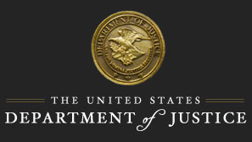

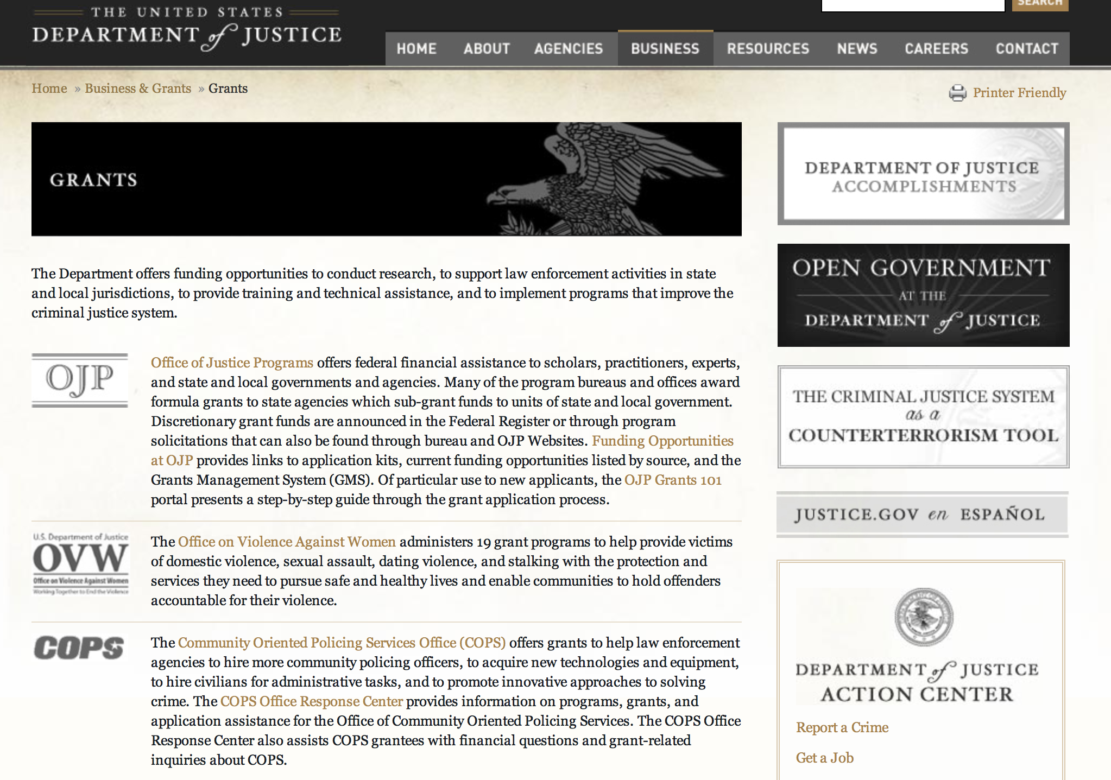

The DOJ agencies listed below also have sites that provide grant information specific to that agency. Examples of what can be found on these sites are programs, funding opportunities, application assistance, and other useful information.

Bureau of Justice Assistance (BJA)

Bureau of Justice Statistics (BJS)

National Criminal Justice Reference Service (NCJRS)

National Institute of Justice (NIJ)

Office of Juvenile Justice and Delinquency Prevention (OJJDP)

Office of Sex Offender Sentencing, Monitoring, Apprehending, Registering, and Tracking (SMART)

Office for Victims of Crime (OVC)

http://www.justice.gov/business/

Programs:

Bureau of Justice Assistance
Justice and Mental Health Collaboration Program Grant

Document Type: | Grants Notice
Funding Opportunity Number: | BJA-2016-9205
Funding Opportunity Title: | Justice and Mental Health Collaboration Program
Opportunity Category: | Discretionary
Opportunity Category Explanation:
Funding Instrument Type: | Grant
Category of Funding Activity: | Law, Justice and Legal Services
Category Explanation:
Expected Number of Awards: | 30
CFDA Number(s): | 16.745 -- Criminal and Juvenile Justice and Mental Health Collaboration Program
Cost Sharing or Matching Requirement: | No
Posted Date: | Mar 22, 2016
Last Updated Date: | Mar 22, 2016
Original Closing Date for Applications: | May 17, 2016
Current Closing Date for Applications: | May 17, 2016
Archive Date:
Estimated Total Program Funding: | $9,000,000
Award Ceiling: | $250,000
Eligible Applicants: | City or township governments  County governments  State governments  Native American tribal governments (Federally recognized)  Others (see text field entitled "Additional Information on Eligibility" for clarification)
Additional Information on Eligibility: | Eligible applicants are limited to states, units of local government, federally recognized Indian tribes (as determined by the Secretary of the Interior), and tribal organizations. BJA will only accept applications that demonstrate that the proposed project will be administered jointly by an agency with responsibility for criminal or juvenile justice activities and a mental health agency. Only one agency is responsible for the submission of the application in Grants.gov. This lead agency must be a state agency, unit of local government, federally recognized Indian tribe, or tribal organization.
Agency Name: | Bureau of Justice Assistance
Description: | The Justice and Mental Health Collaboration Program (JMHCP) supports innovative cross-system collaboration for individuals with mental illnesses or co-occurring mental health and substance abuse disorders who come into contact with the justice system. BJA is seeking applications that demonstrate a collaborative project between criminal justice and mental health partners from eligible applicants to plan, implement or expand a justice and mental health collaboration program. The program is authorized by the Mentally Ill Offender Treatment and Crime Reduction Act of 2004 (MIOTCRA) (Pub.L. 108-414) and the Mentally Ill Offender Treatment and Crime Reduction Reauthorization and Improvement Act of 2008 (Pub.L. 110-416).
Link to Additional Information: | Full Announcement
Contact Information: | If you have difficulty accessing the full announcement electronically, please contact:  For technical assistance with submitting an application, contact the Grants.gov Customer Support Hotline at 800-518-4726 or 606-545-5035, or via email to support@grants.gov. The Grants.gov Support Hotline hours of operation are 24 hours a day, 7 days a week, except federal holidays. support@grants.gov  Technical Application Support

http://www.grants.gov/web/grants/view-opportunity.html?oppId=282382

Office of Justice Programs
Bureau of Justice Assistance
Justice and Mental Health Collaboration Training and Technical Assistance Program Grant

Document Type: | Grants Notice
Funding Opportunity Number: | BJA-2016-9214
Funding Opportunity Title: | Justice and Mental Health Collaboration Training and Technical Assistance Program
Opportunity Category: | Discretionary
Opportunity Category Explanation:
Funding Instrument Type: | Grant
Category of Funding Activity: | Information and Statistics
Category Explanation:
Expected Number of Awards: | 3
CFDA Number(s): | 16.745 -- Criminal and Juvenile Justice and Mental Health Collaboration Program
Cost Sharing or Matching Requirement: | No
Posted Date: | Mar 16, 2016
Last Updated Date: | Mar 16, 2016
Original Closing Date for Applications: | May 17, 2016
Current Closing Date for Applications: | May 17, 2016
Archive Date:
Estimated Total Program Funding: | $600,000
Award Ceiling: | $600,000
Award Floor: | $0
Eligible Applicants: | Nonprofits having a 501(c)(3) status with the IRS, other than institutions of higher education  For profit organizations other than small businesses  Public and State controlled institutions of higher education  Others (see text field entitled "Additional Information on Eligibility" for clarification)  Private institutions of higher education
Additional Information on Eligibility: | Eligible applicants are for-profit (commercial) organizations, nonprofit organizations (including tribal nonprofit and for-profit organizations), faith-based and community organizations, and institutions of higher education (including tribal institutions of higher education). BJA welcomes applicants to partner with other technical assistance providers who have in-depth knowledge in policing. Competitive applications will identify significant law enforcement expertise or be submitted in partnership with a police organization or association that has the capacity to consult and engage communities on issues of improved police and public health responses to people with mental health disorders (MDs) and co-occurring mental health and substance use disorders (CODs). For-profit organizations must agree to forgo any profit or management fee.
Agency Name: | Bureau of Justice Assistance
Description: | To Serve as the primary TTA Provider for approximately 35 Justice and Mental Health grantees to include providing TTA through teleconferencing, peer to peer consultations, web-based assistance and onsite assistance, which utilizes staff and consultants whose expertise and experience best fit the needs of the grantees. TTA will include assistance with the planning process and program design via a five-point planning and implementation guide and targeted support by a team of expert consultants. Continue TTA provision to active JMHCP grantees from former funding years. TTA will also include targeted assistance for grantees on the Affordable Care Act and how it may be leveraged to increase service linkages and improve outcomes for people with mental illness who are involved, or at risk of involvement, in the criminal justice system. This program is funded through the Mentally Ill Offender Treatment and Crime Reduction Act of 2004 (MIOTCRA) (Pub. L. 108-414) and the Mentally Ill Offender Treatment and Crime Reduction Reauthorization and Improvement Act of 2008 (Pub. L. 110-416).
Link to Additional Information: | Full Announcement
Contact Information: | If you have difficulty accessing the full announcement electronically, please contact:  For technical assistance with submitting an application, contact the Grants.gov Customer Support Hotline at 800-518-4726 or 606-545-5035, or via email to support@grants.gov. The Grants.gov Support Hotline hours of operation are 24 hours a day, 7 days a week, except federal holidays. support@grants.gov  Technical Application Support

http://www.grants.gov/web/grants/view-opportunity.html?oppId=282269

Office of Justice Programs
Bureau of Justice Assistance
Small Agency Body-Worn Camera Policy and Implementation Program Grant
And Modification 1
Document Type: | Grants Notice
Funding Opportunity Number: | BJA-2016-9276
Funding Opportunity Title: | Small Agency Body-Worn Camera Policy and Implementation Program
Opportunity Category: | Discretionary
Opportunity Category Explanation:
Funding Instrument Type: | Grant
Category of Funding Activity: | Law, Justice and Legal Services
Category Explanation:
Expected Number of Awards: | 43
CFDA Number(s): | 16.835 -- Body Worn Camera Policy and Implementation
Cost Sharing or Matching Requirement: | Yes
Posted Date: | Mar 08, 2016
Last Updated Date: | Mar 15, 2016
Original Closing Date for Applications: | Apr 27, 2016
Current Closing Date for Applications: | Apr 27, 2016
Archive Date: | May 27, 2016
Estimated Total Program Funding: | $1,600,000
Award Ceiling: | $40,000
Award Floor: | $0
Eligible Applicants: | Native American tribal organizations (other than Federally recognized tribal governments)  State governments  City or township governments  Others (see text field entitled "Additional Information on Eligibility" for clarification)  County governments
Additional Information on Eligibility: | Eligible applicants are limited to public agencies of state government, units of local government, and federally recognized Indian tribal governments that perform law enforcement functions (as determined by the Secretary of the Interior); or any department, agency, or instrumentality of the foregoing that performs criminal justice functions (including combinations of the preceding, one of which is designated as the primary applicant).To ensure this program can assist as many law enforcement agencies as possible, applicants that were awarded funds under the 2015 Body-Worn Camera Pilot Implementation Program or the 2015 Smart Policing Body Worn Camera Initiative solicitation are not eligible to submit applications for this solicitation.
Agency Name: | Bureau of Justice Assistance
Description: | The FY2016 Small Agency Body Worn Camera (BWC) Policy Implementation Program will support the implementation â€“ including the purchase, deployment, maintenance, data storage, and policy development â€“ of a body-worn camera program, and the necessary policies for law enforcement agencies. The program will play a critical role in the creation, implementation, and evaluation of problem solving approaches that incorporate BWCs into officer practice in selected jurisdictions.
Link to Additional Information: | Full Announcement
Contact Information: | If you have difficulty accessing the full announcement electronically, please contact:  For technical assistance with submitting an application, contact the Grants.gov Customer Support Hotline at 800-518-4726 or 606-545-5035, or via email to support@grants.gov. The Grants.gov Support Hotline hours of operation are 24 hours a day, 7 days a week, except federal holidays. support@grants.gov  Technical Application Support

http://www.grants.gov/web/grants/view-opportunity.html?oppId=282077

Office of Justice Programs
Bureau of Justice Assistance
Body-Worn Camera Policy and Implementation Program Grant
And Modification 1

Document Type: | Grants Notice
Funding Opportunity Number: | BJA-2016-9199
Funding Opportunity Title: | Body-Worn Camera Policy and Implementation Program
Opportunity Category: | Discretionary
Opportunity Category Explanation:
Funding Instrument Type: | Grant
Category of Funding Activity: | Law, Justice and Legal Services
Category Explanation:
Expected Number of Awards: | 25
CFDA Number(s): | 16.835 -- Body Worn Camera Policy and Implementation
Cost Sharing or Matching Requirement: | Yes
Posted Date: | Mar 08, 2016
Last Updated Date: | Mar 15, 2016
Original Closing Date for Applications: | Apr 27, 2016
Current Closing Date for Applications: | Apr 27, 2016
Archive Date: | May 27, 2016
Estimated Total Program Funding: | $15,000,000
Award Ceiling: | $1,000,000
Award Floor: | $0
Eligible Applicants: | Native American tribal governments (Federally recognized)  County governments  Others (see text field entitled "Additional Information on Eligibility" for clarification)  State governments  City or township governments
Additional Information on Eligibility: | Eligible applicants are limited to public agencies of state government, units of local government, and federally recognized Indian tribal governments that perform law enforcement functions (as determined by the Secretary of the Interior); or any department, agency, or instrumentality of the foregoing that performs criminal justice functions (including combinations of the preceding, one of which is designated as the primary applicant).
Agency Name: | Bureau of Justice Assistance
Description: | The FY2015 Body Worn Camera (BWC) Policy and Implementation Program will support the implementation, including the purchase, deployment, maintenance, data storage, and policy development of a body-worn camera program, and the necessary policies for law enforcement agencies. The program will play a critical role in the creation, implementation, and evaluation of problem solving approaches that incorporate BWCs into officer practice in selected jurisdictions.
Link to Additional Information: | Full Announcement
Contact Information: | If you have difficulty accessing the full announcement electronically, please contact:  For technical assistance with submitting an application, contact the Grants.gov Customer Support Hotline at 800-518-4726 or 606-545-5035, or via email to support@grants.gov. The Grants.gov Support Hotline hours of operation are 24 hours a day, 7 days a week, except federal holidays. support@grants.gov  Technical Application Support

http://www.grants.gov/web/grants/view-opportunity.html?oppId=282047

Office of Justice Programs
Bureau of Justice Statistics
2016 Visiting Fellows: Criminal Justice Statistics Programs Grant

Document Type: | Grants Notice
Funding Opportunity Number: | BJS-2016-9005
Funding Opportunity Title: | 2016 Visiting Fellows: Criminal Justice Statistics Programs
Opportunity Category: | Discretionary
Opportunity Category Explanation:
Funding Instrument Type: | Cooperative Agreement
Category of Funding Activity: | Information and Statistics
Category Explanation:
Expected Number of Awards: | 3
CFDA Number(s): | 16.734 -- Special Data Collections and Statistical Studies
Cost Sharing or Matching Requirement: | No
Posted Date: | Mar 25, 2016
Last Updated Date: | Mar 25, 2016
Original Closing Date for Applications: | May 23, 2016
Current Closing Date for Applications: | May 23, 2016
Archive Date:
Estimated Total Program Funding: | $600,000
Award Ceiling: | $600,000
Award Floor: | $200,000
Eligible Applicants: | Others (see text field entitled "Additional Information on Eligibility" for clarification)
Additional Information on Eligibility: | Eligible applicants are individuals who have a nationally recognized research portfolio and considerable expertise in their area of proposed research. They should be willing to commit a substantial portion of their time over at least a 12-month period to undertake analyses of BJS data or statistical programs and produce at least one publishable-quality report summarizing their analysis.
Agency Name: | Bureau of Justice Statistics
Description: | The Bureau of Justice Statistics (BJS) Visiting Fellowship Program intended to facilitate collaboration between academic scholars and government researchers in survey methodology, statistics, economics, and social science. BJS Visiting Fellows are provided the unique opportunity to address substantive, methodological, and analytic issues relevant to BJS programs and to further knowledge about and understanding of the operation of the criminal justice system. BJS Visiting Fellows conduct projects that aim to enhance understanding of the operation of the criminal justice system and contribute to improving BJSÃ¢Â€Â™s statistical programs. The BJS Visiting Fellow program offers researchers, survey methodologists, and statisticians an opportunity to conduct statistical research in a particular area of mutual interest to them and BJS, to examine innovative approaches to the analysis and dissemination of BJS data, and to interact with BJS staff and gain first-hand knowledge of developments in BJS statistical programs.
Link to Additional Information: | Program Announcement
Contact Information: | If you have difficulty accessing the full announcement electronically, please contact:  askbjs@usdoj.gov Gerard.Ramker@usdoj.gov  Deputy Director

http://www.grants.gov/web/grants/view-opportunity.html?oppId=282521

Office of Justice Programs
National Institute of Justice
Investigator-Initiated Research and Evaluation on Firearms Violence Grant

Document Type: | Grants Notice
Funding Opportunity Number: | NIJ-2016-9091
Funding Opportunity Title: | Investigator-Initiated Research and Evaluation on Firearms Violence
Opportunity Category: | Discretionary
Opportunity Category Explanation:
Funding Instrument Type: | Grant
Category of Funding Activity: | Law, Justice and Legal Services
Category Explanation:
Expected Number of Awards: | 5
CFDA Number(s): | 16.560 -- National Institute of Justice Research, Evaluation, and Development Project Grants
Cost Sharing or Matching Requirement: | No
Posted Date: | Mar 14, 2016
Last Updated Date: | Mar 14, 2016
Original Closing Date for Applications: | May 13, 2016
Current Closing Date for Applications: | May 13, 2016
Archive Date:
Estimated Total Program Funding: | $3,000,000
Award Ceiling: | $3,000,000
Award Floor: | $0
Eligible Applicants: | Native American tribal governments (Federally recognized)  Public and State controlled institutions of higher education  Nonprofits having a 501(c)(3) status with the IRS, other than institutions of higher education  Private institutions of higher education  County governments  State governments  For profit organizations other than small businesses  Small businesses  Nonprofits that do not have a 501(c)(3) status with the IRS, other than institutions of higher education  Individuals  City or township governments
Agency Name: | National Institute of Justice
Description: | NIJ seeks investigator-initiated applications for funding for research and evaluation related to reducing firearms violence and understanding the causes and effects of firearms violence. This solicitation aims to strengthen our knowledge base and improve public safety by producing findings with practical implications for reducing firearms violence. This solicitation is focused specifically on producing research related to intentional, interpersonal firearms violence. NIJ is particularly interested in supporting research related to the following three areas identified in the 2013 report by the Institute of Medicine and National Research Council titled Priorities for Research to Reduce the Threat of Firearm-Related Violence: (1) the characteristics of firearm violence; (2) risk and protective factors; and (3) interventions and strategies.
Link to Additional Information: | http://nij.gov/funding/Documents/solicitations/NIJ-2016-9091.pdf
Contact Information: | If you have difficulty accessing the full announcement electronically, please contact:  NCJRS Call Center grants@ncjrs.gov  Technical Support

http://www.grants.gov/web/grants/view-opportunity.html?oppId=282208

Office of Justice Programs
Office for Victims of Crime
OVC FY 16 Comprehensive Services for Victims of All Forms of Human Trafficking Grant

Document Type: | Grants Notice
Funding Opportunity Number: | OVC-2016-9291
Funding Opportunity Title: | OVC FY 16 Comprehensive Services for Victims of All Forms of Human Trafficking
Opportunity Category: | Discretionary
Opportunity Category Explanation:
Funding Instrument Type: | Cooperative Agreement
Category of Funding Activity: | Income Security and Social Services  Law, Justice and Legal Services
Category Explanation:
Expected Number of Awards: | 10
CFDA Number(s): | 16.320 -- Services for Trafficking Victims
Cost Sharing or Matching Requirement: | Yes
Posted Date: | Mar 16, 2016
Last Updated Date: | Mar 16, 2016
Original Closing Date for Applications: | May 02, 2016
Current Closing Date for Applications: | May 02, 2016
Archive Date:
Estimated Total Program Funding: | $7,500,000
Award Ceiling: | $750,000
Eligible Applicants: | Others (see text field entitled "Additional Information on Eligibility" for clarification)
Additional Information on Eligibility: | By statute, grants under this program may be awarded to states, units of local government, federally recognized Indian tribal governments (as determined by the Secretary of the Interior), and nonprofit, nongovernmental organizations (including tribal nonprofits). For the purposes of this program, a unit of local government is any city, county, township, town, borough, parish, village, or other general purpose political subdivision of a state, territory, or federally recognized Indian tribal government. Organizations with a demonstrated history of providing victim assistance, social services, legal services, shelter, or mental health services for victims of human trafficking are eligible to apply. OVC may elect to make awards for applications submitted under this solicitation in future fiscal years, dependent on, among other considerations, the merit of the applications, and on the availability of appropriations. OVC welcomes applications that involve two or more entities that will carry out the funded Federal award activities; however, one eligible entity must be the applicant and the others must be proposed as subrecipients. The applicant must be the entity with primary responsibility for administering the funding and managing the entire project. Only one application per lead applicant will be considered; however, subrecipients may be part of multiple proposals. Current OVC trafficking victim services grantees who received funding from the OVC FY 2015 Comprehensive Services for Victims of Human Trafficking solicitation or the OVC FY 2015 Enhanced Collaborative Model to Combat Human Trafficking solicitation are not eligible to apply for funding under this solicitation. Nonprofit organizations that hold money in offshore accounts for the purpose of avoiding paying the tax described in 26 U.S.C. 511(a) are not eligible to apply.
Agency Name: | Office for Victims of Crime
Description: | The primary goal of this FY16 program is to enhance the quality and quantity of services available to assist victims of all forms of human trafficking, as defined by the Trafficking Victims Protection Act (TVPA) of 2000, as amended, by enhancing interagency collaboration and the coordinated community response to victims of human trafficking, and through the provision of high-quality services that address the individual needs of trafficking victims. This solicitation will provide funding to victim service organizations with a demonstrated history of providing services for victims of human trafficking. Funding under this program will support comprehensive services for all victims of human trafficking -- sex trafficking and labor trafficking, foreign national/U.S. citizen/legal permanent resident (LPR), adult/minor, male/ female, and LGBTQ victims of trafficking, among others. Funding will also support efforts to increase the capacity of communities to respond to human trafficking victims through the development of interagency partnerships, professional training, and public awareness activities.
Link to Additional Information: | Full Announcement
Contact Information: | If you have difficulty accessing the full announcement electronically, please contact:  For assistance with any other requirements of this solicitation, contact Kisha Green, Victim Justice Program Specialist, by telephone at 202–307–5983, or by email at kisha.w.green@usdoj.gov. Kisha.W.Green@usdoj.gov  For Programmatic Questions

http://www.grants.gov/web/grants/view-opportunity.html?oppId=282276

Office of Juvenile Justice Delinquency Prevention
OJJDP FY 16 Smart on Juvenile Justice: Statewide Juvenile Justice Reform Planning Training & Technical Assistance Grant
And Modification 1

Document Type: | Grants Notice
Funding Opportunity Number: | OJJDP-2016-9284
Funding Opportunity Title: | OJJDP FY 16 Smart on Juvenile Justice: Statewide Juvenile Justice Reform Planning Training & Technical Assistance
Opportunity Category: | Discretionary
Opportunity Category Explanation:
Funding Instrument Type: | Cooperative Agreement
Category of Funding Activity: | Law, Justice and Legal Services
Category Explanation:
Expected Number of Awards: | 5
CFDA Number(s): | 16.827 -- Justice Reinvestment Initiative
Cost Sharing or Matching Requirement: | No
Posted Date: | Mar 29, 2016
Last Updated Date: | Mar 31, 2016
Original Closing Date for Applications: | May 31, 2016
Current Closing Date for Applications: | May 31, 2016
Archive Date:
Estimated Total Program Funding: | $1,600,000
Award Ceiling: | $800,000
Award Floor: | $200,000
Eligible Applicants: | Private institutions of higher education  Public and State controlled institutions of higher education  Small businesses  Others (see text field entitled "Additional Information on Eligibility" for clarification)  Nonprofits having a 501(c)(3) status with the IRS, other than institutions of higher education  State governments  For profit organizations other than small businesses
Additional Information on Eligibility: | This initiative is composed of two categories. Eligibility differs by category: • Category 1: Statewide Juvenile Justice Reform Planning Grants. Eligible applicants are limited to states (including territories and the District of Columbia). • Category 2: Statewide Juvenile Justice Reform Training and Technical Assistance. Eligible applicants are limited to nonprofit and for-profit organizations (including tribal nonprofit and for-profit organizations) and institutions of higher education (including tribal institutions of higher education). For-profit organizations must agree to forgo any profit or management fee. OJJDP welcomes applications that involve two or more entities that will carry out the funded federal award activities; however, one eligible entity must be the applicant and the others must be proposed as subrecipients. The applicant must be the entity with primary responsibility for administering the funding and managing the entire program. OJJDP will consider only one application per lead applicant; however, subrecipients may be part of multiple proposals. OJJDP may elect to make awards for applications submitted under this solicitation in future fiscal years, dependent on, among other considerations, the merit of the applications and on the availability of appropriations.
Agency Name: | Office of Juvenile Justice Delinquency Prevention
Description: | OJJDP will select a TTA provider to deliver direct training and technical assistance and to provide pass-through funding to selected states to assess their current juvenile justice systems and to develop system-wide juvenile justice reform strategic plans. OJJDP will work with the successful applicant to develop a selection process for eligible states to apply for the TTA and pass-through funding available through this program.
Link to Additional Information: | Full Announcement
Contact Information: | If you have difficulty accessing the full announcement electronically, please contact:  For technical assistance with submitting an application, contact the Grants.gov Customer Support Hotline at 800-518-4726 or 606-545-5035, or via email to support@grants.gov. Hotline hours of operation are 24 hours a day, 7 days a week, except federal holidays. Applicants that experience unforeseen Grants.gov technical issues beyond their control that prevent them from submitting their application by the deadline must email the Response Center at grants@ncjrs.gov within 24 hours after the deadline and request approval to submit their application. Find additional information on reporting technical issues under “Experiencing Unforeseen Grants.gov Technical Issues” in the How To Apply section. For assistance with any other requirements of this solicitation, contact the Response Center by telephone at 800-851-3420 or TTY: 301-240-6310 (Hearing impaired only), by e-mail at grants@ncjrs.gov, or by web chat. Response Center hours of operation are 10 a.m. to 6 p.m. ET, Monday through Friday, and 10 a.m. to 8 p.m. ET on the solicitation close date. Answers to frequently asked questions that may assist applicants are posted at www.ojjdp.gov/grants/solicitations/FY2016/FAQ/JJReformFAQ.pdf. grants@ncjrs.gov  Email

http://www.grants.gov/web/grants/view-opportunity.html?oppId=282578

Office of Justice Programs
Department of Justice
SMART FY 16 Sex Offender Management Fellowship Program Grant

Document Type: | Grants Notice
Funding Opportunity Number: | SMART-2016-8956
Funding Opportunity Title: | SMART FY 16 Sex Offender Management Fellowship Program
Opportunity Category: | Discretionary
Opportunity Category Explanation:
Funding Instrument Type: | Cooperative Agreement
Category of Funding Activity: | Law, Justice and Legal Services
Category Explanation:
Expected Number of Awards: | 15
CFDA Number(s): | 16.750 -- Support for Adam Walsh Act Implementation Grant Program
Cost Sharing or Matching Requirement: | No
Posted Date: | Mar 08, 2016
Last Updated Date: | Mar 03, 2016
Original Closing Date for Applications: | Apr 25, 2016
Current Closing Date for Applications: | Apr 25, 2016
Archive Date: | May 25, 2016
Estimated Total Program Funding: | $300,000
Award Ceiling: | $150,000
Award Floor: | $10,000
Eligible Applicants: | City or township governments  Private institutions of higher education  Individuals  Native American tribal governments (Federally recognized)  County governments  Public and State controlled institutions of higher education  State governments
Agency Name: | Department of Justice
Description: | The SMART Office seeks to fund up to two fellowship positions focusing on enhancing its capacity to provide assistance and support to public or private colleges and universities on their response to, prevention of, and education about sexual violence and other sex offending behaviors on college campuses. Funding for this project is authorized under the Consolidated Appropriations Act, 2016. Project-Specific Information Sexual assault on college campuses is widespread. Reporting rates for campus sexual assault are very low; on average, across the nine schools, 1.1% of sexual battery incidents and 4.2% of rape incidents were reported by the victim to any law enforcement agency. The trauma caused by sexual assault can be life-long and not all campuses have the resources to effectively help the victim. Although many campuses have developed resources for the victims of sexual assault who come forward for help, most have not developed sufficient responses to the alleged perpetrators; sexual violence prevention strategies at the college level have typically focused on programs aimed at changing attitudes or increasing knowledge of sexual abuse. In 2014, the SMART Office released a solicitation targeting the perpetrators of sexual assault on college campuses. Through the initiative, the SMART Office is funding the development of a treatment curriculum for campus perpetrators of sexual assault to be implemented and tested at multiple colleges and universities. Last year, the SMART Office made two awards aimed at enhancing campus safety through the development of primary prevention programs; that is, programs designed to stop sexual violence before it occurs. In developing these solicitations, the SMART Office worked with several federal agencies and understands that these agencies are involved in addressing campus sexual assault issues through a variety of programs. The purpose of the SMART FY 2016 Sex Offender Management Fellowship is to help the SMART Office enhance its capacity to provide assistance and support to public and private colleges and universities on their prevention and response to sexual violence and exploitation on college campuses. The goal of this fellowship is to build a foundation within the field of sex offender management for the integration of effective approaches to sexual violence prevention and educational programming on college campuses. The fellowship will focus on prevention of and education about sexual violence and other sex offending behaviors on college campuses. The fellow will work with the relevant program offices within the Office of Justice Programs (Office for Victims of Crime, the Office of Juvenile Justice and Delinquency Prevention, the Bureau of Justice Assistance, the National Institute of Justice, and the Bureau of Justice Statistics), as well as the Office on Violence Against Women and other federal agencies. The SMART Office anticipates the fellow will work from remote locations full-time. However, the Fellow is expected to appear onsite at the SMART Office in Washington, DC once per quarter, and throughout the life of the award. Applicants who propose more narrowly focused fellowships that focus on their own specific interests will not be considered responsive to this solicitation and will not be forwarded for peer review. Additionally, please note this fellowship award is not intended to support individual pursuits in research or other academic work. Goals, Objectives, and Deliverables The Sex Offender Management Fellowship Program will identify ways to enhance and broaden programming designed to improve the prevention of, and education about, sexual violence and victimization on campus communities. Specifically, the fellow will work with SMART staff to develop a national plan for the prevention of sexual violence on campuses. This plan will strive to bridge the gaps that exist between those who work with victims and those who work with perpetrators of sexual violence; develop strategies to provide specialized education for multiple disciplines to address and promote prevention efforts; and begin the documentation of the research and evaluation of prevention strategies. The fellow will consult with other federal partners on this plan. Activities: • In close coordination with SMART staff, summarize DOJ (and other federal agency) campus sexual assault prevention and/or education resources and programs and describe the processes used by the offices in developing these resources. Draft concise fact sheets detailing each of the offices’ efforts in this area. • Assist SMART staff with the identification, interpretation, and adaptation of social marketing and public health campaigns (within and outside the campus setting) that have the ability to change public attitudes, particularly those specific to sexual assault prevention. • Identify and assess education curricula for students and professionals about preventing campus sexual violence and develop recommendations for promoting promising practices in the field. • Identify, compare, and summarize existent campus climate surveys. • Develop reports, presentations, and other documents at the request of OJP/SMART management and staff to promote campus sexual violence prevention and education efforts and detail challenges and successes of these efforts. • At the request of SMART staff/management, conduct site visits to assist in the assessment of projects or initiatives that are implementing promising sexual violence prevention and education programming, models, or resources on campuses or other relevant institutions. • Participate in professional development and training activities in consultation with SMART management to enhance expertise related to campus sexual violence prevention and sex offender management practices and research. • At the request of SMART staff/management, participate in internal and external stakeholder meetings, forums, workshops and other initiatives related to campus sexual violence prevention and education and sex offender management. • Support SMART’s efforts to build more formal collaborative relationships across the Federal government in response to campus sexual assault. Deliverables: • Determine and provide an inventory and summary of the campus climate surveys that exist and what data analyses indicate. • Determine and provide an inventory and summary of the surveys of students’ sexual behaviors and what data analyses indicate. • Produce an inventory of existing campus, or other relevant institutions, sexual violence prevention programs and curricula, as well as institutional responses to, and sanctions for, sexual violence on campuses. • Draft and present an assessment of research and campaigns in the area of campus sexual violence prevention and education. • Draft and present a literature review of campus, or other relevant institutions, sexual violence prevention and education efforts, focusing in particular on those demonstrating a promising practice or an evidence-based approach. • Provide monthly/quarterly reports to SMART management and Senior Policy Advisors that detail activities and recommendations for the design and execution of SMART forums, conferences, and the SMART newsletters on campus sexual violence prevention and education. • Develop recommendations and suggestions as to how SMART can broaden its scope and collaboration with other entities (federal and non-federal) in the area of campus sexual violence prevention and education. • Provide a final report to OJP/SMART on the fellowship project, including accomplishments, challenges and recommendations for improving the fellowship program.
Link to Additional Information: | http://www.smart.gov/pdfs/SMARTFY16Fellow.pdf
Contact Information: | If you have difficulty accessing the full announcement electronically, please contact:  Faith Baker Associate Director Phone 202-305-2586  Faith.Baker@usdoj.gov

http://www.grants.gov/web/grants/view-opportunity.html?oppId=281933

Office of Justice Programs
Office of Juvenile Justice Delinquency Prevention
OJJDP FY 16 Assessing the Impact of Juvenile Justice Reforms Program Grant

Document Type: | Grants Notice
Funding Opportunity Number: | OJJDP-2016-8999
Funding Opportunity Title: | OJJDP FY 16 Assessing the Impact of Juvenile Justice Reforms Program
Opportunity Category: | Discretionary
Opportunity Category Explanation:
Funding Instrument Type: | Grant
Category of Funding Activity: | Law, Justice and Legal Services
Category Explanation:
Expected Number of Awards: | 3
CFDA Number(s): | 16.540 -- Juvenile Justice and Delinquency Prevention Allocation to States
Cost Sharing or Matching Requirement: | No
Posted Date: | Mar 23, 2016
Last Updated Date: | Mar 23, 2016
Original Closing Date for Applications: | May 23, 2016
Current Closing Date for Applications: | May 23, 2016
Archive Date:
Estimated Total Program Funding: | $150,000
Award Ceiling: | $500,000
Award Floor: | $0
Eligible Applicants: | Native American tribal governments (Federally recognized)  City or township governments  Others (see text field entitled "Additional Information on Eligibility" for clarification)  State governments  Public housing authorities/Indian housing authorities  Small businesses  County governments  Nonprofits having a 501(c)(3) status with the IRS, other than institutions of higher education  Public and State controlled institutions of higher education
Additional Information on Eligibility: | States (including territories), units of local government, federally recognized tribal governments (as determined by the Secretary of the Interior), nonprofit and for-profit organizations (including tribal nonprofit or for-profit organizations), and institutions of higher education (including tribal institutions of higher education) are eligible. Recipient organizations must agree to forgo any profit or management fee. Foreign governments, foreign organizations, and foreign institutions of higher education are not eligible to apply. This solicitation has two categories. Applicants may submit more than one unique application under this solicitation, but they may not submit the same application under both categories. Applicants must clearly indicate under which category they are applying in the project abstract. • Category 1: Smart on Juvenile Justice Initiative State Policy Evaluations • Category 2: State and Local Juvenile Justice Reform Policy Evaluations OJJDP welcomes applications that involve two or more entities that will carry out the funded federal award activities; however, one eligible entity must be the applicant and the other(s) must be proposed as subrecipient(s). The applicant must be the entity with primary responsibility for conducting and leading the project. If successful, the applicant will be responsible for monitoring and appropriately managing any subrecipients or, as applicable, for administering any procurement subcontracts that would receive federal program funds from the applicant under the award. (Applicants should also review and consider the “Duplicate Applications” note under How To Apply in Section D. Application and Submission Information.)
Agency Name: | Office of Juvenile Justice Delinquency Prevention
Description: | OJJDP seeks to award funding for assessing the effectiveness and/or cost efficiency of juvenile justice system reforms defined as systemic policy or practice changes within a locality or state that impact one or more segments of the juvenile justice system.
Link to Additional Information: | Full Announcement
Contact Information: | If you have difficulty accessing the full announcement electronically, please contact:  For technical assistance with submitting an application, contact the Grants.gov Customer Support Hotline at 800-518-4726 or 606-545-5035, or via e-mail to support@grants.gov. Hotline hours of operation are 24 hours a day, 7 days a week, except federal holidays. Applicants that experience unforeseen Grants.gov technical issues beyond their control that prevent them from submitting their application by the deadline must e-mail the OJJDP contact identified below within 24 hours after the application deadline and request approval to submit their application. Additional information on reporting technical issues is found under “Experiencing Unforeseen Grants.gov Technical Issues” in the How To Apply section. For assistance with any other requirements of this solicitation, contact the Response Center by telephone at 800-851-3420 or TTY: 301-240-6310 (Hearing impaired only), by e-mail at grants@ncjrs.gov, or by web chat. Response Center hours of operation are 10 a.m. to 6 p.m. ET, Monday through Friday, and 10 a.m. to 8 p.m. ET on the solicitation close date. Answers to frequently asked questions that may assist applicants are posted at www.ojjdp.gov/grants/solicitations/FY2016/FAQ/AssessingJJReformFAQ.pdf. support@grants.gov  Email

http://www.grants.gov/web/grants/view-opportunity.html?oppId=282472

Office of Justice Programs
Office of Juvenile Justice Delinquency Prevention
OJJDP FY 16 Comprehensive Anti-Gang Strategies and Programs Grant

Document Type: | Grants Notice
Funding Opportunity Number: | OJJDP-2016-9332
Funding Opportunity Title: | OJJDP FY 16 Comprehensive Anti-Gang Strategies and Programs
Opportunity Category: | Discretionary
Opportunity Category Explanation:
Funding Instrument Type: | Grant
Category of Funding Activity: | Law, Justice and Legal Services
Category Explanation:
Expected Number of Awards: | 8
CFDA Number(s): | 16.544 -- Youth Gang Prevention
Cost Sharing or Matching Requirement: | No
Posted Date: | Mar 23, 2016
Last Updated Date: | Mar 23, 2016
Original Closing Date for Applications: | May 23, 2016
Current Closing Date for Applications: | May 23, 2016
Archive Date:
Estimated Total Program Funding: | $2,400,000
Award Ceiling: | $300,000
Award Floor: | $0
Eligible Applicants: | State governments  Native American tribal governments (Federally recognized)  County governments  Nonprofits having a 501(c)(3) status with the IRS, other than institutions of higher education  City or township governments  Others (see text field entitled "Additional Information on Eligibility" for clarification)
Additional Information on Eligibility: | Eligible applicants are limited to states (including territories), units of local government, federally recognized tribal governments (as determined by the Secretary of the Interior), and nonprofit organizations (including tribal nonprofit organizations). OJJDP welcomes applications that involve two or more entities that will carry out the funded federal award activities; however, one eligible entity must be the applicant and the other(s) must be proposed as subrecipient(s). The applicant must be the entity with primary responsibility for administering the funding and managing the entire project. Only one application per lead applicant will be considered; however, a subrecipient may be part of multiple proposals. OJJDP may elect to make awards for applications submitted under this solicitation in future fiscal years, dependent on, among other considerations, the merit of the applications and the availability of appropriations.
Agency Name: | Office of Juvenile Justice Delinquency Prevention
Description: | Youth gangs continue to have a significant adverse impact on youth, families, and communities across America. A growing number of communities have adopted OJJDP's Comprehensive Gang Model, a multistrategy, multidisciplinary approach that has proven to be effective in reducing gang activity. The fiscal year 2016 Comprehensive Antigang Strategies and Programs solicitation provides funding for localities to enhance coordination of federal, state, and local resources in support of community partnerships implementing the following antigang programs: primary prevention, secondary prevention, gang intervention, and targeted gang enforcement.
Link to Additional Information: | Full Announcement
Contact Information: | If you have difficulty accessing the full announcement electronically, please contact:  For technical assistance with submitting an application, contact the Grants.gov Customer Support Hotline at 800-518-4726 or 606-545-5035, or via e-mail to support@grants.gov. Hotline hours of operation are 24 hours a day, 7 days a week, except federal holidays. Applicants who experience unforeseen Grants.gov technical issues beyond their control that prevent them from submitting their applications by the deadline must e-mail JIC@telesishq.com within 24 hours after the application deadline and request approval to submit their application. For assistance with any other requirements of this solicitation, contact the contact the Response Center by telephone at 800-851-3420 or TTY: 301-240-6310 (Hearing impaired only), by e-mail at grants@ncjrs.gov, or by web chat. Response Center hours of operation are 10 a.m. to 6 p.m. ET, Monday through Friday, and 10 a.m. to 8 p.m. ET on the solicitation close date. Answers to frequently asked questions that may assist applicants are posted at www.ojjdp.gov/grants/solicitations/FY2016/FAQ/AntigangFAQ.pdf. grants@ncjrs.gov  Email

http://www.grants.gov/web/grants/view-opportunity.html?oppId=282447

Office of Justice Programs
Office for Victims of Crime
OVC FY 16 Specialized Services for Victims of Human Trafficking Grant

Document Type: | Grants Notice
Funding Opportunity Number: | OVC-2016-9290
Funding Opportunity Title: | OVC FY 16 Specialized Services for Victims of Human Trafficking
Opportunity Category: | Discretionary
Opportunity Category Explanation:
Funding Instrument Type: | Cooperative Agreement
Category of Funding Activity: | Income Security and Social Services  Law, Justice and Legal Services
Category Explanation:
Expected Number of Awards: | 13
CFDA Number(s): | 16.320 -- Services for Trafficking Victims
Cost Sharing or Matching Requirement: | Yes
Posted Date: | Mar 28, 2016
Last Updated Date: | Mar 28, 2016
Original Closing Date for Applications: | May 12, 2016
Current Closing Date for Applications: | May 12, 2016
Archive Date:
Estimated Total Program Funding: | $7,800,000
Award Ceiling: | $600,000
Eligible Applicants: | Others (see text field entitled "Additional Information on Eligibility" for clarification)
Additional Information on Eligibility: | By statute, grants under this program may be awarded to states, units of local government, federally recognized Indian tribal governments (as determined by the Secretary of the Interior), and nonprofit, nongovernmental organizations (including tribal nonprofits). For the purposes of this program, a unit of local government is any city, county, township, town, borough, parish, village, or other general purpose political subdivision of a state, territory, or federally recognized Indian tribal government. Organizations with a demonstrated history of providing victim assistance, social services, legal services, shelter, or mental health services for victims of human trafficking are eligible to apply. Tribal governments, tribal nonprofits, and organizations that specialize in serving American Indian/Alaska Native victims of human trafficking are also eligible to apply. OVC may elect to make awards for applications submitted under this solicitation in future fiscal years, dependent on the merit of the applications and the availability of appropriations. OVC welcomes applications that involve two or more entities that will carry out the funded federal award activities; however, one eligible entity must be the applicant and the others must be proposed as subrecipients. The applicant must be the entity with primary responsibility for administering the funding and managing the entire project. Only one application per lead applicant will be considered; however, subrecipients may be part of multiple proposals. FY 2015 Specialized Services, FY 2015 Comprehensive Services, and FY 2015 Enhanced Collaborative Model to Combat Human Trafficking grantees are not eligible to apply for funding under this solicitation, unless the new proposal outlines new services and cost items that were not included in the FY 2015 application. Nonprofit organizations that hold money in offshore accounts for the purpose of avoiding paying the tax described in 26 U.S.C. 511(a) are not eligible to apply.
Agency Name: | Office for Victims of Crime
Description: | The primary goal of this FY16 program is to enhance the quality and quantity of services available to assist victims of human trafficking, as defined by the Trafficking Victims Protection Act (TVPA) of 2000, as amended, by enhancing interagency collaboration and the coordinated community response to victims of human trafficking, and through the provision of high-quality services that address the individual needs of trafficking victims. This solicitation will provide funding to victim service organizations with a demonstrated history of providing services for victims of human trafficking. Funding under this program will support the provision of a specific type of service or intervention for victims of human trafficking, services provided in specialized settings, or services targeted at specific subgroups of trafficking victims. Funding will also support efforts to increase the capacity of communities to respond to human trafficking victims through the development of interagency partnerships, professional training, and public awareness activities.
Link to Additional Information: | Funding Opportunity
Contact Information: | If you have difficulty accessing the full announcement electronically, please contact:  For assistance with any other requirements of this solicitation, contact Ivette Estrada, Victim Justice Program Specialist, by telephone at 202-307-0932 or by email at ivette.estrada@usdoj.gov. Ivette.Estrada@usdoj.gov  For Programmatic Questions

http://www.grants.gov/web/grants/view-opportunity.html?oppId=282567

Office of Justice Programs
Office of Juvenile Justice Delinquency Prevention
OJJDP FY 2016 Family Drug Court Implementation and Enhancement Program Grant
And Modification 1

Document Type: | Grants Notice
Funding Opportunity Number: | OJJDP-2016-9171
Funding Opportunity Title: | OJJDP FY 2016 Family Drug Court Implementation and Enhancement Program
Opportunity Category: | Discretionary
Opportunity Category Explanation:
Funding Instrument Type: | Grant
Category of Funding Activity: | Law, Justice and Legal Services
Category Explanation:
Expected Number of Awards: | 3
CFDA Number(s): | 16.585 -- Drug Court Discretionary Grant Program
Cost Sharing or Matching Requirement: | Yes
Posted Date: | Mar 28, 2016
Last Updated Date: | Mar 31, 2016
Original Closing Date for Applications: | May 31, 2016
Current Closing Date for Applications: | May 31, 2016
Archive Date:
Estimated Total Program Funding: | $1,000,000
Award Ceiling: | $600,000
Award Floor: | $0
Eligible Applicants: | Others (see text field entitled "Additional Information on Eligibility" for clarification)  State governments  City or township governments  County governments  Native American tribal governments (Federally recognized)
Additional Information on Eligibility: | Eligible applicants under both categories are limited to states (including territories), state and local courts, units of local government, and federally recognized tribal governments (as determined by the Secretary of the Interior). Faith- and community-based, nonprofit, and for-profit organizations are ineligible as applicants, but OJJDP encourages them to partner with eligible applicants as a community provider of services, if applicable and appropriate. Eligible applicants must provide direct services to youth who are younger than 18 years of age and to their parents. An eligible applicant may designate a subunit of government (for example, county probation department, district attorney’s office, or pretrial services agency) as the authorized representative. Another example, the county executive may designate the county probation or district attorney’s office as its representative when applying for this grant. In such cases, the applicant must submit an authorization letter from the eligible agency or organization. OJJDP welcomes applications that involve two or more entities that will carry out the funded federal award activities; however, one eligible entity must be the applicant and the others must be proposed as subrecipients. The applicant must be the entity that will administer the funding and manage the entire project. OJJDP will consider only one application per lead applicant; however, subrecipients may be part of multiple proposals. This solicitation is composed of two grant categories. Applicants must clearly designate under which category they are applying. Category 1: Implementation. Implementation grants are available to jurisdictions that are ready to implement a family drug court. These are for jurisdictions where either no family drug court currently exists or a family drug court has been operational for less than 1 year. Jurisdictions may already have other types of drug or treatment courts (such as adult drug or mental health courts). Category 2: Enhancement. Enhancement grants are available to jurisdictions with a fully operational (for at least 1 year) family drug court that wish to enhance the operation of the court.
Agency Name: | Office of Juvenile Justice Delinquency Prevention
Description: | The Family Drug Courts program builds the capacity of states, state and local courts, units of local government, and federally recognized tribal governments to either implement new drug courts or enhance pre-existing drug courts for individuals with substance abuse disorders or substance use and co-occurring mental health disorders, including histories of trauma, who are involved with the family dependency court as a result of child abuse, neglect, and other parenting issues. Applicants must provide services to the parents in the program and their children. This program provides seed money, not long-term support. OJJDP expects successful applicants to develop and implement a sustainability plan during the grant period to continue operation of the family drug court when the grant ends.
Link to Additional Information: | Full Announcement
Contact Information: | If you have difficulty accessing the full announcement electronically, please contact:  For technical assistance with submitting an application, contact the Grants.gov Customer Support Hotline at 800-518-4726 or 606-545-5035, or via e-mail to support@grants.gov. Hotline hours of operation are 24 hours a day, 7 days a week, except federal holidays. Applicants who experience unforeseen Grants.gov technical issues beyond their control that prevent them from submitting their application by the deadline must e-mail the OJJDP contact identified below within 24 hours after the application deadline and request approval to submit their application. Additional information on reporting technical issues is found under “Experiencing Unforeseen Grants.gov Technical Issues” in the How To Apply section. For assistance with any other requirements of this solicitation, contact the Response Center by telephone at 800-851-3420 or TTY: 301-240-6310 (Hearing impaired only), by e-mail at grants@ncjrs.gov, or by web chat. Response Center hours of operation are 10 a.m. to 6 p.m. ET, Monday through Friday, and 10 a.m. to 8 p.m. ET on the solicitation close date. Answers to frequently asked questions that may assist applicants are posted at www.ojjdp.gov/grants/solicitations/FY2016/FAQ/FamilyDrugCourtFAQ.pdf. grants@ncjrs.gov

http://www.grants.gov/web/grants/view-opportunity.html?oppId=282585

Office of Justice Programs
Office on Violence Against Women
OVW FY 2016 Research and Evaluation Program Grant

Document Type: | Grants Notice
Funding Opportunity Number: | OVW-2016-9780
Funding Opportunity Title: | OVW FY 2016 Research and Evaluation Program
Opportunity Category: | Discretionary
Opportunity Category Explanation:
Funding Instrument Type: | Grant
Category of Funding Activity: | Law, Justice and Legal Services  Science and Technology and other Research and Development
Category Explanation:
Expected Number of Awards: | 14
CFDA Number(s): | 16.026 -- OVW Research and Evaluation Program
Cost Sharing or Matching Requirement: | No
Posted Date: | Mar 21, 2016
Last Updated Date: | Mar 21, 2016
Original Closing Date for Applications: | May 02, 2016
Current Closing Date for Applications: | May 02, 2016
Archive Date: | Jun 01, 2016
Estimated Total Program Funding: | $2,770,000
Award Ceiling: | $400,000
Award Floor: | $50,000
Eligible Applicants: | Native American tribal governments (Federally recognized)  City or township governments  County governments  Public and State controlled institutions of higher education  State governments  Nonprofits having a 501(c)(3) status with the IRS, other than institutions of higher education  Private institutions of higher education
Agency Name: | Office on Violence Against Women
Description: | The purpose of the Research and Evaluation (R&E) Program is to research and evaluate approaches to combatting domestic violence, sexual assault, dating violence, and stalking. By generating more knowledge about strategies for serving victims and holding offenders accountable, communities that benefit from VAWA funding will be better equipped to align their work with practices that are known to be effective, and they will be more capable of generating empirical knowledge on the efficacy of new and promising ways of doing things. The R&E Program is designed to support researcher-practitioner partnerships and a broad range of research and evaluation methods, including qualitative, mixed-method, and quasi-experimental designs.
Link to Additional Information: | OVW FY 2016 Research and Evaluation Program - Full Announcement
Contact Information: | If you have difficulty accessing the full announcement electronically, please contact:  Ginger Baran Lyons Phone (202) 305-2093  virginia.baran@usdoj.gov

http://www.grants.gov/web/grants/view-opportunity.html?oppId=282400

Office of Justice Programs
National Institute of Justice
Research on "Sentinel Events" and Criminal Justice System Errors Grant

Document Type: | Grants Notice
Funding Opportunity Number: | NIJ-2016-9235
Funding Opportunity Title: | Research on "Sentinel Events" and Criminal Justice System Errors
Opportunity Category: | Discretionary
Opportunity Category Explanation:
Funding Instrument Type: | Grant
Category of Funding Activity: | Law, Justice and Legal Services
Category Explanation:
Expected Number of Awards: | 3
CFDA Number(s): | 16.560 -- National Institute of Justice Research, Evaluation, and Development Project Grants
Cost Sharing or Matching Requirement: | No
Posted Date: | Mar 18, 2016
Last Updated Date: | Mar 18, 2016
Original Closing Date for Applications: | May 17, 2016
Current Closing Date for Applications: | May 17, 2016
Archive Date:
Estimated Total Program Funding: | $1,000,000
Award Ceiling: | $1,000,000
Award Floor: | $0
Eligible Applicants: | State governments  For profit organizations other than small businesses  Private institutions of higher education  Public and State controlled institutions of higher education  Nonprofits that do not have a 501(c)(3) status with the IRS, other than institutions of higher education  County governments  Small businesses  Individuals  Native American tribal governments (Federally recognized)  Nonprofits having a 501(c)(3) status with the IRS, other than institutions of higher education  City or township governments
Agency Name: | National Institute of Justice
Description: | The purpose of the National Institute of Justice Research, Evaluation, and Development Projects grants program (CFDA 16.560) is to encourage and support research, development, and evaluation to improve criminal justice policy and practice in the United States. NIJ is interested in encouraging further research on a relatively new area of study in criminal justice research- an exploration of the use of sentinel event reviews to improve justice systems overall. Mistakes, or negative outcomes, in the criminal justice system are rarely caused by one single act or actor. Often, mistakes signal multiple weaknesses in the criminal justice system or process. Thus, corrections to such errors need to go beyond traditional remedies that focus on removing the "bad apple" responsible for the event to those that address the underlying system level problems that contributed to the event. Sentinel event review processes have been used in other fields, notably aviation and medicine, and NIJ would like to sponsor research projects that explore the use of these reviews in the criminal justice system.
Link to Additional Information: | http://nij.gov/funding/Documents/solicitations/NIJ-2016-9235.pdf
Contact Information: | If you have difficulty accessing the full announcement electronically, please contact:  NCJRS Call Center grants@ncjrs.gov  Technical Support

http://www.grants.gov/web/grants/view-opportunity.html?oppId=282362

Federal Bureau of Prisons
National Institute of Corrections
Diversion Symposium Grant

Document Type: | Grants Notice
Funding Opportunity Number: | 16CS13
Funding Opportunity Title: | Diversion Symposium
Opportunity Category: | Discretionary
Opportunity Category Explanation:
Funding Instrument Type: | Cooperative Agreement
Category of Funding Activity: | Other (see text field entitled "Explanation of Other Category of Funding Activity" for clarification)
Category Explanation: | Symposium
Expected Number of Awards: | 5
CFDA Number(s): | 16.601 -- Corrections Training and Staff Development
Cost Sharing or Matching Requirement: | No
Posted Date: | Mar 23, 2016
Last Updated Date: | Mar 23, 2016
Original Closing Date for Applications: | May 23, 2016
Current Closing Date for Applications: | May 23, 2016
Archive Date: | Jun 22, 2016
Estimated Total Program Funding:
Award Ceiling: | $107,000
Award Floor: | $0
Eligible Applicants: | Others (see text field entitled "Additional Information on Eligibility" for clarification)
Additional Information on Eligibility: | NIC invites applications from nonprofit organizations (including faith-based, community, and tribal organizations), for-profit organizations (including tribal for-profit organizations), and institutions of higher education (including tribal institutions of higher education). Recipients, including for-profit organizations, must agree to waive any profit or fee for services. NIC welcomes applications that involve two or more entities; however, one eligible entity must be the applicant and the others must be proposed as subrecipients. The applicant must be the entity with primary responsibility for administering the funding and managing the entire program. NIC may elect to make awards for applications submitted under this solicitation in future fiscal years, dependent on the merit of the applications and on the availability of appropriations.
Agency Name: | National Institute of Corrections
Description: | The National Institute of Corrections (NIC) is seeking applications for funding under the Fiscal Year (FY) 2016. The purpose of the Diversion Symposium is to educate and inform criminal justice stakeholders and policymakers about pretrial diversion decision making. The Symposium will expose participants to a wide range of diversion related topics incorporating proven and research based criminal justice practices on diversion criteria, interventions and programming.
Link to Additional Information:
Contact Information: | If you have difficulty accessing the full announcement electronically, please contact:  Melanie Simms Administrative Officer Phone 202-353-0484  Technical and application questions

http://www.grants.gov/web/grants/view-opportunity.html?oppId=282459

Office of Justice Programs
National Institute of Justice
Comprehensive School Safety Initiative Grant

Document Type: | Grants Notice
Funding Opportunity Number: | NIJ-2016-9093
Funding Opportunity Title: | Comprehensive School Safety Initiative
Opportunity Category: | Discretionary
Opportunity Category Explanation:
Funding Instrument Type: | Grant
Category of Funding Activity: | Law, Justice and Legal Services
Category Explanation:
Expected Number of Awards: | 21
CFDA Number(s): | 16.560 -- National Institute of Justice Research, Evaluation, and Development Project Grants
Cost Sharing or Matching Requirement: | No
Posted Date: | Mar 17, 2016
Last Updated Date: | Mar 17, 2016
Original Closing Date for Applications: | May 27, 2016
Current Closing Date for Applications: | May 27, 2016
Archive Date:
Estimated Total Program Funding: | $65,000,000
Award Ceiling: | $65,000,000
Eligible Applicants: | Others (see text field entitled "Additional Information on Eligibility" for clarification)  Private institutions of higher education  County governments  For profit organizations other than small businesses  Native American tribal governments (Federally recognized)  State governments  Public and State controlled institutions of higher education  Nonprofits that do not have a 501(c)(3) status with the IRS, other than institutions of higher education  Individuals  Nonprofits having a 501(c)(3) status with the IRS, other than institutions of higher education  Independent school districts  Small businesses  City or township governments
Additional Information on Eligibility: | Local education agencies (LEA), public charter schools that are recognized as LEA, and State education agencies
Agency Name: | National Institute of Justice
Description: | The Comprehensive School Safety Initiative (CSSI) funds rigorous research to produce practical knowledge that can improve the safety of schools and students. The initiative is carried out through partnerships between researchers, educators and other stakeholders, including law enforcement and mental health professionals. Projects funded under the CSSI are designed to produce knowledge that can be applied to schools and school districts across the nation for years to come. This solicitation includes multiple funding categories with different expectations and requirements to accomplish the purposes of the CSSI.
Link to Additional Information: | http://nij.gov/funding/Documents/solicitations/NIJ-2016-9093.pdf
Contact Information: | If you have difficulty accessing the full announcement electronically, please contact:  NCJRS Call Center grants@ncjrs.gov  Technical Support

http://www.grants.gov/web/grants/view-opportunity.html?oppId=282321

Office of Justice Programs
National Institute of Justice
Research and Evaluation on Domestic Radicalization to Violent Extremism: Prevention and Intervention Demonstration Programs Grant

Document Type: | Grants Notice
Funding Opportunity Number: | NIJ-2016-9103
Funding Opportunity Title: | Research and Evaluation on Domestic Radicalization to Violent Extremism: Prevention and Intervention Demonstration Programs
Opportunity Category: | Discretionary
Opportunity Category Explanation:
Funding Instrument Type: | Cooperative Agreement
Category of Funding Activity: | Law, Justice and Legal Services
Category Explanation:
Expected Number of Awards: | 5
CFDA Number(s): | 16.560 -- National Institute of Justice Research, Evaluation, and Development Project Grants
Cost Sharing or Matching Requirement: | No
Posted Date: | Mar 08, 2016
Last Updated Date: | Mar 08, 2016
Original Closing Date for Applications: | May 09, 2016
Current Closing Date for Applications: | May 09, 2016
Archive Date:
Estimated Total Program Funding: | $3,500,000
Award Ceiling: | $3,500,000
Eligible Applicants: | City or township governments  For profit organizations other than small businesses  Native American tribal governments (Federally recognized)  Private institutions of higher education  County governments  Nonprofits having a 501(c)(3) status with the IRS, other than institutions of higher education  State governments  Individuals  Small businesses  Nonprofits that do not have a 501(c)(3) status with the IRS, other than institutions of higher education  Public and State controlled institutions of higher education
Agency Name: | National Institute of Justice
Description: | The goal of this research program is to provide a more comprehensive and extensive understanding of domestic radicalization as it occurs in the United States, and to provide State, local and tribal criminal justice agencies evidence-based tools to address it. The primary objective of this solicitation is to produce research studies that improve this understanding by filling gaps in the existing research or expanding on existing work to provide insights for criminal justice agencies. The secondary objective of this solicitation is to provide the empirical basis upon which to formulate and implement policies and programs designed to address domestic radicalization in the United States. The deliverables from this solicitation will consist of research studies and published works that speak to these objectives.
Link to Additional Information: | http://nij.gov/funding/Documents/solicitations/NIJ-2016-9103.pdf
Contact Information: | If you have difficulty accessing the full announcement electronically, please contact:  NCJRS Call Center grants@ncjrs.gov  Technical Support

http://www.grants.gov/web/grants/view-opportunity.html?oppId=282076

Office of Justice Programs
National Institute of Justice
Research and Evaluation on Identity Theft and Services to Victims of Identity Theft Grant

Document Type: | Grants Notice
Funding Opportunity Number: | NIJ-2016-9880
Funding Opportunity Title: | Research and Evaluation on Identity Theft and Services to Victims of Identity Theft
Opportunity Category: | Discretionary
Opportunity Category Explanation:
Funding Instrument Type: | Cooperative Agreement
Category of Funding Activity: | Law, Justice and Legal Services
Category Explanation:
Expected Number of Awards: | 3
CFDA Number(s): | 16.560 -- National Institute of Justice Research, Evaluation, and Development Project Grants
Cost Sharing or Matching Requirement: | No
Posted Date: | Apr 01, 2016
Last Updated Date: | Apr 01, 2016
Original Closing Date for Applications: | Jun 01, 2016
Current Closing Date for Applications: | Jun 01, 2016
Archive Date:
Estimated Total Program Funding: | $1,500,000
Award Ceiling: | $1,500,000
Award Floor: | $0
Eligible Applicants: | Small businesses  Individuals  Public and State controlled institutions of higher education  County governments  Native American tribal governments (Federally recognized)  Nonprofits having a 501(c)(3) status with the IRS, other than institutions of higher education  Nonprofits that do not have a 501(c)(3) status with the IRS, other than institutions of higher education  State governments  City or township governments  Private institutions of higher education  For profit organizations other than small businesses
Agency Name: | National Institute of Justice
Description: | This solicitation seeks to build knowledge and evidence related to strategies, practices, and programs that serve victims of identity theft. The overall purpose of these services is to help victims minimize the damage, restore the security of their accounts and personal information, and recover from the experience. This funding will support research and evaluation projects that build knowledge about the consequences of identity theft and improve the quality of services to victims of identity theft.
Link to Additional Information: | http://nij.gov/funding/Documents/solicitations/NIJ-2016-9880.pdf
Contact Information: | If you have difficulty accessing the full announcement electronically, please contact:  NCJRS Call Center grants@ncjrs.gov  Technical Support

http://www.grants.gov/web/grants/view-opportunity.html?oppId=282681

Office of Justice Programs
National Institute of Justice
Sexual Assault Forensic Evidence - Inventory, Tracking, and Reporting Grant

Document Type: | Grants Notice
Funding Opportunity Number: | NIJ-2016-9088
Funding Opportunity Title: | Sexual Assault Forensic Evidence - Inventory, Tracking, and Reporting
Opportunity Category: | Discretionary
Opportunity Category Explanation:
Funding Instrument Type: | Cooperative Agreement
Category of Funding Activity: | Law, Justice and Legal Services
Category Explanation:
Expected Number of Awards: | 10
CFDA Number(s): | 16.741 -- DNA Backlog Reduction Program
Cost Sharing or Matching Requirement: | No
Posted Date: | Mar 15, 2016
Last Updated Date: | Mar 15, 2016
Original Closing Date for Applications: | May 31, 2016
Current Closing Date for Applications: | May 31, 2016
Archive Date:
Estimated Total Program Funding: | $5,000,000
Award Ceiling: | $5,000,000
Eligible Applicants: | County governments  City or township governments  State governments  Native American tribal governments (Federally recognized)
Agency Name: | National Institute of Justice
Description: | It is not known how many unanalyzed sexual assault kits (SAKs) there are nationwide . Evidence from sexual assaults like weapons, bedding, clothing, and SAKs can be used to corroborate that a crime occurred, identify or eliminate a possible perpetrator, and ascertain whether a suspect may have been involved in other crimes. SAKs contain biological and trace evidence, along with other physical evidence collected from a victim. While all evidence from sexual assaults is important, this program focuses on SAKs. SAKs may be stored in a number of places such as, crime laboratories, police department evidence storage units, hospitals and clinics. Many law enforcement agencies do not have computerized systems to track the processing of a SAK. This program will allow agencies to inventory, track and report all untested and unsubmitted SAKs ensuring accountability and transparency for the collection, processing and testing of SAKs.
Link to Additional Information: | http://nij.gov/funding/Documents/solicitations/NIJ-2016-9088.pdf
Contact Information: | If you have difficulty accessing the full announcement electronically, please contact:  NCJRS Call Center grants@ncjrs.gov  Technical Support

http://www.grants.gov/web/grants/view-opportunity.html?oppId=282228

Modifications:

Office of Justice Programs
Office of Juvenile Justice Delinquency Prevention
OJJDP FY 16 Mentoring Opportunities
Modification 2

Document Type: | Grants Notice
Funding Opportunity Number: | OJJDP-2016-9179
Funding Opportunity Title: | OJJDP FY 16 Mentoring Opportunities
Opportunity Category: | Discretionary
Opportunity Category Explanation:
Funding Instrument Type: | Grant
Category of Funding Activity: | Law, Justice and Legal Services
Category Explanation:
Expected Number of Awards: | 11
CFDA Number(s): | 16.726 -- Juvenile Mentoring Program
Cost Sharing or Matching Requirement: | No
Posted Date: | Mar 01, 2016
Last Updated Date: | Apr 05, 2016
Original Closing Date for Applications: | May 02, 2016
Current Closing Date for Applications: | May 02, 2016
Eligible Applicants: | Others (see text field entitled "Additional Information on Eligibility" for clarification)
Additional Information on Eligibility: | Category 1—National Mentoring Programs: Eligible applicants are limited to national organizations, defined as organizations that have active chapters or subawardees in at least 45 states. Applicants must include a list of active chapters or subawardees and the states where they are located as an attachment to their application. For purposes of this solicitation, two or more independent organizations that form a collaborative to meet the 45-state requirement do not satisfy OJJDP’s definition of a national organization. The organization’s national headquarters must submit the application, and OJJDP requires successful applicants to subaward 90 percent of this award to active chapters or subawardees in at least 38 states. Category 2—Multistate Mentoring Programs: Eligible applicants are limited to multistate organizations, defined as organizations that have operated an established mentoring program for at least 3 years and have active chapters or subawardees in at least 5 states but fewer than 45 states. Applicants must include a list of active chapters or subawardees and the states where they are located as an attachment to their application. For purposes of this solicitation, two or more independent organizations that form a collaborative to meet the five-state requirement do not satisfy OJJDP's definition of a multistate organization. The organization’s headquarters must submit the application. Category 3—Collaborative Mentoring Programs: Eligible applicants must be part of a collaborative of at least three and as many as five mentoring organizations. Under the award, the mentoring organizations that form the collaborative must each provide services in at least one location that is independent of the other mentoring organizations and must all implement the same program design (see definition of the same program design on page 7). Mentoring organizations within the collaborative must ensure that no individual will receive duplicate services from more than one member of the collaborative. The collaborative may include different mentoring organizations receiving funding from the same parent organization; however, official organizational charts must reflect that the mentoring organizations operate independently and at different locations. Each mentoring organization within the collaborative must already have an established mentoring program (operational for at least 1 year) at the time they submit an application for funding. OJJDP encourages applicants to consider partnering with those organizations – and in such a manner – that will best leverage shared costs for training or program-related activities. Applicants must submit memoranda of understanding (or analogous documents) demonstrating a formal collaborative partnership. One organization must be clearly identified as the lead applicant; however, subrecipients may be part of multiple Collaborative Mentoring Program proposals. OJJDP encourages multistate organizations to participate in Collaborative Mentoring Programs, but participation of a multistate organization is not required. National organizations are not eligible to apply. For-profit organizations must agree to forgo any profit or management fee. At the time of application, eligible applicants must provide mentoring services to youth who are 17 years old or younger. An organization that applies for funding in Category 1 may not apply for funds in any other category, but an organization that applies for funding in Category 2 may also apply as a member of the collaborative to receive funds in Category 3. See the chart below.
Agency Name: | Office of Juvenile Justice Delinquency Prevention
Description: | This solicitation supports applicant organizations as they strengthen and/or expand their existing mentoring activities with active chapters or subawardees and/or other mentoring organizations. Mentoring activities include direct one-on-one, group, peer, or a combination of these types of mentoring services for at-risk and underserved youth populations. Mentoring promotes positive behaviors, attitudes, and outcomes for youth and reduces risk factors. It has been shown to improve academic performance and/or social or job skills, support behavioral or other personal development, and reduce consumption of alcohol and other drugs. Successful mentoring programs include matches between a mentor and one or more youth. Mentoring can take place in multiple and informal settings and in a school or program context. OJJDP supports the expansion of quality mentoring services for at-risk and high-risk youth. There are three categories under this solicitation: National Mentoring; Multistate Mentoring; and Collaborative Mentoring
Link to Additional Information: | Full Announcement
Contact Information: | If you have difficulty accessing the full announcement electronically, please contact:  For technical assistance with submitting an application, contact the Grants.gov Customer Support Hotline at 800-518-4726 or 606-545-5035, or via e-mail to support@grants.gov. Hotline hours of operation are 24 hours a day, 7 days a week, except federal holidays. For assistance with any other requirements of this solicitation, contact the Response Center by telephone at 800-851-3420, TTY 301-240-6310 (Hearing impaired only), by e-mail at grants@ncjrs.gov, or by web chat. Response Center hours of operation are 10 a.m. to 6 p.m. eastern time, Monday through Friday. Answers to frequently asked questions that may assist applicants are posted at www.ojjdp.gov/grants/solicitations/FY2016/FAQ/MentoringOpportunitiesFAQ.pdf. A solicitation review call will be held on March 15, 2016, from 1 to 2 pm EST. This call will provide a detailed overview of the solicitation and allow an opportunity for interested applicants to ask questions. Preregistration is required for all participants. Register by clicking on this link: http://ojjdptta.adobeconnect.com/e7jxyzq11i2/event/registration.html and follow the instructions. Due to the limited time, OJJDP encourages participants to review the solicitation and submit any questions they may have in advance and no later than March 7, 2016. Please submit your questions to grants@ncjrs.gov with the email subject as Questions for Mentoring Opportunities for Youth Webinar. grants@ncjrs.gov  Email

http://www.grants.gov/web/grants/view-opportunity.html?oppId=281905

Office of Justice Programs
Bureau of Justice Statistics
2016 Graduate Research Fellowship Program for Criminal Justice Statistics
Modification 2

Document Type: | Grants Notice
Funding Opportunity Number: | BJS-2016-9013
Funding Opportunity Title: | 2016 Graduate Research Fellowship Program for Criminal Justice Statistics
Opportunity Category: | Discretionary
Opportunity Category Explanation:
Funding Instrument Type: | Grant
Category of Funding Activity: | Information and Statistics
Category Explanation:
Expected Number of Awards: | 5
CFDA Number(s): | 16.734 -- Special Data Collections and Statistical Studies
Cost Sharing or Matching Requirement: | No
Posted Date: | Mar 10, 2016
Last Updated Date: | Mar 23, 2016
Original Closing Date for Applications: | May 02, 2016
Current Closing Date for Applications: | May 02, 2016
Archive Date:
Estimated Total Program Funding: | $225,000
Award Ceiling: | $225,000
Award Floor: | $45,000
Eligible Applicants: | Others (see text field entitled "Additional Information on Eligibility" for clarification)
Additional Information on Eligibility: | Eligible applicants are limited to degree-granting educational institutions in the United States. To be eligible, the institution must be fully accredited by one of the regional institutional accreditation agencies recognized by the U.S. Secretary of Education. Historically black colleges and universities are encouraged to apply. Under this solicitation, the applicant institution must apply as the sponsor on behalf of a doctoral student candidate whose dissertation research substantially uses data made available by BJS. Applicant institutions are strongly encouraged to consider minority and female student candidates
Agency Name: | Bureau of Justice Statistics
Description: | The Bureau of Justice Statistics (BJS) Graduate Research Fellowship Program will provide awards for doctoral students research that utilizes criminal justice data or statistics and focuses on crime, violence, and other criminal justice-related topics to accredited universities that offer research-based doctoral degrees. BJS invests in doctoral education by supporting universities that sponsor students who demonstrate the potential to complete doctoral degree programs successfully in disciplines relevant to the mission of BJS, and who are in the final stages of graduate study. Awards will be made to successful applicant institutions in the form of a cooperative agreement to cover a fellowship for the sponsored doctoral student. Each fellowship potentially provides up to three years of support usable over a five-year period. For each year of support, BJS provides the degree-granting institution a stipend of $35,000 usable toward the student salary and related costs, and up to $15,000 to cover the student tuition and fees, research expenses, and related costs.
Link to Additional Information: | Full Announcement
Contact Information: | If you have difficulty accessing the full announcement electronically, please contact:  askbjs@usdoj.gov askbjs@usdoj.gov  General Information

http://www.grants.gov/web/grants/view-opportunity.html?oppId=282114

Office of Justice Programs
Bureau of Justice Assistance
Technology Innovation for Public Safety (TIPS)
Modification 1
Document Type: | Grants Notice
Funding Opportunity Number: | BJA-2016-8994
Funding Opportunity Title: | Technology Innovation for Public Safety (TIPS)
Opportunity Category: | Discretionary
Opportunity Category Explanation:
Funding Instrument Type: | Grant
Category of Funding Activity: | Law, Justice and Legal Services
Category Explanation:
Expected Number of Awards: | 6
CFDA Number(s): | 16.738 -- Edward Byrne Memorial Justice Assistance Grant Program
Cost Sharing or Matching Requirement:
Posted Date: | Mar 03, 2016
Last Updated Date: | Mar 03, 2016
Original Closing Date for Applications: | Apr 20, 2016
Current Closing Date for Applications: | Apr 20, 2016
Archive Date: | May 20, 2016
Estimated Total Program Funding: | $2,500,000
Award Ceiling: | $500,000
Award Floor: | $0
Eligible Applicants: | Nonprofits having a 501(c)(3) status with the IRS, other than institutions of higher education  City or township governments  County governments  Others (see text field entitled "Additional Information on Eligibility" for clarification)  Native American tribal governments (Federally recognized)  State governments
Additional Information on Eligibility: | There are two categories under this solicitation: (1) innovative technology implementation to address precipitous increases in crime and (2) training and technical assistance to assist grantees in project implementation and collection of data to assist BJA in identifying promising practices. Eligible applicants, for category 1, are limited to public agencies of state governments, units of local government, and tribal entities that perform criminal justice functions (or government agencies acting as fiscal agents for eligible applicants); and, for Category 2, national and regional public and private entities, including for-profit (commercial) and nonprofit organizations (including tribal nonprofit or for-profit organizations), faith-based and community organizations, and institutions of higher education (including tribal institutions of higher education) that support initiatives to improve the functioning of the criminal justice system. For-profit organizations must agree to forgo any profit or management fee.
Agency Name: | Bureau of Justice Assistance
Description: | The Justice Information Sharing Solutions Implementation Program is designed to promote innovation in the field to advance the state of the art in technology and information sharing that improves the criminal justice system.
Link to Additional Information: | Full Announcement
Contact Information: | If you have difficulty accessing the full announcement electronically, please contact:  For technical assistance with submitting an application, contact the Grants.gov Customer Support Hotline at 800-518-4726 or 606-545-5035, or via email to support@grants.gov. The Grants.gov Support Hotline hours of operation are 24 hours a day, 7 days a week, except federal holidays. support@grants.gov  Technical Application Support

http://www.grants.gov/web/grants/view-opportunity.html?oppId=281935

Office of Justice Programs
Bureau of Justice Assistance
National Sexual Assault Kit Initiative (SAKI)
Modification 1

Document Type: | Grants Notice
Funding Opportunity Number: | BJA-2016-8989
Funding Opportunity Title: | National Sexual Assault Kit Initiative (SAKI)
Opportunity Category: | Discretionary
Opportunity Category Explanation:
Funding Instrument Type: | Grant
Category of Funding Activity: | Law, Justice and Legal Services
Category Explanation:
Expected Number of Awards: | 19
CFDA Number(s): | 16.833 -- National Sexual Assault Kit Initiative
Cost Sharing or Matching Requirement: | No
Posted Date: | Mar 01, 2016
Last Updated Date: | Mar 01, 2016
Original Closing Date for Applications: | Apr 26, 2016
Current Closing Date for Applications: | Apr 26, 2016
Archive Date: | May 26, 2016
Estimated Total Program Funding: | $4,100,000
Award Ceiling: | $2,000,000
Award Floor: | $0
Eligible Applicants: | Others (see text field entitled "Additional Information on Eligibility" for clarification)
Additional Information on Eligibility: | Eligible applicants for Purpose Area 1 are state, local, and tribal law enforcement agencies (as recognized by the Secretary of the Interior), prosecutor’s offices, or a governmental non-law enforcement agency acting as fiscal agent for the applicant.Eligible applicants for Purpose Area 2 are limited to the lead applicant entities that received award funding under the FY 2015 SAKI Competitive Grant Announcement.
Agency Name: | Bureau of Justice Assistance
Description: | The purpose of this grant program is to provide funding to test untested sexual assault kits, prevent sexual assaults, and improve the criminal justice system's response to sexual assaults.
Link to Additional Information: | Full Announcement
Contact Information: | If you have difficulty accessing the full announcement electronically, please contact:  For technical assistance with submitting an application, contact the Grants.gov Customer Support Hotline at 800-518-4726 or 606-545-5035, or via e-mail to support@grants.gov. The Grants.gov Support Hotline hours of operation are 24 hours a day, 7 days a week, except federal holidays. Angela.Williamson@usdoj.gov  Technical Application Support

http://www.grants.gov/web/grants/view-opportunity.html?oppId=281865

Office of Justice Programs
Bureau of Justice Statistics
2016 Graduate Research Fellowship Program for Criminal Justice Statistics
Modification 1
Document Type: | Grants Notice
Funding Opportunity Number: | BJS-2016-9013
Funding Opportunity Title: | 2016 Graduate Research Fellowship Program for Criminal Justice Statistics
Opportunity Category: | Discretionary
Opportunity Category Explanation:
Funding Instrument Type: | Grant
Category of Funding Activity: | Information and Statistics
Category Explanation:
Expected Number of Awards: | 5
CFDA Number(s): | 16.734 -- Special Data Collections and Statistical Studies
Cost Sharing or Matching Requirement: | No
Posted Date: | Mar 10, 2016
Last Updated Date: | Mar 23, 2016
Original Closing Date for Applications: | May 02, 2016
Current Closing Date for Applications: | May 02, 2016
Archive Date:
Estimated Total Program Funding: | $225,000
Award Ceiling: | $225,000
Award Floor: | $45,000
Eligible Applicants: | Others (see text field entitled "Additional Information on Eligibility" for clarification)
Additional Information on Eligibility: | Eligible applicants are limited to degree-granting educational institutions in the United States. To be eligible, the institution must be fully accredited by one of the regional institutional accreditation agencies recognized by the U.S. Secretary of Education. Historically black colleges and universities are encouraged to apply. Under this solicitation, the applicant institution must apply as the sponsor on behalf of a doctoral student candidate whose dissertation research substantially uses data made available by BJS. Applicant institutions are strongly encouraged to consider minority and female student candidates
Agency Name: | Bureau of Justice Statistics
Description: | The Bureau of Justice Statistics (BJS) Graduate Research Fellowship Program will provide awards for doctoral students research that utilizes criminal justice data or statistics and focuses on crime, violence, and other criminal justice-related topics to accredited universities that offer research-based doctoral degrees. BJS invests in doctoral education by supporting universities that sponsor students who demonstrate the potential to complete doctoral degree programs successfully in disciplines relevant to the mission of BJS, and who are in the final stages of graduate study. Awards will be made to successful applicant institutions in the form of a cooperative agreement to cover a fellowship for the sponsored doctoral student. Each fellowship potentially provides up to three years of support usable over a five-year period. For each year of support, BJS provides the degree-granting institution a stipend of $35,000 usable toward the student salary and related costs, and up to $15,000 to cover the student tuition and fees, research expenses, and related costs.
Link to Additional Information: | Full Announcement
Contact Information: | If you have difficulty accessing the full announcement electronically, please contact:  askbjs@usdoj.gov askbjs@usdoj.gov  General Information

http://www.grants.gov/web/grants/view-opportunity.html?oppId=282114

Reminders:

Office of Justice Programs
National Institute of Justice
Research and Evaluation on Drugs and Crime Grant
And Modifications 1, 2 & 3

Document Type: | Grants Notice
Funding Opportunity Number: | NIJ-2016-9090
Funding Opportunity Title: | Research and Evaluation on Drugs and Crime
Opportunity Category: | Discretionary
Opportunity Category Explanation:
Funding Instrument Type: | Grant
Category of Funding Activity: | Law, Justice and Legal Services
Category Explanation:
Expected Number of Awards: | 5
CFDA Number(s): | 16.560 -- National Institute of Justice Research, Evaluation, and Development Project Grants
Cost Sharing or Matching Requirement: | No
Posted Date: | Feb 05, 2016
Last Updated Date: | Feb 23, 2016
Original Closing Date for Applications: | Apr 20, 2016
Current Closing Date for Applications: | Apr 20, 2016
Archive Date: | May 20, 2016
Estimated Total Program Funding: | $3,000,000
Award Ceiling: | $3,000,000
Eligible Applicants: | Nonprofits having a 501(c)(3) status with the IRS, other than institutions of higher education  For profit organizations other than small businesses  Small businesses  Native American tribal governments (Federally recognized)  State governments  Private institutions of higher education  Individuals  Nonprofits that do not have a 501(c)(3) status with the IRS, other than institutions of higher education  County governments  Public and State controlled institutions of higher education  City or township governments
Agency Name: | National Institute of Justice
Description: | NIJ is seeking investigator-initiated proposals to conduct research that examines criminal justice tools, protocols, and policies concerning drug trafficking, markets and use, and the effects of drug legalization and decriminalization on law enforcement, applicable to State, tribal and local jurisdictions. Proposals must address one of two criminal justice activities: drug intelligence and community surveillance, or criminal investigation and prosecution. In addition, NIJ has identified three drug research priorities: Marijuana and cannabis products; Heroin and other opioids (including diverted prescription drugs); and Novel psychoactive substances (also known as synthetic drugs).
Link to Additional Information: | http://nij.gov/funding/Documents/solicitations/NIJ-2016-9090.pdf
Contact Information: | If you have difficulty accessing the full announcement electronically, please contact:  NCJRS Call Center grants@ncjrs.gov  Technical Support

http://www.grants.gov/web/grants/view-opportunity.html?oppId=281358

Office of Justice Programs
Bureau of Justice Assistance
Smart Supervision: Reducing Prison Populations, Saving Money, and Creating Safer Communities
Grant

Document Type: | Grants Notice
Funding Opportunity Number: | BJA-2016-8992
Funding Opportunity Title: | Smart Supervision: Reducing Prison Populations, Saving Money, and Creating Safer Communities
Opportunity Category: | Discretionary
Opportunity Category Explanation:
Funding Instrument Type: | Grant
Category of Funding Activity: | Law, Justice and Legal Services
Category Explanation:
Expected Number of Awards: | 7
CFDA Number(s): | 16.812 -- Second Chance Act Reentry Initiative
Cost Sharing or Matching Requirement: | No
Posted Date: | Feb 09, 2016
Last Updated Date: | Feb 09, 2016
Original Closing Date for Applications: | Apr 11, 2016
Current Closing Date for Applications: | Apr 11, 2016
Archive Date:
Estimated Total Program Funding: | $5,250,000
Award Ceiling: | $750,000
Award Floor: | $0
Eligible Applicants: | City or township governments  Native American tribal governments (Federally recognized)  State governments  County governments
Agency Name: | Bureau of Justice Assistance
Description: | The FY 2015 Smart Supervision Program seeks to improve supervision success rates and reduce crime, which would in turn reduce admissions to prisons and jails and save taxpayer dollars. Funds can be used to implement evidence-based supervision strategies and to develop innovative strategies to improve outcomes for probationers.
Link to Additional Information: | Full Announcement
Contact Information: | If you have difficulty accessing the full announcement electronically, please contact:  For technical assistance with submitting an application, contact the Grants.gov Customer Support Hotline at 800-518-4726 or 606-545-5035, or via email to support@grants.gov. The Grants.gov Support Hotline hours of operation are 24 hours a day, 7 days a week, except federal holidays. support@grants.gov  Technical Application Support

http://www.grants.gov/web/grants/view-opportunity.html?oppId=281427

Office of Justice Programs
Bureau of Justice Assistance
Justice Reinvestment Initiative: Maximizing State Reforms Grant

Document Type: | Grants Notice
Funding Opportunity Number: | BJA-2016-8975
Funding Opportunity Title: | Justice Reinvestment Initiative: Maximizing State Reforms
Opportunity Category: | Discretionary
Opportunity Category Explanation:
Funding Instrument Type: | Grant
Category of Funding Activity: | Law, Justice and Legal Services
Category Explanation:
Expected Number of Awards: | 5
CFDA Number(s): | 16.827 -- Justice Reinvestment Initiative
Cost Sharing or Matching Requirement: | No
Posted Date: | Feb 09, 2016
Last Updated Date: | Feb 09, 2016
Original Closing Date for Applications: | Apr 11, 2016
Current Closing Date for Applications: | Apr 11, 2016
Archive Date:
Estimated Total Program Funding: | $0
Award Ceiling: | $1,750,000
Award Floor: | $0
Eligible Applicants: | For profit organizations other than small businesses  Private institutions of higher education  Native American tribal governments (Federally recognized)  State governments  Public and State controlled institutions of higher education
Agency Name: | Bureau of Justice Assistance
Description: | Approximately 2.2 million people were incarcerated in federal, state, and local prisons and jails in 2014, a rate of 1 out of every 110 adults. Many prison populations remain near all-time high levels and face crowding or resource challenges, and state spending on corrections has remained high. Over the last 25 years, state corrections expenditures have increased exponentially from $12 billion in 1988 to more than $55 billion estimated for 2014, a significant increase even accounting for inflation. Justice reinvestment emerged as a way to address these issues through a targeted, data-driven policymaking process. BJA, in a public/private partnership with The Pew Charitable Trusts, launched the Justice Reinvestment Initiative (JRI) in 2010 as a multistage process in which a jurisdiction reduces unnecessary incarceration, increases the cost-effectiveness of its criminal justice system and reinvests savings into high-performing public safety strategies. Under the JRI model, a governmental working group with bipartisan and interbranch representation analyzes the correctional population and its cost drivers, develops cost-effective policy options, and implements reforms to manage correctional populations while enhancing public safety. JRI jurisdictions reinvest these cost savings into high-performing initiatives that make communities safer. In addition to reducing prison populations, justice reinvestment encourages states to embrace a culture of greater collaboration, data-driven decisionmaking, and increased use of evidence-based practices. The JRI State Assessment Report, funded by BJA and authored by the Urban Institute, showed that the 17 assessed JRI states are making steady progress toward achieving the goals of JRI: reducing correctional spending and reinvesting in recidivism-reduction strategies. Of the 17 states, 8 had JRI policies in effect for at least one year. All eight have experienced meaningful reductions in their prison populations, and five of them have met or exceeded their population reduction goals. While the full impact of justice reinvestment reforms is not yet known, the policies enacted in JRI states hold great promise to reduce prison populations, achieve substantial cost savings, and avert future growth. The Urban Institute continues to track outcomes in these 17 states and in the additional 7 states that have undertaken justice reinvestment efforts under JRI since the JRI State Assessment Report. The report revealed that many JRI states have issues in common and have focused on similar priorities. Each states criminal justice system is unique, requiring detailed analysis to determine factors behind prison growth and corrections spending. However, many of the states found similar factors driving populations and costs for example, parole and probation revocation rates; sentencing policies and practices that favored incarceration of low-risk offenders over alternatives and that resulted in long lengths of stay; insufficient or inefficient community supervision, services, and support; and parole system processing delays and denials. The policy responses to these issues also overlapped, sharing themes of evidence-based practices and data-driven decisionmaking, including risk and needs assessments; accountability measures such as performance and outcome measure reporting; earned credits to encourage compliance with conditions of community supervision; sentencing changes; swift, certain and fair responses to technical probation and parole violations, mandatory post-incarceration supervision requirements; problem-solving courts; streamlined parole processes and expanded parole eligibility; and re-entry programs to reduce recidivism.
Link to Additional Information: | Full Announcement
Contact Information: | If you have difficulty accessing the full announcement electronically, please contact:  For technical assistance with submitting an application, contact the Grants.gov Customer Support Hotline at 800-518-4726 or 606-545-5035, or via e-mail to support@grants.gov. The Grants.gov Support Hotline hours of operation are 24 hours a day, 7 days a week, except federal holidays. support@grants.gov  Technical Application Support

http://www.grants.gov/web/grants/view-opportunity.html?oppId=281428

Office of Justice Programs
National Institute of Justice
NIJ FY16 Visiting Fellows Program Grant

Document Type: | Grants Notice
Funding Opportunity Number: | NIJ-2016-8890
Funding Opportunity Title: | NIJ FY16 Visiting Fellows Program
Opportunity Category: | Discretionary
Opportunity Category Explanation:
Funding Instrument Type: | Grant
Category of Funding Activity: | Law, Justice and Legal Services
Category Explanation:
Expected Number of Awards: | 6
CFDA Number(s): | 16.560 -- National Institute of Justice Research, Evaluation, and Development Project Grants
Cost Sharing or Matching Requirement: | No
Posted Date: | Feb 12, 2016
Last Updated Date: | Feb 12, 2016
Original Closing Date for Applications: | May 11, 2016
Current Closing Date for Applications: | May 11, 2016
Archive Date: | Jun 10, 2016
Estimated Total Program Funding: | $1,000,000
Award Ceiling: | $1,000,000
Award Floor: | $0
Eligible Applicants: | City or township governments  State governments  County governments  Native American tribal governments (Federally recognized)  Nonprofits that do not have a 501(c)(3) status with the IRS, other than institutions of higher education  Individuals  Small businesses  For profit organizations other than small businesses  Public and State controlled institutions of higher education  Nonprofits having a 501(c)(3) status with the IRS, other than institutions of higher education  Private institutions of higher education
Agency Name: | National Institute of Justice
Description: | With this solicitation, subject to available funding, NIJ seeks proposals for important research work and scholarship as part of the 2016 NIJ Visiting Fellows Program. Awards made under the NIJ Visiting Fellows Program will bring leading researchers and others into residency at NIJ to make important scholarly contributions in their chosen fields of criminology or criminal justice research, and to work with the NIJ Director and staff to help shape the direction of NIJ's research programs. NIJ will recruit research fellows, who have backgrounds primarily in academic or research settings, and policy fellows, who have backgrounds working primarily in a criminal justice policy or practice setting. NIJ will also recruit partnership fellows, a research fellow and a policy fellow who will work together on a joint-research project. During their fellowship at NIJ, visiting fellows will work on a significant piece of scholarship that has the potential to advance significantly criminology or criminal justice research, such as a major capstone effort culminating a line of research or some work in a new area that has significant potential to transform our understanding of crime and justice in the United States.
Link to Additional Information: | Full Announcement
Contact Information: | If you have difficulty accessing the full announcement electronically, please contact:  NCJRS Call Center  Technical Support

http://www.grants.gov/web/grants/view-opportunity.html?oppId=281510

Office of Justice Programs
Office of Justice Programs
Bureau of Justice Statistics
FY 2016 NICS Act Record Improvement Program (NARIP) Grant
And Modification 1

Document Type: | Grants Notice
Funding Opportunity Number: | BJS-2016-9017
Funding Opportunity Title: | FY 2016 NICS Act Record Improvement Program (NARIP)
Opportunity Category: | Discretionary
Opportunity Category Explanation:
Funding Instrument Type: | Cooperative Agreement
Category of Funding Activity: | Information and Statistics
Category Explanation:
Expected Number of Awards: | 28
CFDA Number(s): | 16.813 -- NICS Act Record Improvement Program
Cost Sharing or Matching Requirement: | No
Posted Date: | Feb 12, 2016
Last Updated Date: | Feb 17, 2016
Original Closing Date for Applications: | May 10, 2016
Current Closing Date for Applications: | May 10, 2016
Archive Date:
Estimated Total Program Funding: | $25,000,000
Award Ceiling: | $500,000
Award Floor: | $0
Eligible Applicants: | Others (see text field entitled "Additional Information on Eligibility" for clarification)
Additional Information on Eligibility: | Eligible applicants are limited to (a) the agency designated by the Governor to administer the NARIP, (b) the state or territory central administrative office or similar entity designated by statute or regulation to administer federal grant funds on behalf of the jurisdiction’s court system, or (c) federally recognized Indian tribal governments as determined by the Secretary of the Interior. Additionally, there are two specific conditions associated with eligibility for grants under this program (see “Eligibility” on page 10).
Agency Name: | Bureau of Justice Statistics
Description: | This program was authorized by the NICS Improvement Amendments Act of 2007 (NIAA). The NIAA was enacted in the wake of the April 2007 shooting tragedy at Virginia Tech. The Virginia Tech shooter was able to purchase firearms from a Federal Firearms License (FFL) because information about his prohibiting mental health history was not available to the NICS, and the system was therefore unable to deny the transfer of the firearms used in the shootings. The NIAA seeks to address the gap in information available to NICS about such prohibiting mental health adjudications and commitments and other prohibiting factors. Filling these information gaps will better enable the system to operate as intended to keep guns out of the hands of persons prohibited by federal or state law from receiving or possessing firearms. The automation of records will also reduce delays for law-abiding gun purchasers. The NIAA authorized this grant program to assist states in providing certain information to the NICS.
Link to Additional Information: | Full Announcement available at www.bjs.gov.
Contact Information: | If you have difficulty accessing the full announcement electronically, please contact:  askbjs@usdoj.gov askbjs@usdoj.gov  General Information

http://www.grants.gov/web/grants/view-opportunity.html?oppId=281498

Office of Justice Programs
National Institute of Justice
Research and Evaluation on Institutional Corrections Grant

Document Type: | Grants Notice
Funding Opportunity Number: | NIJ-2016-9086
Funding Opportunity Title: | Research and Evaluation on Institutional Corrections
Opportunity Category: | Discretionary
Opportunity Category Explanation:
Funding Instrument Type: | Grant
Category of Funding Activity: | Law, Justice and Legal Services
Category Explanation:
Expected Number of Awards: | 12
CFDA Number(s): | 16.560 -- National Institute of Justice Research, Evaluation, and Development Project Grants
Cost Sharing or Matching Requirement: | No
Posted Date: | Feb 17, 2016
Last Updated Date: | Feb 17, 2016
Original Closing Date for Applications: | May 17, 2016
Current Closing Date for Applications: | May 17, 2016
Archive Date:
Estimated Total Program Funding: | $8,000,000
Award Ceiling: | $8,000,000
Eligible Applicants: | Nonprofits that do not have a 501(c)(3) status with the IRS, other than institutions of higher education  Native American tribal governments (Federally recognized)  Public and State controlled institutions of higher education  County governments  Small businesses  City or township governments  For profit organizations other than small businesses  Individuals  Private institutions of higher education  Nonprofits having a 501(c)(3) status with the IRS, other than institutions of higher education  State governments
Agency Name: | National Institute of Justice
Description: | The National Institute of Justice (NIJ) seeks innovative research proposals to empirically assess pressing issues in institutional corrections. Interested applicants should submit proposals that address any of the three categories below. NIJ anticipates that up to $8 million may become available for awards under this solicitation. 1. Advancing science: Responding to the National Academy of Sciences (NAS) Report, The Growth of Incarceration in the United States: Exploring Causes and Consequences.  2. Understanding the use of restrictive housing. a. An examination of the use of restrictive housing in state and/or federal prisons. b. Assessing the use of restrictive housing in jails. c. Understanding the impact of restrictive housing on the mental health of inmates and staff in prison and how working in restrictive housing varies from working in the general population. d. A review of step down programs available in restrictive housing environments in U.S. prisons and jails. 3. An examination of correctional officer safety and wellness: The impact of fatal and non-fatal work-related injuries on the corrections institution.
Link to Additional Information: | http://nij.gov/funding/Documents/solicitations/NIJ-2016-9086.pdf
Contact Information: | If you have difficulty accessing the full announcement electronically, please contact:  NCJRS Call Center grants@ncjrs.gov  Technical Support

http://www.grants.gov/web/grants/view-opportunity.html?oppId=281600

Office of Justice Programs
National Institute of Justice
Research and Evaluation in Support of the Recommendations of the President's Task Force on 21st Century Policing Grant

Document Type: | Grants Notice
Funding Opportunity Number: | NIJ-2016-9095
Funding Opportunity Title: | Research and Evaluation in Support of the Recommendations of the President's Task Force on 21st Century Policing
Opportunity Category: | Discretionary
Opportunity Category Explanation:
Funding Instrument Type: | Grant
Category of Funding Activity: | Law, Justice and Legal Services
Category Explanation:
Expected Number of Awards: | 10
CFDA Number(s): | 16.560 -- National Institute of Justice Research, Evaluation, and Development Project Grants
Cost Sharing or Matching Requirement: | No
Posted Date: | Feb 17, 2016
Last Updated Date: | Feb 17, 2016
Original Closing Date for Applications: | May 17, 2016
Current Closing Date for Applications: | May 17, 2016
Archive Date:
Estimated Total Program Funding: | $6,500,000
Award Ceiling: | $6,500,000
Award Floor: | $0
Eligible Applicants: | Small businesses  Nonprofits having a 501(c)(3) status with the IRS, other than institutions of higher education  Individuals  Private institutions of higher education  City or township governments  County governments  Nonprofits that do not have a 501(c)(3) status with the IRS, other than institutions of higher education  State governments  For profit organizations other than small businesses  Native American tribal governments (Federally recognized)  Public and State controlled institutions of higher education
Agency Name: | National Institute of Justice
Description: | NIJ seeks proposals to conduct research on policing to improve policing practices and public safety at the State, local, and tribal levels. In 2015, a task force was created by President Barack Obama to examine the current state of policing in the United States. In response to a number of high profile events across the nation involving the police, the panel provided recommendations on promising policing practices that police could adopt as effective crime fighting strategies that would also strengthen trust and confidence in the police among community residents that they serve. The panel identified a number of reforms or pillars that were viewed as vital to improving current police practices. In response to the recommendations and action items proposed by the task force, NIJ is interested in research in the following topical areas: 1. Research and Evaluation of Strategies to Build and Strengthen Police-Community Relationships 2. Research and Evaluation of Police Training 3. Research and Evaluation on Officer Wellness and Safety 4. Research and Evaluation on Police Technology 5. Research on Crime Scene Investigations: Triaging Evidence
Link to Additional Information: | http://nij.gov/funding/Documents/solicitations/NIJ-2016-9095.pdf
Contact Information: | If you have difficulty accessing the full announcement electronically, please contact:  NCJRS Call Center grants@ncjrs.gov  Technical Support

http://www.grants.gov/web/grants/view-opportunity.html?oppId=281601

Office of Justice Programs
Bureau of Justice Assistance
National Initiatives: Officer Safety and Wellness
And Modification 1

Document Type: | Grants Notice
Funding Opportunity Number: | BJA-2016-9112
Funding Opportunity Title: | National Initiatives: Officer Safety and Wellness
Opportunity Category: | Discretionary
Opportunity Category Explanation:
Funding Instrument Type: | Grant
Category of Funding Activity: | Law, Justice and Legal Services
Category Explanation:
Expected Number of Awards: | 5
CFDA Number(s): | 16.738 -- Edward Byrne Memorial Justice Assistance Grant Program
Cost Sharing or Matching Requirement: | No
Posted Date: | Feb 23, 2016
Last Updated Date: | Feb 24, 2016
Original Closing Date for Applications: | Apr 21, 2016
Current Closing Date for Applications: | Apr 21, 2016
Archive Date:
Estimated Total Program Funding: | $13,431,507
Award Ceiling: | $4,850,000
Eligible Applicants: | Private institutions of higher education  State governments  Public and State controlled institutions of higher education  For profit organizations other than small businesses  Nonprofits having a 501(c)(3) status with the IRS, other than institutions of higher education  County governments  Native American tribal governments (Federally recognized)  Others (see text field entitled "Additional Information on Eligibility" for clarification)  City or township governments
Additional Information on Eligibility: | Eligible applicants are not-for-profit and for-profit organizations (including tribal nonprofit and for-profit organizations); state and local governments; federally recognized Indian tribal governments (as determined by the Secretary of the Interior); and institutions of higher learning (including tribal institutions of higher education). Applicants must have extensive experience in providing national training and technical assistance as well as extensive experience and knowledge of the officer safety and wellness field. For-profit organizations must agree to forgo any profit or management fee.
Agency Name: | Bureau of Justice Assistance
Description: | In 2010, the Bureau of Justice Assistance (BJA) VALOR Officer Safety Initiative was created in response to the startling increase in felonious assaults that have taken the lives of many law enforcement officers. VALOR provides all levels of law enforcement with tools to help prevent violence against law enforcement officers and enhance officer resilience, wellness, and survivability. VALOR is a comprehensive effort that includes classroom and Web-based training, research, and resources for sworn state, local and tribal law enforcement officers. VALOR Training provides critical nationwide, no-cost officer safety training to all levels of law enforcement. Training modules are developed using the latest expertise, analysis, tactics, interdiction techniques, and response methods to address alarming trends. The program also includes active shooter response training for first responders.
Link to Additional Information: | Full Announcement
Contact Information: | If you have difficulty accessing the full announcement electronically, please contact:  For technical assistance with submitting an application, contact the Grants.gov Customer Support Hotline at 800-518-4726 or 606-545-5035, or via email to support@grants.gov. The Grants.gov Support Hotline hours of operation are 24 hours a day, 7 days a week, except federal holidays. support@grants.gov  Technical Application Support

http://www.grants.gov/web/grants/view-opportunity.html?oppId=281744

National Institute of Justice
W.E.B. DuBois Program of Research on Race and Crime Grant

Document Type: | Grants Notice
Funding Opportunity Number: | NIJ-2016-9108
Funding Opportunity Title: | W.E.B. DuBois Program of Research on Race and Crime
Opportunity Category: | Discretionary
Opportunity Category Explanation:
Funding Instrument Type: | Grant
Category of Funding Activity: | Law, Justice and Legal Services
Category Explanation:
Expected Number of Awards: | 7
CFDA Number(s): | 16.566 -- National Institute of Justice W.E.B. DuBois Fellowship Program
Cost Sharing or Matching Requirement: | No
Posted Date: | Feb 26, 2016
Last Updated Date: | Feb 26, 2016
Original Closing Date for Applications: | May 16, 2016
Current Closing Date for Applications: | May 16, 2016
Archive Date:
Estimated Total Program Funding: | $2,300,000
Award Ceiling: | $2,300,000
Eligible Applicants: | Nonprofits having a 501(c)(3) status with the IRS, other than institutions of higher education  Individuals  Private institutions of higher education  Public and State controlled institutions of higher education  City or township governments  State governments  Nonprofits that do not have a 501(c)(3) status with the IRS, other than institutions of higher education  Small businesses  For profit organizations other than small businesses  County governments  Native American tribal governments (Federally recognized)
Agency Name: | National Institute of Justice
Description: | With this solicitation, NIJ seeks applications for the W.E.B. Du Bois Program of Research on Race and Crime. The program seeks to advance knowledge regarding the confluence of crime, justice, and culture in various societal contexts. This year, NIJ seeks applicants for two funding categories: 1) W.E.B. Du Bois Scholars- those who are advanced in their careers and seek to conduct research that advances the study of race and crime and 2) W.E.B. Du Bois Fellows- those who are early in their careers and seek the opportunity to elevate their research ideas to the level of national discussion.
Link to Additional Information: | http://nij.gov/funding/Documents/solicitations/NIJ-2016-9108.pdf
Contact Information: | If you have difficulty accessing the full announcement electronically, please contact:  NCJRS Call Center grants@ncjrs.gov  Technical Support

http://www.grants.gov/web/grants/view-opportunity.html?oppId=281799

Office of Justice Programs
National Institute of Justice
Developing Improved Means to Collect Digital Evidence Grant

Document Type: | Grants Notice
Funding Opportunity Number: | NIJ-2016-8976
Funding Opportunity Title: | Developing Improved Means to Collect Digital Evidence
Opportunity Category: | Discretionary
Funding Instrument Type: | Cooperative Agreement
Category of Funding Activity: | Law, Justice and Legal Services
Category Explanation:
Expected Number of Awards: | 3
CFDA Number(s): | 16.560 -- National Institute of Justice Research, Evaluation, and Development Project Grants
Cost Sharing or Matching Requirement: | No
Posted Date: | Jan 15, 2016
Creation Date: | Jan 15, 2016
Original Closing Date for Applications: | Apr 14, 2016
Current Closing Date for Applications: | Apr 14, 2016
Archive Date:
Estimated Total Program Funding: | $1,500,000
Award Ceiling: | $1,500,000
Eligible Applicants: | Private institutions of higher education  Native American tribal governments (Federally recognized)  Individuals  Nonprofits that do not have a 501(c)(3) status with the IRS, other than institutions of higher education  Nonprofits having a 501(c)(3) status with the IRS, other than institutions of higher education  City or township governments  County governments  State governments  For profit organizations other than small businesses  Small businesses  Public and State controlled institutions of higher education
Agency Name: | National Institute of Justice
Description: | With this solicitation, NIJ seeks proposals for funding to conduct research and technology development leading to the introduction into practice of new and innovative tools to: -Process large-scale computer networks for digital evidence in a forensically sound manner that preserves the probative value of the evidence that the computer network may contain; or -Process mobile devices voluntarily surrendered to law enforcement by witnesses or victims of an alleged crime, which will discriminate between data that is germane to that crime and that which is not, and which will only collect data that is germane; or -Automatically detect children in pornographic videos of varying quality. Individual applicants may propose to address one or more of these topics, but most do so in separate, discrete applications. Single applications proposing to address more than one topic will not be accepted.
Link to Additional Information: | http://nij.gov/funding/Documents/solicitations/NIJ-2016-8976.pdf
Contact Information: | If you have difficulty accessing the full announcement electronically, please contact:  NCJRS Call Center grants@ncjrs.gov  Technical Support

http://www.grants.gov/web/grants/view-opportunity.html?oppId=281004

Office of Justice Programs
National Institute of Justice
Postconviction Testing of DNA Evidence to Exonerate the Innocent Grant

Document Type: | Grants Notice
Funding Opportunity Number: | NIJ-2016-8998
Funding Opportunity Title: | Postconviction Testing of DNA Evidence to Exonerate the Innocent
Opportunity Category: | Discretionary
Funding Instrument Type: | Cooperative Agreement
Category of Funding Activity: | Law, Justice and Legal Services
Category Explanation:
Expected Number of Awards: | 8
CFDA Number(s): | 16.820 -- Postconviction Testing of DNA Evidence to Exonerate the Innocent
Cost Sharing or Matching Requirement: | No
Posted Date: | Jan 8, 2016
Creation Date: | Jan 8, 2016
Original Closing Date for Applications: | Apr 7, 2016
Current Closing Date for Applications: | Apr 7, 2016
Archive Date:
Estimated Total Program Funding: | $3,600,000
Award Ceiling: | $3,600,000
Eligible Applicants: | County governments  Public and State controlled institutions of higher education  City or township governments  State governments
Agency Name: | National Institute of Justice
Description: | NIJ seeks proposals for funding to assist in defraying the costs associated with postconviction DNA testing in cases of violent felony offenses (as defined by State law) in which actual innocence might be demonstrated. Funds may be used to identify and review such postconviction cases and to locate and analyze associated biological evidence.
Link to Additional Information: | http://nij.gov/funding/Documents/solicitations/NIJ-2016-8998.pdf
Contact Information: | If you have difficulty accessing the full announcement electronically, please contact:  NCJRS Call Center grants@ncjrs.gov  Technical Support

http://www.grants.gov/web/grants/view-opportunity.html?oppId=280881

Office of Justice Programs
National Institute of Justice
Research and Evaluation for the Testing and Interpretation of Physical Evidence in Publicly Funded Forensic Laboratories Grant

Document Type: | Grants Notice
Funding Opportunity Number: | NIJ-2016-9011
Funding Opportunity Title: | Research and Evaluation for the Testing and Interpretation of Physical Evidence in Publicly Funded Forensic Laboratories
Opportunity Category: | Discretionary
Funding Instrument Type: | Grant
Category of Funding Activity: | Law, Justice and Legal Services
Category Explanation:
Expected Number of Awards: | 12
CFDA Number(s): | 16.560 -- National Institute of Justice Research, Evaluation, and Development Project Grants
Cost Sharing or Matching Requirement: | No
Posted Date: | Jan 7, 2016
Creation Date: | Jan 7, 2016
Original Closing Date for Applications: | Apr 6, 2016
Current Closing Date for Applications: | Apr 6, 2016
Archive Date:
Estimated Total Program Funding: | $3,000,000
Award Ceiling: | $3,000,000
Eligible Applicants: | State governments  County governments  City or township governments  Native American tribal governments (Federally recognized)
Agency Name: | National Institute of Justice
Description: | With this solicitation, NIJ seeks proposals for research and evaluation projects that will: 1. Identify and inform the forensic community of best practices through the evaluation of existing laboratory protocols; and 2. Have a direct and immediate impact on laboratory efficiency and assist in making laboratory policy decisions. The intent of this program is to direct the findings of the research and evaluation toward the identification of the most efficient, accurate, reliable, and cost-effective methods for the identification, analysis, and interpretation of physical evidence for criminal justice purposes.
Link to Additional Information: | http://nij.gov/funding/Documents/solicitations/NIJ-2016-9011.pdf
Contact Information: | If you have difficulty accessing the full announcement electronically, please contact:  NCJRS Call Center grants@ncjrs.gov  Technical Support

http://www.grants.gov/web/grants/view-opportunity.html?oppId=280868

Office of Justice Programs
Bureau of Justice Assistance
Swift, Certain, and Fair Sanctions (SCF)/ Replicating the Concepts Behind Project HOPE
Modification 2

Document Type: | Grants Notice
Funding Opportunity Number: | BJA-2016-8993
Funding Opportunity Title: | Swift, Certain, and Fair Sanctions (SCF)/ Replicating the Concepts Behind Project HOPE
Opportunity Category: | Discretionary
Opportunity Category Explanation:
Funding Instrument Type: | Grant
Category of Funding Activity: | Law, Justice and Legal Services
Category Explanation:
Expected Number of Awards: | 7
CFDA Number(s): | 16.828 -- Swift, Certain, and Fair (SCF) Sanctions program: Replicating the Concepts behind Project HOPE
Cost Sharing or Matching Requirement: | No
Posted Date: | Feb 09, 2016
Last Updated Date: | Feb 09, 2016
Original Closing Date for Applications: | Apr 11, 2016
Current Closing Date for Applications: | Apr 11, 2016
Archive Date: | May 11, 2016
Estimated Total Program Funding: | $2,800,000
Award Ceiling: | $400,000
Award Floor: | $0
Eligible Applicants: | State governments  Native American tribal governments (Federally recognized)  County governments  City or township governments
Agency Name: | Bureau of Justice Assistance
Description: | There are a multiple states, counties, cities, and tribes that are interested in implementing Swift, Certain, and Fair (SCF) models of supervision with offenders in the community. This interest has grown out of the potential promise that these SCF models have shown in effectively reducing recidivism and preventing crime. In particular, Hawaii's Opportunity Probation with Enforcement (HOPE) program has been shown to have promise, and as a result there is significant interest and activity in implementing models of supervision, and other versions of the HOPE model which rely on swift and certain sanctions. SCF approaches are intended to: (a) improve supervision strategies that reduce recidivism; (b) promote and increase collaboration among agencies and officials who work in community corrections and related fields; (c) enhance the offenders perception that the supervision decisions are fair, consistently applied and consequences are transparent; and (d) improve the outcomes of individuals participating in these initiatives. Through this FY 2015 grant announcement, BJA will select multiple applicants to implement or enhance a HOPE model using SCF. Applicants selected under this announcement will work with BJA and its training and technical assistance (TTA) partner to implement the model with fidelity.
Link to Additional Information: | Full Announcement
Contact Information: | If you have difficulty accessing the full announcement electronically, please contact:  For technical assistance with submitting an application, contact the Grants.gov Customer Support Hotline at 800-518-4726 or 606-545-5035, or via e-mail to support@grants.gov. The Grants.gov Support Hotline hours of operation are 24 hours a day, 7 days a week, except federal holidays support@grants.gov  Technical Application Support

http://www.grants.gov/web/grants/view-opportunity.html?oppId=281426

Office of Justice Programs
Bureau of Justice Assistance
Violent Gang And Gun Crime Reduction Program (PSN)
Modification 1

Document Type: | Grants Notice
Funding Opportunity Number: | BJA-2016-9202
Funding Opportunity Title: | Violent Gang And Gun Crime Reduction Program (PSN)
Opportunity Category: | Discretionary
Opportunity Category Explanation:
Funding Instrument Type: | Grant
Category of Funding Activity: | Law, Justice and Legal Services
Category Explanation:
Expected Number of Awards: | 12
CFDA Number(s): | 16.609 -- Project Safe Neighborhoods
Cost Sharing or Matching Requirement: | No
Posted Date: | Feb 16, 2016
Last Updated Date: | Feb 16, 2016
Original Closing Date for Applications: | May 17, 2016
Current Closing Date for Applications: | May 17, 2016
Archive Date:
Estimated Total Program Funding: | $8,500,000
Award Ceiling: | $500,000
Eligible Applicants: | Others (see text field entitled "Additional Information on Eligibility" for clarification)
Additional Information on Eligibility: | Eligible applicants are PSN Task Force fiscal agents for the U.S. Attorney districts and federally recognized Indian tribal governments (as determined by the Secretary of the Interior). All fiscal agents must be certified by the relevant U.S. Attorney’s Office (USAO). Eligible USAO-certified fiscal agents include states, units of local government, educational institutions, faith-based and other community organizations, private nonprofit organizations, and federally recognized Indian tribal governments (as determined by the Secretary of the Interior). For details on the fiscal agent certification process, see www.bja.gov/programs/psn/cert_process.html.
Agency Name: | Bureau of Justice Assistance
Description: | Project Safe Neighborhoods (PSN) is designed to create safer neighborhoods through a sustained reduction in crime associated with gang and gun violence, and violent offenders. The program's effectiveness is based on the cooperation of local, state, and federal agencies engaged in a unified approach led by the U.S. Attorney (USA) in each district. The USA is responsible for establishing a collaborative PSN task force of federal, state, and local law enforcement and other community members to implement gang and gun crime enforcement, intervention and prevention initiatives within the district. Through the PSN task force, the USA will implement the five design features of PSN partnerships, strategic planning, training, outreach, and accountability to address specific gun and gang crime, and violent offenders, in the most violent neighborhoods.
Link to Additional Information: | Full Announcement
Contact Information: | If you have difficulty accessing the full announcement electronically, please contact:  For technical assistance with submitting an application, contact the Grants.gov Customer Support Hotline at 800-518-4726 or 606-545-5035, or via email to support@grants.gov. The Grants.gov Support Hotline hours of operation are 24 hours a day, 7 days a week, except federal holidays. support@grants.gov  Technical Application Support

http://www.grants.gov/web/grants/view-opportunity.html?oppId=281544

Office of Justice Programs
Bureau of Justice Assistance
Smart Policing Initiative
Modification 2

Document Type: | Grants Notice
Funding Opportunity Number: | BJA-2016-9208
Funding Opportunity Title: | Smart Policing Initiative
Opportunity Category: | Discretionary
Opportunity Category Explanation:
Funding Instrument Type: | Grant
Category of Funding Activity: | Law, Justice and Legal Services
Category Explanation:
Expected Number of Awards: | 8
CFDA Number(s): | 16.738 -- Edward Byrne Memorial Justice Assistance Grant Program
Cost Sharing or Matching Requirement: | No
Posted Date: | Feb 17, 2016
Last Updated Date: | Feb 17, 2016
Original Closing Date for Applications: | Apr 12, 2016
Current Closing Date for Applications: | Apr 12, 2016
Archive Date:
Estimated Total Program Funding: | $5,000,000
Award Ceiling: | $700,000
Eligible Applicants: | Native American tribal governments (Federally recognized)  County governments  State governments  City or township governments
Agency Name: | Bureau of Justice Assistance
Description: | This FY 2015 Smart Policing Initiative (SPI) grant program seeks to build upon analysis-driven, evidence-based policing by encouraging state, local, and tribal law enforcement agencies to develop effective, economical, and innovative responses to crime within their jurisdictions.
Link to Additional Information: | Full Announcement
Contact Information: | If you have difficulty accessing the full announcement electronically, please contact:  For technical assistance with submitting an application, contact the Grants.gov Customer Support Hotline at 800-518-4726 or 606-545-5035, or via email to support@grants.gov. The Grants.gov Support Hotline hours of operation are 24 hours a day, 7 days a week, except federal holidays. support@grants.gov  Technical Application Support

http://www.grants.gov/web/grants/view-opportunity.html?oppId=281577

Office of Justice Programs
Bureau of Justice Assistance
Second Chance Act Comprehensive Community-Based Adult Reentry Program Utilizing Mentors
Modification 1

Document Type: | Grants Notice
Funding Opportunity Number: | BJA-2016-8990
Funding Opportunity Title: | Second Chance Act Comprehensive Community-Based Adult Reentry Program Utilizing Mentors
Opportunity Category: | Discretionary
Opportunity Category Explanation:
Funding Instrument Type: | Grant
Category of Funding Activity: | Law, Justice and Legal Services
Category Explanation:
Expected Number of Awards: | 10
CFDA Number(s): | 16.812 -- Second Chance Act Reentry Initiative
Cost Sharing or Matching Requirement: | No
Posted Date: | Feb 18, 2016
Last Updated Date: | Feb 18, 2016
Original Closing Date for Applications: | Apr 12, 2016
Current Closing Date for Applications: | Apr 12, 2016
Archive Date:
Estimated Total Program Funding: | $10,000,000
Award Ceiling: | $1,000,000
Award Floor: | $0
Eligible Applicants: | Others (see text field entitled "Additional Information on Eligibility" for clarification)
Additional Information on Eligibility: | Applicants are limited to nonprofit organizations (including tribal nonprofit organizations) with a documented history of providing comprehensive, evidence-based reentry services, and federally recognized Indian tribal governments (as determined by the Secretary of the Interior).
Agency Name: | Bureau of Justice Assistance
Description: | The Community-Based Reentry Program Utilizing Mentors will provide $1, 000, 0000 awards for a three year grant period to private non-profits to provide comprehensive, community-based reentry services to formerly incarcerated individuals with moderate to high risk of recidivating. These reentry programs will include a mentoring component.
Link to Additional Information: | Full Announcement
Contact Information: | If you have difficulty accessing the full announcement electronically, please contact:  For technical assistance with submitting an application, contact the Grants.gov Customer Support Hotline at 800-518-4726 or 606-545-5035, or via email to support@grants.gov. The Grants.gov Support Hotline hours of operation are 24 hours a day, 7 days a week, except federal holidays. support@grants.gov  Technical Application Support

http://www.grants.gov/web/grants/view-opportunity.html?oppId=281593

Office of Justice Programs
Bureau of Justice Assistance
Adult Drug Court Discretionary Grant Program
Modification 1

Document Type: | Grants Notice
Funding Opportunity Number: | BJA-2016-9197
Funding Opportunity Title: | Adult Drug Court Discretionary Grant Program
Opportunity Category: | Discretionary
Opportunity Category Explanation:
Funding Instrument Type: | Grant
Category of Funding Activity: | Law, Justice and Legal Services
Category Explanation:
Expected Number of Awards: | 40
CFDA Number(s): | 16.585 -- Drug Court Discretionary Grant Program
Cost Sharing or Matching Requirement: | No
Posted Date: | Feb 23, 2016
Last Updated Date: | Feb 23, 2016
Original Closing Date for Applications: | Apr 19, 2016
Current Closing Date for Applications: | Apr 19, 2016
Archive Date:
Estimated Total Program Funding: | $45,000,000
Award Ceiling: | $1,500,000
Award Floor: | $0
Eligible Applicants: | State governments  Others (see text field entitled "Additional Information on Eligibility" for clarification)  City or township governments  County governments
Additional Information on Eligibility: | For Category 1: Implementation and Category 2: Enhancement, applications will be accepted to support states, state and local courts, counties, units of local government, and federally recognized Indian tribal governments (as determined by the Secretary of the Interior) on behalf of a single jurisdiction drug court. For Category 3: Statewide, applicants are limited to state agencies. State agencies include the state court administrative offices, state criminal justice agencies, and other state agencies involved with the provision of substance abuse, mental health, or related services to criminal substance abusers such as the State Administering Agency (SAA), the Administrative Office of the Courts, and the State Alcohol and Substance Abuse Agency.
Agency Name: | Bureau of Justice Assistance
Description: | BJA is accepting applications to establish new drug courts or enhance existing drug court services, coordination, and offender management and recovery support services. The purpose of the Adult Drug Court Discretionary Grant Program (42 U.S.C. 3797u et seq.) is to provide financial and technical assistance to states, state courts, local courts, units of local government, and Indian tribal governments to develop and implement drug courts that effectively integrate evidenced-based substance abuse treatment, mandatory drug testing, sanctions and incentives, and transitional services in a judicially supervised court setting with jurisdiction over substance-abusing offenders.
Link to Additional Information: | Full Announcement
Contact Information: | If you have difficulty accessing the full announcement electronically, please contact:  For technical assistance with submitting an application, contact the Grants.gov Customer Support Hotline at 800-518-4726 or 606-545-5035, or via email to support@grants.gov. The Grants.gov Support Hotline hours of operation are 24 hours a day, 7 days a week, except federal holidays. support@grants.gov  Technical Application Support

http://www.grants.gov/web/grants/view-opportunity.html?oppId=281717

Office of Justice Programs
Bureau of Justice Assistance
Second Chance Act Technology-Based Career Training Program for Incarcerated Adults and Juveniles
Modification 1
Document Type: | Grants Notice
Funding Opportunity Number: | BJA-2016-9074
Funding Opportunity Title: | Second Chance Act Technology-Based Career Training Program for Incarcerated Adults and Juveniles
Opportunity Category: | Discretionary
Opportunity Category Explanation:
Funding Instrument Type: | Grant
Category of Funding Activity: | Law, Justice and Legal Services
Category Explanation:
Expected Number of Awards: | 6
CFDA Number(s): | 16.812 -- Second Chance Act Reentry Initiative
Cost Sharing or Matching Requirement: | No
Posted Date: | Feb 23, 2016
Last Updated Date: | Feb 23, 2016
Original Closing Date for Applications: | Apr 12, 2016
Current Closing Date for Applications: | Apr 12, 2016
Archive Date: | May 12, 2016
Estimated Total Program Funding: | $6,000,000
Award Ceiling: | $750,000
Eligible Applicants: | State governments  City or township governments  Native American tribal governments (Federally recognized)  County governments
Agency Name: | Bureau of Justice Assistance
Description: | The Second Chance Act of 2007 (Pub. L. 110-199) provides a comprehensive response to the increasing number of incarcerated adults and juveniles who are released from prison, jail, and juvenile residential facilities and returning to communities. Section 115 of the Second Chance Act authorizes federal awards to states, units of local government, territories, and federally recognized Indian tribes to provide technology career training to persons confined in state prisons, local jails, and juvenile residential facilities. This program supports the education, training, mentoring, support services, and job placement for incarcerated/detained adults and juveniles in a technology field.
Link to Additional Information: | Full Announcement
Contact Information: | If you have difficulty accessing the full announcement electronically, please contact:  For technical assistance with submitting an application, contact the Grants.gov Customer Support Hotline at 800-518-4726 or 606-545-5035, or via email to support@grants.gov. The Grants.gov Support Hotline hours of operation are 24 hours a day, 7 days a week, except federal holidays. support@grants.gov  Technical Application Support

http://www.grants.gov/web/grants/view-opportunity.html?oppId=281742



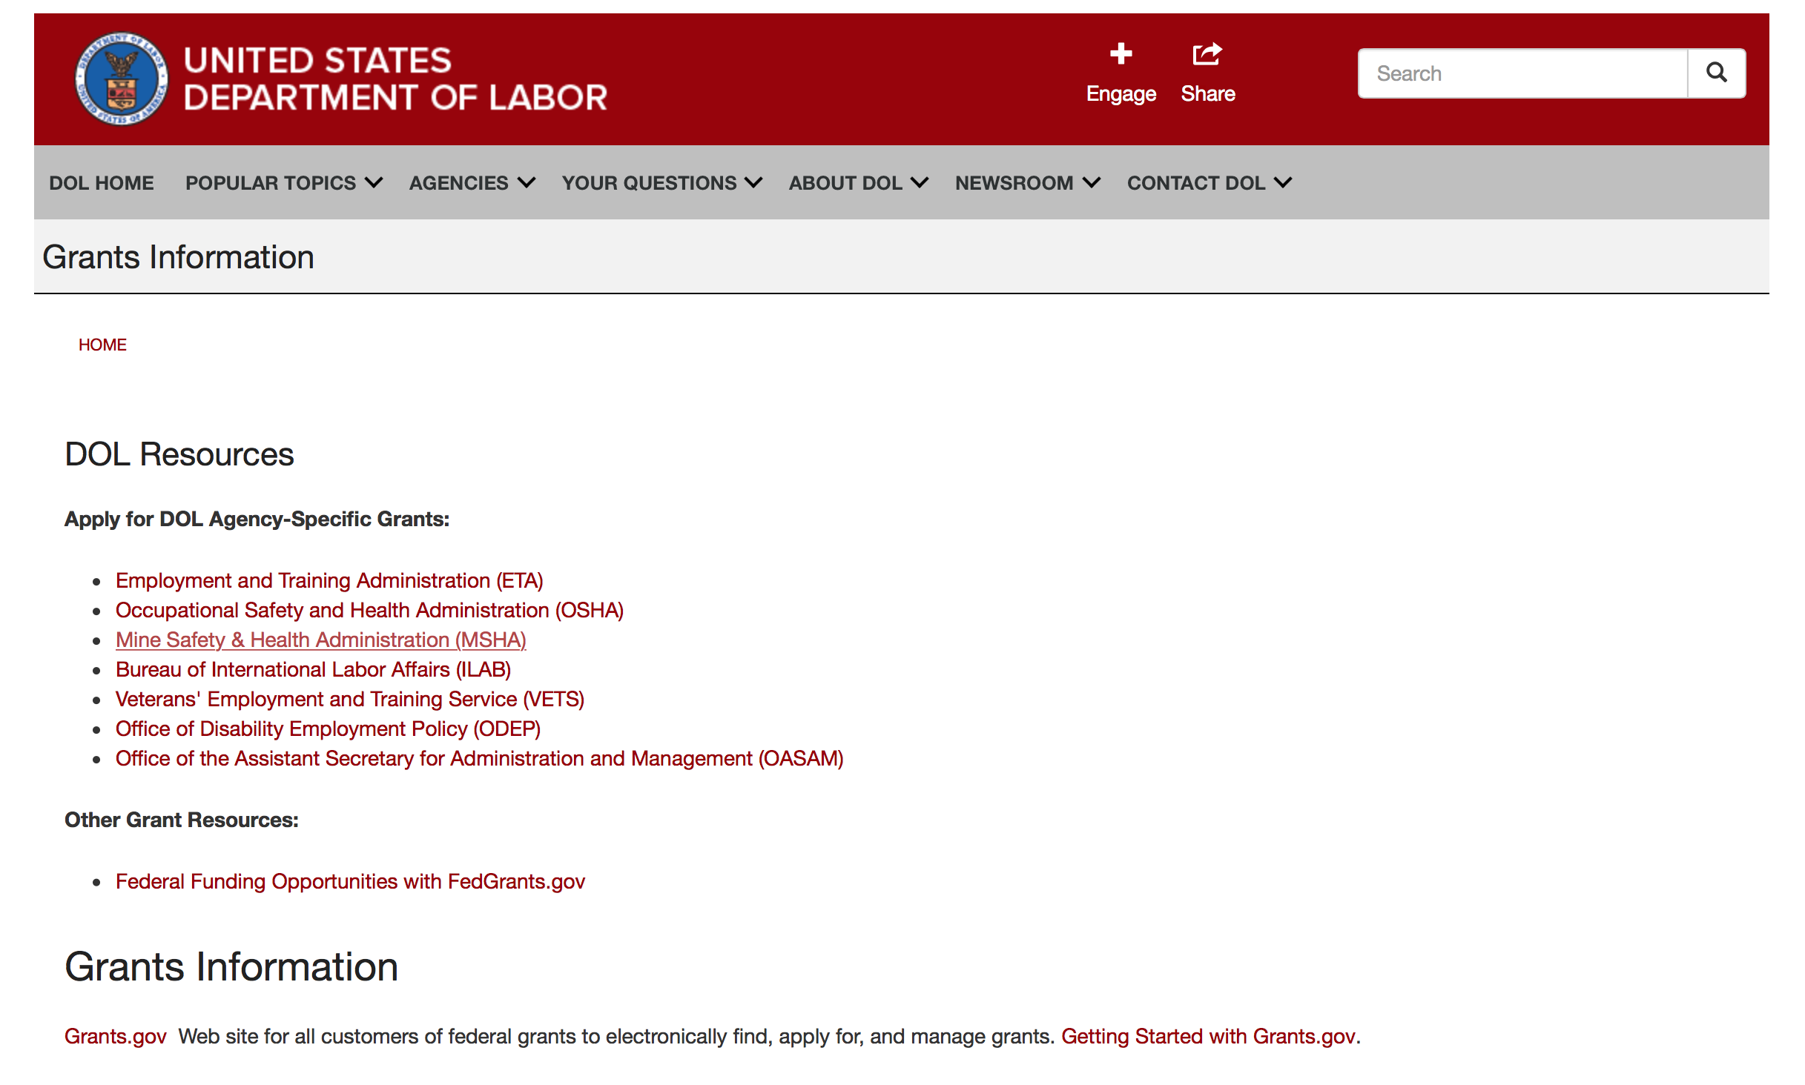

Agency Grants and Contract General Overview

DOL Resources
Apply for DOL Agency-Specific Grants:
- Employment and Training Administration (ETA)
- Occupational Safety and Health Administration (OSHA)
- Mine Safety & Health Administration (MSHA)
- Bureau of International Labor Affairs (ILAB)
- Veterans' Employment and Training Service (VETS)
- Office of Disability Employment Policy (ODEP)
- Office of the Assistant Secretary for Administration and Management (OASAM)

Other Grant Resources:
- Federal Funding Opportunities with FedGrants.gov
Grants Information
Grants.gov — Web site for all customers of federal grants to electronically find, apply for, and manage grants. Getting Started with Grants.gov.

DOL Resources and Instructions for Applying for a Grant
- DOL Guidance Clarifying the Effect of the Religious Freedom Restoration Act on Faith-Based Organizations
- Grant and Contract Information
- Contracting and Grant Program Overview
- Annual Acquisition Plan & Procurement Forecast
- Civil Rights Enforcement for Department of Labor Grant Recipients
- More Information About Grants
- Use of Contracts, Grants & Cooperative Agreements

Other Federal Government Grant Information
- List of Parties Excluded From Federal Procurement and Nonprocurement Programs (as created and maintained by GSA)
- Grant Opportunities (Catalog of Federal Domestic Assistance)

Department of Labor Grant Programs

- Bureau of International Labor Affairs (ILAB): provides grants (cooperative agreements) for the implementation of projects designed to assist developing countries combat the worse forms of child labor, forced labor, and human trafficking; and support worker rights and improve working conditions. http://www.dol.gov/general/business.
- Bureau of Labor Statistics (BLS): provides project grants (cooperative agreements) and the dissemination of technical statistical data and related information on labor force activities; provides data on prices (CPI) and cost of living; data on productivity and technology data; data on compensation and working conditions; data on employment projections.
- Employment and Training (ETA): ETA administers financial assistance programs pursuant to the Workforce Investment Act (WIA), administering State formula grant programs for youth, adults and dislocated workers, national emergency grants for workers affected by mass layoffs, plant closures, and disasters; grant programs for workers with disabilities, Indians and Native Americans, and for migrant and seasonal farmworkers. ETA also administers grant programs for older American workers, apprenticeship programs, Trade Adjustment Assistance (TAA) programs, and assistance for research and development of workforce programs. In addition, ETA is responsible for the operation and maintenance of a national system of public employment service offices and for the national unemployment insurance program.
- Mine Safety and Health (MSHA): provides grants for research, education and training programs to ensure an adequate and competent staff of trained inspectors; and assistance for establishing or improving State mine health and safety programs through technical assistance.
- Occupational Safety and Health (OSHA): provides grants to non-profit organizations to provide training, educational services, and technical assistance; assistance to states to administer and enforce state programs; assistance to states to provide occupational safety and health technical assistance and consultant services.
- Office of Disability Employment Policy (ODEP): The Office of Disability Employment Policy awards competitive grants establishing short-term pilot and technical assistance projects designed to identify, develop, test, evaluate, and disseminate policies to increase employment by expanding access to training, education, employment supports, assistive and systems technology, integrated employment, entrepreneurial development, and small business opportunities for adults and youth with disabilities. Current pilots projects focus on customized employment, Olmstead populations, and innovative demonstration youth grants, among others. Solicitations for grant applications are published in the Federal Register and announced at www.dol.gov/odep. ODEP grants are awarded by the OASAM grant office.
- Veterans' Employment and Training (VETS): provides special employment and training assistance for veterans through the Disabled Veterans' Outreach Program (DVOP) Solicitation for Grant Applications; the Local Veterans' Employment Representative Program (LVER); Veterans' Workforce Investment Program (VWIP); elaws Advisor on veterans' employment and reemployment rights; and the Homeless Veterans Reintegration Project (HVRP). VETS grants are awarded by the OASAM grant office.

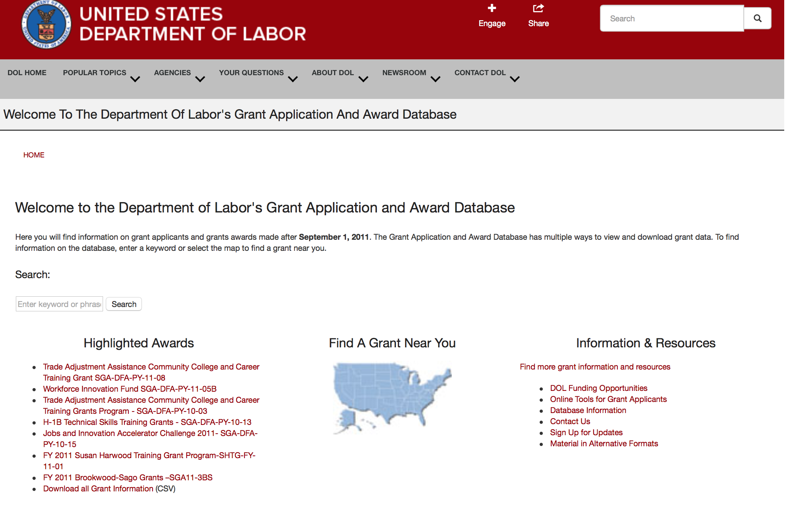

http://www.dol.gov/dol/grants/

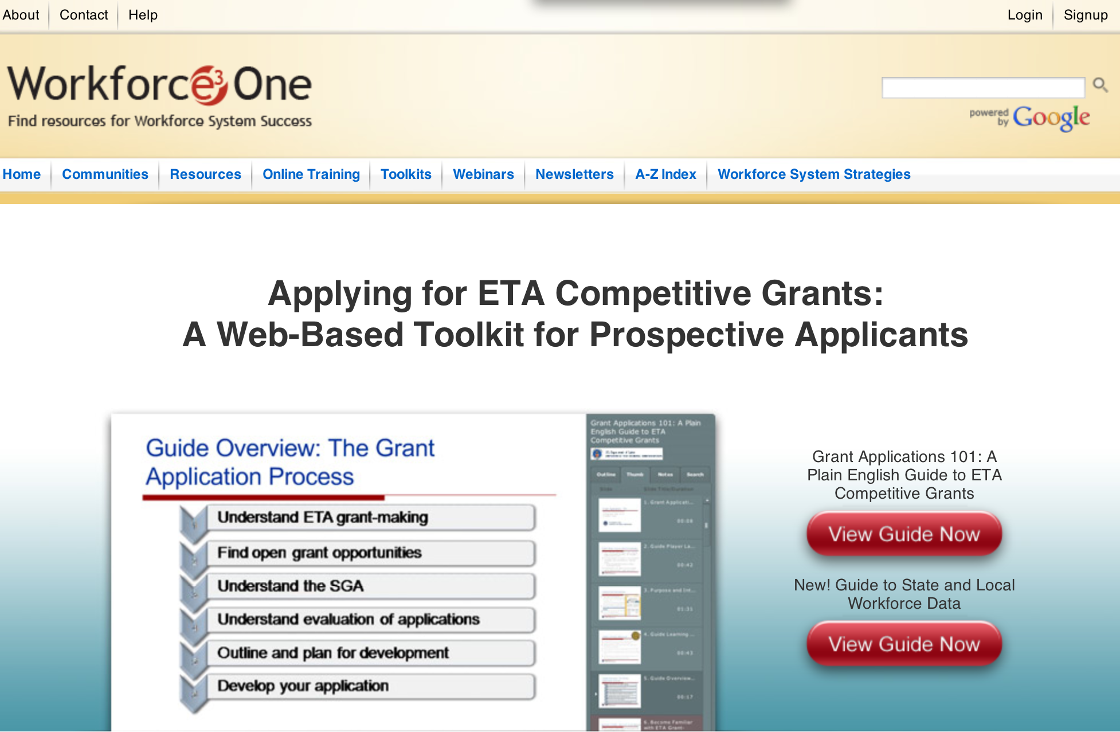

https://www.workforce3one.org/ws/www/pages/grants_toolkit.aspx?pparams=/

Programs

Employment and Training Administration
REENTRY DEMONSTRATION PROJECTS FOR YOUNG ADULTS Grant

Document Type: | Grants Notice
Funding Opportunity Number: | FOA-ETA-16-06
Funding Opportunity Title: | REENTRY DEMONSTRATION PROJECTS FOR YOUNG ADULTS
Opportunity Category: | Discretionary
Opportunity Category Explanation:
Funding Instrument Type: | Grant
Category of Funding Activity: | Employment, Labor and Training
Category Explanation:
Expected Number of Awards: | 7
CFDA Number(s): | 17.270 -- Reintegration of Ex-Offenders
Cost Sharing or Matching Requirement: | No
Posted Date: | Mar 17, 2016
Last Updated Date: | Mar 17, 2016
Original Closing Date for Applications: | Apr 19, 2016 Applications must be received no later than 4:00:00 p.m. Eastern Time.
Current Closing Date for Applications: | Apr 19, 2016 Applications must be received no later than 4:00:00 p.m. Eastern Time.
Archive Date: | May 19, 2016
Estimated Total Program Funding: | $30,250,000
Award Ceiling: | $4,500,000
Award Floor: | $0
Eligible Applicants: | Others (see text field entitled "Additional Information on Eligibility" for clarification)
Additional Information on Eligibility: | Either 1) intermediary organizations (for the purpose of this Announcement, intermediary organizations are defined as community- or faith-based organizations with 501(c)(3) non-profit status, including women’s and minority organizations, that have an affiliate network or offices in at least three communities and across at least two states) or 2) any Indian and Native American entities eligible for grants under Section 166 of WIOA that have a presence in at least three communities and across at least two states. Applicants may include current or former DOL grantees; new applicants that have not received previous DOL grants are also encouraged to apply.
Agency Name: | Employment and Training Administration
Description: | This Reentry Demonstration Projects for Young Adults Funding Opportunity Announcement (FOA) provides the opportunity for organizations to build a customized project built on evidence-based and informed interventions. These projects will serve young adults between the ages of 18 to 24 who have been involved in the juvenile or adult justice system and reside in high-poverty, high-crime communities. The focus of this initiative is to assist communities in planning and implementing comprehensive "reentry" programs to address the full range of challenges involved in helping young offenders released from incarceration make a successful transition back to the community. The intent of this initiative is to protect community safety through the successful reintegration of offenders returning to the community by ensuring that offenders: • become productive, responsible, and law-abiding citizens; • are provided with positive opportunities to engage in pro-social activities such as employment or education; • maintain long-term employment; • sustain a stable residence; and • successfully address their substance abuse issues and mental health needs.
Link to Additional Information:
Contact Information: | If you have difficulty accessing the full announcement electronically, please contact:  Ariam Ferro Grants Management Specialist  ferro.ariam@dol.gov

http://www.grants.gov/web/grants/view-opportunity.html?oppId=282295

Employment and Training Administration
The National Farmworker Jobs Program (NFJP) Employment and Training Grants and Housing
Assistance Grants

Document Type: | Grants Notice
Funding Opportunity Number: | FOA-ETA-16-02
Funding Opportunity Title: | The National Farmworker Jobs Program (NFJP) Employment and Training Grants and Housing Assistance Grants
Opportunity Category: | Discretionary
Opportunity Category Explanation:
Funding Instrument Type: | Grant
Category of Funding Activity: | Employment, Labor and Training
Category Explanation:
Expected Number of Awards: | 72
CFDA Number(s): | 17.264 -- National Farmworker Jobs Program
Cost Sharing or Matching Requirement: | No
Posted Date: | Mar 16, 2016
Last Updated Date: | Mar 16, 2016
Original Closing Date for Applications: | May 03, 2016 Applications must be received no later than 4:00:00 p.m. Eastern Time.
Current Closing Date for Applications: | May 03, 2016 Applications must be received no later than 4:00:00 p.m. Eastern Time.
Archive Date: | Jun 02, 2016
Estimated Total Program Funding: | $81,402,000
Award Ceiling: | $0
Award Floor: | $0
Eligible Applicants: | Others (see text field entitled "Additional Information on Eligibility" for clarification)
Additional Information on Eligibility: | The following organizations are eligible to apply: • State and Local Workforce Development Boards • State Agencies • State Government • County Government • City or Township Government • Public/State Controlled Institution of Higher Education • Indian/Native American Tribal Government (Federally Recognized) • Indian/Native American Tribal Government (Other than Federally Recognized) • Indian/Native American Tribally Designated Organization • Nonprofit Organization with IRS 501(c)(3) Status • Public/Indian Housing • All WIOA Section 166 Grantees The Department encourages applications from organizations who may not have received NFJP grants before, including organizations that serve populations facing multiple barriers to employment (e.g., limited-English proficiency, low educational attainment, or minimal experience with technologies and tools commonly used in the modern workplace).
Agency Name: | Employment and Training Administration
Description: | The Employment and Training Administration (ETA), U.S. Department of Labor (DOL, or the Department, or we), announces the availability of approximately $81,402,000 in grant funds authorized by the Workforce Innovation and Opportunity Act (WIOA) Section 167 for National Farmworker Jobs Program (NFJP) Employment and Training Grants and Housing Assistance Grants. This Announcement solicits applications for the National Farmworker Jobs Program (NFJP) Employment and Training Grants and Housing Assistance Grants. The purpose of this program is to assist eligible Migrant and Seasonal Farmworkers (MSFWs) and their dependents, including youth MSFWs, receive career services, training services, housing assistance services, youth services, and other related assistance services that help retain and stabilize their current agriculture jobs as well as acquire new skills they need to start careers that provide higher wages and stable, year-round employment. To support better economic outcomes for farmworkers, NFJP also works to meet a critical need for quality housing. Of the approximately $81,402,000 available, the Department intends to award approximately $75,885,000 for Employment and Training Grants and $5,517,000 for Housing Assistance Grants. These awards will have a 4-year period of performance and will fund program years (PY) 2016-2019, that is, July 1 2016-June 30, 2020.
Link to Additional Information:
Contact Information: | If you have difficulty accessing the full announcement electronically, please contact:  Amanda Denogean Grants Management Specialists  Denogean.Amanda@dol.gov

http://www.grants.gov/web/grants/view-opportunity.html?oppId=282273

Employment and Training Administration
Senior Community Service Employment Program (SCSEP) National Grants for Program Year (PY) 2016 Grant
And Modification 1

Document Type: | Grants Notice
Funding Opportunity Number: | FOA-ETA-16-04
Funding Opportunity Title: | Senior Community Service Employment Program (SCSEP) National Grants for Program Year (PY) 2016
Opportunity Category: | Discretionary
Opportunity Category Explanation:
Funding Instrument Type: | Grant
Category of Funding Activity: | Employment, Labor and Training
Category Explanation:
Expected Number of Awards: | 22
CFDA Number(s): | 17.235 -- Senior Community Service Employment Program
Cost Sharing or Matching Requirement: | Yes
Posted Date: | Mar 15, 2016
Last Updated Date: | Mar 21, 2016
Original Closing Date for Applications: | Apr 29, 2016 Applications must be received no later than 4:00:00 p.m. Eastern Time.
Current Closing Date for Applications: | Apr 29, 2016 Applications must be received no later than 4:00:00 p.m. Eastern Time.
Archive Date: | May 29, 2016
Estimated Total Program Funding: | $338,520,000
Award Ceiling: | $50,000,000
Award Floor: | $2,000,000
Eligible Applicants: | Others (see text field entitled "Additional Information on Eligibility" for clarification)
Additional Information on Eligibility: | The following organizations are eligible to apply:• Nonprofit Organizations • Federal public agencies• Tribal organizations Applicants must demonstrate their ability to administer a multi-State program that meets the eligibility and responsibility requirements outlined in 20 CFR part 641 subpart D, which are based on the statutory criteria listed in section 514(c) of the OAA. Requirements include providing evidence of legal authority to operate a multi-State program and applying to provide services in more than one State based on the award information requirements in Section II.A.2. After selection, grantees’ Statement of Work will consist of the Project Narrative submitted in response to this FOA, the number of positions assigned by county, and the signed programmatic assurances in Appendix A. We reserve the right to award a grant to only one applicant per State, and to award an applicant funds to serve only one State. This reservation does not, however, permit an applicant to apply to provide services in only one State.
Agency Name: | Employment and Training Administration
Description: | The Employment and Training Administration (ETA), U.S. Department of Labor (DOL, or the Department, or we), announces the availability of approximately $338,520,000 in grant funds authorized by Title V of the Older Americans Act (OAA) as amended in 2006, Pub. L. No. 109-365 for the Community Service Employment for Older Americans program commonly referred to as the Senior Community Service Employment Program (SCSEP), for National Grants for Program Year (PY) 2016. SCSEP is the only Federally-sponsored employment and training program targeted specifically to low-income older individuals who are able to enter or reenter the workforce. Program participants receive paid work experience at local public or non-profit agencies and are paid the higher of the Federal, State, or local minimum wage, or the prevailing wage for similar employment, for approximately 20 hours per week while in community service and other job training (OAA Amendments § 502(b)(1)(J); 20 CFR 641.565(a)). The dual goals of the program are to promote useful opportunities in community service job training and to move SCSEP participants into unsubsidized employment. This is a four-year grant, renewable annually for each of those four years based on annual Departmental application requirements and subject to the availability of funds. The grant may be extended for a fifth year at the Department’s discretion, contingent upon the grantee meeting or exceeding the minimum negotiated performance measures as required by section 514(a) of the OAA Amendments and 20 CFR 641.700.
Link to Additional Information:
Contact Information: | If you have difficulty accessing the full announcement electronically, please contact:  Jeannette Flowers Grants Management Specialist  Flowers.Jeannette@dol.gov

http://www.grants.gov/web/grants/view-opportunity.html?oppId=282220

Modifications

Reminders



National Aeronautics and Space Administration

Research and Contracting Opportunities

NASA Research Opportunities Online

- Various NASA offices publish their research announcements over the Internet, broadening the opportunity for researchers to apply for funding. This site provides access to current research announcements along with their specific due dates.

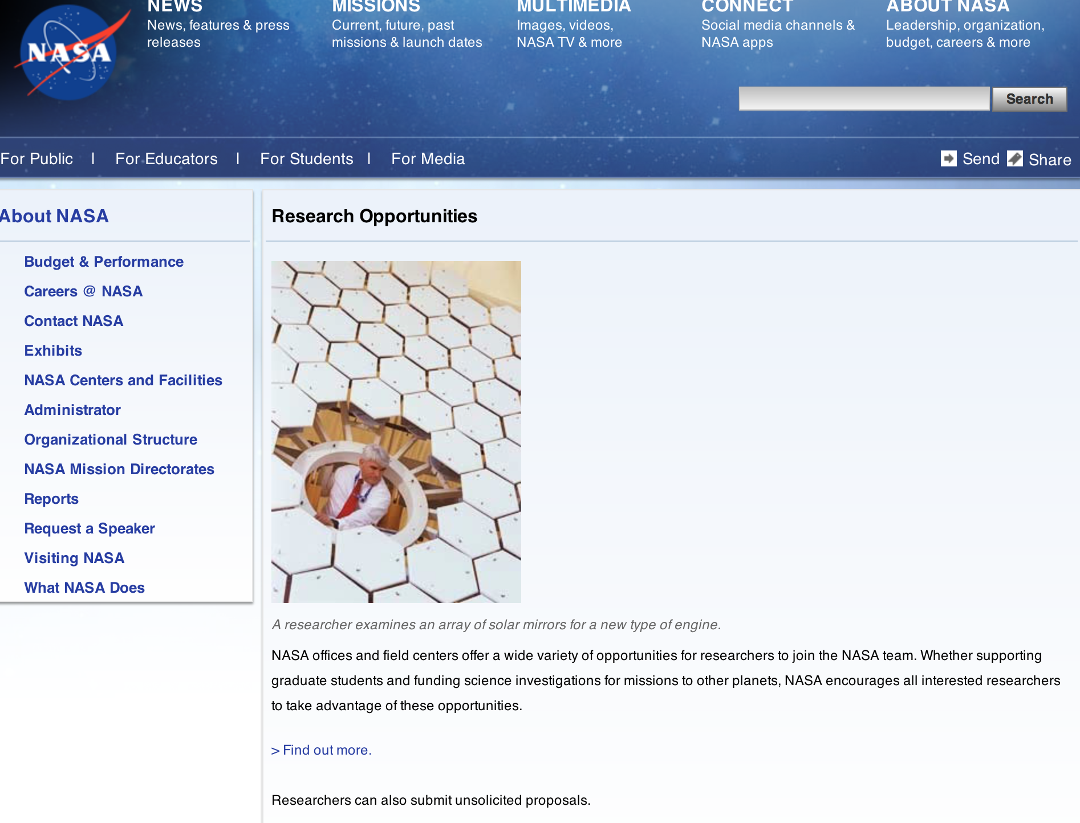

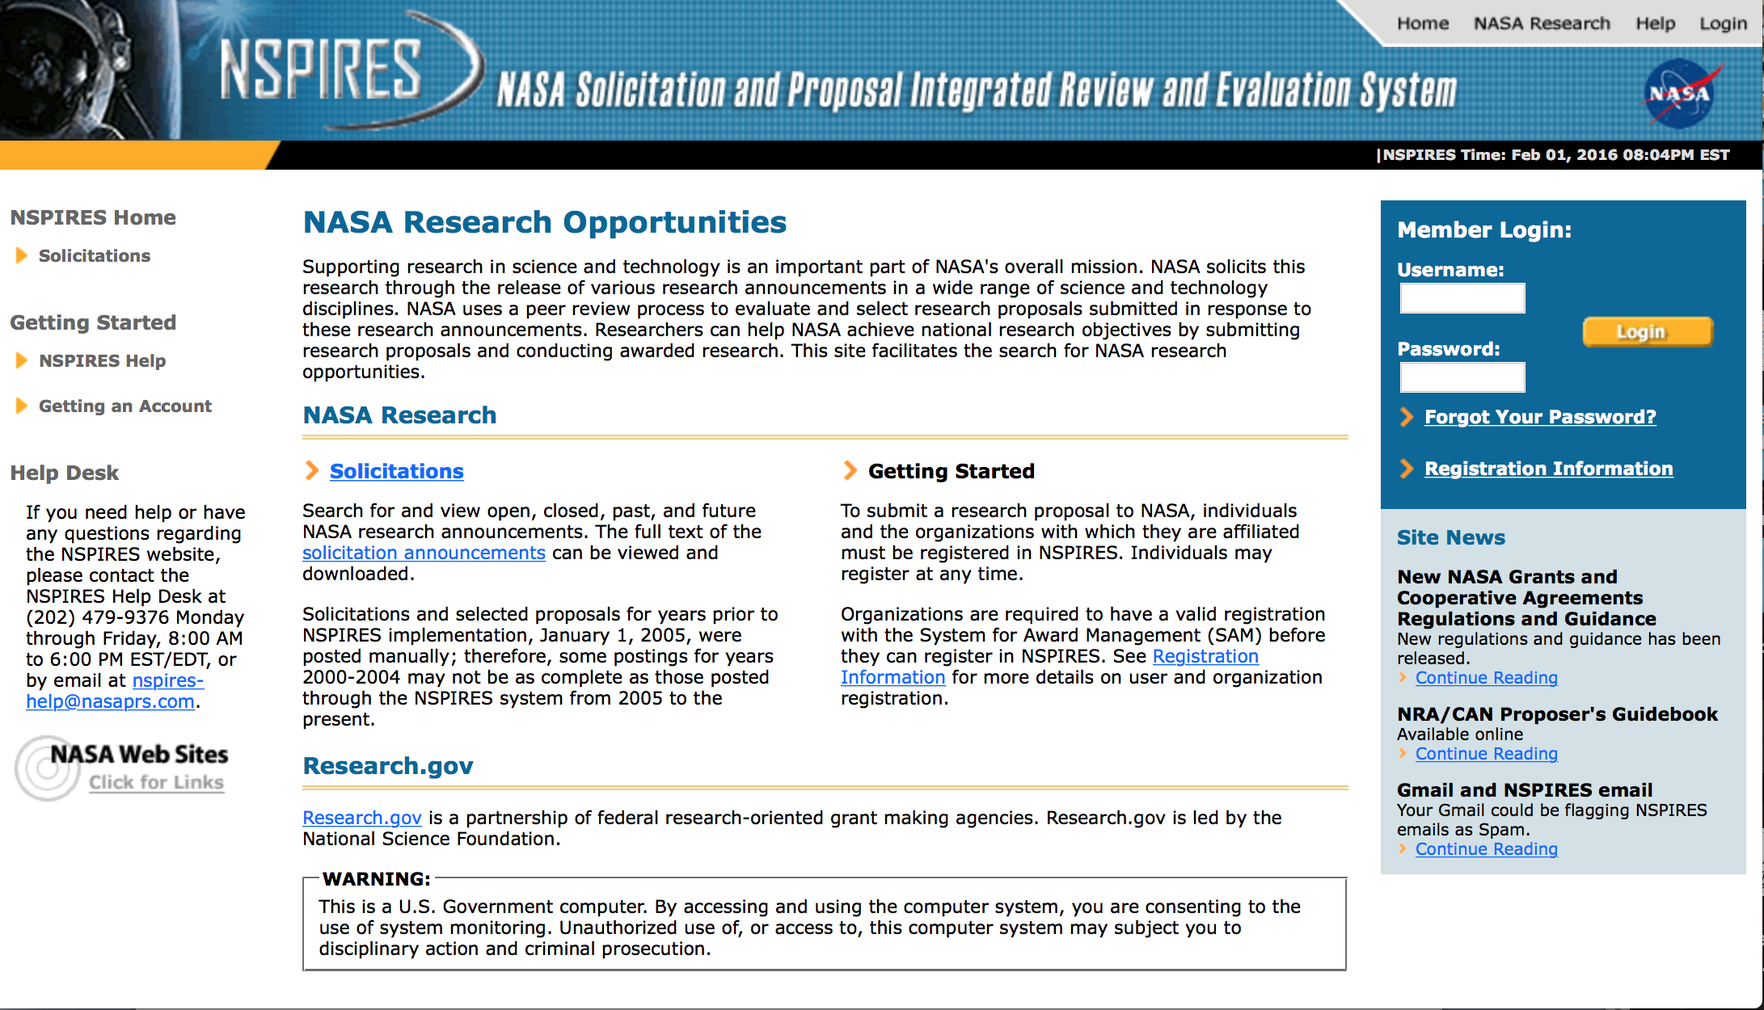

http://nspires.nasaprs.com/external/

Programs:

NASA Headquarters
ROSES 2016: Carbon Cycle Science Grant
http://www.grants.gov/web/grants/view-opportunity.html?oppId=282150

NASA Headquarters
ROSES 2016: NASA Data for Operation and Assessment Grant
http://www.grants.gov/web/grants/view-opportunity.html?oppId=281874

NASA Headquarters
ROSES 2016: Ocean Surface Topography Science Team Grant
http://www.grants.gov/web/grants/view-opportunity.html?oppId=281948

NASA Headquarters
ROSES 2016: Laboratory Analysis of Returned Samples Grant
http://www.grants.gov/web/grants/view-opportunity.html?oppId=282175

NASA Headquarters
ROSES 2016: Astrophysics Data Analysis Program Grant
http://www.grants.gov/web/grants/view-opportunity.html?oppId=282463

Research Opportunities in Space Biology (ROSBio) – 2016 “GeneLab Innovation Awards for Translational Systems Biology and Informatics Research Using the GeneLab Data System” NASA Research Announcement (NRA): Appendix A Grant
http://www.grants.gov/web/grants/view-opportunity.html?oppId=282492

NASA Headquarters
ROSES 2016: Maturation of Instruments for Solar System Exploration Grant
http://www.grants.gov/web/grants/view-opportunity.html?oppId=282380

NASA Headquarters
ROSES 2016: Earth Surface and Interior Grant
http://www.grants.gov/web/grants/view-opportunity.html?oppId=282429

NASA Headquarters
Small Spacecraft Technology Program Smallsat Technology Partnerships Appendix
Grant
http://www.grants.gov/web/grants/view-opportunity.html?oppId=282781

NASA Johnson Space Center
EXPLORATION TECHNOLOGY DEMONSTRATION AND NATIONAL LAB UTILIZATION ENHANCEMENTS
Modification 3
http://www.grants.gov/web/grants/view-opportunity.html?oppId=207073

NASA Headquarters
ROSES 2016: NASA Data for Operation and Assessment
Modification 2
http://www.grants.gov/web/grants/view-opportunity.html?oppId=281874

NASA Headquarters
ROSES 2016: Heliophysics Guest Investigators - Open
Modification 3
http://www.grants.gov/web/grants/view-opportunity.html?oppId=281740

NASA Headquarters
ROSES 2015: SERVIR Applied Sciences Team
Modification 1
http://www.grants.gov/web/grants/view-opportunity.html?oppId=279576

NASA Headquarters
ROSES 2015: Land-Cover/Land-Use Change
Modification 2
http://www.grants.gov/web/grants/view-opportunity.html?oppId=280002

National Archives and Records Administration

Grant Opportunities General Overview

To access the information below: click here

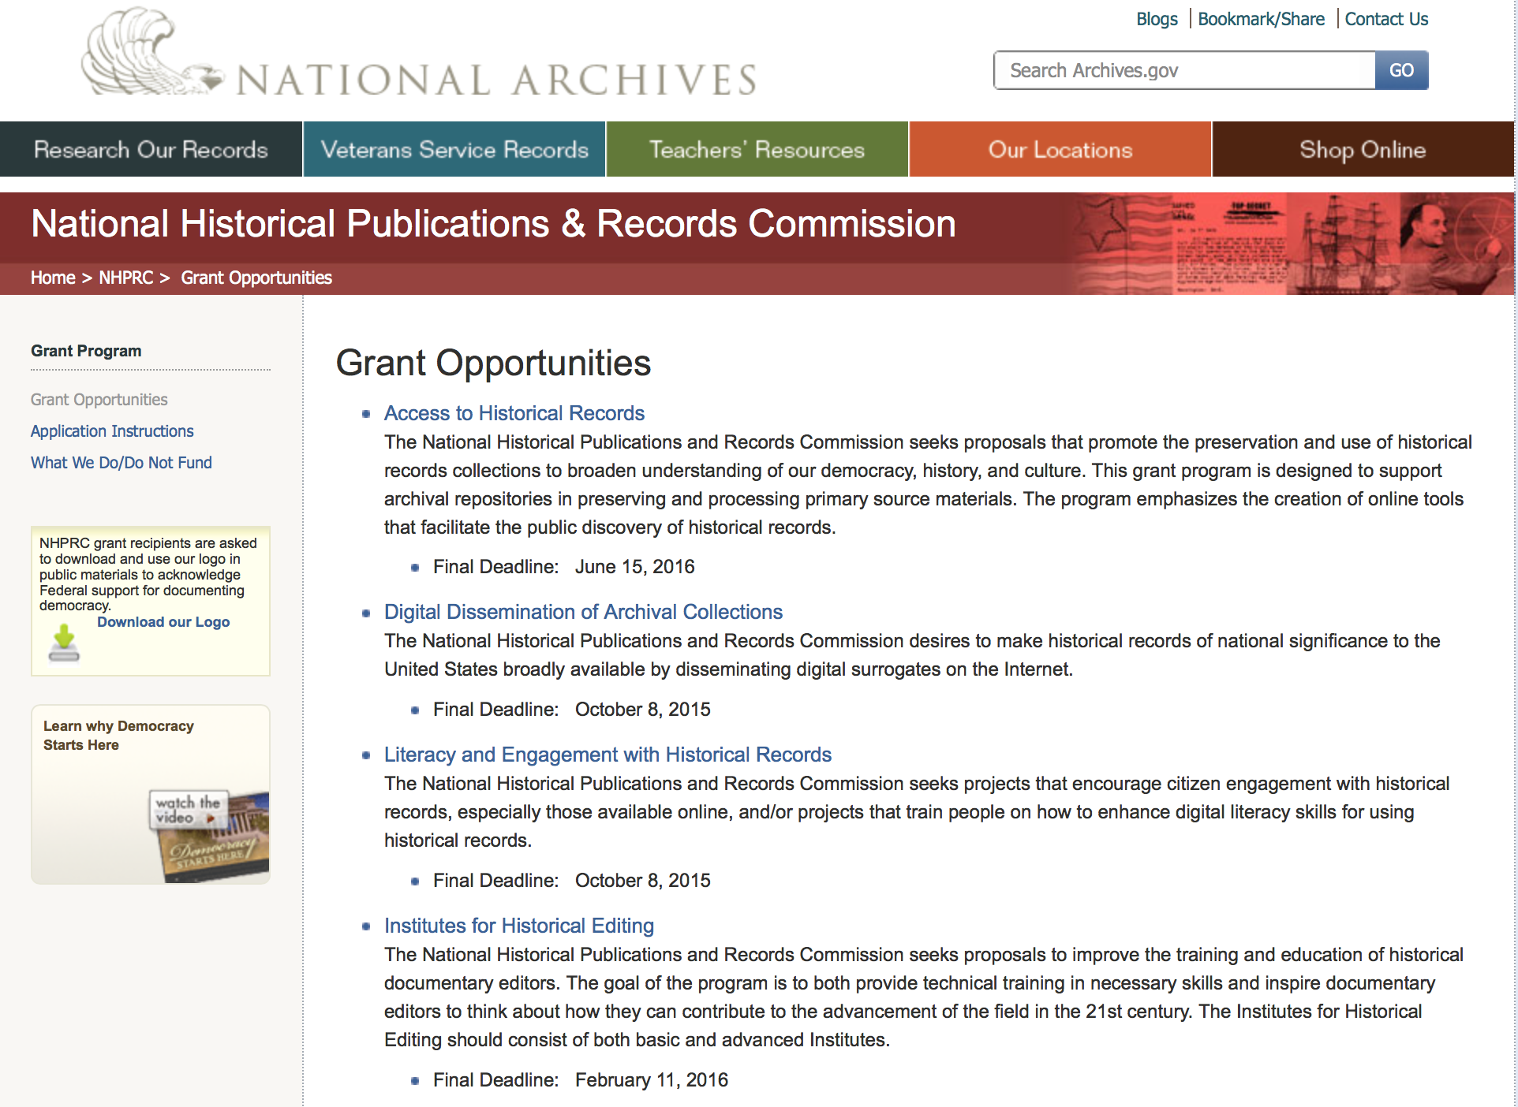

Reminders:

State Board Programming Grants

Document Type: | Grants Notice
Funding Opportunity Number: | STATE-201606
Funding Opportunity Title: | State Board Programming Grants
Opportunity Category: | Discretionary
Funding Instrument Type: | Grant
Category of Funding Activity: | Humanities (see "Cultural Affairs" in CFDA)
Category Explanation:
Expected Number of Awards: | 25
CFDA Number(s): | 89.003 -- National Historical Publications and Records Grants
Cost Sharing or Matching Requirement: | Yes
Posted Date: | Nov 24, 2015
Creation Date: | Nov 23, 2015
Original Closing Date for Applications: | Jun 15, 2016
Current Closing Date for Applications: | Jun 15, 2016
Archive Date: | Jul 15, 2016
Estimated Total Program Funding: | $650,000
Award Ceiling: | $80,000
Award Floor: | $0
Eligible Applicants: | State governments  Public and State controlled institutions of higher education  Others (see text field entitled "Additional Information on Eligibility" for clarification)  Nonprofits having a 501(c)(3) status with the IRS, other than institutions of higher education
Additional Information on Eligibility: | These grants are awarded only to SHRABs in each state, or to the state agency responsible for the SHRAB, ordinarily the state archives. Another state agency, or a non-profit organization, such as a foundation or university, acting on behalf of the designated state agency may apply. States also include the District of Columbia, the Commonwealth of Puerto Rico, and United States territories.
Agency Name: | National Archives and Records Administration
Description: | The National Historical Publications and Records Commission seeks proposals that strengthen the nation’s archival network through activities undertaken by state historical records advisory boards (SHRABs). The purpose of this grant program is to assist state boards to enhance access to historical records, increase citizen engagement with records, and provide learning and development opportunities for students, citizens and professional archivists. The Commission will award grants to State Historical Records Advisory Boards to: • Provide educational and outreach programs, workshops, and other activities that enhance citizen and student engagement with historical records • Operate state-based regrant and scholarship programs that advance access to historical records • Collaborate on projects with other organizations to address common problems or shared opportunities within a state or among a consortium of state archives • Hold or participate in meetings and public forums on statewide or national archival issues. For a comprehensive list of Commission limitations on funding, please see What We Do and Do Not Fund. Applications that consist entirely of ineligible activities will not be considered. Award Information A grant is for one year and for up to $40,000 or for two years and for up to $80,000. The NHPRC expects to award approximately 25 grants in this program. The total amount allocated for this program is up to $650,000. Grants begin no earlier than January 1, 2017. The Commission requires that grant recipients acknowledge NHPRC grant assistance in all publicity, publications, and other products that result from its support. Eligibility These grants are awarded only to SHRABs in each state, or to the state agency responsible for the SHRAB, ordinarily the state archives. Another state agency, or a non-profit organization, such as a foundation or university, acting on behalf of the designated state agency may apply. States also include the District of Columbia, the Commonwealth of Puerto Rico, and United States territories. Cost Sharing The total costs of a project are shared between the NHPRC and the applicant organization. The Commission provides no more than 75 per cent of total direct project costs in the State Board Programming Grants category. NHPRC grant recipients are not permitted to use grant funds for indirect costs (as indicated in 2 CFR 2600.101). Cost sharing is required. The applicant’s financial contribution may include both direct and indirect expenses, in-kind contributions, non-Federal third-party contributions, and any income earned directly by the project. Indirect costs must be listed under the applicant’s cost sharing contribution. Other Requirements Applicant organizations must be registered in System for Award Management (SAM) prior to submitting an application, maintain SAM registration throughout the application and award process, and include a valid DUNS number in their application. Details on SAM registration and requesting a DUNS number can be found at the System for Award Management website at https://sam.gov. Please refer to the User Guides section and the Grants Registrations PDF. A complete application includes the Application for Federal Assistance (Standard Form 424), Assurances - Non-Construction Programs (Standard Form 424B), a Project Narrative, Summary, Supplementary Materials, and Budget. Applications lacking these items will not be considered. Ineligible applications will not be reviewed.
Link to Additional Information: | Link to full grant announcement, including additional requirements
Contact Information: | If you have difficulty accessing the full announcement electronically, please contact:  Jeff de la Concepcion Grant Program Specialist Phone 202-357-5022  Grant Program Specialist

http://www.grants.gov/web/grants/view-opportunity.html?oppId=280200

Publishing Historical Records in Documentary Editions Grant

Document Type: | Grants Notice
Funding Opportunity Number: | EDITIONS-201606
Funding Opportunity Title: | Publishing Historical Records in Documentary Editions
Opportunity Category: | Discretionary
Funding Instrument Type: | Grant
Category of Funding Activity: | Humanities (see "Cultural Affairs" in CFDA)
Category Explanation:
Expected Number of Awards: | 25
CFDA Number(s): | 89.003 -- National Historical Publications and Records Grants
Cost Sharing or Matching Requirement: | Yes
Posted Date: | Nov 24, 2015
Creation Date: | Nov 23, 2015
Original Closing Date for Applications: | Jun 15, 2016
Current Closing Date for Applications: | Jun 15, 2016
Archive Date: | Jul 15, 2016
Estimated Total Program Funding: | $2,500,000
Award Ceiling: | $200,000
Award Floor: | $0
Eligible Applicants: | County governments  Native American tribal governments (Federally recognized)  City or township governments  Private institutions of higher education  Nonprofits having a 501(c)(3) status with the IRS, other than institutions of higher education  State governments  Public and State controlled institutions of higher education
Agency Name: | National Archives and Records Administration
Description: | The National Historical Publications and Records Commission seeks proposals to publish documentary editions of historical records. Projects may focus on the papers of major figures from American history or cover broad historical movements in politics, military, business, social reform, the arts, and other aspects of the national experience. The historical value of the records and their expected usefulness to broad audiences must justify the costs of the project. The goal of this program is to provide access to, and editorial context for, the historical documents and records that tell the American story. The NHPRC encourages projects, whenever possible and appropriate, to provide access to these materials in a free and open online environment, without precluding other forms of publication. Applicants should demonstrate familiarity with the best practices recommended by the Association for Documentary Editing or the Modern Language Association Committee on Scholarly Editions. Projects may also prepare print editions as part of their overall publishing plan. However, projects that do not have definitive plans for digital dissemination and preservation in place at the time of application will not be considered. It is also expected that the contents of any print volumes produced will be made available online within a reasonable period of time following print publication. Grants are awarded for collecting, describing, preserving, compiling, transcribing, annotating, editing, encoding, and publishing documentary source materials in print and online. Because of the focus on documentary sources, grants do not support preparation of critical editions of published works unless such works are just a small portion of the larger project. All applicants should be aware that the application process is highly competitive. Ongoing projects: Applicants from ongoing projects must demonstrate that they have successfully achieved the performance objectives associated with previous NHPRC awards; provide updated, current information, including a description of the new activities as well as description and significance of the specific materials to be edited during the proposed grant period; show progress towards completing the edition; and justify costs in a new budget. For a comprehensive list of Commission's limitations on funding, please see What We Do and Do Not Fund. Applications that consist entirely of ineligible activities will not be considered. Award Information A grant is for one year and for up to $200,000. The Commission expects to make up to 25 grants in this category for a total of up to $2,500,000. Grants begin no earlier than January 1, 2017. The Commission requires that grant recipients acknowledge NHPRC grant assistance in all publications and other products that result from its support. Eligibility U.S. nonprofit organizations or institutions U.S. colleges, universities, and other academic institutions State or local government agencies Federally-acknowledged or state-recognized Native American tribes or groups Cost Sharing The total costs of a project are shared between the NHPRC and the applicant organization. The Commission provides no more than 50 per cent of total direct project costs in the Publishing Historical Records in Documentary Editions category. NHPRC grant recipients are not permitted to use grant funds for indirect costs (as indicated in 2 CFR 2600.101). Cost sharing is required. The applicant’s financial contribution may include both direct and indirect expenses, in-kind contributions, non-Federal third-party contributions, and any income earned directly by the project. Indirect costs must be listed under the applicant’s cost sharing contribution. Other Requirements Applicant organizations must be registered in the System for Award Management (SAM) prior to submitting an application, maintain SAM registration throughout the application and award process, and include a valid DUNS number in their application. Details on SAM registration and requesting a DUNS number can be found at the System for Award Management website at https://sam.gov. Please refer to the User Guides section and the Grants Registrations PDF. A complete application includes the Application for Federal Assistance (Standard Form 424), Assurances -- Non-Construction Programs (Standard Form 424B), a Project Narrative, Summary, Supplementary Materials, and Budget. Applications lacking these items will not be considered. Ineligible applications will not be reviewed.
Link to Additional Information: | Link to full grant announcement, including additional requirements
Contact Information: | If you have difficulty accessing the full announcement electronically, please contact:  Jeff de la Concepcion Grant Program Specialist Phone 202-357-5022  Grant Program Specialist

http://www.grants.gov/web/grants/view-opportunity.html?oppId=280201

Publishing Historical Records in Documentary Editions Grant

Document Type: | Grants Notice
Funding Opportunity Number: | EDITIONS-201610
Funding Opportunity Title: | Publishing Historical Records in Documentary Editions
Opportunity Category: | Discretionary
Funding Instrument Type: | Grant
Category of Funding Activity: | Humanities (see "Cultural Affairs" in CFDA)
Category Explanation:
Expected Number of Awards: | 25
CFDA Number(s): | 89.003 -- National Historical Publications and Records Grants
Cost Sharing or Matching Requirement: | Yes
Posted Date: | Nov 24, 2015
Creation Date: | Nov 23, 2015
Original Closing Date for Applications: | Oct 6, 2016
Current Closing Date for Applications: | Oct 6, 2016
Archive Date: | Nov 4, 2016
Estimated Total Program Funding: | $2,500,000
Award Ceiling: | $200,000
Award Floor: | $0
Eligible Applicants: | Private institutions of higher education  County governments  City or township governments  Public and State controlled institutions of higher education  Native American tribal governments (Federally recognized)  Nonprofits having a 501(c)(3) status with the IRS, other than institutions of higher education  State governments
Agency Name: | National Archives and Records Administration
Description: | The National Historical Publications and Records Commission seeks proposals to publish documentary editions of historical records. Projects may focus on the papers of major figures from American history or cover broad historical movements in politics, military, business, social reform, the arts, and other aspects of the national experience. The historical value of the records and their expected usefulness to broad audiences must justify the costs of the project. The goal of this program is to provide access to, and editorial context for, the historical documents and records that tell the American story. The NHPRC encourages projects, whenever possible and appropriate, to provide access to these materials in a free and open online environment, without precluding other forms of publication. Applicants should demonstrate familiarity with the best practices recommended by the Association for Documentary Editing or the Modern Language Association Committee on Scholarly Editions. Projects may also prepare print editions as part of their overall publishing plan. However, projects that do not have definitive plans for digital dissemination and preservation in place at the time of application will not be considered. It is also expected that the contents of any print volumes produced will be made available online within a reasonable period of time following print publication. Grants are awarded for collecting, describing, preserving, compiling, transcribing, annotating, editing, encoding, and publishing documentary source materials in print and online. Because of the focus on documentary sources, grants do not support preparation of critical editions of published works unless such works are just a small portion of the larger project. All applicants should be aware that the application process is highly competitive. Ongoing projects: Applicants from ongoing projects must demonstrate that they have successfully achieved the performance objectives associated with previous NHPRC awards; provide updated, current information, including a description of the new activities as well as description and significance of the specific materials to be edited during the proposed grant period; show progress towards completing the edition; and justify costs in a new budget. For a comprehensive list of Commission's limitations on funding, please see What We Do and Do Not Fund. Applications that consist entirely of ineligible activities will not be considered. Award Information A grant is for one year and for up to $200,000. The Commission expects to make up to 25 grants in this category for a total of up to $2,500,000. Grants begin no earlier than January 1, 2017. The Commission requires that grant recipients acknowledge NHPRC grant assistance in all publications and other products that result from its support. Eligibility U.S. nonprofit organizations or institutions U.S. colleges, universities, and other academic institutions State or local government agencies Federally-acknowledged or state-recognized Native American tribes or groups Cost Sharing The total costs of a project are shared between the NHPRC and the applicant organization. The Commission provides no more than 50 per cent of total direct project costs in the Publishing Historical Records in Documentary Editions category. NHPRC grant recipients are not permitted to use grant funds for indirect costs (as indicated in 2 CFR 2600.101). Cost sharing is required. The applicant’s financial contribution may include both direct and indirect expenses, in-kind contributions, non-Federal third-party contributions, and any income earned directly by the project. Indirect costs must be listed under the applicant’s cost sharing contribution. Other Requirements Applicant organizations must be registered in the System for Award Management (SAM) prior to submitting an application, maintain SAM registration throughout the application and award process, and include a valid DUNS number in their application. Details on SAM registration and requesting a DUNS number can be found at the System for Award Management website at https://sam.gov. Please refer to the User Guides section and the Grants Registrations PDF. A complete application includes the Application for Federal Assistance (Standard Form 424), Assurances -- Non-Construction Programs (Standard Form 424B), a Project Narrative, Summary, Supplementary Materials, and Budget. Applications lacking these items will not be considered. Ineligible applications will not be reviewed.
Link to Additional Information: | Link to full grant announcement, including additional requirements
Contact Information: | If you have difficulty accessing the full announcement electronically, please contact:  Jeff de la Concepcion Grant Program Specialist Phone 202-357-5022  Grant Program Specialist

http://www.grants.gov/web/grants/view-opportunity.html?oppId=280202

Access to Historical Records Grant

Document Type: | Grants Notice
Funding Opportunity Number: | ACCESS-201606
Funding Opportunity Title: | Access to Historical Records
Opportunity Category: | Discretionary
Funding Instrument Type: | Grant
Category of Funding Activity: | Humanities (see "Cultural Affairs" in CFDA)
Category Explanation:
Expected Number of Awards: | 14
CFDA Number(s): | 89.003 -- National Historical Publications and Records Grants
Cost Sharing or Matching Requirement: | Yes
Posted Date: | Nov 24, 2015
Creation Date: | Nov 23, 2015
Original Closing Date for Applications: | Jun 15, 2016
Current Closing Date for Applications: | Jun 15, 2016
Archive Date: | Jul 15, 2016
Estimated Total Program Funding: | $1,000,000
Award Ceiling: | $200,000
Eligible Applicants: | Public and State controlled institutions of higher education  State governments  City or township governments  Nonprofits having a 501(c)(3) status with the IRS, other than institutions of higher education  Private institutions of higher education  Native American tribal governments (Federally recognized)  County governments
Agency Name: | National Archives and Records Administration
Description: | The National Historical Publications and Records Commission seeks proposals that promote the preservation and use of historical records collections to broaden understanding of our democracy, history, and culture. This grant program is designed to support archival repositories in preserving and processing primary source materials. The program emphasizes the creation of online tools that facilitate the public discovery of historical records. The Commission looks to fund projects that undertake one or more of the following activities: • Preservation, arrangement, and online description of historical records in all formats • Digital preservation of electronic records and unstable audio or moving image formats After completing arrangement and description activities, applicants may also propose to digitize materials to provide online access to collections. For a comprehensive list of Commission limitations on funding, please see “What we do and do not fund” (http://www.archives.gov/nhprc/apply/eligibility.html). Applications that consist entirely of ineligible activities will not be considered. Award Information A grant is for one to two years and for up to $200,000. The Commission expects to make up to 14 grants in this category for a total of up to $1,000,000. Grants begin no earlier than January 1, 2017. The Commission requires that grant recipients acknowledge NHPRC grant assistance in all publicity, publications, and other products that result from its support. Eligibility Information Eligible applicants: • Nonprofit organizations or institutions • Colleges, universities, and other academic institutions • State or local government agencies • Federally-acknowledged or state-recognized Native American tribes or groups Cost Sharing - The total costs of a project are shared between the NHPRC and the applicant organization. The Commission provides no more than 50 per cent of total direct project costs in the Access to Historical Records category. NHPRC grant recipients are not permitted to use grant funds for indirect costs (as indicated in 2 CFR 2600.101). Cost sharing is required. The applicant’s financial contribution may include both direct and indirect expenses, in-kind contributions, non-Federal third-party contributions, and any income earned directly by the project. Indirect costs must be listed under the applicant’s cost sharing contribution. Other Requirements - Applicant organizations must be registered in the System for Award Management (SAM) prior to submitting an application, maintain SAM registration throughout the application and award process, and include a valid DUNS number in their application. Details on SAM registration and requesting a DUNS number can be found at the System for Award Management website at http://sam.gov. Please refer to the User Guides section and the Grants Registrations PDF. A complete application includes the Application for Federal Assistance (Standard Form 424), Assurances -- Non-Construction Programs (Standard Form 424B), a Project Narrative, Summary, Supplementary Materials, and Budget. Applications lacking these items will not be considered. Ineligible applications will not be reviewed.
Link to Additional Information: | Link to full grant announcement, including additional requirements
Contact Information: | If you have difficulty accessing the full announcement electronically, please contact:  Jeff de la Concepcion Grant Program Specialist Phone 202-357-5022  Grant Program Specialist

http://www.grants.gov/web/grants/view-opportunity.html?oppId=280217

National Endowment for the Arts

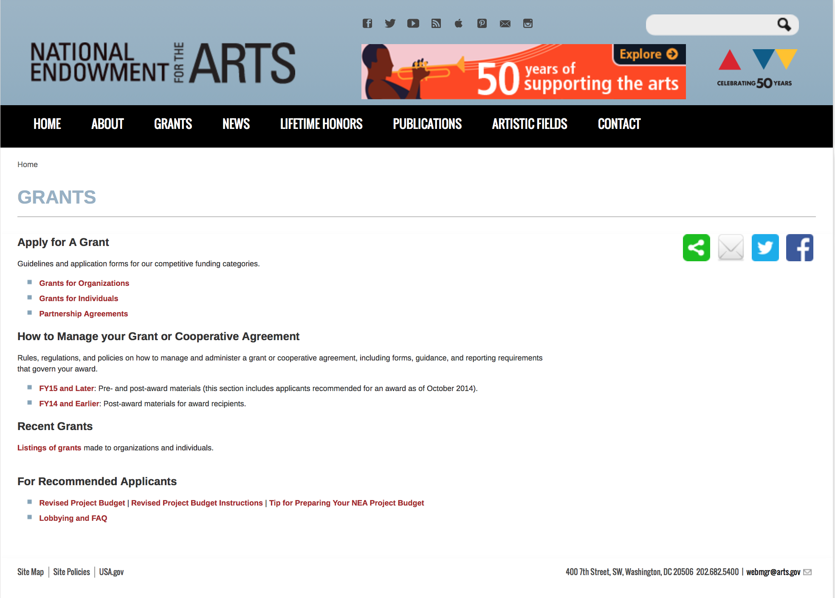

http://arts.gov/grants

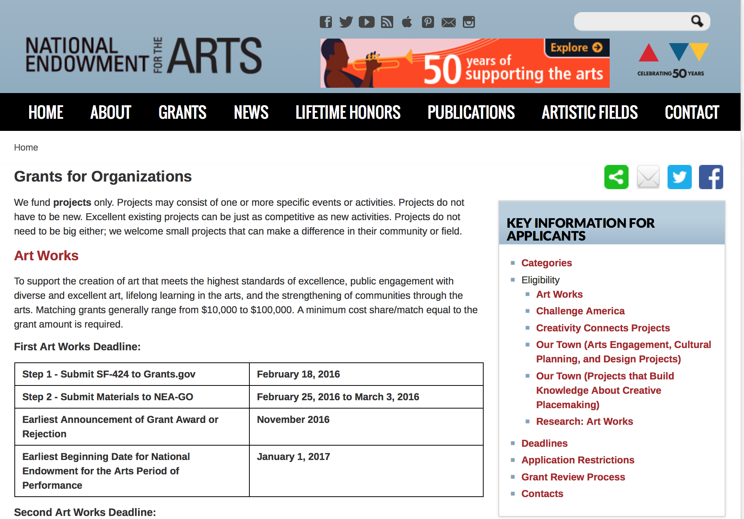
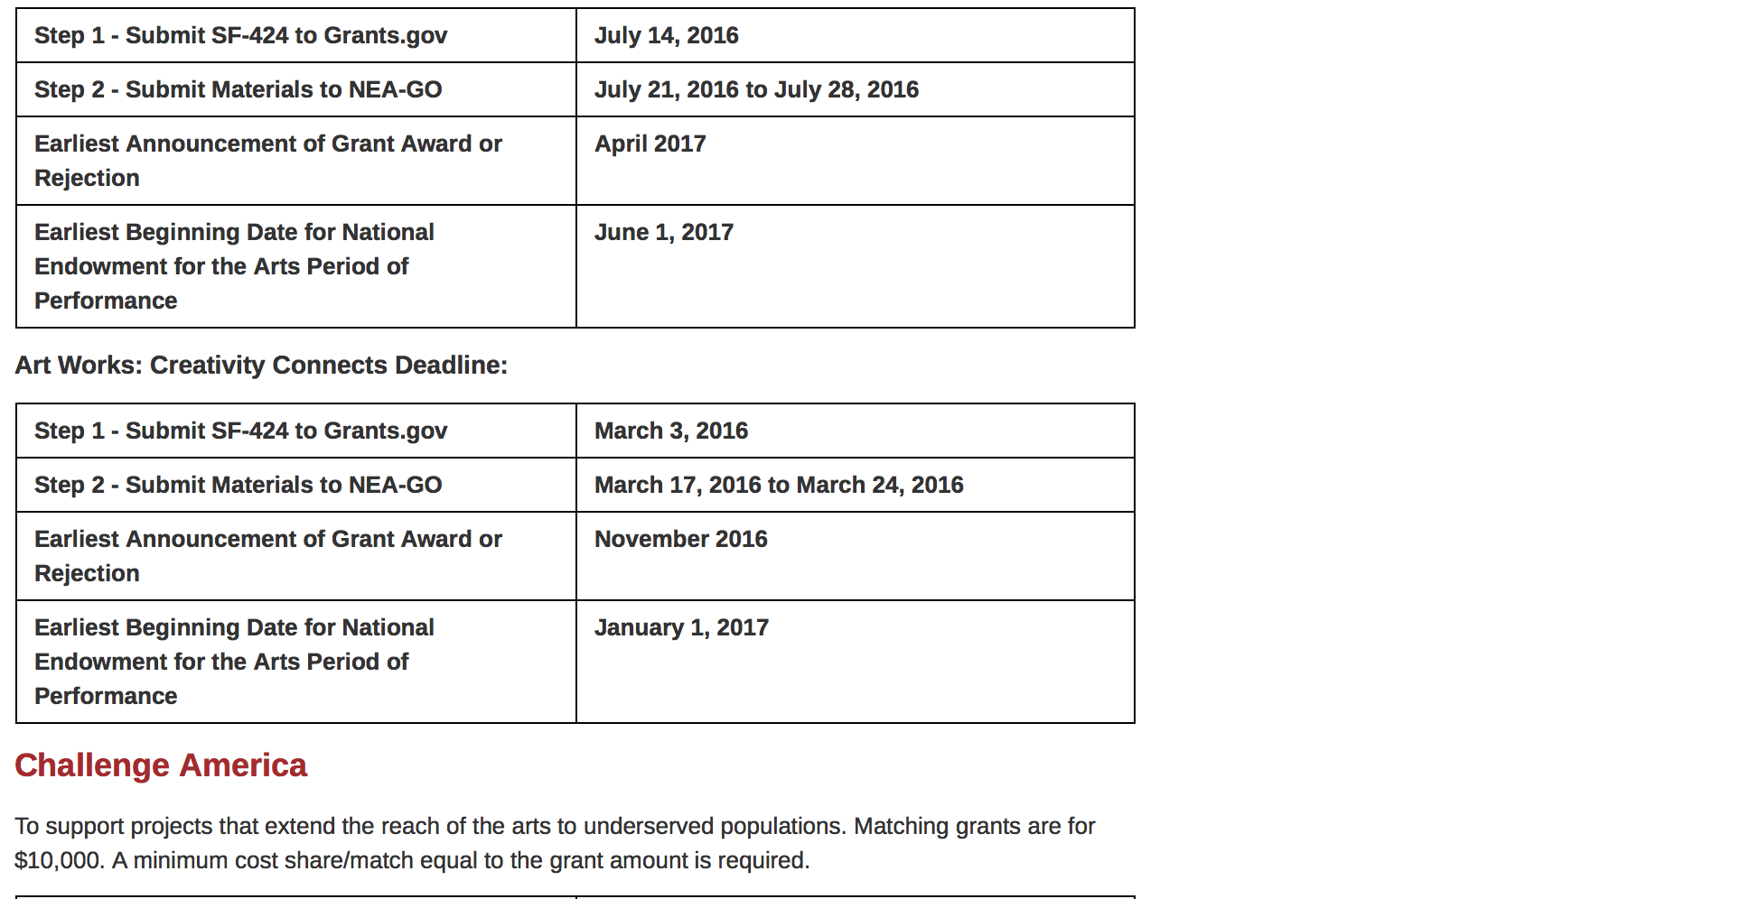
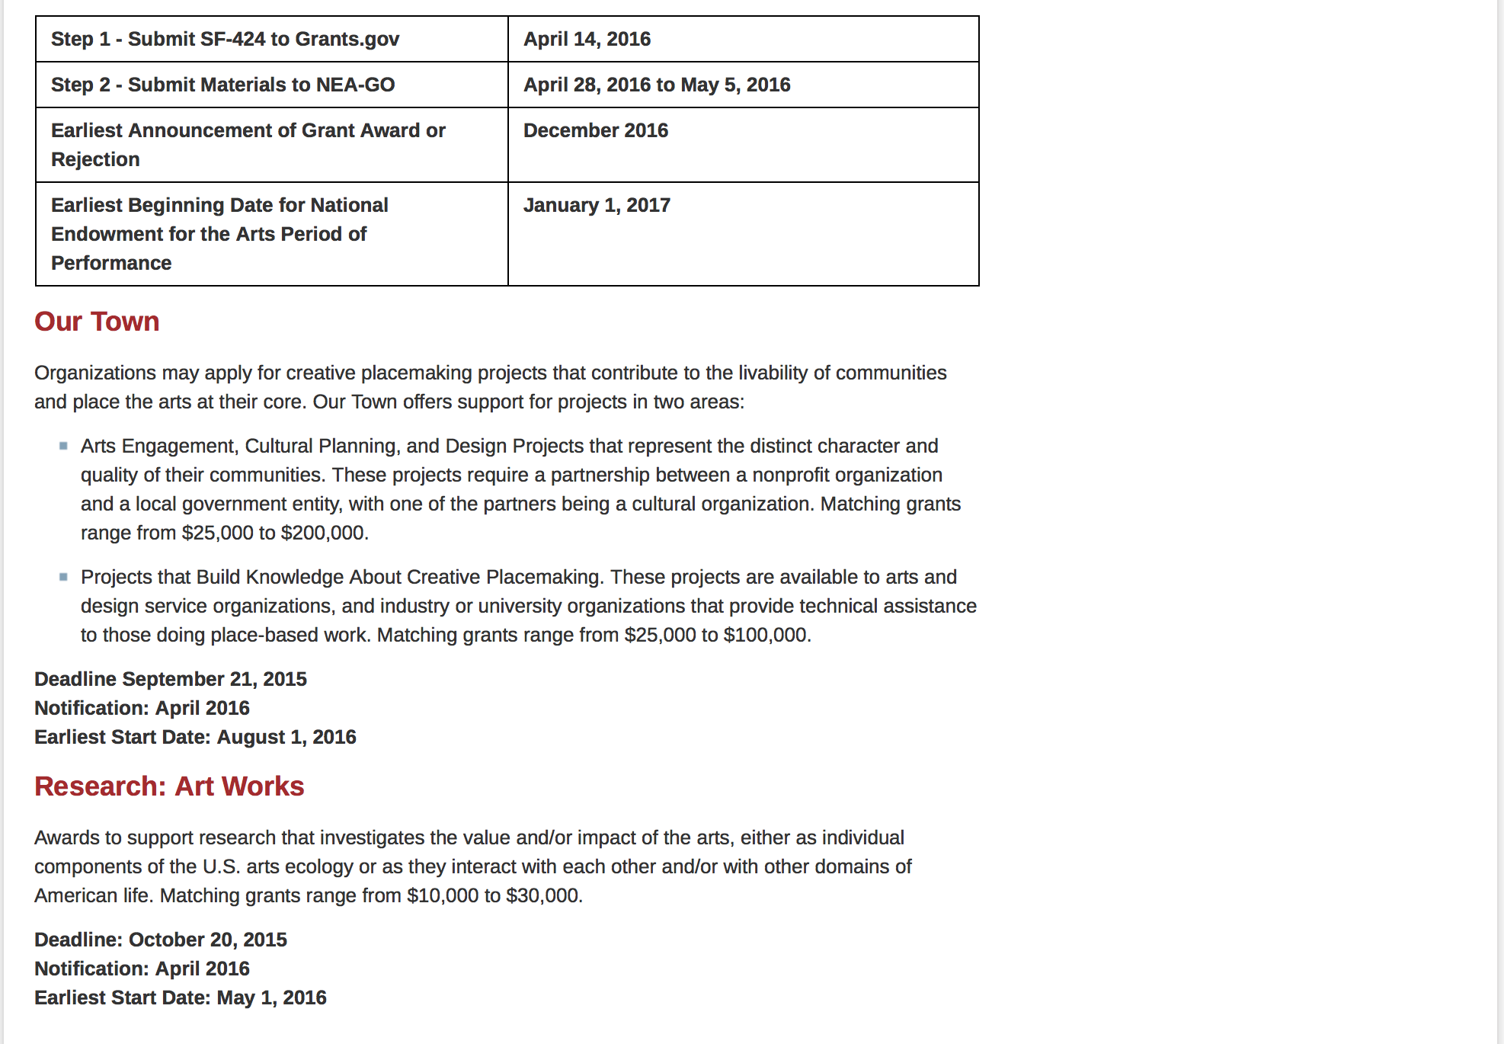
See more at: https://www.arts.gov/grants/apply-grant/grants-organizations

Programs:

Modifications:

Reminders:

NEA Challenge America Application, FY2017 Grant

Document Type: | Grants Notice
Funding Opportunity Number: | 2016NEA01CA
Funding Opportunity Title: | NEA Challenge America Application, FY2017
Opportunity Category: | Discretionary
Funding Instrument Type: | Grant
Category of Funding Activity: | Arts (see "Cultural Affairs" in CFDA)
Category Explanation:
Expected Number of Awards:
CFDA Number(s): | 45.024 -- Promotion of the Arts Grants to Organizations and Individuals
Cost Sharing or Matching Requirement: | Yes
Posted Date: | Dec 15, 2015
Creation Date: | Dec 15, 2015
Original Closing Date for Applications: | Apr 14, 2016 “The Grants.gov system must receive your validated and accepted application no later than 11:59 p.m., Eastern Time, on April 14, 2016.”
Current Closing Date for Applications: | Apr 14, 2016 “The Grants.gov system must receive your validated and accepted application no later than 11:59 p.m., Eastern Time, on April 14, 2016.”
Archive Date: | May 14, 2016
Estimated Total Program Funding:
Award Ceiling: | $10,000
Award Floor: | $10,000
Eligible Applicants: | County governments  Private institutions of higher education  Native American tribal governments (Federally recognized)  State governments  Public and State controlled institutions of higher education  Independent school districts  Special district governments  Nonprofits having a 501(c)(3) status with the IRS, other than institutions of higher education  City or township governments
Additional Information on Eligibility: | The Arts Endowment's support of a project may start on or after January 1, 2017. Grants awarded under these guidelines generally may cover a period of performance of up to two years. An organization that has received Challenge America grants in FY 2014, 2015, and 2016 may not apply for a Challenge America grant under these FY 2017 guidelines. Applicant Eligibility Nonprofit, tax-exempt 501(c)(3), U.S. organizations; units of state or local government; or federally recognized tribal communities or tribes may apply. Applicants may be arts organizations, local arts agencies, arts service organizations, local education agencies (school districts), and other organizations that can help advance the goals of the National Endowment for the Arts.
Agency Name: | National Endowment for the Arts
Description: | The Arts Endowment's support of a project may start on or after January 1, 2017. Grants awarded under these guidelines generally may cover a period of performance of up to two years. An organization that has received Challenge America grants in FY 2014, 2015, and 2016 may not apply for a Challenge America grant under these FY 2017 guidelines. Grant Program Description The Challenge America category offers support primarily to small and mid-sized organizations for projects that extend the reach of the arts to underserved populations -- those whose opportunities to experience the arts are limited by geography, ethnicity, economics, or disability. Age alone (e.g., youth, seniors) does not qualify a group as underserved; at least one of the underserved characteristics noted above also must be present. Grants are available for professional arts programming and for projects that emphasize the potential of the arts in community development. This category encourages and supports the following objective: • Engagement: Engaging the public with diverse and excellent art.
Link to Additional Information: | NEA Complete Website Announcement
Contact Information: | If you have difficulty accessing the full announcement electronically, please contact:  NEA Web Manager  NEA Web Manager

http://www.grants.gov/web/grants/view-opportunity.html?oppId=280532

National Endowment for the Humanities

Grant Overview -

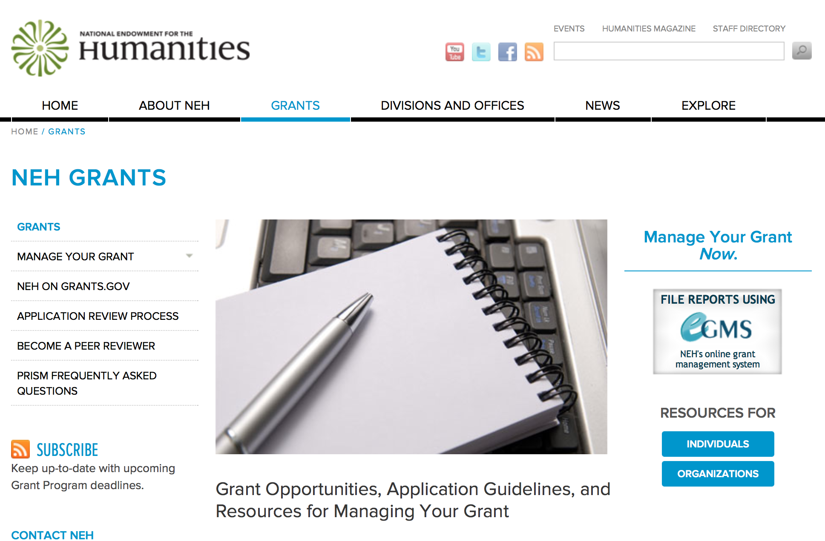

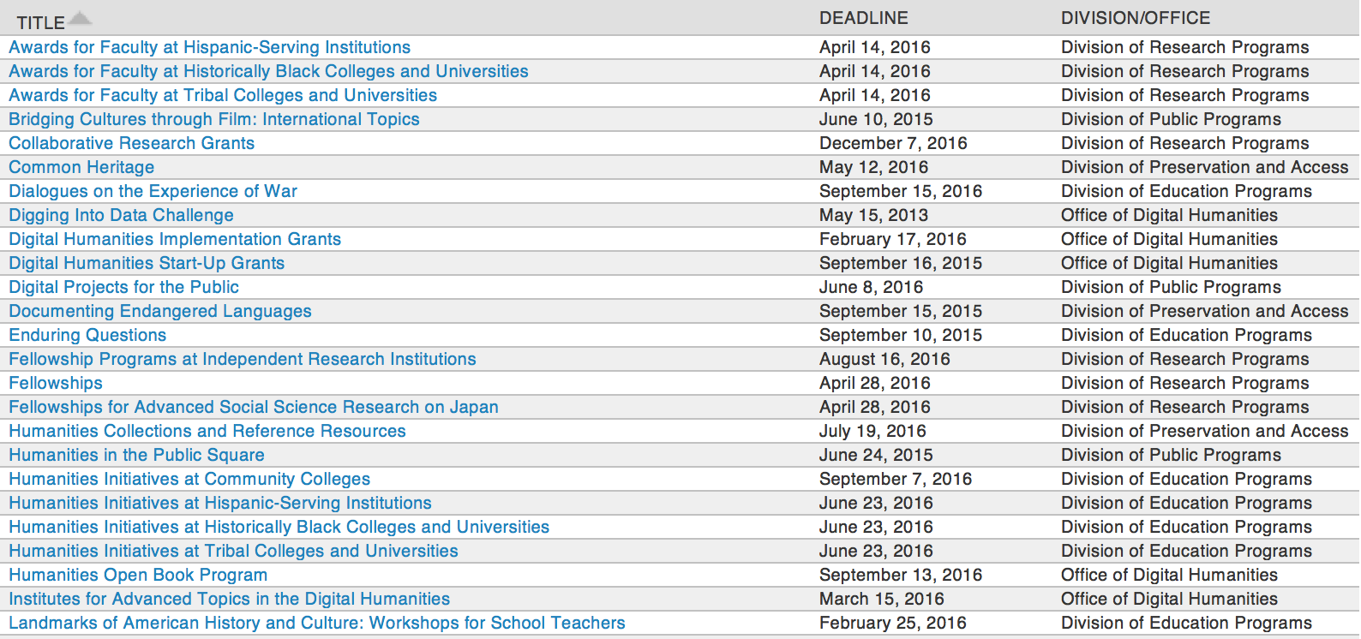

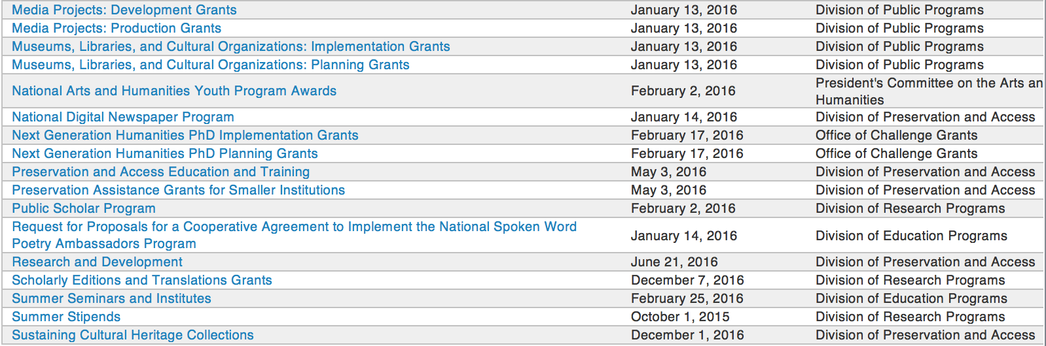

http://www.neh.gov/grants/grantsbydivision.html

Programs:

Common Heritage Grant

Document Type: | Grants Notice
Funding Opportunity Number: | 20160512-PY
Funding Opportunity Title: | Common Heritage
Opportunity Category: | Discretionary
Opportunity Category Explanation:
Funding Instrument Type: | Grant
Category of Funding Activity: | Humanities (see "Cultural Affairs" in CFDA)
Category Explanation:
Expected Number of Awards:
CFDA Number(s): | 45.149 -- Promotion of the Humanities Division of Preservation and Access
Cost Sharing or Matching Requirement: | No
Posted Date: | Mar 11, 2016
Last Updated Date: | Mar 11, 2016
Original Closing Date for Applications: | May 12, 2016
Current Closing Date for Applications: | May 12, 2016
Archive Date:
Estimated Total Program Funding:
Award Ceiling: | $12,000
Award Floor: | $1
Eligible Applicants: | Native American tribal governments (Federally recognized)  State governments  Public and State controlled institutions of higher education  Private institutions of higher education  County governments  Nonprofits that do not have a 501(c)(3) status with the IRS, other than institutions of higher education  City or township governments  Nonprofits having a 501(c)(3) status with the IRS, other than institutions of higher education  Special district governments
Agency Name: | National Endowment for the Humanities
Description: | America’s cultural heritage is preserved not only in libraries, museums, archives, and other community organizations, but also in all of our homes, family histories, and life stories. The Common Heritage program aims to capture this vitally important part of our country’s heritage and preserve it for future generations. Common Heritage will support both the digitization of cultural heritage materials and the organization of public programming at community events that explore these materials as a window on a community’s history and culture. The Common Heritage program recognizes that members of the public—in partnership with libraries, museums, archives, and historical organizations—have much to contribute to the understanding of our cultural mosaic. Together, such institutions and the public can be effective partners in the appreciation and stewardship of our common heritage. The program supports day-long events organized by community cultural institutions, which members of the public will be invited to attend. At these events experienced staff will digitize the community historical materials brought in by the public. Project staff will also record descriptive information—provided by community attendees—about the historical materials. Contributors will be given a free digital copy of their items to take home, along with the original materials. With the owner’s permission, digital copies of these materials would be included in the institutions’ collections. Historical photographs, artifacts, documents, family letters, art works, and audiovisual recordings are among the many items eligible for digitization and public commemoration. Projects must also present public programming that would expand knowledge of the community’s heritage. Public programs could include lectures, panels, reading and discussion, special gallery tours, screening and discussion of relevant films, presentations by a historian, special initiatives for families and children, or comments by curators about items brought in by the public, workshops on preserving heritage materials, or other activities that bring humanities perspectives on heritage materials to wide public audiences. These public programs should provide a framework for a deeper understanding of the community members’ shared or divergent heritage. The programs may take place before, during, and/or after the day of the digitization event. Applicants may but need not include in their proposals a topic around which the event and the public programming would be organized. Topics proposed for the public programming may also be proposed for the digitization event. The applicant institution must plan, promote, and organize the event and ensure that a wide range of historical materials can be digitized and also contextualized through public programming. Since the help of additional institutions and organizations in the community may be needed to accomplish this work, the applicant must take responsibility for enlisting appropriate organizations or institutions, such as local libraries and museums, to contribute to the project, as needed. NEH especially welcomes applications from small and medium-sized institutions that have not previously received NEH support.
Link to Additional Information: | http://www.neh.gov/grants/preservation/common-heritage
Contact Information: | If you have difficulty accessing the full announcement electronically, please contact:  Common Heritage National Endowment for the Humanities 400 Seventh Street, SW Washington, DC 20506 202-606-8570 or preservation@neh.gov preservation@neh.gov  preservation@neh.gov

http://www.grants.gov/web/grants/view-opportunity.html?oppId=282148

Humanities Open Book Program Grant

Document Type: | Grants Notice
Funding Opportunity Number: | 20160913-HZ
Funding Opportunity Title: | Humanities Open Book Program
Opportunity Category: | Discretionary
Opportunity Category Explanation:
Funding Instrument Type: | Grant
Category of Funding Activity: | Humanities (see "Cultural Affairs" in CFDA)
Category Explanation:
Expected Number of Awards:
CFDA Number(s): | 45.169 -- Promotion of the Humanities_Office of Digital Humanities
Cost Sharing or Matching Requirement: | No
Posted Date: | Mar 22, 2016
Last Updated Date: | Mar 22, 2016
Original Closing Date for Applications: | Sep 13, 2016
Current Closing Date for Applications: | Sep 13, 2016
Archive Date:
Estimated Total Program Funding:
Award Ceiling: | $100,000
Award Floor: | $50,000
Eligible Applicants: | Native American tribal governments (Federally recognized)  Special district governments  Public and State controlled institutions of higher education  City or township governments  Private institutions of higher education  County governments  Nonprofits having a 501(c)(3) status with the IRS, other than institutions of higher education  Nonprofits that do not have a 501(c)(3) status with the IRS, other than institutions of higher education  State governments
Agency Name: | National Endowment for the Humanities
Description: | The Humanities Open Book Program is designed to make outstanding out-of-print humanities books available to a wide audience. By taking advantage of low-cost “ebook” technology, the program will allow teachers, students, scholars, and the public to read humanities books that have long been out of print. Humanities Open Book is jointly sponsored by NEH and the Andrew W. Mellon Foundation. Traditionally, printed books have been the primary medium for expressing, communicating, and debating humanistic ideas. However, the vast majority of humanities books sell a small number of copies and then quickly go out of print. Most scholarly books printed since 1923 are not in the public domain and are not easily available to the general public. As a result, there is a huge, mostly untapped resource of remarkable scholarship going back decades that is largely unused by today’s scholars, teachers, students, and members of the public, many of whom turn first to the Internet when looking for information. Modern ebook technology can make these books far more accessible than they are today. NEH and Mellon are soliciting proposals from academic presses, scholarly societies, museums, and other institutions that publish books in the humanities to participate in the Humanities Open Book Program. Applicants will provide a list of previously published humanities books along with brief descriptions of the books and their intellectual significance. Depending on the length and topics of the books, the number to be digitized may vary. However, NEH and Mellon anticipate that applicants may propose to digitize a total that ranges from less than fifty to more than one hundred books. Awards will be given to digitize these books and make them available as Creative Commons-licensed “ebooks” that can be read by the public at no charge on computers, mobile devices, and ebook readers. The final ebook files must be in EPUB version 3.0.1 (or later) format, to ensure that the text is fully searchable and reflowable and that fonts are resizable on any e-reading device.
Link to Additional Information: | http://www.neh.gov/grants/odh/humanities-open-book-program
Contact Information: | If you have difficulty accessing the full announcement electronically, please contact:  If you have questions about the program, contact the ODH staff at odh@neh.gov. Applicants wishing to speak to a staff member by telephone should provide in an e-mail message a telephone number and a preferred time to call. odh@neh.gov  odh@neh.gov

http://www.grants.gov/web/grants/view-opportunity.html?oppId=282404

Digital Projects for the Public Grant

Document Type: | Grants Notice
Funding Opportunity Number: | 20160608-MD
Funding Opportunity Title: | Digital Projects for the Public
Opportunity Category: | Discretionary
Opportunity Category Explanation:
Funding Instrument Type: | Grant
Category of Funding Activity: | Humanities (see "Cultural Affairs" in CFDA)
Category Explanation:
Expected Number of Awards:
CFDA Number(s): | 45.164 -- Promotion of the Humanities Public Programs
Cost Sharing or Matching Requirement: | No
Posted Date: | Apr 05, 2016
Last Updated Date: | Apr 05, 2016
Original Closing Date for Applications: | Jun 08, 2016
Current Closing Date for Applications: | Jun 08, 2016
Archive Date:
Estimated Total Program Funding:
Award Ceiling: | $400,000
Award Floor: | $1
Eligible Applicants: | Private institutions of higher education  Nonprofits that do not have a 501(c)(3) status with the IRS, other than institutions of higher education  State governments  City or township governments  County governments  Special district governments  Nonprofits having a 501(c)(3) status with the IRS, other than institutions of higher education  Native American tribal governments (Federally recognized)  Public and State controlled institutions of higher education
Agency Name: | National Endowment for the Humanities
Description: | Digital Projects for the Public grants support projects that significantly contribute to the public’s engagement with the humanities. Digital platforms—such as websites, mobile applications and tours, interactive touch screens and kiosks, games, and virtual environments—can reach diverse audiences and bring the humanities to life for the American people. The program offers three levels of support for digital projects: grants for Discovery projects (early-stage planning work), Prototyping projects (proof-of-concept development work), and Production projects (end-stage production and distribution work). While projects can take many forms, shapes, and sizes, your request should be for an exclusively digital project or for a digital component of a larger project. All Digital Projects for the Public projects should • deepen public understanding of significant humanities stories and ideas; • incorporate sound humanities scholarship; • involve humanities scholars in all phases of development and production; • include appropriate digital media professionals; • reach a broad public through a realistic plan for development, marketing, and distribution; • create appealing digital formats for the general public; and • demonstrate the capacity to sustain themselves. All projects should demonstrate the potential to attract a broad, general, nonspecialist audience, either online or in person at venues such as museums, libraries or other cultural institutions. Applicants may also choose to identify particular communities and groups, including students, to whom a project may have particular appeal.
Link to Additional Information: | http://www.neh.gov/grants/public/digital-projects-the-public
Contact Information: | If you have difficulty accessing the full announcement electronically, please contact:  Division of Public Programs National Endowment for the Humanities 400 Seventh Street, S.W. Washington, DC 20506 202-606-8269 publicpgms@neh.gov publicpgms@neh.gov  publicpgms@neh.gov

http://www.grants.gov/web/grants/view-opportunity.html?oppId=282754

Modifications:

Reminders:

Fellowships Grant

Document Type: | Grants Notice
Funding Opportunity Number: | 20160428-FA
Funding Opportunity Title: | Fellowships
Opportunity Category: | Discretionary
Opportunity Category Explanation:
Funding Instrument Type: | Grant
Category of Funding Activity: | Humanities (see "Cultural Affairs" in CFDA)
Category Explanation:
Expected Number of Awards:
CFDA Number(s): | 45.160 -- Promotion of the Humanities Fellowships and Stipends
Cost Sharing or Matching Requirement: | No
Posted Date: | Feb 26, 2016
Last Updated Date: | Feb 26, 2016
Original Closing Date for Applications: | Apr 28, 2016
Current Closing Date for Applications: | Apr 28, 2016
Archive Date:
Estimated Total Program Funding:
Award Ceiling: | $50,400
Award Floor: | $25,200
Eligible Applicants: | Individuals
Agency Name: | National Endowment for the Humanities
Description: | Fellowships support individuals pursuing advanced research that is of value to humanities scholars, general audiences, or both. Recipients usually produce articles, monographs, books, digital materials, archaeological site reports, translations, editions, or other scholarly resources in the humanities. Projects may be at any stage of development. Applicants interested in research projects that require digital expression and digital publication are encouraged to apply for NEH-Mellon Fellowships for Digital Publication. Through NEH-Mellon Fellowships for Digital Publication, the National Endowment for the Humanities and The Andrew W. Mellon Foundation jointly support individual scholars pursuing research projects that require digital expression and digital publication. To be eligible for this special opportunity, an applicant’s plans for digital publication must be essential to the project’s research goals. That is, the project must be conceived as digital because the nature of the research and the topics being addressed demand presentation beyond traditional print publication. Successful projects will likely incorporate visual, audio, and/or other multimedia materials or flexible reading pathways that could not be included in traditionally published books.
Link to Additional Information: | http://www.neh.gov/grants/fellowships
Contact Information: | If you have difficulty accessing the full announcement electronically, please contact:  Division of Research Programs National Endowment for the Humanities 400 Seventh Street, SW Washington, DC 20506 202-606-8200 fellowships@neh.gov fellowships@neh.gov  fellowships@neh.gov

http://www.grants.gov/web/grants/view-opportunity.html?oppId=281792

Fellowships for Advanced Social Science Research on Japan Grant

Document Type: | Grants Notice
Funding Opportunity Number: | 20160428-FO
Funding Opportunity Title: | Fellowships for Advanced Social Science Research on Japan
Opportunity Category: | Discretionary
Opportunity Category Explanation:
Funding Instrument Type: | Grant
Category of Funding Activity: | Humanities (see "Cultural Affairs" in CFDA)
Category Explanation:
Expected Number of Awards:
CFDA Number(s): | 45.160 -- Promotion of the Humanities Fellowships and Stipends
Cost Sharing or Matching Requirement: | No
Posted Date: | Feb 26, 2016
Last Updated Date: | Feb 26, 2016
Original Closing Date for Applications: | Apr 28, 2016
Current Closing Date for Applications: | Apr 28, 2016
Archive Date:
Estimated Total Program Funding:
Award Ceiling: | $50,400
Award Floor: | $25,200
Eligible Applicants: | Individuals
Agency Name: | National Endowment for the Humanities
Description: | The Fellowships for Advanced Social Science Research on Japan program is a joint activity of the Japan-U.S. Friendship Commission (JUSFC) and the National Endowment for the Humanities. Awards support research on modern Japanese society and political economy, Japan's international relations, and U.S.-Japan relations. The program encourages innovative research that puts these subjects in wider regional and global contexts and is comparative and contemporary in nature. Research should contribute to scholarly knowledge or to the general public’s understanding of issues of concern to Japan and the United States. Appropriate disciplines for the research include anthropology, economics, geography, history, international relations, linguistics, political science, psychology, public administration, and sociology. Awards usually result in articles, monographs, books, digital materials, archaeological site reports, translations, editions, or other scholarly resources. The fellowships are designed for researchers with advanced language skills whose research will require use of data, sources, and documents in their original languages or whose research requires interviews onsite in direct one-on-one contact. Fellows may undertake their projects in Japan, the United States, or both, and may include work in other countries for comparative purposes. Projects may be at any stage of development.
Link to Additional Information: | http://www.neh.gov/grants/research/fellowships-advanced-social-science-research-japan
Contact Information: | If you have difficulty accessing the full announcement electronically, please contact:  Division of Research Programs National Endowment for the Humanities 400 Seventh Street, SW Washington, DC 20506 202-606-8200 fellowships@neh.gov fellowships@neh.gov  fellowships@neh.gov

http://www.grants.gov/web/grants/view-opportunity.html?oppId=281794

Humanities Access Grants

Document Type: | Grants Notice
Funding Opportunity Number: | 20160504-ZH
Funding Opportunity Title: | Humanities Access Grants
Opportunity Category: | Discretionary
Opportunity Category Explanation:
Funding Instrument Type: | Grant
Category of Funding Activity: | Humanities (see "Cultural Affairs" in CFDA)
Category Explanation:
Expected Number of Awards:
CFDA Number(s): | 45.130 -- Promotion of the Humanities Challenge Grants
Cost Sharing or Matching Requirement: | Yes
Posted Date: | Feb 23, 2016
Last Updated Date: | Feb 23, 2016
Original Closing Date for Applications: | May 04, 2016
Current Closing Date for Applications: | May 04, 2016
Archive Date:
Estimated Total Program Funding:
Award Ceiling: | $200,000
Award Floor: | $100,000
Eligible Applicants: | City or township governments  County governments  Native American tribal governments (Federally recognized)  Public and State controlled institutions of higher education  Special district governments  Private institutions of higher education  Nonprofits that do not have a 501(c)(3) status with the IRS, other than institutions of higher education  State governments  Nonprofits having a 501(c)(3) status with the IRS, other than institutions of higher education
Agency Name: | National Endowment for the Humanities
Description: | Humanities Access grants help support capacity building for humanities programs that benefit one or more of the following groups: youth, communities of color, and economically disadvantaged populations. Humanities Access grants establish or augment term endowments (that is, endowments whose funds are entirely expended over the course of a set time period) to provide funding for existing programs at institutions such as public libraries, local and regional museums, historical societies, community colleges, HBCUs and tribal colleges, Hispanic-serving institutions, archival repositories, and other cultural organizations. Humanities Access grants are intended to seed longer-term endowment-building efforts. Programs supported by Humanities Access grants might include, for example • a summer project for teens at a local historical society; • internships for Native American students at a tribal museum; or • a Clemente course at a homeless shelter organized by a community college. Humanities Access Grants offer two years of match-based funding to be expended through a term endowment over the final three years of the five-year grant period. Humanities Access grant funds should not be used to replace existing program funds. Instead, the grant should expand or enhance an existing exemplary humanities program. Institutions that have never received an NEH grant and small to mid-sized institutions are especially encouraged to apply.
Link to Additional Information: | http://www.neh.gov/grants/challenge/humanities-access-grants
Contact Information: | If you have difficulty accessing the full announcement electronically, please contact:  Office of Challenge Grants National Endowment for the Humanities 400 Seventh Street, SW Washington, DC 20506 202-606-8309 challenge@neh.gov challenge@neh.gov  challenge@neh.gov

http://www.grants.gov/web/grants/view-opportunity.html?oppId=281718



National Science Foundation

General Funding Overview

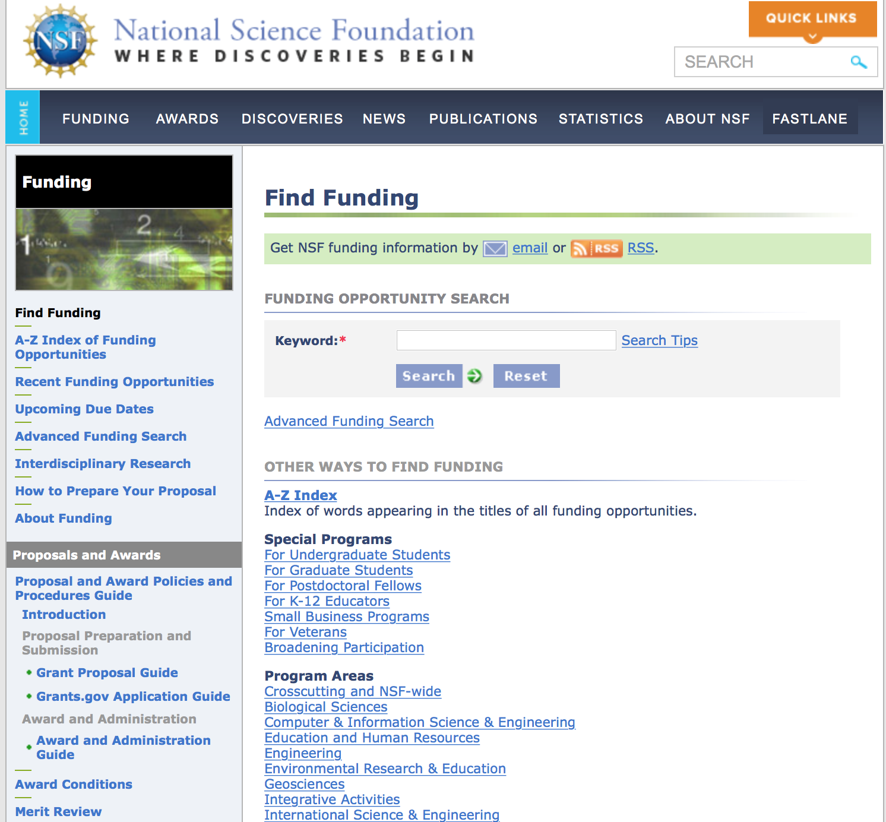
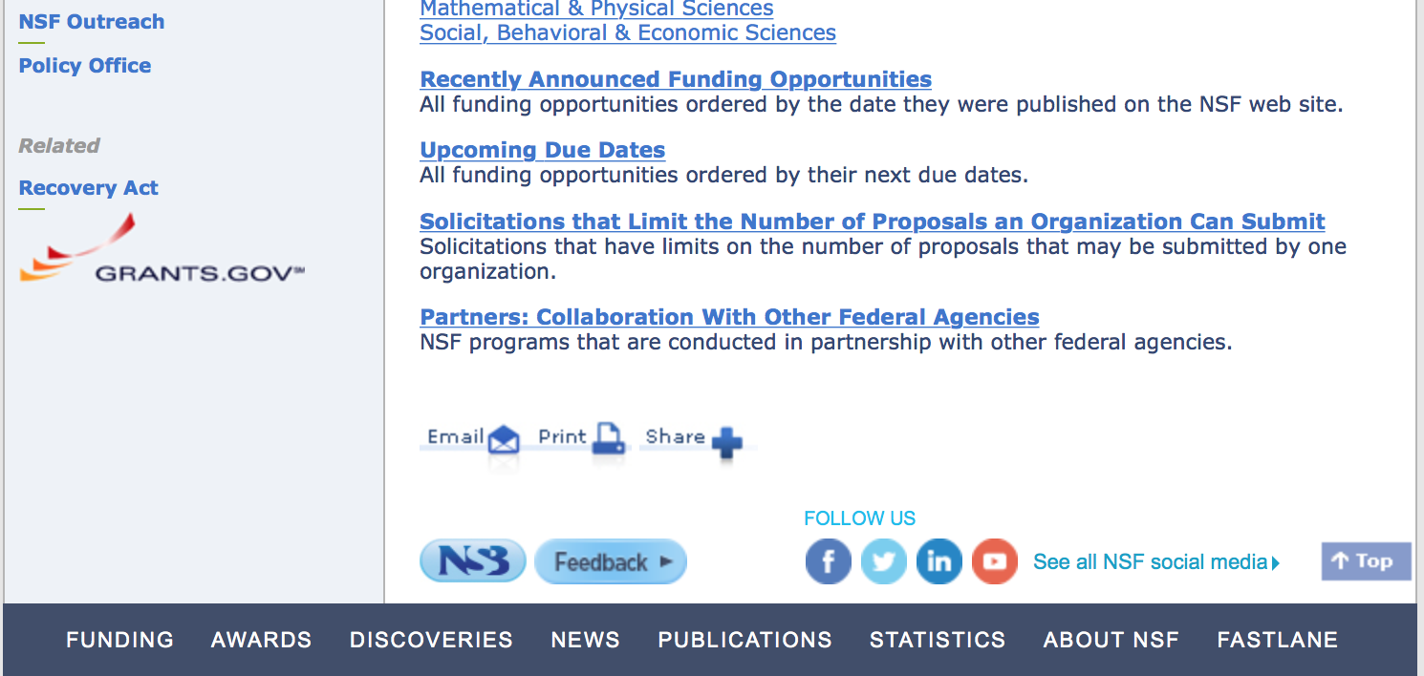

For assistance in finding funding: http://nsf.gov/funding/index.jsp - areas

The National Science Foundation funds research and education in most fields of science and engineering. It does this through grants, and cooperative agreements to more than 2,000 colleges, universities, K-12 school systems, businesses, informal science organizations and other research organizations throughout the United States. The Foundation accounts for about one-fourth of federal support to academic institutions for basic research.
NSF receives approximately 40,000 proposals each year for research, education and training projects, of which approximately 11,000 are funded. In addition, the Foundation receives several thousand applications for graduate and postdoctoral fellowships.
The agency operates no laboratories itself but does support National Research Centers, user facilities, certain oceanographic vessels and Antarctic research stations. The Foundation also supports cooperative research between universities and industry, US participation in international scientific and engineering efforts, and educational activities at every academic level.

For details on active funding deadline dates: http://nsf.gov/funding/pgm_list.jsp?org=NSF&ord=date

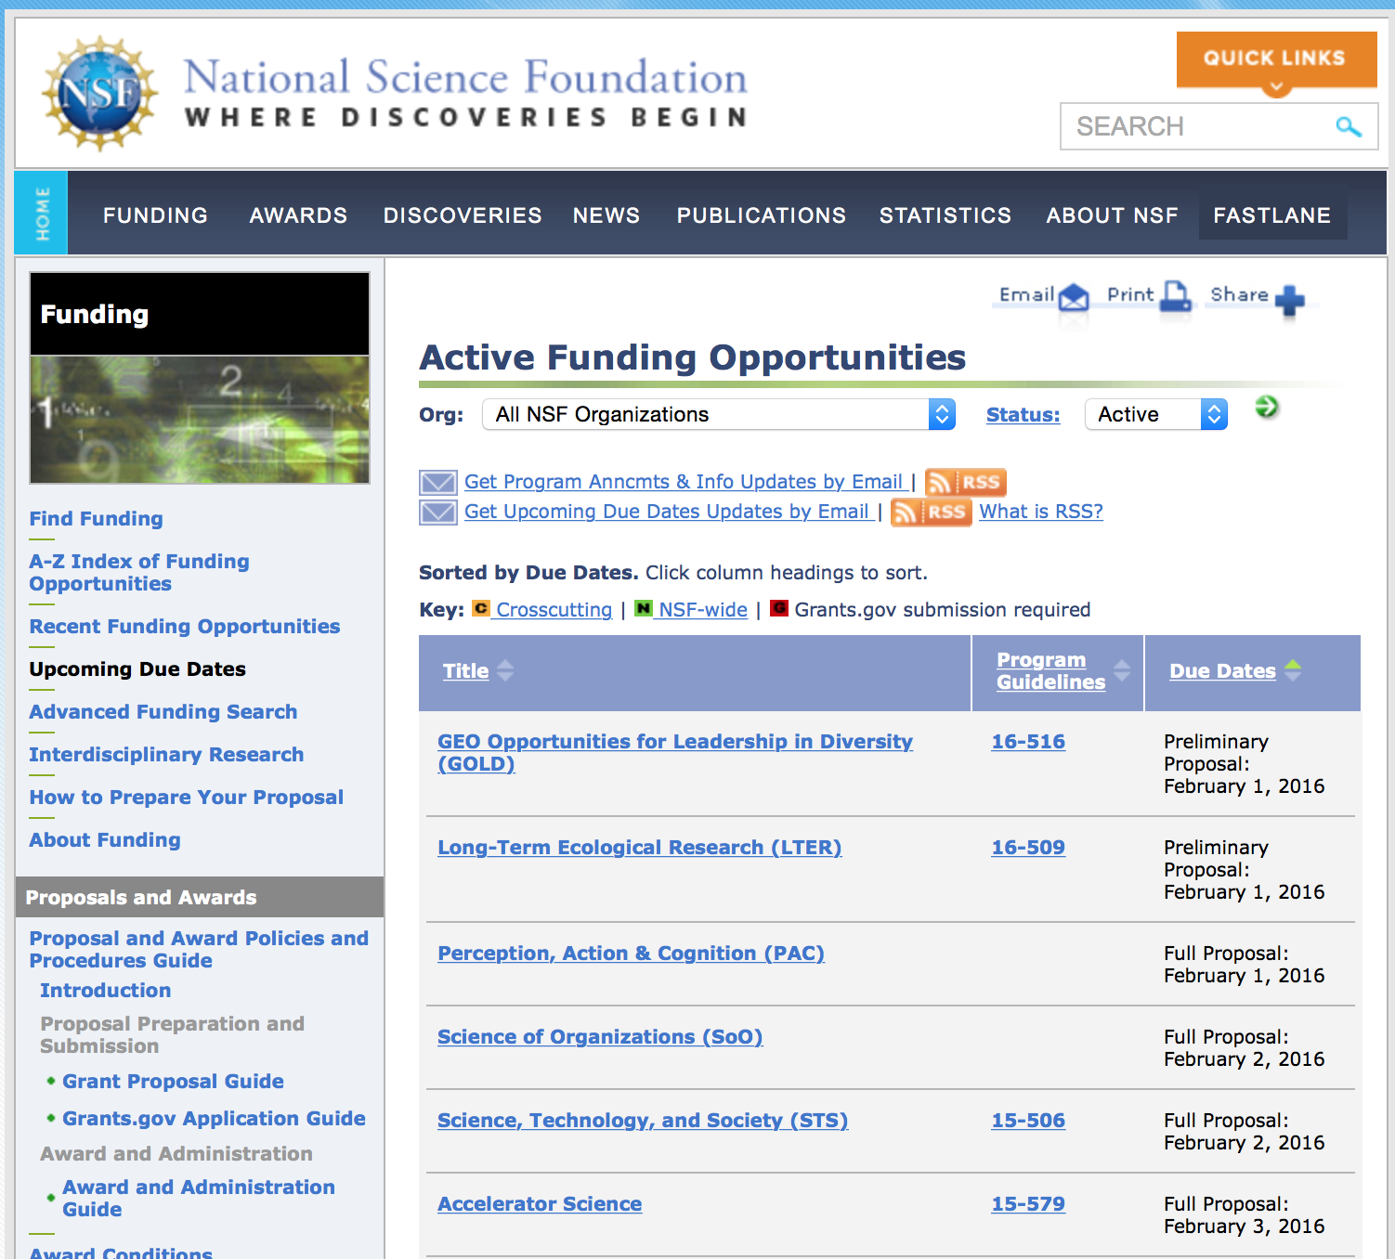

Research and Program Grants:

Broadening Participation in Engineering Grant
http://www.grants.gov/web/grants/view-opportunity.html?oppId=282552

Conferences and Workshops in the Mathematical Sciences Grant
http://www.grants.gov/web/grants/view-opportunity.html?oppId=281952

Cybermanufacturing Systems Grant
http://www.grants.gov/web/grants/view-opportunity.html?oppId=282210

Cyber-Physical Systems Grant
http://www.grants.gov/web/grants/view-opportunity.html?oppId=282226

Dear Colleague Letter: Advanced Cellular Biomanufacturing Grant
http://www.grants.gov/web/grants/view-opportunity.html?oppId=282410

EPSCoR Research Infrastructure Improvement Program Track-1: Grant
http://www.grants.gov/web/grants/view-opportunity.html?oppId=282661

Plant-Biotic Interactions Grant
http://www.grants.gov/web/grants/view-opportunity.html?oppId=282034

Structural and Architectural Engineering and Materials Grant
http://www.grants.gov/web/grants/view-opportunity.html?oppId=282462

Tectonics Grant
http://www.grants.gov/web/grants/view-opportunity.html?oppId=282662

US Ignite: Grant
http://www.grants.gov/web/grants/view-opportunity.html?oppId=282282

Modifications:

Reminders:

Nuclear Regulatory Commission

Reminders:

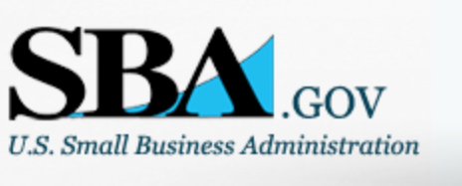

Small Business Administration

General Overview Finding Loans & Grants

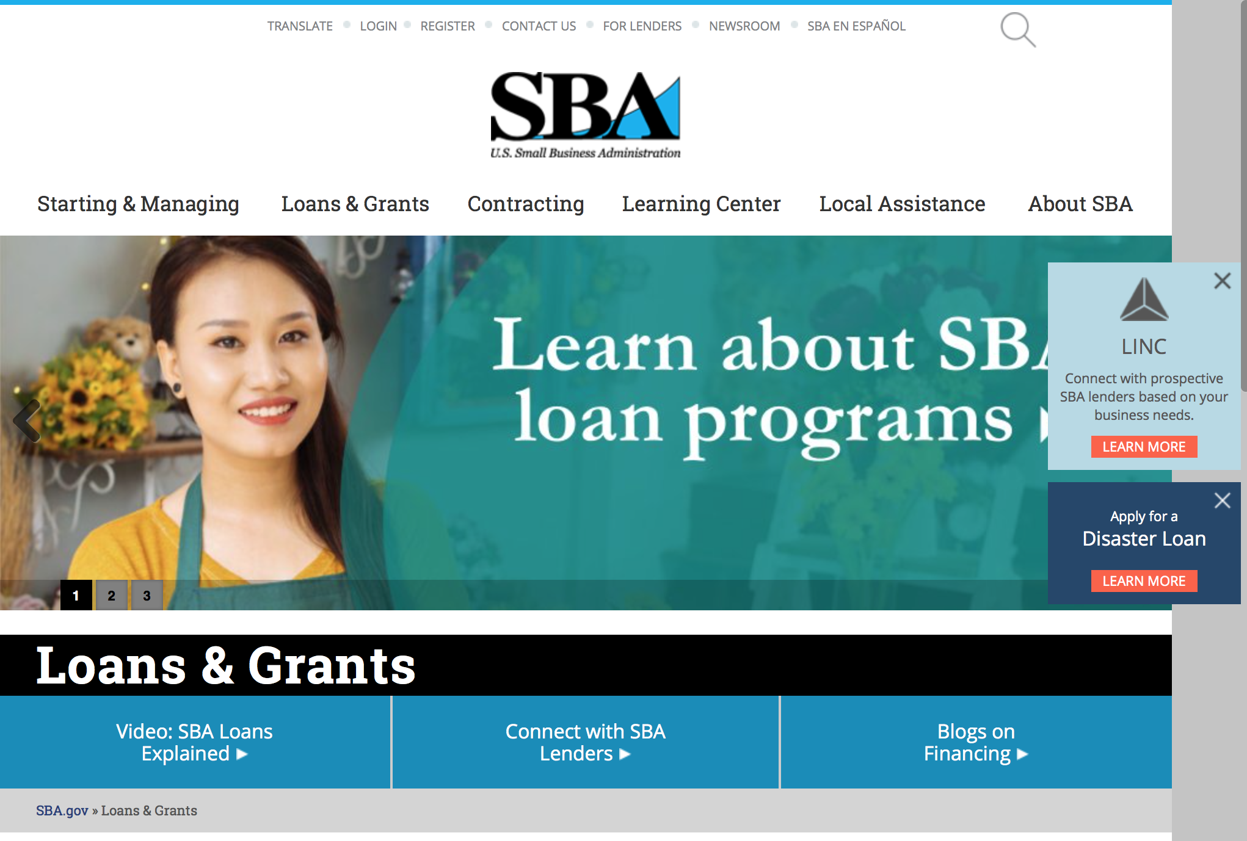
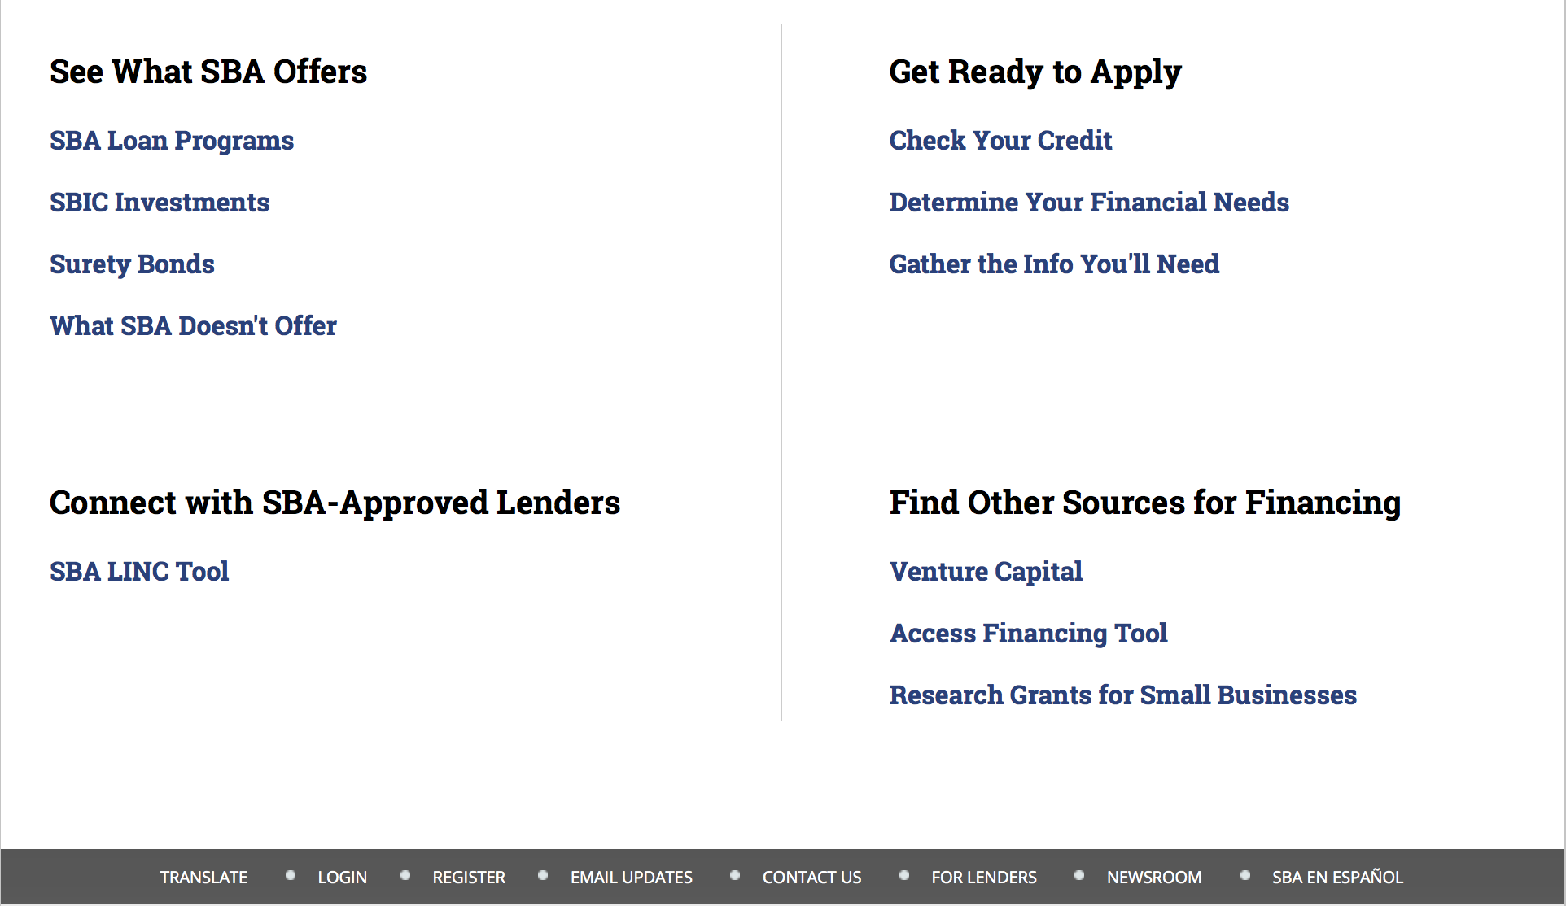

https://www.sba.gov/category/navigation-structure/loans-grants
Federal, state and local governments offer a wide range of financing programs to help small businesses start and grow their operations. These programs include low-interest loans, venture capital, and scientific and economic development grants.

Use SBA.gov's Loans and Grants Search Tool to get a list of financing programs for which you may qualify, or visit the resources below to learn more about small business financing programs. 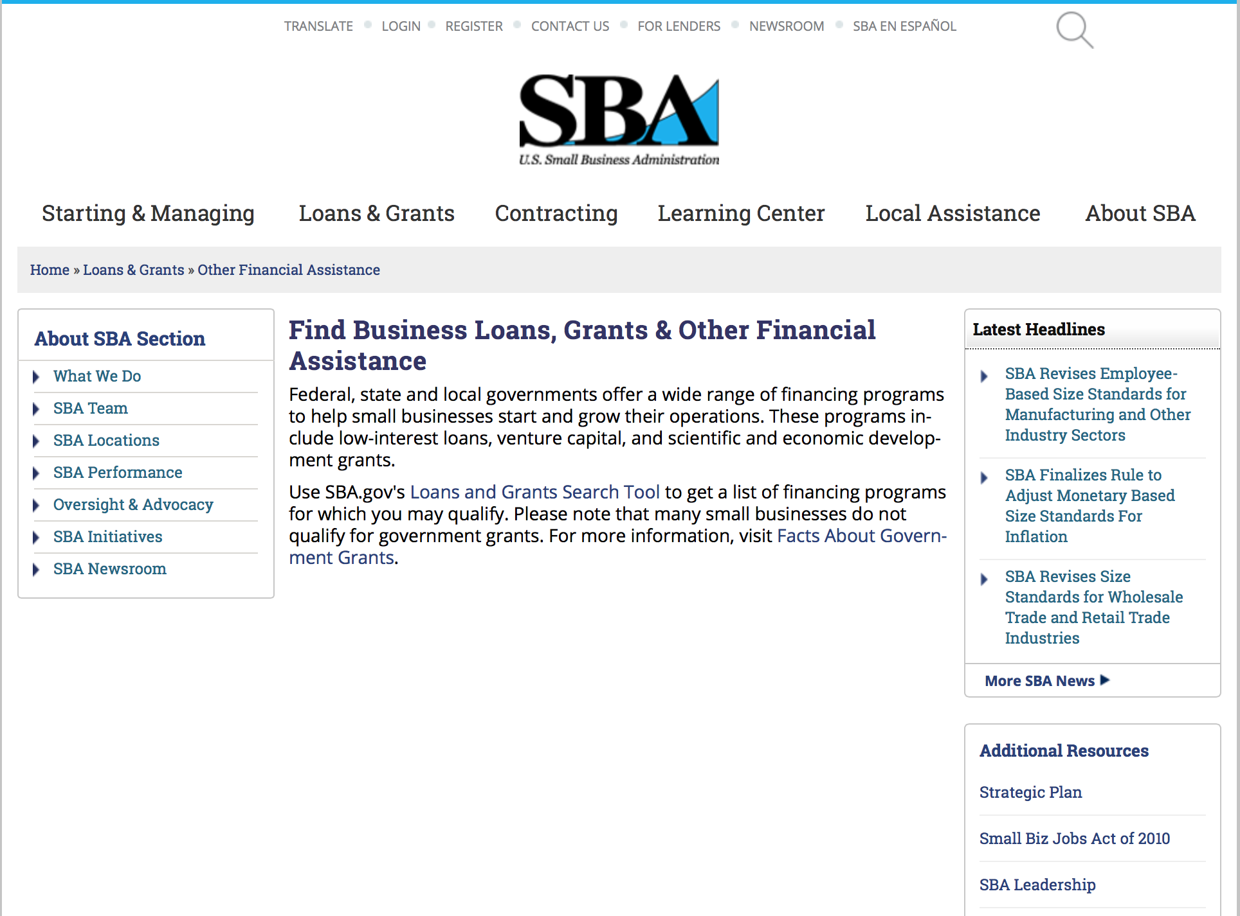
To get to the main SBA.gov funding page click here
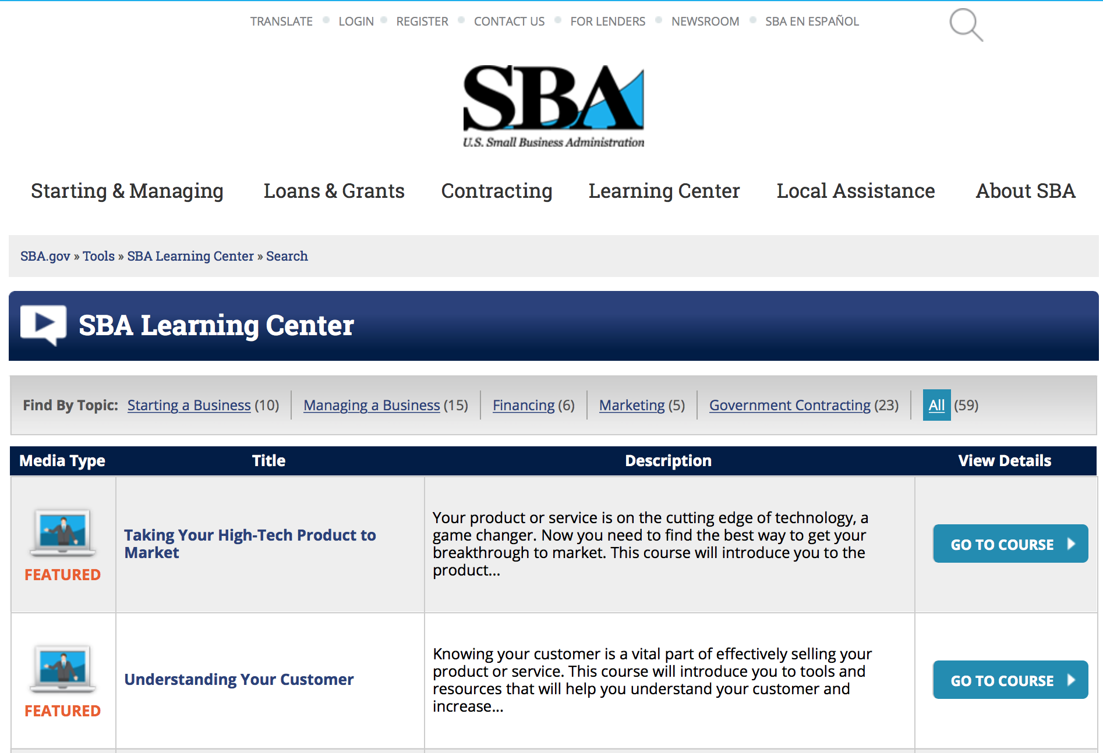
https://www.sba.gov/tools/sba-learning-center/search/training
Programs:

Portable Assistance Program Grant

Document Type: | Grants Notice
Funding Opportunity Number: | OSBDC-2016-05
Funding Opportunity Title: | Portable Assistance Program
Opportunity Category: | Discretionary
Opportunity Category Explanation:
Funding Instrument Type: | Cooperative Agreement
Category of Funding Activity: | Business and Commerce
Category Explanation:
Expected Number of Awards: | 11
CFDA Number(s): | 59.037 -- Small Business Development Centers
Cost Sharing or Matching Requirement: | No
Posted Date: | Mar 25, 2016
Last Updated Date: | Mar 25, 2016
Original Closing Date for Applications: | May 16, 2016 The closing date is May 16, 2016 at 11:59pm EST.
Current Closing Date for Applications: | May 16, 2016 The closing date is May 16, 2016 at 11:59pm EST.
Archive Date: | Jun 15, 2016
Estimated Total Program Funding: | $1,109,769
Award Ceiling: | $100,000
Eligible Applicants: | Others (see text field entitled "Additional Information on Eligibility" for clarification)
Additional Information on Eligibility: | See Synopsis
Agency Name: | Small Business Administration
Description: | The purpose of this Program Announcement is to invite proposals for funding from entities currently funded by SBA as a Small Business Development Center (SBDC) Lead Center. Each proposal must describe recent, serious economic conditions resulting from diminished business or government operations within a discrete area served by an SBDC network. Proposals must include detailed plans to deliver technical assistance to the affected area with corresponding objectives and milestones to be accomplished. Only applications from SBDC Lead Centers will be considered for funding.
Link to Additional Information: | https://www.sba.gov/offices/headquarters/osbdc/resources/20351
Contact Information: | If you have difficulty accessing the full announcement electronically, please contact:  Small Business Administration Office of Small Business Development Centers Tel: (202) 205-6766 Email: OSBDC@sba.gov  OSBDC@sba.gov

http://www.grants.gov/web/grants/view-opportunity.html?oppId=282525

Program for Investment in Microentrepreneurs (PRIME) Grant

Document Type: | Grants Notice
Funding Opportunity Number: | PRIME-2016-02
Funding Opportunity Title: | Program for Investment in Microentrepreneurs (PRIME)
Opportunity Category: | Discretionary
Opportunity Category Explanation:
Funding Instrument Type: | Cooperative Agreement
Category of Funding Activity: | Business and Commerce
Category Explanation:
Expected Number of Awards: | 35
CFDA Number(s): | 59.050 -- Prime Technical Assistance
Cost Sharing or Matching Requirement: | Yes
Posted Date: | Mar 29, 2016
Last Updated Date: | Mar 29, 2016
Original Closing Date for Applications: | Apr 29, 2016 The closing date is 04/29/2016 at 11:59 EST
Current Closing Date for Applications: | Apr 29, 2016 The closing date is 04/29/2016 at 11:59 EST
Archive Date: | May 02, 2016
Estimated Total Program Funding: | $5,000,000
Award Ceiling: | $250,000
Award Floor: | $50,000
Eligible Applicants: | Others (see text field entitled "Additional Information on Eligibility" for clarification)
Additional Information on Eligibility: | See Synopsis
Agency Name: | Small Business Administration
Description: | The Program for Investment in Microentrepreneurs Act of 1999 (the PRIME Act) became law on November 12, 1999 with the passage of Pub. L. No. 106-102 (15 U.S.C. § 6901 note). The PRIME Act authorizes the SBA Administrator to establish a program for the purposes of: (i) providing training and technical assistance to disadvantaged entrepreneurs; (ii) providing training and capacity building assistance to microenterprise development organizations (MDOs) and programs; (iii) aiding in Research and development of best practices for microenterprise and technical assistance programs for disadvantaged entrepreneurs; and (iv) for other activities as the SBA Administrator determines. This year, SBA will concentrate resources in the use of (1) training and technical assistance to strengthen cooperatives serving economically disadvantaged entrepreneurs and areas; and (2) training and technical assistance to support entrepreneurship among ex-offenders in the criminal justice system, especially those on parole, probation or incarcerated persons soon to be released.
Link to Additional Information:
Contact Information: | If you have difficulty accessing the full announcement electronically, please contact:  Jamie Davenport, Chief Community Advantage Division Phone 202-205-7516  Jamie.Davenport@SBA.gov

http://www.grants.gov/web/grants/view-opportunity.html?oppId=282625

Federal And State Technology Partnership Program
Modifications 2, 4 & 6

Document Type: | Grants Notice
Funding Opportunity Number: | FAST-2016-R-0010
Funding Opportunity Title: | FEDERAL AND STATE TECHNOLOGY PARTNERSHIP PROGRAM
Opportunity Category: | Discretionary
Opportunity Category Explanation:
Funding Instrument Type: | Cooperative Agreement
Category of Funding Activity: | Business and Commerce
Category Explanation:
Expected Number of Awards: | 16
CFDA Number(s): | 59.058 -- Federal and State Technology Partnership Program
Cost Sharing or Matching Requirement: | Yes
Posted Date: | Mar 18, 2016
Last Updated Date: | Mar 30, 2016
Original Closing Date for Applications: | May 20, 2016 The closing date is May 20,2016 at 11:59pm EST.
Current Closing Date for Applications: | May 20, 2016 The closing date is May 20,2016 at 11:59pm EST.
Archive Date: | Jun 19, 2016
Estimated Total Program Funding: | $2,000,000
Award Ceiling: | $125,000
Eligible Applicants: | Others (see text field entitled "Additional Information on Eligibility" for clarification)
Additional Information on Eligibility: | See Synopsis
Agency Name: | Small Business Administration
Description: | The purpose of this Program Announcement is to invite proposals for funding from any public or private organization, entity or individual interested in providing assistance and guidance to small technology business concerns.
Link to Additional Information: | http://www.sbir.gov
Contact Information: | If you have difficulty accessing the full announcement electronically, please contact:  Lisa Younger Small Business Administration Office of Technology Tel: 202 619-0359 Email: FAST@sba.gov  FAST@sba.gov

http://www.grants.gov/web/grants/view-opportunity.html?oppId=282341

Federal And State Technology Partnership Program – SBTDC States
Modifications 2, 4, 6 & 8

Document Type: | Grants Notice
Funding Opportunity Number: | FAST-2016-R-0010A
Funding Opportunity Title: | FEDERAL AND STATE TECHNOLOGY PARTNERSHIP PROGRAM – SBTDC STATES
Opportunity Category: | Discretionary
Opportunity Category Explanation:
Funding Instrument Type: | Cooperative Agreement
Category of Funding Activity: | Business and Commerce
Category Explanation:
Expected Number of Awards: | 5
CFDA Number(s): | 59.058 -- Federal and State Technology Partnership Program
Cost Sharing or Matching Requirement: | Yes
Posted Date: | Mar 18, 2016
Last Updated Date: | Mar 30, 2016
Original Closing Date for Applications: | May 20, 2016 The closing date is May 20, 2016 at 11:59pm EST.
Current Closing Date for Applications: | May 20, 2016 The closing date is May 20, 2016 at 11:59pm EST.
Archive Date: | Jun 19, 2016
Estimated Total Program Funding: | $1,000,000
Award Ceiling: | $200,000
Award Floor: | $0
Eligible Applicants: | Others (see text field entitled "Additional Information on Eligibility" for clarification)
Additional Information on Eligibility: | See Synopsis
Agency Name: | Small Business Administration
Description: | The purpose of this Program Announcement is to invite proposals for funding from any public or private organization, entity or individual interested in providing assistance and guidance to small technology business concerns.
Link to Additional Information: | http://www.sbir.gov
Contact Information: | If you have difficulty accessing the full announcement electronically, please contact:  Lisa Younger Small Business Administration Office of Technology Tel: 202 619-0359 Email: FAST@sba.gov  FAST@sba.gov

http://www.grants.gov/web/grants/view-opportunity.html?oppId=282343

Reminders:

SBA Trainings

Contracting Opportunities for Veteran Entrepreneurs
This self-paced training exercise is an introduction to Federal contracting opportunities for Veterans.
Topics include basic information about Veteran-owned businesses and opportunities, services available to small Veteran-owned businesses, small business incentives, and government procurement methods.
Duration: 00:30:00

http://www.sba.gov/tools/sba-learning-center/training/contracting-opportunities-veteran-entrepreneurs

Interested in Exporting? These Four Resources Can Help
Did you know that two-thirds of the world’s purchasing power is in foreign countries? As the numbers show, the international marketplace is a big one. So if you’re interested in exploring the world of exporting – or have gotten started but could use some guidance – check out these resources to help.
- Read more

Upcoming Trainings: Check out SBA's Online Training!
- Financing Options for Small Businesses
How to Prepare Government Contract Proposals
Getting Started With Exporting: Training and Educational Resources
Exporting represents a big opportunity to tap in to new markets, expand your customer base and grow your business. But getting started with exporting can sometimes feel like a maze of regulations, policies, and other barriers. Here are some free training and educational resources to help.
- Read more

For Specific Information in Hawaii see the following links:
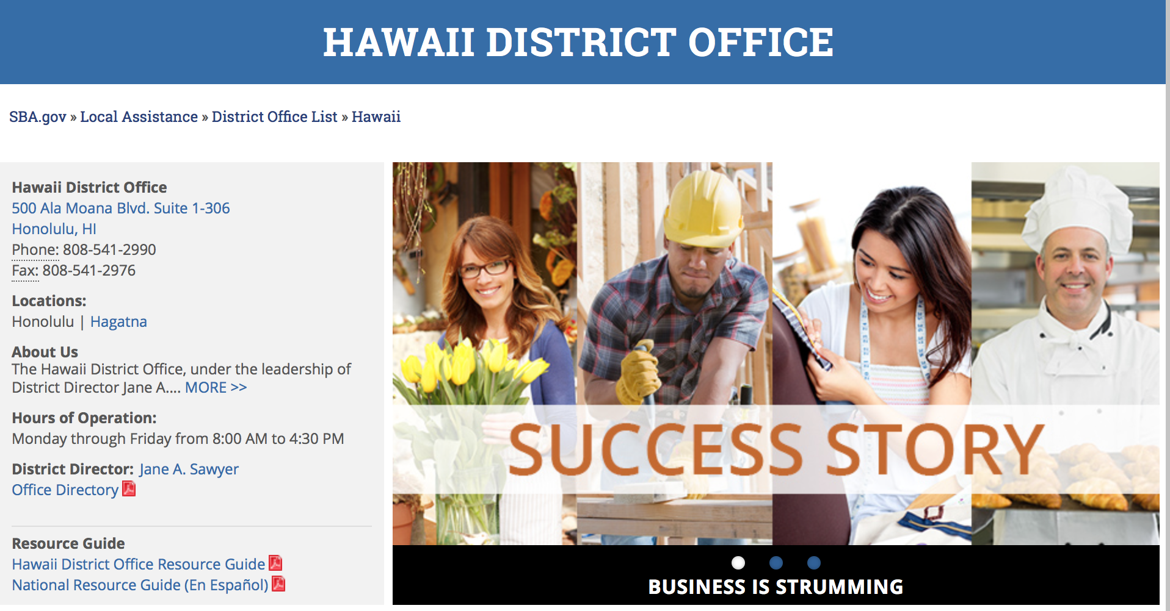

https://www.sba.gov/offices/district/hi/Honolulu

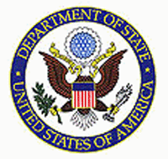

State Department General Overview and Resources for Program Administrators

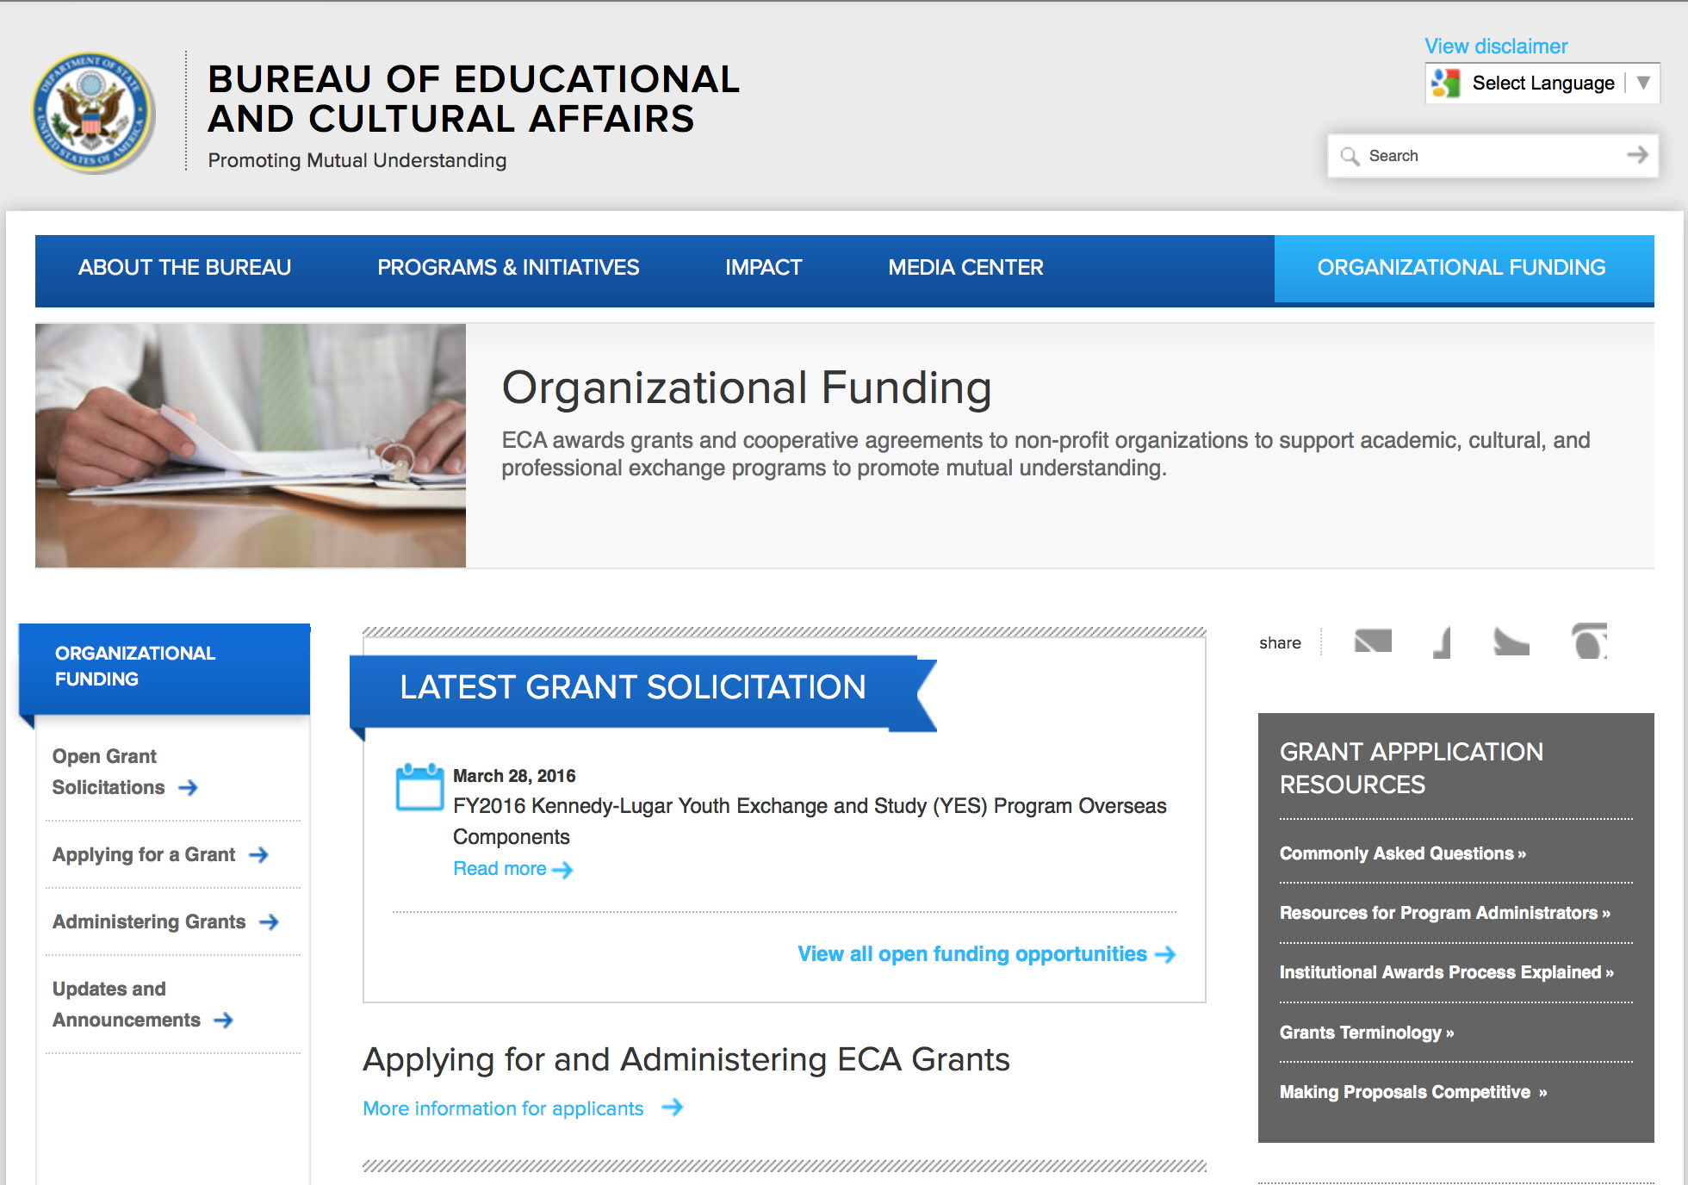
http://eca.state.gov/search/solr/grants?search_referrer=node/237
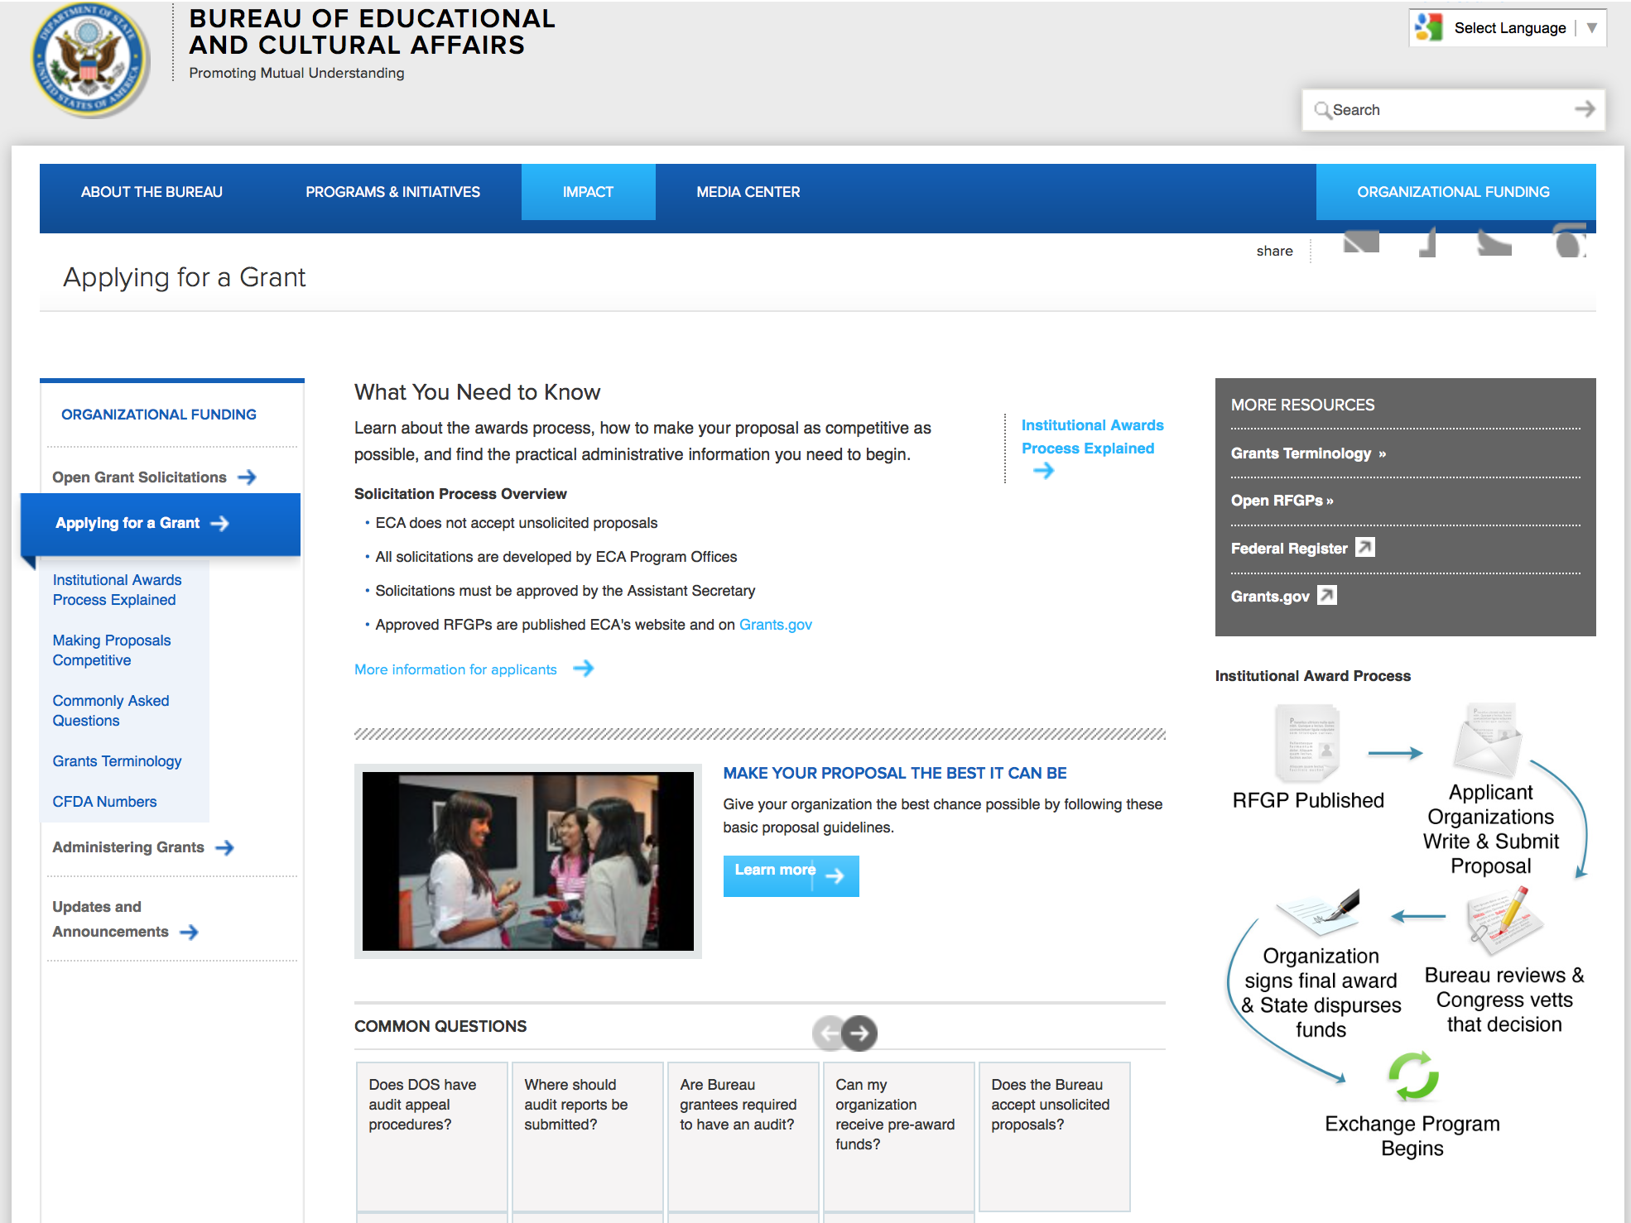

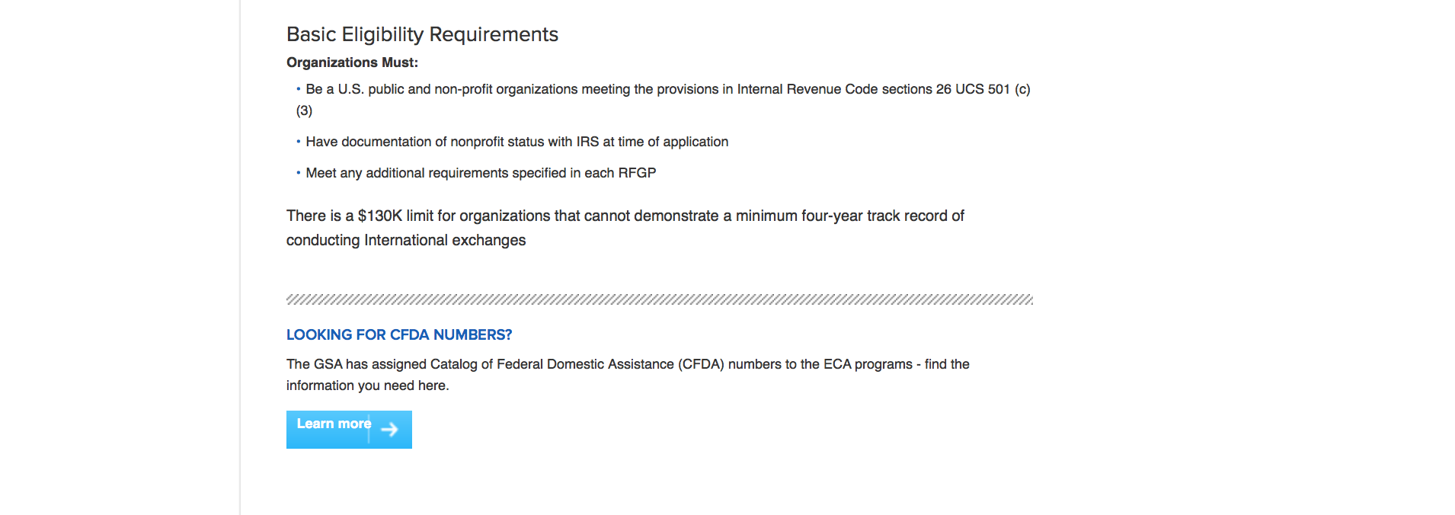
http://eca.state.gov/organizational-funding/applying-grant

General Information:
- Bureau of Educational and Cultural Affairs Grants Division
- Open Grant Opportunities (Requests for Grant Proposals)

For General Information click here

Program Grants:

Bureau of Democracy, Human Rights and Labor
DRL Request for Full Proposals Supporting Syria Survivors of Torture Initiative (SOTI) Grant
http://www.grants.gov/web/grants/view-opportunity.html?oppId=282155

Bureau Of Educational and Cultural Affairs
FY 2016 International Sports Programming Initiative Grant
http://www.grants.gov/web/grants/view-opportunity.html?oppId=282163

East Asia Pacific Environmental Grant
http://www.grants.gov/web/grants/view-opportunity.html?oppId=282219

Bureau of East Asian & Pacific Affairs
Connecting Asia Pacific Online Securely - Request for Statements of Interest Grant
http://www.grants.gov/web/grants/view-opportunity.html?oppId=282279

International Narcotics and Law Enforcement Affair
Building capacity for successful resolution of money laundering and financial crime investigations in Costa Rica Grant
http://www.grants.gov/web/grants/view-opportunity.html?oppId=282169

U.S. Mission to Costa Rica
Strengthen Citizen Security through Economic and Social Opportunity Grant
http://www.grants.gov/web/grants/view-opportunity.html?oppId=281870

International Narcotics and Law Enforcement Affair
Central America Regional Security Initiative Grant
http://www.grants.gov/web/grants/view-opportunity.html?oppId=281987

Macedonia USAID-Skopje
Macedonia Media (M-Media) Media Content Production Grant
http://www.grants.gov/web/grants/view-opportunity.html?oppId=282214

Bureau of Near Eastern Affairs
Near East Affairs - Assistance Coordination
Supporting Local Engagement in Tunisia's Political Process Grant
http://www.grants.gov/web/grants/view-opportunity.html?oppId=282283

Bureau Of Educational and Cultural Affairs
FY 2017 Fulbright Scholar Program Grant
http://www.grants.gov/web/grants/view-opportunity.html?oppId=282784

U.S. Mission to Afghanistan
Programming for Women’s Dormitory at Balkh University Grant
http://www.grants.gov/web/grants/view-opportunity.html?oppId=282750
U.S. Mission to Nigeria
U.S. Embassy Abuja Annual Program Statement Grant
http://www.grants.gov/web/grants/view-opportunity.html?oppId=282479

U.S mission to Estonia
English Language Youth Programs in Northeast Estonia Grant
http://www.grants.gov/web/grants/view-opportunity.html?oppId=282642

Bureau Of Educational and Cultural Affairs
FY 2016 Community College Administrator Program (CCAP) Grant
http://www.grants.gov/web/grants/view-opportunity.html?oppId=282684

Bureau Of Educational and Cultural Affairs
FY16 Congress-Bundestag Youth Exchange Enhancement Program Grant
http://www.grants.gov/web/grants/view-opportunity.html?oppId=282653

Bureau Of Educational and Cultural Affairs
FY 2016 Americans with Disabilities Act (ADA) Anniversary Program Honoring Senators Robert Dole and Thomas Harkin Grant
http://www.grants.gov/web/grants/view-opportunity.html?oppId=282507

Bureau Of Educational and Cultural Affairs
FY 2016 Thematic International Exchange Seminars (TIES) for U.S. Alumni Grant
http://www.grants.gov/web/grants/view-opportunity.html?oppId=282508

South Sudan (USAID)-Juba
USAID’s Biodiversity Annual Program Statement (APS) Grant
http://www.grants.gov/web/grants/view-opportunity.html?oppId=282448

U.S. Mission to Pakistan
Annual Program Statement—Sindh and Balochistan Grant
http://www.grants.gov/web/grants/view-opportunity.html?oppId=282375

U.S. Mission to Nigeria
U.S. Embassy Abuja Annual Program Statement Grant
http://www.grants.gov/web/grants/view-opportunity.html?oppId=282479

Bureau Of Educational and Cultural Affairs
FY 2016 Americans with Disabilities Act (ADA) Anniversary Program Honoring Senators Robert Dole and Thomas Harkin Grant
http://www.grants.gov/web/grants/view-opportunity.html?oppId=282507

Bureau Of Educational and Cultural Affairs
FY 2016 Thematic International Exchange Seminars (TIES) for U.S. Alumni Grant
http://www.grants.gov/web/grants/view-opportunity.html?oppId=282508

International Narcotics and Law Enforcement Affair
Promoting Gender Equality in Pakistan’s Justice System Grant
http://www.grants.gov/web/grants/view-opportunity.html?oppId=282534

International Narcotics and Law Enforcement Affair
Addressing credit card and ATM Fraud in Ukraine Grant
http://www.grants.gov/web/grants/view-opportunity.html?oppId=282565

U.S. Mission to Pakistan
Annual Program Statement—Sindh and Balochistan Grant
http://www.grants.gov/web/grants/view-opportunity.html?oppId=282375

Mexico USAID-Mexico City
Renewable Energy and Social Impacts Grant
http://www.grants.gov/web/grants/view-opportunity.html?oppId=282588

Bureau Of Educational and Cultural Affairs
FY 2017 Fulbright Specialist Program Grant
http://www.grants.gov/web/grants/view-opportunity.html?oppId=282825

PM Weapons Removal and Abatement
PM/WRA Burma HMA Request for Information (RFI) Grant
http://www.grants.gov/web/grants/view-opportunity.html?oppId=282797

PM Weapons Removal and Abatement
PM/WRA Vietnam Technical Adviser NOFO Grant
http://www.grants.gov/web/grants/view-opportunity.html?oppId=282779

Modifications:

Bureau of Democracy, Human Rights and Labor
DRL Request for Full Proposals Supporting Syria Survivors of Torture Initiative (SOTI)
Modification 2
http://www.grants.gov/web/grants/view-opportunity.html?oppId=282155

U.S. Mission to Costa Rica
Strengthen Citizen Security through Economic and Social Opportunity
Modification 1
http://www.grants.gov/web/grants/view-opportunity.html?oppId=281870

Bureau of Population, Refugees and Migration
FY 2016 Notice of Funding Opportunity for NGO Programs Benefiting Malian and Nigerian Refugees in Burkina Faso, Mauritania, and Niger or Refugee Returnees in Mali
Modification 1
http://www.grants.gov/web/grants/view-opportunity.html?oppId=282088
Bureau of Population, Refugees and Migration
FY 2016 Notice of Funding Opportunity for NGO programs benefiting refugees and internally displaced persons (IDPs) from Colombia.
Modification 1
http://www.grants.gov/web/grants/view-opportunity.html?oppId=282373

Bureau of Population, Refugees and Migration
FY 2016 Notice of Funding Opportunity for NGO programs benefiting refugees and asylum seekers in Thailand, Malaysia, Indonesia and the Region
Modification 1
http://www.grants.gov/web/grants/view-opportunity.html?oppId=282460

Bureau of Population, Refugees and Migration
FY 2017 Notice of Funding Opportunity for Reception and Placement Program
Modification 1
http://www.grants.gov/web/grants/view-opportunity.html?oppId=282394

Bureau of Population, Refugees and Migration
FY 2016 Notice of Funding Opportunity for NGO programs benefiting Tibetan and Sri Lankan refugees, IDPs, and returnees in India, Nepal and Sri Lanka
Modification 1
http://www.grants.gov/web/grants/view-opportunity.html?oppId=282673

Bureau of Near Eastern Affairs
Near East Affairs - Assistance Coordination
Supporting Libya through Political Transition
Modification 3
http://www.grants.gov/web/grants/view-opportunity.html?oppId=281780

International Narcotics and Law Enforcement Affair
Central America Regional Security Initiative
Modification 1
http://www.grants.gov/web/grants/view-opportunity.html?oppId=281987

West Bank, Gaza USAID-West Bank
Conflict Management and Mitigation Program
Modification 3
http://www.grants.gov/web/grants/view-opportunity.html?oppId=282329

U.S. Mission to Russia
FY 2016 U.S.-Russia Peer-to-Peer Dialogue Program
Modification 2
http://www.grants.gov/web/grants/view-opportunity.html?oppId=282493

Bureau of Population, Refugees and Migration
FY 2017 Notice of Funding Opportunity for Reception and Placement Program
Modification 2
http://www.grants.gov/web/grants/view-opportunity.html?oppId=282394

Bureau of Population, Refugees and Migration
FY 2016 Notice of Funding Opportunity for NGO programs benefiting refugees and internally displaced persons (IDPs) from Colombia.
Modification 1
http://www.grants.gov/web/grants/view-opportunity.html?oppId=282373

Bureau of Population, Refugees and Migration
FY 2016 Notice of Funding Opportunity for NGO programs benefiting refugees and asylum seekers in Thailand, Malaysia, Indonesia and the Region
Modification 1
http://www.grants.gov/web/grants/view-opportunity.html?oppId=282460

Bureau of Population, Refugees and Migration
FY 2017 Notice of Funding Opportunity for Reception and Placement Program
Modification 1
http://www.grants.gov/web/grants/view-opportunity.html?oppId=282394

U.S. Mission to Russia
FY 2016 U.S.-Russia Peer-to-Peer Dialogue Program
Modification 2
http://www.grants.gov/web/grants/view-opportunity.html?oppId=282493

Bureau of Near Eastern Affairs
Near East Affairs - Assistance Coordination
Supporting Libya through Political Transition
Modification 3
http://www.grants.gov/web/grants/view-opportunity.html?oppId=281780

U.S. Embassy Colombo Public Affairs Section Grants Program
Modification 5
http://www.grants.gov/web/grants/view-opportunity.html?oppId=280102

U.S. Embassy Colombo Public Affairs Section Grants Program
Modification 3
http://www.grants.gov/web/grants/view-opportunity.html?oppId=280102

Reminders:

Department of Transportation

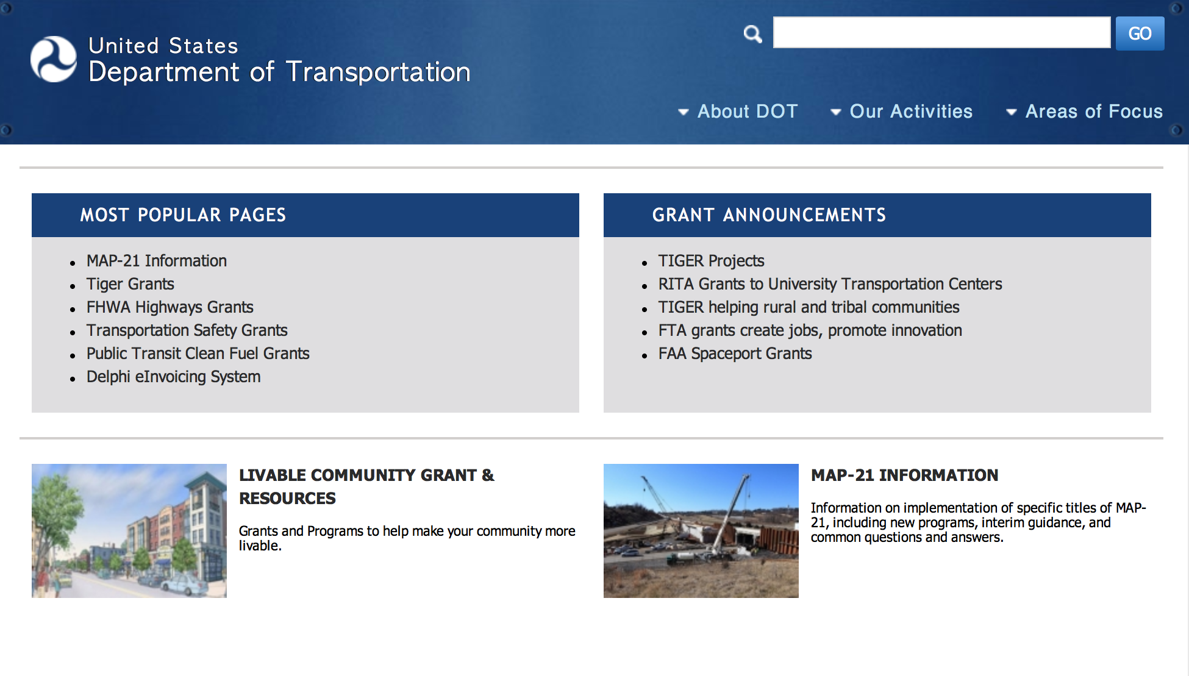
General Grant Program Overview https://www.transportation.gov/grants

Programs:

DOT - Office of Aviation Analysis
Small Community Air Service Development Program Grant

Document Type: | Grants Notice
Funding Opportunity Number: | DOT-OST-2016-0037
Funding Opportunity Title: | Small Community Air Service Development Program
Opportunity Category: | Discretionary
Opportunity Category Explanation:
Funding Instrument Type: | Grant
Category of Funding Activity: | Transportation
Category Explanation:
Expected Number of Awards: | 40
CFDA Number(s): | 20.930 -- Payments for Small Community Air Service Development
Cost Sharing or Matching Requirement: | No
Posted Date: | Mar 29, 2016
Last Updated Date: | Mar 29, 2016
Original Closing Date for Applications: | May 02, 2016 May 2, 2016. Applications of no more than 20 one-sided pages each (excluding the completed Application for Federal Domestic Assistance (SF424), Summary Information schedule, and any letters from the community or an air carrier showing support for the application, including all required information, must be submitted to www.grants.gov no later than 5:00 PM EDT on May 2, 2016.
Current Closing Date for Applications: | May 02, 2016 May 2, 2016. Applications of no more than 20 one-sided pages each (excluding the completed Application for Federal Domestic Assistance (SF424), Summary Information schedule, and any letters from the community or an air carrier showing support for the application, including all required information, must be submitted to www.grants.gov no later than 5:00 PM EDT on May 2, 2016.
Archive Date: | Jun 01, 2016
Estimated Total Program Funding: | $5,000,000
Award Ceiling: | $5,000,000
Award Floor: | $0
Eligible Applicants: | Others (see text field entitled "Additional Information on Eligibility" for clarification)
Additional Information on Eligibility: | Eligible applicants are small communities that meet the following statutory criteria under 49 U.S.C. § 41743, as amended by Pub. L. No. 114-113: 1. (a) The airport serving the community or consortium is not larger than a small hub airport, according to FAA hub classifications effective on the date of service of this Order, or (b) As of calendar year 1997, the airport serving the community or consortium was not larger than a small hub airport, and 2. It has insufficient air carrier service or unreasonably high air fares; and 3. The airport serving the community presents characteristics, such as geographic diversity or unique circumstances that demonstrate the need for, and feasibility of, grant assistance from the Small Community Program. No more than four communities or consortia of communities, or a combination thereof, from the same State may be selected to participate in the program in any fiscal year. No more than 40 communities or consortia of communities, or a combination thereof, may be selected to participate in the program in each year for which the funds are appropriated. Consortium applications: Both individual communities and consortia of communities are eligible for SCASDP funds. An application from a consortium of communities must be one that seeks to facilitate the efforts of the communities working together toward one joint grant project, with one joint objective, including the establishment of one entity to ensure that the joint objective is accomplished. Multiple applications prohibited: A community may file only one application for a grant, either individually or as part of a consortium. Communities without existing air service: Communities that do not currently have commercial air service are eligible for SCASDP funds. Essential Air Service communities: Small communities that meet the basic SCASDP criteria and currently receive subsidized air service under the Essential Air Service (“EAS”) program are eligible to apply for SCASDP funds. However, grant awards to EAS-subsidized communities are limited to marketing or promotion projects that support existing or newly subsidized EAS. Grant funds will not be authorized for EAS-subsidized communities to support any new competing air service. Furthermore, no funds will be authorized to support additional flights by EAS carriers or changes to those carriers’ existing schedules. These restrictions are necessary to avoid conflicts with the mandate of the EAS program. Alternate Essential Air Service communities: Likewise, small communities that meet the basic SCASDP criteria and currently receive assistance under the Alternate Essential Air Service Pilot Program (“Alternate EAS Pilot Program”) (49 U.S.C. § 41745(a)) are eligible to apply for SCASDP funds. Since the Alternate EAS Pilot Program is a substitute/alternative to traditional EAS, we would consider applications from communities receiving assistance under 49 U.S.C. § 41745(a) only for marketing or promotion projects; however, if the community is already receiving Department support for marketing projects, per the community’s proposal under the Alternate EAS Pilot Program, the community’s project would not be considered for a SCASDP grant.
Agency Name: | DOT - Office of Aviation Analysis
Description: | The Small Community Program was established by the Wendell H. Ford Aviation Investment and Reform Act for the 21st Century (Pub. L. No. 106-181), reauthorized by the Vision 100-Century of Aviation Reauthorization Act (Pub. L. No. 108-176), and subsequently reauthorized by the FAA Modernization and Reform Act of 2012 (Pub. L. No. 112-95) (FAA 2012), as amended. The program is designed to provide financial assistance to small communities in order to help them enhance their air service. The Department provides this assistance in the form of monetary grants that are disbursed on a reimbursable basis. Authorization for this program is codified at 49 U.S.C. § 41743. The Small Community Program is authorized to receive appropriations under 49 U.S.C. § 41743(e)(2), as amended. Appropriations are provided for this program for award selection in FY 2016 pursuant to FAA 2012 and the Consolidated Appropriations Act, 2016 (Pub. L. No. 114-113). The Airport and Airway Extension Act of 2015 provides contract authority until March 31, 2016, for the Airport Improvement Program, which funds SCASDP. Therefore, subject to the availability of funding, the Department has up to $5 million available for FY 2016 grant awards to carry out this program. There is no other limitation on the amount of individual awards, and the amounts awarded will vary depending upon the features and merits of the selected proposals. In past years, the Department’s individual grant sizes have ranged from $20,000 to nearly $1.6 million. Funding amounts made available for reimbursement may be impacted by future limitations placed on the spending authority and appropriations enacted for the Department. OST cannot award grants until the enactment of authorizing legislation, an appropriations act, budget authority, and apportionment from the Office of Management and Budget (OMB). OST may, at its discretion, issue partial funding awards up to the level authorized and provided that the above conditions are met. Additional information on the budget process may be found in OMB A-11: http://www.whitehouse.gov/omb/circulars_default/.
Link to Additional Information: | SCASDP website
Contact Information: | If you have difficulty accessing the full announcement electronically, please contact:  Vince Corsaro Transportation Analyst Phone 202-366-1842  vince.corsaro@dot.gov

http://www.grants.gov/web/grants/view-opportunity.html?oppId=282593

DOT/Federal Transit Administration
Solicitation of Project Proposals for the 5339(b) Grants for Buses and Bus Facilities (Bus) Program Grant

Document Type: | Grants Notice
Funding Opportunity Number: | FTA-2016-002-TPM
Funding Opportunity Title: | Solicitation of Project Proposals for the 5339(b) Grants for Buses and Bus Facilities (Bus) Program
Opportunity Category: | Discretionary
Opportunity Category Explanation:
Funding Instrument Type: | Grant
Category of Funding Activity: | Transportation
Category Explanation:
Expected Number of Awards: | 100
CFDA Number(s): | 20.526 -- Bus and Bus Facilities Formula Program
Cost Sharing or Matching Requirement: | Yes
Posted Date: | Mar 29, 2016
Last Updated Date: | Mar 29, 2016
Original Closing Date for Applications: | May 13, 2016
Current Closing Date for Applications: | May 13, 2016
Archive Date: | Jun 12, 2016
Estimated Total Program Funding: | $211,000,000
Eligible Applicants: | City or township governments  County governments  Native American tribal governments (Federally recognized)  State governments  Others (see text field entitled "Additional Information on Eligibility" for clarification)
Additional Information on Eligibility: | Eligible applicants include direct recipients of FTA grants under the Section 5307 Urbanized Area Formula program, States, and Indian Tribes. Except for projects proposed by Indian Tribes, proposals for projects in rural (non-urbanized) areas must be submitted as part of a consolidated State proposal. States and other eligible applicants may also submit consolidated proposals for projects in urbanized areas. Proposals may contain projects to be implemented by the recipient or its subrecipients. Eligible subrecipients include public agencies, private nonprofit organizations, and private providers engaged in public transportation. If a single project proposal involves multiple public transportation providers, such as when an agency acquires vehicles that will be operated by another agency, the proposal must include a detailed statement regarding the role of each public transportation provider in the implementation of the project.
Agency Name: | DOT/Federal Transit Administration
Description: | The purpose of the Bus Program is to improve the condition of the nation’s public transportation bus fleets, expand transportation access to employment, educational, and healthcare facilities, and to improve mobility options in rural and urban areas throughout the country. In accordance with the statutory requirement that FTA must “consider the age and condition of buses, bus fleets, related equipment, and bus-related facilities”, FTA will prioritize projects that demonstrate how they will address significant repair and maintenance needs, improve the safety of transit systems, deploy connective projects that include advanced technologies to connect bus systems with other networks, and support the creation of ladders of opportunity.
Link to Additional Information: | Notices of Funding Opportunity
Contact Information: | If you have difficulty accessing the full announcement electronically, please contact:  Samuel Snead Office of Program Management  Samuel Snead
http://www.grants.gov/web/grants/view-opportunity.html?oppId=282624

DOT/Federal Transit Administration
Low or No Emission Program (Low-No Program) - 2016 NOFO Grant
Document Type: | Grants Notice
Funding Opportunity Number: | FTA-2016-003-TPM
Funding Opportunity Title: | Low or No Emission Program (Low-No Program) - 2016 NOFO
Opportunity Category: | Discretionary
Opportunity Category Explanation:
Funding Instrument Type: | Grant
Category of Funding Activity: | Transportation
Category Explanation:
Expected Number of Awards: | 100
CFDA Number(s): | 20.526 -- Bus and Bus Facilities Formula Program
Cost Sharing or Matching Requirement: | Yes
Posted Date: | Mar 29, 2016
Last Updated Date: | Mar 29, 2016
Original Closing Date for Applications: | May 13, 2016
Current Closing Date for Applications: | May 13, 2016
Archive Date: | Jun 12, 2016
Estimated Total Program Funding: | $55,000,000
Eligible Applicants: | City or township governments  Others (see text field entitled "Additional Information on Eligibility" for clarification)  County governments  State governments  Native American tribal governments (Federally recognized)
Additional Information on Eligibility: | An Eligible Applicant is a direct recipient of FTA grants under the Section 5307 Urbanized Area Formula program, States and Indian Tribes.
Agency Name: | DOT/Federal Transit Administration
Description: | The main purpose of the Low-No Program is to support the transition of the nation’s transit fleet to the lowest polluting and most energy efficient transit vehicles. The Low-No Program provides funding to State and local governmental authorities for the purchase or lease of zero-emission and low-emission transit buses, including acquisition, construction, and leasing of required supporting facilities.
Link to Additional Information: | Low or No Emission Program (Low-No Program) - 2016 NOFO
Contact Information: | If you have difficulty accessing the full announcement electronically, please contact:  Tara Clark Office of Program Management 202-366-2623  Tara Clark

http://www.grants.gov/web/grants/view-opportunity.html?oppId=282627

DOT/Federal Transit Administration
Innovative Coordinated Access and Mobility Grants Program - 2016 NOFO Grant

Document Type: | Grants Notice
Funding Opportunity Number: | FTA-2015-012-TPM-RTW
Funding Opportunity Title: | Innovative Coordinated Access and Mobility Grants Program - 2016 NOFO
Opportunity Category: | Discretionary
Opportunity Category Explanation:
Funding Instrument Type: | Grant
Category of Funding Activity: | Transportation
Category Explanation:
Expected Number of Awards:
CFDA Number(s): | 20.514 -- Public Transportation Research, Technical Assistance, and Training
Cost Sharing or Matching Requirement: | Yes
Posted Date: | Mar 29, 2016
Last Updated Date: | Mar 29, 2016
Original Closing Date for Applications: | May 31, 2016
Current Closing Date for Applications: | May 31, 2016
Archive Date: | Jun 30, 2016
Estimated Total Program Funding: | $5,300,000
Eligible Applicants: | Native American tribal governments (Federally recognized)  Others (see text field entitled "Additional Information on Eligibility" for clarification)  State governments  County governments  City or township governments
Additional Information on Eligibility: | Eligible proposers and eventual grant applicants under this initiative must be States, Tribes, and Designated or Direct Recipients for funds under 49 U.S.C. 5307, 5310 or 5311. Applicants must serve as the lead agency of a local consortium that includes stakeholders from the transportation, healthcare, human service or other sectors. Members of this consortium are eligible as subrecipients. Applicants must demonstrate that the proposed project was planned through an inclusive process with the involvement of the transportation, healthcare and human service industries.
Agency Name: | DOT/Federal Transit Administration
Description: | The goal of the competitive R2W Demonstration Grants is to find and test promising, replicable public transportation healthcare access solutions that support the following Rides to Wellness goals: increased access to care, improved health outcomes and reduced healthcare costs. To support these goals, the R2W Demonstration Grants will: 1. Develop replicable, innovative, sustainable solutions to healthcare access challenges; 2. Foster local partnerships between health, transportation, home and community-based services and other sectors to collaboratively develop and support solutions that increase healthcare access; and 3. Demonstrate the impacts of transportation solutions on improved access to healthcare and health outcomes and reduced costs to the healthcare and transportation sectors.
Link to Additional Information: | Rides to Wellness Demonstration and Innovative Coordinated Access and Mobility Grants program - 2016 NOFO
Contact Information: | If you have difficulty accessing the full announcement electronically, please contact:  Danielle Nelson Office of Program Management 202-366-2160  Danielle Nelson

http://www.grants.gov/web/grants/view-opportunity.html?oppId=282628

DOT Federal Highway Administration
Dwight David Eisenhower Transportation Fellowship Program Graduate Fellowship (DDETFP)
Grant
Document Type: | Grants Notice
Funding Opportunity Number: | DTFH6416RA00002
Funding Opportunity Title: | Dwight David Eisenhower Transportation Fellowship Program Graduate Fellowship (DDETFP)
Opportunity Category: | Discretionary
Opportunity Category Explanation: | Category Explanation
Funding Instrument Type: | Grant
Category of Funding Activity: | Education
Category Explanation:
Expected Number of Awards: | 80
CFDA Number(s): | 20.215 -- Highway Training and Education
Cost Sharing or Matching Requirement: | No
Posted Date: | Mar 01, 2016
Last Updated Date: | Mar 01, 2016
Original Closing Date for Applications: | Apr 14, 2016
Current Closing Date for Applications: | Apr 14, 2016
Archive Date: | May 14, 2016
Estimated Total Program Funding: | $800,000
Award Ceiling: | $35,500
Award Floor: | $5,000
Eligible Applicants: | Individuals
Additional Information on Eligibility: | Applicants of the Eisenhower Graduate Fellowship Recipients must: •Possess a baccalaureate degree from an accredited U.S. Institution; •Be enrolled in an accredited U.S. Institution of higher education •Be pursuing a degree in a full-time program in a transportation-related discipline •Have at least one full academic year remaining in program of study; •Conduct ongoing research in one or more transportation-related disciplines; and •Plan to enter the transportation profession after completing their higher level education.
Agency Name: | DOT Federal Highway Administration
Description: | The EISENHOWER GRADUATE FELLOWSHIP (provides funding for the pursuit of Masters or Doctorate Degrees in transportation related discipline. The program objectives are: 1) to attract the nation's brightest minds to the field of transportation, 2) to enhance the careers of transportation professionals by encouraging them to seek advanced degrees, and, 3) to retain top talent in the transportation industry of the United States. The Program is intended to bring innovation and enhance the breadth and scope of knowledge of the entire transportation community in the United States. The Eisenhower Graduate Fellowship Program encompasses all modes of transportation.
Link to Additional Information: | Universities & Grants Programs website
Contact Information: | If you have difficulty accessing the full announcement electronically, please contact:  Fawn Thompson Program Manager Phone 4045623917  fawn.thompson@dot.gov

http://www.grants.gov/web/grants/view-opportunity.html?oppId=281878

FastLane Grants
Document Type: | Grants Notice
Funding Opportunity Number: | NSFHP-16-FASTLANE16
Funding Opportunity Title: | FastLane Grants
Opportunity Category: | Discretionary
Opportunity Category Explanation:
Funding Instrument Type: | Grant
Category of Funding Activity: | Transportation
Category Explanation:
Expected Number of Awards:
CFDA Number(s): | 20.934 -- Nationally Significant Freight and Highway Projects
Cost Sharing or Matching Requirement: | Yes
Posted Date: | Mar 15, 2016
Last Updated Date: | Mar 10, 2016
Original Closing Date for Applications: | Apr 14, 2016
Current Closing Date for Applications: | Apr 14, 2016
Archive Date: | May 14, 2016
Estimated Total Program Funding: | $800,000,000
Award Ceiling: | $700,000,000
Award Floor: | $5,000,000
Eligible Applicants: | Others (see text field entitled "Additional Information on Eligibility" for clarification)
Additional Information on Eligibility: | Eligible applicants for FastLane grants are 1) a State or group of States; 2) a metropolitan planning organization that serves an urbanized area (as defined by the Bureau of the Census) with a population of more than 200,000 individuals; 3) a unit of local government or group of local governments; 4) a political subdivision of a State or local government; 5) a special purpose district or public authority with a transportation function, including a port authority; 6) a Federal land management agency that applies jointly with a State or group of States; 7) a tribal government or a consortium of tribal governments; or 8) a multi-State or multijurisdictional group of public entities. Multiple States or jurisdictions that submit a joint application must identify a lead applicant as the primary point of contact. Each applicant in a joint application must be an Eligible Applicant. Joint applications must include a description of the roles and responsibilities of each applicant and must be signed by each applicant.
Agency Name: | Department of Transportation
Description: | The Fixing America’s Surface Transportation Act (FAST Act) established the Nationally Significant Freight and Highway Projects (NSFHP) program to provide Federal financial assistance to projects of national or regional significance and authorized the program at $4.5 billion for fiscal years (FY) 2016 through 2020, including $800 million for FY 2016 to be awarded by the Secretary of Transportation. The Department will also refer to NSFHP grants as Fostering Advancements in Shipping and Transportation for the Long-term Achievement of National Efficiencies (FASTLANE) grants. This purpose of this opportunity is to solicit applications for FY 2016 grants for the NSFHP program.
Link to Additional Information: | FastLane Grants Website
Contact Information: | If you have difficulty accessing the full announcement electronically, please contact:  Robert Mariner Deputy Director Phone 202-366-8914  USDOT Contact

http://www.grants.gov/web/grants/view-opportunity.html?oppId=282118

University Transportation Centers Open Competition 2016 Grant

Document Type: | Grants Notice
Funding Opportunity Number: | UTCOPENCOMP2016
Funding Opportunity Title: | University Transportation Centers Open Competition 2016
Opportunity Category: | Discretionary
Opportunity Category Explanation:
Funding Instrument Type: | Grant
Category of Funding Activity: | Transportation
Category Explanation:
Expected Number of Awards: | 35
CFDA Number(s): | 20.701 -- University Transportation Centers Program
Cost Sharing or Matching Requirement: | Yes
Posted Date: | Mar 01, 2016
Last Updated Date: | Feb 29, 2016
Original Closing Date for Applications: | May 13, 2016 NOTE ALSO: Required Letter of Intent Due 04/01/2016.
Current Closing Date for Applications: | May 13, 2016 NOTE ALSO: Required Letter of Intent Due 04/01/2016.
Archive Date: | Jun 12, 2016
Estimated Total Program Funding: | $72,500,000
Award Ceiling: | $3,000,000
Award Floor: | $1,500,000
Eligible Applicants: | Private institutions of higher education  Public and State controlled institutions of higher education
Agency Name: | Department of Transportation
Description: | See attached solicitation for details.
Link to Additional Information: | http://utc.dot.gov
Contact Information: | If you have difficulty accessing the full announcement electronically, please contact:  Amy Stearns University Program Specialist Phone 202-366-4957  Amy Stearns

http://www.grants.gov/web/grants/view-opportunity.html?oppId=281834

DOT Federal Highway Administration
Advanced Transportation and Congestion Management Technologies Deployment Initiative Grant

Document Type: | Grants Notice
Funding Opportunity Number: | DTFH6116RA00012
Funding Opportunity Title: | Advanced Transportation and Congestion Management Technologies Deployment Initiative
Opportunity Category: | Discretionary
Opportunity Category Explanation: | Category Explanation
Funding Instrument Type: | Other
Category of Funding Activity: | Transportation
Category Explanation:
Expected Number of Awards: | 10
CFDA Number(s): | 20.200 -- Highway Research and Development Program
Cost Sharing or Matching Requirement: | Yes
Posted Date: | Mar 22, 2016
Last Updated Date: | Mar 22, 2016
Original Closing Date for Applications: | Jun 03, 2016 Applications Due by 06/03/2016 at 3:00 pm Eastern Time through www.Grants.gov
Current Closing Date for Applications: | Jun 03, 2016 Applications Due by 06/03/2016 at 3:00 pm Eastern Time through www.Grants.gov
Archive Date: | Oct 01, 2016
Estimated Total Program Funding: | $60,000,000
Award Ceiling: | $12,000,000
Eligible Applicants: | Others (see text field entitled "Additional Information on Eligibility" for clarification)
Additional Information on Eligibility: | Eligible applicants are State or local governments, transit agencies, metropolitan planning organizations (MPO) representing a population of over 200,000, or other political subdivisions of a State or local government (such as publicly owned toll or port authorities), or a multijurisdictional group or consortia of research institutions or academic institutions. Partnership with the private sector or public agencies, including multimodal and multijurisdictional entities, research institutions, organizations representing transportation and technology leaders, or other transportation stakeholders is encouraged. Typically, a consortium is a meaningful arrangement with all members involved in planning the overall direction of the group’s activities and participating in most aspects of the group; the consortium is a long-term relationship intended to last the full life of the grant. Any application submitted by a sole research or academic institution and that is not part of a consortium will not be considered for selection. Awards will be either Cooperative Agreements or Allocations to State Departments of Transportations.
Agency Name: | DOT Federal Highway Administration
Description: | The DOT hereby requests applications to result in awards to eligible entities to develop model deployment sites for large scale installation and operation of advanced transportation technologies to improve safety, efficiency, system performance, and infrastructure return on investment. These model deployments are expected to provide benefits in the form of: •reduced traffic-related fatalities and injuries; •reduced traffic congestion and improved travel time reliability; •reduced transportation-related emissions; •optimized multimodal system performance; •improved access to transportation alternatives, including for underserved populations; •public access to real time integrated traffic, transit, and multimodal transportation information to make informed travel decisions; •cost savings to transportation agencies, businesses, and the traveling public; or •other benefits to transportation users and the general public. This competitive advanced transportation and congestion management technologies deployment grant program will promote the use of innovative transportation solutions. The deployment of these technologies will provide Congress and DOT with valuable real life data and feedback to inform future decision making. The United States Department of Transportation (DOT) will host an Informational Session regarding this Funding Opportunity focused on the Advanced Transportation and Congestion Management Technologies Deployment Initiative. This session will be conducted as a virtual forum and will focus on specific topics to help potential applicants gather additional information and ask specific questions. Participation in this session is not mandatory in order to submit an application under this solicitation. Potential applicants are encouraged to take advantage of this opportunity to gather information regarding this specific funding opportunity. DATE: 3/29/2016 TIME: 1:00 pm Eastern Time INFORMATION AND REGISTRATION: https://connectdot.connectsolutions.com/e4x9x0mcr0a/event/registration.html
Link to Additional Information:
Contact Information: | If you have difficulty accessing the full announcement electronically, please contact:  Rick Murray Agreement Officer Phone 202-366-4250  Rick Murray (rick.murray@dot.gov)

http://www.grants.gov/web/grants/view-opportunity.html?oppId=282433

Modifications:

Reminders:

FY 2016 National Infrastructure Investments Grant

Document Type: | Grants Notice
Funding Opportunity Number: | DTOS59-16-RA-TIGER8
Funding Opportunity Title: | FY 2016 National Infrastructure Investments
Opportunity Category: | Discretionary
Opportunity Category Explanation:
Funding Instrument Type: | Grant
Category of Funding Activity: | Transportation
Category Explanation:
Expected Number of Awards:
CFDA Number(s): | 20.933 -- National Infrastructure Investments
Cost Sharing or Matching Requirement: | Yes
Current Closing Date for Applications: | Apr 29, 2016 NOTE: Detailed Instructions on "How to Apply" for TIGER Discretionary Grants can be found on the TIGER Website (www.transportation.gov/tiger). Application Instructions: Applications must be submitted through Grants.gov. The Grants.gov “Apply” function opens on Feb 26, 2016. Please be aware that you must complete the Grants.gov registration process before submitting the Application, and that this process usually takes 2-4 weeks to complete. Applications must be submitted by 8:00 PM E.D.T. on April 29, 2016. Applicants are strongly encouraged to make submissions in advance of the deadline. *Late Applications: Applications received after the deadline will not be considered except in the case of unforeseen technical difficulties outlined below. Late applications that are the result of failure to register or comply with Grants.gov applicant requirements in a timely manner will not be considered. Applicants experiencing technical issues with Grants.gov that are beyond the applicant’s control must contact TIGERGrants@dot.gov or Howard Hill at 202-366-0301 prior to the deadline with the user name of the registrant and details of the technical issue experienced. The applicant must provide 1: Details of the technical issue experienced 2: Screen capture(s) of the technical issue experienced along corresponding “Grant tracking number” (Grants.gov) 3: The "Legal Business Name" for the applicant that was provided in the SF-424. 4: The AOR name submitted in the SF-424 (Grants.gov). 5: The DUNS number associated with the Application. 6: The Grants.gov Help Desk Tracking Number. To ensure a fair competition for limited discretionary funds, the following conditions are not valid reasons to permit late submissions: (1) failure to complete the registration process before the deadline date; (2) failure to follow Grants.gov instructions on how to register and apply as posted on its website; (3) failure to follow all of the instructions in this notice of funding availability; and (4) technical issues experienced with the applicant’s computer or information technology (IT) environment. After DOT staff review all of the information submitted and contact the Grants.gov Help Desk to validate the technical issues you reported, DOT staff will contact you to either approve or deny your request to submit a late application through Grants.gov. If the technical issues you reported cannot be validated, your application will be rejected as untimely.
Archive Date: | Dec 31, 2016
Estimated Total Program Funding: | $500,000,000
Award Ceiling: | $100,000,000
Award Floor: | $1,000,000
Eligible Applicants: | Others (see text field entitled "Additional Information on Eligibility" for clarification)
Additional Information on Eligibility: | Eligible Applicants for TIGER Discretionary Grants are State, local and tribal governments, including U.S. territories, transit agencies, port authorities, metropolitan planning organizations (MPOs), and other political subdivisions of State or local governments. Multiple States or jurisdictions may submit a joint application and must identify a lead applicant as the primary point of contact. Each project party in a joint application must be an Eligible Applicant. Joint applications must include a description of the roles and responsibilities of each project party and must be signed by each project party.
Agency Name: | Department of Transportation
Description: | The FY 2016 Appropriations Act appropriated $500 million to be awarded by DOT for the TIGER Discretionary Grants program. The FY 2016 TIGER Discretionary Grants are for capital investments in surface transportation infrastructure and are to be awarded on a competitive basis for projects that will have a significant impact on the Nation, a metropolitan area, or a region. The Act also allows DOT to use a small portion of the $500 million for oversight and administration of grants. If this solicitation does not result in the award and obligation of all available funds, DOT may publish additional solicitations. The FY 2016 Appropriations Act specifies that TIGER Discretionary Grants may not be less than $5 million and not greater than $100 million, except that for projects located in rural areas the minimum TIGER Discretionary Grant size is $1 million. Pursuant to the FY 2016 Appropriations Act, no more than 20 percent of the funds made available for TIGER Discretionary Grants (or $100 million) may be awarded to projects in a single State. The FY 2016 Appropriations Act directs that not less than 20 percent of the funds provided for TIGER Discretionary Grants (or $100 million) shall be used for projects located in rural areas. Further, pursuant to the FY 2016 Appropriations Act, DOT must take measures to ensure an equitable geographic distribution of grant funds, an appropriate balance in addressing the needs of urban and rural areas, and investment in a variety of transportation modes. The FY 2016 Appropriations Act requires that FY 2016 TIGER funds are only available for obligation through September 30, 2019. No FY 2016 TIGER funds may be expended after September 30, 2024. As part of the review and selection process described in the Notice of Funding Opportunity, DOT will consider whether a project is ready to proceed with an obligation of grant funds from DOT within the statutory time provided. Under the FY 2016 Appropriations Act, no waiver is possible for these deadlines. The FY 2016 Appropriations Act allows for up to 20 percent of available funds (or $100 million) to be used by the Department to pay the subsidy and administrative costs for a project receiving credit assistance under the Transportation Infrastructure Finance and Innovation Act of 1998 (“TIFIA”) program, if it would further the purposes of the TIGER Discretionary Grant program. Recipients of prior TIGER Discretionary Grants may apply for funding to support additional phases of a project awarded funds in earlier rounds of this program. However, to be competitive, the applicant should demonstrate the extent to which the previously funded project phase has been able to meet estimated project schedules and budget, as well as the ability to realize the benefits expected for the project. DOT expects that each TIGER Discretionary Grant will be administered by one of the relevant modal administrations, pursuant to a grant agreement between the TIGER Discretionary Grant recipient and the relevant modal administration.
Link to Additional Information: | TIGER Discretionary Grant Program
Contact Information: | If you have difficulty accessing the full announcement electronically, please contact:  Robert Mariner Senior Policy Analyst Phone 202-366-8914  TIGER Program Manager

http://www.grants.gov/web/grants/view-opportunity.html?oppId=281810

DOT Federal Aviation Administration
DOT - FAA Aviation Research Grants
FAA Aviation Research and Development Grants
Modification 3

Document Type: | Grants Notice
Funding Opportunity Number: | 12-01
Funding Opportunity Title: | FAA Aviation Research and Development Grants
Opportunity Category: | Discretionary
Funding Instrument Type: | Grant
Category of Funding Activity: | Transportation
Category Explanation:
Expected Number of Awards:
CFDA Number(s): | 20.108 -- Aviation Research Grants
Cost Sharing or Matching Requirement: | No
Posted Date: | Jan 1, 2012
Creation Date: | Dec 9, 2015
Original Closing Date for Applications: | Dec 31, 2019
Current Closing Date for Applications: | Dec 31, 2019
Archive Date: | Jan 30, 2020
Estimated Total Program Funding:
Award Ceiling: | $5,000,000
Eligible Applicants: | Private institutions of higher education  Nonprofits having a 501(c)(3) status with the IRS, other than institutions of higher education  Public and State controlled institutions of higher education
Agency Name: | DOT - FAA Aviation Research Grants
Description: | The FAA is soliciting proposals for research grants and cooperative agreements to pursue the long-term growth and short-term technical needs of civil aviation. In order to streamline the application process, it is recommended that all prospective grantees submit a white paper (letter of intent) for agency technical review before complete proposal submission. Please be sure to identify the specific area of interest (Solicitation FAA-12-01 – Chapter I. FAA Research Grants Program, Technical Areas of Research #1-#9). The white paper shall be no longer than three (3) pages and shall detail overall research objectives.
Link to Additional Information:
Contact Information: | If you have difficulty accessing the full announcement electronically, please contact:  Robert Boggi Grants Specialist Phone 609-485-6911  business

http://www.grants.gov/web/grants/view-opportunity.html?oppId=134953

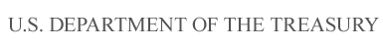

Department of the Treasury

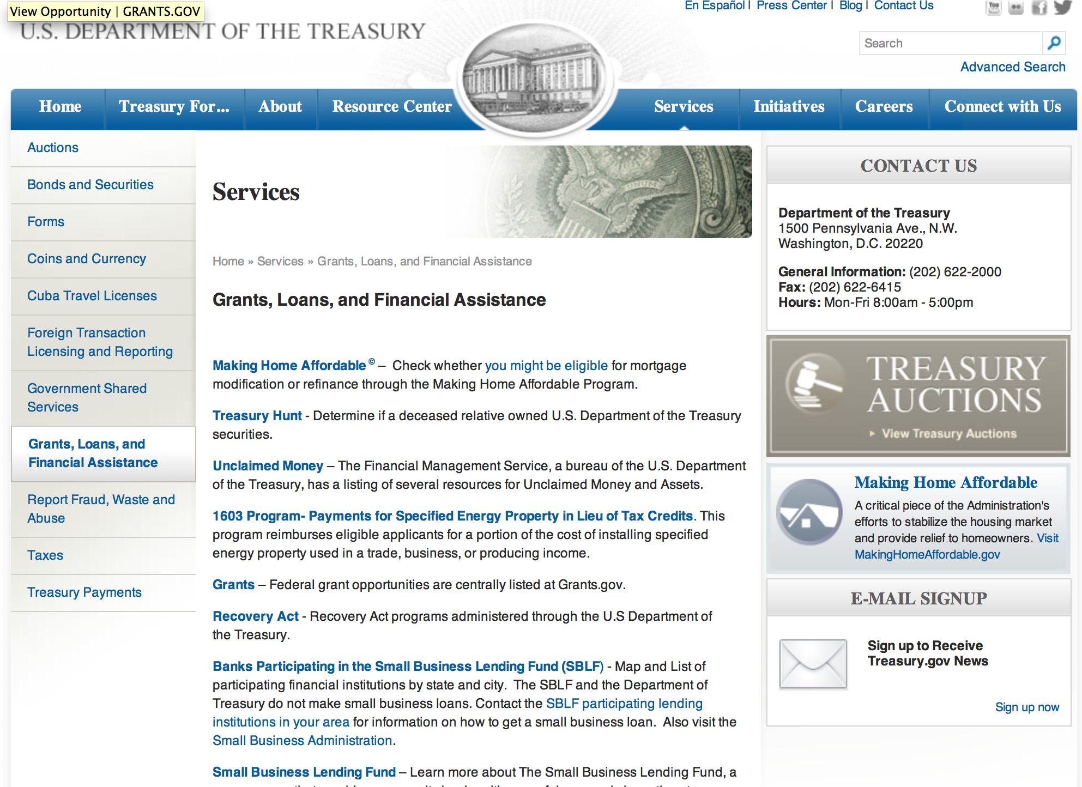

http://www.treasury.gov/services/Pages/Grants-Loans-and-Financial-Assistance.aspx

Programs:

Modifications:

Reminders:

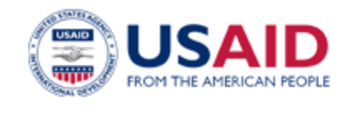

U.S. Agency for International Development

www.usaid.gov

General Overview Funding Opportunities

USAID has working relationships with thousands of American companies and hundreds of U.S.-based private voluntary organizations. For more information on our business and procurement opportunities, please visit our Business section.

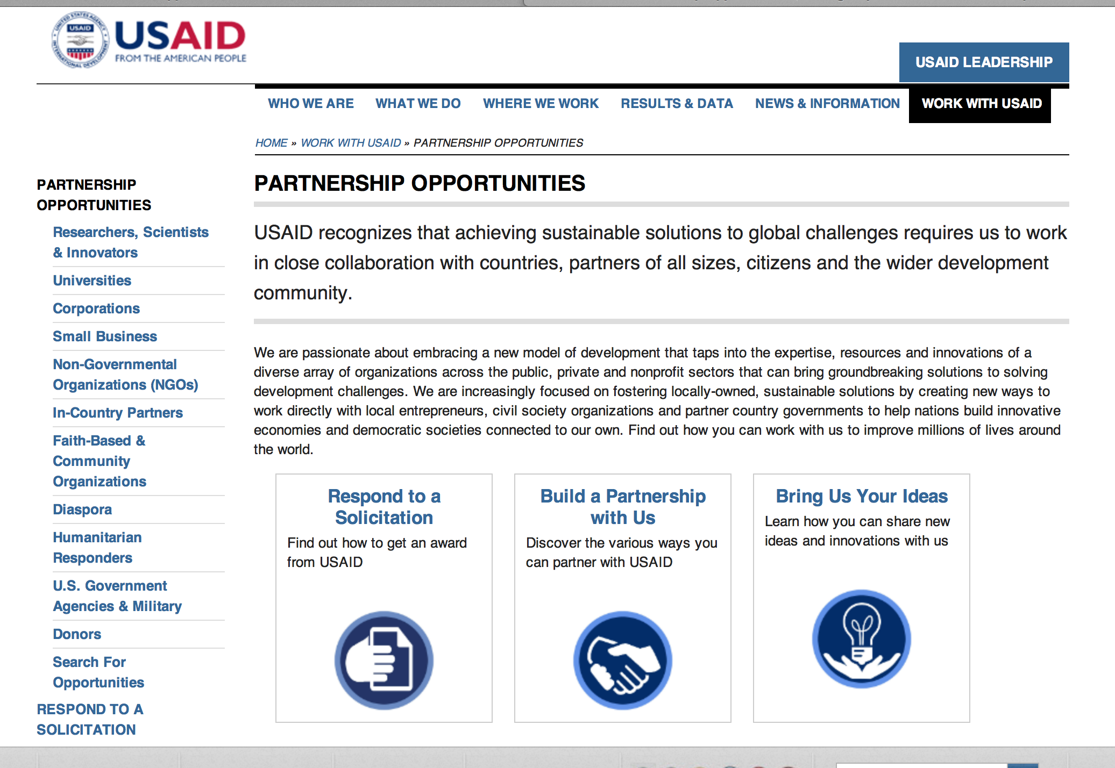
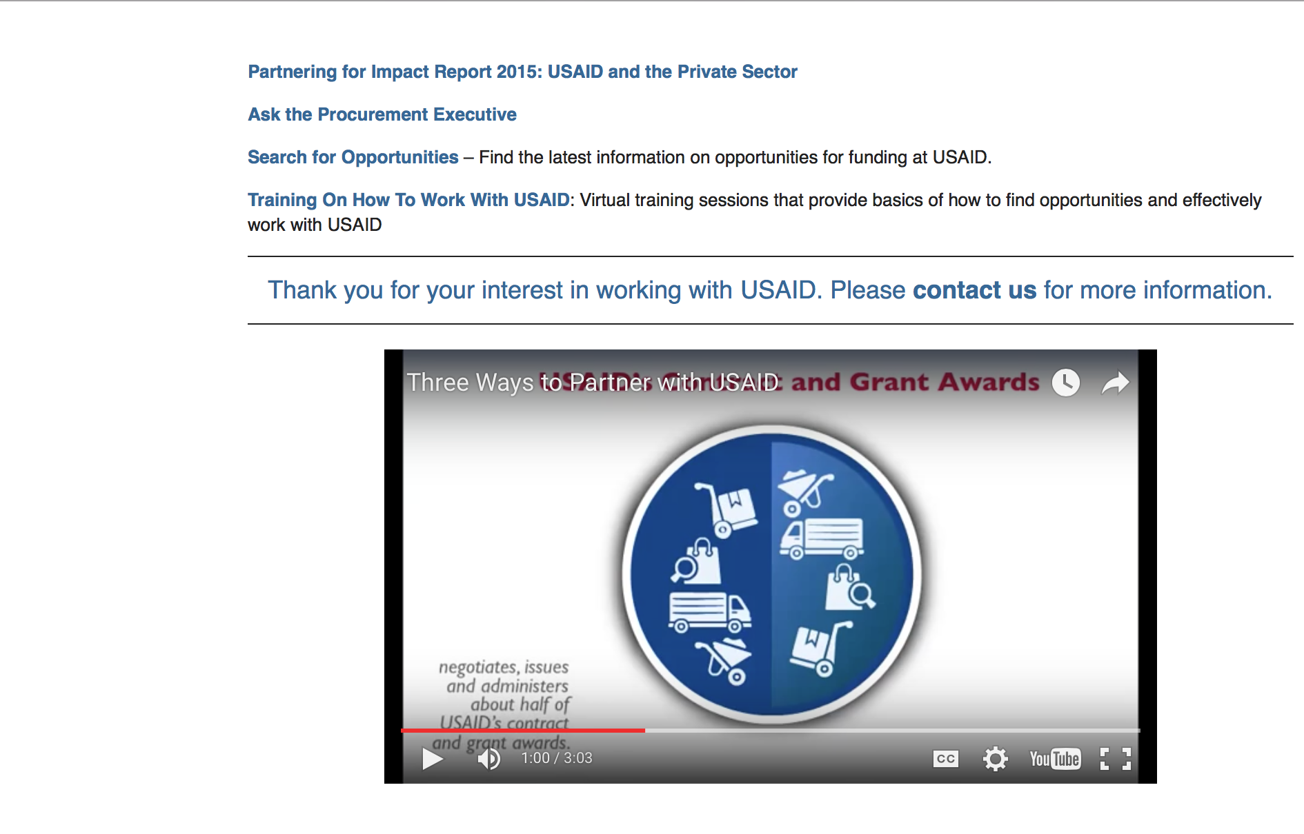

http://www.usaid.gov/partnerships

Programs:

Ethiopia USAID-Addis Ababa
TRANSFORM/DRS Grant
http://www.grants.gov/web/grants/view-opportunity.html?oppId=282187

India USAID-New Delhi
India Partnerships Program (IPP) Grant
http://www.grants.gov/web/grants/view-opportunity.html?oppId=282644

West Bank, Gaza USAID-West Bank
Conflict Management and Mitigation Program
And Modifications 2 & 3
http://www.grants.gov/web/grants/view-opportunity.html?oppId=282329

IFRP-DRAFT-RFA-FFP-DRAFT Grant
http://www.grants.gov/web/grants/view-opportunity.html?oppId=282344

Modifications:

FY 2016 Conflict Mitigation and Reconciliation Programs and Activities (Global Reconciliation Fund)
Modification 2
http://www.grants.gov/web/grants/view-opportunity.html?oppId=282007

FY 2016 Conflict Mitigation and Reconciliation Programs and Activities (Global Reconciliation Fund)
And Modification 1
http://www.grants.gov/web/grants/view-opportunity.html?oppId=282007

Reminders:

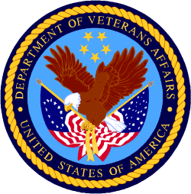

Department of Veterans Affairs

National Veterans Sports Programs
Grants for Adaptive Sports Programs for Disabled Veterans and Disabled Members of the Armed Forces Grant
And Modification 1
Document Type: | Grants Notice
Funding Opportunity Number: | VA-ASG-2017-01
Funding Opportunity Title: | Grants for Adaptive Sports Programs for Disabled Veterans and Disabled Members of the Armed Forces
Opportunity Category: | Discretionary
Opportunity Category Explanation:
Funding Instrument Type: | Grant
Category of Funding Activity: | Other (see text field entitled "Explanation of Other Category of Funding Activity" for clarification)
Category Explanation: | Adaptive Sports Activities for Disabled Veterans and Disabled Members of the Armed Forces
Expected Number of Awards: | 85
CFDA Number(s): | 64.034 -- VA Assistance to United States Paralympic Integrated Adaptive Sports Program
Cost Sharing or Matching Requirement: | No
Posted Date: | Feb 25, 2016
Last Updated Date: | Mar 24, 2016
Original Closing Date for Applications: | Apr 28, 2016
Current Closing Date for Applications: | Apr 28, 2016
Archive Date: | Sep 30, 2016
Estimated Total Program Funding: | $8,000,000
Award Ceiling: | $500,000
Award Floor: | $10,000
Eligible Applicants: | Native American tribal organizations (other than Federally recognized tribal governments)  County governments  Public and State controlled institutions of higher education  City or township governments  Nonprofits having a 501(c)(3) status with the IRS, other than institutions of higher education  Private institutions of higher education  Special district governments  Native American tribal governments (Federally recognized)  Independent school districts  For profit organizations other than small businesses  Small businesses  State governments  Nonprofits that do not have a 501(c)(3) status with the IRS, other than institutions of higher education  Public housing authorities/Indian housing authorities
Agency Name: | National Veterans Sports Programs
Description: | Adaptive Sports Grant (ASG) Program Description: A. Purpose: To provide grants to eligible adaptive sports entities to plan, develop, manage, and implement adaptive sports activities for disabled Veterans and disabled members of the Armed Forces. Adaptive sports activities means: (1) instruction, participation, and competition in adaptive sports; (2) training and technical assistance to program administrators, coaches, recreation therapists, instructors, VA employees, and other appropriate individuals; and (3) coordination, Paralympic classification of athletes, athlete assessment, sport-specific training techniques, program development (including programs at the local level), sports equipment, supplies, program evaluation, and other activities related to the implementation and operation of the program. B. See full text of NOFA for additional ASG Program details.
Link to Additional Information: | Department of Veterans Affairs Adaptive Sports Grant Program
Contact Information: | If you have difficulty accessing the full announcement electronically, please contact:  Michael Welch Paralympic Program Specialist Phone 202-632-7136  VA Office of National Veterans Sports Programs & Special Events

http://www.grants.gov/web/grants/view-opportunity.html?oppId=281763

