Senator Mazie Hirono

Grants Assistance Information
Newsletter
August 2016

G.A.I.N. INDEX

Click on Index Links below to read summaries of the announcements by agency in this document.
Once you reach the item, if you cannot open the links for further information, copy the selected
URL website address into your browser.

Modified sections from previous listings are shown in a GREY background

Notices is Teal are items with immediate deadline dates.

Notices in Yellow are of special interest.

Notices is Green are items of special interest with immediate deadline dates.

Items in this type color are aimed at Small Businesses

Items in this type color have a Faith-Based Organization component

Special Federal Program Notices

SBIR – Small Business Innovation Research

Programs specific to Hawaii

Current Notices

Office of Procurement Operations - Grants Division
2016 DHS Scientific Leadership Awards for Minority Serving Institutions (MSI) Granting Bachelor Degrees

Employment and Training Administration
Department Of Labor Research And Evaluation Grants

Reminders

See Individual Departments for information and webpages representing the best and most accessible information on the agency funding opportunities

Federal Grant and Cooperative Agreement Program Summaries

U.S. Department of Agriculture

Grants and Loans Overview

Programs

National Institute of Food and Agriculture
Agriculture and Food Research Initiative - Agriculture and Natural Resources Science for Climate Variability and Change Challenge Area

National Institute of Food and Agriculture
Small Business Innovation Research Program Phase I

National Institute of Food and Agriculture
Higher Education Multicultural Scholars Program (MSP)

National Institute of Food and Agriculture
K-8 Health Education: Teacher Professional Development & Curriculum Resources for Department of Defense Education Activity (DoDEA) Schools

National Institute of Food and Agriculture
Suicide Prevention Professional Development Program (SPPD) for Department of Defense Education Activity (DoDEA) School Psychologists

Modifications

National Institute of Food and Agriculture
4-H Military Partnership and Outreach Support Program
Synopsis 2

Reminders

National Institute of Food and Agriculture
Agriculture and Food Research Initiative: Foundational Program Grant

AFRI Sustainable Bioenergy and Bioproducts RFA Grant

Department of Commerce

Programs

Ocean Exploration FY 2017 Funding Opportunity

National Competitive Harmful Algal Bloom Programs: The Ecology and Oceanography of Harmful Algal Blooms (ECOHAB) and Prevention, Control and Mitigation of Harmful Algal Blooms Program (PCMHAB)

Research

2017 Saltonstall-Kennedy Competitive Research Program

Administrative Data and data Linkages Research Program

National Institute of Standards and Technology
Disaster Resilience (DR) Research Grants Program

FY 2017 Climate Program Office

John H. Prescott Marine Mammal Rescue Assistance Grant Program (Prescott Grant Program) for Fiscal Year 2017

Modifications

National Institute of Standards and Technology
Project to Develop, Produce, and Distribute a Documentary Film about Rebooting the International Measurement System

Reminders

FY17 Bluefin Tuna Research Program Grant

FY 16 Coastal Ecosystem Resiliency Grants Program

National Institute of Standards and Technology
Measurement Science and Engineering (MSE) Research Grant Programs

National Sea Grant College Program 2016-17 Special Projects Grant

FY 2016 – FY 2019 EDA Planning Program and Local Technical Assistance Program Grant

FY 2016 Economic Development Assistance Programs ­ Application submission and program requirements for EDA’s Public Works and Economic Adjustment Assistance Programs

Economic Development Administration
Planning Program and Local Technical Assistance Program Grant

Deleted

Corporation for National and Community Service

General Program Overview

Programs

Reminders

National Service in Hawaii

Department of Defense

Doing Business with the Department of Defense

DoD Small Business Opportunities and Forecasting

Research Grants

Modifications

Reminders

Dept. of the Army -- Materiel Command
Army Research Office Broad Agency Announcement for Basic and Applied Scientific Research
Modification 8

Department of Education

Grant Programs Overview

Programs

Office of Elementary and Secondary Education (OESE): Equity Assistance Centers (EAC) CFDA Number 84.004D

Research

Modifications

Reminders

Deleted

US Department of Energy

Grants Overview

Programs

Modifications

Reminders

Environmental Protection Agency

Grants and Contracts Overview

Programs

Modeling of Climate Change Mitigation, Impacts and Adaptation

Modifications

Reminders

Department of Health and Human Services

Grants Overview

Program

Research Grants

Modifications

Reminders

Deleted

Department of Homeland Security
Grants Overview

Programs

FY 2016 Countering Violent Extremism Grants

Office of Procurement Operations - Grants Division
DHS S&T Center of Excellence for Homeland Security Quantitative Analysis – Center Partner

Modifications

Reminders

Office of Procurement Operations - Grants Division
Center of Excellence Criminal Investigations and Network Analysis – Partner Grant

Department of Housing and Urban Development

HUD - Notice of Funds Available

Programs

Rural Capacity Building for Community Development and Affordable Housing Grants

ROSS for Education

Modifications

Reminders

FY2016 Continuum of Care
Modification 4

Technical Correction to the General Section to HUD's Fiscal Year 2016 Notice[s] of Funding Availability for Discretionary Programs
Modification 1

General Section to HUD's Fiscal Year 2016 Notice[s] of Funding Availability for Discretionary Programs (General Section)
Modification 1

Institute of Museum and Library Services

Grants Overview

IMLS is on Facebook!

Laura Bush 21st Century Librarian Program

Modifications

Reminders

Deleted

Department of Interior

Grants and Contract Overview

Programs

Fish and Wildlife Service
Marine Turtle Conservation Fund

Modifications

Reminders

Fish and Wildlife Service
National Fish Passage Program Grant

Deleted

Department of Justice

Grants and Contract Overview

Programs

National Institute of Corrections
Networking and Professional Development of State and Large Urban System Healthcare Administrators

Research

Modifications

Reminders

Department of Labor

Grants and Contract General Overview

Programs

Employment and Training Administration
PORTABLE RETIREMENT BENEFITS PLANNING

Mine Safety and Health Administration
Brookwood Sago Grant

Modifications

Reminders

Employment and Training Administration
America’s Promise Job Driven Grant Program

National Aeronautics and Space Administration

Research Grant and Contract General Overview

Programs

Modifications

_______________________________________________________________
National Archives and Records Administration

Grant Opportunities General Overview

Access to Historical Records - Major Initiatives

Access to Historical Records – Archival Projects

Reminders

Public Engagement with Historical Records Grant

Access to Historical Records Grant

_______________________________________________________________
National Endowment for the Arts

Grant Opportunities General Overview

Programs

NEA Research: Art Works Application, FY 2017

Modifications

Reminders

Our Town FY 17 Grant

_______________________________________________________________

National Endowment for the Humanities

Grant Opportunities General Overview

Programs

Humanities Initiatives at Community Colleges

Modifications

Reminders

Humanities Initiatives at Community Colleges

Summer Stipends Grant

Humanities Connections Grant

Humanities Open Book Program Grant

National Science Foundation

Grant Opportunities General Overview

Research and Program Grants

Modifications

Reminders

Deleted

Nuclear Regulatory Commission

Reminders

Small Business Administration

General Overview Finding Loans & Grants

Programs

Reminders

Upcoming Trainings

Links Specific to Hawaii

State Department

General Overview and Resources for Program Administrators

Programs

Modifications

Reminders

U.S. Department of Transportation

General Grant Program Overview

Programs

DOT/Federal Railroad Administration
FY 2017 Positive Train Control Grant Funds

Reminders

DOT Federal Aviation Administration
DOT - FAA Aviation Research Grants
FAA Aviation Research and Development Grants
Modifications 3 & 4

Deleted

Department of the Treasury

Programs

Modifications

Reminders

US Agency for International Development

General Funding Opportunity Overview

Programs
Modifications

Deleted

Department of Veterans Affairs

Special Federal Program Notices

The Small Business Innovative Research Program - SBIR Program
The Small Business Innovation Research (SBIR) program is a highly competitive program that encourages domestic small businesses to engage in Federal Research/Research and Development (R/R&D) that has the potential for commercialization. Through a competitive awards-based program, SBIR enables small businesses to explore their technological potential and provides the incentive to profit from its commercialization. By including qualified small businesses in the nation's R&D arena, high-tech innovation is stimulated and the United States gains entrepreneurial spirit as it meets its specific research and development needs.

SBIR Mission and Program Goals
The mission of the SBIR program is to support scientific excellence and technological innovation through the investment of Federal research funds in critical American priorities to build a strong national economy.
The program’s goals are four-fold:
- Stimulate technological innovation
- Meet Federal research and development needs.
- Foster and encourage participation in innovation and entrepreneurship by socially and economically disadvantaged persons.
- Increase private-sector commercialization of innovations derived from Federal research and development funding.

SBIR-Participating Agencies
Each year, Federal agencies with extramural research and development (R&D) budgets that exceed $100 million are required to allocate 2.5 percent of their R&D budget to these programs. Currently, eleven Federal agencies participate in the program:
- Department of Agriculture
- Department of Commerce - National Institute of Standards and Technology
- Department of Commerce - National Oceanic and Atmospheric Administration
- Department of Defense
- Department of Education
- Department of Energy
- Department of Health and Human Services
- Department of Homeland Security
- Department of Transportation
- Environmental Protection Agency
- National Aeronautics and Space Administration
- National Science Foundation
Each agency administers its own individual program within guidelines established by Congress. These agencies designate R&D topics in their solicitations and accept proposals from small businesses. Awards are made on a competitive basis after proposal evaluation.

Three-Phase Program
The SBIR Program is structured in three phases:
Phase I. The objective of Phase I is to establish the technical merit, feasibility, and commercial potential of the proposed R/R&D efforts and to determine the quality of performance of the small business awardee organization prior to providing further Federal support in Phase II. SBIR Phase I awards normally do not exceed $150,000 total costs for 6 months.
Phase II. The objective of Phase II is to continue the R/R&D efforts initiated in Phase I. Funding is based on the results achieved in Phase I and the scientific and technical merit and commercial potential of the project proposed in Phase II. Only Phase I awardees are eligible for a Phase II award. SBIR Phase II awards normally do not exceed $1,000,000 total costs for 2 years.
Phase III. The objective of Phase III, where appropriate, is for the small business to pursue commercialization objectives resulting from the Phase I/II R/R&D activities. The SBIR program does not fund Phase III. Some Federal agencies, Phase III may involve follow-on non-SBIR funded R&D or production contracts for products, processes or services intended for use by the U.S. Government
SBIR NewsLetter

- SBIR Newsletter
Sign up for e-mail updates

HAWAII APPLICANTS ENCOURAGED

Current Notices:

Office of Procurement Operations - Grants Division
2016 DHS Scientific Leadership Awards for Minority Serving Institutions (MSI) Granting Bachelor Degrees
Synopsis 1

Document Type: | Grants Notice
Funding Opportunity Number: | DHS-16-ST-062-001
Funding Opportunity Title: | 2016 DHS Scientific Leadership Awards for Minority Serving Institutions (MSI) Granting Bachelor Degrees
Opportunity Category: | Discretionary
Opportunity Category Explanation:
Funding Instrument Type: | Grant
Category of Funding Activity: | Education
Category Explanation:
Expected Number of Awards: | 6
CFDA Number(s): | 97.062 -- Scientific Leadership Awards
Cost Sharing or Matching Requirement: | No
Posted Date: | Aug 03, 2016
Last Updated Date: | Aug 03, 2016
Original Closing Date for Applications: | Oct 05, 2016
Current Closing Date for Applications: | Oct 05, 2016
Archive Date: | Nov 04, 2016
Estimated Total Program Funding: | $3,600,000
Award Ceiling: | $1,200,000
Award Floor: | $1,000,000
Eligible Applicants: | Private institutions of higher education  Public and State controlled institutions of higher education
Agency Name: | Office of Procurement Operations - Grants Division
Description: | The Science and Technology Directorate (S&T) is DHS’s primary research and development (R&D) arm. S&T manages science and technology research, from development through transition, for the department's operational components and the nation’s first responders. S&T’s engineers, scientists and researchers work closely with industry and academic partners to ensure R&D investments address the high-priority needs of today and the growing demands of the future. The DHS Scientific Leadership Awards (SLA) program is one of several programs administered by the S&T Office of University Programs. Through the SLA program, OUP seeks to build a diverse, highly capable, technical workforce for the homeland security enterprise. This NOFO is soliciting applications from Minority Serving Intuitions (MSIs) to establish programs that relevant to S&T’s mission within their institutions or MSI networks.
Link to Additional Information:
Grantor Contact Information: | If you have difficulty accessing the full announcement electronically, please contact:  stephanie dawkins grants specialist Phone 202-447-0495  stephanie.dawkins@hq.dhs.gov

http://www.grants.gov/web/grants/view-opportunity.html?oppId=286814

Employment and Training Administration
Department Of Labor Research And Evaluation Grants
Synopsis 1

Document Type: | Grants Notice
Funding Opportunity Number: | FOA-CEO-16-01
Funding Opportunity Title: | DEPARTMENT OF LABOR RESEARCH AND EVALUATION GRANTS
Opportunity Category: | Discretionary
Opportunity Category Explanation:
Funding Instrument Type: | Grant
Category of Funding Activity: | Employment, Labor and Training
Category Explanation:
Expected Number of Awards: | 10
CFDA Number(s): | 17.791 -- Department of Labor Chief Evaluation Office
Cost Sharing or Matching Requirement: | No
Posted Date: | Aug 03, 2016
Last Updated Date: | Aug 03, 2016
Original Closing Date for Applications: | Oct 03, 2016 Applications must be received no later than 4:00:00 p.m. Eastern Time.
Current Closing Date for Applications: | Oct 03, 2016 Applications must be received no later than 4:00:00 p.m. Eastern Time.
Archive Date: | Nov 02, 2016
Estimated Total Program Funding: | $2,000,000
Award Ceiling: | $250,000
Award Floor: | $100,000
Eligible Applicants: | Others (see text field entitled "Additional Information on Eligibility" for clarification)
Additional Information on Eligibility: | The following organizations are eligible to apply: • Public/State Controlled Institution of Higher Education • Indian/Native American Tribal Government (Federally Recognized) • Indian/Native American Tribal Government (Other than Federally Recognized) • Indian/Native American Tribally Designated Organization • Private Institution of Higher Education • Hispanic-serving Institution • Historically Black Colleges and Universities (HBCUs) • Tribally Controlled Colleges and Universities (TCCUs) • Alaska Native and Native Hawaiian Serving Institutions
Agency Name: | Employment and Training Administration
Description: | The Office of the Assistant Secretary for Policy – Chief Evaluation Office (CEO), U.S. Department of Labor (DOL, or the Department, or we), announces the availability of approximately $2 million in grant funds authorized by the Consolidated Appropriations Act of 2016 (PL. 114-113) for the Department of Labor Research and Evaluation (LRE) grants. The CEO is soliciting applications from university-based researchers to fund up to ten Department of Labor Research and Evaluation (LRE) grants for a period of up to two years. Grants of no more than $250,000 per grantee over a two-year period will be awarded. Suggested topic areas for an LRE grant that are of priority interest to DOL include but are not limited to: • Employee Benefits Security, • Miners’ Safety and Health, • Wage and Hour and Labor Standards, • Worker and Workplace Safety and Health, • Workers’ Compensation, • Labor/Management Relations, • International Topics in Worker Protection including child and forced labor issues, • Improving Equal Employment Opportunities for Targeted Populations, • Innovative approaches to evaluating the impact of DOL worker protection programs and policies using existing administrative or other data, and • Low-cost randomized controlled trials or natural experiments to evaluate the impact of DOL programs. The period of performance for the LRE grants is between 12 and 24 months with an anticipated start date of December 1, 2016. This performance period includes all necessary implementation and start-up activities. Depending on the nature of the research, LRE applicants may propose a 12-, 18- or 24- month period of performance. No federal funding is anticipated beyond the initial grant period.
Link to Additional Information:
Grantor Contact Information: | If you have difficulty accessing the full announcement electronically, please contact:  Charese Moore Grants Management Specialist  Moore.Charese@dol.gov

http://www.grants.gov/web/grants/view-opportunity.html?oppId=286915

Reminders:

Please review each department’s General Grant and Funding Overview. These overviews are the key web pages on each departmental website dedicated to the agency’s funding opportunities. Check back often to note the department updates and use these sources to assist you in your planning.

Federal Grant and Cooperative Agreement Program Summaries

U.S. Department of Agriculture



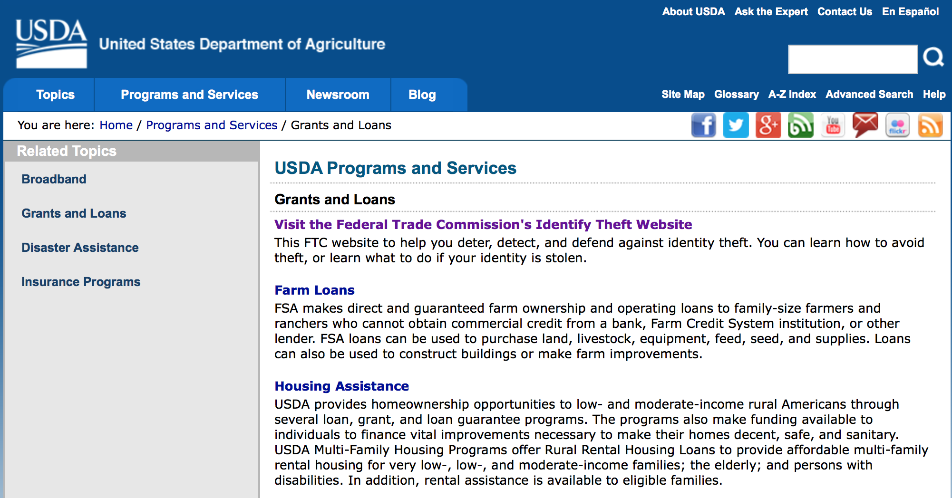
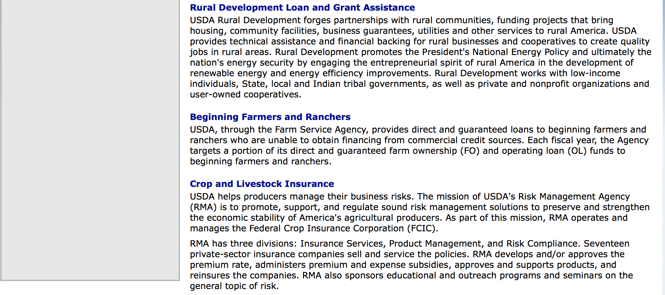

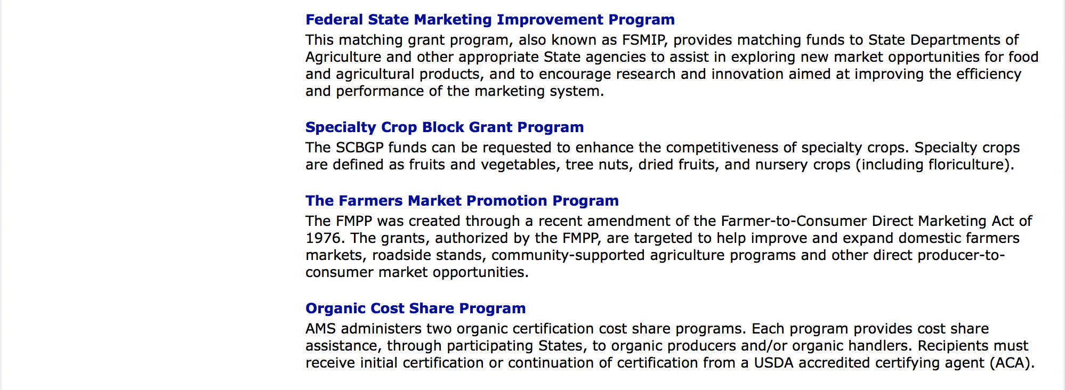

http://usda.gov/wps/portal/usda/usdahome?navid=GRANTS_LOANS

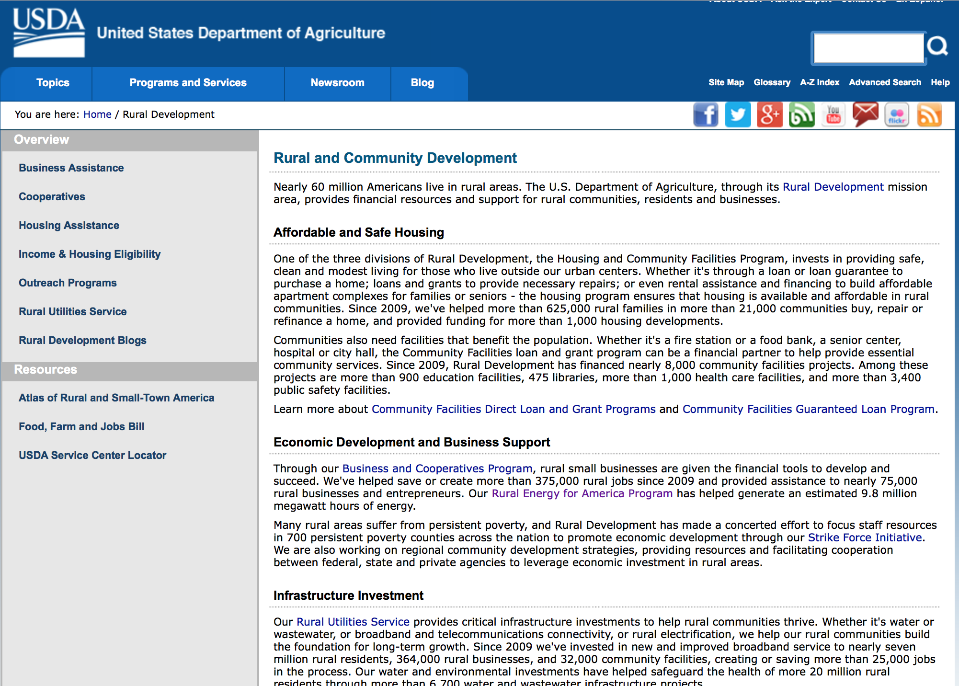

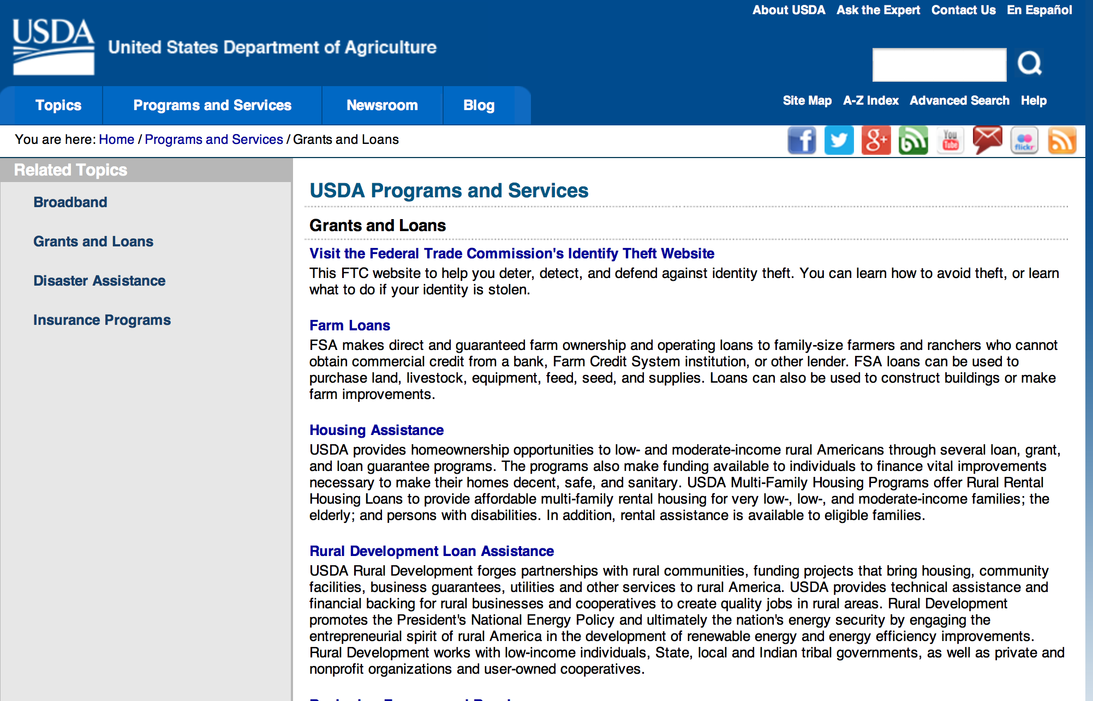

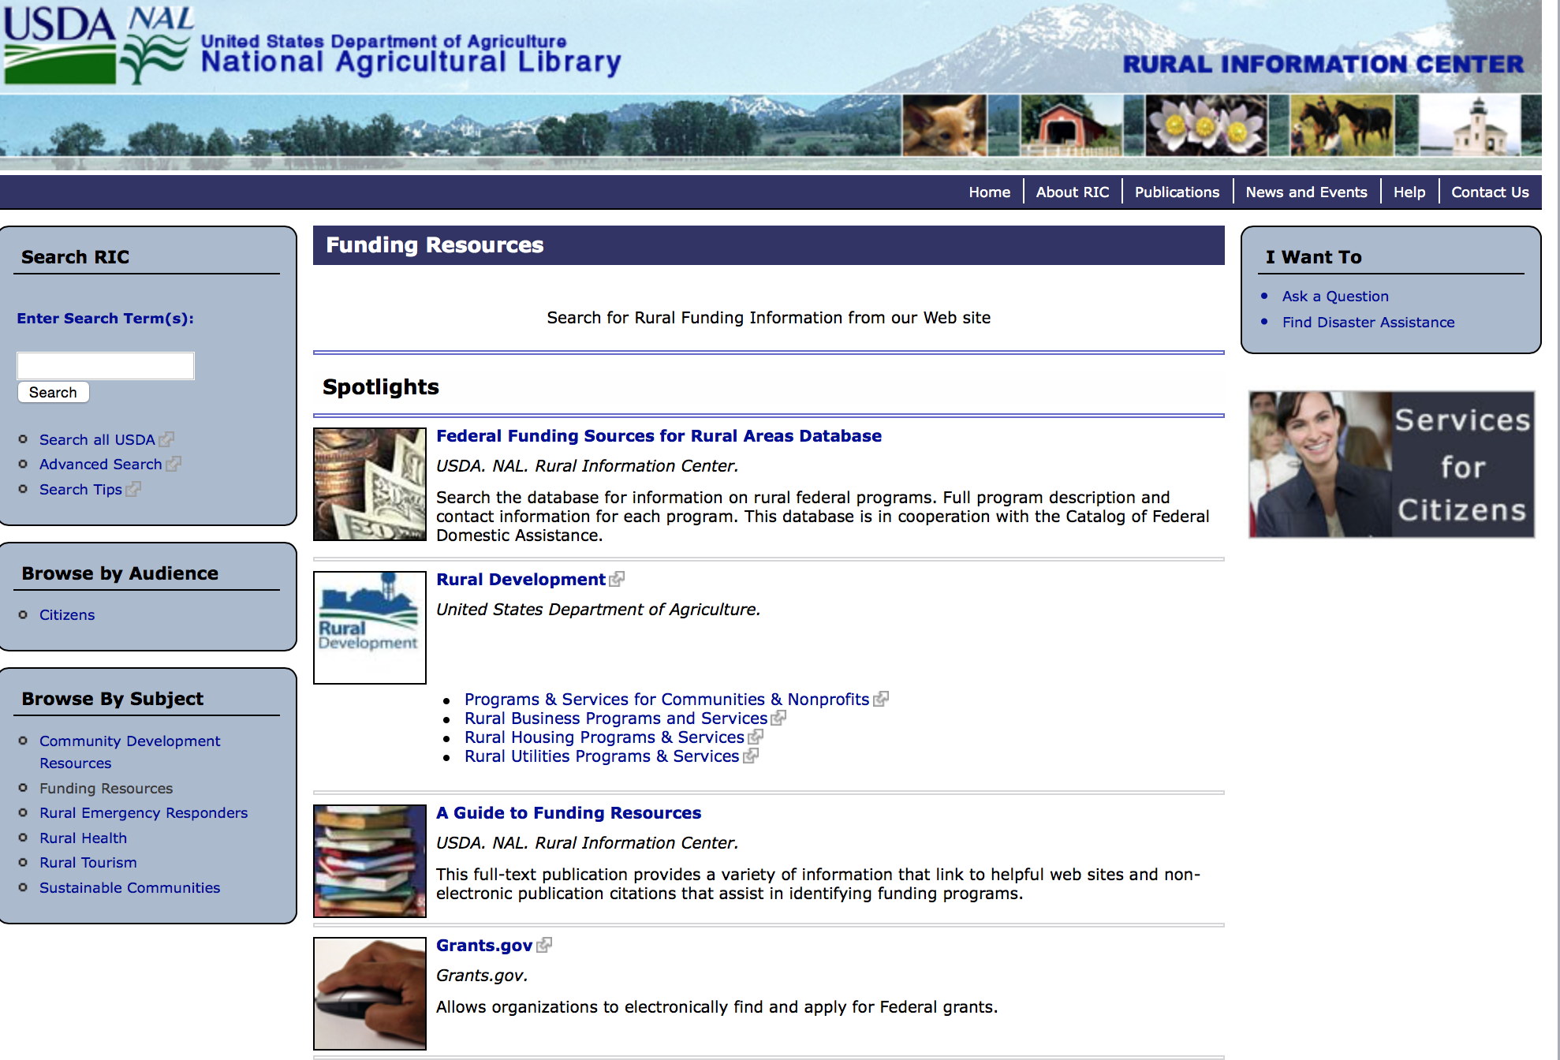

Federal Faith-Based Centers and Community Initiatives
USDA. NAL. Rural Information Center.
- Center for Faith-Based and Community Initiatives (link is external) , U.S. Department of Education
- Center for Faith-Based and Community Initiatives (link is external) , U.S. Department of Health and Human Services
- Center for Faith-Based and Community Initiatives (link is external) , U.S. Department of Labor
- Faith-Based and Community Initiatives (link is external) , U.S. Agency for International Development
- Faith-Based and Community Initiatives (link is external) , U.S. Department of Agriculture
- Faith-Based and Community Initiatives (link is external) , U.S. Department of Housing and Urban Development
- Faith-Based and Other Community Initiatives (link is external) , Corporation for National Community Service
- Task Force for Faith-Based and Community Initiatives (link is external) , U.S. Department of Justice

Grant Writing Resources
- Proposal Writing Short Course (link is external) Foundation Center.
- Data Universal Numbering System Fact sheet (link is external) [PDF | 302.2KB] USDA Rural Development.
- General Tips on Writing a Competitive Grant Proposal (link is external) U.S. Environmental Protection Agency.
- How to Write a Grant Proposal (link is external) Appalachian Regional Commission. <. li>

A Guide to Funding Resources USDA Rural Information Center.

http://ric.nal.usda.gov/funding-resources

http://usda.gov/wps/portal/usda/usdahome?navid=GRANTS_LOANS

Programs:

National Institute of Food and Agriculture
Agriculture and Food Research Initiative - Agriculture and Natural Resources Science for Climate Variability and Change Challenge Area
Synopsis 1

Document Type: | Grants Notice
Funding Opportunity Number: | USDA-NIFA-AFRI-005942
Funding Opportunity Title: | Agriculture and Food Research Initiative - Agriculture and Natural Resources Science for Climate Variability and Change Challenge Area
Opportunity Category: | Discretionary
Opportunity Category Explanation:
Funding Instrument Type: | Grant
Category of Funding Activity: | Agriculture
Category Explanation:
Expected Number of Awards:
CFDA Number(s): | 10.310 -- Agriculture and Food Research Initiative (AFRI)
Cost Sharing or Matching Requirement: | No
Version: | Synopsis 1
Posted Date: | Jul 12, 2016
Last Updated Date: | Jul 12, 2016
Original Closing Date for Applications: | Nov 17, 2016
Current Closing Date for Applications: | Nov 17, 2016
Archive Date: | Dec 17, 2016
Estimated Total Program Funding: | $8,400,000
Eligible Applicants: | Others (see text field entitled "Additional Information on Eligibility" for clarification)
Additional Information on Eligibility: | See Part III, A., Eligible Applicants. Eligibility is linked to the project type. All project types are described beginning in Part II, C.
Agency Name: | National Institute of Food and Agriculture
Description: | This AFRI Challenge Area focuses on the priority to mitigate and adapt to climate variability and change. It supports activities that reduce greenhouse gas emissions, increase carbon sequestration in agricultural and forest production systems, and prepare the nation's agriculture and forests to adapt to variable climates. The long-term outcome for this program is to reduce the use of energy, nitrogen fertilizer, and water by ten percent and increase carbon sequestration by fifteen percent through resilient agriculture and forest production systems. In order to achieve this outcome, this program will support multi-function Integrated Research, Education, and/or Extension Projects and Food and Agricultural Science Enhancement (FASE) Grants.
Link to Additional Information: | AFRI Agriculture and Natural Resources Science for Climate Variability and Change Challenge Area
Grantor Contact Information: | If you have difficulty accessing the full announcement electronically, please contact:  NIFA Help Desk Phone: 202-401-5048 Business hours are M-F, 7:00 am -5:00 pm ET, excluding Federal holidays  If you have any questions related to preparing application content

http://www.grants.gov/web/grants/view-opportunity.html?oppId=285990

National Institute of Food and Agriculture
Small Business Innovation Research Program Phase I
Synopsis 1

Document Type: | Grants Notice
Funding Opportunity Number: | USDA-NIFA-SBIR-005943
Funding Opportunity Title: | Small Business Innovation Research Program Phase I
Opportunity Category: | Discretionary
Opportunity Category Explanation:
Funding Instrument Type: | Grant
Category of Funding Activity: | Agriculture
Category Explanation:
Expected Number of Awards:
CFDA Number(s): | 10.212 -- Small Business Innovation Research
Cost Sharing or Matching Requirement: | No
Version: | Synopsis 1
Posted Date: | Jul 14, 2016
Last Updated Date: | Jul 14, 2016
Original Closing Date for Applications: | Oct 06, 2016
Current Closing Date for Applications: | Oct 06, 2016
Archive Date: | Nov 05, 2016
Estimated Total Program Funding: | $8,000,000
Eligible Applicants: | Others (see text field entitled "Additional Information on Eligibility" for clarification)
Additional Information on Eligibility: | See section 1.4 on the RFA.
Agency Name: | National Institute of Food and Agriculture
Description: | Proposed Phase I projects should prove the scientific or technical feasibility of the approach or concept. Projects dealing with agriculturally related manufacturing and alternative and renewable energy technologies are encouraged across all SBIR topic areas. USDA SBIR's flexible research areas ensure innovative projects consistent with USDA's vision of a healthy and productive nation in harmony with the land, air, and water. USDA SBIR Program has awarded over 2000 research and development projects since 1983, allowing hundreds of small businesses to explore their technological potential, and providing an incentive to profit from the commercialization of innovative ideas.
Link to Additional Information: | Small Business Innovation Research Program - Phase I
Grantor Contact Information: | If you have difficulty accessing the full announcement electronically, please contact:  NIFA Help Desk Phone: 202-401-5048 Business hours are M-F, 7:00 am -5:00 pm ET, excluding Federal holidays  If you have any questions related to preparing application content

http://www.grants.gov/web/grants/view-opportunity.html?oppId=286096

National Institute of Food and Agriculture
Higher Education Multicultural Scholars Program (MSP)
Synopsis 1
Document Type: | Grants Notice
Funding Opportunity Number: | USDA-NIFA-HEMS-005962
Funding Opportunity Title: | Higher Education Multicultural Scholars Program (MSP)
Opportunity Category: | Discretionary
Opportunity Category Explanation:
Funding Instrument Type: | Grant
Category of Funding Activity: | Agriculture
Category Explanation:
Expected Number of Awards:
CFDA Number(s): | 10.220 -- Higher Education - Multicultural Scholars Grant Program
Cost Sharing or Matching Requirement: | No
Posted Date: | Jul 21, 2016
Last Updated Date: | Jul 21, 2016
Original Closing Date for Applications: | Sep 22, 2016
Current Closing Date for Applications: | Sep 22, 2016
Archive Date: | Oct 22, 2016
Estimated Total Program Funding: | $945,400
Award Ceiling: | $200,000
Eligible Applicants: | Others (see text field entitled "Additional Information on Eligibility" for clarification)
Additional Information on Eligibility: | Pursuant to section 1417 of the NARETPA of 1977 (99 Stat. 1548; 7 U.S.C. 3152), applications may be submitted by: (1) land-grant institutions, (2) colleges and universities having significant minority enrollments and a demonstrable capacity to carry out the teaching of food and agricultural sciences, and (3) other colleges and universities having a demonstrable capacity to carry out the teaching of food, and agricultural sciences. Research foundations maintained by an eligible college or university are eligible to submit undergraduate and/or D.V.M. training proposals under this RFA. Applicants should be institutions that confer an undergraduate or D.V.M. degree in at least one of the disciplines in the food and agricultural sciences.
Agency Name: | National Institute of Food and Agriculture
Description: | The purpose of this competitive undergraduate scholarship grant program is to increase the multicultural diversity of the food and agricultural scientific and professional workforce, and advance the educational achievement of all Americans by providing competitive grants to colleges and universities.
Link to Additional Information: | Higher Education Multicultural Scholars Program (MSP)
Grantor Contact Information: | If you have difficulty accessing the full announcement electronically, please contact:  NIFA Help Desk Phone: 202-401-5048 Business hours are M-F, 7:00 am -5:00 pm ET, excluding Federal holidays  If you have any questions related to preparing application content

http://www.grants.gov/web/grants/view-opportunity.html?oppId=286394

National Institute of Food and Agriculture
K-8 Health Education: Teacher Professional Development & Curriculum Resources for Department of Defense Education Activity (DoDEA) Schools
Synopsis 1

Document Type: | Grants Notice
Funding Opportunity Number: | USDA-NIFA-EXCA-005982
Funding Opportunity Title: | K-8 Health Education: Teacher Professional Development & Curriculum Resources for Department of Defense Education Activity (DoDEA) Schools
Opportunity Category: | Discretionary
Opportunity Category Explanation:
Funding Instrument Type: | Grant
Category of Funding Activity: | Agriculture
Category Explanation:
Expected Number of Awards:
CFDA Number(s): | 10.500 -- Cooperative Extension Service
Cost Sharing or Matching Requirement: | No
Posted Date: | Aug 01, 2016
Last Updated Date: | Aug 01, 2016
Original Closing Date for Applications: | Sep 01, 2016
Current Closing Date for Applications: | Sep 01, 2016
Archive Date: | Oct 01, 2016
Estimated Total Program Funding: | $159,600
Award Ceiling: | $159,600
Eligible Applicants: | Others (see text field entitled "Additional Information on Eligibility" for clarification)
Additional Information on Eligibility: | Applications may be submitted by State agricultural experiment stations, State cooperative extension services, all colleges and universities, other research or educational institutions or organizations, and any other contractor or recipient, either foreign or domestic, to further research, extension, or teaching programs in food, agriculture, natural resources and human sciences.
Agency Name: | National Institute of Food and Agriculture
Description: | To create professional development modules and standards-based curriculum resources for K-8 Health Education strands focused on mental health and alcohol, tobacco and other drugs.
Link to Additional Information: | K-8 Health Education: Teacher Professional Development and Curriculum Resources for Department of Defense Education Activity (DoDEA) Schools
Grantor Contact Information: | If you have difficulty accessing the full announcement electronically, please contact:  NIFA Help Desk Phone: 202-401-5048 Business hours are M-F, 7:00 am -5:00 pm ET, excluding Federal holidays  If you have any questions related to preparing application content

http://www.grants.gov/web/grants/view-opportunity.html?oppId=286790

National Institute of Food and Agriculture
Suicide Prevention Professional Development Program (SPPD) for Department of Defense Education Activity (DoDEA) School Psychologists
Synopsis 1

Document Type: | Grants Notice
Funding Opportunity Number: | USDA-NIFA-EXCA-006002
Funding Opportunity Title: | Suicide Prevention Professional Development Program (SPPD) for Department of Defense Education Activity (DoDEA) School Psychologists
Opportunity Category: | Discretionary
Opportunity Category Explanation:
Funding Instrument Type: | Grant
Category of Funding Activity: | Agriculture
Category Explanation:
Expected Number of Awards:
CFDA Number(s): | 10.500 -- Cooperative Extension Service
Cost Sharing or Matching Requirement: | No
Posted Date: | Aug 01, 2016
Last Updated Date: | Aug 01, 2016
Original Closing Date for Applications: | Sep 01, 2016
Current Closing Date for Applications: | Sep 01, 2016
Archive Date: | Oct 01, 2016
Estimated Total Program Funding: | $144,900
Award Ceiling: | $144,900
Eligible Applicants: | Others (see text field entitled "Additional Information on Eligibility" for clarification)
Additional Information on Eligibility: | Applications may be submitted by State agricultural experiment stations, State cooperative extension services, all colleges and universities, other research or educational institution or organizations, Federal and private agencies and organizations, individuals and any other recipient, either foreign or domestic, to further research, extension, or teaching programs in the food and agriculture, natural resources and human sciences.
Agency Name: | National Institute of Food and Agriculture
Description: | NIFA requests applications for the Suicide Prevention Professional Development (SPPD) for DoDEA School Psychologists for fiscal year (FY) 2016 to develop professional development and curriculum resources based on research-based best practices derived from open, web-based resources for DoDEA school psychologists.
Link to Additional Information: | Suicide Prevention Professional Development Program (SPPD) for Department of Defense Education Activity (DoDEA) School Psychologists
Grantor Contact Information: | If you have difficulty accessing the full announcement electronically, please contact:  NIFA Help Desk Phone: 202-401-5048 Business hours are M-F, 7:00 am -5:00 pm ET, excluding Federal holidays  If you have any questions related to preparing application content

http://www.grants.gov/web/grants/view-opportunity.html?oppId=286791

Modifications:

National Institute of Food and Agriculture
4-H Military Partnership and Outreach Support Program
Synopsis 2

Document Type: | Grants Notice
Funding Opportunity Number: | USDA-NIFA-EXCA-006003
Funding Opportunity Title: | 4-H Military Partnership and Outreach Support Program
Opportunity Category: | Discretionary
Opportunity Category Explanation:
Funding Instrument Type: | Cooperative Agreement
Category of Funding Activity: | Agriculture
Category Explanation:
Expected Number of Awards:
CFDA Number(s): | 10.500 -- Cooperative Extension Service
Cost Sharing or Matching Requirement: | No
Posted Date: | Aug 01, 2016
Last Updated Date: | Aug 01, 2016
Original Closing Date for Applications: | Aug 15, 2016
Current Closing Date for Applications: | Aug 15, 2016
Archive Date: | Sep 14, 2016
Estimated Total Program Funding: | $1,971,000
Eligible Applicants: | Others (see text field entitled "Additional Information on Eligibility" for clarification)
Additional Information on Eligibility: | Applications may be submitted by State agricultural experiment stations, State cooperative extension services, all colleges and universities, other research or educational institutions or organizations, Federal and private agencies and organizations, individuals and any other recipient, either foreign or domestic. Due to the unique nature of this application, institutions applying must be authorized to use the4-H name and emblem by 4-H National Headquarters at USDA and be currently implementing a positive youth development program through 4-H. Failure to meet an eligibility criterion by the time of application deadline may result in the application being excluded from consideration or, even though an application may be reviewed, will preclude NIFA from making an award. Only one application per land-grant institution will be accepted.
Agency Name: | National Institute of Food and Agriculture
Description: | The goals for the 4-H Military Partnership and Outreach Support Program (4-H MPOS) for fiscal year (FY) 2016 are to marshal resources of the land-grant institutions and Cooperative Extension System in collaboration with other organizations to develop and deliver positive youth development through 4-H programs for military-connected children and youth, and to plan and conduct on site trainings, webinars, and programs for military staff and volunteers.
Link to Additional Information: | 4-H Military Partnership and Outreach Support (4-H MPOS)
Grantor Contact Information: | If you have difficulty accessing the full announcement electronically, please contact:  NIFA Help Desk Phone: 202-401-5048 Business hours are M-F, 7:00 am -5:00 pm ET, excluding Federal holidays  If you have any questions related to preparing application content

http://www.grants.gov/web/grants/view-opportunity.html?oppId=286808

Reminders:

National Institute of Food and Agriculture
Agriculture and Food Research Initiative: Foundational Program Grant
And Modifications 1 & 2

Document Type: | Grants Notice
Funding Opportunity Number: | USDA-NIFA-AFRI-005843
Funding Opportunity Title: | Agriculture and Food Research Initiative: Foundational Program
Opportunity Category: | Discretionary
Opportunity Category Explanation:
Funding Instrument Type: | Grant
Category of Funding Activity: | Agriculture
Category Explanation:
Expected Number of Awards:
CFDA Number(s): | 10.310 -- Agriculture and Food Research Initiative (AFRI)
Cost Sharing or Matching Requirement: | No
Posted Date: | May 13, 2016
Last Updated Date: | May 23, 2016
Original Closing Date for Applications: | Sep 30, 2016 See Program Area Priority for additional information.
Current Closing Date for Applications: | Aug 31, 2016 See Program Area Priority for additional information.
Archive Date: | Sep 30, 2016
Estimated Total Program Funding: | $130,000,000
Eligible Applicants: | Others (see text field entitled "Additional Information on Eligibility" for clarification)
Additional Information on Eligibility: | See Part III, A., Eligible Applicants. Eligibility is linked to the project type. All project types are described beginning in Part II, C.
Agency Name: | National Institute of Food and Agriculture
Description: | The AFRI Foundational Program is offered to support grants in the six AFRI priority areas to continue building a foundation of knowledge critical for solving current and future societal challenges. The six priority areas are: Plant Health and Production and Plant Products; Animal Health and Production and Animal Products; Food Safety, Nutrition, and Health; Bioenergy, Natural Resources, and Environment; Agriculture Systems and Technology; and Agriculture Economics and Rural Communities. Single-function Research Projects, multi-function Integrated Projects, and Food and Agricultural Science Enhancement (FASE) Grants are expected to address one of the Program Area Priorities (see Foundational Program RFA for details).
Link to Additional Information: | AFRI Foundational Program
Contact Information: | If you have difficulty accessing the full announcement electronically, please contact:  NIFA Help Desk Phone: 202-401-5048 Business hours are M-F, 7:00 am - 5:00 pm ET, excluding Federal holidays  If you have any questions related to preparing application content

http://www.grants.gov/web/grants/view-opportunity.html?oppId=283836

National Institute of Food and Agriculture
AFRI Sustainable Bioenergy and Bioproducts RFA Grant

Document Type: | Grants Notice
Funding Opportunity Number: | USDA-NIFA-AFRI-005460
Funding Opportunity Title: | AFRI Sustainable Bioenergy and Bioproducts RFA
Opportunity Category: | Discretionary
Opportunity Category Explanation:
Funding Instrument Type: | Grant
Category of Funding Activity: | Agriculture  Energy  Natural Resources
Category Explanation:
Expected Number of Awards:
CFDA Number(s): | 10.310 -- Agriculture and Food Research Initiative (AFRI)
Cost Sharing or Matching Requirement: | Yes
Posted Date: | May 13, 2016
Last Updated Date: | May 13, 2016
Original Closing Date for Applications: | Sep 22, 2016 1.The Letter of intent must be received at NIFA by 5:00 p.m. Eastern Time on the dates indicated in the Program Area Descriptions beginning in Part I, C and in the format specified in Part IV, A. 2.Applications must be received by Grants.gov by 5:00 p.m. Eastern Time on the dates indicated in the Program Area Descriptions beginning in Part I, C.
Current Closing Date for Applications: | Sep 22, 2016 1.The Letter of intent must be received at NIFA by 5:00 p.m. Eastern Time on the dates indicated in the Program Area Descriptions beginning in Part I, C and in the format specified in Part IV, A. 2.Applications must be received by Grants.gov by 5:00 p.m. Eastern Time on the dates indicated in the Program Area Descriptions beginning in Part I, C.
Archive Date: | Oct 22, 2016
Estimated Total Program Funding: | $21,000,000
Eligible Applicants: | Others (see text field entitled "Additional Information on Eligibility" for clarification)
Additional Information on Eligibility: | Applications may only be submitted by eligible entities. Eligibility is linked to the project type. All project types are described beginning in Part II, C. See Part III, A. Eligibility Information for details.
Agency Name: | National Institute of Food and Agriculture
Description: | In the Agriculture and Food Research Initiative Sustainable Bioenergy and Bioproducts (SBEBP) Challenge Area specific program areas are designed to achieve the long term outcome of reducing the national dependence on foreign oil through the development and production of regionally-appropriate sustainable bioenergy systems that materially deliver advanced liquid transportation biofuels, biopower, and bioproducts.
Link to Additional Information: | Agriculture and Food Research Initiative Sustainable Bioenergy and Bioproducts (SBEBP) Challenge Area
Contact Information: | If you have difficulty accessing the full announcement electronically, please contact:  NIFA Help Desk Phone: 202-401-5048 Business hours are M-F, 7:00 am -5:00 pm ET, excluding Federal holidays  If you have any questions related to preparing application content

http://www.grants.gov/web/grants/view-opportunity.html?oppId=283812

Department of Commerce

Grants, Contracting, and Trade Opportunities at Commerce
Learn more information about grants, contracting and trade opportunities at the Department of Commerce using the information below.

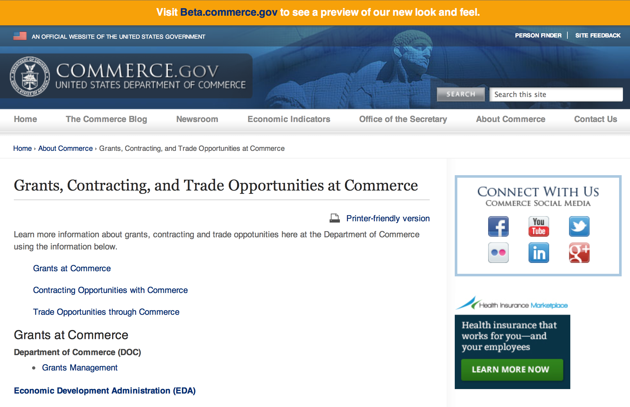
Grants at Commerce
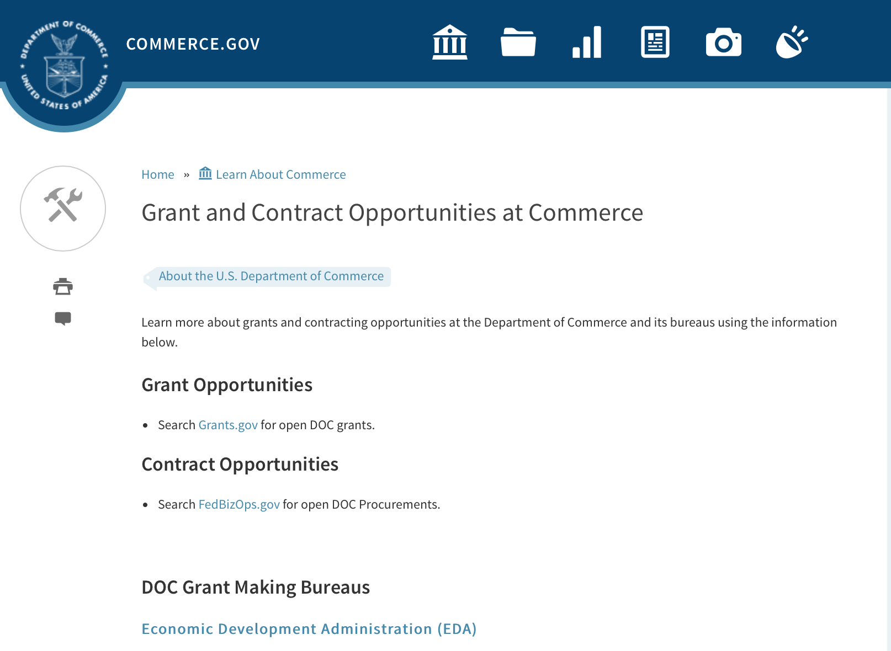

DOC Grant Making Bureaus
Economic Development Administration (EDA)
International Trade Administration (ITA)
- Market Development Cooperator Program
- Special American Business Internship Training Program (SABIT). A technical assistance initiative of the International Trade Administration of the U.S. Department of Commerce, SABIT offers organizations competitive grants and an opportunity to host industry-specific delegations. SABIT serves as an initial entry point for U.S. businesses seeking funding to establish long-term relationships with potential customers, distributors, or partners in the former Soviet Union. The program trains Eurasian managers and scientists in commonly accepted business practices as a means of facilitating cross border relationships. In turn, these personal relationships serve as a basis for business development and reduce market access barriers for U.S. businesses
National Institute of Standards & Technology (NIST)
- Funding Opportunities
National Telecommunications & Information Administration (NTIA)
- Telecommunications Grants
National Oceanic & Atmospheric Administration (NOAA)
- Coastal Ocean Program Grant Information
- Fisheries Saltonstall Kennedy Grant Program
- National Undersea Research Program Funding Opportunities
- Grants Management Division
- Fisheries Grants Program
- National Sea Grant
- Office of Global Programs
Contracting Resources for Contractors
- Office of Small and Disadvantaged Business Utilization (OSDBU) - he Office of Small and Disadvantaged Business Utilization (OSDBU) is an advocacy and advisory office responsible for promoting the use of small, small disadvantaged, 8(a), women-owned, veteran-owned, service-disabled veteran-owned, and HUBZone small businesses within the U.S. Department of Commerce's (DOC) acquisition process.
- Business.USA.gov's Find Opportunities Wizard where in a few quick steps, it will guide you towards federal government contracting programs and opportunities for your business!
- Planned Acquisitions: the Department of Commerce's search tool for our planned acquisitions over $100,000. As requirements change, these acquisition plans are updated by department personnel and this search tool is automatically updated.
- Small Business Administration's Contracting section of their web site where you can learn about how to "Get Started" and "Contracting Support for Small Business"
- The General Services Administration (GSA) has implemented a system for vendors doing business with the Federal Government to manage their entity information in one central location. This new database is the System for Award Management (SAM).

DOC Contracting Offices
- Patent and Trademark Office (PTO)
  - Office of Procurement
- National Institute of Standards & Technology (NIST)
NIST Acquisition Management Group
Contracting Opportunities with Commerce
Trade Opportunities through Commerce
http://www.commerce.gov/about-commerce/grants-contracting-trade-opportunities

Programs:

Ocean Exploration FY 2017 Funding Opportunity
Synopsis 1

Document Type: | Grants Notice
Funding Opportunity Number: | NOAA-OAR-OER-2017-2004970
Funding Opportunity Title: | Ocean Exploration FY 2017 Funding Opportunity
Opportunity Category: | Discretionary
Opportunity Category Explanation:
Funding Instrument Type: | Cooperative Agreement  Grant
Category of Funding Activity: | Environment  Natural Resources  Science and Technology and other Research and Development
Category Explanation:
Expected Number of Awards: | 10
CFDA Number(s): | 11.011 -- Ocean Exploration
Cost Sharing or Matching Requirement: | No
Posted Date: | Aug 02, 2016
Last Updated Date: | Aug 02, 2016
Original Closing Date for Applications: | Dec 23, 2016
Current Closing Date for Applications: | Dec 23, 2016
Archive Date: | Jan 22, 2017
Estimated Total Program Funding: | $3,000,000
Award Ceiling: | $750,000
Award Floor: | $10,000
Eligible Applicants: | Others (see text field entitled "Additional Information on Eligibility" for clarification)
Additional Information on Eligibility: | Eligible applicants are institutions of higher education; non-profit institutions; for-profit organizations; state, local, and tribal governments, and U.S. territories that possess the statutory authority to accept funding for this type of work. Federal agencies that possess the statutory authority to accept funding for this type of work may also apply. Federal and state agencies are strongly encouraged to collaborate with partners from a non-federal eligible entity. OER funding will not be used to hire and/or fund the salaries and associated overhead of any permanent federal employees. Federal award recipients may use their funding to cover only travel, equipment, supplies, and contractual personnel costs associated with the proposed work. Foreign researchers may participate by submitting a sub-award through collaboration with an eligible U.S. entity. The DOC and NOAA support cultural and gender diversity and encourage women and minority individuals and groups to submit applications to this Announcement of Federal Funding Opportunity. In addition, DOC/NOAA is strongly committed to broadening the participation of historically black colleges and universities, Hispanic serving institutions, tribal colleges and universities, and institutions that work in underserved areas. DOC/NOAA encourages applications involving any of the above institutions to apply. PLEASE NOTE: Before non-NOAA Federal applicants may be funded, they must demonstrate that they have legal authority to receive funds from another Federal agency in excess of their appropriation.
Agency Name: | Department of Commerce
Description: | NOAA’s Office of Ocean Exploration & Research (OER) seeks to enhance ocean exploration and scientific knowledge of the unknown or poorly known areas of the ocean. This entails identifying, describing and creating baseline characterizations of new ocean habitats, marine resources and/or processes. In this Announcement, OER is seeking proposals focused on four themes: 1. Exploration of physical, chemical and biological environments and processes within the oceanic water column below ~200m; 2. Exploration of geological, physical, and biological environments as well as biogeochemical processes associated with seamounts; 3. Novel or innovative technologies and methodologies that could increase the pace and scope of ocean exploration, especially exploration of the water column, seamounts, and archaeological sites; and 4. Proposals focused on the discovery and exploration of historically significant submerged marine heritage sites, features and artifacts associated with WWII. Proposals that combine more than one of these exploration themes are encouraged. OER’s overarching objective is to investigate and document poorly known and unknown ocean areas through interdisciplinary exploration, and to advance and disseminate knowledge of the ocean’s physical, geological, chemical, biological, and archaeological environments. Findings from projects and expeditions are anticipated to result in new baseline characterizations; provide better scientific understanding of the processes on U.S. continental margins and the deep ocean; offer new insights into climate variability and marine ecosystems; reveal new or unconventional energy, mineral, biological, and archaeological resources; help identify hazards resulting from extreme events such as submarine volcanic eruptions, earthquakes and tsunamis; and deliver technology advancements (platforms, sensors, methodologies, etc.) that will increase observational capabilities in the ocean. OER is interested in characterization of seamounts located within regions of the U.S. EEZ or ECS, including the Gulf of Alaska, the NW Atlantic, and the deep regions of Marine Protected Areas. Characterization of physical, chemical, and biological ocean environments associated with seamounts in areas where ocean mining may occur (e.g., regions along the Clarion-Clipperton Fracture) is also of particular interest. OER may also consider proposals focused on other areas that are relevant to OER's and NOAA's missions and priorities that would include significant leveraged resources. Archaeology proposals are not restricted to any depth or geographic area.
Link to Additional Information:
Grantor Contact Information: | If you have difficulty accessing the full announcement electronically, please contact:  NOAA Office of Ocean Exploration and Research ATTN: OER FFO 2017, SSMC3, Rm 10316 1315 East West Highway Silver Spring, Maryland 20910 (301) 734-1014 oer.ffo2017@noaa.gov  Work

http://www.grants.gov/web/grants/view-opportunity.html?oppId=286859

National Competitive Harmful Algal Bloom Programs: The Ecology and Oceanography of Harmful Algal Blooms (ECOHAB) and Prevention, Control and Mitigation of Harmful Algal Blooms Program (PCMHAB)
Synopsis 1

Document Type: | Grants Notice
Funding Opportunity Number: | NOAA-NOS-NCCOS-2017-2004943
Funding Opportunity Title: | National Competitive Harmful Algal Bloom Programs: The Ecology and Oceanography of Harmful Algal Blooms (ECOHAB) and Prevention, Control and Mitigation of Harmful Algal Blooms Program (PCMHAB)
Opportunity Category: | Discretionary
Opportunity Category Explanation:
Funding Instrument Type: | Cooperative Agreement
Category of Funding Activity: | Environment  Natural Resources  Science and Technology and other Research and Development
Category Explanation:
Expected Number of Awards:
CFDA Number(s): | 11.478 -- Center for Sponsored Coastal Ocean Research Coastal Ocean Program
Cost Sharing or Matching Requirement: | No
Posted Date: | Aug 02, 2016
Last Updated Date: | Aug 02, 2016
Original Closing Date for Applications: | Nov 02, 2016
Current Closing Date for Applications: | Nov 02, 2016
Archive Date: | Dec 02, 2016
Estimated Total Program Funding: | $1,000,000
Award Ceiling: | $750,000
Award Floor: | $100,000
Eligible Applicants: | Others (see text field entitled "Additional Information on Eligibility" for clarification)
Additional Information on Eligibility: | Eligible applicants for Federal financial assistance in this competition are institutions of higher education, other non-profits, state, local, Indian Tribal Governments, for-profit organizations, U.S. Territories and Federal agencies that possess the statutory authority to receive transfers of funds. DOC/NOAA supports cultural and gender diversity and encourages women and minority individuals and groups to submit applications to the NCCOS/CSCOR programs. In addition, DOC/NOAA is strongly committed to broadening the participation of historically black colleges and universities, Hispanic serving institutions, tribal colleges and universities, and institutions that work in underserved areas. DOC/NOAA encourages applications involving any of the above institutions to apply. Please note that: (1) Principal Investigators should be employees of an eligible entity listed above; and applications should be submitted through that entity. Non-Federal researchers should comply with their institutional requirements for application submission. (2) Non-NOAA Federal applicants will be required to submit certifications or documentation showing that they have specific legal authority to accept funds for this type of research. (3) Foreign researchers must apply as subawards or contracts through an eligible US entity. (4) Non-Federal researchers affiliated with NOAA-University Cooperative/Joint Institutes will be funded through cooperative agreements. (5) NOAA/NOS/NCCOS researchers are ineligible to apply. A. They may not be included in applications as funded or unfunded investigators. B They may not provide letters of support for the application. C Applications that disregard either a. or b. will be rejected without review.
Agency Name: | Department of Commerce
Description: | The purpose of this document is to advise the public that NOAA/NOS/National Centers for Coastal Ocean Science (NCCOS)/Center for Sponsored Coastal Ocean Research (CSCOR) is soliciting proposals for the Ecology and Oceanography of Harmful Algal Blooms (ECOHAB) and Prevention and Control of Harmful Algal Blooms Program (PCMHAB). Funding is contingent upon the availability of Fiscal Year 2017 Federal appropriations. It is anticipated that projects funded under this announcement will have a September 1, 2017 start date.
Link to Additional Information:
Grantor Contact Information: | If you have difficulty accessing the full announcement electronically, please contact:  Technical Information: Quay Dortch, Program Manager for NCCOS/CSCOR, 240-533-0198, Internet: Quay.Dortch@noaa.gov, Grants Administration Information: Laura Golden, NCCOS/CSCOR Grants Administrator, 240-533-0285, Internet: Laurie.Golden@noaa.gov  Work

http://www.grants.gov/web/grants/view-opportunity.html?oppId=286886

Research:

2017 Saltonstall-Kennedy Competitive Research Program
Synopsis 1

Document Type: | Grants Notice
Funding Opportunity Number: | NOAA-NMFS-FHQ-2017-2004980
Funding Opportunity Title: | 2017 Saltonstall-Kennedy Competitive Research Program
Opportunity Category: | Discretionary
Opportunity Category Explanation:
Funding Instrument Type: | Cooperative Agreement  Grant
Category of Funding Activity: | Environment  Natural Resources  Science and Technology and other Research and Development
Category Explanation:
Expected Number of Awards: | 50
CFDA Number(s): | 11.427 -- Fisheries Development and Utilization Research and Development Grants and Cooperative Agreements Program
Cost Sharing or Matching Requirement: | No
Posted Date: | Jul 22, 2016
Last Updated Date: | Jul 22, 2016
Original Closing Date for Applications: | Dec 09, 2016
Current Closing Date for Applications: | Dec 09, 2016
Archive Date: | Jan 08, 2017
Estimated Total Program Funding: | $10,000,000
Award Ceiling: | $300,000
Award Floor: | $25,000
Eligible Applicants: | Others (see text field entitled "Additional Information on Eligibility" for clarification)
Additional Information on Eligibility: | You are eligible to apply for a grant or a cooperative agreement under the Saltonstall- Kennedy Grant Program if: 1. You are a citizen or national of the United States; 2. You represent an entity that is a corporation, partnership, association, or other non- Federal entity, non-profit or otherwise (including Indian tribes), if such entity is a citizen of the United States within the meaning of section 2 of the Shipping Act, 1916, as amended (46 U.S.C. app. 802); or 3. You are a citizen of the Republic of the Marshall Islands, Republic of Palau, or the Federated States of Micronesia. We recognize the interest of the Secretaries of Commerce and Interior in defining appropriate fisheries policies and programs that meet the needs of the U.S. insular areas, so we encourage applications from individuals, government entities, and businesses in U.S. insular areas. We support cultural and gender diversity in our programs and encourage women and minority individuals and groups to submit applications We are also committed to broadening the participation of Minority Serving Institutions (MSIs), which include Historically Black Colleges and Universities, Hispanic Serving Institutions, and Tribal Colleges and Universities, in our grant programs. To find out more about MSIs go to http: http://www2.ed.gov/about/offices/list/ocr/edlite-minorityinst.html. We encourage applications from members of the fishing community and applications that involve fishing community cooperation and participation. We will consider the extent of fishing community involvement when evaluating the potential benefit of funding a proposal. Eligible Applicants must submit a pre-proposal. Full proposals will not be reviewed or evaluated if a pre-proposal was not received and ranked. Non Eligible Applicants You are not eligible to submit an application under this program if you are an employee of any Federal agency; a Regional Fishery Management Council (Council); or an employee of a Council. However, Council members who are not Federal employees can submit an application to the S-K Program.
Agency Name: | Department of Commerce
Description: | The Saltonstall-Kennedy Act established a fund (known as the S-K fund) used by the Secretary of Commerce to provide grants or cooperative agreements for fisheries research and development projects addressing aspects of U.S. fisheries, including, but not limited to, harvesting, processing, marketing, and associated business infrastructures. Under this authority, grants and cooperative agreements are made on a competitive basis (subject to availability of funding) to assist in carrying out projects related to U.S. commercial and recreational fisheries. The term “fisheries” encompasses wild capture, marine aquaculture and recreational fishing. The objective of the S-K Grant Program is to address the needs of the fisheries and fishing communities in optimizing economic benefits by building and maintaining sustainable fisheries and practices, dealing with the impacts of conservation and management measures, and increasing other opportunities to use existing infrastructure to support keeping working waterfronts viable. U.S. fisheries include any fishery, commercial or recreational, that is, or may be, engaged in by citizens or nationals of the United States. Proposals submitted to this competition must address at least one of the following priorities: Marine Aquaculture; Fisheries Data Collection; Techniques for Reducing Bycatch and other Adverse Impacts; Adapting to Climate Change and Other Long Term Ecosystem Change; Promotion, Development and Marketing; Socio-Economic Research; and Territorial Science. This Federal Funding Opportunity includes information on application and criteria for research proposals requesting a maximum of $300,000 in total federal funding for up to a two-year period. Matching funds are not required. Awards are anticipated to start no earlier than September 1, 2017.
Link to Additional Information:
Grantor Contact Information: | If you have difficulty accessing the full announcement electronically, please contact:  Regional S-K Program point of contacts: Headquarters - Program Manager – Daniel Namur, telephone (301) 427-8730 email: Dan.Namur@noaa.gov, Alaska Region: Shawn Carey, telephone: (907) 586-7845; email: Shawn.Carey@noaa.gov; West Coast Region: Kim Raneses, telephone: (206) 526-6131; email: Kim.Raneses@noaa.gov, Pacific Islands Region: Scott Bloom, telephone: (808) 944-2218; email: Scott.Bloom@noaa.gov, Greater Atlantic Region: Susan Olsen, telephone (978) 281-9330; email: Susan.Olsen@noaa.gov; Southeast Region: Robert Sadler, telephone: (727) 551-5760; email: Robert.Sadler@noaa.gov  Work

http://www.grants.gov/web/grants/view-opportunity.html?oppId=286440

Administrative Data and data Linkages Research Program

Synopsis 1
Document Type: | Grants Notice
Funding Opportunity Number: | CENSUS-ADR-CARRA-2016-2004966
Funding Opportunity Title: | Administrative Data and data Linkages Research Program
Opportunity Category: | Discretionary
Opportunity Category Explanation:
Funding Instrument Type: | Cooperative Agreement
Category of Funding Activity: | Environment  Natural Resources  Science and Technology and other Research and Development
Category Explanation:
Expected Number of Awards: | 5
CFDA Number(s): | 11.016 -- Statistical, Research, and Methodology Assistance
Cost Sharing or Matching Requirement: | No
Posted Date: | Jul 25, 2016
Last Updated Date: | Jul 25, 2016
Original Closing Date for Applications: | Aug 31, 2016
Current Closing Date for Applications: | Aug 31, 2016
Archive Date: | Sep 30, 2016
Estimated Total Program Funding: | $5,000,000
Award Ceiling: | $1,000,000
Award Floor: | $100,000
Eligible Applicants: | Others (see text field entitled "Additional Information on Eligibility" for clarification)
Additional Information on Eligibility: | Eligible applicants are institutions of higher education and non-profit organizations. Applications from individuals, federal agencies, employees of federal agencies, for-profit organizations, individuals, and state, local, and Indian tribal governments will not be considered.
Agency Name: | Department of Commerce
Description: | BOC is soliciting applications from eligible applicants to support research that improves measurement of the U.S. population and economy. Policy makers, city planners, teachers, and researchers use data gathered by BOC. Applications are sought to improve the production and availability of statistics that inform public policy. Applications that achieve some or all of the following goals are sought for improving data capture and linkages using administrative data, the identification and pursuit of data to improve evidence building, new statistical products describing the U.S. population; and the development of innovative privacy technology.
Link to Additional Information:
Grantor Contact Information: | If you have difficulty accessing the full announcement electronically, please contact:  Census Cooperative Agreements Team, ADRM.PCO.PM@census.gov  Work

http://www.grants.gov/web/grants/view-opportunity.html?oppId=286535

National Institute of Standards and Technology
Disaster Resilience (DR) Research Grants Program
Synopsis 1

Document Type: | Grants Notice
Funding Opportunity Number: | 2016-NIST-DR-01
Funding Opportunity Title: | Disaster Resilience (DR) Research Grants Program
Opportunity Category: | Discretionary
Opportunity Category Explanation:
Funding Instrument Type: | Cooperative Agreement
Category of Funding Activity: | Science and Technology and other Research and Development
Category Explanation:
Expected Number of Awards:
CFDA Number(s): | 11.609 -- Measurement and Engineering Research and Standards
Cost Sharing or Matching Requirement: | No
Posted Date: | Jul 26, 2016
Last Updated Date: | Jul 26, 2016
Original Closing Date for Applications: | Sep 23, 2016
Current Closing Date for Applications: | Sep 23, 2016
Archive Date: | Oct 23, 2016
Eligible Applicants: | Others (see text field entitled "Additional Information on Eligibility" for clarification)
Additional Information on Eligibility: | Eligibility for all programs listed in this FFO is open to all non-Federal entities. Eligible applicants include institutions of higher education, non-profit organizations, for-profit organizations, state and local governments, Indian tribes, hospitals, foreign public entities, and foreign governments. NIST is not able to accept an application from an individual unaffiliated with a sponsoring applicant organization.
Agency Name: | National Institute of Standards and Technology
Description: | The Disaster Resilience (DR) Research Grants Program seeks applications from eligible applicants to conduct research aimed at advancing the principles of resilience in building design and building codes and standards. Research proposals must support the overall effort of developing science-based building codes by evaluating potential technologies and architectural design criteria to improve disaster resilience in the built environment. Research projects must be aligned with existing NIST Engineering Laboratory (EL) Disaster Resilience programs, as described in Section I. of the Full Announcement/FFO document.
Link to Additional Information: | 2016-NIST-DR-01 Full Announcement/FFO document
Grantor Contact Information: | If you have difficulty accessing the full announcement electronically, please contact:  Christopher Hunton Management and Program Analyst Phone 301-975-5718  Agency Contact

http://www.grants.gov/web/grants/view-opportunity.html?oppId=286558

FY 2017 Climate Program Office
Synopsis 1

Document Type: | Grants Notice
Funding Opportunity Number: | NOAA-OAR-CPO-2017-2004896
Funding Opportunity Title: | FY 2017 Climate Program Office
Opportunity Category: | Discretionary
Opportunity Category Explanation:
Funding Instrument Type: | Cooperative Agreement
Category of Funding Activity: | Environment  Natural Resources  Science and Technology and other Research and Development
Category Explanation:
Expected Number of Awards: | 90
CFDA Number(s): | 11.431 -- Climate and Atmospheric Research
Cost Sharing or Matching Requirement: | No
Posted Date: | Jul 26, 2016
Last Updated Date: | Jul 26, 2016
Original Closing Date for Applications: | Oct 24, 2016
Current Closing Date for Applications: | Oct 24, 2016
Archive Date: | Nov 23, 2016
Estimated Total Program Funding: | $10,000,000
Award Ceiling: | $300,000
Award Floor: | $50,000
Eligible Applicants: | Others (see text field entitled "Additional Information on Eligibility" for clarification)
Additional Information on Eligibility: | Eligible applicants are institutions of higher education, other nonprofits, commercial organizations, international organizations, and state, local and Indian tribal governments. Federal agencies interested in receiving financial support for projects should contact the appropriate competition manager.
Agency Name: | Department of Commerce
Description: | FFO description: The National Oceanic and Atmospheric Administration (NOAA) is focused on providing the essential and highest quality environmental information vital to our Nation’s safety, prosperity and resilience. Toward this goal, the agency conducts and supports weather and climate research, oceanic and atmospheric observations, modeling, information management, assessments, interdisciplinary decision-support research, outreach, education, and partnership development. Climate variability and change present society with significant economic, health, safety, and security challenges and opportunities. In meeting these challenges, and as part of NOAA’s climate portfolio within the Office of Oceanic and Atmospheric Research (OAR), the Climate Program Office (CPO) advances scientific understanding, monitoring, and prediction of climate and its impacts, to enable effective decisions. These investments are key to NOAA’s mission of "Science, Service, and Stewardship" and are guided by the agency’s vision to create and sustain enhanced resilience in ecosystems, communities, and economies. Within this context, CPO manages competitive research programs through which NOAA funds high-priority climate science, assessments, decision support research, outreach, education, and capacity-building activities designed to advance our understanding of the Earth’s climate system, and to foster the application and use of this knowledge to improve the resilience of our Nation and its partners. CPO supports research that is conducted across the United States and internationally. CPO also provides strategic guidance for the agency’s climate science and services programs and supports NOAA’s contributions to the U.S. Global Change Research Program (USGCRP) and its National Climate Assessment, and similar international endeavors such as the Global Framework for Climate Services. CPO’s climate research portfolio is designed to achieve a fully integrated research and applications program. We meet this objective through a focus on climate intelligence and climate resilience, in support of NOAA’s goals. Climate intelligence defines CPO’s technical strength through its foundational capabilities, which include (1) Observations and monitoring, (2) Research to advance scientific understanding, (3) Modeling and prediction, (4) Communication, education, and engagement, and, (5) Climate and societal interactions. A focus on climate resilience leverages CPO’s climate intelligence to advance capabilities for responding to the urgent and growing demand for reliable, trusted, transparent, and timely climate information needed to sustain all sectors of our economy and environment. CPO’s strategy addresses challenges in the areas of, (1) Weather and climate extremes, (2) Climate impacts on water resources, (3) Coasts and climate resilience, (4) Sustainability of marine ecosystems, and (5) Changing atmospheric composition and its impacts. Making progress in addressing climate-related societal challenges and realizing benefits for NOAA’s public and private partners, requires that these mission-focused capabilities be integrated across CPO to align research, applications, transitions, and operations, and to meet the information needs of a resilient society. NOAA envisions a Nation that is prepared for, thriving, and resilient to climate variability and change. CPO’s activities support a unique and highly flexible climate research enterprise to improve scientific understanding of climate variability and change and to enable businesses and communities to derive the benefits of this investment in the present and into the future. Effectively coordinating across these components through the development and deployment of end-to-end research-based integrated information systems that address needs of high societal relevance, have been hallmarks of CPO’s success in linking environmental intelligence to resilience. Key components in this enterprise are Annual Federal Funding Opportunities, competitive grants programs and other types of support that advance and extend NOAA’s foundational capabilities and applications research. Proficiency in these core areas ensures that CPO’s infrastructure is always in place to meet the intelligence and resilience challenges of our changing climate. NOAA, OAR, and the Climate Program Office encourage applicants and awardees to support the principles of diversity and inclusion when writing their proposals and performing their work. Diversity is defined as a collection of individual attributes that together help organizations achieve objectives. Inclusion is defined as a culture that connects each employee to the organization. By promoting diversity and inclusion you can improve creativity, productivity, and the vitality of the research community.
Link to Additional Information:
Grantor Contact Information: | If you have difficulty accessing the full announcement electronically, please contact:  Agency Contacts: Please visit the CPO website for further information at or contact the CPO Grants Manager, Diane Brown, Please allow up to two weeks after receipt for a response.  Work

http://www.grants.gov/web/grants/view-opportunity.html?oppId=286560

John H. Prescott Marine Mammal Rescue Assistance Grant Program (Prescott Grant Program) for Fiscal Year 2017
Synopsis 1
Document Type: | Grants Notice
Funding Opportunity Number: | NOAA-NMFS-PRPO-2017-2004968
Funding Opportunity Title: | John H. Prescott Marine Mammal Rescue Assistance Grant Program (Prescott Grant Program) for Fiscal Year 2017
Opportunity Category: | Discretionary
Opportunity Category Explanation:
Funding Instrument Type: | Cooperative Agreement  Grant
Category of Funding Activity: | Environment  Natural Resources  Science and Technology and other Research and Development
Category Explanation:
Expected Number of Awards: | 40
CFDA Number(s): | 11.439 -- Marine Mammal Data Program
Cost Sharing or Matching Requirement: | Yes
Posted Date: | Jul 27, 2016
Last Updated Date: | Jul 27, 2016
Original Closing Date for Applications: | Oct 05, 2016
Current Closing Date for Applications: | Oct 05, 2016
Archive Date: | Nov 04, 2016
Estimated Total Program Funding: | $4,000,000
Award Ceiling: | $100,000
Eligible Applicants: | Others (see text field entitled "Additional Information on Eligibility" for clarification)
Additional Information on Eligibility: | All eligible applicants must currently be an active, authorized participant or researcher in the National Marine Mammal Stranding Network. Eligible applicants must be: 1) Stranding Agreement (SA) holders or their designee organizations; or 2) holders of researcher authorization letters issued by a NMFS Regional Administrator and/or an MMPA and/or ESA scientific research or enhancement permit (when applicable); or 3) an eligible Federal, state, or local government personnel or tribal personnel (pursuant to Section 109(h) of the MMPA (16 U.S.C. 1379(h)); or 4) diagnostic laboratories performing services for the stranding network. Federal agencies in the DOC or Department of the Interior (DOI) are not eligible to receive Federal assistance under this notice. 1. "In Good Standing Criteria". All eligible applicants must meet the following "in good standing" criteria: a. If the applicant is a designated Principal Investigator on a MMPA and/or ESA scientific research or enhancement permit or a Co-Investigator on the MMHSRP's MMPA/ESA scientific research and enhancement permit (permit No. 18786), the applicant must have fulfilled all permit requirements. The applicant must not have any pending or outstanding enforcement actions under the MMPA or ESA. b. The applicant must have complied with the terms and responsibilities of the appropriate SA, MMPA Section 109(h) authorization, or researcher authorization letter. This includes, but is not limited to: 1) completion of all reporting requirements; 2) cooperation with state, local, and federal officials; 3) cooperation with state and local officials in the disposition of stranded marine mammals; and 4) cooperation with stranding network participants. c. The applicant must have cooperated in a timely manner with NMFS in collecting and submitting Level B and Level C data and samples, when requested. d. The applicant must not have any current enforcement investigation for the take of marine mammals contrary to MMPA/ESA regulations. e. The applicant must not have any pending NMFS notice of violation(s) regarding the policies governing the goals and operations of the Stranding Network and SA, if applicable (e.g., probation, suspension, or termination). 2. Category Specific Criteria. Organizations and individuals must meet all of the following eligibility criteria specific to their category of participation in order for a proposal to be considered for funding: a. SA Holder Participant or SA Designee Participant - SA participants must hold a current, active SA for stranding response and/or rehabilitation from a NMFS Regional Administrator or the Assistant Administrator. SA Designee participants must be holding a current, active letter of designation from a NMFS SA holder. Designees cannot request authorization for activities beyond the scope of what is authorized by the SA to the agreement holder. b. Researcher Participant - Researcher participants must hold a current, active authorizing letter for the proposed award period from the appropriate NMFS Regional Administrator or the Assistant Administrator to salvage stranded marine mammal specimens, parts and samples for the purpose of utilization in scientific research (50 CFR 216.22). Persons authorized to salvage dead marine mammal specimens under this section must register the salvage with the appropriate NMFS Regional Office within 30 days after the taking occurs. Researchers who are authorized under an MMPA/ESA Scientific Research Permit must still obtain an authorizing letter from the Regional Stranding Coordinator in order to use parts or specimens from stranded animals. Researcher participants that would not require an authorizing letter from the NMFS Regional Administrator (i.e., they will be working with data only and not possessing samples or specimens) must still provide a letter of eligibility from the Regional Stranding Coordinator (see section III.A.3. of this FFO). Researcher participants.
Agency Name: | Department of Commerce
Description: | NOAA NMFS' Marine Mammal Health and Stranding Response Program is directed under the Marine Mammal Protection Act (MMPA) to facilitate the collection and dissemination of reference data on stranded marine mammals and health trends of marine mammal populations in the wild. The John H. Prescott Marine Mammal Rescue Assistance Grant Program is administered by NOAA to provide Federal assistance to eligible members of the National Marine Mammal Stranding Network to: 1) support basic needs of organizations for response, treatment, and data collection from living and dead stranded marine mammals, 2) fund scientific research objectives designed to answer questions about marine mammal strandings, health, or rehabilitation techniques utilizing data from living and dead stranded marine mammals, and 3) support facility operations directly related to the recovery, treatment, and data collection from living and dead stranded marine mammals. This document describes how to submit proposals for funding in fiscal year (FY) 2017 and how NMFS will determine which proposals will be funded. This document should be read in its entirety, as some information has changed from the previous year.
Link to Additional Information:
Grantor Contact Information: | If you have difficulty accessing the full announcement electronically, please contact:  Jaclyn Taylor and Nicole Adimey Prescott Grant Program NOAA/NMFS/Office of Protected Resources (F/PR) 1315 East-West Highway, Room 13620 Silver Spring, MD 20910 Phone: (301) 427-8402 Jaclyn.Taylor@noaa.gov or Nicole.Adimey@noaa.gov  Work

http://www.grants.gov/web/grants/view-opportunity.html?oppId=286607

Modifications:

National Institute of Standards and Technology
Project to Develop, Produce, and Distribute a Documentary Film about Rebooting the International Measurement System
Modification 2

Document Type: | Grants Notice
Funding Opportunity Number: | 2016-NIST-KG-01
Funding Opportunity Title: | Project to Develop, Produce, and Distribute a Documentary Film about Rebooting the International Measurement System
Opportunity Category: | Discretionary
Opportunity Category Explanation:
Funding Instrument Type: | Cooperative Agreement  Grant
Category of Funding Activity: | Other (see text field entitled "Explanation of Other Category of Funding Activity" for clarification)
Category Explanation: | Science, Technology, Business and/or Education Outreach
Expected Number of Awards:
CFDA Number(s): | 11.620 -- Science, Technology, Business and/or Education Outreach
Cost Sharing or Matching Requirement: | No
Version: | Modification 2
Posted Date: | Jul 11, 2016
Last Updated Date: | Jul 11, 2016
Original Closing Date for Applications: | Sep 26, 2016
Current Closing Date for Applications: | Sep 26, 2016
Archive Date: | Oct 26, 2016
Eligible Applicants: | Others (see text field entitled "Additional Information on Eligibility" for clarification)
Additional Information on Eligibility: | Eligibility for the program listed in this FFO is unrestricted, that is, open to all non-Federal entities. Eligible applicants include accredited institutions of higher education; non-profit organizations incorporated in the United States; for-profit organizations incorporated in the United States; and state, local, territorial and Indian tribal governments within the United States. An eligible organization may work individually or include proposed subawardees, contractors or other collaborators. NIST will only consider one application per applicant; however, an applicant entity may participate as a subrecipient, contractor, or unfunded collaborator within applications submitted by other entities.
Agency Name: | National Institute of Standards and Technology
Description: | 2016-NIST-KG-01 Full Announcement/FFO document
Link to Additional Information: | 2016-NIST-KG-01 Full Announcement/FFO Document
Grantor Contact Information: | If you have difficulty accessing the full announcement electronically, please contact:  Christopher Hunton Management and Program Analyst Phone 301-975-5718  Agency Contact

http://www.grants.gov/web/grants/view-opportunity.html?oppId=285971

Reminders:

FY17 Bluefin Tuna Research Program Grant

Document Type: | Grants Notice
Funding Opportunity Number: | NOAA-NMFS-SE-2017-2004938
Funding Opportunity Title: | FY17 Bluefin Tuna Research Program
Opportunity Category: | Discretionary
Opportunity Category Explanation:
Funding Instrument Type: | Cooperative Agreement
Category of Funding Activity: | Environment  Natural Resources  Science and Technology and other Research and Development
Category Explanation:
Expected Number of Awards: | 5
CFDA Number(s): | 11.472 -- Unallied Science Program
Cost Sharing or Matching Requirement: | No
Posted Date: | Jun 14, 2016
Last Updated Date: | Jun 14, 2016
Original Closing Date for Applications: | Sep 01, 2016
Current Closing Date for Applications: | Sep 01, 2016
Archive Date: | Oct 01, 2016
Estimated Total Program Funding: | $600,000
Award Ceiling: | $300,000
Award Floor: | $25,000
Eligible Applicants: | Others (see text field entitled "Additional Information on Eligibility" for clarification)
Additional Information on Eligibility: | Eligible applicants may be institutions of higher education, nonprofits, commercial organizations, individuals, and state, local, and Indian tribal governments.
Agency Name: | Department of Commerce
Description: | The BTRP program provides opportunity to compete for financial assistance for projects which seek to increase and improve the working relationship between fisheries researchers from the NMFS, state fishery agencies, universities, other research institutions and U.S. fishery interests (recreational and commercial) focusing on northern bluefin tuna in the Atlantic Ocean. The program is a means of advancing research objectives to address the information needs to improve the science-based fisheries management for Atlantic bluefin tuna. This program addresses NOAA's mission goal to "Protect, Restore, and Manage the Use of Coastal and Ocean Resources through an Ecosystem Approach to Management."
Link to Additional Information:
Grantor Contact Information: | If you have difficulty accessing the full announcement electronically, please contact:  Dax Ruiz, (727) 824-5324, Dax.Ruiz@noaa.gov  Work

http://www.grants.gov/web/grants/view-opportunity.html?oppId=284667

FY 16 Coastal Ecosystem Resiliency Grants Program

Document Type: | Grants Notice
Funding Opportunity Number: | NOAA-NMFS-HCPO-2016-2004840
Funding Opportunity Title: | FY 16 Coastal Ecosystem Resiliency Grants Program
Opportunity Category: | Discretionary
Opportunity Category Explanation:
Funding Instrument Type: | Cooperative Agreement
Category of Funding Activity: | Environment  Natural Resources  Science and Technology and other Research and Development
Category Explanation:
Expected Number of Awards: | 10
CFDA Number(s): | 11.463 -- Habitat Conservation
Cost Sharing or Matching Requirement: | Yes
Posted Date: | Jun 14, 2016
Last Updated Date: | Jun 14, 2016
Original Closing Date for Applications: | Aug 16, 2016
Current Closing Date for Applications: | Aug 16, 2016
Archive Date: | Sep 15, 2016
Estimated Total Program Funding: | $8,500,000
Award Ceiling: | $2,000,000
Award Floor: | $100,000
Eligible Applicants: | Others (see text field entitled "Additional Information on Eligibility" for clarification)
Additional Information on Eligibility: | Eligible applicants are institutions of higher education, non-profit or for-profit organizations, U.S. territories, and state, local and Native American tribal governments. Applications from individuals, federal agencies, or employees of federal agencies will not be considered. Individuals and federal agencies are strongly encouraged to work with states, non-governmental organizations, municipal and county governments, and others that are eligible to apply.
Agency Name: | Department of Commerce
Description: | The principal objective of the National Marine Fisheries Service's (NMFS) Coastal Ecosystem Resiliency Grants solicitation is to implement projects that use a proactive approach to improve or restore coastal habitat to: 1) strengthen the resilience of U.S. marine and coastal ecosystems and decrease the vulnerability of communities to extreme weather and 2) support sustainable fisheries and contribute to the recovery of protected resources. Applications submitted under this solicitation will be selected based on their ability to demonstrate how the proposed project will enhance the resiliency of U.S. marine and coastal ecosystems to the impacts of extreme weather and changing environmental conditions thereby increasing community resilience and improving habitat for species under NOAA jurisdiction. Proposed projects should benefit threatened and endangered species listed under the Endangered Species Act (hereafter, Listed Species), including species identified by NMFS as “Species in the Spotlight” (http://www.nmfs.noaa.gov/stories/2015/05/05_14_15species_in_the_spotlight.html), species managed under the Magnuson-Stevens Fishery Conservation and Management Act (hereafter, Managed Species), or benefit Listed or Managed Species through ecosystem improvements such as restoring habitat for forage fish. Proposed projects should also demonstrate collaboration among stakeholders, as evidenced by recommendations and strategies outlined in multi-stakeholder studies, coastal vulnerability assessments, or comprehensive planning efforts designed to address ecosystem resiliency. Successful applications will: 1) identify an issue limiting the resiliency of U.S. marine and coastal ecosystems to extreme weather events or changing environmental conditions at the proposed project site; 2) identify the proposed project’s outcome goal(s) and describe in detail the actions and on-the-ground restoration to be undertaken to enhance resiliency and reduce risk and; 3) describe the measurable impact on the ecosystem, the species (e.g. Listed or Managed Species) to benefit from the project, and surrounding coastal communities to benefit from the proposed coastal habitat restoration project.
Link to Additional Information:
Grantor Contact Information: | If you have difficulty accessing the full announcement electronically, please contact:  Melanie Gange at (301) 427-8664  work

http://www.grants.gov/web/grants/view-opportunity.html?oppId=284647

National Institute of Standards and Technology
Measurement Science and Engineering (MSE) Research Grant Programs

Document Type: | Grants Notice
Funding Opportunity Number: | 2016-NIST-MSE-01
Funding Opportunity Title: | Measurement Science and Engineering (MSE) Research Grant Programs
Opportunity Category: | Discretionary
Opportunity Category Explanation:
Funding Instrument Type: | Cooperative Agreement  Grant
Category of Funding Activity: | Science and Technology and other Research and Development
Category Explanation:
Expected Number of Awards:
CFDA Number(s):
Cost Sharing or Matching Requirement: | No
Posted Date: | Feb 19, 2016
Last Updated Date: | Feb 19, 2016
Original Closing Date for Applications: | Applications will be accepted and considered on a rolling basis as they are received. See Section IV.4. in the text of the Full Announcement/FFO document. Applications may be submitted by paper or electronically through Grants.gov. Carefully read Section IV. of the Full Announcement/FFO document for details applying to electronic submissions and to paper submissions.
Current Closing Date for Applications: | Applications will be accepted and considered on a rolling basis as they are received. See Section IV.4. in the text of the Full Announcement/FFO document. Applications may be submitted by paper or electronically through Grants.gov. Carefully read Section IV. of the Full Announcement/FFO document for details applying to electronic submissions and to paper submissions.
Eligible Applicants: | Others (see text field entitled "Additional Information on Eligibility" for clarification)
Additional Information on Eligibility: | Eligibility for all programs listed in this FFO is open to all non-Federal entities. Eligible applicants include institutions of higher education, non-profit organizations, for-profit organizations, state and local governments, Indian tribes, hospitals, foreign public entities, and foreign governments. Applicants selected for awards under 15 U.S.C. § 278g-1 are encouraged, but not required, to select underrepresented minorities for participation. In addition, NIST is not able to accept an application from an individual unaffiliated with a sponsoring applicant organization.
Agency Name: | National Institute of Standards and Technology
Description: | NIST is soliciting applications for financial assistance for Fiscal Year 2016 (FY16) within the following NIST Laboratory grant programs: (1) the Material Measurement Laboratory (MML) Grant Program; (2) the Physical Measurement Laboratory (PML) Grant Program; (3) the Engineering Laboratory (EL) Grant Program; (4) the Fire Research (FR) Grant Program; (5) the Information Technology Laboratory (ITL) Grant Program; (6) the Communications Technology Laboratory (CTL) Grant Program; (7) the NIST Center for Neutron Research (NCNR) Grant Program; (8) the Center for Nanoscale Science and Technology (CNST) Grant Program; (9) the Special Programs Office (SPO) Grant Program; (10) the Standards Coordination Office (SCO) Grant Program; (11) the International and Academic Affairs Office (IAAO) Grant Program; and (12) the Associate Director for Laboratory Programs (ADLP) Grant Program.
Link to Additional Information: | 2016-NIST-MSE-01 Full Announcement/FFO document
Contact Information: | If you have difficulty accessing the full announcement electronically, please contact:  Christopher Hunton Management and Program Analyst Phone 301-975-5718  Agency Contact

http://www.grants.gov/web/grants/view-opportunity.html?oppId=281689

National Sea Grant College Program 2016-17 Special Projects Grant

Document Type: | Grants Notice
Funding Opportunity Number: | NOAA-OAR-SG-2016-2004772
Funding Opportunity Title: | National Sea Grant College Program 2016-17 Special Projects
Opportunity Category: | Discretionary
Funding Instrument Type: | Cooperative Agreement  Grant
Category of Funding Activity: | Environment  Natural Resources  Science and Technology and other Research and Development
Category Explanation:
Expected Number of Awards: | 30
CFDA Number(s): | 11.417 -- Sea Grant Support
Cost Sharing or Matching Requirement: | Yes
Posted Date: | Jan 7, 2016
Creation Date: | Jan 7, 2016
Original Closing Date for Applications: | Sep 30, 2017
Current Closing Date for Applications: | Sep 30, 2017
Archive Date: | Oct 30, 2017
Estimated Total Program Funding: | $4,000,000
Award Ceiling: | $1,000,000
Award Floor: | $1
Eligible Applicants: | Others (see text field entitled "Additional Information on Eligibility" for clarification)
Additional Information on Eligibility: | Sea Grant Programs (Sea Grant Colleges, Institutions, or Coherent Area Programs), the National Sea Grant Law Center, and the National Sea Grant Library.
Agency Name: | Department of Commerce
Description: | The purpose of this notice is to request proposals for special projects associated with the National Sea Grant College Program’s (Sea Grant) strategic focus areas, and to provide the general public with information and guidelines on how Sea Grant will select proposals and administer Federal assistance under this announcement. This announcement is a mechanism to encourage research or other projects that are not normally funded through Sea Grant national competitions. This opportunity is open only to Sea Grant Programs. Section III of this announcement describes eligibility requirements in more detail. Funding has not yet been made available to support applications submitted to this Federal Funding Opportunity (FFO), but such funding may become available during the year. Section II.A. below describes individual competition announcements that will be used to announce when funding is available; any restrictions or requirements on such funding, such as matching funds; and other funding details. Awards will be made under this FFO only if funds have been announced as provided in this FFO.
Link to Additional Information:
Contact Information: | If you have difficulty accessing the full announcement electronically, please contact:  Special Projects Competition Manager, NOAA R/SG National Sea Grant Office 1315 East-West Highway, Rm 11839 Silver Spring, MD 20910 301-734-1066  work

http://www.grants.gov/web/grants/view-opportunity.html?oppId=280846

FY 2016 – FY 2019 EDA Planning Program and Local Technical Assistance Program Grant

Document Type: | Grants Notice
Funding Opportunity Number: | EDA-HDQ-TA-HDQ-2016-2004759
Funding Opportunity Title: | FY 2016 – FY 2019 EDA Planning Program and Local Technical Assistance Program
Opportunity Category: | Discretionary
Funding Instrument Type: | Cooperative Agreement  Grant
Category of Funding Activity: | Other (see text field entitled "Explanation of Other Category of Funding Activity" for clarification)  Regional Development
Category Explanation: | Regional planning and local technical assistance
Expected Number of Awards:
CFDA Number(s): | 11.302 -- Economic Development Support for Planning Organizations  11.303 -- Economic Development Technical Assistance
Cost Sharing or Matching Requirement: | No
Posted Date: | Dec 10, 2015
Creation Date: | Dec 10, 2015
Original Closing Date for Applications: | Applications are accepted on a continuing basis and processed as received. This Planning and Local Technical Assistance opportunity will remain in effect until superseded by a future announcement.
Current Closing Date for Applications: | Applications are accepted on a continuing basis and processed as received. This Planning and Local Technical Assistance opportunity will remain in effect until superseded by a future announcement.
Archive Date:
Estimated Total Program Funding:
Award Ceiling: | $300,000
Award Floor: | $0
Eligible Applicants: | Nonprofits having a 501(c)(3) status with the IRS, other than institutions of higher education  City or township governments  Nonprofits that do not have a 501(c)(3) status with the IRS, other than institutions of higher education  Others (see text field entitled "Additional Information on Eligibility" for clarification)  Private institutions of higher education  Native American tribal governments (Federally recognized)  Public and State controlled institutions of higher education  State governments  Special district governments  County governments
Additional Information on Eligibility: | Pursuant to section 3 of the Public Works and Economic Development Act of 1965 (42 U.S.C. § 3122) (PWEDA) and EDA’s regulation at 13 C.F.R. § 300.3, the following types of entities are eligible to receive funding assistance from EDA: 1. District Organizations (as defined in 13 C.F.R. § 300.3); 2. Indian Tribes or a consortium of Indian Tribes; 3. States, cities, or other political subdivisions of a State, including a special purpose unit of a State or local government engaged in economic or infrastructure development activities, or a consortium of political subdivisions; 4. Institutions of higher education or a consortium of institutions of higher education; or 5. Public or private non-profit organizations or associations acting in cooperation with officials of a political subdivision of a State.
Agency Name: | Department of Commerce
Description: | Pursuant to PWEDA, EDA announces general policies and application procedures for grant-based investments under the Planning and Local Technical Assistance programs. Under the Planning program EDA assists eligible recipients in creating regional economic development plans designed to build capacity and guide the economic prosperity and resiliency of an area or region. As part of this program, EDA supports Partnership Planning investments to facilitate the development, implementation, revision, or replacement of Comprehensive Economic Development Strategies (CEDS), which articulate and prioritize the strategic economic goals of recipients’ respective regions. In general, EDA provides Partnership Planning grants to the designated planning organization (e.g., District Organization) serving EDA designated Economic Development Districts to enable these organizations to develop and implement relevant CEDS. In addition, EDA provides Partnership Planning grants to Indian Tribes to help develop and implement CEDS and associated economic development activities. The Planning program also helps support organizations, including District Organizations, Indian Tribes, and other eligible recipients, with Short Term and State Planning investments designed to guide the eventual creation and retention of high-quality jobs, particularly for the unemployed and underemployed in the Nation’s most economically distressed regions. The Local Technical Assistance program strengthens the capacity of local or State organizations, institutions of higher education, and other eligible recipients to undertake and promote effective economic development programs through projects such as feasibility analyses and impact studies.
Link to Additional Information: | www.eda.gov
Contact Information: | If you have difficulty accessing the full announcement electronically, please contact:  The EDA representative for your state. A complete list of EDA representatives is available on EDA's website at http://www.eda.gov/contact/

http://www.grants.gov/web/grants/view-opportunity.html?oppId=280447

FY 2016 Economic Development Assistance Programs ­ Application submission and program requirements for EDA’s Public Works and Economic Adjustment Assistance Programs Grant

Document Type: | Grants Notice
Funding Opportunity Number: | EDAP2016
Funding Opportunity Title: | FY 2016 Economic Development Assistance Programs ­ Application submission and program requirements for EDA’s Public Works and Economic Adjustment Assistance programs.
Opportunity Category: | Discretionary
Funding Instrument Type: | Cooperative Agreement  Grant
Category of Funding Activity: | Other (see text field entitled "Explanation of Other Category of Funding Activity" for clarification)
Category Explanation: | The Economic Development Administration's (EDA's) mission is to lead the Federal economic development agenda by promoting innovation and competitiveness, preparing American regions for economic growth and success in the worldwide economy. EDA fulfills this mission through strategic investments and partnerships that create the regional economic ecosystems required to foster globally competitive regions throughout the United States. EDA supports development in economically distressed areas of the United States by fostering job creation and attracting private investment. Specifically, under the Economic Development Assistance programs (EDAP) Federal Funding Opportunity (FFO) announcement, EDA will make construction, non-construction, and revolving loan fund investments under the Public Works and Economic Adjustment Assistance (EAA) Programs. Grants made under these programs will leverage regional assets to support the implementation of regional economic development strategies designed to create jobs, leverage private capital, encourage economic development, and strengthen America's ability to compete in the global marketplace. Through the EDAP FFO, EDA solicits applications from rural and urban communities to develop initiatives that advance new ideas and creative approaches to address rapidly evolving economic conditions.
Expected Number of Awards:
CFDA Number(s): | 11.300 -- Investments for Public Works and Economic Development Facilities  11.307 -- Economic Adjustment Assistance
Cost Sharing or Matching Requirement: | Yes
Posted Date: | Oct 26, 2015
Creation Date: | Oct 26, 2015
Original Closing Date for Applications: | There are no submission deadlines under this opportunity. Proposals and applications will be accepted on an ongoing basis until the publication of a new EDAP FFO.
Current Closing Date for Applications: | There are no submission deadlines under this opportunity. Proposals and applications will be accepted on an ongoing basis until the publication of a new EDAP FFO.
Archive Date:
Estimated Total Program Funding:
Award Ceiling: | $3,000,000
Award Floor: | $100,000
Eligible Applicants: | Others (see text field entitled "Additional Information on Eligibility" for clarification)  State governments  City or township governments  Native American tribal organizations (other than Federally recognized tribal governments)  Native American tribal governments (Federally recognized)  Private institutions of higher education  Special district governments  Nonprofits having a 501(c)(3) status with the IRS, other than institutions of higher education  County governments  Nonprofits that do not have a 501(c)(3) status with the IRS, other than institutions of higher education  Public and State controlled institutions of higher education
Additional Information on Eligibility: | Eligible applicants for EDA financial assistance under the Public Works and EAA programs include a(n): (i) District Organization of a designated Economic Development District; (ii) Indian Tribe or a consortium of Indian Tribes; (iii) State, county, city, or other political subdivision of a State, including a special purpose unit of a State or local government engaged in economic or infrastructure development activities, or a consortium of political subdivisions; (iv) institution of higher education or a consortium of institutions of higher education; or (v) public or private non-profit organization or association acting in cooperation with officials of a political subdivision of a State. See Section 3 of the Public Works and Economic Development Act of 1965 (PWEDA) (42 U.S.C. § 3122) and 13 C.F.R. § 300.3. EDA is not authorized to provide grants or cooperative agreements to individuals or to for profit entities. Requests from such entities will not be considered for funding.
Agency Name: | Economic Development Administration
Description: | Under this FFO, EDA solicits applications from applicants in rural and urban areas to provide investments that support construction, non-construction, technical assistance, and revolving loan fund projects under EDA’s Public Works and EAA programs. Grants and cooperative agreements made under these programs are designed to leverage existing regional assets and support the implementation of economic development strategies that advance new ideas and creative approaches to advance economic prosperity in distressed communities. EDA provides strategic investments on a competitive- merit-basis to support economic development, foster job creation, and attract private investment in economically distressed areas of the United States.
Link to Additional Information: | www.eda.gov
Contact Information: | If you have difficulty accessing the full announcement electronically, please contact:  the EDA representative for your state. A complete list of EDA representatives is available on EDA's website at http://www.eda.gov/contact/

http://www.grants.gov/web/grants/view-opportunity.html?oppId=279842

Economic Development Administration
Planning Program and Local Technical Assistance Program Grant

Document Type: | Grants Notice
Funding Opportunity Number: | EDAPLANNING2012
Opportunity Category: | Discretionary
Posted Date: | Aug 03, 2012
Creation Date: | Aug 03, 2012
Original Closing Date for Applications: | Applications are accepted on a continuing basis and processed as received. This Planning and Local Technical Assistance opportunity will remain in effect until superseded by a future announcement.
Current Closing Date for Applications: | Applications are accepted on a continuing basis and processed as received. This Planning and Local Technical Assistance opportunity will remain in effect until superseded by a future announcement.
Archive Date:
Funding Instrument Type: | Cooperative Agreement  Grant
Category of Funding Activity: | Other (see text field entitled "Explanation of Other Category of Funding Activity" for clarification)  Regional Development
Category Explanation: | Regional planning and local technical assistance
Expected Number of Awards: | 425
Estimated Total Program Funding:
Award Ceiling: | $100,000
Award Floor:
CFDA Number(s): | 11.302 -- Economic Development Support for Planning Organizations
 | 11.303 -- Economic Development Technical Assistance
Cost Sharing or Matching Requirement: | Yes

Eligible Applicants
State governments
County governments
City or township governments
Public and State controlled institutions of higher education
Native American tribal governments (Federally recognized)
Nonprofits having a 501(c)(3) status with the IRS, other than institutions of higher education
Nonprofits that do not have a 501(c)(3) status with the IRS, other than institutions of higher education
Private institutions of higher education
Others (see text field entitled "Additional Information on Eligibility" for clarification)

Additional Information on Eligibility:
Pursuant to section 3 of the Public Works and Economic Development Act of 1965 (42 U.S.C. § 3122) (PWEDA) and EDA’s regulation at 13 C.F.R. § 300.3, the following types of entities are eligible to receive funding assistance from EDA: 1. District Organizations (as defined in 13 C.F.R. § 300.3); 2. Indian Tribes or a consortium of Indian Tribes; 3. States, cities, or other political subdivisions of a State, including a special purpose unit of a State or local government engaged in economic or infrastructure development activities, or a consortium of political subdivisions; 4. Institutions of higher education or a consortium of institutions of higher education; or 5. Public or private non-profit organizations or associations acting in cooperation with officials of a political subdivision of a State.

Agency Name
Economic Development Administration

Description
Pursuant to PWEDA, EDA announces general policies and application procedures for grant-based investments under the Planning and Local Technical Assistance programs. Under the Planning program EDA assists eligible recipients in creating regional economic development plans designed to stimulate and guide the economic development efforts of a community or region. As part of this program, EDA supports Partnership Planning investments to facilitate the development, implementation, revision, or replacement of Comprehensive Economic Development Strategies (CEDS), which articulate and prioritize the strategic economic goals of recipients' respective regions. In general, EDA provides Partnership Planning grants to the designated planning organization (e.g., District Organization) serving EDA-designated Economic Development Districts to enable these organizations to develop and implement relevant CEDS. In addition, EDA provides Partnership Planning grants to Indian Tribes to help develop and implement CEDS and associated economic development activities. The Planning program also helps support planning organizations, including District Organizations, Indian Tribes, and other eligible Recipients, with Short Term and State Planning investments designed to guide the eventual creation and retention of higher-skill, higher-wage jobs, particularly for the unemployed and underemployed in the Nation’s most economically distressed regions. The Local Technical Assistance program strengthens the capacity of local or State organizations, institutions of higher education, and other eligible recipients to undertake and promote effective economic development programs through projects such as feasibility analyses and impact studies.

Link to Additional Information

If you have difficulty accessing the full announcement electronically, please contact:
David Ives Planning and Local TA email

http://www.grants.gov/web/grants/view-opportunity.html?oppId=189193

Deleted:

Funding Opportunity Number: EDA-HDQ-RNTA-2016-2004952
Funding Opportunity Title: Smart Growth America - Small Scale Manufacturing
Agency Code: DOC-EDA
Agency: Department of Commerce
Economic Development Administration
Deleted Date: Jul 07, 2016
Deletion Comments: Synopsis deleted

Funding Opportunity Number: EDA-HDQ-RNTA-2016-2004950
Funding Opportunity Title: Mitigation Saves Study
Agency Code: DOC-EDA
Agency: Department of Commerce
Economic Development Administration
Deleted Date: Jul 07, 2016
Deletion Comments: Synopsis deleted

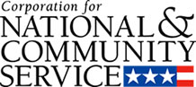

Corporation for National and Community Service

General Program Overview
AmeriCorps provides resources, both human and financial, to organizations that engage Americans in intensive service to meet our country’s critical needs.
Grantees use the funding to support AmeriCorps members for intensive service in their community. AmeriCorps grants partially cover the expense of operating an AmeriCorps program and do not cover general organizational expenses. A cash and in-kind match is required.

The main website can be accessed here: http://www.nationalservice.gov

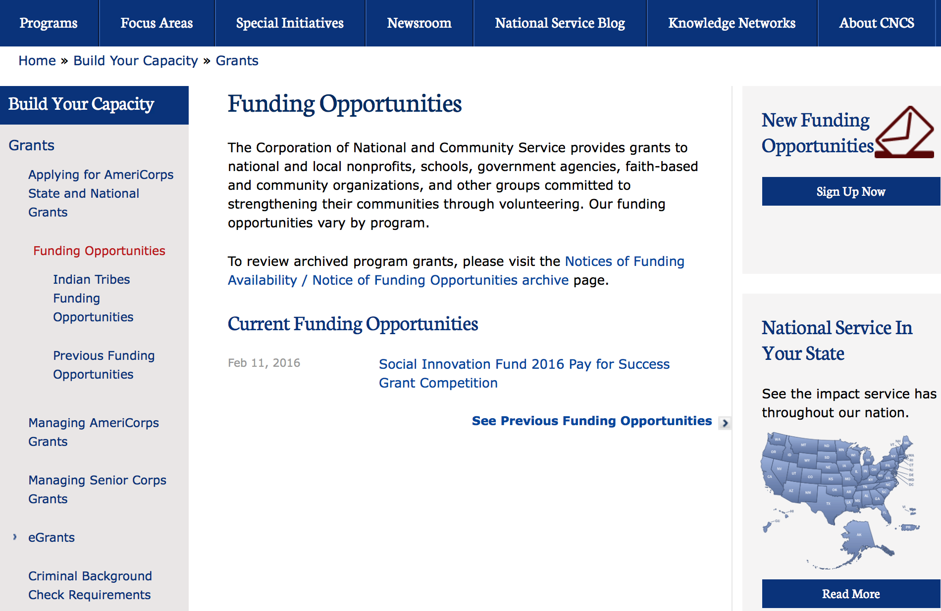

For access to further funding information: click here

http://www.nationalservice.gov/build-your-capacity/grants/funding-opportunities

Programs:

Reminders:

National Service In Hawaii
National Service in Your State - Hawaii
2015-2016

Meeting Community Needs in Hawaii: More than 3,100 people of all ages and backgrounds are helping to meet local needs, strengthen communities, and increase civic engagement through national service in Hawaii. Serving at more than 450 locations throughout the state, these citizens tutor and mentor children, support veterans and military families, provide health services, restore the environment, respond to disasters, increase economic opportunity, and recruit and manage volunteers. This year, the Corporation for National and Community Service (CNCS) will commit more than $6,260,000 to support Hawaii communities through national service initiatives. Through a unique public-private partnership, this federal investment will leverage an additional $9,060,000 in other resources to strengthen community impact, build local support, and increase return on taxpayer dollars. Nationwide, CNCS, its grantees, and project sponsors generated more than $1.25 billion in outside resources from businesses, foundations, public agencies, and other sources in FY 2015.

AmeriCorps
This year, AmeriCorps will provide more than 560 individuals the opportunity to provide intensive, results-driven service to meet education, environmental, health, economic, and other pressing needs in communities across Hawaii. Most AmeriCorps grant funding goes to the Hawaii Commission on National & Community Service, which in turn awards grants to nonprofit groups to respond to local needs. Most of the remainder of the grant funding is distributed by CNCS directly to multi-state and national organizations through a competitive grants process. Other individuals serve through AmeriCorps VISTA, whose members help bring individuals and communities out of poverty by serving full-time to fight illiteracy, improve health services, create businesses, and increase housing opportunities, and AmeriCorps NCCC (National Civilian Community Corps), a 10-month, full time residential program for men and women between the ages of 18 and 24. In exchange for their service, AmeriCorps members earn an education award that can be used to pay for college or to pay back qualified student loans. Since 1994, more than 5,900 Hawaii residents have served more than 6.4 million hours and have qualified for Segal AmeriCorps Education Awards totaling more than $14,980,000.
Download: AmeriCorps in Hawaii (PDF)
Senior Corps
More than 2,500 seniors in Hawaii contribute their time and talents in one of three Senior Corps programs. Foster Grandparents serve one-on-one as tutors and mentors to more than 310 young people who have special needs. Senior Companions help more than 220 homebound seniors and other adults maintain independence in their own homes. RSVP volunteers conduct safety patrols, renovate homes, protect the environment, tutor and mentor youth, respond to natural disasters, and provide other services through more than 250 groups across Hawaii.
Download: Senior Corps in Hawaii (PDF)

The Corporation for National and Community Service is a federal agency that improves lives, strengthens communities, and fosters civic engagement through service and volunteering. CNCS annually engages more than five million Americans in service to meet local needs through Senior Corps, AmeriCorps, and national days of service; improves communities through the Social Innovation Fund, and leads President Obama's national call to service initiative, United We Serve. To learn more visit NationalService.gov or Serve.gov or call 202-606-5000 or TTY 1-800-833-3722.

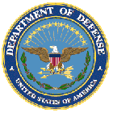

U.S. Department of Defense

Doing Business with the Department of Defense

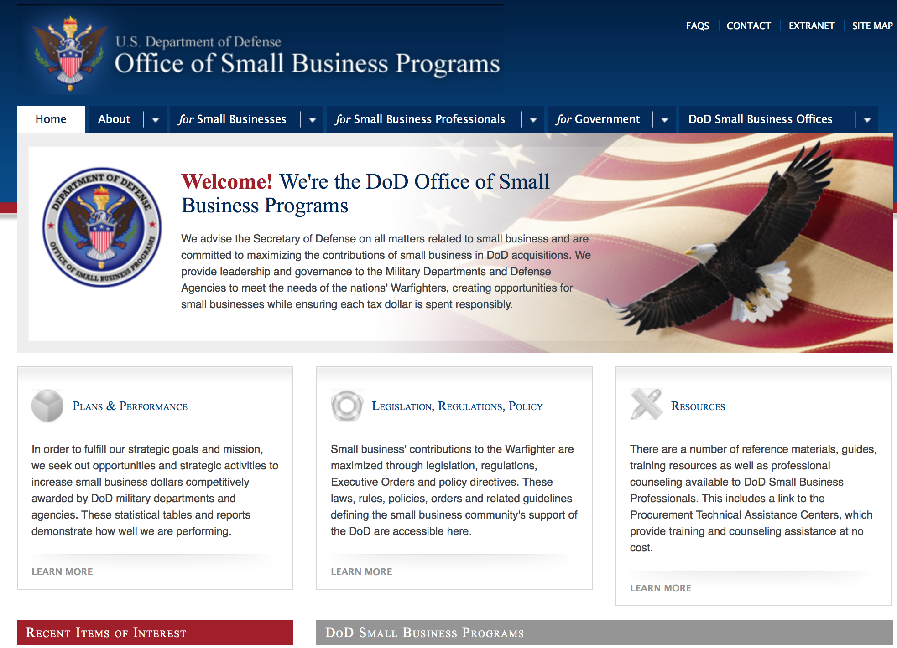

http://www.acq.osd.mil/osbp/

Doing Business with the DoD

Resources

Procurement Technical Assistance Centers (PTACs)

Procurement Technical Assistance Centers (PTACs) are charged with assisting businesses in learning how to do business with federal, state, and local governments. PTACs are a local resource available at no or nominal cost that can provide assistance to business firms in marketing their products and services. They offer training to businesses on how to research and bid on contracts, assist with registration requirements, provide bid-matching services, and assist with pre and post contracting issues.

Prime Contractors with Subcontracting Plans [xlsx]

Directory updated 4/19/11

This FY 2014 directory is intended for small business concerns seeking opportunities with DoD prime contractors. The directory is a listing of large business prime contractors who are required to establish subcontracting plans with goals. The report is generated from data contained in the Individual Subcontract Reports (ISRs) submitted in the Electronic Subcontracting Reporting System (eSRS) by contractors and from data contained in the Federal Procurement Data System (FPDS). The directory includes the name of the prime contractor; the major product/service code (PSC) provided to DoD; the major NAICS of the company; name, telephone number and email address of the company’s point of contact; contract number with the effective date and completion date, ultimate contract value and obligated dollars. In addition, many companies have websites with additional information which may be useful in your search for subcontracting opportunities or teaming arrangements.

Locate a Small Business Professional

Small Business Professionals serve as the primary liaison between private-sector small businesses seeking to do business with government agencies. Specialists advise small businesses regarding current acquisitions contracts available from the federal government.

Procurement Forecasts & the Department of Defense

The Department of Defense, due to its size and scope, does not have a single, comprehensive source for future procurements. Procurements are made locally and within the various services and agencies.

Business Intelligence, relative to future procurement planning, would be gathered at the local level.

For the purposes of forecasting, knowledge of past behavior is useful. Click here for a table of DoD acquisitions in FY10 summarized by NAICS code. The FY10 data has been validated but FPDS data is dynamic and changes continuously.

Non-Appropriated Fund Customers

Non-appropriated fund customers operate similar to non-profit organizations and include commissaries, exchanges, recreation and fitness centers, dining at officer/enlisted/civilian clubs, and barber/beauty services, just to name a few. For more information click here.

Research:

Air Force Academy
Project on Advanced Systems and Concepts for Countering Weapons of Mass Destruction (PASCC) CALL 0001
Synopsis 1
http://www.grants.gov/web/grants/view-opportunity.html?oppId=286456

Air Force Office of Scientific Research
Air Force Defense Research Sciences Conference and Workshop Support
Synopsis 1
http://www.grants.gov/web/grants/view-opportunity.html?oppId=286437

Air Force Academy
Project on Advanced Systems and Concepts for Countering Weapons of Mass Destruction
Synopsis 1
http://www.grants.gov/web/grants/view-opportunity.html?oppId=286441

Dept. of the Army -- USAMRAA
DoD Clinical & Rehabilitative Medicine Neuromusculoskeletal Injuries Rehabilitation Research Award
Synopsis 1
http://www.grants.gov/web/grants/view-opportunity.html?oppId=285996

Dept. of the Army -- USAMRAA
DoD Orthotics and Prosthetics Outcomes Prosthetics Outcomes Research Award
Synopsis 1
http://www.grants.gov/web/grants/view-opportunity.html?oppId=285997

Dept. of the Army -- USAMRAA
DoD Orthotics and Prosthetics Outcomes Orthotics Outcomes Research Award
Synopsis 1
http://www.grants.gov/web/grants/view-opportunity.html?oppId=286017

Dept. of the Army -- USAMRAA
Breast Cancer Breakthrough Award Levels 3 and 4
Synopsis 1
http://www.grants.gov/web/grants/view-opportunity.html?oppId=286327

Dept. of the Army -- USAMRAA
Peer Reviewed Alzheimer’s Convergence Science Research Award
Synopsis 3
http://www.grants.gov/web/grants/view-opportunity.html?oppId=286240

Dept. of the Army -- USAMRAA
Peer Reviewed Alzheimer’s Quality of Life Research Award
Synopsis 1
http://www.grants.gov/web/grants/view-opportunity.html?oppId=286242

Dept. of the Army -- USAMRAA
Parkinson’s Impact Award
Synopsis 1
http://www.grants.gov/web/grants/view-opportunity.html?oppId=286264

Dept. of the Army -- USAMRAA
Epilepsy Idea Development Award
Synopsis 1
http://www.grants.gov/web/grants/view-opportunity.html?oppId=286247

Dept. of the Army -- USAMRAA
Parkinson’s Focused Idea Award
Synopsis 1
http://www.grants.gov/web/grants/view-opportunity.html?oppId=286244

Dept of the Army -- Materiel Command
Robots in Manufacturing Environments Manufacturing Innovation Institute (RIME-MII)
Synopsis 1
http://www.grants.gov/web/grants/view-opportunity.html?oppId=286551

Office of Naval Research
Fundamental Research in Atomic, Molecular and Quantum Physics
Synopsis 1
http://www.grants.gov/web/grants/view-opportunity.html?oppId=286169

Modifications:

Dept. of the Army -- USAMRAA
DoD Gulf War Illness New Investigator Award
Modification 2
http://www.grants.gov/web/grants/view-opportunity.html?oppId=283829

Dept of the Army -- Materiel Command
Robots in Manufacturing Environments Manufacturing Innovation Institute (RIME-MII)
Modification 2
http://www.grants.gov/web/grants/view-opportunity.html?oppId=286551

Dept of the Army -- Materiel Command
Proof of Concept Commercialization Pilot Program
Synopsis 3
http://www.grants.gov/web/grants/view-opportunity.html?oppId=283584

DARPA - Biological Technologies Office
Prometheus
Modification 2
http://www.grants.gov/web/grants/view-opportunity.html?oppId=284679

DARPA - Information Innovation Office
Dispersed Computing
Modification 2
http://www.grants.gov/web/grants/view-opportunity.html?oppId=285415

Defense Threat Reduction Agency
Fundamental Research to Counter Weapons of Mass Destruction
Synopsis 5
http://www.grants.gov/web/grants/view-opportunity.html?oppId=275322

Naval Supply Systems Command
FY16 Acquisition Research Program
Modification 2
http://www.grants.gov/web/grants/view-opportunity.html?oppId=282922

Reminders:

Dept. of the Army -- Materiel Command
Army Research Office Broad Agency Announcement for Basic and Applied Scientific Research
Modification 8

Document Type: | Grants Notice
Funding Opportunity Number: | W911NF-12-R-0012
Funding Opportunity Title: | Army Research Office Broad Agency Announcement for Basic and Applied Scientific Research
Opportunity Category: | Discretionary
Funding Instrument Type: | Cooperative Agreement  Grant  Other  Procurement Contract
Category of Funding Activity: | Science and Technology and other Research and Development
Category Explanation:
Expected Number of Awards: | 1000
CFDA Number(s): | 12.431 -- Basic Scientific Research
Cost Sharing or Matching Requirement: | No
Posted Date: | Mar 27, 2015
Creation Date: | Mar 27, 2015
Original Closing Date for Applications: | Mar 31, 2017
Current Closing Date for Applications: | Mar 31, 2017
Archive Date: | Apr 30, 2017
Eligible Applicants: | Unrestricted (i.e., open to any type of entity above), subject to any clarification in text field entitled "Additional Information on Eligibility"
Agency Name: | Dept. of the Army -- Materiel Command
Description: | The purpose of this Broad Agency Announcement (BAA) is to solicit research proposals in the engineering, physical, life, and information sciences for submission to the Army Research Office (ARO) for consideration for possible funding. For ease of reference, this BAA is an extraction of the ARO sections of the Army Research Laboratory BAA. (www.arl.army.mil/www/default.cfm?page=8).
Link to Additional Information: | ARO CORE BAA-W911NF-12-R-0012-Mod 03
Contact Information: | If you have difficulty accessing the full announcement electronically, please contact:  ANDREW L. FISKE Procurement Analyst Army Contracting Command Aberdeen Proving Ground Research Triangle Park Division Phone: (919) 549-4338 FAX: (919) 549-4388 andrew.l.fiske.civ@mail.mil  Administrative POC

http://www.grants.gov/web/grants/view-opportunity.html?oppId=173593



Department of Education

Grant Programs Overview at the Department of Education

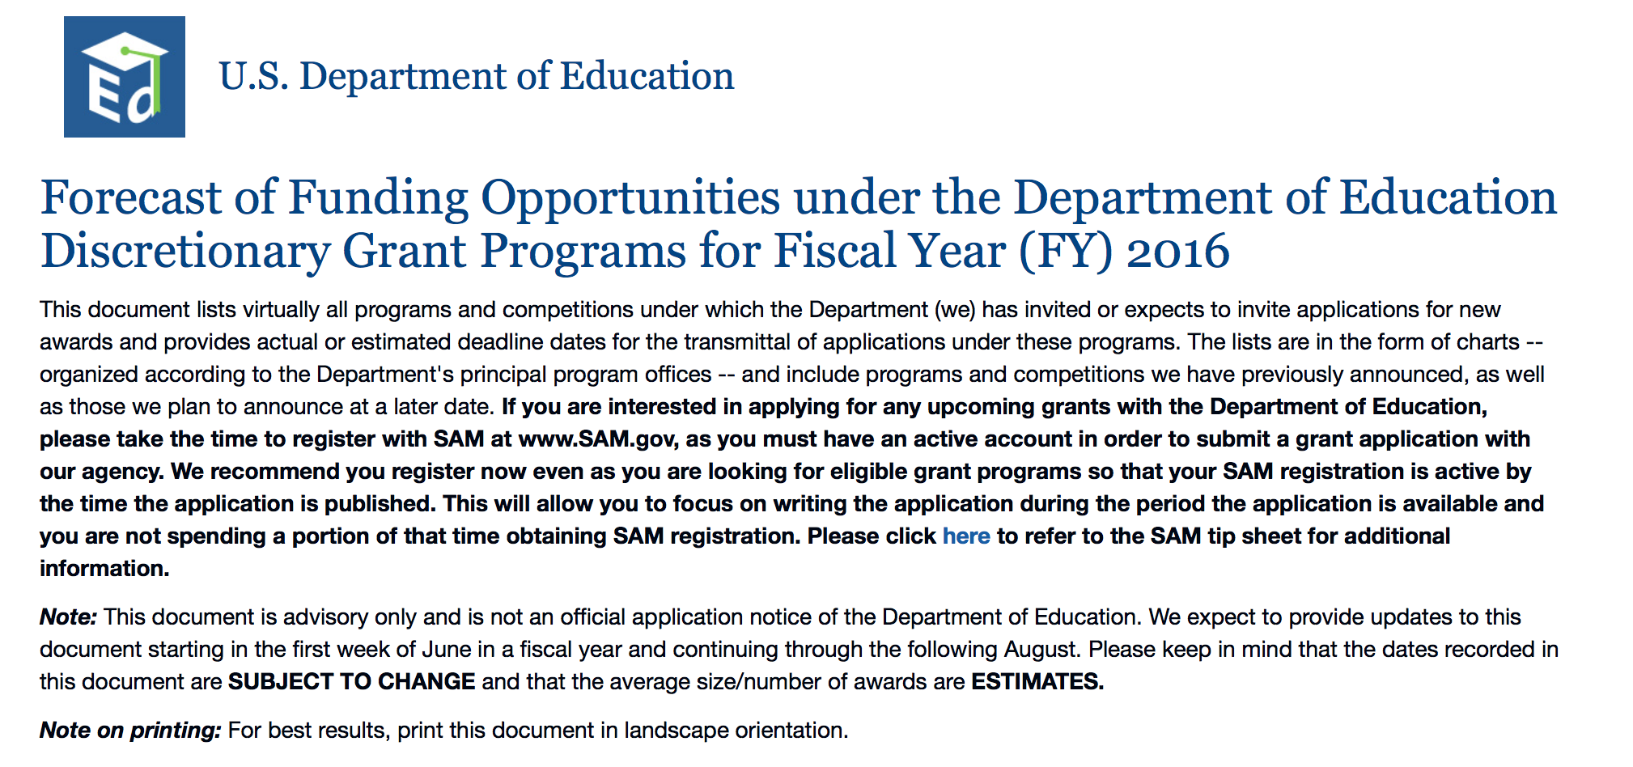To see the complete document click here: http://www2.ed.gov/fund/grant/find/edlite-forecast.html

The general information page for Education Grant funding is an excellent resource describing the three types of grants awarded by the Department of Education. See the screen shot of the Department of Education web page below:

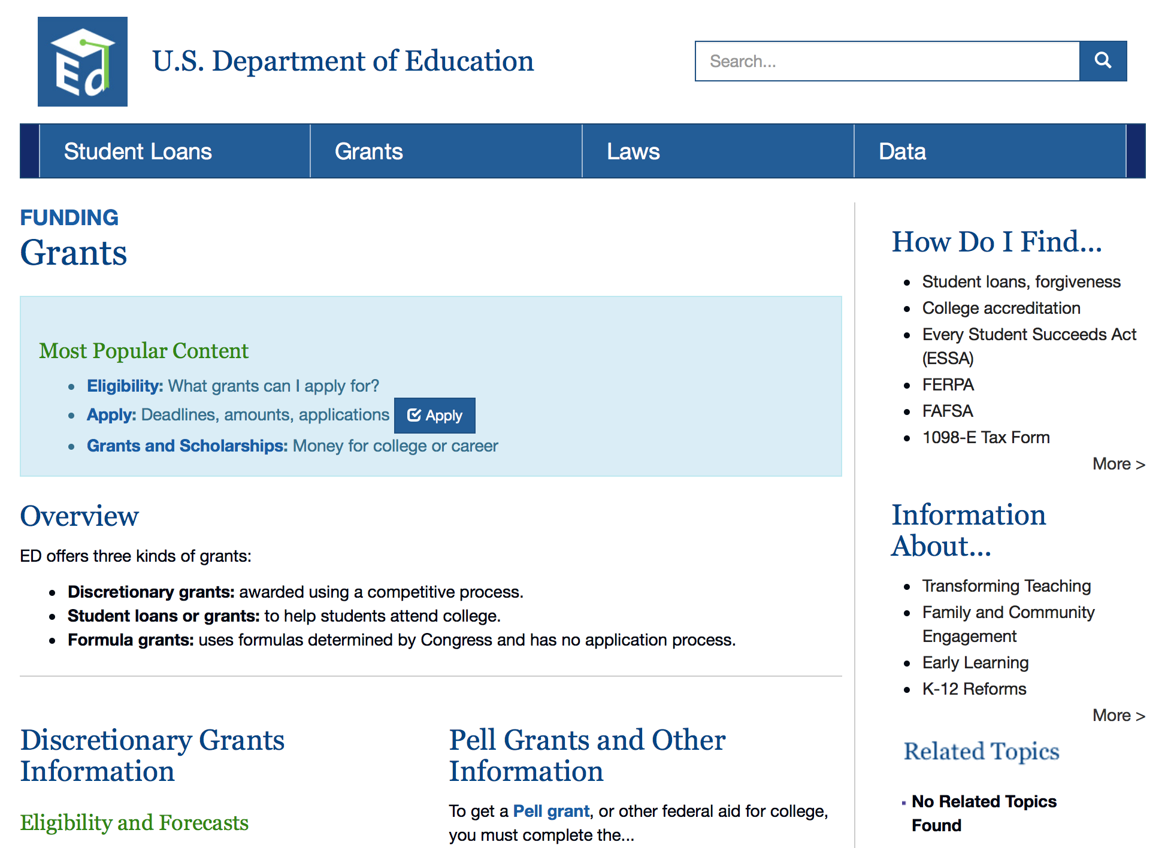

http://www.ed.gov/fund/grants-apply.html

Programs:

Office of Elementary and Secondary Education (OESE): Equity Assistance Centers (EAC) CFDA Number 84.004D
Synopsis 1

Document Type: | Grants Notice
Funding Opportunity Number: | ED-GRANTS-071816-001
Funding Opportunity Title: | Office of Elementary and Secondary Education (OESE): Equity Assistance Centers (EAC) CFDA Number 84.004D
Opportunity Category: | Discretionary
Opportunity Category Explanation:
Funding Instrument Type: | Cooperative Agreement
Category of Funding Activity: | Education
Category Explanation:
Expected Number of Awards: | 4
CFDA Number(s): | 84.004 -- Civil Rights Training and Advisory Services
Cost Sharing or Matching Requirement: | No
Posted Date: | Jul 18, 2016
Last Updated Date: | Jul 18, 2016
Original Closing Date for Applications: | Aug 22, 2016 Applications Available: July 18, 2016. Deadline for Transmittal of Applications: August 22, 2016.
Current Closing Date for Applications: | Aug 22, 2016 Applications Available: July 18, 2016. Deadline for Transmittal of Applications: August 22, 2016.
Archive Date: | Sep 21, 2016
Estimated Total Program Funding: | $6,518,563
Award Ceiling: | $1,700,000
Eligible Applicants: | Others (see text field entitled "Additional Information on Eligibility" for clarification)
Additional Information on Eligibility: | Eligible Applicants: A public agency (other than a State educational agency or a school board) or a private, non-profit organization.
Agency Name: | Department of Education
Description: | Note: Each funding opportunity description is a synopsis of information in the Federal Register application notice. For specific information about eligibility, please see the official application notice. The official version of this document is the document published in the Federal Register. Free Internet access to the official edition of the Federal Register and the Code of Federal Regulations is available on GPO Access at: http://www.access.gpo.gov/nara/index.html. Please review the official application notice for pre-application and application requirements, application submission information, performance measures, priorities and program contact information Purpose of Program: The Equity Assistance Centers (EAC) program is authorized under title IV of the Civil Rights Act of 1964, 42 U.S.C. 2000c--2000c-2, 2000c-5, and the implementing regulations in 34 CFR part 270. This program awards grants through cooperative agreements to operate regional EACs that provide technical assistance (including training) at the request of school boards and other responsible governmental agencies in the preparation, adoption, and implementation of plans for the desegregation of public schools--which in this context means plans for equity (including desegregation based on race, national origin, sex, and religion)--and in the development of effective methods of coping with special educational problems occasioned by desegregation. Assistance may include, among other activities: (1) Dissemination of information regarding effective methods of coping with special educational problems occasioned by desegregation; (2) assistance and advice in coping with these problems; and (3) training designed to improve the ability of teachers, supervisors, counselors, parents, community members, community organizations, and other elementary or secondary school personnel to deal effectively with special educational problems occasioned by desegregation. Catalog of Federal Domestic Assistance (CFDA) Number: 84.004D. Applications for grants under the EAC program, CFDA number 84.004D, must be submitted electronically using the Governmentwide Grants.gov Apply site at www.Grants.gov. Through this site, you will be able to download a copy of the application package, complete it offline, and then upload and submit your application. You may not email an electronic copy of a grant application to us. You may access the electronic grant application for the EAC program at www.Grants.gov. You must search for the downloadable application package for this program by the CFDA number. Do not include the CFDA number's alpha suffix in your search (e.g., search for 84.004, not 84.004D).
Link to Additional Information: | Office of Elementary and Secondary Education (OESE): Equity Assistance Centers (EAC) CFDA Number 84.004D; Notice inviting applications for new awards for fiscal year (FY) 2016
Grantor Contact Information: | If you have difficulty accessing the full announcement electronically, please contact:  Julius Cotton ED Grants.gov FIND Systems Admin. Phone 202-245-6288 EducationGrantInquiries@ed.gov Program Manager: Britt Jung, U.S. Department of Education, 400 Maryland Avenue SW., Room 3E206, Washington, DC 20202-6135. Telephone: (202) 205-4513 or by email: britt.jung@ed.gov.  e-Mail: Program Manager

http://www.grants.gov/web/grants/view-opportunity.html?oppId=286249

Research:

Modifications:

Reminders:

Deleted:

Opportunity Number: ED-GRANTS-070816-001
Opportunity Title: The Office of Innovation and Improvement (OII): Promise Neighborhoods Program: Implementation Grant Competition CFDA # 84.215N
Agency Code: ED
Agency: Department of Education
Deleted Date: Jul 07, 2016
Deletion Comments: Opportunity deleted



U.S. Department of Energy
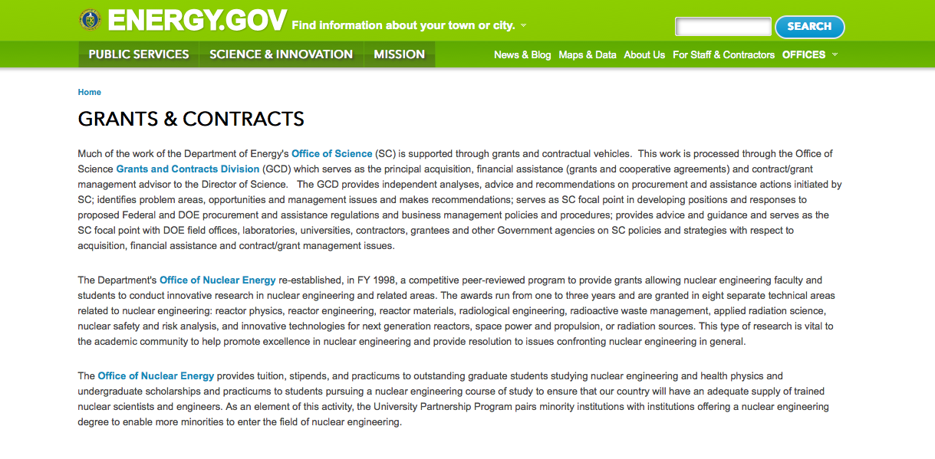
http://www.doe.gov/grants-contracts

Programs:

Golden Field Office
HydroNEXT FOA: Innovative Technologies to Advance Non-Powered Dam and Pumped-Storage Hydropower Deve
Synopsis 1
http://www.grants.gov/web/grants/view-opportunity.html?oppId=285957

National Energy Technology Laboratory
Production of Salable Rare Earth Element Materials from Coal and Coal Byproducts
Synopsis 1
http://www.grants.gov/web/grants/view-opportunity.html?oppId=286409

Golden Field Office
Request for Information (RFI) DE-FOA-0001626: Hydrogen Infrastructure Research, Development, and Demonstration: Identifying project priorities to address deployment barriers
Synopsis 1
http://www.grants.gov/web/grants/view-opportunity.html?oppId=286608

Golden Field Office
HydroNEXT Non-powered Dam Technology Development & Demonstration and North American Grid Integration
Synopsis 1
http://www.grants.gov/web/grants/view-opportunity.html?oppId=286561

PAMS
DOE - Office of Science
Office of Science
Early Career Research Program
Synopsis 1
http://www.grants.gov/web/grants/view-opportunity.html?oppId=286693

PAMS
DOE - Office of Science
Office of Science
Measurement Innovations for Magnetic Fusion Systems
Synopsis 1
http://www.grants.gov/web/grants/view-opportunity.html?oppId=286573

PAMS
DOE - Office of Science
Office of Science
FY 2017 Research Opportunities in High Energy Physics
Synopsis 1
http://www.grants.gov/web/grants/view-opportunity.html?oppId=286531

Golden Field Office
Funding Opportunity Announcement (FOA) Number DE-FOA-0001461: Co-Optimization of Fuels and Engines
Synopsis 1
http://www.grants.gov/web/grants/view-opportunity.html?oppId=286800

Modifications:

Advanced Research Projects Agency Energy
Next Generation Energy Technologies for Connected and Auotmated On-Road Vehicles (NEXTCAR)
Modification 2
http://www.grants.gov/web/grants/view-opportunity.html?oppId=282945

National Energy Technology Laboratory
Next-Generation Transformers – Flexible Designs
Modification 2
http://www.grants.gov/web/grants/view-opportunity.html?oppId=284451

Golden Field Office
HydroNEXT: Innovative Technologies to Advance Non-Powered Dam and Pumped-Storage Hydropower Development
Synopsis 3
http://www.grants.gov/web/grants/view-opportunity.html?oppId=286561

Advanced Research Projects Agency Energy
REFUEL (SBIR/STTR)
Synopsis 3
http://www.grants.gov/web/grants/view-opportunity.html?oppId=283291

Advanced Research Projects Agency Energy
REFUEL FOA
Synopsis 3
http://www.grants.gov/web/grants/view-opportunity.html?oppId=283314

National Energy Technology Laboratory
Production of Salable Rare Earth Element Materials from Coal and Coal Byproducts
Modification 2
http://www.grants.gov/web/grants/view-opportunity.html?oppId=286409

Advanced Research Projects Agency Energy
Rhizosphere Observations Optimizing Terrestrial Sequestration (ROOTS)
Synopsis 3
http://www.grants.gov/web/grants/view-opportunity.html?oppId=282948

National Energy Technology Laboratory
Fiscal Year (FY) 2016 Vehicle Technologies Multi-Topic Funding Opportunity Announcement
Synopsis 4
http://www.grants.gov/web/grants/view-opportunity.html?oppId=284402

Reminders:

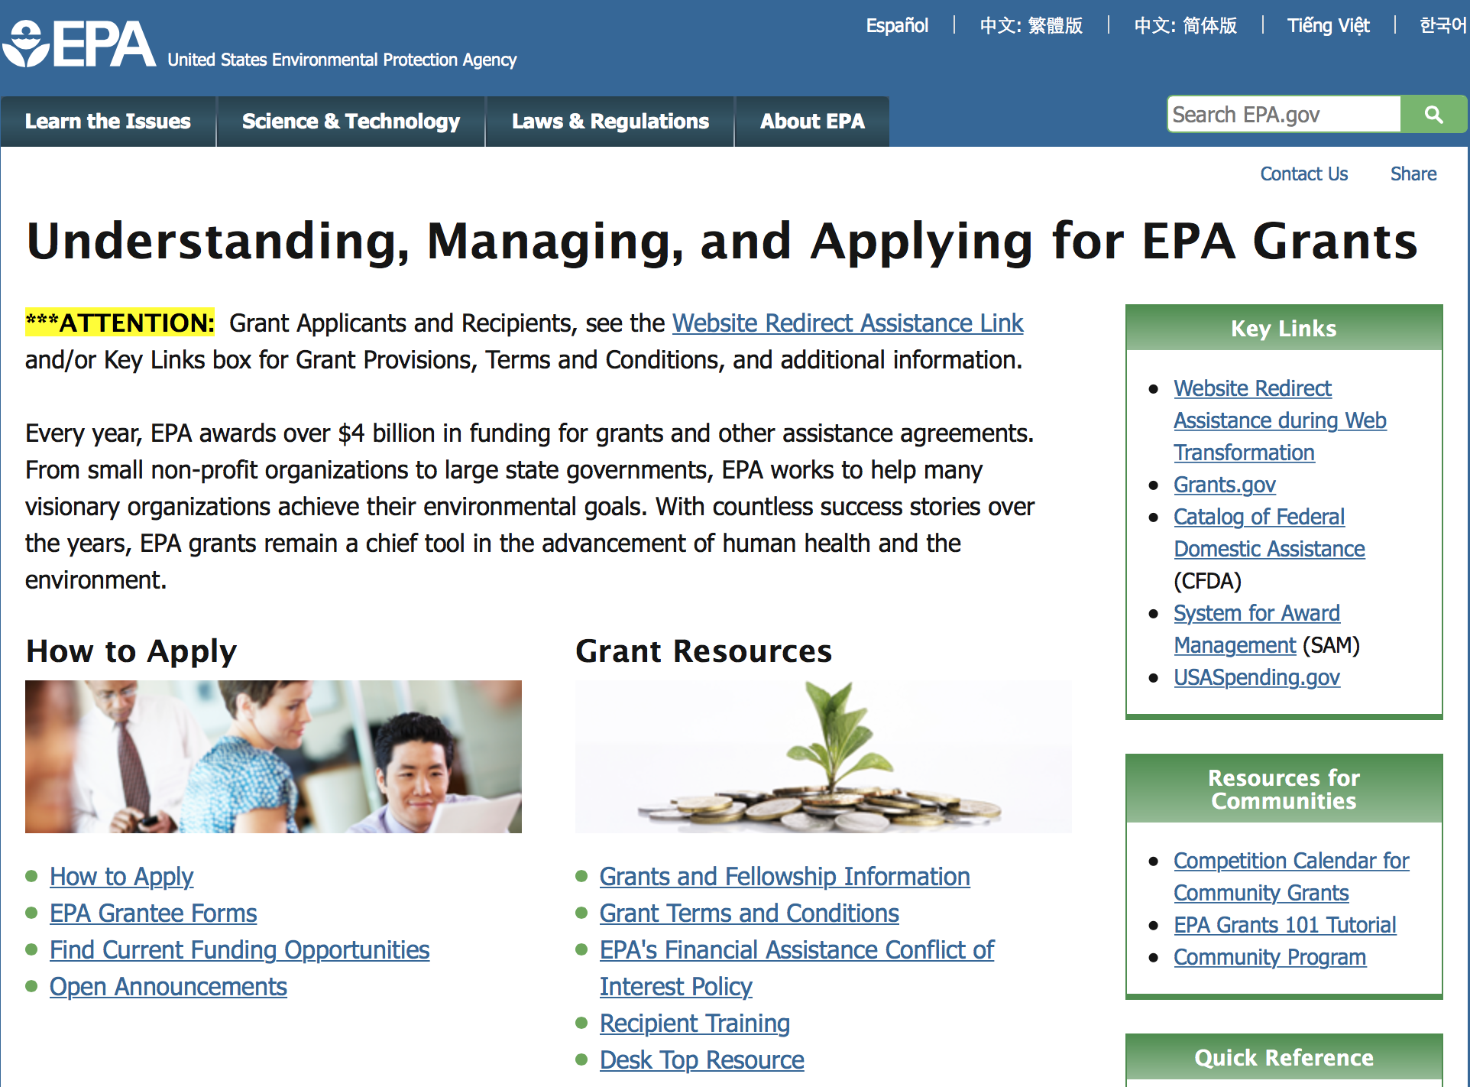

http://www.epa.gov/epahome/grants.htm

Programs:

Modeling of Climate Change Mitigation, Impacts and Adaptation

Document Type: | Grants Notice
Funding Opportunity Number: | EPA-OAR-OAP-16-07
Funding Opportunity Title: | Modeling of Climate Change Mitigation, Impacts and Adaptation
Opportunity Category: | Discretionary
Opportunity Category Explanation:
Funding Instrument Type: | Cooperative Agreement
Category of Funding Activity: | Environment
Category Explanation:
Expected Number of Awards: | 3
CFDA Number(s): | 66.034 -- Surveys, Studies, Research, Investigations, Demonstrations, and Special Purpose Activities Relating to the Clean Air Act
Cost Sharing or Matching Requirement: | No
Posted Date: | Jul 27, 2016
Last Updated Date: | Jul 27, 2016
Original Closing Date for Applications: | Sep 12, 2016 Please refer to the announcement, including Section IV, for additional information on submission methods and due dates.
Current Closing Date for Applications: | Sep 12, 2016 Please refer to the announcement, including Section IV, for additional information on submission methods and due dates.
Archive Date: | Oct 12, 2016
Estimated Total Program Funding: | $1,250,000
Award Ceiling: | $250,000
Award Floor: | $100,000
Eligible Applicants: | Others (see text field entitled "Additional Information on Eligibility" for clarification)
Additional Information on Eligibility: | See Section III of the announcement for additional eligibility information.
Agency Name: | Environmental Protection Agency
Description: | This notice announces the availability of funds and solicits proposals to advance the field of climate economic modeling to assist decision makers and the public in effectively responding to the challenges and opportunities posed by climate change. The work involved in this effort includes two distinct modeling capabilities. The first is computable general equilibrium (CGE) modeling of climate mitigation and impacts at the level of disaggregation of U.S. states. The second is integrated assessment modeling (IAM) and assessment of multiple greenhouse gases (GHGs) and air pollutants to enhance understanding of climate change impacts.
Link to Additional Information: | Modeling of Climate Change Mitigation, Impacts and Adaptation
Grantor Contact Information: | If you have difficulty accessing the full announcement electronically, please contact:  Eric Smith, Phone: 202-343-9200  Eric Smith

http://www.grants.gov/web/grants/view-opportunity.html?oppId=286601

Modifications:

Reminders:



Department of Health and Human Services

Grants Forecast and Overview

The Department of Health and Human Services’ Grants Forecast is a database of planned grant opportunities proposed by its agencies. Each Forecast record contains actual or estimated dates and funding levels for grants that the agency intends to award during the fiscal year. Forecast opportunities are subject to change based on enactment of congressional appropriations. Go to the webpage below for more information.

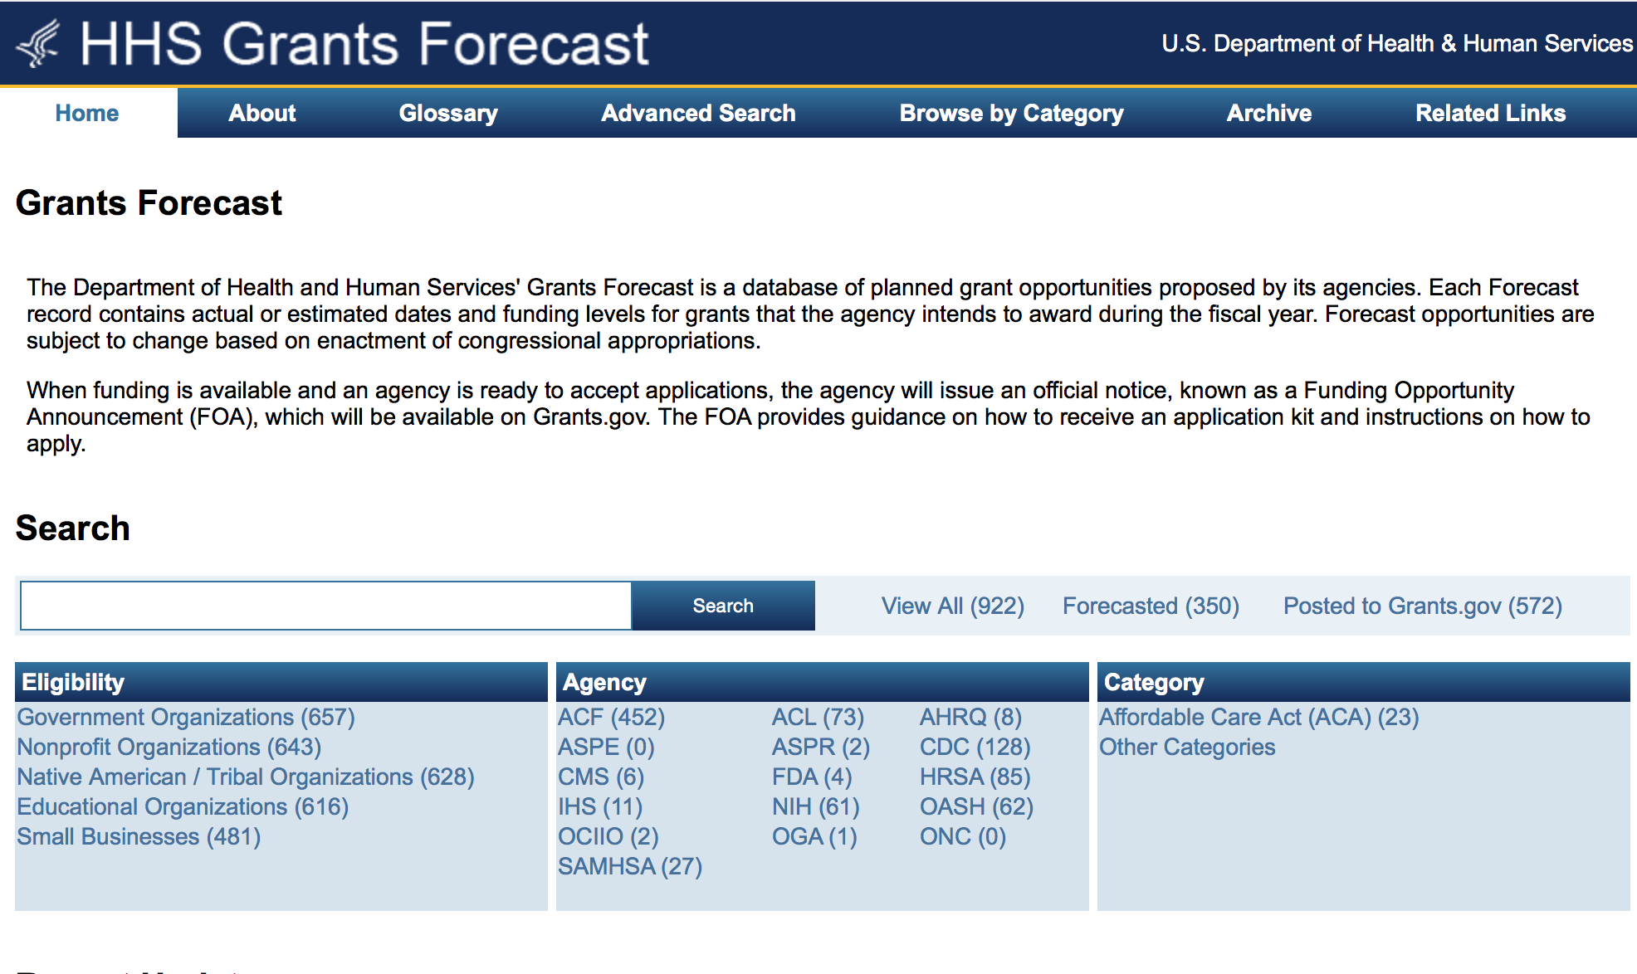
For more general information about HHS Grants and Funding go to the website below at: http://www.hhs.gov/grants/ .

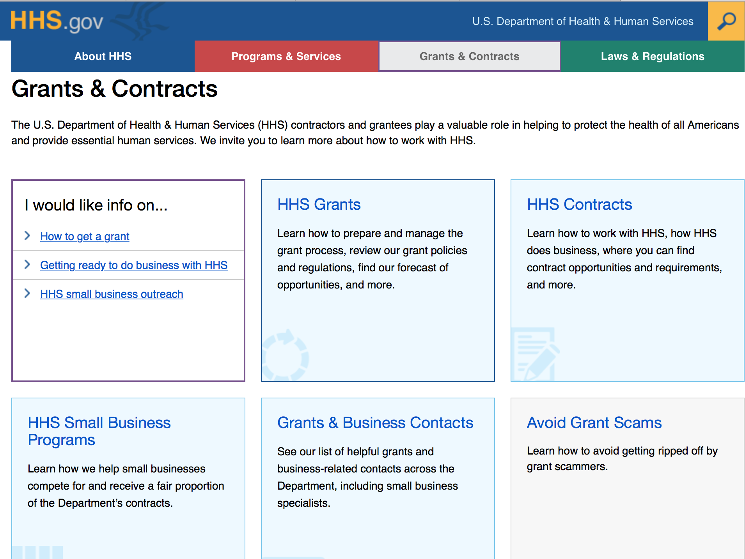

Programs:

Health Resources and Services Administration
Service Area Competition Grant

Document Type: | Grants Notice
Funding Opportunity Number: | HRSA-17-050
Funding Opportunity Title: | Service Area Competition
Opportunity Category: | Discretionary
Opportunity Category Explanation:
Funding Instrument Type: | Grant
Category of Funding Activity: | Health
Category Explanation: | https://grants.hrsa.gov/2010/Web2External/Interface/FundingCycle/ExternalView.aspx?fCycleID=bd9c2f13-d136-444e-bdd2-6a9645fe38a5
Expected Number of Awards: | 85
CFDA Number(s): | 93.224 -- Consolidated Health Centers  (Community Health Centers, Migrant Health Centers,  Health Care for the Homeless, and Public
Cost Sharing or Matching Requirement: | No
Posted Date: | Jun 15, 2016
Last Updated Date: | Jun 15, 2016
Original Closing Date for Applications: | Aug 16, 2016
Current Closing Date for Applications: | Aug 16, 2016
Archive Date: | Sep 30, 2016
Estimated Total Program Funding: | $132,000,000
Eligible Applicants: | Others (see text field entitled "Additional Information on  Eligibility" for clarification)
Additional Information on Eligibility: | You must be a public or nonprofit private entity, as  demonstrated through the submission of the Evidence of  Non-profit/Public Center Status outlined in Section IV.2.vii.  Faith-based and community-based organizations,  Tribes, and tribal organizations are eligible to apply.
Agency Name: | Health Resources and Services Administration
Description: | This announcement solicits applications for the Health Center  Program’s Service Area Competition (SAC). The Health  Center Program supports patient-directed public and private  nonprofit organizations that provide primary and preventive  health care services to the Nation’s medically underserved.  The purpose of the SAC funding opportunity is to ensure  continued access to comprehensive, culturally competent,  quality primary health care services for communities and  vulnerable populations currently served by the Health Center  Program. This FOA details the SAC eligibility requirements,  review criteria, and awarding factors for organizations seeking  funding for operational support to provide primary and  preventive health care services to an announced service area  under the Health Center Program, including Community Health  Center (CHC – section 330(e)), Migrant Health Center  (MHC – section 330(g)), Health Care for the Homeless  (HCH – section 330(h)), and/or Public Housing Primary  Care (PHPC – section 330(i)). For the purposes of this  document, the term “health center” encompasses these  types of funding (i.e., CHC, MHC, HCH, and PHPC).
Link to Additional Information:
Grantor Contact Information: | If you have difficulty accessing the full announcement  electronically, please contact:  Department of Health and Human Services, Health Resources  and Services Administration bphcsac@hrsa.gov  Contact Beth Hartmayer at (301)594-4300 or email bphcsac@hrsa.gov

http://www.grants.gov/web/grants/view-opportunity.html?oppId=284683

Research:
Centers for Disease Control - NCTP
Comprehensive High-Impact HIV Prevention Projects for Young Men of Color Who Have Sex with Men and Young Transgender Persons of Color
Synopsis 1
http://www.grants.gov/web/grants/view-opportunity.html?oppId=286101

Centers for Disease Control - NCBDDD
Surveillance, intervention, and referral to services activities for infants with microcephaly or other adverse outcomes linked with the Zika virus-High Risk Local Areas
Synopsis 1
http://www.grants.gov/web/grants/view-opportunity.html?oppId=286376

Food and Drug Administration
FDA Scientific Conference Grant Program (R13)
Synopsis 1
http://www.grants.gov/web/grants/view-opportunity.html?oppId=286610

Funding Opportunity Number: HRSA-17-052 Service Area Competition
Health Resources and Services Administration
Posted Date: Jul 05, 2016
Version: Synopsis 1
Link: http://www.grants.gov/web/grants/view-opportunity.html?oppId=284903

Funding Opportunity Number: PAR-16-354
Advanced Laboratories for Accelerating the Reach and Impact of Treatments for Youth and Adults with Mental Illness (ALACRITY) Research Centers (P50)
National Institutes of Health
Posted Date: Jul 06, 2016
Version: Synopsis 1
Link: http://www.grants.gov/web/grants/view-opportunity.html?oppId=285789

Funding Opportunity Number: PAR-16-357
Avenir Award Program for Genetics or Epigenetics of Substance Use Disorders (DP1)
National Institutes of Health
Posted Date: Jul 07, 2016
Version: Synopsis 1
Link: http://www.grants.gov/web/grants/view-opportunity.html?oppId=285815

Funding Opportunity Number: PAR-16-358
NIA Program Project Applications (P01)
National Institutes of Health
Posted Date: Jul 07, 2016
Version: Synopsis 1
Link: http://www.grants.gov/web/grants/view-opportunity.html?oppId=285817

Funding Opportunity Number: PAR-16-356
Social Epigenomics Research Focused on Minority Health and Health Disparities (R21)
National Institutes of Health
Posted Date: Jul 07, 2016
Version: Synopsis 1
Link: http://www.grants.gov/web/grants/view-opportunity.html?oppId=285832

Funding Opportunity Number: PAR-16-355
Social Epigenomics Research Focused on Minority Health and Health Disparities (R01)
National Institutes of Health
Posted Date: Jul 07, 2016
Version: Synopsis 1
Link: http://www.grants.gov/web/grants/view-opportunity.html?oppId=285833

Funding Opportunity Number: PAR-16-359
NIA Revision and Resubmission Program Project Applications (P01)
National Institutes of Health
Posted Date: Jul 07, 2016
Version: Synopsis 1
Link: http://www.grants.gov/web/grants/view-opportunity.html?oppId=285836

Funding Opportunity Number: PAR-16-360
Transition to Independent Environmental Health Research (TIEHR) Career Transition Award (K01)
National Institutes of Health
Posted Date: Jul 07, 2016
Version: Synopsis 1
Link: http://www.grants.gov/web/grants/view-opportunity.html?oppId=285837

National Institutes of Health
Research Initiative for Scientific Enhancement (RISE) (R25)
Synopsis 1
http://www.grants.gov/web/grants/view-opportunity.html?oppId=285881

National Institutes of Health
George M. O'Brien Kidney Research Core Centers (P30)
Synopsis 1
http://www.grants.gov/web/grants/view-opportunity.html?oppId=285951

National Institutes of Health
NIDCR Small Research Grants for Secondary Analysis of FaceBase Data (R03)
Synopsis 1
http://www.grants.gov/web/grants/view-opportunity.html?oppId=285953

National Institutes of Health
The Role of Dysbiosis in Cardiovascular, Pulmonary and Hematological Complications During HIV Infection (R01)
Synopsis 1
http://www.grants.gov/web/grants/view-opportunity.html?oppId=285956

National Institutes of Health
International Tobacco, and Health Research and Capacity Building Program (R01)
Synopsis 1
http://www.grants.gov/web/grants/view-opportunity.html?oppId=285970

National Institutes of Health
Notice of Intent to Publish a Reissue of Funding Opportunity Announcement for the Precision Medicine Initiative® Cohort Program Healthcare Provider Organization Enrollment Centers (UG3/UH3)
Forecast 1
http://www.grants.gov/web/grants/view-opportunity.html?oppId=285995

National Institutes of Health
Autism Centers of Excellence: Networks (R01)
Synopsis 1
http://www.grants.gov/web/grants/view-opportunity.html?oppId=286013

National Institutes of Health
Autism Centers of Excellence: Centers (P50)
Synopsis 1
http://www.grants.gov/web/grants/view-opportunity.html?oppId=286014

National Institutes of Health
Dual Purpose with Dual Benefit: Research in Biomedicine and Agriculture Using Agriculturally Important Domestic Animal Species (R01)
Synopsis 1
http://www.grants.gov/web/grants/view-opportunity.html?oppId=286015

National Institutes of Health
Cancer Target Discovery and Development Network (U01)
Synopsis 1
http://www.grants.gov/web/grants/view-opportunity.html?oppId=286156

National Institutes of Health
Phenotypic and Functional Characterization of ApoE2 to Inform Translation Strategies for Aging-Related Conditions (R21)
Synopsis 1
http://www.grants.gov/web/grants/view-opportunity.html?oppId=286172

National Institutes of Health
Phenotypic and Functional Characterization of ApoE2 to Inform Translation Strategies for Aging-Related Conditions (R01)
Synopsis 1
http://www.grants.gov/web/grants/view-opportunity.html?oppId=286173

National Institutes of Health
Resource-Related Research Projects for Development of Animal Models and Related Materials (R24)
Synopsis 1
http://www.grants.gov/web/grants/view-opportunity.html?oppId=286095

National Institutes of Health
Building Interdisciplinary Research Careers in Women's Health (K12)
Synopsis 1
http://www.grants.gov/web/grants/view-opportunity.html?oppId=286097

National Institutes of Health
Development of the Gabriella Miller Kids First Pediatric Data Resource Center (U2C)
Synopsis 1
http://www.grants.gov/web/grants/view-opportunity.html?oppId=286110

National Institutes of Health
Research Infrastructure Development for Interdisciplinary Aging Studies (R21/R33)
Synopsis 1
http://www.grants.gov/web/grants/view-opportunity.html?oppId=286054

National Institutes of Health
Advanced-Stage Development and Utilization of Research Infrastructure for Interdisciplinary Aging Studies (R33)
Synopsis 1
http://www.grants.gov/web/grants/view-opportunity.html?oppId=286055

National Institutes of Health
Small Grants on Primary Immunodeficiency Diseases (R03)
Synopsis 1
http://www.grants.gov/web/grants/view-opportunity.html?oppId=286311

National Institutes of Health
Promoting Organ and Tissue Donation Among Diverse Populations (R01)
Synopsis 1
http://www.grants.gov/web/grants/view-opportunity.html?oppId=286369

National Institutes of Health
Assay Development and Screening to Discover Therapeutic or Imaging Agents for Diseases of Interest to the NIDDK (R01)
Synopsis 1
http://www.grants.gov/web/grants/view-opportunity.html?oppId=286413

National Institutes of Health
Predictors and Determinants of Age-Related Changes in Resiliencies to Physical Stressors in Humans (UH2/UH3)
Synopsis 1
http://www.grants.gov/web/grants/view-opportunity.html?oppId=286414

National Institutes of Health
Revolutionizing Innovative, Visionary Environmental health Research (RIVER) (R35)
Synopsis 1
http://www.grants.gov/web/grants/view-opportunity.html?oppId=286415

National Institutes of Health
T1 Translational Research on Aging: Small Business Innovation Awards (R43/R44)
Synopsis 1
http://www.grants.gov/web/grants/view-opportunity.html?oppId=286434

National Institutes of Health
T2 Translational Research on Aging: Small Business Innovation Awards (R43/R44)
Synopsis 1
http://www.grants.gov/web/grants/view-opportunity.html?oppId=286435

National Institutes of Health
Alzheimer's Clinical Trials Consortium (ACTC) (U24)
Synopsis 1
http://www.grants.gov/web/grants/view-opportunity.html?oppId=286533

National Institutes of Health
Limited Competition: Clinical Research Investigator Supplement (CRIS) for the Maternal Fetal Medicine Units (MFMU) Network and the Neonatal Research Network (NRN) (Admin Supp)
Synopsis 1
http://www.grants.gov/web/grants/view-opportunity.html?oppId=286516

National Institutes of Health
Mechanisms of Immune Activation and Inflammation: HIV Infection, ART, and Drugs of Abuse (R01)
Synopsis 1
http://www.grants.gov/web/grants/view-opportunity.html?oppId=286670

National Institutes of Health
Clinical Centers for the NHLBI's Precision Interventions for Severe and/or Exacerbation Prone Asthma (PrecISE) Network (UG1)
Synopsis 1
http://www.grants.gov/web/grants/view-opportunity.html?oppId=286698

National Institutes of Health
Data and Modeling Coordination Center for the NHLBI's Precision Interventions for Severe and/or Exacerbation-Prone Asthma (PrecISE) Network (U24)
Synopsis 1
http://www.grants.gov/web/grants/view-opportunity.html?oppId=286699

National Institutes of Health
Fundamental Mechanisms of Affective and Decisional Processes in Cancer Control (R01)
Synopsis 1
http://www.grants.gov/web/grants/view-opportunity.html?oppId=286736

National Institutes of Health
Elucidation of Mechanisms of Radiation-Induced Endovascular Injury and Development of Treatments / Mitigators for Radiation-Induced Endothelial Cell and Vascular Dysfunction (U01)
Synopsis 1
http://www.grants.gov/web/grants/view-opportunity.html?oppId=286871

National Institutes of Health
Chemistry Science Track Award for Rapid Transition (C/START) (R03)
Synopsis 1
http://www.grants.gov/web/grants/view-opportunity.html?oppId=286818

National Institutes of Health
Chemical Discovery (CHEM) Award (R21/R33)
Synopsis 1
http://www.grants.gov/web/grants/view-opportunity.html?oppId=286819

National Institutes of Health
Research Innovation for Scientific Knowledge (RISK) for Skin and Rheumatic Diseases (R61/R33)
Synopsis 1
http://www.grants.gov/web/grants/view-opportunity.html?oppId=286794

National Institutes of Health
Pre-Application: Research Innovation for Scientific Knowledge (RISK) for Skin and Rheumatic Diseases (X02)
Synopsis 1
http://www.grants.gov/web/grants/view-opportunity.html?oppId=286795

National Institutes of Health
Research Innovations for Scientific Knowledge (RISK) for Musculoskeletal Diseases (R61/R33)
Synopsis 1
http://www.grants.gov/web/grants/view-opportunity.html?oppId=286796

National Institutes of Health
Pre-Application: Research Innovation for Scientific Knowledge (RISK) for Musculoskeletal Diseases (X02)
Synopsis 1
http://www.grants.gov/web/grants/view-opportunity.html?oppId=286797

National Institutes of Health
Environmental Health Cohorts Maintenance and Infrastructure (R24)
Synopsis 1
http://www.grants.gov/web/grants/view-opportunity.html?oppId=286799

National Institutes of Health
Limited Competition for the Continuation of Epidemiology of Diabetes Interventions and Complications (EDIC) Study Clinical Research Center (Collaborative U01)
Synopsis 1
http://www.grants.gov/web/grants/view-opportunity.html?oppId=286801

National Institutes of Health
Limited Competition for the Continuation of Epidemiology of Diabetes Interventions and Complications (EDIC) Study Biostatistics Research Center (Collaborative U01)
Synopsis 1
http://www.grants.gov/web/grants/view-opportunity.html?oppId=286802

Modifications:

Administration for Children and Families - OHS
Early Head Start Expansion and Early Head Start-Child Care Partnership Grants
Modification 2
http://www.grants.gov/web/grants/view-opportunity.html?oppId=284837

Centers for Disease Control - CGH
Global Emergency Response and Recovery Partner Engagement: Expanding Efforts and Strategies to Improve Rapid Response to Public Health Emergencies Globally
Synopsis 6
http://www.grants.gov/web/grants/view-opportunity.html?oppId=284675

Centers for Disease Control - CGH
Global Emergency Response and Recovery Partner Engagement: Expanding Efforts and Strategies to Improve Rapid Response to Public Health Emergencies Globally
Synopsis 4
http://www.grants.gov/web/grants/view-opportunity.html?oppId=284675

Centers for Disease Control and Prevention - ERA
Grants for Injury Prevention and Control
Synopsis 4
http://www.grants.gov/web/grants/view-opportunity.html?oppId=282258

Centers for Disease Control and Prevention - ERA
NIOSH Exploratory/Developmental Grant Program (R21)
Synopsis 17
http://www.grants.gov/web/grants/view-opportunity.html?oppId=188173

Centers for Disease Control and Prevention - ERA
NIOSH Small Research Program (R03)
Synopsis 18
http://www.grants.gov/web/grants/view-opportunity.html?oppId=188233

Centers for Disease Control and Prevention - ERA
Mentored Research Scientist Development Award (K01)
Modification 23
http://www.grants.gov/web/grants/view-opportunity.html?oppId=237453

Health Resources and Services Administration
Service Area Competition
Modification 2
http://www.grants.gov/web/grants/view-opportunity.html?oppId=284903

National Institutes of Health
Ethical Issues in Research on HIV/AIDS and its Co-Morbidities (R01)
Modification 2
http://www.grants.gov/web/grants/view-opportunity.html?oppId=277109

National Institutes of Health
Nonhuman Primate Transplantation Tolerance (U01)
Modification 2
http://www.grants.gov/web/grants/view-opportunity.html?oppId=283137

National Institutes of Health
Nonhuman Primate Transplantation Tolerance (U19)
Modification 2
http://www.grants.gov/web/grants/view-opportunity.html?oppId=283139

National Institutes of Health
Request to Access Parkinson's Disease Related-Biospecimens (X01)
Modification 2
http://www.grants.gov/web/grants/view-opportunity.html?oppId=264729

National Institutes of Health
Limited Competition: Clinical Research Investigator Supplement (CRIS) for the Maternal Fetal Medicine Units (MFMU) Network and the Neonatal Research Network (NRN) (Admin Supp)
Modification 2
http://www.grants.gov/web/grants/view-opportunity.html?oppId=286516

Reminders:

Deletions:

Assistant Secretary for Preparedness and Response
EP-IDS-16-008 - Strengthening Regional Capabilities to Provide Health and Medical Assistance in the Americas
Deletion Comments: Opportunity deleted

Assistant Secretary for Preparedness and Response
EP-HIT-15-002 - Planning Grant for Healthcare and Public Health Sector Cybersecurity Information Sharing
Deletion Comments: Opportunity deleted

Centers for Disease Control and Prevention
CDC-RFA-GH11-11280401SUPP16 - Program Expansion Supplement: Expanding Access and Enhancing Quality of Integrated HIV Confidential,
Deletion Comments: Opportunity deleted-duplicate

Centers for Disease Control - NCEZID
CDC-RFA-CK16-1603 - Establishing and implementing systems to detect, prevent, and control conditions of public health significance among highly vulnerable refugee and migrant populations in Africa, Asia and the Middle East.
Deletion Comments: Opportunity deleted

Centers for Disease Control - NCEZID
CDC-RFA-CK16-1607 - Strengthening Infection Prevention and Surveillance Capacity in Nursing Homes
Deletion Comments: Opportunity deleted

Centers for Disease Control - OD
CDC-RFA-MN16-1602 - CDC Undergraduate Public Health Scholars Program (CUPS): A Public Health Experience to Expose Undergraduates Interested In Minority Health to Public Health and the Health Professions.
Deletion Comments: Opportunity deleted

Centers for Disease Control - NCHHSTP
CDC-RFA-PS15-150101SUPP16 - A Program to Expand Latent Tuberculosis Testing and Treatment to High-Risk Communities
Deletion Comments: Opportunity deleted

Centers for Disease Control - CGH
CDC-RFA-GH16-1667 - Improvement of Laboratory and Clinical Services, and Collaboration across the National HIV and TB Programs in Vietnam under the President's Emergency Plan for AIDS Relief (PEPFAR)
Deletion Comments: Opportunity deleted

Centers for Disease Control - NCHHSTP
CDC-RFA-PS17-1701 - Comprehensive HIV Prevention Programs for Health Departments
Deletion Comments: Opportunity deleted

Centers for Disease Control and Prevention
CDC-RFA-GH13-13680301SUPP16 - Program Expansion Supplement: Technical Assistance Services to Countries Supported by the President's
Deletion Comments: Opportunity deleted-duplicate

Centers for Disease Control - NCIPC
CDC-RFA-CE16-1604 - Dating Matters Program Implementation
Deletion Comments: Opportunity deleted

Centers for Disease Control - NCIPC
CDC-RFA-CE16-1609 - Rape Prevention Education Program Evaluation
Deletion Comments: Opportunity deleted

Centers for Disease Control and Prevention - ERA
CDC-RFA-TS17-1710 - Test
Deletion Comments: Opportunity deleted

Opportunity Number: CDC-RFA-TK17-1701
Opportunity Title: test
Agency Code: HHS-CDC
Agency: Department of Health and Human Services
Centers for Disease Control and Prevention
Deleted Date: Jul 05, 2016
Deletion Comments: Opportunity deleted

Centers for Disease Control - CGH
CDC-RFA-GH17-1706 - Accelerating Epidemic Control in Hoima Region in the Republic of Uganda under the President's Emergency Plan for AIDS Relief (PEPFAR)
Deletion Comments: Opportunity deleted

Centers for Disease Control - CGH
CDC-RFA-GH17-1751 - Strengthening HIV Care and Treatment through facility and community-based support for testing, enrollment and retention in care in Zimbabwe under the US President's Emergency Plan for AIDS Relief (PEPFAR)
Deletion Comments: Opportunity deleted

Centers for Disease Control - CGH
CDC-RFA-GH17-1722 - Technical Assistance to the Ministry of Health (MOH) for HIV Services and Program Transition in Zambezia Province of the Republic of Mozambique under the President's Emergency Plan for AIDS Relief (PEPFAR)
Deletion Comments: Opportunity deleted

Centers for Disease Control - CGH
CDC-RFA-GH17-1704 - Accelerating Epidemic Control in Arua Region in the Republic of Uganda under the President's Emergency Plan for AIDS Relief (PEPFAR)
Deletion Comments: Opportunity deleted

Centers for Disease Control - CGH
CDC-RFA-GH17-1729 - Technical Assistance for Laboratory Systems Strengthening in Mozambique under the President's Emergency Plan for AIDS Relief (PEPFAR).
Deletion Comments: Opportunity deleted

Centers for Disease Control - CGH
CDC-RFA-GH17-1738 - Support for Monitoring of Program Transition of US Government supported HIV/AIDS activities to the Government of the Republic of Zambia under the President's Emergency Plan for AIDS Relief (PEPFAR).
Deletion Comments: Opportunity deleted

Centers for Disease Control - CGH
CDC-RFA-GH17-1726 - Improving the capacity of University based Medical Education and Superior Training Institutions to provide high quality education in the Republic of Mozambique under the President's Emergency Plan for AIDS Relief (PEPFAR).
Deletion Comments: Opportunity deleted

Centers for Disease Control - CGH
CDC-RFA-GH17-1733 - Supporting the Ghana Heath Service (GHS) in the Strengthening of National Health Management Systems in Laboratory Capacity Building under the President's Emergency Plan for AIDS Relief (PEPFAR)
Deletion Comments: Opportunity deleted

Food and Drug Administration
PAR-14-237 - FDA Scientific Conference Grant Program (R13/U13)
Deletion Comments: PAR-14-237 has been deleted and reissued under a new announcement. Please reference PAR-16-378 for the revised FDA Scientific Conference Grant Announcement.

Department of Homeland Security

The Department of Homeland Security enhances the ability of states, local and tribal jurisdictions, and other regional authorities in the preparation, prevention, and response to terrorist attacks and other disasters, by distributing grant funds. Localities can use grants for planning, equipment, training and exercise needs.

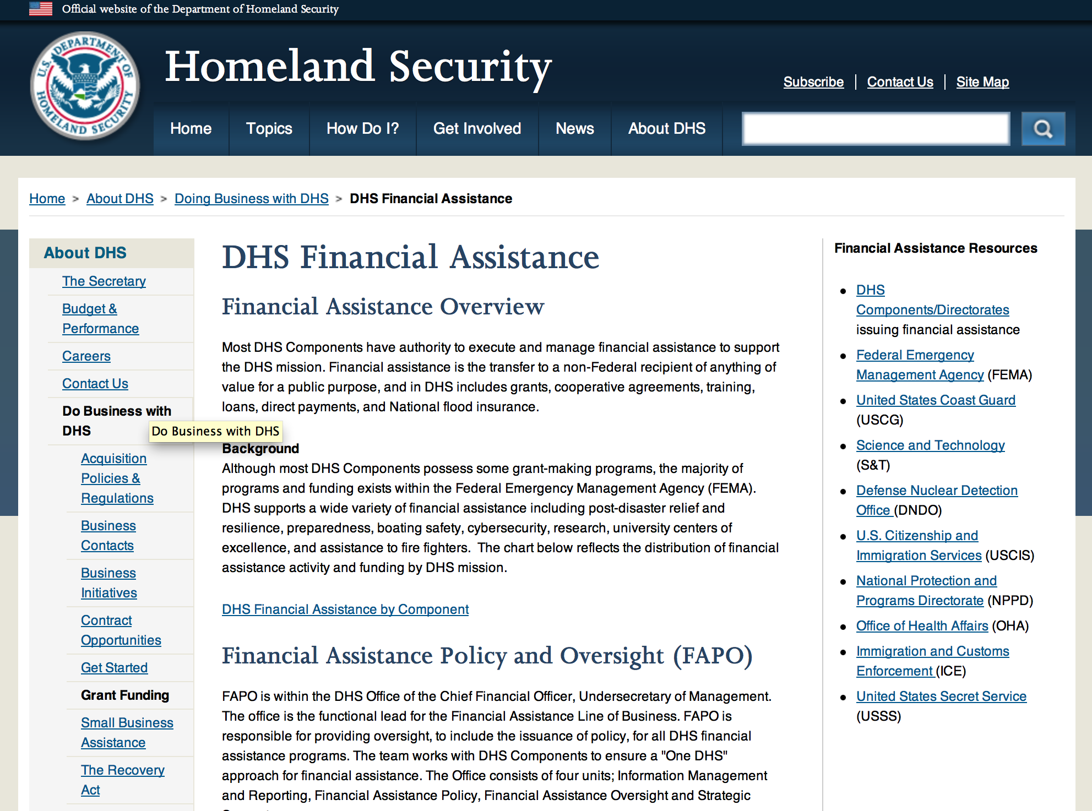

Webpage can be viewed at: http://www.dhs.gov/xopnbiz/grants/index.shtm#2

The FY 2015 Assistance to Firefighters Grants (AFG) Application Period Has Closed.
For AFG program guidance materials, please visit our Documents page.
FY 2015 FIRE PREVENTION & SAFETY (FP&S) Grants
- FY 2015 Application Information Coming Soon
- FP&S Success Stories
FY 2014 FIRE PREVENTION & SAFETY (FP&S) Grants
- FY 2014 FP&S Award Announcements - View Awards List
FY 2015 STAFFING FOR ADEQUATE FIRE and EMERGENCY RESPONSE (SAFER) Grants
- FY 2015 Application Information Coming Soon
- SAFER Success Stories
FY 2014 STAFFING FOR ADEQUATE FIRE and EMERGENCY RESPONSE (SAFER) Grants
- FY 2014 FP&S Award Announcements - View Awards List
FP&S Success Stories

Resources

AFG Help Desk
Contact the AFG Program Help Desk toll-free at 866-274-0960, or email us at firegrants@dhs.gov.
The AFG Program has Fire Program Specialists in 10 federal regional centers. These Regional Fire Program Specialists respond to questions about the AFG program and carry out grant monitoring activities. View regional contacts

Popular AFG links
- AFG Workshop Schedule
- Assistance to Firefighters Grants (AFG)
- AFG Awards List
- AFG Success Stories
- Staffing for Adequate Fire & Emergency Response (SAFER) Grants (SAFER)
- SAFER Awards List
- SAFER Success Stories
- Fire Prevention & Safety (FP&S) Grants
- FP&S Awards List
- FP&S Success Stories
- Grant Closeout Tutorial
- Assistance to Firefighters Grant (AFG) Email Alert Archive
- Frequently Asked Questions
Contact Information For The Assistance to Firefighters Grant (AFG) Program and Help Desk

Federal Funding Alternative To AFG

State Administrative Agencies (SAA) apply for and administer Federal grants on behalf of their States, including FEMA Preparedness Grants. The SAA will work with eligible organizations to comply with the general requirements of grant programs or cooperative agreements. Contact your State’s SAA to find out what current Federal funding opportunities may be available to your organization. A listing of the SAAs and points of contact can be found at http://www.fema.gov/library/viewRecord.do?id=6363.

Programs:

Office of Procurement Operations - Grants Division
DHS S&T Center of Excellence for Homeland Security Quantitative Analysis – Center Partner
Synopsis 1

Document Type: |  | Grants Notice
Funding Opportunity Number: |  | DHS-16-ST-061-HSQA-PARTNER
Funding Opportunity Title: |  | DHS S&T Center of Excellence for Homeland Security Quantitative Analysis – Center Partner
Opportunity Category: |  | Discretionary
Opportunity Category Explanation:
Funding Instrument Type: |  | Cooperative Agreement
Category of Funding Activity: |  | Science and Technology and other Research and Development
Category Explanation:
Expected Number of Awards: |  | 3
CFDA Number(s): |  | 97.061 -- Centers for Homeland Security
Cost Sharing or Matching Requirement: |  | No
Posted Date: |  | Aug 01, 2016
Last Updated Date: |  | Aug 01, 2016
Original Closing Date for Applications: |  | Nov 01, 2016
Current Closing Date for Applications: |  | Nov 01, 2016
Archive Date: |  | Dec 01, 2016
Estimated Total Program Funding: |  | $500,000
Award Ceiling: |  | $500,000
Award Floor: |  | $100,000
Eligible Applicants: |  | Private institutions of higher education  Public and State controlled institutions of higher education
Agency Name: | Office of Procurement Operations - Grants Division
Description: | IMPORTANT: DHS will conduct an informational webinar for interested applicants on August 23, 2016 at 3:00pm [EST]. The Department of Homeland Security (DHS) Science and Technology Directorate (S&T) Office of University Programs (OUP) is requesting applications from U.S. colleges and universities to serve as a partner institution for the Center for Homeland Security Quantitative Analysis (CHSQA). OUP is also posting a separate NOFO for eligible applicants to submit lead proposals for consideration. Please see NOFO Number DHS-16-ST-061-HSQA-Partner or 97.061 on http://www.grants.gov for directions on how to submit single project proposals. DHS will select qualified individual projects from applications received for either the Center Lead NOFO or the Center Partner NOFO, regardless of the institution that is awarded as lead institution. Principal Investigators that are already Partners under a Center Lead application may not submit the same application under this Partner NOFO.
Link to Additional Information: | Webinar Sign-Up Link
Grantor Contact Information: | If you have difficulty accessing the full announcement electronically, please contact:  Shareef Prater Grants Specialist Phone 202-447-5903  DHS Contact

http://www.grants.gov/web/grants/view-opportunity.html?oppId=286806

Modifications:

Funding Opportunity Number: DHS-16-OCP-132-00-01
FY 2016 Countering Violent Extremism Grants
Department of Homeland Security - FEMA
Posted Date: Jul 06, 2016
Version: Modification 2

Document Type: | Grants Notice
Funding Opportunity Number: | DHS-16-OCP-132-00-01
Funding Opportunity Title: | FY 2016 Countering Violent Extremism Grants
Opportunity Category: | Discretionary
Opportunity Category Explanation:
Funding Instrument Type: | Grant
Category of Funding Activity: | Arts (see "Cultural Affairs" in CFDA)  Community Development  Education  Employment, Labor and Training  Health  Humanities (see "Cultural Affairs" in CFDA)  Information and Statistics  Income Security and Social Services  Law, Justice and Legal Services  Regional Development
Category Explanation:
Expected Number of Awards: | 60
CFDA Number(s): | 97.132 -- Financial Assistance for Countering Violent Extremism
Cost Sharing or Matching Requirement: | No
Posted Date: | Jul 06, 2016
Last Updated Date: | Jul 06, 2016
Original Closing Date for Applications: | Sep 06, 2016
Current Closing Date for Applications: | Sep 06, 2016
Archive Date: | Sep 29, 2016
Estimated Total Program Funding: | $10,000,000
Award Ceiling: | $2,000,000
Award Floor: | $20,000
Eligible Applicants: | Special district governments  Nonprofits having a 501(c)(3) status with the IRS, other than institutions of higher education  Native American tribal governments (Federally recognized)  Public and State controlled institutions of higher education  County governments  State governments  Native American tribal organizations (other than Federally recognized tribal governments)  City or township governments  Private institutions of higher education  Independent school districts
Agency Name: | Department of Homeland Security - FEMA
Description: | The Department of Homeland Security Fiscal Year 2016 CVE Grant Program addresses the evolving landscape of international and domestic terrorism. Foreign terrorist organizations continue to encourage travel to conflict zones outside the United States. However, they are also increasingly encouraging individuals to commit violence wherever they happen to be in the name of their cause. Additionally, domestic organizations that span the ideological spectrum are recruiting and influencing individuals to engage in violence to advance their causes. Foreign terrorist organizations and domestic terrorists are increasingly using social media and other on-line tools to recruit and inspire individuals to action. The FY 2016 CVE Grant Program supports programs, projects and activities that prevent recruitment or radicalization to violence by interrupting those efforts, building community-level resilience to them, and identifying the early signs of radicalization to violence and providing appropriate interventions through civic organizations, law enforcement or other entities. Community resilience in the CVE context means those communities where violent extremists routinely meet disinterest and opposition, recruitment attempts routinely fail, and communities know what tools and support are available to assist individuals that may be on a path towards violence. The Homeland Security Act of 2002 instructs the Secretary of Homeland Security to "prevent terrorist attacks in the United States." DHS has made CVE a key element of its strategic vision: the 2014 Quadrennial Homeland Security Review reflected the importance of CVE by identifying CVE as a "Priority Area of Emphasis" within DHS's Mission 1: Prevent Terrorism and Enhance Security. Furthermore, Goal 1.1 of the FY 2014-2018 DHS Strategic Plan identifies CVE as one of four strategies to prevent terrorist attacks. Program Objectives The FY2016 CVE Grant Program seeks to develop new efforts and expand existing efforts at the community level to counter violent extremist recruitment and radicalization to violence by funding activities that enhance the resilience of communities being targeted by violent extremists for recruitment, provide alternatives to individuals who have started down a road to violent extremism, and that create or amplify alternative messages to terrorist/violent extremist recruitment and radicalization efforts. In addition, the CVE Grant Program seeks to develop and support efforts by U.S.-based entities that are broadly countering violent extremists' on-line recruitment efforts aimed at U.S.-based individuals. DHS seeks to support innovative and cost effective programs, projects, and activities which establishes or uses existing effectiveness measures. Awardees will collect data on their chosen performance measures so that evaluations of the program can be conducted, either by the organization or independently. Additionally, DHS will assess funded projects for promising practices and make them available in a replicable form for other communities or sectors. DHS is seeking to fund activities in geographically diverse communities across the country and see awards made to multiple different eligible applicant types. Program Priorities The FY 2016 CVE Grant Program has five focus areas for eligible activities that current research (See Appendix A) has shown is likely to be the most effective in countering violent extremism:- Developing resilience;- Training and engaging with community members;- Managing intervention activities; - Challenging the narrative; and - Building capacity of community-level non-profit organizations active in CVE."
Link to Additional Information: | https://www.dhs.gov/cvegrants
Grantor Contact Information: | If you have difficulty accessing the full announcement electronically, please contact:  Systems, GPD GMD-Systems-Branch@fema.gov  GMD-Systems-Branch@fema.gov

Link: http://www.grants.gov/web/grants/view-opportunity.html?oppId=285773

Reminders:

Office of Procurement Operations - Grants Division
Center of Excellence Criminal Investigations and Network Analysis – Partner Grant

Document Type: |  | Grants Notice
Funding Opportunity Number: |  | DHS-16-ST-061-CINA-PARTNER
Funding Opportunity Title: |  | Center of Excellence Criminal Investigations and Network Analysis - Partner
Opportunity Category: |  | Discretionary
Opportunity Category Explanation:
Funding Instrument Type: |  | Cooperative Agreement
Category of Funding Activity: |  | Science and Technology and other Research and Development
Category Explanation:
Expected Number of Awards: |  | 3
CFDA Number(s): |  | 97.061 -- Centers for Homeland Security
Cost Sharing or Matching Requirement: |  | No
Posted Date: |  | May 27, 2016
Last Updated Date: |  | May 27, 2016
Original Closing Date for Applications: |  | Sep 01, 2016
Current Closing Date for Applications: |  | Sep 01, 2016
Archive Date: |  | Oct 01, 2016
Estimated Total Program Funding: |  | $5,000,000
Award Ceiling: |  | $500,000
Award Floor: |  | $100,000
Eligible Applicants: |  | Public and State controlled institutions of higher education  Private institutions of higher education
Agency Name: | Office of Procurement Operations - Grants Division
Description: | Informational Webinar June 21, 2016 3:00pm EDT. The Department of Homeland Security (DHS) Science and Technology Directorate (S&T) Office of University Programs (OUP) is requesting applications from U.S. colleges and universities to serve as a partner institution for a Center for Criminal Investigations and Network Analysis (CINA). OUP is also posting a separate NOFO for eligible applicants to submit lead proposals for consideration. Please see NOFO Number DHS-16-ST-061-CINA-Partner or 97.061 on http://www.grants.gov for directions on how to submit single project proposals. DHS will select qualified individual projects from applications received for either the Center Lead NOFO or the Center Partner NOFO, regardless of the institution that is awarded as lead institution. Principal Investigators that are already Partners under a Center Lead application may not submit the same application under this Partner NOFO.
Link to Additional Information: | Webinar link 6-21-2016 3:00pm EDT
Contact Information: | If you have difficulty accessing the full announcement electronically, please contact:  Melanie Bales Lead Grants Officer  DHS

http://www.grants.gov/web/grants/view-opportunity.html?oppId=284177

Department of Housing and Urban Development

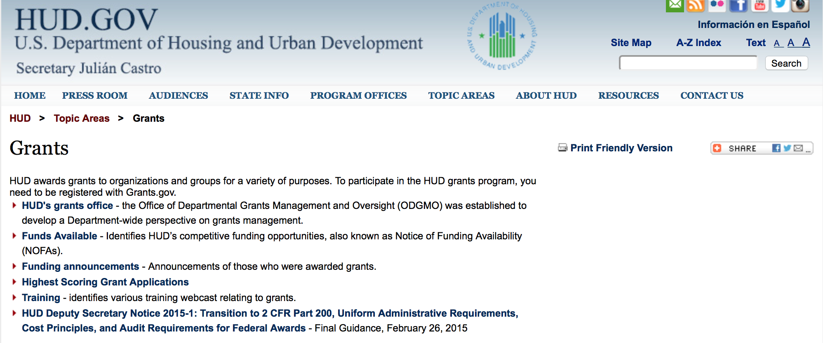

http://portal.hud.gov/hudportal/HUD?src=/topics/grants

HUD - Notice of Funds Available

For detailed information click here

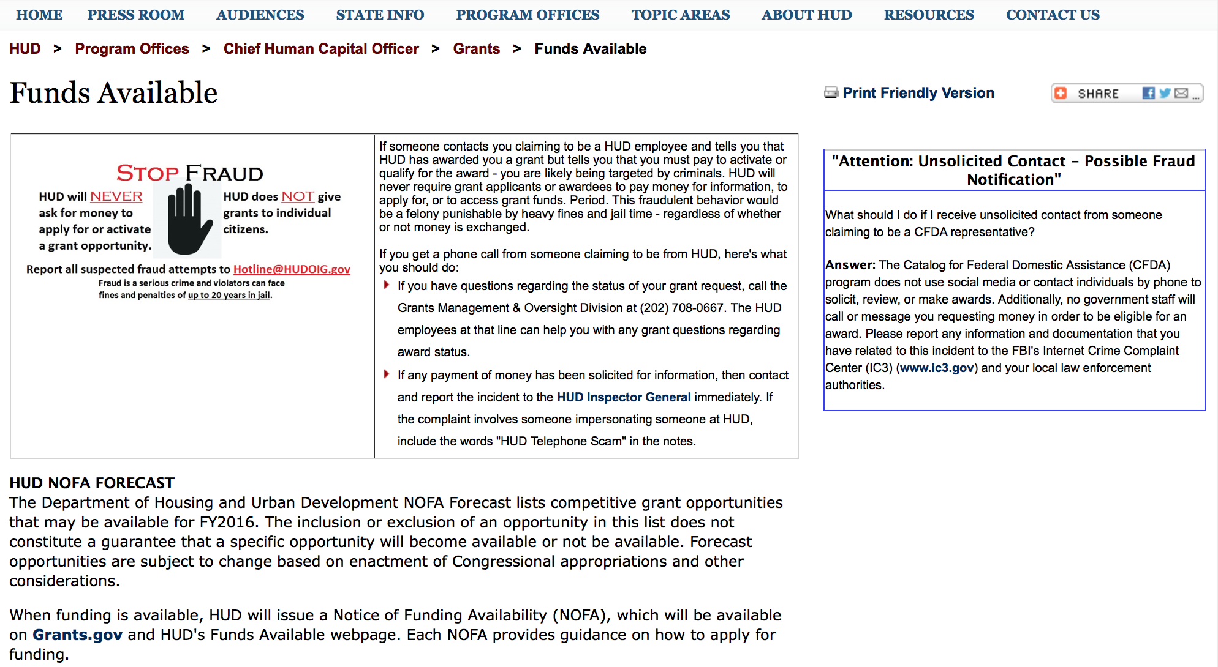

http://portal.hud.gov/hudportal/HUD?src=/program_offices/administration/grants/fundsavail

HUD NOFA FORECAST
The Department of Housing and Urban Development NOFA Forecast lists competitive grant opportunities that may be available for FY2016. The inclusion or exclusion of an opportunity in this list does not constitute a guarantee that a specific opportunity will become available or not be available. Forecast opportunities are subject to change based on enactment of Congressional appropriations and other considerations.
When funding is available, HUD will issue a Notice of Funding Availability (NOFA), which will be available on Grants.gov and HUD's Funds Available webpage. Each NOFA provides guidance on how to apply for funding.
Program Office | Funding Opportunity Title | Funding Opportunity Number | CFDA | Estimated Publication Date | Estimated Application Due Date
GMO | General Section to HUD's Fiscal Year 2016 Notice[s] of Funding Availability for Discretionary Programs (General Section) | FR-6000-N-01 | 14.506 | PUBLISHED | N/A
HSNG | Notice of Funding Availability (NOFA) for the Department's Fiscal Years 2016 and 2017 Comprehensive Housing Counseling Grant Program | FR-6000-N-33 | 14.169 | PUBLISHED | 4/4/2016
HSNG | NOFA for HUD's FY16-17 Housing Counseling Training Grant Program | FR-6000-N-30 | 14.316 | PUBLISHED | 4/4/2016
HSNG | Multifamily Energy and Water Conservation Pay For Success Pilot | FR-6000-N-36 | 14.157 | 9/14/2016 | 11/14/2016
OLHCHH | Lead Hazard Reduction Demonstration (LHRD) Grant Program | FR-6000-N-13 | 14.905 | PUBLISHED | 4/28/2016
OLHCHH | Lead-Based Paint Hazard Control (LBPHC) Grant Program | FR-6000-N-12 | 14.900 | PUBLISHED | 4/28/2016
OLHCHH | Healthy Homes Technical Studies Grant Program Pre and Full Application | FR-6000-N-15 | 14.906 | PUBLISHED | 6/1/2016
PIH | Resident Opportunity & Self-Sufficiency Program | FR-6000-N-05 | 14.870 | PUBLISHED | 5/16/2016
PIH | HOPE VI Main Street Grant Program | FR-6000-N-03 | 14.878 | PUBLISHED | 4/12/2016
PIH | Jobs Plus Initiative | FR-6000-N-14 | 14.895 | PUBLISHED | 6/13/2016
PIH | Family Self-Sufficiency Program | FR-6000-N-04 | 14.896 | PUBLISHED | 4/20/2016
PIH | Community Development Block Grant Program for Indian Tribes and Alaska Native Villages | FR-6000-N-23 | 14.862 | PUBLISHED | 6/14/2016
PIH | Choice Neighborhoods Implementation Grant Program | FR-6000-N-34 | 14.889 | PUBLISHED | 6/28/2016
PIH | Project SOAR | FR-6000-N-27 | 14.889 | 7/20/2016 | 9/19/2016
FHEO | Fair Housing Initiative Program - Private Enforcement Initiative | FR-6000-N-21C | 14.418 | PUBLISHED | 6/23/2016
FHEO | Fair Housing Initiative Program - Fair Housing Organization Initiative | FR-6000-N-21B | 14.417 | PUBLISHED | 6/23/2016
FHEO | Fair Housing Initiative Program - Education and Outreach Initiative | FR-6000-N-21A | 14.416 | PUBLISHED | 6/23/2016
PDR | Research and Evaluation, Demonstration, and Data Analysis and Utilization | FR-5900-N-29 | 14.536 | PUBLISHED | 6/6/2016
PDR | Research and Evaluation, Demonstration, and Data Analysis and Utilization | FR-6000-N-29 | 14.536 | 7/7/2016 | 8/23/2016
CPD | HUD Community Compass Technical Assistance and Capacity Building Program | FR-6000-N-06 | 14.259 | PUBLISHED | 7/19/2016
CPD | Capacity Building for Community Development and Affordable Housing Grants (Section 4) | FR-6000-N-07 | 14.252 | PUBLISHED | 8/9/2016
CPD | Building Capacity to End Youth Homelessness | FR-6000-N-37 | 14.270 | CANCELLED | CANCELLED
CPD | Youth Homelessness Demonstration Project | FR-6000-N-35 | 14.267 | 7/7/2016 | 9/1/2016
CPD | Continuum of Care Program Competition | FR-6000-N-25 | 14.276 | 6/30/2016 | 9/30/2016
CPD | Rural Capacity Building for Community Development and Affordable Housing Grants | FR-6000-N-08 | 14.265 | 7/8/2016 | 9/6/2016
CPD | Self-Help Homeownership Opportunity Program (SHOP) | FR-6000-N-19 | 14.247 | 10/12/2016 | 12/11/2016
- Updated 6/21/2016 General Section
- FONSI
- New Application Attachment Filename Requirement

Programs

Rural Capacity Building for Community Development and Affordable Housing Grants
Synopsis 1

Document Type: | Grants Notice
Funding Opportunity Number: | FR-6000-N-08
Funding Opportunity Title: | Rural Capacity Building for Community Development and Affordable Housing Grants
Opportunity Category: | Discretionary
Opportunity Category Explanation:
Funding Instrument Type: | Grant
Category of Funding Activity: | Community Development
Category Explanation:
Expected Number of Awards: | 5
CFDA Number(s): | 14.265 -- Rural Capacity Building for Community Development and Affordable Housing Grants
Cost Sharing or Matching Requirement: | Yes
Posted Date: | Jul 15, 2016
Last Updated Date: | Jul 15, 2016
Original Closing Date for Applications: | Sep 13, 2016 Electronically submitted applications must be submitted no later than 11:59:59 p.m., ET, on the listed application due date.
Current Closing Date for Applications: | Sep 13, 2016 Electronically submitted applications must be submitted no later than 11:59:59 p.m., ET, on the listed application due date.
Archive Date: | Dec 31, 2016
Estimated Total Program Funding: | $5,000,000
Award Ceiling: | $2,500,000
Award Floor: | $500,000
Eligible Applicants: | Others (see text field entitled "Additional Information on Eligibility" for clarification)  Nonprofits having a 501(c)(3) status with the IRS, other than institutions of higher education
Additional Information on Eligibility: | HUD awards grants under this NOFA to national organizations. A national organization is defined as a non-profit entity or consortium that has on-going experience in rural housing, including experience working with rural housing development organizations, community development corporations (CDCs), community housing development organizations (CHDOs), local governments, and Indian tribes, as evidenced by past and continuing work in one or more states in five or more of the Federal regions described on HUD's website at http://portal.hud.gov/hudportal/HUD?src=/localoffices/regions. Individuals, foreign entities, and sole proprietorship organizations are not eligible to compete for, or receive, awards made under this announcement.
Agency Name: | Department of Housing and Urban Development
Description: | The Rural Capacity Building program and the funding made available through this NOFA are authorized by the Consolidated Appropriations Act, 2016 (Public Law 114-113, approved December 18, 2015).
Link to Additional Information: | http://portal.hud.gov/hudportal/HUD?src=/program_offices/administration/grants/fundsavail
Grantor Contact Information: | If you have difficulty accessing the full announcement electronically, please contact:  Rudene Thomas Rudene.Thomas@hud.gov  Grants Policy

http://www.grants.gov/web/grants/view-opportunity.html?oppId=286174

ROSS for Education

Document Type: | Grants Notice
Funding Opportunity Number: | FR-6000-N-27
Funding Opportunity Title: | ROSS for Education
Opportunity Category: | Discretionary
Opportunity Category Explanation:
Funding Instrument Type: | Grant
Category of Funding Activity: | Housing
Category Explanation:
Expected Number of Awards: | 6
CFDA Number(s): | 14.898 -- ROSS Supportive Services Programs
Cost Sharing or Matching Requirement: | Yes
Posted Date: | Jul 29, 2016
Last Updated Date: | Jul 29, 2016
Original Closing Date for Applications: | Sep 28, 2016 Electronically submitted applications must be submitted no later than 11:59:59 p.m., ET, on the listed application due date.
Current Closing Date for Applications: | Sep 28, 2016 Electronically submitted applications must be submitted no later than 11:59:59 p.m., ET, on the listed application due date.
Archive Date: | Oct 28, 2016
Estimated Total Program Funding: | $2,000,000
Award Ceiling: | $452,000
Eligible Applicants: | Others (see text field entitled "Additional Information on Eligibility" for clarification)
Additional Information on Eligibility: | Eligible applicants are public housing authorities (PHAs) (including newly established consolidated PHAs) that have Annual Contribution Contract units. Non-profit organizations, resident associations, and for-profit organizations are not eligible to apply for funding under this NOFA. Individuals, foreign entities, and sole proprietorship organizations are not eligible to compete for, or receive, awards made under this announcement.
Agency Name: | Department of Housing and Urban Development
Description: | This NOFA announces the availability of approximately $2 million to provide grants to public housing authorities (PHAs) to deploy education navigators to provide individualized assistance to randomly selected public housing youth between the ages of 15-20 and their families in FAFSA completion, financial literacy and college readiness, postsecondary program applications and post-acceptance assistance.
Link to Additional Information: | http://portal.hud.gov/hudportal/HUD?src=/program_offices/administration/grants/fundsavail
Grantor Contact Information: | If you have difficulty accessing the full announcement electronically, please contact:  Maria Queen Maria-Lana.Queen@hud.gov  Grants Policy

http://www.grants.gov/web/grants/view-opportunity.html?oppId=286724

Modifications:

Reminders

Funding Opportunity Number: FR-6000-N-25
FY2016 Continuum of Care
Modification 4
Modification Comments: This modification updates the Agency Contact URL.

Document Type: | Grants Notice
Funding Opportunity Number: | FR-6000-N-25
Funding Opportunity Title: | FY2016 Continuum of Care
Opportunity Category: | Discretionary
Opportunity Category Explanation:
Funding Instrument Type: | Grant
Category of Funding Activity: | Housing
Category Explanation:
Expected Number of Awards: | 8000
CFDA Number(s): | 14.267 -- Continuum of Care Program
Cost Sharing or Matching Requirement: | Yes
Version: | Synopsis 4
Posted Date: | Jun 28, 2016
Last Updated Date: | Jun 29, 2016
Original Closing Date for Applications: | Sep 14, 2016
Current Closing Date for Applications: | Sep 14, 2016
Archive Date: | Oct 14, 2016
Estimated Total Program Funding: | $1,900,000,000
Award Ceiling: | $1,500,000
Award Floor: | $2,500
Eligible Applicants: | City or township governments  State governments  County governments  Others (see text field entitled "Additional Information on Eligibility" for clarification)  Nonprofits having a 501(c)(3) status with the IRS, other than institutions of higher education
Additional Information on Eligibility: | 24 CFR 578.15, eligible project applicants for the CoC Program Competition are nonprofit organizations, States, local governments, and instrumentalities of State and local governments. Public housing agencies, as such term is defined in 24 CFR 5.100, are eligible without limitation or exclusion. For-profit entities are not eligible to apply for grants or to be subrecipients of grant funds. Individuals, foreign entities, and sole proprietorship organizations are not eligible to compete for, or receive, awards made under this announcement.
Agency Name: | Department of Housing and Urban Development
Description: | The CoC Program (24 CFR part 578) is designed to promote a community-wide commitment to the goal of ending homelessness; to provide funding for efforts by nonprofit providers, States, and local governments to quickly re-house homeless individuals, families, persons fleeing domestic violence, and youth while minimizing the trauma and dislocation caused by homelessness; to promote access to and effective utilization of mainstream programs by homeless; and to optimize self-sufficiency among those experiencing homelessness.
Link to Additional Information: | HUD Funds Available Page
Grantor Contact Information: | If you have difficulty accessing the full announcement electronically, please contact:  HUD Staff  HUD Exchange AAQ help desk

Link: http://www.grants.gov/web/grants/view-opportunity.html?oppId=285539

Technical Correction to the General Section to HUD's Fiscal Year 2016 Notice[s] of Funding Availability for Discretionary Programs
Modification 1

Document Type: | Grants Notice
Funding Opportunity Number: | FR-6000-N-01-C
Funding Opportunity Title: | Technical Correction to the General Section to HUD's Fiscal Year 2016 Notice[s] of Funding Availability for Discretionary Programs
Opportunity Category: | Discretionary
Opportunity Category Explanation:
Funding Instrument Type: | Grant
Category of Funding Activity: | Community Development
Category Explanation:
Expected Number of Awards: | 0
CFDA Number(s):
Cost Sharing or Matching Requirement: | No
Posted Date: | May 16, 2016
Last Updated Date: | May 16, 2016
Original Closing Date for Applications: | Dec 31, 2016 Electronically submitted applications to program NOFAs must be submitted no later than 11:59:59 p.m., ET, on the listed application due date. No applications are accepted in response to this Notice, which publishes policies and guidance only.
Current Closing Date for Applications: | Dec 31, 2016 Electronically submitted applications to program NOFAs must be submitted no later than 11:59:59 p.m., ET, on the listed application due date. No applications are accepted in response to this Notice, which publishes policies and guidance only.
Archive Date: | Jan 30, 2017
Estimated Total Program Funding: | $0
Award Ceiling: | $0
Award Floor: | $0
Eligible Applicants: | Public and State controlled institutions of higher education  Unrestricted (i.e., open to any type of entity above), subject to any clarification in text field entitled "Additional Information on Eligibility"  Nonprofits that do not have a 501(c)(3) status with the IRS, other than institutions of higher education  State governments  Private institutions of higher education  Public housing authorities/Indian housing authorities  County governments  Special district governments  City or township governments  Small businesses  Native American tribal governments (Federally recognized)  Independent school districts  Native American tribal organizations (other than Federally recognized tribal governments)  Individuals  Nonprofits having a 501(c)(3) status with the IRS, other than institutions of higher education  For profit organizations other than small businesses
Additional Information on Eligibility: | No applications will be accepted in response to this document. This Document is a policy document only. The individual program Notices of Funds Available (NOFA) will identify eligible applicants for each competition. Each Program NOFA will describe additional eligibility requirements for applicants. HUD does not provide direct services or products to individuals through its formula-based programs or its competitive Program NOFA process. Individuals seeking financial assistance should refer to www.GovBenefits.gov. Individuals, foreign entities, and sole proprietorship organizations are not eligible to compete for, or receive, awards made under this announcement.
Agency Name: | Department of Housing and Urban Development
Description: | HUD publishes a General Section each Fiscal Year (FY) that contains requirements for all of HUD’s competitive grant programs. Applications to HUD programs must meet all applicable requirements of the General Section and the requirements in the Program NOFA to be considered for funding. This updates paragraph V.C.8. Eminent Domain to reflect the 2016 Appropriations authority, and updates paragraph VI.A.1. Obtaining an Electronic Application.
Link to Additional Information: | http://portal.hud.gov/hudportal/HUD?src=/program_offices/administration/grants/fundsavail
Contact Information: | If you have difficulty accessing the full announcement electronically, please contact:  Loyd LaMois loyd.lamois@hud.gov  Grants Policy

http://www.grants.gov/web/grants/view-opportunity.html?oppId=283900

General Section to HUD's Fiscal Year 2016 Notice[s] of Funding Availability for Discretionary Programs (General Section)
Modification 1

Document Type: | Grants Notice
Funding Opportunity Number: | FR-6000-N-01
Funding Opportunity Title: | General Section to HUD's Fiscal Year 2016 Notice[s] of Funding Availability for Discretionary Programs (General Section)
Opportunity Category: | Discretionary
Funding Instrument Type: | Grant
Category of Funding Activity: | Community Development
Category Explanation:
Expected Number of Awards: | 0
CFDA Number(s):
Cost Sharing or Matching Requirement: | No
Posted Date: | Sep 24, 2015
Creation Date: | Sep 24, 2015
Original Closing Date for Applications: | Dec 30, 2016 Electronically submitted applications must be submitted no later than 11:59:59 p.m., ET, on the listed application due date published in the individual program NOFA.
Current Closing Date for Applications: | Dec 30, 2016 Electronically submitted applications must be submitted no later than 11:59:59 p.m., ET, on the listed application due date published in the individual program NOFA.
Archive Date: | Jan 29, 2017
Eligible Applicants: | Others (see text field entitled "Additional Information on Eligibility" for clarification)
Additional Information on Eligibility: | This Document is a policy document only. The individual program Notices of Funds Available (NOFA) will identify eligible applicants for each competition. Each Program NOFA will describe additional eligibility requirements for applicants. All applicants must have valid, active Registration in the System for Award Management (SAM) prior to submission of applications for financial assistance. HUD does not provide direct services or products to individuals through its formula-based programs or its competitive Program NOFA process. Individuals seeking financial assistance should refer to www.GovBenefits.gov. Individuals, foreign entities, and sole proprietorship organizations are not eligible to compete for, or receive, awards made under this announcement.
Agency Name: | Department of Housing and Urban Development
Description: | The General Section describes the requirements that are applicable to all HUD FY 2015 Program NOFAs. The General Section also provides information on HUD’s priorities and strategic goals. Each Program NOFA will describe additional applicable procedures and requirements, including a description of the eligible applicants, eligible activities, threshold requirements, cross-program requirements such as nondiscrimination, environmental protection, and any additional program requirements or limitations. To adequately address all of the application requirements for any program, please carefully read and respond to both this General Section and any applicable Program NOFA.
Link to Additional Information: | http://portal.hud.gov/hudportal/HUD?src=/program_offices/administration/grants/fundsavail
Contact Information: | If you have difficulty accessing the full announcement electronically, please contact:  Loyd LaMois loyd.lamois@hud.gov  Grants Policy

http://www.grants.gov/web/grants/view-opportunity.html?oppId=279206



Institute of Museum and Library Services

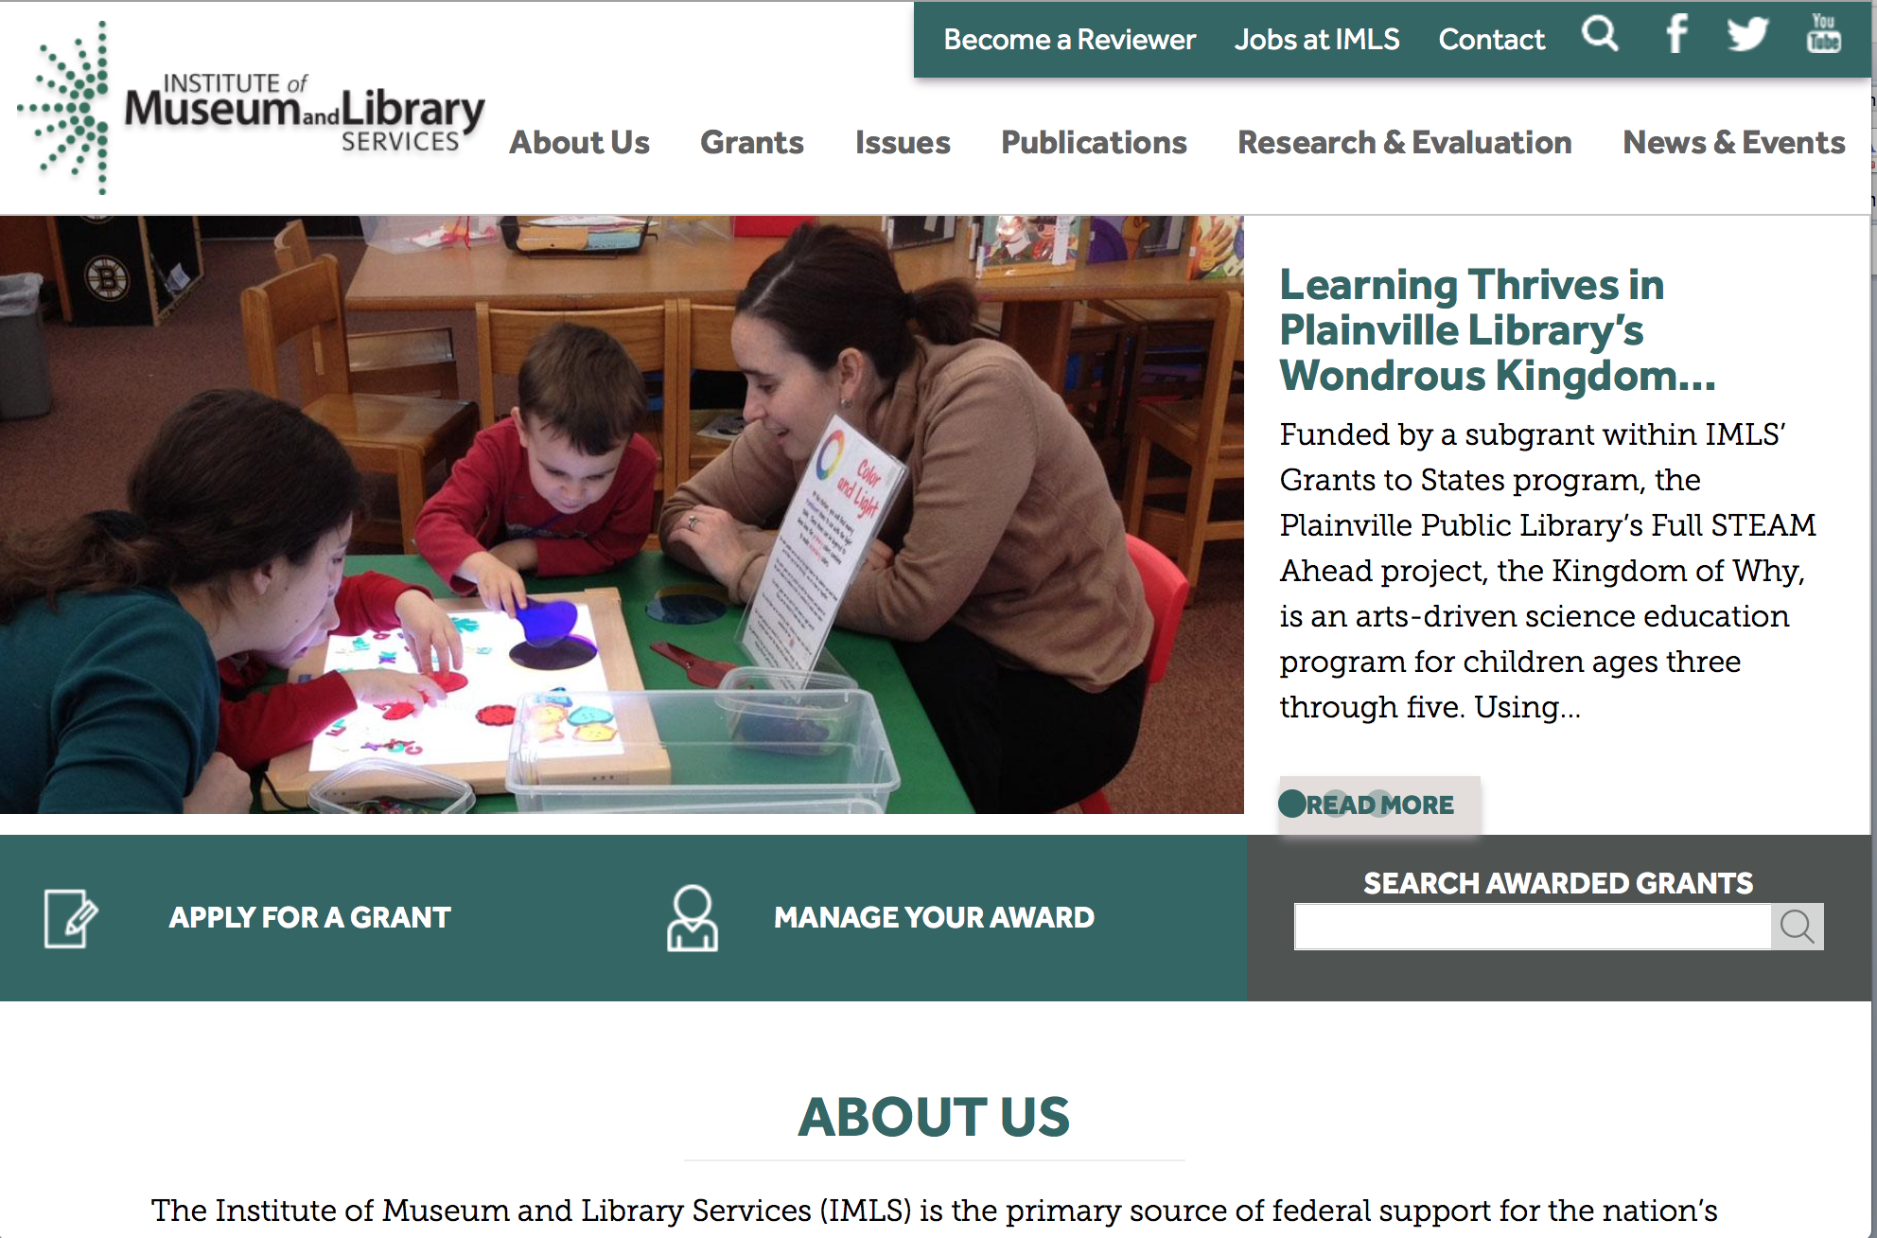

www.imls.gov

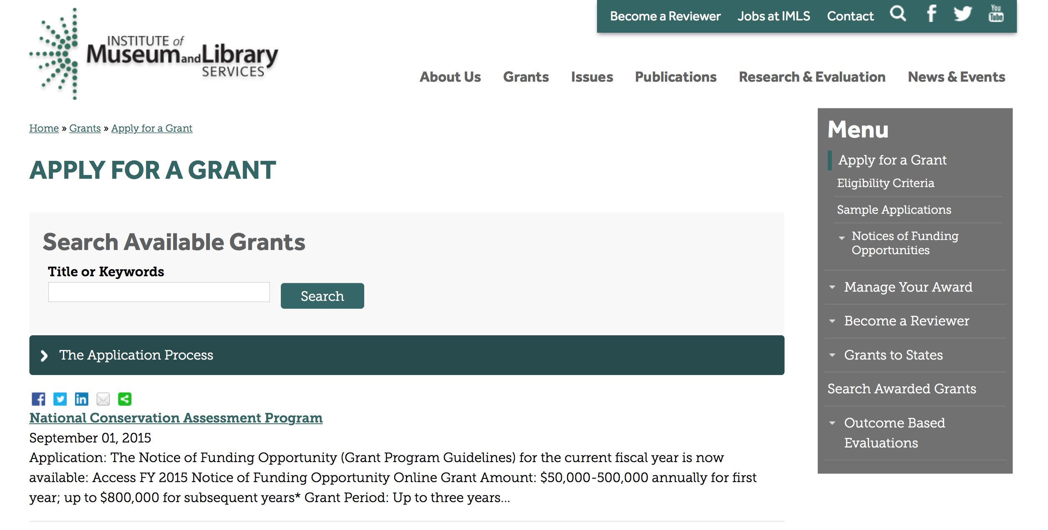
http://www.imls.gov/applicants/available_grants.aspx

Each grant program has specific eligibility requirements. The links below provide general eligibility criteria for museums, libraries, and tribal organizations, but please note that additional organizations may be eligible for grants under certain programs. Additionally, ineligible organizations may still be able to participate in grant programs through partnerships with eligible organizations. Please click on the links below to see general criteria and review Applications and Guidelines for specific information.
Museums Libraries

Institutions: Archives, Federally Recognized Native American Tribe, Historical Society, Library, Nonprofits that serve Native Hawaiians, Professional Association, Public or Private Non-profit Institutions of Higher Education, Regional Organization, State Library Administrative Agency, State or Local Government

Check out IMLS's Facebook page at:
https://www.facebook.com/USIMLS/

Laura Bush 21st Century Librarian Program

Document Type: | Grants Notice
Funding Opportunity Number: | LB21-FY17-1
Funding Opportunity Title: | Laura Bush 21st Century Librarian Program
Opportunity Category: | Discretionary
Opportunity Category Explanation:
Funding Instrument Type: | Grant
Category of Funding Activity: | Humanities (see "Cultural Affairs" in CFDA)
Category Explanation:
Expected Number of Awards: | 11
CFDA Number(s): | 45.313 -- Laura Bush 21st Century Librarian Program
Cost Sharing or Matching Requirement: | Yes
Posted Date: | Jul 28, 2016
Last Updated Date: | Jul 28, 2016
Original Closing Date for Applications: | Jan 13, 2017 The Laura Bush 21st Century Librarian Program has a two phase application process. In the first phase, all applicants must submit a two page preliminary proposal. Grants.gov will accept preliminary proposal applications through 11:59 p.m. U.S. Eastern Time on September 1, 2016. Those applicants whose preliminary proposals are the most promising and best aligned with the IMLS's priorities will be invited to submit full proposals in the second phase of the process. Grants.gov will accept invited, full proposal applications through 11:59 p.m. U.S. Eastern Time on January 13, 2017.
Current Closing Date for Applications: | Jan 13, 2017 The Laura Bush 21st Century Librarian Program has a two phase application process. In the first phase, all applicants must submit a two page preliminary proposal. Grants.gov will accept preliminary proposal applications through 11:59 p.m. U.S. Eastern Time on September 1, 2016. Those applicants whose preliminary proposals are the most promising and best aligned with the IMLS's priorities will be invited to submit full proposals in the second phase of the process. Grants.gov will accept invited, full proposal applications through 11:59 p.m. U.S. Eastern Time on January 13, 2017.
Archive Date: | Feb 12, 2017
Estimated Total Program Funding: | $3,700,000
Award Ceiling: | $1,000,000
Award Floor: | $50,000
Eligible Applicants: | Others (see text field entitled "Additional Information on Eligibility" for clarification)
Additional Information on Eligibility: | To be eligible for LB21, you must be either a unit of State or local government or a private nonprofit organization that has tax-exempt status under the Internal Revenue Code and be located in one of the 50 States of the United States of America, the District of Columbia, the Commonwealth of Puerto Rico, Guam, American Samoa, the U.S. Virgin Islands, the Commonwealth of the Northern Mariana Islands, the Republic of the Marshall Islands, the Federated States of Micronesia, or the Republic of Palau. In addition, you must be one of the following six types of organizations: •A library or a parent organization, such as a school district, a municipality, a State agency, or an academic institution, that is responsible for the administration of a library. Eligible libraries include the following: ◦Public libraries; ◦Public elementary and secondary school libraries; ◦College (including community college) and university libraries; ◦Research libraries and archives that are not an integral part of an institution of higher education and that make publicly available library services and materials that are suitable for scholarly research and not otherwise available (Research libraries must be under the supervision of at least one permanent professional staff librarian and must be either generally recognized as possessing unique scholarly research materials and services that are made available to the public, or able to demonstrate that such is the case when submitting an application to IMLS.); ◦Private or special libraries that have been deemed eligible to participate in this program by the State in which the library is located. •An academic or administrative unit, such as a graduate school of library and information science that is part of an institution of higher education through which it would make application (see below for additional conditions of eligibility that might apply regarding institutions of higher education); •A digital library, if it makes library materials publicly available and provides library services, including selection, organization, description, reference, and preservation, under the supervision of at least one permanent professional staff librarian; •A library agency that is an official agency of a State or other unit of government and is charged by the law governing it with the extension and development of public library services within its jurisdiction; •A library consortium that is a local, statewide, regional, interstate, or international cooperative association of library entities that provides for the systematic and effective coordination of the resources of eligible libraries, as defined above, and information centers that work to improve the services delivered to the clientele of these libraries; •A library association that exists on a permanent basis; serves libraries or library professionals on a national, regional, state, or local level; and engages in activities designed to advance the well-being of libraries and the library profession. We recognize the potential for valuable contributions to the overall goals of the LB21 program by entities that do not meet the eligibility requirements above. Although such entities may not serve as the official applicants, they are encouraged to participate in projects. Federally operated libraries and museums may not apply for LB21 grants, but they may participate with applicants. Contact us before submitting a proposal involving a federal agency or federal collection. Non-Federal entities may serve as subrecipients or contractors and may receive IMLS grant funds as a result of the project. Consult with us about any eligibility questions before submitting an application. Native American tribal organizations may apply if they otherwise meet the above eligibility requirements.
Agency Name: | Institute of Museum and Library Services
Description: | The Laura Bush 21st Century Librarian Program (LB21) supports professional development, graduate education and continuing education to help libraries and archives develop a diverse workforce of librarians to better meet the changing learning and information needs of the American public.
Link to Additional Information: | https://www.imls.gov/grants/available/laura-bush-21st-century-librarian-program
Grantor Contact Information: | If you have difficulty accessing the full announcement electronically, please contact:  Sarah Fuller, Library Program Officer 202-653-4783 sfuller@imls.gov Sandra Toro, PhD, Senior Library Program Officer 202-653-4662 storo@imls.gov Emily Reynolds, Library Program Officer 202-653-4665 ereynolds@imls.gov  sfuller@imls.gov

http://www.grants.gov/web/grants/view-opportunity.html?oppId=286678
Modifications:

Reminders:

Deleted:

NLG-LIBRARIES-FY16 - National Leadership Grants for Libraries
Deletion Comments: Opportunity deleted

LB21-FY16 - Laura Bush 21st Century Librarian Program
Deletion Comments: Opportunity deleted

NLG-LIBRARIES-FY16-2 - National Leadership Grants for Libraries
Deletion Comments: Opportunity deleted

LB21-FY16-2 - Laura Bush 21st Century Librarian Program
Deletion Comments: Opportunity deleted

Department of the Interior
Working with Interior

The Interior Department provides assistance to the public, local governments and businesses through a number of programs. For a general overview see: http://www.doi.gov/index.cfm

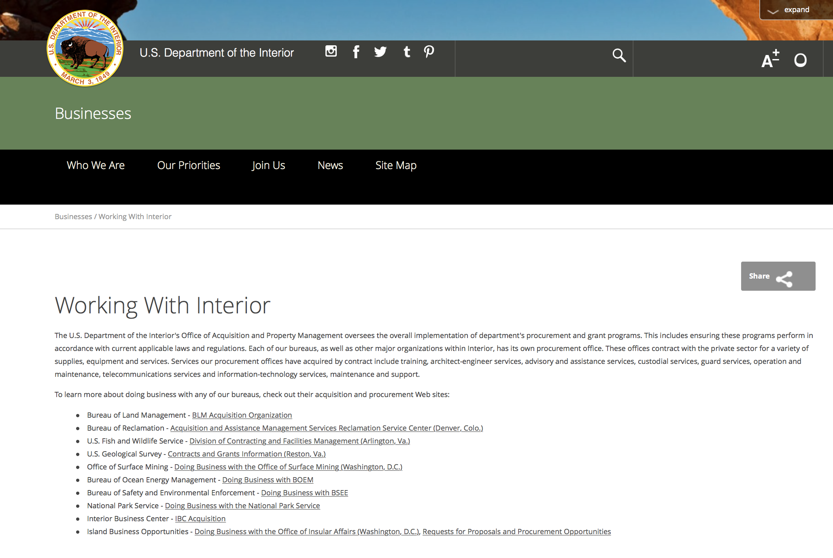

http://www.doi.gov/businesses/working-with-interior.cfm

Programs:

Fish and Wildlife Service
Marine Turtle Conservation Fund
Synopsis 1

Document Type: | Grants Notice
Funding Opportunity Number: | F16AS00378
Funding Opportunity Title: | Marine Turtle Conservation Fund
Opportunity Category: | Discretionary
Opportunity Category Explanation:
Funding Instrument Type: | Cooperative Agreement  Grant
Category of Funding Activity: | Community Development  Education  Environment  Natural Resources  Other (see text field entitled "Explanation of Other Category of Funding Activity" for clarification)  Science and Technology and other Research and Development
Category Explanation: | Wildlife Conservation - proposed project work should occur within the species range, outside of the United States. If work is to be conducted outside of the species range, the proposal should show a clear relevance to its conservation.
Expected Number of Awards: | 40
CFDA Number(s): | 15.645 -- Marine Turtle Conservation Fund
Cost Sharing or Matching Requirement: | No
Posted Date: | Aug 02, 2016
Last Updated Date: | Aug 02, 2016
Original Closing Date for Applications: | Oct 02, 2016
Current Closing Date for Applications: | Oct 02, 2016
Archive Date: | Oct 04, 2016
Estimated Total Program Funding: | $1,500,000
Award Ceiling: | $80,000
Award Floor: | $10,000
Eligible Applicants: | Unrestricted (i.e., open to any type of entity above), subject to any clarification in text field entitled "Additional Information on Eligibility"
Agency Name: | Fish and Wildlife Service
Description: | The Marine Turtle Conservation Fund is soliciting proposals for the conservation of marine turtles (Chelonia mydas, Caretta caretta, Dermochelys coriacea, Eretmochelys imbricata, Lepidochelys olivacea, Lepidochelys kempii) throughout their range outside of the United States and its territories. The U.S. Government enacted the Marine Turtle Conservation Act (MTCA) of 2004 in response to the decline of many marine turtle populations worldwide and the serious threats to their long-term survival. The primary purpose of the Act is to provide financial support for projects that conserve nesting populations and habitat and address other threats to the survival of marine turtles in foreign countries. The goal of this program is to reduce threats to marine turtles in their natural habitat. Proposals should identify specific conservation actions that have a high likelihood of creating lasting benefits. Project activities that emphasize data collection and status assessment should describe a direct link to management action, and explain how lack of information has been a key limiting factor for management action in the past. Proposals that do not identify how actions will reduce threats or that do not demonstrate a strong link between data collection and management action will be disqualified. Proposed project work should occur within the species range, outside of the United States. If work is to be conducted outside of the species range, the proposal should show a clear relevance to its conservation. To the extent that it provides clear, direct support for the program objectives above, proposed work may also relate to climate change adaptation, mitigation and education.
Link to Additional Information: | https://www.fws.gov/international/grants-and-reporting/how-to-apply.html
Grantor Contact Information: | If you have difficulty accessing the full announcement electronically, please contact:  Forrest Miller 703-358-2259 forrest_miller@fws.gov  forrest_miller@fws.gov

http://www.grants.gov/web/grants/view-opportunity.html?oppId=286874

Modifications:

Reminders:

Fish and Wildlife Service
National Fish Passage Program Grant

Document Type: | Grants Notice
Funding Opportunity Number: | F16AS00041
Funding Opportunity Title: | National Fish Passage Program
Opportunity Category: | Discretionary
Funding Instrument Type: | Cooperative Agreement
Category of Funding Activity: | Natural Resources
Category Explanation:
Expected Number of Awards:
CFDA Number(s): | 15.608 -- Fish and Wildlife Management Assistance
Cost Sharing or Matching Requirement: | Yes
Posted Date: | Dec 1, 2015
Creation Date: | Nov 30, 2015
Original Closing Date for Applications: | Sep 1, 2016
Current Closing Date for Applications: | Sep 1, 2016
Archive Date: | Sep 20, 2016
Eligible Applicants: | Unrestricted (i.e., open to any type of entity above), subject to any clarification in text field entitled "Additional Information on Eligibility"
Additional Information on Eligibility: | To receive funding, NFPP projects must be implemented in coordination with FAC staff. Applicants can be, but not limited to: state and federal agencies, private lands, tribes, local municipalities, and non-governmental organizations.
Agency Name: | Fish and Wildlife Service
Description: | The National Fish Passage Program (NFPP) is a voluntary program that provides direct technical assistance and financial assistance in the form of cooperative agreements to partners to provide fish (and other aquatic organisms) passage and restore aquatic connectivity for the benefit of federal trust resources. The NFPP is delivered through more than 65 Fisheries and Aquatic Conservation (FAC) Field Offices across all States and territories. FAC staff coordinates with project partners, stakeholders and other Service programs to identify and collaboratively implement projects within Regional priority areas. Project work plans are developed strategically, in coordination with partners, and with substantial involvement from FAC staff. Projects must advance our mission, promote biological diversity, and be based upon sound scientific biological principles. FAC and Fish and Wildlife Service (FWS) strategic plans inform the types of projects funded under this opportunity. Applicants seeking funding under this program should review the program strategic plan and also contact the regional NFPP Coordinator for local FAC contacts prior to submitting an application for funding.
Link to Additional Information: | http://www.grants.gov
Contact Information: | If you have difficulty accessing the full announcement electronically, please contact:  Stephanie Long, 703-358-1749 Stephanie_A_Long@fws.gov  Stephanie_A_Long@fws.gov

http://www.grants.gov/web/grants/view-opportunity.html?oppId=280260

Deleted :

Fish and Wildlife Service
F16AS00324 - Service Training and Technical Assistance
Deletion Comments: Opportunity deleted

Department of Justice

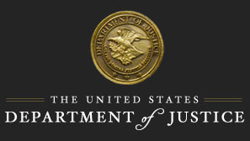

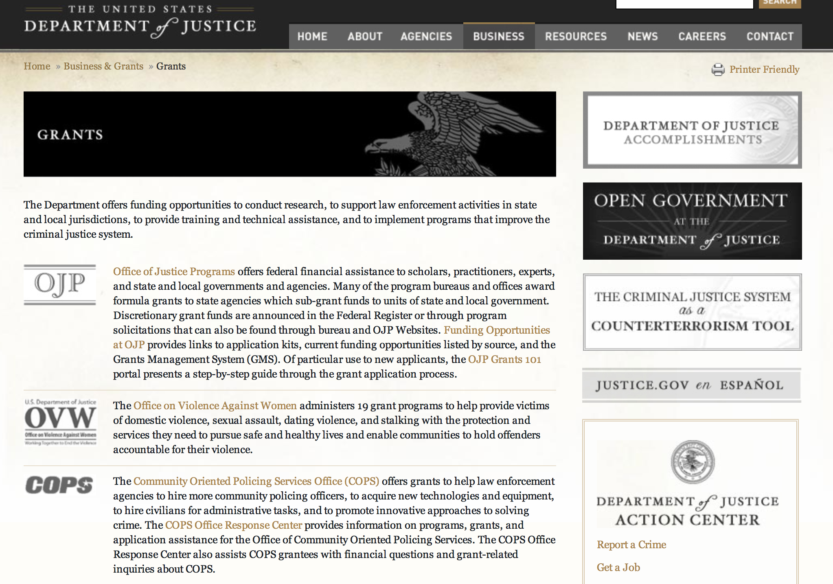

The DOJ agencies listed below also have sites that provide grant information specific to that agency. Examples of what can be found on these sites are programs, funding opportunities, application assistance, and other useful information.

Bureau of Justice Assistance (BJA)

Bureau of Justice Statistics (BJS)

National Criminal Justice Reference Service (NCJRS)

National Institute of Justice (NIJ)

Office of Juvenile Justice and Delinquency Prevention (OJJDP)

Office of Sex Offender Sentencing, Monitoring, Apprehending, Registering, and Tracking (SMART)

Office for Victims of Crime (OVC)

http://www.justice.gov/business/

Programs:

National Institute of Corrections
Networking and Professional Development of State and Large Urban System Healthcare Administrators
And Modification 2

Document Type: | Grants Notice
Funding Opportunity Number: | 16PR04
Funding Opportunity Title: | Networking and Professional Development of State and Large Urban System Healthcare Administrators
Opportunity Category: | Discretionary
Opportunity Category Explanation:
Funding Instrument Type: | Cooperative Agreement
Category of Funding Activity: | Other (see text field entitled "Explanation of Other Category of Funding Activity" for clarification)
Category Explanation: | Networking and Professional Development of State and Large Urban System Healthcare Administrators
Expected Number of Awards:
CFDA Number(s): | 16.601 -- Corrections Training and Staff Development
Cost Sharing or Matching Requirement: | No
Version: | Synopsis 2
Posted Date: | Jul 21, 2016
Last Updated Date: | Jul 27, 2016
Original Closing Date for Applications: | Aug 29, 2016
Current Closing Date for Applications: | Aug 29, 2016
Archive Date: | Sep 28, 2016
Estimated Total Program Funding:
Award Ceiling: | $95,000
Eligible Applicants: | Others (see text field entitled "Additional Information on Eligibility" for clarification)
Additional Information on Eligibility: | NIC invites applications from nonprofit organizations (including faith-based, community, and tribal organizations), for-profit organizations (including tribal for-profit organizations), and institutions of higher education (including tribal institutions of higher education). Recipients, including for-profit organizations, must agree to waive any profit or fee for services rendered. NIC welcomes applications that involve two or more entities; however, one eligible entity must be the primary applicant and the other(s) must be proposed as sub-recipients. The applicant must be the entity with primary responsibility for administering the funding and managing the entire program, and must meet any special conditions specified in this solicitation.
Agency Name: | National Institute of Corrections
Description: | The field of corrections and healthcare services for corrections is constantly evolving, requiring continuous learning and professional development for healthcare administrators. With responsibility for leading complex correctional healthcare systems, administrators of correctional healthcare systems are charged with managing human resources, developing and implementing agency policy and procedure, engaging with internal and external stakeholders, and administering significant fiscal resources – all while supporting strong business practices and delivering results. As such, it is imperative for Healthcare Administrators to stay current regarding critical issues facing the field and methods for effectively addressing areas of need. It is critically important for them to keep abreast of correctional best practices and emerging issues, as well as developing and maintaining a strong peer network of other correctional healthcare administrators. Further, other Healthcare Administrators of Corrections provide vital assistance in gathering information, sharing perspectives, and providing possible solutions to their peers. NIC has been committed for years to improving healthcare administrator’s performance by providing excellent leadership and management as well as additional training for healthcare professionals. In an effort to expand on the resources, NIC has provided the field with the documents such as Effective Prison Mental Health Services: Guidelines to Expand and Improve Treatment , Adults with Behavioral Health Needs Under Correctional Supervision, Health Literacy: Enhancing Access to Health Care for Justice-Involved Individuals and Correctional Leadership Competencies for the 21st Century, a portion of which specifically addresses the role of Correctional Executive’s and Senior Level Leaders. The next step is to create a blended training curriculum for this important role in corrections.
Link to Additional Information:
Grantor Contact Information: | If you have difficulty accessing the full announcement electronically, please contact:  Melanie Simms Administrative Officer Phone 202-305-8408  Technical application questions

http://www.grants.gov/web/grants/view-opportunity.html?oppId=286411

Research:

Modifications:

Reminders:

Deleted:

National Institute of Corrections
16PR04 - Networking and Professional Development of State and Large Urban System Healthcare Administrators
Deletion Comments: Opportunity deleted



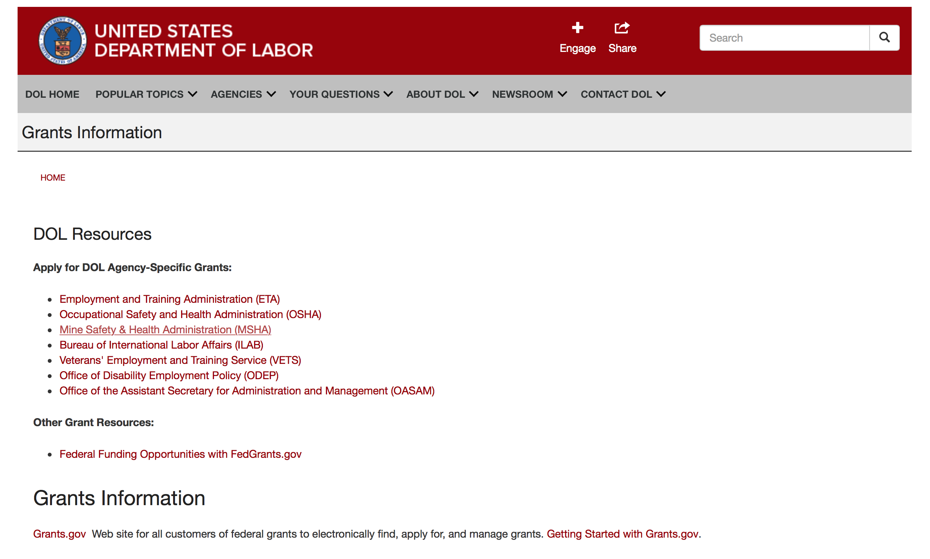

Agency Grants and Contract General Overview

DOL Resources
Apply for DOL Agency-Specific Grants:
- Employment and Training Administration (ETA)
- Occupational Safety and Health Administration (OSHA)
- Mine Safety & Health Administration (MSHA)
- Bureau of International Labor Affairs (ILAB)
- Veterans' Employment and Training Service (VETS)
- Office of Disability Employment Policy (ODEP)
- Office of the Assistant Secretary for Administration and Management (OASAM)

Other Grant Resources:
- Federal Funding Opportunities with FedGrants.gov
Grants Information
Grants.gov — Web site for all customers of federal grants to electronically find, apply for, and manage grants. Getting Started with Grants.gov.

DOL Resources and Instructions for Applying for a Grant
- DOL Guidance Clarifying the Effect of the Religious Freedom Restoration Act on Faith-Based Organizations
- Grant and Contract Information
- Contracting and Grant Program Overview
- Annual Acquisition Plan & Procurement Forecast
- Civil Rights Enforcement for Department of Labor Grant Recipients
- More Information About Grants
- Use of Contracts, Grants & Cooperative Agreements

Other Federal Government Grant Information
- List of Parties Excluded From Federal Procurement and Nonprocurement Programs (as created and maintained by GSA)
- Grant Opportunities (Catalog of Federal Domestic Assistance)

Department of Labor Grant Programs

- Bureau of International Labor Affairs (ILAB): provides grants (cooperative agreements) for the implementation of projects designed to assist developing countries combat the worse forms of child labor, forced labor, and human trafficking; and support worker rights and improve working conditions. http://www.dol.gov/general/business.
- Bureau of Labor Statistics (BLS): provides project grants (cooperative agreements) and the dissemination of technical statistical data and related information on labor force activities; provides data on prices (CPI) and cost of living; data on productivity and technology data; data on compensation and working conditions; data on employment projections.
- Employment and Training (ETA): ETA administers financial assistance programs pursuant to the Workforce Investment Act (WIA), administering State formula grant programs for youth, adults and dislocated workers, national emergency grants for workers affected by mass layoffs, plant closures, and disasters; grant programs for workers with disabilities, Indians and Native Americans, and for migrant and seasonal farmworkers. ETA also administers grant programs for older American workers, apprenticeship programs, Trade Adjustment Assistance (TAA) programs, and assistance for research and development of workforce programs. In addition, ETA is responsible for the operation and maintenance of a national system of public employment service offices and for the national unemployment insurance program.
- Mine Safety and Health (MSHA): provides grants for research, education and training programs to ensure an adequate and competent staff of trained inspectors; and assistance for establishing or improving State mine health and safety programs through technical assistance.
- Occupational Safety and Health (OSHA): provides grants to non-profit organizations to provide training, educational services, and technical assistance; assistance to states to administer and enforce state programs; assistance to states to provide occupational safety and health technical assistance and consultant services.
- Office of Disability Employment Policy (ODEP): The Office of Disability Employment Policy awards competitive grants establishing short-term pilot and technical assistance projects designed to identify, develop, test, evaluate, and disseminate policies to increase employment by expanding access to training, education, employment supports, assistive and systems technology, integrated employment, entrepreneurial development, and small business opportunities for adults and youth with disabilities. Current pilots projects focus on customized employment, Olmstead populations, and innovative demonstration youth grants, among others. Solicitations for grant applications are published in the Federal Register and announced at www.dol.gov/odep. ODEP grants are awarded by the OASAM grant office.
- Veterans' Employment and Training (VETS): provides special employment and training assistance for veterans through the Disabled Veterans' Outreach Program (DVOP) Solicitation for Grant Applications; the Local Veterans' Employment Representative Program (LVER); Veterans' Workforce Investment Program (VWIP); elaws Advisor on veterans' employment and reemployment rights; and the Homeless Veterans Reintegration Project (HVRP). VETS grants are awarded by the OASAM grant office.

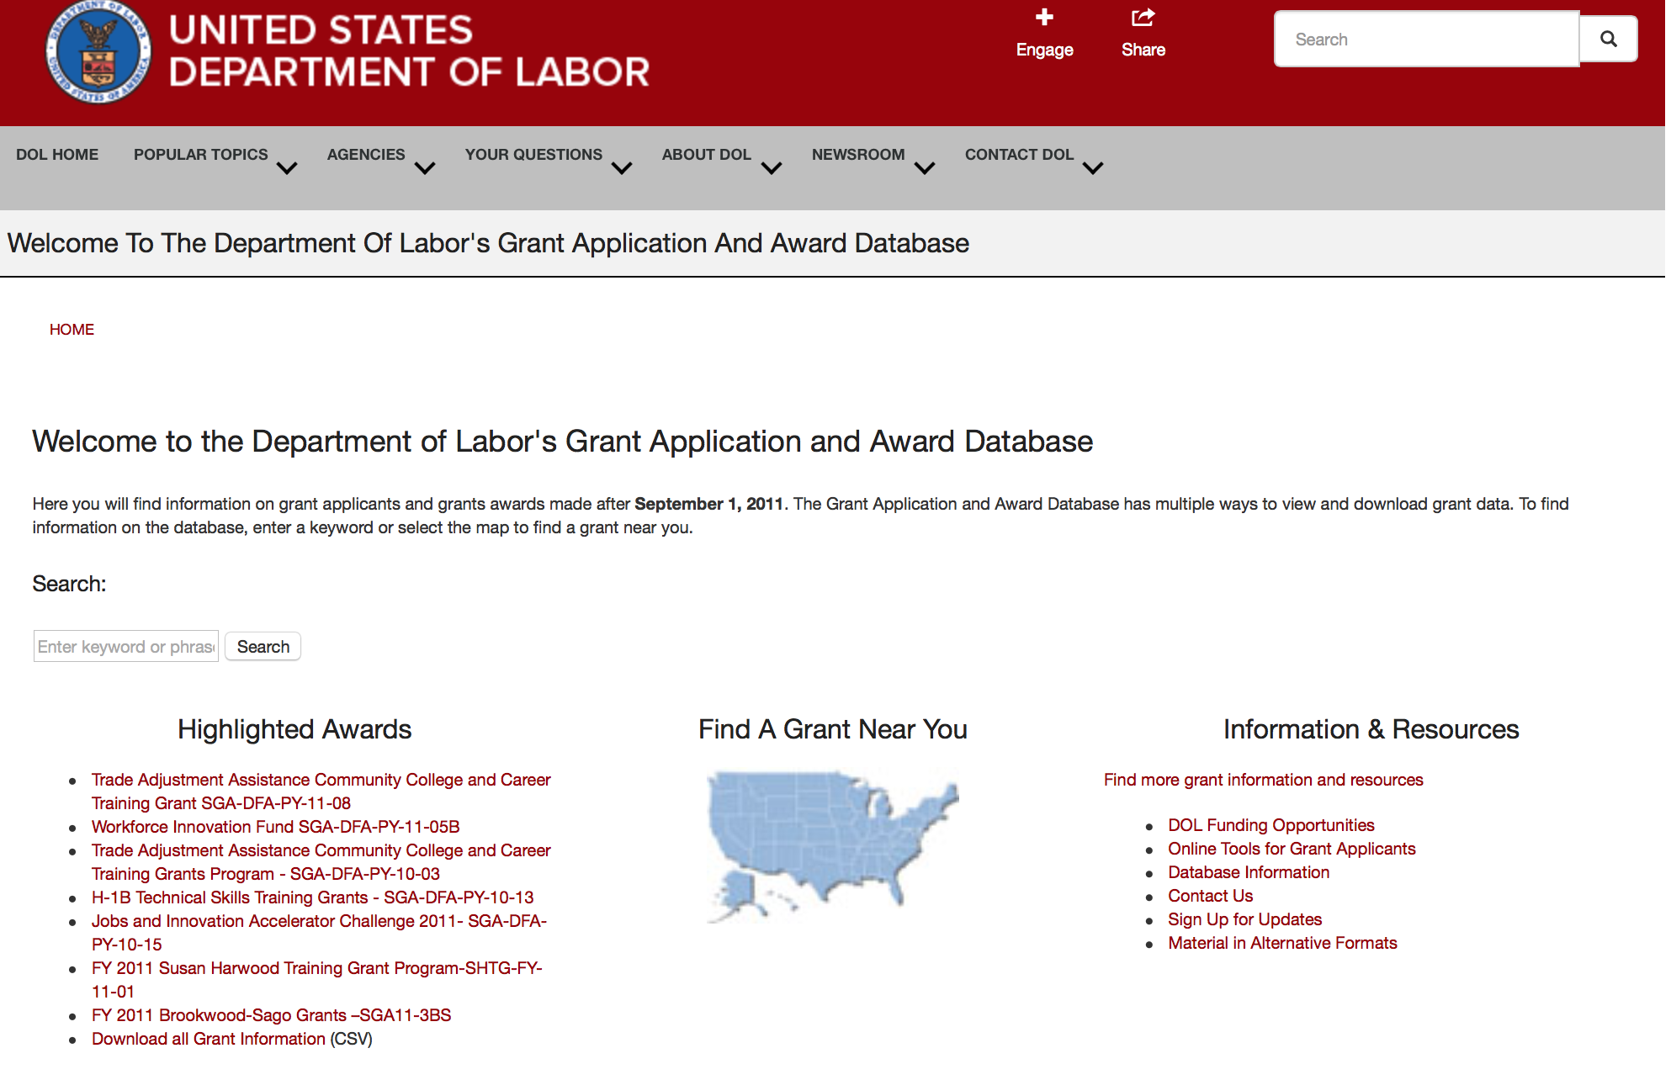

http://www.dol.gov/dol/grants/

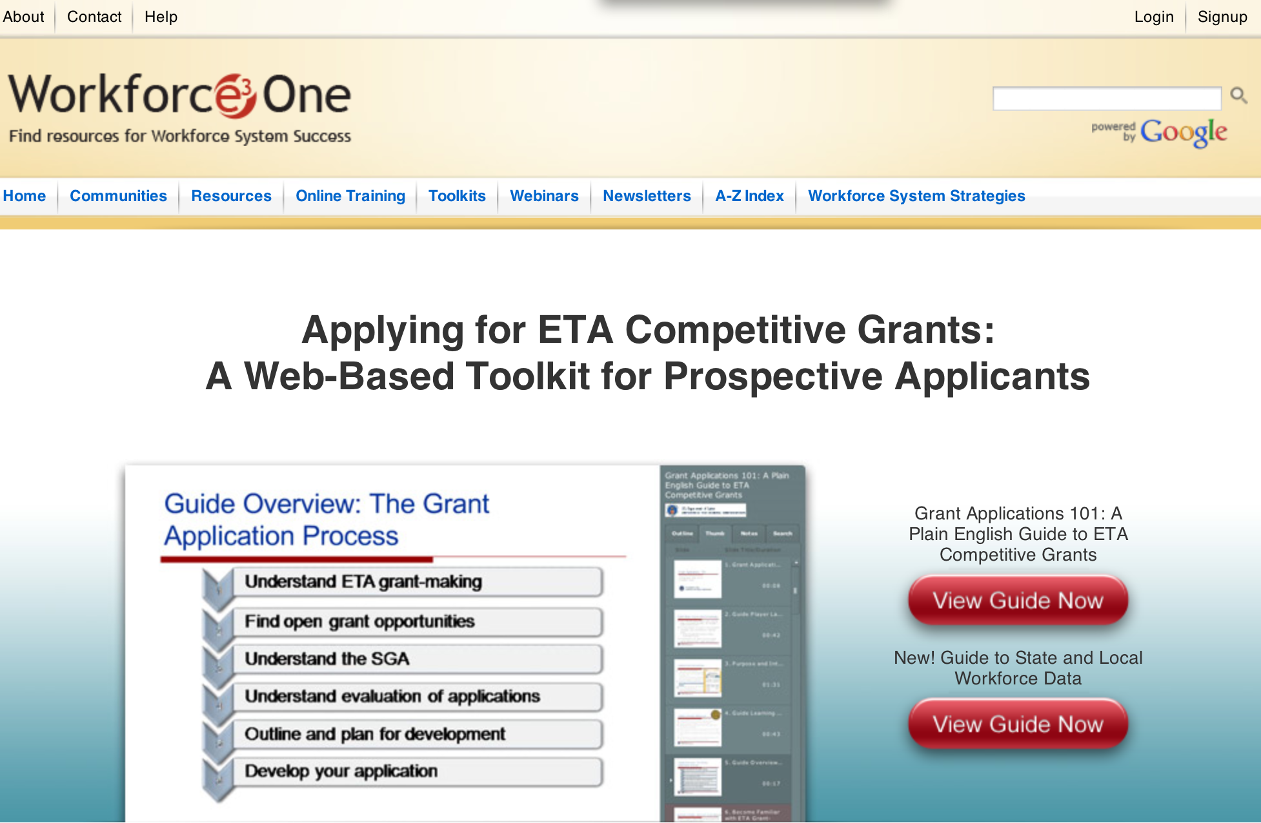

https://www.workforce3one.org/ws/www/pages/grants_toolkit.aspx?pparams=/

Programs

Employment and Training Administration
PORTABLE RETIREMENT BENEFITS PLANNING

Document Type: | Grants Notice
Funding Opportunity Number: | FOA-WB-16-02
Funding Opportunity Title: | PORTABLE RETIREMENT BENEFITS PLANNING
Opportunity Category: | Discretionary
Opportunity Category Explanation:
Funding Instrument Type: | Grant
Category of Funding Activity: | Employment, Labor and Training
Category Explanation:
Expected Number of Awards: | 4
CFDA Number(s): | 17.261 -- WIA/WIOA Pilots, Demonstrations, and Research Projects
Cost Sharing or Matching Requirement: | No
Posted Date: | Jul 27, 2016
Last Updated Date: | Jul 27, 2016
Original Closing Date for Applications: | Aug 26, 2016 Applications must be received no later than 4:00:00 p.m. Eastern Time.
Current Closing Date for Applications: | Aug 26, 2016 Applications must be received no later than 4:00:00 p.m. Eastern Time.
Archive Date: | Sep 25, 2016
Estimated Total Program Funding: | $100,000
Award Ceiling: | $75,000
Award Floor: | $25,000
Eligible Applicants: | Others (see text field entitled "Additional Information on Eligibility" for clarification)
Additional Information on Eligibility: | Eligible applicants are Nonprofit Organizations with IRS 501(c)(3) Status that work with and/or represent low-wage workers and/or that have experience with retirement benefits systems.
Agency Name: | Employment and Training Administration
Description: | The Women’s Bureau (WB), U.S. Department of Labor (DOL, or the Department, or we), announces the availability of approximately $100,000 in grant funds authorized by 29 U.S.C. § 13 and the Consolidated Appropriations Act, 2016, for the Women’s Bureau Portable Retirement Benefits Planning grant program. This grant program is intended to increase retirement security for low-wage workers—many of whom have never had access to retirement benefits through an employer. The grant will help nonprofit organizations (“nonprofits”) undertake certain types of program-planning activities needed to develop a portable retirement benefits program for their stakeholders or target populations. These activities must fall into one or more of the following three categories: • Assessment of the challenges and barriers unique to low-wage workers or target populations with little or no retirement savings; • Research and analysis of available opportunities and tools to expand existing or build new portable retirement savings vehicles, especially for low-wage workers or target populations; and • Research and analysis of scalable models for portable retirement benefits programs, as well as identification of legal constraints and changes to state and/or federal law that would be required in order for these models to be viable for low-wage workers or target populations. Two (2) to four (4) grants of between $25,000 and $75,000 each will be awarded. Selection of grantees will be based on the strength of the proposal, including the design, cost, innovative ideas and solutions, and ability to access relevant data to support the program.
Link to Additional Information:
Grantor Contact Information: | If you have difficulty accessing the full announcement electronically, please contact:  Jeannette Flowers Grants Management Specialist  Flowers.Jeannette@dol.gov

http://www.grants.gov/web/grants/view-opportunity.html?oppId=286595

Mine Safety and Health Administration
Brookwood Sago Grant

Document Type: | Grants Notice
Funding Opportunity Number: | BS16-3BS
Funding Opportunity Title: | Brookwood Sago Grant
Opportunity Category: | Mandatory
Opportunity Category Explanation:
Funding Instrument Type: | Grant
Category of Funding Activity: | Education
Category Explanation:
Expected Number of Awards: | 20
CFDA Number(s): | 17.603 -- Brookwood-Sago Grant
Cost Sharing or Matching Requirement: | No
Posted Date: | Jul 28, 2016
Last Updated Date: | Jul 28, 2016
Original Closing Date for Applications: | Sep 09, 2016
Current Closing Date for Applications: | Sep 09, 2016
Archive Date: | Oct 09, 2016
Estimated Total Program Funding: | $1,000,000
Award Ceiling: | $250,000
Award Floor: | $50,000
Eligible Applicants: | Native American tribal governments (Federally recognized)  Nonprofits having a 501(c)(3) status with the IRS, other than institutions of higher education
Additional Information on Eligibility: | Applicants for the grants may be States and nonprofit (private or public) entities, including U.S. territories, Indian tribes, tribal organizations, Alaska Native entities, Indian-controlled organizations serving Indians, and Native Hawaiian organizations.
Agency Name: | Mine Safety and Health Administration
Description: | The U.S. Department of Labor (DOL), Mine Safety and Health Administration (MSHA), is making up to $1,000,000 available in grant funds for education and training programs to help identify, avoid, and prevent unsafe working conditions in and around mines. The focus of these grants for Fiscal Year (FY) 2016 will be on training and training materials for mine emergency preparedness and mine emergency prevention for all underground mines. Applicants for the grants may be States and nonprofit (private or public) entities, including U.S. territories, Indian tribes, tribal organizations, Alaska Native entities, Indian-controlled organizations serving Indians, and Native Hawaiian organizations. MSHA could award as many as 20 grants. The amount of each individual grant will be at least $50,000.00 and the maximum individual award will be $250,000. This notice contains all of the information needed to apply for grant funding. DATES: The closing date for applications will be September 9, 2016, (no later than 11:59 p.m. EDST). MSHA will award grants on or before September 30, 2016. ADDRESSES: Grant applications for this competition must be submitted electronically through the Grants.gov site at www.grants.gov. If applying online poses a hardship to any applicant, the MSHA Directorate of Educational Policy and Development will provide assistance to help applicants submit online.
Link to Additional Information:
Grantor Contact Information: | If you have difficulty accessing the full announcement electronically, please contact:  Janice Oates Grant Program Manager Phone 202-693-9573

http://www.grants.gov/web/grants/view-opportunity.html?oppId=286677

Modifications

Reminders

Employment and Training Administration
America’s Promise Job Driven Grant Program

Document Type: | Grants Notice
Funding Opportunity Number: | FOA-ETA-16-12
Funding Opportunity Title: | America’s Promise Job Driven Grant Program
Opportunity Category: | Discretionary
Opportunity Category Explanation:
Funding Instrument Type: | Grant
Category of Funding Activity: | Employment, Labor and Training
Category Explanation:
Expected Number of Awards: | 40
CFDA Number(s): | 17.268 -- H-1B Job Training Grants
Cost Sharing or Matching Requirement: | No
Posted Date: | Jun 06, 2016
Last Updated Date: | Jun 06, 2016
Original Closing Date for Applications: | Aug 25, 2016 Applications must be received no later than 4:00:00 p.m. Eastern Time.
Current Closing Date for Applications: | Aug 25, 2016 Applications must be received no later than 4:00:00 p.m. Eastern Time.
Archive Date: | Sep 24, 2016
Estimated Total Program Funding: | $100,000,000
Award Ceiling: | $6,000,000
Award Floor: | $1,000,000
Eligible Applicants: | Others (see text field entitled "Additional Information on Eligibility" for clarification)
Additional Information on Eligibility: | To be eligible for consideration, the lead applicant in the regional workforce partnership must represent one of the following types of entities: a) the workforce investment system; b) education and training providers, including community and technical colleges and systems; and c) business-related nonprofit organizations, an organization functioning as a workforce intermediary for the express purpose of serving the needs of an industry, or a regional or industry association. Applications that do not include a lead applicant that meets the eligibility requirements of one of the three types of entities mentioned above will be considered non-responsive and will not be reviewed.
Agency Name: | Employment and Training Administration
Description: | The purpose of America’s Promise grant program is to strengthen the pipeline of skilled workers to expand an economic region’s middle- to high-skilled workforce within one or more prioritized industry sector(s), thereby creating economic opportunities for America’s workforce to gain the necessary skills to fill in-demand jobs and increasing the long-term competitiveness of an economic region. To help achieve this goal, the grant will provide individuals the opportunity to get high-quality, tuition free education and training that leads to in-demand and industry-recognized credentials and degrees. A fundamental goal of America’s Promise is to accelerate the development of new and the expansion of existing 21st century regional workforce partnerships with business and industry leaders committed to providing a pipeline of skilled workers in a specific industry sector(s). These partnerships will bring together industry leaders with senior level leadership from workforce and economic development, secondary and post-secondary education, elected officials, and other important community stakeholders. To keep pace with the rapid shifts we are seeing in today’s economy, we encourage these partnerships to leverage data and technology to increase communication between employers, workforce and training providers, and job seekers.
Link to Additional Information:
Grantor Contact Information: | If you have difficulty accessing the full announcement electronically, please contact:  Ariam Ferro Grants Management Specialists  ferro.ariam@dol.gov

http://www.grants.gov/web/grants/view-opportunity.html?oppId=284371



National Aeronautics and Space Administration

Research and Contracting Opportunities

NASA Research Opportunities Online

- Various NASA offices publish their research announcements over the Internet, broadening the opportunity for researchers to apply for funding. This site provides access to current research announcements along with their specific due dates.

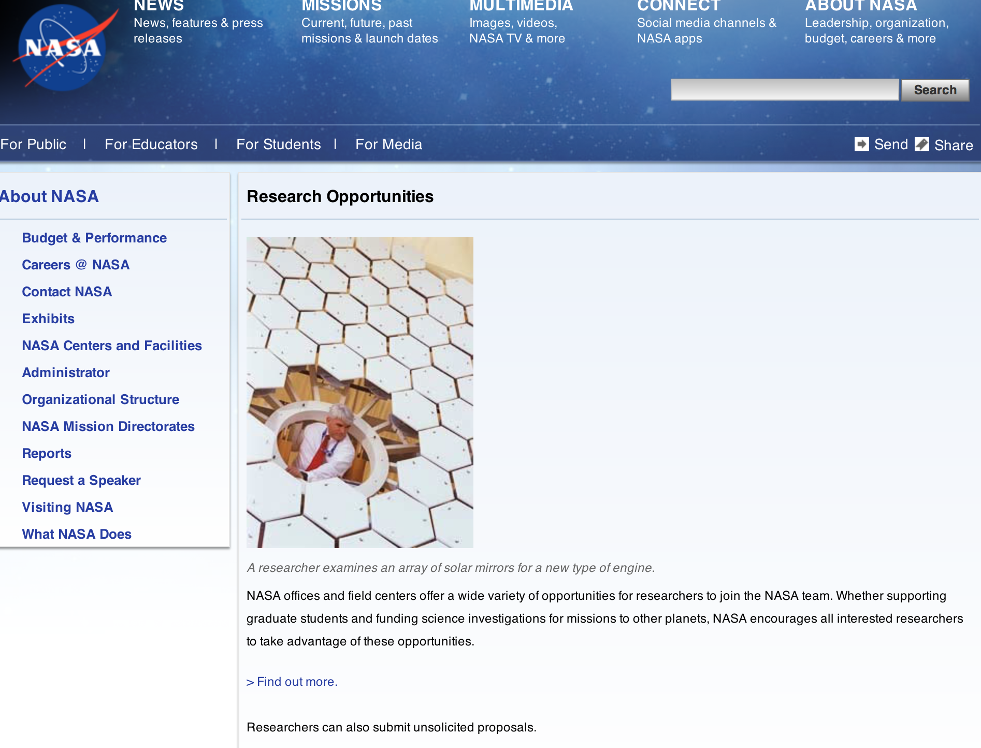

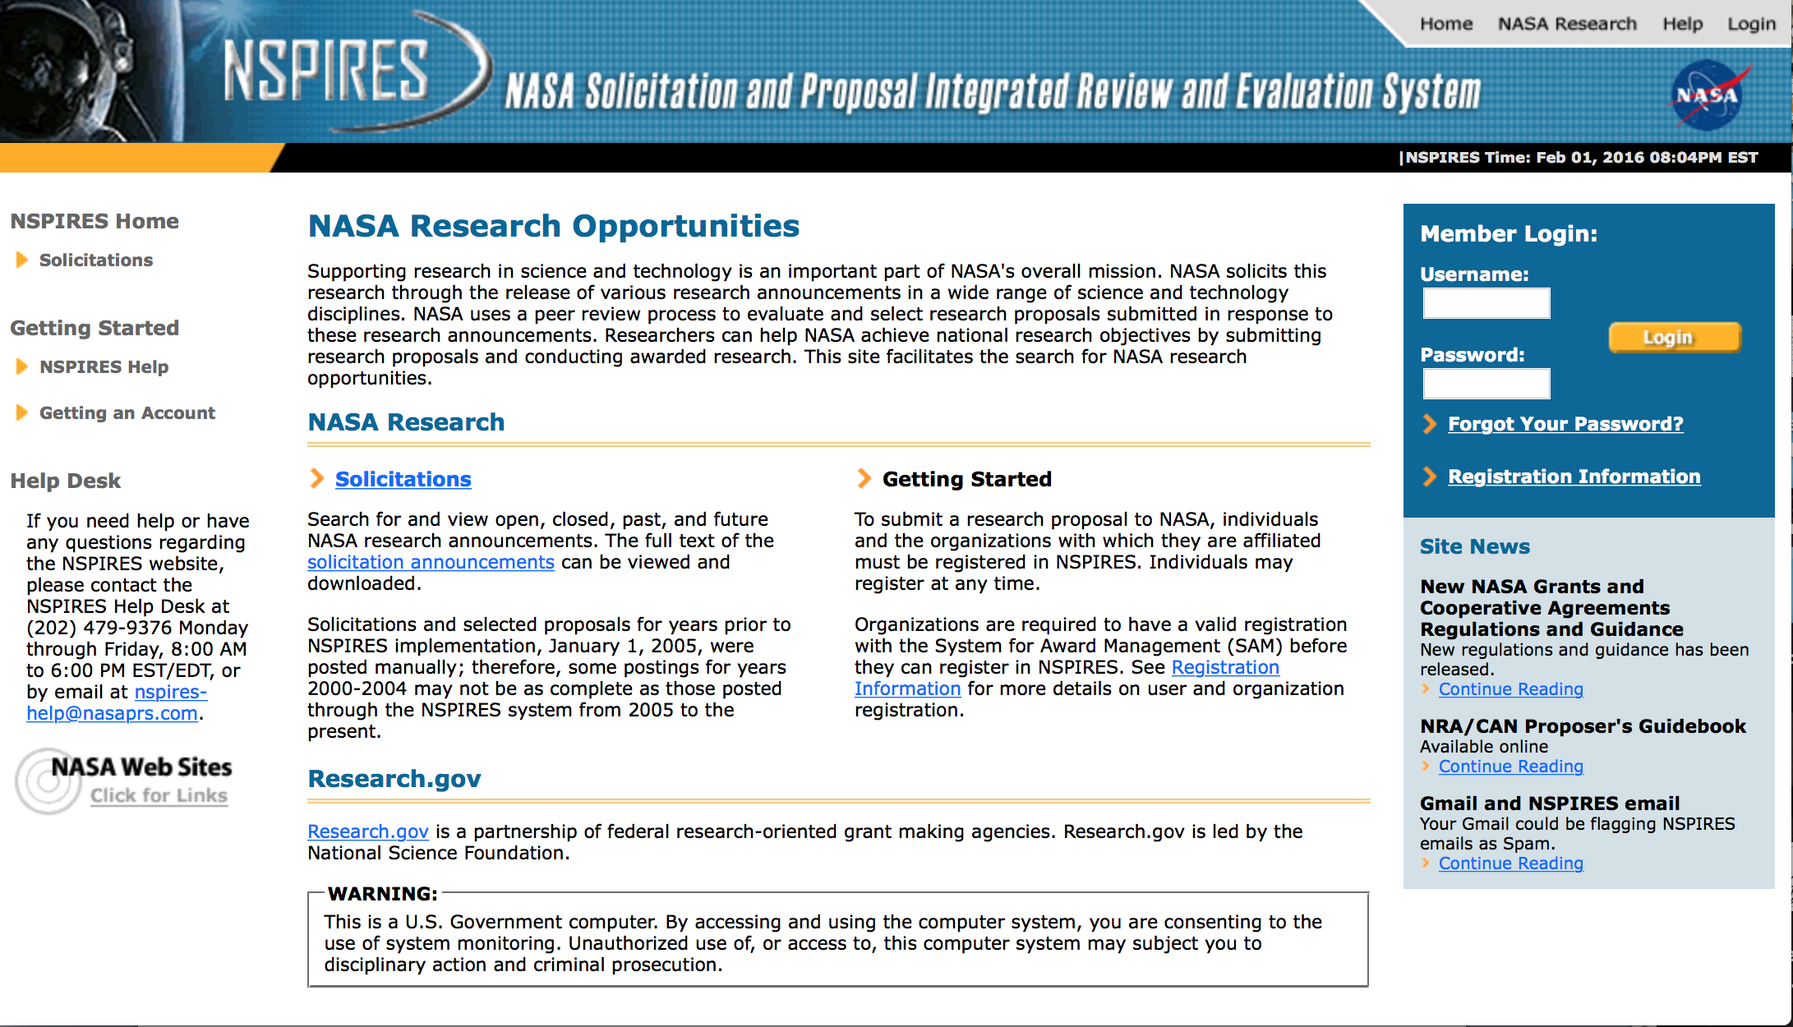

http://nspires.nasaprs.com/external/

Research Programs:

NASA Headquarters
ROSES 2016: Earth Science U.S. Participating Investigator
Synopsis 1
http://www.grants.gov/web/grants/view-opportunity.html?oppId=286115

NASA Headquarters
ROSES 2016: Airborne Instrument Technology Transition
Synopsis 1
http://www.grants.gov/web/grants/view-opportunity.html?oppId=286116

NASA Headquarters
ROSES 2016: Weather and Atmospheric Dynamics
Synopsis 1
http://www.grants.gov/web/grants/view-opportunity.html?oppId=286117

NASA Headquarters
ROSES 2016: Interdisciplinary Research in Earth Science
Synopsis 1
http://www.grants.gov/web/grants/view-opportunity.html?oppId=286852

ROSES 2016: Heliophysics Grand Challenges Research
Synopsis 1
http://www.grants.gov/web/grants/view-opportunity.html?oppId=286873

ROSES 2016: Heliophysics U.S. Participating Investigator
Synopsis 1
http://www.grants.gov/web/grants/view-opportunity.html?oppId=286878

NASA Headquarters
ROSES 2016: Discovery Data Analysis Program
Synopsis 1
http://www.grants.gov/web/grants/view-opportunity.html?oppId=286882

Modifications:

NASA Headquarters
ROSES 2016: Earth Science Applications: Water Resources
Modification 2
http://www.grants.gov/web/grants/view-opportunity.html?oppId=282876

NASA Headquarters
ROSES 2016: Concepts for Ocean worlds Life Detection Technology
Modification 2
http://www.grants.gov/web/grants/view-opportunity.html?oppId=283925

National Archives and Records Administration

Grant Opportunities General Overview

To access the information below: click here

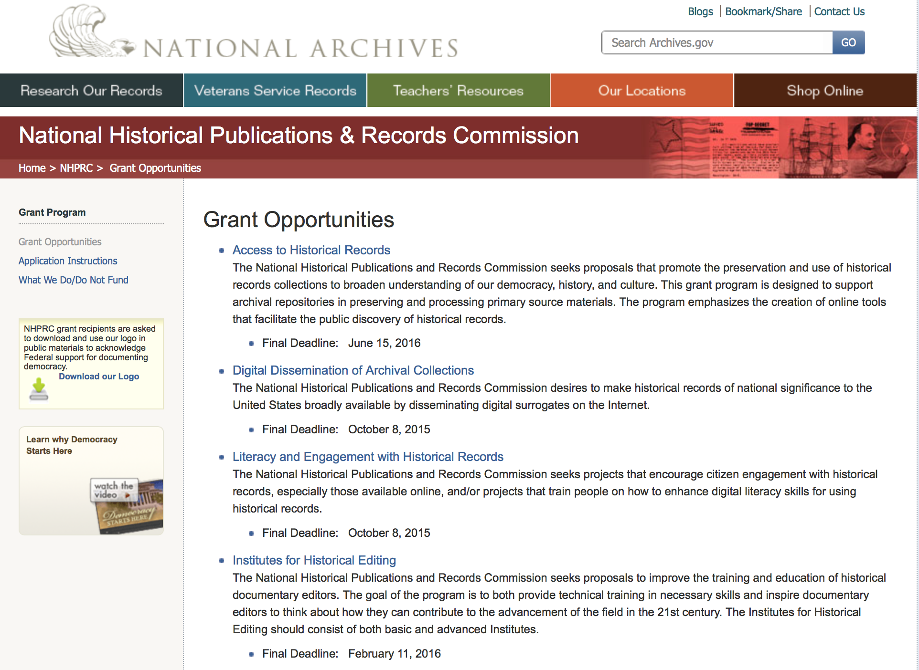

Access to Historical Records - Major Initiatives

Document Type: | Grants Notice
Funding Opportunity Number: | MAJOR-201707
Funding Opportunity Title: | Access to Historical Records - Major Initiatives
Opportunity Category: | Discretionary
Opportunity Category Explanation:
Funding Instrument Type: | Grant
Category of Funding Activity: | Humanities (see "Cultural Affairs" in CFDA)
Category Explanation:
Expected Number of Awards: | 5
CFDA Number(s): | 89.003 -- National Historical Publications and Records Grants
Cost Sharing or Matching Requirement: | Yes
Posted Date: | Jul 25, 2016
Last Updated Date: | Jul 25, 2016
Original Closing Date for Applications: | Jul 12, 2017
Current Closing Date for Applications: | Jul 12, 2017
Archive Date: | Aug 11, 2017
Estimated Total Program Funding: | $1,000,000
Award Ceiling: | $350,000
Award Floor: | $1
Eligible Applicants: | Private institutions of higher education  County governments  Native American tribal governments (Federally recognized)  Public and State controlled institutions of higher education  City or township governments  Nonprofits having a 501(c)(3) status with the IRS, other than institutions of higher education  State governments
Agency Name: | National Archives and Records Administration
Description: | The National Historical Publications and Records Commission seeks projects that will significantly improve public discovery and use of major historical records collections. All types of historical records are eligible, including documents, photographs, born-digital records, and analog audio and moving images. Projects may: • Digitize historical records collections, or related collections, held by a single institution and make them freely available online • Provide access to born-digital records • Create new freely-available virtual collections drawn from historical records held by multiple institutions • Create new tools and methods for users to access records The NHPRC welcomes collaborative projects, particularly for bringing together related records from multiple institutions. Projects that address significant needs in the field and result in replicable and scalable approaches will be more competitive. We also encourage organizations to actively engage the public in the work of the project. For a comprehensive list of Commission limitations on funding, please see “What we do and do not fund” (http://www.archives.gov/nhprc/apply/eligibility.html). Applications that consist entirely of ineligible activities will not be considered. Award Information A grant is for one to three years and for up to $350,000. We expect to make up to five grants in this category for a total of up to $1,000,000. Grants begin no earlier than January 1, 2018. Eligible applicants: • Nonprofit organizations or institutions • Colleges, universities, and other academic institutions • State or local government agencies • Federally-acknowledged or state-recognized Native American tribes or groups Cost Sharing The total costs of a project are shared between the NHPRC and the applicant organization. The Commission provides no more than 50 per cent of total project costs in the Access to Historical Records: Major Initiatives category. NHPRC grant recipients are not permitted to use grant funds for indirect costs (as indicated in 2 CFR 2600.101). Cost sharing is required. The applicant’s financial contribution may include both direct and indirect expenses, in-kind contributions, non-Federal third-party contributions, and any income earned directly by the project. Indirect costs must be listed under the applicant’s cost sharing contribution. Other Requirements Applicant organizations must be registered in the System for Award Management (SAM) prior to submitting an application, maintain SAM registration throughout the application and award process, and include a valid DUNS number in their application. Details on SAM registration and requesting a DUNS number can be found at the System for Award Management website at http://sam.gov. Please refer to the User Guides section and the Grants Registrations PDF. APPLICATION AND SUBMISSION INFORMATION You must use Grants.gov to submit a Full Proposal. All information necessary to apply is included in this announcement, the Application Instructions, and the forms on Grants.gov. If you need the information supplied in an alternative format, please call the NHPRC at 202-357-5010. Applying for the Access to Historical Records: Major Initiatives program is a two-phase process. Phase One All applicants must have submitted a five-page preliminary proposal and Application for Federal Domestic Assistance – Short Organizational form SF424 and the Budget Information for Non-Construction Projects form SF424A by January 19, 2017 using the preliminary proposal Major Initiatives grant announcement (insert link). Only those applicants who have successfully completed Phase One and who have been invited by the Commission to submit a full proposal to the Access to Historical Records: Major Initiatives program are eligible to participate in the second phase of the process. Phase Two Using this announcement, invited applicants will prepare and submit a complete application via Grants.gov by July 12, 2017. A complete application includes the Application for Federal Assistance (Standard Form 424), Assurances -- Non-Construction Programs (Standard Form 424B), a Project Narrative, Supplementary Materials, and Budget. Applications lacking any of these items will not be considered. Applicants may consult with the Director of the Access Program, Alex Lorch (alexander.lorch@nara.gov) during both the preliminary and full proposal project phases. In order to ensure eligibility, applicants should first review the rules and regulations governing NHPRC grants under the Administering an NHPRC Grant section.
Link to Additional Information: | Link to full grant announcement, including additional requirements
Grantor Contact Information: | If you have difficulty accessing the full announcement electronically, please contact:  Jeff de la Concepcion Grant Program Specialist Phone 202-357-5022  Grant Information Specialist

http://www.grants.gov/web/grants/view-opportunity.html?oppId=286436

Access to Historical Records – Archival Projects

Document Type: | Grants Notice
Funding Opportunity Number: | ARCHIVAL-201612
Funding Opportunity Title: | Access to Historical Records – Archival Projects
Opportunity Category: | Discretionary
Opportunity Category Explanation:
Funding Instrument Type: | Grant
Category of Funding Activity: | Humanities (see "Cultural Affairs" in CFDA)
Category Explanation:
Expected Number of Awards: | 10
CFDA Number(s): | 89.003 -- National Historical Publications and Records Grants
Cost Sharing or Matching Requirement: | No
Posted Date: | Jul 25, 2016
Last Updated Date: | Jul 25, 2016
Original Closing Date for Applications: | Dec 06, 2016
Current Closing Date for Applications: | Dec 06, 2016
Archive Date: | Jan 05, 2017
Estimated Total Program Funding: | $700,000
Award Ceiling: | $100,000
Award Floor: | $1
Eligible Applicants: | Private institutions of higher education  Nonprofits having a 501(c)(3) status with the IRS, other than institutions of higher education  State governments  City or township governments  Public and State controlled institutions of higher education  County governments  Native American tribal governments (Federally recognized)
Agency Name: | National Archives and Records Administration
Description: | The National Historical Publications and Records Commission seeks projects that ensure online public discovery and use of historical records collections. All types of historical records are eligible, including documents, photographs, born-digital records, and analog audio and moving images. Projects may preserve and process historical records to: • Create new online Finding Aids to collections • Digitize historical records collections and make them freely available online The NHPRC encourages organizations to actively engage the public in the work of the project. For a comprehensive list of Commission limitations on funding, please see “What we do and do not fund” (http://www.archives.gov/nhprc/apply/eligibility.html). Applications that consist entirely of ineligible activities will not be considered. Award Information A grant is for one to two years and for up to $100,000. The Commission expects to make up to 10 grants in this category for a total of up to $700,000. Grants begin no earlier than July 1, 2017. The Commission requires that grant recipients acknowledge NHPRC grant assistance in all publicity, publications, and other products that result from its support. Eligibility Information Eligible applicants: • Nonprofit organizations or institutions • Colleges, universities, and other academic institutions • State or local government agencies • Federally-acknowledged or state-recognized Native American tribes or groups Cost Sharing The total costs of a project are shared between the NHPRC and the applicant organization. The Commission provides no more than 75 per cent of total project costs in the Access to Historical Records – Archival Projects category. NHPRC grant recipients are not permitted to use grant funds for indirect costs (as indicated in 2 CFR 2600.101). Cost sharing is required. The applicant’s financial contribution may include both direct and indirect expenses, in-kind contributions, non-Federal third-party contributions, and any income earned directly by the project. Indirect costs must be listed under the applicant’s cost sharing contribution. Other Requirements Applicant organizations must be registered in the System for Award Management (SAM) prior to submitting an application, maintain SAM registration throughout the application and award process, and include a valid DUNS number in their application. Details on SAM registration and requesting a DUNS number can be found at the System for Award Management website at http://sam.gov. Please refer to the User Guides section and the Grants Registrations PDF. A complete application includes the Application for Federal Assistance (Standard Form 424), Assurances -- Non-Construction Programs (Standard Form 424B), a Project Narrative, Summary, Supplementary Materials, and Budget. Applications lacking any of these items will not be considered. Ineligible applications will not be reviewed.
Link to Additional Information: | Link to full grant announcement, including additional requirements
Grantor Contact Information: | If you have difficulty accessing the full announcement electronically, please contact:  Jeff de la Concepcion Grant Program Specialist Phone 202-357-5022  Grant Information Specialist

http://www.grants.gov/web/grants/view-opportunity.html?oppId=286450

Reminders:

Public Engagement with Historical Records Grant

Document Type: | Grants Notice
Funding Opportunity Number: | ENGAGEMENT-201610
Funding Opportunity Title: | Public Engagement with Historical Records
Opportunity Category: | Discretionary
Opportunity Category Explanation:
Funding Instrument Type: | Grant
Category of Funding Activity: | Humanities (see "Cultural Affairs" in CFDA)
Category Explanation:
Expected Number of Awards: | 3
CFDA Number(s): | 89.003 -- National Historical Publications and Records Grants
Cost Sharing or Matching Requirement: | Yes
Posted Date: | Jun 06, 2016
Last Updated Date: | Jun 06, 2016
Original Closing Date for Applications: | Oct 06, 2016
Current Closing Date for Applications: | Oct 06, 2016
Archive Date:
Estimated Total Program Funding: | $275,000
Award Ceiling: | $150,000
Award Floor: | $50,000
Eligible Applicants: | State governments  Public and State controlled institutions of higher education  City or township governments  Nonprofits having a 501(c)(3) status with the IRS, other than institutions of higher education  Private institutions of higher education  County governments  Native American tribal governments (Federally recognized)
Agency Name: | National Archives and Records Administration
Description: | The National Historical Publications and Records Commission seeks projects that encourage public engagement with historical records, including the development of new tools that enable people to engage online. The NHPRC is looking for projects that create models and technologies that other institutions can freely adopt. In general, collaborations between archivists, documentary editors, historians, educators, and/or community-based individuals are more likely to create a competitive proposal. Projects might create and develop programs to engage people in the study and use of historical records for institutional, educational or personal reasons. For example, an applicant can: • Enlist volunteer “citizen archivists” in projects to accelerate access to historical records, especially those online. This may include, but is not limited to, efforts to identify, tag, transcribe, annotate, or otherwise enhance digitized historical records. • Develop educational programs for K-16 students or community members that encourage them to engage with historical records already in repositories or that are collected as part of the project. For a comprehensive list of the Commission’s limitations on funding, please see “What we do and do not fund” (http://www.archives.gov/nhprc/apply/eligibility.html). Applications that consist entirely of ineligible activities will not be considered. Award Information A grant normally is for one to three years. The Commission expects to make up to three grants of between $50,000 and $150,000. The total amount allocated for this program is up to $275,000. Grants begin no earlier than July 1, 2017. The Commission requires that grant recipients acknowledge NHPRC grant assistance in all publications and other products that result from its support. Eligibility Information Eligible applicants: • Nonprofit organizations or institutions • Colleges, universities, and other academic institutions • State or local government agencies • Federally-acknowledged or state-recognized Native American tribes or groups Cost Sharing The total costs of a project are shared between the NHPRC and the applicant organization. The Commission provides no more than 50 per cent of total direct project costs in the Public Engagement with Historical Records category. NHPRC grant recipients are not permitted to use grant funds for indirect costs (as indicated in 2 CFR 2600.101). The applicant’s financial contribution may include both direct and indirect expenses, in-kind contributions, non-Federal third-party contributions, and any income earned directly by the project. Indirect costs must be listed under the applicant’s cost sharing contribution. Other Requirements Applicant organizations must be registered in the System for Award Management (SAM) prior to submitting an application, maintain SAM registration throughout the application and award process, and include a valid DUNS number in their application. Details on SAM registration and requesting a DUNS number can be found at the System for Award Management website at www.sam.gov. Please refer to the User Guides section and the Grants Registrations PDF. A complete application includes the Application for Federal Assistance (Standard Form 424), Assurances -- Non-Construction Programs (Standard Form 424B), a Project Narrative, Summary, Supplementary Materials, and Budget. Applications lacking these items will not be considered. Ineligible applications will not be reviewed.
Link to Additional Information: | Link to full grant announcement, including additional requirements
Grantor Contact Information: | If you have difficulty accessing the full announcement electronically, please contact:  Jeff de la Concepcion Jeff.delaconcepcion@nara.gov  Grant Information Specialist

http://www.grants.gov/web/grants/view-opportunity.html?oppId=284376

Publishing Historical Records in Documentary Editions Grant

Document Type: | Grants Notice
Funding Opportunity Number: | EDITIONS-201610
Funding Opportunity Title: | Publishing Historical Records in Documentary Editions
Opportunity Category: | Discretionary
Funding Instrument Type: | Grant
Category of Funding Activity: | Humanities (see "Cultural Affairs" in CFDA)
Category Explanation:
Expected Number of Awards: | 25
CFDA Number(s): | 89.003 -- National Historical Publications and Records Grants
Cost Sharing or Matching Requirement: | Yes
Posted Date: | Nov 24, 2015
Creation Date: | Nov 23, 2015
Original Closing Date for Applications: | Oct 6, 2016
Current Closing Date for Applications: | Oct 6, 2016
Archive Date: | Nov 4, 2016
Estimated Total Program Funding: | $2,500,000
Award Ceiling: | $200,000
Award Floor: | $0
Eligible Applicants: | Private institutions of higher education  County governments  City or township governments  Public and State controlled institutions of higher education  Native American tribal governments (Federally recognized)  Nonprofits having a 501(c)(3) status with the IRS, other than institutions of higher education  State governments
Agency Name: | National Archives and Records Administration
Description: | The National Historical Publications and Records Commission seeks proposals to publish documentary editions of historical records. Projects may focus on the papers of major figures from American history or cover broad historical movements in politics, military, business, social reform, the arts, and other aspects of the national experience. The historical value of the records and their expected usefulness to broad audiences must justify the costs of the project. The goal of this program is to provide access to, and editorial context for, the historical documents and records that tell the American story. The NHPRC encourages projects, whenever possible and appropriate, to provide access to these materials in a free and open online environment, without precluding other forms of publication. Applicants should demonstrate familiarity with the best practices recommended by the Association for Documentary Editing or the Modern Language Association Committee on Scholarly Editions. Projects may also prepare print editions as part of their overall publishing plan. However, projects that do not have definitive plans for digital dissemination and preservation in place at the time of application will not be considered. It is also expected that the contents of any print volumes produced will be made available online within a reasonable period of time following print publication. Grants are awarded for collecting, describing, preserving, compiling, transcribing, annotating, editing, encoding, and publishing documentary source materials in print and online. Because of the focus on documentary sources, grants do not support preparation of critical editions of published works unless such works are just a small portion of the larger project. All applicants should be aware that the application process is highly competitive. Ongoing projects: Applicants from ongoing projects must demonstrate that they have successfully achieved the performance objectives associated with previous NHPRC awards; provide updated, current information, including a description of the new activities as well as description and significance of the specific materials to be edited during the proposed grant period; show progress towards completing the edition; and justify costs in a new budget. For a comprehensive list of Commission's limitations on funding, please see What We Do and Do Not Fund. Applications that consist entirely of ineligible activities will not be considered. Award Information A grant is for one year and for up to $200,000. The Commission expects to make up to 25 grants in this category for a total of up to $2,500,000. Grants begin no earlier than January 1, 2017. The Commission requires that grant recipients acknowledge NHPRC grant assistance in all publications and other products that result from its support. Eligibility U.S. nonprofit organizations or institutions U.S. colleges, universities, and other academic institutions State or local government agencies Federally-acknowledged or state-recognized Native American tribes or groups Cost Sharing The total costs of a project are shared between the NHPRC and the applicant organization. The Commission provides no more than 50 per cent of total direct project costs in the Publishing Historical Records in Documentary Editions category. NHPRC grant recipients are not permitted to use grant funds for indirect costs (as indicated in 2 CFR 2600.101). Cost sharing is required. The applicant’s financial contribution may include both direct and indirect expenses, in-kind contributions, non-Federal third-party contributions, and any income earned directly by the project. Indirect costs must be listed under the applicant’s cost sharing contribution. Other Requirements Applicant organizations must be registered in the System for Award Management (SAM) prior to submitting an application, maintain SAM registration throughout the application and award process, and include a valid DUNS number in their application. Details on SAM registration and requesting a DUNS number can be found at the System for Award Management website at https://sam.gov. Please refer to the User Guides section and the Grants Registrations PDF. A complete application includes the Application for Federal Assistance (Standard Form 424), Assurances -- Non-Construction Programs (Standard Form 424B), a Project Narrative, Summary, Supplementary Materials, and Budget. Applications lacking these items will not be considered. Ineligible applications will not be reviewed.
Link to Additional Information: | Link to full grant announcement, including additional requirements
Contact Information: | If you have difficulty accessing the full announcement electronically, please contact:  Jeff de la Concepcion Grant Program Specialist Phone 202-357-5022  Grant Program Specialist

http://www.grants.gov/web/grants/view-opportunity.html?oppId=280202

National Endowment for the Arts

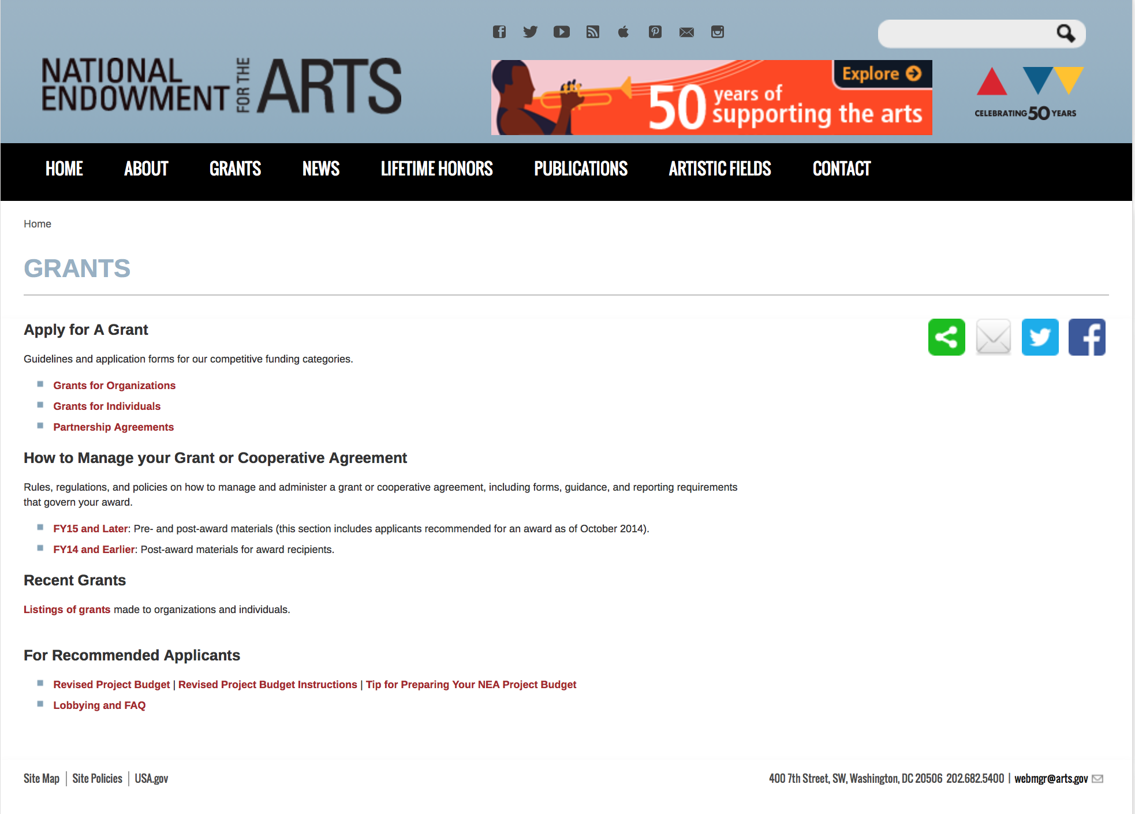

http://arts.gov/grants

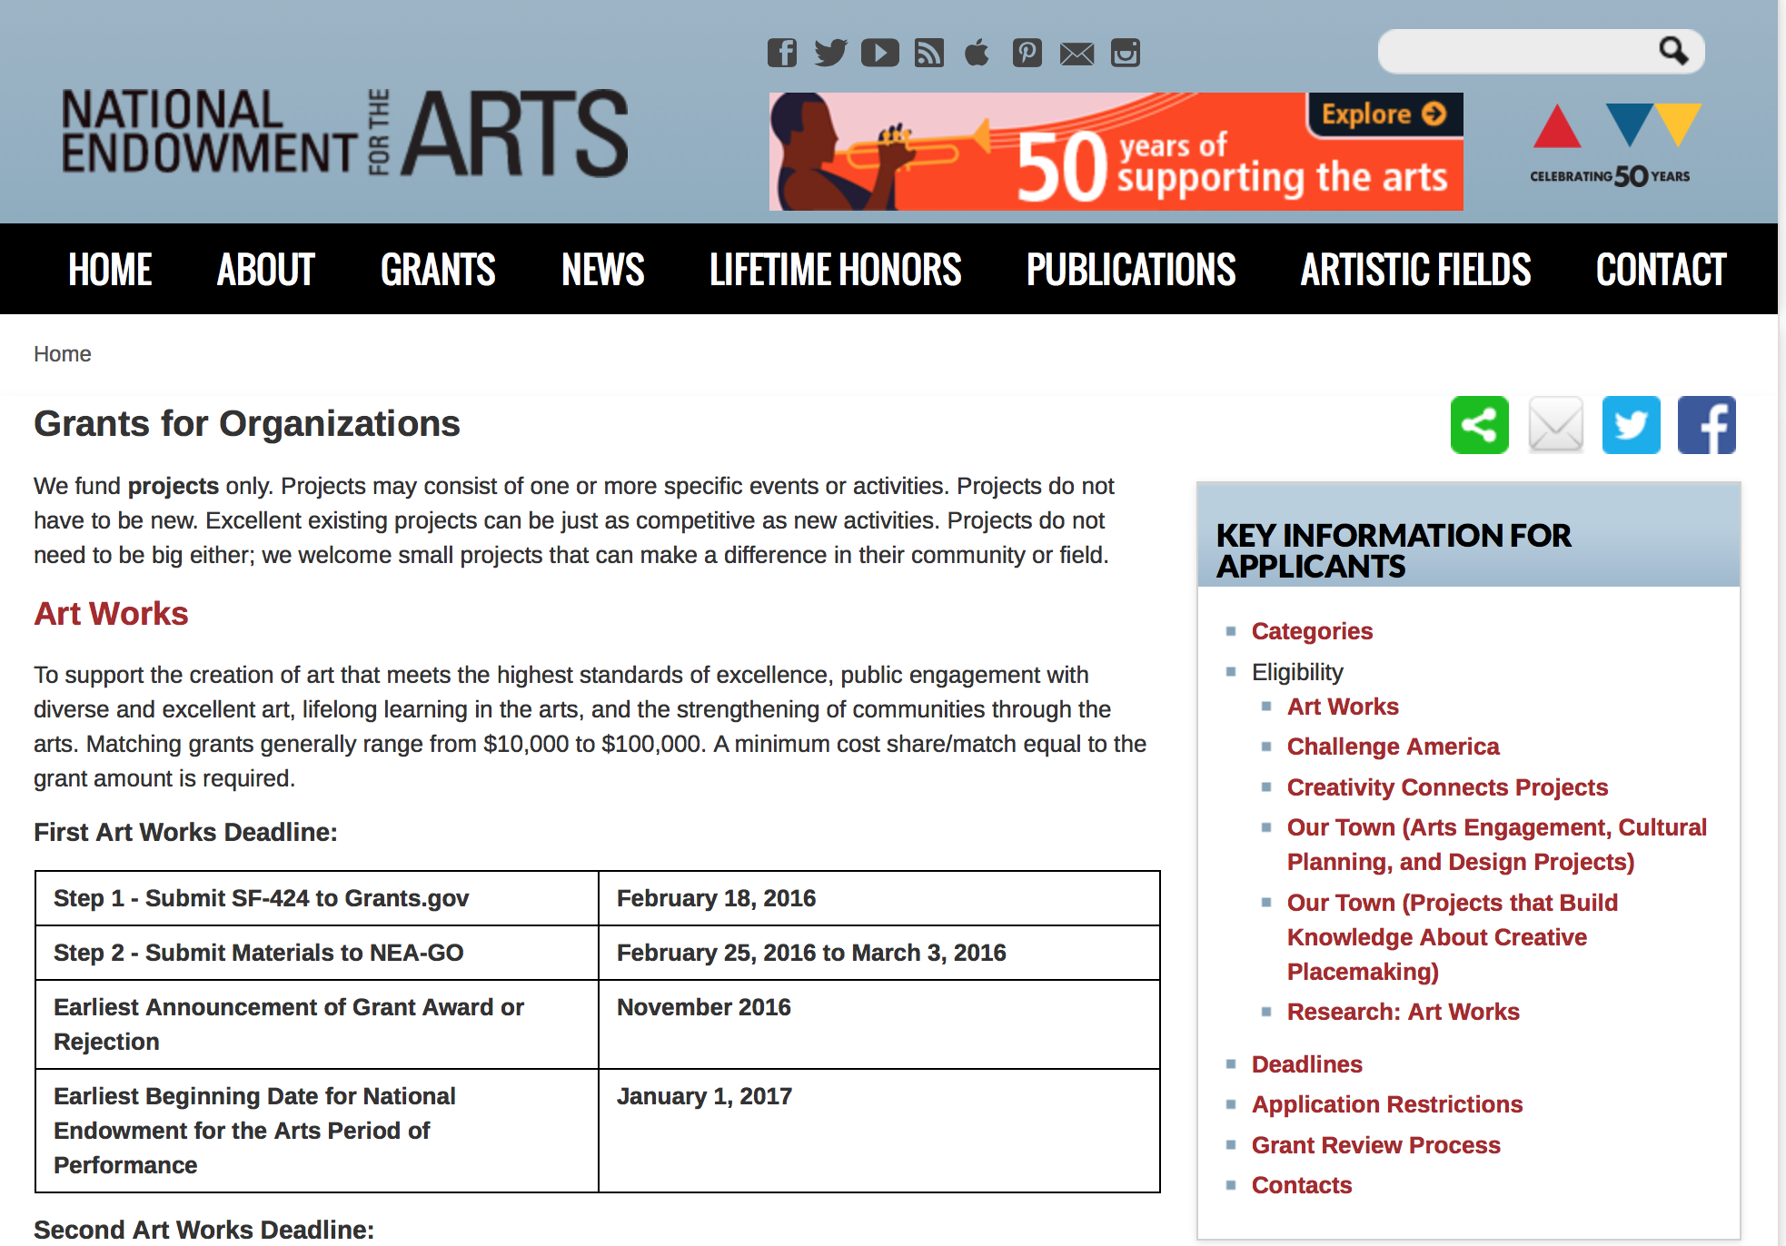
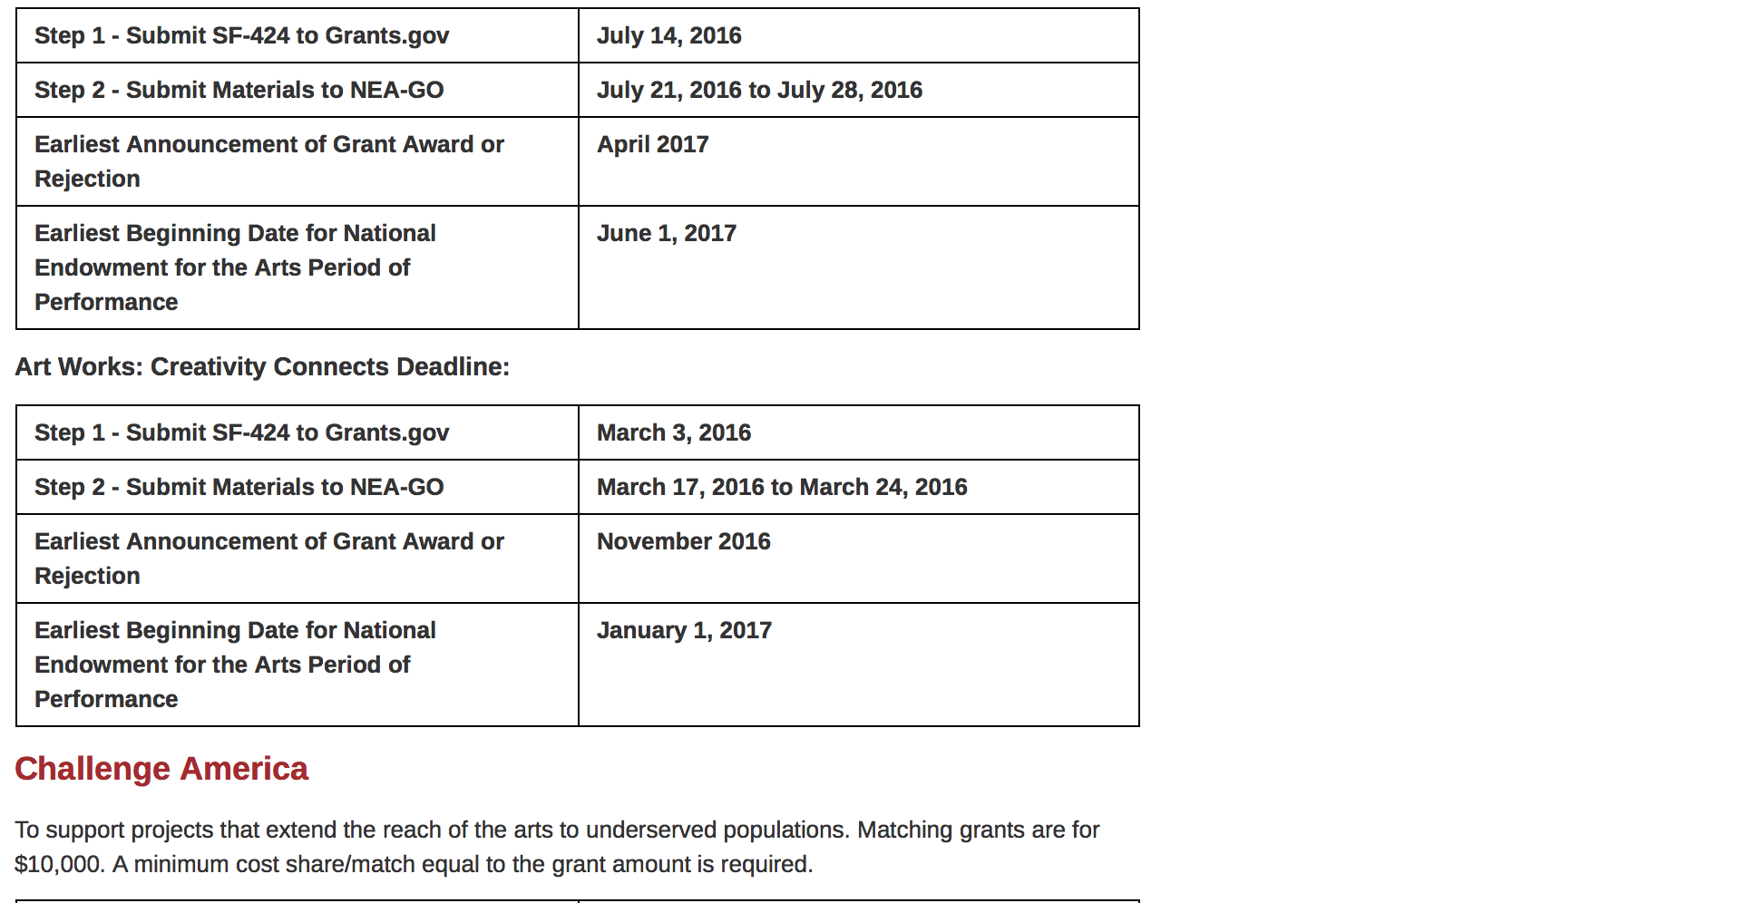
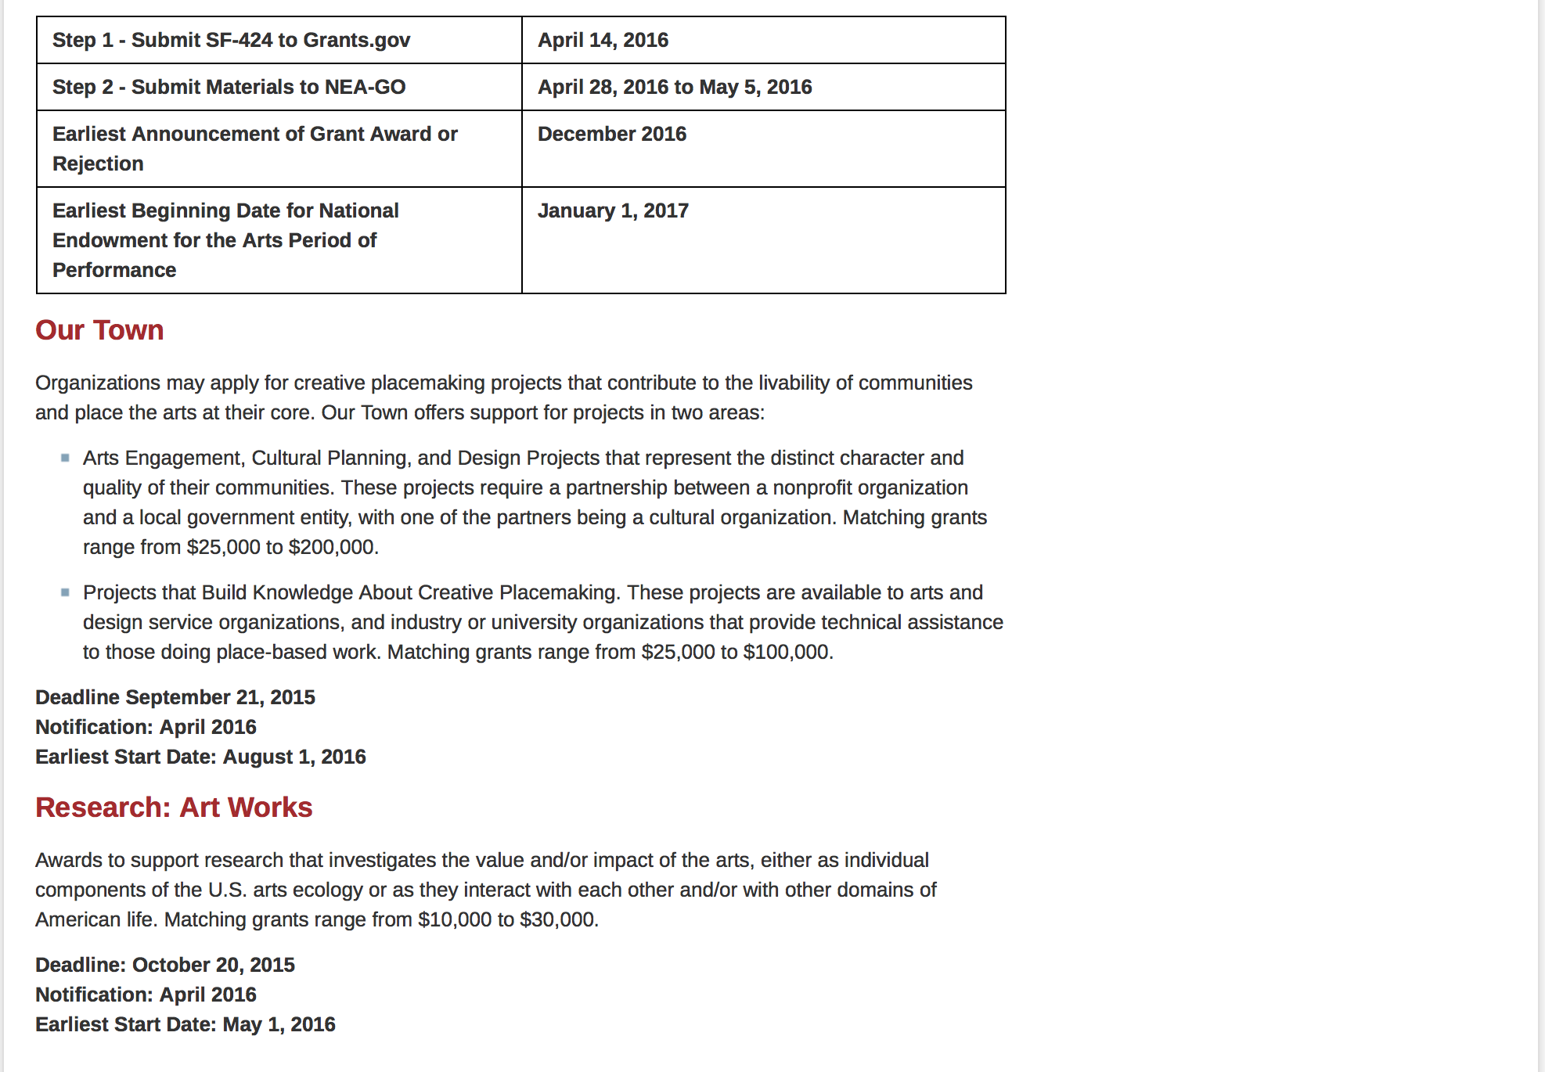
See more at: https://www.arts.gov/grants/apply-grant/grants-organizations

Programs:

NEA Research: Art Works Application, FY 2017

Document Type: | Grants Notice
Funding Opportunity Number: | 2017NEAORA
Funding Opportunity Title: | NEA Research: Art Works Application, FY 2017
Opportunity Category: | Discretionary
Opportunity Category Explanation:
Funding Instrument Type: | Grant
Category of Funding Activity: | Arts (see "Cultural Affairs" in CFDA)
Category Explanation:
Expected Number of Awards:
CFDA Number(s): | 45.024 -- Promotion of the Arts Grants to Organizations and Individuals
Cost Sharing or Matching Requirement: | Yes
Posted Date: | Jul 20, 2016
Last Updated Date: | Jul 20, 2016
Original Closing Date for Applications: | Oct 11, 2016 The Grants.gov system must receive your validated and accepted application no later than 11:59 p.m., Eastern Time, on October 11, 2016. Submit your SF-424 no later than October 1, 2016 to give yourself ample time to resolve any problems you might encounter. You take a significant risk by waiting until the day of the deadline to submit.
Current Closing Date for Applications: | Oct 11, 2016 The Grants.gov system must receive your validated and accepted application no later than 11:59 p.m., Eastern Time, on October 11, 2016. Submit your SF-424 no later than October 1, 2016 to give yourself ample time to resolve any problems you might encounter. You take a significant risk by waiting until the day of the deadline to submit.
Archive Date: | Nov 10, 2016
Estimated Total Program Funding:
Award Ceiling: | $100,000
Award Floor: | $10,000
Eligible Applicants: | City or township governments  Native American tribal governments (Federally recognized)  Public and State controlled institutions of higher education  Private institutions of higher education  State governments  Independent school districts  Special district governments  Nonprofits having a 501(c)(3) status with the IRS, other than institutions of higher education  County governments
Additional Information on Eligibility: | The Arts Endowment’s support of a project may start on May 1, 2017, or any time thereafter. Grants generally may cover a period of performance of up to two years, with an exception for projects that include primary data collection as part of the proposed activity. Projects that include primary data collection may request up to three years. Projects that extend beyond one year will be required to submit an annual progress report. A grantee may not receive more than one National Endowment for the Arts grant for the same project during the same period of performance. Official applicant organizations must be nonprofit, tax-exempt 501(c)(3), U.S. organizations; units of state or local government; or federally recognized tribal communities or tribes. This may include, but is not limited to, colleges and universities. For projects that involve multiple organizations, one organization that meets the eligibility requirements below must act as the official applicant, submit the application, and assume full responsibility for the grant. Partnering organizations are not required to meet the same eligibility requirements as the official applicant organization.
Agency Name: | National Endowment for the Arts
Description: | The Arts Endowment’s support of a project may start on May 1, 2017, or any time thereafter. Grants generally may cover a period of performance of up to two years, with an exception for projects that include primary data collection as part of the proposed activity. Projects that include primary data collection may request up to three years. Projects that extend beyond one year will be required to submit an annual progress report. A grantee may not receive more than one National Endowment for the Arts grant for the same project during the same period of performance. Program Description The National Endowment for the Arts’ Office of Research & Analysis makes awards to support research that investigates the value and/or impact of the arts, either as individual components of the U.S. arts ecology or as they interact with each other and/or with other domains of American life. In past years, the Research: Art Works category has invited researchers to propose studies that examine topics related to any area(s) on the How Art Works system map (see Grant Program Description). These projects have used quantitative, qualitative, or mixed-methods approaches, and have relied on primary and/or secondary data for analysis. Examples of previously funded research can be found via the "Grant Search" engine or by viewing Research: Art Works Grants Final Papers. This year, Research: Art Works offers support for projects in two areas: • Track One: Value and Impact. These research projects aim to examine the value and/or impact of the arts in any topic area(s) by using data and methods appropriate to the proposed research questions. Matching grants range from $10,000-$30,000. o Projects relying primarily on experimental/quasi-experimental design methods are not eligible under this Track and should apply to Track Two. • Track Two: Experimental and Quasi-Experimental Designs. These research projects aim to test the causal or inferred-causal impact of the arts on individual or cohort outcomes by using experimental or quasi-experimental design methods appropriate to the proposed research questions. Matching grants range from $30,000-$100,000. o This Track is only for projects relying primarily on experimental or quasi-experimental research methods.
Link to Additional Information: | NEA Web Site Announcement
Grantor Contact Information: | If you have difficulty accessing the full announcement electronically, please contact:  NEA Web Manager  NEA Web Manager

http://www.grants.gov/web/grants/view-opportunity.html?oppId=286351

Modifications:

Reminders:

Our Town FY 17 Grant

Document Type: | Grants Notice
Funding Opportunity Number: | 2016NEA01OT
Funding Opportunity Title: | Our Town FY 17
Opportunity Category: | Discretionary
Opportunity Category Explanation: | Category Explanation
Funding Instrument Type: | Grant
Category of Funding Activity: | Arts (see "Cultural Affairs" in CFDA)
Category Explanation:
Expected Number of Awards:
CFDA Number(s): | 45.024 -- Promotion of the Arts Grants to Organizations and Individuals
Cost Sharing or Matching Requirement: | Yes
Posted Date: | May 09, 2016
Last Updated Date: | May 09, 2016
Original Closing Date for Applications: | Sep 12, 2016 Applications must be received by September 12, 2016, 11:59 p.m., Eastern Time
Current Closing Date for Applications: | Sep 12, 2016 Applications must be received by September 12, 2016, 11:59 p.m., Eastern Time
Archive Date: | Oct 12, 2016
Estimated Total Program Funding:
Award Ceiling: | $200,000
Award Floor: | $25,000
Eligible Applicants: | State governments  Special district governments  Private institutions of higher education  Public and State controlled institutions of higher education  County governments  Nonprofits having a 501(c)(3) status with the IRS, other than institutions of higher education  Independent school districts  City or township governments  Native American tribal governments (Federally recognized)
Agency Name: | National Endowment for the Arts
Description: | Organizations may apply for creative placemaking projects that contribute to the livability of communities and place the arts at their core. Our Town offers support for projects in two areas: • Arts Engagement, Cultural Planning, and Design Projects that represent the distinct character and quality of their communities. These projects require a partnership between a nonprofit organization and a local government entity, with one of the partners being a cultural organization. Matching grants range from $25,000 to $200,000. • Projects that Build Knowledge About Creative Placemaking. These projects are available to arts and design service organizations, and industry, policy, or university organizations that provide technical assistance to those doing place-based work. Matching grants range from $25,000 to $100,000.
Link to Additional Information: | Our Town Guidelines
Contact Information: | If you have difficulty accessing the full announcement electronically, please contact:  Web Manager  Web manager's email address

http://www.grants.gov/web/grants/view-opportunity.html?oppId=283652

National Endowment for the Humanities

Grant Overview -

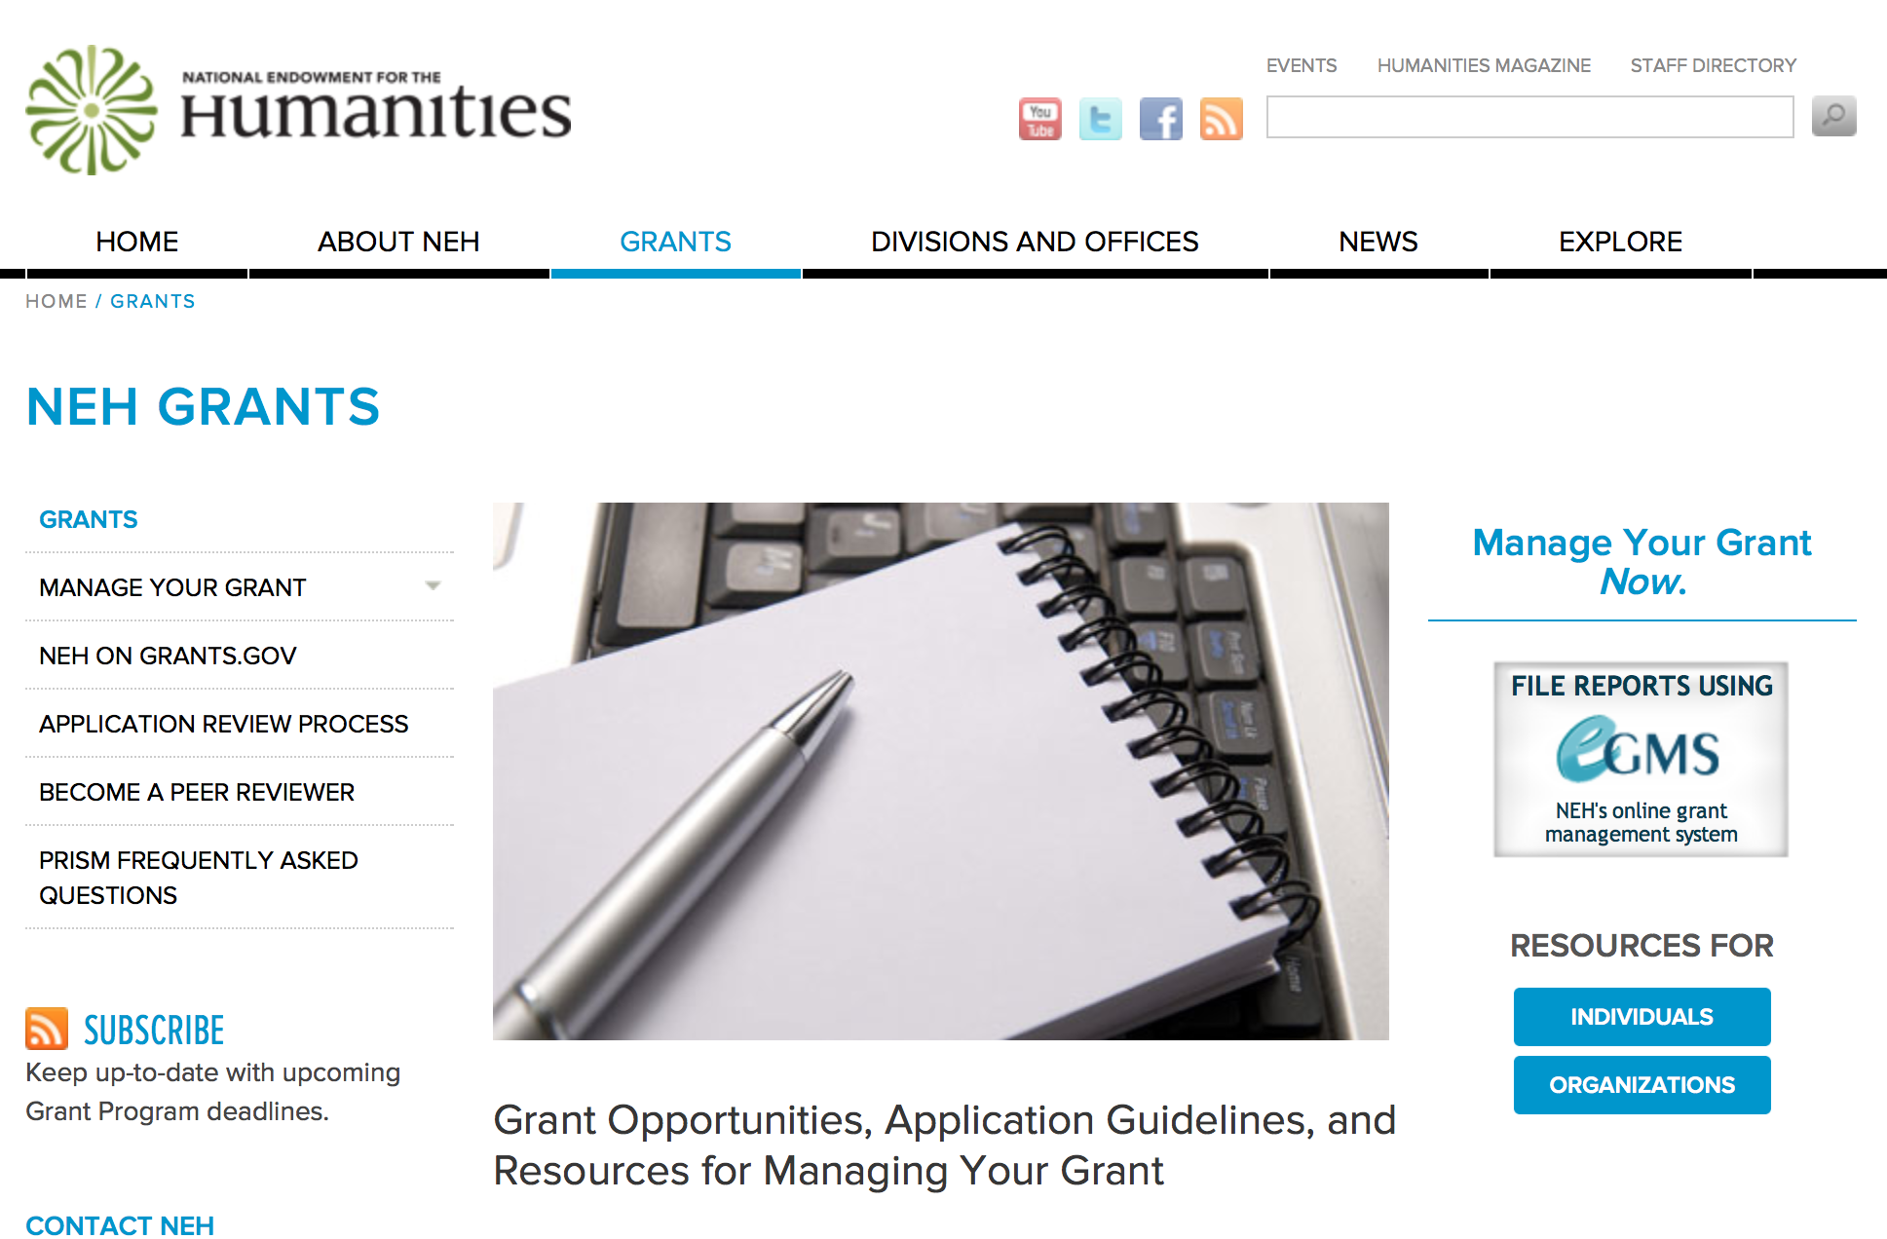

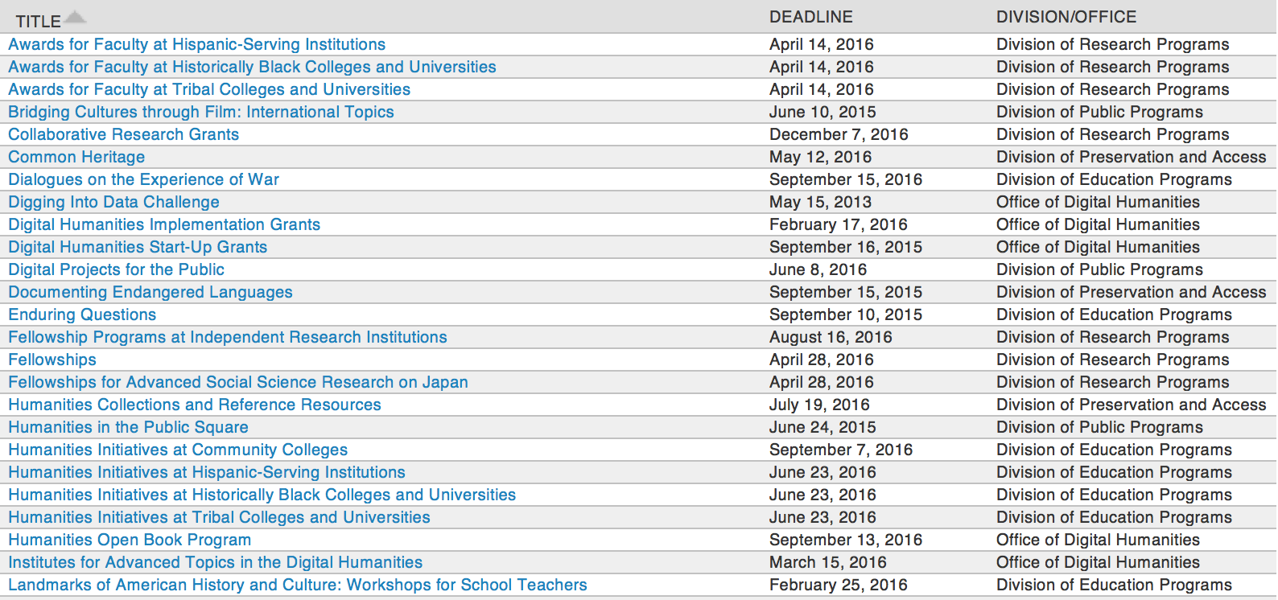

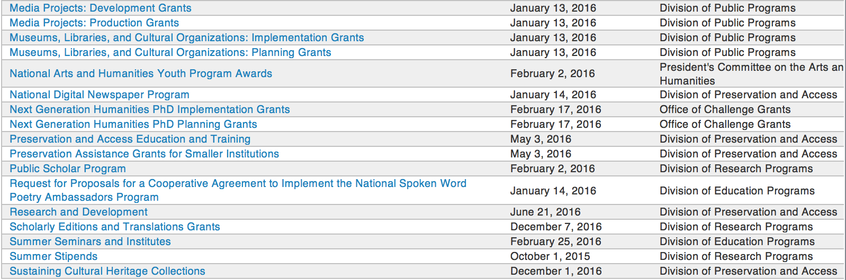

http://www.neh.gov/grants/grantsbydivision.html

Programs:

Funding Opportunity Number: 20170112-AE
Humanities Initiatives at Community Colleges
Posted Date: Jul 05, 2016
Version: Synopsis 1

Document Type: | Grants Notice
Funding Opportunity Number: | 20170112-AE
Funding Opportunity Title: | Humanities Initiatives at Community Colleges
Opportunity Category: | Discretionary
Opportunity Category Explanation:
Funding Instrument Type: | Grant
Category of Funding Activity: | Humanities (see "Cultural Affairs" in CFDA)
Category Explanation:
Expected Number of Awards:
CFDA Number(s): | 45.162 -- Promotion of the Humanities Teaching and Learning Resources and Curriculum Development
Cost Sharing or Matching Requirement: | No
Posted Date: | Jul 05, 2016
Last Updated Date: | Jul 05, 2016
Original Closing Date for Applications: | Jan 12, 2017
Current Closing Date for Applications: | Jan 12, 2017
Archive Date:
Estimated Total Program Funding:
Award Ceiling: | $100,000
Award Floor: | $1
Eligible Applicants: | Others (see text field entitled "Additional Information on Eligibility" for clarification)
Additional Information on Eligibility: | The only eligible applicants are U.S. nonprofit tax-exempt two-year colleges.
Agency Name: | National Endowment for the Humanities
Description: | The humanities can play a vital role at community colleges by expanding students’ intellectual horizons and by increasing their capacity to read, write, and think analytically. By effecting these changes, the humanities can help prepare students for careers and for lives as engaged citizens. Humanities Initiatives at Community Colleges support community colleges’ commitment to educating students on a variety of educational and career paths. The program funds curricular and faculty development projects that help strengthen humanities programs and/or incorporate humanistic approaches in fields outside the humanities. Each project must be organized around a core topic or set of themes, drawn from subjects such as history, philosophy, and literature. Each project must also incorporate a broader institutional vision for the humanities at a community college. NEH Humanities Initiatives may • develop bridge programs for at-risk and nontraditional students; • integrate substantial humanities content or texts in required or developmental courses that focus on close reading, analytical writing, and/or effective speaking; • support new humanities programs (which may include but are not limited to new humanities minors, first-year seminars, and capstone courses) and enhance existing ones; • infuse humanistic learning into professional training (in such fields as business, law, engineering, technology, hospitality, and nursing and medicine); • create or improve curricular pathways towards graduation and/or transfer to four-year institutions; • create opportunities for faculty members to study together, in order to improve their capacity to teach the humanities; and • support collaborative projects in the humanities between the applicant institution and another institution, such as a college or university, a school or school system, a museum or library, or a historical or cultural society. Applicants are encouraged to draw on the knowledge of outside scholars who would contribute expertise and fresh insights to the project.
Link to Additional Information: | http://www.neh.gov/grants/education/humanities-initiatives-community-colleges
Grantor Contact Information: | If you have difficulty accessing the full announcement electronically, please contact:  Division of Education Programs National Endowment for the Humanities 400 Seventh Street, SW Washington, DC 20506 202-606-8471 hi@neh.gov hi@neh.gov  hi@neh.gov

Link: http://www.grants.gov/web/grants/view-opportunity.html?oppId=285749

Modifications:

Reminders:

Funding Opportunity Number: 20170112-AE
Humanities Initiatives at Community Colleges

Posted Date: Jul 05, 2016
Document Type: | Grants Notice
Funding Opportunity Number: | 20170112-AE
Funding Opportunity Title: | Humanities Initiatives at Community Colleges
Opportunity Category: | Discretionary
Opportunity Category Explanation:
Funding Instrument Type: | Grant
Category of Funding Activity: | Humanities (see "Cultural Affairs" in CFDA)
Category Explanation:
Expected Number of Awards:
CFDA Number(s): | 45.162 -- Promotion of the Humanities Teaching and Learning Resources and Curriculum Development
Cost Sharing or Matching Requirement: | No
Posted Date: | Jul 05, 2016
Last Updated Date: | Jul 05, 2016
Original Closing Date for Applications: | Jan 12, 2017
Current Closing Date for Applications: | Jan 12, 2017
Archive Date:
Estimated Total Program Funding:
Award Ceiling: | $100,000
Award Floor: | $1
Eligible Applicants: | Others (see text field entitled "Additional Information on Eligibility" for clarification)
Additional Information on Eligibility: | The only eligible applicants are U.S. nonprofit tax-exempt two-year colleges.
Agency Name: | National Endowment for the Humanities
Description: | The humanities can play a vital role at community colleges by expanding students’ intellectual horizons and by increasing their capacity to read, write, and think analytically. By effecting these changes, the humanities can help prepare students for careers and for lives as engaged citizens. Humanities Initiatives at Community Colleges support community colleges’ commitment to educating students on a variety of educational and career paths. The program funds curricular and faculty development projects that help strengthen humanities programs and/or incorporate humanistic approaches in fields outside the humanities. Each project must be organized around a core topic or set of themes, drawn from subjects such as history, philosophy, and literature. Each project must also incorporate a broader institutional vision for the humanities at a community college. NEH Humanities Initiatives may • develop bridge programs for at-risk and nontraditional students; • integrate substantial humanities content or texts in required or developmental courses that focus on close reading, analytical writing, and/or effective speaking; • support new humanities programs (which may include but are not limited to new humanities minors, first-year seminars, and capstone courses) and enhance existing ones; • infuse humanistic learning into professional training (in such fields as business, law, engineering, technology, hospitality, and nursing and medicine); • create or improve curricular pathways towards graduation and/or transfer to four-year institutions; • create opportunities for faculty members to study together, in order to improve their capacity to teach the humanities; and • support collaborative projects in the humanities between the applicant institution and another institution, such as a college or university, a school or school system, a museum or library, or a historical or cultural society. Applicants are encouraged to draw on the knowledge of outside scholars who would contribute expertise and fresh insights to the project.
Link to Additional Information: | http://www.neh.gov/grants/education/humanities-initiatives-community-colleges
Grantor Contact Information: | If you have difficulty accessing the full announcement electronically, please contact:  Division of Education Programs National Endowment for the Humanities 400 Seventh Street, SW Washington, DC 20506 202-606-8471 hi@neh.gov hi@neh.gov  hi@neh.gov

Link: http://www.grants.gov/web/grants/view-opportunity.html?oppId=285749

Summer Stipends Grant

Document Type: | Grants Notice
Funding Opportunity Number: | 20160929-FT
Funding Opportunity Title: | Summer Stipends
Opportunity Category: | Discretionary
Opportunity Category Explanation:
Funding Instrument Type: | Grant
Category of Funding Activity: | Humanities (see "Cultural Affairs" in CFDA)
Category Explanation:
Expected Number of Awards:
CFDA Number(s): | 45.160 -- Promotion of the Humanities Fellowships and Stipends
Cost Sharing or Matching Requirement: | No
Posted Date: | May 05, 2016
Last Updated Date: | May 05, 2016
Original Closing Date for Applications: | Sep 29, 2016
Current Closing Date for Applications: | Sep 29, 2016
Archive Date:
Estimated Total Program Funding:
Award Ceiling: | $6,000
Award Floor: | $6,000
Eligible Applicants: | Others (see text field entitled "Additional Information on Eligibility" for clarification)
Additional Information on Eligibility: | The only eligible applicants are individuals. Individuals who teach full-time at colleges or universities must be nominated by their institutions to be eligible.
Agency Name: | National Endowment for the Humanities
Description: | Summer Stipends support individuals pursuing advanced research that is of value to humanities scholars, general audiences, or both. Eligible projects usually result in articles, monographs, books, digital materials and publications, archaeological site reports, translations, editions, or other scholarly resources. Summer Stipends support continuous full-time work on a humanities project for a period of two consecutive months. Summer Stipends support projects at any stage of development.
Link to Additional Information: | http://www.neh.gov/grants/research/summer-stipends
Contact Information: | If you have difficulty accessing the full announcement electronically, please contact:  Division of Research Programs National Endowment for the Humanities 400 Seventh Street, SW Washington, D.C. 20506 202-606-8200 stipends@neh.gov stipends@neh.gov  stipends@neh.gov

http://www.grants.gov/web/grants/view-opportunity.html?oppId=283530

Humanities Connections Grant

Document Type: | Grants Notice
Funding Opportunity Number: | 20161005-AK
Funding Opportunity Title: | Humanities Connections
Opportunity Category: | Discretionary
Opportunity Category Explanation:
Funding Instrument Type: | Grant
Category of Funding Activity: | Humanities (see "Cultural Affairs" in CFDA)
Category Explanation:
Expected Number of Awards:
CFDA Number(s): | 45.162 -- Promotion of the Humanities Teaching and Learning Resources and Curriculum Development
Cost Sharing or Matching Requirement: | No
Posted Date: | Apr 19, 2016
Last Updated Date: | Apr 19, 2016
Original Closing Date for Applications: | Oct 05, 2016
Current Closing Date for Applications: | Oct 05, 2016
Archive Date:
Estimated Total Program Funding:
Award Ceiling: | $100,000
Award Floor: | $1
Eligible Applicants: | Public and State controlled institutions of higher education  Private institutions of higher education
Agency Name: | National Endowment for the Humanities
Description: | Humanities Connections grants seek to expand the role of the humanities in the undergraduate curriculum at two- and four-year institutions, offering students in all academic fields new opportunities to develop the intellectual skills and habits of mind that the humanities cultivate. Grant projects focus on connecting the resources and perspectives of the humanities to students’ broader educational and professional goals, regardless of their path of study. Through this new grant program, NEH invites proposals that reflect innovative and imaginative approaches to preparing students for their roles as engaged citizens and productive professionals in a rapidly changing and interdependent world. Grants support the development and implementation of an integrated set of courses and student engagement activities focusing on significant humanities content. A common topic, theme, or compelling issue or question must link the courses and activities. The linked courses (a minimum of three) may fulfill general education or core curriculum requirements but could also be designed primarily for students in a particular major or course of study. The Humanities Connections program gives special encouragement to projects that foster collaboration between humanities faculty and their counterparts in the social and natural sciences and pre-service or professional programs in business, engineering, health sciences, law, computer science, and other non-humanities fields. Humanities Connections projects have two core features: 1. faculty from at least two separate departments or schools at a single institution must collaborate to devise new curricular arrangements; and 2. projects must include provisions for high-impact student engagement activities that relate directly to the topic(s) of the linked courses. These activities could include individual or collaborative undergraduate research projects; opportunities for civic engagement; or a structured experience with community-based, project-based, or site-based learning. Community organizations and cultural institutions can play key roles in this regard.
Link to Additional Information: | http://www.neh.gov/grants/education/humanities-connections
Contact Information: | If you have difficulty accessing the full announcement electronically, please contact:  Humanities Connections Division of Education Programs National Endowment for the Humanities 400 Seventh Street, SW Washington, DC 20506 202-606-8500  humanitiesconnections@neh.gov

http://www.grants.gov/web/grants/view-opportunity.html?oppId=283098

Humanities Open Book Program Grant

Document Type: | Grants Notice
Funding Opportunity Number: | 20160913-HZ
Funding Opportunity Title: | Humanities Open Book Program
Opportunity Category: | Discretionary
Opportunity Category Explanation:
Funding Instrument Type: | Grant
Category of Funding Activity: | Humanities (see "Cultural Affairs" in CFDA)
Category Explanation:
Expected Number of Awards:
CFDA Number(s): | 45.169 -- Promotion of the Humanities Office of Digital Humanities
Cost Sharing or Matching Requirement: | No
Posted Date: | Mar 22, 2016
Last Updated Date: | Mar 22, 2016
Original Closing Date for Applications: | Sep 13, 2016
Current Closing Date for Applications: | Sep 13, 2016
Archive Date:
Estimated Total Program Funding:
Award Ceiling: | $100,000
Award Floor: | $50,000
Eligible Applicants: | Native American tribal governments (Federally recognized)  Special district governments  Public and State controlled institutions of higher education  City or township governments  Private institutions of higher education  County governments  Nonprofits having a 501(c)(3) status with the IRS, other than institutions of higher education  Nonprofits that do not have a 501(c)(3) status with the IRS, other than institutions of higher education  State governments
Agency Name: | National Endowment for the Humanities
Description: | The Humanities Open Book Program is designed to make outstanding out-of-print humanities books available to a wide audience. By taking advantage of low-cost “ebook” technology, the program will allow teachers, students, scholars, and the public to read humanities books that have long been out of print. Humanities Open Book is jointly sponsored by NEH and the Andrew W. Mellon Foundation. Traditionally, printed books have been the primary medium for expressing, communicating, and debating humanistic ideas. However, the vast majority of humanities books sell a small number of copies and then quickly go out of print. Most scholarly books printed since 1923 are not in the public domain and are not easily available to the general public. As a result, there is a huge, mostly untapped resource of remarkable scholarship going back decades that is largely unused by today’s scholars, teachers, students, and members of the public, many of whom turn first to the Internet when looking for information. Modern ebook technology can make these books far more accessible than they are today. NEH and Mellon are soliciting proposals from academic presses, scholarly societies, museums, and other institutions that publish books in the humanities to participate in the Humanities Open Book Program. Applicants will provide a list of previously published humanities books along with brief descriptions of the books and their intellectual significance. Depending on the length and topics of the books, the number to be digitized may vary. However, NEH and Mellon anticipate that applicants may propose to digitize a total that ranges from less than fifty to more than one hundred books. Awards will be given to digitize these books and make them available as Creative Commons-licensed “ebooks” that can be read by the public at no charge on computers, mobile devices, and ebook readers. The final ebook files must be in EPUB version 3.0.1 (or later) format, to ensure that the text is fully searchable and reflowable and that fonts are resizable on any e-reading device.
Link to Additional Information: | http://www.neh.gov/grants/odh/humanities-open-book-program
Contact Information: | If you have difficulty accessing the full announcement electronically, please contact:  If you have questions about the program, contact the ODH staff at odh@neh.gov. Applicants wishing to speak to a staff member by telephone should provide in an e-mail message a telephone number and a preferred time to call. odh@neh.gov  odh@neh.gov

http://www.grants.gov/web/grants/view-opportunity.html?oppId=282404



National Science Foundation

General Funding Overview

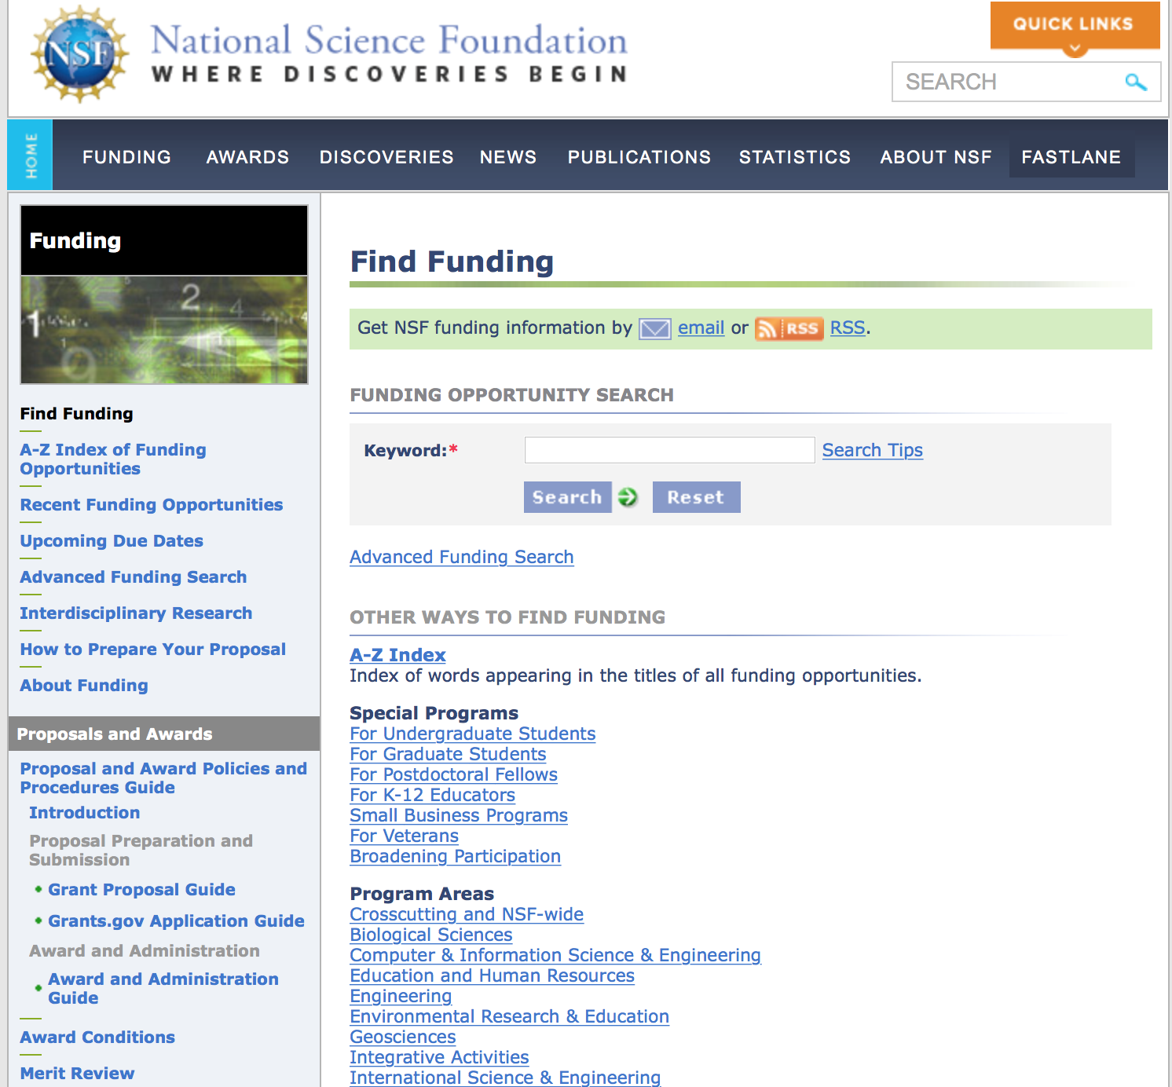
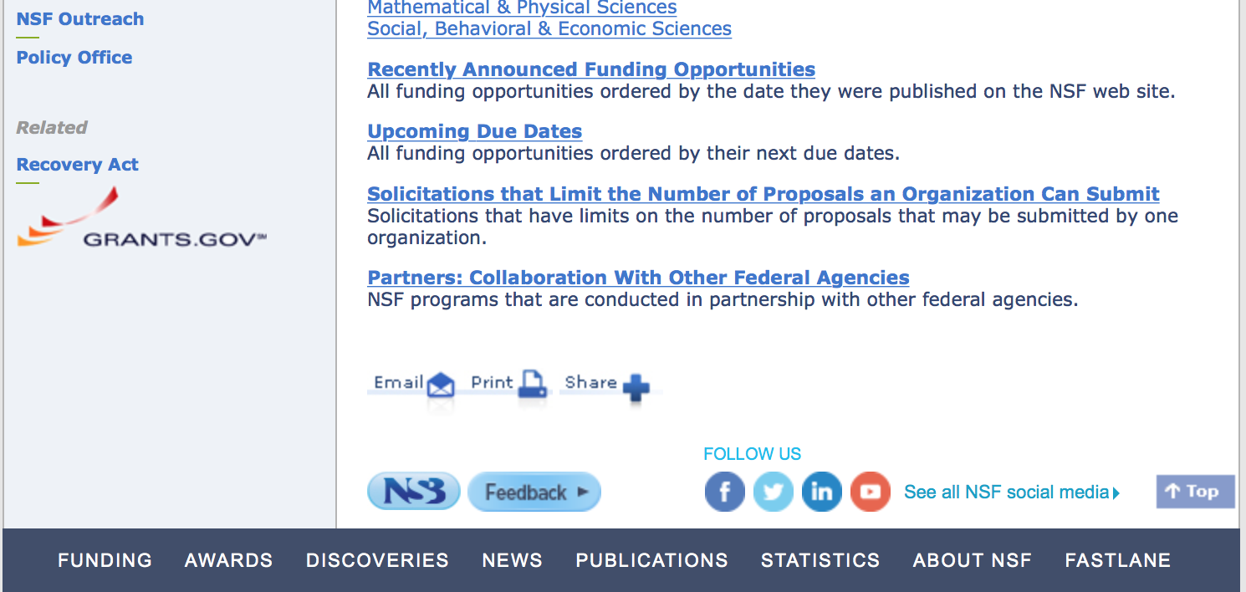

For assistance in finding funding: http://nsf.gov/funding/index.jsp - areas

The National Science Foundation funds research and education in most fields of science and engineering. It does this through grants, and cooperative agreements to more than 2,000 colleges, universities, K-12 school systems, businesses, informal science organizations and other research organizations throughout the United States. The Foundation accounts for about one-fourth of federal support to academic institutions for basic research.
NSF receives approximately 40,000 proposals each year for research, education and training projects, of which approximately 11,000 are funded. In addition, the Foundation receives several thousand applications for graduate and postdoctoral fellowships.
The agency operates no laboratories itself but does support National Research Centers, user facilities, certain oceanographic vessels and Antarctic research stations. The Foundation also supports cooperative research between universities and industry, US participation in international scientific and engineering efforts, and educational activities at every academic level.

For details on active funding deadline dates: http://nsf.gov/funding/pgm_list.jsp?org=NSF&ord=date

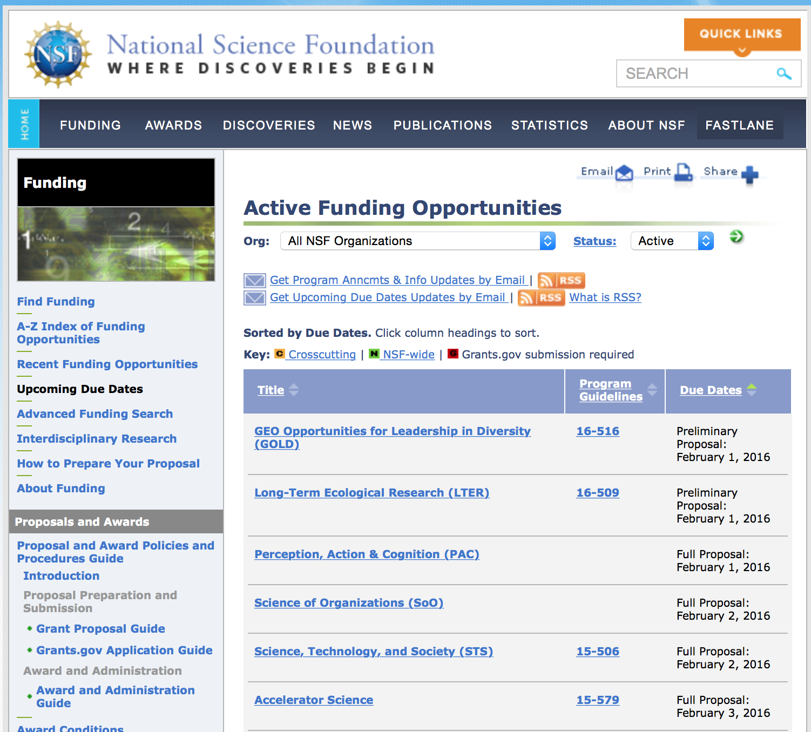

Research and Program Grants:

Number: 16-581
NSF/VMware Partnership on Software Defined Infrastructure as a Foundation for Clean-Slate Computing Security
Synopsis 1
http://www.grants.gov/web/grants/view-opportunity.html?oppId=285909

Number: 16-578
Computing and Communication Foundations (CCF): Core Programs
Posted Date: Jul 06, 2016
Synopsis 1
Link: http://www.grants.gov/web/grants/view-opportunity.html?oppId=285771

Number: 16-579
Computer and Network Systems (CNS): Core Programs
Posted Date: Jul 06, 2016
Synopsis 1
Link: http://www.grants.gov/web/grants/view-opportunity.html?oppId=285772

Improving Undergraduate STEM Education: Pathways into Geoscience
Synopsis 1
http://www.grants.gov/web/grants/view-opportunity.html?oppId=286089

Information and Intelligent Systems (IIS): Core Programs
Posted Date: Jul 06, 2016
Synopsis 1
Link: http://www.grants.gov/web/grants/view-opportunity.html?oppId=285769

NSF/Intel Partnership on Information-Centric Networking in Wireless Edge Networks
Synopsis 1
http://www.grants.gov/web/grants/view-opportunity.html?oppId=286149

Partnerships for Innovation: Accelerating Innovation Research- Technology Translation
Synopsis 1
http://www.grants.gov/web/grants/view-opportunity.html?oppId=286029

Platforms for Advanced Wireless Research (PAWR): Establishing the PAWR Project Office (PPO)
Synopsis 1
http://www.grants.gov/web/grants/view-opportunity.html?oppId=286127

Number: 16-580
Secure and Trustworthy Cyberspace
Posted Date: Jul 06, 2016
Synopsis 1
Link: http://www.grants.gov/web/grants/view-opportunity.html?oppId=285770

Wireless Innovation between Finland and the US
Synopsis 1
http://www.grants.gov/web/grants/view-opportunity.html?oppId=286150

Modifications:

Reminders:

Deleted:

Opportunity Number: 15-572
Opportunity Title: Computer and Network Systems (CNS): Core Programs
Agency Code: NSF
Agency: National Science Foundation
Deleted Date: Jul 06, 2016
Deletion Comments: Opportunity deleted

Opportunity Number: 15-573
Opportunity Title: Computing and Communication Foundations (CCF): Core Programs
Agency Code: NSF
Agency: National Science Foundation
Deleted Date: Jul 06, 2016
Deletion Comments: Opportunity deleted

16-533 - Cybersecurity Innovation for Cyberinfrastructure
Deletion Comments: Opportunity deleted

16-502 - EMERGING FRONTIERS IN RESEARCH AND INNOVATION (EFRI)<BR>
Deletion Comments: Opportunity deleted

12-506 - Opportunities for Promoting Understanding through Synthesis
Deletion Comments: Opportunity deleted

Opportunity Number: 15-574
Opportunity Title: Information and Intelligent Systems (IIS): Core Programs
Agency Code: NSF
Agency: National Science Foundation
Deleted Date: Jul 06, 2016
Deletion Comments: Opportunity deleted

12-506 - Opportunities for Promoting Understanding through Synthesis
Deletion Comments: Opportunity deleted

15-570 - Partnerships for Innovation: Accelerating Innovation Research- Technology Translation
Deletion Comments: Opportunity deleted

15-570 - Partnerships for Innovation: Accelerating Innovation Research- Technology Translation
Deletion Comments: Opportunity deleted

Opportunity Number: 15-575
Opportunity Title: Secure and Trustworthy Cyberspace
Agency Code: NSF
Agency: National Science Foundation
Deleted Date: Jul 06, 2016
Deletion Comments: Opportunity deleted

National Science Foundation
16-537 - Enhancing Access to the Radio Spectrum
Deletion Comments: Opportunity deleted
16-537 - Enhancing Access to the Radio Spectrum
Deletion Comments: Opportunity deleted

Nuclear Regulatory Commission

Reminders:



Small Business Administration

General Overview Finding Loans & Grants

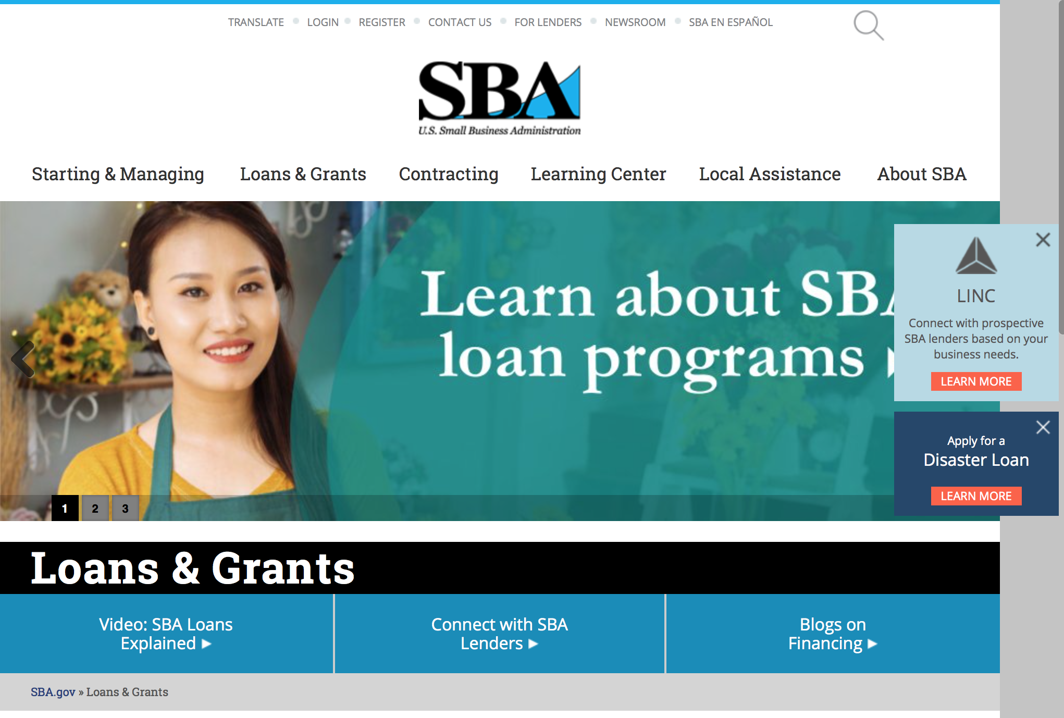
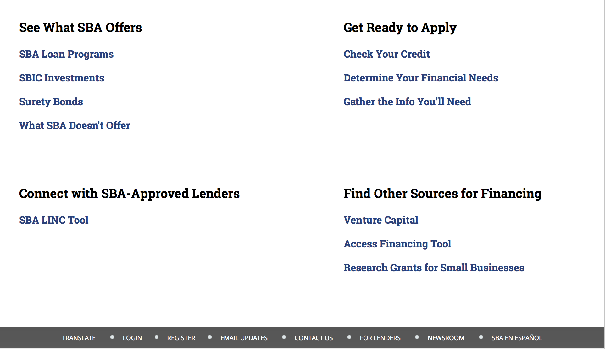

https://www.sba.gov/category/navigation-structure/loans-grants
Federal, state and local governments offer a wide range of financing programs to help small businesses start and grow their operations. These programs include low-interest loans, venture capital, and scientific and economic development grants.

Use SBA.gov's Loans and Grants Search Tool to get a list of financing programs for which you may qualify, or visit the resources below to learn more about small business financing programs. 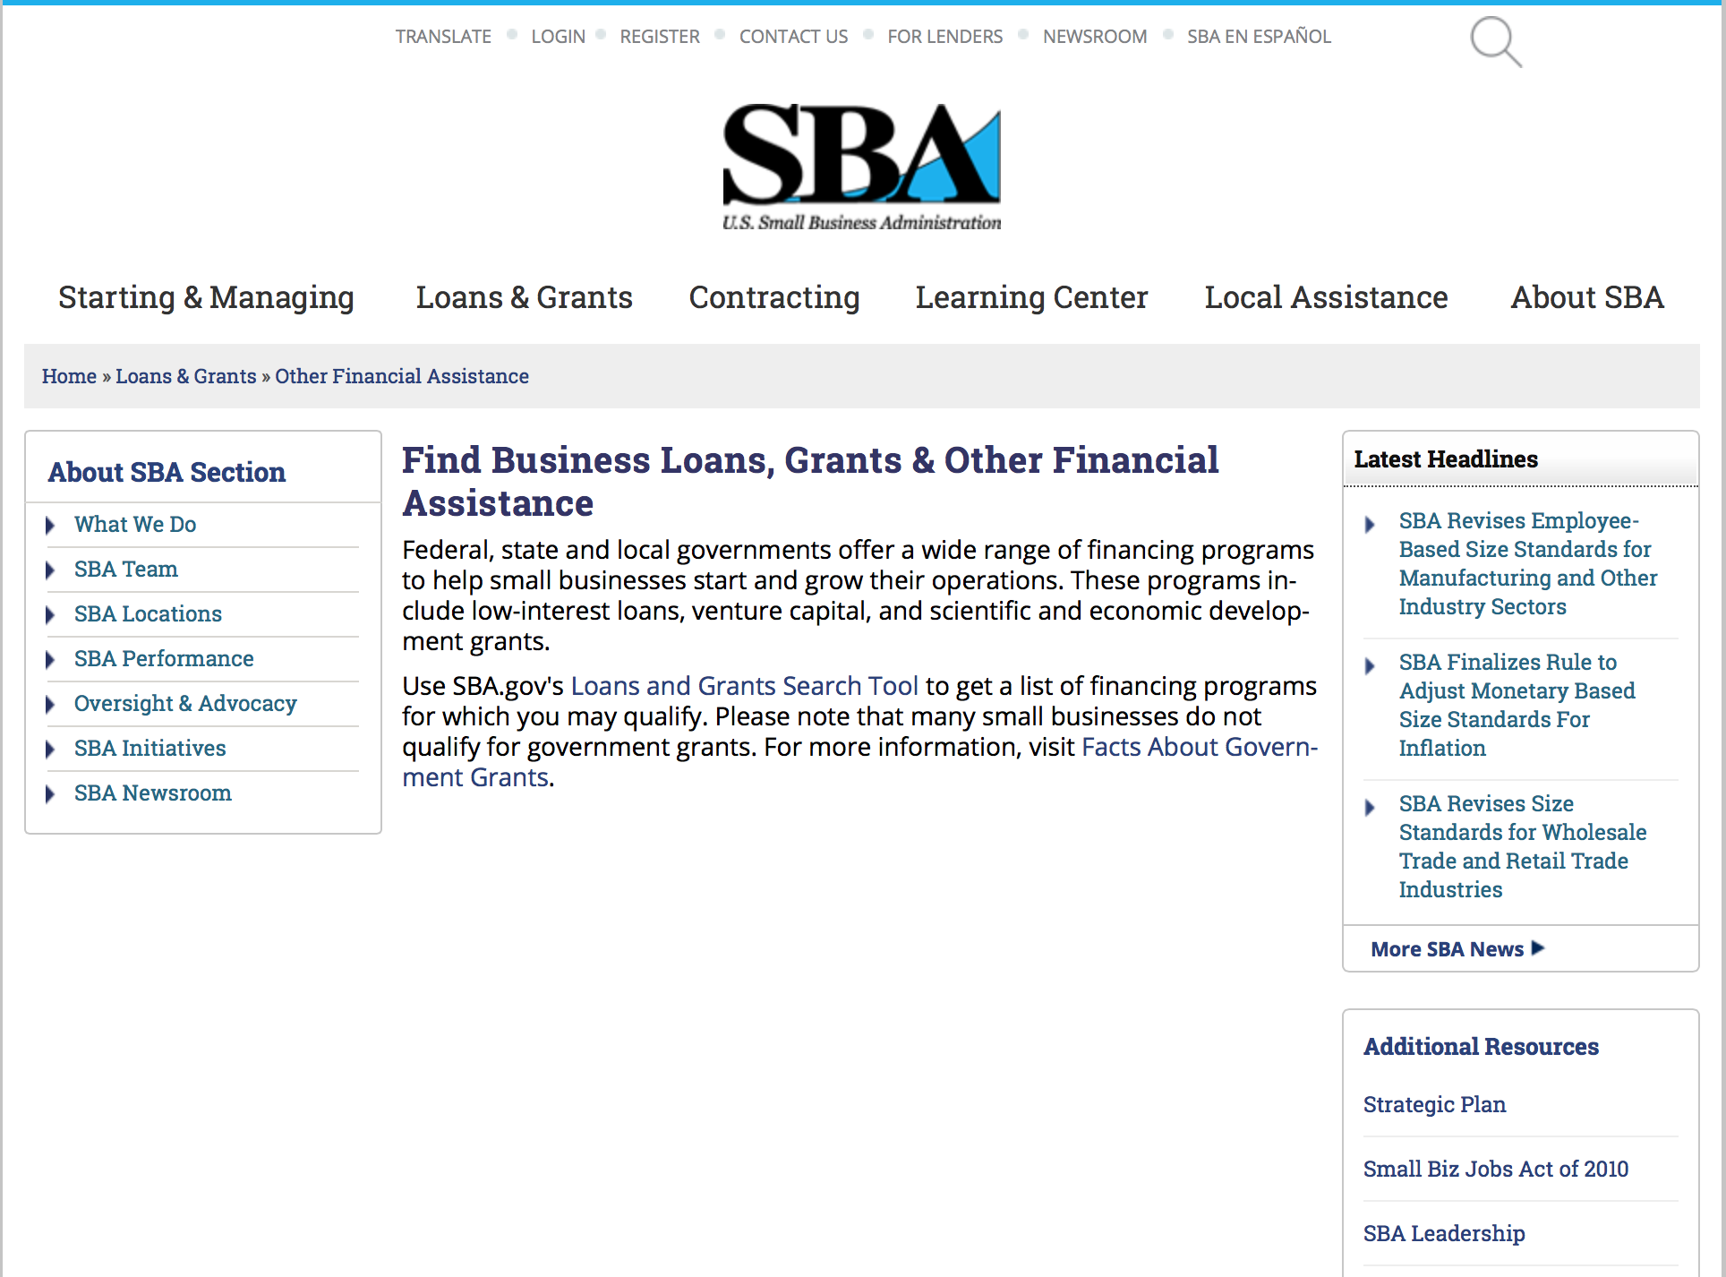
To get to the main SBA.gov funding page click here
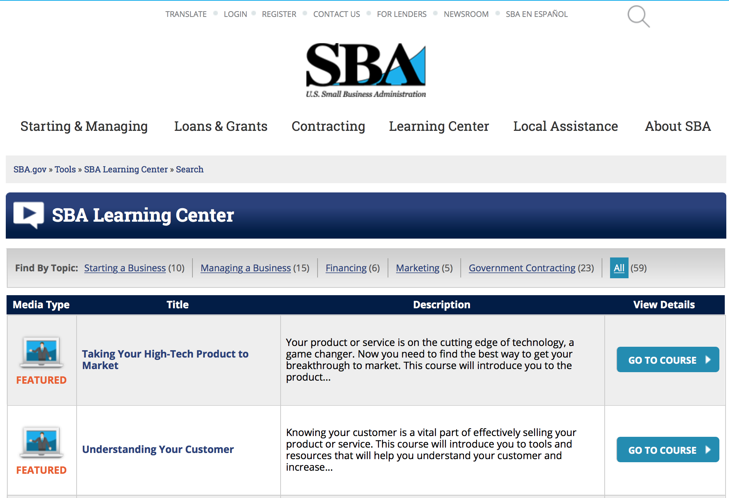
https://www.sba.gov/tools/sba-learning-center/search/training
Programs:

Reminders:

SBA Trainings

Contracting Opportunities for Veteran Entrepreneurs
This self-paced training exercise is an introduction to Federal contracting opportunities for Veterans.
Topics include basic information about Veteran-owned businesses and opportunities, services available to small Veteran-owned businesses, small business incentives, and government procurement methods.
Duration: 00:30:00

http://www.sba.gov/tools/sba-learning-center/training/contracting-opportunities-veteran-entrepreneurs

Interested in Exporting? These Four Resources Can Help
Did you know that two-thirds of the world’s purchasing power is in foreign countries? As the numbers show, the international marketplace is a big one. So if you’re interested in exploring the world of exporting – or have gotten started but could use some guidance – check out these resources to help.
- Read more

Upcoming Trainings: Check out SBA's Online Training!
- Financing Options for Small Businesses
How to Prepare Government Contract Proposals
Getting Started With Exporting: Training and Educational Resources
Exporting represents a big opportunity to tap in to new markets, expand your customer base and grow your business. But getting started with exporting can sometimes feel like a maze of regulations, policies, and other barriers. Here are some free training and educational resources to help.
- Read more

For Specific Information in Hawaii see the following links:
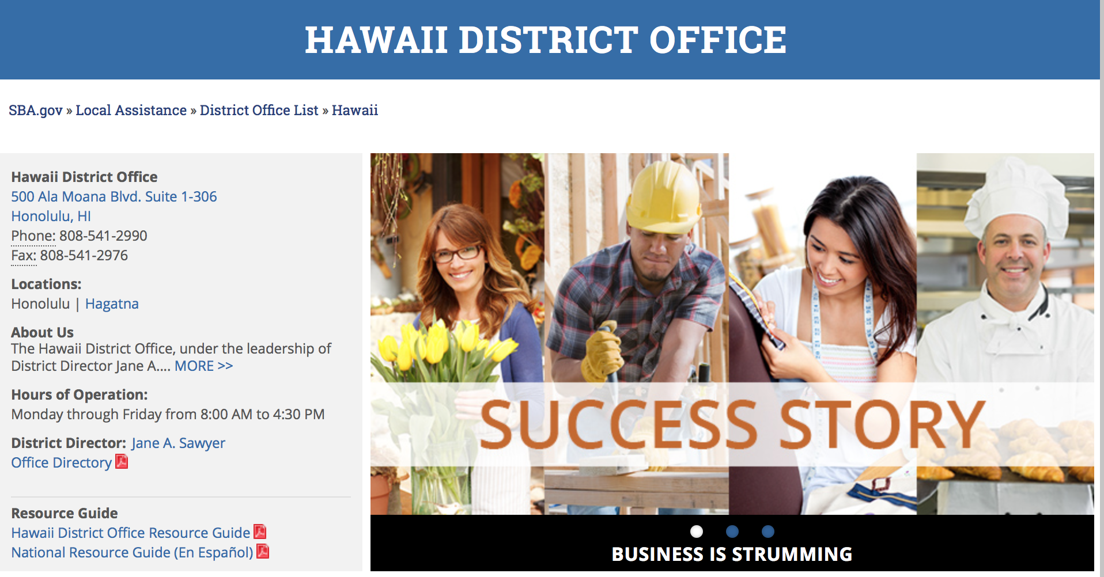

https://www.sba.gov/offices/district/hi/Honolulu

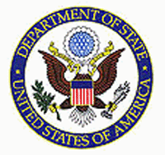

State Department General Overview and Resources for Program Administrators

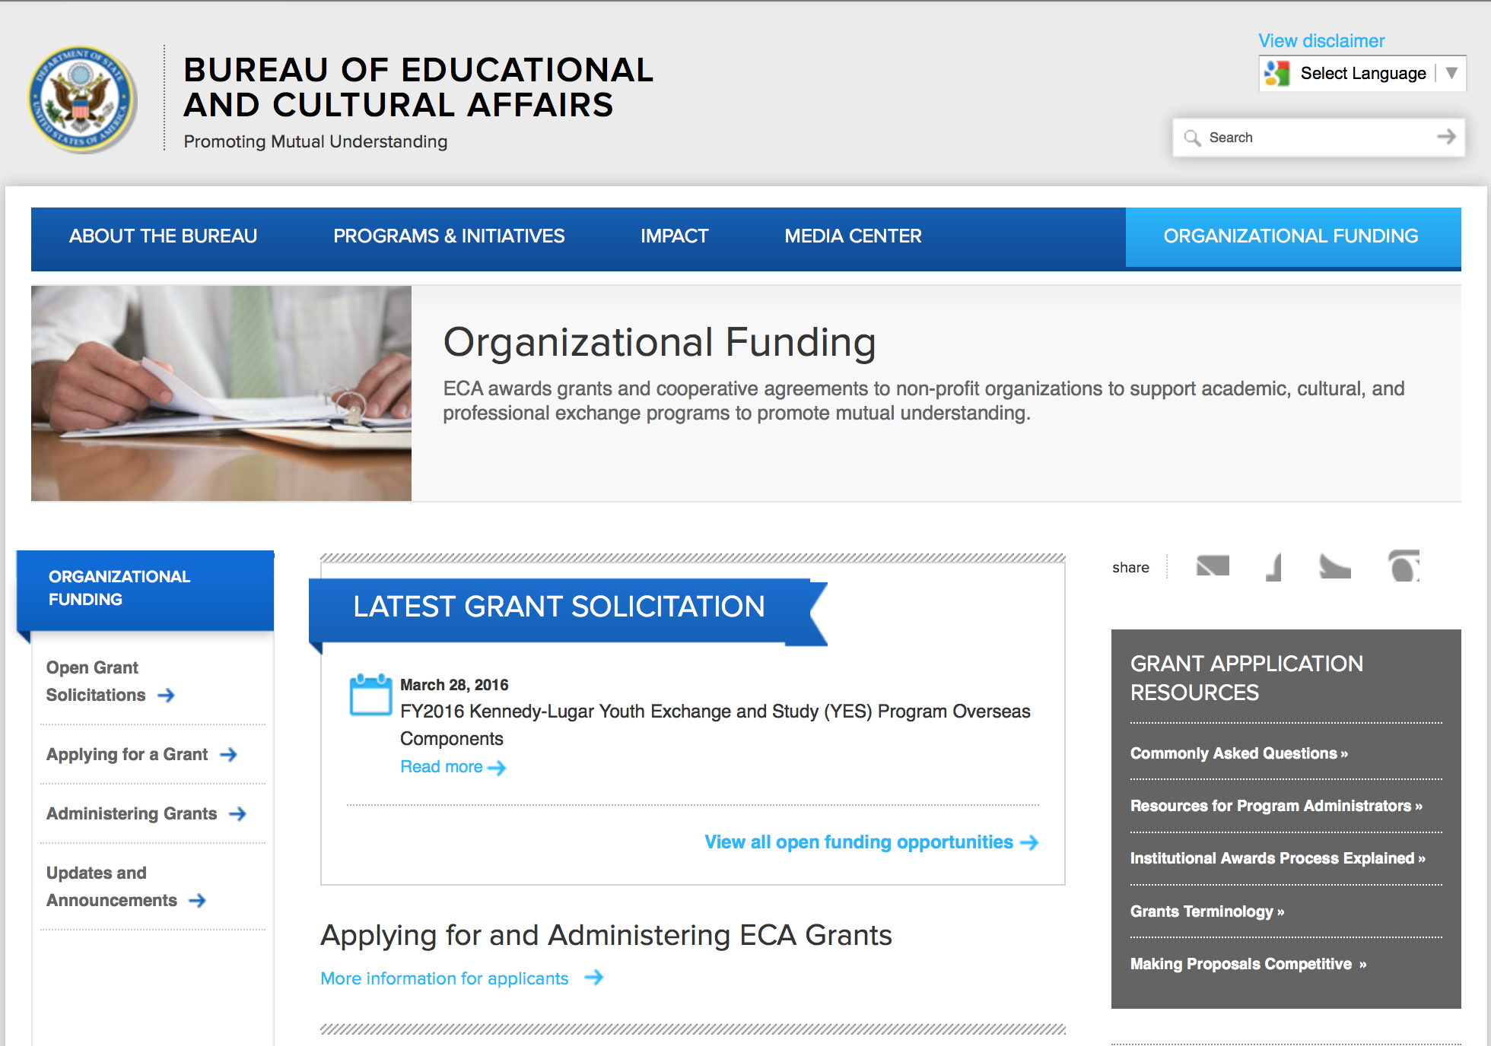
http://eca.state.gov/search/solr/grants?search_referrer=node/237
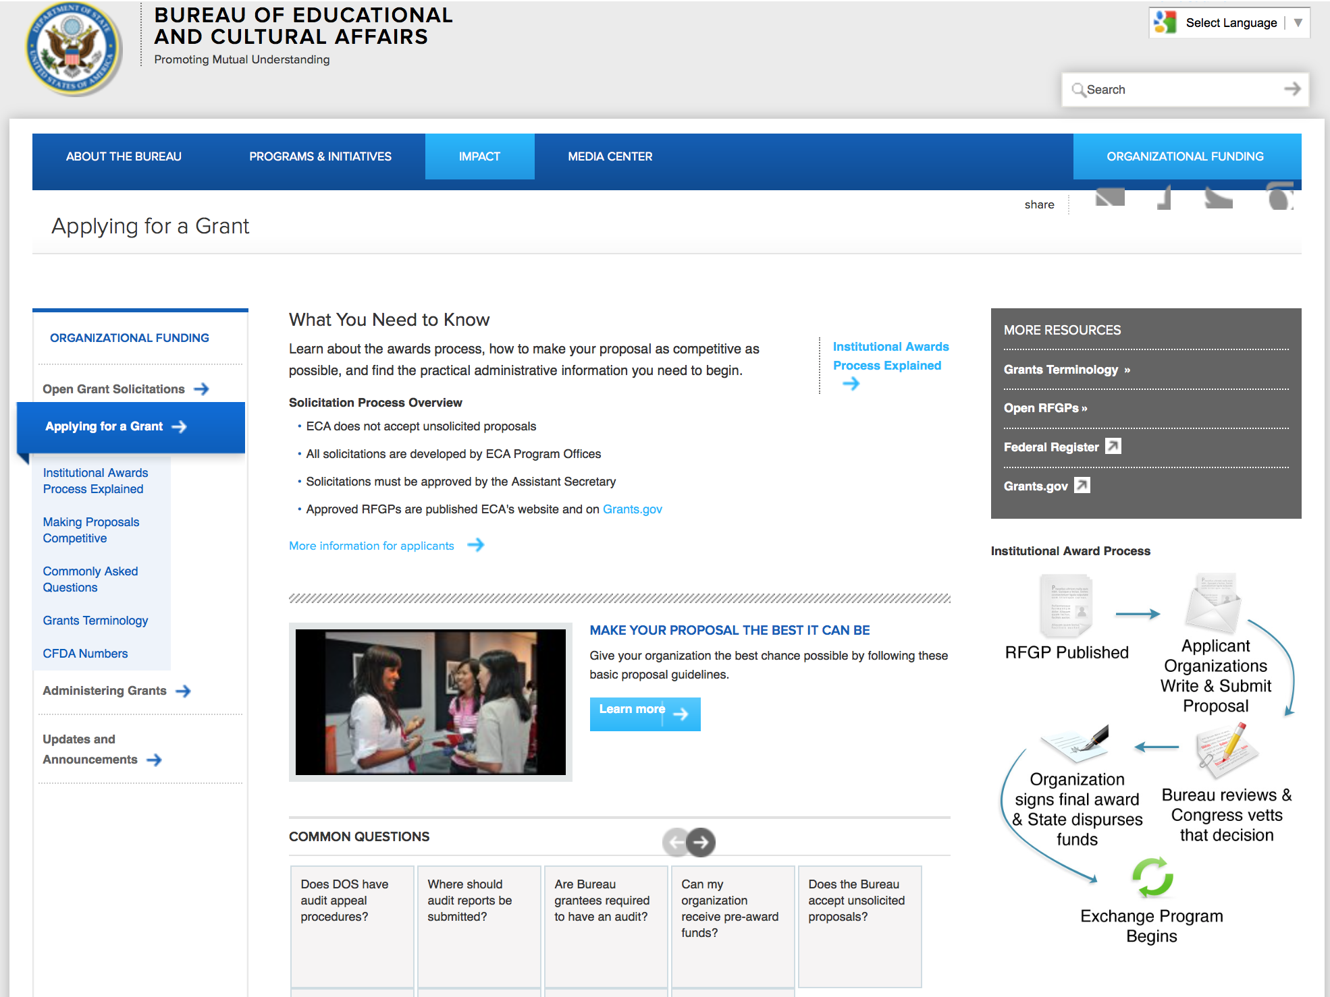

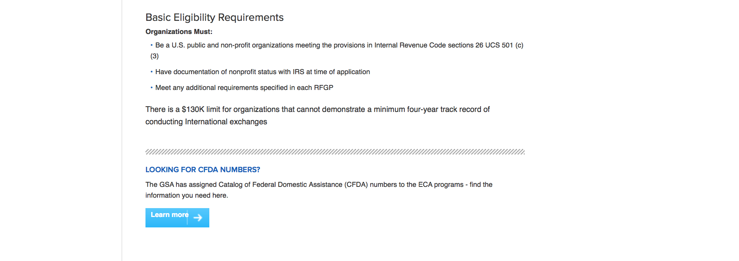
http://eca.state.gov/organizational-funding/applying-grant

General Information:
- Bureau of Educational and Cultural Affairs Grants Division
- Open Grant Opportunities (Requests for Grant Proposals)

For General Information click here

Program Grants:

International Narcotics and Law Enforcement Affair
Private Sector Reinsertion in El Salvador
Synopsis 1
http://www.grants.gov/web/grants/view-opportunity.html?oppId=286188

Public Affairs Section Small Grants Program 2016
Synopsis 1
http://www.grants.gov/web/grants/view-opportunity.html?oppId=286673

International Narcotics and Law Enforcement Affair
Tunisia Women's Police Association
Synopsis 1
http://www.grants.gov/web/grants/view-opportunity.html?oppId=286581

Youth Empowerment Grants 2016
Synopsis 1
http://www.grants.gov/web/grants/view-opportunity.html?oppId=286229

U. S. Mission to Ireland
Advocating for Human and Civil Rights for the LGBT Community
Synopsis 1
http://www.grants.gov/web/grants/view-opportunity.html?oppId=286321

Bureau of Democracy, Human Rights and Labor
Online Censorship Measurement to Support Internet Freedom
Synopsis 1
http://www.grants.gov/web/grants/view-opportunity.html?oppId=286517

Modifications:

Public Affairs Section Small Grants Program 2016
Synopsis 2
http://www.grants.gov/web/grants/view-opportunity.html?oppId=286673

International Narcotics and Law Enforcement Affair
Tunisia Amended Criminal Procedure Code Implementation
Synopsis 2
http://www.grants.gov/web/grants/view-opportunity.html?oppId=286359

Funding Opportunity Number: FA5461349
Exchange Program in the U.S. for English Language Teachers from U.S.-Brazil Binational Centers
Mission to Brazil
Posted Date: Jun 24, 2016
Version: Modification 2

Modification Comments: Please note that International Airfare should not be included in the budget. International airfare will be covered separately by the participants.

Link: http://www.grants.gov/web/grants/view-opportunity.html?oppId=285399

Reminders:

Deleted:

International Narcotics and Law Enforcement Affair
INLEA-INLCJ-12-001 - Morocco Anti-Corruption Program
Deletion Comments: Opportunity deleted

International Narcotics and Law Enforcement Affair
INLEA-INLCJ-13-001 - Legal Socialization Reform in Armenia and Georgia
Deletion Comments: Opportunity deleted

International Narcotics and Law Enforcement Affair
INLEA-INLCJ-13-003 - Nicaragua Citizen Security Grants
Deletion Comments: Opportunity deleted

Department of Transportation

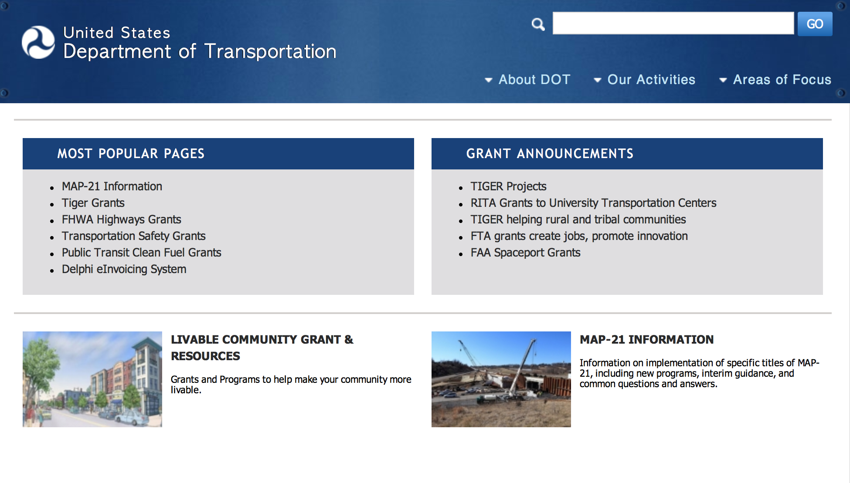
General Grant Program Overview https://www.transportation.gov/grants

Programs:

DOT/Federal Railroad Administration
FY 2017 Positive Train Control Grant Funds

Document Type: | Grants Notice
Funding Opportunity Number: | FR-TEC-16-002
Funding Opportunity Title: | FY 2017 Positive Train Control Grant Funds
Opportunity Category: | Discretionary
Opportunity Category Explanation:
Funding Instrument Type: | Grant
Category of Funding Activity: | Transportation
Category Explanation:
Expected Number of Awards:
CFDA Number(s): | 20.321 -- Railroad Safety Technology Grants
Cost Sharing or Matching Requirement: | Yes
Posted Date: | Jul 29, 2016
Last Updated Date: | Jul 29, 2016
Original Closing Date for Applications: | Sep 27, 2016 No Explanation
Current Closing Date for Applications: | Sep 27, 2016 No Explanation
Archive Date: | Oct 27, 2016
Estimated Total Program Funding:
Award Ceiling: | $197,010,000
Award Floor: | $0
Eligible Applicants: | State governments  Others (see text field entitled "Additional Information on Eligibility" for clarification)  City or township governments  County governments
Additional Information on Eligibility: | Entities that are recipients of funds under 49 U.S.C. Ch. 53, including public transit agencies operating commuter railroads.
Agency Name: | DOT/Federal Railroad Administration
Description: | The purpose of these funds is to award grants for eligible positive train control (PTC) projects. The funding available under this solicitation, $197.01 million, is authorized by section 3028 of the Fixing America's Surface Transportation (FAST) Act (Public Law No. 114-94), and subject to the availability of appropriated funds. Projects eligible under this NOFO must help install PTC systems required under 49 U.S.C. 20157.
Link to Additional Information: | FY 2017 Positive Train Control Grant Funds
Grantor Contact Information: | If you have difficulty accessing the full announcement electronically, please contact:  Grants.gov Contact Center Phone Number: 1-800-518-4726 Hours of operation are 24 hours a day, 7 days a week. The contact center is closed on federal holidays. support@grants.gov  Grants.gov Customer Support

http://www.grants.gov/web/grants/view-opportunity.html?oppId=286710

Modifications:

Reminders:

DOT Federal Aviation Administration
DOT - FAA Aviation Research Grants
FAA Aviation Research and Development Grants
Modifications 3 & 4

Document Type: | Grants Notice
Funding Opportunity Number: | 12-01
Funding Opportunity Title: | FAA Aviation Research and Development Grants
Opportunity Category: | Discretionary
Opportunity Category Explanation:
Funding Instrument Type: | Grant
Category of Funding Activity: | Transportation
Category Explanation:
Expected Number of Awards:
CFDA Number(s): | 20.108 -- Aviation Research Grants
Cost Sharing or Matching Requirement: | No
Version: | Synopsis 5
Posted Date: | Jan 01, 2012
Last Updated Date: | Jun 09, 2016
Original Closing Date for Applications: | Dec 31, 2019
Current Closing Date for Applications: | Dec 31, 2019
Archive Date: | Jan 30, 2020
Estimated Total Program Funding:
Award Ceiling: | $5,000,000
Eligible Applicants: | Nonprofits having a 501(c)(3) status with the IRS, other than institutions of higher education  Private institutions of higher education  Public and State controlled institutions of higher education
Agency Name: | DOT - FAA Aviation Research Grants
Description: | The FAA is soliciting proposals for research grants and cooperative agreements to pursue the long-term growth and short-term technical needs of civil aviation. In order to streamline the application process, it is recommended that all prospective grantees submit a white paper (letter of intent) for agency technical review before complete proposal submission. Please be sure to identify the specific area of interest (Solicitation FAA-12-01 – Chapter I. FAA Research Grants Program, Technical Areas of Research #1-#9). The white paper shall be no longer than three (3) pages and shall detail overall research objectives.
Link to Additional Information:
Grantor Contact Information: | If you have difficulty accessing the full announcement electronically, please contact:  Debra Monzo Grants Officer Phone 609-485-4962  business

http://www.grants.gov/web/grants/view-opportunity.html?oppId=134953

Deleted:

Maritime Administration
DTMA91O1600003 - ELECTRO CHEMICAL BALLAST WATER TREATMENT SYSTEM
Deletion Comments: Opportunity deleted

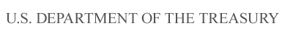

Department of the Treasury

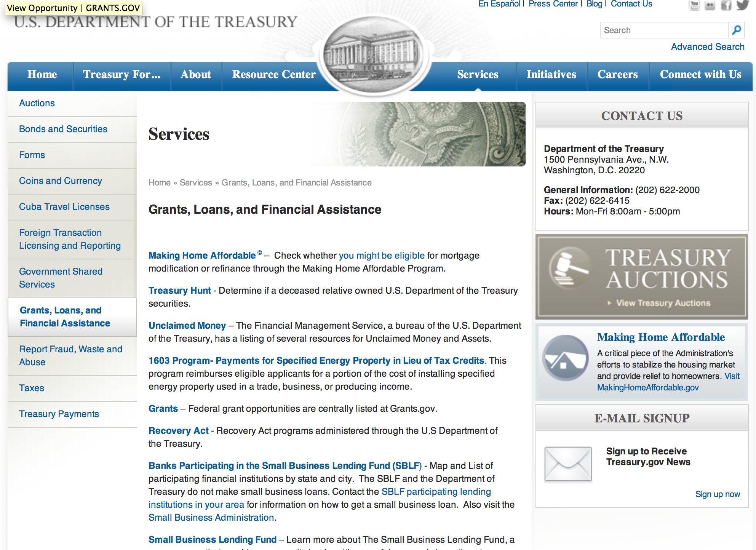

http://www.treasury.gov/services/Pages/Grants-Loans-and-Financial-Assistance.aspx

Programs:

Modifications:

Reminders:

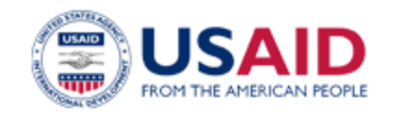

U.S. Agency for International Development

www.usaid.gov

General Overview Funding Opportunities

USAID has working relationships with thousands of American companies and hundreds of U.S.-based private voluntary organizations. For more information on our business and procurement opportunities, please visit our Business section.

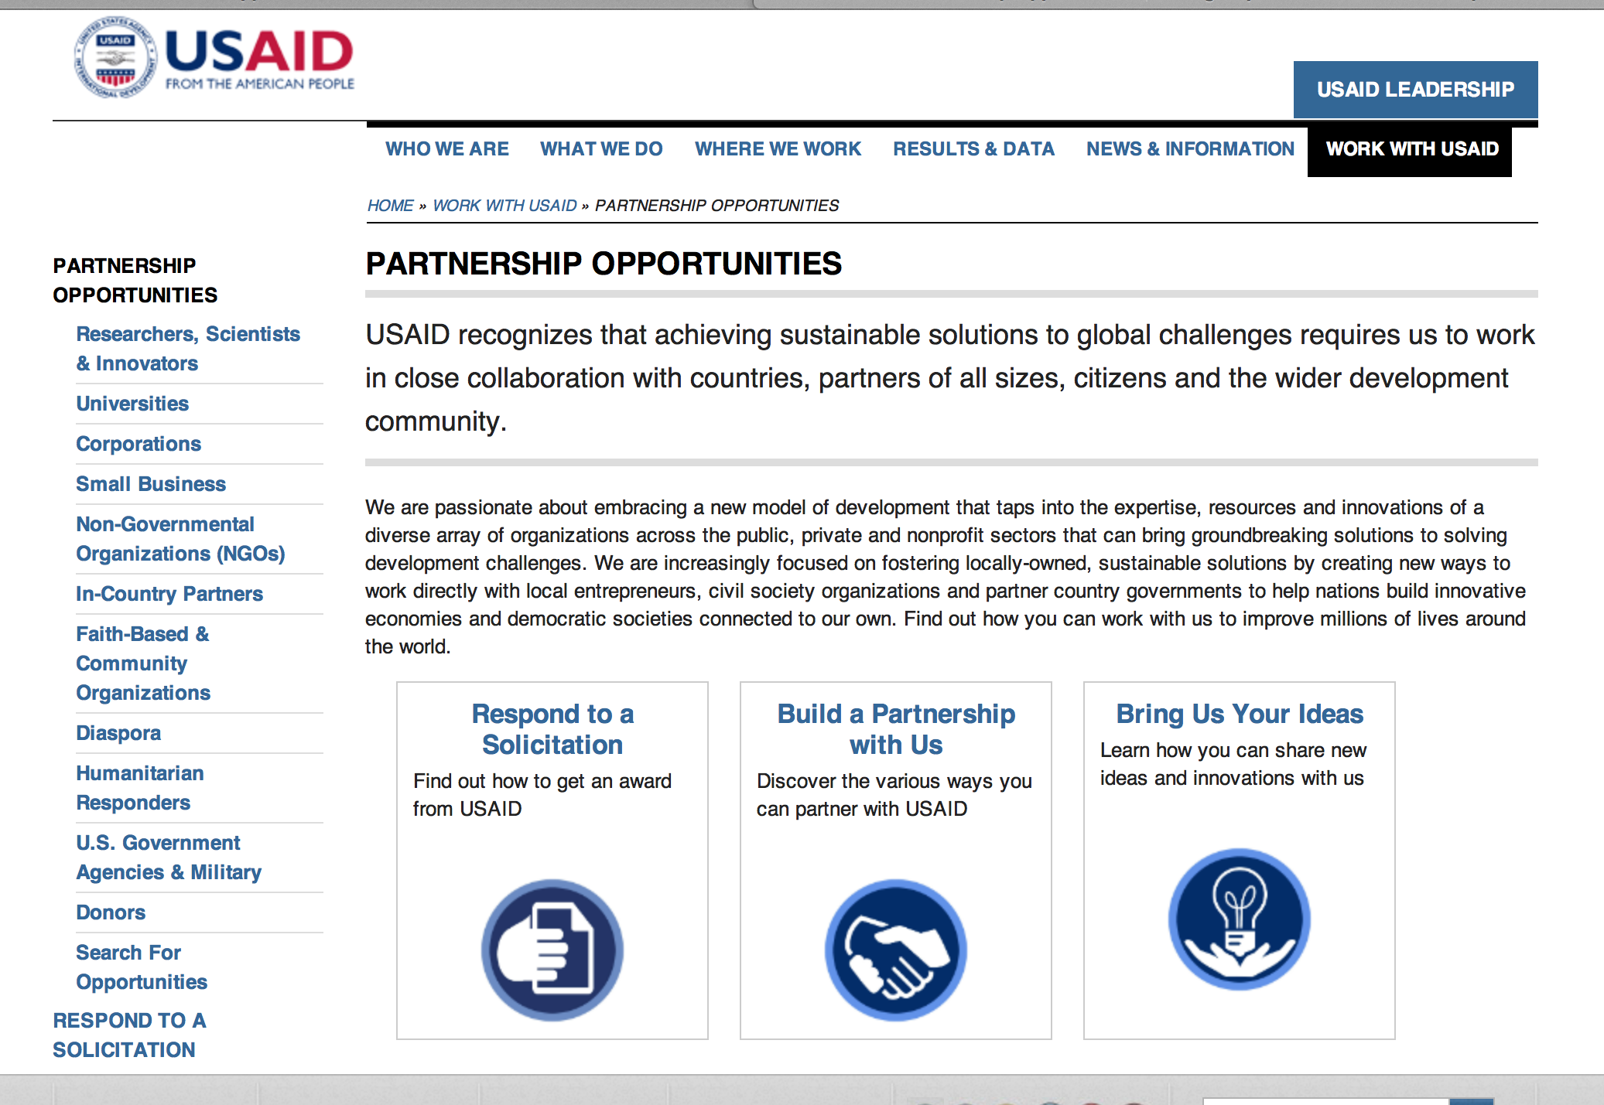
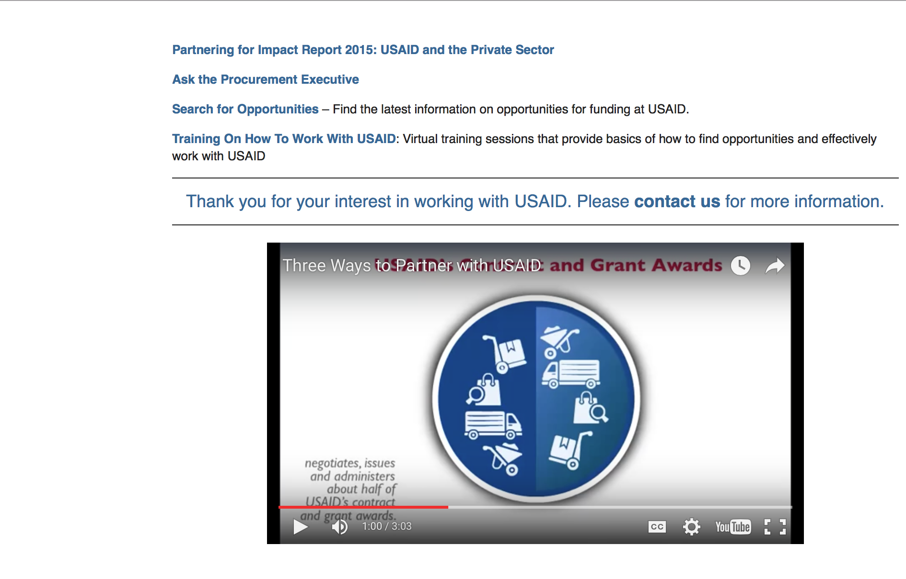

http://www.usaid.gov/partnerships

Programs:

Democratic Republic of the Congo USAID-Kinshasa
Integrated HIV/AIDS Program (IHAP)
Synopsis 1
http://www.grants.gov/web/grants/view-opportunity.html?oppId=286349

Mali USAID -Bamako
Education for deaf and blind Children in Mali
Synopsis 1
http://www.grants.gov/web/grants/view-opportunity.html?oppId=286603

Modifications:

Endowment and Afghan Scholarships
Synopsis 3
http://www.grants.gov/web/grants/view-opportunity.html?oppId=286298

Deleted:

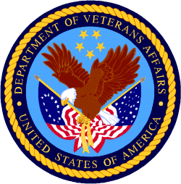

Department of Veterans Affairs

