Senator Mazie Hirono

Grants Assistance Information Newsletter

AUGUST 2017

G.A.I.N. INDEX

Click on Index Links below to read summaries of the announcements by agency in this document. Once you reach the item, if you cannot open the links for further information, copy the selected URL website address into your browser.

Modified sections from previous listings are shown in a GREY background

Notices is Teal are items with immediate deadline dates.

Notices in Yellow are of special interest.

Notices is Green are items of special interest with immediate deadline dates.

Items in this type color are aimed at Small Businesses

Items in this type color have a Faith-Based Organization component

Special Federal Program Notices

Grant Writing Resources

SAM and Grants.Gov Information

SBIR – Small Business Innovation Research

Programs specific to Hawaii

Current Notices

Department of Interior
Bureau of Land Management
Joint Fire Science Program FY 2018 Potential Topics

Reminders

See Individual Departments for information and webpages representing the best and most accessible information on the agency funding opportunities

Federal Grant and Cooperative Agreement Program Summaries

U.S. Department of Agriculture

Grants and Loans Overview

Programs

National Institute of Food and Agriculture
Small Business Innovation Research Program - Phase I

Research

Modifications

Reminders

DM-Office of Advocacy and Outreach
Outreach and Assistance for Socially Disadvantaged Farmers and Ranchers and Veteran Farmers and Ranchers Program

Agricultural Marketing Service
USDA-AMS-TM-SCMP-G-17-0005

Fish and Wildlife Service
2017 National Fish Habitat Action Plan

Deleted:

Department of Commerce

Grants at Commerce

Programs

John H. Prescott Marine Mammal Rescue Assistance Grant Program (Prescott Grant Program) for Fiscal Year 2018

FY18 Cooperative Research Program (CRP)

Ocean Exploration FY 2018 Funding Opportunity

Modifications

Research

Reminders

Economic Development Administration
FY 2017 Economic Development Assistance Programs ­ Application submission and program requirements for EDA’s Public Works and Economic Adjustment Assistance programs.

Climate Program Office 2018

National Institute of Standards and Technology
Embedding MEP in Manufacturing USA Institutes Pilot Projects – Round 3

National Institute of Standards and Technology
Measurement Science and Engineering (MSE) Research Grant Programs

National Sea Grant College Program 2016-17 Special Projects Grant

FY 2016 – FY 2019 EDA Planning Program and Local Technical Assistance Program Grant

Economic Development Administration
Planning Program and Local Technical Assistance Program Grant

Deleted

Corporation for National and Community Service

General Program Overview

Programs

Reminders

National Service in Hawaii

Department of Defense

Doing Business with the Department of Defense

DoD Small Business Opportunities and Forecasting

Research Grants

Modifications

Reminders

Department of Education

Grant Programs Overview

Programs

Office of Innovation and Improvement (OII): American History and Civics Education: National Activities Grants CFDA Number 84.422B

The Office of Elementary and Secondary Education (OESE): Impact Aid Discretionary Construction Grant Program CFDA Number 84.041C

The Office of Innovation and Improvement (OII): Promise Neighborhoods Program CFDA Number 84.215N

Research

Modifications

Reminders

Deleted

US Department of Energy

Grants Overview

Research

Modifications

Reminders

PAMS
Department of Energy - Office of Science
Office of Science
FY 2017 Continuation of Solicitation for the Office of Science Financial Assistance Program
Synopsis 2

Environmental Protection Agency

Grants and Contracts Overview

Programs

2017 Targeted Air Shed Grant Program

Modifications

Research

Reminders

Department of Health and Human Services

Grants Overview

Program

Research Grants

Modifications

Deleted

Reminders

Department of Homeland Security
Grants Overview

Programs

Department of Homeland Security - FEMA
FY17 Flood Mitigation Assistance

Department of Homeland Security - FEMA
FY17 Pre-Disaster Mitigation

Modifications

Advanced Research Projects Agency Energy
SENSOR SBIR/STTR

Reminders

Department of Housing and Urban Development

HUD - Notice of Funds Available

Programs

Modifications

Notice of Funding Availability (NOFA) for the Fiscal Year (FY) 2017 Continuum of Care Program Competition

Deleted

Reminders

Choice Neighborhoods Planning Grants Program

Institute of Museum and Library Services

Grants Overview

IMLS is on Facebook!

Programs

National Leadership Grants for Libraries

Laura Bush 21st Century Librarian Program

Modifications

Reminders

Deleted

Department of Interior

Grants and Contract Overview

Programs

Modifications

Reminders

National Fish Passage Program

Fish and Wildlife Service
Partners for Fish and Wildlife

Fish and Wildlife Service
Coastal Program

Deleted

Department of Justice

Grants and Contract Overview

Programs

Research

Modifications

Deleted

Reminders

Office for Victims of Crime
OVC FY 17 Vision 21: Integrated Services for Victims Program: Increasing Access to Mental Health Services for Victims of Crime

________________________________________________________________________

Department of Labor

Grants and Contract General Overview

Programs

Occupational Safety and Health Administration
Susan Harwood Training Grant, FY 2017, (Targeted Topics)

Modifications

Mine Safety and Health Administration
Mine Health and Safety Grants

Reminders

National Aeronautics and Space Administration

Research Grant and Contract General Overview

Programs

Modifications

_______________________________________________________________
National Archives and Records Administration

Grant Opportunities General Overview

Programs

Access to Historical Records: Major Initiatives (Preliminary)

Access to Historical Records: Major Initiatives

Reminders

Access to Historical Records: Archival Projects

EDITIONS-201710 for Publishing Historical Records in Documentary Editions

_______________________________________________________________
National Endowment for the Arts

Grant Opportunities General Overview

Programs

NEA Literature Fellowships: Translation Projects, FY2019

Modifications

Reminders
_______________________________________________________________

National Endowment for the Humanities

Grant Opportunities General Overview

Programs

Reminders

Fellowship Programs at Independent Research Institutions

Media Projects

Public Humanities Projects

Humanities Open Book Program

Summer Stipends

_______________________________________________________________
National Science Foundation

Grant Opportunities General Overview

Research and Program Grants

Modifications

Reminders

Deleted

Nuclear Regulatory Commission

Reminders

Small Business Administration

General Overview Finding Loans & Grants

Programs

Modifications

Reminders

Program Announcement

OSBDC
Program Announcement

Deleted

Upcoming Trainings

Links Specific to Hawaii

State Department

General Overview and Resources for Program Administrators

Programs

Modifications

Reminders

U.S. Department of Transportation

General Grant Program Overview

Programs

DOT Federal Highway Administration
Dwight David Eisenhower Transportation Fellowship Program (DDETFP) Graduate Fellowship

Research

Modifications:

Reminders

DOT Federal Aviation Administration
DOT - FAA Aviation Research Grants
FAA Aviation Research and Development Grants
Modifications 3 & 4

Deleted

Department of the Treasury

Programs

Modifications

Reminders

US Agency for International Development

General Funding Opportunity Overview

Programs
Modifications

Deleted

Department of Veterans Affairs

Special Federal Program Notices

Grant Writing Resources

The following links are a great resource for faith-based non-profits and other community organizations :

- Center for Faith-Based and Community Initiatives (link is external) , U.S. Department of Labor

- http://www.usaid.gov/partnership-opportunities/fbci. U.S. Agency for International Development

- Faith-Based and Other Community Initiatives (link is external) , Corporation for National Community Service

- Task Force for Faith-Based and Community Initiatives (link is external) , U.S. Department of Justice

- Proposal Writing Short Course (link is external) Foundation Center.
- General Tips on Writing a Competitive Grant Proposal (link is external) U.S. Environmental Protection Agency.
- How to Write a Grant Proposal (link is external) Appalachian Regional Commission.
- A Guide to Funding Resources USDA Rural Information Center.

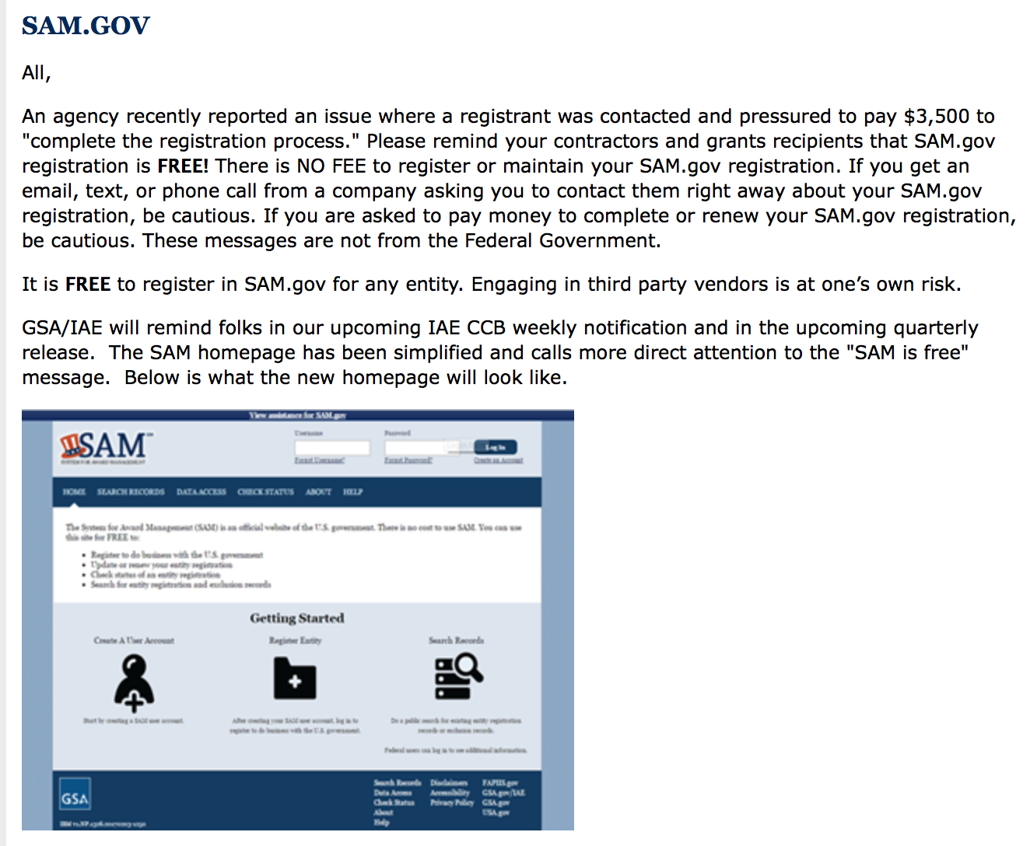

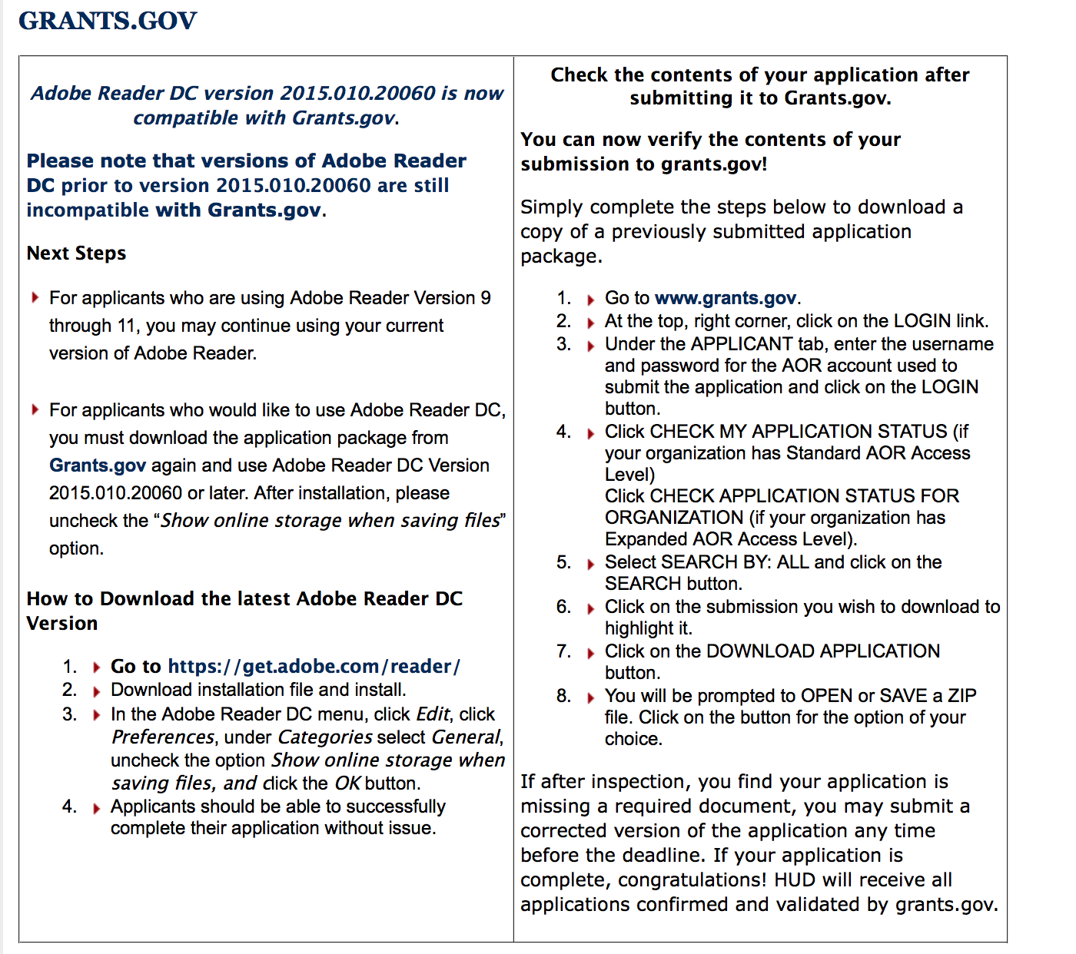

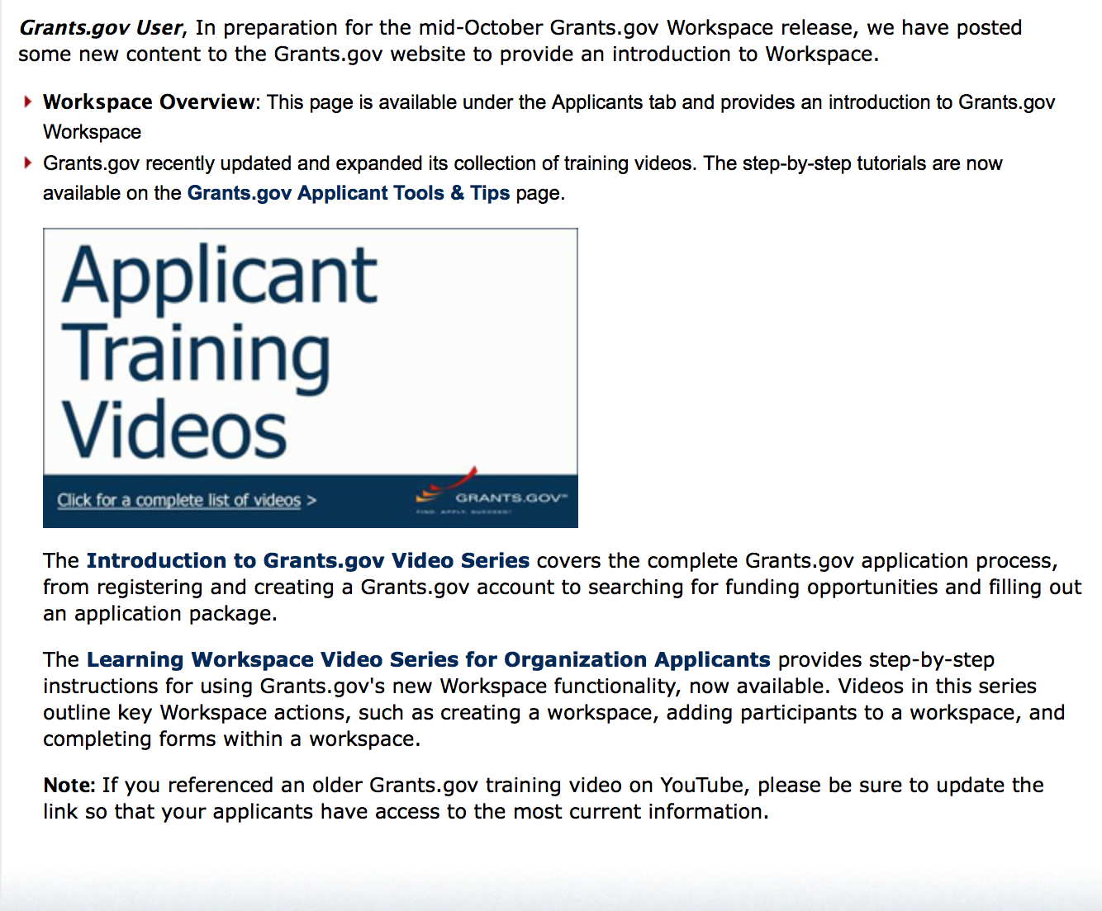
https://portal.hud.gov/hudportal/HUD?src=/program_offices/administration/grants/fundsavail

The Small Business Innovative Research Program - SBIR Program

The Small Business Innovation Research (SBIR) program is a highly competitive program that encourages domestic small businesses to engage in Federal Research/Research and Development (R/R&D) that has the potential for commercialization. Through a competitive awards-based program, SBIR enables small businesses to explore their technological potential and provides the incentive to profit from its commercialization. By including qualified small businesses in the nation's R&D arena, high-tech innovation is stimulated and the United States gains entrepreneurial spirit as it meets its specific research and development needs.

SBIR Mission and Program Goals
The mission of the SBIR program is to support scientific excellence and technological innovation through the investment of Federal research funds in critical American priorities to build a strong national economy.
The program’s goals are four-fold:
- Stimulate technological innovation
- Meet Federal research and development needs.
- Foster and encourage participation in innovation and entrepreneurship by socially and economically disadvantaged persons.
- Increase private-sector commercialization of innovations derived from Federal research and development funding.

SBIR-Participating Agencies
Each year, Federal agencies with extramural research and development (R&D) budgets that exceed $100 million are required to allocate 2.5 percent of their R&D budget to these programs. Currently, eleven Federal agencies participate in the program:
- Department of Agriculture
- Department of Commerce - National Institute of Standards and Technology
- Department of Commerce - National Oceanic and Atmospheric Administration
- Department of Defense
- Department of Education
- Department of Energy
- Department of Health and Human Services
- Department of Homeland Security
- Department of Transportation
- Environmental Protection Agency
- National Aeronautics and Space Administration
- National Science Foundation
Each agency administers its own individual program within guidelines established by Congress. These agencies designate R&D topics in their solicitations and accept proposals from small businesses. Awards are made on a competitive basis after proposal evaluation.

Three-Phase Program
The SBIR Program is structured in three phases:
Phase I. The objective of Phase I is to establish the technical merit, feasibility, and commercial potential of the proposed R/R&D efforts and to determine the quality of performance of the small business awardee organization prior to providing further Federal support in Phase II. SBIR Phase I awards normally do not exceed $150,000 total costs for 6 months.
Phase II. The objective of Phase II is to continue the R/R&D efforts initiated in Phase I. Funding is based on the results achieved in Phase I and the scientific and technical merit and commercial potential of the project proposed in Phase II. Only Phase I awardees are eligible for a Phase II award. SBIR Phase II awards normally do not exceed $1,000,000 total costs for 2 years.
Phase III. The objective of Phase III, where appropriate, is for the small business to pursue commercialization objectives resulting from the Phase I/II R/R&D activities. The SBIR program does not fund Phase III. Some Federal agencies, Phase III may involve follow-on non-SBIR funded R&D or production contracts for products, processes or services intended for use by the U.S. Government
SBIR NewsLetter

- SBIR Newsletter
Sign up for e-mail updates

HAWAII APPLICANTS ENCOURAGED

Current Notices:

Department of Interior
Bureau of Land Management
Joint Fire Science Program FY 2018 Potential Topics
Synopsis 1
Document Type: | Grants Notice
Funding Opportunity Number: | L17JFSP0001
Funding Opportunity Title: | Joint Fire Science Program FY 2018 Potential Topics
Opportunity Category: | Discretionary
Opportunity Category Explanation:
Funding Instrument Type: | Cooperative Agreement
Category of Funding Activity: | Science and Technology and other Research and Development
Category Explanation:
Expected Number of Awards: | 0
CFDA Number(s): | 15.232 -- Wildland Fire Research and Studies
Cost Sharing or Matching Requirement: | No
Version: | Synopsis 1
Posted Date: | Jul 12, 2017
Last Updated Date: | Jul 12, 2017
Original Closing Date for Applications: | Aug 31, 2017
Current Closing Date for Applications: | Aug 31, 2017
Archive Date: | Sep 30, 2017
Eligible Applicants: | Unrestricted (i.e., open to any type of entity above), subject to any clarification in text field entitled "Additional Information on Eligibility"
Agency Name: | Bureau of Land Management
Description: | The interagency Joint Fire Science Program (JFSP) intends to request proposals through one or more formal Funding Opportunity Notice (FON) announcements beginning approximately September 8, 2017 and remaining open through November 16, 2017 for FONs 1 and 2 and December 14, 2017 for FON 3. The intent of this notice is to provide an early alert to investigators interested in the topics listed below so that they can begin considering responsive ideas with potential partners and collaborators.
Link to Additional Information:
Grantor Contact Information: | If you have difficulty accessing the full announcement electronically, please contact:  BLM_FA_JFSP@blm.gov  general e-mail address

http://www.grants.gov/web/grants/view-opportunity.html?oppId=295462

Reminders:

Please review each department’s General Grant and Funding Overview. These overviews are the key web pages on each departmental website dedicated to the agency’s funding opportunities. Check back often to note the department updates and use these sources to assist you in your planning.

Federal Grant and Cooperative Agreement Program Summaries

U.S. Department of Agriculture

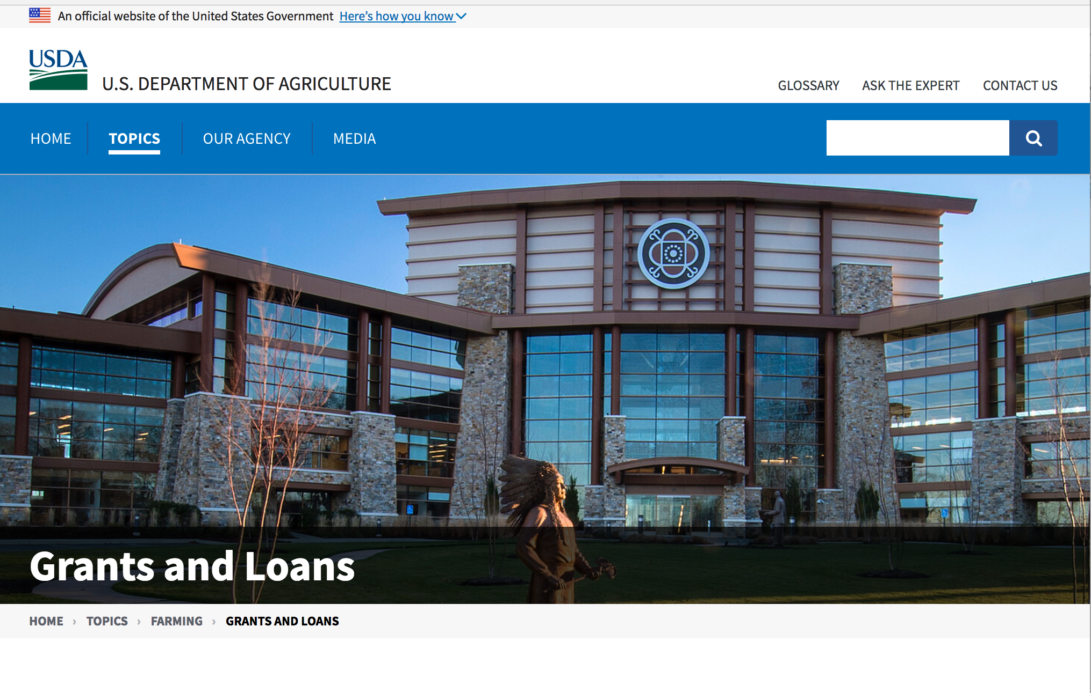

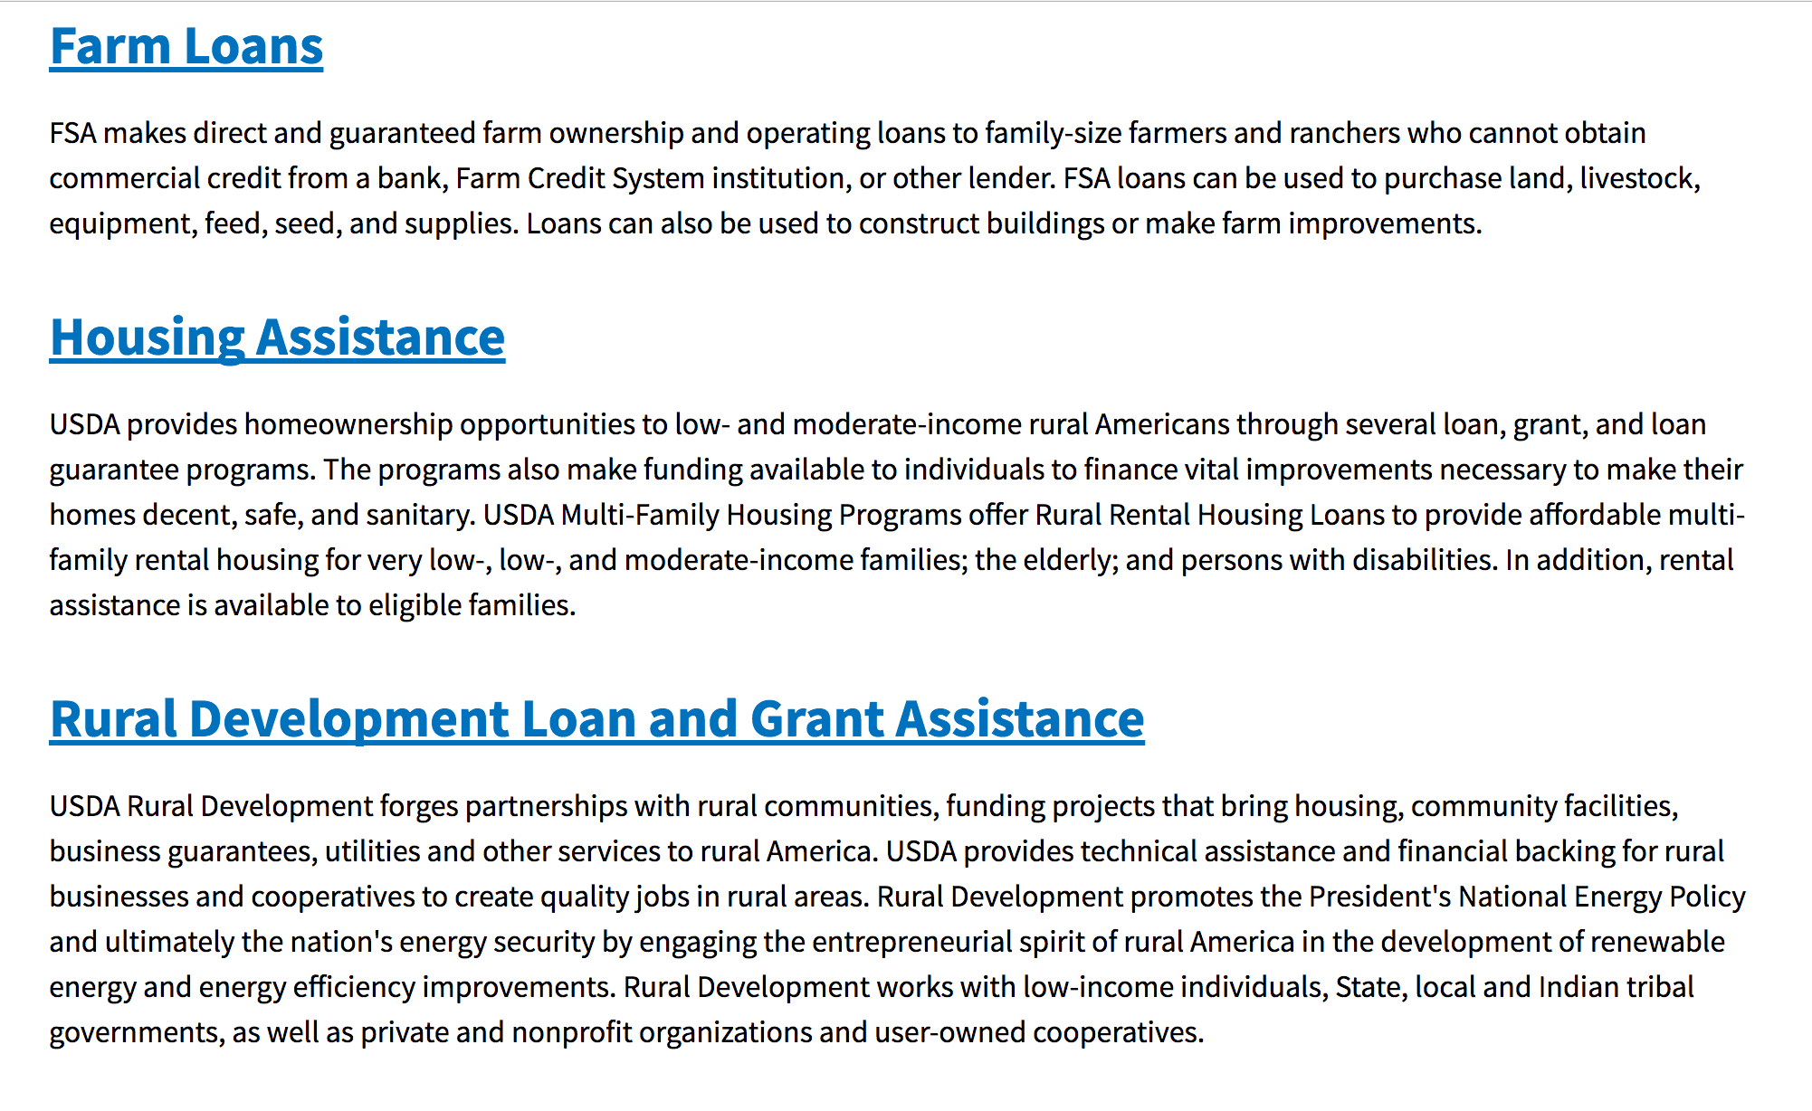

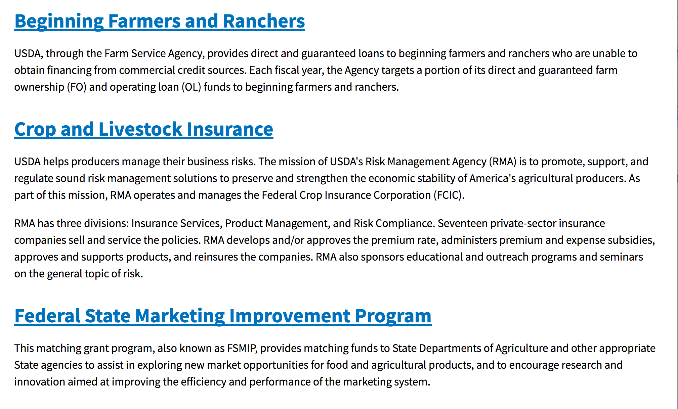
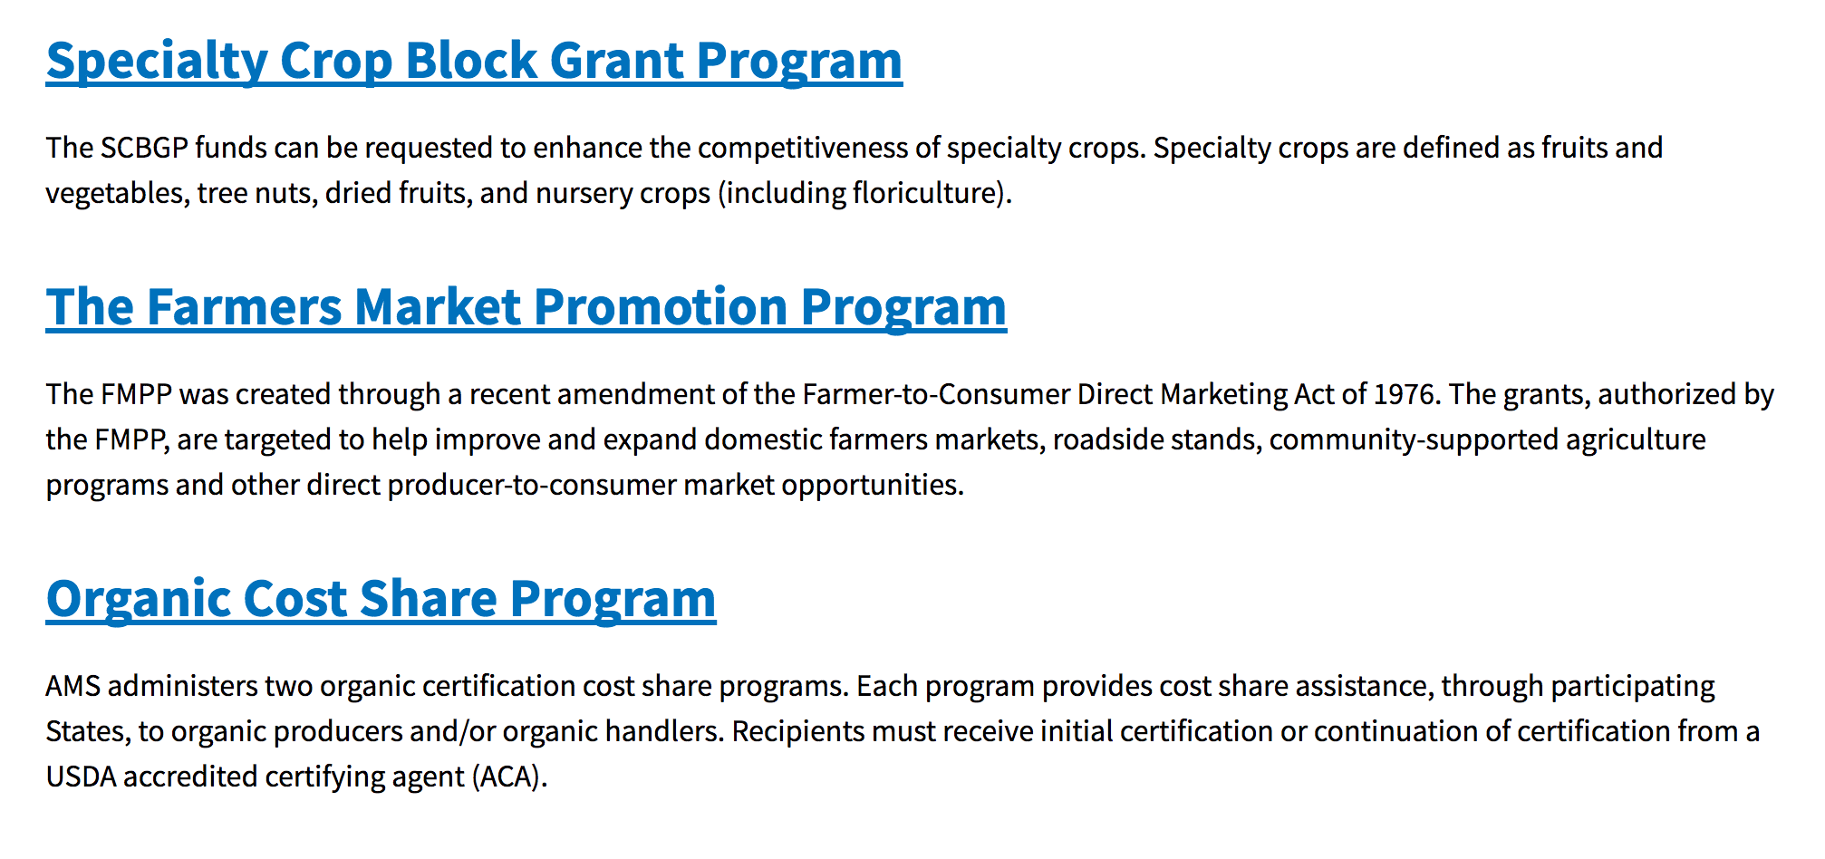
https://www.usda.gov/topics/farming/grants-and-loans

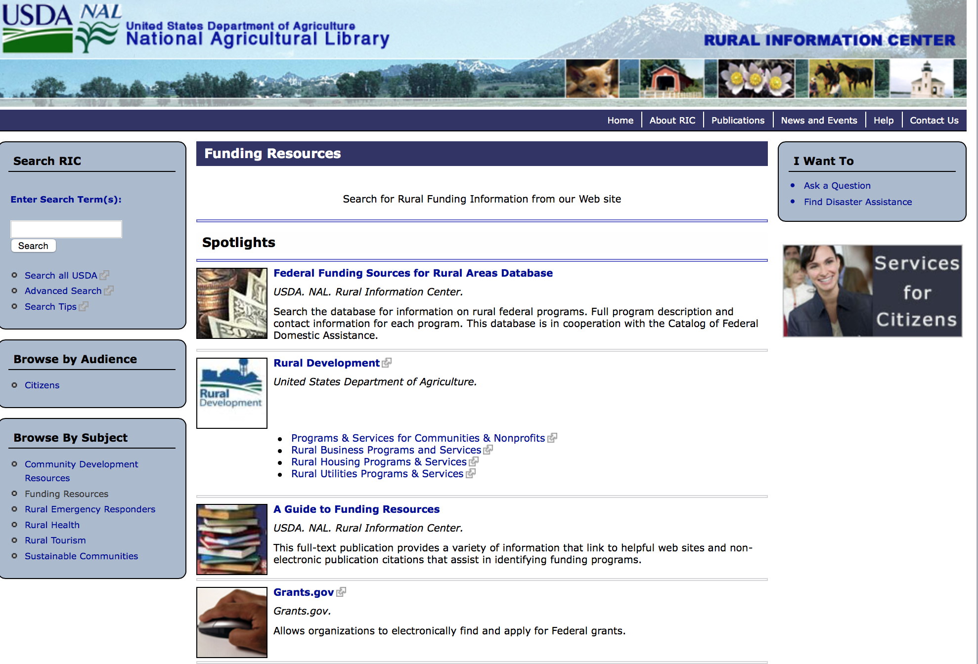

http://ric.nal.usda.gov/funding-resources

Programs:

National Institute of Food and Agriculture
Small Business Innovation Research Program - Phase I
Synopsis 1

Document Type: | Grants Notice
Funding Opportunity Number: | USDA-NIFA-SBIR-006365
Funding Opportunity Title: | Small Business Innovation Research Program - Phase I
Opportunity Category: | Discretionary
Opportunity Category Explanation:
Funding Instrument Type: | Grant
Category of Funding Activity: | Agriculture  Science and Technology and other Research and Development
Category Explanation:
Expected Number of Awards:
CFDA Number(s): | 10.212 -- Small Business Innovation Research
Cost Sharing or Matching Requirement: | No
Version: | Synopsis 1
Posted Date: | Jul 05, 2017
Last Updated Date: | Jul 05, 2017
Original Closing Date for Applications: | Oct 05, 2017
Current Closing Date for Applications: | Oct 05, 2017
Archive Date: | Nov 04, 2017
Eligible Applicants: | Others (see text field entitled "Additional Information on Eligibility" for clarification)
Additional Information on Eligibility: | See Part III, A. of the RFA for eligibility information.
Agency Name: | National Institute of Food and Agriculture
Description: | Proposed Phase I projects should prove the scientific or technical feasibility of the approach or concept. Projects dealing with agriculturally related manufacturing and alternative and renewable energy technologies are encouraged across all SBIR topic areas. USDA SBIR's flexible research areas ensure innovative projects consistent with USDA's vision of a healthy and productive nation in harmony with the land, air, and water. USDA SBIR Program has awarded over 2000 research and development projects since 1983, allowing hundreds of small businesses to explore their technological potential, and providing an incentive to profit from the commercialization of innovative ideas.
Link to Additional Information: | Small Business Innovation Research Program - Phase I
Grantor Contact Information: | If you have difficulty accessing the full announcement electronically, please contact:  NIFA Help Desk Phone: 202-401-5048 Business hours are M-F, 7:00 am -5:00 pm ET, excluding Federal holidays  If you have any questions related to preparing application content

http://www.grants.gov/web/grants/view-opportunity.html?oppId=295181

Research:

Modifications:

Reminders:

DM-Office of Advocacy and Outreach
Outreach and Assistance for Socially Disadvantaged Farmers and Ranchers and Veteran Farmers and Ranchers Program
Synopsis 1
Funding Opportunity Number: | OAO-011
Funding Opportunity Title: | Outreach and Assistance for Socially Disadvantaged Farmers and Ranchers and Veteran Farmers and Ranchers Program
Opportunity Category: | Mandatory
Opportunity Category Explanation:
Funding Instrument Type: | Grant
Category of Funding Activity: | Agriculture
Category Explanation:
Expected Number of Awards:
CFDA Number(s): | 10.443 -- Outreach and Assistance for Socially Disadvantaged and Veteran Farmers and Ranchers
Cost Sharing or Matching Requirement: | No
Version: | Synopsis 1
Posted Date: | Jun 26, 2017
Last Updated Date: | Jun 26, 2017
Original Closing Date for Applications: | Aug 07, 2017
Current Closing Date for Applications: | Aug 07, 2017
Archive Date: | Sep 06, 2017
Estimated Total Program Funding: | $8,400,000
Award Ceiling: | $200,000
Award Floor: | $0
Eligible Applicants: | Private institutions of higher education  Nonprofits that do not have a 501(c)(3) status with the IRS, other than institutions of higher education  Nonprofits having a 501(c)(3) status with the IRS, other than institutions of higher education  Public and State controlled institutions of higher education
Agency Name: | DM-Office of Advocacy and Outreach
Description: | Please refer to application instructions and package.
Link to Additional Information:
Grantor Contact Information: | If you have difficulty accessing the full announcement electronically, please contact:  Kenya Nicholas Program Manager Phone 202-720-6350  Office Email

http://www.grants.gov/web/grants/view-opportunity.html?oppId=294868

Agricultural Marketing Service
USDA-AMS-TM-SCMP-G-17-0005
Synopsis 2
Document Type: | Grants Notice
Funding Opportunity Number: | USDA-AMS-TM-SCMP-G-17-0005
Funding Opportunity Title: | USDA-AMS-TM-SCMP-G-17-0005
Opportunity Category: | Discretionary
Opportunity Category Explanation:
Funding Instrument Type: | Grant
Category of Funding Activity: | Agriculture
Category Explanation:
Expected Number of Awards: | 10
CFDA Number(s): | 10.170 -- Specialty Crop Block Grant Program - Farm Bill
Cost Sharing or Matching Requirement: | No
Version: | Synopsis 2
Posted Date: | Jun 26, 2017
Last Updated Date: | Jun 26, 2017
Original Closing Date for Applications: | Oct 24, 2017
Current Closing Date for Applications: | Oct 24, 2017
Archive Date: | Nov 23, 2017
Estimated Total Program Funding: | $7,000,000
Award Ceiling: | $1,000,000
Award Floor: | $250,000
Eligible Applicants: | Public and State controlled institutions of higher education
Agency Name: | Agricultural Marketing Service
Description: | The Agricultural Marketing Service (AMS) announces the availability of approximately $7 million in competitive grant funds to solely enhance the competitiveness of specialty crops through collaborative, multi-state projects that address the following regional or national level specialty crop issues: food safety; plant pests and disease; research; crop-specific common issues; and marketing and promotion. Specialty crops are defined as fruits and vegetables, dried fruit, tree nuts, horticulture and nursery crops, including floriculture. States are encouraged to submit projects that bring together multi-state teams of partners to research and develop solutions to practical problems that cross state boundaries and address the needs of specialty crop growers. Applications are due October 24, 2017.
Link to Additional Information: | SCMP website
Grantor Contact Information: | If you have difficulty accessing the full announcement electronically, please contact:  Martin Rosier Grants Manager Phone 2022608449  SCMP Office

http://www.grants.gov/web/grants/view-opportunity.html?oppId=295033

Fish and Wildlife Service
2017 National Fish Habitat Action Plan
Synopsis 1

Document Type: | Grants Notice
Funding Opportunity Number: | F17AS00016
Funding Opportunity Title: | 2017 National Fish Habitat Action Plan
Opportunity Category: | Discretionary
Opportunity Category Explanation:
Funding Instrument Type: | Cooperative Agreement  Grant
Category of Funding Activity: | Natural Resources
Category Explanation:
Expected Number of Awards: | 70
CFDA Number(s): | 15.608 -- Fish and Wildlife Management Assistance
Cost Sharing or Matching Requirement: | No
Posted Date: | Nov 08, 2016
Last Updated Date: | Nov 08, 2016
Original Closing Date for Applications: | Applications are accepted on a rolling basis.
Current Closing Date for Applications: | Applications are accepted on a rolling basis.
Archive Date: | May 31, 2017
Estimated Total Program Funding: | $0
Award Ceiling: | $300,000
Award Floor: | $5,000
Eligible Applicants: | Unrestricted (i.e., open to any type of entity above), subject to any clarification in text field entitled "Additional Information on Eligibility"
Additional Information on Eligibility: | Applications are accepted on a rolling basis.
Agency Name: | Fish and Wildlife Service
Description: | The National Fish Habitat Action Plan is a national investment strategy to leverage federal and privately raised funds to protect, restore, and enhance the nation's fish and aquatic habitats through partnerships that foster fish habitat conservation. Funds appropriated to the U.S. Fish and Wildlife Service's (Service) Fish and Aquatic Conservation (FAC) Program specifically to implement the Action Plan will be utilized in collaboration with the National Fish Habitat Board and Fish Habitat Partnerships. Fish Habitat Partnerships are the primary work units of the Action Plan, formed around distinct geographic areas, "keystone" fish species, or system types (e.g. large lakes, impoundments, estuaries). Funds will support national and regional science and coordination activities to protect, restore, or enhance fish habitats. All or a portion or project funds may be transferred to partner organizations if the Service lacks the capability to implement a project. Projects must protect, restore, or enhance fish and aquatic habitats or otherwise directly support habitat-related priorities of Fish Habitat Partnerships or the National Fish Habitat Board. Every project must be identified in the Fisheries Operational Needs System (FONS), a database that identifies the operational needs of FAC field stations, including fish habitat project needs. FAC field offices will work with Fish Habitat Partnerships to identify fish habitat projects, and enter them into the FONS. Entities that seek to propose a fish habitat conservation project for consideration should contact a local or regional office of the Service FAC Program.
Link to Additional Information: | http://www.grants.gov
Grantor Contact Information: | If you have difficulty accessing the full announcement electronically, please contact:  Cecilia Lewis 703-358-2102 Cecilia_Lewis@fws.gov  Fish Biologist

http://www.grants.gov/web/grants/view-opportunity.html?oppId=289987

Deleted:

Department of Commerce

Grants, Contracting, and Trade Opportunities at Commerce
Learn more information about grants, contracting and trade opportunities at the Department of Commerce using the information below.

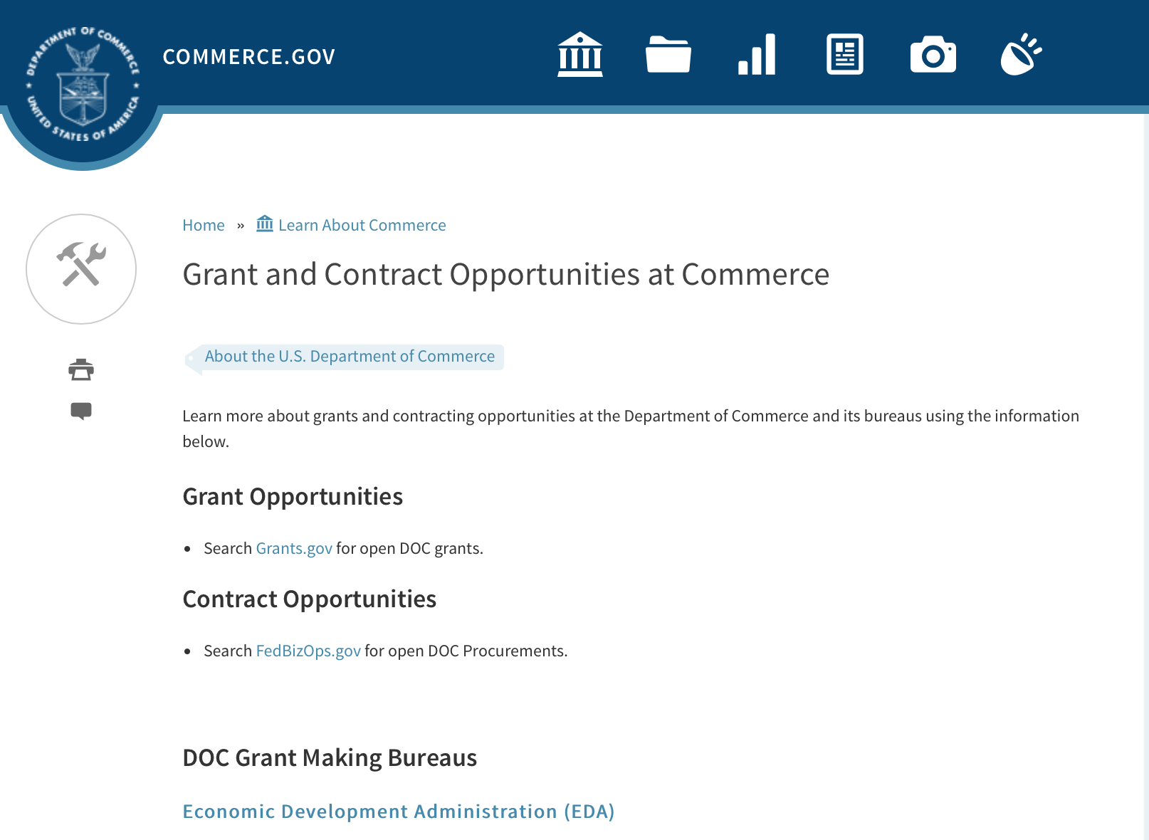
Grants at Commerce
DOC Grant Making Bureaus
Economic Development Administration (EDA)
International Trade Administration (ITA)
- Market Development Cooperator Program
- Special American Business Internship Training Program (SABIT). A technical assistance initiative of the International Trade Administration of the U.S. Department of Commerce, SABIT offers organizations competitive grants and an opportunity to host industry-specific delegations. SABIT serves as an initial entry point for U.S. businesses seeking funding to establish long-term relationships with potential customers, distributors, or partners in the former Soviet Union. The program trains Eurasian managers and scientists in commonly accepted business practices as a means of facilitating cross border relationships. In turn, these personal relationships serve as a basis for business development and reduce market access barriers for U.S. businesses
National Institute of Standards & Technology (NIST)
- Funding Opportunities
National Telecommunications & Information Administration (NTIA)
- Telecommunications Grants
National Oceanic & Atmospheric Administration (NOAA)
- Coastal Ocean Program Grant Information
- Fisheries Saltonstall Kennedy Grant Program
- National Undersea Research Program Funding Opportunities
- Grants Management Division
- Fisheries Grants Program
- National Sea Grant
- Office of Global Programs
Contracting Resources for Contractors
- Office of Small and Disadvantaged Business Utilization (OSDBU) - he Office of Small and Disadvantaged Business Utilization (OSDBU) is an advocacy and advisory office responsible for promoting the use of small, small disadvantaged, 8(a), women-owned, veteran-owned, service-disabled veteran-owned, and HUBZone small businesses within the U.S. Department of Commerce's (DOC) acquisition process.
- Business.USA.gov's Find Opportunities Wizard where in a few quick steps, it will guide you towards federal government contracting programs and opportunities for your business!
- Planned Acquisitions: the Department of Commerce's search tool for our planned acquisitions over $100,000. As requirements change, these acquisition plans are updated by department personnel and this search tool is automatically updated.
- Small Business Administration's Contracting section of their web site where you can learn about how to "Get Started" and "Contracting Support for Small Business"
- The General Services Administration (GSA) has implemented a system for vendors doing business with the Federal Government to manage their entity information in one central location. This new database is the System for Award Management (SAM).

DOC Contracting Offices
- Patent and Trademark Office (PTO)
  - Office of Procurement
- National Institute of Standards & Technology (NIST)
NIST Acquisition Management Group
Contracting Opportunities with Commerce
Trade Opportunities through Commerce
http://www.commerce.gov/about-commerce/grants-contracting-trade-opportunities

Programs:

John H. Prescott Marine Mammal Rescue Assistance Grant Program (Prescott Grant Program) for Fiscal Year 2018
Synopsis 1

Document Type: | Grants Notice
Funding Opportunity Number: | NOAA-NMFS-PRPO-2018-2005309
Funding Opportunity Title: | John H. Prescott Marine Mammal Rescue Assistance Grant Program (Prescott Grant Program) for Fiscal Year 2018
Opportunity Category: | Discretionary
Opportunity Category Explanation:
Funding Instrument Type: | Cooperative Agreement  Grant
Category of Funding Activity: | Environment  Natural Resources  Science and Technology and other Research and Development
Category Explanation:
Expected Number of Awards: | 40
CFDA Number(s): | 11.439 -- Marine Mammal Data Program
Cost Sharing or Matching Requirement: | Yes
Version: | Synopsis 1
Posted Date: | Jul 24, 2017
Last Updated Date: | Jul 24, 2017
Original Closing Date for Applications: | Oct 17, 2017
Current Closing Date for Applications: | Oct 17, 2017
Archive Date: | Nov 16, 2017
Estimated Total Program Funding: | $4,000,000
Award Ceiling: | $100,000
Award Floor: | $0
Eligible Applicants: | Others (see text field entitled "Additional Information on Eligibility" for clarification)
Additional Information on Eligibility: | : All eligible applicants must currently be an active, authorized participant or researcher in the National Marine Mammal Stranding Network. Eligible applicants must be: 1) Stranding Agreement (SA) holders or their designee organizations recognized by the applicable NMFS Region; or 2) Holders of researcher authorization letters issued by a NMFS Regional Administrator and/or an MMPA and/or ESA scientific research or enhancement permit (when applicable) including Co-Investigator authorization; or 3) An eligible Federal, state, or local government personnel or tribal personnel (pursuant to Section 109(h) of the MMPA (16 U.S.C. 1379(h)); or 4) Diagnostic or service organizations performing services for the stranding network. Federal agencies in the DOC or Department of the Interior (DOI) are not eligible to receive Federal assistance under this notice. 1. "In Good Standing Criteria". All eligible applicants must meet the following "in good standing" criteria: a. If the applicant is a designated Principal Investigator on a MMPA and/or ESA scientific research or enhancement permit or a Co-Investigator on the MMHSRP's MMPA/ESA scientific research and enhancement permit (permit No. 18786-01), the applicant must have fulfilled all permit requirements. The applicant must not have any pending or outstanding enforcement actions under the MMPA or ESA. b. The applicant must have complied with the terms and responsibilities of the appropriate SA, MMPA Section 109(h) authorization, or researcher authorization letter. This includes, but is not limited to: 1) completion of all reporting requirements; 2) cooperation with state, local, and federal officials; 3) cooperation with state and local officials in the disposition of stranded marine mammals; and 4) cooperation with stranding network participants. c. The applicant must have cooperated in a timely manner with NMFS in collecting and submitting Level B and Level C data and samples, when requested. d. The applicant must not have any current enforcement investigations for the take of marine mammals contrary to MMPA or ESA regulations. e. The applicant must not have any pending NMFS notice of violation(s) regarding the policies governing the goals and operations of the Stranding Network and SA, if applicable (e.g., probation, suspension, or termination). 2. Category Specific Criteria. Organizations and individuals must meet all of the following eligibility criteria specific to their category of participation in order for a proposal to be considered for funding: a. SA Holder Participant or SA Designee Participant - SA participants must hold a current, active SA for stranding response and/or rehabilitation from a NMFS Regional Administrator or the Assistant Administrator. SA Designee participants must be holding a current, active letter of designation from a NMFS SA holder authorized by NMFS. Designees cannot request authorization for activities beyond the scope of what is authorized by the SA to the agreement holder. b. Researcher Participant - Researcher participants must hold a current, active authorizing letter for the proposed award period from the appropriate NMFS Regional Administrator or the Assistant Administrator to salvage stranded marine mammal specimens, parts and samples for the purpose of utilization in scientific research (50 CFR 216.22). Researchers who are authorized under a MMPA/ESA scientific research or enhancement permit must still obtain an authorizing letter from the Regional Stranding Coordinator in order to use parts or specimens from stranded animals. Researcher participants that would not require an authorizing letter from the NMFS Regional Administrator (i.e., they will be working with data only and not possessing samples or specimens) must still provide a letter of eligibility from the Regional Stranding Coordinator (see section III.A.3. of this FFO). Researcher participants must also have designated Co-Investigator(s) that are active NMFS authorized Stranding Network participants in good standing, and provide documentation to this effect. c. State, Local, Federal Government Employees or Tribal Participants - State and local government officials or employees participating pursuant to Section 109(h) of the MMPA (16 U.S.C. 1379(h)) for marine mammal species not listed under the ESA must fulfill reporting obligations outlined in 50 CFR § 216.22. d. Diagnostic Laboratories – While diagnostic laboratories performing analyses for Stranding Network members do not need authorization from NMFS to receive and possess samples or specimens from stranded marine mammals (50 CFR § 216.22(c)(8)), diagnostic laboratory applicants must still provide a letter of eligibility from the MMHSRP at NMFS Headquarters (see section IV.B.7.a. of this FFO). When requesting a letter of eligibility, laboratories should submit examples of their diagnostic capabilities, diagnostic services proposed and their testing turn-around time to the MMHSRP (see section VII of this FFO for contact information). e. Service Organizations – Organizations without an existing SA that are receiving parts from the stranding network to perform analyses that are not diagnostic analyses (see Section VIII for definitions) must have a valid transfer authorization letter issued by the applicable NMFS Region. Organizations working with carcasses or live stranded animals in coordination with a stranding network member may or may not require additional authorization depending upon the service. All service organizations must provide a letter of eligibility from the MMHSRP at NMFS Headquarters (see section IV.B.7.a of this FFO). When requesting a letter of eligibility, service organizations should submit examples of their capabilities, services proposed, and their turn-around time (if applicable) to the MMHSRP (see section VII of this FFO for contact information). 3. Letter of Eligibility. All applicants must submit a letter of eligibility issued by the appropriate NMFS Regional Stranding Coordinator or the MMHSRP at NMFS Headquarters. This letter is required in order to be considered for an award in this funding cycle. The letter of eligibility states that you are: 1) an eligible Stranding Network participant, diagnostic laboratory, service organization, or permitted researcher at the time of the application submission and during the award period; 2) in good standing; 3) have a history of participation in/with the Stranding Network or that your organization is from a local area with no pre-existing stranding response and/or rehabilitation capabilities or your organization provides diagnostic or other services. A copy of your SA or research authorization will not be considered as proof of eligibility. Any proposal that does not provide a letter of eligibility from the NMFS Regional Stranding Coordinator (or NMFS Headquarters) will not be considered eligible and will not be considered for further review. Contact the NMFS Regional Stranding Coordinators (http://www.nmfs.noaa.gov/pr/health/coordinators.htm) or the Prescott Grant Program at the address in the Agency Contacts, Section VII of this FFO to request this letter. Federal agencies in the DOC or DOI are not eligible to receive Federal assistance under this notice. In addition, federal employees shall not provide assistance in writing any application, writing letters of support for any application, or otherwise confer any unfair advantage on a particular application. However, for activities involving collaboration with current NOAA programs, NOAA employees can write a letter verifying that they are collaborating with the project. This collaboration letter cannot support or endorse the applicant or project. MMHSRP staff and other Federal Program Officers can provide guidance on application procedures and proper completion of required forms. Applications encompassing activities conducted under the authority of a MMPA/ESA scientific research or enhancement permit issued to the DOC or DOI should include a copy of the permit and a letter from the Principal Investigator (DOC/DOI employee) verifying that the work is being conducted with their approval. Federal employee travel costs or salaries are not allowable costs under this program. Refer any questions about potential collaboration or support by non-DOC/DOI Federal employees to the official listed in Agency Contacts, Section VII. of this FFO.
Agency Name: | Department of Commerce
Description: | NOAA NMFS' Marine Mammal Health and Stranding Response Program is directed under the Marine Mammal Protection Act (MMPA) to facilitate the collection and dissemination of reference data on stranded marine mammals and health trends of marine mammal populations in the wild. The John H. Prescott Marine Mammal Rescue Assistance Grant Program is administered by NOAA to provide Federal assistance to eligible members of the National Marine Mammal Stranding Network to: 1) support basic needs of organizations for response, treatment, and data collection from living and dead stranded marine mammals, 2) fund scientific research objectives designed to answer questions about marine mammal strandings, health, or rehabilitation techniques utilizing data from living and dead stranded marine mammals, and 3) support facility operations directly related to the recovery, treatment, and data collection from living and dead stranded marine mammals. This document describes how to submit proposals for funding in fiscal year (FY) 2018 and how NMFS will determine which proposals may be funded. This announcement should be read in its entirety, as some information has changed from the previous year.
Link to Additional Information:
Grantor Contact Information: | If you have difficulty accessing the full announcement electronically, please contact:  Jaclyn Taylor Prescott Grant Program NOAA/NMFS/Office of Protected Resources (F/PR) 1315 East-West Highway, Room 13622 Silver Spring, MD 20910 Phone: (301) 427-8402 e-mail at Jaclyn.Taylor@noaa.gov  Work

http://www.grants.gov/web/grants/view-opportunity.html?oppId=295831

FY18 Cooperative Research Program (CRP)
Synopsis 1
Document Type: | Grants Notice
Funding Opportunity Number: | NOAA-NMFS-SE-2018-2005311
Funding Opportunity Title: | FY18 Cooperative Research Program (CRP)
Opportunity Category: | Discretionary
Opportunity Category Explanation:
Funding Instrument Type: | Cooperative Agreement
Category of Funding Activity: | Environment  Natural Resources  Science and Technology and other Research and Development
Category Explanation:
Expected Number of Awards: | 25
CFDA Number(s): | 11.454 -- Unallied Management Projects
Cost Sharing or Matching Requirement: | No
Version: | Synopsis 1
Posted Date: | Jul 14, 2017
Last Updated Date: | Jul 14, 2017
Original Closing Date for Applications: | Sep 22, 2017
Current Closing Date for Applications: | Sep 22, 2017
Archive Date: | Oct 22, 2017
Estimated Total Program Funding: | $2,000,000
Award Ceiling: | $250,000
Award Floor: | $25,000
Eligible Applicants: | Others (see text field entitled "Additional Information on Eligibility" for clarification)
Additional Information on Eligibility: | Eligible applicants may be institutions of higher education, nonprofits, commercial organizations, individuals, and state, local, and Indian tribal governments. Federal agencies or institutions are not eligible. Foreign governments, organizations under the jurisdiction of foreign governments, and international organizations are excluded for purposes of this solicitation since the objective of the CRP is to optimize research and development benefits from U.S. marine fishery resources. Applicants who are not commercial or recreational fisherman must have commercial or recreational fishermen participating in their project. There must be a written agreement with a fisherman describing the involvement in the project activity and the estimated dollar amount to be provided to that fisherman in compensation for his involvement.
Agency Name: | Department of Commerce
Description: | The Cooperative Research Program (CRP) provides opportunity to compete for financial assistance for projects seeking to improve and strengthen the relationship between fisheries researchers from NMFS, state fishery agencies, and universities and the U.S. fishing industry (recreational and commercial) in the Gulf of Mexico (FL, AL, MS, LA, TX), South Atlantic (FL, NC, SC, GA) and Caribbean (USVI and Puerto Rico). The program bolsters partnerships by providing a way for involving commercial and recreational fishermen in the collection of fundamental fisheries information in support of management and regulatory options. This program addresses NOAA's mission to "Protect, Restore, and Manage the Use of Coastal and Ocean Resources through an Ecosystem Approach to Management."
Link to Additional Information:
Grantor Contact Information: | If you have difficulty accessing the full announcement electronically, please contact:  Dax Ruiz, State/Federal Liaison Branch, (727) 824-5324, or Dax.Ruiz@noaa.gov.  Work

http://www.grants.gov/web/grants/view-opportunity.html?oppId=295524

Ocean Exploration FY 2018 Funding Opportunity
Synopsis 1 & 2
Document Type: | Grants Notice
Funding Opportunity Number: | NOAA-OAR-OER-2018-2005296
Funding Opportunity Title: | Ocean Exploration FY 2018 Funding Opportunity
Opportunity Category: | Discretionary
Opportunity Category Explanation:
Funding Instrument Type: | Cooperative Agreement  Grant
Category of Funding Activity: | Environment  Natural Resources  Science and Technology and other Research and Development
Category Explanation:
Expected Number of Awards: | 10
CFDA Number(s): | 11.011 -- Ocean Exploration
Cost Sharing or Matching Requirement: | No
Version: | Synopsis 2
Posted Date: | Jul 12, 2017
Last Updated Date: | Jul 14, 2017
Original Closing Date for Applications: | Dec 08, 2017
Current Closing Date for Applications: | Dec 08, 2017
Archive Date: | Jan 07, 2018
Estimated Total Program Funding: | $3,000,000
Award Ceiling: | $750,000
Award Floor: | $10,000
Eligible Applicants: | Others (see text field entitled "Additional Information on Eligibility" for clarification)
Additional Information on Eligibility: | Eligible applicants are institutions of higher education; non-profit institutions; state, local, and tribal governments; for-profit organizations; and U.S. territories that possess the statutory authority to accept funding for this type of work.
Agency Name: | Department of Commerce
Description: | NOAA’s Office of Ocean Exploration & Research (OER) seeks to enhance ocean exploration and scientific knowledge of the unknown or poorly known areas of the ocean. This entails identifying, describing and creating baseline characterizations of new ocean habitats, marine resources and/or processes. In this Announcement, OER is seeking proposals focused on three topics including: 1. Exploration of the deep marine environments in the US EEZ and US Outer Continental Shelf (OCS) of the Gulf of Mexico; 2. Discovery and exploration of prehistorically and historically significant submerged marine heritage sites in the Gulf of Mexico within the US EEZ and the US Outer Continental Shelf (OCS); and 3. Novel or innovative technologies and methodologies that could increase the pace and scope of ocean exploration, especially exploration of deep environments including the water column and archaeological sites. For themes 1 and 2, OER will not entertain proposals outside the US EEZ and the US Outer Continental Shelf (OCS) in the Gulf of Mexico. Proposals that combine more than one of these exploration topics are encouraged. All correspondence regarding this FFO must be sent to the email: oer.ffo2018@noaa.gov Applicants are required to submit pre-proposals and, ultimately, full proposals that support OER’s exploration mission. OER’s overarching objective is to investigate and document poorly known and unknown ocean areas through interdisciplinary exploration, and to advance and disseminate knowledge of the ocean’s physical, geological, chemical, biological, and archaeological environments. OER’s mission is compliant with NOAA’s Next Generation Strategic Plan (http://www.performance.noaa.gov/ngsp/) which outlines NOAA goals of Science, Service and Stewardship. Findings from projects and expeditions are anticipated to result in new baseline characterizations; provide better scientific understanding of the processes on US continental margins; offer new insights into climate variability and marine ecosystems; reveal new or unconventional energy, mineral, biological, and/or archaeological resources; help identify hazards resulting from extreme events such as submarine volcanic eruptions, earthquakes and tsunamis; and deliver technology advancements (platforms, sensors, methodologies, etc.) that will increase observational capabilities of the ocean. In FY18, OER anticipates availability of approximately $3,000,000 for this Funding Opportunity (this amount includes of costs for any required ship and/or submersible assets). Note: Ship time on the NOAA Ship Okeanos Explorer will not be funded through this announcement. Background information on how to apply and other informational documents are accessible through the OER Office Website: http://oceanexplorer.noaa.gov/about/what-we-do/funding-opportunities.html. Eligible applicants are institutions of higher education; non-profit institutions; for-profit organizations; state, local, and tribal governments, as well as U.S. territories that possess the statutory authority to accept funding for this type of work. Federal agencies that possess the statutory authority to accept funding for this type of work may also apply and must agree to take FY2018 funding for proposed projects. Federal and state agencies are strongly encouraged to collaborate with partners from a non-federal/non-state eligible entity. For the purpose of this opportunity, the buying of ship time and/or other ocean data collection platform support (remotely operated vehicles, autonomous underwater vehicles, etc.) is considered a rental cost and therefore not included in Modified Total Direct Cost (MTDC). OER funding will not be provided to hire and/or fund the salaries and associated overhead costs of any permanent federal or state government employee. OER will not pay Facilities and Administrative (F&A or "overhead") fees to federal and state agencies for subawards such as ship time or other ocean data collection platform support. Federal and state award recipients may use funding to cover travel, equipment, supplies, and contractual personnel costs associated with the proposed work. Foreign researchers may participate by submitting a subaward through collaboration with an eligible U.S. entity. The DOC and NOAA support cultural and gender diversity and encourage women and minority individuals and groups to submit applications to this Announcement of Federal Funding Opportunity. In addition, DOC/NOAA is strongly committed to broadening the participation of historically black colleges and universities, Hispanic serving institutions, tribal colleges and universities, and institutions that work in underserved areas. DOC/NOAA encourages applications involving any of the above institutions to apply.
Link to Additional Information:
Grantor Contact Information: | If you have difficulty accessing the full announcement electronically, please contact:  NOAA Office of Ocean Exploration and Research OER FFO 2018, SSMC3, Rm 10316, 1315 East West Highway, Silver Spring, Maryland 20910 (301) 734-1014  OER Group email

http://www.grants.gov/web/grants/view-opportunity.html?oppId=295442

Modifications:

Research:

Reminders:

Economic Development Administration
FY 2017 Economic Development Assistance Programs ­ Application submission and program requirements for EDA’s Public Works and Economic Adjustment Assistance programs.
Synopsis 1
Document Type: | Grants Notice
Funding Opportunity Number: | EDAP-2017
Funding Opportunity Title: | FY 2017 Economic Development Assistance Programs Application submission and program requirements for EDA’s Public Works and Economic Adjustment Assistance programs.
Opportunity Category: | Discretionary
Opportunity Category Explanation:
Funding Instrument Type: | Cooperative Agreement  Grant
Category of Funding Activity: | Other (see text field entitled "Explanation of Other Category of Funding Activity" for clarification)
Category Explanation: | The Economic Development Administration's (EDA's) mission is to lead the Federal economic development agenda by promoting innovation and competitiveness, preparing American regions for economic growth and success in the worldwide economy. EDA fulfills this mission through strategic investments and partnerships that create the regional economic ecosystems required to foster globally competitive regions throughout the United States. EDA supports development in economically distressed areas of the United States by fostering job creation and attracting private investment. Specifically, under the Economic Development Assistance programs (EDAP) Notice of Funding Availability (NOFA), EDA will make construction, non-construction, and revolving loan fund investments under the Public Works and Economic Adjustment Assistance (EAA) Programs. Through this NOFA, EDA will also designate a portion of its EAA funding to support communities and regions that have been negatively impacted by changes in the coal economy (Assistance to Coal Communities, or ACC 2017). Grants made under these programs will leverage regional assets to support the implementation of regional economic development strategies designed to create jobs, leverage private capital, encourage economic development, and strengthen America's ability to compete in the global marketplace. Through the EDAP NOFA, EDA solicits applications from rural and urban communities to develop initiatives that advance new ideas and creative approaches to address rapidly evolving economic conditions.
Expected Number of Awards:
CFDA Number(s): | 11.300 -- Investments for Public Works and Economic Development Facilities  11.307 -- Economic Adjustment Assistance
Cost Sharing or Matching Requirement: | Yes
Version: | Synopsis 1
Posted Date: | Jun 19, 2017
Last Updated Date: | Jun 19, 2017
Original Closing Date for Applications: | There are no submission deadlines under this opportunity. Proposals and applications will be accepted on an ongoing basis until the publication of a new EDAP NOFA.
Current Closing Date for Applications: | There are no submission deadlines under this opportunity. Proposals and applications will be accepted on an ongoing basis until the publication of a new EDAP NOFA.
Archive Date:
Estimated Total Program Funding:
Award Ceiling: | $3,000,000
Award Floor: | $100,000
Eligible Applicants: | Native American tribal organizations (other than Federally recognized tribal governments)  Special district governments  Others (see text field entitled "Additional Information on Eligibility" for clarification)  Private institutions of higher education  County governments  Native American tribal governments (Federally recognized)  City or township governments  Nonprofits that do not have a 501(c)(3) status with the IRS, other than institutions of higher education  State governments  Nonprofits having a 501(c)(3) status with the IRS, other than institutions of higher education  Public and State controlled institutions of higher education
Additional Information on Eligibility: | Eligible applicants for EDA financial assistance under the Public Works and EAA programs (including ACC 2017 funding) include a(n): (i) District Organization of a designated Economic Development District; (ii) Indian Tribe or a consortium of Indian Tribes; (iii) State, county, city, or other political subdivision of a State, including a special purpose unit of a State or local government engaged in economic or infrastructure development activities, or a consortium of political subdivisions; (iv) institution of higher education or a consortium of institutions of higher education; or (v) public or private non-profit organization or association acting in cooperation with officials of a political subdivision of a State. See Section 3 of the Public Works and Economic Development Act of 1965 (PWEDA) (42 U.S.C. § 3122) and 13 C.F.R. § 300.3. EDA is not authorized to provide grants or cooperative agreements to individuals or to for profit entities. Requests from such entities will not be considered for funding. For ACC 2017 funding, projects must be located within and targeted to communities or regions that have been impacted, or can reasonably demonstrate that they will be impacted, by coal mining or coal power plant employment loss, or employment loss in the supply chain industries of either.
Agency Name: | Economic Development Administration
Description: | Under this NOFA, EDA solicits applications from applicants in rural and urban areas to provide investments that support construction, non-construction, technical assistance, and revolving loan fund projects under EDA’s Public Works and EAA programs. Grants and cooperative agreements made under these programs are designed to leverage existing regional assets and support the implementation of economic development strategies that advance new ideas and creative approaches to advance economic prosperity in distressed communities, including communities and regions that have been impacted, or can reasonably demonstrate that they will be impacted, by coal mining or coal power plant employment loss, or employment loss in the supply chain industries of either. EDA provides strategic investments on a competitive- merit-basis to support economic development, foster job creation, and attract private investment in economically distressed areas of the United States. This EDAP NOFA supersedes the EDAP Federal Funding Opportunity dated December 23, 2016.
Link to Additional Information: | Economic Development Administration
Grantor Contact Information: | If you have difficulty accessing the full announcement electronically, please contact:  If you have difficulty accessing the full announcement electronically, please contact: the EDA representative for your state. A complete list of EDA representatives is available on EDA's website at http://www.eda.gov/contact/  http://www.eda.gov/contact/

http://www.grants.gov/web/grants/view-opportunity.html?oppId=294771

Climate Program Office 2018
Synopsis 2

Document Type: | Grants Notice
Funding Opportunity Number: | NOAA-OAR-CPO-2018-2005133
Funding Opportunity Title: | Climate Program Office 2018
Opportunity Category: | Discretionary
Opportunity Category Explanation:
Funding Instrument Type: | Grant
Category of Funding Activity: | Environment  Natural Resources  Science and Technology and other Research and Development
Category Explanation:
Expected Number of Awards: | 90
CFDA Number(s): | 11.431 -- Climate and Atmospheric Research
Cost Sharing or Matching Requirement: | No
Version: | Synopsis 2
Posted Date: | May 15, 2017
Last Updated Date: | May 15, 2017
Original Closing Date for Applications: | Sep 11, 2017
Current Closing Date for Applications: | Sep 11, 2017
Archive Date: | Oct 11, 2017
Estimated Total Program Funding: | $8,000,000
Award Ceiling: | $300,000
Award Floor: | $50,000
Eligible Applicants: | Others (see text field entitled "Additional Information on Eligibility" for clarification)
Additional Information on Eligibility: | Eligible applicants are institutions of higher education, other nonprofits, commercial organizations, international organizations, and state, local and Indian tribal governments. Federal agencies interested in receiving financial support for projects should contact the appropriate competition manager.
Agency Name: | Department of Commerce
Description: | The National Oceanic and Atmospheric Administration (NOAA) is focused on providing the essential and highest quality environmental information vital to our Nation’s safety, prosperity and resilience. Toward this goal, the agency conducts and supports weather and climate research, oceanic and atmospheric observations, modeling, information management, assessments, interdisciplinary decision-support research, outreach, education, and partnership development. Climate variability and change present society with significant economic, health, safety, and security challenges and opportunities. In meeting these challenges, and as part of NOAA’s climate portfolio within the Office of Oceanic and Atmospheric Research (OAR), the Climate Program Office (CPO) advances scientific understanding, monitoring, and prediction of climate and its impacts, to enable effective decisions. These investments are key to NOAA’s mission of "Science, Service, and Stewardship" and are guided by the agency’s vision to create and sustain enhanced resilience in ecosystems, communities, and economies. Within this context, CPO manages competitive research programs through which NOAA funds high-priority climate science, assessments, decision support research, outreach, education, and capacity-building activities designed to advance our understanding of the Earth’s climate system, and to foster the application and use of this knowledge to improve the resilience of our Nation and its partners. CPO supports research that is conducted across the United States and internationally. CPO also provides strategic guidance for the agency’s climate science and services programs and supports NOAA’s contributions to the U.S. Global Change Research Program (USGCRP) and its National Climate Assessment, and similar international endeavors such as the Global Framework for Climate Services. CPO’s climate research portfolio is designed to achieve a fully integrated research and applications program. We meet this objective through a focus on climate intelligence and climate resilience, in support of NOAA’s goals. Climate intelligence defines CPO’s technical strength through its foundational capabilities, which include (1) Observations and monitoring, (2) Research to advance scientific understanding, (3) Modeling and prediction, (4) Communication, education, and engagement, and, (5) Climate and societal interactions. A focus on climate resilience leverages CPO’s climate intelligence to advance capabilities for responding to the urgent and growing demand for reliable, trusted, transparent, and timely climate information needed to sustain all sectors of our economy and environment. CPO’s strategy addresses challenges in the areas of, (1) Weather and climate extremes, (2) Climate impacts on water resources, (3) Coasts and climate resilience, (4) Sustainability of marine ecosystems, and (5) Changing atmospheric composition and its impacts. Making progress in addressing climate-related societal challenges and realizing benefits for NOAA’s public and private partners, requires that these mission-focused capabilities be integrated across CPO to align research, applications, transitions, and operations, and to meet the information needs of a resilient society. NOAA envisions a Nation that is prepared for, thriving, and resilient to climate variability and change. CPO’s activities support a unique and highly flexible climate research enterprise to improve scientific understanding of climate variability and change and to enable businesses and communities to derive the benefits of this investment in the present and into the future. Effectively coordinating across these components through the development and deployment of end-to-end research-based integrated information systems that address needs of high societal relevance, have been hallmarks of CPO’s success in linking environmental intelligence to resilience. Key components in this enterprise are annual Federal Funding Opportunities, competitive grants programs and other types of support that advance and extend NOAA’s foundational capabilities and applications research. Proficiency in these core areas ensures that CPO’s infrastructure is always in place to meet the intelligence and resilience challenges of our changing climate. NOAA, OAR, and the Climate Program Office encourage applicants and awardees to support the principles of diversity and inclusion when writing their proposals and performing their work. Diversity is defined as a collection of individual attributes that together help organizations achieve objectives. Inclusion is defined as a culture that connects each employee to the organization. By promoting diversity and inclusion you can improve creativity, productivity, and the vitality of the research community.
Link to Additional Information:
Grantor Contact Information: | If you have difficulty accessing the full announcement electronically, please contact:  Diane Brown CPO Grants Manager  work

http://www.grants.gov/web/grants/view-opportunity.html?oppId=293866

National Institute of Standards and Technology
Measurement Science and Engineering (MSE) Research Grant Programs

Document Type: | Grants Notice
Funding Opportunity Number: | 2016-NIST-MSE-01
Funding Opportunity Title: | Measurement Science and Engineering (MSE) Research Grant Programs
Opportunity Category: | Discretionary
Opportunity Category Explanation:
Funding Instrument Type: | Cooperative Agreement  Grant
Category of Funding Activity: | Science and Technology and other Research and Development
Category Explanation:
Expected Number of Awards:
CFDA Number(s):
Cost Sharing or Matching Requirement: | No
Posted Date: | Feb 19, 2016
Last Updated Date: | Feb 19, 2016
Original Closing Date for Applications: | Applications will be accepted and considered on a rolling basis as they are received. See Section IV.4. in the text of the Full Announcement/FFO document. Applications may be submitted by paper or electronically through Grants.gov. Carefully read Section IV. of the Full Announcement/FFO document for details applying to electronic submissions and to paper submissions.
Current Closing Date for Applications: | Applications will be accepted and considered on a rolling basis as they are received. See Section IV.4. in the text of the Full Announcement/FFO document. Applications may be submitted by paper or electronically through Grants.gov. Carefully read Section IV. of the Full Announcement/FFO document for details applying to electronic submissions and to paper submissions.
Eligible Applicants: | Others (see text field entitled "Additional Information on Eligibility" for clarification)
Additional Information on Eligibility: | Eligibility for all programs listed in this FFO is open to all non-Federal entities. Eligible applicants include institutions of higher education, non-profit organizations, for-profit organizations, state and local governments, Indian tribes, hospitals, foreign public entities, and foreign governments. Applicants selected for awards under 15 U.S.C. § 278g-1 are encouraged, but not required, to select underrepresented minorities for participation. In addition, NIST is not able to accept an application from an individual unaffiliated with a sponsoring applicant organization.
Agency Name: | National Institute of Standards and Technology
Description: | NIST is soliciting applications for financial assistance for Fiscal Year 2016 (FY16) within the following NIST Laboratory grant programs: (1) the Material Measurement Laboratory (MML) Grant Program; (2) the Physical Measurement Laboratory (PML) Grant Program; (3) the Engineering Laboratory (EL) Grant Program; (4) the Fire Research (FR) Grant Program; (5) the Information Technology Laboratory (ITL) Grant Program; (6) the Communications Technology Laboratory (CTL) Grant Program; (7) the NIST Center for Neutron Research (NCNR) Grant Program; (8) the Center for Nanoscale Science and Technology (CNST) Grant Program; (9) the Special Programs Office (SPO) Grant Program; (10) the Standards Coordination Office (SCO) Grant Program; (11) the International and Academic Affairs Office (IAAO) Grant Program; and (12) the Associate Director for Laboratory Programs (ADLP) Grant Program.
Link to Additional Information: | 2016-NIST-MSE-01 Full Announcement/FFO document
Contact Information: | If you have difficulty accessing the full announcement electronically, please contact:  Christopher Hunton Management and Program Analyst Phone 301-975-5718  Agency Contact

http://www.grants.gov/web/grants/view-opportunity.html?oppId=281689

National Sea Grant College Program 2016-17 Special Projects Grant

Document Type: | Grants Notice
Funding Opportunity Number: | NOAA-OAR-SG-2016-2004772
Funding Opportunity Title: | National Sea Grant College Program 2016-17 Special Projects
Opportunity Category: | Discretionary
Funding Instrument Type: | Cooperative Agreement  Grant
Category of Funding Activity: | Environment  Natural Resources  Science and Technology and other Research and Development
Category Explanation:
Expected Number of Awards: | 30
CFDA Number(s): | 11.417 -- Sea Grant Support
Cost Sharing or Matching Requirement: | Yes
Posted Date: | Jan 7, 2016
Creation Date: | Jan 7, 2016
Original Closing Date for Applications: | Sep 30, 2017
Current Closing Date for Applications: | Sep 30, 2017
Archive Date: | Oct 30, 2017
Estimated Total Program Funding: | $4,000,000
Award Ceiling: | $1,000,000
Award Floor: | $1
Eligible Applicants: | Others (see text field entitled "Additional Information on Eligibility" for clarification)
Additional Information on Eligibility: | Sea Grant Programs (Sea Grant Colleges, Institutions, or Coherent Area Programs), the National Sea Grant Law Center, and the National Sea Grant Library.
Agency Name: | Department of Commerce
Description: | The purpose of this notice is to request proposals for special projects associated with the National Sea Grant College Program’s (Sea Grant) strategic focus areas, and to provide the general public with information and guidelines on how Sea Grant will select proposals and administer Federal assistance under this announcement. This announcement is a mechanism to encourage research or other projects that are not normally funded through Sea Grant national competitions. This opportunity is open only to Sea Grant Programs. Section III of this announcement describes eligibility requirements in more detail. Funding has not yet been made available to support applications submitted to this Federal Funding Opportunity (FFO), but such funding may become available during the year. Section II.A. below describes individual competition announcements that will be used to announce when funding is available; any restrictions or requirements on such funding, such as matching funds; and other funding details. Awards will be made under this FFO only if funds have been announced as provided in this FFO.
Link to Additional Information:
Contact Information: | If you have difficulty accessing the full announcement electronically, please contact:  Special Projects Competition Manager, NOAA R/SG National Sea Grant Office 1315 East-West Highway, Rm 11839 Silver Spring, MD 20910 301-734-1066  work

http://www.grants.gov/web/grants/view-opportunity.html?oppId=280846

FY 2016 – FY 2019 EDA Planning Program and Local Technical Assistance Program Grant

Document Type: | Grants Notice
Funding Opportunity Number: | EDA-HDQ-TA-HDQ-2016-2004759
Funding Opportunity Title: | FY 2016 – FY 2019 EDA Planning Program and Local Technical Assistance Program
Opportunity Category: | Discretionary
Funding Instrument Type: | Cooperative Agreement  Grant
Category of Funding Activity: | Other (see text field entitled "Explanation of Other Category of Funding Activity" for clarification)  Regional Development
Category Explanation: | Regional planning and local technical assistance
Expected Number of Awards:
CFDA Number(s): | 11.302 -- Economic Development Support for Planning Organizations  11.303 -- Economic Development Technical Assistance
Cost Sharing or Matching Requirement: | No
Posted Date: | Dec 10, 2015
Creation Date: | Dec 10, 2015
Original Closing Date for Applications: | Applications are accepted on a continuing basis and processed as received. This Planning and Local Technical Assistance opportunity will remain in effect until superseded by a future announcement.
Current Closing Date for Applications: | Applications are accepted on a continuing basis and processed as received. This Planning and Local Technical Assistance opportunity will remain in effect until superseded by a future announcement.
Archive Date:
Estimated Total Program Funding:
Award Ceiling: | $300,000
Award Floor: | $0
Eligible Applicants: | Nonprofits having a 501(c)(3) status with the IRS, other than institutions of higher education  City or township governments  Nonprofits that do not have a 501(c)(3) status with the IRS, other than institutions of higher education  Others (see text field entitled "Additional Information on Eligibility" for clarification)  Private institutions of higher education  Native American tribal governments (Federally recognized)  Public and State controlled institutions of higher education  State governments  Special district governments  County governments
Additional Information on Eligibility: | Pursuant to section 3 of the Public Works and Economic Development Act of 1965 (42 U.S.C. § 3122) (PWEDA) and EDA’s regulation at 13 C.F.R. § 300.3, the following types of entities are eligible to receive funding assistance from EDA: 1. District Organizations (as defined in 13 C.F.R. § 300.3); 2. Indian Tribes or a consortium of Indian Tribes; 3. States, cities, or other political subdivisions of a State, including a special purpose unit of a State or local government engaged in economic or infrastructure development activities, or a consortium of political subdivisions; 4. Institutions of higher education or a consortium of institutions of higher education; or 5. Public or private non-profit organizations or associations acting in cooperation with officials of a political subdivision of a State.
Agency Name: | Department of Commerce
Description: | Pursuant to PWEDA, EDA announces general policies and application procedures for grant-based investments under the Planning and Local Technical Assistance programs. Under the Planning program EDA assists eligible recipients in creating regional economic development plans designed to build capacity and guide the economic prosperity and resiliency of an area or region. As part of this program, EDA supports Partnership Planning investments to facilitate the development, implementation, revision, or replacement of Comprehensive Economic Development Strategies (CEDS), which articulate and prioritize the strategic economic goals of recipients’ respective regions. In general, EDA provides Partnership Planning grants to the designated planning organization (e.g., District Organization) serving EDA designated Economic Development Districts to enable these organizations to develop and implement relevant CEDS. In addition, EDA provides Partnership Planning grants to Indian Tribes to help develop and implement CEDS and associated economic development activities. The Planning program also helps support organizations, including District Organizations, Indian Tribes, and other eligible recipients, with Short Term and State Planning investments designed to guide the eventual creation and retention of high-quality jobs, particularly for the unemployed and underemployed in the Nation’s most economically distressed regions. The Local Technical Assistance program strengthens the capacity of local or State organizations, institutions of higher education, and other eligible recipients to undertake and promote effective economic development programs through projects such as feasibility analyses and impact studies.
Link to Additional Information: | www.eda.gov
Contact Information: | If you have difficulty accessing the full announcement electronically, please contact:  The EDA representative for your state. A complete list of EDA representatives is available on EDA's website at http://www.eda.gov/contact/

http://www.grants.gov/web/grants/view-opportunity.html?oppId=280447

Economic Development Administration
Planning Program and Local Technical Assistance Program Grant

Document Type: | Grants Notice
Funding Opportunity Number: | EDAPLANNING2012
Opportunity Category: | Discretionary
Posted Date: | Aug 03, 2012
Creation Date: | Aug 03, 2012
Original Closing Date for Applications: | Applications are accepted on a continuing basis and processed as received. This Planning and Local Technical Assistance opportunity will remain in effect until superseded by a future announcement.
Current Closing Date for Applications: | Applications are accepted on a continuing basis and processed as received. This Planning and Local Technical Assistance opportunity will remain in effect until superseded by a future announcement.
Archive Date:
Funding Instrument Type: | Cooperative Agreement  Grant
Category of Funding Activity: | Other (see text field entitled "Explanation of Other Category of Funding Activity" for clarification)  Regional Development
Category Explanation: | Regional planning and local technical assistance
Expected Number of Awards: | 425
Estimated Total Program Funding:
Award Ceiling: | $100,000
Award Floor:
CFDA Number(s): | 11.302 -- Economic Development Support for Planning Organizations
 | 11.303 -- Economic Development Technical Assistance
Cost Sharing or Matching Requirement: | Yes

Eligible Applicants
State governments
County governments
City or township governments
Public and State controlled institutions of higher education
Native American tribal governments (Federally recognized)
Nonprofits having a 501(c)(3) status with the IRS, other than institutions of higher education
Nonprofits that do not have a 501(c)(3) status with the IRS, other than institutions of higher education
Private institutions of higher education
Others (see text field entitled "Additional Information on Eligibility" for clarification)

Additional Information on Eligibility:
Pursuant to section 3 of the Public Works and Economic Development Act of 1965 (42 U.S.C. § 3122) (PWEDA) and EDA’s regulation at 13 C.F.R. § 300.3, the following types of entities are eligible to receive funding assistance from EDA: 1. District Organizations (as defined in 13 C.F.R. § 300.3); 2. Indian Tribes or a consortium of Indian Tribes; 3. States, cities, or other political subdivisions of a State, including a special purpose unit of a State or local government engaged in economic or infrastructure development activities, or a consortium of political subdivisions; 4. Institutions of higher education or a consortium of institutions of higher education; or 5. Public or private non-profit organizations or associations acting in cooperation with officials of a political subdivision of a State.

Agency Name
Economic Development Administration

Description
Pursuant to PWEDA, EDA announces general policies and application procedures for grant-based investments under the Planning and Local Technical Assistance programs. Under the Planning program EDA assists eligible recipients in creating regional economic development plans designed to stimulate and guide the economic development efforts of a community or region. As part of this program, EDA supports Partnership Planning investments to facilitate the development, implementation, revision, or replacement of Comprehensive Economic Development Strategies (CEDS), which articulate and prioritize the strategic economic goals of recipients' respective regions. In general, EDA provides Partnership Planning grants to the designated planning organization (e.g., District Organization) serving EDA-designated Economic Development Districts to enable these organizations to develop and implement relevant CEDS. In addition, EDA provides Partnership Planning grants to Indian Tribes to help develop and implement CEDS and associated economic development activities. The Planning program also helps support planning organizations, including District Organizations, Indian Tribes, and other eligible Recipients, with Short Term and State Planning investments designed to guide the eventual creation and retention of higher-skill, higher-wage jobs, particularly for the unemployed and underemployed in the Nation’s most economically distressed regions. The Local Technical Assistance program strengthens the capacity of local or State organizations, institutions of higher education, and other eligible recipients to undertake and promote effective economic development programs through projects such as feasibility analyses and impact studies.

Link to Additional Information

If you have difficulty accessing the full announcement electronically, please contact:
David Ives Planning and Local TA email

http://www.grants.gov/web/grants/view-opportunity.html?oppId=189193

Deleted:

ITA-INA-OPCM-2017-2004912 - Market Development Cooperator Program 2017
Deletion Comments: Opportunity deleted. Per the Program Officer email dated 3/22/17 this FFO is being deleted.

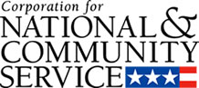

Corporation for National and Community Service

General Program Overview
AmeriCorps provides resources, both human and financial, to organizations that engage Americans in intensive service to meet our country’s critical needs.
Grantees use the funding to support AmeriCorps members for intensive service in their community. AmeriCorps grants partially cover the expense of operating an AmeriCorps program and do not cover general organizational expenses. A cash and in-kind match is required.

The main website can be accessed here: http://www.nationalservice.gov

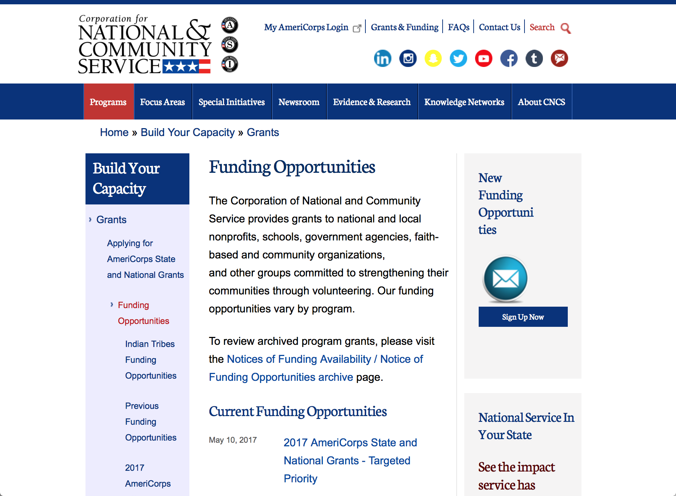

Current Funding Opportunities
There are no current funding opportunities.

For access to further funding information: click here

http://www.nationalservice.gov/build-your-capacity/grants/funding-opportunities

Programs:

Research:

Reminders:

National Service In Hawaii
National Service in Your State - Hawaii
2015-2016

Meeting Community Needs in Hawaii: More than 3,100 people of all ages and backgrounds are helping to meet local needs, strengthen communities, and increase civic engagement through national service in Hawaii. Serving at more than 450 locations throughout the state, these citizens tutor and mentor children, support veterans and military families, provide health services, restore the environment, respond to disasters, increase economic opportunity, and recruit and manage volunteers. This year, the Corporation for National and Community Service (CNCS) will commit more than $6,260,000 to support Hawaii communities through national service initiatives. Through a unique public-private partnership, this federal investment will leverage an additional $9,060,000 in other resources to strengthen community impact, build local support, and increase return on taxpayer dollars. Nationwide, CNCS, its grantees, and project sponsors generated more than $1.25 billion in outside resources from businesses, foundations, public agencies, and other sources in FY 2015.

AmeriCorps
This year, AmeriCorps will provide more than 560 individuals the opportunity to provide intensive, results-driven service to meet education, environmental, health, economic, and other pressing needs in communities across Hawaii. Most AmeriCorps grant funding goes to the Hawaii Commission on National & Community Service, which in turn awards grants to nonprofit groups to respond to local needs. Most of the remainder of the grant funding is distributed by CNCS directly to multi-state and national organizations through a competitive grants process. Other individuals serve through AmeriCorps VISTA, whose members help bring individuals and communities out of poverty by serving full-time to fight illiteracy, improve health services, create businesses, and increase housing opportunities, and AmeriCorps NCCC (National Civilian Community Corps), a 10-month, full time residential program for men and women between the ages of 18 and 24. In exchange for their service, AmeriCorps members earn an education award that can be used to pay for college or to pay back qualified student loans. Since 1994, more than 5,900 Hawaii residents have served more than 6.4 million hours and have qualified for Segal AmeriCorps Education Awards totaling more than $14,980,000.
Download: AmeriCorps in Hawaii (PDF)
Senior Corps
More than 2,500 seniors in Hawaii contribute their time and talents in one of three Senior Corps programs. Foster Grandparents serve one-on-one as tutors and mentors to more than 310 young people who have special needs. Senior Companions help more than 220 homebound seniors and other adults maintain independence in their own homes. RSVP volunteers conduct safety patrols, renovate homes, protect the environment, tutor and mentor youth, respond to natural disasters, and provide other services through more than 250 groups across Hawaii.
Download: Senior Corps in Hawaii (PDF)

The Corporation for National and Community Service is a federal agency that improves lives, strengthens communities, and fosters civic engagement through service and volunteering. CNCS annually engages more than five million Americans in service to meet local needs through Senior Corps, AmeriCorps, and national days of service; improves communities through the Social Innovation Fund, and leads President Obama's national call to service initiative, United We Serve. To learn more visit NationalService.gov or Serve.gov or call 202-606-5000 or TTY 1-800-833-3722.

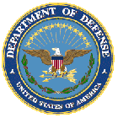

U.S. Department of Defense

Doing Business with the Department of Defense

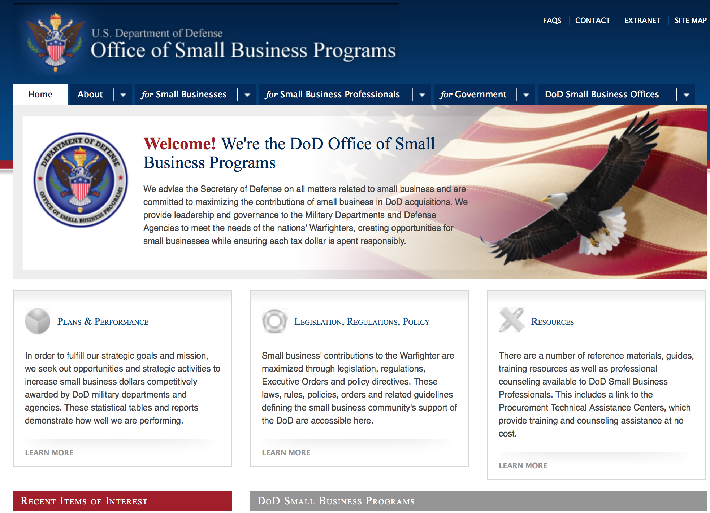
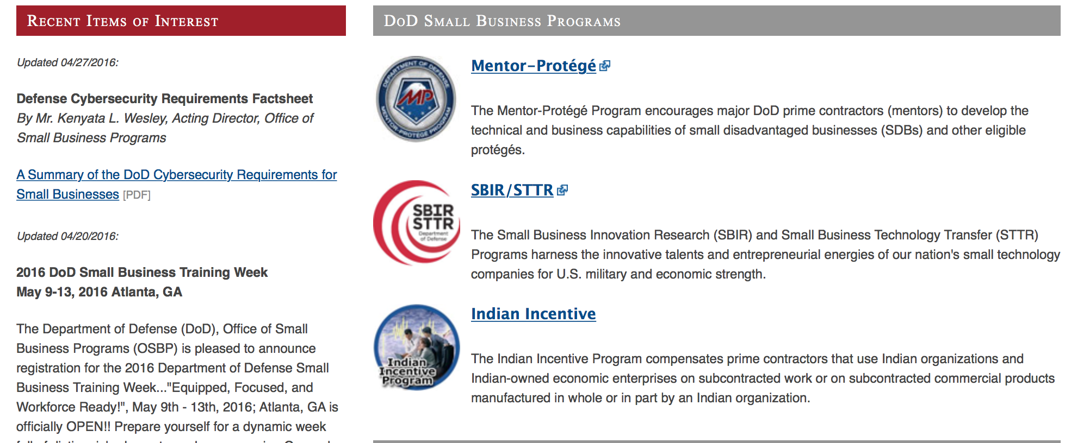

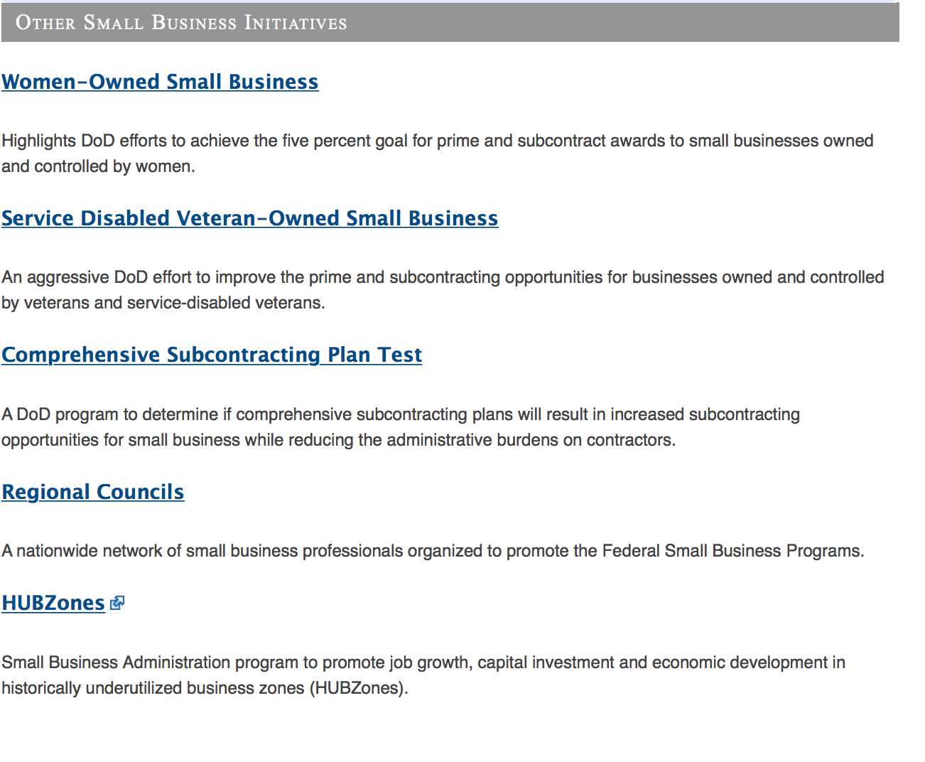
http://www.acq.osd.mil/osbp/

Doing Business with the DoD

Resources

Procurement Technical Assistance Centers (PTACs)

Procurement Technical Assistance Centers (PTACs) are charged with assisting businesses in learning how to do business with federal, state, and local governments. PTACs are a local resource available at no or nominal cost that can provide assistance to business firms in marketing their products and services. They offer training to businesses on how to research and bid on contracts, assist with registration requirements, provide bid-matching services, and assist with pre and post contracting issues.

Prime Contractors with Subcontracting Plans [xlsx]

Directory last updated 6/2017

This FY 2014 directory is intended for small business concerns seeking opportunities with DoD prime contractors. The directory is a listing of large business prime contractors who are required to establish subcontracting plans with goals. The report is generated from data contained in the Individual Subcontract Reports (ISRs) submitted in the Electronic Subcontracting Reporting System (eSRS) by contractors and from data contained in the Federal Procurement Data System (FPDS). The directory includes the name of the prime contractor; the major product/service code (PSC) provided to DoD; the major NAICS of the company; name, telephone number and email address of the company’s point of contact; contract number with the effective date and completion date, ultimate contract value and obligated dollars. In addition, many companies have websites with additional information which may be useful in your search for subcontracting opportunities or teaming arrangements.

Locate a Small Business Professional

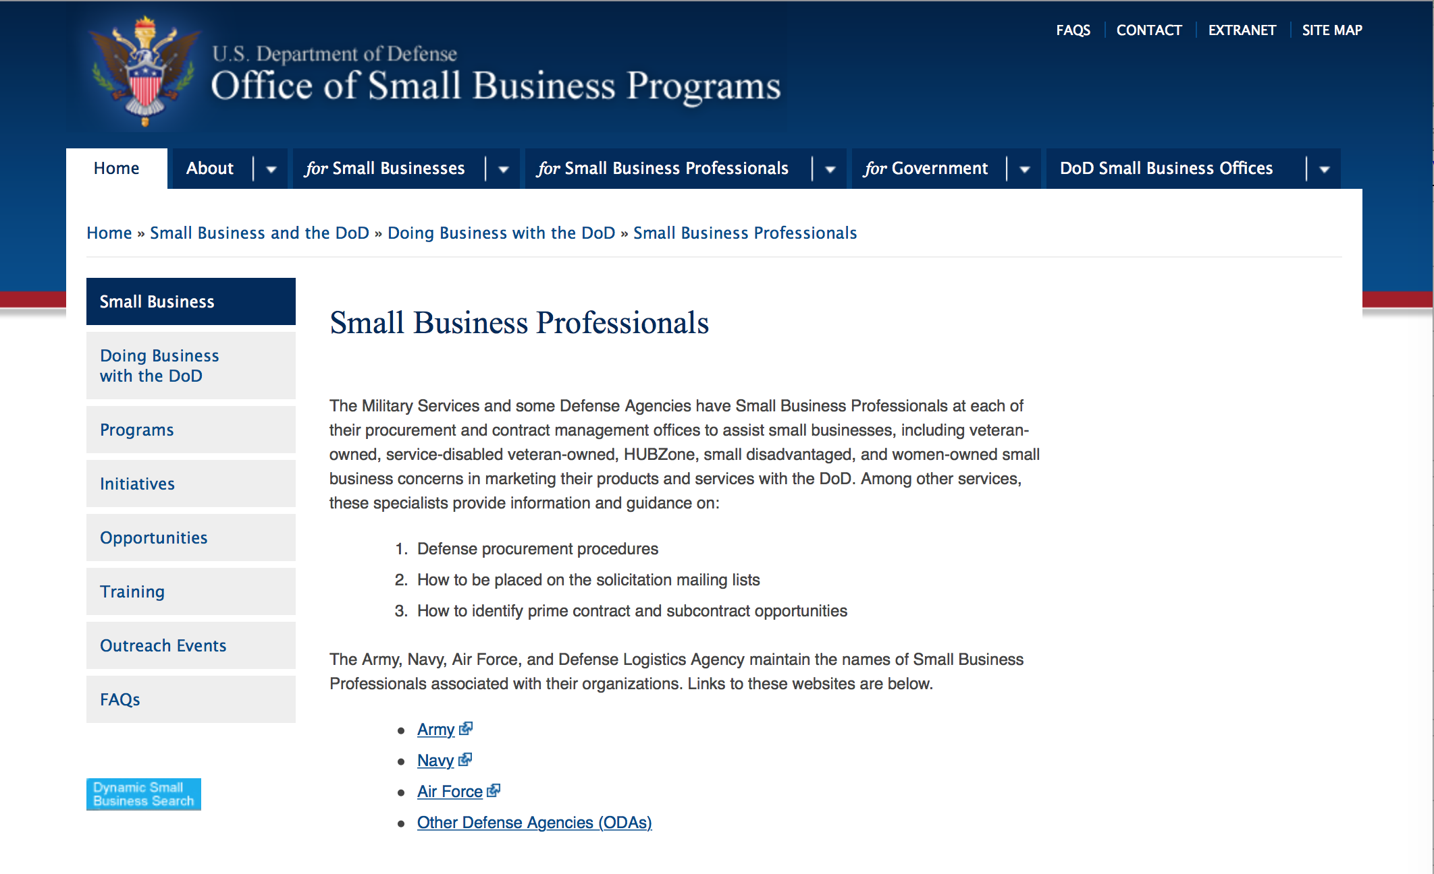

Non-Appropriated Fund Customers

Non-appropriated fund customers operate similar to non-profit organizations and include commissaries, exchanges, recreation and fitness centers, dining at officer/enlisted/civilian clubs, and barber/beauty services, just to name a few.

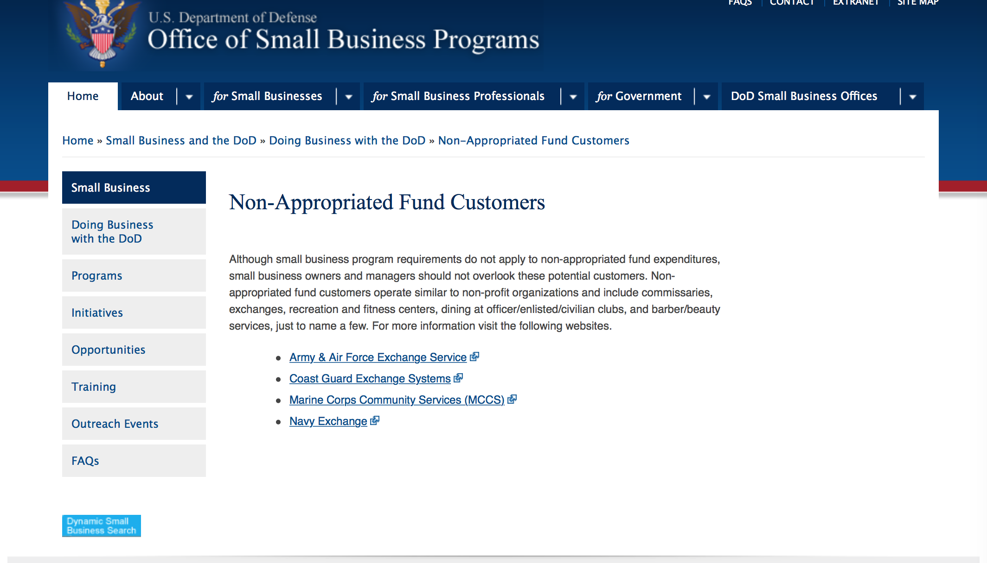

For more information click here.

Research:

Air Force -- Research Lab
Science and Technology for Autonomous Teammates (STAT)
Synopsis 1
http://www.grants.gov/web/grants/view-opportunity.html?oppId=295281

Dept. of the Army -- USAMRAA
DoD Epilepsy, Epilepsy Risk Factors Award
Synopsis 1
http://www.grants.gov/web/grants/view-opportunity.html?oppId=295755

Dept. of the Army -- USAMRAA
DoD Epilepsy, Idea Development Award
Synopsis 1
http://www.grants.gov/web/grants/view-opportunity.html?oppId=295756

Dept. of the Army -- USAMRAA
DoD, Peer Reviewed Alzheimer's
Synopsis 1 & 2
http://www.grants.gov/web/grants/view-opportunity.html?oppId=295757

Dept. of the Army -- USAMRAA
DoD Peer Reviewed Alzheimer's, New Investigator Research Award
Synopsis 1
http://www.grants.gov/web/grants/view-opportunity.html?oppId=295758

Dept. of the Army -- USAMRAA
DoD Peer Reviewed Alzheimer's, Research Partnership Award
Synopsis 1
http://www.grants.gov/web/grants/view-opportunity.html?oppId=295760

Dept. of the Army -- USAMRAA
DoD Peer Reviewed Alzheimer's, Quality of Life Research Award
Synopsis 1
http://www.grants.gov/web/grants/view-opportunity.html?oppId=295761

Defense Logistics Agency
Procurement Technical Assistance Program - Option Period
Synopsis 1
http://www.grants.gov/web/grants/view-opportunity.html?oppId=295441

Office of Naval Research
National Oceanographic Partnership Program (NOPP) 2018 Broad Agency Announcement
Synopsis 1
http://www.grants.gov/web/grants/view-opportunity.html?oppId=295516

Uniformed Services Univ. of the Health Sciences
TriService Nursing Research Program "A Call"
Synopsis 1
http://www.grants.gov/web/grants/view-opportunity.html?oppId=295301

Modifications:

Reminders:



Department of Education
Grant Programs Overview at the Department of Education

The general information page for Education Grant funding is an excellent resource describing the three types of grants awarded by the Department of Education. See the screen shot of the Department of Education web page below:

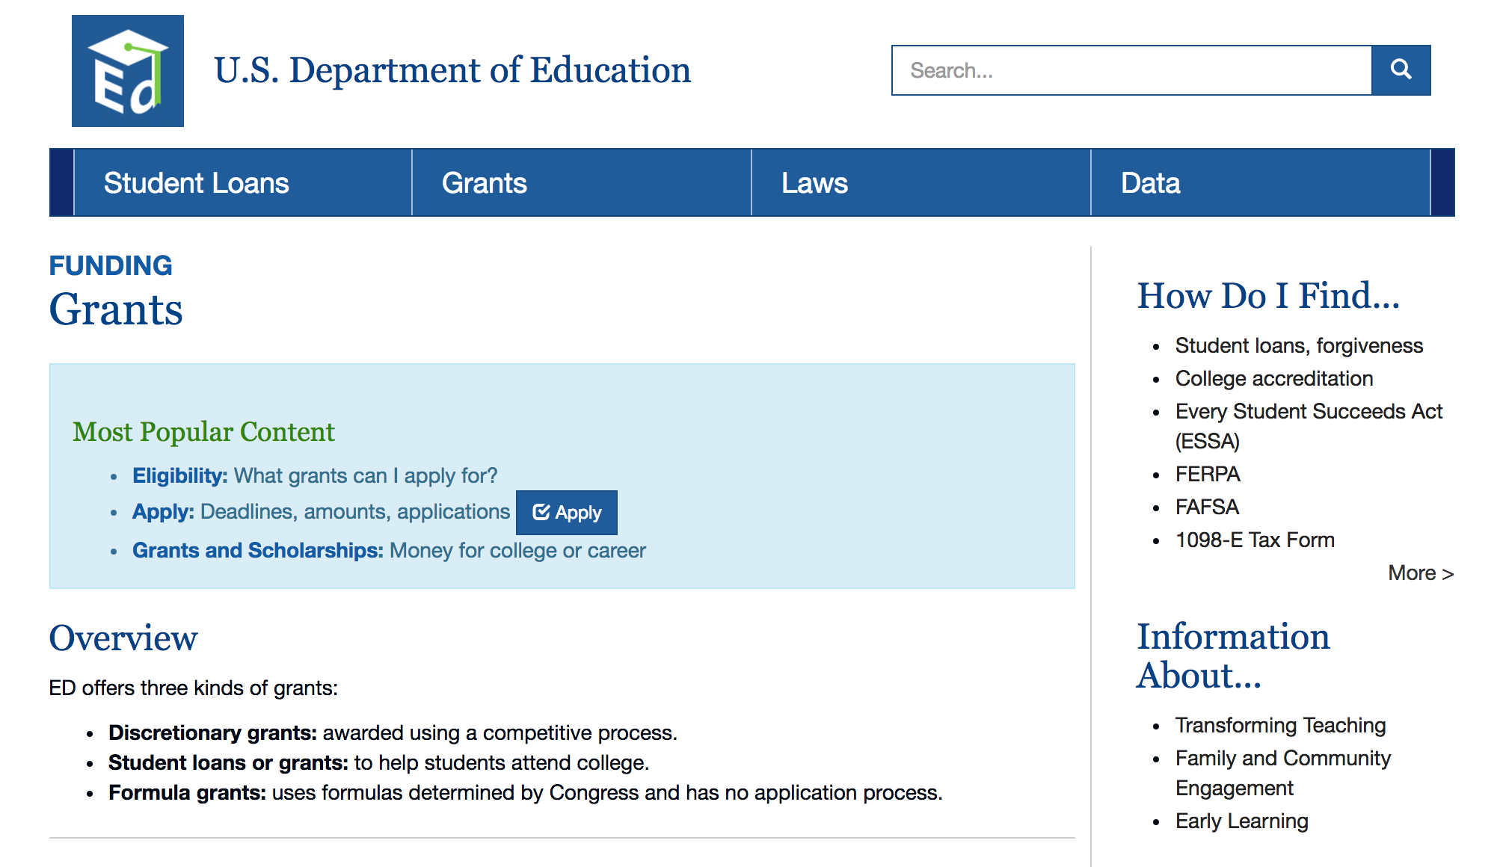
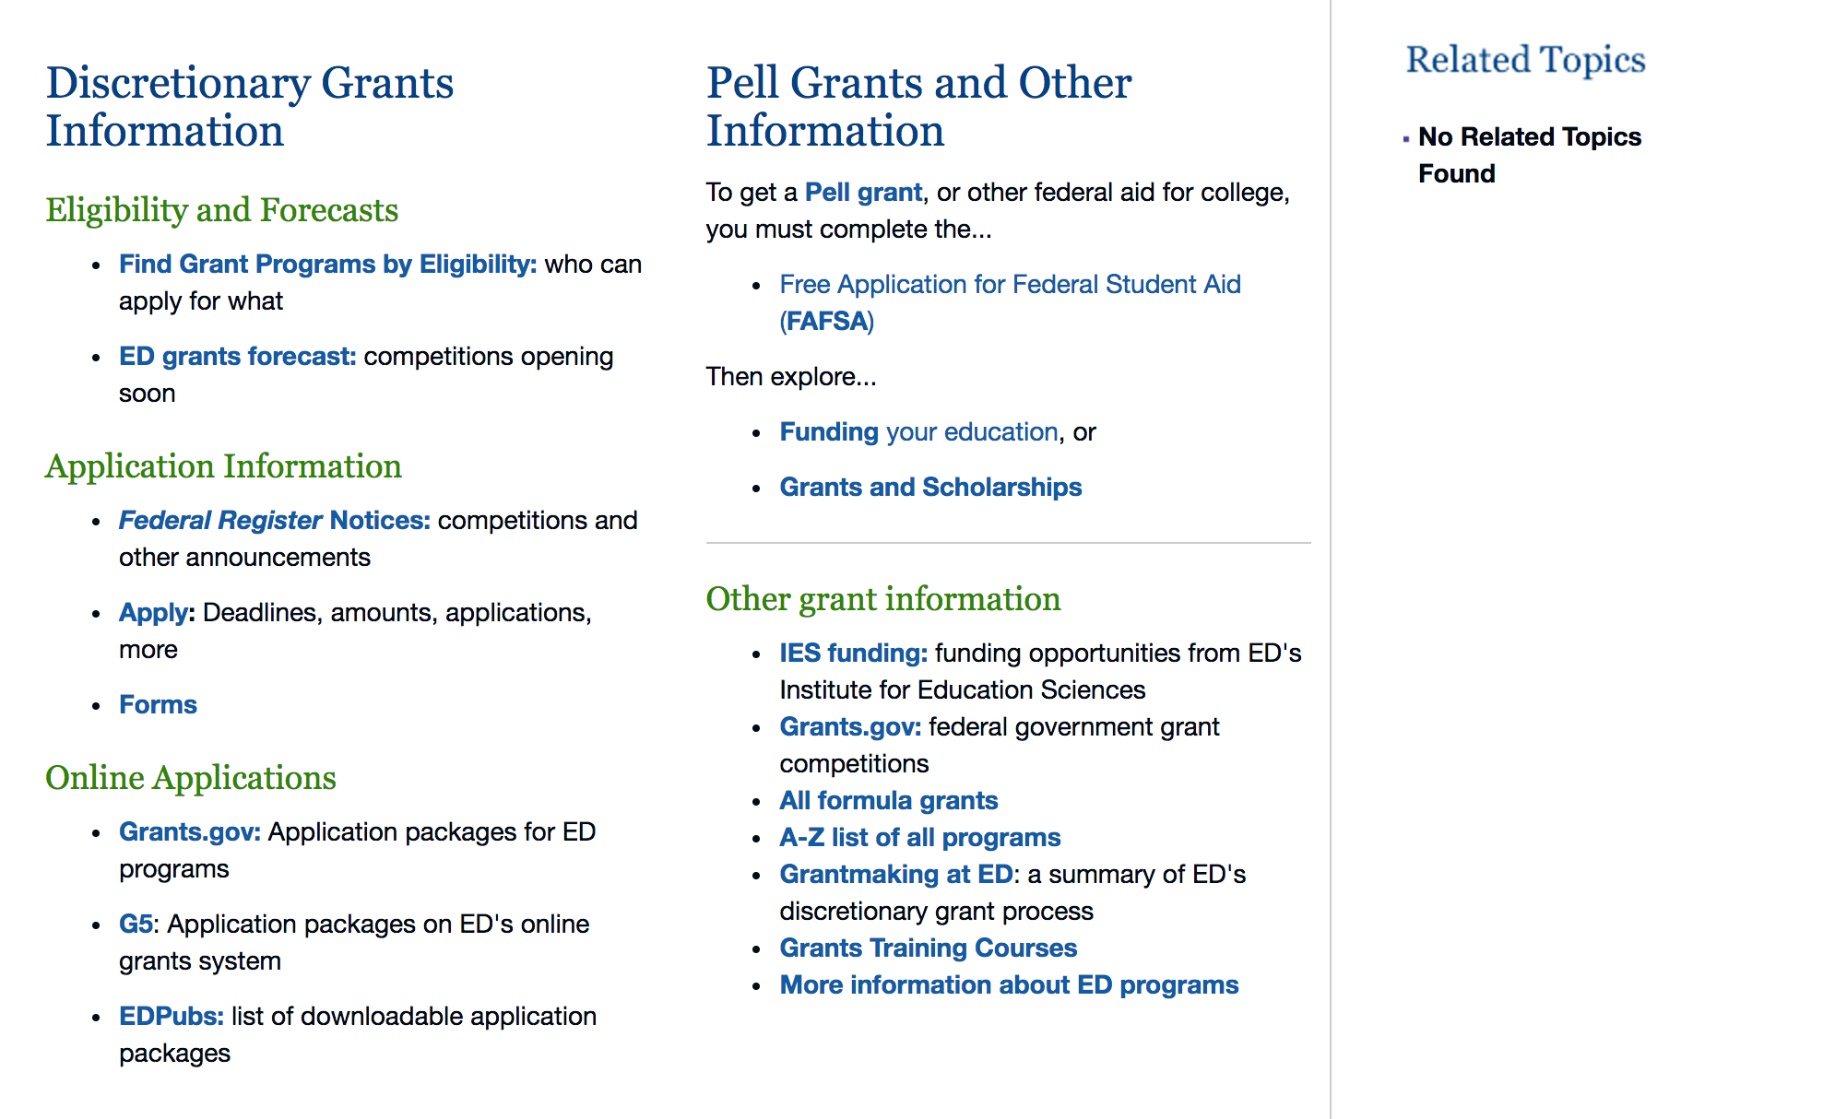

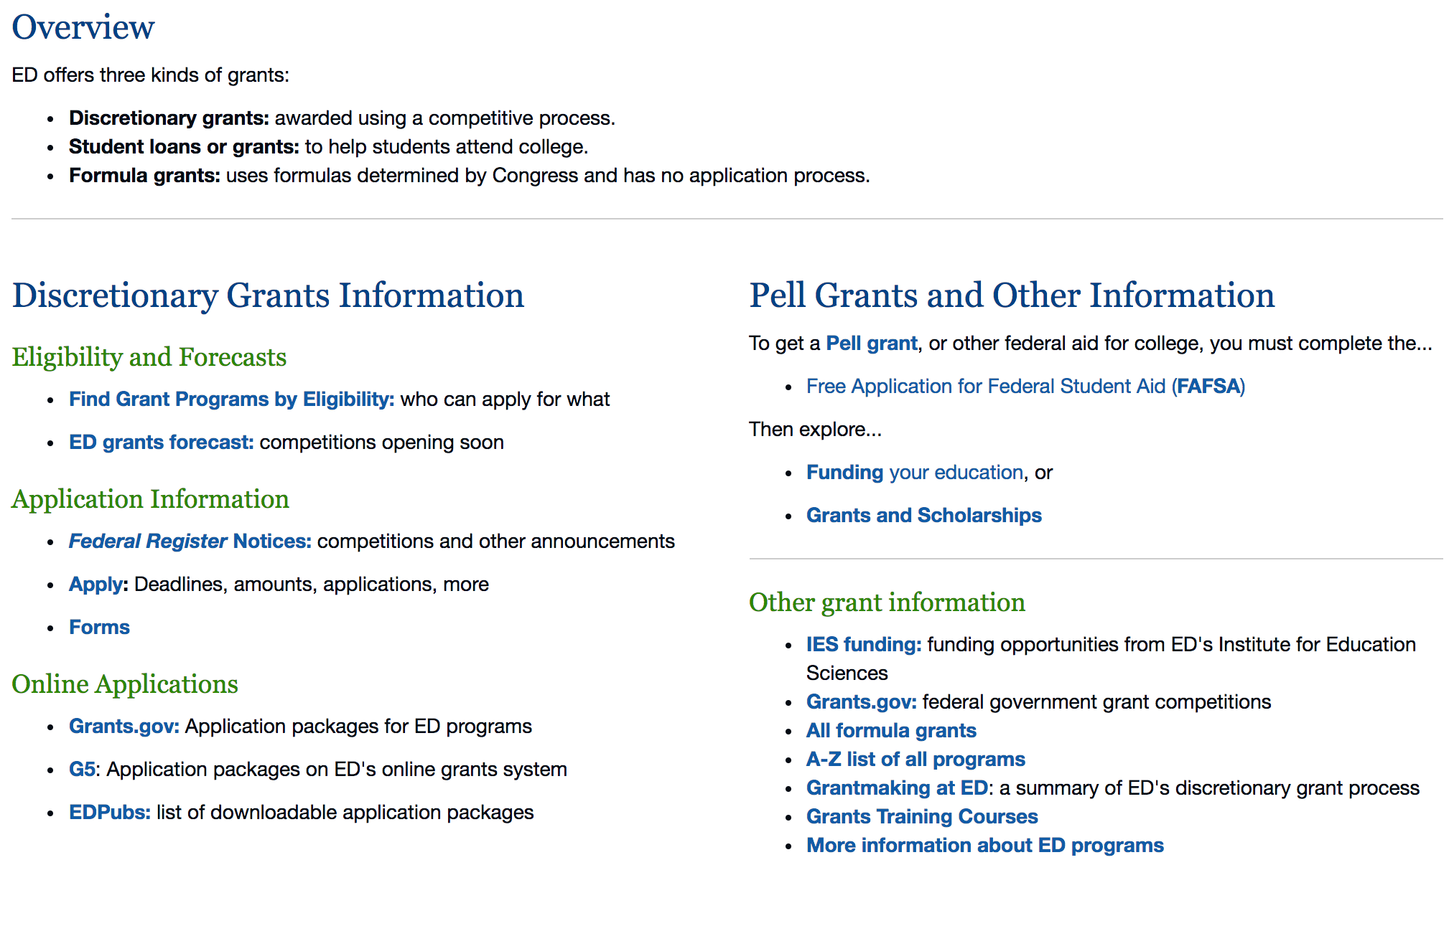

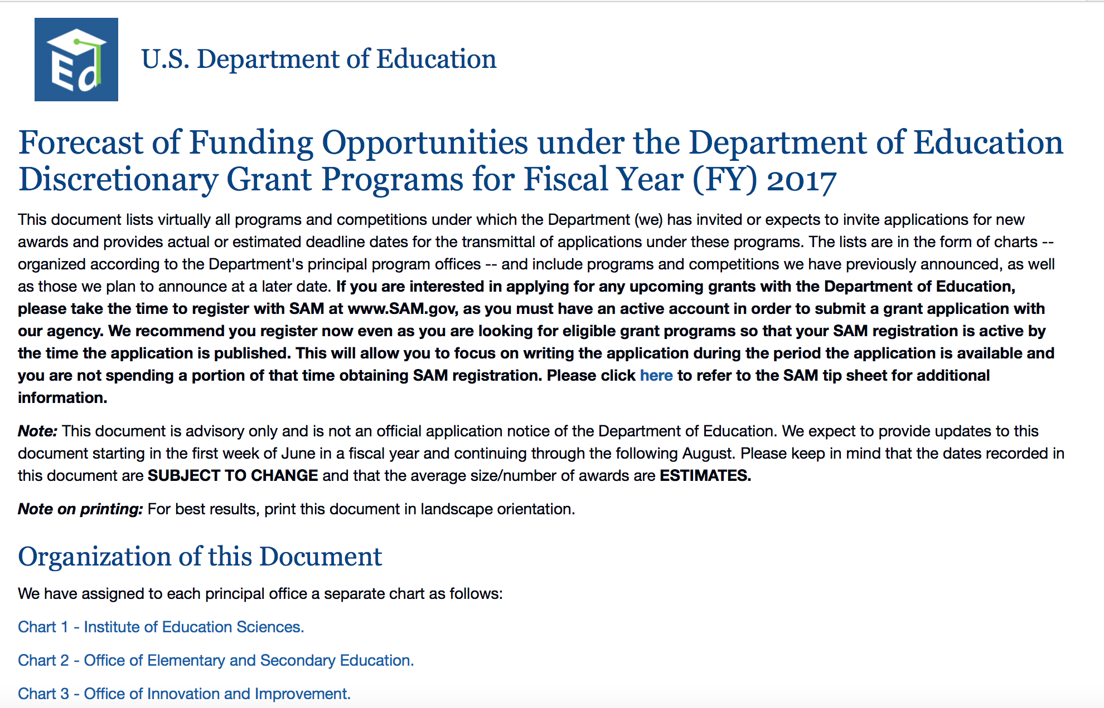
https://www2.ed.gov/fund/grants-apply.html?src=pn

Programs:

Office of Innovation and Improvement (OII): American History and Civics Education: National Activities Grants CFDA Number 84.422B
Synopsis 1
Document Type: |  | Grants Notice
Funding Opportunity Number: |  | ED-GRANTS-071117-001
Funding Opportunity Title: |  | Office of Innovation and Improvement (OII): American History and Civics Education: National Activities Grants CFDA Number 84.422B
Opportunity Category: |  | Discretionary
Opportunity Category Explanation:
Funding Instrument Type: |  | Grant
Category of Funding Activity: |  | Education
Category Explanation:
Expected Number of Awards: |  | 7
CFDA Number(s): |  | 84.422 -- Presidential and Congressional Academies for American History and Civics
Cost Sharing or Matching Requirement: |  | No
Version: | Synopsis 1
Posted Date: | Jul 11, 2017
Last Updated Date: | Jul 11, 2017
Original Closing Date for Applications: | Aug 21, 2017 Applications Available: July 11, 2017. Deadline for Notice of Intent to Apply: August 10, 2017. Date of Pre-Application Webinars: The Department of Education (Department) will host a pre-application webinar to provide technical assistance to interested applicants on July 18, 2017 at 2:30 p.m. eastern time. To join the webinar please go to the event address at https://educateevents.webex.com/educateevents/onstage/g.php?MTID=e0ff2dd5c36144d0f8e4ba71d69d03484. Deadline for Transmittal of Applications: August 21, 2017.
Current Closing Date for Applications: | Aug 21, 2017 Applications Available: July 11, 2017. Deadline for Notice of Intent to Apply: August 10, 2017. Date of Pre-Application Webinars: The Department of Education (Department) will host a pre-application webinar to provide technical assistance to interested applicants on July 18, 2017 at 2:30 p.m. eastern time. To join the webinar please go to the event address at https://educateevents.webex.com/educateevents/onstage/g.php?MTID=e0ff2dd5c36144d0f8e4ba71d69d03484. Deadline for Transmittal of Applications: August 21, 2017.
Archive Date: | Sep 20, 2017
Estimated Total Program Funding: | $1,700,000
Award Ceiling:
Award Floor:

Eligible Applicants: | Nonprofits that do not have a 501(c)(3) status with the IRS, other than institutions of higher education  Nonprofits having a 501(c)(3) status with the IRS, other than institutions of higher education  Others (see text field entitled "Additional Information on Eligibility" for clarification)  Public and State controlled institutions of higher education  Private institutions of higher education
Additional Information on Eligibility: | Eligible Applicants: An institution of higher education or other nonprofit or for-profit organization with demonstrated expertise in the development of evidence-based approaches with the potential to improve the quality of American history, civics and government, or geography learning and teaching. Note: If multiple eligible entities wish to form a consortium and jointly submit a single application, they must follow the procedures for group applications described in 34 CFR 75.127 through 34 CFR 75.129.
Agency Name: | Department of Education
Description: | Note: Each funding opportunity description is a synopsis of information in the Federal Register application notice. For specific information about eligibility, please see the official application notice. The official version of this document is the document published in the Federal Register. Free Internet access to the official edition of the Federal Register and the Code of Federal Regulations is available on GPO Access at: http://www.access.gpo.gov/nara/index.html. Please review the official application notice for pre-application and application requirements, application submission information, performance measures, priorities and program contact information. Purpose of Program: The American History and Civics Education-- National Activities Grants Program promotes innovative instruction, learning strategies, and professional development in American history, civics and government, and geography, with an emphasis on activities and programs that benefit low-income students and underserved populations. Background: This competition provides funding to support the development, implementation, expansion, evaluation, and dissemination of evidence-based instructional approaches and professional development activities and programs in American history, civics and government, and geography in elementary and secondary schools. This competition includes an absolute priority for projects serving high-need students to help these students improve learning outcomes for these students. This competition includes an absolute priority for projects that show potential to improve student achievement in, and teaching of, these subjects, and that demonstrate innovation, scalability, accountability, and a focus on underserved populations. Additionally, we include a competitive preference priority for projects that leverage technology to support professional development and instructional practice, which may lead to increased student engagement and help accelerate learning. This competition also includes a requirement for applicants to propose project-specific performance measures and performance targets consistent with the objectives of the proposed project. Applications must provide information on these measures and targets under 34 CFR 75.110(b) and (c). Catalog of Federal Domestic Assistance (CFDA) number 84.422B. Electronic Submission of Applications. Applications for grants under the American History and Civics Education--National Activities Grants Program, CFDA number 84.422B, must be submitted electronically using the Governmentwide Grants.gov Apply site at www.Grants.gov. Through this site, you will be able to download a copy of the application package, complete it offline, and then upload and submit your application. You may not email an electronic copy of a grant application to us. You may access the electronic grant application for the American History and Civics Education_National Activities Grants Program at www.Grants.gov. You must search for the downloadable application package for this competition by the CFDA number. Do not include the CFDA number's alpha suffix in your search (e.g., search for 84.422, not 84.422B).
Link to Additional Information: | Office of Innovation and Improvement (OII): American History and Civics Education: National Activities Grants CFDA Number 84.422B; Notice Inviting Applications for New Awards for Fiscal Year (FY) 2017
Grantor Contact Information: | If you have difficulty accessing the full announcement electronically, please contact:  Julius Cotton ED Grants.gov FIND Systems Admin. Phone 202-245-6288 EducationGrantInquiries@ed.gov Program Manager: Christine Miller, U.S. Department of Education, 400 Maryland Avenue SW., Room 4W205, Washington, DC 20202-5960. Or by email: Christine.Miller@ed.gov.  e-Mail: Program Manager

http://www.grants.gov/web/grants/view-opportunity.html?oppId=295343

The Office of Elementary and Secondary Education (OESE): Impact Aid Discretionary Construction Grant Program CFDA Number 84.041C
Synopsis 1
Document Type: | Grants Notice
Funding Opportunity Number: | ED-GRANTS-072117-002
Funding Opportunity Title: | The Office of Elementary and Secondary Education (OESE): Impact Aid Discretionary Construction Grant Program CFDA Number 84.041C
Opportunity Category: | Discretionary
Opportunity Category Explanation:
Funding Instrument Type: | Grant
Category of Funding Activity: | Education
Category Explanation:
Expected Number of Awards: | 8
CFDA Number(s): | 84.041 -- Impact Aid
Cost Sharing or Matching Requirement: | Yes
Version: | Synopsis 1
Posted Date: | Jul 21, 2017
Last Updated Date: | Jul 21, 2017
Original Closing Date for Applications: | Sep 15, 2017 Applications Available: July 21, 2017. Deadline for Transmittal of Applications: September 15, 2017.
Current Closing Date for Applications: | Sep 15, 2017 Applications Available: July 21, 2017. Deadline for Transmittal of Applications: September 15, 2017.
Archive Date: | Oct 15, 2017
Estimated Total Program Funding: | $17,400,000
Eligible Applicants: | Others (see text field entitled "Additional Information on Eligibility" for clarification)
Additional Information on Eligibility: | Eligible Applicants: An LEA must meet the absolute priority in this notice. An LEA is eligible to receive an emergency grant under the priority if it-- (a) Is eligible to receive formula construction funds for the fiscal year under section 7007(a) of the Act (20 U.S.C. 7707(a)) because it enrolls a high percentage (at least 50 percent) of federally connected children in average daily attendance (ADA) who either reside on Indian lands or who have a parent on active duty in the U.S. uniformed services. (b)(1) Has no practical capacity to issue bonds (as defined in 34 CFR 222.176); (2) Has minimal capacity to issue bonds (as defined in 34 CFR 222.176) and has used at least 75 percent of its bond limit; or (3) Is eligible to receive funds for the fiscal year for heavily impacted districts under section 7003(b)(2) of the Act (20 U.S.C. 7703(b)(2)); and (c) Has a school facility emergency that the Secretary has determined, consistent with 34 CFR 222.172(a) and 222.173, poses a health or safety hazard to students and school personnel.
Agency Name: | Department of Education
Description: | Purpose of Program: The Impact Aid Discretionary Construction Grant Program provides grants for emergency repairs and modernization of school facilities to certain local educational agencies (LEAs) that receive Impact Aid formula funds. Applications for grants under the Impact Aid Discretionary Construction Grant Program, CFDA number 84.041C, must be submitted electronically using the G5 system, accessible through the Department's G5 site at: www.G5.gov.
Link to Additional Information: | The Office of Elementary and Secondary Education (OESE): Impact Aid Discretionary Construction Grant Program CFDA Number 84.041C
Grantor Contact Information: | If you have difficulty accessing the full announcement electronically, please contact:  Joyce Mays Management Analyst Phone 202-245-6122 joyce.mays@ed.gov Program Officer Amanda Ognibene  Program Manager: email

http://www.grants.gov/web/grants/view-opportunity.html?oppId=295737

The Office of Innovation and Improvement (OII): Promise Neighborhoods Program CFDA Number 84.215N
Synopsis 1
Document Type: | Grants Notice
Funding Opportunity Number: | ED-GRANTS-072117-001
Funding Opportunity Title: | The Office of Innovation and Improvement (OII): Promise Neighborhoods Program CFDA Number 84.215N
Opportunity Category: | Discretionary
Opportunity Category Explanation:
Funding Instrument Type: | Grant
Category of Funding Activity: | Education
Category Explanation:
Expected Number of Awards: | 7
CFDA Number(s): | 84.215 -- Fund for the Improvement of Education
Cost Sharing or Matching Requirement: | No
Version: | Synopsis 1
Posted Date: | Jul 21, 2017
Last Updated Date: | Jul 21, 2017
Original Closing Date for Applications: | Sep 05, 2017 Applications Available: July 21, 2017. Deadline for Notice of Intent to Apply: August 21, 2017. Date of Pre-Application Webinars: The Promise Neighborhoods team intends to hold pre-application webinars to provide technical assistance to interested applicants. Detailed information regarding these webinar times will be provided on the Promise Neighborhoods' Web site at https://innovation.ed.gov/what-we-do/parental-options/promise-neighborhoods-pn/. Deadline for Transmittal of Applications: September 5, 2017.
Current Closing Date for Applications: | Sep 05, 2017 Applications Available: July 21, 2017. Deadline for Notice of Intent to Apply: August 21, 2017. Date of Pre-Application Webinars: The Promise Neighborhoods team intends to hold pre-application webinars to provide technical assistance to interested applicants. Detailed information regarding these webinar times will be provided on the Promise Neighborhoods' Web site at https://innovation.ed.gov/what-we-do/parental-options/promise-neighborhoods-pn/. Deadline for Transmittal of Applications: September 5, 2017.
Archive Date: | Oct 05, 2017
Estimated Total Program Funding: | $30,000,000
Eligible Applicants: | Others (see text field entitled "Additional Information on Eligibility" for clarification)
Additional Information on Eligibility: | Eligible Applicants: Under section 4623 of the ESEA, an eligible organization must: (1) Be representative of the geographic area proposed to be served; (2) Operate or propose to work with and involve in carrying out its proposed project, in coordination with the school's LEA, at least one public elementary or secondary school that is located within the identified geographic area that the grant will serve; (3) Be one of the following: (a) An institution of higher education, as defined in section 102 of the HEA (20 U.S.C. 1002); (b) An Indian Tribe or Tribal organization, as defined in section 4 of the Indian Self-Determination and Education Assistance Act (25 U.S.C. 5304); or (c) One or more nonprofit entities working in formal partnership with not less than one of the following entities: i. A high-need LEA. ii. An institution of higher education, as defined in section 102 of the HEA (20 U.S.C. 1002). iii. The office of a chief elected official of a unit of local government. iv. An Indian Tribe or Tribal organization, as defined under section 4 of the Indian Self-Determination and Education Assistance Act (25 U.S.C. 5304); and (4) Currently provide at least one of the solutions from the applicant's proposed pipeline services in the geographic area proposed to be served.
Agency Name: | Department of Education
Description: | Purpose of Program: The Promise Neighborhoods program is newly authorized under the Elementary and Secondary Education Act of 1965 (ESEA), as amended by the Every Succeeds Act (ESSA). The purpose of the Promise Neighborhoods program is to significantly improve the academic and developmental outcomes of children living in the most distressed communities of the United States, including ensuring school readiness, high school graduation, and access to a community-based continuum of high-quality services. The program serves neighborhoods with high concentrations of low-income individuals; multiple signs of distress, which may include high rates of poverty, childhood obesity, academic failure, and juvenile delinquency, adjudication, or incarceration; and schools implementing comprehensive support and improvement activities or targeted support and improvement activities under section 1111(d) of the ESEA. All strategies in the continuum of solutions must be accessible to children with disabilities and English learners. Applications for grants under this competition must be submitted electronically using the Grants.gov Apply site (Grants.gov). You must search for the downloadable application package for this competition by the CFDA number. Do not include the CFDA number's alpha suffix in your search (e.g., search for 84.215, not 84.215N).
Link to Additional Information: | The Office of Innovation and Improvement (OII): Promise Neighborhoods Program CFDA Number 84.215N
Grantor Contact Information: | If you have difficulty accessing the full announcement electronically, please contact:  Joyce Mays Management Analyst Phone 202-245-6122 joyce.mays@ed.gov Program Officer: Adrienne Hawkins U.S. Department of Education 400 Maryland Avenue SW., Room 4W256, Washington, DC 20202. Telephone: (202) 453-5638 or by email:  Program Manager: email

http://www.grants.gov/web/grants/view-opportunity.html?oppId=295751

Research:

Modifications:

Reminders:

Deleted:

U.S. Department of Energy

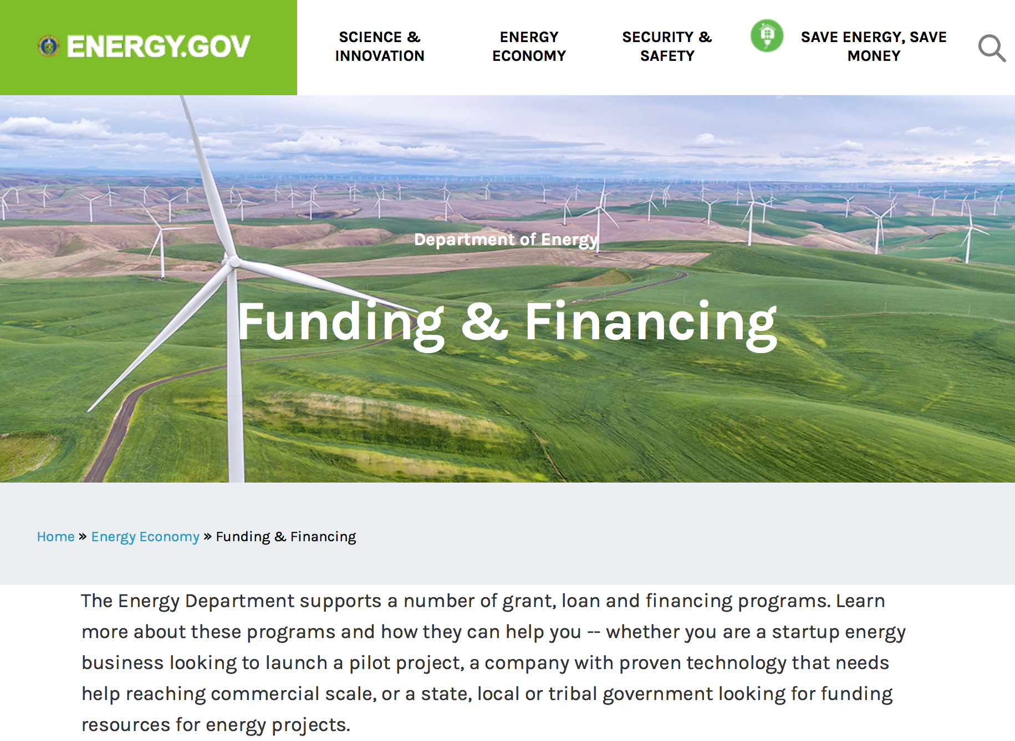
https://www.energy.gov/energy-economy/funding-financing

Research:

Advanced Research Projects Agency Energy
INTEGRATE FOA
Synopsis 1 & 2
http://www.grants.gov/web/grants/view-opportunity.html?oppId=295894

National Energy Technology Laboratory
Notice of Intent to issue DE-FOA-0001791 Design and Testing of Advanced Carbon Capture Technologies
Synopsis 1
http://www.grants.gov/web/grants/view-opportunity.html?oppId=295682

Office of Science
Collaborative Research on International and Domestic Spherical Tokamaks
Synopsis 1
http://www.grants.gov/web/grants/view-opportunity.html?oppId=295182

Modifications:

Golden Field Office
Request for Information (RFI): Clean Water Technologies
Synopsis 2
http://www.grants.gov/web/grants/view-opportunity.html?oppId=294177

Advanced Research Projects Agency Energy
SENSOR
Synopsis 2
http://www.grants.gov/web/grants/view-opportunity.html?oppId=291299

Reminders:

PAMS
Department of Energy - Office of Science
Office of Science
FY 2017 Continuation of Solicitation for the Office of Science Financial Assistance Program
Synopsis 2

Document Type: | Grants Notice
Funding Opportunity Number: | DE-FOA-0001664
Funding Opportunity Title: | FY 2017 Continuation of Solicitation for the Office of Science Financial Assistance Program
Opportunity Category: | Discretionary
Opportunity Category Explanation:
Funding Instrument Type: | Cooperative Agreement  Grant
Category of Funding Activity: | Science and Technology and other Research and Development
Category Explanation:
Expected Number of Awards: | 200
CFDA Number(s): | 81.049 -- Office of Science Financial Assistance Program
Cost Sharing or Matching Requirement: | No
Version: | Synopsis 2
Posted Date: | Sep 30, 2016
Last Updated Date: | Oct 04, 2016
Original Closing Date for Applications: | Sep 30, 2017
Current Closing Date for Applications: | Sep 30, 2017
Archive Date: | Oct 30, 2017
Estimated Total Program Funding:
Award Ceiling: | $4,000,000
Award Floor: | $2,000
Eligible Applicants: | Unrestricted (i.e., open to any type of entity above), subject to any clarification in text field entitled "Additional Information on Eligibility"
Agency Name: | Office of Science
Description: | The Office of Science (SC) of the Department of Energy hereby announces its continuing interest in receiving grant applications for support of work in the following program areas: Advanced Scientific Computing Research, Basic Energy Sciences, Biological and Environmental Research, Fusion Energy Sciences, High Energy Physics, and Nuclear Physics. On September 3, 1992, DOE published in the Federal Register the Office of Energy Research Financial Assistance Program (now called the Office of Science Financial Assistance Program), 10 CFR 605, as a Final Rule, which contained a solicitation for this program. Information about submission of applications, eligibility, limitations, evaluation and selection processes and other policies and procedures are specified in 10 CFR 605.
Link to Additional Information: | http://science.energy.gov/~/media/grants/pdf/foas/2017/SC_FOA_0001664.pdf
Grantor Contact Information: | If you have difficulty accessing the full announcement electronically, please contact:  Kimberlie Laing Grant Analyst Phone 301-903-3026  kim.laing@science.doe.gov

http://www.grants.gov/web/grants/view-opportunity.html?oppId=289281

Environmental Protection Agency

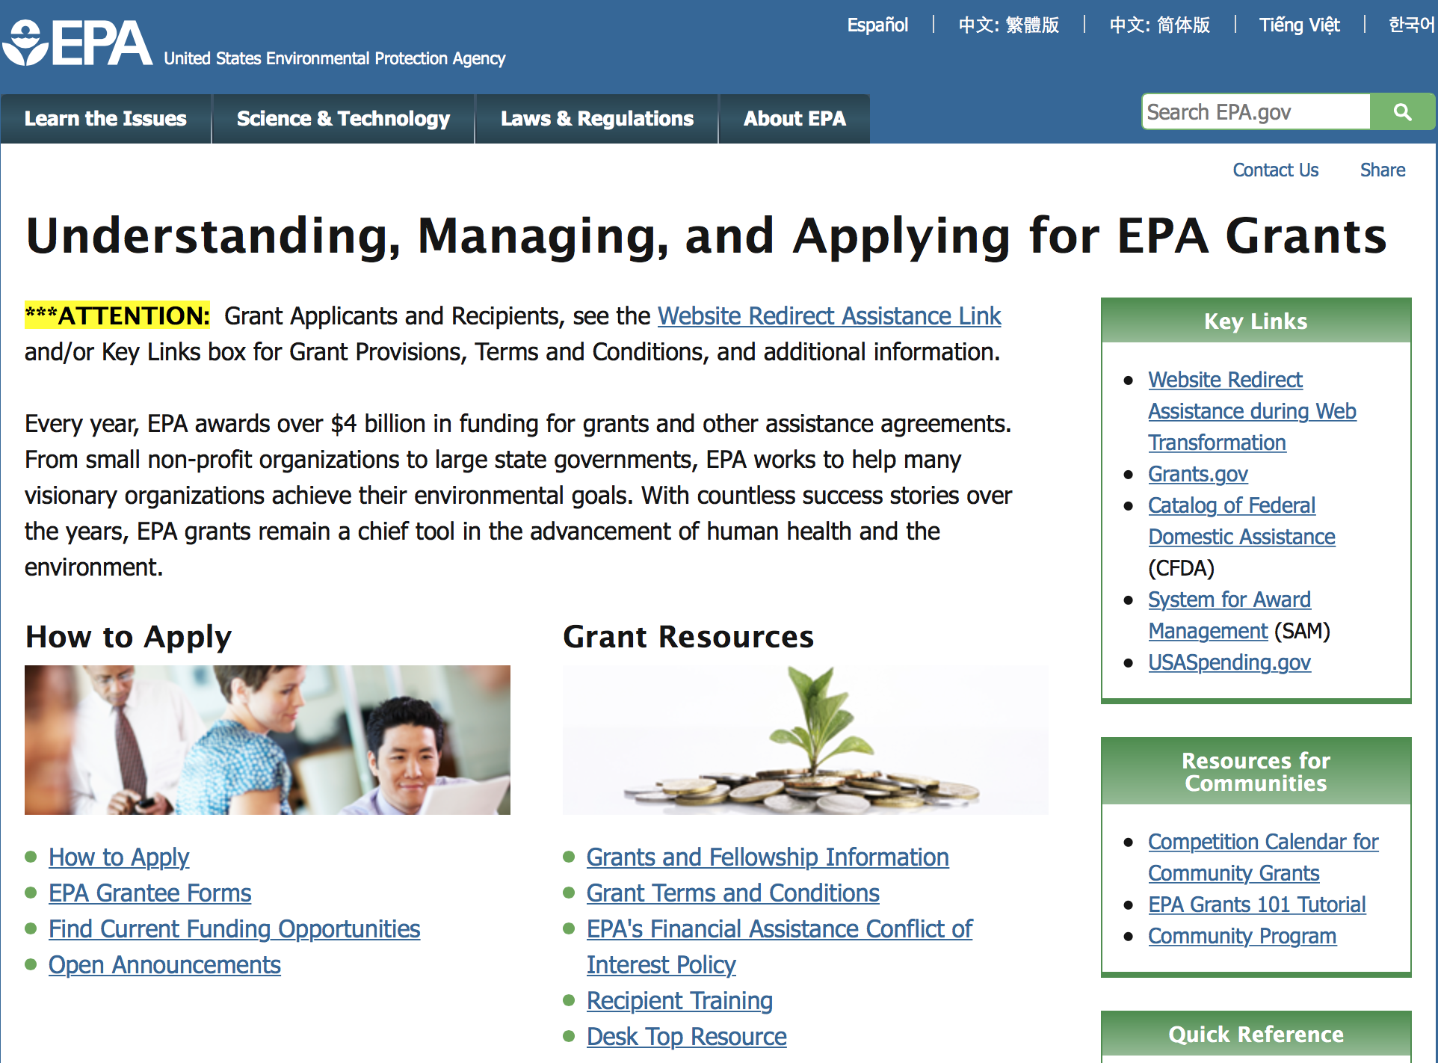

http://www.epa.gov/epahome/grants.htm

Programs:

2017 Targeted Air Shed Grant Program
Synopsis 1
Document Type: | Grants Notice
Funding Opportunity Number: | EPA-OAR-OAQPS-17-06
Funding Opportunity Title: | 2017 Targeted Air Shed Grant Program
Opportunity Category: | Discretionary
Opportunity Category Explanation:
Funding Instrument Type: | Cooperative Agreement  Grant
Category of Funding Activity: | Environment
Category Explanation:
Expected Number of Awards: | 7
CFDA Number(s): | 66.202 -- Congressionally Mandated Projects
Cost Sharing or Matching Requirement: | No
Version: | Synopsis 1
Posted Date: | Jul 19, 2017
Last Updated Date: | Jul 19, 2017
Original Closing Date for Applications: | Oct 18, 2017 Please see the announcement including Section IV for additional submission information.
Current Closing Date for Applications: | Oct 18, 2017 Please see the announcement including Section IV for additional submission information.
Archive Date: | Nov 17, 2017
Estimated Total Program Funding: | $30,000,000
Award Ceiling: | $4,000,000
Award Floor: | $0
Eligible Applicants: | Others (see text field entitled "Additional Information on Eligibility" for clarification)
Additional Information on Eligibility: | Please see the announcement including Section III for additional eligibility information.
Agency Name: | Environmental Protection Agency
Description: | This notice announces the availability of funds and solicits applications from eligible entities to compete for financial assistance through the Targeted Air Shed Grant Program. This program will assist local, state and/or tribal air pollution control agencies in developing plans, conducting demonstrations, and implementing projects to reduce air pollution in nonattainment areas that EPA determines are the top five most polluted areas relative to ozone (O3), annual average fine particulate matter (PM2.5), or 24-hour PM2.5 National Ambient Air Quality Standards (NAAQS). The overall goal of the Targeted Air Shed Grant program is to reduce air pollution in the Nation’s areas with the highest levels of ozone and PM2.5 ambient air concentrations.
Link to Additional Information: | 2017 Targeted Air Shed Grant Program
Grantor Contact Information: | If you have difficulty accessing the full announcement electronically, please contact:  Gary Blais, 919-541-3223  Gary Blais

http://www.grants.gov/web/grants/view-opportunity.html?oppId=295677

Research:

Modifications:

Reminders:

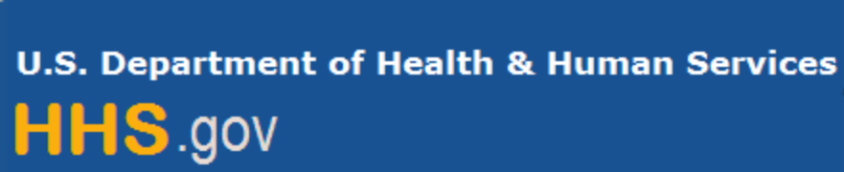

Department of Health and Human Services

Grants Forecast and Overview

The Department of Health and Human Services’ Grants Forecast is a database of planned grant opportunities proposed by its agencies. Each Forecast record contains actual or estimated dates and funding levels for grants that the agency intends to award during the fiscal year. Forecast opportunities are subject to change based on enactment of congressional appropriations.

For more general information about HHS Grants and Funding go to the website below at:

https://www.hhs.gov/grants/grants/index.html

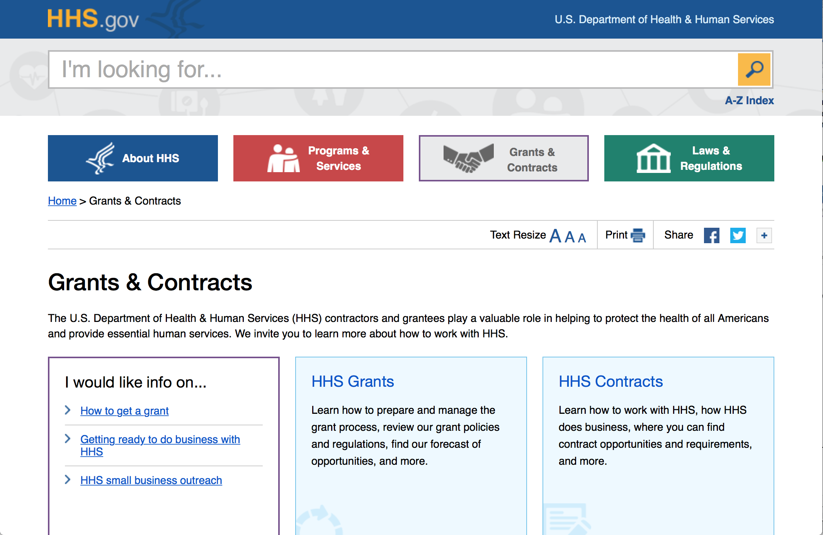

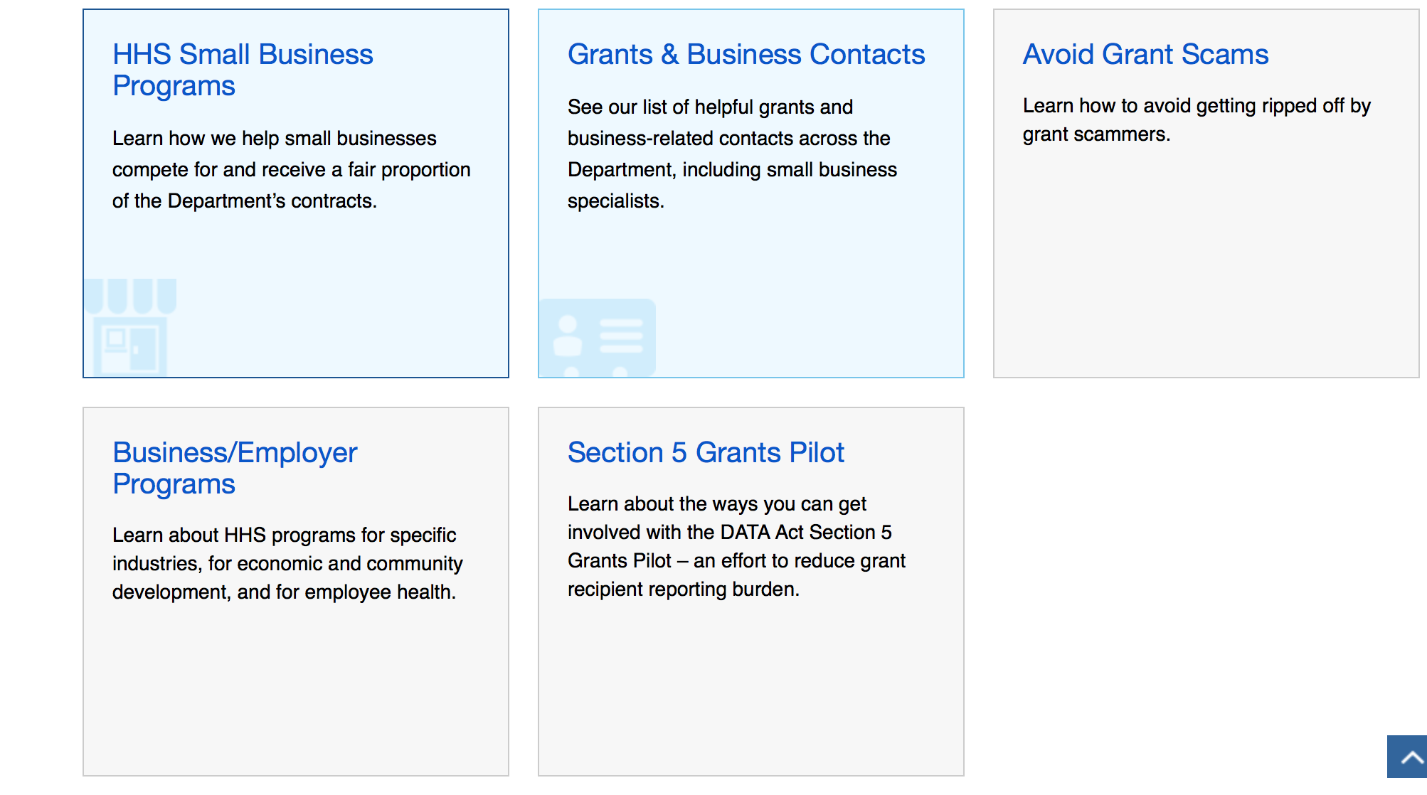

Programs:

Research:

Centers for Disease Control - NCHHSTP
TB Centers of Excellence for Training, Education, and Medical Consultation (TB COE)
Synopsis 1
http://www.grants.gov/web/grants/view-opportunity.html?oppId=295877

Centers for Disease Control - NCHHSTP
STD AAPPS Supplemental Funding for Enhanced Congenital Syphilis Response
Synopsis 1
http://www.grants.gov/web/grants/view-opportunity.html?oppId=295276

Centers for Disease Control - CGH
Addressing Ebola and other Highly Infectious Diseases Internationally
Synopsis 1
http://www.grants.gov/web/grants/view-opportunity.html?oppId=295763

Health Resources and Services Administration
Service Area Competition
Synopsis 1
http://www.grants.gov/web/grants/view-opportunity.html?oppId=295213

Health Resources and Services Administration
Service Area Competition
Synopsis 1
http://www.grants.gov/web/grants/view-opportunity.html?oppId=295212

Health Resources and Services Administration
Service Area Competition
Synopsis 1
http://www.grants.gov/web/grants/view-opportunity.html?oppId=295214

National Institutes of Health
Exploratory/Developmental Investigations on Primary Immunodeficiency Diseases (R21)
Synopsis 1
http://www.grants.gov/web/grants/view-opportunity.html?oppId=295754

National Institutes of Health
National Centers for Translational Research in Reproduction and Infertility (P50)
Synopsis 1
http://www.grants.gov/web/grants/view-opportunity.html?oppId=295836

National Institutes of Health
Implementing Genomics in Practice (IGNITE) II: Pragmatic Clinical Trials Clinical Groups (U01)
Synopsis 1
http://www.grants.gov/web/grants/view-opportunity.html?oppId=295837

National Institutes of Health
Implementing Genomics in Practice (IGNITE) II: Pragmatic Clinical Trials Enhanced Diversity Clinical Groups (U01)
Synopsis 1
http://www.grants.gov/web/grants/view-opportunity.html?oppId=295838

National Institutes of Health
Implementing Genomics in Practice (IGNITE) II: Pragmatic Clinical Trials Coordinating Center
Synopsis 1
http://www.grants.gov/web/grants/view-opportunity.html?oppId=295827

National Institutes of Health
Small Grants on Primary Immunodeficiency Diseases (R03)
Synopsis 1
http://www.grants.gov/web/grants/view-opportunity.html?oppId=295739

National Institutes of Health
CAPSTONE Centers for Multidisciplinary Research in Child Abuse and Neglect (P50)
Synopsis 1
http://www.grants.gov/web/grants/view-opportunity.html?oppId=295740

National Institutes of Health
First in Human and Early Stage Clinical Trials of Novel Investigational Drugs or Devices for Psychiatric Disorders (U01)
Synopsis 1
http://www.grants.gov/web/grants/view-opportunity.html?oppId=295634

National Institutes of Health
Central Neural Mechanisms of Age-Related Hearing Loss (R01)
Synopsis 1
http://www.grants.gov/web/grants/view-opportunity.html?oppId=295652

National Institutes of Health
NIAID Physician-Scientist Pathway to Independence Award (K99/R00)
Synopsis 1
http://www.grants.gov/web/grants/view-opportunity.html?oppId=295714

National Institutes of Health
Discovery of Small Molecule Immunomodulators for Cancer Therapy (R01)
Synopsis 1
http://www.grants.gov/web/grants/view-opportunity.html?oppId=295725

National Institutes of Health
NIMH Administrative Supplement Program to Enable Continuity of Research Experiences of MD/PhDs during Clinical Training (Admin Supp)
Synopsis 1
http://www.grants.gov/web/grants/view-opportunity.html?oppId=295668

National Institutes of Health
Re-Competition of Global Network for Womens and Childrens Health Research (UG1)
Synopsis 1
http://www.grants.gov/web/grants/view-opportunity.html?oppId=295636

National Institutes of Health
Administrative Supplements for the U.S.-Japan Brain Research Cooperative Program (BRCP) - U.S. Entity (Admin Supplement)
Synopsis 1
http://www.grants.gov/web/grants/view-opportunity.html?oppId=295609

National Institutes of Health
Development of a Device to Objectively Measure Pain (R43/R44)
Synopsis 1
http://www.grants.gov/web/grants/view-opportunity.html?oppId=295434

National Institutes of Health
Ethical, Legal, and Social Implications (ELSI) of Genomics Small Research Grant Program (R03)
Synopsis 1
http://www.grants.gov/web/grants/view-opportunity.html?oppId=295336

National Institutes of Health
Ethical, Legal, and Social Implications (ELSI) of Genomics Exploratory/Developmental Research Grant Program (R21)
Synopsis 1
http://www.grants.gov/web/grants/view-opportunity.html?oppId=295338

National Institutes of Health
Ethical, Legal, and Social Implications (ELSI) of Genomics Research Project Grant Program (R01)
Synopsis 1
http://www.grants.gov/web/grants/view-opportunity.html?oppId=295339

National Institutes of Health
Increasing Use of Cardiac and Pulmonary Rehabilitation in Traditional and Community Settings (R61/R33)
Synopsis 1
http://www.grants.gov/web/grants/view-opportunity.html?oppId=295452

National Institutes of Health
Development of a Device to Objectively Measure Pain (R41/R42)
Synopsis 1
http://www.grants.gov/web/grants/view-opportunity.html?oppId=295453

National Institutes of Health
BRAIN Initiative: New Concepts and Early - Stage Research for Large - Scale Recording and Modulation in the Nervous System (R21)
Synopsis 1
http://www.grants.gov/web/grants/view-opportunity.html?oppId=295602

National Institutes of Health
Using Small Molecules and Molecular Genetics to Identify Novel Targets and Mechanisms Contributing to Tumor Immune Evasion (R01)
Synopsis 1
http://www.grants.gov/web/grants/view-opportunity.html?oppId=295706

National Institutes of Health
Preparing for Hybrid Effectiveness-Implementation Trials for Heart, Lung, Blood, and Sleep Diseases in the Inpatient Setting (U01)
Synopsis 1
http://www.grants.gov/web/grants/view-opportunity.html?oppId=295486

National Institutes of Health
Tobacco Regulatory Science (R21)
Synopsis 1
http://www.grants.gov/web/grants/view-opportunity.html?oppId=295698

National Institutes of Health
Tobacco Regulatory Science Small Grant Program for New Investigators (R03)
Synopsis 1
http://www.grants.gov/web/grants/view-opportunity.html?oppId=295699

National Institutes of Health
Tobacco Regulatory Science (R01)
Synopsis 1
http://www.grants.gov/web/grants/view-opportunity.html?oppId=295700

National Institutes of Health
Population Dynamics Centers Research Infrastructure Program FY 2018 (P2C)
Synopsis 1
http://www.grants.gov/web/grants/view-opportunity.html?oppId=295800

National Institutes of Health
Synthetic Biology for Engineering Applications (R01)
Synopsis 1
http://www.grants.gov/web/grants/view-opportunity.html?oppId=295813

National Institutes of Health
Discovery of in vivo Chemical Probes for Novel Brain Targets (R01)
Synopsis 1
http://www.grants.gov/web/grants/view-opportunity.html?oppId=295802

National Institutes of Health
Discovery of cell-based Chemical Probes for Novel Brain Targets (R21)
Synopsis 1
http://www.grants.gov/web/grants/view-opportunity.html?oppId=295804

National Institutes of Health
Assay development and screening for discovery of chemical probes or therapeutic agents (R01)
Synopsis 1
http://www.grants.gov/web/grants/view-opportunity.html?oppId=295905

National Institutes of Health
Tailoring Cardiac Rehabilitation to Enhance Participation of Older Adults (R01)
Synopsis 1
http://www.grants.gov/web/grants/view-opportunity.html?oppId=295949

National Institutes of Health
Administrative Supplement for the NINDS Research Education Program for Residents and Fellows in Neurology, Neurosurgery, Neuropathology, Neuroradiology and Emergency Medicine (Admin Supp)
Synopsis 1
http://www.grants.gov/web/grants/view-opportunity.html?oppId=295955

National Institutes of Health
Limited Competition: Small Research Grant Program for NIAID K01/K08/K23 Recipients (R03)
Synopsis 1
http://www.grants.gov/web/grants/view-opportunity.html?oppId=295972

Modifications:

National Institutes of Health
Extracellular Vesicles and Substance Use Disorders (R01)
Synopsis 2
http://www.grants.gov/web/grants/view-opportunity.html?oppId=292982

National Institutes of Health
International Research Collaboration on Alcohol and Alcoholism (U01)
Synopsis 2
http://www.grants.gov/web/grants/view-opportunity.html?oppId=258771

National Institutes of Health
Arts-Based Approaches in Palliative Care for Symptom Management (R01)
Synopsis 2
http://www.grants.gov/web/grants/view-opportunity.html?oppId=260175

National Institutes of Health
Neuroscience Research on Drug Abuse (R21)
Synopsis 2
http://www.grants.gov/web/grants/view-opportunity.html?oppId=291118

National Institutes of Health
Lymphatics in Health and Disease in the Digestive System, Kidney, and Urinary Tract (R01)
Synopsis 2
http://www.grants.gov/web/grants/view-opportunity.html?oppId=278073

National Institutes of Health
Exploratory Clinical Trials of Mind and Body Interventions for NCCAM High Priority Research Topics (R34)
Synopsis 2
http://www.grants.gov/web/grants/view-opportunity.html?oppId=254074

National Institutes of Health
Notice of Intent to Publish a Funding Opportunity Announcement for NHLBI Early Phase Clinical Trials for Therapeutics and/or Diagnostics (R61/R33)
Forecast 4
http://www.grants.gov/web/grants/view-opportunity.html?oppId=291104

National Institutes of Health
Notice of Intent to Publish a Funding Opportunity Announcement for Metabolomic Data Analysis and Interpretation Tools (U01)
Forecast 2
http://www.grants.gov/web/grants/view-opportunity.html?oppId=294284

National Institutes of Health
Clinical Research Sites for the Network of Excellence in Neuroscience Clinical Trials (NeuroNEXT sites) (U24)
Synopsis 2
http://www.grants.gov/web/grants/view-opportunity.html?oppId=295133

HHS
Department of Health and Human Services
Health Resources and Services Administration
HRSA-17-099 - Poison Center Network Service Area Competition
Deletion Comments: Opportunity deleted

Centers for Disease Control - CGH
CDC-RFA-GH18-1825 - Comprehensive Care and Support Services for Orphans and Vulnerable Children in Nigeria under the President's Emergency Plan for AIDS Relief (PEPFAR)
Deletion Comments: Opportunity deleted

National Institutes of Health
Uncovering the Causes, Contexts, and Consequences of Elder Mistreatment (R01)
Synopsis 2
http://www.grants.gov/web/grants/view-opportunity.html?oppId=293770

Deleted:

Centers for Disease Control - NCHHSTP
CDC-RFA-PS18-1804 - TB Centers of Excellence for Training, Education, and Medical Consultation (TB COEs)
Deletion Comments: Opportunity deleted

Reminders:

Department of Homeland Security

The Department of Homeland Security enhances the ability of states, local and tribal jurisdictions, and other regional authorities in the preparation, prevention, and response to terrorist attacks and other disasters, by distributing grant funds. Localities can use grants for planning, equipment, training and exercise needs.

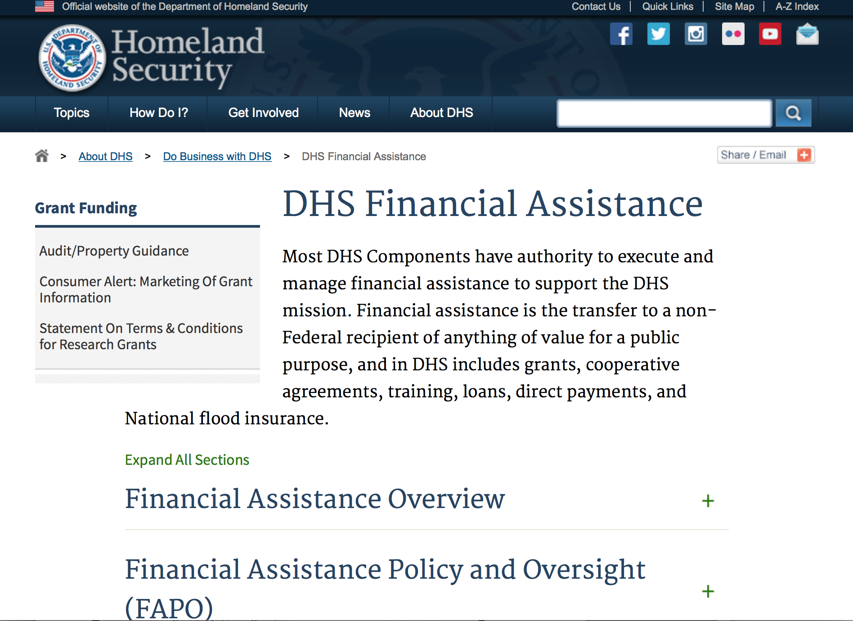
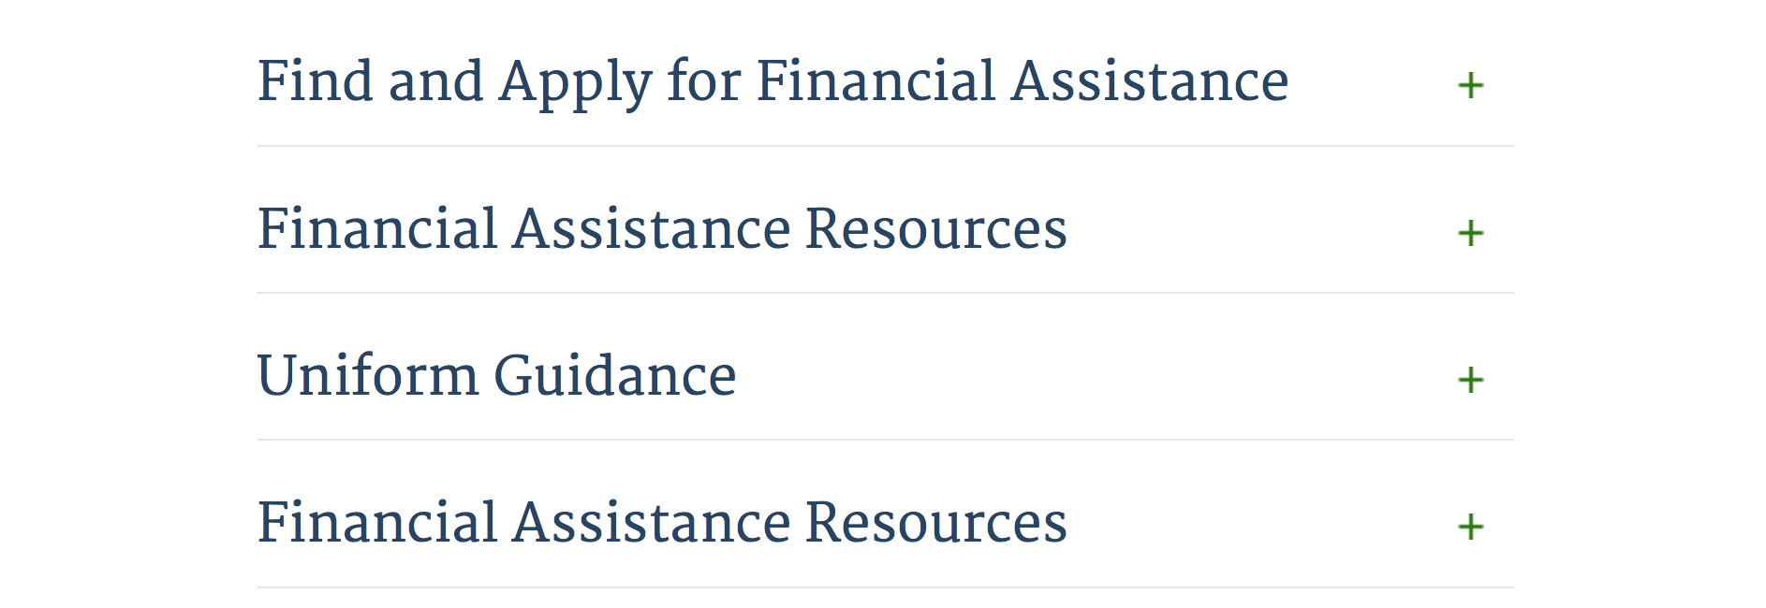

Webpage can be viewed at: http://www.dhs.gov/xopnbiz/grants/index.shtm#2

Information about 2016 for reference only
The FY 2016 Assistance to Firefighters Grants (AFG)
FY 2016 ASSISTANCE TO FIREFIGHTERS (AFG) GRANTS IS CLOSED AT THIS TIME
- FY 2016 Application Workshop Schedule
- FY 2016 AFG Application Guidance Materials The following documents are now available:
  - FY 2016 Notice of Funding Opportunity (NOFO) – Available Now
  - FY 2016 AFG Grant Application Get Ready Guide
  - FY 2016 AFG Narrative Get Ready Guide
  - FY 2016 AFG Self-Evaluation - Operations and Safety
  - FY 2016 AFG Self-Evaluation - Vehicle Acquisition
  - FY 2016 AFG Application Checklist
  - FY 2016 AFG Cost Share Calculator
FY 2016 AFG FAQs
For AFG program guidance materials, please visit our Documents page.

Resources

AFG Help Desk
Contact the AFG Program Help Desk toll-free at 866-274-0960, or email us at firegrants@dhs.gov.
The AFG Program has Fire Program Specialists in 10 federal regional centers. These Regional Fire Program Specialists respond to questions about the AFG program and carry out grant monitoring activities. View regional contacts

Popular AFG links
- AFG Workshop Schedule
- Assistance to Firefighters Grants (AFG)
- AFG Awards List
- AFG Success Stories
- Staffing for Adequate Fire & Emergency Response (SAFER) Grants (SAFER)
- SAFER Awards List
- SAFER Success Stories
- Fire Prevention & Safety (FP&S) Grants
- FP&S Awards List
- FP&S Success Stories
- Grant Closeout Tutorial
- Assistance to Firefighters Grant (AFG) Email Alert Archive
- Frequently Asked Questions
Contact Information For The Assistance to Firefighters Grant (AFG) Program and Help Desk

Federal Funding Alternative To AFG

State Administrative Agencies (SAA) apply for and administer Federal grants on behalf of their States, including FEMA Preparedness Grants. The SAA will work with eligible organizations to comply with the general requirements of grant programs or cooperative agreements. Contact your State’s SAA to find out what current Federal funding opportunities may be available to your organization. A listing of the SAAs and points of contact can be found at http://www.fema.gov/library/viewRecord.do?id=6363.

Programs:

Department of Homeland Security - FEMA
FY17 Flood Mitigation Assistance
Synopsis 1
Document Type: | Grants Notice
Funding Opportunity Number: | DHS-17-MT-029-000-99
Funding Opportunity Title: | FY17 Flood Mitigation Assistance
Opportunity Category: | Discretionary
Opportunity Category Explanation:
Funding Instrument Type: | Grant
Category of Funding Activity: | Other (see text field entitled "Explanation of Other Category of Funding Activity" for clarification)
Category Explanation: | The Flood Mitigation Assistance (FMA) Program makes available Federal funds to State, Local and Tribal Governments to reduce or eliminate the risk of repetitive flood damage to buildings and structures insured under the National Flood Insurance Program (NFIP).
Expected Number of Awards: | 200
CFDA Number(s): | 97.029 -- Flood Mitigation Assistance
Cost Sharing or Matching Requirement:

Version: | Synopsis 1
Posted Date: | Jul 10, 2017
Last Updated Date: | Jul 10, 2017
Original Closing Date for Applications: | Nov 14, 2017
Current Closing Date for Applications: | Nov 14, 2017
Archive Date: | Dec 14, 2017
Estimated Total Program Funding: | $160,000,000
Eligible Applicants: | State governments  Others (see text field entitled "Additional Information on Eligibility" for clarification)  Native American tribal governments (Federally recognized)
Additional Information on Eligibility: | District of Columbia; U.S. Territories. Local governments must apply through their state.
Agency Name: | Department of Homeland Security - FEMA
Description: | The Flood Mitigation Assistance (FMA) Program makes available Federal funds to State, Local and Tribal Governments to reduce or eliminate the risk of repetitive flood damage to buildings and structures insured under the National Flood Insurance Program (NFIP). In FY17, the FMA Program will prioritize proposals that address community flood risk by setting aside $70 million for this purpose. FEMA will seek to fund two types of community flood mitigation activities: Advance Assistance for flood mitigation design and development of community flood mitigation projects and mitigation projects that address community flood risk for the purpose of reducing NFIP flood claim payments. The remaining funding, at least $90,000,000, will be used for FMA technical assistance, mitigation planning, and mitigation projects reducing risk to severe repetitive loss (SRL) and repetitive loss (RL) properties. Applicants must submit applications via the Mitigation eGrants system on the FEMA Grants Portal: https://portal.fema.gov. Applicants may submit a maximum of 1 advanced assistance and 1 community mitigation project sub-application.
Link to Additional Information:
Grantor Contact Information: | If you have difficulty accessing the full announcement electronically, please contact:  Mitigation eGrants System Helpdesk Phone: 1-855-228-3362  MTeGrants@fema.dhs.gov

http://www.grants.gov/web/grants/view-opportunity.html?oppId=295313

Department of Homeland Security - FEMA
FY17 Pre-Disaster Mitigation
Synopsis 1

Document Type: | Grants Notice
Funding Opportunity Number: | DHS-17-MT-047-000-99
Funding Opportunity Title: | FY17 Pre-Disaster Mitigation
Opportunity Category: | Discretionary
Opportunity Category Explanation:
Funding Instrument Type: | Grant
Category of Funding Activity: | Other (see text field entitled "Explanation of Other Category of Funding Activity" for clarification)
Category Explanation: | The Robert T. Stafford Disaster Relief and Emergency Assistance Act, Public Law 93-288, as amended, (42 U.S.C. 5133), Section 203 authorizes FEMA to make grants for the purpose of implementing a sustained pre-disaster natural hazard mitigation program to reduce overall risk to the population and structures from future hazard events, while also reducing reliance on Federal funding from future disasters.
Expected Number of Awards: | 250
CFDA Number(s): | 97.047 -- Pre-Disaster Mitigation
Cost Sharing or Matching Requirement: | No
Version: | Synopsis 1
Posted Date: | Jul 10, 2017
Last Updated Date: | Jul 10, 2017
Original Closing Date for Applications: | Nov 14, 2017
Current Closing Date for Applications: | Nov 14, 2017
Archive Date: | Dec 14, 2017
Estimated Total Program Funding: | $90,000,000
Award Ceiling: | $15,000,000
Eligible Applicants: | State governments  Native American tribal governments (Federally recognized)  Others (see text field entitled "Additional Information on Eligibility" for clarification)
Additional Information on Eligibility: | District of Columbia; U.S. Territories. Local governments must apply through their state.
Agency Name: | Department of Homeland Security - FEMA
Description: | The Pre-Disaster Mitigation (PDM) program makes available Federal funds to State, Local and Tribal Governments to implement and sustain cost-effective measures designed to reduce the risk to individuals and property from natural hazards, while also reducing reliance on Federal funding from future disasters. FEMA will provide allocations of $575,000 as required by the Stafford Act to states and territories; and a tribal set aside of $10 million for allocations up to $575,000 for Native American Indian tribal governments to support overall mitigation planning and projects. The remaining PDM funds will be awarded on a competitive basis with a focus on multi-state/tribal mitigation initiatives. Applicants must submit applications via the Mitigation eGrants system on the FEMA Grants Portal: https://portal.fema.gov. Applicants may submit a maximum of 9 project sub-applications notwithstanding any project(s) submitted for the state/territory allocation or tribal set aside. In addition, any state or tribe willing to serve as the applicant for a multi-state or tribal activity may submit one additional plan or project subapplication.
Link to Additional Information:
Grantor Contact Information: | If you have difficulty accessing the full announcement electronically, please contact:  Mitigation eGrants System Helpdesk Phone: 1-855-228-3362  MTeGrants@fema.dhs.gov

http://www.grants.gov/web/grants/view-opportunity.html?oppId=295314

Modifications:

Advanced Research Projects Agency Energy
SENSOR SBIR/STTR
Synopsis 2

Document Type: | Grants Notice
Funding Opportunity Number: | DE-FOA-0001738
Funding Opportunity Title: | SENSOR SBIR/STTR
Opportunity Category: | Discretionary
Opportunity Category Explanation:
Funding Instrument Type: | Cooperative Agreement
Category of Funding Activity: | Science and Technology and other Research and Development
Category Explanation:
Expected Number of Awards: | 5
CFDA Number(s): | 81.135 -- Advanced Research Projects Agency - Energy
Cost Sharing or Matching Requirement: | Yes
Version: | Synopsis 2
Posted Date: | Jan 18, 2017
Last Updated Date: | Jul 07, 2017
Original Closing Date for Applications: | Mar 17, 2017 Applicants are strongly encouraged to submit their Concept Papers at least 48 hours in advance of the submission due date.
Current Closing Date for Applications: | Aug 21, 2017 Applicants are strongly encouraged to submit their Full Applications at least 48 hours in advance of the submission due date.
Archive Date: | Nov 15, 2017
Estimated Total Program Funding: | $10,000,000
Award Ceiling: | $3,225,000
Award Floor: | $225,000
Eligible Applicants: | Small businesses
Agency Name: | Advanced Research Projects Agency Energy
Description: | SAVING ENERGY NATIONWIDE IN STRUCTURES WITH OCCUPANCY RECOGNITION (SENSOR)(SBIR/STTR) The purpose of this modification is to incorporate changes to the Funding Opportunity Announcement, DE-FOA-0001738. Accordingly, this modification: •Inserted certain deadlines, including the deadlines for submitting questions and Full Applications. See Cover Page and Required Documents Checklist. •Updated language in Section I.E of the FOA to indicate Full Application Phase of the FOA. •Updated expected Start Date for Funding Agreements. See Section II.A of the FOA. •Revised the following sections of the FOA to provide guidance on required application forms and the content and form of Full Applications and Replies to Reviewer Comments: Required Documents Checklist and Sections IV.D, IV.E, and IV.G of the FOA. Applicants are strongly encouraged to use the templates provided on ARPA&#8208;E eXCHANGE (https://arpa&#8208;e&#8208;foa.energy.gov). •Inserted criteria that ARPA&#8208;E will use to evaluate Full Applications, see Section V.A.2 of the FOA. •Inserted criteria that ARPA&#8208;E will use to evaluate Replies to Reviewer Comments in Section V.A.3 of the FOA. •Inserted information on the anticipated announcement and award dates, see Section V.C of the FOA. •Inserted information concerning Full Application Notifications, see Section VI.A.3 of the FOA. •Inserted Administrative and National Policy Requirements, see Section VI.B of the FOA. •Inserted Reporting Requirements, see Section VI.C of the FOA. To obtain a copy of the Funding Opportunity Announcement (FOA) please go to the ARPA-E website at https://arpa-e-foa.energy.gov. ARPA-E will not review or consider full applications submitted through other means. For detailed guidance on using ARPA-E eXCHANGE, please refer to the ARPA-E eXCHANGE User Guide (https://arpa-e-foa.energy.gov/Manuals.aspx).
Link to Additional Information: | ARPA-E eXCHANGE
Grantor Contact Information: | If you have difficulty accessing the full announcement electronically, please contact:  ARPA-E CO arpa-e-co@hq.doe.gov  ARPA-E CO

http://www.grants.gov/web/grants/view-opportunity.html?oppId=291300

Reminders:

Department of Housing and Urban Development

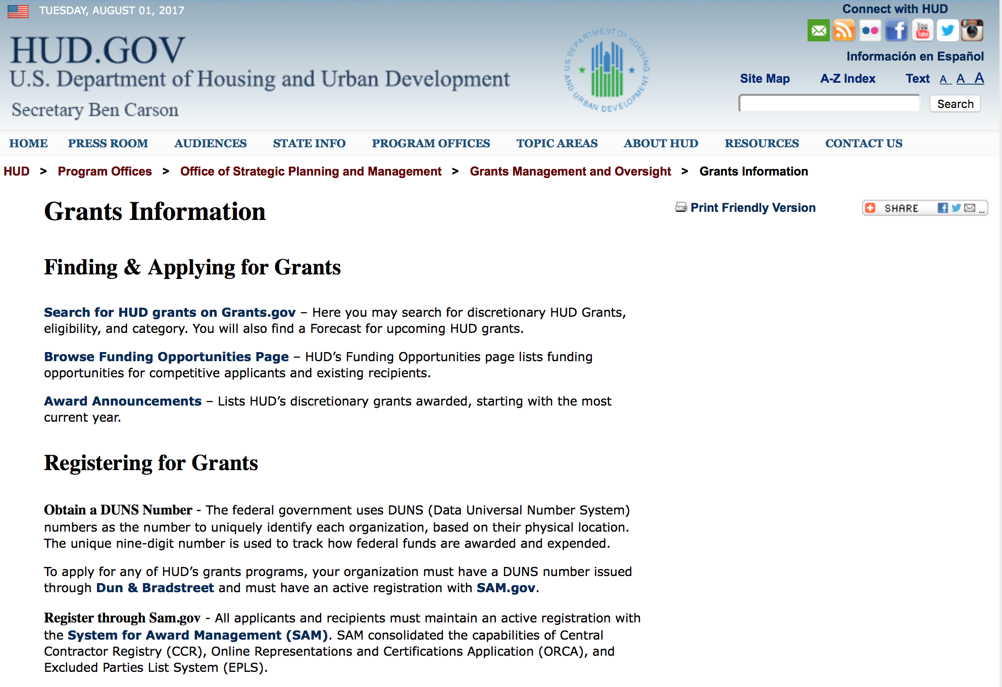

http://portal.hud.gov/hudportal/HUD?src=/topics/grants

HUD - Notice of Funds Available
For detailed information click here

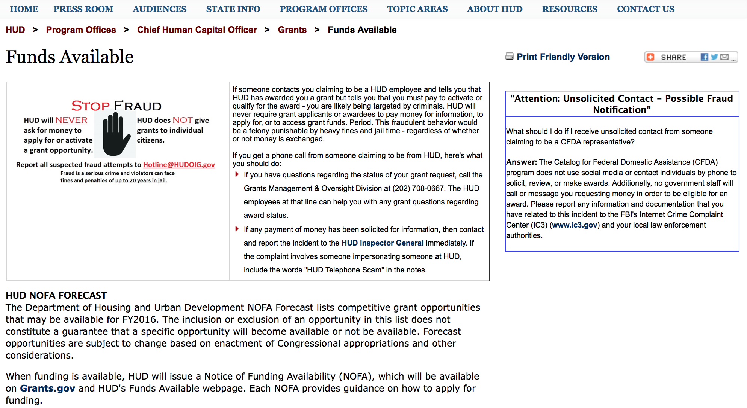

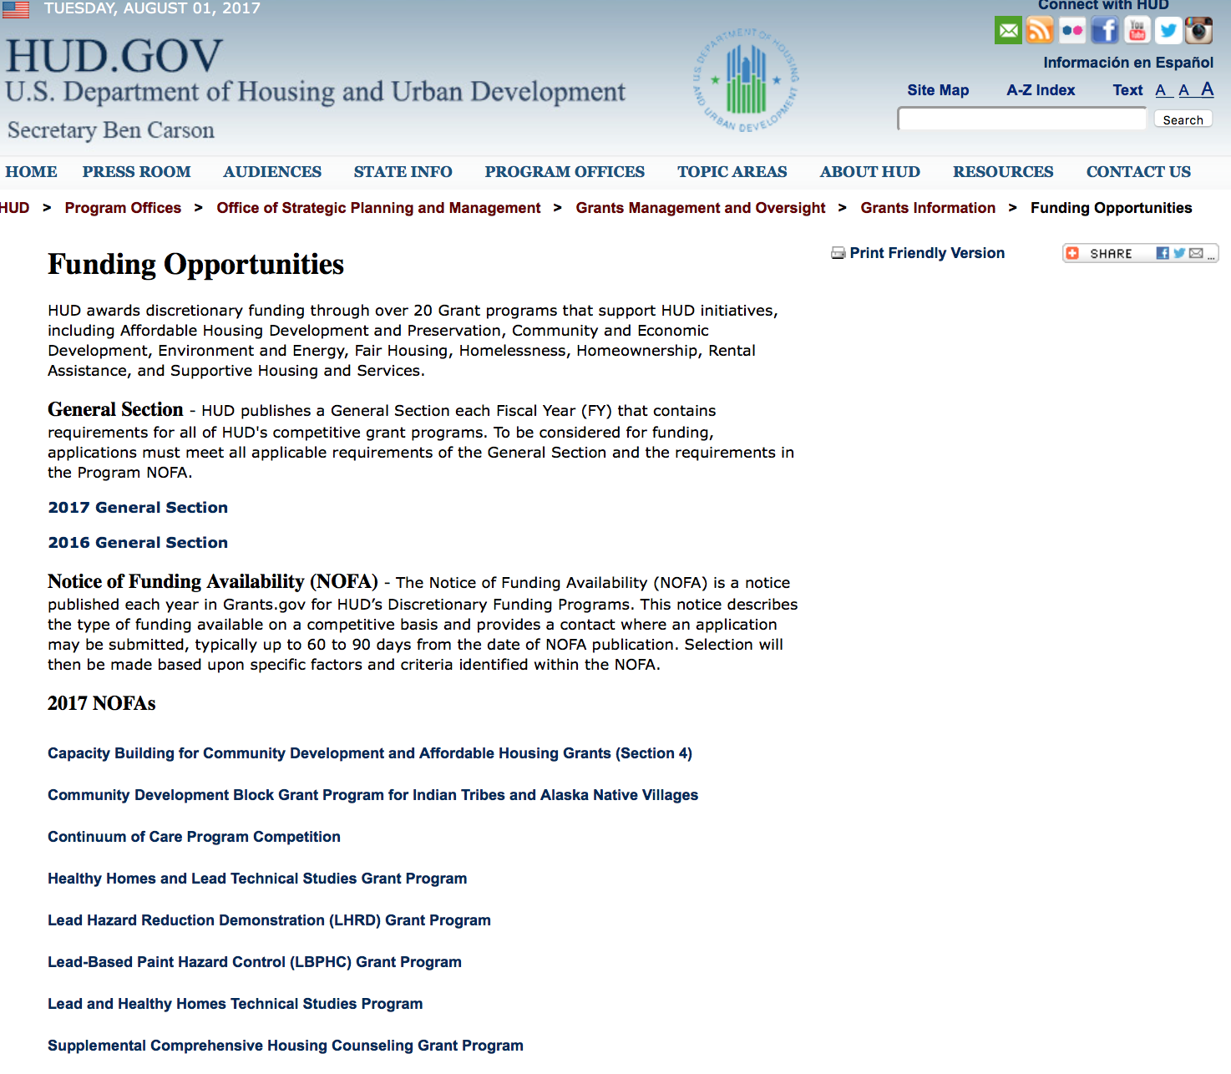

http://portal.hud.gov/hudportal/HUD?src=/program_offices/administration/grants/fundsavail

HUD NOFA FORECAST
The Department of Housing and Urban Development NOFA Forecast lists competitive grant opportunities that may be available for FY2016. The inclusion or exclusion of an opportunity in this list does not constitute a guarantee that a specific opportunity will become available or not be available. Forecast opportunities are subject to change based on enactment of Congressional appropriations and other considerations.
When funding is available, HUD will issue a Notice of Funding Availability (NOFA), which will be available on Grants.gov

Programs:

Modifications:

Notice of Funding Availability (NOFA) for the Fiscal Year (FY) 2017 Continuum of Care Program Competition
Synopsis 3
Document Type: | Grants Notice
Funding Opportunity Number: | FR-6100-N-25
Funding Opportunity Title: | Notice of Funding Availability (NOFA) for the Fiscal Year (FY) 2017 Continuum of Care Program Competition
Opportunity Category: | Discretionary
Opportunity Category Explanation:
Funding Instrument Type: | Grant
Category of Funding Activity: | Housing
Category Explanation:
Expected Number of Awards: | 8000
CFDA Number(s): | 14.267 -- Continuum of Care Program
Cost Sharing or Matching Requirement: | Yes
Version: | Synopsis 3
Posted Date: | Jul 14, 2017
Last Updated Date: | Jul 14, 2017
Original Closing Date for Applications: | Sep 28, 2017 Electronically submitted applications must be submitted no later than 8:00 p.m., ET, on the listed application due date.
Current Closing Date for Applications: | Sep 28, 2017 Electronically submitted applications must be submitted no later than 8:00 p.m., ET, on the listed application due date.
Archive Date: | Oct 28, 2017
Estimated Total Program Funding: | $2,000,000,000
Eligible Applicants: | County governments  City or township governments  Nonprofits having a 501(c)(3) status with the IRS, other than institutions of higher education  State governments
Additional Information on Eligibility: | 24 CFR 578.15, eligible project applicants for the CoC Program Competition are nonprofit organizations, States, local governments, and instrumentalities of State and local governments, and public housing agencies, as such term is defined in 24 CFR 5.100, without limitation or exclusion. For-profit entities are not eligible to apply for grants or to be subrecipients of grant funds. Individuals, foreign entities, and sole proprietorship organizations are not eligible to compete for, or receive, awards made under this announcement.
Agency Name: | Department of Housing and Urban Development
Description: | The CoC Program (24 CFR part 578) is designed to promote a community-wide commitment to the goal of ending homelessness; to provide funding for efforts by nonprofit providers, States, and local governments to quickly re-house homeless individuals, families, persons fleeing domestic violence, and youth while minimizing the trauma and dislocation caused by homelessness; to promote access to and effective utilization of mainstream programs by homeless; and to optimize self-sufficiency among those experiencing homelessness.
Link to Additional Information: | http://portal.hud.gov/hudportal/HUD?src=/program_offices/administration/grants/fundsavail
Grantor Contact Information: | If you have difficulty accessing the full announcement electronically, please contact:  HUD- Ask a Question  Grants Policy

http://www.grants.gov/web/grants/view-opportunity.html?oppId=295502

Deleted:

Reminders:

Choice Neighborhoods Planning Grants Program
Synopsis 2
Document Type: | Grants Notice
Funding Opportunity Number: | FR-6100-N-38
Funding Opportunity Title: | Choice Neighborhoods Planning Grants Program
Opportunity Category: | Discretionary
Opportunity Category Explanation:
Funding Instrument Type: | Grant
Category of Funding Activity: | Housing
Category Explanation:
Expected Number of Awards: | 6
CFDA Number(s): | 14.892 -- Choice Neighborhoods Planning Grants
Cost Sharing or Matching Requirement: | Yes
Version: | Synopsis 2
Posted Date: | Jun 28, 2017
Last Updated Date: | Jun 28, 2017
Original Closing Date for Applications: | Aug 28, 2017 Electronically submitted applications must be submitted no later than 11:59 p.m., ET, on the listed application due date.
Current Closing Date for Applications: | Aug 28, 2017 Electronically submitted applications must be submitted no later than 11:59 p.m., ET, on the listed application due date.
Archive Date: | Sep 27, 2017
Estimated Total Program Funding: | $5,000,000
Award Ceiling: | $1,300,000
Award Floor: | $1
Eligible Applicants: | Others (see text field entitled "Additional Information on Eligibility" for clarification)
Additional Information on Eligibility: | Eligible applicants under this NOFA are Public Housing Authorities (PHAs), local governments, tribal entities, and nonprofits. Refer to the definitions in section I.A.3.b for definitions of these terms. Individuals, foreign entities, and sole proprietorship organizations are not eligible to compete for, or receive, awards made under this announcement.
Agency Name: | Department of Housing and Urban Development
Description: | With this publication, HUD is making available up to $5,000,000 for Planning Grants, including Planning and Action Grants.1. Planning Grants are two-year grants that assist communities with severely distressed public or HUD-assisted housing in developing a successful neighborhood transformation plan and building the support necessary for that plan to be successfully implemented.2. Planning and Action Grants are three and a half year planning grants that pair planning with action. Experience shows that tangible actions taken early on help communities build momentum for further planning and the eventual transition from planning to implementation of that plan. These actions improve neighborhood confidence, which in turn sustains the community's energy, attracts more engagement and resources, and helps convince skeptical stakeholders that positive change is possible. Under these grants, the planning process activities would take place during the first 24 months of the grant period. The planning process will identify Action Activities that will be carried out during the latter portion of the grant period. Action Activities must build upon the planning for the target housing and neighborhood.
Link to Additional Information: | http://portal.hud.gov/hudportal/HUD?src=/program_offices/administration/grants/fundsavail
Grantor Contact Information: | If you have difficulty accessing the full announcement electronically, please contact:  ChoiceNeighborhoods@hud.gov  Email inquiries

http://www.grants.gov/web/grants/view-opportunity.html?oppId=295096

Institute of Museum and Library Services

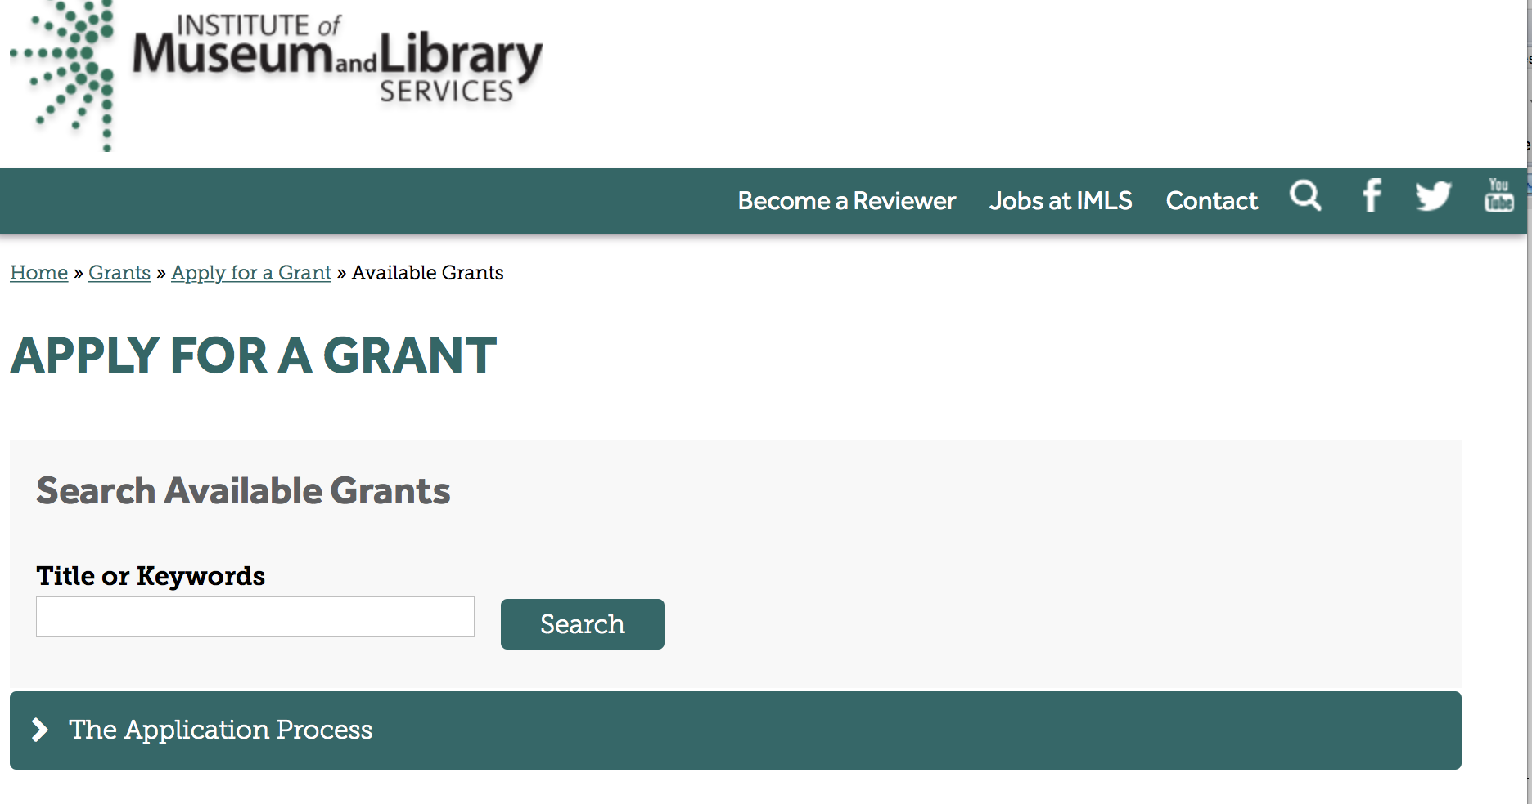

https://www.imls.gov/grants/apply-grant/available-grants

Each grant program has specific eligibility requirements. The links below provide general eligibility criteria for museums, libraries, and tribal organizations, but please note that additional organizations may be eligible for grants under certain programs. Additionally, ineligible organizations may still be able to participate in grant programs through partnerships with eligible organizations. Please click on the links below to see general criteria and review Applications and Guidelines for specific information.
Museums Libraries

Institutions: Archives, Federally Recognized Native American Tribe, Historical Society, Library, Nonprofits that serve Native Hawaiians, Professional Association, Public or Private Non-profit Institutions of Higher Education, Regional Organization, State Library Administrative Agency, State or Local Government

Check out IMLS's Facebook page at:
https://www.facebook.com/USIMLS/

Programs:

National Leadership Grants for Libraries
Synopsis 1
Document Type: | Grants Notice
Funding Opportunity Number: | NLG-LIBRARIES-FY18-1
Funding Opportunity Title: | National Leadership Grants for Libraries
Opportunity Category: | Discretionary
Opportunity Category Explanation:
Funding Instrument Type: | Grant
Category of Funding Activity: | Arts (see "Cultural Affairs" in CFDA)  Humanities (see "Cultural Affairs" in CFDA)
Category Explanation:
Expected Number of Awards: | 12
CFDA Number(s): | 45.312 -- National Leadership Grants
Cost Sharing or Matching Requirement: | Yes
Version: | Synopsis 1
Posted Date: | Jul 20, 2017
Last Updated Date: | Jul 20, 2017
Current Closing Date for Applications: | Jan 16, 2018 The National Leadership Grants for Libraries Program is a two phase process. In the first phase, all applicants must submit a two page preliminary proposal. Grants.gov will accept preliminary proposal applications through 11:59 p.m. U.S. Eastern Time on September 1, 2017. Those applicants whose preliminary proposals are the most promising and best aligned with the IMLS's priorities will be invited to submit full proposals in the second phase of the process. Grants.gov will accept invited, full proposal applications through 11:59 p.m. U.S. Eastern Time on January 16, 2018.
Archive Date: | Feb 15, 2018
Estimated Total Program Funding: | $5,700,000
Award Ceiling: | $2,000,000
Award Floor: | $1
Eligible Applicants: | Others (see text field entitled "Additional Information on Eligibility" for clarification)
Additional Information on Eligibility: | Please see Notice of Funding Opportunity for eligibility specifics.
Agency Name: | Institute of Museum and Library Services
Description: | National Leadership Grants for Libraries (NLG-L) support projects that address significant challenges and opportunities facing the library and archives fields and that have the potential to advance theory and practice. Successful proposals will generate results such as new tools, research findings, models, services, practices, or alliances that will be widely used, adapted, scaled, or replicated to extend the benefits of federal investment.
Link to Additional Information: | https://www.imls.gov/grants/available/national-leadership-grants-libraries
Grantor Contact Information: | If you have difficulty accessing the full announcement electronically, please contact:  Tim Carrigan, Senior Program Officer, 202-653-4639, tcarrigan@imls.gov (for technical issues); Sandra Toro, PhD, Senior Program Officer, 202-653-4662, storo@imls.gov; James Neal, Senior Program Officer, 202-653-4740, jneal@imls.gov; Ashley Sands, PhD, Senior Program Officer, 202-653-4730, asands@imls.gov; Sarah Fuller, Senior Program Officer, 202-653-4783, sfuller@imls.gov; Emily Reynolds, Program Officer, 202-653-4665, ereynolds@imls.gov  Tim Carrigan, Senior Program Officer

http://www.grants.gov/web/grants/view-opportunity.html?oppId=295712

Laura Bush 21st Century Librarian Program
Synopsis 1
Document Type: | Grants Notice
Funding Opportunity Number: | LB21-FY18-1
Funding Opportunity Title: | Laura Bush 21st Century Librarian Program
Opportunity Category: | Discretionary
Opportunity Category Explanation:
Funding Instrument Type: | Grant
Category of Funding Activity: | Arts (see "Cultural Affairs" in CFDA)  Humanities (see "Cultural Affairs" in CFDA)
Category Explanation:
Expected Number of Awards: | 11
CFDA Number(s): | 45.313 -- Laura Bush 21st Century Librarian Program
Cost Sharing or Matching Requirement: | Yes
Version: | Synopsis 1
Posted Date: | Jul 20, 2017
Last Updated Date: | Jul 20, 2017
Current Closing Date for Applications: | Jan 16, 2018 The Laura Bush 21st Century Librarian Program is a two phase process. In the first phase, all applicants must submit a two page preliminary proposal. Grants.gov will accept preliminary proposal applications through 11:59 p.m. U.S. Eastern Time on September 1, 2017. Those applicants whose preliminary proposals are the most promising and best aligned with the IMLS's priorities will be invited to submit full proposals in the second phase of the process. Grants.gov will accept invited, full proposal applications through 11:59 p.m. U.S. Eastern Time on January 16, 2018.
Archive Date: | Feb 15, 2018
Estimated Total Program Funding: | $3,700,000
Award Ceiling: | $1,000,000
Award Floor: | $1
Eligible Applicants: | Others (see text field entitled "Additional Information on Eligibility" for clarification)
Additional Information on Eligibility: | Please see Notice of Funding Opportunity for eligibility specifics.
Agency Name: | Institute of Museum and Library Services
Description: | The Laura Bush 21st Century Librarian Program (LB21) supports developing a diverse workforce of librarians to better meet the changing learning and information needs of the American public by: enhancing the training and professional development of librarians, developing faculty and library leaders, and recruiting and educating the next generation of librarians.
Link to Additional Information: | https://www.imls.gov/grants/available/laura-bush-21st-century-librarian-program
Grantor Contact Information: | If you have difficulty accessing the full announcement electronically, please contact:  Tim Carrigan, Senior Program Officer, 202-653-4639, tcarrigan@imls.gov; Sandra Toro, PhD, Senior Program Officer, 202-653-4662, storo@imls.gov; James Neal, Senior Program Officer, 202-653-4740, jneal@imls.gov; Ashley Sands, PhD, Senior Program Officer, 202-653-4730, asands@imls.gov; Sarah Fuller, Senior Program Officer, 202-653-4783, sfuller@imls.gov (for technical issues); Emily Reynolds, Program Officer, 202-653-4665, ereynolds@imls.gov  Sarah Fuller, Senior Program Officer

http://www.grants.gov/web/grants/view-opportunity.html?oppId=295716

Modifications:

Reminders:

Deleted:

Department of the Interior
Working with Interior

The Interior Department provides assistance to the public, local governments and businesses through a number of programs. For a general overview see: http://www.doi.gov/index.cfm

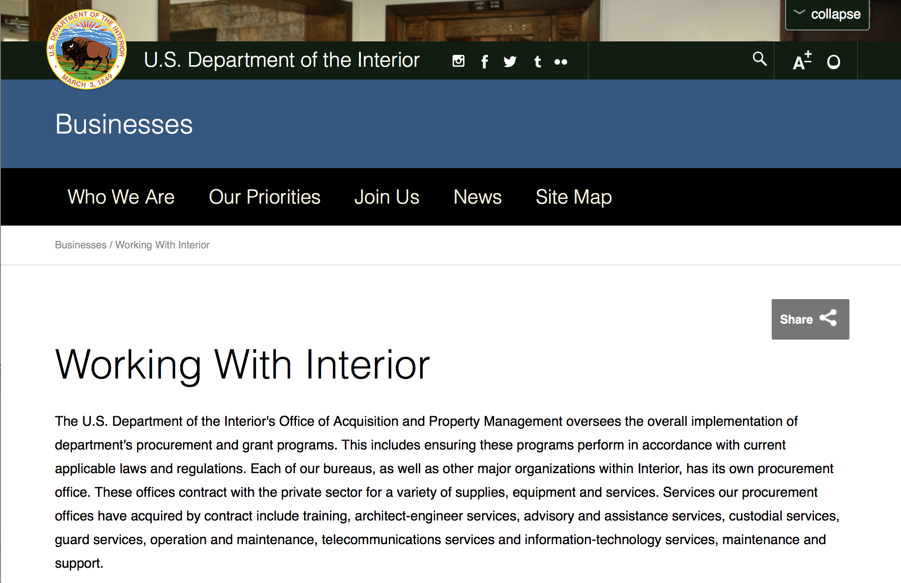

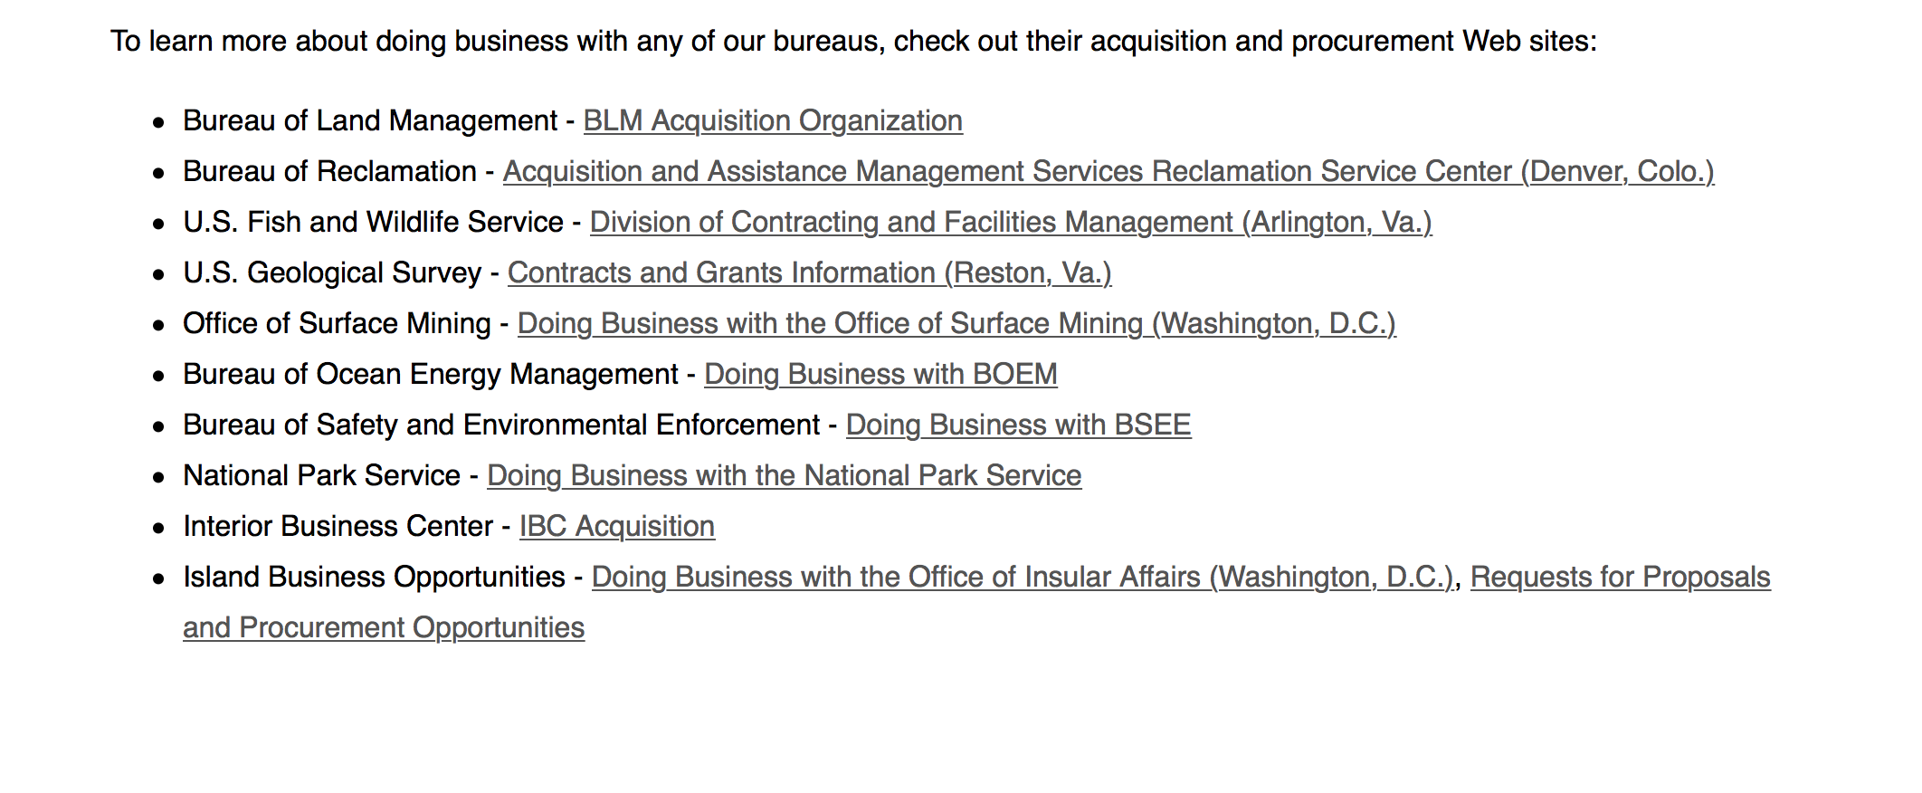
http://www.doi.gov/businesses/working-with-interior.cfm

Programs:

Modifications:

National Park Service
National Maritime Heritage Grants 2017
Synopsis 3

http://www.grants.gov/web/grants/view-opportunity.html?oppId=293713

Reminders:

National Fish Passage Program
Synopsis 1

Document Type: | Grants Notice
Funding Opportunity Number: | F17AS00030
Funding Opportunity Title: | National Fish Passage Program
Opportunity Category: | Discretionary
Opportunity Category Explanation:
Funding Instrument Type: | Cooperative Agreement  Grant
Category of Funding Activity: | Natural Resources
Category Explanation:
Expected Number of Awards: | 0
CFDA Number(s): | 15.608 -- Fish and Wildlife Management Assistance
Cost Sharing or Matching Requirement: | Yes
Posted Date: | Nov 23, 2016
Last Updated Date: | Nov 23, 2016
Original Closing Date for Applications: | Sep 30, 2017
Current Closing Date for Applications: | Sep 30, 2017
Archive Date: | Oct 02, 2017
Estimated Total Program Funding: | $0
Award Ceiling: | $2,000,000
Award Floor: | $500
Eligible Applicants: | Unrestricted (i.e., open to any type of entity above), subject to any clarification in text field entitled "Additional Information on Eligibility"
Additional Information on Eligibility: | To receive funding, NFPP projects must be implemented in coordination with FAC staff. Applicants can be, but not limited to: state and federal agencies, private lands, tribes, local municipalities, and non-governmental organizations.
Agency Name: | Fish and Wildlife Service
Description: | The National Fish Passage Program (NFPP) is a voluntary program that provides direct technical assistance and financial assistance in the form of cooperative agreements and grants to partners to provide fish (and other aquatic organisms) passage and restore aquatic connectivity for the benefit of federal trust resources. The NFPP is delivered through more than 65 Fisheries and Aquatic Conservation (FAC) Field Offices across all States and territories. FAC staff coordinates with project partners, stakeholders and other Service programs to identify and collaboratively implement projects within Regional priority areas. Project work plans are developed strategically, in coordination with partners, and with substantial involvement from FAC staff. Projects must advance our mission, promote biological diversity, and be based upon sound scientific biological principles. FAC and Fish and Wildlife Service (FWS) strategic plans inform the types of projects funded under this opportunity. Applicants seeking funding under this program should review the program strategic plan and also contact the regional NFPP Coordinator for local FAC contacts prior to submitting an application for funding.
Link to Additional Information: | http://www.grants.gov
Grantor Contact Information: | If you have difficulty accessing the full announcement electronically, please contact:  Susan Wells 703-358-2523 Susan_Wells@fws.gov  Fish Passage Coordinator

http://www.grants.gov/web/grants/view-opportunity.html?oppId=290297

Fish and Wildlife Service
Partners for Fish and Wildlife
Synopsis 1

Document Type: | Grants Notice
Funding Opportunity Number: | F17AS00015
Funding Opportunity Title: | Partners for Fish and Wildlife
Opportunity Category: | Discretionary
Opportunity Category Explanation:
Funding Instrument Type: | Cooperative Agreement
Category of Funding Activity: | Community Development  Education  Environment  Natural Resources
Category Explanation:
Expected Number of Awards: | 5000
CFDA Number(s): | 15.631 -- Partners for Fish and Wildlife
Cost Sharing or Matching Requirement: | No
Posted Date: | Nov 03, 2016
Last Updated Date: | Nov 03, 2016
Original Closing Date for Applications: | Sep 30, 2017
Current Closing Date for Applications: | Sep 30, 2017
Archive Date: | Oct 07, 2017
Estimated Total Program Funding: | $52,000,000
Award Ceiling: | $500,000
Award Floor: | $1
Eligible Applicants: | For profit organizations other than small businesses  Nonprofits having a 501(c)(3) status with the IRS, other than institutions of higher education  City or township governments  Native American tribal organizations (other than Federally recognized tribal governments)  State governments  Individuals  Small businesses  Public and State controlled institutions of higher education  Nonprofits that do not have a 501(c)(3) status with the IRS, other than institutions of higher education  Native American tribal governments (Federally recognized)  County governments  Private institutions of higher education
Agency Name: | Fish and Wildlife Service
Description: | The Partners for Fish and Wildlife (PFW) Program is a voluntary, incentive-based program that provides direct technical assistance and financial assistance in the form of cooperative agreements to private landowners to restore and conserve fish and wildlife habitat for the benefit of federal trust resources. The PFW Program is delivered through more than 250 full-time staff, active in all 50 States and territories. Partners for Fish and Wildlife Program staff coordinate with project partners, stakeholders and other Service programs to identify geographic focus areas and develop habitat conservation priorities within these focus areas. Geographic focus areas are where the PFW Program directs resources to conserve habitat for federal trust species. Project work plans are developed strategically, in coordination with partners, and with substantial involvement from Service field staff. Projects must advance our mission, promote biological diversity, and be based upon sound scientific biological principles. Program strategic plans inform the types of projects funded under this opportunity. Applicants seeking funding under this program should review the program strategic plan and also contact the regional PFW Program office prior to submitting an application for funding. Authorizing statues include Partners for Fish and Wildlife Act of 2006, 16 U.S.C. 3771-3774; Fish and Wildlife Act of 1956; 16 U.S.C. 742a-c, 742e-j; Fish and Wildlife Coordination Act of 1958, 16 U.S.C. 661-667(e).
Link to Additional Information: | http://www.grants.gov
Grantor Contact Information: | If you have difficulty accessing the full announcement electronically, please contact:  Matthew Filsinger 703-358-2011 matthew_filsinger@fws.gov  Project Officer

http://www.grants.gov/web/grants/view-opportunity.html?oppId=289882

Fish and Wildlife Service
Coastal Program
Synopsis 1

Document Type: | Grants Notice
Funding Opportunity Number: | F17AS00014
Funding Opportunity Title: | Coastal Program
Opportunity Category: | Discretionary
Opportunity Category Explanation:
Funding Instrument Type: | Cooperative Agreement
Category of Funding Activity: | Community Development  Education  Environment  Natural Resources
Category Explanation:
Expected Number of Awards: | 500
CFDA Number(s): | 15.630 -- Coastal
Cost Sharing or Matching Requirement: | No
Posted Date: | Nov 03, 2016
Last Updated Date: | Nov 03, 2016
Original Closing Date for Applications: | Sep 30, 2017
Current Closing Date for Applications: | Sep 30, 2017
Archive Date: | Oct 07, 2017
Estimated Total Program Funding: | $14,000,000
Award Ceiling: | $500,000
Award Floor: | $1
Eligible Applicants: | County governments  Nonprofits having a 501(c)(3) status with the IRS, other than institutions of higher education  City or township governments  Special district governments  Native American tribal governments (Federally recognized)  Private institutions of higher education  Native American tribal organizations (other than Federally recognized tribal governments)  For profit organizations other than small businesses  State governments  Small businesses  Public and State controlled institutions of higher education  Individuals  Nonprofits that do not have a 501(c)(3) status with the IRS, other than institutions of higher education
Agency Name: | Fish and Wildlife Service
Description: | The Coastal Program is a voluntary, incentive-based program that provides direct technical assistance and financial assistance in the form of cooperative agreements to coastal communities and landowners to restore and protect fish and wildlife habitat on public and private lands. Coastal Program staff coordinate with project partners, stakeholders and other Service programs to identify geographic focus areas and develop habitat conservation priorities within these focus areas. Geographic focus areas are where the Coastal Program directs resources to conserve habitat for federal trust species. Project work plans are developed strategically, in coordination with partners, and with substantial involvement from Service field staff. Projects must advance our mission, promote biological diversity, and be based upon sound scientific biological principles. Program strategic plans inform the types of projects funded under this opportunity. Applicants seeking funding under this program should review the program strategic plan and also contact the regional Coastal Program office prior to submitting an application for funding. Authorizing statues include Fish and Wildlife Act of 1956, 16 U.S.C. 742a-c, 747e-742j; and Fish and Wildlife Coordination Act of 1958, 16 U.S.C. 661 667(e).
Link to Additional Information: | http://www.grants.gov
Grantor Contact Information: | If you have difficulty accessing the full announcement electronically, please contact:  Chris Darnell 703-358-2236 chris_darnell@fws.gov  Project Officer

http://www.grants.gov/web/grants/view-opportunity.html?oppId=289863

Deleted:

Department of Justice

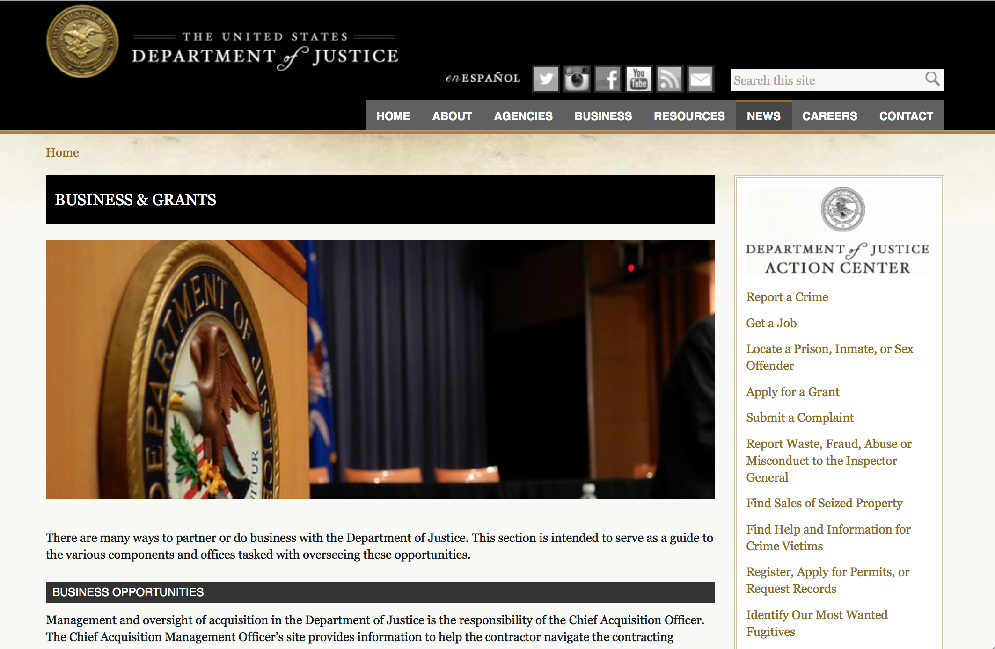

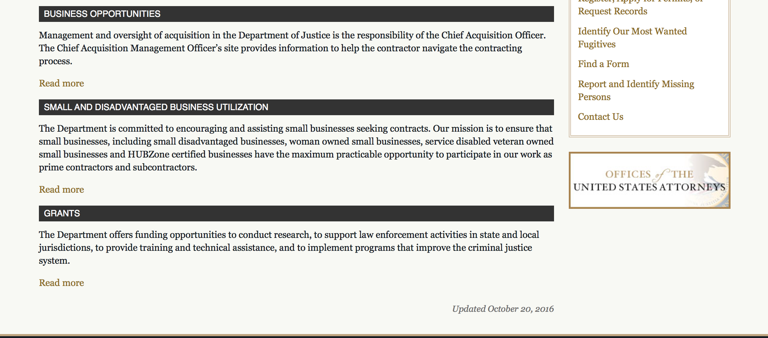

The DOJ agencies listed below also have sites that provide grant information specific to that agency. Examples of what can be found on these sites are programs, funding opportunities, application assistance, and other useful information.

Bureau of Justice Assistance (BJA)

Bureau of Justice Statistics (BJS)

National Criminal Justice Reference Service (NCJRS)

National Institute of Justice (NIJ)

Office of Sex Offender Sentencing, Monitoring, Apprehending, Registering, and Tracking (SMART)

http://www.justice.gov/business/

Programs:

Research:

Modifications:

Deleted:

Reminders:

Office for Victims of Crime
OVC FY 17 Vision 21: Integrated Services for Victims Program: Increasing Access to Mental Health Services for Victims of Crime
Synopsis 1
Document Type: | Grants Notice
Funding Opportunity Number: | OVC-2017-12280
Funding Opportunity Title: | OVC FY 17 Vision 21: Integrated Services for Victims Program: Increasing Access to Mental Health Services for Victims of Crime
Opportunity Category: | Discretionary
Opportunity Category Explanation:
Funding Instrument Type: | Cooperative Agreement
Category of Funding Activity: | Income Security and Social Services  Law, Justice and Legal Services
Category Explanation:
Expected Number of Awards: | 9
CFDA Number(s): | 16.582 -- Crime Victim Assistance/Discretionary Grants
Cost Sharing or Matching Requirement: | No
Version: | Synopsis 1
Posted Date: | Jun 27, 2017
Last Updated Date: | Jun 27, 2017
Original Closing Date for Applications: | Aug 10, 2017
Current Closing Date for Applications: | Aug 10, 2017
Archive Date:
Estimated Total Program Funding: | $4,750,000
Award Ceiling: | $500,000
Award Floor: | $350,000
Eligible Applicants: | Others (see text field entitled "Additional Information on Eligibility" for clarification)
Additional Information on Eligibility: | For information on eligibility, see Section C of the funding opportunity under Eligibility Information.
Agency Name: | Office for Victims of Crime
Description: | Vision 21 Integrated Services for Victims Program: Increasing Access to Mental Health Services for Victims of Crime (Vision 21 ISV Program), consists of three purpose areas: (1) developing a suicide prevention gatekeeper training curriculum to increase the capacity of crime victim advocates to help prevent suicide; (2) increasing access to services for victims of domestic violence and sexual assault who have a serious mental illness; and (3) increasing access to mental health services for traditionally underserved victims of crime. The Vision 21 ISV Program will promote a collaborative approach to the delivery of direct services by requiring crime victim services providers and clinical mental health service providers to form strategic partnerships to develop and implement project developed under purpose areas 2 and 3 of this program.
Link to Additional Information: | Funding Opportunity
Grantor Contact Information: | If you have difficulty accessing the full announcement electronically, please contact:  For assistance with any other requirements of this solicitation, contact Kimberly Woodard, Senior Tribal Affairs Specialist, by telephone at 202–307–2952. kimberly.woodard@usdoj.gov  For Programmatic Questions

http://www.grants.gov/web/grants/view-opportunity.html?oppId=295072



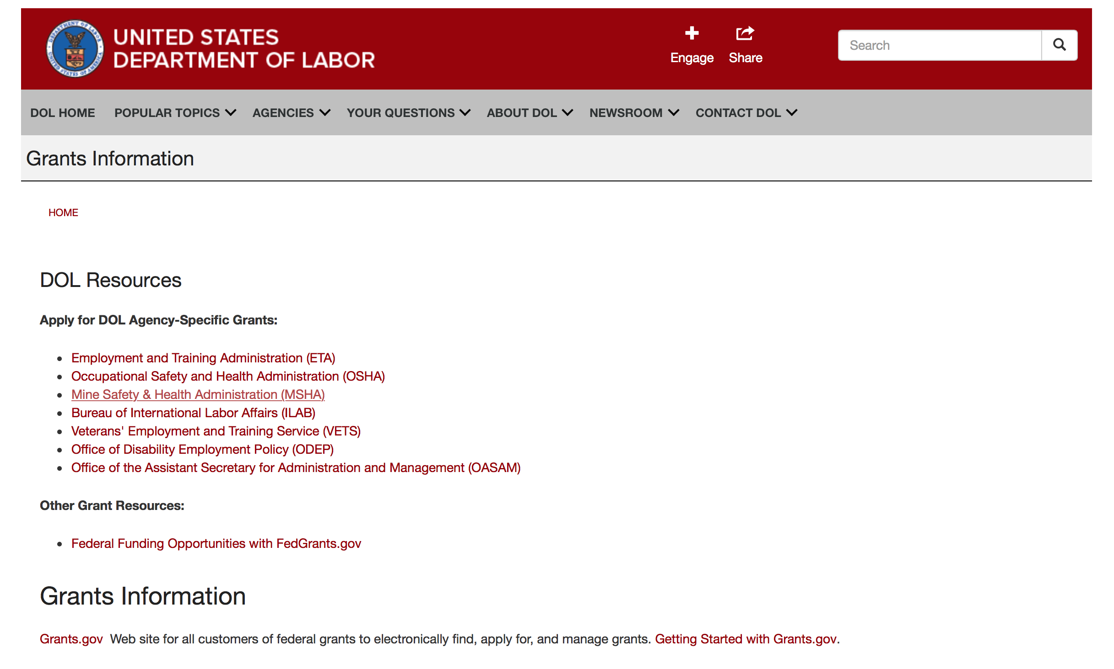

Agency Grants and Contract General Overview

DOL Resources
Apply for DOL Agency-Specific Grants:
- Employment and Training Administration (ETA)
- Occupational Safety and Health Administration (OSHA)
- Mine Safety & Health Administration (MSHA)
- Bureau of International Labor Affairs (ILAB)
- Veterans' Employment and Training Service (VETS)
- Office of Disability Employment Policy (ODEP)
- Office of the Assistant Secretary for Administration and Management (OASAM)

Other Grant Resources:
- Federal Funding Opportunities with FedGrants.gov
Grants Information
Grants.gov — Web site for all customers of federal grants to electronically find, apply for, and manage grants. Getting Started with Grants.gov.

DOL Resources and Instructions for Applying for a Grant
- DOL Guidance Clarifying the Effect of the Religious Freedom Restoration Act on Faith-Based Organizations
- Grant and Contract Information
- Contracting and Grant Program Overview
- Civil Rights Enforcement for Department of Labor Grant Recipients
- More Information About Grants
- Use of Contracts, Grants & Cooperative Agreements

Other Federal Government Grant Information
- Grant Opportunities (Catalog of Federal Domestic Assistance)

Department of Labor Grant Programs

- Bureau of International Labor Affairs (ILAB): provides grants (cooperative agreements) for the implementation of projects designed to assist developing countries combat the worse forms of child labor, forced labor, and human trafficking; and support worker rights and improve working conditions. http://www.dol.gov/general/business.
- Bureau of Labor Statistics (BLS): provides project grants (cooperative agreements) and the dissemination of technical statistical data and related information on labor force activities; provides data on prices (CPI) and cost of living; data on productivity and technology data; data on compensation and working conditions; data on employment projections.
- Employment and Training (ETA): ETA administers financial assistance programs pursuant to the Workforce Investment Act (WIA), administering State formula grant programs for youth, adults and dislocated workers, national emergency grants for workers affected by mass layoffs, plant closures, and disasters; grant programs for workers with disabilities, Indians and Native Americans, and for migrant and seasonal farmworkers. ETA also administers grant programs for older American workers, apprenticeship programs, Trade Adjustment Assistance (TAA) programs, and assistance for research and development of workforce programs. In addition, ETA is responsible for the operation and maintenance of a national system of public employment service offices and for the national unemployment insurance program.
- Mine Safety and Health (MSHA): provides grants for research, education and training programs to ensure an adequate and competent staff of trained inspectors; and assistance for establishing or improving State mine health and safety programs through technical assistance.
- Occupational Safety and Health (OSHA): provides grants to non-profit organizations to provide training, educational services, and technical assistance; assistance to states to administer and enforce state programs; assistance to states to provide occupational safety and health technical assistance and consultant services.
- Office of Disability Employment Policy (ODEP): The Office of Disability Employment Policy awards competitive grants establishing short-term pilot and technical assistance projects designed to identify, develop, test, evaluate, and disseminate policies to increase employment by expanding access to training, education, employment supports, assistive and systems technology, integrated employment, entrepreneurial development, and small business opportunities for adults and youth with disabilities. Current pilots projects focus on customized employment, Olmstead populations, and innovative demonstration youth grants, among others. Solicitations for grant applications are published in the Federal Register and announced at www.dol.gov/odep. ODEP grants are awarded by the OASAM grant office.
- Veterans' Employment and Training (VETS): provides special employment and training assistance for veterans through the Disabled Veterans' Outreach Program (DVOP) Solicitation for Grant Applications; the Local Veterans' Employment Representative Program (LVER); Veterans' Workforce Investment Program (VWIP); elaws Advisor on veterans' employment and reemployment rights; and the Homeless Veterans Reintegration Project (HVRP). VETS grants are awarded by the OASAM grant office.

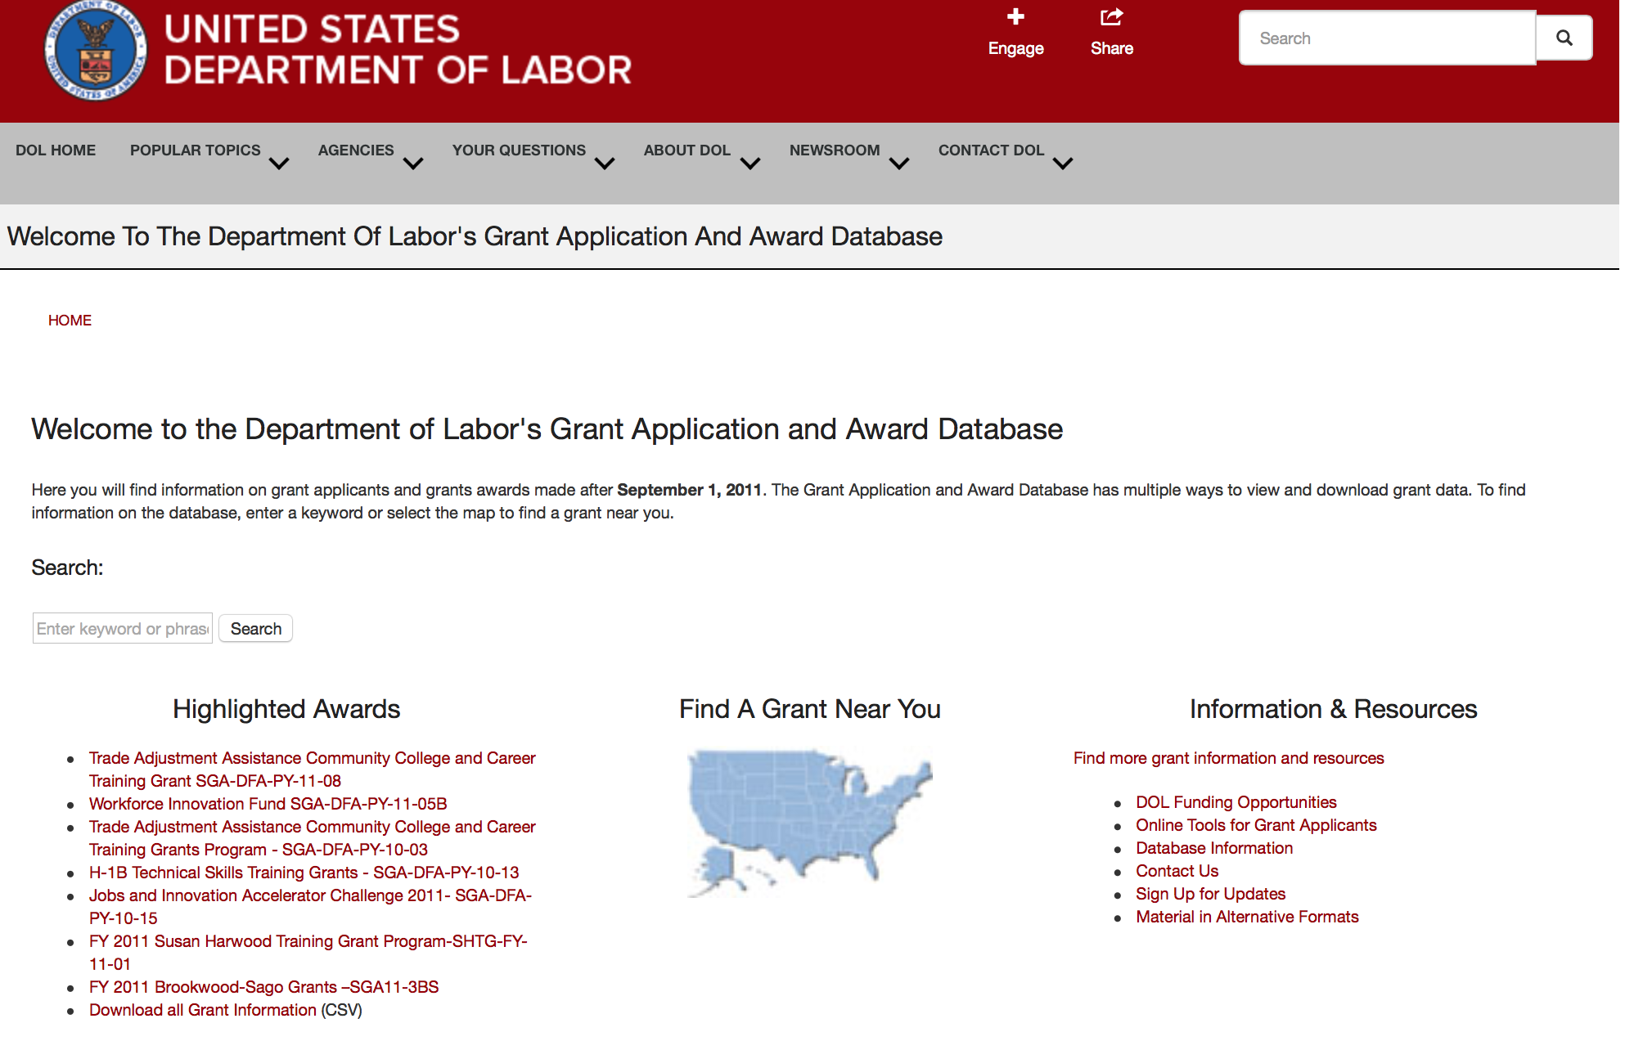

http://www.dol.gov/dol/grants/

Programs

Occupational Safety and Health Administration
Susan Harwood Training Grant, FY 2017, (Targeted Topics)
Synopsis 1 & 2

Document Type: | Grants Notice
Funding Opportunity Number: | SHTG-FY-17-01
Funding Opportunity Title: | Susan Harwood Training Grant, FY 2017, (Targeted Topics)
Opportunity Category: | Discretionary
Opportunity Category Explanation:
Funding Instrument Type: | Grant
Category of Funding Activity: | Other (see text field entitled "Explanation of Other Category of Funding Activity" for clarification)
Category Explanation: | Safety and Health Training and Education
Expected Number of Awards: | 150
CFDA Number(s): | 17.502 -- Occupational Safety and Health Susan Harwood Training Grants
Cost Sharing or Matching Requirement: | No
Version: | Synopsis 2
Posted Date: | Jul 13, 2017
Last Updated Date: | Jul 17, 2017
Original Closing Date for Applications: | Aug 28, 2017 This FOA closes on Monday, August 28, 2017, at 11:59 p.m. Eastern Time. All applications must be successfully submitted and validated in Grants.gov before they will be considered viable for review. Applications submitted after this date and time will be considered non-responsive and will not be reviewed.
Current Closing Date for Applications: | Aug 28, 2017 This FOA closes on Monday, August 28, 2017, at 11:59 p.m. Eastern Time. All applications must be successfully submitted and validated in Grants.gov before they will be considered viable for review. Applications submitted after this date and time will be considered non-responsive and will not be reviewed.
Archive Date: | Sep 27, 2017
Estimated Total Program Funding: | $10,500,000
Eligible Applicants: | Others (see text field entitled "Additional Information on Eligibility" for clarification)
Additional Information on Eligibility: | Qualifying labor unions, Community-based and faith-based organizations, Employer associations that are not an agency of a state or local government, state or local government-supported Institutions of higher education, Indian tribes, tribal organizations, Alaska Native entities, Indian-controlled organizations serving Indians, and Native Hawaiian organizations.
Agency Name: | Occupational Safety and Health Administration
Description: | Under the authority of Section 21(c) of the Occupational Safety and Health Act of 1970 (OSH Act), the U .S. Department of Labor (DOL) Occupational Safety and Health Administration (OSHA) established its discretionary grant program in 1978. In 1997, the program was renamed in honor of the late Susan Harwood, a former director of OSHA’s Office of Risk Assessment. The program offers an opportunity for nonprofit organizations to compete annually for funding so they may develop and conduct training and education programs for small business employers and workers on the recognition, avoidance, and prevention of occupational safety and health hazards in their workplaces, and to inform workers of their rights and employers of their responsibilities under the OSH Act. For FY 2017, OSHA announces the availability of approximately $10.5 million to fund new Susan Harwood Training Grants. OSHA expects to award multiple grants to eligible nonprofit organizations under this competitive Funding Opportunity Announcement (FOA). Program funding will be for a 12-month period beginning no later than September 30, 2017, and ending on September 30, 2018. Grant awards will not exceed $155,000 for a Targeted Topic Training grant or $50,000 for a Training and Education Material Development grant.
Link to Additional Information:
Grantor Contact Information: | If you have difficulty accessing the full announcement electronically, please contact:  Susan Harwood Grant Coordinator at 847-759-7700 x7926  E-Mail questions to

http://www.grants.gov/web/grants/view-opportunity.html?oppId=295465

Modifications

Mine Safety and Health Administration
Mine Health and Safety Grants
Synopsis 6
Document Type: | Grants Notice
Funding Opportunity Number: | MSHA2017-1
Funding Opportunity Title: | Mine Health and Safety Grants
Opportunity Category: | Mandatory
Opportunity Category Explanation:
Funding Instrument Type: | Grant
Category of Funding Activity: | Education
Category Explanation:
Expected Number of Awards: | 56
CFDA Number(s): | 17.600 -- Mine Health and Safety Grants
Cost Sharing or Matching Requirement: | Yes
Version: | Synopsis 6
Posted Date: | Jan 04, 2017
Last Updated Date: | Jul 10, 2017
Original Closing Date for Applications: | Mar 07, 2017 Closing Date for Receipt of Applications has been extended from January 17, 2017 to March 7, 2017.
Current Closing Date for Applications: | Aug 07, 2017 Close date for receipt of applications extended to August 7, 2017.
Archive Date: | Aug 16, 2017
Estimated Total Program Funding: | $8,441,000
Eligible Applicants: | Public and State controlled institutions of higher education  State governments  Native American tribal governments (Federally recognized)
Agency Name: | Mine Safety and Health Administration
Description: | The Secretary of Labor's vision for the U.S. workforce is Promoting and Protecting Opportunity. One of the Department’s strategic goals is to “improve workplace safety and health” through the strategic objective “secure safe and healthy workplaces, particularly in high-risk industries.” MSHA’s goal in accomplishing this objective is to “prevent death, disease, and injury from mining and promote safe and healthful workplaces for the Nation’s miners.” Under Section 503 of the Federal Mine Safety and Health Act of 1977 (Mine Act), Public Law 95-164, as amended, the Secretary of Labor through the Mine Safety and Health Administration (MSHA) may award grants to States to include the District of Columbia, the Commonwealth of Puerto Rico, the Virgin Islands, American Samoa, Guam, and the Commonwealth of the Mariana Islands to assist them in developing and enforcing State mining laws and regulations, to improve State workers’ compensation and mining occupational disease laws and programs, and to improve safety and health conditions in the Nation’s mines through Federal-State coordination and cooperation.
Link to Additional Information:
Grantor Contact Information: | If you have difficulty accessing the full announcement electronically, please contact:  Janice Oates Management and Program Analyst Phone 202-693-9573  Department of Labor

http://www.grants.gov/web/grants/view-opportunity.html?oppId=291040

Reminders



National Aeronautics and Space Administration

Research and Contracting Opportunities

NASA Research Opportunities Online

- Various NASA offices publish their research announcements over the Internet, broadening the opportunity for researchers to apply for funding. This site provides access to current research announcements along with their specific due dates.

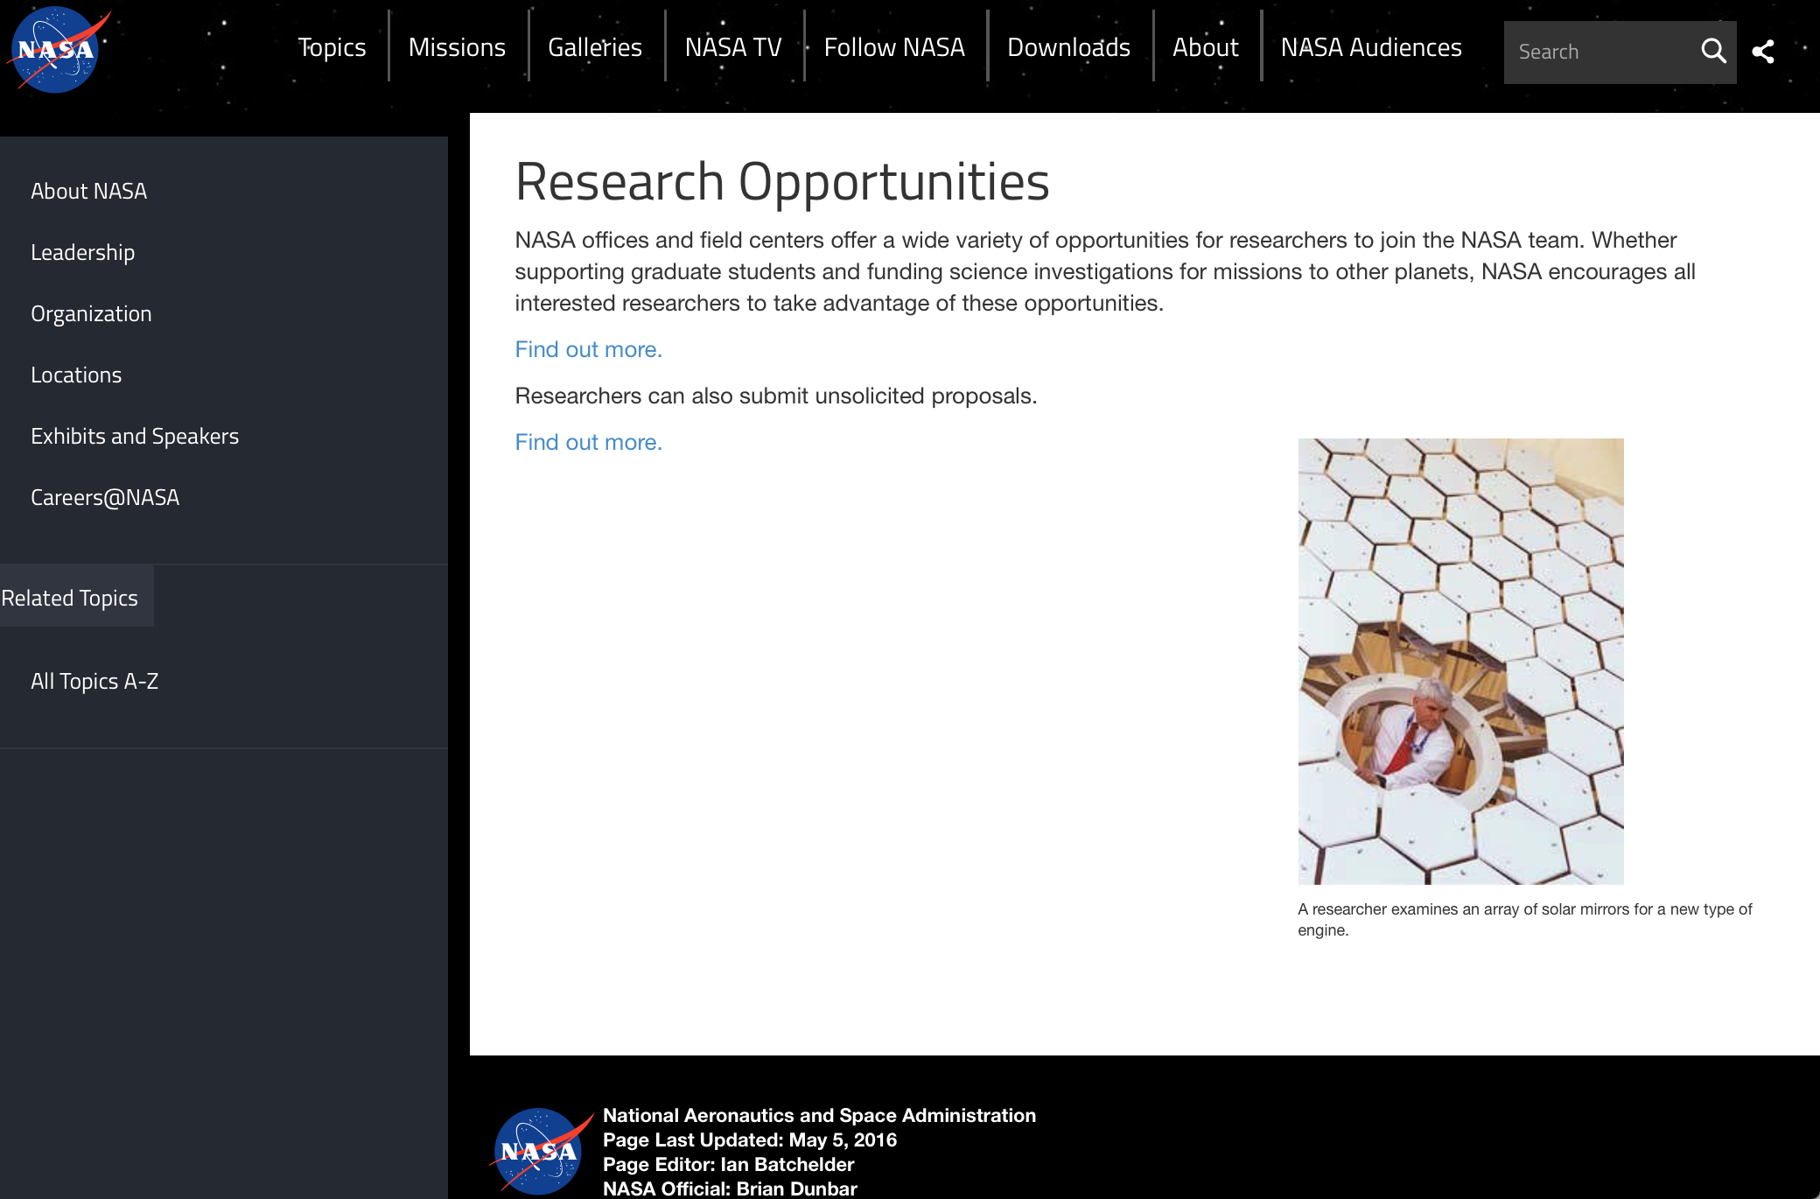

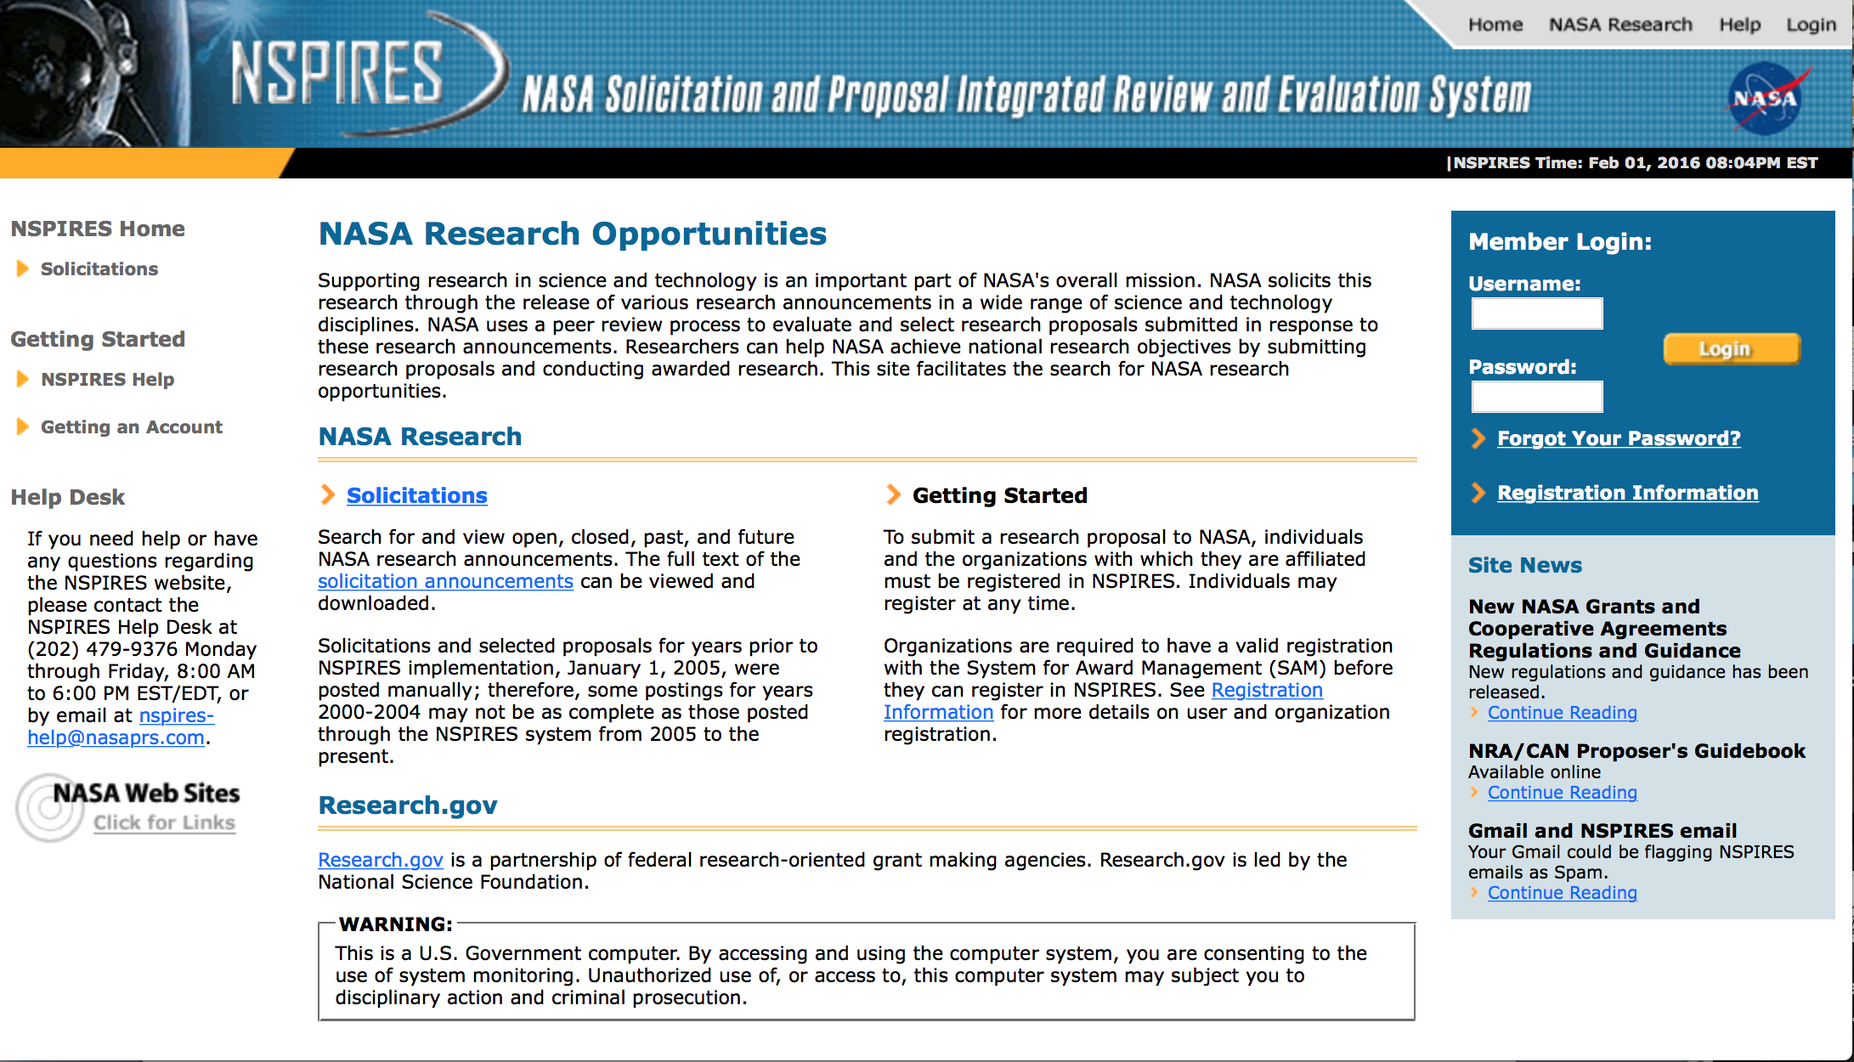
http://nspires.nasaprs.com/external/

Research Programs:

NASA Headquarters
ROSES 2017: Solar Irradiance Science Team
Synopsis 1
http://www.grants.gov/web/grants/view-opportunity.html?oppId=295385

NASA Headquarters
ROSBio Appendix C: Solicitation of Proposals for Possible Inclusion in a Russian Bion-M2 Mission
Synopsis 1
http://www.grants.gov/web/grants/view-opportunity.html?oppId=295500

NASA Headquarters
SpaceTech-REDDI-2017 Appendix E1: Smallsat Technology Partnerships
Synopsis 1
http://www.grants.gov/web/grants/view-opportunity.html?oppId=295623

NASA Headquarters
ROSES 2017: Science Team for the OCO Missions
Synopsis 1
http://www.grants.gov/web/grants/view-opportunity.html?oppId=295593

Modifications:

NASA Headquarters
ROSES 2017: New (Early Career) Investigator Program
Synopsis 2
http://www.grants.gov/web/grants/view-opportunity.html?oppId=293790

NASA Headquarters
ROSES 2017: Heliophysics Supporting Research
Synopsis 2
http://www.grants.gov/web/grants/view-opportunity.html?oppId=294198

NASA Johnson Space Center
2017 Human Exploration Research Opportunities (HERO)
Synopsis 2 & 4
http://www.grants.gov/web/grants/view-opportunity.html?oppId=295274

National Archives and Records Administration

Grant Opportunities General Overview

To access the information below: click here

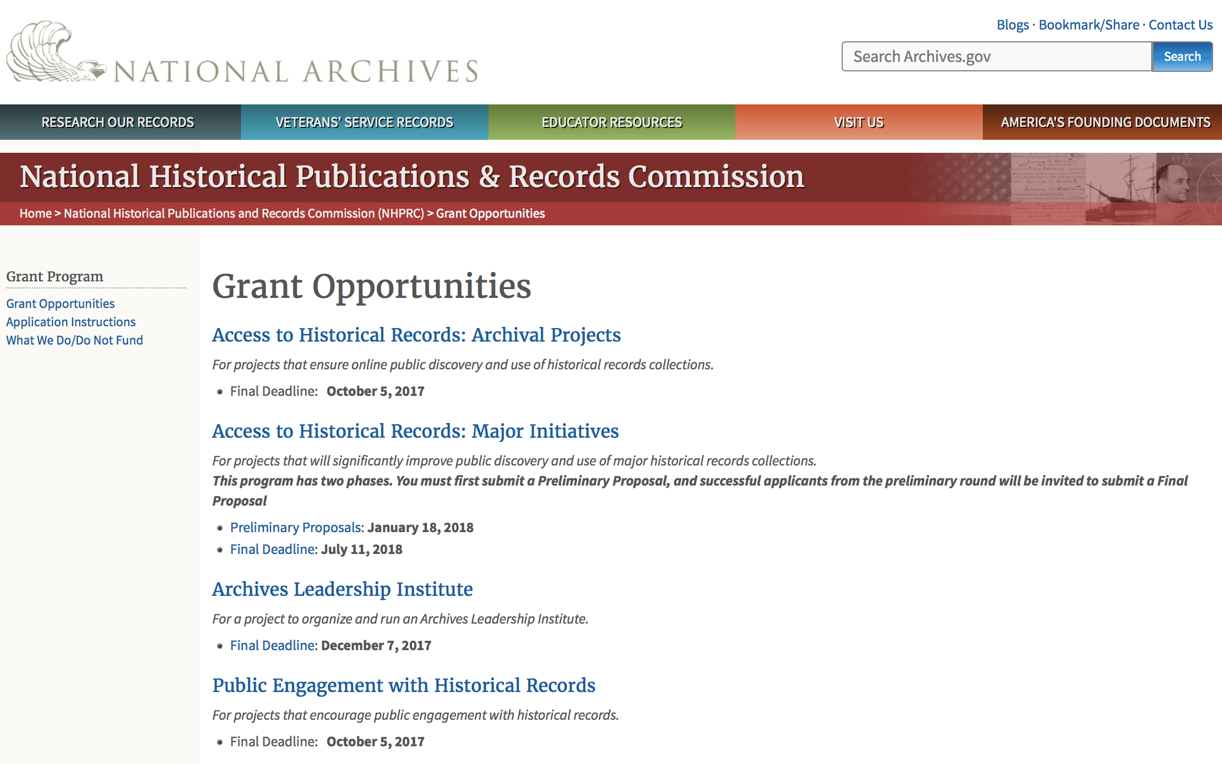

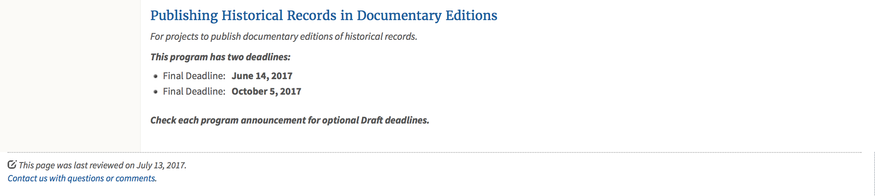
https://www.archives.gov/nhprc/announcement

Programs:

Access to Historical Records: Major Initiatives (Preliminary)
Synopsis 1

Document Type: | Grants Notice
Funding Opportunity Number: | PRELIM-201801
Funding Opportunity Title: | Access to Historical Records: Major Initiatives (Preliminary)
Opportunity Category: | Discretionary
Opportunity Category Explanation:
Funding Instrument Type: | Grant
Category of Funding Activity: | Humanities (see "Cultural Affairs" in CFDA)
Category Explanation:
Expected Number of Awards: | 5
CFDA Number(s): | 89.003 -- National Historical Publications and Records Grants
Cost Sharing or Matching Requirement: | Yes
Version: | Synopsis 3
Posted Date: | Jul 14, 2017
Last Updated Date: | Jul 24, 2017
Original Closing Date for Applications: | Jan 18, 2018
Current Closing Date for Applications: | Jan 18, 2018
Archive Date:
Estimated Total Program Funding: | $1,000,000
Award Ceiling: | $350,000
Award Floor: | $100,000
Eligible Applicants: | State governments  County governments  Nonprofits having a 501(c)(3) status with the IRS, other than institutions of higher education  Private institutions of higher education  Native American tribal governments (Federally recognized)  Public and State controlled institutions of higher education  City or township governments
Agency Name: | National Archives and Records Administration
Description: | The National Historical Publications and Records Commission seeks projects that will significantly improve public discovery and use of major historical records collections. All types of historical records are eligible, including documents, photographs, born-digital records, and analog audio and moving images. Projects may: • Digitize historical records collections, or related collections, held by a single institution and make them freely available online• Provide access to born-digital records• Create new freely-available virtual collections drawn from historical records held by multiple institutions• Create new tools and methods for users to access records The NHPRC welcomes collaborative projects, particularly for bringing together related records from multiple institutions. Projects that address significant needs in the field and result in replicable and scalable approaches will be more competitive. We also encourage organizations to actively engage the public in the work of the project. Applicants should also consult Access to Historical Records: Archival Projects program, which has different requirements and award amounts. For a comprehensive list of Commission limitations on funding, please see: "What we do and do not fund" (http://www.archives.gov/nhprc/apply/eligibility.html). Applications that consist entirely of ineligible activities will not be considered. Award InformationA grant is for one to three years and for between $100,000 and $350,000. We expect to make up to five grants in this category for a total of up to $1,000,000. Grants begin no earlier than January 1, 2019.The Commission requires that grant recipients acknowledge NHPRC grant assistance in all publications and other products that result from its support. Eligibility Eligible applicants:• Nonprofit organizations or institutions• Colleges, universities, and other academic institutions• State or local government agencies• Federally-acknowledged or state-recognized Native American tribes or groups Cost Sharing The total costs of a project are shared between the NHPRC and the applicant organization. The Commission provides no more than 50 per cent of total project costs in the Access to Historical Records: Major Initiatives category. NHPRC grant recipients are not permitted to use grant funds for indirect costs (as indicated in 2 CFR 2600.101).Cost sharing is required. The applicant's financial contribution may include both direct and indirect expenses, in-kind contributions, non-Federal third-party contributions, and any income earned directly by the project. Indirect costs must be listed under the applicant's cost sharing contribution. Other Requirements Applicant organizations must be registered in the System for Award Management (SAM) prior to submitting an application, maintain SAM registration throughout the application and award process, and include a valid DUNS number in their application. Details on SAM registration and requesting a DUNS number can be found at the System for Award Management website at https://sam.gov. Please refer to the User Guides section and the Grants Registrations PDF. Application Information You must use Grants.gov to submit a Preliminary Proposal. All information necessary to apply is included in this announcement, the Application Instructions, and the forms on Grants.gov. If you need the information supplied in an alternative format, please call the NHPRC at 202-357-5010.In order to ensure eligibility, applicants should first review the rules and regulations governing NHPRC grants under the Administering an NHPRC Grant section. Applying to the Access to Historical Records: Major Initiatives program is a two-phase process. Phase One• Using this announcement, all applicants must submit an Application Package that includes the Application for Federal Domestic Assistance Form SF424, a completed NHPRC Budget, and five-page Project Narrative via Grants.gov by January 18, 2018.• Preliminary proposals will then undergo peer and staff review. Based on those reviews, a selection of promising applicants will be invited by April 16, 2018 to participate in the second phase of the process. Phase Two• Invited applicants will then prepare and submit a complete application to the full Major Initiatives grant announcement via Grants.gov by July 11, 2018. • Applicants may consult with the Director of the Access Program, Alex Lorch (alexander.lorch@nara.gov), or with the Director for Technology Initiatives, Nancy Melley (nancy.melley@nara.gov), during both the preliminary and full proposal project phases. • In order to ensure eligibility, applicants should first review the rules and regulations governing NHPRC grants under the Administering an NHPRC Grant section.
Link to Additional Information: | Link to full grant announcement, including additional requirements
Grantor Contact Information: | If you have difficulty accessing the full announcement electronically, please contact:  Jeff de la Concepcion Jeff.delaconcepcion@Nara.gov  Grant Information Specialist

http://www.grants.gov/web/grants/view-opportunity.html?oppId=295495

Access to Historical Records: Major Initiatives
Synopsis 1

Document Type: | Grants Notice
Funding Opportunity Number: | MAJOR-201807
Funding Opportunity Title: | Access to Historical Records: Major Initiatives
Opportunity Category: | Discretionary
Opportunity Category Explanation:
Funding Instrument Type: | Grant
Category of Funding Activity: | Humanities (see "Cultural Affairs" in CFDA)
Category Explanation:
Expected Number of Awards: | 5
CFDA Number(s): | 89.003 -- National Historical Publications and Records Grants
Cost Sharing or Matching Requirement: | Yes
Version: | Synopsis 1
Posted Date: | Jul 14, 2017
Last Updated Date: | Jul 14, 2017
Original Closing Date for Applications: | Jul 11, 2018
Current Closing Date for Applications: | Jul 11, 2018
Archive Date:
Estimated Total Program Funding: | $1,000,000
Award Ceiling: | $350,000
Award Floor: | $100,000
Eligible Applicants: | Public and State controlled institutions of higher education  County governments  Nonprofits having a 501(c)(3) status with the IRS, other than institutions of higher education  State governments  City or township governments  Private institutions of higher education  Native American tribal governments (Federally recognized)
Agency Name: | National Archives and Records Administration
Description: | The National Historical Publications and Records Commission seeks projects that will significantly improve public discovery and use of major historical records collections. All types of historical records are eligible, including documents, photographs, born-digital records, and analog audio and moving images. Projects may: • Digitize historical records collections, or related collections, held by a single institution and make them freely available online • Provide access to born-digital records • Create new freely-available virtual collections drawn from historical records held by multiple institutions • Create new tools and methods for users to access records The NHPRC welcomes collaborative projects, particularly for bringing together related records from multiple institutions. Projects that address significant needs in the field and result in replicable and scalable approaches will be more competitive. We also encourage organizations to actively engage the public in the work of the project. Applicants should also consult Access to Historical Records: Archival Projects program, which has different requirements and award amounts. For a comprehensive list of Commission limitations on funding, please see: "What we do and do not fund" (http://www.archives.gov/nhprc/apply/eligibility.html). Applications that consist entirely of ineligible activities will not be considered. Award Information A grant is for one to three years and between $100,000 and $350,000. We expect to make up to five grants in this category for a total of up to $1,000,000. Grants begin no earlier than January 1, 2019. The Commission requires that grant recipients acknowledge NHPRC grant assistance in all publicity, publications, and other products that result from its support. Eligibility Eligible applicants: • U.S. nonprofit organizations or institutions • U.S. colleges, universities, and other academic institutions • State or local government agencies • Federally-acknowledged or state-recognized Native American tribes or groups Cost Sharing The total costs of a project are shared between the NHPRC and the applicant organization. The Commission provides no more than 50 per cent of total project costs in the Access to Historical Records: Major Initiatives category. NHPRC grant recipients are not permitted to use grant funds for indirect costs (as indicated in 2 CFR 2600.101). Cost sharing is required. The applicant's financial contribution may include both direct and indirect expenses, in-kind contributions, non-Federal third-party contributions, and any income earned directly by the project. Indirect costs must be listed under the applicant's cost sharing contribution. Other Requirements Applicant organizations must be registered in the System for Award Management (SAM) prior to submitting an application, maintain SAM registration throughout the application and award process, and include a valid DUNS number in their application. Details on SAM registration and requesting a DUNS number can be found at the System for Award Management website at https://sam.gov. Please refer to the User Guides section and the Grants Registrations PDF. Application Information You must use Grants.gov to submit your Full Proposal. All information necessary to apply is included in this announcement, the Application Instructions, and the forms on Grants.gov. If you need the information supplied in an alternative format, please call the NHPRC at 202-357-5010. In order to ensure eligibility, applicants should first review the rules and regulations governing NHPRC grants under the Administering an NHPRC Grant section. Applying to the Access to Historical Records: Major Initiatives program is a two-phase process. Phase One • All applicants must have submitted a Preliminary Proposal by January 18, 2018. • Only those applicants who have successfully completed Phase One and who have been invited by the Commission to submit a full proposal to the Access to Historical Records: Major Initiatives program are eligible to participate in the second phase of the process. Phase Two • If you have been invited, prepare and submit a complete application to the full Major Initiatives grant announcement via Grants.gov by July 11, 2018. • Applicants may consult with the Director of the Access Program, Alex Lorch (alexander.lorch@nara.gov), or with the Director for Technology Initiatives, Nancy Melley (nancy.melley@nara.gov), during both the preliminary and full proposal project phases.
Link to Additional Information: | Link to full grant announcement, including additional requirements
Grantor Contact Information: | If you have difficulty accessing the full announcement electronically, please contact:  Jeff de la Concepcion Jeff.delaconcepcion@nara.gov  Grant Information Specialist

http://www.grants.gov/web/grants/view-opportunity.html?oppId=295496

Reminders:

Access to Historical Records: Archival Projects
Synopsis 1
Document Type: | Grants Notice
Funding Opportunity Number: | ARCHIVAL-201710
Funding Opportunity Title: | Access to Historical Records: Archival Projects
Opportunity Category: | Discretionary
Opportunity Category Explanation:
Funding Instrument Type: | Grant
Category of Funding Activity: | Humanities (see "Cultural Affairs" in CFDA)
Category Explanation:
Expected Number of Awards: | 10
CFDA Number(s): | 89.003 -- National Historical Publications and Records Grants
Cost Sharing or Matching Requirement: | Yes
Version: | Synopsis 1
Posted Date: | Jun 09, 2017
Last Updated Date: | Jun 09, 2017
Original Closing Date for Applications: | Oct 05, 2017
Current Closing Date for Applications: | Oct 05, 2017
Archive Date:
Estimated Total Program Funding: | $700,000
Award Ceiling: | $100,000
Award Floor: | $1
Eligible Applicants: | Private institutions of higher education  Public and State controlled institutions of higher education  City or township governments  County governments  Nonprofits having a 501(c)(3) status with the IRS, other than institutions of higher education  Native American tribal governments (Federally recognized)  State governments
Agency Name: | National Archives and Records Administration
Description: | The National Historical Publications and Records Commission seeks projects that ensure online public discovery and use of historical records collections. All types of historical records are eligible, including documents, photographs, born-digital records, and analog audio and moving images. Projects may preserve and process historical records to: • Create new online Finding Aids to collections • Digitize historical records collections and make them freely available online The NHPRC encourages organizations to actively engage the public in the work of the project. For a comprehensive list of Commission limitations on funding, please see: "What we do and do not fund" (http://www.archives.gov/nhprc/apply/eligibility.html). Applications that consist entirely of ineligible activities will not be considered. Award Information A grant is for one or two years and for up to $100,000. The Commission expects to make up to 10 grants in this category for a total of up to $700,000. Grants begin no earlier than July 1, 2018. The Commission requires that grant recipients acknowledge NHPRC grant assistance in all publicity, publications, and other products that result from its support. Eligibility Eligible applicants: • Nonprofit organizations or institutions • Colleges, universities, and other academic institutions • State or local government agencies • Federally-acknowledged or state-recognized Native American tribes or groups Cost Sharing The total costs of a project are shared between the NHPRC and the applicant organization. The Commission provides no more than 75 per cent of total project costs in the Access to Historical Records: Archival Projects category. NHPRC grant recipients are not permitted to use grant funds for indirect costs (as indicated in 2 CFR 2600.101). Cost sharing is required. The applicant's financial contribution may include both direct and indirect expenses, in-kind contributions, non-Federal third-party contributions, and any income earned directly by the project. Indirect costs must be listed under the applicant's cost sharing contribution. Other Requirements Applicant organizations must be registered in the System for Award Management (SAM) prior to submitting an application, maintain SAM registration throughout the application and award process, and include a valid DUNS number in their application. Details on SAM registration and requesting a DUNS number can be found at the System for Award Management website at https://sam.gov. Please refer to the User Guides section and the Grants Registrations PDF. Ineligible applications will not be reviewed.
Link to Additional Information: | Link to full grant announcement, including additional requirements
Grantor Contact Information: | If you have difficulty accessing the full announcement electronically, please contact:  Jeff de la Concepcion Jeff.delaconcepcion@nara.gov  Grant Information Specialist

http://www.grants.gov/web/grants/view-opportunity.html?oppId=294522

EDITIONS-201710 for Publishing Historical Records in Documentary Editions
Synopsis 1

Document Type: | Grants Notice
Funding Opportunity Number: | EDITIONS-201710
Funding Opportunity Title: | For Publishing Historical Records in Documentary Editions
Opportunity Category: | Discretionary
Opportunity Category Explanation:
Funding Instrument Type: | Grant
Category of Funding Activity: | Humanities (see "Cultural Affairs" in CFDA)
Category Explanation:
Expected Number of Awards: | 25
CFDA Number(s): | 89.003 -- National Historical Publications and Records Grants
Cost Sharing or Matching Requirement: | Yes
Version: | Synopsis 1
Posted Date: | Dec 09, 2016
Last Updated Date: | Dec 09, 2016
Original Closing Date for Applications: | Oct 05, 2017
Current Closing Date for Applications: | Oct 05, 2017
Archive Date:
Estimated Total Program Funding: | $2,500,000
Award Ceiling: | $200,000
Award Floor: | $1
Eligible Applicants: | County governments  Nonprofits having a 501(c)(3) status with the IRS, other than institutions of higher education  Native American tribal governments (Federally recognized)  City or township governments  Public and State controlled institutions of higher education  State governments  Private institutions of higher education
Agency Name: | National Archives and Records Administration
Description: | The National Historical Publications and Records Commission seeks proposals to publish documentary editions of historical records. Projects may focus on the papers of major figures from American history or cover broad historical movements in politics, military, business, social reform, the arts, and other aspects of the national experience. The historical value of the records and their expected usefulness to broad audiences must justify the costs of the project. The goal of this program is to provide access to, and editorial context for, the historical documents and records that tell the American story. The NHPRC encourages projects, whenever possible and appropriate, to provide free access to these materials in an open online environment, without precluding other forms of publication. Applicants should demonstrate familiarity with the best practices recommended by the Association for Documentary Editing or the Modern Language Association Committee on Scholarly Editions. Projects may also prepare print editions as part of their overall publishing plan. However, projects that do not have definitive plans for digital dissemination and preservation in place at the time of application will not be considered. It is also expected that the contents of any print volumes produced will be made available online within a reasonable period of time following print publication. Grants are awarded for collecting, describing, preserving, compiling, transcribing, annotating, editing, encoding, and publishing documentary source materials online and in print. Because of the focus on documentary sources, grants do not support preparation of critical editions of published works unless such works are just a small portion of the larger project. All applicants should be aware that the application process is highly competitive. For a comprehensive list of Commission's limitations on funding, please see What We Do and Do Not Fund. Applications that consist entirely of ineligible activities will not be considered. Ongoing projects: Applicants from ongoing projects must demonstrate that they have successfully achieved the performance objectives associated with previous NHPRC awards; provide updated, current information, including a description of the new activities; describe the content and historical significance of the specific materials to be edited during the proposed grant period; show progress towards completing the edition; and justify costs in a new budget. Award Information A grant is for one year and for up to $200,000. The Commission expects to make up to 25 grants in this category for a total of up to $2,500,000. Grants begin no earlier than January 1, 2018. The Commission requires that grant recipients acknowledge NHPRC grant assistance in all publications, publicity, and other products that result from its support. Eligibility • U.S. nonprofit organizations or institutions • U.S. colleges, universities, and other academic institutions • State or local government agencies • Federally-acknowledged or state-recognized Native American tribes or groups Cost Sharing The total costs of a project are shared between the NHPRC and the applicant organization. The Commission provides no more than 50 per cent of total direct project costs in the Publishing Historical Records in Documentary Editions category. NHPRC grant recipients are not permitted to use grant funds for indirect costs (as indicated in 2 CFR 2600.101). Cost sharing is required. The applicant’s financial contribution may include both direct and indirect expenses, in-kind contributions, non-Federal third-party contributions, and any income earned directly by the project. Indirect costs must be listed under the applicant’s cost sharing contribution. Other Requirements Applicant organizations must be registered in the System for Award Management (SAM) prior to submitting an application, maintain SAM registration throughout the application and award process, and include a valid DUNS number in their application. Details on SAM registration and requesting a DUNS number can be found at the System for Award Management website at https://sam.gov. Please refer to the User Guides section and the Grants Registrations PDF. A complete application includes the Application for Federal Assistance (Standard Form 424), Assurances -- Non-Construction Programs (Standard Form 424B), a Project Narrative, Summary, Supplementary Materials, and Budget. Applications lacking these items will not be considered. Ineligible applications will not be reviewed.
Link to Additional Information: | Link to full grant announcement, including additional requirements
Grantor Contact Information: | If you have difficulty accessing the full announcement electronically, please contact:  Jeff de la Concepcion Jeff.delaConcepcion@nara.gov  Grant Information Specialist

http://www.grants.gov/web/grants/view-opportunity.html?oppId=290564

National Endowment for the Arts

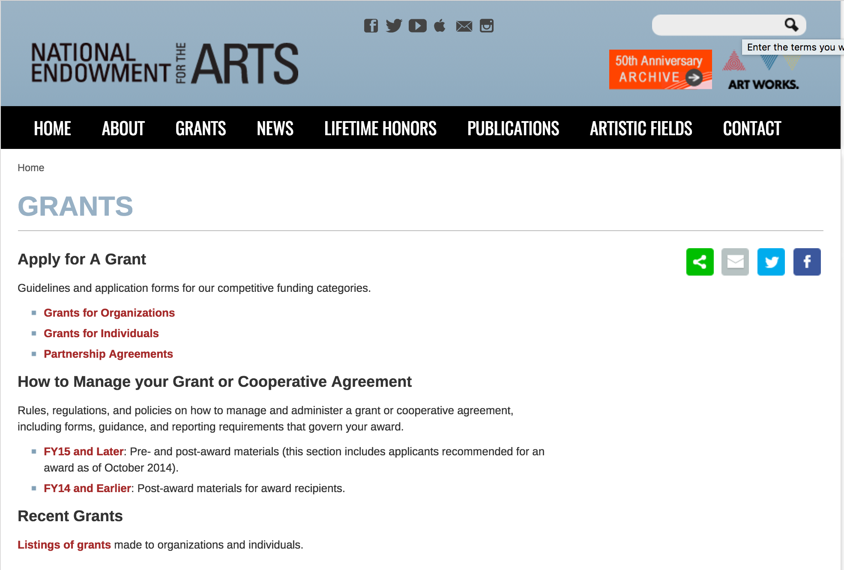

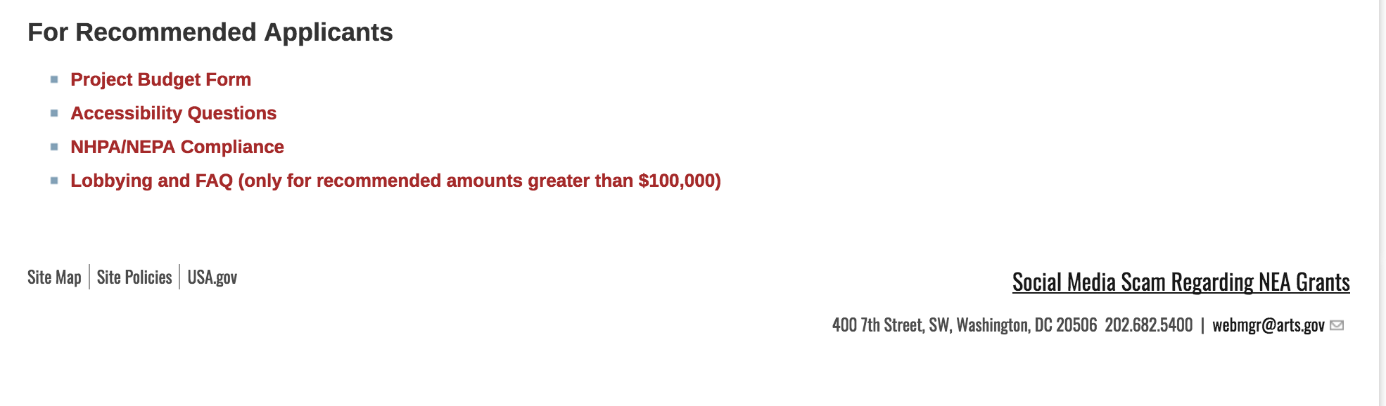
See more at: https://www.arts.gov/grants

Programs:

NEA Literature Fellowships: Translation Projects, FY2019
Synopsis 1
Document Type: | Grants Notice
Funding Opportunity Number: | 2018NEA03LFTP
Funding Opportunity Title: | NEA Literature Fellowships: Translation Projects, FY2019
Opportunity Category: | Discretionary
Opportunity Category Explanation:
Funding Instrument Type: | Grant
Category of Funding Activity: | Arts (see "Cultural Affairs" in CFDA)
Category Explanation:
Expected Number of Awards:
CFDA Number(s): | 45.024 -- Promotion of the Arts Grants to Organizations and Individuals
Cost Sharing or Matching Requirement: | No
Version: | Synopsis 1
Posted Date: | Jul 25, 2017
Last Updated Date: | Jul 25, 2017
Original Closing Date for Applications: | Dec 05, 2017
Current Closing Date for Applications: | Dec 05, 2017
Archive Date:
Estimated Total Program Funding:
Award Ceiling: | $25,000
Award Floor: | $12,500
Eligible Applicants: | Individuals
Agency Name: | National Endowment for the Arts
Description: | An individual may submit only one application for FY 2019 funding. You may not apply for both a Translation Project under this deadline (December 5, 2017) and a Literature Fellowship (in prose or poetry) under the 2018 deadline (when fellowships in prose are offered). The Arts Endowment’s support of a project may begin any time between November 1, 2018, and November 1, 2019, and extend for up to two years. Program Description Through fellowships to published translators, the National Endowment for the Arts supports projects for the translation of specific works of prose, poetry, or drama from other languages into English. We encourage translations of writers and of work that are not well represented in English translation. All proposed projects must be for creative translations of literary material into English. The work to be translated should be of interest for its literary excellence and value. Priority will be given to projects that involve work that has not previously been translated into English. Competition for fellowships is rigorous. Potential applicants should consider carefully whether their work will be competitive at the national level.
Link to Additional Information: | NEA Website Announcement
Grantor Contact Information: | If you have difficulty accessing the full announcement electronically, please contact:  NEA Web Manager webmgr@arts.gov  NEA Web Manager

http://www.grants.gov/web/grants/view-opportunity.html?oppId=295826

Modifications:

Reminders:

NEA Our Town Application, FY2018
Synopsis 1
Document Type: | Grants Notice
Funding Opportunity Number: | 2017NEA01OT
Funding Opportunity Title: | NEA Our Town Application, FY2018
Opportunity Category: | Discretionary
Opportunity Category Explanation:
Funding Instrument Type: | Grant
Category of Funding Activity: | Arts (see "Cultural Affairs" in CFDA)
Category Explanation:
Expected Number of Awards: | 500
CFDA Number(s): | 45.024 -- Promotion of the Arts Grants to Organizations and Individuals
Cost Sharing or Matching Requirement: | Yes
Version: | Synopsis 1
Posted Date: | May 18, 2017
Last Updated Date: | May 18, 2017
Original Closing Date for Applications: | Sep 11, 2017
Current Closing Date for Applications: | Sep 11, 2017
Archive Date:
Estimated Total Program Funding:
Award Ceiling: | $200,000
Award Floor: | $25,000
Eligible Applicants: | State governments  County governments  Private institutions of higher education  Independent school districts  Public and State controlled institutions of higher education  City or township governments  Special district governments  Nonprofits having a 501(c)(3) status with the IRS, other than institutions of higher education  Native American tribal governments (Federally recognized)
Agency Name: | National Endowment for the Arts
Description: | The Our Town grant program supports creative placemaking projects that help to transform communities into lively, beautiful, and resilient places – achieving these community goals through strategies that incorporate arts, culture, and/or design. Creative placemaking is when artists, arts organizations, and community development practitioners deliberately integrate arts and culture into community revitalization work - placing arts at the table with land-use, transportation, economic development, education, housing, infrastructure, and public safety strategies. This funding supports local efforts to enhance quality of life and opportunity for existing residents, increase creative activity, and create or preserve a distinct sense of place. Through Our Town, subject to the availability of funding, the National Endowment for the Arts will provide a limited number of grants for creative placemaking. Our Town requires partnerships between arts organizations and government, other nonprofit organizations, and private entities to achieve livability goals for communities. Our Town offers support for projects in two areas: • Arts Engagement, Cultural Planning, and Design Projects. These projects represent the distinct character and quality of their communities. These projects require a partnership between a nonprofit organization and a local government entity, with one of the partners being a cultural organization. Matching grants range from $25,000 to $200,000. • Projects that Build Knowledge About Creative Placemaking. These projects are available to arts and design service organizations, and industry, policy, or university organizations that provide technical assistance to those doing place-based work. Matching grants range from $25,000 to $100,000. • Through Our Town projects, the National Endowment for the Arts intends to achieve the following objective: Livability: American communities are strengthened through the arts.
Link to Additional Information: | NEA Website Announcement
Grantor Contact Information: | If you have difficulty accessing the full announcement electronically, please contact:  NEA Web Manager webmgr@arts.gov  NEA Web Manager

http://www.grants.gov/web/grants/view-opportunity.html?oppId=293915

National Endowment for the Humanities

Grant Overview -

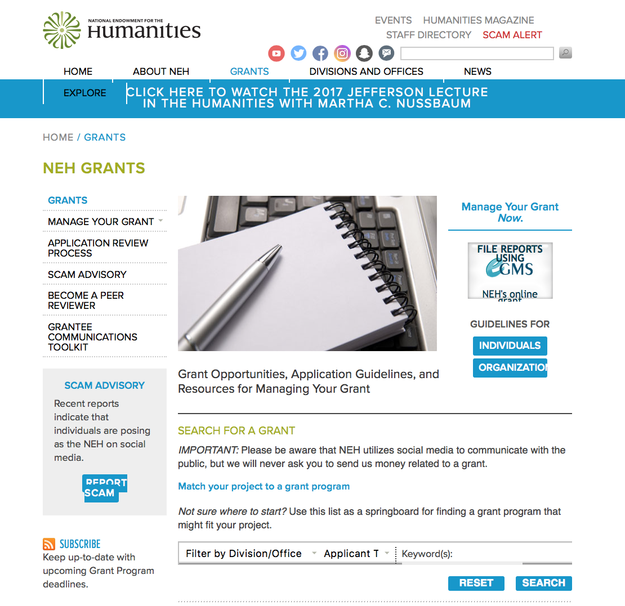

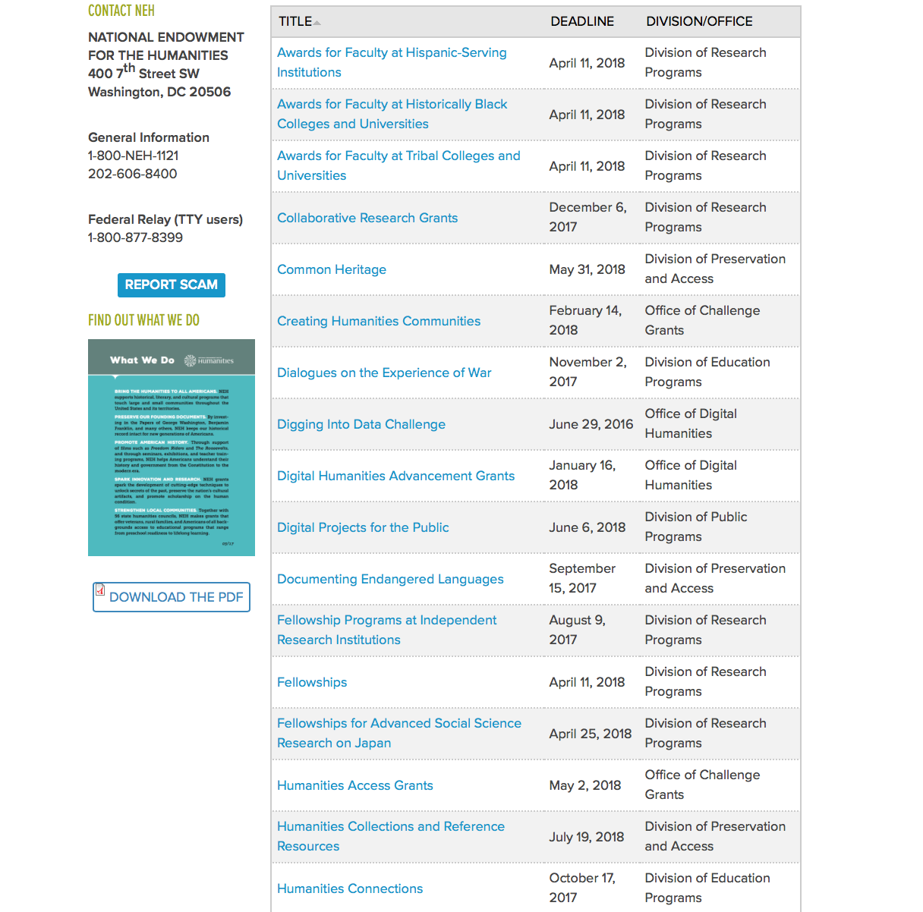

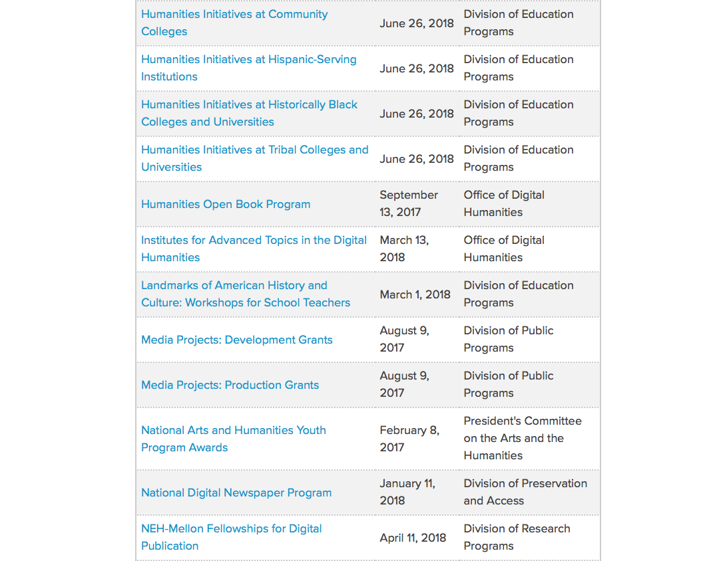

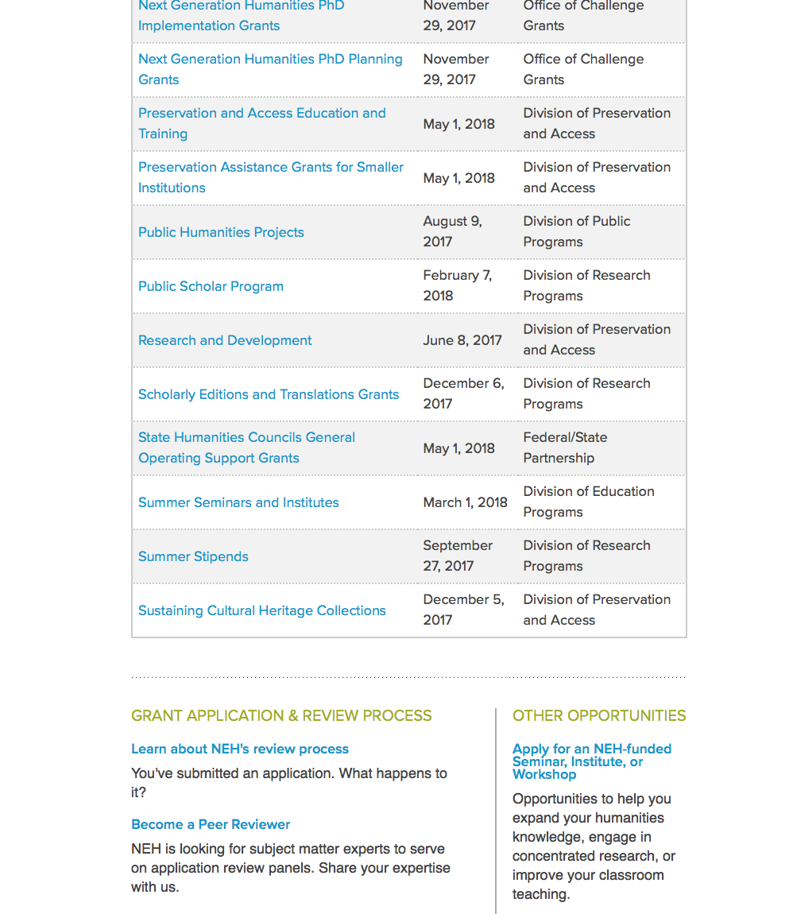

https://www.neh.gov/grants

Programs:

Modifications:

Reminders:

Fellowship Programs at Independent Research Institutions
Synopsis 1
Document Type: | Grants Notice
Funding Opportunity Number: | 20170809-RA
Funding Opportunity Title: | Fellowship Programs at Independent Research Institutions
Opportunity Category: | Discretionary
Opportunity Category Explanation:
Funding Instrument Type: | Grant
Category of Funding Activity: | Humanities (see "Cultural Affairs" in CFDA)
Category Explanation:
Expected Number of Awards:
CFDA Number(s): | 45.161 -- Promotion of the Humanities Research
Cost Sharing or Matching Requirement: | No
Version: | Synopsis 1
Posted Date: | Jun 05, 2017
Last Updated Date: | Jun 05, 2017
Original Closing Date for Applications: | Aug 09, 2017
Current Closing Date for Applications: | Aug 09, 2017
Archive Date:
Estimated Total Program Funding:
Award Ceiling: | $400,000
Award Floor: | $100,000
Eligible Applicants: | Nonprofits having a 501(c)(3) status with the IRS, other than institutions of higher education  City or township governments  Native American tribal governments (Federally recognized)  State governments  County governments  Special district governments
Agency Name: | National Endowment for the Humanities
Description: | Grants for Fellowship Programs at Independent Research Institutions (FPIRI) support fellowships at institutions devoted to advanced study and research in the humanities. Recognizing that at times scholars need to work away from their homes and institutions, the FPIRI program sponsors fellowships that provide scholars with research time, a stimulating intellectual environment, and access to resources that might otherwise not be available to them. Fellowship programs may be administered by independent centers for advanced study, libraries, and museums in the United States; American overseas research centers; and American organizations that have expertise in promoting research in foreign countries. Individual scholars apply directly to the institutions for fellowships. In evaluating applications consideration is given to the library holdings, archives, special collections, and other resources—either on site or nearby—that institutions make available to fellows. FPIRI grants provide funding for humanities fellowships of four to twelve months. The fellowships are held at the U.S. grantee institutions or—in the case of overseas research centers and organizations—abroad. FPIRI grants support fellowship stipends at a rate of $4,200 per month and a portion of the costs of selecting the fellows, up to $5,000 per year.
Link to Additional Information: | https://www.neh.gov/grants/research/fellowship-programs-independent-research-institutions
Grantor Contact Information: | If you have difficulty accessing the full announcement electronically, please contact:  Division of Research Programs National Endowment for the Humanities 400 Seventh Street, SW Washington, DC 20506 202-606-8200 fpiri@neh.gov fpiri@neh.gov  fpiri@neh.gov

http://www.grants.gov/web/grants/view-opportunity.html?oppId=294391

Media Projects
Synopsis 1
Document Type: | Grants Notice
Funding Opportunity Number: | 20170809-TD
Funding Opportunity Title: | Media Projects
Opportunity Category: | Discretionary
Opportunity Category Explanation:
Funding Instrument Type: | Grant
Category of Funding Activity: | Humanities (see "Cultural Affairs" in CFDA)
Category Explanation:
Expected Number of Awards:
CFDA Number(s): | 45.164 -- Promotion of the Humanities Public Programs
Cost Sharing or Matching Requirement: | No
Version: | Synopsis 1
Posted Date: | Jun 02, 2017
Last Updated Date: | Jun 02, 2017
Original Closing Date for Applications: | Aug 09, 2017
Current Closing Date for Applications: | Aug 09, 2017
Archive Date:
Estimated Total Program Funding:
Award Ceiling: | $1,000,000
Award Floor: | $1
Eligible Applicants: | Private institutions of higher education  Nonprofits having a 501(c)(3) status with the IRS, other than institutions of higher education  Native American tribal governments (Federally recognized)  City or township governments  State governments  Special district governments  County governments  Public and State controlled institutions of higher education
Agency Name: | National Endowment for the Humanities
Description: | The Media Projects program supports film, television, and radio projects that engage general audiences with humanities ideas in creative and appealing ways. All projects must be grounded in humanities scholarship in disciplines such as history, art history, film studies, literature, drama, religious studies, philosophy, or anthropology. Projects must also demonstrate an approach that is thoughtful, balanced, and analytical (rather than celebratory). The approach to the subject matter must go beyond the mere presentation of factual information to explore its larger significance and stimulate critical thinking. NEH is a national funding agency, so the projects that we support must demonstrate the potential to attract a broad general audience. Film and television projects may be single programs or a series addressing significant figures, events, or ideas. Programs must be intended for national distribution, via traditional carriage or online distribution. The Division of Public Programs welcomes projects that range in length from short-form to broadcast-length video. The Division of Public Programs also encourages film and television projects that examine international themes and subjects in the humanities, in order to spark Americans’ engagement with the broader world beyond the United States. These projects should demonstrate international collaboration by enlisting scholars based both in the United States and abroad, and/or by working with an international media team. The collaborations should bring broad cross-cultural perspectives to the proposed topics and should be intended primarily for U.S. public audiences. Radio projects, including podcasts, may involve single programs, limited series, or segments within an ongoing series. They may also develop new humanities content to augment existing radio programming or add greater historical background or humanities analysis to the subjects of existing programs. Programs receiving production grants may be either broadcast or disseminated online. They may be intended for national or regional distribution. NEH encourages projects that engage public audiences through multiple formats in the exploration of humanities ideas. Proposed projects might include complementary components to a film, television, or radio project. These components should deepen the audience’s understanding of the subject in a supplementary manner: for example, book/film discussion programs, supplemental educational websites, or museum exhibitions. Development grants enable media producers to collaborate with scholars to develop humanities content and to prepare programs for production. Grants should result in a script and may also yield a detailed plan for outreach and public engagement in collaboration with a partner organization or organizations. See application guidelines for Development Grants. Production grants support the production and distribution of films, television programs, and radio programs or podcasts that promise to engage a broad public audience. Development grants enable media producers to collaborate with scholars to develop humanities content and to prepare programs for production. Grants should result in a script and may also yield a detailed plan for outreach and public engagement in collaboration with a partner organization or organizations. See application guidelines for Development Grants. Production grants support the production and distribution of films, television programs, and radio programs or podcasts that promise to engage a broad public audience. Development grants enable media producers to collaborate with scholars to develop humanities content and to prepare programs for production. Grants should result in a script and may also yield a detailed plan for outreach and public engagement in collaboration with a partner organization or organizations. Production grants support the production and distribution of films, television programs, and radio programs or podcasts that promise to engage a broad public audience.
Link to Additional Information: | https://www.neh.gov/grants/mp
Grantor Contact Information: | If you have difficulty accessing the full announcement electronically, please contact:  Division of Public Programs National Endowment for the Humanities 400 Seventh Street, SW Washington, DC 20506 202-606-8269 publicpgms@neh.gov publicpgms@neh.gov  publicpgms@neh.gov

http://www.grants.gov/web/grants/view-opportunity.html?oppId=294262

Public Humanities Projects
Synopsis 1
Document Type: | Grants Notice
Funding Opportunity Number: | 20170809-GW
Funding Opportunity Title: | Public Humanities Projects
Opportunity Category: | Discretionary
Opportunity Category Explanation:
Funding Instrument Type: | Grant
Category of Funding Activity: | Humanities (see "Cultural Affairs" in CFDA)
Category Explanation:
Expected Number of Awards:
CFDA Number(s): | 45.164 -- Promotion of the Humanities Public Programs
Cost Sharing or Matching Requirement: | No
Version: | Synopsis 1
Posted Date: | Jun 08, 2017
Last Updated Date: | Jun 08, 2017
Original Closing Date for Applications: | Aug 09, 2017
Current Closing Date for Applications: | Aug 09, 2017
Archive Date:
Estimated Total Program Funding:
Award Ceiling: | $1,000,000
Award Floor: | $1
Eligible Applicants: | Public and State controlled institutions of higher education  Private institutions of higher education  Nonprofits having a 501(c)(3) status with the IRS, other than institutions of higher education  State governments  Native American tribal governments (Federally recognized)  City or township governments  Special district governments  County governments
Agency Name: | National Endowment for the Humanities
Description: | Public Humanities Projects grants support projects that bring the ideas and insights of the humanities to life for general audiences. Projects must engage humanities scholarship to analyze significant themes in disciplines such as history, literature, ethics, and art history, or to address challenging issues in contemporary life. NEH encourages projects that involve members of the public in collaboration with humanities scholars or that invite contributions from the community in the development and delivery of humanities programming. This grant program supports a variety of forms of audience engagement. Applications should follow the parameters set out below for one of the following three formats: • Community Conversations: This format supports one- to two-year-long series of community-wide public discussions that bring together a diverse group of residents to address important topics relevant to their town or city, guided by the perspectives of the humanities. Applicants must demonstrate prior experience conducting public and nonpartisan dialogues about important topics. • Exhibitions: This format supports permanent exhibitions that will be on view for at least three years, or travelling exhibitions that will be available to public audiences in at least two venues in the United States (including the originating location). • Historic Places: This format supports the interpretation of historic sites, houses, neighborhoods, and regions, which might include living history presentations, guided tours, exhibitions, and public programs. NEH encourages projects that explore humanities ideas through multiple formats. Proposed projects may include complementary components: for example, a museum exhibition might be accompanied by a website, mobile app, or discussion programs. Your application must identify one primary format for your project and follow the application instructions for that format.
Link to Additional Information: | https://www.neh.gov/grants/public/public-humanities-projects
Grantor Contact Information: | If you have difficulty accessing the full announcement electronically, please contact:  Division of Public Programs National Endowment for the Humanities 400 Seventh Street, SW Washington, DC 20506 202-606-8269 publicpgms@neh.gov publicpgms@neh.gov  publicpgms@neh.gov

http://www.grants.gov/web/grants/view-opportunity.html?oppId=294484

Humanities Open Book Program
Synopsis 1
Document Type: | Grants Notice
Funding Opportunity Number: | 20170913-HZ
Funding Opportunity Title: | Humanities Open Book Program
Opportunity Category: | Discretionary
Opportunity Category Explanation:
Funding Instrument Type: | Grant
Category of Funding Activity: | Humanities (see "Cultural Affairs" in CFDA)
Category Explanation:
Expected Number of Awards:
CFDA Number(s): | 45.169 -- Promotion of the Humanities Office of Digital Humanities
Cost Sharing or Matching Requirement: | No
Version: | Synopsis 1
Posted Date: | Jun 22, 2017
Last Updated Date: | Jun 22, 2017
Original Closing Date for Applications: | Sep 13, 2017
Current Closing Date for Applications: | Sep 13, 2017
Archive Date:
Estimated Total Program Funding:
Award Ceiling: | $200,000
Award Floor: | $1
Eligible Applicants: | State governments  Native American tribal governments (Federally recognized)  Special district governments  Private institutions of higher education  Nonprofits having a 501(c)(3) status with the IRS, other than institutions of higher education  City or township governments  Public and State controlled institutions of higher education  County governments
Agency Name: | National Endowment for the Humanities
Description: | The Humanities Open Book Program is designed to make outstanding out-of-print humanities books available to a wide audience. By taking advantage of low-cost “ebook” technology, the program will allow teachers, students, scholars, and the public to read humanities books that have long been out of print. The Humanities Open Book Program is jointly sponsored by NEH and the Andrew W. Mellon Foundation. Traditionally, printed books have been the primary medium for expressing, communicating, and debating humanistic ideas. However, the vast majority of humanities books sell a small number of copies and then quickly go out of print. Most scholarly books printed since 1923 are not in the public domain and are not easily available to the general public. As a result, there is a huge, mostly untapped resource of remarkable scholarship going back decades that is largely unused by today’s scholars, teachers, students, and members of the public, many of whom turn first to the Internet when looking for information. Modern ebook technology can make these books far more accessible than they are today. NEH and Mellon are soliciting proposals from academic presses, scholarly societies, museums, and other institutions that publish books in the humanities to participate in the Humanities Open Book Program. Applicants will provide a list of previously published humanities books along with brief descriptions of the books and their intellectual significance. Depending on the length and topics of the books, the number to be digitized may vary. However, NEH and Mellon anticipate that applicants may propose to digitize a total that ranges from less than fifty to more than one hundred books. Awards will be given to digitize these books and make them available as Creative Commons-licensed “ebooks” that can be read by the public at no charge on computers, mobile devices, and ebook readers. The final ebook files must be in EPUB version 3.0.1 (or later) format, to ensure that the text is fully searchable and reflowable and that fonts are resizable on any e-reading device.
Link to Additional Information: | https://www.neh.gov/grants/odh/humanities-open-book-program
Grantor Contact Information: | If you have difficulty accessing the full announcement electronically, please contact:  If you have questions about the program, contact the Office of Digital Humanities staff at odh@neh.gov. Applicants wishing to speak to a staff member by telephone should provide in an e-mail message a telephone number and a preferred time to call. odh@neh.gov  odh@neh.gov

http://www.grants.gov/web/grants/view-opportunity.html?oppId=294921

Summer Stipends
Synopsis 1

Document Type: | Grants Notice
Funding Opportunity Number: | 20170927-FT
Funding Opportunity Title: | Summer Stipends
Opportunity Category: | Discretionary
Opportunity Category Explanation:
Funding Instrument Type: | Grant
Category of Funding Activity: | Humanities (see "Cultural Affairs" in CFDA)
Category Explanation:
Expected Number of Awards:
CFDA Number(s): | 45.160 -- Promotion of the Humanities Fellowships and Stipends
Cost Sharing or Matching Requirement: | No
Version: | Synopsis 1
Posted Date: | May 19, 2017
Last Updated Date: | May 19, 2017
Original Closing Date for Applications: | Sep 27, 2017
Current Closing Date for Applications: | Sep 27, 2017
Archive Date:
Estimated Total Program Funding:
Award Ceiling: | $6,000
Award Floor: | $6,000
Eligible Applicants: | Others (see text field entitled "Additional Information on Eligibility" for clarification)
Additional Information on Eligibility: | The only eligible applicants are individuals. Individuals who teach full-time at colleges or universities must be nominated by their institutions to be eligible.
Agency Name: | National Endowment for the Humanities
Description: | Summer Stipends support individuals pursuing advanced research that is of value to humanities scholars, general audiences, or both. Eligible projects usually result in articles, monographs, books, digital materials and publications, archaeological site reports, translations, or editions. Projects must not result solely in the collection of data; instead they must also incorporate analysis and interpretation. Summer Stipends support continuous full-time work on a humanities project for a period of two consecutive months. Summer Stipends support projects at any stage of development.
Link to Additional Information: | https://www.neh.gov/grants/research/summer-stipends
Grantor Contact Information: | If you have difficulty accessing the full announcement electronically, please contact:  Division of Research Programs National Endowment for the Humanities 400 Seventh Street, SW Washington, D.C. 20506 202-606-8200 stipends@neh.gov stipends@neh.gov  stipends@neh.gov

http://www.grants.gov/web/grants/view-opportunity.html?oppId=293973



National Science Foundation

General Funding Overview

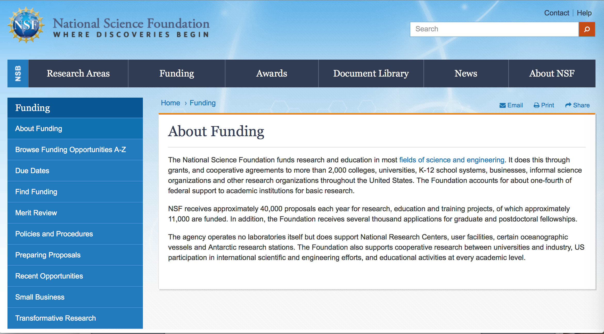

For assistance: https://nsf.gov/funding/aboutfunding.jsp

The National Science Foundation funds research and education in most fields of science and engineering. It does this through grants, and cooperative agreements to more than 2,000 colleges, universities, K-12 school systems, businesses, informal science organizations and other research organizations throughout the United States. The Foundation accounts for about one-fourth of federal support to academic institutions for basic research.
NSF receives approximately 40,000 proposals each year for research, education and training projects, of which approximately 11,000 are funded. In addition, the Foundation receives several thousand applications for graduate and postdoctoral fellowships.
The agency operates no laboratories itself but does support National Research Centers, user facilities, certain oceanographic vessels and Antarctic research stations. The Foundation also supports cooperative research between universities and industry, US participation in international scientific and engineering efforts, and educational activities at every academic level.

For details on active funding deadline dates: http://nsf.gov/funding/pgm_list.jsp?org=NSF&ord=date

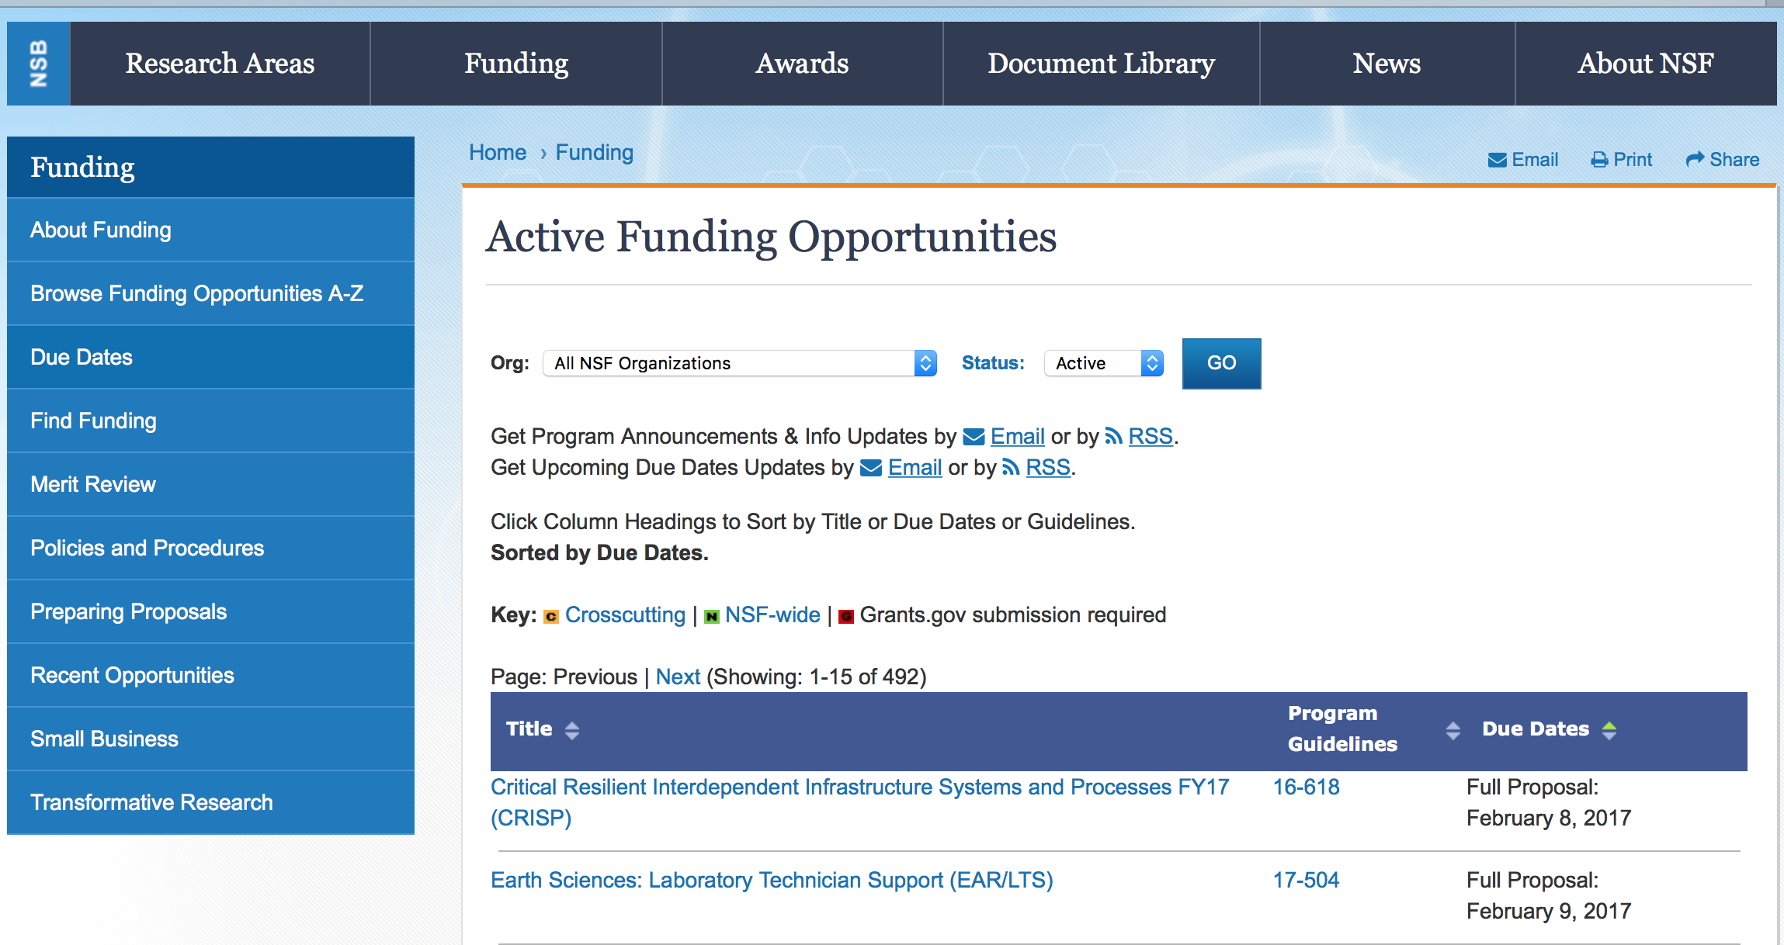

Advancing Informal STEM Learning
Synopsis 1
http://www.grants.gov/web/grants/view-opportunity.html?oppId=295308

CISE Research Infrastructure
Synopsis 1
http://www.grants.gov/web/grants/view-opportunity.html?oppId=295735

Discovery Research PreK-12
Synopsis 1
http://www.grants.gov/web/grants/view-opportunity.html?oppId=295856

Discovery Research PreK-12
Synopsis 1
http://www.grants.gov/web/grants/view-opportunity.html?oppId=295856

Division of Materials Research: Topical Materials Research Programs
Synopsis 1
http://www.grants.gov/web/grants/view-opportunity.html?oppId=295711

EAR Postdoctoral Fellowships
Synopsis 1
http://www.grants.gov/web/grants/view-opportunity.html?oppId=295770

EarthScope
Synopsis 1
http://www.grants.gov/web/grants/view-opportunity.html?oppId=295342

EMERGING FRONTIERS IN RESEARCH AND INNOVATION (EFRI): Chromatin and Epigenetic Engineering (CEE) and Continuum, Compliant, and Configurable Soft Robotics Engineering (C3 SoRo)
Synopsis 1
http://www.grants.gov/web/grants/view-opportunity.html?oppId=295630

Improving Undergraduate STEM Education: Pathways into Geoscience
Synopsis 1
http://www.grants.gov/web/grants/view-opportunity.html?oppId=295309

Innovations in Graduate Education (IGE) Program
Synopsis 1
http://www.grants.gov/web/grants/view-opportunity.html?oppId=295857

Japan-US Network Opportunity
Synopsis 1
http://www.grants.gov/web/grants/view-opportunity.html?oppId=295947

Louis Stokes Alliances for Minority Participation
Synopsis 1
http://www.grants.gov/web/grants/view-opportunity.html?oppId=295629

Management and Operation of the Ocean Bottom Seismometer Instrument Center
Synopsis 1
http://www.grants.gov/web/grants/view-opportunity.html?oppId=295948

Marine Geology and Geophysics
Synopsis 1
http://www.grants.gov/web/grants/view-opportunity.html?oppId=295449

Paleo Perspectives on Climate Change
Synopsis 1
http://www.grants.gov/web/grants/view-opportunity.html?oppId=295736

Research Experiences for Teachers (RET) in Engineering and Computer Science
Synopsis 1
http://www.grants.gov/web/grants/view-opportunity.html?oppId=295306

Secure and Trustworthy Cyberspace
Synopsis 1
http://www.grants.gov/web/grants/view-opportunity.html?oppId=295307

Modifications:

Reminders:

Deleted:

12-502 - Algorithms for Threat Detection
Deletion Comments: Opportunity deleted

15-568 - EAR Postdoctoral Fellowships
Deletion Comments: Opportunity deleted

15-590 - CISE Research Infrastructure
Deletion Comments: Opportunity deleted

15-592 - Discovery Research PreK-12
Deletion Comments: Opportunity deleted

16-571 - Partnerships for International Research and Education
Deletion Comments: Opportunity deleted

16-580 - Secure and Trustworthy Cyberspace
Deletion Comments: Opportunity deleted

17-502 - Advanced Biomanufacturing of Therapeutic Cells
Deletion Comments: Opportunity deleted

17-511 - EarthScope
Deletion Comments: Opportunity deleted

17-524 - Management and Operation of the Ocean Observatories Initiative (OOI)
Deletion Comments: Opportunity deleted

17-540 - Tomorrow's Internet Project Office
Deletion Comments: Opportunity deleted

PD-03-1773 - Polymers
Deletion Comments: Opportunity deleted

PD-03-1775 - Electronic and Photonic Materials
Deletion Comments: Opportunity deleted

PD-03-1710 - Condensed Matter Physics
Deletion Comments: Opportunity deleted

PD-06-7623 - Biomaterials
Deletion Comments: Opportunity deleted

PD-09-1771 - Metals and Metallic Nanostructures
DeletionPD-10-1762 - Solid State and Materials Chemistry
Deletion Comments: Opportunity deleted

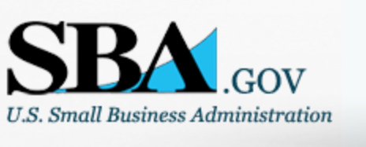

Small Business Administration

General Overview Finding Loans & Grants

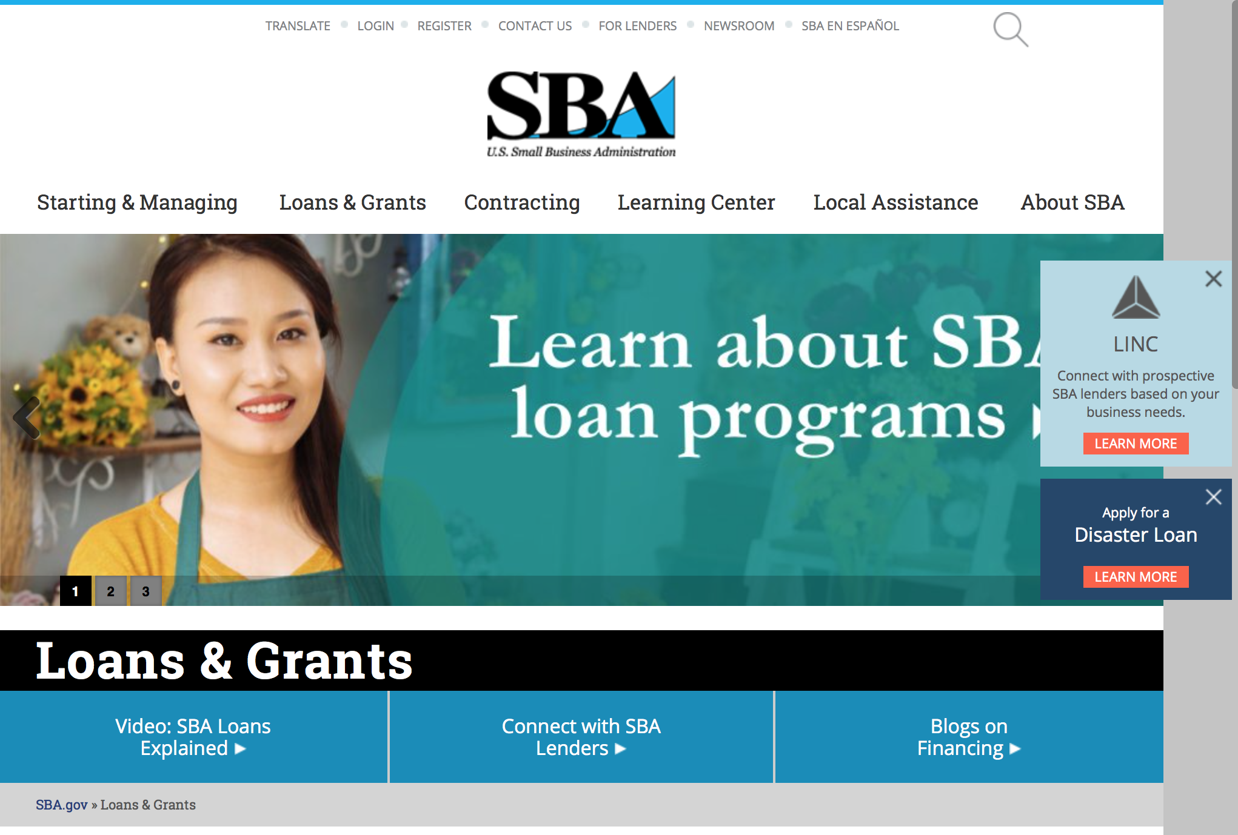
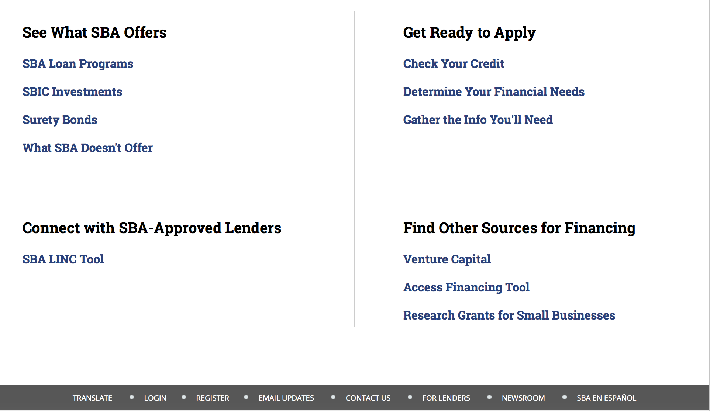

https://www.sba.gov/category/navigation-structure/loans-grants
Federal, state and local governments offer a wide range of financing programs to help small businesses start and grow their operations. These programs include low-interest loans, venture capital, and scientific and economic development grants.
Use SBA.gov's Loans and Grants Search Tool to get a list of financing programs for which you may qualify, or visit the resources below to learn more about small business financing programs.
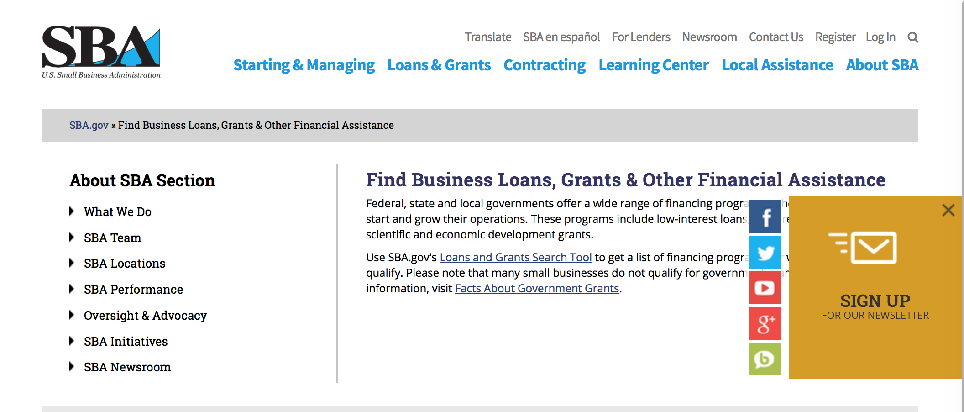
To get to the main SBA.gov funding page click here
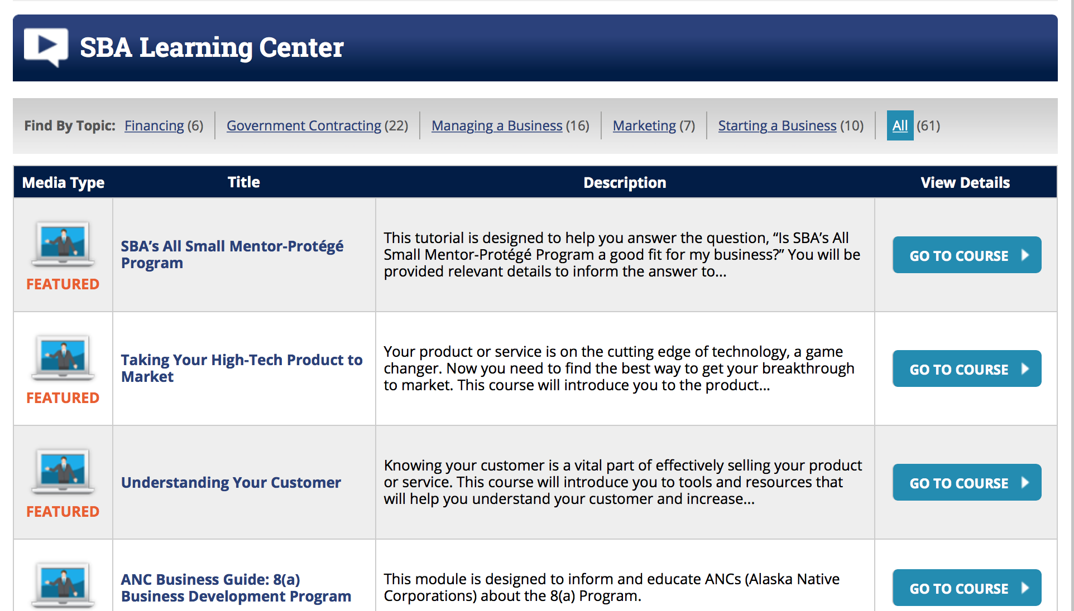
https://www.sba.gov/tools/sba-learning-center/search/training

Programs:

Modifications

Reminders:

Program Announcement
Synopsis 3
Document Type: | Grants Notice
Funding Opportunity Number: | OSBDC-2018-02
Funding Opportunity Title: | Program Announcement
Opportunity Category: | Mandatory
Opportunity Category Explanation:
Funding Instrument Type: | Cooperative Agreement
Category of Funding Activity: | Business and Commerce
Category Explanation:
Expected Number of Awards: | 63
CFDA Number(s): | 59.037 -- Small Business Development Centers
Cost Sharing or Matching Requirement: | Yes
Version: | Synopsis 3
Posted Date: | May 22, 2017
Last Updated Date: | Jun 09, 2017
Original Closing Date for Applications: | Aug 25, 2017
Current Closing Date for Applications: | Aug 25, 2017
Archive Date:
Estimated Total Program Funding: | $110,000,000
Award Ceiling: | $6,186,911
Award Floor: | $199,999
Eligible Applicants: | Others (see text field entitled "Additional Information on Eligibility" for clarification)
Additional Information on Eligibility: | An eligible candidate is an existing SBDC recipient organization currently funded under the Small Business Development (SBDC) Program which is in good standing regarding accreditation. An application submitted by an entity that is not a current Lead SBDC will not be considered.
Agency Name: | Small Business Administration
Description: | The SBDC program is the SBA’s largest matching grant, funding a service delivery network to provide high quality business and economic development assistance to small businesses and nascent entrepreneurs in order to promote growth, expansion, innovation, increased productivity and management improvement. The SBDCs, in partnership with SBA’s Office of Small Business Development Centers (OSBDC) and SBA District Offices, develop programs and provide business management and other services that enhance the economic development goals and objectives of SBA and their other respective state and local funding partners. The SBDC program is a broad-based system of assistance for the small business community that links the resources of Federal, state, and local governments with those of the educational community and the private sector. Although SBA is responsible for the general management and oversight of the SBDC program, a partnership exists between SBA and the recipient organization to effectuate the delivery of assistance to the small business community.
Link to Additional Information:
Grantor Contact Information: | If you have difficulty accessing the full announcement electronically, please contact:  Victoria Mundt Deputy Director/SBDC Phone 202-205-7176  victoria.mundt@sba.gov

http://www.grants.gov/web/grants/view-opportunity.html?oppId=294041

OSBDC
Program Announcement

Program Announcement
Synopsis 2
Document Type: | Grants Notice
Funding Opportunity Number: | OSBDC-2018-02
Funding Opportunity Title: | Program Announcement
Opportunity Category: | Mandatory
Opportunity Category Explanation:
Funding Instrument Type: | Cooperative Agreement
Category of Funding Activity: | Business and Commerce
Category Explanation:
Expected Number of Awards: | 63
CFDA Number(s): | 59.037 -- Small Business Development Centers
Cost Sharing or Matching Requirement: | Yes
Version: | Synopsis 2
Posted Date: | May 22, 2017
Last Updated Date: | May 24, 2017
Original Closing Date for Applications: | Aug 25, 2017
Current Closing Date for Applications: | Aug 25, 2017
Archive Date:
Estimated Total Program Funding:
Award Ceiling: | $7,300,000
Award Floor: | $199,999
Eligible Applicants: | Unrestricted (i.e., open to any type of entity above), subject to any clarification in text field entitled "Additional Information on Eligibility"
Agency Name: | Small Business Administration
Description: | Higher Institutions are eligible
Link to Additional Information:
Grantor Contact Information: | If you have difficulty accessing the full announcement electronically, please contact:  Victoria Mundt Deputy Director/SBDC Phone 202-205-7176  victoria.mundt@sba.gov

http://www.grants.gov/web/grants/view-opportunity.html?oppId=294041

Deleted:

SBA Trainings

Contracting Opportunities for Veteran Entrepreneurs
This self-paced training exercise is an introduction to Federal contracting opportunities for Veterans.
Topics include basic information about Veteran-owned businesses and opportunities, services available to small Veteran-owned businesses, small business incentives, and government procurement methods.
Duration: 00:30:00

http://www.sba.gov/tools/sba-learning-center/training/contracting-opportunities-veteran-entrepreneurs

Interested in Exporting? These Four Resources Can Help
Did you know that two-thirds of the world’s purchasing power is in foreign countries? As the numbers show, the international marketplace is a big one. So if you’re interested in exploring the world of exporting – or have gotten started but could use some guidance – check out these resources to help.
- Read more

Upcoming Trainings: Check out SBA's Online Training!
- Financing Options for Small Businesses
How to Prepare Government Contract Proposals
Getting Started With Exporting: Training and Educational Resources
Exporting represents a big opportunity to tap in to new markets, expand your customer base and grow your business. But getting started with exporting can sometimes feel like a maze of regulations, policies, and other barriers. Here are some free training and educational resources to help.
- Read more

For Specific Information in Hawaii see the following links:
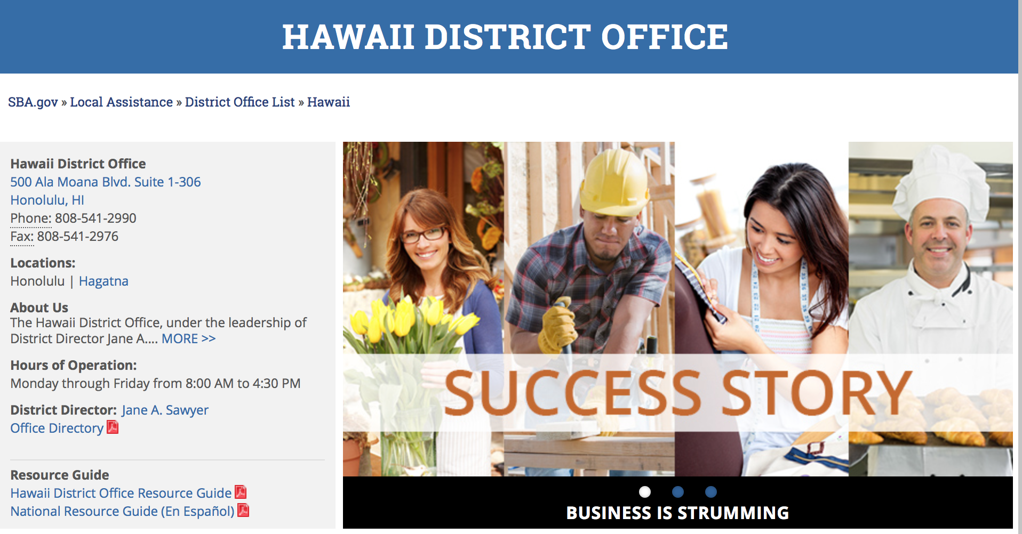

https://www.sba.gov/offices/district/hi/Honolulu

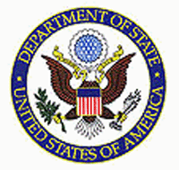

State Department General Overview and Resources for Program Administrators

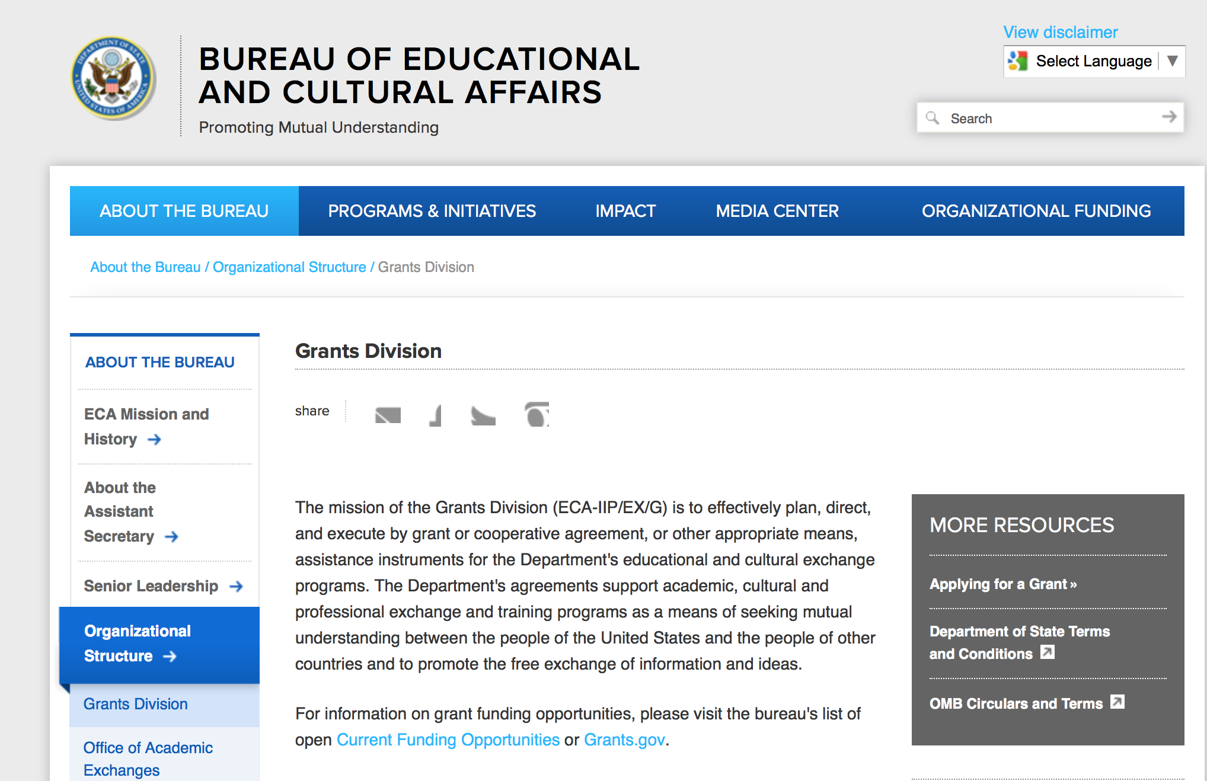

https://eca.state.gov/about-bureau/organizational-structure/grants-division

http://eca.state.gov/search/solr/grants?search_referrer=node/237

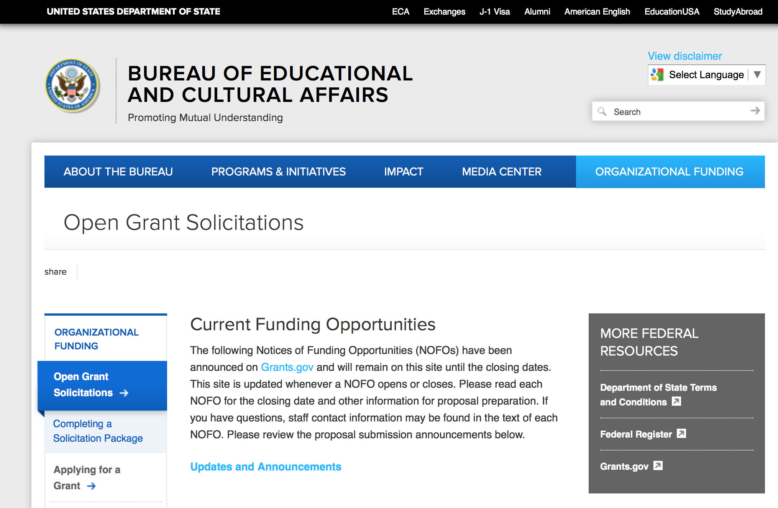
https://eca.state.gov/organizational-funding/open-grant-solicitations

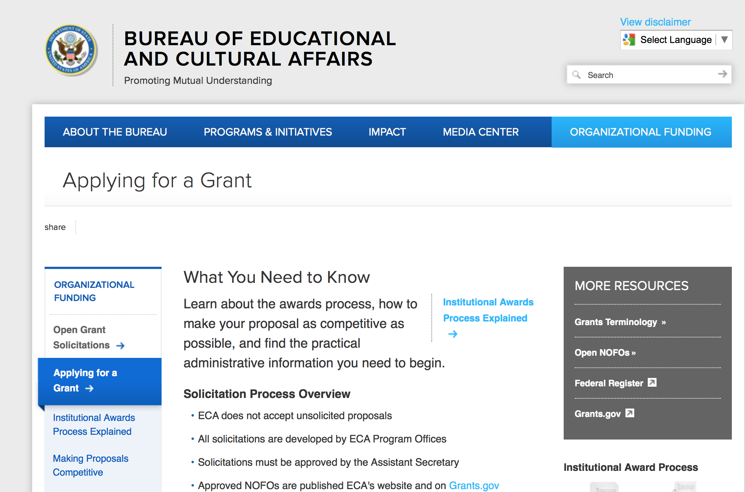
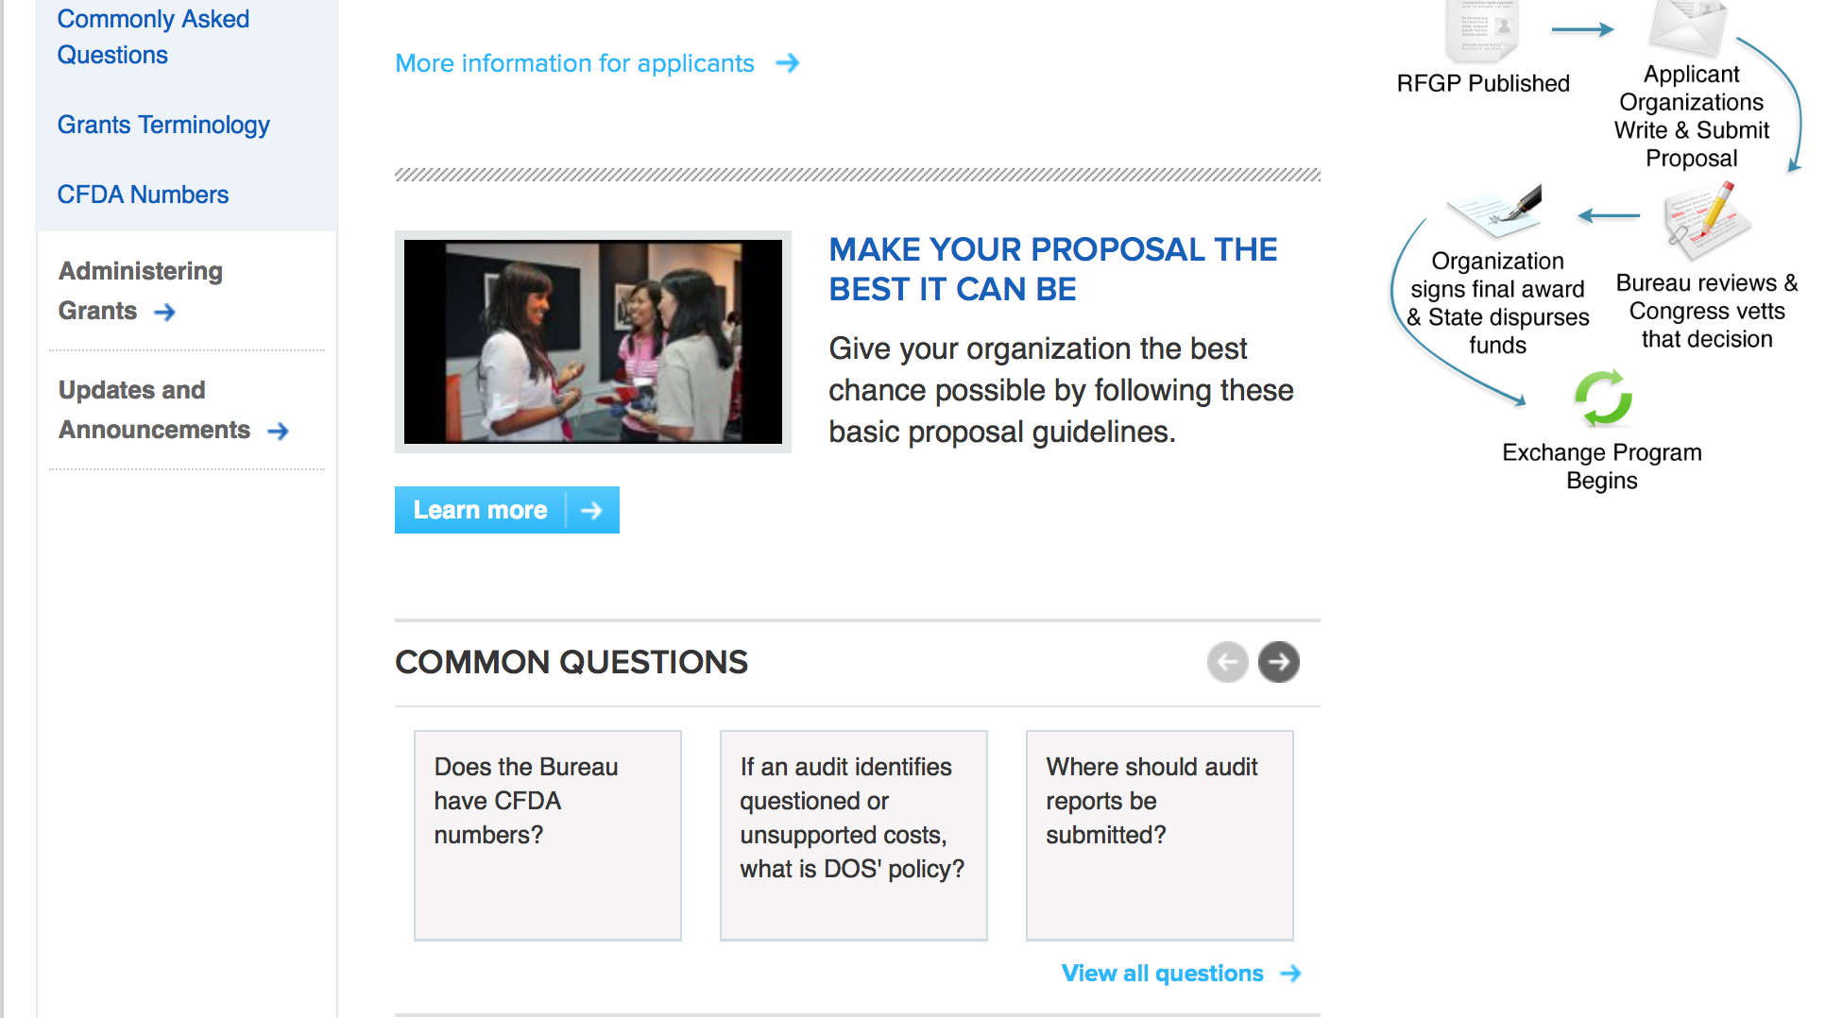
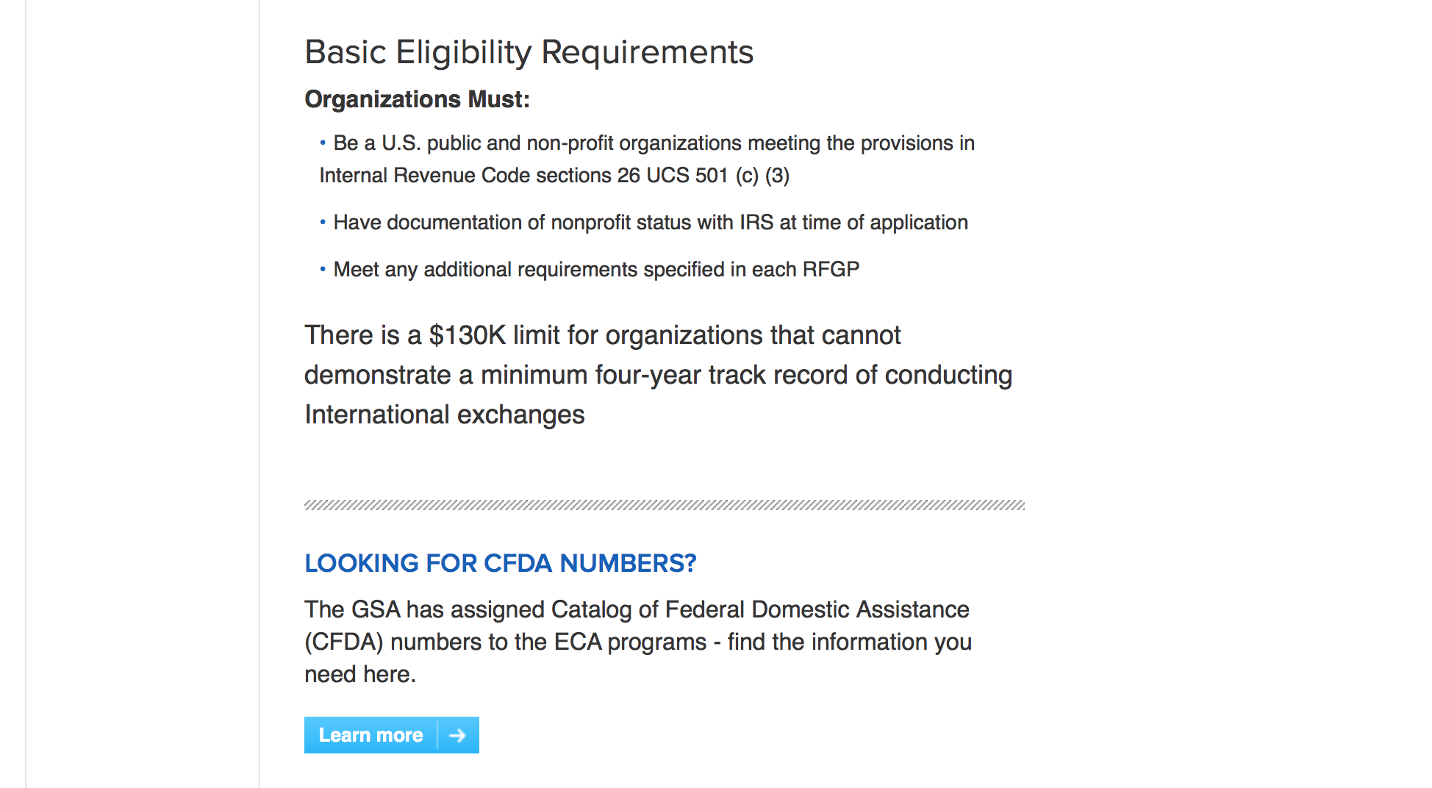
http://eca.state.gov/organizational-funding/applying-grant

General Information:
- Bureau of Educational and Cultural Affairs Grants Division
- Open Grant Opportunities (Requests for Grant Proposals)

For General Information click here

Program Grants:

Assistance Coordination
Driving Local Development with the Tunisian Chambers of Commerce
Synopsis 1
http://www.grants.gov/web/grants/view-opportunity.html?oppId=295847

Bureau Of Educational and Cultural Affairs
FY 2018 Global Undergraduate Exchange Program (Global UGRAD Program)
Synopsis 1
http://www.grants.gov/web/grants/view-opportunity.html?oppId=295265

Bureau of International Narcotics-Law Enforcement
Developing Prevention and Urban Design Strategies for Municipalities in Costa Rica to Prevent Crime and Drug Trafficking
Synopsis 1
http://www.grants.gov/web/grants/view-opportunity.html?oppId=295293

Bureau of International Narcotics-Law Enforcement
"Capacity-Building, Development of Protocols, and Justice Sector Engagement for the Prevention of Bullying"
Synopsis 1
http://www.grants.gov/web/grants/view-opportunity.html?oppId=295294

Bureau of International Security-Nonproliferation
Strategic Trade Controls Seminars
Synopsis 1
http://www.grants.gov/web/grants/view-opportunity.html?oppId=295606

Bureau of International Security-Nonproliferation
Seminar on Controlling Arms Transfers for Serbia
Synopsis 1
http://www.grants.gov/web/grants/view-opportunity.html?oppId=295248

Bureau of International Security-Nonproliferation
Strategic Trade Control Assistance for Albania
Synopsis 1
http://www.grants.gov/web/grants/view-opportunity.html?oppId=295250

U.S. Mission to Australia
Young Pacific Leaders Conference 2017/2018
Synopsis 1
http://www.grants.gov/web/grants/view-opportunity.html?oppId=295316

U.S. Mission to Brazil
Afro Entrepreneurship Mentoring Program
Synopsis 1
http://www.grants.gov/web/grants/view-opportunity.html?oppId=296001

PM Weapons Removal and Abatement
17.PMWRA.ElSalvador.SALW&PSSM.NOFO
Synopsis 1
http://www.grants.gov/web/grants/view-opportunity.html?oppId=295330

PM Weapons Removal and Abatement
17.PMWRA.Honduras.SALW.NOFO
Synopsis 1
http://www.grants.gov/web/grants/view-opportunity.html?oppId=295390

PM Weapons Removal and Abatement
17.PMWRA.Colombia.HMA.NOFO
Synopsis 1
http://www.grants.gov/web/grants/view-opportunity.html?oppId=295915

U.S. Mission to Benin
Embassy Cotonou's Small-Grants Program
Synopsis 1
http://www.grants.gov/web/grants/view-opportunity.html?oppId=295979

U.S. Mission to the Dominican Republic
Cultural programs on youth empowerment through the arts
Synopsis 1
http://www.grants.gov/web/grants/view-opportunity.html?oppId=295340

U.S. Mission to the Dominican Republic
Building English Teaching Capacity
Synopsis 1
http://www.grants.gov/web/grants/view-opportunity.html?oppId=295440

U.S. Mission to Moldova
Public Diplomacy Program
Synopsis 1
http://www.grants.gov/web/grants/view-opportunity.html?oppId=295904

U.S. Mission to Vietnam
Women’s Empowerment Club
Synopsis 1
http://www.grants.gov/web/grants/view-opportunity.html?oppId=295448

Modifications:

Bureau of International Narcotics-Law Enforcement
West Bank Access to Justice Legal Aid Project
Synopsis 2
http://www.grants.gov/web/grants/view-opportunity.html?oppId=295866

Bureau of International Security-Nonproliferation
SFOP0002266 - Strategic Trade Control Support: Tajikistan and Uzbekistan
Deletion Comments: Awaiting the Grant Officer in house to have access in grants.gov

Bureau of Oceans - Int. Environmental - Scientific
SFOP0002268 - Science and Technology (S&T) Dialogues
Deletion Comments: add correct budget template

Bureau of International Security-Nonproliferation
Countering DPRK Missile and Nuclear Programs
Synopsis 2
http://www.grants.gov/web/grants/view-opportunity.html?oppId=295643

U.S. Mission to Cuba
U.S. Embassy Havana PAS Annual Program Statement
Synopsis 2
http://www.grants.gov/web/grants/view-opportunity.html?oppId=295101

U.S. Mission to Saudi Arabia
Saudi Young Leaders Exchange Program
Synopsis 6
http://www.grants.gov/web/grants/view-opportunity.html?oppId=294832

U.S. Mission to Vietnam
Promote human rights for LGBTI community
Synopsis 4
http://www.grants.gov/web/grants/view-opportunity.html?oppId=295858

Reminders:

Bureau of Democracy Human Rights and Labor
DRLA-DRLAQM-17-080 - Promoting Religious Freedom in Cuba
Deletion Comments: Opportunity deleted

Bureau of Democracy Human Rights and Labor
DRLA-DRLAQM-17-080 - Promoting Religious Freedom in Cuba
Deletion Comments: Opportunity deleted

Bureau of International Security-Nonproliferation
SFOP0002260 - Understanding China's Information Campaigns and Public Diplomacy in the Asian and Pacific Regions
Deletion Comments: Withdrawing to update agency.

Bureau of International Narcotics-Law Enforcement
INL17GR0044-WHPCOSTARICA-JUSTSECT-070617 - "Capacity-Building, Development of Protocols, and Justice Sector Engagement for the Prevention of Bullying"
Deletion Comments: Opportunity deleted

Bureau of International Narcotics-Law Enforcement
INL17GR0043-WHPCOSTARICA-PREVENTIONSTRAT - Developing Prevention and Urban Design Strategies for Municipalities in Costa Rica to Prevent Crime and Drug Trafficking
Deletion Comments: Opportunity deleted

Bureau of Democracy Human Rights and Labor
DRLA-DRLAQM-17-080 - Promoting Religious Freedom in Cuba
Deletion Comments: Opportunity deleted

Bureau of Oceans - Int. Environmental - Scientific
SFOP0002268 - Science and Technology (S&T) Dialogues
Deletion Comments: Withdrawing opportunity to update eligible organizations list.

Deleted:

Department of Transportation

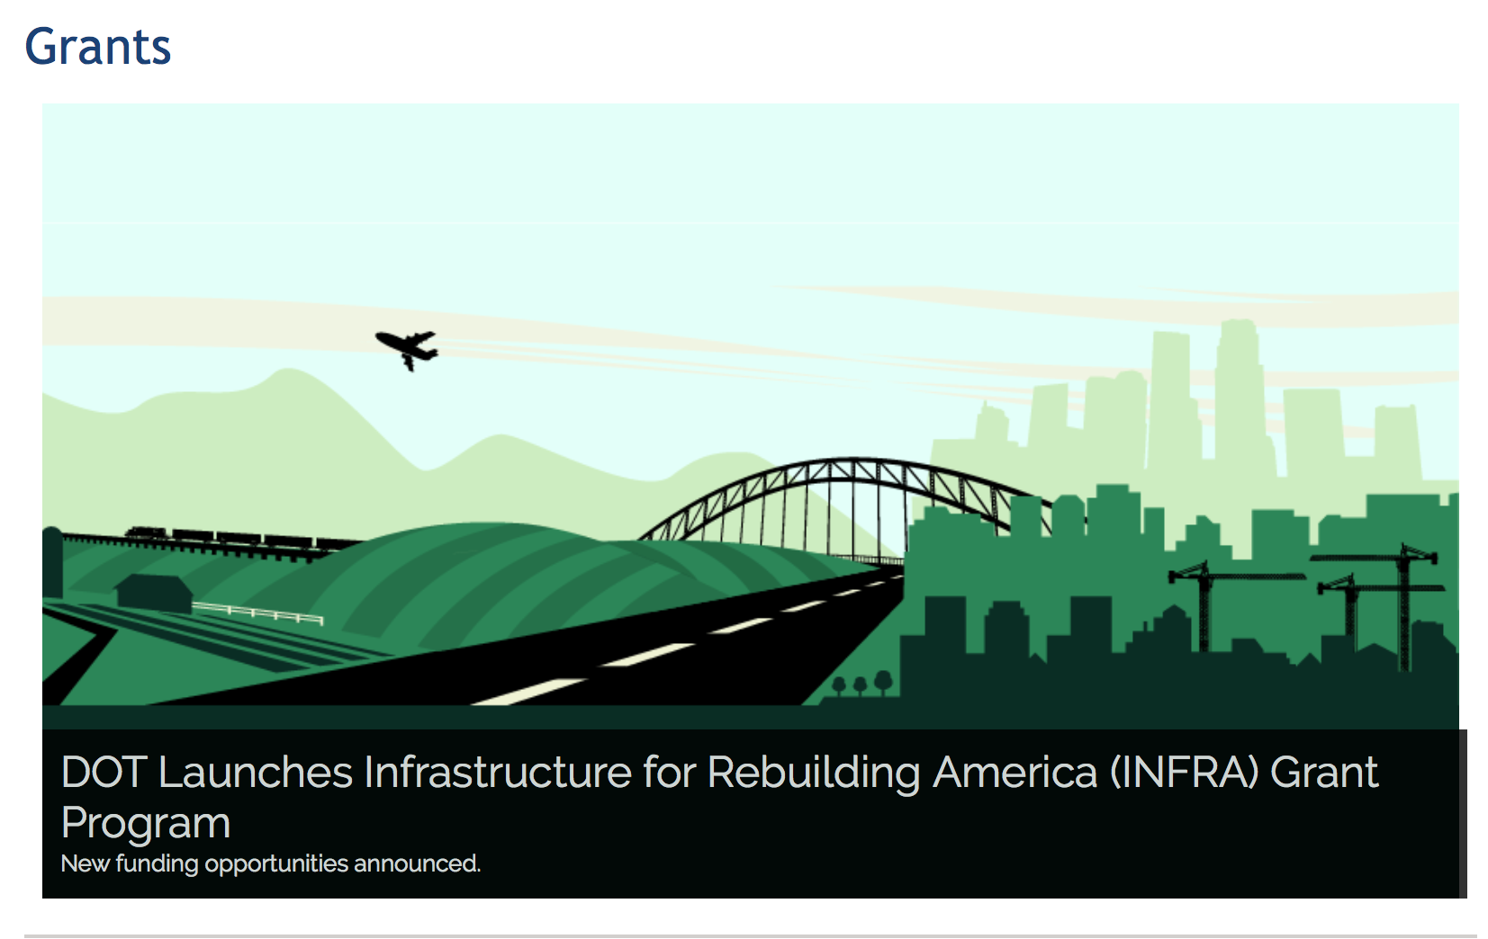

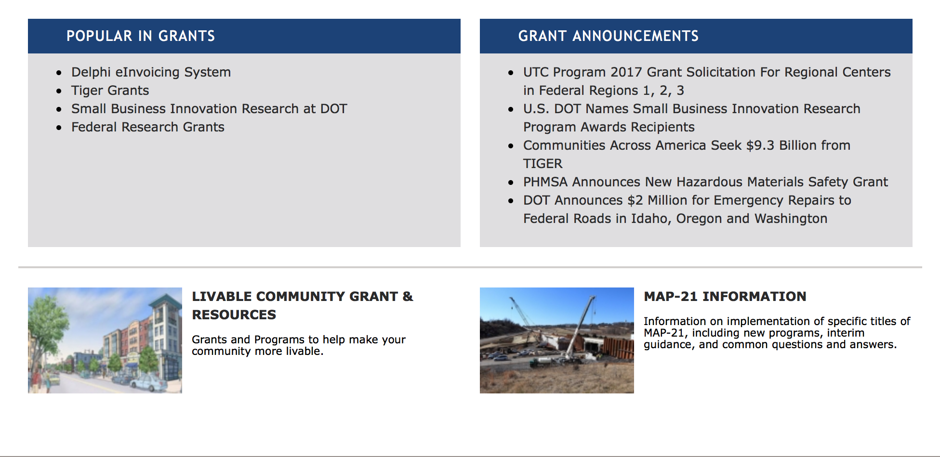

General Grant Program Overview https://www.transportation.gov/grants

Programs:

DOT Federal Highway Administration
Dwight David Eisenhower Transportation Fellowship Program (DDETFP) Graduate Fellowship
Synopsis 1
Document Type: | Grants Notice
Funding Opportunity Number: | 693JJ317NF0007
Funding Opportunity Title: | Dwight David Eisenhower Transportation Fellowship Program (DDETFP) Graduate Fellowship
Opportunity Category: | Discretionary
Opportunity Category Explanation:
Funding Instrument Type: | Grant
Category of Funding Activity: | Education
Category Explanation:
Expected Number of Awards: | 100
CFDA Number(s): | 20.215 -- Highway Training and Education
Cost Sharing or Matching Requirement: | No
Version: | Synopsis 2
Posted Date: | Jul 14, 2017
Last Updated Date: | Jul 21, 2017
Original Closing Date for Applications: | Aug 28, 2017
Current Closing Date for Applications: | Aug 28, 2017
Archive Date: | Sep 27, 2017
Estimated Total Program Funding: | $1,000,000
Award Ceiling: | $35,500
Award Floor: | $5,000
Eligible Applicants: | Individuals
Additional Information on Eligibility: | Applicants of the DDETFP Graduate Fellowship must: Possess a baccalaureate degree from an accredited U.S. Institution or be a confirmed graduating senior at an accredited U.S. Institution; Demonstrate confirmation of acceptance in a graduate degree program at an accredited U.S. Institution; Be enrolled in an accredited U.S. Institution of higher education; Be pursuing a graduate degree in a full-time program in a transportation-related discipline; Have at least one full academic year remaining in program of study; Conduct ongoing research in one or more transportation-related disciplines; and Plan to enter the transportation profession after completing their higher level education.
Agency Name: | DOT Federal Highway Administration
Description: | The DDETFP Graduate Fellowship provides funding for students to pursue master’s or doctoral degrees in transportation-related disciplines. The program objectives are: 1) to attract the Nation's brightest minds to the field of transportation; 2) to enhance the careers of transportation professionals by encouraging them to seek advanced degrees; and 3) to retain top talent in the transportation industry of the United States. The DDETFP is intended to bring innovation and enhance the breadth and scope of knowledge of the entire transportation community in the United States. NOTE: "RELATED DOCUMENTS" tab includes full NOFO and application instructions.
Link to Additional Information: | FHWA Universities & Grants Programs website
Grantor Contact Information: | If you have difficulty accessing the full announcement electronically, please contact:  Ewa Flom Program Manager Phone 703-235-0532  ewa.flom@dot.gov

http://www.grants.gov/web/grants/view-opportunity.html?oppId=295509

Modifications:

Research:

Reminders:

DOT Federal Aviation Administration
DOT - FAA Aviation Research Grants
FAA Aviation Research and Development Grants
Modifications 3 & 4

Document Type: | Grants Notice
Funding Opportunity Number: | 12-01
Funding Opportunity Title: | FAA Aviation Research and Development Grants
Opportunity Category: | Discretionary
Opportunity Category Explanation:
Funding Instrument Type: | Grant
Category of Funding Activity: | Transportation
Category Explanation:
Expected Number of Awards:
CFDA Number(s): | 20.108 -- Aviation Research Grants
Cost Sharing or Matching Requirement: | No
Version: | Synopsis 5
Posted Date: | Jan 01, 2012
Last Updated Date: | Jun 09, 2016
Original Closing Date for Applications: | Dec 31, 2019
Current Closing Date for Applications: | Dec 31, 2019
Archive Date: | Jan 30, 2020
Estimated Total Program Funding:
Award Ceiling: | $5,000,000
Eligible Applicants: | Nonprofits having a 501(c)(3) status with the IRS, other than institutions of higher education  Private institutions of higher education  Public and State controlled institutions of higher education
Agency Name: | DOT - FAA Aviation Research Grants
Description: | The FAA is soliciting proposals for research grants and cooperative agreements to pursue the long-term growth and short-term technical needs of civil aviation. In order to streamline the application process, it is recommended that all prospective grantees submit a white paper (letter of intent) for agency technical review before complete proposal submission. Please be sure to identify the specific area of interest (Solicitation FAA-12-01 – Chapter I. FAA Research Grants Program, Technical Areas of Research #1-#9). The white paper shall be no longer than three (3) pages and shall detail overall research objectives.
Link to Additional Information:
Grantor Contact Information: | If you have difficulty accessing the full announcement electronically, please contact:  Debra Monzo Grants Officer Phone 609-485-4962  business

http://www.grants.gov/web/grants/view-opportunity.html?oppId=134953

Deleted:

Department of the Treasury

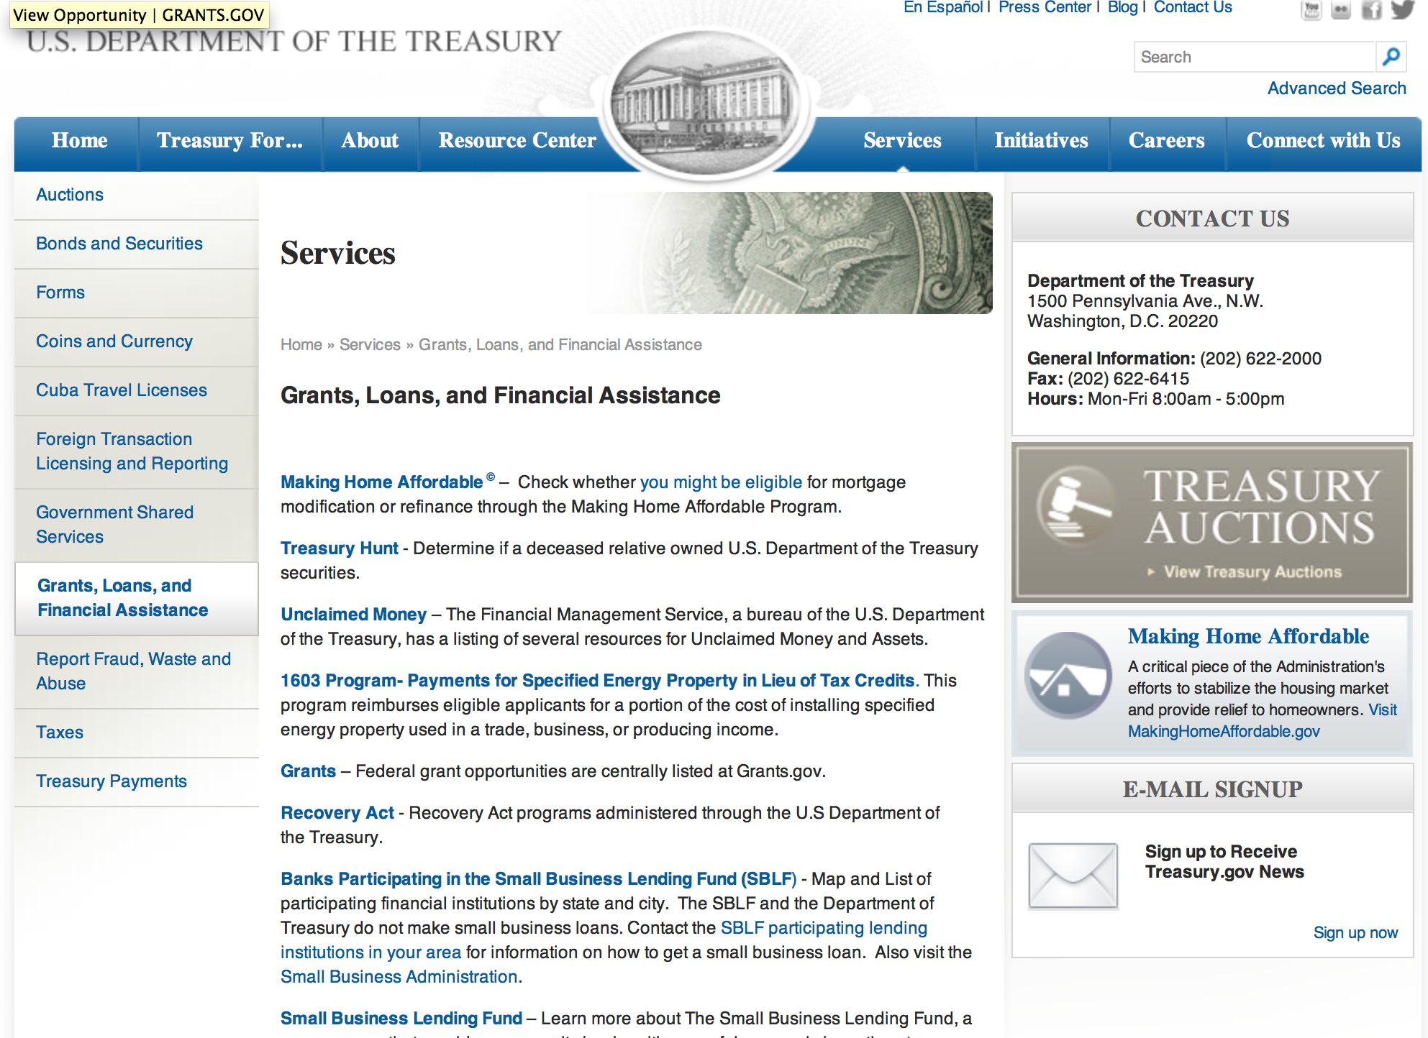

http://www.treasury.gov/services/Pages/Grants-Loans-and-Financial-Assistance.aspx

Programs:

Modifications:

Reminders:

U.S. Agency for International Development

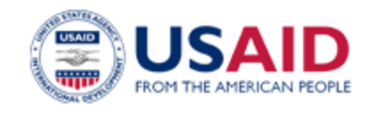

www.usaid.gov

General Overview Funding Opportunities

USAID has working relationships with thousands of American companies and hundreds of U.S.-based private voluntary organizations. For more information on our business and procurement opportunities, please visit our Business section.

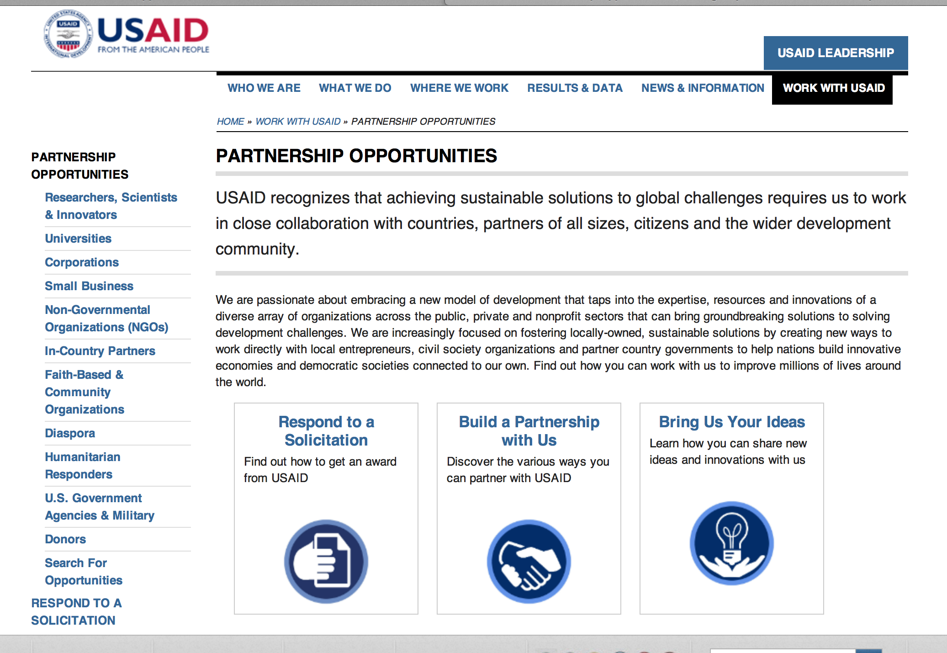
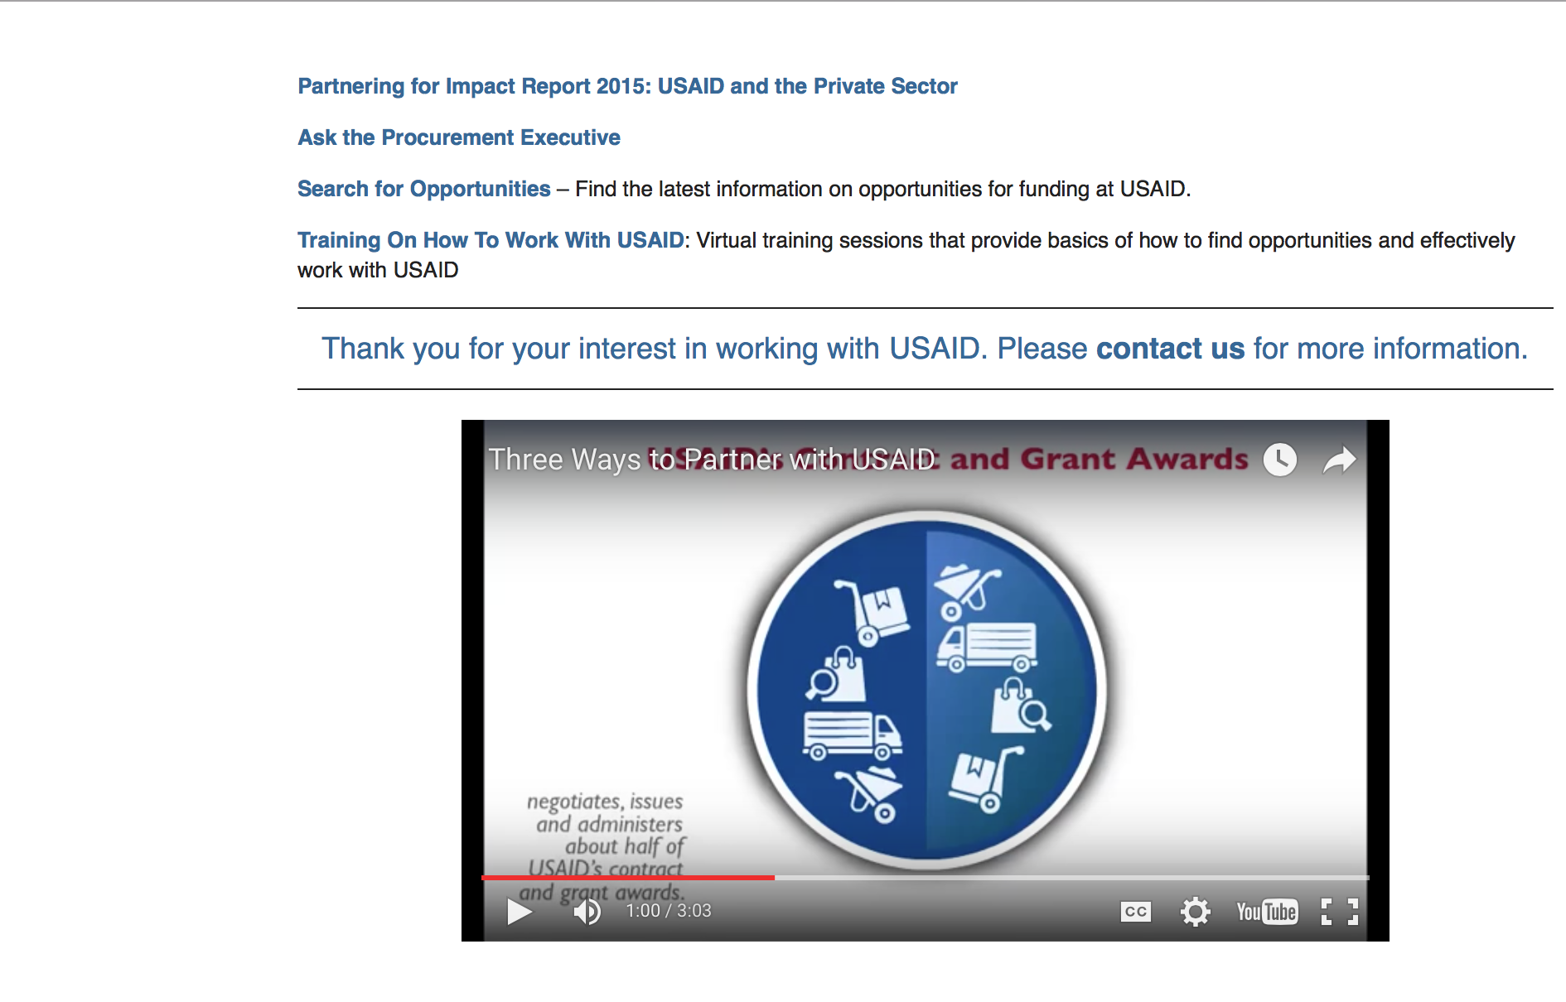

http://www.usaid.gov/partnerships

Programs:

Grassroots Civil Society Building Program
Synopsis 1
http://www.grants.gov/web/grants/view-opportunity.html?oppId=295938

GDL Center for Digital Development
Synopsis 1
http://www.grants.gov/web/grants/view-opportunity.html?oppId=295971

Peru USAID-Lima
Green Infrastructure for Water Security
Synopsis 1 & 2
http://www.grants.gov/web/grants/view-opportunity.html?oppId=295195

Modifications:

Afghanistan USAID-Kabul
Afghanistan Jobs Creation Program (AJCP)
Synopsis 3
http://www.grants.gov/web/grants/view-opportunity.html?oppId=294649

Ethiopia USAID-Addis Ababa
Supporting the Electronic Information Systems in Ethiopia
Synopsis 2
http://www.grants.gov/web/grants/view-opportunity.html?oppId=295464

Partnering for Impact in Guinea
Synopsis 2
http://www.grants.gov/web/grants/view-opportunity.html?oppId=295147

Guatemala USAID-Guatemala City
520-DRAFT-PD-GUATEMALA-PASCA-3-0 - PASCA 3.0
Deletion Comments: Opportunity deleted

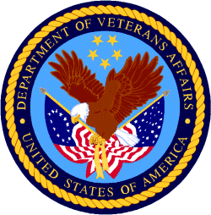

Department of Veterans Affairs

