Senator Mazie Hirono

Grants Assistance Information Newsletter
WITH DISASTER ASSISTANCE SUPPLEMENT
AUGUST 2023

PART 1 – FEDERAL DISASTER ASSISTANCE INFORMATION

PART 2– CURRENT FEDERAL AGENCY DISCRETIONARY GRANT OPPORTUNITIES

PART 3 - GENERAL FEDERAL AGENCY GRANTS INFORMATION

PART 1 - Federal Disaster Assistance Information

Index

President Joseph R. Biden, Jr. Approves Major Disaster Declaration for Hawaii

How to Apply for Disaster Assistance

Voluntary Organizations Active in Disaster Relief

Coordinated Federal Agency Disaster Response

State and Local Level Referrals

Verifying Home Ownership

Text to Find Shelter

Locating Loved Ones

Small Business Disaster Assistance

President Joseph R. Biden, Jr. Approves Major Disaster Declaration for Hawaii
Release Date: August 10, 2023
WASHINGTON -- FEMA announced that federal disaster assistance has been made available to the state of Hawaii to supplement recovery efforts in the areas affected by wildfires beginning on Aug. 8, 2023 and continuing.
The President's action makes federal funding available to affected individuals in Maui County. Assistance can include grants for temporary housing and home repairs, low-interest loans to cover uninsured property losses and other programs to help individuals and business owners jumpstart their recovery.
Individuals and business owners who sustained losses in the designated areas can begin applying for assistance by registering online at www.DisasterAssistance.gov, by calling 1-800-621- 3362 or by using the FEMA App. If you use a relay service, such as video relay service (VRS), captioned telephone service or others, give FEMA the number for that service.
Federal funding is also available to state and eligible local governments and certain private nonprofit organizations on a cost-sharing basis for debris removal and emergency protective measures in Maui County and assistance for emergency protective measures for Hawaii County.
Federal funding is also available on a cost-sharing basis for hazard mitigation measures statewide.
Maona N. Ngwira has been named the Federal Coordinating Officer for federal recovery operations in the affected areas. Additional designations may be made at a later date if warranted by the results of damage assessments.

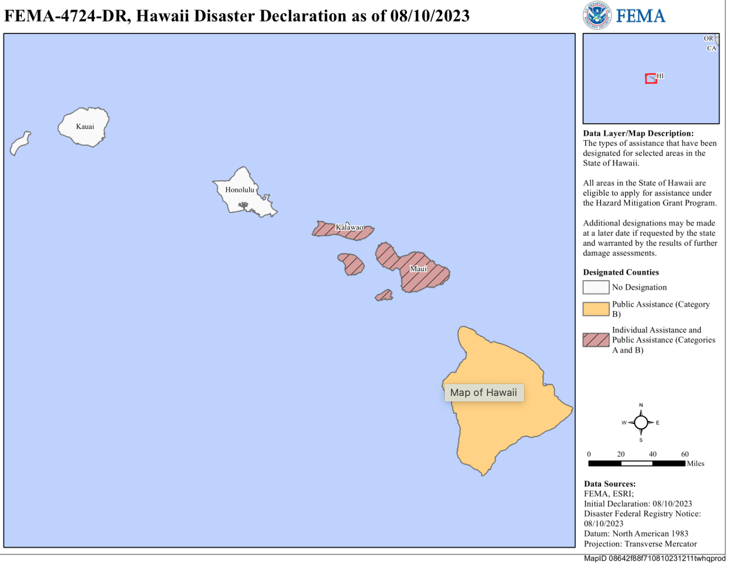


HOW TO APPLY FOR ASSISTANCE
To apply for this assistance, visit DisasterAssistance.gov or download the FEMA mobile app. Applicants can also call the FEMA Helpline at 800-621-3362, with language translation services available. The helpline is open and available 24 hours a day, 7 days a week, with no cost for Hawaii residents to call.
If you use video relay service (VRS), captioned telephone service or others, give FEMA your number for that service.
When applying for assistance, have the following information ready:
- A current phone number where you can be contacted
- Your address at the time of the disaster and the address where you are not staying
- Your social security number
- A general list of damage and losses
- Banking information if you choose direct deposit
- If insured, the policy number or the agent and/or the company name
Survivors may be eligible to receive assistance for uninsured and underinsured damage and losses resulting from the Hawaii wildfires. If you have homeowners or renters insurance, you should file a claim as soon as possible. FEMA cannot duplicate benefits for losses covered by insurance. If your policy does not cover all your disaster expenses, you may be eligible for federal assistance.
Take photos to document damage and begin cleanup and repairs to prevent further damage. Remember to keep receipts from all purchases related to the cleanup and repair.
Disaster assistance may include financial help with temporary lodging and home repairs, as well as other disaster-related expenses.
For an accessible video on how to apply for assistance visit: youtube.com/watch?v=LU7wzRjByhI&list=PL720Kw_OojlKOhtKG7HM_0n_kEawus6FC&index=6.
For information on Hawaii’s disaster recovery, visit fema.gov/disaster/4724. Follow FEMA at twitter.com/femaregion9 and at facebook.com/fema.

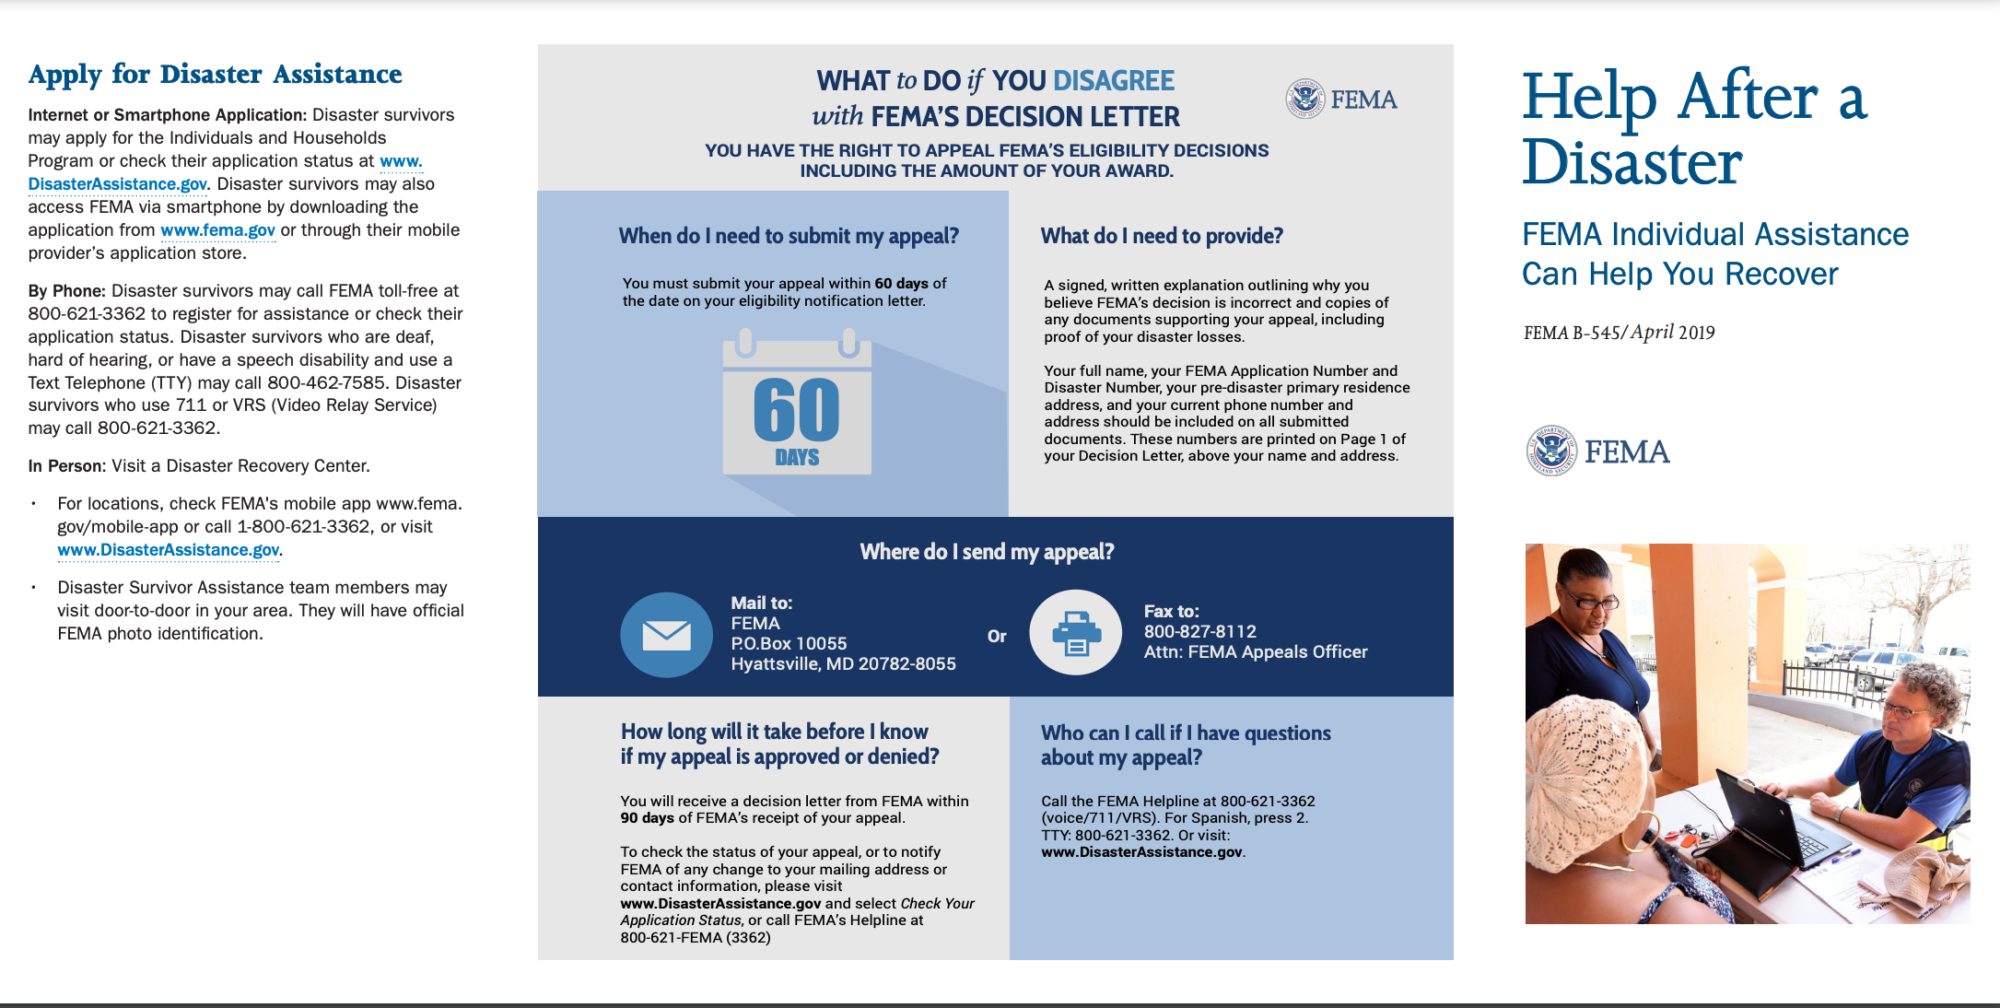
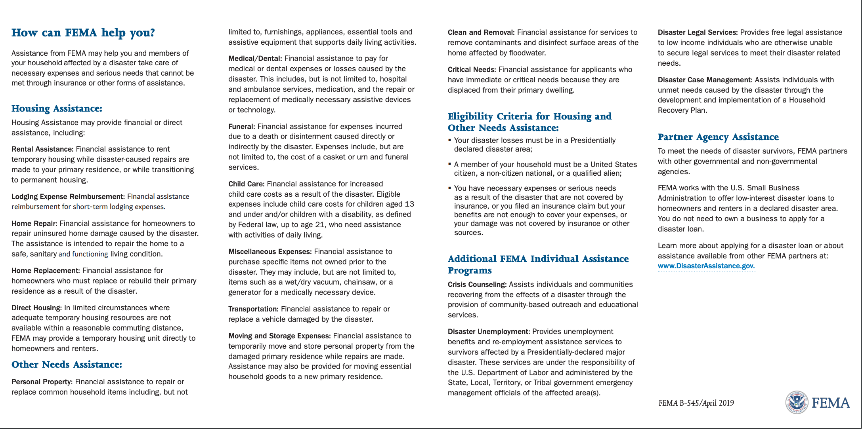
To view Help After a Disaster online: https://www.fema.gov/sites/default/files/2020-08/fema_help-after-disaster_english_trifold.pdf

FEMA and Federal Agency Partners Continue Supporting Local Response Efforts as National Voluntary Organizations Active in Disaster (VOAD) and Other Voluntary Organizations Play Critical Role in Hawaii
WASHINGTON -- FEMA, along with its federal and local agency partners, National Voluntary Organizations Active in Disaster (VOAD) member organizations and many other volunteer and faith-based organizations continues responding to survivors' immediate needs following the devastating wildfires in Maui. FEMA and federal partners are supporting the state of Hawaii, focusing on search and rescue operations and assessing damages in the impacted areas. There are now over 200 FEMA personnel deployed to the state and working with local officials to help distribute commodities and aid recovery efforts.
Non-profit and voluntary organizations have been working around the clock to support the wildfire survivors, as VOADs, volunteer organizations and faith-based groups are providing meals and clothing, cleaning up debris and helping survivors jumpstart their recovery.
Anyone interested in providing assistance to disaster survivors in Hawaii may visit the National VOAD website at www.nvoad.org to learn more. Consider cash donations as it allows the most flexibility in obtaining time sensitive resources and has the added benefit of moving money into the local economy to help businesses recover.
In addition to federal, state and county response operations:
The American Red Cross: Red Cross disaster workers responded immediately, opening shelters across Maui to provide refuge for thousands of residents and tourists who have been displaced by the fires. Since the fires began, the Red Cross and partners have provided almost 2,900 overnight shelter stays. As of today, approximately 240 Red Cross personnel are responding or actively deploying.
The Salvation Army is bringing food, shelter, hygiene items and emotional and spiritual care to survivors. They are providing thousands of meals to individuals and families at the Maui County Pukalani Shelter.
The Disability Hui led by the Hawaii State Council on Developmental Disabilities convened 16 partner organizations who serve people with disabilities and the aging community. Together they are working directly with Maui County on continued reunification services to account for every one of their clients. They are coordinating with community agencies, including Catholic Charities and the American Red Cross, to provide direct contact information for the disability organizations to every person with a disability who is staying at shelters and to those who may benefit from their services.
Americares emergency response experts are in transit to Hawaii to support the hardest hit communities. Upon arrival, the team will assess the needs of local health care facilities, coordinate emergency shipments of medicine and relief supplies. Americares is readying hygiene kits, first aid supplies and other critically needed items to send to partner organizations in Hawaii. The health-focused relief and development organization is also prepared to provide emergency funding to help restore health services for low-income and uninsured residents in affected communities.
Samaritan’s Purse deployed North American Ministries assessment teams to determine relief and support with debris clearance and sifting. Billy Graham Rapid Response Team chaplains are also on the island to provide emotional support and spiritual comfort to residents suffering in the wake of so much loss.
The Home Cleanup Hotline has been activated. It is anticipated that most volunteer groups will work through Friday, Aug. 25. Survivors needing assistance can call 808-451-3102.
Hawaii residents impacted by the wildfires in Maui county can register for federal assistance by visiting DisasterAssistance.gov, through the FEMA app, or by calling 1-800-621-3362. Residents who use a relay service, such as video relay or captioned telephone service, can give the FEMA operator the number for that service.

FEMA, Federal Family Unite to Support Hawaii Wildfire Response, Recovery
Release Date:
August 12, 2023
WASHINGTON -- More than a dozen federal agencies and departments are mobilized to assist state, county, nonprofit and private sector partners to help the people of Hawaii with recent devastating wildfires. Personnel from FEMA, federal agencies and voluntary organizations are arriving daily to Hawaii to support active response and initial recovery efforts.
FEMA Administrator Deanne Criswell is in Hawaii today with U.S. Fire Administrator Dr. Lori Moore-Merrell and Administrator Isabella Guzman of the U.S. Small Business Administration to meet with Gov. Josh Green and other officials to assess the damage. In addition, hundreds of staff from across the federal family have been deployed or mobilized to assist. Federal assets from FEMA, the Department of Defense, the U.S. Coast Guard, U.S. Army Corps of Engineers, U.S. Department of Health & Human Services, as well as many others, have been helping responders since the wildfires began.
As of Aug. 12, 2023:
- FEMA has deployed more than 150 FEMA personnel, including search and rescue teams, with more on the way. Today, Disaster Survivor Assistance teams are in Maui to help residents register for assistance and address any critical needs in the affected neighborhoods.
- Department of Health and Human Services Secretary Xavier Beccera declared a public health emergency in Hawaii, which allows health care providers and suppliers greater flexibility in meeting emergency health needs of Medicare and Medicaid beneficiaries.
- The Substance Abuse and Mental Health Services Administration activated the national disaster distress hotline. Professional counselors are available for anyone in Hawaii who may need it. They can be reached via call or text at 1-800-985-5990.
- The U.S. Small Business Administration (SBA) encourages homeowners, renters, businesses and nonprofits to apply for low interest disaster loans. Businesses can apply for up to $2 million for physical damage or economic injury. During her visit today, SBA Administrator Guzman will visit with local small business owners to discuss resources available to support their recovery.
- The American Red Cross has mobilized volunteers who are focused on providing shelter, food and other necessities to survivors who are unable to return home, as well as helping with family reunification efforts. They are also deploying reunification teams in Maui and Oahu.
- The Salvation Army is providing thousands of meals to individuals and families at the Maui County Pukalani Shelter.
- The U.S. Army Corps of Engineers has personnel on the ground supporting local officials with the assessment of the damaged infrastructure.
- The National Guard has activated 134 troops — including 99 Army National Guard personnel and 35 Air National Guard personnel — to assist in the in the ongoing local and federal wildfire response efforts.
- Through its response and rescue operations, the U.S. Coast Guard has saved 17 lives, with 40 additional survivors located and assisted ashore by U.S. Coast Guard Station Maui.
- The U.S. Department of Agriculture is working on pet reunification and large-animal removal.
- The U.S. Department of Veteran Affairs is working with Veteran Affairs hospital patients to ensure that they have enough supplies, like oxygen.
- The U.S. Department of the Interior is coordinating with FEMA and other federal and local partners to address the tragic loss of the Lahaina Historic District and National Historic Landmark.
As response and recovery efforts continue, Hawaii residents and tourists should continue to monitor instructions from local authorities.

Hawaii State and Local Level Referrals

When a disaster occurs, local governments often work together with community leaders and organizations to provide on-the-ground emergency management. You may also reference FEMA’s national-level referrals list.

Use the "Search" field to look for categories or types of assistance.
Show 102550100 entries
Search:
Category | Entity | Type of Assistance | Telephone Number
Access and Functional Needs and Disabilities | Hawaii Disability Rights Center | Hawaii Disability Rights Center is Hawaii's designated. Protection and Advocacy (P&A) System for people with disabilities. | 808-949-2922  800-882-1057
Aging Services | State of Hawaii, Department of Health Executive Office of Aging | Resources for older persons and/or their families | 808-586-0100  Main: 808-586-4400
Agricultural Aid | Hawaii Department of Agriculture, Office of the Chairperson | Support, enhance, promote, and protect Hawaii’s agriculture and aquaculture industries | 808-973-9560
Animals/Pets | Homepage - Hawaiian Humane Society : Hawaiian Humane Society | Animal friendly information and support | Main: 808-356-2200  Emergencies/Animal rescues:  808-356-2250
Animals/Pets | Hawaiian Animal Rescue Foundation | Animal friendly information and support | 808-876-0022
Citizenship | USCIS Field Office Honolulu, HI Office Details | Steps to apply for citizenship, guide to naturalization | Online directory for local offices
Consumer Services | State of Hawaii, Department of Commerce and Consumer Affairs | Information on price gouging and consumer complaint services. | 808-587-4272
Contractors | General Contractors Association of Hawaii | Contractor's license verification and consumer complaints services. | 808-833-1681
Crisis Counseling | CARE Hawaii | Outpatient mental health services, adult services, children services, adult case management and therapeutic program services, additional services & crisis services | Emergency: 911  808-533-3936
Crisis Counseling | State of Hawaii, Department of Health; Adult Mental Health Division | Adult services, case management and support services, crisis services, Psychosocial rehabilitation, Forensic Services, Treatment, & Community Housing | Emergency: 911  AMHD HI Crisis Line: 800-753-6879  Oahu Crisis Line: 808-832-3100

Disaster Specific Information | TBD
Disaster Unemployment Assistance | State of Hawaii - Unemployment Insurance | When Disaster Unemployment Assistance is activated, the agency will provide disaster information. This assistance provides weekly beneﬁt payments to those out of work due to the disaster, including self-employed persons, farm and ranch owners, and others not covered under regular unemployment insurance programs. The directory provides contact information for island offices for unemployment claims and benefits. | 808-974-4086  Online directory of local offices
Environment | Hawaii Environmental Planning Office | The Environmental Planning Office develops strategic plans, supports land use reviews and helps to get new programs underway. | 808-586-4400
Environment | Hazard Evaluation and Emergency Response Office | The Hazard Evaluation and Emergency Response Office provides risk assessments, responds to the release of hazardous substances and oversees the cleanup of contaminated sites. | 808-586-4249  After hours: 808-236-8200
Essential Needs | Hawaii Food Bank | Information on food assistance programs, referrals to network agencies | 808-836-3600
Family & Protective Services | Hawaii Department of Human Services - Children Services | Individuals concerned with children at risk for abuse and neglect. Child Welfare Services programs include family strengthening and support, child protection, foster care, adoption, independent living and licensing of resource family homes, group homes and child-placing organizations. Services are available on Oahu, Hawaii, Kauai, Maui, Molokai and Lanai | Emergency: 911  Child Abuse Reporting: 808-832-5300  888-380-3088  Child Trafficking: 808-832-1999  888-398-1188
Family & Protective Services | Hawaii Department of Human Services - Adult Services | Individuals concerned with possible elder abuse, neglect, or exploitation. Adult Protective Services provides crisis intervention, without regard to income, including investigation and emergency services for vulnerable adults who are reported to be abused, neglected or financially exploited by others or seriously endangered due to self-neglect. A vulnerable adult is a person eighteen years of age or older, who because of mental, developmental, or physical impairment, is unable to: communicate or make responsible decisions to manage the person’s own care or resources; carry out or arrange for essential activities of daily living; or protect oneself from abuse. | Emergency: 911  Oahu Hotline: 808-832-5115  Kauai Hotline: 808-241-3337  Maui/Molokai/Lanai Hotline:  808-933-8820  West Hawaii: 808-327-6280
Financial Assistance | Hawaii Department of Human Services Benefit, Employment and Support Services | Programs that serve different populations, aimed at providing clients with monthly benefits to assist them with such essentials as food, shelter, and child care, as well as employment support and work-training and dependency diversion and prevention. | 855-643-1643
Health Care Services | Hawaii Health Systems Corporation | Public Health system | 808-733-4020
Housing | Aloha Kohua | Referral Information on housing, resources to find long term rentals, emergency shelters, pet boarding, housing agencies, housing networks. | N/A

Identity Theft | State of Hawaii  Department of Commerce and Consumer Affairs  Identity Theft & Security Breach Information | Identity theft information, warning signs | 808-587-3222
Insurance | Hawaii Department of Commerce and Consumer Affairs: Insurance | Online complaint form, consumer information, consumer resources, lava flow insurance information. | 808-586-2790  808-586-2799  800-468-4644
Legal Services | Legal Aid Society of Hawai'i | Legal information resources, immigrant justice center, legal services portal | 808-536-4302  Live online chat
Roadside Assistance | Hawaii Freeway Service Patrol | FSP provides roadside assistance with a greater goal of increasing safety for stranded motorists | 808-841-HELP (4357)  808-587-2160
Students | Hawaii Department of Education - Parents & Students | Hawaii public school system, student programs and services, resources and tools. Alerts and notices available per website banner. | 808-784-6200
Tax Preparation | Hawaii - Department of Taxation | Directory of contacts, frequently asked question, taxpayer services | (808) 587-4242
Veterans Services | Hawaii Office of Veterans Services | Directory of contacts on islands. Veterans benefits and Services including advocacy, housing, vital statistics, counseling and referrals. | (808) 433-0402
Vital Statistics | State of Hawaii, Department of Health Vital Records | Replacement birth/death/marriage certificates and other vital document services. | 808-586-4539
Volunteer | Conservation Connections | How to help, and how to Join | Online access
Volunteer | ARC - Hawaii - Volunteer | How to help, and how to Join | Online access

Volunteer | VOLUNTEERS SHOULD NOT SELF-DEPLOY

https://www.fema.gov/assistance/individual/disaster-survivors/state-local-referral-lists/hawaii

Housing - Verifying Home Ownership -

Maui: if you are applying for disaster assistance & need guidance on how to provide proof of home ownership or occupancy, you have options. FEMA accepts lots of documents, many that can be accessed online.

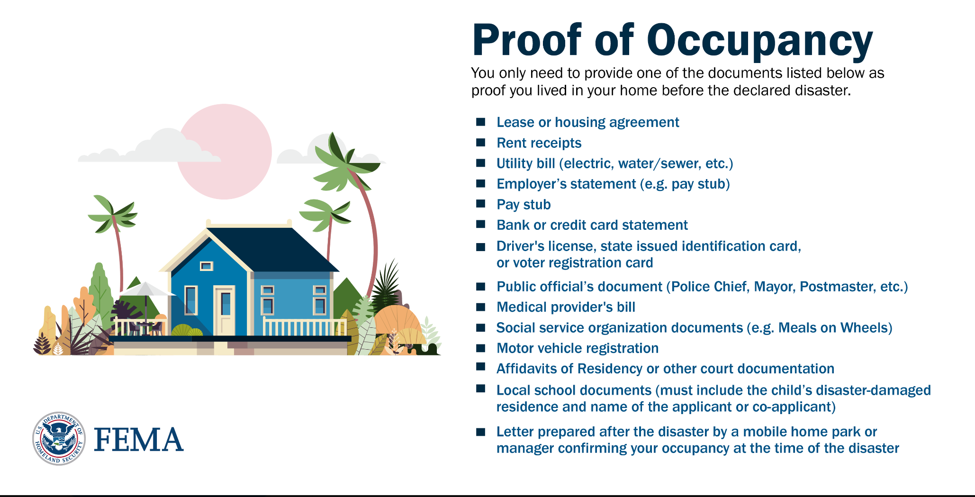

Proof of Ownership

FEMA accepts the following documents as proof you owned your home before the declared disaster. You only need to provide one of the documents listed below.
- Deed or Official Record
- Mortgage documentation
- Homeowners insurance documentation
- Property tax receipt or bill
- Manufactured home certificate or title
- Home purchase contracts (e.g. Bill of Sale, Bond for Title, Land Installment Contract, etc.)
- Will or Affidavit or heirship (with death certificate) naming you heir to the property
- Receipts for major repairs or maintenance dated within 5 years prior to the disaster
- Court documents
- Letter prepared after the disaster from a mobile home park owner or manager or public official that meets FEMA requirements
Most documents can be dated within 1 year prior to the disaster or within the 18-month period of assistance.

Expanded Flexibility

FEMA understands that disaster survivors in some situations may experience additional difficulty gathering specific documents. As a result, FEMA has made recent policy changes to provide additional flexibility to allow applicants who are unable to provide the standard types of documents to provide written self-declarative statements as a last resort in specific situations.

Proof of Occupancy

If your pre-disaster residence was a mobile home or travel trailer or you live in an insular area, island or tribal land and you do not have any acceptable forms of occupancy, FEMA may accept a written self-declarative statement as a last resort, due to challenges with obtaining traditional forms of documentation for these types of homes.
A self-declarative statement for proof of occupancy must include all of the below items:
- The address of the disaster-damaged residence.
- Length of time you lived in the disaster-damaged home, as your primary residence, prior to the Presidential disaster declaration.
- Your or your co-applicant’s name and signature.
- The major elements of the following statement and additional explanation:
"I have made a good faith effort, in coordination with FEMA, to obtain and provide a copy of acceptable occupancy documentation. I was unable to obtain this documentation because [provide an explanation of the circumstances that prevent standard occupancy verification to include why the other document types were not available to the applicant or how the available documents do not meet FEMA's requirements]. I hereby declare under penalty of perjury that the foregoing is true and correct."

Proof of Ownership
If you own a home, live in an insular area, island, or tribal land or in a travel trailer or mobile home, and do not have any acceptable forms of ownership, FEMA will accept a written self-declarative statement as proof of ownership as a last resort.
A self-declarative statement for proof of ownership must include all of the below items:
- The address of the disaster-damaged residence.
- Length of time you lived in the disaster-damaged home, as your primary residence, prior to the Presidential disaster declaration.
- Your or your co-applicant’s name and signature.
- The major elements of the following statement and additional explanation:
"I have made a good faith effort, in coordination with FEMA, to obtain and provide a copy of acceptable ownership documentation. I do meet FEMA's definition of an owner-occupant because I am either [(A) the legal owner of the home. (B) pay no rent, but am responsible for the payment of taxes or maintenance for the residence, or (C) hold lifetime occupancy rights]. I was unable to obtain this documentation because [provide an explanation of the circumstances that prevent standard ownership verification of the appropriate owner-occupant category]. I hereby declare under penalty of perjury that the foregoing is true and correct."
If you own and live in a home that was passed down via heirship and do not have any acceptable forms of ownership, FEMA, as a last resort, will accept a written self-declarative statement as proof of ownership.

A self-declarative statement for proof of ownership passed down via heirship must include all of the below items:
- The address of the disaster-damaged residence.
- Length of time you lived in the disaster-damaged home, as your primary residence, prior to the Presidential disaster declaration.
- Your or your co-applicant’s name and signature.
- A copy of the decedent’s death certification.
- The major elements of the following statement and additional explanation:
"I have made a good faith effort, in coordination with FEMA, to obtain and provide a copy of acceptable ownership documentation. I was unable to obtain this documentation because [provide an explanation of the circumstances that prevent standard ownership verification]."
AND, the major elements of the following statement:
"As the nearest relative of the deceased in the line of succession, my ownership includes all the rights and obligations of the deceased. The decedent's name is ________________, and they died on ________________. I understand I must submit the death certificate along with this declaration. I hereby declare under penalty of perjury that the foregoing is true and correct."

https://www.fema.gov/assistance/individual/after-applying/verifying-home-ownership-occupancy

Text to Find Shelters
Shelters are open and providing food, water and other support. To search for shelters near you:
- Text "SHELTER" and your ZIP code to 43362
- Use the FEMA App: fema.gov/app
- Visit redcross.org/shelters

Locate Family or Loved Ones
If you are trying to locate family or loved ones, call 1-800 RED CROSS (1-800-733-2767) and select Option 4, then follow the voice prompts for "Hawaii Wildfires". The Maui County Emergency Management Agency set up a Family Assistance Center at the Kahului Community Center to help families locate missing loved ones.
Visit @Maui_EMA's Family Assistance Center at the Kahului Community Center to get help locating missing loved ones.
Beware of Scams and Fraud
After a disaster, scam artists often attempt to take advantage of disaster survivors. We encourage survivors to watch for and report any suspicious activity.
Ways to report fraud:
- Email: StopFEMAFraud@fema.dhs.gov
- Call: 1-866-223-0814
- Fax: 202-212-4926
For more information, visit fema.gov/disaster-fraud.

Small Business Disaster Assistance -

SBA Stands Ready to Assist Hawaii Businesses and Residents Affected by the Wildfires

SACRAMENTO, Calif. August 10, 2023 – Low-interest federal disaster loans are now available to Hawaii businesses and residents as a result of President Biden’s major disaster declaration, U.S. Small Business Administration’s Guzman announced.
The declaration covers Maui County as a result of the wildfires that began on Aug. 8.
“SBA’s mission-driven team stands ready to help Hawaii’s small businesses and residents impacted by wildfires,” said Administrator Guzman. “We’re committed to providing federal disaster loans swiftly and efficiently, with a customer-centric approach to help businesses and communities recover and rebuild.”
Businesses of all sizes and private nonprofit organizations may borrow up to $2 million to repair or replace damaged or destroyed real estate, machinery and equipment, inventory and other business assets. SBA can also lend additional funds to businesses and homeowners to help with the cost of improvements to protect, prevent or minimize the disaster damage from occurring in the future.
For small businesses, small agricultural cooperatives, small businesses engaged in aquaculture and most private nonprofit organizations of any size, SBA offers Economic Injury Disaster Loans to help meet working capital needs caused by the disaster. Economic injury assistance is available to businesses regardless of any property damage.
Disaster loans up to $500,000 are available to homeowners to repair or replace damaged or destroyed real estate. Homeowners and renters are eligible for up to $100,000 to repair or replace damaged or destroyed personal property, including personal vehicles.
Interest rates can be as low as 4 percent for businesses, 2.375 percent for private nonprofit organizations and 2.5 percent for homeowners and renters with terms up to 30 years. Loan amounts and terms are set by SBA and are based on each applicant’s financial condition.
To be considered for all forms of disaster assistance, survivors must first contact the Federal Emergency Management Agency at www.disasterassistance.gov. As soon as Federal-State Disaster Recovery Centers open throughout the affected area, SBA will provide one-on-one assistance to disaster loan applicants. Additional information and details on the location of disaster recovery centers is available by calling the SBA Customer Service Center at (800) 659-2955.

PART 2 – Current Federal Agency Grant and Cooperative Agreement Discretionary Program Summaries

Click on Index Links below to find summaries of the current announcements listed by agency in this document. Once you reach the item, if you cannot open the links for further information, copy the selected URL website address into your browser.

Notices is Teal are items with immediate deadline dates.

Notices in Yellow are of special interest.

Notices is Green are items of special interest with immediate deadline dates.

Several Agencies have research or program opportunities that are not individually listed because they are for very technical or specific audiences. Click on the Agency Index Research or Program designation to review those grant and contract notices.

If an Agency does not have listings, it is due to the lack of competitive open opportunities at that Agency this month. Please review Part 2 for general information not specific to a current deadline date for general funding cycle information.

President Biden’s Bipartisan Infrastructure Law’s Distribution of funding in Hawaii

Programs specific to Hawaii

Current Notices
Native American/Native Hawaiian Museum Services (2024)
Reminders
Health Resources and Services Administration
FY 2024 Native Hawaiian Health Care Improvement Act

Small Business Administration
OWBO 2023 Minority Serving Institutions Wave II

U.S. Department of Agriculture

Programs

Animal and Plant Health Inspection Service
National Animal Disease Preparedness and Response Program Fiscal Year 2024
Food and Nutrition Service
Farm To School Technical Assistance-Cooperative Agreement
Foreign Agricultural Service
Cochran Fellowship Program Global Training Opportunity
Foreign Agricultural Service
FY2023 Cochran Fellowship Program
National Institute of Food and Agriculture
4-H Military Extension Educator Program

National Institute of Food and Agriculture
Yellow Ribbon Reintegration Program Youth Support and Internship Program
National Institute of Food and Agriculture
Community Food Projects Competitive Grant Program

Research

Modifications
Rural Business-Cooperative Service
Evaluation of Rural Development’s Investments in Food Supply Chains

Rural Housing Service
Community Facilities Program Disaster Repair Grants
Forest Service
Community Wildfire Defense Grant 2023 West
Rural Utilities Service
Empowering Rural America (New ERA) Program

Reminders

Rural Utilities Service
Calendar Year 2022 Disaster Water Grants
National Institute of Food and Agriculture
Small Business Innovation Research and Small Business Technology Transfer Programs Phase I
Rural Business-Cooperative Service
Higher Blends Infrastructure Incentive Program (HBIIP)
Rural Utilities Service
Powering Affordable Clean Energy

National Institute of Food and Agriculture
Agriculture and Food Research Initiative Competitive Grants Program Education and Workforce Development
National Institute of Food and Agriculture
Agriculture and Food Research Initiative Competitive Grants Program Foundational and Applied Science Program

Department of Commerce

Programs
John H. Prescott Marine Mammal Rescue Assistance Grant
National Institute of Standards and Technology
Manufacturing USA Workforce, Education and Vibrant Ecosystems (WEAVE) Public Service Awards
Research
Modifications

NOAA's Restoring Fish Passage through Barrier Removal Grants Under the BIL and IRA

Reminders

Fiscal Year 2024 - FY2025 Margaret A. Davidson Graduate Fellowships for the National Estuarine Research Reserve System
NERRS Habitat Protection and Restoration Bipartisan Infrastructure Law (BIL) Competition
Ocean Acidification Coastal Research: Uniting Investigations and Shipboard Experiments (OA CRUISE)
NOAA Ocean Acidification Program Education Mini-Grant Program
2023 Inflation Reduction Act Climate-Ready Workforce for Coastal States and Territories Competition

Inflation Reduction Act: NOAA Climate Resilience Regional Challenge
Economic Development Administration
FY 2023 Recompete Pilot Program - Phase 1

FY2023 Ocean-Based Climate Resilience

National Institute of Standards and Technology
Measurement Science and Engineering (MSE) Research Grant Programs

National Institute of Standards and Technology
CHIPS Incentives Program – Commercial Fabrication Facilities

FY2023 National Sea Grant College Program Special Projects
FY 2021 - 2023 Economic Development RNTA
National Institute of Standards and Technology
Measurement Science and Engineering (MSE) Research Grant Programs
National Institute of Standards and Technology
NIST Manufacturing USA National Emergency Assistance Program
Economic Development Administration
FY 2020 EDA Public Works and Economic Adjustment Assistance Programs

Consumer Product Safety Commission

Corporation for National and Community Service

Programs

Reminders

Department of Defense

Programs

Research Grants

Reminders

Dept of the Army -- Materiel Command
United States Army Research Institute For The Behavioral And Social Sciences (ARI) Broad Agency Announcement For Basic, Applied, And Advanced Scientific Research

Air Force Office of Scientific Research
Fiscal Year (FY) 2024 Department of Defense Multidisciplinary Research Program of the University Research Initiative (MURI)

Dept of the Army -- Materiel Command
Fiscal Year (FY) 2024 Department of Defense Multidisciplinary Research Program of the University Research Initiative (MURI)- Army Submission

Dept of the Army -- Materiel Command
DEVCOM Analysis Center Broad Agency Announcement For Applied Research

Dept of the Army -- Materiel Command
DEVCOM Army Research Laboratory Broad Agency Announcement For Foundational Research

Department of Education

Programs
Office of Postsecondary Education (OPE): Higher Education Programs (HEP): Fund for The Improvement of Postsecondary Education (FIPSE): Postsecondary Student Success Grant Program (PSSG), Assistance Listing Number 84.116M
Research
Modifications
OPE: HEP: FIPSE: Historically Black Colleges or Universities (HBCUs), Tribally Controlled Colleges or Universities (TCCUs), and Minority-Serving Institutions (MSIs) Research and Development Infrastructure Grant Program (RDI), ALN 84.116H

Reminders

Institute of Education Sciences (IES): National Center for Education Research (NCER): Transformative Research in the Education Sciences Grant Program, Assistance Listing Number (ALN) 84.305T

US Department of Energy

Programs

National Energy Technology Laboratory
BIL - Carbon Utilization Procurement Grants under Bipartisan Infrastructure Law Section 40302
Research

PAMS
Department of Energy - Office of Science
Office of Science
FY 2024 Phase I Release 1
Modifications

Reminders

Office of Science
FY2023 Continuation of Solicitation for the Office of Science Financial Assistance Program

Environmental Protection Agency

Programs

Clean Communities Investment Accelerator (CCIA)
Modifications
Reminders

Community-Based Research For Effective Programs, Policies, And Decisions To Mitigate Cumulative Health Impacts And Environmental Health Disparities In Underserved Communities
Solar for All

2023 Clean School Bus (CSB) Grant Program

Department of Health and Human Services

Programs

Health Resources and Services Administration
Healthy Start Initiative: Eliminating Disparities in Perinatal Health
Research Grants

Modifications

Reminders
Health Resources and Services Administration
FY 2024 Service Area Competition

Health Resources and Services Administration
Behavioral Health Workforce Education and Training Program- Professionals
Health Resources and Services Administration
FY 2024 Behavioral Health Service Expansion
Health Resources and Services Administration
FY 2024 Expanded Hours
Health Resources and Services Administration
FY 2024 New Access Points

Department of Homeland Security
Programs
Reminders

Department of Housing and Urban Development

Programs
Modifications

Reminders
Notice of Funding Opportunity (NOFO) for Fiscal Year (FY) 2023 Continuum of Care Competition and Renewal or Replacement of Youth Homeless Demonstration Program Grants
FY2023 and FY2024 Radon Testing and Mitigation Demonstration for Public Housing
FY2023 and FY2024 Authority to Accept Unsolicited Proposals for Research Partnerships
Capital Fund At-Risk/Receivership/Substandard/Troubled Program
Green and Resilient Retrofit Program (GRRPC) Comprehensive

Green and Resilient Retrofit Program (GRRPE) Elements

Green and Resilient Retrofit Program (GRRP) Leading Edge
Housing Mobility-Related Services
FY 2023 Jobs Plus NOFO

Veterans Housing Rehabilitation and Modification Pilot Program

Institute of Museum and Library Services
Programs

Inspire! Grants for Small Museums (2024)
Museums Empowered (2024)
National Leadership Grants for Libraries (2024)

National Leadership Grants for Museums (2024)

Modifications
Laura Bush 21st Century Librarian Program (2024)
Museums for America (2024)
Reminders

Department of Interior

Programs
Fish and Wildlife Service
F24AS00012 - NAWCA 2024 US Small Grants
Fish and Wildlife Service
F23AS00455 - Central Africa Regional Program
Fish and Wildlife Service
F24AS00017 - Species Conservation Catalyst Fund on Songbird Trade
Office of Surface Mining
OSMRE Mine Drainage Technology Initiative (MDTI)

Modifications

Bureau of Reclamation
WaterSMART Cooperative Watershed Management Program Phase I for Fiscal Year 2023

Reminders

Fish and Wildlife Service
F24AS00015 Sea Duck Joint Venture FY24 Competitive Grants
Bureau of Reclamation
WaterSMART-Applied Science Grants for Fiscal Year 2023

Fish and Wildlife Service
F23AS00395 National Fire Plan-Wildland Urban Interface Community Fire Assistance
Fish and Wildlife Service
F23AS00249 National Fish Passage Program Base Funding Fiscal Year 2023
Fish and Wildlife Service
F23AS00124 FY23 Recovery Implementation
Fish and Wildlife Service
F23AS00126 FY23 Candidate Species Conservation Fund
National Park Service
FY2023 ABPP - Battlefield Land Acquisition Grant

National Park Service
NPS Cooperative Ecosystems Studies Units (CESU) Master Cooperative Agreements
Fish and Wildlife Service
F23AS00078 National Fish Passage Program Bipartisan Infrastructure Law Fiscal Year 2023
Fish and Wildlife Service
F23AS00100 Refuges Enhancement/Infrastructure
Fish and Wildlife Service
F23AS00069 Youth Engagement, Education, and Employment

Fish and Wildlife Service
F23AS00032 - 2023 Coastal Program

Geological Survey
Cooperative Research Units Program Department of the Interior Geological Survey

Department of Justice

Programs
Office of Juvenile Justice Delinquency Prevention
OJJDP FY 2023 Building Local Continuums of Care to Support Youth Success
Synopsis 1
https://www.grants.gov/web/grants/view-opportunity.html?oppId=349843

Modifications

Research

Reminders

________________________________________________________________________

Department of Labor

Programs
Modifications

Reminders

Veterans Employment and Training Service
Announcement of Stand Down Grants

Employment and Training Administration
National Dislocated Worker Grants Program Guidance

Library of Congress

Of the People: Widening the Path: Community Collections Grants to Organizations
Of the People: Widening the Path: Community Collections Grants to Individuals

National Aeronautics and Space Administration

Research

_______________________________________________________________
National Archives and Records Administration

Programs

Archival Projects
Public Engagement with Historical Records
Reminders

Publishing Historical Records in Collaborative Digital Editions
_______________________________________________________________
National Endowment for the Arts

Programs
NEA Literature Fellowships: Translation Projects, FY2025
Modifications

Reminders

___________________________________________________________
National Endowment for the Humanities

Programs

Dangers and Opportunities of Technology: Perspectives from the Humanities
Collaborative Research

Cultural and Community Resilience
Digital Projects for the Public
Fellowships
Humanities Collections and Reference Resources
Humanities Initiatives
Public Impact Projects at Smaller Organizations
Research and Development
Spotlight on Humanities in Higher Education

Modifications
Fellowships for Digital Publication

Preservation and Access Education and Training

Reminders

Dangers and Opportunities of Technology: Perspectives from the Humanities

Spotlight on Humanities in Higher Education
Collaborative Research

Digital Humanities Advancement Grants

Institutes for Higher Education Faculty Institutes for K-12 Educators
Landmarks of American History and Culture

National Digital Newspaper Program
Preservation Assistance Grants for Smaller Institutions
Sustaining Cultural Heritage Collections

Dynamic Language Infrastructure – Documenting Endangered Languages Fellowships
Dynamic Language Infrastructure – Documenting Endangered Languages Fellowships
Climate Smart Humanities Organizations
Humanities Connections
Dialogues on the Experiences of War

Humanities Collections and Reference Resources

Fellowships Open Book Program
_______________________________________________________________
National Science Foundation

Research and Program Grants

Modifications

Reminders

Research Experiences for Undergraduates

Nuclear Regulatory Commission

Programs

U.S. Nuclear Regulatory Commission Notice of Funding Opportunity Announcement (NOFO), Minority Serving Institutions Grant Program (MSIG), Scholarships and Fellowships, Fiscal Year (FY) 2024

Small Business Administration

Programs
Modifications

Reminders

State Department

Programs

Reminders

U.S. Department of Transportation

Programs

DOT/Federal Transit Administration
FY 2023 Emergency Relief Grants for Public Transportation Systems Affected by Major Declared Disasters in Calendar Years 2017, 2020, 2021, and 2022

Modifications
Reminders

69A345 Office of the Under Secretary for Policy
INFRA Grants
69A345 Office of the Under Secretary for Policy
Mega Grants
69A345 Office of the Under Secretary for Policy
Rural Surface Transportation Grant Program
69A345 Office of the Under Secretary for Policy
Neighborhood Access and Equity (NAE) Program
69A345 Office of the Under Secretary for Policy
Reconnecting Communities Pilot (RCP) Program

Department of the Treasury

Programs

Modifications

Reminders

US Agency for International Development
Programs

Department of Veterans Affairs

Programs
Reminders

Current Federal Agency Grant and Cooperative Agreement Discretionary Program Summaries

Special Programs:

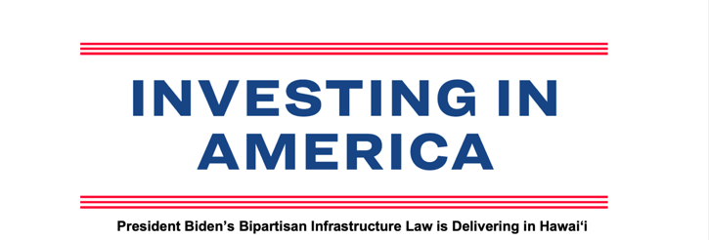

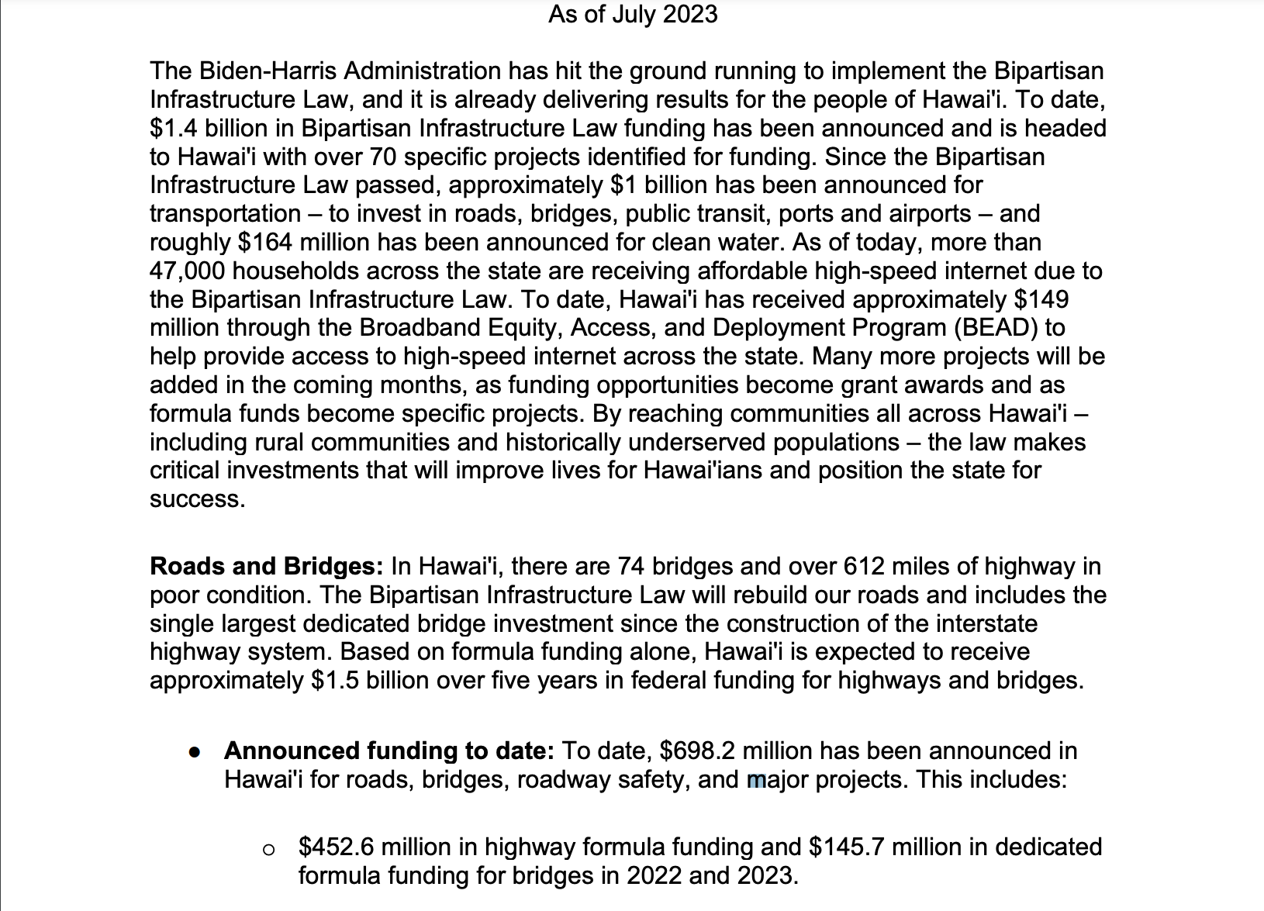
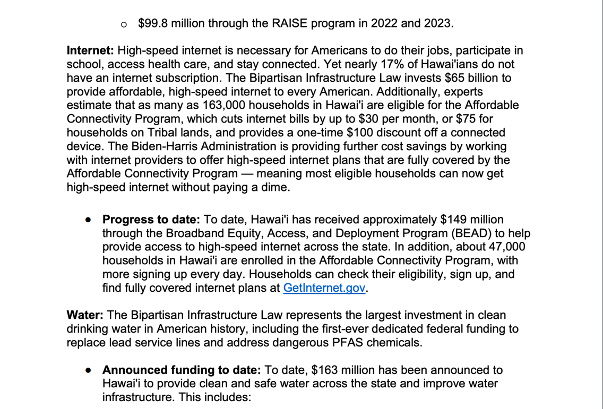
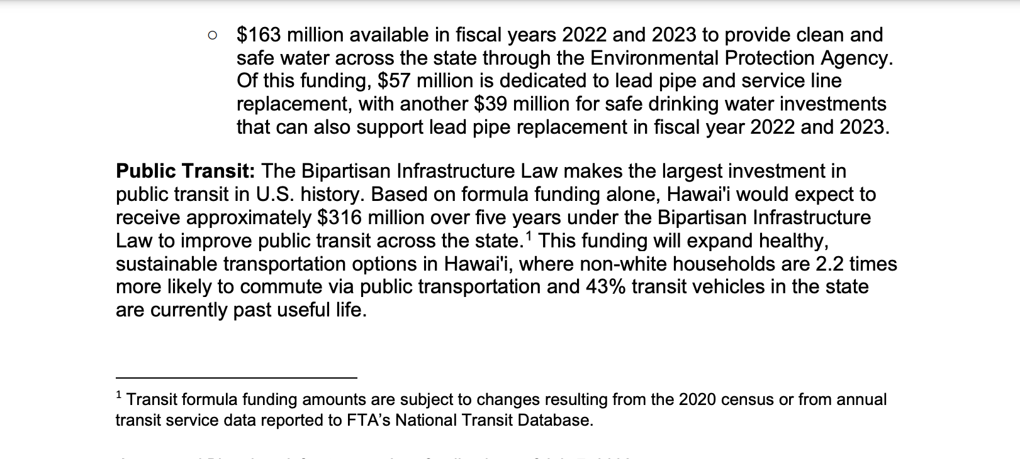
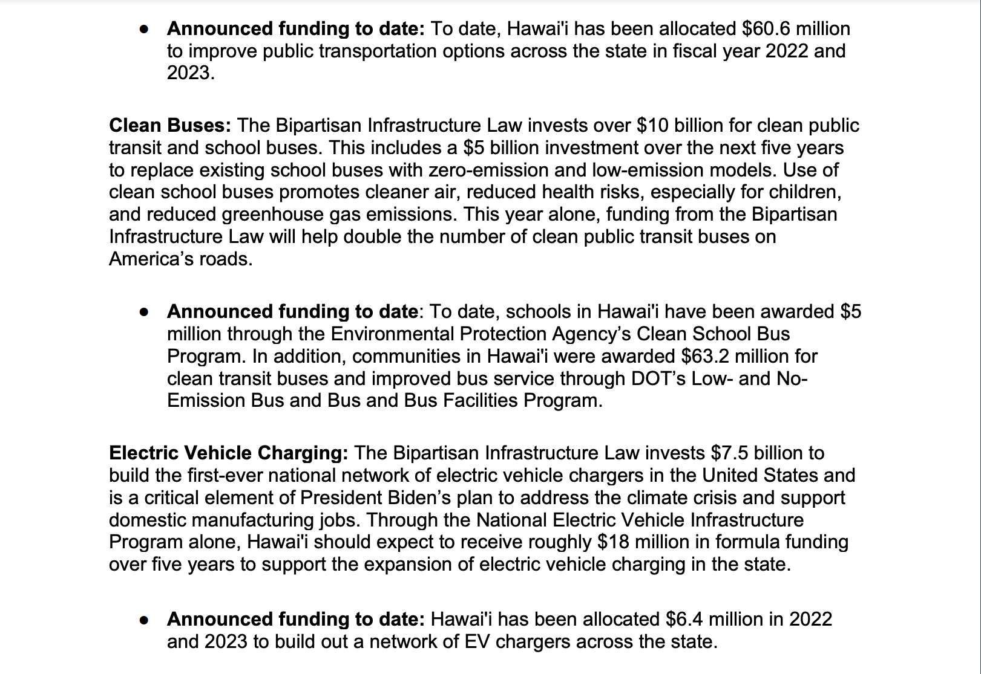
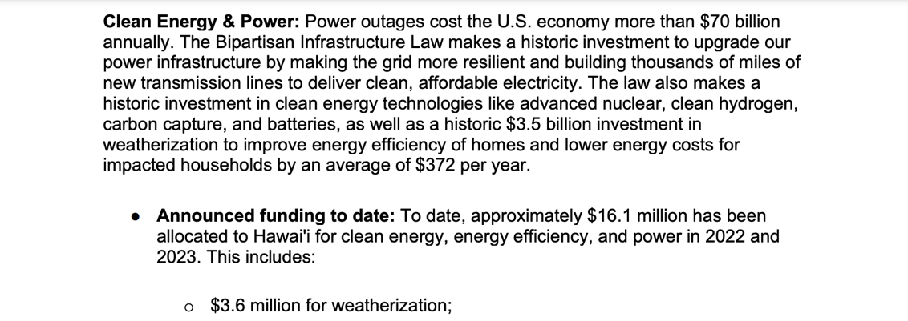
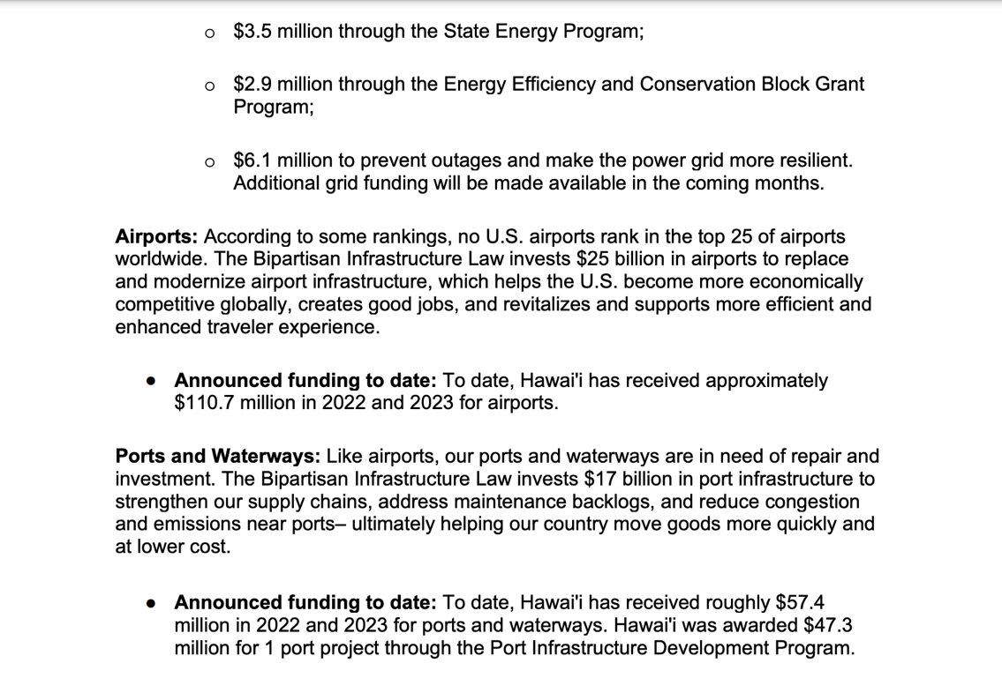
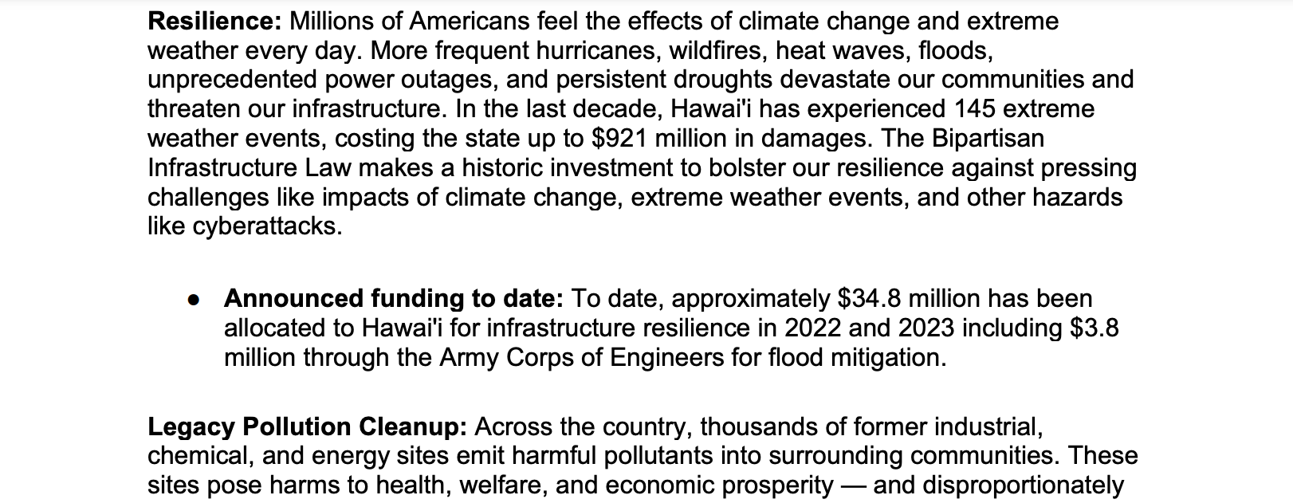
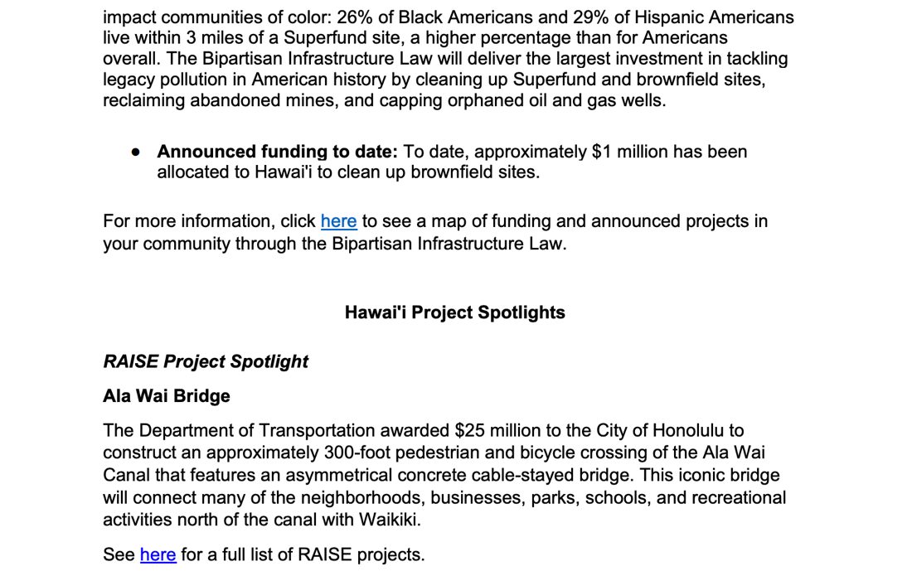
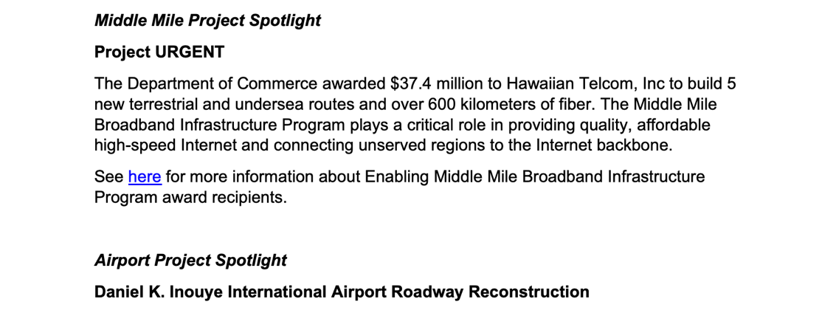
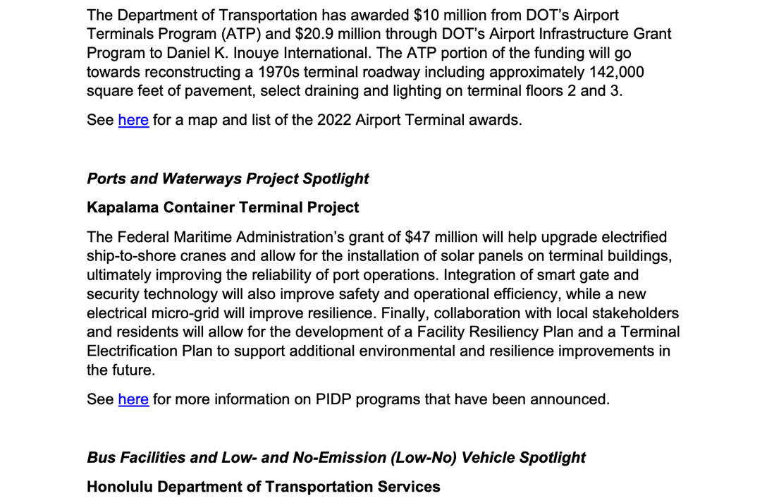

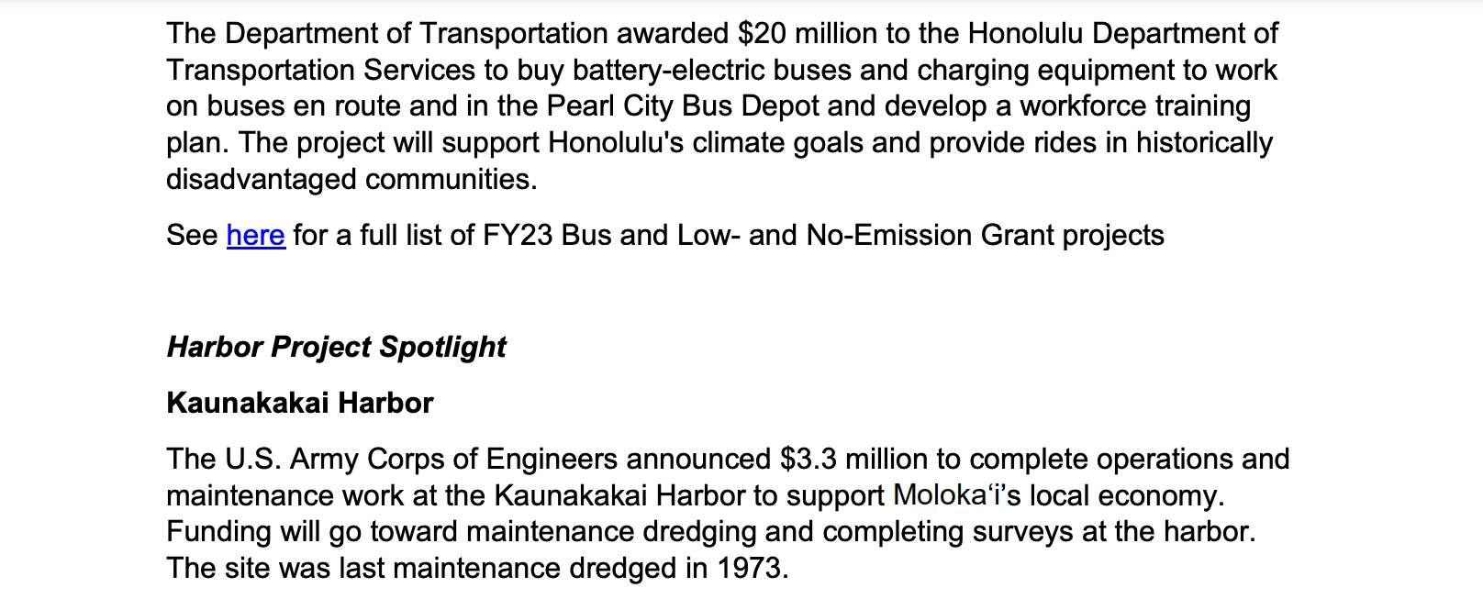
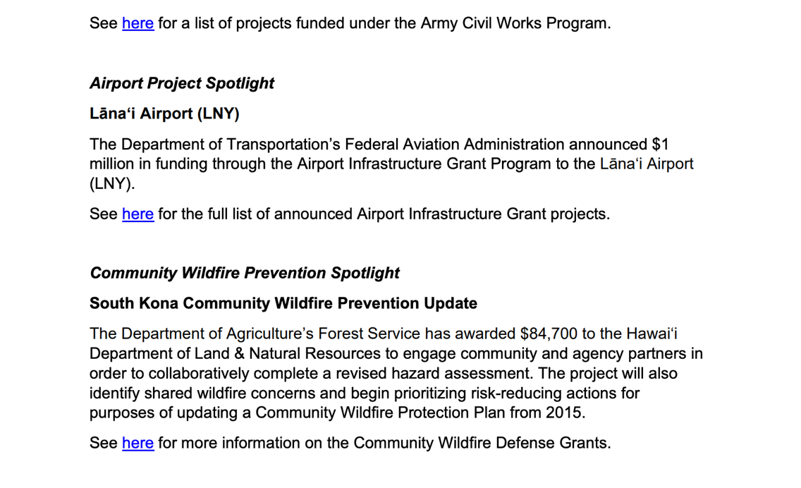
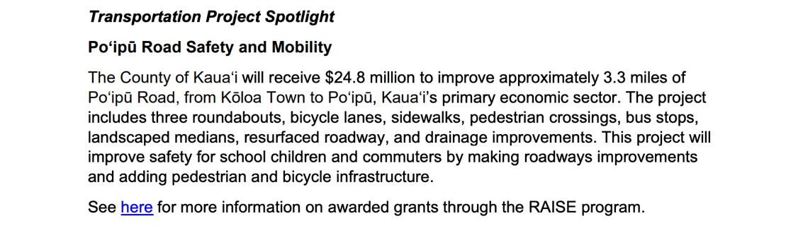
All the links in the document above can be accessed via this link:
https://www.whitehouse.gov/wp-content/uploads/2023/07/Hawai_i-Fact-Sheet-July.pdf

To learn more about how the Bipartisan Infrastructure Law will rebuild our roads and bridges, replace lead pipes for clean water, and more, click here.

https://www.whitehouse.gov/build/guidebook/

HAWAII SPECIFIC APPLICANTS ENCOURAGED

Current Notices

Native American/Native Hawaiian Museum Services (2024)
Forecast 1
Document Type: Grants Notice  Opportunity Number: NANH-FY24  Opportunity Title: Native American/Native Hawaiian Museum Services (2024)  Opportunity Category: Discretionary  Opportunity Category Explanation:  Funding Instrument Type: Grant  Category of Funding Activity: Arts (see "Cultural Affairs" in CFDA) Humanities (see "Cultural Affairs" in CFDA)  Category Explanation:  Expected Number of Awards: 25  CFDA Number(s): 45.308 -- Native American/Native Hawaiian Museum Services Program  Cost Sharing or Matching Requirement: No | Version: Forecast 2  Forecasted Date: Jul 13, 2023  Last Updated Date: Jul 17, 2023  Estimated Post Date: Aug 15, 2023  Estimated Application Due Date: Nov 25, 2023  Estimated Award Date: Jun 15, 2024  Estimated Project Start Date: Jul 01, 2024  Fiscal Year: 2024  Archive Date:  Estimated Total Program Funding: $3,772,000  Award Ceiling: $250,000  Award Floor: $5,000

Eligible Applicants: | Others (see text field entitled "Additional Information on Eligibility" for clarification)
Additional Information on Eligibility: | Federally Recognized Indian Tribes and nonprofit organizations that primarily serve and represent Native Hawaiians.

Agency Name: | Institute of Museum and Library Services
Description: | The Native American/Native Hawaiian Museum Services (NANH) grant program is designed to support Indian tribes and organizations that primarily serve and represent Native Hawaiians in sustaining heritage, culture, and knowledge through exhibitions, educational services and programming, workforce professional development, organizational capacity building, and collections stewardship.
Link to Additional Information: | https://imls.gov/grants/available/native-americannative-hawaiian-museum-services-program
Grantor Contact Information: | Sarah Glass Senior Museum Program Officer sglass@imls.gov Jennifer Anstadt Museum Program Specialist janstadt@imls.gov  (202) 653-4657  imls-museumgrants@imls.gov
https://www.grants.gov/web/grants/view-opportunity.html?oppId=349276

Reminders:

Health Resources and Services Administration
FY 2024 Native Hawaiian Health Care Improvement Act
Forecast 1
Document Type: Grants Notice  Opportunity Number: HRSA-24-030  Opportunity Title: FY 2024 Native Hawaiian Health Care Improvement Act  Opportunity Category: Discretionary  Opportunity Category Explanation:  Funding Instrument Type: Grant  Category of Funding Activity: Health  Category Explanation:  Expected Number of Awards: 6  CFDA Number(s): 93.932 -- Native Hawaiian Health Care Systems  Cost Sharing or Matching Requirement: No | Version: Forecast 1  Forecasted Date: Jul 03, 2023  Last Updated Date: Jul 03, 2023  Estimated Post Date: Dec 15, 2023  Estimated Application Due Date: Mar 15, 2024  Estimated Award Date:  Estimated Project Start Date: Aug 01, 2024  Fiscal Year: 2024  Archive Date:  Estimated Total Program Funding: $27,000,000  Award Ceiling:  Award Floor:

Eligible Applicants: | Others (see text field entitled "Additional Information on Eligibility" for clarification)
Additional Information on Eligibility: | Organizations as eligible under the NHHCIA

Agency Name: | Health Resources and Services Administration
Description: | The purpose of this funding opportunity is to distribute funding under the Native Hawaiian Health Care Improvement Act (NHHCIA) program. The NHHCIA, as amended (42 U.S.C. 11701 - 11714), states that “it is the policy of the United States in fulfillment of its special responsibilities and legal obligations to the indigenous people of Hawaii to (1) raise the health status of Native Hawaiians to the highest possible health level; and (2) provide existing Native Hawaiian health care programs with all resources necessary to effectuate this policy” [see 42 U.S.C. 11702(a)].
Link to Additional Information:
Grantor Contact Information: | NH Technical Assistance Team  (301)594-4300  BPHCFunding@hrsa.gov
https://www.grants.gov/web/grants/view-opportunity.html?oppId=349044

Small Business Administration
OWBO 2023 Minority Serving Institutions Wave II
Synopsis 2
Document Type: Grants Notice  Funding Opportunity Number: SB-OEDWB-23-003  Funding Opportunity Title: OWBO 2023 Minority Serving Institutions Wave II  Opportunity Category: Discretionary  Opportunity Category Explanation:  Funding Instrument Type: Grant  Category of Funding Activity: Business and Commerce Community Development Regional Development  Category Explanation:  Expected Number of Awards: 15  CFDA Number(s): 59.043 -- Women's Business Ownership Assistance  Cost Sharing or Matching Requirement: Yes | Version: Synopsis 2  Posted Date: Jul 05, 2023  Last Updated Date: Jul 05, 2023  Original Closing Date for Applications: Aug 24, 2023 No Explanation  Current Closing Date for Applications: Aug 24, 2023 No Explanation  Archive Date: Sep 23, 2023  Estimated Total Program Funding:  Award Ceiling: $150,000  Award Floor: $75,000

Eligible Applicants: | Private institutions of higher education  Nonprofits having a 501(c)(3) status with the IRS, other than institutions of higher education
Additional Information on Eligibility: | An applicant organization selected to receive Federal funding to deliver WBC services under a grant agreement. By statute, only private, nonprofit organizations certified under § 501(c) of the Internal Revenue Code of 1986 can be recipient organizations.

Agency Name: | Small Business Administration
Description: | The purpose of this FOA is to provide funding for up to fifteen (15) private, non-profit organizations that will provide entrepreneurial development services to women, with an emphasis on socially and economically disadvantaged entrepreneurs in locations that are outside of the geographical areas of existing WBCs. Eligible applicants must be private, non-profit organizations with 501(c) tax exempt status from the U.S. Treasury’s Internal Revenue Service and must or be affiliated with a Minority Serving Institution. Eligible applicants include the following institutions of higher education or their affiliates: Historically Black Colleges and Universities (HBCUs)(as defined in 20 USC §1061), Hispanic Serving Institutions (HSIs)(as defined in 20 USC § 1101a), Tribal Colleges and University (TCUs) (as defined in 20 USC 1059c), Native Hawaiian Serving Institutions (NHSIs)(as defined in 20 USC § 1059d(b)), and Alaska Native Serving Institutions (ANSIs)(as defined in 20 USC § 1059d(b)) of higher learning with existing minority entrepreneurship or related programs. Additionally, those 501c organizations that serve designated Hubzones are eligible to apply.
Link to Additional Information: | OWBO 2023 Minority Serving Institutions Wave II
Grantor Contact Information: | If you have difficulty accessing the full announcement electronically, please contact:  Grants.gov Contact Center Phone Number: 1-800-518-4726 Hours of operation are 24 hours a day, 7 days a week. The contact center is closed on federal holidays. support@grants.gov  Grants.gov Customer Support
https://www.grants.gov/web/grants/view-opportunity.html?oppId=349101

U.S. Department of Agriculture

Programs:

Animal and Plant Health Inspection Service
National Animal Disease Preparedness and Response Program Fiscal Year 2024
Synopsis 1
Document Type: Grants Notice  Funding Opportunity Number: USDA-APHIS-10025-VSSP0000-24-0001  Funding Opportunity Title: National Animal Disease Preparedness and Response Program Fiscal Year 2024  Opportunity Category: Discretionary  Opportunity Category Explanation:  Funding Instrument Type: Cooperative Agreement Other  Category of Funding Activity: Agriculture  Category Explanation:  Expected Number of Awards:  CFDA Number(s): 10.025 -- Plant and Animal Disease, Pest Control, and Animal Care  Cost Sharing or Matching Requirement: No | Version: Synopsis 1  Posted Date: Jul 27, 2023  Last Updated Date: Jul 27, 2023  Original Closing Date for Applications: Oct 20, 2023  Current Closing Date for Applications: Oct 20, 2023  Archive Date: Nov 19, 2023  Estimated Total Program Funding:  Award Ceiling:  Award Floor:

Eligible Applicants: | Others (see text field entitled "Additional Information on Eligibility" for clarification)
Additional Information on Eligibility: | 1. State departments of agriculture2. Offices of the chief animal health official of a State3. Land-Grant Universities and other entities eligible to receive funds under a capacity and infrastructure program (as defined in section 251(f)(1)(C) of the Department of Agriculture Reorganization Act of 1994 (7 U.S.C. 6971(f)(1)(C))). This includes entities eligible for the National Institute of Food and Agriculture Federal Assistance Programs.4. Colleges of veterinary medicine, including a veterinary emergency team at such college5. State or national livestock, poultry, or aquaculture producer organizations with direct and significant economic interest in livestock, poultry, or aquaculture production6. State emergency agencies7. State, national, allied, or regional veterinary organizations or specialty boards recognized by the American Veterinary Medical Association8. Indian Tribes9. Federal agencies.

Agency Name: | Animal and Plant Health Inspection Service
Description: | The U.S. Department of Agriculture (USDA), Animal and Plant Health Inspection Service (APHIS), Veterinary Services (VS) is announcing the availability of up to $17,000,000 in funds in the National Animal Disease Preparedness and Response Program (NADPRP) to support projects in the priority topics listed below.  1. Develop, enhance, and exercise State and Tribal animal disease outbreak emergency response plans.  2. Support livestock1 and poultry biosecurity measures and programs.  3. Enhance capability and capacity for depopulation, carcass disposal, and decontamination in a disease outbreak.  4. Support animal movement decisions in a disease outbreak.  5. Enhance animal disease traceability during a disease outbreak.  6. Support outreach & education on animal disease prevention, preparedness, and response.  7. Develop and deliver training & exercises for animal agriculture sector responders.  8. Advance the development of sheep and goat vaccines.  9. Enhance aquatic animal disease preparedness and response.
Link to Additional Information: | See Related Documents
Grantor Contact Information: | If you have difficulty accessing the full announcement electronically, please contact:  Julie Wallin, NADPRP Program Coordinator, julie.e.wallin@usda.gov, 970-494-7258  For questions about the NADPRP program, required documents, or the ezFedGrants application process
https://www.grants.gov/web/grants/view-opportunity.html?oppId=349582

Food and Nutrition Service
Farm To School Technical Assistance-Cooperative Agreement
Synopsis 1
Document Type: Grants Notice  Funding Opportunity Number: USDA-FNS-F2S-TECH-COOP-24  Funding Opportunity Title: Farm To School Technical Assistance-Cooperative Agreement  Opportunity Category: Discretionary  Opportunity Category Explanation:  Funding Instrument Type: Cooperative Agreement  Category of Funding Activity: Food and Nutrition  Category Explanation:  Expected Number of Awards: 9  CFDA Number(s): 10.531 -- State Agency: Farm to School Program Training and Curricula  Cost Sharing or Matching Requirement: No | Version: Synopsis 1  Posted Date: Jul 27, 2023  Last Updated Date: Jul 27, 2023  Original Closing Date for Applications: Oct 10, 2023  Current Closing Date for Applications: Oct 10, 2023  Archive Date: Nov 09, 2023  Estimated Total Program Funding: $3,000,000  Award Ceiling: $1,000,000  Award Floor: $500,000

Eligible Applicants: | Native American tribal governments (Federally recognized)  Nonprofits having a 501(c)(3) status with the IRS, other than institutions of higher education
Additional Information on Eligibility: | To apply to this Farm to School Technical Assistance Cooperative Agreement, the recipient must be either a 501(c)3 non-profit organization or Indian Tribal Organization (ITO) meeting the criteria listed below. • Must be a regional or national organization. A regional organization includes one working with at least three adjacent States (interstate) or territories within one USDA-FNS region. A national organization provides services and conducts activities nationwide. Farm to school experience is preferred. • Must have a history of meaningful engagement with the intended audience of the track (for example, multiple years of collaboration on a variety of topics and existing relationships with stakeholders in the required audience). The applicant’s proposal and supporting documentation should build a case that demonstrates a history of meaningful engagement; applicants who cannot demonstrate sufficient experience working with the appropriate audience will not be considered. • Supporting Tribal Engagement Track - Must be led/staffed by Tribal members and have partnerships and strong history with indigenous food producers and CNP operators. • Supporting Producer Engagement Track - Demonstrated experience supporting organizations that working with new, small, and/or historically underserved farmers, ranchers, and/or fishers. Applicants that are non-profits must provide a copy of their 501(c)3 Determination Letter to indicate nonprofit status. Applicants must clearly describe how their organization satisfies the criteria for an “eligible entity” as stated above.

Agency Name: | Food and Nutrition Service
Description: | The purpose of the Farm to School Technical Assistance Cooperative Agreement described in this request for applications (RFA) is to support nonprofit entities and Indian Tribal Organizations to implement national- and/or regional-level farm to school activities. Awardees under this cooperative agreement will undertake projects supporting USDA’s priorities of Food System Transformation, Improving Child Health through Nutritious School Meals, and Indigenous Food Sovereignty. There are three funding tracks available, corresponding with each USDA priority. Applicants to the Supporting Community Engagement track (aligned with USDA’s priority of Improving Child Health through Nutritious School Meals) will propose projects that expand farm to school institutes. The Supporting Producer Engagement track aligns with USDA’s Food Systems Transformation priority and will fund projects that strengthen producer engagement with the Child Nutrition Programs market. Finally, the Supporting Tribal Engagement track will fund an entity to conduct Tribal dialogues with the purpose of supporting FNS’s farm to school grantmaking and technical assistance for Tribal entities, in alignment with USDA’s Indigenous Food Sovereignty priority. Available funding ranges from $500,000 to $1 million depending on the applicant’s choice of track. Eligible applicants are national and/or regional level nonprofit entities and Indian Tribal Organizations with a history of meaningful engagement with the target audience for this cooperative agreement
Link to Additional Information: | FNS Grant Opportunities
Grantor Contact Information: | If you have difficulty accessing the full announcement electronically, please contact:  Jean Bingham Grants Officer  grant officer
https://www.grants.gov/web/grants/view-opportunity.html?oppId=349583

Foreign Agricultural Service
Cochran Fellowship Program Global Training Opportunity
Synopsis 1
Document Type: Grants Notice  Funding Opportunity Number: USDA-FAS-10962-0700-10-23-0007  Funding Opportunity Title: Cochran Fellowship Program Global Training Opportunity  Opportunity Category: Discretionary  Opportunity Category Explanation:  Funding Instrument Type: Cooperative Agreement  Category of Funding Activity: Agriculture  Category Explanation:  Expected Number of Awards: 10  CFDA Number(s): 10.962 -- Cochran Fellowship Program  Cost Sharing or Matching Requirement: No | Version: Synopsis 1  Posted Date: Jul 12, 2023  Last Updated Date: Jul 12, 2023  Original Closing Date for Applications: Aug 25, 2023  Current Closing Date for Applications: Aug 25, 2023  Archive Date: Sep 24, 2023  Estimated Total Program Funding: $1,500,000  Award Ceiling: $150,000  Award Floor:

Eligible Applicants: | Others (see text field entitled "Additional Information on Eligibility" for clarification)
Additional Information on Eligibility: | See Section C of the funding opportunity announcement for eligibility information.

Agency Name: | Foreign Agricultural Service
Description: | Since 1984, the U.S. Congress has made funds available to the Cochran Fellowship Program for training agriculturalists from middle-income countries, emerging markets, and emerging democracies. Training opportunities are for senior and mid-level specialists and administrators working in agricultural trade and policy, agribusiness development, management, animal, plant, and food sciences, extension services, agricultural marketing, and many other areas.  Please see appendix for full SOWs and learning objectives.  • Women in Agriculture: Entrepreneurship for Food Processing, Packaging, and Value Chain  • Food Safety Standards and Regulations for Nigeria  • WTO Adherence: SPS, TBT, & TFA Agreements  • Food Safety Standards and Regulations
Link to Additional Information: | See Related Documents
Grantor Contact Information: | If you have difficulty accessing the full announcement electronically, please contact:  Desiree Lawrence  Desiree.Lawrence@usda.gov
https://www.grants.gov/web/grants/view-opportunity.html?oppId=349213
Foreign Agricultural Service
FY2023 Cochran Fellowship Program
Synopsis 1

Document Type: Grants Notice  Funding Opportunity Number: USDA-FAS-10962-0700-10-23-0008  Funding Opportunity Title: FY2023 Cochran Fellowship Program  Opportunity Category: Discretionary  Opportunity Category Explanation:  Funding Instrument Type: Cooperative Agreement  Category of Funding Activity: Agriculture  Category Explanation:  Expected Number of Awards: 29  CFDA Number(s): 10.962 -- Cochran Fellowship Program  Cost Sharing or Matching Requirement: No | Version: Synopsis 1  Posted Date: Jul 12, 2023  Last Updated Date: Jul 12, 2023  Original Closing Date for Applications: Aug 25, 2023  Current Closing Date for Applications: Aug 25, 2023  Archive Date: Sep 24, 2023  Estimated Total Program Funding: $4,350,000  Award Ceiling: $150,000  Award Floor:

Eligible Applicants: | Others (see text field entitled "Additional Information on Eligibility" for clarification)
Additional Information on Eligibility: | See Section C of the funding opportunity announcement for eligibility information.

Agency Name: | Foreign Agricultural Service
Description: | Since 1984, the U.S. Congress has made funds available to the Cochran Fellowship Program for training agriculturalists from middle-income countries, emerging markets, and emerging democracies. Training opportunities are for senior and mid-level specialists and administrators working in agricultural trade and policy, agribusiness development, management, animal, plant, and food sciences, extension services, agricultural marketing, and many other areas.  Please see appendix for full SOWs and learning objectives.  • Adoption of Biotechnology and Science-Based Agricultural Policy for Burundi, Democratic Republic of Congo, Kenya, Malawi, Republic of Congo, Tanzania and Uganda  • Community Based Aquaculture Development for Senegal  • Women in Agriculture: Entrepreneurship for Food Processing, Packaging and Value Chain for India  • Peoples Republic of China – Feed Ingredients for Aquaculture and Animal Husbandry  • Peoples Republic of China – Food Service Chief Training Program  • Climate Smart Agriculture for Vietnam  • Effective Implementation of Climate Smart Agricultural Technology for Thailand  • Biotechnology Adoption and Biosafety for Guatemala, El Salvador, and Honduras  • Biotechnology: Policies, Management, and Public Outreach for Argentina and Paraguay  • Climate-Smart Agricultural Practices and Extension for Dominica, Grenada, St. Lucia, St. Vincent and the Grenadines, and Guyana  • Post-Harvest and Storage Handling of U.S. Grains for Dominican Republic  Partnerships for Climate-Smart Commodities Initiative for Colombia, Dominican Republic, Ecuador, El Salvador, Guatemala, Honduras, and Peru  • Hotel Foodservice Industry Trends & Best Practices for Mexico, Monterrey  • Stock Inventory Management for Peru and Ecuador  • U.S. Tree Nuts as Food Ingredients for Brazil  • Hotel Foodservice Industry Trends & Best Practices for Mexico  • Introduction to U.S. Gastronomy and Food Ingredients for Colombia  • Promotion & Marketing of U.S. Seafood for Ghana, Cote d’Ivoire, Togo  • U.S. Private Label Management for People’s Republic of China  • Utilization of American Softwood for Vietnam  • U.S. Sweets and Snacks for Bangladesh  • Marketing and Grading of U.S. Hardwood for Pakistan  • Overview of U.S. East Coast Seafood and New Species for People’s Republic of China  • Promotion of U.S. Tree Nuts for Turkey  • Building Resilience through Climate-Smart Agriculture for Bosnia and Herzegovina  • Overview of Animal Health and Disease Management for Bosnia and Herzegovina  • Climate Smart Agriculture and Food Systems Innovation for Serbia  • Women in Agriculture Entrepreneurship and Food Production for Serbia  • Overview of Climate-Smart Agricultural for Turkey
Link to Additional Information: | See Related Documents
Grantor Contact Information: | If you have difficulty accessing the full announcement electronically, please contact:  Desiree Lawrence Phone: 202-690-0947  Desiree.Lawrence@usda.gov
https://www.grants.gov/web/grants/view-opportunity.html?oppId=349214

National Institute of Food and Agriculture
4-H Military Extension Educator Program
Synopsis 1
Document Type: Grants Notice  Funding Opportunity Number: USDA-NIFA-EXCA-010106  Funding Opportunity Title: 4-H Military Extension Educator Program  Opportunity Category: Discretionary  Opportunity Category Explanation:  Funding Instrument Type: Grant  Category of Funding Activity: Agriculture  Category Explanation:  Expected Number of Awards:  CFDA Number(s): 10.500 -- Cooperative Extension Service  Cost Sharing or Matching Requirement: No | Version: Synopsis 2  Posted Date: Aug 03, 2023  Last Updated Date: Aug 04, 2023  Original Closing Date for Applications: Sep 05, 2023  Current Closing Date for Applications: Sep 05, 2023  Archive Date: Oct 05, 2023  Estimated Total Program Funding: $190,000  Award Ceiling: $190,000  Award Floor: $190,000

Eligible Applicants: | Others (see text field entitled "Additional Information on Eligibility" for clarification)
Additional Information on Eligibility: | Eligibility Requirements Applicants for the 4-H Military Extension Educator Program must meet all the requirements discussed in this RFA. Failure to meet the eligibility criteria by the application deadline may result in exclusion from consideration or, preclude NIFA from making an award. For those new to Federal financial assistance, NIFA’s Grants Overview provides highly recommended information about grants and other resources to help understand the Federal awards process.

Agency Name: | National Institute of Food and Agriculture
Description: | This notice identifies the objectives for the 4-H Military Extension Educator (MEE) Program for fiscal year 2023 including deadlines, funding information, eligibility criteria for projects and applicants, and application forms and associated instructions.
Link to Additional Information: | 4-H Military Extension Educator Program
Grantor Contact Information: | If you have difficulty accessing the full announcement electronically, please contact:  NIFA Support Key Information: Business hours: Monday thru Friday, 7a.m. – 5p.m. ET, except federal holidays  If you have any questions related to preparing application content.
https://www.grants.gov/web/grants/view-opportunity.html?oppId=349747

National Institute of Food and Agriculture
Yellow Ribbon Reintegration Program Youth Support and Internship Program
Synopsis 1
Document Type: Grants Notice  Funding Opportunity Number: USDA-NIFA-EXCA-010126  Funding Opportunity Title: Yellow Ribbon Reintegration Program Youth Support and Internship Program  Opportunity Category: Discretionary  Opportunity Category Explanation:  Funding Instrument Type: Grant  Category of Funding Activity: Agriculture  Category Explanation:  Expected Number of Awards:  CFDA Number(s): 10.500 -- Cooperative Extension Service  Cost Sharing or Matching Requirement: No | Version: Synopsis 1  Posted Date: Aug 03, 2023  Last Updated Date: Aug 03, 2023  Original Closing Date for Applications: Sep 05, 2023  Current Closing Date for Applications: Sep 05, 2023  Archive Date: Oct 05, 2023  Estimated Total Program Funding: $950,000  Award Ceiling: $950,000  Award Floor: $950,000

Eligible Applicants: | Others (see text field entitled "Additional Information on Eligibility" for clarification)
Additional Information on Eligibility: | Eligibility Requirements Only Land-grant Institutions are eligible to receive an award through the Youth Support Internship Program. Eligible Land-grant Institutions include all 1862, 1890 and 1994 Land-grant Universities and Colleges.

Agency Name: | National Institute of Food and Agriculture
Description: | This notice identifies the objectives for Youth Support Internship Program projects including deadlines, funding information, eligibility criteria for projects and applicants, and application forms and associated instructions.
Link to Additional Information: | Yellow Ribbon Reintegration Program Youth Support and Internship Program
Grantor Contact Information: | If you have difficulty accessing the full announcement electronically, please contact:  NIFA Support Key Information: Business hours: Monday thru Friday, 7a.m. – 5p.m. ET, except federal holidays  If you have any questions related to preparing application content.
https://www.grants.gov/web/grants/view-opportunity.html?oppId=349745
National Institute of Food and Agriculture
Community Food Projects Competitive Grant Program
Synopsis 1
Document Type: Grants Notice  Funding Opportunity Number: USDA-NIFA-CFP-009982  Funding Opportunity Title: Community Food Projects Competitive Grant Program  Opportunity Category: Discretionary  Opportunity Category Explanation:  Funding Instrument Type: Grant  Category of Funding Activity: Agriculture  Category Explanation:  Expected Number of Awards:  CFDA Number(s): 10.225 -- Community Food Projects  Cost Sharing or Matching Requirement: Yes | Version: Synopsis 2  Posted Date: Aug 01, 2023  Last Updated Date: Aug 02, 2023  Original Closing Date for Applications: Oct 30, 2023  Current Closing Date for Applications: Oct 30, 2023  Archive Date: Nov 29, 2023  Estimated Total Program Funding: $4,800,000  Award Ceiling: $400,000  Award Floor: $25,000

Eligible Applicants: | Others (see text field entitled "Additional Information on Eligibility" for clarification)
Additional Information on Eligibility: | Eligibility Requirements Applicants for the CFPCGP must meet all the requirements stated in this RFA. Failure to meet the eligibility criteria by the application deadline may result in exclusion from consideration or preclude NIFA from making an award. For those new to Federal financial assistance, NIFA’s Grants Overview provides highly recommended information about grants and other resources to help understand the Federal awards process. To be eligible for a grant under CFPCGP, a public food program service provider, a tribal organization, or a private nonprofit entity, including gleaners, must1) have experience in the area of-a) community food work, particularly concerning small and medium-sized farms, including the provision of food to people in communities with low incomes and the development of new markets in communities with low incomes for agricultural producers; b) job training and business development activities for food-related activities in communities with low incomes; orc) efforts to reduce food insecurity in the community, including food distribution, improving access to services, or coordinating services and programs;2) demonstrate competency to implement a project, provide fiscal accountability, collect data, and prepare reports and other necessary documentation;3) demonstrate a willingness to share information with researchers, practitioners, and other interested parties; and4) collaborate with one or more local partner organizations using one or more action steps proposed by congress to achieve a “hunger-free communities' goal. “Private Nonprofit entities” are defined as any nongovernmental corporation, trust, association, cooperative or other organization which: (i) is operated primarily for scientific, educational, service, charitable, or similar purposes in the public interest; (ii) is not organized primarily for profit; and (iii) uses its net proceeds to maintain, improve, and/or expand its operations. Acceptable evidence of non-profit eligibility in this program includes the following: (i) A copy of a currently valid Internal Revenue Service tax exemption certificate; (ii) A statement from a state taxing body, State Attorney General, or other appropriate state official certifying that the applicant organization has a non- profit status; (iii) A certified copy of the organization’s certificate of incorporation or similar document that clearly establishes non-profit status; or (iii) Any of the above proof for a state or national parent organization and a statement signed by the parent organization that the applicant organization is a local non-profit affiliate. See the NIFA Policy Guide for additional information. To demonstrate competency to implement a project and provide fiscal accountability, an applicant must assign a Fiscal Agent. A Fiscal Agent is an organization managing financial responsibilities on behalf of the applicant. If an institution/organization cannot accept Federal funds directly, a letter must be included in the application stating that in the event the application results in an award, the award funds must be administered through a Fiscal Agent on their behalf. This agent must be identified in the letter from the applicant and the letter must be countersigned by an authorized representative of the fiscal agent organization. The letter should include the Fiscal Agent’s point of contact, address, telephone number, fax number and e-mail address. This letter is to be included as an attachment to Field 12, Other Attachments (see Part IV § B of this RFA). In the event an application is recommended for funding, NIFA will request that both the applicant or institution/organization and the fiscal agent organization submit complete management information (see Part V § C of this RFA).

Agency Name: | National Institute of Food and Agriculture
Description: | This notice identifies the objectives for Community Food Projects Competitive Grant Program (CFPCGP) projects, deadlines, funding information, eligibility criteria for projects and applicants, and application forms and associated instructions. In FY 2024 NIFA’s CFPCGP intends to solicit applications and fund two types of grants. The grant types are (1) Planning Projects (PP) and (2) Community Food Projects (CFP).
Link to Additional Information: | Community Food Projects Competitive Grant Program
Grantor Contact Information: | If you have difficulty accessing the full announcement electronically, please contact:  NIFA Support Key Information: Business hours: Monday thru Friday, 7a.m. – 5p.m. ET, except federal holidays  If you have any questions related to preparing application content.
https://www.grants.gov/web/grants/view-opportunity.html?oppId=349690

Research:

Modifications:

Rural Business-Cooperative Service
Evaluation of Rural Development’s Investments in Food Supply Chains
Synopsis 2

Document Type: Grants Notice  Funding Opportunity Number: USDA-RD-RBCS-INVESTFSC-23  Funding Opportunity Title: Evaluation of Rural Development’s Investments in Food Supply Chains  Opportunity Category: Discretionary  Opportunity Category Explanation:  Funding Instrument Type: Cooperative Agreement  Category of Funding Activity: Agriculture Business and Commerce Food and Nutrition  Category Explanation:  Expected Number of Awards:  CFDA Number(s): 10.890 -- Rural Development Cooperative Agreement Program  Cost Sharing or Matching Requirement: No | Version: Synopsis 2  Posted Date: Aug 09, 2023  Last Updated Date: Aug 09, 2023  Original Closing Date for Applications: Sep 08, 2023  Current Closing Date for Applications: Sep 08, 2023  Archive Date: Oct 08, 2023  Estimated Total Program Funding:  Award Ceiling:  Award Floor:

Eligible Applicants: | Others (see text field entitled "Additional Information on Eligibility" for clarification)
Additional Information on Eligibility: | Organizations eligible to apply include public and private sector institutions with five or more years of experience conducting research on U.S. food systems or evaluations of federally funded programs in support of strengthening food supply chains. Individuals are not eligible to apply. Applicants must demonstrate they have the capacity and resources to carry out the evaluation and complete all tasks and deliverables within the Period of Performance. Applicants must specifically demonstrate past experience and current capacity to design and implement formative, performance, and impact evaluations.

Agency Name: | Rural Business-Cooperative Service
Description: | This Notice announces that Rural Development (RD or the Agency) is accepting proposals to evaluate the impact of RD’s grants and loan programs on regional food supply chains. This funding opportunity will be administered by the RD Innovation Center, in partnership with the United States Department of Agriculture’s (USDA) Office of Budget and Program Analysis (OBPA). The Agency is announcing $750,000 in competitive cooperative agreement funds in fiscal year (FY) 2023. The Agency may select one (1) or no Cooperator. RD reserves the right to withhold the awarding of any funds. Applications must receive a minimum score of at least 60 points to be considered. This Notice lists the information needed to submit an application for these funds.
Link to Additional Information: | See Related Documents
Grantor Contact Information: | If you have difficulty accessing the full announcement electronically, please contact:  Kasey Martin  kasey.martin@usda.gov

https://www.grants.gov/web/grants/view-opportunity.html?oppId=349814

Rural Housing Service
Community Facilities Program Disaster Repair Grants
Synopsis 3
Document Type: Grants Notice  Funding Opportunity Number: USDA-RHS-CFDG-2023  Funding Opportunity Title: Community Facilities Program Disaster Repair Grants  Opportunity Category: Discretionary  Opportunity Category Explanation:  Funding Instrument Type: Grant  Category of Funding Activity: Other (see text field entitled "Explanation of Other Category of Funding Activity" for clarification)  Category Explanation: Supplemental Disaster Grant funding received under the Consolidated Appropriations Act, 2023.  Expected Number of Awards: 30  CFDA Number(s): 10.766 -- Community Facilities Loans and Grants  Cost Sharing or Matching Requirement: Yes | Version: Synopsis 3  Posted Date: Jul 26, 2023  Last Updated Date: Jul 26, 2023  Original Closing Date for Applications: Applications for the Community Facilities Disaster Repair Grant Program will be accepted on a continual basis by the USDA RD Office for the state where the project is located, beginning on the publication date of this notice, until funds are exhausted. Interested applicants must contact the RD Office for the state where the project is located to discuss potential projects prior to preparing their application and to connect with a technical assistance provider. Agency state office contact information is available at https://www.rd.usda.gov/about-rd/state-offices.  Current Closing Date for Applications: Applications for the Community Facilities Disaster Repair Grant Program will be accepted on a continual basis by the USDA RD Office for the state where the project is located, beginning on the publication date of this notice, until funds are exhausted. Interested applicants must contact the RD Office for the state where the project is located to discuss potential projects prior to preparing their application and to connect with a technical assistance provider. Agency state office contact information is available at https://www.rd.usda.gov/about-rd/state-offices.  Archive Date:  Estimated Total Program Funding: $50,000,000  Award Ceiling: $10  Award Floor: $1

Eligible Applicants: | Native American tribal governments (Federally recognized)  City or township governments  Others (see text field entitled "Additional Information on Eligibility" for clarification)  County governments  Nonprofits having a 501(c)(3) status with the IRS, other than institutions of higher education
Additional Information on Eligibility: | An eligible applicant must be a public body, nonprofit corporation, or Federally-recognized tribe. To be eligible for grant funds under this Notice, the project must be located in a rural area in a county (or a rural area of a Reservation for Indian tribes) with a disaster declaration as declared by the President of the United States; the disaster declaration must be related to the consequences of a disaster occurring in CY 2022; the Federal Emergency Management Agency (FEMA) must have provided a notice declaring the disaster. The term rural or rural area is defined in Section 343(a)(13)(C) of the Consolidated Farm and Rural Development Act (7 U.S.C. 1991(a)(13)(C)), as amended, as a city, town or, unincorporated area that has a population of not more than 20,000 inhabitants.
Additional Information
Agency Name: | Rural Housing Service
Description: | This program provides up to $50 million in grant funding to eligible public bodies, non-profits, and Federally-recognized tribes. Grants may cover up to 75 percent of total project cost. There is no minimum or maximum award amount.  Grants will be provided to eligible applicants to repair eligible essential community facilities damaged by Presidentially Declared Disasters that occurred in CY 2022 . Subject to any updates to the Presidentially Declared Disasters, the following states have been identified with areas that have been impacted by qualifying events during CY 2022: Alaska, American Samoa, Arizona, California, Colorado, Florida, Hawaii, Idaho, Illinois, Iowa, Kansas, Kentucky, Maine, Massachusetts, Minnesota, Mississippi, Missouri, Montana, Nebraska, Nevada, New Mexico, New York, North Carolina, North Dakota, Oklahoma, Oregon, Puerto Rico, Rhode Island, South Carolina, South Dakota, Tennessee, Texas, U.S. Virgin Islands, Virginia, Washington, and West Virginia.  Applications for the CF Program Disaster Repair Grants must be submitted to the applicable USDA RD Office. Applications will be accepted on a continual basis, beginning on the publication date of this notice, until funds are exhausted. The applicable USDA RD State Office will conduct an initial review, rating, and selection of complete applications.
Link to Additional Information: | Announcement of the Availability of Community Facilities Program Disaster Repair Grants
Grantor Contact Information: | If you have difficulty accessing the full announcement electronically, please contact:  Surabhi Dabir Phone 202 768-5875  Email for Surabhi Dabir
https://www.grants.gov/web/grants/view-opportunity.html?oppId=348870

Forest Service
Community Wildfire Defense Grant 2023 West
Synopsis 5
Document Type: Grants Notice  Funding Opportunity Number: USDA-FS-2023-CWDG-CWSF  Funding Opportunity Title: Community Wildfire Defense Grant 2023 West  Opportunity Category: Discretionary  Opportunity Category Explanation:  Funding Instrument Type: Grant  Category of Funding Activity: Disaster Prevention and Relief Natural Resources  Category Explanation:  Expected Number of Awards: 500  CFDA Number(s): 10.720 -- Infrastructure Investment and Jobs Act Community Wildfire Defense Grants  Cost Sharing or Matching Requirement: Yes | Version: Synopsis 5  Posted Date: Jul 31, 2023  Last Updated Date: Jul 31, 2023  Original Closing Date for Applications: Oct 31, 2023  Current Closing Date for Applications: Oct 31, 2023  Archive Date: Nov 04, 2023  Estimated Total Program Funding: $250,000,000  Award Ceiling: $10,000,000  Award Floor: $0

Eligible Applicants: | Special district governments  Nonprofits having a 501(c)(3) status with the IRS, other than institutions of higher education  Nonprofits that do not have a 501(c)(3) status with the IRS, other than institutions of higher education  City or township governments  Native American tribal organizations (other than Federally recognized tribal governments)  County governments  Public and State controlled institutions of higher education  State governments  Native American tribal governments (Federally recognized)
Additional Information on Eligibility:

Agency Name: | Forest Service
Description: | This announcement contains the Notice of Funding Opportunity (NOFO)/Instructions. To apply after reading the NOFO, visit the application portal at cwdg.forestrygrants.org.  The purpose of the Community Wildfire Defense Grant is to assist at-risk local communities and Indian Tribes with planning and mitigating against the risk created by wildfire.  The Act prioritizes at-risk communities in an area identified as having high or very high wildfire hazard potential, are low-income, and/or have been impacted by a severe disaster. More details on these three priorities can be found in the Notices of Funding Opportunity (NOFOs).  The CWDG helps communities in the wildland urban interface (WUI) implement the three goals of the National Cohesive Wildland Fire Management Strategy (Cohesive Strategy):  - Restore and Maintain Landscapes: Landscapes, regardless of jurisdictional boundaries, are resilient to fire, insect, disease, invasive species, and climate change disturbances, in accordance with management objectives.  - Create Fire Adapted Communities: Human populations and infrastructure are as prepared as possible to receive, respond to, and recover from wildland fire.  - Improve Wildfire Response: All jurisdictions participate in making and implementing safe, effective, efficient risk-based wildfire management decisions.  This program is authorized in Public Law 117-58, Infrastructure Investment and Jobs Act, commonly referred to as the Bipartisan Infrastructure Law (BIL).  There are two primary project types for which the grant provides funding:  - The development and revision of Community Wildfire Protection Plans (CWPP)  - The implementation of projects described in a CWPP that is less than ten years old  Applicant Webinars for CWDG Round 2 have been scheduled as follows. The application process in Round 2 is the same for all applicants (versus Round 1 where there were different processes for different regions), and any applicant in any region, area, or Tribe may attend any webinar, they will all have the same content, however, the August 10 Webinar will be more focused on Tribal applications and Tribal application Q&A.  This information will also be on the Forest Service CWDG website, link below.  To attend a webinar, please register in advance by clicking on the link following each date:  August 4, 2pm-4pm Eastern  https://us06web.zoom.us/webinar/register/WN_DOtCNZHVRym3gFKdzYlLUg  August 9, 2pm-4pm Eastern  https://us06web.zoom.us/webinar/register/WN_Q-NLfp_HRR2zWoOQZgMprw  August 10, 2pm-4pm Eastern  https://us06web.zoom.us/webinar/register/WN_yxe-tURVSqqKl7EMJ5zOmQ  August 15, 2pm-4pm Eastern  https://us06web.zoom.us/webinar/register/WN_8XdtEXfHSYyk_XxdkOeGgA  Applicant Webinar recordings will be made available soon after the webinars for those unable to attend one of the live offerings, check back on the Forest Service CWDG website for recordings.
Link to Additional Information: | CWDG Homepage
Grantor Contact Information: | If you have difficulty accessing the full announcement electronically, please contact:  Branch Chief, Cooperative Fire  USFS Cooperative Fire Branch-CWDG Program
https://www.grants.gov/web/grants/view-opportunity.html?oppId=349612

Rural Utilities Service
Empowering Rural America (New ERA) Program
Synopsis 6
Document Type: Grants Notice  Funding Opportunity Number: RUS-NEWERA-2023  Funding Opportunity Title: Empowering Rural America (New ERA) Program  Opportunity Category: Discretionary  Opportunity Category Explanation:  Funding Instrument Type: Grant Other  Category of Funding Activity: Other (see text field entitled "Explanation of Other Category of Funding Activity" for clarification)  Category Explanation: Inflation Reduction Act (IRA)  Expected Number of Awards:  CFDA Number(s): 10.758 -- New Empowering Rural America (New ERA) Program  Cost Sharing or Matching Requirement: Yes | Version: Synopsis 6  Posted Date: Jul 31, 2023  Last Updated Date: Jul 31, 2023  Original Closing Date for Applications: Sep 15, 2023  Current Closing Date for Applications: Sep 15, 2023  Archive Date: Jun 30, 2024  Estimated Total Program Funding:  Award Ceiling: $970,000,000  Award Floor: $0

Eligible Applicants: | Others (see text field entitled "Additional Information on Eligibility" for clarification)
Additional Information on Eligibility: | RUS will accept Letters of Interest from the following: An electric cooperative described in section 501(c)(12) or 1381(a)(2) of the Internal Revenue Code of 1986 and is or has been a RUS or Rural Electrification Administration (REA) electric loan borrower pursuant to the Rural Electrification Act of 1936 (RE Act) or is serving a predominantly Rural Area (or a wholly or jointly owned subsidiary of any the preceding listed such electric cooperatives).

Agency Name: | Rural Utilities Service
Description: | The New ERA Program provides Rural Utilities Service (RUS) with $9.7 billion in appropriated loan and grant funds under the Inflation Reduction Act (IRA). In keeping with the statutory authority for the program, RUS will utilize the New ERA funds to assist Eligible Entities to achieve the greatest reduction in Greenhouse Gas (GHG) emissions while advancing the long-term resiliency, reliability, and affordability of rural electric systems.  As provided in Section 22004 of IRA, no one Applicant may receive an amount equal to more than 10 percent of the total $9.7 billion of budget authority appropriated under Section 22004, which equals $970 million. The Applicant’s Portfolio of Actions may cost more than $970 million as long as the funded application uses less than $970 million in budget authority.  Funds can be used to make energy efficiency improvements to eligible generation and transmission systems, to purchase, build, or deploy renewable energy, zero-emission systems, carbon capture storage systems, or to purchase renewable/ clean energy.  The following types of financial assistance can be requested:  • Loan: The interest rate for loans will be set either at the U.S. Treasury rate or at a fixed rate as low as 2 percent. Treasury interest rates are set at the time funds are drawn. A zero percent interest rate is available to refinance debt related to stranded fossil assets or for projects that serve predominantly distressed, disadvantaged, or energy communities (as defined in the funding notice).  • Grant: Applicants can apply for a grant only that equals no more than 25 percent of the total project cost. Applicants would have to demonstrate the ability to meet the remaining 75 percent of the project cost.  • Loan and Grant Combinations: Applicants can request loan and grant combination financing for proposed projects.  • Loan Refinancing or Loan Modification: In addition to loan and grant combinations, applicants may propose to refinance debt related to a stranded fossil assets if the applicant utilizes the refinancing savings to fund eligible clean energy project(s).  Letters of Interest will be scored and ranked on the greatest reduction in cost-per-unit measure of greenhouse gases. Projects must be reliable, resilient (able to recover quickly following an unexpected disruption), and affordable.
Link to Additional Information: | New ERA website
Grantor Contact Information: | If you have difficulty accessing the full announcement electronically, please contact:  Tasha Deardorff Grantor  New ERA email box
https://www.grants.gov/web/grants/view-opportunity.html?oppId=349588

Reminders:

Rural Utilities Service
Calendar Year 2022 Disaster Water Grants
Synopsis 21
Document Type: Grants Notice  Funding Opportunity Number: RD-RUS-CY22DISASTER  Funding Opportunity Title: Calendar Year 2022 Disaster Water Grants  Opportunity Category: Discretionary  Opportunity Category Explanation:  Funding Instrument Type: Grant  Category of Funding Activity: Community Development  Category Explanation:  Expected Number of Awards:  CFDA Number(s): 10.760 -- Water and Waste Disposal Systems for Rural Communities  Cost Sharing or Matching Requirement: No | Version: Synopsis 21  Posted Date: Jun 22, 2023  Last Updated Date: Jun 22, 2023  Original Closing Date for Applications: Applications will be accepted continuously until funds are exhausted.  Current Closing Date for Applications: Applications will be accepted continuously until funds are exhausted.  Archive Date:  Estimated Total Program Funding:  Award Ceiling: $0  Award Floor: $0

Eligible Applicants: | Others (see text field entitled "Additional Information on Eligibility" for clarification)
Additional Information on Eligibility: | Eligible Applicants. See information on eligibility under Description below.

Agency Name: | Rural Utilities Service
Description: | APPLICATIONS ARE TO BE SUBMITTED ELECTRONICALLY THROUGH RD APPLY AT: https://rdapply.sc.egov.usda.gov/. This posting at grants.gov is informational only.  ﻿The CY 2022 Disaster Water Grants Program is designed to assist communities by awarding grant funds to qualified entities for expenses related to water infrastructure systems in designated areas that were impacted by events that occurred during CY 2022 and were recognized through Presidentially Declared Disasters. In addition to damage repairs, these grants are also intended to develop system capacity and resiliency in order to reduce or eliminate long-term risks from future events. Water infrastructure systems include drinking water, wastewater, solid waste, and stormwater projects serving eligible communities. Adequate documentation must be provided to demonstrate impacts to the water infrastructure systems.  Eligible applicants must meet the following eligibility requirements:  (a) Be either a Public Body, an organization operated on a not-for-profit basis, a tribe, or a prefabricated home organization operating an eligible community-based system. Non-tribal applicants proposing to serve tribes and tribal areas should have the support of those tribes either in the form of a Tribal Resolution and/or letter of support for the project impacting their communities.  (b) Be eligible to receive and administer a Federal grant under Federal law.  (c) Each applicant must:  (1) Have or will obtain the legal authority necessary for owning, constructing, operating, and maintaining the facility or service to be repaired or replaced and for issuing security for the proposed grant;  (2) Be responsible for operating, maintaining, and managing the facility, and providing for its continued availability and use at reasonable user rates and charges; and  (3) Retain this responsibility even though the facility may be operated, maintained, or managed by a third party under contract or management agreement.  (d) Demonstrate that they possess the technical, managerial, and financial capability necessary to consistently comply with pertinent Federal and State laws and requirements.  (e) Have no delinquent debt to the federal government or no outstanding judgments to repay a federal debt.
Link to Additional Information: | Government website
Grantor Contact Information: | If you have difficulty accessing the full announcement electronically, please contact:  Angela Tilghman Grantor Phone 302-857-3598  Government email
https://www.grants.gov/web/grants/view-opportunity.html?oppId=348809

National Institute of Food and Agriculture
Small Business Innovation Research and Small Business Technology Transfer Programs Phase I
Synopsis 1
Document Type: Grants Notice  Funding Opportunity Number: USDA-NIFA-SBIR-009962  Funding Opportunity Title: Small Business Innovation Research and Small Business Technology Transfer Programs Phase I  Opportunity Category: Discretionary  Opportunity Category Explanation:  Funding Instrument Type: Grant  Category of Funding Activity: Agriculture  Category Explanation:  Expected Number of Awards:  CFDA Number(s): 10.212 -- Small Business Innovation Research  Cost Sharing or Matching Requirement: No | Version: Synopsis 1  Posted Date: Jul 07, 2023  Last Updated Date: Jul 07, 2023  Original Closing Date for Applications: Sep 19, 2023  Current Closing Date for Applications: Sep 19, 2023  Archive Date: Oct 19, 2023  Estimated Total Program Funding: $15,500,000  Award Ceiling: $181,500  Award Floor: $125,000

Eligible Applicants: | Others (see text field entitled "Additional Information on Eligibility" for clarification)
Additional Information on Eligibility: | Applicants for the SBIR/STTR Phase I must meet all the requirements discussed in this RFA. Failure to meet the eligibility criteria by the application deadline may result in exclusion from consideration or preclude NIFA from making an award. For those new to Federal financial assistance, NIFA’s Grants Overview provides highly recommended information about grants and other resources to help understand the Federal awards process. Each applicant must qualify as an SBC through registration with the SBA for R/R&D purposes at the time of selection (see definitions in section Part VIII of this RFA). Failure to meet an eligibility criterion by the application deadline may result in the application being excluded from consideration or, even though an application may be reviewed, will preclude NIFA from making an award. SBIR/STTR eligibility requirements are in place to ensure that the funds go only to small, independent US businesses. The regulations include restrictions about (1) the type of firm, (2) its ownership structure, and (3) the firm’s size in terms of the number of employees.

Agency Name: | National Institute of Food and Agriculture
Description: | The USDA SBIR/STTR programs focus on transforming scientific discovery into products and services with commercial potential and/or societal benefit. Unlike fundamental research, the USDA SBIR/STTR programs support small businesses in the creation of innovative, disruptive technologies and enable the application of research advancements from conception into the market. The STTR program aims to foster technology transfer through formal cooperative R&D between small businesses and nonprofit research institutions.  Projects dealing with agriculturally-related manufacturing and alternative and renewable energy technologies are encouraged across all SBIR/STTR topic areas. USDA SBIR/STTR's flexible research areas ensure innovative projects consistent with USDA's vision of a healthy and productive nation in harmony with the land, air, and water. The USDA SBIR/STTR programs have awarded over 2000 research and development projects since 1983, allowing hundreds of small businesses to explore their technological potential, and providing an incentive to profit from the commercialization of innovative ideas. Click below for more SBIR/STTR information.
Link to Additional Information: | Small Business Innovation Research and Small Business Technology Transfer Programs Phase I
Grantor Contact Information: | If you have difficulty accessing the full announcement electronically, please contact:  NIFA Support Key Information: Business hours: Monday thru Friday, 7a.m. – 5p.m. ET, except federal holidays  If you have any questions related to preparing application content.
https://www.grants.gov/web/grants/view-opportunity.html?oppId=349159

Rural Business-Cooperative Service
Higher Blends Infrastructure Incentive Program (HBIIP)
Synopsis 4
Document Type: Grants Notice  Funding Opportunity Number: RBCS-2023-2024-01-HBIIP  Funding Opportunity Title: Higher Blends Infrastructure Incentive Program (HBIIP)  Opportunity Category: Discretionary  Opportunity Category Explanation:  Funding Instrument Type: Grant  Category of Funding Activity: Business and Commerce Energy Environment Transportation  Category Explanation:  Expected Number of Awards: 900  CFDA Number(s): 10.754 -- Higher Blends Infrastructure Incentive Program  Cost Sharing or Matching Requirement: Yes | Version: Synopsis 4  Posted Date: Jun 28, 2023  Last Updated Date: Jun 22, 2023  Original Closing Date for Applications: Sep 30, 2024  Current Closing Date for Applications: Sep 30, 2024  Archive Date: Oct 30, 2024  Estimated Total Program Funding: $500,000,000  Award Ceiling: $5,000,000  Award Floor: $0

Eligible Applicants: | Small businesses  Public and State controlled institutions of higher education  City or township governments  County governments  Special district governments  Nonprofits that do not have a 501(c)(3) status with the IRS, other than institutions of higher education  For profit organizations other than small businesses  Native American tribal governments (Federally recognized)  Native American tribal organizations (other than Federally recognized tribal governments)  Individuals  Nonprofits having a 501(c)(3) status with the IRS, other than institutions of higher education  Private institutions of higher education  Independent school districts  State governments
Additional Information on Eligibility:

Agency Name: | Rural Business-Cooperative Service
Description: | Please note that applications for this program are not accepted through Grants.Gov. You must gain access to the Online Application System for the program and submit your application through it. For more information, visit https://www.rd.usda.gov/hbiip, select "How To Apply", and then the "To Apply" tab.  What does this program do?  The purpose of HBIIP is to significantly increase the sales and use of higher blends of ethanol and biodiesel by expanding the infrastructure for renewable fuels derived from U.S. agricultural products.  The program is also intended to encourage a more comprehensive approach to market higher blends by sharing the costs related to building out biofuel-related infrastructure.  Who may apply?  Transportation fueling facilities including:  - Fueling stations, convenience stores, hypermarket fueling stations, fleet facilities (including rail and marine), and similar entities with capital investments;  Fuel distribution facilities, such as:  - Terminal operations, depots, and midstream partners, and similarly equivalent operations.  - Home heating oil distribution facilities.  What funding is available?  Under HBIIP, approximately $90 million is made available each quarter to:  - Fueling stations, convenience stores, hypermarket fueling stations, fleet facilities, and similar entities with capital investments) for eligible implementation activities related to higher blends of fuel ethanol greater than 10 percent ethanol, such as E15 or higher; and biodiesel greater than 5 percent biodiesel, such as B20 or higher; and  - Terminal operations, depots, midstream partners, and home heating oil distributors, for eligible implementation activities related to higher blends of fuel ethanol greater than 10 percent ethanol, such as E15 or higher, and biodiesel greater than 5 percent biodiesel, such as B20 or higher.  What are the terms?  Awards to successful applicants will be in the form of cost-share grants for up to 75 percent of total eligible project costs, but not to exceed $5 million, whichever is less.
Link to Additional Information: | HBIIP Program Website
Grantor Contact Information: | If you have difficulty accessing the full announcement electronically, please contact:  Jeff Carpenter HBIIP Manager Phone 402-437-5554  HBIIP Inbox
https://www.grants.gov/web/grants/view-opportunity.html?oppId=348100

Rural Utilities Service
Powering Affordable Clean Energy
Synopsis 7
Document Type: Grants Notice  Funding Opportunity Number: RUS-PACE-2023  Funding Opportunity Title: Powering Affordable Clean Energy  Opportunity Category: Discretionary  Opportunity Category Explanation:  Funding Instrument Type: Other  Category of Funding Activity: Other (see text field entitled "Explanation of Other Category of Funding Activity" for clarification)  Category Explanation: Inflation Reduction Act (IRA)  Expected Number of Awards:  CFDA Number(s): 10.757 -- Powering Affordable Clean Energy (PACE) Program  Cost Sharing or Matching Requirement: Yes | Version: Synopsis 7  Posted Date: Jul 10, 2023  Last Updated Date: Jul 10, 2023  Original Closing Date for Applications: Sep 29, 2023  Current Closing Date for Applications: Sep 29, 2023  Archive Date: Dec 29, 2023  Estimated Total Program Funding:  Award Ceiling: $100,000,000  Award Floor: $1,000,000

Eligible Applicants: | Others (see text field entitled "Additional Information on Eligibility" for clarification)
Additional Information on Eligibility: | RUS will accept Letters of Interest from the following entities: (a) For-profit organizations.(b) State or local governments.(c) Indian Tribes defined by the Federally Recognized Indian Tribe List Act of 1994 (Public Law 103-454; 108 Stat. 4791, 4792), including their wholly arms and instrumentalities.(d) Alaska Native Corporations, including regional or village corporations as defined under or established pursuant to the Alaska Native Claims Settlement Act (Public Law 104-42; 85 State. 688) (e) Nonprofits. (f) Institutions of higher education.(g) Community-based organizations, distribution electric cooperatives, and generation and transmission electric cooperatives.

Agency Name: | Rural Utilities Service
Description: | The Powering Affordable Clean Energy (PACE) program is part of the Inflation Reduction Act. With $1 billion in funding, PACE helps make clean, affordable, and reliable energy accessible to the people of rural America. Under PACE, USDA Rural Development’s Rural Utilities Service (RUS) will forgive up to 60 percent of loans for renewable energy projects that use wind, solar, hydropower, geothermal, or biomass, as well as for renewable energy storage projects.  The PACE program allocates funding across three applicant categories:  (a) Category 1: Provides up to 20 percent total loan forgiveness.  (b) Category 2: Up to 40 percent total loan forgiveness if 50 percent or more of the population served by the proposed service area is located within the following areas: (1) Energy Communities; or (2) Distressed or Disadvantaged Communities.  (c) Category 3: Provides up to 60 percent total loan forgiveness if: (1) The proposed service area is located in Puerto Rico, United States Virgin Islands (USVI), Guam, American Samoa or other U.S. territories or Compact of Free Association (COFA) states; or (2) The proposed service area consists of 60 percent or more of a Tribal area or serves an area that constitutes a SUTA; or (3) The Project is owned by an Indian Tribe defined by the Federally Recognized Indian Tribe List Act of 1994 (Public Law 103-454; 108 Stat. 4791, 4792), including their wholly owned arms and instrumentalities, or an Alaska Native Corporation, including regional or village corporations, as defined under or established pursuant to the Alaska Native Claims Settlement Act (Public Law 104-42; 85 State. 688).
Link to Additional Information: | RUS PACE website
Grantor Contact Information: | If you have difficulty accessing the full announcement electronically, please contact:  Tasha Deardorff Grantor  RUS PACE email account
https://www.grants.gov/web/grants/view-opportunity.html?oppId=349160

National Institute of Food and Agriculture
Agriculture and Food Research Initiative Competitive Grants Program Education and Workforce Development
Synopsis 1
Document Type: Grants Notice  Funding Opportunity Number: USDA-NIFA-AFRI-009842  Funding Opportunity Title: Agriculture and Food Research Initiative Competitive Grants Program Education and Workforce Development  Opportunity Category: Discretionary  Opportunity Category Explanation:  Funding Instrument Type: Grant  Category of Funding Activity: Agriculture  Category Explanation:  Expected Number of Awards:  CFDA Number(s): 10.310 -- Agriculture and Food Research Initiative (AFRI)  Cost Sharing or Matching Requirement: Yes | Version: Synopsis 1  Posted Date: May 02, 2023  Last Updated Date: May 02, 2023  Original Closing Date for Applications: Dec 07, 2023  Current Closing Date for Applications: Dec 07, 2023  Archive Date: Jan 06, 2024  Estimated Total Program Funding: $49,000,000  Award Ceiling: $750,000  Award Floor: $20,000

Eligible Applicants: | Others (see text field entitled "Additional Information on Eligibility" for clarification)
Additional Information on Eligibility: | Eligibility Requirements Applicants for AFRI must meet all the requirements discussed in this RFA. Failure to meet the eligibility criteria by the application deadline may result in exclusion from consideration or, preclude NIFA from making an award. For those new to Federal financial assistance, NIFA’s Grants Overview provides highly recommended information about grants and other resources to help understand the Federal awards process. Eligibility is linked to the project type as specified below. 1. Research, Education, or Extension Projects Eligible applicants for single-function Research, Education or Extension Projects include: a) State Agricultural Experiment Station; b) colleges and universities (including junior colleges offering associate degrees or higher); c) university research foundations; d) other research institutions and organizations; e) Federal agencies; f) national laboratories; g) private organizations or corporations; h) individuals who are U.S. citizens, nationals, or permanent residents; and i) any group consisting of two or more entities identified in a) through h). Eligible institutions do not include foreign and international organizations. 2. Integrated Projects Eligible applicants for Integrated Projects include: a) colleges and universities; b) 1994 Land-Grant Institutions; and c) Hispanic-serving agricultural colleges and universities (see NIFA’s Hispanic-Serving Agricultural Colleges and Universities page). For item a) under Integrated Projects, the terms “college” and “university” mean an educational institution in any state which: a) admits as regular students only persons having a certificate of graduation from a school providing secondary education, or the recognized equivalent of such a certificate; b) is legally authorized within such state to provide a program of education beyond secondary education; c) provides an educational program for which a bachelor’s degree or any other higher degree is awarded; d) is a public or other nonprofit institution; and e) is accredited by a nationally recognized accrediting agency or association. A research foundation maintained by a college or university is eligible to receive an award under this program. 3. Food and Agricultural Science Enhancement Grants Part II C.2 contains the eligibility details for Food and Agricultural Science Enhancement (FASE) Grants. Note that under FASE program, New Investigator, Strengthening Standard, Strengthening Conference, Seed, Equipment and Sabbatical Grants are solicited in this RFA. Applicants must respond to the program area priorities and deadlines found in Part I C. Grant recipients may subcontract to organizations not eligible to apply provided such organizations are necessary for the conduct of the project. Failure to meet an eligibility criterion by the application deadline may result in the application being excluded from consideration or, even though an application may be reviewed, will preclude NIFA from making an award (see Part III B).

Agency Name: | National Institute of Food and Agriculture
Description: | The Agriculture and Food Research Initiative - Education and Workforce Development (EWD) focuses on developing the next generation of research, education, and extension professionals in the food and agricultural sciences. In 2023, the National Institute of Food and Agriculture (NIFA) requests applications for the AFRI’s Education and Workforce Development program areas to support:  1. professional development opportunities for K-14 educational professionals;  2. non-formal education that cultivates food and agricultural interest in youth;  3. workforce training at community, junior, and technical colleges;  4. training of undergraduate students in research and extension;  5. fellowships for predoctoral candidates and postdoctoral scholars.
Link to Additional Information: | Agriculture and Food Research Initiative Competitive Grants Program Education and Workforce Development
Grantor Contact Information: | If you have difficulty accessing the full announcement electronically, please contact:  NIFA Support Key Information: Business hours: Monday thru Friday, 7a.m. – 5p.m. ET, except federal holidays  If you have any questions related to preparing application content.
https://www.grants.gov/web/grants/view-opportunity.html?oppId=347879

National Institute of Food and Agriculture
Agriculture and Food Research Initiative Competitive Grants Program Foundational and Applied Science Program
Synopsis 1
Document Type: Grants Notice  Funding Opportunity Number: USDA-NIFA-AFRI-009755  Funding Opportunity Title: Agriculture and Food Research Initiative Competitive Grants Program Foundational and Applied Science Program  Opportunity Category: Discretionary  Opportunity Category Explanation:  Funding Instrument Type: Grant  Category of Funding Activity: Agriculture  Category Explanation:  Expected Number of Awards:  CFDA Number(s): 10.310 -- Agriculture and Food Research Initiative (AFRI)  Cost Sharing or Matching Requirement: No | Version: Synopsis 1  Posted Date: Feb 03, 2023  Last Updated Date: Feb 03, 2023  Original Closing Date for Applications: Dec 29, 2023  Current Closing Date for Applications: Dec 29, 2023  Archive Date: Jan 28, 2024  Estimated Total Program Funding: $300,000,000  Award Ceiling: $15,000,000  Award Floor: $0

Eligible Applicants: | Others (see text field entitled "Additional Information on Eligibility" for clarification)
Additional Information on Eligibility: | A. Eligibility Requirements Applicants for AFRI must meet all the requirements discussed in this RFA. Failure to meet the eligibility criteria by the application deadline may result in exclusion from consideration or, preclude NIFA from making an award. For those new to Federal financial assistance, NIFA’s Grants Overview provides highly recommended information about grants and other resources to help understand the Federal awards process. Eligibility is linked to the project type as specified below. 1. Research, Education or Extension Projects Eligible applicants for single-function Research, Education or Extension Projects include: a) State Agricultural Experiment Station; b) colleges and universities (including junior colleges offering associate degrees or higher); c) university research foundations; d) other research institutions and organizations; e) Federal agencies; f) national laboratories; g) private organizations or corporations; h) individuals who are U.S. citizens, nationals, or permanent residents; and i) any group consisting of two or more entities identified in a) through h). Eligible institutions do not include foreign and international organizations. 2. Integrated Projects Eligible applicants for Integrated Projects include: a) colleges and universities; b) 1994 Land-Grant Institutions; and c) Hispanic-serving agricultural colleges and universities (see NIFA's Hispanic-Serving Agricultural Colleges and Universities page). For item a) under Integrated Projects, the terms "college" and "university" mean an educational institution in any state which a) admits as regular students only persons having a certificate of graduation from a school providing secondary education, or the recognized equivalent of such a certificate; b) is legally authorized within such state to provide a program of education beyond secondary education; c) provides an educational program for which a bachelor’s degree or any other higher degree is awarded; d) is a public or other nonprofit institution; and e) is accredited by a nationally recognized accrediting agency or association. A research foundation maintained by a college or university is eligible to receive an award under this program. 115 3. Food and Agricultural Science Enhancement Grants Part II § C.2 contains the eligibility details for Food and Agricultural Science Enhancement (FASE) Grants. Note that under FASE program, New Investigator, Strengthening Standard, Strengthening Conference, Seed, Equipment and Sabbatical Grants are solicited in this RFA. Applicants must respond to the program area priorities and deadlines found in Part I § C. Grant recipients may subcontract to organizations not eligible to apply provided such organizations are necessary for the conduct of the project. Failure to meet an eligibility criterion by the application deadline may result in the application being excluded from consideration or, even though an application may be reviewed, will preclude NIFA from making an award (see Part III § B).

Agency Name: | National Institute of Food and Agriculture
Description: | The AFRI Foundational and Applied Science Program supports grants in six AFRI priority areas to advance knowledge in both fundamental and applied sciences important to agriculture. The six priority areas are: Plant Health and Production and Plant Products; Animal Health and Production and Animal Products; Food Safety, Nutrition, and Health; Bioenergy, Natural Resources, and Environment; Agriculture Systems and Technology; and Agriculture Economics and Rural Communities. Research-only, extension-only, and integrated research, education and/or extension projects are solicited in this Request for Applications (RFA). See Foundational and Applied Science RFA for specific detail.
Link to Additional Information: | Agriculture and Food Research Initiative - Foundational and Applied Science Program
Grantor Contact Information: | If you have difficulty accessing the full announcement electronically, please contact:  NIFA Support Key Information: Business hours: Monday thru Friday, 7a.m. – 5p.m. ET, except federal holidays  If you have any questions related to preparing application content.
https://www.grants.gov/web/grants/view-opportunity.html?oppId=345796

Department of Commerce

Programs:

John H. Prescott Marine Mammal Rescue Assistance Grant
Synopsis 1
Document Type: Grants Notice  Funding Opportunity Number: NOAA-NMFS-PRPO-2024-2007997  Funding Opportunity Title: John H. Prescott Marine Mammal Rescue Assistance Grant  Opportunity Category: Discretionary  Opportunity Category Explanation:  Funding Instrument Type: Cooperative Agreement Grant  Category of Funding Activity: Environment Natural Resources Science and Technology and other Research and Development  Category Explanation:  Expected Number of Awards: 40  CFDA Number(s): 11.439 -- Marine Mammal Data Program  Cost Sharing or Matching Requirement: Yes | Version: Synopsis 1  Posted Date: Jul 14, 2023  Last Updated Date: Jul 14, 2023  Original Closing Date for Applications: Oct 12, 2023  Current Closing Date for Applications: Oct 12, 2023  Archive Date: Nov 11, 2023  Estimated Total Program Funding:  Award Ceiling: $150,000  Award Floor: $1

Eligible Applicants: | Native American tribal organizations (other than Federally recognized tribal governments)  Small businesses  City or township governments  Nonprofits having a 501(c)(3) status with the IRS, other than institutions of higher education  Individuals  State governments  Nonprofits that do not have a 501(c)(3) status with the IRS, other than institutions of higher education  Native American tribal governments (Federally recognized)  For profit organizations other than small businesses  County governments  Special district governments
Additional Information on Eligibility:

Agency Name: | Department of Commerce
Description: | NOAA NMFS' Marine Mammal Health and Stranding Response Program (MMHSRP) is directed under the Marine Mammal Protection Act (MMPA) to facilitate collecting and disseminating reference data on stranded marine mammals and the health trends of marine mammal populations in the wild. The John H. Prescott Marine Mammal Rescue Assistance Grant Program is administered by NOAA to provide Federal assistance to eligible members of the National Marine Mammal Stranding Network and collaborators to provide for: (A) the recovery, care, or treatment of sick, injured, or entangled marine mammals; (B) responses to marine mammal stranding events that require emergency assistance; (C) the collection of data and samples from living or dead stranded marine mammals for scientific research or assessments regarding marine mammal health; (D) facility operating costs that are Notice of Federal Funding Page 2 of 56 directly related to activities described in (A), (B), or (C); and (E) development of stranding network capacity, including training for emergency response, where facilities do not exist or are sparse.
Link to Additional Information: | See Related Documents
Grantor Contact Information: | If you have difficulty accessing the full announcement electronically, please contact:  Artie Wong arthur.wong@noaa.gov (301) 427-8454  Work
https://www.grants.gov/web/grants/view-opportunity.html?oppId=349284

National Institute of Standards and Technology
Manufacturing USA Workforce, Education and Vibrant Ecosystems (WEAVE) Public Service Awards
Synopsis 1
Document Type: Grants Notice  Funding Opportunity Number: 2023-NIST-MFGUSA-WEAVE-01  Funding Opportunity Title: Manufacturing USA Workforce, Education and Vibrant Ecosystems (WEAVE) Public Service Awards  Opportunity Category: Discretionary  Opportunity Category Explanation:  Funding Instrument Type: Cooperative Agreement  Category of Funding Activity: Science and Technology and other Research and Development  Category Explanation:  Expected Number of Awards:  CFDA Number(s): 11.619 -- Arrangements for Interdisciplinary Research Infrastructure  Cost Sharing or Matching Requirement: No | Version: Synopsis 1  Posted Date: Aug 02, 2023  Last Updated Date: Aug 02, 2023  Original Closing Date for Applications: Oct 02, 2023  Current Closing Date for Applications: Oct 02, 2023  Archive Date: Nov 01, 2023  Estimated Total Program Funding:  Award Ceiling:  Award Floor:

Eligible Applicants: | Others (see text field entitled "Additional Information on Eligibility" for clarification)
Additional Information on Eligibility: | Eligibility for this program is limited to current Manufacturing USA institutes at the time of proposal submission and at the time of award (should an award be issued). The Manufacturing USA institutes eligible to submit applications under this funding opportunity are: AFFOA, AIM Photonics, America Makes, ARM, BioFabUSA, BioMADE, CESMII, CyManII, EPIXC, IACMI, LIFT, MxD, NextFlex, NIIMBL, PowerAmerica, RAPID, & REMADE. No other entities are eligible to submit applications. Importantly, applications for funding must be submitted by a partnership of two or more current Manufacturing USA Institutes. A Manufacturing USA Institute may only serve as the lead applicant on one application but may serve as a subrecipient or as an unfunded collaborator on other applications. Also note that members of the institutes, individuals, and organizations not associated with the institutes are NOT eligible to apply under this NOFO; however, they may participate as part of an institute’s team.

Agency Name: | National Institute of Standards and Technology
Description: | Through this Workforce, Education, and Vibrant Ecosystems (WEAVE) funding opportunity, NIST invites eligible Manufacturing USA institutes to propose high-impact public service projects to support vibrant and inclusive advanced manufacturing ecosystems that promote domestic production of institute-developed advanced manufacturing technologies and equitable access to good jobs.
Link to Additional Information: | See Related Documents
Grantor Contact Information: | If you have difficulty accessing the full announcement electronically, please contact:  Misty Roosa Management Analyst  AGENCY CONTACT
https://www.grants.gov/web/grants/view-opportunity.html?oppId=349721
Research:

Modifications:
NOAA's Restoring Fish Passage through Barrier Removal Grants Under the BIL and IRA
Synopsis 3
Document Type: Grants Notice  Funding Opportunity Number: NOAA-NMFS-HCPO-2023-2008056  Funding Opportunity Title: NOAA's Restoring Fish Passage through Barrier Removal Grants Under the BIL and IRA  Opportunity Category: Discretionary  Opportunity Category Explanation:  Funding Instrument Type: Cooperative Agreement  Category of Funding Activity: Environment Infrastructure Investment and Jobs Act (IIJA) Natural Resources Other (see text field entitled "Explanation of Other Category of Funding Activity" for clarification)  Category Explanation: Inflation Reduction Act  Expected Number of Awards:  CFDA Number(s): 11.463 -- Habitat Conservation  Cost Sharing or Matching Requirement: No | Version: Synopsis 3  Posted Date: Jul 31, 2023  Last Updated Date: Jul 31, 2023  Original Closing Date for Applications: Oct 16, 2023  Current Closing Date for Applications: Oct 16, 2023  Archive Date: Nov 15, 2023  Estimated Total Program Funding: $175,000,000  Award Ceiling: $20,000,000  Award Floor: $1,000,000

Eligible Applicants: | Public and State controlled institutions of higher education  Public housing authorities/Indian housing authorities  Small businesses  Special district governments  Native American tribal governments (Federally recognized)  For profit organizations other than small businesses  State governments  City or township governments  Nonprofits having a 501(c)(3) status with the IRS, other than institutions of higher education  Independent school districts  Native American tribal organizations (other than Federally recognized tribal governments)  County governments  Nonprofits that do not have a 501(c)(3) status with the IRS, other than institutions of higher education  Private institutions of higher education  Others (see text field entitled "Additional Information on Eligibility" for clarification)
Additional Information on Eligibility: | Eligible applicants are institutions of higher education, non-profits, commercial (for profit) organizations, U.S. territories, and state, local, and Native American and Alaska Native tribal governments. Applications from federal agencies or employees of federal agencies will not be considered. Federal agencies are strongly encouraged to work with applicants who are eligible to apply. Applicants must propose work in areas that benefit United States migratory fish as defined in the Program Objective (Section I.A). Eligible applicants for Great Lakes projects must propose work within one of the eight U.S. Great Lakes states (New York, Pennsylvania, Ohio, Michigan, Indiana, Illinois, Wisconsin, and Minnesota), within the Great Lakes basin. Eligible applicants that propose projects in the Commonwealth and Territories of the United States must propose work in American Samoa, Guam, Northern Mariana Islands, U.S. Virgin Islands, or Puerto Rico.

Agency Name: | Department of Commerce
Description: | The principal objective of NOAA’s Restoring Fish Passage through Barrier Removal Notice of Funding Opportunity is to provide federal financial and technical assistance to fish passage through the removal of dams and other in-stream barriers for native migratory or sea-run fish. Funding will be used for fish passage that rebuilds productive and sustainable fisheries, contributes to the recovery and conservation of threatened and endangered species, enhances watershed health, promotes resilient ecosystems and communities, especially in underserved communities, and improves economic vitality, including local employment. This funding opportunity announcement is authorized under the Infrastructure Investment and Jobs Act (Bipartisan Infrastructure Law (BIL), Public Law 117-58) and the Inflation Reduction Act (IRA, Public Law 117-169). See full announcement.
Link to Additional Information: | See Related Documents
Grantor Contact Information: | If you have difficulty accessing the full announcement electronically, please contact:  Melanie Gange Competition Manager Phone 301-427-8664 E-mail: fish.passage.grants@noaa.gov  Office
https://www.grants.gov/web/grants/view-opportunity.html?oppId=349628

Reminders:

Fiscal Year 2024 - FY2025 Margaret A. Davidson Graduate Fellowships for the National Estuarine Research Reserve System
Synopsis 1
Document Type: Grants Notice  Funding Opportunity Number: NOAA-NOS-OCM-2023-2008028  Funding Opportunity Title: Fiscal Year 2024 - FY2025 Margaret A. Davidson Graduate Fellowships for the National Estuarine Research Reserve System  Opportunity Category: Discretionary  Opportunity Category Explanation:  Funding Instrument Type: Cooperative Agreement  Category of Funding Activity: Other (see text field entitled "Explanation of Other Category of Funding Activity" for clarification)  Category Explanation: The purpose of this notice is to solicit grant proposals for the NOAA Margaret A. Davidson Graduate Fellowship (Davidson Fellowship) at the National Estuarine Research Reserves. Eligible fellows are master’s and doctoral students admitted to or enrolled full-time in a graduate program at an accredited university. The National Estuarine Research Reserve System is a program of NOAA’s Office for Coastal Management and authorized by the Coastal Zone Management Act. The research reserve program aims to balance the needs of the natural environment and coastal communities. The goal of the Davidson Fellowship is to provide research that meets priority management needs of the reserves and their coastal communities, while building the next generation of leaders in estuarine science and coastal management by affording qualified graduate students the opportunity to conduct collaborative science within National Estuarine Research Reserves (reserves); partake in professional development opportunities; and receive mentoring to support professional growth. All Davidson Fellowship projects must be conducted in coordination with the reserve specified in the application and be designed to address one of the reserve’s priority management questions. Approaches to these questions may employ a variety of disciplines, spanning the range of natural and social sciences. Cross-discipline approaches are encouraged. Mentoring and professional development activities will be provided to enhance the fellow’s skill set and contribute to the program’s goal of building capable leaders. The program is also designed to create a strong network among the fellows during their tenure and into the early portion of their careers. One fellow will be selected for each of the 30 reserves for a two-year duration. Total anticipated funding for all awards is approximately $1,800,000 per year and is subject to the availability of fiscal year (FY) 2024 and FY 2025 appropriations. The federal funding for each award must not exceed $60,000 per year (direct and indirect) for a 24-month project period. Of that amount, direct costs must not exceed $45,000 per year. Direct costs may include stipend, supplies, travel, and tuition to support the student. Awards will be made to the fellow's graduate institution through the use of a cooperative agreement. Funds are expected to be available on a competitive basis. To be eligible, fellows must be citizens or permanent residents of U.S. states or territories an  Expected Number of Awards: 30  CFDA Number(s): 11.420 -- Coastal Zone Management Estuarine Research Reserves  Cost Sharing or Matching Requirement: No | Version: Synopsis 1  Posted Date: Jun 08, 2023  Last Updated Date: Jun 08, 2023  Original Closing Date for Applications: Dec 04, 2023  Current Closing Date for Applications: Dec 04, 2023  Archive Date: Jan 03, 2024  Estimated Total Program Funding: $1,800,000  Award Ceiling: $60,000  Award Floor: $45,000

Eligible Applicants: | Others (see text field entitled "Additional Information on Eligibility" for clarification)
Additional Information on Eligibility: | Eligible applicants are institutions of higher education or other research-related organizations. Students interested in this fellowship opportunity should work with their advisor and the university’s office of sponsored programs, or their equivalent. An authorized representative of the sponsoring organization will submit the application to Grants.gov. Awards will be made to the fellow's graduate institution through the use of a cooperative agreement. Funds are expected to be available on a competitive basis to qualified graduate students for research within a reserve(s) leading to a graduate degree. To be eligible to participate, prospective fellows must be citizens or permanent residents of U.S. states or territories, and admitted to or enrolled full-time in a master's or doctoral program at a U.S. accredited university. A prospective fellow may submit a signed letter from the institution indicating provisional acceptance to a graduate degree program conditional on obtaining financial support, such as this fellowship. The intent is for a two-year fellowship, thus successful prospective fellows must plan to be enrolled for all of the first year and at least the majority of the second year of funding. Federal agencies and employees are not allowed to receive funds under this announcement but may serve as project partners. If federal agencies are collaborators, applicants are expected to provide details on the planned level of federal engagement in the application. Examples might include, but are not limited to, participating in an advisory capacity or providing facilities for research. National Estuarine Research Reserve System staff are ineligible to submit an application for a fellowship under this announcement. The Department of Commerce and NOAA support cultural and gender diversity and encourage women and minorities to submit applications to this program. In addition, the Department of Commerce and NOAA are strongly committed to broadening the participation of historically Black colleges and universities, Hispanic serving institutions, Tribal colleges and universities, and institutions that work in underserved areas. The Department of Commerce and NOAA encourage applications involving any of the above institutions.

Agency Name: | Department of Commerce
Description: | The goal of the Davidson Fellowship is to provide research that meets priority management needs of the reserves and their coastal communities, while building the next generation of leaders in estuarine science and coastal management by affording qualified graduate students the opportunity to conduct collaborative science within the National Estuarine Research Reserve System; partake in professional development opportunities; and receive mentoring to support professional growth. The program is also designed to create a strong network among the fellows during their tenure and into the early portion of their careers.  Proposed outcomes include:  Critical reserve management priorities are addressed through high-quality collaborative research directed towards local coastal and estuarine issues and contributing to regional and national efforts.  A diverse cadre of next-generation leaders in estuarine science and coastal management are supported and develop a strong network that continues after the fellowship and into their careers.  The National Oceanic and Atmospheric Administration (NOAA) recognizes the need to ensure that research in the National Estuarine Research Reserve System addresses critical gaps in knowledge about estuarine systems, ecological processes, socioeconomics, and related areas. The nature of research conducted at the reserves, as well as interactions with reserve staff, partners, and academic institutions with similar goals, can help students fulfill their degree requirements through work benefiting the reserves and the field of coastal resource management.  Office for Coastal Management fellowships are committed to being accessible to all interested and eligible candidates, allowing all fellows to be comfortable in their identities and participate fully in their fellowships, and removing barriers to becoming part of the next generation of coastal leaders. NOAA supports cultural and gender diversity and encourages women and individuals from minority groups to submit applications to this program. In addition, the Department of Commerce and NOAA are strongly committed to broadening the participation of Historically Black Colleges and Universities, Hispanic-serving Institutions, Tribal Colleges and Universities, and institutions that work in underserved areas.
Link to Additional Information: | See Related Documents
Grantor Contact Information: | If you have difficulty accessing the full announcement electronically, please contact:  OCM Program Office  OCM Program Office
https://www.grants.gov/web/grants/view-opportunity.html?oppId=348621

NERRS Habitat Protection and Restoration Bipartisan Infrastructure Law (BIL) Competition
Synopsis 1
Document Type: Grants Notice  Funding Opportunity Number: NOAA-NOS-OCM-2023-2008058  Funding Opportunity Title: NERRS Habitat Protection and Restoration Bipartisan Infrastructure Law (BIL) Competition  Opportunity Category: Discretionary  Opportunity Category Explanation:  Funding Instrument Type: Cooperative Agreement  Category of Funding Activity: Infrastructure Investment and Jobs Act (IIJA)  Category Explanation: The National Estuarine Research Reserve System (NERRS) consists of estuarine areas of the United States and its territories designated and managed for research and educational purposes (Reserves). Each Reserve within the NERRS is chosen to represent a different biogeographic region and to include a variety of ecosystem types in accordance with the classification scheme of the national program as specified in 15 C.F.R. § 921. By funding designated Reserve agencies and universities to conduct land acquisition and habitat restoration projects that support the NERRS mission, NOAA will strengthen protection of key land and water areas, improve climate resilience, enhance long-term protection of Reserve areas for research and education, and support the habitat protection goals and priorities of the National Coastal Zone Management Act. Funding under this opportunity will enable Reserves to protect and restore ecologically significant habitats, including conserving lands that play a critical role in helping coastal communities become more resilient to storms, flooding, inundation, erosion, tsunamis, sea level rise and lake level changes and other natural hazards affecting the U.S. coastlines. This Notice of Funding Opportunity (NOFO) supports NOAA’s efforts to reduce the impacts of climate change. A key pillar is resilience to climate change and its impacts, throughout our communities and ecosystems. Specifically, this NOFO seeks projects that enhance coastal resilience. Coastal areas support the nation’s largest and often fastest-growing population centers as well as key natural assets. Strengthening coastal resilience means preparing and adapting coastal communities to mitigate the impacts of and more quickly recover after extreme events such as hurricanes, coastal storms, flooding, and sea level rise. Habitat restoration and natural and nature-based infrastructure and solutions are critical to doing so by protecting lives and property; sustaining commercial, recreational, and subsistence fishing; recovering threatened and endangered species; and maintaining and fostering vibrant coastal economies and lifestyles. This NOFO – along with the NOFOs for National Coastal Resilience Fund; Transformational Habitat Restoration and Coastal Resilience Grants; Coastal Habitat and Resilience Grants for Underserved Communities; and Coastal Zone Management Habitat Protection and Restoration grants– aims to fund projects that support the overarching goal of e  Expected Number of Awards: 10  CFDA Number(s): 11.473 -- Office for Coastal Management  Cost Sharing or Matching Requirement: No | Version: Synopsis 1  Posted Date: Jun 13, 2023  Last Updated Date: Jun 13, 2023  Original Closing Date for Applications: Jan 10, 2024  Current Closing Date for Applications: Jan 10, 2024  Archive Date: Feb 09, 2024  Estimated Total Program Funding: $16,000,000  Award Ceiling: $4,000,000  Award Floor: $200,000

Eligible Applicants: | Nonprofits that do not have a 501(c)(3) status with the IRS, other than institutions of higher education
Additional Information on Eligibility: | Eligible applicants are NERRS lead state agencies or universities designated to receive NERRS operations funding through a Memorandum of Understanding with NOAA in coastal states and territories including the Pacific, Gulf of Mexico, Caribbean, Atlantic Coast and Great Lakes. Eligible applicants should meet requirements as stated in the NERRS regulations codified at 15 C.F.R. § 921.32 that are available online at http://go.usa.gov/xkGEf. Each applicant may submit no more than three letters of intent for consideration under this competition. NOAA may, with concurrence of the NERRS lead state agency or university, make a grant directly to an eligible Reserve partner in order to expedite completion of an approved project. For these projects, the NERRS lead state agency or university would submit the Letter of Intent and include a description of which Reserve partner would be the final grant recipient. If the Reserve is invited to submit a final application for this proposal, then the Reserve partner would submit the final application through grants.gov. These final proposals should include a letter of support from the Reserve. In such cases, the Reserve Partner (as the grant recipient) will be responsible for ensuring that allocated funds are used for the approved purposes and in a manner consistent with this program. Non-governmental organizations may serve as the lead applicant for habitat restoration projects or for habitat restoration engineering, design and planning projects. As noted in section III C.3. Public Benefit, all projects must be located on publicly-owned land, or land where a public entity holds a lease or easement that provides for adequate public control of the property. For these projects, the project application should also include a letter of support from the public entity who holds title or a legal interest on the project site. Non-governmental organizations are not eligible to hold title to lands acquired with these funds and therefore may not serve as the lead applicant for habitat conservation projects and also should not be listed as a subawardee for the land acquisition portion of the project However, non-governmental organizations may participate as partners with eligible entities in the acquisition, restoration and long-term stewardship of lands through this program, such as: identifying target properties; conducting or assisting in acquisition negotiations to secure properties; conducting restoration activities; and providing stewardship and management of properties in perpetuity, including holding a secondary easement or other stewardship agreement for these lands. DOC/NOAA supports cultural and gender diversity and is strongly committed to broadening the participation of Minority Service Institutions, including historically black colleges and universities, Hispanic serving institutions, tribal colleges and universities, and Asian American and Pacific Islander serving institutions that work in underserved areas. While this program limits applicants to NERRS lead agencies or universities, DOC/NOAA encourages applicants to include partners and contributors from any of the above groups or institutions.

Agency Name: | Department of Commerce
Description: | The purpose of this notice is to solicit grant proposals from National Estuarine Research Reserves (NERRS or Reserves) for coastal habitat restoration; coastal habitat restoration planning, engineering, and design; and land conservation projects that support the goals and intent of the Coastal Zone Management Act (CZMA), the Coastal and Estuarine Land Conservation Program (CELCP), and the Infrastructure Investment and Jobs Act, Public Law 117-58. For the purposes of this funding opportunity, coastal habitat conservation is defined as the acquisition of fee simple interest in real property or conservation easements.  NOAA anticipates that approximately $16 million will be competitively awarded to Reserves’ designated state lead agency or university. For habitat restoration engineering, design and planning, it is anticipated that projects will range from approximately $200,000-$350,000. For habitat restoration, it is anticipated that projects will range from approximately $2 million to $4 million. For land conservation, it is anticipated that projects will range from approximately $500,000 to $1.5 million. Applicants may propose projects with a Federal funding request less than or more than these amounts, up to $4 million.  The NOAA Office for Coastal Management (OCM) encourages applicants and awardees to support the principles of equity and inclusion when writing their proposals and performing their work. Promoting equity and inclusion through community engagement, co-development, and partnership improves creativity, productivity, and the vitality of the coastal management community that OCM supports.
Link to Additional Information: | See Related Documents
Grantor Contact Information: | If you have difficulty accessing the full announcement electronically, please contact:  Office for Coastal Management  E-mail
https://www.grants.gov/web/grants/view-opportunity.html?oppId=348703

Ocean Acidification Coastal Research: Uniting Investigations and Shipboard Experiments (OA CRUISE)
Synopsis 1
Document Type: Grants Notice  Funding Opportunity Number: NOAA-OAR-OAP-2024-2008006  Funding Opportunity Title: Ocean Acidification Coastal Research: Uniting Investigations and Shipboard Experiments (OA CRUISE)  Opportunity Category: Discretionary  Opportunity Category Explanation:  Funding Instrument Type: Cooperative Agreement  Category of Funding Activity: Environment Natural Resources Science and Technology and other Research and Development  Category Explanation:  Expected Number of Awards: 15  CFDA Number(s): 11.017 -- Ocean Acidification Program (OAP)  Cost Sharing or Matching Requirement: No | Version: Synopsis 1  Posted Date: Jun 21, 2023  Last Updated Date: Jun 21, 2023  Original Closing Date for Applications: Sep 18, 2023  Current Closing Date for Applications: Sep 18, 2023  Archive Date: Oct 18, 2023  Estimated Total Program Funding: $1,000,000  Award Ceiling: $500,000  Award Floor: $200,000

Eligible Applicants: | Others (see text field entitled "Additional Information on Eligibility" for clarification)
Additional Information on Eligibility: | Eligible applicants for this competition are institutions of higher education, nonprofit and for-profit organizations, and federal, state, local, and tribal governments. Foreign institutions may not be the primary recipient of awards under this announcement. Applications from non-Federal and Federal applicants will be competed against each other. Proposals selected for funding from non-Federal applicants will be funded through a cooperative agreement as described above in section II. C. of this notice. Proposals selected for funding from NOAA scientists shall be distributed by an intra-agency fund transfer. Proposals selected for funding from a non-NOAA Federal agency will be funded through an inter-agency transfer. PLEASE NOTE: Before non-NOAA Federal applicants may be funded, they must demonstrate that they have legal authority to receive funds from another Federal agency in excess of their appropriation. Because this announcement is not proposing to procure goods or services from applicants, the Economy Act (31 USC 1535) is not an appropriate legal basis.

Agency Name: | Department of Commerce
Description: | NOAA’s Ocean Acidification Program (OAP) is soliciting cruise project proposals to complement core observing activities on existing cruises as part of its upcoming coastal ocean acidification (OA) cruises targeting the US Coastal Large Marine Ecosystems. The proposed activities should provide for expanded OA observational and experimental capabilities of repeated oceanographic research cruises to better achieve the strategic aims of the program. Projects should be designed to expand the existing capabilities of the OAP supported research cruises conducted along the coastal US. Projects should be aimed towards fulfilling the OA Cruise Science Priority Guidance document (https://bit.ly/OAP_NOFO2023) Level 2 and Level 3 activities. Proposals should demonstrate how their proposed efforts in concert with the Level 1 core activities/measures would better address regionally relevant objectives in the NOAA Ocean, Coastal, and Great Lakes Research Plan: 2020-2029
Link to Additional Information: | See Related Documents
Grantor Contact Information: | If you have difficulty accessing the full announcement electronically, please contact:  Erica Ombres 301.734.1072 1315 East West Highway, Silver Spring, MD 20910  Work
https://www.grants.gov/web/grants/view-opportunity.html?oppId=348862

NOAA Ocean Acidification Program Education Mini-Grant Program
Synopsis 1
Document Type: Grants Notice  Funding Opportunity Number: NOAA-OAR-OAP-2024-2008061  Funding Opportunity Title: NOAA Ocean Acidification Program Education Mini-Grant Program  Opportunity Category: Discretionary  Opportunity Category Explanation:  Funding Instrument Type: Cooperative Agreement Grant  Category of Funding Activity: Business and Commerce Education Environment Natural Resources Science and Technology and other Research and Development  Category Explanation:  Expected Number of Awards: 8  CFDA Number(s): 11.017 -- Ocean Acidification Program (OAP)  Cost Sharing or Matching Requirement: No | Version: Synopsis 1  Posted Date: Jun 29, 2023  Last Updated Date: Jun 29, 2023  Original Closing Date for Applications: Feb 23, 2024  Current Closing Date for Applications: Feb 23, 2024  Archive Date: Mar 24, 2024  Estimated Total Program Funding:  Award Ceiling: $400,000  Award Floor: $50,000

Eligible Applicants: | Others (see text field entitled "Additional Information on Eligibility" for clarification)
Additional Information on Eligibility: | Eligible applicants are United States institutions of higher education; other nonprofits; commercial organizations; state, local and Indian tribal governments; and Federal agencies. Applications from non-Federal and Federal applicants will be competed against each other. Proposals selected for funding from non-Federal applicants will be funded through a grant as described above in section II. C. of this notice. Proposals selected for funding from NOAA scientists shall be affected by an intra-agency fund transfer. Proposals selected for funding from a non-NOAA Federal agency will be funded through an inter-agency transfer. PLEASE NOTE: Before non-NOAA Federal applicants may be funded, they must demonstrate, with a statement from appropriate agency counsel, that they have legal authority to receive funds from another Federal agency in excess of their appropriation. Because this announcement is not proposing to procure goods or services from applicants, the Economy Act (31 USC 1535) is not an appropriate legal basis.

Agency Name: | Department of Commerce
Description: | NOAA's Ocean Acidification Program (OAP) Education Mini-Grant Program, is a competitively-based initiative that supports coastal and ocean acidification education programs that are responsive to the goals of the NOAA Ocean Acidification Education Implementation Plan and the 2021-2040 NOAA Education Strategic Plan. Priority goals include engaging diverse audiences in ocean acidification education and outreach, matching ocean acidification communication needs with existing research, education and outreach activities, while developing innovative approaches for community involvement. These goals are part of NOAA's efforts to increase Diversity, Equity, Inclusion, and Accessibility (DEIA) (https://www.whitehouse.gov/briefing-room/presidential-actions/2021/06/25/executive-order-on-diversity-equity-inclusion-and-accessibility-in-the-federal-workforce/) in ocean literacy, stewardship, and workforce development, particularly in underserved and/or Indigenous communities or Tribes.
Link to Additional Information: | See Related Documents
Grantor Contact Information: | If you have difficulty accessing the full announcement electronically, please contact:  Alexandra Puritz  Business
https://www.grants.gov/web/grants/view-opportunity.html?oppId=348989

2023 Inflation Reduction Act Climate-Ready Workforce for Coastal States and Territories Competition
Synopsis 1
Document Type: Grants Notice  Funding Opportunity Number: NOAA-OAR-SG-2024-2007783  Funding Opportunity Title: 2023 Inflation Reduction Act Climate-Ready Workforce for Coastal States and Territories Competition  Opportunity Category: Discretionary  Opportunity Category Explanation:  Funding Instrument Type: Cooperative Agreement Grant  Category of Funding Activity: Business and Commerce Education Environment Natural Resources Science and Technology and other Research and Development  Category Explanation:  Expected Number of Awards: 20  CFDA Number(s): 11.417 -- Sea Grant Support  Cost Sharing or Matching Requirement: No | Version: Synopsis 2  Posted Date: Jun 29, 2023  Last Updated Date: Jun 30, 2023  Original Closing Date for Applications: Feb 13, 2024  Current Closing Date for Applications: Feb 13, 2024  Archive Date: Mar 14, 2024  Estimated Total Program Funding:  Award Ceiling: $10,000,000  Award Floor: $500,000

Eligible Applicants: | Others (see text field entitled "Additional Information on Eligibility" for clarification)

Agency Name: | Department of Commerce
Description: | A climate ready nation requires a climate ready workforce. NOAA will assist communities in coastal and Great Lakes states and territories so they may form partnerships that train workers and place them into jobs that enhance climate resilience. This competition is designed to meet the emerging and existing skills needs of employers while helping workers enter good jobs, so that together they may enhance climate resilience. NOAA envisions making between 10-20 awards under this competition, at amounts ranging from $500,000 to $10 million each. NOAA is issuing this Notice of Funding Opportunity (NOFO) for qualified organizations to form and support partnerships that will work collaboratively to support regional economies and their associated workforces by developing training programs that build in-demand skills, offering wraparound services that allow workers to successfully enroll in and complete training, and helping workers enter or advance into good jobs that enhance climate resilience. Wraparound services allow people to overcome barriers to participate in the program, especially individuals in underserved groups. Examples of wraparound services include transportation, childcare, elder care, and housing services. NOAA heavily prioritizes efforts to reach individuals from historically underserved communities (see Executive Order (EO) 13985; see https://www.whitehouse.gov/briefing-room/presidential-actions/2021/01/20/executive-order-adva ncing-racial-equity-and-support-for-underserved-communities-through-the-federal-government/), , and to benefit disadvantaged communities (see Executive Order 14008; see https://www.whitehouse.gov/briefing-room/presidential-actions/2021/01/27/executive-order-on-tackling-the-climate-crisis-at-home-and-abroad/ and defined in M-23-09, https://www.whitehouse.gov/wp-content/uploads/2023/01/M-23-09_Signed_CEQ_CPO.pdf).  Moreover, Executive Order 14096 recognizes that the Federal Government must continue to remove barriers to the meaningful involvement of the public in such decision-making, particularly those barriers that affect members of communities with environmental justice concerns (see https://www.whitehouse.gov/briefing-room/presidential-actions/2023/04/21/executive-order-on-revitalizing-our-nations-commitment-to-environmental-justice-for-all/). Ultimately, the purpose of this NOFO is to ensure workers in coastal states and territories are trained for and hired into quality private- and public-sector jobs in the U.S. economy that are needed to increase resilience to climate-related hazards (https://www.noaa.gov/sites/default/files/2022-06/NOAA_FY2226_Strategic_Plan.pdf).  This document sets out requirements for submitting to NOAA-OAR-SG-2024-2007783.
Link to Additional Information: | See Related Documents
Grantor Contact Information: | If you have difficulty accessing the full announcement electronically, please contact:  NOAA Sea Grant 1315 East-West Highway Silver Spring, MD 20910  Business
https://www.grants.gov/web/grants/view-opportunity.html?oppId=348990

Inflation Reduction Act: NOAA Climate Resilience Regional Challenge
Synopsis 4

Document Type: Grants Notice  Funding Opportunity Number: NOAA-NOS-OCM-2023-2008068  Funding Opportunity Title: Inflation Reduction Act: NOAA Climate Resilience Regional Challenge  Opportunity Category: Discretionary  Opportunity Category Explanation:  Funding Instrument Type: Cooperative Agreement  Category of Funding Activity: Other (see text field entitled "Explanation of Other Category of Funding Activity" for clarification)  Category Explanation: The NOAA Climate Resilience Regional Challenge (Challenge) will support collaborative approaches to achieving resilience in coastal regions with an emphasis on risk reduction, regional collaboration, equity, and building enduring capacity. The Challenge is a $575 million competition with a Letter of Intent phase and two exclusive funding tracks designed to meet the needs of coastal communities wherever they are in the resilience and adaptation process. Regional Collaborative Building and Strategy Development (Track One) supports building capacity for, development of, and collaboration on transformational resilience and adaptation strategies for coastal communities. Successful applicants will receive $500,000 to $2,000,000 to support regional scale coordination, engagement, planning, advancement of equitable outcomes, and capacity building for resilience and adaptation. Total funding for all Track One awards may be up to $25 million. Implementation of Resilience and Adaptation Actions (Track Two) supports implementation of transformational resilience and adaptation strategies and associated actions for coastal communities anchored in previous planning efforts. Applicants must propose a suite of complementary adaptation actions that together build the resilience of multiple communities within a coastal region, including those that have been marginalized, underserved, or underrepresented. Applicants can apply for not less than $15,000,000 and not more than $75,000,000, with most awards being between $25,000,000 and $50,000,000. Total funding available for all Track Two awards is up to $550,000,000.  Expected Number of Awards: 45  CFDA Number(s): 11.473 -- Office for Coastal Management  Cost Sharing or Matching Requirement: No | Version: Synopsis 4  Posted Date: Jun 20, 2023  Last Updated Date: Jun 20, 2023  Original Closing Date for Applications: Aug 21, 2023  Current Closing Date for Applications: Aug 21, 2023  Archive Date: Sep 20, 2023  Estimated Total Program Funding: $575,000,000  Award Ceiling: $75,000,000  Award Floor: $500,000

Eligible Applicants: | Others (see text field entitled "Additional Information on Eligibility" for clarification)
Additional Information on Eligibility: | Eligible Applicants Eligible entities who may apply include:- coastal States, territories, or Tribes;- counties, cities, or other political subdivisions of a coastal State or territory, including special purpose units of government engaged in economic or infrastructure development activities;- the District of Columbia;- institutions of higher education; and- non-profit organizations or associations, including those acting in cooperation with a State, tribal, local or territorial government; regional councils of government and regional planning councils. Coastal states are defined in the Coastal Zone Management Act (16 U.S.C. § 1453(4) as any state of the United States in, or bordering on, the Atlantic, Pacific, or Arctic Ocean, the Gulf of Mexico, Long Island Sound, or one or more of the Great Lakes, including the District of Columbia, Puerto Rico, the Virgin Islands, Guam, the Commonwealth of the Northern Mariana Islands, American Samoa, and former Trust Territories of the Pacific Islands including Federated States of Micronesia, Republic of the Marshall Islands, and Republic of Palau. The term ‘‘Tribe’’ is synonymous with “tribal government” and means any Indian or Alaska Native Tribe, band, nation, pueblo, village, community, component band, or component reservation, individually identified (including parenthetically) in the list published most recently as of the date of enactment of this subsection pursuant to 25 U.S.C. 5131. The term “tribal organization” means the recognized governing body of any Indian tribe; any legally established organization of Indians which is controlled, sanctioned, or chartered by such governing body or which is democratically elected by the adult members of the Indian community to be served by such organization and which includes the maximum participation of Indians in all phases of its activities (25 U.S.C 5304). While tribal organizations are eligible to apply on behalf of one or more Tribes, they must document tribal approval prior to commencing proposed activities (per 25 U.S.C. 5304). Non-profit organizations are eligible to apply, including state-recognized tribes, Native Hawaiian entities or other non-profit organizations serving the needs of indigenous peoples. Institutions of higher education (as defined in subsection (a) of section 101 of the Higher Notice of Federal Funding Page 19 of 64Education Act of 1965 (20 U.S.C. 1001(a)) are eligible. For the purposes of this competition, a group of entities who are applying together are considered a regional collaborative (also referred to as a collaborative or a collaborative team). Collaboratives teams must identify a lead entity to submit an application (i.e., the funding recipient, who is the non-federal entity that receives a Federal award directly from a Federal awarding agency, per 2 CFR 200.1). The lead entity is responsible for the award as a whole, including monitoring, reporting, and communicating progress to NOAA. The lead entity should work with other collaborators and partners through sub awards and contract sunder 2 CFR 200.1 and other arrangements pertinent to the collaborative’s activities that do not involve the transfer of funds. In addition, the lead entity must identify a Project Director(PD), who is the individual with the appropriate level of authority and responsibility to direct the activities supported by the grant. Applicants should be aware that the terms Project Director (PD) and Principal Investigator (PI) are used interchangeably.

Agency Name: | Department of Commerce
Description: | The NOAA Climate Resilience Regional Challenge seeks to transform the resilience of U.S. coastal communities, ecosystems, and associated economies to weather and climate impacts. Applications submitted for both Track One and Track Two should consider the following program priorities in the development of their proposals:  - Risk Reduction. Building resilience requires implementing adaptation actions that reduce risk to coastal populations, infrastructure, economies, and ecosystems from the impacts of drought, extreme heat, sea level rise, floods, and wildfires, and/or other future weather and climate impacts. For Track One, applicants should assess weather and climate risks and apply risk information to identity, plan and design future adaptation actions. For Track Two, applicants should propose a complementary set of adaptation actions (approximately three to eight) that collectively reduce risk by increasing community preparedness, decreasing community exposure, and/or improving community recovery. Proposed adaptation actions can include nature-based and hybrid green and gray actions. Those adaptation actions should provide co-benefits and alleviate multiple stressors within communities, such as improving public health,  achieving reductions in pollution burden, enhancing habitat or other environmental benefits, and providing access to safe parks, natural areas, and waterways. Applicants must include metrics for risk reduction in their applications.  - Regional Coordination and Collaboration. Regional coordination and collaboration, driven by an integrated, achievable, and ambitious vision for how to improve the resilience of the region, is critical to addressing weather and climate impacts. All applicants to both tracks should focus on ensuring that relevant entities are engage as collaborators and/or partners in building resilience across states, counties, cities, and Tribes within the region. Applicants should focus on the identification of shared needs, priorities, challenges, and strategies that can be addressed by actions at the local and regional scales. Successful applicants will support public engagement to inform planning efforts and build effective relationships between government entities and communities.  - Equity and Inclusion. Inclusive and equitable adaptation strategies and actions require co-development with members of marginalized, underserved, and underrepresented communities to ensure that benefits flow to them. These adaptation strategies and actions should include Tribes, tribal priorities, and indigenous knowledge.  - Enduring Capacity. Enduring capacity refers to sustaining a level of community readiness that promotes continuous adaptation to the impacts of weather and climate, including developing and maintaining specific workforce capabilities and capacities.  All applicants to both tracks should focus on building capacity for adaptation that can be sustained into the future within the region (post-award period) including with community-based organizations and for marginalized, underserved, and underrepresented communities. Successful applicants will also propose efforts to extend anticipated benefits beyond their region through information sharing and transfer of knowledge to other regions. In addition to these program priorities, NOAA will consider other standard factors in evaluating the extent to which applications address these program priorities including: technical merit; qualifications of the applicant(s); project costs; and outreach an engagement (See Section V.A. for the Evaluation Criteria and weighting for Track One and Track Two). For additional information on the NOAA Climate Resilience Regional Challenge program, visit: https://coast.noaa.gov/funding/ira/resilience-challenge/.
Link to Additional Information: | See Related Documents
Grantor Contact Information: | If you have difficulty accessing the full announcement electronically, please contact:  OCM Grants Coordinator: resiliencechallenge@noaa.gov  OCM Grants Coordinator:
https://www.grants.gov/web/grants/view-opportunity.html?oppId=348810

Economic Development Administration
FY 2023 Recompete Pilot Program - Phase 1
Synopsis 4
Document Type: Grants Notice  Funding Opportunity Number: EDA-RECOMPETEPHASE1-2023  Funding Opportunity Title: FY 2023 Recompete Pilot Program - Phase 1  Opportunity Category: Discretionary  Opportunity Category Explanation:  Funding Instrument Type: Grant  Category of Funding Activity: Business and Commerce Other (see text field entitled "Explanation of Other Category of Funding Activity" for clarification) Regional Development  Category Explanation: Awards made under this NOFO will seek to alleviate persistent economic distress and support long-term comprehensive economic development and job creation, in places with a high prime-age (25 to 54 years) employment gap.  Expected Number of Awards: 20  CFDA Number(s): 11.040 -- Distressed Area Recompete Pilot Program  Cost Sharing or Matching Requirement: No | Version: Synopsis 4  Posted Date: Jun 30, 2023  Last Updated Date: Jun 30, 2023  Original Closing Date for Applications: Oct 05, 2023  Current Closing Date for Applications: Oct 05, 2023  Archive Date: Nov 04, 2023  Estimated Total Program Funding: $12,000,000  Award Ceiling: $750,000  Award Floor: $0

Eligible Applicants: | Others (see text field entitled "Additional Information on Eligibility" for clarification)  Nonprofits having a 501(c)(3) status with the IRS, other than institutions of higher education  Private institutions of higher education  Native American tribal governments (Federally recognized)  State governments  Public and State controlled institutions of higher education  County governments  Nonprofits that do not have a 501(c)(3) status with the IRS, other than institutions of higher education  Independent school districts  Special district governments  City or township governments
Additional Information on Eligibility: | Pursuant to section 29(c) of the Stevenson-Wydler Technology Innovation Act of 1980 (15 U.S.C. § 3722b(j)(2) and (j)(7)), eligible applicants under this NOFO include: (i) a unit of local government; (ii) the District of Columbia; (iii) a territory of the United States; (iv) a Tribal government; (v) political subdivisions of a State or other entity, including a special-purpose entity engaged in economic development activities; (vi) a public entity or nonprofit organization, acting in cooperation with the officials of a political subdivision of a State or other entity described in (v); (vii) an economic development district; and (viii) a coalition of any of the above entities that serve or are contained within an eligible geographic area. See section A.1.c. of this NOFO for a description of eligible geographic areas.

Agency Name: | Economic Development Administration
Description: | The Distressed Area Recompete Pilot Program (Recompete Pilot Program) aims alleviate persistent economic distress and support long-term comprehensive economic development and job creation, in places with a high prime-age (25 to 54 years) employment gap.  EDA will run this competition in two phases through two separate Notices of Funding Opportunity (NOFOs). In this Phase 1 NOFO, EDA will fund Strategy Development Grants and will approve Recompete Plans for certain regions. Applicants to this Phase 1 NOFO must choose whether they are pursuing a Strategy Development Grant, approval of a Recompete Plan, or both. Strategy Development Grants are funded and are discussed in greater detail in the NOFO. Recompete Plan approval, on the other hand, is unfunded, but is a prerequisite to applying to the Phase 2 NOFO. Under the Phase 2 NOFO EDA will award Implementation funding. Thus, if an applicant would like to compete for Implementation funding under the upcoming Phase 2 NOFO, it should at minimum apply for Recompete Plan approval under this Phase 1 NOFO (the applicant can also apply for a Strategy Development Grant if it so chooses). Recompete Plan approval is discussed in more detail in the NOFO.  EDA is excited to announce the launch of its new grants management platform: the Economic Development Grants Experience (EDGE). EDGE was developed to streamline the application and grants management process by implementing a single platform with increased transparency, improved user experience, higher data quality, and more efficiency throughout the entire grant lifecycle.  Starting April 6, 2023, applications will no longer be accepted on Grants.gov, and will ONLY be accepted through EDGE (sfgrants.eda.gov). To apply for the FY 2023 Recompete Pilot Program - Phase 1, please access the portal here. More information on how to apply is provided in the full NOFO.
Link to Additional Information: | EDA Recompete Page
Grantor Contact Information: | If you have difficulty accessing the full announcement electronically, please contact:  EDA Contact Page  EDA Contact Page
https://www.grants.gov/web/grants/view-opportunity.html?oppId=348921

FY2023 Ocean-Based Climate Resilience
Synopsis 4
Document Type: Grants Notice  Funding Opportunity Number: NOAA-NOS-IOOS-2023-2008077  Funding Opportunity Title: FY2023 Ocean-Based Climate Resilience  Opportunity Category: Discretionary  Opportunity Category Explanation:  Funding Instrument Type: Cooperative Agreement  Category of Funding Activity: Environment  Category Explanation: The NOAA Climate Resilience Accelerators funding opportunity seeks to fund accelerator entities that will support businesses navigating commercialization pathways for ocean-based climate resilience solutions that support NOAA’s mission to help communities prepare for, adapt to, and build resilience to climate challenges. NOAA has developed climate resilience theme areas that align with the U.S. Ocean Climate Action Plan (https://www.whitehouse.gov/wp content/uploads/2023/03/Ocean-Climate-Action- Plan_Final.pdf), and expects results of this opportunity to support relevant actions, such as: - Maintain and expand ocean basic and applied research, observing networks, modeling, forecasting, synthesis, and technology development. - Develop new and innovative technologies and information pathways for ocean climate action. - Expand coastal mapping, monitoring, observational systems, research, and modeling to inform science-based decision-making capabilities and advance use of nature-based solutions. Notice of Federal Funding - Advance research, technologies, and observation systems to support climate-ready marine resources and communities. - Enhance community resilience to ocean change by developing ocean-based solutions that help communities adapt and thrive in our changing climate This funding opportunity announcement addresses Phase One of what will be implemented as a two-phase process. Phase One - Scoping and Design of a Climate Resilience Accelerator Program: NOAA will award up to $250,000 per awardee over 9 months to support up to 15 qualified accelerator entities in scoping, planning, and designing an ocean-based climate resilience-focused accelerator program design that aligns with NOAA mission areas and addresses climate resilience challenges. A visual timeline for phase one and phase two of the Ocean-based Climate Resilience Accelerators program will be provided publicly via website within 2 weeks of the announcement of this funding opportunity. NOAA will invite winning applicants to engage in public workshops and webinars designed to convene a range of federal, state, local, territorial, and tribal agencies, non-governmental organizations, trade, and academic organizations, and other relevant entities to identify regional and/or sector specific needs and market opportunities.  Expected Number of Awards: 15  CFDA Number(s): 11.012 -- Integrated Ocean Observing System (IOOS)  Cost Sharing or Matching Requirement: No | Version: Synopsis 4  Posted Date: Jul 10, 2023  Last Updated Date: Jul 09, 2023  Original Closing Date for Applications: Sep 11, 2023  Current Closing Date for Applications: Sep 11, 2023  Archive Date: Oct 11, 2023  Estimated Total Program Funding: $5,000,000  Award Ceiling: $250,000  Award Floor: $50,000

Eligible Applicants: | State governments  For profit organizations other than small businesses  City or township governments  Native American tribal organizations (other than Federally recognized tribal governments)  Nonprofits having a 501(c)(3) status with the IRS, other than institutions of higher education  Public and State controlled institutions of higher education  County governments  Special district governments  Native American tribal governments (Federally recognized)  Private institutions of higher education
Additional Information on Eligibility: | Eligible applicants are US-based, geographically concentrated entities to include the following: a) for-profit organizations, which may include corporations, partnerships, and joint ventures, b) academic institutions, including institutions of higher education and NOAA cooperative institutes, c) nonprofit organizations, d) Tribal organizations, e) state, territorial, or local governmental entities, agencies or instrumentalities, or f) Tribal governments or consortia of Tribal governments. Applicants are encouraged to form partnerships, with one accelerator entity serving as the lead and primary applicant. NOAA recognizes that the terms “accelerator” and “incubator” are at times used interchangeably, and that some organizations which call themselves “incubators” may meet the lead institution criteria specified in this NOFO. By using the term “accelerator,” NOAA does not seek to dissuade qualified incubators from applying. Federal agencies or institutions and foreign governments may not be the primary recipient of awards under this announcement. If a primary applicant proposes a non-federal partner(s) who would receive funds, the lead entity will be expected to use subawards. If a primary applicant proposes federal partners, other appropriate mechanisms should be used to provide funds to the partner(s).

Agency Name: | Department of Commerce
Description: | NOAA’s mission is to understand and predict changes in climate, weather, ocean, and coasts, to share that knowledge and information with others, and to conserve and manage coastal marine ecosystems and resources. The Inflation Reduction Act (IRA) complements the Bipartisan Infrastructure Law (BIL) to provide the largest direct investment to date in our Nation’s coastal resilience. Over 40% of the U.S. population lives in coastal counties, producing more than $9.65 trillion in goods and services and employing 54.6 million people.  Within the Climate Ready Coasts component of the IRA, NOAA will work with partners from multiple sectors in the U.S. coastal and Great Lakes states and territories to help address localized impacts of climate change that would otherwise have an outsized economic and societal impact on the entire nation. The Climate Resilience Accelerators component of the IRA will fund accelerator entities to support businesses navigating commercialization pathways for coastal and ocean-based resilience solutions related to NOAA’s mission to help communities prepare for, adapt to, and build resilience to climate challenges. The accelerators will support entrepreneurs and startups with training, resources, mentorship, and funding to bring ocean-based climate resilience solutions to market. Climate resilience focused start-ups and innovative technologies are critical to the growth of the resilience economy in the United States. Start-ups drive technology development, business model innovation, and job creation. However, the market has not demonstrated the ability to provide sufficient capital, business development services, and entrepreneurial training to early-stage climate resilience-focused companies.  NOAA recognizes that successfully navigating commercialization pathways in the climate resilience market requires a variety of services over and above capital access, including mentorship, capacity building, testing facilities, business development, data processing and storage capabilities, and connections to manufacturers. Business accelerators provide important services that assist start-ups in commercialization pathways and play an increasingly important role for companies and entrepreneurs who may have raised initial capital through private foundations or small business innovation research (SBIR) grants but  struggle to bring their company to market. Strong business accelerator services—including, but not limited to, mentoring, Notice of Federal Funding Page 3 of 31  entrepreneurial training, prototyping assistance, and follow-on commercialization support—not only provide direct support for early-stage start-ups, but also have the potential to de-risk the start-ups for follow-on investors. Accelerators have the potential to spur regional economic development, strengthen national innovation capacity, and propel the advancement of ocean-based climate resilience solutions to market. By recruiting and selecting promising entrepreneurs and startups, connecting entrepreneurs with manufacturers and other key resources, and advising start-ups to prudently use their capital on vital services, accelerators play a critical role in supporting commercialization pathways. Accelerators can also play a key role in advancing diversity, equity, inclusion, and  accessibility within innovation ecosystems by prioritizing these practices within the accelerator’s own organizational culture, by engaging in partnerships with diverse organizations and stakeholders, through the entrepreneurs and businesses that are selected to  participate in accelerator programming, and by integrating relevant best practices into the accelerator’s approach to outreach, curriculum, and retention.  The objectives of the NOAA Ocean-Based Climate Resilience Accelerators two-phase opportunity are to:  - Establish a network of ocean-based climate resilience accelerator entities across the nation with coordinated support to better understand how ocean observation technologies and information services can support solutions to climate resilience challenges, enable sustainable business models for US businesses delivering such solutions, and increase competitive advantages for innovators to meet these challenges.  - Support entrepreneurs and startups that are developing ocean-based climate resilience focused products or services.  - Accelerate and catalyze investment in ocean-based climate resilience-focused businesses by providing funding, where appropriate, as well as access to growth capital and support in networking for innovative technologies and startups.  - Leverage and advance startups and technologies that have already received federal investments (from SBIR/STTR and other BIL and IRA projects) to enable more product and service development and industry adoption.  - Advance diversity, equity, inclusion, and accessibility within ocean-based climate resilience business innovation ecosystems.  Definitions  Notice of Federal Funding Page 4 of 31  For the purpose of this opportunity, the following definitions are provided.  Accelerator Entities are defined as entities composed of one or more eligible applicants (see Section III.A) that develop and deliver accelerator programing. For the purposes of this NOFO, accelerator entities must have a proven track record of supporting businesses and/or entrepreneurs in business development.  Accelerator program design is defined as the program development process aimed at designing an accelerator program that supports entrepreneurs and startups as they navigate commercialization pathways including, for example, market analysis, customer discovery, partner structure, challenge definition, use cases/product-market fit, and/or demonstrations that will be executed by the accelerator entity. Program designs should clearly articulate how the Accelerator Entity will provide entrepreneurs and businesses with training, resources, mentorship, connections, and funding access needed to address critical start-up challenges, overcome common pitfalls, and accelerate their path to commercialization. Accelerator program implementation is the execution of the Accelerator Program design, including selection of cohort participant businesses, training cohort participant businesses in the concepts that they have incorporated into their accelerator program design, and other support services to assist accelerator cohort participating businesses navigating commercialization pathways. Implementation also includes conducting rigorous processes for distribution of technology, development, and commercialization (TDC) awards to cohort  participant businesses. Funds for TDC awards will be provided by NOAA as part of a Phase Two award. Cohort participant business is a company that applies and is selected to participate in a specific cohort of an accelerator program. These businesses are the entities that will participate in the accelerator program, potentially receive TDC awards, and ultimately be positioned to pursue commercial opportunities in the ocean-based climate resilience sector.  Accelerator cohort is a group of cohort participant businesses that participate in an iteration  of an accelerator program together.  Technology Development and Commercialization (TDC) awards are non-dilutive funding awards that are offered to cohort participant businesses by the accelerator entity, during or after the businesses have completed the formal accelerator training, to implement specific projects or activities that were identified through the accelerator process to directly promote commercialization of their product/service.  Notice of Federal Funding Page 5 of 31  Climate resilience is the ability of a community to prepare and plan for, absorb impacts of, recover from, and/or adapt to extreme weather events and longer-term climate impacts. Ocean-based climate resilience solutions are products and/or services that integrate ocean observing technologies and information services into solutions that address specific climate resilience challenges. This includes technologies that support the acquisition of coastal, ocean, and Great Lakes data, analytical and modeling tools to translate such data into actionable information, and the development of decision support services targeting specific climate resilience applications targeted to identified needs. These resources may also include integration of social science and economic information to support particular climate resilience decision making applications. Commercialization pathways include the various strategies and approaches that lead to  successful commercialization of a product or service. There are multiple potential commercialization pathways that may be appropriate for a particular product or service depending on a variety of factors including but not limited to market opportunity, scalability, and capital intensity. Examples of commercialization pathways include, but are not limited to, business scaling, partnerships, licensing, and acquisitions.
Link to Additional Information: | See Related Documents
Grantor Contact Information: | If you have difficulty accessing the full announcement electronically, please contact:  Debra Esty  debra.esty@noaa.gov

https://www.grants.gov/web/grants/view-opportunity.html?oppId=349164
National Institute of Standards and Technology
Measurement Science and Engineering (MSE) Research Grant Programs
Synopsis 1
Document Type: Grants Notice  Funding Opportunity Number: 2023-NIST-MSE-01  Funding Opportunity Title: Measurement Science and Engineering (MSE) Research Grant Programs  Opportunity Category: Discretionary  Opportunity Category Explanation:  Funding Instrument Type: Cooperative Agreement Grant  Category of Funding Activity: Science and Technology and other Research and Development  Category Explanation:  Expected Number of Awards: 300  CFDA Number(s): 11.609 -- Measurement and Engineering Research and Standards 11.619 -- Arrangements for Interdisciplinary Research Infrastructure 11.620 -- Science, Technology, Business and/or Education Outreach  Cost Sharing or Matching Requirement: No | Version: Synopsis 1  Posted Date: Apr 14, 2023  Last Updated Date: Apr 14, 2023  Original Closing Date for Applications: Apr 14, 2025 Rolling NOFO  Current Closing Date for Applications: Apr 14, 2025 Rolling NOFO  Archive Date: May 14, 2025  Estimated Total Program Funding:  Award Ceiling:  Award Floor:

Eligible Applicants: | Others (see text field entitled "Additional Information on Eligibility" for clarification)
Additional Information on Eligibility: | Eligibility for all programs listed in this NOFO is open to all non-Federal entities. Eligible applicants include institutions of higher education, non-profit organizations, for-profit organizations, state and local governments, Indian tribes, hospitals, foreign public entities, and foreign governments. NIST seeks to collaborate with a wide range of organizations and encourages minority-serving institutions of higher education to apply. Please note that individuals and unincorporated sole proprietors are not considered “non-Federal entities” and are not eligible to apply under this NOFO.

Agency Name: | National Institute of Standards and Technology
Description: | NIST’s mission is to drive innovation and industrial competitiveness through measurement science and standards by cultivating a culture of belonging that integrates diversity, equity, inclusion, and accessibility in all ways of working. One component of this mission is NIST’s ongoing effort to develop a diverse, world-class pool of scientists and engineers to engage in NIST's measurement science and standards research, and to support the development of a general population that understands and appreciates measurement science and standards. NIST also seeks to collaborate with a wide range of organizations, including but not limited to minority-serving institutions such as Historically Black colleges and universities, as well as community colleges, in support of NIST's mission.
Link to Additional Information: | See Related Documents
Grantor Contact Information: | If you have difficulty accessing the full announcement electronically, please contact:  Misty L Roosa Management Analyst  Agency Contact
https://www.grants.gov/web/grants/view-opportunity.html?oppId=347512

National Institute of Standards and Technology
CHIPS Incentives Program – Commercial Fabrication Facilities
Synopsis 14
Document Type: Grants Notice  Funding Opportunity Number: 2023-NIST-CHIPS-CFF-01  Funding Opportunity Title: CHIPS Incentives Program – Commercial Fabrication Facilities  Opportunity Category: Discretionary  Opportunity Category Explanation:  Funding Instrument Type: Other  Category of Funding Activity: Science and Technology and other Research and Development  Category Explanation:  Expected Number of Awards: 500  CFDA Number(s): 11.037 -- CHIPS Incentives Program  Cost Sharing or Matching Requirement: No | Version: Synopsis 14  Posted Date: Feb 28, 2023  Last Updated Date: Feb 28, 2023  Original Closing Date for Applications: Rolling NOFO  Current Closing Date for Applications: Rolling NOFO  Archive Date:  Estimated Total Program Funding:  Award Ceiling:  Award Floor:

Eligible Applicants: | Others (see text field entitled "Additional Information on Eligibility" for clarification)
Additional Information on Eligibility: | An applicant must be a “covered entity” to receive CHIPS Incentives. For purposes of this NOFO, a “covered entity” means a nonprofit entity; a private-sector entity; a consortium of private-sector entities; or a consortium of nonprofit, public, and private-sector entities with a demonstrated ability to substantially finance, construct, expand, or modernize a facility relating to fabrication, assembly, testing, advanced packaging, or production of semiconductors.

Agency Name: | National Institute of Standards and Technology
Description: | The CHIPS Incentives Program aims to catalyze long-term economically sustainable growth in the domestic semiconductor industry in support of U.S. economic and national security. This is the first Notice of Funding Opportunity under this program. It seeks applications for projects for the construction, expansion, or modernization of commercial facilities for the front- and back-end fabrication of leading-edge, current-generation, and mature-node semiconductors.  For more information, additional resources, and instructions on how to apply, please visit chips.gov. Note that all applications must be submitted through the CHIPS Incentives Portal at http://applications.chips.gov. If you have any questions on how to apply, please email apply@chips.gov.
Link to Additional Information: | CHIPS Application portal
Grantor Contact Information: | If you have difficulty accessing the full announcement electronically, please contact:  Misty Roosa Management Analyst  Agency Contact
https://www.grants.gov/web/grants/view-opportunity.html?oppId=346349

FY2023 National Sea Grant College Program Special Projects
Synopsis 1
Document Type: Grants Notice  Funding Opportunity Number: NOAA-OAR-SG-2023-2007550  Funding Opportunity Title: FY2023 National Sea Grant College Program Special Projects  Opportunity Category: Discretionary  Opportunity Category Explanation:  Funding Instrument Type: Cooperative Agreement Grant  Category of Funding Activity: Business and Commerce Education Environment Natural Resources Science and Technology and other Research and Development  Category Explanation:  Expected Number of Awards: 15  CFDA Number(s): 11.417 -- Sea Grant Support  Cost Sharing or Matching Requirement: No | Version: Synopsis 1  Posted Date: Sep 21, 2022  Last Updated Date: Sep 21, 2022  Original Closing Date for Applications: Sep 30, 2023  Current Closing Date for Applications: Sep 30, 2023  Archive Date: Oct 30, 2023  Estimated Total Program Funding: $30,000,000  Award Ceiling: $2,500,000  Award Floor: $100,000

Eligible Applicants: | Others (see text field entitled "Additional Information on Eligibility" for clarification)
Additional Information on Eligibility: | Eligible applicants are: Sea Grant Programs (Sea Grant Colleges, Institutions, or Coherent Area Programs). Individual competition announcements may restrict eligibility to a subset of these applicants. The National Sea Grant College Program champions diversity, equity, and inclusion (DEI) by recruiting, retaining, and preparing a diverse workforce, and proactively engaging and serving the diverse populations of coastal communities. Sea Grant is committed to building inclusive research, extension, communication, and education programs that serve people with unique backgrounds, circumstances, needs, perspectives, and ways of thinking. We encourage Sea Grant program applications to reflect diverse participation with regards to age, race, ethnicities, national origins, gender identities, sexual orientations, disabilities, cultures, religions, citizenship types, marital statuses, education levels, job classifications, veteran status types, income, and socioeconomic status.

Agency Name: | Department of Commerce
Description: | The National Sea Grant College Program was enacted by U.S. Congress in 1966 (amended in 2020, Public Law 116-221) to support leveraged federal and state partnerships that harness the intellectual capacity of the nation’s universities and research institutions to solve problems and generate opportunities in coastal communities. The purpose of this notice is to request proposals for special projects consistent with the focus areas outlined in the National Sea Grant College Program’s (Sea Grant) strategic plan, and to provide the general public with information and guidelines on how Sea Grant will select proposals and administer Federal assistance under this announcement. This announcement is a mechanism to encourage research or other projects that are not normally funded through Sea Grant national competitions. This opportunity is open only to: Sea Grant programs (Sea Grant Colleges, Institutions, or Coherent Area Programs). Section III of this announcement describes eligibility requirements in more detail. Funding has not yet been made available to support applications submitted to this Notice of Funding Opportunity (NOFO), but such funding may become available during the year. Section II.A. below describes individual competition announcements that will be used to announce when funding is available, any restrictions or requirements such as cost share, and other funding details. Awards will be made under this NOFO only to applications that are responsive to individual competition announcements. Unsolicited applications will not be reviewed. This document sets out requirements for submitting to NOAA-OAR-SG-2023-2007550.
Link to Additional Information: | See Related Documents
Grantor Contact Information: | If you have difficulty accessing the full announcement electronically, please contact:  NOAA Sea Grant 1315 East-West Highway Silver Spring, MD 20910  Work
https://www.grants.gov/web/grants/view-opportunity.html?oppId=343695

FY 2021 - 2023 Economic Development RNTA
Synopsis 1
Document Type: Grants Notice  Funding Opportunity Number: EDA-HDQ-RNTA-2021-2006892  Funding Opportunity Title: FY 2021 - 2023 Economic Development RNTA  Opportunity Category: Discretionary  Opportunity Category Explanation:  Funding Instrument Type: Cooperative Agreement Grant  Category of Funding Activity: Other (see text field entitled "Explanation of Other Category of Funding Activity" for clarification) Opportunity Zone Benefits  Category Explanation: EDA provides strategic investments on a competitive merit basis to support economic development, foster job creation, and attract private investment in economically distressed areas of the United States. Under this NOFO, EDA solicits applications from applicants in order to provide investments that support research and technical assistance projects under EDA’s R&E and NTA programs. Grants and cooperative agreements made under these programs are designed to leverage existing regional assets and support the implementation of economic development strategies that advance new ideas and creative approaches to advance economic prosperity in distressed communities. EDA reserves the right to determine if an award will be structured as a grant or a cooperative agreement. EDA may make changes or additions to this NOFO. All changes will be communicated on Grants.gov.  Expected Number of Awards: 15  CFDA Number(s): 11.303 -- Economic Development Technical Assistance 11.312 -- Research and Evaluation Program  Cost Sharing or Matching Requirement: No | Version: Synopsis 1  Posted Date: Apr 02, 2021  Last Updated Date: Apr 02, 2021  Original Closing Date for Applications: There are no submission deadlines under this NOFO. Applications will be accepted on an ongoing basis until the termination of this NOFO or publication of a superseding RNTA NOFO.  Current Closing Date for Applications: There are no submission deadlines under this NOFO. Applications will be accepted on an ongoing basis until the termination of this NOFO or publication of a superseding RNTA NOFO.  Archive Date:  Estimated Total Program Funding:  Award Ceiling: $1,500,000  Award Floor: $0

Eligible Applicants: | Others (see text field entitled "Additional Information on Eligibility" for clarification)
Additional Information on Eligibility: | Pursuant to Section 3(4) of PWEDA (42 U.S.C. § 3122(4)) and 13 C.F.R. § 300.3 (Eligible Recipient), eligible applicants for and recipients of EDA RNTA investment assistance include: a District Organization; an Indian Tribe or a consortium of Indian Tribes; a State; a city or other political subdivision of a State, including a special purpose unit of a State or local government engaged in economic or infrastructure development activities, or a consortium of political subdivisions; an institution of higher education or a consortium of institutions of higher education; a public or private non-profit organization or association acting in cooperation with officials of a political subdivision of a State; private individual; or a for-profit organization.

Agency Name: | Department of Commerce
Description: | EDA provides strategic investments on a competitive merit basis to support economic development, foster job creation, and attract private investment in economically distressed areas of the United States. Under this NOFO, EDA solicits applications from applicants in order to provide investments that support research and technical assistance projects under EDA’s R&E and NTA programs. Grants and cooperative agreements made under these programs are designed to leverage existing regional assets and support the implementation of economic development strategies that advance new ideas and creative approaches to advance economic prosperity in distressed communities.
Link to Additional Information: | See Related Documents
Grantor Contact Information: | If you have difficulty accessing the full announcement electronically, please contact:  rnta@eda.gov  rnta@eda.gov
https://www.grants.gov/web/grants/view-opportunity.html?oppId=332576

National Institute of Standards and Technology
Measurement Science and Engineering (MSE) Research Grant Programs
Synopsis 1
Document Type: Grants Notice  Funding Opportunity Number: 2021-NIST-MSE-01  Funding Opportunity Title: Measurement Science and Engineering (MSE) Research Grant Programs  Opportunity Category: Discretionary  Opportunity Category Explanation:  Funding Instrument Type: Cooperative Agreement Grant  Category of Funding Activity: Science and Technology and other Research and Development  Category Explanation:  Expected Number of Awards:  CFDA Number(s): 11.609 -- Measurement and Engineering Research and Standards 11.619 -- Arrangements for Interdisciplinary Research Infrastructure 11.620 -- Science, Technology, Business and/or Education Outreach  Cost Sharing or Matching Requirement: No | Version: Synopsis 1  Posted Date: Jan 26, 2021  Last Updated Date: Jan 26, 2021  Original Closing Date for Applications: Applications will be accepted and considered on a rolling basis as they are received. See Section IV.4. in the Full Announcement Text of this NOFO.  Current Closing Date for Applications: Applications will be accepted and considered on a rolling basis as they are received. See Section IV.4. in the Full Announcement Text of this NOFO.  Archive Date:  Estimated Total Program Funding:  Award Ceiling:  Award Floor:

Eligible Applicants: | Others (see text field entitled "Additional Information on Eligibility" for clarification)
Additional Information on Eligibility: | Eligibility for all programs listed in this NOFO is open to all non-Federal entities. Eligible applicants include institutions of higher education, non-profit organizations, for-profit organizations, state and local governments, Indian tribes, hospitals, foreign public entities, and foreign governments. Please note that individuals and unincorporated sole proprietors are not considered “non-Federal entities” and are not eligible to apply under this NOFO.

Agency Name: | National Institute of Standards and Technology
Description: | NIST is soliciting applications for financial assistance for Fiscal Year 2021 (FY21) within the following NIST grant programs:  - the Associate Director for Innovation and Industry Services (ADIIS);  - the Associate Director for Laboratory Programs (ADLP);  - the Communications Technology Laboratory (CTL);  - the Engineering Laboratory (EL);  - Fire Research (FR);  - the Information Technology Laboratory (ITL);  - the International and Academic Affairs Office (IAAO);  - the Material Measurement Laboratory (MML);  - the NIST Center for Neutron Research (NCNR);  - the Physical Measurement Laboratory (PML);  - the Special Programs Office (SPO); and  - the Standards Coordination Office (SCO).
Link to Additional Information: | See Related Documents
Grantor Contact Information: | If you have difficulty accessing the full announcement electronically, please contact:  Misty L Roosa Management Analyst Phone 301-975-3007  Agency Contact
https://www.grants.gov/web/grants/view-opportunity.html?oppId=331121

National Institute of Standards and Technology
NIST Public Safety Innovation Accelerator Program (PSIAP) – Follow-on Funding for Technical and Business Assistance and Demonstration Projects with Public Safety Agencies
Synopsis 1
Document Type: Grants Notice  Funding Opportunity Number: 2020-NIST-PSIAP-TABA-01  Funding Opportunity Title: NIST Public Safety Innovation Accelerator Program (PSIAP) – Follow-on Funding for Technical and Business Assistance and Demonstration Projects with Public Safety Agencies  Opportunity Category: Discretionary  Opportunity Category Explanation:  Funding Instrument Type: Cooperative Agreement Grant  Category of Funding Activity: Science and Technology and other Research and Development  Category Explanation:  Expected Number of Awards:  CFDA Number(s): 11.620 -- Science, Technology, Business and/or Education Outreach  Cost Sharing or Matching Requirement: No | Version: Synopsis 10  Posted Date: May 14, 2020  Last Updated Date: Oct 17, 2022  Original Closing Date for Applications: Applications will be accepted and considered on a rolling basis as they are received. This announcement will remain open until the next version is published. See Section IV.4 in the Full Announcement Text of this NOFO.  Current Closing Date for Applications: Jul 21, 2022  Archive Date:  Estimated Total Program Funding:  Award Ceiling:  Award Floor:

Eligible Applicants: | Others (see text field entitled "Additional Information on Eligibility" for clarification)
Additional Information on Eligibility: | This NOFO is open to entities that have been awarded a grant or cooperative agreement (including Small Business Innovation Research and Small Business Technology Transfer awards originally made in the form of a procurement contract), or received an award as part of a prize challenge, from a federal agency (“entities with a previous award”) for a public-safety focused communication technology innovation. NIST will only consider one application per applicant, for a single technology innovation, at a time. Applicants may only request funding for either (1) technical and business assistance or (2) a demonstration project, in a single application. Entities with multiple eligible technology innovation awards may submit multiple applications, but only one application per technology innovation will be considered at a time. After the applicant has completed their proposed technical and business assistance or demonstration project (or been notified that their initial application will not be funded), they may reapply to this NOFO for the other funding opportunity (i.e., the same technology innovation may not receive two technical and business assistance awards or two demonstration project awards, but may receive one of each type).

Agency Name: | National Institute of Standards and Technology
Description: | The NIST PSIAP is seeking applications from eligible organizations - entities that previously were awarded a grant, cooperative agreement, prize challenge, including a Small Business Innovation Research or Small Business Technology Transfer award originally made in the form of a procurement contract, or subaward by a federal entity (‘entities with a previous award”), such as NIST Public Safety Communications Research Division, National Telecommunications and Information Administration, Department of Homeland Security, etc., for a public-safety focused communication technology innovation - to propose activities that will either: (1) more rapidly advance their prototypes through needed technical and business assistance or (2) a demonstration project with a partnering public safety agency, to provide additional testing and research.
Link to Additional Information: | See Related Documents
Grantor Contact Information: | If you have difficulty accessing the full announcement electronically, please contact:  Ashley Smothers NOFO Coordinator  grants@nist.gov
https://www.grants.gov/web/grants/view-opportunity.html?oppId=327052

National Institute of Standards and Technology
NIST Manufacturing USA National Emergency Assistance Program
Synopsis 1
Document Type: Grants Notice  Funding Opportunity Number: 2020-NIST-MFGUSA-NEAP-01  Funding Opportunity Title: NIST Manufacturing USA National Emergency Assistance Program  Opportunity Category: Discretionary  Opportunity Category Explanation:  Funding Instrument Type: Cooperative Agreement Grant  Category of Funding Activity: Science and Technology and other Research and Development  Category Explanation:  Expected Number of Awards:  CFDA Number(s): 11.620 -- Science, Technology, Business and/or Education Outreach  Cost Sharing or Matching Requirement: No | Version: Synopsis 1  Posted Date: Mar 30, 2020  Last Updated Date: Mar 27, 2020  Original Closing Date for Applications: Applications for funding pursuant to this NOFO will be reviewed and considered on a rolling basis as they are received. Applications will be accepted until an amendment indicating 90 days to close this NOFO, subject to the publication of a superseding NOFO. Funding is subject to availability.  Current Closing Date for Applications: Applications for funding pursuant to this NOFO will be reviewed and considered on a rolling basis as they are received. Applications will be accepted until an amendment indicating 90 days to close this NOFO, subject to the publication of a superseding NOFO. Funding is subject to availability.  Archive Date:  Estimated Total Program Funding:  Award Ceiling:  Award Floor:

Eligible Applicants: | Others (see text field entitled "Additional Information on Eligibility" for clarification)
Additional Information on Eligibility: | NIST invites applications from current Manufacturing USA institutes not receiving financial assistance under Section 1741(e) of the National Defense Authorization Act for Fiscal Year 2020 ((Pub. L. 116-92, December 20, 2019), to be codified at 15 U.S.C. § 278s(e)) at the time of proposal submission. An institute may work individually or may include proposed subawards to other institutes and/or proposed contracts with other organizations as part of the applicant’s proposal.

Agency Name: | National Institute of Standards and Technology
Description: | NIST invites Manufacturing USA institutes to propose high-impact projects designed to respond to the COVID-19 pandemic.
Link to Additional Information: | See Related Documents
Grantor Contact Information: | If you have difficulty accessing the full announcement electronically, please contact:  Leon Sampson NOFO Coordinator Phone 301-975-3086  Agency Contact
https://www.grants.gov/web/grants/view-opportunity.html?oppId=325811

Economic Development Administration
FY 2020 EDA Public Works and Economic Adjustment Assistance Programs
Synopsis 10
Document Type: Grants Notice  Funding Opportunity Number: PWEAA2020  Funding Opportunity Title: FY 2020 EDA Public Works and Economic Adjustment Assistance Programs including CARES Act Funding  Opportunity Category: Discretionary  Opportunity Category Explanation:  Funding Instrument Type: Cooperative Agreement Grant  Category of Funding Activity: Other (see text field entitled "Explanation of Other Category of Funding Activity" for clarification) Opportunity Zone Benefits  Category Explanation: **This section reflects the availability of financial assistance for CARES Act Recovery Assistance Projects.** The Economic Development Administration's (EDA's) mission is to lead the Federal economic development agenda by promoting innovation and competitiveness, preparing American regions for economic growth and success in the worldwide economy. EDA fulfills this mission through strategic investments and partnerships that create the regional economic ecosystems required to foster globally competitive regions throughout the United States. EDA supports development in economically distressed areas of the United States by fostering job creation and attracting private investment. Under this NOFO, EDA solicits applications from applicants in order to provide investments that support construction, non-construction, planning, technical assistance, and revolving loan fund projects under EDA’s Public Works program and EAA program (which includes Assistance to Coal Communities and Nuclear Closure Communities). Grants and cooperative agreements made under these programs are designed to leverage existing regional assets and support the implementation of economic development strategies that advance new ideas and creative approaches to advance economic prosperity in distressed communities, including those negatively impacted by changes to the coal economy and nuclear power plant closures. Details about financial assistance for CARES Act Recovery Assistance Projects are located in the addendum released 05/07/2020.  Expected Number of Awards: 3000  CFDA Number(s): 11.300 -- Investments for Public Works and Economic Development Facilities 11.307 -- Economic Adjustment Assistance  Cost Sharing or Matching Requirement: Yes | Version: Synopsis 10  Posted Date: Oct 18, 2019  Last Updated Date: Apr 05, 2023  Original Closing Date for Applications: There are no submission deadlines under this opportunity. Applications will be accepted on an ongoing basis until the publication of a new PWEAA NOFO.  Current Closing Date for Applications: Apr 06, 2023  Archive Date:  Estimated Total Program Funding:  Award Ceiling: $30,000,000  Award Floor: $100,000

Eligible Applicants: | Nonprofits having a 501(c)(3) status with the IRS, other than institutions of higher education  State governments  Others (see text field entitled "Additional Information on Eligibility" for clarification)  Public and State controlled institutions of higher education  Special district governments  City or township governments  Nonprofits that do not have a 501(c)(3) status with the IRS, other than institutions of higher education  County governments  Native American tribal governments (Federally recognized)  Private institutions of higher education
Additional Information on Eligibility: | Eligible applicants for EDA financial assistance under the Public Works and EAA programs include a(n): (i) District Organization of a designated Economic Development District; (ii) Indian Tribe or a consortium of Indian Tribes; (iii) State, county, city, or other political subdivision of a State, including a special purpose unit of a State or local government engaged in economic or infrastructure development activities, or a consortium of political subdivisions; (iv) institution of higher education or a consortium of institutions of higher education; or (v) public or private non-profit organization or association acting in cooperation with officials of a political subdivision of a State. See Section 3 of the Public Works and Economic Development Act of 1965 (PWEDA) (42 U.S.C. § 3122) and 13 C.F.R. § 300.3. EDA is not authorized to provide grants or cooperative agreements to individuals or to for profit entities. Requests from such entities will not be considered for funding. For ACC funding, projects must be located within and targeted to communities or regions that have been impacted, or can reasonably demonstrate that they will be impacted, by coal mining or coal power plant employment loss, or employment loss in the supply chain industries of either. For NCC funding, eligible regions have been impacted, or can reasonably demonstrate that they will be impacted, by one or more nuclear power plant closures. For CARES Act funding, applicants must explain clearly in their application how the proposed project would “prevent, prepare for, and respond to coronavirus” or respond to “economic injury as a result of coronavirus.”

Agency Name: | Economic Development Administration
Description: | *NOTICE - PLEASE READ FOR UPDATE ON APPLICATION PROCESS*  EDA is excited to announce the launch of its new grants management platform: the Economic Development Grants Experience (EDGE). EDGE was developed to streamline the application and grants management process by implementing a single platform with increased transparency, improved user experience, higher data quality, and more efficiency throughout the entire grant lifecycle.  As of April 6th, 2023, this NOFO is closed and PWEAA applications can no longer be submitted on Grants.gov. To apply for the new PWEAA2023 NOFO, please go here to access the NOFO and go to: sfgrants.eda.gov to apply. More information on how to apply is provided in the full NOFO.  *PREVIOUS UPDATE ON CARES ACT FUNDING AVAILABILITY*  Due to the extraordinary level of interest in EDA’s CARES Act Recovery Assistance there has been an unusually high volume of applications received. Prospective applicants are strongly encouraged to contact their applicable EDA Regional Office representatives to discuss their needs and availability of funds. Prospective applicants can find current contact information for EDA Regional Office staff at https://www.eda.gov/contact/.  Under this NOFO, EDA solicits applications from applicants in rural and urban areas to provide investments that support construction, non-construction, technical assistance, and revolving loan fund projects under EDA’s Public Works and EAA programs. Grants and cooperative agreements made under these programs are designed to leverage existing regional assets and support the implementation of economic development strategies that advance new ideas and creative approaches to advance economic prosperity in distressed communities. EDA provides strategic investments on a competitive- merit-basis to support economic development, foster job creation, and attract private investment in economically distressed areas of the United States. If you are interested in applying for a project of national impact/scope under the CARES Act; please inquire at RNTA@eda.gov.  **Please note: While the published Notice of Funding Opportunity (available under "Related Documents") states that the ED900A form and the SF424B form are both required for a complete application in some cases, these forms are no longer required and have therefore been removed from the relevant package templates. The rest of the ED900 application forms have all been updated in the appropriate packages on April 1, 2022 and are expected to be used for all applications submitted after April 1, 2022.
Link to Additional Information: | EDA Website
Grantor Contact Information: | If you have difficulty accessing the full announcement electronically, please contact:  If you have difficulty accessing the full announcement electronically, please contact: the EDA representative for your state. A complete list of EDA representatives is available on EDA's website at http://www.eda.gov/contact/  http://www.eda.gov/contact/
https://www.grants.gov/web/grants/view-opportunity.html?oppId=321695

Consumer Product Safety Commission

Corporation for National and Community Service

Programs:

Research:

Reminders:

U.S. Department of Defense

Programs:

Research:

ACC-APG-Aberdeen Division A
DOD-2023-APEX-ACCELERATOR-SUPPLEMENTAL-FUNDING
Synopsis 1
https://www.grants.gov/web/grants/view-opportunity.html?oppId=349841

Department Of The Air Force Air Force Research Laboratory Eglin Air Force Base Florida Science, Innovation & Technology Partnership Intermediary Agreement (PIA) Funding Opportunity Announcement (FOA)
Synopsis 1
https://www.grants.gov/web/grants/view-opportunity.html?oppId=349398

DARPA - Biological Technologies Office
Assured Microbial Preservation in Harsh Or Remote Areas (AMPHORA)
Synopsis 1
https://www.grants.gov/web/grants/view-opportunity.html?oppId=349805

DARPA - Defense Sciences Office
Synthetic Quantum Nanostructures (SynQuaNon)
Synopsis 1
https://www.grants.gov/web/grants/view-opportunity.html?oppId=349846
DARPA - Microsystems Technology Office
Forward-Looking Experimentation (FLEX)
Synopsis 1
https://www.grants.gov/web/grants/view-opportunity.html?oppId=349816

Dept. of the Army -- USAMRAA
DoD Kidney Cancer, Clinical Consortium Award
Synopsis 1
https://www.grants.gov/web/grants/view-opportunity.html?oppId=349278

Dept. of the Army -- USAMRAA
Broad Agency Announcement (BAA) for Extramural Biomedical Research and Development Department of Defense
Synopsis 2
https://www.grants.gov/web/grants/view-opportunity.html?oppId=349586

Dept of the Army -- Materiel Command
Foundations Of Superconducting Digital Logic (FSDL)
Synopsis 1
https://www.grants.gov/web/grants/view-opportunity.html?oppId=349238

Dept of the Army -- Materiel Command
FY24 DOD HBCU/MI Equipment/Instrumentation
Synopsis 1
https://www.grants.gov/web/grants/view-opportunity.html?oppId=349307
Dahlgren University Research and Development (R&D) Projects and Capstone Projects
Synopsis 1
https://www.grants.gov/web/grants/view-opportunity.html?oppId=349325
Washington Headquarters Services
Defense Security Cooperation University - Research Grants
Synopsis 1
https://www.grants.gov/web/grants/view-opportunity.html?oppId=349804
Office of Naval Research
Class of 2024 Vannevar Bush Faculty Fellowship (VBFF) Program
Synopsis 1
https://www.grants.gov/web/grants/view-opportunity.html?oppId=349324

Reminders:

Dept of the Army -- Materiel Command
United States Army Research Institute For The Behavioral And Social Sciences (ARI) Broad Agency Announcement For Basic, Applied, And Advanced Scientific Research
Synopsis 2
Document Type: Grants Notice  Funding Opportunity Number: W911NF-23-S-0010  Funding Opportunity Title: UNITED STATES ARMY RESEARCH INSTITUTE FOR THE BEHAVIORAL AND SOCIAL SCIENCES (ARI) BROAD AGENCY ANNOUNCEMENT FOR BASIC, APPLIED, AND ADVANCED SCIENTIFIC RESEARCH  Opportunity Category: Discretionary  Opportunity Category Explanation:  Funding Instrument Type: Cooperative Agreement Grant Other Procurement Contract  Category of Funding Activity: Science and Technology and other Research and Development  Category Explanation:  Expected Number of Awards: 1000  CFDA Number(s): 12.630 -- Basic, Applied, and Advanced Research in Science and Engineering  Cost Sharing or Matching Requirement: No | Version: Synopsis 2  Posted Date: May 01, 2023  Last Updated Date: May 01, 2023  Original Closing Date for Applications: Apr 30, 2028  Current Closing Date for Applications: Apr 30, 2028  Archive Date: May 30, 2028  Estimated Total Program Funding:  Award Ceiling:  Award Floor:

Eligible Applicants: | Others (see text field entitled "Additional Information on Eligibility" for clarification)
Additional Information on Eligibility: | Proposals are sought from institutions of higher education, non-profit organizations, and for- profit organizations, domestic or foreign, for research and development (R&D) in those areas specified in SECTION II. A of this BAA. Foreign organization and foreign public entities are advised that security restrictions may apply that could preclude their participation in these efforts. Countries included on the U.S. State Department List of Countries that Support Terrorism are excluded from participation in these efforts. Government Laboratories, Federal Funded Research and Development Centers (FFRDCs), and U.S. Service Academies are not eligible to participate as prime Contractors or Recipients under this BAA. If a proposal selected for award includes the involvement of a Government laboratory, Federally Funded Research and Development Center, or U.S. Service Academy, award funds allocated for the involvement of Government laboratories, FFRDCs, and/or U.S. Service Academies will be directly provided from ARI to the respective Government laboratory, FFRDC or U.S. Service Academy via a Military Interdepartmental Purchase Request (MIPR). No award funds will be channeled directly from a prime awardee (e.g., Contractor or Recipient) to a Government laboratory, FFRDC, or U.S. Service Academy.

Agency Name: | Dept of the Army -- Materiel Command
Description: | This Broad Agency Announcement (BAA), which sets forth research areas of interest to the United States Army Research Institute for the Behavioral and Social Sciences (ARI), is issued under the provisions of paragraph 6.102(d)(2) and 35.016 of the Federal Acquisition Regulation (FAR), which provides for the acquisition of basic and applied research and that part of development not related to the development of a specific system or hardware procurement through the competitive selection of proposals, and 10 U.S.C. 4001, 10 U.S.C. 4021, and 10 U.S.C. 4022, which provide the authorities for issuing awards under this announcement for basic and applied research. Proposals submitted in response to this BAA and selected for award are considered to be the result of full and open competition and in full compliance with the provisions of Public Law 98-369, "The Competition in Contracting Act of 1984" and subsequent amendments.  ARI is the Army’s lead agency for the conduct of research, development, and analyses for Army readiness and performance via research advances and applications of the behavioral and social sciences that address personnel, organization, and Soldier and leader development issues. Programs funded under this BAA include basic research, applied research, and advanced technology development that can improve human performance and Army readiness.  Funding of research and development (R&D) within ARI areas of interest will be determined by funding constraints and priorities set during each budget cycle. Those contemplating submission of a proposal are encouraged to contact the ARI Technical Point of Contact (TPOC) identified in Section G of this BAA or the responsible ARI Manager noted at the end of the technical area entry (Part II Section A of this BAA) to determine whether the proposed R&D warrants further inquiry. If the proposed R&D warrants further inquiry and funding is available, submission of a white paper or proposal will be entertained. The recommended three-step sequence is (1) initial contact with the ARI TPOC or responsible ARI Manager, (2) white paper submission, (3) proposal submission.  This sequence allows earliest determination of the potential for funding and minimizes the labor and cost associated with submission of proposals that have minimal probability of being selected for funding. Costs associated with white paper or proposal submissions in response to this BAA are not considered allowable direct charges to any resulting award. These costs may be allowable expenses to normal bid and proposal indirect costs specified in FAR 31.205-18.  Applicants submitting proposals are cautioned that only a Government Contracting or Grants Officer may obligate the Government to any agreement involving expenditure of Government funds.  To be eligible for an award under this announcement, a prospective awardee must meet certain minimum standards pertaining to financial resources and responsibility, ability to comply with the performance schedule, past performance, integrity, experience, technical capabilities, operational controls, and facilities. In accordance with Federal statutes, regulations, and Department of Defense (DoD) and Army policies, no person on grounds of race, color, age, sex, national origin, or disability shall be excluded from participation in, be denied the benefits of, or be subjected to discrimination under any program or activity receiving financial assistance from the Army.
Link to Additional Information: | See Related Documents
Grantor Contact Information: | If you have difficulty accessing the full announcement electronically, please contact:  Wilveria A Sanders Grantor  Point of Contact
https://www.grants.gov/web/grants/view-opportunity.html?oppId=347858

Air Force Office of Scientific Research
Fiscal Year (FY) 2024 Department of Defense Multidisciplinary Research Program of the University Research Initiative (MURI)
Synopsis 4

Document Type: Grants Notice  Funding Opportunity Number: FOA-AFRL-AFOSR-2023-0004  Funding Opportunity Title: Fiscal Year (FY) 2024 Department of Defense Multidisciplinary Research Program of the University Research Initiative (MURI)  Opportunity Category: Discretionary  Opportunity Category Explanation:  Funding Instrument Type: Grant  Category of Funding Activity: Science and Technology and other Research and Development  Category Explanation:  Expected Number of Awards: 500  CFDA Number(s): 12.800 -- Air Force Defense Research Sciences Program  Cost Sharing or Matching Requirement: No | Version: Synopsis 4  Posted Date: Feb 22, 2023  Last Updated Date: Feb 22, 2023  Original Closing Date for Applications: Sep 08, 2023 09/08/2023 at 5:00 PM Eastern Time  Current Closing Date for Applications: Sep 08, 2023 09/08/2023 at 5:00 PM Eastern Time  Archive Date: Oct 08, 2023  Estimated Total Program Funding: $276,000,000  Award Ceiling: $7,500,000  Award Floor: $1,000,000

Eligible Applicants: | Others (see text field entitled "Additional Information on Eligibility" for clarification)
Additional Information on Eligibility: | This MURI competition is open only to, and proposals are to be submitted only by, U.S. institutions of higher education (universities) with degree-granting programs in science and/or engineering, including DoD institutions of higher education. To the extent that it is part of a U.S. institution of higher education and is not designated as a Federally Funded Research and Development Center (FFRDC), a University Affiliated Research Center (UARC) is eligible to submit a proposal to this MURI competition and/or receive MURI funds. Ineligible organizations (e.g., industry, DoD laboratories, FFRDCs, and foreign entities) may collaborate on the research but may not receive MURI funds directly or via subaward.

Agency Name: | Air Force Office of Scientific Research
Description: | Agency Name:  Air Force Office of Scientific Research  Description:  See full announcement in Related Documents folder for detailed descriptions of the SPECIFIC MURI TOPICS.  Grantor Contact Information:  If you have difficulty accessing the full announcement electronically, please contact  Katie Wisecarver  Program Coordinator  Phone 703-696-9544  Business Point of Contact
Link to Additional Information: | https://www.afrl.af.mil/About-Us/Fact-Sheets/Fact-Sheet-Display/Article/2282103/afosr-funding-opportunities/
Grantor Contact Information: | If you have difficulty accessing the full announcement electronically, please contact:  Katie Wisecarver Program Coordinator Katie.wisecarver@us.af.mil Phone 703-696-9544  Business Point of Contact
https://www.grants.gov/web/grants/view-opportunity.html?oppId=346285

Dept of the Army -- Materiel Command
Fiscal Year (FY) 2024 Department of Defense Multidisciplinary Research Program of the University Research Initiative (MURI)- Army Submission
Synopsis 1
Document Type: Grants Notice  Funding Opportunity Number: W911NF-23-S-0005  Funding Opportunity Title: Fiscal Year (FY) 2024 Department of Defense Multidisciplinary Research Program of the University Research Initiative (MURI)- Army Submission  Opportunity Category: Discretionary  Opportunity Category Explanation:  Funding Instrument Type: Cooperative Agreement Grant  Category of Funding Activity: Science and Technology and other Research and Development  Category Explanation:  Expected Number of Awards: 100  CFDA Number(s): 12.431 -- Basic Scientific Research  Cost Sharing or Matching Requirement: No | Version: Synopsis 1  Posted Date: Feb 22, 2023  Last Updated Date: Feb 22, 2023  Original Closing Date for Applications: Sep 08, 2023 White Paper Inquiries and Questions: 05 May 2023 White Papers must be received no later than: 19 May 2023 at 5:00 PM Eastern Time Application Inquiries and Questions: 25 August 2023 Applications must be received no later than: 08 September 2023 at 5:00 PM Eastern Time  Current Closing Date for Applications: Sep 08, 2023 White Paper Inquiries and Questions: 05 May 2023 White Papers must be received no later than: 19 May 2023 at 5:00 PM Eastern Time Application Inquiries and Questions: 25 August 2023 Applications must be received no later than: 08 September 2023 at 5:00 PM Eastern Time  Archive Date: Oct 08, 2023  Estimated Total Program Funding: $276,000,000  Award Ceiling: $1,500,000  Award Floor: $1,250,000

Eligible Applicants: | Others (see text field entitled "Additional Information on Eligibility" for clarification)
Additional Information on Eligibility: | This MURI competition is open only to, and proposals are to be submitted only by, U.S. institutions of higher education (universities) with degree-granting programs in science and/or engineering, including DoD institutions of higher education. To the extent that it is part of a U.S. institution of higher education and is not designated as a Federally Funded Research and Development Center (FFRDC), a University Affiliated Research Center (UARC) is eligible to submit a proposal to this MURI competition and/or receive MURI funds. Ineligible organizations (e.g., industry, DoD laboratories, FFRDCs, and foreign entities) may collaborate on the research but may not receive MURI funds directly or via subaward.

Agency Name: | Dept of the Army -- Materiel Command
Description: | The Department of Defense (DoD) Multidisciplinary University Research Initiative (MURI), one element of the University Research Initiative (URI), is sponsored by the DoD research offices. Those offices include the Office of Naval Research (ONR), the Army Research Office (ARO), and the Air Force Office of Scientific Research (AFOSR) (hereafter collectively referred to as "DoD agencies" or “DoD”). This publication constitutes a Funding Opportunity Announcement (FOA) as contemplated in the Department of Defense Grants and Agreements regulations (DoDGARS) 32 CFR 22.315(a). The DoD agencies reserve the right to fund all, some, or none of the proposals received under this FOA. The DoD agencies provide no funding for direct reimbursement of proposal development costs. Technical and budget proposals (or any other material) submitted in response to this FOA will not be returned. It is the policy of the DoD agencies to treat all white papers and proposals submitted under this FOA as sensitive competitive information and to disclose their contents only for the purposes of evaluation.  Hyperlinks have been embedded within this document and appear as underlined, blue-colored words. The reader may “jump” to the linked section by clicking the hyperlink. A formal Request for Proposals (RFP), solicitation, and/or additional information regarding this announcement will not be issued. DoD's MURI program addresses high-risk basic research and attempts to understand or achieve something that has never been done before. The program was initiated over 25 years ago, and it has regularly produced significant scientific breakthroughs with far reaching consequences to the fields of science, economic growth, and revolutionary new military technologies. Key to the program’s success is the close management of the MURI projects by Service program officers and their active role in providing research guidance. The DoD agencies involved in this program reserve the right to select for award all, some or none of the proposals submitted in response to this announcement. The DoD agencies provide no funding for direct reimbursement of proposal development costs. Technical and cost proposals (or any other material) submitted in response to this FOA will not be returned. It is the policy of the DoD agencies to treat all proposals as competition sensitive information and to disclose their contents only for the purposes of evaluation.  Awards will take the form of grants. FOR ARO SUBMISSIONS ONLY, awards will take the form of grants and/or cooperative agreements. Any assistance instrument awarded under this announcement will be governed by the award terms and conditions that conform to DoD’s implementation of the Office of Management and Budget (OMB) circulars applicable to financial assistance. Terms and conditions will reflect DoD implementation of OMB guidance in 2 CFR Part 200, “Uniform Administrative Requirements, Cost Principles, and Audit Requirements for Federal Awards.”
Link to Additional Information: | See Related Documents
Grantor Contact Information: | If you have difficulty accessing the full announcement electronically, please contact:  Kia S McCormick Procurement Analyst Phone 919-549-4281  Point of Contact
https://www.grants.gov/web/grants/view-opportunity.html?oppId=346282

Dept of the Army -- Materiel Command
DEVCOM Analysis Center Broad Agency Announcement For Applied Research
Synopsis 1
Document Type: Grants Notice  Funding Opportunity Number: W911NF-23-S-0003  Funding Opportunity Title: DEVCOM ANALYSIS CENTER BROAD AGENCY ANNOUNCEMENT FOR APPLIED RESEARCH  Opportunity Category: Discretionary  Opportunity Category Explanation:  Funding Instrument Type: Cooperative Agreement Grant Other Procurement Contract  Category of Funding Activity: Science and Technology and other Research and Development  Category Explanation:  Expected Number of Awards: 1000  CFDA Number(s): 12.431 -- Basic Scientific Research  Cost Sharing or Matching Requirement: No | Version: Synopsis 1  Posted Date: Jan 05, 2023  Last Updated Date: Jan 05, 2023  Original Closing Date for Applications: Jan 04, 2028  Current Closing Date for Applications: Jan 04, 2028  Archive Date: Feb 03, 2028  Estimated Total Program Funding:  Award Ceiling:  Award Floor:

Eligible Applicants: | Others (see text field entitled "Additional Information on Eligibility" for clarification)
Additional Information on Eligibility: | Unless dictated by the award instrument type, eligible applicants under this BAA include institutions of higher education, nonprofit organizations, state and local governments, foreign organizations, foreign public entities, and for-profit organizations (i.e. large and small businesses). For specific Other Transactions for Prototypes eligibility requirements, please see the “Other Transaction for Prototype or Production” section within the II.B. Federal Award Information section.

Agency Name: | Dept of the Army -- Materiel Command
Description: | The purpose of this Broad Agency Announcement (BAA) under Federal Acquisition Regulation (FAR) Part 35 and Funding Opportunity Announcement (FOA) under 2 Code of Federal Regulations (CFR) 200.204 (henceforth referred to as “BAA”) is to solicit research proposals for submission to the U.S. Army Combat Capabilities Development Command (DEVCOM) Analysis Center (DAC) for funding consideration.  The DAC is the Army's foundation for data-driven analytical decisions across the lifecycle to ensure overmatch for a lethal Army. DAC’s mission is to: Inform Army modernization and readiness decisions with objective Analysis enabled through Tool development and Data curation.  DAC partners across the national security enterprise to deliver fundamentally advantageous change that is rooted in the creation and exploitation of scientific knowledge. DAC accomplishes this mission by funding the areas of applied research (budget activity 6.2), as defined by 32 CFR 22.105, advanced technology development (budget activity 6.3), and advanced component development and prototypes (budget activity 6.4).  Whitepapers for initial concept reviews and full proposals are sought from institutions of higher education, nonprofit organizations, state and local governments, foreign organizations, foreign public entities, and for-profit organizations (i.e. large and small businesses) for scientific research that supports the DAC mission. The DAC BAA generally conforms to the portfolio structured around research area based mission execution. Whitepapers and full proposals are expected to be for cutting-edge innovative research that could produce discoveries with a significant impact to enable new and improved Army technologies and related operational capabilities and related technologies.  In an effort to provide DAC's research topics and related information in an easy to digest format, DAC has published the following public website listing all current DAC research topics: https://www.army.mil/article/261533, hereafter referenced as the DAC BAA topics website. DAC focuses on executing in-house research programs but supplements our efforts with support from the broader technology base and Academia. DAC funds a modest amount of extramural research in certain specific areas, and those areas are described on the DAC BAA topics website. Changes to these topics will be made using this website on an as needed basis. A change to the DAC BAA topics website is not an amendment to this BAA and will not be posted on https://www.grants.gov/ and https://sam.gov/. A change to this document, the BAA itself, is an amendment and will be posted on https://www.grants.gov/ and https://sam.gov/. DAC will maintain a daily static snapshot of the DAC BAA topics website to ensure submissions are aligned with listed research topics on the day of submission.  Interested parties are encouraged to continually browse the DAC BAA topics website for white paper and proposal topics that DAC desires to explore. These specific research topics should be viewed as suggestive, rather than limiting. DAC is always interested in considering other innovative research concepts of relevance to the Army if those concepts align with DAC's mission. Please see Section II, Detailed Information about the Funding Opportunity, for more information on the DAC research topics advertised through this BAA. Interested parties should also review https://www.grants.gov/ and https://sam.gov/ to obtain the latest version of the BAA for whitepaper and proposal submission requirements.
Link to Additional Information: | DAC Listing of Research Topics
Grantor Contact Information: | If you have difficulty accessing the full announcement electronically, please contact:  Kia S McCormick Procurement Analyst Phone 919-549-4281  Point of Contact
https://www.grants.gov/web/grants/view-opportunity.html?oppId=345241

Dept of the Army -- Materiel Command
DEVCOM Army Research Laboratory Broad Agency Announcement For Foundational Research
Synopsis 1

Document Type: Grants Notice  Funding Opportunity Number: W911NF-23-S-0001  Funding Opportunity Title: DEVCOM ARMY RESEARCH LABORATORY BROAD AGENCY ANNOUNCEMENT FOR FOUNDATIONAL RESEARCH  Opportunity Category: Discretionary  Opportunity Category Explanation:  Funding Instrument Type: Cooperative Agreement Grant Other Procurement Contract  Category of Funding Activity: Science and Technology and other Research and Development  Category Explanation:  Expected Number of Awards: 2000  CFDA Number(s): 12.431 -- Basic Scientific Research  Cost Sharing or Matching Requirement: No | Version: Synopsis 1  Posted Date: Nov 21, 2022  Last Updated Date: Nov 21, 2022  Original Closing Date for Applications: Nov 20, 2027  Current Closing Date for Applications: Nov 20, 2027  Archive Date: Dec 20, 2027  Estimated Total Program Funding:  Award Ceiling:  Award Floor:

Eligible Applicants: | Others (see text field entitled "Additional Information on Eligibility" for clarification)
Additional Information on Eligibility: | Eligible applicants under this BAA include institutions of higher education, nonprofit organizations, state and local governments, foreign organizations, foreign public entities, and for-profit organizations (i.e. large and small businesses). For ARO Targeted Opportunities, please see the specific eligibility requirements in the II.A.3 ARO Targeted Opportunities section above. For specific Other Transactions for Prototypes eligibility requirements, please see the “Other Transaction for Prototype or Production” section within the II.B. Federal Award Information section.

Agency Name: | Dept of the Army -- Materiel Command
Description: | The purpose of this combined Broad Agency Announcement (BAA) under Federal Acquisition Regulation (FAR) Part 35 and Funding Opportunity Announcement (FOA) under 2 Code of Federal Regulations (CFR) 200.204 (henceforth referred to as “BAA”) is to solicit research proposals for submission to the U.S. Army Combat Capabilities Development Command (DEVCOM) Army Research Laboratory (ARL) for funding consideration.  Prior to this announcement, ARL announced two separate BAAs to support the mission: 1) W911NF-17-S-0002 titled “Army Research Laboratory Army Research Office Broad Agency Announcement for Fundamental Research”; and 2) W911NF-17-S-0003 titled “Army Research Laboratory Broad Agency Announcement for Basic and Applied Scientific Research”. This announcement succeeds BAA W911NF-17-S-0002 and BAA W911NF-17-S-0003 combining the opportunities into a single announcement.  ARL’s mission as the Army’s foundational research laboratory is to Operationalize Science to ensure overmatch in any future conflict. ARL’s foundational research mission spans basic research (budget activity 6.1) and applied research (budget activity 6.2) as defined by 32 CFR 22.105 but may include advanced technology development (budget activity 6.3) and advanced component development and prototypes (budget activity 6.4) when opportunities arise to help directly or indirectly achieve ARL’s mission. ARL partners across the national security enterprise to deliver fundamentally advantageous change that is rooted in the creation and exploitation of scientific knowledge.  This publication constitutes a BAA for awards as contemplated in FAR 6.102(d)(2) and 35.016 as well as a merit-based, competitive procedure in accordance with the Department of Defense Grant and Agreement Regulations (DoDGARS) at 32 CFR 22.315(a) and the Office of the Under Secretary of Defense for Acquisition and Sustainment Other Transaction Guide version 1.0 dated November, 2018.  This BAA document, and the online list of research topics found on the ARL BAA topics website at https://www.arl.army.mil/opportunities/arl-baa/, sets forth ARL’s research topics of interest for whitepapers and proposals. This BAA is issued under FAR 6.102(d)(2), which provides for the competitive selection of basic and applied research proposals, and 10 U.S.C. 4001, 10 U.S.C. 4021, and 10 U.S.C. 4022, which provide the authorities for issuing awards under this announcement for basic and applied research. The definitions of basic and applied research may be found at 32 CFR 22.105.  Proposals submitted in response to this BAA and selected for award are considered to be the result of full and open competition and in full compliance with the provision of Public Law 98-369, “The Competition in Contracting Act of 1984” and subsequent amendments.
Link to Additional Information: | ARL BAA topics website
Grantor Contact Information: | If you have difficulty accessing the full announcement electronically, please contact:  U.S. Army Contracting Command Aberdeen Proving Ground Research Triangle Park Division P. O. Box 12211 Research Triangle Park, NC 27709-2211  Point of Contact
https://www.grants.gov/web/grants/view-opportunity.html?oppId=344592

Department of Education

Programs:

Office of Postsecondary Education (OPE): Higher Education Programs (HEP): Fund for The Improvement of Postsecondary Education (FIPSE): Postsecondary Student Success Grant Program (PSSG), Assistance Listing Number 84.116M
Synopsis 4

Document Type: Grants Notice  Funding Opportunity Number: ED-GRANTS-072623-001  Funding Opportunity Title: Office of Postsecondary Education (OPE): Higher Education Programs (HEP): Fund for The Improvement of Postsecondary Education (FIPSE): Postsecondary Student Success Grant Program (PSSG), Assistance Listing Number 84.116M  Opportunity Category: Discretionary  Opportunity Category Explanation:  Funding Instrument Type: Grant  Category of Funding Activity: Education  Category Explanation:  Expected Number of Awards: 12  CFDA Number(s): 84.116 -- Fund for the Improvement of Postsecondary Education  Cost Sharing or Matching Requirement: Yes | Version: Synopsis 4  Posted Date: Jul 26, 2023  Last Updated Date: Jul 26, 2023  Original Closing Date for Applications: Sep 25, 2023 Applications Available: July 26, 2023. Deadline for Transmittal of Applications: September 25, 2023. Deadline for Intergovernmental Review: November 24, 2023. FOR FURTHER INFORMATION CONTACT: Nemeka Mason-Clercin, U.S. Department of Education, 400 Maryland Avenue, SW, 5th floor, Washington, DC 20202-4260. Telephone: (202) 987-1340. Nalini Lamba-Nieves, U.S. Department of Education, 400 Maryland Avenue, SW, room 5C127, Washington, DC 20202-4260. Telephone: (202) 453-7953. Email: PSSG@ed.gov.  Current Closing Date for Applications: Sep 25, 2023 Applications Available: July 26, 2023. Deadline for Transmittal of Applications: September 25, 2023. Deadline for Intergovernmental Review: November 24, 2023. FOR FURTHER INFORMATION CONTACT: Nemeka Mason-Clercin, U.S. Department of Education, 400 Maryland Avenue, SW, 5th floor, Washington, DC 20202-4260. Telephone: (202) 987-1340. Nalini Lamba-Nieves, U.S. Department of Education, 400 Maryland Avenue, SW, room 5C127, Washington, DC 20202-4260. Telephone: (202) 453-7953. Email: PSSG@ed.gov.  Archive Date: Oct 25, 2023  Estimated Total Program Funding: $44,550,000  Award Ceiling: $1,750,000  Award Floor:

Eligible Applicants: | Private institutions of higher education  Public and State controlled institutions of higher education  Others (see text field entitled "Additional Information on Eligibility" for clarification)
Additional Information on Eligibility: | 1. Eligible Applicants: Institutions designated as eligible to apply under Title III/V (which includes HBCUs, TCCUs, MSIs and SIP); nonprofits that are not an IHE or part of an IHE, in partnership with at least one eligible Title III/V IHE; a State, in partnership with at least one eligible Title III/V IHE; or a public system of higher education institutions. Note: The notice announcing the FY 2023 process for designation of eligible institutions, and inviting applications for waiver of eligibility requirements, was published in the Federal Register on January 17, 2023 (88 FR 2611). Only institutions that the Department determines are eligible, or which are granted a waiver under the process described in the January 17, 2023, notice, and that meet the other eligibility requirements described in this notice, may apply for a grant under this program. To determine if your institution is eligible for this grant program please visit, https://www2.ed.gov/about/offices/list/ope/idues/eligibility.html. Institutions must include their FY 2023 Eligibility Letter in their application packet under other attachments. To retrieve the letter, please visit https://hepis.ed.gov/main. Note: If you are a nonprofit organization, under 34 CFR 75.51, you may demonstrate your nonprofit status by providing: (1) proof that the Internal Revenue Service currently recognizes the applicant as an organization to which contributions are tax deductible under section 501(c)(3) of the Internal Revenue Code; (2) a statement from a State taxing body or the State attorney general certifying that the organization is a nonprofit organization operating within the State and that no part of its net earnings may lawfully benefit any private shareholder or individual; (3) a certified copy of the applicant's certificate of incorporation or similar document if it clearly establishes the nonprofit status of the applicant; or (4) any item described above if that item applies to a State or national parent organization, together with a statement by the State or parent organization that the applicant is a local nonprofit affiliate.

Agency Name: | Department of Education
Description: | Note: Each funding opportunity description is a synopsis of information in the Federal Register application notice. For specific information about eligibility, please see the official application notice. The official version of this document is the document published in the Federal Register. Free Internet access to the official edition of the Federal Register and the Code of Federal Regulations is available on GPO Access at: http://www.access.gpo.gov/nara/index.html. Please review the official application notice for pre-application and application requirements, application submission information, performance measures, priorities and program contact information.  For the addresses for obtaining and submitting an application, please refer to our Revised Common Instructions for Applicants to Department of Education Discretionary Grant Programs, published in the Federal Register on December 7, 2022.  Purpose of Program: The purpose of this program is to equitably improve postsecondary student outcomes, including retention, transfer (including successful transfer of completed credits), credit accumulation, and completion, by leveraging data and implementing, scaling, and rigorously evaluating evidence-based activities to support data-driven decisions and actions by institutional leaders committed to inclusive student success.  Assistance Listing Number (ALN) 84.116M.
Link to Additional Information: | Office of Postsecondary Education (OPE): Higher Education Programs (HEP): Fund for The Improvement of Postsecondary Education (FIPSE): Postsecondary Student Success Grant Program (PSSG), Assistance Listing Number 84.116M; Notice Inviting Applications
Grantor Contact Information: | If you have difficulty accessing the full announcement electronically, please contact:  Julius C Cotton ED Grants.gov FIND Systems Admin. Phone 202-245-6288 julius.cotton@ed.gov Program Managers: Nemeka Mason-Clercin, U.S. Department of Education, 400 Maryland Avenue, SW, 5th floor, Washington, DC 20202-4260. Telephone: (202) 987-1340. Nalini Lamba-Nieves, U.S. Department of Education, 400 Maryland Avenue, SW, room 5C127, Washington, DC 20202-4260. Telephone: (202) 453-7953. Email: PSSG@ed.gov.  Program Mailbox
https://www.grants.gov/web/grants/view-opportunity.html?oppId=349499

Research:

Modifications:

OPE: HEP: FIPSE: Historically Black Colleges or Universities (HBCUs), Tribally Controlled Colleges or Universities (TCCUs), and Minority-Serving Institutions (MSIs) Research and Development Infrastructure Grant Program (RDI), ALN 84.116H
Synopsis 3
Document Type: Grants Notice  Funding Opportunity Number: ED-GRANTS-080223-001  Funding Opportunity Title: OPE: HEP: FIPSE: Historically Black Colleges or Universities (HBCUs), Tribally Controlled Colleges or Universities (TCCUs), and Minority-Serving Institutions (MSIs) Research and Development Infrastructure Grant Program (RDI), ALN 84.116H  Opportunity Category: Discretionary  Opportunity Category Explanation:  Funding Instrument Type: Grant  Category of Funding Activity: Education  Category Explanation:  Expected Number of Awards:  CFDA Number(s): 84.116 -- Fund for the Improvement of Postsecondary Education  Cost Sharing or Matching Requirement: Yes | Version: Synopsis 3  Posted Date: Aug 02, 2023  Last Updated Date: Aug 02, 2023  Original Closing Date for Applications: Oct 02, 2023 Applications Available: August 2, 2023. Deadline for Transmittal of Applications: October 2, 2023. Deadline for Intergovernmental Review: November 30, 2023. FOR FURTHER INFORMATION CONTACT: Jason Cottrell, Ph.D., U.S. Department of Education, 400 Maryland Avenue, SW, room 5C122, Washington, DC 20202-4260. Telephone: (202) 453-7530. Email: Jason.Cottrell@ed.gov.  Current Closing Date for Applications: Oct 02, 2023 Applications Available: August 2, 2023. Deadline for Transmittal of Applications: October 2, 2023. Deadline for Intergovernmental Review: November 30, 2023. FOR FURTHER INFORMATION CONTACT: Jason Cottrell, Ph.D., U.S. Department of Education, 400 Maryland Avenue, SW, room 5C122, Washington, DC 20202-4260. Telephone: (202) 453-7530. Email: Jason.Cottrell@ed.gov.  Archive Date: Nov 01, 2023  Estimated Total Program Funding: $49,500,000  Award Ceiling: $5,000,000  Award Floor:

Eligible Applicants: | Others (see text field entitled "Additional Information on Eligibility" for clarification)  Public and State controlled institutions of higher education  Private institutions of higher education
Additional Information on Eligibility: | 1. Eligible Applicants: Eligible applicants are four-year institutions of higher education (as defined in this notice) that are HBCUs (as defined in this notice), TCCUs (as defined in this notice), and MSIs (as defined in this notice). Eligible applicants may apply individually or as lead applicants of a consortium with other eligible applicants and/or other partners such as an institution of higher education with an R1 Carnegie Classification, community colleges, or non-profit, industry and philanthropic partners. The lead applicant must be an eligible applicant under the absolute priority under which it is applying.

Agency Name: | Department of Education
Description: | Note: Each funding opportunity description is a synopsis of information in the Federal Register application notice. For specific information about eligibility, please see the official application notice. The official version of this document is the document published in the Federal Register. Free Internet access to the official edition of the Federal Register and the Code of Federal Regulations is available on GPO Access at: http://www.access.gpo.gov/nara/index.html. Please review the official application notice for pre-application and application requirements, application submission information, performance measures, priorities and program contact information.  For the addresses for obtaining and submitting an application, please refer to our Revised Common Instructions for Applicants to Department of Education Discretionary Grant Programs, published in the Federal Register on December 7, 2022.  Purpose of Program: The RDI grant program is designed to provide four-year HBCUs, TCCUs, and MSIs including Asian American and Native American Pacific Islander Serving Institutions (AANAPISIs), Alaska Native and Native Hawaiian Serving Institutions (ANNH), Hispanic Serving Institutions (HSIs), Native American Serving Non-Tribal Institutions (NASNTIs), and/or Predominantly Black Institutions (PBIs), or consortia led by an eligible institution of higher education (institution), with funds to implement transformational investments in research infrastructure, including research productivity, faculty expertise, graduate programs, physical infrastructure, human capital development, and partnerships leading to increases in external funding.  For HBCUs and MSIs, the RDI grant program will support institutions in increasing their level of research activity in alignment with the Carnegie Classification designations. Grant funds can be utilized by HBCU and MSI institutions with a Doctoral and Professional Universities (D/PU) classification to move toward the Doctoral Universities with High Research Activity (R2) classification, and by Doctoral Universities with High Research Activity (R2) to move toward a classification of Doctoral Universities with Very High Research Activity (R1). For TCCUs, which have their own Carnegie Classification designation and cannot be classified as R1, R2, or D/PU, this program seeks to support an increase in research activities, undergraduate research opportunities, faculty development, research development, and infrastructure, including physical infrastructure and human capital development.  Assistance Listing Number (ALN) 84.116H.
Link to Additional Information: | OPE: HEP: FIPSE: Historically Black Colleges or Universities (HBCUs), Tribally Controlled Colleges or Universities (TCCUs), and Minority-Serving Institutions (MSIs) Research and Development Infrastructure Grant Program (RDI), ALN 84.116H; Notice
Grantor Contact Information: | If you have difficulty accessing the full announcement electronically, please contact:  Julius C Cotton ED Grants.gov FIND Systems Admin. Phone 202-245-6288 julius.cotton@ed.gov Program Manager: Jason Cottrell, Ph.D., U.S. Department of Education, 400 Maryland Avenue, SW, room 5C122, Washington, DC 20202-4260. Telephone: (202) 453-7530. Email: Jason.Cottrell@ed.gov.  Program Manager
https://www.grants.gov/web/grants/view-opportunity.html?oppId=349645
Reminders:

Institute of Education Sciences (IES): National Center for Education Research (NCER): Transformative Research in the Education Sciences Grant Program, Assistance Listing Number (ALN) 84.305T
Synopsis 1
Document Type: Grants Notice  Funding Opportunity Number: ED-GRANTS-060623-002  Funding Opportunity Title: Institute of Education Sciences (IES): National Center for Education Research (NCER): Transformative Research in the Education Sciences Grant Program, Assistance Listing Number (ALN) 84.305T  Opportunity Category: Discretionary  Opportunity Category Explanation:  Funding Instrument Type: Cooperative Agreement Grant  Category of Funding Activity: Education  Category Explanation:  Expected Number of Awards:  CFDA Number(s): 84.305 -- Education Research, Development and Dissemination  Cost Sharing or Matching Requirement: Yes | Version: Synopsis 1  Posted Date: Jun 06, 2023  Last Updated Date: Jun 06, 2023  Current Closing Date for Applications: Aug 17, 2023 Applications Available: June 8, 2023. Deadline for Transmittal of Applications: August 17, 2023. FOR FURTHER INFORMATION CONTACT: Dr. Erin Higgins for the Transformative Research in the Education Sciences grant program (EMAIL: Erin.Higgins@ed.gov), Institute of Education Sciences, U.S. Department of Education, Potomac Center Plaza, Room 4148, 550 12th Street SW, Washington, DC 20202.  Archive Date: Sep 16, 2023  Estimated Total Program Funding:  Award Ceiling: $1,250,000  Award Floor:

Eligible Applicants: | State governments  Nonprofits that do not have a 501(c)(3) status with the IRS, other than institutions of higher education  County governments  Others (see text field entitled "Additional Information on Eligibility" for clarification)  City or township governments  Private institutions of higher education  Nonprofits having a 501(c)(3) status with the IRS, other than institutions of higher education  For profit organizations other than small businesses  Special district governments  Public and State controlled institutions of higher education
Additional Information on Eligibility: | 1. Eligible Applicants: For the Transformative Research in the Education Sciences (ALN 84.305T) grant program, eligible applicants are organizations that have the demonstrated ability and capacity to conduct rigorous research and development. Eligible applicants include, but are not limited to, institutions of higher education and non-profit, for-profit, public, or private agencies.

Agency Name: | Department of Education
Description: | Note: Each funding opportunity description is a synopsis of information in the Federal Register application notice. For specific information about eligibility, please see the official application notice. The official version of this document is the document published in the Federal Register. Free Internet access to the official edition of the Federal Register and the Code of Federal Regulations is available on GPO Access at: http://www.access.gpo.gov/nara/index.html. Please review the official application notice for pre-application and application requirements, application submission information, performance measures, priorities and program contact information.  For the addresses for obtaining and submitting an application, please refer to our Revised Common Instructions for Applicants to Department of Education Discretionary Grant Programs, published in the Federal Register on December 7, 2022.  Purpose of Program: In awarding research grants, the Institute of Education Sciences (IES) intends to provide national leadership in expanding knowledge and understanding of (1) education outcomes for all learners from early childhood education through postsecondary and adult education, and (2) employment and wage outcomes when relevant (such as for those engaged in career and technical, postsecondary, or adult education). The IES research grant programs are designed to provide interested individuals and the general public with reliable and valid information about education practices that support learning and improve academic achievement and access to education opportunities for all learners. These interested individuals include parents, educators, learners, researchers, and policymakers. In carrying out its grant programs, IES provides support for programs of research in areas of demonstrated national need.  Competitions in This Notice:  The IES National Center for Education Research (NCER) is announcing two competitions--one competition in each of the following areas: using longitudinal data to support State education policymaking and transformative research in the education sciences.  Using Longitudinal Data to Support State Education Policymaking (ALN 84.305S). Under this competition, NCER will only consider applications that address State agencies’ use of their State’s education longitudinal data systems to identify and reduce opportunity and achievement gaps for learners from prekindergarten through adult education.  Transformative Research in the Education Sciences (ALN 84.305T). Through this program, IES seeks to support innovative and unconventional research that has the potential to make dramatic advances towards solving seemingly intractable problems and challenges in the education field and/or to accelerate the pace of conducting education research to facilitate major breakthroughs. For the FY 2024 competition, the Transformative Research in the Education Sciences grant program will have a special focus on accelerating learning and reducing persistent education inequities by leveraging evidence-based principles from the learning sciences with advanced technology to create high-reward, scalable solutions.  Assistance Listing Number (ALN) 84.305T.
Link to Additional Information: | Institute of Education Sciences (IES): National Center for Education Research (NCER): Transformative Research in the Education Sciences Grant Program, Assistance Listing Number (ALN) 84.305T; Notice Inviting Applications for New Awards
Grantor Contact Information: | If you have difficulty accessing the full announcement electronically, please contact:  Julius C Cotton ED Grants.gov FIND Systems Admin. Phone 202-245-6288 julius.cotton@ed.gov Program Manager: Dr. Erin Higgins for the Transformative Research in the Education Sciences grant program (EMAIL: Erin.Higgins@ed.gov), Institute of Education Sciences, U.S. Department of Education, Potomac Center Plaza, Room 4148, 550 12th Street SW, Washington, DC 20202.  Program Manager
https://www.grants.gov/web/grants/view-opportunity.html?oppId=348539

U.S. Department of Energy

Programs

National Energy Technology Laboratory
BIL - Carbon Utilization Procurement Grants under Bipartisan Infrastructure Law Section 40302
Synopsis 1
Document Type: Grants Notice  Funding Opportunity Number: DE-FOA-0002829  Funding Opportunity Title: BIL - Carbon Utilization Procurement Grants under Bipartisan Infrastructure Law Section 40302  Opportunity Category: Discretionary  Opportunity Category Explanation:  Funding Instrument Type: Grant  Category of Funding Activity: Energy  Category Explanation:  Expected Number of Awards: 100  CFDA Number(s): 81.089 -- Fossil Energy Research and Development  Cost Sharing or Matching Requirement: Yes | Version: Synopsis 1  Posted Date: Jul 24, 2023  Last Updated Date: Jul 24, 2023  Original Closing Date for Applications: Apr 30, 2024  Current Closing Date for Applications: Apr 30, 2024  Archive Date: May 30, 2024  Estimated Total Program Funding: $50,000,000  Award Ceiling: $500,000  Award Floor: $1

Eligible Applicants: | County governments  City or township governments  Others (see text field entitled "Additional Information on Eligibility" for clarification)  State governments
Additional Information on Eligibility: | See Section III of the Funding Opportunity Announcement for a full description of restricted eligibility.

Agency Name: | National Energy Technology Laboratory
Description: | Funding Opportunity Announcement No. DE-FOA-0002829, titled BIL-Carbon Utilization Procurement Grants Under Bipartisan Infrastructure Law Section 40302 The overall objective of the planned Funding Opportunity Announcement is to support DOE’s current vision of the Carbon Utilization Procurement Grants Program which will illustrate that several incumbent products can be replaced or supplemented with alternatives that are derived from the conversion of anthropogenic carbon oxides, demonstrating that significant net reductions in greenhouse gas emissions are possible. These grants will illustrate that more sustainable alternatives are viable and will promote the deployment of these products even after the grant ends.
Link to Additional Information: | FedConnect
Grantor Contact Information: | If you have difficulty accessing the full announcement electronically, please contact:  Jacqulyn M. Wilson 304-285-4135 jacqulyn.wilson@netl.doe.gov  Click to email contact
https://www.grants.gov/web/grants/view-opportunity.html?oppId=349523

Research:
PAMS
Department of Energy - Office of Science
Office of Science
FY 2024 Phase I Release 1
Synopsis 1
Document Type: Grants Notice  Funding Opportunity Number: DE-FOA-0003110  Funding Opportunity Title: FY 2024 Phase I Release 1  Opportunity Category: Discretionary  Opportunity Category Explanation:  Funding Instrument Type: Grant  Category of Funding Activity: Science and Technology and other Research and Development  Category Explanation:  Expected Number of Awards: 110  CFDA Number(s): 81.049 -- Office of Science Financial Assistance Program  Cost Sharing or Matching Requirement: No | Version: Synopsis 1  Posted Date: Aug 07, 2023  Last Updated Date: Aug 04, 2023  Original Closing Date for Applications: Oct 10, 2023  Current Closing Date for Applications: Oct 10, 2023  Archive Date: Jan 10, 2024  Estimated Total Program Funding: $24,000,000  Award Ceiling: $250,000  Award Floor: $1

Eligible Applicants: | Small businesses
Additional Information on Eligibility:

Agency Name: | Office of Science
Description: | This FOA describes the funding opportunities for DOE: the Small Business Innovation Research (SBIR) and the Small Business Technology Transfer (STTR) programs for Fiscal Year (FY) 2024.
Link to Additional Information: | https://science.osti.gov/SBIR
Grantor Contact Information: | If you have difficulty accessing the full announcement electronically, please contact:  Carl Hebron (301) 903-5707  SBIR-STTR@science.doe.gov
https://www.grants.gov/web/grants/view-opportunity.html?oppId=349764

Golden Field Office
Materials, Operation, and Recycling of Photovoltaics (MORE PV) - Funded in part by BIL
Synopsis 1
https://www.grants.gov/web/grants/view-opportunity.html?oppId=349522

Golden Field Office
2023 Funding Opportunity Announcement for Energy Future Grants (EFG) Creating a Community-Led Energy Future
Synopsis 1
https://www.grants.gov/web/grants/view-opportunity.html?oppId=349525

National Energy Technology Laboratory
Underserved And Indigenous Community Microgrids (UICM)
Synopsis 1
https://www.grants.gov/web/grants/view-opportunity.html?oppId=349332

National Energy Technology Laboratory
BIL - Front-End Engineering and Design Studies for Production of Critical Minerals and Materials from Coal-Based Resources
Synopsis 1
https://www.grants.gov/web/grants/view-opportunity.html?oppId=349253
National Energy Technology Laboratory
Notice of Intent (NOI) related to Regional Initiative for Technical Assistance Partnerships (RITAP) to Advance Deployment of Basin-Scale Carbon Transport and Storage and Community Engagement
Synopsis 1
https://www.grants.gov/web/grants/view-opportunity.html?oppId=349218
National Energy Technology Laboratory
NOI: Enhancing the Electric Power Systems’ Reliability and Resilience via Sensor Data Analytics Demonstrations
Synopsis 2
https://www.grants.gov/web/grants/view-opportunity.html?oppId=349270

Reminders:

National Energy Technology Laboratory
Bipartisan Infrastructure Law (BIL) Consumer Electronics Battery Recycling, Reprocessing, and Battery Collection
Synopsis 2
Document Type: Grants Notice  Funding Opportunity Number: DE-FOA-0002897  Funding Opportunity Title: Bipartisan Infrastructure Law (BIL) Consumer Electronics Battery Recycling, Reprocessing, and Battery Collection  Opportunity Category: Discretionary  Opportunity Category Explanation:  Funding Instrument Type: Grant  Category of Funding Activity: Energy  Category Explanation:  Expected Number of Awards: 70  CFDA Number(s): 81.086 -- Conservation Research and Development  Cost Sharing or Matching Requirement: Yes | Version: Synopsis 2  Posted Date: Jun 12, 2023  Last Updated Date: Jun 12, 2023  Original Closing Date for Applications: Nov 29, 2023  Current Closing Date for Applications: Nov 29, 2023  Archive Date: Dec 29, 2023  Estimated Total Program Funding: $125,000,000  Award Ceiling: $10,000,000  Award Floor: $1

Eligible Applicants: | Unrestricted (i.e., open to any type of entity above), subject to any clarification in text field entitled "Additional Information on Eligibility"
Additional Information on Eligibility:

Agency Name: | National Energy Technology Laboratory
Description: | Bipartisan Infrastructure Law (BIL) - Consumer Electronics Battery Recycling, Reprocessing, and Battery Collection - DE-FOA-0002897. This Funding Opportunity Announcement will provide funding to support the recycling of consumer electronics batteries and battery-containing devices to help build a robust domestic critical material supply chain for EV batteries in the United States. The program will accomplish this by: 1) Increasing participation by consumers in recycling programs; 2) Improving the economics of consumer battery recycling to create a market for recycling, including battery recycling research, development, and demonstration activities to create innovative and practical approaches to increase the reuse and recycling of batteries; and 3) Increasing the number of these programs, including state and local programs to assist in the establishment or enhancement of state consumer electronics battery collection, recycling, and reprocessing programs and to establish collection points at retailers.
Link to Additional Information: | EERE Exchange
Grantor Contact Information: | If you have difficulty accessing the full announcement electronically, please contact:  Caitlin A. Lecker 412-386-9427 DE-FOA-0002897@netl.doe.gov  Click to email contact
https://www.grants.gov/web/grants/view-opportunity.html?oppId=348660

Office of Science
FY2023 Continuation of Solicitation for the Office of Science Financial Assistance Program
Synopsis 1
Document Type: Grants Notice  Funding Opportunity Number: DE-FOA-0002844  Funding Opportunity Title: FY2023 Continuation of Solicitation for the Office of Science Financial Assistance Program  Opportunity Category: Discretionary  Opportunity Category Explanation:  Funding Instrument Type: Cooperative Agreement Grant Procurement Contract  Category of Funding Activity: Science and Technology and other Research and Development  Category Explanation:  Expected Number of Awards: 1000  CFDA Number(s): 81.049 -- Office of Science Financial Assistance Program  Cost Sharing or Matching Requirement: No | Version: Synopsis 1  Posted Date: Sep 30, 2022  Last Updated Date: Sep 30, 2022  Original Closing Date for Applications: Sep 30, 2023  Current Closing Date for Applications: Sep 30, 2023  Archive Date: Dec 31, 2023  Estimated Total Program Funding: $400,000,000  Award Ceiling: $100,000,000  Award Floor: $5,000

Eligible Applicants: | Unrestricted (i.e., open to any type of entity above), subject to any clarification in text field entitled "Additional Information on Eligibility"
Additional Information on Eligibility:

Agency Name: | Office of Science
Description: | The Office of Science (SC) of the Department of Energy (DOE) hereby announces its continuing interest in receiving grant applications for support of work in the following program areas: Advanced Scientific Computing Research, Basic Energy Sciences, Biological and Environmental Research, Fusion Energy Sciences, High Energy Physics, Nuclear Physics, Isotope R&D and Production, and Accelerator R&D and Production. On September 3, 1992, DOE published in the Federal Register the Office of Energy Research Financial Assistance Program (now called the Office of Science Financial Assistance Program), 10 CFR 605, as a Final Rule, which contained a solicitation for this program. Information about submission of applications, eligibility, limitations, evaluation and selection processes and other policies and procedures are specified in 10 CFR 605.  This FOA is our annual, broad, open solicitation that covers all research areas in SC and is open throughout the Fiscal Year. Any research within SC’s Congressionally-authorized mission may be proposed under this FOA.  This FOA will remain open until September 30, 2023, 11:59 PM Eastern Time, or until it is succeeded by another issuance, whichever occurs first. This FOA succeeds DE-FOA-0002562, which was published September 30, 2021.
Link to Additional Information: | Office of Science
Grantor Contact Information: | If you have difficulty accessing the full announcement electronically, please contact:  sc.grantsandcontracts@science.doe.gov  Office of Grants and Contracts Support
https://www.grants.gov/web/grants/view-opportunity.html?oppId=343866

Environmental Protection Agency

Programs:

Clean Communities Investment Accelerator (CCIA)
Synopsis 1
Document Type: Grants Notice  Funding Opportunity Number: EPA-R-HQ-CCIA-23  Funding Opportunity Title: Clean Communities Investment Accelerator (CCIA)  Opportunity Category: Discretionary  Opportunity Category Explanation:  Funding Instrument Type: Cooperative Agreement Grant  Category of Funding Activity: Environment  Category Explanation:  Expected Number of Awards: 7  CFDA Number(s): 66.957 -- Greenhouse Gas Reduction Fund: Section 134(a)(2) & Section 134(a)(3) - General Assistance & Low-Income & Disadvantaged Communities Grant Program  Cost Sharing or Matching Requirement: No | Version: Synopsis 1  Posted Date: Jul 14, 2023  Last Updated Date: Jul 14, 2023  Original Closing Date for Applications: Oct 12, 2023  Current Closing Date for Applications: Oct 12, 2023  Archive Date: Nov 11, 2023  Estimated Total Program Funding: $6,000,000,000  Award Ceiling: $6,000,000,000  Award Floor:

Eligible Applicants: | Others (see text field entitled "Additional Information on Eligibility" for clarification)
Additional Information on Eligibility: | See Section III of funding opportunity for eligibility information.

Agency Name: | Environmental Protection Agency
Description: | President Biden’s Inflation Reduction Act authorized the U.S. Environmental Protection Agency to implement the Greenhouse Gas Reduction Fund, creating a historic $27 billion investment in communities across the country—from states to territories to Tribal lands, from the largest urban cities to the most remote rural towns. This bold investment will not only deploy clean energy and combat the climate crisis but also improve health outcomes, lower energy costs, and create high-quality jobs for Americans—all while strengthening our country’s economic competitiveness and ensuring energy security.  As part of this investment, EPA is launching three distinct but complementary grant competitions: a $14 billion National Clean Investment Fund competition to finance clean technology deployment nationally; a $6 billion Clean Communities Investment Accelerator competition to finance clean technology deployment in low-income and disadvantaged communities while simultaneously building the capacity of community lenders that serve those communities; and a $7 billion Solar for All competition to spur adoption of clean distributed solar energy that lowers energy bills for millions of Americans in low-income and disadvantaged communities.  This Notice of Funding Opportunity provides details on the $6 billion Clean Communities Investment Accelerator competition. This competition will provide grants to 2–7 hub nonprofits that will provide funding and technical assistance to specific industry networks of public, quasi-public, not-for-profit, and nonprofit community lenders, supporting the goal that every community in the country has access to the capital they need to deploy clean technology projects in their homes, small businesses, schools, and community institutions. These community lenders could include community development financial institutions (including Certified Native CDFIs), credit unions, green banks, housing finance agencies, minority depository institutions, and other types of lenders.
Link to Additional Information: | See Related Documents
Grantor Contact Information: | If you have difficulty accessing the full announcement electronically, please contact:  ggrf@epa.gov  ggrf@epa.gov
https://www.grants.gov/web/grants/view-opportunity.html?oppId=349233

Modifications:

Reminders:

Community-Based Research For Effective Programs, Policies, And Decisions To Mitigate Cumulative Health Impacts And Environmental Health Disparities In Underserved Communities
Synopsis 1

Document Type: Grants Notice  Funding Opportunity Number: EPA-G2023-STAR-G1  Funding Opportunity Title: Community-Based Research For Effective Programs, Policies, And Decisions To Mitigate Cumulative Health Impacts And Environmental Health Disparities In Underserved Communities  Opportunity Category: Discretionary  Opportunity Category Explanation:  Funding Instrument Type: Cooperative Agreement Grant  Category of Funding Activity: Environment  Category Explanation:  Expected Number of Awards: 5  CFDA Number(s): 66.509 -- Science To Achieve Results (STAR) Research Program  Cost Sharing or Matching Requirement: No | Version: Synopsis 1  Posted Date: Jun 20, 2023  Last Updated Date: Jun 20, 2023  Original Closing Date for Applications: Aug 31, 2023 See Section IV of funding opportunity announcement for closing date information.  Current Closing Date for Applications: Aug 31, 2023 See Section IV of funding opportunity announcement for closing date information.  Archive Date: Sep 30, 2023  Estimated Total Program Funding: $10,000,000  Award Ceiling: $2,000,000  Award Floor: $0

Eligible Applicants: | Others (see text field entitled "Additional Information on Eligibility" for clarification)
Additional Information on Eligibility: | Please see Section III of the funding opportunity announcement for eligibility information.

Agency Name: | Environmental Protection Agency
Description: | This Request for Applications (RFA) aims to further advance the scientific knowledge essential for obtaining an accurate and realistic assessment of the cumulative impacts from multiple chemical and non-chemical stressors, exacerbated by environmental factors, including racial and social injustices in underserved communities. It seeks applications for community-based scientific research to assess cumulative impacts from multiple combined and interacting environmental (chemical [pollutants/contaminants] and non-chemical) stressors upon human health in underserved communities. This RFA is a follow-up to the EPA STAR RFA, “Cumulative Health Impacts at the Intersection of Climate Change, Environmental Justice, and Vulnerable Populations/Lifestages: Community-Based Research for Solutions” in terms of making progress toward developing and evaluating practical approaches or methods to conduct cumulative impact assessments that incorporate key environmental justice factors into solutions. While many environmental issues may be common across communities, each community is also unique in terms of its people and the issues they face. A program or policy that works for one community may not work for another. Therefore, for the solution to be effective, it must reflect and address the community’s needs to eliminate environmental health disparities. The goal is not only to understand cumulative impacts from a community perspective, but also to consider community dynamics and variability in the development of solutions. The RFA will seek research proposals to (1) improve health, well-being, and quality of life outcomes by assessing and addressing cumulative impacts resulting from combinations of chemical and non-chemical stressors in underserved communities and investigate how the scientific information can be used to develop effective cumulative impact assessment approaches and/or methods; and (2) investigate how cumulative impact assessment approaches and/or methods can be used to shape better informed practical programs, policies, and decisions to eliminate environmental health disparities. The applicants are asked to identify and work with specific communities, state, tribal, and/or local programs and policies that cumulative impact assessment can improve and inform explicitly where in the decision-making process the cumulative impact assessment can be applied.
Link to Additional Information: | See Related Documents
Grantor Contact Information: | If you have difficulty accessing the full announcement electronically, please contact:  Technical Contact: Flora Barrow; phone: 202-564-0478; email: barrow.flora@epa.gov Eligibility Contact: Ron Josephson; phone: 202-564-7823; email: josephson.ron@epa.gov Electronic Submissions Contact: electronic-grant-submissions@epa.gov  Flora Barrow, Ron Josephson, Electronic Submissions
https://www.grants.gov/web/grants/view-opportunity.html?oppId=348805

Solar for All
Synopsis 1
Document Type: Grants Notice  Funding Opportunity Number: EPA-R-HQ-SFA-23-01  Funding Opportunity Title: SOLAR FOR ALL  Opportunity Category: Discretionary  Opportunity Category Explanation:  Funding Instrument Type: Cooperative Agreement  Category of Funding Activity: Environment  Category Explanation:  Expected Number of Awards: 60  CFDA Number(s): 66.959 -- Greenhouse Gas Reduction Fund: Section 134(a)(1) - Zero Emission Technologies Grant Program  Cost Sharing or Matching Requirement: No | Version: Synopsis 1  Posted Date: Jun 28, 2023  Last Updated Date: Jun 28, 2023  Original Closing Date for Applications: Sep 26, 2023 See Section IV of funding opportunity announcement for closing date information.  Current Closing Date for Applications: Sep 26, 2023 See Section IV of funding opportunity announcement for closing date information.  Archive Date: Oct 26, 2023  Estimated Total Program Funding: $7,000,000,000  Award Ceiling: $400,000,000  Award Floor: $25,000,000

Eligible Applicants: | Others (see text field entitled "Additional Information on Eligibility" for clarification)
Additional Information on Eligibility: | Please see Section III of the funding opportunity announcement for eligibility information.

Agency Name: | Environmental Protection Agency
Description: | President Biden’s Inflation Reduction Act authorized the U.S. Environmental Protection Agency (EPA) to implement the Greenhouse Gas Reduction Fund (GGRF), a historic $27 billion investment to combat the climate crisis by mobilizing financing and private capital for greenhouse gas- and air pollution-reducing projects in communities across the country. As part of this program, EPA is launching a $7 billion Solar for All competition — designed to spur the deployment of residential distributed solar energy to lower energy bills for millions of Americans and catalyze transformation in markets serving low-income and disadvantaged communities. Solar for All will tackle the financial and non-financial barriers that limit the ability of low-income and disadvantaged communities across the country to benefit from the rapid growth in distributed solar capacity, thus advancing the Biden-Harris Administration’s climate and environmental justice goals.  This Notice of Funding Opportunity (NOFO) is for the $7 billion Solar for All competition. This competition will award up to 60 grants to states, territories, Tribal governments, municipalities, and eligible nonprofit recipients to expand the number of low-income and disadvantaged communities primed for distributed solar investment—enabling millions of low-income households to access affordable, resilient, and clean solar energy. Grantees will use funds to expand existing low-income solar programs or design and deploy new Solar for All programs nationwide. EPA will not fund individual projects under this competition.  EPA’s $7 billion Solar for All competition will help deliver on the climate and environmental justice goals of the United States. To achieve these goals, Solar for All grantees will provide subsidies and other financial assistance to residential rooftop and residential-serving community solar projects in and benefiting low-income and disadvantaged communities in addition to project-deployment technical assistance such as workforce development, community outreach, and other project-deployment support (e.g., interconnection technical assistance, siting and permitting support) to help overcome barriers to solar deployment.
Link to Additional Information: | See Related Documents
Grantor Contact Information: | If you have difficulty accessing the full announcement electronically, please contact:  Further information, if needed, may be obtained by emailing ggrf@epa.gov. Information regarding this funding opportunity obtained from sources other than the EPA may not be accurate.  Greenhouse Gas Reduction Fund
https://www.grants.gov/web/grants/view-opportunity.html?oppId=348957

2023 Clean School Bus (CSB) Grant Program
Synopsis 1
Document Type: Grants Notice  Funding Opportunity Number: EPA-OAR-OTAQ-23-06  Funding Opportunity Title: 2023 Clean School Bus (CSB) Grant Program  Opportunity Category: Discretionary  Opportunity Category Explanation:  Funding Instrument Type: Cooperative Agreement Grant  Category of Funding Activity: Environment  Category Explanation:  Expected Number of Awards: 50  CFDA Number(s): 66.045 -- Clean School Bus Program  Cost Sharing or Matching Requirement: No | Version: Synopsis 1  Posted Date: Apr 24, 2023  Last Updated Date: Apr 24, 2023  Original Closing Date for Applications: Aug 22, 2023  Current Closing Date for Applications: Aug 22, 2023  Archive Date: Sep 21, 2023  Estimated Total Program Funding: $400,000,000  Award Ceiling: $400,000,000  Award Floor:

Eligible Applicants: | Others (see text field entitled "Additional Information on Eligibility" for clarification)
Additional Information on Eligibility: | See Section III of the funding opportunity announcement for eligibility information.

Agency Name: | Environmental Protection Agency
Description: | EPA anticipates awarding approximately $400 million in Clean School Bus (CSB) funding under this Notice of Funding Opportunity (NOFO), subject to the availability of funds, the quantity and quality of applications received, and other applicable considerations. To ensure a healthy grant competition, this NOFO includes two sub-programs, one for school district and Tribal applicants (School District Sub-program) and one for third-party applicants (Third-Party Sub-program) to serve at least four school district beneficiaries. EPA is providing two separate competitions under this single NOFO to address the unique needs and concerns of diverse recipients and encourage participation in the CSB grants program.
Link to Additional Information: | See Related Documents
Grantor Contact Information: | If you have difficulty accessing the full announcement electronically, please contact:  cleanschoolbus@epa.gov  cleanschoolbus@epa.gov
https://www.grants.gov/web/grants/view-opportunity.html?oppId=347715

Department of Health and Human Services

Programs:

Health Resources and Services Administration
Healthy Start Initiative: Eliminating Disparities in Perinatal Health
Forecast 1
Document Type: Grants Notice  Opportunity Number: HRSA-24-033  Opportunity Title: Healthy Start Initiative: Eliminating Disparities in Perinatal Health  Opportunity Category: Discretionary  Opportunity Category Explanation:  Funding Instrument Type: Grant  Category of Funding Activity: Health  Category Explanation:  Expected Number of Awards: 101  CFDA Number(s): 93.926 -- Healthy Start Initiative  Cost Sharing or Matching Requirement: No | Version: Forecast 2  Forecasted Date: Jul 19, 2023  Last Updated Date: Jul 20, 2023  Estimated Post Date: Aug 18, 2023  Estimated Application Due Date: Nov 16, 2023  Estimated Award Date:  Estimated Project Start Date: Apr 01, 2024  Fiscal Year: 2024  Archive Date:  Estimated Total Program Funding: $113,645,000  Award Ceiling:  Award Floor:

Eligible Applicants: | Special district governments  Independent school districts  Native American tribal governments (Federally recognized)  City or township governments  Public and State controlled institutions of higher education  Public housing authorities/Indian housing authorities  Native American tribal organizations (other than Federally recognized tribal governments)  Nonprofits having a 501(c)(3) status with the IRS, other than institutions of higher education  County governments  State governments  Private institutions of higher education
Additional Information on Eligibility:

Agency Name: | Health Resources and Services Administration
Description: | The purpose of the Healthy Start Initiative – Eliminating Racial/Ethnic Disparities program is to improve health outcomes before, during, and after pregnancy and to reduce racial/ethnic differences in rates of infant death and adverse perinatal outcomes. MCHB
Link to Additional Information:
Grantor Contact Information: | Mia Morrison, MPH  (301)443-2521  MCHBHealthyStart@hrsa.gov
https://www.grants.gov/web/grants/view-opportunity.html?oppId=349416

Research:

Administration for Children and Families - OCS
Medical-Legal Partnerships Plus (+)
Synopsis 1
https://www.grants.gov/web/grants/view-opportunity.html?oppId=348889

Administration for Children and Families - ANA
Environmental Regulatory Enhancement
Forecast 1
https://www.grants.gov/web/grants/view-opportunity.html?oppId=349763
Administration for Children and Families - OPRE
Secondary Analyses of Child Care and Early Education Data
Forecast 1
https://www.grants.gov/web/grants/view-opportunity.html?oppId=349840

Administration for Children and Families - OPRE
Family Self-Sufficiency Demonstration Development Continuation Awards
Forecast 1
https://www.grants.gov/web/grants/view-opportunity.html?oppId=349758
Administration for Children & Families - ACYF/FYSB
Family Violence Prevention and Services Discretionary Grants: Specialized Services to Abused Parents and their Children (Demonstration Projects)
Forecast 1
https://www.grants.gov/web/grants/view-opportunity.html?oppId=349732

Administration for Children & Families - ACYF/FYSB
FY 2024 Basic Center Program
Forecast 1
https://www.grants.gov/web/grants/view-opportunity.html?oppId=349760
Administration for Children & Families - ACYF/FYSB
FY2024 Competitive Personal Responsibility Education Program
Forecast 1
https://www.grants.gov/web/grants/view-opportunity.html?oppId=349730
Administration for Children & Families - ACYF/FYSB
FY 2024 Maternity Group Home Program
Forecast 1
https://www.grants.gov/web/grants/view-opportunity.html?oppId=349759
Administration for Children & Families - ACYF/FYSB
FY 24 Runaway and Homeless Youth Prevention Demonstration Program
Forecast 1
https://www.grants.gov/web/grants/view-opportunity.html?oppId=349731

Administration for Children & Families - ACYF/FYSB
FY24 Street Outreach Program
Forecast 1
https://www.grants.gov/web/grants/view-opportunity.html?oppId=349749
Administration for Children & Families - ACYF/FYSB
FY2024 Transitional Living Program
Forecast 1
https://www.grants.gov/web/grants/view-opportunity.html?oppId=349754
Administration for Children & Families - ACYF/FYSB
General Departmental Sexual Risk Avoidance Education (GDSRAE)
Forecast 1
https://www.grants.gov/web/grants/view-opportunity.html?oppId=349734

Administration for Children and Families - ORR
Refugee Family Child Care Microenterprise Development Program
Forecast 1
https://www.grants.gov/web/grants/view-opportunity.html?oppId=349736

Administration for Children and Families - OPRE
Secondary Analyses of Head Start Data
Forecast 1
https://www.grants.gov/web/grants/view-opportunity.html?oppId=349744

Administration for Children and Families - ANA
Social and Economic Development Strategies -SEDS
Forecast 1
https://www.grants.gov/web/grants/view-opportunity.html?oppId=349761
Administration for Children & Families - ACYF/FYSB
Title V Competitive Sexual Risk Avoidance Education
Forecast 1
https://www.grants.gov/web/grants/view-opportunity.html?oppId=349733

Administration for Children and Families - OPRE
Child Care Policy Research Partnerships
Forecast 1
https://www.grants.gov/web/grants/view-opportunity.html?oppId=349806

Administration for Community Living
Field Initiated Projects Program (Development)
Forecast 1
https://www.grants.gov/web/grants/view-opportunity.html?oppId=349380

Administration for Community Living
Field Initiated Projects Program (Research)
Forecast 1
https://www.grants.gov/web/grants/view-opportunity.html?oppId=349381

Administration for Community Living
Merit Switzer Research Fellowships for Doctoral Dissertation Research
Forecast 1
https://www.grants.gov/web/grants/view-opportunity.html?oppId=349344

Administration for Community Living
Projects of National Significance: Achieving Economic Mobility
Synopsis 1
https://www.grants.gov/web/grants/view-opportunity.html?oppId=349337

Administration for Community Living
Projects of National Significance: Empowering Individuals
Forecast 1
https://www.grants.gov/web/grants/view-opportunity.html?oppId=349449
Administration for Community Living
Projects of National Significance: Health Equity
Forecast 1
https://www.grants.gov/web/grants/view-opportunity.html?oppId=349338

Administration for Community Living
Small Business Innovation Research (SBIR) program, Phase I
Forecast 1
https://www.grants.gov/web/grants/view-opportunity.html?oppId=349378

Administration for Community Living
Switzer Research Fellowships Program
Forecast 1
https://www.grants.gov/web/grants/view-opportunity.html?oppId=349384

Administration for Children and Families - ORR
Support for Trauma-Affected Refugees (STAR)
Synopsis 1
https://www.grants.gov/web/grants/view-opportunity.html?oppId=346233
Administration for Community Living
Elder Justice Innovation Grants FY2024
Forecast 1
https://www.grants.gov/web/grants/view-opportunity.html?oppId=349712

Administration for Community Living
Pension Counseling & Information Projects
Forecast 1
https://www.grants.gov/web/grants/view-opportunity.html?oppId=349713

ARPA-H Open Office BAA
Synopsis 1
https://www.grants.gov/web/grants/view-opportunity.html?oppId=348520
ARPAH -- Advanced Research Projects Agency for Health
NITRO OA Model Symposium
Synopsis 1
https://www.grants.gov/web/grants/view-opportunity.html?oppId=349568
Centers for Disease Control - NCCDPHP
Supporting Young Breast Cancer Survivors, Metastatic Breast Cancer Patients, and their Families
Forecast 1
https://www.grants.gov/web/grants/view-opportunity.html?oppId=349817

Centers for Disease Control - NCCDPHP
Paul Coverdell National Stroke Program
Forecast 1
https://www.grants.gov/web/grants/view-opportunity.html?oppId=349789
Centers for Disease Control - NCCDPHP
A Cultural Approach to Good Health and Wellness in Indian Country (GHWIC)
Forecast 1
https://www.grants.gov/web/grants/view-opportunity.html?oppId=349788
Centers for Disease Control - NCCDPHP
Enhancing Reviews and Surveillance to Eliminate Maternal Mortality
Forecast 1
https://www.grants.gov/web/grants/view-opportunity.html?oppId=349738
Centers for Disease Control - NCCDPHP
Expanding the National Approach to Chronic Disease Education and Awareness
Forecast 1
https://www.grants.gov/web/grants/view-opportunity.html?oppId=349767

Centers for Disease Control - CGH
Strengthening immunization program implementation in sub-national consequential geographies
Forecast 1
https://www.grants.gov/web/grants/view-opportunity.html?oppId=349739
Centers for Disease Control and Prevention - ERA
Identify and Evaluate Potential Risk Factors for Amyotrophic Lateral Sclerosis (ALS)
Synopsis 1
https://www.grants.gov/web/grants/view-opportunity.html?oppId=347167
Centers for Disease Control - NCCDPHP
State Promotion of Strategies to Advance Oral Health Equity
Forecast 1
https://www.grants.gov/web/grants/view-opportunity.html?oppId=349661
Centers for Disease Control - NCIPC
Drug-Free Communities (DFC) Support Program-Competing Continuation (Year 6)
Forecast 1
https://www.grants.gov/web/grants/view-opportunity.html?oppId=349585
Centers for Disease Control - NCIPC
Drug-Free Communities (DFC) Support Program - NEW (Year 1)
Forecast 1
https://www.grants.gov/web/grants/view-opportunity.html?oppId=349584

Centers for Disease Control - NCCDPHP
Behavioral Risk Factor Surveillance System (BRFSS): Impact on Population Health
Forecast 1
https://www.grants.gov/web/grants/view-opportunity.html?oppId=349236
Centers for Disease Control - NCHHSTP
Support and Scale Up of HIV Prevention Services in Sexual Health Clinics
Forecast 1
https://www.grants.gov/web/grants/view-opportunity.html?oppId=349237
Centers for Medicare & Medicaid Services
Cooperative Agreement to Support Navigators in Federally-facilitated Exchanges
Forecast 1
https://www.grants.gov/web/grants/view-opportunity.html?oppId=349642

Health Resources and Services Administration
Autism and Epilepsy Transition Demonstration Program
Forecast 1
https://www.grants.gov/web/grants/view-opportunity.html?oppId=349426

Health Resources and Services Administration
Cooperative Newborn Screening System Priorities Program (Co-Propel)
Forecast 1
https://www.grants.gov/web/grants/view-opportunity.html?oppId=349438

Health Resources and Services Administration
Early Hearing Detection and Intervention (EHDI) State/Territory Program
Forecast 1
https://www.grants.gov/web/grants/view-opportunity.html?oppId=349418

Health Resources and Services Administration
Health Care Workforce Innovation Program
Forecast 1
https://www.grants.gov/web/grants/view-opportunity.html?oppId=349377

Health Resources and Services Administration
Maternal and Child Health - Improving Oral Health Integration (MCH-IOHI) Demonstration Projects
Forecast 1
https://www.grants.gov/web/grants/view-opportunity.html?oppId=349423

Health Resources and Services Administration
Maternal and Child Health Policy Innovation Program (PIP)
Forecast 1
https://www.grants.gov/web/grants/view-opportunity.html?oppId=349421
Health Resources and Services Administration
Maternal, Infant, and Early Childhood Home Visiting Program – Base and Matching Grants
Forecast 1
https://www.grants.gov/web/grants/view-opportunity.html?oppId=349432
Health Resources and Services Administration
Medicare Rural Hospital Flexibility Program
Forecast 1
https://www.grants.gov/web/grants/view-opportunity.html?oppId=349397
Health Resources and Services Administration
Medicare Rural Hospital Flexibility Program – Emergency Medical Services Supplement
Forecast 1
https://www.grants.gov/web/grants/view-opportunity.html?oppId=349405

Health Resources and Services Administration
Poison Control Centers Program
Forecast 1
https://www.grants.gov/web/grants/view-opportunity.html?oppId=349428

Health Resources and Services Administration
Radiation Exposure Screening and Education Program
Forecast 1
https://www.grants.gov/web/grants/view-opportunity.html?oppId=349407

Health Resources and Services Administration
Rural Communities Opioid Response Program-Psychostimulant Support
Forecast 1
https://www.grants.gov/web/grants/view-opportunity.html?oppId=349408

Health Resources and Services Administration
Rural Health Clinic Behavioral Health Care Program
Forecast 1
https://www.grants.gov/web/grants/view-opportunity.html?oppId=349415

Health Resources and Services Administration
Rural Health Network Development Planning Program
Forecast 1
https://www.grants.gov/web/grants/view-opportunity.html?oppId=349406

Health Resources and Services Administration
Rural Health Research Center Program
Forecast 1
https://www.grants.gov/web/grants/view-opportunity.html?oppId=349401

Health Resources and Services Administration
Rural Residency Planning and Development Program
Forecast 1
https://www.grants.gov/web/grants/view-opportunity.html?oppId=349410

Health Resources and Services Administration
Rural Substance Use Disorder Impact Program
Forecast 1
https://www.grants.gov/web/grants/view-opportunity.html?oppId=349409
Health Resources and Services Administration
State Maternal Health Innovation
Forecast 1
https://www.grants.gov/web/grants/view-opportunity.html?oppId=349430
Health Resources and Services Administration
Early Hearing Detection and Intervention State/Territory Program
Synopsis 1
https://www.grants.gov/web/grants/view-opportunity.html?oppId=349418
Health Resources and Services Administration
Teaching Health Center Graduate Medical Education (THCGME) Program
Synopsis 1
https://www.grants.gov/web/grants/view-opportunity.html?oppId=349139
National Institutes of Health
Assay development and screening for discovery of chemical probes, drugs or immunomodulators (R01 Clinical Trial Not Allowed)
Synopsis 1
https://www.grants.gov/web/grants/view-opportunity.html?oppId=349827
National Institutes of Health
Community-Engaged Health Equity Research in Neuroscience Initiative (R01 CT Not Allowed)
Synopsis 1
https://www.grants.gov/web/grants/view-opportunity.html?oppId=349830

National Institutes of Health
Community-Engaged Health Equity Research in Neuroscience Initiative (R34 CT Not Allowed)
Synopsis 1
https://www.grants.gov/web/grants/view-opportunity.html?oppId=349845

National Institutes of Health
Neural and Non-Neural Mechanisms Underlying Gait as a Preclinical Marker for Alzheimers Disease and Alzheimers Disease-Related Dementias (R01 Clinical Trial Optional)
Synopsis 1
https://www.grants.gov/web/grants/view-opportunity.html?oppId=349848
National Institutes of Health
NIH Brain Development Cohorts (NBDC) Biospecimen Access (X01 Clinical Trial Not Allowed)
Synopsis 1
https://www.grants.gov/web/grants/view-opportunity.html?oppId=349847

National Institutes of Health
Understanding Expectancies in Cancer Symptom Management (R01 Clinical Trial Required)
Synopsis 1
https://www.grants.gov/web/grants/view-opportunity.html?oppId=349832
National Institutes of Health
Academic-Industrial Partnerships (AIP) to Translate and Validate In Vivo Imaging Systems (R01 Clinical Trial Optional)
Synopsis 1
https://www.grants.gov/web/grants/view-opportunity.html?oppId=349801
National Institutes of Health
Alcohol Health Services Research (R01 Clinical Trial Optional)
Synopsis 1
https://www.grants.gov/web/grants/view-opportunity.html?oppId=349812
National Institutes of Health
Alcohol Health Services Research (R34 Clinical Trial Optional)
Synopsis 1
https://www.grants.gov/web/grants/view-opportunity.html?oppId=349813
National Institutes of Health
Alcohol Treatment, Pharmacotherapy, and Recovery Research (R34 Clinical Trial required)
Synopsis 1
https://www.grants.gov/web/grants/view-opportunity.html?oppId=349810

National Institutes of Health
Alcohol Treatment, Pharmacotherapy, and Recovery Research (R01 Clinical Trial Required)
Synopsis 1
https://www.grants.gov/web/grants/view-opportunity.html?oppId=349811
National Institutes of Health
Elucidating Variability of Physiologic and Functional Responses to Exercise Training in Older Adults (R01 Clinical Trial Required)
Synopsis 1
https://www.grants.gov/web/grants/view-opportunity.html?oppId=349809
National Institutes of Health
Personal Health Informatics for Delivering Actionable Insights to Individuals (R01 Clinical Trial Optional)
Synopsis 1
https://www.grants.gov/web/grants/view-opportunity.html?oppId=349807

National Institutes of Health
Feasibility Trials of the NIH Music-based Interventions Toolkit for Brain Disorders of Aging (R34 Clinical Trial Required)
Synopsis 1
https://www.grants.gov/web/grants/view-opportunity.html?oppId=349781
National Institutes of Health
Accelerating Medicines Partnership Schizophrenia (AMP SCZ): Clinical High Risk for Psychosis Clinical Trial Network (U01 Clinical Trial Required)
Synopsis 1
https://www.grants.gov/web/grants/view-opportunity.html?oppId=349226
National Institutes of Health
Limited Competition: Centers of Biomedical Research Excellence (COBRE) (Phase 3) - Transitional Centers (P30 Clinical Trial Optional)
Synopsis 1
https://www.grants.gov/web/grants/view-opportunity.html?oppId=349206

National Institutes of Health
National Centers for Biomedical Imaging and Bioengineering (NCBIB) (P41 Clinical Trials Optional)
Synopsis 1
https://www.grants.gov/web/grants/view-opportunity.html?oppId=349618

National Institutes of Health
Limited Competition for the Continuation of Cure Glomerulonephropathy (CureGN) Participating Clinical Centers (U01 Clinical Trial Not Allowed)
Synopsis 1
https://www.grants.gov/web/grants/view-opportunity.html?oppId=349291
National Institutes of Health
Molecular Atlas of Lung Development Program (LungMAP) Phase 3 - Research Centers (U01 Clinical Trial Not Allowed)
Synopsis 1
https://www.grants.gov/web/grants/view-opportunity.html?oppId=349292
National Institutes of Health
Partnerships With Common Fund Data Ecosystem Resources (U24 Clinical Trial not Allowed)
Synopsis 1
https://www.grants.gov/web/grants/view-opportunity.html?oppId=349204
National Institutes of Health
PHS 2023-2 Omnibus Solicitation of the NIH for Small Business Technology Transfer Grant Applications (Parent STTR [R41/R42] Clinical Trial Not Allowed)
Synopsis 1
https://www.grants.gov/web/grants/view-opportunity.html?oppId=349224
National Institutes of Health
PHS 2023-2 Omnibus Solicitation of the NIH for Small Business Technology Transfer Grant Applications (Parent STTR [R41/R42] Clinical Trial Required)
Synopsis 1
https://www.grants.gov/web/grants/view-opportunity.html?oppId=349225
National Institutes of Health
PHS 2023-2 Omnibus Solicitation of the NIH and CDC for Small Business Innovation Research Grant Applications (Parent SBIR [R43/R44] Clinical Trial Required)
Synopsis 1
https://www.grants.gov/web/grants/view-opportunity.html?oppId=349222
National Institutes of Health
PHS 2023-2 Omnibus Solicitation of the NIH, CDC and FDA for Small Business Innovation Research Grant Applications (Parent SBIR [R43/R44] Clinical Trial Not Allowed)
Synopsis 1
https://www.grants.gov/web/grants/view-opportunity.html?oppId=349223

National Institutes of Health
Research Resource for Systematic Reviews of Complementary and Integrative Health (R24 Clinical Trial Not Allowed)
Synopsis 1
https://www.grants.gov/web/grants/view-opportunity.html?oppId=349267
National Institutes of Health
SBIR/STTR Commercialization Readiness Pilot (CRP) Program Technical Assistance and Late Stage Development (SB1, Clinical Trial Not Allowed)
Synopsis 1
https://www.grants.gov/web/grants/view-opportunity.html?oppId=349231

National Institutes of Health
SBIR/STTR Commercialization Readiness Pilot (CRP) Program Technical Assistance and Late Stage Development (SB1 Clinical Trial Required)
Synopsis 1
https://www.grants.gov/web/grants/view-opportunity.html?oppId=349235
National Institutes of Health
Single Source: Accelerating Medicines Partnership Schizophrenia (AMP SCZ): Clinical Trial Data Processing, Analysis, and Coordination Center (U24 Clinical Trial Not Allowed)
Synopsis 1
https://www.grants.gov/web/grants/view-opportunity.html?oppId=349227

National Institutes of Health
Single Source: Molecular Atlas of Lung Development Program (LungMAP) Phase 3 - Data Coordinating Center (U24- Clinical Trial Not Allowed)
Synopsis 1
https://www.grants.gov/web/grants/view-opportunity.html?oppId=349293
National Institutes of Health
Single Source: Molecular Atlas of Lung Development Program (LungMAP) Phase 3 - Human Tissue Core (U01- Clinical Trial Not Allowed)
Synopsis 1
https://www.grants.gov/web/grants/view-opportunity.html?oppId=349294
National Institutes of Health
Single Source: NIH Blueprint for Neuroscience Research: NeuroImaging Tools and Resources Collaboratory (R24 Clinical Trial Not Allowed)
Synopsis 1
https://www.grants.gov/web/grants/view-opportunity.html?oppId=349262

National Institutes of Health
Single Source for the Continuation of Cure Glomerulonephropathy (CureGN) Data Coordinating Center (U24 Clinical Trial Not Allowed)
Synopsis 1
https://www.grants.gov/web/grants/view-opportunity.html?oppId=349265
National Institutes of Health
HEAL Initiative: Novel Targets for Opioid Use Disorders and Opioid Overdose (R01 Clinical Trial Not Allowed)
Synopsis 1
https://www.grants.gov/web/grants/view-opportunity.html?oppId=349403

National Institutes of Health
HEAL Initiative: Novel Targets for Opioid Use Disorders and Opioid Overdose (R21 Clinical Trial Not Allowed)
Synopsis 1
https://www.grants.gov/web/grants/view-opportunity.html?oppId=349404
National Institutes of Health
Health Equity and the Cost of Novel Treatments for Alzheimers Disease (AD) and AD-Related Dementias (ADRD) (R61/R33 Clinical Trial Not Allowed)
Synopsis 1
https://www.grants.gov/web/grants/view-opportunity.html?oppId=349400
National Institutes of Health
Mechanisms of Fusion-Driven Oncogenesis in Childhood Cancers (U01 Clinical Trial Not Allowed)
Synopsis 1
https://www.grants.gov/web/grants/view-opportunity.html?oppId=349312
National Institutes of Health
Next Generation Chemistry Centers for Fusion Oncoproteins (UM1 Clinical Trial Not Allowed)
Synopsis 1
https://www.grants.gov/web/grants/view-opportunity.html?oppId=349313
National Institutes of Health
Notice of Intent to Publish a Funding Opportunity Announcement for Approaches to Identifying Preteen Suicide Risk and Protective Factors (R01 Clinical Trial Not Allowed)
Forecast 1
https://www.grants.gov/web/grants/view-opportunity.html?oppId=349517

National Institutes of Health
Notice of Intent to Publish a Notice of Funding Opportunity Announcement for Blueprint Neurotherapeutics Network (BPN): Small Molecule Drug Discovery and Development for Disorders of the Nervous System (U44 Clinical Trial Optional)
Forecast 1
https://www.grants.gov/web/grants/view-opportunity.html?oppId=349514

National Institutes of Health
Notice of Intent to Publish a Notice of Funding Opportunity Announcement for Blueprint Neurotherapeutics Network (BPN): Small Molecule Drug Discovery and Development of Disorders of the Nervous System (UG3/UH3 Clinical Trial Optional)
Forecast 1
https://www.grants.gov/web/grants/view-opportunity.html?oppId=349520
National Institutes of Health
Notice of Intent to Publish a Funding Opportunity Announcement for Diagnostic Centers of Excellence (U01 - Clinical Trial Not Allowed)
Forecast 1
https://www.grants.gov/web/grants/view-opportunity.html?oppId=349515
National Institutes of Health
Notice of Intent to Publish a Funding Opportunity for the NIH Common Fund Human Virome Program: Characterization of functional interactions between viruses and human and microbial hosts (U01 Clinical Trial Not Allowed)
Forecast 1
https://www.grants.gov/web/grants/view-opportunity.html?oppId=349516

National Institutes of Health
Notice of Intent to Publish a Funding Opportunity Announcement for Personal Health Informatics for Delivering Actionable Insights to Individuals (R01 Clinical Trial Optional)
Forecast 1
https://www.grants.gov/web/grants/view-opportunity.html?oppId=349511
National Institutes of Health
Pharmacokinetic and Pharmacodynamic (PK/PD) Studies of mTOR Inhibitors on Aging-Related Indications (U01 Clinical Trial Required)
Synopsis 1
https://www.grants.gov/web/grants/view-opportunity.html?oppId=349560
National Institutes of Health
Pilot Projects Enhancing Utility and Usage of Common Fund Data Sets (R03 Clinical Trial Not Allowed)
Synopsis 1
https://www.grants.gov/web/grants/view-opportunity.html?oppId=349563

National Institutes of Health
Addressing HIV in Highest Risk Sexual and Gender Minorities (R01 Clinical Trial Optional)
Synopsis 1
https://www.grants.gov/web/grants/view-opportunity.html?oppId=349638
National Institutes of Health
Addressing HIV in highest risk sexual and gender minorities (R34 Clinical Trial Required)
Synopsis 1
https://www.grants.gov/web/grants/view-opportunity.html?oppId=349639

National Institutes of Health
Alcohol and Other Substance Use Research Education Programs for Health Professionals (R25 Clinical Trial Not Allowed)
Synopsis 1
https://www.grants.gov/web/grants/view-opportunity.html?oppId=349692
National Institutes of Health
Institutional Network Award for Promoting Kidney, Urologic, and Hematologic Research Training (U2C - Clinical Trial Not Allowed)
Synopsis 1
https://www.grants.gov/web/grants/view-opportunity.html?oppId=349693
National Institutes of Health
Network of Genomics-Enabled Learning Health Systems (gLHS) Clinical Sites (U01 Clinical Trial Required)
Synopsis 1
https://www.grants.gov/web/grants/view-opportunity.html?oppId=349674
National Institutes of Health
Network of Genomics-Enabled Learning Health Systems (gLHS) Coordinating Center (U01 Clinical Trials Required)
Synopsis 1
https://www.grants.gov/web/grants/view-opportunity.html?oppId=349675
National Institutes of Health
Prevention and Treatment through a Comprehensive Care Continuum for HIV-affected Adolescents in Resource Constrained Settings Implementation Science Network (PATCH-IN) Implementation Science Coordinating Center (UM2 Clinical Trial Optional)
Synopsis 1
https://www.grants.gov/web/grants/view-opportunity.html?oppId=349637

National Institutes of Health
Secondary Analysis and Integration of Existing Data to Elucidate Cancer Risk and Related Outcomes (R01 Clinical Trial Not Allowed)
Synopsis 1
https://www.grants.gov/web/grants/view-opportunity.html?oppId=349671
National Institutes of Health
Secondary Analysis and Integration of Existing Data to Elucidate Cancer Risk and Related Outcomes (R21 Clinical Trials Not Allowed)
Synopsis 1
https://www.grants.gov/web/grants/view-opportunity.html?oppId=349673
Office of the Assistant Secretary for Health
Supporting Vaccine Confidence
Forecast 1
https://www.grants.gov/web/grants/view-opportunity.html?oppId=349573
Office of the Assistant Secretary for Health
Healthy People 2030 Leading Health Indicators Initiative
Forecast 1
https://www.grants.gov/web/grants/view-opportunity.html?oppId=349434

Substance Abuse and Mental Health Services Adminis
Assisted Outpatient Treatment Program for Individuals with Serious Mental Illness
Forecast 1
https://www.grants.gov/web/grants/view-opportunity.html?oppId=349703

Substance Abuse and Mental Health Services Adminis
Building Communities of Recovery
Forecast 1
https://www.grants.gov/web/grants/view-opportunity.html?oppId=349682
Substance Abuse and Mental Health Services Adminis
GLS Campus Suicide Prevention
Forecast 1
https://www.grants.gov/web/grants/view-opportunity.html?oppId=349701
Substance Abuse and Mental Health Services Adminis
Grants to Expand Substance Use Disorder Treatment Capacity in Adult and Family Treatment Drug Courts
Forecast 1
https://www.grants.gov/web/grants/view-opportunity.html?oppId=349683
Substance Abuse and Mental Health Services Adminis
Provider’s Clinical Support System Universities (PCSS-U)
Forecast 1
https://www.grants.gov/web/grants/view-opportunity.html?oppId=349680
Substance Abuse and Mental Health Services Adminis
Rural Opioid Technical Assistance Regional Centers
Forecast 1
https://www.grants.gov/web/grants/view-opportunity.html?oppId=349685
Substance Abuse and Mental Health Services Adminis
Sober Truth on Preventing Underage Drinking Act (STOP Act) Grant Program
Forecast 1
https://www.grants.gov/web/grants/view-opportunity.html?oppId=349688
Substance Abuse and Mental Health Services Adminis
Statewide Family Network Program
Forecast 1
https://www.grants.gov/web/grants/view-opportunity.html?oppId=349698
Modifications:

Administration for Children and Families - ORR
Refugee Career Pathways Program
Forecast 3
https://www.grants.gov/web/grants/view-opportunity.html?oppId=349715

Substance Abuse and Mental Health Services Adminis
First Responders – Comprehensive Addiction and Recovery Act
Forecast 2
https://www.grants.gov/web/grants/view-opportunity.html?oppId=349684

Reminders:

Health Resources and Services Administration
FY 2024 Service Area Competition
Forecast 1
Document Type: Grants Notice  Opportunity Number: HRSA-24-071  Opportunity Title: FY 2024 Service Area Competition  Opportunity Category: Discretionary  Opportunity Category Explanation:  Funding Instrument Type: Grant  Category of Funding Activity: Health  Category Explanation:  Expected Number of Awards: 163  CFDA Number(s): 93.224 -- Health Center Program (Community Health Centers, Migrant Health Centers, Health Care for the Homeless, and Public Housing Primary Care)  Cost Sharing or Matching Requirement: No | Version: Forecast 1  Forecasted Date: Jun 23, 2023  Last Updated Date: Jun 23, 2023  Estimated Post Date: Aug 31, 2023  Estimated Application Due Date: Oct 30, 2023  Estimated Award Date:  Estimated Project Start Date: Jun 01, 2024  Fiscal Year: 2024  Archive Date:  Estimated Total Program Funding: $412,967,054  Award Ceiling:  Award Floor:

Eligible Applicants: | Native American tribal organizations (other than Federally recognized tribal governments)  City or township governments  Native American tribal governments (Federally recognized)  Nonprofits having a 501(c)(3) status with the IRS, other than institutions of higher education  County governments  State governments  Special district governments  Independent school districts
Additional Information on Eligibility:

Agency Name: | Health Resources and Services Administration
Description: | The purpose of the Service Area Competition (SAC) grant is to improve the health of the Nation’s underserved communities and vulnerable populations by assuring continued access to comprehensive, culturally competent, high quality primary health care services.
Link to Additional Information:
Grantor Contact Information: | SAC Technical Assistance Team  (301)594-4300  BPHCFunding@hrsa.gov
https://www.grants.gov/web/grants/view-opportunity.html?oppId=348908

Health Resources and Services Administration
Behavioral Health Workforce Education and Training Program- Professionals
Forecast 1
Document Type: Grants Notice  Opportunity Number: HRSA-24-095  Opportunity Title: Behavioral Health Workforce Education and Training Program- Professionals  Opportunity Category: Discretionary  Opportunity Category Explanation:  Funding Instrument Type: Grant  Category of Funding Activity: Health  Category Explanation:  Expected Number of Awards: 204  CFDA Number(s): 93.732 -- Mental and Behavioral Health Education and Training Grants  Cost Sharing or Matching Requirement: No | Version: Forecast 1  Forecasted Date: Jul 07, 2023  Last Updated Date: Jul 07, 2023  Estimated Post Date: Nov 28, 2023  Estimated Application Due Date: Jan 29, 2024  Estimated Award Date:  Estimated Project Start Date: Jul 01, 2024  Fiscal Year: 2024  Archive Date:  Estimated Total Program Funding: $153,000,000  Award Ceiling:  Award Floor:

Eligible Applicants: | For profit organizations other than small businesses  Public and State controlled institutions of higher education
Additional Information on Eligibility:

Agency Name: | Health Resources and Services Administration
Description: | The purpose of this program is to increase the supply of behavioral health professionals trained to work with children, adolescents and transitional-aged youth at risk for behavioral health disorders by engaging and retaining families in mental health prevention and intervention programs.
Link to Additional Information:
Grantor Contact Information: | Tracey Smith  (301)443-3612  bhwet@hrsa.gov
https://www.grants.gov/web/grants/view-opportunity.html?oppId=349144
Health Resources and Services Administration
FY 2024 Behavioral Health Service Expansion
Forecast 1
Document Type: Grants Notice  Opportunity Number: HRSA-24-078  Opportunity Title: FY 2024 Behavioral Health Service Expansion  Opportunity Category: Discretionary  Opportunity Category Explanation:  Funding Instrument Type: Grant  Category of Funding Activity: Health  Category Explanation:  Expected Number of Awards: 1370  CFDA Number(s): 93.224 -- Health Center Program (Community Health Centers, Migrant Health Centers, Health Care for the Homeless, and Public Housing Primary Care)  Cost Sharing or Matching Requirement: No | Version: Forecast 1  Forecasted Date: Jul 03, 2023  Last Updated Date: Jul 03, 2023  Estimated Post Date: Jan 12, 2024  Estimated Application Due Date: Mar 14, 2024  Estimated Award Date:  Estimated Project Start Date: Aug 01, 2024  Fiscal Year: 2024  Archive Date:  Estimated Total Program Funding: $700,000,000  Award Ceiling: $500,000  Award Floor:

Eligible Applicants: | State governments  County governments  Independent school districts  Others (see text field entitled "Additional Information on Eligibility" for clarification)  City or township governments  Special district governments  Native American tribal organizations (other than Federally recognized tribal governments)  Nonprofits having a 501(c)(3) status with the IRS, other than institutions of higher education  Native American tribal governments (Federally recognized)
Additional Information on Eligibility: | Only organizations that currently receive an H80 grant award are eligible for funding

Agency Name: | Health Resources and Services Administration
Description: | Fiscal year (FY) 2024 Behavioral Health Service Expansion funding will increase equitable access to high quality integrated mental health and substance use disorder (SUD) services.
Link to Additional Information:
Grantor Contact Information: | BH Technical Assistance Team  (301)594-4300  BPHCFunding@hrsa.gov
https://www.grants.gov/web/grants/view-opportunity.html?oppId=349049
Health Resources and Services Administration
FY 2024 Expanded Hours
Forecast 1
Document Type: Grants Notice  Opportunity Number: HRSA-24-031  Opportunity Title: FY 2024 Expanded Hours  Opportunity Category: Discretionary  Opportunity Category Explanation:  Funding Instrument Type: Grant  Category of Funding Activity: Health  Category Explanation:  Expected Number of Awards: 500  CFDA Number(s): 93.224 -- Health Center Program (Community Health Centers, Migrant Health Centers, Health Care for the Homeless, and Public Housing Primary Care)  Cost Sharing or Matching Requirement: No | Version: Forecast 1  Forecasted Date: Jul 03, 2023  Last Updated Date: Jul 03, 2023  Estimated Post Date: Dec 01, 2023  Estimated Application Due Date: Jan 30, 2024  Estimated Award Date:  Estimated Project Start Date: Sep 01, 2024  Fiscal Year: 2024  Archive Date:  Estimated Total Program Funding:  Award Ceiling:  Award Floor:

Eligible Applicants: | Native American tribal governments (Federally recognized)  Others (see text field entitled "Additional Information on Eligibility" for clarification)  Nonprofits having a 501(c)(3) status with the IRS, other than institutions of higher education  County governments  City or township governments  Special district governments  Independent school districts  State governments
Additional Information on Eligibility: | Only organizations that currently receive an H80 grant award are eligible for funding

Agency Name: | Health Resources and Services Administration
Description: | The purpose of the Expanded Services funding opportunity is to expand access to health center services and support health centers to meet identified patient needs by increasing the number of health center operating hours.
Link to Additional Information:
Grantor Contact Information: | EH Technical Assistance Team  (301)594-4300  BPHCFunding@hrsa.gov
https://www.grants.gov/web/grants/view-opportunity.html?oppId=349045
Health Resources and Services Administration
FY 2024 New Access Points
Forecast 1
Document Type: Grants Notice  Opportunity Number: HRSA-24-032  Opportunity Title: FY 2024 New Access Points  Opportunity Category: Discretionary  Opportunity Category Explanation:  Funding Instrument Type: Grant  Category of Funding Activity: Health  Category Explanation:  Expected Number of Awards: 230  CFDA Number(s): 93.224 -- Health Center Program (Community Health Centers, Migrant Health Centers, Health Care for the Homeless, and Public Housing Primary Care)  Cost Sharing or Matching Requirement: No | Version: Forecast 1  Forecasted Date: Jul 03, 2023  Last Updated Date: Jul 03, 2023  Estimated Post Date: Dec 12, 2023  Estimated Application Due Date: Feb 12, 2024  Estimated Award Date:  Estimated Project Start Date: Sep 01, 2024  Fiscal Year: 2024  Archive Date:  Estimated Total Program Funding: $150,000,000  Award Ceiling:  Award Floor: $650,000

Eligible Applicants: | Native American tribal governments (Federally recognized)  State governments  Special district governments  City or township governments  County governments  Independent school districts  Nonprofits having a 501(c)(3) status with the IRS, other than institutions of higher education
Additional Information on Eligibility:

Agency Name: | Health Resources and Services Administration
Description: | The purpose of the New Access Point (NAP) funding is to provide operational support for new service delivery sites under the Health Center Program. These new sites will improve the health of the nation’s underserved communities and populations by expanding access to comprehensive, culturally competent, quality primary health care services.
Link to Additional Information:
Grantor Contact Information: | NAP Technical Assistance Team  (301) 594-4300  BPHCFunding@hrsa.gov
https://www.grants.gov/web/grants/view-opportunity.html?oppId=349046

Department of Homeland Security

Programs:

Reminders:

Department of Housing and Urban Development

Programs:

Modifications:

Reminders:

Notice of Funding Opportunity (NOFO) for Fiscal Year (FY) 2023 Continuum of Care Competition and Renewal or Replacement of Youth Homeless Demonstration Program Grants
Synopsis 1
Document Type: Grants Notice  Funding Opportunity Number: FR-6700-N-25  Funding Opportunity Title: Notice of Funding Opportunity (NOFO) for Fiscal Year (FY) 2023 Continuum of Care Competition and Renewal or Replacement of Youth Homeless Demonstration Program Grants  Opportunity Category: Discretionary  Opportunity Category Explanation:  Funding Instrument Type: Grant  Category of Funding Activity: Housing  Category Explanation:  Expected Number of Awards: 8000  CFDA Number(s): 14.267 -- Continuum of Care Program  Cost Sharing or Matching Requirement: Yes | Version: Synopsis 1  Posted Date: Jul 05, 2023  Last Updated Date: Jul 05, 2023  Original Closing Date for Applications: Sep 28, 2023 Electronically submitted applications must be submitted no later than 8:00 p.m., ET, on the listed application due date.  Current Closing Date for Applications: Sep 28, 2023 Electronically submitted applications must be submitted no later than 8:00 p.m., ET, on the listed application due date.  Archive Date:  Estimated Total Program Funding: $3,134,000,000  Award Ceiling: $15,000,000  Award Floor: $2,500

Eligible Applicants: | Special district governments  State governments  Native American tribal governments (Federally recognized)  Native American tribal organizations (other than Federally recognized tribal governments)  Nonprofits having a 501(c)(3) status with the IRS, other than institutions of higher education  Public housing authorities/Indian housing authorities  County governments  City or township governments  Others (see text field entitled "Additional Information on Eligibility" for clarification)
Additional Information on Eligibility: | Eligible project applicants for the CoC Program Competition are found at 24 CFR 578.15 and include nonprofit organizations; state governments; local governments; instrumentalities of state and local governments; Indian Tribes and tribally designated housing entities, as defined in section 4 of the Native American Housing Assistance and Self-Determination Act of 1996 (25 U.S.C. 4103); and public housing agencies, as such term is defined in 24 CFR 5.100, are eligible without limitation or exclusion. Individuals, foreign entities, and sole proprietorship organizations are not eligible to compete for, or receive, awards made under this announcement. Individuals, foreign entities, and sole proprietorship organizations are not eligible to compete for, or receive, awards made under this announcement. Individuals, foreign entities, and sole proprietorship organizations are not eligible to compete for, or receive, awards made under this announcement.

Agency Name: | Department of Housing and Urban Development
Description: | The CoC Program (24 CFR part 578) is designed to promote a community-wide commitment to the goal of ending homelessness; to provide funding for efforts by nonprofit organizations, state governments, local governments, instrumentalities of state and local governments, Indian Tribes, tribally designated housing entities, as defined in section 4 of the Native American Housing Assistance and Self-Determination Act of 1996 (25 U.S.C. 4103), and public housing agencies, as such term is defined in 24 CFR 5.100, are eligible without limitation or exclusion, to quickly re-house homeless individuals, families, persons fleeing domestic violence, and youth while minimizing the trauma and dislocation caused by homelessness; to promote access to and effective utilization of mainstream programs by homeless; and to optimize self-sufficiency among those experiencing homelessness.
Link to Additional Information: | https://www.hud.gov/grants/
Grantor Contact Information: | If you have difficulty accessing the full announcement electronically, please contact:  Robert Waters CoCNOFO@hud.gov  Questions regarding this NOFO must be submitted to CoCNOFO@hud.gov
https://www.grants.gov/web/grants/view-opportunity.html?oppId=349091

FY2023 and FY2024 Radon Testing and Mitigation Demonstration for Public Housing
Synopsis 1
Document Type: Grants Notice  Funding Opportunity Number: FR-6700-N-80  Funding Opportunity Title: FY2023 and FY2024 Radon Testing and Mitigation Demonstration for Public Housing  Opportunity Category: Discretionary  Opportunity Category Explanation:  Funding Instrument Type: Grant  Category of Funding Activity: Housing  Category Explanation:  Expected Number of Awards: 15  CFDA Number(s): 14.901 -- Healthy Homes Demonstration Grants  Cost Sharing or Matching Requirement: No | Version: Synopsis 1  Posted Date: Jul 07, 2023  Last Updated Date: Jul 07, 2023  Original Closing Date for Applications: Aug 21, 2023 The application deadline is 11:59:59 PM Eastern time on  Current Closing Date for Applications: Aug 21, 2023 The application deadline is 11:59:59 PM Eastern time on  Archive Date:  Estimated Total Program Funding: $5,064,179  Award Ceiling: $600,000  Award Floor: $150,000

Eligible Applicants: | Others (see text field entitled "Additional Information on Eligibility" for clarification)
Additional Information on Eligibility: | Public Housing Agencies (PHAs) with the legal authority to develop, own, modernize, and operate a public housing project in accordance with the 1937 Act are eligible. PHAs that are troubled are eligible for funding if the agency is in compliance with any current Memorandum of Agreement or Recovery Agreements. See below for the list of entities that are NOT eligible for awards made under this announcement: Tribes and tribally-designated housing entities (TDHEs)Nonprofit organizations. Resident associations. Individuals, foreign entities and sole proprietorship organizations. State governments. County governments. City governments. Indian Housing Authorities. Has that received awards under the FY 2022 or FY 2021 Radon Testing and Mitigation Demonstration for Public Housing grant program. Has with only Rental Assistance Demonstration (RAD) Section 8 Project-Based Voucher (PBV) or Project-Based Rental Assistance (PBRA) housing in their portfolio. Individuals, foreign entities, and sole proprietorship organizations are not eligible to compete for, or receive, awards made under this announcement.

Agency Name: | Department of Housing and Urban Development
Description: | The purpose of this NOFO is to provide funds to public housing agencies (PHAs) to conduct testing and, if applicable, mitigation of radon in the units that they manage and to support the development of a plan for future testing and mitigation, as needed.
Link to Additional Information: | See Related Documents
Grantor Contact Information: | If you have difficulty accessing the full announcement electronically, please contact:  Rhona P. Julien, Sc.D. rhona.p.julien@hud.gov  For programmatic questions on the Radon Testing and Mitigation Demonstration grant program.
https://www.grants.gov/web/grants/view-opportunity.html?oppId=349163

FY2023 and FY2024 Authority to Accept Unsolicited Proposals for Research Partnerships
Synopsis 1
Document Type: Grants Notice  Funding Opportunity Number: FR-6700-N-USP  Funding Opportunity Title: FY2023 and FY2024 Authority to Accept Unsolicited Proposals for Research Partnerships  Opportunity Category: Discretionary  Opportunity Category Explanation:  Funding Instrument Type: Cooperative Agreement  Category of Funding Activity: Housing Science and Technology and other Research and Development  Category Explanation:  Expected Number of Awards: 12  CFDA Number(s): 14.506 -- General Research and Technology Activity  Cost Sharing or Matching Requirement: Yes | Version: Synopsis 1  Posted Date: Jul 03, 2023  Last Updated Date: Jul 03, 2023  Original Closing Date for Applications: Jun 30, 2025 Proposals may be submitted at any time from the date of this Notice until 11:59:59 PM Eastern time on  Current Closing Date for Applications: Jun 30, 2025 Proposals may be submitted at any time from the date of this Notice until 11:59:59 PM Eastern time on  Archive Date:  Estimated Total Program Funding: $3,000,000  Award Ceiling: $1,000,000  Award Floor: $0

Eligible Applicants: | Others (see text field entitled "Additional Information on Eligibility" for clarification)
Additional Information on Eligibility: | Eligible applicants under this Notice include: philanthropic entities, other Federal agencies, State or local governments and their agencies, Indian Tribes, tribally-designated housing entities, colleges or universities located in the United States. Financial proposals may not include a line for profit because successful applicants may not earn profit under their financial arrangements with HUD. For the purposes of this Notice, HUD defines a philanthropic entity as one among the subset of 501(c)(3) organizations whose articles of incorporation or other organizational documents include the direct funding of research activities and other charitable purposes. These include private foundations, educational institutions that may have a separate foundation, public charities, and operating foundations. A philanthropic entity must identify and provide, as part of its proposal, the specific part of its articles of incorporation or other organizational documentation establishing it as a philanthropic entity. Individuals, foreign entities, and sole proprietorship organizations are not eligible to compete for, or receive, awards made under this announcement.

Agency Name: | Department of Housing and Urban Development
Description: | The U.S. Department of Housing and Urban Development (HUD), Office of Policy Development and Research (PD&R) issues this Notice to announce that it has authority to accept unsolicited research proposals that address the current research priorities, which are included in this Notice. In accordance with statutory requirements, the research proposals must be submitted by eligible applicants and provide cost sharing of at least 50 percent of total project cost from philanthropic entities or Federal, state, or local government agencies. This Notice also announces that HUD is accepting research proposals for such research partnerships and provides a general description of information that should be included in any research proposal. Any organization that expects to submit a proposal to HUD should carefully read all information in this Notice to avoid sending an incomplete or ineligible proposal. Failure to respond accurately to any submission requirement could result in an incomplete or ineligible proposal. For further information regarding this Notice, direct questions regarding the specific requirements of this Notice to the agency contact identified in section VII.
Link to Additional Information: | https://www.hud.gov/program_offices/spm/gmomgmt/grantsinfo/fundingopps
Grantor Contact Information: | If you have difficulty accessing the full announcement electronically, please contact:  Katina L Jordan or Leatha M Blanks katina.l.jordan@hud.gov; leatha.m.blanks@hud.gov  Email the Grantor Contacts
https://www.grants.gov/web/grants/view-opportunity.html?oppId=349076

Capital Fund At-Risk/Receivership/Substandard/Troubled Program
Synopsis 1
Document Type: Grants Notice  Funding Opportunity Number: FR-6700-N-81  Funding Opportunity Title: Capital Fund At-Risk/Receivership/Substandard/Troubled Program  Opportunity Category: Discretionary  Opportunity Category Explanation:  Funding Instrument Type: Grant  Category of Funding Activity: Housing  Category Explanation:  Expected Number of Awards: 5  CFDA Number(s): 14.888 -- Lead-Based Paint Capital Fund Program  Cost Sharing or Matching Requirement: No | Version: Synopsis 1  Posted Date: May 22, 2023  Last Updated Date: May 22, 2023  Current Closing Date for Applications: Aug 21, 2023 The application deadline is 11:59:59 PM Eastern time on  Archive Date:  Estimated Total Program Funding: $12,500,000  Award Ceiling: $3,000,000  Award Floor: $250,000

Eligible Applicants: | Public housing authorities/Indian housing authorities
Additional Information on Eligibility: | PHAs with the legal authority to develop, own, modernize, and operate a public housing project in accordance with the 1937 Act are eligible. Tribes and tribally designated housing entities (TDHEs), nonprofit organizations, resident management corporations, and resident associations are not eligible to apply. Eligible applicants under this NOFO are troubled, substandard, receivership or high risk PHAs, as defined in Section I.A.3, Definitions. Individuals, foreign entities, and sole proprietorship organizations are not eligible to compete for, or receive, awards made under this announcement.

Agency Name: | Department of Housing and Urban Development
Description: | $12,000,000 shall be to support the costs of administrative and judicial receiverships and for competitive grants to PHAs in receivership, designated troubled or substandard, or otherwise at risk, as determined by the Secretary, for costs associated with public housing asset improvement, in addition to other amounts for that purpose provided under any heading under this title.
Link to Additional Information: | https://www.hud.gov/program_offices/public_indian_housing/programs/ph/capfund
Grantor Contact Information: | If you have difficulty accessing the full announcement electronically, please contact:  United States Department of Housing and Urban Development NOFO_FY23@hud.gov  PIH Office of Field Operations
https://www.grants.gov/web/grants/view-opportunity.html?oppId=348296
Green and Resilient Retrofit Program (GRRPC) Comprehensive
Synopsis 2
Document Type: Grants Notice  Funding Opportunity Number: FR-6700-N-91A  Funding Opportunity Title: Green and Resilient Retrofit Program (GRRPC) Comprehensive  Opportunity Category: Discretionary  Opportunity Category Explanation:  Funding Instrument Type: Other  Category of Funding Activity: Housing  Category Explanation:  Expected Number of Awards: 300  CFDA Number(s): 14.021 -- Green and Resilient Retrofit Program  Cost Sharing or Matching Requirement: Yes | Version: Synopsis 2  Posted Date: May 11, 2023  Last Updated Date: May 11, 2023  Original Closing Date for Applications: May 30, 2024 The application deadline is 11:59:59 PM Eastern time on  Current Closing Date for Applications: May 30, 2024 The application deadline is 11:59:59 PM Eastern time on  Archive Date:  Estimated Total Program Funding: $1,470,000,000  Award Ceiling: $20,000,000  Award Floor: $1

Eligible Applicants: | Unrestricted (i.e., open to any type of entity above), subject to any clarification in text field entitled "Additional Information on Eligibility"
Additional Information on Eligibility: | An entity is an Eligible Applicant and may apply under this NOFO if it:1. Owns a property that is assisted under one of the following forms of assistance contract with HUD: Properties assisted by the following types of Project-Based Rental Assistance (PBRA) Housing Assistance Payments (HAP) Contracts: New Construction State Housing Agencies Program Substantial Rehabilitation Section 202/8Rural Housing Services Section 515/8 (including Section 8 Farmer Home Administration (FmHA))Loan Management Set-Aside (LMSA)Property Disposition Set-Aside (PDSA)Rental Assistance Demonstration (RAD) PBRA Contracts executed on or before September 30, 2021Pension Fund PBRA Contracts executed on or before September 30, 2021.Properties assisted under Section 202 of the Housing Act of 1959 (12 U.S.C. 1701q) and Section 202 of the Housing Act of 1959 (former 12 U.S.C. 1701q), as such section existed before the enactment of the Cranston-Gonzalez National Affordable Housing Act (“Section 202”), including: Section 202/162 Project Assistance Contract (PAC)Section 202 Capital Advance (commonly known as “Section 202 Project Rental Assistance Contract” (PRAC) properties)Section 202 Direct Loans (commonly known as “Pre-1974 Section 202 Direct Loan” properties)Properties assisted under Section 811 of the Cranston-Gonzalez National Affordable Housing Act (42 U.S.C. 8013) (“Section 811”), including: Section 811 Capital Advance (commonly known as “Section 811 Project Rental Assistance Contract” (PRAC) properties)Section 811 Project Rental Assistance (PRA)Properties assisted under Section 236 of the National Housing Act (12 U.S.C. 1715z-1) which are receiving Section 236 Interest Reduction Payments (IRP)2. Has a signed purchase agreement, purchase option, or an agreement or option to enter into a long-term ground leasehold interest (more than 50 years) for a property assisted under the programs listed above, provided that A) the applicant submits a consent to the application executed by the owner; B) at the time of any request by HUD for confirmation between the date of application and the financial closing, the purchase has either been consummated or the purchase agreement or purchase option remains valid; and C) the applicant or its assignee is the legal owner of the property at the point of Closing as defined in Housing Notice H 2023-05. Individuals, foreign entities, and sole proprietorship organizations are not eligible to compete for, or receive, awards made under this announcement.

Agency Name: | Department of Housing and Urban Development
Description: | The Green and Resilient Retrofit Program (GRRP) is authorized and funded by Section 30002 of the Inflation Reduction Act of 2022, (Public Law 117-169) (the “IRA”), titled “Improving Energy Efficiency or Water Efficiency or Climate Resilience of Affordable Housing.” The program seeks to amplify recent technological advancements in utility efficiency and energy generation, bring a new focus on preparing for climate hazards by reducing residents’ and properties’ exposure to hazards, and protecting life, livability, and property when disaster strikes. GRRP is the first HUD program to simultaneously invest in energy efficiency, energy generation, and climate resilience strategies specifically in HUD-assisted multifamily housing. All of the investments under the GRRP will be made in affordable housing communities serving low-income families in alignment with the Administration’s Justice 40 goals. HUD is offering GRRP funding through three separate cohorts designed to meet the different needs of HUD’s assisted multifamily portfolio. Round One of the GRRP consists of three cohorts of awards, implemented through three parallel Notices of Funding Opportunity (NOFOs):The Elements NOFO provides modest awards designed to add proven and highly impactful climate resilience and carbon reduction measures to the construction scopes of in-progress recapitalization transactions. The Leading Edge NOFO provides funding to Owners aiming to quickly meet ambitious carbon reduction and resilience goals without requiring extensive collaboration with HUD. The Comprehensive NOFO provides funding to initiate recapitalization investments designed from inception around deep retrofits, focused on innovative energy efficiency and greening measures, renewable energy generation, use of structural building materials with lower embodied carbon, and climate resilience investments. Comprehensive Awards are designed for the widest range of properties, including those that have not yet developed a recapitalization plan. To the greatest extent feasible, these approaches will: Substantially improve energy and water efficiency, including moving properties toward net zero, zero energy ready, or zero over time energy performance; Address climate resilience, including synergies that can be achieved between efficiency and resilience investments; Enhance indoor air quality and resident health; Implement the use of zero-emission electricity generation and energy storage; Minimize embodied carbon and incorporate low-emission building materials or processes; and Support building electrification.
Link to Additional Information: | For additional training and technical assistance materials for applicants, please click above.
Grantor Contact Information: | If you have difficulty accessing the full announcement electronically, please contact:  HUD GRRP Team GRRP@hud.gov  Questions related to this NOFO.
https://www.grants.gov/web/grants/view-opportunity.html?oppId=348061

Green and Resilient Retrofit Program (GRRPE) Elements
Synopsis 2
Document Type: Grants Notice  Funding Opportunity Number: FR-6700-N-91B  Funding Opportunity Title: Green and Resilient Retrofit Program (GRRPE) Elements  Opportunity Category: Discretionary  Opportunity Category Explanation:  Funding Instrument Type: Other  Category of Funding Activity: Housing  Category Explanation:  Expected Number of Awards: 200  CFDA Number(s): 14.021 -- Green and Resilient Retrofit Program  Cost Sharing or Matching Requirement: No | Version: Synopsis 2  Posted Date: May 11, 2023  Last Updated Date: May 11, 2023  Original Closing Date for Applications: Mar 28, 2024 The application deadline is 11:59:59 PM Eastern time on  Current Closing Date for Applications: Mar 28, 2024 The application deadline is 11:59:59 PM Eastern time on  Archive Date:  Estimated Total Program Funding: $140,000,000  Award Ceiling: $750,000  Award Floor: $1

Eligible Applicants: | Unrestricted (i.e., open to any type of entity above), subject to any clarification in text field entitled "Additional Information on Eligibility"
Additional Information on Eligibility: | An entity is an Eligible Applicant and may apply under this NOFO if it:1. Owns a property that is assisted under one of the following forms of assistance contract with HUD: Properties assisted by the following types of Project-Based Rental Assistance (PBRA) Housing Assistance Payments (HAP) Contracts: New Construction State Housing Agencies Program Substantial Rehabilitation Section 202/8Rural Housing Services Section 515/8 (including Section 8 Farmer Home Administration (FmHA))Loan Management Set-Aside (LMSA)Property Disposition Set-Aside (PDSA)Rental Assistance Demonstration (RAD) PBRA Contracts executed on or before September 30, 2021Pension Fund PBRA Contracts executed on or before September 30, 2021.Properties assisted under Section 202 of the Housing Act of 1959 (12 U.S.C. 1701q) and Section 202 of the Housing Act of 1959 (former 12 U.S.C. 1701q), as such section existed before the enactment of the Cranston-Gonzalez National Affordable Housing Act (“Section 202”), including: Section 202/162 Project Assistance Contract (PAC)Section 202 Capital Advance (commonly known as “Section 202 Project Rental Assistance Contract” (PRAC) properties)Section 202 Direct Loans (commonly known as “Pre-1974 Section 202 Direct Loan” properties)Properties assisted under Section 811 of the Cranston-Gonzalez National Affordable Housing Act (42 U.S.C. 8013) (“Section 811”), including: Section 811 Capital Advance (commonly known as “Section 811 Project Rental Assistance Contract” (PRAC) properties)Section 811 Project Rental Assistance (PRA)Properties assisted under Section 236 of the National Housing Act (12 U.S.C. 1715z-1) which are receiving Section 236 Interest Reduction Payments (IRP)2. Has a signed purchase agreement, purchase option, or an agreement or option to enter into a long-term ground leasehold interest (more than 50 years) for a property assisted under the programs listed above, provided that A) the applicant submits a consent to the application executed by the owner; B) at the time of any request by HUD for confirmation between the date of application and the financial closing, the purchase has either been consummated or the purchase agreement or purchase option remains valid; and C) the applicant or its assignee is the legal owner of the property at the point of Closing as defined in Housing Notice H 2023-05. Individuals, foreign entities, and sole proprietorship organizations are not eligible to compete for, or receive, awards made under this announcement.

Agency Name: | Department of Housing and Urban Development
Description: | The Green and Resilient Retrofit Program (GRRP) is authorized and funded by Section 30002 of the Inflation Reduction Act of 2022, (Public Law 117-169) (the “IRA”), titled “Improving Energy Efficiency or Water Efficiency or Climate Resilience of Affordable Housing.” The program seeks to amplify recent technological advancements in utility efficiency and energy generation, bring a new focus on preparing for climate hazards by reducing residents’ and properties’ exposure to hazards, and protecting life, livability, and property when disaster strikes. GRRP is the first HUD program to simultaneously invest in energy efficiency, energy generation, and climate resilience strategies specifically in HUD-assisted multifamily housing. All of the investments under the GRRP will be made in affordable housing communities serving low-income families in alignment with the Administration’s Justice 40 goals. HUD is offering GRRP funding through three separate cohorts designed to meet the different needs of HUD’s assisted multifamily portfolio. Round One of the GRRP consists of three cohorts of awards, implemented through three parallel Notices of Funding Opportunity (NOFOs):The Elements NOFO provides modest awards designed to add proven and highly impactful climate resilience and carbon reduction measures to the construction scopes of in-progress recapitalization transactions. The Leading Edge NOFO provides funding to Owners aiming to quickly meet ambitious carbon reduction and resilience goals without requiring extensive collaboration with HUD. The Comprehensive NOFO provides funding to initiate recapitalization investments designed from inception around deep retrofits, focused on innovative energy efficiency and greening measures, renewable energy generation, use of structural building materials with lower embodied carbon, and climate resilience investments. Comprehensive Awards are designed for the widest range of properties, including those that have not yet developed a recapitalization plan. To the greatest extent feasible, these approaches will: Substantially improve energy and water efficiency, including moving properties toward net zero, zero energy ready, or zero over time energy performance; /Address climate resilience, including synergies that can be achieved between efficiency and resilience investments; Enhance indoor air quality and resident health; Implement the use of zero-emission electricity generation and energy storage; Minimize embodied carbon and incorporate low-emission building materials or processes; and Support building electrification.
Link to Additional Information: | For additional training and technical assistance materials for applicants click the link above.
Grantor Contact Information: | If you have difficulty accessing the full announcement electronically, please contact:  HUD GRRP Team GRRP@hud.gov  n/a
https://www.grants.gov/web/grants/view-opportunity.html?oppId=348062

Green and Resilient Retrofit Program (GRRP) Leading Edge
Synopsis 2
Document Type: Grants Notice  Funding Opportunity Number: FR-6700-N-91C  Funding Opportunity Title: Green and Resilient Retrofit Program (GRRP) Leading Edge  Opportunity Category: Discretionary  Opportunity Category Explanation:  Funding Instrument Type: Other  Category of Funding Activity: Housing  Category Explanation:  Expected Number of Awards: 100  CFDA Number(s): 14.021 -- Green and Resilient Retrofit Program  Cost Sharing or Matching Requirement: No | Version: Synopsis 2  Posted Date: May 11, 2023  Last Updated Date: May 11, 2023  Original Closing Date for Applications: Apr 30, 2024 The application deadline is 11:59:59 PM Eastern time on  Current Closing Date for Applications: Apr 30, 2024 The application deadline is 11:59:59 PM Eastern time on  Archive Date:  Estimated Total Program Funding: $400,000,000  Award Ceiling: $10,000,000  Award Floor: $1

Eligible Applicants: | Unrestricted (i.e., open to any type of entity above), subject to any clarification in text field entitled "Additional Information on Eligibility"
Additional Information on Eligibility: | An entity is an Eligible Applicant and may apply under this NOFO if it:1. Owns a property that is assisted under one of the following forms of assistance contract with HUD: Properties assisted by the following types of Project-Based Rental Assistance (PBRA) Housing Assistance Payments (HAP) Contracts: New Construction State Housing Agencies Program Substantial Rehabilitation Section 202/8Rural Housing Services Section 515/8 (including Section 8 Farmer Home Administration (FmHA))Loan Management Set-Aside (LMSA)Property Disposition Set-Aside (PDSA)Rental Assistance Demonstration (RAD) PBRA Contracts executed on or before September 30, 2021Pension Fund PBRA Contracts executed on or before September 30, 2021.Properties assisted under Section 202 of the Housing Act of 1959 (12 U.S.C. 1701q) and Section 202 of the Housing Act of 1959 (former 12 U.S.C. 1701q), as such section existed before the enactment of the Cranston-Gonzalez National Affordable Housing Act (“Section 202”), including: Section 202/162 Project Assistance Contract (PAC)Section 202 Capital Advance (commonly known as “Section 202 Project Rental Assistance Contract” (PRAC) properties)Section 202 Direct Loans (commonly known as “Pre-1974 Section 202 Direct Loan” properties)Properties assisted under Section 811 of the Cranston-Gonzalez National Affordable Housing Act (42 U.S.C. 8013) (“Section 811”), including: Section 811 Capital Advance (commonly known as “Section 811 Project Rental Assistance Contract” (PRAC) properties)Section 811 Project Rental Assistance (PRA)Properties assisted under Section 236 of the National Housing Act (12 U.S.C. 1715z-1) which are receiving Section 236 Interest Reduction Payments (IRP)2. Has a signed purchase agreement, purchase option, or an agreement or option to enter into a long-term ground leasehold interest (more than 50 years) for a property assisted under the programs listed above, provided that A) the applicant submits a consent to the application executed by the owner; B) at the time of any request by HUD for confirmation between the date of application and the financial closing, the purchase has either been consummated or the purchase agreement or purchase option remains valid; and C) the applicant or its assignee is the legal owner of the property at the point of Closing as defined in Housing Notice H 2023-05. Individuals, foreign entities, and sole proprietorship organizations are not eligible to compete for, or receive, awards made under this announcement.
Additional Information
Agency Name: | Department of Housing and Urban Development
Description: | The Green and Resilient Retrofit Program (GRRP) is authorized and funded by Section 30002 of the Inflation Reduction Act of 2022, (Public Law 117-169) (the “IRA”), titled “Improving Energy Efficiency or Water Efficiency or Climate Resilience of Affordable Housing.” The program seeks to amplify recent technological advancements in utility efficiency and energy generation, bring a new focus on preparing for climate hazards by reducing residents’ and properties’ exposure to hazards, and protecting life, livability, and property when disaster strikes. GRRP is the first HUD program to simultaneously invest in energy efficiency, energy generation, and climate resilience strategies specifically in HUD-assisted multifamily housing. All of the investments under the GRRP will be made in affordable housing communities serving low-income families in alignment with the Administration’s Justice 40 goals. HUD is offering GRRP funding through three separate cohorts designed to meet the different needs of HUD’s assisted multifamily portfolio. Round One of the GRRP consists of three cohorts of awards, implemented through three parallel Notices of Funding Opportunity (NOFOs):The Elements NOFO provides modest awards designed to add proven and highly impactful climate resilience and carbon reduction measures to the construction scopes of in-progress recapitalization transactions. The Leading Edge NOFO provides funding to Owners aiming to quickly meet ambitious carbon reduction and resilience goals without requiring extensive collaboration with HUD. The Comprehensive NOFO provides funding to initiate recapitalization investments designed from inception around deep retrofits, focused on innovative energy efficiency and greening measures, renewable energy generation, use of structural building materials with lower embodied carbon, and climate resilience investments. Comprehensive Awards are designed for the widest range of properties, including those that have not yet developed a recapitalization plan. To the greatest extent feasible, these approaches will: Substantially improve energy and water efficiency, including moving properties toward net zero, zero energy ready, or zero over time energy performance; Address climate resilience, including synergies that can be achieved between efficiency and resilience investments; Enhance indoor air quality and resident health; Implement the use of zero-emission electricity generation and energy storage; Minimize embodied carbon and incorporate low-emission building materials or processes; and Support building electrification.
Link to Additional Information: | For additional training and technical assistance materials for applicants please click link above.
Grantor Contact Information: | If you have difficulty accessing the full announcement electronically, please contact:  HUD GRRP Team GRRP@hud.gov  n/a
https://www.grants.gov/web/grants/view-opportunity.html?oppId=348063

Housing Mobility-Related Services
Synopsis 1
Document Type: Grants Notice  Funding Opportunity Number: FR-6700-N-87  Funding Opportunity Title: Housing Mobility-Related Services  Opportunity Category: Discretionary  Opportunity Category Explanation:  Funding Instrument Type: Grant  Category of Funding Activity: Housing  Category Explanation:  Expected Number of Awards: 11  CFDA Number(s): 14.871 -- Section 8 Housing Choice Vouchers  Cost Sharing or Matching Requirement: No | Version: Synopsis 1  Posted Date: Jun 01, 2023  Last Updated Date: Jun 01, 2023  Original Closing Date for Applications: Aug 30, 2023 The application deadline is 11:59:59 PM Eastern time on  Current Closing Date for Applications: Aug 30, 2023 The application deadline is 11:59:59 PM Eastern time on  Archive Date:  Estimated Total Program Funding: $25,000,000  Award Ceiling: $5,000,000  Award Floor: $750,000

Eligible Applicants: | Public housing authorities/Indian housing authorities
Additional Information on Eligibility: | Only PHAs that have an existing Annual Contributions Contract (ACC) with HUD for HCVs are eligible to apply for funding under this announcement. Has wishing to share the administration of housing mobility-related services with another PHA may apply jointly. However, the grant will solely be with the lead PHA applicant. HUD will only consider funding one application per PHA. Individuals, foreign entities, and sole proprietorship organizations are not eligible to compete for, or receive, awards made under this announcement.

Agency Name: | Department of Housing and Urban Development
Description: | The Consolidated Appropriations Act, 2022 ((Pub. L., 117-103, approved March 15, 2022) (2022 Appropriations Act), made available $25,000,000 for mobility-related services (as defined by the Secretary) for voucher families with children modeled after services provided in connection with the mobility demonstration authorized under section 235 of division G of the Consolidated Appropriations Act, 2019 (42 U.S.C. 1437f note; Public Law 116–6). The overall purpose of these mobility-related services funds made available under the FY 2022 appropriations bill is to expand housing choices for Housing Choice Voucher families with children particularly by increasing access to opportunity neighborhoods with high-performing schools, access to jobs, low crime, parks and other amenities. The HCV program offers families with vouchers the opportunity to live in a neighborhood of their choice, including low-poverty, opportunity neighborhoods. Yet, HCV families may encounter barriers to using their vouchers in communities with expanded opportunities. Some barriers may be financial, such as saving enough money for a security deposit or maintaining a positive credit score. Other barriers may include inadequate time to find a unit, landlord unwillingness to rent to voucher holders, or limited awareness of neighborhood amenities, such as the location of high-performing schools. Congress previously made available $50 million for the Community Choice Demonstration (CCD), formerly known as the HCV mobility demonstration. The CCD is now underway at 8 Public Housing Agency (PHA) sites across the country. As required by the 2022 Appropriations Act, the funds awarded under this NOFO will be modeled after the services provided in the CCD. The CCD builds upon recent research that shows growing up in neighborhoods with lower levels of poverty improves children's academic achievement and long-term chances of success and reduces intergenerational poverty. Children who move to low-poverty neighborhoods have also been shown to experience lower rates of hospitalizations, lower hospital spending, and some positive changes in mental health over the long-term. Adults given the chance to move to low-poverty neighborhoods experience reductions in obesity and diabetes. The CCD supports selected PHAs in addressing barriers to accessing housing choices by offering mobility-related services to increase the number of voucher families with children living in opportunity areas. The CCD includes a rigorous, independent evaluation to determine what services are most effective at helping families move to opportunity areas. HUD also intends to make materials developed for the Demonstration available to all PHAs for use in their own communities. Under the CCD program, PHAs must offer comprehensive mobility-related services (CMRS), which includes pre- and post-move supports, family financial assistance (e.g. security deposits), landlord outreach, and housing search assistance. The mobility-related services funds made available under this NOFO will allow more PHAs to begin planning for, and implementing housing mobility programs, thus increasing the number of HCV families with children residing in lower-poverty neighborhoods. HUD will continue, to the extent possible, to share lessons learned and evidence from the CCD with grantees to implement successful evidence and practice-based programs.
Link to Additional Information: | https://
Grantor Contact Information: | If you have difficulty accessing the full announcement electronically, please contact:  Alison Bell housingmobility@hud.gov  housingmobility@hud.gov
https://www.grants.gov/web/grants/view-opportunity.html?oppId=348474

FY 2023 Jobs Plus NOFO
Synopsis 1
Document Type: Grants Notice  Funding Opportunity Number: FR-6700-N-14  Funding Opportunity Title: FY 2023 Jobs Plus NOFO  Opportunity Category: Discretionary  Opportunity Category Explanation:  Funding Instrument Type: Grant  Category of Funding Activity: Employment, Labor and Training  Category Explanation:  Expected Number of Awards: 12  CFDA Number(s): 14.895 -- Jobs-Plus Pilot Initiative  Cost Sharing or Matching Requirement: Yes | Version: Synopsis 1  Posted Date: Jun 06, 2023  Last Updated Date: Jun 06, 2023  Original Closing Date for Applications: Aug 21, 2023 The application deadline is 11:59:59 PM Eastern time on  Current Closing Date for Applications: Aug 21, 2023 The application deadline is 11:59:59 PM Eastern time on  Archive Date:  Estimated Total Program Funding: $22,500,000  Award Ceiling: $3,700,000  Award Floor: $1,600,000

Eligible Applicants: | Others (see text field entitled "Additional Information on Eligibility" for clarification)
Additional Information on Eligibility: | See Section III.A.1. Criteria for Eligible Applicants; paragraph a. Eligible applicants for additional criteria. Individuals, foreign entities, and sole proprietorship organizations are not eligible to compete for, or receive, awards made under this announcement.

Agency Name: | Department of Housing and Urban Development
Description: | The subject line of the email message should be "FY 2023Jobs Plus NOFO"
Link to Additional Information: | https://https://www.hud.gov/program_offices/public_indian_housing/jpi
Grantor Contact Information: | If you have difficulty accessing the full announcement electronically, please contact:  Jobs Plus Program Office jobsplus@hud.gov  Jobs Plus Program Office email
https://www.grants.gov/web/grants/view-opportunity.html?oppId=348561

Veterans Housing Rehabilitation and Modification Pilot Program
Synopsis 1
Document Type: Grants Notice  Funding Opportunity Number: FR-6700-N-39  Funding Opportunity Title: Veterans Housing Rehabilitation and Modification Pilot Program  Opportunity Category: Discretionary  Opportunity Category Explanation:  Funding Instrument Type: Grant  Category of Funding Activity: Housing  Category Explanation:  Expected Number of Awards: 6  CFDA Number(s): 14.278 -- Veterans Housing Rehabilitation and Modification Program  Cost Sharing or Matching Requirement: Yes | Version: Synopsis 1  Posted Date: Apr 26, 2023  Last Updated Date: Apr 26, 2023  Original Closing Date for Applications: Aug 31, 2023 The application deadline is 11:59:59 PM Eastern time on  Current Closing Date for Applications: Aug 31, 2023 The application deadline is 11:59:59 PM Eastern time on  Archive Date:  Estimated Total Program Funding: $6,445,980  Award Ceiling: $1,000,000  Award Floor: $700,000

Eligible Applicants: | Others (see text field entitled "Additional Information on Eligibility" for clarification)
Additional Information on Eligibility: | To be eligible for a VHRMP grant, each applicant must meet both of the following criteria: (1) The organization must be described in section 501(c)(3) or 501(c)(19) of the Internal Revenue Code of 1986 (26 U.S.C. 501(c)(3) or 501(c)(19)) and be exempt from tax under section 501(a) of such Code (26 U.S.C. 501(a)); and (2) The organization must provide nationwide or statewide programs that primarily serve veterans or low-income individuals. Individuals, foreign entities, and sole proprietorship organizations are not eligible to compete for, or receive, awards made under this announcement.

Agency Name: | Department of Housing and Urban Development
Description: | The purpose of the Veterans Housing Rehabilitation and Modification Pilot Program (VHRMP) is to explore the potential benefits of awarding grants to nonprofit organizations to rehabilitate and modify the primary residence of veterans who are low-income and have disabilities. The funds made available under this program will be awarded competitively. A number of America’s veterans who are low-income and have disabilities are in need of adaptive housing to help them regain or maintain their independence, are unable to fund significant home repairs, or are burdened by utility costs. In partnership with the U.S. Department of Veterans Affairs, HUD designed the VHRMP to test a new approach to address these challenges in accordance with section 1079 of the Carl Levin and Howard P. “Buck” McKeon National Defense Authorization Act for Fiscal Year 2015 (Public Law 113-291, §1079, enacted December 19, 2014, as amended by Public Law 114-92, §1081(b)(4), November 25, 2015). The VHRMP provides competitive grants of up to $1 million each to nonprofit organizations that provide nationwide or statewide programs that primarily serve veterans and/or low-income individuals. The grants may be used to modify or rehabilitate eligible veterans’ primary residences or to provide grantees’ affiliates with technical, administrative, and training support in connection with those services. The performance goals and required output and outcome measures for these grants are discussed in section VI.C.6 of this NOFO.
Link to Additional Information: | https://www.hud.gov/program_offices/spm/gmomgmt/grantsinfo/fundingopps
Grantor Contact Information: | If you have difficulty accessing the full announcement electronically, please contact:  Jovette G. Bryant RHED@hud.gov  Office of Rural Housing and Economic Development Email Account
https://www.grants.gov/web/grants/view-opportunity.html?oppId=347761

Institute of Museum and Library Services

Programs:

Inspire! Grants for Small Museums (2024)
Forecast 1
Document Type: Grants Notice  Opportunity Number: IGSM-FY24  Opportunity Title: Inspire! Grants for Small Museums (2024)  Opportunity Category: Discretionary  Opportunity Category Explanation:  Funding Instrument Type: Grant  Category of Funding Activity: Arts (see "Cultural Affairs" in CFDA) Humanities (see "Cultural Affairs" in CFDA)  Category Explanation:  Expected Number of Awards: 60  CFDA Number(s): 45.301 -- Museums for America  Cost Sharing or Matching Requirement: No | Version: Forecast 2  Forecasted Date: Jul 13, 2023  Last Updated Date: Jul 17, 2023  Estimated Post Date: Aug 15, 2023  Estimated Application Due Date: Nov 15, 2023  Estimated Award Date: Aug 15, 2024  Estimated Project Start Date: Sep 01, 2024  Fiscal Year: 2024  Archive Date:  Estimated Total Program Funding: $2,600,000  Award Ceiling: $75,000  Award Floor: $5,000

Eligible Applicants: | Others (see text field entitled "Additional Information on Eligibility" for clarification)
Additional Information on Eligibility: | Museums that are units of state, local, or tribal government or are nonprofit with tax-exempt status; that are organized on a permanent basis for essentially educational, cultural heritage, or aesthetic purposes; and that can make a compelling case for their classification as “small.”

Agency Name: | Institute of Museum and Library Services
Description: | Inspire! Grants for Small Museums is a special initiative of the Museums for America program. It is designed to support small museums of all disciplines in project-based efforts to serve the public through exhibitions, educational/interpretive programs, digital learning resources, policy development and institutional planning, technology enhancements, professional development, community outreach, audience development, and/or collections management, curation, care, and conservation.
Link to Additional Information: | https://imls.gov/grants/available/inspire-grants-small-museums
Grantor Contact Information: | Mark Feitl Senior Museum Program Officer mfeitl@imls.gov Reagan Moore Senior Museum Program Officer rmoore@imls.gov Jennifer Anstadt Museum Program Specialist janstadt@imls.gov Lola Clairmont Museum Program Specialist lclairmont@imls.gov Laura Zamarripa Museum Program Specialist lzamarripa@imls.gov  (202) 653-4657  imls-museumgrants@imls.gov
https://www.grants.gov/web/grants/view-opportunity.html?oppId=349273

Museums Empowered (2024)
Forecast 1
Document Type: Grants Notice  Opportunity Number: ME-FY24  Opportunity Title: Museums Empowered (2024)  Opportunity Category: Discretionary  Opportunity Category Explanation:  Funding Instrument Type: Grant  Category of Funding Activity: Arts (see "Cultural Affairs" in CFDA) Humanities (see "Cultural Affairs" in CFDA)  Category Explanation:  Expected Number of Awards: 20  CFDA Number(s): 45.301 -- Museums for America  Cost Sharing or Matching Requirement: Yes | Version: Forecast 2  Forecasted Date: Jul 13, 2023  Last Updated Date: Jul 17, 2023  Estimated Post Date: Aug 15, 2023  Estimated Application Due Date: Nov 15, 2023  Estimated Award Date: Aug 15, 2024  Estimated Project Start Date: Sep 01, 2024  Fiscal Year: 2024  Archive Date:  Estimated Total Program Funding: $4,299,000  Award Ceiling: $250,000  Award Floor: $5,000

Eligible Applicants: | Others (see text field entitled "Additional Information on Eligibility" for clarification)
Additional Information on Eligibility: | Museums that are units of state, local, or tribal government or are nonprofit with tax-exempt status and that are organized on a permanent basis for essentially educational, cultural heritage, or aesthetic purposes.

Agency Name: | Institute of Museum and Library Services
Description: | Museums Empowered: Professional Development Opportunities for Museum Staff is a special initiative of the Museums for America grant program. It is designed to support projects that use the transformative power of professional development and training to generate systemic change within museums of all types and sizes.
Link to Additional Information: | https://imls.gov/grants/available/museums-empowered-professional-development-opportunities-museum-staff
Grantor Contact Information: | Mark Isaksen Supervisory Grants Management Specialist misaksen@imls.gov  (202) 653-4667  imls-museumgrants@imls.gov
https://www.grants.gov/web/grants/view-opportunity.html?oppId=349274

National Leadership Grants for Libraries (2024)
Synopsis 1
Document Type: Grants Notice  Funding Opportunity Number: NLG-LIBRARIES-FY24  Funding Opportunity Title: National Leadership Grants for Libraries (2024)  Opportunity Category: Discretionary  Opportunity Category Explanation:  Funding Instrument Type: Grant  Category of Funding Activity: Arts (see "Cultural Affairs" in CFDA) Humanities (see "Cultural Affairs" in CFDA)  Category Explanation:  Expected Number of Awards: 39  CFDA Number(s): 45.312 -- National Leadership Grants  Cost Sharing or Matching Requirement: Yes | Version: Synopsis 1  Posted Date: Jul 13, 2023  Last Updated Date: Jul 13, 2023  Original Closing Date for Applications: Mar 20, 2024  Current Closing Date for Applications: Mar 20, 2024  Archive Date:  Estimated Total Program Funding: $11,500,000  Award Ceiling: $1,000,000  Award Floor: $50,000

Eligible Applicants: | Others (see text field entitled "Additional Information on Eligibility" for clarification)
Additional Information on Eligibility: | See the Notice of Funding Opportunity for eligibility requirements.

Agency Name: | Institute of Museum and Library Services
Description: | The National Leadership Grants for Libraries Program (NLG-L) supports projects that address critical needs of the library and archives fields and have the potential to advance practice and strengthen library and archival services for the American public. Successful proposals will generate results such as new models, tools, research findings, services, practices, and/or alliances that can be widely used, adapted, scaled, or replicated to extend and leverage the benefits of federal investment. Applications to IMLS should both advance knowledge and understanding and ensure that the federal investment made generates benefits to society. Specifically, the goals for this program are to generate projects of far-reaching impact that: • Build the workforce and institutional capacity for managing the national information infrastructure and serving the information and education needs of the public. • Build the capacity of libraries and archives to lead and contribute to efforts that improve community well-being and strengthen civic engagement. • Improve the ability of libraries and archives to provide broad access to and use of information and collections with emphasis on collaboration to avoid duplication and maximize reach. • Strengthen the ability of libraries to provide services to affected communities in the event of an emergency or disaster. • Strengthen the ability of libraries, archives, and museums to work collaboratively for the benefit of the communities they serve. Throughout its work, IMLS places importance on diversity, equity, and inclusion. This may be reflected in an IMLS-funded project in a wide range of ways, including efforts to serve individuals of diverse geographic, cultural, and socioeconomic backgrounds; individuals with disabilities; individuals with limited functional literacy or information skills; individuals having difficulty using a library or museum; and underserved urban and rural communities, including children from families with incomes below the poverty line. Application Process: The application process for the NLG-L program has two phases; applicants must begin by applying for Phase I. For Phase I, all applicants must submit Preliminary Proposals by the September 20th deadline listed for this Notice of Funding Opportunity. For Phase II, only selected applicants will be invited to submit Full Proposals, and only those Invited Full Proposals will be considered for funding. Invited Full Proposals will be due March 20, 2024.
Link to Additional Information: | https://www.imls.gov/grants/available/national-leadership-grants-libraries
Grantor Contact Information: | If you have difficulty accessing the full announcement electronically, please contact:  Erin Barsan, Senior Program Officer, ebarsan@imls.gov Jill Connors-Joyner, Senior Program Officer, jconnors-joyner@imls.gov Sarah Fuller, Senior Program Officer, sfuller@imls.gov James Neal, Senior Program Officer, jneal@imls.gov Dr. Ashley Sands, Senior Program Officer, asands@imls.gov imls-librarygrants@imls.gov  imls-librarygrants@imls.gov
https://www.grants.gov/web/grants/view-opportunity.html?oppId=349005

National Leadership Grants for Museums (2024)
Forecast 1
Document Type: Grants Notice  Opportunity Number: NLG-M-FY24  Opportunity Title: National Leadership Grants for Museums (2024)  Opportunity Category: Discretionary  Opportunity Category Explanation:  Funding Instrument Type: Grant  Category of Funding Activity: Arts (see "Cultural Affairs" in CFDA) Humanities (see "Cultural Affairs" in CFDA)  Category Explanation:  Expected Number of Awards: 15  CFDA Number(s): 45.312 -- National Leadership Grants  Cost Sharing or Matching Requirement: Yes | Version: Forecast 2  Forecasted Date: Jul 13, 2023  Last Updated Date: Jul 17, 2023  Estimated Post Date: Aug 15, 2023  Estimated Application Due Date: Nov 15, 2023  Estimated Award Date: Aug 15, 2024  Estimated Project Start Date: Sep 01, 2024  Fiscal Year: 2024  Archive Date:  Estimated Total Program Funding: $5,800,000  Award Ceiling: $750,000  Award Floor: $50,000

Eligible Applicants: | Others (see text field entitled "Additional Information on Eligibility" for clarification)
Additional Information on Eligibility: | Organizations that are units of state, local, or tribal government or are nonprofit with tax-exempt status and that are qualified as one of the following: a museum organized on a permanent basis for essentially educational, cultural heritage, or aesthetic purposes; an organization that advances the well-being of museums and the museum profession; an institution of higher education; or a nonprofit agency responsible for the operation of an eligible museum.

Agency Name: | Institute of Museum and Library Services
Description: | National Leadership Grants for Museums support projects that address critical needs of the museum field and that have the potential to advance practice in the profession to strengthen museum services for the American public.
Link to Additional Information: | https://www.imls.gov/grants/available/national-leadership-grants-museums
Grantor Contact Information: | Helen Wechsler Supervisory Grants Management Specialist hwechsler@imls.gov  (202) 653-4779  imls-museumgrants@imls.gov
https://www.grants.gov/web/grants/view-opportunity.html?oppId=349277

Modifications:

Laura Bush 21st Century Librarian Program (2024)
Synopsis 3
Document Type: Grants Notice  Funding Opportunity Number: LB21-FY24  Funding Opportunity Title: Laura Bush 21st Century Librarian Program (2024)  Opportunity Category: Discretionary  Opportunity Category Explanation:  Funding Instrument Type: Grant  Category of Funding Activity: Arts (see "Cultural Affairs" in CFDA) Humanities (see "Cultural Affairs" in CFDA)  Category Explanation:  Expected Number of Awards: 31  CFDA Number(s): 45.313 -- Laura Bush 21st Century Librarian Program  Cost Sharing or Matching Requirement: Yes | Version: Synopsis 3  Posted Date: Jul 13, 2023  Last Updated Date: Jul 13, 2023  Original Closing Date for Applications: Mar 20, 2024  Current Closing Date for Applications: Mar 20, 2024  Archive Date:  Estimated Total Program Funding: $8,500,000  Award Ceiling: $1,000,000  Award Floor: $50,000

Eligible Applicants: | Others (see text field entitled "Additional Information on Eligibility" for clarification)
Additional Information on Eligibility: | See the Notice of Funding Opportunity for eligibility requirements.

Agency Name: | Institute of Museum and Library Services
Description: | The Laura Bush 21st Century Librarian Program (LB21) supports the training and professional development of library and archives professionals; developing faculty and information leaders; and recruiting, educating, and retaining the next generation of library and archives professionals in order to develop a diverse library and archival workforce and meet the information needs of their communities. Applications to IMLS should both advance knowledge and understanding and ensure that the federal investment made generates benefits to society. Specifically, the goals for this program are to generate projects of far-reaching impact that: • Recruit, train, develop, and retain a diverse workforce of library and archives professionals. • Develop faculty, library, and archives leaders by increasing the institutional capacity of libraries, archives, and graduate programs related to library and information science. • Enhance the training and professional development of the library and archival workforce to meet the needs of their communities. Throughout its work, IMLS places importance on diversity, equity, and inclusion. This may be reflected in an IMLS-funded project in a wide range of ways, including efforts to serve individuals of diverse geographic, cultural, and socioeconomic backgrounds; individuals with disabilities; individuals with limited functional literacy or information skills; individuals having difficulty using a library or museum; and underserved urban and rural communities, including children from families with incomes below the poverty line. Application Process: The application process for the LB21 program has two phases; applicants must begin by applying for Phase I. For Phase I, all applicants must submit Preliminary Proposals by the September 20th deadline listed for this Notice of Funding Opportunity. For Phase II, only selected applicants will be invited to submit Full Proposals, and only those Invited Full Proposals will be considered for funding. Invited Full Proposals will be due March 20, 2024.
Link to Additional Information: | https://www.imls.gov/grants/available/laura-bush-21st-century-librarian-program
Grantor Contact Information: | If you have difficulty accessing the full announcement electronically, please contact:  Erin Barsan, Senior Program Officer, ebarsan@imls.gov Jill Connors-Joyner, Senior Program Officer, jconnors-joyner@imls.gov Sarah Fuller, Senior Program Officer, sfuller@imls.gov James Neal, Senior Program Officer, jneal@imls.gov Dr. Ashley Sands, Senior Program Officer, asands@imls.gov imls-librarygrants@imls.gov  imls-librarygrants@imls.gov
https://www.grants.gov/web/grants/view-opportunity.html?oppId=349007

Museums for America (2024)
Forecast 2
Document Type: Grants Notice  Opportunity Number: MFA-FY24  Opportunity Title: Museums for America (2024)  Opportunity Category: Discretionary  Opportunity Category Explanation:  Funding Instrument Type: Grant  Category of Funding Activity: Arts (see "Cultural Affairs" in CFDA) Humanities (see "Cultural Affairs" in CFDA)  Category Explanation:  Expected Number of Awards: 120  CFDA Number(s): 45.301 -- Museums for America  Cost Sharing or Matching Requirement: Yes | Version: Forecast 3  Forecasted Date: Jul 13, 2023  Last Updated Date: Jul 17, 2023  Estimated Post Date: Aug 15, 2023  Estimated Application Due Date: Nov 15, 2023  Estimated Award Date: Aug 15, 2024  Estimated Project Start Date: Sep 01, 2024  Fiscal Year: 2024  Archive Date:  Estimated Total Program Funding: $21,699,000  Award Ceiling: $250,000  Award Floor: $5,000

Eligible Applicants: | Others (see text field entitled "Additional Information on Eligibility" for clarification)
Additional Information on Eligibility: | Museums that are units of state, local, or tribal government or are nonprofit with tax-exempt status and that are organized on a permanent basis for essentially educational, cultural heritage, or aesthetic purposes.

Agency Name: | Institute of Museum and Library Services
Description: | The Museums for America program supports museums of all sizes and disciplines in strategic, project-based efforts to serve the public through exhibitions, educational/interpretive programs, digital learning resources, professional development, community debate and dialogue, audience-focused studies, and/or collections management, curation, care, and conservation.
Link to Additional Information: | https://imls.gov/grants/available/museums-america
Grantor Contact Information: | Mark Feitl Senior Museum Program Officer mfeitl@imls.gov Sarah Glass Senior Museum Program Officer sglass@imls.gov Reagan Moore Senior Museum Program Officer rmoore@imls.gov Lola Clairmont Museum Program Specialist lclairmont@imls.gov Laura Zamarripa Museum Program Specialist lzamarripa@imls.gov  (202) 653-4657  imls-museumgrants@imls.gov
https://www.grants.gov/web/grants/view-opportunity.html?oppId=349275

Reminders:

Department of the Interior
Programs:

Fish and Wildlife Service
F24AS00012 - NAWCA 2024 US Small Grants
Synopsis 1
Document Type: Grants Notice  Funding Opportunity Number: F24AS00012  Funding Opportunity Title: F24AS00012 - NAWCA 2024 US Small Grants  Opportunity Category: Discretionary  Opportunity Category Explanation:  Funding Instrument Type: Grant  Category of Funding Activity: Natural Resources  Category Explanation:  Expected Number of Awards:  CFDA Number(s): 15.623 -- North American Wetlands Conservation Fund  Cost Sharing or Matching Requirement: Yes | Version: Synopsis 1  Posted Date: Aug 09, 2023  Last Updated Date: Aug 09, 2023  Original Closing Date for Applications: Oct 12, 2023 Electronically submitted applications must be submitted no later than 11:59p.m., ET, on the listed application due date 10/12/2023.  Current Closing Date for Applications: Oct 12, 2023 Electronically submitted applications must be submitted no later than 11:59p.m., ET, on the listed application due date 10/12/2023.  Archive Date: Oct 13, 2023  Estimated Total Program Funding: $3,000,000  Award Ceiling: $250,000  Award Floor: $1,000

Eligible Applicants: | Small businesses  County governments  Independent school districts  State governments  City or township governments  Nonprofits having a 501(c)(3) status with the IRS, other than institutions of higher education  Special district governments  Nonprofits that do not have a 501(c)(3) status with the IRS, other than institutions of higher education  Private institutions of higher education  Public and State controlled institutions of higher education  Native American tribal governments (Federally recognized)  Native American tribal organizations (other than Federally recognized tribal governments)
Additional Information on Eligibility: | For additional eligibility criteria on the NAWCA Small Program, visit: https://fws.gov/service/north-american-wetlands-conservation-act-nawca-grants-us-small

Agency Name: | Fish and Wildlife Service
Description: | The U.S. Small Grants Program is a competitive, matching grants program that supports public-private partnerships carrying out projects in the United States that further the goals of the North American Wetlands Conservation Act. Projects must involve only long-term protection, restoration, enhancement and/or establishment of wetland and associated upland habitats to benefit migratory birds. The program requires a 1:1 non-federal match and research funding is ineligible. This program supports the DOI and FWS mission of protecting and managing the nation's natural resources by collaborating with partners and stakeholders to conserve land and water and to expand outdoor recreation and access.
Link to Additional Information: | See Related Documents
Grantor Contact Information: | If you have difficulty accessing the full announcement electronically, please contact:  Rodecia McKnight rodecia_mcknight@fws.gov  rodecia_mcknight@fws.gov
https://www.grants.gov/web/grants/view-opportunity.html?oppId=349808

Fish and Wildlife Service
F23AS00455 - Central Africa Regional Program
Synopsis 1
Document Type: Grants Notice  Funding Opportunity Number: F23AS00455  Funding Opportunity Title: F23AS00455 - Central Africa Regional Program  Opportunity Category: Discretionary  Opportunity Category Explanation:  Funding Instrument Type: Cooperative Agreement Grant  Category of Funding Activity: Natural Resources  Category Explanation:  Expected Number of Awards:  CFDA Number(s): 15.651 -- Central Africa Regional  Cost Sharing or Matching Requirement: No | Version: Synopsis 2  Posted Date: Jul 31, 2023  Last Updated Date: Aug 02, 2023  Original Closing Date for Applications: Sep 30, 2023 Applications must be submitted electronically through GrantSolutions by 11:59 PM ET on September 30, 2023.Late applications will not be accepted. Applications must be submitted in English. A confirmation email containing an assigned application number beginning with “FWS-” will be sent to applicants upon submission. If you do not receive this email within five days of the opportunity closing date, contact wwb_africa@fws.gov.DO NOT SUBMIT YOUR APPLICATION MORE THAN ONCE. Duplicate applications will be discarded. Please see more information about submission requirements in section D7: Other Submission Requirements. Applicants must have an active registration in SAM to apply.  Current Closing Date for Applications: Sep 30, 2023 Applications must be submitted electronically through GrantSolutions by 11:59 PM ET on September 30, 2023.Late applications will not be accepted. Applications must be submitted in English. A confirmation email containing an assigned application number beginning with “FWS-” will be sent to applicants upon submission. If you do not receive this email within five days of the opportunity closing date, contact wwb_africa@fws.gov.DO NOT SUBMIT YOUR APPLICATION MORE THAN ONCE. Duplicate applications will be discarded. Please see more information about submission requirements in section D7: Other Submission Requirements. Applicants must have an active registration in SAM to apply.  Archive Date:  Estimated Total Program Funding: $8,200,000  Award Ceiling: $2,500,000  Award Floor: $700,000

Eligible Applicants: | Others (see text field entitled "Additional Information on Eligibility" for clarification)
Additional Information on Eligibility: | Applicants may be multi-national secretariats, U.S. and foreign non-profits, non-governmental organizations, community and Indigenous organizations, and U.S. and foreign public and private institutions of higher education.

Agency Name: | Fish and Wildlife Service
Description: | The U.S. Fish and Wildlife Service’s (Service) mission is to work with others to conserve, protect and enhance fish, wildlife, plants, and their habitats for the continuing benefit of the American people. The International Affairs Program delivers this mission through its financial assistance programs by supporting strategic projects that deliver measurable conservation results for priority species and their habitats around the world. The Central Africa Program is administered by the Service’s Africa Branch and focuses on developing the capacity of protected area and conservation managers, at all levels of implementation, in order to sustain healthy wildlife populations and benefit those communities with which they co-exist. Applications awarded under this announcement will be funded through a Participating Agency Program Agreement (PAPA) between the US Fish and Wildlife Service (Service) and the United States Agency for International Development (USAID), Central Africa Regional Program for the Environment (CARPE). The Activity Title of the Agreement is Strengthening Conservation Management in Central Africa, signed on May 17, 2021. Section 632(b) of the Foreign Assistance Act of 1961, as amended (FAA), 22 U.S.C section 2392 (b).
Link to Additional Information: | See Related Documents
Grantor Contact Information: | If you have difficulty accessing the full announcement electronically, please contact:  Olivia Anton olivia_anton@fws.gov  olivia_anton@fws.gov
https://www.grants.gov/web/grants/view-opportunity.html?oppId=349648
Fish and Wildlife Service
F24AS00017 - Species Conservation Catalyst Fund on Songbird Trade
Synopsis 1
Document Type: Grants Notice  Funding Opportunity Number: F24AS00017  Funding Opportunity Title: F24AS00017 - Species Conservation Catalyst Fund on Songbird Trade  Opportunity Category: Discretionary  Opportunity Category Explanation:  Funding Instrument Type: Cooperative Agreement Grant  Category of Funding Activity: Environment  Category Explanation:  Expected Number of Awards:  CFDA Number(s): 15.679 -- Combating Wildlife Trafficking  Cost Sharing or Matching Requirement: No | Version: Synopsis 3  Posted Date: Aug 02, 2023  Last Updated Date: Aug 04, 2023  Current Closing Date for Applications: Dec 08, 2023 Electronically submitted applications must be submitted through GrantSolutions no later than 11:59 PM ET, on the listed application due date. Applications must be submitted in English. Late applications will not be accepted. A confirmation email containing an assigned application number beginning with “FWS-” will be sent to applicants upon submission. If you do not receive this email within five days of the opportunity closing date, contact cwt@fws.gov. DO NOT SUBMIT YOUR APPLICATION MORE THAN ONCE. Duplicate applications will be discarded. Please see more information about submission requirements in section D7. Other Submission Requirements. Applicants must have an active registration in SAM to apply.  Archive Date:  Estimated Total Program Funding: $1,400,000  Award Ceiling: $1,000,000  Award Floor: $100,000
Eligibility
Eligible Applicants: | Others (see text field entitled "Additional Information on Eligibility" for clarification)
Additional Information on Eligibility: | Applicants can be individuals, multi-national secretariats, foreign, national, and local government agencies, non-profit non-governmental organizations, for-profit organizations, and public and private institutions of higher education.
Additional Information
Agency Name: | Fish and Wildlife Service
Description: | The U.S. Fish and Wildlife Service’s mission is to work with others to conserve, protect and enhance fish, wildlife, plants, and their habitats for the continuing benefit of the American people. The International Affairs Program delivers on this mission through its technical expertise, international conservation experience, and financial assistance by supporting strategic projects that deliver measurable conservation results for priority species and their habitats around the world. The Combating Wildlife Trafficking Program supports innovative projects to reduce wildlife trafficking. In 2022, the program launched the Species Conservation Catalyst Fund (SCCF) to reduce wildlife trafficking for selected species within the complex social-ecological systems across a species’ trade chain. This Notice of Funding Opportunity launches the SCCF’s third species group, songbirds (suborder Passeri or Oscines, order Passeriformes) native to the Guiana Shield and Caribbean. A distinct market within the widespread caged bird trade of Latin America and the Caribbean is the trade of songbirds for singing competitions. Popular in the Guiana Shield of South America and the Caribbean, this sport consists of “racing” male songbirds to assess which bird can sing a specific song the most in a given time. Evidence suggests that potentially 15 wild bird species native to the Guiana Shield and Caribbean – primarily seed-finches, seedeaters, buntings and grosbeaks – may be experiencing local or range-wide declines due to wild harvest for singing competitions. Current practices of international trade of these songbird species for singing competitions is suspected to be a primary driver of declines, in part because songbirds are typically trafficked with high mortality. This funding opportunity solicits projects to reduce the illegal, unsustainable international trade of native songbirds from the Guiana Shield and Caribbean for singing competitions. Proposals are invited for two broad Objectives: (1) addressing the illegal, unsustainable trade of songbirds or (2) convening and coordinating SCCF Songbird award recipients for projects aimed at meeting Objective 1. Support will be provided for 2–5-year grants and cooperative agreements ranging from $50,000 to $200,000 per year. Please review the full “NOFO Description” file in Related Documents for complete details.
Link to Additional Information: | See Related Documents
Grantor Contact Information: | If you have difficulty accessing the full announcement electronically, please contact:  Jen Miller, Program Officer cwt@fws.gov  cwt@fws.gov
https://www.grants.gov/web/grants/view-opportunity.html?oppId=349725

Office of Surface Mining
OSMRE Mine Drainage Technology Initiative (MDTI)
Synopsis 1
Document Type: Grants Notice  Funding Opportunity Number: S23AS00382  Funding Opportunity Title: OSMRE Mine Drainage Technology Initiative (MDTI)  Opportunity Category: Discretionary  Opportunity Category Explanation:  Funding Instrument Type: Cooperative Agreement  Category of Funding Activity: Science and Technology and other Research and Development  Category Explanation:  Expected Number of Awards:  CFDA Number(s): 15.255 -- Science and Technology Projects Related to Coal Mining and Reclamation  Cost Sharing or Matching Requirement: No | Version: Synopsis 1  Posted Date: Aug 04, 2023  Last Updated Date: Aug 04, 2023  Original Closing Date for Applications: Sep 25, 2023 Electronically submitted applications must be submitted no later than 5:00 p.m., ET, on the listed application due date.  Current Closing Date for Applications: Sep 25, 2023 Electronically submitted applications must be submitted no later than 5:00 p.m., ET, on the listed application due date.  Archive Date:  Estimated Total Program Funding: $200,000  Award Ceiling: $200,000  Award Floor: $175,000

Eligible Applicants: | Others (see text field entitled "Additional Information on Eligibility" for clarification)  Public and State controlled institutions of higher education  Native American tribal organizations (other than Federally recognized tribal governments)  Nonprofits having a 501(c)(3) status with the IRS, other than institutions of higher education  Private institutions of higher education
Additional Information on Eligibility: | DOI’s Minority Serving Institutions are encouraged to apply for funding. MDTI projects contribute to the goal of improving the quality of science and technology instruction in institutions that serve high concentrations of minority students who historically have been underrepresented in higher education.

Agency Name: | Office of Surface Mining
Description: | Grants Officer
Link to Additional Information: | See Related Documents
Grantor Contact Information: | If you have difficulty accessing the full announcement electronically, please contact:  Tawana Mckeither tmckeither@osmre.gov  tmckeither@osmre.gov
https://www.grants.gov/web/grants/view-opportunity.html?oppId=349755

Modifications:

Bureau of Reclamation
WaterSMART Cooperative Watershed Management Program Phase I for Fiscal Year 2023
Synopsis 4
Document Type: Grants Notice  Funding Opportunity Number: R23AS00362  Funding Opportunity Title: WaterSMART Cooperative Watershed Management Program Phase I for Fiscal Year 2023  Opportunity Category: Discretionary  Opportunity Category Explanation:  Funding Instrument Type: Cooperative Agreement Grant  Category of Funding Activity: Natural Resources  Category Explanation:  Expected Number of Awards:  CFDA Number(s): 15.554 -- Cooperative Watershed Management  Cost Sharing or Matching Requirement: No | Version: Synopsis 4  Posted Date: Aug 07, 2023  Last Updated Date: Aug 07, 2023  Original Closing Date for Applications: Dec 05, 2023 First application period: Tuesday, December 5, 2023, 4:00 p.m. Mountain Standard Time. Second application period: Tuesday, September 3, 2024,4:00 p.m., Mountain Daylight Time. Electronic applications must be submitted no later than 4:00 p.m., MDT, on the listed application due date.  Current Closing Date for Applications: Sep 03, 2024 First application period: Tuesday, December 5, 2023, 4:00 p.m. Mountain Standard Time. Second application period: Tuesday, September 3, 2024,4:00 p.m., Mountain Daylight Time. Electronic applications must be submitted no later than 4:00 p.m., MDT, on the listed application due date.  Archive Date:  Estimated Total Program Funding:  Award Ceiling: $300,000  Award Floor: $10,000
Eligibility
Eligible Applicants: | State governments  Nonprofits that do not have a 501(c)(3) status with the IRS, other than institutions of higher education  Others (see text field entitled "Additional Information on Eligibility" for clarification)  City or township governments  County governments  Native American tribal governments (Federally recognized)  Special district governments  Nonprofits having a 501(c)(3) status with the IRS, other than institutions of higher education
Additional Information on Eligibility: | Applicants eligible to receive an award as a Watershed Group include states, Indian Tribes, local and special districts (e.g., irrigation and water districts), local governmental entities, interstate organizations, non-profit organizations, and institutes of higher education sponsoring a watershed group and must be located in one of the state or territories: Alaska, Arizona, California, Colorado, Hawaii, Idaho, Kansas, Montana, Nebraska, Nevada, New Mexico, North Dakota, Oklahoma, Oregon, South Dakota, Texas, Utah, Washington, Wyoming, American Samoa, Guam, the Northern Mariana Islands, the Virgin Islands, and Puerto Rico.
Additional Information
Agency Name: | Bureau of Reclamation
Description: | The objective of this NOFO is to invite states, Indian Tribes, irrigation districts, water districts, local governmental entities, non-profit organizations, Existing Watershed Groups, and local and special districts (e.g., irrigation and water districts, conservation districts, natural resource districts) to submit proposals for Phase I activities to develop a watershed group, complete watershed restoration planning activities, and design watershed management projects. See Section C.4. Eligible Projects for a more comprehensive description of eligible activities. A “watershed group,” as defined in Section 6001(6) of the Cooperative Watershed Management Act (see Section A.1. Authority for full citation) is a grassroots, non-regulatory entity that addresses water availability and quality issues within the relevant watershed, is capable of promoting the sustainable use of water resources in the watershed, makes decisions on a consensus basis, and represents a diverse group of stakeholders, including hydroelectric producers, livestock grazing, timber production, land development, recreation or tourism, irrigated agriculture, the environment, municipal water supplies, private property owners, Federal, state and local governments, Tribes, and disadvantaged communities.
Link to Additional Information: | See Related Documents
Grantor Contact Information: | If you have difficulty accessing the full announcement electronically, please contact:  Christina Munoz bor-sha-fafoa@usbr.gov  bor-sha-fafoa@usbr.gov
https://www.grants.gov/web/grants/view-opportunity.html?oppId=349783

Reminders:

Fish and Wildlife Service
F24AS00015 Sea Duck Joint Venture FY24 Competitive Grants
Synopsis 1
Document Type: Grants Notice  Funding Opportunity Number: F24AS00015  Funding Opportunity Title: F24AS00015 Sea Duck Joint Venture FY24 Competitive Grants  Opportunity Category: Discretionary  Opportunity Category Explanation:  Funding Instrument Type: Cooperative Agreement Grant Other  Category of Funding Activity: Science and Technology and other Research and Development  Category Explanation:  Expected Number of Awards:  CFDA Number(s): 15.637 -- Migratory Bird Joint Ventures  Cost Sharing or Matching Requirement: No | Version: Synopsis 1  Posted Date: Jun 12, 2023  Last Updated Date: Jun 12, 2023  Current Closing Date for Applications: Sep 30, 2023 Electronically submitted applications must be submitted no later than 11:59 PM, Eastern Time, on the listed application due date. It is the applicant’s responsibility to ensure confirmation of delivery by any means (e.g., electronic, mail, or personal/courier delivery). If applications are submitted through Grants.gov, the deadline is 9:00 PM Eastern Time. If application is sent by email, please request an email confirmation from Service Project Officer acknowledging receipt of application. Applications received after that date will be considered only under extraordinary circumstances.  Archive Date: Oct 02, 2023  Estimated Total Program Funding: $400,000  Award Ceiling: $300,000  Award Floor: $5,000

Eligible Applicants: | Unrestricted (i.e., open to any type of entity above), subject to any clarification in text field entitled "Additional Information on Eligibility"
Additional Information on Eligibility: | No restrictions; all potential applicants are eligible including government agencies, educational institutions, Native American tribal organizations, other non-profit organizations and commercial entities. U.S. non-profit, non-governmental organizations must provide a copy of their Section 501(c)(3), 501(c)(4) or 501(c)(5) status determination letter received from the Internal Revenue Service. See Section D below for specific application directions for Federal applicants.

Agency Name: | Fish and Wildlife Service
Description: | The Sea Duck Joint Venture (SDJV) is a conservation partnership under the North American Waterfowl Management Plan (NAWMP). Its mission is to promote the conservation of North American sea ducks by providing greater scientific knowledge and understanding of sea duck biology and ecology to support effective management. The SDJV is composed of Federal and state/provincial wildlife agencies in Canada and the U.S., as well as non-governmental organizations and other entities committed to sea duck conservation. SDJV projects are accomplished through efficient public/private partnerships and cooperative funding. The SDJV is coordinated and administered by the United States Fish and Wildlife Service (USFWS) and the Canadian Wildlife Service. Primary funding is provided to the SDJV through U.S. Congressional appropriations; some of this funding is made available through competitive grants to solicit partnerships that can address priority science needs of the SDJV. This funding opportunity is made under the authority of Fish and Wildlife Act of 1956; 16 U.S.C. 742. SDJV funding supports both the USFWS and Department of Interior (DOI) missions, and the DOI Secretary’s priorities related to conservation stewardship and protection. One of the purposes of the SDJV is to prevent further listings of sea duck species under the U.S. Endangered Species Act (ESA), as two sea duck populations are already listed as threatened in the U.S., and two are listed as species of concern under the Species at Risk Act (SARA) in Canada. Funded projects contribute sound science about sea duck populations and habitat needs that contribute to monitoring their status and addressing factors that diminish their abundance. Healthy sea duck populations support traditional harvests of sea ducks that are important for subsistence hunters in rural northern communities, and waterfowl hunting opportunities for hunters in the U.S. and Canada, particularly in coastal areas of the Atlantic, Great Lakes, and Pacific regions. In FY 2024, the SDJV is requesting proposals that directly address the following research priorities and/or proposals that address development of new techniques or technologies to advance our ability to address these priorities. Proposals focused on SDJV high priority species will be prioritized. SDJV considers the following species high priority because of the magnitude of information needs of each given an assessment of available information and predicted current/future stressors: Common Eider, King Eider, White-winged Scoter, Black Scoter, Surf Scoter, Harlequin Duck, Long-tailed Duck, and Barrow’s Goldeneye. Research Priorities (not listed in order of importance):1. Information on migratory connectivity of sea ducks to improve survey design, harvest management and development of conservation actions. New studies could target geographic gaps from previous satellite telemetry studies or analyze existing datasets. Priorities include but are not limited to large-scale projects that provide information on population delineation (Pacific vs. Atlantic) for species where populations overlap, and projects focusing on priority sea duck species, particularly Long-tailed Ducks and King Eiders.2. Studies that use Indigenous Knowledge to inform broad questions about sea duck ecology and management related to SDJV priorities. Projects that are co-produced with Indigenous partners are encouraged.3. Studies focused on estimating rates of fecundity and survival of priority sea duck species. Modeling studies that identify and/or address information gaps, and studies refining alternative methods such as using photographic surveys to estimate sex and/or age ratios, are encouraged. Large-scale projects focused on investigating factors that influence these demographic parameters and provide information to inform harvest estimates and population-level management decisions will be prioritized.4. Projects that characterize habitat use of priority species. Desired products include but are not limited to (a) estimates of energetic demands or time activity budgets for molting or wintering sea ducks to inform future estimates of landscape carrying capacity and (b) habitat suitability models. Projects that directly contribute to management or conservation of key sites identified in the Sea Duck Key Habitat Sites Atlas are encouraged.5. Studies to determine effects of anthropogenic activities on sea duck populations. This may include (a) evaluation of the effects of industrial development (e.g., wind energy, mariculture, oil and gas development, vessel traffic, sand mining, contaminants) on sea ducks, and/or (b) development and testing of potential methods to reduce negative effects of these activities on sea ducks. 6. Studies that evaluate and predict effects of climate change on sea ducks, including changes in northern breeding areas and coastal habitats, altered phenology of life history patterns, changes in food resources and predator communities, and other conditions that degrade or enhance productivity and survival.7. Evaluations of the effects of disease or parasites on sea duck populations.8. Studies that improve our understanding of the viewpoints of various stakeholders in sea duck conservation to inform conservation and management actions. This could include an assessment of the values, concerns and behaviors of birdwatchers, the waterfowl management community, habitat joint ventures, hunters, hunting guides/outfitters, Indigenous communities and organizations, and other groups.9. Studies that provide estimates of the size and composition of general and subsistence sea duck harvest such that the information could be incorporated into population models and management plans. This may include assessments of the derivation and distribution of sea duck harvest and how harvest is changing over time.10. Assessments of the effect of changing predator communities (e.g., bald eagle, polar bear, mink, fox) on sea duck foraging behavior, breeding success, diurnal and long-term distribution patterns, and the effects of potential distribution shifts on the interpretation of survey data from long-term monitoring studies. Interested applicants are strongly encouraged to contact the SDJV Coordinators and JV associates in advance of submitting proposals to ensure that they understand the specific nature of the issues and consider advice on previous scientific work. More information on the SDJV’s previous work, strategies, and priorities is outlined in plans, reports, and products archived at seaduckjv.org.
Link to Additional Information: | See Related Documents
Grantor Contact Information: | If you have difficulty accessing the full announcement electronically, please contact:  Kate Martin kate_martin@fws.gov  kate_martin@fws.gov
https://www.grants.gov/web/grants/view-opportunity.html?oppId=348659

Bureau of Reclamation
WaterSMART-Applied Science Grants for Fiscal Year 2023
Synopsis 1
Document Type: Grants Notice  Funding Opportunity Number: R23AS00446  Funding Opportunity Title: WaterSMART-Applied Science Grants for Fiscal Year 2023  Opportunity Category: Discretionary  Opportunity Category Explanation:  Funding Instrument Type: Cooperative Agreement Grant  Category of Funding Activity: Science and Technology and other Research and Development  Category Explanation:  Expected Number of Awards:  CFDA Number(s): 15.557 -- Applied Science Grants  Cost Sharing or Matching Requirement: Yes | Version: Synopsis 1  Posted Date: Jun 29, 2023  Last Updated Date: Jun 29, 2023  Original Closing Date for Applications: Oct 17, 2023 The submission deadline for applications submitted electronically in Grants.gov is: October 17, 2023, at 10:00 p.m. MDT.The submission deadline for applications submitted by mail, overnight delivery, or courier is October 17, 2023, at 5:00 p.m. MDT.  Current Closing Date for Applications: Oct 17, 2023 The submission deadline for applications submitted electronically in Grants.gov is: October 17, 2023, at 10:00 p.m. MDT.The submission deadline for applications submitted by mail, overnight delivery, or courier is October 17, 2023, at 5:00 p.m. MDT.  Archive Date:  Estimated Total Program Funding: $400,000  Award Ceiling: $400,000  Award Floor: $0

Eligible Applicants: | Others (see text field entitled "Additional Information on Eligibility" for clarification)
Additional Information on Eligibility: | Applicants eligible to receive an award under this NOFO include: Category A: States, Indian Tribes, irrigation districts, and water districts; State, regional, or local authorities, which include one or more organizations with water or power delivery authority as members; and Other organizations with water or power delivery authority. To be eligible, Category A applicants must also be located in one of the following United States or specific Territories: Alaska, Arizona, California, Colorado, Hawaii, Idaho, Kansas, Montana, Nebraska, Nevada, New Mexico, North Dakota, Oklahoma, Oregon, South Dakota, Texas, Utah, Washington, Wyoming, American Samoa, Guam, the Northern Mariana Islands, and the Virgin Islands, or Puerto Rico. Category Universities, nonprofit research institutions, federally funded research and development centers, and non-profit entities (including 501[c][3] organizations) that are acting in partnership with and with the agreement of an entity described in Category A. Category B applicants should include with their application a letter from the Category A partner, stating that the Category A partner: Is acting in partnership with the applicant; Agrees to the submittal and content of the application; and Intends to participate in the project in some way, for example, by providing input, feedback, or other support for the project. Note: Partners do not necessarily need to contribute cost share funding. All Category B applicants must be in the United States, or the specific Territories identified above.

Agency Name: | Bureau of Reclamation
Description: | The objective of this NOFO is to invite eligible non-Federal entities to leverage their money and resources by cost sharing with Reclamation on applied science projects (Project) to improve access to and use of hydrologic data, develop and improve water management tools, improve modeling and forecasting capabilities. Results from these projects will be used by water managers to increase water supply reliability, provide flexibility in water operations, improve water management, and support nature-based solutions. Project results must be readily applicable by managers—resulting in tools and information that can be used to support: water supply reliability, water delivery management, water marketing activities, drought management activities, conjunctive use of ground and surface water, water rights administration, ability to meet endangered species requirements, watershed health, conservation and efficiency, support for nature-based solutions and other water management objectives. Note: Projects that support nature-based solutions have been added to the NOFO objectives in this announcement.
Link to Additional Information: | https://www.usbr.gov/watersmart/appliedscience/index.html
Grantor Contact Information: | If you have difficulty accessing the full announcement electronically, please contact:  Nathan Moeller nmoeller@usbr.gov  nmoeller@usbr.gov
https://www.grants.gov/web/grants/view-opportunity.html?oppId=349002

Fish and Wildlife Service
F23AS00395 National Fire Plan-Wildland Urban Interface Community Fire Assistance
Synopsis 1

Document Type: Grants Notice  Funding Opportunity Number: F23AS00395  Funding Opportunity Title: F23AS00395 National Fire Plan-Wildland Urban Interface Community Fire Assistance  Opportunity Category: Discretionary  Opportunity Category Explanation:  Funding Instrument Type: Cooperative Agreement Grant Other  Category of Funding Activity: Natural Resources  Category Explanation:  Expected Number of Awards:  CFDA Number(s): 15.674 -- National Fire Plan-Wildland Urban Interface Community Fire Assistance  Cost Sharing or Matching Requirement: No | Version: Synopsis 1  Posted Date: Jun 05, 2023  Last Updated Date: Jun 05, 2023  Original Closing Date for Applications: Sep 01, 2023 Electronically submitted applications must be submitted no later than 11:59 PM., ET, on the listed application due date.  Current Closing Date for Applications: Sep 01, 2023 Electronically submitted applications must be submitted no later than 11:59 PM., ET, on the listed application due date.  Archive Date: Sep 10, 2023  Estimated Total Program Funding: $25,000,000  Award Ceiling: $10,000,000  Award Floor: $5,000

Eligible Applicants: | County governments  Special district governments  Native American tribal governments (Federally recognized)  For profit organizations other than small businesses  City or township governments  Nonprofits having a 501(c)(3) status with the IRS, other than institutions of higher education  Native American tribal organizations (other than Federally recognized tribal governments)  Small businesses  Others (see text field entitled "Additional Information on Eligibility" for clarification)  Private institutions of higher education  Nonprofits that do not have a 501(c)(3) status with the IRS, other than institutions of higher education  Public and State controlled institutions of higher education  State governments  Individuals
Additional Information on Eligibility: | Applicants seeking technical or financial assistance are requested to consult with local FWS HQ, program, of field station BEFORE developing or submitting an application. See Agency Contacts at the end of this announcement. Other Organizations such as 501(c) 4 or 501(c) 5 nonprofit organizations that are labor unions, neighborhood associations, or other types of eligible organizations, including those that reach or represent potentially underserved communities

Agency Name: | Fish and Wildlife Service
Description: | To implement the National Cohesive Wildland Fire Management Strategy and assist communities at risk from catastrophic wildland fires by providing assistance in the following areas: Implementation of community programs that develop and enhance local capability in the areas of risk assessment and planning, training, mitigation activities, and community and homeowner education and action; Planning and implementation of fuels management reduction activities aimed at mitigating the threat of catastrophic wildlife to communities and natural resources in high risk areas, including associated monitoring or maintenance, on federal land and/or on adjacent non-federal land; Enhancement of local and small business employment opportunities for rural communities; and providing education and training focused on increasing knowledge and fire protection capability of rural fire districts. Projects that include a cost-share or in-kind contribution will have priority for selection.
Link to Additional Information: | See Related Documents
Grantor Contact Information: | If you have difficulty accessing the full announcement electronically, please contact:  Patrick Schulze patrick_schulze@fws.gov  patrick_schulze@fws.gov
https://www.grants.gov/web/grants/view-opportunity.html?oppId=348531

Fish and Wildlife Service
F23AS00249 National Fish Passage Program Base Funding Fiscal Year 2023
Synopsis 1
Document Type: Grants Notice  Funding Opportunity Number: F23AS00249  Funding Opportunity Title: F23AS00249 National Fish Passage Program Base Funding Fiscal Year 2023  Opportunity Category: Discretionary  Opportunity Category Explanation:  Funding Instrument Type: Cooperative Agreement Grant  Category of Funding Activity: Environment  Category Explanation:  Expected Number of Awards:  CFDA Number(s): 15.685 -- National Fish Passage  Cost Sharing or Matching Requirement: No | Version: Synopsis 2  Posted Date: Feb 10, 2023  Last Updated Date: Mar 03, 2023  Current Closing Date for Applications: Dec 31, 2023 Due Date for applications December 31, 2023 in Grant Solutions. Applications accepted on a rolling basis. Electronically submitted applications must be submitted no later than 11:59 p.m., ET, on the listed application due date. Applications should only be submitted in GrantSolutions following invitation by appropriate Regional staff. Regional staff should be contacted to determine appropriate deadlines and application process. Applications may be submitted continuously between date Funding Opportunity Announcement is posted, and December 31, 2023. Electronically submitted applications must be submitted no later than 5:00 p.m., ET, on December 31, 2023.  Archive Date: Dec 31, 2024  Estimated Total Program Funding: $9,200,000  Award Ceiling: $2,000,000  Award Floor: $500

Eligible Applicants: | Nonprofits having a 501(c)(3) status with the IRS, other than institutions of higher education  Others (see text field entitled "Additional Information on Eligibility" for clarification)  Native American tribal organizations (other than Federally recognized tribal governments)  Native American tribal governments (Federally recognized)  For profit organizations other than small businesses  Nonprofits that do not have a 501(c)(3) status with the IRS, other than institutions of higher education  Special district governments  Independent school districts  Small businesses  Public housing authorities/Indian housing authorities  Individuals  Public and State controlled institutions of higher education  State governments  Private institutions of higher education
Additional Information on Eligibility: | For eligible applicants to receive funding, NFPP projects must be implemented in coordination with FAC staff. FAC Program staff work collaboratively with potential applicants to identify common conservation priorities. We strongly suggest that all potential applicants work with the local FAC Program staff to ensure that their project meets conservation needs of the Service. Projects are considered for funding throughout the year, depending on the availability of funds. Applicants must ensure that activities occurring outside the United States, or its territories are coordinated as necessary with appropriate U.S. and foreign government authorities and that any necessary licenses, permits, or approvals are obtained prior to undertaking proposed activities. The Service does not assume responsibility for recipient compliance with the laws and regulations of the country in which the work is to be conducted.

Agency Name: | Fish and Wildlife Service
Description: | The National Fish Passage Program (NFPP) is a voluntary program that provides direct technical and financial assistance to partners to remove instream barriers and restore aquatic organism passage and aquatic connectivity for the benefit of Federal trust resources. In doing so, NFPP aims to maintain or increase fish populations to improve ecosystem resiliency and provide quality fishing experiences for the American people. Activities that restore fish passage also support the modernization of the country’s infrastructure such as road culverts, bridges, and water diversions contributing to enhanced community resilience to the impacts from climate change and other public safety hazards. NFPP funds a variety of project types including, but not limited to, dam removals, culvert replacements, floodplain restoration, and the installation of fishways. This funding is available through annual appropriations to the NFPP and is separate from NFPP funding provided through the Infrastructure Investment and Jobs Act (also known as the Bipartisan Infrastructure Law). The NFPP is delivered through the Fish and Aquatic Conservation Program (FAC) across all States and territories. FAC staff coordinate with project partners, stakeholders, and other Service programs to identify and collaboratively implement projects within regional priority areas. Project work plans are developed strategically, in coordination with partners, and with substantial involvement from FAC staff. Projects must be based upon sound scientific principles, advance the Service mission, and promote biological diversity. Applicants seeking funding under this program should contact the regional NFPP Coordinator that corresponds to the location of the project for additional information on regional priorities and coordination with FAC staff prior to applying for funding. Contacts are listed at end of this announcement. We use our staff and cooperative partnerships to provide: (1) information on habitat needs of fish and other aquatic species; (2) methods for fish to bypass barriers; (3) technical engineering support to develop or review project designs and recommend the most cost-effective techniques; (4) assistance to partners in planning and prioritizing fish passage projects; and (5) assistance in fulfilling environmental compliance requirements. Activities proposed under this award may include project planning and feasibility studies, engineering and design, permitting, on-the-ground fish passage restoration, near-term implementation monitoring, project outreach, and capacity to manage these project-related activities.
Link to Additional Information: | See Related Documents
Grantor Contact Information: | If you have difficulty accessing the full announcement electronically, please contact:  Shannon Boyle shannon_boyle@fws.gov  shannon_boyle@fws.gov
https://www.grants.gov/web/grants/view-opportunity.html?oppId=345976

Fish and Wildlife Service
F23AS00124 FY23 Recovery Implementation
Synopsis 1
Document Type: Grants Notice  Funding Opportunity Number: F23AS00124  Funding Opportunity Title: F23AS00124 FY23 Recovery Implementation  Opportunity Category: Discretionary  Opportunity Category Explanation:  Funding Instrument Type: Cooperative Agreement Grant  Category of Funding Activity: Natural Resources  Category Explanation:  Expected Number of Awards:  CFDA Number(s): 15.657 -- Endangered Species Recovery Implementation  Cost Sharing or Matching Requirement: No | Version: Synopsis 2  Posted Date: Dec 21, 2022  Last Updated Date: Jan 05, 2023  Original Closing Date for Applications: Sep 30, 2023 Electronically submitted applications must be submitted no later than 11:59 p.m., ET, on the listed application due date.  Current Closing Date for Applications: Sep 30, 2023 Electronically submitted applications must be submitted no later than 11:59 p.m., ET, on the listed application due date.  Archive Date: Oct 30, 2023  Estimated Total Program Funding: $14,000,000  Award Ceiling: $2,000,000  Award Floor: $1,000

Eligible Applicants: | Nonprofits having a 501(c)(3) status with the IRS, other than institutions of higher education  Unrestricted (i.e., open to any type of entity above), subject to any clarification in text field entitled "Additional Information on Eligibility"  State governments  Nonprofits that do not have a 501(c)(3) status with the IRS, other than institutions of higher education  Others (see text field entitled "Additional Information on Eligibility" for clarification)  For profit organizations other than small businesses  Public and State controlled institutions of higher education  Native American tribal organizations (other than Federally recognized tribal governments)  Small businesses  City or township governments  Public housing authorities/Indian housing authorities  Individuals  County governments  Independent school districts  Special district governments  Native American tribal governments (Federally recognized)  Private institutions of higher education
Additional Information on Eligibility: | Applicants are expected to have demonstrated knowledge and understanding of the biology of the involved endangered or threatened species and their ecosystem, including preferably having worked with the species and holding a currently valid Endangered Species Act permit, issued by the Service, authorizing them to work with these species (or that have previously held a permit to do so). If funding is awarded, applicants that do not currently hold a valid permit for the proposed activity may need to apply for and obtain a Service permit before beginning the proposed activity. For more information about the permit requirements, please visit our Ecological Services Program’s permit website at https://fws.gov/service/permits

Agency Name: | Fish and Wildlife Service
Description: | The principal objective of this Recovery Implementation funding opportunity is to support the implementation of priority recovery actions for federally endangered and threatened species. The ESA conveys the importance of recovery plans as a central organizing tool for guiding each species’ recovery process by requiring their development for every listed species. Recovery plans establish an overall recovery vision that, among other things: • Defines the point at which protections under the Endangered Species Act (ESA) are no longer needed, • Identifies and prioritizes the most effective and feasible suite of recovery actions that will promote species survival and recovery, • Provides the public and policy makers with an overall estimate of the time and cost to recover species, and the ability to measure success and resources needs, and • Aids the Service in working with others to improve the status for imperiled species.
Link to Additional Information: | See Related Documents
Grantor Contact Information: | If you have difficulty accessing the full announcement electronically, please contact:  Patrick G. McKenney FWS_ES_GRANTS@fws.gov  FWS_ES_GRANTS@fws.gov
https://www.grants.gov/web/grants/view-opportunity.html?oppId=345057

Fish and Wildlife Service
F23AS00126 FY23 Candidate Species Conservation Fund
Synopsis 1
Document Type: Grants Notice  Funding Opportunity Number: F23AS00126  Funding Opportunity Title: F23AS00126 FY23 Candidate Species Conservation Fund  Opportunity Category: Discretionary  Opportunity Category Explanation:  Funding Instrument Type: Cooperative Agreement Grant  Category of Funding Activity: Natural Resources  Category Explanation:  Expected Number of Awards:  CFDA Number(s): 15.660 -- Candidate Species Conservation  Cost Sharing or Matching Requirement: No | Version: Synopsis 1  Posted Date: Dec 21, 2022  Last Updated Date: Dec 21, 2022  Original Closing Date for Applications: Sep 30, 2023 Electronically submitted applications must be submitted no later than 11:59 p.m., ET, on the listed application due date.  Current Closing Date for Applications: Sep 30, 2023 Electronically submitted applications must be submitted no later than 11:59 p.m., ET, on the listed application due date.  Archive Date: Dec 30, 2023  Estimated Total Program Funding: $500,000  Award Ceiling: $500,000  Award Floor: $1,000

Eligible Applicants: | Native American tribal governments (Federally recognized)  Individuals  State governments  Nonprofits having a 501(c)(3) status with the IRS, other than institutions of higher education  City or township governments  Native American tribal organizations (other than Federally recognized tribal governments)  Small businesses  Public and State controlled institutions of higher education  Public housing authorities/Indian housing authorities  Others (see text field entitled "Additional Information on Eligibility" for clarification)  Independent school districts  For profit organizations other than small businesses  Unrestricted (i.e., open to any type of entity above), subject to any clarification in text field entitled "Additional Information on Eligibility"  County governments  Private institutions of higher education  Nonprofits that do not have a 501(c)(3) status with the IRS, other than institutions of higher education  Special district governments
Additional Information on Eligibility: | Applicants are expected to have demonstrated knowledge and understanding of the biology of the involved candidate or at-risk species and its ecosystem, including preferably having worked with the species in the field.

Agency Name: | Fish and Wildlife Service
Description: | The purpose of the Endangered Species Act (ESA) is to provide a means by which the ecosystems upon which endangered and threatened species depend may be conserved, to provide a program for the conservation of such endangered species and threatened species, and to take appropriate steps to achieve the purposes of treaties and conventions set forth in the ESA. Section 2(a)(5) of the ESA authorizes the use of Federal financial assistance to encourage the states and other interested parties to develop and maintain conservation programs to safeguard the Nation’s heritage in fish, wildlife and plants for the benefit of all citizens. The U.S. Fish and Wildlife Service (Service) Ecological Services Program provides Federal financial assistance on a competitive basis to states, landowners, educators, non-profit organizations, researchers and other potential partners to secure information about candidate and other at-risk species to avert listing of species pursuant to the ESA, and to help conserve the ecosystems upon which these species depend. II. Program Objective The principal objective of this Candidate Species Conservation funding opportunity is to accomplish conservation tasks for high priority candidate species (based on our annual Candidate Species Assessments) or other at-risk species in the United States, such that identified threats to the species may be reduced or eliminated. These efforts are based on cooperative relationships with states, non-governmental organizations, private landowners and those interested in habitat restoration or undertaking candidate and at-risk species research, surveys and monitoring, or educational outreach efforts. III. Program Priorities This opportunity will help to support the Administration’s priorities of Build Back Better framework, integrate climate change mitigation, and advance racial justice, equity, diversity and inclusion, as well as supports America the Beautiful initiative. Projects should show a clear conservation benefit that will help prevent listing of a candidate or at-risk species, remove identified threats and improve status, or contribute information on the species’ response to changes in the environment. Priority will be given to proposals that (1) enhance partnerships with states, non-governmental organizations, private landowners, Federal agencies, and others, and (2) leverage our resources and authorities with those of our partners. Priority will be given to projects that aid in improving the conservation status of a species so as to preclude the need to list. These projects could include, but are not limited to, activities that will secure scientific information about candidate or at-risk species and their habitat, implement restoration actions that will lead to removing threats to the species, or help prevent extinction of a species. This opportunity addresses the Presidential priority articulated in Executive Order 14008: Tackling the Climate Crisis at Home and Abroad by supporting biodiversity efforts. Species eligible for this funding opportunity include both candidate and at-risk species. A full list of candidate species is available through the Service’s ECOS website: https://ecos.fws.gov/ecp/report/candidate-species. Candidate species with a Listing Priority Number of 1-6 are especially important to focus on. Projects must include the purpose of conserving species that are candidates for ESA listing status (50 CFR 424.15), included in the Service National Listing work plan, or otherwise identified as priority at-risk species. At-risk species are those that have a reasonable potential to be considered for listing. Listing of at-risk species can be found on the National listing workplan, state endangered species list, and/or have a state heritage rank of G1 or G2, as a few examples. The Service has prioritized at-risk species in their national listing work plan by assigning a priority number. The at-risk species with a priority number of 3 or 4 are especially important to work on – see https://www.fws.gov/endangered/what- we-do/listing-workplan.html for a list of species on the work plan, and see https://www.fws.gov/endangered/what-we-do/listing-workplan-prioritization.html for a description of the prioritization methodology. Funds may be provided via cooperative agreements or project grants. Land acquisition or easement purchase is not allowed under this Notice of Funding Opportunity. Projects for NMFS-managed species are not included in this funding opportunity.
Link to Additional Information: | See Related Documents
Grantor Contact Information: | If you have difficulty accessing the full announcement electronically, please contact:  Patrick McKenney FWS_ES_GRANTS@fws.gov  FWS_ES_GRANTS@fws.gov
https://www.grants.gov/web/grants/view-opportunity.html?oppId=345058
National Park Service
FY2023 ABPP - Battlefield Land Acquisition Grant
Synopsis 1
Document Type: Grants Notice  Funding Opportunity Number: P23AS00469  Funding Opportunity Title: FY2023 ABPP - Battlefield Land Acquisition Grant  Opportunity Category: Discretionary  Opportunity Category Explanation:  Funding Instrument Type: Grant  Category of Funding Activity: Other (see text field entitled "Explanation of Other Category of Funding Activity" for clarification)  Category Explanation: Non-Federal acquisition of property or interest in property.  Expected Number of Awards:  CFDA Number(s): 15.928 -- Battlefield Land Acquisition Grants  Cost Sharing or Matching Requirement: Yes | Version: Synopsis 1  Posted Date: Dec 30, 2022  Last Updated Date: Dec 30, 2022  Current Closing Date for Applications: Dec 31, 2023 This Notice of Funding Opportunity will remain open until December 31, 2023, or until it is succeeded by another issuance. Electronically submitted applications and associated required documents will be accepted throughout the calendar year, but must be submitted no later than 11:59 PM, ET, on December 31, 2023.  Archive Date:  Estimated Total Program Funding: $17,400,000  Award Ceiling: $0  Award Floor: $0

Eligible Applicants: | State governments  City or township governments  County governments
Additional Information on Eligibility: | In accordance with 54 U.S.C. § 308103(b), Battlefield Acquisition Grant Program, this funding opportunity is limited to state or local governments. Nonprofit organizations may acquire an interest in an eligible site by partnering in an application from a state or local government which has jurisdiction over the property interest to be acquired. The government agency will be the grant recipient and serve as a pass-through entity for Federal funds to the nonprofit organization (2 C.F.R. § 200.74 and 2 C.F.R. § 200.86).

Agency Name: | National Park Service
Description: | Battlefields and sites of armed conflict are powerful reminders of the shared heritage of all Americans. To learn and heal from the past, the National Park Service’s American Battlefield Protection Program (NPS ABPP) promotes the preservation and interpretation of these important places. NPS ABPP supports community-driven stewardship of historic resources through four grant programs: Preservation Planning, Battlefield Restoration, Battlefield Interpretation, and Battlefield Land Acquisition. NPS ABPP offers Battlefield Land Acquisition Grants (BLAGs) to assist state and local governments and, when applicable, their nonprofit partners acquire and preserve eligible Revolutionary War, War of 1812, and Civil War battlefield lands. Funding for the BLAG program is made available from the Land and Water Conservation Fund (LWCF) and is awarded competitively. Each grant requires a dollar-for-dollar non-Federal match. Grants are available to purchase 1) land in fee simple or 2) permanent, protective interests in land (easements) at Civil War battlefields listed in the Civil War sites Advisory Commission's (CWSAC) Report on the Nation's Civil War Battlefields (1993) and the principal battlefields and associated sites of the Revolutionary War and War of 1812 identified in NPS ABPP’s Report to Congress on the Historic Preservation of Revolutionary War and War of 1812 Sites in the United States (2007) (Survey Reports). Applications are accepted and evaluated on a rolling basis. Applications for acquisition of lands at eligible battlefield and associated sites rated as Preservation Priority I and II properties will be given precedence in processing, evaluation, and award recommendations. Eligible battlefields and associated sites (“eligible sites”) have been assigned a battlefield or “survey” code in the Survey Reports. Boundaries for most eligible battlefields are defined in NPS survey data. Eligible acquisitions should lie within the boundaries of eligible sites. If the land to be acquired overlaps the battlefield boundary, a majority (more than 50%) of the land must be within the boundary for the proposal to be eligible for funding.
Link to Additional Information: | https://www.nps.gov/orgs/2287/index.htm
Grantor Contact Information: | If you have difficulty accessing the full announcement electronically, please contact:  James E. Modrick james_modrick@nps.gov  james_modrick@nps.gov
https://www.grants.gov/web/grants/view-opportunity.html?oppId=345162

National Park Service
NPS Cooperative Ecosystems Studies Units (CESU) Master Cooperative Agreements
Synopsis 1
Document Type: Grants Notice  Funding Opportunity Number: P23AS00132  Funding Opportunity Title: NPS Cooperative Ecosystems Studies Units (CESU) Master Cooperative Agreements  Opportunity Category: Discretionary  Opportunity Category Explanation:  Funding Instrument Type: Cooperative Agreement  Category of Funding Activity: Environment  Category Explanation:  Expected Number of Awards:  CFDA Number(s): 15.945 -- Cooperative Research and Training Programs ��� Resources of the National Park System  Cost Sharing or Matching Requirement: No | Version: Synopsis 1  Posted Date: Dec 22, 2022  Last Updated Date: Dec 22, 2022  Original Closing Date for Applications: Dec 31, 2027 Electronically submitted applications must be submitted no later than 05:00 PM, ET, on the listed application due date.  Current Closing Date for Applications: Dec 31, 2027 Electronically submitted applications must be submitted no later than 05:00 PM, ET, on the listed application due date.  Archive Date: Jan 01, 2028  Estimated Total Program Funding:  Award Ceiling: $0  Award Floor: $0

Eligible Applicants: | Others (see text field entitled "Additional Information on Eligibility" for clarification)
Additional Information on Eligibility: | All applicants must be a partner of the CESU network prior to being considered for an award of a master cooperative agreement under this announcement. Information on how to join the CESU network can be found at: www.cesu.org.

Agency Name: | National Park Service
Description: | The National Park Service (NPS) are seeking applications for Master Cooperative Agreements from CESU network participants in the following CESU network regions: North and West Alaska Californian Chesapeake Watershed Colorado Plateau Desert Southwest Great Basin Great Lakes Northern Forest Great Plains Great Rivers Gulf Coast Hawaii/Pacific Islands North Atlantic Coast Pacific Northwest Piedmont-South Atlantic Coast Rocky Mountains South Florida Caribbean Southern Appalachian Cooperative agreements to CESU network participants residing in CESU network regions other than those listed above will be pursued separate from this notice of funding opportunity; however, those CESU network participants may still apply for a Master Cooperative Agreement under this announcement. Application instructions are found in Section D. Application and Submission Information. Applications will be reviewed and evaluated as they are received and may be submitted at any time up until the closing date of this announcement. The Cooperative Ecosystem Studies Units network is a national consortium of Federal agencies, tribes, academic institutions, state and local governments, nongovernmental conservation organizations, and other partners working together to support informed public trust resource stewardship. The CESU network includes 390 non-Federal partners and 15 Federal Agencies in seventeen (17) CESUs representing biogeographic regions encompassing all 50 states and U.S. territories. The CESU network is well positioned as a platform to support research, technical assistance, education and capacity building that is responsive to long-standing and contemporary science and resource management priorities. The seventeen (17) CESUs bring together scientists, resource managers, students, and other conservation professionals, drawing upon expertise from across the biological, physical, social, cultural, and engineering disciplines (from Anthropology to Zoology) to conduct collaborative and interdisciplinary applied projects that address natural and cultural heritage resource issues at multiple scales and in an ecosystem context. Each CESU is structured as a working collaborative with participation from numerous Federal and non-Federal institutional partners. CESUs are based at host universities and focused on a particular biogeographic region of the country. The NPS is required under “Research Mandate” 54 USC 100702 to ensure the management of NPS units are “enhanced by the availability and utilization of a broad program of the highest quality science and information.” To help answer this mandate, the NPS works cooperatively with approved CESU cooperators. Annually the NPS obligates between $30M and $40M in CESU cooperative agreements agency wide. Individual projects are up to five (5) years in duration with an average of approximately $60,000 per agreement. The NPS plans to create Master Cooperative Agreements with CESU partners to carry out the CFDA program 15.945, Cooperative Research and Training Programs – Resources of the National Park System. The NPS is announcing the intent to solicit proposals from organizations within the CESU network. The objectives of the CESU program are: a. Provide usable knowledge to support informed decision making. b. Ensure the independence and objectivity of research. c. Create and maintain effective partnerships among the Federal agencies and universities to share resources and expertise. d. Take full advantage of university resources while benefiting faculty and students. e. Encourage professional development of current and future Federal scientists, resource managers, and environmental leaders. f. Manage Federal resources effectively.
Link to Additional Information: | See Related Documents
Grantor Contact Information: | If you have difficulty accessing the full announcement electronically, please contact:  Melissa Jacobi melissa_a_jacobi@nps.gov  Email
https://www.grants.gov/web/grants/view-opportunity.html?oppId=345083

Fish and Wildlife Service
F23AS00078 National Fish Passage Program Bipartisan Infrastructure Law Fiscal Year 2023
Synopsis 1
Document Type: Grants Notice  Funding Opportunity Number: F23AS00078  Funding Opportunity Title: F23AS00078 National Fish Passage Program Bipartisan Infrastructure Law Fiscal Year 2023  Opportunity Category: Discretionary  Opportunity Category Explanation:  Funding Instrument Type: Cooperative Agreement Grant Other Procurement Contract  Category of Funding Activity: Natural Resources  Category Explanation:  Expected Number of Awards:  CFDA Number(s): 15.685 -- National Fish Passage  Cost Sharing or Matching Requirement: No | Version: Synopsis 2  Posted Date: Nov 17, 2022  Last Updated Date: Nov 22, 2022  Current Closing Date for Applications: Dec 31, 2023 Letters of Intent must be received via email to the appropriate NFPP Regional Coordinator by 11:59 p.m. Eastern Time on December 16, 2022 (see Section G1 for contact information). Full proposals (by invitation only) are due in GrantSolutions by 11:59 p.m. Eastern Time on December 31, 2023. See Section D2 Content and Form of Application Submission for more information.  Archive Date: May 01, 2024  Estimated Total Program Funding: $38,000,000  Award Ceiling: $2,000,000  Award Floor: $100,000

Eligible Applicants: | Others (see text field entitled "Additional Information on Eligibility" for clarification)  Native American tribal governments (Federally recognized)  Public and State controlled institutions of higher education  Private institutions of higher education  Small businesses  Individuals  City or township governments  Special district governments  Public housing authorities/Indian housing authorities  State governments  Nonprofits that do not have a 501(c)(3) status with the IRS, other than institutions of higher education  Independent school districts  County governments  Unrestricted (i.e., open to any type of entity above), subject to any clarification in text field entitled "Additional Information on Eligibility"  Nonprofits having a 501(c)(3) status with the IRS, other than institutions of higher education  For profit organizations other than small businesses  Native American tribal organizations (other than Federally recognized tribal governments)
Additional Information on Eligibility: | For eligible applicants to receive funding, NFPP BIL projects must be developed and implemented in coordination with FAC staff. FAC Program staff work collaboratively with potential applicants to identify common conservation priorities and provide technical assistance to applicants in the generation and development of projects. To be eligible for this funding, potential applicants must work with their local FAC Program staff to ensure the eligibility of their project (see Section D2 for application submission process and Section E2 for project review and selection process). Applicants must ensure that activities occurring outside the United States, or its territories are coordinated as necessary with appropriate U.S. and foreign government authorities and that any necessary licenses, permits, or approvals are obtained prior to undertaking proposed activities. The Service does not assume responsibility for recipient compliance with the laws and regulations of the country in which the work is to be conducted.

Agency Name: | Fish and Wildlife Service
Description: | The Infrastructure Investment and Jobs Act of 2021 (Pub. L. 117-58, November 15, 2021, “Bipartisan Infrastructure Law,” or “BIL”) provided $200 million for Federal Fiscal Years (FY) 2022 to 2026 to the U.S. Fish and Wildlife Service’s (Service) National Fish Passage Program (NFPP). This funding opportunity announcement outlines the criteria and process to select projects for NFPP BIL FY2023 funding. The NFPP is a voluntary program that provides direct technical and financial assistance to partners to remove instream barriers and restore aquatic organism passage and aquatic connectivity for the benefit of Federal trust resources. In doing so, NFPP aims to maintain or increase fish populations to improve ecosystem resiliency and provide quality fishing experiences for the American people. Activities that restore fish passage also support the modernization of the country’s infrastructure such as road culverts, bridges, and water diversions contributing to enhanced community resilience to the impacts from climate change and other public safety hazards. NFPP funds a variety of project types including, but not limited to, dam removals, culvert replacements, floodplain restoration, and the installation of fishways. The NFPP is delivered through the Fish and Aquatic Conservation Program (FAC) across all States and territories. FAC staff coordinate with project partners, stakeholders, and other Service programs to identify and collaboratively implement projects within regional priority areas. Project work plans are developed strategically, in coordination with partners, and with substantial involvement from FAC staff. Projects must be based upon sound scientific principles, advance the Service mission, and promote biological diversity. Applicants seeking funding under this program should contact the regional NFPP Coordinator that corresponds to the location of the project for additional information on regional priorities and coordination with FAC staff prior to applying for funding. Contact is listed at the end of the announcement.
Link to Additional Information: | See Related Documents
Grantor Contact Information: | If you have difficulty accessing the full announcement electronically, please contact:  Sara Nicole Williams sara_n_williams@fws.gov  sara_n_williams@fws.gov
https://www.grants.gov/web/grants/view-opportunity.html?oppId=344533

Fish and Wildlife Service
F23AS00100 Refuges Enhancement/Infrastructure
Synopsis 1
Document Type: Grants Notice  Funding Opportunity Number: F23AS00100  Funding Opportunity Title: F23AS00100 Refuges Enhancement/Infrastructure  Opportunity Category: Discretionary  Opportunity Category Explanation:  Funding Instrument Type: Cooperative Agreement  Category of Funding Activity: Natural Resources  Category Explanation:  Expected Number of Awards:  CFDA Number(s): 15.654 -- National Wildlife Refuge System Enhancements  Cost Sharing or Matching Requirement: Yes | Version: Synopsis 1  Posted Date: Nov 23, 2022  Last Updated Date: Nov 23, 2022  Current Closing Date for Applications: Sep 10, 2023 Electronically submitted applications must be submitted no later than 11:59 PM., ET, on the listed application due date.  Archive Date: Sep 15, 2023  Estimated Total Program Funding: $5,000,000  Award Ceiling: $5,000,000  Award Floor: $5,000

Eligible Applicants: | For profit organizations other than small businesses  City or township governments  Native American tribal organizations (other than Federally recognized tribal governments)  Private institutions of higher education  County governments  Small businesses  Others (see text field entitled "Additional Information on Eligibility" for clarification)  Special district governments  Public and State controlled institutions of higher education  Nonprofits that do not have a 501(c)(3) status with the IRS, other than institutions of higher education  Native American tribal governments (Federally recognized)  Nonprofits having a 501(c)(3) status with the IRS, other than institutions of higher education  Independent school districts  State governments
Additional Information on Eligibility: | Be a state or local government entity, the governing body of any Indian tribe, a nonprofit organization, or an accredited institution of higher education. Have financial policies and procedures that reflect generally accepted accounting principles. Have risk management policies that reflect industry standards and are proactive and thorough in mitigating and managing risk. Have a current Memorandum of Understanding (MOU) with FWS (national, regional office, or field station) that clearly identifies both organization’s roles and responsibilities for implementing the type of project the Partner Organization is proposing (i.e. an organization will not need a new MOU for every individual project if the current MOU includes the type of project being proposed). For example, a national nonprofit organization with a general national MOU with FWS to conduct trail maintenance will not need a new MOU for every refuge where it performs trail maintenance. A copy of the MOU must be included in the application. Please contact your local U.S. Fish and Wildlife Service National Wildlife Refuge or Robert L. Williams for more information on developing an MOU. Contribute a minimum of 50% of the total costs of the project, either as cash or qualified third-party in-kind contributions which can include donations of items considered a reasonable expense of the project such as labor, materials, supplies, or equipment loans. Other Organizations that have an established Memorandum of Understanding (MOU) with FWS such as 501(c) 4 or 501(c) 5 nonprofit organizations that are labor unions, neighborhood associations, or other types of eligible organizations, including those that reach or represent potentially underserved communities.

Agency Name: | Fish and Wildlife Service
Description: | The U.S. Fish and Wildlife Service (FWS) is the premier government agency dedicated to the conservation, protection, and enhancement of fish, wildlife and plants, and their habitats. We are the only agency in the federal government whose primary responsibility is the conservation and management of these important natural resources for the American public. FWS origins date back to 1871 when Congress established the U.S. Fish Commission to study the decrease in the nation’s food fishes and recommend ways to reverse that decline. Today, we are a diverse and largely decentralized organization, employing about 8,000 dedicated professionals working out of facilities across the country, including a headquarters office in Falls Church, Virginia, and eight regional offices representing the 12 Unified Interior Regions. The National Infrastructure Partnerships initiative of the US Fish and Wildlife Service (FWS) encourages National Wildlife Refuge System field stations to partner with local, regional, and national nonprofit organizations, other land management groups, state and tribal partners, and others to accomplish projects that: promote the stewardship of resources of the refuge through habitat maintenance, restoration, and improvement, and support the operation and maintenance of the refuge through constructing, operating, maintaining, or improving the facilities and services of the refuge. The goals of the initiative are to enable local communities to play a more active role in increasing outdoor recreation opportunities on refuge lands and waters, to be more focused and deliberate in using partnerships to help FWS address infrastructure repair and improvement needs such as proactive maintenance and the maintenance backlog, and to enhance wildlife habitat. Additionally, this initiative can help address multiple FWS priorities as a catalyst for: Economic and Conservation Enhancement Career Training and Mentoring Opportunities for Youth and Adults Equity and Inclusion in Conservation and Recreation Climate and Wildlife Resilience Community Health Successful projects will be related to identified FWS priorities or infrastructure projects at national wildlife refuges that enhance the visitor experience, promote wildlife-dependent outdoor recreation, provide sustainable wildlife habitat, provide career training and mentoring opportunities, and engage the community in opportunities to participate in wildlife-dependent outdoor recreation on FWS lands and waters. Fish and Wildlife Act – Community Partnership Enhancement Authority Overview Notwithstanding the Federal Grants and Cooperative Agreements Act, the Fish and Wildlife Act—Community partnership enhancement (16 U.S.C. 742f(d)) authorizes FWS to enter into cooperative agreements with non-Federal partner entities to implement projects or programs for a refuge or complex of geographically related refuges , including carrying out certain construction projects on refuge property. For the purposes of this Act, construction projects include “constructing, operating, maintaining, or improving the facilities”. However, there are several restrictions that apply to the special authority when used for construction, including restrictions on partner administrative and operational costs and property ownership. This authority is only available to the National Wildlife Refuge System. Improvements become the property of the US Fish and Wildlife Service. Federal funds may not exceed non-Federal matching funds. Per the Fish and Wildlife Act – Community Partnership Enhancement Authority, FWS cannot provide funding under this program for non-Federal entity operation or administration costs (i.e. indirect costs): “(ii) Use of Federal funds - Any Federal funds used to fund a project or program under a cooperative agreement may be used only for expenses directly related to the project or program and may not be used for operation or administration of any non-Federal entity.”
Link to Additional Information: | See Related Documents
Grantor Contact Information: | If you have difficulty accessing the full announcement electronically, please contact:  Robert L. Williams robert_l_williams@fws.gov  robert_l_williams@fws.gov
https://www.grants.gov/web/grants/view-opportunity.html?oppId=344640

Fish and Wildlife Service
F23AS00069 Youth Engagement, Education, and Employment
Synopsis 1
Document Type: Grants Notice  Funding Opportunity Number: F23AS00069  Funding Opportunity Title: F23AS00069 Youth Engagement, Education, and Employment  Opportunity Category: Discretionary  Opportunity Category Explanation:  Funding Instrument Type: Cooperative Agreement  Category of Funding Activity: Natural Resources  Category Explanation:  Expected Number of Awards:  CFDA Number(s): 15.676 -- Youth Engagement, Education, and Employment  Cost Sharing or Matching Requirement: Yes | Version: Synopsis 1  Posted Date: Nov 07, 2022  Last Updated Date: Nov 07, 2022  Original Closing Date for Applications: Sep 10, 2023 Electronically submitted applications must be submitted no later than 11:59 PM., ET, on the listed application due date. Awards are issued on a rolling-basis throughout the year.  Current Closing Date for Applications: Sep 10, 2023 Electronically submitted applications must be submitted no later than 11:59 PM., ET, on the listed application due date. Awards are issued on a rolling-basis throughout the year.  Archive Date: Sep 15, 2023  Estimated Total Program Funding: $18,000,000  Award Ceiling: $2,000,000  Award Floor: $5,000

Eligible Applicants: | County governments  Nonprofits having a 501(c)(3) status with the IRS, other than institutions of higher education  Native American tribal governments (Federally recognized)  Others (see text field entitled "Additional Information on Eligibility" for clarification)  City or township governments  Public and State controlled institutions of higher education  State governments  Special district governments  Native American tribal organizations (other than Federally recognized tribal governments)  Nonprofits that do not have a 501(c)(3) status with the IRS, other than institutions of higher education  Private institutions of higher education
Additional Information on Eligibility: | Other Organizations that have established Public Lands Corps Act eligibility as FWS Youth Corps member organizations such as 501(c) 4 or 501(c) 5 nonprofit organizations that are labor unions, neighborhood associations, or other types of eligible organizations, including those that reach or represent potentially underserved communities. FWS Youth Corps eligibility information is included in the attachments to this NOFO.
Additional Information
Agency Name: | Fish and Wildlife Service
Description: | The U.S. Fish and Wildlife Service (FWS, Service) is committed to building and retaining a diverse and inclusive workforce that reflects the ethic, age, socioeconomic and cultural backgrounds, and language diversity of contemporary America. The Service operates a variety of programs that promote wildlife conservation and public land management under the Public Lands Corps Act (PLC, FWS Youth Corps) through engagement, employment, and education of our nation’s diverse youth and veterans. Service programs operating under the Public Lands Corps Act have been designated as covered programs under Justice40 (Executive Order 14008). The Service strives to meet the Federal Government’s goal that 40 percent of the overall benefits of certain Federal Investments flow to disadvantaged communities that are marginalized, underserved, and overburdened by pollution. The categories of investment are: climate change, clean energy and energy efficiency, clean transit, affordable and sustainable housing, training and workforce development, remediation of reduction of legacy pollution, and the development of critical clean water and wastewater infrastructure. The Service is the premier government agency dedicated to the conservation, protection, and enhancement of fish, wildlife and plants, and their habitats. We are the only agency in the federal government whose primary responsibility is the conservation and management of these important natural resources for the American public. The Service's origins date back to 1871 when Congress established the U.S. Fish Commission to study the decrease in the nation’s food fishes and recommend ways to reverse that decline. ***Applicants seeking technical or financial assistance from a Service PLC Program are requested to consult with a local Service office BEFORE developing or submitting an application (see Agency Contacts at the end of this announcement or visit U.S. Fish and Wildlife Service (fws.gov) The Public Lands Corps (PLC) Program is authorized by Congress under Title 16 USC Sec. 1721-1726; Public Law 109-154, Public Lands Corps Healthy Forests Restoration Act of 2005 (amends the Public Lands Corps Act of 1993)1, and all subsequent amendments. Guidance authorizes U.S. Fish and Wildlife Service (Service) HQ, Regional, and field offices to (1) establish PLC Programs (2) certify participants who meet the PLC eligibility requirements for the PLC non- competitive hiring authority status, and (3) ensure consistent program standards throughout the Service. The purpose of Service PLC Programs is to provide work and education opportunities for youth (defined as ages 16-30 inclusive, and up to age 35 for veterans) participants in the areas of natural and cultural resource conservation, development, and scientific research. Participants perform work on our nation’s public lands by providing additional, unique capacity designed to boost the impact of the Service for the conservation and management of fish, wildlife, plants and their habitats for the American people. The PLC Program allows the Service to establish partnerships with Partner organizations (Partners), generally defined as “qualified youth or conservation corps,” using financial assistance/cooperative agreements or MOUs, to employ the next generation of conservationists in paid PLC projects and internships. Partners must be designated as an official member of the FWS Youth Corps (formerly 21CSC Youth Corps) in order to certify Participants. FWS Youth Corps application information is available in the attachments to this Notice of Funding Opportunity (NOFO). The purpose of this NOFO is not to establish new partnerships. Unsolicited partnership applications or projects that are not collaboratively developed between an existing FWS Youth Corps member and the U.S. Fish and Wildlife Service will be returned as ineligible. ***Applicants seeking technical or financial assistance from a Service PLC Program are requested to consult with a local Service office BEFORE developing or submitting an application (see Agency Contacts at the end of this announcement or visit U.S. Fish and Wildlife Service (fws.gov) The PLC Program’s goals are to: Perform, in a cost-effective manner, appropriate conservation projects on eligible lands where such projects will not be performed by existing government employees. Assist governments and Indian tribes in performing research and public education tasks associated with natural and cultural resources on eligible lands. Expose young people to public service while furthering their understanding and appreciation of the Nation’s natural and cultural resources. Stimulate interest among the Nation’s youth in the Service and conservation careers by exposing them to conservation, scientific research, and other professionals in the Service, and offering them non-competitive hiring eligibility for Federal positions for which they qualify upon meeting program requirements. Allow PLC participants the opportunity to seek forbearance on Stafford loans2. Qualifying PLC participants, who have met program requirements, may become eligible for PLC non-competitive hiring authority status that is valid for up to for two (2) years and can be used to apply for permanent, temporary and term federal positions for which they qualify. The Service operates many PLC programs under the FWS Youth Corps that offer the possibility of non-competitive hiring authority status. Programs such as: Public Lands Transportation Fellows Program (PLTFP) The Public Lands Transportation Fellows program (PLTF) provides fellowships to outstanding graduates in a transportation-related field to work directly with staff of Federal Land Management Agencies on key visitor transportation issues. The PLTF program began in 2012 and was modeled after the very successful Transportation Scholars program managed by the National Park Foundation (NPF) that serves the National Park Service (NPS). The PLTF program gives recent graduates (sometimes current students) in a transportation related engineering, planning, or resource management program a unique opportunity for career development and public service. Successful applicants are placed at a federal land unit facing a transportation issue to facilitate a transportation planning or implementation project. A fellow is assigned to work directly with staff at a unit or headquarters/region/field office. The assigned projects help the land units develop transportation solutions that preserve valuable resources and enhance the visitor experience. The program has three goals, which are to: Encourage emerging transportation professionals to pursue their career serving federal lands. Provide much needed transportation expertise to FMLA units and regions to help them address critical transportation issues. Support the development, implementation, and evaluation of viable alternative transportation for visitors to FLMA’s. Youth Conservation Corps The Youth Conservation Corps (YCC) is summer youth employment program that engages young people in meaningful work experiences on public lands while developing an ethic of environmental stewardship and civic responsibility. YCC programs are generally 8 to 10 weeks long. Participants are paid the minimum wage for a 40-hour work week. Most YCC opportunities are non-residential programs that provide paid daytime work. The Service anticipates entering into cooperative agreements with multiple organizations to accomplish crew-based YCC projects in fiscal year 2022. For Service Regions that operate YCC programs through financial assistance, collaborative projects must be submitted through GrantSolutions prior to the Application Due Date of this Notice of Funding Opportunity. Youth Conservation Corps Career Discovery Internship Program Founded in 2008, the Career Discovery Internship Program (CDIP) was created in partnership with the Student Conservation Association (SCA) to help prepare the next generation of wildlife professionals and managers by: Introducing culturally and ethnically diverse college freshman and sophomores to conservation careers in the U.S. Fish and Wildlife Service (Service); Giving field staff the experience of working with culturally and ethnically diverse employee; and Increasing the diversity of the applicant pool for conservation-based jobs. These internships provide a diverse group of youth with the opportunity to gain hands-on experience in the field. Interns are paid a living wage and, in some cases, are also provided with room and board for the duration of their service. CDIP interns are assigned to Service field stations for a summer of hard work and experiential education. Before beginning their assignment, interns attend a week-long training and orientation program. During this time, interns receive a variety of training units including an introduction to the Service and SCA, cultural and intergenerational awareness training, mentor/mentee training to name a few. The interns also engage in simulations and Service challenges designed and facilitated by Service and SCA staff. Interns also meet their designated mentor for the summer, who is a Service employee. Service challenges are usually management issues common to daily life on a Service field station, with topics considering public relations, invasive species, and resource conservation. The interns close their week with a presentation on their solutions to these challenges. New and emerging Programs The Indian Youth Service Corps Program The IYSC Program is a program established within the Public Lands Corps Act that offers Tribes and other partner organizations the opportunity to enter into agreements with the Secretary of the Interior, Agriculture, or Commerce to do one or more of the following, for the benefit of Tribal members: Establish conservation crews to carry out appropriate conservation projects on eligible service lands; or Place individuals in resource assistant positions; or Place individuals in apprenticeships. The purpose of the IYSC is to: Perform, in a cost-effective manner, appropriate conservation projects on eligible service lands where such projects will not be performed by existing employees; Assist governments and Indian tribes in performing research and public education tasks associated with natural and cultural resources on eligible service lands. Expose Indian young men and women to public service while furthering their understanding and appreciation of our Nation’s natural and cultural resources. Expand educational opportunities by rewarding individuals who participate in national service with an increased ability to pursue higher education or job training; and Stimulate interest among our nation’s Indian young men and women in conservation careers by exposing them to conservation professionals in land-managing agencies. U.S. Fish and Wildlife Service Fire Management Program The U.S. Fish and Wildlife Service Fire Management Program’s goals include: Provide enough fuels work to employ a module of 6 or more for 3 or more months. Provide project leadership to introduce each treatment, present goals, objectives, ensure a safe work environment, quality control monitoring, and ensure FWS policies are being followed. Provide a short project description for each treatment including the scope of the project, objectives, required equipment, required qualifications, etc., to allow the FWS Youth Corps program to develop a cost estimate and bid, and ensure qualification compliance. Provide logistical support when logistical options are limited. Provide educational opportunities to FWS Youth Corps staff about the FWS, our refuges, ecology, wildland fire management, etc. Resource Assistant Programs In addition to PLC non-competitive hiring authority programs, the Service operates Direct Hire programs such as the Directorate Fellows Program (DFP). Under the authorization of the Public Land Corp Act, Resources Assistant Program, the Department of the Interior established policy for bureaus to implement the Direct Hire Authority, Resources Assistant Internship Program (DHA/RAIP) in 2012. The key requirements of the program are: (1) students must be enrolled in undergraduate and graduate degree programs; and (2) mandated targeted recruitment to ensure the full representation of women and participants from historically Black, Hispanic, Asian Pacific Islander and Native American schools or other schools with diverse student populations; and (3) design a rigorous project for a minimum of least 11-weeks for candidates selected to participate in the program. The DFP program is designed with the intent of creating a pipeline of diverse talented individuals who would qualify and be eligible for hiring into permanent entry level science positions. The FWS, DFP was implemented in 2014 with a focus on recruiting diverse students pursuing biological science, natural resources management or related degrees that support FWS conservation mission. The FWS, DFP has provided a cohort of well-qualified, motivated folks who are eligible for direct hiring authority. Since its inception, the DFP has provided 11-week rigorous fellowships for hundreds of students with exemplary talent, approximately 200 of whom have joined our workforce.
Link to Additional Information: | See Related Documents
Grantor Contact Information: | If you have difficulty accessing the full announcement electronically, please contact:  Patrick K. Schulze patrick_schulze@fws.gov  Service e-mail
https://www.grants.gov/web/grants/view-opportunity.html?oppId=344392

Fish and Wildlife Service
F23AS00032 - 2023 Coastal Program
Synopsis 1

Document Type: Grants Notice  Funding Opportunity Number: F23AS00032  Funding Opportunity Title: F23AS00032 - 2023 Coastal Program  Opportunity Category: Discretionary  Opportunity Category Explanation:  Funding Instrument Type: Cooperative Agreement Grant  Category of Funding Activity: Natural Resources  Category Explanation:  Expected Number of Awards:  CFDA Number(s): 15.630 -- Coastal  Cost Sharing or Matching Requirement: No | Version: Synopsis 1  Posted Date: Sep 21, 2022  Last Updated Date: Sep 21, 2022  Current Closing Date for Applications: Sep 30, 2023 Electronically submitted applications must be submitted no later than 11:59 PM, ET, on the listed application due date. Applications are accepted on a rolling basis between October 1, 2022 and September 29, 2023. In order for applications to be considered for funding in FY23, they must be submitted by June 30, 2023. Applications received after June 30, 2023, may not be awarded until the following fiscal year.  Archive Date:  Estimated Total Program Funding: $6,000,000  Award Ceiling: $200,000  Award Floor: $1

Eligible Applicants: | Nonprofits having a 501(c)(3) status with the IRS, other than institutions of higher education  Public and State controlled institutions of higher education  Private institutions of higher education  Special district governments  Native American tribal governments (Federally recognized)  State governments  Small businesses  Public housing authorities/Indian housing authorities  Individuals  Independent school districts  Native American tribal organizations (other than Federally recognized tribal governments)  City or township governments  For profit organizations other than small businesses  County governments  Nonprofits that do not have a 501(c)(3) status with the IRS, other than institutions of higher education
Additional Information on Eligibility:

Agency Name: | Fish and Wildlife Service
Description: | The U.S. Fish and Wildlife Service (Service) Coastal Program is a voluntary, community-based program that provides technical and financial assistance through cooperative agreements to coastal communities, conservation partners, and landowners to restore and protect fish and wildlife habitat on public and private lands. The Coastal Program staff coordinates with partners, stakeholders and other Service programs to identify geographic focus areas and develop habitat conservation goals and priorities within these focus areas. Geographic focus areas are where the Coastal Program directs resources to conserve habitat for Federal trust species. Projects are developed in collaboration with partners, and with substantial involvement from Service field staff. Coastal Program projects must support the missions of the U.S. Department of the Interior (DOI), U.S. Fish and Wildlife Service (Service), and the Coastal Program, and be based on biological principles and the best available science. The Coastal Program takes an adaptive approach to designing and implementing coastal habitat protection and restoration strategies that anticipate and ameliorate the impacts of climate change and other environmental stressors. Coastal Program habitat improvement projects strive to increase coastal resiliency by improving the ability of coastal ecosystems to adapt to environmental changes and supporting natural and nature-based infrastructure projects to protect and enhance coastal habitats. Applicants seeking technical or financial assistance from the Coastal Program are requested to consult with the regional or local Coastal Program office BEFORE developing or submitting an application (Visit https://www.fws.gov/program/coastal/contact-us for regional Coastal Program contacts).
Link to Additional Information: | See Related Documents
Grantor Contact Information: | If you have difficulty accessing the full announcement electronically, please contact:  John Huffman john_huffman@fws.gov  john_huffman@fws.gov

https://www.grants.gov/web/grants/view-opportunity.html?oppId=343706

Department of Justice

Programs:

Office of Juvenile Justice Delinquency Prevention
OJJDP FY 2023 Building Local Continuums of Care to Support Youth Success
Synopsis 1
Document Type: Grants Notice  Funding Opportunity Number: O-OJJDP-2023-171851  Funding Opportunity Title: OJJDP FY 2023 Building Local Continuums of Care to Support Youth Success  Opportunity Category: Discretionary  Opportunity Category Explanation:  Funding Instrument Type: Cooperative Agreement  Category of Funding Activity: Law, Justice and Legal Services  Category Explanation:  Expected Number of Awards: 26  CFDA Number(s): 16.540 -- Juvenile Justice and Delinquency Prevention 16.548 -- Delinquency Prevention Program 16.827 -- Justice Reinvestment Initiative  Cost Sharing or Matching Requirement: No | Version: Synopsis 1  Posted Date: Aug 11, 2023  Last Updated Date: Aug 11, 2023  Original Closing Date for Applications: Sep 28, 2023  Current Closing Date for Applications: Sep 28, 2023  Archive Date:  Estimated Total Program Funding: $16,210,487  Award Ceiling: $1,500,000  Award Floor: $0

Eligible Applicants: | Private institutions of higher education  Special district governments  Nonprofits having a 501(c)(3) status with the IRS, other than institutions of higher education  County governments  City or township governments  Nonprofits that do not have a 501(c)(3) status with the IRS, other than institutions of higher education  State governments  For profit organizations other than small businesses  Small businesses  Public and State controlled institutions of higher education
Additional Information on Eligibility:

Agency Name: | Office of Juvenile Justice Delinquency Prevention
Description: | OJP is committed to advancing work that promotes civil rights and racial equity, increases access to justice, supports crime victims and individuals impacted by the justice system, strengthens community safety and protects the public from crime and evolving threats, and builds trust between law enforcement and the community. OJJDP's guiding philosophy is to enhance the welfare of America’s youth and broaden their opportunities for a better future. To bring these goals to fruition, OJJDP is leading efforts to transform the juvenile justice system into one that will Treat Children as Children; Serve Children at Home, With Their Families, in Their Communities; and Open Up Opportunities for System-Involved Youth. OJJDP encourages all proposed applications that work with youth to highlight how the proposed program aligns with these priorities. OJJDP envisions a juvenile justice system centered on the strengths, needs, and voices of youth and families. Young people and family members with lived experience are vital resources for understanding and reaching persons involved or at risk of involvement with youth-serving systems. OJJDP asks stakeholders to join us in sustainably integrating bold, transformative youth and family partnership strategies into our daily work. OJJDP believes in achieving positive outcomes for youth, families, and communities through meaningful engagement and active partnerships, ensuring they play a central role in collaboratively developing solutions. Applicants under all categories must describe how their proposed project/program will integrate and sustain meaningful youth and family partnerships into their project plan and budget. Depending on the nature of an applicant’s proposed project, youth and family partnership could consist of one or more of the following: Individual-level partnership in case planning and direct service delivery (before, during, and after contact with youth-serving systems). Agency-level partnership (e.g., in policy, practice, and program development, implementation, and evaluation; staffing; advisory bodies; budget development). System-level partnership (e.g., in strategic planning activities, system improvement initiatives, advocacy strategies, reform efforts). With this solicitation, OJJDP seeks to support communities in conducting planning and assessment activities that will inform the development of a community-based continuum of promising and evidence-based prevention and intervention services that will serve as a strong foundation for preventing youth from entering the juvenile justice system, diverting them from moving deeper into the system (i.e., detention and corrections) and ultimately providing them with the skills they need to lead productive, safe, healthy, and law-abiding lives. The planning process supported under this solicitation is vital to helping communities identify and map out their available resources, as well as gaps that need to be filled, in order to address the problem of high youth incarceration and crime rates. Based on the outcome of planning and assessment activities, communities will be able to respond to gaps in their current service continuum and strategically reinvest any cost savings into the most effective recidivism reduction, prevention and intervention programs.
Link to Additional Information: | URL
Grantor Contact Information: | If you have difficulty accessing the full announcement electronically, please contact:  For assistance with the requirements of this solicitation, contact the OJP Response Center at 800-851-3420, 301-240-6310 (TTY for hearing-impaired callers only), or grants@ncjrs.gov. The OJP Response Center operates from 10:00 a.m. to 6:00 p.m. eastern time (ET) Monday-Friday, and 10:00 a.m. to 8:00 p.m. ET on the solicitation close date. For information related to unforeseen technical issues beyond the control of the applicant and that impact submission, see the "How to Apply" section, Experiencing Unforeseen Technical Issues. grants@ncjrs.gov  Email
https://www.grants.gov/web/grants/view-opportunity.html?oppId=349843

Modifications:

Research:

Reminders:

Department of Labor

Programs:

Modifications:

Reminders:

Veterans Employment and Training Service
Announcement of Stand Down Grants
Synopsis 1
Document Type: Grants Notice  Funding Opportunity Number: VPL-01-23  Funding Opportunity Title: Announcement of Stand Down Grants  Opportunity Category: Discretionary  Opportunity Category Explanation:  Funding Instrument Type: Grant  Category of Funding Activity: Employment, Labor and Training  Category Explanation:  Expected Number of Awards:  CFDA Number(s): 17.805 -- Homeless Veterans’ Reintegration Program  Cost Sharing or Matching Requirement: No | Version: Synopsis 2  Posted Date: Jan 10, 2023  Last Updated Date: Jan 11, 2023  Original Closing Date for Applications: Sep 30, 2025  Current Closing Date for Applications: Sep 30, 2025  Archive Date: Oct 30, 2025  Estimated Total Program Funding:  Award Ceiling: $10,000  Award Floor: $0

Eligible Applicants: | Others (see text field entitled "Additional Information on Eligibility" for clarification)
Additional Information on Eligibility: | See VPL 01-23 Section IV for the list of eligible applicants. Note: Organizations registered with the Internal Revenue Service as 501(c)(4) entities are ineligible to apply for this funding opportunity.

Agency Name: | Veterans Employment and Training Service
Description: | The U.S. Department of Labor’s (DOL) Veterans’ Employment and Training Service (VETS) supports local Stand Down events that assist veterans experiencing homelessness by providing a wide range of employment, social, and health services.  Stand Down is a military term referring to an opportunity to achieve a brief respite from combat. Troops assemble in a base camp to receive new clothing, hot food, support services, and a relative degree of safety before returning to combat action. A DOL VETS-funded Stand Down event serves a similar purpose; however, it is intended for veterans experiencing or at-risk of homelessness. The critical services provided at these events are often the catalyst that enables those individuals to reenter the workforce.  VETS awards these noncompetitive grants on a first-come, first-served basis to support one-day or multi-day events at up to $7,000 or $10,000, respectively. They are collaborative events coordinated between VA, DOL, other federal, state, and local government agencies and community-based organizations providing services and supplies to veterans experiencing and at risk of homelessness. In the event of a federal disaster declaration, VETS will accept applications up to $50,000 to conduct Stand Down events in the impacted areas.  State, Territory, and Possession, county, city, local, special district, and Native American tribal governments and agencies, non-profit and for-profit entities, state and local workforce boards, institutions of higher education, public and tribal housing authorities and faith-based organizations are eligible to apply.
Link to Additional Information: | DVET State Contact Information
Grantor Contact Information: | If you have difficulty accessing the full announcement electronically, please contact:  Questions regarding a SD grant application should be sent to the DVET in the state in which the event will take place. Contact information for the DVET is available at: https://www.dol.gov/vets/aboutvets/regionaloffices/map.htm.  N/A

https://www.grants.gov/web/grants/view-opportunity.html?oppId=345327

Employment and Training Administration
National Dislocated Worker Grants Program Guidance
Synopsis 1

Document Type: Grants Notice  Funding Opportunity Number: ETA-TEGL-12-19  Funding Opportunity Title: National Dislocated Worker Grants Program Guidance  Opportunity Category: Discretionary  Opportunity Category Explanation:  Funding Instrument Type: Grant  Category of Funding Activity: Employment, Labor and Training  Category Explanation:  Expected Number of Awards: 150  CFDA Number(s): 17.277 -- WIOA National Dislocated Worker Grants / WIA National Emergency Grants  Cost Sharing or Matching Requirement: No | Version: Synopsis 2  Posted Date: Mar 19, 2020  Last Updated Date: Apr 10, 2020  Original Closing Date for Applications: ETA-TEGL-12-19 is a rolling grant solicitation. Currently, there is no closing date for this opportunity.  Current Closing Date for Applications: ETA-TEGL-12-19 is a rolling grant solicitation. Currently, there is no closing date for this opportunity.  Archive Date:  Estimated Total Program Funding: $300,000,000  Award Ceiling: $100,000,000  Award Floor: $150,000

Eligible Applicants: | Others (see text field entitled "Additional Information on Eligibility" for clarification)
Additional Information on Eligibility: | Eligibility varies depending upon the type of National Dislocated Worker Grant requested, as noted below. Please reference the text of TEGL 12-19 for additional requirements. Disaster Recovery DWGs: 1. States, as defined by the Workforce Innovation and Opportunity Act (WIOA) in Section 3(56);2. Outlying areas as defined by WIOA, Section 3(45); and,3. Indian tribal governments as defined by the Stafford Act, 42 U.S.C. 5122(6) Employment Recovery DWGs: 1. a state or outlying area (as defined by WIOA, Section 3), or a consortium of states;2. a local Workforce Development Board (WDB) or a consortium of WDBs;3. an entity eligible for funding through the Indian and Native American program in WIOA Section 166(c);4. entities determined to be appropriate by the governor of the state or outlying area involved; and,5. entities that demonstrate to the Secretary of Labor their capability to effectively respond to circumstances related to particular dislocations.

Agency Name: | Employment and Training Administration
Description: | National Dislocated Worker Grants (DWGs) are discretionary grants awarded by the Secretary of Labor under Section 170 of the Workforce Innovation and Opportunity Act (WIOA) to provide employment-related services for dislocated workers. The Department funds two types of DWGs: Disaster Recovery and Employment Recovery.  Disaster Recovery DWGs provide funding to create temporary employment opportunities to assist with clean-up and recovery efforts when an area impacted by an emergency or major disaster is declared eligible for public assistance by the Federal Emergency Management Agency (FEMA), or is declared, or otherwise recognized, as an emergency or disaster of national significance by a Federal agency with authority or jurisdiction over Federal response to the disaster or emergency.  Employment Recovery DWGs temporarily expand capacity to serve dislocated workers and to meet the increased demand for employment and training services following a qualifying event. Qualifying events include major economic dislocations, such as plant closures, mass layoffs, or higher-than-average demand for employment and training activities for dislocated members of the Armed Forces and their spouses. Under 20 CFR 687.110(a)(5), the Secretary of Labor may determine other major dislocations eligible for Employment Recovery DWGs.
Link to Additional Information: | See Related Documents
Grantor Contact Information: | If you have difficulty accessing the full announcement electronically, please contact:  Jenifer McEnery Grants Management Specialist McEnery.Jenifer@dol.gov  McEnery.Jenifer@dol.gov
https://www.grants.gov/web/grants/view-opportunity.html?oppId=325616

Library of Congress

Of the People: Widening the Path: Community Collections Grants to Organizations
Synopsis 3
Document Type: Grants Notice  Funding Opportunity Number: 030ADV23R0051  Funding Opportunity Title: Of the People: Widening the Path: Community Collections Grants to Organizations  Opportunity Category: Discretionary  Opportunity Category Explanation:  Funding Instrument Type: Cooperative Agreement  Category of Funding Activity: Other (see text field entitled "Explanation of Other Category of Funding Activity" for clarification)  Category Explanation: The Library of Congress seeks to award organizations with projects supporting contemporary cultural documentation focusing on the culture and traditions of diverse, often underrepresented communities in the United States today.  Expected Number of Awards: 10  CFDA Number(s): 42.011 -- Library of Congress Grants  Cost Sharing or Matching Requirement: No | Version: Synopsis 3  Posted Date: Jun 30, 2023  Last Updated Date: Jun 30, 2023  Original Closing Date for Applications: Aug 18, 2023 August 18, 2023 at 2:00 PM Eastern Time  Current Closing Date for Applications: Aug 18, 2023 August 18, 2023 at 2:00 PM Eastern Time  Archive Date: Sep 17, 2023  Estimated Total Program Funding:  Award Ceiling: $50,000  Award Floor:

Eligible Applicants: | Others (see text field entitled "Additional Information on Eligibility" for clarification)
Additional Information on Eligibility: | Applicants may be charitable or similar organizations, for federal tax-exempt purposes subject to 26 U.S.C 501c(3) or similar authority, including institutions of higher education, colleges and universities, as well as professional associations and community groups. For-profit applicants are not eligible. Organizations must be U.S.-based. Eligibility extends to all 50 U.S. states, protectorates, territories, and the District of Columbia. Only one entity may receive the funding. See Notice of Funding Opportunity for more information on eligibility requirements.

Agency Name: | Library of Congress
Description: | Through a gift from the Andrew W. Mellon Foundation, the Library will support a multiyear initiative that entails public participation in the creation of archival collections. Specifically, the Library of Congress seeks to make awards to support contemporary cultural documentation focusing on the culture and traditions of diverse, often underrepresented communities in the United States today. These projects will result in archival collections preserved at the American Folklife Center and made accessible through the Library of Congress’ web site. The major goals of this program are to enable communities to document their cultural traditions, practices and experiences from their own perspectives, while enhancing the Library’s holdings with materials featuring creativity and knowledge found at the local level. As such, successful proposals will come from applicants within or closely affiliated with the community they propose to document.  Funding through these awards can be used to cover travel, equipment rental or purchase, and other expenses associated with cultural documentation fieldwork. American Folklife Center folklorists and archivists can assist successful applicants in providing support for specific aspects of cultural documentation activities, such as sharing expertise or training in fieldwork methods, archival practices and associated digital technologies. Library staff will be available to provide technical advice, and work with successful applicants to facilitate a cohort for sharing knowledge and lessons learned. In consultation with American Folklife Center staff during the award process, awardees have the option to develop public programs connected to their projects in their home communities, as potentially supported by additional funds. The American Folklife Center is seeking to build long-term relationships with awardees and to give awardees the opportunity to present their work in a forum at the Library of Congress in Washington, D.C.  See attached Notice of Funding Opportunity (NOFO) for additional information. All applications must be submitted by email to AFC-grants@loc.gov per Section D.6 of the Notice.
Link to Additional Information: | Website for the Community Collections Grant Application
Grantor Contact Information: | If you have difficulty accessing the full announcement electronically, please contact:  AFC Grants  AFC Grants
https://www.grants.gov/web/grants/view-opportunity.html?oppId=348996

Of the People: Widening the Path: Community Collections Grants to Individuals
Synopsis 4
Document Type: Grants Notice  Funding Opportunity Number: 030ADV23R0050  Funding Opportunity Title: Of the People: Widening the Path: Community Collections Grants to Individuals  Opportunity Category: Discretionary  Opportunity Category Explanation:  Funding Instrument Type: Cooperative Agreement  Category of Funding Activity: Other (see text field entitled "Explanation of Other Category of Funding Activity" for clarification)  Category Explanation: The Library of Congress seeks to award individuals with projects involving contemporary cultural documentation focusing on the culture and traditions of diverse, often underrepresented communities in the United States today.  Expected Number of Awards: 10  CFDA Number(s): 42.011 -- Library of Congress Grants  Cost Sharing or Matching Requirement: No | Version: Synopsis 4  Posted Date: Jun 30, 2023  Last Updated Date: Jun 30, 2023  Original Closing Date for Applications: Aug 18, 2023 August 18, 2023 at 2:00 PM Eastern Time  Current Closing Date for Applications: Aug 18, 2023 August 18, 2023 at 2:00 PM Eastern Time  Archive Date: Sep 17, 2023  Estimated Total Program Funding:  Award Ceiling: $50,000  Award Floor:

Eligible Applicants: | Individuals
Additional Information on Eligibility: | Eligible applicants must be individuals who are U.S. citizens or Permanent Residents. Eligibility extends to all 50 U.S. states, protectorates, territories and the District of Columbia. If an individual seeks to apply on behalf of one’s organization (i.e., in an official capacity), the individual must review and submit an application using the NOFO for Organizations (030ADV23R0051). See full NOFO for more information on Eligibility.

Agency Name: | Library of Congress
Description: | Through a gift from the Andrew W. Mellon Foundation, the Library will support a multiyear initiative that entails public participation in the creation of archival collections. Specifically, the Library of Congress seeks to make awards to support contemporary cultural documentation focusing on the culture and traditions of diverse, often underrepresented communities in the United States today. These projects will result in archival collections preserved at the American Folklife Center and made accessible through the Library of Congress’ web site. The major goals of this program are to enable communities to document their cultural traditions, practices and experiences from their own perspectives, while enhancing the Library’s holdings with materials featuring creativity and knowledge found at the local level. As such, successful proposals will come from applicants within or closely affiliated with the community they propose to document.  Funding through these awards can be used to cover travel, equipment rental or purchase, and other expenses associated with cultural documentation fieldwork. American Folklife Center folklorists and archivists can assist successful applicants in providing support for specific aspects of cultural documentation activities, such as sharing expertise or training in fieldwork methods, archival practices and associated digital technologies. Library staff will be available to provide technical advice and work with successful applicants to facilitate a cohort for sharing knowledge and lessons learned. In consultation with American Folklife Center staff during the award process, awardees have the option to develop public programs connected to their projects in their home communities, as potentially supported by additional funds. The American Folklife Center is seeking to build long-term relationships with awardees and to give awardees the opportunity to present their work in a forum at the Library of Congress in Washington, D.C.  See attached Notice of Funding Opportunity (NOFO) for additional information. All applications must be submitted by email to AFC-grants@loc.gov per Section D.6 of the NOFO.
Link to Additional Information: | Website for the Community Collections Grant Application
Grantor Contact Information: | If you have difficulty accessing the full announcement electronically, please contact:  AFC Grants  AFC Grants
https://www.grants.gov/web/grants/view-opportunity.html?oppId=348994

National Aeronautics and Space Administration

Research Programs:
NASA Headquarters
ROSES 2023: A.40 GLOBE Implementation Office
Synopsis 1
https://www.grants.gov/web/grants/view-opportunity.html?oppId=349605

National Archives and Records Administration

Programs:

Reminders:

Archival Projects
Synopsis 2
Document Type: Grants Notice  Funding Opportunity Number: ARCHIVAL-202311  Funding Opportunity Title: Archival Projects  Opportunity Category: Discretionary  Opportunity Category Explanation:  Funding Instrument Type: Grant  Category of Funding Activity: Humanities (see "Cultural Affairs" in CFDA)  Category Explanation:  Expected Number of Awards: 12  CFDA Number(s): 89.003 -- National Historical Publications and Records Grants  Cost Sharing or Matching Requirement: Yes | Version: Synopsis 2  Posted Date: May 18, 2023  Last Updated Date: May 18, 2023  Original Closing Date for Applications: Nov 02, 2023  Current Closing Date for Applications: Nov 02, 2023  Archive Date:  Estimated Total Program Funding: $1,200,000  Award Ceiling: $150,000  Award Floor: $1

Eligible Applicants: | Native American tribal governments (Federally recognized)  Nonprofits having a 501(c)(3) status with the IRS, other than institutions of higher education  City or township governments  Native American tribal organizations (other than Federally recognized tribal governments)  County governments  Public and State controlled institutions of higher education  Private institutions of higher education  State governments
Additional Information on Eligibility:

Agency Name: | National Archives and Records Administration
Description: | The NHPRC seeks archival projects that will significantly improve online public discovery and use of historical records collections. We welcome projects that engage the public, expand civic education, and promote understanding of the nation’s history, democracy, and culture from the founding era to the present day. The Commission encourages projects focused on collections of America’s early legal records, such as the records of colonial, territorial, county, and early statehood and tribal proceedings that document the evolution of the nation’s legal history. Collections that center the voices and document the history of Black, Indigenous, and People of Color are especially welcome. In addition, with the 250th anniversary of the Declaration of Independence approaching, the Commission is particularly interested in projects that promote discovery and access to collections that explore the ideals behind our nation’s founding and the continuous debate over those ideals to the present day. Projects, to preserve and process historical records, may:? Convert existing description for online access? Create new online finding aids to collections? Digitize historical records collections and make them freely available online All types of historical records are eligible, including documents, photographs, born-digital records, and analog audio and moving images. The successful application will:? demonstrate the value of the collections to the understanding of United States democracy, history, and culture;? outline a work plan that uses archival best practices,? be appropriately staffed with archivists;? propose a cost-effective budget; and outline activities that connect researchers to the project’s collections, as well as the rest of the repository’s holdings. For a comprehensive list of Commission limitations on funding, please see: "What we do and do not fund”. Award Information A grant is for one to two years and for up to $150,000. The Commission expects to make up to 12 grants in this category for a total of up to $1,200,000. The Commission requires that grant recipients acknowledge NHPRC grant assistance in all publicity, publications, and other products that result from its support. Eligibility Eligible applicants:? Nonprofit organizations or institutions? Colleges, universities, and other academic institutions? State or local government agencies? Federally-recognized or -acknowledged or state-recognized Native American tribes or groups Projects must include at least one of the eligible activities described for this program. Applications must include all required elements (SF424, Narrative, NHPRC Budget form, and Supplemental Materials). Applications that do not meet both of these criteria will not be considered. In order to ensure eligibility, applicants should first review the rules and regulations governing NHPRC grants under the Administering an NHPRC Grant section. Cost Sharing The total costs of a project are shared between the NHPRC and the applicant organization. Cost sharing is required. The applicant's financial contribution may include both direct and indirect expenses, in-kind contributions, non-Federal third-party contributions, and any income earned directly by the project. NHPRC grant recipients are not permitted to use grant funds for indirect costs (as indicated in 2 CFR 2600.101). Indirect costs must be listed under the applicant's cost sharing contribution if they are included in the budget. The Commission provides no more than 75 percent of total project costs in the Archival Projects program. For example, a total project cost of $100,000 means the applicant institution can request up to $75,000 in NHPRC grant funds and must provide at least $25,000 in cost share. Other Requirements Applicant organizations must be registered in the System for Award Management (SAM) prior to submitting an application, maintain SAM registration throughout the application and award process, and include a valid Unique Entity Identifier (UEI) in their application. Details on SAM registration and requesting a UEI can be found at the System for Award Management website at https://sam.gov. Please refer to the User Guides section and the Grants Registrations PDF. Ensure your SAM.gov and Grants.gov registrations and passwords are current. It may take up to one month to register or reactivate your registration with SAM.gov and Grants.gov. NHPRC will not grant deadline extensions for lack of registration.
Link to Additional Information: | Link to full grant announcement, including additional requirements
Grantor Contact Information: | If you have difficulty accessing the full announcement electronically, please contact:  Nancy Melley nancy.melley@nara.gov  Director for Access Programs
https://www.grants.gov/web/grants/view-opportunity.html?oppId=348207

Public Engagement with Historical Records
Synopsis 3
Document Type: Grants Notice  Funding Opportunity Number: ENGAGEMENT-202311  Funding Opportunity Title: Public Engagement with Historical Records  Opportunity Category: Discretionary  Opportunity Category Explanation:  Funding Instrument Type: Grant  Category of Funding Activity: Humanities (see "Cultural Affairs" in CFDA)  Category Explanation:  Expected Number of Awards: 5  CFDA Number(s): 89.003 -- National Historical Publications and Records Grants  Cost Sharing or Matching Requirement: Yes | Version: Synopsis 3  Posted Date: May 18, 2023  Last Updated Date: May 18, 2023  Original Closing Date for Applications: Nov 02, 2023  Current Closing Date for Applications: Nov 02, 2023  Archive Date:  Estimated Total Program Funding: $600,000  Award Ceiling: $150,000  Award Floor: $50,000

Eligible Applicants: | Native American tribal governments (Federally recognized)  City or township governments  Private institutions of higher education  Public and State controlled institutions of higher education  Nonprofits having a 501(c)(3) status with the IRS, other than institutions of higher education  State governments  County governments  Native American tribal organizations (other than Federally recognized tribal governments)
Additional Information on Eligibility:
Additional Information
Agency Name: | National Archives and Records Administration
Description: | The National Historical Publications and Records Commission seeks projects that encourage public engagement with historical records. The idea behind this program is to form collaborations among archivists, educators, historians (including documentary editors) and people working in community- based archives to involve the public in discovering and using historical records. The NHPRC is looking for collaborative projects that create models, tools, and technologies that other institutions can freely adopt to serve other communities. Projects that center the voices and document the history of Black, Indigenous, and People of Color are especially welcome. In addition, with the 250th anniversary of the Declaration of Independence approaching, the Commission is interested in projects that promote discovery and access to collections that explore the ideals behind our nation’s founding and the continuous debate over those ideals to the present day. We are seeking programs that will engage people in the study and use of historical records for institutional, educational or personal reasons. For example, an applicant can:? Enlist volunteer “citizen archivists” in projects to accelerate access to historical records, especially those online. This may include, but is not limited to, efforts to identify, tag, transcribe, annotate, or otherwise enhance digitized historical records.? Develop educational or creative programs for K-12 students, undergraduate classes, or community members that encourage them to discover and use historical records already in repositories or that are collected as part of the project.? Collect primary source material from people through public gatherings and sponsor discussions or websites about the results.? Use historical records for artistic endeavors in educational settings. This could include K-12 students, undergraduate classes, or community members. Examples include projects that encourage researching and writing life stories for performance; using record facsimiles in painting, sculpture, or audiovisual collages; or using text as lyrics for music or as music. For a comprehensive list of the Commission’s limitations on funding, please see “What we do and do not fund”. Applications that consist entirely of ineligible activities will not be considered. A grant normally is for one to three years. The Commission expects to make up to five grants of between $50,000 and $150,000. The total amount allocated for this program is up to $600,000. Grants begin no earlier than July 1, 2024.The Commission requires that grant recipients acknowledge NHPRC grant assistance in all publications and other products that result from its support. Eligibility: Eligible applicants:? Nonprofit organizations or institutions? Colleges, universities, and other academic institutions? State or local government agencies ? Federally-recognized or -acknowledged or state-recognized Native American tribes or groups Projects must include at least one of the eligible activities described for this program. Applications must include all required elements (SF424, Narrative, NHPRC Budget form, and Supplemental Materials). Applications that do not meet both of these criteria will not be considered. In order to ensure eligibility, applicants should first review the rules and regulations governing NHPRC grants under the Administering an NHPRC Grant section. Cost Sharing The total costs of a project are shared between the NHPRC and the applicant organization. Cost sharing is required. The applicant's financial contribution may include both direct and indirect expenses, in-kind contributions, non-Federal third-party contributions, and any income earned directly by the project. NHPRC grant recipients are not permitted to use grant funds for indirect costs (as indicated in 2 CFR 2600.101). Indirect costs must be listed under the applicant's cost sharing contribution if they are included in the budget. The Commission provides no more than 75 percent of total project costs in the Public Engagement with Historical Records category. For example, a total project cost of $100,000 means the applicant institution can request up to $75,000 in NHPRC grant funds and must provide at least $25,000 in cost share. Applicant organizations must be registered in the System for Award Management (SAM) prior to submitting an application, maintain SAM registration throughout the application and award process, and include a valid Unique Entity Identifier (UEI) in their application. Details on SAM registration and requesting a UEI can be found at the System for Award Management website at www.sam.gov. Please refer to the User Guides section and the Grants Registrations PDF. Ensure your SAM.gov and Grants.gov registrations and passwords are current. It may take up to one month to register or reactivate your registration with SAM.gov and Grants.gov. NHPRC will not grant deadline extensions for lack of registration.
Link to Additional Information: | Link to full grant announcement, including additional requirements
Grantor Contact Information: | If you have difficulty accessing the full announcement electronically, please contact:  Nancy Melley Nancy.Melley@nara.gov  Director for Access Programs
https://www.grants.gov/web/grants/view-opportunity.html?oppId=348208

Publishing Historical Records in Collaborative Digital Editions
Synopsis 1
Document Type: Grants Notice  Funding Opportunity Number: EDITIONS-202311  Funding Opportunity Title: Publishing Historical Records in Collaborative Digital Editions  Opportunity Category: Discretionary  Opportunity Category Explanation:  Funding Instrument Type: Grant  Category of Funding Activity: Humanities (see "Cultural Affairs" in CFDA)  Category Explanation:  Expected Number of Awards: 35  CFDA Number(s): 89.003 -- National Historical Publications and Records Grants  Cost Sharing or Matching Requirement: Yes | Version: Synopsis 1  Posted Date: Nov 29, 2022  Last Updated Date: Nov 29, 2022  Original Closing Date for Applications: Nov 02, 2023  Current Closing Date for Applications: Nov 02, 2023  Archive Date:  Estimated Total Program Funding: $4,000,000  Award Ceiling: $125,000  Award Floor: $1

Eligible Applicants: | Private institutions of higher education  County governments  Nonprofits having a 501(c)(3) status with the IRS, other than institutions of higher education  State governments  Public and State controlled institutions of higher education  City or township governments  Native American tribal governments (Federally recognized)
Additional Information on Eligibility:

Agency Name: | National Archives and Records Administration
Description: | The National Historical Publications and Records Commission seeks proposals to publish online editions of historical records. All types of historical records are eligible, including documents, photographs, born-digital records, and analog audio. Projects may focus on broad historical movements in U.S. history, including any aspect of African American, Asian American, Hispanic American, and Native American history, such as law (including the social and cultural history of the law), politics, social reform, business, military, the arts, and other aspects of the national experience. Projects that center the voices and document the history of Black, Indigenous, and People of Color are especially welcome. With the 250th anniversary of the Declaration of Independence approaching, the Commission also invites projects that promote discovery and access to collections that explore the ideals behind our nation’s founding and the continuous debate over those ideals to the present day. The goal of this program is to provide access to, and editorial context for, the historical documents and records that tell the American story. Applicants should demonstrate familiarity with the best practices recommended by the Association for Documentary Editing (ADE) or the Modern Language Association (MLA) Committee on Scholarly Editions. This grant program does not support the production of film or video documentaries. For a comprehensive list of the Commission's limitations on funding, please see What We Do and Do Not Fund. Applications that consist entirely of ineligible activities will not be considered. New Projects All new projects (those which have never received NHPRC funding) must have definitive plans for publishing and preserving a digital edition which provides online access to a searchable, fully-transcribed and annotated collection of documents. New projects may also prepare print editions as part of their overall publishing plan, but the contents of those volumes must be published in a fully-searchable digital edition within a reasonable period of time following print publication. The NHPRC encourages projects to provide free public access to online editions. Projects that do not have suitable plans for digital dissemination and preservation in place at the time of application will not be considered. Collaboration Grants are awarded to collaborative teams (including at least two scholar-editors, in addition to one or more archivists, digital scholars, data curators, and/or other support and technical staff, as necessary) for collecting, describing, preserving, compiling, transcribing, annotating, editing, encoding, and publishing documentary source materials online. We strongly encourage applications from collaborative teams that include diverse faculty and staff in key positions, and that include editorial, archival, and technical staff at Historically Black Colleges and Universities, Hispanic- and Minority-Serving Institutions, Tribal Colleges, and/or other Indigenous and Native American tribal scholars and community members, and institutions serving Asian American communities. We also encourage projects to seek out community members as well as undergraduate and graduate students to contribute to (and benefit from) participation in all phases of the project. **Notice of Funding Renewal Limitation: The NHPRC now limits the number of years it will support projects in this grant category. All projects seeking renewed funding are limited to a maximum of up to 10 years total funding support, beginning with and including any funds awarded for the FY 2022 funding year. (Funding years need not be consecutive.) Applicants seeking renewed funding in this grant category must demonstrate that they have successfully achieved the performance objectives associated with previous NHPRC awards; provide updated, current information, including a description of the new activities; describe the content and historical significance of the specific materials to be edited during the proposed grant period; show progress towards completing the edition; and justify costs in a new budget. Award Information A grant is for one year and for up to $125,000 per year. The Commission expects to make up to 35 grants in this category for a total of up to $4,000,000, contingent on the availability of appropriated funds. Grants begin no earlier than January 1, 2024. The Commission requires that grant recipients acknowledge NHPRC grant assistance in all publications, publicity, and other products that result from its support. Eligibility ? U.S. nonprofit organizations or institutions ? U.S. colleges, universities, and other academic institutions ? State or local government agencies ? Federally-acknowledged or state-recognized Native American tribes or groups In order to ensure eligibility, applicants should first review the rules and regulations governing NHPRC grants under the Administering an NHPRC Grant section. Cost Sharing The total costs of a project are shared between the NHPRC and the applicant organization. Cost sharing is required. The applicant's financial contribution may include both direct and indirect expenses, in-kind contributions, non-Federal third-party contributions, and any income earned directly by the project. NHPRC grant recipients are not permitted to use grant funds for indirect costs (as indicated in 2 CFR 2600.101). Indirect costs must be listed under the applicant's cost sharing contribution if they are included in the budget. The Commission provides no more than 75 percent of total project costs in the Publishing Historical Records in Collaborative Digital Editions category. For example, a request of $75,000 in NHPRC grant funds means the applicant institution must provide at least $25,000 in cost share. Other Requirements Applicant organizations must be registered in the System for Award Management (SAM) prior to submitting an application, maintain SAM registration throughout the application and award process, and include a valid Unique Entity ID in their application. To register or request a Unique Entity ID, go to https://sam.gov. Already manage an entity that does business with the federal government? You may want to consult this article on the transition from DUNS to the Unique Entity ID. Ensure your SAM.gov and Grants.gov registrations and passwords are current. It may take up to one month to register or reactivate your registration with SAM.gov and Grants.gov. NHPRC will not grant deadline extensions for lack of registration.
Link to Additional Information: | Link to full grant announcement, including additional requirements
Grantor Contact Information: | If you have difficulty accessing the full announcement electronically, please contact:  Darrell Meadows Darrell.Meadows@nara.gov  NHPRC Acting Deputy Director
https://www.grants.gov/web/grants/view-opportunity.html?oppId=344692

National Endowment for the Arts

Programs:

NEA Literature Fellowships: Translation Projects, FY2025
Synopsis 1
Document Type: Grants Notice  Funding Opportunity Number: 2024NEA03LFTP  Funding Opportunity Title: NEA Literature Fellowships: Translation Projects, FY2025  Opportunity Category: Discretionary  Opportunity Category Explanation:  Funding Instrument Type: Grant  Category of Funding Activity: Arts (see "Cultural Affairs" in CFDA)  Category Explanation:  Expected Number of Awards:  CFDA Number(s): 45.024 -- Promotion of the Arts Grants to Organizations and Individuals  Cost Sharing or Matching Requirement: No | Version: Synopsis 1  Posted Date: Jul 19, 2023  Last Updated Date: Jul 19, 2023  Original Closing Date for Applications: Jan 18, 2024  Current Closing Date for Applications: Jan 18, 2024  Archive Date:  Estimated Total Program Funding:  Award Ceiling: $25,000  Award Floor: $10,000

Eligible Applicants: | Individuals
Additional Information on Eligibility:

Agency Name: | National Endowment for the Arts
Description: | For application guidelines and instructions see here: https://www.arts.gov/grants/translation-projects
Link to Additional Information: | Guidelines and Application Instructions
Grantor Contact Information: | If you have difficulty accessing the full announcement electronically, please contact:  NEA Web Manager webmgr@arts.gov  NEA Web Manager
https://www.grants.gov/web/grants/view-opportunity.html?oppId=349439

Modifications:

Reminders:

National Endowment for the Humanities

Programs:

Dangers and Opportunities of Technology: Perspectives from the Humanities
Synopsis 1
Document Type: Grants Notice  Funding Opportunity Number: 20231011-DOI-DOC  Funding Opportunity Title: Dangers and Opportunities of Technology: Perspectives from the Humanities  Opportunity Category: Discretionary  Opportunity Category Explanation:  Funding Instrument Type: Grant  Category of Funding Activity: Humanities (see "Cultural Affairs" in CFDA)  Category Explanation:  Expected Number of Awards: 12  CFDA Number(s): 45.169 -- Promotion of the Humanities Office of Digital Humanities  Cost Sharing or Matching Requirement: No | Version: Synopsis 1  Posted Date: Jul 25, 2023  Last Updated Date: Jul 25, 2023  Original Closing Date for Applications: Oct 11, 2023  Current Closing Date for Applications: Oct 11, 2023  Archive Date:  Estimated Total Program Funding: $1,000,000  Award Ceiling: $150,000  Award Floor: $1

Eligible Applicants: | Native American tribal governments (Federally recognized)  State governments  Private institutions of higher education  Public and State controlled institutions of higher education  Special district governments  Nonprofits having a 501(c)(3) status with the IRS, other than institutions of higher education  County governments  City or township governments
Additional Information on Eligibility:

Agency Name: | National Endowment for the Humanities
Description: | The National Endowment for the Humanities (NEH) Office of Digital Humanities is accepting applications for the Dangers & Opportunities of Technology: Perspectives from the Humanities program. This program supports research that examines technology and its relationship to society through the lens of the humanities, with a focus on the dangers and/or opportunities presented by technology, broadly defined. NEH is particularly interested in projects that examine the role of technology in shaping current social and cultural issues.
Link to Additional Information: | https://www.neh.gov/program/dangers-and-opportunities-technology-perspectives-humanities
Grantor Contact Information: | If you have difficulty accessing the full announcement electronically, please contact:  Office of Digital Humanities National Endowment for the Humanities 400 Seventh Street, SW Washington, DC 20506 Office of Digital Humanities National Endowment for the Humanities 400 Seventh Street, SW Washington, DC 20506 odh@neh.gov  odh@neh.gov
https://www.grants.gov/web/grants/view-opportunity.html?oppId=348930

Collaborative Research
Synopsis 1
Document Type: Grants Notice  Funding Opportunity Number: 20231129-RZ  Funding Opportunity Title: Collaborative Research  Opportunity Category: Discretionary  Opportunity Category Explanation:  Funding Instrument Type: Grant  Category of Funding Activity: Humanities (see "Cultural Affairs" in CFDA)  Category Explanation:  Expected Number of Awards: 15  CFDA Number(s): 45.161 -- Promotion of the Humanities Research  Cost Sharing or Matching Requirement: No | Version: Synopsis 1  Posted Date: Aug 01, 2023  Last Updated Date: Aug 01, 2023  Original Closing Date for Applications: Nov 29, 2023  Current Closing Date for Applications: Nov 29, 2023  Archive Date:  Estimated Total Program Funding: $2,500,000  Award Ceiling: $300,000  Award Floor: $1

Eligible Applicants: | State governments  City or township governments  Private institutions of higher education  Special district governments  Public and State controlled institutions of higher education  Native American tribal governments (Federally recognized)  County governments  Nonprofits having a 501(c)(3) status with the IRS, other than institutions of higher education
Additional Information on Eligibility: | See C. Eligibility Information in the Notice of Funding Opportunity

Agency Name: | National Endowment for the Humanities
Description: | The National Endowment for the Humanities (NEH) Division of Research Programs is accepting applications for the Collaborative Research program. This program supports groups of two or more scholars seeking to increase humanistic knowledge through convenings, manuscript preparation for collaborative publications, the creation of scholarly digital projects, or the planning of an international collaboration. Projects must pursue significant research questions and lead to a tangible interpretive product. The collaborative work can be rooted in a single field or cross disciplines. NEH encourages collaboration with scholars working in the natural or social sciences, but projects must focus on humanistic content and employ humanistic methods.
Link to Additional Information: | https://www.neh.gov/grants/research/collaborative-research-grants
Grantor Contact Information: | If you have difficulty accessing the full announcement electronically, please contact:  Division of Research Programs National Endowment for the Humanities 400 Seventh Street, SW Washington, DC 20506 202-606-8200 collaborative@neh.gov  collaborative@neh.gov
https://www.grants.gov/web/grants/view-opportunity.html?oppId=349149

Cultural and Community Resilience
Forecast 1
Document Type: Grants Notice  Opportunity Number: 20240521-PN  Opportunity Title: Cultural and Community Resilience  Opportunity Category: Discretionary  Opportunity Category Explanation:  Funding Instrument Type: Grant  Category of Funding Activity: Humanities (see "Cultural Affairs" in CFDA)  Category Explanation:  Expected Number of Awards: 12  CFDA Number(s): 45.149 -- Promotion of the Humanities Division of Preservation and Access  Cost Sharing or Matching Requirement: No | Version: Forecast 1  Forecasted Date: Aug 02, 2023  Last Updated Date: Aug 02, 2023  Estimated Post Date: Feb 21, 2024  Estimated Application Due Date: May 21, 2024  Estimated Award Date: Dec 31, 2024  Estimated Project Start Date: Feb 01, 2025  Fiscal Year: 2025  Archive Date:  Estimated Total Program Funding: $1,500,000  Award Ceiling: $150,000  Award Floor: $1

Eligible Applicants: | Public and State controlled institutions of higher education  City or township governments  Private institutions of higher education  Nonprofits having a 501(c)(3) status with the IRS, other than institutions of higher education  State governments  County governments  Special district governments  Native American tribal governments (Federally recognized)
Additional Information on Eligibility:

Agency Name: | National Endowment for the Humanities
Description: | The Cultural and Community Resilience program supports community-based efforts to mitigate climate change and COVID-19 pandemic impacts, safeguard cultural resources, and foster cultural resilience through identifying, documenting, and/or collecting cultural heritage and community experience. The program prioritizes projects from disadvantaged communities in the United States or its jurisdictions, and NEH encourages applications that employ inclusive methodologies.
Link to Additional Information: | https://www.neh.gov/program/cultural-and-community-resilience
Grantor Contact Information: | Division of Preservation and Access National Endowment for the Humanities 400 Seventh Street, SW Washington, DC 20506  202-606-8570  preservation@neh.gov
https://www.grants.gov/web/grants/view-opportunity.html?oppId=349718
Digital Projects for the Public
Forecast 1
Document Type: Grants Notice  Opportunity Number: 20240612-MD-MN-MT  Opportunity Title: Digital Projects for the Public  Opportunity Category: Discretionary  Opportunity Category Explanation:  Funding Instrument Type: Grant  Category of Funding Activity: Humanities (see "Cultural Affairs" in CFDA)  Category Explanation:  Expected Number of Awards: 14  CFDA Number(s): 45.164 -- Promotion of the Humanities Public Programs  Cost Sharing or Matching Requirement: No | Version: Forecast 1  Forecasted Date: Aug 02, 2023  Last Updated Date: Aug 02, 2023  Estimated Post Date: Mar 12, 2024  Estimated Application Due Date: Jun 12, 2024  Estimated Award Date: Dec 31, 2024  Estimated Project Start Date: Feb 01, 2025  Fiscal Year: 2025  Archive Date:  Estimated Total Program Funding: $1,500,000  Award Ceiling: $400,000  Award Floor: $1

Eligible Applicants: | Special district governments  Private institutions of higher education  City or township governments  Public and State controlled institutions of higher education  County governments  Native American tribal governments (Federally recognized)  Nonprofits having a 501(c)(3) status with the IRS, other than institutions of higher education  State governments
Additional Information on Eligibility:

Agency Name: | National Endowment for the Humanities
Description: | The Digital Projects for the Public program supports projects that interpret and analyze humanities content in primarily digital platforms and formats, such as websites, mobile applications and tours, interactive touch screens and kiosks, games, and virtual environments.
Link to Additional Information: | https://www.neh.gov/grants/public/digital-projects-the-public
Grantor Contact Information: | Division of Public Programs National Endowment for the Humanities 400 Seventh Street, SW Washington, DC 20506  202-606-8494  publicpgms@neh.gov
https://www.grants.gov/web/grants/view-opportunity.html?oppId=349720

Fellowships
Forecast 1
Document Type: Grants Notice  Opportunity Number: 20240410-FEL  Opportunity Title: Fellowships  Opportunity Category: Discretionary  Opportunity Category Explanation:  Funding Instrument Type: Grant  Category of Funding Activity: Humanities (see "Cultural Affairs" in CFDA)  Category Explanation:  Expected Number of Awards: 80  CFDA Number(s): 45.160 -- Promotion of the Humanities Fellowships and Stipends  Cost Sharing or Matching Requirement: No | Version: Forecast 1  Forecasted Date: Jul 31, 2023  Last Updated Date: Jul 31, 2023  Estimated Post Date: Jan 10, 2024  Estimated Application Due Date: Apr 10, 2024  Estimated Award Date: Dec 15, 2024  Estimated Project Start Date: Jan 01, 2025  Fiscal Year: 2025  Archive Date:  Estimated Total Program Funding: $4,800,000  Award Ceiling: $60,000  Award Floor: $1

Eligible Applicants: | Individuals
Additional Information on Eligibility:

Agency Name: | National Endowment for the Humanities
Description: | The Fellowships program supports individual scholars pursuing projects that embody exceptional humanistic research, rigorous analysis, and clear writing. Fellowships provide recipients time to conduct research or to produce books, monographs, peer-reviewed articles, e-books, digital materials, translations with annotations or a critical apparatus, or critical editions resulting from previous research.
Link to Additional Information: | https://www.neh.gov/grants/research/fellowships
Grantor Contact Information: | Division of Research Programs National Endowment for the Humanities 400 Seventh Street, SW Washington, DC 20506  202-606-8200  fellowships@neh.gov
https://www.grants.gov/web/grants/view-opportunity.html?oppId=349634

Humanities Collections and Reference Resources
Forecast 1
Document Type: Grants Notice  Opportunity Number: 20240716-PW  Opportunity Title: Humanities Collections and Reference Resources  Opportunity Category: Discretionary  Opportunity Category Explanation:  Funding Instrument Type: Grant  Category of Funding Activity: Humanities (see "Cultural Affairs" in CFDA)  Category Explanation:  Expected Number of Awards: 35  CFDA Number(s): 45.149 -- Promotion of the Humanities Division of Preservation and Access  Cost Sharing or Matching Requirement: No | Version: Forecast 1  Forecasted Date: Jul 31, 2023  Last Updated Date: Jul 31, 2023  Estimated Post Date: Apr 16, 2024  Estimated Application Due Date: Jul 16, 2024  Estimated Award Date: Apr 30, 2025  Estimated Project Start Date: Jun 01, 2025  Fiscal Year: 2025  Archive Date:  Estimated Total Program Funding: $7,500,000  Award Ceiling: $350,000  Award Floor: $1

Eligible Applicants: | Private institutions of higher education  County governments  Special district governments  Nonprofits having a 501(c)(3) status with the IRS, other than institutions of higher education  Native American tribal governments (Federally recognized)  State governments  Public and State controlled institutions of higher education  City or township governments
Additional Information on Eligibility: | See C. Eligibility Information in the Notice of Funding Opportunity.

Agency Name: | National Endowment for the Humanities
Description: | The Humanities Collections and Reference Resource program supports projects that provide an essential underpinning for scholarship, education, and public engagement in the humanities. It strengthens efforts to extend the reach of humanities collections and make their intellectual content widely accessible.
Link to Additional Information: | https://www.neh.gov/grants/preservation/humanities-collections-and-reference-resources
Grantor Contact Information: | Division of Preservation and Access National Endowment for the Humanities 400 Seventh Street, SW Washington, DC 20506  202-606-8570  preservation@neh.gov
https://www.grants.gov/web/grants/view-opportunity.html?oppId=349625

Humanities Initiatives
Forecast 1
Document Type: Grants Notice  Opportunity Number: 20240507-AA-AB-AC-AD-AE  Opportunity Title: Humanities Initiatives  Opportunity Category: Discretionary  Opportunity Category Explanation:  Funding Instrument Type: Grant  Category of Funding Activity: Humanities (see "Cultural Affairs" in CFDA)  Category Explanation:  Expected Number of Awards: 20  CFDA Number(s): 45.162 -- Promotion of the Humanities Teaching and Learning Resources and Curriculum Development  Cost Sharing or Matching Requirement: No | Version: Forecast 1  Forecasted Date: Aug 02, 2023  Last Updated Date: Aug 02, 2023  Estimated Post Date: Feb 07, 2024  Estimated Application Due Date: May 07, 2024  Estimated Award Date: Dec 31, 2024  Estimated Project Start Date: Feb 01, 2025  Fiscal Year: 2025  Archive Date:  Estimated Total Program Funding: $3,000,000  Award Ceiling: $150,000  Award Floor: $1

Eligible Applicants: | Private institutions of higher education  Public and State controlled institutions of higher education
Additional Information on Eligibility: | See the Notice of Funding Opportunity for the eligibility criteria for the five Humanities Initiatives awards.

Agency Name: | National Endowment for the Humanities
Description: | Humanities Initiatives programs strengthen the teaching and study of the humanities at institutions of higher education by developing new or enhancing existing programs, resources (including those in digital format), or courses that explore, interpret, and preserve the diversity of human cultures, ideas, and practices, past and present.
Link to Additional Information: | Each of the five Humanities Initiatives programs has its own URL. See the Notice of Funding Opportunity for more information.
Grantor Contact Information: | Division of Education Programs National Endowment for the Humanities 400 Seventh Street, SW Washington, DC 20506  202-606-2324  hi@neh.gov
https://www.grants.gov/web/grants/view-opportunity.html?oppId=349717

Public Impact Projects at Smaller Organizations
Forecast 1
Document Type: Grants Notice  Opportunity Number: 20240626-TA  Opportunity Title: Public Impact Projects at Smaller Organizations  Opportunity Category: Discretionary  Opportunity Category Explanation:  Funding Instrument Type: Grant  Category of Funding Activity: Humanities (see "Cultural Affairs" in CFDA)  Category Explanation:  Expected Number of Awards: 50  CFDA Number(s): 45.164 -- Promotion of the Humanities Public Programs  Cost Sharing or Matching Requirement: No | Version: Forecast 1  Forecasted Date: Jul 31, 2023  Last Updated Date: Jul 31, 2023  Estimated Post Date: Mar 26, 2024  Estimated Application Due Date: Jun 26, 2024  Estimated Award Date: Dec 31, 2024  Estimated Project Start Date: Mar 01, 2025  Fiscal Year: 2025  Archive Date:  Estimated Total Program Funding: $1,250,000  Award Ceiling: $25,000  Award Floor: $1

Eligible Applicants: | State governments  County governments  Public and State controlled institutions of higher education  Nonprofits having a 501(c)(3) status with the IRS, other than institutions of higher education  City or township governments  Special district governments  Native American tribal governments (Federally recognized)  Private institutions of higher education
Additional Information on Eligibility:

Agency Name: | National Endowment for the Humanities
Description: | The Public Impact Projects at Smaller Organizations program supports small and mid-sized museums and cultural organizations in the creation of public humanities programming and strengthens their capacity to develop such programming.
Link to Additional Information: | https://www.neh.gov/program/public-impact-projects-smaller-organizations
Grantor Contact Information: | Division of Public Programs National Endowment for the Humanities 400 Seventh Street, SW Washington, DC 20506  202-606-8269  publicpgms@neh.gov
https://www.grants.gov/web/grants/view-opportunity.html?oppId=349632

Research and Development
Forecast 1
Document Type: Grants Notice  Opportunity Number: 20240521-PR  Opportunity Title: Research and Development  Opportunity Category: Discretionary  Opportunity Category Explanation:  Funding Instrument Type: Grant  Category of Funding Activity: Humanities (see "Cultural Affairs" in CFDA)  Category Explanation:  Expected Number of Awards: 7  CFDA Number(s): 45.149 -- Promotion of the Humanities Division of Preservation and Access  Cost Sharing or Matching Requirement: No | Version: Forecast 1  Forecasted Date: Aug 01, 2023  Last Updated Date: Aug 01, 2023  Estimated Post Date: Feb 21, 2024  Estimated Application Due Date: May 21, 2024  Estimated Award Date: Dec 31, 2024  Estimated Project Start Date: Mar 01, 2025  Fiscal Year: 2025  Archive Date:  Estimated Total Program Funding: $1,500,000  Award Ceiling: $350,000  Award Floor: $1

Eligible Applicants: | Nonprofits having a 501(c)(3) status with the IRS, other than institutions of higher education  Private institutions of higher education  Public and State controlled institutions of higher education  County governments  City or township governments  State governments  Native American tribal governments (Federally recognized)  Special district governments
Additional Information on Eligibility:

Agency Name: | National Endowment for the Humanities
Description: | The Research and Development program supports projects that address major challenges in preserving or providing access to humanities collections and resources. Research and Development offers two funding tiers to address projects at all stages of development and implementation.
Link to Additional Information: | https://www.neh.gov/grants/preservation/research-and-development
Grantor Contact Information: | Division of the Preservation & Access National Endowment for the Humanities 400 Seventh Street, SW Washington, DC 20506  202-606-8570  preservation@neh.gov
https://www.grants.gov/web/grants/view-opportunity.html?oppId=349689

Spotlight on Humanities in Higher Education
Synopsis 1
Document Type: Grants Notice  Funding Opportunity Number: 20231011-ASA-ASB  Funding Opportunity Title: Spotlight on Humanities in Higher Education  Opportunity Category: Discretionary  Opportunity Category Explanation:  Funding Instrument Type: Grant  Category of Funding Activity: Humanities (see "Cultural Affairs" in CFDA)  Category Explanation:  Expected Number of Awards: 25  CFDA Number(s): 45.162 -- Promotion of the Humanities Teaching and Learning Resources and Curriculum Development  Cost Sharing or Matching Requirement: No | Version: Synopsis 7  Posted Date: Aug 02, 2023  Last Updated Date: Aug 03, 2023  Original Closing Date for Applications: Oct 18, 2023  Current Closing Date for Applications: Oct 18, 2023  Archive Date:  Estimated Total Program Funding: $1,000,000  Award Ceiling: $60,000  Award Floor: $1

Eligible Applicants: | Public and State controlled institutions of higher education  Native American tribal governments (Federally recognized)  Nonprofits having a 501(c)(3) status with the IRS, other than institutions of higher education  County governments  State governments  City or township governments  Special district governments  Private institutions of higher education
Additional Information on Eligibility:

Agency Name: | National Endowment for the Humanities
Description: | Spotlight on Humanities in Higher Education program supports the exploration and development of small projects that would benefit underserved populations through the teaching and study of the humanities at small and medium-sized colleges and universities. NEH invites applications from two- and four-year institutions of higher education, as well as from nonprofit organizations and state, local, or Native American Tribal governments aiming to advance the humanities at these institutions. The program especially aims to benefit community colleges; minority-serving institutions; rural colleges and universities; colleges and universities enrolling a majority of students receiving Pell grants; and institutions that have not received funding from the NEH Division of Education Programs since 2018.
Link to Additional Information: | https://www.neh.gov/program/spotlight-humanities-higher-education
Grantor Contact Information: | If you have difficulty accessing the full announcement electronically, please contact:  National Endowment for the Humanities 400 Seventh Street, SW Washington, DC 20506 spotlight@neh.gov  spotlight@neh.gov
https://www.grants.gov/web/grants/view-opportunity.html?oppId=348929

Modifications:

Fellowships for Digital Publication
Forecast 2
Document Type: Grants Notice  Opportunity Number: 20240417-FEL  Opportunity Title: Fellowships for Digital Publication  Opportunity Category: Discretionary  Opportunity Category Explanation:  Funding Instrument Type: Grant  Category of Funding Activity: Humanities (see "Cultural Affairs" in CFDA)  Category Explanation:  Expected Number of Awards: 5  CFDA Number(s): 45.160 -- Promotion of the Humanities Fellowships and Stipends  Cost Sharing or Matching Requirement: No | Version: Forecast 2  Forecasted Date: Aug 01, 2023  Last Updated Date: Aug 01, 2023  Estimated Post Date: Jan 01, 2024  Estimated Application Due Date: Apr 17, 2024  Estimated Award Date: Dec 15, 2024  Estimated Project Start Date: Jan 01, 2025  Fiscal Year: 2025  Archive Date:  Estimated Total Program Funding: $300,000  Award Ceiling: $60,000  Award Floor: $30,000

Eligible Applicants: | Individuals
Additional Information on Eligibility: | See the Notice of Funding Opportunity for eligibility details.

Agency Name: | National Endowment for the Humanities
Description: | The Fellowships for Digital Publication program supports individual scholars pursuing significant humanities projects that require digital expression and publication. It provides recipients time to conduct research, prepare publications, and develop and incorporate multimedia or interactive components using existing technologies and platforms. Recipients must publish their products in digital form.
Link to Additional Information: | https://www.neh.gov/grants/research/fellowships-digital-publication
Grantor Contact Information: | Division of Research Programs National Endowment for the Humanities 400 Seventh Street, SW Washington, DC 20506  202-606-8494  fellowships@neh.gov
https://www.grants.gov/web/grants/view-opportunity.html?oppId=349677

Preservation and Access Education and Training
Forecast 2
Document Type: Grants Notice  Opportunity Number: 20240521-PE  Opportunity Title: Preservation and Access Education and Training  Opportunity Category: Discretionary  Opportunity Category Explanation:  Funding Instrument Type: Grant  Category of Funding Activity: Humanities (see "Cultural Affairs" in CFDA)  Category Explanation:  Expected Number of Awards: 10  CFDA Number(s): 45.149 -- Promotion of the Humanities Division of Preservation and Access  Cost Sharing or Matching Requirement: No | Version: Forecast 2  Forecasted Date: Aug 02, 2023  Last Updated Date: Aug 02, 2023  Estimated Post Date: Feb 21, 2024  Estimated Application Due Date: May 21, 2024  Estimated Award Date: Dec 31, 2024  Estimated Project Start Date: Mar 01, 2025  Fiscal Year: 2025  Archive Date:  Estimated Total Program Funding: $2,700,000  Award Ceiling: $350,000  Award Floor: $1

Eligible Applicants: | Public and State controlled institutions of higher education  City or township governments  Special district governments  Nonprofits having a 501(c)(3) status with the IRS, other than institutions of higher education  Native American tribal governments (Federally recognized)  State governments  County governments  Private institutions of higher education
Additional Information on Eligibility:

Agency Name: | National Endowment for the Humanities
Description: | The Preservation and Access Education and Training program supports training programs that develop knowledge and skills among professionals responsible for preserving and establishing access to humanities collections. NEH will issue awards to organizations that offer national, regional, or statewide education and training programs that provide staff of cultural institutions with the knowledge and skills they need to serve as effective stewards of humanities collections.
Link to Additional Information: | https://www.neh.gov/grants/preservation/preservation-and-access-education-and-training
Grantor Contact Information: | Division of Preservation and Access National Endowment for the Humanities 400 Seventh Street, SW Washington, DC 20506  202-606-8570  preservation@neh.gov
https://www.grants.gov/web/grants/view-opportunity.html?oppId=349716

Reminders:

Dangers and Opportunities of Technology: Perspectives from the Humanities
Forecast 1
Document Type: Grants Notice  Opportunity Number: 20231011-DOI-DOC  Opportunity Title: Dangers and Opportunities of Technology: Perspectives from the Humanities  Opportunity Category: Discretionary  Opportunity Category Explanation:  Funding Instrument Type: Grant  Category of Funding Activity: Humanities (see "Cultural Affairs" in CFDA)  Category Explanation:  Expected Number of Awards: 12  CFDA Number(s): 45.169 -- Promotion of the Humanities Office of Digital Humanities  Cost Sharing or Matching Requirement: No | Version: Forecast 1  Forecasted Date: Jun 26, 2023  Last Updated Date: Jun 26, 2023  Estimated Post Date: Jul 11, 2023  Estimated Application Due Date: Oct 11, 2023  Estimated Award Date: Apr 01, 2024  Estimated Project Start Date: Jun 01, 2024  Fiscal Year: 2024  Archive Date:  Estimated Total Program Funding: $1,000,000  Award Ceiling: $150,000  Award Floor: $1

Eligible Applicants: | Native American tribal governments (Federally recognized)  City or township governments  Nonprofits having a 501(c)(3) status with the IRS, other than institutions of higher education  County governments  Special district governments  Private institutions of higher education  Public and State controlled institutions of higher education  State governments
Additional Information on Eligibility:

Agency Name: | National Endowment for the Humanities
Description: | The National Endowment for the Humanities (NEH) Office of Digital Humanities will be accepting applications for the Dangers & Opportunities of Technology: Perspectives from the Humanities program. This program supports research that examines technology and its relationship to society through the lens of the humanities. NEH is particularly interested in projects that examine the role of technology in shaping current social and cultural issues.
Link to Additional Information: | https://www.neh.gov/program/dangers-and-opportunities-technology-perspectives-humanities
Grantor Contact Information: | Office of Digital Humanities National Endowment for the Humanities 400 Seventh Street, SW Washington, DC 20506 Office of Digital Humanities National Endowment for the Humanities 400 Seventh Street, SW Washington, DC 20506  202-606-8400  odh@neh.gov
https://www.grants.gov/web/grants/view-opportunity.html?oppId=348930

Spotlight on Humanities in Higher Education
Forecast 1
Document Type: Grants Notice  Opportunity Number: 20231011-ASA-ASB  Opportunity Title: Spotlight on Humanities in Higher Education  Opportunity Category: Discretionary  Opportunity Category Explanation:  Funding Instrument Type: Grant  Category of Funding Activity: Humanities (see "Cultural Affairs" in CFDA)  Category Explanation:  Expected Number of Awards: 25  CFDA Number(s): 45.162 -- Promotion of the Humanities Teaching and Learning Resources and Curriculum Development  Cost Sharing or Matching Requirement: No | Version: Forecast 1  Forecasted Date: Jun 26, 2023  Last Updated Date: Jun 26, 2023  Estimated Post Date: Jul 18, 2023  Estimated Application Due Date: Oct 11, 2023  Estimated Award Date: Apr 30, 2024  Estimated Project Start Date: Jun 01, 2024  Fiscal Year: 2024  Archive Date:  Estimated Total Program Funding: $1,000,000  Award Ceiling: $60,000  Award Floor: $1

Eligible Applicants: | City or township governments  Public and State controlled institutions of higher education  Special district governments  Nonprofits having a 501(c)(3) status with the IRS, other than institutions of higher education  County governments  State governments  Native American tribal governments (Federally recognized)  Private institutions of higher education
Additional Information on Eligibility: | See C. Eligibility Information in the Notice of Funding Opportunity for details.

Agency Name: | National Endowment for the Humanities
Description: | The National Endowment for the Humanities (NEH) Division of Education Programs will accept applications for the Spotlight on Humanities in Higher Education program. This program supports the exploration and development of projects that would benefit underserved populations through the teaching and study of the humanities at small and medium-sized colleges and universities. NEH invites applications from two- and four-year institutions of higher education, as well as from nonprofit organizations.
Link to Additional Information: | https://www.neh.gov/program/spotlight-humanities-higher-education
Grantor Contact Information: | Division of Education National Endowment for the Humanities 400 Seventh Street, SW Washington, DC 20506 202-606-2324  (202) 606-8400  spotlight@neh.gov
https://www.grants.gov/web/grants/view-opportunity.html?oppId=348929

Collaborative Research
Forecast 1
Document Type: Grants Notice  Opportunity Number: 20231129-RZ  Opportunity Title: Collaborative Research  Opportunity Category: Discretionary  Opportunity Category Explanation:  Funding Instrument Type: Grant  Category of Funding Activity: Humanities (see "Cultural Affairs" in CFDA)  Category Explanation:  Expected Number of Awards: 15  CFDA Number(s): 45.161 -- Promotion of the Humanities Research  Cost Sharing or Matching Requirement: No | Version: Forecast 1  Forecasted Date: Jul 07, 2023  Last Updated Date: Jul 07, 2023  Estimated Post Date: Aug 01, 2023  Estimated Application Due Date: Nov 29, 2023  Estimated Award Date: Aug 01, 2024  Estimated Project Start Date: Oct 01, 2024  Fiscal Year: 2024  Archive Date:  Estimated Total Program Funding: $2,500,000  Award Ceiling: $300,000  Award Floor: $1

Eligible Applicants: | Native American tribal governments (Federally recognized)  Private institutions of higher education  City or township governments  State governments  Public and State controlled institutions of higher education  Nonprofits having a 501(c)(3) status with the IRS, other than institutions of higher education  Special district governments  County governments
Additional Information on Eligibility:

Agency Name: | National Endowment for the Humanities
Description: | The Collaborative Research program supports groups of two or more scholars seeking to increase humanistic knowledge through convenings, manuscript preparation for collaborative publications, the creation of scholarly digital projects, or the planning of an international collaboration Projects must pursue significant research questions and lead to a tangible interpretive product. The collaborative work can be rooted in a single field or cross disciplines.
Link to Additional Information: | https://www.neh.gov/grants/research/collaborative-research-grants
Grantor Contact Information: | Division of Research Programs National Endowment for the Humanities 400 Seventh Street, SW Washington, DC 20506 202-606-8200  202-606-8200  collaborative@neh.gov
https://www.grants.gov/web/grants/view-opportunity.html?oppId=349149

Digital Humanities Advancement Grants
Forecast 1
Document Type: Grants Notice  Opportunity Number: 20240111-HAA  Opportunity Title: Digital Humanities Advancement Grants  Opportunity Category: Discretionary  Opportunity Category Explanation:  Funding Instrument Type: Grant  Category of Funding Activity: Humanities (see "Cultural Affairs" in CFDA)  Category Explanation:  Expected Number of Awards: 15  CFDA Number(s): 45.169 -- Promotion of the Humanities Office of Digital Humanities  Cost Sharing or Matching Requirement: No | Version: Forecast 1  Forecasted Date: Jul 07, 2023  Last Updated Date: Jul 07, 2023  Estimated Post Date: Sep 01, 2023  Estimated Application Due Date: Jan 11, 2024  Estimated Award Date: Aug 01, 2024  Estimated Project Start Date: Sep 01, 2024  Fiscal Year: 2024  Archive Date:  Estimated Total Program Funding: $2,200,000  Award Ceiling: $450,000  Award Floor: $1

Eligible Applicants: | Native American tribal governments (Federally recognized)  Private institutions of higher education  State governments  City or township governments  Nonprofits having a 501(c)(3) status with the IRS, other than institutions of higher education  Public and State controlled institutions of higher education  Special district governments  County governments
Additional Information on Eligibility:

Agency Name: | National Endowment for the Humanities
Description: | The Digital Humanities Advancement Grants program supports innovative, experimental, and/or computationally challenging digital projects leading to work that can scale to enhance scholarly research, teaching, and public programming in the humanities.
Link to Additional Information: | https://www.neh.gov/grants/odh/digital-humanities-advancement-grants
Grantor Contact Information: | Office of Digital Humanities National Endowment for the Humanities 400 Seventh Street, SW Washington, DC 20506  202-606-8494  odh@neh.gov
https://www.grants.gov/web/grants/view-opportunity.html?oppId=349156

Institutes for Higher Education Faculty Institutes for K-12 Educators
Forecast 1
Document Type: Grants Notice  Opportunity Number: 20240214-EH-ES  Opportunity Title: Institutes for Higher Education Faculty Institutes for K-12 Educators  Opportunity Category: Discretionary  Opportunity Category Explanation:  Funding Instrument Type: Grant  Category of Funding Activity: Humanities (see "Cultural Affairs" in CFDA)  Category Explanation:  Expected Number of Awards: 18  CFDA Number(s): 45.163 -- Promotion of the Humanities Professional Development  Cost Sharing or Matching Requirement: No | Version: Forecast 1  Forecasted Date: Jul 07, 2023  Last Updated Date: Jul 07, 2023  Estimated Post Date: Sep 01, 2023  Estimated Application Due Date: Feb 14, 2024  Estimated Award Date: Aug 01, 2024  Estimated Project Start Date: Oct 01, 2024  Fiscal Year: 2024  Archive Date:  Estimated Total Program Funding: $3,000,000  Award Ceiling: $220,000  Award Floor: $1

Eligible Applicants: | Nonprofits having a 501(c)(3) status with the IRS, other than institutions of higher education  City or township governments  Special district governments  Public and State controlled institutions of higher education  Native American tribal governments (Federally recognized)  Private institutions of higher education  County governments  State governments
Additional Information on Eligibility:

Agency Name: | National Endowment for the Humanities
Description: | The Institutes for Higher Education Faculty and Institutes for K-12 Educators programs are professional development programs that convene higher education faculty or K-12 educators from across the nation to deepen and enrich their understanding of significant topics in the humanities and enrich their capacity for effective scholarship and teaching.
Link to Additional Information: | Higher Education Faculty: https://www.neh.gov/grants/education/institutes-higher-education-faculty. K-12 Educators: https://www.neh.gov/grants/education/institutes-k-12-educators
Grantor Contact Information: | Division of Education Programs National Endowment for the Humanities 400 Seventh Street, SW Washington, DC 20506  202-606-2324  institutes@neh.gov
https://www.grants.gov/web/grants/view-opportunity.html?oppId=349158

Landmarks of American History and Culture
Forecast 1
Document Type: Grants Notice  Opportunity Number: 20240214-BH-BG  Opportunity Title: Landmarks of American History and Culture  Opportunity Category: Discretionary  Opportunity Category Explanation:  Funding Instrument Type: Grant  Category of Funding Activity: Humanities (see "Cultural Affairs" in CFDA)  Category Explanation:  Expected Number of Awards: 13  CFDA Number(s): 45.163 -- Promotion of the Humanities Professional Development  Cost Sharing or Matching Requirement: No | Version: Forecast 1  Forecasted Date: Jul 07, 2023  Last Updated Date: Jul 07, 2023  Estimated Post Date: Sep 01, 2023  Estimated Application Due Date: Feb 14, 2024  Estimated Award Date: Aug 01, 2024  Estimated Project Start Date: Oct 01, 2024  Fiscal Year: 2024  Archive Date:  Estimated Total Program Funding: $2,500,000  Award Ceiling: $190,000  Award Floor: $1

Eligible Applicants: | City or township governments  Public and State controlled institutions of higher education  Nonprofits having a 501(c)(3) status with the IRS, other than institutions of higher education  Private institutions of higher education  State governments  County governments  Native American tribal governments (Federally recognized)  Special district governments
Additional Information on Eligibility:

Agency Name: | National Endowment for the Humanities
Description: | The Landmarks of American History and Culture program supports a series of one-week residential, virtual, and combined format workshops across the nation to enhance and strengthen how K-12 educators, higher education faculty, and humanities professionals incorporate place-based teaching and learning in the humanities.
Link to Additional Information: | https://www.neh.gov/grants/education/landmarks-american-history-and-culture-workshops-school-teachers
Grantor Contact Information: | Division of Education Programs National Endowment for the Humanities 400 Seventh Street, SW Washington, DC 20506  202-606-8494  landmarks@neh.gov
https://www.grants.gov/web/grants/view-opportunity.html?oppId=349157

National Digital Newspaper Program
Forecast 1
Document Type: Grants Notice  Opportunity Number: 20240111-PJ  Opportunity Title: National Digital Newspaper Program  Opportunity Category: Discretionary  Opportunity Category Explanation:  Funding Instrument Type: Cooperative Agreement  Category of Funding Activity: Humanities (see "Cultural Affairs" in CFDA)  Category Explanation:  Expected Number of Awards: 10  CFDA Number(s): 45.149 -- Promotion of the Humanities Division of Preservation and Access  Cost Sharing or Matching Requirement: No | Version: Forecast 1  Forecasted Date: Jul 07, 2023  Last Updated Date: Jul 07, 2023  Estimated Post Date: Sep 01, 2023  Estimated Application Due Date: Jan 11, 2024  Estimated Award Date: Aug 01, 2024  Estimated Project Start Date: Sep 01, 2024  Fiscal Year: 2024  Archive Date:  Estimated Total Program Funding: $2,500,000  Award Ceiling: $325,000  Award Floor: $1

Eligible Applicants: | State governments  Public and State controlled institutions of higher education  Private institutions of higher education  City or township governments  Special district governments  Nonprofits having a 501(c)(3) status with the IRS, other than institutions of higher education  County governments  Native American tribal governments (Federally recognized)
Additional Information on Eligibility:

Agency Name: | National Endowment for the Humanities
Description: | The National Digital Newspaper Program creates a national digital resource of historically significant newspapers published between 1690 and 1963 from all 56 states and U.S. jurisdictions. The Library of Congress (LC) maintains this freely accessible, searchable online database.
Link to Additional Information: | https://www.neh.gov/grants/preservation/national-digital-newspaper-program
Grantor Contact Information: | Division of Preservation and Access National Endowment for the Humanities 400 Seventh Street, SW Washington, DC 20506 202-606-8570  202-606-8570  preservation@neh.gov
https://www.grants.gov/web/grants/view-opportunity.html?oppId=349155

Preservation Assistance Grants for Smaller Institutions
Forecast 1
Document Type: Grants Notice  Opportunity Number: 20240111-PG  Opportunity Title: Preservation Assistance Grants for Smaller Institutions  Opportunity Category: Continuation  Opportunity Category Explanation:  Funding Instrument Type: Grant  Category of Funding Activity: Humanities (see "Cultural Affairs" in CFDA)  Category Explanation:  Expected Number of Awards: 65  CFDA Number(s): 45.149 -- Promotion of the Humanities Division of Preservation and Access  Cost Sharing or Matching Requirement: No | Version: Forecast 1  Forecasted Date: Jul 07, 2023  Last Updated Date: Jul 07, 2023  Estimated Post Date: Sep 01, 2023  Estimated Application Due Date: Jan 11, 2024  Estimated Award Date: Aug 01, 2024  Estimated Project Start Date: Sep 01, 2024  Fiscal Year: 2024  Archive Date:  Estimated Total Program Funding: $650,000  Award Ceiling: $10,000  Award Floor: $1

Eligible Applicants: | Special district governments  Public and State controlled institutions of higher education  State governments  City or township governments  Native American tribal governments (Federally recognized)  Private institutions of higher education  Nonprofits having a 501(c)(3) status with the IRS, other than institutions of higher education  County governments
Additional Information on Eligibility:

Agency Name: | National Endowment for the Humanities
Description: | The Preservation Assistance Grants for Smaller Institutions program helps small and mid-sized institutions improve their ability to preserve and care for their significant humanities collections.
Link to Additional Information: | https://www.neh.gov/grants/preservation/preservation-assistance-grants-smaller-institutions
Grantor Contact Information: | Division of Preservation and Access National Endowment for the Humanities 400 Seventh Street, SW Washington, DC 20506 202-606-8570  202-606-8570  preservation@neh.gov
https://www.grants.gov/web/grants/view-opportunity.html?oppId=349152

Sustaining Cultural Heritage Collections
Forecast 1
Document Type: Grants Notice  Opportunity Number: 20240111-PF  Opportunity Title: Sustaining Cultural Heritage Collections  Opportunity Category: Discretionary  Opportunity Category Explanation:  Funding Instrument Type: Grant  Category of Funding Activity: Humanities (see "Cultural Affairs" in CFDA)  Category Explanation:  Expected Number of Awards: 15  CFDA Number(s): 45.149 -- Promotion of the Humanities Division of Preservation and Access  Cost Sharing or Matching Requirement: No | Version: Forecast 1  Forecasted Date: Jul 07, 2023  Last Updated Date: Jul 07, 2023  Estimated Post Date: Sep 01, 2023  Estimated Application Due Date: Jan 11, 2024  Estimated Award Date: Aug 01, 2024  Estimated Project Start Date: Oct 01, 2024  Fiscal Year: 2024  Archive Date:  Estimated Total Program Funding: $2,000,000  Award Ceiling: $350,000  Award Floor: $1

Eligible Applicants: | County governments  Special district governments  Public and State controlled institutions of higher education  Native American tribal governments (Federally recognized)  City or township governments  Private institutions of higher education  State governments  Nonprofits having a 501(c)(3) status with the IRS, other than institutions of higher education
Additional Information on Eligibility:

Agency Name: | National Endowment for the Humanities
Description: | The Sustaining Cultural Heritage Collections program helps cultural institutions meet the complex challenge of preserving large and diverse holdings of humanities materials for future generations by supporting environmentally sustainable preventive care measures that mitigate deterioration, prolong the useful life of collections, reduce energy consumption, and strengthen institutional resilience to disasters resulting from current and future effects of climate change or human activity.
Link to Additional Information: | https://www.neh.gov/grants/preservation/sustaining-cultural-heritage-collections
Grantor Contact Information: | Division of Preservation and Access National Endowment for the Humanities 400 Seventh Street, SW Washington, DC 20506 202-606-8570  202-606-8570  preservation@neh.gov
https://www.grants.gov/web/grants/view-opportunity.html?oppId=349150

Dynamic Language Infrastructure – Documenting Endangered Languages Fellowships
Forecast 2
Document Type: Grants Notice  Opportunity Number: 20230913-FN  Opportunity Title: Dynamic Language Infrastructure – Documenting Endangered Languages Fellowships  Opportunity Category: Discretionary  Opportunity Category Explanation:  Funding Instrument Type: Grant  Category of Funding Activity: Humanities (see "Cultural Affairs" in CFDA)  Category Explanation:  Expected Number of Awards: 5  CFDA Number(s): 45.160 -- Promotion of the Humanities Fellowships and Stipends  Cost Sharing or Matching Requirement: No | Version: Forecast 2  Forecasted Date: Jun 14, 2023  Last Updated Date: Jun 14, 2023  Estimated Post Date: Jun 30, 2023  Estimated Application Due Date: Sep 13, 2023  Estimated Award Date: Apr 01, 2024  Estimated Project Start Date: May 01, 2024  Fiscal Year: 2024  Archive Date:  Estimated Total Program Funding: $300,000  Award Ceiling: $60,000  Award Floor: $30,000

Eligible Applicants: | Individuals
Additional Information on Eligibility: | See C. Eligibility Information in the Notice of Funding Opportunity for details.

Agency Name: | National Endowment for the Humanities
Description: | The National Endowment for the Humanities (NEH) Division of Research Programs will accept applications for Dynamic Language Infrastructure – Documenting Endangered Languages (DLI-DEL) Fellowships program, offered in partnership with the National Science Foundation (NSF). This program supports individual scholars pursuing research on documentation and analysis of one or more endangered languages.
Link to Additional Information: | https://www.neh.gov/program/dli-del-fellowships
Grantor Contact Information: | Division of Research Programs National Endowment for the Humanities 400 Seventh Street, SW Washington, DC 20506 202-606-8200  202-606-8200  delfel@neh.gov
https://www.grants.gov/web/grants/view-opportunity.html?oppId=348718

Dynamic Language Infrastructure – Documenting Endangered Languages Fellowships
Synopsis 5
Document Type: Grants Notice  Funding Opportunity Number: 20230913-FN  Funding Opportunity Title: Dynamic Language Infrastructure – Documenting Endangered Languages Fellowships  Opportunity Category: Discretionary  Opportunity Category Explanation:  Funding Instrument Type: Grant  Category of Funding Activity: Humanities (see "Cultural Affairs" in CFDA)  Category Explanation:  Expected Number of Awards: 5  CFDA Number(s): 45.160 -- Promotion of the Humanities Fellowships and Stipends  Cost Sharing or Matching Requirement: No | Version: Synopsis 5  Posted Date: Jul 05, 2023  Last Updated Date: Jul 05, 2023  Original Closing Date for Applications: Sep 13, 2023  Current Closing Date for Applications: Sep 13, 2023  Archive Date:  Estimated Total Program Funding: $300,000  Award Ceiling: $60,000  Award Floor: $30,000

Eligible Applicants: | Individuals
Additional Information on Eligibility: | See C. Eligibility Information in the Notice of Funding Opportunity.

Agency Name: | National Endowment for the Humanities
Description: | The National Endowment for the Humanities (NEH) Division of Research Programs is accepting applications for Dynamic Language Infrastructure – Documenting Endangered Languages (DLI-DEL) Fellowships program, offered in partnership with the National Science Foundation (NSF). This program supports individual scholars pursuing research on documentation and analysis of one or more endangered languages. DLI-DEL Fellowships provide recipients with time for fieldwork to record languages; digital archiving; transcription and annotation; linguistic and ethnographic analysis of findings; and preparation of print or digital research publications. Anticipated products may include, but are not limited to, lexicons, grammars, databases, peer-reviewed articles, and monographs.
Link to Additional Information: | https://www.neh.gov/program/dli-del-fellowships
Grantor Contact Information: | If you have difficulty accessing the full announcement electronically, please contact:  Division of Research Programs National Endowment for the Humanities 400 Seventh Street, SW Washington, DC 20506 202-606-2324 delfel@neh.gov  delfel@neh.gov

https://www.grants.gov/web/grants/view-opportunity.html?oppId=348718

Climate Smart Humanities Organizations
Synopsis 1
Document Type: Grants Notice  Funding Opportunity Number: 20230914-CLI  Funding Opportunity Title: Climate Smart Humanities Organizations  Opportunity Category: Discretionary  Opportunity Category Explanation:  Funding Instrument Type: Grant  Category of Funding Activity: Humanities (see "Cultural Affairs" in CFDA)  Category Explanation:  Expected Number of Awards: 25  CFDA Number(s): 45.130 -- Promotion of the Humanities Challenge Grants  Cost Sharing or Matching Requirement: Yes | Version: Synopsis 1  Posted Date: May 05, 2023  Last Updated Date: May 05, 2023  Original Closing Date for Applications: Sep 14, 2023  Current Closing Date for Applications: Sep 14, 2023  Archive Date:  Estimated Total Program Funding: $6,000,000  Award Ceiling: $300,000  Award Floor: $1

Eligible Applicants: | State governments  Native American tribal governments (Federally recognized)  Nonprofits having a 501(c)(3) status with the IRS, other than institutions of higher education  Public and State controlled institutions of higher education  Special district governments  Private institutions of higher education  City or township governments  County governments
Additional Information on Eligibility: | See C. Eligibility Information in the Notice of Funding Opportunity for more information.
Additional Information
Agency Name: | National Endowment for the Humanities
Description: | The National Endowment for the Humanities (NEH) Office of Challenge Programs is accepting applications for the Climate Smart Humanities Organizations program. This program supports comprehensive assessment and strategic planning efforts by humanities organizations to mitigate physical and operational environmental impacts and adapt to a changing climate. Projects will result in climate action and adaptation planning documents or similar detailed assessments including prioritized, measurable actions and their expected outcomes. Proposals must address how strategic planning for climate change will increase the organization’s resilience and support its work in the humanities over the long term. Projects are financed through a combination of federal matching funds and gifts raised from third-party non-federal sources.
Link to Additional Information: | https://www.neh.gov/program/climate-smart-humanities-organizations-0
Grantor Contact Information: | If you have difficulty accessing the full announcement electronically, please contact:  Office of Challenge Programs National Endowment for the Humanities 400 Seventh Street, SW Washington, DC 20506 202-606-8309 challenge@neh.gov  challenge@neh.gov
https://www.grants.gov/web/grants/view-opportunity.html?oppId=347961

Humanities Connections
Synopsis 2
Document Type: Grants Notice  Funding Opportunity Number: 20230907-AKA-AKB  Funding Opportunity Title: Humanities Connections  Opportunity Category: Discretionary  Opportunity Category Explanation:  Funding Instrument Type: Grant  Category of Funding Activity: Humanities (see "Cultural Affairs" in CFDA)  Category Explanation:  Expected Number of Awards: 20  CFDA Number(s): 45.162 -- Promotion of the Humanities Teaching and Learning Resources and Curriculum Development  Cost Sharing or Matching Requirement: No | Version: Synopsis 2  Posted Date: May 22, 2023  Last Updated Date: May 22, 2023  Original Closing Date for Applications: Sep 07, 2023  Current Closing Date for Applications: Sep 07, 2023  Archive Date:  Estimated Total Program Funding: $1,500,000  Award Ceiling: $150,000  Award Floor: $1

Eligible Applicants: | Private institutions of higher education  Public and State controlled institutions of higher education
Additional Information on Eligibility:

Agency Name: | National Endowment for the Humanities
Description: | The National Endowment for the Humanities (NEH) Division of Education Programs is accepting applications for the Humanities Connections program. This program seeks to expand the role of the humanities in undergraduate education at two- and four-year institutions by encouraging partnerships between humanities faculty and their counterparts in other areas of study. Awards support the planning or implementation of curricular projects connecting the humanities to the physical and natural sciences; pre-service or professional programs, including law and business; computer science, data science, and other technology-driven fields; or other non-humanities departments or schools. Projects must incorporate the approaches and learning activities of both the humanities and the non-humanities disciplines involved.
Link to Additional Information: | https://www.neh.gov/grants/education/humanities-connections
Grantor Contact Information: | If you have difficulty accessing the full announcement electronically, please contact:  Division of Education Programs National Endowment for the Humanities 400 Seventh Street, SW Washington, DC 20506 202-606-8337 hc@neh.gov  hc@neh.gov
https://www.grants.gov/web/grants/view-opportunity.html?oppId=348280

Dialogues on the Experiences of War
Synopsis 1
Document Type: Grants Notice  Funding Opportunity Number: 20230907-AV  Funding Opportunity Title: Dialogues on the Experiences of War  Opportunity Category: Discretionary  Opportunity Category Explanation:  Funding Instrument Type: Grant  Category of Funding Activity: Humanities (see "Cultural Affairs" in CFDA)  Category Explanation:  Expected Number of Awards: 10  CFDA Number(s): 45.163 -- Promotion of the Humanities Professional Development  Cost Sharing or Matching Requirement: No | Version: Synopsis 1  Posted Date: Jun 06, 2023  Last Updated Date: Jun 06, 2023  Original Closing Date for Applications: Sep 07, 2023  Current Closing Date for Applications: Sep 07, 2023  Archive Date:  Estimated Total Program Funding: $1,000,000  Award Ceiling: $100,000  Award Floor: $1

Eligible Applicants: | Nonprofits having a 501(c)(3) status with the IRS, other than institutions of higher education  Public and State controlled institutions of higher education  City or township governments  Native American tribal governments (Federally recognized)  State governments  County governments  Private institutions of higher education  Special district governments
Additional Information on Eligibility: | See C. Eligibility Information in the Notice of Funding Opportunity.

Agency Name: | National Endowment for the Humanities
Description: | The National Endowment for the Humanities (NEH) Division of Education Programs is accepting applications for the Dialogues on the Experience of War program. This program supports the study and discussion of important humanities sources about war and military service, in the belief that these sources can help U.S. military veterans and others think more deeply about the issues that they raise. Dialogues discussion groups may include exclusively veterans (including a subset of veterans such as students or residents of a group facility); civilians; military-affiliated persons; or any mix of these groups.
Link to Additional Information: | https://www.neh.gov/grants/education/dialogues-the-experience-war
Grantor Contact Information: | If you have difficulty accessing the full announcement electronically, please contact:  Division of Education Programs National Endowment for the Humanities 400 Seventh Street, SW Washington, DC 20506 dew@neh.gov  dew@neh.gov
https://www.grants.gov/web/grants/view-opportunity.html?oppId=348553

Fellowships Open Book Program
Synopsis 1
Document Type: Grants Notice  Funding Opportunity Number: 20230315-DR  Funding Opportunity Title: Fellowships Open Book Program  Opportunity Category: Discretionary  Opportunity Category Explanation:  Funding Instrument Type: Grant  Category of Funding Activity: Humanities (see "Cultural Affairs" in CFDA)  Category Explanation:  Expected Number of Awards: 45  CFDA Number(s): 45.169 -- Promotion of the Humanities Office of Digital Humanities  Cost Sharing or Matching Requirement: No | Version: Synopsis 1  Posted Date: Nov 21, 2022  Last Updated Date: Nov 21, 2022  Original Closing Date for Applications: Nov 15, 2023  Current Closing Date for Applications: Nov 15, 2023  Archive Date:  Estimated Total Program Funding: $450,000  Award Ceiling: $5,500  Award Floor: $5,500

Eligible Applicants: | Public and State controlled institutions of higher education  Private institutions of higher education  Nonprofits having a 501(c)(3) status with the IRS, other than institutions of higher education
Additional Information on Eligibility: | Eligibility is limited to publishers who have published during or after 2016 (or will publish within the period of performance) a book whose research was supported by an NEH fellowship or grant program, including books that were reissued or published in new editions during this period. See A. Program Description in the Notice of Funding Opportunity for additional information.

Agency Name: | National Endowment for the Humanities
Description: | The National Endowment for the Humanities (NEH) Office of Digital Humanities, in partnership with the NEH Division of Research Programs, is accepting applications for the Fellowships Open Book Program. This limited competition awards publishers a $5,500 grant to release open access digital editions of books whose underlying research was funded by an eligible NEH fellowship or grant. (See A. Program Description for a complete list of eligible programs.) Publishers must release e-books under a Creative Commons license, making those books free for anyone to download. The book could be a forthcoming title (to be open access upon first release) or it could be a book that was published, reissued, or printed in a new edition during or after calendar year 2016.
Link to Additional Information: | https://www.neh.gov/grants/odh/FOBP
Grantor Contact Information: | If you have difficulty accessing the full announcement electronically, please contact:  Office of Digital Humanities National Endowment for the Humanities 400 Seventh Street, SW Washington, DC 20506 odh@neh.gov  odh@neh.gov
https://www.grants.gov/web/grants/view-opportunity.html?oppId=344601

National Science Foundation

Programs:

Arctic Research Opportunities
Synopsis 1
https://www.grants.gov/web/grants/view-opportunity.html?oppId=349724
Computational and Data-Enabled Science and Engineering
Synopsis 1
https://www.grants.gov/web/grants/view-opportunity.html?oppId=349342

Condensed Matter and Materials Theory
Synopsis 1
https://www.grants.gov/web/grants/view-opportunity.html?oppId=349654

Division of Materials Research: Topical Materials Research Programs
Synopsis 1
https://www.grants.gov/web/grants/view-opportunity.html?oppId=349655

Division of Physics: Investigator-Initiated Research Projects
Synopsis 1
https://www.grants.gov/web/grants/view-opportunity.html?oppId=349837
Dynamics of Integrated Socio-Environmental Systems
Synopsis 1
https://www.grants.gov/web/grants/view-opportunity.html?oppId=349619
Focused Research Hubs in Theoretical Physics
Synopsis 1
https://www.grants.gov/web/grants/view-opportunity.html?oppId=349450

Mathematical Sciences Research Institutes
Synopsis 1
https://www.grants.gov/web/grants/view-opportunity.html?oppId=349343
Mathematical Sciences Postdoctoral Research Fellowships
Synopsis 1
https://www.grants.gov/web/grants/view-opportunity.html?oppId=349280

National Artificial Intelligence (AI) Research Institutes
Synopsis 1
https://www.grants.gov/web/grants/view-opportunity.html?oppId=349643

NSF National Quantum Virtual Laboratory
Synopsis 1
https://www.grants.gov/web/grants/view-opportunity.html?oppId=349319

Research Security and Integrity Information Sharing Analysis Organization
Synopsis 1
https://www.grants.gov/web/grants/view-opportunity.html?oppId=349653
Smart Health and Biomedical Research in the Era of Artificial Intelligence and Advanced Data Science
Synopsis 1
https://www.grants.gov/web/grants/view-opportunity.html?oppId=349838

Modifications:

Reminders:

Research Experiences for Undergraduates
Synopsis 1
Document Type: Grants Notice  Funding Opportunity Number: 23-601  Funding Opportunity Title: Research Experiences for Undergraduates  Opportunity Category: Discretionary  Opportunity Category Explanation:  Funding Instrument Type: Grant  Category of Funding Activity: Science and Technology and other Research and Development  Category Explanation:  Expected Number of Awards: 1350  CFDA Number(s): 47.041 -- Engineering 47.049 -- Mathematical and Physical Sciences 47.050 -- Geosciences 47.070 -- Computer and Information Science and Engineering 47.074 -- Biological Sciences 47.075 -- Social, Behavioral, and Economic Sciences 47.076 -- STEM Education (formerly Education and Human Resources) 47.079 -- Office of International Science and Engineering 47.083 -- Integrative Activities 47.084 -- NSF Technology, Innovation, and Partnerships  Cost Sharing or Matching Requirement: No | Version: Synopsis 1  Posted Date: Jun 29, 2023  Last Updated Date: Jun 29, 2023  Original Closing Date for Applications: Sep 27, 2023  Current Closing Date for Applications: Sep 27, 2023  Archive Date: Sep 15, 2028  Estimated Total Program Funding: $84,800,000  Award Ceiling: $500,000  Award Floor: $5,000

Eligible Applicants: | Others (see text field entitled "Additional Information on Eligibility" for clarification)
Additional Information on Eligibility: | *Who May Serve as PI: For REU Site proposals, a single individual maybe designated as the Principal Investigator. This individual will be responsible for overseeing all aspects of the award. However, one additional person may be designated as Co-Principal Investigator if developing and operating the REU Site would involve such shared responsibility. After a proposal is awarded, some NSF units may allow the addition of more Co-PIs if an exceptional case can be made for why the management of the REU Site must be distributed.

Agency Name: | National Science Foundation
Description: | The Research Experiences for Undergraduates (REU) program supports active research participation by undergraduate students in any of the areas of research funded by the National Science Foundation. REU projects involve students in meaningful ways in ongoing research programs or in research projects specifically designed for the REU program. This solicitation features two mechanisms for supporting student research:  - REU Sites are based on independent proposals to initiate and conduct projects that engage a number of students in research. REU Sites may be based in a single discipline or academic department or may offer interdisciplinary or multi-department research opportunities with a coherent intellectual theme.  - REU Supplements may be included as a component of proposals for new or renewal NSF grants or cooperative agreements or may be requested for ongoing NSF-funded research projects.  REU projects with an international dimension are welcome. Undergraduate student participants in either REU Sites or REU Supplements must be U.S. citizens, U.S. nationals, or U.S. permanent residents. Students do not apply to NSF to participate in REU activities, and NSF does not select students for the opportunities. Investigators who receive REU awards establish their own process for receiving and reviewing applications and selecting students, and students follow the instructions provided by each REU Site or REU Supplement to apply. (In some cases, investigators pre-select students for REU Supplements.) To identify appropriate REU Sites, students should consult the directory of active REU Sites on the Web at https://www.nsf.gov/crssprgm/reu/reu_search.cfm.
Link to Additional Information: | NSF Publication 23-601
Grantor Contact Information: | If you have difficulty accessing the full announcement electronically, please contact:  NSF grants.gov support grantsgovsupport@nsf.gov  If you have any problems linking to this funding announcement, please contact the email address above.
https://www.grants.gov/web/grants/view-opportunity.html?oppId=348985

Nuclear Regulatory Commission

Programs:

U.S. Nuclear Regulatory Commission Notice of Funding Opportunity Announcement (NOFO), Minority Serving Institutions Grant Program (MSIG), Scholarships and Fellowships, Fiscal Year (FY) 2024
Synopsis 1

Document Type: Grants Notice  Funding Opportunity Number: 31310023K0004  Funding Opportunity Title: U.S. Nuclear Regulatory Commission Notice of Funding Opportunity Announcement (NOFO), Minority Serving Institutions Grant Program (MSIG), Scholarships and Fellowships, Fiscal Year (FY) 2024  Opportunity Category: Discretionary  Opportunity Category Explanation:  Funding Instrument Type: Grant  Category of Funding Activity: Education  Category Explanation:  Expected Number of Awards: 10  CFDA Number(s): 77.007 -- U.S. Nuclear Regulatory Commission Minority Serving Institutions Program (MSIP)  Cost Sharing or Matching Requirement: No | Version: Synopsis 2  Posted Date: Jul 26, 2023  Last Updated Date: Aug 10, 2023  Original Closing Date for Applications: Aug 25, 2023  Current Closing Date for Applications: Aug 25, 2023  Archive Date: Sep 24, 2023  Estimated Total Program Funding: $2,400,000  Award Ceiling: $400,000  Award Floor: $150,000

Eligible Applicants: | Others (see text field entitled "Additional Information on Eligibility" for clarification)  Public and State controlled institutions of higher education
Additional Information on Eligibility: | • Hispanic-Serving Institutions (HSIs) • Historically Black Colleges and Universities (HBCUs) • Predominantly Black Institutions. (PBIs) • Tribal-Controlled Colleges and Universities (TCUs) • Native American Non-Tribal Institutions (NANTI) • Alaskan Native or Native Hawaiian-Serving Institutions (ANNHIs) • Asian American Pacific Islander Institutions (AANAPISIs) • Public/State Controlled Minority Institutions of Higher Education • Private Minority Institutions of Higher Education

Agency Name: | Nuclear Regulatory Commission
Description: | U.S. Nuclear Regulatory Commission Notice of Funding Opportunity Announcement (NOFO), Minority Serving Institutions Grant Program (MSIG), Scholarships and Fellowships, Fiscal Year (FY) 2024
Link to Additional Information: | See Related Documents
Grantor Contact Information: | If you have difficulty accessing the full announcement electronically, please contact:  Grants Officer M'LITA R. CARR 301-415-6869 MLita.Carr@nrc.gov Grants Officer M'LITA R. CARR 301-415-6869 MLita.Carr@nrc.gov  Click to email contact
https://www.grants.gov/web/grants/view-opportunity.html?oppId=349572

Small Business Administration

Programs:

Modifications:

Reminders:

State Department

Program Grants:
Bureau of International Narcotics-Law Enforcement
Drug Demand Reduction
Synopsis 1
https://www.grants.gov/web/grants/view-opportunity.html?oppId=349436

Reminders:

Department of Transportation
Programs:
DOT/Federal Transit Administration
FY 2023 Emergency Relief Grants for Public Transportation Systems Affected by Major Declared Disasters in Calendar Years 2017, 2020, 2021, and 2022
Synopsis 1

Document Type: Grants Notice  Funding Opportunity Number: FTA-2023-011-TPM-ER  Funding Opportunity Title: FY 2023 Emergency Relief Grants for Public Transportation Systems Affected by Major Declared Disasters in Calendar Years 2017, 2020, 2021, and 2022  Opportunity Category: Discretionary  Opportunity Category Explanation:  Funding Instrument Type: Grant  Category of Funding Activity: Transportation  Category Explanation:  Expected Number of Awards: 5  CFDA Number(s): 20.527 -- Public Transportation Emergency Relief Program  Cost Sharing or Matching Requirement: No | Version: Synopsis 1  Posted Date: Aug 02, 2023  Last Updated Date: Aug 02, 2023  Original Closing Date for Applications: Oct 31, 2023  Current Closing Date for Applications: Oct 31, 2023  Archive Date: Nov 30, 2023  Estimated Total Program Funding: $109,975,497  Award Ceiling: $0  Award Floor: $0

Eligible Applicants: | Others (see text field entitled "Additional Information on Eligibility" for clarification)  State governments  County governments  Native American tribal governments (Federally recognized)  City or township governments
Additional Information on Eligibility: | Eligible applicants are public transportation agencies, States, territories, local governmental authorities, Indian tribes, and other FTA grant recipients that provide or fund public transportation service.

Agency Name: | DOT/Federal Transit Administration
Description: | The Federal Transit Administration (FTA) announces the opportunity to apply for $109,975,497 in grants under the Public Transportation Emergency Relief Program (Emergency Relief Program) for states, territories, local government authorities, Indian tribes, and other FTA recipients affected by major declared disasters in calendar years 2017, 2020, 2021, and 2022. Projects may include costs for disaster response, recovery, and rebuilding activities. Costs related to the COVID-19 pandemic are not eligible for this funding. FTA will distribute these funds in a manner consistent with the eligibility requirements of this program, subject to the priorities set forth in the Notice of Availability of Emergency Relief Funding. FTA will review applications and make additional funding allocations on a rolling basis, with the first review taking place for any application submitted within the first 30 days (9/1/2023) of the publication of this notice. If funding remains, additional applications will be evaluated after the final submission deadline of 10/31/2023.
Link to Additional Information: | FTA NOFO Website
Grantor Contact Information: | If you have difficulty accessing the full announcement electronically, please contact:  Thomas Wilson Emergency Relief Program Manager Office of Program Management Phone: (202) 366-5279  FTA Office of Program Management
https://www.grants.gov/web/grants/view-opportunity.html?oppId=349697

Modifications:

Reminders:

69A345 Office of the Under Secretary for Policy
INFRA Grants
Synopsis 1
Document Type: Grants Notice  Funding Opportunity Number: NSMFHP-23-24-INFRA  Funding Opportunity Title: INFRA Grants  Opportunity Category: Discretionary  Opportunity Category Explanation:  Funding Instrument Type: Grant  Category of Funding Activity: Infrastructure Investment and Jobs Act (IIJA)  Category Explanation:  Expected Number of Awards: 40  CFDA Number(s): 20.934 -- Nationally Significant Freight and Highway Projects  Cost Sharing or Matching Requirement: Yes | Version: Synopsis 1  Posted Date: Jun 26, 2023  Last Updated Date: Jun 26, 2023  Original Closing Date for Applications: Aug 21, 2023  Current Closing Date for Applications: Aug 21, 2023  Archive Date: Sep 20, 2023  Estimated Total Program Funding: $3,100,000,000  Award Ceiling: $1,290,300,000  Award Floor: $5,000,000

Eligible Applicants: | Others (see text field entitled "Additional Information on Eligibility" for clarification)
Additional Information on Eligibility: | Eligible applicants for INFRA grants are: (1) a State or group of States; (2) a metropolitan planning organization that serves an Urbanized Area (as defined by the Bureau of the Census) with a population of more than 200,000 individuals; (3) a unit of local government or group of local governments; (4) a political subdivision of a State or local government; (5) a special purpose district or public authority with a transportation function, including a port authority; (6) a Federal land management agency that applies jointly with a State or group of States; (7) a tribal government or a consortium of tribal governments; (8) a multistate corridor organization; or (9) a multistate or multijurisdictional group of entities described in this paragraph. For INFRA, the definition of State includes the District of Columbia and Puerto Rico.

Agency Name: | 69A345 Office of the Under Secretary for Policy
Description: | The Department is combining three major discretionary grant programs into one Multimodal Projects Discretionary Grant (MPDG) opportunity to reduce the burden for state and local applicants and increase the pipeline of “shovel-worthy” projects that are now possible because of the Bipartisan Infrastructure Law. These investments will create good-paying jobs, grow the economy, reduce emissions, improve safety, make our transportation more sustainable and resilient, and expand transportation options in rural America and other underserved communities. Thanks to the Bipartisan Infrastructure Law, this funding will help enable more communities to build vital infrastructure projects that also strengthen supply chains and reduce costs for American families.  The Infrastructure for Rebuilding America (INFRA) program is an existing competitive program that will see a more than 50 percent increase in this year’s funding due to the Bipartisan Infrastructure Law. These grants advance the Administration’s priorities of rebuilding America’s infrastructure and creating jobs by funding highway, multimodal freight and rail projects that position America to win the 21st century. Projects will improve safety, generate economic benefits, reduce congestion, enhance resiliency, and hold the greatest promise to eliminate supply chain bottlenecks and improve critical freight movements. Last year, DOT received over $27 billion in application requests, but could only fund around $1.5 billion of projects. To see last year’s INFRA grants, click here. The Bipartisan Infrastructure Law provides approximately $8 billion for INFRA over 5 years, of which approximately $3.1 billion will be made available through this NOFO.
Link to Additional Information: | https://www.transportation.gov/grants/mpdg-announcement
Grantor Contact Information: | If you have difficulty accessing the full announcement electronically, please contact:  Paul Baumer Grantor  MPDGrants@dot.gov
https://www.grants.gov/web/grants/view-opportunity.html?oppId=348879
69A345 Office of the Under Secretary for Policy
Mega Grants
Synopsis 1
Document Type: Grants Notice  Funding Opportunity Number: NIPA-23-24-MEGA  Funding Opportunity Title: Mega Grants  Opportunity Category: Discretionary  Opportunity Category Explanation:  Funding Instrument Type: Grant  Category of Funding Activity: Infrastructure Investment and Jobs Act (IIJA)  Category Explanation:  Expected Number of Awards:  CFDA Number(s): 20.937 -- National Infrastructure Project Assistance (Mega Projects)  Cost Sharing or Matching Requirement: Yes | Version: Synopsis 1  Posted Date: Jun 26, 2023  Last Updated Date: Jun 26, 2023  Original Closing Date for Applications: Aug 21, 2023  Current Closing Date for Applications: Aug 21, 2023  Archive Date: Sep 20, 2023  Estimated Total Program Funding: $1,800,000,000  Award Ceiling: $1,000,000,000  Award Floor: $0

Eligible Applicants: | Others (see text field entitled "Additional Information on Eligibility" for clarification)
Additional Information on Eligibility: | Eligible applicants for Mega grants are: (1) a State or a group of States; (2) a metropolitan planning organization; (3) a unit of local government; (4) a political subdivision of a State; (5) a special purpose district or public authority with a transportation function, including a port authority; (6) a Tribal government or a consortium of Tribal governments; (7) a partnership between Amtrak and 1 or more entities described in (1) through (6); and (8) a group of entities described in any of (1) through (7). For Mega, territories are also eligible.

Agency Name: | 69A345 Office of the Under Secretary for Policy
Description: | The Department is combining three major discretionary grant programs into one Multimodal Projects Discretionary Grant (MPDG) opportunity to reduce the burden for state and local applicants and increase the pipeline of “shovel-worthy” projects that are now possible because of the Bipartisan Infrastructure Law. These investments will create good-paying jobs, grow the economy, reduce emissions, improve safety, make our transportation more sustainable and resilient, and expand transportation options in rural America and other underserved communities. Thanks to the Bipartisan Infrastructure Law, this funding will help enable more communities to build vital infrastructure projects that also strengthen supply chains and reduce costs for American families.  The National Infrastructure Project Assistance (MEGA) program was created in the Bipartisan Infrastructure Law to fund major projects that are too large or complex for traditional funding programs. The program will provide grants on a competitive basis to support multijurisdictional or regional projects of significance that may also cut across multiple modes of transportation. Eligible projects could include highway, bridge, freight, port, passenger rail, and related public transportation projects of national and regional significance. DOT will award approximately 50 percent of funding to projects greater than $500 million in cost, and approximately 50 percent to projects greater than $100 million but less than $500 million in cost.  For more information about last year's Mega awards, visit here: https://www.transportation.gov/grants/mega-grant-program/FY22awards
Link to Additional Information: | https://www.transportation.gov/grants/mega-grant-program
Grantor Contact Information: | If you have difficulty accessing the full announcement electronically, please contact:  Paul Baumer Grantor  MPDGrants@dot.gov
https://www.grants.gov/web/grants/view-opportunity.html?oppId=348882

69A345 Office of the Under Secretary for Policy
Rural Surface Transportation Grant Program
Synopsis 1
Document Type: Grants Notice  Funding Opportunity Number: RSTGP-23-24-RURAL  Funding Opportunity Title: Rural Surface Transportation Grant Program  Opportunity Category: Discretionary  Opportunity Category Explanation:  Funding Instrument Type: Grant  Category of Funding Activity: Infrastructure Investment and Jobs Act (IIJA)  Category Explanation:  Expected Number of Awards:  CFDA Number(s): 20.938 -- Rural Surface Transportation Grant Program  Cost Sharing or Matching Requirement: Yes | Version: Synopsis 1  Posted Date: Jun 26, 2023  Last Updated Date: Jun 26, 2023  Original Closing Date for Applications: Aug 21, 2023  Current Closing Date for Applications: Aug 21, 2023  Archive Date: Sep 20, 2023  Estimated Total Program Funding: $675,000,000  Award Ceiling: $675,000,000  Award Floor: $0

Eligible Applicants: | Others (see text field entitled "Additional Information on Eligibility" for clarification)
Additional Information on Eligibility: | Eligible applicants for Rural grants are: (1) a State; (2) a regional transportation planning organization; (3) a unit of local government; (4) a tribal government or a consortium of tribal governments; or (5) a multijurisdictional group of entities above. For Rural, States are defined to the District of Columbia and Puerto Rico.

Agency Name: | 69A345 Office of the Under Secretary for Policy
Description: | The Department is combining three major discretionary grant programs into one Multimodal Projects Discretionary Grant (MPDG) opportunity to reduce the burden for state and local applicants and increase the pipeline of “shovel-worthy” projects that are now possible because of the Bipartisan Infrastructure Law. These investments will create good-paying jobs, grow the economy, reduce emissions, improve safety, make our transportation more sustainable and resilient, and expand transportation options in rural America and other underserved communities. Thanks to the Bipartisan Infrastructure Law, this funding will help enable more communities to build vital infrastructure projects that also strengthen supply chains and reduce costs for American families.  The Rural Surface Transportation Grant Program (RURAL) was created in the Bipartisan Infrastructure Law and will support projects to improve and expand the surface transportation infrastructure in rural areas to increase connectivity, improve the safety and reliability of the movement of people and freight, and generate regional economic growth and improve quality of life. Eligible projects for Rural grants include highway, bridge, and tunnel projects that help improve freight, safety, and provide or increase access to an agricultural, commercial, energy, or transportation facilities that support the economy of a rural area. This year alone, DOT will award up to $675 million in grants through the rural program—part of the $2 billion included in the Bipartisan Infrastructure Law over five years. At least 90% of rural funding must be awarded in amounts of $25 million or more. If you are seeking less than $25 million, you are competing for only about $67.5 million nationwide.  For more information on last year's rural awards, see: https://www.transportation.gov/grants/rural-2022-fact-sheets
Link to Additional Information: | https://www.transportation.gov/grants/rural-surface-transportation-grant-program
Grantor Contact Information: | If you have difficulty accessing the full announcement electronically, please contact:  Paul Baumer Grantor  MPDGrants@dot.gov
https://www.grants.gov/web/grants/view-opportunity.html?oppId=348890

69A345 Office of the Under Secretary for Policy
Neighborhood Access and Equity (NAE) Program
Synopsis 8
Document Type: Grants Notice  Funding Opportunity Number: DOT-NAE-FY23-01  Funding Opportunity Title: Neighborhood Access and Equity (NAE) Program  Opportunity Category: Discretionary  Opportunity Category Explanation:  Funding Instrument Type: Grant  Category of Funding Activity: Transportation  Category Explanation:  Expected Number of Awards: 100  CFDA Number(s): 20.205 -- Highway Planning and Construction  Cost Sharing or Matching Requirement: Yes | Version: Synopsis 8  Posted Date: Jul 05, 2023  Last Updated Date: Jul 05, 2023  Original Closing Date for Applications: Sep 28, 2023  Current Closing Date for Applications: Sep 28, 2023  Archive Date: Oct 28, 2023  Estimated Total Program Funding: $3,155,000,000  Award Ceiling: $450,000,000  Award Floor:

Eligible Applicants: | Nonprofits that do not have a 501(c)(3) status with the IRS, other than institutions of higher education  County governments  State governments  Native American tribal governments (Federally recognized)  Others (see text field entitled "Additional Information on Eligibility" for clarification)  City or township governments
Additional Information on Eligibility: | Eligible Applicants for the RCP program are the following: 1) A State or territory of the United States; 2) A unit of local government; 3) A political subdivision of a State; 4) A Tribal government; 5) A special purpose district or public authority with a transportation function; 6) A Metropolitan Planning Organization; or 7) A nonprofit organization or institution of higher education that has entered into a partnership with an eligible entity (#1-6 above) and is applying for a grant for planning and capacity building activities in disadvantaged or underserved communities. See the NOFO for additional details on eligibility.

Agency Name: | 69A345 Office of the Under Secretary for Policy
Description: | The Department of Transportation is combining two major discretionary grant programs, the Reconnecting Communities Pilot (RCP) and Neighborhood Access and Equity (NAE) programs, into one Notice of Funding Opportunity (NOFO). Together, this combined program is known as the Reconnecting Communities and Neighborhoods (RCN) Program.  The primary goal of the NAE Program is to assist economically disadvantaged or undeserved communities for planning and construction activities.  Funds for the fiscal year (FY) 2023 NAE grant program are to be awarded on a competitive basis to support planning, capital construction, and regional partnership activities that aim to restore community connectivity through the removal, retrofit, mitigation or replacement of highways, roadways, or other infrastructure facilities that create barriers to mobility, access or economic development.  Applicants must submit their applications via Valid Eval at the links below:  Community Planning Grants: https://usg.valideval.com/teams/rcn_planning/signup  Capital Construction Grants: https://usg.valideval.com/teams/rcn_captialconstruction/signup  Do not submit applications through Grants.gov.  Applications must be submitted by 11:59 PM Eastern Time on Thursday, September 28, 2023. Late applications will not be accepted.
Link to Additional Information: | Reconnecting Communities and Neighborhoods Website
Grantor Contact Information: | If you have difficulty accessing the full announcement electronically, please contact:  Andrew Emanuele Grantor  reconnectingcommunities@dot.gov
https://www.grants.gov/web/grants/view-opportunity.html?oppId=348980
69A345 Office of the Under Secretary for Policy
Reconnecting Communities Pilot (RCP) Program
Synopsis 12
Document Type: Grants Notice  Funding Opportunity Number: DOT-RCP-FY23-01  Funding Opportunity Title: Reconnecting Communities Pilot (RCP) Program  Opportunity Category: Discretionary  Opportunity Category Explanation:  Funding Instrument Type: Grant  Category of Funding Activity: Transportation  Category Explanation:  Expected Number of Awards: 50  CFDA Number(s): 20.940 -- Reconnecting Communities Pilot (RCP) Discretionary Grant Program  Cost Sharing or Matching Requirement: Yes | Version: Synopsis 12  Posted Date: Jul 05, 2023  Last Updated Date: Jul 05, 2023  Original Closing Date for Applications: Sep 28, 2023  Current Closing Date for Applications: Sep 28, 2023  Archive Date: Oct 28, 2023  Estimated Total Program Funding: $198,000,000  Award Ceiling: $100,000,000  Award Floor:

Eligible Applicants: | Native American tribal governments (Federally recognized)  County governments  Others (see text field entitled "Additional Information on Eligibility" for clarification)  City or township governments  Nonprofits having a 501(c)(3) status with the IRS, other than institutions of higher education  State governments
Additional Information on Eligibility: | Eligible Applicants for the RCP program are the following: RCP Community Planning Grants: 1) A State; 2) A unit of local government; 3) A Tribal government; 4) A Metropolitan Planning Organization; or 5) A non-profit organization RCP Capital Construction Grants: 1) Owner(s) of the eligible facility proposed in the project for which all necessary feasibility studies and other planning activities have been completed; or 2) a partnership between a facility owner (#1 above) and any eligible RCP Community Planning Grant applicant. See the NOFO for additional details on eligibility.

Agency Name: | 69A345 Office of the Under Secretary for Policy
Description: | The Department is combining two major discretionary grant programs, the Reconnecting Communities Pilot (RCP) and Neighborhood Access and Equity (NAE) programs, into one Notice of Funding Opportunity (NOFO). Together, this combined program is known as the Reconnecting Communities and Neighborhoods (RCN) Program.  The RCP Program aims to advance and support reconnection of communities divided by transportation infrastructure – with a priority on helping disadvantaged communities improve access to daily needs (jobs, schools, healthcare, grocery stores, and recreation). Funds for the fiscal year (FY) 2023 RCP grant program are to be awarded on a competitive basis to support planning and capital construction activities that aim to restore community connectivity through the removal, retrofit, mitigation or replacement of highways, roadways, or other infrastructure facilities that create barriers to mobility, access or economic development.  Applicants must submit their applications via Valid Eval at the links below:  Community Planning Grants: https://usg.valideval.com/teams/rcn_planning/signup  Capital Construction Grants: https://usg.valideval.com/teams/rcn_captialconstruction/signup  Do not submit applications through Grants.gov.  Applications must be submitted by 11:59 PM Eastern Time on Thursday, September 28, 2023. Late applications will not be accepted.
Link to Additional Information: | Reconnecting Communities and Neighborhoods Website
Grantor Contact Information: | If you have difficulty accessing the full announcement electronically, please contact:  Andrew Emanuele Grantor  reconnectingcommunities@dot.gov
https://www.grants.gov/web/grants/view-opportunity.html?oppId=348959

Department of the Treasury

Programs:

Modifications:

Reminders:

U.S. Agency for International Development
Programs:

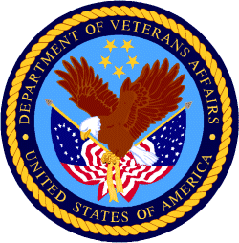

Department of Veterans Affairs

Programs:

Reminders:

VA accesses resources to increase housing assistance for vulnerable Veterans
The Department of Veterans Affairs updated regulations Nov. 10 governing the Supportive Services for Veteran Families grant program to provide a more effective subsidy to Veterans in high-cost rental markets and to increase the cap in general housing assistance available to the most vulnerable Veteran families.
Under the new regulations, in certain communities, the SSVF grant will cover up to 50%, an increase from 35% of eligible Veterans’ reasonable rent for two years without need for recertification.
“We know Veterans are increasingly vulnerable to homelessness and housing insecurity,” said VA Secretary Denis McDonough. “The updated regulations give Supportive Services for Veteran Families grantees more flexibility and tools to keep Veterans housed while also helping them increase their income and access permanent affordable housing solutions.”
The new rule also expands the maximum stay in emergency housing for unsheltered Veterans.
The original rule authorized placement for a Veteran and his or her spouse with dependents in emergency housing for up to 45 days, which proved often not enough time to locate stable and affordable permanent housing in highly competitive rental markets.
A Veteran and his or her spouse with dependents can now stay in emergency housing for a maximum of 60 days. The 15-day increase in length-of-stay is expected to have the most significant benefit to Veteran families in rental markets with few vacancies, as well as unsheltered homeless Veterans families.
Ending Veteran homelessness is a top priority for VA, aligned with the White House’s priority to promote housing stability by supporting vulnerable tenants.
Learn more about VA’s mission to end homelessness among Veterans and how you can help.

PART 3 – GENERAL FEDERAL AGENCY GRANTS INFORMATION
AUGUST 2023

Please review each department’s General Grant and Funding Overview. These overviews are the key web pages on each departmental website dedicated to the agency’s funding opportunities. Check back often to note the department updates.

(See Part 2 for current grant opportunity notices)

Federal Agencies Discretionary Grants and Contract Website Links

Native Hawaiian Programs

U.S. Department of Agriculture

Grants and Loans Overview

Department of Commerce

Grants at Commerce

Economic Development Administration Hawaii Contacts

Corporation for National and Community Service

General Program Overview

National Service in Hawaii

Department of Defense

Doing Business with the Department of Defense

Department of Education

Grant Programs Overview

US Department of Energy

Grants Overview

Environmental Protection Agency

Grants and Contracts Overview

Federal Mediation and Conciliation Service

Grants Overview

Department of Health and Human Services

Grants Overview

Department of Homeland Security
Grants Overview

Department of Housing and Urban Development

HUD - Notice of Funds Available

Institute of Museum and Library Services
Grants Overview

IMLS is on Facebook!

Department of Interior

Grants and Contract Overview

Department of Justice

Grants and Contract Overview

Hawaii State Administrative Agency Contacts
________________________________________________________________________

Department of Labor

Grants and Contract General Overview

National Aeronautics and Space Administration

Research Grant and Contract General Overview
_______________________________________________________________
National Archives and Records Administration

Grant Opportunities General Overview
_______________________________________________________________
National Endowment for the Arts

Grant Opportunities General Overview
_______________________________________________________________
National Endowment for the Humanities

Grant Opportunities General Overview
_______________________________________________________________
National Science Foundation

Grant Opportunities General Overview

Small Business Administration

General Overview Finding Loans & Grants

Links Specific to Hawaii

State Department

General Overview and Resources for Program Administrators

_________________________________________________________________________________

U.S. Department of Transportation

General Grant Program Overview

Department of the Treasury

Overview

US Agency for International Development
General Funding Opportunity Overview

Department of Veterans Affairs

Programs

Grants.Gov Links

Grant Writing Resources

SBIR – Small Business Innovation Research

Federal Agency Discretionary Grant and Contract Websites and Overviews
Federal Offices of Likely Interest to Native Hawaiians
- U.S. Department of Education
Office of Elementary and Secondary Education
Native Hawaiian Education Programs
White House Initiative on Asian Americans and Pacific Islanders
- U.S. Department of Health and Human Services
Health Resources & Services Administration
Native Hawaiian Health Care Systems
Office of Regional Operations Region 9 Office
Administration for Native Americans
ANA Pacific Region Training and Technical Assistance Center
- U.S. Department of Housing and Urban Development
Federal Housing Administration
Insured Mortgages on Hawaiian Home Lands, FHA Section 247
Office of Native American Programs
Native Hawaiian Housing
Hawai‘i State Home Page
- U.S. Department of the Interior
National Park Service
Hawai‘i Parks
National NAGPRA Program
U.S. Fish and Wildlife Service
Pacific Islands Fish and Wildlife Office
Office of the Region One Tribal Liaison
U.S. Geological Survey
Pacific Region - Hawai‘i
- U.S. Department of Agriculture
Cooperative Research and Extension Services
Farm Service Agency - Hawai‘i and Pacific Basin
Natural Resources Conservation Services - Pacific Islands Area
Rural Development - Hawai‘i
- U.S. Department of Defense
Office of the Deputy Under Secretary of Defense (Installations & Environment)
Senior Advisor and Liaison for Native American Affairs
Native Hawaiian Affairs
- Advisory Council on Historic Preservation
Office of Native American Affairs
- U.S. Department of Commerce
U.S. Economic Development Administration
University Center Economic Development Program
Representative covering the State of Hawaii
National Oceanic and Atmospheric Administration
NOAA in Your State - Hawai‘i
- U.S. Small Business Administration
Hawai‘i District Office
8(a) Business Development Program (open to qualified Native Hawaiian businesses)
- U.S. Department of the Treasury
Community Development Financial Institution Fund (CDFI Fund)
- U.S. Department of Veteran Affairs
Center for Minority Veterans
Office of Diversity and Inclusion

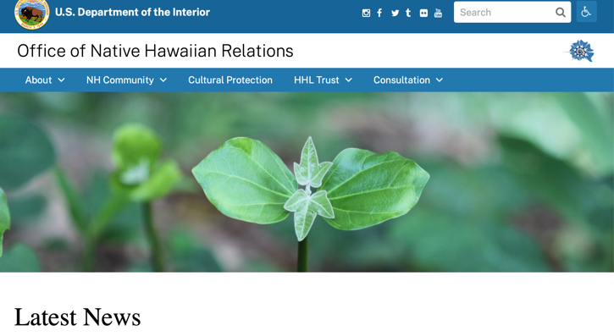
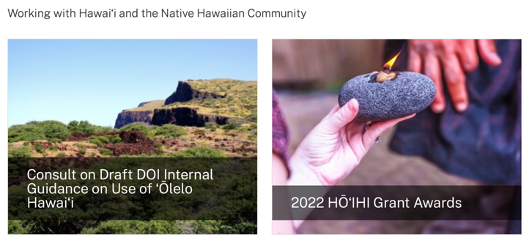
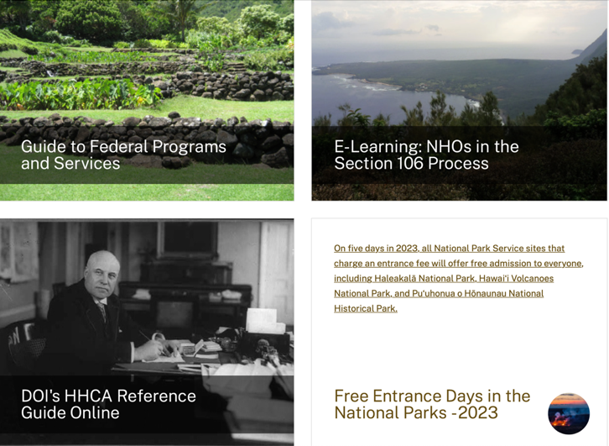
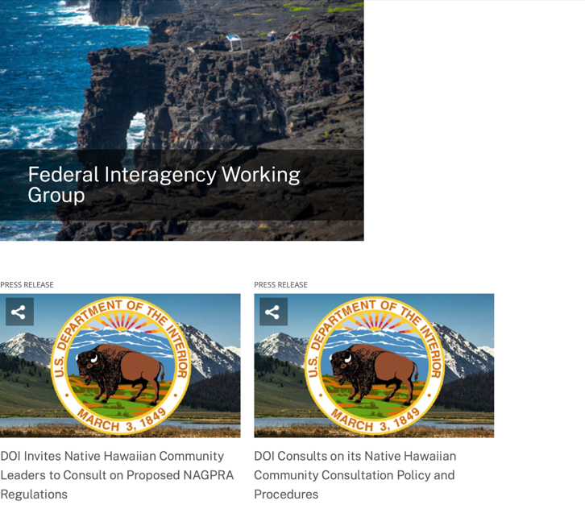
https://www.doi.gov/hawaiian

Office of Hawaiian Affairs Community Grants Program
Grants – The purpose of the Office of Hawaiian Affairs Grants Program is to support Hawaiʻi based nonprofit organizations that have projects, programs, and initiatives to serve our Lāhui in alignment with OHA’s Strategic Foundations, Directions & Outcomes.
Reminder, to be eligible for funding consideration, an applicant shall:
- Be registered to do business in the State of Hawaiʻi
- Provide services to Native Hawaiians and/or Native Hawaiian community(ies) in the State of Hawaiʻi
- Have an IRS letter of Determination
- Compliant with Hawaiʻi Compliance Express

https://www.oha.org/resources/

Resources
Providing resources is among the key ways that the Office of Hawaiian Affairs fulfills its purpose.
The best possible Native Hawaiian historical and cultural information has been just a click away since the launch in April 2013 of the Kipuka Database. It is a searchable online geographic information system that makes data that once would have taken long to compile, now available within seconds. The database helps complement our other key research tools, such as the Native Hawaiian Data Book and the Papakilo Database, which is a digital library for Native Hawaiian historical and cultural information.
In addition, we launched Kamakako’i, an issues-based digital media tool that has been years in the making. The cutting-edge website provides a platform to quickly engage key audiences and inspire action on policy matters important to the Native Hawaiian community.

Resources
- Grants – The purpose of the Office of Hawaiian Affairs Community Grants Program is to support projects, programs and initiatives that address OHA’s six Strategic Priorities and accompanying Strategic Results contained in OHA’s 2010-2018 Strategic Plan.
- Kamakakoʻi – A cutting edge tool that leverages technology to engage, inform, activate and rally the Hawaiʻi community around voices on the cutting edge of community issues. It is produced and maintained by the Office of Hawaiian Affairs.
- Ka Wai Ola – Ka Wai Ola is a monthly newspaper published by OHA. The Ka Wai Ola operates under the Communications division of Community Engagement. The Ka Wai Ola has about 60,000 subscribers and strives to create rich content geared toward captivating the Hawaiian community.
- Kīpuka Database – A geographical information system (GIS) that utilizes the latest mapping technologies to provide a window into native Hawaiian land, culture and history.
- Loans – The Office of Hawaiians Affairs is committed to ensuring Native Hawaiians and their ‘ohana have access to resources to assist them in pursuing their financial goals.
- OHA Native Hawaiian Data Book – A compilation of basic demographic data on Hawaiians and data to identify gaps and important issues to ensure OHA’s actions and initiatives are based on the best information available.
- Papakilo Data Base – A comprehensive “Database of Databases” consisting of varied collections of data pertaining to historically and culturally significant places, events, and documents in Hawai’i’s history.
- Reports and Research – A collection of reports and surveys intended to help guide strategic direction and policy decisions.
- Scholarships – Each year OHA provides funding for scholarships through its Higher Education Scholarship Programs.

U.S. Department of Agriculture

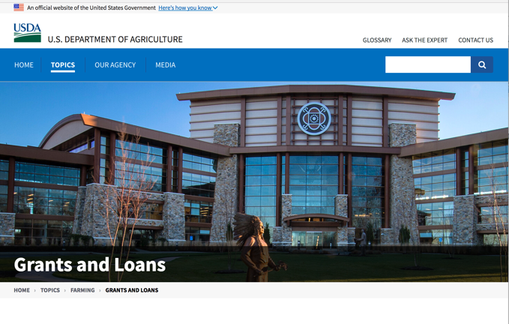

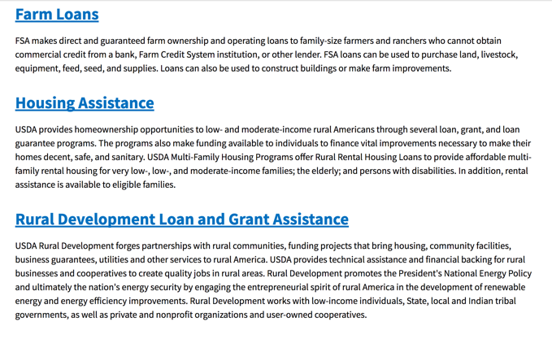

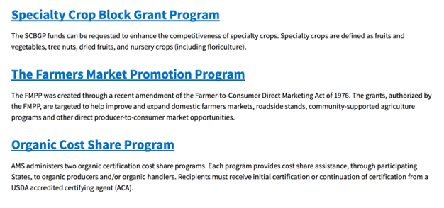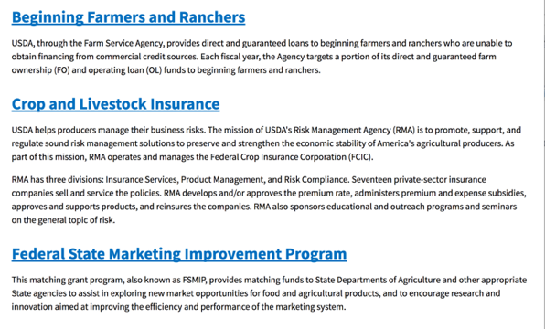
https://www.usda.gov/topics/farming/grants-and-loans
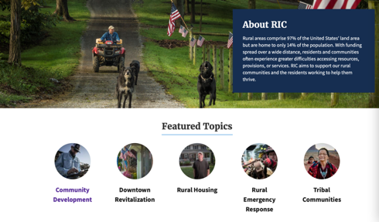https://www.nal.usda.gov/ric/community-development-resources

Department of Commerce

Grants, Contracting, and Trade Opportunities at Commerce
Learn more information about grants, contracting and trade opportunities at the Department of Commerce using the information below
https://www.commerce.gov/work-with-us/grants-and-contract-opportunities
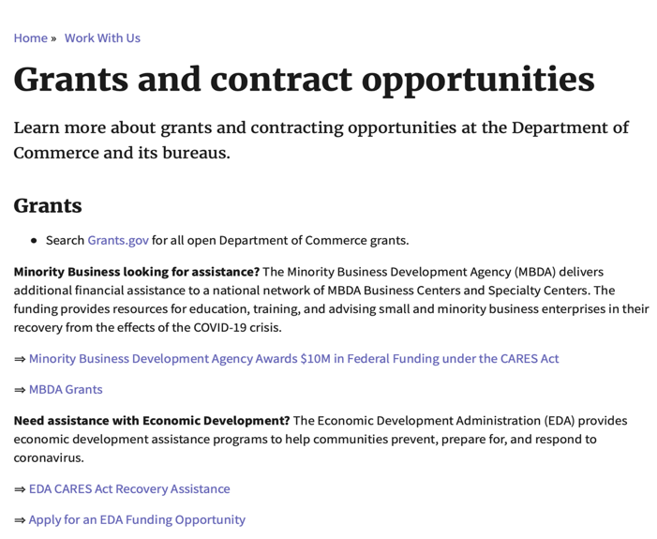

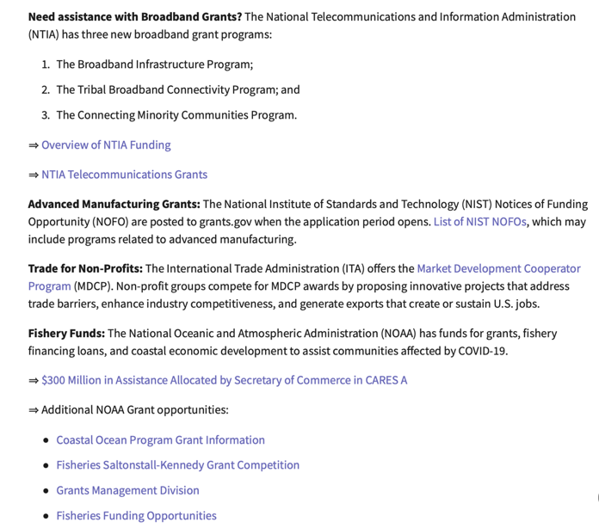
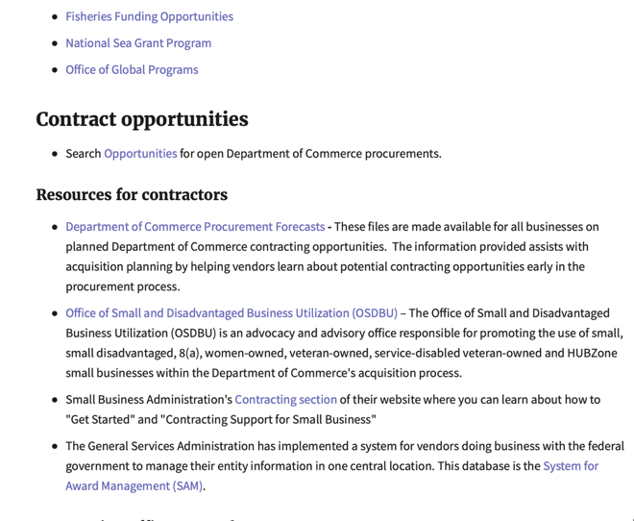
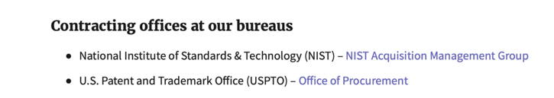
DOC Grant Making Bureaus
Economic Development Administration (EDA)
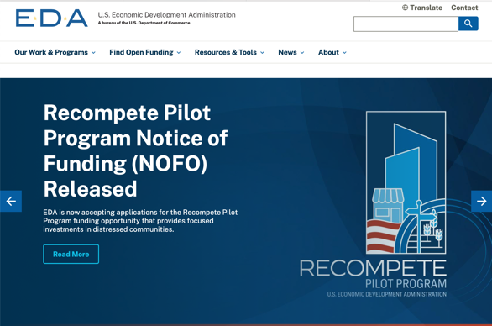
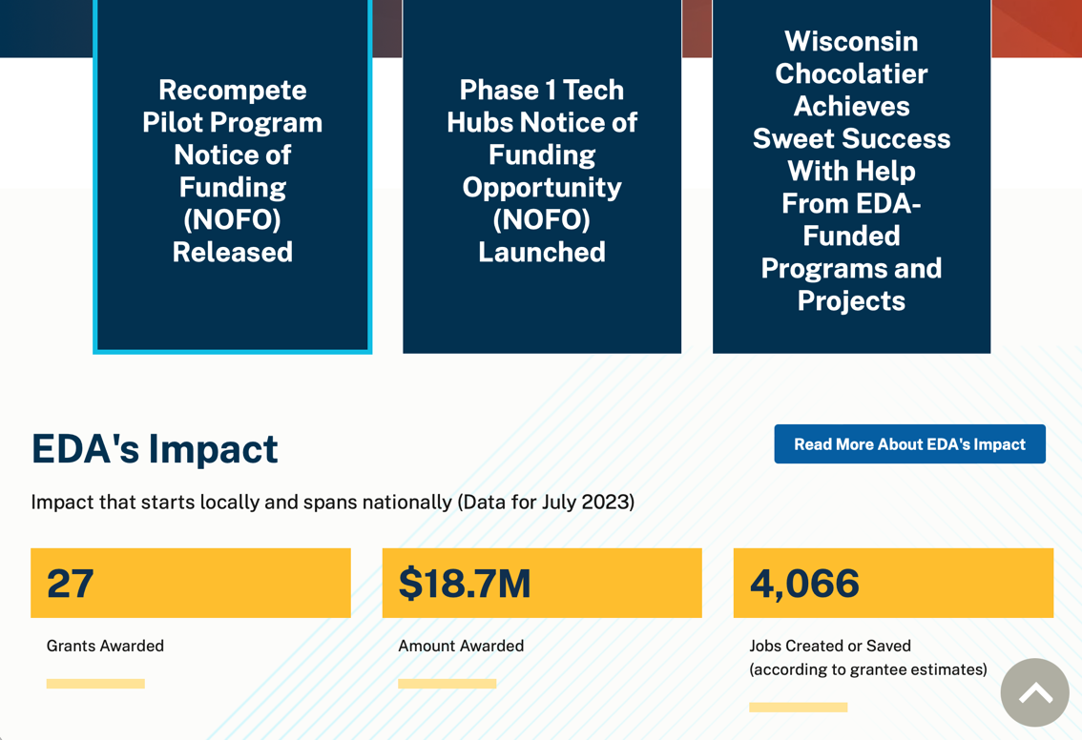
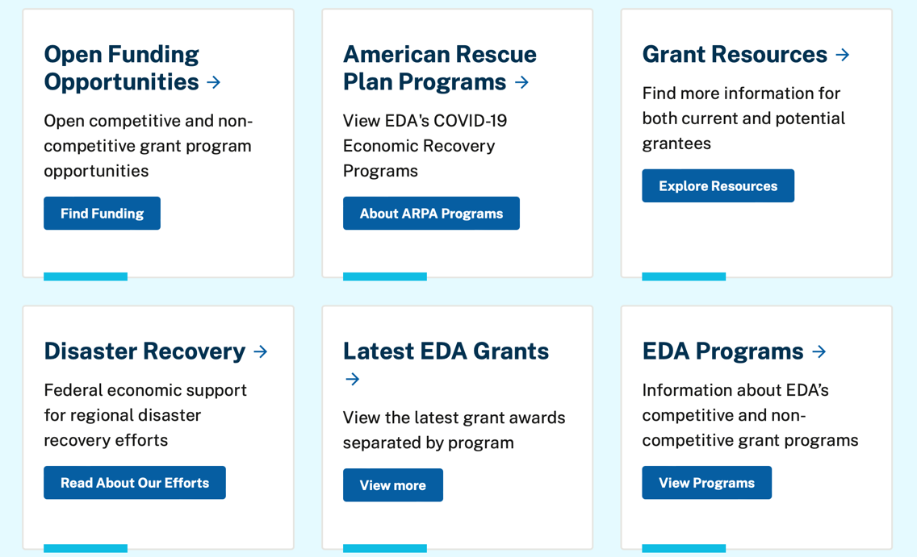

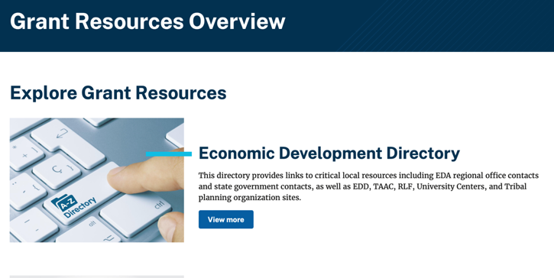
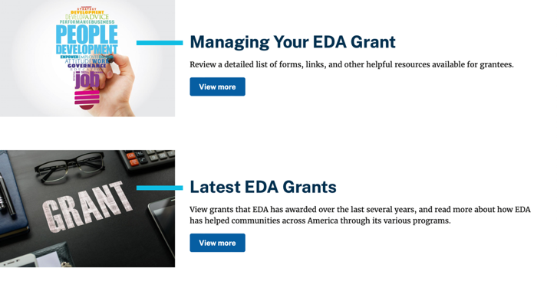

https://www.eda.gov/grant-resources

Economic Development Administration Hawaii Contacts

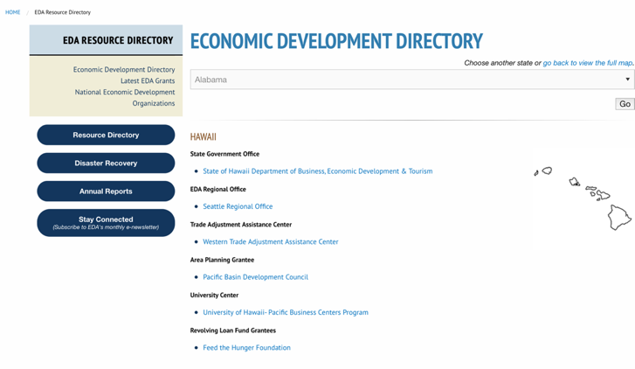
https://www.eda.gov/archives/2016/resources/economic-development-directory/states/hi.htm

International Trade Administration (ITA)
- Market Development Cooperator Program
- Special American Business Internship Training Program (SABIT). A technical assistance initiative of the International Trade Administration of the U.S. Department of Commerce, SABIT offers organizations competitive grants and an opportunity to host industry-specific delegations. SABIT serves as an initial entry point for U.S. businesses seeking funding to establish long-term relationships with potential customers, distributors, or partners in the former Soviet Union. The program trains Eurasian managers and scientists in commonly accepted business practices as a means of facilitating cross border relationships. In turn, these personal relationships serve as a basis for business development and reduce market access barriers for U.S. businesses.
National Institute of Standards & Technology (NIST)
- Funding Opportunities
National Telecommunications & Information Administration (NTIA)
- Telecommunications Grants
National Oceanic & Atmospheric Administration (NOAA)
- Coastal Ocean Program Grant Information
- Fisheries Saltonstall Kennedy Grant Program
- National Undersea Research Program Funding Opportunities
- Grants Management Division
- Fisheries Grants Program
- National Sea Grant
- Office of Global Programs
Contracting Resources for Contractors
- Office of Small and Disadvantaged Business Utilization (OSDBU) - the Office of Small and Disadvantaged Business Utilization (OSDBU) is an advocacy and advisory office responsible for promoting the use of small, small disadvantaged, 8(a), women-owned, veteran-owned, service-disabled veteran-owned, and HUBZone small businesses within the U.S. Department of Commerce's (DOC) acquisition process.
- Business.USA.gov's Find Opportunities Wizard where in a few quick steps, it will guide you towards federal government contracting programs and opportunities for your business!
- Planned Acquisitions: the Department of Commerce's search tool for our planned acquisitions over $100,000. As requirements change, these acquisition plans are updated by department personnel and this search tool is automatically updated.
- Small Business Administration's Contracting section of their web site where you can learn about how to "Get Started" and "Contracting Support for Small Business."
- The General Services Administration (GSA) has implemented a system for vendors doing business with the Federal Government to manage their entity information in one central location. This new database is the System for Award Management (SAM).
DOC Contracting Offices
- Patent and Trademark Office (PTO)
  - Office of Procurement

- National Institute of Standards & Technology (NIST)
Trade Opportunities through Commerce
http://www.commerce.gov

Corporation for National and Community Service

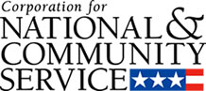

General Program Overview

AmeriCorps provides resources, both human and financial, to organizations that engage Americans in intensive service to meet our country’s critical needs.
Grantees use the funding to support AmeriCorps members for intensive service in their community. AmeriCorps grants partially cover the expense of operating an AmeriCorps program and do not cover general organizational expenses. A cash and in-kind match are required.

The main website can be accessed here: http://www.nationalservice.gov

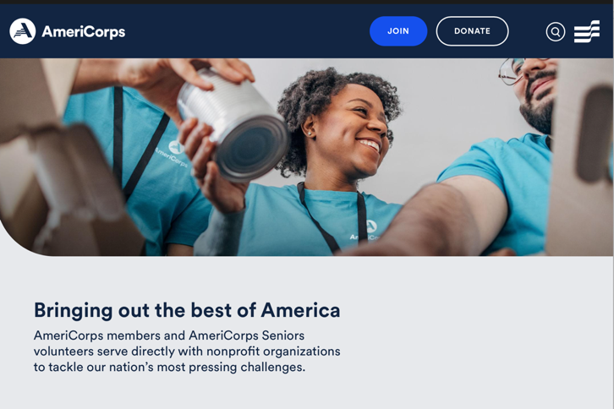

For access to further funding information: https://americorps.gov/partner/funding-opportunities

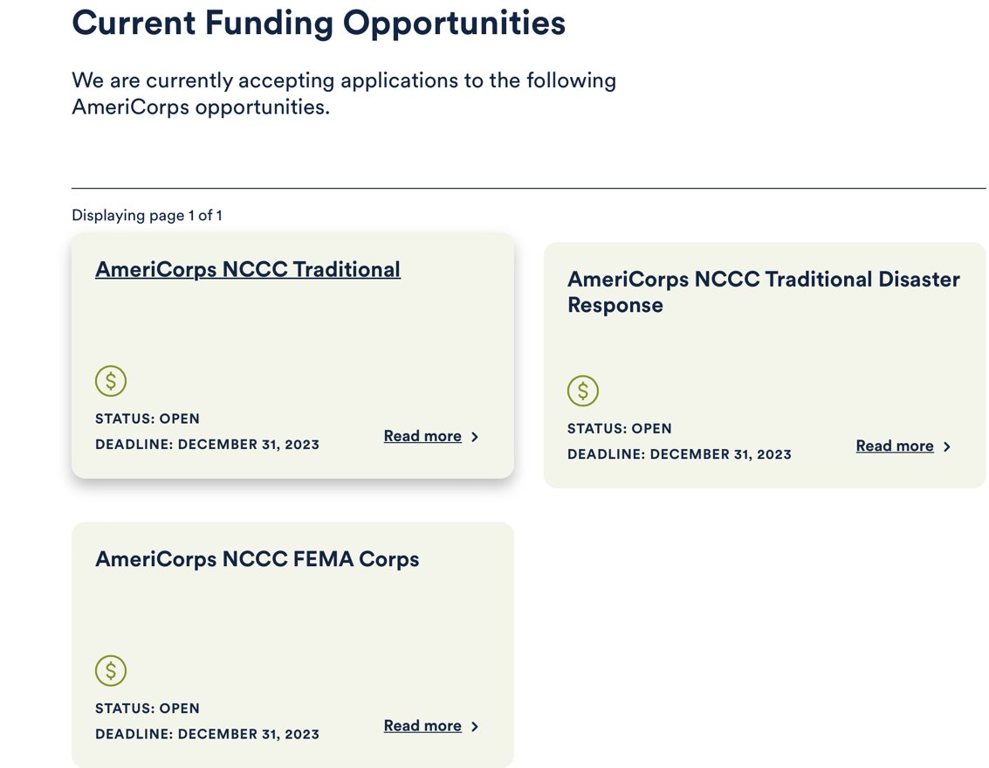

https://www.americorps.gov/partner/funding-opportunities

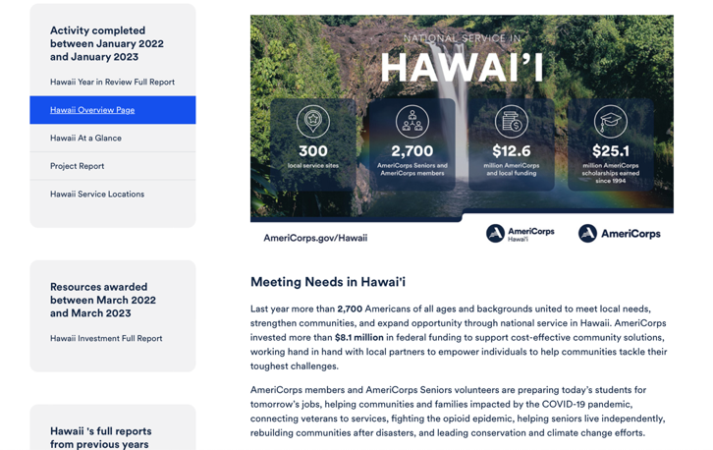
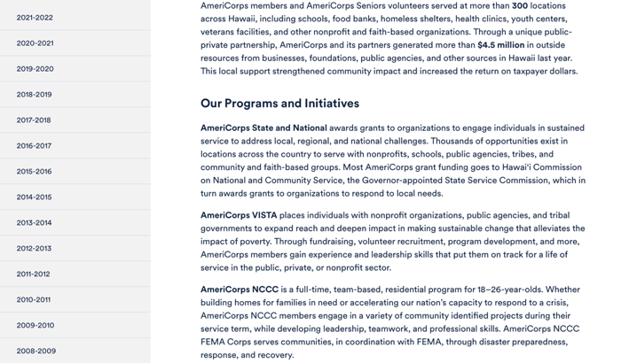
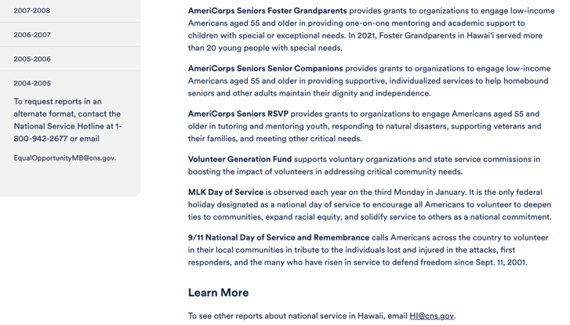

Learn More https://americorps.gov/national-service-report/hi
To see other reports about national service in Hawaii, please contact HI@cns.gov.
The Corporation for National and Community Service is a federal agency that improves lives, strengthens communities, and fosters civic engagement through service and volunteering. To learn more, visit www.NationalService.gov or call 202-606-5000 or TTY 1-800-833-3722.

U.S. Department of Defense

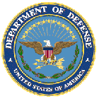

Doing Business with the Department of Defense

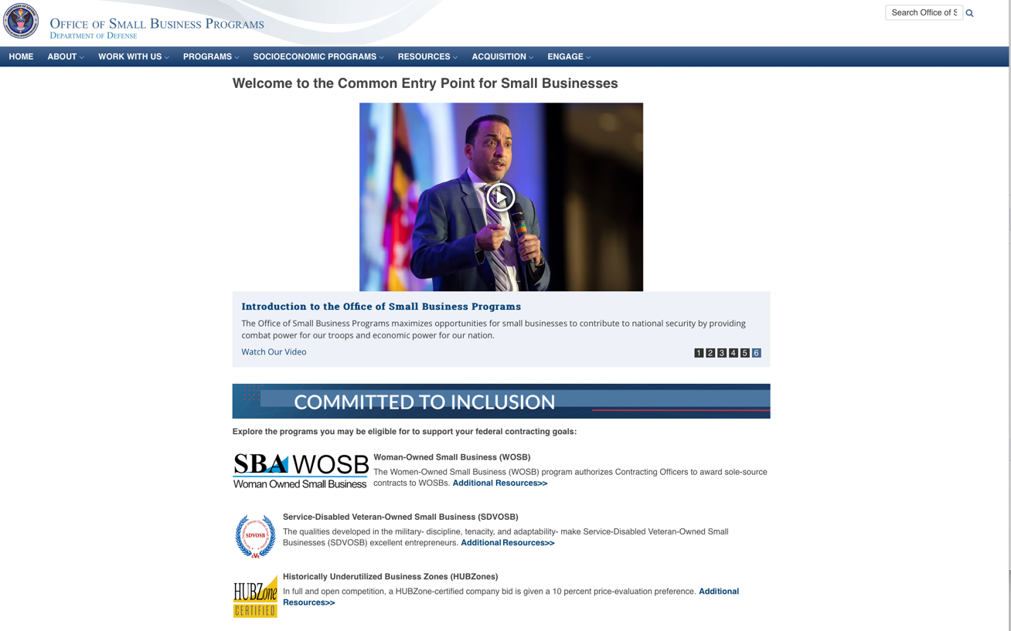

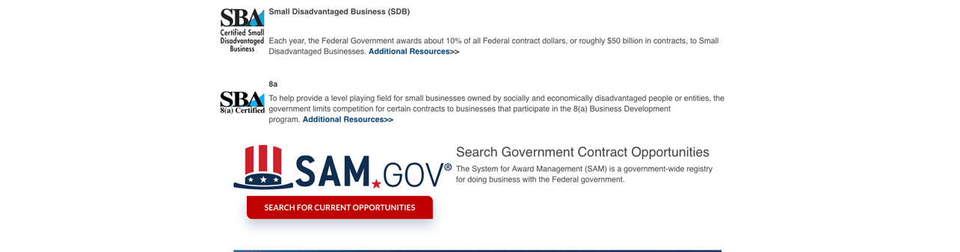

http://business.defense.gov

Department of Education


Grant Programs Overview at the Department of Education

The general information page for Education Grant funding is an excellent resource describing the three types of grants awarded by the Department of Education. See the screen shot of the Department of Education web page below:

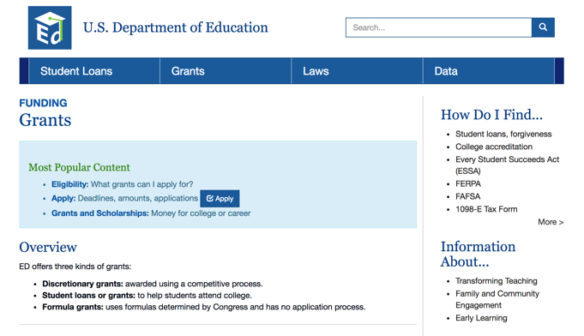
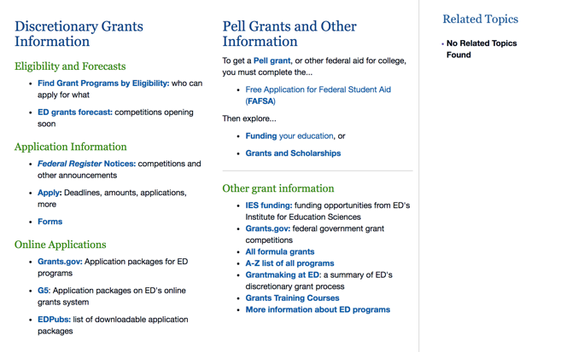

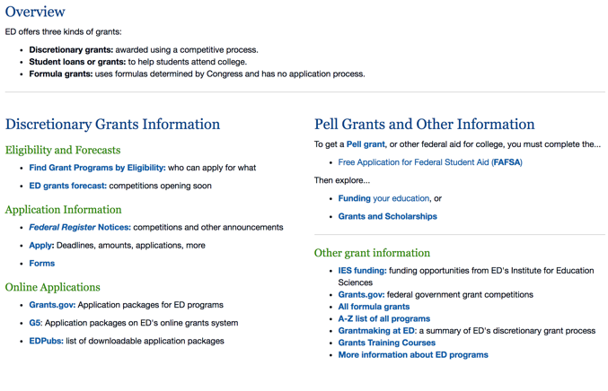

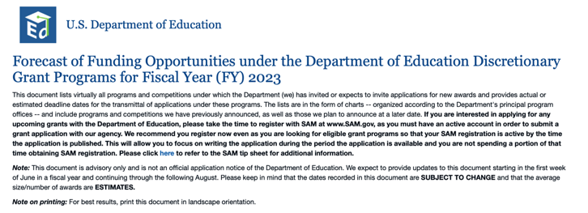

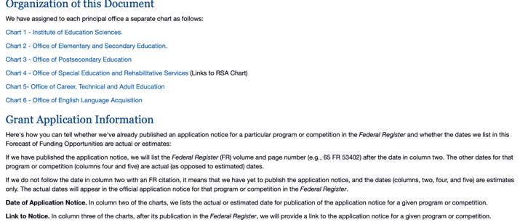

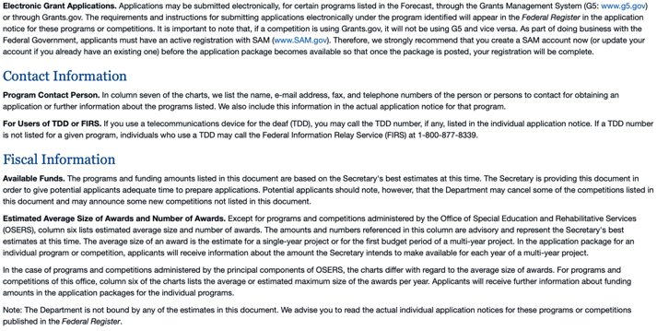

https://www2.ed.gov/fund/grant/find/edlite-forecast.html

U.S. Department of Energy

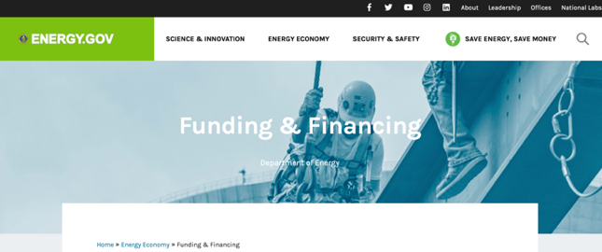
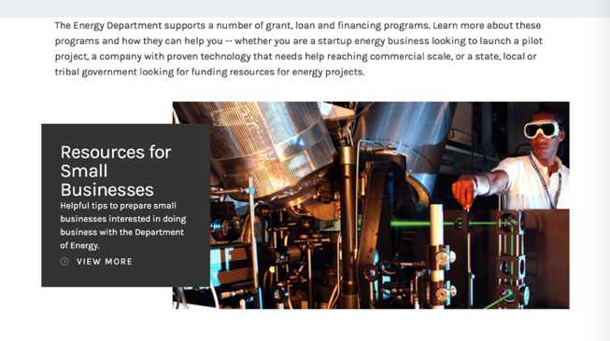
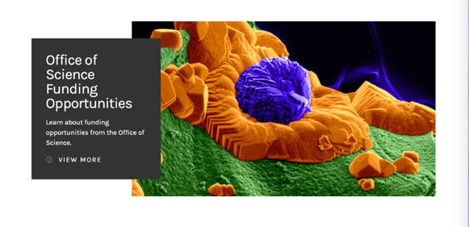

https://www.energy.gov/energy-economy/funding-financing

Environmental Protection Agency

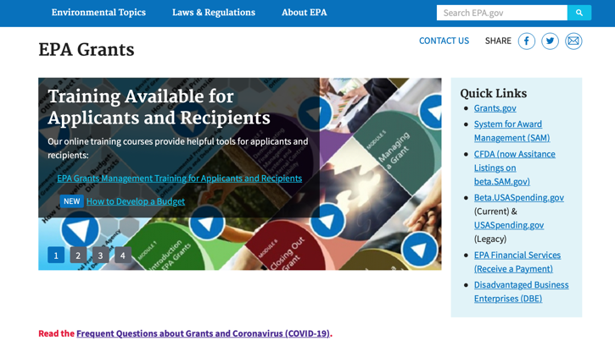

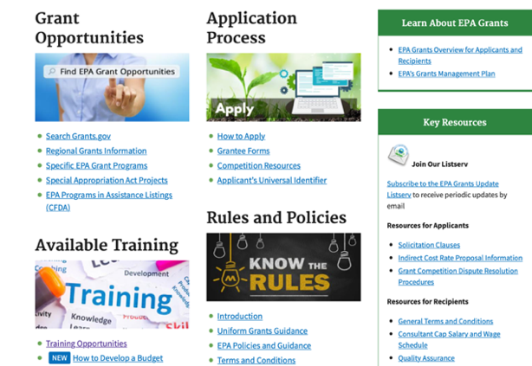

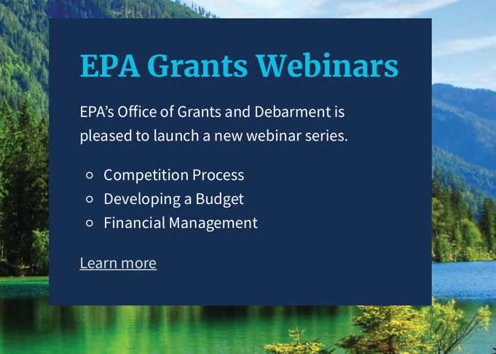

https://www.epa.gov/grants/epa-grants-webinars

https://www.epa.gov/grants

Federal Mediation and Conciliation Service

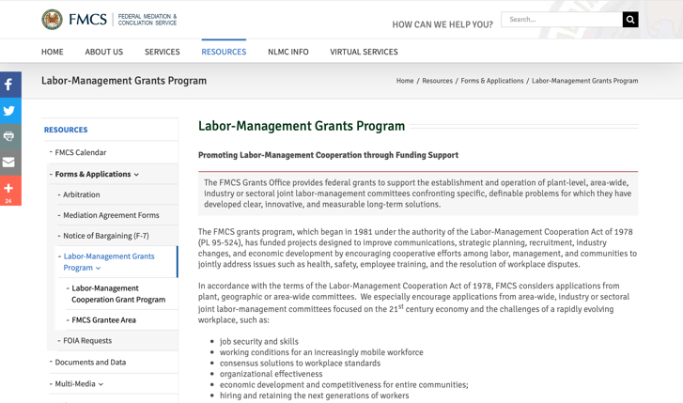
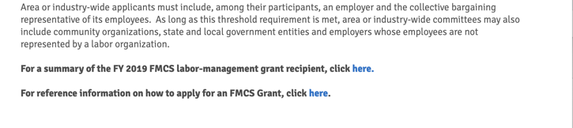

https://www.fmcs.gov/resources/forms-applications/labor-management-grants-program/

Department of Health and Human Services

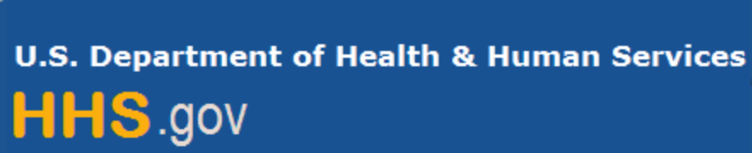

Grants Forecast and Overview

The Department of Health and Human Services’ Grants Forecast is a database of planned grant opportunities proposed by its agencies. Each Forecast record contains actual or estimated dates and funding levels for grants that the agency intends to award during the fiscal year. Forecast opportunities are subject to change based on enactment of congressional appropriations.

For more general information about HHS Grants and Funding go to the website below at:

https://www.hhs.gov/grants/grants/index.html

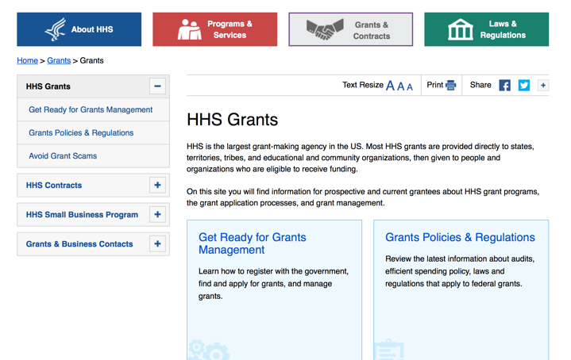

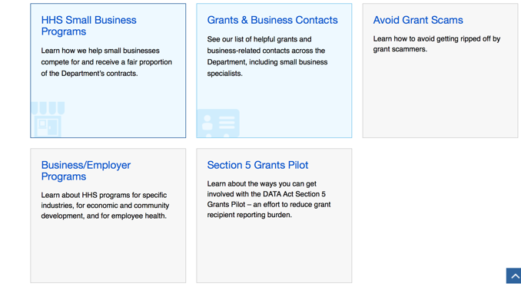

Department of Homeland Security



The Department of Homeland Security enhances the ability of states, local and tribal jurisdictions, and other regional authorities in the preparation, prevention, and response to terrorist attacks and other disasters, by distributing grant funds. Localities can use grants for planning, equipment, training and exercise needs.

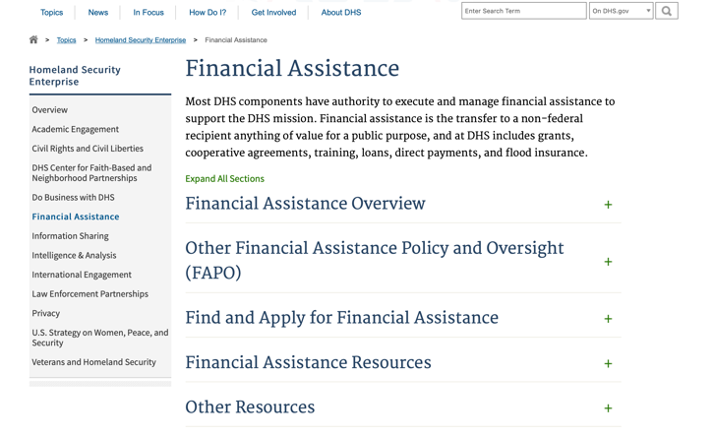

Webpage can be viewed at: https://www.dhs.gov/dhs-financial-assistance#2

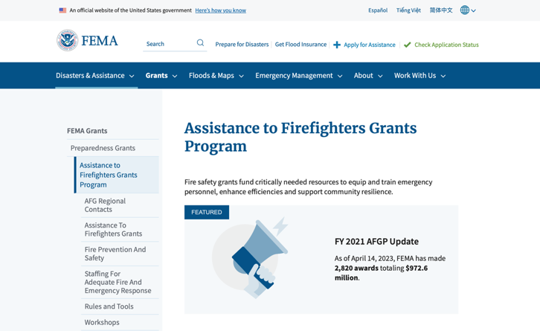
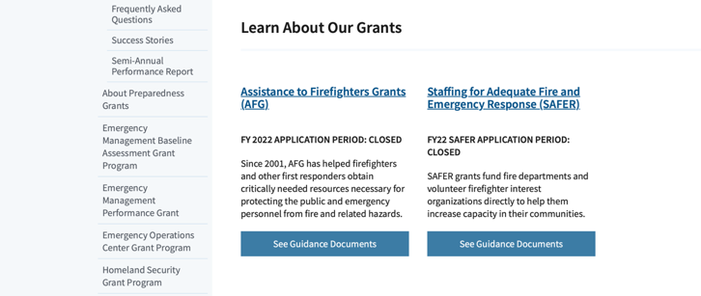
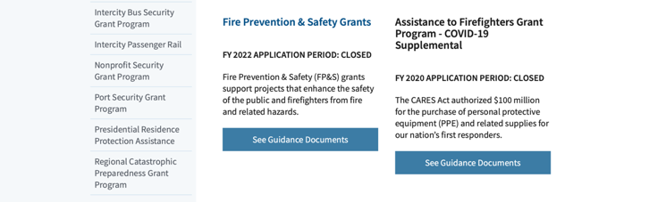

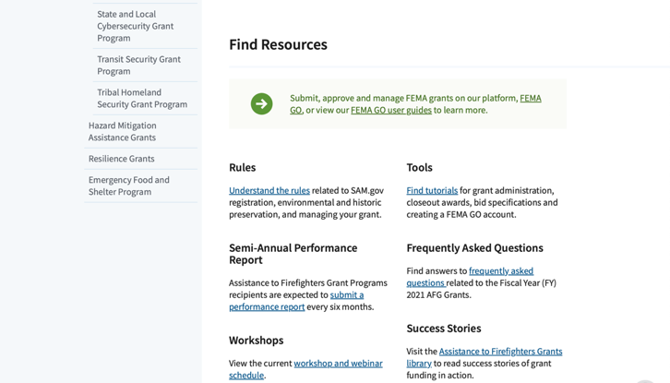
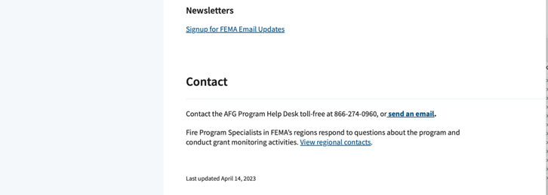
(Most recent update as of 8/8/2023)

https://www.fema.gov/welcome-assistance-firefighters-grant-program

For AFG program guidance materials, please visit our Documents page.

Resources

AFG Help Desk
Contact the AFG Program Help Desk toll-free at 866-274-0960, or email us at firegrants@dhs.gov.
The AFG Program has Fire Program Specialists in 10 federal regional centers. These Regional Fire Program Specialists respond to questions about the AFG program and carry out grant monitoring activities. View regional contacts

Popular AFG links
- Assistance to Firefighters Grants (AFG)
- AFG Awards List
- Staffing for Adequate Fire & Emergency Response (SAFER) Grants (SAFER)
- SAFER Awards List
- SAFER Success Stories
- Fire Prevention & Safety (FP&S) Grants
- FP&S Awards List
- FP&S Success Stories
- Grant Closeout Tutorial
- Assistance to Firefighters Grant (AFG) Email Alert Archive
- Frequently Asked Questions
Contact Information For The Assistance to Firefighters Grant (AFG) Program and Help Desk

Federal Funding Alternative To AFG

https://www.fema.gov

Department of Housing and Urban Development

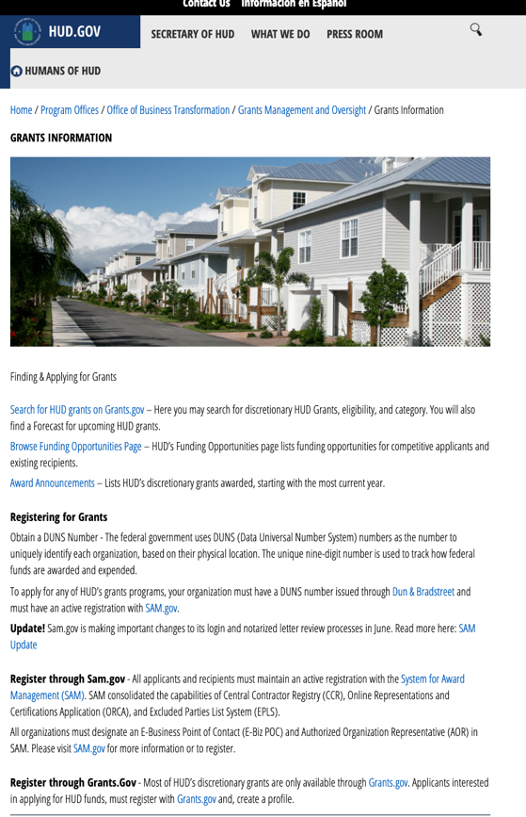
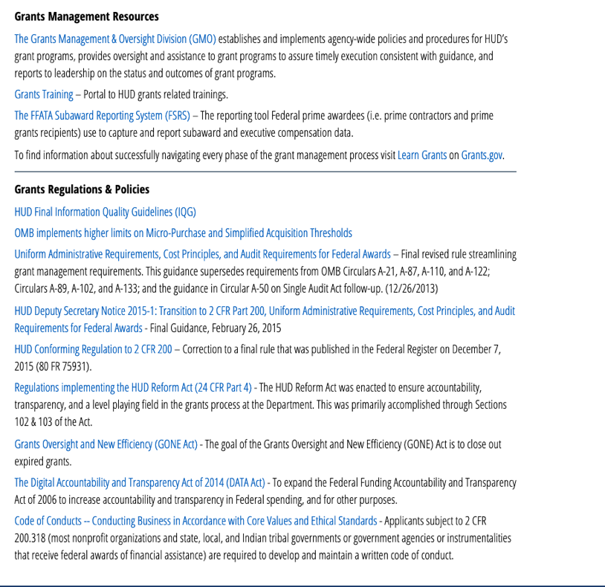

https://www.hud.gov/program_offices/spm/gmomgmt/grantsinfo

HUD - Notice of Funds Available
For detailed information click here

Fiscal Year 2023 Funding Opportunities
HUD awards discretionary funding through over 20 Grant programs that support HUD initiatives, including Affordable Housing Development and Preservation, Community and Economic Development, Environment and Energy, Fair Housing, Homelessness, Homeownership, Rental Assistance, Supportive Housing and Services.
Notice of Funding Opportunity (NOFO) – The Notice of Funding Opportunities (NOFO) is a published each year on Grants.gov for HUD’s Discretionary Funding Programs. These NOFOs describe the type of funding available on a competitive basis and provides information on submission of an application, typically up to 30 to 90 days from the date of the NOFO publication on grants.gov.

Additional Information Related to HUD's Funding Opportunities
- 2 CFR Crosswalk - On August 13, 2020, the Office of Management and Budget (OMB) revised Federal Guidance for Grants and Agreements, to include 2 CFR 25, 2 CFR 170, 2 CFR 183, and 2 CFR 200. An index of those changes was consolidated in a document for reference. Here is the link to the document: https://www.cfo.gov/wp-content/uploads/2020/12/2-CFR-Crosswalk_20201106.xlsx
- Part 200 of Title 2 of the Code of Federal Regulations (2 CFR Part 200)
- Eligibility Requirements for Applicants of HUD's Grants Programs - 2023
- Eligibility Requirements for Applicants of HUD's Grants Programs - 2022
- Administrative, National & Departmental Policy Requirements and Terms for HUDs Financial Assistance - 2023
- Administrative, National & Departmental Policy Requirements and Terms for HUDs Financial Assistance - 2022
- Build American, Buy America Act (BABA)
  - This site provides a comprehensive collection of proposed, currently effective, and expired waivers (as they become available) of the Build America, Buy America Act (BABA) domestic content procurement preference as applied to HUD’s Federal Financial Assistance programs
- Environmental Requirements
  - E.O. 12898 Federal Actions to Address Environmental Justice
  - E.O. 14008 Tackling the Climate Crisis
- Code of Conducts Page

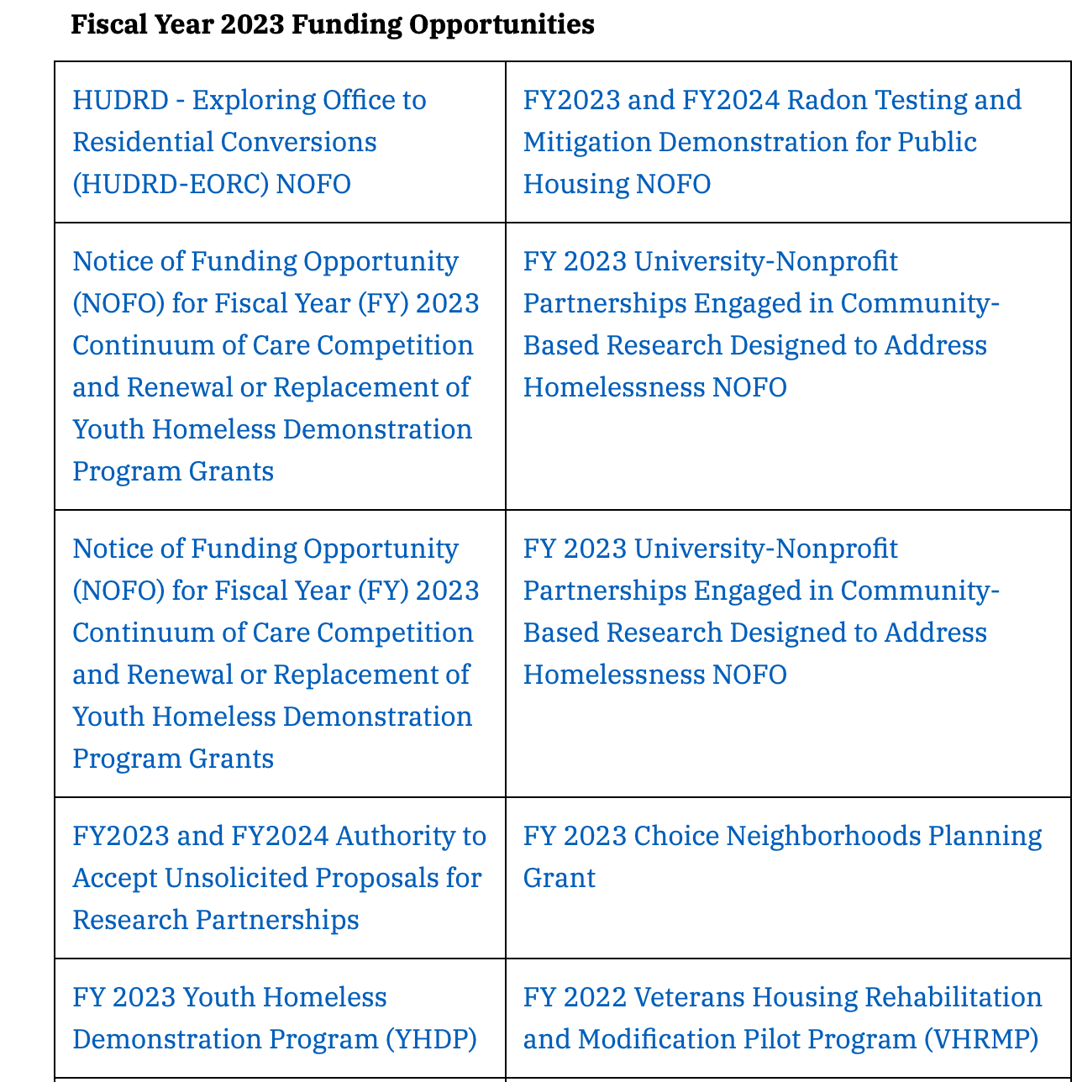
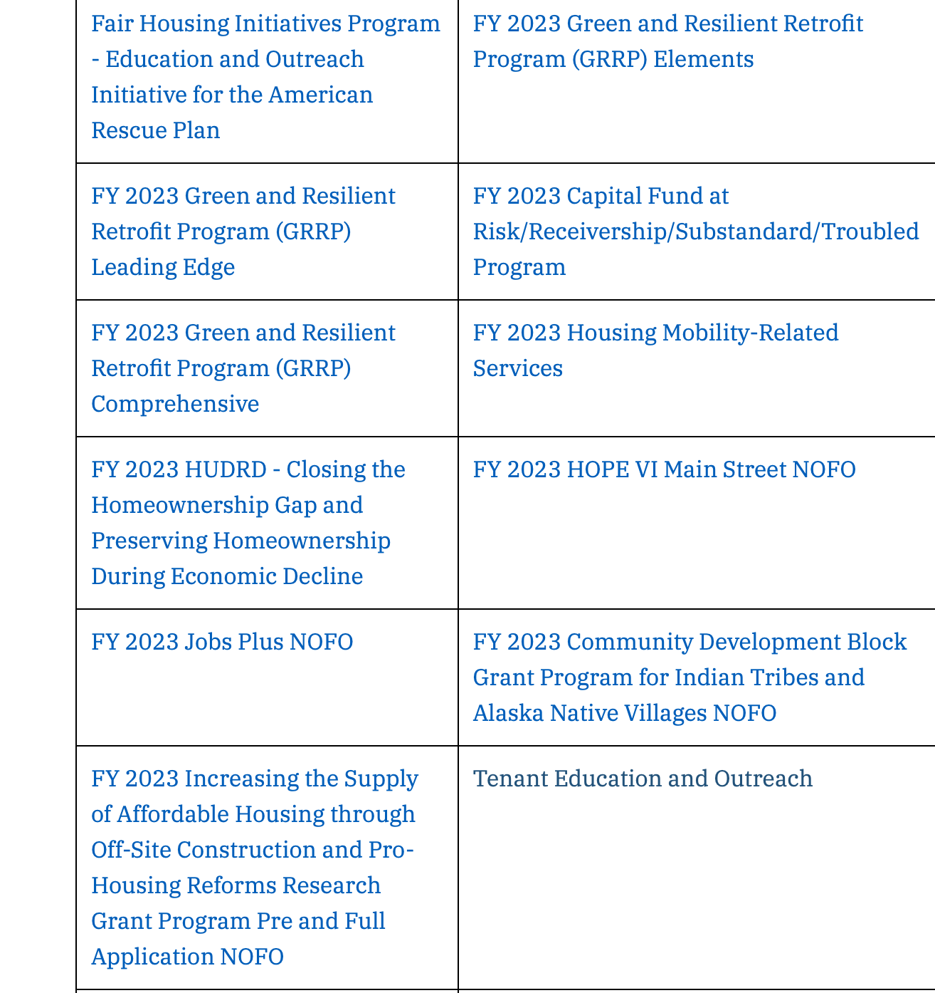
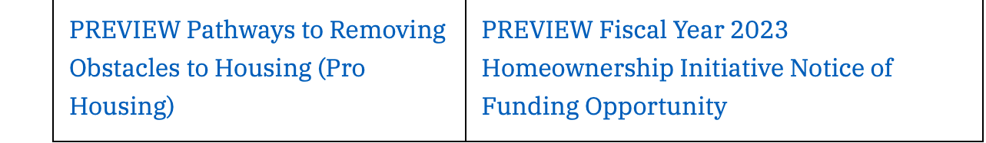

Forecast for Expected Fiscal Year 2023 Funding Opportunities
The Department of Housing and Urban Development NOFO Forecast list below identifies competitive grant opportunities that may be available for Fiscal Year (FY) 2023. The inclusion or exclusion of an opportunity in the listing below does not constitute a guarantee that a specific opportunity will become available or not be available. Forecast opportunities are subject to change based on enactment of Congressional appropriations and other considerations.
When funding is available, HUD will issue a Notice of Funding Opportunity (NOFO), which will be published on Grants.gov and the Funds Available webpage will be updated to indicate the NOFO has been published. Each NOFA provides guidance on how to apply for funding.
Office of Community Planning and Development (CPD)
- Self-Help Homeownership Opportunity Program (SHOP)
- Section 4 Capacity Building for Community Development and Affordable Housing (RCB)
- The Youth Homelessness Systems Improvement Program
- Continuum of Care Competition and Renewal or Replacement of Youth Homeless Demonstration Program
- Housing Opportunities for Persons with AIDS (HOPWA) Competitive Grant: Housing Interventions HINT) to End the HIV Epidemic
- Community Development Block Grant (CDBG) Pro – Housing
- Community Development Block Grant (CDBG) Price
Office of Fair Housing and Equal Opportunity (FHEO)
- Fair Housing Initiatives Program – Education Outreach Initiative
- Fair Housing Initiatives Program – Fair Housing Organization Initiative
- Fair Housing Initiatives Program – Private Enforcement Initiative

Office of Healthy Homes Lead Hazard Control (OHHLHC)
- FY2023 and FY2024 Radon Testing and Mitigation Demonstration for Public Housing
- Lead and Healthy Homes Technical Studies (LHHTS) Grant Program Pre- and Full Application
- Healthy Homes Production Grant Program
- Older Adult Modification Grant Program
- Healthy Homes Weatherization Cooperative Demonstration
Office of Housing (HSNG)
- Green and Resilient Retrofit Program Comprehensive
- Green and Resilient Retrofit Program Elements
- Green and Resilient Retrofit Program Leading Edge
- Section 811 Supportive Housing for Persons with Disabilities - Capitol Advance
- Section 811 Supportive Housing for Persons with Disabilities – Project Rental Assistance
- Fiscal Years 2022 and 2023 Homeownership Initiative Grant
- Comprehensive Housing Counseling Grant Program
- Service Coordinators in Multifamily Housing (SCMF) Discretionary
- Tenant Education and Outreach
Office of Policy Development and Research (PD&R)
- FY23 HUDRD - FHA’s Role in Closing the Homeownership Gap and Preserving Homeownership During Economic Decline
- FY2023 and FY2024 Authority to Accept Unsolicited Proposals for Research Partnerships
- Increasing the Supply of Affordable Housing through Off-Site Construction and Pro-Housing Reforms Research Grant Program Pre and Full Application
- Eviction Protection Grant Program

Office of Public and Indian Housing (PIH)
- Community Development Block Grant Program for Indian Tribes and Alaska Native Villages
- Housing Mobility-Related Services
- Indian Community Development Block Grant
- Capital Fund at Risk/Receivership/ Substandard/ Troubled Program
- Foster Youth to Independence (FYI) Competitive
- Resident Opportunity and Self-Sufficiency (ROSS) Service Coordinator Program
- Jobs Plus NOFO
- FY2023 HOPE VI Main Street Grant Program
- Choice Neighborhoods Implementation Grants

Updated 8/8/2023

http://portal.hud.gov/hudportal/HUD?src=/program_offices/Administration/grants/fundsavail

Institute of Museum and Library Services

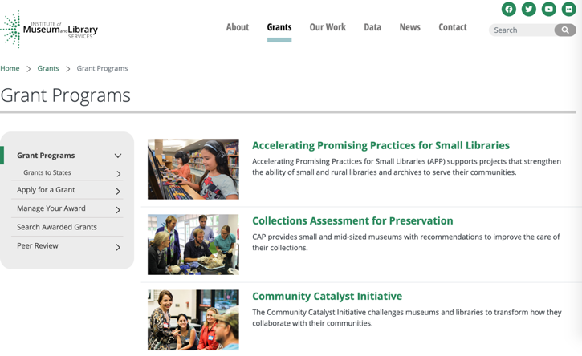
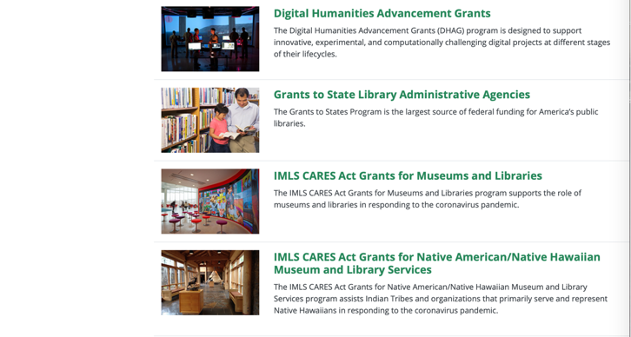

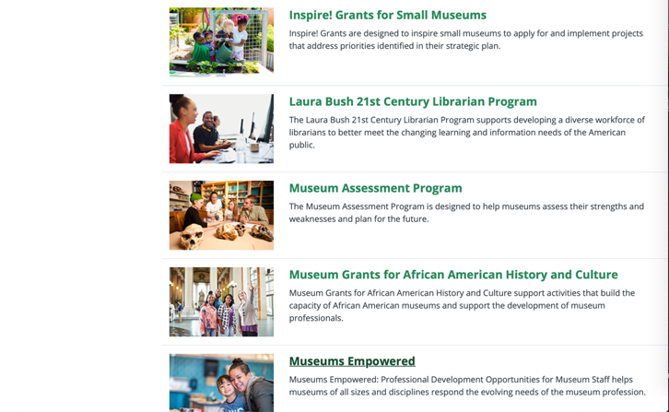

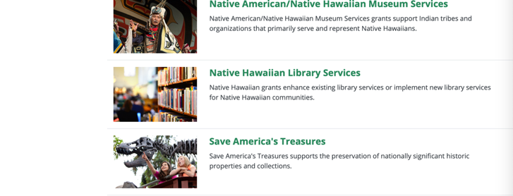
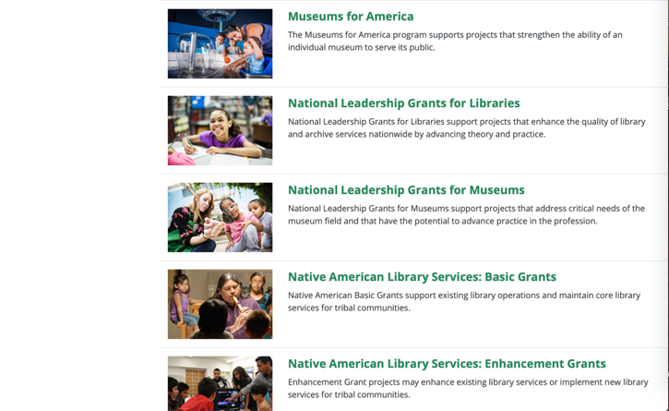
https://www.imls.gov/grants/apply-grant/available-grants

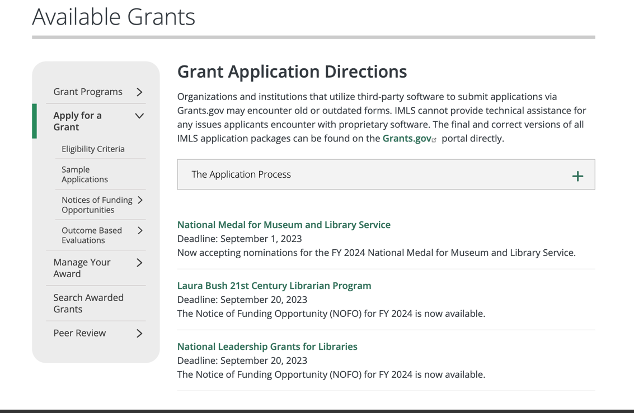

Each grant program has specific eligibility requirements. The links below provide general eligibility criteria for museums, libraries, and tribal organizations, but please note that additional organizations may be eligible for grants under certain programs. Additionally, ineligible organizations may still be able to participate in grant programs through partnerships with eligible organizations. Please click on the links below to see general criteria and review Applications and Guidelines for specific information.
Museums Libraries
Institutions: Archives, Federally Recognized Native American Tribe, Historical Society, Library, Nonprofits that serve Native Hawaiians, Professional Association, Public or Private Non-profit Institutions of Higher Education, Regional Organization, State Library Administrative Agency, State or Local Government.

Check out IMLS's Facebook page at:
https://www.facebook.com/USIMLS/

Department of the Interior
The Interior Department provides assistance to the public, local governments and businesses through a number of programs. For a general overview see: http://www.doi.gov/index.cfm

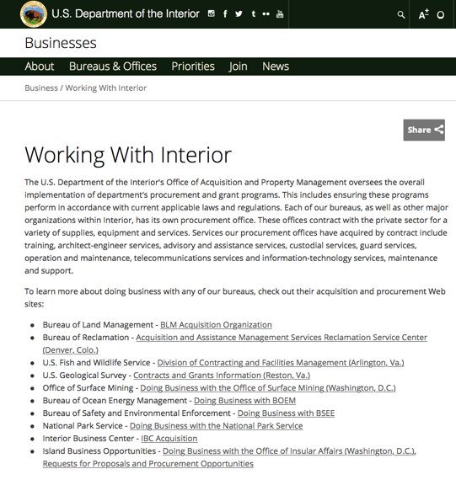

http://www.doi.gov/businesses/working-with-interior.cfm

Department of Justice

http://www.justice.gov/business/

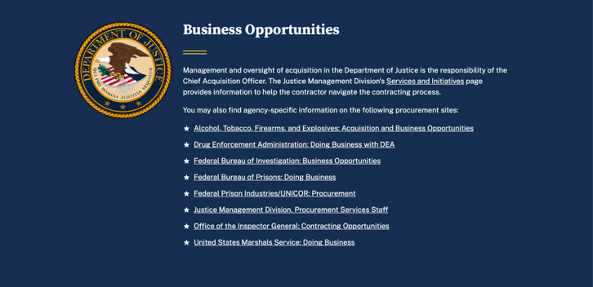

The DOJ agencies listed below also have sites that provide grant information specific to that agency. Examples of what can be found on these sites are programs, funding opportunities, application assistance, and other useful information.

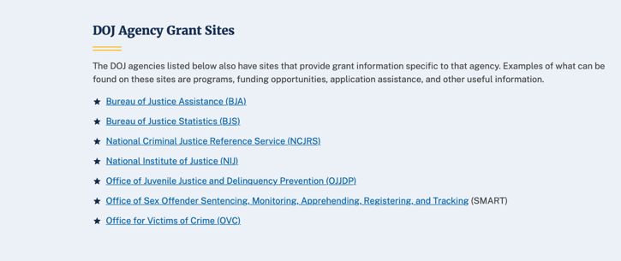

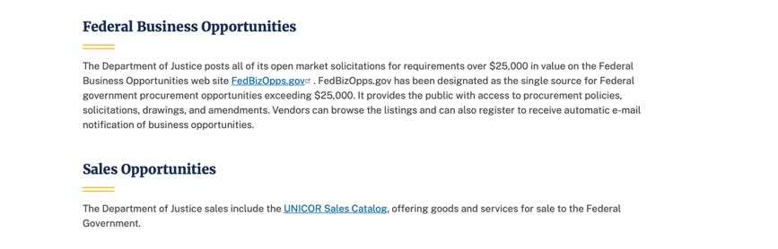
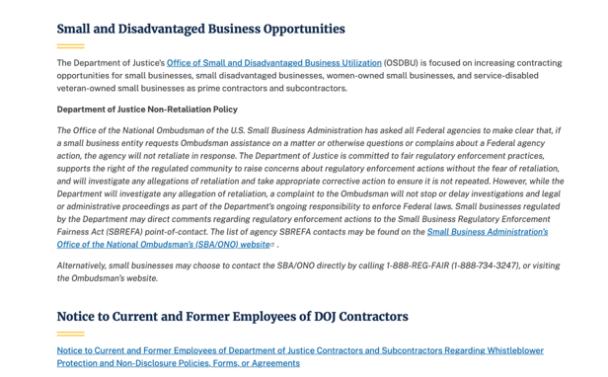
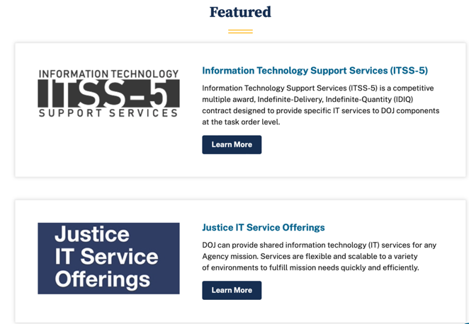
Bureau of Justice Assistance (BJA)

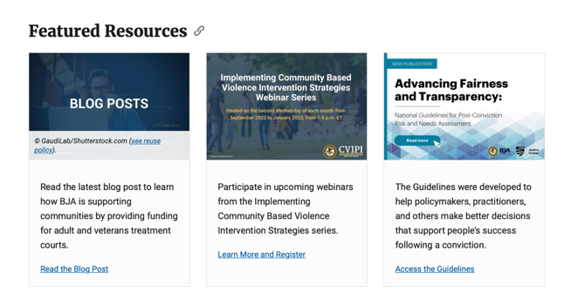
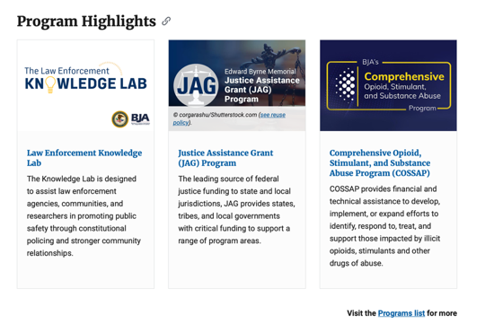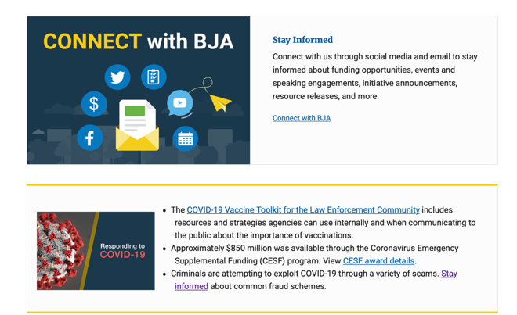

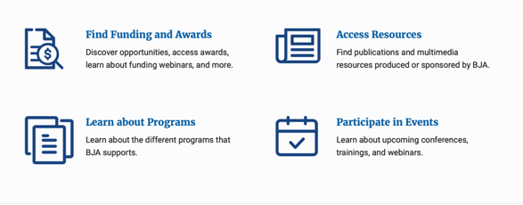
Bureau of Justice Statistics (BJS)
National Criminal Justice Reference Service (NCJRS)
National Institute of Justice (NIJ)
Office of Sex Offender Sentencing, Monitoring, Apprehending, Registering, and Tracking (SMART)

Hawaii State Administrative Agency Contacts

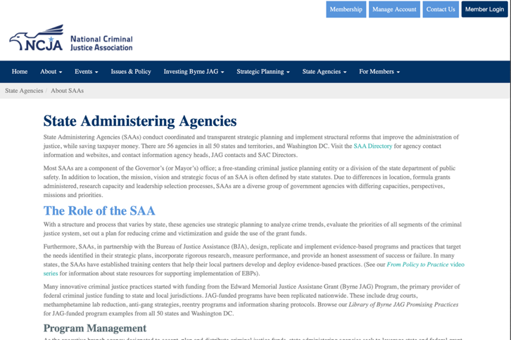

HAWAII DEPARTMENT OF THE ATTORNEY GENERAL, CRIME PREVENTION & JUSTICE ASSISTANCE DIVISION
235 S Beretania Street, Suite 401
Honolulu, HI 96813
(808) 586-1150
Agency Head: Julie Ebato, Administrator
JAG Contact: Shaleigh Tice, Grants & Planning Branch Chief
SAC Director: Paul Perrone, Chief of Research and Statistics

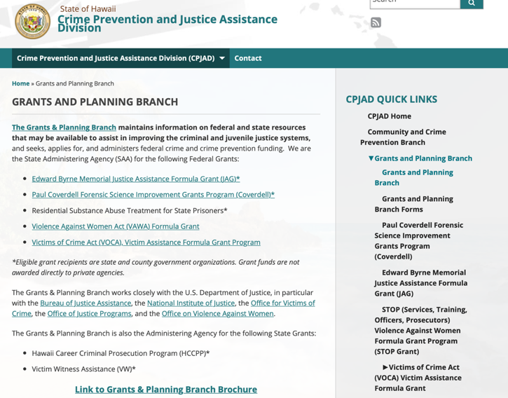
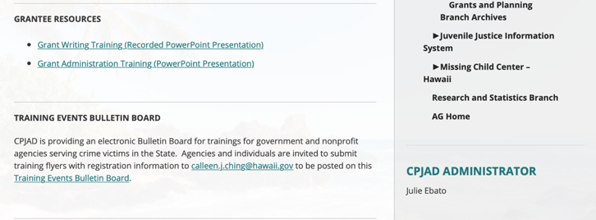
https://ag.hawaii.gov/cpja/gp/

Department of Labor

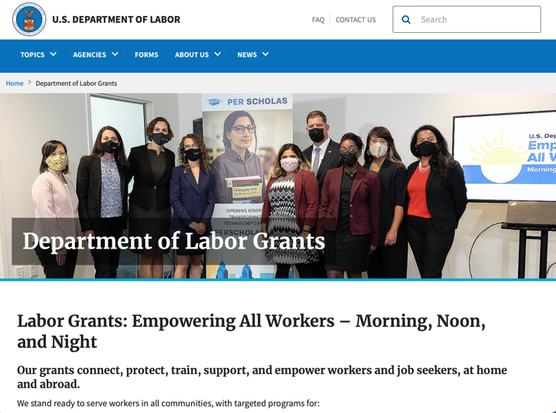
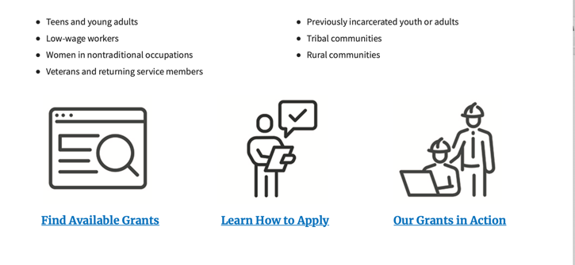

https://www.dol.gov/general/grants/howto

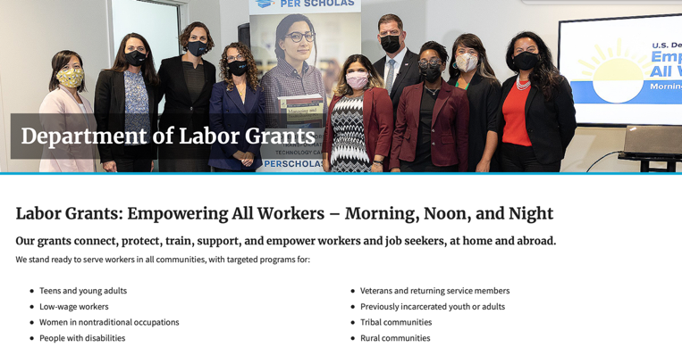

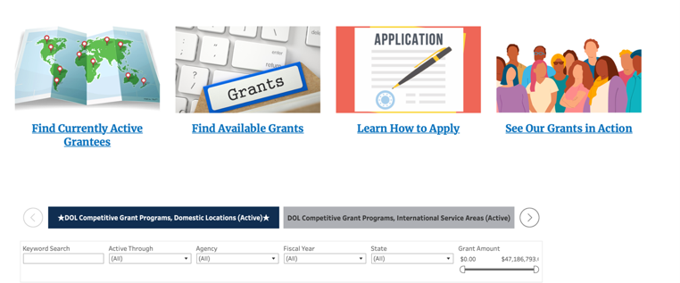

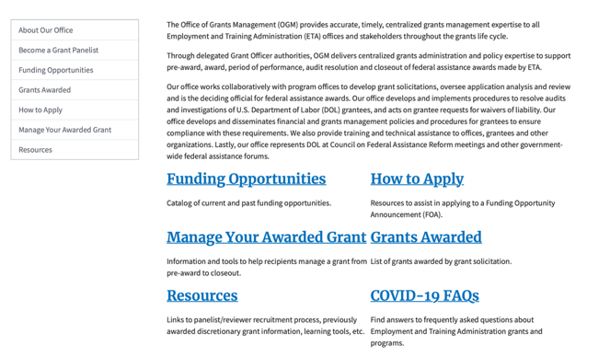

https://www.doleta.gov/grants/

Agency Grants and Contract General Overview

DOL Resources
Apply for DOL Agency-Specific Grants:
- Employment and Training Administration (ETA)
- Occupational Safety and Health Administration (OSHA)
- Bureau of International Labor Affairs (ILAB)
- Veterans' Employment and Training Service (VETS)
- Office of Disability Employment Policy (ODEP)
- Office of the Assistant Secretary for Administration and Management (OASAM)

Other Grant Resources:

DOL Resources and Instructions for Applying for a Grant
- DOL Guidance Clarifying the Effect of the Religious Freedom Restoration Act on Faith-Based Organizations
- Grant and Contract Information
- More Information About Grants

Other Federal Government Grant Information
- Grant Opportunities (Catalog of Federal Domestic Assistance)

Department of Labor Grant Programs

- Bureau of International Labor Affairs (ILAB): provides grants (cooperative agreements) for the implementation of projects designed to assist developing countries combat the worse forms of child labor, forced labor, and human trafficking; and support worker rights and improve working conditions. http://www.dol.gov/general/business.
- Bureau of Labor Statistics (BLS): provides project grants (cooperative agreements) and the dissemination of technical statistical data and related information on labor force activities; provides data on prices (CPI) and cost of living; data on productivity and technology data; data on compensation and working conditions; data on employment projections.
- Employment and Training (ETA): ETA Administers financial assistance programs pursuant to the Workforce Investment Act (WIA), administering State formula grant programs for youth, adults and dislocated workers, national emergency grants for workers affected by mass layoffs, plant closures, and disasters; grant programs for workers with disabilities, Indians and Native Americans, and for migrant and seasonal farmworkers. ETA also administers grant programs for older American workers, apprenticeship programs, Trade Adjustment Assistance (TAA) programs, and assistance for research and development of workforce programs. In addition, ETA is responsible for the operation and maintenance of a national system of public employment service offices and for the national unemployment insurance program.
- Mine Safety and Health (MSHA): provides grants for research, education and training programs to ensure an adequate and competent staff of trained inspectors; and assistance for establishing or improving State mine health and safety programs through technical assistance.
- Occupational Safety and Health (OSHA): provides grants to non-profit organizations to provide training, educational services, and technical assistance; assistance to states to administer and enforce state programs; assistance to states to provide occupational safety and health technical assistance and consultant services.
- Office of Disability Employment Policy (ODEP): The Office of Disability Employment Policy awards competitive grants establishing short-term pilot and technical assistance projects designed to identify, develop, test, evaluate, and disseminate policies to increase employment by expanding access to training, education, employment supports, assistive and systems technology, integrated employment, entrepreneurial development, and small business opportunities for adults and youth with disabilities. Current pilots projects focus on customized employment, Olmstead populations, and innovative demonstration youth grants, among others. Solicitations for grant applications are published in the Federal Register and announced at www.dol.gov/odep. ODEP grants are awarded by the OASAM grant office.
- Veterans' Employment and Training (VETS): provides special employment and training assistance for veterans through the Disabled Veterans' Outreach Program (DVOP) Solicitation for Grant Applications; the Local Veterans' Employment Representative Program (LVER); Veterans' Workforce Investment Program (VWIP); elaws Advisor on veterans' employment and reemployment rights; and the Homeless Veterans Reintegration Project (HVRP). VETS grants are awarded by the OASAM grant office.

https://www.dol.gov/general/grants/howto

National Aeronautics and Space Administration

 NASA Research Opportunities Online

- Various NASA offices publish their research announcements over the Internet, broadening the opportunity for researchers to apply for funding. This site provides access to current research announcements along with their specific due dates.

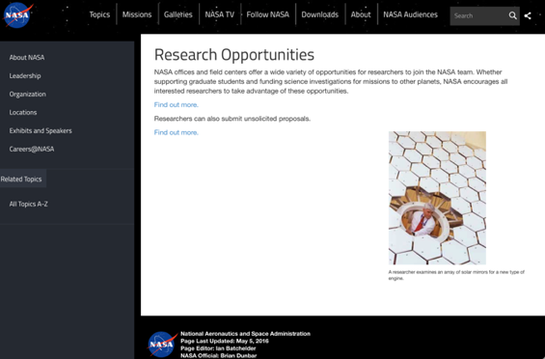
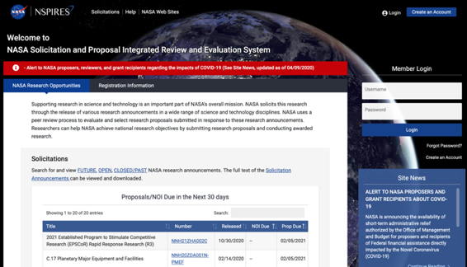
http://nspires.nasaprs.com/external/

National Archives and Records Administration

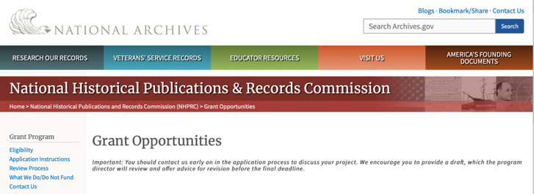

Archival Projects
For projects that ensure online public discovery and use of historical records collections.
- Draft Deadline (optional): August 15, 2023
- Final Deadline: November 2, 2023

Public Engagement with Historical Records
For projects that encourage public engagement with historical records.
- Draft Deadline (optional): August 15, 2023
- Final Deadline: November 2, 2023

Publishing Historical Records in Collaborative Digital Editions
For projects to publish documentary editions of historical records. This program has two application cycles.
First cycle:
- Draft Deadline: February 15, 2023
- Final Deadline: May 3, 2023
Second Cycle:
- Draft Deadline: August 15, 2023
- Final Deadline: November 2, 2023

NHPRC-Mellon Planning Grants for Collaborative Digital Editions in African American, Asian American, Hispanic American, and Native American History and Ethnic Studies
For projects to publish collaborative digital editions in African American, Asian American, Hispanic American, and Native American History and Ethnic Studies.
- Draft Deadline: April 1, 2023
- Final Deadline: June 7, 2023

The deadline for the opportunities listed below has passed. These guidelines may be used for reference, but should NOT be used to prepare an application. New announcements will be published in November 2023.

Major Collaborative Archival Initiatives
For collaborative projects that will significantly improve public discovery and use of major historical records collections.
- Draft Deadline: February 15, 2023
- Final Deadline: May 3, 2023

Archives Collaboratives
For projects to plan and develop a working collaborative designed to enhance the capacity of small and diverse organizations with historical records collections.
- Draft Deadline: February 15, 2023
- Final Deadline: May 3, 2023

State Board Programming Grants
For projects that strengthen the nation’s archival network through activities undertaken by state historical records advisory boards.
- Draft Deadline: February 15, 2023
- Final Deadline: May 3, 2023

NHPRC-Mellon Planning Grants for Collaborative Digital Editions in African American, Asian American, Hispanic American, and Native American History and Ethnic Studies
For projects to publish collaborative digital editions in African American, Asian American, Hispanic American, and Native American History and Ethnic Studies.
- Draft Deadline: April 1, 2023
- Final Deadline: June 7, 2023

This page was last reviewed on 8/8/ 2023
To access the information above: click here

https://www.archives.gov/nhprc/announcement

National Endowment for the Arts

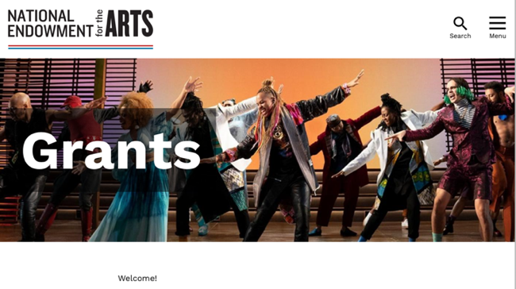
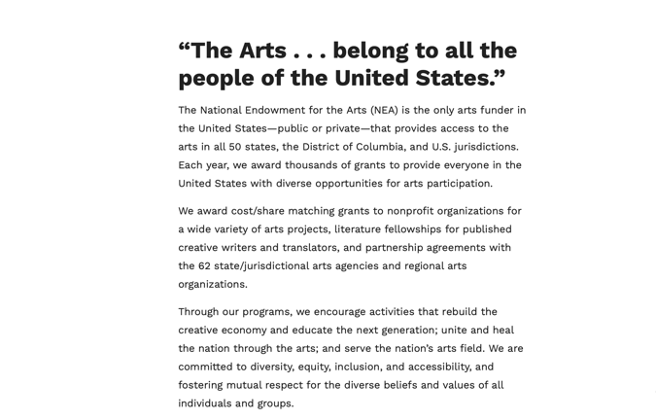

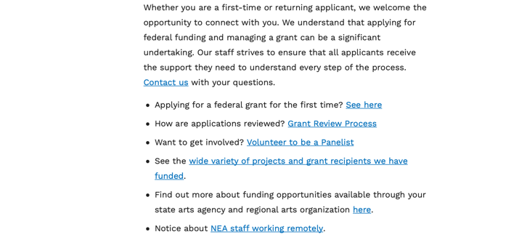
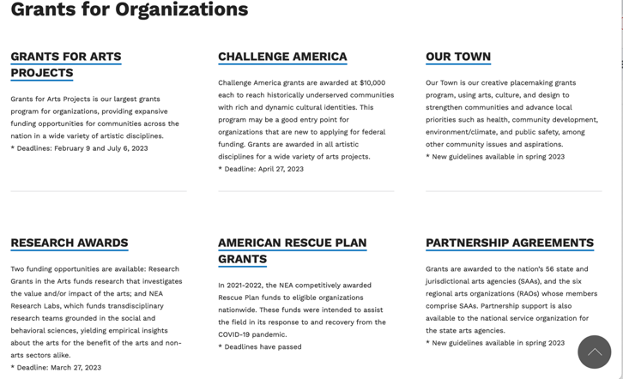

See more at: https://www.arts.gov/grants

National Endowment for the Humanities

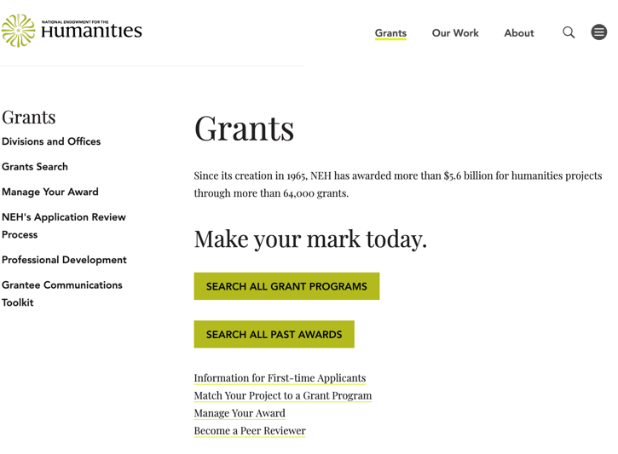
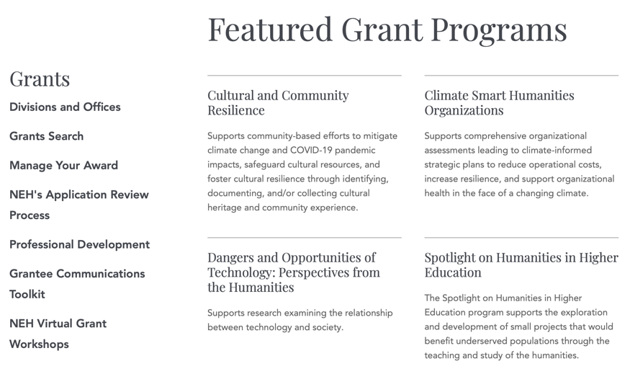
https://www.neh.gov/grants

National Science Foundation



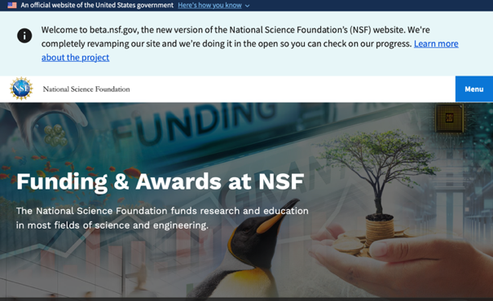

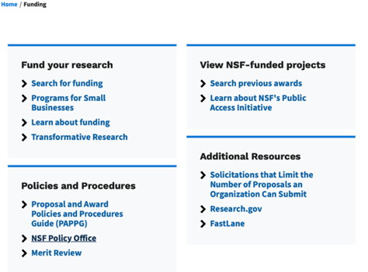
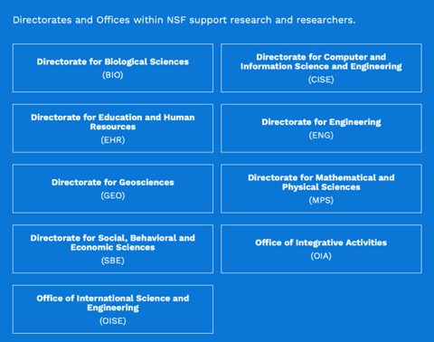

For assistance: https://nsf.gov/funding/aboutfunding.jsp

The National Science Foundation funds research and education in most fields of science and engineering. It does this through grants, and cooperative agreements to more than 2,000 colleges, universities, K-12 school systems, businesses, informal science organizations and other research organizations throughout the United States. The Foundation accounts for about one-fourth of federal support to academic institutions for basic research.
NSF receives approximately 40,000 proposals each year for research, education and training projects, of which approximately 11,000 are funded. In addition, the Foundation receives several thousand applications for graduate and postdoctoral fellowships.
The agency operates no laboratories itself but does support National Research Centers, user facilities, certain oceanographic vessels and Antarctic research stations. The Foundation also supports cooperative research between universities and industry, US participation in international scientific and engineering efforts, and educational activities at every academic level.

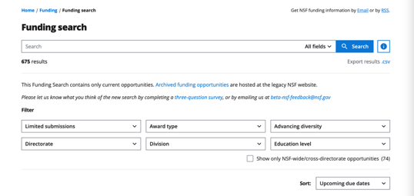

For details on active funding deadline dates: http://nsf.gov/funding/pgm_list.jsp?org=NSF&ord=date

Small Business Administration

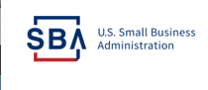

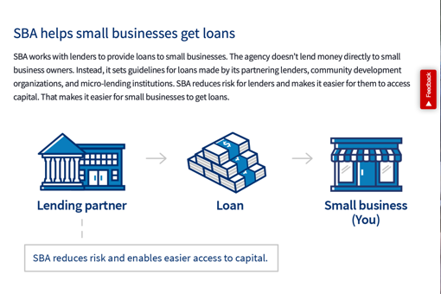

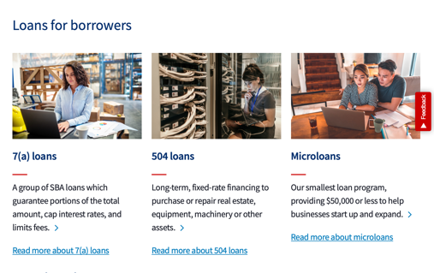
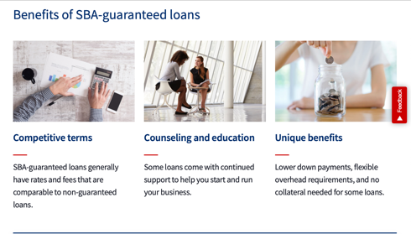

https://www.sba.gov/funding-programs/loans
Federal, state and local governments offer a wide range of financing programs to help small businesses start and grow their operations. These programs include low-interest loans, venture capital, and scientific and economic development grants.
Use SBA.gov's Loans and Grants Search Tool to get a list of financing programs for which you may qualify, or visit the resources below to learn more about small business financing programs.

https://www.sba.gov/funding-programs/grants
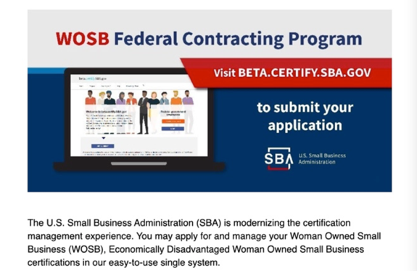
Learn more

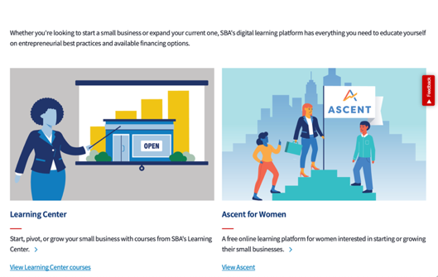
https://www.sba.gov/learning-center

SBA Trainings

https://www.sba.gov/learning-center
Upcoming Trainings: Check out SBA's Online Training!
- Financing Options for Small Businesses
For Specific Information in Hawaii see the following links:

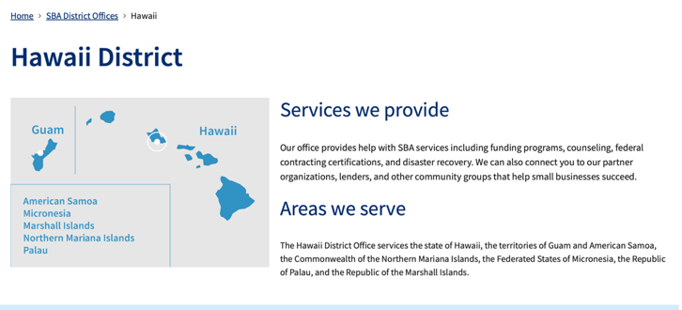
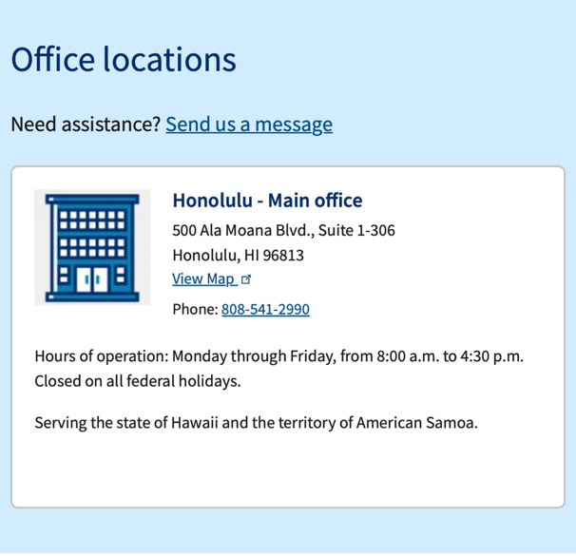

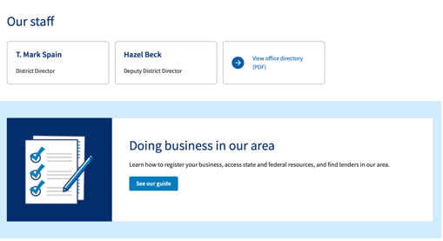

https://www.sba.gov/offices/district/hi/Honolulu

State Department

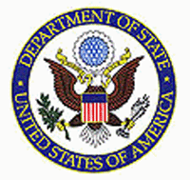

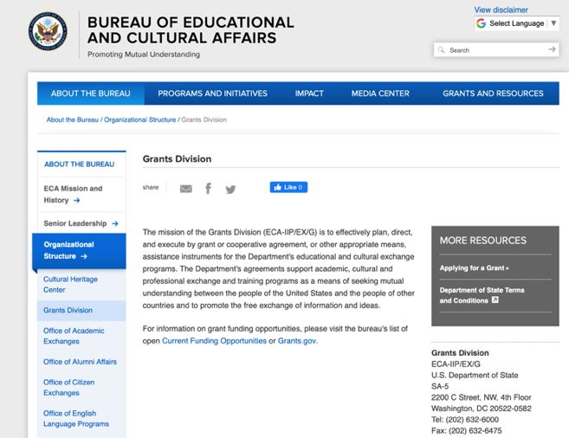

https://eca.state.gov/about-bureau/organizational-structure/grants-division

http://eca.state.gov/search/solr/grants?search_referrer=node/237

https://eca.state.gov/organizational-funding/open-grant-solicitations

http://eca.state.gov/organizational-funding/applying-grant

General Information:
- Bureau of Educational and Cultural Affairs Grants Division
- Open Grant Opportunities (Requests for Grant Proposals)

For General Information click here

Department of Transportation
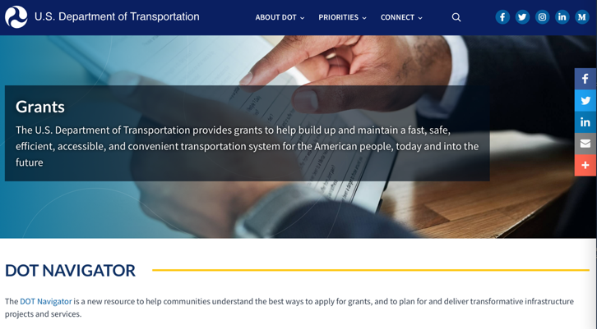
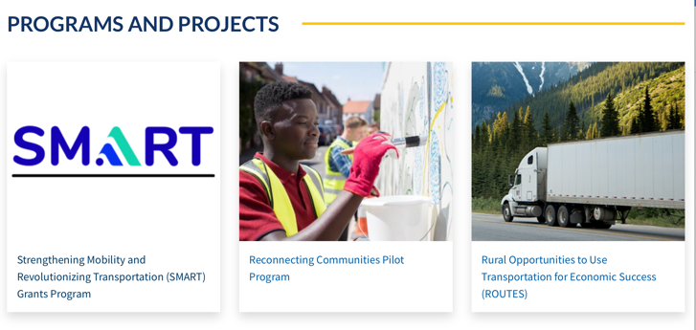
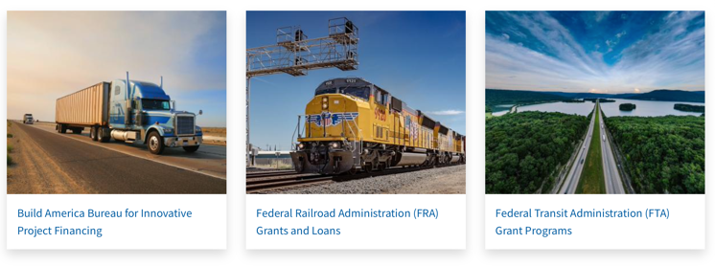
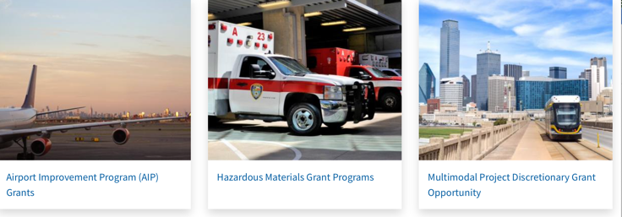
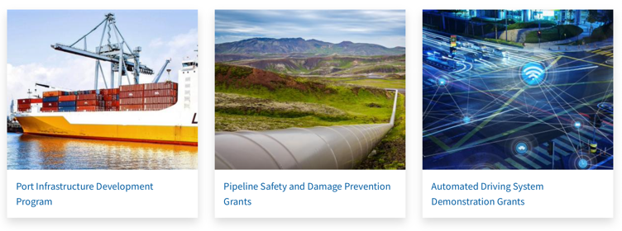
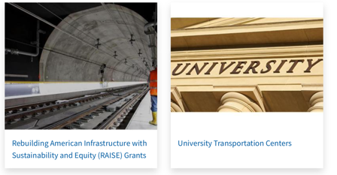

General Grant Program Overview https://www.transportation.gov/grants

Department of the Treasury

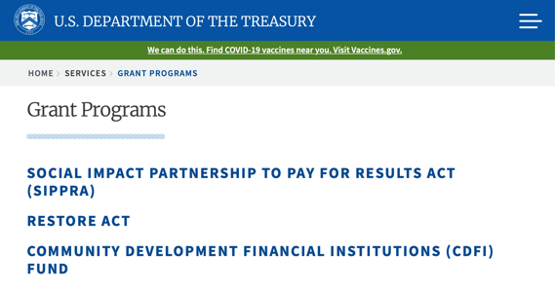
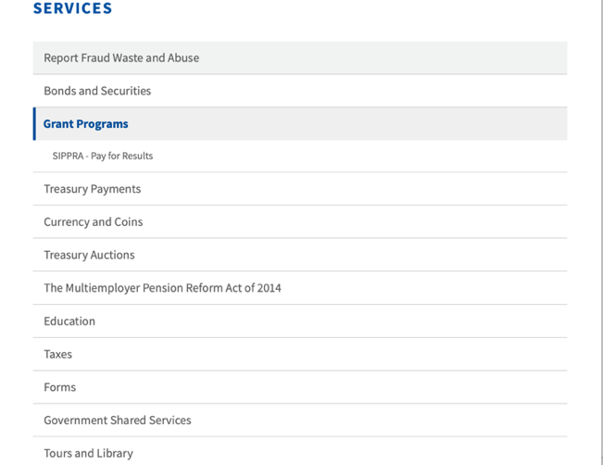

https://home.treasury.gov/services/grant-programs

U.S. Agency for International Development
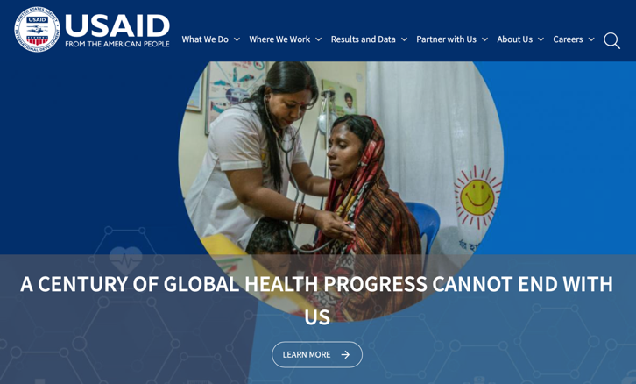

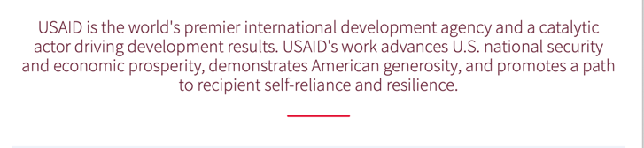

www.usaid.gov

General Overview Funding Opportunities

USAID has working relationships with thousands of American companies and hundreds of U.S.-based private voluntary organizations. For more information on our business and procurement opportunities, \

Department of Veterans Affairs

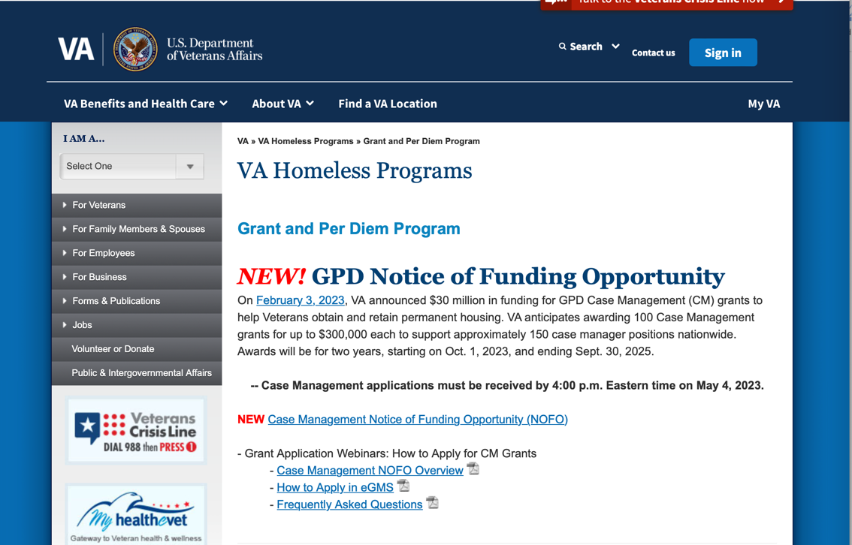
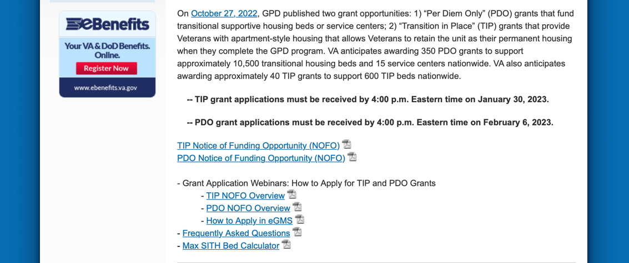
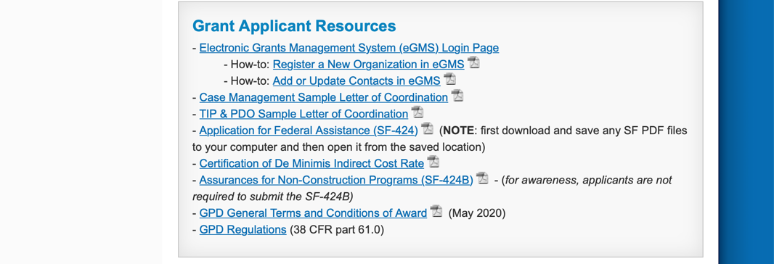
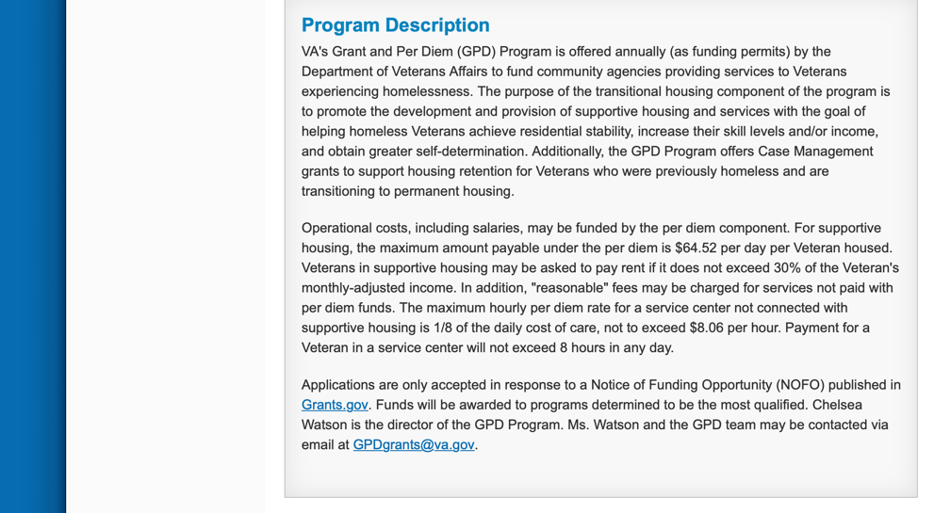
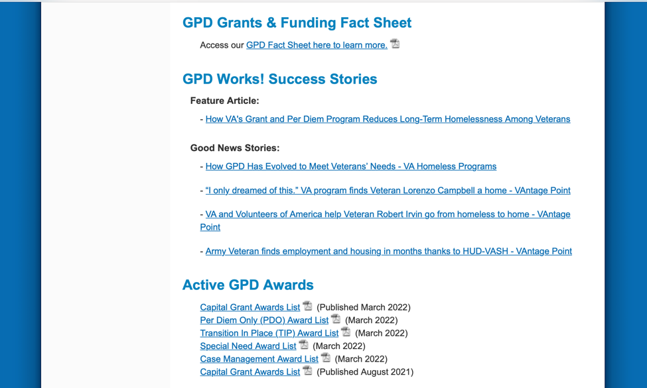
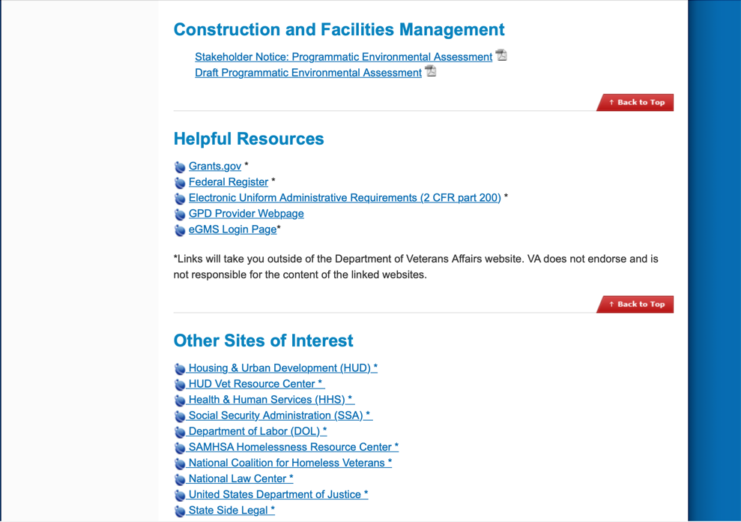
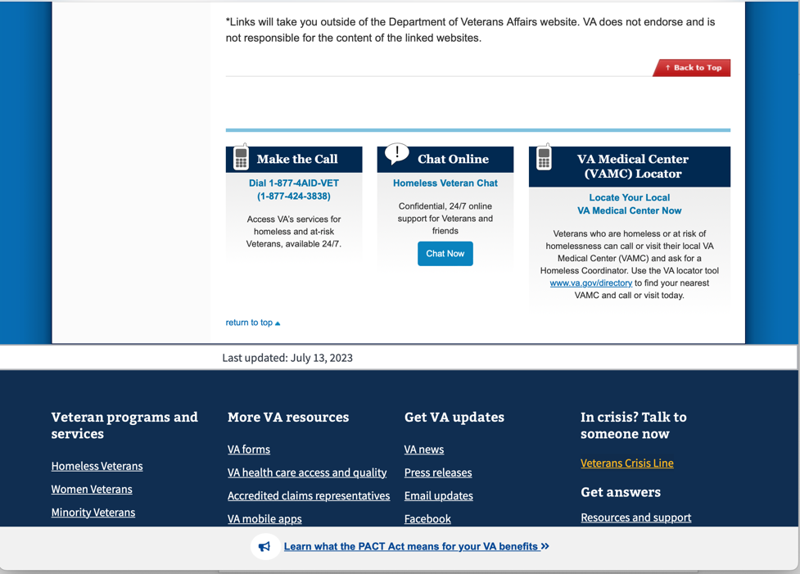

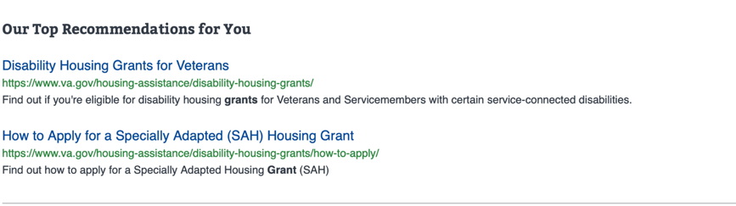
Page reviewed on 8/8/ 2023

https://www.va.gov/homeless/gpd.asp

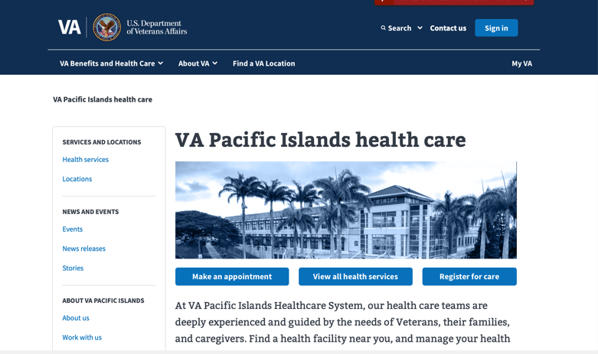
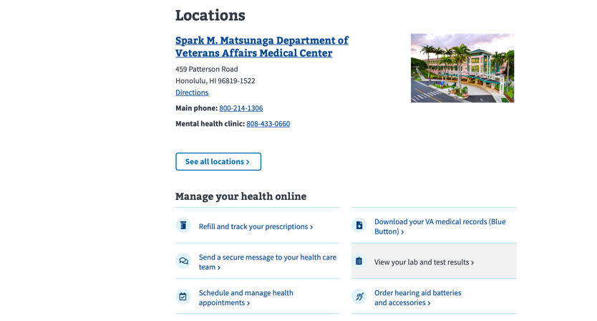
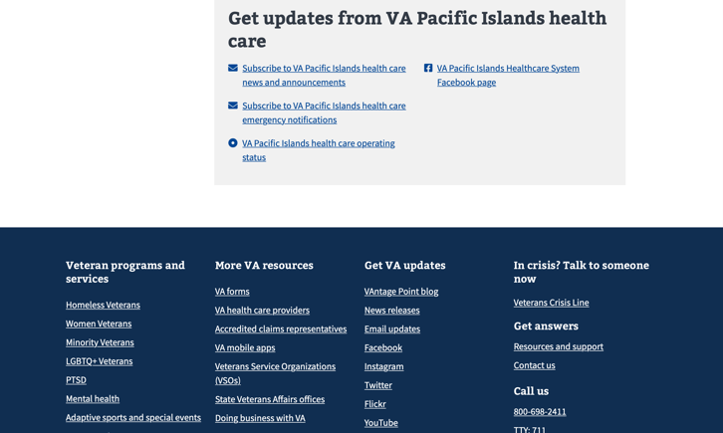

https://www.va.gov/pacific-islands-health-care/

Grants General Tips and Information

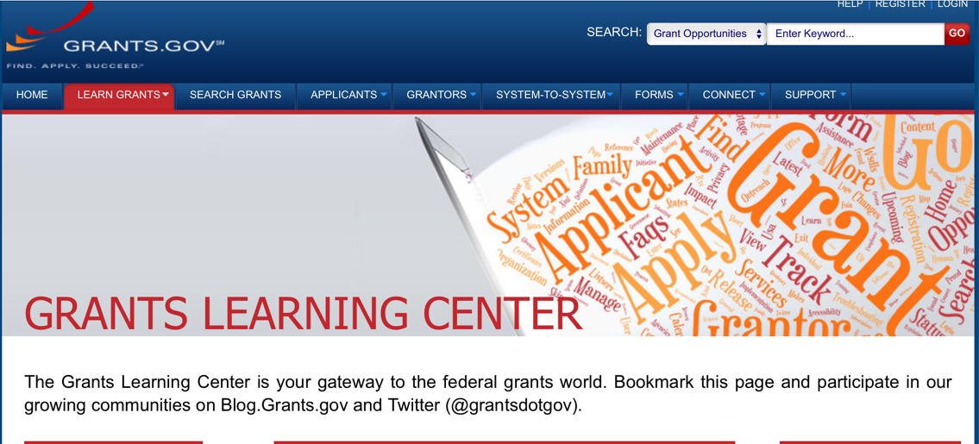

Provides a Grants Learning Center as a gateway to the federal grants world. Bookmark the following link and participate at blog.grants.gov or on twitter @grantsdotgov

Topics include: Grants 101, Grant Policies, Grant Eligibility, Grant Terms, Grant Agencies , Grant Systems, Grant Programs, Grant Careers, Grant Reporting, Grant Fraud and Grant Events

https://www.grants.gov/web/grants/learn-grants.html

Grants.gov maintains a blog. This reprinted article provides some helpful tips:

Grant Writing: 3 Tips for Crafting Need Statements in Federal Grant Proposals
Originally Posted on March 27, 2019 by Grants.gov
In this space, we have previously shared tips about the pre-writing phase of completing a federal grant application – for example, the importance of reading (and re-reading) the grant announcement, and the importance of understanding the criteria by which your application will be evaluated.
In this post, we dip our toes into the grant writing process itself and share some tips about crafting a need statement. These tips are adapted from the U.S. Department of Health and Human Services Health Resources & Services Administration’s grant writing guide, titled “Tips for Writing and Submitting Good Grant Proposals”. Along with each tip, we also include an excerpt from an award-winning federal grant proposal that can be viewed in full on the website of the Institute of Museum and Library Services. (IMLS has an excellent collection of proposals that are worthy of review – especially for new federal grant applicants.)

https://grantsgovprod.wordpress.com/2019/03/27/3-tips-for-crafting-need-statements-in-federal-grant-proposals/?utm_source=newsletter&utm_medium=email&utm_campaign=noprofile&utm_content=june2020

Grant Writing Resources

The following links are a great resource for Faith-Based Non-profits and other community organizations:

U.S. Department of Justice
Task Force for Faith-Based and Community Initiatives

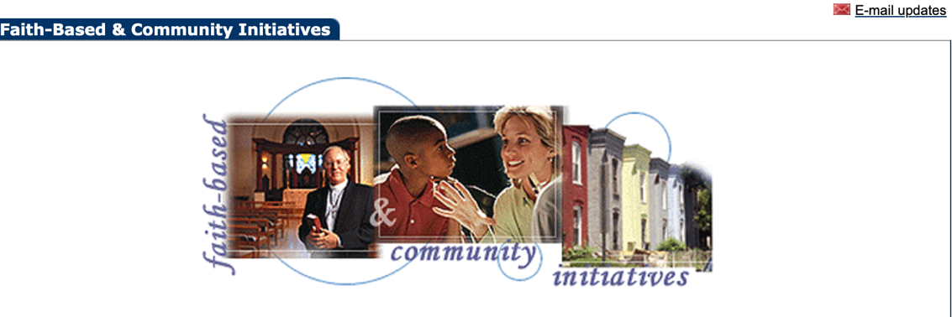

Foundation Center
Proposal Writing Short Course

USDA Rural Information Center
A Guide to Funding Resources

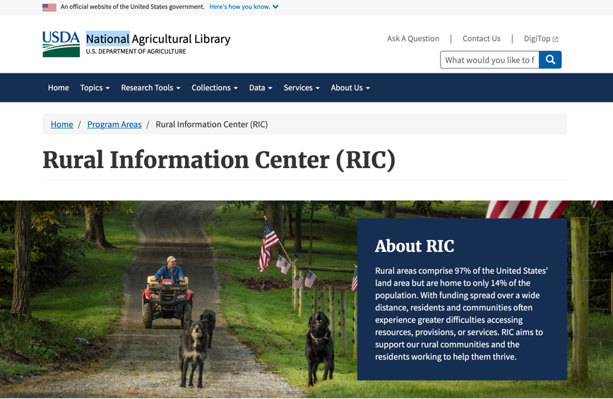

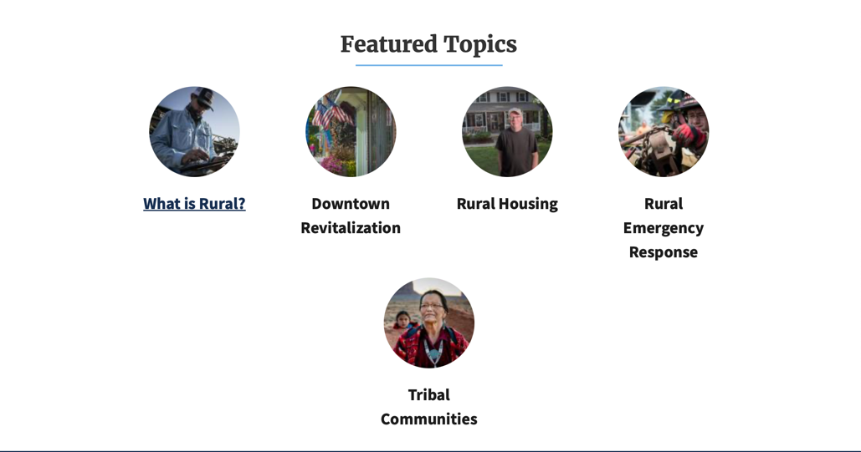
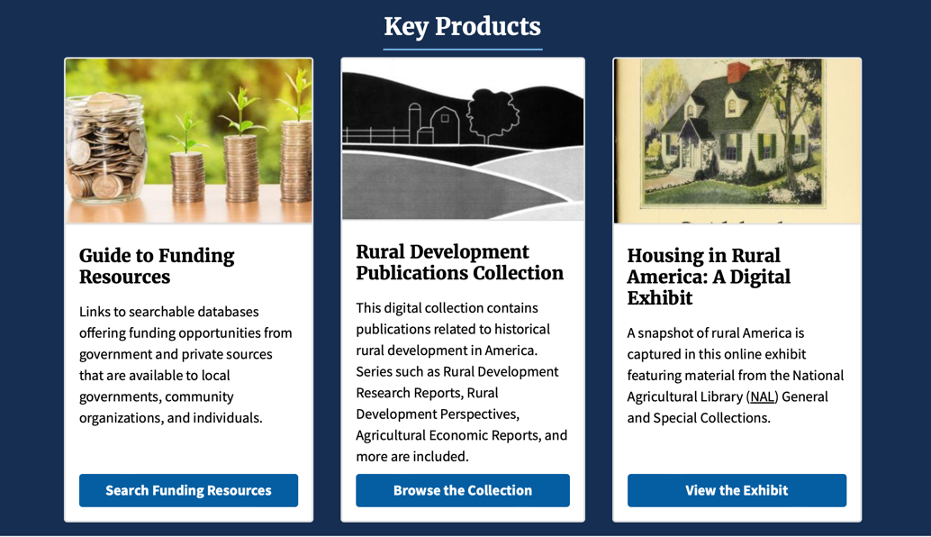
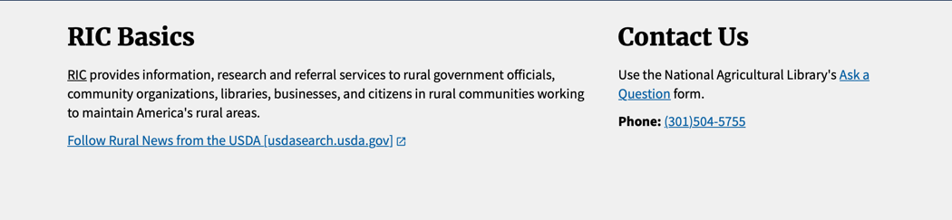

The Small Business Innovative Research Program - SBIR Program

The Small Business Innovation Research (SBIR) program is a highly competitive program that encourages domestic small businesses to engage in Federal Research/Research and Development (R/R&D) that has the potential for commercialization. Through a competitive awards-based program, SBIR enables small businesses to explore their technological potential and provides the incentive to profit from its commercialization. By including qualified small businesses in the nation's R&D arena, high-tech innovation is stimulated, and the United States gains entrepreneurial spirit as it meets its specific research and development needs.

SBIR Mission and Program Goals
The mission of the SBIR program is to support scientific excellence and technological innovation through the investment of Federal research funds in critical American priorities to build a strong national economy.
The program’s goals are four-fold:
- Stimulate technological innovation
- Meet Federal research and development needs.
- Foster and encourage participation in innovation and entrepreneurship by socially and economically disadvantaged persons.
- Increase private-sector commercialization of innovations derived from Federal research and development funding.

SBIR-Participating Agencies
Each year, Federal agencies with extramural research and development (R&D) budgets that exceed $100 million are required to allocate 2.5 percent of their R&D budget to these programs. Currently,
- eDepartment of Commerce - National Institute of Standards and Technology
- Department of Energy
- Department of Health and Human Services
- Department of Transportation
- National Aeronautics and Space Administration
- National Science Foundation
Each agency administers its own individual program within guidelines established by Congress. These agencies designate R&D topics in their solicitations and accept proposals from small businesses. Awards are made on a competitive basis after proposal evaluation.

Three-Phase Program
The SBIR Program is structured in three phases:
Phase I. The objective of Phase I is to establish the technical merit, feasibility, and commercial potential of the proposed R/R&D efforts and to determine the quality of performance of the small business awardee organization prior to providing further Federal support in Phase II. SBIR Phase I awards normally do not exceed $150,000 total costs for 6 months.
Phase II. The objective of Phase II is to continue the R/R&D efforts initiated in Phase I. Funding is based on the results achieved in Phase I and the scientific and technical merit and commercial potential of the project proposed in Phase II. Only Phase I awardees are eligible for a Phase II award. SBIR Phase II awards normally do not exceed $1,000,000 total costs for 2 years.
Phase III. The objective of Phase III, where appropriate, is for the small business to pursue commercialization objectives resulting from the Phase I/II R/R&D activities. The SBIR program does not fund Phase III. Some Federal agencies, Phase III may involve follow-on non-SBIR funded R&D or production contracts for products, processes or services intended for use by the U.S. Government

