Senator Mazie Hirono

Grants Assistance Information
Newsletter
DECEMBER 2016

G.A.I.N. INDEX

Click on Index Links below to read summaries of the announcements by agency in this document.
Once you reach the item, if you cannot open the links for further information, copy the selected
URL website address into your browser.

Modified sections from previous listings are shown in a GREY background

Notices is Teal are items with immediate deadline dates.

Notices in Yellow are of special interest.

Notices is Green are items of special interest with immediate deadline dates.

Items in this type color are aimed at Small Businesses

Items in this type color have a Faith-Based Organization component

Special Federal Program Notices

SBIR – Small Business Innovation Research

Programs specific to Hawaii

Current Notices

2017 Partnerships for Implementing Hawaiian Monk Seal Species in the Spotlight Priority Recovery Actions

Administration for Children and Families - ANA
Native Youth Initiative for Leadership, Empowerment, and Development (I-LEAD)

Reminders

FY17 Coral Reef Conservation Program, Domestic Coral Reef Conservation Grants
Synopsis 1

Bureau of Reclamation
Desalination and Water Purification Research Program Fiscal Year 2017 Research & Laboratory Scale Projects
Synopsis 2

Bureau of Reclamation
Desalination and Water Purification Research (DWPR) Program Fiscal Year 2017 Pilot Scale Testing Projects
Synopsis 1

National Park Service
NAGPRA Repatriation Grants
Synopsis 1

Bureau of Reclamation
WaterSMART: Water Recycling and Reuse Research under the Title XVI Water Reclamation and Reuse Program for Fiscal Year 2017
Synopsis 3

See Individual Departments for information and webpages representing the best and most accessible information on the agency funding opportunities

Federal Grant and Cooperative Agreement Program Summaries

U.S. Department of Agriculture

Grants and Loans Overview

Programs

Modifications

Deleted

Reminders

Utilities Programs
RUS SWM Grant FY 2017

Foreign Agricultural Service
McGovern-Dole International Food for Education and Child Nutrition Program
Synopsis 1, 2, 3 & 4

National Institute of Food and Agriculture
Food Insecurity Nutrition Incentive (FINI) Grant Program

Foreign Agricultural Service
Food for Progress Program
Synopsis 1, 2, 3 & 4

National Institute of Food and Agriculture
Organic Agriculture Research and Extension Initiative

Forest Service
Wood Innovations

Natural Resources Conservation Service
2017 National Conservation Innovation Grants APF

Department of Commerce

Programs

FY17-19 Habitat Blueprint – Coastal and Marine Habitat Focus Area Cooperative Agreements

Research

Modifications

National Estuarine Research Reserve System (NERRS) Land Acquisition and Construction Program for Fiscal Year 2017
Synopsis 2

FY 2017 Joint Technology Transfer Initiative
Synopsis 2

Reminders

NOAA Climate Program Office’s Regional Integrated Sciences and Assessments (RISA) Program

Fiscal Year 2018 National Sea Grant College Program Dean John A. Knauss Marine Policy Fellowship

Ocean Exploration FY 2017 Funding Opportunity

National Institute of Standards and Technology
Measurement Science and Engineering (MSE) Research Grant Programs

National Sea Grant College Program 2016-17 Special Projects Grant

FY 2016 – FY 2019 EDA Planning Program and Local Technical Assistance Program Grant

FY 2016 Economic Development Assistance Programs ­ Application submission and program requirements for EDA’s Public Works and Economic Adjustment Assistance Programs

Economic Development Administration
Planning Program and Local Technical Assistance Program Grant

Deleted

Corporation for National and Community Service

General Program Overview

Programs

Reminders

2017 AmeriCorps State and National Grants

National Service in Hawaii

Department of Defense

Doing Business with the Department of Defense

DoD Small Business Opportunities and Forecasting

Research Grants

Modifications

Reminders

Dept. of the Army -- Materiel Command
Army Research Office Broad Agency Announcement for Basic and Applied Scientific Research
Modification 8

Department of Education

Grant Programs Overview

Programs

Research

Modifications

Reminders

Office of Postsecondary Education (OPE): Minority Science and Engineering Improvement Program CFDA Number 84.120A

Deleted

US Department of Energy

Grants Overview

Research

Modifications

Reminders

PAMS
Department of Energy - Office of Science
Office of Science
FY 2017 Continuation of Solicitation for the Office of Science Financial Assistance Program
Synopsis 2

Environmental Protection Agency

Grants and Contracts Overview

Programs

Modifications

Environmental Justice Small Grants Program
Synopsis 3

Research

Reminders

FY17 Guidelines for Brownfields Assessment Grants

FY17 Guidelines for Brownfields Cleanup Grants

Department of Health and Human Services

Grants Overview

Program

Research Grants

Modifications

Reminders

Administration for Children & Families - ACYF/FYSB
Transitional Living Program and Maternity Group Homes
Forecast 1

Administration for Children and Families - ORR
Ethnic Community Self Help Program
Forecast 1

Deleted

Department of Homeland Security
Grants Overview

Programs

Modifications

Reminders

United States Coast Guard
National Non-Profit Organization Grant Program

Department of Housing and Urban Development

HUD - Notice of Funds Available

Programs

Lead-Based Paint Hazard Control (LBPHC) Grant Program

Healthy Homes and Lead Technical Studies Grant Program Pre and Full Application

Lead Hazard Reduction Demonstration (LHRD) Grant Program

Resident Opportunity & Self-Sufficiency Program

Family Self-Sufficiency Program

Jobs Plus Initiative

Modifications

Reminders

Technical Correction to the General Section to HUD's Fiscal Year 2016 Notice[s] of Funding Availability for Discretionary Programs
Modification 1

General Section to HUD's Fiscal Year 2016 Notice[s] of Funding Availability for Discretionary Programs (General Section)
Modification 1

Institute of Museum and Library Services

Grants Overview

IMLS is on Facebook!

Programs

Modifications

Reminders

Deleted

Department of Interior

Grants and Contract Overview

Programs

National Fish Passage Program

Modifications

Reminders

Fish and Wildlife Service
Fiscal Year 2017 Recovery Implementation Grants

Fish and Wildlife Service
Partners for Fish and Wildlife

Fish and Wildlife Service
Coastal Program

Geological Survey
Cooperative Research Units Program FY 2017
Synopsis 2

Deleted

Department of Justice

Grants and Contract Overview

Programs

National Institute of Justice
NIJ FY17 Research and Development in Forensic Science for Criminal Justice Purposes
Synopsis 1 & 2

Research

Modifications

Reminders

Department of Labor

Grants and Contract General Overview

Programs

Modifications

Reminders

National Aeronautics and Space Administration

Research Grant and Contract General Overview

Programs

Modifications

_______________________________________________________________
National Archives and Records Administration

Grant Opportunities General Overview

Reminders

Access to Historical Records - Major Initiatives

_______________________________________________________________
National Endowment for the Arts

Grant Opportunities General Overview

Programs

Modifications

Reminders

NEA Poetry Out Loud: 2018 National Finals Competition

_______________________________________________________________

National Endowment for the Humanities

Grant Opportunities General Overview

Programs

Public Scholar Program

Reminders

National Digital Newspaper Program

Creating Humanities Communities

Media Projects Grants

Public Humanities Projects

Digital Humanities Advancement Grants

Humanities Initiatives at Community Colleges

Sustaining Cultural Heritage CollectionsModifications

_______________________________________________________________
National Science Foundation

Grant Opportunities General Overview

Research and Program Grants

Modifications

Reminders

Deleted

Nuclear Regulatory Commission

Reminders

Small Business Administration

General Overview Finding Loans & Grants

Programs

Request for Statement of Interest for Upcoming Boots to Business Funding Opportunity

Reminders

Women's Veteran Entrepreneurship Training Program (WVETP)
Synopsis 1 and 2

Deleted

Upcoming Trainings

Links Specific to Hawaii

State Department

General Overview and Resources for Program Administrators

Programs

Modifications

Reminders

U.S. Department of Transportation

General Grant Program Overview

Programs

Research

Modifications:

DOT/Federal Motor Carrier Safety Administration
FY 2017 High Priority Grant Program
Synopsis 2 & 4

Reminders

DOT Federal Aviation Administration
DOT - FAA Aviation Research Grants
FAA Aviation Research and Development Grants
Modifications 3 & 4

Deleted

Department of the Treasury

Programs

Modifications

Reminders

US Agency for International Development

General Funding Opportunity Overview

Programs
Modifications

Deleted

Department of Veterans Affairs

Special Federal Program Notices

The Small Business Innovative Research Program - SBIR Program
The Small Business Innovation Research (SBIR) program is a highly competitive program that encourages domestic small businesses to engage in Federal Research/Research and Development (R/R&D) that has the potential for commercialization. Through a competitive awards-based program, SBIR enables small businesses to explore their technological potential and provides the incentive to profit from its commercialization. By including qualified small businesses in the nation's R&D arena, high-tech innovation is stimulated and the United States gains entrepreneurial spirit as it meets its specific research and development needs.

SBIR Mission and Program Goals
The mission of the SBIR program is to support scientific excellence and technological innovation through the investment of Federal research funds in critical American priorities to build a strong national economy.
The program’s goals are four-fold:
- Stimulate technological innovation
- Meet Federal research and development needs.
- Foster and encourage participation in innovation and entrepreneurship by socially and economically disadvantaged persons.
- Increase private-sector commercialization of innovations derived from Federal research and development funding.

SBIR-Participating Agencies
Each year, Federal agencies with extramural research and development (R&D) budgets that exceed $100 million are required to allocate 2.5 percent of their R&D budget to these programs. Currently, eleven Federal agencies participate in the program:
- Department of Agriculture
- Department of Commerce - National Institute of Standards and Technology
- Department of Commerce - National Oceanic and Atmospheric Administration
- Department of Defense
- Department of Education
- Department of Energy
- Department of Health and Human Services
- Department of Homeland Security
- Department of Transportation
- Environmental Protection Agency
- National Aeronautics and Space Administration
- National Science Foundation
Each agency administers its own individual program within guidelines established by Congress. These agencies designate R&D topics in their solicitations and accept proposals from small businesses. Awards are made on a competitive basis after proposal evaluation.

Three-Phase Program
The SBIR Program is structured in three phases:
Phase I. The objective of Phase I is to establish the technical merit, feasibility, and commercial potential of the proposed R/R&D efforts and to determine the quality of performance of the small business awardee organization prior to providing further Federal support in Phase II. SBIR Phase I awards normally do not exceed $150,000 total costs for 6 months.
Phase II. The objective of Phase II is to continue the R/R&D efforts initiated in Phase I. Funding is based on the results achieved in Phase I and the scientific and technical merit and commercial potential of the project proposed in Phase II. Only Phase I awardees are eligible for a Phase II award. SBIR Phase II awards normally do not exceed $1,000,000 total costs for 2 years.
Phase III. The objective of Phase III, where appropriate, is for the small business to pursue commercialization objectives resulting from the Phase I/II R/R&D activities. The SBIR program does not fund Phase III. Some Federal agencies, Phase III may involve follow-on non-SBIR funded R&D or production contracts for products, processes or services intended for use by the U.S. Government
SBIR NewsLetter

- SBIR Newsletter
Sign up for e-mail updates

HAWAII APPLICANTS ENCOURAGED

Current Notices:

2017 Partnerships for Implementing Hawaiian Monk Seal Species in the Spotlight Priority Recovery Actions
Synopsis 1

Document Type: | Grants Notice
Funding Opportunity Number: | NOAA-NMFS-PIRO-2017-2005112
Funding Opportunity Title: | 2017 Partnerships for Implementing Hawaiian Monk Seal Species in the Spotlight Priority Recovery Actions
Opportunity Category: | Discretionary
Opportunity Category Explanation:
Funding Instrument Type: | Cooperative Agreement  Grant
Category of Funding Activity: | Environment  Natural Resources  Science and Technology and other Research and Development
Category Explanation:
Expected Number of Awards:
CFDA Number(s): | 11.454 -- Unallied Management Projects
Cost Sharing or Matching Requirement: | No
Posted Date: | Dec 02, 2016
Last Updated Date: | Dec 02, 2016
Original Closing Date for Applications: | Feb 28, 2017
Current Closing Date for Applications: | Feb 28, 2017
Archive Date: | Mar 30, 2017
Estimated Total Program Funding: | $150,000
Award Ceiling: | $50,000
Award Floor: | $15,000
Eligible Applicants: | Others (see text field entitled "Additional Information on Eligibility" for clarification)
Additional Information on Eligibility: | Eligible applicants are individuals, institutions of higher education, nonprofits, commercial organizations, state, local, and Indian tribal governments. Federal agencies, Federal instrumentalities, or employees of Federal agencies, are not eligible to apply.
Agency Name: | Department of Commerce
Description: | The National Marine Fisheries Service (hereinafter, "NMFS") is soliciting competitive applications for the fiscal year 2017 Partnerships for Hawaiian Monk Seal Species in the Spotlight Priority Recovery Actions. Projects are being solicited to support specific programmatic activities related to 1) detecting and preventing disease-related mortality, 2) development and implementation of a strategic communications plan and social marketing strategy, and 3) encouraging citizen science in the main Hawaiian Islands.
Link to Additional Information:
Grantor Contact Information: | If you have difficulty accessing the full announcement electronically, please contact:  Ms. Penny Larin NOAA Fisheries Service Pacific Islands Regional Office 1845 Wasp Blvd Building 176 Honolulu, HI 96818 Phone: (808) 725-5057 Email: Penny.Larin@noaa.gov  Work

http://www.grants.gov/web/grants/view-opportunity.html?oppId=290438

Department of Health and Human Services

Administration for Children and Families - ANA
Native Youth Initiative for Leadership, Empowerment, and Development (I-LEAD)
Forecast 1

Document Type: | Grants Notice
Opportunity Number: | HHS-2017-ACF-ANA-NC-1263
Opportunity Title: | Native Youth Initiative for Leadership, Empowerment, and Development (I-LEAD)
Opportunity Category: | Discretionary
Opportunity Category Explanation:
Funding Instrument Type: | Grant
Category of Funding Activity: | Income Security and Social Services
Category Explanation:
Expected Number of Awards: | 5
CFDA Number(s): | 93.612 -- Native American Programs
Cost Sharing or Matching Requirement: | Yes
Posted Date: | Dec 02, 2016
Last Updated Date: | Dec 02, 2016
Estimated Synopsis Post Date: | Jan 09, 2017
Estimated Application Due Date: | Mar 10, 2017 Electronically submitted applications must be submitted no later than 11:59 p.m., ET, on the listed application due date.
Estimated Award Date: | Sep 29, 2017
Estimated Project Start Date: | Sep 30, 2017
Fiscal Year: | 2017
Archive Date:
Estimated Total Program Funding: | $1,500,000
Award Ceiling: | $300,000
Award Floor: | $100,000
Eligible Applicants: | Others (see text field entitled "Additional Information on Eligibility" for clarification)  Nonprofits having a 501(c)(3) status with the IRS, other than institutions of higher education  Native American tribal organizations (other than Federally recognized tribal governments)  Native American tribal governments (Federally recognized)
Additional Information on Eligibility: | Non-profit organizations representing American Indians, Alaska Natives, Native Hawaiians, and other Native American Pacific Islanders, including American Samoa, Guam, and the Commonwealth of the Northern Mariana Islands are eligible applicants under this announcement. A full listing of eligible entities under this announcement will be published in the funding opportunity announcement. Faith-based and community organizations that meet the eligibility requirements are eligible to receive awards under this funding opportunity announcement. Faith-based organizations are encouraged to review the ACF Policy on Grants to Faith-Based Organizations at: http: //www.acf.hhs.gov/acf-policy-on-grants-to-faith-based-organizations. Applications from individuals (including sole proprietorships) and foreign entities are not eligible and will be disqualified from competitive review and from funding under this announcement.
Agency Name: | Administration for Children and Families - ANA
Description: | The Administration for Native Americans (ANA), within the Administration for Children and Families (ACF), announces the availability of Fiscal Year (FY) 2017 funds for the Native Youth I-LEAD. This program will emphasize a comprehensive, culturally-appropriate approach to ensure that all young Native people can thrive and reach their full potential by fostering Native youth resilience, capacity building, and leadership. Native Youth I-LEAD will specifically focus on implementation of community programs that promote Native youth resiliency and foster protective factors such as connections with Native languages and Elders, positive peer groups, culturally-responsive parenting resources, models of safe sanctuary, and reconnection with traditional healing. Projects will also promote Native youth leadership development through the establishment of local models to instill confidence in Native youth of their value and potential, preparation of older youth to be role models for younger peers, and activities that foster leadership and skills-building. In addition, it is intended that Native youth must be actively involved during the planning and implementation phases of the projects to ensure that they are responsive to the needs of Native youth in the communities to be served and to ensure that youth remain engaged throughout the project period.
Link to Additional Information:
Grantor Contact Information: | Carmelia Strickland  (202) 401-6741  Carmelia.Strickland@acf.hhs.gov

http://www.grants.gov/web/grants/view-opportunity.html?oppId=290439

Reminders:

Department of Commerce
FY17 Coral Reef Conservation Program, Domestic Coral Reef Conservation Grants
Synopsis 1

Document Type: | Grants Notice
Funding Opportunity Number: | NOAA-NOS-OCM-2017-2005011
Funding Opportunity Title: | FY17 Coral Reef Conservation Program, Domestic Coral Reef Conservation Grants
Opportunity Category: | Discretionary
Opportunity Category Explanation:
Funding Instrument Type: | Cooperative Agreement  Grant
Category of Funding Activity: | Environment  Natural Resources  Science and Technology and other Research and Development
Category Explanation:
Expected Number of Awards: | 15
CFDA Number(s): | 11.482 -- Coral Reef Conservation Program
Cost Sharing or Matching Requirement: | Yes
Version: | Synopsis 1
Posted Date: | Sep 06, 2016
Last Updated Date: | Sep 06, 2016
Original Closing Date for Applications: | Jan 11, 2017
Current Closing Date for Applications: | Jan 11, 2017
Archive Date: | Feb 10, 2017
Estimated Total Program Funding: | $1,000,000
Award Ceiling: | $80,000
Award Floor: | $30,000
Eligible Applicants: | Others (see text field entitled "Additional Information on Eligibility" for clarification)
Additional Information on Eligibility: | Institutions of higher education, non-profit organizations, for-profit organizations, and local (as defined at 2 C.F.R. § 200.64, which includes counties, municipalities, and cities) and Indian tribal government agencies are eligible to apply for funding under this funding category. U.S. federal agencies, state, territory, and commonwealth governments and Regional Fishery Management Councils are not eligible to apply under this funding announcement, as NOAA funds their coral reef work in separate programs.
Agency Name: | Department of Commerce
Description: | The NOAA Coral Reef Conservation Grant Program, 16 USC §§ 6401-6409, provides matching grants of financial assistance through the Domestic Coral Reef Conservation Grant program to institutions of higher education, non-profit organizations, for-profit organizations, and local (as defined at 2 CFR § 200.64, which includes counties, municipalities, and cities) and Indian tribal government agencies. These awards are intended to support coral reef conservation projects in shallow water coral reef ecosystems, including reefs at mesophotic depths, in American Samoa, the Commonwealth of the Northern Mariana Islands, Florida, Guam, Hawaii, Puerto Rico, the U.S. Virgin Islands, and coral-dominated banks in the U.S. portions of the Gulf of Mexico. Projects may be proposed in the Northwestern Hawaiian Islands and the U.S. Pacific Remote Island Areas, but these locations are not considered geographic priorities under this announcement. Proposals submitted to this competition must address at least one of the following four categories: 1) Fishing Impacts; 2) Land-Based Sources of Pollution; 3) Climate Change; and 4) Local and Emerging Management Issues. Each category is described in more detail in the Federal Funding Opportunity announcement. All proposed work must be consistent with Coral Reef Conservation Program (CRCP) National Goals and Objectives 2010-2015
Link to Additional Information:
Grantor Contact Information: | If you have difficulty accessing the full announcement electronically, please contact:  For administrative or technical questions regarding this announcement, contact the competition manager: Liz Fairey. She can be reached by phone at 301-427- 8632, by fax at 301-713-1594, by email at Liz.Fairey@noaa.gov or by mail at: Liz Fairey, NOAA Fisheries Office of Habitat Conservation, 1315 East West Highway, SSMC3, 14224, Silver Spring, MD, 20910.  Work

http://www.grants.gov/web/grants/view-opportunity.html?oppId=288521

Department of Interior

Bureau of Reclamation
Desalination and Water Purification Research Program Fiscal Year 2017 Research & Laboratory Scale Projects
Synopsis 2

Document Type: | Grants Notice
Funding Opportunity Number: | BOR-DO-17-F005
Funding Opportunity Title: | Desalination and Water Purification Research Program Fiscal Year 2017 Research & Laboratory Scale Projects
Opportunity Category: | Discretionary
Opportunity Category Explanation:
Funding Instrument Type: | Cooperative Agreement
Category of Funding Activity: | Science and Technology and other Research and Development
Category Explanation:
Expected Number of Awards: | 15
CFDA Number(s): | 15.506 -- Water Desalination Research and Development
Cost Sharing or Matching Requirement: | No
Version: | Synopsis 2
Posted Date: | Nov 03, 2016
Last Updated Date: | Nov 03, 2016
Original Closing Date for Applications: | Jan 18, 2017
Current Closing Date for Applications: | Jan 18, 2017
Archive Date: | Jan 19, 2017
Estimated Total Program Funding:
Award Ceiling: | $150,000
Award Floor: | $150,000
Eligible Applicants: | Nonprofits that do not have a 501(c)(3) status with the IRS, other than institutions of higher education  State governments  Native American tribal organizations (other than Federally recognized tribal governments)  City or township governments  Individuals  For profit organizations other than small businesses  County governments  Special district governments  Native American tribal governments (Federally recognized)  Private institutions of higher education  Others (see text field entitled "Additional Information on Eligibility" for clarification)  Small businesses  Nonprofits having a 501(c)(3) status with the IRS, other than institutions of higher education  Public and State controlled institutions of higher education
Additional Information on Eligibility: | Any responsible research sponsor is eligible to receive an award under this FOA, including:• individuals• institutions of higher education• commercial or industrial organizations• private entities• State and local governmental entities• non-profit organizations• Federally-funded research and development centers• tribal governments and organizations Those not eligible include the following entities:• Federal governmental entities• Foreign entities
Agency Name: | Bureau of Reclamation
Description: | Through DWPR, research sponsors partner with Reclamation to address a broad range of desalting and water purification needs. Reclamation is interested in research where the benefits are widespread but where private-sector entities are not able to make the full investment and assume all the risks. Reclamation is also interested in research that has a national significance – where the issues are of large-scale concern and the benefits accrue to a large sector of the public. The objective of this Funding Opportunity Announcement (FOA) is to invite private industry, universities, water utilities, and other research sponsors to submit proposals to cost share research and laboratory scale projects that address DWPR program goals and objectives. Research & laboratory scale projects are typically bench scale studies involving small flow rates less than 2 gallons per minute. They are used to determine the viability of a novel process, new materials, or process modifications. Research at this stage often involves a high degree of risk and uncertainty.
Link to Additional Information:
Grantor Contact Information: | If you have difficulty accessing the full announcement electronically, please contact:  Janeen Koza Grants Management Specialist Phone 303-445-3446  Grants Management Specialist

http://www.grants.gov/web/grants/view-opportunity.html?oppId=289865

Bureau of Reclamation
Desalination and Water Purification Research (DWPR) Program Fiscal Year 2017 Pilot Scale Testing Projects

Document Type: | Grants Notice
Funding Opportunity Number: | BOR-DO-17-F006
Funding Opportunity Title: | Desalination and Water Purification Research (DWPR) Program Fiscal Year 2017 Pilot Scale Testing Projects
Opportunity Category: | Discretionary
Opportunity Category Explanation:
Funding Instrument Type: | Cooperative Agreement
Category of Funding Activity: | Science and Technology and other Research and Development
Category Explanation:
Expected Number of Awards: | 8
CFDA Number(s): | 15.506 -- Water Desalination Research and Development
Cost Sharing or Matching Requirement: | No
Posted Date: | Nov 03, 2016
Last Updated Date: | Nov 03, 2016
Original Closing Date for Applications: | Jan 12, 2017
Current Closing Date for Applications: | Jan 12, 2017
Archive Date: | Jan 13, 2017
Estimated Total Program Funding:
Award Ceiling: | $400,000
Award Floor: | $200,000
Eligible Applicants: | Small businesses  Others (see text field entitled "Additional Information on Eligibility" for clarification)  Public and State controlled institutions of higher education  Nonprofits that do not have a 501(c)(3) status with the IRS, other than institutions of higher education  Special district governments  Nonprofits having a 501(c)(3) status with the IRS, other than institutions of higher education  For profit organizations other than small businesses  Native American tribal organizations (other than Federally recognized tribal governments)  County governments  Individuals  City or township governments  State governments  Private institutions of higher education  Native American tribal governments (Federally recognized)
Additional Information on Eligibility: | Individuals, institutions of higher education commercial or industrial organizations, private entities, public entities (including state and local), non-profit organizations, Federally-funded Research and Development Centers and Indian Tribal Governments. Foreign entities are not eligible for funding under the authorizing legislation for this program. Federal agencies are not eligible to apply.
Agency Name: | Bureau of Reclamation
Description: | Through DWPR, research sponsors partner with Reclamation to address a broad range of desalting and water purification needs. Reclamation is interested in research where the benefits are widespread but where private-sector entities are not able to make the full investment and assume all the risks. Reclamation is also interested in research that has a national significance – where the issues are of large-scale concern and the benefits accrue to a large sector of the public. The objective of this Funding Opportunity Announcement (FOA) is to invite private industry, universities, water utilities, and other research sponsors to submit proposals to cost share pilot scale testing projects that address DWPR program goals and objectives. Pilot scale testing projects are generally preceded by research studies (funded previously by DWPR or others) that demonstrate that the technology works.
Link to Additional Information:
Grantor Contact Information: | If you have difficulty accessing the full announcement electronically, please contact:  Janeen Koza Grants Management Specialist Phone 303-445-3446  Grants Management Specialist

http://www.grants.gov/web/grants/view-opportunity.html?oppId=289866

National Park Service
NAGPRA Repatriation Grants
Synopsis 1

Document Type: | Grants Notice
Funding Opportunity Number: | P17AS00003
Funding Opportunity Title: | NAGPRA Repatriation Grants
Opportunity Category: | Discretionary
Opportunity Category Explanation:
Funding Instrument Type: | Grant
Category of Funding Activity: | Arts (see "Cultural Affairs" in CFDA)  Education  Humanities (see "Cultural Affairs" in CFDA)  Law, Justice and Legal Services  Other (see text field entitled "Explanation of Other Category of Funding Activity" for clarification)
Category Explanation: | Cultural Resources
Expected Number of Awards: | 15
CFDA Number(s): | 15.922 -- Native American Graves Protection and Repatriation Act
Cost Sharing or Matching Requirement: | No
Posted Date: | Oct 20, 2016
Last Updated Date: | Oct 20, 2016
Original Closing Date for Applications: | Jun 01, 2017 Applications are accepted ongoing through 11:59pm Pacific Daylight Time on 6/1/17. Applications must be submitted through grants.gov unless a waiver is obtained.
Current Closing Date for Applications: | Jun 01, 2017 Applications are accepted ongoing through 11:59pm Pacific Daylight Time on 6/1/17. Applications must be submitted through grants.gov unless a waiver is obtained.
Archive Date: | Dec 31, 2017
Estimated Total Program Funding: | $1,654,000
Award Ceiling: | $15,000
Award Floor: | $300
Eligible Applicants: | Native American tribal governments (Federally recognized)  Nonprofits having a 501(c)(3) status with the IRS, other than institutions of higher education  Others (see text field entitled "Additional Information on Eligibility" for clarification)  County governments  Private institutions of higher education  Public and State controlled institutions of higher education  City or township governments  State governments
Additional Information on Eligibility: | Native Hawaiian organization including any organization that: a) serves and represents the interests of Native Hawaiians; b) has as a primary and stated purpose the provision of services to Native Hawaiians; and c) has expertise in Native Hawaiian Affairs.
Agency Name: | National Park Service
Description: | Awards to defray costs associated with the packaging, transportation, contamination removal, reburial and/or storage of NAGPRA-related human remains and/or cultural items.
Link to Additional Information: | Program website
Grantor Contact Information: | If you have difficulty accessing the full announcement electronically, please contact:  Grant Coordinator Sarah Glass 202-354-1479 nagpra_grants@nps.gov  nagpra_grants@nps.gov

http://www.grants.gov/web/grants/view-opportunity.html?oppId=289641

Department of the Interior
Bureau of Reclamation
WaterSMART: Water Recycling and Reuse Research under the Title XVI Water Reclamation and Reuse Program for Fiscal Year 2017
Synopsis 3

Document Type: | Grants Notice
Funding Opportunity Number: | BOR-DO-17-F004
Funding Opportunity Title: | WaterSMART: Water Recycling and Reuse Research under the Title XVI Water Reclamation and Reuse Program for Fiscal Year 2017
Opportunity Category: | Discretionary
Opportunity Category Explanation:
Funding Instrument Type: | Cooperative Agreement  Grant
Category of Funding Activity: | Science and Technology and other Research and Development
Category Explanation:
Expected Number of Awards: | 10
CFDA Number(s): | 15.504 -- Title XVI Water Reclamation and Reuse
Cost Sharing or Matching Requirement: | Yes
Version: | Synopsis 3
Posted Date: | Nov 03, 2016
Last Updated Date: | Nov 03, 2016
Original Closing Date for Applications: | Feb 06, 2017
Current Closing Date for Applications: | Feb 06, 2017
Archive Date: | Mar 08, 2017
Estimated Total Program Funding: | $2,000,000
Award Ceiling: | $300,000
Award Floor: | $0
Eligible Applicants: | Others (see text field entitled "Additional Information on Eligibility" for clarification)
Additional Information on Eligibility: | State, regional, or local authorities; Indian tribes or tribal organizations; or other entities such as water district, wastewater district, or rural water district. Applicants must located in the western United States or United States Territories as identified in the Reclamation Act of June 17, 1902, as amended or Hawaii.
Agency Name: | Bureau of Reclamation
Description: | Water reclamation and reuse research helps states, tribes, and local communities tackle water supply challenges. Research funded under the Title XVI Program (Title XVI Research) supports the implementation of water reclamation and reuse projects under development to supplement urban and irrigation water supplies through water reuse, thereby improving efficiency, providing flexibility during water shortages, and diversifying the water supply. Water reclamation and reuse projects provide growing communities with new sources of clean water while promoting water and energy efficiency and environmental stewardship. Water reclamation and reuse projects are an important part of Interior’s implementation of the President’s June 2013 Climate Action Plan and the November 1, 2013, Executive Order, Preparing the United States for the Impacts of Climate Change. Title XVI Research increases water management flexibility, making our water supply more resilient and thereby helping to prepare for the impacts of climate change.
Link to Additional Information:
Grantor Contact Information: | If you have difficulty accessing the full announcement electronically, please contact:  Matthew Reichert Grants Management Specialist Phone: 303-445-3865 E-mail: mreichert@usbr.gov  Grants Management Specialist

http://www.grants.gov/web/grants/view-opportunity.html?oppId=289759

Please review each department’s General Grant and Funding Overview. These overviews are the key web pages on each departmental website dedicated to the agency’s funding opportunities. Check back often to note the department updates and use these sources to assist you in your planning.

Federal Grant and Cooperative Agreement Program Summaries

U.S. Department of Agriculture



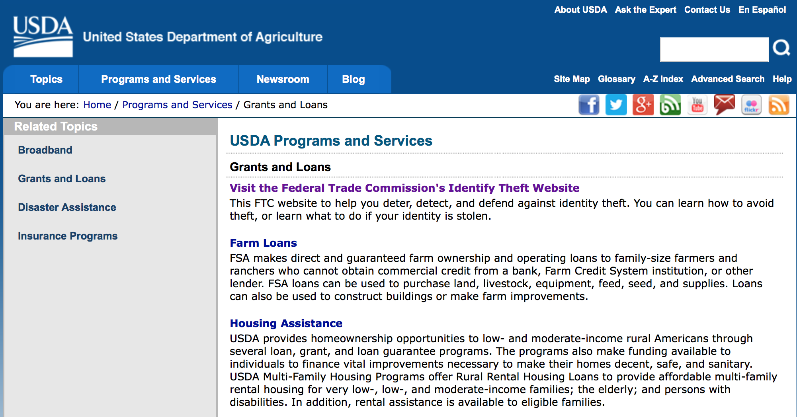
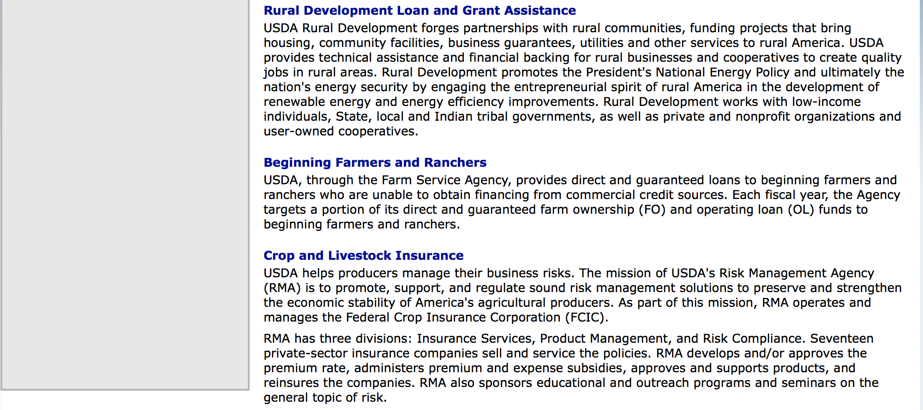

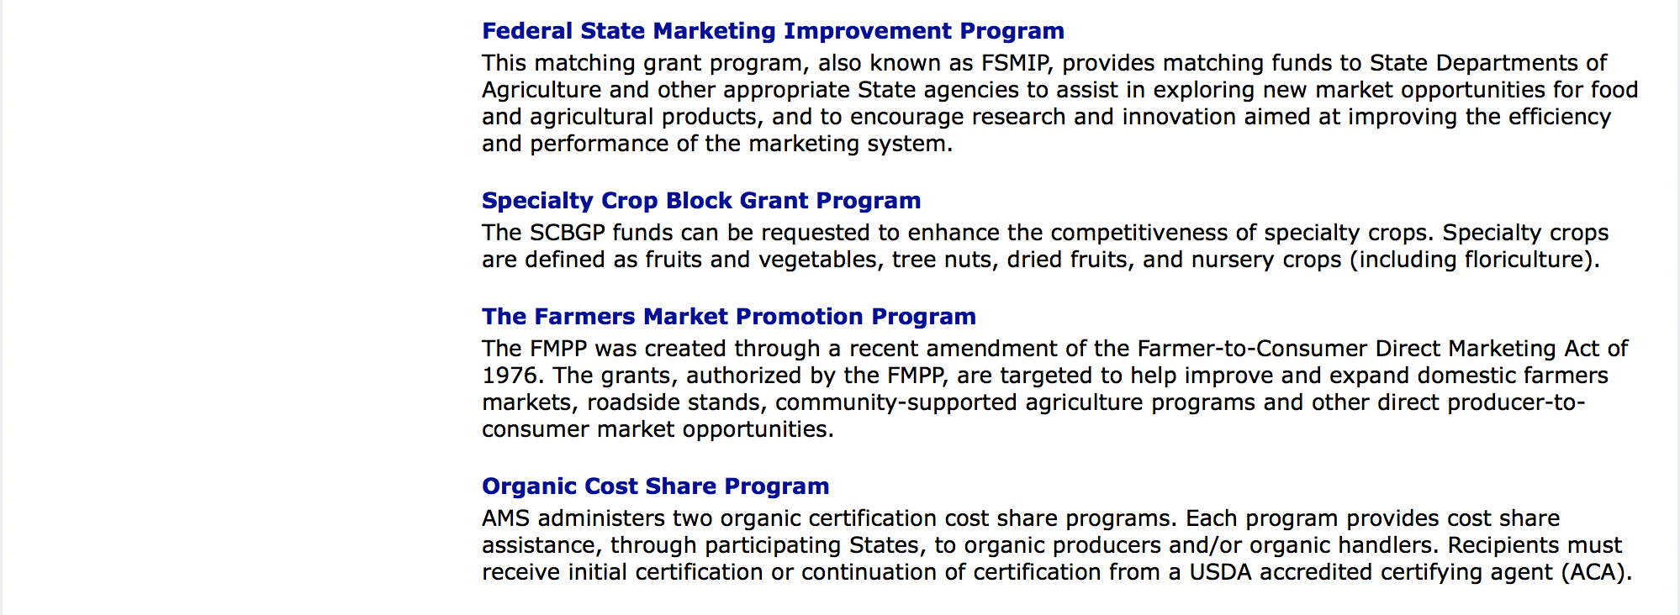

http://usda.gov/wps/portal/usda/usdahome?navid=GRANTS_LOANS

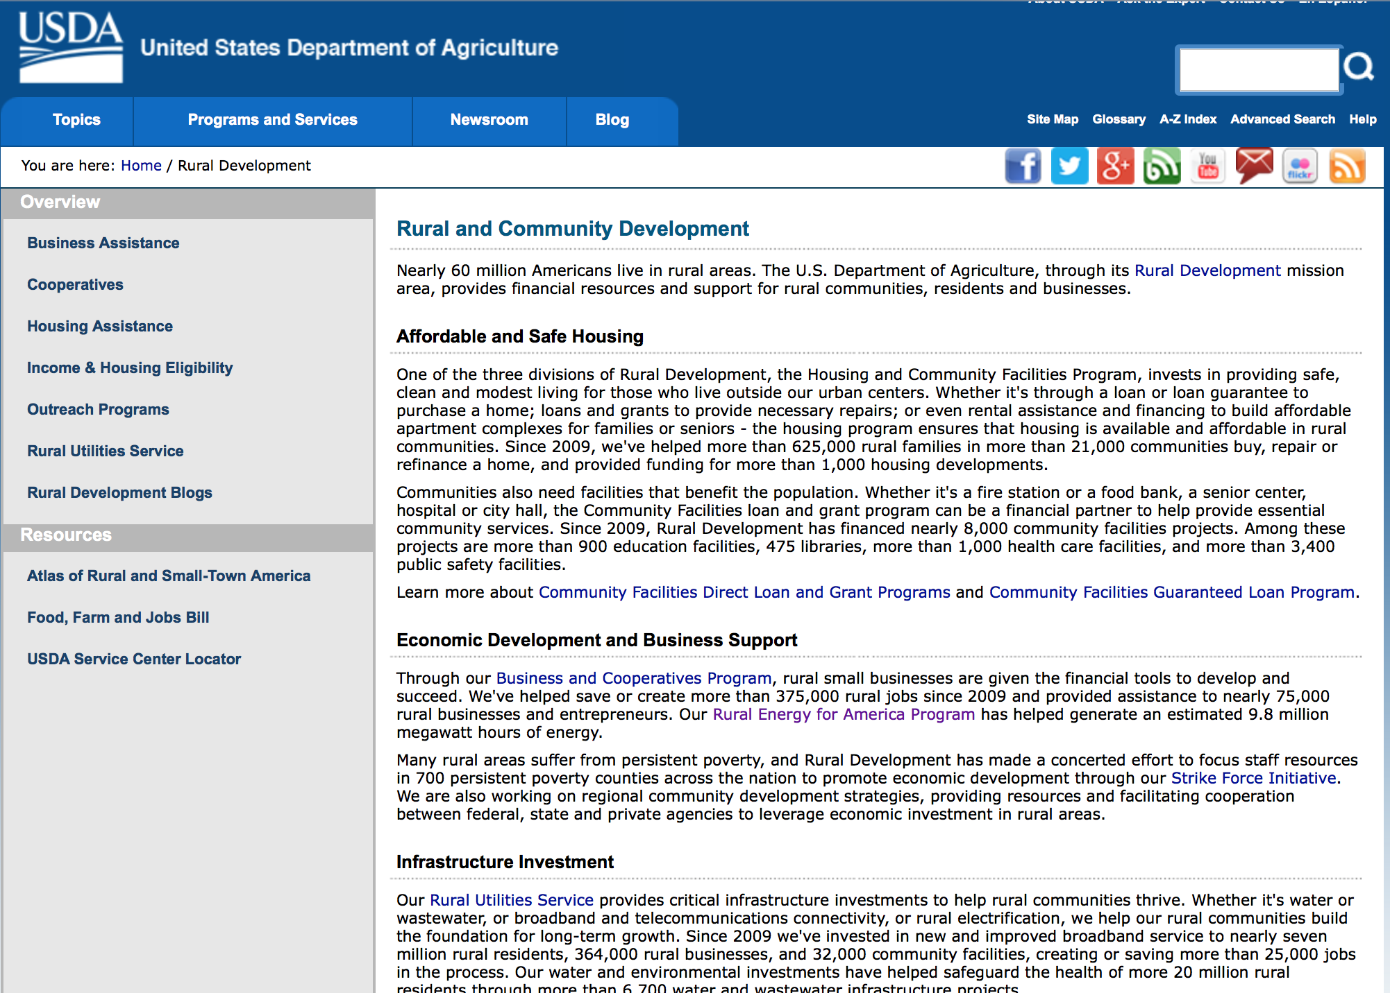

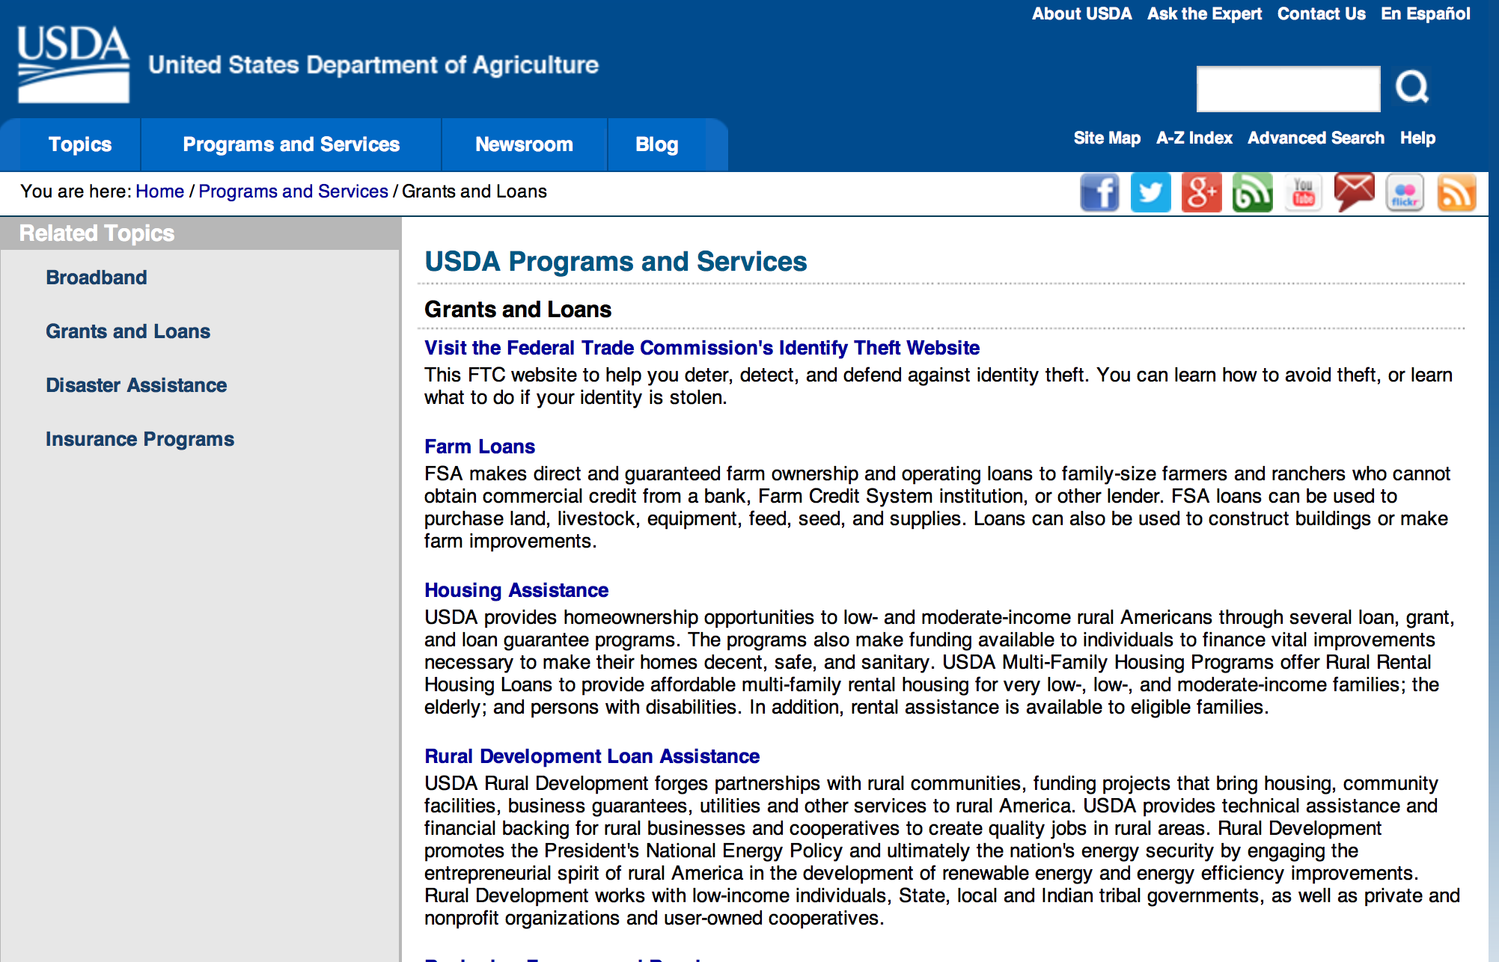

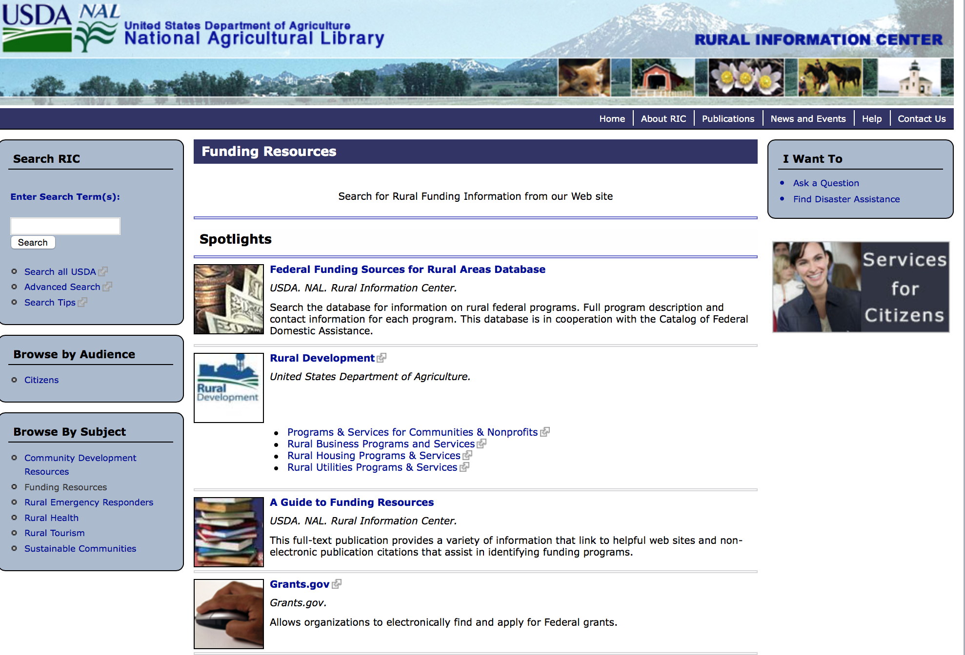

Federal Faith-Based Centers and Community Initiatives
USDA. NAL. Rural Information Center.
- Center for Faith-Based and Community Initiatives (link is external) , U.S. Department of Education
- Center for Faith-Based and Community Initiatives (link is external) , U.S. Department of Health and Human Services
- Center for Faith-Based and Community Initiatives (link is external) , U.S. Department of Labor
- Faith-Based and Community Initiatives (link is external) , U.S. Agency for International Development
- Faith-Based and Community Initiatives (link is external) , U.S. Department of Agriculture
- Faith-Based and Community Initiatives (link is external) , U.S. Department of Housing and Urban Development
- Faith-Based and Other Community Initiatives (link is external) , Corporation for National Community Service
- Task Force for Faith-Based and Community Initiatives (link is external) , U.S. Department of Justice

Grant Writing Resources
- Proposal Writing Short Course (link is external) Foundation Center.
- Data Universal Numbering System Fact sheet (link is external) [PDF | 302.2KB] USDA Rural Development.
- General Tips on Writing a Competitive Grant Proposal (link is external) U.S. Environmental Protection Agency.
- How to Write a Grant Proposal (link is external) Appalachian Regional Commission. <. li>

A Guide to Funding Resources USDA Rural Information Center.

http://ric.nal.usda.gov/funding-resources

http://usda.gov/wps/portal/usda/usdahome?navid=GRANTS_LOANS

Programs:

Modifications:

Deleted:

Reminders:

Utilities Programs
RUS SWM Grant FY 2017
Synopsis 1

Document Type: | Grants Notice
Funding Opportunity Number: | SWMFY2017
Funding Opportunity Title: | RUS SWM Grant FY 2017
Opportunity Category: | Discretionary
Opportunity Category Explanation:
Funding Instrument Type: | Grant
Category of Funding Activity: | Other (see text field entitled "Explanation of Other Category of Funding Activity" for clarification)
Category Explanation: | The Solid Waste Management (SWM) Grant Program has been established to assist communities through free technical assistance and/or training provided by the grant recipients. Qualified organizations will receive SWM grant funds to reduce or eliminate pollution of water resources in rural areas, and improve planning and management of solid waste sites in rural areas.
Expected Number of Awards: | 30
CFDA Number(s): | 10.762 -- Solid Waste Management Grants
Cost Sharing or Matching Requirement: | No
Version: | Synopsis 1
Posted Date: | Oct 01, 2016
Last Updated Date: | Sep 30, 2016
Original Closing Date for Applications: | Dec 31, 2016
Current Closing Date for Applications: | Dec 31, 2016
Archive Date: | Jan 30, 2017
Estimated Total Program Funding: | $4,000,000
Award Ceiling: | $0
Award Floor: | $0
Eligible Applicants: | Others (see text field entitled "Additional Information on Eligibility" for clarification)
Additional Information on Eligibility: | An organization is eligible to receive a SWM grant if it: a. Is a private, non-profit organization that has tax-exempt status from the United States Internal Revenue Service (IRS);b. Is a Public body; c. Is a federally acknowledged or State-recognized Native American tribe or group; d. Is an Academic institution; e. Is legally established and located within one of the following: a state within the United States; the District of Columbia; the Commonwealth of Puerto Rico; a United States territory. Has the legal capacity and authority to carry out the grant purpose; g. Has a proven record of successfully providing technical assistance and/or training to rural areas; h. Has capitalization acceptable to the Agency, and is composed of at least 51 percent of the outstanding interest or membership being citizens of the United States or individuals who reside in the United States after being legally admitted for permanent residence; i. Has no delinquent debt to the Federal Government or no outstanding judgments to repay a Federal debt; j. Demonstrates that it possesses the financial, technical, and managerial capability to comply with Federal and State laws and requirements. k. Contracts with a nonaffiliated organization for not more than 49 percent of the grant to provide the proposed assistance.
Agency Name: | Utilities Programs
Description: | Funds may be used to: Evaluate current landfill conditions to determine threats to water resources in rural areas; provide technical assistance and/or training to enhance operator skills in the maintenance and operation of active landfills in rural areas; provide technical assistance and/or training to help associations reduce the solid waste stream; and provide technical assistance and/or training for operators of landfills in rural areas which are closed or will be closed in the near future with the development/implementation of closure plans, future land use plans, safety and maintenance planning, and closure scheduling within permit requirements. Grant funds may not be used to: Recruit preapplications/applications for any loan and/or grant program including RUS Water and Waste Disposal Loan and/or Grant Program; duplication of current services, replacement or substitution of support previously provided such as those performed by an association's consultant in developing a project; fund political activities; pay for capital assets, the purchase of real estate or vehicles, improve and renovate office space, or repair and maintain privately-owned property; pay for construction or operation and maintenance costs of water and waste facilities; and pay costs incurred prior to the effective date of grants made under 7 CFR 1775.
Link to Additional Information: | Program Website address
Grantor Contact Information: | If you have difficulty accessing the full announcement electronically, please contact:  LAVONDA PERNELL Community Programs Specialist Phone 202-720-9635  government address

http://www.grants.gov/web/grants/view-opportunity.html?oppId=289284

Foreign Agricultural Service
McGovern-Dole International Food for Education and Child Nutrition Program
Synopsis 1, 2, 3 & 4

Document Type: | Grants Notice
Funding Opportunity Number: | USDA-FAS-MGD-17
Funding Opportunity Title: | McGovern-Dole International Food for Education and Child Nutrition Program
Opportunity Category: | Other
Opportunity Category Explanation: | Food for Education, Food Assistance, School Feeding, Child Nutrition, Teacher Training, Gender Equity
Funding Instrument Type: | Cooperative Agreement
Category of Funding Activity: | Agriculture  Community Development  Education  Other (see text field entitled "Explanation of Other Category of Funding Activity" for clarification)
Category Explanation: | Food for Education, Food Assistance, School Feeding, Child Nutrition, Teacher Training, Gender Equity
Expected Number of Awards: | 7
CFDA Number(s): | 10.608 -- Food for Education
Cost Sharing or Matching Requirement: | No
Version: | Synopsis 3
Posted Date: | Oct 24, 2016
Last Updated Date: | Oct 27, 2016
Original Closing Date for Applications: | Jan 24, 2017
Current Closing Date for Applications: | Jan 21, 2017
Archive Date: | Feb 23, 2017
Estimated Total Program Funding: | $200,000,000
Eligible Applicants: | Others (see text field entitled "Additional Information on Eligibility" for clarification)
Additional Information on Eligibility: | Private voluntary organizations, Cooperatives, Intergovernmental organizations, Foreign governments
Agency Name: | Foreign Agricultural Service
Description: | The McGovern-Dole International Food for Education and Child Nutrition Program (McGovern-Dole) provides for the financial and technical assistance to improve the education, food security, and health of school-age children, especially girls in developing countries. U.S. agreements with private voluntary organizations, cooperatives, intergovernmental organizations and foreign governments who implement the school feeding and educational improvement projects.
Link to Additional Information: | USDA Foreign Agricultural Service Food Assistance Information System
Grantor Contact Information: | If you have difficulty accessing the full announcement electronically, please contact:  Ansu John Writer Phone 202-6493862  email of person writing opportunity synopsis

http://www.grants.gov/web/grants/view-opportunity.html?oppId=289674

National Institute of Food and Agriculture
Food Insecurity Nutrition Incentive (FINI) Grant Program
Synopsis 1

Document Type: | Grants Notice
Funding Opportunity Number: | USDA-NIFA-FINI-006104
Funding Opportunity Title: | Food Insecurity Nutrition Incentive (FINI) Grant Program
Opportunity Category: | Discretionary
Opportunity Category Explanation:
Funding Instrument Type: | Grant
Category of Funding Activity: | Agriculture
Category Explanation:
Expected Number of Awards:
CFDA Number(s): | 10.331 -- Food Insecurity Nutrition Incentive Grants Program
Cost Sharing or Matching Requirement: | Yes
Version: | Synopsis 1
Posted Date: | Oct 20, 2016
Last Updated Date: | Oct 20, 2016
Original Closing Date for Applications: | Dec 12, 2016
Current Closing Date for Applications: | Dec 12, 2016
Archive Date: | Jan 11, 2017
Estimated Total Program Funding: | $16,700,000
Award Ceiling: | $500,000
Award Floor: | $100,000
Eligible Applicants: | Others (see text field entitled "Additional Information on Eligibility" for clarification)
Additional Information on Eligibility: | Applications may only be submitted by government agencies and non-profit organizations.
Agency Name: | National Institute of Food and Agriculture
Description: | To support projects to increase the purchase of fruits and vegetables among low-income consumers participating in the Supplemental Nutrition Assistance Program (SNAP) by providing incentives at the point of purchase.
Link to Additional Information: | Food Insecurity Nutrition Incentive (FINI) Grant Program
Grantor Contact Information: | If you have difficulty accessing the full announcement electronically, please contact:  NIFA Help Desk Phone: 202-401-5048 Business hours are M-F, 7:00 am -5:00 pm ET, excluding Federal holidays  If you have any questions related to preparing application content

http://www.grants.gov/web/grants/view-opportunity.html?oppId=289612

Foreign Agricultural Service
Food for Progress Program
Synopsis 1, 2, 3, & 4

Document Type: | Grants Notice
Funding Opportunity Number: | USDA-FAS-FFPR-17
Funding Opportunity Title: | Food for Progress Program
Opportunity Category: | Discretionary
Opportunity Category Explanation:
Funding Instrument Type: | Cooperative Agreement
Category of Funding Activity: | Agriculture  Community Development  Employment, Labor and Training  Food and Nutrition  Regional Development
Category Explanation:
Expected Number of Awards: | 6
CFDA Number(s): | 10.606 -- Food for Progress
Cost Sharing or Matching Requirement: | No
Version: | Synopsis 4
Posted Date: | Oct 24, 2016
Last Updated Date: | Nov 07, 2016
Original Closing Date for Applications: | Jan 24, 2017
Current Closing Date for Applications: | Jan 19, 2017
Archive Date: | Feb 23, 2017
Estimated Total Program Funding: | $145,000,000
Eligible Applicants: | Others (see text field entitled "Additional Information on Eligibility" for clarification)
Additional Information on Eligibility: | Private voluntary organizations, cooperatives, intergovernmental organizations, foreign governments
Agency Name: | Foreign Agricultural Service
Description: | The Food for Progress program provides for the donation of U.S. agricultural commodities to developing countries and emerging democracies that are committed to introducing or expanding free enterprise in their agricultural economies. Donated U.S. commodities are typically 'monetized' (sold on the local market in the beneficiary country) and the proceeds are used to fund agricultural development activities
Link to Additional Information: | USDA Foreign Agricultural Service Food Aid Information System Web site
Grantor Contact Information: | If you have difficulty accessing the full announcement electronically, please contact:  Ansu John Writer Phone 202-6493862  email of synposis author

http://www.grants.gov/web/grants/view-opportunity.html?oppId=289675

National Institute of Food and Agriculture
Organic Agriculture Research and Extension Initiative
Synopsis 1

Document Type: | Grants Notice
Funding Opportunity Number: | USDA-NIFA-ICGP-006124
Funding Opportunity Title: | Organic Agriculture Research and Extension Initiative
Opportunity Category: | Mandatory
Opportunity Category Explanation:
Funding Instrument Type: | Grant
Category of Funding Activity: | Agriculture
Category Explanation:
Expected Number of Awards:
CFDA Number(s): | 10.307 -- Organic Agriculture Research and Extension Initiative
Cost Sharing or Matching Requirement: | Yes
Version: | Synopsis 1
Posted Date: | Oct 21, 2016
Last Updated Date: | Oct 21, 2016
Original Closing Date for Applications: | Jan 19, 2017
Current Closing Date for Applications: | Jan 19, 2017
Archive Date: | Feb 18, 2017
Estimated Total Program Funding: | $17,624,076
Award Ceiling: | $2,000,000
Award Floor: | $50,000
Eligible Applicants: | Others (see text field entitled "Additional Information on Eligibility" for clarification)
Additional Information on Eligibility: | The following entities are eligible to apply for and receive a grant under this program. 1. State agricultural experiment stations; 2. Colleges and universities; 3. University research foundations; 4. Other research institutions and organizations; 5. Federal agencies; 6. National laboratories; 7. Private organizations, foundations, or corporations; 8. Individuals who are United States citizens or nationals; or 9. A group consisting of two or more of the entities described in subparagraphs (1) through (8).
Agency Name: | National Institute of Food and Agriculture
Description: | The OREI seeks to solve critical organic agriculture issues, priorities, or problems through the integration of research, education, and extension activities. The purpose of this program is to fund projects that will enhance the ability of producers and processors who have already adopted organic standards to grow and market high quality organic agricultural products. Priority concerns include biological, physical, and social sciences, including economics. The OREI is particularly interested in projects that emphasize research, education and outreach that assist farmers and ranchers with whole farm planning by delivering practical research-based information. Projects should plan to deliver applied production information to producers. Fieldwork must be done on certified organic land or on land in transition to organic certification, as appropriate to project goals and objectives. Refer to the USDA National Organic Program (http://www.ams.usda.gov/nop) for organic production standards.
Link to Additional Information: | Organic Agriculture Research and Extension Initiative
Grantor Contact Information: | If you have difficulty accessing the full announcement electronically, please contact:  NIFA Help Desk Phone: 202-401-5048 Business hours are M-F, 7:00 am -5:00 pm ET, excluding Federal holidays  If you have any questions related to preparing application content

http://www.grants.gov/web/grants/view-opportunity.html?oppId=289645

Forest Service
Wood Innovations
Synopsis 1

Document Type: |  | Grants Notice
Funding Opportunity Number: |  | USDA-FS-WERC-2017
Funding Opportunity Title: |  | Wood Innovations
Opportunity Category: |  | Discretionary
Opportunity Category Explanation:
Funding Instrument Type: |  | Cooperative Agreement  Grant
Category of Funding Activity: |  | Agriculture  Business and Commerce  Energy  Natural Resources
Category Explanation:
Expected Number of Awards: |  | 40
CFDA Number(s): |  | 10.674 -- Wood Utilization Assistance
Cost Sharing or Matching Requirement: |  | Yes
Posted Date: |  | Oct 19, 2016
Last Updated Date: |  | Oct 18, 2016
Original Closing Date for Applications: |  | Jan 23, 2017
Current Closing Date for Applications: |  | Jan 23, 2017
Archive Date: |  | Feb 22, 2017
Estimated Total Program Funding: |  | $7,000,000
Award Ceiling: |  | $250,000
Award Floor: |  | $10,000
Eligible Applicants: |  | Others (see text field entitled "Additional Information on Eligibility" for clarification)
Additional Information on Eligibility: |  | Eligible applicants are for-profit entities; State, local, and Tribal governments; school districts; communities; not-for-profit organizations; or special purpose districts (e.g., public utilities districts, fire districts, conservation districts, or ports).
Agency Name: | Forest Service
Description: | Instructions and application can be viewed and downloaded at http://www.na.fs.fed.us/werc/wip/2017-rfp.shtm.
Link to Additional Information: | USDA Forest Service web site
Grantor Contact Information: | If you have difficulty accessing the full announcement electronically, please contact:  Edward Cesa Deputy Director - WERC Phone 304-285-1530  Federal e-mail address

http://www.grants.gov/web/grants/view-opportunity.html?oppId=289592

Natural Resources Conservation Service
2017 National Conservation Innovation Grants APF
Synopsis 2

Document Type: | Grants Notice
Funding Opportunity Number: | USDA-NRCS-NHQ-CIG-17-01
Funding Opportunity Title: | 2017 National Conservation Innovation Grants APF
Opportunity Category: | Discretionary
Opportunity Category Explanation:
Funding Instrument Type: | Grant
Category of Funding Activity: | Agriculture  Environment  Natural Resources
Category Explanation:
Expected Number of Awards: | 60
CFDA Number(s): | 10.912 -- Environmental Quality Incentives Program
Cost Sharing or Matching Requirement: | Yes
Version: | Synopsis 2
Posted Date: | Nov 03, 2016
Last Updated Date: | Nov 07, 2016
Original Closing Date for Applications: | Jan 09, 2017
Current Closing Date for Applications: | Jan 09, 2017
Archive Date: | Feb 28, 2017
Estimated Total Program Funding: | $25,000,000
Award Ceiling: | $2,000,000
Award Floor: | $0
Eligible Applicants: | For profit organizations other than small businesses  Individuals  Private institutions of higher education  Native American tribal governments (Federally recognized)  Special district governments  State governments  Small businesses  Nonprofits having a 501(c)(3) status with the IRS, other than institutions of higher education  Public and State controlled institutions of higher education  City or township governments  County governments
Agency Name: | Natural Resources Conservation Service
Description: | Overview: The purpose of CIG is to stimulate the development and adoption of innovative conservation approaches and technologies, while leveraging the Federal investment in environmental enhancement and protection in conjunction with agricultural production. CIG projects are expected to lead to the transfer of conservation technologies, management systems, and innovative approaches (such as market-based systems) to EQIP eligible producers, into NRCS technical manuals and guides, or to the private sector. CIG is used to apply or demonstrate previously proven technology in order to increase adoption, with an emphasis on opportunities to scale proven, emerging conservation strategies. CIG promotes the sharing of skills, knowledge, technologies, and facilities among communities, governments, and other institutions to ensure that scientific and technological developments are accessible to a wider range of users. CIG projects targeting innovative on-the-ground conservation, including pilot projects, field demonstrations, and on-farm conservation research. On-farm conservation research is defined as an investigation conducted to answer a specific conservation-related question using a statistically valid design while employing farm-scale equipment on farm fields. Specifically, a valid study design will use an appropriate number of replications and statistical analysis of results. To the extent NRCS funds research projects through CIG, the agency will only fund on-farm research projects that stimulate innovative approaches to natural resource management in conjunction with agricultural production. NRCS will accept proposals under this notice for single or multiyear projects, not to exceed 3 years, submitted by eligible entities from any of the 50 States, the District of Columbia, the Caribbean Area (Puerto Rico and the U.S. Virgin Islands), or the Pacific Islands Area (Guam, American Samoa, and the Commonwealth of the Northern Mariana Islands). Eligible entities include Indian Tribes, State and local units of government, non-governmental organizations, and individuals. Complete proposals received by the deadline will be evaluated through a two-tier review process. The first-tier review will be performed by a technical peer review panel based on the Proposal Evaluation Criteria identified in the instructions in section V, part B. For the second-tier review, full proposals, along with evaluations from the technical peer review panel and State Conservationist, will be forwarded to the Grants Review Board. The Grants Review Board will make its recommendations for project approval to the NRCS Chief who will make the final selections.
Link to Additional Information: | NRCS CIG Homepage
Grantor Contact Information: | If you have difficulty accessing the full announcement electronically, please contact:  Melleny Cotton (Technical Contact) USDA, NRCS 1400 Independence Ave., SW Rm. 6141S Washington, DC 20250 Tel: 202-7207412 Email: Melleny.Cotton@wdc.usda.gov Frankie Comfort (Admin. Contact) USDA, NRCS 1400 Independence Avenue, SW Rm. 6819S Washington, DC 20250 Tel: 202-720-0242 Email: Frankie.Comfort@wdc.usda.gov  Administrative Point of Contact

http://www.grants.gov/web/grants/view-opportunity.html?oppId=289864

Fish and Wildlife Service
2017 National Fish Habitat Action Plan
Synopsis 1

Document Type: | Grants Notice
Funding Opportunity Number: | F17AS00016
Funding Opportunity Title: | 2017 National Fish Habitat Action Plan
Opportunity Category: | Discretionary
Opportunity Category Explanation:
Funding Instrument Type: | Cooperative Agreement  Grant
Category of Funding Activity: | Natural Resources
Category Explanation:
Expected Number of Awards: | 70
CFDA Number(s): | 15.608 -- Fish and Wildlife Management Assistance
Cost Sharing or Matching Requirement: | No
Posted Date: | Nov 08, 2016
Last Updated Date: | Nov 08, 2016
Original Closing Date for Applications: | Applications are accepted on a rolling basis.
Current Closing Date for Applications: | Applications are accepted on a rolling basis.
Archive Date: | May 31, 2017
Estimated Total Program Funding: | $0
Award Ceiling: | $300,000
Award Floor: | $5,000
Eligible Applicants: | Unrestricted (i.e., open to any type of entity above), subject to any clarification in text field entitled "Additional Information on Eligibility"
Additional Information on Eligibility: | Applications are accepted on a rolling basis.
Agency Name: | Fish and Wildlife Service
Description: | The National Fish Habitat Action Plan is a national investment strategy to leverage federal and privately raised funds to protect, restore, and enhance the nation's fish and aquatic habitats through partnerships that foster fish habitat conservation. Funds appropriated to the U.S. Fish and Wildlife Service's (Service) Fish and Aquatic Conservation (FAC) Program specifically to implement the Action Plan will be utilized in collaboration with the National Fish Habitat Board and Fish Habitat Partnerships. Fish Habitat Partnerships are the primary work units of the Action Plan, formed around distinct geographic areas, "keystone" fish species, or system types (e.g. large lakes, impoundments, estuaries). Funds will support national and regional science and coordination activities to protect, restore, or enhance fish habitats. All or a portion or project funds may be transferred to partner organizations if the Service lacks the capability to implement a project. Projects must protect, restore, or enhance fish and aquatic habitats or otherwise directly support habitat-related priorities of Fish Habitat Partnerships or the National Fish Habitat Board. Every project must be identified in the Fisheries Operational Needs System (FONS), a database that identifies the operational needs of FAC field stations, including fish habitat project needs. FAC field offices will work with Fish Habitat Partnerships to identify fish habitat projects, and enter them into the FONS. Entities that seek to propose a fish habitat conservation project for consideration should contact a local or regional office of the Service FAC Program.
Link to Additional Information: | http://www.grants.gov
Grantor Contact Information: | If you have difficulty accessing the full announcement electronically, please contact:  Cecilia Lewis 703-358-2102 Cecilia_Lewis@fws.gov  Fish Biologist

http://www.grants.gov/web/grants/view-opportunity.html?oppId=289987

Department of Commerce

Grants, Contracting, and Trade Opportunities at Commerce
Learn more information about grants, contracting and trade opportunities at the Department of Commerce using the information below.

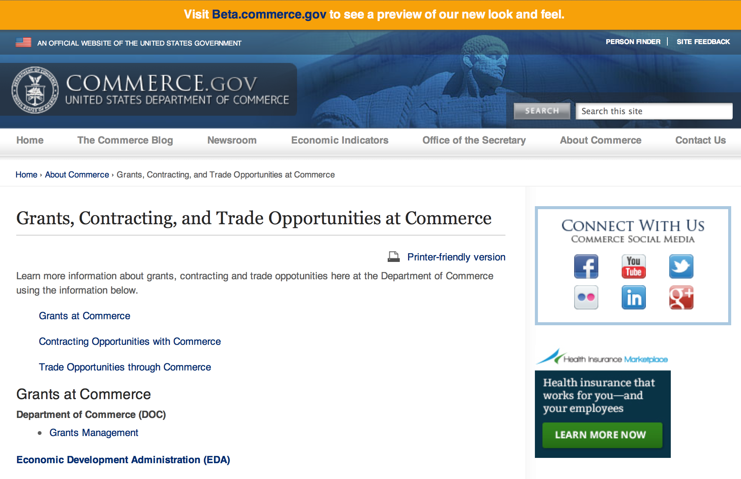
Grants at Commerce
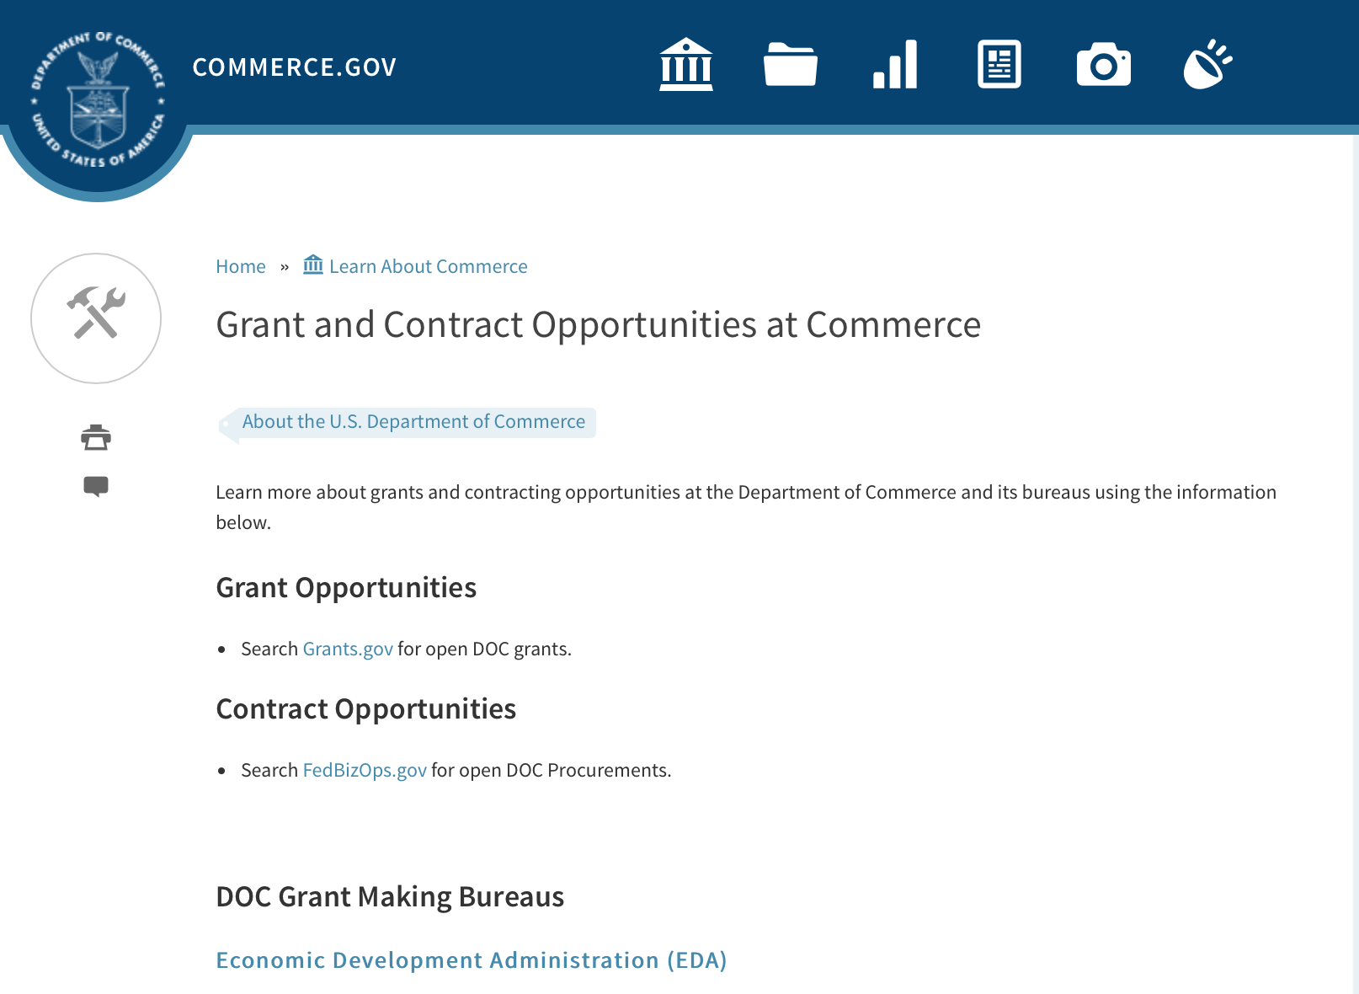

DOC Grant Making Bureaus
Economic Development Administration (EDA)
International Trade Administration (ITA)
- Market Development Cooperator Program
- Special American Business Internship Training Program (SABIT). A technical assistance initiative of the International Trade Administration of the U.S. Department of Commerce, SABIT offers organizations competitive grants and an opportunity to host industry-specific delegations. SABIT serves as an initial entry point for U.S. businesses seeking funding to establish long-term relationships with potential customers, distributors, or partners in the former Soviet Union. The program trains Eurasian managers and scientists in commonly accepted business practices as a means of facilitating cross border relationships. In turn, these personal relationships serve as a basis for business development and reduce market access barriers for U.S. businesses
National Institute of Standards & Technology (NIST)
- Funding Opportunities
National Telecommunications & Information Administration (NTIA)
- Telecommunications Grants
National Oceanic & Atmospheric Administration (NOAA)
- Coastal Ocean Program Grant Information
- Fisheries Saltonstall Kennedy Grant Program
- National Undersea Research Program Funding Opportunities
- Grants Management Division
- Fisheries Grants Program
- National Sea Grant
- Office of Global Programs
Contracting Resources for Contractors
- Office of Small and Disadvantaged Business Utilization (OSDBU) - he Office of Small and Disadvantaged Business Utilization (OSDBU) is an advocacy and advisory office responsible for promoting the use of small, small disadvantaged, 8(a), women-owned, veteran-owned, service-disabled veteran-owned, and HUBZone small businesses within the U.S. Department of Commerce's (DOC) acquisition process.
- Business.USA.gov's Find Opportunities Wizard where in a few quick steps, it will guide you towards federal government contracting programs and opportunities for your business!
- Planned Acquisitions: the Department of Commerce's search tool for our planned acquisitions over $100,000. As requirements change, these acquisition plans are updated by department personnel and this search tool is automatically updated.
- Small Business Administration's Contracting section of their web site where you can learn about how to "Get Started" and "Contracting Support for Small Business"
- The General Services Administration (GSA) has implemented a system for vendors doing business with the Federal Government to manage their entity information in one central location. This new database is the System for Award Management (SAM).

DOC Contracting Offices
- Patent and Trademark Office (PTO)
  - Office of Procurement
- National Institute of Standards & Technology (NIST)
NIST Acquisition Management Group
Contracting Opportunities with Commerce
Trade Opportunities through Commerce
http://www.commerce.gov/about-commerce/grants-contracting-trade-opportunities

Programs:

FY17-19 Habitat Blueprint – Coastal and Marine Habitat Focus Area Cooperative Agreements
Synopsis 1

Document Type: | Grants Notice
Funding Opportunity Number: | NOAA-NMFS-HCPO-2017-2005105
Funding Opportunity Title: | FY17-19 Habitat Blueprint – Coastal and Marine Habitat Focus Area Cooperative Agreements
Opportunity Category: | Discretionary
Opportunity Category Explanation:
Funding Instrument Type: | Cooperative Agreement
Category of Funding Activity: | Environment  Natural Resources  Science and Technology and other Research and Development
Category Explanation:
Expected Number of Awards:
CFDA Number(s): | 11.463 -- Habitat Conservation
Cost Sharing or Matching Requirement: | No
Posted Date: | Dec 02, 2016
Last Updated Date: | Dec 02, 2016
Original Closing Date for Applications: | Feb 02, 2017
Current Closing Date for Applications: | Feb 02, 2017
Archive Date: | Mar 04, 2017
Estimated Total Program Funding: | $1,500,000
Award Ceiling: | $650,000
Award Floor: | $150,000
Eligible Applicants: | Others (see text field entitled "Additional Information on Eligibility" for clarification)
Additional Information on Eligibility: | Eligible applicants are institutions of higher education, non-profits, commercial (for-profit) organizations, U.S. territories, and state, local and Native American tribal governments. Applications from federal agencies or employees of federal agencies will not be considered. Federal agencies are strongly encouraged to work with states, non-governmental organizations, municipal and county governments, and others that are eligible to apply.
Agency Name: | Department of Commerce
Description: | The principal objective of the National Oceanic and Atmospheric Administration's (NOAA) FY17-19 Habitat Blueprint - Coastal and Marine Habitat Focus Area Cooperative Agreements solicitation is to identify and support comprehensive and cooperative habitat conservation projects in NOAA Habitat Focus Areas (HFAs) that sustain resilient and thriving marine and coastal resources, communities, and economies. Proposals submitted under this solicitation will be selected based on their ability to demonstrate success in achieving the NOAA Habitat Blueprint’s primary goals within nine of the HFAs: Biscayne Bay, Florida; Choptank River, Maryland/Delaware; Kachemak Bay, Alaska; Manell-Geus, Guam; Muskegon Lake Michigan; Northeast Marine Corridor and Culebra Island, Puerto Rico; Penobscot River, Maine; Russian River, California; and West Hawaii, Hawaii. Specific objectives vary from HFA to HFA, and have been selected to effectively protect and/or restore high-priority habitat for managed fisheries, protected species, and other coastal and marine life; foster resilient coastal communities; advance habitat science; and/or lead to increased socio-economic benefits. HFA - specific priorities are identified in this federal funding opportunity, and successful proposals will: 1) address issues/concerns contributing to the loss or deterioration of coastal or marine habitats; 2) identify the project’s outcome(s) and goal(s) and describing in detail the actions and project(s) to be undertaken to achieve those goals; and 3) describe the measurable impact on the issue/concern, including proposed evaluation techniques.
Link to Additional Information:
Grantor Contact Information: | If you have difficulty accessing the full announcement electronically, please contact:  Liz Fairey NOAA Fisheries Office of Habitat Conservation 1315 East West Highway SSMC3, 14224 Silver Spring, MD, 20910 301-427-8632 Liz.Fairey@noaa.gov  Work

http://www.grants.gov/web/grants/view-opportunity.html?oppId=290437

Research:

Modifications:

National Estuarine Research Reserve System (NERRS) Land Acquisition and Construction Program for Fiscal Year 2017
Synopsis 2

Document Type: | Grants Notice
Funding Opportunity Number: | NOAA-NOS-OCM-2017-2005115
Funding Opportunity Title: | National Estuarine Research Reserve System (NERRS) Land Acquisition and Construction Program for Fiscal Year 2017
Opportunity Category: | Discretionary
Opportunity Category Explanation:
Funding Instrument Type: | Grant
Category of Funding Activity: | Environment  Natural Resources  Science and Technology and other Research and Development
Category Explanation:
Expected Number of Awards: | 10
CFDA Number(s): | 11.420 -- Coastal Zone Management Estuarine Research Reserves
Cost Sharing or Matching Requirement: | Yes
Version: | Synopsis 2
Posted Date: | Nov 15, 2016
Last Updated Date: | Nov 30, 2016
Original Closing Date for Applications: | Feb 03, 2018
Current Closing Date for Applications: | Feb 03, 2017
Archive Date: | Mar 05, 2018
Estimated Total Program Funding: | $1,700,000
Award Ceiling: | $800,000
Award Floor: | $20,000
Eligible Applicants: | Others (see text field entitled "Additional Information on Eligibility" for clarification)
Additional Information on Eligibility: | Eligible applicants are NERRS lead state agencies or universities designated to receive NERRS operations funding through a Memorandum of Understanding with NOAA in coastal states including the Pacific, Gulf, Atlantic Coast and Great Lakes. Eligible applicants should meet requirements as stated in the NERRS regulations codified at 15 CFR 921.32 which are available on line at http://go.usa.gov/xkGEf.Federal agencies and employees are not allowed to receive funds under this announcement but may serve as collaborative project partners. Federal agencies and employees’ ‘in-kind’ services cannot be considered as part of an applicant’s match on shared costs. If federal agencies are collaborators, applicants are expected to provide detail on the planned level of federal engagement in the application. Examples might include, but are not limited to partnership services; serving in a review capacity; or participating in priority task teams, working groups, or leadership teams.
Agency Name: | Department of Commerce
Description: | The National Estuarine Research Reserve System (NERRS or System) consists of estuarine areas of the United States and its territories designated and managed for research and educational purposes. Each Reserve within the system is chosen to represent a different bio-geographic region and to include a variety of ecosystem types in accordance with the classification scheme of the national program as specified in 15 CFR Part 921 By funding Reserve lead agencies and universities to conduct land acquisition and construction projects that support the NERRS mission, NOAA will strengthen protection of key land and water areas, enhance long-term protection of Reserve areas for research and education, and provide for facility and exhibit construction that meet the highest sustainable design standards possible. NOAA anticipates approximately $1.7 million in Fiscal Year 2017 will be available to designated lead Reserve agencies or universities in coastal states for approximately 1-10 construction and acquisition projects, and expected to range from approximately $20,000 to $800,000 per project and with project periods typically covering 12-36 months, depending on the availability of funds.
Link to Additional Information:
Grantor Contact Information: | If you have difficulty accessing the full announcement electronically, please contact:  Nina Garfield Program Coordinator, NOAA/Office for Coastal Management 1305 East-West Highway, SSMC4, 10th Floor Silver Spring, MD 20910 Phone 240-533-0817 Email: Nina.Garfield@noaa.gov or Erica Seiden at 240-533-0781 E-mail Erica.Seiden@noaa.gov.  Work

http://www.grants.gov/web/grants/view-opportunity.html?oppId=290106

FY 2017 Joint Technology Transfer Initiative
Synopsis 2

Document Type: | Grants Notice
Funding Opportunity Number: | NOAA-OAR-OWAQ-2017-2005122
Funding Opportunity Title: | FY 2017 Joint Technology Transfer Initiative
Opportunity Category: | Discretionary
Opportunity Category Explanation:
Funding Instrument Type: | Cooperative Agreement
Category of Funding Activity: | Environment  Natural Resources  Science and Technology and other Research and Development
Category Explanation:
Expected Number of Awards: | 13
CFDA Number(s): | 11.459 -- Weather and Air Quality Research
Cost Sharing or Matching Requirement: | No
Version: | Synopsis 2
Posted Date: | Nov 15, 2016
Last Updated Date: | Nov 22, 2016
Original Closing Date for Applications: | Feb 09, 2017
Current Closing Date for Applications: | Feb 09, 2017
Archive Date: | Mar 11, 2017
Estimated Total Program Funding: | $2,000,000
Award Ceiling: | $300,000
Award Floor: | $150,000
Eligible Applicants: | Others (see text field entitled "Additional Information on Eligibility" for clarification)
Additional Information on Eligibility: | Eligible applicants are institutions of higher education; other nonprofit organizations; and commercial organizations.
Agency Name: | Department of Commerce
Description: | Through the Joint Technology Transfer Initiative (JTTI) Program, OAR's Office of Weather and Air Quality (OWAQ) is soliciting proposals to conduct research and development activities related to advancing the convective scale modeling and water prediction over the coming 1 to 2 years.
Link to Additional Information:
Grantor Contact Information: | If you have difficulty accessing the full announcement electronically, please contact:  Chandra Kondragunta 301-734-1034 Office of Weather and Air Quality, Office of Oceanic and Atmospheric Research, 1315 East-West Hwy, Silver Spring, MD 20910-3282  Work

http://www.grants.gov/web/grants/view-opportunity.html?oppId=290109

Deleted:

Reminders:

NOAA Climate Program Office’s Regional Integrated Sciences and Assessments (RISA) Program
Synopsis 1

Document Type: | Grants Notice
Funding Opportunity Number: | NOAA-OAR-CPO-2017-2005017
Funding Opportunity Title: | NOAA Climate Program Office’s Regional Integrated Sciences and Assessments (RISA) Program
Opportunity Category: | Discretionary
Opportunity Category Explanation:
Funding Instrument Type: | Cooperative Agreement
Category of Funding Activity: | Environment  Natural Resources  Science and Technology and other Research and Development
Category Explanation:
Expected Number of Awards: | 10
CFDA Number(s): | 11.431 -- Climate and Atmospheric Research
Cost Sharing or Matching Requirement: | No
Posted Date: | Nov 01, 2016
Last Updated Date: | Nov 01, 2016
Original Closing Date for Applications: | Feb 06, 2017
Current Closing Date for Applications: | Feb 06, 2017
Archive Date: | Mar 08, 2017
Estimated Total Program Funding: | $3,500,000
Award Ceiling: | $700,000
Award Floor: | $1
Eligible Applicants: | Others (see text field entitled "Additional Information on Eligibility" for clarification)
Additional Information on Eligibility: | Eligible applicants are institutions of higher education, other nonprofits, commercial organizations, international organizations, and state, local and Indian tribal governments. Federal lead investigators who wish to apply to this Announcement of Opportunity must prepare a proposal according to the FFO guidelines and submit the proposal to the program manager directly, instead of to Grants.gov. Federal co-investigators must submit a proposal identical to the proposal lead's but with personalized budget information.
Agency Name: | Department of Commerce
Description: | The NOAA Climate Program Office’s (CPO) Regional Integrated Sciences and Assessments (RISA) program supports research teams that conduct innovative, interdisciplinary, user-inspired, and regionally relevant research that informs resource management and public policy. CPO funds a network of RISA teams across the United States (US) and Pacific Islands, which is a model for interdisciplinary science and assessment. NOAA’s RISA program is overseen by CPO’s Climate and Societal Interactions (CSI) division. CSI’s mission is to inform improvements in resilience and preparedness in diverse socio-economic regions and sectors throughout the US and abroad through the use of climate knowledge and information. Our research advances the nation’s understanding of climate-related risks and vulnerabilities across sectors and regions, and the development of tools to foster more informed decision making. These efforts support NOAA's vision to create and sustain enhanced resilience in ecosystems, communities, and economies. In addition to RISA, CSI’s programs include the International Research and Applications Project (IRAP), the Sectoral Applications Research Program (SARP), and the Coastal and Ocean Climate Applications program (COCA). CSI is also an active partner with NOAA efforts to provide integrated regional climate services. This partnership brings together NOAA Regional Climate Services Directors (RCSDs), other NOAA offices, and close external partners such as RISA teams, Regional Climate Centers, State Climatologists, and Sea Grant to help make climate information relevant and accessible to people across the US. NOAA seeks to marshal climate assets and partners towards the common goal of assessing regional needs and vulnerabilities and then supporting the development and delivery of timely climate services that aid adaptation and mitigation choices. RISA and CSI activities address the societal challenges identified in NOAA’s Next-Generation Strategic Plan (NGSP): i) climate impacts on water resources; ii) coasts and climate resilience; iii) sustainability of marine ecosystems; and iv) changes in the extremes of weather and climate. These efforts support NOAA’s vision to create and sustain enhanced resilience in ecosystems, communities, and economies, as outlined in the NGSP. In FY 2017, RISA is holding two competitions for research funding focused on three geographies. We are soliciting proposals for: 1) Competition 1: a RISA team focused on the Arizona/New Mexico region of the US; and 2) Competition 2: a RISA team focused on either the California/Nevada region of the US or on the Midwestern region of the US. We estimate that $3-$3.5 million over five years will be available for each competition, pending available funding and budget appropriations. Awards will be at a funding level of $600,000-$700,000 per year for up to 5 years. Please download the RISA Information Sheet for more detailed information (http://www.cpo.noaa.gov/risa/).
Link to Additional Information:
Grantor Contact Information: | If you have difficulty accessing the full announcement electronically, please contact:  Please visit the RISA website for further information at or contact the RISA Program Managers, by mail (see address above) or at oar.cpo.risa@noaa.gov. Please allow up to two weeks after receipt for a response.  Work

http://www.grants.gov/web/grants/view-opportunity.html?oppId=289851

Fiscal Year 2018 National Sea Grant College Program Dean John A. Knauss Marine Policy Fellowship
Synopsis 1

Document Type: | Grants Notice
Funding Opportunity Number: | NOAA-OAR-SG-2018-2004993
Funding Opportunity Title: | Fiscal Year 2018 National Sea Grant College Program Dean John A. Knauss Marine Policy Fellowship
Opportunity Category: | Discretionary
Opportunity Category Explanation:
Funding Instrument Type: | Cooperative Agreement
Category of Funding Activity: | Environment  Natural Resources  Science and Technology and other Research and Development
Category Explanation:
Expected Number of Awards: | 30
CFDA Number(s): | 11.417 -- Sea Grant Support
Cost Sharing or Matching Requirement: | No
Posted Date: | Aug 11, 2016
Last Updated Date: | Aug 11, 2016
Original Closing Date for Applications: | Mar 31, 2017
Current Closing Date for Applications: | Mar 31, 2017
Archive Date: | Apr 30, 2017
Estimated Total Program Funding:
Award Ceiling: | $66,500
Award Floor: | $56,500
Eligible Applicants: | Others (see text field entitled "Additional Information on Eligibility" for clarification)
Additional Information on Eligibility: | An eligible applicant is any student, regardless of citizenship, who, on February 10, 2017, is enrolled towards a degree in a graduate program, that have an interest in ocean, coastal and Great Lakes resources and in the national policy decisions affecting those resources. The graduate degree needs to be awarded through a United States accredited institution of higher education in the United States or U.S. Territories.
Agency Name: | Department of Commerce
Description: | This notice announces that applications may be submitted for the 2018 National Sea Grant College Program Dean John A. Knauss Marine Policy Fellowship (Sea Grant Knauss Fellowship Program). Sea Grant anticipates funding not less than 30 selected applicants, of which those assigned to the Legislative branch may be limited to 12. Each award will be funded at a total of $56,500 in federal funding, with the option by the host office to add no more than $10,000 for fellow travel related to host office duties, for a maximum of $66,500.
Link to Additional Information:
Grantor Contact Information: | If you have difficulty accessing the full announcement electronically, please contact:  Julia Galkiewicz Sea Grant Knauss Fellowship Program Manager National Sea Grant College Program 1315 East-West Highway, R/SG, Room 11861 Silver Spring, MD 20910 (301) 734-1067 E-mail: OAR.SG.Fellows@noaa.gov  Work

http://www.grants.gov/web/grants/view-opportunity.html?oppId=287335

Ocean Exploration FY 2017 Funding Opportunity
Synopsis 1

Document Type: | Grants Notice
Funding Opportunity Number: | NOAA-OAR-OER-2017-2004970
Funding Opportunity Title: | Ocean Exploration FY 2017 Funding Opportunity
Opportunity Category: | Discretionary
Opportunity Category Explanation:
Funding Instrument Type: | Cooperative Agreement  Grant
Category of Funding Activity: | Environment  Natural Resources  Science and Technology and other Research and Development
Category Explanation:
Expected Number of Awards: | 10
CFDA Number(s): | 11.011 -- Ocean Exploration
Cost Sharing or Matching Requirement: | No
Posted Date: | Aug 02, 2016
Last Updated Date: | Aug 02, 2016
Original Closing Date for Applications: | Dec 23, 2016
Current Closing Date for Applications: | Dec 23, 2016
Archive Date: | Jan 22, 2017
Estimated Total Program Funding: | $3,000,000
Award Ceiling: | $750,000
Award Floor: | $10,000
Eligible Applicants: | Others (see text field entitled "Additional Information on Eligibility" for clarification)
Additional Information on Eligibility: | Eligible applicants are institutions of higher education; non-profit institutions; for-profit organizations; state, local, and tribal governments, and U.S. territories that possess the statutory authority to accept funding for this type of work. Federal agencies that possess the statutory authority to accept funding for this type of work may also apply. Federal and state agencies are strongly encouraged to collaborate with partners from a non-federal eligible entity. OER funding will not be used to hire and/or fund the salaries and associated overhead of any permanent federal employees. Federal award recipients may use their funding to cover only travel, equipment, supplies, and contractual personnel costs associated with the proposed work. Foreign researchers may participate by submitting a sub-award through collaboration with an eligible U.S. entity. The DOC and NOAA support cultural and gender diversity and encourage women and minority individuals and groups to submit applications to this Announcement of Federal Funding Opportunity. In addition, DOC/NOAA is strongly committed to broadening the participation of historically black colleges and universities, Hispanic serving institutions, tribal colleges and universities, and institutions that work in underserved areas. DOC/NOAA encourages applications involving any of the above institutions to apply. PLEASE NOTE: Before non-NOAA Federal applicants may be funded, they must demonstrate that they have legal authority to receive funds from another Federal agency in excess of their appropriation.
Agency Name: | Department of Commerce
Description: | NOAA’s Office of Ocean Exploration & Research (OER) seeks to enhance ocean exploration and scientific knowledge of the unknown or poorly known areas of the ocean. This entails identifying, describing and creating baseline characterizations of new ocean habitats, marine resources and/or processes. In this Announcement, OER is seeking proposals focused on four themes: 1. Exploration of physical, chemical and biological environments and processes within the oceanic water column below ~200m; 2. Exploration of geological, physical, and biological environments as well as biogeochemical processes associated with seamounts; 3. Novel or innovative technologies and methodologies that could increase the pace and scope of ocean exploration, especially exploration of the water column, seamounts, and archaeological sites; and 4. Proposals focused on the discovery and exploration of historically significant submerged marine heritage sites, features and artifacts associated with WWII. Proposals that combine more than one of these exploration themes are encouraged. OER’s overarching objective is to investigate and document poorly known and unknown ocean areas through interdisciplinary exploration, and to advance and disseminate knowledge of the ocean’s physical, geological, chemical, biological, and archaeological environments. Findings from projects and expeditions are anticipated to result in new baseline characterizations; provide better scientific understanding of the processes on U.S. continental margins and the deep ocean; offer new insights into climate variability and marine ecosystems; reveal new or unconventional energy, mineral, biological, and archaeological resources; help identify hazards resulting from extreme events such as submarine volcanic eruptions, earthquakes and tsunamis; and deliver technology advancements (platforms, sensors, methodologies, etc.) that will increase observational capabilities in the ocean. OER is interested in characterization of seamounts located within regions of the U.S. EEZ or ECS, including the Gulf of Alaska, the NW Atlantic, and the deep regions of Marine Protected Areas. Characterization of physical, chemical, and biological ocean environments associated with seamounts in areas where ocean mining may occur (e.g., regions along the Clarion-Clipperton Fracture) is also of particular interest. OER may also consider proposals focused on other areas that are relevant to OER's and NOAA's missions and priorities that would include significant leveraged resources. Archaeology proposals are not restricted to any depth or geographic area.
Link to Additional Information:
Grantor Contact Information: | If you have difficulty accessing the full announcement electronically, please contact:  NOAA Office of Ocean Exploration and Research ATTN: OER FFO 2017, SSMC3, Rm 10316 1315 East West Highway Silver Spring, Maryland 20910 (301) 734-1014 oer.ffo2017@noaa.gov  Work

http://www.grants.gov/web/grants/view-opportunity.html?oppId=286859

National Institute of Standards and Technology
Measurement Science and Engineering (MSE) Research Grant Programs

Document Type: | Grants Notice
Funding Opportunity Number: | 2016-NIST-MSE-01
Funding Opportunity Title: | Measurement Science and Engineering (MSE) Research Grant Programs
Opportunity Category: | Discretionary
Opportunity Category Explanation:
Funding Instrument Type: | Cooperative Agreement  Grant
Category of Funding Activity: | Science and Technology and other Research and Development
Category Explanation:
Expected Number of Awards:
CFDA Number(s):
Cost Sharing or Matching Requirement: | No
Posted Date: | Feb 19, 2016
Last Updated Date: | Feb 19, 2016
Original Closing Date for Applications: | Applications will be accepted and considered on a rolling basis as they are received. See Section IV.4. in the text of the Full Announcement/FFO document. Applications may be submitted by paper or electronically through Grants.gov. Carefully read Section IV. of the Full Announcement/FFO document for details applying to electronic submissions and to paper submissions.
Current Closing Date for Applications: | Applications will be accepted and considered on a rolling basis as they are received. See Section IV.4. in the text of the Full Announcement/FFO document. Applications may be submitted by paper or electronically through Grants.gov. Carefully read Section IV. of the Full Announcement/FFO document for details applying to electronic submissions and to paper submissions.
Eligible Applicants: | Others (see text field entitled "Additional Information on Eligibility" for clarification)
Additional Information on Eligibility: | Eligibility for all programs listed in this FFO is open to all non-Federal entities. Eligible applicants include institutions of higher education, non-profit organizations, for-profit organizations, state and local governments, Indian tribes, hospitals, foreign public entities, and foreign governments. Applicants selected for awards under 15 U.S.C. § 278g-1 are encouraged, but not required, to select underrepresented minorities for participation. In addition, NIST is not able to accept an application from an individual unaffiliated with a sponsoring applicant organization.
Agency Name: | National Institute of Standards and Technology
Description: | NIST is soliciting applications for financial assistance for Fiscal Year 2016 (FY16) within the following NIST Laboratory grant programs: (1) the Material Measurement Laboratory (MML) Grant Program; (2) the Physical Measurement Laboratory (PML) Grant Program; (3) the Engineering Laboratory (EL) Grant Program; (4) the Fire Research (FR) Grant Program; (5) the Information Technology Laboratory (ITL) Grant Program; (6) the Communications Technology Laboratory (CTL) Grant Program; (7) the NIST Center for Neutron Research (NCNR) Grant Program; (8) the Center for Nanoscale Science and Technology (CNST) Grant Program; (9) the Special Programs Office (SPO) Grant Program; (10) the Standards Coordination Office (SCO) Grant Program; (11) the International and Academic Affairs Office (IAAO) Grant Program; and (12) the Associate Director for Laboratory Programs (ADLP) Grant Program.
Link to Additional Information: | 2016-NIST-MSE-01 Full Announcement/FFO document
Contact Information: | If you have difficulty accessing the full announcement electronically, please contact:  Christopher Hunton Management and Program Analyst Phone 301-975-5718  Agency Contact

http://www.grants.gov/web/grants/view-opportunity.html?oppId=281689

National Sea Grant College Program 2016-17 Special Projects Grant

Document Type: | Grants Notice
Funding Opportunity Number: | NOAA-OAR-SG-2016-2004772
Funding Opportunity Title: | National Sea Grant College Program 2016-17 Special Projects
Opportunity Category: | Discretionary
Funding Instrument Type: | Cooperative Agreement  Grant
Category of Funding Activity: | Environment  Natural Resources  Science and Technology and other Research and Development
Category Explanation:
Expected Number of Awards: | 30
CFDA Number(s): | 11.417 -- Sea Grant Support
Cost Sharing or Matching Requirement: | Yes
Posted Date: | Jan 7, 2016
Creation Date: | Jan 7, 2016
Original Closing Date for Applications: | Sep 30, 2017
Current Closing Date for Applications: | Sep 30, 2017
Archive Date: | Oct 30, 2017
Estimated Total Program Funding: | $4,000,000
Award Ceiling: | $1,000,000
Award Floor: | $1
Eligible Applicants: | Others (see text field entitled "Additional Information on Eligibility" for clarification)
Additional Information on Eligibility: | Sea Grant Programs (Sea Grant Colleges, Institutions, or Coherent Area Programs), the National Sea Grant Law Center, and the National Sea Grant Library.
Agency Name: | Department of Commerce
Description: | The purpose of this notice is to request proposals for special projects associated with the National Sea Grant College Program’s (Sea Grant) strategic focus areas, and to provide the general public with information and guidelines on how Sea Grant will select proposals and administer Federal assistance under this announcement. This announcement is a mechanism to encourage research or other projects that are not normally funded through Sea Grant national competitions. This opportunity is open only to Sea Grant Programs. Section III of this announcement describes eligibility requirements in more detail. Funding has not yet been made available to support applications submitted to this Federal Funding Opportunity (FFO), but such funding may become available during the year. Section II.A. below describes individual competition announcements that will be used to announce when funding is available; any restrictions or requirements on such funding, such as matching funds; and other funding details. Awards will be made under this FFO only if funds have been announced as provided in this FFO.
Link to Additional Information:
Contact Information: | If you have difficulty accessing the full announcement electronically, please contact:  Special Projects Competition Manager, NOAA R/SG National Sea Grant Office 1315 East-West Highway, Rm 11839 Silver Spring, MD 20910 301-734-1066  work

http://www.grants.gov/web/grants/view-opportunity.html?oppId=280846

FY 2016 – FY 2019 EDA Planning Program and Local Technical Assistance Program Grant

Document Type: | Grants Notice
Funding Opportunity Number: | EDA-HDQ-TA-HDQ-2016-2004759
Funding Opportunity Title: | FY 2016 – FY 2019 EDA Planning Program and Local Technical Assistance Program
Opportunity Category: | Discretionary
Funding Instrument Type: | Cooperative Agreement  Grant
Category of Funding Activity: | Other (see text field entitled "Explanation of Other Category of Funding Activity" for clarification)  Regional Development
Category Explanation: | Regional planning and local technical assistance
Expected Number of Awards:
CFDA Number(s): | 11.302 -- Economic Development Support for Planning Organizations  11.303 -- Economic Development Technical Assistance
Cost Sharing or Matching Requirement: | No
Posted Date: | Dec 10, 2015
Creation Date: | Dec 10, 2015
Original Closing Date for Applications: | Applications are accepted on a continuing basis and processed as received. This Planning and Local Technical Assistance opportunity will remain in effect until superseded by a future announcement.
Current Closing Date for Applications: | Applications are accepted on a continuing basis and processed as received. This Planning and Local Technical Assistance opportunity will remain in effect until superseded by a future announcement.
Archive Date:
Estimated Total Program Funding:
Award Ceiling: | $300,000
Award Floor: | $0
Eligible Applicants: | Nonprofits having a 501(c)(3) status with the IRS, other than institutions of higher education  City or township governments  Nonprofits that do not have a 501(c)(3) status with the IRS, other than institutions of higher education  Others (see text field entitled "Additional Information on Eligibility" for clarification)  Private institutions of higher education  Native American tribal governments (Federally recognized)  Public and State controlled institutions of higher education  State governments  Special district governments  County governments
Additional Information on Eligibility: | Pursuant to section 3 of the Public Works and Economic Development Act of 1965 (42 U.S.C. § 3122) (PWEDA) and EDA’s regulation at 13 C.F.R. § 300.3, the following types of entities are eligible to receive funding assistance from EDA: 1. District Organizations (as defined in 13 C.F.R. § 300.3); 2. Indian Tribes or a consortium of Indian Tribes; 3. States, cities, or other political subdivisions of a State, including a special purpose unit of a State or local government engaged in economic or infrastructure development activities, or a consortium of political subdivisions; 4. Institutions of higher education or a consortium of institutions of higher education; or 5. Public or private non-profit organizations or associations acting in cooperation with officials of a political subdivision of a State.
Agency Name: | Department of Commerce
Description: | Pursuant to PWEDA, EDA announces general policies and application procedures for grant-based investments under the Planning and Local Technical Assistance programs. Under the Planning program EDA assists eligible recipients in creating regional economic development plans designed to build capacity and guide the economic prosperity and resiliency of an area or region. As part of this program, EDA supports Partnership Planning investments to facilitate the development, implementation, revision, or replacement of Comprehensive Economic Development Strategies (CEDS), which articulate and prioritize the strategic economic goals of recipients’ respective regions. In general, EDA provides Partnership Planning grants to the designated planning organization (e.g., District Organization) serving EDA designated Economic Development Districts to enable these organizations to develop and implement relevant CEDS. In addition, EDA provides Partnership Planning grants to Indian Tribes to help develop and implement CEDS and associated economic development activities. The Planning program also helps support organizations, including District Organizations, Indian Tribes, and other eligible recipients, with Short Term and State Planning investments designed to guide the eventual creation and retention of high-quality jobs, particularly for the unemployed and underemployed in the Nation’s most economically distressed regions. The Local Technical Assistance program strengthens the capacity of local or State organizations, institutions of higher education, and other eligible recipients to undertake and promote effective economic development programs through projects such as feasibility analyses and impact studies.
Link to Additional Information: | www.eda.gov
Contact Information: | If you have difficulty accessing the full announcement electronically, please contact:  The EDA representative for your state. A complete list of EDA representatives is available on EDA's website at http://www.eda.gov/contact/

http://www.grants.gov/web/grants/view-opportunity.html?oppId=280447

FY 2016 Economic Development Assistance Programs ­ Application submission and program requirements for EDA’s Public Works and Economic Adjustment Assistance Programs Grant

Document Type: | Grants Notice
Funding Opportunity Number: | EDAP2016
Funding Opportunity Title: | FY 2016 Economic Development Assistance Programs ­ Application submission and program requirements for EDA’s Public Works and Economic Adjustment Assistance programs.
Opportunity Category: | Discretionary
Funding Instrument Type: | Cooperative Agreement  Grant
Category of Funding Activity: | Other (see text field entitled "Explanation of Other Category of Funding Activity" for clarification)
Category Explanation: | The Economic Development Administration's (EDA's) mission is to lead the Federal economic development agenda by promoting innovation and competitiveness, preparing American regions for economic growth and success in the worldwide economy. EDA fulfills this mission through strategic investments and partnerships that create the regional economic ecosystems required to foster globally competitive regions throughout the United States. EDA supports development in economically distressed areas of the United States by fostering job creation and attracting private investment. Specifically, under the Economic Development Assistance programs (EDAP) Federal Funding Opportunity (FFO) announcement, EDA will make construction, non-construction, and revolving loan fund investments under the Public Works and Economic Adjustment Assistance (EAA) Programs. Grants made under these programs will leverage regional assets to support the implementation of regional economic development strategies designed to create jobs, leverage private capital, encourage economic development, and strengthen America's ability to compete in the global marketplace. Through the EDAP FFO, EDA solicits applications from rural and urban communities to develop initiatives that advance new ideas and creative approaches to address rapidly evolving economic conditions.
Expected Number of Awards:
CFDA Number(s): | 11.300 -- Investments for Public Works and Economic Development Facilities  11.307 -- Economic Adjustment Assistance
Cost Sharing or Matching Requirement: | Yes
Posted Date: | Oct 26, 2015
Creation Date: | Oct 26, 2015
Original Closing Date for Applications: | There are no submission deadlines under this opportunity. Proposals and applications will be accepted on an ongoing basis until the publication of a new EDAP FFO.
Current Closing Date for Applications: | There are no submission deadlines under this opportunity. Proposals and applications will be accepted on an ongoing basis until the publication of a new EDAP FFO.
Archive Date:
Estimated Total Program Funding:
Award Ceiling: | $3,000,000
Award Floor: | $100,000
Eligible Applicants: | Others (see text field entitled "Additional Information on Eligibility" for clarification)  State governments  City or township governments  Native American tribal organizations (other than Federally recognized tribal governments)  Native American tribal governments (Federally recognized)  Private institutions of higher education  Special district governments  Nonprofits having a 501(c)(3) status with the IRS, other than institutions of higher education  County governments  Nonprofits that do not have a 501(c)(3) status with the IRS, other than institutions of higher education  Public and State controlled institutions of higher education
Additional Information on Eligibility: | Eligible applicants for EDA financial assistance under the Public Works and EAA programs include a(n): (i) District Organization of a designated Economic Development District; (ii) Indian Tribe or a consortium of Indian Tribes; (iii) State, county, city, or other political subdivision of a State, including a special purpose unit of a State or local government engaged in economic or infrastructure development activities, or a consortium of political subdivisions; (iv) institution of higher education or a consortium of institutions of higher education; or (v) public or private non-profit organization or association acting in cooperation with officials of a political subdivision of a State. See Section 3 of the Public Works and Economic Development Act of 1965 (PWEDA) (42 U.S.C. § 3122) and 13 C.F.R. § 300.3. EDA is not authorized to provide grants or cooperative agreements to individuals or to for profit entities. Requests from such entities will not be considered for funding.
Agency Name: | Economic Development Administration
Description: | Under this FFO, EDA solicits applications from applicants in rural and urban areas to provide investments that support construction, non-construction, technical assistance, and revolving loan fund projects under EDA’s Public Works and EAA programs. Grants and cooperative agreements made under these programs are designed to leverage existing regional assets and support the implementation of economic development strategies that advance new ideas and creative approaches to advance economic prosperity in distressed communities. EDA provides strategic investments on a competitive- merit-basis to support economic development, foster job creation, and attract private investment in economically distressed areas of the United States.
Link to Additional Information: | www.eda.gov
Contact Information: | If you have difficulty accessing the full announcement electronically, please contact:  the EDA representative for your state. A complete list of EDA representatives is available on EDA's website at http://www.eda.gov/contact/

http://www.grants.gov/web/grants/view-opportunity.html?oppId=279842

Economic Development Administration
Planning Program and Local Technical Assistance Program Grant

Document Type: | Grants Notice
Funding Opportunity Number: | EDAPLANNING2012
Opportunity Category: | Discretionary
Posted Date: | Aug 03, 2012
Creation Date: | Aug 03, 2012
Original Closing Date for Applications: | Applications are accepted on a continuing basis and processed as received. This Planning and Local Technical Assistance opportunity will remain in effect until superseded by a future announcement.
Current Closing Date for Applications: | Applications are accepted on a continuing basis and processed as received. This Planning and Local Technical Assistance opportunity will remain in effect until superseded by a future announcement.
Archive Date:
Funding Instrument Type: | Cooperative Agreement  Grant
Category of Funding Activity: | Other (see text field entitled "Explanation of Other Category of Funding Activity" for clarification)  Regional Development
Category Explanation: | Regional planning and local technical assistance
Expected Number of Awards: | 425
Estimated Total Program Funding:
Award Ceiling: | $100,000
Award Floor:
CFDA Number(s): | 11.302 -- Economic Development Support for Planning Organizations
 | 11.303 -- Economic Development Technical Assistance
Cost Sharing or Matching Requirement: | Yes

Eligible Applicants
State governments
County governments
City or township governments
Public and State controlled institutions of higher education
Native American tribal governments (Federally recognized)
Nonprofits having a 501(c)(3) status with the IRS, other than institutions of higher education
Nonprofits that do not have a 501(c)(3) status with the IRS, other than institutions of higher education
Private institutions of higher education
Others (see text field entitled "Additional Information on Eligibility" for clarification)

Additional Information on Eligibility:
Pursuant to section 3 of the Public Works and Economic Development Act of 1965 (42 U.S.C. § 3122) (PWEDA) and EDA’s regulation at 13 C.F.R. § 300.3, the following types of entities are eligible to receive funding assistance from EDA: 1. District Organizations (as defined in 13 C.F.R. § 300.3); 2. Indian Tribes or a consortium of Indian Tribes; 3. States, cities, or other political subdivisions of a State, including a special purpose unit of a State or local government engaged in economic or infrastructure development activities, or a consortium of political subdivisions; 4. Institutions of higher education or a consortium of institutions of higher education; or 5. Public or private non-profit organizations or associations acting in cooperation with officials of a political subdivision of a State.

Agency Name
Economic Development Administration

Description
Pursuant to PWEDA, EDA announces general policies and application procedures for grant-based investments under the Planning and Local Technical Assistance programs. Under the Planning program EDA assists eligible recipients in creating regional economic development plans designed to stimulate and guide the economic development efforts of a community or region. As part of this program, EDA supports Partnership Planning investments to facilitate the development, implementation, revision, or replacement of Comprehensive Economic Development Strategies (CEDS), which articulate and prioritize the strategic economic goals of recipients' respective regions. In general, EDA provides Partnership Planning grants to the designated planning organization (e.g., District Organization) serving EDA-designated Economic Development Districts to enable these organizations to develop and implement relevant CEDS. In addition, EDA provides Partnership Planning grants to Indian Tribes to help develop and implement CEDS and associated economic development activities. The Planning program also helps support planning organizations, including District Organizations, Indian Tribes, and other eligible Recipients, with Short Term and State Planning investments designed to guide the eventual creation and retention of higher-skill, higher-wage jobs, particularly for the unemployed and underemployed in the Nation’s most economically distressed regions. The Local Technical Assistance program strengthens the capacity of local or State organizations, institutions of higher education, and other eligible recipients to undertake and promote effective economic development programs through projects such as feasibility analyses and impact studies.

Link to Additional Information

If you have difficulty accessing the full announcement electronically, please contact:
David Ives Planning and Local TA email

http://www.grants.gov/web/grants/view-opportunity.html?oppId=189193

Deleted:

NOAA-NMFS-PIRO-2017-2005107 - 2017 Turtle Management and Conservation
Deletion Comments: Opportunity deleted

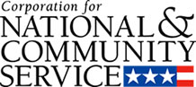

Corporation for National and Community Service

General Program Overview
AmeriCorps provides resources, both human and financial, to organizations that engage Americans in intensive service to meet our country’s critical needs.
Grantees use the funding to support AmeriCorps members for intensive service in their community. AmeriCorps grants partially cover the expense of operating an AmeriCorps program and do not cover general organizational expenses. A cash and in-kind match is required.

The main website can be accessed here: http://www.nationalservice.gov

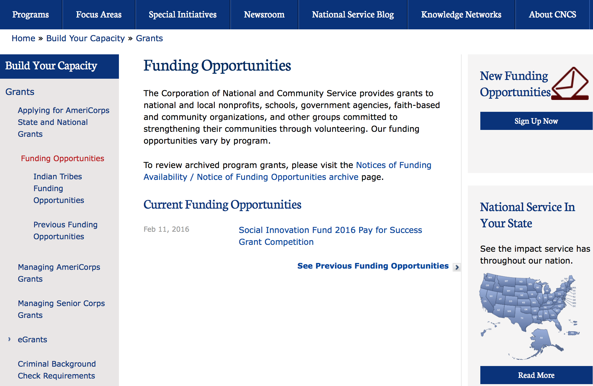

For access to further funding information: click here

http://www.nationalservice.gov/build-your-capacity/grants/funding-opportunities

Programs:

Research:

Reminders:

2017 AmeriCorps State and National Grants
Synopsis 1

Document Type: | Grants Notice
Funding Opportunity Number: | CNCS-8-17-2017
Funding Opportunity Title: | 2017 AmeriCorps State and National Grants
Opportunity Category: | Discretionary
Opportunity Category Explanation:
Funding Instrument Type: | Grant
Category of Funding Activity: | Agriculture  Arts (see "Cultural Affairs" in CFDA)  Community Development  Disaster Prevention and Relief  Education  Employment, Labor and Training  Energy  Environment  Food and Nutrition  Health  Housing  Income Security and Social Services  Law, Justice and Legal Services  Natural Resources  Regional Development
Category Explanation:
Expected Number of Awards:
CFDA Number(s): | 94.006 -- AmeriCorps
Cost Sharing or Matching Requirement: | Yes
Version: | Synopsis 1
Posted Date: | Aug 17, 2016
Last Updated Date: | Aug 17, 2016
Current Closing Date for Applications: | Jan 18, 2017 Notification of Intent to Apply: Applicants are strongly encouraged to submit a Notification of Intent to Apply for this competition. Notifications of Intent to Apply should be filed by Wednesday, December 7, 2016. Single-State applicants should provide this information directly to the Commission in the state in which the applicant intends to operate the program, not CNCS. The State Commissions’ deadlines are earlier than this deadline. See Types of Applicants section of the Notice for definitions of National Direct and Single-State applicants. Deadline: Applications are due Wednesday, January 18, 2017 at 5:00 p.m. Eastern Time to CNCS. Single-state applicant deadlines to State and Territory Commissions may be significantly before the CNCS deadlines, so prospective state applicants should contact the commission in the state or territory where they intend to apply as early as possible
Eligible Applicants: | State governments  Nonprofits having a 501(c)(3) status with the IRS, other than institutions of higher education  City or township governments  Private institutions of higher education  Public and State controlled institutions of higher education  Public housing authorities/Indian housing authorities  County governments  Native American tribal organizations (other than Federally recognized tribal governments)  Native American tribal governments (Federally recognized)  Nonprofits that do not have a 501(c)(3) status with the IRS, other than institutions of higher education  Special district governments  Independent school districts
Additional Information on Eligibility: | Eligible Applicants The following Non-Federal entities (as defined in 2 C.F.R. §200.69) who have DUNS numbers and are registered in System for Award Management (SAM) are eligible to apply: • Indian Tribes (2 C.F.R. §200.54) • Institutions of higher education (2 C. F.R. §200.54) • Local governments (2 C.F.R. §200.64) • Nonprofit organizations (2 C.F.R. §200.70) • States (2 C.F.R. §200.90) Previously receiving funds from CNCS or another federal agency is not a prerequisite to apply to this Notice. CNCS encourages organizations that have not received prior funding from CNCS to apply. The general practice is to award at least 20 member positions (slots) but no more than 50 member positions (slots) to organizations receiving an AmeriCorps grant for the first time. Continuation Applicants Organizations that have current AmeriCorps awards that do not end in FY17 must submit an application in order to be eligible to receive funding for the following year.
Agency Name: | Corporation for National and Community Service
Description: | AmeriCorps grants are awarded to eligible organizations proposing to engage AmeriCorps members in evidence-based or evidence-informed interventions to strengthen communities. An AmeriCorps member is an individual who engages in community service through an approved national service position. Members may receive a living allowance and other benefits while serving. Upon successful completion of their service, members earn a Segal AmeriCorps Education Award from the National Service Trust that members can use to pay for higher education expenses or apply to qualified student loans. Grant awards generally have two components: operating funds and AmeriCorps member positions. Grant award amounts vary – both in the level of operating funds and in the type and amount of AmeriCorps member positions. Unless otherwise specified, the grant generally covers a three-year project period. In approving a multi-year project period, CNCS generally makes an initial award for the first year of operation. In most cases, the application is submitted with a one-year budget. Continuation funding is not guaranteed.
Link to Additional Information: | Funding Opportunity Webpage
Grantor Contact Information: | If you have difficulty accessing the full announcement electronically, please contact:  AmeriCorps Program Office 202-606-7508  AmeriCorps Program Office Email

http://www.grants.gov/web/grants/view-opportunity.html?oppId=287588

National Service In Hawaii
National Service in Your State - Hawaii
2015-2016

Meeting Community Needs in Hawaii: More than 3,100 people of all ages and backgrounds are helping to meet local needs, strengthen communities, and increase civic engagement through national service in Hawaii. Serving at more than 450 locations throughout the state, these citizens tutor and mentor children, support veterans and military families, provide health services, restore the environment, respond to disasters, increase economic opportunity, and recruit and manage volunteers. This year, the Corporation for National and Community Service (CNCS) will commit more than $6,260,000 to support Hawaii communities through national service initiatives. Through a unique public-private partnership, this federal investment will leverage an additional $9,060,000 in other resources to strengthen community impact, build local support, and increase return on taxpayer dollars. Nationwide, CNCS, its grantees, and project sponsors generated more than $1.25 billion in outside resources from businesses, foundations, public agencies, and other sources in FY 2015.

AmeriCorps
This year, AmeriCorps will provide more than 560 individuals the opportunity to provide intensive, results-driven service to meet education, environmental, health, economic, and other pressing needs in communities across Hawaii. Most AmeriCorps grant funding goes to the Hawaii Commission on National & Community Service, which in turn awards grants to nonprofit groups to respond to local needs. Most of the remainder of the grant funding is distributed by CNCS directly to multi-state and national organizations through a competitive grants process. Other individuals serve through AmeriCorps VISTA, whose members help bring individuals and communities out of poverty by serving full-time to fight illiteracy, improve health services, create businesses, and increase housing opportunities, and AmeriCorps NCCC (National Civilian Community Corps), a 10-month, full time residential program for men and women between the ages of 18 and 24. In exchange for their service, AmeriCorps members earn an education award that can be used to pay for college or to pay back qualified student loans. Since 1994, more than 5,900 Hawaii residents have served more than 6.4 million hours and have qualified for Segal AmeriCorps Education Awards totaling more than $14,980,000.
Download: AmeriCorps in Hawaii (PDF)
Senior Corps
More than 2,500 seniors in Hawaii contribute their time and talents in one of three Senior Corps programs. Foster Grandparents serve one-on-one as tutors and mentors to more than 310 young people who have special needs. Senior Companions help more than 220 homebound seniors and other adults maintain independence in their own homes. RSVP volunteers conduct safety patrols, renovate homes, protect the environment, tutor and mentor youth, respond to natural disasters, and provide other services through more than 250 groups across Hawaii.
Download: Senior Corps in Hawaii (PDF)

The Corporation for National and Community Service is a federal agency that improves lives, strengthens communities, and fosters civic engagement through service and volunteering. CNCS annually engages more than five million Americans in service to meet local needs through Senior Corps, AmeriCorps, and national days of service; improves communities through the Social Innovation Fund, and leads President Obama's national call to service initiative, United We Serve. To learn more visit NationalService.gov or Serve.gov or call 202-606-5000 or TTY 1-800-833-3722.

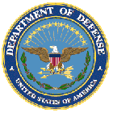

U.S. Department of Defense

Doing Business with the Department of Defense

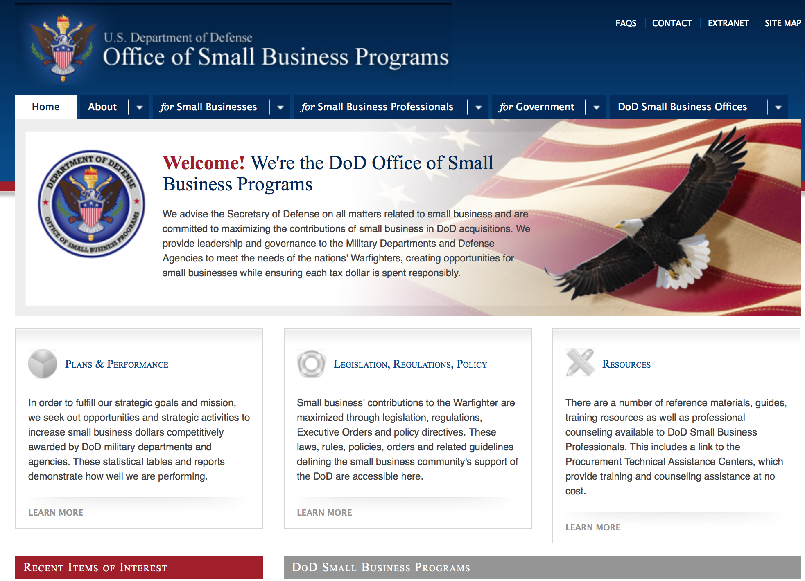

http://www.acq.osd.mil/osbp/

Doing Business with the DoD

Resources

Procurement Technical Assistance Centers (PTACs)

Procurement Technical Assistance Centers (PTACs) are charged with assisting businesses in learning how to do business with federal, state, and local governments. PTACs are a local resource available at no or nominal cost that can provide assistance to business firms in marketing their products and services. They offer training to businesses on how to research and bid on contracts, assist with registration requirements, provide bid-matching services, and assist with pre and post contracting issues.

Prime Contractors with Subcontracting Plans [xlsx]

Directory updated 4/19/11

This FY 2014 directory is intended for small business concerns seeking opportunities with DoD prime contractors. The directory is a listing of large business prime contractors who are required to establish subcontracting plans with goals. The report is generated from data contained in the Individual Subcontract Reports (ISRs) submitted in the Electronic Subcontracting Reporting System (eSRS) by contractors and from data contained in the Federal Procurement Data System (FPDS). The directory includes the name of the prime contractor; the major product/service code (PSC) provided to DoD; the major NAICS of the company; name, telephone number and email address of the company’s point of contact; contract number with the effective date and completion date, ultimate contract value and obligated dollars. In addition, many companies have websites with additional information which may be useful in your search for subcontracting opportunities or teaming arrangements.

Locate a Small Business Professional

Small Business Professionals serve as the primary liaison between private-sector small businesses seeking to do business with government agencies. Specialists advise small businesses regarding current acquisitions contracts available from the federal government.

Procurement Forecasts & the Department of Defense

The Department of Defense, due to its size and scope, does not have a single, comprehensive source for future procurements. Procurements are made locally and within the various services and agencies.

Business Intelligence, relative to future procurement planning, would be gathered at the local level.

For the purposes of forecasting, knowledge of past behavior is useful. Click here for a table of DoD acquisitions in FY10 summarized by NAICS code. The FY10 data has been validated but FPDS data is dynamic and changes continuously.

Non-Appropriated Fund Customers

Non-appropriated fund customers operate similar to non-profit organizations and include commissaries, exchanges, recreation and fitness centers, dining at officer/enlisted/civilian clubs, and barber/beauty services, just to name a few. For more information click here.

Research:

Modifications:

DARPA - Microsystems Technology Office
Common Heterogeneous Integration and IP Reuse Strategies (CHIPS)
Synopsis 2
http://www.grants.gov/web/grants/view-opportunity.html?oppId=289238

Defense Threat Reduction Agency
Fundamental Research to Counter Weapons of Mass Destruction
Synopsis 6
http://www.grants.gov/web/grants/view-opportunity.html?oppId=275322

Naval Supply Systems Command
FY17 - FY18 Department of Defense HIV/AIDS Prevention Program: Military Specific HIV/AIDS Prevention, Care, and Treatment Program for Non-PEPFAR (President's Emergency Plan for AIDS Relief) Funded Countries
Synopsis 2
http://www.grants.gov/web/grants/view-opportunity.html?oppId=290364

Reminders:

Dept. of the Army -- Materiel Command
Army Research Office Broad Agency Announcement for Basic and Applied Scientific Research
Modification 8

Document Type: | Grants Notice
Funding Opportunity Number: | W911NF-12-R-0012
Funding Opportunity Title: | Army Research Office Broad Agency Announcement for Basic and Applied Scientific Research
Opportunity Category: | Discretionary
Funding Instrument Type: | Cooperative Agreement  Grant  Other  Procurement Contract
Category of Funding Activity: | Science and Technology and other Research and Development
Category Explanation:
Expected Number of Awards: | 1000
CFDA Number(s): | 12.431 -- Basic Scientific Research
Cost Sharing or Matching Requirement: | No
Posted Date: | Mar 27, 2015
Creation Date: | Mar 27, 2015
Original Closing Date for Applications: | Mar 31, 2017
Current Closing Date for Applications: | Mar 31, 2017
Archive Date: | Apr 30, 2017
Eligible Applicants: | Unrestricted (i.e., open to any type of entity above), subject to any clarification in text field entitled "Additional Information on Eligibility"
Agency Name: | Dept. of the Army -- Materiel Command
Description: | The purpose of this Broad Agency Announcement (BAA) is to solicit research proposals in the engineering, physical, life, and information sciences for submission to the Army Research Office (ARO) for consideration for possible funding. For ease of reference, this BAA is an extraction of the ARO sections of the Army Research Laboratory BAA. (www.arl.army.mil/www/default.cfm?page=8).
Link to Additional Information: | ARO CORE BAA-W911NF-12-R-0012-Mod 03
Contact Information: | If you have difficulty accessing the full announcement electronically, please contact:  ANDREW L. FISKE Procurement Analyst Army Contracting Command Aberdeen Proving Ground Research Triangle Park Division Phone: (919) 549-4338 FAX: (919) 549-4388 andrew.l.fiske.civ@mail.mil  Administrative POC

http://www.grants.gov/web/grants/view-opportunity.html?oppId=173593



Department of Education

Grant Programs Overview at the Department of Education

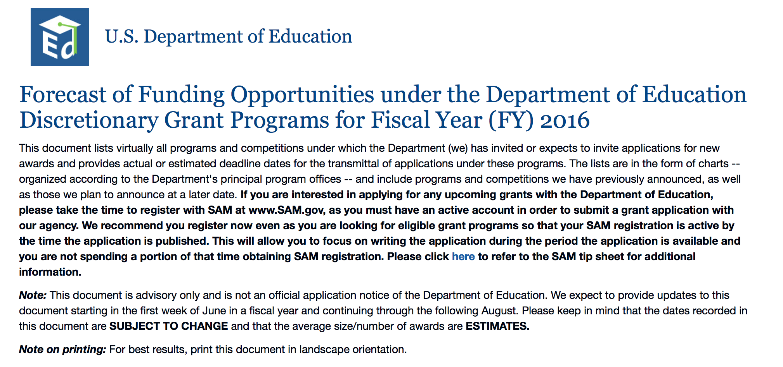To see the complete document click here: http://www2.ed.gov/fund/grant/find/edlite-forecast.html

The general information page for Education Grant funding is an excellent resource describing the three types of grants awarded by the Department of Education. See the screen shot of the Department of Education web page below:

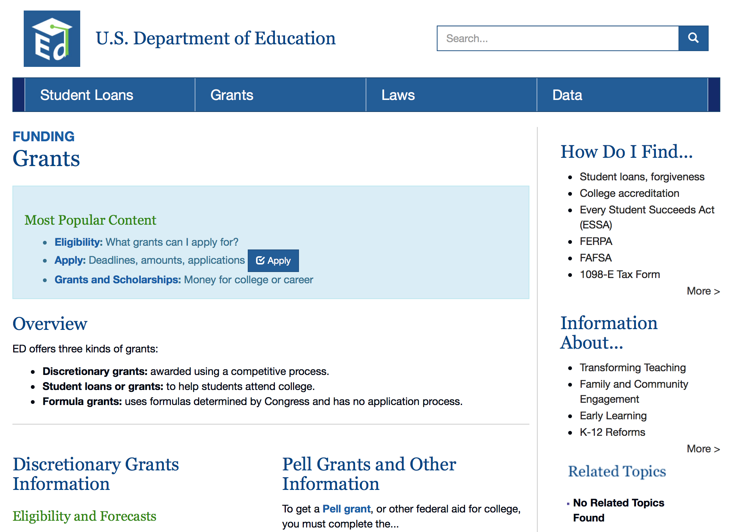

http://www.ed.gov/fund/grants-apply.html

Programs:

Research:

Modifications:

Reminders:

Office of Postsecondary Education (OPE): Minority Science and Engineering Improvement Program CFDA Number 84.120A
Synopsis 1 & 2

Document Type: | Grants Notice
Funding Opportunity Number: | ED-GRANTS-102116-001
Funding Opportunity Title: | Office of Postsecondary Education (OPE): Minority Science and Engineering Improvement Program CFDA Number 84.120A
Opportunity Category: | Discretionary
Opportunity Category Explanation:
Funding Instrument Type: | Grant
Category of Funding Activity: | Education
Category Explanation:
Expected Number of Awards: | 11
CFDA Number(s): | 84.120 -- Minority Science and Engineering Improvement
Cost Sharing or Matching Requirement: | No
Version: | Synopsis 2
Posted Date: | Oct 21, 2016
Last Updated Date: | Oct 24, 2016
Original Closing Date for Applications: | Dec 20, 2016 Applications Available: October 21, 2016. Date of Pre-Application Webinar: The Department of Education (Department) intends to hold a Webinar to provide technical assistance to interested applicants. Detailed information regarding this Webinar will be provided on the Web site for the Minority Science and Engineering Improvement Program (MSEIP) at http://www2.ed.gov/programs/iduesmsi/index.html. A recording of this Webinar will be available on the Web site following the session. Deadline for Transmittal of Applications: December 20, 2016.
Current Closing Date for Applications: | Dec 20, 2016 Applications Available: October 21, 2016. Date of Pre-Application Webinar: The Department of Education (Department) intends to hold a Webinar to provide technical assistance to interested applicants. Detailed information regarding this Webinar will be provided on the Web site for the Minority Science and Engineering Improvement Program (MSEIP) at http://www2.ed.gov/programs/iduesmsi/index.html. A recording of this Webinar will be available on the Web site following the session. Deadline for Transmittal of Applications: December 20, 2016.
Archive Date: | Jan 19, 2017
Estimated Total Program Funding: | $2,597,607
Award Ceiling: | $300,000

http://www.grants.gov/web/grants/view-opportunity.html?oppId=289621

Deleted:



U.S. Department of Energy
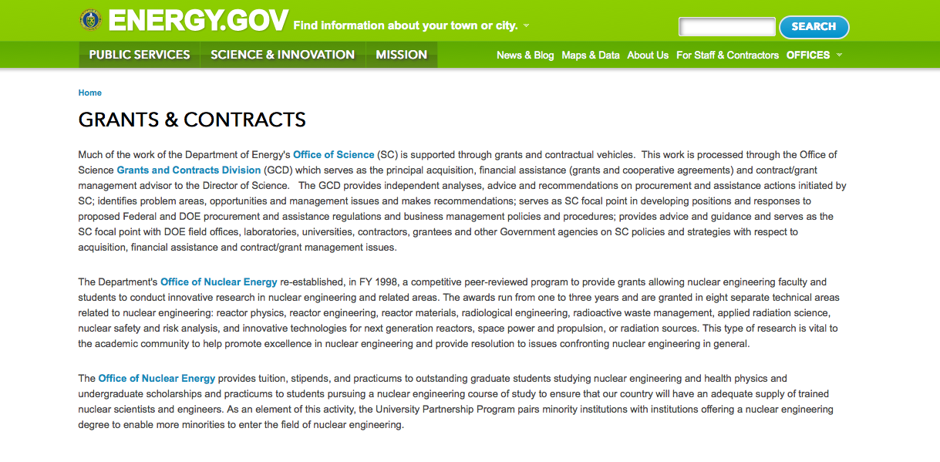
http://www.doe.gov/grants-contracts

Research:

Golden Field Office
Request for Information (RFI): Hydrogen and Fuel Cell Manufacturing: Identifying Specific Components for Manufacturing Standarization
Synopsis 1
http://www.grants.gov/web/grants/view-opportunity.html?oppId=290168

Golden Field Office
Fuel Cells Technologies Office Annual Funding Opportunity Announcement
Synopsis 1
http://www.grants.gov/web/grants/view-opportunity.html?oppId=290183

Golden Field Office
Assisting Federal Facilities with Energy Conservation Technologies (AFFECT) 2017
Synopsis 1
http://www.grants.gov/web/grants/view-opportunity.html?oppId=290262

Golden Field Office
Buildings Energy Efficiency Frontiers & Innovation Technologies (BENEFIT) – 2017
Synopsis 1
http://www.grants.gov/web/grants/view-opportunity.html?oppId=290414

PAMS
Department of Energy - Office of Science
Office of Science
Scientific Discovery through Advanced Computing: Integrated Simulation Partnerships in Fusion Energy Sciences
Synopsis 1
http://www.grants.gov/web/grants/view-opportunity.html?oppId=290155

Modifications:

Reminders:

PAMS
Department of Energy - Office of Science
Office of Science
FY 2017 Continuation of Solicitation for the Office of Science Financial Assistance Program
Synopsis 2

Document Type: | Grants Notice
Funding Opportunity Number: | DE-FOA-0001664
Funding Opportunity Title: | FY 2017 Continuation of Solicitation for the Office of Science Financial Assistance Program
Opportunity Category: | Discretionary
Opportunity Category Explanation:
Funding Instrument Type: | Cooperative Agreement  Grant
Category of Funding Activity: | Science and Technology and other Research and Development
Category Explanation:
Expected Number of Awards: | 200
CFDA Number(s): | 81.049 -- Office of Science Financial Assistance Program
Cost Sharing or Matching Requirement: | No
Version: | Synopsis 2
Posted Date: | Sep 30, 2016
Last Updated Date: | Oct 04, 2016
Original Closing Date for Applications: | Sep 30, 2017
Current Closing Date for Applications: | Sep 30, 2017
Archive Date: | Oct 30, 2017
Estimated Total Program Funding:
Award Ceiling: | $4,000,000
Award Floor: | $2,000
Eligible Applicants: | Unrestricted (i.e., open to any type of entity above), subject to any clarification in text field entitled "Additional Information on Eligibility"
Agency Name: | Office of Science
Description: | The Office of Science (SC) of the Department of Energy hereby announces its continuing interest in receiving grant applications for support of work in the following program areas: Advanced Scientific Computing Research, Basic Energy Sciences, Biological and Environmental Research, Fusion Energy Sciences, High Energy Physics, and Nuclear Physics. On September 3, 1992, DOE published in the Federal Register the Office of Energy Research Financial Assistance Program (now called the Office of Science Financial Assistance Program), 10 CFR 605, as a Final Rule, which contained a solicitation for this program. Information about submission of applications, eligibility, limitations, evaluation and selection processes and other policies and procedures are specified in 10 CFR 605.
Link to Additional Information: | http://science.energy.gov/~/media/grants/pdf/foas/2017/SC_FOA_0001664.pdf
Grantor Contact Information: | If you have difficulty accessing the full announcement electronically, please contact:  Kimberlie Laing Grant Analyst Phone 301-903-3026  kim.laing@science.doe.gov

http://www.grants.gov/web/grants/view-opportunity.html?oppId=289281

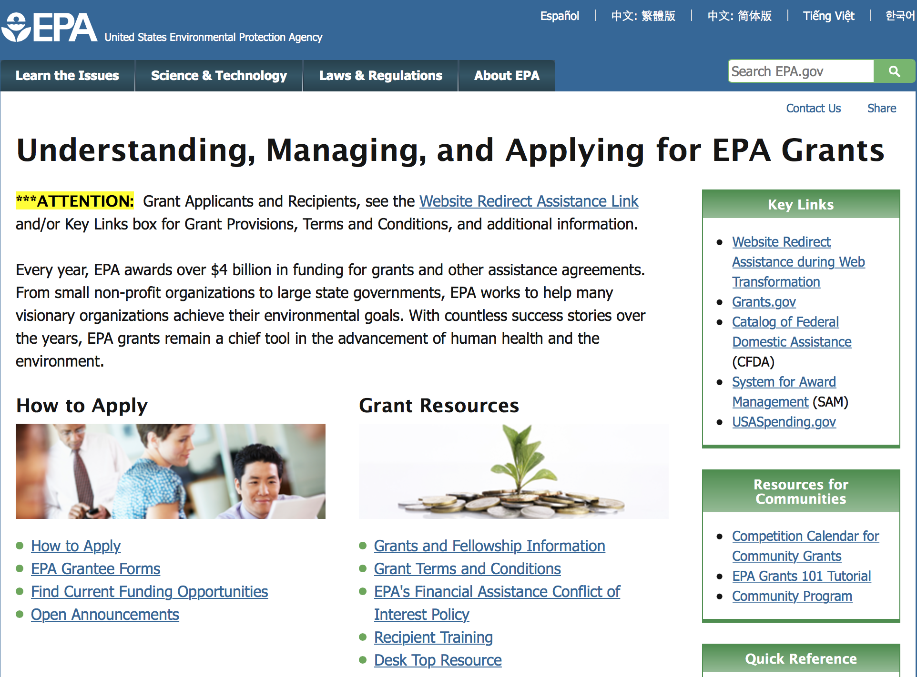

http://www.epa.gov/epahome/grants.htm

Programs:

Research:

Freshwater Harmful Algal Blooms
Synopsis 1
http://www.grants.gov/web/grants/view-opportunity.html?oppId=289761

Early Career: Freshwater Harmful Algal Blooms
Synopsis 1
http://www.grants.gov/web/grants/view-opportunity.html?oppId=289762

Modifications:

Environmental Justice Small Grants Program
Synopsis 3

Document Type: | Grants Notice
Funding Opportunity Number: | EPA-OECA-OEJ-17-01
Funding Opportunity Title: | ENVIRONMENTAL JUSTICE SMALL GRANTS PROGRAM
Opportunity Category: | Discretionary
Opportunity Category Explanation:
Funding Instrument Type: | Grant
Category of Funding Activity: | Environment
Category Explanation:
Expected Number of Awards: | 40
CFDA Number(s): | 66.604 -- Environmental Justice Small Grant Program
Cost Sharing or Matching Requirement: | No
Version: | Synopsis 3
Posted Date: | Nov 01, 2016
Last Updated Date: | Nov 29, 2016
Original Closing Date for Applications: | Jan 31, 2017 Please see the announcement including Section IV for additional submission information
Current Closing Date for Applications: | Jan 31, 2017 Please see the announcement including Section IV for additional submission information
Archive Date: | Mar 02, 2017
Estimated Total Program Funding: | $1,200,000
Award Ceiling: | $30,000
Award Floor: | $0
Eligible Applicants: | Others (see text field entitled "Additional Information on Eligibility" for clarification)
Additional Information on Eligibility: | Please see the announcement including Section III for additional eligibility information
Agency Name: | Environmental Protection Agency
Description: | The Environmental Justice Small Grants (EJSG) Program provides funding for eligible applicants for projects that address local environmental and public health issues within an affected community. The EJSG Program is designed to help communities understand and address exposure to multiple environmental harms and risks. Applying organizations are encouraged to have a direct connection to the vulnerable affected, community impacted by environmental harms and risks.
Link to Additional Information: | ENVIRONMENTAL JUSTICE SMALL GRANTS PROGRAM
Grantor Contact Information: | If you have difficulty accessing the full announcement electronically, please contact:  See Section VII of announcement  See Section VII of announcement

http://www.grants.gov/web/grants/view-opportunity.html?oppId=289829

Reminders:

FY17 Guidelines for Brownfields Assessment Grants
Synopsis 1
Document Type: | Grants Notice
Funding Opportunity Number: | EPA-OLEM-OBLR-16-08
Funding Opportunity Title: | FY17 Guidelines for Brownfields Assessment Grants
Opportunity Category: | Discretionary
Opportunity Category Explanation:
Funding Instrument Type: | Cooperative Agreement
Category of Funding Activity: | Environment
Category Explanation:
Expected Number of Awards: | 234
CFDA Number(s): | 66.818 -- Brownfields Assessment and Cleanup Cooperative Agreements
Cost Sharing or Matching Requirement: | No
Posted Date: | Oct 12, 2016
Last Updated Date: | Oct 12, 2016
Original Closing Date for Applications: | Dec 20, 2016 Please refer to the announcement, including Section IV, for additional information on submission methods and due dates.
Current Closing Date for Applications: | Dec 20, 2016 Please refer to the announcement, including Section IV, for additional information on submission methods and due dates.
Archive Date: | Jan 19, 2017
Estimated Total Program Funding: | $54,000,000
Award Ceiling: | $42,000,000
Award Floor: | $0
Eligible Applicants: | Others (see text field entitled "Additional Information on Eligibility" for clarification)
Additional Information on Eligibility: | Please see the announcement including Section III for eligibility information.
Agency Name: | Environmental Protection Agency
Description: | The Small Business Liability Relief and Brownfields Revitalization Act (“Brownfields Law”, P.L. 107-118) requires the U.S. Environmental Protection Agency (EPA) to publish guidance for grants to assess and clean up brownfield sites. EPA’s Brownfields Program provides funds to empower states, communities, tribes, and nonprofits to prevent, inventory, assess, clean up, and reuse brownfield sites. Under these guidelines, EPA is seeking proposals for Assessment Grants only. If you are interested in requesting funding for Cleanup Grants, please refer to announcement EPA-OLEM-OBLR-16-09 (Cleanup Grant Guidelines) posted separately on www.grants.gov and www.epa.gov/brownfields/apply-brownfields-grant-funding. Note: A solicitation for new Revolving Loan Fund (RLF) Grants will not be issued in FY17. EPA expects to solicit requests from existing, high-performing RLF grantees for supplemental funding through a Federal Register notice in early 2017.
Link to Additional Information: | FY17 Guidelines for Brownfields Assessment Grants
Grantor Contact Information: | If you have difficulty accessing the full announcement electronically, please contact:  See Section VII of announcement for Agency Contacts  If you have difficulty accessing the full announcement electronically, contact Jerry Minor-Gordon

http://www.grants.gov/web/grants/view-opportunity.html?oppId=289469

FY17 Guidelines for Brownfields Cleanup Grants
Synopsis 1

Document Type: | Grants Notice
Funding Opportunity Number: | EPA-OLEM-OBLR-16-09
Funding Opportunity Title: | FY17 Guidelines for Brownfields Cleanup Grants
Opportunity Category: | Discretionary
Opportunity Category Explanation:
Funding Instrument Type: | Cooperative Agreement
Category of Funding Activity: | Environment
Category Explanation:
Expected Number of Awards: | 294
CFDA Number(s): | 66.818 -- Brownfields Assessment and Cleanup Cooperative Agreements
Cost Sharing or Matching Requirement: | Yes
Posted Date: | Oct 12, 2016
Last Updated Date: | Oct 12, 2016
Original Closing Date for Applications: | Dec 20, 2016 Please refer to the announcement, including Section IV, for additional information on submission methods and due dates.
Current Closing Date for Applications: | Dec 20, 2016 Please refer to the announcement, including Section IV, for additional information on submission methods and due dates.
Archive Date: | Jan 19, 2017
Estimated Total Program Funding: | $54,000,000
Award Ceiling: | $12,000,000
Award Floor: | $0
Eligible Applicants: | Others (see text field entitled "Additional Information on Eligibility" for clarification)
Additional Information on Eligibility: | Please see the announcement including Section III for eligibility information.
Agency Name: | Environmental Protection Agency
Description: | The Small Business Liability Relief and Brownfields Revitalization Act (“Brownfields Law”, P.L. 107-118) requires the U.S. Environmental Protection Agency (EPA) to publish guidance for grants to assess and clean up brownfield sites. EPA’s Brownfields Program provides funds to empower states, communities, tribes, and nonprofits to prevent, inventory, assess, clean up, and reuse brownfield sites. Under these guidelines, EPA is seeking proposals for Cleanup Grants only. If you are interested in requesting funding for Assessment Grants, please refer to announcement EPA-OLEM-OBLR-16-08 (Assessment Grant Guidelines) posted separately on www.grants.gov and www.epa.gov/brownfields/apply-brownfields-grant-funding. Note: A solicitation for new Revolving Loan Fund (RLF) Grants will not be issued in FY17. EPA expects to solicit requests from existing, high-performing RLF grantees for supplemental funding through a Federal Register notice in early 2017.
Link to Additional Information: | FY17 Guidelines for Brownfields Cleanup Grants
Grantor Contact Information: | If you have difficulty accessing the full announcement electronically, please contact:  See Section VII of announcement for the Agency Contact.  If you have difficulty accessing the full announcement electronically, contact Jerry Minor-Gordon

http://www.grants.gov/web/grants/view-opportunity.html?oppId=289447

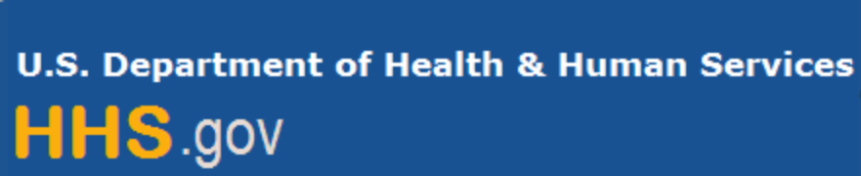

Department of Health and Human Services

Grants Forecast and Overview

The Department of Health and Human Services’ Grants Forecast is a database of planned grant opportunities proposed by its agencies. Each Forecast record contains actual or estimated dates and funding levels for grants that the agency intends to award during the fiscal year. Forecast opportunities are subject to change based on enactment of congressional appropriations. Go to the webpage below for more information.

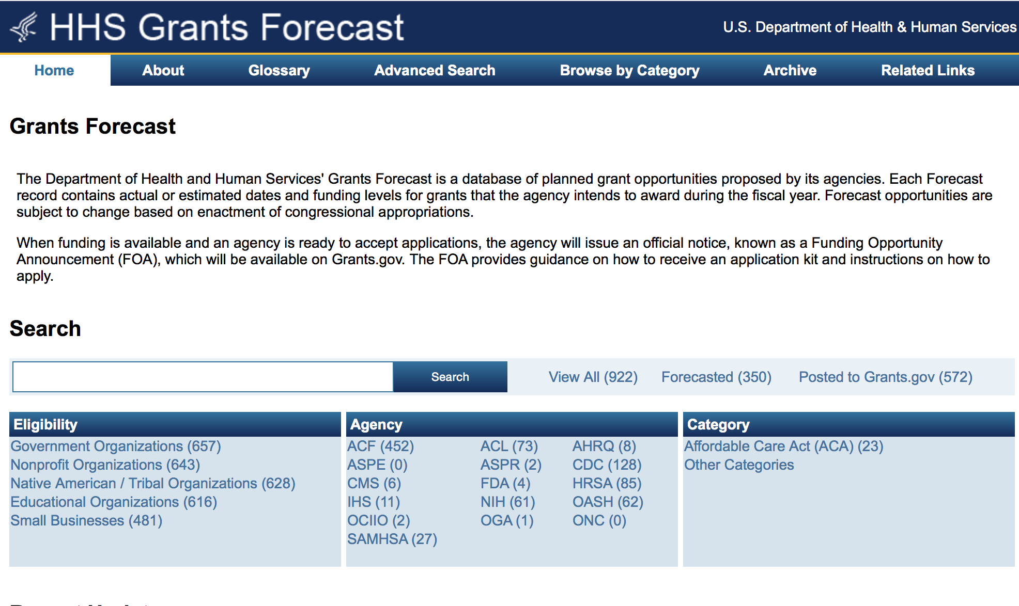
For more general information about HHS Grants and Funding go to the website below at: http://www.hhs.gov/grants/ .

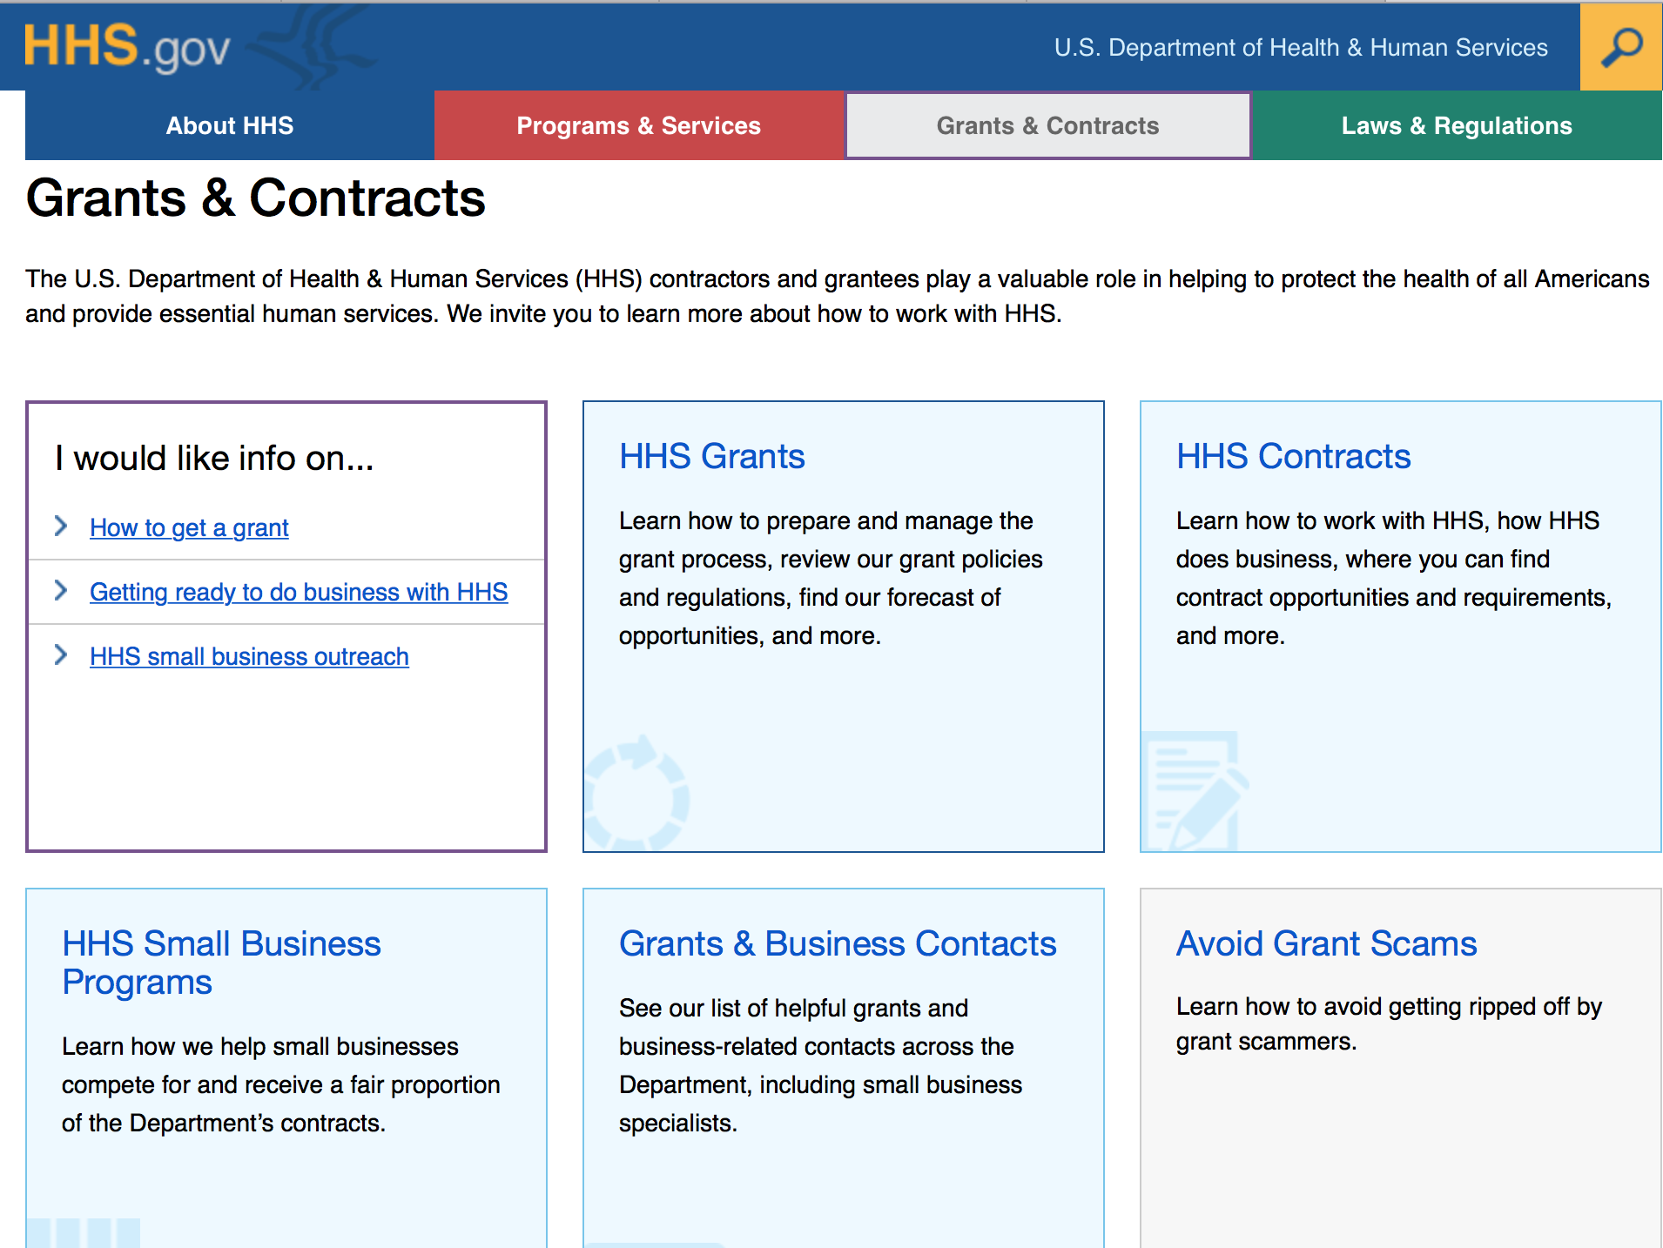

Programs:

Research:

Administration for Community Living
Switzer Research Fellowships Program
Synopsis 1
http://www.grants.gov/web/grants/view-opportunity.html?oppId=290029

Administration for Children & Families - ACYF/FYSB
Street Outreach Program
Forecast 1
http://www.grants.gov/web/grants/view-opportunity.html?oppId=290260

Administration for Children & Families - ACYF/FYSB
Basic Center Program
Forecast 1
http://www.grants.gov/web/grants/view-opportunity.html?oppId=290154

Centers for Disease Control - NCTP
Strengthening Surveillance in Jurisdictions with High Incidence of Hepatitis C Virus (HCV) and Hepatitis B Virus (HBV) Infections
Synopsis 1
http://www.grants.gov/web/grants/view-opportunity.html?oppId=290367

Centers for Disease Control and Prevention - ERA
NIOSH Small Research Grant Program (R03)
Forecast 1
http://www.grants.gov/web/grants/view-opportunity.html?oppId=290157

Centers for Disease Control and Prevention - ERA
Mentored Research Scientist Development Award (K01)
Forecast 1
http://www.grants.gov/web/grants/view-opportunity.html?oppId=290158

Centers for Disease Control - NCCDPHP
Scaling the National Diabetes Prevention Program to Priority Populations
Forecast 1
http://www.grants.gov/web/grants/view-opportunity.html?oppId=290159

Centers for Disease Control and Prevention - ERA
NIOSH Exploratory/Developmental Grant Program (R21)
Forecast 1
http://www.grants.gov/web/grants/view-opportunity.html?oppId=290173

Centers for Disease Control and Prevention - ERA
Household Transmission of Influenza Viruses in the Community
Synopsis 1
http://www.grants.gov/web/grants/view-opportunity.html?oppId=285280

Health Resources and Services Administration
Ryan White HIV/AIDS Program National Training and Technical Assistance Programs for Resource Dissemination, Improved Data, and Organizational Development
Synopsis 2
http://www.grants.gov/web/grants/view-opportunity.html?oppId=289994

National Institutes of Health
National Cancer Institute Youth Enjoy Science Research Education Program (R25)
Synopsis 1
http://www.grants.gov/web/grants/view-opportunity.html?oppId=290300

National Institutes of Health
Promoting Caregiver Health Using Self-Management (R01)
Synopsis 1
http://www.grants.gov/web/grants/view-opportunity.html?oppId=290302

National Institutes of Health
Limited Competition: Cancer Immunotherapy Trials Network (CITN)(UM1)
Synopsis 1
http://www.grants.gov/web/grants/view-opportunity.html?oppId=290332

National Institutes of Health
APOL1 Long-term Kidney Transplantation Outcomes Network (APOLLO) Clinical Centers (Collaborative U01)
Synopsis 1
http://www.grants.gov/web/grants/view-opportunity.html?oppId=290140

National Institutes of Health
Systems Biology: The Next Generation for Infectious Diseases (U19)
Synopsis 1
http://www.grants.gov/web/grants/view-opportunity.html?oppId=290130

National Institutes of Health
Planning Grant for Global Infectious Disease Research Training Program (D71)
Synopsis 1
http://www.grants.gov/web/grants/view-opportunity.html?oppId=290174

National Institutes of Health
BRAIN Initiative: Research Opportunities Using Invasive Neural Recording and Stimulating Technologies in the Human Brain (U01)
Synopsis 1
http://www.grants.gov/web/grants/view-opportunity.html?oppId=290399

National Institutes of Health
Child Health Research Career Development Award (CHRCDA) Program (K12)
Synopsis 1
http://www.grants.gov/web/grants/view-opportunity.html?oppId=290176

National Institutes of Health
Partnerships for the Development of Tools to Advance Therapeutic Discovery for Select Antimicrobial-Resistant Gram-Negative Bacteria (R01)
Synopsis 1
http://www.grants.gov/web/grants/view-opportunity.html?oppId=290136

National Institutes of Health
Leveraging Existing Cohort Studies to Clarify Risk and Protective Factors for Alzheimers Disease and Related Dementias (R01)
Synopsis 1
http://www.grants.gov/web/grants/view-opportunity.html?oppId=290137

National Institutes of Health
Summer Research Experiences for Students and Science Teachers (Admin Supp)
Synopsis 1
http://www.grants.gov/web/grants/view-opportunity.html?oppId=290142

National Institutes of Health
Enhancing the Target and Biomarker Discovery Efforts of the AMP-AD and M2OVE-AD Consortia (R01)
Synopsis 1
http://www.grants.gov/web/grants/view-opportunity.html?oppId=290152

National Institutes of Health
Investigator Initiated Extended Clinical Trial (R01)
Synopsis 1
http://www.grants.gov/web/grants/view-opportunity.html?oppId=290163

National Institutes of Health
Global Infectious Disease Research Training Program (D43)
Synopsis 1
http://www.grants.gov/web/grants/view-opportunity.html?oppId=290164

National Institutes of Health
NIH Health Care Systems Research Collaboratory - Demonstration Projects for Pragmatic Clinical Trials (UG3/UH3)
Synopsis 1
http://www.grants.gov/web/grants/view-opportunity.html?oppId=290289

National Institutes of Health
Pragmatic Trials for Dementia Care in Long-term Services and Support (LTSS) Settings (R01)
Synopsis 1
http://www.grants.gov/web/grants/view-opportunity.html?oppId=290273

National Institutes of Health
Pragmatic Trials for Dementia Care in Long-term Services and Support (LTSS) Settings (R21/R33)
Synopsis 1
http://www.grants.gov/web/grants/view-opportunity.html?oppId=290274

National Institutes of Health
Integrated Approaches to HIV-Related Heart, Lung, Blood, and Sleep (HLBS) Comorbidities (R01)
Synopsis 1
http://www.grants.gov/web/grants/view-opportunity.html?oppId=290272

National Institutes of Health
Oral Anticancer Agents: Utilization, Adherence, and Health Care Delivery (R01)
Synopsis 1
http://www.grants.gov/web/grants/view-opportunity.html?oppId=290372

National Institutes of Health
Limited Competition: Clinical Trials in Organ Transplantation in Children (CTOT-C): Mechanistic Ancillary Studies (U01)
Synopsis 1
http://www.grants.gov/web/grants/view-opportunity.html?oppId=290353

National Institutes of Health
Oral Anticancer Agents: Utilization, Adherence, and Health Care Delivery (R21)
Synopsis 1
http://www.grants.gov/web/grants/view-opportunity.html?oppId=290354

National Institutes of Health
Discovery of the Genetic Basis of Childhood Cancers and of Structural Birth Defects: Gabriella Miller Kids First Pediatric Research Program (X01)
Synopsis 1
http://www.grants.gov/web/grants/view-opportunity.html?oppId=290403

National Institutes of Health
Silvio O. Conte Digestive Diseases Research Core Centers (P30)
Synopsis 1
http://www.grants.gov/web/grants/view-opportunity.html?oppId=290404

National Institutes of Health
Leveraging Existing Resources for Research on Lewy Body Dementia (R03)
Synopsis 1
http://www.grants.gov/web/grants/view-opportunity.html?oppId=290433

National Institutes of Health
BRAIN Initiative: Team-Research BRAIN Circuit Programs - TeamBCP (U19)
Synopsis 1
http://www.grants.gov/web/grants/view-opportunity.html?oppId=290436

National Institutes of Health
Advancing Research on Alzheimer's Disease (AD) and Alzheimer's-Disease-Related Dementias (ADRD) (R41/R42)
Synopsis 1
http://www.grants.gov/web/grants/view-opportunity.html?oppId=290452

National Institutes of Health
Advancing Research on Alzheimer's Disease (AD) and Alzheimer's-Disease-Related Dementias (ADRD) (R43/R44)
Synopsis 1
http://www.grants.gov/web/grants/view-opportunity.html?oppId=290453

National Institutes of Health
Tools for Clinical Care and Management of Alzheimers Disease (AD) and Its Comorbidities (R41/R42)
Synopsis 1
http://www.grants.gov/web/grants/view-opportunity.html?oppId=290455

National Institutes of Health
Tools for Clinical Care and Management of Alzheimers Disease (AD) and its Comorbidities (R43/R44)
Synopsis 1
http://www.grants.gov/web/grants/view-opportunity.html?oppId=290456

National Institutes of Health
BRAIN Initiative: Targeted BRAIN Circuits Projects - TargetedBCP (R01)
Synopsis 1
http://www.grants.gov/web/grants/view-opportunity.html?oppId=290457

National Institutes of Health
BRAIN Initiative: Exploratory Targeted BRAIN Circuits Projects - eTargetedBCP (R21)
Synopsis 1
http://www.grants.gov/web/grants/view-opportunity.html?oppId=290458

Modifications:

Administration for Children and Families - OPRE
Early Care and Education Research Scholars: Head Start Graduate Student Research Grants
Forecast 2
http://www.grants.gov/web/grants/view-opportunity.html?oppId=287810

Administration for Children and Families - OPRE
Early Care and Education Research Scholars: Child Care Research Scholars
Forecast 4
http://www.grants.gov/web/grants/view-opportunity.html?oppId=287555

Administration for Community Living
FIELD INITIATED PROJECTS PROGRAM (RESEARCH)
Synopsis 2
http://www.grants.gov/web/grants/view-opportunity.html?oppId=289862

Administration for Community Living
FIELD INITIATED PROJECTS PROGRAM (DEVELOPMENT)
Synopsis 2
http://www.grants.gov/web/grants/view-opportunity.html?oppId=289877

Centers for Disease Control and Prevention - ERA
Research Grants for Preventing Violence and Violence Related Injury (R01)
Forecast 4
http://www.grants.gov/web/grants/view-opportunity.html?oppId=287832

Centers for Disease Control and Prevention - ERA
Creation of a Healthcare-Associated Infectious Disease Modeling Network to Improve Prevention Research and Healthcare Delivery
Synopsis 16
http://www.grants.gov/web/grants/view-opportunity.html?oppId=285279

Centers for Disease Control - ATSDR
ATSDR's Partnership to Promote Local Efforts To Reduce Environmental Exposure
Synopsis 4
http://www.grants.gov/web/grants/view-opportunity.html?oppId=284858

National Institutes of Health
Stem Cell-Derived Blood Products for Therapeutic Use: Technology Improvement (R43/R44)
Synopsis 2
http://www.grants.gov/web/grants/view-opportunity.html?oppId=269430

National Institutes of Health
Perinatal Stroke (R01)
Synopsis 2
http://www.grants.gov/web/grants/view-opportunity.html?oppId=289095

National Institutes of Health
Multilevel Interventions in Cancer Care Delivery: Building from the Problem of Follow-up to Abnormal Screening Tests (U01)
Synopsis 2
http://www.grants.gov/web/grants/view-opportunity.html?oppId=272448

Office of the Assistant Secretary for Health
National Lupus Outreach and Clinical Trial Education Program
Forecast 3
http://www.grants.gov/web/grants/view-opportunity.html?oppId=289374

Office of the Assistant Secretary for Health
Minority Youth Violence Prevention II
Forecast 3
http://www.grants.gov/web/grants/view-opportunity.html?oppId=289363

Administration for Children and Families - ANA
-2016-ACF-ANA-NC-1167 - Native Youth Initiative for Leadership, Empowerment, and Development (I-LEAD)
Deletion Comments: Opportunity deleted

Centers for Disease Control - CGH
CDC-RFA-GH15-163202CONT17B - Global Health Security Partnership Engagement: Expanding Efforts and Strategies to Protect and Improve Public Health Globally, Center for Global Health
Deletion Comments: Opportunity deleted

Centers for Disease Control - NCTP
CDC-RFA-PS17-1706 - Enhancing Partnerships to Mobilize and Sustain Support for TB Elimination
Deletion Comments: Opportunity deleted

Centers for Disease Control - CGH
CDC-RFA-GH15-150402CONT17 - Capacity Building through Training and Mentoring for Treatment, care and Support, Including PMTCT, TB/HIV, Laboratory, Informatics and Cervical Cancer in Botswana under PEPFAR
Deletion Comments: This continuation solicitation was submitted too early. This will be republished later on in 2017.

Reminders:

Administration for Children & Families - ACYF/FYSB
Transitional Living Program and Maternity Group Homes
Forecast 1
Document Type: | Grants Notice
Opportunity Number: | HHS-2017-ACF-ACYF-CX-1233
Opportunity Title: | Transitional Living Program and Maternity Group Homes
Opportunity Category: | Discretionary
Opportunity Category Explanation:
Funding Instrument Type: | Grant
Category of Funding Activity: | Income Security and Social Services
Category Explanation:
Expected Number of Awards: | 103
CFDA Number(s): | 93.550 -- Transitional Living for Homeless Youth
Cost Sharing or Matching Requirement: | Yes
Version: | Forecast 1
Posted Date: | Sep 27, 2016
Last Updated Date: | Sep 27, 2016
Estimated Synopsis Post Date: | Apr 14, 2017
Estimated Application Due Date: | Jun 13, 2017 Electronically submitted applications must be submitted no later than 11:59 p.m., ET, on the listed application due date.
Estimated Award Date: | Sep 28, 2017
Estimated Project Start Date: | Sep 29, 2017
Fiscal Year: | 2017
Archive Date:
Estimated Total Program Funding: | $20,056,829
Award Ceiling: | $194,726
Award Floor: | $100,000
Eligible Applicants: | Native American tribal governments (Federally recognized)  Public and State controlled institutions of higher education  Nonprofits that do not have a 501(c)(3) status with the IRS, other than institutions of higher education  Native American tribal organizations (other than Federally recognized tribal governments)  Independent school districts  Special district governments  State governments  Others (see text field entitled "Additional Information on Eligibility" for clarification)  Private institutions of higher education  Public housing authorities/Indian housing authorities  City or township governments  Nonprofits having a 501(c)(3) status with the IRS, other than institutions of higher education  County governments
Additional Information on Eligibility: | In accordance with Section 321 of the Runaway and Homeless Youth (RHY) Act, the Secretary is authorized to make grants to provide technical assistance to public and nonprofit private entities to establish and operate transitional living youth projects for homeless youth. In selecting eligible applicants to receive grants under this Funding Opportunity Announcement, priority will be given to applicants who have experience working with runaway and homeless youth as required by the RHY Act. Additionally, ACF ensures that the applicants selected represent diverse geographic regions of the United States. Faith-based and community organizations that meet the eligibility requirements are eligible to receive awards under this funding opportunity announcement. Faith-based organizations are encouraged to review the ACF Policy on Grants to Faith-Based Organizations at: http: //www.acf.hhs.gov/acf-policy-on-grants-to-faith-based-organizations. Applications from individuals (including sole proprietorships) and foreign entities are not eligible and will be disqualified from competitive review and from funding under this announcement.
Agency Name: | Administration for Children & Families - ACYF/FYSB
Description: | The Family and Youth Services Bureau (FYSB) is forecasting a funding opportunity announcement for the Transitional Living Program (TLP) and for Maternity Group Homes (MGH) for a five-year project period. The TLP and MGH projects will work to implement, enhance, and/or support promising intervention strategies for the effective transition of homeless youth (for the purposes of MGH projects, homeless youth and their dependent child(ren)) to self-sufficiency. Both projects must provide safe, stable, and appropriate shelter for up to 21 months and comprehensive services that supports the transition of homeless youth to stable living.
Link to Additional Information:
Grantor Contact Information: | Angie Webley  (202) 401-5490  Angie.Webley@acf.hhs.gov

http://www.grants.gov/web/grants/view-opportunity.html?oppId=289165

Administration for Children and Families - ORR
Ethnic Community Self Help Program
Forecast 1

Document Type: | Grants Notice
Opportunity Number: | HHS-2017-ACF-ORR-RE-1232
Opportunity Title: | Ethnic Community Self Help Program
Opportunity Category: | Discretionary
Opportunity Category Explanation:
Funding Instrument Type: | Grant
Category of Funding Activity: | Income Security and Social Services
Category Explanation:
Expected Number of Awards: | 13
CFDA Number(s): | 93.576 -- Refugee and Entrant Assistance Discretionary Grants
Cost Sharing or Matching Requirement: | No
Version: | Forecast 1
Posted Date: | Sep 21, 2016
Last Updated Date: | Sep 21, 2016
Estimated Synopsis Post Date: | Mar 31, 2017
Estimated Application Due Date: | May 30, 2017 Electronically submitted applications must be submitted no later than 11:59 p.m., ET, on the listed application due date.
Estimated Award Date: | Sep 29, 2017
Estimated Project Start Date: | Sep 30, 2017
Fiscal Year: | 2017
Archive Date:
Estimated Total Program Funding: | $2,000,000
Award Ceiling: | $200,000
Award Floor: | $100,000
Eligible Applicants: | Others (see text field entitled "Additional Information on Eligibility" for clarification)
Additional Information on Eligibility: | This Funding Opportunity Announcement (FOA) is open only to Ethnic Community-Based Organizations (ECBOs). For the purposes of this FOA, the Office of Refugee Resettlement considers an ECBO as a non-profit organization whose board of directors is comprised of at least 60 percent current and/or former refugees. The applicant must demonstrate that at the time of submission its board of directors is comprised of at least 60 percent current and/or former refugees. Faith-based and community organizations that meet the eligibility requirements are eligible to receive awards under this funding opportunity announcement. Faith-based organizations are encouraged to review the ACF Policy on Grants to Faith-Based Organizations at: http: //www.acf.hhs.gov/acf-policy-on-grants-to-faith-based-organizations. Applications from individuals (including sole proprietorships) and foreign entities are not eligible and will be disqualified from competitive review and from funding under this announcement.
Agency Name: | Administration for Children and Families - ORR
Description: | The Administration for Children and Families, Office of Refugee Resettlement invites the submission of applications for funding under the Ethnic Community Self-Help (ECSH) Program. The goal of this program is to support Ethnic Community-Based Organizations (ECBOs) in providing refugee populations with critical services to assist them in becoming integrated members of American society. Under the ECSH Program, the following three main objectives must be implemented: 1) to strengthen ECBOs'; provision of culturally and linguistically appropriate services to refugees within five years after their initial resettlement; 2) to support ECBOs' organizational development and engagement in capacity building by encouraging their collaboration with established refugee service providers and mainstream organizations; and 3) to support ECBOs in promoting community building and civic participation by refugee individuals and refugee community members.
Link to Additional Information:
Grantor Contact Information: | Anastasia Brown  (202) 401-4559  Anastasia.Brown@acf.hhs.gov

http://www.grants.gov/web/grants/view-opportunity.html?oppId=289035

Deletions:

Department of Homeland Security

The Department of Homeland Security enhances the ability of states, local and tribal jurisdictions, and other regional authorities in the preparation, prevention, and response to terrorist attacks and other disasters, by distributing grant funds. Localities can use grants for planning, equipment, training and exercise needs.

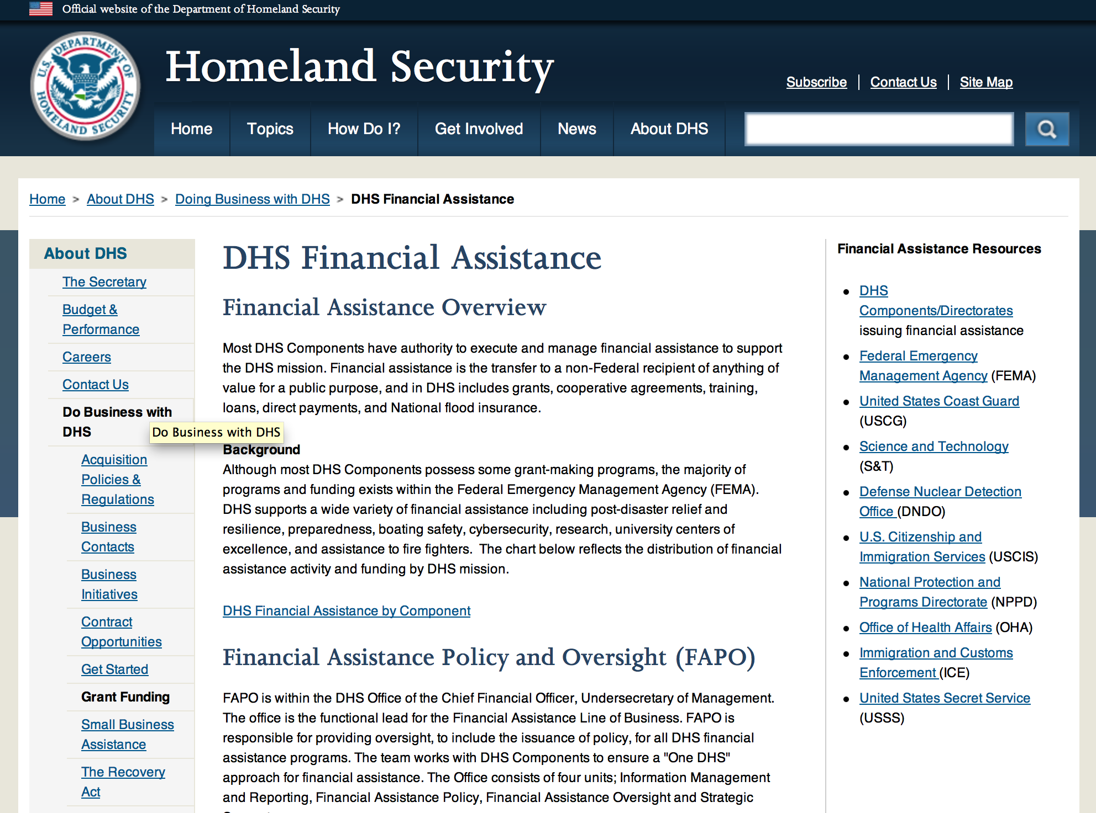

Webpage can be viewed at: http://www.dhs.gov/xopnbiz/grants/index.shtm#2

The FY 2016 Assistance to Firefighters Grants (AFG)
FY 2016 ASSISTANCE TO FIREFIGHTERS (AFG) GRANTS IS CLOSED AT THIS TIME
The FY 2016 AFG Open Application Period Dates Will Be As Follows: 8AM ET OCTOBER 11 through 5PM ET NOVEMBER 18
- FY 2016 Application Workshop Schedule
- FY 2016 AFG Application Guidance Materials The following documents are now available:
  - FY 2016 Notice of Funding Opportunity (NOFO) – Available Now
  - FY 2016 AFG Grant Application Get Ready Guide
  - FY 2016 AFG Narrative Get Ready Guide
  - FY 2016 AFG Self-Evaluation - Operations and Safety
  - FY 2016 AFG Self-Evaluation - Vehicle Acquisition
  - FY 2016 AFG Application Checklist
  - FY 2016 AFG Cost Share Calculator
FY 2016 AFG FAQs
For AFG program guidance materials, please visit our Documents page.

Resources

AFG Help Desk
Contact the AFG Program Help Desk toll-free at 866-274-0960, or email us at firegrants@dhs.gov.
The AFG Program has Fire Program Specialists in 10 federal regional centers. These Regional Fire Program Specialists respond to questions about the AFG program and carry out grant monitoring activities. View regional contacts

Popular AFG links
- AFG Workshop Schedule
- Assistance to Firefighters Grants (AFG)
- AFG Awards List
- AFG Success Stories
- Staffing for Adequate Fire & Emergency Response (SAFER) Grants (SAFER)
- SAFER Awards List
- SAFER Success Stories
- Fire Prevention & Safety (FP&S) Grants
- FP&S Awards List
- FP&S Success Stories
- Grant Closeout Tutorial
- Assistance to Firefighters Grant (AFG) Email Alert Archive
- Frequently Asked Questions
Contact Information For The Assistance to Firefighters Grant (AFG) Program and Help Desk

Federal Funding Alternative To AFG

State Administrative Agencies (SAA) apply for and administer Federal grants on behalf of their States, including FEMA Preparedness Grants. The SAA will work with eligible organizations to comply with the general requirements of grant programs or cooperative agreements. Contact your State’s SAA to find out what current Federal funding opportunities may be available to your organization. A listing of the SAAs and points of contact can be found at http://www.fema.gov/library/viewRecord.do?id=6363.

Programs:

Modifications:

Reminders:

United States Coast Guard
National Non-Profit Organization Grant Program
Synopsis 2

Document Type: |  | Grants Notice
Funding Opportunity Number: |  | DHS-USCG-2017-001
Funding Opportunity Title: |  | National Non-Profit Organization Grant Program
Opportunity Category: |  | Discretionary
Opportunity Category Explanation:
Funding Instrument Type: |  | Cooperative Agreement
Category of Funding Activity: |  | Other (see text field entitled "Explanation of Other Category of Funding Activity" for clarification)
Category Explanation: |  | Recreational Boating Safety
Expected Number of Awards: |  | 30
CFDA Number(s): |  | 97.012 -- Boating Safety Financial Assistance
Cost Sharing or Matching Requirement: |  | No
Posted Date: |  | Oct 14, 2016
Last Updated Date: |  | Oct 14, 2016
Original Closing Date for Applications: |  | Jan 27, 2017
Current Closing Date for Applications: |  | Jan 27, 2017
Archive Date: |  | Feb 26, 2017
Estimated Total Program Funding: |  | $5,021,274
Eligible Applicants: |  | Nonprofits having a 501(c)(3) status with the IRS, other than institutions of higher education
Agency Name: | United States Coast Guard
Description: | The purpose of the National Recreational Boating Safety Program is to reduce the number of accidents, injuries and deaths on America’s waterways and provide a safe enjoyable experience for the boating public. The program also encourages greater non-profit organizations participation and uniformity in boating safety efforts.
Link to Additional Information: | United States Coast Guard Boating Safety
Grantor Contact Information: | If you have difficulty accessing the full announcement electronically, please contact:  Carlin Hertz Non-Profit Grants Coordinator Phone 202-372-1060  Non-Profit Grants Coordinator

http://www.grants.gov/web/grants/view-opportunity.html?oppId=289478

Department of Housing and Urban Development

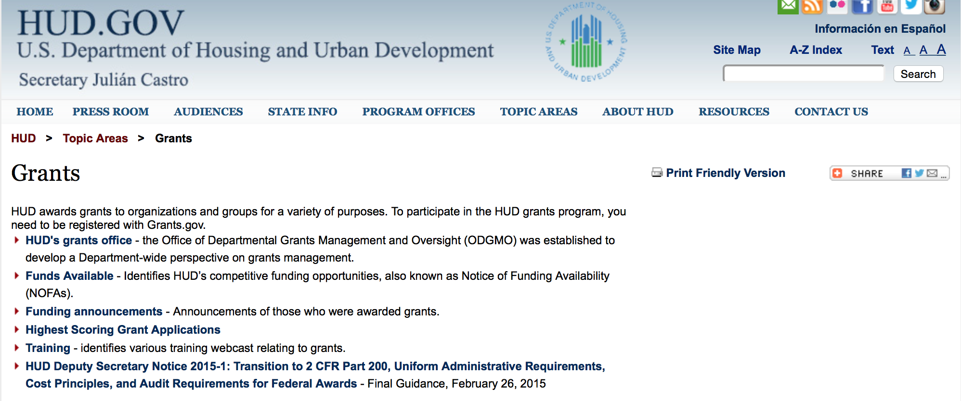

http://portal.hud.gov/hudportal/HUD?src=/topics/grants

HUD - Notice of Funds Available

For detailed information click here

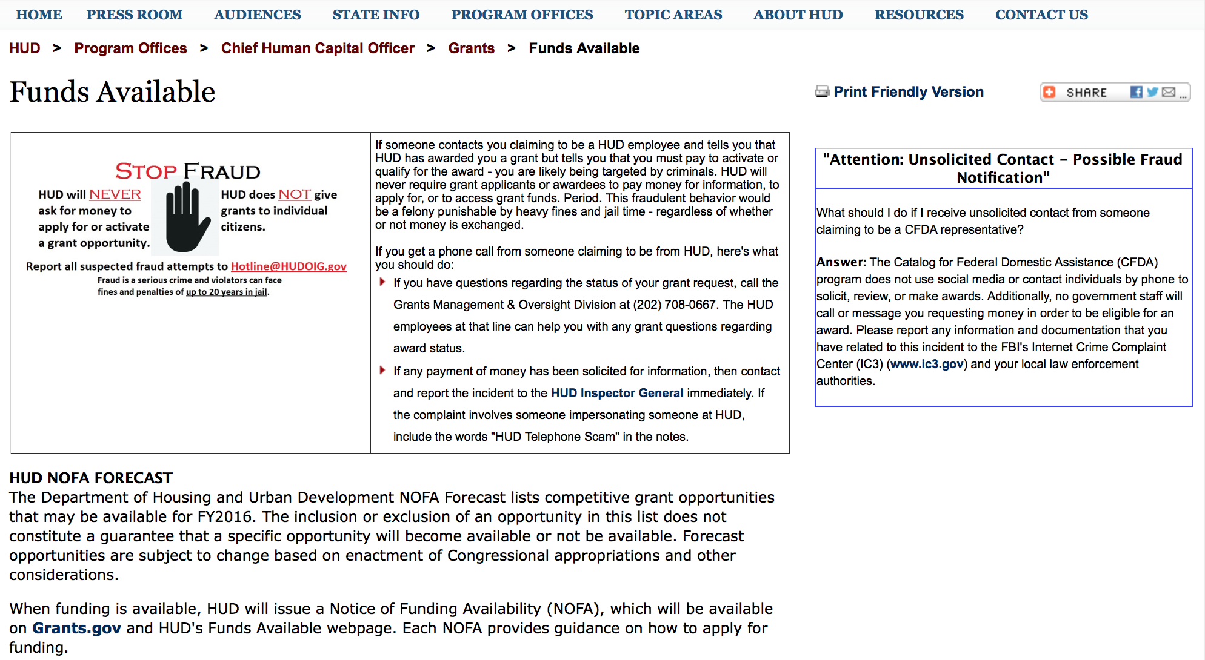

http://portal.hud.gov/hudportal/HUD?src=/program_offices/administration/grants/fundsavail

HUD NOFA FORECAST
The Department of Housing and Urban Development NOFA Forecast lists competitive grant opportunities that may be available for FY2016. The inclusion or exclusion of an opportunity in this list does not constitute a guarantee that a specific opportunity will become available or not be available. Forecast opportunities are subject to change based on enactment of Congressional appropriations and other considerations.
When funding is available, HUD will issue a Notice of Funding Availability (NOFA), which will be available on Grants.gov and HUD's Funds Available webpage. Each NOFA provides guidance on how to apply for funding.
Program Office | Funding Opportunity Title | Funding Opportunity Number | CFDA | Estimated Publication Date | Estimated Application Due Date
GMO | General Section to HUD's Fiscal Year 2016 Notice[s] of Funding Availability for Discretionary Programs (General Section) | FR-6000-N-01 | 14.506 | PUBLISHED | N/A
HSNG | Notice of Funding Availability (NOFA) for the Department's Fiscal Years 2016 and 2017 Comprehensive Housing Counseling Grant Program | FR-6000-N-33 | 14.169 | PUBLISHED | 4/4/2016
HSNG | NOFA for HUD's FY16-17 Housing Counseling Training Grant Program | FR-6000-N-30 | 14.316 | PUBLISHED | 4/4/2016
HSNG | Multifamily Energy and Water Conservation Pay For Success Pilot | FR-6000-N-36 | 14.157 | 9/14/2016 | 11/14/2016
OLHCHH | Lead Hazard Reduction Demonstration (LHRD) Grant Program | FR-6000-N-13 | 14.905 | PUBLISHED | 4/28/2016
OLHCHH | Lead-Based Paint Hazard Control (LBPHC) Grant Program | FR-6000-N-12 | 14.900 | PUBLISHED | 4/28/2016
OLHCHH | Healthy Homes Technical Studies Grant Program Pre and Full Application | FR-6000-N-15 | 14.906 | PUBLISHED | 6/1/2016
PIH | Resident Opportunity & Self-Sufficiency Program | FR-6000-N-05 | 14.870 | PUBLISHED | 5/16/2016
PIH | HOPE VI Main Street Grant Program | FR-6000-N-03 | 14.878 | PUBLISHED | 4/12/2016
PIH | Jobs Plus Initiative | FR-6000-N-14 | 14.895 | PUBLISHED | 6/13/2016
PIH | Family Self-Sufficiency Program | FR-6000-N-04 | 14.896 | PUBLISHED | 4/20/2016
PIH | Community Development Block Grant Program for Indian Tribes and Alaska Native Villages | FR-6000-N-23 | 14.862 | PUBLISHED | 6/14/2016
PIH | Choice Neighborhoods Implementation Grant Program | FR-6000-N-34 | 14.889 | PUBLISHED | 6/28/2016
PIH | Project SOAR | FR-6000-N-27 | 14.889 | 7/20/2016 | 9/19/2016
FHEO | Fair Housing Initiative Program - Private Enforcement Initiative | FR-6000-N-21C | 14.418 | PUBLISHED | 6/23/2016
FHEO | Fair Housing Initiative Program - Fair Housing Organization Initiative | FR-6000-N-21B | 14.417 | PUBLISHED | 6/23/2016
FHEO | Fair Housing Initiative Program - Education and Outreach Initiative | FR-6000-N-21A | 14.416 | PUBLISHED | 6/23/2016
PDR | Research and Evaluation, Demonstration, and Data Analysis and Utilization | FR-5900-N-29 | 14.536 | PUBLISHED | 6/6/2016
PDR | Research and Evaluation, Demonstration, and Data Analysis and Utilization | FR-6000-N-29 | 14.536 | 7/7/2016 | 8/23/2016
CPD | HUD Community Compass Technical Assistance and Capacity Building Program | FR-6000-N-06 | 14.259 | PUBLISHED | 7/19/2016
CPD | Capacity Building for Community Development and Affordable Housing Grants (Section 4) | FR-6000-N-07 | 14.252 | PUBLISHED | 8/9/2016
CPD | Building Capacity to End Youth Homelessness | FR-6000-N-37 | 14.270 | CANCELLED | CANCELLED
CPD | Youth Homelessness Demonstration Project | FR-6000-N-35 | 14.267 | 7/7/2016 | 9/1/2016
CPD | Continuum of Care Program Competition | FR-6000-N-25 | 14.276 | 6/30/2016 | 9/30/2016
CPD | Rural Capacity Building for Community Development and Affordable Housing Grants | FR-6000-N-08 | 14.265 | 7/8/2016 | 9/6/2016
CPD | Self-Help Homeownership Opportunity Program (SHOP) | FR-6000-N-19 | 14.247 | 10/12/2016 | 12/11/2016
- Updated 6/21/2016 General Section
- FONSI
- New Application Attachment Filename Requirement

Programs

Lead-Based Paint Hazard Control (LBPHC) Grant Program
Forecast 1

Document Type: | Grants Notice
Opportunity Number: | FR-6100-N-12
Opportunity Title: | Lead-Based Paint Hazard Control (LBPHC) Grant Program
Opportunity Category: | Discretionary
Opportunity Category Explanation:
Funding Instrument Type: | Grant
Category of Funding Activity: | Housing
Category Explanation:
Expected Number of Awards: | 20
CFDA Number(s): | 14.900 -- Lead-Based Paint Hazard Control in Privately-Owned Housing
Cost Sharing or Matching Requirement: | Yes
Version: | Forecast 1
Posted Date: | Nov 21, 2016
Last Updated Date: | Nov 21, 2016
Estimated Synopsis Post Date: | Jan 05, 2017
Estimated Application Due Date: | Feb 21, 2017 Electronically submitted applications must be submitted no later than 11:59 p.m., ET, on the listed application due date.
Estimated Award Date: | May 02, 2017
Estimated Project Start Date: | Jun 30, 2017
Fiscal Year: | 2017
Archive Date: | Jan 18, 2017
Estimated Total Program Funding: | $48,000,000
Award Ceiling: | $2,500,000
Award Floor: | $1,000,000
Eligible Applicants: | Special district governments  County governments  Others (see text field entitled "Additional Information on Eligibility" for clarification)  Native American tribal governments (Federally recognized)  State governments  City or township governments
Additional Information on Eligibility: | If your organization is established under section 501(c) (including any subsidiary sections) of the Internal Revenue Code, you are not eligible to apply for funding under this NOFA. Under the authorizing statute for this grant program, only cities, counties/parishes, and other units of local government, and certain States and Native American Tribes (see below) are eligible to receive funding under this NOFA. State government and Native American tribal applicants (whether they are the principal applicant or partner applicants in a consortium) are eligible to apply for funding under this NOFA only if they have an Environmental Protection Agency (EPA) authorized lead-based paint training and certification program as of the submission deadline date (see www.epa.gov/lead/pubs/traincert.htm). Multiple agencies within a local government, or multiple units of local government, or a state and one or more units of local government may apply as a consortium; however, an eligible principal (lead) applicant that will be responsible for ensuring compliance with all requirements in this NOFA must be identified. Where an application involves multiple entities, each entity must meet the civil rights threshold requirement of Resolution of Civil Rights Matters. If you, the applicant, are not a component of the executive branch of your jurisdiction&rsquo;s government, that is, if your department or agency does not report directly or through a direct chain of command to the chief executive officer of your jurisdiction (e.g., the governor, the county executive (by whatever title), or the mayor (by whatever title), you must identify the law that provides the authority establishing you as a part of the State government or the unit of local government. To do so, you must provide the specific statutory citation(s) (e.g., 1 Mystate Revised Code 2345), and either the relevant wording as an attachment, or the specific web address(es) of the relevant wording in the body of your application. Be sure to verify that each web address cited is active and available without cost. Individuals, foreign entities, and sole proprietorship organizations are not eligible to compete for, or receive, awards made under this announcement.
Agency Name: | Department of Housing and Urban Development
Description: | The LBPHC program funds units of state, local and tribal government to implement comprehensive programs to identify and remediate lead based paint hazards in privately owned rental or owner occupied housing. Healthy Homes Supplemental funds may be used only in homes also receiving HUD-funded lead hazard control work (interim controls or abatement). Grantees must use an inspection tool that identifies all 29 hazards identified in the Healthy Homes Rating System (HHRS) for assessing, prioritizing and repairing the identified health and safety hazards within those units. For more information about the HHRS, see HUD's HHRS webpage.
Link to Additional Information:
Grantor Contact Information: | Shannon Steinbauer  2024026885  Shannon.E.Steinbauer@hud.gov

http://www.grants.gov/web/grants/view-opportunity.html?oppId=290235

Healthy Homes and Lead Technical Studies Grant Program Pre and Full Application
Forecast 1

Document Type: | Grants Notice
Opportunity Number: | FR-6100-N-15
Opportunity Title: | Healthy Homes and Lead Technical Studies Grant Program Pre and Full Application
Opportunity Category: | Discretionary
Opportunity Category Explanation:
Funding Instrument Type: | Cooperative Agreement
Category of Funding Activity: | Housing
Category Explanation:
Expected Number of Awards: | 6
CFDA Number(s): | 14.902 -- Lead Technical Studies Grants  14.906 -- Healthy Homes Technical Studies Grants
Cost Sharing or Matching Requirement: | No
Posted Date: | Nov 21, 2016
Last Updated Date: | Nov 21, 2016
Estimated Synopsis Post Date: | Jan 23, 2017
Estimated Application Due Date: | Feb 22, 2017 Electronically submitted applications must be submitted no later than 11:59 p.m., ET, on the listed application due date.
Estimated Award Date: | Jun 14, 2017
Estimated Project Start Date: | Oct 03, 2017
Fiscal Year: | 2017
Archive Date:
Estimated Total Program Funding: | $3,800,000
Award Ceiling: | $700,000
Award Floor: | $300,000
Eligible Applicants: | For profit organizations other than small businesses  City or township governments  Public and State controlled institutions of higher education  County governments  Native American tribal governments (Federally recognized)  Nonprofits having a 501(c)(3) status with the IRS, other than institutions of higher education  Small businesses  Native American tribal organizations (other than Federally recognized tribal governments)  Special district governments  Private institutions of higher education  State governments  Nonprofits that do not have a 501(c)(3) status with the IRS, other than institutions of higher education  Independent school districts  Public housing authorities/Indian housing authorities
Additional Information on Eligibility: | Applications to supplement existing projects are eligible to compete with applications for new awards. Federal agencies are not eligible to submit applications. If your organization received an award under the FY2015 and FY 2016 Healthy Homes Technical Studies Grant Program cycle, you are not eligible to apply unless you apply with a different Principal Investigator (PI). Individuals, foreign entities, and sole proprietorship organizations are not eligible to compete for, or receive, awards made under this announcement.
Agency Name: | Department of Housing and Urban Development
Description: | To fund technical studies to improve existing methods for detecting and controlling key housing-related health and safety hazards, including lead-based paint hazards; to develop new methods to detect and control these hazards; and to improve our knowledge of these key housing-related health and safety hazards.
Link to Additional Information:
Grantor Contact Information: | Peter Ashley  (202) 402-7595  peter.j.ashley@hud.gov

http://www.grants.gov/web/grants/view-opportunity.html?oppId=290236

Lead Hazard Reduction Demonstration (LHRD) Grant Program
Forecast 1
Document Type: | Grants Notice
Opportunity Number: | FR-6100-N-13
Opportunity Title: | Lead Hazard Reduction Demonstration (LHRD) Grant Program
Opportunity Category: | Discretionary
Opportunity Category Explanation:
Funding Instrument Type: | Grant
Category of Funding Activity: | Housing
Category Explanation:
Expected Number of Awards: | 15
CFDA Number(s): | 14.905 -- Lead Hazard Reduction Demonstration Grant Program
Cost Sharing or Matching Requirement: | Yes
Posted Date: | Nov 21, 2016
Last Updated Date: | Nov 21, 2016
Estimated Synopsis Post Date: | Jan 05, 2017
Estimated Application Due Date: | Feb 21, 2017 Electronically submitted applications must be submitted no later than 11:59 p.m., ET, on the listed application due date.
Estimated Award Date: | May 07, 2017
Estimated Project Start Date: | Jun 30, 2017
Fiscal Year: | 2017
Archive Date: | Feb 21, 2017
Estimated Total Program Funding: | $45,000,000
Award Ceiling: | $3,000,000
Award Floor: | $1,000,000
Eligible Applicants: | County governments  Others (see text field entitled "Additional Information on Eligibility" for clarification)  State governments  Native American tribal governments (Federally recognized)  City or township governments  Special district governments
Additional Information on Eligibility: | If your organization is established under section 501(c) (including any subsidiary sections) of the Internal Revenue Code, you are not eligible to apply for funding under this NOFA. Under the authorizing statute for this grant program, only cities, counties/parishes, and other units of local government, and certain States and Native American Tribes (see below) are eligible to receive funding under this NOFA. State government and Native American tribal applicants (whether they are the principal applicant or partner applicants in a consortium) are eligible to apply for funding under this NOFA only if they have an Environmental Protection Agency (EPA) authorized lead-based paint training and certification program as of the submission deadline date (see www.epa.gov/lead/pubs/traincert.htm). Multiple agencies within a local government, or multiple units of local government, or a state and one or more units of local government may apply as a consortium; however, an eligible principal (lead) applicant that will be responsible for ensuring compliance with all requirements in this NOFA must be identified. Where an application involves multiple entities, each entity must meet the civil rights threshold requirement of Resolution of Civil Rights Matters. If you, the applicant, are not a component of the executive branch of your jurisdiction&rsquo;s government, that is, if your department or agency does not report directly or through a direct chain of command to the chief executive officer of your jurisdiction (e.g., the governor, the county executive (by whatever title), or the mayor (by whatever title), you must identify the law that provides the authority establishing you as a part of the State government or the unit of local government. To do so, you must provide the specific statutory citation(s) (e.g., 1 Mystate Revised Code 2345), and either the relevant wording as an attachment, or the specific web address(es) of the relevant wording in the body of your application. Be sure to verify that each web address cited is active and available without cost. Individuals, foreign entities, and sole proprietorship organizations are not eligible to compete for, or receive, awards made under this announcement.
Agency Name: | Department of Housing and Urban Development
Description: | The LHRD program funds units of state, local and tribal government to implement comprehensive programs to identify and remediate lead based paint hazards in privately owned rental or owner occupied housing. The LHRD program is targeted to urban jurisdictions (either alone or through a consortium) that have at least 3,500 pre-1940 occupied rental housing units. Healthy Homes Supplemental funds may be used only in homes also receiving HUD-funded lead hazard control work (interim controls or abatement). Grantees must use an inspection tool that identifies all 29 hazards identified in the Healthy Homes Rating System (HHRS) for assessing, prioritizing and repairing the identified health and safety hazards within those units. For more information on the HHRS, see HUD's HHRS webpage.
Link to Additional Information:
Grantor Contact Information: | Shannon Steinbauer  (202) 402-6885  Shannon.E.Steinbauer@hud.gov

http://www.grants.gov/web/grants/view-opportunity.html?oppId=290237

Resident Opportunity & Self-Sufficiency Program
Forecast 1

Document Type: | Grants Notice
Opportunity Number: | FR-6100-N-05
Opportunity Title: | Resident Opportunity & Self-Sufficiency Program
Opportunity Category: | Discretionary
Opportunity Category Explanation:
Funding Instrument Type: | Grant
Category of Funding Activity: | Housing
Category Explanation:
Expected Number of Awards: | 110
CFDA Number(s): | 14.870 -- Resident Opportunity and Supportive Services - Service Coordinators
Cost Sharing or Matching Requirement: | Yes
Posted Date: | Nov 21, 2016
Last Updated Date: | Nov 21, 2016
Estimated Synopsis Post Date: | May 01, 2017
Estimated Application Due Date: | Jun 20, 2017 Electronically submitted applications must be submitted no later than 11:59 p.m., ET, on the listed application due date.
Estimated Award Date: | Sep 25, 2017
Estimated Project Start Date: | Oct 16, 2017
Fiscal Year: | 2017
Archive Date:
Estimated Total Program Funding: | $35,000,000
Award Ceiling: | $738,000
Award Floor: | $0
Eligible Applicants: | Public housing authorities/Indian housing authorities  Nonprofits having a 501(c)(3) status with the IRS, other than institutions of higher education  Nonprofits that do not have a 501(c)(3) status with the IRS, other than institutions of higher education  Native American tribal governments (Federally recognized)
Additional Information on Eligibility: | For-profit entities are not eligible to apply. Resident associations of all kinds must have either locally-incorporated nonprofit status (usually designated by the state) or 501(c)(3) nonprofit status designated by the IRS. All applicants with nonprofit status must submit documentation attesting to their nonprofit status. Please see Section XXX for more information. Individuals, foreign entities, and sole proprietorship organizations are not eligible to compete for, or receive, awards made under this announcement.
Agency Name: | Department of Housing and Urban Development
Description: | Program Overview: The Resident Opportunity & Self Sufficiency (ROSS) Service Coordinator (SC) program funds eligible applicants to hire Service Coordinators to coordinate use of assistance under the Public Housing program with public and private resources, for supportive services and resident empowerment activities. Service Coordinators assess the needs of public and Indian housing residents and link them to supportive services that enable participants to increase earned income, reduce or eliminate the need for welfare assistance, and make progress toward achieving economic independence and housing self-sufficiency. In the case of elderly/disabled residents, the Service Coordinator links participants to supportive services which enable them to age/remain in-place thereby avoiding costlier forms of care. Funds awarded to applicants may be used for (1)service coordinator functions, (2) training and travel related to professional and/or program development, (3) and administration cost.
Link to Additional Information:
Grantor Contact Information: | Tremayne Youmans  (202) 402-6621  Tremayne.E.Youmans@hud.gov

http://www.grants.gov/web/grants/view-opportunity.html?oppId=290238

Family Self-Sufficiency Program
Forecast 1

Document Type: | Grants Notice
Opportunity Number: | FR-6100-N-04
Opportunity Title: | Family Self-Sufficiency Program
Opportunity Category: | Discretionary
Opportunity Category Explanation:
Funding Instrument Type: | Grant
Category of Funding Activity: | Housing
Category Explanation:
Expected Number of Awards: | 700
CFDA Number(s): | 14.896 -- Family Self-Sufficiency Program
Cost Sharing or Matching Requirement: | No
Version: | Forecast 1
Posted Date: | Nov 21, 2016
Last Updated Date: | Nov 21, 2016
Estimated Synopsis Post Date: | Feb 20, 2017
Estimated Application Due Date: | Apr 25, 2017 Electronically submitted applications must be submitted no later than 11:59 p.m., ET, on the listed application due date.
Estimated Award Date: | Aug 02, 2017
Estimated Project Start Date: | Jan 01, 2018
Fiscal Year: | 2017
Archive Date: | Apr 21, 2017
Estimated Total Program Funding: | $75,000,000
Award Ceiling: | $72,000
Award Floor: | $0
Eligible Applicants: | Public housing authorities/Indian housing authorities
Additional Information on Eligibility: | 1. Eligible applicants. PHAs (including MTW PHAs) and Indian tribes/TDHEs currently administering an FSS program, that have served at least the minimum number of families required by this NOFA (as described in Section III.E.3. below; "Eligibility Requirement: Number of FSS Families Served") and have met all other funding requirements. Due to the level of funding under this NOFA, you will only be eligible for funding if you meet one of the following criteria: you were funded under any of the FY 2014, FY 2015, and/or FY 2016 FSS NOFAs, or you received a FSS program through a transfer or consolidation from a PHA that was funded under such NOFAs. Appendix D provides a list of applicants who meet the criteria set forth in the bullet points above. If you are not listed in Appendix D, but you believe you meet the criteria set forth in the bullet points above, you may request a review of eligibility from HUD by following the steps described in Section III.A.2 below. HUD does not award grants to individuals. HUD will also not evaluate applications from ineligible applicants. As required in the Code of Federal Regulations (CFR) at 2 CFR 25.200 and 24 CFR Part 5 Subpart K, all applicants for financial assistance must have an active Data Universal Numbering System (DUNS) number (http://fedgov.dnb.com/webform) and have an active registration in the System for Award Management (SAM) (www.sam.gov) before submitting an application. Getting a DUNS number and completing SAM registration can take up to four weeks; therefore, applicants should start this process or check their status See Section V.B.3 of this NOFA for more information on how funding will be distributed among eligible applicants. See also Section IV.B.1 for necessary form and content information. 2. Request for Review of Eligibility. In advance of submitting this grant application, applicants who are not listed in Appendix D but who believe they meet the eligibility criteria in the Section above (Section III.A.1 of this NOFA) must submit a Request for Review of Eligibility via email to fss@hud.gov. The subject line should be "2017 Review of FSS Eligibility." The email must include the applicant's name, PHA number (in the format found in Appendix D), and a brief explanation of why the applicant believes to be eligible. HUD will review and respond within five working days of receipt of the request. That response will be an eligibility approval, eligibility disapproval, or a request for more information. If more information is requested, HUD will respond within five working days upon receipt of the additional information. All initial Requests for Review of Eligibility must be received no later than 20 calendar days prior to the due date of this NOFA. Individuals, foreign entities, and sole proprietorship organizations are not eligible to compete for, or receive, awards made under this announcement.
Agency Name: | Department of Housing and Urban Development
Description: | The FSS program supports the Department's strategic goal of utilizing housing as a platform for improving quality of life by helping HUD-assisted renters increase their economic security and self-sufficiency. The FSS program promotes the development of local strategies to coordinate the use of assistance under the HCV and PH programs with public and private resources to enable participating families to increase earned income and financial literacy, reduce or eliminate the need for welfare assistance, and make progress toward economic independence and self-sufficiency. PHAs or tribes/Tribally Designated Housing Entities (TDHEs) that administer FSS programs enter into five-year contracts with new families on an ongoing basis. The FSS contract spells out the terms and conditions governing participation and the responsibilities of both the PHA (or tribe/TDHE) and the family. PHAs are not permitted to limit FSS participation to those families most likely to succeed because of current education level or job history.
Link to Additional Information:
Grantor Contact Information: | Tremayne Youmans  (202) 402-6621  fss@hud.gov

http://www.grants.gov/web/grants/view-opportunity.html?oppId=290254

Jobs Plus Initiative
Forecast 1

Document Type: | Grants Notice
Opportunity Number: | FR-6100-N-14
Opportunity Title: | Jobs Plus Initiative
Opportunity Category: | Discretionary
Opportunity Category Explanation:
Funding Instrument Type: | Grant
Category of Funding Activity: | Housing
Category Explanation:
Expected Number of Awards: | 12
CFDA Number(s): | 14.895 -- Jobs-Plus Pilot Initiative
Cost Sharing or Matching Requirement: | Yes
Posted Date: | Nov 22, 2016
Last Updated Date: | Nov 22, 2016
Estimated Synopsis Post Date: | Feb 07, 2017
Estimated Application Due Date: | Apr 10, 2017 Electronically submitted applications must be submitted no later than 11:59 p.m., ET, on the listed application due date.
Estimated Award Date: | Jul 17, 2017
Estimated Project Start Date: | Aug 01, 2017
Fiscal Year: | 2017
Archive Date: | Apr 10, 2017
Estimated Total Program Funding: | $35,000,000
Award Ceiling: | $3,000,000
Award Floor: | $1,000,000
Eligible Applicants: | Others (see text field entitled "Additional Information on Eligibility" for clarification)
Additional Information on Eligibility: | Conditions for Eligibility of Public Housing Authorities Eligible applicants are PHAs that operate one or more public housing developments that meet the criteria outlined in this NOFA. A list of developments that meet the criteria is provided in Appendix B however, the mere appearance of a development on this list does not necessarily mean that the development is appropriate for a Jobs Plus program. PHAs that received a Jobs Plus program grant in 2014, 2015 or 2016 are not eligible for 2017 grant funds. Federally designated tribes and tribally designated housing entities are not eligible entities under this award. Successful applicants will be required to implement the full 48 month term of the grant at the public housing site(s) for which funds were awarded and commit to not engaging in any significant redevelopment that would result in resident relocation during the 48-month Jobs Plus implementation timeframe. Successful applicants will be required to inform HUD of any planned Rental Assistance Demonstration (RAD) conversions at the Jobs Plus site. Conversion of Public Housing developments to RAD using project based vouchers will be permitted as long as the planned conversion will take place post award. Criteria for Eligible Developments Size: Minimum development size of 200 non-elderly-only households. Non-elderly-only means households where at least one resident is under age 62. Unemployment: At least 40 percent of the households (excluding elderly-only households) contain no member showing earned income in PIC. Place: Units to be served must be contiguous unless good cause can be shown that the program will be successful in non-contiguous developments. A description as to how the program will be run from one central location and remain accessible to residents of non-contiguous developments will be required. This requirement may disqualify developments on the Eligible Development list if the Asset Management Project (AMP) is for scattered sites. Performance: Developments that belong to a non-performing PHA may be eligible to participate provided HUD has determined the PHA has the capacity to implement and oversee the grant successfully. A non-performing PHA; is defined as a PHA that is designated as a troubled performer under the Public Housing Assessment System (PHAS) as listed on HUD's most recent official Troubled List or is designated a substandard performer based on its most recent published PHAS score. PHAs that have more than one development already listed as eligible in Appendix B may apply to serve more than one of the eligible developments as long as they are contiguous or show in the application that they meet the required criteria for place. No Request for Review of Eligibility is required prior to submitting the application. PHAs that have developments not listed on Appendix B that they believe, when combined, meet the criteria, may submit a request for review of eligibility. PHAs may propose to combine two or more developments to meet the criteria for eligible developments, subject to the following conditions: Parts of developments cannot be combined. Only entire developments may be combined. The combined developments must meet the criteria for size. The combined developments must meet the criteria for unemployment. Individuals, foreign entities, and sole proprietorship organizations are not eligible to compete for, or receive, awards made under this announcement.
Agency Name: | Department of Housing and Urban Development
Description: | 1. Purpose. The purpose of the Jobs Plus Pilot program is to develop locally-based, job-driven approaches to increase earnings and advance employment outcomes through work readiness, employer linkages, job placement, educational advancement, technology skills, and financial literacy for residents of public housing. The place-based Jobs Plus Pilot program addresses poverty among public housing residents by incentivizing and enabling employment through earned income disregards for working families, and a set of services designed to support work including employer linkages, job placement and counseling, educational advancement, and financial counseling. Ideally, these incentives will saturate the target developments, building a culture of work and making working families the norm. The Jobs Plus Pilot program consists of the following three core components: Employment-Related Services Financial Incentives; Jobs Plus Earned Income Disregard (JPEID) Community Supports for Work Applicants are encouraged to develop key partnerships to connect participants with any other needed services to remove barriers to work. An Individualized Training and Services Plan (ITSP) should be developed for each participant to establish goals and service strategies, and to track progress. These grants will employ several principles of the President's Job Driven Training checklist (available at https://www.whitehouse.gov/sites/default/files/docs/ready_to_work_factsheet.pdf) ) to ensure that public housing residents are connected to a program that is using evidence-based practices that work for job seekers and employers. Labor Market Data: Successful programs will first consider the data in their local community; where the jobs are and what industries offer the most opportunities for residents to achieve long-term employment and progression along a career pathway. Career Pathways: Successful programs will also promote a seamless progression from one educational stepping stone to another and across work-based training and education, so individuals are obtaining new training and credentials. Work Experience: Successful programs will support learning opportunities with employers; including on-the-job training, internships and pre-apprenticeships and Registered Apprenticeships; as training paths to employment. Access to Training: Successful programs will break down barriers to accessing job-driven training and hiring for any public housing resident who is willing and able to work, including access to job supports and relevant guidance. Key Partnerships: Finally, a successful Jobs Plus Pilot program is collaboratively designed and implemented by high-performing local housing authorities, residents of public housing developments, Workforce Investment Boards (WIBs) and American Job Centers (AJC's, also known as One Stop Career Centers), local businesses and employers, and other organizations that provide supportive services within that community. Other suggested partners include higher education institutions, philanthropic organizations, human service agencies, vocational rehabilitation agencies, business-related and other non-profit organizations and community and faith based organizations. Background HUD, the Rockefeller Foundation, and the MDRC, through a public-private partnership, designed and supported the Jobs Plus program model between 1998 and 2003. HUD has issued two separate evaluation reports on the demonstration, in an effort to identify and document the most promising approaches to increasing employment among families in public housing. Each evaluation showed ongoing positive effects for residents when the program was well-implemented and included the three core elements. More information on the findings can be found at http://www.mdrc.org/project/jobs-plus-community-revitalization-initiative-public-housing-families#overview. Employment-Related Services Successful applicants must partner with the Department of Labor Workforce Investment Board (WIB) and American Job Center (AJC)/One-Stop in their area to offer multiple employment-related services for residents with a range of employment needs. Local Labor Market Information (LMI) should be used both for initial planning and analysis of which employment opportunities are most available locally, as well as for monitoring ongoing trends. Program services provided on-site should include, but need not be limited to, the following: Career exploration/job readiness workshops Job search and job placement assistance Work experience including on-the-job training, internships, pre-apprenticeships and Registered Apprenticeships (HUD encourages opportunities for residents to be paid while training whenever possible) Facilitated connections to education and training opportunities Rapid re-employment assistance in the event of job loss Proactive post-placement job retention support and career advancement coaching Access to computers, phones, fax, and copy machines and other supplies, for participants; employment-related uses as well as adequate training on how to use these technologies To facilitate these employment services, applicants may consider having dedicated, on-site, workforce system staff to perform job developer and case manager functions. Job developers work directly with the business community to identify and create employment opportunities and act as liaisons with local employment agencies. Case managers work one-on-one with participants to guide them through the employment process and help them achieve employment-related goals. Financial Incentives; Jobs Plus Earned Income Disregard (JPEID) Successful applicants must also implement a financial incentive to program participants, known as the Jobs Plus Earned Income Disregard (JPEID). This component will neutralize any rent increase due to rising income for Jobs Plus participants, removing a major disincentive to employment. Rent incentives offered through JPEID will be reimbursed to the PHA via Jobs Plus appropriations, and should be included in the program budget. Any other compensation to the PHA for lost rent revenues, such as by the standard EID calculation in the Operating Fund, will be offset manually to prevent overpayment of HUD funds to grant recipients. Further guidance will be available at the time of the award. All residents in a Jobs Plus development are eligible to receive the JPEID benefit, but in order to access JPEID they must sign up for the Jobs Plus program even if they do not actively participate in other Jobs Plus Activities. Residents who previously used up some or all of their lifetime EID eligibility are eligible to receive the full JPEID benefit. Disregarded Amount. The JPEID excludes from the Family Rent calculation 100 percent of incremental earned income for the entire period of the Jobs Plus program. Calculation of the JPEID. Once the JPEID is triggered for a family, their baseline income will not change for the duration of the term of the grant (so participants who enroll early may benefit from the JPEID longer than residents who enroll later.) To facilitate reimbursements for rent revenue losses due to the JPEID, grantees must calculate and document each participant's Family Rent both before and after the inclusion of any incremental earned income. The difference between these two rents is the amount to be reimbursed to the PHA through JPEID. These calculations must be provided to HUD when drawing reimbursement funds. As with any government benefit, an increase in earned income may result in the reduction or loss of other benefits that an individual was previously receiving. Grantees, through case management or other means, must be prepared to help residents understand the overall financial impact of an increase in earned income and the JPEID. It is also expected that grantees will encourage participants to take advantage of other financial work incentives they may be entitled to, such as the Earned Income Tax Credit (EITC). Community Supports for Work Successful applicants will incorporate a robust engagement strategy for involving the residents in the targeted development and creating a working community. Engagement is more than signing up; sustained involvement in the program leading to residents' ownership of their own growth and experiences, as well as that of peers, will yield continued benefits for both participants and future residents of the development beyond the grant period. Program outreach should be directed towards residents at all points along the employment spectrum; from unemployed individuals with no work history to working underemployed families with substantial work history. Unless an application specifies that the applicant will target a limited sub-group, the application narrative should include strategies to target this wide range of potential participants, as well as strategies for retention. One key strategy for retention should include the use of residents as Community Coaches. Community Coaches can market the various aspects of the Jobs Plus program, disseminate information about job opportunities and programs via resident social networks in the development, mentor specific individuals or groups who enroll in Jobs Plus, and help shape program offerings and outreach efforts based on their intimate knowledge of the needs and strengths of the community. Partnerships with Local Agencies The comprehensive nature of the Jobs Plus Pilot model requires that PHAs establish partnerships with American Job Centers and other key social service agencies within the community. HUD and DOL have developed a toolkit and webinar which describes effective strategies for establishing partnerships between PHAs and WIBs/AJCs (see; From the Ground Up: Creating Partnerships between Public Housing Authorities and Workforce Investment Boards; at https://www.workforce3one.org/view/5001417448285409284/info) The toolkit provides several models for partnership that prospective applicants may want to consider. These partnerships will serve to strengthen program planning and implementation, as well as streamline access to services for participants. For each partner identified, applicants must describe the role of the partner agency and a description of the services to be provided by the partner agency, as well as the amount of grant funding (if any) that partners will receive. Applicants should demonstrate their ability to build collaboration among all partners, regardless of whether a partner will be receiving grant funding for their services, or if the services will be provided in-kind. Partners should include: Workforce Investment Boards/American Job Centers Local welfare agencies Employment and training organizations Vocational training providers Community colleges and four-year educational institutions Other supportive service agencies providing either direct services or referrals to services that are critical for supporting successful employment In addition to employment, training and educational supports, grantees will have the flexibility to provide other supportive services based on resident needs and local capacity. HUD expects that all services that are generally available to residents of the community will be leveraged in-kind from partners. Grant funds should only be used to procure services that are not already available (either by service type or amount). Examples of the types of services that may be provided by grant funds, formal partners or the program's referral network include but are not limited to the following: Child care services and/or after school programs Transportation assistance Financial literacy workshops Legal services (e.g. expungement) Domestic violence prevention services Services for formerly incarcerated/returning citizens Life Skills Other applicable local business support
Link to Additional Information:
Grantor Contact Information: | Jobs Plus  202-402-3624  jobsplus@hud.gov

http://www.grants.gov/web/grants/view-opportunity.html?oppId=290259

Modifications:

Reminders

Technical Correction to the General Section to HUD's Fiscal Year 2016 Notice[s] of Funding Availability for Discretionary Programs
Modification 1

Document Type: | Grants Notice
Funding Opportunity Number: | FR-6000-N-01-C
Funding Opportunity Title: | Technical Correction to the General Section to HUD's Fiscal Year 2016 Notice[s] of Funding Availability for Discretionary Programs
Opportunity Category: | Discretionary
Opportunity Category Explanation:
Funding Instrument Type: | Grant
Category of Funding Activity: | Community Development
Category Explanation:
Expected Number of Awards: | 0
CFDA Number(s):
Cost Sharing or Matching Requirement: | No
Posted Date: | May 16, 2016
Last Updated Date: | May 16, 2016
Original Closing Date for Applications: | Dec 31, 2016 Electronically submitted applications to program NOFAs must be submitted no later than 11:59:59 p.m., ET, on the listed application due date. No applications are accepted in response to this Notice, which publishes policies and guidance only.
Current Closing Date for Applications: | Dec 31, 2016 Electronically submitted applications to program NOFAs must be submitted no later than 11:59:59 p.m., ET, on the listed application due date. No applications are accepted in response to this Notice, which publishes policies and guidance only.
Archive Date: | Jan 30, 2017
Estimated Total Program Funding: | $0
Award Ceiling: | $0
Award Floor: | $0
Eligible Applicants: | Public and State controlled institutions of higher education  Unrestricted (i.e., open to any type of entity above), subject to any clarification in text field entitled "Additional Information on Eligibility"  Nonprofits that do not have a 501(c)(3) status with the IRS, other than institutions of higher education  State governments  Private institutions of higher education  Public housing authorities/Indian housing authorities  County governments  Special district governments  City or township governments  Small businesses  Native American tribal governments (Federally recognized)  Independent school districts  Native American tribal organizations (other than Federally recognized tribal governments)  Individuals  Nonprofits having a 501(c)(3) status with the IRS, other than institutions of higher education  For profit organizations other than small businesses
Additional Information on Eligibility: | No applications will be accepted in response to this document. This Document is a policy document only. The individual program Notices of Funds Available (NOFA) will identify eligible applicants for each competition. Each Program NOFA will describe additional eligibility requirements for applicants. HUD does not provide direct services or products to individuals through its formula-based programs or its competitive Program NOFA process. Individuals seeking financial assistance should refer to www.GovBenefits.gov. Individuals, foreign entities, and sole proprietorship organizations are not eligible to compete for, or receive, awards made under this announcement.
Agency Name: | Department of Housing and Urban Development
Description: | HUD publishes a General Section each Fiscal Year (FY) that contains requirements for all of HUD’s competitive grant programs. Applications to HUD programs must meet all applicable requirements of the General Section and the requirements in the Program NOFA to be considered for funding. This updates paragraph V.C.8. Eminent Domain to reflect the 2016 Appropriations authority, and updates paragraph VI.A.1. Obtaining an Electronic Application.
Link to Additional Information: | http://portal.hud.gov/hudportal/HUD?src=/program_offices/administration/grants/fundsavail
Contact Information: | If you have difficulty accessing the full announcement electronically, please contact:  Loyd LaMois loyd.lamois@hud.gov  Grants Policy

http://www.grants.gov/web/grants/view-opportunity.html?oppId=283900

General Section to HUD's Fiscal Year 2016 Notice[s] of Funding Availability for Discretionary Programs (General Section)
Modification 1

Document Type: | Grants Notice
Funding Opportunity Number: | FR-6000-N-01
Funding Opportunity Title: | General Section to HUD's Fiscal Year 2016 Notice[s] of Funding Availability for Discretionary Programs (General Section)
Opportunity Category: | Discretionary
Funding Instrument Type: | Grant
Category of Funding Activity: | Community Development
Category Explanation:
Expected Number of Awards: | 0
CFDA Number(s):
Cost Sharing or Matching Requirement: | No
Posted Date: | Sep 24, 2015
Creation Date: | Sep 24, 2015
Original Closing Date for Applications: | Dec 30, 2016 Electronically submitted applications must be submitted no later than 11:59:59 p.m., ET, on the listed application due date published in the individual program NOFA.
Current Closing Date for Applications: | Dec 30, 2016 Electronically submitted applications must be submitted no later than 11:59:59 p.m., ET, on the listed application due date published in the individual program NOFA.
Archive Date: | Jan 29, 2017
Eligible Applicants: | Others (see text field entitled "Additional Information on Eligibility" for clarification)
Additional Information on Eligibility: | This Document is a policy document only. The individual program Notices of Funds Available (NOFA) will identify eligible applicants for each competition. Each Program NOFA will describe additional eligibility requirements for applicants. All applicants must have valid, active Registration in the System for Award Management (SAM) prior to submission of applications for financial assistance. HUD does not provide direct services or products to individuals through its formula-based programs or its competitive Program NOFA process. Individuals seeking financial assistance should refer to www.GovBenefits.gov. Individuals, foreign entities, and sole proprietorship organizations are not eligible to compete for, or receive, awards made under this announcement.
Agency Name: | Department of Housing and Urban Development
Description: | The General Section describes the requirements that are applicable to all HUD FY 2015 Program NOFAs. The General Section also provides information on HUD’s priorities and strategic goals. Each Program NOFA will describe additional applicable procedures and requirements, including a description of the eligible applicants, eligible activities, threshold requirements, cross-program requirements such as nondiscrimination, environmental protection, and any additional program requirements or limitations. To adequately address all of the application requirements for any program, please carefully read and respond to both this General Section and any applicable Program NOFA.
Link to Additional Information: | http://portal.hud.gov/hudportal/HUD?src=/program_offices/administration/grants/fundsavail
Contact Information: | If you have difficulty accessing the full announcement electronically, please contact:  Loyd LaMois loyd.lamois@hud.gov  Grants Policy

http://www.grants.gov/web/grants/view-opportunity.html?oppId=279206



Institute of Museum and Library Services

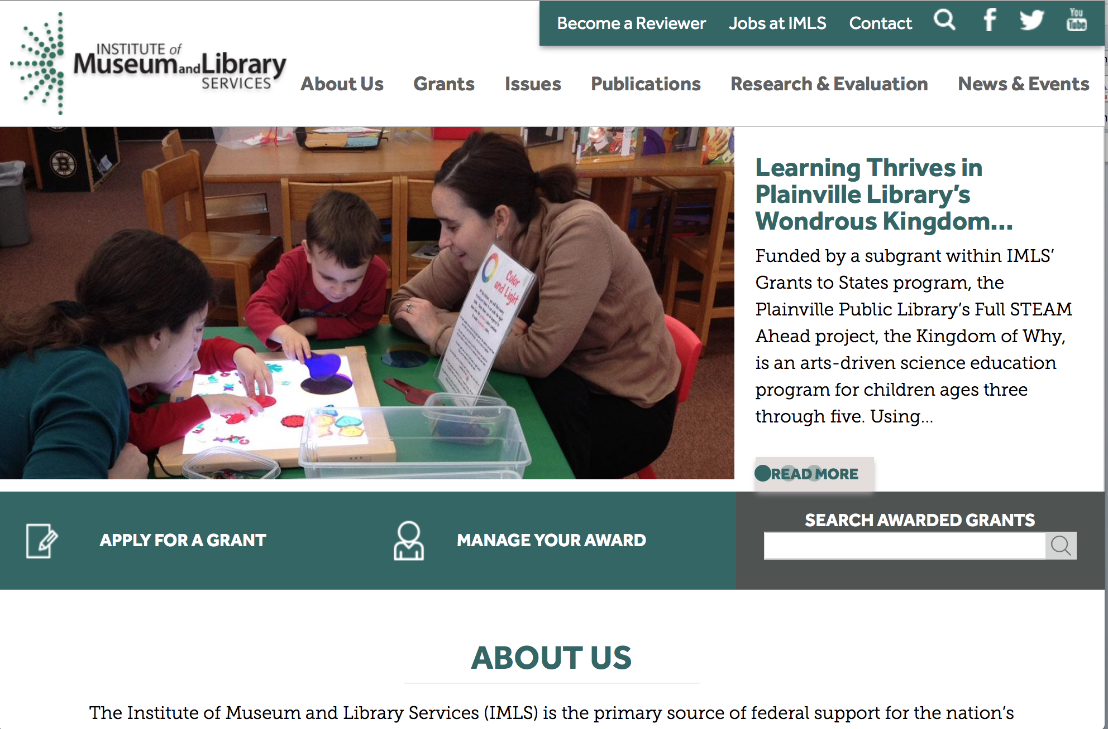

www.imls.gov

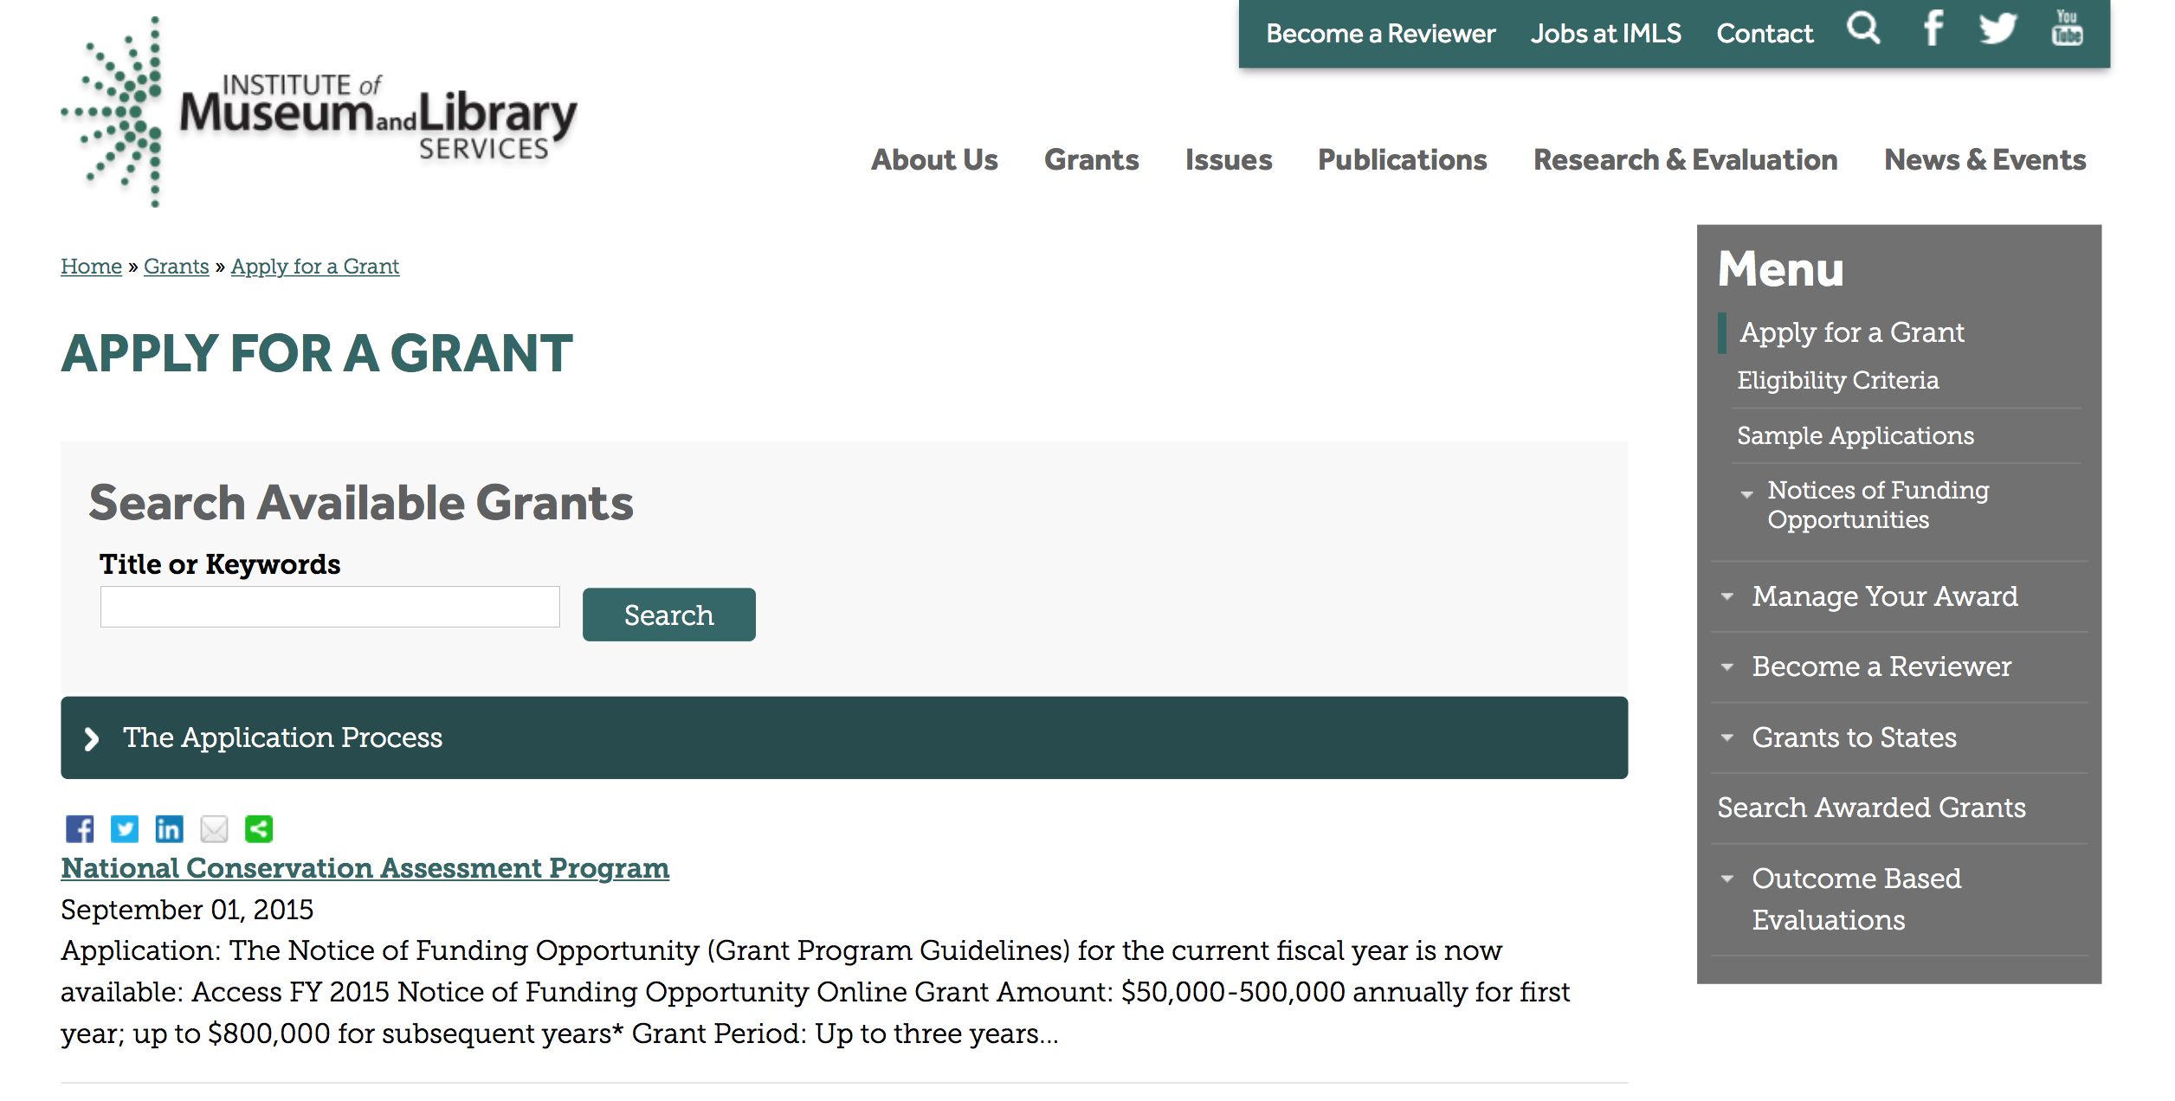
http://www.imls.gov/applicants/available_grants.aspx

Each grant program has specific eligibility requirements. The links below provide general eligibility criteria for museums, libraries, and tribal organizations, but please note that additional organizations may be eligible for grants under certain programs. Additionally, ineligible organizations may still be able to participate in grant programs through partnerships with eligible organizations. Please click on the links below to see general criteria and review Applications and Guidelines for specific information.
Museums Libraries

Institutions: Archives, Federally Recognized Native American Tribe, Historical Society, Library, Nonprofits that serve Native Hawaiians, Professional Association, Public or Private Non-profit Institutions of Higher Education, Regional Organization, State Library Administrative Agency, State or Local Government

Check out IMLS's Facebook page at:
https://www.facebook.com/USIMLS/

Programs:

Modifications:

Reminders:

Deleted:

Department of the Interior
Working with Interior

The Interior Department provides assistance to the public, local governments and businesses through a number of programs. For a general overview see: http://www.doi.gov/index.cfm

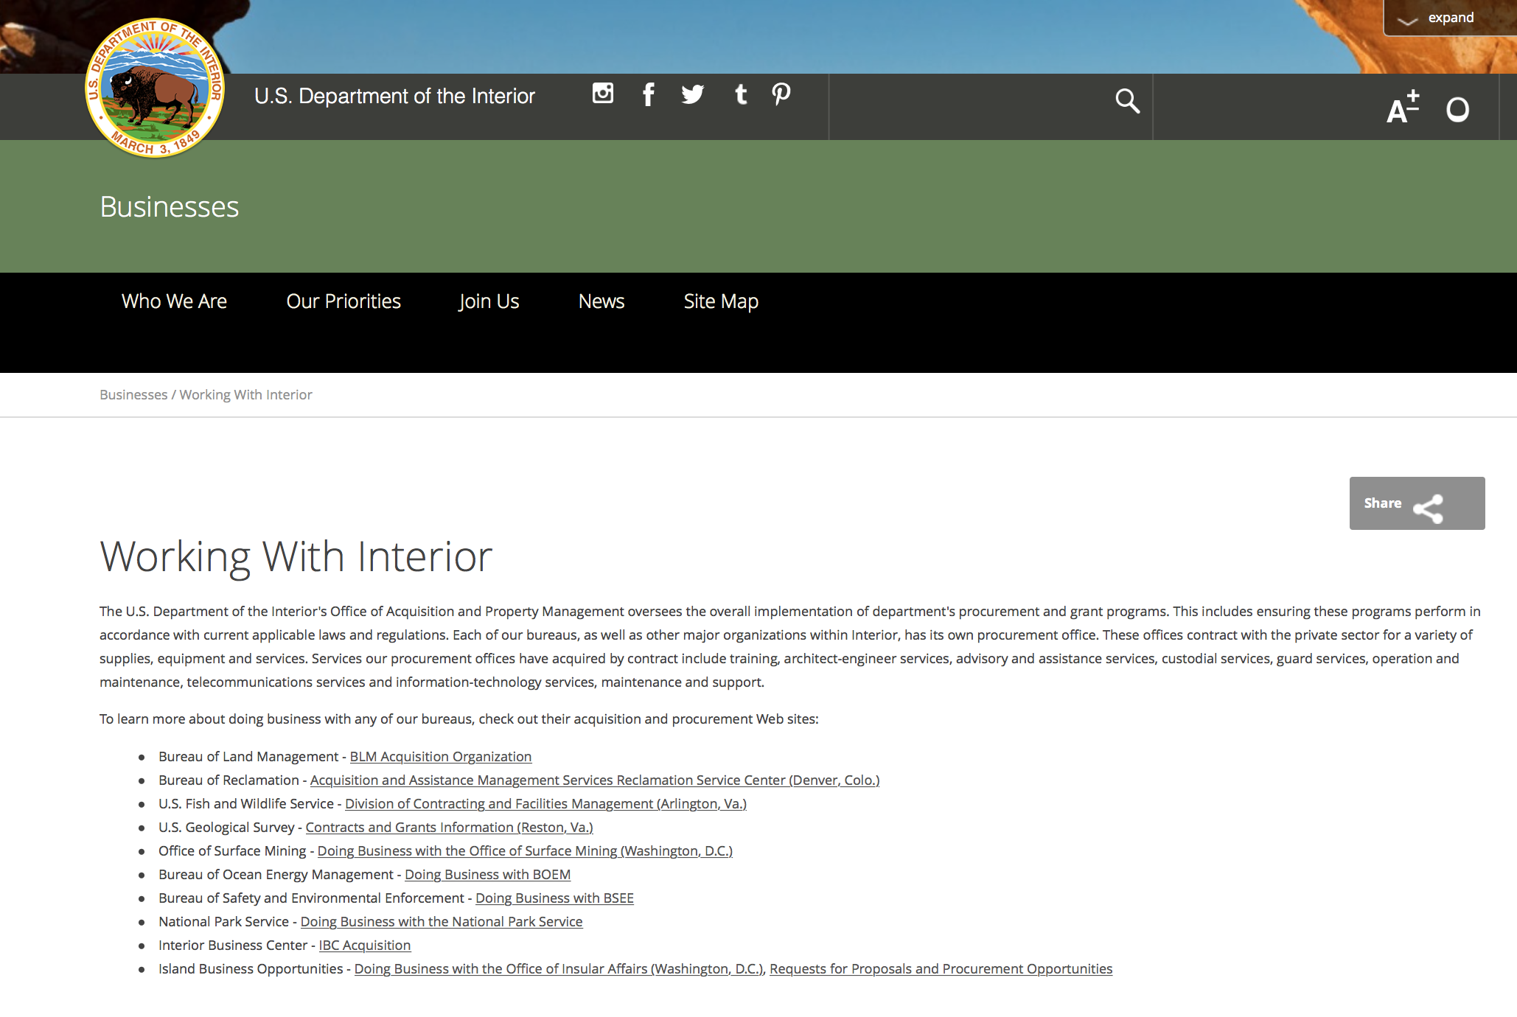

http://www.doi.gov/businesses/working-with-interior.cfm

Programs:

National Fish Passage Program
Synopsis 1

Document Type: | Grants Notice
Funding Opportunity Number: | F17AS00030
Funding Opportunity Title: | National Fish Passage Program
Opportunity Category: | Discretionary
Opportunity Category Explanation:
Funding Instrument Type: | Cooperative Agreement  Grant
Category of Funding Activity: | Natural Resources
Category Explanation:
Expected Number of Awards: | 0
CFDA Number(s): | 15.608 -- Fish and Wildlife Management Assistance
Cost Sharing or Matching Requirement: | Yes
Posted Date: | Nov 23, 2016
Last Updated Date: | Nov 23, 2016
Original Closing Date for Applications: | Sep 30, 2017
Current Closing Date for Applications: | Sep 30, 2017
Archive Date: | Oct 02, 2017
Estimated Total Program Funding: | $0
Award Ceiling: | $2,000,000
Award Floor: | $500
Eligible Applicants: | Unrestricted (i.e., open to any type of entity above), subject to any clarification in text field entitled "Additional Information on Eligibility"
Additional Information on Eligibility: | To receive funding, NFPP projects must be implemented in coordination with FAC staff. Applicants can be, but not limited to: state and federal agencies, private lands, tribes, local municipalities, and non-governmental organizations.
Agency Name: | Fish and Wildlife Service
Description: | The National Fish Passage Program (NFPP) is a voluntary program that provides direct technical assistance and financial assistance in the form of cooperative agreements and grants to partners to provide fish (and other aquatic organisms) passage and restore aquatic connectivity for the benefit of federal trust resources. The NFPP is delivered through more than 65 Fisheries and Aquatic Conservation (FAC) Field Offices across all States and territories. FAC staff coordinates with project partners, stakeholders and other Service programs to identify and collaboratively implement projects within Regional priority areas. Project work plans are developed strategically, in coordination with partners, and with substantial involvement from FAC staff. Projects must advance our mission, promote biological diversity, and be based upon sound scientific biological principles. FAC and Fish and Wildlife Service (FWS) strategic plans inform the types of projects funded under this opportunity. Applicants seeking funding under this program should review the program strategic plan and also contact the regional NFPP Coordinator for local FAC contacts prior to submitting an application for funding.
Link to Additional Information: | http://www.grants.gov
Grantor Contact Information: | If you have difficulty accessing the full announcement electronically, please contact:  Susan Wells 703-358-2523 Susan_Wells@fws.gov  Fish Passage Coordinator

http://www.grants.gov/web/grants/view-opportunity.html?oppId=290297

Modifications:

Reminders:

Fish and Wildlife Service
Fiscal Year

Document Type: | Grants Notice
Funding Opportunity Number: | F17AS00005
Funding Opportunity Title: | Fiscal Year 2017 Recovery Implementation Grants
Opportunity Category: | Discretionary
Opportunity Category Explanation:
Funding Instrument Type: | Cooperative Agreement  Grant  Procurement Contract
Category of Funding Activity: | Environment  Natural Resources
Category Explanation:
Expected Number of Awards: | 0
CFDA Number(s): | 15.657 -- Endangered Species Conservation - Recovery Implementation Funds
Cost Sharing or Matching Requirement: | No
Posted Date: | Oct 18, 2016
Last Updated Date: | Oct 18, 2016
Original Closing Date for Applications: | Applications are due by July 31, 2017. However, you may submit applications throughout the year. Consideration of applications ultimately will be based on the FWS budget cycle.
Current Closing Date for Applications: | Applications are due by July 31, 2017. However, you may submit applications throughout the year. Consideration of applications ultimately will be based on the FWS budget cycle.
Archive Date: | Aug 31, 2017
Estimated Total Program Funding: | $100,000
Award Ceiling: | $100,000
Award Floor: | $1
Eligible Applicants: | Unrestricted (i.e., open to any type of entity above), subject to any clarification in text field entitled "Additional Information on Eligibility"
Additional Information on Eligibility: | Applicants must have a demonstrated knowledge and understanding of the biology of the involved endangered or threatened species in the United States and their ecosystem, including preferably having worked with the species in the field and holding a currently valid Endangered Species Act permit, issued by the FWS, authorizing them to work with these species (or that have previously held a permit to do so). If funding is awarded, applicants that do not currently hold a valid permit for the proposed activity may need to apply for and obtain a permit (http://www.fws.gov/endangered/permits/index.html) before beginning the proposed activity. FWS Regional (or Field Office) contacts will discuss potential proposals with interested parties if needed, and review eligible applications. The FWS Regional Office will refer interested parties to the appropriate FWS Field Office for further consideration as appropriate. For potential proposals submitted directly to the Field Office, the Field Office will conduct the proposal review and selection process. A list of FWS Regional Office contacts is available in the Full Announcement under section VII. Agency Contacts.
Agency Name: | Fish and Wildlife Service
Description: | The FWS Ecological Services Program provides Federal financial assistance on a competitive basis to States, other Federal agencies, landowners, educators, non-profit organizations, researchers, and other partners to secure information about endangered, threatened or candidate species, to aid in the recovery of these species, to avert listing of species pursuant to the Endangered Species Act, and to help conserve the ecosystems upon which these species depend. The FWS and National Marine Fisheries Service (NMFS), which is part of the Department of Commerceï¿½s NOAA Fisheries office, share Endangered Species Act responsibilities for several species such as sea turtles. We have responsibility for sea turtles when they are on land, and NMFS has responsibility for sea turtles when they are in the water. Projects for NMFS-managed species are not included in this funding opportunity. This Recovery Implementation funding opportunity is intended for projects that will contribute to the recovery of FWS-managed endangered and threatened species in the United States, and is limited to projects carrying out actions described in a speciesï¿½ approved recovery plan, in the implementation schedule of a speciesï¿½ approved recovery plan, actions recommended in a completed 5-year status review of the species or in a spotlight species action plan, or projects documenting speciesï¿½ response to climate change. For example: securing scientific information about endangered or threatened species, implementing restoration actions that will lead to delisting of a species, help prevent extinction of a species, or aid in the recovery of a species. Projects that address species response to climate change will receive additional consideration.
Link to Additional Information: | http://www.grants.gov
Grantor Contact Information: | If you have difficulty accessing the full announcement electronically, please contact:  Kelly Niland 703-358-2492 Kelly_Niland@fws.gov  Kelly_Niland@fws.gov

http://www.grants.gov/web/grants/view-opportunity.html?oppId=289600

Fish and Wildlife Service
Partners for Fish and Wildlife
Synopsis 1

Document Type: | Grants Notice
Funding Opportunity Number: | F17AS00015
Funding Opportunity Title: | Partners for Fish and Wildlife
Opportunity Category: | Discretionary
Opportunity Category Explanation:
Funding Instrument Type: | Cooperative Agreement
Category of Funding Activity: | Community Development  Education  Environment  Natural Resources
Category Explanation:
Expected Number of Awards: | 5000
CFDA Number(s): | 15.631 -- Partners for Fish and Wildlife
Cost Sharing or Matching Requirement: | No
Posted Date: | Nov 03, 2016
Last Updated Date: | Nov 03, 2016
Original Closing Date for Applications: | Sep 30, 2017
Current Closing Date for Applications: | Sep 30, 2017
Archive Date: | Oct 07, 2017
Estimated Total Program Funding: | $52,000,000
Award Ceiling: | $500,000
Award Floor: | $1
Eligible Applicants: | For profit organizations other than small businesses  Nonprofits having a 501(c)(3) status with the IRS, other than institutions of higher education  City or township governments  Native American tribal organizations (other than Federally recognized tribal governments)  State governments  Individuals  Small businesses  Public and State controlled institutions of higher education  Nonprofits that do not have a 501(c)(3) status with the IRS, other than institutions of higher education  Native American tribal governments (Federally recognized)  County governments  Private institutions of higher education
Agency Name: | Fish and Wildlife Service
Description: | The Partners for Fish and Wildlife (PFW) Program is a voluntary, incentive-based program that provides direct technical assistance and financial assistance in the form of cooperative agreements to private landowners to restore and conserve fish and wildlife habitat for the benefit of federal trust resources. The PFW Program is delivered through more than 250 full-time staff, active in all 50 States and territories. Partners for Fish and Wildlife Program staff coordinate with project partners, stakeholders and other Service programs to identify geographic focus areas and develop habitat conservation priorities within these focus areas. Geographic focus areas are where the PFW Program directs resources to conserve habitat for federal trust species. Project work plans are developed strategically, in coordination with partners, and with substantial involvement from Service field staff. Projects must advance our mission, promote biological diversity, and be based upon sound scientific biological principles. Program strategic plans inform the types of projects funded under this opportunity. Applicants seeking funding under this program should review the program strategic plan and also contact the regional PFW Program office prior to submitting an application for funding. Authorizing statues include Partners for Fish and Wildlife Act of 2006, 16 U.S.C. 3771-3774; Fish and Wildlife Act of 1956; 16 U.S.C. 742a-c, 742e-j; Fish and Wildlife Coordination Act of 1958, 16 U.S.C. 661-667(e).
Link to Additional Information: | http://www.grants.gov
Grantor Contact Information: | If you have difficulty accessing the full announcement electronically, please contact:  Matthew Filsinger 703-358-2011 matthew_filsinger@fws.gov  Project Officer

http://www.grants.gov/web/grants/view-opportunity.html?oppId=289882

Fish and Wildlife Service
Coastal Program
Synopsis 1

Document Type: | Grants Notice
Funding Opportunity Number: | F17AS00014
Funding Opportunity Title: | Coastal Program
Opportunity Category: | Discretionary
Opportunity Category Explanation:
Funding Instrument Type: | Cooperative Agreement
Category of Funding Activity: | Community Development  Education  Environment  Natural Resources
Category Explanation:
Expected Number of Awards: | 500
CFDA Number(s): | 15.630 -- Coastal
Cost Sharing or Matching Requirement: | No
Posted Date: | Nov 03, 2016
Last Updated Date: | Nov 03, 2016
Original Closing Date for Applications: | Sep 30, 2017
Current Closing Date for Applications: | Sep 30, 2017
Archive Date: | Oct 07, 2017
Estimated Total Program Funding: | $14,000,000
Award Ceiling: | $500,000
Award Floor: | $1
Eligible Applicants: | County governments  Nonprofits having a 501(c)(3) status with the IRS, other than institutions of higher education  City or township governments  Special district governments  Native American tribal governments (Federally recognized)  Private institutions of higher education  Native American tribal organizations (other than Federally recognized tribal governments)  For profit organizations other than small businesses  State governments  Small businesses  Public and State controlled institutions of higher education  Individuals  Nonprofits that do not have a 501(c)(3) status with the IRS, other than institutions of higher education
Agency Name: | Fish and Wildlife Service
Description: | The Coastal Program is a voluntary, incentive-based program that provides direct technical assistance and financial assistance in the form of cooperative agreements to coastal communities and landowners to restore and protect fish and wildlife habitat on public and private lands. Coastal Program staff coordinate with project partners, stakeholders and other Service programs to identify geographic focus areas and develop habitat conservation priorities within these focus areas. Geographic focus areas are where the Coastal Program directs resources to conserve habitat for federal trust species. Project work plans are developed strategically, in coordination with partners, and with substantial involvement from Service field staff. Projects must advance our mission, promote biological diversity, and be based upon sound scientific biological principles. Program strategic plans inform the types of projects funded under this opportunity. Applicants seeking funding under this program should review the program strategic plan and also contact the regional Coastal Program office prior to submitting an application for funding. Authorizing statues include Fish and Wildlife Act of 1956, 16 U.S.C. 742a-c, 747e-742j; and Fish and Wildlife Coordination Act of 1958, 16 U.S.C. 661 667(e).
Link to Additional Information: | http://www.grants.gov
Grantor Contact Information: | If you have difficulty accessing the full announcement electronically, please contact:  Chris Darnell 703-358-2236 chris_darnell@fws.gov  Project Officer

http://www.grants.gov/web/grants/view-opportunity.html?oppId=289863

Geological Survey
Cooperative Research Units Program FY 2017
Synopsis 2

Document Type: | Grants Notice
Funding Opportunity Number: | G17AS00004
Funding Opportunity Title: | Cooperative Research Units Program FY 2017
Opportunity Category: | Discretionary
Opportunity Category Explanation:
Funding Instrument Type: | Cooperative Agreement
Category of Funding Activity: | Environment  Natural Resources  Science and Technology and other Research and Development
Category Explanation:
Expected Number of Awards: | 0
CFDA Number(s): | 15.812 -- Cooperative Research Units
Cost Sharing or Matching Requirement: | No
Version: | Synopsis 2
Posted Date: | Sep 23, 2016
Last Updated Date: | Sep 23, 2016
Original Closing Date for Applications: | June 20, 2017 (new or changes in scope of work or total estimated cost) August 9, 2017 (other changes not involving change to scope of work or total estimated cost)
Current Closing Date for Applications: | June 20, 2017 (new or changes in scope of work or total estimated cost) August 9, 2017 (other changes not involving change to scope of work or total estimated cost)
Archive Date: | Oct 31, 2017
Estimated Total Program Funding: | $0
Award Ceiling: | $0
Award Floor: | $0
Eligible Applicants: | Others (see text field entitled "Additional Information on Eligibility" for clarification)
Additional Information on Eligibility: | Only CRU Cooperating Universities are eligible to apply to the RWO component of the Cooperative Research Unit Program pursuant to the Cooperative Research Unit Act (Public Law 86-686).
Agency Name: | Geological Survey
Description: | The Cooperative Research Units Program is a unique collaborative relationship between States, Universities, the Federal government and a non-profit organization. The program is comprised of 40 Cooperative Fish and Wildlife Research Units on university campuses in 38 states. Since the original nine Units were established in the 1930s, additional Units were established by Congress at specified universities. The 40 units in the program are jointly supported by the US Geological Survey, Host Universities, State Natural Resource Agencies, Wildlife Management Institute, and the US Fish and Wildlife Service.
Link to Additional Information: | http://www.grants.gov/
Grantor Contact Information: | If you have difficulty accessing the full announcement electronically, please contact:  Melissa Thode (703) 648-4265  CRU Headquarters Office

http://www.grants.gov/web/grants/view-opportunity.html?oppId=289097

Deleted:

Department of Justice

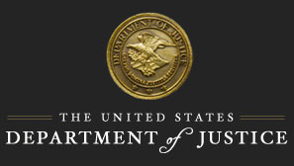

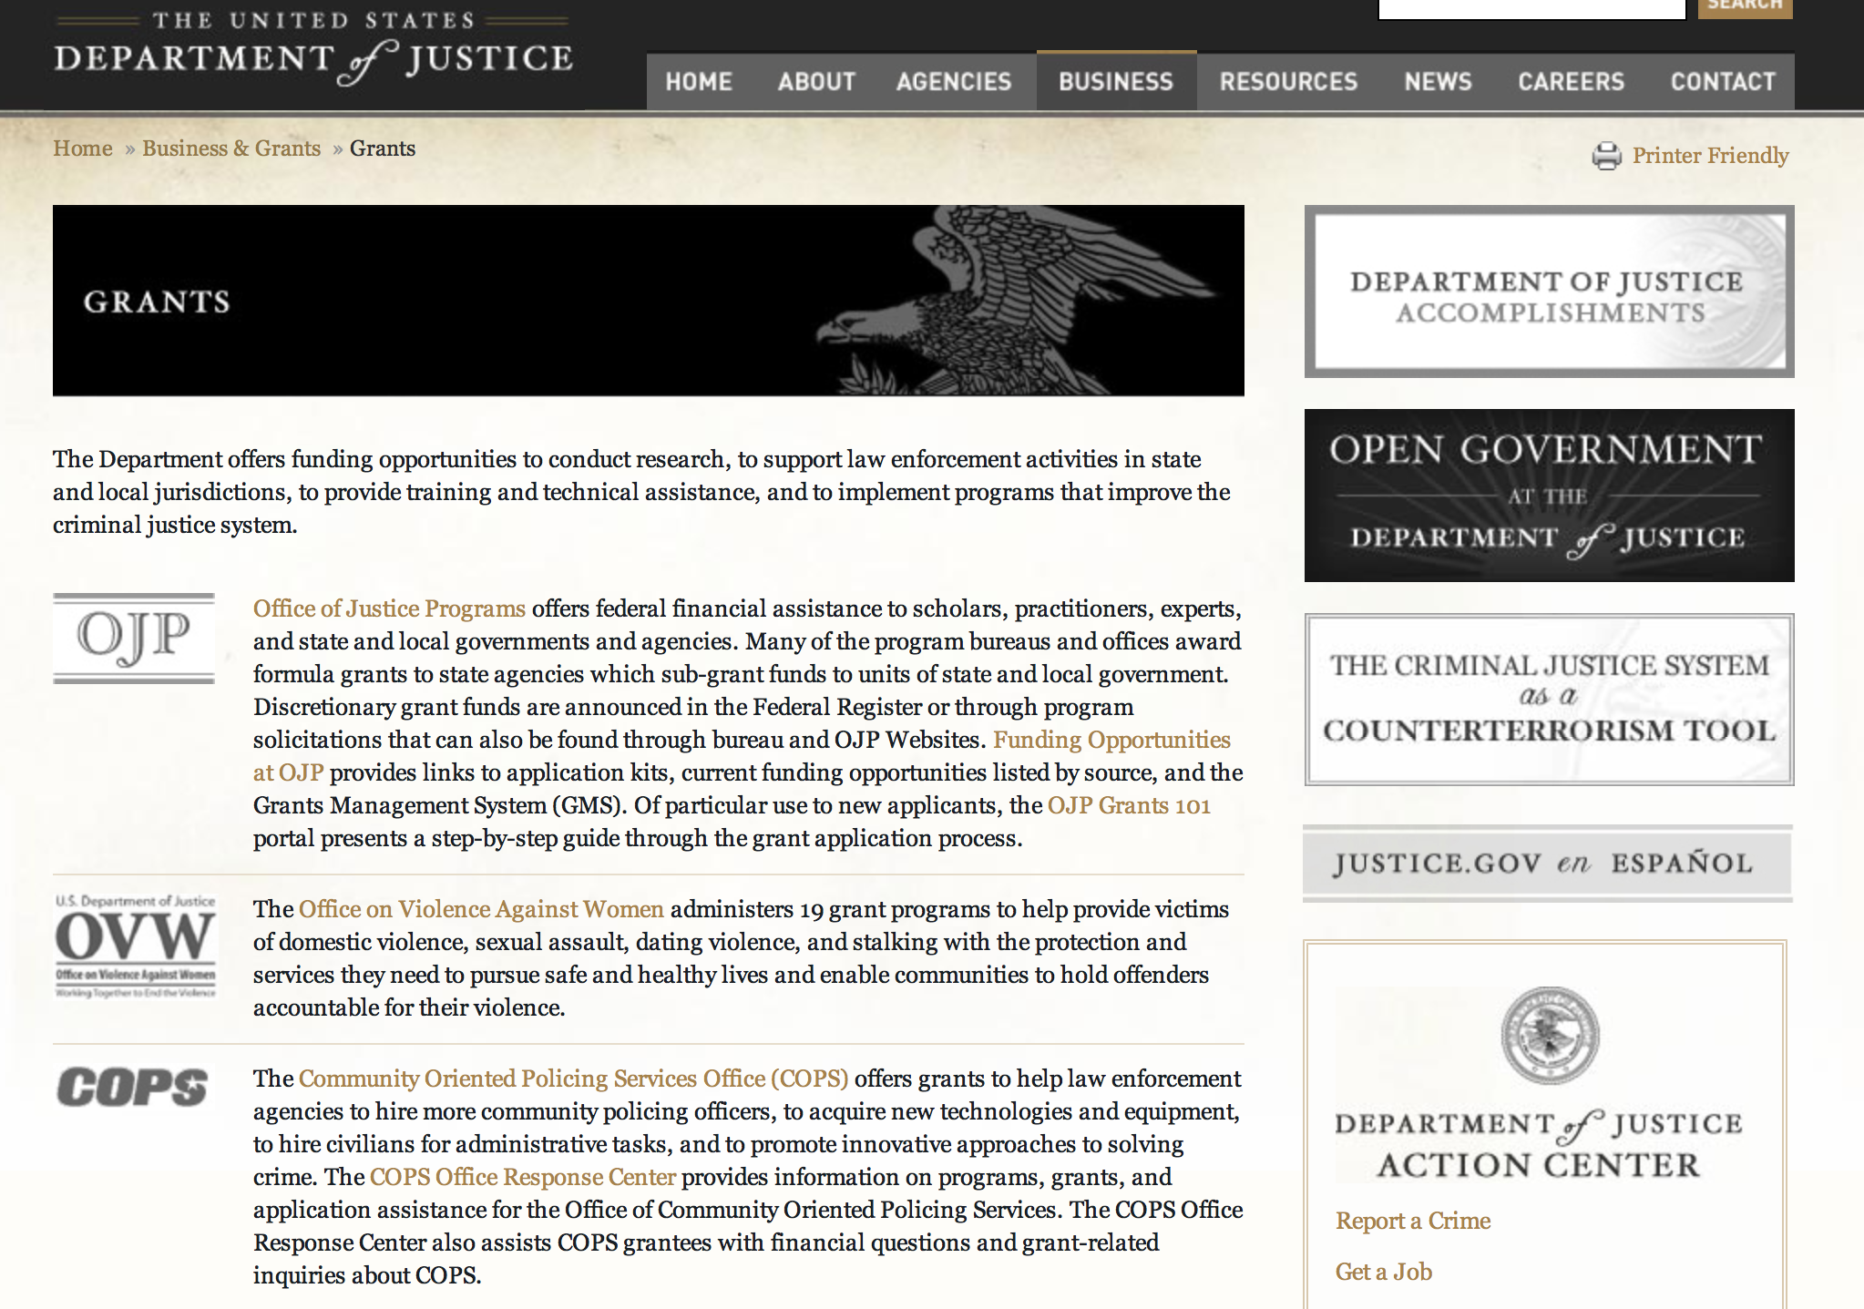

The DOJ agencies listed below also have sites that provide grant information specific to that agency. Examples of what can be found on these sites are programs, funding opportunities, application assistance, and other useful information.

Bureau of Justice Assistance (BJA)

Bureau of Justice Statistics (BJS)

National Criminal Justice Reference Service (NCJRS)

National Institute of Justice (NIJ)

Office of Juvenile Justice and Delinquency Prevention (OJJDP)

Office of Sex Offender Sentencing, Monitoring, Apprehending, Registering, and Tracking (SMART)

Office for Victims of Crime (OVC)

http://www.justice.gov/business/

Programs:

National Institute of Justice
NIJ FY17 Research and Development in Forensic Science for Criminal Justice Purposes
Synopsis 1 & 2

Document Type: | Grants Notice
Funding Opportunity Number: | NIJ-2017-11080
Funding Opportunity Title: | NIJ FY17 Research and Development in Forensic Science for Criminal Justice Purposes
Opportunity Category: | Discretionary
Opportunity Category Explanation:
Funding Instrument Type: | Grant
Category of Funding Activity: | Science and Technology and other Research and Development
Category Explanation:
Expected Number of Awards: | 50
CFDA Number(s): | 16.560 -- National Institute of Justice Research, Evaluation, and Development Project Grants
Cost Sharing or Matching Requirement: | No
Version: | Synopsis 2
Posted Date: | Nov 18, 2016
Last Updated Date: | Nov 28, 2016
Original Closing Date for Applications: | Feb 28, 2017
Current Closing Date for Applications: | Feb 28, 2017
Archive Date:
Estimated Total Program Funding: | $20,000,000
Award Ceiling: | $20,000,000
Award Floor: | $0
Eligible Applicants: | Nonprofits that do not have a 501(c)(3) status with the IRS, other than institutions of higher education  Small businesses  Individuals  State governments  City or township governments  For profit organizations other than small businesses  Public and State controlled institutions of higher education  Nonprofits having a 501(c)(3) status with the IRS, other than institutions of higher education  Private institutions of higher education  County governments  Native American tribal governments (Federally recognized)
Agency Name: | National Institute of Justice
Description: | With this solicitation, NIJ seeks proposals for basic or applied research and development projects that will: (1) increase the body of knowledge to guide and inform forensic science policy and practice or (2) lead to the production of useful materials, devices, systems, or methods that have the potential for forensic application. The intent of this program is to direct the findings of basic scientific research, research and development in broader scientific fields applicable to forensic science, and ongoing forensic science research toward the development of highly discriminating, accurate, reliable, cost-effective, and rapid methods for the identification, analysis, and interpretation of physical evidence for criminal justice purposes.
Link to Additional Information: | http://nij.gov/funding/Documents/solicitations/NIJ-2017-11080.pdf
Grantor Contact Information: | If you have difficulty accessing the full announcement electronically, please contact:  For assistance with this solicitation, contact the National Criminal Justice Reference Service Response Center by telephone at 800-851-3420 or TTY: 301-240-6310 (Hearing impaired only), by e-mail at grants@ncjrs.gov, or by web chat at https://webcontact.ncjrs.gov/ncjchat/chat.jsp. Response Center hours of operation are 10 a.m. to 6 p.m. ET, Monday through Friday, and 10 a.m. to 8 p.m. ET on the solicitation close date. General information on applying for NIJ awards can be found at www.nij.gov/funding/Pages/welcome.aspx. Answers to frequently asked questions that may assist applicants are posted at www.nij.gov/funding/Pages/faqs.aspx. grants@ncjrs.gov  Technical Support

http://www.grants.gov/web/grants/view-opportunity.html?oppId=290187

Research:

Modifications:

Reminders:

Deleted:



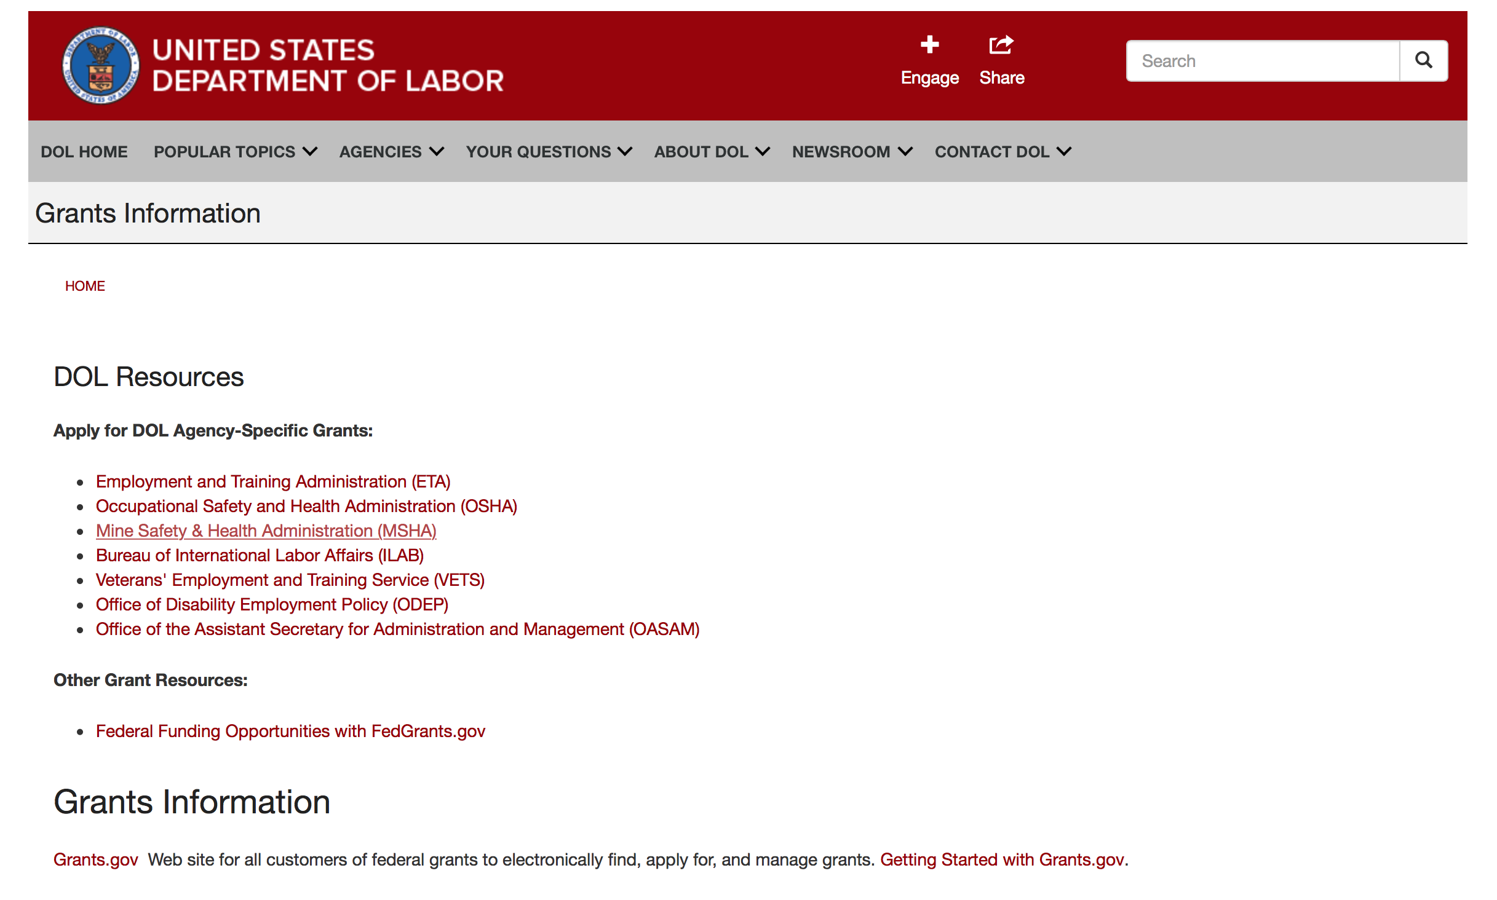

Agency Grants and Contract General Overview

DOL Resources
Apply for DOL Agency-Specific Grants:
- Employment and Training Administration (ETA)
- Occupational Safety and Health Administration (OSHA)
- Mine Safety & Health Administration (MSHA)
- Bureau of International Labor Affairs (ILAB)
- Veterans' Employment and Training Service (VETS)
- Office of Disability Employment Policy (ODEP)
- Office of the Assistant Secretary for Administration and Management (OASAM)

Other Grant Resources:
- Federal Funding Opportunities with FedGrants.gov
Grants Information
Grants.gov — Web site for all customers of federal grants to electronically find, apply for, and manage grants. Getting Started with Grants.gov.

DOL Resources and Instructions for Applying for a Grant
- DOL Guidance Clarifying the Effect of the Religious Freedom Restoration Act on Faith-Based Organizations
- Grant and Contract Information
- Contracting and Grant Program Overview
- Annual Acquisition Plan & Procurement Forecast
- Civil Rights Enforcement for Department of Labor Grant Recipients
- More Information About Grants
- Use of Contracts, Grants & Cooperative Agreements

Other Federal Government Grant Information
- List of Parties Excluded From Federal Procurement and Nonprocurement Programs (as created and maintained by GSA)
- Grant Opportunities (Catalog of Federal Domestic Assistance)

Department of Labor Grant Programs

- Bureau of International Labor Affairs (ILAB): provides grants (cooperative agreements) for the implementation of projects designed to assist developing countries combat the worse forms of child labor, forced labor, and human trafficking; and support worker rights and improve working conditions. http://www.dol.gov/general/business.
- Bureau of Labor Statistics (BLS): provides project grants (cooperative agreements) and the dissemination of technical statistical data and related information on labor force activities; provides data on prices (CPI) and cost of living; data on productivity and technology data; data on compensation and working conditions; data on employment projections.
- Employment and Training (ETA): ETA administers financial assistance programs pursuant to the Workforce Investment Act (WIA), administering State formula grant programs for youth, adults and dislocated workers, national emergency grants for workers affected by mass layoffs, plant closures, and disasters; grant programs for workers with disabilities, Indians and Native Americans, and for migrant and seasonal farmworkers. ETA also administers grant programs for older American workers, apprenticeship programs, Trade Adjustment Assistance (TAA) programs, and assistance for research and development of workforce programs. In addition, ETA is responsible for the operation and maintenance of a national system of public employment service offices and for the national unemployment insurance program.
- Mine Safety and Health (MSHA): provides grants for research, education and training programs to ensure an adequate and competent staff of trained inspectors; and assistance for establishing or improving State mine health and safety programs through technical assistance.
- Occupational Safety and Health (OSHA): provides grants to non-profit organizations to provide training, educational services, and technical assistance; assistance to states to administer and enforce state programs; assistance to states to provide occupational safety and health technical assistance and consultant services.
- Office of Disability Employment Policy (ODEP): The Office of Disability Employment Policy awards competitive grants establishing short-term pilot and technical assistance projects designed to identify, develop, test, evaluate, and disseminate policies to increase employment by expanding access to training, education, employment supports, assistive and systems technology, integrated employment, entrepreneurial development, and small business opportunities for adults and youth with disabilities. Current pilots projects focus on customized employment, Olmstead populations, and innovative demonstration youth grants, among others. Solicitations for grant applications are published in the Federal Register and announced at www.dol.gov/odep. ODEP grants are awarded by the OASAM grant office.
- Veterans' Employment and Training (VETS): provides special employment and training assistance for veterans through the Disabled Veterans' Outreach Program (DVOP) Solicitation for Grant Applications; the Local Veterans' Employment Representative Program (LVER); Veterans' Workforce Investment Program (VWIP); elaws Advisor on veterans' employment and reemployment rights; and the Homeless Veterans Reintegration Project (HVRP). VETS grants are awarded by the OASAM grant office.

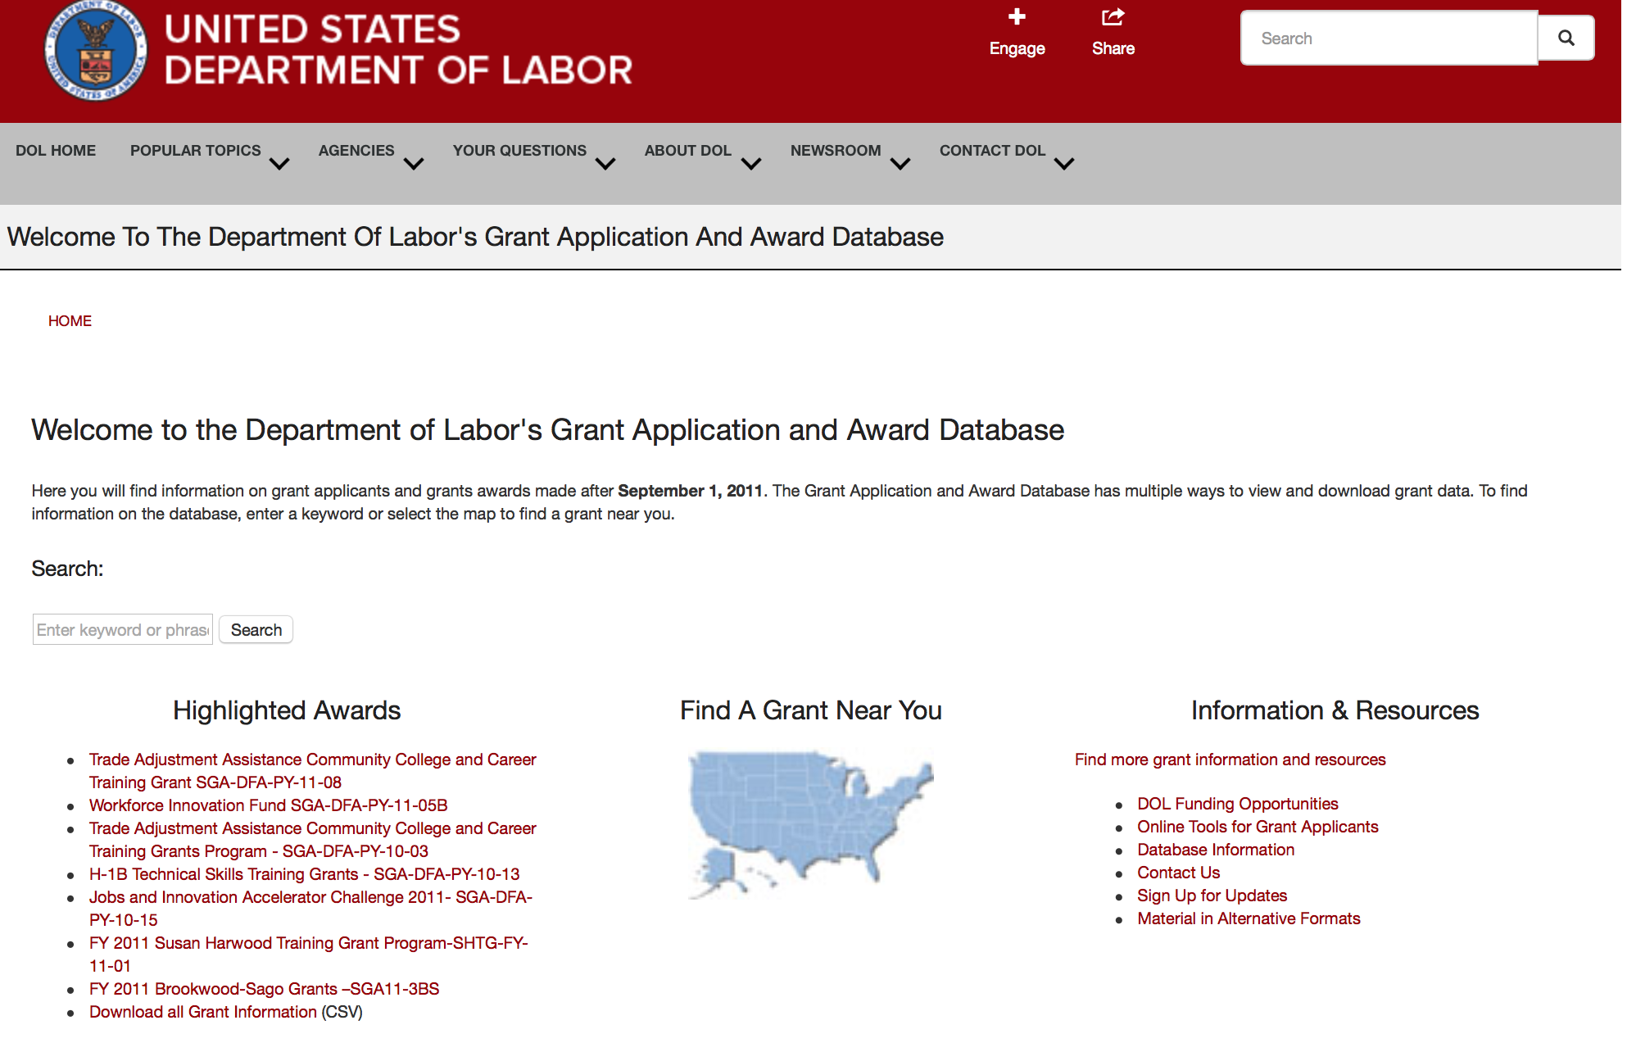

http://www.dol.gov/dol/grants/

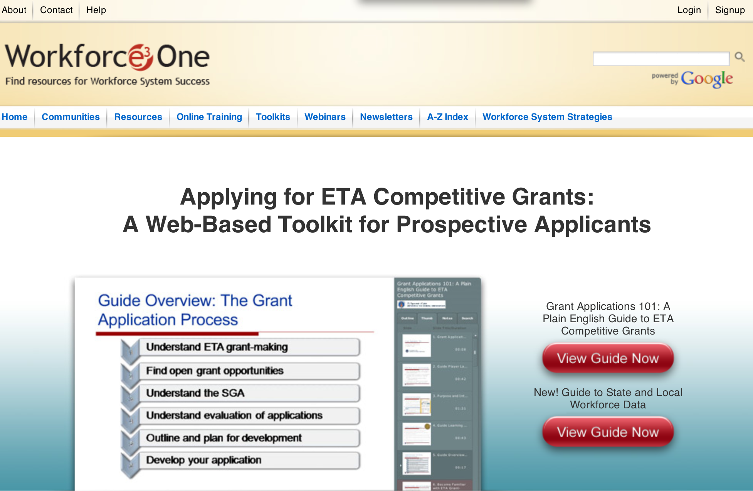

https://www.workforce3one.org/ws/www/pages/grants_toolkit.aspx?pparams=/

Programs

Modifications

Reminders



National Aeronautics and Space Administration

Research and Contracting Opportunities

NASA Research Opportunities Online

- Various NASA offices publish their research announcements over the Internet, broadening the opportunity for researchers to apply for funding. This site provides access to current research announcements along with their specific due dates.

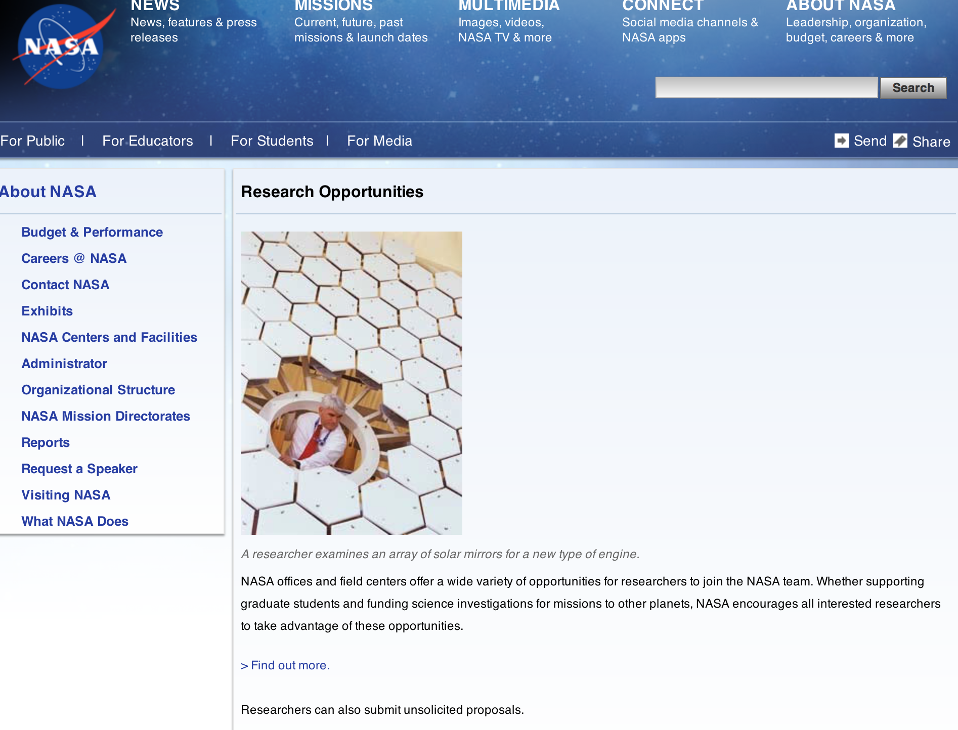

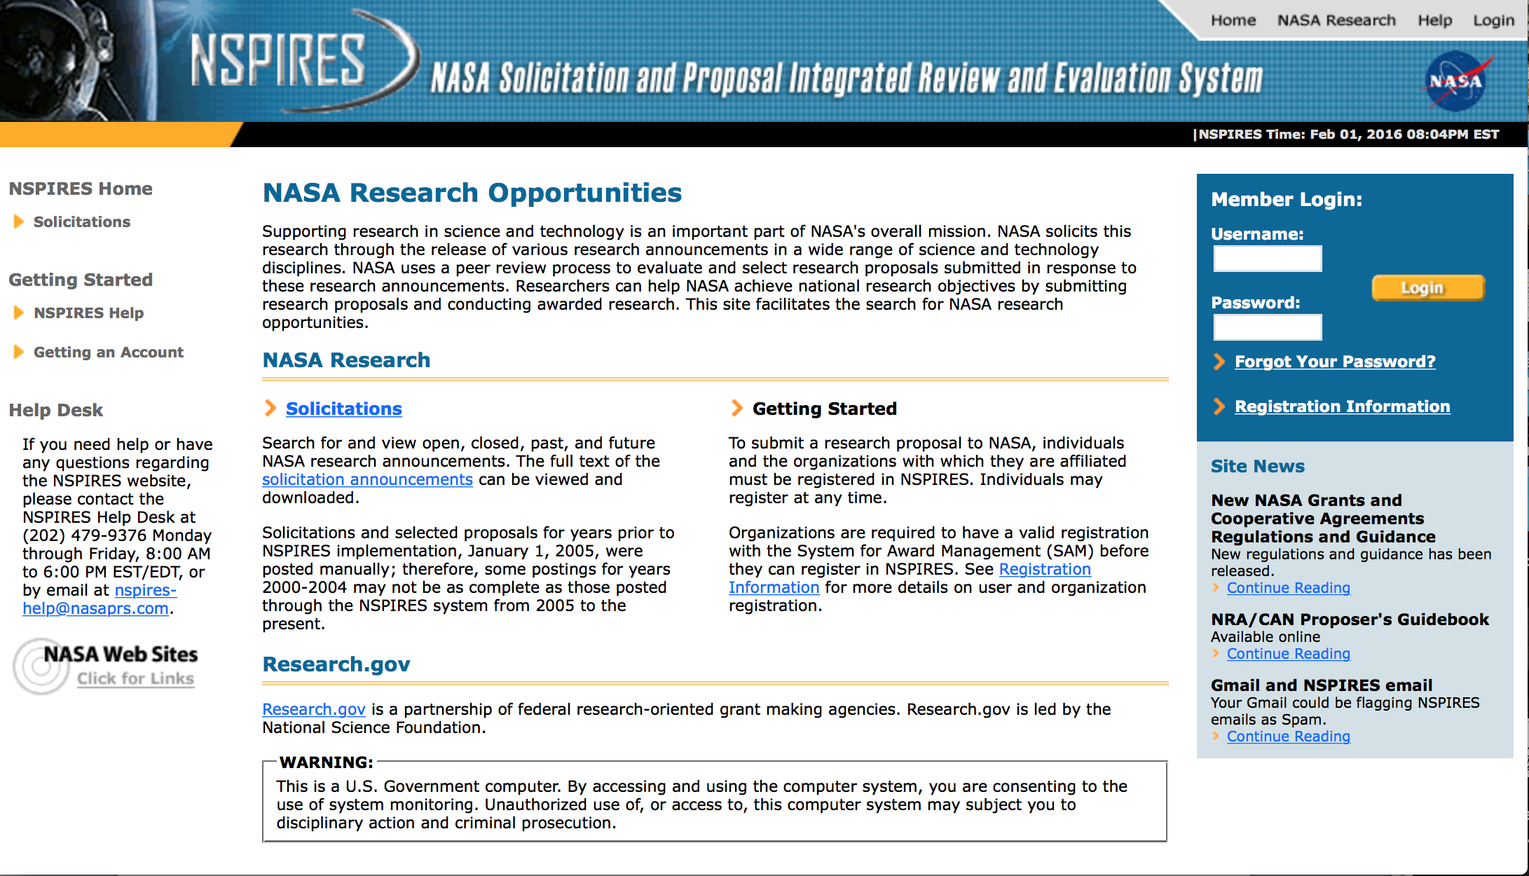

http://nspires.nasaprs.com/external/

Research Programs:

NASA Headquarters
ROSES 2016: Carbon Monitoring System: Continuing Prototype Product Development, Research, and Scoping
Synopsis 1
http://www.grants.gov/web/grants/view-opportunity.html?oppId=290400

Modifications:

National Archives and Records Administration

Grant Opportunities General Overview

To access the information below: click here

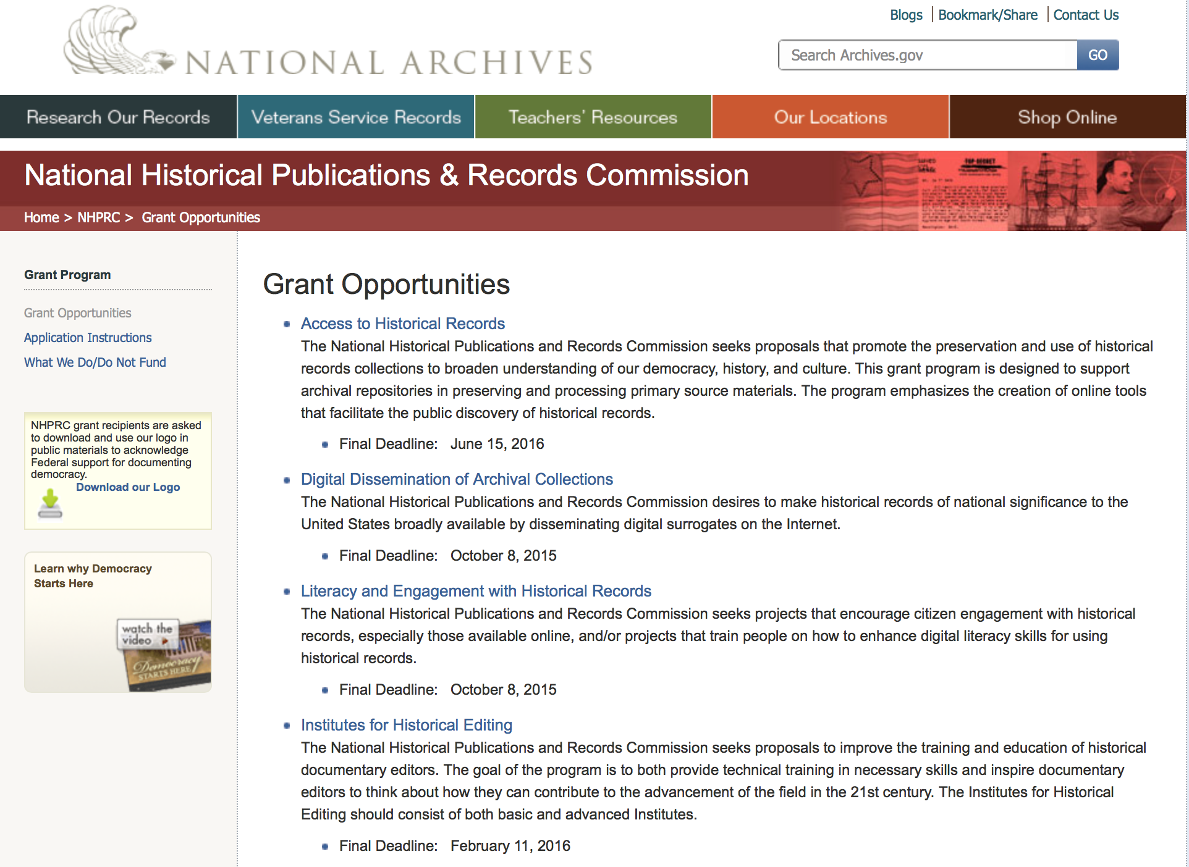

Reminders:

Access to Historical Records - Major Initiatives

Document Type: | Grants Notice
Funding Opportunity Number: | MAJOR-201707
Funding Opportunity Title: | Access to Historical Records - Major Initiatives
Opportunity Category: | Discretionary
Opportunity Category Explanation:
Funding Instrument Type: | Grant
Category of Funding Activity: | Humanities (see "Cultural Affairs" in CFDA)
Category Explanation:
Expected Number of Awards: | 5
CFDA Number(s): | 89.003 -- National Historical Publications and Records Grants
Cost Sharing or Matching Requirement: | Yes
Posted Date: | Jul 25, 2016
Last Updated Date: | Jul 25, 2016
Original Closing Date for Applications: | Jul 12, 2017
Current Closing Date for Applications: | Jul 12, 2017
Archive Date: | Aug 11, 2017
Estimated Total Program Funding: | $1,000,000
Award Ceiling: | $350,000
Award Floor: | $1
Eligible Applicants: | Private institutions of higher education  County governments  Native American tribal governments (Federally recognized)  Public and State controlled institutions of higher education  City or township governments  Nonprofits having a 501(c)(3) status with the IRS, other than institutions of higher education  State governments
Agency Name: | National Archives and Records Administration
Description: | The National Historical Publications and Records Commission seeks projects that will significantly improve public discovery and use of major historical records collections. All types of historical records are eligible, including documents, photographs, born-digital records, and analog audio and moving images. Projects may: • Digitize historical records collections, or related collections, held by a single institution and make them freely available online • Provide access to born-digital records • Create new freely-available virtual collections drawn from historical records held by multiple institutions • Create new tools and methods for users to access records The NHPRC welcomes collaborative projects, particularly for bringing together related records from multiple institutions. Projects that address significant needs in the field and result in replicable and scalable approaches will be more competitive. We also encourage organizations to actively engage the public in the work of the project. For a comprehensive list of Commission limitations on funding, please see “What we do and do not fund” (http://www.archives.gov/nhprc/apply/eligibility.html). Applications that consist entirely of ineligible activities will not be considered. Award Information A grant is for one to three years and for up to $350,000. We expect to make up to five grants in this category for a total of up to $1,000,000. Grants begin no earlier than January 1, 2018. Eligible applicants: • Nonprofit organizations or institutions • Colleges, universities, and other academic institutions • State or local government agencies • Federally-acknowledged or state-recognized Native American tribes or groups Cost Sharing The total costs of a project are shared between the NHPRC and the applicant organization. The Commission provides no more than 50 per cent of total project costs in the Access to Historical Records: Major Initiatives category. NHPRC grant recipients are not permitted to use grant funds for indirect costs (as indicated in 2 CFR 2600.101). Cost sharing is required. The applicant’s financial contribution may include both direct and indirect expenses, in-kind contributions, non-Federal third-party contributions, and any income earned directly by the project. Indirect costs must be listed under the applicant’s cost sharing contribution. Other Requirements Applicant organizations must be registered in the System for Award Management (SAM) prior to submitting an application, maintain SAM registration throughout the application and award process, and include a valid DUNS number in their application. Details on SAM registration and requesting a DUNS number can be found at the System for Award Management website at http://sam.gov. Please refer to the User Guides section and the Grants Registrations PDF. APPLICATION AND SUBMISSION INFORMATION You must use Grants.gov to submit a Full Proposal. All information necessary to apply is included in this announcement, the Application Instructions, and the forms on Grants.gov. If you need the information supplied in an alternative format, please call the NHPRC at 202-357-5010. Applying for the Access to Historical Records: Major Initiatives program is a two-phase process. Phase One All applicants must have submitted a five-page preliminary proposal and Application for Federal Domestic Assistance – Short Organizational form SF424 and the Budget Information for Non-Construction Projects form SF424A by January 19, 2017 using the preliminary proposal Major Initiatives grant announcement (insert link). Only those applicants who have successfully completed Phase One and who have been invited by the Commission to submit a full proposal to the Access to Historical Records: Major Initiatives program are eligible to participate in the second phase of the process. Phase Two Using this announcement, invited applicants will prepare and submit a complete application via Grants.gov by July 12, 2017. A complete application includes the Application for Federal Assistance (Standard Form 424), Assurances -- Non-Construction Programs (Standard Form 424B), a Project Narrative, Supplementary Materials, and Budget. Applications lacking any of these items will not be considered. Applicants may consult with the Director of the Access Program, Alex Lorch (alexander.lorch@nara.gov) during both the preliminary and full proposal project phases. In order to ensure eligibility, applicants should first review the rules and regulations governing NHPRC grants under the Administering an NHPRC Grant section.
Link to Additional Information: | Link to full grant announcement, including additional requirements
Grantor Contact Information: | If you have difficulty accessing the full announcement electronically, please contact:  Jeff de la Concepcion Grant Program Specialist Phone 202-357-5022  Grant Information Specialist

http://www.grants.gov/web/grants/view-opportunity.html?oppId=286436

National Endowment for the Arts

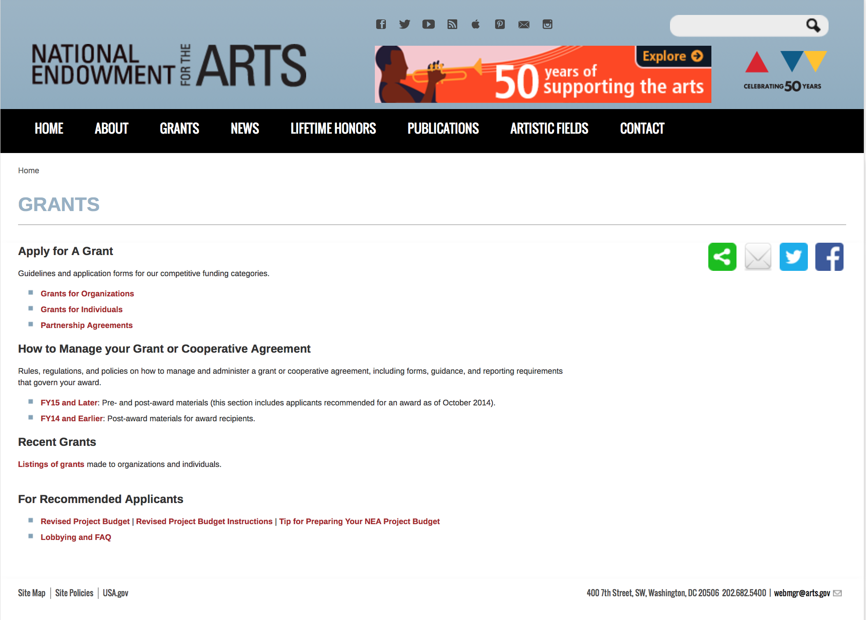

http://arts.gov/grants

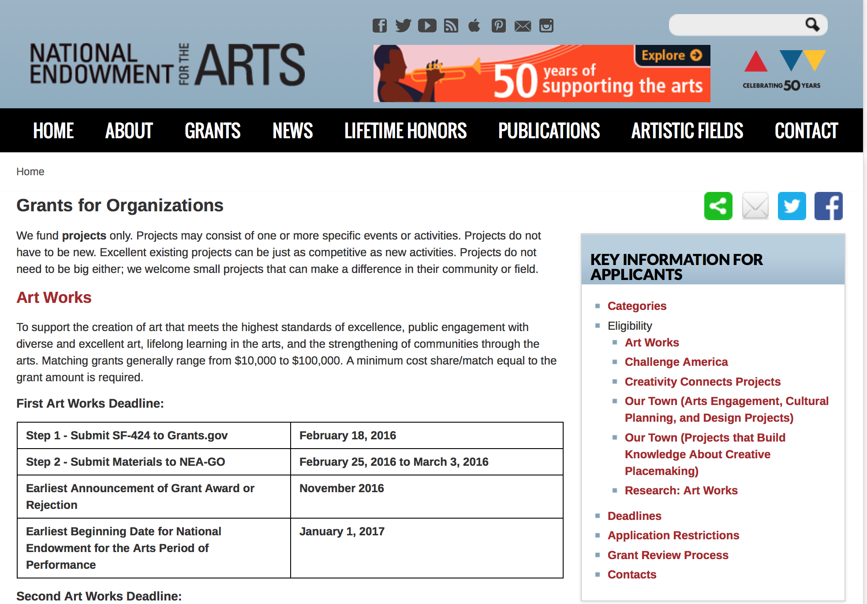
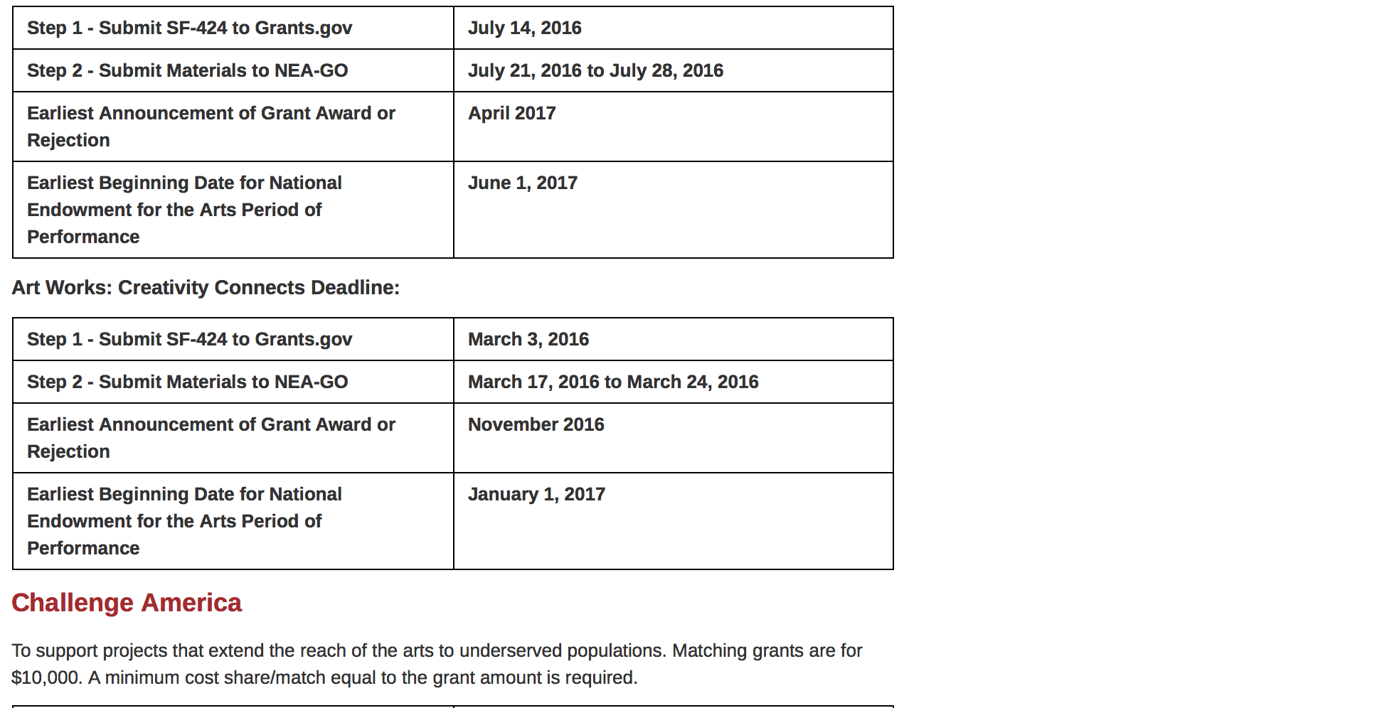
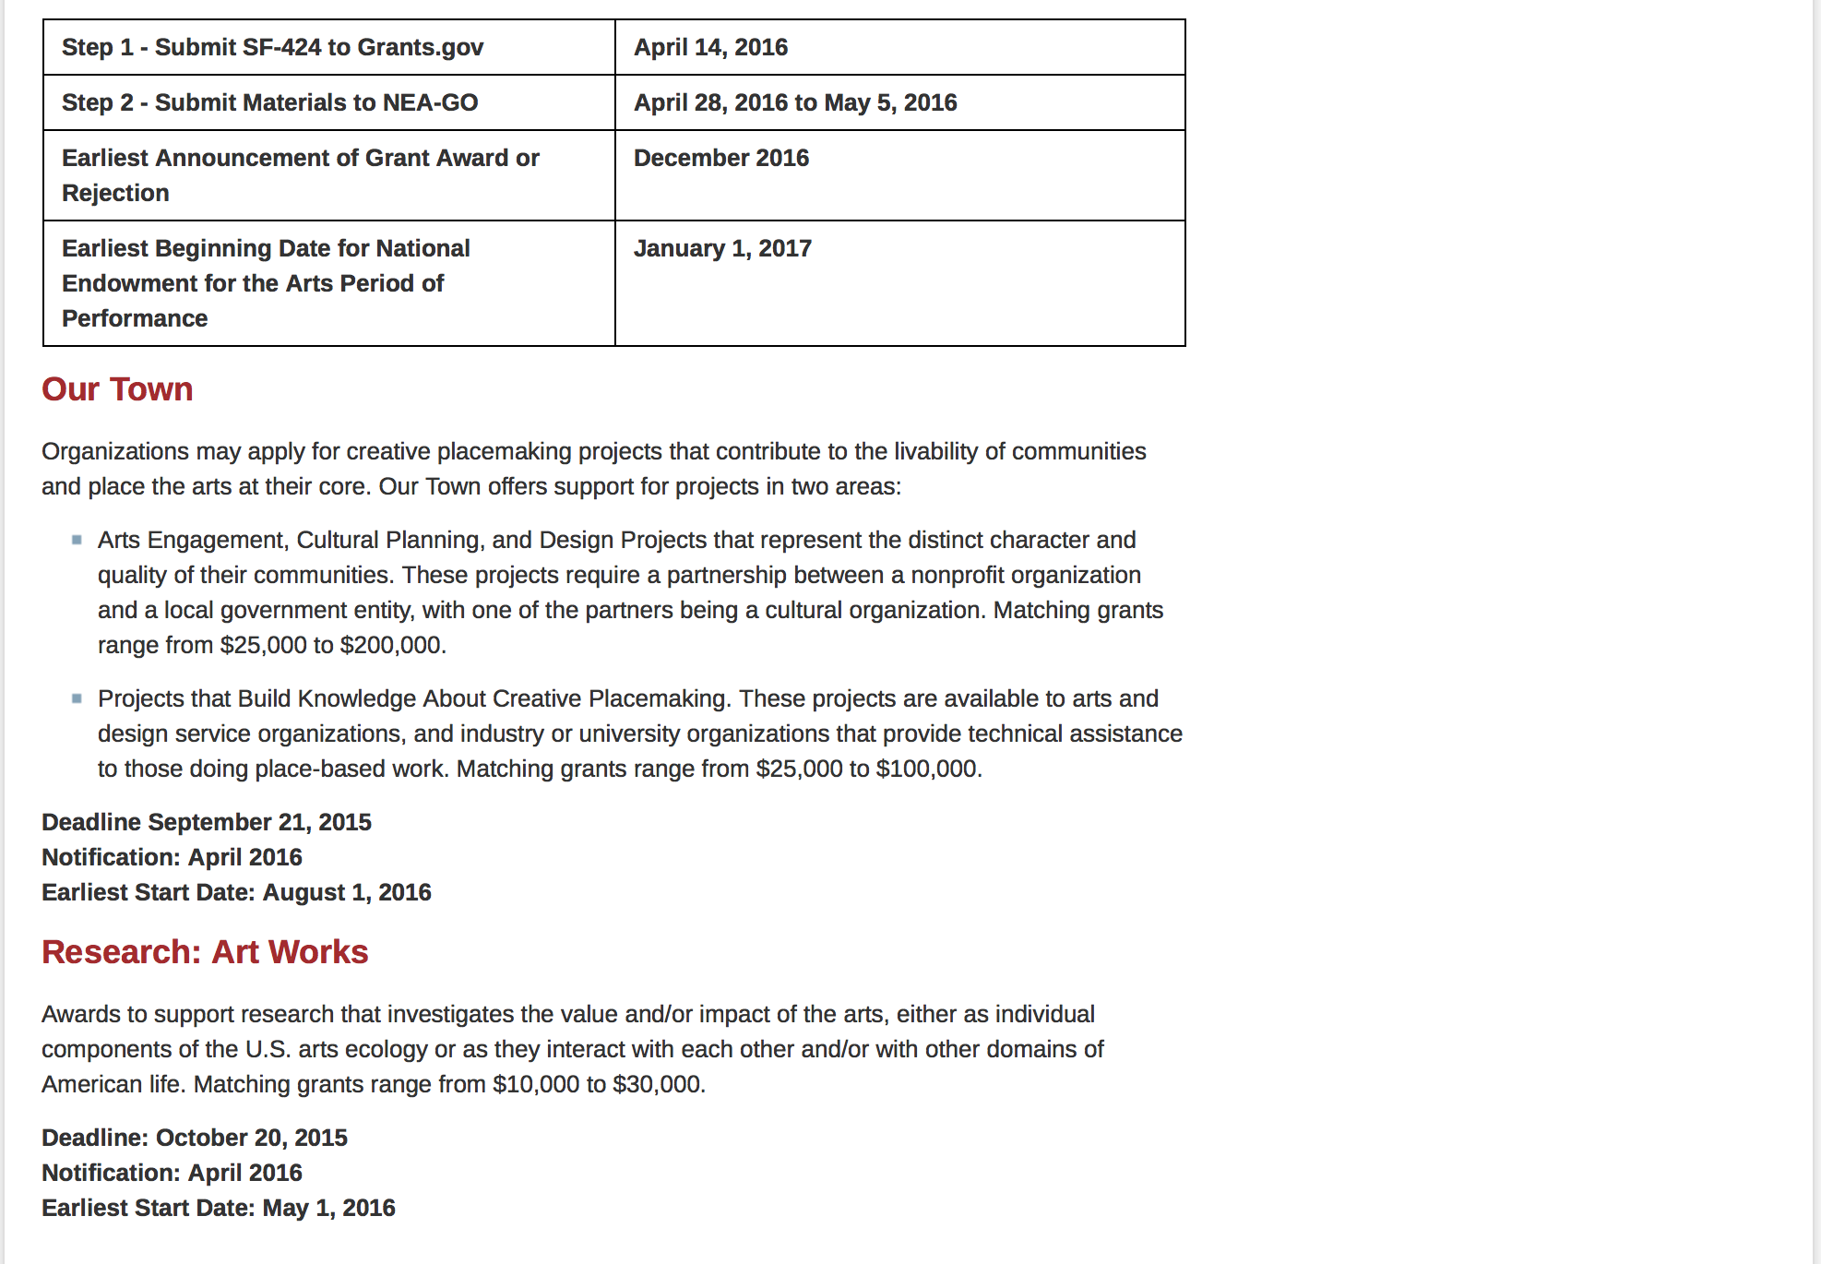
See more at: https://www.arts.gov/grants/apply-grant/grants-organizations

Programs:

Modifications:

Reminders:

NEA Poetry Out Loud: 2018 National Finals Competition
Synopsis 1

Document Type: | Grants Notice
Funding Opportunity Number: | NEAPS1604
Funding Opportunity Title: | NEA Poetry Out Loud: 2018 National Finals Competition
Opportunity Category: | Discretionary
Opportunity Category Explanation:
Funding Instrument Type: | Cooperative Agreement
Category of Funding Activity: | Arts (see "Cultural Affairs" in CFDA)
Category Explanation:
Expected Number of Awards:
CFDA Number(s): | 45.024 -- Promotion of the Arts Grants to Organizations and Individuals
Cost Sharing or Matching Requirement: | No
Version: | Synopsis 1
Posted Date: | Sep 28, 2016
Last Updated Date: | Sep 28, 2016
Original Closing Date for Applications: | Jan 05, 2017 The Grants.gov system must receive your proposal no later than 11:59 p.m., Eastern Time, on January 5, 2017. We strongly recommend that you submit your application by December 27, 2016 to give yourself ample time to resolve any problems that you might encounter.
Current Closing Date for Applications: | Jan 05, 2017 The Grants.gov system must receive your proposal no later than 11:59 p.m., Eastern Time, on January 5, 2017. We strongly recommend that you submit your application by December 27, 2016 to give yourself ample time to resolve any problems that you might encounter.
Archive Date: | Feb 04, 2017
Estimated Total Program Funding:
Award Ceiling: | $195,000
Award Floor: | $195,000
Eligible Applicants: | Native American tribal governments (Federally recognized)  Private institutions of higher education  Nonprofits having a 501(c)(3) status with the IRS, other than institutions of higher education  City or township governments  Special district governments  Public and State controlled institutions of higher education  State governments  Independent school districts  County governments
Additional Information on Eligibility: | An organization may submit only one proposal under this program solicitation. This Cooperative Agreement will begin no earlier than June 1, 2017, and may extend for up to 15 months. Applicant Eligibility Nonprofit, tax-exempt 501(c)(3), U.S. organizations; units of state or local government; the six U.S. regional arts organizations; or federally recognized tribal communities or tribes may apply.
Agency Name: | National Endowment for the Arts
Description: | An organization may submit only one proposal under this program solicitation. This Cooperative Agreement will begin no earlier than June 1, 2017, and may extend for up to 15 months. Program Description Through this Program Solicitation, the National Endowment for the Arts seeks a Cooperator to produce and administer the 2018 Poetry Out Loud National Finals competition to take place April 23-25, 2018 in Washington, DC. The National Finals are the culmination of the nationwide Poetry Out Loud (POL) program that encourages more than 365,000 high school students each year to learn about classic and contemporary poetry through memorization and performance. Students select, memorize, and recite poems from an anthology and compete for the title of National Poetry Out Loud Champion. Through a pyramid structure competition, winners advance from classroom recitation contests to school-wide competitions, then to the state competitions and, ultimately, to the National Finals. One student from every state, the District of Columbia, the U.S. Virgin Islands, and Puerto Rico travel to the National Finals to compete for the national championship. Scope of Work The purpose of this Program Solicitation is to select an organization (Cooperator) to produce and coordinate the three-day 2018 POL National Finals competition of state and jurisdictional champions of the POL program, in conjunction with the National Endowment for the Arts and its partners. That National Finals will take place April 23-25, 2018 in Washington, DC. The National Finals competition venue and hotel have already been reserved to ensure the availability of space.
Link to Additional Information: | NEA Web Site Announcement
Grantor Contact Information: | If you have difficulty accessing the full announcement electronically, please contact:  NEA Web Manager  NEA Web Manager

http://www.grants.gov/web/grants/view-opportunity.html?oppId=289143

National Endowment for the Humanities

Grant Overview -

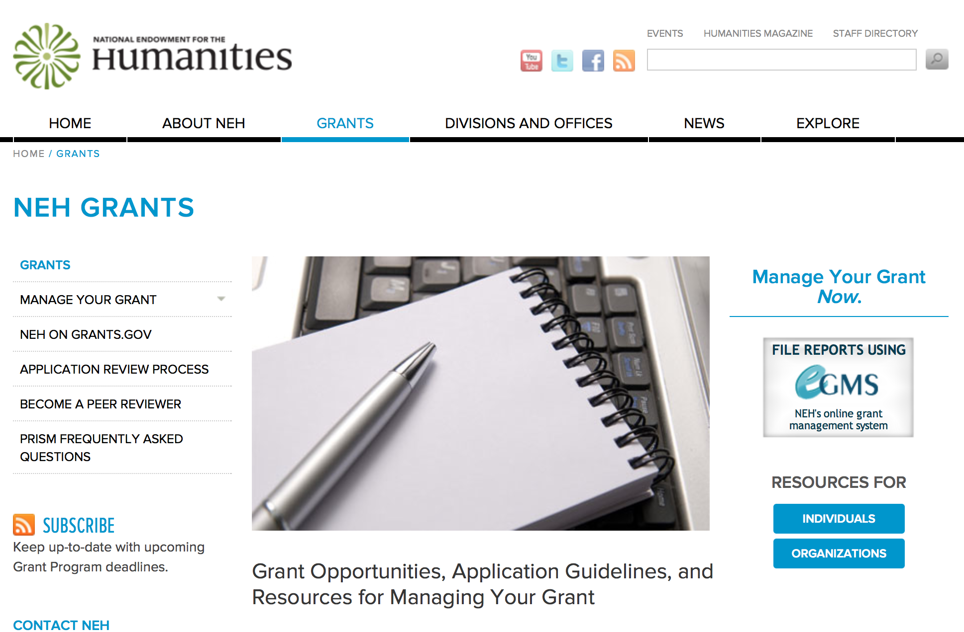

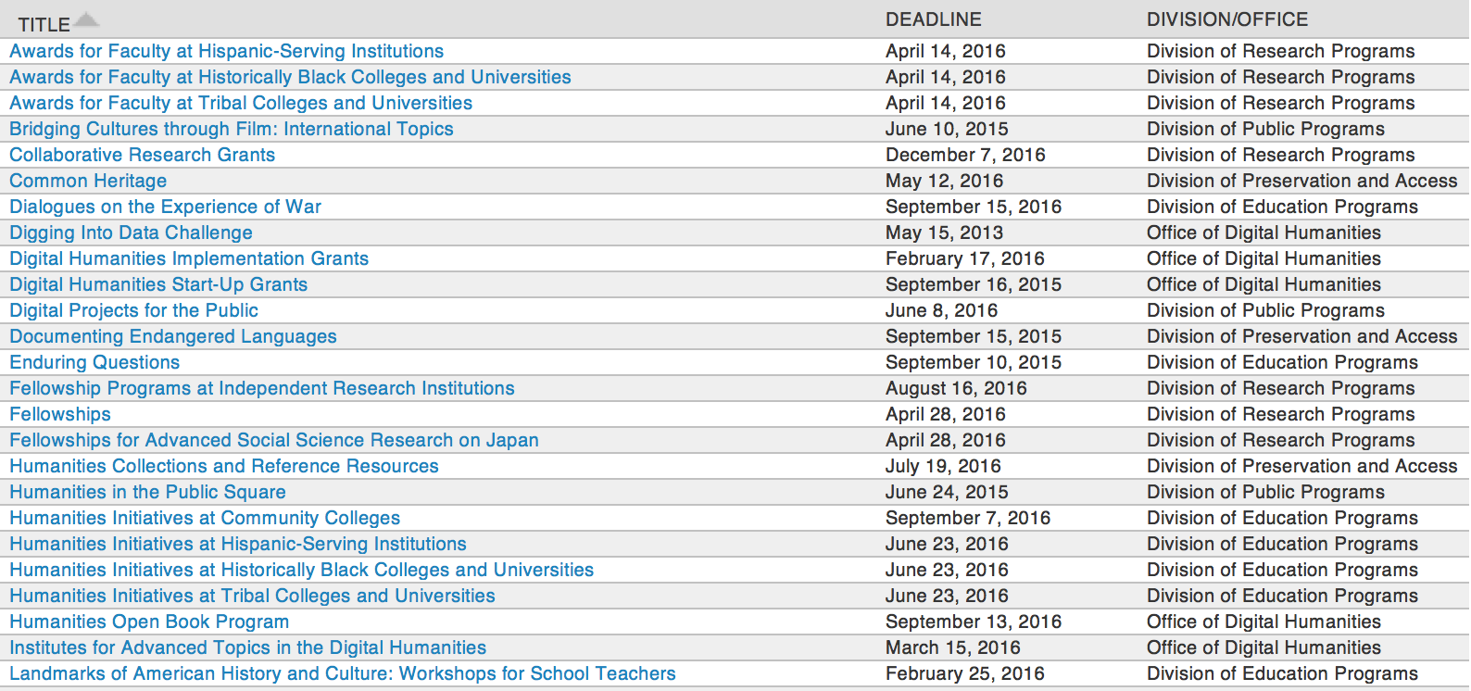

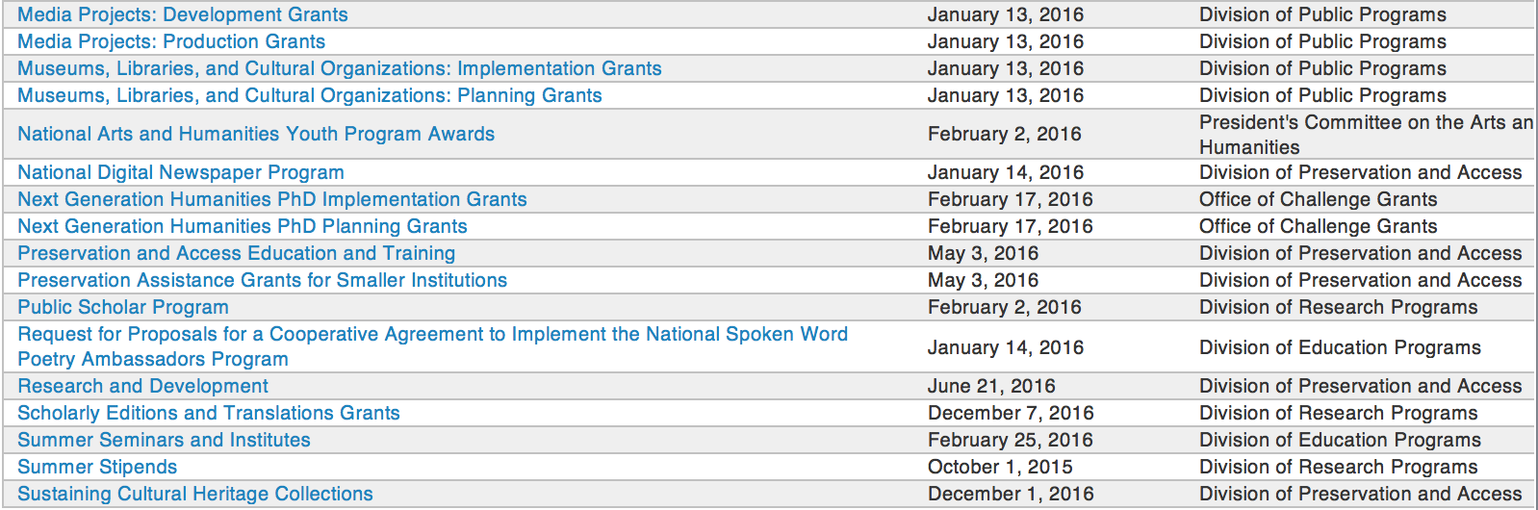

http://www.neh.gov/grants/grantsbydivision.html

Programs:

Public Scholar Program
Synopsis 1

Document Type: | Grants Notice
Funding Opportunity Number: | 20170201-FZ
Funding Opportunity Title: | Public Scholar Program
Opportunity Category: | Discretionary
Opportunity Category Explanation:
Funding Instrument Type: | Grant
Category of Funding Activity: | Humanities (see "Cultural Affairs" in CFDA)
Category Explanation:
Expected Number of Awards:
CFDA Number(s): | 45.160 -- Promotion of the Humanities Fellowships and Stipends
Cost Sharing or Matching Requirement: | No
Version: | Synopsis 1
Posted Date: | Nov 28, 2016
Last Updated Date: | Nov 28, 2016
Original Closing Date for Applications: | Feb 01, 2017
Current Closing Date for Applications: | Feb 01, 2017
Archive Date:
Estimated Total Program Funding:
Award Ceiling: | $50,400
Award Floor: | $25,200
Eligible Applicants: | Individuals
Agency Name: | National Endowment for the Humanities
Description: | The Public Scholar Program supports well-researched books in the humanities intended to reach a broad readership. Although humanities scholarship can be specialized, the humanities also strive to engage broad audiences in exploring subjects of general interest. They seek to deepen our understanding of the human condition as well as current conditions and contemporary problems. The Public Scholar Program aims to encourage scholarship that will be of broad interest and have lasting impact. Such scholarship might present a narrative history, tell the stories of important individuals, analyze significant texts, provide a synthesis of ideas, revive interest in a neglected subject, or examine the latest thinking on a topic. Books supported by this program must be grounded in humanities research and scholarship. They must address significant humanities themes likely to be of broad interest and must be written in a readily accessible style. Making use of primary and/or secondary sources, they should open up important and appealing subjects for a wide audience. The challenge is to make sense of a significant topic in a way that will appeal to general readers. Applications to write books directed primarily to scholars are not appropriate for this program. By establishing the Public Scholar Program, NEH entered a long-term commitment to encourage scholarship in the humanities for general audiences. The program is open to both individuals affiliated with scholarly institutions and independent scholars or researchers. Projects may be at any stage of development.
Link to Additional Information: | https://www.neh.gov/grants/research/public-scholar-program
Grantor Contact Information: | If you have difficulty accessing the full announcement electronically, please contact:  Division of Research Programs National Endowment for the Humanities Washington, DC 20506 202-606-8200 publicscholar@neh.gov publicscholar@neh.gov  publicscholar@neh.gov

http://www.grants.gov/web/grants/view-opportunity.html?oppId=290373

Modifications:

Reminders:

National Digital Newspaper Program
Synopsis 1

Document Type: | Grants Notice
Funding Opportunity Number: | 20170112-PJ
Funding Opportunity Title: | National Digital Newspaper Program
Opportunity Category: | Discretionary
Opportunity Category Explanation:
Funding Instrument Type: | Cooperative Agreement
Category of Funding Activity: | Humanities (see "Cultural Affairs" in CFDA)
Category Explanation:
Expected Number of Awards:
CFDA Number(s): | 45.149 -- Promotion of the Humanities Division of Preservation and Access
Cost Sharing or Matching Requirement: | No
Posted Date: | Oct 31, 2016
Last Updated Date: | Oct 31, 2016
Original Closing Date for Applications: | Jan 12, 2017
Current Closing Date for Applications: | Jan 12, 2017
Archive Date:
Estimated Total Program Funding:
Award Ceiling: | $325,000
Award Floor: | $1
Eligible Applicants: | City or township governments  Private institutions of higher education  Nonprofits having a 501(c)(3) status with the IRS, other than institutions of higher education  State governments  Public and State controlled institutions of higher education  Nonprofits that do not have a 501(c)(3) status with the IRS, other than institutions of higher education  Native American tribal governments (Federally recognized)  County governments  Special district governments
Agency Name: | National Endowment for the Humanities
Description: | The National Digital Newspaper Program (NDNP) is a partnership between NEH and the Library of Congress to create a national digital resource of historically significant newspapers published between 1690 and 1963, from all the states and U.S. territories. This searchable database will be permanently maintained at the Library of Congress (LC) and will be freely accessible via the Internet. (See the website, Chronicling America: Historic American Newspapers.) An accompanying national newspaper directory of bibliographic and holdings information on the website directs users to newspaper titles available in all types of formats. During the course of its partnership with NEH, LC will also digitize and contribute to the NDNP database a significant number of newspaper pages drawn from its own collections. Forty-three states and one territory have joined the NDNP so far. Previous award recipients include Alaska, Arizona, California, Colorado, Connecticut, Delaware, Florida, Hawaii, Idaho, Illinois, Indiana, Iowa, Kansas, Kentucky, Louisiana, Maine, Maryland, Michigan, Minnesota, Mississippi, Missouri, Montana, Nebraska, Nevada, New Jersey, New Mexico, New York, North Carolina, North Dakota, Ohio, Oklahoma, Oregon, Pennsylvania, Puerto Rico, South Carolina, South Dakota, Tennessee, Texas, Utah, Vermont, Virginia, Washington, West Virginia, and Wisconsin. NEH intends to support projects in all states and U.S. territories. Awards are made to an organization within each U.S. state or territory, which typically collaborates with relevant state partners in this effort. After their initial NDNP awards, state partners are encouraged to seek second and third awards, to produce a total of approximately 300,000 pages of digitized newspapers per state. Awardees may receive support for continued work beyond the third award, but the program gives priority to applications from those states and territories that have not received NDNP funding—as well as applications from states and territories that have received fewer than three awards. Applications that involve collaboration between previously funded and new projects are also welcome.
Link to Additional Information: | https://www.neh.gov/grants/preservation/national-digital-newspaper-program
Grantor Contact Information: | If you have difficulty accessing the full announcement electronically, please contact:  preservation@neh.gov 202-606-8570 National Digital Newspaper Program Division of Preservation and Access National Endowment for the Humanities 400 Seventh Street, SW Washington, DC 20506 preservation@neh.gov  preservation@neh.gov

http://www.grants.gov/web/grants/view-opportunity.html?oppId=289833

Creating Humanities Communities
Synopsis 1
Document Type: | Grants Notice
Funding Opportunity Number: | 20170215-ZR
Funding Opportunity Title: | Creating Humanities Communities
Opportunity Category: | Discretionary
Opportunity Category Explanation:
Funding Instrument Type: | Grant
Category of Funding Activity: | Humanities (see "Cultural Affairs" in CFDA)
Category Explanation:
Expected Number of Awards:
CFDA Number(s): | 45.130 -- Promotion of the Humanities Challenge Grants
Cost Sharing or Matching Requirement: | Yes
Version: | Synopsis 1
Posted Date: | Nov 04, 2016
Last Updated Date: | Nov 04, 2016
Original Closing Date for Applications: | Feb 15, 2017
Current Closing Date for Applications: | Feb 15, 2017
Archive Date:
Estimated Total Program Funding:
Award Ceiling: | $150,000
Award Floor: | $30,000
Eligible Applicants: | County governments  Private institutions of higher education  State governments  Nonprofits that do not have a 501(c)(3) status with the IRS, other than institutions of higher education  Native American tribal governments (Federally recognized)  Public and State controlled institutions of higher education  City or township governments  Special district governments  Nonprofits having a 501(c)(3) status with the IRS, other than institutions of higher education
Agency Name: | National Endowment for the Humanities
Description: | The Creating Humanities Communities program provides matching grants to help stimulate and proliferate meaningful humanities activities in states and U.S. territories underserved by NEH’s grantmaking divisions and offices. Grantees will use the funds to establish and undertake new humanities programs. The goal of these grants is to make connections between organizations that will foster community cohesion on a local or regional level. Applicants may define community in a variety of ways (by focusing, for example, on a place such as a village or town, or on a common interest or a common theme), and the programs that the cooperating institutions carry out together must aim to enhance the importance of the humanities in people’s lives. Projects to create a humanities community might include, for example, collaborations linking • a public library and a nearby community college to research, write, and produce a series of video biographies of the town’s important personalities (to be presented in public programs at the local historical movie palace); • several railroad museums throughout a state that join forces to write a transportation-based curriculum module for use in fourth-grade social studies classes; • three Native American tribes to establish a cultural heritage trail highlighting important sites and collections; • a veterans’ group and a high school in developing intergenerational family programs at local historic sites; and • a public radio station and the philosophy department at a local college to host public programs discussing industry and ethics to commemorate the hundredth anniversary of the town’s paper mill. Applicants to this program must form collaborative partnerships with at least two and at most five institutions (including the applicant organization). These partnerships may involve organizations such as public libraries, cultural centers, museums, historical societies, colleges (including community colleges) and universities, archival repositories, historic houses, school districts, civic centers, or other cultural entities.
Link to Additional Information: | https://www.neh.gov/grants/challenge/creating-humanities-communities
Grantor Contact Information: | If you have difficulty accessing the full announcement electronically, please contact:  Office of Challenge Grants National Endowment for the Humanities 400 Seventh Street, SW Washington, DC 20506 202-606-8309 challenge@neh.gov challenge@neh.gov  challenge@neh.gov

http://www.grants.gov/web/grants/view-opportunity.html?oppId=289891

Media Projects Grants
Synopsis 1

Document Type: | Grants Notice
Funding Opportunity Number: | 20170111-TD
Funding Opportunity Title: | Media Projects Grants
Opportunity Category: | Discretionary
Opportunity Category Explanation:
Funding Instrument Type: | Grant
Category of Funding Activity: | Humanities (see "Cultural Affairs" in CFDA)
Category Explanation:
Expected Number of Awards:
CFDA Number(s): | 45.164 -- Promotion of the Humanities Public Programs
Cost Sharing or Matching Requirement: | No
Posted Date: | Nov 10, 2016
Last Updated Date: | Nov 10, 2016
Original Closing Date for Applications: | Jan 11, 2017
Current Closing Date for Applications: | Jan 11, 2017
Archive Date:
Estimated Total Program Funding:
Award Ceiling: | $1,000,000
Award Floor: | $1
Eligible Applicants: | Private institutions of higher education  Special district governments  State governments  Public and State controlled institutions of higher education  Native American tribal governments (Federally recognized)  City or township governments  County governments  Nonprofits having a 501(c)(3) status with the IRS, other than institutions of higher education  Nonprofits that do not have a 501(c)(3) status with the IRS, other than institutions of higher education
Agency Name: | National Endowment for the Humanities
Description: | The Media Projects program supports film, television, and radio projects that engage public audiences with humanities ideas in creative and appealing ways. All projects must be grounded in humanities scholarship in disciplines such as history, art history, film studies, literature, drama, religious studies, philosophy, or anthropology. Projects must also demonstrate an approach that is thoughtful, balanced, and analytical (rather than celebratory). The approach to the subject matter must go beyond the mere presentation of factual information to explore its larger significance and stimulate critical thinking. NEH is a national funding agency, so the projects that we support must demonstrate the potential to attract a broad general audience. Film and television projects may be single programs or a series addressing significant figures, events, or ideas. Programs must be intended for national distribution, via traditional carriage or online distribution. The Division of Public Programs welcomes projects that range in length from short-form to broadcast-length video. The Division of Public Programs also encourages film and television projects that examine international themes and subjects in the humanities, in order to spark Americans’ engagement with the broader world beyond the United States. These projects should demonstrate international collaboration by enlisting scholars based both in the United States and abroad, and/or by working with an international media team. The collaborations should bring broad cross-cultural perspectives to the proposed topics and should be intended primarily for U.S. public audiences. Radio projects, including podcasts, may involve single programs, limited series, or segments within an ongoing program. They may also develop new humanities content to augment existing radio programming or add greater historical background or humanities analysis to the subjects of existing programs. They may be intended for regional or national distribution. NEH encourages projects that engage public audiences through multiple formats in the exploration of humanities ideas. Proposed projects might include complementary components to a film, television, or radio project. These components should deepen the audience’s understanding of the subject in a supplementary manner: for example, book/film discussion programs, supplementary educational websites, or museum exhibitions. Development grants enable media producers to collaborate with scholars to develop humanities content and to prepare programs for production. Grants should result in a script and may also yield a detailed plan for outreach and public engagement in collaboration with a partner organization or organizations. Production grants support the production and distribution of films, television programs, and radio programs that promise to engage a broad public audience.
Link to Additional Information: | https://www.neh.gov/grants/mp
Grantor Contact Information: | If you have difficulty accessing the full announcement electronically, please contact:  Division of Public Programs National Endowment for the Humanities 400 Seventh Street, SW Washington, DC 20506 202-606-8269 publicpgms@neh.gov publicpgms@neh.gov  publicpgms@neh.gov

http://www.grants.gov/web/grants/view-opportunity.html?oppId=290023

Public Humanities Projects
Synopsis 1

Document Type: | Grants Notice
Funding Opportunity Number: | 20170111-GW
Funding Opportunity Title: | Public Humanities Projects
Opportunity Category: | Discretionary
Opportunity Category Explanation:
Funding Instrument Type: | Grant
Category of Funding Activity: | Humanities (see "Cultural Affairs" in CFDA)
Category Explanation:
Expected Number of Awards:
CFDA Number(s): | 45.164 -- Promotion of the Humanities Public Programs
Cost Sharing or Matching Requirement: | No
Posted Date: | Nov 10, 2016
Last Updated Date: | Nov 10, 2016
Original Closing Date for Applications: | Jan 11, 2017
Current Closing Date for Applications: | Jan 11, 2017
Archive Date:
Estimated Total Program Funding:
Award Ceiling: | $1,000,000
Award Floor: | $1
Eligible Applicants: | Public and State controlled institutions of higher education  Private institutions of higher education  Native American tribal governments (Federally recognized)  City or township governments  County governments  Nonprofits having a 501(c)(3) status with the IRS, other than institutions of higher education  State governments  Special district governments  Nonprofits that do not have a 501(c)(3) status with the IRS, other than institutions of higher education
Agency Name: | National Endowment for the Humanities
Description: | Public Humanities Projects grants support projects that bring the ideas and insights of the humanities to life for general audiences. Projects must engage humanities scholarship to analyze significant themes in disciplines such as history, literature, ethics, and art, or to address challenging issues in contemporary life. NEH encourages projects that involve members of the public in collaboration with humanities scholars or that invite contributions from the community in the development and delivery of humanities programming. This grant program supports a variety of forms of audience engagement. Applications should follow the parameters set out below for one of the following three formats: • Community Conversations: This format supports one- to three-year-long series of community-wide public discussions in which diverse residents creatively address community challenges, guided by the perspectives of the humanities. • Exhibitions: This format supports permanent exhibitions that will be on view for at least three years, or travelling exhibitions that will be available to public audiences in at least two venues in the United States (including the originating location). • Historic Places: This format supports the interpretation of historic sites, houses, neighborhoods, and regions, which might include living history presentations, guided tours, exhibitions, and public programs. NEH encourages projects that explore humanities ideas through multiple formats. Proposed projects may include complementary components that deepen an audience’s understanding of a subject: for example, a museum exhibition might be accompanied by a website, mobile app, or discussion programs. Your application must identify one primary format for your project and follow the application instructions for that format.
Link to Additional Information: | https://www.neh.gov/grants/public/public-humanities-projects
Grantor Contact Information: | If you have difficulty accessing the full announcement electronically, please contact:  Division of Public Programs National Endowment for the Humanities 400 Seventh Street, SW Washington, DC 20506 202-606-8269 publicpgms@neh.gov publicpgms@neh.gov  publicpgms@neh.gov

http://www.grants.gov/web/grants/view-opportunity.html?oppId=290024

Digital Humanities Advancement Grants
Synopsis 1

Document Type: | Grants Notice
Funding Opportunity Number: | 20170111-HAA
Funding Opportunity Title: | Digital Humanities Advancement Grants
Opportunity Category: | Discretionary
Opportunity Category Explanation:
Funding Instrument Type: | Grant
Category of Funding Activity: | Humanities (see "Cultural Affairs" in CFDA)
Category Explanation:
Expected Number of Awards:
CFDA Number(s): | 45.169 -- Promotion of the Humanities Office of Digital Humanities
Cost Sharing or Matching Requirement: | No
Version: | Synopsis 1
Posted Date: | Sep 06, 2016
Last Updated Date: | Sep 06, 2016
Original Closing Date for Applications: | Jan 11, 2017
Current Closing Date for Applications: | Jan 11, 2017
Archive Date:
Estimated Total Program Funding:
Award Ceiling: | $375,000
Award Floor: | $1
Eligible Applicants: | Nonprofits that do not have a 501(c)(3) status with the IRS, other than institutions of higher education  State governments  City or township governments  Public and State controlled institutions of higher education  County governments  Nonprofits having a 501(c)(3) status with the IRS, other than institutions of higher education  Special district governments  Native American tribal governments (Federally recognized)  Private institutions of higher education
Agency Name: | National Endowment for the Humanities
Description: | Digital Humanities Advancement Grants (DHAG) support digital projects throughout their lifecycles, from early start-up phases through implementation and long-term sustainability. Experimentation, reuse, and extensibility are hallmarks of this grant category, leading to innovative work that can scale to enhance research, teaching, and public programming in the humanities. This program combines the former Digital Humanities Start-Up Grants and Digital Humanities Implementation Grants programs; the combined program is offered twice per year. Proposals are welcome for digital initiatives in any area of the humanities. Through a special partnership, the Institute of Museum and Library Services (IMLS) anticipates providing additional funding to this program to encourage innovative collaborations between museum or library professionals and humanities professionals to advance preservation of, access to, use of, and engagement with digital collections and services. Through this partnership, IMLS and NEH may jointly fund some DHAG projects that involve collaborations with museums and/or libraries. Digital Humanities Advancement Grants may involve • creating or enhancing experimental, computationally-based methods or techniques that contribute to the humanities; • pursuing scholarship that examines the history, criticism, and philosophy of digital culture and its impact on society, or explores the philosophical or practical implications and impact of digital humanities in specific fields or disciplines; or • revitalizing and/or recovering existing digital projects that promise to contribute substantively to scholarship, teaching, or public knowledge of the humanities.
Link to Additional Information: | http://www.neh.gov/grants/odh/digital-humanities-advancement-grants
Grantor Contact Information: | If you have difficulty accessing the full announcement electronically, please contact:  If you have questions about the program, contact the ODH staff at odh@neh.gov. Applicants wishing to speak to a staff member by telephone should provide in an e-mail message a telephone number and a preferred time to call. odh@neh.gov  odh@neh.gov

http://www.grants.gov/web/grants/view-opportunity.html?oppId=288529

Funding Opportunity Number: 20170112-AE
Humanities Initiatives at Community Colleges

Posted Date: Jul 05, 2016
Document Type: | Grants Notice
Funding Opportunity Number: | 20170112-AE
Funding Opportunity Title: | Humanities Initiatives at Community Colleges
Opportunity Category: | Discretionary
Opportunity Category Explanation:
Funding Instrument Type: | Grant
Category of Funding Activity: | Humanities (see "Cultural Affairs" in CFDA)
Category Explanation:
Expected Number of Awards:
CFDA Number(s): | 45.162 -- Promotion of the Humanities Teaching and Learning Resources and Curriculum Development
Cost Sharing or Matching Requirement: | No
Posted Date: | Jul 05, 2016
Last Updated Date: | Jul 05, 2016
Original Closing Date for Applications: | Jan 12, 2017
Current Closing Date for Applications: | Jan 12, 2017
Archive Date:
Estimated Total Program Funding:
Award Ceiling: | $100,000
Award Floor: | $1
Eligible Applicants: | Others (see text field entitled "Additional Information on Eligibility" for clarification)
Additional Information on Eligibility: | The only eligible applicants are U.S. nonprofit tax-exempt two-year colleges.
Agency Name: | National Endowment for the Humanities
Description: | The humanities can play a vital role at community colleges by expanding students’ intellectual horizons and by increasing their capacity to read, write, and think analytically. By effecting these changes, the humanities can help prepare students for careers and for lives as engaged citizens. Humanities Initiatives at Community Colleges support community colleges’ commitment to educating students on a variety of educational and career paths. The program funds curricular and faculty development projects that help strengthen humanities programs and/or incorporate humanistic approaches in fields outside the humanities. Each project must be organized around a core topic or set of themes, drawn from subjects such as history, philosophy, and literature. Each project must also incorporate a broader institutional vision for the humanities at a community college. NEH Humanities Initiatives may • develop bridge programs for at-risk and nontraditional students; • integrate substantial humanities content or texts in required or developmental courses that focus on close reading, analytical writing, and/or effective speaking; • support new humanities programs (which may include but are not limited to new humanities minors, first-year seminars, and capstone courses) and enhance existing ones; • infuse humanistic learning into professional training (in such fields as business, law, engineering, technology, hospitality, and nursing and medicine); • create or improve curricular pathways towards graduation and/or transfer to four-year institutions; • create opportunities for faculty members to study together, in order to improve their capacity to teach the humanities; and • support collaborative projects in the humanities between the applicant institution and another institution, such as a college or university, a school or school system, a museum or library, or a historical or cultural society. Applicants are encouraged to draw on the knowledge of outside scholars who would contribute expertise and fresh insights to the project.
Link to Additional Information: | http://www.neh.gov/grants/education/humanities-initiatives-community-colleges
Grantor Contact Information: | If you have difficulty accessing the full announcement electronically, please contact:  Division of Education Programs National Endowment for the Humanities 400 Seventh Street, SW Washington, DC 20506 202-606-8471 hi@neh.gov hi@neh.gov  hi@neh.gov

Link: http://www.grants.gov/web/grants/view-opportunity.html?oppId=285749_

Sustaining Cultural Heritage Collections
Synopsis 1

Document Type: | Grants Notice
Funding Opportunity Number: | 20161213-PF
Funding Opportunity Title: | Sustaining Cultural Heritage Collections
Opportunity Category: | Discretionary
Opportunity Category Explanation:
Funding Instrument Type: | Grant
Category of Funding Activity: | Humanities (see "Cultural Affairs" in CFDA)
Category Explanation:
Expected Number of Awards:
CFDA Number(s): | 45.149 -- Promotion of the Humanities Division of Preservation and Access
Cost Sharing or Matching Requirement: | No
Version: | Synopsis 1
Posted Date: | Oct 13, 2016
Last Updated Date: | Oct 13, 2016
Original Closing Date for Applications: | Dec 13, 2016
Current Closing Date for Applications: | Dec 13, 2016
Archive Date:
Estimated Total Program Funding:
Award Ceiling: | $350,000
Award Floor: | $1
Version: | Synopsis 1
Posted Date: | Oct 13, 2016
Last Updated Date: | Oct 13, 2016
Original Closing Date for Applications: | Dec 13, 2016
Current Closing Date for Applications: | Dec 13, 2016
Archive Date:
Estimated Total Program Funding:
Award Ceiling: | $350,000
Award Floor: | $1
Agency Name: | National Endowment for the Humanities
Description: | Sustaining Cultural Heritage Collections (SCHC) helps cultural institutions meet the complex challenge of preserving large and diverse holdings of humanities materials for future generations by supporting sustainable conservation measures that mitigate deterioration, prolong the useful life of collections, and support institutional resilience: the ability to anticipate and respond to natural and man-made disasters. Libraries, archives, museums, and historical organizations across the country face an enormous challenge: to preserve collections that facilitate research, strengthen teaching, and provide opportunities for life-long learning in the humanities. Ensuring the preservation of books and manuscripts, photographs, sound recordings and moving images, archaeological and ethnographic artifacts, art, and historical objects requires institutions to implement measures that slow deterioration and prevent catastrophic loss from natural or man-made emergencies. This work is best accomplished through preventive conservation, which encompasses managing relative humidity, temperature, light, and pollutants in collection spaces; providing protective storage enclosures and systems for collections; and safeguarding collections from theft, fire, floods, and other disasters. As museums, libraries, archives, and other collecting institutions strive to be effective stewards of humanities collections, they must find ways to implement preventive conservation measures that are sustainable. This program therefore helps cultural repositories plan and implement preservation strategies that pragmatically balance effectiveness, cost, and environmental impact. Sustainable approaches to preservation can contribute to an institution’s financial health, reduce its use of fossil fuels, and benefit its green initiatives, while ensuring that collections are well cared for and available for use in humanities programming, education, and research. Sustainable preventive conservation measures may also aim to prepare and plan for, absorb, respond to, recover from, and more successfully protect collections in the event of natural or man-made disasters. All applicants, whether applying for planning or implementation projects, must clearly address sustainable preventive conservation strategies in their application narratives. Sustainable preservation strategies can take many forms, depending on the nature of an institution and its collections, its building, and the local climate. However, interdisciplinary collaboration during planning and implementation of these strategies is essential. In SCHC projects, such teams typically consist of consultants and members of the institution’s staff and can include architects, building engineers, conservation scientists, conservators, curators, archivists, and facilities managers, among others.
Link to Additional Information: | https://www.neh.gov/grants/preservation/sustaining-cultural-heritage-collections
Grantor Contact Information: | If you have difficulty accessing the full announcement electronically, please contact:  Sustaining Cultural Heritage Collections Division of Preservation and Access National Endowment for the Humanities 400 Seventh Street, SW Washington, DC 20506 202-606-8570 or preservation@neh.gov preservation@neh.gov  preservation@neh.gov

http://www.grants.gov/web/grants/view-opportunity.html?oppId=289493



National Science Foundation

General Funding Overview

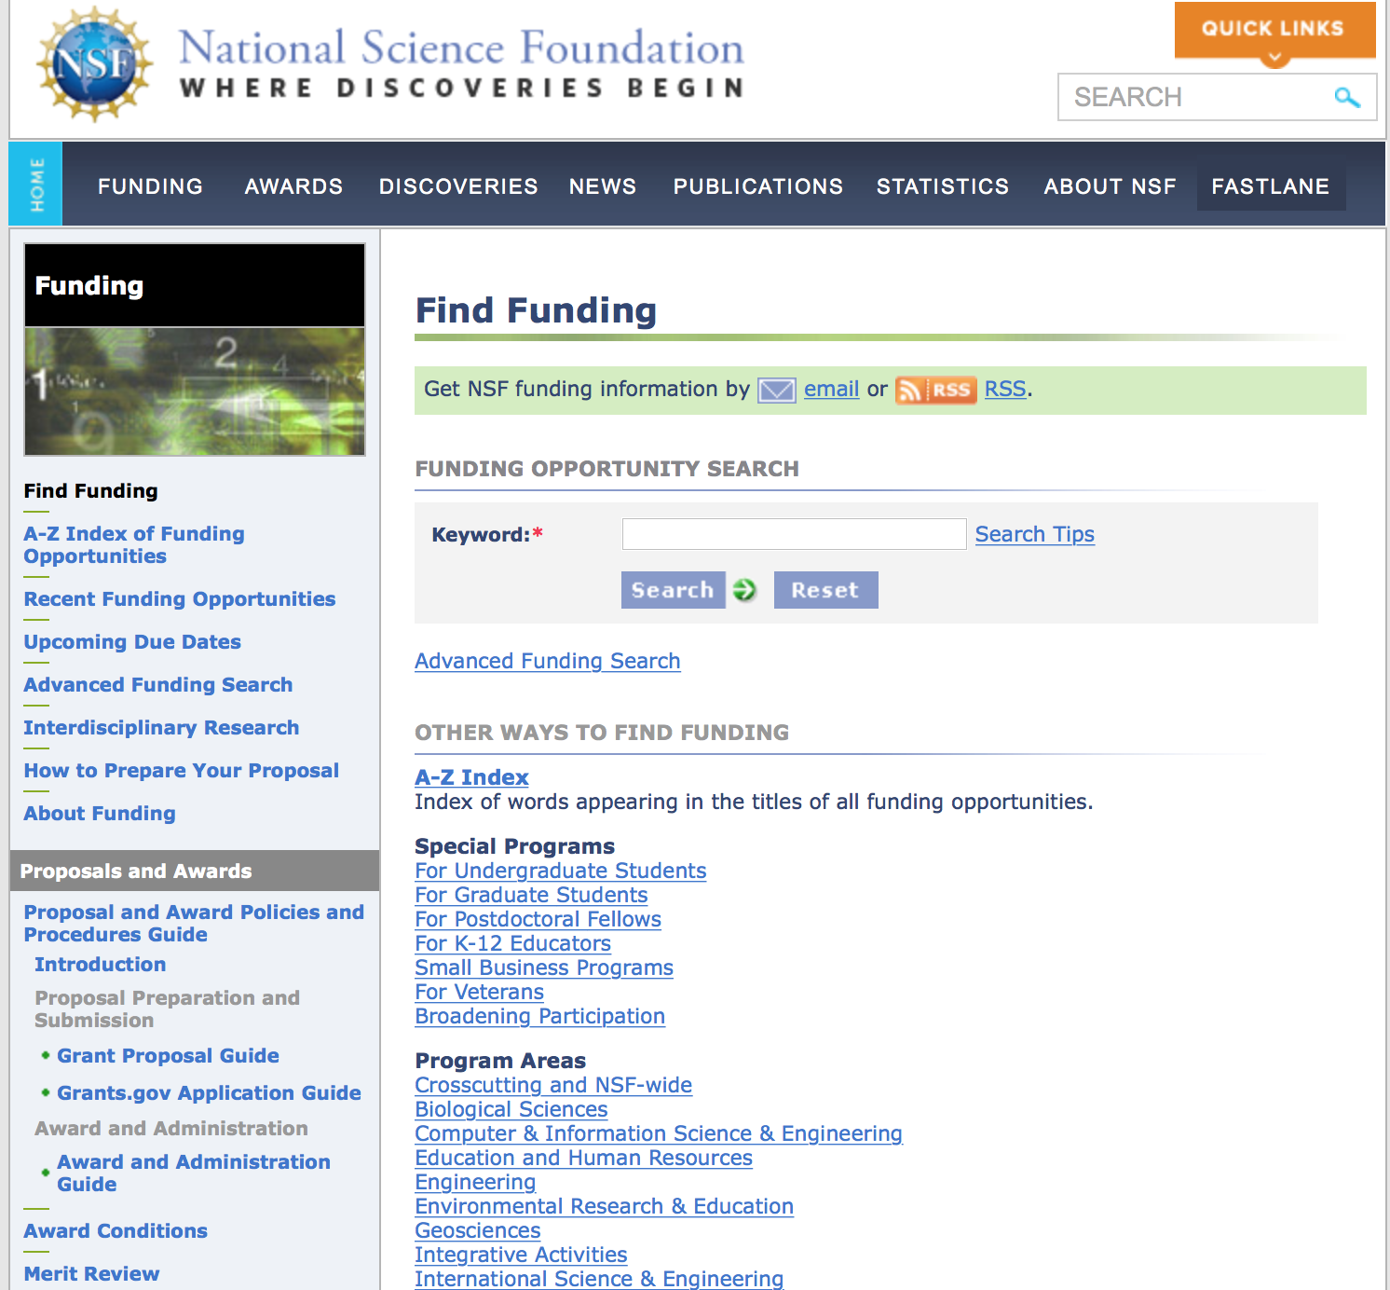
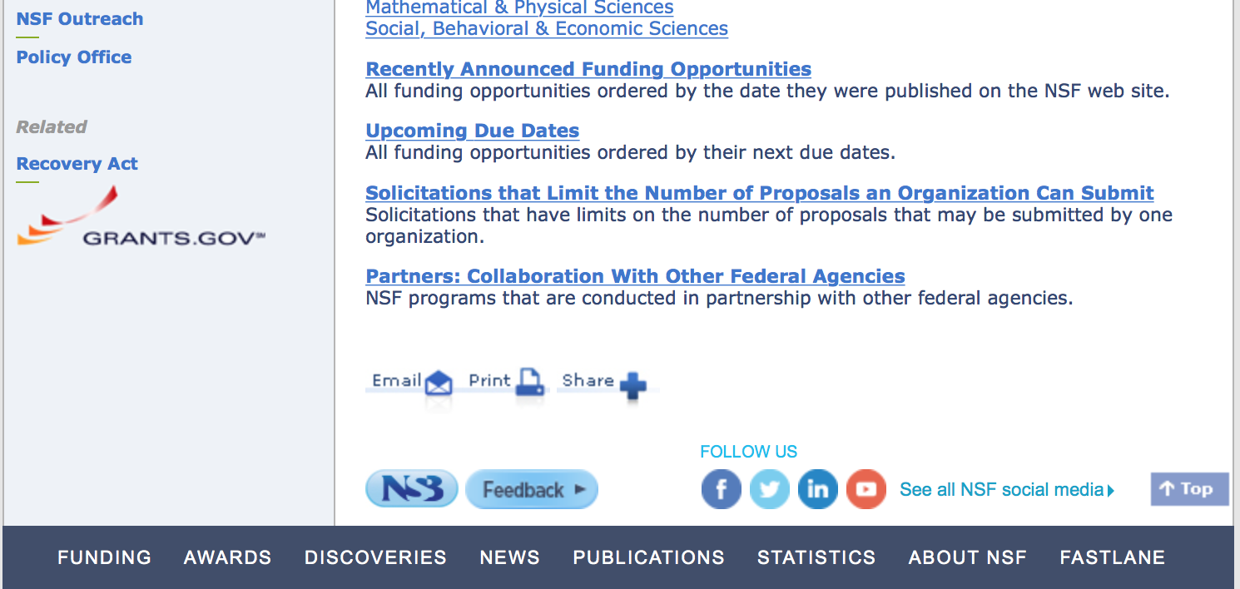

For assistance in finding funding: http://nsf.gov/funding/index.jsp - areas

The National Science Foundation funds research and education in most fields of science and engineering. It does this through grants, and cooperative agreements to more than 2,000 colleges, universities, K-12 school systems, businesses, informal science organizations and other research organizations throughout the United States. The Foundation accounts for about one-fourth of federal support to academic institutions for basic research.
NSF receives approximately 40,000 proposals each year for research, education and training projects, of which approximately 11,000 are funded. In addition, the Foundation receives several thousand applications for graduate and postdoctoral fellowships.
The agency operates no laboratories itself but does support National Research Centers, user facilities, certain oceanographic vessels and Antarctic research stations. The Foundation also supports cooperative research between universities and industry, US participation in international scientific and engineering efforts, and educational activities at every academic level.

For details on active funding deadline dates: http://nsf.gov/funding/pgm_list.jsp?org=NSF&ord=date

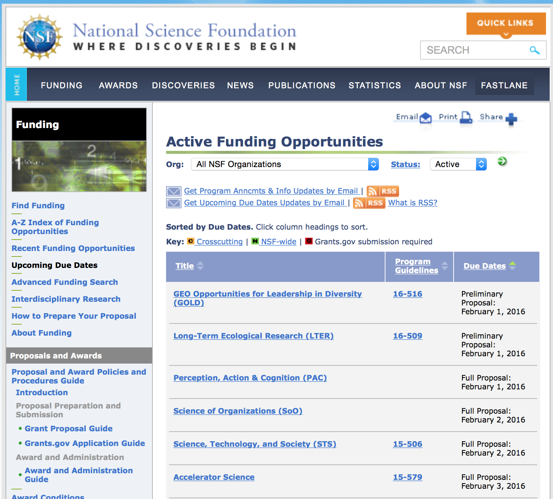

Research and Program Grants:

Computer Science for All
Synopsis 1
http://www.grants.gov/web/grants/view-opportunity.html?oppId=290417

Cybersecurity Innovation for Cyberinfrastructure
Synopsis 1
http://www.grants.gov/web/grants/view-opportunity.html?oppId=290463

Cybersecurity Innovation for Cyberinfrastructure
Synopsis 1
http://www.grants.gov/web/grants/view-opportunity.html?oppId=290463

Cyberinfrastructure for Emerging Science and Engineering Research
Synopsis 1
http://www.grants.gov/web/grants/view-opportunity.html?oppId=290465

Dimensions of Biodiversity
Synopsis 1
http://www.grants.gov/web/grants/view-opportunity.html?oppId=290160

Inclusion across the Nation of Communities of Learners of Underrepresented Discoverers in Engineering and Science
Synopsis 1
http://www.grants.gov/web/grants/view-opportunity.html?oppId=290161

Management and Operation of the Ocean Observatories Initiative (OOI)
Synopsis 1
http://www.grants.gov/web/grants/view-opportunity.html?oppId=290213

NSF Scholarships in Science, Technology, Engineering, and Mathematics Program
Synopsis 1
http://www.grants.gov/web/grants/view-opportunity.html?oppId=290464

Scholarships in Science, Technology, Engineering, and Mathematics Program
Synopsis 1
http://www.grants.gov/web/grants/view-opportunity.html?oppId=290464

Software Infrastructure for Sustained Innovation
Synopsis 1
http://www.grants.gov/web/grants/view-opportunity.html?oppId=290432

Modifications:

Reminders:

Deleted:

16-567 - Campus Cyberinfrastructure
Deletion Comments: Opportunity deleted

16-522 - Genealogy of Life
Deletion Comments: Opportunity deleted

15-553 - Software Infrastructure for Sustained Innovation - SSE & SSI
16-532 - Software Infrastructure for Sustained Innovation - SSE & SSI
Deletion Comments: Opportunity deleted

16-540 - Scholarships in Science, Technology, Engineering, and Mathematics Program
Deletion Comments: Opportunity deleted

Nuclear Regulatory Commission

Reminders:

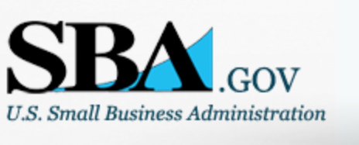

Small Business Administration

General Overview Finding Loans & Grants

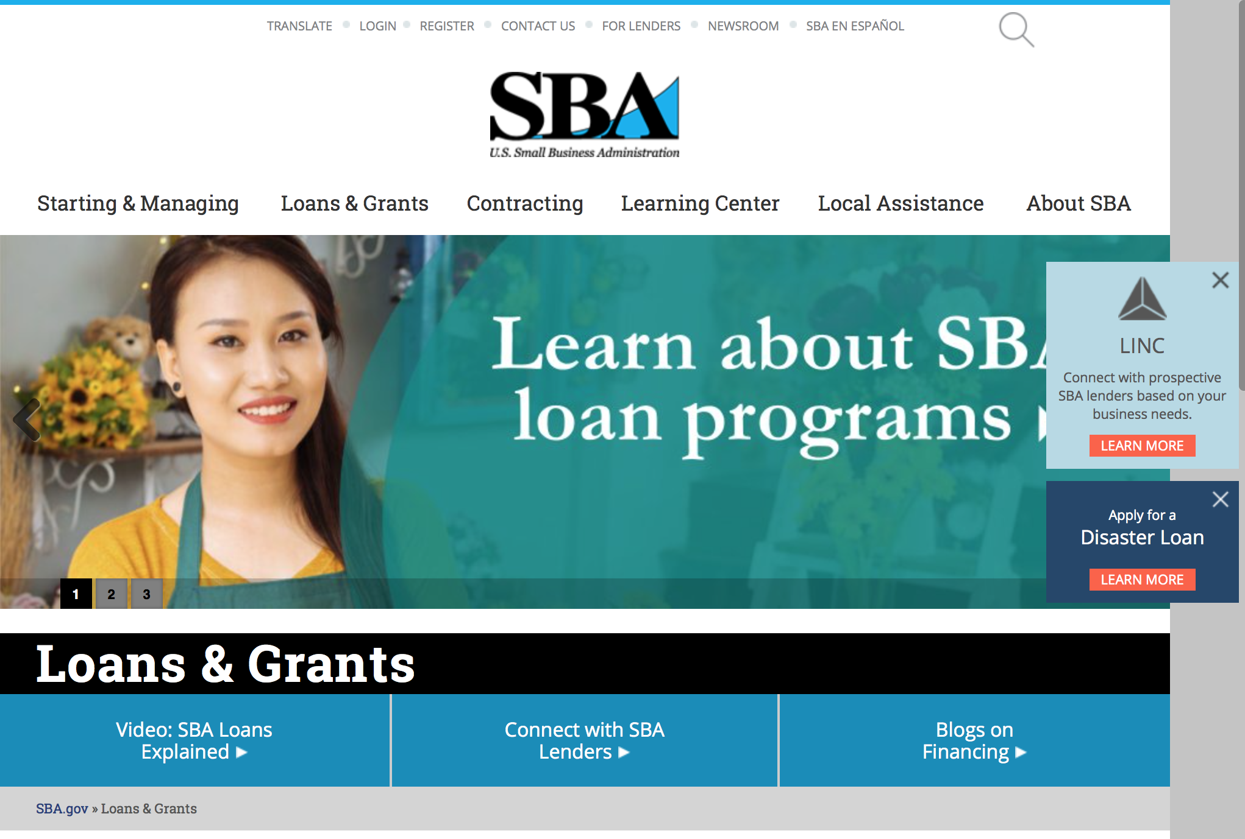
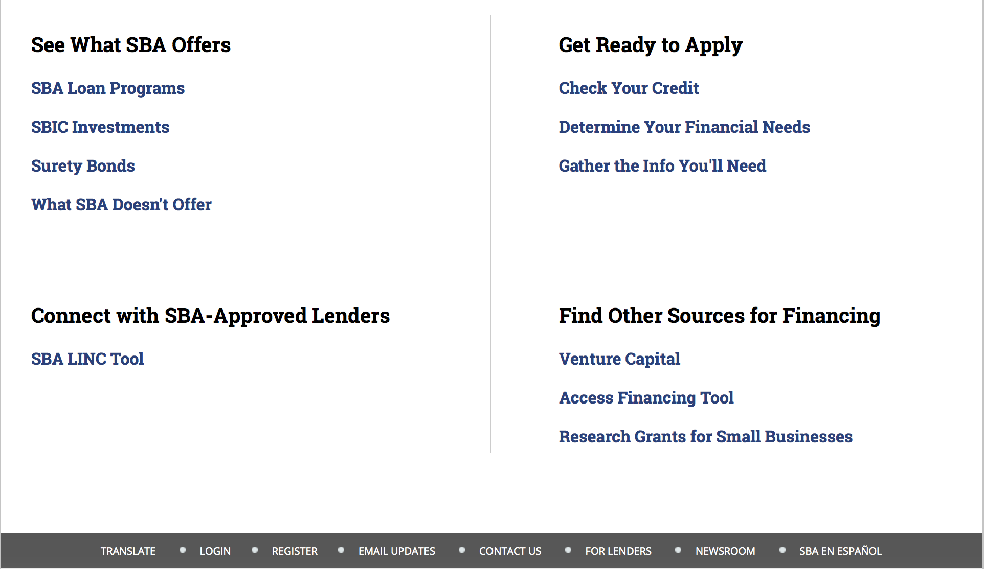

https://www.sba.gov/category/navigation-structure/loans-grants
Federal, state and local governments offer a wide range of financing programs to help small businesses start and grow their operations. These programs include low-interest loans, venture capital, and scientific and economic development grants.

Use SBA.gov's Loans and Grants Search Tool to get a list of financing programs for which you may qualify, or visit the resources below to learn more about small business financing programs. 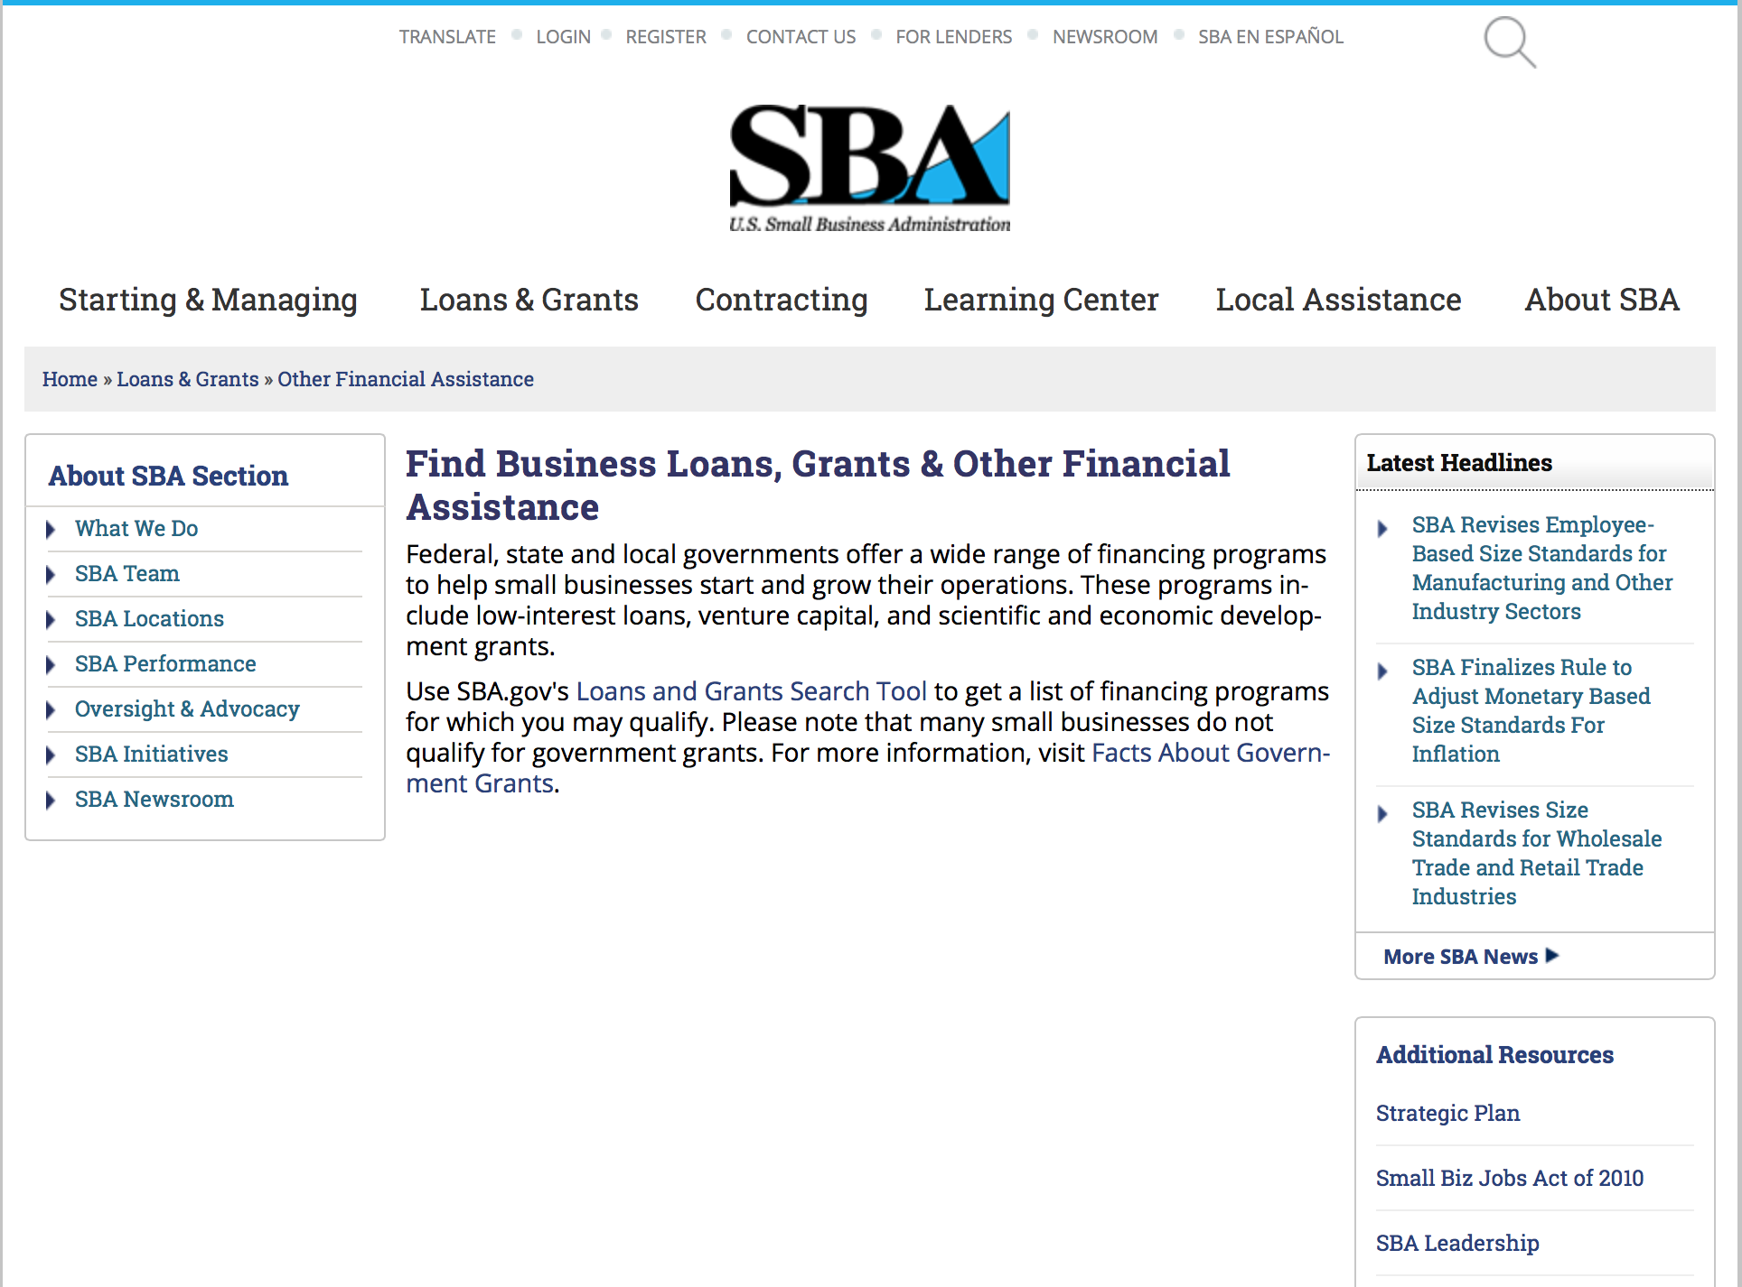
To get to the main SBA.gov funding page click here
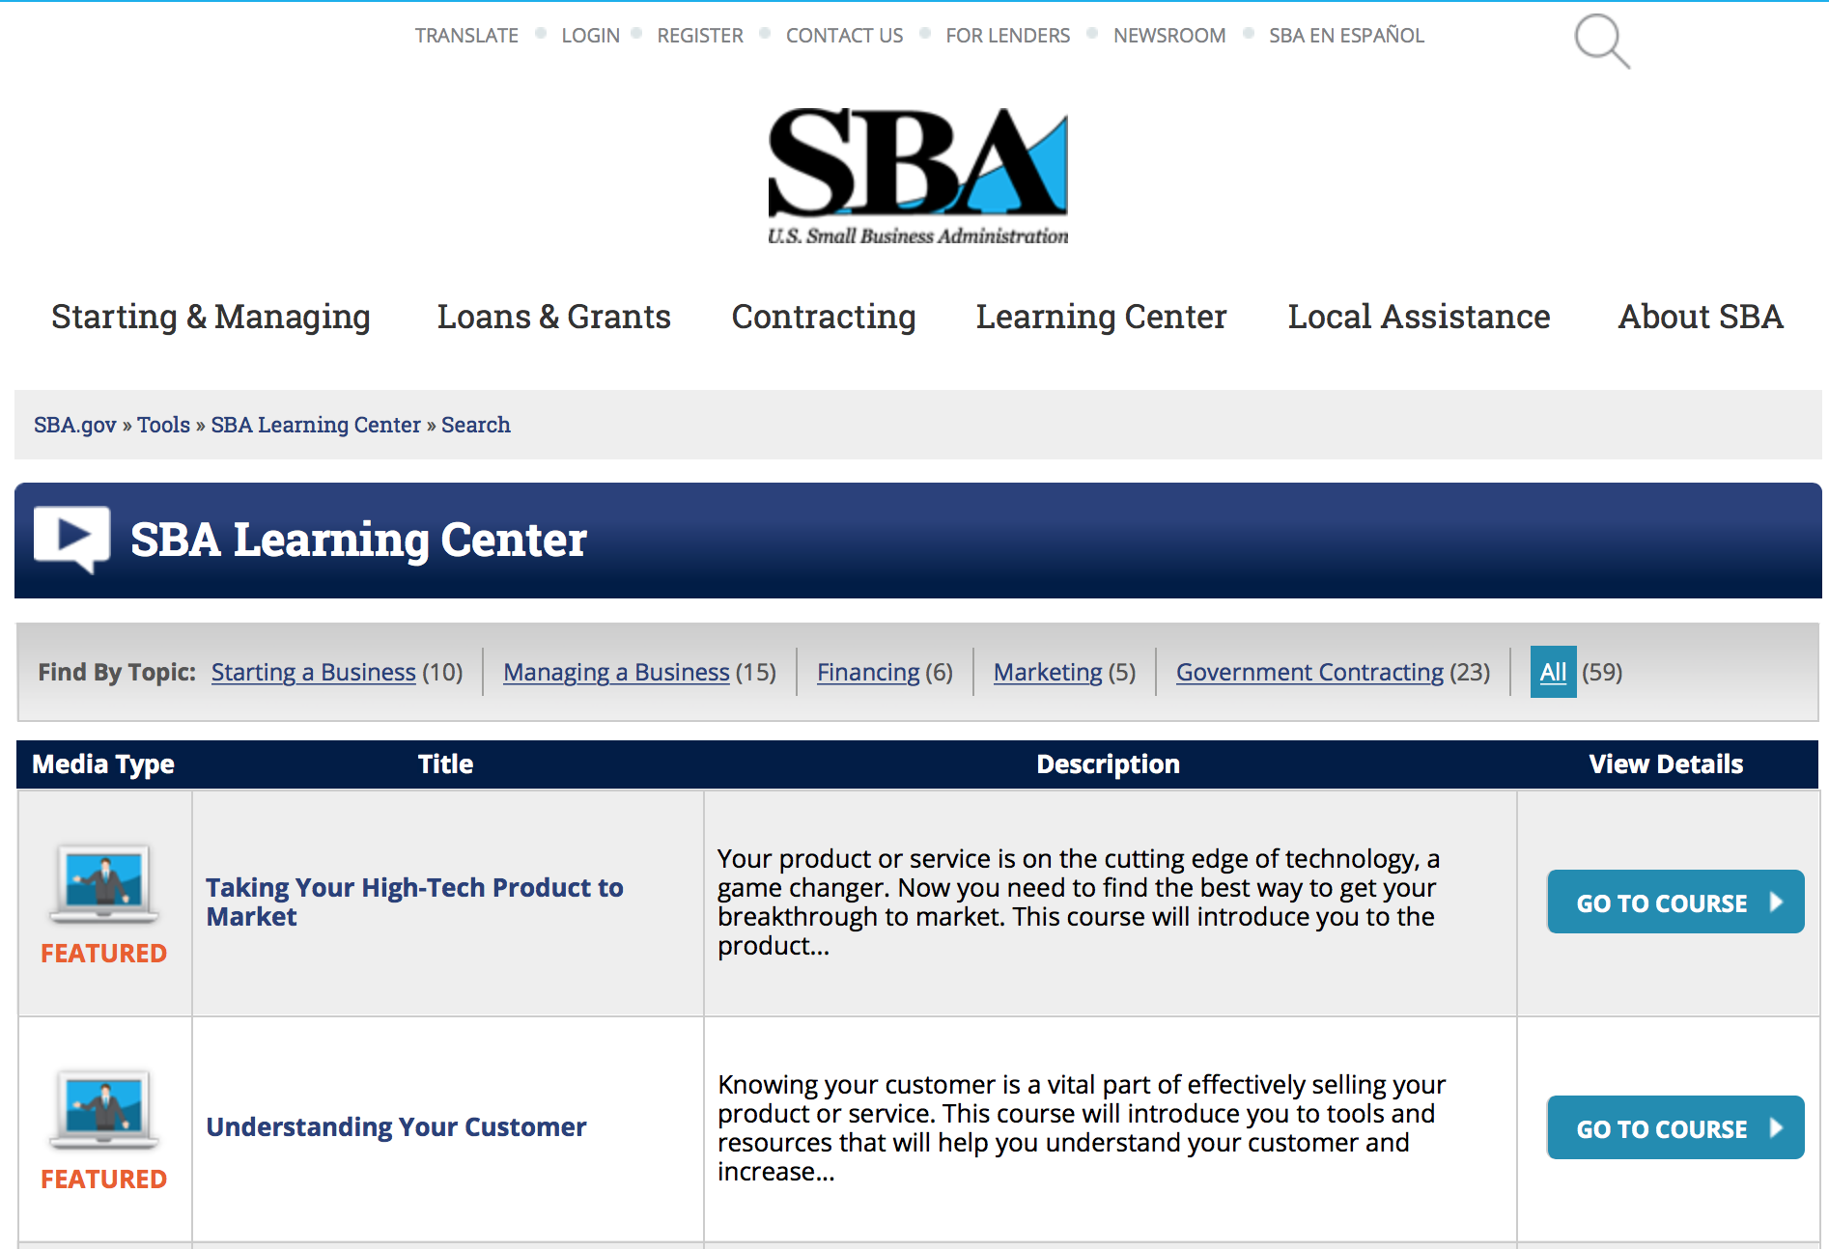
https://www.sba.gov/tools/sba-learning-center/search/training
Programs:

Request for Statement of Interest for Upcoming Boots to Business Funding Opportunity
Synopsis 3 & 4

Document Type: | Grants Notice
Funding Opportunity Number: | B2B-SOI-2017-01
Funding Opportunity Title: | Request for Statement of Interest for Upcoming Boots to Business Funding Opportunity
Opportunity Category: | Other
Opportunity Category Explanation: | Request for Statements of Interest for Upcoming Boots to Business Funding Opportunity- Cooperative Agreement(s)
Funding Instrument Type: | Cooperative Agreement
Category of Funding Activity: | Business and Commerce
Category Explanation:
Expected Number of Awards:
CFDA Number(s): | 59.044 -- Veterans Outreach Program
Cost Sharing or Matching Requirement: | No
Version: | Synopsis 4
Posted Date: | Nov 18, 2016
Last Updated Date: | Nov 29, 2016
Original Closing Date for Applications: | Dec 18, 2016
Current Closing Date for Applications: | Dec 18, 2016
Archive Date: | Jan 17, 2017
Estimated Total Program Funding: | $2,500,000
Award Ceiling: | $2,500,000
Award Floor: | $500,000
Eligible Applicants: | Nonprofits having a 501(c)(3) status with the IRS, other than institutions of higher education  Public and State controlled institutions of higher education  For profit organizations other than small businesses  Others (see text field entitled "Additional Information on Eligibility" for clarification)  Small businesses  Private institutions of higher education
Additional Information on Eligibility: | See Related Documents
Agency Name: | Small Business Administration
Description: | The U.S. Small Business Administration’s Office of Veterans Business Development requests statement of interest for the Boots to Business (B2B) program funding opportunity from organizations interested in providing entrepreneurship training to transitioning service members, veterans, and military spouses interested in starting and growing a small business. The B2B entrepreneurial development program provides introductory and follow-on small business ownership education and training to U.S. military service members and spouses (including members of the Reserve and National Guard) via the U.S. Department of Defense’s Transition Assistance Program (TAP).Statements of interest are expected to provide insight on the potential applicants experience in administering entrepreneurship training programs by utilizing instructors with practical experience in starting, owning, and operating businesses to clients, specifically veterans and military spouses, in addition to those interested in starting new businesses or those who currently own an established business and are seeking opportunities for expansion or diversification. This request for statements of interest closes at 11:59 p.m. on December 16, 2016. All SOIs must be submitted through the grants.gov web-portal at www.grants.gov. SOIs submitted via other media will not be reviewed. A Q&A Webinar and Conference Call will be held on December 6, 2016 at 3:00 p.m. EST to answer questions. Please submit all questions to John Lira, at john.lira@sba.gov by December 2, 2016. Below please find the telephone number and access code for the webinar and conference call. Web Conference URL: https://www.connectmeeting.att.com Telephone: 1-888-858-2144 Access Code:1183010#
Link to Additional Information: | SBA-Office of Veterans Business Development Spotlight
Grantor Contact Information: | If you have difficulty accessing the full announcement electronically, please contact:  John Lira B2B Program Analyst Phone 202-205-6522  B2B Program Analyst

http://www.grants.gov/web/grants/view-opportunity.html?oppId=290189

Reminders:

Women's Veteran Entrepreneurship Training Program (WVETP)
Synopsis 1 and 2

Document Type: | Grants Notice
Funding Opportunity Number: | WVETP-2017-01
Funding Opportunity Title: | Women's Veteran Entrepreneurship Training Program (WVETP)
Opportunity Category: | Discretionary
Opportunity Category Explanation:
Funding Instrument Type: | Cooperative Agreement
Category of Funding Activity: | Business and Commerce
Category Explanation:
Expected Number of Awards: | 6
CFDA Number(s): | 59.044 -- Veterans Outreach Program
Cost Sharing or Matching Requirement: | No
Version: | Synopsis 2
Posted Date: | Nov 04, 2016
Last Updated Date: | Nov 07, 2016
Original Closing Date for Applications: | Dec 12, 2016 The Closing date is 12/12/2016 at 11:59 pm est
Current Closing Date for Applications: | Dec 12, 2016 The Closing date is 12/12/2016 at 11:59 pm est
Archive Date: | Dec 13, 2016
Estimated Total Program Funding: | $300,000
Award Ceiling: | $300,000
Award Floor: | $25,000
Eligible Applicants: | Others (see text field entitled "Additional Information on Eligibility" for clarification)
Additional Information on Eligibility: | See Synopsis.
Agency Name: | Small Business Administration
Description: | See link below
Link to Additional Information: | OVBD website
Grantor Contact Information: | If you have difficulty accessing the full announcement electronically, please contact:  Jan Moorman janet.moorman@sba.gov  Veterana Affairs Specialist

http://www.grants.gov/web/grants/view-opportunity.html?oppId=289917

Deleted:
GCBD-7J-2017-01 - 7(j) Management and Technical Assistance
Deletion Comments: Opportunity deleted

B2BSOI-2017 - Boost 2 Business Statement of Interest
Deletion Comments: Opportunity deleted

SBA Trainings

Contracting Opportunities for Veteran Entrepreneurs
This self-paced training exercise is an introduction to Federal contracting opportunities for Veterans.
Topics include basic information about Veteran-owned businesses and opportunities, services available to small Veteran-owned businesses, small business incentives, and government procurement methods.
Duration: 00:30:00

http://www.sba.gov/tools/sba-learning-center/training/contracting-opportunities-veteran-entrepreneurs

Interested in Exporting? These Four Resources Can Help
Did you know that two-thirds of the world’s purchasing power is in foreign countries? As the numbers show, the international marketplace is a big one. So if you’re interested in exploring the world of exporting – or have gotten started but could use some guidance – check out these resources to help.
- Read more

Upcoming Trainings: Check out SBA's Online Training!
- Financing Options for Small Businesses
How to Prepare Government Contract Proposals
Getting Started With Exporting: Training and Educational Resources
Exporting represents a big opportunity to tap in to new markets, expand your customer base and grow your business. But getting started with exporting can sometimes feel like a maze of regulations, policies, and other barriers. Here are some free training and educational resources to help.
- Read more

For Specific Information in Hawaii see the following links:
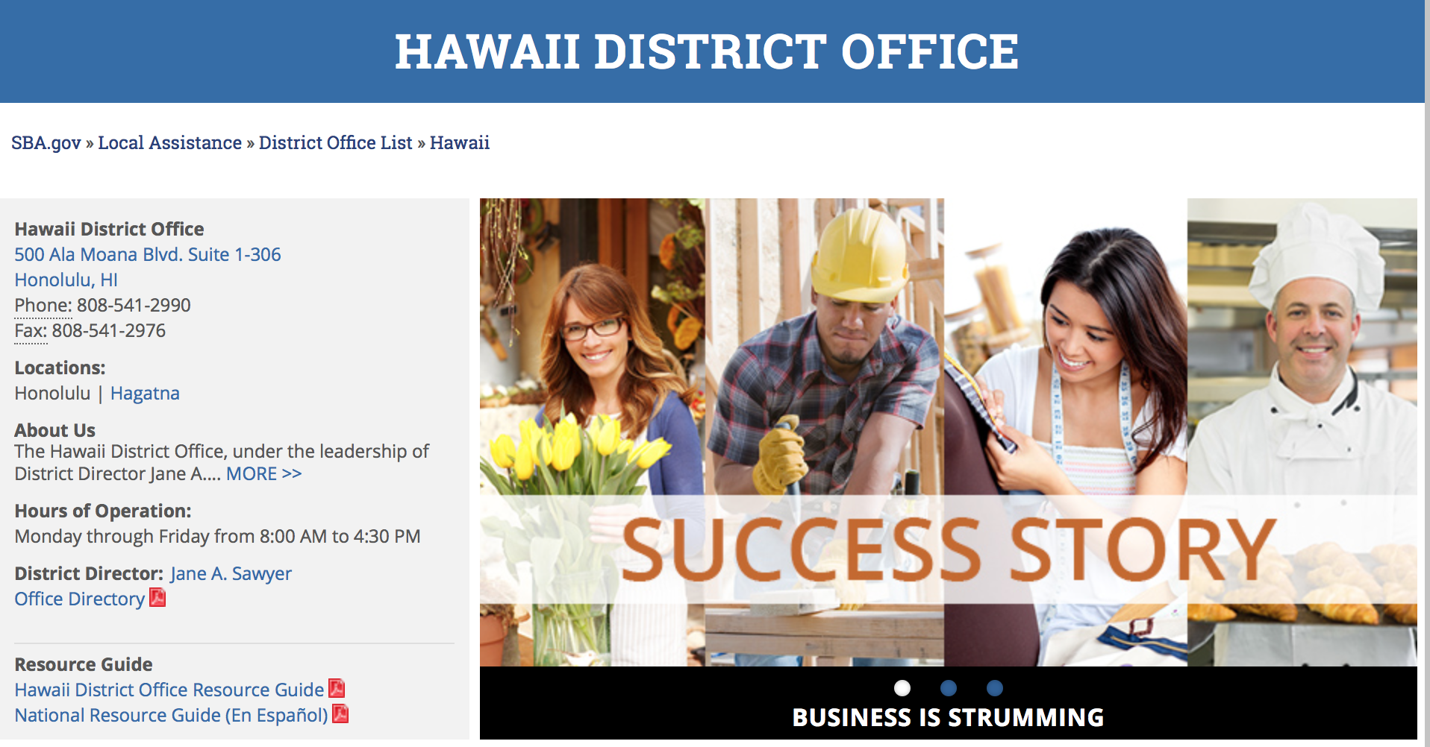

https://www.sba.gov/offices/district/hi/Honolulu

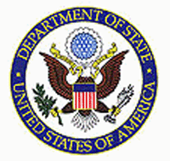

State Department General Overview and Resources for Program Administrators

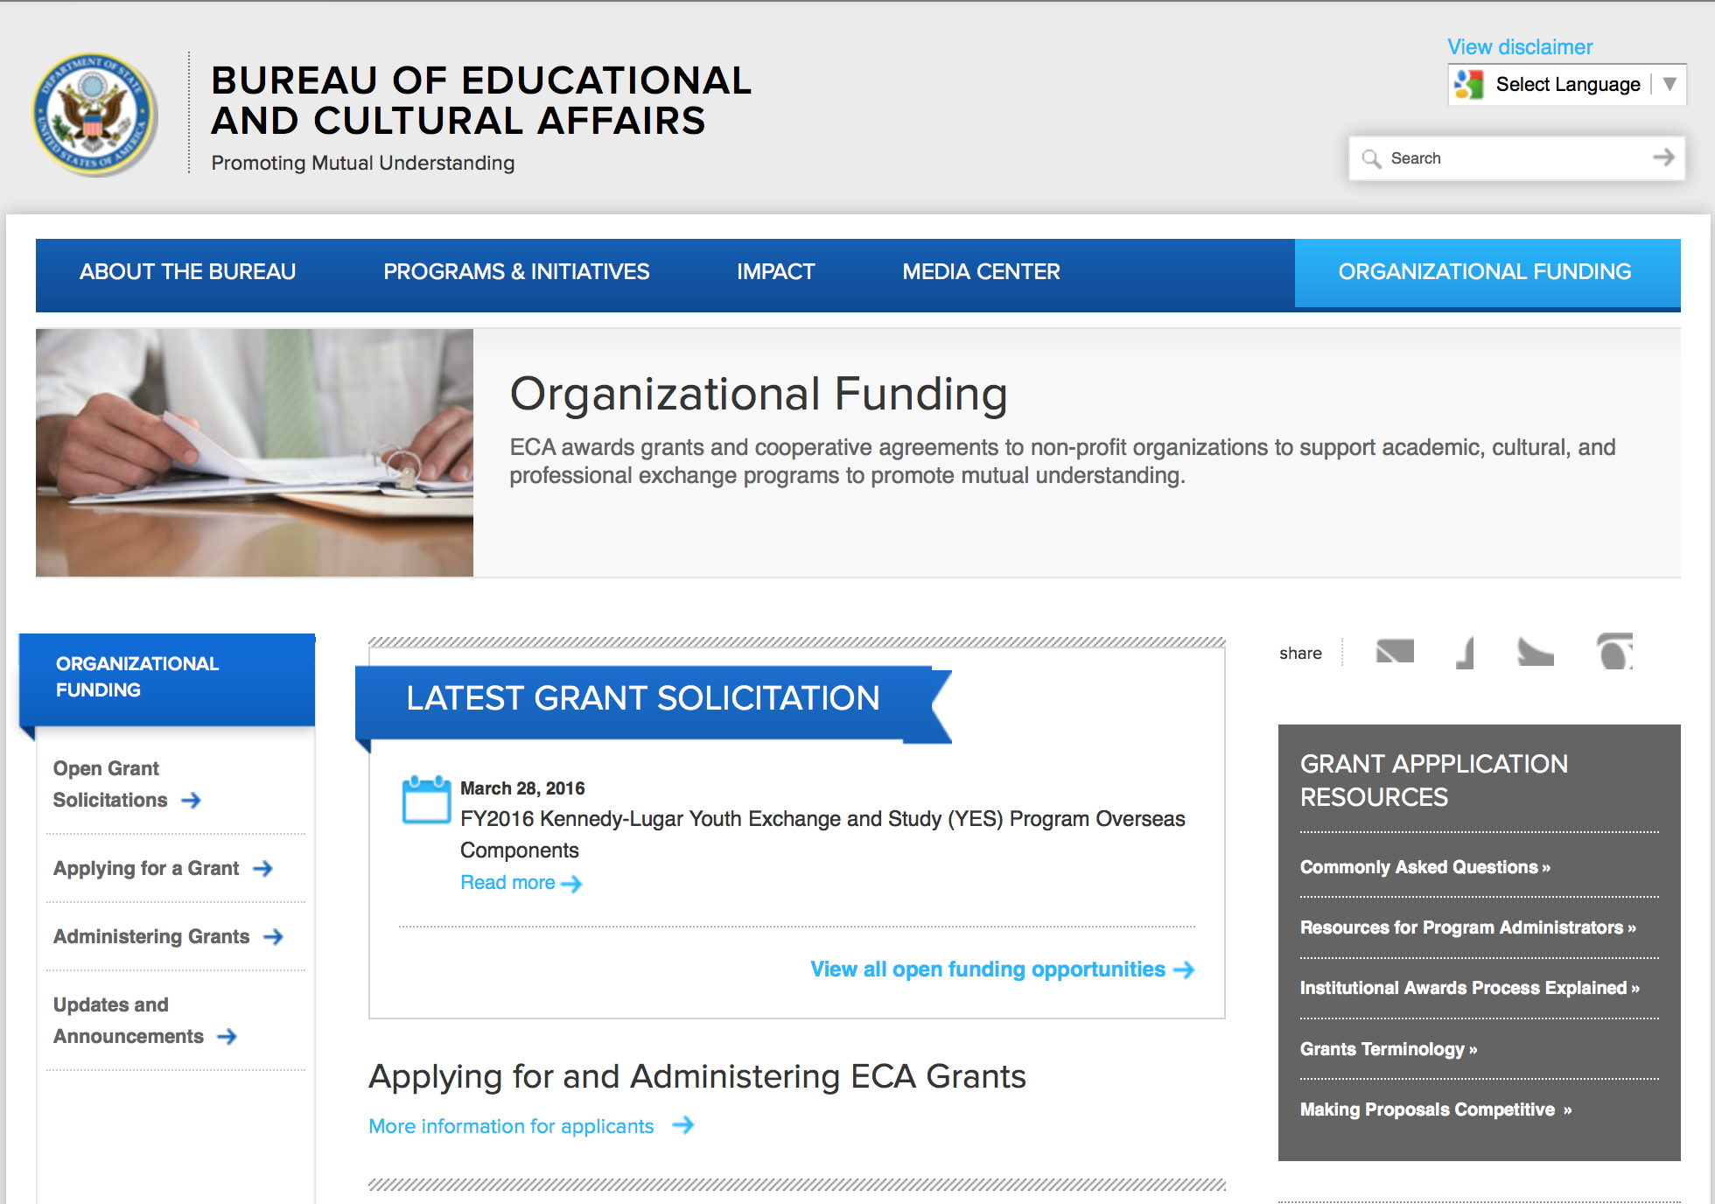
http://eca.state.gov/search/solr/grants?search_referrer=node/237
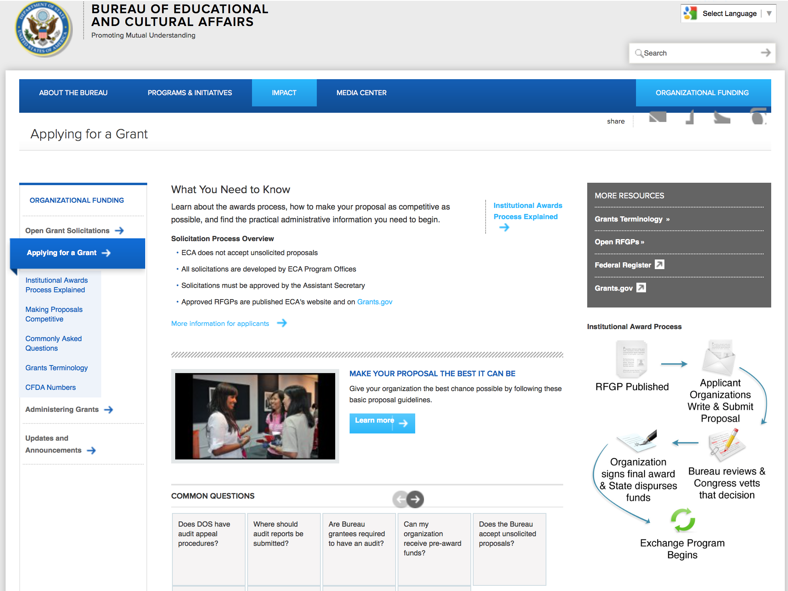

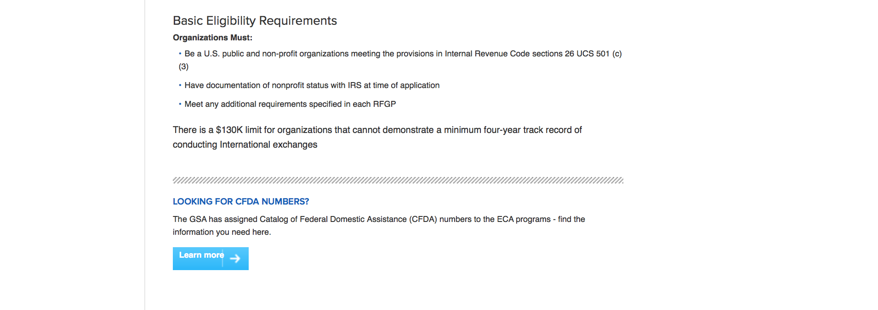
http://eca.state.gov/organizational-funding/applying-grant

General Information:
- Bureau of Educational and Cultural Affairs Grants Division
- Open Grant Opportunities (Requests for Grant Proposals)

For General Information click here

Program Grants:

Bureau of Democracy, Human Rights and Labor
DRL FY16 Supporting Local Civil Society in Ukraine
Synopsis 1
http://www.grants.gov/web/grants/view-opportunity.html?oppId=290288

Modifications:

Bureau of Democracy, Human Rights and Labor
FY16 - Protecting and Supporting Marginalized Roma in Europe
Synopsis 2
http://www.grants.gov/web/grants/view-opportunity.html?oppId=290134

Bureau of International Security and Nonproliferat
ISN-CTR Biosecurity Engagement Program FY17 NOFO
Synopsis 2
http://www.grants.gov/web/grants/view-opportunity.html?oppId=290099

Global Engagement Center - Statement of Interest and Capacity
Synopsis 2
http://www.grants.gov/web/grants/view-opportunity.html?oppId=289812

U.S. Mission to Jordan
Inspiring Young Women to Join the Workplace
Synopsis 2 & 3
http://www.grants.gov/web/grants/view-opportunity.html?oppId=290138

Reminders:

Deleted:

Department of Transportation

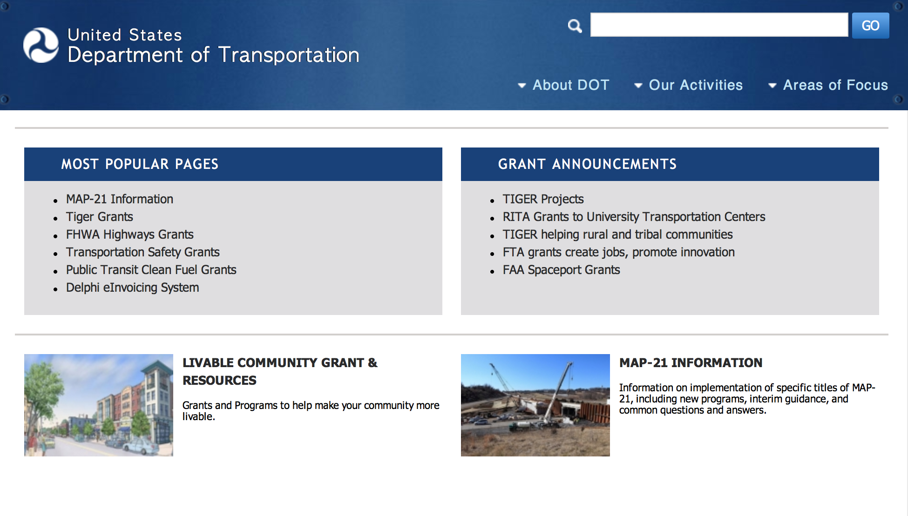
General Grant Program Overview https://www.transportation.gov/grants

Programs:

Modifications:

DOT/Federal Motor Carrier Safety Administration
FY 2017 High Priority Grant Program
Synopsis 2 & 4

Document Type: | Grants Notice
Funding Opportunity Number: | FM-MHP-17-001
Funding Opportunity Title: | FY 2017 High Priority Grant Program
Opportunity Category: | Discretionary
Opportunity Category Explanation:
Funding Instrument Type: | Cooperative Agreement  Grant
Category of Funding Activity: | Transportation
Category Explanation:
Expected Number of Awards: | 125
CFDA Number(s): | 20.237 -- Motor Carrier Safety Assistance High Priority Activities Grants and Cooperative Agreements
Cost Sharing or Matching Requirement: | Yes
Version: | Synopsis 4
Posted Date: | Nov 18, 2016
Last Updated Date: | Nov 21, 2016
Original Closing Date for Applications: | Jan 13, 2017 No Explanation
Current Closing Date for Applications: | Jan 13, 2017 No Explanation
Archive Date: | Feb 12, 2017
Estimated Total Program Funding: | $41,567,000
Award Ceiling: | $2,000,000
Award Floor: | $10,000
Eligible Applicants: | County governments  Private institutions of higher education  Native American tribal governments (Federally recognized)  For profit organizations other than small businesses  Nonprofits having a 501(c)(3) status with the IRS, other than institutions of higher education  Small businesses  City or township governments  State governments  Public and State controlled institutions of higher education  Native American tribal organizations (other than Federally recognized tribal governments)  Special district governments  Independent school districts  Nonprofits that do not have a 501(c)(3) status with the IRS, other than institutions of higher education
Agency Name: | DOT/Federal Motor Carrier Safety Administration
Description: | The High Priority (HP) Grant Program is a discretionary (i.e., competitive) program which provides financial assistance to: 1)advance the technological capability and promote HP Innovative Technology Deployment (HP-ITD) to include the deployment of intelligent transportation system (i.e., formerly CVISN) applications for commercial motor vehicle (CMV) operations, including CMVs, commercial drivers, and carrier-specific information systems/networks; to support/maintain CMV information systems/networks; to link Federal Motor Carrier Safety Administration (FMCSA) information systems with State CMV information systems; to improve the safety and productivity of CMVs and commercial drivers; to reduce costs associated with CMV operations and Federal and State CMV regulatory requirements; and/or 2)carry out HP-CMV Safety activities and projects that augment motor carrier safety activities and projects planned in accordance with the Motor Carrier Safety Assistance Program (MCSAP) including projects related to Performance and Registration Information Systems Management (PRISM) and Safety Data Quality (SaDIP).
Link to Additional Information: | FY 2017 High Priority Grant Program
Grantor Contact Information: | If you have difficulty accessing the full announcement electronically, please contact:  Grants.gov Contact Center Phone Number: 1-800-518-4726 Hours of operation are 24 hours a day, 7 days a week. The contact center is closed on federal holidays. support@grants.gov  Grants.gov Customer Support

http://www.grants.gov/web/grants/view-opportunity.html?oppId=290185

Research:

DOT/Federal Transit Administration
Zero Emission Research Opportunity (ZERO)
Synopsis 1
http://www.grants.gov/web/grants/view-opportunity.html?oppId=290356

Reminders:

DOT Federal Aviation Administration
DOT - FAA Aviation Research Grants
FAA Aviation Research and Development Grants
Modifications 3 & 4

Document Type: | Grants Notice
Funding Opportunity Number: | 12-01
Funding Opportunity Title: | FAA Aviation Research and Development Grants
Opportunity Category: | Discretionary
Opportunity Category Explanation:
Funding Instrument Type: | Grant
Category of Funding Activity: | Transportation
Category Explanation:
Expected Number of Awards:
CFDA Number(s): | 20.108 -- Aviation Research Grants
Cost Sharing or Matching Requirement: | No
Version: | Synopsis 5
Posted Date: | Jan 01, 2012
Last Updated Date: | Jun 09, 2016
Original Closing Date for Applications: | Dec 31, 2019
Current Closing Date for Applications: | Dec 31, 2019
Archive Date: | Jan 30, 2020
Estimated Total Program Funding:
Award Ceiling: | $5,000,000
Eligible Applicants: | Nonprofits having a 501(c)(3) status with the IRS, other than institutions of higher education  Private institutions of higher education  Public and State controlled institutions of higher education
Agency Name: | DOT - FAA Aviation Research Grants
Description: | The FAA is soliciting proposals for research grants and cooperative agreements to pursue the long-term growth and short-term technical needs of civil aviation. In order to streamline the application process, it is recommended that all prospective grantees submit a white paper (letter of intent) for agency technical review before complete proposal submission. Please be sure to identify the specific area of interest (Solicitation FAA-12-01 – Chapter I. FAA Research Grants Program, Technical Areas of Research #1-#9). The white paper shall be no longer than three (3) pages and shall detail overall research objectives.
Link to Additional Information:
Grantor Contact Information: | If you have difficulty accessing the full announcement electronically, please contact:  Debra Monzo Grants Officer Phone 609-485-4962  business

http://www.grants.gov/web/grants/view-opportunity.html?oppId=134953

Deleted:

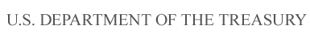

Department of the Treasury

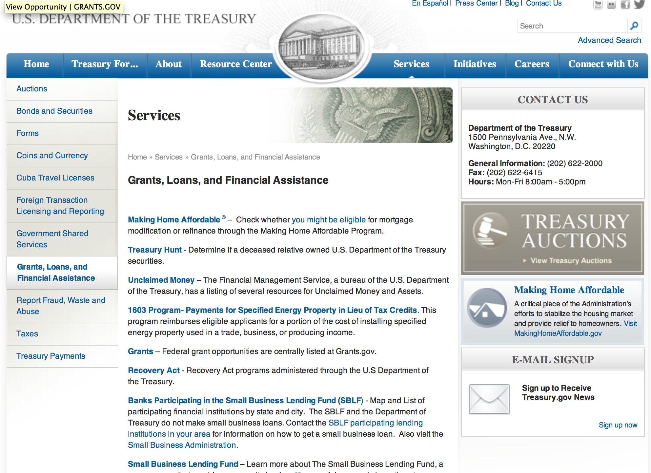

http://www.treasury.gov/services/Pages/Grants-Loans-and-Financial-Assistance.aspx

Programs:

Modifications:

Reminders:

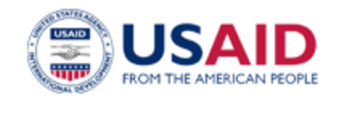

U.S. Agency for International Development

www.usaid.gov

General Overview Funding Opportunities

USAID has working relationships with thousands of American companies and hundreds of U.S.-based private voluntary organizations. For more information on our business and procurement opportunities, please visit our Business section.

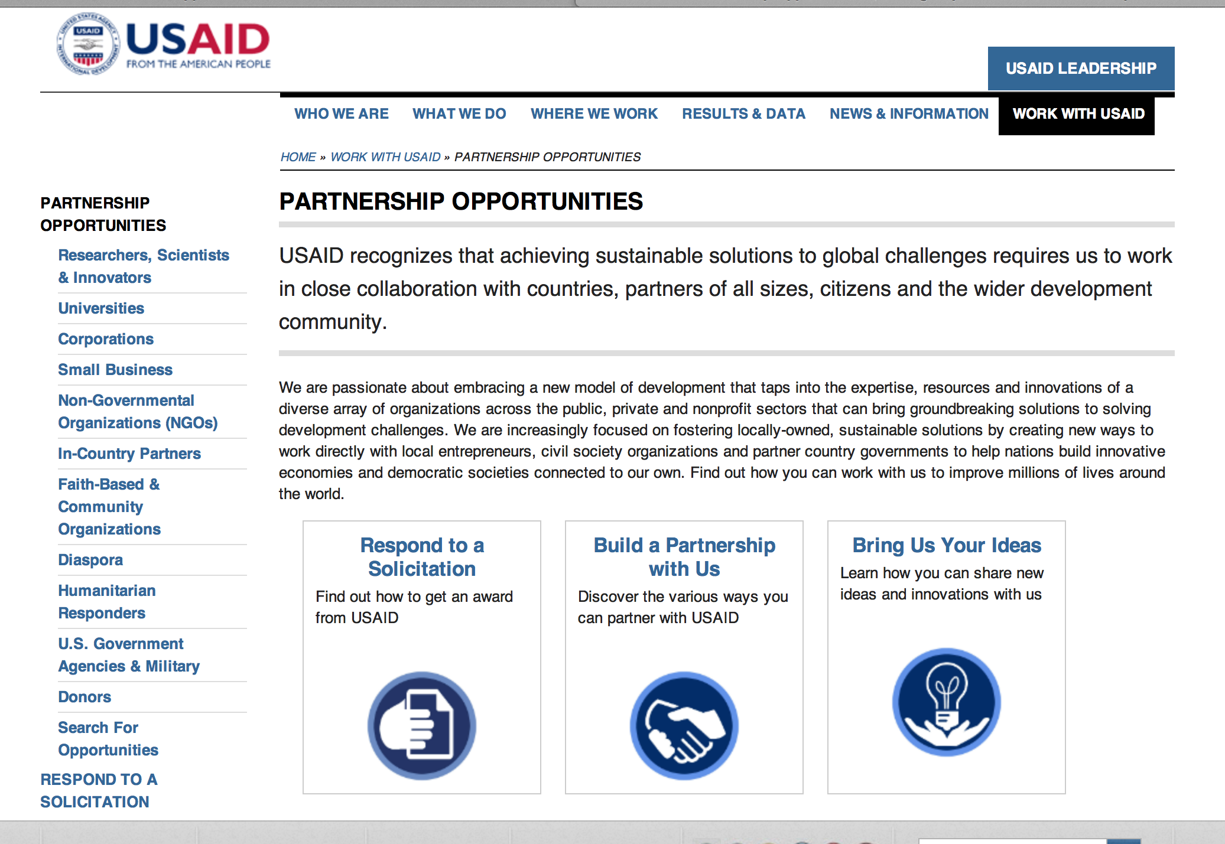
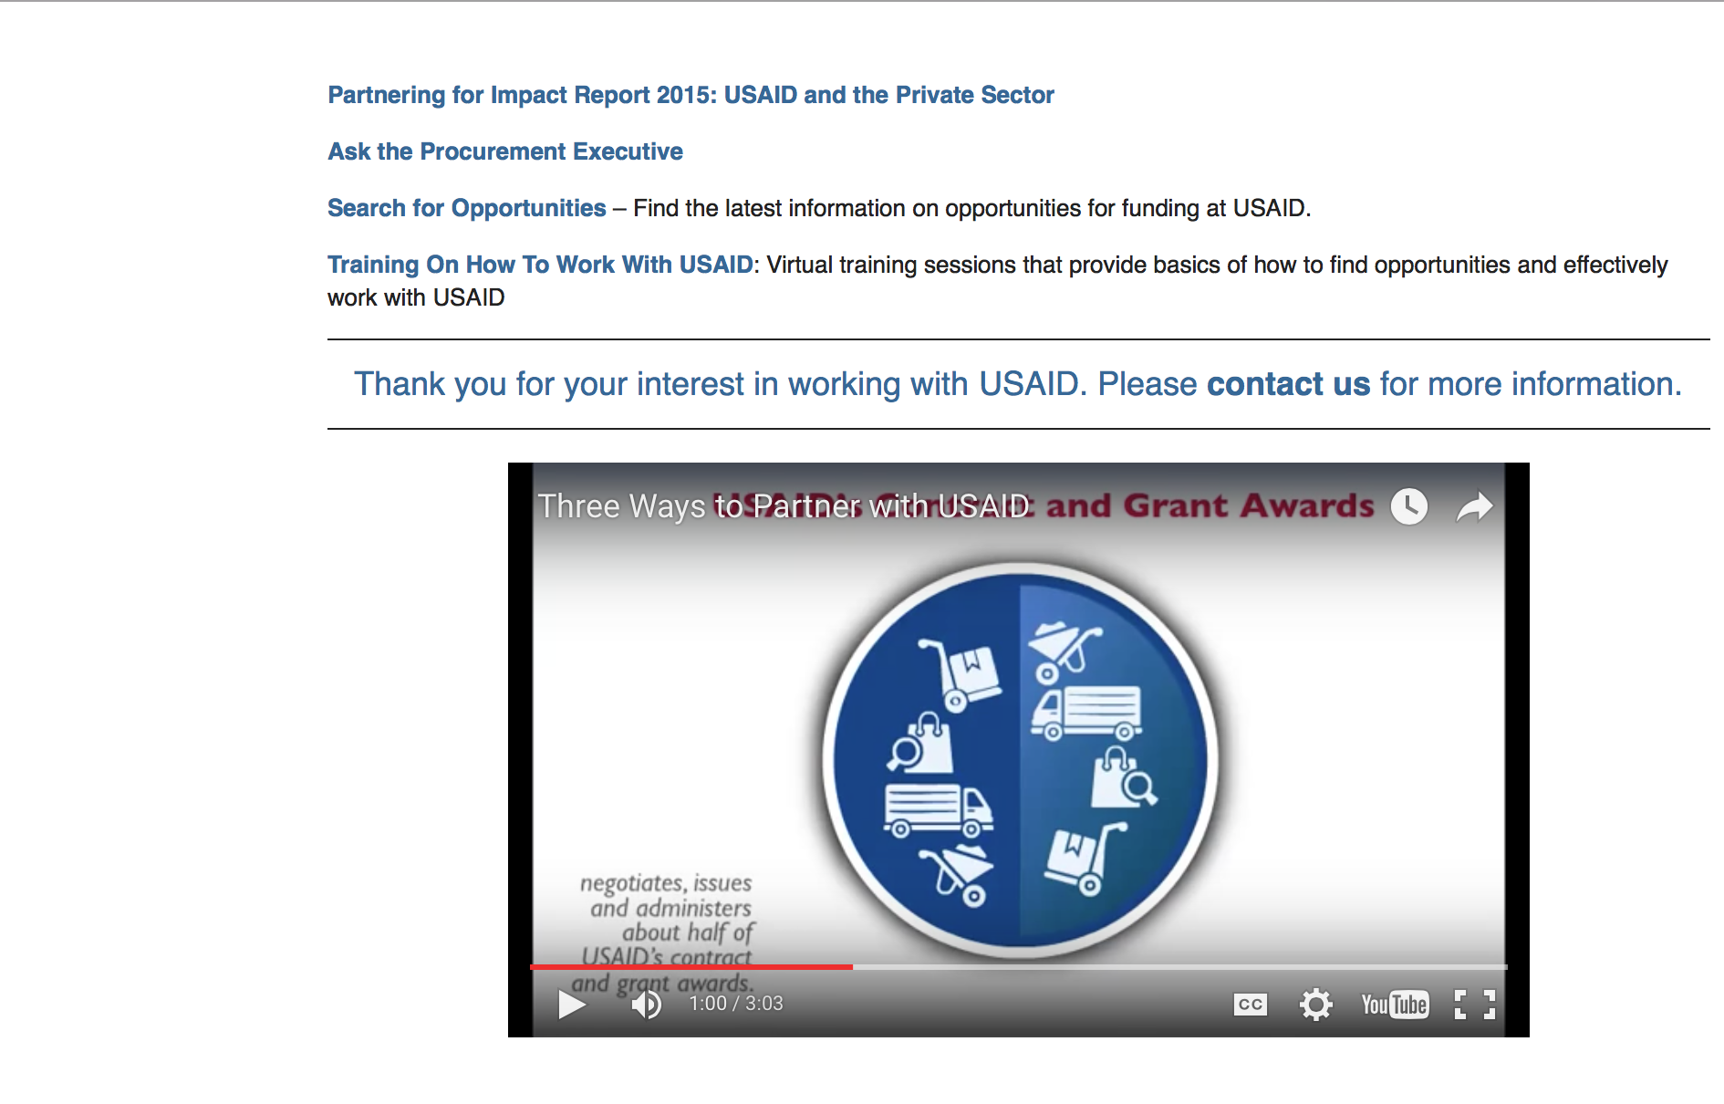

http://www.usaid.gov/partnerships

Programs:

Kosovo USAID-Pristina
Workforce Partnership
Synopsis 3
http://www.grants.gov/web/grants/view-opportunity.html?oppId=289911

FY 2017 American Schools and Hospitals Abroad (ASHA) Program
Synopsis 3
http://www.grants.gov/web/grants/view-opportunity.html?oppId=289760

Modifications:

RFA-168-17-000001 - USAID Media Program in BiH
Deletion Comments: Opportunity re-posted under USAID - Bosnia and Herzegovina mission

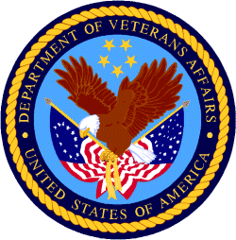

Department of Veterans Affairs

