Senator Mazie Hirono

Grants Assistance Information Newsletter

DECEMBER 2020

PART 1 – CURRENT FEDERAL AGENCY DISCRETIONARY GRANT OPPORTUNITIES

PART 2 – GENERAL FEDERAL AGENCY GRANTS INFORMATION

Current Federal Agency Grant and Cooperative Agreement Discretionary Program Summaries

Click on Index Links below to find summaries of the current announcements listed by agency in this document. Once you reach the item, if you cannot open the links for further information, copy the selected URL website address into your browser.

Notices is Teal are items with immediate deadline dates.

Notices in Yellow are of special interest.

Notices is Green are items of special interest with immediate deadline dates.

Several Agencies have research or program opportunities that are not individually listed because they are for very technical or specific audiences. Click on the Agency Index Research or Program designation to review those grant and contract notices.

If an Agency does not have listings, it is due to the lack of competitive open opportunities at that Agency this month. Please review Part 2 for general information not specific to a current deadline date for general funding cycle information.

Special Notice

General Federal Government Coronavirus Responses

Specific Agency Coronavirus Responses

Corona Virus Response for Small Business

Programs specific to Hawaii

Current Notices

Department of Commerce
2021 Marine Education and Training Mini Grant Program
Department of Interior
Bureau of Reclamation
WaterSMART Cooperative Watershed Management Program Phase I Grants
National Park Service
NPS-FY21-WASO-NAGPRA Consultation/Documentation Grants
National Park Service
NPS-FY21-WASO-NAGPRA Repatriation Grants

Reminders
National Institute of Food and Agriculture
Alaska Native-Serving and Native Hawaiian-Serving Institutions Education Competitive Grants Program (ANNH)
2021 Recreational Fisheries Competition for the Pacific Islands
Office of Science
Established Program to Stimulate Competitive Research (DOE ESPCoR) Implementation Grants
Environmental Education Local Grants Program for Region 9-- Solicitation Notice for 2020
Administration for Children and Families - ANA
Native American Language Preservation and Maintenance
Administration for Children and Families - ANA
Native American Language Preservation and Maintenance-Esther Martinez Immersion

Administration for Children and Families - ANA
Social and Economic Development Strategies -SEDS
Administration for Children and Families - ANA
Social and Economic Development Strategies - Growing Organizations (GO)

National Institutes of Health
Intervention Research to Improve Native American Health (R01 Clinical Trial Optional)

National Institutes of Health
Research to Improve Native American Health (R21 Clinical Trials Optional)
Air Force Office of Scientific Research
(FY20) Defense Established Program to Stimulate Competitive Research (DEPSCoR)

U.S. Department of Agriculture

Programs
National Institute of Food and Agriculture
Agriculture and Food Research Initiative Competitive Grants Program Sustainable Agricultural Systems (SAS)
Norman E. Borlaug Intl Ag Science and Tech 10.777
2021 Norman E. Borlaug International Agricultural Science and Technology Fellowship, Fall Release
Business and Cooperative Programs
REAP-Renewable Energy Systems and Energy Efficiency Improvements

Research

Scientific Cooperation and Research 10.961
Scientific Cooperation Research Program (SCRP)
Modifications

McGovern-Dole Food for Education 10.608
FY 2021 McGovern-Dole Standing Supplemental NOFO
National Institute of Food and Agriculture
Specialty Crop Research Initiative (SCRI) Pre-Applications
Reminders

Utilities Programs
Community Connect Grant Program

National Institute of Food and Agriculture
Organic Agriculture Research and Extension Initiative (OREI)

National Institute of Food and Agriculture
Farm Business Management and Benchmarking

National Institute of Food and Agriculture
Higher Education Challenge (HEC) Grants Program

National Institute of Food and Agriculture
Rural Health and Safety Education Competitive Grants Program (RHSE)
National Institute of Food and Agriculture
Secondary Education, Two-Year Postsecondary Education, and Agriculture in the K-12 Classroom Challenge Grants Program (SPECA)
National Institute of Food and Agriculture
Women and Minorities in Science, Technology, Engineering, and Mathematics Fields Program (WAMS)

Food and Nutrition Service
FY 2021 Farm to School Grants

Forest Service
Community Wood Energy and Wood Innovation Program

Forest Service
2021 Wood Innovations Funding Opportunity

Utilities Programs
Solid Waste Management Grant Program

Department of Commerce

Programs

Fiscal Year 2021 NMFS-Sea Grant Fellowship in Population and Ecosystem Dynamics and Marine Resource Economics
Climate Program Office (CPO), Regional Integrated Sciences and Assessments (RISA) Program FY2021
FY2021 North America Marine Debris Prevention and Removal

Research

Modifications

Reminders

National Estuarine Research Reserve System (NERRS) Land Acquisition and Construction Program for Fiscal Year 2021

Fiscal Year 2022 National Sea Grant College Program Dean John A. Knauss Marine Policy Fellowship
NOAA SBIR FY 2021 Phase I
Addressing the Impacts of Multiple Stressors on Shellfish Aquaculture through Research/Industry Partnerships

FY2021 Marine Debris Research

FY21 Effects of Sea Level Rise (ESLR)

CZM Projects of Special Merit Competition - FY 2021

National Institute of Standards and Technology
NIST Public Safety Innovation Accelerator Program (PSIAP) – Follow-on Funding for Technical and Business Assistance and Demonstration Projects with Public Safety Agencies
FY 2021 Implementation of the U.S. Integrated Ocean Observing System (IOOS®)
Ocean Exploration Fiscal Year 2021 Funding Opportunity

National Institute of Standards and Technology
NIST Manufacturing USA National Emergency Assistance Program
Economic Development Administration
FY 2020 EDA Public Works and Economic Adjustment Assistance Programs

Consumer Product Safety Commission

Corporation for National and Community Service

Programs

Reminders

FY 2021 AmeriCorps State and National Grants

Department of Defense

Programs

Research Grants

Modifications

Reminders

Department of Education

Programs

Office of Elementary and Secondary Education (OESE): College Assistance Migrant Program (CAMP) Assistance Listing Number 84.149A

Office of Elementary and Secondary Education (OESE): High School Equivalency Program (HEP) Assistance Listing Number 84.141A

Research

Institute of Education Sciences (IES): Education Research: Transformative Research in The Education Sciences Assistance Listing Number 84.305T
Institute of Education Sciences (IES): Education Research: Research Networks Focused on Critical Problems of Education Policy and Practice Assistance Listing Number 84.305N

Modifications

Reminders

US Department of Energy

Research

Modifications

Reminders

Environmental Protection Agency

Programs

Technical Assistance To Brownfields Communities
18th Annual P3 Awards: A National Student Design Competition Focusing on People, Prosperity and the Planet

Research

Modifications

Reminders

Early Career: Interventions and Communication Strategies to Reduce Health Risks of Wildland Fire Smoke Exposures
Interventions and Communication Strategies to Reduce Health Risks of Wildland Fire Smoke Exposures
Fiscal Year 2020 and Fiscal Year 2021 National Wetland Program Development Grants

Approaches To Reduce Nutrient Loadings For Harmful Algal Blooms Management

Viral Pathogen and Surrogate Approaches for Assessing Treatment Performance in Water Reuse

Federal Mediation and Conciliation Service

Programs

Reminders

Department of Health and Human Services

Programs

Research Grants

Modifications

Reminders
Health Resources and Services Administration
Ending the HIV Epidemic - Primary Care HIV Prevention (PCHP) Supplement
Forecast 1

Health Resources and Services Administration
Service Area Competition
Forecast 1

Health Resources and Services Administration
Behavioral Health Workforce Education and Training (BHWET) Program - Paraprofessionals
Forecast 1
Health Resources and Services Administration
Behavioral Health Workforce Education and Training (BHWET) Program - Professionals
Forecast 1
Office of the Assistant Secretary for Health
SARS-CoV-2 (COVID-19) Program Activities
Health Resources and Services Administration
Sickle Cell Disease Newborn Screening Follow-up Program

Department of Homeland Security
Programs

United States Coast Guard
National Nonprofit Organization Recreational Boating Safety (RBS) Grant Program

Modifications

Reminders

Department of Housing and Urban Development

Programs

Modifications

Reminders

FY2020 Choice Neighborhoods Implementation Grant Program

Institute of Museum and Library Services
Programs

Modifications

Reminders

Department of Interior

Programs

Bureau of Ocean Energy Management
Bureau of Ocean Energy Management
Fish and Wildlife Service
Coastal Program

National Park Service
FY2020 Historic Preservation Fund- Save America's Treasures Collection Grants

National Park Service
FY2020 Historic Preservation Fund- Save America's Treasures Preservation Grants
National Park Service
Battlefield Preservation Planning Grants

National Park Service
FY2020 Historic Preservation Fund- African American Civil Rights- History Grants

National Park Service
FY2020 Historic Preservation Fund- African American Civil Rights- Preservation Grants

National Park Service
FY2020 Historic Preservation Fund- History of Equal Rights- Preservation Grants

Modifications

Reminders

Bureau of Safety and Environmental Enforcement
Operation and Maintenance of the Ocean Energy Safety Institute (OESI 2.0)
Fish and Wildlife Service
Candidate Species Conservation Fund
Fish and Wildlife Service
Endangered Species Recovery Implementation
U. S. Geological Survey
The Educational Component of the National Cooperative Geologic Mapping Program
U. S. Geological Survey
Cooperative Research Units Program FY 2021

Department of Justice

Programs
Office on Violence Against Women
OVW Fiscal Year 2021 Justice for Families Program Solicitation
Office on Violence Against Women
OVW Fiscal Year 2021 Legal Assistance for Victims (LAV) Grant Program Solicitation
Modifications

Reminders

________________________________________________________________________

Department of Labor

Programs

Modifications

Reminders

Employment and Training Administration
National Dislocated Worker Grants Program Guidance

Veterans Employment and Training Service
Announcement of Stand Down Grants
Employment and Training Administration
Job Corps Scholars Program
Office of Disability Employment Policy
Retaining Employment and Talent after Injury/Illness Network (RETAIN) Demonstration Projects – Phase 2

National Aeronautics and Space Administration

Research

Modifications

_______________________________________________________________
National Archives and Records Administration

Programs

Access to Historical Records: Major Initiatives
Access to Historical Records: Major Initiatives (Preliminary)
Publishing Historical Records in Documentary Editions

Publishing Historical Records in Documentary Editions

Reminders

_______________________________________________________________
National Endowment for the Arts

Programs
Modifications

Reminders

NEA National Folklife Network, FY2021

NEA Arts & Artifacts Domestic Indemnity Program, FY2021

_______________________________________________________________

National Endowment for the Humanities

Programs

Modifications

Reminders

Institutes for Advanced Topics in the Digital Humanities
National Digital Newspaper Program
Digital Humanities Advancement Grants

Public Scholars
Preservation Assistance Grants for Smaller Institutions

Public Humanities Projects
Media Projects
Short Documentaries

Sustaining Cultural Heritage Collections
Fellowships Open Book Program

_______________________________________________________________
National Science Foundation

Research and Program Grants

Modifications

Reminders

Nuclear Regulatory Commission

Programs

Small Business Administration

Programs
Modifications

Reminders

State Department

Programs

Modifications

Reminders

U.S. Department of Transportation

Programs

Research

Modifications
69A345 Office of the Under Secretary for Policy
Small Community Air Service Development Program

Reminders

Department of the Treasury

Programs

Modifications

Reminders

US Agency for International Development

Programs

Department of Veterans Affairs

Programs

Reminders

Current Federal Agency Grant and Cooperative Agreement Discretionary Program Summaries

Special Programs:
For all Federal Government reports on Coronavirus see:
https://www.coronavirus.gov

For specific agency links on Coronavirus see:

Department of Agriculture
https://www.usda.gov/coronavirus

Department of Commerce:
https://www.commerce.gov/coronavirus

Corporation for National and Community Service:
https://www.nationalservice.gov/about-cncs/coronavirus-disease-2019-covid-19

Department of Defense
-- https://business.defense.gov/COVID-19-SMALL-BUSINESS-RESOURCES/

Department of Education
https://www.ed.gov/coronavirus?%3F=

Department of Energy
https://www.energy.gov/covid-19-hub

Environmental Protection Agency
https://www.epa.gov/grants/epa-frequent-questions-grant-issues-response-novel-coronavirus-covid-19-public-health

Department of Health and Human Services
https://www.hhs.gov/coronavirus/cares-act-provider-relief-fund/index.html

Department of Homeland Security
https://www.dhs.gov/news/2020/10/02/weekly-update-dhs-response-covid-19

Department of Housing and Urban Development
https://www.hud.gov/coronavirus

Institute of Museum and Library Services
https://www.imls.gov/coronavirus-covid-19-updates

Department of Justice
https://www.justice.gov/coronavirus

Department of Labor
https://www.dol.gov/coronavirus

National Endowment for the Arts
https://www.arts.gov/covid-19-resources-for-artists-and-arts-organizations

National Endowment for the Humanities
https://www.neh.gov/coronavirus

National Science Foundation
https://www.nsf.gov/news/special_reports/coronavirus/

Small Business Administration
https://www.sba.gov/page/coronavirus-covid-19-small-business-guidance-loan-resources

Department of State
https://covid19.state.gov

Department of Transportation
https://www.transportation.gov/coronavirus

Department of Treasury
https://home.treasury.gov/policy-issues/cares/state-and-local-governments

USAID
https://www.usaid.gov/coronavirus

HAWAII SPECIFIC APPLICANTS ENCOURAGED

Current Notices

Department of Commerce

2021 Marine Education and Training Mini Grant Program
Synopsis 1
Document Type: Grants Notice  Funding Opportunity Number: NOAA-NMFS-PIRO-2021-2006718  Funding Opportunity Title: 2021 Marine Education and Training Mini Grant Program  Opportunity Category: Discretionary  Opportunity Category Explanation:  Funding Instrument Type: Cooperative Agreement Grant  Category of Funding Activity: Environment Natural Resources Science and Technology and other Research and Development  Category Explanation:  Expected Number of Awards: 13  CFDA Number(s): 11.452 -- Unallied Industry Projects  Cost Sharing or Matching Requirement: No | Version: Synopsis 1  Posted Date: Nov 17, 2020  Last Updated Date: Nov 17, 2020  Original Closing Date for Applications: Feb 10, 2021  Current Closing Date for Applications: Feb 10, 2021  Archive Date: Mar 12, 2021  Estimated Total Program Funding: $150,000  Award Ceiling: $15,000  Award Floor: $1

Eligible Applicants: | Others (see text field entitled "Additional Information on Eligibility" for clarification)
Additional Information on Eligibility: | Eligible applicants are individuals, institutions of higher education, nonprofits, commercial organizations, state, local and Indian tribal governments. Federal agencies and their employees, as well as Federal instrumentalities (including employees and members), are not eligible to apply. Projects must be conducted within Hawaii, Guam, the Commonwealth of the Northern Mariana Islands (CNMI), or American Samoa.

Agency Name: | Department of Commerce
Description: | The National Marine Fisheries Service (NMFS) is soliciting competitive applications for the fiscal year 2021 Pacific Islands Region Marine Education and Training (MET) Mini-Grant Program. Projects are being solicited to improve communication, education, and training on marine resource issues throughout the region and increase scientific education for marine-related professions among coastal community residents, including indigenous Pacific islanders, Native Hawaiians, and other underrepresented groups in the region.
Link to Additional Information: | See Related Documents
Grantor Contact Information: | If you have difficulty accessing the full announcement electronically, please contact:  If you have any questions regarding this proposal solicitation, please contact Penny Larin, NOAA Fisheries Service, Pacific Islands Regional Office, 1845 Wasp Blvd, Building 176, Honolulu, HI 96818; Phone: (808) 725-5057  Work email address
https://www.grants.gov/web/grants/view-opportunity.html?oppId=329867

Department of Interior
Bureau of Reclamation
WaterSMART Cooperative Watershed Management Program Phase I Grants
Synopsis 1
Document Type: Grants Notice  Funding Opportunity Number: BOR-DO-21-F003  Funding Opportunity Title: WaterSMART Cooperative Watershed Management Program Phase I Grants  Opportunity Category: Discretionary  Opportunity Category Explanation:  Funding Instrument Type: Cooperative Agreement Grant  Category of Funding Activity: Natural Resources  Category Explanation:  Expected Number of Awards: 20  CFDA Number(s): 15.554 -- Cooperative Watershed Management  Cost Sharing or Matching Requirement: No | Version: Synopsis 1  Posted Date: Nov 18, 2020  Last Updated Date: Nov 18, 2020  Original Closing Date for Applications: Jan 19, 2021  Current Closing Date for Applications: Jan 19, 2021  Archive Date: Feb 18, 2021  Estimated Total Program Funding: $2,000,000  Award Ceiling: $100,000  Award Floor: $0

Eligible Applicants: | Others (see text field entitled "Additional Information on Eligibility" for clarification)
Additional Information on Eligibility: | Applicants eligible to receive financial assistance to fund activities under this FOA include the following entities located in the Western United States or United States Territories including Alaska, Arizona, California, Colorado, Hawaii, Idaho, Kansas, Montana, Nebraska, Nevada, New Mexico, North Dakota, Oklahoma, Oregon, South Dakota, Texas, Utah, Washington, Wyoming, American Samoa, Guam, the Northern Mariana Islands, and the Virgin Islands. New Watershed Group: States, Indian tribes, local and special districts(e.g., irrigation and water districts, etc.), local governmental entities, interstate organizations, and non-profit organizations. Existing Watershed Groups: In order to be eligible to receive an award for funding as an Existing Watershed Group, the applicant must be an eligible entity as described immediately above for New Watershed Groups, and must either be: (1) An Existing Watershed Group, (i.e., a grassroots, non-regulatory legal entity that otherwise meets the definition of a watershed group as described in Section A.2., Objective of this Funding Opportunity Announcement); or (2) a participant in an Existing Watershed Group.

Agency Name: | Bureau of Reclamation
Description: | Through this FOA, Reclamation provides funding for projects that improve use of technology to increase water reliability consistent with section 4 of the October 19, 2018, Presidential Memorandum on Promoting the Reliable Supply and Delivery of Water in the West.  The Cooperative Watershed Management Program (CWMP), Reclamation provides funding to watershed groups to encourage diverse stakeholders to form local solutions to address their water management needs. By providing this funding Reclamation promotes water reliability and cooperation between stakeholders to reduce conflict, facilitate solutions to complex water issues, and stretch limited water supplies.  See related documents tab above for the full Funding Opportunity document
Link to Additional Information: | Cooperative Watershed Management Program Website
Grantor Contact Information: | If you have difficulty accessing the full announcement electronically, please contact:  Matthew D Reichert Grants Management Specialist Phone 303-445-3865  Application, Submission, and Award Administration

https://www.grants.gov/web/grants/view-opportunity.html?oppId=329878

National Park Service
NPS-FY21-WASO-NAGPRA Consultation/Documentation Grants
Synopsis 1
Document Type: Grants Notice  Funding Opportunity Number: P21AS00209  Funding Opportunity Title: NPS-FY21-WASO-NAGPRA Consultation/Documentation Grants  Opportunity Category: Discretionary  Opportunity Category Explanation:  Funding Instrument Type: Grant  Category of Funding Activity: Other (see text field entitled "Explanation of Other Category of Funding Activity" for clarification)  Category Explanation: NAGPRA Consultation/Documentation Grants  Expected Number of Awards:  CFDA Number(s): 15.922 -- Native American Graves Protection and Repatriation Act  Cost Sharing or Matching Requirement: No | Version: Synopsis 1  Posted Date: Nov 30, 2020  Last Updated Date: Nov 30, 2020  Original Closing Date for Applications: Mar 12, 2021 Applicants are held responsible for their proposals being submitted to the National Park Service. Complete applications must be submitted to the National Park Service by Friday, March 12, 2021, 11:59PM PT. Applicants are encouraged to submit the application well before the deadline. Application preparation time may take several weeks, so please start the application process as soon as possible. Applications submitted after the deadline will not be reviewed or considered for award. If it is determined that a proposal was not considered due its being late or incomplete, the applicant will be notified during the selection process.  Current Closing Date for Applications: Mar 12, 2021 Applicants are held responsible for their proposals being submitted to the National Park Service. Complete applications must be submitted to the National Park Service by Friday, March 12, 2021, 11:59PM PT. Applicants are encouraged to submit the application well before the deadline. Application preparation time may take several weeks, so please start the application process as soon as possible. Applications submitted after the deadline will not be reviewed or considered for award. If it is determined that a proposal was not considered due its being late or incomplete, the applicant will be notified during the selection process.  Archive Date: Sep 01, 2021  Estimated Total Program Funding: $1,907,000  Award Ceiling: $90,000  Award Floor: $5,000

Eligible Applicants: | Public and State controlled institutions of higher education  State governments  Private institutions of higher education  County governments  Nonprofits having a 501(c)(3) status with the IRS, other than institutions of higher education  Others (see text field entitled "Additional Information on Eligibility" for clarification)  City or township governments  Native American tribal governments (Federally recognized)
Additional Information on Eligibility: | The following entities are eligible to apply for a NAGPRA Consultation/Documentation Grant: An Indian Tribe, Alaska Native village, or Native Hawaiian Organization An &#34;Indian tribe&#34; means any tribe, band, nation, or other organized group or community of Indians, including any Alaska Native village (as defined in, or established pursuant to, the Alaska Native Claims Settlement Act), which is recognized as eligible for the special programs and services provided by the United States to Indians because of their status as Indians. The Department of the Interior has interpreted this definition as applying to over 573 Indian tribes and Alaska Native villages that are recognized by the United States Government. The Bureau of Indian Affairs&#8217; list of Federally recognized tribes is available at www.bia.gov. This list does not include Alaska regional or village corporations, although Alaska Native Villages may subcontract work under grants to such corporations. &#8220;Native Hawaiian organization&#8221; includes any organization that: a) serves and represents the interests of Native Hawaiians; b) has as a primary and stated purpose the provision of services to Native Hawaiians; and c) has expertise in Native Hawaiian Affairs. NAGPRA states that this shall include the Office of Hawaiian Affairs. A museum that has control of Native American human remains, funerary objects, sacred objects, or objects of cultural patrimony and has received Federal funds. The term &#8220;Museum&#8221; includes state or local government agencies, private institutions, and institutions of higher learning that have received Federal funds. Eligible museums must have completed and provided the following documents to the National NAGPRA Program and to Indian tribes or Native Hawaiian organizations, as appropriate: A NAGPRA Summary of the Native American unassociated funerary objects, sacred objects or objects of cultural patrimony in their possession or control by November 16, 1993, and thereafter according to timelines established by 43 CFR 10.13. A NAGPRA Inventory of Native American human remains and associated funerary objects in their possession or control by November 16, 1995 (or other deadline as stipulated by the Department of the Interior), and thereafter according to timelines established by 43 CFR 10.13. A museum that has not yet completed the initial requirements of NAGPRA (summaries and inventories), but does so prior to submitting a grant proposal, may then be eligible to receive an award. Museums determined to be out of compliance with NAGPRA may be excluded from consideration. Federal agencies may not apply for grants. Applicants who previously received a NAGPRA grant but did not meet the conditions of the grant agreement, including reports or deliverables, may be penalized in the review process. Questions about eligibility should be directed to the Awarding Agency using the information provided in Section G of this announcement.

Agency Name: | National Park Service
Description: | Grant funds must be used for CONSULTATION and DOCUMENTATION projects under NAGPRA. Consultation projects support efforts related to compiling or revising a NAGPRA inventory and making or responding to requests for items in a NAGPRA summary. Documentation projects support determining the geographical origin, cultural affiliation, and other basic facts surrounding the acquisition of Native American cultural items. Consultation and documentation projects should lead to determining control, treatment, and disposition of NAGPRA cultural items.
Link to Additional Information: | www.nps.gov/nagpra
Grantor Contact Information: | If you have difficulty accessing the full announcement electronically, please contact:  Sarah Glass nagpra_grants@nps.gov  nagpra_grants@nps.gov
https://www.grants.gov/web/grants/view-opportunity.html?oppId=330120

National Park Service
NPS-FY21-WASO-NAGPRA Repatriation Grants
Synopsis 1
Document Type: Grants Notice  Funding Opportunity Number: P21AS00208  Funding Opportunity Title: NPS-FY21-WASO-NAGPRA Repatriation Grants  Opportunity Category: Discretionary  Opportunity Category Explanation:  Funding Instrument Type: Grant  Category of Funding Activity: Other (see text field entitled "Explanation of Other Category of Funding Activity" for clarification)  Category Explanation: NAGPRA Repatriation Grants  Expected Number of Awards:  CFDA Number(s): 15.922 -- Native American Graves Protection and Repatriation Act  Cost Sharing or Matching Requirement: No | Version: Synopsis 1  Posted Date: Nov 30, 2020  Last Updated Date: Nov 30, 2020  Original Closing Date for Applications: May 14, 2021 Applicants are held responsible for their proposals being submitted to the National Park Service. Complete applications must be submitted to the National Park Service by Friday, May 14, 2021, 11:59PM PT. Applicants are encouraged to submit the application well before the deadline. Application preparation time may take several weeks, so please start the application process as soon as possible. Applications submitted after the deadline will not be reviewed or considered for award. If it is determined that a proposal was not considered due its being late or incomplete, the applicant will be notified during the selection process.  Current Closing Date for Applications: May 14, 2021 Applicants are held responsible for their proposals being submitted to the National Park Service. Complete applications must be submitted to the National Park Service by Friday, May 14, 2021, 11:59PM PT. Applicants are encouraged to submit the application well before the deadline. Application preparation time may take several weeks, so please start the application process as soon as possible. Applications submitted after the deadline will not be reviewed or considered for award. If it is determined that a proposal was not considered due its being late or incomplete, the applicant will be notified during the selection process.  Archive Date: Sep 01, 2021  Estimated Total Program Funding: $1,907,000  Award Ceiling: $15,000  Award Floor: $1,000

Eligible Applicants: | Native American tribal governments (Federally recognized)  Private institutions of higher education  Others (see text field entitled "Additional Information on Eligibility" for clarification)  Public and State controlled institutions of higher education  County governments  City or township governments  State governments  Nonprofits having a 501(c)(3) status with the IRS, other than institutions of higher education
Additional Information on Eligibility: | The following entities are eligible to apply for a NAGPRA Repatriation Grant: a. An Indian Tribe or Native Hawaiian Organization An &#34;Indian tribe&#34; means any tribe, band, nation, or other organized group or community of Indians, including any Alaska Native village (as defined in, or established pursuant to, the Alaska Native Claims Settlement Act), which is recognized as eligible for the special programs and services provided by the United States to Indians because of their status as Indians. The Department of the Interior has interpreted this definition as applying to over 573 Indian tribes and Alaska Native villages that are recognized by the United States Government. The Bureau of Indian Affairs&#8217; list of Federally recognized tribes is available at www.bia.gov. This list does not include Alaska regional or village corporations, although Alaska Native Villages may contract work under grants to such corporations. &#8220;Native Hawaiian organization&#8221; includes any organization that: a) serves and represents the interests of Native Hawaiians; b) has as a primary and stated purpose the provision of services to Native Hawaiians; and c) has expertise in Native Hawaiian Affairs. NAGPRA states that such Native Hawaiian organizations shall include the Office of Hawaiian Affairs. b. A museum that has control of Native American human remains, funerary objects, sacred objects, or objects of cultural patrimony and has received Federal funds The term &#8220;Museum&#8221; includes state or local government agencies, private institutions, and institutions of higher learning that have received Federal funds. Federal agencies may not apply for grants. Applicants who previously received a NAGPRA grant, but whose grant expired without successfully completing major elements of the proposed work or without meeting the conditions of the grant award may be penalized in the review process. If an applicant has questions about their eligibility, they should contact the Awarding Agency using the information provided in Section G of this announcement.

Agency Name: | National Park Service
Description: | Grant funds must be used for REPATRIATION under NAGPRA, which means the transfer of control of Native American human remains and/or cultural items to lineal descendants, Indian tribes, and Native Hawaiian organizations. Repatriation includes disposition of culturally unidentifiable Native American human remains (CUI) according to 43 CFR § 10.11. Repatriation projects defray costs associated with the packaging, transportation, contamination removal, reburial, and/or storage of NAGPRA-related human remains and/or cultural items.
Link to Additional Information: | www.nps.gov/nagpra
Grantor Contact Information: | If you have difficulty accessing the full announcement electronically, please contact:  Sarah Glass nagpra_grants@nps.gov  nagpra_grants@nps.gov
https://www.grants.gov/web/grants/view-opportunity.html?oppId=330119

Reminders:

National Institute of Food and Agriculture
Alaska Native-Serving and Native Hawaiian-Serving Institutions Education Competitive Grants Program (ANNH)
Synopsis 1
Document Type: Grants Notice  Funding Opportunity Number: USDA-NIFA-AHSI-007832  Funding Opportunity Title: Alaska Native-Serving and Native Hawaiian-Serving Institutions Education Competitive Grants Program (ANNH)  Opportunity Category: Discretionary  Opportunity Category Explanation:  Funding Instrument Type: Grant  Category of Funding Activity: Agriculture  Category Explanation:  Expected Number of Awards: 5  CFDA Number(s): 10.228 -- Alaska Native Serving and Native Hawaiian Serving Institutions Education Grants  Cost Sharing or Matching Requirement: No | Version: Synopsis 2  Posted Date: Oct 16, 2020  Last Updated Date: Oct 17, 2020  Original Closing Date for Applications: Feb 25, 2021  Current Closing Date for Applications: Feb 25, 2021  Archive Date: Mar 27, 2021  Estimated Total Program Funding: $3,000,000  Award Ceiling: $1,000,000  Award Floor: $150,000
Eligibility
Eligible Applicants: | Others (see text field entitled "Additional Information on Eligibility" for clarification)
Additional Information on Eligibility: | For the purpose of the ANNH Grants Program, an eligible institution means an individual public or private, nonprofit Alaska Native-Serving and Native Hawaiian-Serving Institutions of higher education that meet the definitions of Alaska-Serving Institutions or Native Hawaiian-Serving Institution established in Title III, Part A of the Higher Education Act of 1965, as amended (20 U.S.C. 1059d.).
Additional Information
Agency Name: | National Institute of Food and Agriculture
Description: | The purpose of this program is to promote and strengthen the ability of Alaska Native-Serving Institutions and Native Hawaiian-Serving Institutions to carry out education, applied research, and related community development programs. NIFA intends this program to address educational needs, as determined by each institution, within a broadly defined arena of food and agricultural sciences-related disciplines. Priority will be given to those projects that enhance educational equity for underrepresented students; strengthen institutional educational capacities; prepare students for careers related to the food, agricultural, and natural resource systems of the United States; and maximize the development and use of resources to improve food and agricultural sciences teaching programs.
Link to Additional Information: | Alaska Native-Serving Institutions and Native Hawaiian-Serving Institutions
Grantor Contact Information: | If you have difficulty accessing the full announcement electronically, please contact:  NIFA Support Business hours are M-F, 7:00 am -5:00 pm ET, excluding Federal holidays  If you have any questions related to preparing application content.
https://www.grants.gov/web/grants/view-opportunity.html?oppId=329464

2021 Recreational Fisheries Competition for the Pacific Islands
Synopsis 1
Document Type: Grants Notice  Funding Opportunity Number: NOAA-NMFS-PIRO-2021-2006715  Funding Opportunity Title: 2021 Recreational Fisheries Competition for the Pacific Islands  Opportunity Category: Discretionary  Opportunity Category Explanation:  Funding Instrument Type: Cooperative Agreement Grant  Category of Funding Activity: Environment Natural Resources Science and Technology and other Research and Development  Category Explanation:  Expected Number of Awards: 5  CFDA Number(s): 11.454 -- Unallied Management Projects  Cost Sharing or Matching Requirement: No | Version: Synopsis 1  Posted Date: Oct 30, 2020  Last Updated Date: Oct 30, 2020  Original Closing Date for Applications: Jan 27, 2021  Current Closing Date for Applications: Jan 27, 2021  Archive Date: Feb 26, 2021  Estimated Total Program Funding: $100,000  Award Ceiling: $30,000  Award Floor: $1

Eligible Applicants: | Others (see text field entitled "Additional Information on Eligibility" for clarification)
Additional Information on Eligibility: | Eligible applicants are individuals, institutions of higher education, nonprofits, commercial organizations, state, local and Indian tribal governments. Federal agencies and their employees, as well as Federal instrumentalities (including employees and members), are not eligible to apply. Projects must be conducted within Hawaii, Guam, the Commonwealth of the Northern Mariana Islands (CNMI), or American Samoa.

Agency Name: | Department of Commerce
Description: | The National Marine Fisheries Service (NMFS) is soliciting competitive applications for the fiscal year 2021 Recreational and Non- Commercial Fisheries Competition for the Pacific Islands Region (Guam, the Commonwealth of the Northern Mariana Islands, American Samoa, and Hawaii). This competition seeks to support recreational and non-commercial fishing projects in the Pacific Island Region (PIR) that improve sustainable fishing opportunities, maintain stability of fish stocks, and protect cultural fishing traditions.
Link to Additional Information: | See Related Documents
Grantor Contact Information: | If you have difficulty accessing the full announcement electronically, please contact:  Penny Larin (808) 725-5057 NOAA Inouye Regional Center 1845 Wasp Blvd., Building 176 Honolulu, HI 96818  Work
https://www.grants.gov/web/grants/view-opportunity.html?oppId=329646

Office of Science
Established Program to Stimulate Competitive Research (DOE ESPCoR) Implementation Grants
Synopsis 1
Document Type: Grants Notice  Funding Opportunity Number: DE-FOA-0002431  Funding Opportunity Title: Established Program to Stimulate Competitive Research (DOE ESPCoR) Implementation Grants  Opportunity Category: Discretionary  Opportunity Category Explanation:  Funding Instrument Type: Grant  Category of Funding Activity: Science and Technology and other Research and Development  Category Explanation:  Expected Number of Awards:  CFDA Number(s): 81.049 -- Office of Science Financial Assistance Program  Cost Sharing or Matching Requirement: No | Version: Synopsis 1  Posted Date: Oct 27, 2020  Last Updated Date: Oct 26, 2020  Original Closing Date for Applications: Mar 02, 2021  Current Closing Date for Applications: Mar 02, 2021  Archive Date: Apr 01, 2021  Estimated Total Program Funding: $24,000,000  Award Ceiling: $2,500,000  Award Floor: $1,000,000

Eligible Applicants: | Others (see text field entitled "Additional Information on Eligibility" for clarification)
Additional Information on Eligibility: | While the academic, non-profit and industrial research community is welcome to lead or to participate in applications, a strong component of graduate student education is required for all applicants. DOE EPSCoR currently follows eligibility determinations made by the National Science Foundation Established Program to Stimulate Competitive Research (NSF EPSCoR). Thus, entities located within the following jurisdictions will be eligible to apply under this FOA: Alabama, Alaska, Arkansas, Delaware, Guam, Hawaii, Idaho, Iowa, Kansas, Kentucky, Louisiana, Maine, Mississippi, Montana, Nebraska, Nevada, New Hampshire, New Mexico, North Dakota, Oklahoma, Puerto Rico, Rhode Island, South Carolina, South Dakota, Vermont, Virgin Islands, West Virginia, and Wyoming.

Agency Name: | Office of Science
Description: | The DOE Established Program to Stimulate Competitive Research (DOE EPSCoR) hereby announces its interest in receiving new and renewal applications from eligible jurisdictions for Implementation Grants. Grants awarded under this program are intended to improve research capability through the support of a group of scientists and engineers, including graduate students and post-doctoral fellows, working on a common scientific theme in one or more EPSCoR jurisdictions. These awards are not appropriate mechanisms to provide support for individual faculty science and technology research projects.  While the academic, non-profit and industrial research community is welcome to lead or to participate in applications, a strong component of graduate student education is required for all applicants. DOE EPSCoR currently follows eligibility determinations made by the National Science Foundation Established Program to Stimulate Competitive Research (NSF EPSCoR). Thus, entities located within the following jurisdictions will be eligible to apply under this FOA: Alabama, Alaska, Arkansas, Delaware, Guam, Hawaii, Idaho, Iowa, Kansas, Kentucky, Louisiana, Maine, Mississippi, Montana, Nebraska, Nevada, New Hampshire, New Mexico, North Dakota, Oklahoma, Puerto Rico, Rhode Island, South Carolina, South Dakota, Vermont, Virgin Islands, West Virginia, and Wyoming.
Link to Additional Information: | See Related Documents
Grantor Contact Information: | If you have difficulty accessing the full announcement electronically, please contact:  Tim Fitzsimmons Program Manager  tim.fitzsimmons@science.doe.gov
https://www.grants.gov/web/grants/view-opportunity.html?oppId=329576

Environmental Education Local Grants Program for Region 9-- Solicitation Notice for 2020
Synopsis 1
Document Type: Grants Notice  Funding Opportunity Number: EPA-EE-20-09  Funding Opportunity Title: Environmental Education Local Grants Program for Region 9-- Solicitation Notice for 2020  Opportunity Category: Discretionary  Opportunity Category Explanation:  Funding Instrument Type: Grant  Category of Funding Activity: Environment  Category Explanation:  Expected Number of Awards: 4  CFDA Number(s): 66.951 -- Environmental Education Grants  Cost Sharing or Matching Requirement: Yes | Version: Synopsis 1  Posted Date: Oct 24, 2019  Last Updated Date: Oct 24, 2019  Original Closing Date for Applications: Jan 06, 2020 See Section IV of the solicitation for close date information.  Current Closing Date for Applications: Jan 06, 2020 See Section IV of the solicitation for close date information.  Archive Date: Feb 05, 2020  Estimated Total Program Funding: $300,000  Award Ceiling: $100,000  Award Floor: $50,000

Eligible Applicants: | Others (see text field entitled "Additional Information on Eligibility" for clarification)
Additional Information on Eligibility: | See Section III of the solicitation for eligibility information.

Agency Name: | Environmental Protection Agency
Description: | The purpose of the Environmental Education Local Grants Program in Region 9 is to support locally-focused environmental education projects that increase public awareness and knowledge about environmental and conservation issues and provide the skills that participants in its funded projects need to make informed decisions and take responsible actions toward the environment.
Link to Additional Information: | Environmental Education (EE) Grant Solicitation Notice
Grantor Contact Information: | If you have difficulty accessing the full announcement electronically, please contact:  Michael Band  EEGrants@EPA.gov
https://www.grants.gov/web/grants/view-opportunity.html?oppId=321851

Administration for Children and Families - ANA
Native American Language Preservation and Maintenance
Forecast 1
Document Type: Grants Notice  Opportunity Number: HHS-2021-ACF-ANA-NL-1924  Opportunity Title: Native American Language Preservation and Maintenance  Opportunity Category: Discretionary  Opportunity Category Explanation:  Funding Instrument Type: Grant  Category of Funding Activity: Income Security and Social Services  Category Explanation:  Expected Number of Awards: 15  CFDA Number(s): 93.587 -- Promote the Survival and Continuing Vitality of Native American Languages  Cost Sharing or Matching Requirement: Yes | Version: Forecast 1  Forecasted Date: Oct 22, 2020  Last Updated Date: Oct 22, 2020  Estimated Post Date: Feb 22, 2021  Estimated Application Due Date: Apr 23, 2021 Electronically submitted applications must be submitted no later than 11:59 p.m., ET, on the listed application due date.  Estimated Award Date: Jul 01, 2021  Estimated Project Start Date: Jul 01, 2021  Fiscal Year: 2021  Archive Date:  Estimated Total Program Funding: $2,500,000  Award Ceiling: $300,000  Award Floor: $100,000

Eligible Applicants: | Nonprofits having a 501(c)(3) status with the IRS, other than institutions of higher education  Native American tribal governments (Federally recognized)  Native American tribal organizations (other than Federally recognized tribal governments)  Nonprofits that do not have a 501(c)(3) status with the IRS, other than institutions of higher education  Others (see text field entitled "Additional Information on Eligibility" for clarification)
Additional Information on Eligibility: | Non-profit organizations representing American Indians, Alaska Natives, Native Hawaiians, and other Native American Pacific Islanders, including American Samoa, Guam, and the Commonwealth of the Northern Mariana Islands are eligible applicants under this announcement. A full listing of eligible entities under this announcement will be published in the funding opportunity announcement. Faith-based and community organizations that meet the eligibility requirements are eligible to receive awards under this funding opportunity announcement. Applications from individuals (including sole proprietorships) and foreign entities are not eligible and will be disqualified from competitive review and from funding under this announcement.

Agency Name: | Administration for Children and Families - ANA
Description: | The Administration for Children and Families (ACF), Administration for Native Americans (ANA) announces that it will be soliciting applications for the Native American Language Preservation and Maintenance program. This program provides funding for projects to support assessments of the status of the native languages in an established community, as well as the planning, designing, restoration, and implementing of native language curriculum and education projects to support a community's language preservation goals. Native American communities include American Indian tribes (federally-recognized and non-federally recognized), Native Hawaiians, Alaskan Natives, and Native American Pacific Islanders.
Link to Additional Information:
Grantor Contact Information: | Carmelia Strickland  (202) 401-6741  Carmelia.Strickland@acf.hhs.gov
https://www.grants.gov/web/grants/view-opportunity.html?oppId=329540
Administration for Children and Families - ANA
Native American Language Preservation and Maintenance-Esther Martinez Immersion
Forecast 1
Document Type: Grants Notice  Opportunity Number: HHS-2021-ACF-ANA-NB-1958  Opportunity Title: Native American Language Preservation and Maintenance-Esther Martinez Immersion  Opportunity Category: Discretionary  Opportunity Category Explanation:  Funding Instrument Type: Grant  Category of Funding Activity: Income Security and Social Services  Category Explanation:  Expected Number of Awards: 8  CFDA Number(s): 93.587 -- Promote the Survival and Continuing Vitality of Native American Languages  Cost Sharing or Matching Requirement: Yes | Version: Forecast 1  Forecasted Date: Oct 22, 2020  Last Updated Date: Oct 22, 2020  Estimated Post Date: Feb 22, 2021  Estimated Application Due Date: Apr 23, 2021 Electronically submitted applications must be submitted no later than 11:59 p.m., ET, on the listed application due date.  Estimated Award Date: Jul 01, 2021  Estimated Project Start Date: Jul 01, 2021  Fiscal Year: 2021  Archive Date:  Estimated Total Program Funding: $1,500,000  Award Ceiling: $300,000  Award Floor: $100,000

Eligible Applicants: | Native American tribal governments (Federally recognized)  Nonprofits that do not have a 501(c)(3) status with the IRS, other than institutions of higher education  Native American tribal organizations (other than Federally recognized tribal governments)  Others (see text field entitled "Additional Information on Eligibility" for clarification)  Nonprofits having a 501(c)(3) status with the IRS, other than institutions of higher education
Additional Information on Eligibility: | Non-profit organizations representing American Indians, Alaska Natives, Native Hawaiians, and other Native American Pacific Islanders, including American Samoa, Guam, and the Commonwealth of the Northern Mariana Islands are eligible applicants under this announcement. A full listing of eligible entities will be published in the funding opportunity announcement. Applications from individuals (including sole proprietorships) and foreign entities are not eligible and will be disqualified from competitive review and from funding under this announcement.

Agency Name: | Administration for Children and Families - ANA
Description: | The Administration for Children and Families, Administration for Native Americans announces that it will be soliciting applications for the Native American Language Preservation and Maintenance - Esther Martinez Immersion program (EMI). The program provides funding for community-based projects that ensure continuing vitality of Native languages through immersion-based instruction. Programs funded under the EMI funding opportunity announcement must meet the requirements for either a Native American Language Nest, or a Native American Survival School. As defined by Esther Martinez Native American Languages Preservation Act (42 U.S.C. 2991b-3(b)(7)), Language Nests are "site-based educational programs that- (i) provide instruction and child care through the use of a Native American language for at least 5 children under the age of 7 for an average of at least 500 hours per year per student," and Native American Survival Schools are "site-based educational programs for school-age students that- (i) provide an average of at least 500 hours of instruction through the use of 1 or more Native American languages for at least 10 students for whom a Native American language survival school is their principal place of instruction."
Link to Additional Information:
Grantor Contact Information: | Carmelia Strickland  (202) 401-6741  Carmelia.Strickland@acf.hhs.gov
https://www.grants.gov/web/grants/view-opportunity.html?oppId=329541

Administration for Children and Families - ANA
Social and Economic Development Strategies -SEDS
Forecast 1
Document Type: Grants Notice  Opportunity Number: HHS-2021-ACF-ANA-NA-1906  Opportunity Title: Social and Economic Development Strategies -SEDS  Opportunity Category: Discretionary  Opportunity Category Explanation:  Funding Instrument Type: Grant  Category of Funding Activity: Income Security and Social Services  Category Explanation:  Expected Number of Awards: 28  CFDA Number(s): 93.612 -- Native American Programs  Cost Sharing or Matching Requirement: Yes | Version: Forecast 1  Forecasted Date: Oct 23, 2020  Last Updated Date: Oct 23, 2020  Estimated Post Date: Feb 22, 2021  Estimated Application Due Date: May 23, 2021 Electronically submitted applications must be submitted no later than 11:59 p.m., ET, on the listed application due date.  Estimated Award Date: Sep 30, 2021  Estimated Project Start Date: Sep 30, 2021  Fiscal Year: 2021  Archive Date:  Estimated Total Program Funding: $8,500,000  Award Ceiling: $400,000  Award Floor: $100,000

Eligible Applicants: | Nonprofits having a 501(c)(3) status with the IRS, other than institutions of higher education  Nonprofits that do not have a 501(c)(3) status with the IRS, other than institutions of higher education  Native American tribal organizations (other than Federally recognized tribal governments)  Others (see text field entitled "Additional Information on Eligibility" for clarification)  Native American tribal governments (Federally recognized)
Additional Information on Eligibility: | Non-profit organizations representing American Indians, Alaska Natives, Native Hawaiians, and other Native American Pacific Islanders, including American Samoa, Guam, and the Commonwealth of the Northern Mariana Islands are eligible applicants under this announcement. A full listing of eligible entities under this announcement will be published in the funding opportunity announcement. Applications from individuals (including sole proprietorships) and foreign entities are not eligible and will be disqualified from competitive review and from funding under this announcement.

Agency Name: | Administration for Children and Families - ANA
Description: | The Administration for Children and Families (ACF), Administration for Native Americans (ANA) announces the availability of Fiscal Year (FY) 2021 funds for the Social and Economic Development Strategies (SEDS) program. This program is focused on community-driven projects designed to grow local economies, strengthen Native American families, including the preservation of Native American cultures, and decrease the high rate of current challenges caused by the lack of community-based businesses, and social and economic infrastructure in Native American communities. Native American communities include American Indian tribes (federally-recognized and non-federally recognized), Native Hawaiians, Alaska Natives, and Native American Pacific Islanders.
Link to Additional Information:
Grantor Contact Information: | Carmelia Strickland  (202) 401-6741  Carmelia.Strickland@acf.hhs.gov
https://www.grants.gov/web/grants/view-opportunity.html?oppId=329546
Administration for Children and Families - ANA
Social and Economic Development Strategies - Growing Organizations (GO)
Forecast 1
Document Type: Grants Notice  Opportunity Number: HHS-2021-ACF-ANA-NN-1918  Opportunity Title: Social and Economic Development Strategies - Growing Organizations (GO)  Opportunity Category: Discretionary  Opportunity Category Explanation:  Funding Instrument Type: Grant  Category of Funding Activity: Income Security and Social Services  Category Explanation:  Expected Number of Awards: 5  CFDA Number(s): 93.612 -- Native American Programs  Cost Sharing or Matching Requirement: Yes | Version: Forecast 1  Forecasted Date: Oct 22, 2020  Last Updated Date: Oct 22, 2020  Estimated Post Date: Feb 21, 2021  Estimated Application Due Date: Jun 14, 2021 Electronically submitted applications must be submitted no later than 11:59 p.m., ET, on the listed application due date.  Estimated Award Date: Sep 30, 2021  Estimated Project Start Date: Sep 30, 2021  Fiscal Year: 2021  Archive Date:  Estimated Total Program Funding: $1,000,000  Award Ceiling: $200,000  Award Floor: $50,000

Eligible Applicants: | Native American tribal governments (Federally recognized)  Others (see text field entitled "Additional Information on Eligibility" for clarification)  Native American tribal organizations (other than Federally recognized tribal governments)
Additional Information on Eligibility: | Non-profit organizations representing American Indians, Alaska Natives, Native Hawaiians, and other Native American Pacific Islanders, including American Samoa, Guam, and the Commonwealth of the Northern Mariana Islands are eligible applicants under this announcement. A full listing of eligible entities will be published in the funding opportunity announcement. Applications from individuals (including sole proprietorships) and foreign entities are not eligible and will be disqualified from competitive review and from funding under this announcement.

Agency Name: | Administration for Children and Families - ANA
Description: | The Administration for Children and Families (ACF), Administration for Native Americans (ANA) announces that it will be soliciting applications for Social Economic Development Strategies for Growing Organizations (SEDS-GO). The goal of this program is to build capacity within Tribes, Native Non-Profits, and other entities which are eligible for ANA funding to strengthen their organizational capacity to compete for and sustain federal grants. The purpose of the Social Economic Development Strategies for Growing Organizations (SEDS-GO) is to provide financial assistance to Tribes and Native organizations that need to build internal capacity in order to better serve the communities where services are provided. The SEDS-GO is a funding opportunity that has the flexibility for up to a three-year project period with an award ceiling of $200,000 per budget period.
Link to Additional Information:
Grantor Contact Information: | Carmelia Strickland  (202) 401-6741  Carmelia.Strickland@acf.hhs.gov
https://www.grants.gov/web/grants/view-opportunity.html?oppId=329543

National Institutes of Health
Intervention Research to Improve Native American Health (R01 Clinical Trial Optional)
Synopsis 1
Document Type: Grants Notice  Funding Opportunity Number: PAR-20-238  Funding Opportunity Title: Intervention Research to Improve Native American Health (R01 Clinical Trial Optional)  Opportunity Category: Discretionary  Opportunity Category Explanation:  Funding Instrument Type: Grant  Category of Funding Activity: Education Environment Health  Category Explanation:  Expected Number of Awards:  CFDA Number(s): 93.113 -- Environmental Health 93.121 -- Oral Diseases and Disorders Research 93.242 -- Mental Health Research Grants 93.273 -- Alcohol Research Programs 93.279 -- Drug Abuse and Addiction Research Programs 93.286 -- Discovery and Applied Research for Technological Innovations to Improve Human Health 93.307 -- Minority Health and Health Disparities Research 93.361 -- Nursing Research 93.399 -- Cancer Control 93.846 -- Arthritis, Musculoskeletal and Skin Diseases Research 93.855 -- Allergy and Infectious Diseases Research 93.879 -- Medical Library Assistance  Cost Sharing or Matching Requirement: No | Version: Synopsis 1  Posted Date: Aug 17, 2020  Last Updated Date: Aug 17, 2020  Original Closing Date for Applications: Sep 07, 2023  Current Closing Date for Applications: Sep 07, 2023  Archive Date: Oct 13, 2023  Estimated Total Program Funding:  Award Ceiling:  Award Floor:

Eligible Applicants: | Nonprofits that do not have a 501(c)(3) status with the IRS, other than institutions of higher education  Small businesses  Others (see text field entitled "Additional Information on Eligibility" for clarification)  County governments  City or township governments  State governments  Public and State controlled institutions of higher education  Native American tribal governments (Federally recognized)  Independent school districts  Native American tribal organizations (other than Federally recognized tribal governments)  Special district governments  Nonprofits having a 501(c)(3) status with the IRS, other than institutions of higher education  Private institutions of higher education  Public housing authorities/Indian housing authorities  For profit organizations other than small businesses
Additional Information on Eligibility: | Other Eligible Applicants include the following: Alaska Native and Native Hawaiian Serving Institutions; Asian American Native American Pacific Islander Serving Institutions (AANAPISISs); Eligible Agencies of the Federal Government; Faith-based or Community-based Organizations; Hispanic-serving Institutions; Historically Black Colleges and Universities (HBCUs); Indian/Native American Tribal Governments (Other than Federally Recognized); Regional Organizations; Tribally Controlled Colleges and Universities (TCCUs) ; U.S. Territory or Possession; Non-domestic (non-U.S.) Entities (Foreign Institutions) are not eligible to apply. Non-domestic (non-U.S.) components of U.S. Organizations are not eligible to apply. Foreign components, as defined in the NIH Grants Policy Statement, are allowed.

Agency Name: | National Institutes of Health
Description: | The purpose of this funding opportunity announcement (FOA) is to support research on interventions to improve health in Native American (NA) populations. This includes 1) etiologic research, where there is a significant gap in knowledge, that will directly inform intervention development or adaptations, 2) research that develops, adapts, or tests the efficacy or effectiveness of health promotion and disease prevention interventions, 3) research that tests culturally informed treatment or recovery interventions and 4) where a sufficient body of knowledge on intervention efficacy exists, research on dissemination and implementation that develops and tests strategies to overcome barriers to the adoption, integration, scale-up, and sustainability of effective interventions. Existing data suggest that significant acute and chronic disease inequities exist for NA populations. Concurrently, NA populations experience unique sociopolitical, historical, and environmental stressors and risks that may exacerbate health conditions and/or impact the effectiveness of existing solutions to address the conditions. They also possess unique strengths and resiliencies that can mitigate stressors or inform intervention strategies. Through this initiative, intervention and related research is sought to build upon community knowledge, resources, and resilience to test science-based, culturally appropriate solutions to reduce morbidity and mortality through identification and remediation of precursors to diseases and disorders and through culturally informed treatment. Interventions should be designed with a consideration for sustainability within the communities where they are tested, and have the flexibility to be readily adapted, disseminated, and scaled up to other communities where culturally appropriate. For the purposes of this FOA, Native Americans include the following populations: Alaska Natives, American Indians (whose ancestral lands fall at least partially within the U.S. ma
Link to Additional Information: | http://grants.nih.gov/grants/guide/pa-files/PAR-20-238.html
Grantor Contact Information: | If you have difficulty accessing the full announcement electronically, please contact:  NIH OER Webmaster FBOWebmaster@OD.NIH.GOV  If you have any problems linking to this funding announcement, please contact the NIH OER Webmaster
https://www.grants.gov/web/grants/view-opportunity.html?oppId=328725

National Institutes of Health
Research to Improve Native American Health (R21 Clinical Trials Optional)
Synopsis 1
Document Type: Grants Notice  Funding Opportunity Number: PAR-20-214  Funding Opportunity Title: Research to Improve Native American Health (R21 Clinical Trials Optional)  Opportunity Category: Discretionary  Opportunity Category Explanation:  Funding Instrument Type: Grant  Category of Funding Activity: Education Environment Health  Category Explanation:  Expected Number of Awards:  CFDA Number(s): 93.113 -- Environmental Health 93.121 -- Oral Diseases and Disorders Research 93.213 -- Research and Training in Complementary and Integrative Health 93.242 -- Mental Health Research Grants 93.273 -- Alcohol Research Programs 93.279 -- Drug Abuse and Addiction Research Programs 93.307 -- Minority Health and Health Disparities Research 93.350 -- National Center for Advancing Translational Sciences 93.361 -- Nursing Research 93.399 -- Cancer Control 93.846 -- Arthritis, Musculoskeletal and Skin Diseases Research 93.879 -- Medical Library Assistance  Cost Sharing or Matching Requirement: No | Version: Synopsis 1  Posted Date: Aug 17, 2020  Last Updated Date: Aug 17, 2020  Original Closing Date for Applications: Sep 07, 2023  Current Closing Date for Applications: Sep 07, 2023  Archive Date: Oct 13, 2023  Estimated Total Program Funding:  Award Ceiling: $200,000  Award Floor:

Eligible Applicants: | Public and State controlled institutions of higher education  Nonprofits that do not have a 501(c)(3) status with the IRS, other than institutions of higher education  For profit organizations other than small businesses  Private institutions of higher education  Small businesses  Others (see text field entitled "Additional Information on Eligibility" for clarification)  Native American tribal organizations (other than Federally recognized tribal governments)  State governments  Nonprofits having a 501(c)(3) status with the IRS, other than institutions of higher education  Independent school districts  Public housing authorities/Indian housing authorities  County governments  City or township governments  Special district governments  Native American tribal governments (Federally recognized)
Additional Information on Eligibility: | Other Eligible Applicants include the following: Alaska Native and Native Hawaiian Serving Institutions; Asian American Native American Pacific Islander Serving Institutions (AANAPISISs); Eligible Agencies of the Federal Government; Faith-based or Community-based Organizations; Hispanic-serving Institutions; Historically Black Colleges and Universities (HBCUs); Indian/Native American Tribal Governments (Other than Federally Recognized); Regional Organizations; Tribally Controlled Colleges and Universities (TCCUs) ; U.S. Territory or Possession; Non-domestic (non-U.S.) Entities (Foreign Institutions) are not eligible to apply. Non-domestic (non-U.S.) components of U.S. Organizations are not eligible to apply. Foreign components, as defined in the NIH Grants Policy Statement, are allowed.

Agency Name: | National Institutes of Health
Description: | The purpose of this funding opportunity announcement (FOA) is to support developmental/exploratory studies in preparation for health promotion, disease prevention, treatment, or treatment services research to improve health in Native American (NA) populations. Applications may include 1) etiologic research, where there is a significant gap in knowledge, that will directly inform intervention development or adaptations, 2) research to develop and pilot test new or adapted interventions for feasibility, acceptability, and scalability, 3) research to test the short-term efficacy of interventions, 4) where a sufficient body of knowledge on intervention efficacy exists, research on strategies to overcome barriers to the adoption, integration, scale-up, and sustainability of effective interventions. Existing data suggest that significant acute and chronic disease inequities exist for NA populations. Concurrently, NA populations experience unique sociopolitical, historical, and environmental stressors and risks that may exacerbate health conditions and/or impact the effectiveness of existing solutions to address the conditions. They also possess unique strengths and resiliencies that can mitigate stressors or inform intervention strategies. Through this announcement, culturally informed exploratory/developmental research is sought that builds upon community knowledge, resources, and resilience to provide foundational knowledge for future science-based, culturally appropriate solutions to reduce morbidity and mortality through identification and remediation of precursors to diseases and disorders and through culturally informed treatment. For the purposes of this FOA, Native Americans include the following populations: Alaska Natives, American Indians (whose ancestral lands fall at least partially within the U.S. mainland border), and Native Hawaiians. The term Native Hawaiian means any individual any of whose ancestors were natives, prior to 1778, of the area which
Link to Additional Information: | http://grants.nih.gov/grants/guide/pa-files/PAR-20-214.html
Grantor Contact Information: | If you have difficulty accessing the full announcement electronically, please contact:  NIH OER Webmaster FBOWebmaster@OD.NIH.GOV  If you have any problems linking to this funding announcement, please contact the NIH OER Webmaster
https://www.grants.gov/web/grants/view-opportunity.html?oppId=328702

Air Force Office of Scientific Research
(FY20) Defense Established Program to Stimulate Competitive Research (DEPSCoR)
Synopsis 10

Document Type: Grants Notice  Funding Opportunity Number: FOA-AFRL-AFOSR-2020-0004  Funding Opportunity Title: (FY20) Defense Established Program to Stimulate Competitive Research (DEPSCoR)  Opportunity Category: Discretionary  Opportunity Category Explanation:  Funding Instrument Type: Grant  Category of Funding Activity: Science and Technology and other Research and Development  Category Explanation:  Expected Number of Awards: 12  CFDA Number(s): 12.431 -- Basic Scientific Research  Cost Sharing or Matching Requirement: No | Version: Synopsis 10  Posted Date: May 05, 2020  Last Updated Date: May 05, 2020  Original Closing Date for Applications: Feb 15, 2021 The Close Date for Full Proposal Submissions (by invitation only) is due electronically on the Grants.gov website no later than 11:59PM Eastern Standard Time on the Close Date identified.  Current Closing Date for Applications: Feb 15, 2021 The Close Date for Full Proposal Submissions (by invitation only) is due electronically on the Grants.gov website no later than 11:59PM Eastern Standard Time on the Close Date identified.  Archive Date: Mar 17, 2021  Estimated Total Program Funding: $7,200,000  Award Ceiling: $600,000  Award Floor: $200,000

Eligible Applicants: | Others (see text field entitled "Additional Information on Eligibility" for clarification)
Additional Information on Eligibility: | This funding opportunity aims to create basic research collaborations between a pair of researchers, namely 1) Applicant/Principal Investigator (PI), henceforth referred to as Applicant, a full-time faculty member who has never served as a PI on a prior DoD-funded award and 2) Collaborator/co-Principal Investigator (co-PI), henceforth referred to as Collaborator, an investigator who will provide mentorship to the Applicant and has served as a PI on a DoD-funded research award actively between 1 October 2013 and 30 September 2020. This structure is aimed at introducing potential applicants to the DoD’s unique research challenges and its supportive research ecosystem. The website https://discover.dtic.mil/products-services/ is a non-comprehensive repository of government-funded scientific, technical, and engineering information for the DoD. Researchers new to DoD and Applicants are encouraged to visit the site as a starting point for identifying past and present DoD-funded researchers. While each member of the collaboration should be in a tenure-track appointment or tenured at IHE in DEPSCoR-eligible States/Territories, you do not need to be in the same state. Likewise, the Applicant and Collaborator can have appointments at the same IHE. Though this is a collaboration between the Applicant and Collaborator, the Applicant’s IHE will submit the proposal. The Applicant and Collaborator are eligible to apply to this announcement if both IHE are located in an eligible State/Territory. States/Territories are deemed eligible to submit proposals for DEPSCoR research grants based on meeting both of the following criteria: 1. Falls into a specific range of DoD R&D S&E funding to IHE in that State/Territory as defined in legislation -- AND -- 2. Contains an advanced degree granting program in science, mathematics, and/or engineering. IHE in the following 37 States/Territories are eligible to receive awards under this announcement: Alabama, Alaska, Arizona, Arkansas, Connecticut, Delaware, District of Columbia, Guam, Hawaii, Idaho, Indiana, Iowa, Kansas, Kentucky, Louisiana, Maine, Minnesota, Mississippi, Missouri, Montana, Nebraska, Nevada, New Hampshire, New Mexico, North Dakota, Oklahoma, Oregon, Puerto Rico, Rhode Island, South Carolina, South Dakota, Tennessee, U.S. Virgin Islands, Vermont, West Virginia, Wisconsin, and Wyoming.

Agency Name: | Air Force Office of Scientific Research
Description: | The Department of Defense (DoD) announces the fiscal year 2020 (FY20) Defense Established Program to Stimulate Competitive Research (DEPSCoR). The program is sponsored and managed by the Basic Research Office, Office of the Under Secretary of Defense for Research and Engineering (OUSD [R&E]), awarded by the Air Force Office of Scientific Research (AFOSR), and Administered through the Office of Naval Research (ONR). The DoD plans to award FY20 DEPSCoR appropriations through this announcement.  The aim of DEPSCoR is to improve the research capabilities at institutions of higher education (IHE) in eligible States/Territories to perform competitive basic research in science and engineering that is relevant to the DoD mission and reflect national security priorities.  The Basic Research Office anticipates approximately $7.2 million in total funding will be made available for this program to fund approximately twelve (12) awards up to $600,000 (total cost) each. Each award will be funded up to $200,000 (total cost) per year for three (3) years in the form of a grant.  The FY20 DEPSCoR competition seeks proposals addressing the following topic areas as detailed in the full announcement in the Related Documents folder:  - Cognitive and Computational Neurosciences  - Space Science  - Agile Science of Test and Evaluation  - Materials with Extreme Properties  - Propulsion and Energetics  - Computational Architectures and Visualization  - Optoelectronics  - Probability and Statistics  - Molecular Structure and Dynamics  - Social and Behavioral Science  - Biotronics  - Aerospace Structures and Materials  - Ocean Acoustics  - Machine Learning, Reasoning, and Intelligence  - Power Electronics & Electromagnetism, Adaptive & Machinery Controls and Advanced Machinery Systems
Link to Additional Information: | OUSD Basic Research Directorate FY20 DEPSCoR Pilot
Grantor Contact Information: | If you have difficulty accessing the full announcement electronically, please contact:  Elaina L Barker Grants Officer  If you have difficulty accessing the full announcement electronically, contact the Grants Officer.
https://www.grants.gov/web/grants/view-opportunity.html?oppId=326765

U.S. Department of Agriculture

Programs:

National Institute of Food and Agriculture
Agriculture and Food Research Initiative Competitive Grants Program Sustainable Agricultural Systems (SAS
Synopsis 1
Document Type: Grants Notice  Funding Opportunity Number: USDA-NIFA-AFRI-007892  Funding Opportunity Title: Agriculture and Food Research Initiative Competitive Grants Program Sustainable Agricultural Systems (SAS)  Opportunity Category: Discretionary  Opportunity Category Explanation:  Funding Instrument Type: Grant  Category of Funding Activity: Agriculture  Category Explanation:  Expected Number of Awards:  CFDA Number(s): 10.310 -- Agriculture and Food Research Initiative (AFRI)  Cost Sharing or Matching Requirement: Yes | Version: Synopsis 2  Posted Date: Nov 09, 2020  Last Updated Date: Nov 10, 2020  Original Closing Date for Applications: Jul 01, 2021  Current Closing Date for Applications: Jul 01, 2021  Archive Date: Jul 31, 2021  Estimated Total Program Funding: $150,000,000  Award Ceiling: $10,000,000  Award Floor: $1,000,000

Eligible Applicants: | Others (see text field entitled "Additional Information on Eligibility" for clarification)
Additional Information on Eligibility: | A. Eligible Applicants: Applications may only be submitted by eligible entities. Failure to meet an eligibility criterion by the application deadline may result in the application being excluded from consideration or, even though an application may be reviewed, will preclude NIFA from making an award. Eligibility is linked to the project type as specified below.1. Research, Education or Extension Projects Eligible applicants for single-function Research, Education or Extension Projects include: a) State Agricultural Experiment Station; b) colleges and universities (including junior colleges offering associate degrees or higher);c) university research foundations; d) other research institutions and organizations; e) Federal agencies; f) national laboratories; g) private organizations or corporations; h) individuals who are U.S. citizens, nationals, or permanent residents; and i) any group consisting of two or more entities identified in a) through h).Eligible institutions do not include foreign and international organizations.2. Integrated Projects Eligible applicants for Integrated Projects include: a) colleges and universities; b) 1994 Land-Grant Institutions; and c) Hispanic-serving agricultural colleges and universities (see NIFA's Hispanic-Serving Agricultural Colleges and Universities page).For item a) under Integrated Projects, the terms "college" and "university" mean an educational institution in any state which i) admits as regular students only persons having a certificate of graduation from a school providing secondary education, or the recognized equivalent of such a certificate; ii) is legally authorized within such state to provide a program of education beyond secondary education; iii) provides an educational program for which a bachelor’s degree or any other higher degree is awarded; Iv) is a public or other nonprofit institution; and v) is accredited by a nationally recognized accrediting agency or association. A research foundation maintained by a college or university is eligible to receive an award under this program.233. Food and Agricultural Science Enhancement Grants Part II, C(2) of this RFA contains the eligibility details for Food and Agricultural Science Enhancement (FASE) Grants. Note that under FASE program, Strengthening Coordinated Agricultural Project and Strengthening Standard Grants are solicited in this RFA. Applicants must respond to the program area priorities and deadlines found in Part I, C of this RFA. Grant recipients may subcontract to organizations not eligible to apply provided such organizations are necessary for the conduct of the project. Failure to meet an eligibility criterion by the application deadline may result in the application being excluded from consideration or, even though an application may be reviewed, will preclude NIFA from making an award (see Part III, B).

Agency Name: | National Institute of Food and Agriculture
Description: | Applications to the Agriculture and Food Research Initiative - Sustainable Agricultural Systems (SAS) Request for Applications (RFA) must focus on approaches that promote transformational changes in the U.S. food and agriculture system. NIFA seeks creative and visionary applications that take a systems approach for projects focused on the themes in the USDA Science Blueprint: (1) sustainable agricultural intensification; (2) agricultural climate adaptation; (3) value-added innovation; and/or (4) food and nutrition translation. These projects are expected to significantly improve the supply of affordable, safe, nutritious, and accessible agricultural products, while fostering economic development and rural prosperity in America. These approaches must demonstrate current needs and anticipate future social, cultural, behavioral, economic, health, and environmental impacts. Additionally, the outcomes of the work being proposed should result in societal benefits, including promotion of rural prosperity and enhancement of quality of life for all those involved in food and agricultural value chains from production to utilization and consumption. See AFRI SAS RFA for details.
Link to Additional Information: | Agriculture and Food Research Initiative Competitive Grants Program Sustainable Agricultural Systems (SAS)
Grantor Contact Information: | If you have difficulty accessing the full announcement electronically, please contact:  NIFA Support Key Information: Customer service business Hours 24/7, except federal holidays.  If you have difficulty accessing the full announcement electronically, please contact:
https://www.grants.gov/web/grants/view-opportunity.html?oppId=329768

Norman E. Borlaug Intl Ag Science and Tech 10.777
2021 Norman E. Borlaug International Agricultural Science and Technology Fellowship, Fall Release
Synopsis 1
Document Type: Grants Notice  Funding Opportunity Number: USDA-FAS-10777-0700-10-21-0002  Funding Opportunity Title: 2021 Norman E. Borlaug International Agricultural Science and Technology Fellowship, Fall Release  Opportunity Category: Discretionary  Opportunity Category Explanation:  Funding Instrument Type: Other  Category of Funding Activity: Agriculture  Category Explanation: Cost Reimbursable  Expected Number of Awards: 9  CFDA Number(s): 10.777 -- Norman E. Borlaug International Agricultural Science and Technology Fellowship  Cost Sharing or Matching Requirement: No | Version: Synopsis 1  Posted Date: Nov 20, 2020  Last Updated Date: Nov 20, 2020  Original Closing Date for Applications: Feb 01, 2021 February 1, 2021 at 11:59PM EST  Current Closing Date for Applications: Feb 01, 2021 February 1, 2021 at 11:59PM EST  Archive Date: Mar 03, 2021  Estimated Total Program Funding: $540,000  Award Ceiling: $60,000  Award Floor: $1

Eligible Applicants: | Private institutions of higher education  Public and State controlled institutions of higher education
Additional Information on Eligibility: | State cooperative institutions or other colleges and universities in the United States

Agency Name: | Norman E. Borlaug Intl Ag Science and Tech 10.777
Description: | BACKGROUND  Since 2004, the U.S. Congress has made funds available to the Borlaug Fellowship Program to advance USDA’s agricultural research goals of promoting collaborative programs among agricultural professionals of eligible countries, agricultural professionals of the United States, the international agricultural research system, and United States entities conducting research by providing Fellowships to individuals from eligible countries who specialize or have experience in agricultural education, research, extension, or other related fields. Fellowships promote food security and economic growth in eligible countries by educating a new generation of agricultural scientists, increasing scientific knowledge and collaborative research to improve agricultural productivity, and extending that knowledge to users and intermediaries in the marketplace. The collaborative nature of the training and research programs not only benefits the Fellow, his or her home institution, and partner country; the U.S. host institution, its professors, researchers, and students; and the global agricultural sector by improving agricultural productivity, systems, and processes in partnering nations through the transfer of new science and agricultural technologies.  Objectives  USDA identifies Borlaug Participants based on country-specific topics of importance to international agricultural trade. USDA then places Participants with U.S. research institutions for 10-12-week intensive programs. These programs are expected to contribute to the strategic goals and objectives of the Participant and the institutions through a hands-on experience in a “real-world” agricultural research scenario, providing opportunity for application of research agendas where they can have a direct impact on food security and economic growth in an emerging economy. It is hoped that host institutions will share the knowledge gained through the program in their classroom and extension work with their faculty, students, extension officers, and constituents; and that they will continue to maintain professional contacts with the Participants after their departure from the United States.  SCOPE OF WORK  The selected institution will design and implement a training program to meet the Participant’s proposed research goals and objectives to the closest extent possible. The selected institution will also include leadership and communication training to help the fellow better communicate research conducted under their fellowship to policy makers in their respective countries to help implement science based agricultural policies. The Participant’s proposed research and training objectives, and full descriptions are in the appendix which can be quickly accessed vis the link in the table:  Fellow specific objectives:  - Algeria – Leishmaniasis Risk Assessment (Page 19)  - Tunisia – Conservation of Tunisian Olives (Page 21)  - Bangladesh–Highly Pathogenic Avian Influenza Bioinformatics (Page 23)  - Bangladesh – Newcastle Disease Vaccine (Page 25)  - Mongolia–Animal Health (Page 27)  - Vietnam–Tilapia Aquaculture (Page 29)  - Vietnam–Soybean Biotechnology (Page 31)  - Turkey– Apomixis in Gene Level (Page 33)  - Guatemala – Medfly Gene Editing (Page 35)  PLACE OF PERFORMANCE  - The applicant is expected to host participants at a research facility on their campus in the United States.  - The Participant is expected to spend two to three days at the USDA in Washington DC at the commencement and at the end of their fellowship program to brief and debrief with key USDA officers. The mentor or PI will be expected to make all necessary travel arrangements as well as accompany the Participant during both trips.  - The mentor is expected to make a reciprocal visit of up to two weeks to the participant’s home institution, which may be in a developing country.
Link to Additional Information: | See full NOFO instructions attached.
Grantor Contact Information: | If you have difficulty accessing the full announcement electronically, please contact:  Nicola Sakhleh; Director, Scientific Exchanges Branch Hours of operation: 8:00 AM – 4:30 PM Eastern Standard Time Telephone: (202) 690-2484 E-mail address: BolaugFellowships@usda.gov 1400 Independence Ave, SW, Room 3231-S; Stop 1031 Washington, DC 20250-1031  USDA Email Address
https://www.grants.gov/web/grants/view-opportunity.html?oppId=329946

Business and Cooperative Programs
REAP-Renewable Energy Systems and Energy Efficiency Improvements
Synopsis 3
Document Type: Grants Notice  Funding Opportunity Number: RDBCP-REAP-RES-EEI-2021  Funding Opportunity Title: REAP-Renewable Energy Systems and Energy Efficiency Improvements  Opportunity Category: Mandatory  Opportunity Category Explanation:  Funding Instrument Type: Grant  Category of Funding Activity: Agriculture Business and Commerce Energy  Category Explanation:  Expected Number of Awards: 1000  CFDA Number(s): 10.868 -- Rural Energy for America Program  Cost Sharing or Matching Requirement: Yes | Version: Synopsis 3  Posted Date: Dec 02, 2020  Last Updated Date: Dec 02, 2020  Current Closing Date for Applications: Mar 31, 2021 REAP Applications are accepted year-round. For applicants requesting grants of $20,000 or less, that wish to have their application compete for the "Grants of $20,000 or less set aside", complete applications must be received no later than 4:30pm local time on: March 31, 2021. For applicants requesting grant funds of over $20,000, complete applications must be received no later than 4:30pm local time on March 31, 2021.  Archive Date:  Estimated Total Program Funding: $35,400,000  Award Ceiling: $500,000  Award Floor: $1,500

Eligible Applicants: | Others (see text field entitled "Additional Information on Eligibility" for clarification)
Additional Information on Eligibility: | Eligible applicants are agricultural producers and rural small businesses. All agricultural producers, including farmers and ranchers, who gain 50% or more of their gross income from the agricultural operations are eligible. Small businesses that are located in a rural area can also apply. Rural electric cooperatives may also be eligible to apply. Additional Information on Eligibility: Citizenship - To be eligible, applicants must be individuals or entities at least 51 percent owned by persons who are either: 1) citizens of the United States (U.S.),the Republic of Palau, the Federated States of Micronesia, the Republic of the Marshall Islands, or American Samoa; or 2) legally admitted permanent residents residing in the U.S. Project - The project must be to conduct a feasibility study for a renewable energy system. Eligible technologies include: projects that produce energy from wind, solar, biomass, geothermal, hydro power and hydrogen-based sources. All projects must be located in a rural area and must be owned by the applicant. Legal authority and responsibility - Each applicant must have, or obtain, the legal authority necessary to carry out the purpose of the grant.

Agency Name: | Business and Cooperative Programs
Description: | The Rural Energy for America Program will provide funds to agricultural producers and rural small businesses to install renewable energy systems and energy efficiency improvements. The Rural Energy for America Program is designed to help agricultural producers and rural small businesses reduce energy costs and consumption and help meet the nations critical energy needs. The grants are awarded on a competitive basis.
Link to Additional Information: | Program Notice
Grantor Contact Information: | If you have difficulty accessing the full announcement electronically, please contact:  Deb Yocum Business Loan & Grant Analyst Phone (402) 499-1198  Program Contact
https://www.grants.gov/web/grants/view-opportunity.html?oppId=330153

Modifications:

McGovern-Dole Food for Education 10.608
FY 2021 McGovern-Dole Standing Supplemental NOFO
Synopsis 4
Document Type: Grants Notice  Funding Opportunity Number: USDA-FAS-0700-10608-21-S  Funding Opportunity Title: FY 2021 McGovern-Dole Standing Supplemental NOFO  Opportunity Category: Discretionary  Opportunity Category Explanation:  Funding Instrument Type: Cooperative Agreement  Category of Funding Activity: Agriculture  Category Explanation:  Expected Number of Awards: 20  CFDA Number(s): 10.608 -- Food for Education  Cost Sharing or Matching Requirement: No | Version: Synopsis 4  Posted Date: Dec 01, 2020  Last Updated Date: Dec 01, 2020  Original Closing Date for Applications: Aug 01, 2021  Current Closing Date for Applications: Aug 01, 2021  Archive Date:  Estimated Total Program Funding: $35,000,000  Award Ceiling: $5,000,000  Award Floor: $50,000

Eligible Applicants: | Others (see text field entitled "Additional Information on Eligibility" for clarification)
Additional Information on Eligibility: | Current McGovern-Dole award recipients with active cooperative agreements and an invitation from FAS/IFAD. Pursuant to 2 CFR Part 415.1(d)(3), this NOFO supports continuing work already started under the base McGovern-Dole agreement. Organizations without an active McGovern-Dole agreement are ineligible. All applicants must have an active registration in the SAM database at SAM.gov; pending or expired registrants are not eligible. This requirement must be met before the supplement amendment will be signed and will not be waived. Please contact MGDAmendments@usda.gov if you have questions about this requirement.

Agency Name: | McGovern-Dole Food for Education 10.608
Description: | Program Overview  The McGovern-Dole program feeds school children and improves literacy (especially for girls) in low-income, food-deficit countries around the world. The program provides for the donation of U.S. agricultural commodities, as well as financial and technical assistance, to support school feeding, literacy, maternal and child health and nutrition projects worldwide pursuant to an agreement with USDA-FAS. The program requires the inclusion of graduation as stipulated in the legislation.  Program Objectives  The McGovern-Dole program key objectives are to carry out:  - Preschool and primary school food for education programs in foreign countries to improve food security, reduce the incidence of hunger, and improve literacy and primary education, particularly with respect to girls; and  - Maternal, infant, and child nutrition programs for pregnant women, nursing mothers, infants, and children who are five years of age or younger.  Program Priorities  The program funding priorities of this NOFO are to provide additional freight, commodity, and/or administrative funds to active McGovern-Dole cooperative agreements. Generally, additional funding is needed due to natural disasters, complications related to COVID-19, higher than anticipated commodity and/or freight rates, continuation of program activities/school feeding, political instability delaying key project dates, pipeline breaks in school feeding, or commodity loss.
Link to Additional Information: | See Related Documents
Grantor Contact Information: | If you have difficulty accessing the full announcement electronically, please contact:  Lindsay Carter Director, McGovern-Dole Branch International Food Assistance Division Global Programs, Foreign Agricultural Service U.S. Department of Agriculture 1400 Independence Avenue, SW Room 6970 Washington, DC 20250 Phone: (202) 720-1008 Fax: (202) 690-0251 Email at:MGDAmendments@usda.gov  USDA email address
https://www.grants.gov/web/grants/view-opportunity.html?oppId=330109

National Institute of Food and Agriculture
Specialty Crop Research Initiative (SCRI) Pre-Applications
Synopsis 2
Document Type: Grants Notice  Funding Opportunity Number: USDA-NIFA-SCRI-007952  Funding Opportunity Title: Specialty Crop Research Initiative (SCRI) Pre-Applications  Opportunity Category: Discretionary  Opportunity Category Explanation:  Funding Instrument Type: Grant  Category of Funding Activity: Agriculture  Category Explanation:  Expected Number of Awards:  CFDA Number(s): 10.309 -- Specialty Crop Research Initiative  Cost Sharing or Matching Requirement: Yes | Version: Synopsis 2  Posted Date: Nov 19, 2020  Last Updated Date: Nov 19, 2020  Original Closing Date for Applications: Jan 26, 2021  Current Closing Date for Applications: Jan 26, 2021  Archive Date: Feb 25, 2021  Estimated Total Program Funding: $80,000,000  Award Ceiling: $8,000,000  Award Floor: $50,000

Eligible Applicants: | Others (see text field entitled "Additional Information on Eligibility" for clarification)
Additional Information on Eligibility: | A. Eligible Applicants Pre-applications may only be submitted by Federal agencies, national laboratories, colleges and universities, research institutions and organizations, private organizations or corporations, State Agricultural Experiment Stations, individuals, or groups consisting of two or more of these entities. For those new to Federal financial assistance, a grants overview page is available on the NIFA website. This page includes information about free Grants 101 Training and other resources that are highly recommended for those seeking an understanding of Federal awards.

Agency Name: | National Institute of Food and Agriculture
Description: | The purpose of the SCRI program is to address the critical needs of the specialty crop industry by awarding grants to support research and extension that address key challenges of national, regional, and multi-state importance in sustaining all components of food and agriculture, including conventional and organic food production systems. Projects must address at least one of five focus areas:  - Research in plant breeding, genetics, genomics, and other methods to improve crop characteristics  - Efforts to identify and address threats from pests and diseases, including threats to specialty crop pollinators  - Efforts to improve production efficiency, handling and processing, productivity, and profitability over the long term (including specialty crop policy and marketing)  - New innovations and technology, including improved mechanization and technologies that delay or inhibit ripening  - Methods to prevent, detect, monitor, control, and respond to potential food safety hazards in the production efficiency, handling and processing of specialty crops.
Link to Additional Information: | Specialty Crop Research Initiative (SCRI) Pre-Applications
Grantor Contact Information: | If you have difficulty accessing the full announcement electronically, please contact:  NIFA Support Key Information: Business hours: Monday thru Friday, 7a.m. – 5p.m. ET, except federal holidays  If you have any questions related to preparing application content.
https://www.grants.gov/web/grants/view-opportunity.html?oppId=329886

Research:

Scientific Cooperation and Research 10.961
Scientific Cooperation Research Program (SCRP)
Synopsis 2
Document Type: Grants Notice  Funding Opportunity Number: USDA-FAS-10961-0700-10-21-0001  Funding Opportunity Title: Scientific Cooperation Research Program (SCRP)  Opportunity Category: Discretionary  Opportunity Category Explanation:  Funding Instrument Type: Other  Category of Funding Activity: Agriculture  Category Explanation:  Expected Number of Awards: 10  CFDA Number(s): 10.961 -- Scientific Cooperation and Research  Cost Sharing or Matching Requirement: No | Version: Synopsis 2  Posted Date: Dec 01, 2020  Last Updated Date: Dec 01, 2020  Original Closing Date for Applications: Mar 01, 2021  Current Closing Date for Applications: Mar 01, 2021  Archive Date: Mar 31, 2021  Estimated Total Program Funding: $10  Award Ceiling: $50,000  Award Floor: $1

Eligible Applicants: | Others (see text field entitled "Additional Information on Eligibility" for clarification)  Private institutions of higher education  Public and State controlled institutions of higher education
Additional Information on Eligibility: | Applications may be received from U.S. State Cooperative Institutions or other colleges and universities in the United States.

Agency Name: | Scientific Cooperation and Research 10.961
Description: | The Scientific Cooperation Research Program (SCRP) supports FAS’ Borlaug Fellowship Program and other strategic goals and utilizes the scientific communities’ accumulated knowledge and technologies to help aid in developing practical solutions to address issues including agricultural trade and market access, animal and plant health, biotechnology, food safety and security, and sustainable natural resource management. All applications must include foreign collaborations, and projects should not exceed two years. Funding may be allocated to foreign collaborators through sub-awards.  Background  The Scientific Cooperation Research Program (SCRP) is a Foreign Agricultural Service Office, (FAS) administered program that has been in existence for several decades. Historically, SCRP has funded hundreds of collaborative research programs between U.S. and foreign scientists.  This program supports up to 10 collaborative research programs annually, up to $50,000.  Objectives  SCRP will support applied research, extension, and education projects — lasting up to two years between U.S. researchers and researchers from selected emerging market economies - that create practical solutions to challenges faced by small farmers and build regional or global trade capacities in FAS countries. In general, applications should support one or more of the following strategies of the Global Food Security Act (Public Law No: 114-195):  1. Accelerate inclusive, agricultural-led economic growth that reduces global poverty, hunger, and malnutrition, particularly among women and children.  2. Increase the productivity, incomes, and livelihoods of small-scale producers, especially women, by working across agricultural value chains, enhancing local capacity to manage agricultural resources effectively, and expanding producer access to local and international markets.  3. Build resilience to food shocks among vulnerable populations and households while reducing reliance upon emergency food assistance.  4. Create an enabling environment for agricultural growth and investment, including through the promotion of secure and transparent property rights.  5. Improve the nutritional status of women and children, with a focus on reducing child stunting, including through the promotion of highly nutritious foods, diet diversification, and nutritional behaviors that improve maternal and child health; Align with and leverage broader United States strategies and investments in trade, economic growth, science and technology, agricultural research and extension, maternal and child health, nutrition, and water, sanitation, and hygiene.
Link to Additional Information: | The Full announcement is located under the tab "Related Documents" at the top of this synopsis.
Grantor Contact Information: | If you have difficulty accessing the full announcement electronically, please contact:  Isaac Ehlers-Weiss (202)690-5080  USDA email address
https://www.grants.gov/web/grants/view-opportunity.html?oppId=330111

Reminders:

Utilities Programs
Community Connect Grant Program
Synopsis 3

Document Type: Grants Notice  Funding Opportunity Number: RDRUS-CC-2021  Funding Opportunity Title: Community Connect Grant Program  Opportunity Category: Discretionary  Opportunity Category Explanation:  Funding Instrument Type: Grant  Category of Funding Activity: Business and Commerce Community Development Regional Development  Category Explanation:  Expected Number of Awards: 20  CFDA Number(s): 10.863 -- Community Connect Grant Program  Cost Sharing or Matching Requirement: Yes | Version: Synopsis 3  Posted Date: Sep 24, 2020  Last Updated Date: Sep 24, 2020  Original Closing Date for Applications: Dec 23, 2020  Current Closing Date for Applications: Dec 23, 2020  Archive Date: Jan 22, 2021  Estimated Total Program Funding:  Award Ceiling: $3,000,000  Award Floor: $100,000

Eligible Applicants: | Independent school districts  Public and State controlled institutions of higher education  Nonprofits having a 501(c)(3) status with the IRS, other than institutions of higher education  Small businesses  City or township governments  Native American tribal governments (Federally recognized)  Native American tribal organizations (other than Federally recognized tribal governments)  Nonprofits that do not have a 501(c)(3) status with the IRS, other than institutions of higher education  Special district governments  Private institutions of higher education  County governments  For profit organizations other than small businesses  State governments
Additional Information on Eligibility:

Agency Name: | Utilities Programs
Description: | The Community Connect Grant Program provides financial assistance to eligible applicants that will provide service at or above the Broadband Grant Speed to all premises in rural, economically-challenged communities where broadband service does not exist. The deployment of broadband services on a “community-oriented connectivity” basis stimulates economic development and provides enhanced educational and health care opportunities in rural areas. RUS will give priority to rural areas that demonstrate the greatest need for broadband services, based on the criteria contained herein.  The regulation for the Community Connect Grant Program can be found at 7 CFR part 1739.  All applicants should carefully review and prepare their applications according to instructions in the FY 2021 Community Connect Grant Program Application Guide (Application Guide) and program resources. This Application Guide can be found at https://www.rd.usda.gov/community-connect. Expenses incurred in developing applications will be at the applicant’s own risk. Applications will be submitted through the Community Connect Portal application system available on the program web site.  The Agency encourages applications that will help improve life in rural America. See information on the Interagency Task Force on Agriculture and Rural Prosperity found at www.usda.gov/ruralprosperity. Applicants are encouraged to consider projects that provide measurable results in helping rural communities build robust and sustainable economies through strategic investments in infrastructure, partnerships and innovation. Key strategies include:  - Achieving e-Connectivity for Rural America  - Developing the Rural Economy  - Harnessing Technological Innovation  - Supporting a Rural Workforce  - Improving Quality of Life
Link to Additional Information: | Community Connect Web Site
Grantor Contact Information: | If you have difficulty accessing the full announcement electronically, please contact:  Scott D Steiner Supervisory Electronics Engineer Phone 202-720-0800  Community Connect Help Desk
https://www.grants.gov/web/grants/view-opportunity.html?oppId=329191

National Institute of Food and Agriculture
Agriculture and Food Research Initiative - Foundational and Applied Science
Synopsis 2

Document Type: Grants Notice  Funding Opportunity Number: USDA-NIFA-AFRI-007692  Funding Opportunity Title: Agriculture and Food Research Initiative - Foundational and Applied Science  Opportunity Category: Discretionary  Opportunity Category Explanation:  Funding Instrument Type: Grant  Category of Funding Activity: Agriculture  Category Explanation:  Expected Number of Awards: 500  CFDA Number(s): 10.310 -- Agriculture and Food Research Initiative (AFRI)  Cost Sharing or Matching Requirement: Yes | Version: Synopsis 2  Posted Date: Jul 17, 2020  Last Updated Date: Jul 17, 2020  Original Closing Date for Applications: Jul 29, 2021  Current Closing Date for Applications: Jul 29, 2021 Conference Grants - Letter of Intent required, Letter of Intent Deadline - Minimum of 195 days before the conference begins; Application Deadline Dates - Dates vary by program area priority, see Program Area Descriptions for additional information (See Part I, C.).  Archive Date: Aug 28, 2021  Estimated Total Program Funding: $290,000,000  Award Ceiling:  Award Floor:

Eligible Applicants: | Others (see text field entitled "Additional Information on Eligibility" for clarification)
Additional Information on Eligibility: | Additional Information on Eligibility: Applications may only be submitted by eligible entities. Failure to meet an eligibility criterion by the application deadline may result in the application being excluded from consideration or, even though an application may be reviewed, will preclude NIFA from making an award. Eligibility is linked to the project type as specified in the RFA.

Agency Name: | National Institute of Food and Agriculture
Description: | The AFRI Foundational and Applied Science Program supports grants in six AFRI priority areas to advance knowledge in both fundamental and applied sciences important to agriculture. The six priority areas are: Plant Health and Production and Plant Products; Animal Health and Production and Animal Products; Food Safety, Nutrition, and Health; Bioenergy, Natural Resources, and Environment; Agriculture Systems and Technology; and Agriculture Economics and Rural Communities. Research-only, extension-only, and integrated research, education and/or extension projects are solicited in this Request for Applications (RFA). See Foundational and Applied Science RFA for specific details.
Link to Additional Information: | Agriculture and Food Research Initiative - Foundational and Applied Science Program
Grantor Contact Information: | If you have difficulty accessing the full announcement electronically, please contact:  NIFA Help Desk Business hours are M-F, 7:00 am -5:00 pm ET, excluding Federal holidays  If you have any questions related to preparing application content.
https://www.grants.gov/web/grants/view-opportunity.html?oppId=328182

National Institute of Food and Agriculture
Organic Agriculture Research and Extension Initiative (OREI)
Synopsis 1
Document Type: Grants Notice  Funding Opportunity Number: USDA-NIFA-ICGP-007872  Funding Opportunity Title: Organic Agriculture Research and Extension Initiative (OREI)  Opportunity Category: Discretionary  Opportunity Category Explanation:  Funding Instrument Type: Grant  Category of Funding Activity: Agriculture  Category Explanation:  Expected Number of Awards:  CFDA Number(s): 10.307 -- Organic Agriculture Research and Extension Initiative  Cost Sharing or Matching Requirement: Yes | Version: Synopsis 2  Posted Date: Oct 29, 2020  Last Updated Date: Oct 30, 2020  Original Closing Date for Applications: Jan 14, 2021  Current Closing Date for Applications: Jan 14, 2021  Archive Date: Feb 13, 2021  Estimated Total Program Funding: $25,000,000  Award Ceiling: $3,000,000  Award Floor: $50,000

Eligible Applicants: | Others (see text field entitled "Additional Information on Eligibility" for clarification)
Additional Information on Eligibility: | A. Eligible Applicants Applications may only be submitted by the following entities:1. State agricultural experiment stations;2. Colleges and universities;3. University research foundations;4. Other research institutions and organizations;5. Federal agencies;6. National laboratories;7. Private organizations, foundations, or corporations;8. Individuals who are United States citizens or nationals; or9. A group consisting of two or more of the entities described in subparagraphs(1) through (8).Award recipients may subcontract to organizations not eligible to apply provided such organizations are necessary for the conduct of the project. Failure to meet an eligibility criterion by the application deadline may result in the application being excluded from consideration or, even though an application may be reviewed, will preclude NIFA from making an award. For those new to Federal financial assistance, a grants overview page is available on the NIFA website. This page includes information about free Grants 101 Training and other resources that are highly recommended for those seeking an understanding of Federal awards.

Agency Name: | National Institute of Food and Agriculture
Description: | The Organic Agriculture Research and Extension Initiative (OREI) seeks to solve critical organic agriculture issues, priorities, or problems through the integration of research, education, and extension activities. The purpose of this program is to fund projects that will enhance the ability of producers and processors who have already adopted organic standards to grow and market high quality organic agricultural products. Priority concerns include biological, physical, and social sciences, including economics. The OREI is particularly interested in projects that emphasize research, education and outreach that assist farmers and ranchers with whole farm planning by delivering practical research-based information. Projects should plan to deliver applied production information to producers. Fieldwork must be done on certified organic land or on land in transition to organic certification, as appropriate to project goals and objectives. Refer to the USDA National Organic Program for organic production standards.
Link to Additional Information: | Organic Agriculture Research and Extension Initiative (OREI)
Grantor Contact Information: | If you have difficulty accessing the full announcement electronically, please contact:  NIFA Support Key Information: Business hours: Monday thru Friday, 7a.m. – 5p.m. ET, except federal holidays  If you have any questions related to preparing application content.
https://www.grants.gov/web/grants/view-opportunity.html?oppId=329637

National Institute of Food and Agriculture
Farm Business Management and Benchmarking
Synopsis 1
Document Type: Grants Notice  Funding Opportunity Number: USDA-NIFA-FBMB-007854  Funding Opportunity Title: Farm Business Management and Benchmarking  Opportunity Category: Discretionary  Opportunity Category Explanation:  Funding Instrument Type: Grant  Category of Funding Activity: Agriculture  Category Explanation:  Expected Number of Awards:  CFDA Number(s): 10.319 -- Farm Business Management and Benchmarking Competitive Grants Program  Cost Sharing or Matching Requirement: No | Version: Synopsis 1  Posted Date: Oct 15, 2020  Last Updated Date: Oct 15, 2020  Original Closing Date for Applications: Apr 08, 2021  Current Closing Date for Applications: Apr 08, 2021  Archive Date: May 08, 2021  Estimated Total Program Funding: $1,850,000  Award Ceiling: $500,000  Award Floor: $0

Eligible Applicants: | Others (see text field entitled "Additional Information on Eligibility" for clarification)
Additional Information on Eligibility: | Farm Business Management and Benchmarking Competitive Grants Program (FBMB) A. Eligibility Requirements Applicants for the FBMB must meet all the requirements discussed in this RFA. Failure to meet the eligibility criteria by the application deadline may result in exclusion from consideration or, preclude NIFA from making an award. For those new to Federal financial assistance, NIFA’s Grants Overview provides highly recommended information about grants and other resources to help understand the Federal awards process. Applications may be submitted by numerous entities. Pursuant to 7 U.S.C. 3157(b)(7), eligible applicant means: 1. State agricultural experiment station; 2. College and universities; 3. University research foundation; 4. Other research institutions and organizations; 5. Federal agencies; 6. National laboratories; 7. Private organizations or corporations; 8. Individuals; or 9. Any group consisting of two (2) or more of the entities described in subparagraphs (A) through (H).

Agency Name: | National Institute of Food and Agriculture
Description: | The Farm Business Management and Benchmarking (FBMB) Competitive Grants Program provides funds for improving the farm management knowledge and skills of agricultural producers by maintaining and expanding a national, publicly available farm financial management database to support improved farm management.
Link to Additional Information: | Farm Business Management and Benchmarking
Grantor Contact Information: | If you have difficulty accessing the full announcement electronically, please contact:  NIFA Support Key Information: Business hours: Monday thru Friday, 7a.m. – 5p.m. ET, except federal holidays  If you have any questions related to preparing application content
https://www.grants.gov/web/grants/view-opportunity.html?oppId=329447

National Institute of Food and Agriculture
Higher Education Challenge (HEC) Grants Program
Synopsis 1
Document Type: Grants Notice  Funding Opportunity Number: USDA-NIFA-CGP-007858  Funding Opportunity Title: Higher Education Challenge (HEC) Grants Program  Opportunity Category: Discretionary  Opportunity Category Explanation:  Funding Instrument Type: Grant  Category of Funding Activity: Agriculture  Category Explanation:  Expected Number of Awards:  CFDA Number(s): 10.217 -- Higher Education - Institution Challenge Grants Program  Cost Sharing or Matching Requirement: No | Version: Synopsis 1  Posted Date: Oct 16, 2020  Last Updated Date: Oct 16, 2020  Original Closing Date for Applications: Mar 18, 2021  Current Closing Date for Applications: Mar 18, 2021  Archive Date: Apr 17, 2021  Estimated Total Program Funding: $4,500,000  Award Ceiling: $750,000  Award Floor: $30,000

Eligible Applicants: | Others (see text field entitled "Additional Information on Eligibility" for clarification)
Additional Information on Eligibility: | A. Eligibility Requirements Applicants for the HEC must meet all the requirements discussed in this RFA. Applications may be submitted by: (a) U.S. public or private nonprofit colleges and universities offering a baccalaureate or first professional degree in at least one discipline or area of the food and agricultural sciences; (a) land-grant colleges and universities, (including land grant institutions in the Insular Areas); (b) colleges and universities having significant minority enrollments and a demonstrable capacity to carry out the teaching of food and agricultural sciences; and (c) other colleges and universities having a demonstrable capacity to carry out the teaching of food and agricultural sciences. An applicant also must meet the definition of an Eligible Institution/Organization as stated in this RFA (see Appendix III). For the purposes of this program, the individual branches of a state university or other system of higher education that are separately accredited as degree-granting institutions are treated as separate institutions and are therefore eligible for HEC awards. Separate branches or campuses of a college or university that are not individually accredited as degree-granting institutions are not treated as separate institutions. An institution eligible to receive an award under this program includes a research foundation maintained by an eligible college or university. Accreditation must be by an agency or association recognized by the Secretary of the U.S. Department of Education. United States citizenship is not required of faculty that wish to serve as PD, co-PD, or key personnel on a HEC grant. Any individual (eligible participant) receiving Federal funds (for developmental activities) must be a citizen or national of the United States, as defined in this RFA (see Appendix III). Failure to meet an eligibility criterion by the time of application deadline may result in the application being excluded from consideration or, even though an application may be reviewed, will preclude NIFA from making an award. The following applies to CG1 and CG2 applicants only: The applicant institution must meet the definition of “eligible institution” as specified in §3405.2(i); the other institutions participating in a CG1 and CG2 project proposals are not required to meet the definition of “eligible institution” as specified in §3405.2(i), nor required to meet the definition of “college” or “university” as specified in §3405.2(f). Award recipients may subcontract to organizations not eligible to apply, provided such organizations are necessary for the conduct of the project. Failure to meet the eligibility criteria by the application deadline may result in exclusion from consideration or, preclude NIFA from making an award. For those new to Federal financial assistance, NIFA’s Grants Overview provides highly recommended information about grants and other resources to help understand the Federal awards process.

Agency Name: | National Institute of Food and Agriculture
Description: | Projects supported by the Higher Education Challenge Grants Program will: (1) address a state, regional, national, or international educational need; (2) involve a creative or non-traditional approach toward addressing that need that can serve as a model to others; (3) encourage and facilitate better working relationships in the university science and education community, as well as between universities and the private sector, to enhance program quality and supplement available resources; and (4) result in benefits that will likely transcend the project duration and USDA support.
Link to Additional Information: | Higher Education Challenge (HEC) Grants Program
Grantor Contact Information: | If you have difficulty accessing the full announcement electronically, please contact:  NIFA SUPPORT Key Information: Business hours: Monday thru Friday, 7a.m. – 5p.m. ET, except federal holidays  If you have any questions related to preparing application content.
https://www.grants.gov/web/grants/view-opportunity.html?oppId=329477

National Institute of Food and Agriculture
Rural Health and Safety Education Competitive Grants Program (RHSE)
Synopsis 1
Document Type: Grants Notice  Funding Opportunity Number: USDA-NIFA-RHSE-007857  Funding Opportunity Title: Rural Health and Safety Education Competitive Grants Program (RHSE)  Opportunity Category: Discretionary  Opportunity Category Explanation:  Funding Instrument Type: Grant  Category of Funding Activity: Agriculture  Category Explanation:  Expected Number of Awards:  CFDA Number(s): 10.516 -- Rural Health and Safety Education Competitive Grants Program  Cost Sharing or Matching Requirement: No | Version: Synopsis 1  Posted Date: Oct 16, 2020  Last Updated Date: Oct 16, 2020  Original Closing Date for Applications: Apr 29, 2021  Current Closing Date for Applications: Apr 29, 2021  Archive Date: May 29, 2021  Estimated Total Program Funding: $4,000,000  Award Ceiling: $350,000  Award Floor: $0

Eligible Applicants: | Others (see text field entitled "Additional Information on Eligibility" for clarification)
Additional Information on Eligibility: | Applicants for the RHSE must meet all the requirements discussed in this RFA. Failure to meet the eligibility criteria by the application deadline may result in exclusion from consideration or, preclude NIFA from making an award. For those new to Federal financial assistance, NIFA’s Grants Overview provides highly recommended information about grants and other resources to help understand the Federal awards process. Applications may be submitted by 1862 and 1890 Land Grant colleges and universities that are eligible to receive funds under the Act of July 2, 1862 (7 U.S.C. 301 et seq.), and the Act of August 30, 1890 (7 U.S.C. 321 et seq.), including Central State University, Tuskegee University, and West Virginia State University. Applications also may be submitted by any of the Tribal colleges and universities designated as 1994 Land Grant Institutions under the Educational Land-Grant Status Act of 1994, as amended. Award recipients may subcontract to organizations not eligible to apply provided such organizations are necessary for the conduct of the project. Duplicate or Multiple Submissions – duplicate or multiple submissions is not allowed. NIFA will disqualify both applications if an applicant submits duplicate or multiple submissions. For those new to Federal financial assistance, NIFA’s Grants Overview provides highly recommended information about grants and other resources to help understand the Federal awards process.

Agency Name: | National Institute of Food and Agriculture
Description: | The RHSE program proposals are expected to be community-based outreach education programs, such as those conducted through Human Science extension outreach that provide individuals and families with: information as to the value of good health at any age; information to increase individual or family’s motivation to take more responsibility for their own health; information regarding rural environmental health issues that directly impact human health; information about and access to health promotion and educational activities; and training for volunteers and health services providers concerning health promotion and health care services for individuals and families in cooperation with state, local, and community partners.
Link to Additional Information: | Rural Health and Safety Education Competitive Grants Program (RHSE)
Grantor Contact Information: | If you have difficulty accessing the full announcement electronically, please contact:  NIFA Support Key Information: Business hours: Monday thru Friday, 7a.m. – 5p.m. ET, except federal holidays  If you have any questions related to preparing application content.
https://www.grants.gov/web/grants/view-opportunity.html?oppId=329476

National Institute of Food and Agriculture
Secondary Education, Two-Year Postsecondary Education, and Agriculture in the K-12 Classroom Challenge Grants Program (SPECA)
Synopsis 1
Document Type: Grants Notice  Funding Opportunity Number: USDA-NIFA-SAECP-007855  Funding Opportunity Title: Secondary Education, Two-Year Postsecondary Education, and Agriculture in the K-12 Classroom Challenge Grants Program (SPECA)  Opportunity Category: Discretionary  Opportunity Category Explanation:  Funding Instrument Type: Grant  Category of Funding Activity: Agriculture  Category Explanation:  Expected Number of Awards:  CFDA Number(s): 10.226 -- Secondary and Two-Year Postsecondary Agriculture Education Challenge Grants  Cost Sharing or Matching Requirement: No | Version: Synopsis 3  Posted Date: Oct 16, 2020  Last Updated Date: Oct 17, 2020  Original Closing Date for Applications: Feb 04, 2022  Current Closing Date for Applications: Feb 04, 2022  Archive Date: Mar 06, 2022  Estimated Total Program Funding: $800,000  Award Ceiling: $300,000  Award Floor: $50,000

Eligible Applicants: | Others (see text field entitled "Additional Information on Eligibility" for clarification)
Additional Information on Eligibility: | Applicants for the SPECA must meet all the requirements discussed in this RFA. Applications may only be submitted by: (1) public secondary schools, (2) public or private nonprofit junior and community colleges, (3) institutions of higher education, or (4) nonprofit organizations (Attach IRS 501(c)(3) status under R&R ‘Other Project Information’ Field 12 Other Attachments). Failure to meet the eligibility criteria by the application deadline may result in exclusion from consideration or, preclude NIFA from making an award. For those new to Federal financial assistance, NIFA’s Grants Overview provides highly recommended information about grants and other resources to help understand the Federal awards process. School boards are not eligible as legal recipients of the award

Agency Name: | National Institute of Food and Agriculture
Description: | The Secondary Education, Two-Year Postsecondary Education, and Agriculture in the K-12 Classroom Challenge Grants (SPECA) program seeks to: (a) promote and strengthen secondary education and two-year postsecondary education in the food, agriculture, natural resources and human (FANH) sciences in order to help ensure the existence of a workforce in the United States that's qualified to serve the FANH sciences system; and (b) promote complementary and synergistic linkages among secondary, two-year postsecondary, and higher education programs in the FANH sciences in order to advance excellence in education and encourage more young Americans to pursue and complete a baccalaureate or higher degree in the FANH sciences.
Link to Additional Information: | Secondary Education, Two-Year Postsecondary Education, and Agriculture in the K-12 Classroom Challenge Grants Program (SPECA)
Grantor Contact Information: | If you have difficulty accessing the full announcement electronically, please contact:  NIFA Support Business Hours are M-F, 7:00 am - 5:00 pm ET, excluding Federal Holidays  If you have any questions related to preparing application content.
https://www.grants.gov/web/grants/view-opportunity.html?oppId=329465
National Institute of Food and Agriculture
Women and Minorities in Science, Technology, Engineering, and Mathematics Fields Program (WAMS)
Synopsis 1
Document Type: Grants Notice  Funding Opportunity Number: USDA-NIFA-WAMS-007852  Funding Opportunity Title: Women and Minorities in Science, Technology, Engineering, and Mathematics Fields Program (WAMS)  Opportunity Category: Discretionary  Opportunity Category Explanation:  Funding Instrument Type: Grant  Category of Funding Activity: Agriculture  Category Explanation:  Expected Number of Awards:  CFDA Number(s): 10.318 -- Women and Minorities in Science, Technology, Engineering, and Mathematics Fields  Cost Sharing or Matching Requirement: Yes | Version: Synopsis 1  Posted Date: Oct 15, 2020  Last Updated Date: Oct 15, 2020  Original Closing Date for Applications: Jan 21, 2021  Current Closing Date for Applications: Jan 21, 2021  Archive Date: Feb 20, 2021  Estimated Total Program Funding: $384,000  Award Ceiling: $100,000  Award Floor: $0

Eligible Applicants: | Others (see text field entitled "Additional Information on Eligibility" for clarification)
Additional Information on Eligibility: | As contained in Section 7204 of the Food, Conservation, and Energy Act of 2008 (FCEA) (Pub.L. 110-246 which amends Section 1672 of the Food, Agriculture, Conservation, and Trade Act of 1990 (7 U.S.C. 5925)), applications may only be submitted by the following eligible applicants: (a) State agricultural experiment stations; (b) colleges and universities; (c) university research foundations; (d) other research institutions and organizations; (e) Federal agencies; (f) national laboratories; (g) private organizations or corporations; and, (h) individuals. Applicants for the WAMS program must meet all the requirements discussed in this RFA. Failure to meet the eligibility criteria by the application deadline may result in exclusion from consideration or, preclude NIFA from making an award. For those new to Federal financial assistance, NIFA’s Grants Overview provides highly recommended information about grants and other resources to help understand the Federal awards process. Duplicate or Multiple Submission – duplicate or multiple submission is not allowed. NIFA will disqualify both applications if an applicant submits duplicate or multiple submissions. For those new to Federal financial assistance, NIFA’s Grants Overview provides highly recommended information about grants and other resources to help understand the Federal awards process.

Agency Name: | National Institute of Food and Agriculture
Description: | The purpose of this program is to support research, education/teaching, and extension projects that increase participation by women and underrepresented minorities from rural areas in STEM. NIFA intends this program to address educational needs within broadly defined areas of food, agriculture, natural resources, and human (FANH) sciences. Applications recommended for funding must highlight and emphasize the development of a competent and qualified workforce in the FAHN sciences. WAMS-funded projects improve the economic health and viability of rural communities by developing research and extension initiatives that focus on new and emerging employment opportunities in STEM occupations. Projects that contribute to the economic viability of rural communities are also encouraged.
Link to Additional Information: | Women and Minorities in Science, Technology, Engineering, and Mathematics Fields Program (WAMS)
Grantor Contact Information: | If you have difficulty accessing the full announcement electronically, please contact:  NIFA Support Key Information: Business hours: Monday thru Friday, 7a.m. – 5p.m. ET, except federal holidays  If you have any questions related to preparing application content.
https://www.grants.gov/web/grants/view-opportunity.html?oppId=329446

Food and Nutrition Service
FY 2021 Farm to School Grants
Synopsis 3
Document Type: Grants Notice  Funding Opportunity Number: USDA-FNS-F2S-2021  Funding Opportunity Title: FY 2021 Farm to School Grants  Opportunity Category: Discretionary  Opportunity Category Explanation:  Funding Instrument Type: Grant  Category of Funding Activity: Agriculture Food and Nutrition Health  Category Explanation:  Expected Number of Awards: 150  CFDA Number(s): 10.575 -- Farm to School Grant Program  Cost Sharing or Matching Requirement: Yes | Version: Synopsis 5  Posted Date: Oct 16, 2020  Last Updated Date: Oct 20, 2020  Original Closing Date for Applications: Jan 08, 2021  Current Closing Date for Applications: Jan 08, 2021  Archive Date: Feb 07, 2021  Estimated Total Program Funding: $10,000,000  Award Ceiling: $100,000  Award Floor:

Eligible Applicants: | City or township governments  Nonprofits having a 501(c)(3) status with the IRS, other than institutions of higher education  State governments  Independent school districts  Others (see text field entitled "Additional Information on Eligibility" for clarification)  County governments  Native American tribal governments (Federally recognized)  Small businesses  Native American tribal organizations (other than Federally recognized tribal governments)
Additional Information on Eligibility: | The following eligible entities are described in more detail below:• Institutions, including schools, school districts, and non-school based sites, that operate the National School Lunch and/or Breakfast Program(s), CACFP, and/or SFSP. On the coversheet, any applicant to whom this definition applies should select “Eligible school” for entity type;• State agencies;• Local agencies;• Indian tribal organizations;• Agricultural producers or groups of agricultural producers; and• Non-profit entities. Entity type must be clearly indicated and unambiguous in all application materials. If USDA cannot determine the applicant to be an eligible entity based on information contained within the application, the applicant may be subject to removal from consideration. Eligible schools are defined as schools or institutions that participate in the National

Agency Name: | Food and Nutrition Service
Description: | The Richard B. Russell National School Lunch Act (NSLA) establishes a Farm to School Program in order to assist eligible entities, through grants and technical assistance, in implementing farm to school programs that improve access to local foods in eligible schools.  To fulfill the farm to school mandate in the NSLA, $5 million is provided to the Department of Agriculture (USDA) on an annual basis to support grants, technical assistance, and the Federal Administrative costs related to USDA’s Farm to School Program. The USDA Farm to School Grant  Program is housed within the Food and Nutrition Services’ (FNS) Office of Community Food Systems (OCFS). Additional funding for the Farm to School Grant Program was made available through agricultural appropriations and, as a result, up to $10 million will be awarded under this solicitation.
Link to Additional Information: | Farm to School Website
Grantor Contact Information: | If you have difficulty accessing the full announcement electronically, please contact:  Kimberly Shields Grants Officer  Grant Officer E-mail address
https://www.grants.gov/web/grants/view-opportunity.html?oppId=329449

Forest Service
Community Wood Energy and Wood Innovation Program
Synopsis 2
Document Type: Grants Notice  Funding Opportunity Number: USDA-FS-COMMUNITY-WOOD-2021  Funding Opportunity Title: Community Wood Energy and Wood Innovation Program  Opportunity Category: Discretionary  Opportunity Category Explanation:  Funding Instrument Type: Grant  Category of Funding Activity: Natural Resources  Category Explanation:  Expected Number of Awards:  CFDA Number(s): 10.708 -- Community Wood Energy and Wood Innovation Program  Cost Sharing or Matching Requirement: No | Version: Synopsis 2  Posted Date: Oct 20, 2020  Last Updated Date: Oct 19, 2020  Original Closing Date for Applications: Feb 03, 2021  Current Closing Date for Applications: Feb 03, 2021  Archive Date: Mar 05, 2021  Estimated Total Program Funding: $5,000,000  Award Ceiling: $1,000,000  Award Floor: $10,000

Eligible Applicants: | Others (see text field entitled "Additional Information on Eligibility" for clarification)
Additional Information on Eligibility: | Eligible applicants are non-profits; local, state, and tribal governments; businesses, companies, corporations (for profit); institutions of higher education; and special purpose districts (public utility districts, fire districts, conservation districts, school districts, and ports.)

Agency Name: | Forest Service
Description: | The U.S. Forest Service (Forest Service) requests proposals for projects to install a thermally led community wood energy system or build an innovative wood product facility. The grants awarded under this announcement are authorized by the Agriculture Improvement Act of 2018 (7 U.S. Code § 8113) and intended to support forest health and stimulate local economies by expanding renewable wood energy use and innovative wood products manufacturing capacity.  The Forest Service solicits proposals for projects that will achieve the following:  - Expand thermally led community wood energy or innovative wood product opportunities  - Improve forest health; and  - Stimulate local economies.  This funding opportunity is intended for shovel ready projects that will not require additional funding or time to complete after the award period.  Examples of eligible projects include, but are not limited to:  - Install a thermally led community wood energy system for heating, cooling, and/or electricity that replaces fossil fuels such as coal, oil, propane, or natural gas.  - Purchase and install manufacturing equipment at a mass timber production facility.  - Expand a sawmill to add higher value production lines that incorporate innovative technologies and cost cutting measures.  - Purchase and install equipment at a new facility to produce renewable natural gas or other biofuels from forest residues.  All awards are based on funding availability. The Forest Service plans to award approximately $5 million in total awards under this announcement. The maximum for each award is $1 million to pay for up to 35% of total capital costs. The Forest Service may consider awarding up to $1.5 million (for up to 50% of total capital costs) for a proposal that warrants special consideration, especially for projects located in areas of high unemployment.  Matching funds are not required; however, leveraging is required. Applicants must contribute the remaining funds (leveraged funds) necessary to complete the project above and beyond the requested Forest Service funding. For example, if an applicant requests Forest Service funding for 35% of the total capital costs of the project, then the applicant must commit to providing 65% of the total capital costs of the project. In this example, the 65% of the total capital costs are considered the required leveraged funds. Even though leveraged funds have a lower reporting burden and fewer legal requirements than matching funds, applicants must adhere to requirements for leveraged funds.  Leveraged funds must be from non-federal sources and be committed within the grant timeframe. Moreover, if third-party organizations contribute to the leveraged funds requirement, then applicants must submit with their proposal package commitment letters from the third-party organizations confirming the amount of leveraging being committed.  The Forest Service will hold an informational pre-application webinar on this and another related grant opportunity on Tuesday, November 10, 2020 at 2:00 p.m. Eastern Standard Time to provide information and answer questions. The webinar can be accessed at: https://usfs.adobeconnect.com/wood-innovations/. To call in by phone, dial: 888-844-9904 and use access code 9780832.  Individuals who use telecommunication devices for the deaf (TDD) may call the Federal Relay Service at 800-877-8339, 24 hours a day, every day of the year, including holidays. https://www.federalrelay.us/tty
Link to Additional Information: | USDA Forest Service Wood Innovations Program
Grantor Contact Information: | If you have difficulty accessing the full announcement electronically, please contact:  Julie Tucker, USDA Forest Service, Renewable Wood Energy, 202-253-6483  USDA Forest Service e-mail address
https://www.grants.gov/web/grants/view-opportunity.html?oppId=329495

Forest Service
2021 Wood Innovations Funding Opportunity
Synopsis 5
Document Type: Grants Notice  Funding Opportunity Number: USDA-FS-WERC-2021  Funding Opportunity Title: 2021 Wood Innovations Funding Opportunity  Opportunity Category: Discretionary  Opportunity Category Explanation:  Funding Instrument Type: Grant  Category of Funding Activity: Natural Resources  Category Explanation:  Expected Number of Awards: 30  CFDA Number(s): 10.674 -- Wood Utilization Assistance  Cost Sharing or Matching Requirement: Yes | Version: Synopsis 5  Posted Date: Oct 20, 2020  Last Updated Date: Oct 19, 2020  Original Closing Date for Applications: Jan 20, 2021  Current Closing Date for Applications: Jan 20, 2021  Archive Date: Feb 19, 2021  Estimated Total Program Funding: $8,000,000  Award Ceiling: $250,000  Award Floor: $10,000

Eligible Applicants: | Others (see text field entitled "Additional Information on Eligibility" for clarification)
Additional Information on Eligibility: | Eligible applicants are for-profit entities; state, local, and tribal governments; school districts; community, not-for-profit organizations; institutions of higher education; and special purpose districts (e.g., public utilities districts, fire districts, conservation districts, and ports).

Agency Name: | Forest Service
Description: | The U.S. Forest Service (Forest Service) requests proposals for projects that will substantially expand and accelerate wood products and wood energy markets throughout the United States to support forest management needs on National Forest System and other forest lands.  The grants and agreements awarded under this announcement will support the Agriculture Improvement Act of 2018 (Pub. L. 115-334), Rural Revitalization Technologies (7 U.S.C. 6601), and the nationwide challenge of disposing of hazardous fuels and other wood residues from the National Forest System and other U.S. forest lands in a manner that supports wood products and wood energy markets.  This Request for Proposals focuses on the Wood Innovations program goals:  - Reduce hazardous fuels and improve forest health on National Forest System and other forest lands.  - Reduce the costs of forest management on all land types.  - Promote economic and environmental health of communities.  Examples of eligible projects include, but are not limited to:  - Completing requirements, such as architectural and engineering designs, cost analyses, and permitting necessary for 1) commercial construction projects that use wood as a primary building material, and 2) wood energy project development to secure financing. Early phase project development proposals and feasibility studies will not be competitive.  - Establishing or increasing wood products manufacturing capacity and/or markets that support forest ecosystem restoration  - Showcasing quantifiable environmental and economic benefits of using wood as a sustainable building material in a constructed commercial building to increase acceptance and encourage growth in the construction industry.  - Establishing statewide wood utilization teams or statewide wood energy teams. Only proposals from States without an existing or former team will be considered. Current teams are found on this map (https://www.fs.usda.gov/naspf/sites/default/files/media_wysiwyg/swet_swut_map_20201001_0.jpg).  - Developing a cluster of wood energy projects in a geographic area or specific sector; or installing a wood energy system at a facility (e.g., prisons, hospitals, universities, manufacturing or industrial sector) that will use forest woody biomass or forest products manufacturing residues.  - Developing commercial wood biomass and wood product utilization industrial parks.  - Overcoming market barriers and stimulating expansion of wood energy in the institutional, commercial, or industrial sectors.  - Implementing applied research projects that engage with or involve industry partners to resolve gaps in practical knowledge that can lead to readily applied advances in the wood products or wood energy market.  - Stationary wood energy equipment.  All awards are based on funding availability. The Forest Service plans to award up to $8 million under this announcement. The maximum for each award is generally $250,000; however, the Forest Service may consider awarding more to a proposal that demonstrates the ability to have a significant and sizeable impact on wood product or energy markets.  Applicants must contribute matching funds equal to at least 100% of the Forest Service requested funds. This means for every $1 of Federal funding requested applicants must provide at least $1 in match. For example, if the requested Federal amount is $100,000, the applicant match must be at least $100,000 or more. Applicant match must come from non-Federal sources. The match may include cash or in-kind contributions. All matching funds must be directly related to the proposed project.  The Forest Service will hold an informational Pre-Application Webinar on this and another related grant opportunity on Tuesday, November 10, 2020 at 2:00 p.m. Eastern Standard Time to provide information and answer questions. The webinar can be accessed at: https://usfs.adobeconnect.com/wood-innovations/. To call in by phone, dial: 888-844-9904 and use access code 9780832.  Individuals who use telecommunication devices for the deaf (TDD) may call the Federal Relay Service (FRS) at 800-877-8339, 24 hours a day, every day of the year, including holidays.
Link to Additional Information: | USDA Forest Service Wood Innovations Program
Grantor Contact Information: | If you have difficulty accessing the full announcement electronically, please contact:  Kevin Naranjo, USDA Forest Service, Wood Innovations, 404-673-3482  USDA Forest Service e-mail address
https://www.grants.gov/web/grants/view-opportunity.html?oppId=329480

Utilities Programs
Solid Waste Management Grant Program
Synopsis 2
Document Type: Grants Notice  Funding Opportunity Number: SWMFY2021  Funding Opportunity Title: Solid Waste Management Grant Program  Opportunity Category: Discretionary  Opportunity Category Explanation:  Funding Instrument Type: Grant  Category of Funding Activity: Community Development Environment  Category Explanation: The Solid Waste Management (SWM) Grant Program has been established to assist communities through free technical assistance and/or training provided by the grant recipients. Qualified organizations will receive SWM grant funds to reduce or eliminate pollution of water resources in rural areas, and improve planning and management of solid waste sites in rural areas.  Expected Number of Awards: 30  CFDA Number(s): 10.762 -- Solid Waste Management Grants  Cost Sharing or Matching Requirement: No | Version: Synopsis 2  Posted Date: Oct 07, 2020  Last Updated Date: Oct 07, 2020  Original Closing Date for Applications: Dec 31, 2020  Current Closing Date for Applications: Dec 31, 2020  Archive Date: Jan 30, 2021  Estimated Total Program Funding: $4,000,000  Award Ceiling: $1,000,000  Award Floor: $0

Eligible Applicants: | Others (see text field entitled "Additional Information on Eligibility" for clarification)
Additional Information on Eligibility: | An organization is eligible to receive a SWM grant if it: a) is a private, non-profit organization that has tax-exempt status from the U.S. Internal Revenue Service (IRS); b) Is a Public Body; c) Is a federally acknowledged or State-recognized Native American tribe or group; d) Is an Academic Institution; e) Is legally established and located within one of the following: a state within the U.S.; the District of Columbia; the Commonwealth of Puerto Rico; a U.S territory. f) Has the legal capacity and authority to carry out the grant purpose; g) Has a proven record of successfully providing technical assistance and/or training to rural areas; h) Has capitalization acceptable to the Agency and is composed of at least 51 percent of the outstanding interest or membership being citizens of the U.S. or individuals who reside in the U.S. after being legally admitted for permanent residence; I) Has no delinquent debt to the Federal Government or no outstanding judgments to repay a Federal debt; j) Demonstrates that it possesses the financial, technical, and managerial capability to comply with Federal and State laws and requirements; k)Contracts with a non-affiliated organization for not more than 49 percent of the grant to provide proposed assistance.

Agency Name: | Utilities Programs
Description: | Funds may be used to:  Evaluating current landfill conditions to determine threats to water resources; provide technical assistance and/or training to enhance operator skills in the operation and maintenance of active landfills; provide technical assistance and/or training to help communities reduce the solid waste stream; provide technical assistance and/or training for operators of landfills which are closed or will be closed in the near future with the development and implementation of closure plans, future land use plans, safety and maintenance planning, and closure scheduling within permit requirements. Grant funds may not be used to: recruit applications for the Agency’s water and waste loan and/or any loan and/or grant program; duplicate current services, or replace or substitute support normally provided by other means, such as those performed by an association’s consultant in developing a project, including feasibility, design, and cost estimates; fund political or lobbying activities; pay for capital assets; purchase real estate or vehicles, improve or renovate office space, or repair and maintain privately owned property; pay the costs for construction, improvement, rehabilitation, modification or operation and maintenance of water, wastewater, and solid waste disposal facilities and pay costs incurred prior to effective date of grants made under 7 CFR 1775.
Link to Additional Information: | government website
Grantor Contact Information: | If you have difficulty accessing the full announcement electronically, please contact:  CHRIS ADAMCHAK Community Programs Specialist Phone 352-363-0550  Grant Manager
https://www.grants.gov/web/grants/view-opportunity.html?oppId=329288

Department of Commerce

Programs:

Fiscal Year 2021 NMFS-Sea Grant Fellowship in Population and Ecosystem Dynamics and Marine Resource Economics
Synopsis 1
Document Type: Grants Notice  Funding Opportunity Number: NOAA-OAR-SG-2021-2006728  Funding Opportunity Title: Fiscal Year 2021 NMFS-Sea Grant Fellowship in Population and Ecosystem Dynamics and Marine Resource Economics  Opportunity Category: Discretionary  Opportunity Category Explanation:  Funding Instrument Type: Cooperative Agreement  Category of Funding Activity: Environment Natural Resources Science and Technology and other Research and Development  Category Explanation:  Expected Number of Awards: 6  CFDA Number(s): 11.417 -- Sea Grant Support  Cost Sharing or Matching Requirement: No | Version: Synopsis 2  Posted Date: Nov 13, 2020  Last Updated Date: Nov 16, 2020  Original Closing Date for Applications: Feb 17, 2021  Current Closing Date for Applications: Feb 17, 2021  Archive Date: Feb 20, 2021  Estimated Total Program Funding: $800,000  Award Ceiling: $159,000  Award Floor: $53,000

Eligible Applicants: | Others (see text field entitled "Additional Information on Eligibility" for clarification)
Additional Information on Eligibility: | 1) Prospective fellows must be United States citizens.2) At the time of application, prospective fellows must be admitted to a Ph.D. degree program at a U.S. accredited university in the U.S. in population dynamics, ecosystem dynamics, resource or environmental economics, or a related field such as wildlife biology, fishery biology, natural resource management, marine biology, quantitative ecology, applied mathematics, applied statistics, or simulation modeling at an institution of higher education in the United States or its territories. 3) Alternatively, an applicant may submit a signed letter from the institution indicating provisional acceptance to a Ph.D. degree program conditional on obtaining financial support such as this fellowship. Applications must come from Sea Grant programs and must be submitted through Grants.gov. Applicants enrolled towards a degree in a graduate program in a state or territory served by a Sea Grant program must submit to that program.

Agency Name: | Department of Commerce
Description: | The National Sea Grant College Program (Sea Grant) was enacted by U.S. Congress in 1966 (amended in 2008, Public Law 110-394) to support federal and state partnerships that harness the intellectual capacity of the nation’s universities and research institutions to solve problems and generate opportunities in coastal communities.  This notice announces that applications may be submitted for the 2021 NMFS-Sea Grant Fellowship in Population and Ecosystem Dynamics and Marine Resource Economics. When applying, be sure to specify your project’s focus area in your title page: either Population and Ecosystem Dynamics (PED), or Marine Resource Economics (MRE). See Section IV.B, Content and Form of Application, for more information.  Population and Ecosystem Dynamics: Sea Grant anticipates funding at least four new Ph.D. fellowships in 2021 to students who are interested in careers related to marine ecosystem and population dynamics, with a focus on modeling and managing systems of living marine resources. The emphasis will be on the development and implementation of quantitative methods for assessing marine ecosystems for assessing the status of fish, invertebrate, and other targeted species stocks and for assessing the status of marine mammals, seabirds, and other protected species.  Marine Resource Economics: Sea Grant anticipates funding at least one new Ph.D. fellowship in 2021 to students who are interested in careers related to the development and implementation of quantitative methods for assessing the economics of the conservation and management of living marine resources.
Link to Additional Information: | See Related Documents
Grantor Contact Information: | If you have difficulty accessing the full announcement electronically, please contact:  Maddie Kennedy 301-734-1066 [SG], Silver Springs, MD 29405-2413  Work
https://www.grants.gov/web/grants/view-opportunity.html?oppId=329805
Climate Program Office (CPO), Regional Integrated Sciences and Assessments (RISA) Program FY2021
Synopsis 1
Document Type: Grants Notice  Funding Opportunity Number: NOAA-OAR-CPO-2021-2006677  Funding Opportunity Title: Climate Program Office (CPO), Regional Integrated Sciences and Assessments (RISA) Program FY2021  Opportunity Category: Discretionary  Opportunity Category Explanation:  Funding Instrument Type: Cooperative Agreement  Category of Funding Activity: Environment Natural Resources Science and Technology and other Research and Development  Category Explanation:  Expected Number of Awards:  CFDA Number(s): 11.431 -- Climate and Atmospheric Research  Cost Sharing or Matching Requirement: No | Version: Synopsis 2  Posted Date: Nov 09, 2020  Last Updated Date: Nov 10, 2020  Original Closing Date for Applications: Feb 16, 2021  Current Closing Date for Applications: Feb 16, 2021  Archive Date: Mar 18, 2021  Estimated Total Program Funding: $7,600,000  Award Ceiling: $700,000  Award Floor: $100,000

Eligible Applicants: | Others (see text field entitled "Additional Information on Eligibility" for clarification)

Agency Name: | Department of Commerce
Description: | The Regional Integrated Science and Assessments (RISA) Program resides in the Climate Program Office’s (CPO) Climate and Societal Interactions Division (CSI). CSI has traditionally been a home for high-impact science, catalyzing some of the earliest U.S. government investments in regionally scaled, societally relevant, interdisciplinary climate research and engagement focused on reducing vulnerability and risk through the use of climate knowledge and information. Today, CSI continues to work with partners to enhance community and national resilience in the face of climatic changes, through research and engagement activities designed to connect innovative science directly to complex and dynamic preparedness, adaptation and resilience challenges. Programs managed by CSI are a key component of NOAA’s cutting-edge research enterprise, which has evolved over time to include the private sector, NGOs, interdisciplinary teams and the social sciences at large. Moving forward, the CSI Division is reorganizing to include the new Adaptation Science Program as well as continuing to support the RISA Program, in order to streamline, expand and build upon past investments, and address cutting-edge topics in adaptation science - a critical cornerstone to a more resilient future.  The RISA Program  The RISA program supports the development of knowledge, expertise, and abilities of decision-makers to plan and prepare for climate variability and change. Through regionally-focused and interdisciplinary research and engagement teams, RISA builds and expands the Nation's capacity to adapt and become resilient to extreme weather events and climate change. RISA teams accomplish this through co-developed applied research and partnerships with public and private communities. A central tenet of the RISA program is that learning about climate adaptation and resilience is facilitated by and sustained across a wide range of experts, practitioners, and the public. As such, the RISA program supports a network of people, prioritizing wide participation in learning by doing, learning through adapting, and managing risk with uncertain information. Early decades of the program focused on understanding the use of climate information at regional scales (e.g., through experimental seasonal outlooks), improving predictions and scenarios, building capacity for drought early warning, and advancing the science of climate impact assessments. More recently, emphasis has shifted to address the growing urgency to advance approaches that tackle the complex societal issues surrounding adaptation planning, implementation, and building community resilience. To do so, RISA continues to prioritize collaborative approaches that incorporate multiple knowledge sources and integrate social, physical, and natural science, resulting in long-term support of and increased capacity for communities. As the adaptation community in the United States advances and evolves, RISA seeks to support new creative, solution-oriented approaches that are both responsive to communities and that integrate across silos of scientific knowledge and expertise. Central to achieving the RISA mission are:  - Regional Relevance, Local Expertise  - Integrated Scientific Approaches  - Knowledge-to-Action Partnerships  - A National Network of Resilience Researchers and Adaptation Science Specialists  The RISA program encourages applicants and awardees to support the principles of justice, equity, diversity, and inclusion when writing their proposals and performing their work. Ensuring justice and equity -means paying particular attention to the most vulnerable populations, which are often low-income, those already overburdened by pollution, those who lack economic or social opportunity, and people facing disenfranchisement. Diversity here is defined as a collection of individual attributes that together help organizations achieve objectives. Inclusion is defined as a culture that connects each person to the larger organizing structure. Promoting justice, equity, diversity, and inclusion improves the creativity, productivity, and vitality of the communities in which the program engages.  The RISA program is holding two competitions under this Federal Funding Opportunity:  1. Competition for one RISA team in each of the following nine regions with existing RISA activities: Northeast, MidAtlantic, Intermountain West, Carolinas, Great Lakes, Alaska, Pacific Islands, South Central, and Pacific Northwest  2. Competition for collaborative planning activities in the Southeast and the U.S. Caribbean
Link to Additional Information: | See Related Documents
Grantor Contact Information: | If you have difficulty accessing the full announcement electronically, please contact:  Please contact the CPO Grants Manager, Diane Brown, by mail (see address above) or at diane.brown@noaa.gov for administrative process questions relating to this NOFO or grant policies and management at NOAA. For programmatic questions related to these competitions, RISA Program Managers may be reached by mail (see address above) or e-mail at oar.cpo.risa@noaa.gov. Please allow up to two weeks after receipt for a response.  work email
https://www.grants.gov/web/grants/view-opportunity.html?oppId=329767

FY2021 North America Marine Debris Prevention and Removal
Synopsis 1
Document Type: Grants Notice  Funding Opportunity Number: NOAA-NOS-ORR-2021-2006716  Funding Opportunity Title: FY2021 North America Marine Debris Prevention and Removal  Opportunity Category: Discretionary  Opportunity Category Explanation:  Funding Instrument Type: Cooperative Agreement  Category of Funding Activity: Environment Natural Resources Science and Technology and other Research and Development  Category Explanation:  Expected Number of Awards:  CFDA Number(s): 11.999 -- Marine Debris Program  Cost Sharing or Matching Requirement: Yes | Version: Synopsis 1  Posted Date: Nov 09, 2020  Last Updated Date: Nov 09, 2020  Original Closing Date for Applications: Jan 29, 2021  Current Closing Date for Applications: Jan 29, 2021  Archive Date: Feb 28, 2021  Estimated Total Program Funding: $5,000,000  Award Ceiling: $750,000  Award Floor: $150,000

Eligible Applicants: | Others (see text field entitled "Additional Information on Eligibility" for clarification)
Additional Information on Eligibility: | As outlined in the Marine Debris Act, eligible applicants in the United States are state, local, and tribal governments whose activities affect removal and prevention of marine debris and any institution of higher education, nonprofit organization, or commercial (for-profit) organization with expertise in a field related to marine debris. Applications from federal agencies or employees of federal agencies will not be considered. Interested federal agencies may collaborate with eligible applicants but may not receive funds through this competition. Applicants from the United States that engage partners in Mexico and/or Canada will receive greater consideration for funding in this competition, with a higher priority for partner engagement in Mexico. This award is also open for application by certain organizations (as noted below) in Mexico and Canada, with a higher priority for activities to be conducted in Mexico. This can include applicants either working with partners in the United States, or working solely in Mexico or Canada, but only if such proposed work demonstrates that it addresses marine debris that impacts the United States economy, the United States marine environment, or navigation safety in the United States. Consistent with the Marine Debris Act, eligible applicants in Mexico or Canada are limited to any institution of higher education, nonprofit organization or commercial (for-profit) organization with expertise in a field related to marine debris. This includes community based organizations, business associations, and non-public foreign organizations. Applicants from foreign public entities (see 2 CFR 200.46), including from Canada or Mexico, are not eligible to receive awards or subawards under the Marine Debris Act and will not be considered. Interested governmental agencies in Canada or Mexico may collaborate with eligible applicants but may not receive funds as recipients or subrecipients through this competition. NOAA is strongly committed to broadening the participation of veterans, minority-serving institutions, and entities that work in underserved areas. The NOAA MDP encourages proposals from, or involving, any of the above types of eligible institutions. Applications that have been submitted to other NOAA grant programs or as part of another NOAA grant may be considered under this solicitation, but will not be given preferential treatment.

Agency Name: | Department of Commerce
Description: | The NOAA Marine Debris Program (MDP), authorized in the Marine Debris Act (33 U.S.C. § 1951-1958), provides funding to address the adverse impacts of marine debris on the United States economy, the marine environment, and navigation safety through the identification, determination of sources, assessment, prevention, reduction, and removal of marine debris. Funds available through this solicitation were allocated to MDP in furtherance of the United States-Mexico-Canada Agreement (USMCA) Supplemental Appropriations Act, 2019 Pub. L. 116-113, Title IX to carry out Section 3 of the Marine Debris Act (33 U.S.C. § 1952) in the North American region. The purpose of this competition is to address marine debris issues of mutual interest in the border areas of the United States, Mexico, and Canada. Successful proposals through this solicitation will be funded through cooperative agreements.  Funding of up to $5,000,000 is expected to be available for Marine Debris Prevention and Removal grants in FY2021. Typical awards for this competition will range from $150,000 - $750,000. The MDP anticipates that between 6 and 12 projects will be awarded under this solicitation. Projects funded through this notification will be for a term of up to two years.  This solicitation is focused on efforts to:1) prevent land- and sea-based debris from entering the marine and Great Lakes environment through targeted engagement and outreach efforts that aim to support more sustainable practices, resulting in less waste generated; 2) remove priority debris types from the environment and support alternative disposal of removed debris. Efforts combining prevention and removal efforts will also be considered. It is not intended for scientific research.
Link to Additional Information: | See Related Documents
Grantor Contact Information: | If you have difficulty accessing the full announcement electronically, please contact:  For further information contact Tom Barry (tom.barry@noaa.gov, 202-870-2863)  work email
https://www.grants.gov/web/grants/view-opportunity.html?oppId=329765

Research:

Modifications:

Reminders:

National Estuarine Research Reserve System (NERRS) Land Acquisition and Construction Program for Fiscal Year 2021
Synopsis 1

Document Type: Grants Notice  Funding Opportunity Number: NOAA-NOS-OCM-2021-2006713  Funding Opportunity Title: National Estuarine Research Reserve System (NERRS) Land Acquisition and Construction Program for Fiscal Year 2021  Opportunity Category: Discretionary  Opportunity Category Explanation:  Funding Instrument Type: Grant  Category of Funding Activity: Environment Natural Resources Science and Technology and other Research and Development  Category Explanation:  Expected Number of Awards:  CFDA Number(s): 11.420 -- Coastal Zone Management Estuarine Research Reserves  Cost Sharing or Matching Requirement: Yes | Version: Synopsis 1  Posted Date: Oct 30, 2020  Last Updated Date: Oct 30, 2020  Original Closing Date for Applications: Feb 12, 2021  Current Closing Date for Applications: Feb 12, 2021  Archive Date: Mar 14, 2021  Estimated Total Program Funding: $4,500,000  Award Ceiling: $1,000,000  Award Floor: $20,000

Eligible Applicants: | Others (see text field entitled "Additional Information on Eligibility" for clarification)
Additional Information on Eligibility: | Eligible applicants are NERRS lead state agencies or universities designated to receive NERRS operations funding through a Memorandum of Understanding with NOAA in coastal states and territories including the Pacific, Gulf of Mexico, Caribbean, Atlantic Coast and Great Lakes. Eligible applicants should meet requirements as stated in the NERRS regulations codified at 15 CFR 921.32 which are available online at http://go.usa.gov/xkGEf. Federal agencies and employees are not allowed to receive funds under this announcement but may serve as collaborative project partners. Federal agencies and employees’ ‘in-kind’ services cannot be considered as part of an applicant’s match on shared costs. If federal agencies are collaborators, applicants are expected to provide detail on the planned level of federal engagement in the application. Examples might include, but are not limited to partnership services; serving in a review capacity; or participating in priority task teams, working groups, or leadership teams.
Additional Information
Agency Name: | Department of Commerce
Description: | The National Estuarine Research Reserve System (NERRS) consists of estuarine areas of the United States and its territories designated and managed for research and educational purposes (Reserve). Each Reserve within the NERRS is chosen to represent a different bio-geographic region and to include a variety of ecosystem types in accordance with the classification scheme of the national program as specified in 15 CFR Part 921. By funding Reserve lead agencies and universities to conduct land acquisition and construction projects that support the NERRS mission, NOAA will strengthen protection of key land and water areas, enhance long-term protection of Reserve areas for research and education, and provide for facility and exhibit construction that meet the highest sustainable design standards possible.  NOAA anticipates approximately $4.5 million in Fiscal Year 2021 will be available to designated lead Reserve agencies or universities in coastal states for approximately 5-20 construction and acquisition projects, and expected to range from approximately $20,000 to $1,000,000 per project and with project periods typically covering 12-36 months, depending on the availability of funds.
Link to Additional Information: | See Related Documents
Grantor Contact Information: | If you have difficulty accessing the full announcement electronically, please contact:  For Administrative and technical questions regarding the program and application process, please contact Matthew Chasse, Program Coordinator, at NOAA/Office for Coastal Management, 1305 East-West Highway, SSMC4, 10th Floor, Silver Spring, MD 20910 or via phone: 240-533-0808, email: contact Matt.Chasse@noaa.gov  work email

https://www.grants.gov/web/grants/view-opportunity.html?oppId=329645

Fiscal Year 2022 National Sea Grant College Program Dean John A. Knauss Marine Policy Fellowship
Synopsis 1
Document Type: Grants Notice  Funding Opportunity Number: NOAA-OAR-SG-2022-2006631  Funding Opportunity Title: Fiscal Year 2022 National Sea Grant College Program Dean John A. Knauss Marine Policy Fellowship  Opportunity Category: Discretionary  Opportunity Category Explanation:  Funding Instrument Type: Cooperative Agreement  Category of Funding Activity: Environment Natural Resources Science and Technology and other Research and Development  Category Explanation:  Expected Number of Awards:  CFDA Number(s): 11.417 -- Sea Grant Support  Cost Sharing or Matching Requirement: No | Version: Synopsis 2  Posted Date: Oct 21, 2020  Last Updated Date: Oct 23, 2020  Original Closing Date for Applications: Feb 19, 2021  Current Closing Date for Applications: Apr 02, 2021  Archive Date: May 03, 2021  Estimated Total Program Funding: $6,300,000  Award Ceiling: $84,000  Award Floor: $66,500

Eligible Applicants: | Others (see text field entitled "Additional Information on Eligibility" for clarification)
Additional Information on Eligibility: | Any student, regardless of citizenship, is eligible to submit to this opportunity if:(1) The student is enrolled towards a degree in a graduate program at any point between the onset of the 2020 Fall Term (quarter, trimester, semester, etc.) and February 19, 2021;(2) The graduate degree will be awarded through an accredited institution of higher education in the United States or U.S. Territories, and; (3) The student has an interest in ocean, coastal, and Great Lakes resources and in the national policy decisions affecting those resources. Application submission is through an application to the Sea Grant program in the state in which the student is earning their degree. If there is no Sea Grant program, a Sea Grant program will be assigned (see Section IV.D.)The National Sea Grant College Program champions diversity, equity, and inclusion (DEI) by working to create a marine science workforce that reflects the communities we serve. We are recruiting, retaining, and preparing a diverse workforce, and proactively engaging and serving the diverse populations of coastal communities. Sea Grant is committed to building inclusive research, extension, communication, and education programs that serve people with unique backgrounds, circumstances, needs, perspectives, and ways of thinking. We encourage applicants of all ages, races, ethnicities, national origins, gender identities, sexual orientations, disabilities, cultures, religions, citizenship types, marital statuses, education levels, job classifications, veteran status types, and income, and socioeconomic status types to apply for this opportunity.

Agency Name: | Department of Commerce
Description: | The National Sea Grant College Program was enacted by U.S. Congress in 1966 (amended in 2008, Public Law 110-394) to support federal and state partnerships that harness the intellectual capacity of the nation’s universities and research institutions to solve problems and generate opportunities in coastal communities.  This notice announces that applications may be submitted for the 2022 National Sea Grant College Program Dean John A. Knauss Marine Policy Fellowship (Sea Grant Knauss Fellowship Program). The National Sea Grant College Program (Sea Grant) anticipates funding not less than 35 applicants, of which approximately 17 will be assigned to the Legislative branch. Application packages will each propose a total of $84,000 in funding. Detailed breakout of this funding is described in Section II.A and Section III.F of this announcement.  Applicants are strongly encouraged to reach out to the Sea Grant Program in their state/territory at least one to two months prior to the state application deadline to receive application support and provide notification of intent to apply. The applicant should allow sufficient time to schedule an interview with the eligible Sea Grant program at the program’s request.  This document describes requirements for submitting to NOAA-OAR-SG-2022-2006631. Additional guidance and tips on how best to prepare an application are provided in the Sea Grant General Application Guide available at: https://seagrant.noaa.gov/Portals/1/Guidance/SeaGrantGeneralApplicationGuide.pdf
Link to Additional Information: | See Related Documents
Grantor Contact Information: | If you have difficulty accessing the full announcement electronically, please contact:  Contact the Sea Grant Knauss Fellowship Program Manager, National Sea Grant College Program, 1315 East-West Highway, R/SG, Room 11861, Silver Spring, MD 20910; Tel: (240) 507-3712; E-mail: oar.sg.fellows@noaa.gov  work email
https://www.grants.gov/web/grants/view-opportunity.html?oppId=329537

NOAA SBIR FY 2021 Phase I
Synopsis 1
Document Type: Grants Notice  Funding Opportunity Number: NOAA-OAR-OAR-TPO-2021-2006702  Funding Opportunity Title: NOAA SBIR FY 2021 Phase I  Opportunity Category: Discretionary  Opportunity Category Explanation:  Funding Instrument Type: Grant  Category of Funding Activity: Environment Natural Resources Science and Technology and other Research and Development  Category Explanation:  Expected Number of Awards: 20  CFDA Number(s): 11.021 -- NOAA Small Business Innovation Research (SBIR) Program  Cost Sharing or Matching Requirement: No | Version: Synopsis 1  Posted Date: Oct 15, 2020  Last Updated Date: Oct 15, 2020  Original Closing Date for Applications: Jan 13, 2021  Current Closing Date for Applications: Jan 13, 2021  Archive Date: Feb 12, 2021  Estimated Total Program Funding: $3,750,000  Award Ceiling: $150,000  Award Floor: $100,000

Eligible Applicants: | Others (see text field entitled "Additional Information on Eligibility" for clarification)
Additional Information on Eligibility: | Each applicant must qualify as a small business concern for research or research and development (R/R&D) purposes, as defined in Section 1.7 of this NOFO, at the time of the award and at any other time set forth in the SBA’s regulations at 13 CFR 121.701- 121.705. Each awardee, at the time of the award (but not at the time of the application), must submit a certification (See Appendix A) stating that it meets the size, ownership, and other requirements of the SBIR Program and at any other time set forth in SBA’s regulations at 13 CFR 121.701-705 in order to qualify for the award. In addition, the primary employment of the principal investigator (PI) must be with the small business concern (SBC) at the time of the award and during the conduct of the proposed project. Primary employment means that more than one-half of the Principal Investigator’s (PI’s) time is spent in the employ of the SBC. Primary employment with a SBC precludes full-time employment with another organization. Further, a small business may only replace the principal investigator on an SBIR Phase I award if the NOAA Grants Officer provides prior written approval. The R/R&D work must be performed in the United States. Requests for an exemption must be submitted in writing at the time of application submission. Only rare and unique circumstances will be considered for an exemption. The NOAA Grants Officer must approve each exemption and its terms in writing. For Phase I, a minimum of two-thirds of the research and/or analytical effort must be performed by the awardee. The total cost for all consultant fees, facility leases, usage fees, and other subcontract/sub-award or purchase agreements may not exceed one-third of the total award. For Phase II, a minimum of one-half of the research and/or analytical effort must be performed by the awardee. The total cost for all consultant fees, facility leases, usage fees, and other subcontract/sub-award or purchase agreements may not exceed one-half of the total award. Venture Capital Participation: NOAA elects not to use the authority that would allow venture capital operating companies (VCOCs), hedge funds or private equity firms to participate in the SBIR Program. Therefore, applications in which work would be performed by VCOCs will not be considered for award. Applications not responding to topics listed herein are not eligible for SBIR awards. Only proposals that are directly responsive to the topics as described in Section 9 will be considered. Applicants (and any affiliated individuals) may not participate in the selection of any topic. Additionally, they may not participate in the review of proposals. All associated entities to applicants to this NOFO (including Guest Researchers, Cooperative Research and Development Agreement (CRADA) partners and others working with NOAA) may only submit a proposal if they: • Had no role in developing or reviewing the topic • Have not been the recipient of any information on the topic not available in the NOFO or by other public means; and • Have not received any assistance from DOC in preparing the proposal for this specific NOFO (including any 'informal' reviews) prior to submission. NOAA may not enter into, or continue, an existing CRADA with an awardee under this program. Each applicant will be required to provide certain information via www.sbir.gov as well as other information required by the SBIR Policy Directive (see Appendices V-VI), found at https://www.sbir.gov/sites/default/files/sbir_pd_with_1-8-14_amendments_2-24- 14.pdf. Each Small Business Concern (SBC) applying for an award is required to update the appropriate information in SBIR.gov for any of its existing and prior SBIR awards.

Agency Name: | Department of Commerce
Description: | The Department of Commerce (DOC) National Oceanic and Atmospheric Administration (NOAA) invites small businesses to submit research proposals under this NOFO. Firms with the capability to conduct research and development (R&D) in any of the topic areas listed in Section 9 of this announcement and to commercialize the results of that R&D are encouraged to participate. The Small Business Innovation Research (SBIR) Program is not a substitute for existing unsolicited proposal mechanisms. Unsolicited proposals are not accepted under the SBIR program.  Only FY 2021 Phase I applications may be submitted in response to this NOFO. Phase II applications are not being accepted at this time. NOAA will publish a Phase II NOFO approximately 30 days prior to the end of the previous year’s Phase I period of performance to request Phase II applications. That NOFO will provide instructions for Phase I awardees to prepare a Phase II application and the closing date for submission of applications; only the previous year’s Phase I awardees are eligible to submit a Phase II application.  The Small Business Innovation Research (SBIR) program was originally established in 1982 by the Small Business Innovation Development Act (P.L. 97-219), codified at 15  U.S.C. § 638. It was then expanded and extended by the Small Business Research and Development (R&D) Enhancement Act of 1992 (P.L. 102-564), and received subsequent reauthorization and extensions, the most recent of which extends the SBIR program through 2022. (P.L. 114-328).  Eleven federal agencies set aside a portion of their extramural R&D budget each year to fund research proposals from small science and technology-based firms. The objectives of the SBIR program are to: stimulate technological innovation in the private sector; strengthen the role of small business in meeting Federal R&D needs; foster and encourage participation by businesses owned by socially and economically disadvantaged persons and women-owned small business concerns in technological innovation; and increase private sector commercialization of innovations derived from federal research and development funding. The NOAA SBIR Program identifies and solicits proposals in topics that fall within NOAA’s mission.  NOAA is not obligated to make any awards under this NOFO, and all awards are subject to the availability of funds. NOAA is not responsible for any costs expended by the applicant in the development of the proposal and prior to award of any finance assistance award.
Link to Additional Information: | See Related Documents
Grantor Contact Information: | If you have difficulty accessing the full announcement electronically, please contact:  Programmatic Questions – SBIR Program Office NOAA.SBIR@NOAA.GOV Subject Line: NOAA-OAR-OAR-TPO-2021-2006702 Electronic Application Submission through Grants.gov at https://www.grants.gov/ Grants.gov Phone: 1-800-518-4726 Email: support@grants.gov Grant Administrative Rules and Regulations Lamar Revis Phone: (301) 628-1308 Email: Lamar.Revis@noaa.gov  Work email address
https://www.grants.gov/web/grants/view-opportunity.html?oppId=329444

Addressing the Impacts of Multiple Stressors on Shellfish Aquaculture through Research/Industry Partnerships
Synopsis 2
Document Type: Grants Notice  Funding Opportunity Number: NOAA-OAR-SG-2021-2006704  Funding Opportunity Title: Addressing the Impacts of Multiple Stressors on Shellfish Aquaculture through Research/Industry Partnerships  Opportunity Category: Discretionary  Opportunity Category Explanation:  Funding Instrument Type: Cooperative Agreement Grant  Category of Funding Activity: Environment Natural Resources Science and Technology and other Research and Development  Category Explanation:  Expected Number of Awards: 10  CFDA Number(s): 11.417 -- Sea Grant Support  Cost Sharing or Matching Requirement: Yes | Version: Synopsis 5  Posted Date: Oct 19, 2020  Last Updated Date: Nov 02, 2020  Original Closing Date for Applications: Mar 16, 2021  Current Closing Date for Applications: Mar 16, 2021  Archive Date: Apr 15, 2021  Estimated Total Program Funding: $2,000,000  Award Ceiling: $300,000  Award Floor: $100,000

Eligible Applicants: | Others (see text field entitled "Additional Information on Eligibility" for clarification)
Additional Information on Eligibility: | Eligible applicants are United States institutions of higher education; other nonprofits; commercial organizations; state, local, and tribal governments. PLEASE NOTE: Federal employees may act as co-PIs but may NOT act as the PI that submits the application package to grants.gov. In addition, federal labs and offices can make available specialized expertise, facilities, and equipment to applicants as part of a proposal, however the value of such assets CANNOT be used as match (see FAQs found at, https://seagrant.noaa.gov/Funding). If your application includes federal partners, please reach out to the agency contacts listed in section VII of this notice; you will need additional information regarding your budget. PLEASE NOTE: Before non-NOAA federal applicants may be funded, they must demonstrate that they have legal authority to receive funds from another federal agency in excess of their appropriation. Because this announcement is not proposing to procure goods or services from applicants, the Economy Act (31 USC 1535) is not an appropriate legal basis. Proposals selected for funding from non-federal applicants will be funded through a grant or cooperative agreement as described above in section II. C. of this notice. Proposals selected for funding with NOAA researchers shall be affected by an intra-agency fund transfer. Proposals selected for funding from a non-NOAA federal agency will be funded through an inter-agency transfer. If none of the co-PIs listed on an application are affiliated with a Sea Grant program, then it is recommended, but not required, that the co-PIs receive a letter of support for their application from their local Sea Grant director. Letters of support should be submitted with the full proposal application.

Agency Name: | Department of Commerce
Description: | The National Sea Grant Office (NSGO) and the Ocean Acidification Program (OAP) are seeking applications that establish, continue, and/or expand collaborations between researchers and the shellfish aquaculture industry. Specifically, applications to this competition should utilize new or existing research/industry partnerships to study how ocean and coastal acidification in combination with other stressors impacts shellfish aquaculture. Projects should utilize multiple parameter physical, chemical, or biological observing systems and/or conduct multiple stressor experimental research. The priorities of this funding opportunity are to (1) build or strengthen relationships between the shellfish aquaculture industry and the aquaculture research community (including university, industry, private sector, tribal, state, and/or federal scientists representing diverse perspectives), (2) develop scientific knowledge on the impact of ocean and coastal acidification in combination with other stressors to shellfish aquaculture, and (3) create data products, tools, technologies, management practices, or other deliverables that are broadly applicable to building resilience within the shellfish aquaculture sector.  Subject to the availability of funding, NSGO and OAP anticipate approximately $2,000,000 total will be available to support approximately 2-6 projects, with each project funded at the approximate level of $100,000 - $300,000 per year for 1-3 years.  This document sets out requirements for submitting to NOAA-OAR-SG-2021-2006704. Additional guidance and tips on how best to prepare an application are provided in the Sea Grant General Application Guide available at (https://seagrant.noaa.gov/Portals/1/Guidance/SeaGrantGeneralApplicationGuide.pdf)
Link to Additional Information: | See Related Documents
Grantor Contact Information: | If you have difficulty accessing the full announcement electronically, please contact:  Rebecca Certner Sea Grant Office of Oceanic AND Atmospheric Research 1315 East West Hwy, Silver Spring, MD 20910-3282  Work group email address
https://www.grants.gov/web/grants/view-opportunity.html?oppId=329496

FY2021 Marine Debris Research
Synopsis 1

Document Type: Grants Notice  Funding Opportunity Number: NOAA-NOS-ORR-2021-2006620  Funding Opportunity Title: FY2021 Marine Debris Research  Opportunity Category: Discretionary  Opportunity Category Explanation:  Funding Instrument Type: Cooperative Agreement  Category of Funding Activity: Environment Natural Resources Science and Technology and other Research and Development  Category Explanation:  Expected Number of Awards: 5  CFDA Number(s): 11.999 -- Marine Debris Program  Cost Sharing or Matching Requirement: Yes | Version: Synopsis 2  Posted Date: Sep 15, 2020  Last Updated Date: Sep 16, 2020  Original Closing Date for Applications: Feb 08, 2021  Current Closing Date for Applications: Feb 08, 2021  Archive Date: Mar 10, 2021  Estimated Total Program Funding: $2,000,000  Award Ceiling: $350,000  Award Floor: $75,000

Eligible Applicants: | Others (see text field entitled "Additional Information on Eligibility" for clarification)
Additional Information on Eligibility: | As outlined in the Marine Debris Act, eligible applicants are state, local, tribal, and territory governments whose activities affect research or regulation of marine debris and any institution of higher education, nonprofit organization, or commercial (for-profit) organization with expertise in a field related to marine debris. Applications from federal agencies or employees of federal agencies will not be considered. Interested federal agencies may collaborate with eligible applicants but may not receive funds through this competition. All projects must take place within the United States or territories or their adjacent waterways. Foreign organizations and foreign public entities are not eligible to apply as the primary applicant but can be involved as project partners. NOAA is strongly committed to broadening the participation of veterans, minority-serving institutions, and entities that work in underserved areas. The NOAA MDP encourages proposals from, or involving any of the above types of institutions. Applications that have been submitted to other NOAA grant programs or as part of another NOAA grant may be considered under this solicitation. Applicants should indicate if the proposal has been submitted elsewhere for funding as described in the Budget Justification referenced in Section IV.B. of this announcement.

Agency Name: | Department of Commerce
Description: | The NOAA Marine Debris Program (MDP), authorized in the Marine Debris Act (33 U.S.C. 1951-1958), provides funding to support eligible organizations to conduct research directly related to marine debris through field, laboratory, and modeling experiments. NOAA MDP invites applications for research that investigates and identifies the critical input pathways for marine debris introduction into the coastal zone (shoreline or nearshore), including evaluation of appropriate simultaneous pathways of riverine transport downstream, surface runoff, stormwater discharge, and wind-driven transport, and degradation and fragmentation of debris during transport. Projects should be original, hypothesis-driven projects that have not previously been addressed to scientific standards. Successful proposals through this solicitation will be funded through cooperative agreements. Funding of up to $2,000,000 is expected to be available for Marine Debris Research grants in Fiscal Year 2021 (FY21). Typical awards will range from $150,000 - $300,000. Funding for this grant competition comes through the NOAA Marine Debris Program as annual or supplemental appropriations to the Office of Response and Restoration, National Ocean Service.  This funding opportunity has a pre-proposal requirement; a Letter of Intent (LOI) must be submitted before full proposals will be invited. LOIs must follow the content and form described in the notice of funding opportunity. LOIs must be submitted via email to grants.marinedebris@noaa.gov (as an attachment) no later than 11:59 p.m. ET, November 5, 2020. If invited per the instructions in this announcement, full proposals must then be submitted through and validated by Grants.gov on or before 11:59 p.m. ET, February 8, 2021.
Link to Additional Information: | See Related Documents
Grantor Contact Information: | If you have difficulty accessing the full announcement electronically, please contact:  Tom Barry tom.barry@noaa.gov, 202-870-2863  Work
https://www.grants.gov/web/grants/view-opportunity.html?oppId=329047

FY21 Effects of Sea Level Rise (ESLR)
Synopsis 2
Document Type: Grants Notice  Funding Opportunity Number: NOAA-NOS-NCCOS-2021-2006594  Funding Opportunity Title: FY21 Effects of Sea Level Rise (ESLR)  Opportunity Category: Discretionary  Opportunity Category Explanation:  Funding Instrument Type: Cooperative Agreement  Category of Funding Activity: Environment Natural Resources Science and Technology and other Research and Development  Category Explanation:  Expected Number of Awards: 8  CFDA Number(s): 11.478 -- Center for Sponsored Coastal Ocean Research Coastal Ocean Program  Cost Sharing or Matching Requirement: No | Version: Synopsis 2  Posted Date: Sep 10, 2020  Last Updated Date: Sep 10, 2020  Original Closing Date for Applications: Jan 07, 2021  Current Closing Date for Applications: Jan 07, 2021  Archive Date: Feb 06, 2021  Estimated Total Program Funding: $1,200,000  Award Ceiling: $500,000  Award Floor: $200,000

Eligible Applicants: | Others (see text field entitled "Additional Information on Eligibility" for clarification)
Additional Information on Eligibility: | Eligible applicants for Federal financial assistance in this competition are institutions of higher education, other non-profits, state, local, Indian Tribal Governments, U.S. Territories, and for-profit organizations. Federal agencies that possess the statutory authority to receive transfers of funds are eligible to submit applications for intra- or inter-agency funds transfers through this competition. Department of Commerce (DOC)/NOAA supports cultural and gender diversity and encourages women and minority individuals and groups to submit applications its programs. In addition, DOC/NOAA is strongly committed to broadening the participation of historically black colleges and universities, Hispanic serving institutions, tribal colleges and universities, and institutions that work in underserved areas. DOC/NOAA encourages applications involving any of the above institutions to apply. Please note that:(1) PIs must be employees of an eligible entity listed above; and applications must be submitted through that entity. Non-Federal researchers should comply with their institutional requirements for application submission.(2) Non-Federal researchers affiliated with NOAA-University Cooperative/Joint Institutes will be funded through cooperative agreements. (3) Foreign researchers must apply as subawards or contracts through an eligible U.S. entity. (4) Federal applicants are eligible to submit applications for intra- or inter-agency funds transfers through this competition. Non-NOAA Federal applicants will be required to submit certifications or documentation showing that they have specific legal authority to accept funds for this type of research. (5) An eligible U.S. entity may propose Federal agency researchers as funded or unfunded collaborators. If Federal agency researchers are proposed as funded collaborators, the applicant should present the collaborator's funding request in the application in the same way documentation is provided for a subrecipient for purposes of project evaluation, even though intra- or inter-agency funding transfers will generally be used if the project is selected.(6) NCCOS researchers may apply through an eligible U.S. entity as funded or unfunded collaborators, but cannot be the lead PI on the application. NOAA federal salaries will not be paid.

Agency Name: | Department of Commerce
Description: | The purpose of this document is to advise the public that NOAA/NOS/National Centers for Coastal Ocean Science (NCCOS)/Competitive Research Program (CRP) [formerly Center for Sponsored Coastal Ocean Research (CSCOR)/Coastal Ocean Program (COP)], is soliciting proposals for the Effects of Sea Level Rise Program (ESLR). The program name was shortened in 2020, and was formerly known as the Ecological Effects of Sea Level Rise Program (EESLR). This solicitation is to improve adaptation and planning in response to regional and local effects of sea level rise and coastal inundation through targeted research on key technologies, natural and nature-based infrastructure, physical and biological processes, and model evaluation. The overall goal of the ESLR Program is to facilitate informed adaptation planning and coastal management decisions through a multidisciplinary research program that results in integrated models of dynamic physical and biological processes capable of evaluating vulnerability and resilience under multiple SLR, inundation, and management scenarios. Funding is contingent upon the availability of Fiscal Year 2021 Federal appropriations. It is anticipated that projects funded under this announcement will have a September 1, 2021 or September 1, 2022 start date.  Total funding for this research:  There are two distinct focal areas for this solicitation that will compete separately, 1) Coastal Resilience and 2) Surface Transportation Resilience.  It is anticipated that approximately $1,200,000 may be available in Fiscal Year 2021 for the first year for some projects in each focus area, while an additional $1,200,000 could be available in Fiscal Year 2022 for the first year for additional projects selected from this opportunity.  Approximately 2-4 projects of 2-4 years in duration are expected to be funded under the Coastal Resilience focus area at a level of approximately $200,000 to $400,000 per year per proposal, with a total budget (across all years) that is less than $1,600,000 for the Coastal Resilience focus area.  Approximately 2-4 projects of 2-4 years in duration are expected to be funded under the Surface Transportation Resilience focus area at a level of approximately $200,000 to $500,000 per year per proposal with a total budget (across all years) that is less than $2,000,000 for the Surface Transportation Resilience focus area.  Electronic Access: Background information about the ESLR Program, including additional information on this Announcement, details on the timing of an informational webinar, and eventually a recording of the webinar can be found at https://coastalscience.noaa.gov/research/coastal-change/ecological-effects-sea-level-rise-program.  The required LOI should be sent by e-mail to nccos.grant.awards@noaa.gov. Full proposals will not be considered if a LOI was not submitted.  Full proposals should be submitted through Grants.gov, http://www.grants.gov. Sign up to receive any potential amendments to this Announcement via www.grants.gov.
Link to Additional Information: | See Related Documents
Grantor Contact Information: | If you have difficulty accessing the full announcement electronically, please contact:  Technical Information: David Kidwell, Director, NCCOS/CRP, 240-533-0286, David.Kidwell@noaa.gov. Grants Administration Information: Jennifer Hinden, NCCOS, Business Support Branch, 240-533-0197, Jennifer.Hinden@noaa.gov  work email
https://www.grants.gov/web/grants/view-opportunity.html?oppId=328992

CZM Projects of Special Merit Competition - FY 2021
Synopsis 1
Document Type: Grants Notice  Funding Opportunity Number: NOAA-NOS-OCM-2021-2006621  Funding Opportunity Title: CZM Projects of Special Merit Competition - FY 2021  Opportunity Category: Discretionary  Opportunity Category Explanation:  Funding Instrument Type: Cooperative Agreement  Category of Funding Activity: Environment Natural Resources Science and Technology and other Research and Development  Category Explanation:  Expected Number of Awards: 8  CFDA Number(s): 11.419 -- Coastal Zone Management Administration Awards  Cost Sharing or Matching Requirement: No | Version: Synopsis 1  Posted Date: Sep 15, 2020  Last Updated Date: Sep 15, 2020  Original Closing Date for Applications: Jan 15, 2021  Current Closing Date for Applications: Jan 15, 2021  Archive Date: Feb 14, 2021  Estimated Total Program Funding: $1,500,000  Award Ceiling: $250,000  Award Floor: $50,000

Eligible Applicants: | Others (see text field entitled "Additional Information on Eligibility" for clarification)
Additional Information on Eligibility: | Any coastal State or Territorial CMP that has been approved by NOAA pursuant to the Coastal Zone Management Act (16 U.S.C. § 1455) is eligible under this announcement if the requirements established at 15 C.F.R. § 923.121 are met. Specifically, applicants must have an approved Assessment and Strategy for the 2021-2025 assessment period that includes at least one strategy for one or more of the priority enhancement areas identified in Section I.B of this Notice of Funding Opportunity (NOFO). In addition to strategies that were originally approved as part of a State or Territory's Assessment and Strategy, approved strategies also include strategies that were added or substantially modified and approved by NOAA's Office for Coastal Management prior to the closing date of the competition. See 15 C.F.R. § 923.121 for all requirements. The designated lead agency for implementing each approved CMP is eligible to submit projects for funding under this competition. For the purposes of this competition, the San Francisco Bay Conservation and Development Commission is an eligible applicant. Eligible applicants may submit a proposal on behalf of State agency partners within the approved State CMP network, if applicable. Local governments and nonprofits may participate as partners on the proposed projects; however, projects should be focused upon enhancing the approved State CMP. Each applicant may submit no more than two applications for consideration under this competition. NOAA employees are not permitted to assist in the preparation of applications. For proposals that involve collaboration with current NOAA projects or staff, NOAA employees may provide a limited statement verifying the nature and extent of the collaboration and confirming prior coordination activities. Letters of support from NOAA employees are not allowable and will not be included among the application materials considered by merit reviewers. Federal agencies and employees are not allowed to receive funds under this announcement, but may serve as collaborative project partners. In-kind services from federal agencies and employees cannot be considered as part of an applicant’s match on shared costs. If Federal agencies are collaborators, applicants are expected to provide detail on the planned level of federal engagement in the application. Examples may include, but are not limited to, partnership services, serving in a review capacity, or participating in priority task teams, working groups, or leadership teams. DOC/NOAA supports cultural and gender diversity and is strongly committed to broadening the participation of historically black colleges and universities, Hispanic serving institutions, tribal colleges and universities, and institutions that work in underserved areas. While this program limits applicants to state and territorial CMPs, DOC/NOAA encourages applicants to include partners and contributors from any of the above groups or institutions.

Agency Name: | Department of Commerce
Description: | The purpose of this document is to advise eligible applicants that NOAA is soliciting proposals for competitive funding under the Coastal Zone Management Act (CZMA)’s Enhancement Program Projects of Special Merit, authorized under Section 309 of the CZMA (16 U.S.C. §1456b). The objective of Section 309 assistance is to encourage each State or Territory with a federally-approved coastal management program (CMP) to continually improve its program in specified areas of national importance. The intent of Projects of Special Merit (PSM) funding is to offer CMPs the opportunity to develop innovative projects that further their approved enhancement area strategies and focus on the following national enhancement area priorities: Coastal Hazards, Ocean and Great Lakes Resources, and Public Access. In order to apply for this funding opportunity, CMPs must be approved by NOAA pursuant to the Coastal Zone Management Act (16 U.S.C. §1455) and have an approved 2021-2025 Section 309 Assessment and Strategy. Additionally, CMPs can only apply for priorities for which they have a corresponding approved strategy. Coastal Zone Management Program Regulations at 15 C.F.R. Part 923 apply to this Announcement, and program policies and procedures are further implemented through the provisions in this announcement.
Link to Additional Information: | See Related Documents
Grantor Contact Information: | If you have difficulty accessing the full announcement electronically, please contact:  For Administrative or technical questions regarding the announcement, contact the competition manager: Kris Wall, NOAA’s Office for Coastal Management, at 541-776-4303 x262, or via email at Kris.Wall@noaa.gov.  Work email address
https://www.grants.gov/web/grants/view-opportunity.html?oppId=329031

National Institute of Standards and Technology
NIST Public Safety Innovation Accelerator Program (PSIAP) – Follow-on Funding for Technical and Business Assistance and Demonstration Projects with Public Safety Agencies
Synopsis 1
Document Type: Grants Notice  Funding Opportunity Number: 2020-NIST-PSIAP-TABA-01  Funding Opportunity Title: NIST Public Safety Innovation Accelerator Program (PSIAP) – Follow-on Funding for Technical and Business Assistance and Demonstration Projects with Public Safety Agencies  Opportunity Category: Discretionary  Opportunity Category Explanation:  Funding Instrument Type: Cooperative Agreement Grant  Category of Funding Activity: Science and Technology and other Research and Development  Category Explanation:  Expected Number of Awards:  CFDA Number(s): 11.620 -- Science, Technology, Business and/or Education Outreach  Cost Sharing or Matching Requirement: No | Version: Synopsis 1  Posted Date: May 14, 2020  Last Updated Date: May 14, 2020  Original Closing Date for Applications: Applications will be accepted and considered on a rolling basis as they are received. This announcement will remain open until the next version is published. See Section IV.4 in the Full Announcement Text of this NOFO.  Current Closing Date for Applications: Applications will be accepted and considered on a rolling basis as they are received. This announcement will remain open until the next version is published. See Section IV.4 in the Full Announcement Text of this NOFO.  Archive Date:  Estimated Total Program Funding:  Award Ceiling:  Award Floor:

Eligible Applicants: | Others (see text field entitled "Additional Information on Eligibility" for clarification)
Additional Information on Eligibility: | This NOFO is open to entities that have been awarded a grant or cooperative agreement (including Small Business Innovation Research and Small Business Technology Transfer awards originally made in the form of a procurement contract), or received an award as part of a prize challenge, from a federal agency (“entities with a previous award”) for a public-safety focused communication technology innovation. NIST will only consider one application per applicant, for a single technology innovation, at a time. Applicants may only request funding for either (1) technical and business assistance or (2) a demonstration project, in a single application. Entities with multiple eligible technology innovation awards may submit multiple applications, but only one application per technology innovation will be considered at a time. After the applicant has completed their proposed technical and business assistance or demonstration project (or been notified that their initial application will not be funded), they may reapply to this NOFO for the other funding opportunity (i.e., the same technology innovation may not receive two technical and business assistance awards or two demonstration project awards, but may receive one of each type).

Agency Name: | National Institute of Standards and Technology
Description: | The NIST PSIAP is seeking applications from eligible organizations - entities that previously were awarded a grant, cooperative agreement, prize challenge, including a Small Business Innovation Research or Small Business Technology Transfer award originally made in the form of a procurement contract, or subaward by a federal entity (‘entities with a previous award”), such as NIST Public Safety Communications Research Division, National Telecommunications and Information Administration, Department of Homeland Security, etc., for a public-safety focused communication technology innovation - to propose activities that will either: (1) more rapidly advance their prototypes through needed technical and business assistance or (2) a demonstration project with a partnering public safety agency, to provide additional testing and research.
Link to Additional Information: | See Related Documents
Grantor Contact Information: | If you have difficulty accessing the full announcement electronically, please contact:  Christopher Hunton NOFO Coordinator Phone 301-975-5718  Agency Contact
https://www.grants.gov/web/grants/view-opportunity.html?oppId=327052

FY 2021 Implementation of the U.S. Integrated Ocean Observing System (IOOS®)
Synopsis 1
Document Type: Grants Notice  Funding Opportunity Number: NOAA-NOS-IOOS-2021-2006475  Funding Opportunity Title: FY 2021 Implementation of the U.S. Integrated Ocean Observing System (IOOS®)  Opportunity Category: Discretionary  Opportunity Category Explanation:  Funding Instrument Type: Cooperative Agreement  Category of Funding Activity: Environment Natural Resources Science and Technology and other Research and Development  Category Explanation:  Expected Number of Awards: 11  CFDA Number(s): 11.012 -- Integrated Ocean Observing System (IOOS)  Cost Sharing or Matching Requirement: No | Version: Synopsis 1  Posted Date: May 22, 2020  Last Updated Date: May 22, 2020  Original Closing Date for Applications: Dec 31, 2020  Current Closing Date for Applications: Dec 31, 2020  Archive Date: Jan 30, 2021  Estimated Total Program Funding: $40,000,000  Award Ceiling: $6,000,000  Award Floor: $300,000

Eligible Applicants: | Others (see text field entitled "Additional Information on Eligibility" for clarification)
Additional Information on Eligibility: | Eligible funding applicants for this competition are institutions of higher education, non- profit and for-profit organizations, and state, local and tribal governments. Federal agencies or institutions and foreign governments may not be the primary recipient of awards under this announcement, but are encouraged to partner with applicants when appropriate. If requesting funds under this award, Federal partners must identify the relevant statutory authorities that will allow for the receipt of funds. Because of the nature of this competition, the Economy Act (31 U.S.C. 1535) is not an appropriate authority. As the implementing program for this competition, the U.S. IOOS Office expects lead grantees to use subcontracts or other appropriate mechanisms to provide funds to its non- Federal partner(s). If a partner is a NOAA office or laboratory, the U.S. IOOS Office will transfer the funds internally. Applicants should note that before an award will be issued, they must obtain written assurance (to include the specific legal citation) from the receiving Federal agency regarding its legal authority to take in the funds and to carry out the identified work.

Agency Name: | Department of Commerce
Description: | The U.S. Integrated Ocean Observing System (IOOS®) is a national and regional partnership working to produce, integrate, and communicate high quality ocean, coastal, and Great Lakes data that meets the safety, economic, and stewardship needs of the nation. NOAA is requesting proposals for coordinated regional efforts that further the IOOS in two topic areas; Implementation and Development of Regional Coastal Ocean Observing Systems (Topic Area 1), and Advancing the National Data Management and Cyberinfrastructure System Architecture (Topic Area 2).  ﻿The U.S. IOOS Office, in conjunction with the National Oceanographic Partnership Program (NOPP), is seeking to fund projects, subject to the availability of funds, which meet the following criteria in each topic area. The NOPP was established by Congress via Title II, subtitle E, of Public Law 104-201 to promote the national goals of ensuring national security, advancing economic development, protecting quality of life, and strengthening science education and communication by improving knowledge of the ocean. There are over twenty agencies participating in the NOPP. They are identified on the NOPP website: www.nopp.org.  NOAA invites applicants to submit proposals for one or both of these topic areas, described in  detail below, and requests applicants submit separate applications for each topic area. For  each proposal, clearly identify the topic area and present all required information such that merit reviewers can associate proposal elements (project description, partners, budgets) with the specific topic area.  NOAA anticipates making multiple awards, subject to the availability of funds for Topic Area 1 of up to $6,000,000 per proposal per year, for up to five years; for Topic Area 2 of up to $300,000 per year for up to three years.
Link to Additional Information: | See Related Documents
Grantor Contact Information: | If you have difficulty accessing the full announcement electronically, please contact:  For questions regarding this announcement, contact: Oriana Villar, US IOOS Office; 1315 East West Highway, 2nd Floor, Silver Spring, Maryland 20910; or by phone at 240-533-9466, or by fax 301-713-3281, or via email at oriana.villar@noaa.gov.  Work email address
https://www.grants.gov/web/grants/view-opportunity.html?oppId=327286

National Institute of Standards and Technology
NIST Manufacturing USA National Emergency Assistance Program
Synopsis 1
Document Type: Grants Notice  Funding Opportunity Number: 2020-NIST-MFGUSA-NEAP-01  Funding Opportunity Title: NIST Manufacturing USA National Emergency Assistance Program  Opportunity Category: Discretionary  Opportunity Category Explanation:  Funding Instrument Type: Cooperative Agreement Grant  Category of Funding Activity: Science and Technology and other Research and Development  Category Explanation:  Expected Number of Awards:  CFDA Number(s): 11.620 -- Science, Technology, Business and/or Education Outreach  Cost Sharing or Matching Requirement: No | Version: Synopsis 1  Posted Date: Mar 30, 2020  Last Updated Date: Mar 27, 2020  Original Closing Date for Applications: Applications for funding pursuant to this NOFO will be reviewed and considered on a rolling basis as they are received. Applications will be accepted until an amendment indicating 90 days to close this NOFO, subject to the publication of a superseding NOFO. Funding is subject to availability.  Current Closing Date for Applications: Applications for funding pursuant to this NOFO will be reviewed and considered on a rolling basis as they are received. Applications will be accepted until an amendment indicating 90 days to close this NOFO, subject to the publication of a superseding NOFO. Funding is subject to availability.  Archive Date:  Estimated Total Program Funding:  Award Ceiling:  Award Floor:

Eligible Applicants: | Others (see text field entitled "Additional Information on Eligibility" for clarification)
Additional Information on Eligibility: | NIST invites applications from current Manufacturing USA institutes not receiving financial assistance under Section 1741(e) of the National Defense Authorization Act for Fiscal Year 2020 ((Pub. L. 116-92, December 20, 2019), to be codified at 15 U.S.C. § 278s(e)) at the time of proposal submission. An institute may work individually or may include proposed subawards to other institutes and/or proposed contracts with other organizations as part of the applicant’s proposal.

Agency Name: | National Institute of Standards and Technology
Description: | NIST invites Manufacturing USA institutes to propose high-impact projects designed to respond to the COVID-19 pandemic.
Link to Additional Information: | See Related Documents
Grantor Contact Information: | If you have difficulty accessing the full announcement electronically, please contact:  Leon Sampson NOFO Coordinator Phone 301-975-3086  Agency Contact
https://www.grants.gov/web/grants/view-opportunity.html?oppId=325811

Economic Development Administration
FY 2020 EDA Public Works and Economic Adjustment Assistance Programs
Synopsis 1
Document Type: Grants Notice  Funding Opportunity Number: PWEAA2020  Funding Opportunity Title: FY 2020 EDA Public Works and Economic Adjustment Assistance Programs  Opportunity Category: Discretionary  Opportunity Category Explanation:  Funding Instrument Type: Cooperative Agreement  Category of Funding Activity: Other (see text field entitled "Explanation of Other Category of Funding Activity" for clarification)  Category Explanation: The Economic Development Administration's (EDA's) mission is to lead the Federal economic development agenda by promoting innovation and competitiveness, preparing American regions for economic growth and success in the worldwide economy. EDA fulfills this mission through strategic investments and partnerships that create the regional economic ecosystems required to foster globally competitive regions throughout the United States. EDA supports development in economically distressed areas of the United States by fostering job creation and attracting private investment. Under this NOFO, EDA solicits applications from applicants in order to provide investments that support construction, non-construction, planning, technical assistance, and revolving loan fund projects under EDA’s Public Works program and EAA program (which includes Assistance to Coal Communities). Grants and cooperative agreements made under these programs are designed to leverage existing regional assets and support the implementation of economic development strategies that advance new ideas and creative approaches to advance economic prosperity in distressed communities, including those negatively impacted by changes to the coal economy.  Expected Number of Awards: 500  CFDA Number(s): 11.300 -- Investments for Public Works and Economic Development Facilities 11.307 -- Economic Adjustment Assistance  Cost Sharing or Matching Requirement: Yes | Version: Synopsis 1  Posted Date: Oct 18, 2019  Last Updated Date: Oct 18, 2019  Original Closing Date for Applications: There are no submission deadlines under this opportunity. Applications will be accepted on an ongoing basis until the publication of a new PWEAA NOFO.  Current Closing Date for Applications: There are no submission deadlines under this opportunity. Applications will be accepted on an ongoing basis until the publication of a new PWEAA NOFO.  Archive Date:  Estimated Total Program Funding:  Award Ceiling: $3,000,000  Award Floor: $100,000

Eligible Applicants: | Nonprofits that do not have a 501(c)(3) status with the IRS, other than institutions of higher education  Native American tribal governments (Federally recognized)  State governments  Special district governments  Others (see text field entitled "Additional Information on Eligibility" for clarification)  County governments  City or township governments  Private institutions of higher education  Public and State controlled institutions of higher education  Nonprofits having a 501(c)(3) status with the IRS, other than institutions of higher education
Additional Information on Eligibility: | Eligible applicants for EDA financial assistance under the Public Works and EAA programs include a(n): (i) District Organization of a designated Economic Development District; (ii) Indian Tribe or a consortium of Indian Tribes; (iii) State, county, city, or other political subdivision of a State, including a special purpose unit of a State or local government engaged in economic or infrastructure development activities, or a consortium of political subdivisions; (iv) institution of higher education or a consortium of institutions of higher education; or (v) public or private non-profit organization or association acting in cooperation with officials of a political subdivision of a State. See Section 3 of the Public Works and Economic Development Act of 1965 (PWEDA) (42 U.S.C. § 3122) and 13 C.F.R. § 300.3. EDA is not authorized to provide grants or cooperative agreements to individuals or to for profit entities. Requests from such entities will not be considered for funding. For ACC funding, projects must be located within and targeted to communities or regions that have been impacted, or can reasonably demonstrate that they will be impacted, by coal mining or coal power plant employment loss, or employment loss in the supply chain industries of either.

Agency Name: | Economic Development Administration
Description: | Under this NOFO, EDA solicits applications from applicants in rural and urban areas to provide investments that support construction, non-construction, technical assistance, and revolving loan fund projects under EDA’s Public Works and EAA programs. Grants and cooperative agreements made under these programs are designed to leverage existing regional assets and support the implementation of economic development strategies that advance new ideas and creative approaches to advance economic prosperity in distressed communities. EDA provides strategic investments on a competitive- merit-basis to support economic development, foster job creation, and attract private investment in economically distressed areas of the United States.
Link to Additional Information: | EDA Website
Grantor Contact Information: | If you have difficulty accessing the full announcement electronically, please contact:  If you have difficulty accessing the full announcement electronically, please contact: the EDA representative for your state. A complete list of EDA representatives is available on EDA's website at http://www.eda.gov/contact/  http://www.eda.gov/contact/
https://www.grants.gov/web/grants/view-opportunity.html?oppId=321695

Consumer Product Safety Commission

Corporation for National and Community Service

Programs:

Research:

Reminders:

FY 2021 AmeriCorps State and National Grants
Synopsis 2
Document Type: Grants Notice  Funding Opportunity Number: CNCS-09-11-20  Funding Opportunity Title: FY 2021 AmeriCorps State and National Grants  Opportunity Category: Discretionary  Opportunity Category Explanation:  Funding Instrument Type: Grant  Category of Funding Activity: Community Development Disaster Prevention and Relief Education Employment, Labor and Training Environment Food and Nutrition Health Housing Natural Resources  Category Explanation:  Expected Number of Awards:  CFDA Number(s): 94.006 -- AmeriCorps  Cost Sharing or Matching Requirement: Yes | Version: Synopsis 2  Posted Date: Sep 11, 2020  Last Updated Date: Sep 11, 2020  Original Closing Date for Applications: Jan 06, 2021  Current Closing Date for Applications: Jan 06, 2021  Archive Date: Jan 07, 2021  Estimated Total Program Funding:  Award Ceiling:  Award Floor:

Eligible Applicants: | Public and State controlled institutions of higher education  State governments  Nonprofits that do not have a 501(c)(3) status with the IRS, other than institutions of higher education  Special district governments  Nonprofits having a 501(c)(3) status with the IRS, other than institutions of higher education  Public housing authorities/Indian housing authorities  Native American tribal organizations (other than Federally recognized tribal governments)  Independent school districts  Private institutions of higher education  City or township governments  County governments  Native American tribal governments (Federally recognized)
Additional Information on Eligibility:

Agency Name: | Corporation for National and Community Service
Description: | AmeriCorps grants are awarded to eligible organizations proposing to engage AmeriCorps members in evidence-based or evidence-informed interventions to strengthen communities. An AmeriCorps member is an individual who engages in community service through an approved national service position. Members may receive a living allowance and other benefits while serving. Upon successful completion of their service, members earn a Segal AmeriCorps Education Award from the National Service Trust that members can use to pay for higher education expenses or apply to qualified student loans.
Link to Additional Information: | Full competition information and resources
Grantor Contact Information: | If you have difficulty accessing the full announcement electronically, please contact:  Phone (202) 606-7508  Competition Inbox
https://www.grants.gov/web/grants/view-opportunity.html?oppId=329024

U.S. Department of Defense

Programs:

Research:

Air Force Academy
Research Interests of the United States Air Force Academy
Synopsis 1
https://www.grants.gov/web/grants/view-opportunity.html?oppId=330175

DoD Education Activity
Grants to Military-Connected Local Educational Agencies for Academic and Support Programs (MCASP)
Synopsis 1
https://www.grants.gov/web/grants/view-opportunity.html?oppId=330130

Dept of the Army -- Materiel Command
Department of Army Center for Synthetic Biology
Synopsis 1
https://www.grants.gov/web/grants/view-opportunity.html?oppId=329839
DARPA - Information Innovation Office
I2O PostDoc Fellowship
Synopsis 1
https://www.grants.gov/web/grants/view-opportunity.html?oppId=329795

Modifications:

Dept of the Army -- Materiel Command
Combat Capabilities Development Command (CCDC) Data and Analysis Center (DAC)
Synopsis 3
https://www.grants.gov/web/grants/view-opportunity.html?oppId=330055
Dept of the Army -- Materiel Command
Department of Army Ultra-wide Bandgap RF Electronics Center Fiscal Year 2022
Synopsis 3
https://www.grants.gov/web/grants/view-opportunity.html?oppId=330032
DEFENSE CIVILIAN TRAINING CORPS
Forecast 2
https://www.grants.gov/web/grants/view-opportunity.html?oppId=329760
Naval Research Laboratory
Naval Research Laboratory Postdoctoral Fellowship Program
Synopsis 3
https://www.grants.gov/web/grants/view-opportunity.html?oppId=329820

Reminders:

Department of Education

Programs:

Office of Elementary and Secondary Education (OESE): College Assistance Migrant Program (CAMP) Assistance Listing Number 84.149A
Synopsis 1

Document Type: Grants Notice  Funding Opportunity Number: ED-GRANTS-112320-002  Funding Opportunity Title: Office of Elementary and Secondary Education (OESE): College Assistance Migrant Program (CAMP) Assistance Listing Number 84.149A  Opportunity Category: Discretionary  Opportunity Category Explanation:  Funding Instrument Type: Grant  Category of Funding Activity: Education  Category Explanation:  Expected Number of Awards: 14  CFDA Number(s): 84.149 -- Migrant Education College Assistance Migrant Program  Cost Sharing or Matching Requirement: No | Version: Synopsis 1  Posted Date: Nov 23, 2020  Last Updated Date: Nov 23, 2020  Current Closing Date for Applications: Jan 22, 2021 Applications Available: November 27, 2020. Deadline for Transmittal of Applications: January 22, 2021. Deadline for Intergovernmental Review: March 23, 2021. Pre-Application Webinar Information: The Department will hold pre-application workshops via webinar for prospective applicants on Monday, November 30, 1:30 p.m. Eastern Time. We will repeat the webinar on Tuesday, December 1, 1:30 p.m. Eastern Time. FOR FURTHER INFORMATION CONTACT: Steven Carr, U.S. Department of Education, 400 Maryland Avenue, SW, room 3E321, Washington, DC 20202. Telephone: (202) 260-2067. Email: steven.carr@ed.gov.  Archive Date:  Estimated Total Program Funding:  Award Ceiling: $475,000  Award Floor: $180,000

Eligible Applicants: | Others (see text field entitled "Additional Information on Eligibility" for clarification)  Nonprofits having a 501(c)(3) status with the IRS, other than institutions of higher education  Public and State controlled institutions of higher education  Private institutions of higher education  Nonprofits that do not have a 501(c)(3) status with the IRS, other than institutions of higher education
Additional Information on Eligibility: | 1. Eligible Applicants: An IHE or a private nonprofit organization may apply for a grant to operate a CAMP project. If a private nonprofit organization other than an IHE applies for a CAMP grant, that agency must plan the project in cooperation with an IHE and must propose to operate the project with the facilities of that IHE. Note: IHE has the meaning given it in section 101 and 102 of the HEA. Note: The definitions for “private” and “nonprofit” are in 34 CFR 77.1. Note: If you are a nonprofit organization, under 34 CFR 75.51, you may demonstrate your nonprofit status by providing: (1) proof that the Internal Revenue Service currently recognizes the applicant as an organization to which contributions are tax deductible under section 501(c)(3) of the Internal Revenue Code; (2) a statement from a State taxing body or the State attorney general certifying that the organization is a nonprofit organization operating within the State and that no part of its net earnings may lawfully benefit any private shareholder or individual; (3) a certified copy of the applicant's certificate of incorporation or similar document if it clearly establishes the nonprofit status of the applicant; or (4) any item described above if that item applies to a State or national parent organization, together with a statement by the State or parent organization that the applicant is a local nonprofit affiliate.

Agency Name: | Department of Education
Description: | Note: Each funding opportunity description is a synopsis of information in the Federal Register application notice. For specific information about eligibility, please see the official application notice. The official version of this document is the document published in the Federal Register. Free Internet access to the official edition of the Federal Register and the Code of Federal Regulations is available on GPO Access at: http://www.access.gpo.gov/nara/index.html. Please review the official application notice for pre-application and application requirements, application submission information, performance measures, priorities and program contact information.  For the addresses for obtaining and submitting an application, please refer to our Common Instructions for Applicants to Department of Education Discretionary Grant Programs, published in the Federal Register on February 13, 2019 (84 FR 3768),or at www.govinfo.gov/​content/​pkg/​FR-2019-02-13/​pdf/​2019-02206.pdf.  Purpose of Program: The CAMP is designed to assist migratory or seasonal farmworkers (or immediate family members of such workers) who are enrolled or are admitted for enrollment on a full-time basis at an institution of higher education (IHE) to complete their first academic year.  Assistance Listing Number 84.149A.
Link to Additional Information: | Office of Elementary and Secondary Education (OESE): College Assistance Migrant Program (CAMP) Assistance Listing Number 84.149A; Notice Inviting Applications for New Awards for Fiscal Year (FY) 2021
Grantor Contact Information: | If you have difficulty accessing the full announcement electronically, please contact:  Julius C Cotton ED Grants.gov FIND Systems Admin. Phone 202-245-6288 julius.cotton@ed.gov Program Manager: Steven Carr, U.S. Department of Education, 400 Maryland Avenue, SW, room 3E321, Washington, DC 20202. Telephone: (202) 260-2067. Email: steven.carr@ed.gov.  e-Mail: Program Manager
https://www.grants.gov/web/grants/view-opportunity.html?oppId=329912

Office of Elementary and Secondary Education (OESE): High School Equivalency Program (HEP) Assistance Listing Number 84.141A
Synopsis 1
Document Type: Grants Notice  Funding Opportunity Number: ED-GRANTS-112320-001  Funding Opportunity Title: Office of Elementary and Secondary Education (OESE): High School Equivalency Program (HEP) Assistance Listing Number 84.141A  Opportunity Category: Discretionary  Opportunity Category Explanation:  Funding Instrument Type: Grant  Category of Funding Activity: Education  Category Explanation:  Expected Number of Awards: 14  CFDA Number(s): 84.141 -- Migrant Education High School Equivalency Program  Cost Sharing or Matching Requirement: No | Version: Synopsis 1  Posted Date: Nov 23, 2020  Last Updated Date: Nov 23, 2020  Current Closing Date for Applications: Jan 22, 2021 Applications Available: November 27, 2020. Deadline for Transmittal of Applications: January 22, 2021. Deadline for Intergovernmental Review: March 23, 2021. Pre-Application Webinar Information: The Department will hold pre-application workshops via webinar for prospective applicants on Monday, November 30, 1:30 p.m. Eastern Time. We will repeat the webinar on Tuesday, December 1, 1:30 p.m. Eastern Time. FOR FURTHER INFORMATION CONTACT: Steven Carr, U.S. Department of Education, 400 Maryland Avenue, SW, room 3E321, Washington, DC 20202. Telephone: (202) 260-2067. Email: steven.carr@ed.gov.  Archive Date: Feb 21, 2021  Estimated Total Program Funding:  Award Ceiling: $475,000  Award Floor: $180,000

Eligible Applicants: | Public and State controlled institutions of higher education  Nonprofits having a 501(c)(3) status with the IRS, other than institutions of higher education  Nonprofits that do not have a 501(c)(3) status with the IRS, other than institutions of higher education  Others (see text field entitled "Additional Information on Eligibility" for clarification)  Private institutions of higher education
Additional Information on Eligibility: | 1. Eligible Applicants: An IHE or a private nonprofit organization may apply for a grant to operate a HEP project. If a private nonprofit organization other than an IHE applies for a HEP grant, that agency must plan the project in cooperation with an IHE and must propose to operate some aspects of the project with the facilities of that IHE. Note: IHE has the meaning given it in sections 101 and 102 of the HEA. Note: The definitions for “private” and “nonprofit” are in 34 CFR 77.1. Note: If you are a nonprofit organization, under 34 CFR 75.51, you may demonstrate your nonprofit status by providing: (1) proof that the Internal Revenue Service currently recognizes the applicant as an organization to which contributions are tax deductible under section 501(c)(3) of the Internal Revenue Code; (2) a statement from a State taxing body or the State attorney general certifying that the organization is a nonprofit organization operating within the State and that no part of its net earnings may lawfully benefit any private shareholder or individual; (3) a certified copy of the applicant's certificate of incorporation or similar document if it clearly establishes the nonprofit status of the applicant; or (4) any item described above if that item applies to a State or national parent organization, together with a statement by the State or parent organization that the applicant is a local nonprofit affiliate.

Agency Name: | Department of Education
Description: | Note: Each funding opportunity description is a synopsis of information in the Federal Register application notice. For specific information about eligibility, please see the official application notice. The official version of this document is the document published in the Federal Register. Free Internet access to the official edition of the Federal Register and the Code of Federal Regulations is available on GPO Access at: http://www.access.gpo.gov/nara/index.html. Please review the official application notice for pre-application and application requirements, application submission information, performance measures, priorities and program contact information.  For the addresses for obtaining and submitting an application, please refer to our Common Instructions for Applicants to Department of Education Discretionary Grant Programs, published in the Federal Register on February 13, 2019 (84 FR 3768),or at www.govinfo.gov/​content/​pkg/​FR-2019-02-13/​pdf/​2019-02206.pdf.  Purpose of Program: The HEP is designed to assist migratory or seasonal farmworkers (or immediate family members of such workers) to obtain the equivalent of a secondary school diploma and subsequently to gain improved employment, enter into military service, or be placed in an institution of higher education (IHE) or other postsecondary education or training.  Assistance Listing Number 84.141A.
Link to Additional Information: | Office of Elementary and Secondary Education (OESE): High School Equivalency Program (HEP) Assistance Listing Number 84.141A; Notice Inviting Applications for New Awards for Fiscal Year (FY) 2021
Grantor Contact Information: | If you have difficulty accessing the full announcement electronically, please contact:  Julius C Cotton ED Grants.gov FIND Systems Admin. Phone 202-245-6288 julius.cotton@ed.gov Program Manager: Steven Carr, U.S. Department of Education, 400 Maryland Avenue, SW, room 3E321, Washington, DC 20202. Telephone: (202) 260-2067. Email: steven.carr@ed.gov.  e-Mail: Program Manager
https://www.grants.gov/web/grants/view-opportunity.html?oppId=329910

Research:

Institute of Education Sciences (IES): Education Research: Transformative Research in The Education Sciences Assistance Listing Number 84.305T
Synopsis 1

Document Type: Grants Notice  Funding Opportunity Number: ED-GRANTS-112020-002  Funding Opportunity Title: Institute of Education Sciences (IES): Education Research: Transformative Research in The Education Sciences Assistance Listing Number 84.305T  Opportunity Category: Discretionary  Opportunity Category Explanation:  Funding Instrument Type: Cooperative Agreement  Category of Funding Activity: Education  Category Explanation:  Expected Number of Awards:  CFDA Number(s): 84.305 -- Education Research, Development and Dissemination  Cost Sharing or Matching Requirement: No | Version: Synopsis 1  Posted Date: Nov 23, 2020  Last Updated Date: Nov 23, 2020  Original Closing Date for Applications: Feb 25, 2021 Applications Available: December 17, 2020. Deadline for Transmittal of Applications: February 25, 2021. FOR FURTHER INFORMATION CONTACT: For the Transformative Research in the Education Sciences competition (84.305T): Erin Higgins. Telephone: (202) 706-8509. Email: Erin.Higgins@ed.gov.  Current Closing Date for Applications: Feb 25, 2021 Applications Available: December 17, 2020. Deadline for Transmittal of Applications: February 25, 2021. FOR FURTHER INFORMATION CONTACT: For the Transformative Research in the Education Sciences competition (84.305T): Erin Higgins. Telephone: (202) 706-8509. Email: Erin.Higgins@ed.gov.  Archive Date: Mar 27, 2021  Estimated Total Program Funding:  Award Ceiling:  Award Floor:

Eligible Applicants: | State governments  Independent school districts  Public and State controlled institutions of higher education  County governments  Nonprofits that do not have a 501(c)(3) status with the IRS, other than institutions of higher education  For profit organizations other than small businesses  Private institutions of higher education  Nonprofits having a 501(c)(3) status with the IRS, other than institutions of higher education  City or township governments  Special district governments  Others (see text field entitled "Additional Information on Eligibility" for clarification)
Additional Information on Eligibility: | 1. Eligible Applicants: Applicants that have the ability and capacity to conduct scientifically valid research are eligible to apply. These include, but are not limited to, nonprofit and for-profit organizations and public and private agencies and institutions of higher education, such as colleges and universities. If you are a nonprofit organization, under 34 CFR 75.51, you may demonstrate your nonprofit status by providing: (1) proof that the Internal Revenue Service currently recognizes the applicant as an organization to which contributions are tax deductible under section 501(c)(3) of the Internal Revenue Code; (2) a statement from a State taxing body or the State attorney general certifying that the organization is a nonprofit organization operating within the State and that no part of its net earnings may lawfully benefit any private shareholder or individual; (3) a certified copy of the applicant's certificate of incorporation or similar document if it clearly establishes the nonprofit status of the applicant; or (4) any item described above if that item applies to a State or national parent organization, together with a statement by the State or parent organization that the applicant is a local nonprofit affiliate.

Agency Name: | Department of Education
Description: | Note: Each funding opportunity description is a synopsis of information in the Federal Register application notice. For specific information about eligibility, please see the official application notice. The official version of this document is the document published in the Federal Register. Free Internet access to the official edition of the Federal Register and the Code of Federal Regulations is available on GPO Access at: http://www.access.gpo.gov/nara/index.html. Please review the official application notice for pre-application and application requirements, application submission information, performance measures, priorities and program contact information.  For the addresses for obtaining and submitting an application, please refer to our Common Instructions for Applicants to Department of Education Discretionary Grant Programs, published in the Federal Register on February 13, 2019 (84 FR 3768),or at www.govinfo.gov/​content/​pkg/​FR-2019-02-13/​pdf/​2019-02206.pdf.  Purpose of Program: Through the National Center for Education Research (NCER), the Institute of Education Sciences (Institute) provides support for programs of research in areas of demonstrated national need. The Institute’s research grant programs are designed to provide interested individuals and the general public with reliable and valid information about education practices that support learning and improve academic achievement and access to education opportunities for all learners.  Through the Transformative Research in the Education Sciences grant program, NCER intends to support innovative or unconventional research that has the potential to lead to new scientific paradigms, new and more effective approaches to education practice or policy, or transformative technologies that substantially increase learner outcomes.  Transformative Research in the Education Sciences. Under this competition, NCER will consider only applications that demonstrate the potential to produce a major impact in an area relevant to the Institute’s mission through innovative or unconventional research.  Assistance Listing Number 84.305T.
Link to Additional Information: | Institute of Education Sciences (IES): Education Research: Transformative Research in The Education Sciences Assistance Listing Number 84.305T; Notice Inviting Applications for New Awards for Fiscal Year (FY) 2021
Grantor Contact Information: | If you have difficulty accessing the full announcement electronically, please contact:  Julius C Cotton ED Grants.gov FIND Systems Admin. Phone 202-245-6288 julius.cotton@ed.gov Program Manager: Erin Higgins. Telephone: (202) 706-8509. Email: Erin.Higgins@ed.gov.  e-Mail: Program Manager
https://www.grants.gov/web/grants/view-opportunity.html?oppId=329854

Institute of Education Sciences (IES): Education Research: Research Networks Focused on Critical Problems of Education Policy and Practice Assistance Listing Number 84.305N
Synopsis 2
Document Type: Grants Notice  Funding Opportunity Number: ED-GRANTS-112020-001  Funding Opportunity Title: Institute of Education Sciences (IES): Education Research: Research Networks Focused on Critical Problems of Education Policy and Practice Assistance Listing Number 84.305N  Opportunity Category: Discretionary  Opportunity Category Explanation:  Funding Instrument Type: Cooperative Agreement  Category of Funding Activity: Education  Category Explanation:  Expected Number of Awards:  CFDA Number(s): 84.305 -- Education Research, Development and Dissemination  Cost Sharing or Matching Requirement: No | Version: Synopsis 2  Posted Date: Nov 23, 2020  Last Updated Date: Nov 23, 2020  Current Closing Date for Applications: Feb 25, 2021 Applications Available: December 17, 2020. Deadline for Transmittal of Applications: February 25, 2021. FOR FURTHER INFORMATION CONTACT: For the Research Networks Focused on Critical Problems of Education Policy and Practice competition (84.305N): Meredith Larson. Telephone: (202) 245-7037. Email: Meredith.Larson@ed.gov.  Archive Date: Mar 27, 2021  Estimated Total Program Funding:  Award Ceiling:  Award Floor:

Eligible Applicants: | Public and State controlled institutions of higher education  Nonprofits that do not have a 501(c)(3) status with the IRS, other than institutions of higher education  Independent school districts  Special district governments  Private institutions of higher education  Others (see text field entitled "Additional Information on Eligibility" for clarification)  For profit organizations other than small businesses  County governments  State governments  Nonprofits having a 501(c)(3) status with the IRS, other than institutions of higher education  City or township governments
Additional Information on Eligibility: | 1. Eligible Applicants: Applicants that have the ability and capacity to conduct scientifically valid research are eligible to apply. These include, but are not limited to, nonprofit and for-profit organizations and public and private agencies and institutions of higher education, such as colleges and universities. If you are a nonprofit organization, under 34 CFR 75.51, you may demonstrate your nonprofit status by providing: (1) proof that the Internal Revenue Service currently recognizes the applicant as an organization to which contributions are tax deductible under section 501(c)(3) of the Internal Revenue Code; (2) a statement from a State taxing body or the State attorney general certifying that the organization is a nonprofit organization operating within the State and that no part of its net earnings may lawfully benefit any private shareholder or individual; (3) a certified copy of the applicant's certificate of incorporation or similar document if it clearly establishes the nonprofit status of the applicant; or (4) any item described above if that item applies to a State or national parent organization, together with a statement by the State or parent organization that the applicant is a local nonprofit affiliate.

Agency Name: | Department of Education
Description: | Note: Each funding opportunity description is a synopsis of information in the Federal Register application notice. For specific information about eligibility, please see the official application notice. The official version of this document is the document published in the Federal Register. Free Internet access to the official edition of the Federal Register and the Code of Federal Regulations is available on GPO Access at: http://www.access.gpo.gov/nara/index.html. Please review the official application notice for pre-application and application requirements, application submission information, performance measures, priorities and program contact information.  For the addresses for obtaining and submitting an application, please refer to our Common Instructions for Applicants to Department of Education Discretionary Grant Programs, published in the Federal Register on February 13, 2019 (84 FR 3768),or at www.govinfo.gov/​content/​pkg/​FR-2019-02-13/​pdf/​2019-02206.pdf.  Purpose of Program: Through the National Center for Education Research (NCER), the Institute of Education Sciences (Institute) provides support for programs of research in areas of demonstrated national need. The Institute’s research grant programs are designed to provide interested individuals and the general public with reliable and valid information about education practices that support learning and improve academic achievement and access to education opportunities for all learners.  Through the Research Networks Focused on Critical Problems of Education Policy and Practice grant program, NCER focuses resources and attention on specific education problems or issues that are a high priority for the Nation, and establishes both a structure and process for researchers who are working on these issues to share ideas, build new knowledge, and strengthen their research and dissemination capacity. The Institute is establishing both the Adult Skills Network and the Digital Learning Platforms Network to fulfill the requirements in section 133(c)(1) of the Education Sciences Reform Act of 2002 for national research and development centers.  Assistance Listing Number 84.305N.
Link to Additional Information: | Institute of Education Sciences (IES): Education Research: Research Networks Focused on Critical Problems of Education Policy and Practice Assistance Listing Number 84.305N; Notice Inviting Applications for New Awards for Fiscal Year (FY) 2021
Grantor Contact Information: | If you have difficulty accessing the full announcement electronically, please contact:  Julius C Cotton ED Grants.gov FIND Systems Admin. Phone 202-245-6288 julius.cotton@ed.gov Program Manager: Meredith Larson. Telephone: (202) 245-7037. Email: Meredith.Larson@ed.gov.  e-Mail: Program Manager
https://www.grants.gov/web/grants/view-opportunity.html?oppId=329853

Modifications:

Reminders:

U.S. Department of Energy

Research:

Golden Field Office
Request for Information (RFI): Offshore Wind Transmission System Integration Research Needs
Synopsis 1
https://www.grants.gov/web/grants/view-opportunity.html?oppId=330001

Office of Science
Nuclear Data Interagency Working Group (NDIAWG) Research Program
Synopsis 1
https://www.google.com/url?q=https://www.grants.gov/web/grants/view-opportunity.html?oppId%3D330196&source=gmail-imap&ust=1607928441000000&usg=AOvVaw0Dq6QEVYgxR6uWGICVarLj

Office of Science
Bioimaging Research to Develop Imaging Instrumentation and Approaches
Synopsis 1
https://www.grants.gov/web/grants/view-opportunity.html?oppId=329856

Office of Science
Environmental System Science
Synopsis 1
https://www.grants.gov/web/grants/view-opportunity.html?oppId=329897
Office of Science
FY2021 Research Opportunities in High Energy Physics
Synopsis 1
https://www.grants.gov/web/grants/view-opportunity.html?oppId=329855

Office of Science
High-Energy-Density Laboratory Plasma Science
Synopsis 1
https://www.grants.gov/web/grants/view-opportunity.html?oppId=330132

Office of Science
SYSTEMS BIOLOGY OF BIOENERGY-RELEVANT MICROBES TO ENABLE PRODUCTION OF NEXT-GENERATION BIOFUELS AND BIOPRODUCTS
Synopsis 1
https://www.grants.gov/web/grants/view-opportunity.html?oppId=330176
National Energy Technology Laboratory
University Turbine Systems Research (UTSR) - Focus on Hydrogen Fuels
Synopsis 1
https://www.grants.gov/web/grants/view-opportunity.html?oppId=330129
National Energy Technology Laboratory
Research and Development Challenges or Research Gaps Associated with the Application of Carbon Capture to Industrial Emissions
Synopsis 5
https://www.grants.gov/web/grants/view-opportunity.html?oppId=330123

Reminders:

Environmental Protection Agency

Programs:

Technical Assistance To Brownfields Communities
Synopsis 1
Document Type: Grants Notice  Funding Opportunity Number: EPA-OLEM-OBLR-20-08  Funding Opportunity Title: TECHNICAL ASSISTANCE TO BROWNFIELDS COMMUNITIES  Opportunity Category: Discretionary  Opportunity Category Explanation:  Funding Instrument Type: Cooperative Agreement  Category of Funding Activity: Environment  Category Explanation:  Expected Number of Awards: 11  CFDA Number(s): 66.814 -- Brownfields Training, Research, and Technical Assistance Grants and Cooperative Agreements  Cost Sharing or Matching Requirement: No | Version: Synopsis 1  Posted Date: Nov 10, 2020  Last Updated Date: Nov 10, 2020  Original Closing Date for Applications: Dec 22, 2020 Please see Section IV for additional submission information.  Current Closing Date for Applications: Dec 22, 2020 Please see Section IV for additional submission information.  Archive Date: Jan 21, 2021  Estimated Total Program Funding: $11,000,000  Award Ceiling: $1,000,000  Award Floor: $0

Eligible Applicants: | Others (see text field entitled "Additional Information on Eligibility" for clarification)
Additional Information on Eligibility: | Please see Section III for additional eligibility information.

Agency Name: | Environmental Protection Agency
Description: | The total estimated funding for the solicitation is $11,000,000. EPA anticipates award of up to 11 cooperative agreement(s). The maximum value of each agreement will be based on the technical assistance being provided but the funding for no geographical area will exceed $1,000,000 under this competitive opportunity. If a single entity is selected for multiple geographical areas, those applications may be combined into a single award so the total award may exceed $1,000,000. Cooperative agreements awarded will be funded incrementally. Additional funds may be added in each subsequent year of the agreement, subject to satisfactory performance, agency priorities, and the availability of funds.
Link to Additional Information: | TECHNICAL ASSISTANCE TO BROWNFIELDS COMMUNITIES
Grantor Contact Information: | If you have difficulty accessing the full announcement electronically, please contact:  Sahar Rana, (202)566-2916  Sahar Rana
https://www.grants.gov/web/grants/view-opportunity.html?oppId=329720

18th Annual P3 Awards: A National Student Design Competition Focusing on People, Prosperity and the Planet
Synopsis 1
Document Type: Grants Notice  Funding Opportunity Number: EPA-G2021-P3-Q2  Funding Opportunity Title: 18th Annual P3 Awards: A National Student Design Competition Focusing on People, Prosperity and the Planet  Opportunity Category: Discretionary  Opportunity Category Explanation:  Funding Instrument Type: Grant  Category of Funding Activity: Environment  Category Explanation:  Expected Number of Awards: 25  CFDA Number(s): 66.516 -- P3 Award: National Student Design Competition for Sustainability  Cost Sharing or Matching Requirement: No | Version: Synopsis 1  Posted Date: Nov 13, 2020  Last Updated Date: Nov 13, 2020  Original Closing Date for Applications: Feb 09, 2021 Please refer to the announcement, including Section IV, for additional information on submission methods and due dates.  Current Closing Date for Applications: Feb 09, 2021 Please refer to the announcement, including Section IV, for additional information on submission methods and due dates.  Archive Date: Mar 11, 2021  Estimated Total Program Funding: $1,000,000  Award Ceiling: $25,000  Award Floor: $0

Eligible Applicants: | Others (see text field entitled "Additional Information on Eligibility" for clarification)
Additional Information on Eligibility: | Please see Section III of the announcement for eligibility information.

Agency Name: | Environmental Protection Agency
Description: | The U.S. Environmental Protection Agency (EPA), as part of its People, Prosperity and the Planet (P3) Award Program – is seeking applications proposing to research, develop, design, and demonstrate solutions to real world challenges. The P3 competition highlights the use of scientific principles in creating innovative technology-based projects that achieve the mutual goals of improved quality of life, economic prosperity and protection of the planet – people, prosperity, and the planet. The EPA offers the P3 competition to respond to the environmental and human health protection needs of people in the United States, including those in small, rural, tribal and/or disadvantaged communities. Please see the P3 Student Design Competition website for more details about this program. Proposed projects must embody the P3 approach, which is that they have the intention and capability to simultaneously improve the quality of people’s lives, provide economic benefits and protect the environment.
Link to Additional Information: | 18th Annual P3 Awards: A National Student Design Competition Focusing on People, Prosperity and the Planet
Grantor Contact Information: | If you have difficulty accessing the full announcement electronically, please contact:  Angela Page, Technical Contact, Phone: 202-564-7957  Angela Page, Technical Contact
https://www.grants.gov/web/grants/view-opportunity.html?oppId=329812
https://www.grants.gov/web/grants/view-opportunity.html?oppId=329814
https://www.grants.gov/web/grants/view-opportunity.html?oppId=329821
https://www.grants.gov/web/grants/view-opportunity.html?oppId=329835

Research:

Modifications:

Reminders:

Early Career: Interventions and Communication Strategies to Reduce Health Risks of Wildland Fire Smoke Exposures
Synopsis 1
Document Type: Grants Notice  Funding Opportunity Number: EPA-G2021-STAR-G2  Funding Opportunity Title: Early Career: Interventions and Communication Strategies to Reduce Health Risks of Wildland Fire Smoke Exposures  Opportunity Category: Discretionary  Opportunity Category Explanation:  Funding Instrument Type: Cooperative Agreement Grant  Category of Funding Activity: Environment  Category Explanation:  Expected Number of Awards: 4  CFDA Number(s): 66.509 -- Science To Achieve Results (STAR) Research Program  Cost Sharing or Matching Requirement: No | Version: Synopsis 2  Posted Date: Oct 09, 2020  Last Updated Date: Oct 13, 2020  Original Closing Date for Applications: Dec 15, 2020 See Section IV for close date information.  Current Closing Date for Applications: Dec 15, 2020 See Section IV for close date information.  Archive Date: Jan 14, 2021  Estimated Total Program Funding: $2,200,000  Award Ceiling: $550,000  Award Floor:

Eligible Applicants: | Others (see text field entitled "Additional Information on Eligibility" for clarification)
Additional Information on Eligibility: | The U.S. Environmental Protection Agency (EPA), as part of its Science to Achieve Results (STAR) program, is seeking applications proposing research that will address behavioral, technical and practical aspects of interventions and communication strategies to reduce exposures and/or health risks of wildland fire smoke. This solicitation provides the opportunity for the submission of applications for projects that may involve human subjects research. Human subjects research supported by the EPA is governed by EPA Regulation 40 CFR Part 26 (Protection of Human Subjects). This includes the Common Rule at subpart A and prohibitions and additional protections for pregnant women and fetuses, nursing women, and children at subparts B, C, and D. Research meeting the regulatory

Agency Name: | Environmental Protection Agency
Description: | The U.S. Environmental Protection Agency (EPA), as part of its Science to Achieve Results (STAR) program, is seeking applications proposing research that will address behavioral, technical and practical aspects of interventions and communication strategies to reduce exposures and/or health risks of wildland fire smoke.  This solicitation provides the opportunity for the submission of applications for projects that may involve human subjects research. Human subjects research supported by the EPA is governed by EPA Regulation 40 CFR Part 26 (Protection of Human Subjects). This includes the Common Rule at subpart A and prohibitions and additional protections for pregnant women and fetuses, nursing women, and children at subparts B, C, and D. Research meeting the regulatory definition of intentional exposure research found in subpart B is prohibited by that subpart in pregnant women, nursing women, and children. Research meeting the regulatory definition of observational research found in subparts C and D is subject to the additional protections found in those subparts for pregnant women and fetuses (subpart C) and children (subpart D). All applications must include a Human Subjects Research Statement (HSRS, as described in Section IV.C.6.c of this solicitation), and if the project involves human subjects research, it will be subject to an additional level of review prior to funding decisions being made as described in Sections V.D and V.F of this solicitation.
Link to Additional Information: | Interventions and Communication Strategies to Reduce Health Risks of Wildland Fire Smoke Exposures
Grantor Contact Information: | If you have difficulty accessing the full announcement electronically, please contact:  Technical Contact: Serena Chung; phone: 202-564-6069; email: chung.serena@epa.gov Eligibility Contact: Ron Josephson; phone: 202-564-7823; email: josephson.ron@epa.gov Electronic Submissions Contact: Debra M. Jones; phone: 202-564-7839; email: jones.debram@epa.gov  jones.debram@epa.gov
https://www.grants.gov/web/grants/view-opportunity.html?oppId=329384

Interventions and Communication Strategies to Reduce Health Risks of Wildland Fire Smoke Exposures
Synopsis 1
Document Type: Grants Notice  Funding Opportunity Number: EPA-G2021-STAR-G1  Funding Opportunity Title: Interventions and Communication Strategies to Reduce Health Risks of Wildland Fire Smoke Exposures  Opportunity Category: Discretionary  Opportunity Category Explanation:  Funding Instrument Type: Cooperative Agreement Grant  Category of Funding Activity: Environment  Category Explanation:  Expected Number of Awards: 5  CFDA Number(s): 66.509 -- Science To Achieve Results (STAR) Research Program  Cost Sharing or Matching Requirement: No | Version: Synopsis 3  Posted Date: Oct 09, 2020  Last Updated Date: Oct 13, 2020  Original Closing Date for Applications: Dec 15, 2020 See Section IV for close date info.  Current Closing Date for Applications: Dec 15, 2020 See Section IV for close date info.  Archive Date: Jan 14, 2021  Estimated Total Program Funding: $5,000,000  Award Ceiling: $1,000,000  Award Floor:

Eligible Applicants: | Others (see text field entitled "Additional Information on Eligibility" for clarification)
Additional Information on Eligibility: | See Section III for eligibility information.

Agency Name: | Environmental Protection Agency
Description: | The U.S. Environmental Protection Agency (EPA), as part of its Science to Achieve Results (STAR) program, is seeking applications proposing research that will address behavioral, technical and practical aspects of interventions and communication strategies to reduce exposures and/or health risks of wildland fire smoke.  This solicitation provides the opportunity for the submission of applications for projects that may involve human subjects research. Human subjects research supported by the EPA is governed by EPA Regulation 40 CFR Part 26 (Protection of Human Subjects). This includes the Common Rule at subpart A and prohibitions and additional protections for pregnant women and fetuses, nursing women, and children at subparts B, C, and D. Research meeting the regulatory definition of intentional exposure research found in subpart B is prohibited by that subpart in pregnant women, nursing women, and children. Research meeting the regulatory definition of observational research found in subparts C and D is subject to the additional protections found in those subparts for pregnant women and fetuses (subpart C) and children (subpart D). All applications must include a Human Subjects Research Statement (HSRS, as described in Section IV.C.6.c of this solicitation), and if the project involves human subjects research, it will be subject to an additional level of review prior to funding decisions being made as described in Sections V.D and V.F of this solicitation.
Link to Additional Information: | Interventions and Communication Strategies to Reduce Health Risks of Wildland Fire Smoke Exposures
Grantor Contact Information: | If you have difficulty accessing the full announcement electronically, please contact:  Technical Contact: Serena Chung; phone: 202-564-6069; email: chung.serena@epa.gov Eligibility Contact: Ron Josephson; phone: 202-564-7823; email: josephson.ron@epa.gov Electronic Submissions Contact: Debra M. Jones; phone: 202-564-7839; email: jones.debram@epa.gov  jones.debram@epa.gov
https://www.grants.gov/web/grants/view-opportunity.html?oppId=329383

Fiscal Year 2020 and Fiscal Year 2021 National Wetland Program Development Grants
Synopsis 3
Document Type: Grants Notice  Funding Opportunity Number: EPA-OW-OWOW-20-04  Funding Opportunity Title: Fiscal Year 2020 and Fiscal Year 2021 National Wetland Program Development Grants  Opportunity Category: Discretionary  Opportunity Category Explanation:  Funding Instrument Type: Cooperative Agreement Grant  Category of Funding Activity: Environment  Category Explanation:  Expected Number of Awards: 6  CFDA Number(s): 66.462 -- National Wetland Program Development Grants and Five-Star Restoration Training Grant  Cost Sharing or Matching Requirement: Yes | Version: Synopsis 3  Posted Date: Oct 30, 2020  Last Updated Date: Oct 30, 2020  Original Closing Date for Applications: Jan 12, 2021 Please see Section IV of the announcement for additional submission information  Current Closing Date for Applications: Jan 12, 2021 Please see Section IV of the announcement for additional submission information  Archive Date: Feb 11, 2021  Estimated Total Program Funding: $660,000  Award Ceiling: $220,000  Award Floor: $75,000

Eligible Applicants: | Others (see text field entitled "Additional Information on Eligibility" for clarification)
Additional Information on Eligibility: | Please see Section III of the announcement for additional eligibility information

Agency Name: | Environmental Protection Agency
Description: | The U.S. Environmental Protection Agency (EPA) is soliciting applications from eligible applicants for projects that develop or refine state, tribal, or local government wetland programs as a whole, or individual components of those programs. Applications for projects submitted under this announcement for Wetland Program Development Grants (WPDGs) must address the National Priority Area identified in Section I.B.
Link to Additional Information: | Fiscal Year 2020 and Fiscal Year 2021 National Wetland Program Development Grants
Grantor Contact Information: | If you have difficulty accessing the full announcement electronically, please contact:  Myra Price, 202-566-1225  Myra Price
https://www.grants.gov/web/grants/view-opportunity.html?oppId=329641

Approaches To Reduce Nutrient Loadings For Harmful Algal Blooms Management
Synopsis 1
Document Type: Grants Notice  Funding Opportunity Number: EPA-G2020-STAR-A1  Funding Opportunity Title: APPROACHES TO REDUCE NUTRIENT LOADINGS FOR HARMFUL ALGAL BLOOMS MANAGEMENT  Opportunity Category: Discretionary  Opportunity Category Explanation:  Funding Instrument Type: Grant  Category of Funding Activity: Environment  Category Explanation:  Expected Number of Awards: 6  CFDA Number(s): 66.509 -- Science To Achieve Results (STAR) Research Program  Cost Sharing or Matching Requirement: No | Version: Synopsis 1  Posted Date: Oct 25, 2019  Last Updated Date: Oct 25, 2019  Original Closing Date for Applications: Dec 10, 2019 Please see Section IV of the announcement for additional submission information.  Current Closing Date for Applications: Dec 10, 2019 Please see Section IV of the announcement for additional submission information.  Archive Date: Jan 09, 2020  Estimated Total Program Funding: $6,000,000  Award Ceiling: $1,000,000  Award Floor: $0

Eligible Applicants: | Others (see text field entitled "Additional Information on Eligibility" for clarification)
Additional Information on Eligibility: | Please see Section III of the announcement for additional eligibility information.

Agency Name: | Environmental Protection Agency
Description: | The U.S. Environmental Protection Agency (EPA), as part of its Science to Achieve Results (STAR) program, aims to promote scientific progress towards preventing and controlling harmful algal blooms (HABs) by seeking applications proposing research to: (1) determine the effectiveness of existing nutrient treatment technologies; (2) evaluate the scale-up of emerging nutrient treatment technologies and develop new technologies; and (3) develop best management practices to help both rural and urban communities control nutrients in their watersheds.
Link to Additional Information: | APPROACHES TO REDUCE NUTRIENT LOADINGS FOR HARMFUL ALGAL BLOOMS MANAGEMENT
Grantor Contact Information: | If you have difficulty accessing the full announcement electronically, please contact:  Technical Contact: Benjamin Packard,202-564-7673; Eligibility Contact: Ron Josephson,202-564-7823; Electronic Submissions Contact: Debra M. Jones, 202-564-7839.  Benjamin Packard; Ron Josephson; Debra M. Jones
https://www.grants.gov/web/grants/view-opportunity.html?oppId=321901

Viral Pathogen and Surrogate Approaches for Assessing Treatment Performance in Water Reuse
Synopsis 1
Document Type: Grants Notice  Funding Opportunity Number: EPA-G2021-STAR-A1  Funding Opportunity Title: Viral Pathogen and Surrogate Approaches for Assessing Treatment Performance in Water Reuse  Opportunity Category: Discretionary  Opportunity Category Explanation:  Funding Instrument Type: Grant  Category of Funding Activity: Environment  Category Explanation:  Expected Number of Awards: 5  CFDA Number(s): 66.509 -- Science To Achieve Results (STAR) Research Program  Cost Sharing or Matching Requirement: No | Version: Synopsis 1  Posted Date: Oct 29, 2020  Last Updated Date: Oct 29, 2020  Original Closing Date for Applications: Jan 06, 2021 Please refer to the announcement, including Section IV, for additional information on submission methods and due dates.  Current Closing Date for Applications: Jan 06, 2021 Please refer to the announcement, including Section IV, for additional information on submission methods and due dates.  Archive Date: Feb 05, 2021  Estimated Total Program Funding: $6,200,000  Award Ceiling: $1,240,000  Award Floor: $0

Eligible Applicants: | Others (see text field entitled "Additional Information on Eligibility" for clarification)
Additional Information on Eligibility: | Please see Section III of the announcement for eligibility information.

Agency Name: | Environmental Protection Agency
Description: | The U.S. Environmental Protection Agency (EPA), as part of its Science to Achieve Results (STAR) program, is seeking applications proposing to conduct research on existing and novel surrogates for the detection and monitoring of the presence of human enteric viral pathogens and surrogates in water reuse applications, where wastewater is the source water. Additionally, proposals should aim to identify quantitative reductions of infectious viral pathogens and surrogates across unit treatment processes and full treatment trains to improve viral risk assessments; viral log reduction targets; and unit process credits for water reuse applications.
Link to Additional Information: | Viral Pathogen and Surrogate Approaches for Assessing Treatment Performance in Water Reuse
Grantor Contact Information: | If you have difficulty accessing the full announcement electronically, please contact:  Sarah Ludwig-Monty, Phone: 202-566-1072  Sarah Ludwig-Monty, Technical Contact
https://www.grants.gov/web/grants/view-opportunity.html?oppId=329621

Federal Mediation and Conciliation Service

Programs:

Reminders:

Department of Health and Human Services

Programs:

Research:

Administration for Community Living
Small Business Innovation Research Program (SBIR) Phase I
Synopsis 1
https://www.grants.gov/web/grants/view-opportunity.html?oppId=330043
Administration for Community Living
2021 Empowering Communities to Address Behavioral Health and Chronic Pain through Chronic Disease Self-Management Education Programs
Synopsis 1
https://www.grants.gov/web/grants/view-opportunity.html?oppId=329787

Administration for Community Living
2021 Empowering Communities to Reduce Falls and Falls Risk
Synopsis 1
https://www.grants.gov/web/grants/view-opportunity.html?oppId=329763
Administration for Community Living
2021 Empowering Communities to Reduce Falls and Falls Risk
Forecast 1
https://www.grants.gov/web/grants/view-opportunity.html?oppId=329763

Administration for Community Living
2021 Empowering Communities to Address Behavioral Health and Chronic Pain through Chronic Disease Self-Management Education Programs
Forecast 1
https://www.grants.gov/web/grants/view-opportunity.html?oppId=329787

Administration for Community Living
Small Business Innovation Research Program (SBIR) Phase I
Forecast 1
https://www.grants.gov/web/grants/view-opportunity.html?oppId=330043
Administration for Community Living
Innovations in Nutrition Programs and Services - Research
Forecast 1
https://www.grants.gov/web/grants/view-opportunity.html?oppId=330122

Centers for Disease Control and Prevention - ERA
State Occupational Safety and Health Surveillance Program
Synopsis 1
https://www.grants.gov/web/grants/view-opportunity.html?oppId=326762

Centers for Disease Control - NCIPC
Comprehensive Addiction and Recovery Act (CARA) Local Drug Crises Grants
Forecast 1
https://www.grants.gov/web/grants/view-opportunity.html?oppId=329980
Centers for Disease Control - NCIPC
Preventing Violence Affecting Young Lives
Forecast 1
https://www.grants.gov/web/grants/view-opportunity.html?oppId=329981

Centers for Disease Control and Prevention - ERA
Conducting Public Health Research in Ethiopia
Synopsis 1
https://www.grants.gov/web/grants/view-opportunity.html?oppId=329802

Centers for Disease Control and Prevention - ERA
Conducting Research to Inform Pandemic Response and Recovery of Emergency-Affected Populations by Determining Public Health Needs, Improving Methods, and Integrating Services to Mitigate Morbidity and Mortality
Synopsis 1
https://www.grants.gov/web/grants/view-opportunity.html?oppId=329756

Centers for Disease Control and Prevention - ERA
Strengthening Public Health Research and Implementation Science (Operations Research) to Control and Eliminate Infectious Diseases Globally
Synopsis 1
https://www.grants.gov/web/grants/view-opportunity.html?oppId=329700

Centers for Disease Control and Prevention - ERA
US Enhanced Surveillance Network to Assess Burden, Natural History, and Effectiveness of Vaccines to Prevent Enteric and Respiratory Viruses in Children
Synopsis 1
https://www.grants.gov/web/grants/view-opportunity.html?oppId=328354

Food and Drug Administration
Dermal Physiologically-Based Pharmacokinetic (PBPK) Models Accounting for the Absorption and Evaporation of Vehicle/Co-Solvent Following the Application of Generic Dermatological Products
Forecast 1
https://www.grants.gov/web/grants/view-opportunity.html?oppId=330003

Food and Drug Administration
Expanding the Opioids System Model to more comprehensively incorporate fentanyl, stimulants use, polysubstance use and associated outcomes.
Forecast 1
https://www.grants.gov/web/grants/view-opportunity.html?oppId=330015
Food and Drug Administration
Impulse Oscillometry Endpoint Sensitivity to Regional Lung Function Changes using Computational Fluid Dynamics (CFD)
Forecast 1
https://www.grants.gov/web/grants/view-opportunity.html?oppId=329988
Food and Drug Administration
Quantify the expression of metabolizing enzymes and transporter proteins in lung, eye and skin tissue in relevant animal models and humans
Forecast 1
https://www.grants.gov/web/grants/view-opportunity.html?oppId=329987

Health Resources and Services Administration
Fiscal Year 2021 Ending the HIV Epidemic – Primary Care HIV Prevention
Synopsis 1
https://www.grants.gov/web/grants/view-opportunity.html?oppId=329933

Health Resources and Services Administration
Ryan White HIV/AIDS Program Part C Capacity Development Program
Synopsis 1
https://www.grants.gov/web/grants/view-opportunity.html?oppId=328436

Health Resources and Services Administration
Advanced Nursing Education - Sexual Assault Nurse Examiners (ANE-SANE) Program
Synopsis 1
https://www.grants.gov/web/grants/view-opportunity.html?oppId=329851
Health Resources and Services Administration
Behavioral Health Workforce Development Technical Assistance and Evaluation (BHWD TAE) Program
Forecast 1
https://www.grants.gov/web/grants/view-opportunity.html?oppId=329871
Health Resources and Services Administration
Leadership Education in Neurodevelopmental and Other Related Disabilities (LEND)
Synopsis 1
https://www.grants.gov/web/grants/view-opportunity.html?oppId=329860

Health Resources and Services Administration
Evidence-Based Telehealth Network Program
Forecast 1
https://www.grants.gov/web/grants/view-opportunity.html?oppId=329771

Health Resources and Services Administration
Rural Maternity and Obstetrics Management Strategies
Forecast 1
https://www.grants.gov/web/grants/view-opportunity.html?oppId=329770
Health Resources and Services Administration
Ending the HIV Epidemic - Primary Care HIV Prevention (PCHP)
Forecast 1
https://www.grants.gov/web/grants/view-opportunity.html?oppId=329933

Health Resources and Services Administration
Maternal, Infant, and Early Childhood Home Visiting Program - Formula
Forecast 1
https://www.grants.gov/web/grants/view-opportunity.html?oppId=329949

Health Resources and Services Administration
Nursing Workforce Diversity (NWD) Program
Synopsis 1
https://www.grants.gov/web/grants/view-opportunity.html?oppId=329945
Health Resources and Services Administration
Optimizing Virtual Care (OVC)
Forecast 1
https://www.grants.gov/web/grants/view-opportunity.html?oppId=329934

National Institutes of Health
Advanced Development and Validation of Emerging Biospecimen Science Technologies for Basic and Clinical Cancer Research (R33 Clinical Trial Not Allowed)
Synopsis 1
https://www.grants.gov/web/grants/view-opportunity.html?oppId=329947
National Institutes of Health
Advanced Development and Validation of Emerging Molecular and Cellular Analysis Technologies for Basic and Clinical Cancer Research (R33 Clinical Trial Not Allowed)
Synopsis 1
https://www.grants.gov/web/grants/view-opportunity.html?oppId=329928
National Institutes of Health
Analytical Validation of a Candidate Biomarker for Neurological or Neuromuscular Disorders(U01 Clinical Trial Optional)
Synopsis 1
https://www.grants.gov/web/grants/view-opportunity.html?oppId=329894

National Institutes of Health
Analytical Validation of a Candidate Biomarker for Neurological or Neuromuscular Disorders (U44 Clinical Trial Optional)
Synopsis 1
https://www.grants.gov/web/grants/view-opportunity.html?oppId=329916
National Institutes of Health
Biological Testing Facility (X01 Clinical Trial Not Allowed)
Synopsis 1
https://www.grants.gov/web/grants/view-opportunity.html?oppId=329915
National Institutes of Health
Clinical Validation of a Candidate Biomarker for Neurological or Neuromuscular Disorders (U44 Clinical Trial Optional)
Synopsis 1
https://www.grants.gov/web/grants/view-opportunity.html?oppId=329917
National Institutes of Health
Clinical Validation of a Candidate Biomarker for Neurological or Neuromuscular Disorders (U01 Clinical Trial Optional)
Synopsis 1
https://www.grants.gov/web/grants/view-opportunity.html?oppId=329936

National Institutes of Health
Diabetes Research Centers (P30 Clinical Trial Optional)
Synopsis 1
https://www.grants.gov/web/grants/view-opportunity.html?oppId=329914

National Institutes of Health
Graduate Research Training Initiative for Student Enhancement (G-RISE) (T32 - Clinical Trial Not Allowed)
Synopsis 1
https://www.grants.gov/web/grants/view-opportunity.html?oppId=329950
National Institutes of Health
Initiative for Maximizing Student Development (IMSD) (T32 - Clinical Trial Not Allowed)
Synopsis 1
https://www.grants.gov/web/grants/view-opportunity.html?oppId=329924
National Institutes of Health
Innovative Biospecimen Science Technologies for Basic and Clinical Cancer Research (R21 Clinical Trial Not Allowed)
Synopsis 1
https://www.grants.gov/web/grants/view-opportunity.html?oppId=329929
National Institutes of Health
Innovative Molecular and Cellular Analysis Technologies for Basic and Clinical Cancer Research (R21 Clinical Trial Not Allowed)
Synopsis 1
https://www.grants.gov/web/grants/view-opportunity.html?oppId=329926
National Institutes of Health
Outstanding New Environmental Scientist (ONES) Award (R01 Clinical Trial Optional)
Synopsis 1
https://www.grants.gov/web/grants/view-opportunity.html?oppId=329893
National Institutes of Health
Stephen I. Katz Early Stage Investigator Research Project Grant (R01 Clinical Trial Not Allowed)
Synopsis 1
https://www.grants.gov/web/grants/view-opportunity.html?oppId=329744

National Institutes of Health
Stephen I. Katz Early Stage Investigator Research Project Grant (R01 Basic Experimental Studies with Humans Required)
Synopsis 1
https://www.grants.gov/web/grants/view-opportunity.html?oppId=329745

National Institutes of Health
Clinical Observational (CO) Studies in Musculoskeletal, Rheumatic, and Skin Diseases (R01 Clinical Trial Not Allowed)
Synopsis 1
https://www.grants.gov/web/grants/view-opportunity.html?oppId=329816

National Institutes of Health
Detection of HIV for Self-Testing (R61/R33 Clinical Trial Not Allowed)
Synopsis 1
https://www.grants.gov/web/grants/view-opportunity.html?oppId=329809

National Institutes of Health
Exploratory Clinical Trial Grants in Arthritis and Musculoskeletal and Skin Diseases (R21 Clinical Trial Required)
Synopsis 1
https://www.grants.gov/web/grants/view-opportunity.html?oppId=329815

National Institutes of Health
Exploring the Scientific Value of Existing or New Sepsis Human Biospecimen Collections (R21/R33 - Clinical Trial Not Allowed)
Synopsis 1
https://www.grants.gov/web/grants/view-opportunity.html?oppId=329794

National Institutes of Health
National Cancer Institute's Investigator-Initiated Early Phase Clinical Trials for Cancer Treatment and Diagnosis (R01 Clinical Trial Required)
Synopsis 1
https://www.grants.gov/web/grants/view-opportunity.html?oppId=329803

National Institutes of Health
Addressing the Etiology of Health Disparities and Health Advantages Among Immigrant Populations (R01 Clinical trial not allowed)
Synopsis 1
https://www.grants.gov/web/grants/view-opportunity.html?oppId=329866

National Institutes of Health
Addressing Health Disparities among Immigrant Populations through Effective Interventions (R01 Clinical Trial Optional)
Synopsis 1
https://www.grants.gov/web/grants/view-opportunity.html?oppId=329848
National Institutes of Health
Exploratory Centers for Interdisciplinary Research in Benign Urology (P20 Clinical Trial Optional)
Synopsis 1
https://www.grants.gov/web/grants/view-opportunity.html?oppId=329857

National Institutes of Health
Mood and Psychosis Symptoms during the Menopause Transition (R01 Clinical Trial Optional)
Synopsis 1
https://www.grants.gov/web/grants/view-opportunity.html?oppId=329884
National Institutes of Health
Mood and Psychosis Symptoms during the Menopause Transition (R21 Clinical Trial Optional)
Synopsis 1
https://www.grants.gov/web/grants/view-opportunity.html?oppId=329898
National Institutes of Health
Multi-Site Studies for System-Level Implementation of Substance Use Prevention and Treatment Services (R01 Clinical Trial Optional)
Synopsis 1
https://www.grants.gov/web/grants/view-opportunity.html?oppId=329840

National Institutes of Health
Multi-Site Studies for System-Level Implementation of Substance Use Prevention and Treatment Services (R34 Clinical Trial Optional)
Synopsis 1
https://www.grants.gov/web/grants/view-opportunity.html?oppId=329841

National Institutes of Health
NEI Collaborative Clinical Vision Project: Resource Center Grant (UG1- Clinical Trial Required)
Synopsis 1
https://www.grants.gov/web/grants/view-opportunity.html?oppId=329873

National Institutes of Health
NEI Collaborative Clinical Vision Research : Chair's Grant (UG1-Clinical Trial Required)
Synopsis 1
https://www.grants.gov/web/grants/view-opportunity.html?oppId=329881
National Institutes of Health
NEI Collaborative Clinical Vision Research Project: Coordinating Center Grant (UG1 Clinical Trial Required)
Synopsis 1
https://www.grants.gov/web/grants/view-opportunity.html?oppId=329895

National Institutes of Health
NHLBI Clinical Trial Pilot Studies (R34 Clinical Trial Optional)
Synopsis 1
https://www.grants.gov/web/grants/view-opportunity.html?oppId=329883
National Institutes of Health
Research Supplements to Promote Diversity in Health-Related Research (Admin Supp Clinical Trial Not Allowed)
Synopsis 1
https://www.grants.gov/web/grants/view-opportunity.html?oppId=329842

National Institutes of Health
Social Drivers of Mental Illnesses in Low- and Middle-Income Countries: Mechanisms and Pathways of Interventions for Youth (R01 Clinical Trial Optional)
Synopsis 1
https://www.grants.gov/web/grants/view-opportunity.html?oppId=329876
National Institutes of Health
Strengthening HIV Prevention Efforts for Women in the Southern U.S. (R34 Clinical Trial Optional)
Synopsis 1
https://www.grants.gov/web/grants/view-opportunity.html?oppId=329849

National Institutes of Health
Alzheimer's Clinical Trials Consortium (ACTC) Clinical Trials (R01 Clinical Trial Required)
Synopsis 1
https://www.grants.gov/web/grants/view-opportunity.html?oppId=330008

National Institutes of Health
GenitoUrinary Development Molecular Anatomy Project (GUDMAP) - Atlas Projects (U01 Clinical Trial Not Allowed)
Synopsis 1
https://www.grants.gov/web/grants/view-opportunity.html?oppId=329982

National Institutes of Health
Multidisciplinary Studies of HIV/AIDS and Aging (R01 Clinical Trial Optional)
Synopsis 1
https://www.grants.gov/web/grants/view-opportunity.html?oppId=329977
National Institutes of Health
Multidisciplinary Studies of HIV/AIDS and Aging (R21 Clinical Trial Optional)
Synopsis 1
https://www.grants.gov/web/grants/view-opportunity.html?oppId=329978
National Institutes of Health
NIDCR Small Grant Program for New Investigators (R03 Clinical Trial Not Allowed)
Synopsis 1
https://www.grants.gov/web/grants/view-opportunity.html?oppId=330046
National Institutes of Health
Revision Applications for Incorporation of Novel NCI- Supported Technology to Accelerate Cancer Research (U01 Clinical Trial Optional)
Synopsis 1
https://www.grants.gov/web/grants/view-opportunity.html?oppId=330012
National Institutes of Health
Revision Applications for Incorporation of Novel NCI-Supported Technology to Accelerate Cancer Research (U54 Clinical Trial Optional)
Synopsis 1
https://www.grants.gov/web/grants/view-opportunity.html?oppId=330013

National Institutes of Health
Revision Applications for Incorporation of Novel NCI-Supported Technology to Accelerate Cancer Research (P50 Clinical Trial Optional)
Synopsis 1
https://www.grants.gov/web/grants/view-opportunity.html?oppId=330014

National Institutes of Health
Revision Applications for Incorporation of Novel NCI-Supported Technology to Accelerate Cancer Research (R01 Clinical Trial Optional)
Synopsis 1
https://www.grants.gov/web/grants/view-opportunity.html?oppId=330017

National Institutes of Health
Revision Applications for Incorporation of Novel NCI-Supported Technology to Accelerate Cancer Research (U2C Clinical Trial Optional)
Synopsis 1
https://www.grants.gov/web/grants/view-opportunity.html?oppId=330018

National Institutes of Health
Revision Applications for Incorporation of Novel NCI-Supported Technology to Accelerate Cancer Research (P01 Clinical Trial Optional)
Synopsis 1
https://www.grants.gov/web/grants/view-opportunity.html?oppId=330019

National Institutes of Health
Small Business Transition Grant For Early Career Scientists (R42 Clinical Trial Not Allowed)
Synopsis 1
https://www.grants.gov/web/grants/view-opportunity.html?oppId=330045

National Institutes of Health
Small Vessel VCID Biomarker Validation Consortium Sites (U01)(Clinical Trials Not Allowed)
Synopsis 1
https://www.grants.gov/web/grants/view-opportunity.html?oppId=330000
National Institutes of Health
Strengthening HIV Prevention Efforts for Women in the Southern U.S. (R01 Clinical Trial Optional)
Synopsis 1
https://www.grants.gov/web/grants/view-opportunity.html?oppId=329850
National Institutes of Health
Development of Innovative Informatics Methods and Algorithms for Cancer Research and Management (R21 Clinical Trial Optional)
Synopsis 1
https://www.grants.gov/web/grants/view-opportunity.html?oppId=330177

National Institutes of Health
Early-Stage Development of Informatics Technologies for Cancer Research and Management (U01 Clinical Trial Optional)
Synopsis 1
https://www.grants.gov/web/grants/view-opportunity.html?oppId=330178
National Institutes of Health
Limited Competition: Small Grant Program for ORIP Special Emphasis Research Career Award (SERCA) K01 Recipients (R03 Clinical Trials Not Allowed)
Synopsis 1
https://www.grants.gov/web/grants/view-opportunity.html?oppId=330102

National Institutes of Health
NEI Institutional Mentored Physician Scientist Award (K12 Clinical Trial Optional)
Synopsis 1
https://www.grants.gov/web/grants/view-opportunity.html?oppId=330112

National Institutes of Health
NHLBI Program Project Applications (P01 Clinical Trials Optional)
Synopsis 1
https://www.grants.gov/web/grants/view-opportunity.html?oppId=330157
National Institutes of Health
Notice of Intent to Publish a Funding Opportunity Announcement for Innovation Grants to Nurture Initial Translational Efforts (IGNITE): Assay Development and Neurotherapeutic Agent Identification (R61/R33 Clinical Trial Not Allowed)
Forecast 1
https://www.grants.gov/web/grants/view-opportunity.html?oppId=330145
National Institutes of Health
Notice of Intent to Publish a Funding Opportunity Announcement for Innovation Grants to Nurture Initial Translational Efforts (IGNITE): Development and Validation of Model Systems to Facilitate Neurotherapeutic Discovery (R61/R33)
Forecast 1
https://www.grants.gov/web/grants/view-opportunity.html?oppId=330146
National Institutes of Health
Notice of Intent to Publish a Funding Opportunity Announcement for Innovation Grants to Nurture Initial Translational Efforts (IGNITE): Neurotherapeutic Agent Characterization and In vivo Efficacy Studies (R61/R33 Clinical Trial Not Allowed)
Forecast 1
https://www.grants.gov/web/grants/view-opportunity.html?oppId=330144

National Institutes of Health
Notice of Intent to Publish a Funding Opportunity Announcement for Nutrition for Precision Health, powered by the All of Us Research Program: Artificial Intelligence for Multimodal Data Modeling and Bioinformatics Center (U54 Clinical Trial Not Allowed)
Forecast 1
https://www.grants.gov/web/grants/view-opportunity.html?oppId=330150
National Institutes of Health
Notice of Intent to Publish a Funding Opportunity Announcement for Nutrition for Precision Health, powered by the All of Us Research Program: Clinical Centers (UG1 Clinical Trial Required)
Forecast 1
https://www.grants.gov/web/grants/view-opportunity.html?oppId=330141
National Institutes of Health
Notice of Intent to Publish a Funding Opportunity Announcement for Nutrition for Precision Health, powered by the All of Us Research Program: Dietary Assessment Center (U24 Clinical Trial Optional)
Forecast 1
https://www.grants.gov/web/grants/view-opportunity.html?oppId=330143
National Institutes of Health
Notice of Intent to Publish a Funding Opportunity Announcement for Nutrition for Precision Health, powered by the All of Us Research Program: Metabolomics and Clinical Assays Center (U24)
Forecast 1
https://www.grants.gov/web/grants/view-opportunity.html?oppId=330140

National Institutes of Health
Notice of Intent to Publish a Funding Opportunity Announcement for Nutrition for Precision Health, powered by the All of Us Research Program: Microbiome and Metagenomics Center (U24 Clinical Trial Not Allowed)
Forecast 1
https://www.grants.gov/web/grants/view-opportunity.html?oppId=330142

National Institutes of Health
Notice of Intent to Publish a Funding Opportunity Announcement for Nutrition for Precision Health, powered by the All of Us Research Program: Research Coordinating Center (U24 Clinical Trial Not Allowed)
Forecast 1
https://www.grants.gov/web/grants/view-opportunity.html?oppId=330148

National Institutes of Health
Notice of Intent to Publish a Funding Opportunity Announcement for Ocular Surface Innervation from Cell Types to Circuit Functions (U01 Clinical Trial Not Allowed)
Forecast 1
https://www.grants.gov/web/grants/view-opportunity.html?oppId=330149
National Institutes of Health
Summer Institute for Research Education in Biostatistics and Data Science (R25 Clinical Trial Not Allowed)
Synopsis 1
https://www.grants.gov/web/grants/view-opportunity.html?oppId=330105
Modifications:

Substance Abuse and Mental Health Services Administration
Building Communities of Recovery
Forecast 2
https://www.grants.gov/web/grants/view-opportunity.html?oppId=330038
Substance Abuse and Mental Health Services Administration
Cooperative Agreement for National Suicide Prevention Lifeline and Disaster Distress Helpline
Forecast 2
https://www.grants.gov/web/grants/view-opportunity.html?oppId=330021
Substance Abuse and Mental Health Services Administration
Enhancement and Expansion of Treatment and Recovery Services for Adolescents, Transitional Aged Youth, and their Families
Forecast 2
https://www.grants.gov/web/grants/view-opportunity.html?oppId=330026

Substance Abuse and Mental Health Services Administration
Grants for Expansion and Sustainability of the Comprehensive Community Mental Health Services for Children with Serious Emotional Disturbances
Forecast 2
https://www.grants.gov/web/grants/view-opportunity.html?oppId=330035

Substance Abuse and Mental Health Services Administration
Medication Assisted Treatment - Prescription Drug and Opioid Addiction
Forecast 2
https://www.grants.gov/web/grants/view-opportunity.html?oppId=330040
Substance Abuse and Mental Health Services Administration
Mental Health Awareness Training
Forecast 2
https://www.grants.gov/web/grants/view-opportunity.html?oppId=330023

Substance Abuse and Mental Health Services Administration
National Center for Child Traumatic Stress – Category I, National Center for Child Traumatic Stress Cooperative Agreement
Forecast 2
https://www.grants.gov/web/grants/view-opportunity.html?oppId=330036

Substance Abuse and Mental Health Services Administration
National Child Traumatic Stress Initiative – Category II, Treatment and Service Adaptation (TSA) Centers
Forecast 2
https://www.grants.gov/web/grants/view-opportunity.html?oppId=330037
Substance Abuse and Mental Health Services Administration
National Child Traumatic Stress Initiative – Category III, Community Treatment and Service (CTS) Centers
Forecast 2
https://www.grants.gov/web/grants/view-opportunity.html?oppId=330024
Substance Abuse and Mental Health Services Administration
Provider’s Clinical Support System - Universities
Forecast 2
https://www.grants.gov/web/grants/view-opportunity.html?oppId=330028

Substance Abuse and Mental Health Services Administration
Rural Emergency Medical Services Training Grant
Forecast 2
https://www.grants.gov/web/grants/view-opportunity.html?oppId=330039

Reminders:

Health Resources and Services Administration
Ending the HIV Epidemic - Primary Care HIV Prevention (PCHP) Supplement
Forecast 1
Document Type: Grants Notice  Opportunity Number: HRSA-21-010  Opportunity Title: Ending the HIV Epidemic - Primary Care HIV Prevention (PCHP) Supplement  Opportunity Category: Discretionary  Opportunity Category Explanation:  Funding Instrument Type: Grant  Category of Funding Activity: Health  Category Explanation:  Expected Number of Awards: 325  CFDA Number(s): 93.527 -- Grants for New and Expanded Services under the Health Center Program  Cost Sharing or Matching Requirement: No | Version: Forecast 1  Forecasted Date: Jul 30, 2020  Last Updated Date: Jul 30, 2020  Estimated Post Date: Oct 07, 2020  Estimated Application Due Date: Jan 12, 2021  Estimated Award Date:  Estimated Project Start Date: May 01, 2021  Fiscal Year: 2021  Archive Date:  Estimated Total Program Funding: $83,000,000  Award Ceiling:  Award Floor:

Eligible Applicants: | Others (see text field entitled "Additional Information on Eligibility" for clarification)
Additional Information on Eligibility: | .

Agency Name: | Health Resources and Services Administration
Description: | Existing health centers will use fiscal year (FY) 2021 Ending the HIV Epidemic - Primary Care HIV Prevention (PCHP) supplemental funding to expand HIV prevention services that decrease the risk of HIV transmission in geographic locations identified in Ending the HIV Epidemic: A Plan for America, focusing on supporting access to and use of pre-exposure prophylaxis (PrEP).
Link to Additional Information:
Grantor Contact Information: | BPHC PCHP Team  (301) 594-4300  RLevine2@hrsa.gov
https://www.grants.gov/web/grants/view-opportunity.html?oppId=328412

Health Resources and Services Administration
Service Area Competition
Forecast 1
Document Type: Grants Notice  Opportunity Number: HRSA-21-007  Opportunity Title: Service Area Competition  Opportunity Category: Discretionary  Opportunity Category Explanation:  Funding Instrument Type: Grant  Category of Funding Activity: Health  Category Explanation:  Expected Number of Awards: 6  CFDA Number(s): 93.224 -- Health Center Program (Community Health Centers, Migrant Health Centers, Health Care for the Homeless, and Public Housing Primary Care)  Cost Sharing or Matching Requirement: No | Version: Forecast 1  Forecasted Date: Jul 30, 2020  Last Updated Date: Jul 30, 2020  Estimated Post Date: Sep 17, 2020  Estimated Application Due Date: Dec 17, 2020  Estimated Award Date:  Estimated Project Start Date: Jun 01, 2021  Fiscal Year: 2021  Archive Date:  Estimated Total Program Funding: $12,173,443  Award Ceiling:  Award Floor:

Eligible Applicants: | Others (see text field entitled "Additional Information on Eligibility" for clarification)
Additional Information on Eligibility: | .

Agency Name: | Health Resources and Services Administration
Description: | The purpose of the Service Area Competition (SAC) grant is to improve the health of the Nation’s underserved communities and vulnerable populations by assuring continued access to affordable, accessible, quality and cost effective primary health care services. SAC funding ensures ongoing services to underserved individuals in areas already served by HRSA’s Health Center Program.
Link to Additional Information:
Grantor Contact Information: | BPHC SAC Team  (301) 594-4300  BPHCSAC@hrsa.gov
https://www.grants.gov/web/grants/view-opportunity.html?oppId=328409

Health Resources and Services Administration
Behavioral Health Workforce Education and Training (BHWET) Program - Paraprofessionals
Forecast 1
Document Type: Grants Notice  Opportunity Number: HRSA-21-090  Opportunity Title: Behavioral Health Workforce Education and Training (BHWET) Program - Paraprofessionals  Opportunity Category: Discretionary  Opportunity Category Explanation:  Funding Instrument Type: Grant  Category of Funding Activity: Health  Category Explanation:  Expected Number of Awards: 37  CFDA Number(s): 93.732 -- Mental and Behavioral Health Education and Training Grants  Cost Sharing or Matching Requirement: No | Version: Forecast 1  Forecasted Date: Jul 31, 2020  Last Updated Date: Jul 31, 2020  Estimated Post Date: Nov 06, 2020  Estimated Application Due Date: Feb 04, 2021  Estimated Award Date:  Estimated Project Start Date: Jul 01, 2021  Fiscal Year: 2021  Archive Date:  Estimated Total Program Funding: $13,800,000  Award Ceiling:  Award Floor:

Eligible Applicants: | Others (see text field entitled "Additional Information on Eligibility" for clarification)
Additional Information on Eligibility: | .

Agency Name: | Health Resources and Services Administration
Description: | The purpose of the BHWET Paraprofessionals program is to improve the supply and distribution of behavioral health paraprofessionals fully equipped to practice in integrated, interprofessional team based settings, trained in high quality services to populations across the lifespan, and working in rural and medically underserved areas.
Link to Additional Information:
Grantor Contact Information: | Hannah Reisner  (301) 443-3327  HReisner@hrsa.gov
https://www.grants.gov/web/grants/view-opportunity.html?oppId=328445
Health Resources and Services Administration
Behavioral Health Workforce Education and Training (BHWET) Program - Professionals
Forecast 1
Document Type: Grants Notice  Opportunity Number: HRSA-21-089  Opportunity Title: Behavioral Health Workforce Education and Training (BHWET) Program - Professionals  Opportunity Category: Discretionary  Opportunity Category Explanation:  Funding Instrument Type: Grant  Category of Funding Activity: Health  Category Explanation:  Expected Number of Awards: 92  CFDA Number(s): 93.732 -- Mental and Behavioral Health Education and Training Grants  Cost Sharing or Matching Requirement: No | Version: Forecast 1  Forecasted Date: Jul 31, 2020  Last Updated Date: Jul 31, 2020  Estimated Post Date: Nov 06, 2020  Estimated Application Due Date: Feb 04, 2021  Estimated Award Date:  Estimated Project Start Date: Jul 01, 2021  Fiscal Year: 2021  Archive Date:  Estimated Total Program Funding: $44,200,000  Award Ceiling:  Award Floor:

Eligible Applicants: | Others (see text field entitled "Additional Information on Eligibility" for clarification)
Additional Information on Eligibility: | .

Agency Name: | Health Resources and Services Administration
Description: | To improve the supply and distribution of behavioral health professionals fully equipped to practice in integrated, interprofessional team based settings, trained in high quality services to populations across the lifespan, and working in rural and medically underserved areas.
Link to Additional Information:
Grantor Contact Information: | Isabel Nieto  (301) 443-2351  lNieto@hrsa.gov
https://www.grants.gov/web/grants/view-opportunity.html?oppId=328444

Office of the Assistant Secretary for Health
SARS-CoV-2 (COVID-19) Program Activities
Forecast 1
Document Type: Grants Notice  Opportunity Number: OS-PAW-20-001  Opportunity Title: SARS-CoV-2 (COVID-19) Program Activities  Opportunity Category: Discretionary  Opportunity Category Explanation:  Funding Instrument Type: Cooperative Agreement  Category of Funding Activity: Disaster Prevention and Relief Health Science and Technology and other Research and Development  Category Explanation:  Expected Number of Awards: 10  CFDA Number(s): 93.311 -- Mobilization For Health: National Prevention Partnership Awards 93.990 -- National Health Promotion  Cost Sharing or Matching Requirement: No | Version: Forecast 1  Forecasted Date: Jul 10, 2020  Last Updated Date: Jul 10, 2020  Estimated Post Date: Jul 10, 2020  Estimated Application Due Date: To be determined based on public health emergency needs.  Estimated Award Date:  Estimated Project Start Date:  Fiscal Year: 2020  Archive Date:  Estimated Total Program Funding: $100,000,000  Award Ceiling: $25,000,000  Award Floor:

Eligible Applicants: | City or township governments  Private institutions of higher education  Special district governments  Native American tribal organizations (other than Federally recognized tribal governments)  Nonprofits that do not have a 501(c)(3) status with the IRS, other than institutions of higher education  Individuals  Small businesses  Nonprofits having a 501(c)(3) status with the IRS, other than institutions of higher education  County governments  State governments  Public and State controlled institutions of higher education  Native American tribal governments (Federally recognized)  Independent school districts  For profit organizations other than small businesses  Public housing authorities/Indian housing authorities
Additional Information on Eligibility:

Agency Name: | Office of the Assistant Secretary for Health
Description: | The Office of the Assistant Secretary for Health (OASH) has established the Laboratory and Diagnostics Working Group (LDWG) seeking submissions to a Broad Agency Announcement (BAA) “to prevent, prepare for, and respond to coronavirus, domestically or internationally, for necessary expenses to research, develop, validate, manufacture, purchase, Administrate, and expand capacity for COVID–19 tests to effectively monitor and suppress COVID–19…” (Paycheck Protection Program and Healthcare Enhancement Act (P.L. 116-139)). OASH/LDWG seeks proposals for projects that will further enable the coordination and development of testing and associated products that meet the current and future needs, and the effective transition of technology into broad use without impediments. The primary areas of focus should specifically include (1) Scaling and Networking of Technologies, and (2) Testing Demonstrations & Technical Assistance. Specifically, OASH is interested in submissions that will substantially increase our testing capacity and quality in the near term, and do not fall within the scope of other HHS programs.  When posted, the funding opportunity announcement (FOA) will provide guidance for applicants on the submission of short white papers, which after review, may be followed by full proposal submissions for consideration for funding. Applicants will have the option of forgoing the white paper submission for direct submission of a full proposals. Applications will be accepted and reviewed on a rolling basis to address immediate public needs. Applicants must submit white papers and applications through Grants.gov according to the instructions in the FOA. Applicants must have an active SAM registration at the time of submission and maintain an active registration throughout the review process and during any award that may result.  BACKGROUND: On January 31, 2020, HHS Secretary Alex M. Azar II declared a public health emergency in response to the 2019 novel coronavirus, now known as SARS-CoV-2, or COVID-19. Testing is vital to prevent and contain outbreaks that may occur as economic and social activities expand across the country. Accordingly, the Paycheck Protection Program and Healthcare Enhancement Act (P.L. 116-139) provides funding to HHS to “to prevent, prepare for, and respond to coronavirus, domestically or internationally, for necessary expenses to research, develop, validate, manufacture, purchase, administrate, and expand capacity for COVID–19 tests to effectively monitor and suppress COVID–19…” As part of the response to this requirement, and in order to administrate agency actions to mitigate the pandemic, the Office of the Assistant Secretary for Health (OASH) Laboratory and Diagnostics Working Group (LDWG) complements existing efforts within the Department. To meet current and future challenges with the least possible risk, the nation needs more testing - with increasingly diverse, accurate, and affordable platforms – that are tailored to specific use cases.
Link to Additional Information:
Grantor Contact Information: | Eric West Office of Grants & Acquisitions Management  240-453-8822  Office of Grants & Acquisitions Management

https://www.grants.gov/web/grants/view-opportunity.html?oppId=328065

Health Resources and Services Administration
Sickle Cell Disease Newborn Screening Follow-up Program
Forecast 1
Document Type: Grants Notice  Opportunity Number: HRSA-21-036  Opportunity Title: Sickle Cell Disease Newborn Screening Follow-up Program  Opportunity Category: Discretionary  Opportunity Category Explanation:  Funding Instrument Type: Cooperative Agreement  Category of Funding Activity: Health  Category Explanation:  Expected Number of Awards: 15  CFDA Number(s): 93.110 -- Maternal and Child Health Federal Consolidated Programs  Cost Sharing or Matching Requirement: No | Version: Forecast 1  Forecasted Date: Jul 31, 2020  Last Updated Date: Jul 31, 2020  Estimated Post Date: Jan 11, 2021  Estimated Application Due Date: Apr 12, 2021  Estimated Award Date:  Estimated Project Start Date: Sep 01, 2021  Fiscal Year: 2021  Archive Date:  Estimated Total Program Funding: $2,904,400  Award Ceiling:  Award Floor:

Eligible Applicants: | Others (see text field entitled "Additional Information on Eligibility" for clarification)
Additional Information on Eligibility: | .

Agency Name: | Health Resources and Services Administration
Description: | The purpose of this program is to provide support for a Sickle Cell Newborn Screening Technical Assistance Center (TAC) that will improve the care and reduce rates of loss to follow-up of individuals identified with sickle cell disease (SCD) and sickle cell trait through universal newborn screening by supporting efforts of community-based organizations (CBOs) on sickle cell disease education and service coordination.
Link to Additional Information:
Grantor Contact Information: | Mia Morrison  (301) 443-2521  Mmorrison@hrsa.gov

https://www.grants.gov/web/grants/view-opportunity.html?oppId=328460

Department of Homeland Security

Programs:

United States Coast Guard
National Nonprofit Organization Recreational Boating Safety (RBS) Grant Program
Synopsis 1
Document Type: Grants Notice  Funding Opportunity Number: DHS-USCG-2021-001  Funding Opportunity Title: National Nonprofit Organization Recreational Boating Safety (RBS) Grant Program  Opportunity Category: Discretionary  Opportunity Category Explanation:  Funding Instrument Type: Cooperative Agreement  Category of Funding Activity: Other (see text field entitled "Explanation of Other Category of Funding Activity" for clarification)  Category Explanation: Recreational Boating Safety  Expected Number of Awards:  CFDA Number(s): 97.012 -- Boating Safety Financial Assistance  Cost Sharing or Matching Requirement: No | Version: Synopsis 1  Posted Date: Nov 10, 2020  Last Updated Date: Nov 10, 2020  Original Closing Date for Applications: Jan 27, 2021  Current Closing Date for Applications: Jan 27, 2021  Archive Date: Jan 28, 2021  Estimated Total Program Funding: $4,560,348  Award Ceiling:  Award Floor:

Eligible Applicants: | Nonprofits having a 501(c)(3) status with the IRS, other than institutions of higher education
Additional Information on Eligibility:

Agency Name: | United States Coast Guard
Description: | The purpose of the National RBS Program is to reduce the number of accidents, injuries, and deaths on America’s waterways and to provide a safe enjoyable experience for the boating public. The program also encourages greater nonprofit organization participation and uniformity in boating safety efforts.  This competition is only open to nonprofits with 501(c)(3) IRS status, other than institutions of higher education. Please review Section C. Eligibility Information before submitting an application.
Link to Additional Information: | Program Website
Grantor Contact Information: | If you have difficulty accessing the full announcement electronically, please contact:  Cynthia Dudzinski Grants Management Specialist Phone 2023721064  Nonprofit Coordinator
https://www.grants.gov/web/grants/view-opportunity.html?oppId=329776

Modifications:

Reminders:

Department of Housing and Urban Development

Programs:

Modifications:

Reminders:

FY2020 Choice Neighborhoods Implementation Grant Program
Synopsis 1
Document Type: Grants Notice  Funding Opportunity Number: FR-6400-N-34  Funding Opportunity Title: FY2020 Choice Neighborhoods Implementation Grant Program  Opportunity Category: Discretionary  Opportunity Category Explanation:  Funding Instrument Type: Grant  Category of Funding Activity: Housing  Category Explanation:  Expected Number of Awards: 5  CFDA Number(s): 14.889 -- Choice Neighborhoods Implementation Grants  Cost Sharing or Matching Requirement: Yes | Version: Synopsis 1  Posted Date: Aug 24, 2020  Last Updated Date: Aug 24, 2020  Original Closing Date for Applications: Dec 16, 2020 The application deadline is 11:59:59 pm Eastern Standard time on  Current Closing Date for Applications: Dec 16, 2020 The application deadline is 11:59:59 pm Eastern Standard time on  Archive Date:  Estimated Total Program Funding: $182,000,000  Award Ceiling: $35,000,000  Award Floor: $1

Eligible Applicants: | Public housing authorities/Indian housing authorities  Others (see text field entitled "Additional Information on Eligibility" for clarification)  City or township governments
Additional Information on Eligibility: | The local government of jurisdiction must be either the Lead Applicant or Co-Applicant. The Lead Applicant can be either a Public Housing Authority (PHA), local government, or tribal entity. A Co-Applicant can be a local government, PHA, tribal entity, or the owner of the target HUD-assisted housing (e.g. nonprofit or for-profit developer). Individuals, foreign entities, and sole proprietorship organizations are not eligible to compete for, or receive, awards made under this announcement.

Agency Name: | Department of Housing and Urban Development
Description: | Choice Neighborhoods Implementation Grants support the implementation of comprehensive neighborhood revitalization plans that are expected to achieve the following three core goals: 1. Housing: Replace distressed public and assisted housing with high-quality mixed-income housing that is well-managed and responsive to the needs of the surrounding neighborhood; 2. People: Improve outcomes of households living in the target housing related to employment and income, health, and children’s education; and 3. Neighborhood: Create the conditions necessary for public and private reinvestment in distressed neighborhoods to offer the kinds of amenities and assets, including safety, good schools, and commercial activity, that are important to families’ choices about their community.
Link to Additional Information: | https://www.hud.gov/cn
Grantor Contact Information: | If you have difficulty accessing the full announcement electronically, please contact:  Choice Neighborhoods office ChoiceNeighborhoods@hud.gov  ChoiceNeighborhoods@hud.gov
https://www.grants.gov/web/grants/view-opportunity.html?oppId=328780

Institute of Museum and Library Services

Programs:

Modifications:

Reminders:

Department of the Interior
Programs:

Bureau of Ocean Energy Management
Bureau of Ocean Energy Management
Synopsis 1
Document Type: Grants Notice  Funding Opportunity Number: M21AS00195  Funding Opportunity Title: Bureau of Ocean Energy Management  Opportunity Category: Discretionary  Opportunity Category Explanation:  Funding Instrument Type: Cooperative Agreement  Category of Funding Activity: Environment  Category Explanation:  Expected Number of Awards:  CFDA Number(s): 15.424 -- Marine Minerals Activities  Cost Sharing or Matching Requirement: No | Version: Synopsis 1  Posted Date: Nov 20, 2020  Last Updated Date: Nov 20, 2020  Original Closing Date for Applications: Jan 20, 2021  Current Closing Date for Applications: Jan 20, 2021  Archive Date: Feb 18, 2021  Estimated Total Program Funding:  Award Ceiling: $500,000  Award Floor: $275,000

Eligible Applicants: | Public and State controlled institutions of higher education
Additional Information on Eligibility:

Agency Name: | Bureau of Ocean Energy Management
Description: | MM-20-02 Sandbridge Highly Migratory Species: Fish Distribution on a Dredged Shoal
Link to Additional Information: | GS NOFO
Grantor Contact Information: | If you have difficulty accessing the full announcement electronically, please contact:  Dominique Bruce Grantor Phone 7037871342  POC for NOFO
https://www.grants.gov/web/grants/view-opportunity.html?oppId=329955
Fish and Wildlife Service
Coastal Program
Synopsis 1
Document Type: Grants Notice  Funding Opportunity Number: F21AS00197  Funding Opportunity Title: Coastal Program  Opportunity Category: Discretionary  Opportunity Category Explanation:  Funding Instrument Type: Cooperative Agreement Grant  Category of Funding Activity: Natural Resources  Category Explanation:  Expected Number of Awards:  CFDA Number(s): 15.630 -- Coastal  Cost Sharing or Matching Requirement: No | Version: Synopsis 1  Posted Date: Nov 09, 2020  Last Updated Date: Nov 09, 2020  Original Closing Date for Applications: Sep 30, 2021 Applications are accepted on a rolling basis between October 1, 2020 and September 30, 2021  Current Closing Date for Applications: Sep 30, 2021 Applications are accepted on a rolling basis between October 1, 2020 and September 30, 2021  Archive Date:  Estimated Total Program Funding: $13,000,000  Award Ceiling: $500,000  Award Floor: $1

Eligible Applicants: | Public and State controlled institutions of higher education  Private institutions of higher education  City or township governments  Native American tribal organizations (other than Federally recognized tribal governments)  Individuals  Nonprofits having a 501(c)(3) status with the IRS, other than institutions of higher education  For profit organizations other than small businesses  Public housing authorities/Indian housing authorities  Unrestricted (i.e., open to any type of entity above), subject to any clarification in text field entitled "Additional Information on Eligibility"  Native American tribal governments (Federally recognized)  Special district governments  State governments  Nonprofits that do not have a 501(c)(3) status with the IRS, other than institutions of higher education  Small businesses  Independent school districts  Others (see text field entitled "Additional Information on Eligibility" for clarification)  County governments
Additional Information on Eligibility: | U.S. non-profit, non-governmental organization with 501(c)(3) status with the Internal Revenue Status (IRS) must provide a copy of their Section 501(c)(3) status determination letter received from the Internal Revenue Service. Federal law mandates that all entities applying for Federal financial assistance must have a valid Dun &#38; Bradstreet Data Universal Number System (DUNS) number and have a current registration in the System for Award Management (SAM). Request a DUNS number at http://fedgov.dnb.com/webform. Exemptions: The SAM registration requirement does not apply to individuals submitting an application on their own behalf and not on behalf of a company or other for-profit entity, state, local or Tribal government, academia or other type of organization.

Agency Name: | Fish and Wildlife Service
Description: | From Grants.gov
Link to Additional Information: | See Related Documents
Grantor Contact Information: | If you have difficulty accessing the full announcement electronically, please contact:  Chris Darnell chris_darnell@fws.gov  chris_darnell@fws.gov
https://www.grants.gov/web/grants/view-opportunity.html?oppId=329764

National Park Service
FY2020 Historic Preservation Fund- Save America's Treasures Collection Grants
Synopsis 1
Document Type: Grants Notice  Funding Opportunity Number: P21AS00203  Funding Opportunity Title: FY2020 Historic Preservation Fund- Save America's Treasures Collection Grants  Opportunity Category: Discretionary  Opportunity Category Explanation:  Funding Instrument Type: Grant  Category of Funding Activity: Other (see text field entitled "Explanation of Other Category of Funding Activity" for clarification)  Category Explanation: Historic Preservation  Expected Number of Awards:  CFDA Number(s): 15.929 -- Save America's Treasures  Cost Sharing or Matching Requirement: Yes | Version: Synopsis 2  Posted Date: Nov 20, 2020  Last Updated Date: Nov 23, 2020  Original Closing Date for Applications: Dec 22, 2020 Electronically submitted applications must be submitted no later than 11:59&nbsp;PM, ET, on the listed application due date.  Current Closing Date for Applications: Jan 26, 2021 Electronically submitted applications must be submitted no later than 11:59&nbsp;PM, ET, on the listed application due date.  Archive Date:  Estimated Total Program Funding: $16,000,000  Award Ceiling: $500,000  Award Floor: $25,000

Eligible Applicants: | County governments  City or township governments  Independent school districts  Native American tribal organizations (other than Federally recognized tribal governments)  Special district governments  Public and State controlled institutions of higher education  Nonprofits having a 501(c)(3) status with the IRS, other than institutions of higher education  State governments  Native American tribal governments (Federally recognized)  Nonprofits that do not have a 501(c)(3) status with the IRS, other than institutions of higher education
Additional Information on Eligibility: | Federal agencies funded by the Department of the Interior and Related Agencies Appropriations Act, with the exception of the National Park Service (NPS). Grants will not be available for work on sites or collections owned by the NPS. Other federal agencies collaborating with a nonprofit partner to preserve the historic properties or collections owned by the federal agency may submit applications through the nonprofit partner. Federally-recognized Indian Tribes, Alaska Natives, and Native Hawaiian Organizations, as defined by 54 USC &#167; 300300 Grants are not available for sites or collections owned by the NPS.

Agency Name: | National Park Service
Description: | Save America’s Treasures grants from the Historic Preservation Fund provide preservation and/or conservation assistance to nationally significant historic properties and collections. Grants are awarded through a competitive process and require a dollar-for-dollar, non-Federal match, which can be cash or documented in-kind. The grant program is administered by the National Park Service (NPS) in partnership with the National Endowment for the Arts (NEA), the National Endowment for the Humanities (NEH), and the Institute of Museum and Library Services (IMLS).There are separate opportunities for preservation and collections projects. The collections opportunity can be found under opportunity number P21AS00203. The preservation opportunity can be found under opportunity Number P21AS00202FY2020 Public Law 116-94 provides $16 million for the SAT Grant Program.
Link to Additional Information: | http://go.nps.gov/sat
Grantor Contact Information: | If you have difficulty accessing the full announcement electronically, please contact:  STLPG Staff STLPG@nps.gov  STLPG@nps.gov
https://www.grants.gov/web/grants/view-opportunity.html?oppId=329925

National Park Service
FY2020 Historic Preservation Fund- Save America's Treasures Preservation Grants
Synopsis 1
Document Type: Grants Notice  Funding Opportunity Number: P21AS00202  Funding Opportunity Title: FY2020 Historic Preservation Fund- Save America's Treasures Preservation Grants  Opportunity Category: Discretionary  Opportunity Category Explanation:  Funding Instrument Type: Grant  Category of Funding Activity: Other (see text field entitled "Explanation of Other Category of Funding Activity" for clarification)  Category Explanation: Historic Preservation  Expected Number of Awards:  CFDA Number(s): 15.929 -- Save America's Treasures  Cost Sharing or Matching Requirement: Yes | Version: Synopsis 2  Posted Date: Nov 20, 2020  Last Updated Date: Nov 23, 2020  Original Closing Date for Applications: Dec 22, 2020 Electronically submitted applications must be submitted no later than 11:59&nbsp;PM, ET, on the listed application due date.  Current Closing Date for Applications: Jan 26, 2021 Electronically submitted applications must be submitted no later than 11:59 PM, ET, on the listed application due date.  Archive Date:  Estimated Total Program Funding: $16,000,000  Award Ceiling: $500,000  Award Floor: $125,000

Eligible Applicants: | Public and State controlled institutions of higher education  Native American tribal governments (Federally recognized)  Native American tribal organizations (other than Federally recognized tribal governments)  State governments  Nonprofits that do not have a 501(c)(3) status with the IRS, other than institutions of higher education  City or township governments  County governments  Nonprofits having a 501(c)(3) status with the IRS, other than institutions of higher education  Special district governments  Independent school districts
Additional Information on Eligibility: | Federal agencies funded by the Department of the Interior and Related Agencies Appropriations Act, with the exception of the National Park Service (NPS). Grants will not be available for work on sites or collections owned by the NPS. Other federal agencies collaborating with a nonprofit partner to preserve the historic properties or collections owned by the federal agency may submit applications through the nonprofit partner. Federally-recognized Indian Tribes, Alaska Natives, and Native Hawaiian Organizations, as defined by 54 USC &#167; 300300 Grants are not available for sites or collections owned by the NPS.

Agency Name: | National Park Service
Description: | Save America’s Treasures grants from the Historic Preservation Fund provide preservation and/or conservation assistance to nationally significant historic properties and collections. Grants are awarded through a competitive process and require a dollar-for-dollar, non-Federal match, which can be cash or documented in-kind. The grant program is administered by the National Park Service (NPS) in partnership with the National Endowment for the Arts (NEA), the National Endowment for the Humanities (NEH), and the Institute of Museum and Library Services (IMLS).There are separate opportunities for preservation and collections projects. The preservation opportunity can be found under opportunity number P21AS00202. The collections opportunity can be found under opportunity Number P21AS00203.FY2020 Public Law 116-94 provides $16 million for the SAT Grant Program.
Link to Additional Information: | http://go.nps.gov/sat
Grantor Contact Information: | If you have difficulty accessing the full announcement electronically, please contact:  STLPG Staff STLPG@nps.gov  STLPG@nps.gov
https://www.grants.gov/web/grants/view-opportunity.html?oppId=329927
National Park Service
Battlefield Preservation Planning Grants
Synopsis 1
Document Type: Grants Notice  Funding Opportunity Number: P21AS00206  Funding Opportunity Title: Battlefield Preservation Planning Grants  Opportunity Category: Discretionary  Opportunity Category Explanation:  Funding Instrument Type: Grant  Category of Funding Activity: Education  Category Explanation:  Expected Number of Awards:  CFDA Number(s): 15.926 -- American Battlefield Protection  Cost Sharing or Matching Requirement: No | Version: Synopsis 1  Posted Date: Nov 13, 2020  Last Updated Date: Nov 13, 2020  Original Closing Date for Applications: Feb 12, 2021 Electronically submitted applications must be submitted no later than 11:59&nbsp;PM, ET, on the listed application due date.  Current Closing Date for Applications: Feb 12, 2021 Electronically submitted applications must be submitted no later than 11:59&nbsp;PM, ET, on the listed application due date.  Archive Date:  Estimated Total Program Funding:  Award Ceiling: $150,000  Award Floor: $30,000

Eligible Applicants: | Independent school districts  Public and State controlled institutions of higher education  Public housing authorities/Indian housing authorities  Native American tribal organizations (other than Federally recognized tribal governments)  Nonprofits having a 501(c)(3) status with the IRS, other than institutions of higher education  Special district governments  City or township governments  Native American tribal governments (Federally recognized)  Others (see text field entitled "Additional Information on Eligibility" for clarification)  State governments  Private institutions of higher education  County governments
Additional Information on Eligibility: | Native Hawaiian organizations including any organization that serves and represents the interests of Native Hawaiians, has as a primary and stated purpose the provision of services to Native Hawaiians, and has expertise in Native Hawaiian affairs.

Agency Name: | National Park Service
Description: | Program Background Information and Objectives: The American Battlefield Protection Program supports the identification, research, evaluation, interpretation, and protection of historic battlefields and associated sites on a national, state, and local level. Under this Funding Opportunity, grant funds are awarded to state, local, and tribal governments, other public entities, educational institutions, and nonprofit organizations. Projects must relate to planning, interpreting, and protecting sites where historic battles were fought on American soil during the armed conflicts that shaped the growth and development of the United States, in order that present and future generations may learn and gain inspiration from the ground where Americans made their ultimate sacrifice. Secretary of the Interior Priorities: This program supports the following Secretary of the Interior Priorities: Foster relationships with conservation organizations advocating for balanced stewardship and use of public lands. Expand the lines of communication with Governors, state natural resources offices, Fish and Wildlife offices, water authorities, county commissioners, Tribes, and local communities. The program supports the priorities listed above by providing financial and technical assistance to conservation or preservation organizations as well as state, local, and tribal governments for projects and partnerships related to local and regional community needs and interests. Grant funds support battlefield planning, interpretation, and protection projects.
Link to Additional Information: | https://www.nps.gov/subjects/battlefields/battlefield-planning-grants.htm
Grantor Contact Information: | If you have difficulty accessing the full announcement electronically, please contact:  Patrick Reidy patrick_reidy@nps.gov  patrick_reidy@nps.gov
https://www.grants.gov/web/grants/view-opportunity.html?oppId=329813

National Park Service
FY2020 Historic Preservation Fund- African American Civil Rights- History Grants
Synopsis 1
Document Type: Grants Notice  Funding Opportunity Number: P21AS00199  Funding Opportunity Title: FY2020 Historic Preservation Fund- African American Civil Rights- History Grants  Opportunity Category: Discretionary  Opportunity Category Explanation:  Funding Instrument Type: Grant  Category of Funding Activity: Other (see text field entitled "Explanation of Other Category of Funding Activity" for clarification)  Category Explanation: Historic Preservation  Expected Number of Awards:  CFDA Number(s): 15.904 -- Historic Preservation Fund Grants-In-Aid  Cost Sharing or Matching Requirement: No | Version: Synopsis 1  Posted Date: Nov 09, 2020  Last Updated Date: Nov 09, 2020  Original Closing Date for Applications: Dec 15, 2020 Electronically submitted applications must be submitted no later than 11:59 PM, ET on the listed application due date.  Current Closing Date for Applications: Dec 15, 2020 Electronically submitted applications must be submitted no later than 11:59 PM, ET on the listed application due date.  Archive Date: Sep 30, 2021  Estimated Total Program Funding: $15,500,000  Award Ceiling: $50,000  Award Floor: $15,000

Eligible Applicants: | Nonprofits having a 501(c)(3) status with the IRS, other than institutions of higher education  Independent school districts  City or township governments  Native American tribal organizations (other than Federally recognized tribal governments)  State governments  Special district governments  Native American tribal governments (Federally recognized)  County governments  Public and State controlled institutions of higher education  Nonprofits that do not have a 501(c)(3) status with the IRS, other than institutions of higher education
Additional Information on Eligibility: | Eligible applicants are State governments, local governments, nonprofits, educational institutions, and Federally Recognized Indian Tribes, Alaskan Natives, and Native Hawaiian Organizations as defined by 54 USC 300300. Grants are not available for sites or collections owned by the NPS.

Agency Name: | National Park Service
Description: | The National Park Service’s (NPS) African American Civil Rights Grant Program (AACR) will document, interpret, and preserve the sites and stories related to the African American struggle to gain equal rights as citizens as well as the transatlantic slave trade. The NPS 2008 report, Civil Rights in America, A Framework for Identifying Significant Sites, will serve as a guide in determining the appropriateness of proposed projects and properties. AACR Preservation Grants are funded by the Historic Preservation Fund (HPF), administered by the NPS, and will fund a broad range of history projects for historic sites including: survey and inventory, National Register nominations, oral histories and more. Grants are awarded through a competitive process and do not require non-Federal match. There are separate funding announcements for physical preservation projects and for historical research/documentation projects. Funding announcement P21AS00200 is for physical preservation of historic sites only; P21AS00199 is for historical research/documentation/survey/nomination projects. Please ensure you apply under the correct opportunity number for your project. There is a new Historic Equal Rights grant program under P21AS00201 for physical preservation only of sites involved in the struggle for all Americans civil rights. FY2020 Public Law 116-94 provides $15.5 million for the AACR Grant Program.
Link to Additional Information: | http://go.nps.gov/civilrightsgrant
Grantor Contact Information: | If you have difficulty accessing the full announcement electronically, please contact:  STLPG Staff STLPG@nps.gov  STLPG@nps.gov
https://www.grants.gov/web/grants/view-opportunity.html?oppId=329743

National Park Service
FY2020 Historic Preservation Fund- African American Civil Rights- Preservation Grants
Synopsis 1
Document Type: Grants Notice  Funding Opportunity Number: P21AS00200  Funding Opportunity Title: FY2020 Historic Preservation Fund- African American Civil Rights- Preservation Grants  Opportunity Category: Discretionary  Opportunity Category Explanation:  Funding Instrument Type: Grant  Category of Funding Activity: Other (see text field entitled "Explanation of Other Category of Funding Activity" for clarification)  Category Explanation: Historic Preservation  Expected Number of Awards:  CFDA Number(s): 15.904 -- Historic Preservation Fund Grants-In-Aid  Cost Sharing or Matching Requirement: No | Version: Synopsis 1  Posted Date: Nov 09, 2020  Last Updated Date: Nov 09, 2020  Original Closing Date for Applications: Dec 15, 2020 Electronically submitted applications must be submitted no later than 11:00 PM, ET on the listed application due date.  Current Closing Date for Applications: Dec 15, 2020 Electronically submitted applications must be submitted no later than 11:00 PM, ET on the listed application due date.  Archive Date: Jun 01, 2021  Estimated Total Program Funding: $15,500,000  Award Ceiling: $500,000  Award Floor: $15,000

Eligible Applicants: | Nonprofits having a 501(c)(3) status with the IRS, other than institutions of higher education  Independent school districts  Special district governments  County governments  Nonprofits that do not have a 501(c)(3) status with the IRS, other than institutions of higher education  Native American tribal governments (Federally recognized)  Public and State controlled institutions of higher education  City or township governments  Native American tribal organizations (other than Federally recognized tribal governments)  State governments
Additional Information on Eligibility: | Eligible applicants are State governments, local governments, nonprofits, educational institutions, and Federally Recognized Indian Tribes, Alaskan Natives, and Native Hawaiian Organizations as defined by 54 USC 300300. Grants are not available for sites or collections owned by the NPS.

Agency Name: | National Park Service
Description: | The National Park Service’s (NPS) African American Civil Rights Grant Program (AACR) will document, interpret, and preserve the sites and stories of the full history of the African American struggle to gain equal rights as citizens and the transatlantic slave trade. The NPS 2008 report, Civil Rights in America, A Framework for Identifying Significant Sites, will serve as a guide in determining the appropriateness of proposed projects and properties. AACR Preservation Grants are funded by the Historic Preservation Fund (HPF), administered by the NPS, and will fund a broad range of preservation projects for historic sites including: architectural services, historic structure reports, preservation plans, and physical preservation to structures. Grants are awarded through a competitive process and do not require non-Federal match. There are separate funding announcements for physical preservation projects and for historical research/documentation projects. Funding announcement P21AS00200 is for physical preservation of historic sites only; P21AS00199 is for historical research/documentation/survey/nomination projects. Please ensure you apply under the correct opportunity number for your project. There is a new Historic Equal Rights grant program under P21AS00201 for physical preservation only of sites involved in the struggle for All American’s civil rights. FY2020 Public Law 116-94 provides $15.5 million for the AACR Grant Program.
Link to Additional Information: | http://go.nps.gov/civilrightsgrant
Grantor Contact Information: | If you have difficulty accessing the full announcement electronically, please contact:  STLPG Staff STLPG@nps.gov  STLPG@nps.gov
https://www.grants.gov/web/grants/view-opportunity.html?oppId=329757

National Park Service
FY2020 Historic Preservation Fund- History of Equal Rights- Preservation Grants
Synopsis 1
Document Type: Grants Notice  Funding Opportunity Number: P21AS00201  Funding Opportunity Title: FY2020 Historic Preservation Fund- History of Equal Rights- Preservation Grants  Opportunity Category: Discretionary  Opportunity Category Explanation:  Funding Instrument Type: Grant  Category of Funding Activity: Other (see text field entitled "Explanation of Other Category of Funding Activity" for clarification)  Category Explanation: Historic Preservation  Expected Number of Awards:  CFDA Number(s): 15.904 -- Historic Preservation Fund Grants-In-Aid  Cost Sharing or Matching Requirement: No | Version: Synopsis 1  Posted Date: Nov 09, 2020  Last Updated Date: Nov 09, 2020  Original Closing Date for Applications: Dec 15, 2020 Electronically submitted applications must be submitted no later than 11:59 PM, ET on the listed application due date.  Current Closing Date for Applications: Dec 15, 2020 Electronically submitted applications must be submitted no later than 11:59 PM, ET on the listed application due date.  Archive Date: Sep 30, 2021  Estimated Total Program Funding: $2,500,000  Award Ceiling: $500,000  Award Floor: $15,000

Eligible Applicants: | County governments  City or township governments  Native American tribal governments (Federally recognized)  Public and State controlled institutions of higher education  State governments  Native American tribal organizations (other than Federally recognized tribal governments)  Special district governments  Independent school districts  Nonprofits that do not have a 501(c)(3) status with the IRS, other than institutions of higher education  Nonprofits having a 501(c)(3) status with the IRS, other than institutions of higher education
Additional Information on Eligibility: | Eligible applicants are State governments, local governments, nonprofits, educational institutions, and Federally Recognized Indian Tribes, Alaskan Natives, and Native Hawaiian Organizations as defined by 54 USC 300300. Grants are not available for sites or collections owned by the NPS.

Agency Name: | National Park Service
Description: | The National Park Service’s (NPS) History of Equal Rights Grant Program (HER) will preserve sites related to the struggle of all American's to achieve equal rights. HER grants are funded by the Historic Preservation Fund (HPF), administered by the NPS, and will fund a broad range of preservation projects for historic sites including: architectural services, historic structure reports, preservation plans, and physical preservation to structures. Grants are awarded through a competitive process and do not require non-Federal match. The HER opportunity number is P21AS00201. There are separate funding announcements for African American Civil Rights physical preservation projects and for historical research/documentation projects. Funding announcement P21AS00200 is for physical preservation of African American historic sites only; P21AS00199 is for African American historical research/documentation projects only. Ensure you apply under the correct opportunity number for your project.
Link to Additional Information: | http://go.nps.gov/HER
Grantor Contact Information: | If you have difficulty accessing the full announcement electronically, please contact:  STLPG Staff STLPG@nps.gov  STLPG@nps.gov
https://www.grants.gov/web/grants/view-opportunity.html?oppId=329759

Modifications:

Reminders:

Bureau of Safety and Environmental Enforcement
Operation and Maintenance of the Ocean Energy Safety Institute (OESI 2.0)
Synopsis 1
Document Type: Grants Notice  Funding Opportunity Number: S21AS00165  Funding Opportunity Title: Operation and Maintenance of the Ocean Energy Safety Institute (OESI 2.0)  Opportunity Category: Discretionary  Opportunity Category Explanation:  Funding Instrument Type: Cooperative Agreement  Category of Funding Activity: Environment  Category Explanation:  Expected Number of Awards:  CFDA Number(s): 15.441 -- Safety and Environmental Enforcement Research and Data Collection for Offshore Energy and Mineral Activities  Cost Sharing or Matching Requirement: No | Version: Synopsis 1  Posted Date: Oct 28, 2020  Last Updated Date: Oct 28, 2020  Original Closing Date for Applications: Dec 28, 2020 Electronically submitted applications must be submitted no later than 5:00 p.m., ET, on the listed application due date.  Current Closing Date for Applications: Dec 28, 2020 Electronically submitted applications must be submitted no later than 5:00 p.m., ET, on the listed application due date.  Archive Date: Jan 28, 2021  Estimated Total Program Funding: $40,000,000  Award Ceiling: $40,000,000  Award Floor: $0

Eligible Applicants: | Public and State controlled institutions of higher education  Others (see text field entitled "Additional Information on Eligibility" for clarification)

Agency Name: | Bureau of Safety and Environmental Enforcement
Description: | Up to $40 million will be made available for the operation of the Ocean Energy Safety Institute (OESI) through this cooperative agreement, that includes substantial involvement with BSEE and the Department of Energy (DOE), during the 5-year project period. The BSEE will accept proposals for the operation and maintenance of an institute that will facilitate research and development and other related tasks to support improvements in safety and environmental protection for offshore oil and gas and wind developments. OESI will be a collaborative initiative involving government, academia and scientific experts. The recipient institution receiving the award will be responsible for managing OESI, providing input on yearly objectives, conducting certain work to further the attainment of those objectives, and being a focal point for collaboration on issues within the OESI mandate. While OESI will operate independently of BSEE and DOE, both agencies will be substantially involved in the institute through a Joint Steering Committee (JSC), which will include representatives from each agency with expertise related to oil and gas, offshore wind and marine and hydrokinetic (MHK) energy technologies. The JSC will provide input to OESI on its technology roadmaps, annual plans, and review and approve its major deliverables. The complete funding opportunity description is included under the Related Documents tab.
Link to Additional Information: | See Related Documents
Grantor Contact Information: | If you have difficulty accessing the full announcement electronically, please contact:  Christy Tardiff christy.tardiff@bsee.gov  Point of Contact for Questions
https://www.grants.gov/web/grants/view-opportunity.html?oppId=329616
Fish and Wildlife Service
Candidate Species Conservation Fund
Synopsis 1
Document Type: Grants Notice  Funding Opportunity Number: F21AS00156  Funding Opportunity Title: Candidate Species Conservation Fund  Opportunity Category: Discretionary  Opportunity Category Explanation:  Funding Instrument Type: Cooperative Agreement Grant  Category of Funding Activity: Natural Resources  Category Explanation: The principle objective of this Candidate Species Conservation funding opportunity is to accomplish conservation tasks for high priority candidate species (based on our annual Candidate Species Assessments) or other at-risk species in the United States, such that identified threats to the species may be reduced or eliminated. These efforts are based on cooperative relationships with states, non-governmental organizations, private landowners and those interested in habitat restoration or undertaking candidate and at-risk species research, surveys and monitoring, or educational outreach efforts.  Expected Number of Awards:  CFDA Number(s): 15.660 -- Candidate Species Conservation  Cost Sharing or Matching Requirement: No | Version: Synopsis 1  Posted Date: Oct 28, 2020  Last Updated Date: Oct 28, 2020  Original Closing Date for Applications: Sep 30, 2021 Electronically submitted applications must be submitted no later than 11:59 p.m., ET, on the listed application due date.  Current Closing Date for Applications: Sep 30, 2021 Electronically submitted applications must be submitted no later than 11:59 p.m., ET, on the listed application due date.  Archive Date:  Estimated Total Program Funding: $500,000  Award Ceiling: $500,000  Award Floor: $1,000

Eligible Applicants: | City or township governments  Private institutions of higher education  Nonprofits that do not have a 501(c)(3) status with the IRS, other than institutions of higher education  Special district governments  For profit organizations other than small businesses  Public and State controlled institutions of higher education  Nonprofits having a 501(c)(3) status with the IRS, other than institutions of higher education  Individuals  State governments  Small businesses  Independent school districts  County governments  Native American tribal governments (Federally recognized)  Native American tribal organizations (other than Federally recognized tribal governments)
Additional Information on Eligibility: | Applicants are expected to have demonstrated knowledge and understanding of the biology of the involved candidate or at-risk species and its ecosystem, including preferably having worked with the species in the field.

Agency Name: | Fish and Wildlife Service
Description: | The principle objective of this Candidate Species Conservation funding opportunity is to accomplish conservation tasks for high priority candidate species (based on our annual Candidate Species Assessments) or other at-risk species in the United States, such that identified threats to the species may be reduced or eliminated. These efforts are based on cooperative relationships with states, non-governmental organizations, private landowners and those interested in habitat restoration or undertaking candidate and at-risk species research, surveys and monitoring, or educational outreach efforts.
Link to Additional Information: | See Related Documents
Grantor Contact Information: | If you have difficulty accessing the full announcement electronically, please contact:  Amanda Murnane amanda_murnane@fws.gov  amanda_murnane@fws.gov
https://www.grants.gov/web/grants/view-opportunity.html?oppId=329585
Fish and Wildlife Service
Endangered Species Recovery Implementation
Synopsis 1
Document Type: Grants Notice  Funding Opportunity Number: F21AS00155  Funding Opportunity Title: Endangered Species Recovery Implementation  Opportunity Category: Discretionary  Opportunity Category Explanation:  Funding Instrument Type: Cooperative Agreement Grant  Category of Funding Activity: Natural Resources  Category Explanation: The principal objective of this Recovery Implementation funding opportunity is to support the implementation of priority recovery actions for federally endangered and threatened species. The ESA conveys the importance of recovery plans as a central organizing tool for guiding each species&#8217; recovery process by requiring their development for every listed species. Recovery plans establish an overall recovery vision that, among other things: &#8226; Defines the point at which protections under the Endangered Species Act (ESA) are no longer needed, &#8226; Identifies and prioritizes the most effective and feasible suite of recovery actions that will promote species survival and recovery, &#8226; Provides the public and policy makers with an overall estimate of the time and cost to recover species, and the ability to measure success and resources needs, and &#8226; Aids the Service in working with others to improve the status for imperiled species.  Expected Number of Awards:  CFDA Number(s): 15.657 -- Endangered Species Recovery Implementation  Cost Sharing or Matching Requirement: No | Version: Synopsis 1  Posted Date: Oct 28, 2020  Last Updated Date: Oct 28, 2020  Original Closing Date for Applications: Sep 30, 2021 Electronically submitted applications must be submitted no later than 11:59 p.m., ET, on the listed application due date.  Current Closing Date for Applications: Sep 30, 2021 Electronically submitted applications must be submitted no later than 11:59 p.m., ET, on the listed application due date.  Archive Date:  Estimated Total Program Funding: $14,000,000  Award Ceiling: $2,000,000  Award Floor: $1,000

Eligible Applicants: | Small businesses  Native American tribal governments (Federally recognized)  Independent school districts  Nonprofits that do not have a 501(c)(3) status with the IRS, other than institutions of higher education  Public and State controlled institutions of higher education  Nonprofits having a 501(c)(3) status with the IRS, other than institutions of higher education  State governments  County governments  City or township governments  For profit organizations other than small businesses  Native American tribal organizations (other than Federally recognized tribal governments)  Private institutions of higher education  Individuals  Special district governments
Additional Information on Eligibility: | Applicants are expected to have demonstrated knowledge and understanding of the biology of the involved endangered or threatened species and their ecosystem, including preferably having worked with the species in the field and holding a currently valid Endangered Species Act permit, issued by the Service, authorizing them to work with these species (or that have previously held a permit to do so). If funding is awarded, applicants that do not currently hold a valid permit for the proposed activity may need to apply for and obtain a Service permit before beginning the proposed activity. For more information about the permit requirements, please visit our Ecological Services Program&#8217;s permit website at http: //www.fws.gov/endangered/permits/index.html.

Agency Name: | Fish and Wildlife Service
Description: | The principal objective of this Recovery Implementation funding opportunity is to support the implementation of priority recovery actions for federally endangered and threatened species. The ESA conveys the importance of recovery plans as a central organizing tool for guiding each species’ recovery process by requiring their development for every listed species. Recovery plans establish an overall recovery vision that, among other things: • Defines the point at which protections under the Endangered Species Act (ESA) are no longer needed, • Identifies and prioritizes the most effective and feasible suite of recovery actions that will promote species survival and recovery, • Provides the public and policy makers with an overall estimate of the time and cost to recover species, and the ability to measure success and resources needs, and • Aids the Service in working with others to improve the status for imperiled species.
Link to Additional Information: | See Related Documents
Grantor Contact Information: | If you have difficulty accessing the full announcement electronically, please contact:  Amanda Murnane amanda_murnane@fws.gov  amanda_murnane@fws.gov
https://www.grants.gov/web/grants/view-opportunity.html?oppId=329584

U. S. Geological Survey
The Educational Component of the National Cooperative Geologic Mapping Program
Synopsis 1
Document Type: Grants Notice  Funding Opportunity Number: G21AS00005  Funding Opportunity Title: The Educational Component of the National Cooperative Geologic Mapping Program  Opportunity Category: Discretionary  Opportunity Category Explanation:  Funding Instrument Type: Cooperative Agreement  Category of Funding Activity: Education  Category Explanation:  Expected Number of Awards: 35  CFDA Number(s): 15.810 -- National Cooperative Geologic Mapping  Cost Sharing or Matching Requirement: Yes | Version: Synopsis 1  Posted Date: Oct 19, 2020  Last Updated Date: Oct 19, 2020  Original Closing Date for Applications: Dec 15, 2020  Current Closing Date for Applications: Dec 15, 2020  Archive Date: Jan 14, 2021  Estimated Total Program Funding: $800,000  Award Ceiling: $50,000  Award Floor: $0

Eligible Applicants: | Others (see text field entitled "Additional Information on Eligibility" for clarification)
Additional Information on Eligibility: | U.S. accredited university Geoscience or related Departments are eligible for EDMAP funds. University professors must write and submit the proposals. EDMAP cooperative agreements are intended to fund students doing geologic mapping in the field. While it is proper for the professors advisors to ask for some logistical support so that they may be with their student(s) in the field for a credible amount of time, the bulk of the award is intended to support the students mapping efforts. EDMAP cooperative agreements do not support faculty salaries. Masters and Doctoral students of Geoscience or related Departments at accredited United States colleges and universities are eligible applicants to the EDMAP Program. In addition, qualified undergraduate Juniors and Seniors are also eligible. These undergraduates should have received some basic mineralogy, petrology and structural geology training prior to the time they will do the geologic mapping proposed in this proposal.

Agency Name: | Geological Survey
Description: | The primary objective of the EDMAP component of the NCGMP is to train the next generation of geologic mappers. To do this NCGMP provides funds for graduate and selected undergraduate students in academic research projects that involve geologic mapping as a major component. Through these cooperative agreements NCGMP hopes to expand the research and educational capacity of academic programs that teach earth science students the techniques of geologic mapping and field data analysis. Another important goal is to increase the level of communication between the Nations geologic surveys (both State Geological Surveys and the USGS) and geologic mappers in the academic community. We hope that this improved communication will have two results: 1) that the academic mapping community will learn more about the societal needs that drive geologic mapping projects at the USGS and State Geologic Surveys, and 2) more geologic maps produced in academia will eventually be made available to the public.
Link to Additional Information: | Grants.gov
Grantor Contact Information: | If you have difficulty accessing the full announcement electronically, please contact:  Virginia Carter Grants Management Specialist Phone 703-648-7487  Grants Management Specialist
https://www.grants.gov/web/grants/view-opportunity.html?oppId=329483
U. S. Geological Survey
Cooperative Research Units Program FY 2021
Synopsis 2
Document Type: Grants Notice  Funding Opportunity Number: G21AS00004  Funding Opportunity Title: Cooperative Research Units Program FY 2021  Opportunity Category: Discretionary  Opportunity Category Explanation:  Funding Instrument Type: Cooperative Agreement  Category of Funding Activity: Environment Natural Resources Science and Technology and other Research and Development  Category Explanation:  Expected Number of Awards: 50  CFDA Number(s): 15.812 -- Cooperative Research Units  Cost Sharing or Matching Requirement: No | Version: Synopsis 2  Posted Date: Sep 23, 2020  Last Updated Date: Sep 23, 2020  Original Closing Date for Applications: June 19, 2019 (new or changes in scope of work or total estimated cost) August 6, 2020 (other changes not involving change to scope of work or total estimated cost)  Current Closing Date for Applications: Aug 06, 2021 June 18, 2021 (new or changes in scope of work or total estimated cost) August 6, 2021 (other changes not involving change to scope of work or total estimated cost)  Archive Date: Oct 31, 2021  Estimated Total Program Funding: $0  Award Ceiling: $1,000,000  Award Floor: $1

Eligible Applicants: | Others (see text field entitled "Additional Information on Eligibility" for clarification)
Additional Information on Eligibility: | Only CRU Cooperating Universities are eligible to apply to the RWO component of the Cooperative Research Unit Program pursuant to the Cooperative Research Unit Act (Public Law 86-686).

Agency Name: | Geological Survey
Description: | The Cooperative Research Units Program is a unique collaborative relationship between States, Universities, the Federal government and a non-profit organization. The program is comprised of 40 Cooperative Fish and Wildlife Research Units on university campuses in 38 states. Since the original nine Units were established in the 1930s, additional Units were established by Congress at specified universities. The 40 units in the program are jointly supported by the US Geological Survey, Host Universities, State Natural Resource Agencies, Wildlife Management Institute, and the US Fish and Wildlife Service.
Link to Additional Information: | Grants.gov
Grantor Contact Information: | If you have difficulty accessing the full announcement electronically, please contact:  Laura Mahoney 703-648-7344 lmahoney@usgs.gov  USGS Grants.gov POC
https://www.grants.gov/web/grants/view-opportunity.html?oppId=329197

Department of Justice

Programs:

Office on Violence Against Women
OVW Fiscal Year 2021 Justice for Families Program Solicitation
Synopsis 1

Document Type: Grants Notice  Funding Opportunity Number: O-OVW-2021-30001  Funding Opportunity Title: OVW Fiscal Year 2021 Justice for Families Program Solicitation  Opportunity Category: Discretionary  Opportunity Category Explanation:  Funding Instrument Type: Grant  Category of Funding Activity: Law, Justice and Legal Services  Category Explanation:  Expected Number of Awards: 23  CFDA Number(s): 16.021 -- Justice Systems Response to Families  Cost Sharing or Matching Requirement: No | Version: Synopsis 1  Posted Date: Nov 23, 2020  Last Updated Date: Nov 23, 2020  Original Closing Date for Applications: Jan 22, 2021  Current Closing Date for Applications: Jan 22, 2021  Archive Date:  Estimated Total Program Funding: $13,000,000  Award Ceiling: $650,000  Award Floor: $550,000

Eligible Applicants: | Nonprofits having a 501(c)(3) status with the IRS, other than institutions of higher education  Others (see text field entitled "Additional Information on Eligibility" for clarification)  City or township governments  County governments  State governments  Native American tribal governments (Federally recognized)
Additional Information on Eligibility: | Eligible applicants are limited to: States, units of local government, courts (including juvenile courts), Indian tribal governments, nonprofit organizations, legal services providers, and victim service providers in the United States or U.S. territories. For more information, see the Eligibility Information section of this solicitation.

Agency Name: | Office on Violence Against Women
Description: | This program is authorized by 34 U.S.C. § 12464. The Grants to Support Families in the Justice System program (referred to as the Justice for Families Program) (CFDA # 16.021) was authorized in the Violence Against Women Reauthorization Act of 2013 (VAWA 2013) to improve the response of the civil and criminal justice system to families with a history of domestic violence, dating violence, sexual assault, and stalking, or in cases involving allegations of child sexual abuse. The program supports the following activities for improving the capacity of courts and communities to respond to families affected by the targeted crimes: court-based and court-related programs; supervised visitation and safe exchange by and between parents; training for people who work with families in the court system; civil legal services; and the provision of resources in juvenile court matters. For additional information about this program and related performance measures, including how awards contribute to the achievement of program goals and objectives, see: OVW grant program information: https://www.justice.gov/ovw/grant-programs. Program performance measures under the Measuring Effectiveness Initiative: https://www.vawamei.org/grant-programs/. Examples of successful projects in OVW's most recent report to Congress on the effectiveness of VAWA grant programs: https://www.justice.gov/ovw/page/file/1292636/download.
Link to Additional Information: | https://www.justice.gov/ovw/open-solicitations
Grantor Contact Information: | If you have difficulty accessing the full announcement electronically, please contact:  For assistance with the requirements of this solicitation, email OVW at OVW.JFF@usdoj.gov. Alternatively, interested parties may call OVW at 202-307-6026. OVW.JFF@usdoj.gov  OVW.JFF@usdoj.gov
https://www.grants.gov/web/grants/view-opportunity.html?oppId=330002

Office on Violence Against Women
OVW Fiscal Year 2021 Legal Assistance for Victims (LAV) Grant Program Solicitation
Synopsis 1
Document Type: Grants Notice  Funding Opportunity Number: O-OVW-2021-38001-PROD  Funding Opportunity Title: OVW Fiscal Year 2021 Legal Assistance for Victims (LAV) Grant Program Solicitation  Opportunity Category: Discretionary  Opportunity Category Explanation:  Funding Instrument Type: Grant  Category of Funding Activity: Law, Justice and Legal Services  Category Explanation:  Expected Number of Awards: 56  CFDA Number(s): 16.524 -- Legal Assistance for Victims  Cost Sharing or Matching Requirement: No | Version: Synopsis 1  Posted Date: Dec 04, 2020  Last Updated Date: Dec 04, 2020  Original Closing Date for Applications: Feb 02, 2021  Current Closing Date for Applications: Feb 02, 2021  Archive Date:  Estimated Total Program Funding: $34,000,000  Award Ceiling: $800,000  Award Floor: $600,000

Eligible Applicants: | Nonprofits that do not have a 501(c)(3) status with the IRS, other than institutions of higher education  Public and State controlled institutions of higher education  Native American tribal organizations (other than Federally recognized tribal governments)  Nonprofits having a 501(c)(3) status with the IRS, other than institutions of higher education  Private institutions of higher education  Others (see text field entitled "Additional Information on Eligibility" for clarification)  Native American tribal governments (Federally recognized)
Additional Information on Eligibility: | Eligible applicants are limited to: Private nonprofit entities; publicly funded organizations not acting in a governmental capacity; territorial organizations; Indian tribal governments; and tribal organizations in the United States or U.S. territories. For more information, see the Eligibility Information section of this solicitation.

Agency Name: | Office on Violence Against Women
Description: | This program is authorized by 34 U.S.C. § 20121. The LAV Grant Program (CFDA 16.524) is intended to increase the availability of civil and criminal legal assistance needed to effectively aid adult and youth (ages 11 and older) victims of domestic violence, dating violence, sexual assault, and stalking by providing funds for comprehensive direct legal services to victims in legal matters relating to or arising out of that abuse or violence. "Legal assistance" includes assistance to adult and youth victims of domestic violence, dating violence, sexual assault, and stalking in: a) family, tribal, territorial, immigration, employment, administrative agency, housing matters, campus administrative, or protection or stay away order proceedings, and other similar matters; and b) criminal justice investigations, prosecutions, and post-trial matters (including sentencing, parole, and probation) that impact the victim’s safety and privacy. Intake or referral, by itself, does not constitute legal assistance. 34 U.S.C. §12291(a)(19). Comprehensive legal services should address the broad spectrum of legal issues that victims encounter and help promote economic independence for victims. In addition to representation in emergency and non-emergency protection order hearings, this includes representation in family matters (divorce, child custody, or child support), consumer or housing matters, and credit restoration. For additional information about this program and related performance measures, including how awards contribute to the achievement of program goals and objectives, see: OVW grant program information: https://www.justice.gov/ovw/grant-programs. Program performance measures under the Measuring Effectiveness Initiative: https://www.vawamei.org/grant-program/legal-assistance-program/. Examples of successful projects in OVW’s most recent report to Congress on the effectiveness of VAWA grant programs: https://www.justice.gov/ovw/page/file/1292636/download.
Link to Additional Information: | https://www.justice.gov/ovw/open-solicitations
Grantor Contact Information: | If you have difficulty accessing the full announcement electronically, please contact:  For assistance with the requirements of this solicitation, email OVW at OVW.LAV@usdoj.gov. Alternatively, interested parties may call OVW at 202-307-6026. OVW.LAV@usdoj.gov  OVW.LAV@usdoj.gov
https://www.grants.gov/web/grants/view-opportunity.html?oppId=330197

Research:

Modifications:

Reminders:

Department of Labor

Programs:

Modifications

Reminders

Employment and Training Administration
National Dislocated Worker Grants Program Guidance
Synopsis 1

Document Type: Grants Notice  Funding Opportunity Number: ETA-TEGL-12-19  Funding Opportunity Title: National Dislocated Worker Grants Program Guidance  Opportunity Category: Discretionary  Opportunity Category Explanation:  Funding Instrument Type: Grant  Category of Funding Activity: Employment, Labor and Training  Category Explanation:  Expected Number of Awards: 150  CFDA Number(s): 17.277 -- WIOA National Dislocated Worker Grants / WIA National Emergency Grants  Cost Sharing or Matching Requirement: No | Version: Synopsis 2  Posted Date: Mar 19, 2020  Last Updated Date: Apr 10, 2020  Original Closing Date for Applications: ETA-TEGL-12-19 is a rolling grant solicitation. Currently, there is no closing date for this opportunity.  Current Closing Date for Applications: ETA-TEGL-12-19 is a rolling grant solicitation. Currently, there is no closing date for this opportunity.  Archive Date:  Estimated Total Program Funding: $300,000,000  Award Ceiling: $100,000,000  Award Floor: $150,000

Eligible Applicants: | Others (see text field entitled "Additional Information on Eligibility" for clarification)
Additional Information on Eligibility: | Eligibility varies depending upon the type of National Dislocated Worker Grant requested, as noted below. Please reference the text of TEGL 12-19 for additional requirements. Disaster Recovery DWGs: 1. States, as defined by the Workforce Innovation and Opportunity Act (WIOA) in Section 3(56);2. Outlying areas as defined by WIOA, Section 3(45); and,3. Indian tribal governments as defined by the Stafford Act, 42 U.S.C. 5122(6) Employment Recovery DWGs: 1. a state or outlying area (as defined by WIOA, Section 3), or a consortium of states;2. a local Workforce Development Board (WDB) or a consortium of WDBs;3. an entity eligible for funding through the Indian and Native American program in WIOA Section 166(c);4. entities determined to be appropriate by the governor of the state or outlying area involved; and,5. entities that demonstrate to the Secretary of Labor their capability to effectively respond to circumstances related to particular dislocations.

Agency Name: | Employment and Training Administration
Description: | National Dislocated Worker Grants (DWGs) are discretionary grants awarded by the Secretary of Labor under Section 170 of the Workforce Innovation and Opportunity Act (WIOA) to provide employment-related services for dislocated workers. The Department funds two types of DWGs: Disaster Recovery and Employment Recovery.  Disaster Recovery DWGs provide funding to create temporary employment opportunities to assist with clean-up and recovery efforts when an area impacted by an emergency or major disaster is declared eligible for public assistance by the Federal Emergency Management Agency (FEMA), or is declared, or otherwise recognized, as an emergency or disaster of national significance by a Federal agency with authority or jurisdiction over Federal response to the disaster or emergency.  Employment Recovery DWGs temporarily expand capacity to serve dislocated workers and to meet the increased demand for employment and training services following a qualifying event. Qualifying events include major economic dislocations, such as plant closures, mass layoffs, or higher-than-average demand for employment and training activities for dislocated members of the Armed Forces and their spouses. Under 20 CFR 687.110(a)(5), the Secretary of Labor may determine other major dislocations eligible for Employment Recovery DWGs.
Link to Additional Information: | See Related Documents
Grantor Contact Information: | If you have difficulty accessing the full announcement electronically, please contact:  Jenifer McEnery Grants Management Specialist McEnery.Jenifer@dol.gov  McEnery.Jenifer@dol.gov
https://www.grants.gov/web/grants/view-opportunity.html?oppId=325616

Veterans Employment and Training Service
Announcement of Stand Down Grants
Synopsis 2

Document Type: | Grants Notice
Funding Opportunity Number: | VPL-02-18
Funding Opportunity Title: | Announcement of Stand Down Grants
Opportunity Category: | Discretionary
Opportunity Category Explanation:
Funding Instrument Type: | Grant
Category of Funding Activity: | Other (see text field entitled "Explanation of Other Category of Funding Activity" for clarification)
Category Explanation: | Veterans' Employment and Training Service
Expected Number of Awards:
CFDA Number(s): | 17.805 -- Homeless Veterans Reintegration Program
Cost Sharing or Matching Requirement: | No
Version: | Synopsis 2
Posted Date: | Jan 02, 2018
Last Updated Date: | Jan 02, 2018
Original Closing Date for Applications: | Dec 31, 2020
Current Closing Date for Applications: | Dec 31, 2020
Archive Date: | Jan 30, 2021
Estimated Total Program Funding:
Award Ceiling: | $10,000
Award Floor: | $7,000
Eligible Applicants: | Others (see text field entitled "Additional Information on Eligibility" for clarification)
Additional Information on Eligibility: | The following organizations and entities may apply for grant funds for Stand Down events: State and Local Workforce Development Boards, Veteran Service Organizations, local public agencies, tribal governments, and non-profit organizations including community and faith-based organizations. Organizations registered with the Internal Revenue Service as 501(c)(4) entities are not eligible to apply for this funding opportunity.

Agency Name: | Veterans Employment and Training Service
Description: | DOL VETS supports local Stand Down (SD) events that assist homeless veterans by providing a wide variety of employment, social, and health services. A homeless veteran is a veteran, as defined in 38 U.S.C. 101(2), who is “homeless” as that term is defined at 42 U.S.C. 11302(a)-(b), as amended by the Homeless Emergency Assistance and Rapid Transition to Housing Act of 2009 (Public Law 111-22).Stand Down grant funds must be used to enhance employment and training opportunities or to promote the self-sufficiency of homeless veterans through paid work. Veterans experiencing homelessness do not always have access to basic hygiene supplies necessary to maintain their health and appearance. Lack of shelter limits their ability to prepare for and present themselves at job interviews or be contacted for follow-up. Basic services such as showers, haircuts, attention to health concerns, and other collaborative services provided at SD events can give participants a greater sense of self and an opportunity to improve their chances of securing and maintaining employment. Each year, VETS sets funds aside from the Homeless Veterans’ Reintegration Program (HVRP) budget activity to award SD grants. Stand Down funding is a non-competitive grant awarded on a first-come, first-served basis until available annual funding is exhausted. VETS will continue to accept applications and process when additional funds become available. The maximum amount that can be awarded, per applicant for a geographic area, in a fiscal year (October 1 – September 30) is $7,000 for a one-day event and $10,000 for a multi-day event. Grants may be awarded to multiple organizations that conduct SD events in the same general area so long as there is no commingling of federal funds. In the event of a significant natural or man-made disaster, VETS may elect to accept and award grants for SD events in excess of the $10,000 limit. VETS recognizes the following as circumstances that may justify awarding SD grants in higher amounts: emergencies or major disasters, as defined in the Stafford Act, which have been declared eligible for public assistance by the Federal Emergency Management Agency (FEMA). In addition, emergencies or disaster situations of national significance, natural or man-made, that could result in a potentially large loss of employment, as declared or otherwise recognized in writing by the chief official of the Federal Agency with jurisdiction over the Federal response to the emergency or disaster. If the VETS Assistant Secretary determines it is appropriate to award increased grants for SD events due to a disaster, the VETS Assistant Secretary will announce such a determination in writing, including the maximum amount that can be awarded on account of such an identified disaster, in order to provide notice to entities proposing to conduct SD events in those geographic areas where a disaster has been declared or to which a substantial number of veterans have relocated or been relocated. Acceptable uses of Stand Down grant funds do not change in such circumstances. All applications should be emailed to the appropriate DVET of the state in which the SD event is planned.
Link to Additional Information:
Grantor Contact Information: | If you have difficulty accessing the full announcement electronically, please contact:  Questions regarding a SD grant application should be referred to the DVET in the state in which the event will take place. DVET contact information is available at: https://www.dol.gov/vets/aboutvets/regionaloffices/map.htm.  https://www.dol.gov/vets/aboutvets/regionaloffices/map.htm
https://www.grants.gov/web/grants/view-opportunity.html?oppId=299798

Employment and Training Administration
Job Corps Scholars Program
Synopsis 3
Document Type: Grants Notice  Funding Opportunity Number: FOA-ETA-20-03  Funding Opportunity Title: Job Corps Scholars Program  Opportunity Category: Discretionary  Opportunity Category Explanation:  Funding Instrument Type: Grant  Category of Funding Activity: Employment, Labor and Training  Category Explanation:  Expected Number of Awards: 20  CFDA Number(s): 17.287 -- Job Corps Experimental Projects and Technical Assistance  Cost Sharing or Matching Requirement: No | Version: Synopsis 3  Posted Date: Oct 23, 2019  Last Updated Date: Oct 23, 2019  Original Closing Date for Applications: Jan 08, 2020 The closing date for receipt of applications under this announcement is January 8, 2020. Applications must be received no later than 4:00:00 p.m. Eastern Time.  Current Closing Date for Applications: Jan 08, 2020 The closing date for receipt of applications under this announcement is January 8, 2020. Applications must be received no later than 4:00:00 p.m. Eastern Time.  Archive Date: Feb 07, 2020  Estimated Total Program Funding: $23,738,000  Award Ceiling: $1,186,900  Award Floor: $0

Eligible Applicants: | Others (see text field entitled "Additional Information on Eligibility" for clarification)
Additional Information on Eligibility: | Accredited, two-year, public community colleges; accredited, public, two- and four-year historically Black colleges and universities or HBCUs, and accredited, two- and four-year tribal colleges and universities or TCCUs with at least one certification training program that can be completed in 12 months or less.

Agency Name: | Employment and Training Administration
Description: | Approximately 20 successful applicants will receive awards of $1,186,900. Through this announcement, the Job Corps Scholars Program will serve Job Corps eligible youth enrolled at selected community colleges, HBCUs and TCCUs. For students designated by the grantees as “Job Corps Scholars,” these educational institutions will provide free tuition for their first year in the Job Corps Scholars program, career technical training, and intensive personal and career counseling services to support and facilitate completion of the program. In addition, employment counseling services will be provided, including follow-up employment services. These projects will serve low income young adults between the ages of 16 to 24 who have at least one characteristic that is a barrier to education and employment listed in the FOA.
Link to Additional Information: | See Related Documents
Grantor Contact Information: | If you have difficulty accessing the full announcement electronically, please contact:  Elizabeth DeHart Grants Management Specialist  dehart.elizabeth@dol.gov
https://www.grants.gov/web/grants/view-opportunity.html?oppId=321659

Office of Disability Employment Policy
Retaining Employment and Talent after Injury/Illness Network (RETAIN) Demonstration Projects – Phase 2
Synopsis 7

Document Type: Grants Notice  Funding Opportunity Number: FOA-ODEP-21-01  Funding Opportunity Title: Retaining Employment and Talent after Injury/Illness Network (RETAIN) Demonstration Projects – Phase 2  Opportunity Category: Discretionary  Opportunity Category Explanation:  Funding Instrument Type: Cooperative Agreement  Category of Funding Activity: Other (see text field entitled "Explanation of Other Category of Funding Activity" for clarification)  Category Explanation: Office of Disability Employment Policy  Expected Number of Awards: 5  CFDA Number(s): 17.720 -- Disability Employment Policy Development  Cost Sharing or Matching Requirement: No | Version: Synopsis 7  Posted Date: Oct 15, 2020  Last Updated Date: Oct 15, 2020  Original Closing Date for Applications: Jan 15, 2021 The closing date for receipt of applications under this announcement is 1/15/2021. Applications must be received no later than 4:00:00 p.m. Eastern Time.  Current Closing Date for Applications: Jan 15, 2021 The closing date for receipt of applications under this announcement is 1/15/2021. Applications must be received no later than 4:00:00 p.m. Eastern Time.  Archive Date: Feb 14, 2021  Estimated Total Program Funding: $108,000,000  Award Ceiling: $21,600,000  Award Floor: $0

Eligible Applicants: | Others (see text field entitled "Additional Information on Eligibility" for clarification)
Additional Information on Eligibility: | Only recipients of RETAIN Phase 1 cooperative agreements are eligible to apply for or receive RETAIN Phase 2 funds.

Agency Name: | Office of Disability Employment Policy
Description: | This Announcement solicits applications for RETAIN Phase 2 – Implementation cooperative agreements for the RETAIN Demonstration Projects. The purpose of the RETAIN initiative is to implement and evaluate promising early intervention strategies to support injured or ill workers in remaining at or returning to work. The awardees will accomplish this by providing coordinated health and employment services to these workers starting within 12 weeks of work disability onset, and continuing for up to six (6) months after RETAIN program entry.
Link to Additional Information: | See Related Documents
Grantor Contact Information: | If you have difficulty accessing the full announcement electronically, please contact:  Marc Purvis Grants Management Specialist Purvis.marc@dol.gov  Purvis.marc@dol.gov

https://www.grants.gov/web/grants/view-opportunity.html?oppId=329440

National Aeronautics and Space Administration

Research Programs:
NASA Headquarters
ROSES 2020: Heliophysics Environmental and Radiation Measurement Experiment Suite (HERMES) Interdisciplinary Science Teams
Synopsis 1
https://www.grants.gov/web/grants/view-opportunity.html?oppId=329865

NASA Headquarters
ROSES 2020: NASA Suomi National Polar-Orbiting Partnership (NPP) and the Joint Polar Satellite System (JPSS) Satellites Standard Products for Earth System Data Records
Synopsis 1
https://www.grants.gov/web/grants/view-opportunity.html?oppId=330007
NASA Headquarters
ROSES 2020: The Science of Terra, Aqua, and Suomi-NPP
Synopsis 1
https://www.grants.gov/web/grants/view-opportunity.html?oppId=330006

NASA Headquarters
ROSES 2020: Space Biology
Synopsis 2
https://www.grants.gov/web/grants/view-opportunity.html?oppId=329852

Modifications:

National Archives and Records Administration

Programs:

Access to Historical Records: Major Initiatives
Synopsis 1 & 2
Document Type: Grants Notice  Funding Opportunity Number: MAJOR-202107  Funding Opportunity Title: Access to Historical Records: Major Initiatives  Opportunity Category: Discretionary  Opportunity Category Explanation:  Funding Instrument Type: Grant  Category of Funding Activity: Humanities (see "Cultural Affairs" in CFDA)  Category Explanation:  Expected Number of Awards: 5  CFDA Number(s): 89.003 -- National Historical Publications and Records Grants  Cost Sharing or Matching Requirement: Yes | Version: Synopsis 2  Posted Date: Dec 02, 2020  Last Updated Date: Dec 02, 2020  Original Closing Date for Applications: Jul 13, 2021  Current Closing Date for Applications: Jul 13, 2021  Archive Date:  Estimated Total Program Funding: $1,000,000  Award Ceiling: $350,000  Award Floor: $100,000

Eligible Applicants: | City or township governments  Nonprofits having a 501(c)(3) status with the IRS, other than institutions of higher education  Native American tribal governments (Federally recognized)  County governments  State governments  Private institutions of higher education  Public and State controlled institutions of higher education
Additional Information on Eligibility:

Agency Name: | National Archives and Records Administration
Description: | The National Historical Publications and Records Commission seeks projects that will significantly improve public discovery and use of major historical records collections. The Commission is especially interested in collections of America’s early legal records, such as the records of colonial, territorial, county, and early statehood and tribal proceedings that document the evolution of the nation’s legal history. All types of historical records are eligible, including documents, photographs, born-digital records, and analog audio and moving images. Projects may: Digitize historical records collections, or related collections, held by a single institution and make them freely available online? Provide access to born-digital records? Create new freely-available virtual collections drawn from historical records held by multiple institutions? Create new tools and methods for users to access records The NHPRC welcomes collaborative projects, particularly for bringing together related records from multiple institutions. Projects that address significant needs in the field and result in replicable and scalable approaches will be more competitive. We also encourage organizations to actively engage the public in the work of the project. Applicants should also consult Access to Historical Records: Archival Projects program, which has different requirements and award amounts. For a comprehensive list of Commission limitations on funding, please see: "What we do and do not fund" (http://www.archives.gov/nhprc/apply/eligibility.html). Applications that consist entirely of ineligible activities will not be considered. Award Information grant is for one to three years and between $100,000 and $350,000. We expect to make up to five grants in this category for a total of up to $1,000,000. Grants begin no earlier than January 1, 2022.The Commission requires that grant recipients acknowledge NHPRC grant assistance in all publicity, publications, and other products that result from its support. Eligibility Eligible applicants: U.S. nonprofit organizations or institutions? U.S. colleges, universities, and other academic institutions? State or local government agencies? Federally-acknowledged or state-recognized Native American tribes or groups Cost Sharing The total costs of a project are shared between the NHPRC and the applicant organization. The Commission provides no more than 50 per cent of total project costs in the Access to Historical Records: Major Initiatives category. NHPRC grant recipients are not permitted to use grant funds for indirect costs (as indicated in 2 CFR 2600.101).Cost sharing is required. The applicant's financial contribution may include both direct and indirect expenses, in-kind contributions, non-Federal third-party contributions, and any income earned directly by the project. Indirect costs must be listed under the applicant's cost sharing contribution. Other Requirements Applicant organizations must be registered in the System for Award Management (SAM) prior to submitting an application, maintain SAM registration throughout the application and award process, and include a valid DUNS number in their application. Details on SAM registration and requesting a DUNS number can be found at the System for Award Management website at https://sam.gov. Please refer to the User Guides section and the Grants Registrations PDF.
Link to Additional Information: | Link to full grant announcement, including additional requirements
Grantor Contact Information: | If you have difficulty accessing the full announcement electronically, please contact:  Jeff de la Concepcion Jeff.delaconcepcion@nara.gov  Grant Information Specialist
https://www.grants.gov/web/grants/view-opportunity.html?oppId=330138
Access to Historical Records: Major Initiatives (Preliminary)
Synopsis 1
Document Type: Grants Notice  Funding Opportunity Number: PRELIM-202102  Funding Opportunity Title: Access to Historical Records: Major Initiatives (Preliminary)  Opportunity Category: Discretionary  Opportunity Category Explanation:  Funding Instrument Type: Grant  Category of Funding Activity: Humanities (see "Cultural Affairs" in CFDA)  Category Explanation:  Expected Number of Awards: 5  CFDA Number(s): 89.003 -- National Historical Publications and Records Grants  Cost Sharing or Matching Requirement: Yes | Version: Synopsis 1  Posted Date: Dec 01, 2020  Last Updated Date: Dec 01, 2020  Original Closing Date for Applications: Feb 25, 2021  Current Closing Date for Applications: Feb 25, 2021  Archive Date:  Estimated Total Program Funding: $1,000,000  Award Ceiling: $350,000  Award Floor: $100,000
Eligibility
Eligible Applicants: | Native American tribal governments (Federally recognized)  Public and State controlled institutions of higher education  State governments  City or township governments  Nonprofits having a 501(c)(3) status with the IRS, other than institutions of higher education  County governments  Private institutions of higher education
Additional Information on Eligibility:
Additional Information
Agency Name: | National Archives and Records Administration
Description: | The National Historical Publications and Records Commission (NHPRC) supports projects that promote access to America's historical records to encourage understanding of our democracy, history, and culture. The following information is for Preliminary Proposals for Access to Historical Records: Major Initiatives. Please review the full announcement for all requirements for this grant program. Successful preliminary proposal applicants will learn by April 23, 2021 whether they have been invited to submit a full application under the Major Initiatives category. The following grant application information is for Access to Historical Records: Major Initiatives projects. Funding Opportunity Number: PRELIM-202102 Catalog of Federal Domestic Assistance (CFDA) Number: 89.003 ? Preliminary Proposal Deadline: February 25, 2021 NHPRC support begins no earlier than January 1, 2022. Grant Program Description The National Historical Publications and Records Commission seeks projects that will significantly improve public discovery and use of major historical records collections. The Commission is especially interested in collections of America’s early legal records, such as the records of colonial, territorial, county, and early statehood and tribal proceedings that document the evolution of the nation’s legal history. All types of historical records are eligible, including documents, photographs, born-digital records, and analog audio and moving images. Projects may: ? Digitize historical records collections, or related collections, held by a single institution and make them freely available online ? Provide access to born-digital records ? Create new freely-available virtual collections drawn from historical records held by multiple institutions ? Create new tools and methods for users to access records The NHPRC welcomes collaborative projects, particularly for bringing together related records from multiple institutions. Projects that address significant needs in the field and result in replicable and scalable approaches will be more competitive. We also encourage organizations to actively engage the public in the work of the project. Applicants should also consult Access to Historical Records: Archival Projects program, which has different requirements and award amounts. For a comprehensive list of Commission limitations on funding, please see: "What we do and do not fund" (http://www.archives.gov/nhprc/apply/eligibility.html). Applications that consist entirely of ineligible activities will not be considered. Award Information A grant is for one to three years and for between $100,000 and $350,000. We expect to make up to five grants in this category for a total of up to $1,000,000. Grants begin no earlier than January 1, 2022. The Commission requires that grant recipients acknowledge NHPRC grant assistance in all publications and other products that result from its support. Eligibility Eligible applicants: ? Nonprofit organizations or institutions ? Colleges, universities, and other academic institutions ? State or local government agencies ? Federally-acknowledged or state-recognized Native American tribes or groups Cost Sharing The total costs of a project are shared between the NHPRC and the applicant organization. The Commission provides no more than 50 per cent of total project costs in the Access to Historical Records: Major Initiatives category. NHPRC grant recipients are not permitted to use grant funds for indirect costs (as indicated in 2 CFR 2600.101). Cost sharing is required. The applicant's financial contribution may include both direct and indirect expenses, in-kind contributions, non-Federal third-party contributions, and any income earned directly by the project. Indirect costs must be listed under the applicant's cost sharing contribution. Other Requirements Applicant organizations must be registered in the System for Award Management (SAM) prior to submitting an application, maintain SAM registration throughout the application and award process, and include a valid DUNS number in their application. Details on SAM registration and requesting a DUNS number can be found at the System for Award Management website at https://sam.gov. Please refer to the User Guides section and the Grants Registrations PDF. A complete preliminary application includes the Application for Federal Assistance (Standard Form 424), a Project Narrative, and Budget. Applications lacking these items will not be considered. Ineligible applications will not be reviewed.
Link to Additional Information: | Link to full grant announcement, including additional requirements
Grantor Contact Information: | If you have difficulty accessing the full announcement electronically, please contact:  Jeff de la Concepcion Jeff.delaconcepcion@nara.gov  Grant Information Specialist
https://www.grants.gov/web/grants/view-opportunity.html?oppId=330133

Publishing Historical Records in Documentary Editions
Synopsis 1
Document Type: Grants Notice  Funding Opportunity Number: EDITIONS-202110  Funding Opportunity Title: Publishing Historical Records in Documentary Editions  Opportunity Category: Discretionary  Opportunity Category Explanation:  Funding Instrument Type: Grant  Category of Funding Activity: Humanities (see "Cultural Affairs" in CFDA)  Category Explanation:  Expected Number of Awards: 25  CFDA Number(s): 89.003 -- National Historical Publications and Records Grants  Cost Sharing or Matching Requirement: Yes | Version: Synopsis 1  Posted Date: Dec 01, 2020  Last Updated Date: Dec 01, 2020  Original Closing Date for Applications: Oct 07, 2021  Current Closing Date for Applications: Oct 07, 2021  Archive Date:  Estimated Total Program Funding: $3,000,000  Award Ceiling: $175,000  Award Floor: $1

Eligible Applicants: | Nonprofits having a 501(c)(3) status with the IRS, other than institutions of higher education  Private institutions of higher education  State governments  City or township governments  County governments  Public and State controlled institutions of higher education  Native American tribal governments (Federally recognized)
Additional Information on Eligibility:

Agency Name: | National Archives and Records Administration
Description: | The National Historical Publications and Records Commission seeks proposals to publish documentary editions of historical records. We especially welcome projects that focus on broad historical movements in U.S. history, such as law (including the social and cultural history of the law), politics, social reform, business, military, the arts, and other aspects of the national experience, including any aspect of African American, Asian American, Hispanic American, and Native American history. Projects may also center on the papers of major figures from American history. The Commission is especially interested in projects to commemorate the 250th anniversary of the Declaration of Independence. We encourage applications that use collections to examine the ideals behind the founding of the United States and the continual interpretation and debate over those ideals over the past 250 years. We welcome projects that engage the public, expand civic education, and promote understanding of the nation’s history, democracy, and culture from the founding era to the present day. The goal of this program is to provide access to, and editorial context for, the historical documents and records that tell the American story. Applicants should demonstrate familiarity with the best practices recommended by the Association for Documentary Editing (ADE) or the Modern Language Association (MLA) Committee on Scholarly Editions . All new projects (those which have never received NHPRC funding) must have definitive plans for publishing and preserving a digital edition which provides online access to a searchable, fully-transcribed and annotated collection of documents. New projects may also prepare print editions (including ebooks and searchable PDFs posted online) as part of their overall publishing plan, but the contents of those volumes must be published in a fully-searchable digital edition within a reasonable period of time following print publication. The NHPRC encourages projects to provide free public access to online editions. Projects that do not have suitable plans for digital dissemination and preservation in place at the time of application will not be considered. Grants are awarded to collaborative teams (including at least two scholar-editors, in addition to one or more archivists, digital scholars, data curators, and/or other support and technical staff, as necessary) for collecting, describing, preserving, compiling, transcribing, annotating, editing, encoding, and publishing documentary source materials online and in print. Eligible documentary edition projects typically focus on original manuscript or typewritten documents, but may also include other formats, such as analog audio and/or born-digital records. Because of the focus on historical documentary sources, grants do not support preparation of critical editions of published works unless such works are just a small portion of the larger project. This grant program does not support the production of film or video documentaries. For a comprehensive list of the Commission's limitations on funding, please see What We Do and Do Not Fund. Applications that consist entirely of ineligible activities will not be considered. Ongoing projects: Applicants from ongoing projects must demonstrate that they have successfully achieved the performance objectives associated with previous NHPRC awards; provide updated, current information, including a description of the new activities; describe the content and historical significance of the specific materials to be edited during the proposed grant period; show progress towards completing the edition; and justify costs in a new budget. The successful application will demonstrate the historical value of the records to be included in the edition for its intended audiences, will outline a project that addresses best practices for the work and that is appropriately staffed, will propose a budget that accomplishes the project in a cost-effective manner, and will outline activities that bring researchers to the published edition. For a comprehensive list of Commission limitations on funding, please see: "What we do and do not fund" (http://www.archives.gov/nhprc/apply/eligibility.html). Award Information A grant is for one year and for up to $175,000 per year. The Commission expects to make up to 25 grants in this category for a total of up to $3,000,000. Grants begin no earlier than January 1, 2022. The Commission requires that grant recipients acknowledge NHPRC grant assistance in all publications, publicity, and other products that result from its support. Eligibility ? U.S. nonprofit organizations or institutions ? U.S. colleges, universities, and other academic institutions ? State or local government agencies ? Federally-acknowledged or state-recognized Native American tribes or groups In order to ensure eligibility, applicants should first review the rules and regulations governing NHPRC grants under the Administering an NHPRC Grant section. Cost Sharing The total costs of a project are shared between the NHPRC and the applicant organization. Cost sharing is required. The applicant's financial contribution may include both direct and indirect expenses, in-kind contributions, non-Federal third-party contributions, and any income earned directly by the project. NHPRC grant recipients are not permitted to use grant funds for indirect costs (as indicated in 2 CFR 2600.101). Indirect costs must be listed under the applicant's cost sharing contribution if they are included in the budget. The Commission provides no more than 50 per cent of total project costs in the Publishing Historical Records in Documentary Editions category. For example, a request of $75,000 in NHPRC grant funds means the applicant institution must provide at least $75,000 in cost share. Other Requirements Applicant organizations must be registered in the System for Award Management (SAM) prior to submitting an application, maintain SAM registration throughout the application and award process, and include a valid DUNS number in their application. Details on SAM registration and requesting a DUNS number can be found at the System for Award Management website at https://sam.gov. Please refer to the User Guides section and the Grants Registrations PDF. Ineligible applications will not be reviewed.
Link to Additional Information: | Link to full grant announcement, including additional requirements
Grantor Contact Information: | If you have difficulty accessing the full announcement electronically, please contact:  Jeff de la Concepcion Jeff.delaconcepcion@nara.gov  Grant Information Specialist
https://www.grants.gov/web/grants/view-opportunity.html?oppId=330114

Publishing Historical Records in Documentary Editions
Synopsis 1
Document Type: Grants Notice  Funding Opportunity Number: EDITIONS-202106  Funding Opportunity Title: Publishing Historical Records in Documentary Editions.  Opportunity Category: Discretionary  Opportunity Category Explanation:  Funding Instrument Type: Grant  Category of Funding Activity: Humanities (see "Cultural Affairs" in CFDA)  Category Explanation:  Expected Number of Awards: 25  CFDA Number(s): 89.003 -- National Historical Publications and Records Grants  Cost Sharing or Matching Requirement: Yes | Version: Synopsis 1  Posted Date: Dec 01, 2020  Last Updated Date: Dec 01, 2020  Original Closing Date for Applications: Jun 09, 2021  Current Closing Date for Applications: Jun 09, 2021  Archive Date:  Estimated Total Program Funding: $3,000,000  Award Ceiling: $175,000  Award Floor: $1

Eligible Applicants: | City or township governments  County governments  Native American tribal governments (Federally recognized)  Public and State controlled institutions of higher education  Private institutions of higher education  State governments  Nonprofits having a 501(c)(3) status with the IRS, other than institutions of higher education
Additional Information on Eligibility:

Agency Name: | National Archives and Records Administration
Description: | The National Historical Publications and Records Commission seeks proposals to publish documentary editions of historical records. We especially welcome projects that focus on broad historical movements in U.S. history, such as law (including the social and cultural history of the law), politics, social reform, business, military, the arts, and other aspects of the national experience, including any aspect of African American, Asian American, Hispanic American, and Native American history. Projects may also center on the papers of major figures from American history. The Commission is especially interested in projects to commemorate the 250th anniversary of the Declaration of Independence. We encourage applications that use collections to examine the ideals behind the founding of the United States and the continual interpretation and debate over those ideals over the past 250 years. We welcome projects that engage the public, expand civic education, and promote understanding of the nation’s history, democracy, and culture from the founding era to the present day. The goal of this program is to provide access to, and editorial context for, the historical documents and records that tell the American story. Applicants should demonstrate familiarity with the best practices recommended by the Association for Documentary Editing (ADE) or the Modern Language Association (MLA) Committee on Scholarly Editions . All new projects (those which have never received NHPRC funding) must have definitive plans for publishing and preserving a digital edition which provides online access to a searchable, fully-transcribed and annotated collection of documents. New projects may also prepare print editions (including ebooks and searchable PDFs posted online) as part of their overall publishing plan, but the contents of those volumes must be published in a fully-searchable digital edition within a reasonable period of time following print publication. The NHPRC encourages projects to provide free public access to online editions. Projects that do not have suitable plans for digital dissemination and preservation in place at the time of application will not be considered. Grants are awarded to collaborative teams (including at least two scholar-editors, in addition to one or more archivists, digital scholars, data curators, and/or other support and technical staff, as necessary) for collecting, describing, preserving, compiling, transcribing, annotating, editing, encoding, and publishing documentary source materials online and in print. Eligible documentary edition projects typically focus on original manuscript or typewritten documents, but may also include other formats, such as analog audio and/or born-digital records. Because of the focus on historical documentary sources, grants do not support preparation of critical editions of published works unless such works are just a small portion of the larger project. This grant program does not support the production of film or video documentaries. For a comprehensive list of the Commission's limitations on funding, please see What We Do and Do Not Fund. Applications that consist entirely of ineligible activities will not be considered. Ongoing projects: Applicants from ongoing projects must demonstrate that they have successfully achieved the performance objectives associated with previous NHPRC awards; provide updated, current information, including a description of the new activities; describe the content and historical significance of the specific materials to be edited during the proposed grant period; show progress towards completing the edition; and justify costs in a new budget. The successful application will demonstrate the historical value of the records to be included in the edition for its intended audiences, will outline a project that addresses best practices for the work and that is appropriately staffed, will propose a budget that accomplishes the project in a cost-effective manner, and will outline activities that bring researchers to the published edition. For a comprehensive list of Commission limitations on funding, please see: "What we do and do not fund" (http://www.archives.gov/nhprc/apply/eligibility.html). Award Information A grant is for one year and for up to $175,000 per year. The Commission expects to make up to 25 grants in this category for a total of up to $3,000,000. Grants begin no earlier than January 1, 2022. The Commission requires that grant recipients acknowledge NHPRC grant assistance in all publications, publicity, and other products that result from its support. Eligibility ? U.S. nonprofit organizations or institutions ? U.S. colleges, universities, and other academic institutions ? State or local government agencies ? Federally-acknowledged or state-recognized Native American tribes or groups In order to ensure eligibility, applicants should first review the rules and regulations governing NHPRC grants under the Administering an NHPRC Grant section. Cost Sharing The total costs of a project are shared between the NHPRC and the applicant organization. Cost sharing is required. The applicant's financial contribution may include both direct and indirect expenses, in-kind contributions, non-Federal third-party contributions, and any income earned directly by the project. NHPRC grant recipients are not permitted to use grant funds for indirect costs (as indicated in 2 CFR 2600.101). Indirect costs must be listed under the applicant's cost sharing contribution if they are included in the budget. The Commission provides no more than 50 per cent of total project costs in the Publishing Historical Records in Documentary Editions category. For example, a request of $75,000 in NHPRC grant funds means the applicant institution must provide at least $75,000 in cost share. Other Requirements Applicant organizations must be registered in the System for Award Management (SAM) prior to submitting an application, maintain SAM registration throughout the application and award process, and include a valid DUNS number in their application. Details on SAM registration and requesting a DUNS number can be found at the System for Award Management website at https://sam.gov. Please refer to the User Guides section and the Grants Registrations PDF. Ineligible applications will not be reviewed.
Link to Additional Information: | Link to full grant announcement, including additional requirements
Grantor Contact Information: | If you have difficulty accessing the full announcement electronically, please contact:  Jeff de la Concepcion Jeff.delaconcepcion@nara.gov  Grant Information Specialist
https://www.grants.gov/web/grants/view-opportunity.html?oppId=330135

Reminders:

National Endowment for the Arts

Programs:

Modifications:

Reminders:

NEA National Folklife Network, FY2021
Synopsis 1

Document Type: Grants Notice  Funding Opportunity Number: NEAPS2003  Funding Opportunity Title: NEA National Folklife Network, FY2021  Opportunity Category: Discretionary  Opportunity Category Explanation:  Funding Instrument Type: Cooperative Agreement  Category of Funding Activity: Arts (see "Cultural Affairs" in CFDA)  Category Explanation:  Expected Number of Awards:  CFDA Number(s): 45.024 -- Promotion of the Arts Grants to Organizations and Individuals  Cost Sharing or Matching Requirement: No | Version: Synopsis 1  Posted Date: Oct 14, 2020  Last Updated Date: Oct 14, 2020  Original Closing Date for Applications: Dec 17, 2020  Current Closing Date for Applications: Dec 17, 2020  Archive Date:  Estimated Total Program Funding:  Award Ceiling: $1,000,000  Award Floor: $1,000,000

Eligible Applicants: | City or township governments  Public and State controlled institutions of higher education  Special district governments  County governments  Private institutions of higher education  Native American tribal governments (Federally recognized)  Independent school districts  State governments  Nonprofits having a 501(c)(3) status with the IRS, other than institutions of higher education
Additional Information on Eligibility:

Agency Name: | National Endowment for the Arts
Description: | The purpose of this Program Solicitation is to select an organization (the “Cooperator”) to establish and administer the National Folklife Network. This Cooperative Agreement will begin no earlier than June 1, 2021, and may extend for up to 24 months. Program Description: For more than 50 years, the National Endowment for the Arts (Arts Endowment) has acknowledged the variety of ways that the folk & traditional arts enrich everyday life. In recent years, the Arts Endowment has convened practitioners from across the country to discuss how to honor and sustain folk & traditional artists and their communities. In Fall 2019, the Arts Endowment released Living Traditions, a portfolio analysis of the agency’s folk & traditional arts program. The report identified significant gaps in the map of national arts funding for the folk & traditional arts, centered primarily in seven regions within the United States (four rural and three urban). The report also articulated a need to identify and connect related organizations and individuals within each region to promote and strengthen the folk & traditional arts.
Link to Additional Information: | NEA Website Announcement
Grantor Contact Information: | If you have difficulty accessing the full announcement electronically, please contact:  NEA Web Manager webmgr@arts.gov  NEA Web Manager
https://www.grants.gov/web/grants/view-opportunity.html?oppId=329403

NEA Arts & Artifacts Domestic Indemnity Program, FY2021
Synopsis 1

Document Type: Grants Notice  Funding Opportunity Number: 2021FCAHDOM01  Funding Opportunity Title: NEA Arts & Artifacts Domestic Indemnity Program, FY2021  Opportunity Category: Discretionary  Opportunity Category Explanation:  Funding Instrument Type: Grant  Category of Funding Activity: Arts (see "Cultural Affairs" in CFDA)  Category Explanation:  Expected Number of Awards:  CFDA Number(s): 45.201 -- Arts and Artifacts Indemnity  Cost Sharing or Matching Requirement: No | Version: Synopsis 1  Posted Date: Jul 14, 2020  Last Updated Date: Jul 14, 2020  Original Closing Date for Applications: Dec 14, 2020  Current Closing Date for Applications: Dec 14, 2020  Archive Date:  Estimated Total Program Funding:  Award Ceiling: $100,000  Award Floor: $10,000

Eligible Applicants: | County governments  Native American tribal governments (Federally recognized)  City or township governments  Private institutions of higher education  Public and State controlled institutions of higher education  State governments  Nonprofits having a 501(c)(3) status with the IRS, other than institutions of higher education  Independent school districts  Special district governments
Additional Information on Eligibility:

Agency Name: | National Endowment for the Arts
Description: | To allow time to resolve any problems you might encounter, we strongly recommend that you submit your application to Grants.gov by at least December 4, 2020, ten days prior to the Part 1 deadline.
Link to Additional Information: | Complete Web Site Announcement
Grantor Contact Information: | If you have difficulty accessing the full announcement electronically, please contact:  NEA Web Manager webmgr@arts.gov  NEA Web Manager
https://www.grants.gov/web/grants/view-opportunity.html?oppId=328090

National Endowment for the Humanities

Programs:

Modifications:

Reminders:

Institutes for Advanced Topics in the Digital Humanities
Synopsis 1
Document Type: Grants Notice  Funding Opportunity Number: 20210302-HT  Funding Opportunity Title: Institutes for Advanced Topics in the Digital Humanities  Opportunity Category: Discretionary  Opportunity Category Explanation:  Funding Instrument Type: Grant  Category of Funding Activity: Humanities (see "Cultural Affairs" in CFDA)  Category Explanation:  Expected Number of Awards: 5  CFDA Number(s): 45.169 -- Promotion of the Humanities Office of Digital Humanities  Cost Sharing or Matching Requirement: No | Version: Synopsis 1  Posted Date: Oct 30, 2020  Last Updated Date: Oct 30, 2020  Original Closing Date for Applications: Mar 02, 2021  Current Closing Date for Applications: Mar 02, 2021  Archive Date:  Estimated Total Program Funding: $850,000  Award Ceiling: $250,000  Award Floor: $1

Eligible Applicants: | City or township governments  County governments  Public and State controlled institutions of higher education  Private institutions of higher education  State governments  Special district governments  Nonprofits having a 501(c)(3) status with the IRS, other than institutions of higher education  Native American tribal governments (Federally recognized)
Additional Information on Eligibility:

Agency Name: | National Endowment for the Humanities
Description: | The National Endowment for the Humanities (NEH) Office of Digital Humanities is accepting applications for the Institutes for Advanced Topics in the Digital Humanities program. The purpose of this program is to support national or regional (multistate) training programs for scholars, humanities professionals, and advanced graduate students to broaden and extend their knowledge of digital humanities. Through this program NEH seeks to increase the number of humanities scholars and practitioners using digital technology in their research and to broadly disseminate knowledge about advanced technology tools and methodologies relevant to the humanities.
Link to Additional Information: | https://www.neh.gov/grants/odh/institutes-advanced-topics-in-the-digital-humanities
Grantor Contact Information: | If you have difficulty accessing the full announcement electronically, please contact:  Office of Digital Humanities National Endowment for the Humanities 400 Seventh Street, SW Washington, DC 20506 odh@neh.gov  odh@neh.gov

https://www.grants.gov/web/grants/view-opportunity.html?oppId=329655
National Digital Newspaper Program
Synopsis 1
Document Type: Grants Notice  Funding Opportunity Number: 20210114-PJ  Funding Opportunity Title: National Digital Newspaper Program  Opportunity Category: Discretionary  Opportunity Category Explanation:  Funding Instrument Type: Cooperative Agreement  Category of Funding Activity: Humanities (see "Cultural Affairs" in CFDA)  Category Explanation:  Expected Number of Awards: 10  CFDA Number(s): 45.149 -- Promotion of the Humanities Division of Preservation and Access  Cost Sharing or Matching Requirement: No | Version: Synopsis 1  Posted Date: Oct 23, 2020  Last Updated Date: Oct 23, 2020  Original Closing Date for Applications: Jan 14, 2021  Current Closing Date for Applications: Jan 14, 2021  Archive Date:  Estimated Total Program Funding: $2,000,000  Award Ceiling: $325,000  Award Floor: $1

Eligible Applicants: | Special district governments  Nonprofits having a 501(c)(3) status with the IRS, other than institutions of higher education  County governments  City or township governments  Native American tribal governments (Federally recognized)  Public and State controlled institutions of higher education  State governments  Private institutions of higher education
Additional Information on Eligibility:

Agency Name: | National Endowment for the Humanities
Description: | The National Endowment for the Humanities (NEH) Division of Preservation and Access is accepting applications for the National Digital Newspaper Program. The purpose of this program is to create a national digital resource of historically significant newspapers published between 1690 and 1963 from all the states and U.S. territories. This searchable database will be permanently maintained at the Library of Congress (LC) and will be freely accessible online.
Link to Additional Information: | https://www.neh.gov/grants/preservation/national-digital-newspaper-program
Grantor Contact Information: | If you have difficulty accessing the full announcement electronically, please contact:  Division of Preservation and Access National Endowment for the Humanities 400 Seventh Street, SW Washington, DC 20506 202-606-8570 preservation@neh.gov  preservation@neh.gov
https://www.grants.gov/web/grants/view-opportunity.html?oppId=329565

Digital Humanities Advancement Grants
Synopsis 1
Document Type: Grants Notice  Funding Opportunity Number: 20210115-HAA  Funding Opportunity Title: Digital Humanities Advancement Grants  Opportunity Category: Discretionary  Opportunity Category Explanation:  Funding Instrument Type: Grant  Category of Funding Activity: Humanities (see "Cultural Affairs" in CFDA)  Category Explanation:  Expected Number of Awards: 15  CFDA Number(s): 45.169 -- Promotion of the Humanities Office of Digital Humanities  Cost Sharing or Matching Requirement: No | Version: Synopsis 1  Posted Date: Sep 11, 2020  Last Updated Date: Sep 11, 2020  Original Closing Date for Applications: Jan 15, 2021  Current Closing Date for Applications: Jan 15, 2021  Archive Date:  Estimated Total Program Funding: $2,000,000  Award Ceiling: $375,000  Award Floor: $1

Eligible Applicants: | State governments  Private institutions of higher education  City or township governments  County governments  Native American tribal governments (Federally recognized)  Public and State controlled institutions of higher education  Nonprofits having a 501(c)(3) status with the IRS, other than institutions of higher education  Special district governments
Additional Information on Eligibility:

Agency Name: | National Endowment for the Humanities
Description: | The National Endowment for the Humanities (NEH) Office of Digital Humanities is accepting applications for the Digital Humanities Advancement Grants program. The program supports innovative, experimental, and/or computationally challenging digital projects at different stages of their lifecycles, from early start-up phases through implementation and sustainability. Experimentation, reuse, and extensibility are valued in this program, leading to work that can scale to enhance scholarly research, teaching, and public programming in the humanities. The program also supports scholarship that examines the history, criticism, and philosophy of digital culture or technology and its impact on society.
Link to Additional Information: | https://www.neh.gov/grants/odh/digital-humanities-advancement-grants
Grantor Contact Information: | If you have difficulty accessing the full announcement electronically, please contact:  Office of Digital Humanities National Endowment for the Humanities 400 Seventh Street, SW Washington, DC 20506 odh@neh.gov  odh@neh.gov
https://www.grants.gov/web/grants/view-opportunity.html?oppId=329017

Public Scholars
Synopsis 1
Document Type: Grants Notice  Funding Opportunity Number: 20201216-FZ  Funding Opportunity Title: Public Scholars  Opportunity Category: Discretionary  Opportunity Category Explanation:  Funding Instrument Type: Grant  Category of Funding Activity: Humanities (see "Cultural Affairs" in CFDA)  Category Explanation:  Expected Number of Awards: 25  CFDA Number(s): 45.160 -- Promotion of the Humanities Fellowships and Stipends  Cost Sharing or Matching Requirement: No | Version: Synopsis 1  Posted Date: Sep 09, 2020  Last Updated Date: Sep 09, 2020  Original Closing Date for Applications: Dec 16, 2020  Current Closing Date for Applications: Dec 16, 2020  Archive Date:  Estimated Total Program Funding: $1,500,000  Award Ceiling: $60,000  Award Floor: $30,000

Eligible Applicants: | Individuals
Additional Information on Eligibility: | See section C of the Notice of Funding Opportunity for additional information.

Agency Name: | National Endowment for the Humanities
Description: | The National Endowment for the Humanities (NEH) Division of Research Programs is accepting applications for the Public Scholars program. The purpose of this program is to support the creation of well-researched nonfiction books in the humanities written for the broad public by offering grants to individual authors for research, writing, travel, and other activities leading to publication. The program is intended both to encourage non-academic writers to deepen their engagement with the humanities by strengthening the research underlying their books, and to encourage academic writers in the humanities to communicate the significance of their research to the broadest possible range of readers.
Link to Additional Information: | https://www.neh.gov/grants/research/public-scholar-program
Grantor Contact Information: | If you have difficulty accessing the full announcement electronically, please contact:  Division of Research Programs National Endowment for the Humanities 400 Seventh Street, SW Washington, DC 20506 202-606-8200 publicscholar@neh.gov  publicscholar@neh.gov
https://www.grants.gov/web/grants/view-opportunity.html?oppId=329000

Preservation Assistance Grants for Smaller Institutions
Synopsis 1
Document Type: Grants Notice  Funding Opportunity Number: 20210114-PG  Funding Opportunity Title: Preservation Assistance Grants for Smaller Institutions  Opportunity Category: Discretionary  Opportunity Category Explanation:  Funding Instrument Type: Grant  Category of Funding Activity: Humanities (see "Cultural Affairs" in CFDA)  Category Explanation:  Expected Number of Awards: 55  CFDA Number(s): 45.149 -- Promotion of the Humanities Division of Preservation and Access  Cost Sharing or Matching Requirement: No | Version: Synopsis 1  Posted Date: Sep 25, 2020  Last Updated Date: Sep 25, 2020  Original Closing Date for Applications: Jan 14, 2021  Current Closing Date for Applications: Jan 14, 2021  Archive Date:  Estimated Total Program Funding: $600,000  Award Ceiling: $15,000  Award Floor: $1

Eligible Applicants: | County governments  City or township governments  Special district governments  Private institutions of higher education  Nonprofits having a 501(c)(3) status with the IRS, other than institutions of higher education  Public and State controlled institutions of higher education  State governments  Native American tribal governments (Federally recognized)
Additional Information on Eligibility:

Agency Name: | National Endowment for the Humanities
Description: | The National Endowment for the Humanities (NEH) Division of Preservation and Access is accepting applications for the Preservation Assistance Grants for Smaller Institutions program. The purpose of this program is to help small and mid-sized institutions improve their ability to preserve and care for their significant humanities collections. The program encourages applications from small and mid-sized institutions that have never received an NEH grant.
Link to Additional Information: | https://www.neh.gov/grants/preservation/preservation-assistance-grants-smaller-institutions
Grantor Contact Information: | If you have difficulty accessing the full announcement electronically, please contact:  Division of Preservation and Access National Endowment for the Humanities 400 Seventh Street, SW Washington, DC 20506 202-606-8570 preservation@neh.gov  preservation@neh.gov
https://www.grants.gov/web/grants/view-opportunity.html?oppId=329203

Public Humanities Projects
Synopsis 2
Document Type: Grants Notice  Funding Opportunity Number: 20200907-BP-BR-GE-GG-GI  Funding Opportunity Title: Public Humanities Projects  Opportunity Category: Discretionary  Opportunity Category Explanation:  Funding Instrument Type: Grant  Category of Funding Activity: Humanities (see "Cultural Affairs" in CFDA)  Category Explanation:  Expected Number of Awards: 19  CFDA Number(s): 45.164 -- Promotion of the Humanities Public Programs  Cost Sharing or Matching Requirement: No | Version: Synopsis 2  Posted Date: Aug 06, 2020  Last Updated Date: Aug 06, 2020  Original Closing Date for Applications: Jan 06, 2021  Current Closing Date for Applications: Jan 06, 2021  Archive Date:  Estimated Total Program Funding: $2,735,000  Award Ceiling: $1,000,000  Award Floor: $1

Eligible Applicants: | Nonprofits having a 501(c)(3) status with the IRS, other than institutions of higher education  Public and State controlled institutions of higher education  Native American tribal governments (Federally recognized)  Private institutions of higher education  City or township governments  State governments  County governments  Special district governments
Additional Information on Eligibility:

Agency Name: | National Endowment for the Humanities
Description: | The National Endowment for the Humanities (NEH) Division of Public Programs is accepting applications for the Public Humanities Projects program. The purpose of this program is to support projects that bring the ideas and insights of the humanities to life for general audiences through in-person programming. Projects must engage humanities scholarship to analyze significant themes in disciplines such as history, literature, ethics, and art history. NOTE: This funding opportunity includes two application deadlines: September 8, 2020 and January 6, 2021. Please select the appropriate application package under the “Package” tab.
Link to Additional Information: | https://www.neh.gov/grants/public/public-humanities-projects
Grantor Contact Information: | If you have difficulty accessing the full announcement electronically, please contact:  Division of Public Programs National Endowment for the Humanities 400 Seventh Street, SW Washington, DC 20506 202-606-8269 publicpgms@neh.gov  publicpgms@neh.gov
https://www.grants.gov/web/grants/view-opportunity.html?oppId=328561

Media Projects
Synopsis 1
Document Type: Grants Notice  Funding Opportunity Number: 20200812-TD-TR  Funding Opportunity Title: Media Projects  Opportunity Category: Discretionary  Opportunity Category Explanation:  Funding Instrument Type: Grant  Category of Funding Activity: Humanities (see "Cultural Affairs" in CFDA)  Category Explanation:  Expected Number of Awards: 12  CFDA Number(s): 45.164 -- Promotion of the Humanities Public Programs  Cost Sharing or Matching Requirement: No | Version: Synopsis 1  Posted Date: Jun 25, 2020  Last Updated Date: Jun 25, 2020  Original Closing Date for Applications: Jan 06, 2021  Current Closing Date for Applications: Jan 06, 2021  Archive Date:  Estimated Total Program Funding: $3,500,000  Award Ceiling: $1,000,000  Award Floor: $1

Eligible Applicants: | Private institutions of higher education  City or township governments  State governments  Nonprofits having a 501(c)(3) status with the IRS, other than institutions of higher education  County governments  Special district governments  Public and State controlled institutions of higher education  Native American tribal governments (Federally recognized)
Additional Information on Eligibility:

Agency Name: | National Endowment for the Humanities
Description: | The National Endowment for the Humanities (NEH) Division of Public Programs is accepting applications for the Media Projects program. The purpose of this program is to support collaboration between media producers and scholars to develop humanities content and to prepare documentary film, television, radio, and podcast projects that engage public audiences with humanities ideas in creative and appealing ways. All projects must be grounded in humanities scholarship. Media Projects makes awards at two levels: Development and Production.
Link to Additional Information: | https://www.neh.gov/program/media-projects
Grantor Contact Information: | If you have difficulty accessing the full announcement electronically, please contact:  Division of Public Programs National Endowment for the Humanities 400 Seventh Street, SW Washington, DC 20506 202-606-8269 publicpgms@neh.gov  publicpgms@neh.gov
https://www.grants.gov/web/grants/view-opportunity.html?oppId=327836

Short Documentaries
Synopsis 1
Document Type: Grants Notice  Funding Opportunity Number: 20200812-TT  Funding Opportunity Title: Short Documentaries  Opportunity Category: Discretionary  Opportunity Category Explanation:  Funding Instrument Type: Grant  Category of Funding Activity: Humanities (see "Cultural Affairs" in CFDA)  Category Explanation:  Expected Number of Awards: 9  CFDA Number(s): 45.164 -- Promotion of the Humanities Public Programs  Cost Sharing or Matching Requirement: No | Version: Synopsis 1  Posted Date: Jun 25, 2020  Last Updated Date: Jun 25, 2020  Original Closing Date for Applications: Jan 06, 2021  Current Closing Date for Applications: Jan 06, 2021  Archive Date:  Estimated Total Program Funding: $2,500,000  Award Ceiling: $300,000  Award Floor: $1

Eligible Applicants: | Native American tribal governments (Federally recognized)  State governments  City or township governments  Private institutions of higher education  Public and State controlled institutions of higher education  County governments  Nonprofits having a 501(c)(3) status with the IRS, other than institutions of higher education  Special district governments
Additional Information on Eligibility:

Agency Name: | National Endowment for the Humanities
Description: | The National Endowment for the Humanities (NEH) Division of Public Programs is currently accepting proposals for the Short Documentaries program. The purpose of the program is to support documentary films up to 30 minutes that engage audiences with humanities ideas in appealing ways. The program aims to extend the humanities to new audiences through the medium of short documentary films. Films must be grounded in humanities scholarship. The Short Documentaries program can support single films or a series of thematically-related short films addressing significant figures, events, or ideas. The proposed film(s) must be intended for regional or national distribution, via broadcast, festivals, and/or online distribution. The subject of the film(s) must be related to “A More Perfect Union”: NEH Special Initiative Advancing Civic Education and Commemorating the Nation’s 250th Anniversary.
Link to Additional Information: | https://www.neh.gov/grants/listing/short-documentaries
Grantor Contact Information: | If you have difficulty accessing the full announcement electronically, please contact:  Division of Public Programs National Endowment for the Humanities 400 Seventh Street, SW Washington, DC 20506 202-606-8269 publicpgms@neh.gov  publicpgms@neh.gov
https://www.grants.gov/web/grants/view-opportunity.html?oppId=327843

Sustaining Cultural Heritage Collections
Synopsis 1

Document Type: Grants Notice  Funding Opportunity Number: 20210114-PF  Funding Opportunity Title: Sustaining Cultural Heritage Collections  Opportunity Category: Discretionary  Opportunity Category Explanation:  Funding Instrument Type: Grant  Category of Funding Activity: Humanities (see "Cultural Affairs" in CFDA)  Category Explanation:  Expected Number of Awards: 15  CFDA Number(s): 45.149 -- Promotion of the Humanities Division of Preservation and Access  Cost Sharing or Matching Requirement: No | Version: Synopsis 1  Posted Date: Nov 12, 2020  Last Updated Date: Nov 12, 2020  Original Closing Date for Applications: Jan 14, 2021  Current Closing Date for Applications: Jan 14, 2021  Archive Date:  Estimated Total Program Funding: $1,800,000  Award Ceiling: $350,000  Award Floor: $1

Eligible Applicants: | Special district governments  County governments  Public and State controlled institutions of higher education  Native American tribal governments (Federally recognized)  State governments  Nonprofits having a 501(c)(3) status with the IRS, other than institutions of higher education  Private institutions of higher education  City or township governments
Additional Information on Eligibility:

Agency Name: | National Endowment for the Humanities
Description: | The National Endowment for the Humanities (NEH) Division of Preservation and Access is accepting applications for the Sustaining Cultural Heritage Collections program. The purpose of this program is to help cultural institutions meet the complex challenge of preserving large and diverse holdings of humanities materials for future generations by supporting sustainable conservation measures that mitigate deterioration, prolong the useful life of collections, and strengthen institutional resilience (i.e., the ability to anticipate and respond to disasters resulting from natural or human activity.)
Link to Additional Information: | https://www.neh.gov/grants/preservation/sustaining-cultural-heritage-collections
Grantor Contact Information: | If you have difficulty accessing the full announcement electronically, please contact:  Division of Preservation and Access National Endowment for the Humanities 400 Seventh Street, SW Washington, DC 20506 202-606-8570 preservation@neh.gov  preservation@neh.gov

https://www.grants.gov/web/grants/view-opportunity.html?oppId=329800

Fellowships Open Book Program
Synopsis 1
Document Type: Grants Notice  Funding Opportunity Number: 20200316-DR  Funding Opportunity Title: Fellowships Open Book Program  Opportunity Category: Discretionary  Opportunity Category Explanation:  Funding Instrument Type: Grant  Category of Funding Activity: Humanities (see "Cultural Affairs" in CFDA)  Category Explanation:  Expected Number of Awards: 30  CFDA Number(s): 45.169 -- Promotion of the Humanities Office of Digital Humanities  Cost Sharing or Matching Requirement: No | Version: Synopsis 1  Posted Date: Dec 10, 2019  Last Updated Date: Dec 10, 2019  Original Closing Date for Applications: Dec 15, 2020  Current Closing Date for Applications: Dec 15, 2020  Archive Date:  Estimated Total Program Funding: $75,000  Award Ceiling: $5,500  Award Floor: $5,500

Eligible Applicants: | Private institutions of higher education  Nonprofits having a 501(c)(3) status with the IRS, other than institutions of higher education  Public and State controlled institutions of higher education
Additional Information on Eligibility: | Eligibility is limited to publishers who have published within the last three years (or will publish within the period of performance) a book whose research was supported by an NEH fellowship. Publishers must be U.S. nonprofit organizations with 501(c)(3) tax-exempt status, or accredited public or 501(c)(3) institutions of higher education. If previously published, the book must have included an acknowledgement to the relevant NEH award for the author’s research and/or writing to be eligible for this program. See Section C of the notice of funding opportunity for additional information.

Agency Name: | National Endowment for the Humanities
Description: | The National Endowment for the Humanities (NEH) Office of Digital Humanities, in partnership with the NEH Division of Research Programs, is accepting applications for the Fellowships Open Book Program. This limited competition aims to award publishers a $5,500 grant to release open access digital editions of books whose underlying research was funded by one of the following six NEH programs: Fellowships; Awards for Faculty at Hispanic-Serving Institutions; Awards for Faculty at Historically Black Colleges and Universities; Awards for Faculty at Tribal Colleges and University; Fellowships for Advanced Social Science Research on Japan; or Public Scholars. Each ebook shall be released under a Creative Commons license, making those books free for anyone to download. The book could be a forthcoming title (to be open access upon first release) or it could be a book that has been on sale for up to three years before application submission. This program utilizes a greatly streamlined application process and there are three proposal deadlines per year.
Link to Additional Information: | https://www.neh.gov/grants/odh/FOBP
Grantor Contact Information: | If you have difficulty accessing the full announcement electronically, please contact:  Office of Digital Humanities National Endowment for the Humanities 400 Seventh Street, SW Washington, DC 20506 odh@neh.gov  odh@neh.gov
https://www.grants.gov/web/grants/view-opportunity.html?oppId=322968

National Science Foundation

Programs:

Arctic Research Opportunities
Synopsis 1
https://www.grants.gov/web/grants/view-opportunity.html?oppId=329789
Build and Broaden 2.0: Enhancing Social, Behavioral and Economic Science Research and Capacity at Minority-Serving Institutions
Synopsis 1
https://www.grants.gov/web/grants/view-opportunity.html?oppId=330202

Campus Cyberinfrastructure
Synopsis 1
https://www.grants.gov/web/grants/view-opportunity.html?oppId=329844
Computer and Information Science and Engineering Minority-Serving Institutions Research Expansion Program
Synopsis 1
https://www.grants.gov/web/grants/view-opportunity.html?oppId=329899

Conferences and Workshops in the Mathematical Sciences
Synopsis 1
https://www.grants.gov/web/grants/view-opportunity.html?oppId=330201
Designing Synthetic Cells Beyond the Bounds of Evolution
Synopsis 1
https://www.grants.gov/web/grants/view-opportunity.html?oppId=329932

Environmental Convergence Opportunities in Chemical, Bioengineering, Environmental, and Transport Systems
Synopsis 1
https://www.grants.gov/web/grants/view-opportunity.html?oppId=329790

Harnessing the Data Revolution (HDR): Data Science Corps
Synopsis 1
https://www.grants.gov/web/grants/view-opportunity.html?oppId=329748

Mid-scale Research Infrastructure-2
Synopsis 1
https://www.grants.gov/web/grants/view-opportunity.html?oppId=330181

Navigating the New Arctic
Synopsis 1
https://www.grants.gov/web/grants/view-opportunity.html?oppId=329777
National Science Foundation Research Traineeship (NRT) Program
Synopsis 1
https://www.grants.gov/web/grants/view-opportunity.html?oppId=330059

Ocean Sciences Postdoctoral Research Fellowships
Synopsis 1
https://www.grants.gov/web/grants/view-opportunity.html?oppId=330182
Planning Grants for Engineering Research Centers (ERC)
Synopsis 1
https://www.grants.gov/web/grants/view-opportunity.html?oppId=329843

Reproducible Cells and Organoids via Directed- Differentiation Encoding
Synopsis 1
https://www.grants.gov/web/grants/view-opportunity.html?oppId=329940
Smart and Connected Communities
Synopsis 1
https://www.grants.gov/web/grants/view-opportunity.html?oppId=330047
Smart Health and Biomedical Research in the Era of Artificial Intelligence and Advanced Data Science
Synopsis 1
https://www.grants.gov/web/grants/view-opportunity.html?oppId=329941

Spectrum and Wireless Innovation enabled by Future Technologies
Synopsis 1
https://www.grants.gov/web/grants/view-opportunity.html?oppId=330171

Strengthening American Infrastructure
Synopsis 1
https://www.grants.gov/web/grants/view-opportunity.html?oppId=329791

Transport Phenomena Research at the International Space Station to Benefit Life on Earth
Synopsis 1
https://www.grants.gov/web/grants/view-opportunity.html?oppId=329788
Understanding the Rules of Life: Microbiome Interactions and Mechanisms
Synopsis 1
https://www.grants.gov/web/grants/view-opportunity.html?oppId=330041

Vision and Change in Undergraduate Biology Education
Synopsis 1
https://www.grants.gov/web/grants/view-opportunity.html?oppId=329749

Modifications:

Reminders:

Nuclear Regulatory Commission

Programs:

Small Business Administration

Programs:

Modifications:

Reminders:

State Department

Program Grants:

Bureau of International Narcotics-Law Enforcement
Community Based Policing Development in the Kyrgyz Republic
Synopsis 1
https://www.grants.gov/web/grants/view-opportunity.html?oppId=330163

U.S. Mission to Canada
Defense Partnership Virtual Grant Program
Synopsis 1
https://www.grants.gov/web/grants/view-opportunity.html?oppId=329906
U.S. Mission to Canada
Democracy, Diversity and Human Rights Virtual Grant Program
Synopsis 1
https://www.grants.gov/web/grants/view-opportunity.html?oppId=329892

U.S. Mission to Canada
Higher Education and STEM Virtual Grant Program
Synopsis 1
https://www.grants.gov/web/grants/view-opportunity.html?oppId=329890
U.S. Mission to Canada
Trade, Investment and Economy Virtual Grant Program
Synopsis 1
https://www.grants.gov/web/grants/view-opportunity.html?oppId=329911

U.S. Mission to the Dominican Republic
U.S. Embassy Santo Domingo – Public Diplomacy Annual Program Statement
Synopsis 1
https://www.grants.gov/web/grants/view-opportunity.html?oppId=329952
U.S. Mission to Hungary
U.S. Embassy Budapest, PAS - FY21 Annual Program Statement
Synopsis 1
https://www.grants.gov/web/grants/view-opportunity.html?oppId=330151
U.S. Mission to Mali
U.S. Embassy Bamako Public Diplomacy Annual Program Statement
Synopsis 1
https://www.grants.gov/web/grants/view-opportunity.html?oppId=329755

U.S. Mission to Paraguay
U.S. Embassy Asuncion, Paraguay - PD Annual Program Statement Fiscal Year 2021
Synopsis 1
https://www.grants.gov/web/grants/view-opportunity.html?oppId=330016

U.S. Mission to Russia
America Works in Russia
Synopsis 1
https://www.grants.gov/web/grants/view-opportunity.html?oppId=330042

U.S. Mission to Russia
Same Planet
Synopsis 1
https://www.grants.gov/web/grants/view-opportunity.html?oppId=330127

U.S. Mission to Russia
Sharing America with Russia
Synopsis 1
https://www.grants.gov/web/grants/view-opportunity.html?oppId=330108
U.S. Mission to Russia
Media and Information in Russia
Synopsis 2
https://www.grants.gov/web/grants/view-opportunity.html?oppId=330126

U.S. Mission to Singapore
U.S. Embassy Singapore - Annual Program Statement
Synopsis 1
https://www.grants.gov/web/grants/view-opportunity.html?oppId=329943

U.S. Mission to Ukraine
Development Cooperation Partnership (DCP), formerly known as Emerging Donors Challenge Program (EDCP), Round 8
Synopsis 1
https://www.grants.gov/web/grants/view-opportunity.html?oppId=329992

U.S. Mission to Canada
Arctic Region Virtual Grant Program
Synopsis 2
https://www.grants.gov/web/grants/view-opportunity.html?oppId=329909
U.S. Mission to Canada
Countering Malign Influences Virtual Grant Program
Synopsis 2
https://www.grants.gov/web/grants/view-opportunity.html?oppId=329891
U.S. Mission to Canada
Law Enforcement Co-Operation & Countering Violent Extremism Virtual Grant Program
Synopsis 4
https://www.grants.gov/web/grants/view-opportunity.html?oppId=329887

Reminders:

Department of Transportation
Programs:

Modifications:

69A345 Office of the Under Secretary for Policy
Small Community Air Service Development Program
Synopsis 3
Document Type: Grants Notice  Funding Opportunity Number: DOT-OST-2020-0231  Funding Opportunity Title: Small Community Air Service Development Program  Opportunity Category: Discretionary  Opportunity Category Explanation:  Funding Instrument Type: Grant  Category of Funding Activity: Transportation  Category Explanation:  Expected Number of Awards: 25  CFDA Number(s): 20.930 -- Payments for Small Community Air Service Development  Cost Sharing or Matching Requirement: No | Version: Synopsis 3  Posted Date: Nov 24, 2020  Last Updated Date: Nov 24, 2020  Current Closing Date for Applications: Jan 26, 2021 To participate in this proceeding, interested communities, or consortia of communities, must submit applications of no more than 20 one-sided pages each (excluding the completed Application for Federal Domestic Assistance (SF424), Summary Information schedule, and any letters from the community or an air carrier showing support for the application). These applications, including all required information, must be submitted to www.grants.gov no later than 4:00 PM EST on January 26, 2021.  Archive Date: Feb 25, 2021  Estimated Total Program Funding: $13,000,000  Award Ceiling: $13,000,000  Award Floor: $0

Eligible Applicants: | Others (see text field entitled "Additional Information on Eligibility" for clarification)
Additional Information on Eligibility: | The Department determines application eligibility as part of the Eligibility Review stage. Applicants and applications deemed ineligible at this stage will be disqualified. The Department will apply the criteria under Section C.1 as part of the Eligibility Review stage. Only public entities may apply for and serve as the legal sponsor of a grant under the Small Community Program. Private organizations cannot be the lead applicant. A community may file only one application for a grant, either individually or as part of a consortium. Consortium Applications: Both individual communities and consortia of communities are eligible for SCASDP funds. An application from a consortium of communities must be one that seeks to facilitate the efforts of the communities working together toward one joint grant project, with one joint objective, including the establishment of one entity to ensure that the joint objective is accomplished. Communities Without Existing Air Service: Communities that do not currently have commercial air service are eligible for SCASDP funds. Hub Size: In order to satisfy the hub size requirement, set forth in 49 U.S.C. § 41743(c)(1)(A), the airport serving the community or consortium may not be larger than a small hub airport, as determined using the FAA’s most recently published classification effective on the date that the community or consortium files an application. Same Project Limitation: Under 49 U.S.C. § 41743(c)(4)(B), a community or consortium may not receive a new grant to support the same project more than once in a ten-year period. In assessing whether a previous recipient’s current application represents a new project, the Department will compare the goals and objectives of the previous grant, including the key components of the means by which those goals and objectives were to be achieved, to the current application. For example, if a community received an earlier grant to support a revenue guarantee for service to a particular destination or direction, a new application by that community for another revenue guarantee for service to the same destination or in the same direction would be subject to the ten-year restriction, even if the revenue guarantee were structured differently or the type of carrier were different. However, a new application by such a previous recipient for service to a new destination or direction using a revenue guarantee, or for general marketing and promotion (including advertising and public relations) of the airport and the various services it offers, would be eligible. The Department recognizes that not all revenue guarantees, marketing agreements, studies, or other activities are of the same nature, and that if a subsequent application incorporates different goals or significantly different components, it may be sufficiently different to constitute a new project under 49 U.S.C. § 41743(c).In FAA 2018, Congress authorized limited waivers of the Ten-Year Same Project Limitation. Under Section 41743(c)(4)(C), the Secretary may waive the limitation, and thus make additional grants to a community or consortium of communities to participate in support of the same project within a 10-year period, if the Secretary determines that communities “spent little or no money on [their] previous project or encountered industry or environmental challenges, due to circumstances that were reasonably beyond [their] control….” The Department will consider such waivers as part of complete and timely applications submitted in response to this Order. Communities seeking a waiver are asked to include in their application a discussion of the facts and circumstances that the Secretary should consider in applying the statutory test to their request, e.g. a full history of the previous grant and a documented and well-supported description of any industry or environmental challenges encountered in the communities. Concurrent Grant Limitation: A community or consortium may have only one SCASDP grant at any time. If a community or consortium applies for a subsequent SCASDP grant when its current grant has not yet expired, that community/consortium must notify the Department of its intent to terminate the current SCASDP grant, and if the community/consortium is selected for a new grant, such termination must take place prior to entering into the new grant agreement. In addition, for consortium member applicants, permission must be granted from both the grant sponsor and the Department to withdraw from the current SCASDP grant before that consortium member will be deemed eligible to receive a subsequent SCASDP grant. Airport Capital Improvement Projects: Airport capital improvement projects, including, but not limited to, runway expansions and enhancements, the construction of additional aircraft gates, and other airport terminal expansions and reconfigurations are ineligible for funding under the Small Community Program. Airports seeking funding for airport capital improvement projects may want to consult with their local FAA Regional Office to discuss potential eligibility for grants under the Airport Improvement Program. Essential Air Service Communities: Small communities that currently receive subsidized air service under the Essential Air Service (“EAS”) or Alternate Essential Air Service (“AEAS”) program will not be considered eligible for SCASDP funds. The EAS statute (49 U.S.C. § 41733(c)(1)(E)) includes a provision requiring that the Department consider whether an air carrier has included a marketing proposal in its proposal to provide subsidized EAS as part of the carrier selection criteria. In light of this and the scarcity of SCASDP funds, the Department will not consider awarding additional Federal support under SCASDP for the marketing of subsidized EAS air service.2. Cost Sharing or Matching Cost sharing or matching is not required for applications. However, applications that provide multiple levels of contributions (State, local, cash, and in-kind contributions) will be viewed more favorably. See Section E.1.c (“Cost sharing and Local Contributions”).

Agency Name: | 69A345 Office of the Under Secretary for Policy
Description: | PROGRAM DESCRIPTION  The Small Community Program was established by the Wendell H. Ford Aviation Investment and Reform Act for the 21st Century (Pub. L. No. 106-181), reauthorized by the Vision 100-Century of Aviation Reauthorization Act (Pub. L. No. 108-176), and subsequently reauthorized by the FAA Modernization and Reform Act of 2012 (Pub. L. No. 112-95) as amended, the Disaster Tax Relief and Airport and Airway Extension Act of 2017 (Pub. L. No. 115-63), and the FAA Reauthorization Act of 2018 (Pub. L. No. 115-254) (FAA 2018). The program is codified at 49 U.S.C. § 41743. The program is designed to provide financial assistance to small communities to help them enhance their air service. The Department provides this assistance in the form of grants that are disbursed on a reimbursable basis.  The Small Community Program is authorized to receive appropriations under 49 U.S.C. § 41743(e)(2). Appropriations are provided for this program for award selection in FY 2019 pursuant to the Consolidated Appropriations Act, 2019 (Pub. L. No. 116-6).  49 U.S.C. § 41743(c) sets forth the “Criteria for Participation.” As detailed below, in implementing these statutory criteria, the Department has determined that certain criteria will be considered as part of the Eligibility Review, and other criteria will be considered as part of the Technical Review. The Department’s application of these criteria has not changed, but this NOFO provides additional clarity to assist applicants.  B. FEDERAL AWARD INFORMATION  No more than four communities or consortia of communities, or a combination thereof, from the same State may be selected to participate in the program in any fiscal year. No more than 40 communities or consortia of communities, or a combination thereof, may be selected to participate in the program in each year for which the funds are appropriated. Applications for renewal or supplementation of existing projects are not eligible to compete with applications for new Federal awards.  Pursuant to the authorities described above, the Department has up to $13 million available for FY 2019 grant awards to carry out this program. There is no minimum or maximum individual award amount, and the amounts awarded will vary depending upon the features and merits of the selected applications. In past years, the Department’s individual grant sizes have ranged from $20,000 to nearly $1.6 million. Funding amounts made available for reimbursement may be impacted by future limitations placed on the spending authority and appropriations enacted for the Department. The Department may, at its discretion, issue partial funding awards up to the level authorized and provided that the above conditions are met.
Link to Additional Information: | SCASDP Website
Grantor Contact Information: | If you have difficulty accessing the full announcement electronically, please contact:  Vince Corsaro Transportation Analyst Phone 202-366-1842  vince.corsaro@dot.gov
https://www.grants.gov/web/grants/view-opportunity.html?oppId=329923

Research:

Reminders:

Department of the Treasury

Programs:

Modifications:

Reminders:

U.S. Agency for International Development
Programs:

Azerbaijan USAID-Baku
USAID/AZERBAIJAN SOCIAL ENGAGEMENT SUPPORT (SES) ACTIVITY
Forecast 1
https://www.grants.gov/web/grants/view-opportunity.html?oppId=330004
Investing in Resilient Families
Synopsis 1
https://www.grants.gov/web/grants/view-opportunity.html?oppId=330058

Peru USAID-Lima
Unsustainable and illegal, unreported and unregulated fishing in marine environments along the coasts of Peru, Ecuador, and Colombia.
Synopsis 1
https://www.grants.gov/web/grants/view-opportunity.html?oppId=329811

Peru USAID-Lima
Regional Community Response to Conservation Crimes
Synopsis 1
https://www.grants.gov/web/grants/view-opportunity.html?oppId=330139
PROPEL Health Project (Promoting Results and Outcomes through Policy and Economic Levers)
Forecast 1
https://www.grants.gov/web/grants/view-opportunity.html?oppId=330125

Rwanda USAID-Kigali
Homes and Communities Activity
Forecast 1
https://www.grants.gov/web/grants/view-opportunity.html?oppId=329888
Rwanda USAID-Kigali
Schools and Systems Activity
Forecast 1
https://www.grants.gov/web/grants/view-opportunity.html?oppId=329889
Thailand USAID-Bangkok
RFI - Laos Maternal Child Health Nutrition Activity
Synopsis 1
https://www.grants.gov/web/grants/view-opportunity.html?oppId=330166
American Schools and Hospitals Abroad Program Worldwide
Synopsis 3
https://www.grants.gov/web/grants/view-opportunity.html?oppId=329783

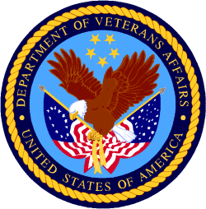

Department of Veterans Affairs

Programs:

Reminders:

PART 2 – GENERAL FEDERAL AGENCY GRANTS INFORMATION
SEPTEMBER 2020

Please review each department’s General Grant and Funding Overview. These overviews are the key web pages on each departmental website dedicated to the agency’s funding opportunities. Check back often to note the department updates.

(See Part 1 for current grant opportunity notices)

Federal Agencies Discretionary Grants and Contract Website Links

Native Hawaiian Programs

U.S. Department of Agriculture

Grants and Loans Overview

Department of Commerce

Grants at Commerce

Economic Development Administration Hawaii Contacts

Corporation for National and Community Service

General Program Overview

National Service in Hawaii

Department of Defense

Doing Business with the Department of Defense

Department of Education

Grant Programs Overview

US Department of Energy

Grants Overview

Environmental Protection Agency

Grants and Contracts Overview

Federal Mediation and Conciliation Service

Grants Overview

Department of Health and Human Services

Grants Overview

Department of Homeland Security
Grants Overview

Department of Housing and Urban Development

HUD - Notice of Funds Available

Institute of Museum and Library Services
Grants Overview

IMLS is on Facebook!

Department of Interior

Grants and Contract Overview

Department of Justice

Grants and Contract Overview

Hawaii State Administrative Agency Contacts
________________________________________________________________________

Department of Labor

Grants and Contract General Overview

National Aeronautics and Space Administration

Research Grant and Contract General Overview
_______________________________________________________________
National Archives and Records Administration

Grant Opportunities General Overview
_______________________________________________________________
National Endowment for the Arts

Grant Opportunities General Overview
_______________________________________________________________

National Endowment for the Humanities

Grant Opportunities General Overview
_______________________________________________________________
National Science Foundation

Grant Opportunities General Overview

Small Business Administration

General Overview Finding Loans & Grants

Links Specific to Hawaii

State Department

General Overview and Resources for Program Administrators

_________________________________________________________________________________

U.S. Department of Transportation

General Grant Program Overview

Department of the Treasury

Overview

US Agency for International Development

General Funding Opportunity Overview

Department of Veterans Affairs

Programs

Grants.Gov Links

Grant Writing Resources

SBIR – Small Business Innovation Research

Federal Agency Discretionary Grant and Contract Websites and Overviews

Native Hawaiian Programs

The Office of Native Hawaiian Relations was authorized by Congress in Public Law 108-199 on January 23, 2004, and in Public Law 104-42 on November 2, 1995. The Office discharges the Secretary's responsibilities for matters related to Native Hawaiians and serves as a conduit for the Department’s field activities in Hawaii

To access the resources in the 2016 guide (the most recent) click on this link:
https://www.doi.gov/sites/doi.gov/files/uploads/NHC%20Guide%20to%20Fed%20Prog%20and%20Services%2002052016%20ONHR.pdf

The listing below can be reviewed online at the following site:
https://www.doi.gov/hawaiian/programs

U.S. Department of Agriculture

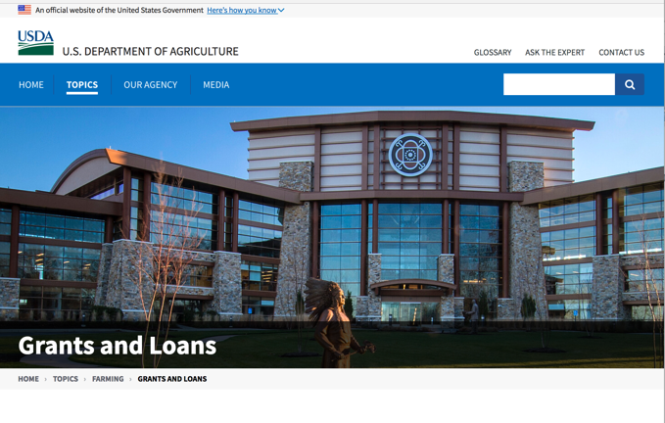

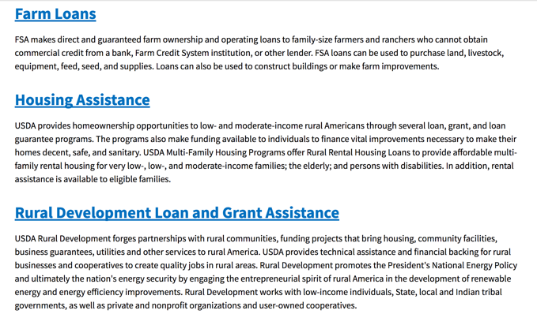
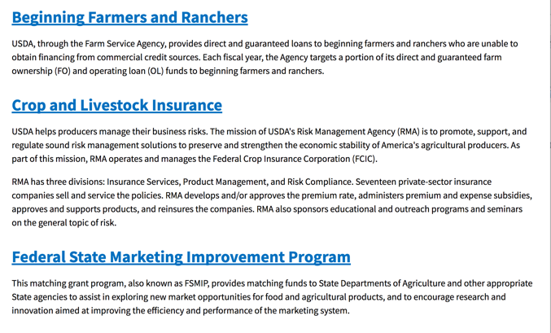
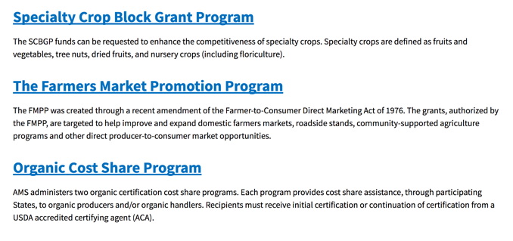
https://www.usda.gov/topics/farming/grants-and-loans

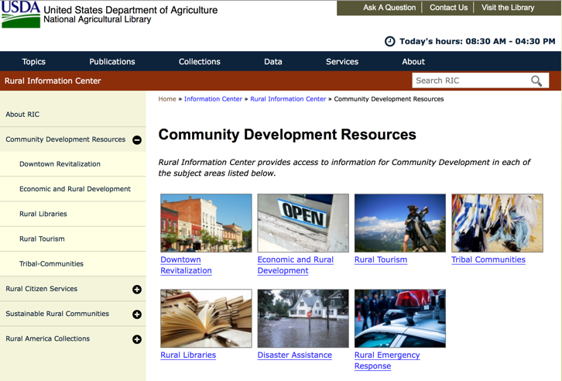

https://www.nal.usda.gov/ric/community-development-resources

Department of Commerce

Grants, Contracting, and Trade Opportunities at Commerce
Learn more information about grants, contracting and trade opportunities at the Department of Commerce using the information below.
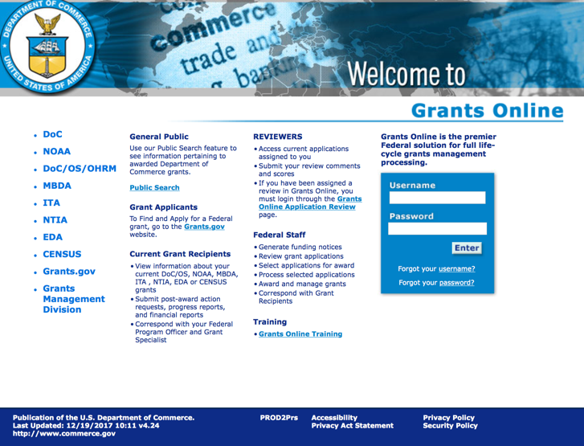
https://grantsonline.rdc.noaa.gov/flows/home/Login/LoginController.jpf

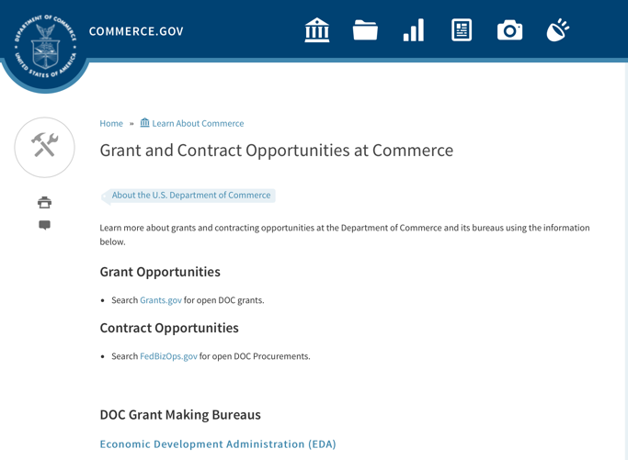
DOC Grant Making Bureaus
Economic Development Administration (EDA)
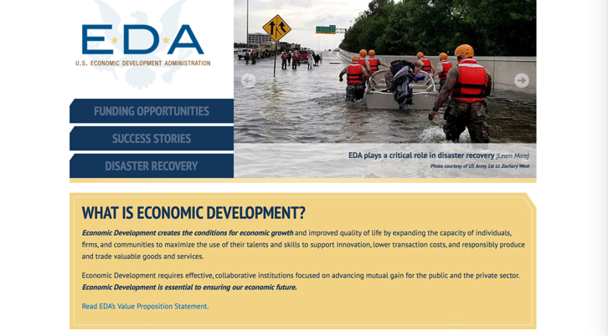
International Trade Administration (ITA)
- Market Development Cooperator Program
- Special American Business Internship Training Program (SABIT). A technical assistance initiative of the International Trade Administration of the U.S. Department of Commerce, SABIT offers organizations competitive grants and an opportunity to host industry-specific delegations. SABIT serves as an initial entry point for U.S. businesses seeking funding to establish long-term relationships with potential customers, distributors, or partners in the former Soviet Union. The program trains Eurasian managers and scientists in commonly accepted business practices as a means of facilitating cross border relationships. In turn, these personal relationships serve as a basis for business development and reduce market access barriers for U.S. businesses
National Institute of Standards & Technology (NIST)
- Funding Opportunities
National Telecommunications & Information Administration (NTIA)
- Telecommunications Grants
National Oceanic & Atmospheric Administration (NOAA)
- Coastal Ocean Program Grant Information
- Fisheries Saltonstall Kennedy Grant Program
- National Undersea Research Program Funding Opportunities
- Grants Management Division
- Fisheries Grants Program
- National Sea Grant
- Office of Global Programs
Contracting Resources for Contractors
- Office of Small and Disadvantaged Business Utilization (OSDBU) - the Office of Small and Disadvantaged Business Utilization (OSDBU) is an advocacy and advisory office responsible for promoting the use of small, small disadvantaged, 8(a), women-owned, veteran-owned, service-disabled veteran-owned, and HUBZone small businesses within the U.S. Department of Commerce's (DOC) acquisition process.
- Business.USA.gov's Find Opportunities Wizard where in a few quick steps, it will guide you towards federal government contracting programs and opportunities for your business!
- Planned Acquisitions: the Department of Commerce's search tool for our planned acquisitions over $100,000. As requirements change, these acquisition plans are updated by department personnel and this search tool is automatically updated.
- Small Business Administration's Contracting section of their web site where you can learn about how to "Get Started" and "Contracting Support for Small Business"
- The General Services Administration (GSA) has implemented a system for vendors doing business with the Federal Government to manage their entity information in one central location. This new database is the System for Award Management (SAM).

DOC Contracting Offices
- Patent and Trademark Office (PTO)
  - Office of Procurement

- National Institute of Standards & Technology (NIST)
NIST Acquisition Management Group
Contracting Opportunities with Commerce
Trade Opportunities through Commerce
http://www.commerce.gov

Economic Development Administration Hawaii Contacts

https://www.eda.gov/resources/economic-development-directory/states/hi.htm

Corporation for National and Community Service

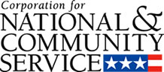

General Program Overview

AmeriCorps provides resources, both human and financial, to organizations that engage Americans in intensive service to meet our country’s critical needs.
Grantees use the funding to support AmeriCorps members for intensive service in their community. AmeriCorps grants partially cover the expense of operating an AmeriCorps program and do not cover general organizational expenses. A cash and in-kind match is required.

The main website can be accessed here: http://www.nationalservice.gov

For access to further funding information: click here

http://www.nationalservice.gov/build-your-capacity/grants/funding-opportunities

National Service In Hawaii
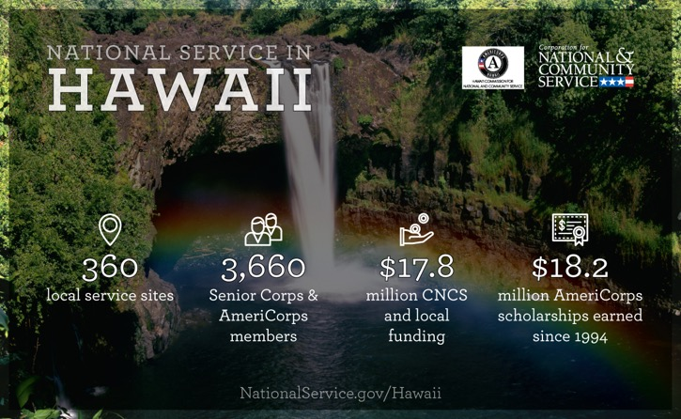
Meeting Community Needs in Hawaii: Last year more than 3,600Americans of all ages and backgrounds met local needs, strengthened communities, and expanded economic opportunity through national service in Hawaii. The Corporation for National and Community Service (CNCS) invested more than $8.1 million to support cost-effective community solutions, working hand in hand with local partners to empower citizens to solve problems. AmeriCorps members and Senior Corps volunteers are preparing today's students for tomorrow's jobs, reducing crime and reviving cities, connecting veterans to services, fighting the opioid epidemic, helping seniors live independently, and rebuilding communities after disasters. Service members served at more than 300 locations across Hawaii, including schools, food banks, homeless shelters, health clinics, youth centers, veterans facilities, and other nonprofit and faith-based organizations. Through a unique public-private partnership, CNCS, its grantees, and project sponsors generated more than $9.6 million in outside resources from businesses, foundations, public agencies, and other sources in FY 2017. This local support strengthened community impact and increased the return on taxpayer dollars.

AmeriCorps
Last year, more than 600 AmeriCorps members met pressing local needs across Hawaii, making a lasting impact in communities while gaining valuable skills and experience to advance their careers. AmeriCorps members serve through one of three programs:
- AmeriCorps State & National engages men and women in intensive service at thousands of locations across the country through nonprofits, schools, public agencies, tribes, and community and faith-based groups. Most AmeriCorps grant funding goes to the Hawaii Commission on National & Community Service, the Governor-appointed State Service Commission, which in turn awards grants to organizations to respond to local needs.
- AmeriCorps VISTA (Volunteers In Service To America) taps the skills, talents, and passion of Americans of all ages to support community efforts to overcome poverty.
- AmeriCorps NCCC (National Civilian Community Corps) is a full-time, team-based residential program for 18-24 year-olds. Members develop leadership skills by serving in public safety, environment, and disaster projects. FEMA Corps, a unit of NCCC, focuses solely on disaster preparedness, response, and recovery.

Senior Corps
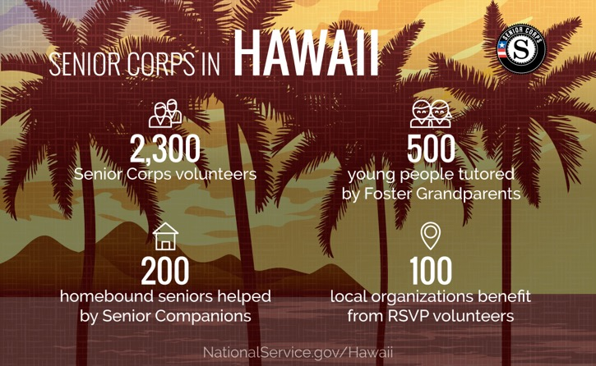
Senior Corps taps the skills, talents, and experience of Americans age 55 and over to meet a wide range of community challenges. Last year, more than 3,000 Hawaii seniors met critical community needs while contributing to longer, healthier lives through one of three Senior Corps programs:
- Foster Grandparents serve one-on-one as tutors and mentors to young people with exceptional needs.
- Senior Companions help homebound seniors and other adults maintain independence primarily in their own homes.
- RSVP volunteers conduct safety patrols, renovate homes, protect the environment, tutor and mentor youth, respond to natural disasters, and provide other services.
Last year in Hawaii, Foster Grandparents tutored and mentored 530young people, Senior Companions helped 290 seniors live independently, and RSVP volunteers strengthened the impact of 150organizations across the state.

Learn More
To see other reports about national service in Hawaii, please contact HI@cns.gov.
The Corporation for National and Community Service is a federal agency that improves lives, strengthens communities, and fosters civic engagement through service and volunteering. To learn more, visit www.NationalService.gov or call 202-606-5000 or TTY 1-800-833-3722.

U.S. Department of Defense

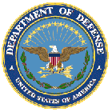

Doing Business with the Department of Defense

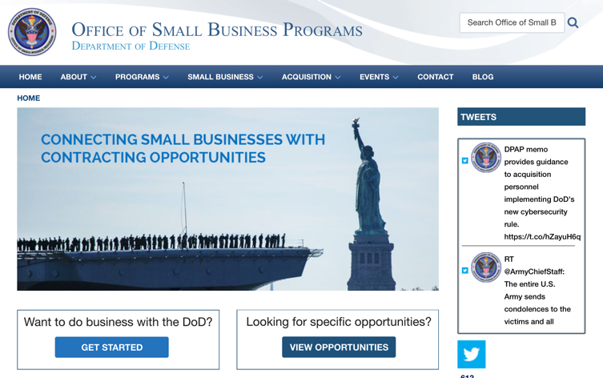

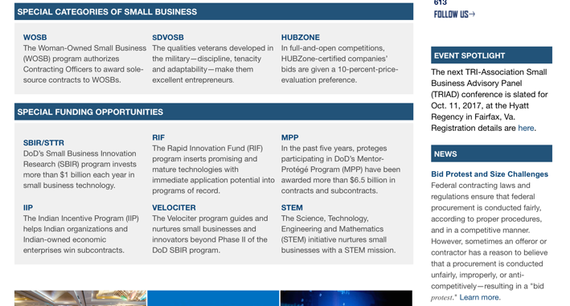

http://business.defense.gov

Corona Virus Response -- https://business.defense.gov/COVID-19-SMALL-BUSINESS-RESOURCES/

Department of Education


Grant Programs Overview at the Department of Education

The general information page for Education Grant funding is an excellent resource describing the three types of grants awarded by the Department of Education. See the screen shot of the Department of Education web page below:

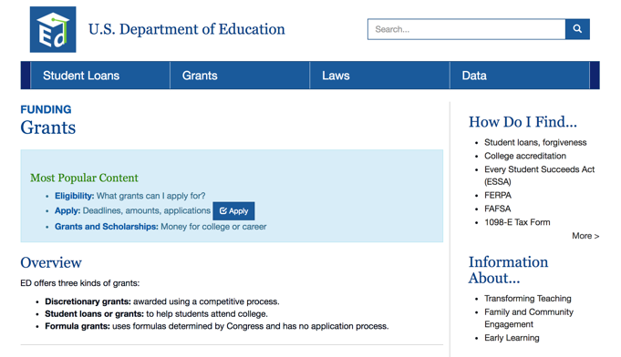
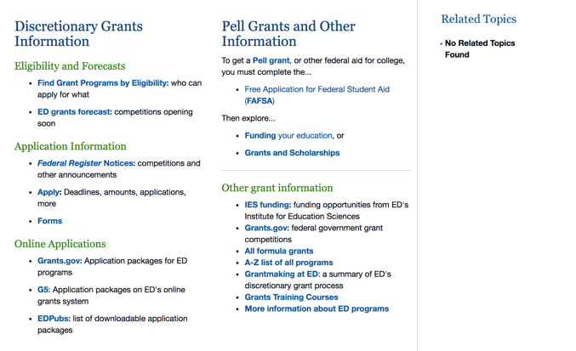

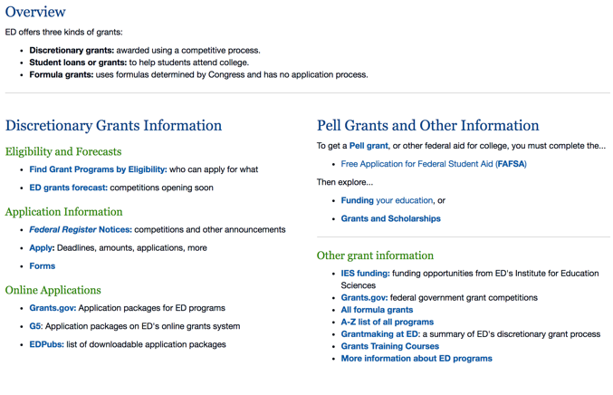

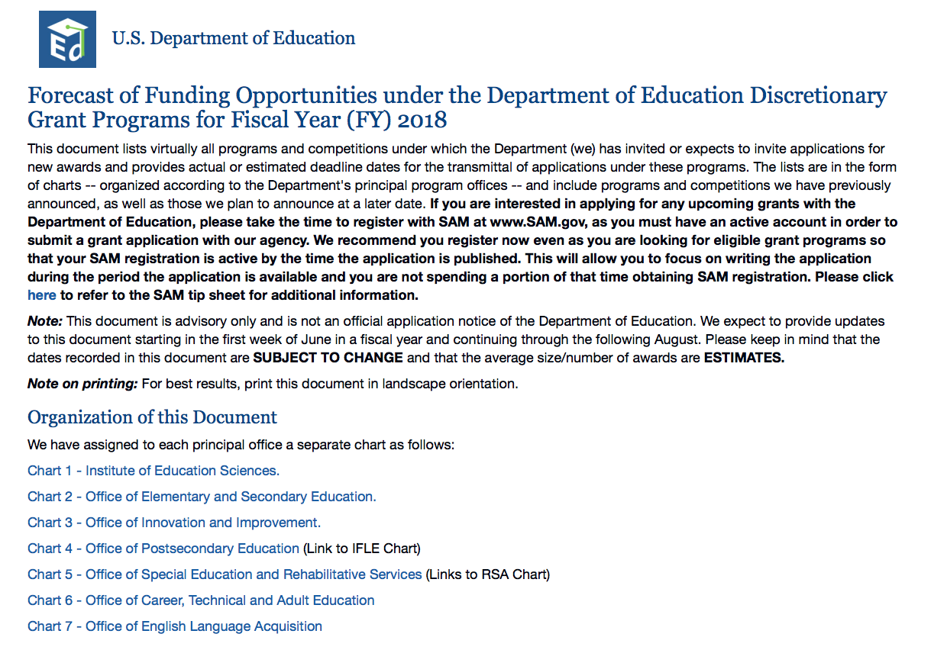

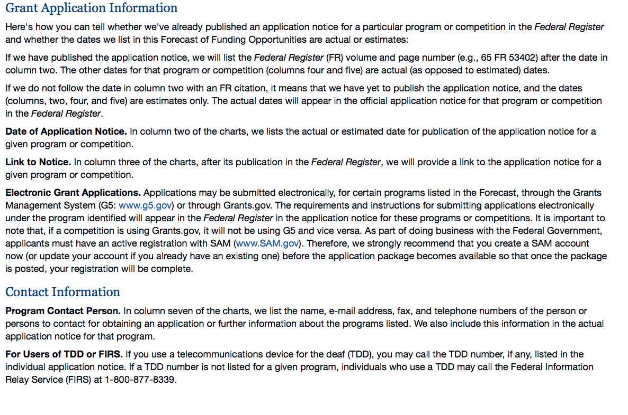

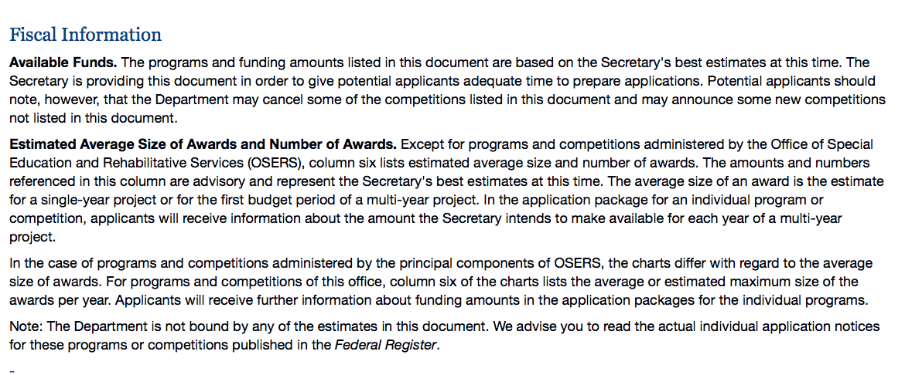

https://www2.ed.gov/fund/grant/find/edlite-forecast.html

U.S. Department of Energy

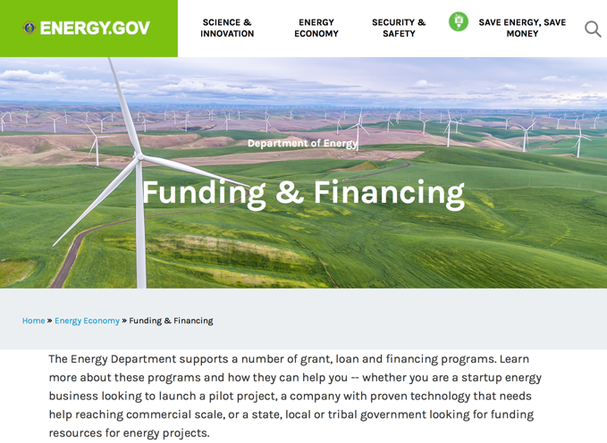

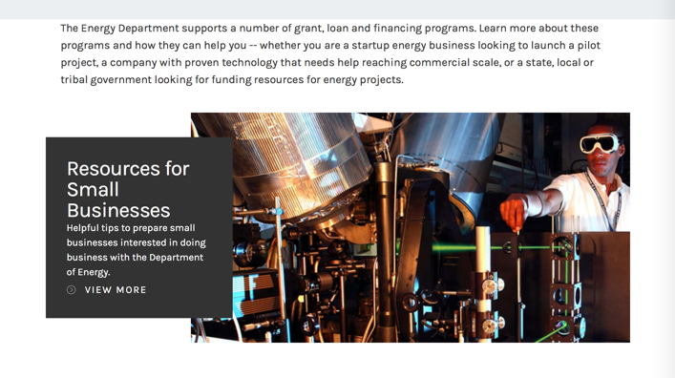

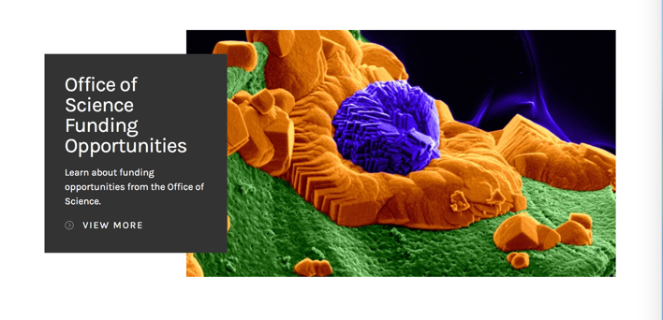

https://www.energy.gov/energy-economy/funding-financing

Environmental Protection Agency

https://www.epa.gov/grants

Federal Mediation and Conciliation Service

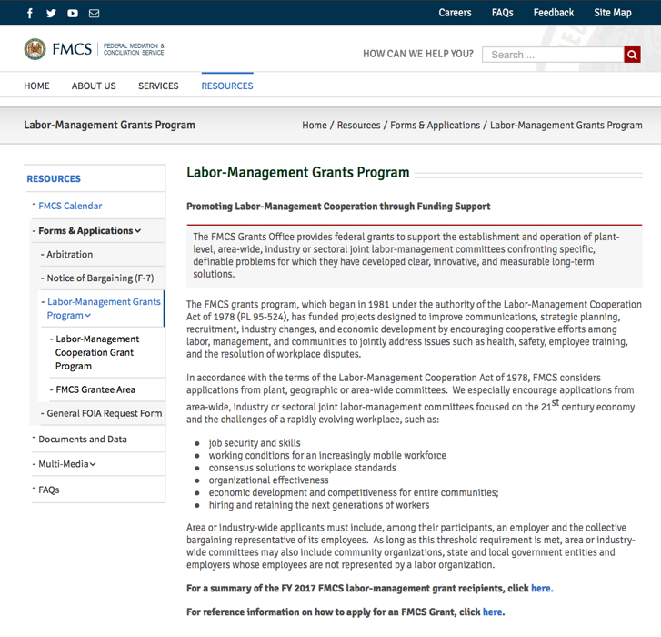
https://www.fmcs.gov/resources/forms-applications/labor-management-grants-program/

Department of Health and Human Services

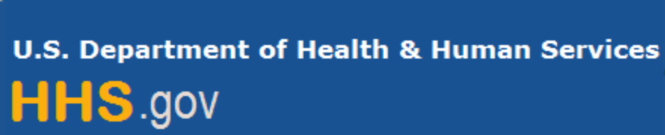

Grants Forecast and Overview

The Department of Health and Human Services’ Grants Forecast is a database of planned grant opportunities proposed by its agencies. Each Forecast record contains actual or estimated dates and funding levels for grants that the agency intends to award during the fiscal year. Forecast opportunities are subject to change based on enactment of congressional appropriations.

For more general information about HHS Grants and Funding go to the website below at:

https://www.hhs.gov/grants/grants/index.html

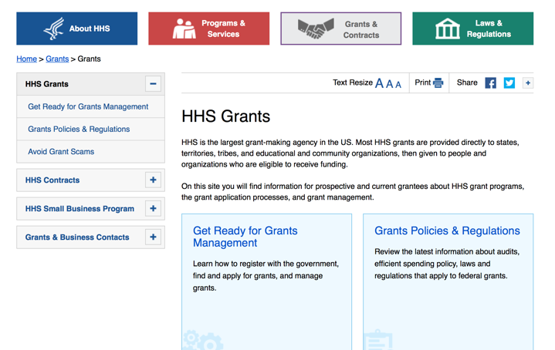

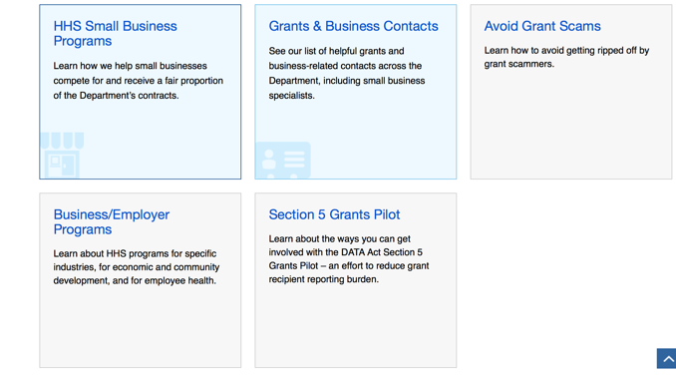

Department of Homeland Security



The Department of Homeland Security enhances the ability of states, local and tribal jurisdictions, and other regional authorities in the preparation, prevention, and response to terrorist attacks and other disasters, by distributing grant funds. Localities can use grants for planning, equipment, training and exercise needs.

Webpage can be viewed at: https://www.dhs.gov/dhs-financial-assistance#2

https://www.fema.gov/welcome-assistance-firefighters-grant-program

For AFG program guidance materials, please visit our Documents page.

Resources

AFG Help Desk
Contact the AFG Program Help Desk toll-free at 866-274-0960, or email us at firegrants@dhs.gov.
The AFG Program has Fire Program Specialists in 10 federal regional centers. These Regional Fire Program Specialists respond to questions about the AFG program and carry out grant monitoring activities. View regional contacts

Popular AFG links
- Assistance to Firefighters Grants (AFG)
- AFG Awards List
- Staffing for Adequate Fire & Emergency Response (SAFER) Grants (SAFER)
- SAFER Awards List
- SAFER Success Stories
- Fire Prevention & Safety (FP&S) Grants
- FP&S Awards List
- FP&S Success Stories
- Grant Closeout Tutorial
- Assistance to Firefighters Grant (AFG) Email Alert Archive
- Frequently Asked Questions
Contact Information For The Assistance to Firefighters Grant (AFG) Program and Help Desk

Federal Funding Alternative To AFG

State Administrative Agencies (SAA) apply for and administer Federal grants on behalf of their States, including FEMA Preparedness Grants. The SAA will work with eligible organizations to comply with the general requirements of grant programs or cooperative agreements. Contact your State’s SAA to find out what current Federal funding opportunities may be available to your organization. A listing of the SAAs and points of contact can be found at http://www.fema.gov/library/viewRecord.do?id=6363.

Department of Housing and Urban Development

https://www.hud.gov/program_offices/spm/gmomgmt/grantsinfo

HUD - Notice of Funds Available
For detailed information click here

http://portal.hud.gov/hudportal/HUD?src=/program_offices/Administration/grants/fundsavail

HUD NOFA FORECAST
The Department of Housing and Urban Development NOFA Forecast lists competitive grant opportunities that may be available for FY2016. The inclusion or exclusion of an opportunity in this list does not constitute a guarantee that a specific opportunity will become available or not be available. Forecast opportunities are subject to change based on enactment of Congressional appropriations and other considerations.
When funding is available, HUD will issue a Notice of Funding Availability (NOFA), which will be available on Grants.gov

Institute of Museum and Library Services

https://www.imls.gov/grants/apply-grant/available-grants

Each grant program has specific eligibility requirements. The links below provide general eligibility criteria for museums, libraries, and tribal organizations, but please note that additional organizations may be eligible for grants under certain programs. Additionally, ineligible organizations may still be able to participate in grant programs through partnerships with eligible organizations. Please click on the links below to see general criteria and review Applications and Guidelines for specific information.
Museums Libraries

Institutions: Archives, Federally Recognized Native American Tribe, Historical Society, Library, Nonprofits that serve Native Hawaiians, Professional Association, Public or Private Non-profit Institutions of Higher Education, Regional Organization, State Library Administrative Agency, State or Local Government

Check out IMLS's Facebook page at:
https://www.facebook.com/USIMLS/

Department of the Interior

Working with Interior

The Interior Department provides assistance to the public, local governments and businesses through a number of programs. For a general overview see: http://www.doi.gov/index.cfm

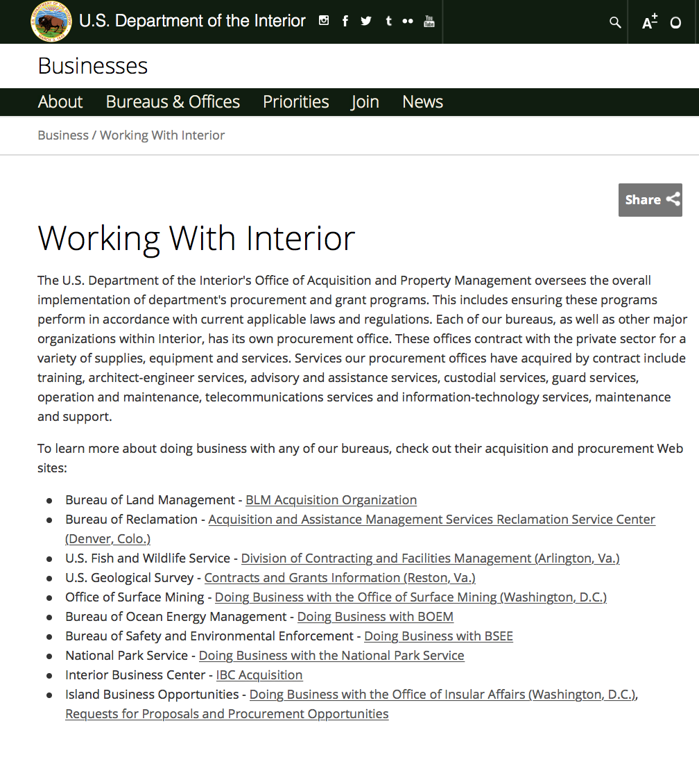

http://www.doi.gov/businesses/working-with-interior.cfm

Department of Justice

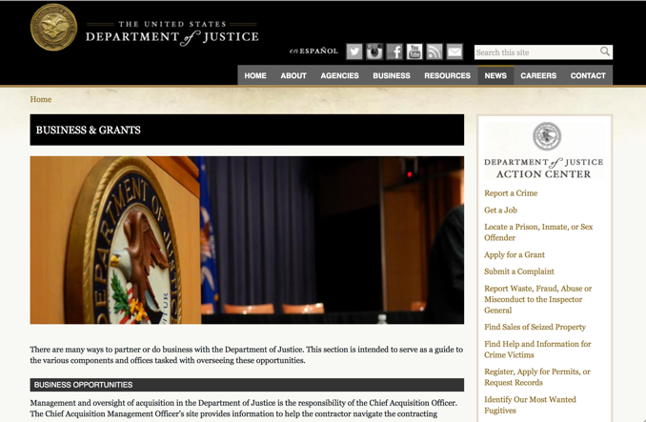

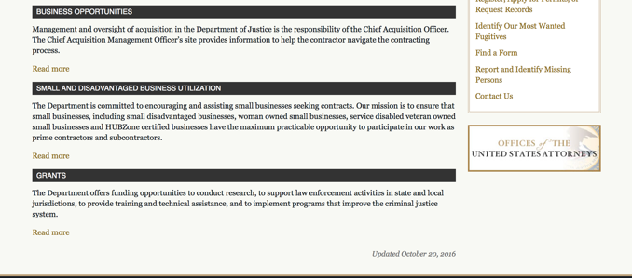

The DOJ agencies listed below also have sites that provide grant information specific to that agency. Examples of what can be found on these sites are programs, funding opportunities, application assistance, and other useful information.

Bureau of Justice Assistance (BJA)

Bureau of Justice Statistics (BJS)

National Criminal Justice Reference Service (NCJRS)

National Institute of Justice (NIJ)

Office of Sex Offender Sentencing, Monitoring, Apprehending, Registering, and Tracking (SMART)

http://www.justice.gov/business/

Hawaii State Administrative Agency Contacts

https://www.ncja.org/state-agencies/about-state-agencies

HAWAII DEPARTMENT OF THE ATTORNEY GENERAL, CRIME PREVENTION & JUSTICE ASSISTANCE DIVISION
235 S Beretania Street, Suite 401
Honolulu, HI 96813
(808) 586-1150
Agency Head: Julie Ebato, Administrator
JAG Contact: Shaleigh Tice, Grants & Planning Branch Chief
SAC Director: Paul Perrone, Chief of Research and Statistics

https://ag.hawaii.gov/cpja/gp/

Department of Labor

https://www.dol.gov/general/grants/howto

https://www.doleta.gov/grants/

Agency Grants and Contract General Overview

DOL Resources
Apply for DOL Agency-Specific Grants:
- Employment and Training Administration (ETA)
- Occupational Safety and Health Administration (OSHA)
- Bureau of International Labor Affairs (ILAB)
- Veterans' Employment and Training Service (VETS)
- Office of Disability Employment Policy (ODEP)
- Office of the Assistant Secretary for Administration and Management (OASAM)

Other Grant Resources:

DOL Resources and Instructions for Applying for a Grant
- DOL Guidance Clarifying the Effect of the Religious Freedom Restoration Act on Faith-Based Organizations
- Grant and Contract Information
- More Information About Grants

Other Federal Government Grant Information
- Grant Opportunities (Catalog of Federal Domestic Assistance)

Department of Labor Grant Programs

- Bureau of International Labor Affairs (ILAB): provides grants (cooperative agreements) for the implementation of projects designed to assist developing countries combat the worse forms of child labor, forced labor, and human trafficking; and support worker rights and improve working conditions. http://www.dol.gov/general/business.
- Bureau of Labor Statistics (BLS): provides project grants (cooperative agreements) and the dissemination of technical statistical data and related information on labor force activities; provides data on prices (CPI) and cost of living; data on productivity and technology data; data on compensation and working conditions; data on employment projections.
- Employment and Training (ETA): ETA Administers financial assistance programs pursuant to the Workforce Investment Act (WIA), administering State formula grant programs for youth, adults and dislocated workers, national emergency grants for workers affected by mass layoffs, plant closures, and disasters; grant programs for workers with disabilities, Indians and Native Americans, and for migrant and seasonal farmworkers. ETA also administers grant programs for older American workers, apprenticeship programs, Trade Adjustment Assistance (TAA) programs, and assistance for research and development of workforce programs. In addition, ETA is responsible for the operation and maintenance of a national system of public employment service offices and for the national unemployment insurance program.
- Mine Safety and Health (MSHA): provides grants for research, education and training programs to ensure an adequate and competent staff of trained inspectors; and assistance for establishing or improving State mine health and safety programs through technical assistance.
- Occupational Safety and Health (OSHA): provides grants to non-profit organizations to provide training, educational services, and technical assistance; assistance to states to administer and enforce state programs; assistance to states to provide occupational safety and health technical assistance and consultant services.
- Office of Disability Employment Policy (ODEP): The Office of Disability Employment Policy awards competitive grants establishing short-term pilot and technical assistance projects designed to identify, develop, test, evaluate, and disseminate policies to increase employment by expanding access to training, education, employment supports, assistive and systems technology, integrated employment, entrepreneurial development, and small business opportunities for adults and youth with disabilities. Current pilots projects focus on customized employment, Olmstead populations, and innovative demonstration youth grants, among others. Solicitations for grant applications are published in the Federal Register and announced at www.dol.gov/odep. ODEP grants are awarded by the OASAM grant office.
- Veterans' Employment and Training (VETS): provides special employment and training assistance for veterans through the Disabled Veterans' Outreach Program (DVOP) Solicitation for Grant Applications; the Local Veterans' Employment Representative Program (LVER); Veterans' Workforce Investment Program (VWIP); elaws Advisor on veterans' employment and reemployment rights; and the Homeless Veterans Reintegration Project (HVRP). VETS grants are awarded by the OASAM grant office.

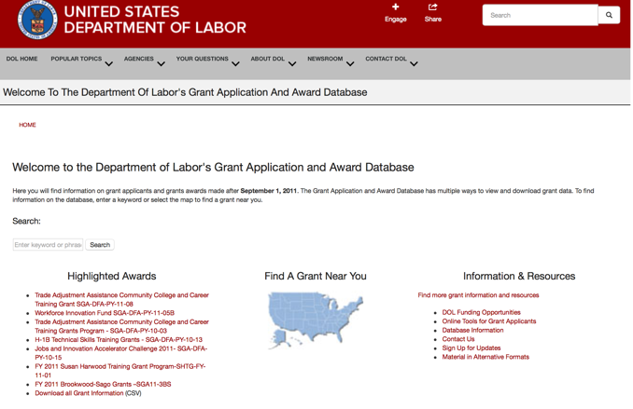

https://www.dol.gov/general/grants/howto

National Aeronautics and Space Administration

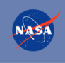

NASA Research Opportunities Online

- Various NASA offices publish their research announcements over the Internet, broadening the opportunity for researchers to apply for funding. This site provides access to current research announcements along with their specific due dates.

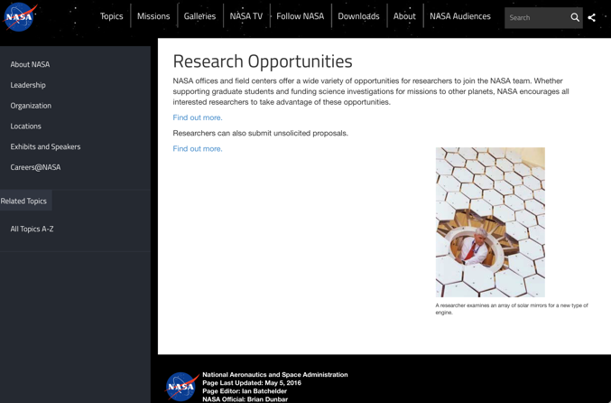

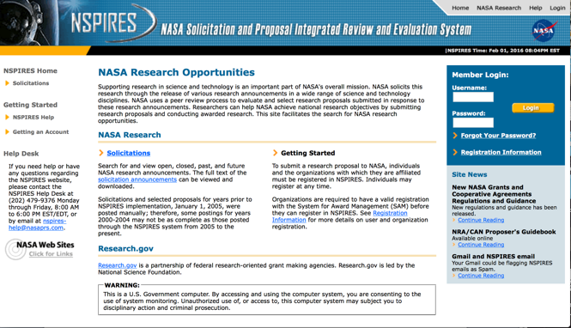
http://nspires.nasaprs.com/external/

National Archives and Records Administration

To access the information above: click here

https://www.archives.gov/nhprc/announcement

National Endowment for the Arts

See more at: https://www.arts.gov/grants

National Endowment for the Humanities

https://www.neh.gov/grants

National Science Foundation



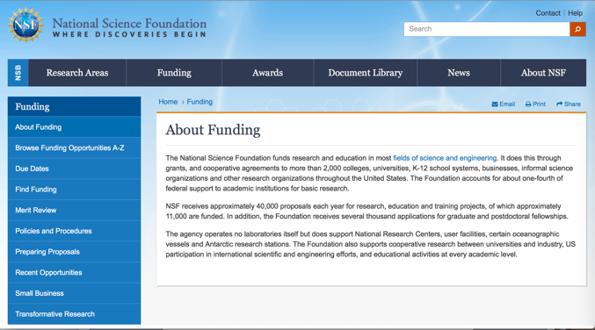

For assistance: https://nsf.gov/funding/aboutfunding.jsp

The National Science Foundation funds research and education in most fields of science and engineering. It does this through grants, and cooperative agreements to more than 2,000 colleges, universities, K-12 school systems, businesses, informal science organizations and other research organizations throughout the United States. The Foundation accounts for about one-fourth of federal support to academic institutions for basic research.
NSF receives approximately 40,000 proposals each year for research, education and training projects, of which approximately 11,000 are funded. In addition, the Foundation receives several thousand applications for graduate and postdoctoral fellowships.
The agency operates no laboratories itself but does support National Research Centers, user facilities, certain oceanographic vessels and Antarctic research stations. The Foundation also supports cooperative research between universities and industry, US participation in international scientific and engineering efforts, and educational activities at every academic level.

For details on active funding deadline dates: http://nsf.gov/funding/pgm_list.jsp?org=NSF&ord=date

Small Business Administration

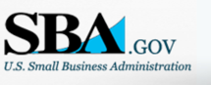


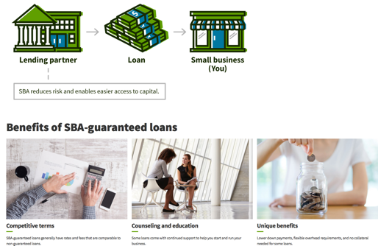

https://www.sba.gov/funding-programs/loans
Federal, state and local governments offer a wide range of financing programs to help small businesses start and grow their operations. These programs include low-interest loans, venture capital, and scientific and economic development grants.
Use SBA.gov's Loans and Grants Search Tool to get a list of financing programs for which you may qualify, or visit the resources below to learn more about small business financing programs.

To get to the main SBA.gov funding page click here
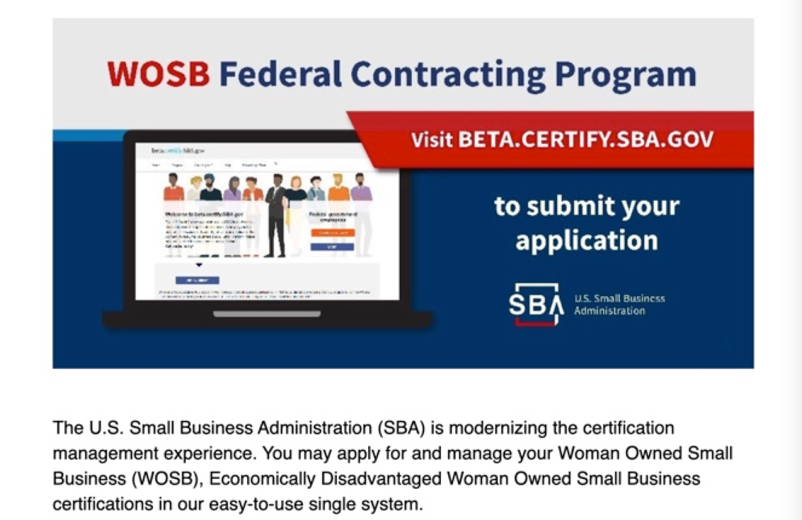
Learn more

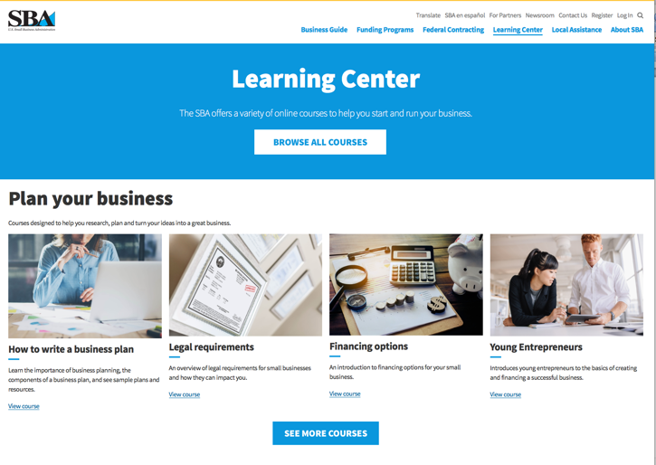
https://www.sba.gov/learning-center

SBA Trainings

https://www.sba.gov/learning-center
Upcoming Trainings: Check out SBA's Online Training!
- Financing Options for Small Businesses

For Specific Information in Hawaii see the following links:
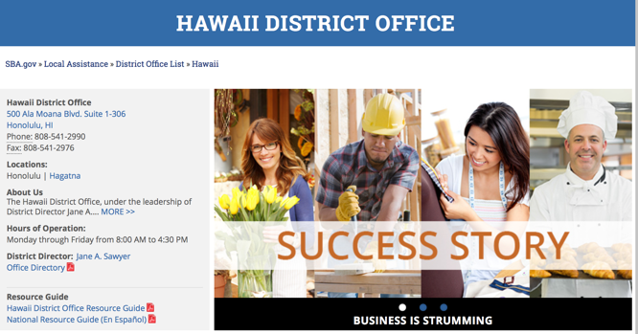

https://www.sba.gov/offices/district/hi/Honolulu

State Department

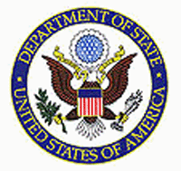

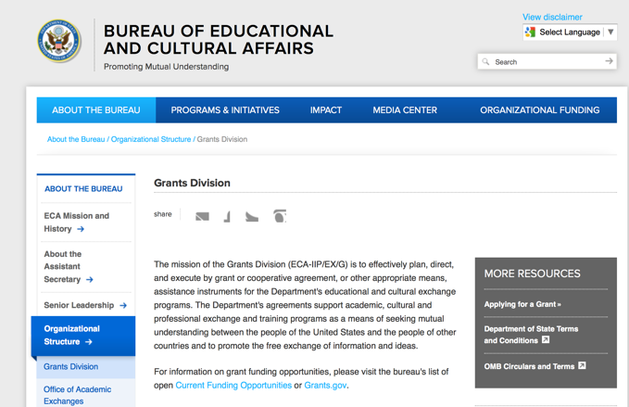

https://eca.state.gov/about-bureau/organizational-structure/grants-division

http://eca.state.gov/search/solr/grants?search_referrer=node/237

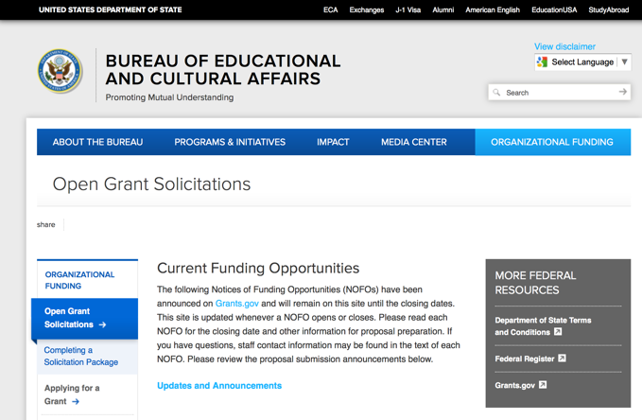
https://eca.state.gov/organizational-funding/open-grant-solicitations

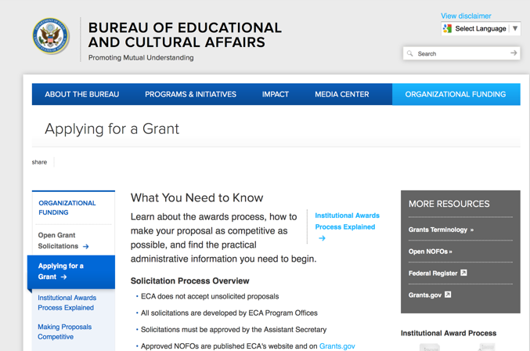
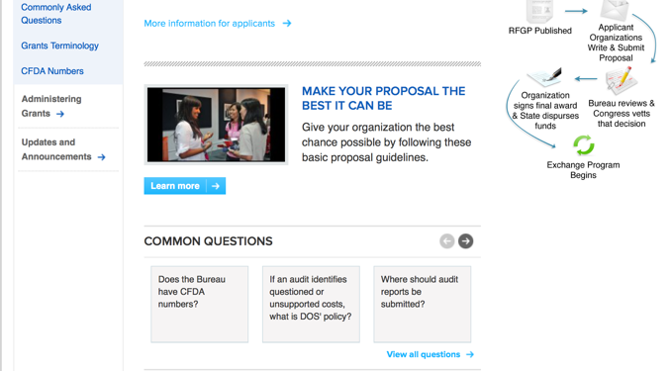
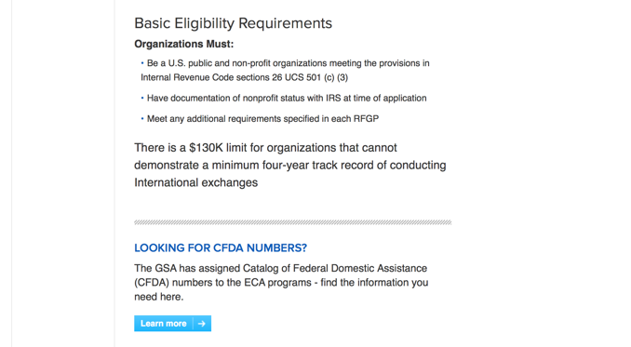
http://eca.state.gov/organizational-funding/applying-grant

General Information:
- Bureau of Educational and Cultural Affairs Grants Division
- Open Grant Opportunities (Requests for Grant Proposals)

For General Information click here

Department of Transportation

General Grant Program Overview https://www.transportation.gov/grants

Department of the Treasury

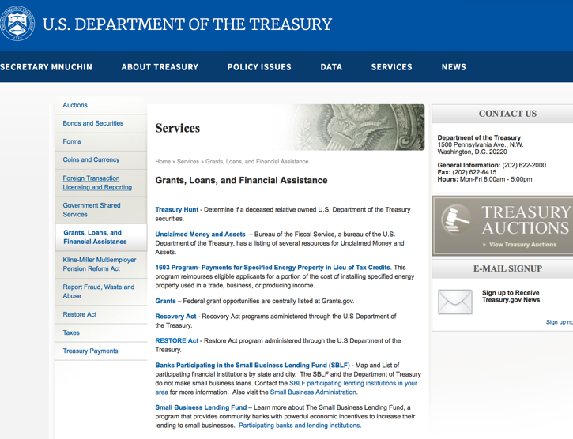

https://www.treasury.gov/services/Pages/Grants-Loans-and-Financial-Assistance.aspx

U.S. Agency for International Development

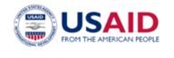
www.usaid.gov

General Overview Funding Opportunities

USAID has working relationships with thousands of American companies and hundreds of U.S.-based private voluntary organizations. For more information on our business and procurement opportunities, please visit our Business section.

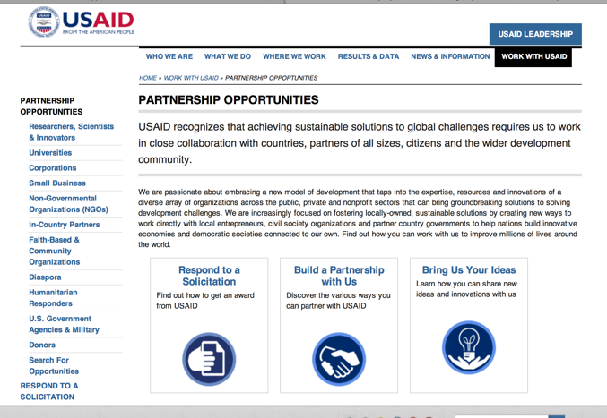

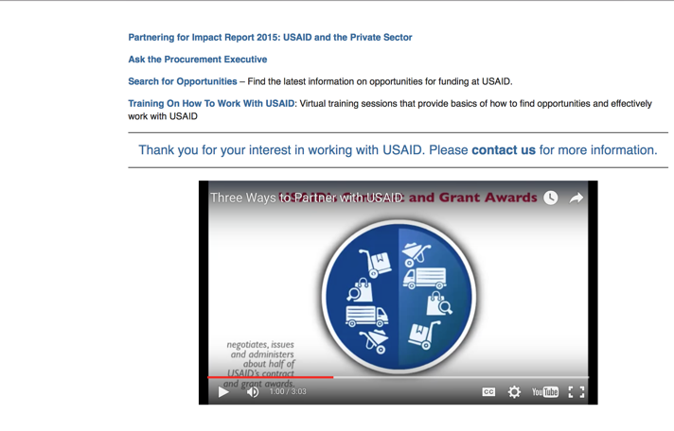

http://www.usaid.gov/partnerships

Department of Veterans Affairs

https://www.va.gov/homeless/gpd.asp
GRANTS.GOV

Provides a Grants Learning Center as a gateway to the federal grants world. Bookmark the following link and participate at blog.grants.gov or on twitter @grantsdotgov

Topics include: Grants 101, Grant Policies, Grant Eligibility, Grant Terms, Grant Agencies , Grant Systems, Grant Programs, Grant Careers, Grant Reporting, Grant Fraud and Grant Events

https://www.grants.gov/web/grants/learn-grants.html

Grants.gov maintains a blog. This reprinted article provides some helpful tips:

Grant Writing: 3 Tips for Crafting Need Statements in Federal Grant Proposals
Posted on March 27, 2019 by Grants.gov
In this space, we have previously shared tips about the pre-writing phase of completing a federal grant application – for example, the importance of reading (and re-reading) the grant announcement, and the importance of understanding the criteria by which your application will be evaluated.
In this post, we dip our toes into the grant writing process itself and share some tips about crafting a need statement. These tips are adapted from the U.S. Department of Health and Human Services Health Resources & Services Administration’s grant writing guide, titled “Tips for Writing and Submitting Good Grant Proposals”. Along with each tip, we also include an excerpt from an award-winning federal grant proposal that can be viewed in full on the website of the Institute of Museum and Library Services. (IMLS has an excellent collection of proposals that are worthy of review – especially for new federal grant applicants.)

https://grantsgovprod.wordpress.com/2019/03/27/3-tips-for-crafting-need-statements-in-federal-grant-proposals/?utm_source=newsletter&utm_medium=email&utm_campaign=noprofile&utm_content=june2020

Grant Writing Resources

The following links are a great resource for Faith-Based Non-profits and other community organizations:

U.S. Agency for International Development
Faith Based and Community Organization Work with USAID

Corporation for National Community Service
Faith-Based and Other Community Initiatives

U.S. Department of Justice
Task Force for Faith-Based and Community Initiatives

Foundation Center
Proposal Writing Short Course

U.S. Environmental Protection Agency
General Tips on Writing a Competitive Grant Proposal

Appalachian Regional Commission
How To Write A Grant Proposal

USDA Rural Information Center
A Guide to Funding Resources

The Small Business Innovative Research Program - SBIR Program

The Small Business Innovation Research (SBIR) program is a highly competitive program that encourages domestic small businesses to engage in Federal Research/Research and Development (R/R&D) that has the potential for commercialization. Through a competitive awards-based program, SBIR enables small businesses to explore their technological potential and provides the incentive to profit from its commercialization. By including qualified small businesses in the nation's R&D arena, high-tech innovation is stimulated, and the United States gains entrepreneurial spirit as it meets its specific research and development needs.

SBIR Mission and Program Goals
The mission of the SBIR program is to support scientific excellence and technological innovation through the investment of Federal research funds in critical American priorities to build a strong national economy.
The program’s goals are four-fold:
- Stimulate technological innovation
- Meet Federal research and development needs.
- Foster and encourage participation in innovation and entrepreneurship by socially and economically disadvantaged persons.
- Increase private-sector commercialization of innovations derived from Federal research and development funding.

SBIR-Participating Agencies
Each year, Federal agencies with extramural research and development (R&D) budgets that exceed $100 million are required to allocate 2.5 percent of their R&D budget to these programs. Currently, eleven Federal agencies participate in the program:
- Department of Agriculture
- Department of Commerce - National Institute of Standards and Technology
- Department of Defense
- Department of Energy
- Department of Health and Human Services
- Department of Homeland Security
- Department of Transportation
- Environmental Protection Agency
- National Aeronautics and Space Administration
- National Science Foundation
Each agency administers its own individual program within guidelines established by Congress. These agencies designate R&D topics in their solicitations and accept proposals from small businesses. Awards are made on a competitive basis after proposal evaluation.

Three-Phase Program
The SBIR Program is structured in three phases:
Phase I. The objective of Phase I is to establish the technical merit, feasibility, and commercial potential of the proposed R/R&D efforts and to determine the quality of performance of the small business awardee organization prior to providing further Federal support in Phase II. SBIR Phase I awards normally do not exceed $150,000 total costs for 6 months.
Phase II. The objective of Phase II is to continue the R/R&D efforts initiated in Phase I. Funding is based on the results achieved in Phase I and the scientific and technical merit and commercial potential of the project proposed in Phase II. Only Phase I awardees are eligible for a Phase II award. SBIR Phase II awards normally do not exceed $1,000,000 total costs for 2 years.
Phase III. The objective of Phase III, where appropriate, is for the small business to pursue commercialization objectives resulting from the Phase I/II R/R&D activities. The SBIR program does not fund Phase III. Some Federal agencies, Phase III may involve follow-on non-SBIR funded R&D or production contracts for products, processes or services intended for use by the U.S. Government

