Senator Mazie Hirono

Grants Assistance Information Newsletter
WITH DISASTER ASSISTANCE SUPPLEMENT
DECEMBER 2023

PART 1– CURRENT FEDERAL AGENCY DISCRETIONARY GRANT OPPORTUNITIES

PART 2 - GENERAL FEDERAL AGENCY GRANTS INFORMATION

INDEX

PART 1 – Current General Federal Agency Grant and Cooperative Agreement Discretionary Program Summaries

Programs Specific To Hawaiʻi

President Biden’s Bipartisan Infrastructure Law’s Distribution of funding in Hawaiʻi

Current Notices

Department of Agriculture
National Institute of Food and Agriculture
Alaska Native-Serving and Native Hawaiian-Serving Institutions Education Competitive Grants Program

Department of Commerce
FY 2024 NOAA Coral Reef Conservation Program - Ruth D. Gates Grant Program: Local and National Capacity Building Support Grants and Cooperative Agreements
Department of Interior
National Park Service
FY2024 NAGPRA Consultation/Documentation Grants

Reminders

Department of Interior - Kapapahuliau Climate Resilience Program

The 2024 NOAA Hawaii Bay Watershed Education and Training (B-WET) Program

Health Resources and Services Administration
FY 2024 Native Hawaiian Health Care Improvement Act

General National Programs by Federal Agency

U.S. Department of Agriculture

Programs

National Institute of Food and Agriculture
Small Business Innovation Research and Small Business Technology Transfer Programs Phase II
National Institute of Food and Agriculture
Integrated Research, Education, and Extension Competitive Grants Program – Organic Transitions

National Institute of Food and Agriculture
Organic Agriculture Research and Extension Initiative
National Institute of Food and Agriculture
Biotechnology Risk Assessment Research Grants Program
National Institute of Food and Agriculture
Secondary Education Two-Year Postsecondary Education and Agriculture in the K-12 Classroom Challenge Grants Program

National Institute of Food and Agriculture
Food Safety Outreach Program
National Institute of Food and Agriculture
Farm Business Management and Benchmarking Competitive Grants Program
Research

Modifications

National Institute of Food and Agriculture
Capacity Building Grants for Non-Land Grant Colleges of Agriculture Program

National Institute of Food and Agriculture
Crop Protection and Pest Management Competitive Grants Program
National Institute of Food and Agriculture
Women and Minorities in Science, Technology, Engineering, and Mathematics Fields Program

National Institute of Food and Agriculture
Women and Minorities in Science, Technology, Engineering, and Mathematics Fields Program
Rural Business-Cooperative Service
Rural Business Development Grant (RBDG)

Reminders

Food and Nutrition Service
FY2024 Farm to School Grants
National Institute of Food and Agriculture
Agriculture Risk Management Education Partnerships Competitive Grants Program

Rural Utilities Service
Solid Waste Management Grant Program

Rural Utilities Service
Technical Assistance and Training Grant Program

Agricultural Marketing Service
Specialty Crop Multi-State Program
Forest Service
USDA Forest Service Inflation Reduction Act Forest Landowner Support

Forest Service
USDA Forest Service Inflation Reduction Act Forest Landowner Support

Animal and Plant Health Inspection Service
National Animal Disease Preparedness and Response Program Fiscal Year 2024
Rural Housing Service
Community Facilities Program Disaster Repair Grants

Rural Utilities Service
Calendar Year 2022 Disaster Water Grants
National Institute of Food and Agriculture
Agriculture and Food Research Initiative Competitive Grants Program Foundational and Applied Science Program

Department of Commerce

Programs
FY2024 Ruth D. Gates Restoration Innovation Grants
Ocean and Coastal Carbon Observing Optimization Studies
Climate Program Office (CPO) Adaptation Sciences Program FY2024
Research

Modifications

Reminders

DOC NOAA - ERA Production
2023 Inflation Reduction Act Climate-Ready Workforce for Coastal States and Territories Competition
DOC NOAA - ERA Production
FY2024 Sea Grant Programs Only - Disaster Preparedness for Coastal Communities
DOC NOAA - ERA Production
FY2024 NMFS-Sea Grant Fellowship in Population and Ecosystem Dynamics and Marine Resource Economics
National Estuarine Research Reserve System (NERRS) Land Acquisition and Construction Program for Fiscal Year 2024

National Institute of Standards and Technology
Small Business Innovation Research (SBIR) Program Phase I

Economic Development Administration
FY 2023 Regional Technology and Innovation Hub Program Phase 2 Notice of Funding Opportunity
FY24 Dr. Nancy Foster Scholarship Program

DOC NOAA - ERA Production
FY2024-2025 National Sea Grant BIL Marine Debris Challenge Competition
DOC NOAA - ERA Production
FY2024-2025 National Sea Grant BIL Marine Debris Community Action Coalitions
2024 Effects of Sea Level Rise
DOC NOAA - ERA Production
Fiscal Year 2025 National Sea Grant College Program Dean John A. Knauss Marine Policy Fellowship

2024 Bycatch Reduction Engineering Program

NOAA SBIR FY 2024 Phase I

National Institute of Standards and Technology
CHIPS Incentives Program – Facilities for Semiconductor Materials and Manufacturing Equipment
FY2024 Coastal and Ocean Modeling Testbed Project

FY24 NOAA Marine Debris Removal under the Bipartisan Infrastructure Law

Coastal Habitat Restoration and Resilience Grants for Tribes and Underserved Communities, Under the BIL and IRA
FY24 NOAA Marine Debris Interception Technologies under the Bipartisan Infrastructure Law
Social, Cultural and Economic Assessment of Harmful Algal Blooms
Fiscal Year 2024 - FY2025 Margaret A. Davidson Graduate Fellowships for the National Estuarine Research Reserve System
NERRS Habitat Protection and Restoration Bipartisan Infrastructure Law (BIL) Competition
NOAA Ocean Acidification Program Education Mini-Grant Program
2023 Inflation Reduction Act Climate-Ready Workforce for Coastal States and Territories Competition

National Institute of Standards and Technology
Measurement Science and Engineering (MSE) Research Grant Programs

National Institute of Standards and Technology
CHIPS Incentives Program – Commercial Fabrication Facilities

FY 2021 - 2023 Economic Development RNTA
National Institute of Standards and Technology
Measurement Science and Engineering (MSE) Research Grant Programs
National Institute of Standards and Technology
NIST Manufacturing USA National Emergency Assistance Program
Economic Development Administration
FY 2020 EDA Public Works and Economic Adjustment Assistance Programs

Corporation for National and Community Service

Programs

Reminders

Fiscal Year (FY) 2024 AmeriCorps Seniors Senior Companion Program (SCP) Replacement and Expansion Opportunity
Fiscal Year (FY 2024 AmeriCorps Seniors Foster Grandparents (FGP) Replacement and Expansion Opportunity Program

Fiscal Year (FY) 2024 AmeriCorps State and National Competitive Grants

Department of Defense

Programs

Research Grants

Reminders

Dept of the Army -- Materiel Command
The Department Of Defense (DOD) Fiscal Year 2025 Defense University Research Instrumentation Program (DURIP)

Dept of the Army -- Materiel Command
United States Army Research Institute For The Behavioral And Social Sciences (ARI) Broad Agency Announcement For Basic, Applied, And Advanced Scientific Research

Dept of the Army -- Materiel Command
DEVCOM Analysis Center Broad Agency Announcement For Applied Research

Dept of the Army -- Materiel Command
DEVCOM Army Research Laboratory Broad Agency Announcement For Foundational Research

Department of Education

Programs
Research

Modifications
Office of Elementary and Secondary Education (OESE): Office of Migrant Education (OME): College Assistance Migrant Program (CAMP), Assistance Listing Number (ALN) 84.149A
Institute of Education Sciences (IES): National Center for Education Research (NCER): Research Education Research and Development Center Program, Assistance Listing Number (ALN) 84.305C
OSERS: OSEP: Personnel Development to Improve Services and Results for Children with Disabilities--Preparation of Related Services Personnel Serving Children with Disabilities who have High-Intensity Needs, Assistance Listing Number (ALN) 84.325R
OSERS: OSEP: Personnel Preparation of Special Education, Early Intervention, and Related Services Personnel at Historically Black Colleges and Universities, Tribally Controlled Colleges and Universities, and Other Minority Serving Institutions, ALN 84.325

Reminders

Institute of Education Sciences (IES): National Center for Education Research (NCER): Research Networks Focused on Critical Problems of Education Policy and Practice, Assistance Listing Number (ALN) 84.305N

Institute of Education Sciences (IES): National Center for Education Research (NCER): Statistical and Research Methodology in Education, Assistance Listing Number (ALN) 84.305D
Institute of Education Sciences (IES): National Center for Education Research (NCER): Research Training Programs in The Education Sciences, Assistance Listing Number (ALN) 84.305B

US Department of Energy

Programs

National Energy Technology Laboratory
Bipartisan Infrastructure Law (BIL) Grid Resilience and Innovative Partnerships (GRIP)

Research

Modifications

Reminders

Office of Science
FY 2024 Continuation of Solicitation for the Office of Science Financial Assistance Program

National Energy Technology Laboratory
Inflation Reduction Act - Transmission Siting and Economic Development Program
National Energy Technology Laboratory
BIL - Carbon Utilization Procurement Grants under Bipartisan Infrastructure Law Section 40302

Environmental Protection Agency

Programs

Environmental and Climate Justice Community Change Grants Program
Training and Technical Assistance to Improve Water Quality and Enable Small Public Water Systems to Provide Safe Drinking Water

Hydrofluorocarbon Reclaim and Innovative Destruction Grants
R4 Fiscal Year 2023 and 2024 Wetland Program Development Grants
Modifications
Reminders
Climate Pollution Reduction Grants Program: Implementation Grants (General Competition)

Reducing Embodied Greenhouse Gas Emissions for Construction Materials and Products

Department of Health and Human Services

Programs

Research Grants

Modifications

Reminders

Health Resources and Services Administration
Behavioral Health Workforce Education and Training Program- Professionals
Health Resources and Services Administration
FY 2024 Behavioral Health Service Expansion
Health Resources and Services Administration
FY 2024 Expanded Hours
Health Resources and Services Administration
FY 2024 New Access Points

Department of Homeland Security
Programs
Reminders

Department of Homeland Security - FEMA
Fiscal Year 2023 Building Resilient Infrastructure and Communities (BRIC)
Department of Homeland Security - FEMA
Notice of Funding Opportunity (NOFO) for Fiscal Year 2023 Flood Mitigation Assistance

Department of Housing and Urban Development

Programs

Modifications

Reminders
ROSS (Resident Opportunity and Self-Sufficiency) Service Coordinator Program - FY2023 - NOFO
Section 811 Supportive Housing for Persons with Disabilities (Capital Advance)
The Youth Homelessness System Improvement (YHSI) Grants

Fiscal Year (FY) 2023 Housing Opportunities for Persons With AIDS (HOPWA) Competitive Grant: Housing Interventions (HINT) to End the HIV Epidemic
FY2023 and FY2024 Authority to Accept Unsolicited Proposals for Research Partnerships
Green and Resilient Retrofit Program (GRRPC) Comprehensive

Green and Resilient Retrofit Program (GRRPE) Elements

Green and Resilient Retrofit Program (GRRP) Leading Edge

Institute of Museum and Library Services
Programs
Modifications
Reminders
National Leadership Grants for Libraries (2024)

Laura Bush 21st Century Librarian Program (2024)

Department of Interior

Programs
Fish and Wildlife Service
F24AS00181 - MENTOR – HAWLT (Holistically Addressing Wildlife Trafficking)

Modifications

Geological Survey
USGS Non-Competitive Assistance FY 2024 - National Grants Branch

Reminders

Bureau of Land Management
FY24 Bureau of Land Management Wild Horse and Burro Resource Management- Research
Bureau of Land Management
FY24 IIJA/IRA Bureau of Land Management Headquarters (HQ) Aquatic Resource Management
Bureau of Land Management
FY24 Bureau of Land Management Headquarters (HQ) National Conservation Lands-Management Studies Support Program
Bureau of Land Management
FY24 IIJA/IRA Bureau of Land Management Headquarters (HQ) Recreation and Visitor Services Program

Bureau of Land Management
FY24 IIJA/IRA Bureau of Land Management Headquarters (HQ) Threatened and Endangered Species Program
Bureau of Land Management
FY24 IIJA/IRA Bureau of Land Management Headquarters (HQ) Wildlife Program

Fish and Wildlife Service
F24AS00129 - Youth Engagement, Education, and Employment
Fish and Wildlife Service
F24AS00078 FY24 Recovery Challenge Fund
Fish and Wildlife Service
F24AS00074 FY24 Candidate Species Conservation
Fish and Wildlife Service
F24AS00431 FY24 Recovery Implementation
Geological Survey
FY2024 Water Resources Research Act Non-Competitive Coordination
National Park Service
FY2023 Historic Preservation Fund- Save America's Treasures Collection Grants
National Park Service
FY2023 Historic Preservation Fund- Save America's Treasures Preservation Grants

National Park Service
National Park Service 21st Century Conservation Service Corps & Civilian Climate Corps Program - National Youth Cooperative Agreements
Fish and Wildlife Service
F24AS00022 - Coastal Program - FY24
Geological Survey
The Educational Component of the National Cooperative Geologic Mapping Program

Geological Survey
Groundwater and Streamflow Information Program, National Ground-Water Monitoring Network

Geological Survey
Cooperative Research Units Program Department of the Interior Geological Survey

Fish and Wildlife Service
F23AS00249 National Fish Passage Program Base Funding Fiscal Year 2023
National Park Service
FY2023 ABPP - Battlefield Land Acquisition Grant

National Park Service
NPS Cooperative Ecosystems Studies Units (CESU) Master Cooperative Agreements
Fish and Wildlife Service
F23AS00078 National Fish Passage Program Bipartisan Infrastructure Law Fiscal Year 2023

Department of Justice

Programs
Office on Violence Against Women
OVW Fiscal Year 2024 Justice for Families Program

Modifications

Research

National Institute of Justice
NIJ FY24 Research on Law Enforcement Responses to Opioid Overdoses

Reminders

________________________________________________________________________

Department of Labor

Programs
Modifications

Reminders

Veterans Employment and Training Service
Announcement of Stand Down Grants

Employment and Training Administration
National Dislocated Worker Grants Program Guidance

National Aeronautics and Space Administration

Research

_______________________________________________________________
National Archives and Records Administration

Programs
Archives Collaboratives

Major Collaborative Archival Initiatives
Publishing Historical Records Collaborative Digital Editions
Publishing Historical Records In Collaborative Digital Editions

Reminders

_______________________________________________________________
National Endowment for the Arts

Programs
NEA Challenge America, FY2025

NEA Grants for Arts Projects 1, FY2025
NEA Literature Fellowships: Poetry, FY2025

Modifications

NEA Big Read Program Solicitation, FY2024
NEA Creative Placemaking Technical Assistance Program, FY2024
NEA Shakespeare in American Communities, FY2024
Reminders

NEA Literature Fellowships: Translation Projects, FY2025

___________________________________________________________

National Endowment for the Humanities

Programs

Modifications
Fellowships Open Book Program
Institutes for Higher Education Faculty Institutes for K-12 Educators
Reminders

Archaeological and Ethnographic Field Research

National Digital Newspaper Program

Spotlight on Humanities in Higher Education

Landmarks of American History and Culture
Preservation Assistance Grants for Smaller Institutions
Sustaining Cultural Heritage Collections

Dialogues on the Experience of War
Humanities Connections

Climate Smart Humanities Organizations
Summer Stipends

Digital Humanities Advancement Grants
Cultural and Community Resilience
Digital Projects for the Public
Fellowships
Humanities Collections and Reference Resources
Humanities Initiatives
Public Impact Projects at Smaller Organizations
Research and Development
Fellowships for Digital Publication

Preservation and Access Education and Training

Digital Humanities Advancement Grants

Institutes for Higher Education Faculty Institutes for K-12 Educators
_______________________________________________________________
National Science Foundation

Research and Program Grants

Modifications

Reminders

Small Business Administration

Programs
Modifications

Reminders

State Department

Programs

Reminders

U.S. Department of Transportation

Programs

Modifications
69A355 Research and Technology
Rural Autonomous Vehicle Program
DOT Federal Highway Administration
FY23-FY24 Advanced Transportation Technology and Innovation (ATTAIN) Program
69A345 Office of the Under Secretary for Policy
FY 2024 National Infrastructure Investments
FAA-COE-AJFE
Center of Excellence for Alternative Jet Fuels and Environment
Reminders

Department of the Treasury

Programs

Modifications

Reminders

Community Development Financial Institutions
Fiscal Year 2024 Small Dollar Loan Program

US Agency for International Development

Programs

Department of Veterans Affairs

Programs
Supportive Services for Veteran Families
VA Supportive Services for Veteran Families Program
Reminders

National Veterans Sports Programs
Grants for Adaptive Sports Programs for Disabled Veterans and Disabled Members of the Armed Forces (Equine Assisted Therapy)
National Veterans Sports Programs
Grants for Adaptive Sports Programs for Disabled Veterans and Members of the Armed Forces program
Veterans Legacy Grant Program

Part 2 – GENERAL FEDERAL AGENCY GRANTS INFORMATION

Federal Agencies Discretionary Grants and Contract Website Links

Native Hawaiian Programs

U.S. Department of Agriculture

Grants and Loans Overview

Department of Commerce

Grants at Commerce

Economic Development Administration Hawaiʻi Contacts

Corporation for National and Community Service

General Program Overview

National Service in Hawaiʻi

Department of Defense

Doing Business with the Department of Defense

Department of Education

Grant Programs Overview

US Department of Energy

Grants Overview

Environmental Protection Agency

Grants and Contracts Overview

Federal Mediation and Conciliation Service

Grants Overview

Department of Health and Human Services

Grants Overview

Department of Homeland Security
Grants Overview

Department of Housing and Urban Development

HUD - Notice of Funds Available

Institute of Museum and Library Services
Grants Overview

IMLS is on Facebook!

Department of Interior

Grants and Contract Overview

Department of Justice

Grants and Contract Overview

Hawaiʻi State Administrative Agency Contacts
________________________________________________________________________

Department of Labor

Grants and Contract General Overview

National Aeronautics and Space Administration

Research Grant and Contract General Overview
_______________________________________________________________
National Archives and Records Administration

Grant Opportunities General Overview
_______________________________________________________________
National Endowment for the Arts

Grant Opportunities General Overview
_______________________________________________________________

National Endowment for the Humanities

Grant Opportunities General Overview
_______________________________________________________________
National Science Foundation

Grant Opportunities General Overview

Small Business Administration

General Overview Finding Loans & Grants

Links Specific to Hawaiʻi

State Department

General Overview and Resources for Program Administrators

_________________________________________________________________________________

U.S. Department of Transportation

General Grant Program Overview

Department of the Treasury

Overview

US Agency for International Development

General Funding Opportunity Overview

Department of Veterans Affairs

Programs

Grants.Gov Links

Grant Writing Resources

SBIR – Small Business Innovation Research

PART 1 – Current General Federal Agency Grant and Cooperative Agreement Discretionary Program Summaries

Click on Index Links below to find summaries of the current announcements listed by agency in this document. Once you reach the item, if you cannot open the links for further information, copy the selected URL website address into your browser.

Notices is Teal are items with immediate deadline dates.

Notices in Yellow are of special interest.

Notices is Green are items of special interest with immediate deadline dates.

Several Agencies have research or program opportunities that are not individually listed because they are for very technical or specific audiences. Click on the Agency Index Research or Program designation to review those grant and contract notices.

If an Agency does not have listings, it is due to the lack of competitive open opportunities at that Agency this month. Please review Part 2 for general information not specific to a current deadline date for general funding cycle information.

President Biden’s Bipartisan Infrastructure Law’s Distribution of funding in Hawaiʻi

Current Federal Agency Grant and Cooperative Agreement Discretionary Program Summaries

Programs Of Special Interest In Hawaiʻi

Special Programs:

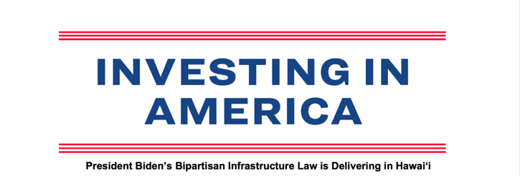

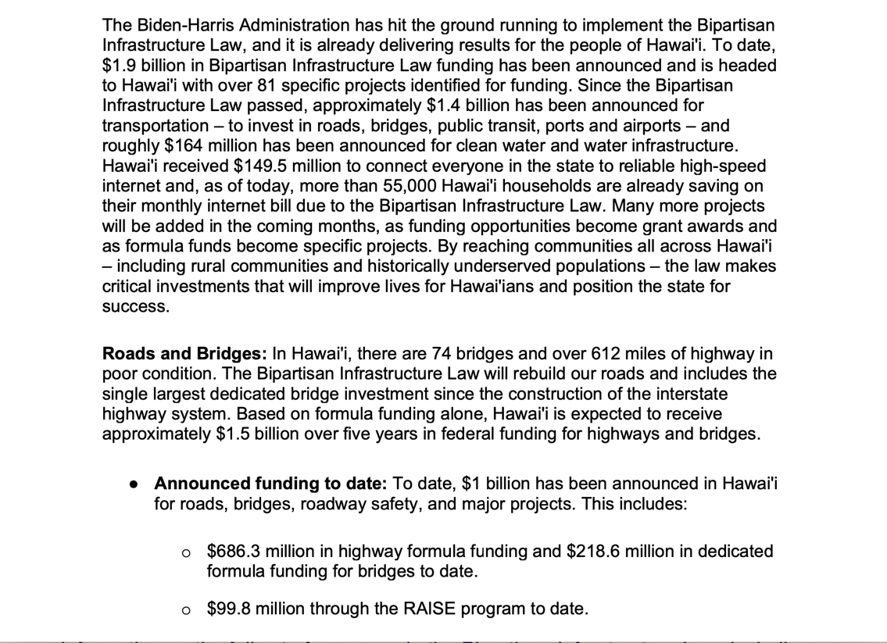

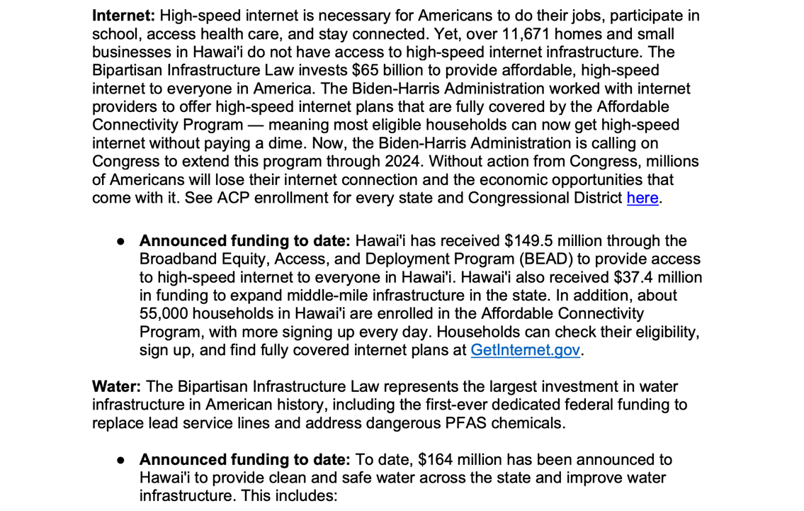

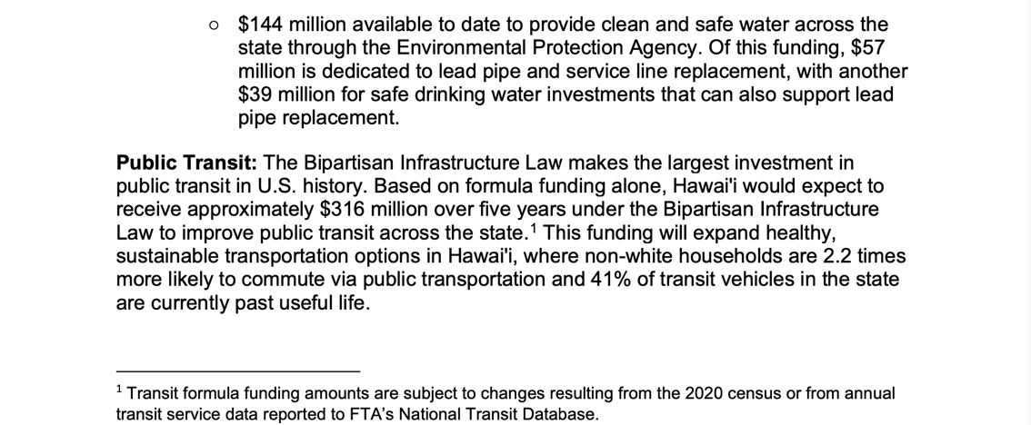

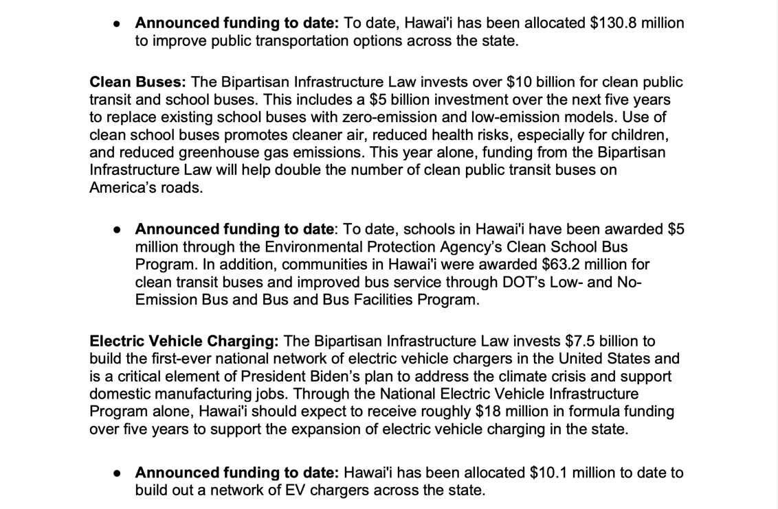

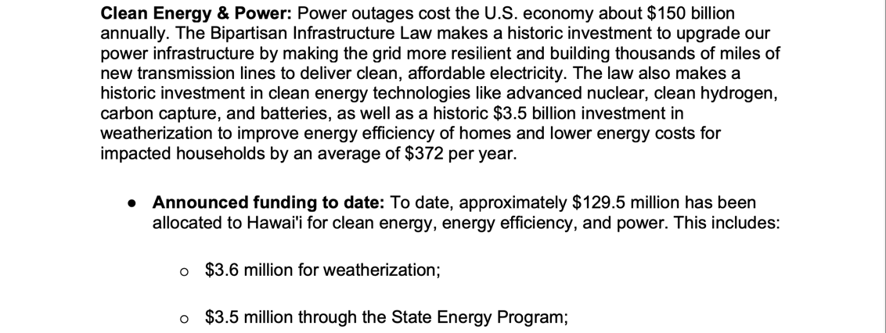

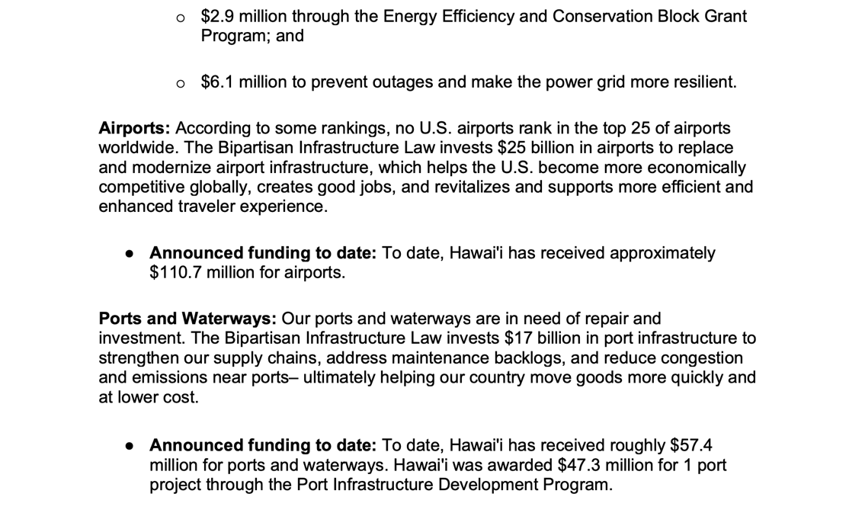

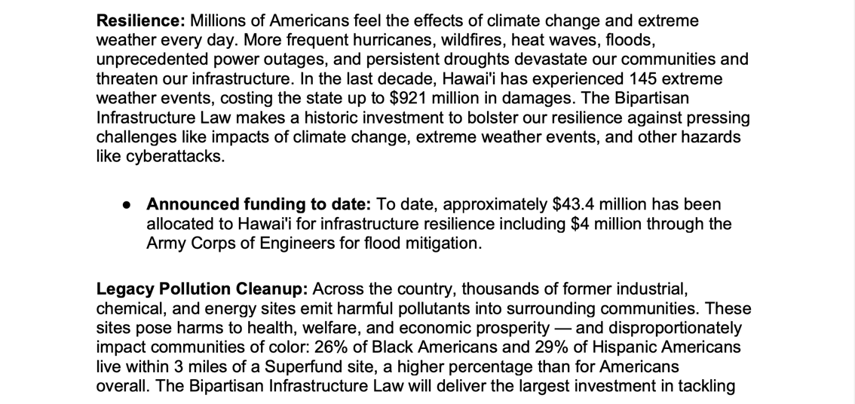

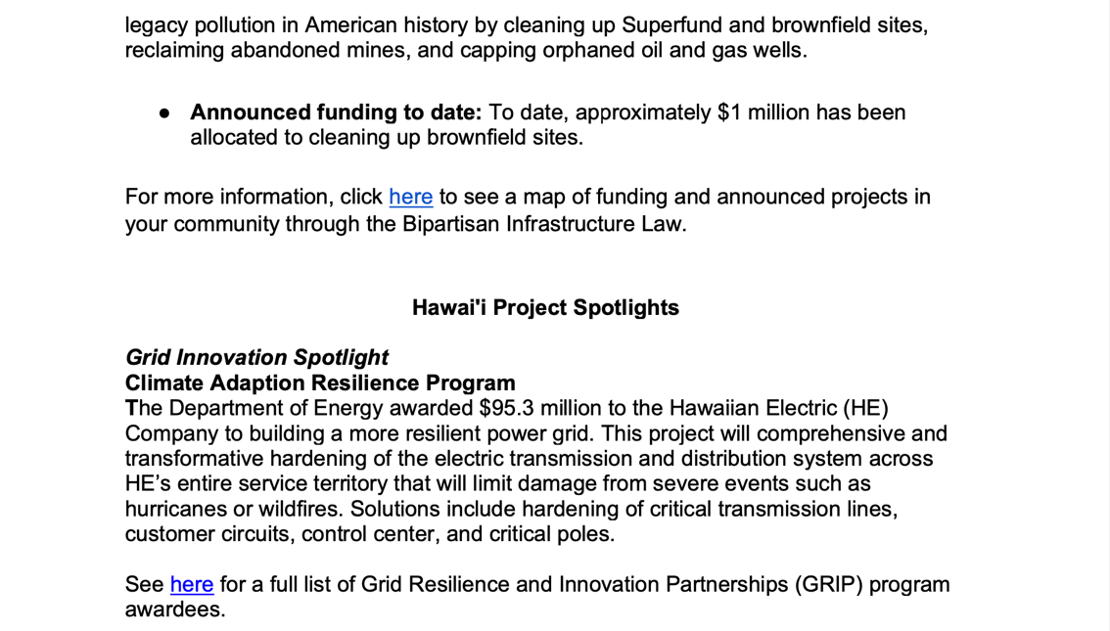

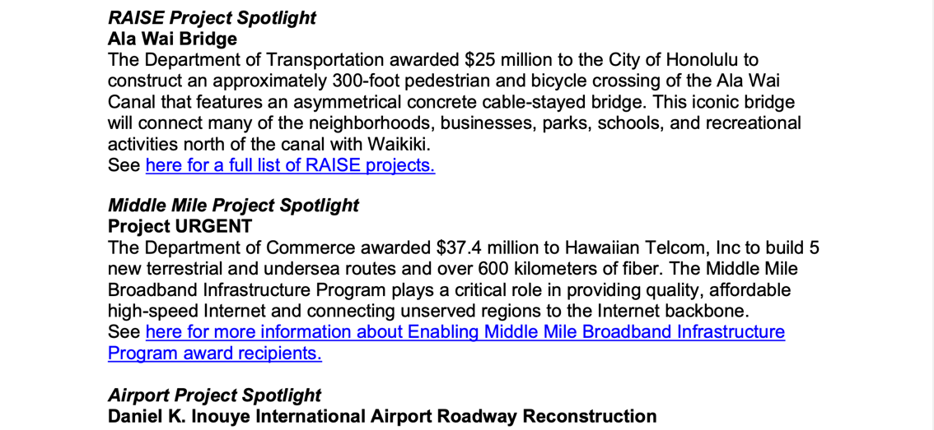

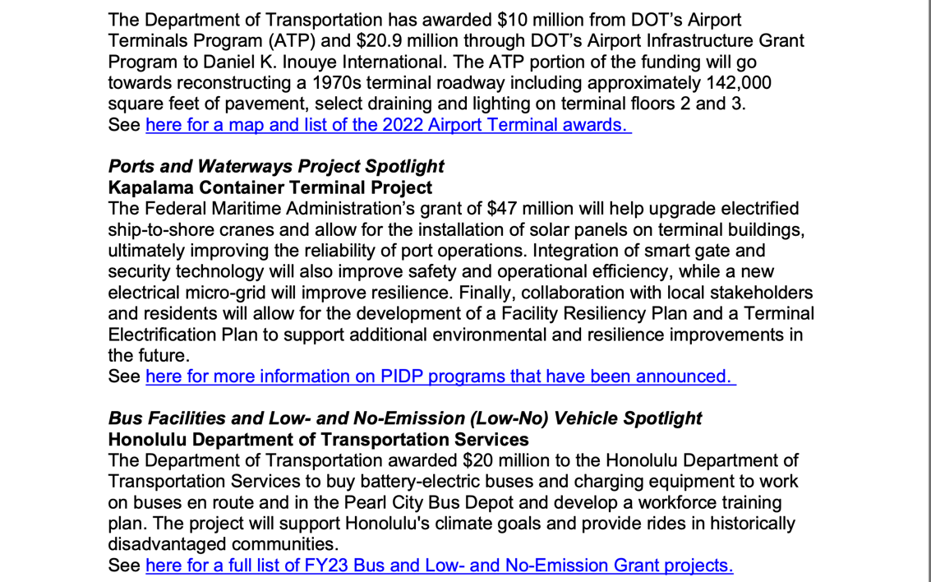

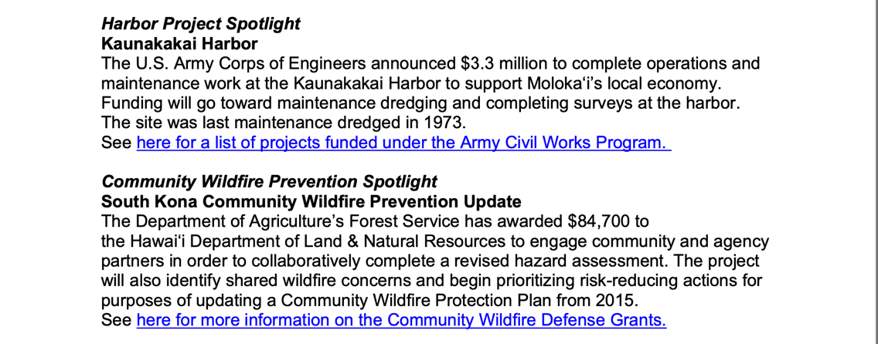

To learn more about how the Bipartisan Infrastructure Law will rebuild our roads and bridges, replace lead pipes for clean water, and more, click here.

https://www.whitehouse.gov/build/guidebook/
OPEN AND UPCOMING INFRASTRUCTURE FUNDING OPPORTUNITIES

This document highlights funding opportunities that communities can apply for today, along with a calendar for funding opportunities across Fall 2023-Winter 2024. The list includes information on the program, the deadline for applying, and a link to the application, where applicable.
For more information on the full set of programs in the Bipartisan Infrastructure Law, including upcoming milestones, visit build.gov.

. 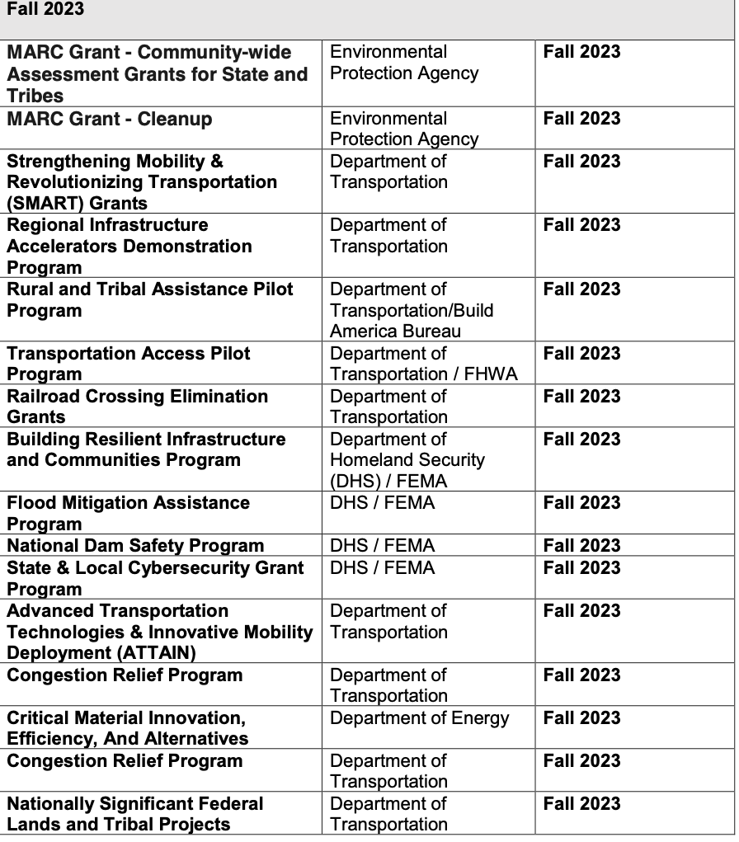

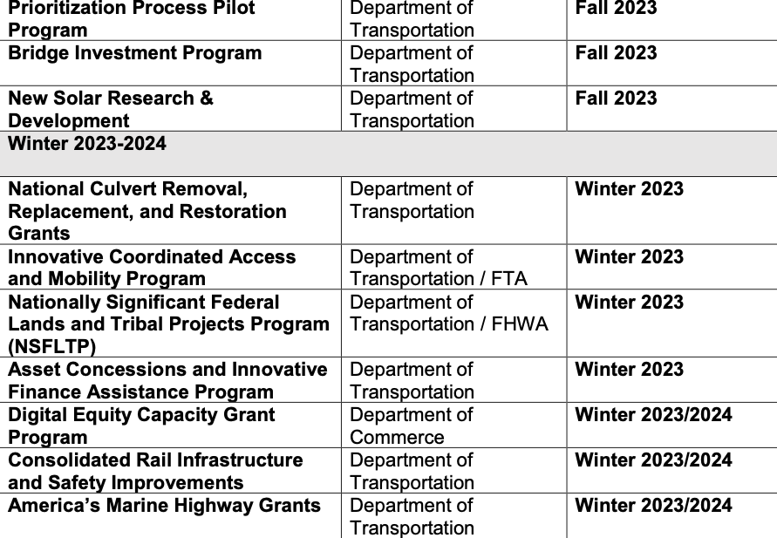

For more information on open funding opportunities under the Inflation reduction act see this page on CleanEnergy.gov

General Discretionary Programs Specific to Hawaiʻi :

Current Notices

Department of Agriculture
National Institute of Food and Agriculture
Alaska Native-Serving and Native Hawaiian-Serving Institutions Education Competitive Grants Program
Synopsis 1
Document Type: | Grants Notice
Funding Opportunity Number: | USDA-NIFA-AHSI-010474
Funding Opportunity Title: | Alaska Native-Serving and Native Hawaiian-Serving Institutions Education Competitive Grants Program
Opportunity Category: | Discretionary
Opportunity Category Explanation:
Funding Instrument Type: | Grant
Category of Funding Activity: | Agriculture
Category Explanation:
Expected Number of Awards: | 5
CFDA Number(s): | 10.228 -- Alaska Native Serving and Native Hawaiian Serving Institutions Education Grants
Cost Sharing or Matching Requirement: | No
Version: | Synopsis 1
Posted Date: | Dec 07, 2023
Last Updated Date: | Dec 07, 2023
Original Closing Date for Applications: | Mar 05, 2024
Current Closing Date for Applications: | Mar 05, 2024
Archive Date: | Apr 04, 2024
Estimated Total Program Funding: | $ 4,787,050
Award Ceiling: | $1,500,000
Award Floor: | $150,000
Eligibility
Eligible Applicants: | Others (see text field entitled "Additional Information on Eligibility" for clarification)
Additional Information on Eligibility: | Applicants for the Alaska Native-Serving and Native Hawaiian-Serving Institutions Education Competitive Grants Program (ANNH) must meet all the requirements discussed in this RFA. Failure to meet the  eligibility criteria by the application deadline may result in exclusion from consideration or, preclude  NIFA from making an award. For those new to Federal financial assistance, NIFA’s Grants  Overview provides highly recommended information about grants and other resources to help  understand the Federal awards process. For the purpose of ANNH, an eligible institution means  an individual public or private, nonprofit Alaska Native-Serving and Native Hawaiian-Serving  Institutions of higher education that meet the definitions of Alaska-Serving Institutions or Native  Hawaiian-Serving Institution established in Title III, Part A of the Higher Education Act of 1965,  as amended (20 U.S.C. 1059d).

Agency Name: | National Institute of Food and Agriculture
Description: | The purpose of this program is to promote and strengthen the ability of Alaska Native-Serving  Institutions and Native Hawaiian-Serving Institutions to carry out education, applied research, and  related community development programs. NIFA intends this program to address educational  needs, as determined by each institution, within a broadly defined arena of food and agricultural  sciences-related disciplines. Priority will be given to those projects that enhance educational equity  for underrepresented students; strengthen institutional educational capacities; prepare students  for careers related to the food, agricultural, and natural resource systems of the United States; and maximize the development and use of resources to improve food and agricultural sciences teaching programs.
Link to Additional Information: | Alaska Native-Serving and Native Hawaiian-Serving Institutions Education Competitive Grants Program
Grantor Contact Information: | If you have difficulty accessing the full announcement electronically, please contact:  NIFA Support  Key Information: Business hours: Monday thru Friday, 7a.m. – 5p.m. ET, except federal holidays  If you have any questions related to preparing application content.
https://www.grants.gov/search-results-detail/351381

Department of Commerce
FY 2024 NOAA Coral Reef Conservation Program - Ruth D. Gates Grant Program: Local and National Capacity Building Support Grants and Cooperative Agreements
Synopsis 2
Document Type: | Grants Notice
Funding Opportunity Number: | NOAA-NOS-OCM-2024-2008253
Funding Opportunity Title: | FY 2024 NOAA Coral Reef Conservation Program - Ruth D. Gates Grant Program: Local and National Capacity Building Support Grants and Cooperative Agreements
Opportunity Category: | Discretionary
Opportunity Category Explanation:
Funding Instrument Type: | Cooperative Agreement Grant
Category of Funding Activity: | Environment  Natural Resources  Science and Technology and other Research and Development
Category Explanation:
Expected Number of Awards:
CFDA Number(s): | 11.482 -- Coral Reef Conservation Program
Cost Sharing or Matching Requirement: | Yes
Version: | Synopsis 2
Posted Date: | Nov 14, 2023
Last Updated Date: | Nov 14, 2023
Original Closing Date for Applications: | Feb 15, 2024
Current Closing Date for Applications: | Feb 15, 2024
Archive Date: | Mar 16, 2024
Estimated Total Program Funding: | $ 1,000,000
Award Ceiling: | $600,000
Award Floor: | $25,000
Eligibility
Eligible Applicants: | Others (see text field entitled "Additional Information on Eligibility" for clarification)
Additional Information on Eligibility: | The purpose of this competition is to aid in coral reef stewardship partnership development. At the time of this announcement, these stewardship partnerships have not been established so eligibility  for the Ruth D. Gates Grant Program (16 U.S.C. &sect; 6410(c)(2)(C)) has been expanded to  include most applicant types who could be considered eligible members of an; interested  stakeholder; (16 U.S.C. &sect; 6415 (15)) that might be accepted into a stewardship partnership.  Until such time, these entities may be considered as; candidate coral reef stewardship partnership members; engaging in pre-partnership development activities. For Priority 1, regional or national organizations may also apply in partnership with, or on behalf of, local organizations, as  needed (e.g., as a fiscal agent, primary service provider, or coordinating entity).

Agency Name: | Department of Commerce
Description: | The purpose of this notice is to solicit financial assistance applications that will build capacity  in States with coral reef ecosystems (defined as the states of Florida and Hawaii; territories of American Samoa, the Commonwealth of the Northern Mariana Islands, Guam, Puerto Rico, and the United States Virgin Islands; or any other territory or possession of the United States or separate sovereign in free association with the United States that contains a coral reef ecosystem) by strengthening local nongovernmental organizations’ and/or other interested stakeholder groups’  ability to participate in future coral reef stewardship partnerships, as outlined in the reauthorized  Coral Reef Conservation Act, 16 U.S.C. 6401-15 (the Act). Projects funded through this competition must address one of two priorities:  PRIORITY 1: Local Coral Community Group Support  Applications submitted under the Local Coral Community Group Support priority should propose  work plans over a duration of 12 to 24 months (1 to 2 years). Each application should not request  more than $50,000 in total Federal funds per geographic region (e.g., counties, islands, or States)  in which the project will be performed. Applications that propose projects across multiple geographic regions may request proportionally higher levels of Federal funds. Applications may be submitted  by the local organization(s) themselves or by a collaborating partner (either local, regional, or  national) who may act as a fiscal agent or primary program coordinator.  ﻿PRIORITY 2: National Coral Conservation Support.  Applications submitted under the National Coral Conservation Support priority will be implemented through either a grant or cooperative agreement and should propose work plans over a duration  of 12 to 48 months (1 to 4 years). Each application should request no more than $75,000 in  Federal funds per year for projects with regional beneficiaries and no more than $150,000 per  year in Federal funds for projects with national beneficiaries. It is expected that one national or  up to two regional applications may be selected. Applications are expected to be submitted by  multi-state or multinational entities that may be located outside one of the beneficiary States,  however, applicants should demonstrate experience working across these diverse jurisdictions.
Link to Additional Information:
Grantor Contact Information: | If you have difficulty accessing the full announcement electronically, please contact:  Victoria Barker 202-936-5696  1305 East West Highway, Silver Spring, MD 20910  Work
https://www.grants.gov/search-results-detail/350975

Department of Interior
National Park Service
FY2024 NAGPRA Consultation/Documentation Grants
Synopsis 1
Document Type: | Grants Notice
Funding Opportunity Number: | P24AS00505
Funding Opportunity Title: | FY2024 NAGPRA Consultation/Documentation Grants
Opportunity Category: | Discretionary
Opportunity Category Explanation:
Funding Instrument Type: | Grant
Category of Funding Activity: | Other (see text field entitled "Explanation of Other Category of Funding Activity" for clarification)
Category Explanation: | NAGPRA Consultation/Documentation Grants
Expected Number of Awards:
CFDA Number(s): | 15.922 -- Native American Graves Protection and Repatriation Act
Cost Sharing or Matching Requirement: | No
Version: | Synopsis 1
Posted Date: | Nov 20, 2023
Last Updated Date: | Nov 20, 2023
Original Closing Date for Applications: | Mar 08, 2024 Complete applications must be submitted to the National Park Service by Friday, March 8, 2024, 11:59PM PT. Applicants are encouraged to submit the application well before the deadline. Application preparation time may take several weeks, so please start the application process as soon as possible. Applications submitted after the deadline will not be reviewed or considered for award. If it is determined that a proposal was not considered due its being late or incomplete, the applicant will be notified during the selection process.
Current Closing Date for Applications: | Mar 08, 2024 Complete applications must be submitted to the National Park Service by Friday, March 8, 2024, 11:59PM PT. Applicants are encouraged to submit the application well before the deadline. Application preparation time may take several weeks, so please start the application process as soon as possible. Applications submitted after the deadline will not be reviewed or considered for award. If it is determined that a proposal was not considered due its being late or incomplete, the applicant will be notified during the selection process.
Archive Date: | Apr 04, 2024
Estimated Total Program Funding: | $ 3,407,000
Award Ceiling: | $100,000
Award Floor: | $5,000

Eligible Applicants: | Special district governments  Nonprofits having a 501(c)(3) status with the IRS, other than institutions  of higher education  Public and State controlled institutions of higher education  Native American tribal governments (Federally recognized)  Private institutions of higher education  Others (see text field entitled "Additional Information on Eligibility" for clarification)  County governments  State governments  City or township governments  Native American tribal organizations (other than Federally recognized tribal governments)
Additional Information on Eligibility: | The following entities are eligible to apply for a NAGPRA Consultation/Documentation grant: An Indian Tribe, Alaska Native village,  or Native Hawaiian Organization An Indian Tribe; means any tribe, band,  nation, or other organized group or community of Indians, including Alaska  Native villages, which is recognized as eligible for the special programs  and services provided by the United States to Indians because of their status  as Indians. The Department of the Interior has interpreted this definition as  applying to the 574 Indian tribes and Alaska Native villages that are  recognized by the United States Government. The Bureau of Indian Affairs;  list of Federally recognized tribes is available at;www.bia.gov. This  list does not include Alaska regional or village corporations. Native Hawaiian  organization (NHO) includes any organization that: a) serves and represents  the interests of Native Hawaiians; b) has as a primary and stated purpose the  provision of services to Native Hawaiians; and c) has expertise in Native Hawaiian  Affairs. NAGPRA states that this shall include the Office of Hawaiian Affairs. A  Museum that has control of Native American human remains, funerary objects, sacred objects, or objects of cultural patrimony and has received Federal funds. The term; ”Museum”; includes state or local government agencies, private institutions,  and institutions of higher learning that have received Federal funds. Eligible  museums must have completed and provided the following documents to the  National NAGPRA Program and to Indian tribes or Native Hawaiian organizations, as appropriate, prior to submission of a grant application: A NAGPRA Summary of  the cultural items in their possession or control by November 16, 1993, or after  according to timelines in 43 CFR 10.13.A NAGPRA Inventory of human remains  and associated funerary objects in their possession or control by November 16, 1995,  or after according to timelines in:43 CFR 10.13.A museum that has not yet completed  a; or inventory, but does so prior to submitting a grant proposal, may then be eligible  to receive an award; Museums determined to be out of compliance with NAGPRA  may be excluded from consideration; Federal agencies and the Smithsonian Institution  may not apply for grants; Applicants who previously received a NAGPRA grant  but did not meet the conditions of the grant agreement, including reports or  deliverables, may be penalized in the review process.
Additional Information
Agency Name: | National Park Service
Description: | Grant funds must be used for CONSULTATION and/or  DOCUMENTATION projects under NAGPRA. Consultation projects  support efforts related to revising a NAGPRA inventory and making or responding to  requests for repatriation of items in a NAGPRA summary. Documentation projects  support determining the geographical origin, cultural affiliation, and other basic  facts surrounding the acquisition of Native American cultural items. Consultation  and documentation projects should lead to determining control, treatment,  repatriation, and disposition of NAGPRA cultural items.
Link to Additional Information: | https://www.nps.gov/subjects/nagpra/index.htm
Grantor Contact Information: | If you have difficulty accessing the full announcement electronically,  please contact:  Seth Tinkham  nagpra_grants@nps.gov  Email preferred.
https://www.grants.gov/search-results-detail/351056

Reminders

Department of Interior - Office of Native Hawaiian Relations
Kapapahuliau Climate Resilience Program

The Office of Native Hawaiian Relations (ONHR), a dedicated office under the Office of the Secretary of the Interior, has announced a $20 million climate resilience initiative funded by the 2022 Inflation Reduction Act.
Named for the imagery of navigating changing winds and currents on a Hawaiian voyaging waʻa (canoe), the Kapapahuliau Climate Resilience Program aims to enhance the ability of the Native Hawaiian community to navigate the effects of climate change in ways that maintain their integrity and identity as a people.
- Climate Change in Hawaiʻi
- Preparing for Climate Resilience & Adaptation
- Program Goals and Principles
- Kapapahuliau Climate Resilience Priorities
- DOI Media Release
- NHO Notice of Funding Announcement

Funding Categories
Financial Assistance Award Amounts
Who can apply?
Where can I apply?
Additional References and Resources

Pre-Proposal Informational Sessions
ONHR will be hosting two 120-minute virtual pre-proposal informational sessions in the coming weeks to provide an overview of the Kapapahuliau Program and address questions for interested NHOs. The second of these virtual informational sessions is currently scheduled for:
Wednesday, December 13, 2023 from Noon to 2:00 pm HST
NHOs interested in attending either of these sessions may register at:
https://blm.zoomgov.com/webinar/register/WN_tGZJxaeuQpuU5IUcGJkiFA(link is external)
Deadline to apply:
Thursday, February 29, 2024.

Document Type: | Grants Notice
Funding Opportunity Number: | D24AS00098
Funding Opportunity Title: | Kapapahuliau Native Hawaiian Climate Resilience Program
Opportunity Category: | Discretionary
Opportunity Category Explanation:
Funding Instrument Type: | Cooperative Agreement Grant
Category of Funding Activity: | Environment  Natural Resources
Category Explanation: | Funding Instrument shall be in the form of Grants for Categories 1 and 2 as the Kiakahi and Auwaa awards. Substantial involvement is not expected between the ONHR and the recipient when carrying out the activities contemplated in the agreement. For Category 3, Cooperative Agreements will be issued for Hookele awards. The recipient should expect that there will be substantial involvement by the Office of Native Hawaiian Relations (ONHR) in the project. Prior to submitting an application, applicants are encouraged to contact prospective NHO sub-recipients where the work is proposed to take place to discuss proposed projects to determine eligibility under the ONHR priorities and criteria described in this Notice of Funding Opportunity (NOFO). Substantial involvement may include, but not be limited to, such things as the following: collaboration between the ONHR and applicant/primary recipient in carrying out management, development, implementation, operation, monitoring and evaluation of the proposed work; training and technical assistance for sub-recipient personnel; review and approval by the ONHR of one stage of work prior to the start of the next stage; review and approval by the ONHR of modifications or sub-awards prior to their award; participation in selecting recipient project staff; and/or; ability to immediately halt work because of failure to meet agreement objectives. The funding periods and amounts referenced in this solicitation are subject to the availability of funds at the time of award, as well as the DOI priorities at the time of the award. Publication of this NOFO does not obligate DOI to award any specific grant or to obligate all or any part of available funds. Future funding is subject to the availability of appropriations and cannot be guaranteed. DOI may cancel or withdraw this NOFO at any time. Please Note: Omitted Hawaiian Language diacriticals because of limitations of the grants.gov software.
Expected Number of Awards: | 20
CFDA Number(s): | 15.098 -- Native Hawaiian Climate Resilience Program
Cost Sharing or Matching Requirement: | No
Version: | Synopsis 7
Posted Date: | Nov 15, 2023
Last Updated Date: | Nov 20, 2023
Original Closing Date for Applications: | Feb 29, 2024 Complete application packages, including all required forms, must be submitted electronically to the Grants.gov website no later than&nbsp;6:59 p.m., Hawaiʻi Standard Time (HST), on the listed application due date in Section D4 above.
Current Closing Date for Applications: | Feb 29, 2024 Complete application packages, including all required forms, must be submitted electronically to the Grants.gov website no later than 6:59 p.m. Hawaii Standard Time (HST) on the listed application due date in Section D4 of the Notice of Funding Opportunity (NOFO) in the Related Tab above.
Archive Date:
Estimated Total Program Funding: | $ 20,000,000
Award Ceiling: | $5,000,000
Award Floor: | $100,000

Eligibility
Eligible Applicants: | Others (see text field entitled "Additional Information on Eligibility" for clarification)
Additional Information on Eligibility: | For this financial assistance opportunity, applicants for all Financial Assistance Categories of Kiakahi, Auwaa, and Hookele must meet the following definition of,  and criteria for, a Native Hawaiian Organization. Native Hawaiian Organization or NHO means a non-profit organization (A) that principally serves or benefits  the Native Hawaiian Community; (B) that is composed primarily of Native  Hawaiians, who also control or serve in substantive leadership and  decision-making roles; and (C) that has demonstrated expertise in Native  Hawaiian heritage, economic development, health and well-being,  self-governance, or natural and cultural resources management. Native  Hawaiian Community means the distinct Native Hawaiian indigenous political community that Congress, exercising its plenary power over Native  American affairs, has recognized and with which Congress has implemented  a special political and trust relationship. Native Hawaiian means any individual  who is a descendant of the aboriginal people who, prior to 1778, occupied and exercised sovereignty in the area that now constitutes the State of Hawaii. All applicants are required to include in their application submission, per Section D  of the Notice of Funding Opportunity (NOFO), an attestation or certification  signed by a duly authorized NHO representative (such as the Executive  Director, CEO, or Board of Directors acknowledging that the NHO meets  the definition and criteria of an NHO specified above. For Category 2 Auwaa  and Category 3 Hookele awardees, all partners NHOs and subawardees,  respectively must indicate and include such an attestation. Registration or  placement on the List of NHOs maintained by ONHR is not a pre-requisite or requirement for submitting an application, nor does it confer eligibility as an  NHO in lieu of the attestation or certification per Section D of the NOFO.  Please Note: Omitted Hawaiian Language diacriticals because of limitations  of the grants.gov software.

Agency Name: | Interior Business Center
Description: | Please download the full announcement, including instructions, in the Related Documents Tab above. To download the application forms  required by this Notice of Funding Opportunity, please go to the  Application Tab above.
Link to Additional Information: | www.doi.gov/hawaiian/climate-resilience
Grantor Contact Information: | If you have difficulty accessing the full announcement electronically,  please contact:  Tristan Harley  aqd-fa.onhr@ibc.doi.gov Eleni Sarris aqd-fa.onhr@ibc.doi.gov  aqd-fa.onhr@ibc.doi.gov

https://www.doi.gov/hawaiian/climate-resilience

The 2024 NOAA Hawaii Bay Watershed Education and Training (B-WET) Program
Synopsis 3
Document Type: | Grants Notice
Funding Opportunity Number: | NOAA-NOS-ONMS-2024-2008250
Funding Opportunity Title: | The 2024 NOAA Hawaii Bay Watershed Education and Training (B-WET) Program
Opportunity Category: | Discretionary
Opportunity Category Explanation:
Funding Instrument Type: | Grant
Category of Funding Activity: | Environment  Natural Resources
Category Explanation:
Expected Number of Awards: | 10
CFDA Number(s): | 11.429 -- Marine Sanctuary Program
Cost Sharing or Matching Requirement: | No
Version: | Synopsis 7
Posted Date: | Nov 01, 2023
Last Updated Date: | Nov 02, 2023
Original Closing Date for Applications: | Dec 31, 2023
Current Closing Date for Applications: | Jan 31, 2024
Archive Date:
Estimated Total Program Funding: | $ 1,000,000
Award Ceiling: | $150,000
Award Floor: | $50,000
Eligibility
Eligible Applicants: | Others (see text field entitled "Additional Information on Eligibility" for clarification)
Additional Information on Eligibility: | Eligible funding applicants are K-12 public and independent schools and school systems, institutions of higher education, commercial and nonprofit organizations, state or local government agencies, and Indian tribal governments conducting projects in Hawaii  (Islands of Hawaii, Maui, Kahoolawe, Lanai, Molokai, Oahu, Kauai, Niihau, and/or the Northwestern Hawaiian Islands). Individual applicants and federal agencies are not eligible. Notice of Federal Funding Page 21 of 50 DOC/NOAA supports cultural and gender diversity, and is strongly committed to broadening the participation of organizations that promote inclusion, such as tribal colleges, minority serving institutions, universities, and groups  that work in historically underserved communities. The term underserved communities  refers to populations sharing a particular characteristic, as well as geographic communities,  that have been systematically denied a full opportunity to participate in aspects of economic, social, and civic life. Underserved communities are defined in Executive Order 13985: https://www.federalregister.gov/documents/2021/01/25/2021-01753/advancing-racialequity-  and-support-for-underserved-communities-through-the-federal-government.Federal agencies  and employees are not allowed to receive funds under this announcement, but may serve  as collaborative project partners and may contribute services in-kind; these; in-kind services; cannot be considered as part of an applicant’s match on shared  costs. If an applicant proposes a federal agency as a collaborator, applicants should  provide detail on the expected level of federal engagement in the application. Examples  might include, but are not limited to partnership services; serving in a review capacity; or participating in priority task teams, working groups, or leadership teams. NOAA employees  are not permitted to assist in the preparation of applications.
Additional Information
Agency Name: | Department of Commerce
Description: | The NOAA Hawaii Bay Watershed Education and Training (B-WET) program is an environmental education program that meets NOAA’s mission of science, service, and stewardship. The Hawaii  B-WET program supports a vision of a future where societies and ecosystems are healthy and  resilient in the face of sudden or prolonged change. The purpose for this funding opportunity is to support our communities by developing well-informed members of society, who are involved in  decision-making that positively impacts our coastal, marine, and watershed ecosystems in the  Hawaiian Islands. This is a competitive opportunity for grants to assist in the development of new programs, encourage innovative partnerships among environmental education programs, and  support geographically targeted programs to advance environmental education efforts that  complement national and state school requirements. The Hawaii B-WET program plays a  foundational role as an environmental education program that promotes locally relevant,  experiential learning in the K-12 environment on Priority Content Areas such as Science with an emphasis on climate and Indigenous Knowledge (IK). Funded projects provide Meaningful  Watershed Educational Experiences (MWEEs) for students and professional development  for teachers that support regional education and environmental priorities. More information  about the B-WET program is online at https://www.noaa.gov/office-education/bwet.
Link to Additional Information:
Grantor Contact Information: | If you have difficulty accessing the full announcement electronically, please contact:  Mahealani Bambico  Hawaii B-WET Coordinator  E-mail
https://www.grants.gov/search-results-detail/350829

Health Resources and Services Administration
FY 2024 Native Hawaiian Health Care Improvement Act
Forecast 1
Document Type: Grants Notice  Opportunity Number: HRSA-24-030  Opportunity Title: FY 2024 Native Hawaiian Health Care Improvement Act  Opportunity Category: Discretionary  Opportunity Category Explanation:  Funding Instrument Type: Grant  Category of Funding Activity: Health  Category Explanation:  Expected Number of Awards: 6  CFDA Number(s): 93.932 -- Native Hawaiian Health Care Systems  Cost Sharing or Matching Requirement: No | Version: Forecast 1  Forecasted Date: Jul 03, 2023  Last Updated Date: Jul 03, 2023  Estimated Post Date: Dec 15, 2023  Estimated Application Due Date: Mar 15, 2024  Estimated Award Date:  Estimated Project Start Date: Aug 01, 2024  Fiscal Year: 2024  Archive Date:  Estimated Total Program Funding: $27,000,000  Award Ceiling:  Award Floor:

Eligible Applicants: | Others (see text field entitled "Additional Information on Eligibility" for clarification)
Additional Information on Eligibility: | Organizations as eligible under the NHHCIA

Agency Name: | Health Resources and Services Administration
Description: | The purpose of this funding opportunity is to distribute funding under the Native Hawaiian Health Care Improvement Act (NHHCIA) program. The NHHCIA, as amended (42 U.S.C. 11701 - 11714), states that “it is the policy of the United States in fulfillment of its special responsibilities and legal obligations to the indigenous people of Hawaiʻi to (1) raise the health status of Native Hawaiians to the highest possible health level; and (2) provide existing Native Hawaiian health care programs with all resources necessary to effectuate this policy” [see 42 U.S.C. 11702(a)].
Link to Additional Information:
Grantor Contact Information: | NH Technical Assistance Team  (301)594-4300  BPHCFunding@hrsa.gov
https://www.grants.gov/web/grants/view-opportunity.html?oppId=349044

General National Programs by Federal Agency

U.S. Department of Agriculture

Programs:

National Institute of Food and Agriculture
Small Business Innovation Research and Small Business Technology Transfer Programs Phase II
Synopsis 1
Document Type: | Grants Notice
Funding Opportunity Number: | USDA-NIFA-SBIR-010287
Funding Opportunity Title: | Small Business Innovation Research and Small Business Technology Transfer Programs Phase II
Opportunity Category: | Mandatory
Funding Instrument Type: | Grant
Category of Funding Activity: | Agriculture
Category Explanation:
Expected Number of Awards:
CFDA Number(s): | 10.212 -- Small Business Innovation Research (SBIR) Program / Small Business Technology Transfer (STTR) Program
Cost Sharing or Matching Requirement: | No
Version: | Synopsis 1
Posted Date: | Nov 14, 2023
Last Updated Date: | Nov 14, 2023
Original Closing Date for Applications: | Mar 26, 2024
Current Closing Date for Applications: | Mar 26, 2024
Archive Date: | Apr 25, 2024
Estimated Total Program Funding: | $ 22,100,000
Award Ceiling: | $650,000
Award Floor: | $600,000

Eligible Applicants: | Others (see text field entitled "Additional Information on Eligibility" for clarification)
Additional Information on Eligibility: | Eligibility Requirements SBIR/STTR Phase I awardees who have not previously applied  for Phase II support are eligible to apply for Phase II support through the FY 2024 and  FY 2025 RFAs. This includes those awardees identified via a; or;  successor-in-interest; revised funding agreement. A Phase I project may  only apply for a Phase II award once. If a Phase I awardee was unsuccessful in receiving  a Phase II award with a previous application, then the awardee is not eligible to resubmit the proposal under this or a future Phase II program solicitation. Each applicant must qualify  as a SBC through registration with the SBA for R/R;D purposes at the time of selection  (see Definitions in Appendix III of this RFA). Failure to meet an eligibility criterion by the  application deadline may result in the application being excluded from consideration or,  even though an application may be reviewed, will preclude NIFA from making an award.  SBIR/STTR program eligibility requirements are in place to ensure that the funds go  only to small, independent U.S. businesses. The regulations include restrictions about  - the type of firm, (2) its ownership structure, and (3) the firm; size in terms  - of the number of employees.
Additional Information
Agency Name: | National Institute of Food and Agriculture
Description: | The Small Business Administration (SBA), through the SBIR/STTR Policy Directive, provides  policy guidance for these programs. A main purpose of the legislation is to stimulate technological innovation and increase private sector commercialization  among small business concerns and enable them to undertake and to obtain the benefits of  research and development in order to maintain and strengthen the competitive free enterprise  system and the national economy. The goal of Phase II is to continue research and development  while increasing the focus on commercialization. The STTR program aims to foster technology  transfer through formal cooperative R&D between small businesses and nonprofit research  institutions. The USDA SBIR/STTR programs Assistance Listing 10.212, is therefore in a unique  position to meet both the goals of USDA and the purpose of the SBIR/STTR legislation by  transforming scientific discovery and innovation both social and economic benefit, and by  emphasizing private sector commercialization.
Link to Additional Information: | Small Business Innovation Research and Small Business Technology Transfer Programs Phase II
Grantor Contact Information: | If you have difficulty accessing the full announcement electronically, please contact:  NIFA Support  Key Information: Business hours: Monday thru Friday, 7a.m. – 5p.m. ET, except federal holidays  If you have any questions related to preparing application content.
https://www.grants.gov/search-results-detail/350979

National Institute of Food and Agriculture
Integrated Research, Education, and Extension Competitive Grants Program – Organic Transitions
Synopsis 1
Document Type: | Grants Notice
Funding Opportunity Number: | USDA-NIFA-ICGP-010290
Funding Opportunity Title: | Integrated Research, Education, and Extension Competitive Grants Program; Organic Transitions
Opportunity Category: | Discretionary
Opportunity Category Explanation:
Funding Instrument Type: | Grant
Category of Funding Activity: | Agriculture
Category Explanation:
Expected Number of Awards: | 12
CFDA Number(s): | 10.303 -- Integrated Programs
Cost Sharing or Matching Requirement: | Yes
Version: | Synopsis 1
Posted Date: | Nov 24, 2023
Last Updated Date: | Nov 24, 2023
Original Closing Date for Applications: | Mar 07, 2024
Current Closing Date for Applications: | Mar 07, 2024
Archive Date: | Apr 06, 2024
Estimated Total Program Funding: | $ 7,500,000
Award Ceiling: | $1,000,000
Award Floor: | $20,000
Eligibility
Eligible Applicants: | Others (see text field entitled "Additional Information on Eligibility" for  clarification)
Additional Information on Eligibility: | Eligibility Requirements Applicants for the ORG must meet all the  requirements discussed in this RFA. Failure to meet the eligibility criteria  by the application deadline may result in exclusion from consideration or, preclude NIFA from making an award. For those new to Federal financial assistance, NIFA’s Grants Overview provides highly recommended  information about grants and other resources to help understand the Federal awards process. Applications may only be submitted by colleges and  universities, as defined in 7 U.S.C. 3103, 1994 Institutions, and  Hispanic-serving agricultural colleges and universities. Award recipients  may subcontract to organizations not eligible to apply provided such organizations are necessary for the conduct of the project. Failure to  meet an eligibility criterion by the application deadline may result in the application being excluded from consideration or, even though an  application may be reviewed, will preclude NIFA from making an award.
Additional Information
Agency Name: | National Institute of Food and Agriculture
Description: | The overall goal of the Organic Transitions Program (ORG) is to support the development  and implementation of research, extension and higher education programs to improve the competitiveness of organic livestock and crop producers, as well as those who are  adopting organic practices. NIFA administers the ORG program by determining priorities  in U.S. agriculture through Agency stakeholder input processes in consultation with the NAREEEAB.  ORG will continue to prioritize environmental services provided by organic farming  systems in the area of soil conservation, pollinator health, and climate change mitigation, including greenhouse gases (GHG), as well as the development of educational tools for Cooperative Extension personnel and other agricultural professionals who advise  producers on organic practices, and development of cultural practices and other allowable alternatives to substances recommended for removal from the National Organic Program’s National List of Allowed and Prohibited Substances. It is expected that all projects will  integrate research,  education and extension activities, as appropriate to project goals, although some  projects may be weighted more heavily than others in one or more of these areas.  However, all proposals should have activities and impact in research and at  least one of the other areas: education and extension.
Link to Additional Information: | Integrated Research, Education, and Extension Competitive Grants Program – Organic Transitions
Grantor Contact Information: | If you have difficulty accessing the full announcement electronically, please contact:  NIFA Support  Key Information: Business hours: Monday thru Friday, 7a.m. – 5p.m. ET, except federal holidays  If you have any questions related to preparing application content.
https://www.grants.gov/search-results-detail/351129

National Institute of Food and Agriculture
Organic Agriculture Research and Extension Initiative
Synopsis 1
Document Type: | Grants Notice
Funding Opportunity Number: | USDA-NIFA-ICGP-010314
Funding Opportunity Title: | Organic Agriculture Research and Extension Initiative
Opportunity Category: | Mandatory
Opportunity Category Explanation:
Funding Instrument Type: | Grant
Category of Funding Activity: | Agriculture
Category Explanation:
Expected Number of Awards:
CFDA Number(s): | 10.307 -- Organic Agriculture Research and Extension Initiative
Cost Sharing or Matching Requirement: | Yes
Version: | Synopsis 1
Posted Date: | Nov 24, 2023
Last Updated Date: | Nov 24, 2023
Original Closing Date for Applications: | Feb 15, 2024
Current Closing Date for Applications: | Feb 15, 2024
Archive Date: | Mar 16, 2024
Estimated Total Program Funding: | $ 44,000,000
Award Ceiling: | $3,500,000
Award Floor: | $50,000
Eligibility
Eligible Applicants: | Others (see text field entitled "Additional Information on Eligibility" for clarification)
Additional Information on Eligibility: | Eligibility Requirements The Organic Agriculture Research and Extension Initiative (OREI), under assistance listing 10.307, seeks to solve critical organic agricultural issues, priorities, or problems  through the integration of research, education, and extension activities. The purpose of this program  is to fund high priority integrated projects that will enhance the ability of producers and processors  who have already adopted organic standards to grow and market high quality organic agricultural products, mitigate and adapt to climate change, build resilience of the organic farming system,  and protect water and other resources. Priority concerns include biological, physical, and social  sciences, including economics.
Additional Information
Agency Name: | National Institute of Food and Agriculture
Description: | The Organic Agriculture Research and Extension Initiative (OREI) seeks to solve critical organic agriculture issues, priorities, or problems through the integration of research, education, and  extension activities. The purpose of this program is to fund projects that will enhance the ability of producers and processors who have already adopted organic standards to grow and market high quality organic agricultural products. Priority concerns include biological, physical, and social  sciences, including economics. The OREI is particularly interested in projects that emphasize research, education and outreach that assist farmers and ranchers with whole farm planning by delivering practical research-based information. Projects should plan to deliver applied production information to producers. Fieldwork must be done on certified organic land or on land in transition  to organic certification, as appropriate to project goals and objectives. Award recipients may subcontract to organizations not eligible to apply provided such organizations are necessary for  the conduct of the project.
Link to Additional Information: | https://www.nifa.usda.gov/grants/funding-opportunities/organic-agriculture-research-extension-initiative
Grantor Contact Information: | If you have difficulty accessing the full announcement electronically, please contact:  NIFA Support  Key Information: Business hours: Monday thru Friday, 7a.m. – 5p.m. ET, except federal holidays  If you have any questions related to preparing application content.
https://www.grants.gov/search-results-detail/351133

National Institute of Food and Agriculture
Biotechnology Risk Assessment Research Grants Program
Synopsis 1
Document Type: | Grants Notice
Funding Opportunity Number: | USDA-NIFA-BRAP-010309
Funding Opportunity Title: | Biotechnology Risk Assessment Research Grants Program
Opportunity Category: | Mandatory
Opportunity Category Explanation:
Funding Instrument Type: | Grant
Category of Funding Activity: | Agriculture
Category Explanation:
Expected Number of Awards: | 10
CFDA Number(s): | 10.219 -- Biotechnology Risk Assessment Research
Cost Sharing or Matching Requirement: | No
Version: | Synopsis 2
Posted Date: | Dec 01, 2023
Last Updated Date: | Dec 05, 2023
Original Closing Date for Applications: | Feb 29, 2024
Current Closing Date for Applications: | Feb 29, 2024
Archive Date: | Mar 30, 2024
Estimated Total Program Funding: | $ 5,500,000
Award Ceiling: | $650,000
Award Floor: | $10,000
Eligibility
Eligible Applicants: | Others (see text field entitled "Additional Information on Eligibility" for clarification)
Additional Information on Eligibility: | Eligibility Requirements Applicants for the BRAG program are limited to public or private  research or educational institutions or organizations and must meet all the requirements discussed in this RFA.
Additional Information
Agency Name: | National Institute of Food and Agriculture
Description: | The purpose of the Biotechnology Risk Assessment Research Grants Program (BRAG) program  is to support the generation of new information that will assist Federal regulatory agencies in  making science-based decisions about the effects of introducing into the environment genetically engineered organisms (GE), including plants, microorganisms — such as fungi, bacteria, and  viruses — arthropods, fish, birds, mammals and other animals excluding humans. Investigations  of effects on both managed and natural environments are relevant. The BRAG program  accomplishes its purpose by providing federal regulatory agencies with scientific information  relevant to regulatory issues.
Link to Additional Information: | Biotechnology Risk Assessment Research Grants Program
Grantor Contact Information: | If you have difficulty accessing the full announcement electronically, please contact:  NIFA Support  Key Information: Business hours: Monday thru Friday, 7a.m. – 5p.m. ET, except federal holidays  If you have any questions related to preparing application content.
https://www.grants.gov/search-results-detail/351267
National Institute of Food and Agriculture
Secondary Education Two-Year Postsecondary Education and Agriculture in the K-12 Classroom Challenge Grants Program
Synopsis 1
Document Type: | Grants Notice
Funding Opportunity Number: | USDA-NIFA-SAECP-010339
Funding Opportunity Title: | Secondary Education Two-Year Postsecondary Education and Agriculture in the K-12 Classroom Challenge Grants Program
Opportunity Category: | Discretionary
Opportunity Category Explanation:
Funding Instrument Type: | Grant
Category of Funding Activity: | Agriculture
Category Explanation:
Expected Number of Awards: | 9
CFDA Number(s): | 10.226 -- Secondary Education, Two-Year Postsecondary Education, and Agriculture in the K-12 Classroom
Cost Sharing or Matching Requirement: | No
Version: | Synopsis 1
Posted Date: | Dec 07, 2023
Last Updated Date: | Dec 07, 2023
Original Closing Date for Applications: | Mar 08, 2024
Current Closing Date for Applications: | Mar 08, 2024
Archive Date: | Apr 07, 2024
Estimated Total Program Funding: | $ 900,000
Award Ceiling: | $150,000
Award Floor: | $50,000
Eligibility
Eligible Applicants: | Others (see text field entitled "Additional Information on Eligibility" for clarification)
Additional Information on Eligibility: | Applicants for the SPECA must meet all the requirements discussed in this RFA. Applications may  only be submitted by: (1) public secondary schools 20 U.S.C. 7801(45), (2) public or private nonprofit  junior and community colleges, (3) institutions of higher education (20 U.S.C. 1001), or (4) nonprofit organizations (Attach IRS 501(c)(3) status under Other Project Information;  Field 12 Other Attachments). Failure to meet the eligibility criteria by the application deadline may result in exclusion from consideration or, preclude NIFA from making an award. For those new to Federal  financial assistance, NIFA’s Grants Overview provides highly recommended information about grants  and other resources to help understand the Federal awards process. School boards are not eligible  as legal recipients of the award.

Agency Name: | National Institute of Food and Agriculture
Description: | The Secondary Education, Two-Year Postsecondary Education, and Agriculture in the K-12 Classroom Challenge Grants (SPECA) program seeks to: (a) promote and strengthen secondary education and  two-year postsecondary education in the food and agriculture sciences in order to help ensure the existence of a workforce in the United States that's qualified to serve the food and agriculture sciences system; and (b) promote complementary and synergistic linkages among secondary, two-year postsecondary, and higher education programs in the food and agriculture sciences in order to  advance excellence in education and encourage more young Americans to pursue and complete a baccalaureate or higher degree in the food and agriculture sciences
Link to Additional Information: | Secondary Education Two-Year Postsecondary Education and Agriculture in the K-12 Classroom Challenge Grants Program
Grantor Contact Information: | If you have difficulty accessing the full announcement electronically, please contact:  NIFA Support  Key Information: Business hours: Monday thru Friday, 7a.m. – 5p.m. ET, except federal holidays  If you have any questions related to preparing application content.
https://www.grants.gov/search-results-detail/351383

National Institute of Food and Agriculture
Food Safety Outreach Program
Synopsis 1
Document Type: | Grants Notice
Funding Opportunity Number: | USDA-NIFA-FSMA-010336
Funding Opportunity Title: | Food Safety Outreach Program
Opportunity Category: | Discretionary
Opportunity Category Explanation:
Funding Instrument Type: | Grant
Category of Funding Activity: | Agriculture
Category Explanation:
Expected Number of Awards: | 25
CFDA Number(s): | 10.328 -- Food Safety Outreach Program
Cost Sharing or Matching Requirement: | No
Version: | Synopsis 1
Posted Date: | Dec 05, 2023
Last Updated Date: | Dec 05, 2023
Original Closing Date for Applications: | Feb 13, 2024
Current Closing Date for Applications: | Feb 13, 2024
Archive Date: | Mar 14, 2024
Estimated Total Program Funding: | $ 9,600,000
Award Ceiling: | $1,000,000
Award Floor: | $75,000

Eligible Applicants: | Others (see text field entitled "Additional Information on Eligibility" for  clarification)
Additional Information on Eligibility: | Eligibility Requirements Entities are eligible to apply to the Food Safety  Outreach Program (FSOP) if they meet at least one of the following criteria: 1. The Cooperative  Extension Service for a U.S. state or territory; 2. Non-government organizations and/or  community-based organizations representing owners and operators of farms, small food processors,  or small fruit and vegetable merchant wholesalers that has a commitment to public health and  expertise in administering programs that contribute to food safety; 3. Federal, State, local, or tribal agencies; 4. An institution of higher education (as defined in Section 101(a) of the Higher Education  Act of 1965 (20 U.S.C 1001(a)) or a foundation maintained by an institution of higher  education; 5. A collaboration of two or more eligible entities. Applicants for the FSOP must meet  all the requirements discussed in this RFA. Failure to meet the eligibility criteria by the application  deadline may result in exclusion from consideration or, preclude NIFA from making an award.  For those new to Federal financial assistance, NIFA’s Grants Overview provides highly  recommended information about grants and other resources to help understand the Federal awards process. Duplicate or Multiple Submissions; Duplicate or multiple submissions are not allowed.  NIFA will disqualify both applications if a Project Director/Principal Investigator (PD/PI) submits  multiple submissions. For those new to Federal financial assistance, NIFA’s Grants Overview  provides highly recommended information about grants and other resources to help understand  the Federal awards process.
Additional Information
Agency Name: | National Institute of Food and Agriculture
Description: | The Food Safety Outreach Program will complement and expand the national infrastructure of the National Food Safety Training, Education, Extension, Outreach, and Technical Assistance  Competitive Grants Program. The Food Safety Outreach Program will build upon that national infrastructure, with a sustained focus on delivery of customized training to members of the target audiences. Awardees will develop and implement food safety training, education, extension,  outreach and technical assistance projects that address the needs of owners and operators of  small to mid-sized farms, beginning farmers, socially-disadvantaged farmers, small processors,  or small fresh fruit and vegetable merchant wholesalers. Grant applications will be solicited  directly from those in local communities to include those from community-based organizations,  non-governmental organizations, food hubs, farm cooperatives, extension, and other local groups.
Link to Additional Information: | Food Safety Outreach Program
Grantor Contact Information: | If you have difficulty accessing the full announcement electronically, please contact:  NIFA Support  Key Information: Business hours: Monday thru Friday, 7a.m. – 5p.m. ET, except federal holidays  If you have any questions related to preparing application content.
https://www.grants.gov/search-results-detail/351306

National Institute of Food and Agriculture
Farm Business Management and Benchmarking Competitive Grants Program
Synopsis 1
Document Type: | Grants Notice
Funding Opportunity Number: | USDA-NIFA-FBMB-010313
Funding Opportunity Title: | Farm Business Management and Benchmarking Competitive Grants Program
Opportunity Category: | Discretionary
Opportunity Category Explanation:
Funding Instrument Type: | Grant
Category of Funding Activity: | Agriculture
Category Explanation:
Expected Number of Awards: | 5
CFDA Number(s): | 10.319 -- Farm Business Management and Benchmarking Competitive Grants Program
Cost Sharing or Matching Requirement: | No
Version: | Synopsis 1
Posted Date: | Dec 11, 2023
Last Updated Date: | Dec 11, 2023
Original Closing Date for Applications: | Feb 07, 2024
Current Closing Date for Applications: | Feb 07, 2024
Archive Date: | Mar 08, 2024
Estimated Total Program Funding: | $ 2,350,000
Award Ceiling: | $500,000
Award Floor: | $450,000
Eligibility
Eligible Applicants: | Others (see text field entitled "Additional Information on Eligibility" for clarification)
Additional Information on Eligibility: | Eligibility Requirements Applicants for the Farm Business Management and Benchmarking (FBMB) program must meet all the requirements discussed in this RFA. Failure to meet the eligibility criteria by the application deadline may result in exclusion from consideration or, preclude NIFA from making an award. For those new to Federal financial assistance, NIFA&rsquo;s Grants Overview provides highly recommended information about grants and other resources to help understand the Federal awards process. Applications may be submitted by numerous entities. Pursuant to 7 U.S.C. 3157(b)(7), eligible applicant means: 1. State agricultural experiment station; 2. College and universities; 3. University research foundation; 4. Other research institutions and organizations; 5. Federal agencies; 6. National laboratories; 7. Private organizations or corporations; 8. Individuals; or 9. Any group consisting of two (2) or more of the entities described in subparagraphs (A) through (H). Award recipients may subcontract to organizations not eligible to apply provided such organizations are necessary for the conduct of the project..
Additional Information
Agency Name: | National Institute of Food and Agriculture
Description: | The Farm Business Management and Benchmarking (FBMB) Competitive Grants Program provides funds for improving the farm management knowledge and skills of agricultural producers by maintaining and expanding a national, publicly available farm financial management database to support improved farm management.
Link to Additional Information: | Farm Business Management and Benchmarking Competitive Grants Program
Grantor Contact Information: | If you have difficulty accessing the full announcement electronically, please contact:  NIFA Support  Key Information: Business hours: Monday thru Friday, 7a.m. – 5p.m. ET, except federal holidays  If you have any questions related to preparing application content.
https://www.grants.gov/search-results-detail/351429

Research:

Modifications:

National Institute of Food and Agriculture
Capacity Building Grants for Non-Land Grant Colleges of Agriculture Program
Synopsis 3

Document Type: | Grants Notice
Funding Opportunity Number: | USDA-NIFA-NLGCA-010248
Funding Opportunity Title: | Capacity Building Grants for Non-Land Grant Colleges of Agriculture Program
Opportunity Category: | Discretionary
Opportunity Category Explanation:
Funding Instrument Type: | Grant
Category of Funding Activity: | Agriculture
Category Explanation:
Expected Number of Awards: | 20
CFDA Number(s): | 10.326 -- Capacity Building for Non-Land Grant Colleges of Agriculture (NLGCA)
Cost Sharing or Matching Requirement: | No
Version: | Synopsis 3
Posted Date: | Nov 16, 2023
Last Updated Date: | Nov 16, 2023
Original Closing Date for Applications: | Jan 16, 2024
Current Closing Date for Applications: | Jan 16, 2024
Archive Date: | Feb 15, 2024
Estimated Total Program Funding: | $ 5,700,000
Award Ceiling: | $750,000
Award Floor: | $150,000
Eligibility
Eligible Applicants: | Others (see text field entitled "Additional Information on Eligibility" for clarification)
Additional Information on Eligibility: | Eligibility Requirements Applicants for the NLGCA must meet all the requirements discussed  in this RFA. Applications may only be submitted by a Non-Land Grant College of Agriculture (NLGCAs) certified as such by the NIFA at the time of application. A current list of NLGCA’s certified by  NIFA can be found at the NLGCA List Resource webpage. In order for an institution to  qualify as a NLGCA, it must be a public college or university offering a baccalaureate or  higher degree in the study of agricultural sciences, forestry, or both, which is any of the  32 specified Areas of Study: Agricultural and domestic animal services; Agricultural and  extension education services; Agricultural and food products processing; Agricultural  business and management; Agricultural communication or agricultural journalism; Agricultural economics; Agricultural engineering; Agricultural mechanization; Agricultural production  operations; Agricultural public services; Agriculture; Animal sciences; Applied horticulture or horticulture operations; Aquaculture; Equestrian/Equine Studies; Floriculture or floristry  operations and management; Food science; Forest sciences and biology; Forestry;  Greenhouse operations and management; International agriculture; Natural resource  economics; Natural resources management and policy; Natural resources or conservation; Ornamental horticulture; Plant nursery operations and management; Plant sciences; Range  science and management; Soil science; Turf and turfgrass management; Urban forestry; and  Wood science and wood products or pulp or paper technology. If you are not sure if  you are eligible to request NLGCA designation, please consult the NLGCA Eligibility Flow  Chart.
Additional Information
Agency Name: | National Institute of Food and Agriculture
Description: | Capacity Building Grants for Non-Land-Grant Colleges of Agriculture Program  (NLGCA) Institutions may use the funds: (a) to successfully compete for funds  from Federal grants and other sources to carry out educational, research, and  outreach activities that address priority concerns of national, regional, State,  and local interest; (b) to disseminate information relating to priority concerns to interested  members of the agriculture, renewable resources, and other relevant communities, the public,  and any other interested entity; (c) to encourage  members of the agriculture, renewable resources, and other relevant communities  to participate in priority education, research, and outreach activities by providing matching  funding to leverage grant funds; and (d) through: (1) the purchase or  other acquisition of equipment and other infrastructure (not including alteration,  repair, renovation, or construction of buildings); (2) the professional growth and development  of the faculty of the NLGCA Institution; and (3) the development of graduate assistantships.
Link to Additional Information: | Capacity Building Grants for Non-Land Grant Colleges of Agriculture Program
Grantor Contact Information: | If you have difficulty accessing the full announcement electronically, please contact:  NIFA Support  Key Information: Business hours: Monday thru Friday, 7a.m. – 5p.m. ET,  except federal holidays  If you have any questions related to preparing application content.
https://www.grants.gov/search-results-detail/351018

National Institute of Food and Agriculture
Crop Protection and Pest Management Competitive Grants Program
Synopsis 2
Document Type: | Grants Notice
Funding Opportunity Number: | USDA-NIFA-CPPM-010315
Funding Opportunity Title: | Crop Protection and Pest Management Competitive Grants Program
Opportunity Category: | Discretionary
Opportunity Category Explanation:
Funding Instrument Type: | Grant
Category of Funding Activity: | Agriculture
Category Explanation:
Expected Number of Awards: | 18
CFDA Number(s): | 10.329 -- Minor Crop Pest Management (IR-4)
Cost Sharing or Matching Requirement: | Yes
Version: | Synopsis 2
Posted Date: | Nov 22, 2023
Last Updated Date: | Nov 22, 2023
Original Closing Date for Applications: | Feb 15, 2024
Current Closing Date for Applications: | Feb 15, 2024
Archive Date: | Mar 16, 2024
Estimated Total Program Funding: | $ 14,800,000
Award Ceiling: | $325,000
Award Floor: | $150,000
Eligibility
Eligible Applicants: | Others (see text field entitled "Additional Information on Eligibility" for clarification)
Additional Information on Eligibility: | Applicants for the Crop Protection and Pest Management (CPPM) program must meet all the requirements discussed in this RFA. Failure to meet the eligibility criteria by the application deadline may result in exclusion from consideration or, preclude NIFA from making an  award. For those new to Federal financial assistance, NIFA’s Grants Overview  provides highly recommended information about grants and other resources to help understand the Federal awards process. Applications may only be submitted by colleges and universities,  as defined in 7 U.S.C. 3103, 1994 Institutions, and Hispanic-serving agricultural colleges and universities.
Additional Information
Agency Name: | National Institute of Food and Agriculture
Description: | The purpose of the Crop Protection and Pest Management program is to address high priority issues related to pests and their management using IPM approaches at the state, regional and national levels. The CPPM program supports projects that will ensure food security and respond effectively to other major societal pest management challenges with comprehensive IPM approaches that are economically viable, ecologically prudent, and safe for human health.  The CPPM program addresses IPM challenges for emerging issues and existing priority pest concerns that can be addressed more effectively with new and emerging technologies.  The outcomes of the CPPM program are effective, affordable, and environmentally sound  IPM practices and strategies needed to maintain agricultural productivity and healthy  communities. ​
Link to Additional Information: | Crop Protection and Pest Management Competitive Grants Program
Grantor Contact Information: | If you have difficulty accessing the full announcement electronically, please contact:  NIFA Support  Key Information: Business hours: Monday thru Friday, 7a.m. – 5p.m. ET, except federal  holidays  If you have any questions related to preparing application content.

https://www.grants.gov/search-results-detail/351097
National Institute of Food and Agriculture
Women and Minorities in Science, Technology, Engineering, and Mathematics Fields Program
Synopsis 2
Document Type: | Grants Notice
Funding Opportunity Number: | USDA-NIFA-WAMS-010338
Funding Opportunity Title: | Women and Minorities in Science, Technology, Engineering, and Mathematics Fields Program
Opportunity Category: | Discretionary
Opportunity Category Explanation:
Funding Instrument Type: | Grant
Category of Funding Activity: | Agriculture
Category Explanation:
Expected Number of Awards: | 10
CFDA Number(s): | 10.318 -- Women and Minorities in Science, Technology, Engineering, and Mathematics Fields
Cost Sharing or Matching Requirement: | Yes
Version: | Synopsis 2
Posted Date: | Dec 11, 2023
Last Updated Date: | Dec 11, 2023
Original Closing Date for Applications: | Feb 09, 2024
Current Closing Date for Applications: | Feb 09, 2024
Archive Date: | Mar 10, 2024
Estimated Total Program Funding: | $ 1,800,000
Award Ceiling: | $200,000
Award Floor: | $0

Eligible Applicants: | Others (see text field entitled "Additional Information on Eligibility" for clarification)
Additional Information on Eligibility: | Eligibility Requirements As contained in Section 7204 of the Food, Conservation, and Energy Act of 2008 (FCEA) (Pub. L. 110-246 which amends Section 1672 of the Food, Agriculture, Conservation, and Trade Act of 1990 (7 U.S.C. 5925)), applications may only be submitted by the following eligible applicants: (a) State agricultural experiment stations; (b) colleges and universities; (c) university research foundations; (d) other research institutions and organizations; (e) Federal agencies; (f) national laboratories; (g) private organizations or corporations; and, (h) individuals or any group consisting of two or more of the entities described in subparagraphs (A) through (H). Applicants for the Women and Minorities in Science, Technology, Engineering, and Mathematics Fields (WAMS) program must meet all the requirements discussed in this RFA. Failure to meet the eligibility criteria by the application deadline may result in exclusion from consideration or, preclude NIFA from making an award. For those new to Federal financial assistance, NIFA&rsquo;s Grants Overview provides highly recommended information about grants and other resources to help understand the Federal awards process.
Additional Information
Agency Name: | National Institute of Food and Agriculture
Description: | The Women and Minorities in Science, Technology, Engineering and Mathematics Fields Grant Program is a competitive grants program supporting research and extension projects that will increase — to the maximum extent practicable — participation by rural women and underrepresented minorities from rural areas in science, technology, engineering, and mathematics (STEM) fields.
Link to Additional Information: | Women and Minorities in Science, Technology, Engineering, and Mathematics Fields Program
Grantor Contact Information: | If you have difficulty accessing the full announcement electronically, please contact:  NIFA Support  Key Information: Business hours: Monday thru Friday, 7a.m. – 5p.m. ET, except federal holidays  If you have any questions related to preparing application content.
https://www.grants.gov/search-results-detail/351430

National Institute of Food and Agriculture
Women and Minorities in Science, Technology, Engineering, and Mathematics Fields Program
Synopsis 2
Document Type: | Grants Notice
Funding Opportunity Number: | USDA-NIFA-WAMS-010338
Funding Opportunity Title: | Women and Minorities in Science, Technology, Engineering, and Mathematics Fields Program
Opportunity Category: | Discretionary
Opportunity Category Explanation:
Funding Instrument Type: | Grant
Category of Funding Activity: | Agriculture
Category Explanation:
Expected Number of Awards: | 10
CFDA Number(s): | 10.318 -- Women and Minorities in Science, Technology, Engineering, and Mathematics Fields
Cost Sharing or Matching Requirement: | Yes
Version: | Synopsis 2
Posted Date: | Dec 11, 2023
Last Updated Date: | Dec 11, 2023
Original Closing Date for Applications: | Feb 09, 2024
Current Closing Date for Applications: | Feb 09, 2024
Archive Date: | Mar 10, 2024
Estimated Total Program Funding: | $ 1,800,000
Award Ceiling: | $200,000
Award Floor: | $0

Eligible Applicants: | Others (see text field entitled "Additional Information on Eligibility" for clarification)
Additional Information on Eligibility: | Eligibility Requirements As contained in Section 7204 of the Food, Conservation, and Energy Act of 2008 (FCEA) (Pub. L. 110-246 which amends Section 1672 of the Food, Agriculture, Conservation, and Trade Act of 1990 (7 U.S.C. 5925)), applications may only be submitted by the following eligible applicants: (a) State agricultural experiment stations; (b) colleges and universities; (c) university research foundations; (d) other research institutions and organizations; (e) Federal agencies; (f) national laboratories; (g) private organizations or corporations; and, (h) individuals or any group consisting of two or more of the entities described in subparagraphs (A) through (H). Applicants for the Women and Minorities in Science, Technology, Engineering, and Mathematics Fields (WAMS) program must meet all the requirements discussed in this RFA. Failure to meet the eligibility criteria by the application deadline may result in exclusion from consideration or, preclude NIFA from making an award. For those new to Federal financial assistance, NIFA&rsquo;s Grants Overview provides highly recommended information about grants and other resources to help understand the Federal awards process.

Agency Name: | National Institute of Food and Agriculture
Description: | The Women and Minorities in Science, Technology, Engineering and Mathematics Fields Grant Program is a competitive grants program supporting research and extension projects that will increase — to the maximum extent practicable — participation by rural women and underrepresented minorities from rural areas in science, technology, engineering, and mathematics (STEM) fields.
Link to Additional Information: | Women and Minorities in Science, Technology, Engineering, and Mathematics Fields Program
Grantor Contact Information: | If you have difficulty accessing the full announcement electronically, please contact:  NIFA Support  Key Information: Business hours: Monday thru Friday, 7a.m. – 5p.m. ET, except federal holidays  If you have any questions related to preparing application content.
https://www.grants.gov/search-results-detail/351430

Rural Business-Cooperative Service
Rural Business Development Grant (RBDG)
Synopsis 3
Document Type: | Grants Notice
Funding Opportunity Number: | RDBCP-RBDG-2024
Funding Opportunity Title: | Rural Business Development Grant (RBDG)
Opportunity Category: | Discretionary
Opportunity Category Explanation:
Funding Instrument Type: | Grant
Category of Funding Activity: | Business and Commerce
Category Explanation: | This program is designed to provide technical assistance and training for small rural businesses. Small means that the business has fewer than 50 new workers and less than $1 million in gross revenue.
Expected Number of Awards: | 450
CFDA Number(s): | 10.351 -- Rural Business Development Grant
Cost Sharing or Matching Requirement: | No
Version: | Synopsis 3
Posted Date: | Dec 12, 2023
Last Updated Date: | Dec 12, 2023
Original Closing Date for Applications: | Feb 28, 2024 Complete applications may be submitted in paper or electronic format and must be received by 4:30 p.m. local time on February 28, 2023, in the USDA Rural Development State Office for the State where the Project is located. Late submissions will not be considered
Current Closing Date for Applications: | Feb 28, 2024 Complete applications may be submitted in paper or electronic format and must be received by 4:30 p.m. local time on February 28, 2024, in the USDA Rural Development State Office for the State where the Project is located. Late submissions will not be considered
Archive Date: | Apr 10, 2024
Estimated Total Program Funding:
Award Ceiling: | $
Award Floor: | $
Eligibility
Eligible Applicants: | Public and State controlled institutions of higher education  Native American tribal governments (Federally recognized)  Nonprofits having a 501(c)(3) status with the IRS, other than institutions of higher education  County governments  State governments  Private institutions of higher education  City or township governments
Additional Information on Eligibility: | Rural public entities including, but not limited to:Towns, Communities, State agencies, Authorities, Nonprofit corporations, Institutions of higher education, Federally-recognized tribes, Rural cooperatives (if organized as a private nonprofit corporation).
Additional Information
Agency Name: | Rural Business-Cooperative Service
Description: | The purpose of the program is to promote economic development and job creation projects through the awarding of grant funds to eligible entities. Applications  will compete in two separate categories, business opportunity grants and business enterprise grants, for use in funding various business and community projects that serve rural areas.
Link to Additional Information: | Link to program Web site
Grantor Contact Information: | If you have difficulty accessing the full announcement electronically, please contact:  Cindy Mason  Program Manager  RBDG Program Contact
https://www.grants.gov/search-results-detail/351446

Reminders:

Food and Nutrition Service
FY2024 Farm to School Grants

Programs:
Document Type: | Grants Notice
Funding Opportunity Number: | USDA-FNS-F2S-2024
Funding Opportunity Title: | FY2024 Farm to School Grants
Opportunity Category: | Discretionary
Opportunity Category Explanation:
Funding Instrument Type: | Grant
Category of Funding Activity: | Food and Nutrition
Category Explanation:
Expected Number of Awards: | 100
CFDA Number(s): | 10.575 -- Farm to School Grant Program
Cost Sharing or Matching Requirement: | Yes
Version: | Synopsis 2
Posted Date: | Oct 10, 2023
Last Updated Date: | Oct 25, 2023
Original Closing Date for Applications: | Jan 11, 2024
Current Closing Date for Applications: | Jan 11, 2024
Archive Date: | Feb 10, 2024
Estimated Total Program Funding: | $ 12,000,000
Award Ceiling: | $500,000
Award Floor: | $1

Eligible Applicants: | City or township governments  County governments  Native American tribal governments (Federally recognized)  State governments  Nonprofits that do not have a 501(c)(3) status with the IRS, other than institutions of higher education  Nonprofits having a 501(c)(3) status with the IRS, other than institutions of higher education  Independent school districts
Additional Information on Eligibility: | The following are generally eligible entities, which are described in more detail in the Request for Applications. Please see each track’s eligibility section for track-specific eligibility: &bull; Eligible schools, including nonprofit private and charter schools, which operate the NSLP and/or SBP; &bull; Eligible child care institutions, including non-school based institutions that have an agreement with the State agency to operate CACFP; &bull; Eligible summer sponsors, including non-school based institutions that have an agreement with the State agency to operate SFSP; &bull; State agencies; &bull; Local agencies; &bull; Indian Tribal Organizations; &bull; Agricultural producers or groups of agricultural producers; and &bull; Non-profit entities. Entity type must be clearly indicated and unambiguous in all application materials. If USDA cannot determine the applicant to be an eligible entity based on information contained within the application, the applicant will be deemed ineligible and removed from competition without further consideration.
Agency Name: | Food and Nutrition Service
Description: | The Patrick Leahy Farm to School Grant Program is designed to increase the availability of local foods in schools and help connect students to the sources of their food through education, taste tests, school gardens, field trips, and local food sourcing for school meals. Grants can launch new farm to school programs or expand existing efforts. The Fiscal Year (FY) 2024 Farm to School Grant awards projects of 24 months in length for funding up to $500,000. Applicants are required to provide matching support of at least 25 percent of the total project budget in the form of cash or in-kind contributions. The RFA offers three tracks - Implementation, State Agency, and Turnkey - to support a variety of projects and implementation stages. Eligible applicants may include schools and other institutions that operate Child Nutrition Programs, Indian Tribal Organizations, agricultural producers or groups of agricultural producers, nonprofit entities, and State and local agencies.
Link to Additional Information: | Farm to School Grant Program Website
Grantor Contact Information: | If you have difficulty accessing the full announcement electronically, please contact:  Anna Arrowsmith  Grants Officer e-mail address
https://www.grants.gov/web/grants/view-opportunity.html?oppId=350548

National Institute of Food and Agriculture
Agriculture Risk Management Education Partnerships Competitive Grants Program
Synopsis 1
Document Type: | Grants Notice
Funding Opportunity Number: | USDA-NIFA-ARPA-010473
Funding Opportunity Title: | Agriculture Risk Management Education Partnerships Competitive Grants Program
Opportunity Category: | Mandatory
Opportunity Category Explanation:
Funding Instrument Type: | Grant
Category of Funding Activity: | Agriculture
Category Explanation:
Expected Number of Awards: | 5
CFDA Number(s): | 10.520 -- Agriculture Risk Management Education Partnerships Competitive Grants Program
Cost Sharing or Matching Requirement: | No
Version: | Synopsis 1
Posted Date: | Nov 08, 2023
Last Updated Date: | Nov 08, 2023
Original Closing Date for Applications: | Jan 15, 2024
Current Closing Date for Applications: | Jan 15, 2024
Archive Date: | Feb 14, 2024
Estimated Total Program Funding: | $ 9,052,800
Award Ceiling: | $2,150,040
Award Floor: | $452,640

Eligible Applicants: | Others (see text field entitled "Additional Information on Eligibility" for clarification)
Additional Information on Eligibility: | Eligibility Requirements Applications may only be submitted by qualified public and private entities (including land grant colleges, cooperative extension services, and colleges or universities). This includes all colleges and universities, Federal, State, and local agencies, nonprofit and for-profit private organization or corporations, and other entities. Award recipients may subcontract to organizations not eligible to apply provided such organizations are necessary for the conduct of the project. Failure to meet an eligibility criterion by the application deadline may result in the application being excluded from consideration or, even though an application may be reviewed, will preclude NIFA from making an award.

Agency Name: | National Institute of Food and Agriculture
Description: | The purpose of the Agriculture Risk Management Education Partnerships Competitive Grants Program (ARME), Assistance Listing 10.520, is to educate agricultural producers about the full range of risk management activities. These activities include futures, options, agricultural trade options, crop insurance, cash forward contracting, debt reduction, production diversification, marketing plans and tactics, farm resources risk reduction, and other appropriate risk management strategies. The program places special emphasis on risk management strategies, education, and outreach specifically targeted at: (A) beginning farmers or ranchers; (B) legal immigrant farmers or ranchers that are attempting to become established producers in the United States; (C) socially disadvantaged farmers or ranchers; (D) farmers or ranchers that (i) are preparing to retire; and (ii) are using transition strategies to help new farmers or ranchers get started; and (E) new or established farmers or ranchers that are converting production and marketing systems to pursue new markets. The Agriculture Risk Management Education (ARME) program brings the existing knowledge base to bear on risk management issues faced by agricultural producers and expands the program throughout the Nation on a regional and multi-regional basis.
Link to Additional Information: | Agriculture Risk Management Education Partnerships Competitive Grants Program
Grantor Contact Information: | If you have difficulty accessing the full announcement electronically, please contact:  NIFA Support  Key Information: Business hours: Monday thru Friday, 7a.m. – 5p.m. ET, except federal holidays  If you have any questions related to preparing application content.
https://www.grants.gov/search-results-detail/350927

Rural Utilities Service
Solid Waste Management Grant Program
Synopsis 1
Document Type: Grants Notice  Funding Opportunity Number: SWMFY24  Funding Opportunity Title: Solid Waste Management Grant Program  Opportunity Category: Discretionary  Opportunity Category Explanation:  Funding Instrument Type: Grant  Category of Funding Activity: Community Development Environment Opportunity Zone Benefits  Category Explanation: The Solid Waste Management (SWM) Grant Program has been established to assist communities through free technical assistance and/or training provided by the grant recipients. Qualified organizations will receive SWM grant funds to reduce or eliminate pollution of water resources in rural areas, and improve planning and management of solid waste sites in rural areas.  Expected Number of Awards: 40  CFDA Number(s): 10.762 -- Solid Waste Management Grants  Cost Sharing or Matching Requirement: No | Version: Synopsis 1  Posted Date: Oct 02, 2023  Last Updated Date: Sep 29, 2023  Original Closing Date for Applications: Jan 02, 2024  Current Closing Date for Applications: Jan 02, 2024  Archive Date: Jan 31, 2024  Estimated Total Program Funding: $4,000,000  Award Ceiling: $1,000,000  Award Floor: $0

Eligible Applicants: | Others (see text field entitled "Additional Information on Eligibility" for clarification)
Additional Information on Eligibility: | An organization is eligible to receive a SWM grant if it: a) is a private, non-profit organization that has tax-exempt status from the U.S. Internal Revenue Service (IRS); b) Is a Public Body; c) Is a federally acknowledged or State-recognized Native American tribe or group; d) Is an Academic Institution; e) Is legally established and located within one of the following: a state within the U.S.; the District of Columbia; the Commonwealth of Puerto Rico; a U.S territory. f) Has the legal capacity and authority to carry out the grant purpose; g) Has a proven record of successfully providing technical assistance and/or training to rural areas; h) Has capitalization acceptable to the Agency and is composed of at least 51 percent of the outstanding interest or membership being citizens of the U.S. or individuals who reside in the U.S. after being legally admitted for permanent residence; I) Has no delinquent debt to the Federal Government or no outstanding judgments to repay a Federal debt; j) Demonstrates that it possesses the financial, technical, and managerial capability to comply with Federal and State laws and requirements; k)Contracts with a non-affiliated organization for not more than 49 percent of the grant to provide proposed assistance.

Agency Name: | Rural Utilities Service
Description: | Funds may be used to:  Evaluate current landfill conditions to determine threats to water resources; provide technical assistance and/or training to enhance operator skills in the operation and maintenance of active landfills; provide technical assistance and/or training to help communities reduce the solid waste stream; provide technical assistance and/or training for operators of landfills which are closed or will be closed in the near future with the development and implementation of closure plans, future land use plans, safety and maintenance planning, and closure scheduling within permit requirements. Grant funds may not be used to: recruit applications for the Agency’s water and waste loan and/or any loan and/or grant program; duplicate current services, or replace or substitute support normally provided by other means, such as those performed by an association’s consultant in developing a project, including feasibility, design, and cost estimates; fund political or lobbying activities; pay for capital assets; purchase real estate or vehicles, improve or renovate office space, or repair and maintain privately owned property; pay the costs for construction, improvement, rehabilitation, modification or operation and maintenance of water, wastewater, and solid waste disposal facilities and pay costs incurred prior to effective date of grants made under 7 CFR 1775.
Link to Additional Information: | Government Website
Grantor Contact Information: | If you have difficulty accessing the full announcement electronically, please contact:  Dolores Maratita Community Programs Specialist Phone 615-714-8883  Grant Manager
https://www.grants.gov/web/grants/view-opportunity.html?oppId=350412

Rural Utilities Service
Technical Assistance and Training Grant Program
Synopsis 5
Document Type: Grants Notice  Funding Opportunity Number: TATFY24  Funding Opportunity Title: Technical Assistance and Training Grant Program  Opportunity Category: Discretionary  Opportunity Category Explanation:  Funding Instrument Type: Grant  Category of Funding Activity: Community Development Employment, Labor and Training Environment Opportunity Zone Benefits  Category Explanation: The Technical Assistance and Training (TAT) Grant Program has been established to assist communities with water or wastewater systems through free technical assistance and/or training provided by the grant recipients. Qualified private non-profit organizations will receive TAT grant funds to identify and evaluate solutions to water and waste disposal problems in rural areas, assist applicants in preparing applications for water and waste grants made at the State level offices, and improve operation and maintenance of existing water and waste disposal facilities in rural areas.  Expected Number of Awards: 40  CFDA Number(s): 10.761 -- Technical Assistance and Training Grants  Cost Sharing or Matching Requirement: No | Version: Synopsis 5  Posted Date: Oct 02, 2023  Last Updated Date: Sep 29, 2023  Original Closing Date for Applications: Jan 02, 2024  Current Closing Date for Applications: Jan 02, 2024  Archive Date: Jan 31, 2024  Estimated Total Program Funding: $37,500,000  Award Ceiling: $0  Award Floor: $0

Eligible Applicants: | Nonprofits having a 501(c)(3) status with the IRS, other than institutions of higher education
Additional Information on Eligibility: | (a) Entities eligible for grants must be private nonprofit organizations with tax exempt status, designated by the Internal Revenue Service. A nonprofit organization is defined as any corporation, trust, association, cooperative, or other organization that:(1) Is operated primarily for scientific, education, service, charitable, or similar purposes in the public interest.(2) Is not organized primarily for profit.(3) Uses its net proceeds to maintain, improve, and/or expand its operations.(b) Entities must be legally established and located within a state as defined in §1775.2.(c) Organizations must be incorporated by December 31 of the year the application period occurs to be eligible for funds.(d) Private businesses, Federal agencies, public bodies, and individuals are ineligible for these grants.(e) Applicants must also have the proven ability, background, experience (as evidenced by the organization's satisfactory completion of project(s) similar to those proposed), legal authority, and actual capacity to provide technical assistance and/or training on a regional basis to associations as provided in §1775.33. To meet the requirement of actual capacity, an applicant must either:(1) Have the necessary resources to provide technical assistance and/or training to associations in rural areas through its staff, or (2) Be assisted by an affiliate or member organization which has such background and experience, and which agrees, in writing, that it will provide the assistance, or (3) Contract with a nonaffiliated organization for not more than 49 percent of the grant to provide the proposed assistance. Eligible Projects. Grants may be made to organizations as defined in §1775.35 to enable such organizations to assist associations to: (a) Identify and evaluate solutions to water problems of associations in rural areas relating to source, storage, treatment, and/or distribution (b) Identify and evaluate solutions to waste problems of associations in rural areas relating to collection, treatment, and/or disposal (c ) Prepare water and/or waste disposal loan/grant applications (d) Provide technical assistance/training to association personnel that will improve the management, operation, and maintenance of water and waste facilities (e) Pay the expenses associated with providing the technical assistance and/or training authorized in paragraphs (a) through (d) of this section.

Agency Name: | Rural Utilities Service
Description: | Funds may be used to pay expenses associated with providing technical assistance and/or training (TAT) to: Identify and evaluate solutions to water problems relating to source, storage, treatment, or distribution; identify and evaluate solutions to waste problems relating to collection, treatment, or disposal: assist applicants, that have filed a pre-application with RUS, in the preparation of water and/or waste loan and/or grant applications; and/or provide technical assistance and/or training to water/wastewater system personnel that will improve the management, operation and maintenance of water and waste disposal facilities. Grant funds may not be used to duplicate current services, such as those performed by an association’s consultant in developing a project; fund political or lobbying activities; pay for capital assets; purchase real estate or vehicles; improve or renovate office space, or repair and maintain privately owned property; pay the costs for construction, improvement, rehabilitation, modification or operation and maintenance of water, wastewater, and solid waste disposal facilities; and pay costs incurred prior to effective date of grant.
Link to Additional Information: | Government website
Grantor Contact Information: | If you have difficulty accessing the full announcement electronically, please contact:  LORRIE A. DAVIS Community Programs Specialist Phone 202-568-9046  TAT Grant Manager
https://www.grants.gov/web/grants/view-opportunity.html?oppId=350205

Agricultural Marketing Service
Specialty Crop Multi-State Program
Synopsis 1
Document Type: Grants Notice  Funding Opportunity Number: USDA-AMS-TM-SCMP-G-23-0020  Funding Opportunity Title: Specialty Crop Multi-State Program  Opportunity Category: Discretionary  Opportunity Category Explanation:  Funding Instrument Type: Grant  Category of Funding Activity: Agriculture  Category Explanation:  Expected Number of Awards: 80  CFDA Number(s): 10.170 -- Specialty Crop Block Grant Program - Farm Bill  Cost Sharing or Matching Requirement: No | Version: Synopsis 1  Posted Date: Aug 24, 2023  Last Updated Date: Aug 24, 2023  Original Closing Date for Applications: Dec 22, 2023 Only applications submitted and validated by 11:59 pm Eastern Time on  Current Closing Date for Applications: Dec 22, 2023 Only applications submitted and validated by 11:59 pm Eastern Time on  Archive Date: Jan 21, 2024  Estimated Total Program Funding: $10,000,000  Award Ceiling: $1,000,000  Award Floor: $250,000
Eligibility
Eligible Applicants: | Public and State controlled institutions of higher education  Nonprofits having a 501(c)(3) status with the IRS, other than institutions of higher education  State governments  Native American tribal governments (Federally recognized)
Additional Information on Eligibility:
Additional Information
Agency Name: | Agricultural Marketing Service
Description: | The SCMP supports collaborative multi-state partnerships to enhance the competitiveness of specialty crops through competitively funded projects. A multi-state partnership is a project that implements activities with measurable outcomes that benefit two or more U.S. States and/or Territories along with Non-Profit entities. The focus is to address regional or national level specialty crop issues, including, but not limited to, food safety, plant pests and disease, research, crop-specific projects addressing common issues, and marketing and promotion. Projects must enhance the competitiveness of U.S. or U.S. territory-grown specialty crops in either domestic or foreign markets.
Link to Additional Information: | See Related Documents
Grantor Contact Information: | If you have difficulty accessing the full announcement electronically, please contact:  sagpgrants@usda.gov sagpgrants@usda.gov  sagpgrants@usda.gov
https://www.grants.gov/web/grants/view-opportunity.html?oppId=349977

Forest Service
USDA Forest Service Inflation Reduction Act Forest Landowner Support
Forecast 1
Document Type: Grants Notice  Funding Opportunity Number: USDA-FS-2023-IRA-FLS-01  Funding Opportunity Title: USDA Forest Service Inflation Reduction Act Forest Landowner Support  Opportunity Category: Discretionary  Opportunity Category Explanation:  Funding Instrument Type: Cooperative Agreement Grant  Category of Funding Activity: Environment Natural Resources Other (see text field entitled "Explanation of Other Category of Funding Activity" for clarification)  Category Explanation: Inflation Reduction Act  Expected Number of Awards:  CFDA Number(s): 10.731 -- Inflation Reduction Act Landscape Scale Restoration  Cost Sharing or Matching Requirement: No | Version: Synopsis 4  Posted Date: Aug 22, 2023  Last Updated Date: Aug 22, 2023  Current Closing Date for Applications: Aug 21, 2024 Track A: Proposal budgets greater than or equal to $2 million and less than $25 million are due by October 21, 2023, 60 days following publication. Track B: Proposal budgets less than $2 million will be considered for funding on a quarterly basis beginning at least 60 days following publication. Track C: Proposals to administer a national competitive regranting program may also be considered. Budgets must be greater than or equal to $5 million, less than $50 million, and include at least 80% sub-awards. Proposals will be considered on a rolling basis and reviewed at least quarterly.  Archive Date: Sep 30, 2024  Estimated Total Program Funding: $150,000,000  Award Ceiling: $50,000,000  Award Floor: $0

Eligible Applicants: | Independent school districts  Nonprofits that do not have a 501(c)(3) status with the IRS, other than institutions of higher education  Native American tribal organizations (other than Federally recognized tribal governments)  Native American tribal governments (Federally recognized)  Special district governments  Public and State controlled institutions of higher education  Small businesses  Nonprofits having a 501(c)(3) status with the IRS, other than institutions of higher education  State governments  City or township governments  For profit organizations other than small businesses  County governments  Private institutions of higher education
Additional Information on Eligibility:

Agency Name: | Forest Service
Description: | This notice of funding opportunity (NOFO) is the first in an anticipated series of Landowner Support for Forest Resilience NOFOs. Landowner Support for Forest Resilience is currently funded by four Inflation Reduction Act (IRA) provisions (Public Law No: 117-169. Subtitle D, Sec. 23002(a) (1 ), (2), (3), and (4)), which encompass cost share and payment incentives for forestry practices and support participation of underserved landowners and small-acreage landowners (owning less than 2,500 acres) in emerging private markets for climate mitigation or forest resilience. Landowner Support for Forest Resilience falls under the USDA Forest Service's existing Landscape Scale Restoration Program, as authorized under Section 13A of the Cooperative Forestry Assistance Act of 1978 (16 U.S.C. 2109a). This program advances the Biden-Harris Administration's Justice40 Initiative. Established by Executive Order 14008 on Tackling the Climate Crisis at Home and Abroad, the Justice40 Initiative has made it a goal that 40 percent of the overall benefits of certain federal investments, such as climate, clean energy, and other areas, flow to disadvantaged communities. This notice of funding opportunity (NOFO) solicits proposals for two IRA provisions: Subtitle D, Sec. 23002 (a)(2) and Subtitle D, Sec. 23002 (a)(3). These provisions provide the USDA Forest Service with funding to:  - Support the participation of underserved forest landowners in emerging private markets for climate mitigation or forest resilience.  - Support the participation of forest landowners who own less than 2,500 acres of forest land in emerging private markets for climate mitigation or forest resilience.
Link to Additional Information: | USDA Forest Service, Inflation Reduction Act Forest Landowner Support
Grantor Contact Information: | If you have difficulty accessing the full announcement electronically, please contact:  USDA Forest Service Cooperative Forestry, Forest Landowner Support  Forest Landowner Support Staff Mailbox
https://www.grants.gov/web/grants/view-opportunity.html?oppId=349857

Forest Service
USDA Forest Service Inflation Reduction Act Forest Landowner Support
Synopsis 4
Document Type: Grants Notice  Funding Opportunity Number: USDA-FS-2023-IRA-FLS-01  Funding Opportunity Title: USDA Forest Service Inflation Reduction Act Forest Landowner Support  Opportunity Category: Discretionary  Opportunity Category Explanation:  Funding Instrument Type: Cooperative Agreement Grant  Category of Funding Activity: Environment Natural Resources Other (see text field entitled "Explanation of Other Category of Funding Activity" for clarification)  Category Explanation: Inflation Reduction Act  Expected Number of Awards:  CFDA Number(s): 10.731 -- Inflation Reduction Act Landscape Scale Restoration  Cost Sharing or Matching Requirement: No | Version: Synopsis 4  Posted Date: Aug 22, 2023  Last Updated Date: Aug 22, 2023  Current Closing Date for Applications: Aug 21, 2024 Track A: Proposal budgets greater than or equal to $2 million and less than $25 million are due by October 21, 2023, 60 days following publication. Track B: Proposal budgets less than $2 million will be considered for funding on a quarterly basis beginning at least 60 days following publication. Track C: Proposals to administer a national competitive regranting program may also be considered. Budgets must be greater than or equal to $5 million, less than $50 million, and include at least 80% sub-awards. Proposals will be considered on a rolling basis and reviewed at least quarterly.  Archive Date: Sep 30, 2024  Estimated Total Program Funding: $150,000,000  Award Ceiling: $50,000,000  Award Floor: $0

Eligible Applicants: | Small businesses  County governments  Public and State controlled institutions of higher education  Nonprofits having a 501(c)(3) status with the IRS, other than institutions of higher education  State governments  Special district governments  Native American tribal governments (Federally recognized)  Native American tribal organizations (other than Federally recognized tribal governments)  Private institutions of higher education  For profit organizations other than small businesses  Nonprofits that do not have a 501(c)(3) status with the IRS, other than institutions of higher education  Independent school districts  City or township governments
Additional Information on Eligibility:

Agency Name: | Forest Service
Description: | This notice of funding opportunity (NOFO) is the first in an anticipated series of Landowner Support for Forest Resilience NOFOs. Landowner Support for Forest Resilience is currently funded by four Inflation Reduction Act (IRA) provisions (Public Law No: 117-169. Subtitle D, Sec. 23002(a) (1 ), (2), (3), and (4)), which encompass cost share and payment incentives for forestry practices and support participation of underserved landowners and small-acreage landowners (owning less than 2,500 acres) in emerging private markets for climate mitigation or forest resilience. Landowner Support for Forest Resilience falls under the USDA Forest Service's existing Landscape Scale Restoration Program, as authorized under Section 13A of the Cooperative Forestry Assistance Act of 1978 (16 U.S.C. 2109a). This program advances the Biden-Harris Administration's Justice40 Initiative. Established by Executive Order 14008 on Tackling the Climate Crisis at Home and Abroad, the Justice40 Initiative has made it a goal that 40 percent of the overall benefits of certain federal investments, such as climate, clean energy, and other areas, flow to disadvantaged communities. This notice of funding opportunity (NOFO) solicits proposals for two IRA provisions: Subtitle D, Sec. 23002 (a)(2) and Subtitle D, Sec. 23002 (a)(3). These provisions provide the USDA Forest Service with funding to:  - Support the participation of underserved forest landowners in emerging private markets for climate mitigation or forest resilience.  - Support the participation of forest landowners who own less than 2,500 acres of forest land in emerging private markets for climate mitigation or forest resilience.
Link to Additional Information: | USDA Forest Service, Inflation Reduction Act Forest Landowner Support
Grantor Contact Information: | If you have difficulty accessing the full announcement electronically, please contact:  USDA Forest Service Cooperative Forestry, Forest Landowner Support  Forest Landowner Support Staff Mailbox
https://www.grants.gov/web/grants/view-opportunity.html?oppId=349857

Rural Housing Service
Community Facilities Program Disaster Repair Grants
Synopsis 3
Document Type: Grants Notice  Funding Opportunity Number: USDA-RHS-CFDG-2023  Funding Opportunity Title: Community Facilities Program Disaster Repair Grants  Opportunity Category: Discretionary  Opportunity Category Explanation:  Funding Instrument Type: Grant  Category of Funding Activity: Other (see text field entitled "Explanation of Other Category of Funding Activity" for clarification)  Category Explanation: Supplemental Disaster Grant funding received under the Consolidated Appropriations Act, 2023.  Expected Number of Awards: 30  CFDA Number(s): 10.766 -- Community Facilities Loans and Grants  Cost Sharing or Matching Requirement: Yes | Version: Synopsis 3  Posted Date: Jul 26, 2023  Last Updated Date: Jul 26, 2023  Original Closing Date for Applications: Applications for the Community Facilities Disaster Repair Grant Program will be accepted on a continual basis by the USDA RD Office for the state where the project is located, beginning on the publication date of this notice, until funds are exhausted. Interested applicants must contact the RD Office for the state where the project is located to discuss potential projects prior to preparing their application and to connect with a technical assistance provider. Agency state office contact information is available at https://www.rd.usda.gov/about-rd/state-offices.  Current Closing Date for Applications: Applications for the Community Facilities Disaster Repair Grant Program will be accepted on a continual basis by the USDA RD Office for the state where the project is located, beginning on the publication date of this notice, until funds are exhausted. Interested applicants must contact the RD Office for the state where the project is located to discuss potential projects prior to preparing their application and to connect with a technical assistance provider. Agency state office contact information is available at https://www.rd.usda.gov/about-rd/state-offices.  Archive Date:  Estimated Total Program Funding: $50,000,000  Award Ceiling: $10  Award Floor: $1

Eligible Applicants: | Native American tribal governments (Federally recognized)  City or township governments  Others (see text field entitled "Additional Information on Eligibility" for clarification)  County governments  Nonprofits having a 501(c)(3) status with the IRS, other than institutions of higher education
Additional Information on Eligibility: | An eligible applicant must be a public body, nonprofit corporation, or Federally-recognized tribe. To be eligible for grant funds under this Notice, the project must be located in a rural area in a county (or a rural area of a Reservation for Indian tribes) with a disaster declaration as declared by the President of the United States; the disaster declaration must be related to the consequences of a disaster occurring in CY 2022; the Federal Emergency Management Agency (FEMA) must have provided a notice declaring the disaster. The term rural or rural area is defined in Section 343(a)(13)(C) of the Consolidated Farm and Rural Development Act (7 U.S.C. 1991(a)(13)(C)), as amended, as a city, town or unincorporated area that has a population of not more than 20,000 inhabitants.
Additional Information
Agency Name: | Rural Housing Service
Description: | This program provides up to $50 million in grant funding to eligible public bodies, non-profits, and Federally-recognized tribes. Grants may cover up to 75 percent of total project cost. There is no minimum or maximum award amount.  Grants will be provided to eligible applicants to repair eligible essential community facilities damaged by Presidentially Declared Disasters that occurred in CY 2022 . Subject to any updates to the Presidentially Declared Disasters, the following states have been identified with areas that have been impacted by qualifying events during CY 2022: Alaska, American Samoa, Arizona, California, Colorado, Florida, Hawaiʻi , Idaho, Illinois, Iowa, Kansas, Kentucky, Maine, Massachusetts, Minnesota, Mississippi, Missouri, Montana, Nebraska, Nevada, New Mexico, New York, North Carolina, North Dakota, Oklahoma, Oregon, Puerto Rico, Rhode Island, South Carolina, South Dakota, Tennessee, Texas, U.S. Virgin Islands, Virginia, Washington, and West Virginia.  Applications for the CF Program Disaster Repair Grants must be submitted to the applicable USDA RD Office. Applications will be accepted on a continual basis, beginning on the publication date of this notice, until funds are exhausted. The applicable USDA RD State Office will conduct an initial review, rating, and selection of complete applications.
Link to Additional Information: | Announcement of the Availability of Community Facilities Program Disaster Repair Grants
Grantor Contact Information: | If you have difficulty accessing the full announcement electronically, please contact:  Surabhi Dabir Phone 202 768-5875  Email for Surabhi Dabir
https://www.grants.gov/web/grants/view-opportunity.html?oppId=348870

Rural Utilities Service
Calendar Year 2022 Disaster Water Grants
Synopsis 21
Document Type: Grants Notice  Funding Opportunity Number: RD-RUS-CY22DISASTER  Funding Opportunity Title: Calendar Year 2022 Disaster Water Grants  Opportunity Category: Discretionary  Opportunity Category Explanation:  Funding Instrument Type: Grant  Category of Funding Activity: Community Development  Category Explanation:  Expected Number of Awards:  CFDA Number(s): 10.760 -- Water and Waste Disposal Systems for Rural Communities  Cost Sharing or Matching Requirement: No | Version: Synopsis 21  Posted Date: Jun 22, 2023  Last Updated Date: Jun 22, 2023  Original Closing Date for Applications: Applications will be accepted continuously until funds are exhausted.  Current Closing Date for Applications: Applications will be accepted continuously until funds are exhausted.  Archive Date:  Estimated Total Program Funding:  Award Ceiling: $0  Award Floor: $0

Eligible Applicants: | Others (see text field entitled "Additional Information on Eligibility" for clarification)
Additional Information on Eligibility: | Eligible Applicants. See information on eligibility under Description below.

Agency Name: | Rural Utilities Service
Description: | APPLICATIONS ARE TO BE SUBMITTED ELECTRONICALLY THROUGH RD APPLY AT: https://rdapply.sc.egov.usda.gov/. This posting at grants.gov is informational only.  ﻿The CY 2022 Disaster Water Grants Program is designed to assist communities by awarding grant funds to qualified entities for expenses related to water infrastructure systems in designated areas that were impacted by events that occurred during CY 2022 and were recognized through Presidentially Declared Disasters. In addition to damage repairs, these grants are also intended to develop system capacity and resiliency in order to reduce or eliminate long-term risks from future events. Water infrastructure systems include drinking water, wastewater, solid waste, and stormwater projects serving eligible communities. Adequate documentation must be provided to demonstrate impacts to the water infrastructure systems.  Eligible applicants must meet the following eligibility requirements:  (a) Be either a Public Body, an organization operated on a not-for-profit basis, a tribe, or a prefabricated home organization operating an eligible community-based system. Non-tribal applicants proposing to serve tribes and tribal areas should have the support of those tribes either in the form of a Tribal Resolution and/or letter of support for the project impacting their communities.  (b) Be eligible to receive and administer a Federal grant under Federal law.  (c) Each applicant must:  (1) Have or will obtain the legal authority necessary for owning, constructing, operating, and maintaining the facility or service to be repaired or replaced and for issuing security for the proposed grant;  (2) Be responsible for operating, maintaining, and managing the facility, and providing for its continued availability and use at reasonable user rates and charges; and  (3) Retain this responsibility even though the facility may be operated, maintained, or managed by a third party under contract or management agreement.  (d) Demonstrate that they possess the technical, managerial, and financial capability necessary to consistently comply with pertinent Federal and State laws and requirements.  (e) Have no delinquent debt to the federal government or no outstanding judgments to repay a federal debt.
Link to Additional Information: | Government website
Grantor Contact Information: | If you have difficulty accessing the full announcement electronically, please contact:  Angela Tilghman Grantor Phone 302-857-3598  Government email
https://www.grants.gov/web/grants/view-opportunity.html?oppId=348809

National Institute of Food and Agriculture
Agriculture and Food Research Initiative Competitive Grants Program Foundational and Applied Science Program
Synopsis 1
Document Type: Grants Notice  Funding Opportunity Number: USDA-NIFA-AFRI-009755  Funding Opportunity Title: Agriculture and Food Research Initiative Competitive Grants Program Foundational and Applied Science Program  Opportunity Category: Discretionary  Opportunity Category Explanation:  Funding Instrument Type: Grant  Category of Funding Activity: Agriculture  Category Explanation:  Expected Number of Awards:  CFDA Number(s): 10.310 -- Agriculture and Food Research Initiative (AFRI)  Cost Sharing or Matching Requirement: No | Version: Synopsis 1  Posted Date: Feb 03, 2023  Last Updated Date: Feb 03, 2023  Original Closing Date for Applications: Dec 29, 2023  Current Closing Date for Applications: Dec 29, 2023  Archive Date: Jan 28, 2024  Estimated Total Program Funding: $300,000,000  Award Ceiling: $15,000,000  Award Floor: $0

Eligible Applicants: | Others (see text field entitled "Additional Information on Eligibility" for clarification)
Additional Information on Eligibility: | A. Eligibility Requirements Applicants for AFRI must meet all the requirements discussed in this RFA. Failure to meet the eligibility criteria by the application deadline may result in exclusion from consideration or, preclude NIFA from making an award. For those new to Federal financial assistance, NIFA’s Grants Overview provides highly recommended information about grants and other resources to help understand the Federal awards process. Eligibility is linked to the project type as specified below. 1. Research, Education or Extension Projects Eligible applicants for single-function Research, Education or Extension Projects include: a) State Agricultural Experiment Station; b) colleges and universities (including junior colleges offering associate degrees or higher); c) university research foundations; d) other research institutions and organizations; e) Federal agencies; f) national laboratories; g) private organizations or corporations; h) individuals who are U.S. citizens, nationals, or permanent residents; and i) any group consisting of two or more entities identified in a) through h). Eligible institutions do not include foreign and international organizations. 2. Integrated Projects Eligible applicants for Integrated Projects include: a) colleges and universities; b) 1994 Land-Grant Institutions; and c) Hispanic-serving agricultural colleges and universities (see NIFA's Hispanic-Serving Agricultural Colleges and Universities page). For item a) under Integrated Projects, the terms "college" and "university" mean an educational institution in any state which a) admits as regular students only persons having a certificate of graduation from a school providing secondary education, or the recognized equivalent of such a certificate; b) is legally authorized within such state to provide a program of education beyond secondary education; c) provides an educational program for which a bachelor’s degree or any other higher degree is awarded; d) is a public or other nonprofit institution; and e) is accredited by a nationally recognized accrediting agency or association. A research foundation maintained by a college or university is eligible to receive an award under this program. 115 3. Food and Agricultural Science Enhancement Grants Part II § C.2 contains the eligibility details for Food and Agricultural Science Enhancement (FASE) Grants. Note that under FASE program, New Investigator, Strengthening Standard, Strengthening Conference, Seed, Equipment and Sabbatical Grants are solicited in this RFA. Applicants must respond to the program area priorities and deadlines found in Part I § C. Grant recipients may subcontract to organizations not eligible to apply provided such organizations are necessary for the conduct of the project. Failure to meet an eligibility criterion by the application deadline may result in the application being excluded from consideration or, even though an application may be reviewed, will preclude NIFA from making an award (see Part III § B).

Agency Name: | National Institute of Food and Agriculture
Description: | The AFRI Foundational and Applied Science Program supports grants in six AFRI priority areas to advance knowledge in both fundamental and applied sciences important to agriculture. The six priority areas are: Plant Health and Production and Plant Products; Animal Health and Production and Animal Products; Food Safety, Nutrition, and Health; Bioenergy, Natural Resources, and Environment; Agriculture Systems and Technology; and Agriculture Economics and Rural Communities. Research-only, extension-only, and integrated research, education and/or extension projects are solicited in this Request for Applications (RFA). See Foundational and Applied Science RFA for specific detail.
Link to Additional Information: | Agriculture and Food Research Initiative - Foundational and Applied Science Program
Grantor Contact Information: | If you have difficulty accessing the full announcement electronically, please contact:  NIFA Support Key Information: Business hours: Monday thru Friday, 7a.m. – 5p.m. ET, except federal holidays  If you have any questions related to preparing application content.
https://www.grants.gov/web/grants/view-opportunity.html?oppId=345796

Department of Commerce

Programs:
FY2024 Ruth D. Gates Restoration Innovation Grants
Synopsis 2
Document Type: | Grants Notice
Funding Opportunity Number: | NOAA-NMFS-HCPO-2024-2008273
Funding Opportunity Title: | FY2024 Ruth D. Gates Restoration Innovation Grants
Opportunity Category: | Discretionary
Opportunity Category Explanation:
Funding Instrument Type: | Cooperative Agreement
Category of Funding Activity: | Environment  Natural Resources  Science and Technology and other Research and Development
Category Explanation:
Expected Number of Awards: | 6
CFDA Number(s): | 11.482 -- Coral Reef Conservation Program
Cost Sharing or Matching Requirement: | Yes
Version: | Synopsis 2
Posted Date: | Dec 05, 2023
Last Updated Date: | Dec 05, 2023
Original Closing Date for Applications: | Feb 14, 2024
Current Closing Date for Applications: | Feb 14, 2024
Archive Date: | Mar 15, 2024
Estimated Total Program Funding:
Award Ceiling: | $1,000,000
Award Floor: | $100,000
Eligibility
Eligible Applicants: | County governments  Nonprofits having a 501(c)(3) status with the IRS, other than institutions of higher education  Native American tribal governments (Federally recognized)  State governments  City or township governments  Special district governments  Nonprofits that do not have a 501(c)(3) status with the IRS, other than institutions of higher education  Native American tribal organizations (other than Federally recognized tribal governments)  Private institutions of higher education  Small businesses  For profit organizations other than small businesses  Others (see text field entitled "Additional Information on Eligibility" for clarification)
Additional Information on Eligibility: | Eligible applicants are nongovernmental organizations or research institutions that have demonstrated expertise in coral reef conservation or restoration and/or scientific research;  U.S. states, territories, or local governments with authority over coral reefs; and Native  entities with interests in a coral reef ecosystem. Applications from federal agencies or  employees of federal agencies will not be considered. NOAA employees are not permitted  to assist in the preparation of applications.
Additional Information
Agency Name: | Department of Commerce
Description: | The Ruth D. Gates Coral Restoration Innovation Grants competition is a tribute to the work  and life of Dr. Ruth Gates and aims to build on her efforts to address the decline in the abundance and health of coral reefs due to climate change, through innovative research.  The work funded through this program is aimed at promoting long-term persistence of  corals by supporting the science needed to incorporate resilient corals into restoration  activities, enhance coral survivorship, and improve restoration methods. The principal  objective of this grant program is to move coral intervention and restoration science towards  field application in order to increase restoration scalability and coral survivorship and to  promote resilient, genetically diverse, and reproductively viable coral populations. Projects  funded through the Ruth D. Gates Restoration Innovation Grants are expected to have an overarching goal of bringing coral intervention research or techniques into restoration efforts. These projects should 1) advance the research and development of coral interventions to improve resilience to environmental stressors or 2) research innovations to improve coral restoration practices, survivorship of post larval settlers, and growth/survival of mid-sized  corals. Selected proposals will be funded through cooperative agreements. NOAA will  consider applications for one, two, or three funding years. The funding for the second  and/or third year (2025 and/or 2026) will be estimated in the 2024 application, with final  funding amounts determined in those future years, pending future federal appropriations  and progress towards project milestones. Proposals requesting multi-year funding should  detail the costs expected for each year separately in this proposal (see Section IV.B for  more details about the budget narrative for multi-year awards). NOAA anticipates typical  federal funding for awards will range from $100,000-$250,000/year for a total $100,000 to $750,000 over one to three years. NOAA will not accept proposals with a federal funding  request of less than $100,000 or more than $1,000,000 total over three years. NOAA  anticipates approximately $1,000,000 will be available under this announcement in  fiscal year 2024. The Office of Habitat Conservation in conjunction with the NOAA  Coral Reef Conservation Program (CRCP) will administer the funds. Funding may be  divided among the U.S. Pacific and Atlantic regions to maintain the geographic balance  of the Ruth D. Gates Coral Reef Conservation Grant Program as required by the  reauthorized Coral Reef Conservation Act, 16 U.S.C. § 6401-15. NOAA anticipated an  additional $2,000,000 may be available in the next two years (fiscal year 2025 - fiscal  year 2026) to support selected awards. Awards are dependent upon the amount of federal appropriations made available to NOAA in the fiscal year 2024 through fiscal year 2026  budgets. Applicants must be U.S. based and all NOAA funded in-water work must take place within U.S. jurisdictions (i.e., American Samoa, Commonwealth of Northern Mariana Islands, Florida, Guam, Hawaii, Puerto Rico or the U.S. Virgin Islands).
Link to Additional Information:
Grantor Contact Information: | If you have difficulty accessing the full announcement electronically, please contact:  Liz Fairey  301-427-8632 Liz.Fairey@noaa.gov  Work
https://www.grants.gov/search-results-detail/351305

Ocean and Coastal Carbon Observing Optimization Studies
Synopsis 1
Document Type: | Grants Notice
Funding Opportunity Number: | NOAA-OAR-OAP-2024-2008263
Funding Opportunity Title: | Ocean and Coastal Carbon Observing Optimization Studies
Opportunity Category: | Discretionary
Opportunity Category Explanation:
Funding Instrument Type: | Cooperative Agreement Grant
Category of Funding Activity: | Business and Commerce  Science and Technology and other Research and Development
Category Explanation:
Expected Number of Awards:
CFDA Number(s): | 11.017 -- Ocean Acidification Program (OAP)
Cost Sharing or Matching Requirement: | No
Version: | Synopsis 1
Posted Date: | Nov 28, 2023
Last Updated Date: | Nov 28, 2023
Original Closing Date for Applications: | Mar 17, 2024
Current Closing Date for Applications: | Mar 17, 2024
Archive Date: | Apr 16, 2024
Estimated Total Program Funding: | $ 4,000,000
Award Ceiling: | $1,500,000
Award Floor: | $350,000
Eligibility
Eligible Applicants: | Others (see text field entitled "Additional Information on Eligibility" for clarification)
Additional Information on Eligibility: | Eligible applicants for Federal financial assistance in this competition are institutions of higher education, other non-profits, state, local, Indian Tribal Governments, for-profit organizations, U.S. Territories and Federal agencies that possess the statutory authority to receive transfers of funds. DOC/NOAA supports cultural and gender diversity and encourages applications involving women and minority individuals and groups. In addition, DOC/NOAA is strongly committed to broadening the participation of historically black colleges and universities, Hispanic serving institutions, tribal colleges and universities, and institutions that work in underserved areas. DOC/NOAA encourages applications involving any of the above institutions to apply. Please note that: (1) PIs should be employees of an eligible entity listed above and applications should be submitted through that entity. Non-Federal researchers should comply with their institutional requirements for application submission. (2) Non-NOAA Federal applicants will be required to submit certifications or documentation showing that they have specific legal authority to accept funds for this type of research. (3) Foreign researchers must apply as subawards or contracts through an eligible US entity.
Additional Information
Agency Name: | Department of Commerce
Description: | The NOAA Ocean Acidification Program (OAP), in partnership with the Global Ocean Monitoring and Observing (GOMO) Program is soliciting proposals to optimize sampling strategies that improve carbonate chemistry observing systems co-developed with an observing data product end user that can inform real-time data delivery and forecasting of ocean acidification relevant parameters. The optimization design should be geared towards delivering the data needed to support the end user's specific decision support needs. Funding is contingent upon the availability of Federal appropriations.  Total funding for this research: Applicants should submit proposals not to exceed $500,000 per year for projects generally 2-3 years in duration, with a total multi-year budget not to exceed $1,500,000 (Option 1.a.: Up to $350,000 per year for three years; Option 1.b.: Up to $200,000 per year for three years; Option 2: Up to $500,000 per year for three years). Should funds become available for this program, up to approximately $4,000,000 may be available in Fiscal Year 2024 for the first year. We anticipate funding 2-5 projects with expected start dates of September 1, 2024. Funding for this program is contingent upon availability of funds, which have not been appropriated at the time of this announcement.
Link to Additional Information:
Grantor Contact Information: | If you have difficulty accessing the full announcement electronically, please contact:  OAP point of contact for technical and grant related matters: Erica Ombres, Program Manager phone: 301-734-1072 email: erica.h.ombres@noaa.gov  Business
https://www.grants.gov/search-results-detail/351187

Climate Program Office (CPO) Adaptation Sciences Program FY2024
Synopsis 1
Document Type: | Grants Notice
Funding Opportunity Number: | NOAA-OAR-CPO-2024-2008252
Funding Opportunity Title: | Climate Program Office (CPO) Adaptation Sciences Program FY2024
Opportunity Category: | Discretionary
Opportunity Category Explanation:
Funding Instrument Type: | Cooperative Agreement Grant
Category of Funding Activity: | Business and Commerce  Science and Technology and other Research and Development
Category Explanation:
Expected Number of Awards: | 7
CFDA Number(s): | 11.431 -- Climate and Atmospheric Research
Cost Sharing or Matching Requirement: | No
Version: | Synopsis 1
Posted Date: | Nov 21, 2023
Last Updated Date: | Nov 21, 2023
Original Closing Date for Applications: | Mar 20, 2024
Current Closing Date for Applications: | Mar 20, 2024
Archive Date: | Apr 19, 2024
Estimated Total Program Funding:
Award Ceiling: | $300,000
Award Floor: | $150,000
Eligibility
Eligible Applicants: | Others (see text field entitled "Additional Information on Eligibility" for clarification)
Additional Information on Eligibility: | Eligible applicants are institutions of higher education, other nonprofits, commercial organizations, international and regional organizations, and state, local and Indian tribal governments. Federal agencies or institutions are not eligible to receive Federal assistance under this notice, but may be identified as partners in the proposals (with their own resources).
Additional Information
Agency Name: | Department of Commerce
Description: | The Adaptation Sciences (AdSci) program, an interdisciplinary research and engagement program, is housed in the NOAA Climate Program Office’s (CPO’s) Climate and Societal Interactions (CSI) Division. The AdSci program advances the knowledge, methods, and frameworks needed to move society beyond incremental adaptation toward more widespread, connected, and transformative adaptive pathways and resilience strategies with clear economic, social, cultural and environmental co-benefits. This work is conducted through a combination of dedicated partnerships that support capacity building and engagement activities, and competitive research awards designed to address key knowledge and information needs. Given the global complexities involved in climate impacts and society’s adaptive strategies, the AdSci program supports work both within and outside of the United States.  AdSci has two core objectives:  *Developing an understanding of key drivers and conditions that shape and enable adaptation across multiple temporal and spatial scales, in particular geographies and settings where this knowledge can be practically applied to efforts to reduce risk and enhance resilience in equitable ways; and  *Identifying key aspects of and promoting opportunities for the use of scientific information to best support preparedness and planned adaptation of high value to social and economic goals.  Learn more about AdSci at https://cpo.noaa.gov/AdSci.  Through the FY24 Notice of Funding Opportunity (NOFO), the AdSci Program is soliciting applications for two competitions:  1. Evidence-building, Evaluation and Learning Approaches to Support Adaptation to a Changing Climate  2. Developing a Social Science Research Agenda to Support Adaptation and Resilience
Link to Additional Information:
Grantor Contact Information: | If you have difficulty accessing the full announcement electronically, please contact:  Lisa Vaughan  AdSci Competition Manager Lisa.Vaughan@noaa.gov noaa.adsci.fy24nofo@noaa.gov For general questions about the NOFO application process, please contact: Diane Brown CPO Grants Manager diane.brown@noaa.gov Please allow up to two weeks after receipt for a response.  Business
https://www.grants.gov/search-results-detail/351083

Research:

Modifications:

Reminders:
DOC NOAA - ERA Production
2023 Inflation Reduction Act Climate-Ready Workforce for Coastal States and Territories Competition
Synopsis 1

Document Type: | Grants Notice
Funding Opportunity Number: | NOAA-OAR-SG-2024-2007783
Funding Opportunity Title: | 2023 Inflation Reduction Act Climate-Ready Workforce for Coastal States and Territories Competition
Opportunity Category: | Discretionary
Opportunity Category Explanation:
Funding Instrument Type: | Cooperative Agreement Grant
Category of Funding Activity: | Business and Commerce  Natural Resources  Science and Technology and other Research and Development
Category Explanation:
Expected Number of Awards: | 20
CFDA Number(s): | 11.417 -- Sea Grant Support
Cost Sharing or Matching Requirement: | No
Version: | Synopsis 1
Posted Date: | Nov 06, 2023
Last Updated Date: | Nov 06, 2023
Original Closing Date for Applications: | Feb 13, 2024
Current Closing Date for Applications: | Feb 13, 2024
Archive Date: | Mar 14, 2024
Estimated Total Program Funding:
Award Ceiling: | $10,000,000
Award Floor: | $500,000
Eligibility
Eligible Applicants: | Others (see text field entitled "Additional Information on Eligibility" for clarification)
Additional Information on Eligibility: | Eligible applicants for the Climate Ready Workforce Competition must be located in coastal states or territories as defined by 16 U.S.C. &sect; 1453(4) or in the District of Columbia. They are: State governments; Tribal governments - the recognized governing body of any Indian or Alaska Native tribe, band, nation, pueblo, village, community, component band, or component reservation, individually identified (including parenthetically) in the list published most recently as of 2022 pursuant to section 104 of the Federally Recognized Indian Tribe List Act of 1994 (25 U.S.C. 5131);Territorial governments; Local governments; Institutions of higher education (as defined in subsection (a) of section 101 of the Higher Education Act of 1965 (20 U.S.C. 1001(a))), including Historically Black Colleges and Universities, Tribal Colleges and Universities, other Minority-Serving Institutions, community colleges, and technical colleges; Non-profit organizations or associations. Applicant Role Applicants will have all or most of the following characteristics: Convening power in the region, which is the ability to catalyze collective action by relevant actors to address regional climate challenges. Exercising convening power is not an end-goal but rather a means to foster collective action to achieve desirable development outcomes. Committed support of the executive leadership from the region and buy-in from appropriate relevant groups (e.g., a governor, mayor or chief executive of a jurisdiction, chief executives of major employers, heads of labor unions, presidents of two- and four-year institutions of higher education).Strong fundraising or budget-management capabilities or connection to a system with strong fundraising capabilities. Relationships and credibility with key players in the workforce ecosystem, including employers, governmental entities, state or local workforce development boards, educational institutions, labor organizations, and worker-serving organizations. A proven track record of coordinating across sectors and partners and of driving relevant groups to successful action. Dedicated full-time employee(s) focused on addressing regional workforce issues to support regional economic development. Ability to translate various sectors; objectives and key concerns to other sectors. Strong outreach and engagement capabilities. Applicants do not need to have a background in climate resilience but are expected to engage with employers that have good jobs that enhance climate resilience, as well as with strategic partners who can work with the applicant and employers to ensure the training provides the skills needed for those jobs. The workers trained under this NOFO must fill jobs located in a coastal state, Tribal nation, or territory, with a focus on workers from the community where the jobs are located (per section VIII.H).Partner Roles Applications must include project teams that consist of committed partners. Partners are essential within the Climate Ready Workforce Competition. Partners may include government entities, educational institutions (including community and technical colleges), training organizations, economic development organizations, workforce development organizations, unions, labor management partnerships, industry associations, employer-serving organizations, conservation corps, not-for-profits, philanthropic organizations, and/or community-based organizations. All partners do not need to be located in coastal states, Tribal nations, or territories (though, as stated elsewhere, applicants and resulting jobs must be).We encourage applicants to partner and work directly with climate service practitioners, who themselves: have a range of experiences (Figure 2); are trained to evaluate climate risk and develop strategies responsive to that risk; and can help identify employers who need skilled workers related to climate resilience. Many workers in good jobs that enhance climate resilience will not be climate service.
Additional Information
Agency Name: | DOC NOAA - ERA Production
Description: | A climate ready nation requires a climate ready workforce. NOAA will assist communities in coastal and Great Lakes states and territories so they may form partnerships that train workers and place them into jobs that enhance climate resilience. This competition is designed to meet the emerging and existing skills needs of employers while helping workers enter good jobs, so that together they may enhance climate resilience. NOAA envisions making between 10-20 awards under this competition, at amounts ranging from $500,000 to $10 million each. NOAA is issuing this Notice of Funding Opportunity (NOFO) for qualified organizations to form and support partnerships that will work collaboratively to support regional economies and their associated workforces by developing training programs that build in-demand skills, offering wraparound services that allow workers to successfully enroll in and complete training, and helping workers enter or advance into good jobs that enhance climate resilience. Wraparound services allow people to overcome barriers to participate in the program, especially individuals in underserved groups. Examples of wraparound services include transportation, childcare, elder care, and housing services. NOAA heavily prioritizes efforts to reach individuals from historically underserved communities (see Executive Order (EO) 13985; see https://www.whitehouse.gov/briefing-room/presidential-actions/2021/01/20/executive-order-adva ncing-racial-equity-and-support-for-underserved-communities-through-the-federal-government/), , and to benefit disadvantaged communities (see Executive Order 14008; see https://www.whitehouse.gov/briefing-room/presidential-actions/2021/01/27/executive-order-on-tackling-the-climate-crisis-at-home-and-abroad/ and defined in M-23-09, https://www.whitehouse.gov/wp-content/uploads/2023/01/M-23-09_Signed_CEQ_CPO.pdf).  Moreover, Executive Order 14096 recognizes that the Federal Government must continue to remove barriers to the meaningful involvement of the public in such decision-making, particularly those barriers that affect members of communities with environmental justice concerns (see https://www.whitehouse.gov/briefing-room/presidential-actions/2023/04/21/executive-order-on-revitalizing-our-nations-commitment-to-environmental-justice-for-all/). Ultimately, the purpose of this NOFO is to ensure workers in coastal states and territories are trained for and hired into quality private- and public-sector jobs in the U.S. economy that are needed to increase resilience to climate-related hazards (https://www.noaa.gov/sites/default/files/2022-06/NOAA_FY2226_Strategic_Plan.pdf). This document sets out requirements for submitting to NOAA-OAR-SG-2024-2007783.
Link to Additional Information:
Grantor Contact Information: | If you have difficulty accessing the full announcement electronically, please contact:  NOAA Sea Grant 1  315 East-West Highway Silver Spring, MD 20910  Business

https://www.grants.gov/search-results-detail/350866

DOC NOAA - ERA Production
FY2024 Sea Grant Programs Only - Disaster Preparedness for Coastal Communities
Synopsis 1

Document Type: | Grants Notice
Funding Opportunity Number: | NOAA-OAR-SG-2024-24113
Funding Opportunity Title: | FY2024 Sea Grant Programs Only - Disaster Preparedness for Coastal Communities
Opportunity Category: | Discretionary
Opportunity Category Explanation:
Funding Instrument Type: | Cooperative Agreement Grant
Category of Funding Activity: | Business and Commerce  Science and Technology and other Research and Development
Category Explanation:
Expected Number of Awards:
CFDA Number(s): | 11.417 -- Sea Grant Support
Cost Sharing or Matching Requirement: | No
Version: | Synopsis 1
Posted Date: | Oct 9, 2023
Last Updated Date: | Oct 10, 2023
Original Closing Date for Applications: | Mar 12, 2024
Current Closing Date for Applications: | Mar 12, 2024
Archive Date: | Apr 11, 2024
Estimated Total Program Funding: | $ 600,000
Award Ceiling: | $200,000
Award Floor: | $160,000

Eligible Applicants: | Others (see text field entitled "Additional Information on Eligibility" for clarification)
Additional Information on Eligibility: | Sea Grant College Programs, Sea Grant Institutional Programs, Sea Grant Coherent Area Programs, the National Sea Grant Law Center, and the National Sea Grant Library. For the remainder of this document, these entities are collectively referred to as; Sea Grant Programs;. The National Sea Grant College Program champions diversity, equity, and inclusion (DEI) by recruiting, retaining, and preparing a diverse workforce, and proactively engaging and serving the diverse populations of coastal communities. Sea Grant is committed to building inclusive research, extension, communication, and education programs that serve people with unique backgrounds, circumstances, needs, perspectives, and ways of thinking. We encourage Sea Grant program applications to reflect diverse participation with regards to age, race, ethnicities, national origins, gender identities, sexual orientations, disabilities, cultures, religions, citizenship types, marital statuses, education levels, job classifications, veteran status types, income, and socioeconomic status.
Additional Information
Agency Name: | DOC NOAA - ERA Production
Description: | This opportunity is only open to existing institutional Sea Grant programs.  The National Sea Grant College Program was enacted by the U.S. Congress in 1966 (amended in 2020, Public Law 116-221) to support leveraged federal and state partnerships that harness the intellectual capacity of the nation’s universities and research institutions to solve problems and generate opportunities in coastal communities.  The National Sea Grant Office (NSGO) anticipates that approximately $600,000 in FY 2024 federal funds will be available to individual Sea Grant programs in order to support innovative all-hazard preparedness, response, and recovery initiatives for coastal communities.  Applications to this opportunity should propose projects that do the following:  - Address a disaster preparedness gap or need of an underserved or vulnerable coastal community;  - Enable coastal communities to reduce disaster impacts and reach recovery more quickly; and  - Feature innovative techniques, ideas, or solutions.  This document sets out requirements for submitting to NOAA-OAR-SG-2024-24113.
Link to Additional Information:
Grantor Contact Information: | If you have difficulty accessing the full announcement electronically, please contact:  NOAA Sea Grant  1315 East-West Highway Silver Spring, MD 20910 sg.grants@noaa.gov  Business
https://www.grants.gov/web/grants/view-opportunity.html?oppId=350545

DOC NOAA - ERA Production
FY2024 NMFS-Sea Grant Fellowship in Population and Ecosystem Dynamics and Marine Resource Economics
Synopsis 1
Document Type: | Grants Notice
Funding Opportunity Number: | NOAA-OAR-SG-2024-24162
Funding Opportunity Title: | FY2024 NMFS-Sea Grant Fellowship in Population and Ecosystem Dynamics and Marine Resource Economics
Opportunity Category: | Discretionary
Opportunity Category Explanation:
Funding Instrument Type: | Cooperative Agreement Grant
Category of Funding Activity: | Business and Commerce  Science and Technology and other Research and Development
Category Explanation:
Expected Number of Awards:
CFDA Number(s): | 11.417 -- Sea Grant Support
Cost Sharing or Matching Requirement: | No
Version: | Synopsis 1
Posted Date: | Oct 24, 2023
Last Updated Date: | Oct 25, 2023
Original Closing Date for Applications: | Feb 21, 2024
Current Closing Date for Applications: | Feb 21, 2024
Archive Date: | Mar 22, 2024
Estimated Total Program Funding:
Award Ceiling: | $62,500
Award Floor: | $31,250

Eligible Applicants: | Others (see text field entitled "Additional Information on Eligibility" for clarification)
Additional Information on Eligibility: | The following entities are eligible to submit to this opportunity: Full applications submitted to Grants.gov must come from an eligible Sea Grant program. Prospective fellows enrolled towards a degree in a graduate program in a state or territory served by a Sea Grant program must submit to that program. Applications that are not approved and submitted by the student’s state Sea Grant program will not be considered for review. Interested students in states or territories without a Sea Grant program must submit their applications to the Sea Grant program to which they were referred to by the NMFS-Sea Grant Fellowship Program Manager listed in section VII. Those eligible to submit to a Sea Grant Program: 1) Prospective fellows must be United States citizens. 2) At the time of application, prospective fellows must be admitted to a Ph.D. degree program at a U.S. accredited university in the U.S. in population dynamics, ecosystem dynamics, resource or environmental economics, or a related field such as wildlife biology, fishery biology, natural resource management, marine biology, quantitative ecology, applied mathematics, applied statistics, or simulation modeling at an institution of higher education in the United States or its territories. 3) Alternatively, a prospective fellow may submit a signed letter from the institution indicating provisional acceptance to a Ph.D. degree program conditional on obtaining financial support such as this fellowship. The National Sea Grant College Program champions diversity, equity, and inclusion (DEI) by recruiting, retaining, and preparing a diverse workforce, and proactively engaging and serving the diverse populations of coastal communities. Sea Grant is committed to building inclusive research, extension, communication, and education programs that serve people with unique backgrounds, circumstances, needs, perspectives, and ways of thinking. We encourage Sea Grant program applications to reflect diverse participation with regards to age, race, ethnicities, national origins, gender identities, sexual orientations, disabilities, cultures, religions, citizenship types, marital statuses, education levels, job classifications, veteran status types, income, and socioeconomic status.

Agency Name: | DOC NOAA - ERA Production
Description: | The National Sea Grant College Program was enacted by the U.S. Congress in 1966 (amended in 2020, Public Law 116-221) to support leveraged federal and state partnerships that harness the intellectual capacity of the nation’s universities and research institutions to solve problems and generate opportunities in coastal communities.  This notice announces that applications may be submitted for the 2024 NMFS-Sea Grant Fellowship in Population and Ecosystem Dynamics and Marine Resource Economics. When an interested student is applying, be sure to specify your project’s focus area in your title page: either Population and Ecosystem Dynamics (PED), or Marine Resource Economics (MRE). See Section IV.B, Content and Form of Application, for more information.  Population and Ecosystem Dynamics: Sea Grant anticipates funding at least four new Ph.D. fellowships in 2024 to students who are interested in careers related to marine ecosystem and population dynamics. The emphasis will be on the research and development of quantitative methods for assessing the status of marine ecosystems; managed fish, invertebrates, and other targeted species; and marine mammals, seabirds, and other protected species.  Marine Resource Economics: Sea Grant anticipates funding at least one new Ph.D. fellowship in 2024 to students who are interested in careers related to the development and implementation of quantitative methods for assessing the economics of the conservation and management of living marine resources.  Fellows will work on thesis questions of public interest and relevance to the National Marine Fisheries Service (NMFS) under the guidance of NMFS mentors at participating NMFS Science Centers or Offices. The NMFS-Sea Grant Fellowship in Population and Ecosystem Dynamics and Marine Resource Economics meets NOAA's healthy oceans goal of “marine fisheries, habitats, biodiversity sustained with healthy and productive ecosystems.”  Application packages may propose up to $62,500 in federal funding plus at least 20% matching ($12,500) funding per year. These awards will be jointly funded by NMFS and Sea Grant. These fellowships can provide support for up to three years.  Interested students are strongly encouraged to reach out to the Sea Grant program in their state/territory at least one month prior to the state application deadline to receive application support and provide notification of intent to apply.  This document sets out requirements for submitting to NOAA-OAR-SG-2024-24162.
Link to Additional Information:
Grantor Contact Information: | If you have difficulty accessing the full announcement electronically, please contact:  NOAA Sea Grant  1315 East-West Highway Silver Spring, MD 20910 Tel: (240) 507-4825 E-mail: oar.sg.fellows@noaa.gov  Business
https://www.grants.gov/web/grants/view-opportunity.html?oppId=350685
National Estuarine Research Reserve System (NERRS) Land Acquisition and Construction Program for Fiscal Year 2024
Synopsis 1
Document Type: | Grants Notice
Funding Opportunity Number: | NOAA-NOS-OCM-2024-2008247
Funding Opportunity Title: | National Estuarine Research Reserve System (NERRS) Land Acquisition and Construction Program for Fiscal Year 2024
Opportunity Category: | Discretionary
Opportunity Category Explanation:
Funding Instrument Type: | Grant
Category of Funding Activity: | Environment  Natural Resources  Science and Technology and other Research and Development
Category Explanation:
Expected Number of Awards: | 20
CFDA Number(s): | 11.420 -- Coastal Zone Management Estuarine Research Reserves
Cost Sharing or Matching Requirement: | Yes
Version: | Synopsis 1
Posted Date: | Oct 24, 2023
Last Updated Date: | Oct 25, 2023
Original Closing Date for Applications: | Feb 8, 2024
Current Closing Date for Applications: | Feb 8, 2024
Archive Date: | Mar 9, 2024
Estimated Total Program Funding: | $ 8,500,000
Award Ceiling: | $8,500,000
Award Floor: | $20,000

Eligible Applicants: | Others (see text field entitled "Additional Information on Eligibility" for clarification)
Additional Information on Eligibility: | Eligible applicants are NERRS lead state agencies or universities designated to receive NERRS operations funding through a Memorandum of Understanding with NOAA in coastal states and territories including the Pacific, Gulf of Mexico, Caribbean, Atlantic Coast and Great Lakes. Eligible applicants should meet requirements as stated in the NERRS regulations codified at 15 C.F.R. 921.32 which are available online at http://go.usa.gov/xkGEf.
Additional Information
Agency Name: | Department of Commerce
Description: | The National Estuarine Research Reserve System (NERRS) consists of estuarine areas of the United States and its territories designated and managed for research and educational purposes (Reserve). Each Reserve within the NERRS is chosen to represent a different bio-geographic region and to include a variety of ecosystem types in accordance with the classification scheme of the national program as specified in 15 C.F.R. Part 921. By funding Reserve lead agencies and universities to conduct land acquisition and construction projects that support the NERRS mission, NOAA will strengthen protection of key land and water areas, enhance long-term protection of Reserve areas for research and education, and provide for facility and exhibit construction activities that meet the highest sustainable design standards possible. Each Reserve supports a wide range of beneficial uses important to ecological, economic, recreational, and aesthetic values, which are dependent upon the maintenance of a healthy ecosystem. The sites provide habitats for a wide range of ecologically and commercially important species of fish, shellfish, birds, and other aquatic and terrestrial wildlife. Each Reserve was designated to ensure its effectiveness as a conservation unit and as a site for long-term research and monitoring. In maintaining their effectiveness, the Reserves may find it necessary to expand their boundaries through strategically planned land acquisitions and/or to develop or enhance their reserve facilities, including their in-situ monitoring infrastructure, to meet the demands of research, monitoring, and education program objectives.
Link to Additional Information:
Grantor Contact Information: | If you have difficulty accessing the full announcement electronically, please contact:  Matthew Chasse 301-713-3155  1325 East West Highway, Silver Spring, MD 20910  Work
https://www.grants.gov/web/grants/view-opportunity.html?oppId=350719

National Institute of Standards and Technology
Small Business Innovation Research (SBIR) Program Phase I
Synopsis 2

Document Type: | Grants Notice
Funding Opportunity Number: | 2024-NIST-SBIR-01
Funding Opportunity Title: | Small Business Innovation Research (SBIR) Program Phase I
Opportunity Category: | Discretionary
Opportunity Category Explanation:
Funding Instrument Type: | Cooperative Agreement
Category of Funding Activity: | Science and Technology and other Research and Development
Category Explanation:
Expected Number of Awards: | 10
CFDA Number(s): | 11.620 -- Science, Technology, Business and/or Education Outreach
Cost Sharing or Matching Requirement: | No
Version: | Synopsis 2
Posted Date: | Oct 23, 2023
Last Updated Date: | Oct 24, 2023
Original Closing Date for Applications: | Dec 21, 2023
Current Closing Date for Applications: | Dec 21, 2023
Archive Date: | Jan 20, 2024
Estimated Total Program Funding:
Award Ceiling: | $
Award Floor: | $
Eligibility
Eligible Applicants: | Others (see text field entitled "Additional Information on Eligibility" for clarification)
Additional Information on Eligibility: | Applicants must qualify as a Small Business Concern for Research/Research and Development (R/RD) purposes, as defined in Section 1.05 of this NOFO, at the time of award. In addition, the primary employment of the principal investigator must be with the small business at the time of the award and during the conduct of the proposed research. Primary employment means that more than one-half of the principal investigator's time is spent working with the small business. Primary employment with a small business precludes full-time employment with another organization.
Additional Information
Agency Name: | National Institute of Standards and Technology
Description: | The Small Business Innovation Research (SBIR) Program Phase I is seeking applications from eligible applicants to explore the technical merit or feasibility of an innovative idea or technology with the aim of developing a viable product or service that will be introduced to the commercial marketplace.
Link to Additional Information:
Grantor Contact Information: | If you have difficulty accessing the full announcement electronically, please contact:  Misty L Roosa  Management Analyst  Agency Contact
https://www.grants.gov/web/grants/view-opportunity.html?oppId=350700

Economic Development Administration
FY 2023 Regional Technology and Innovation Hub Program Phase 2 Notice of Funding Opportunity
Synopsis 4
Document Type: | Grants Notice
Funding Opportunity Number: | EDA-TECHHUBSPHASE2-2023
Funding Opportunity Title: | FY 2023 Regional Technology and Innovation Hub Program Phase 2 Notice of Funding Opportunity
Opportunity Category: | Discretionary
Opportunity Category Explanation:
Funding Instrument Type: | Cooperative Agreement Grant
Category of Funding Activity: | Business and Commerce  Regional Development  Science and Technology and other Research and Development
Category Explanation:
Expected Number of Awards: | 10
CFDA Number(s): | 11.039 -- Regional Technology and Innovation Hubs
Cost Sharing or Matching Requirement: | Yes
Version: | Synopsis 4
Posted Date: | Oct 22, 2023
Last Updated Date: | Oct 23, 2023
Original Closing Date for Applications: | Feb 28, 2024
Current Closing Date for Applications: | Feb 28, 2024
Archive Date: | Mar 29, 2024
Estimated Total Program Funding: | $ 500,000,000
Award Ceiling: | $150,000,000
Award Floor: | $1

Eligible Applicants: | Native American tribal organizations (other than Federally recognized tribal governments)  Native American tribal governments (Federally recognized)  State governments  Special district governments  Nonprofits having a 501(c)(3) status with the IRS, other than institutions of higher education  Others (see text field entitled "Additional Information on Eligibility" for clarification)  Private institutions of higher education  County governments  Nonprofits that do not have a 501(c)(3) status with the IRS, other than institutions of higher education  City or township governments  Public and State controlled institutions of higher education
Additional Information on Eligibility: | Pursuant to section 28(c) of the Stevenson-Wydler Technology Innovation Act of 1980 (15 U.S.C. &sect; 3722a(c)), consortia that EDA Designated as Tech Hubs under the Phase 1 NOFO are eligible applicants under this NOFO. An eligible consortium must include one or more of each of the following: (i) institutions of higher education, which may include Historically Black Colleges and Universities, Tribal Colleges or Universities, and Minority-Serving Institutions; (ii) State, territorial, local, or Tribal governments or other political subdivisions of a State, or a consortium thereof; (iii) industry groups or firms in relevant technology, innovation or manufacturing sectors; (iv) economic development organizations or similar entities focused primarily on improving science, technology, innovation, entrepreneurship, or access to capital; and (v) labor organizations or workforce training organizations. See section A.1.b.iii. for additional requirements related to consortia. See section C.1. of this NOFO for a list of other entities that may also be part of a consortium.
Additional Information
Agency Name: | Economic Development Administration
Description: | This is Phase 2 of a two-phase competition. Applications received after this deadline will not be reviewed or considered. Only applicants that EDA Designated as Tech Hubs in Phase 1 will be permitted to apply to Phase 2.  Pursuant to section 28(c) of the Stevenson-Wydler Technology Innovation Act of 1980 (15 U.S.C. § 3722a(c)), consortia that EDA Designated as Tech Hubs under the Phase 1 NOFO are eligible applicants under this NOFO. An eligible consortium must include one or more of each of the following: (i) institutions of higher education, which may include Historically Black Colleges and Universities, Tribal Colleges or Universities, and Minority-Serving Institutions; (ii) State, territorial, local, or Tribal governments or other political subdivisions of a State, or a consortium thereof; (iii) industry groups or firms in relevant technology, innovation or manufacturing sectors; (iv) economic development organizations or similar entities focused primarily on improving science, technology, innovation, entrepreneurship, or access to capital; and (v) labor organizations or workforce training organizations. See section A.1.b.iii. for additional requirements related to consortia. See section C.1. of this NOFO for a list of other entities that may also be part of a consortium.  Subject to the availability of funds, awards made under this NOFO will seek to strengthen U.S. economic and national security through place-based investments in regions with the assets, resources, capacity, and potential to become globally competitive Tech Hubs, within approximately ten years, in the technologies and industries of the future, and for those industries, companies, and the good jobs they create to start, grow, and remain in the United States. Through this NOFO, EDA will award approximately $50-75 million in implementation grants to each of approximately 5-10 Designated Tech Hubs.
Link to Additional Information:
Grantor Contact Information: | If you have difficulty accessing the full announcement electronically, please contact:  Tech Hubs Team  TechHubs@eda.gov
https://www.grants.gov/web/grants/view-opportunity.html?oppId=350598

FY24 Dr. Nancy Foster Scholarship Program
Synopsis 6

Document Type: | Grants Notice
Funding Opportunity Number: | NOAA-NOS-ONMS-2024-2008244
Funding Opportunity Title: | FY24 Dr. Nancy Foster Scholarship Program
Opportunity Category: | Discretionary
Opportunity Category Explanation:
Funding Instrument Type: | Cooperative Agreement
Category of Funding Activity: | Environment  Natural Resources
Category Explanation:
Expected Number of Awards: | 5
CFDA Number(s): | 11.429 -- Marine Sanctuary Program
Cost Sharing or Matching Requirement: | No
Version: | Synopsis 6
Posted Date: | Oct 22, 2023
Last Updated Date: | Oct 23, 2023
Original Closing Date for Applications: | Dec 19, 2023
Current Closing Date for Applications: | Dec 19, 2023
Archive Date: | Jan 18, 2024
Estimated Total Program Funding: | $ 500,000
Award Ceiling: | $50,000
Award Floor: | $40,000

Eligible Applicants: | Individuals
Additional Information on Eligibility: | 1) Must be a U.S. citizen or a permanent resident, or citizen of the U.S. territories.2) Must be applying to or have been accepted to a U.S. accredited graduate institution to pursue a master's or doctoral level degree in oceanography, marine biology, or maritimearchaeology.3) Must have a cumulative 3.30 GPA.
Additional Information
Agency Name: | Department of Commerce
Description: | The Dr. Nancy Foster Scholarship Program is authorized at 16 U.S.C. 1445c-1 and 16 U.S.C. 1445c to recognize outstanding achievement in master’s and doctoral degrees in oceanography, marine biology, maritime archaeology—these may include but are not limited to ocean and/or coastal: engineering, social science, marine education, marine stewardship, cultural anthropology, and resource management disciplines—and particularly encourages women and members of minority groups to apply. The scholarship supports independent graduate level research through financial support of graduate degrees in such fields. Gender and minority status are not considered when selecting award recipients. However, special outreach efforts are employed to solicit applications from women and members of minority groups. Scholarships are distributed by disciplines, institutions, and geography, and by degree sought, with selections within distributions based on financial need, the potential for success in a graduate level studies program (academic achievement), and the potential for achieving research and career goals. The program is administered through the NOAA Office of National Marine Sanctuaries and is funded annually with 1% of the amount appropriated each fiscal year to carry out the National Marine Sanctuaries Act.
Link to Additional Information:
Grantor Contact Information: | If you have difficulty accessing the full announcement electronically, please contact:  Dr. Nancy Foster Scholarship Program  NOAA Office of National Marine Sanctuaries Attn: Seaberry Nachbar 99 Pacific Street Monterey, CA 93940  E-mail
https://www.grants.gov/web/grants/view-opportunity.html?oppId=350686

DOC NOAA - ERA Production
FY2024-2025 National Sea Grant BIL Marine Debris Challenge Competition
Synopsis 1
Document Type: Grants Notice  Funding Opportunity Number: NOAA-OAR-SG-2024-23706  Funding Opportunity Title: FY2024-2025 National Sea Grant BIL Marine Debris Challenge Competition  Opportunity Category: Discretionary  Opportunity Category Explanation:  Funding Instrument Type: Cooperative Agreement Grant  Category of Funding Activity: Infrastructure Investment and Jobs Act (IIJA)  Category Explanation:  Expected Number of Awards: 12  CFDA Number(s): 11.417 -- Sea Grant Support  Cost Sharing or Matching Requirement: No | Version: Synopsis 1  Posted Date: Sep 13, 2023  Last Updated Date: Sep 13, 2023  Original Closing Date for Applications: Mar 27, 2024  Current Closing Date for Applications: Mar 27, 2024  Archive Date: Apr 26, 2024  Estimated Total Program Funding:  Award Ceiling: $3,000,000  Award Floor: $250,000

Eligible Applicants: | Others (see text field entitled "Additional Information on Eligibility" for clarification)
Additional Information on Eligibility: | This opportunity is open to any person or group within the United States or its territories, as well as tribal nations within those geographies. Applicants must submit proposals in partnership with a relevant Sea Grant program. Please note that it is not a requirement that investigators, including the PI, are part of a Sea Grant program. Contact information for Sea Grant programs can be found at: https://seagrant.noaa.gov/About. If you need further assistance in identifying a program to partner with, please contact one of the Sea Grant Marine Debris Team listed below in Section VII. Agency Contacts. Federal agencies and their personnel are not permitted to receive federal funding under this competition; however, federal scientists and other employees can serve as uncompensated partners or co-Principal Investigators on applications. Federal labs and offices can also make available specialized expertise, facilities, or equipment to applicants but cannot be compensated under this competition for their use. The National Sea Grant College Program champions diversity, equity, inclusion, justice, and accessibility (DEIJA) by recruiting, retaining, and preparing a diverse workforce, and proactively engaging and serving the diverse populations of coastal communities. Sea Grant is committed to building inclusive research, extension, communication, and education programs that serve people with unique backgrounds, circumstances, needs, perspectives, and ways of thinking. We encourage applicants of all ages, races, ethnicities, national origins, gender identities, sexual orientations, disabilities, cultures, religions, citizenship types, marital statuses, education levels, job classifications, veteran status types, income, and socioeconomic status types to apply for this opportunity.

Agency Name: | DOC NOAA - ERA Production
Description: | NOAA works through Sea Grant institutions to increase the understanding, assessment, development, management, utilization, and conservation of the Nation’s ocean, coastal, and Great Lakes resources by providing assistance to promote a strong educational base, responsive research and training activities, broad and prompt dissemination of knowledge and techniques, and multidisciplinary approaches to environmental problems, in accordance with 33 USC 1121(b).  There are many types, sources, and causes of marine debris, defined by statute as "any persistent solid material that is manufactured or processed and directly or indirectly, intentionally or unintentionally, disposed of or abandoned into the marine environment or the Great Lakes" (15 C.F.R. § 909.1). Marine debris has long been a significant issue and may include (but is not limited to) plastic waste, trash, derelict vessels, lost or discarded fishing gear, and microplastics. The mass production of plastics, and their ubiquity of application and use across every economic sector, has ultimately resulted in an inescapable global marine debris problem. The United States is the top generator of plastic waste in the world (Law 2020), with a per capita generation rate of 2.22 to 2.72 kg per person per day (EREF 2016, Powell and Chertow 2019, U.S. EPA 2021a). The management of solid plastic waste varies per state and local government and consists of landfilling, recycling, and incineration. An unquantified amount of waste, however, is mismanaged and leaked into the environment. Recognizing the imperative to address the fate of plastics into marine environments, in 2004, the U.S. Commission on Ocean Policy identified marine “debris,” a term used to describe a wide-range of aquatic-solid waste pollution, as a national ocean priority (National Academies of Sciences, Engineering, and Medicine 2021. Reckoning with the U.S. Role in Global Ocean Plastic Waste). To strengthen efforts in prevention and mitigation, the Bipartisan Infrastructure Law (BIL), has directed NOAA’s National Sea Grant College Program to execute $50.0 million over five years for the prevention and removal of marine debris. While plastics are a key focus, this work will also address other relevant types of marine debris, as appropriate. This work will complement broader NOAA efforts, particularly, the National Ocean Service’s Marine Debris Program, focused on active removal, cleanup, mitigation, and prevention of marine debris. Each Sea Grant program will determine and prioritize local needs and research-driven solutions that fully integrate the needs of historically underserved communities as defined by Executive Order 13985 (Section 2(b)).  This competition will support innovative research to application (R2A) projects that will address the prevention and/or removal of marine debris and provide the potential for transformational behavior change. “Research to application” or R2A refers to research that transitions into tangible outputs. Example outputs include (but are not limited to) inventive prototypes, commercial products, specialized services, or cutting-edge tools. Big ideas and risk taking are encouraged. Planning and capacity building activities are allowed but must accompany subsequent implementation activities; the end result of these projects cannot be solely academic or non-tangible outputs (e.g., scientific publications, awareness/training). A strong application will clearly outline how the project will produce new and effective deliverables that change the landscape for marine debris prevention and/or removal. Projects will communicate these outputs to the public (communities, stakeholders, industry, etc.) with the aim of addressing critical gaps with respect to marine debris. Proposals may address (but are not limited to) innovative or non-proven interception and/or removal technologies (i.e. prototype devices that require additional research and development prior to deployment, and/or need to be tested in new environments), reusable systems, and/or the detection and mitigation of microplastics and/or nanoplastics. See Section I.B. Program Priorities for more details.  Competitive projects will include funding for Sea Grant education and extension professionals and display a diverse coalition of partners including (but not limited to) community representatives, stakeholder groups, and industry collaborators. Projects will proactively incorporate principles of diversity, equity, inclusion, justice, and accessibility at every level of the work.  Principal investigators of proposals selected for funding will be required to participate in annual National Sea Grant Marine Debris meetings to share results of work conducted, discuss challenges, synthesize outputs, and to plan next steps. Cost sharing, leveraged funds, and in-kind support will make projects more competitive. Applicants are strongly encouraged to combine NOAA federal funding with formal matching contributions and informal leverage from a broad range of sources in the public and private sectors. To this end, applicants should note that cost sharing and leverage of other funds is an element considered in the evaluation criteria.
Link to Additional Information: | See Related Documents
Grantor Contact Information: | If you have difficulty accessing the full announcement electronically, please contact:  National Sea Grant Office NOAA Sea Grant 1315 East-West Highway Silver Spring, MD 20910 sg.grants@noaa.gov  Business
https://www.grants.gov/web/grants/view-opportunity.html?oppId=350193
DOC NOAA - ERA Production
FY2024-2025 National Sea Grant BIL Marine Debris Community Action Coalitions
Synopsis 1
Document Type: Grants Notice  Funding Opportunity Number: NOAA-OAR-SG-2024-23704  Funding Opportunity Title: FY2024-2025 National Sea Grant BIL Marine Debris Community Action Coalitions  Opportunity Category: Discretionary  Opportunity Category Explanation:  Funding Instrument Type: Cooperative Agreement Grant  Category of Funding Activity: Infrastructure Investment and Jobs Act (IIJA)  Category Explanation:  Expected Number of Awards: 20  CFDA Number(s): 11.417 -- Sea Grant Support  Cost Sharing or Matching Requirement: No | Version: Synopsis 1  Posted Date: Sep 13, 2023  Last Updated Date: Sep 13, 2023  Original Closing Date for Applications: Mar 05, 2024  Current Closing Date for Applications: Mar 05, 2024  Archive Date: Apr 04, 2024  Estimated Total Program Funding:  Award Ceiling: $300,000  Award Floor: $150,000

Eligible Applicants: | Others (see text field entitled "Additional Information on Eligibility" for clarification)
Additional Information on Eligibility: | The following entities are eligible to submit to this opportunity: Sea Grant Programs (Sea Grant Colleges, Institutions, or Coherent Area Programs). The National Sea Grant College Program champions diversity, equity, and inclusion (DEI) by recruiting, retaining, and preparing a diverse workforce, and proactively engaging and serving the diverse populations of coastal communities. Sea Grant is committed to building inclusive research, extension, communication, and education programs that serve people with unique backgrounds, circumstances, needs, perspectives, and ways of thinking. We encourage Sea Grant program applications to reflect diverse participation with regards to age, race, ethnicities, national origins, gender identities, sexual orientations, disabilities, cultures, religions, citizenship types, marital statuses, education levels, job classifications, veteran status types, income, and socioeconomic status.

Agency Name: | DOC NOAA - ERA Production
Description: | To strengthen efforts in prevention and mitigation of marine debris, the Bipartisan Infrastructure Law (BIL) has directed NOAA’s National Sea Grant College Program to execute $50 million over five years “for marine debris prevention and removal.” There are many types, sources, and causes of marine debris, defined for the purposes of this competition as "any persistent solid material that is manufactured or processed and directly or indirectly, intentionally or unintentionally, disposed of or abandoned into the marine environment or the Great Lakes" (15 C.F.R. § 909.1).  While marine debris is a global issue, it is also intensely local – the activities and attitudes of individuals, communities, and industries drive the global problem. It is important for marine debris prevention and removal to be addressed at the local scale, along with other efforts at larger scales, with the support of key players in the community. Community coalitions and local partnerships are essential to creating effective and long-lasting action on marine debris.  Due to lack of resources, entire segments of our society have not yet been able to invest funding and time into addressing challenges related to the prevention and removal of marine debris. This includes Tribes and Indigenous People who face additional institutional barriers in order to mitigate local marine debris and pollutants. Executive Order 14096, “Revitalizing Our Nation's Commitment to Environmental Justice for All (https://www.federalregister.gov/documents/2023/04/26/2023-08955/revitalizing-our-nations-commitment-to-environmental-justice-for-all), and E.O.13985 (https://www.federalregister.gov/documents/2021/01/25/2021-01753/advancing-racial-equity-and-support-for-underserved-communities-through-the-federal-government), emphasize the need for Federal agencies to take actions to redress unfair disparities and remove barriers to government programs and services. E.O. 14096 places even greater urgency on the Federal Government to “. . . build upon and strengthen its commitment to deliver environmental justice to all communities across America. Our Nation needs . . . ". Executive Order 14008, “Tackling the Climate Crisis at Home and Abroad”, also established the Justice40 Initiative, directing that 40% of the overall benefits from certain federal investments, such as climate, clean energy, and other areas, flow to disadvantaged communities and that such communities accrue the benefits of those investments. For more information, see E.O. 14008, Tackling the Climate Crisis at Home and Abroad (Jan. 27, 2023), https://www.federalregister.gov/documents/2021/02/01/2021-02177/tackling-the-climate-crisis-at-home-and-abroad; Justice40 Initiative, https://www.whitehouse.gov/environmentaljustice/justice40/. This funding opportunity will support the creation of coalitions and partnerships among communities, groups, and localities, especially those that have been traditionally underserved, to address various marine debris challenges.  Applicants and awardees from the FY22 National Sea Grant Infrastructure Investment and Jobs Act (IIJA) Marine Debris Community Action Coalitions Competition are eligible to apply for these funds. Current awardees should make clear in their application how additional funds are additive to their original award and how these additional funds would advance outcomes beyond those committed as part of their originally funded project. These applicants can focus on scaling the impact of their original proposal or adding complementary activities that will improve outcomes. NOAA also encourages new applicants or previous applicants with new project ideas to apply.  This is one of two National Sea Grant federal funding opportunities in support of the Bipartisan Infrastructure Law (BIL) to address the prevention and removal of marine debris, focusing on bringing communities together to address local issues in marine debris. A second opportunity NOAA-OAR-SG-XXX, the “Bipartisan Infrastructure Law (BIL) Marine Debris Challenge Competition,” will support original, innovative, and transformational marine debris prevention and removal research that pushes the boundaries of existing technologies and approaches, changes the current landscape of marine debris mitigation, and ties that research to tangible outputs. The two Sea Grant BIL NOFOs complement two NOAA Marine Debris Program funding opportunities (NOAA-NOS-ORR-2024-2007993 “FY24 NOAA Marine Debris Removal under the Bipartisan Infrastructure Law”; and NOAA-NOS-ORR-2024-2007991 “FY24 NOAA Marine Debris Interception Technologies under the Bipartisan Infrastructure Law”) that will fund large scale marine debris removal and interception projects.
Link to Additional Information: | See Related Documents
Grantor Contact Information: | If you have difficulty accessing the full announcement electronically, please contact:  National Sea Grant Office NOAA Sea Grant 1315 East-West Highway Silver Spring, MD 20910 sg.grants@noaa.gov  Business
https://www.grants.gov/web/grants/view-opportunity.html?oppId=350192

2024 Effects of Sea Level Rise
Synopsis 1
Document Type: Grants Notice  Funding Opportunity Number: NOAA-NOS-NCCOS-2024-2008163  Funding Opportunity Title: 2024 Effects of Sea Level Rise  Opportunity Category: Discretionary  Opportunity Category Explanation:  Funding Instrument Type: Cooperative Agreement  Category of Funding Activity: Law, Justice and Legal Services  Category Explanation: The Competitive Research Program (CRP), part of the National Oceanic and Atmospheric Administration (NOAA) National Centers for Coastal Ocean Science (NCCOS), supports the development of actionable information and tools that improve how the nation protects, manages, and conserves ocean and coastal ecosystems. NCCOS/CRP funds regional-scale and targeted research through a competitive, peer-reviewed process to address our Nation’s most pressing issues including harmful algal blooms and hypoxia research as authorized under the Harmful Algal Bloom and Hypoxia Research and Control Act, coastal resiliency, sea-level rise, ocean acidification, mesophotic coral ecosystems, and effective ecosystem-based management. Research supported by NCCOS/CRP seeks to produce actionable information and user-driven products that will enable resource managers to assess management and policy strategies, as well as increase scientific understanding on issues threatening ecosystems and communities. To accomplish this, NCCOS/CRP emphasizes a collaborative research process that involves resource managers, planners, policymakers, and impacted communities as research project partners or advisors. To ensure useful results, NCCOS/CRP requires articulation of outcomes that benefit management in proposals, and recipients must report progress toward achieving outcome-based goals annually (see Section IV.B.).  Expected Number of Awards: 6  CFDA Number(s): 11.478 -- Center for Sponsored Coastal Ocean Research Coastal Ocean Program  Cost Sharing or Matching Requirement: No | Version: Synopsis 3  Posted Date: Sep 21, 2023  Last Updated Date: Sep 25, 2023  Original Closing Date for Applications: Jan 24, 2024  Current Closing Date for Applications: Jan 24, 2024  Archive Date: Feb 23, 2024  Estimated Total Program Funding:  Award Ceiling: $500,000  Award Floor: $200,000

Eligible Applicants: | Others (see text field entitled "Additional Information on Eligibility" for clarification)
Additional Information on Eligibility: | Eligible applicants for Federal financial assistance in this competition are U.S. institutions of higher education, other non-profits, state and local governments, tribal government entities, U.S. Territories, U.S. Affiliated Pacific Islands institutions, and for-profit organizations. Federal agencies that possess the statutory authority to receive transfers of funds are eligible to submit applications for intra- or inter- agency funds transfers through this competition. Department of Commerce (DOC)/NOAA supports cultural and gender diversity and encourages women and minority individuals and groups to submit applications to its programs. In addition, DOC/NOAA is strongly committed to broadening the participation of Historically Black Colleges and Universities, Hispanic-serving institutions, Tribal colleges and universities, Alaskan Native and Native Hawaiian institutions, Asian American and Native Pacific Islander serving institutions, and institutions that work in underserved areas. DOC/NOAA encourages applications involving any of the above institutions to apply. Please note that:1. PIs must be employees of an eligible entity listed above; and applications must be submitted through that entity. Non-Federal researchers should comply with Notice of Federal Funding Page 22 of 60 their institutional requirements for application submission.2. Non-Federal researchers affiliated with NOAA-University Cooperative/Joint Institutes will be funded through cooperative agreements.3. Foreign researchers must apply as subawards or contracts through an eligible U.S. entity.4. Federal applicants are eligible to submit applications for intra- or inter-agency funds transfers through this competition. Non-NOAA Federal applicants will be required to submit certifications or documentation showing that they have specific legal authority to accept funds for this type of research.5. An eligible U.S. entity may propose Federal agency researchers as funded or unfunded collaborators. If Federal agency researchers are proposed as funded collaborators, the applicant should present the collaborator's funding request in the application in the same way documentation is provided for a subrecipient for purposes of project evaluation, even though intra- or inter-agency funding transfers will generally be used if the project is selected.6. NCCOS researchers may apply through an eligible U.S. entity as funded or unfunded collaborators, but cannot be the lead PI on the application. NOAA Federal salaries will not be paid.
Additional Information
Agency Name: | Department of Commerce
Description: | Rising sea level represents a significant threat to coastal ecosystems, communities, and infrastructure through land loss, altered habitats, and increased vulnerability to coastal storms, nuisance flooding, and wave actions such as wave run-up, wave forces, wave induced buoyancy, and erosion. Trends in increasing coastal sea level have been well documented and are expected to continue increasing, if not accelerate, in the coming decades (Sweet et al. 2022). While global consequences of SLR provide a Notice of Federal Funding Page 5 of 60 sobering assessment for possible coastal conditions in the future, significant variability in the rates of SLR and the impacts to coastal communities and ecosystems at the regional and local levels exists. The actual impact from changing sea levels in a region varies substantially as a function of shoreline geomorphology, ecosystem type, level of development, and human response (e.g., beach nourishment, setbacks) to changes. Damages and economic losses experienced by coastal communities could be reduced with improved knowledge on the potential extent and impacts of SLR and inundation, as well as options for mitigation and adaptation (Council on Climate Preparedness and  Resilience 2016, FEMA 2021). In recognition of the need to facilitate increased coastal resiliency and improve adaptation and mitigation capabilities, numerous informational reports and tools have been produced to provide guidance to scientists, managers, and communities. The ESLR Program aims to contribute to this information, delivering effective information to guide policy, land management decisions, and infrastructure design. Where appropriate, projects should build on existing information sources used by the end-user community before developing new outputs including tools and interactive applications.
Link to Additional Information: | See Related Documents
Grantor Contact Information: | If you have difficulty accessing the full announcement electronically, please contact:  For inquiries and technical information, please contact the following ESLR Program Managers, Rebecca Atkins (email: Rebecca.Atkins@noaa.gov) and Trevor Meckley (email: Trevor.Meckley@noaa.gov). For Grants administration information, contact Laura Golden (NCCOS Business Support Branch, email: laurie.golden@noaa.gov).  E-mail
https://www.grants.gov/web/grants/view-opportunity.html?oppId=350281

DOC NOAA - ERA Production
Fiscal Year 2025 National Sea Grant College Program Dean John A. Knauss Marine Policy Fellowship
Synopsis 1
Document Type: Grants Notice  Funding Opportunity Number: NOAA-OAR-SG-2025-23655  Funding Opportunity Title: Fiscal Year 2025 National Sea Grant College Program Dean John A. Knauss Marine Policy Fellowship  Opportunity Category: Discretionary  Opportunity Category Explanation:  Funding Instrument Type: Cooperative Agreement Grant  Category of Funding Activity: Business and Commerce Science and Technology and other Research and Development  Category Explanation:  Expected Number of Awards: 35  CFDA Number(s): 11.417 -- Sea Grant Support  Cost Sharing or Matching Requirement: No | Version: Synopsis 1  Posted Date: Sep 28, 2023  Last Updated Date: Sep 28, 2023  Original Closing Date for Applications: Feb 15, 2024  Current Closing Date for Applications: Feb 15, 2024  Archive Date: Mar 16, 2024  Estimated Total Program Funding:  Award Ceiling: $93,900  Award Floor: $71,400

Eligible Applicants: | Others (see text field entitled "Additional Information on Eligibility" for clarification)
Additional Information on Eligibility: | The following entities are eligible to submit to this opportunity: Any student, regardless of citizenship, is eligible to submit to this opportunity if: (1) The student is enrolled towards a degree in a graduate program at any point between the onset of the 2023 Fall Term (quarter, trimester, semester, etc.) and February 15, 2024; (2) The graduate degree will be awarded through an accredited institution of higher education in the United States or U.S. Territories, and; (3) The student has an interest in ocean, coastal, and Great Lakes resources and in the national policy decisions affecting those resources. Application submission is through an application to the Sea Grant program in the state in which the student is earning their degree. If there is no Sea Grant program, a Sea Grant program will be assigned (see Section IV.D.) The National Sea Grant College Program champions diversity, equity, and inclusion (DEI) by working to create a marine science workforce that reflects the communities we serve. We are recruiting, retaining, and preparing a diverse workforce, and proactively engaging and serving the diverse populations of coastal communities. Sea Grant is committed to building inclusive research, extension, communication, and education programs that serve people with unique backgrounds, circumstances, needs, perspectives, and ways of thinking. We encourage student applicants of all ages, races, ethnicities, national origins, gender identities, sexual orientations, disabilities, cultures, religions, citizenship types, marital statuses, education levels, job classifications, veteran status types, income, and socioeconomic status types to apply for this opportunity.

Agency Name: | DOC NOAA - ERA Production
Description: | NOAA provides funding to Sea Grant institutions to increase the understanding, assessment, development, management, utilization, and conservation of the Nation’s ocean, coastal, and Great Lakes resources by providing assistance to promote a strong educational base, responsive research and training activities, broad and prompt dissemination of knowledge and techniques, and multidisciplinary approaches to environmental problems, in accordance with 33 USC 1121(b).  ﻿The Sea Grant Act includes a legislative mandate to provide an educational experience in the policies and processes of the legislative and executive branches of the federal government for students enrolled in graduate or professional programs that have an interest in ocean, coastal and Great Lakes resources and in the national policy decisions affecting those resources. In 1979, the National Oceanic and Atmospheric Administration's (NOAA's) National Sea Grant College Program (Sea Grant) initiated the Sea Grant Knauss Fellowship Program to help fulfill its broad educational responsibilities and meet this legislative mandate. The Sea Grant Knauss Fellowship Program meets NOAA's mission of “Science, service and stewardship.  The National Sea Grant College Program values diversity, equity, and inclusion (DEI) in both our organization and the communities we serve. Through the Sea Grant Knauss Fellowship we strive to provide an educational and employment opportunity for current and recent graduate students interested in ocean, coastal and Great Lakes resources and the national policy decisions affecting those resources, regardless of race, color, religion, place of origin, gender, sexual orientation, age, socio-economic status, disability or veteran status.
Link to Additional Information: | See Related Documents
Grantor Contact Information: | If you have difficulty accessing the full announcement electronically, please contact:  National Sea Grant College Program Tel: (240) 507-3712 E-mail: oar.sg.fellows@noaa.gov  Business
https://www.grants.gov/web/grants/view-opportunity.html?oppId=350379

2024 Bycatch Reduction Engineering Program
Synopsis 1
Document Type: Grants Notice  Funding Opportunity Number: NOAA-NMFS-FHQ-2024-2008210  Funding Opportunity Title: 2024 Bycatch Reduction Engineering Program  Opportunity Category: Discretionary  Opportunity Category Explanation:  Funding Instrument Type: Cooperative Agreement  Category of Funding Activity: Environment Natural Resources Science and Technology and other Research and Development  Category Explanation:  Expected Number of Awards:  CFDA Number(s): 11.472 -- Unallied Science Program  Cost Sharing or Matching Requirement: No | Version: Synopsis 1  Posted Date: Sep 28, 2023  Last Updated Date: Sep 28, 2023  Original Closing Date for Applications: Mar 20, 2024  Current Closing Date for Applications: Mar 20, 2024  Archive Date: Apr 19, 2024  Estimated Total Program Funding: $2,300,000  Award Ceiling: $200,000  Award Floor: $50,000

Eligible Applicants: | Native American tribal organizations (other than Federally recognized tribal governments)  Native American tribal governments (Federally recognized)  State governments  Nonprofits that do not have a 501(c)(3) status with the IRS, other than institutions of higher education  Public and State controlled institutions of higher education  City or township governments  Small businesses  Special district governments  Individuals  County governments  Independent school districts  Private institutions of higher education  For profit organizations other than small businesses  Public housing authorities/Indian housing authorities  Nonprofits having a 501(c)(3) status with the IRS, other than institutions of higher education
Additional Information on Eligibility:

Agency Name: | Department of Commerce
Description: | The mission of the National Bycatch Reduction Engineering Program (BREP) is to support the development of technological solutions and changes in fishing practices designed to minimize bycatch of fish and protected species (including Endangered Species Act-listed fish, marine mammals, seabirds, and sea turtles) and to reduce impacts to invertebrates (including sponges, deep-sea corals, and shallow (tropical) corals.) In addition, BREP may support projects that quantify post-release mortality and identify ways to minimize mortality and injury of bycaught species (including post-release injury and mortality). Projects should produce outcomes that can directly influence management needs of federally managed living marine resources. For Fiscal Year 2024, NMFS anticipates that approximately $2,300,000 could be made available for approximately 10-15 projects that address bycatch research as identified in the Program Priority Section (I.B.1 - I.B.5).
Link to Additional Information: | See Related Documents
Grantor Contact Information: | If you have difficulty accessing the full announcement electronically, please contact:  Justin Pearce Office of Sustainable Fisheries 1315 East-West Highway Silver Spring, MD 20910 301-427-8521 NMFS.HQ.BREP@noaa.gov  Work
https://www.grants.gov/web/grants/view-opportunity.html?oppId=350380

NOAA SBIR FY 2024 Phase I
Synopsis 1
Document Type: Grants Notice  Funding Opportunity Number: NOAA-OAR-TPO-2024-2008184  Funding Opportunity Title: NOAA SBIR FY 2024 Phase I  Opportunity Category: Discretionary  Opportunity Category Explanation:  Funding Instrument Type: Grant  Category of Funding Activity: Business and Commerce Education Environment Natural Resources Science and Technology and other Research and Development  Category Explanation:  Expected Number of Awards: 15  CFDA Number(s): 11.021 -- NOAA Small Business Innovation Research (SBIR) Program  Cost Sharing or Matching Requirement: No | Version: Synopsis 1  Posted Date: Sep 28, 2023  Last Updated Date: Sep 28, 2023  Original Closing Date for Applications: Dec 20, 2023  Current Closing Date for Applications: Dec 20, 2023  Archive Date: Jan 19, 2024  Estimated Total Program Funding: $4,375,000  Award Ceiling: $175,000  Award Floor: $100,000

Eligible Applicants: | Others (see text field entitled "Additional Information on Eligibility" for clarification)
Additional Information on Eligibility: | Each applicant must qualify as a Small Business Concern (SBC) for R/R&D purposes, as defined in Section 1.5 of this NOFO, at the time of the award and at any other time set forth in the Small Business Administration (SBA)’s regulations at 13 CFR 121.701- 121.705. Each awardee, at the time of the award (but not at the time of the application), must submit a certification (See Appendix B) stating that it meets the size, ownership, and other requirements of the SBIR Program and at any other time set forth in SBA’s regulations at 13 CFR 121.701-705 in order to qualify for the award. Review the NOFO Section 1.5.1 for addition information.

Agency Name: | Department of Commerce
Description: | The Department of Commerce (DOC) National Oceanic and Atmospheric Administration (NOAA) invites small businesses to submit research proposals under this NOFO. Firms with the capability to conduct research and development (R&D) in any of the research topic areas listed in Section 9.0 of this announcement and to commercialize the results of that R&D are encouraged to participate. The Small Business Innovation Research (SBIR) Program is not a substitute for existing unsolicited proposal mechanisms. Unsolicited proposals are not accepted under the SBIR program.  Only FY 2024 Phase I applications may be submitted in response to this NOFO. Phase II applications are not being accepted at this time. NOAA will publish a Phase II NOFO approximately 30 days prior to the end of the previous year’s Phase I period of performance to request Phase II applications. That NOFO will provide instructions for Phase I awardees to prepare a Phase II application and the closing date for submission of applications; only the previous year’s Phase I awardees are eligible to submit a Phase II application.  The Small Business Innovation Research (SBIR) program was originally established in 1982 by the Small Business Innovation Development Act (P.L. 97-219), codified at 15 U.S.C. § 638. It was then expanded and extended by the Small Business Research and Development Enhancement Act of 1992 (P.L. 102-564), and received subsequent reauthorization and extensions, the most recent of which extends the SBIR program through 2025. (P.L. 117-183).  Each Federal agency with an extramural budget for research/research and Development (R/R&D) in excess of $100,000,000 must participate in the SBIR program and spend (obligate) a minimum percentage of their extramural R/R&D budgets (obligations) of not less than 3.2% of such budget in fiscal year 2017 and for the percentage required by statute for each fiscal year after for awards to small business concerns (SBCs) for R/R&D under the SBIR program. The objectives of the SBIR program are to: stimulate technological innovation in the private sector; strengthen the role of small business in meeting Federal R&D needs; foster and encourage participation by businesses owned by socially and economically disadvantaged persons and women-owned SBCs in technological innovation; and increase private sector commercialization of innovations derived from federal R&D funding.  Fostering diversity by encouraging the participation of individuals from nationally underrepresented groups in the scientific research workforce is longstanding interest of Congress, and a key component of NOAA’s commitment to diversity, equity, inclusion, and accessibility (e.g., Public Law 114-329, American Innovation and Competitiveness Act of 2017, and https://tpo-dev.oar.woc.noaa.gov/abouttpo/dei-statement/). Increasing participation by socially and economically disadvantaged and women-owned small businesses is critical to the success of the SBIR program.
Link to Additional Information: | See Related Documents
Grantor Contact Information: | If you have difficulty accessing the full announcement electronically, please contact:  Genevieve Lind Phone 2027349715 1305 East West Highway, SSMC4, Room 7602, Silver Spring, MD 20910  Work
https://www.grants.gov/web/grants/view-opportunity.html?oppId=350392

National Institute of Standards and Technology
CHIPS Incentives Program – Facilities for Semiconductor Materials and Manufacturing Equipment
Synopsis 8
Document Type: Grants Notice  Funding Opportunity Number: 2023-NIST-CHIPS-SMME-01  Funding Opportunity Title: CHIPS Incentives Program – Facilities for Semiconductor Materials and Manufacturing Equipment  Opportunity Category: Discretionary  Opportunity Category Explanation:  Funding Instrument Type: Cooperative Agreement  Category of Funding Activity: Science and Technology and other Research and Development  Category Explanation:  Expected Number of Awards:  CFDA Number(s): 11.037 -- CHIPS Incentives Program  Cost Sharing or Matching Requirement: No | Version: Synopsis 8  Posted Date: Sep 29, 2023  Last Updated Date: Sep 29, 2023  Original Closing Date for Applications: Rolling NOFO  Current Closing Date for Applications: Rolling NOFO  Archive Date: Mar 02, 2024  Estimated Total Program Funding:  Award Ceiling:  Award Floor:

Eligible Applicants: | Others (see text field entitled "Additional Information on Eligibility" for clarification)
Additional Information on Eligibility: | An applicant must be a “covered entity” to receive CHIPS Incentives. For purposes of this NOFO, a “covered entity” means a nonprofit entity; a private-sector entity; a consortium of private-sector entities; or a consortium of nonprofit, public, and private-sector entities with a demonstrated ability to substantially finance, construct, expand, or modernize a facility relating to the fabrication, assembly, testing, advanced packaging, production, or research and development of semiconductors, materials used to manufacture semiconductors or semiconductor manufacturing equipment.

Agency Name: | National Institute of Standards and Technology
Description: | The CHIPS Incentives Program aims to catalyze long-term economically sustainable growth in the domestic semiconductor industry in support of U.S. economic and national security. This is the second Notice of Funding Opportunity under this program and seeks applications for projects for the construction, expansion, or modernization of commercial facilities for semiconductor materials and manufacturing equipment for which the capital investment falls below $300 million.  For more information, additional resources, and instructions on how to apply, please visit chips.gov. Note that all applications must be submitted through the CHIPS Incentives Portal at https://applications.chips.gov. If you have any questions on how to apply, please email apply@chips.gov.
Link to Additional Information: | CHIPS Application Portal
Grantor Contact Information: | If you have difficulty accessing the full announcement electronically, please contact:  Misty Roosa Management Analyst  Agency Contact
https://www.grants.gov/web/grants/view-opportunity.html?oppId=350338

FY2024 Coastal and Ocean Modeling Testbed Project
Synopsis 2
Document Type: Grants Notice  Funding Opportunity Number: NOAA-NOS-IOOS-2024-2008197  Funding Opportunity Title: FY2024 Coastal and Ocean Modeling Testbed Project  Opportunity Category: Discretionary  Opportunity Category Explanation:  Funding Instrument Type: Cooperative Agreement  Category of Funding Activity: Environment Natural Resources  Category Explanation: The U.S. Integrated Ocean Observing System (IOOS®) is a national and regional partnership working to provide ocean, coastal and Great Lakes observations, data, tools, and forecasts to improve safety, enhance the economy, and protect our environment. NOAA and IOOS stakeholders view a coastal and ocean modeling test environment as essential to achieve a sustained and operational IOOS. The Coastal and Ocean Modeling Testbed (COMT) was established to advance predictions and forecasts by fostering continued coordination of development and testing work between federal and non-federal operational and research partners. The COMT aims to support projects that facilitate and accelerate the transition of models and model based technologies from research environments toward operational readiness. The goal of this effort is to grow the federal suite of operational ocean modeling products to better understand coastal, ocean and lake processes and to improve predictions of events and changes that impact coastal lives and livelihoods. Of particular interest are coastal, ocean and lake phenomena that intersect the mission goals of NOAA, other operational agencies, and the IOOS Regional Associations. The U.S. IOOS Program is seeking to fund projects which advance new or existing solutions that address long standing and emerging coastal modeling and forecast product development challenges. This announcement specifically funds activities needed to progress through the transitional stages from research toward full operations (such as system integration, testing, validation, and verification). Projects will be expected to participate in and advance the operation of the U.S. IOOS COMT under a community modeling environment. Funding will be targeted to models, tools or products, with demonstrated operators and end users, that are sufficiently mature for evaluation and transition to long term operations.  Expected Number of Awards: 5  CFDA Number(s): 11.012 -- Integrated Ocean Observing System (IOOS)  Cost Sharing or Matching Requirement: No | Version: Synopsis 2  Posted Date: Oct 03, 2023  Last Updated Date: Oct 03, 2023  Original Closing Date for Applications: Feb 26, 2024  Current Closing Date for Applications: Feb 26, 2024  Archive Date: Mar 27, 2024  Estimated Total Program Funding: $1,500,000  Award Ceiling: $300,000  Award Floor: $100,000

Eligible Applicants: | Others (see text field entitled "Additional Information on Eligibility" for clarification)
Additional Information on Eligibility: | Eligible funding applicants for this competition are institutions of higher education, nonprofit and for-profit organizations, and State, local and tribal governments. Federal agencies or institutions and foreign governments may not be the primary recipient of awards under this announcement, but they are encouraged to partner with applicants when appropriate. If an applicant has a partner(s) who would receive funds, the lead grantee will be expected to use subcontracts or other appropriate mechanisms to provide funds to the partner(s). If a partner is a NOAA office or laboratory, the IOOS office will transfer funds internally. Applicants should note that paying for transportation, travel, or other expenses for any Federal employee are unallowable costs.

Agency Name: | Department of Commerce
Description: | The overarching purpose of the U.S. Integrated Ocean Observing System (IOOS®) is to address regional and national needs for ocean information, to gather reliable data on key coastal, ocean, and Great Lakes variables, and to ensure timely and sustained dissemination  and availability of these data. IOOS is a national, regional and private-sector partnership working to enhance the nation’s ability to collect, disseminate, and use ocean information. U.S. IOOS is designed to address regional and national needs for ocean information, to gather specific data on key coastal, ocean, and Great Lakes variables, and to ensure timely and sustained dissemination and availability of these data to support national defense, marine commerce, navigation safety, weather, climate, and marine forecasting, energy siting and production, economic development, ecosystem-based marine, coastal, and Great Lakes resource management, public safety, and public outreach training and education.  The IOOS Coastal and Ocean Modeling Testbed (COMT) is an ongoing, multi-year effort to transition prototype ocean, coastal, and Great Lakes models, modeling tools and techniques, products, and data management advances to operations using a process that includes stakeholder engagement from industry, government, academia, and others invested in the modeling and prediction of the nation’s ocean and coastal regions. IOOS, along with the other seven program offices within the National Ocean Service (NOS), has recently published a NOS Modeling Strategy (https://aambpublicoceanservice.blob.core.windows.net/oceanserviceprod/tools/coastalpredictions/ NOS-Modeling-Strategy-2023.pdf) that describes a holistic, interdisciplinary, and community built modeling portfolio to deliver the applications and services needed to reduce risks to life and property, enhance the economy, and promote social well-being in concert with our ocean, coastal, and Great Lakes environments. The COMT program aims to bring this vision to fruition through co-development of operational models. Operational mode is defined as the actual application of the technology in its final form and under  mission requirements. Within this context, the U.S. IOOS Program is managing a competitive research and development project in which the IOOS Program funds advanced ocean, coastal, and Great Lakes modeling, prediction innovation projects designed to enable evaluation and transition of these models, modeling tools and techniques to operations mode. This funding will support modeling and prediction transitions in regions across the United States.
Link to Additional Information: | See Related Documents
Grantor Contact Information: | If you have difficulty accessing the full announcement electronically, please contact:  Name: Debra Esty Title: Management and Program Analyst  E-mail
https://www.grants.gov/web/grants/view-opportunity.html?oppId=350456

FY24 NOAA Marine Debris Removal under the Bipartisan Infrastructure Law
Synopsis 1
Document Type: Grants Notice  Funding Opportunity Number: NOAA-NOS-ORR-2024-2007993  Funding Opportunity Title: FY24 NOAA Marine Debris Removal under the Bipartisan Infrastructure Law  Opportunity Category: Discretionary  Opportunity Category Explanation:  Funding Instrument Type: Grant  Category of Funding Activity: Other (see text field entitled "Explanation of Other Category of Funding Activity" for clarification)  Category Explanation: The overall objective of this funding opportunity is to support impactful, large marine debris removal projects that will improve the resilience of the coastal and marine environment and implement strategies to prevent the re-accumulation of marine debris. “Impactful” projects are considered to be those that will have long-lasting, transformational benefits to marine and coastal NOAA trust resources, coastal communities, and/or local economies. This funding opportunity will openly compete funding made available through the Bipartisan Infrastructure Law (PL 117-58), and will focus support for impactful marine debris removal efforts throughout the coastal United States (including coastal riverine systems), Great Lakes, territories, and freely associated states, including Tribal and underserved communities. The NOAA Marine Debris Program (MDP), a division of the Office of Response and Restoration, leads national efforts to address marine debris. The mission of the NOAA MDP is to investigate and prevent the adverse impacts of marine debris. This mission is achieved through research, prevention, and removal activities that aim to conserve and protect our nation’s marine environment and coastal economy, as well as ensure navigation safety. Marine debris is defined as "any persistent solid material that is manufactured or processed and directly or indirectly, intentionally or unintentionally, disposed of or abandoned into the marine environment or the Great Lakes" (15 C.F.R. § 909.1). For the purposes of this funding opportunity, “large debris” is defined as abandoned and derelict vessels (ADVs), derelict fishing gear (DFG), and other debris that is unable to be easily collected by hand. In alignment with the Executive Order 13985 on Advancing Racial Equity and Support for Underserved Communities through the Federal Government, the NOAA MDP encourages applicants and awardees to support the principles of diversity, equity, inclusion, justice, and accessibility when writing their proposals and performing their work. Ensuring these principles means paying particular attention to the most vulnerable or underserved communities, which are often low-income, those already overburdened by pollution, those who lack economic or social opportunity, and people facing disenfranchisement.  Expected Number of Awards: 10  CFDA Number(s): 11.999 -- Marine Debris Program  Cost Sharing or Matching Requirement: No | Version: Synopsis 1  Posted Date: Aug 28, 2023  Last Updated Date: Aug 28, 2023  Original Closing Date for Applications: Feb 23, 2024  Current Closing Date for Applications: Feb 23, 2024  Archive Date: Mar 24, 2024  Estimated Total Program Funding: $24,000,000  Award Ceiling: $6,000,000  Award Floor: $800,000

Eligible Applicants: | Others (see text field entitled "Additional Information on Eligibility" for clarification)
Additional Information on Eligibility: | As outlined in the Marine Debris Act, eligible applicants for projects taking place in the coastal United States, Great Lakes, territories, and freely associated states (or their adjacent waterways), are state, local, Tribal, and territory governments whose activities affect research or regulation of marine debris. Equally eligible are any institution of higher education, nonprofit organization, or commercial (for-profit) organization with expertise in a field related to marine debris. Applications from federal agencies or employees of federal agencies will not be considered. Interested federal agencies may collaborate with eligible applicants but may not receive funds through this competition. Foreign public entities (see 2 CFR 200.1) from outside of the freely associated states are not eligible to apply. NOAA is strongly committed to broadening the participation of veterans, minority-serving institutions, and entities that work in underserved and underrepresented areas. The NOAA MDP encourages applicants of all backgrounds, circumstances, perspectives, and ways of thinking to apply. Applications that have been submitted to other NOAA grant programs or as part of another NOAA grant may be considered under this solicitation. Applicants should indicate if the proposal has been submitted elsewhere for funding as described in the Budget Justification referenced in Section IV. Application and Submission Information (Subsection B “Content and Form of Application”) of this announcement.

Agency Name: | Department of Commerce
Description: | The NOAA Marine Debris Program, authorized in the Marine Debris Act, codified at 33 U.S.C. § 1951 et seq., supports the development and implementation of marine debris removal and prevention projects that benefit coastal habitat, waterways, and marine and Great Lake resources. Through this solicitation, NOAA seeks to openly compete funding made available through the Bipartisan Infrastructure Law (PL 117-58) to support large-scale marine debris removal efforts throughout the coastal United States, Great Lakes, territories, and freely associated states, including in Tribal or underserved communities.  The overall objective of this funding opportunity is to support impactful, large marine debris removal projects that will improve the resilience of the coastal and marine environment. This competition considers impactful projects to be those that will have long-lasting, transformational benefits to marine and coastal NOAA Trust Resources, coastal communities, and/or local economies. To accomplish this, the Marine Debris Program seeks proposals for impactful projects that remove and dispose of large marine debris (such as abandoned and derelict vessels, derelict fishing gear, and other large debris) and prevent the re-accumulation of marine debris in the environment.  The Notice of Funding Opportunity (NOFO) describes the types of projects that are eligible for funding, as well as the proposal requirements and criteria under which applications will be evaluated for funding consideration. Funding of up to $24,000,000 is expected to be available for this grant solicitation. NOAA MDP expects the majority of the funded projects to be between $1M and $4M. The minimum federal request for this solicitation is $800,000 and, in some cases, up to $6M may be awarded. NOAA expects to support between four to eight projects from this competition but may support more or fewer based on the merit of submitted applications and their proposed geographies and scale. Cost sharing, leveraged funds, and in-kind support are important to ensuring these projects are impactful and well supported. Applicants are strongly encouraged to explore the opportunity to combine NOAA federal funding with formal matching contributions and informal leverage from a broad range of sources in the public and private sectors.  NOAA-NOS-ORR-2024-2007993: This funding opportunity requires a Letter of Intent to be submitted for competitive review before a full proposal can be submitted. LOIs must be received via e-mail as an attachment (to grants.marinedebris@noaa.gov) no later than 11:59 p.m. Eastern time, October 27, 2023. If invited per the instructions in this announcement, full proposals must then be submitted through and validated by Grants.gov on or before11:59 p.m. EST, February 23, 2024. Due to limited staffing of federal offices, hardcopy LOIs or full applications will not be accepted. Please follow all LOI submission guidelines and instructions outlined in the notice of funding opportunity.
Link to Additional Information: | See Related Documents
Grantor Contact Information: | If you have difficulty accessing the full announcement electronically, please contact:  Amanda Dwyer 240-533-0402  NOS Office of Response and Restoration
https://www.grants.gov/web/grants/view-opportunity.html?oppId=349974

Coastal Habitat Restoration and Resilience Grants for Tribes and Underserved Communities, Under the BIL and IRA
Synopsis 4
Document Type: Grants Notice  Funding Opportunity Number: NOAA-NMFS-HCPO-2023-2008173  Funding Opportunity Title: Coastal Habitat Restoration and Resilience Grants for Tribes and Underserved Communities, Under the BIL and IRA  Opportunity Category: Discretionary  Opportunity Category Explanation:  Funding Instrument Type: Cooperative Agreement  Category of Funding Activity: Environment Infrastructure Investment and Jobs Act (IIJA) Natural Resources Other (see text field entitled "Explanation of Other Category of Funding Activity" for clarification)  Category Explanation: Inflation Reduction Act  Expected Number of Awards:  CFDA Number(s): 11.463 -- Habitat Conservation  Cost Sharing or Matching Requirement: No | Version: Synopsis 4  Posted Date: Sep 01, 2023  Last Updated Date: Sep 01, 2023  Original Closing Date for Applications: Dec 19, 2023  Current Closing Date for Applications: Dec 19, 2023  Archive Date: Jan 18, 2024  Estimated Total Program Funding:  Award Ceiling: $3,000,000  Award Floor: $75,000

Eligible Applicants: | Public and State controlled institutions of higher education  Public housing authorities/Indian housing authorities  Special district governments  Small businesses  Independent school districts  Others (see text field entitled "Additional Information on Eligibility" for clarification)  City or township governments  County governments  Nonprofits that do not have a 501(c)(3) status with the IRS, other than institutions of higher education  For profit organizations other than small businesses  Native American tribal organizations (other than Federally recognized tribal governments)  Nonprofits having a 501(c)(3) status with the IRS, other than institutions of higher education  Native American tribal governments (Federally recognized)  Private institutions of higher education  State governments
Additional Information on Eligibility: | Eligible applicants are tribes, applicants that can demonstrate status as a tribal entity, an underserved community (see definitions in Section I.A.), or entities that partner with tribes, tribal entities, and/or underserved communities such as institutions of higher education, nonprofit organizations, commercial (for profit) organizations, U.S. territories, and state, local, and Native American and Alaska Native tribal governments. As part of their applications, applicants must demonstrate their status as, or connection to, a tribe, tribal entity, and/or an underserved community. This status or connection will be reviewed by NOAA as part of the initial eligibility review, and through the application merit review process. NOAA will validate the applicant’s description against publicly available demographic and economic data. Applications from federal agencies or employees of federal agencies will not be considered. However, federal agencies or employees may serve as unfunded collaborative project partners. Foreign entities should participate as partners (contractors, sub-recipients, or informal collaborators) of a prime recipient based in the U.S. Applicants must propose work in coastal, estuarine, marine, or Great Lakes areas (Section I.B), see Section I.A. for a definition of coastal areas. Eligible applicants for Great Lakes projects must propose work within one of the eight U.S. Great Lakes states (New York, Pennsylvania, Ohio, Michigan, Indiana, Illinois, Wisconsin, and Minnesota). Applications that propose projects in the Commonwealth and Territories of the United States, for this funding opportunity defined as American Samoa, Guam, Northern Mariana Islands, U.S. Virgin Islands, and Puerto Rico, are eligible, but those in the Freely Associated States (the Republic of the Marshall Islands (RMI), Palau, and the Federated States of Micronesia) are not eligible to submit an application.

Agency Name: | Department of Commerce
Description: | The principal objective of this funding opportunity is to support opportunities for tribes, and/or tribal entities, and underserved communities to meaningfully engage in coastal habitat restoration activities. NOAA anticipates up to $45 million will be available under this opportunity, of which $20 million will specifically be available as direct awards and subawards to Indian tribes (as defined in 25 U.S.C. Section 5304 (e)) and Native American organizations that represent Indian tribes through formal legal agreements (e.g. tribal commissions, tribal consortia, tribal conservation districts, and tribal cooperatives). The remaining $25 million will be available to all eligible applicants. Funding will prioritize capacity building, science support, and restoration project activities that enhance resilience of tribes, tribal entities, and underserved communities and have the greatest potential to lead to habitat restoration in coastal, estuarine, marine, and Great Lakes areas.  This funding opportunity is authorized under the Infrastructure Investment and Jobs Act (Bipartisan Infrastructure Law) (BIL, Public Law 117-58), 135 STAT. 1356 (Nov. 15, 2021) and the Inflation Reduction Act (IRA, Public Law 117-169). This funding opportunity does not have a formal matching requirement.  Projects that are most responsive to the program priorities will be more competitive. Potential activities include: 1) Capacity building, which may include (but is not limited to) participation in municipal or regional-scale resilience planning, project planning and feasibility studies, stakeholder engagement, proposal development for future funding, and outreach and education, as well as hiring of staff to increase capacity to support the planning, design and implementation of restoration actions, as well as capacity to support overall award management including tracking, reporting, and project coordination/development; 2) actionable science support, such as the collection and/or analysis of climate, habitat or other community- or conservation-related data that informs planning and decision making and/or future restoration actions of tribes, tribal entities, and/or underserved communities; and/or 3) restoration project activities, including for demonstration projects, which may include engineering and design, permitting, on-the-ground restoration, and pre- and post-project implementation monitoring. Competitive applications will directly benefit tribes or underserved communities. Applicants may apply for funding to support one or more of these activities.  This funding opportunity supports NOAA’s efforts to enhance coastal resilience. Coastal areas support the nation’s largest and often fastest-growing population centers, as well as key natural assets. Strengthening coastal resilience means preparing and adapting coastal communities to mitigate the impacts of and more quickly recover after extreme events such as hurricanes, coastal storms, flooding, and sea level rise. Habitat restoration and natural and nature-based solutions are critical to doing so by: protecting lives and property; sustaining commercial, recreational, and subsistence fishing; recovering threatened and endangered species; and maintaining and fostering vibrant coastal economies and lifestyles. This funding opportunity – along with those for National Oceans and Coastal Security Fund Grants, Climate Resilience Regional Challenge Grants, Transformational Habitat Restoration and Coastal Resilience Grants, Coastal Zone Management, and National Estuarine Research Reserves – aims to fund projects that enhance coastal resilience. This funding opportunity in particular focuses on building organizational capacity and/or supporting restoration activities that benefit tribes, tribal entities, and/or underserved communities and enhance their resilience to climate hazards.  Through this funding opportunity, NOAA offers funding for tribes, tribal entities, and/or underserved community applicants to meaningfully engage their communities through outreach and education throughout the project. Meaningful engagement ensures community members are integral to the visioning, decision-making, and leadership for coastal habitat restoration projects that may affect their environment, and/or health and well-being. For applicants demonstrating a connection to tribes, tribal entities, and/or underserved communities, meaningful engagement of tribes, tribal entities, and/or underserved communities is intended to ensure that community members are integral to the visioning, decision-making, and leadership for coastal habitat restoration projects; to ensure that the scope of such projects are inclusive of the priorities and needs of communities; and/or to ensure that the benefits of such projects flow back to tribes, tribal entities, or underserved communities.  NOAA is committed to the goals of advancing equity and support for underserved communities. NOAA encourages applicants to include and demonstrate principles of diversity, equity, inclusion, and accessibility through proactive, meaningful, and equitable community engagement in the identification, design, and/or implementation of proposed projects. NOAA also encourages applicants to appropriately consider and elevate local or Indigenous knowledge in project design, implementation, and evaluation. Guidance on Indigenous Knowledge is available at https://www.whitehouse.gov/wp-content/uploads/2022/12/OSTP-CEQ-IK-Guidance.pdf  Applicants should identify if the project is located within tribal or underserved communities and/or whether a portion of the resilience benefits from the proposed work will flow to tribal, tribal entities, or underserved communities. This program will advance the Biden-Harris Administration’s Justice40 Initiative. Established by Executive Order 14008 on Tackling the Climate Crisis at Home and Abroad, the Justice40 Initiative set the goal that 40 percent of the overall benefits of certain federal investments, such as climate, clean energy, and other areas, flow to disadvantaged communities that are marginalized and overburdened by pollution and underinvestment.  Proposals selected for funding through this opportunity will be funded through cooperative agreements. NOAA encourages a period of performance of up to three years, with the potential for up to five years, if necessary and approved by NOAA. NOAA anticipates typical federal funding for awards will range from $250,000 to $1 million over three years. NOAA will not accept proposals with a total federal funding request of less than $75,000 or more than $3 million for the entire award. Projects requesting the upper limit of funding are expected to implement restoration actions and science support or capacity-building, versus being solely focused on capacity-building and/or science support. Funds will be administered by the NOAA Office of Habitat Conservation, as directed by the Bipartisan Infrastructure Law.
Link to Additional Information: | See Related Documents
Grantor Contact Information: | If you have difficulty accessing the full announcement electronically, please contact:  Julia Royster (301) 427-8686 underserved.community.grants@noaa.gov  Work
https://www.grants.gov/web/grants/view-opportunity.html?oppId=350054

FY24 NOAA Marine Debris Interception Technologies under the Bipartisan Infrastructure Law
Synopsis 6
Document Type: Grants Notice  Funding Opportunity Number: NOAA-NOS-ORR-2024-2007991  Funding Opportunity Title: FY24 NOAA Marine Debris Interception Technologies under the Bipartisan Infrastructure Law  Opportunity Category: Discretionary  Opportunity Category Explanation:  Funding Instrument Type: Grant  Category of Funding Activity: Other (see text field entitled "Explanation of Other Category of Funding Activity" for clarification)  Category Explanation: The overall objective of this funding opportunity is to support the installation, monitoring, and maintenance of proven marine debris interception technologies to benefit marine and coastal NOAA trust resources, coastal communities, and/or local economies. This funding opportunity will openly compete funding made available through the Bipartisan Infrastructure Law (PL 117-58) to support marine debris removal through the deployment and management of proven debris interception technologies throughout the coastal United States, Great Lakes, territories, and freely associated states, including in Tribal and underserved communities. The NOAA Marine Debris Program (MDP), a division of the Office of Response and Restoration, leads national efforts to address marine debris. The mission of the NOAA MDP is to investigate and prevent the adverse impacts of marine debris. This mission is achieved through research, prevention, and removal activities that aim to conserve and protect our nation’s marine environment and coastal economy, as well as ensure navigation safety. Marine debris is defined as "any persistent solid material that is manufactured or processed and directly or indirectly, intentionally or unintentionally, disposed of or abandoned into the marine environment or the Great Lakes" (15 C.F.R. § 909.1). This funding opportunity focuses on the removal of marine debris from coastal and marine waters (including the Great Lakes and coastal riverine systems) of the United States, territories, and freely associated states. In alignment with the Executive Order 13985 on Advancing Racial Equity and Support for Underserved Communities through the Federal Government, the NOAA MDP encourages applicants and awardees to support the principles of justice, equity, diversity, inclusion, and accessibility when writing their proposals and performing their work. Ensuring these principles means paying particular attention to the most vulnerable or underserved communities, which are often low-income, those already overburdened by pollution, those who lack economic or social opportunity, and people facing disenfranchisement.  Expected Number of Awards: 10  CFDA Number(s): 11.999 -- Marine Debris Program  Cost Sharing or Matching Requirement: No | Version: Synopsis 6  Posted Date: Aug 28, 2023  Last Updated Date: Aug 28, 2023  Original Closing Date for Applications: May 15, 2024  Current Closing Date for Applications: Mar 15, 2024  Archive Date: Jun 14, 2024  Estimated Total Program Funding: $4,000,000  Award Ceiling: $1,000,000  Award Floor: $100,000

Eligible Applicants: | Others (see text field entitled "Additional Information on Eligibility" for clarification)
Additional Information on Eligibility: | As outlined in the Marine Debris Act, eligible applicants for projects taking place in the coastal United States, Great Lakes, territories, and freely associated states (or their adjacent waterways), are state, local, Tribal, and territory governments whose activities affect research or regulation of marine debris. Equally eligible are any institution of higher education, nonprofit organization, or commercial (for-profit) organization with expertise in a field related to marine debris. Applications from federal agencies or employees of federal agencies will not be considered. Interested federal agencies may collaborate with eligible applicants but may not receive funds through this competition. Foreign public entities (see 2 CFR 200.1) from outside of the freely associated states are not eligible to apply. NOAA is strongly committed to broadening the participation of veterans, minority-serving institutions, and entities that work in underserved and underrepresented areas. The NOAA MDP encourages applicants of all backgrounds, circumstances, perspectives, and ways of thinking to apply. Applications that have been submitted to other NOAA grant programs or as part of another NOAA grant may be considered under this solicitation. Applicants should indicate if the proposal has been submitted elsewhere for funding as described in the Budget Justification referenced in Section IV.B (“Content and Form of Application”) of this announcement.

Agency Name: | Department of Commerce
Description: | The NOAA Marine Debris Program, authorized in the Marine Debris Act, codified at 33 U.S.C. § 1951 et seq., supports the development and implementation of marine debris assessment, removal, and prevention projects that benefit coastal habitat, waterways, and marine and Great Lake resources. Through this solicitation, NOAA seeks to openly compete funding made available through the Bipartisan Infrastructure Law (PL 117-58) to support marine debris removal through the deployment and management of proven debris interception technologies throughout the coastal United States, Great Lakes, territories, and freely associated states, including in Tribal and underserved communities.  The overall objective of this funding opportunity is to support the installation, monitoring, and maintenance of proven marine debris interception technologies that will capture marine debris at or close to known marine debris sources or pathways and which benefit marine and coastal NOAA trust resources, coastal communities, and/or local economies. The Notice of Funding Opportunity (NOFO) describes the types of projects that are eligible for funding, as well as the proposal requirements and criteria under which applications will be evaluated for funding consideration. Funding of up to $4,000,000 is expected to be available for this grant solicitation. The minimum federal request for this solicitation is $100,000. The maximum federal request is $1,000,000. The typical funding level for the federal share of project awards ranges from $250,000 to $750,000. The exact amount of funds to be awarded and the number of awards made will be at the discretion of NOAA following pre-award negotiations with highly meritorious applicants.  NOAA-NOS-ORR-2024-2007991: This funding opportunity requires a Letter of Intent to be submitted for competitive review before a full proposal can be submitted. LOIs must be received via e-mail as an attachment (to grants.marinedebris@noaa.gov) no later than 11:59 p.m. Eastern time, November 15, 2023. If invited per the instructions in this announcement, full proposals must then be submitted through and validated by Grants.gov on or before11:59 p.m. EST, March 15, 2024. Due to limited staffing of federal offices, hardcopy LOIs or full applications will not be accepted. Please follow all LOI submission guidelines and instructions outlined in the notice of funding opportunity.
Link to Additional Information: | See Related Documents
Grantor Contact Information: | If you have difficulty accessing the full announcement electronically, please contact:  Sarah Lowe 419-287-6766  work email address
https://www.grants.gov/web/grants/view-opportunity.html?oppId=349978

Social, Cultural and Economic Assessment of Harmful Algal Blooms
Synopsis 5
Document Type: Grants Notice  Funding Opportunity Number: NOAA-NOS-NCCOS-2024-2008101  Funding Opportunity Title: Social, Cultural and Economic Assessment of Harmful Algal Blooms  Opportunity Category: Discretionary  Opportunity Category Explanation:  Funding Instrument Type: Cooperative Agreement  Category of Funding Activity: Environment  Category Explanation:  Expected Number of Awards: 5  CFDA Number(s): 11.478 -- Center for Sponsored Coastal Ocean Research Coastal Ocean Program  Cost Sharing or Matching Requirement: No | Version: Synopsis 6  Posted Date: Aug 22, 2023  Last Updated Date: Aug 23, 2023  Original Closing Date for Applications: Oct 13, 2023  Current Closing Date for Applications: Jan 17, 2024  Archive Date: Feb 16, 2024  Estimated Total Program Funding: $1,500,000  Award Ceiling: $400,000  Award Floor: $300,000
Eligibility
Eligible Applicants: | Others (see text field entitled "Additional Information on Eligibility" for clarification)
Additional Information on Eligibility: | Eligible applicants for Federal financial assistance in this competition are U.S institutions of higher education, other non-profits, state, local, tribal government entities, U.S. Territories, and for-profit organizations. Federal agencies that possess the statutory authority to receive transfers of funds are eligible to submit applications for intra- or inter-agency funds transfers through this competition. Department of Commerce (DOC)/NOAA supports cultural and gender diversity and encourages women and minority individuals and groups to submit applications to its programs. In addition, DOC/NOAA is strongly committed to broadening the participation of historically black colleges and universities, Hispanic serving institutions, tribal colleges and universities, Asian American and Native American Pacific Islander-Serving Institutions, and institutions that work in underserved areas. DOC/NOAA encourages applications involving any of the above institutions to apply. Please note that: (1) PIs must be employees of an eligible entity listed above; and applications must be submitted through that entity. Non-Federal researchers should comply with their institutional requirements for application submission. (2) Non-Federal researchers affiliated with NOAA-University Cooperative/Joint Institutes will be funded through cooperative agreements. (3) Foreign researchers must apply as subawards or contracts through an eligible U.S. entity. (4) Federal applicants are eligible to submit applications for intra- or inter-agency funds transfers through this competition. Non-NOAA Federal applicants will be required to submit certifications or documentation showing that they have specific legal authority to accept funds for this type of research. (5) An eligible U.S. entity may propose Federal agency researchers as funded or unfunded collaborators. If Federal agency researchers are proposed as funded collaborators, the applicant should present the collaborator's funding request in the application in the same way documentation is provided for a subrecipient for purposes of project evaluation, even though intra- or inter-agency funding transfers will generally be used if the project is selected. (6) NCCOS researchers may apply through an eligible U.S. entity as funded or unfunded collaborators but cannot be the lead PI on the application. NOAA Federal salaries will not be paid.
Additional Information
Agency Name: | Department of Commerce
Description: | The purpose of this document is to advise the public that NOAA/NOS/National Centers for Coastal Ocean Science (NCCOS)/Competitive Research Program (CRP) [formerly Center for Sponsored Coastal Ocean Research (CSCOR)/Coastal Ocean Program (COP)] is soliciting proposals for the Social, Cultural and Economic Assessment of Harmful Algal Bloom program. Funding is contingent upon the availability of Fiscal Year 2024 Federal appropriations. It is anticipated that projects funded under this announcement will have a September 1, 2024 start date. An informational webinar on this solicitation will be offered within approximately two weeks from the publication date of the NOFO. Information regarding this announcement, including webinars and additional background information, is available on the NCCOS funding opportunities website (https://coastalscience.noaa.gov/about/funding-opportunities/ ).  It is anticipated that up to approximately $1,500,000 may be available in Fiscal Year 2024 for the first year for all projects combined. If funds become available for this program, 3 to 5 projects are expected to be funded at the level of $300,000 to $400,000 per year per proposal. Projects are not expected to exceed 3 years in duration. NCCOS/CRP may reject any proposals submitted with an annual budget that is greater than $400,000 for any year.  NOAA encourages applicants and awardees to support the principles of diversity, equity, and inclusion when writing their proposals and performing their work. NOAA defines diversity as the mixture of the unique attributes that shape an individual’s identity which they bring into the workplace to help NOAA accomplish its goals (1). Diversity refers to demographic diversity (e.g., race, gender, sexual orientation), experiential diversity (e.g., affinities, hobbies, and abilities), and cognitive diversity (e.g., sensory processing and problem solving). Equity is defined as the consistent and systematic fair, just, and impartial treatment of all individuals, including individuals who belong to underserved communities that have been denied such treatment (2,3). NOAA defines inclusion as a culture that values the unique attributes of all team members. Inclusion is an environment which is respectful, collaborative, supportive, and one that allows for equal access (1). Inclusion requires active and intentional engagement on the part of everyone and provides a feeling of belonging. By promoting diversity, equity, and inclusion NOAA seeks to improve the creativity, productivity, and the vitality of its research community.  The required LOI should be sent by e-mail to nccos.grant.awards@noaa.gov. Full proposals will not be considered if a LOI was not submitted.  Electronic Access: Proposals should be submitted through Grants.gov, http://www.grants.gov . Sign up to receive any potential amendments to this Announcement via www.grants.gov.
Link to Additional Information: | See Related Documents
Grantor Contact Information: | If you have difficulty accessing the full announcement electronically, please contact:  SEAHAB Program Manager, NCCOS/CRP Brittany King, (301) 941-7968, Grants Administration Information: NCCOS Business Support Branch, Laura Golden, (240) 533-0285  NCCOS Business Support Branch

https://www.grants.gov/web/grants/view-opportunity.html?oppId=349953

Fiscal Year 2024 - FY2025 Margaret A. Davidson Graduate Fellowships for the National Estuarine Research Reserve System
Synopsis 1
Document Type: Grants Notice  Funding Opportunity Number: NOAA-NOS-OCM-2023-2008028  Funding Opportunity Title: Fiscal Year 2024 - FY2025 Margaret A. Davidson Graduate Fellowships for the National Estuarine Research Reserve System  Opportunity Category: Discretionary  Opportunity Category Explanation:  Funding Instrument Type: Cooperative Agreement  Category of Funding Activity: Other (see text field entitled "Explanation of Other Category of Funding Activity" for clarification)  Category Explanation: The purpose of this notice is to solicit grant proposals for the NOAA Margaret A. Davidson Graduate Fellowship (Davidson Fellowship) at the National Estuarine Research Reserves. Eligible fellows are master’s and doctoral students admitted to or enrolled full-time in a graduate program at an accredited university. The National Estuarine Research Reserve System is a program of NOAA’s Office for Coastal Management and authorized by the Coastal Zone Management Act. The research reserve program aims to balance the needs of the natural environment and coastal communities. The goal of the Davidson Fellowship is to provide research that meets priority management needs of the reserves and their coastal communities, while building the next generation of leaders in estuarine science and coastal management by affording qualified graduate students the opportunity to conduct collaborative science within National Estuarine Research Reserves (reserves); partake in professional development opportunities; and receive mentoring to support professional growth. All Davidson Fellowship projects must be conducted in coordination with the reserve specified in the application and be designed to address one of the reserve’s priority management questions. Approaches to these questions may employ a variety of disciplines, spanning the range of natural and social sciences. Cross-discipline approaches are encouraged. Mentoring and professional development activities will be provided to enhance the fellow’s skill set and contribute to the program’s goal of building capable leaders. The program is also designed to create a strong network among the fellows during their tenure and into the early portion of their careers. One fellow will be selected for each of the 30 reserves for a two-year duration. Total anticipated funding for all awards is approximately $1,800,000 per year and is subject to the availability of fiscal year (FY) 2024 and FY 2025 appropriations. The federal funding for each award must not exceed $60,000 per year (direct and indirect) for a 24-month project period. Of that amount, direct costs must not exceed $45,000 per year. Direct costs may include stipend, supplies, travel, and tuition to support the student. Awards will be made to the fellow's graduate institution through the use of a cooperative agreement. Funds are expected to be available on a competitive basis. To be eligible, fellows must be citizens or permanent residents of U.S. states or territories an  Expected Number of Awards: 30  CFDA Number(s): 11.420 -- Coastal Zone Management Estuarine Research Reserves  Cost Sharing or Matching Requirement: No | Version: Synopsis 1  Posted Date: Jun 08, 2023  Last Updated Date: Jun 08, 2023  Original Closing Date for Applications: Dec 04, 2023  Current Closing Date for Applications: Dec 04, 2023  Archive Date: Jan 03, 2024  Estimated Total Program Funding: $1,800,000  Award Ceiling: $60,000  Award Floor: $45,000

Eligible Applicants: | Others (see text field entitled "Additional Information on Eligibility" for clarification)
Additional Information on Eligibility: | Eligible applicants are institutions of higher education or other research-related organizations. Students interested in this fellowship opportunity should work with their advisor and the university’s office of sponsored programs, or their equivalent. An authorized representative of the sponsoring organization will submit the application to Grants.gov. Awards will be made to the fellow's graduate institution through the use of a cooperative agreement. Funds are expected to be available on a competitive basis to qualified graduate students for research within a reserve(s) leading to a graduate degree. To be eligible to participate, prospective fellows must be citizens or permanent residents of U.S. states or territories, and admitted to or enrolled full-time in a master's or doctoral program at a U.S. accredited university. A prospective fellow may submit a signed letter from the institution indicating provisional acceptance to a graduate degree program conditional on obtaining financial support, such as this fellowship. The intent is for a two-year fellowship, thus successful prospective fellows must plan to be enrolled for all of the first year and at least the majority of the second year of funding. Federal agencies and employees are not allowed to receive funds under this announcement but may serve as project partners. If federal agencies are collaborators, applicants are expected to provide details on the planned level of federal engagement in the application. Examples might include, but are not limited to, participating in an advisory capacity or providing facilities for research. National Estuarine Research Reserve System staff are ineligible to submit an application for a fellowship under this announcement. The Department of Commerce and NOAA support cultural and gender diversity and encourage women and minorities to submit applications to this program. In addition, the Department of Commerce and NOAA are strongly committed to broadening the participation of historically Black colleges and universities, Hispanic serving institutions, Tribal colleges and universities, and institutions that work in underserved areas. The Department of Commerce and NOAA encourage applications involving any of the above institutions.

Agency Name: | Department of Commerce
Description: | The goal of the Davidson Fellowship is to provide research that meets priority management needs of the reserves and their coastal communities, while building the next generation of leaders in estuarine science and coastal management by affording qualified graduate students the opportunity to conduct collaborative science within the National Estuarine Research Reserve System; partake in professional development opportunities; and receive mentoring to support professional growth. The program is also designed to create a strong network among the fellows during their tenure and into the early portion of their careers.  Proposed outcomes include:  Critical reserve management priorities are addressed through high-quality collaborative research directed towards local coastal and estuarine issues and contributing to regional and national efforts.  A diverse cadre of next-generation leaders in estuarine science and coastal management are supported and develop a strong network that continues after the fellowship and into their careers.  The National Oceanic and Atmospheric Administration (NOAA) recognizes the need to ensure that research in the National Estuarine Research Reserve System addresses critical gaps in knowledge about estuarine systems, ecological processes, socioeconomics, and related areas. The nature of research conducted at the reserves, as well as interactions with reserve staff, partners, and academic institutions with similar goals, can help students fulfill their degree requirements through work benefiting the reserves and the field of coastal resource management.  Office for Coastal Management fellowships are committed to being accessible to all interested and eligible candidates, allowing all fellows to be comfortable in their identities and participate fully in their fellowships, and removing barriers to becoming part of the next generation of coastal leaders. NOAA supports cultural and gender diversity and encourages women and individuals from minority groups to submit applications to this program. In addition, the Department of Commerce and NOAA are strongly committed to broadening the participation of Historically Black Colleges and Universities, Hispanic-serving Institutions, Tribal Colleges and Universities, and institutions that work in underserved areas.
Link to Additional Information: | See Related Documents
Grantor Contact Information: | If you have difficulty accessing the full announcement electronically, please contact:  OCM Program Office  OCM Program Office
https://www.grants.gov/web/grants/view-opportunity.html?oppId=348621

NERRS Habitat Protection and Restoration Bipartisan Infrastructure Law (BIL) Competition
Synopsis 1
Document Type: Grants Notice  Funding Opportunity Number: NOAA-NOS-OCM-2023-2008058  Funding Opportunity Title: NERRS Habitat Protection and Restoration Bipartisan Infrastructure Law (BIL) Competition  Opportunity Category: Discretionary  Opportunity Category Explanation:  Funding Instrument Type: Cooperative Agreement  Category of Funding Activity: Infrastructure Investment and Jobs Act (IIJA)  Category Explanation: The National Estuarine Research Reserve System (NERRS) consists of estuarine areas of the United States and its territories designated and managed for research and educational purposes (Reserves). Each Reserve within the NERRS is chosen to represent a different biogeographic region and to include a variety of ecosystem types in accordance with the classification scheme of the national program as specified in 15 C.F.R. § 921. By funding designated Reserve agencies and universities to conduct land acquisition and habitat restoration projects that support the NERRS mission, NOAA will strengthen protection of key land and water areas, improve climate resilience, enhance long-term protection of Reserve areas for research and education, and support the habitat protection goals and priorities of the National Coastal Zone Management Act. Funding under this opportunity will enable Reserves to protect and restore ecologically significant habitats, including conserving lands that play a critical role in helping coastal communities become more resilient to storms, flooding, inundation, erosion, tsunamis, sea level rise and lake level changes and other natural hazards affecting the U.S. coastlines. This Notice of Funding Opportunity (NOFO) supports NOAA’s efforts to reduce the impacts of climate change. A key pillar is resilience to climate change and its impacts, throughout our communities and ecosystems. Specifically, this NOFO seeks projects that enhance coastal resilience. Coastal areas support the nation’s largest and often fastest-growing population centers as well as key natural assets. Strengthening coastal resilience means preparing and adapting coastal communities to mitigate the impacts of and more quickly recover after extreme events such as hurricanes, coastal storms, flooding, and sea level rise. Habitat restoration and natural and nature-based infrastructure and solutions are critical to doing so by protecting lives and property; sustaining commercial, recreational, and subsistence fishing; recovering threatened and endangered species; and maintaining and fostering vibrant coastal economies and lifestyles. This NOFO – along with the NOFOs for National Coastal Resilience Fund; Transformational Habitat Restoration and Coastal Resilience Grants; Coastal Habitat and Resilience Grants for Underserved Communities; and Coastal Zone Management Habitat Protection and Restoration grants– aims to fund projects that support the overarching goal of e  Expected Number of Awards: 10  CFDA Number(s): 11.473 -- Office for Coastal Management  Cost Sharing or Matching Requirement: No | Version: Synopsis 1  Posted Date: Jun 13, 2023  Last Updated Date: Jun 13, 2023  Original Closing Date for Applications: Jan 10, 2024  Current Closing Date for Applications: Jan 10, 2024  Archive Date: Feb 09, 2024  Estimated Total Program Funding: $16,000,000  Award Ceiling: $4,000,000  Award Floor: $200,000

Eligible Applicants: | Nonprofits that do not have a 501(c)(3) status with the IRS, other than institutions of higher education
Additional Information on Eligibility: | Eligible applicants are NERRS lead state agencies or universities designated to receive NERRS operations funding through a Memorandum of Understanding with NOAA in coastal states and territories including the Pacific, Gulf of Mexico, Caribbean, Atlantic Coast and Great Lakes. Eligible applicants should meet requirements as stated in the NERRS regulations codified at 15 C.F.R. § 921.32 that are available online at http://go.usa.gov/xkGEf. Each applicant may submit no more than three letters of intent for consideration under this competition. NOAA may, with concurrence of the NERRS lead state agency or university, make a grant directly to an eligible Reserve partner in order to expedite completion of an approved project. For these projects, the NERRS lead state agency or university would submit the Letter of Intent and include a description of which Reserve partner would be the final grant recipient. If the Reserve is invited to submit a final application for this proposal, then the Reserve partner would submit the final application through grants.gov. These final proposals should include a letter of support from the Reserve. In such cases, the Reserve Partner (as the grant recipient) will be responsible for ensuring that allocated funds are used for the approved purposes and in a manner consistent with this program. Non-governmental organizations may serve as the lead applicant for habitat restoration projects or for habitat restoration engineering, design and planning projects. As noted in section III C.3. Public Benefit, all projects must be located on publicly-owned land, or land where a public entity holds a lease or easement that provides for adequate public control of the property. For these projects, the project application should also include a letter of support from the public entity who holds title or a legal interest on the project site. Non-governmental organizations are not eligible to hold title to lands acquired with these funds and therefore may not serve as the lead applicant for habitat conservation projects and also should not be listed as a subawardee for the land acquisition portion of the project However, non-governmental organizations may participate as partners with eligible entities in the acquisition, restoration and long-term stewardship of lands through this program, such as: identifying target properties; conducting or assisting in acquisition negotiations to secure properties; conducting restoration activities; and providing stewardship and management of properties in perpetuity, including holding a secondary easement or other stewardship agreement for these lands. DOC/NOAA supports cultural and gender diversity and is strongly committed to broadening the participation of Minority Service Institutions, including historically black colleges and universities, Hispanic serving institutions, tribal colleges and universities, and Asian American and Pacific Islander serving institutions that work in underserved areas. While this program limits applicants to NERRS lead agencies or universities, DOC/NOAA encourages applicants to include partners and contributors from any of the above groups or institutions.

Agency Name: | Department of Commerce
Description: | The purpose of this notice is to solicit grant proposals from National Estuarine Research Reserves (NERRS or Reserves) for coastal habitat restoration; coastal habitat restoration planning, engineering, and design; and land conservation projects that support the goals and intent of the Coastal Zone Management Act (CZMA), the Coastal and Estuarine Land Conservation Program (CELCP), and the Infrastructure Investment and Jobs Act, Public Law 117-58. For the purposes of this funding opportunity, coastal habitat conservation is defined as the acquisition of fee simple interest in real property or conservation easements.  NOAA anticipates that approximately $16 million will be competitively awarded to Reserves’ designated state lead agency or university. For habitat restoration engineering, design and planning, it is anticipated that projects will range from approximately $200,000-$350,000. For habitat restoration, it is anticipated that projects will range from approximately $2 million to $4 million. For land conservation, it is anticipated that projects will range from approximately $500,000 to $1.5 million. Applicants may propose projects with a Federal funding request less than or more than these amounts, up to $4 million.  The NOAA Office for Coastal Management (OCM) encourages applicants and awardees to support the principles of equity and inclusion when writing their proposals and performing their work. Promoting equity and inclusion through community engagement, co-development, and partnership improves creativity, productivity, and the vitality of the coastal management community that OCM supports.
Link to Additional Information: | See Related Documents
Grantor Contact Information: | If you have difficulty accessing the full announcement electronically, please contact:  Office for Coastal Management  E-mail
https://www.grants.gov/web/grants/view-opportunity.html?oppId=348703

NOAA Ocean Acidification Program Education Mini-Grant Program
Synopsis 1
Document Type: Grants Notice  Funding Opportunity Number: NOAA-OAR-OAP-2024-2008061  Funding Opportunity Title: NOAA Ocean Acidification Program Education Mini-Grant Program  Opportunity Category: Discretionary  Opportunity Category Explanation:  Funding Instrument Type: Cooperative Agreement Grant  Category of Funding Activity: Business and Commerce Education Environment Natural Resources Science and Technology and other Research and Development  Category Explanation:  Expected Number of Awards: 8  CFDA Number(s): 11.017 -- Ocean Acidification Program (OAP)  Cost Sharing or Matching Requirement: No | Version: Synopsis 1  Posted Date: Jun 29, 2023  Last Updated Date: Jun 29, 2023  Original Closing Date for Applications: Feb 23, 2024  Current Closing Date for Applications: Feb 23, 2024  Archive Date: Mar 24, 2024  Estimated Total Program Funding:  Award Ceiling: $400,000  Award Floor: $50,000

Eligible Applicants: | Others (see text field entitled "Additional Information on Eligibility" for clarification)
Additional Information on Eligibility: | Eligible applicants are United States institutions of higher education; other nonprofits; commercial organizations; state, local and Indian tribal governments; and Federal agencies. Applications from non-Federal and Federal applicants will be competed against each other. Proposals selected for funding from non-Federal applicants will be funded through a grant as described above in section II. C. of this notice. Proposals selected for funding from NOAA scientists shall be affected by an intra-agency fund transfer. Proposals selected for funding from a non-NOAA Federal agency will be funded through an inter-agency transfer. PLEASE NOTE: Before non-NOAA Federal applicants may be funded, they must demonstrate, with a statement from appropriate agency counsel, that they have legal authority to receive funds from another Federal agency in excess of their appropriation. Because this announcement is not proposing to procure goods or services from applicants, the Economy Act (31 USC 1535) is not an appropriate legal basis.

Agency Name: | Department of Commerce
Description: | NOAA's Ocean Acidification Program (OAP) Education Mini-Grant Program, is a competitively-based initiative that supports coastal and ocean acidification education programs that are responsive to the goals of the NOAA Ocean Acidification Education Implementation Plan and the 2021-2040 NOAA Education Strategic Plan. Priority goals include engaging diverse audiences in ocean acidification education and outreach, matching ocean acidification communication needs with existing research, education and outreach activities, while developing innovative approaches for community involvement. These goals are part of NOAA's efforts to increase Diversity, Equity, Inclusion, and Accessibility (DEIA) (https://www.whitehouse.gov/briefing-room/presidential-actions/2021/06/25/executive-order-on-diversity-equity-inclusion-and-accessibility-in-the-federal-workforce/) in ocean literacy, stewardship, and workforce development, particularly in underserved and/or Indigenous communities or Tribes.
Link to Additional Information: | See Related Documents
Grantor Contact Information: | If you have difficulty accessing the full announcement electronically, please contact:  Alexandra Puritz  Business
https://www.grants.gov/web/grants/view-opportunity.html?oppId=348989

2023 Inflation Reduction Act Climate-Ready Workforce for Coastal States and Territories Competition
Synopsis 1
Document Type: Grants Notice  Funding Opportunity Number: NOAA-OAR-SG-2024-2007783  Funding Opportunity Title: 2023 Inflation Reduction Act Climate-Ready Workforce for Coastal States and Territories Competition  Opportunity Category: Discretionary  Opportunity Category Explanation:  Funding Instrument Type: Cooperative Agreement Grant  Category of Funding Activity: Business and Commerce Education Environment Natural Resources Science and Technology and other Research and Development  Category Explanation:  Expected Number of Awards: 20  CFDA Number(s): 11.417 -- Sea Grant Support  Cost Sharing or Matching Requirement: No | Version: Synopsis 2  Posted Date: Jun 29, 2023  Last Updated Date: Jun 30, 2023  Original Closing Date for Applications: Feb 13, 2024  Current Closing Date for Applications: Feb 13, 2024  Archive Date: Mar 14, 2024  Estimated Total Program Funding:  Award Ceiling: $10,000,000  Award Floor: $500,000

Eligible Applicants: | Others (see text field entitled "Additional Information on Eligibility" for clarification)

Agency Name: | Department of Commerce
Description: | A climate ready nation requires a climate ready workforce. NOAA will assist communities in coastal and Great Lakes states and territories so they may form partnerships that train workers and place them into jobs that enhance climate resilience. This competition is designed to meet the emerging and existing skills needs of employers while helping workers enter good jobs, so that together they may enhance climate resilience. NOAA envisions making between 10-20 awards under this competition, at amounts ranging from $500,000 to $10 million each. NOAA is issuing this Notice of Funding Opportunity (NOFO) for qualified organizations to form and support partnerships that will work collaboratively to support regional economies and their associated workforces by developing training programs that build in-demand skills, offering wraparound services that allow workers to successfully enroll in and complete training, and helping workers enter or advance into good jobs that enhance climate resilience. Wraparound services allow people to overcome barriers to participate in the program, especially individuals in underserved groups. Examples of wraparound services include transportation, childcare, elder care, and housing services. NOAA heavily prioritizes efforts to reach individuals from historically underserved communities (see Executive Order (EO) 13985; see https://www.whitehouse.gov/briefing-room/presidential-actions/2021/01/20/executive-order-adva ncing-racial-equity-and-support-for-underserved-communities-through-the-federal-government/), , and to benefit disadvantaged communities (see Executive Order 14008; see https://www.whitehouse.gov/briefing-room/presidential-actions/2021/01/27/executive-order-on-tackling-the-climate-crisis-at-home-and-abroad/ and defined in M-23-09, https://www.whitehouse.gov/wp-content/uploads/2023/01/M-23-09_Signed_CEQ_CPO.pdf).  Moreover, Executive Order 14096 recognizes that the Federal Government must continue to remove barriers to the meaningful involvement of the public in such decision-making, particularly those barriers that affect members of communities with environmental justice concerns (see https://www.whitehouse.gov/briefing-room/presidential-actions/2023/04/21/executive-order-on-revitalizing-our-nations-commitment-to-environmental-justice-for-all/). Ultimately, the purpose of this NOFO is to ensure workers in coastal states and territories are trained for and hired into quality private- and public-sector jobs in the U.S. economy that are needed to increase resilience to climate-related hazards (https://www.noaa.gov/sites/default/files/2022-06/NOAA_FY2226_Strategic_Plan.pdf).  This document sets out requirements for submitting to NOAA-OAR-SG-2024-2007783.
Link to Additional Information: | See Related Documents
Grantor Contact Information: | If you have difficulty accessing the full announcement electronically, please contact:  NOAA Sea Grant 1315 East-West Highway Silver Spring, MD 20910  Business
https://www.grants.gov/web/grants/view-opportunity.html?oppId=348990
National Institute of Standards and Technology
Measurement Science and Engineering (MSE) Research Grant Programs
Synopsis 1
Document Type: Grants Notice  Funding Opportunity Number: 2023-NIST-MSE-01  Funding Opportunity Title: Measurement Science and Engineering (MSE) Research Grant Programs  Opportunity Category: Discretionary  Opportunity Category Explanation:  Funding Instrument Type: Cooperative Agreement Grant  Category of Funding Activity: Science and Technology and other Research and Development  Category Explanation:  Expected Number of Awards: 300  CFDA Number(s): 11.609 -- Measurement and Engineering Research and Standards 11.619 -- Arrangements for Interdisciplinary Research Infrastructure 11.620 -- Science, Technology, Business and/or Education Outreach  Cost Sharing or Matching Requirement: No | Version: Synopsis 1  Posted Date: Apr 14, 2023  Last Updated Date: Apr 14, 2023  Original Closing Date for Applications: Apr 14, 2025 Rolling NOFO  Current Closing Date for Applications: Apr 14, 2025 Rolling NOFO  Archive Date: May 14, 2025  Estimated Total Program Funding:  Award Ceiling:  Award Floor:

Eligible Applicants: | Others (see text field entitled "Additional Information on Eligibility" for clarification)
Additional Information on Eligibility: | Eligibility for all programs listed in this NOFO is open to all non-Federal entities. Eligible applicants include institutions of higher education, non-profit organizations, for-profit organizations, state and local governments, Indian tribes, hospitals, foreign public entities, and foreign governments. NIST seeks to collaborate with a wide range of organizations and encourages minority-serving institutions of higher education to apply. Please note that individuals and unincorporated sole proprietors are not considered “non-Federal entities” and are not eligible to apply under this NOFO.

Agency Name: | National Institute of Standards and Technology
Description: | NIST’s mission is to drive innovation and industrial competitiveness through measurement science and standards by cultivating a culture of belonging that integrates diversity, equity, inclusion, and accessibility in all ways of working. One component of this mission is NIST’s ongoing effort to develop a diverse, world-class pool of scientists and engineers to engage in NIST's measurement science and standards research, and to support the development of a general population that understands and appreciates measurement science and standards. NIST also seeks to collaborate with a wide range of organizations, including but not limited to minority-serving institutions such as Historically Black colleges and universities, as well as community colleges, in support of NIST's mission.
Link to Additional Information: | See Related Documents
Grantor Contact Information: | If you have difficulty accessing the full announcement electronically, please contact:  Misty L Roosa Management Analyst  Agency Contact
https://www.grants.gov/web/grants/view-opportunity.html?oppId=347512

National Institute of Standards and Technology
CHIPS Incentives Program – Commercial Fabrication Facilities
Synopsis 14
Document Type: Grants Notice  Funding Opportunity Number: 2023-NIST-CHIPS-CFF-01  Funding Opportunity Title: CHIPS Incentives Program – Commercial Fabrication Facilities  Opportunity Category: Discretionary  Opportunity Category Explanation:  Funding Instrument Type: Other  Category of Funding Activity: Science and Technology and other Research and Development  Category Explanation:  Expected Number of Awards: 500  CFDA Number(s): 11.037 -- CHIPS Incentives Program  Cost Sharing or Matching Requirement: No | Version: Synopsis 14  Posted Date: Feb 28, 2023  Last Updated Date: Feb 28, 2023  Original Closing Date for Applications: Rolling NOFO  Current Closing Date for Applications: Rolling NOFO  Archive Date:  Estimated Total Program Funding:  Award Ceiling:  Award Floor:

Eligible Applicants: | Others (see text field entitled "Additional Information on Eligibility" for clarification)
Additional Information on Eligibility: | An applicant must be a “covered entity” to receive CHIPS Incentives. For purposes of this NOFO, a “covered entity” means a nonprofit entity; a private-sector entity; a consortium of private-sector entities; or a consortium of nonprofit, public, and private-sector entities with a demonstrated ability to substantially finance, construct, expand, or modernize a facility relating to fabrication, assembly, testing, advanced packaging, or production of semiconductors.

Agency Name: | National Institute of Standards and Technology
Description: | The CHIPS Incentives Program aims to catalyze long-term economically sustainable growth in the domestic semiconductor industry in support of U.S. economic and national security. This is the first Notice of Funding Opportunity under this program. It seeks applications for projects for the construction, expansion, or modernization of commercial facilities for the front- and back-end fabrication of leading-edge, current-generation, and mature-node semiconductors.  For more information, additional resources, and instructions on how to apply, please visit chips.gov. Note that all applications must be submitted through the CHIPS Incentives Portal at http://applications.chips.gov. If you have any questions on how to apply, please email apply@chips.gov.
Link to Additional Information: | CHIPS Application portal
Grantor Contact Information: | If you have difficulty accessing the full announcement electronically, please contact:  Misty Roosa Management Analyst  Agency Contact
https://www.grants.gov/web/grants/view-opportunity.html?oppId=346349

FY 2021 - 2023 Economic Development RNTA
Synopsis 1
Document Type: Grants Notice  Funding Opportunity Number: EDA-HDQ-RNTA-2021-2006892  Funding Opportunity Title: FY 2021 - 2023 Economic Development RNTA  Opportunity Category: Discretionary  Opportunity Category Explanation:  Funding Instrument Type: Cooperative Agreement Grant  Category of Funding Activity: Other (see text field entitled "Explanation of Other Category of Funding Activity" for clarification) Opportunity Zone Benefits  Category Explanation: EDA provides strategic investments on a competitive merit basis to support economic development, foster job creation, and attract private investment in economically distressed areas of the United States. Under this NOFO, EDA solicits applications from applicants in order to provide investments that support research and technical assistance projects under EDA’s R&E and NTA programs. Grants and cooperative agreements made under these programs are designed to leverage existing regional assets and support the implementation of economic development strategies that advance new ideas and creative approaches to advance economic prosperity in distressed communities. EDA reserves the right to determine if an award will be structured as a grant or a cooperative agreement. EDA may make changes or additions to this NOFO. All changes will be communicated on Grants.gov.  Expected Number of Awards: 15  CFDA Number(s): 11.303 -- Economic Development Technical Assistance 11.312 -- Research and Evaluation Program  Cost Sharing or Matching Requirement: No | Version: Synopsis 1  Posted Date: Apr 02, 2021  Last Updated Date: Apr 02, 2021  Original Closing Date for Applications: There are no submission deadlines under this NOFO. Applications will be accepted on an ongoing basis until the termination of this NOFO or publication of a superseding RNTA NOFO.  Current Closing Date for Applications: There are no submission deadlines under this NOFO. Applications will be accepted on an ongoing basis until the termination of this NOFO or publication of a superseding RNTA NOFO.  Archive Date:  Estimated Total Program Funding:  Award Ceiling: $1,500,000  Award Floor: $0

Eligible Applicants: | Others (see text field entitled "Additional Information on Eligibility" for clarification)
Additional Information on Eligibility: | Pursuant to Section 3(4) of PWEDA (42 U.S.C. § 3122(4)) and 13 C.F.R. § 300.3 (Eligible Recipient), eligible applicants for and recipients of EDA RNTA investment assistance include: a District Organization; an Indian Tribe or a consortium of Indian Tribes; a State; a city or other political subdivision of a State, including a special purpose unit of a State or local government engaged in economic or infrastructure development activities, or a consortium of political subdivisions; an institution of higher education or a consortium of institutions of higher education; a public or private non-profit organization or association acting in cooperation with officials of a political subdivision of a State; private individual; or a for-profit organization.

Agency Name: | Department of Commerce
Description: | EDA provides strategic investments on a competitive merit basis to support economic development, foster job creation, and attract private investment in economically distressed areas of the United States. Under this NOFO, EDA solicits applications from applicants in order to provide investments that support research and technical assistance projects under EDA’s R&E and NTA programs. Grants and cooperative agreements made under these programs are designed to leverage existing regional assets and support the implementation of economic development strategies that advance new ideas and creative approaches to advance economic prosperity in distressed communities.
Link to Additional Information: | See Related Documents
Grantor Contact Information: | If you have difficulty accessing the full announcement electronically, please contact:  rnta@eda.gov  rnta@eda.gov
https://www.grants.gov/web/grants/view-opportunity.html?oppId=332576

National Institute of Standards and Technology
Measurement Science and Engineering (MSE) Research Grant Programs
Synopsis 1
Document Type: Grants Notice  Funding Opportunity Number: 2021-NIST-MSE-01  Funding Opportunity Title: Measurement Science and Engineering (MSE) Research Grant Programs  Opportunity Category: Discretionary  Opportunity Category Explanation:  Funding Instrument Type: Cooperative Agreement Grant  Category of Funding Activity: Science and Technology and other Research and Development  Category Explanation:  Expected Number of Awards:  CFDA Number(s): 11.609 -- Measurement and Engineering Research and Standards 11.619 -- Arrangements for Interdisciplinary Research Infrastructure 11.620 -- Science, Technology, Business and/or Education Outreach  Cost Sharing or Matching Requirement: No | Version: Synopsis 1  Posted Date: Jan 26, 2021  Last Updated Date: Jan 26, 2021  Original Closing Date for Applications: Applications will be accepted and considered on a rolling basis as they are received. See Section IV.4. in the Full Announcement Text of this NOFO.  Current Closing Date for Applications: Applications will be accepted and considered on a rolling basis as they are received. See Section IV.4. in the Full Announcement Text of this NOFO.  Archive Date:  Estimated Total Program Funding:  Award Ceiling:  Award Floor:

Eligible Applicants: | Others (see text field entitled "Additional Information on Eligibility" for clarification)
Additional Information on Eligibility: | Eligibility for all programs listed in this NOFO is open to all non-Federal entities. Eligible applicants include institutions of higher education, non-profit organizations, for-profit organizations, state and local governments, Indian tribes, hospitals, foreign public entities, and foreign governments. Please note that individuals and unincorporated sole proprietors are not considered “non-Federal entities” and are not eligible to apply under this NOFO.

Agency Name: | National Institute of Standards and Technology
Description: | NIST is soliciting applications for financial assistance for Fiscal Year 2021 (FY21) within the following NIST grant programs:  - the Associate Director for Innovation and Industry Services (ADIIS);  - the Associate Director for Laboratory Programs (ADLP);  - the Communications Technology Laboratory (CTL);  - the Engineering Laboratory (EL);  - Fire Research (FR);  - the Information Technology Laboratory (ITL);  - the International and Academic Affairs Office (IAAO);  - the Material Measurement Laboratory (MML);  - the NIST Center for Neutron Research (NCNR);  - the Physical Measurement Laboratory (PML);  - the Special Programs Office (SPO); and  - the Standards Coordination Office (SCO).
Link to Additional Information: | See Related Documents
Grantor Contact Information: | If you have difficulty accessing the full announcement electronically, please contact:  Misty L Roosa Management Analyst Phone 301-975-3007  Agency Contact
https://www.grants.gov/web/grants/view-opportunity.html?oppId=331121

National Institute of Standards and Technology
NIST Public Safety Innovation Accelerator Program (PSIAP) – Follow-on Funding for Technical and Business Assistance and Demonstration Projects with Public Safety Agencies
Synopsis 1
Document Type: Grants Notice  Funding Opportunity Number: 2020-NIST-PSIAP-TABA-01  Funding Opportunity Title: NIST Public Safety Innovation Accelerator Program (PSIAP) – Follow-on Funding for Technical and Business Assistance and Demonstration Projects with Public Safety Agencies  Opportunity Category: Discretionary  Opportunity Category Explanation:  Funding Instrument Type: Cooperative Agreement Grant  Category of Funding Activity: Science and Technology and other Research and Development  Category Explanation:  Expected Number of Awards:  CFDA Number(s): 11.620 -- Science, Technology, Business and/or Education Outreach  Cost Sharing or Matching Requirement: No | Version: Synopsis 10  Posted Date: May 14, 2020  Last Updated Date: Oct 17, 2022  Original Closing Date for Applications: Applications will be accepted and considered on a rolling basis as they are received. This announcement will remain open until the next version is published. See Section IV.4 in the Full Announcement Text of this NOFO.  Current Closing Date for Applications: Jul 21, 2022  Archive Date:  Estimated Total Program Funding:  Award Ceiling:  Award Floor:

Eligible Applicants: | Others (see text field entitled "Additional Information on Eligibility" for clarification)
Additional Information on Eligibility: | This NOFO is open to entities that have been awarded a grant or cooperative agreement (including Small Business Innovation Research and Small Business Technology Transfer awards originally made in the form of a procurement contract), or received an award as part of a prize challenge, from a federal agency (“entities with a previous award”) for a public-safety focused communication technology innovation. NIST will only consider one application per applicant, for a single technology innovation, at a time. Applicants may only request funding for either (1) technical and business assistance or (2) a demonstration project, in a single application. Entities with multiple eligible technology innovation awards may submit multiple applications, but only one application per technology innovation will be considered at a time. After the applicant has completed their proposed technical and business assistance or demonstration project (or been notified that their initial application will not be funded), they may reapply to this NOFO for the other funding opportunity (i.e., the same technology innovation may not receive two technical and business assistance awards or two demonstration project awards, but may receive one of each type).

Agency Name: | National Institute of Standards and Technology
Description: | The NIST PSIAP is seeking applications from eligible organizations - entities that previously were awarded a grant, cooperative agreement, prize challenge, including a Small Business Innovation Research or Small Business Technology Transfer award originally made in the form of a procurement contract, or subaward by a federal entity (‘entities with a previous award”), such as NIST Public Safety Communications Research Division, National Telecommunications and Information Administration, Department of Homeland Security, etc., for a public-safety focused communication technology innovation - to propose activities that will either: (1) more rapidly advance their prototypes through needed technical and business assistance or (2) a demonstration project with a partnering public safety agency, to provide additional testing and research.
Link to Additional Information: | See Related Documents
Grantor Contact Information: | If you have difficulty accessing the full announcement electronically, please contact:  Ashley Smothers NOFO Coordinator  grants@nist.gov
https://www.grants.gov/web/grants/view-opportunity.html?oppId=327052

National Institute of Standards and Technology
NIST Manufacturing USA National Emergency Assistance Program
Synopsis 1
Document Type: Grants Notice  Funding Opportunity Number: 2020-NIST-MFGUSA-NEAP-01  Funding Opportunity Title: NIST Manufacturing USA National Emergency Assistance Program  Opportunity Category: Discretionary  Opportunity Category Explanation:  Funding Instrument Type: Cooperative Agreement Grant  Category of Funding Activity: Science and Technology and other Research and Development  Category Explanation:  Expected Number of Awards:  CFDA Number(s): 11.620 -- Science, Technology, Business and/or Education Outreach  Cost Sharing or Matching Requirement: No | Version: Synopsis 1  Posted Date: Mar 30, 2020  Last Updated Date: Mar 27, 2020  Original Closing Date for Applications: Applications for funding pursuant to this NOFO will be reviewed and considered on a rolling basis as they are received. Applications will be accepted until an amendment indicating 90 days to close this NOFO, subject to the publication of a superseding NOFO. Funding is subject to availability.  Current Closing Date for Applications: Applications for funding pursuant to this NOFO will be reviewed and considered on a rolling basis as they are received. Applications will be accepted until an amendment indicating 90 days to close this NOFO, subject to the publication of a superseding NOFO. Funding is subject to availability.  Archive Date:  Estimated Total Program Funding:  Award Ceiling:  Award Floor:

Eligible Applicants: | Others (see text field entitled "Additional Information on Eligibility" for clarification)
Additional Information on Eligibility: | NIST invites applications from current Manufacturing USA institutes not receiving financial assistance under Section 1741(e) of the National Defense Authorization Act for Fiscal Year 2020 ((Pub. L. 116-92, December 20, 2019), to be codified at 15 U.S.C. § 278s(e)) at the time of proposal submission. An institute may work individually or may include proposed subawards to other institutes and/or proposed contracts with other organizations as part of the applicant’s proposal.

Agency Name: | National Institute of Standards and Technology
Description: | NIST invites Manufacturing USA institutes to propose high-impact projects designed to respond to the COVID-19 pandemic.
Link to Additional Information: | See Related Documents
Grantor Contact Information: | If you have difficulty accessing the full announcement electronically, please contact:  Leon Sampson NOFO Coordinator Phone 301-975-3086  Agency Contact
https://www.grants.gov/web/grants/view-opportunity.html?oppId=325811

Economic Development Administration
FY 2020 EDA Public Works and Economic Adjustment Assistance Programs
Synopsis 10
Document Type: Grants Notice  Funding Opportunity Number: PWEAA2020  Funding Opportunity Title: FY 2020 EDA Public Works and Economic Adjustment Assistance Programs including CARES Act Funding  Opportunity Category: Discretionary  Opportunity Category Explanation:  Funding Instrument Type: Cooperative Agreement Grant  Category of Funding Activity: Other (see text field entitled "Explanation of Other Category of Funding Activity" for clarification) Opportunity Zone Benefits  Category Explanation: **This section reflects the availability of financial assistance for CARES Act Recovery Assistance Projects.** The Economic Development Administration's (EDA's) mission is to lead the Federal economic development agenda by promoting innovation and competitiveness, preparing American regions for economic growth and success in the worldwide economy. EDA fulfills this mission through strategic investments and partnerships that create the regional economic ecosystems required to foster globally competitive regions throughout the United States. EDA supports development in economically distressed areas of the United States by fostering job creation and attracting private investment. Under this NOFO, EDA solicits applications from applicants in order to provide investments that support construction, non-construction, planning, technical assistance, and revolving loan fund projects under EDA’s Public Works program and EAA program (which includes Assistance to Coal Communities and Nuclear Closure Communities). Grants and cooperative agreements made under these programs are designed to leverage existing regional assets and support the implementation of economic development strategies that advance new ideas and creative approaches to advance economic prosperity in distressed communities, including those negatively impacted by changes to the coal economy and nuclear power plant closures. Details about financial assistance for CARES Act Recovery Assistance Projects are located in the addendum released 05/07/2020.  Expected Number of Awards: 3000  CFDA Number(s): 11.300 -- Investments for Public Works and Economic Development Facilities 11.307 -- Economic Adjustment Assistance  Cost Sharing or Matching Requirement: Yes | Version: Synopsis 10  Posted Date: Oct 18, 2019  Last Updated Date: Apr 05, 2023  Original Closing Date for Applications: There are no submission deadlines under this opportunity. Applications will be accepted on an ongoing basis until the publication of a new PWEAA NOFO.  Current Closing Date for Applications: Apr 06, 2023  Archive Date:  Estimated Total Program Funding:  Award Ceiling: $30,000,000  Award Floor: $100,000

Eligible Applicants: | Nonprofits having a 501(c)(3) status with the IRS, other than institutions of higher education  State governments  Others (see text field entitled "Additional Information on Eligibility" for clarification)  Public and State controlled institutions of higher education  Special district governments  City or township governments  Nonprofits that do not have a 501(c)(3) status with the IRS, other than institutions of higher education  County governments  Native American tribal governments (Federally recognized)  Private institutions of higher education
Additional Information on Eligibility: | Eligible applicants for EDA financial assistance under the Public Works and EAA programs include a(n): (i) District Organization of a designated Economic Development District; (ii) Indian Tribe or a consortium of Indian Tribes; (iii) State, county, city, or other political subdivision of a State, including a special purpose unit of a State or local government engaged in economic or infrastructure development activities, or a consortium of political subdivisions; (iv) institution of higher education or a consortium of institutions of higher education; or (v) public or private non-profit organization or association acting in cooperation with officials of a political subdivision of a State. See Section 3 of the Public Works and Economic Development Act of 1965 (PWEDA) (42 U.S.C. § 3122) and 13 C.F.R. § 300.3. EDA is not authorized to provide grants or cooperative agreements to individuals or to for profit entities. Requests from such entities will not be considered for funding. For ACC funding, projects must be located within and targeted to communities or regions that have been impacted, or can reasonably demonstrate that they will be impacted, by coal mining or coal power plant employment loss, or employment loss in the supply chain industries of either. For NCC funding, eligible regions have been impacted, or can reasonably demonstrate that they will be impacted, by one or more nuclear power plant closures. For CARES Act funding, applicants must explain clearly in their application how the proposed project would “prevent, prepare for, and respond to coronavirus” or respond to “economic injury as a result of coronavirus.”

Agency Name: | Economic Development Administration
Description: | *NOTICE - PLEASE READ FOR UPDATE ON APPLICATION PROCESS*  EDA is excited to announce the launch of its new grants management platform: the Economic Development Grants Experience (EDGE). EDGE was developed to streamline the application and grants management process by implementing a single platform with increased transparency, improved user experience, higher data quality, and more efficiency throughout the entire grant lifecycle.  As of April 6th, 2023, this NOFO is closed and PWEAA applications can no longer be submitted on Grants.gov. To apply for the new PWEAA2023 NOFO, please go here to access the NOFO and go to: sfgrants.eda.gov to apply. More information on how to apply is provided in the full NOFO.  *PREVIOUS UPDATE ON CARES ACT FUNDING AVAILABILITY*  Due to the extraordinary level of interest in EDA’s CARES Act Recovery Assistance there has been an unusually high volume of applications received. Prospective applicants are strongly encouraged to contact their applicable EDA Regional Office representatives to discuss their needs and availability of funds. Prospective applicants can find current contact information for EDA Regional Office staff at https://www.eda.gov/contact/.  Under this NOFO, EDA solicits applications from applicants in rural and urban areas to provide investments that support construction, non-construction, technical assistance, and revolving loan fund projects under EDA’s Public Works and EAA programs. Grants and cooperative agreements made under these programs are designed to leverage existing regional assets and support the implementation of economic development strategies that advance new ideas and creative approaches to advance economic prosperity in distressed communities. EDA provides strategic investments on a competitive- merit-basis to support economic development, foster job creation, and attract private investment in economically distressed areas of the United States. If you are interested in applying for a project of national impact/scope under the CARES Act; please inquire at RNTA@eda.gov.  **Please note: While the published Notice of Funding Opportunity (available under "Related Documents") states that the ED900A form and the SF424B form are both required for a complete application in some cases, these forms are no longer required and have therefore been removed from the relevant package templates. The rest of the ED900 application forms have all been updated in the appropriate packages on April 1, 2022 and are expected to be used for all applications submitted after April 1, 2022.
Link to Additional Information: | EDA Website
Grantor Contact Information: | If you have difficulty accessing the full announcement electronically, please contact:  If you have difficulty accessing the full announcement electronically, please contact: the EDA representative for your state. A complete list of EDA representatives is available on EDA's website at http://www.eda.gov/contact/  http://www.eda.gov/contact/
https://www.grants.gov/web/grants/view-opportunity.html?oppId=321695

Corporation for National and Community Service

Programs:

Research:

Reminders:

Fiscal Year (FY) 2024 AmeriCorps Seniors Senior Companion Program (SCP) Replacement and Expansion Opportunity
Synopsis 5
Document Type: | Grants Notice
Funding Opportunity Number: | AC-11-02-23
Funding Opportunity Title: | Fiscal Year (FY) 2024 AmeriCorps Seniors Senior Companion Program (SCP) Replacement and Expansion Opportunity
Opportunity Category: | Discretionary
Opportunity Category Explanation:
Funding Instrument Type: | Grant
Category of Funding Activity: | Community Development  Disaster Prevention and Relief  Education  Employment, Labor and Training  Environment  Food and Nutrition  Health  Other (see text field entitled "Explanation of Other Category of Funding Activity" for clarification)
Category Explanation: | Economic Opportunity; Veterans and Military Families.
Expected Number of Awards:
CFDA Number(s): | 94.016 -- AmeriCorps Seniors Senior Companion Program (SCP) 94.016
Cost Sharing or Matching Requirement: | Yes
Version: | Synopsis 5
Posted Date: | Nov 01, 2023
Last Updated Date: | Nov 01, 2023
Original Closing Date for Applications: | Feb 01, 2024
Current Closing Date for Applications: | Feb 01, 2024
Archive Date: | Feb 02, 2024
Estimated Total Program Funding: | $ 2,000,000
Award Ceiling: | $
Award Floor: | $
Eligibility
Eligible Applicants: | Nonprofits having a 501(c)(3) status with the IRS, other than institutions of higher education  Public and State controlled institutions of higher education  Native American tribal organizations (other than Federally recognized tribal governments)  Private institutions of higher education  State governments  City or township governments  Native American tribal governments (Federally recognized)  County governments  Nonprofits that do not have a 501(c)(3) status with the IRS, other than institutions of higher education  Others (see text field entitled "Additional Information on Eligibility" for clarification)
Additional Information on Eligibility: | State Service Commission and/or States and US Territories.***For the category of private institutions of higher education, only non-profit institutions of higher education are eligible.

Agency Name: | AmeriCorps
Description: | AmeriCorps improves lives, strengthens communities, and fosters civic engagement through service and volunteering. AmeriCorps brings people together to tackle some of the country’s most pressing challenges through national service and volunteerism. AmeriCorps members and AmeriCorps Seniors volunteers serve with organizations dedicated to the improvement of communities and those serving. AmeriCorps helps make service a cornerstone of our national culture.  Established in 1974, the AmeriCorps Seniors’ Senior Companion Program engages adults aged 55 and over to provide companionship and support to other adults in need of extra assistance to remain at home or in the community for as long as possible. AmeriCorps Seniors’ volunteers in the Senior Companion program serve with most of the volunteer service taking place in the homes of their clients. Among other activities, they provide companionship to ease loneliness and social isolation, assist with transportation and light chores, help to serve as eyes and ears to professionals who can intervene in the case of medical or other deterioration on the part of the clients, and give support to informal caregivers. While serving, AmeriCorps Seniors volunteers in the Senior Companion Program improve their own lives by staying active and civically engaged.
Link to Additional Information: | Full competition information and resources
Grantor Contact Information: | If you have difficulty accessing the full announcement electronically, please contact:  FGPSCPReplacement@cns.gov  Competition Inbox
https://www.grants.gov/search-results-detail/350733

Fiscal Year (FY 2024 AmeriCorps Seniors Foster Grandparents (FGP) Replacement and Expansion Opportunity Program
Synopsis 10
Document Type: | Grants Notice
Funding Opportunity Number: | AC-11-01-23
Funding Opportunity Title: | Fiscal Year (FY 2024 AmeriCorps Seniors Foster Grandparents (FGP) Replacement and Expansion Opportunity Program
Opportunity Category: | Discretionary
Opportunity Category Explanation:
Funding Instrument Type: | Grant
Category of Funding Activity: | Community Development  Disaster Prevention and Relief  Education  Employment, Labor and Training  Environment  Food and Nutrition  Health  Other (see text field entitled "Explanation of Other Category of Funding Activity" for clarification)
Category Explanation: | Economic Opportunity; Veterans and Military Families.
Expected Number of Awards:
CFDA Number(s): | 94.011 -- AmeriCorps Seniors Foster Grandparent Program (FGP) 94.011
Cost Sharing or Matching Requirement: | Yes
Version: | Synopsis 10
Posted Date: | Nov 01, 2023
Last Updated Date: | Nov 01, 2023
Original Closing Date for Applications: | Feb 01, 2024
Current Closing Date for Applications: | Feb 01, 2024
Archive Date: | Feb 02, 2024
Estimated Total Program Funding: | $ 1,500,000
Award Ceiling: | $
Award Floor: | $

Eligible Applicants: | Others (see text field entitled "Additional Information on Eligibility" for clarification)  Nonprofits having a 501(c)(3) status with the IRS, other than institutions of higher education  Nonprofits that do not have a 501(c)(3) status with the IRS, other than institutions of higher education  Native American tribal organizations (other than Federally recognized tribal governments)  Public and State controlled institutions of higher education  Private institutions of higher education  State governments  County governments  City or township governments  Native American tribal governments (Federally recognized)
Additional Information on Eligibility: | State Service Commission and/or States and US Territories. ***For the category of private institutions of higher education, only non-profit institutions of higher education are eligible.

Agency Name: | AmeriCorps
Description: | AmeriCorps improves lives, strengthens communities, and fosters civic engagement through service and volunteering. AmeriCorps brings people together to tackle some of the country’s most pressing challenges through national service and volunteerism. AmeriCorps members and AmeriCorps Seniors volunteers serve with organizations dedicated to the improvement of communities and those serving. AmeriCorps helps make service a cornerstone of our national culture.  Established in 1965, the AmeriCorps Seniors Foster Grandparent Program (FGP) engages adults aged 55 and over to provide caring and experienced tutors and mentors to children and youth with special or exceptional needs, or who would benefit from the one-one-one attention an AmeriCorps Seniors volunteer can provide. AmeriCorps Seniors volunteers serve in schools, Head Starts, drug treatment centers, correctional institutions, and childcare centers. Among other activities, they review schoolwork, reinforce values, teach parenting skills to young parents, and care for premature infants and children with disabilities. AmeriCorps Seniors volunteers often maintain an ongoing, intensive relationship with the children and youth served for a year or longer.
Link to Additional Information: | Full competition information and resources
Grantor Contact Information: | If you have difficulty accessing the full announcement electronically, please contact:  FGPSCPReplacement@cns.gov  Competition Inbox
https://www.grants.gov/search-results-detail/350732

Fiscal Year (FY) 2024 AmeriCorps State and National Competitive Grants
Synopsis 3
Document Type: Grants Notice  Funding Opportunity Number: AC-08-18-23  Funding Opportunity Title: Fiscal Year (FY) 2024 AmeriCorps State and National Competitive Grants  Opportunity Category: Discretionary  Opportunity Category Explanation:  Funding Instrument Type: Grant  Category of Funding Activity: Community Development Disaster Prevention and Relief Education Employment, Labor and Training Environment Food and Nutrition Health Housing Other (see text field entitled "Explanation of Other Category of Funding Activity" for clarification)  Category Explanation: Economic Opportunity; Veterans and Military Families  Expected Number of Awards:  CFDA Number(s): 94.006 -- AmeriCorps State and National 94.006  Cost Sharing or Matching Requirement: Yes | Version: Synopsis 3  Posted Date: Aug 18, 2023  Last Updated Date: Aug 18, 2023  Original Closing Date for Applications: Jan 04, 2024  Current Closing Date for Applications: Jan 04, 2024  Archive Date: Jan 05, 2024  Estimated Total Program Funding:  Award Ceiling:  Award Floor:

Eligible Applicants: | City or township governments  Native American tribal organizations (other than Federally recognized tribal governments)  Nonprofits having a 501(c)(3) status with the IRS, other than institutions of higher education  Private institutions of higher education  County governments  Others (see text field entitled "Additional Information on Eligibility" for clarification)  State governments  Special district governments  Public and State controlled institutions of higher education  Native American tribal governments (Federally recognized)  Nonprofits that do not have a 501(c)(3) status with the IRS, other than institutions of higher education
Additional Information on Eligibility: | State Service Commission and/or States and US Territories

Agency Name: | AmeriCorps
Description: | AmeriCorps improves lives, strengthens communities, and fosters civic engagement through service and volunteering. AmeriCorps brings people together to tackle some of the country’s most pressing challenges through national service and volunteerism. AmeriCorps members and AmeriCorps Seniors volunteers serve with organizations dedicated to the improvement of communities and those serving. AmeriCorps helps make service a cornerstone of our national culture.  AmeriCorps grants are awarded to eligible organizations (Use Section C.1. Eligible Applicants) proposing to engage AmeriCorps members in evidence-based or evidence-informed interventions/practices to strengthen communities. An AmeriCorps member is an individual who engages in community service through an approved national service position. Members may receive a living allowance and other benefits while serving. Upon successful completion of their service, members earn a Segal AmeriCorps Education Award that they can use to pay for higher education expenses or apply to qualified student loans.
Link to Additional Information: | Full competition information and resources
Grantor Contact Information: | If you have difficulty accessing the full announcement electronically, please contact:  americorpsgrants@cns.gov  Competition Inbox
https://www.grants.gov/web/grants/view-opportunity.html?oppId=349881

U.S. Department of Defense

Programs:

Research:
Dept of the Army -- Materiel Command
DEVCOM ARL HBCU/MI Research Partnerships
Synopsis 1
https://www.grants.gov/search-results-detail/351168
Air Force -- Research Lab
Geospatial Intelligence Processing And Exploitation (GeoPEX)
Synopsis 17
https://www.grants.gov/search-results-detail/351240

Washington Headquarters Services
Minerva Research Initiative - University Research
Synopsis 1
https://www.grants.gov/search-results-detail/351388
Reminders:
Dept of the Army -- Materiel Command
The Department Of Defense (DOD) Fiscal Year 2025 Defense University Research Instrumentation Program (DURIP)
Synopsis 2

Document Type: | Grants Notice
Funding Opportunity Number: | W911NF24S0001
Funding Opportunity Title: | THE DEPARTMENT OF DEFENSE (DoD) FISCAL YEAR 2025 DEFENSE UNIVERSITY RESEARCH INSTRUMENTATION PROGRAM (DURIP)
Opportunity Category: | Discretionary
Opportunity Category Explanation:
Funding Instrument Type: | Grant
Category of Funding Activity: | Science and Technology and other Research and Development
Category Explanation:
Expected Number of Awards: | 1000
CFDA Number(s): | 12.431 -- Basic Scientific Research
Cost Sharing or Matching Requirement: | No
Version: | Synopsis 2
Posted Date: | Nov 09, 2023
Last Updated Date: | Nov 09, 2023
Original Closing Date for Applications: | Feb 16, 2024
Current Closing Date for Applications: | Feb 16, 2024
Archive Date: | Mar 17, 2024
Estimated Total Program Funding: | $ 53,000,000
Award Ceiling: | $3,000,000
Award Floor: | $50,000

Eligible Applicants: | Others (see text field entitled "Additional Information on Eligibility" for clarification)
Additional Information on Eligibility: | Accredited U.S. Institutions of Higher Education. This competition is open to accredited U.S. institutions of higher education with degree granting programs in science, mathematics, and/or engineering except for-profit educational institutions.

Agency Name: | Dept of the Army -- Materiel Command
Description: | The Department of Defense (DoD) announces the Fiscal Year 2025 Defense University Research Instrumentation Program (DURIP). DURIP is designed to improve the capabilities of accredited United States (U.S.) institutions of higher education to conduct research and to educate scientists and engineers in areas important to national defense, by providing funds for the acquisition of research equipment or instrumentation. For-profit organizations are not eligible for DURIP funding.
Link to Additional Information:
Grantor Contact Information: | If you have difficulty accessing the full announcement electronically, please contact:  DR. SUE KASE  DURIP Program Manager  Army Point of Contact
https://www.grants.gov/search-results-detail/350954

Dept of the Army -- Materiel Command
United States Army Research Institute For The Behavioral And Social Sciences (ARI) Broad Agency Announcement For Basic, Applied, And Advanced Scientific Research
Synopsis 2
Document Type: Grants Notice  Funding Opportunity Number: W911NF-23-S-0010  Funding Opportunity Title: UNITED STATES ARMY RESEARCH INSTITUTE FOR THE BEHAVIORAL AND SOCIAL SCIENCES (ARI) BROAD AGENCY ANNOUNCEMENT FOR BASIC, APPLIED, AND ADVANCED SCIENTIFIC RESEARCH  Opportunity Category: Discretionary  Opportunity Category Explanation:  Funding Instrument Type: Cooperative Agreement Grant Other Procurement Contract  Category of Funding Activity: Science and Technology and other Research and Development  Category Explanation:  Expected Number of Awards: 1000  CFDA Number(s): 12.630 -- Basic, Applied, and Advanced Research in Science and Engineering  Cost Sharing or Matching Requirement: No | Version: Synopsis 2  Posted Date: May 01, 2023  Last Updated Date: May 01, 2023  Original Closing Date for Applications: Apr 30, 2028  Current Closing Date for Applications: Apr 30, 2028  Archive Date: May 30, 2028  Estimated Total Program Funding:  Award Ceiling:  Award Floor:

Eligible Applicants: | Others (see text field entitled "Additional Information on Eligibility" for clarification)
Additional Information on Eligibility: | Proposals are sought from institutions of higher education, non-profit organizations, and for- profit organizations, domestic or foreign, for research and development (R&D) in those areas specified in SECTION II. A of this BAA. Foreign organization and foreign public entities are advised that security restrictions may apply that could preclude their participation in these efforts. Countries included on the U.S. State Department List of Countries that Support Terrorism are excluded from participation in these efforts. Government Laboratories, Federal Funded Research and Development Centers (FFRDCs), and U.S. Service Academies are not eligible to participate as prime Contractors or Recipients under this BAA. If a proposal selected for award includes the involvement of a Government laboratory, Federally Funded Research and Development Center, or U.S. Service Academy, award funds allocated for the involvement of Government laboratories, FFRDCs, and/or U.S. Service Academies will be directly provided from ARI to the respective Government laboratory, FFRDC or U.S. Service Academy via a Military Interdepartmental Purchase Request (MIPR). No award funds will be channeled directly from a prime awardee (e.g., Contractor or Recipient) to a Government laboratory, FFRDC, or U.S. Service Academy.

Agency Name: | Dept of the Army -- Materiel Command
Description: | This Broad Agency Announcement (BAA), which sets forth research areas of interest to the United States Army Research Institute for the Behavioral and Social Sciences (ARI), is issued under the provisions of paragraph 6.102(d)(2) and 35.016 of the Federal Acquisition Regulation (FAR), which provides for the acquisition of basic and applied research and that part of development not related to the development of a specific system or hardware procurement through the competitive selection of proposals, and 10 U.S.C. 4001, 10 U.S.C. 4021, and 10 U.S.C. 4022, which provide the authorities for issuing awards under this announcement for basic and applied research. Proposals submitted in response to this BAA and selected for award are considered to be the result of full and open competition and in full compliance with the provisions of Public Law 98-369, "The Competition in Contracting Act of 1984" and subsequent amendments.  ARI is the Army’s lead agency for the conduct of research, development, and analyses for Army readiness and performance via research advances and applications of the behavioral and social sciences that address personnel, organization, and Soldier and leader development issues. Programs funded under this BAA include basic research, applied research, and advanced technology development that can improve human performance and Army readiness.  Funding of research and development (R&D) within ARI areas of interest will be determined by funding constraints and priorities set during each budget cycle. Those contemplating submission of a proposal are encouraged to contact the ARI Technical Point of Contact (TPOC) identified in Section G of this BAA or the responsible ARI Manager noted at the end of the technical area entry (Part II Section A of this BAA) to determine whether the proposed R&D warrants further inquiry. If the proposed R&D warrants further inquiry and funding is available, submission of a white paper or proposal will be entertained. The recommended three-step sequence is (1) initial contact with the ARI TPOC or responsible ARI Manager, (2) white paper submission, (3) proposal submission.  This sequence allows earliest determination of the potential for funding and minimizes the labor and cost associated with submission of proposals that have minimal probability of being selected for funding. Costs associated with white paper or proposal submissions in response to this BAA are not considered allowable direct charges to any resulting award. These costs may be allowable expenses to normal bid and proposal indirect costs specified in FAR 31.205-18.  Applicants submitting proposals are cautioned that only a Government Contracting or Grants Officer may obligate the Government to any agreement involving expenditure of Government funds.  To be eligible for an award under this announcement, a prospective awardee must meet certain minimum standards pertaining to financial resources and responsibility, ability to comply with the performance schedule, past performance, integrity, experience, technical capabilities, operational controls, and facilities. In accordance with Federal statutes, regulations, and Department of Defense (DoD) and Army policies, no person on grounds of race, color, age, sex, national origin, or disability shall be excluded from participation in, be denied the benefits of, or be subjected to discrimination under any program or activity receiving financial assistance from the Army.
Link to Additional Information: | See Related Documents
Grantor Contact Information: | If you have difficulty accessing the full announcement electronically, please contact:  Wilveria A Sanders Grantor  Point of Contact
https://www.grants.gov/web/grants/view-opportunity.html?oppId=347858

Dept of the Army -- Materiel Command
DEVCOM Analysis Center Broad Agency Announcement For Applied Research
Synopsis 1
Document Type: Grants Notice  Funding Opportunity Number: W911NF-23-S-0003  Funding Opportunity Title: DEVCOM ANALYSIS CENTER BROAD AGENCY ANNOUNCEMENT FOR APPLIED RESEARCH  Opportunity Category: Discretionary  Opportunity Category Explanation:  Funding Instrument Type: Cooperative Agreement Grant Other Procurement Contract  Category of Funding Activity: Science and Technology and other Research and Development  Category Explanation:  Expected Number of Awards: 1000  CFDA Number(s): 12.431 -- Basic Scientific Research  Cost Sharing or Matching Requirement: No | Version: Synopsis 1  Posted Date: Jan 05, 2023  Last Updated Date: Jan 05, 2023  Original Closing Date for Applications: Jan 04, 2028  Current Closing Date for Applications: Jan 04, 2028  Archive Date: Feb 03, 2028  Estimated Total Program Funding:  Award Ceiling:  Award Floor:

Eligible Applicants: | Others (see text field entitled "Additional Information on Eligibility" for clarification)
Additional Information on Eligibility: | Unless dictated by the award instrument type, eligible applicants under this BAA include institutions of higher education, nonprofit organizations, state and local governments, foreign organizations, foreign public entities, and for-profit organizations (i.e. large and small businesses). For specific Other Transactions for Prototypes eligibility requirements, please see the “Other Transaction for Prototype or Production” section within the II.B. Federal Award Information section.

Agency Name: | Dept of the Army -- Materiel Command
Description: | The purpose of this Broad Agency Announcement (BAA) under Federal Acquisition Regulation (FAR) Part 35 and Funding Opportunity Announcement (FOA) under 2 Code of Federal Regulations (CFR) 200.204 (henceforth referred to as “BAA”) is to solicit research proposals for submission to the U.S. Army Combat Capabilities Development Command (DEVCOM) Analysis Center (DAC) for funding consideration.  The DAC is the Army's foundation for data-driven analytical decisions across the lifecycle to ensure overmatch for a lethal Army. DAC’s mission is to: Inform Army modernization and readiness decisions with objective Analysis enabled through Tool development and Data curation.  DAC partners across the national security enterprise to deliver fundamentally advantageous change that is rooted in the creation and exploitation of scientific knowledge. DAC accomplishes this mission by funding the areas of applied research (budget activity 6.2), as defined by 32 CFR 22.105, advanced technology development (budget activity 6.3), and advanced component development and prototypes (budget activity 6.4).  Whitepapers for initial concept reviews and full proposals are sought from institutions of higher education, nonprofit organizations, state and local governments, foreign organizations, foreign public entities, and for-profit organizations (i.e. large and small businesses) for scientific research that supports the DAC mission. The DAC BAA generally conforms to the portfolio structured around research area based mission execution. Whitepapers and full proposals are expected to be for cutting-edge innovative research that could produce discoveries with a significant impact to enable new and improved Army technologies and related operational capabilities and related technologies.  In an effort to provide DAC's research topics and related information in an easy to digest format, DAC has published the following public website listing all current DAC research topics: https://www.army.mil/article/261533, hereafter referenced as the DAC BAA topics website. DAC focuses on executing in-house research programs but supplements our efforts with support from the broader technology base and Academia. DAC funds a modest amount of extramural research in certain specific areas, and those areas are described on the DAC BAA topics website. Changes to these topics will be made using this website on an as needed basis. A change to the DAC BAA topics website is not an amendment to this BAA and will not be posted on https://www.grants.gov/ and https://sam.gov/. A change to this document, the BAA itself, is an amendment and will be posted on https://www.grants.gov/ and https://sam.gov/. DAC will maintain a daily static snapshot of the DAC BAA topics website to ensure submissions are aligned with listed research topics on the day of submission.  Interested parties are encouraged to continually browse the DAC BAA topics website for white paper and proposal topics that DAC desires to explore. These specific research topics should be viewed as suggestive, rather than limiting. DAC is always interested in considering other innovative research concepts of relevance to the Army if those concepts align with DAC's mission. Please see Section II, Detailed Information about the Funding Opportunity, for more information on the DAC research topics advertised through this BAA. Interested parties should also review https://www.grants.gov/ and https://sam.gov/ to obtain the latest version of the BAA for whitepaper and proposal submission requirements.
Link to Additional Information: | DAC Listing of Research Topics
Grantor Contact Information: | If you have difficulty accessing the full announcement electronically, please contact:  Kia S McCormick Procurement Analyst Phone 919-549-4281  Point of Contact
https://www.grants.gov/web/grants/view-opportunity.html?oppId=345241

Dept of the Army -- Materiel Command
DEVCOM Army Research Laboratory Broad Agency Announcement For Foundational Research
Synopsis 1

Document Type: Grants Notice  Funding Opportunity Number: W911NF-23-S-0001  Funding Opportunity Title: DEVCOM ARMY RESEARCH LABORATORY BROAD AGENCY ANNOUNCEMENT FOR FOUNDATIONAL RESEARCH  Opportunity Category: Discretionary  Opportunity Category Explanation:  Funding Instrument Type: Cooperative Agreement Grant Other Procurement Contract  Category of Funding Activity: Science and Technology and other Research and Development  Category Explanation:  Expected Number of Awards: 2000  CFDA Number(s): 12.431 -- Basic Scientific Research  Cost Sharing or Matching Requirement: No | Version: Synopsis 1  Posted Date: Nov 21, 2022  Last Updated Date: Nov 21, 2022  Original Closing Date for Applications: Nov 20, 2027  Current Closing Date for Applications: Nov 20, 2027  Archive Date: Dec 20, 2027  Estimated Total Program Funding:  Award Ceiling:  Award Floor:

Eligible Applicants: | Others (see text field entitled "Additional Information on Eligibility" for clarification)
Additional Information on Eligibility: | Eligible applicants under this BAA include institutions of higher education, nonprofit organizations, state and local governments, foreign organizations, foreign public entities, and for-profit organizations (i.e. large and small businesses). For ARO Targeted Opportunities, please see the specific eligibility requirements in the II.A.3 ARO Targeted Opportunities section above. For specific Other Transactions for Prototypes eligibility requirements, please see the “Other Transaction for Prototype or Production” section within the II.B. Federal Award Information section.

Agency Name: | Dept of the Army -- Materiel Command
Description: | The purpose of this combined Broad Agency Announcement (BAA) under Federal Acquisition Regulation (FAR) Part 35 and Funding Opportunity Announcement (FOA) under 2 Code of Federal Regulations (CFR) 200.204 (henceforth referred to as “BAA”) is to solicit research proposals for submission to the U.S. Army Combat Capabilities Development Command (DEVCOM) Army Research Laboratory (ARL) for funding consideration.  Prior to this announcement, ARL announced two separate BAAs to support the mission: 1) W911NF-17-S-0002 titled “Army Research Laboratory Army Research Office Broad Agency Announcement for Fundamental Research”; and 2) W911NF-17-S-0003 titled “Army Research Laboratory Broad Agency Announcement for Basic and Applied Scientific Research”. This announcement succeeds BAA W911NF-17-S-0002 and BAA W911NF-17-S-0003 combining the opportunities into a single announcement.  ARL’s mission as the Army’s foundational research laboratory is to Operationalize Science to ensure overmatch in any future conflict. ARL’s foundational research mission spans basic research (budget activity 6.1) and applied research (budget activity 6.2) as defined by 32 CFR 22.105 but may include advanced technology development (budget activity 6.3) and advanced component development and prototypes (budget activity 6.4) when opportunities arise to help directly or indirectly achieve ARL’s mission. ARL partners across the national security enterprise to deliver fundamentally advantageous change that is rooted in the creation and exploitation of scientific knowledge.  This publication constitutes a BAA for awards as contemplated in FAR 6.102(d)(2) and 35.016 as well as a merit-based, competitive procedure in accordance with the Department of Defense Grant and Agreement Regulations (DoDGARS) at 32 CFR 22.315(a) and the Office of the Under Secretary of Defense for Acquisition and Sustainment Other Transaction Guide version 1.0 dated November, 2018.  This BAA document, and the online list of research topics found on the ARL BAA topics website at https://www.arl.army.mil/opportunities/arl-baa/, sets forth ARL’s research topics of interest for whitepapers and proposals. This BAA is issued under FAR 6.102(d)(2), which provides for the competitive selection of basic and applied research proposals, and 10 U.S.C. 4001, 10 U.S.C. 4021, and 10 U.S.C. 4022, which provide the authorities for issuing awards under this announcement for basic and applied research. The definitions of basic and applied research may be found at 32 CFR 22.105.  Proposals submitted in response to this BAA and selected for award are considered to be the result of full and open competition and in full compliance with the provision of Public Law 98-369, “The Competition in Contracting Act of 1984” and subsequent amendments.
Link to Additional Information: | ARL BAA topics website
Grantor Contact Information: | If you have difficulty accessing the full announcement electronically, please contact:  U.S. Army Contracting Command Aberdeen Proving Ground Research Triangle Park Division P. O. Box 12211 Research Triangle Park, NC 27709-2211  Point of Contact
https://www.grants.gov/web/grants/view-opportunity.html?oppId=344592

Department of Education

Programs:

Research:

Modifications:

Office of Elementary and Secondary Education (OESE): Office of Migrant Education (OME): College Assistance Migrant Program (CAMP), Assistance Listing Number (ALN) 84.149A
Synopsis 6
Document Type: | Grants Notice
Funding Opportunity Number: | ED-GRANTS-111423-002
Funding Opportunity Title: | Office of Elementary and Secondary Education (OESE): Office of Migrant Education (OME):: College Assistance Migrant Program (CAMP), Assistance Listing Number (ALN) 84.149A
Opportunity Category: | Discretionary
Opportunity Category Explanation:
Funding Instrument Type: | Grant
Category of Funding Activity: | Education
Category Explanation:
Expected Number of Awards: | 11
CFDA Number(s): | 84.149 -- Migrant Education College Assistance Migrant Program
Cost Sharing or Matching Requirement: | No
Version: | Synopsis 8
Posted Date: | Nov 14, 2023
Last Updated Date: | Nov 15, 2023
Original Closing Date for Applications: | Jan 16, 2024 Applications Available: November 17, 2023. Deadline for Transmittal of Applications: January 16, 2024. Deadline for Intergovernmental Review: March 13, 2024. Pre-Application Webinar Information: The Department will hold a pre-application workshop via webinar for prospective applicants. The date and time of the workshop will be announced on the Department’s website at: https://oese.ed.gov/offices/office-of-migrant-education/college-assistance-migrant-program/applicant-information-college-assistance-migrant-program/. FOR FURTHER INFORMATION CONTACT: Dylan Hart-Medina, Office of Migrant Education, Office of Elementary and Secondary Education, U.S. Department of Education, 400 Maryland Avenue, Washington, DC 20202. Telephone: (202) 987-1705. Email: Dylan.Hart-Medina@ed.gov.
Current Closing Date for Applications: | Jan 16, 2024 Applications Available: November 17, 2023. Deadline for Transmittal of Applications: January 16, 2024. Deadline for Intergovernmental Review: March 13, 2024. Pre-Application Webinar Information: The Department will hold a pre-application workshop via webinar for prospective applicants. The date and time of the workshop will be announced on the Department's website at: https://oese.ed.gov/offices/office-of-migrant-education/college-assistance-migrant-program/applicant-information-college-assistance-migrant-program/. FOR FURTHER INFORMATION CONTACT: Dylan Hart-Medina, Office of Migrant Education, Office of Elementary and Secondary Education, U.S. Department of Education, 400 Maryland Avenue, Washington, DC 20202. Telephone: (202) 987-1705. Email: Dylan.Hart-Medina@ed.gov.
Archive Date:
Estimated Total Program Funding: | $ 4,783,787
Award Ceiling: | $475,000
Award Floor: | $180,000
Eligibility
Eligible Applicants: | Others (see text field entitled "Additional Information on Eligibility" for clarification)
Additional Information on Eligibility: | 1. Eligible Applicants: An IHE (as defined in section 101 and 102 of the HEA) or a private nonprofit (as those terms are defined in 34 CFR 77.1) organization may apply for a grant to operate a CAMP project. If a private nonprofit organization other than an IHE applies for a CAMP grant, that organization must plan the project in cooperation with an IHE and must propose to operate the project with the facilities of that IHE. Note: If you are a nonprofit organization, under 34 CFR 75.51, you may demonstrate your nonprofit status by providing: (1) proof that the Internal Revenue Service currently recognizes the applicant as an organization to which contributions are tax deductible under section 501(c)(3) of the Internal Revenue Code; (2) a statement from a State taxing body or the State attorney general certifying that the organization is a nonprofit organization operating within the State and that no part of its net earnings may lawfully benefit any private shareholder or individual; (3) a certified copy of the applicant's certificate of incorporation or similar document if it clearly establishes the nonprofit status of the applicant; or (4) any item described above if that item applies to a State or national parent organization, together with a statement by the State or parent organization that the applicant is a local nonprofit affiliate.
Additional Information
Agency Name: | Department of Education
Description: | Note: Each funding opportunity description is a synopsis of information in the Federal Register application notice. For specific information about eligibility, please see the official application notice. The official version of this document is the document published in the Federal Register. Free Internet access to the official edition of the Federal Register and the Code of Federal Regulations is available on GPO Access at: http://www.access.gpo.gov/nara/index.html. Please review the official application notice for pre-application and application requirements, application submission information, performance measures, priorities and program contact information.  For the addresses for obtaining and submitting an application, please refer to our Revised Common Instructions for Applicants to Department of Education Discretionary Grant Programs, published in the Federal Register on December 7, 2022.  Purpose of Program: The CAMP is designed to assist migratory or seasonal farmworkers (or immediate family members of such workers) who are enrolled or are admitted for enrollment on a full-time basis at an institution of higher education (IHE) to complete their first academic year.  Assistance Listing Number (ALN) 84.149A.
Link to Additional Information: | Office of Elementary and Secondary Education (OESE): Office of Migrant Education (OME):: College Assistance Migrant Program (CAMP), Assistance Listing Number (ALN) 84.149A; Notice Inviting Applications for New Awards
Grantor Contact Information: | If you have difficulty accessing the full announcement electronically, please contact:  Julius C Cotton  ED Grants.gov FIND Systems Admin. Phone 202-245-6288 julius.cotton@ed.gov Program Manager: Dylan Hart-Medina, Office of Migrant Education, Office of Elementary and Secondary Education, U.S. Department of Education, 400 Maryland Avenue, Washington, DC 20202. Telephone: (202) 987-1705. Email: Dylan.Hart-Medina@ed.gov.  Program Manager
https://www.grants.gov/search-results-detail/350932

Institute of Education Sciences (IES): National Center for Education Research (NCER): Research Education Research and Development Center Program, Assistance Listing Number (ALN) 84.305C
Synopsis 7
Document Type: | Grants Notice
Funding Opportunity Number: | ED-GRANTS-112723-001
Funding Opportunity Title: | Institute of Education Sciences (IES): National Center for Education Research (NCER): Research Education Research and Development Center Program, Assistance Listing Number (ALN) 84.305C
Opportunity Category: | Discretionary
Opportunity Category Explanation:
Funding Instrument Type: | Cooperative Agreement
Category of Funding Activity: | Education
Category Explanation:
Expected Number of Awards:
CFDA Number(s): | 84.305 -- Education Research, Development and Dissemination
Cost Sharing or Matching Requirement: | No
Version: | Synopsis 7
Posted Date: | Nov 27, 2023
Last Updated Date: | Nov 27, 2023
Original Closing Date for Applications: | Mar 07, 2024 Applications Available: On or before December 7, 2023. Deadline for Transmittal of Applications: March 7, 2024. Deadline for Intergovernmental Review: N/A. For Further Information Please Contact one or more of the following Program Contacts: Emily Doolittle, e-Mail: Emily.Doolittle@ed.gov, Telephone: 202-987-0795; Wai-Ying Chow, e-Mail: Wai-Ying.Chow@ed.gov, Telephone: 202-245-8198; Jennifer Schellinger, e-Mail: Jennifer.Schellinger@ed.gov, 2Telephone: 02-987-0765; Christina Chhin, e-Mail: Christina.Chhin@ed.gov, Telephone: 202-245-7736
Current Closing Date for Applications: | Mar 07, 2024 Applications Available: On or before December 7, 2023. Deadline for Transmittal of Applications: March 7, 2024. Deadline for Intergovernmental Review: N/A. For Further Information Please Contact one or more of the following Program Contacts: Emily Doolittle, e-Mail: Emily.Doolittle@ed.gov, Telephone: 202-987-0795; Wai-Ying Chow, e-Mail: Wai-Ying.Chow@ed.gov, Telephone: 202-245-8198; Jennifer Schellinger, e-Mail: Jennifer.Schellinger@ed.gov, 2Telephone: 02-987-0765; Christina Chhin, e-Mail: Christina.Chhin@ed.gov, Telephone: 202-245-7736
Archive Date: | Apr 06, 2024

Eligible Applicants: | Private institutions of higher education  Nonprofits having a 501(c)(3) status with the IRS, other than institutions of higher education  For profit organizations other than small businesses  Public and State controlled institutions of higher education  Nonprofits that do not have a 501(c)(3) status with the IRS, other than institutions of higher education  Others (see text field entitled "Additional Information on Eligibility" for clarification)
Additional Information on Eligibility: | 1. Eligible Applicants: Applicants that have the ability and capacity to conduct rigorous research are eligible to apply. Eligible applicants include, but are not limited to, nonprofit and for-profit organizations and public and private agencies and institutions of higher education, such as colleges and universities.
Additional Information
Agency Name: | Department of Education
Description: | Note: Each funding opportunity description is a synopsis of information in the Federal Register application notice. For specific information about eligibility, please see the official application notice. The official version of this document is the document published in the Federal Register. Free Internet access to the official edition of the Federal Register and the Code of Federal Regulations is available on GPO Access at: http://www.access.gpo.gov/nara/index.html. Please review the official application notice for pre-application and application requirements, application submission information, performance measures, priorities and program contact information.  For the addresses for obtaining and submitting an application, please refer to our Revised Common Instructions for Applicants to Department of Education Discretionary Grant Programs, published in the Federal Register on December 7, 2022.  Purpose of Program: In awarding the grants, the Institute of Education Sciences (IES) intends to provide national leadership in expanding knowledge and understanding of (1) education outcomes for all learners from early childhood education through postsecondary and adult education, and (2) employment and wage outcomes when relevant (such as for those engaged in career and technical, postsecondary, or adult education). IES research grant programs are designed to provide interested individuals and the general public with reliable and valid information about education practices that support learning and improve academic achievement and access to education opportunities for all learners. These interested individuals include parents, educators, learners, researchers, and policymakers. In carrying out its grant programs, IES provides support for programs of research in areas of demonstrated national need.  Competition in This Notice: The IES National Center for Education Research (NCER) is announcing one competition: the education research and development center program.  The Education Research and Development Center Program (ALN 84.305C). Under this competition, NCER will consider only applications that address one of the following topics:  • Improving Rural Education.  • Using Generative Artificial Intelligence to Augment Teaching and Learning in Classrooms.  • K-12 Teacher Recruitment and Retention Policy.  • Improving Outcomes in Elementary Science Education.  IES intends to fund four centers, each focused on one of the topics, subject to receiving applications of sufficient quality. The Education Research and Development Center for Improving Outcomes in Elementary Science Education will be supported in part with funding provided by the National Science Foundation’s STEM Education Directorate.  Assistance Listing Number (ALN) 84.305C.
Link to Additional Information: | Institute of Education Sciences (IES): National Center for Education Research (NCER): Research Education Research and Development Center Program, Assistance Listing Number (ALN) 84.305C; Notice Inviting Applications for New Awards
Grantor Contact Information: | If you have difficulty accessing the full announcement electronically, please contact:  Julius C Cotton  ED Grants.gov FIND Systems Admin. Phone 202-245-6288 julius.cotton@ed.gov Program Manager: Emily Doolittle, e-Mail: Emily.Doolittle@ed.gov, Telephone: 202-987-0795; Wai-Ying Chow, e-Mail: Wai-Ying.Chow@ed.gov, Telephone: 202-245-8198; Jennifer Schellinger, e-Mail: Jennifer.Schellinger@ed.gov, Telephone: 202-987-0765; Christina Chhin, e-Mail: Christina.Chhin@ed.gov, Telephone: 202-245-7736  Program Manager
https://www.grants.gov/search-results-detail/351098
OSERS: OSEP: Personnel Development to Improve Services and Results for Children with Disabilities--Preparation of Related Services Personnel Serving Children with Disabilities who have High-Intensity Needs, Assistance Listing Number (ALN) 84.325R
Synopsis 6
Document Type: | Grants Notice
Funding Opportunity Number: | ED-GRANTS-111623-001
Funding Opportunity Title: | OSERS: OSEP: Personnel Development to Improve Services and Results for Children with Disabilities--Preparation of Related Services Personnel Serving Children with Disabilities who have High-Intensity Needs, Assistance Listing Number (ALN) 84.325R
Opportunity Category: | Discretionary
Opportunity Category Explanation:
Funding Instrument Type: | Grant
Category of Funding Activity: | Education
Category Explanation:
Expected Number of Awards: | 20
CFDA Number(s): | 84.325 -- Special Education - Personnel Development to Improve Services and Results for Children with Disabilities
Cost Sharing or Matching Requirement: | No
Version: | Synopsis 6
Posted Date: | Nov 16, 2023
Last Updated Date: | Nov 16, 2023
Original Closing Date for Applications: | Jan 16, 2024 Applications Available: November 16, 2023. Deadline for Transmittal of Applications: January 16, 2024. Deadline for Intergovernmental Review: March 16, 2024. Pre-Application Webinar Information: No later than November 21, 2023, the Office of Special Education and Rehabilitative Services will post details on pre-recorded informational webinars designed to provide technical assistance to interested applicants. Links to the webinars may be found at https://www2.ed.gov/fund/grant/apply/osep/new-osep-grants.html. FOR FURTHER INFORMATION CONTACT: Louise Tripoli, U.S. Department of Education, 400 Maryland Avenue SW, room 4A10, Washington, DC 20202. Telephone: (202) 245-7554. Email: Louise.Tripoli@ed.gov.
Current Closing Date for Applications: | Jan 16, 2024 Applications Available: November 16, 2023. Deadline for Transmittal of Applications: January 16, 2024. Deadline for Intergovernmental Review: March 16, 2024. Pre-Application Webinar Information: No later than November 21, 2023, the Office of Special Education and Rehabilitative Services will post details on pre-recorded informational webinars designed to provide technical assistance to interested applicants. Links to the webinars may be found at https://www2.ed.gov/fund/grant/apply/osep/new-osep-grants.html. FOR FURTHER INFORMATION CONTACT: Louise Tripoli, U.S. Department of Education, 400 Maryland Avenue SW, room 4A10, Washington, DC 20202. Telephone: (202) 245-7554. Email: Louise.Tripoli@ed.gov.
Archive Date: | Feb 15, 2024
Estimated Total Program Funding: | $ 5,000,000
Award Ceiling: | $1,250,000
Award Floor: | $
Eligibility
Eligible Applicants: | Nonprofits having a 501(c)(3) status with the IRS, other than institutions of higher education  Public and State controlled institutions of higher education  Nonprofits that do not have a 501(c)(3) status with the IRS, other than institutions of higher education  Private institutions of higher education  Others (see text field entitled "Additional Information on Eligibility" for clarification)
Additional Information on Eligibility: | 1. Eligible Applicants: Eligible applicants are IHEs and private nonprofit organizations. Note: If you are a nonprofit organization, under 34 CFR 75.51, you may demonstrate your nonprofit status by providing: (1) proof that the Internal Revenue Service currently recognizes the applicant as an organization to which contributions are tax deductible under section 501(c)(3) of the Internal Revenue Code; (2) a statement from a State taxing body or the State attorney general certifying that the organization is a nonprofit organization operating within the State and that no part of its net earnings may lawfully benefit any private shareholder or individual; (3) a certified copy of the applicant’s certificate of incorporation or similar document if it clearly establishes the nonprofit status of the applicant; or (4) any item described above if that item applies to a State or national parent organization, together with a statement by the State or parent organization that the applicant is a local nonprofit affiliate.

Agency Name: | Department of Education
Description: | Note: Each funding opportunity description is a synopsis of information in the Federal Register application notice. For specific information about eligibility, please see the official application notice. The official version of this document is the document published in the Federal Register. Free Internet access to the official edition of the Federal Register and the Code of Federal Regulations is available on GPO Access at: http://www.access.gpo.gov/nara/index.html. Please review the official application notice for pre-application and application requirements, application submission information, performance measures, priorities and program contact information.  For the addresses for obtaining and submitting an application, please refer to our Revised Common Instructions for Applicants to Department of Education Discretionary Grant Programs, published in the Federal Register on December 7, 2022.  Purpose of Program: The purposes of this program are to (1) help address State-identified needs for personnel preparation in early intervention, special education, related services, and regular education to work with children, including infants, toddlers, and youth, with disabilities; and (2) ensure that those personnel have the necessary skills and knowledge, derived from practices that have been determined through scientifically based research, to be successful in serving those children.  Assistance Listing Number (ALN) 84.325R..
Link to Additional Information: | OSERS: OSEP: Personnel Development to Improve Services and Results for Children with Disabilities--Preparation of Related Services Personnel Serving Children with Disabilities who have High-Intensity Needs, Assistance Listing Number (ALN) 84.325R;
Grantor Contact Information: | If you have difficulty accessing the full announcement electronically, please contact:  Julius C Cotton  ED Grants.gov FIND Systems Admin. Phone 202-245-6288 julius.cotton@ed.gov Program Manager: Louise Tripoli, U.S. Department of Education, 400 Maryland Avenue SW, room 4A10, Washington, DC 20202. Telephone: (202) 245-7554. Email: Louise.Tripoli@ed.gov.  Program Manager
https://www.grants.gov/search-results-detail/351010

OSERS: OSEP: Personnel Preparation of Special Education, Early Intervention, and Related Services Personnel at Historically Black Colleges and Universities, Tribally Controlled Colleges and Universities, and Other Minority Serving Institutions, ALN 84.325
Synopsis 8
Document Type: | Grants Notice
Funding Opportunity Number: | ED-GRANTS-120723-002
Funding Opportunity Title: | OSERS: OSEP: Personnel Preparation of Special Education, Early Intervention, and Related Services Personnel at Historically Black Colleges and Universities, Tribally Controlled Colleges and Universities, and Other Minority Serving Institutions, ALN 84.325
Opportunity Category: | Discretionary
Opportunity Category Explanation:
Funding Instrument Type: | Grant
Category of Funding Activity: | Education
Category Explanation:
Expected Number of Awards: | 29
CFDA Number(s): | 84.325 -- Special Education - Personnel Development to Improve Services and Results for Children with Disabilities
Cost Sharing or Matching Requirement: | No
Version: | Synopsis 8
Posted Date: | Dec 07, 2023
Last Updated Date: | Dec 07, 2023
Original Closing Date for Applications: | Feb 20, 2024 Applications Available: December 7, 2023. Deadline for Transmittal of Applications: February 20, 2024. Deadline for Intergovernmental Review: April 20, 2024. Pre-Application Webinar Information: No later than December 12, 2023, the Office of Special Education and Rehabilitative Services will post details on pre-recorded informational webinars designed to provide technical assistance to interested applicants. Links to the webinars may be found at https://www2.ed.gov/fund/grant/apply/osep/new-osep-grants.html. FOR FURTHER INFORMATION CONTACT: Tracie Dickson, U.S. Department of Education, 400 Maryland Avenue, SW, room 4A10, Washington, DC 20202. Telephone: 202-245-7844. Email: Tracie.Dickson@ed.gov.
Current Closing Date for Applications: | Feb 20, 2024 Applications Available: December 7, 2023. Deadline for Transmittal of Applications: February 20, 2024. Deadline for Intergovernmental Review: April 20, 2024. Pre-Application Webinar Information: No later than December 12, 2023, the Office of Special Education and Rehabilitative Services will post details on pre-recorded informational webinars designed to provide technical assistance to interested applicants. Links to the webinars may be found at https://www2.ed.gov/fund/grant/apply/osep/new-osep-grants.html. FOR FURTHER INFORMATION CONTACT: Tracie Dickson, U.S. Department of Education, 400 Maryland Avenue, SW, room 4A10, Washington, DC 20202. Telephone: 202-245-7844. Email: Tracie.Dickson@ed.gov.
Archive Date: | Mar 21, 2024
Estimated Total Program Funding: | $ 7,250,000
Award Ceiling: | $1,250,000
Award Floor: | $
Eligibility
Eligible Applicants: | Public and State controlled institutions of higher education  Nonprofits having a 501(c)(3) status with the IRS, other than institutions of higher education  Nonprofits that do not have a 501(c)(3) status with the IRS, other than institutions of higher education  Others (see text field entitled "Additional Information on Eligibility" for clarification)  Private institutions of higher education
Additional Information on Eligibility: | 1. Eligible Applicants: HBCUs, TCCUs, MSIs, and private nonprofit organizations associated with HBCUs, TCCUs, and MSIs.Note: If you are a nonprofit organization, under 34 CFR 75.51, you may demonstrate your nonprofit status by providing: (1) proof that the Internal Revenue Service currently recognizes the applicant as an organization to which contributions are tax deductible under section 501(c)(3) of the Internal Revenue Code; (2) a statement from a State taxing body or the State attorney general certifying that the organization is a nonprofit organization operating within the State and that no part of its net earnings may lawfully benefit any private shareholder or individual; (3) a certified copy of the applicant’s certificate of incorporation or similar document if it clearly establishes the nonprofit status of the applicant; or (4) any item described above if that item applies to a State or national parent organization, together with a statement by the State or parent organization that the applicant is a local nonprofit affiliate.
Additional Information
Agency Name: | Department of Education
Description: | Note: Each funding opportunity description is a synopsis of information in the Federal Register application notice. For specific information about eligibility, please see the official application notice. The official version of this document is the document published in the Federal Register. Free Internet access to the official edition of the Federal Register and the Code of Federal Regulations is available on GPO Access at: http://www.access.gpo.gov/nara/index.html. Please review the official application notice for pre-application and application requirements, application submission information, performance measures, priorities and program contact information.  For the addresses for obtaining and submitting an application, please refer to our Revised Common Instructions for Applicants to Department of Education Discretionary Grant Programs, published in the Federal Register on December 7, 2022.  Purpose of Program: The purposes of this program are to (1) help address State-identified needs for personnel preparation in special education, early intervention, related services, and regular education to work with children, including infants, toddlers, and youth with disabilities; and (2) ensure that those personnel have the necessary skills and knowledge, derived from practices that have been determined through scientifically based research, to be successful in serving those children.  Assistance Listing Number (ALN) 84.325M.
Link to Additional Information: | OSERS: OSEP: Personnel Preparation of Special Education, Early Intervention, and Related Services Personnel at Historically Black Colleges and Universities, Tribally Controlled Colleges and Universities, and Other Minority Serving Institutions 84.325
Grantor Contact Information: | If you have difficulty accessing the full announcement electronically, please contact:  Julius C Cotton  ED Grants.gov FIND Systems Admin. Phone 202-245-6288 julius.cotton@ed.gov Program Manager: Tracie Dickson, U.S. Department of Education, 400 Maryland Avenue, SW, room 4A10, Washington, DC 20202. Telephone: 202-245-7844. Email: Tracie.Dickson@ed.gov.  Program Manager
https://www.grants.gov/search-results-detail/351312
Reminders:

Institute of Education Sciences (IES): National Center for Education Research (NCER): Research Networks Focused on Critical Problems of Education Policy and Practice, Assistance Listing Number (ALN) 84.305N
Synopsis 2
Document Type: Grants Notice  Funding Opportunity Number: ED-GRANTS-091123-003  Funding Opportunity Title: Institute of Education Sciences (IES): National Center for Education Research (NCER): Research Networks Focused on Critical Problems of Education Policy and Practice, Assistance Listing Number (ALN) 84.305N  Opportunity Category: Discretionary  Opportunity Category Explanation:  Funding Instrument Type: Cooperative Agreement Grant  Category of Funding Activity: Education  Category Explanation:  Expected Number of Awards:  CFDA Number(s): 84.305 -- Education Research, Development and Dissemination  Cost Sharing or Matching Requirement: No | Version: Synopsis 3  Posted Date: Sep 11, 2023  Last Updated Date: Sep 15, 2023  Current Closing Date for Applications: Jan 11, 2024 Posting Date: September 11, 2023. Publication Date for The Notice Inviting Applications for New Awards for Fiscal Year (FY) 2024 Document: September 11, 2023. Application Package Available: October 26, 2023. Deadline for Transmittal of Applications: January 11, 2024. For Further Information Contact: Erin Higgins, U.S. Department of Education, Institute of Education Sciences (IES), e-Mail: Erin.Higgens@ed.gov, Telephone: (202) 987-1532 or Corinne Alfeld, U.S. Department of Education, Institute of Education Sciences (IES), e-Mail: Corinne.Alfeld@ed.gov, Telephone: (202) 987-0835  Archive Date: Feb 10, 2024  Estimated Total Program Funding:  Award Ceiling: $800,000  Award Floor:

Eligible Applicants: | Nonprofits that do not have a 501(c)(3) status with the IRS, other than institutions of higher education  Private institutions of higher education  For profit organizations other than small businesses  State governments  County governments  Nonprofits having a 501(c)(3) status with the IRS, other than institutions of higher education  City or township governments  Special district governments  Public and State controlled institutions of higher education  Others (see text field entitled "Additional Information on Eligibility" for clarification)
Additional Information on Eligibility: | For all other competitions in this notice, applicants that have the ability and capacity to conduct rigorous research are eligible to apply. Eligible applicants include, but are not limited to, nonprofit and for-profit organizations and public and private agencies and institutions of higher education, such as colleges and universities.
Additional Information
Agency Name: | Department of Education
Description: | Note: Each funding opportunity description is a synopsis of information in the Federal Register application notice. For specific information about eligibility, please see the official application notice. The official version of this document is the document published in the Federal Register. Free Internet access to the official edition of the Federal Register and the Code of Federal Regulations is available on GPO Access at: http://www.access.gpo.gov/nara/index.html. Please review the official application notice for pre-application and application requirements, application submission information, performance measures, priorities and program contact information.  For the addresses for obtaining and submitting an application, please refer to our Revised Common Instructions for Applicants to Department of Education Discretionary Grant Programs, published in the Federal Register on December 7, 2022.  Purpose of Program: In awarding the research grants, the Institute of Education Sciences (IES) intends to provide national leadership in expanding knowledge and understanding of (1) education outcomes for all learners from early childhood education through postsecondary and adult education, and (2) employment and wage outcomes when relevant (such as for those engaged in career and technical, postsecondary, or adult education). IES research grant programs are designed to provide interested individuals and the general public with reliable and valid information about education practices that support learning and improve academic achievement and access to education opportunities for all learners. These interested individuals include parents, educators, learners, researchers, and policymakers. In carrying out its grant programs, IES provides support for programs of research in areas of demonstrated national need. In awarding research training grant programs, IES aims to prepare individuals to conduct rigorous and relevant education and special education research that advances knowledge within the field and addresses issues important to education policymakers and practitioners.  Assistance Listing Number (ALN) 84.305N.
Link to Additional Information: | Institute of Education Sciences (IES): National Center for Education Research (NCER): Research Networks Focused on Critical Problems of Education Policy and Practice, Assistance Listing Number (ALN) 84.305N; Notice Inviting Applications
Grantor Contact Information: | If you have difficulty accessing the full announcement electronically, please contact:  Julius C Cotton ED Grants.gov FIND Systems Admin. Phone 202-245-6288 julius.cotton@ed.gov Program Managers: Erin Higgins, U.S. Department of Education, Institute of Education Sciences (IES), e-Mail: Erin.Higgens@ed.gov, Telephone: (202) 987-1532 or Corinne Alfeld, U.S. Department of Education, Institute of Education Sciences (IES), e-Mail: Corinne.Alfeld@ed.gov, Telephone: (202) 987-0835  Program Manager
https://www.grants.gov/web/grants/view-opportunity.html?oppId=350121

Institute of Education Sciences (IES): National Center for Education Research (NCER): Statistical and Research Methodology in Education, Assistance Listing Number (ALN) 84.305D
Synopsis 2
Document Type: Grants Notice  Funding Opportunity Number: ED-GRANTS-091123-002  Funding Opportunity Title: Institute of Education Sciences (IES): National Center for Education Research (NCER): Statistical and Research Methodology in Education, Assistance Listing Number (ALN) 84.305D  Opportunity Category: Discretionary  Opportunity Category Explanation:  Funding Instrument Type: Cooperative Agreement Grant  Category of Funding Activity: Education  Category Explanation:  Expected Number of Awards:  CFDA Number(s): 84.305 -- Education Research, Development and Dissemination  Cost Sharing or Matching Requirement: No | Version: Synopsis 2  Posted Date: Sep 11, 2023  Last Updated Date: Sep 11, 2023  Current Closing Date for Applications: Jan 11, 2024 Posting Date on The Grants.gov Server: September 11, 2023. Application Package Available: September 28, 2023. Deadline for Transmittal of Applications: January 11, 2024. For Further Information Contact: Charles Laurin, U.S. Department of Education, Institute of Education Sciences (IES), e-Mail: Charles.Laurin@ed.gov, Telephone: (202) 987-0919  Archive Date: Feb 10, 2024  Estimated Total Program Funding:  Award Ceiling: $300,000  Award Floor:
Eligibility
Eligible Applicants: | Nonprofits having a 501(c)(3) status with the IRS, other than institutions of higher education  For profit organizations other than small businesses  County governments  Others (see text field entitled "Additional Information on Eligibility" for clarification)  City or township governments  Public and State controlled institutions of higher education  Private institutions of higher education  State governments  Special district governments  Nonprofits that do not have a 501(c)(3) status with the IRS, other than institutions of higher education
Additional Information on Eligibility: | For all other competitions in this notice, applicants that have the ability and capacity to conduct rigorous research are eligible to apply. Eligible applicants include, but are not limited to, nonprofit and for-profit organizations and public and private agencies and institutions of higher education, such as colleges and universities.
Additional Information
Agency Name: | Department of Education
Description: | Note: Each funding opportunity description is a synopsis of information in the Federal Register application notice. For specific information about eligibility, please see the official application notice. The official version of this document is the document published in the Federal Register. Free Internet access to the official edition of the Federal Register and the Code of Federal Regulations is available on GPO Access at: http://www.access.gpo.gov/nara/index.html. Please review the official application notice for pre-application and application requirements, application submission information, performance measures, priorities and program contact information.  For the addresses for obtaining and submitting an application, please refer to our Revised Common Instructions for Applicants to Department of Education Discretionary Grant Programs, published in the Federal Register on December 7, 2022.  Purpose of Program: In awarding the research grants, the Institute of Education Sciences (IES) intends to provide national leadership in expanding knowledge and understanding of (1) education outcomes for all learners from early childhood education through postsecondary and adult education, and (2) employment and wage outcomes when relevant (such as for those engaged in career and technical, postsecondary, or adult education). IES research grant programs are designed to provide interested individuals and the general public with reliable and valid information about education practices that support learning and improve academic achievement and access to education opportunities for all learners. These interested individuals include parents, educators, learners, researchers, and policymakers. In carrying out its grant programs, IES provides support for programs of research in areas of demonstrated national need. In awarding research training grant programs, IES aims to prepare individuals to conduct rigorous and relevant education and special education research that advances knowledge within the field and addresses issues important to education policymakers and practitioners.  Assistance Listing Number (ALN) 84.305D.
Link to Additional Information: | Institute of Education Sciences (IES): National Center for Education Research (NCER): Statistical and Research Methodology in Education, Assistance Listing Number (ALN) 84.305D; Notice Inviting Applications for New Awards for Fiscal Year (FY) 2024
Grantor Contact Information: | If you have difficulty accessing the full announcement electronically, please contact:  Julius C Cotton ED Grants.gov FIND Systems Admin. Phone 202-245-6288 julius.cotton@ed.gov Program Manager: Charles Laurin, U.S. Department of Education, Institute of Education Sciences (IES), e-Mail: Charles.Laurin@ed.gov, Telephone: (202) 987-0919  Program Manager
https://www.grants.gov/web/grants/view-opportunity.html?oppId=350120

Institute of Education Sciences (IES): National Center for Education Research (NCER): Research Training Programs in The Education Sciences, Assistance Listing Number (ALN) 84.305B
Synopsis 4
Document Type: Grants Notice  Funding Opportunity Number: ED-GRANTS-091123-001  Funding Opportunity Title: Institute of Education Sciences (IES): National Center for Education Research (NCER): Research Training Programs in The Education Sciences, Assistance Listing Number (ALN) 84.305B  Opportunity Category: Discretionary  Opportunity Category Explanation:  Funding Instrument Type: Cooperative Agreement Grant  Category of Funding Activity: Education  Category Explanation:  Expected Number of Awards:  CFDA Number(s): 84.305 -- Education Research, Development and Dissemination  Cost Sharing or Matching Requirement: No | Version: Synopsis 4  Posted Date: Sep 11, 2023  Last Updated Date: Sep 11, 2023  Current Closing Date for Applications: Jan 11, 2024 Posting Date on The Grants.gov Server: September 11, 2023. Application Package Available: September 28, 2023. Deadline for Transmittal of Applications: January 11, 2024. For Further Information Contact: Katina Stapleton, U.S. Department of Education, Institute of Education Sciences (IES), e-Mail: Katina.Stapleton@ed.gov. Telephone: (202) 245-6181  Archive Date: Feb 10, 2024  Estimated Total Program Funding:  Award Ceiling: $267,000  Award Floor:

Eligible Applicants: | Others (see text field entitled "Additional Information on Eligibility" for clarification)
Additional Information on Eligibility: | Eligible Applicants: For the Early Career Development and Mentoring Program for Faculty at Minority-Serving Institutions under the Research Training Programs in the Education Sciences competition (ALN 84.305B), applicants must be a minority-serving institution (MSI) located in the territorial United States that confers bachelor’s, master’s, or doctoral degrees in academic fields relevant to education. For the Methods Training for Education Researchers topic under the Research Training Programs in the Education Sciences competition (ALN 84.305B), applicants must be located in the territorial United States and have the ability and capacity to conduct training in scientific research methods for education research.

Agency Name: | Department of Education
Description: | Note: Each funding opportunity description is a synopsis of information in the Federal Register application notice. For specific information about eligibility, please see the official application notice. The official version of this document is the document published in the Federal Register. Free Internet access to the official edition of the Federal Register and the Code of Federal Regulations is available on GPO Access at: http://www.access.gpo.gov/nara/index.html. Please review the official application notice for pre-application and application requirements, application submission information, performance measures, priorities and program contact information.  For the addresses for obtaining and submitting an application, please refer to our Revised Common Instructions for Applicants to Department of Education Discretionary Grant Programs, published in the Federal Register on December 7, 2022.  Purpose of Program: In awarding the research grants, the Institute of Education Sciences (IES) intends to provide national leadership in expanding knowledge and understanding of (1) education outcomes for all learners from early childhood education through postsecondary and adult education, and (2) employment and wage outcomes when relevant (such as for those engaged in career and technical, postsecondary, or adult education). IES research grant programs are designed to provide interested individuals and the general public with reliable and valid information about education practices that support learning and improve academic achievement and access to education opportunities for all learners. These interested individuals include parents, educators, learners, researchers, and policymakers. In carrying out its grant programs, IES provides support for programs of research in areas of demonstrated national need. In awarding research training grant programs, IES aims to prepare individuals to conduct rigorous and relevant education and special education research that advances knowledge within the field and addresses issues important to education policymakers and practitioners.  Assistance Listing Number (ALN) 84.305B.
Link to Additional Information: | Institute of Education Sciences (IES): National Center for Education Research (NCER): Research Training Programs in The Education Sciences, Assistance Listing Number (ALN) 84.305B; Notice Inviting Applications for New Awards for Fiscal Year (FY) 202
Grantor Contact Information: | If you have difficulty accessing the full announcement electronically, please contact:  Julius C Cotton ED Grants.gov FIND Systems Admin. Phone 202-245-6288 julius.cotton@ed.gov Program Manager: Katina Stapleton, U.S. Department of Education, Institute of Education Sciences (IES), e-Mail: Katina.Stapleton@ed.gov. Telephone: (202) 245-6181  Program Manager
https://www.grants.gov/web/grants/view-opportunity.html?oppId=350118

U.S. Department of Energy

Programs

National Energy Technology Laboratory
Bipartisan Infrastructure Law (BIL) Grid Resilience and Innovative Partnerships (GRIP)
Synopsis 1

Document Type: | Grants Notice
Funding Opportunity Number: | DE-FOA-0003195
Funding Opportunity Title: | Bipartisan Infrastructure Law (BIL) Grid Resilience and Innovative Partnerships (GRIP)
Opportunity Category: | Discretionary
Opportunity Category Explanation:
Funding Instrument Type: | Cooperative Agreement Grant
Category of Funding Activity: | Energy
Category Explanation:
Expected Number of Awards: | 100
CFDA Number(s): | 81.254 -- Grid Infrastructure Deployment and Resilience
Cost Sharing or Matching Requirement: | Yes
Version: | Synopsis 2
Posted Date: | Nov 13, 2023
Last Updated Date: | Nov 24, 2023
Original Closing Date for Applications: | Apr 17, 2024 Please see the Funding Opportunity Announcement for the closing date for each topic area, respectively.
Current Closing Date for Applications: | Apr 17, 2024 Please see the Funding Opportunity Announcement for the closing date for each topic area, respectively.
Archive Date:
Estimated Total Program Funding: | $ 3,900,000,000
Award Ceiling: | $250,000,000
Award Floor: | $1
Eligibility
Eligible Applicants: | Others (see text field entitled "Additional Information on Eligibility" for  clarification)
Additional Information on Eligibility: | See Section III.A of the Funding Opportunity Announcement for a  full description of the eligibility requirements.
Additional Information
Agency Name: | National Energy Technology Laboratory
Description: | Modification 000001 is to correct the respective deadline submission dates for full applications  submitted to Topic Area 2 and Topic Area 3, to modify the Concept  Paper Form, and to make other minor edits. Please see the FOA for a full  description of the modification. The Grid Deployment Office, in conjunction with  the Office of Clean Energy Demonstrations, is issuing this FOA. Awards made  under this FOA will be funded, in whole or in part, with funds appropriated by the Infrastructure  Investment and Jobs Act, also more commonly known as the  Bipartisan Infrastructure Law or BIL. The activities to be funded under this  FOA support three BIL sections including Section 40101(c): Grid Resilience Grants,  Section 40107: Smart Grid Grants, and Section 40103(b): Grid Innovation  Program. Together DOE refers to these programs as the Grid Resilience and  Innovation Partnerships or GRIP program.
Link to Additional Information: | Exchange
Grantor Contact Information: | If you have difficulty accessing the full announcement electronically, please contact:  Janet S. Laukaitis 412-386-5173  janet.laukaitis@netl.doe.gov  Click to email contact
https://www.grants.gov/search-results-detail/350971

Research:
Advanced Research Projects Agency Energy
Grid-free Renewable Energy Enabling New Ways to Economical Liquids and Long-term Storage (GREENWELLS)
Synopsis 1
https://www.grants.gov/search-results-detail/351440

Advanced Research Projects Agency Energy
Grid-free Renewable Energy Enabling New Ways to Economical Liquids and Long-term Storage SBIR/STTR (GREENWELLS SBIR/STTR)
Synopsis 1
https://www.grants.gov/search-results-detail/351442
Golden Field Office
Industrial Efficiency and Decarbonization Office (IEDO) Fiscal Year 2024 Cross-Sector Technologies FOA
Synopsis 1
https://www.grants.gov/search-results-detail/351030
Golden Field Office
DE-FOA-0003155 Critical Materials Accelerator
Synopsis 2
https://www.grants.gov/search-results-detail/351340

Idaho Field Office
Fiscal Year 2024 University Reactor Sharing
Synopsis 1
https://www.grants.gov/search-results-detail/351357

National Energy Technology Laboratory
Grid-Enhancing Data Analytics Demonstrations for Operations, Monitoring and Control
Synopsis 1
https://www.grants.gov/search-results-detail/351448
National Energy Technology Laboratory
Bipartisan Infrastructure Law (BIL) Battery Materials Processing and Battery Manufacturing
Synopsis 1
https://www.grants.gov/search-results-detail/350986

National Energy Technology Laboratory
Regional Initiative for Technical Assistance Partnerships (RITAP)
Synopsis 2
https://www.grants.gov/search-results-detail/351263
National Energy Technology Laboratory
NOI: Distribution Communication and Control Technologies Research, Development, and Demonstration”
Synopsis 1
https://www.grants.gov/search-results-detail/351062
Office of Science
Bioimaging Research Approaches for the Bioeconomy & the Environment
Synopsis 1
https://www.grants.gov/search-results-detail/351379

Office of Science
Building EPSCoR-State/National Laboratory Partnerships
Synopsis 1
https://www.grants.gov/search-results-detail/351397

Office of Science
High-Energy-Density Laboratory Plasma Science
Synopsis 1
https://www.grants.gov/search-results-detail/351173

Reminders:

Office of Science
FY 2024 Continuation of Solicitation for the Office of Science Financial Assistance Program
Synopsis 1
Document Type: Grants Notice  Funding Opportunity Number: DE-FOA-0003177  Funding Opportunity Title: FY 2024 Continuation of Solicitation for the Office of Science Financial Assistance Program  Opportunity Category: Discretionary  Opportunity Category Explanation:  Funding Instrument Type: Grant  Category of Funding Activity: Science and Technology and other Research and Development  Category Explanation:  Expected Number of Awards: 300  CFDA Number(s): 81.049 -- Office of Science Financial Assistance Program  Cost Sharing or Matching Requirement: No | Version: Synopsis 1  Posted Date: Sep 29, 2023  Last Updated Date: Sep 29, 2023  Original Closing Date for Applications: Sep 30, 2024  Current Closing Date for Applications: Sep 30, 2024  Archive Date: Oct 30, 2024  Estimated Total Program Funding: $500,000,000  Award Ceiling: $5,000,000  Award Floor: $5,000

Eligible Applicants: | Unrestricted (i.e., open to any type of entity above), subject to any clarification in text field entitled "Additional Information on Eligibility"
Additional Information on Eligibility:

Agency Name: | Office of Science
Description: | The Office of Science (SC) of the Department of Energy (DOE) hereby announces its continuing interest in receiving grant applications for support of work in the following program areas: Advanced Scientific Computing Research, Basic Energy Sciences, Biological and Environmental Research, Fusion Energy Sciences, High Energy Physics, Nuclear Physics, Isotope R&D and Production, and Accelerator R&D and Production. On September 3, 1992, DOE published in the Federal Register the Office of Energy Research Financial Assistance Program (now called the Office of Science Financial Assistance Program), 10 CFR 605, as a Final Rule, which contained a solicitation for this program. Information about submission of applications, eligibility, limitations, evaluation and selection processes and other policies and procedures are specified in 10 CFR 605.
Link to Additional Information: | See Related Documents
Grantor Contact Information: | If you have difficulty accessing the full announcement electronically, please contact:  SC.Grantsandcontracts@science.doe.gov  SC.grantsandcontracts@science.doe.gov
https://www.grants.gov/web/grants/view-opportunity.html?oppId=350408

National Energy Technology Laboratory
Inflation Reduction Act - Transmission Siting and Economic Development Program
Synopsis 1
Document Type: Grants Notice  Funding Opportunity Number: DE-FOA-0003101  Funding Opportunity Title: Inflation Reduction Act - Transmission Siting and Economic Development Program  Opportunity Category: Discretionary  Opportunity Category Explanation:  Funding Instrument Type: Grant  Category of Funding Activity: Energy  Category Explanation:  Expected Number of Awards: 80  CFDA Number(s): 81.254 -- Grid Infrastructure Deployment and Resilience  Cost Sharing or Matching Requirement: Yes | Version: Synopsis 1  Posted Date: Aug 29, 2023  Last Updated Date: Aug 29, 2023  Original Closing Date for Applications: Apr 05, 2024  Current Closing Date for Applications: Apr 05, 2024  Archive Date: May 05, 2024  Estimated Total Program Funding: $300,000,000  Award Ceiling: $50,000,000  Award Floor: $1

Eligible Applicants: | Native American tribal governments (Federally recognized)  Special district governments  State governments  City or township governments  County governments
Additional Information on Eligibility:

Agency Name: | National Energy Technology Laboratory
Description: | The U.S. Department of Energy (DOE)/National Energy Technology Laboratory (NETL) is issuing, on behalf of the Grid Deployment Office (GDO), this Funding Opportunity Announcement (FOA). Awards made under this FOA will be funded, in whole or in part, with funds appropriated by Section 50152 of the Inflation Reduction Act of 2022 (IRA) – Grants to Facilitate the Siting of Interstate Electricity Transmission Lines.
Link to Additional Information: | Infrastructure Exchange
Grantor Contact Information: | If you have difficulty accessing the full announcement electronically, please contact:  Maureen B. Davison 412-386-5163 Maureen.Davison@NETL.DOE.GOV  Click to email contact
https://www.grants.gov/web/grants/view-opportunity.html?oppId=350022

National Energy Technology Laboratory
BIL - Carbon Utilization Procurement Grants under Bipartisan Infrastructure Law Section 40302
Synopsis 1
Document Type: Grants Notice  Funding Opportunity Number: DE-FOA-0002829  Funding Opportunity Title: BIL - Carbon Utilization Procurement Grants under Bipartisan Infrastructure Law Section 40302  Opportunity Category: Discretionary  Opportunity Category Explanation:  Funding Instrument Type: Grant  Category of Funding Activity: Energy  Category Explanation:  Expected Number of Awards: 100  CFDA Number(s): 81.089 -- Fossil Energy Research and Development  Cost Sharing or Matching Requirement: Yes | Version: Synopsis 1  Posted Date: Jul 24, 2023  Last Updated Date: Jul 24, 2023  Original Closing Date for Applications: Apr 30, 2024  Current Closing Date for Applications: Apr 30, 2024  Archive Date: May 30, 2024  Estimated Total Program Funding: $50,000,000  Award Ceiling: $500,000  Award Floor: $1

Eligible Applicants: | County governments  City or township governments  Others (see text field entitled "Additional Information on Eligibility" for clarification)  State governments
Additional Information on Eligibility: | See Section III of the Funding Opportunity Announcement for a full description of restricted eligibility.

Agency Name: | National Energy Technology Laboratory
Description: | Funding Opportunity Announcement No. DE-FOA-0002829, titled BIL-Carbon Utilization Procurement Grants Under Bipartisan Infrastructure Law Section 40302 The overall objective of the planned Funding Opportunity Announcement is to support DOE’s current vision of the Carbon Utilization Procurement Grants Program which will illustrate that several incumbent products can be replaced or supplemented with alternatives that are derived from the conversion of anthropogenic carbon oxides, demonstrating that significant net reductions in greenhouse gas emissions are possible. These grants will illustrate that more sustainable alternatives are viable and will promote the deployment of these products even after the grant ends.
Link to Additional Information: | FedConnect
Grantor Contact Information: | If you have difficulty accessing the full announcement electronically, please contact:  Jacqulyn M. Wilson 304-285-4135 jacqulyn.wilson@netl.doe.gov  Click to email contact
https://www.grants.gov/web/grants/view-opportunity.html?oppId=349523

Environmental Protection Agency

Programs:

Environmental and Climate Justice Community Change Grants Program
Synopsis 1
Document Type: | Grants Notice
Funding Opportunity Number: | EPA-R-OEJECR-OCS-23-04
Funding Opportunity Title: | Environmental and Climate Justice Community Change Grants Program
Opportunity Category: | Discretionary
Opportunity Category Explanation:
Funding Instrument Type: | Cooperative Agreement
Category of Funding Activity: | Environment
Category Explanation:
Expected Number of Awards: | 170
CFDA Number(s): | 66.616 -- Environmental and Climate Justice Block Grant Program
Cost Sharing or Matching Requirement: | No
Version: | Synopsis 1
Posted Date: | Nov 21, 2023
Last Updated Date: | Nov 21, 2023
Original Closing Date for Applications: | Nov 21, 2024
Current Closing Date for Applications: | Nov 21, 2024
Archive Date: | Dec 21, 2024
Estimated Total Program Funding: | $ 2,000,000,000
Award Ceiling: | $20,000,000
Award Floor: | $
Eligibility
Eligible Applicants: | Others (see text field entitled "Additional Information on Eligibility" for clarification)
Additional Information on Eligibility: | See Section III of the funding opportunity announcement for eligibility information.
Additional Information
Agency Name: | Environmental Protection Agency
Description: | The Environmental and Climate Justice Community Change Grant program (Community Change Grants), created by the Inflation Reduction Act, offers an unprecedented $2 billion in grants under this Notice of Funding Opportunity (NOFO). The Community Change Grants will fund community-driven projects that address climate challenges and reduce pollution while strengthening communities through thoughtful implementation. This historic level of support will enable communities and their partners to overcome longstanding environmental challenges and implement meaningful solutions to meet community needs now and for generations to come. There will be two tracks of funding under this opportunity. Track I will fund approximately 150 large, transformational community-driven investment grants of $10 million - $20 million. Track II will fund approximately 20 meaningful engagement grants of $1 million - $3 million. Grants cannot exceed 3-years in duration. Please review the NOFO for further information about the exciting opportunities under the Community Change Grants program and details about the application process.
Link to Additional Information:
Grantor Contact Information: | If you have difficulty accessing the full announcement electronically, please contact:  CCGP@epa.gov  CCGP@epa.gov
https://www.grants.gov/search-results-detail/351071

Training and Technical Assistance to Improve Water Quality and Enable Small Public Water Systems to Provide Safe Drinking Water
Synopsis 1
Document Type: | Grants Notice
Funding Opportunity Number: | EPA-OW-OGWDW-24-01
Funding Opportunity Title: | Training and Technical Assistance to Improve Water Quality and Enable Small Public Water Systems to Provide Safe Drinking Water
Opportunity Category: | Discretionary
Opportunity Category Explanation:
Funding Instrument Type: | Cooperative Agreement
Category of Funding Activity: | Environment
Category Explanation:
Expected Number of Awards: | 7
CFDA Number(s): | 66.424 -- Surveys, Studies, Investigations, Demonstrations, and Training Grants - Section 1442 of the Safe Drinking Water Act  66.436 -- Surveys, Studies, Investigations, Demonstrations, and Training Grants and Cooperative Agreements - Section 104(b)(3) of the Clean Water Act
Cost Sharing or Matching Requirement: | Yes
Version: | Synopsis 1
Posted Date: | Dec 04, 2023
Last Updated Date: | Dec 04, 2023
Original Closing Date for Applications: | Feb 02, 2024
Current Closing Date for Applications: | Feb 02, 2024
Archive Date: | Mar 03, 2024
Estimated Total Program Funding: | $ 30,700,000
Award Ceiling: | $13,000,000
Award Floor: | $
Eligibility
Eligible Applicants: | Others (see text field entitled "Additional Information on Eligibility" for clarification)
Additional Information on Eligibility: | See Section III of the Notice of Funding Opportunity for eligibility information.
Additional Information
Agency Name: | Environmental Protection Agency
Description: | The EPA provides technical assistance (TA) to help communities identify water infrastructure needs, plan for capital improvements, maintain regulatory compliance, improve resiliency, build capacity, and apply for the range of eligible projects under various grant programs. TA is provided through direct interactions with water utilities and communities. Through this grant program, the EPA seeks to support communities at the drinking water system level, including operational, environmental, and financial resource challenges they face. The funds included in this opportunity will ensure that vital services are provided and reach the drinking water systems in communities that need them most. Funding will be provided to assist small drinking water systems, small publicly-owned wastewater systems, and onsite/decentralized wastewater systems and private well owners.
Link to Additional Information:
Grantor Contact Information: | If you have difficulty accessing the full announcement electronically, please contact:  Brianna Knoppow  E-mail: smallsystemsRFA@epa.gov  smallsystemsRFA@epa.gov
https://www.grants.gov/search-results-detail/351276

Hydrofluorocarbon Reclaim and Innovative Destruction Grants
Synopsis 1
Document Type: | Grants Notice
Funding Opportunity Number: | EPA-R-OAR-HFC-24-01
Funding Opportunity Title: | Hydrofluorocarbon Reclaim and Innovative Destruction Grants
Opportunity Category: | Discretionary
Opportunity Category Explanation:
Funding Instrument Type: | Grant
Category of Funding Activity: | Environment
Category Explanation:
Expected Number of Awards: | 9
CFDA Number(s): | 66.047 -- Hydrofluorocarbon Reclaim and Innovative Destruction Grants
Cost Sharing or Matching Requirement: | No
Version: | Synopsis 1
Posted Date: | Nov 17, 2023
Last Updated Date: | Nov 17, 2023
Original Closing Date for Applications: | Feb 16, 2024
Current Closing Date for Applications: | Feb 16, 2024
Archive Date: | Mar 17, 2024
Estimated Total Program Funding: | $ 14,250,000
Award Ceiling: | $6,500,000
Award Floor: | $450,000
Eligibility
Eligible Applicants: | Others (see text field entitled "Additional Information on Eligibility" for clarification)
Additional Information on Eligibility: | See Section III of the funding opportunity for eligibility information.
Additional Information
Agency Name: | Environmental Protection Agency
Description: | This Notice of Funding Opportunity announces the availability of funds and solicits applications from eligible entities to develop projects for hydrofluorocarbon (HFC) reclamation and innovative destruction technologies. Section 60109 of the Inflation Reduction Act (IRA) provided the EPA with $15 million for competitive grants for “reclaim and innovative destruction technologies” consistent with subsections (a) through (i) and subsection (k) of section 103 division S of Public Law 116-260 (42 U.S.C. 7675) (also known as the American Innovation and Manufacturing Act). Enacted in 2020, the American Innovation and Manufacturing (AIM) Act authorizes the EPA to address climate-damaging greenhouse gases (GHGs) called HFCs by: phasing down their production and consumption, maximizing reclamation and minimizing releases from equipment, and facilitating the transition to next-generation technologies through sector-based restrictions on HFCs. HFCs are potent GHGs commonly used in refrigeration and air conditioning equipment, as well as foams and many other applications. A global phasedown of HFCs is expected to avoid up to 0.5°C of global warming by 2100. There are hundreds of possible HFC compounds. The 18 HFCs listed as regulated substances by the AIM Act are some of the most commonly used HFCs and have high impacts as measured by the quantity emitted multiplied by their respective global warming potentials (GWPs). For more information on the AIM Act and its implementing regulations, please visit https://www.epa.gov/climate-hfcs-reduction.
Link to Additional Information:
Grantor Contact Information: | If you have difficulty accessing the full announcement electronically, please contact:  Chris Orvin  (202) 564-0430  HFCGrants@epa.gov; orvin.chris@epa.gov
https://www.grants.gov/search-results-detail/351034

R4 Fiscal Year 2023 and 2024 Wetland Program Development Grants
Synopsis 1
Document Type: | Grants Notice
Funding Opportunity Number: | EPA-REG4-WPDG-23-01
Funding Opportunity Title: | R4 Fiscal Year 2023 and 2024 Wetland Program Development Grants
Opportunity Category: | Discretionary
Opportunity Category Explanation:
Funding Instrument Type: | Cooperative Agreement Grant
Category of Funding Activity: | Environment
Category Explanation:
Expected Number of Awards: | 16
CFDA Number(s): | 66.461 -- Regional Wetland Program Development Grants
Cost Sharing or Matching Requirement: | Yes
Version: | Synopsis 1
Posted Date: | Nov 17, 2023
Last Updated Date: | Nov 17, 2023
Original Closing Date for Applications: | Jan 12, 2024
Current Closing Date for Applications: | Jan 12, 2024
Archive Date: | Feb 11, 2024
Estimated Total Program Funding: | $ 3,662,000
Award Ceiling: | $
Award Floor: | $
Eligibility
Eligible Applicants: | Others (see text field entitled "Additional Information on Eligibility" for clarification)
Additional Information on Eligibility: | See Section III of the funding opportunity for eligibility information.
Additional Information
Agency Name: | Environmental Protection Agency
Description: | Wetland Program Development Grants (WPDGs) assist state, tribal, territory, local government agencies, and interstate or intertribal entities in developing or refining state, tribal, territory, or local programs which protect, manage, and restore wetlands. The primary focus of these grants is to develop/refine state, tribal, and territory wetland programs. A secondary focus is to develop/refine local (e.g., county or municipal) programs.
Link to Additional Information:
Grantor Contact Information: | If you have difficulty accessing the full announcement electronically, please contact:  Molly Martin  404-562-9405  martin.molly@epa.gov
https://www.grants.gov/search-results-detail/351032

Modifications:

Reminders:
Climate Pollution Reduction Grants Program: Implementation Grants (General Competition)
Synopsis 1
Document Type: Grants Notice  Funding Opportunity Number: EPA-R-OAR-CPRGI-23-07  Funding Opportunity Title: Climate Pollution Reduction Grants Program: Implementation Grants (General Competition)  Opportunity Category: Discretionary  Opportunity Category Explanation:  Funding Instrument Type: Grant  Category of Funding Activity: Environment  Category Explanation:  Expected Number of Awards: 115  CFDA Number(s): 66.046 -- Climate Pollution Reduction Grants  Cost Sharing or Matching Requirement: No | Version: Synopsis 1  Posted Date: Sep 20, 2023  Last Updated Date: Sep 20, 2023  Original Closing Date for Applications: Apr 01, 2024  Current Closing Date for Applications: Apr 01, 2024  Archive Date: May 01, 2024  Estimated Total Program Funding: $4,300,000,000  Award Ceiling: $500,000,000  Award Floor: $2,000,000

Eligible Applicants: | Others (see text field entitled "Additional Information on Eligibility" for clarification)
Additional Information on Eligibility: | See Section III of funding opportunity announcement for eligibility information.

Agency Name: | Environmental Protection Agency
Description: | This notice of funding opportunity (NOFO) announces the availability of up to $4.3 billion for the for competitive grants to eligible applicants to implement GHG reduction programs, policies, projects, and measures (collectively referred to as “GHG reduction measures,” or “measures”) identified in a PCAP developed under a CPRG planning grant. Lead organizations for CPRG planning grants must submit their PCAPs to EPA by the deadline of March 1, 2024, in order for lead organizations and other eligible applicants under this announcement to submit grant applications to fund measures contained in those plans. EPA anticipates awarding approximately 30 to 115 grants ranging between $2 million and $500 million under this general competition. Further detail on award tiers can be found in Table 1 of Section II.B.
Link to Additional Information: | See Related Documents
Grantor Contact Information: | If you have difficulty accessing the full announcement electronically, please contact:  CPRG@epa.gov  CPRG@epa.gov
https://www.grants.gov/web/grants/view-opportunity.html?oppId=350252

Reducing Embodied Greenhouse Gas Emissions for Construction Materials and Products
Synopsis 1
Document Type: Grants Notice  Funding Opportunity Number: EPA-R-OCSPP-OPPT-FY2023-001  Funding Opportunity Title: Reducing Embodied Greenhouse Gas Emissions for Construction Materials and Products  Opportunity Category: Discretionary  Opportunity Category Explanation:  Funding Instrument Type: Cooperative Agreement Grant  Category of Funding Activity: Environment  Category Explanation:  Expected Number of Awards: 40  CFDA Number(s): 66.721 -- Reducing Embodied Greenhouse Gas Emissions for Construction Materials and Products  Cost Sharing or Matching Requirement: No | Version: Synopsis 1  Posted Date: Sep 28, 2023  Last Updated Date: Sep 28, 2023  Original Closing Date for Applications: Jan 08, 2024  Current Closing Date for Applications: Jan 08, 2024  Archive Date: Feb 07, 2024  Estimated Total Program Funding: $100,000,000  Award Ceiling: $10,000,000  Award Floor: $250,000

Eligible Applicants: | Others (see text field entitled "Additional Information on Eligibility" for clarification)
Additional Information on Eligibility: | See Section III of the funding opportunity for eligibility information.

Agency Name: | Environmental Protection Agency
Description: | The Reducing Embodied Greenhouse Gas Emissions for Construction Materials and Products grant program will advance the goals of EPA’s Environmental Product Declarations Assistance Program as follows: Increase the robustness of greenhouse gas emissions data associated with the production, use, and disposal of construction materials and products; Assist businesses in disclosing and verifying these data via robust EPDs, as well as states, Indian tribes and non-profit organizations that assist these businesses; and Spur market demand for construction materials and products that have lower embodied greenhouse gas emissions.  To support these goals, EPA plans to award up to 40 grants and/or cooperative agreements in FY2024, including:  • Grants and/or cooperative agreements to businesses that manufacture construction materials and products for developing and verifying Environmental Product Declarations, and to States, Indian Tribes, and nonprofit organizations that will support such businesses.  • Cooperative agreements to pass-through entities that will collaborate with EPA to design and build their own processes to receive and evaluate subaward applications from businesses that manufacture construction materials and products for developing and verifying Environmental Product Declarations, and to States, Indian Tribes, and nonprofit organizations that will support such businesses. Per the Code of Federal Regulations (2 CFR 200.74), a pass-through entity is defined as a non-Federal entity that provides a subaward7 to a subrecipient to carry out part of a federal program. See Sections I.B, III.A, IV.E for more details on pass-through entities.
Link to Additional Information: | See Related Documents
Grantor Contact Information: | If you have difficulty accessing the full announcement electronically, please contact:  embodiedcarbon@epa.gov  embodiedcarbon@epa.gov
https://www.grants.gov/web/grants/view-opportunity.html?oppId=350373

Department of Health and Human Services

Programs:

Research:

Administration for Community Living
Switzer Research Fellowships Program
Synopsis 1
https://www.grants.gov/search-results-detail/349384

Agency for Health Care Research and Quality
Systems-Based Approaches to Improve Patient Safety by Improving Healthcare Worker Safety and Well-Being (R01 Clinical Trial Optional)
Synopsis 1
https://www.grants.gov/search-results-detail/351315

Centers for Disease Control - CGH
Improving Integrated Surveillance Methods and Quality of Public Health Systems to Address HIV in Jamaica and Trinidad & Tobago under the President's Emergency Plan for AIDS Relief (PEPFAR)
Synopsis 1
https://www.grants.gov/search-results-detail/350501

Centers for Disease Control and Prevention
Strengthening Public Health Systems and Services through National Partnerships to Improve and Protect the Nation's Health
Forecast 1
https://www.grants.gov/search-results-detail/351314

Centers for Disease Control - NCCDPHP
Improving Adolescent Health and Well-Being Through School-Based Surveillance and the What Works in Schools Program
Forecast 1
https://www.grants.gov/search-results-detail/351244
Centers for Disease Control - NCHHSTP
High-Impact HIV Prevention and Surveillance Programs for Health Departments
Forecast 1
https://www.grants.gov/search-results-detail/351042
Centers for Disease Control and Prevention - ERA
Minority HIV Research Initiative (MARI): Epidemiologic, Behavioral, and Implementation Science Research in Racial/Ethnic Minority Communities Disproportionately Affected by HIV and Build Research Capacity Among Historically Underrepresented Researchers
Synopsis 1
https://www.grants.gov/search-results-detail/350553
Centers for Disease Control - CGH
Strengthening the Government of Lesotho’s National and District HIV and TB Programming through Advancing Health Information Systems, Case-Based Surveillance, Monitoring, Evaluation and Quality Improvement Support under PEPFAR
Synopsis 1
https://www.grants.gov/search-results-detail/350482
Food and Drug Administration
OMHHE Educational Funding Opportunity: Expanding education on skin lightening products (U01) Clinical Trials Not Allowed
Forecast 1
https://www.grants.gov/search-results-detail/351451

Food and Drug Administration
Natural History, Clinical Outcome Assessment, and Biomarker Studies of Rare Neurodegenerative Diseases (U01) Clinical Trials Optional
Synopsis 2
https://www.grants.gov/search-results-detail/351426

Food and Drug Administration
Collaborations to Enhance Drug Development and Regulatory Science
Forecast 1
https://www.grants.gov/search-results-detail/351254
Food and Drug Administration
Minor Use Minor Species Development of Drugs (R01)
Forecast 1
https://www.grants.gov/search-results-detail/351252
Health Resources and Services Administration
Rural Residency Planning and Development (RRPD) Program
Synopsis 1
https://www.grants.gov/search-results-detail/349410
Health Resources and Services Administration
Cooperative Newborn Screening System Priorities Program (NBS Co-Propel)
Synopsis 1
https://www.grants.gov/search-results-detail/349438

Health Resources and Services Administration
Geriatrics Workforce Enhancement Program
Synopsis 1
https://www.grants.gov/search-results-detail/349137

National Institutes of Health
Discovery of the Genetic Basis of Childhood Cancers and of Structural Birth Defects: Gabriella Miller Kids First Pediatric Research Program (X01 Clinical Trial Not Allowed)
Synopsis 1
https://www.grants.gov/search-results-detail/351450

National Institutes of Health
Implementation Research on Noncommunicable Disease Risk Factors among Low- and Middle-Income Country and Tribal Populations Living in City Environments (R01 Clinical Trial Optional)
Synopsis 1
https://www.g;rants.gov/search-results-detail/351455
National Institutes of Health
Multidisciplinary Studies of HIV/AIDS and Aging (R21 Clinical Trial Optional)
Synopsis 1
https://www.grants.gov/search-results-detail/351432

National Institutes of Health
Multidisciplinary Studies of HIV/AIDS and Aging (R01 Clinical Trial Optional)
Synopsis 1
https://www.grants.gov/search-results-detail/351433
National Institutes of Health
Cancer Adoptive Cellular Therapy Network (Can-ACT) for Pediatric Cancers (UG3/UH3 Clinical Trial Required)
Synopsis 1
https://www.grants.gov/search-results-detail/351341
National Institutes of Health
Integrated Functional Mapping and Molecular Profiling of Cell Ensembles Encoding the Effects of Addictive Substances in Rodents (R01 Clinical Trial Not Allowed)
Synopsis 1
https://www.grants.gov/search-results-detail/351361

National Institutes of Health
Interplay of Autophagy Regulated Cell Death and HIV Pathogenesis in Substance Use Disorders (R01 Clinical Trial Not Allowed)
Synopsis 1
https://www.grants.gov/search-results-detail/351342
National Institutes of Health
Interplay of Autophagy Regulated Cell Death and HIV Pathogenesis in Substance Use Disorders (R21 Clinical Trial Not Allowed)
Synopsis 1
https://www.grants.gov/search-results-detail/351345
National Institutes of Health
Mobile Health: Technology and Outcomes in Low and Middle Income Countries (R21/R33 - Clinical Trial Optional)
Synopsis 1
https://www.grants.gov/search-results-detail/351337
National Institutes of Health
Omics Phenotypes Related to Down Syndrome for the INCLUDE Project (X01 Clinical Trial Not Allowed)
Synopsis 1
https://www.grants.gov/search-results-detail/351318

National Institutes of Health
Streamlining mental health interventions for youth living with HIV in Low- and Middle-Income Countries (R01 Clinical Trial Optional)
Synopsis 1
https://www.grants.gov/search-results-detail/351311

National Institutes of Health
Assessment of Climate at Institutions (ACt) Award (RC2 - Clinical Trial Not Allowed)
Synopsis 1
https://www.grants.gov/search-results-detail/351376
National Institutes of Health
Undergraduate Research Education Program (UP) to Enhance Diversity in the Environmental Health Sciences (R25 Clinical Trial Not Allowed)
Synopsis 1
https://www.grants.gov/search-results-detail/351378
National Institutes of Health
Addressing the Impact of Syndemics on the Health of People with HIV and Diseases and Conditions within the Missions of NIDDK and NHLBI (R01 Clinical Trial Optional)
Synopsis 1
https://www.grants.gov/search-results-detail/351243
National Institutes of Health
Alcohol Research-Related Resource Award (R24 Clinical Trial Not Allowed)
Synopsis 1
https://www.grants.gov/search-results-detail/351234
National Institutes of Health
Basket Clinical Trials of Drugs Targeting Shared Molecular Etiologies in Multiple Rare Diseases (U44 Clinical Trial Required)
Synopsis 1
https://www.grants.gov/search-results-detail/351265

National Institutes of Health
Cardiovascular Repository Type 1 Diabetes (CARE-T1D) Consortium (U01 Clinical Trial Not Allowed).
Synopsis 1
https://www.grants.gov/search-results-detail/351242
National Institutes of Health
NEI Small Business Innovation Research (SBIR) Cooperative Agreement for Early-Stage Clinical Trials with Greater than Minimal Risk (U44-Clinical Trial Required)
Synopsis 1
https://www.grants.gov/search-results-detail/351266
National Institutes of Health
Short-Term Research Education Program to Enhance Diversity in Health-Related Research (R25 Clinical Trial Not Allowed)
Synopsis 1
https://www.grants.gov/search-results-detail/351246
National Institutes of Health
Advanced Development and Validation of Emerging Biospecimen Science Technologies for Basic and Clinical Cancer Research (R33 Clinical Trial Not Allowed)
Synopsis 1
https://www.grants.gov/search-results-detail/351176
National Institutes of Health
BRAIN Initiative: Marmoset Colonies for Neuroscience Research (U24 Clinical Trials Not Allowed)
Synopsis 1
https://www.grants.gov/search-results-detail/351185

National Institutes of Health
BRAIN Initiative: Marmoset Coordination Center (U24 Clinical Trials Not Allowed)
Synopsis 1
https://www.grants.gov/search-results-detail/351186
National Institutes of Health
Early Psychosis Intervention Network (EPINET) Data Coordinating Center (U24 Clinical Trial Not Allowed)
Synopsis 1
https://www.grants.gov/search-results-detail/351189
National Institutes of Health
Innovative Biospecimen Science Technologies for Basic and Clinical Cancer Research (R61 Clinical Trial Not Allowed)
Synopsis 1
https://www.grants.gov/search-results-detail/351175

National Institutes of Health
Innovative Molecular and Cellular Analysis Technologies for Basic and Clinical Cancer Research (R61 Clinical Trial Not Allowed)
Synopsis 1
https://www.grants.gov/search-results-detail/351174
National Institutes of Health
NINDS Exploratory Clinical Trials for Small Business (R43/R44 Clinical Trial Required)
Synopsis 1
https://www.grants.gov/search-results-detail/351149

National Institutes of Health
NINDS Exploratory Clinical Trials for Small Business (R41/R42 Clinical Trial Required)
Synopsis 1
https://www.grants.gov/search-results-detail/351150

National Institutes of Health
Revision Applications for Incorporation of Novel NCI-Supported Technology to Accelerate Cancer Research (R01 Clinical Trial Optional)
Synopsis 1
https://www.grants.gov/search-results-detail/351178
National Institutes of Health
Revision Applications for Incorporation of Novel NCI- Supported Technology to Accelerate Cancer Research (U01 Clinical Trial Optional)
Synopsis 1
https://www.grants.gov/search-results-detail/351179
National Institutes of Health
Revision Applications for Incorporation of Novel NCI-Supported Technology to Accelerate Cancer Research (P50 Clinical Trial Optional)
Synopsis 1
https://www.grants.gov/search-results-detail/351180
National Institutes of Health
Revision Applications for Incorporation of Novel NCI-Supported Technology to Accelerate Cancer Research (P30 Clinical Trial Optional)
Synopsis 1
https://www.grants.gov/search-results-detail/351181
National Institutes of Health
Amyotrophic Lateral Sclerosis (ALS) Intermediate Patient Population Expanded Access (U01 Clinical Trial Required)
Synopsis 1
https://www.grants.gov/search-results-detail/351077
National Institutes of Health
Limited Competition: Small Grant Program for the NCATS Clinical and Translational Science Award (CTSA) Program (R03 Clinical Trial Optional)
Synopsis 1
https://www.grants.gov/search-results-detail/351101
National Institutes of Health
Modules for Enhancing Biomedical Research Workforce Training (R25 - Independent Clinical Trial Not Allowed)
Synopsis 1
https://www.grants.gov/search-results-detail/351109
National Institutes of Health
NHLBI Program Project Applications (P01 Clinical Trials Optional)
Synopsis 1
https://www.grants.gov/search-results-detail/351057

National Institutes of Health
NIDCD Research Dissertation Fellowship for Au.D. Audiologists (F32)
Synopsis 1
https://www.grants.gov/search-results-detail/351100
National Institutes of Health
Prevention and Intervention Approaches for Fetal Alcohol Spectrum Disorders (R34 Clinical Trial Optional)
Synopsis 1
https://www.grants.gov/search-results-detail/351106

National Institutes of Health
Prevention and Intervention Approaches for Fetal Alcohol Spectrum Disorders (R61/R33 Clinical Trial Optional)
Synopsis 1
https://www.grants.gov/search-results-detail/351108

National Institutes of Health
Graduate Research Training Initiative for Student Enhancement (G-RISE) (T32)
Synopsis 1
https://www.grants.gov/search-results-detail/350978
National Institutes of Health
Initiative for Maximizing Student Development (IMSD) (T32)
Synopsis 1
https://www.grants.gov/search-results-detail/350977
National Institutes of Health
Nursing Research Education Program in Firearm Injury Prevention Research: Short Courses (R25 Independent Clinical Trial Not Allowed)
Synopsis 1
https://www.grants.gov/search-results-detail/351005
National Institutes of Health
Adolescent Overdose Prevention and SUD Treatment Initiative (R21 - Clinical Trial Not Allowed)
Synopsis 1
https://www.grants.gov/search-results-detail/351037
National Institutes of Health
Adolescent Overdose Prevention and SUD Treatment Initiative (R34 - Clinical Trial Optional)
Synopsis 1
https://www.grants.gov/search-results-detail/351038

National Institutes of Health
Career Enhancement Award to Advance Research on Firearm Injury and Mortality Prevention (K18 Independent Clinical Trial Not Allowed}
Synopsis 1
https://www.grants.gov/search-results-detail/351134
National Institutes of Health
Career Enhancement Award to Advance Research on Firearm Injury and Mortality Prevention (K18 Independent Clinical Trial Required)
Synopsis 1
https://www.grants.gov/search-results-detail/351136
National Institutes of Health
Competing Revisions to Existing NIH Single Project Research Grants and Cooperative Agreements (Clinical Trial Optional)
Synopsis 1
https://www.grants.gov/search-results-detail/351124
National Institutes of Health
Notice of Intent to Publish: Alcohol-associated Hepatitis Clinical Network � Late Phase Clinical Trials
Forecast 1
https://www.grants.gov/search-results-detail/351113
National Institutes of Health
Notice of Intent to Publish a Funding Opportunity Announcement for BRAIN Initiative: Preclinical Proof of Concept for Novel Recording and Modulation Technologies in the Human CNS (R18 - Clinical Trial Not Allowed)
Forecast 1
https://www.grants.gov/search-results-detail/351119
National Institutes of Health
Notice of Intent to Publish a Funding Opportunity Announcement for Cardiovascular Repository � Type 1 Diabetes (CARE-T1D) Consortium (U01 Clinical Trial Not Allowed).
Forecast 1
https://www.grants.gov/search-results-detail/351116

National Institutes of Health
Notice of Intent to Publish a Funding Opportunity Announcement for Limited Competition: Revision Applications of Existing NIH Centers for AIDS Research (CFAR) and Developmental Centers for AIDS Research (D-CFAR) Grants (P30 Clinical Trial Not Allowed)
Forecast 1
https://www.grants.gov/search-results-detail/351114
National Institutes of Health
Notice of Intent to Publish a Funding Opportunity Announcement for NIDCR Mentoring Network to Support a Diverse Dental, Oral and Craniofacial Research Workforce (UE5 Clinical Trial Not Allowed)
Forecast 1
https://www.grants.gov/search-results-detail/351117
National Institutes of Health
Notice of Intent to Publish a Funding Opportunity Announcement for Translational Neural Devices (R61/R33 - Clinical Trial Optional)
Forecast 1
https://www.grants.gov/search-results-detail/351120

Modifications:
Advanced Research Projects Agency for Health
Antigens Predicted for Broad Viral Efficacy through Computational Experimentation (APECx)
Synopsis 2
https://www.grants.gov/search-results-detail/351039
Centers for Disease Control and Prevention - ERA
Effectiveness of Telehealth-Based Programs to Detect Glaucoma Among High-Risk Populations in Community Health Settings
Synopsis 2
https://www.grants.gov/search-results-detail/348858

Reminders:

Health Resources and Services Administration
Behavioral Health Workforce Education and Training Program- Professionals
Forecast 1
Document Type: Grants Notice  Opportunity Number: HRSA-24-095  Opportunity Title: Behavioral Health Workforce Education and Training Program- Professionals  Opportunity Category: Discretionary  Opportunity Category Explanation:  Funding Instrument Type: Grant  Category of Funding Activity: Health  Category Explanation:  Expected Number of Awards: 204  CFDA Number(s): 93.732 -- Mental and Behavioral Health Education and Training Grants  Cost Sharing or Matching Requirement: No | Version: Forecast 1  Forecasted Date: Jul 07, 2023  Last Updated Date: Jul 07, 2023  Estimated Post Date: Nov 28, 2023  Estimated Application Due Date: Jan 29, 2024  Estimated Award Date:  Estimated Project Start Date: Jul 01, 2024  Fiscal Year: 2024  Archive Date:  Estimated Total Program Funding: $153,000,000  Award Ceiling:  Award Floor:

Eligible Applicants: | For profit organizations other than small businesses  Public and State controlled institutions of higher education
Additional Information on Eligibility:

Agency Name: | Health Resources and Services Administration
Description: | The purpose of this program is to increase the supply of behavioral health professionals trained to work with children, adolescents and transitional-aged youth at risk for behavioral health disorders by engaging and retaining families in mental health prevention and intervention programs.
Link to Additional Information:
Grantor Contact Information: | Tracey Smith  (301)443-3612  bhwet@hrsa.gov
https://www.grants.gov/web/grants/view-opportunity.html?oppId=349144
Health Resources and Services Administration
FY 2024 Behavioral Health Service Expansion
Forecast 1
Document Type: Grants Notice  Opportunity Number: HRSA-24-078  Opportunity Title: FY 2024 Behavioral Health Service Expansion  Opportunity Category: Discretionary  Opportunity Category Explanation:  Funding Instrument Type: Grant  Category of Funding Activity: Health  Category Explanation:  Expected Number of Awards: 1370  CFDA Number(s): 93.224 -- Health Center Program (Community Health Centers, Migrant Health Centers, Health Care for the Homeless, and Public Housing Primary Care)  Cost Sharing or Matching Requirement: No | Version: Forecast 1  Forecasted Date: Jul 03, 2023  Last Updated Date: Jul 03, 2023  Estimated Post Date: Jan 12, 2024  Estimated Application Due Date: Mar 14, 2024  Estimated Award Date:  Estimated Project Start Date: Aug 01, 2024  Fiscal Year: 2024  Archive Date:  Estimated Total Program Funding: $700,000,000  Award Ceiling: $500,000  Award Floor:

Eligible Applicants: | State governments  County governments  Independent school districts  Others (see text field entitled "Additional Information on Eligibility" for clarification)  City or township governments  Special district governments  Native American tribal organizations (other than Federally recognized tribal governments)  Nonprofits having a 501(c)(3) status with the IRS, other than institutions of higher education  Native American tribal governments (Federally recognized)
Additional Information on Eligibility: | Only organizations that currently receive an H80 grant award are eligible for funding

Agency Name: | Health Resources and Services Administration
Description: | Fiscal year (FY) 2024 Behavioral Health Service Expansion funding will increase equitable access to high quality integrated mental health and substance use disorder (SUD) services.
Link to Additional Information:
Grantor Contact Information: | BH Technical Assistance Team  (301)594-4300  BPHCFunding@hrsa.gov
https://www.grants.gov/web/grants/view-opportunity.html?oppId=349049
Health Resources and Services Administration
FY 2024 Expanded Hours
Forecast 1
Document Type: Grants Notice  Opportunity Number: HRSA-24-031  Opportunity Title: FY 2024 Expanded Hours  Opportunity Category: Discretionary  Opportunity Category Explanation:  Funding Instrument Type: Grant  Category of Funding Activity: Health  Category Explanation:  Expected Number of Awards: 500  CFDA Number(s): 93.224 -- Health Center Program (Community Health Centers, Migrant Health Centers, Health Care for the Homeless, and Public Housing Primary Care)  Cost Sharing or Matching Requirement: No | Version: Forecast 1  Forecasted Date: Jul 03, 2023  Last Updated Date: Jul 03, 2023  Estimated Post Date: Dec 01, 2023  Estimated Application Due Date: Jan 30, 2024  Estimated Award Date:  Estimated Project Start Date: Sep 01, 2024  Fiscal Year: 2024  Archive Date:  Estimated Total Program Funding:  Award Ceiling:  Award Floor:

Eligible Applicants: | Native American tribal governments (Federally recognized)  Others (see text field entitled "Additional Information on Eligibility" for clarification)  Nonprofits having a 501(c)(3) status with the IRS, other than institutions of higher education  County governments  City or township governments  Special district governments  Independent school districts  State governments
Additional Information on Eligibility: | Only organizations that currently receive an H80 grant award are eligible for funding

Agency Name: | Health Resources and Services Administration
Description: | The purpose of the Expanded Services funding opportunity is to expand access to health center services and support health centers to meet identified patient needs by increasing the number of health center operating hours.
Link to Additional Information:
Grantor Contact Information: | EH Technical Assistance Team  (301)594-4300  BPHCFunding@hrsa.gov
https://www.grants.gov/web/grants/view-opportunity.html?oppId=349045
Health Resources and Services Administration
FY 2024 New Access Points
Forecast 1
Document Type: Grants Notice  Opportunity Number: HRSA-24-032  Opportunity Title: FY 2024 New Access Points  Opportunity Category: Discretionary  Opportunity Category Explanation:  Funding Instrument Type: Grant  Category of Funding Activity: Health  Category Explanation:  Expected Number of Awards: 230  CFDA Number(s): 93.224 -- Health Center Program (Community Health Centers, Migrant Health Centers, Health Care for the Homeless, and Public Housing Primary Care)  Cost Sharing or Matching Requirement: No | Version: Forecast 1  Forecasted Date: Jul 03, 2023  Last Updated Date: Jul 03, 2023  Estimated Post Date: Dec 12, 2023  Estimated Application Due Date: Feb 12, 2024  Estimated Award Date:  Estimated Project Start Date: Sep 01, 2024  Fiscal Year: 2024  Archive Date:  Estimated Total Program Funding: $150,000,000  Award Ceiling:  Award Floor: $650,000

Eligible Applicants: | Native American tribal governments (Federally recognized)  State governments  Special district governments  City or township governments  County governments  Independent school districts  Nonprofits having a 501(c)(3) status with the IRS, other than institutions of higher education
Additional Information on Eligibility:

Agency Name: | Health Resources and Services Administration
Description: | The purpose of the New Access Point (NAP) funding is to provide operational support for new service delivery sites under the Health Center Program. These new sites will improve the health of the nation’s underserved communities and populations by expanding access to comprehensive, culturally competent, quality primary health care services.
Link to Additional Information:
Grantor Contact Information: | NAP Technical Assistance Team  (301) 594-4300  BPHCFunding@hrsa.gov
https://www.grants.gov/web/grants/view-opportunity.html?oppId=349046

Department of Homeland Security

Programs:

Reminders:

Department of Homeland Security - FEMA
Fiscal Year 2023 Building Resilient Infrastructure and Communities (BRIC)
Synopsis 1
Document Type: | Grants Notice
Funding Opportunity Number: | DHS-23-MT-047-00-98
Funding Opportunity Title: | Fiscal Year 2023 Building Resilient Infrastructure and Communities (BRIC)
Opportunity Category: | Discretionary
Opportunity Category Explanation:
Funding Instrument Type: | Grant
Category of Funding Activity: | Other (see text field entitled "Explanation of Other Category of Funding Activity" for clarification)
Category Explanation: | The Robert T. Stafford Disaster Relief and Emergency Assistance Act, Public Law 93-288, as amended, (42 U.S.C. 5133), Section 203 authorizes FEMA to make grants for the purpose of implementing a sustained pre-disaster natural hazard mitigation program to reduce overall risk to the population and structures from future hazard events, while also reducing reliance on federal funding from future disasters.
Expected Number of Awards:
CFDA Number(s): | 97.047 -- BRIC: Building Resilient Infrastructure and Communities
Cost Sharing or Matching Requirement: | Yes
Version: | Synopsis 1
Posted Date: | Oct 11, 2023
Last Updated Date: | Oct 12, 2023
Original Closing Date for Applications: | Feb 28, 2024
Current Closing Date for Applications: | Feb 28, 2024
Archive Date: | Mar 29, 2024
Estimated Total Program Funding: | $ 1,000,000,000
Award Ceiling: | $0
Award Floor: | $0
Eligibility
Eligible Applicants: | Native American tribal governments (Federally recognized)  State governments  Others (see text field entitled "Additional Information on Eligibility" for clarification)
Additional Information on Eligibility: | District of Columbia; U.S. Territories. Local governments must apply through their state or territory.
Additional Information
Agency Name: | Department of Homeland Security - FEMA
Description: | The Building Resilient Infrastructure and Communities (BRIC) grant program makes federal funds available to states, U.S. territories, federally recognized Tribal governments, and local governments for hazard mitigation activities. It does so with a recognition of the growing hazards associated with climate change, and of the need for natural hazard risk mitigation activities that promote climate adaptation and resilience with respect to those hazards. These include both acute extreme weather events and chronic stressors which have been observed and are expected to increase in intensity and frequency in the future. The BRIC program’s guiding principles include supporting communities through capability and capacity-building; encouraging and enabling innovation, including multi-hazard resilience or nature-based solutions; promoting partnerships; enabling large, systems-based projects; maintaining flexibility; and providing consistency. Through these efforts communities are able to better understand disaster risk and vulnerabilities, conduct community-driven resilience, hazard mitigation planning, and design transformational projects and programs.  Awards made under this funding opportunity will be funded, in whole or in part, with funds appropriated by the Infrastructure Investment and Jobs Act, also more commonly known as the Bipartisan Infrastructure Law (BIL). The BIL is a once-in-a-generation investment in infrastructure, which will grow a more sustainable, resilient, and equitable economy by enhancing U.S. competitiveness, driving the creation of good-paying jobs with the free and fair choice to join a union, and ensuring stronger access to economic and environmental benefits for disadvantaged communities . The BIL appropriates billions of dollars to FEMA to promote resilient infrastructure, respond to the impacts of climate change, and equip our nation with the resources to combat its most pressing threats.  FEMA will provide financial assistance to eligible BRIC applicants for the following activities:  • Capability and Capacity-Building activities – activities that enhance the knowledge, skills, and expertise of the current workforce to expand or improve the administration of mitigation assistance. This includes activities in the following sub-categories: building codes, partnerships, project scoping, hazard mitigation planning and planning-related activities, and other activities;  • Hazard Mitigation Projects – cost-effective projects designed to increase resilience and public safety; reduce injuries and loss of life; and reduce damage and destruction to property, critical services, facilities, and infrastructure (including natural systems) from a multitude of natural hazards, including drought, wildfire, earthquakes, extreme heat, and the effects of climate change; and  • Management Costs – financial assistance to reimburse the recipient and subrecipient for eligible and reasonable indirect costs, direct administrative costs, and other administrative expenses associated with a specific mitigation measure or project in an amount up to 15% of the total amount of the grant award, of which not more than 10% of the total award amount may be used by the recipient and 5% by the subrecipient for such costs generally.  Applicants can submit applications for this funding opportunity through FEMA Grants Outcomes (GO). Access the system at https://go.fema.gov/
Link to Additional Information: | femago@fema.dhs.gov
Grantor Contact Information: | If you have difficulty accessing the full announcement electronically, please contact:  FEMA GO Help Desk  Phone: 1-877-585-3242 E-mail: femago@fema.dhs.gov  femago@fema.dhs.gov
https://www.grants.gov/web/grants/view-opportunity.html?oppId=350563

Department of Homeland Security - FEMA
Notice of Funding Opportunity (NOFO) for Fiscal Year 2023 Flood Mitigation Assistance
Synopsis 1
Document Type: | Grants Notice
Funding Opportunity Number: | DHS-23-MT-029-000-98
Funding Opportunity Title: | Notice of Funding Opportunity (NOFO) for Fiscal Year 2023 Flood Mitigation Assistance
Opportunity Category: | Discretionary
Opportunity Category Explanation:
Funding Instrument Type: | Grant
Category of Funding Activity: | Other (see text field entitled "Explanation of Other Category of Funding Activity" for clarification)
Category Explanation: | Mitigation: Natural Hazards
Expected Number of Awards: | 40
CFDA Number(s): | 97.029 -- Flood Mitigation Assistance
Cost Sharing or Matching Requirement: | Yes
Version: | Synopsis 1
Posted Date: | Oct 11, 2023
Last Updated Date: | Oct 12, 2023
Original Closing Date for Applications: | Feb 28, 2024
Current Closing Date for Applications: | Feb 28, 2024
Archive Date: | Mar 29, 2024
Estimated Total Program Funding: | $ 800,000,000
Award Ceiling: | $0
Award Floor: | $0

Eligible Applicants: | State governments  Others (see text field entitled "Additional Information on Eligibility" for clarification)  Native American tribal governments (Federally recognized)
Additional Information on Eligibility: | States; District of Columbia U.S. territories Federally recognized Tribal governments
Additional Information
Agency Name: | Department of Homeland Security - FEMA
Description: | The Flood Mitigation Assistance (FMA) grant program makes federal funds available to states, U.S. territories, federally recognized Tribal governments, and local governments to reduce or eliminate the risk of repetitive flood damage to buildings and structures insured under the National Flood Insurance Program (NFIP), and within NFIP-participating communities. It does so with a recognition of the growing flood hazards associated with climate change, and of the need for flood hazard risk mitigation activities that promote climate adaptation, equity, and resilience with respect to flooding. These include both acute extreme weather events and chronic stressors which have been observed and are expected to increase in intensity and frequency in the future. From Fiscal Year (FY) 1996 to FY 2019, FMA obligated over $1.5 billion in federal cost share mitigating over 8,000 properties insured by the NFIP.  Projects or initiatives that are eligible for funding under this announcement may or may not involve Geospatial (GIS) issues.  Applicants can submit applications for this funding opportunity through FEMA Grants Outcomes (GO). Access the system at https://go.fema.gov/.
Link to Additional Information: | femago@fema.dhs.gov
Grantor Contact Information: | If you have difficulty accessing the full announcement electronically, please contact:  FEMA GO Help Desk  Phone: 1-877-585-3242 E-mail: femago@fema.dhs.gov  femago@fema.dhs.gov

https://www.grants.gov/web/grants/view-opportunity.html?oppId=350564

Department of Housing and Urban Development

Programs:

Modifications:

Reminders:

ROSS (Resident Opportunity and Self-Sufficiency) Service Coordinator Program - FY2023 - NOFO
Synopsis 1
Document Type: | Grants Notice
Funding Opportunity Number: | FR-6700-N-05
Funding Opportunity Title: | ROSS (Resident Opportunity and Self-Sufficiency) Service Coordinator Program - FY2023 - NOFO
Opportunity Category: | Discretionary
Opportunity Category Explanation:
Funding Instrument Type: | Grant
Category of Funding Activity: | Education  Employment, Labor and Training  Health  Housing  Opportunity Zone Benefits
Category Explanation:
Expected Number of Awards: | 130
CFDA Number(s): | 14.870 -- Resident Opportunity and Supportive Services - Service Coordinators
Cost Sharing or Matching Requirement: | Yes
Version: | Synopsis 1
Posted Date: | Oct 15, 2023
Last Updated Date: | Oct 16, 2023
Original Closing Date for Applications: | Dec 17, 2023 The application deadline is 11:59:59 PM Eastern time on
Current Closing Date for Applications: | Dec 17, 2023 The application deadline is 11:59:59 PM Eastern time on
Archive Date:
Estimated Total Program Funding: | $ 40,000,000
Award Ceiling: | $816,750
Award Floor: | $0
Eligibility
Eligible Applicants: | Others (see text field entitled "Additional Information on Eligibility" for clarification)  Nonprofits that do not have a 501(c)(3) status with the IRS, other than institutions of higher education  Nonprofits having a 501(c)(3) status with the IRS, other than institutions of higher education  Native American tribal governments (Federally recognized)  Public housing authorities/Indian housing authorities
Additional Information on Eligibility: | Resident Associations (RAs) are eligible to apply. RAs must have either locally incorporated nonprofit status (usually designated by the state) or&nbsp;501(c)(3);nonprofit; status designated by the IRS. Multifamily Owners are eligible to apply. Multifamily Owners that are applying to serve RAD PBRA residents must be the entity that has the legal right to lease dwelling units; in the PBRA project(s) to be served.; Indian Tribes as defined in Section 4(13) of NAHASDA (25 U.S.C. 4103);are eligible to apply. Tribally-Designated; Housing Entities (TDHEs) as defined in section 4(22) of NAHASDA;(25 U.S.C. 4103) are also eligible to apply for FY23 ROSS funding. Tribes are reminded that the number of ROSS-SC positions they are eligible to apply for is based on the number of occupied units in projects to be served that receive NAHASDA-rental assistance as of the application deadline; Individuals, foreign entities, and sole proprietorship organizations are not eligible to compete for, or receive, awards made under this announcement.
Additional Information
Agency Name: | Department of Housing and Urban Development
Description: | The Resident Opportunity and Self Sufficiency Service Coordinator (ROSS-SC) program is designed to assist residents of Public and Indian Housing make progress towards economic and housing self-sufficiency by removing the educational, professional and health barriers they face. Self-sufficiency is defined as an individual’s ability to support their household by maintaining financial, housing, and personal/family stability. To achieve self-sufficiency, an individual moves along a continuum towards economic independence and stability; such movement is facilitated by the achievement of individual educational, professional, and health-related goals. To help residents make progress towards self-sufficiency, HUD provides ROSS-SC grant funding to eligible applicants to hire a Service Coordinator who assesses the needs of Public and Indian housing residents and links them to local training and supportive services that will enable participants to move along the self-sufficiency continuum. In the case of elderly/residents with disabilities, the Service Coordinator also links them to congregate and other supportive services which enable them to age/remain in place in addition to providing other desired training and supportive services which are made available to other residents. In addition, with the ROSS-SC grant, HUD provides funding for grantees to provide direct services to further support the work of the ROSS-SC and ultimately, the goals of the ROSS program.
Link to Additional Information: | https://www.hud.gov/program_offices/spm/gmomgmt/grantsinfo/fundingopps
Grantor Contact Information: | If you have difficulty accessing the full announcement electronically, please contact:  U.S. Department of Housing and Urban Development  ROSS-PIH@HUD.gov  ROSS-PIH@HUD.gov
https://www.grants.gov/web/grants/view-opportunity.html?oppId=350599

Section 811 Supportive Housing for Persons with Disabilities (Capital Advance)
Synopsis 1
Document Type: | Grants Notice
Funding Opportunity Number: | FR-6700-N-49
Funding Opportunity Title: | Section 811 Supportive Housing for Persons with Disabilities (Capital Advance)
Opportunity Category: | Discretionary
Opportunity Category Explanation:
Funding Instrument Type: | Grant
Category of Funding Activity: | Housing
Category Explanation:
Expected Number of Awards: | 21
CFDA Number(s): | 14.181 -- Supportive Housing for Persons with Disabilities
Cost Sharing or Matching Requirement: | No
Version: | Synopsis 1
Posted Date: | Oct 11, 2023
Last Updated Date: | Oct 12, 2023
Original Closing Date for Applications: | Feb 11, 2024 The application deadline is 11:59:59 PM Eastern time on
Current Closing Date for Applications: | Feb 11, 2024 The application deadline is 11:59:59 PM Eastern time on
Archive Date:
Estimated Total Program Funding: | $ 106,000,000
Award Ceiling: | $5,000,000
Award Floor: | $1

Eligible Applicants: | Nonprofits having a 501(c)(3) status with the IRS, other than institutions of higher education  Others (see text field entitled "Additional Information on Eligibility" for clarification)
Additional Information on Eligibility: | Eligible applicants are Sponsors or Co-Sponsors that are private non-profit organizations that have tax-exempt status under Section 501(c)(3) of the Internal Revenue Service Code of 1986, other than institutions of higher education, and who meet the threshold requirements contained in Section III, D below; The Owner corporation, when later formed by the Sponsor, must be; A single-purpose and single-asset private non-profit organization that has tax-exempt status under Section 501(c)(3) of the Internal Revenue Service Code of 1986; or A for-profit limited partnership, the sole general partner of which owns at least one-hundredth of one percent of the partnership assets, whereby the sole general partner is either: an organization meeting the requirements of &sect; 891.805 or a corporation owned and controlled by an organization meeting the requirements of &sect;891.805.&nbsp; If the project will include units financed with the use of Federal Low-Income Housing Tax Credits and the organization is a limited partnership, the requirements of section 42 of the IRS code, including the requirements of section 42(h)(5), apply; The general partner may also be the sponsor, so long as it meets the requirements of this part for sponsors and general partners. Individuals, foreign entities, and sole proprietorship organizations are not eligible to compete for, or receive, awards made under this announcement.
Additional Information
Agency Name: | Department of Housing and Urban Development
Description: | The Section 811 Supportive Housing for Persons with Disabilities Program aims to expand the supply of integrated affordable housing by providing Capital Advance funding for the development of permanent supportive rental housing for very-low-income persons with disabilities who are 18 years of age or older and less than 62 years of age at entry. The program also provides project rental subsidies in the form of a Project Rental Assistance Contract (“PRAC”) to maintain ongoing affordability over at least the next forty years. These units provide persons with disabilities the opportunity to live with dignity and independence within the community in an integrated environment that provides access to appropriate and voluntary supportive services. Individuals with disabilities have historically faced discrimination that limited opportunities to live independently in the community and often required persons to live in institutions and other segregated settings. In 1999, the United States Supreme Court issued the landmark decision in Olmstead v. L.C., 527 U.S. 581 (1999), affirming that the unjustified segregation of individuals with disabilities is a form of discrimination prohibited by Title II of the Americans with Disabilities Act (ADA). Olmstead held that persons with disabilities must have choice in the housing, health care, and related support services they receive. As individual states facilitate the transition and integration of persons with disabilities at serious risk of institutionalization and other segregated settings into the community, Sponsors/Owners of supportive rental housing for persons with disabilities have an opportunity to design innovative approaches to meet the associated challenges and opportunities. HUD is committed to helping offer very low-income persons with disabilities housing options that provide meaningful choices about housing, health care, and long-term services and support, so they can participate fully in community life. The Frank Melville Supportive Housing Investment Act of 2010 (Pub. L. No. 111-374) amended Section 811 of the Cranston-Gonzalez National Affordable Housing Act (42 U.S.C. 8013), including the PRAC program, to better achieve this goal. HUD through this NOFO seeks to fund innovative Section 811 permanent supportive housing models that will be at the forefront of design, service delivery and efficient use of federal resources. To meet this goal, HUD expects successful applications to demonstrate best practices or innovation in both physical design and supportive services. Proposals must promote the long-term housing security and facilitate community integration of persons with disabilities. HUD aims to provide Capital Advance funding to those applicants who meet the goal of developing permanent supportive housing. For more information about specific Review Criteria see Section V.A. Capital Advance funds must be used to finance construction, reconstruction, moderate or substantial rehabilitation, or acquisition of a structure with or without rehabilitation. Capital Advance funds bear no interest and repayment is not required if housing remains available for occupancy by Very-Low-Income Disabled Persons for at least 40 years. Applicants will include the requested Capital Advance funds in the SF424 and in the Development Budget (Section III.F.2.). The amount of the Capital Advance funds requested may not exceed the Total Development Cost as published by HUD (see 2022 UNIT TOTAL DEVELOPMENT COST (TDC) LIMITS) . The Total Development Cost limit is determined by identifying the appropriate building type (e.g., elevator) and unit size(s) in the development proposal. Project Rental Assistance Contracts (PRACs) are used to cover the difference between the tenants' contributions toward rent and the HUD approved cost to operate the project. HUD encourages applicants to use Capital Advance funds in combination with other non-Section 811 funding but, Capital Advance funds may only be used in connection with units that will be assisted under the PRAC. PRAC units may be developed or placed within a property that also includes non-PRAC residential units (whether restricted as affordable or rented at market rates) and non-residential units (such as first floor commercial space).Partnerships. Sponsors/Owners are encouraged to establish formal partnerships with health and human service agencies or other organizations with a demonstrated capacity to coordinate voluntary services and support to enable individuals to live independently in the community. These partner organizations should assist the Owners by providing referrals of potential tenants, assisting with a timely transition to a unit, and providing the opportunity to access supportive services and support. Demonstrated capacity may refer to previous experience as well as a well-developed plan to provide referrals, services, and support. At a minimum, a well-developed supportive services plan: Aligns with the applicant’s local/State government’s approach to expanding community living opportunities for persons with disabilities. Documents an implementation and sustainment strategy for providing outreach and referrals, transition services, tenancy support, and other services and support as needed. Discusses the applicant’s approach for development and capacity building within the partnership. In addition to receiving referrals from partner organizations, the Owners must allow non-elderly persons with disabilities to apply for housing directly without going through a partner agency. There is no limit to the number of agencies an Owner may partner with for referrals and supportive services. In addition to local service providers, HUD encourages applicants to partner with one or more of the following State service agencies that offer tenant support: State Medicaid Agency State Developmental Disability Services Agency State Mental Health Authority Centers for Independent Living Such partnerships cannot result in eligibility requirements which may violate non-discrimination requirements under any applicable Federal civil rights statutes and requirements, including Section 504 of the Rehabilitation Act (Section 504), titles II or III of the Americans with Disabilities (ADA), and the Fair Housing Act and their implementing regulations at 24 CFR part 8; 28 CFR parts 35 and 36; 24 CFR part 100. In addition, compliance with HUD’s Equal Access Rule requires that eligibility determinations are made regardless of actual or perceived sexual orientation, gender identity, or marital status.
Link to Additional Information: | https://www.hud.gov/program_offices/spm/gmomgmt/grantsinfo/fundingopps
Grantor Contact Information: | If you have difficulty accessing the full announcement electronically, please contact:  811 Capital Advance NOFO Team  811CAPAdvance@hud.gov  Mailbox to send questions regarding the 811 Capital Advance NOFO Application Process
https://www.grants.gov/web/grants/view-opportunity.html?oppId=350575

The Youth Homelessness System Improvement (YHSI) Grants
Synopsis 1
Document Type: | Grants Notice
Funding Opportunity Number: | FR-6700-N-96
Funding Opportunity Title: | The Youth Homelessness System Improvement (YHSI) Grants
Opportunity Category: | Discretionary
Opportunity Category Explanation:
Funding Instrument Type: | Grant
Category of Funding Activity: | Housing
Category Explanation:
Expected Number of Awards: | 35
CFDA Number(s): | 14.277 -- Youth Homeless System Improvement Grants
Cost Sharing or Matching Requirement: | No
Version: | Synopsis 1
Posted Date: | Nov 08, 2023
Last Updated Date: | Nov 08, 2023
Original Closing Date for Applications: | Feb 15, 2024 The application deadline is 11:59:59 PM Eastern time on
Current Closing Date for Applications: | Feb 15, 2024 The application deadline is 11:59:59 PM Eastern time on
Archive Date:
Estimated Total Program Funding: | $ 50,000,000
Award Ceiling: | $2,000,000
Award Floor: | $200,000
Eligibility
Eligible Applicants: | Native American tribal governments (Federally recognized)  Native American tribal organizations (other than Federally recognized tribal governments)  Others (see text field entitled "Additional Information on Eligibility" for clarification)  County governments  Public housing authorities/Indian housing authorities  Special district governments  State governments  City or township governments
Additional Information on Eligibility: | (25) Other Indian Tribes and tribally designated housing entities as defined in Section 4 of the Native American Housing Assistance and Self-Determination Act of 1996 (25 U.S.C. 4103)Tax-exempt nonprofit organizations, as demonstrated by criteria at 24 CFR 5.109(l)(1) through 24 CFR 5.109(l)(5); Individuals, foreign entities, and sole proprietorship organizations are not eligible to compete for, or receive, awards made under this announcement.
Additional Information
Agency Name: | Department of Housing and Urban Development
Description: | Through this NOFO, HUD is awarding Youth Homelessness System Improvement (YHSI) grants to support selected communities develop and implement systems infrastructure to better address youth homelessness. The grants will focus on systems change to create and build capacity for Youth Action Boards; collect and use data that work with at-risk youth; develop strong leaders within a community; and improve the coordination, communication, operation, and administration of homeless assistance projects to better serve youth, including prevention and diversion strategies. The goal of the YHSI is to increase the capacity of communities to better serve youth and create projects that are responsive to the needs of youth at-risk of or experiencing homelessness in the community. The objectives of this funding are to: Improve the capacity of youth in the community: Developing peer support models, including training, project design, and implementation; creating Youth Action Board training, including government rules, leadership, and other skills; community training and outreach on how to work with youth and integrate youth leadership in an authentic way. Establish partnerships: Bringing together system partners who also work with youth who are housing unstable. This could include partnerships with Tribes and cultural organizations in the community, k-12 schools, higher education, juvenile justice, child welfare, employment services, etc. Improve Coordinated Entry Systems (CES).Improve data collection and use between systems that work with youth at-risk of and experiencing homelessness. Assess, address, and improve equity in youth homeless response systems.
Link to Additional Information: | https://
Grantor Contact Information: | If you have difficulty accessing the full announcement electronically, please contact:  Nili Soni  YHSI@hud.gov  Please contact Nili Soni at YHSI@hud.gov with questions.
https://www.grants.gov/search-results-detail/350924

Fiscal Year (FY) 2023 Housing Opportunities for Persons With AIDS (HOPWA) Competitive Grant: Housing Interventions (HINT) to End the HIV Epidemic
Synopsis 1
Document Type: Grants Notice  Funding Opportunity Number: FR-6700-N-11  Funding Opportunity Title: Fiscal Year (FY) 2023 Housing Opportunities for Persons With AIDS (HOPWA) Competitive Grant: Housing Interventions (HINT) to End the HIV Epidemic  Opportunity Category: Discretionary  Opportunity Category Explanation:  Funding Instrument Type: Grant  Category of Funding Activity: Health Housing  Category Explanation:  Expected Number of Awards: 20  CFDA Number(s): 14.241 -- Housing Opportunities for Persons with AIDS  Cost Sharing or Matching Requirement: No | Version: Synopsis 1  Posted Date: Sep 15, 2023  Last Updated Date: Sep 15, 2023  Original Closing Date for Applications: Jan 31, 2024 The application deadline is 11:59:59 PM Eastern time on  Current Closing Date for Applications: Jan 31, 2024 The application deadline is 11:59:59 PM Eastern time on  Archive Date:  Estimated Total Program Funding: $50,000,000  Award Ceiling: $2,500,000  Award Floor: $600,000

Eligible Applicants: | Others (see text field entitled "Additional Information on Eligibility" for clarification)  State governments  County governments  Nonprofits having a 501(c)(3) status with the IRS, other than institutions of higher education  City or township governments  Nonprofits that do not have a 501(c)(3) status with the IRS, other than institutions of higher education
Additional Information on Eligibility: | Eligible applicants for funding under this NOFO are States, units of general local government, and nonprofit organizations. To be eligible, nonprofit organizations must meet the definition of an eligible “nonprofit organization” under the HOPWA program regulations at 24 CFR 574.3. Individuals, foreign entities, and sole proprietorship organizations are not eligible to compete for, or receive, awards made under this announcement.

Agency Name: | Department of Housing and Urban Development
Description: | The Fiscal Year (FY) 2023 Housing Opportunities for Persons With AIDS (HOPWA) Competitive Grant: Housing Interventions (HINT) to End the HIV Epidemic Notice of Funding Opportunity (NOFO) announces the availability of funding under the authority for HOPWA Special Projects of National Significance (SPNS) at Section 854(c)(5) of the AIDS Housing Opportunity Act (42 U.S.C. 12903(c)(5)). This funding will provide communities an opportunity to create and implement new projects that align with initiatives aimed at ending the HIV epidemic, and elevate housing as an effective structural intervention in ending the epidemic. HUD is seeking projects with exemplary and innovative qualities, including incorporation of Housing First principles, community-level coordination, data collection with emphasis on stable housing and positive health outcomes, the use of cultural humility in providing housing and services, and a systemic approach to advance equity in underserved communities that can serve as a national place-based model. Each project must be designed for the Grantee to achieve the following six required project objectives: Implement and document a low-barrier model using Housing First principles to provide housing and services to low-income people with HIV and their families that is innovative and replicable in other similar localities or nationally; Increase alignment with new or existing local initiatives or strategies to end the HIV epidemic by elevating housing as an effective structural intervention; Improve use of available community resources and coordination among local housing and service providers; Increase the amount of quality data collected and used for data-driven decision making with an emphasis on stable housing, positive health outcomes, and equity; Assess and document replicable practices that ensure equitable access and cultural humility in providing housing and services for populations of people with HIV experiencing service gaps; and Prioritize sustainable, effective, and equitable approaches to providing housing and services to people with HIV and their families that can be continued past the funded project’s period of performance. Each successful applicant under this NOFO will receive a one-time, non-renewable grant to fund housing assistance and supportive services for eligible individuals and families, coordination and planning activities, and grants management and administration. Reporting requirements under this NOFO are more comprehensive than traditional HOPWA program reporting. Grantees will be required to collect client-level data to produce a programmatic HIV Housing Care Continuum Model at the end of each operating year. At the end of the grant period of performance, each grantee must also develop a SPNS Grant Model, consisting of promising practices for and lessons learned in using housing as a structural intervention to end the HIV epidemic. Each SPNS Grant Model will be shared with the public, and lessons learned through these grantee efforts will help inform national and community policy and actions.
Link to Additional Information: | https://www.hud.gov/program_offices/comm_planning/hopwa
Grantor Contact Information: | If you have difficulty accessing the full announcement electronically, please contact:  HUD Office of HIV/AIDS Housing HOPWA@hud.gov  General HOPWA Program Inbox
https://www.grants.gov/web/grants/view-opportunity.html?oppId=350225

FY2023 and FY2024 Authority to Accept Unsolicited Proposals for Research Partnerships
Synopsis 1
Document Type: Grants Notice  Funding Opportunity Number: FR-6700-N-USP  Funding Opportunity Title: FY2023 and FY2024 Authority to Accept Unsolicited Proposals for Research Partnerships  Opportunity Category: Discretionary  Opportunity Category Explanation:  Funding Instrument Type: Cooperative Agreement  Category of Funding Activity: Housing Science and Technology and other Research and Development  Category Explanation:  Expected Number of Awards: 12  CFDA Number(s): 14.506 -- General Research and Technology Activity  Cost Sharing or Matching Requirement: Yes | Version: Synopsis 1  Posted Date: Jul 03, 2023  Last Updated Date: Jul 03, 2023  Original Closing Date for Applications: Jun 30, 2025 Proposals may be submitted at any time from the date of this Notice until 11:59:59 PM Eastern time on  Current Closing Date for Applications: Jun 30, 2025 Proposals may be submitted at any time from the date of this Notice until 11:59:59 PM Eastern time on  Archive Date:  Estimated Total Program Funding: $3,000,000  Award Ceiling: $1,000,000  Award Floor: $0

Eligible Applicants: | Others (see text field entitled "Additional Information on Eligibility" for clarification)
Additional Information on Eligibility: | Eligible applicants under this Notice include: philanthropic entities, other Federal agencies, State or local governments and their agencies, Indian Tribes, tribally-designated housing entities, colleges or universities located in the United States. Financial proposals may not include a line for profit because successful applicants may not earn profit under their financial arrangements with HUD. For the purposes of this Notice, HUD defines a philanthropic entity as one among the subset of 501(c)(3) organizations whose articles of incorporation or other organizational documents include the direct funding of research activities and other charitable purposes. These include private foundations, educational institutions that may have a separate foundation, public charities, and operating foundations. A philanthropic entity must identify and provide, as part of its proposal, the specific part of its articles of incorporation or other organizational documentation establishing it as a philanthropic entity. Individuals, foreign entities, and sole proprietorship organizations are not eligible to compete for, or receive, awards made under this announcement.

Agency Name: | Department of Housing and Urban Development
Description: | The U.S. Department of Housing and Urban Development (HUD), Office of Policy Development and Research (PD&R) issues this Notice to announce that it has authority to accept unsolicited research proposals that address the current research priorities, which are included in this Notice. In accordance with statutory requirements, the research proposals must be submitted by eligible applicants and provide cost sharing of at least 50 percent of total project cost from philanthropic entities or Federal, state, or local government agencies. This Notice also announces that HUD is accepting research proposals for such research partnerships and provides a general description of information that should be included in any research proposal. Any organization that expects to submit a proposal to HUD should carefully read all information in this Notice to avoid sending an incomplete or ineligible proposal. Failure to respond accurately to any submission requirement could result in an incomplete or ineligible proposal. For further information regarding this Notice, direct questions regarding the specific requirements of this Notice to the agency contact identified in section VII.
Link to Additional Information: | https://www.hud.gov/program_offices/spm/gmomgmt/grantsinfo/fundingopps
Grantor Contact Information: | If you have difficulty accessing the full announcement electronically, please contact:  Katina L Jordan or Leatha M Blanks katina.l.jordan@hud.gov; leatha.m.blanks@hud.gov  Email the Grantor Contacts
https://www.grants.gov/web/grants/view-opportunity.html?oppId=349076
Green and Resilient Retrofit Program (GRRPC) Comprehensive
Synopsis 2
Document Type: Grants Notice  Funding Opportunity Number: FR-6700-N-91A  Funding Opportunity Title: Green and Resilient Retrofit Program (GRRPC) Comprehensive  Opportunity Category: Discretionary  Opportunity Category Explanation:  Funding Instrument Type: Other  Category of Funding Activity: Housing  Category Explanation:  Expected Number of Awards: 300  CFDA Number(s): 14.021 -- Green and Resilient Retrofit Program  Cost Sharing or Matching Requirement: Yes | Version: Synopsis 2  Posted Date: May 11, 2023  Last Updated Date: May 11, 2023  Original Closing Date for Applications: May 30, 2024 The application deadline is 11:59:59 PM Eastern time on  Current Closing Date for Applications: May 30, 2024 The application deadline is 11:59:59 PM Eastern time on  Archive Date:  Estimated Total Program Funding: $1,470,000,000  Award Ceiling: $20,000,000  Award Floor: $1

Eligible Applicants: | Unrestricted (i.e., open to any type of entity above), subject to any clarification in text field entitled "Additional Information on Eligibility"
Additional Information on Eligibility: | An entity is an Eligible Applicant and may apply under this NOFO if it:1. Owns a property that is assisted under one of the following forms of assistance contract with HUD: Properties assisted by the following types of Project-Based Rental Assistance (PBRA) Housing Assistance Payments (HAP) Contracts: New Construction State Housing Agencies Program Substantial Rehabilitation Section 202/8Rural Housing Services Section 515/8 (including Section 8 Farmer Home Administration (FmHA))Loan Management Set-Aside (LMSA)Property Disposition Set-Aside (PDSA)Rental Assistance Demonstration (RAD) PBRA Contracts executed on or before September 30, 2021Pension Fund PBRA Contracts executed on or before September 30, 2021.Properties assisted under Section 202 of the Housing Act of 1959 (12 U.S.C. 1701q) and Section 202 of the Housing Act of 1959 (former 12 U.S.C. 1701q), as such section existed before the enactment of the Cranston-Gonzalez National Affordable Housing Act (“Section 202”), including: Section 202/162 Project Assistance Contract (PAC)Section 202 Capital Advance (commonly known as “Section 202 Project Rental Assistance Contract” (PRAC) properties)Section 202 Direct Loans (commonly known as “Pre-1974 Section 202 Direct Loan” properties)Properties assisted under Section 811 of the Cranston-Gonzalez National Affordable Housing Act (42 U.S.C. 8013) (“Section 811”), including: Section 811 Capital Advance (commonly known as “Section 811 Project Rental Assistance Contract” (PRAC) properties)Section 811 Project Rental Assistance (PRA)Properties assisted under Section 236 of the National Housing Act (12 U.S.C. 1715z-1) which are receiving Section 236 Interest Reduction Payments (IRP)2. Has a signed purchase agreement, purchase option, or an agreement or option to enter into a long-term ground leasehold interest (more than 50 years) for a property assisted under the programs listed above, provided that A) the applicant submits a consent to the application executed by the owner; B) at the time of any request by HUD for confirmation between the date of application and the financial closing, the purchase has either been consummated or the purchase agreement or purchase option remains valid; and C) the applicant or its assignee is the legal owner of the property at the point of Closing as defined in Housing Notice H 2023-05. Individuals, foreign entities, and sole proprietorship organizations are not eligible to compete for, or receive, awards made under this announcement.

Agency Name: | Department of Housing and Urban Development
Description: | The Green and Resilient Retrofit Program (GRRP) is authorized and funded by Section 30002 of the Inflation Reduction Act of 2022, (Public Law 117-169) (the “IRA”), titled “Improving Energy Efficiency or Water Efficiency or Climate Resilience of Affordable Housing.” The program seeks to amplify recent technological advancements in utility efficiency and energy generation, bring a new focus on preparing for climate hazards by reducing residents’ and properties’ exposure to hazards, and protecting life, livability, and property when disaster strikes. GRRP is the first HUD program to simultaneously invest in energy efficiency, energy generation, and climate resilience strategies specifically in HUD-assisted multifamily housing. All of the investments under the GRRP will be made in affordable housing communities serving low-income families in alignment with the Administration’s Justice 40 goals. HUD is offering GRRP funding through three separate cohorts designed to meet the different needs of HUD’s assisted multifamily portfolio. Round One of the GRRP consists of three cohorts of awards, implemented through three parallel Notices of Funding Opportunity (NOFOs):The Elements NOFO provides modest awards designed to add proven and highly impactful climate resilience and carbon reduction measures to the construction scopes of in-progress recapitalization transactions. The Leading Edge NOFO provides funding to Owners aiming to quickly meet ambitious carbon reduction and resilience goals without requiring extensive collaboration with HUD. The Comprehensive NOFO provides funding to initiate recapitalization investments designed from inception around deep retrofits, focused on innovative energy efficiency and greening measures, renewable energy generation, use of structural building materials with lower embodied carbon, and climate resilience investments. Comprehensive Awards are designed for the widest range of properties, including those that have not yet developed a recapitalization plan. To the greatest extent feasible, these approaches will: Substantially improve energy and water efficiency, including moving properties toward net zero, zero energy ready, or zero over time energy performance; Address climate resilience, including synergies that can be achieved between efficiency and resilience investments; Enhance indoor air quality and resident health; Implement the use of zero-emission electricity generation and energy storage; Minimize embodied carbon and incorporate low-emission building materials or processes; and Support building electrification.
Link to Additional Information: | For additional training and technical assistance materials for applicants, please click above.
Grantor Contact Information: | If you have difficulty accessing the full announcement electronically, please contact:  HUD GRRP Team GRRP@hud.gov  Questions related to this NOFO.
https://www.grants.gov/web/grants/view-opportunity.html?oppId=348061

Green and Resilient Retrofit Program (GRRPE) Elements
Synopsis 2
Document Type: Grants Notice  Funding Opportunity Number: FR-6700-N-91B  Funding Opportunity Title: Green and Resilient Retrofit Program (GRRPE) Elements  Opportunity Category: Discretionary  Opportunity Category Explanation:  Funding Instrument Type: Other  Category of Funding Activity: Housing  Category Explanation:  Expected Number of Awards: 200  CFDA Number(s): 14.021 -- Green and Resilient Retrofit Program  Cost Sharing or Matching Requirement: No | Version: Synopsis 2  Posted Date: May 11, 2023  Last Updated Date: May 11, 2023  Original Closing Date for Applications: Mar 28, 2024 The application deadline is 11:59:59 PM Eastern time on  Current Closing Date for Applications: Mar 28, 2024 The application deadline is 11:59:59 PM Eastern time on  Archive Date:  Estimated Total Program Funding: $140,000,000  Award Ceiling: $750,000  Award Floor: $1

Eligible Applicants: | Unrestricted (i.e., open to any type of entity above), subject to any clarification in text field entitled "Additional Information on Eligibility"
Additional Information on Eligibility: | An entity is an Eligible Applicant and may apply under this NOFO if it:1. Owns a property that is assisted under one of the following forms of assistance contract with HUD: Properties assisted by the following types of Project-Based Rental Assistance (PBRA) Housing Assistance Payments (HAP) Contracts: New Construction State Housing Agencies Program Substantial Rehabilitation Section 202/8Rural Housing Services Section 515/8 (including Section 8 Farmer Home Administration (FmHA))Loan Management Set-Aside (LMSA)Property Disposition Set-Aside (PDSA)Rental Assistance Demonstration (RAD) PBRA Contracts executed on or before September 30, 2021Pension Fund PBRA Contracts executed on or before September 30, 2021.Properties assisted under Section 202 of the Housing Act of 1959 (12 U.S.C. 1701q) and Section 202 of the Housing Act of 1959 (former 12 U.S.C. 1701q), as such section existed before the enactment of the Cranston-Gonzalez National Affordable Housing Act (“Section 202”), including: Section 202/162 Project Assistance Contract (PAC)Section 202 Capital Advance (commonly known as “Section 202 Project Rental Assistance Contract” (PRAC) properties)Section 202 Direct Loans (commonly known as “Pre-1974 Section 202 Direct Loan” properties)Properties assisted under Section 811 of the Cranston-Gonzalez National Affordable Housing Act (42 U.S.C. 8013) (“Section 811”), including: Section 811 Capital Advance (commonly known as “Section 811 Project Rental Assistance Contract” (PRAC) properties)Section 811 Project Rental Assistance (PRA)Properties assisted under Section 236 of the National Housing Act (12 U.S.C. 1715z-1) which are receiving Section 236 Interest Reduction Payments (IRP)2. Has a signed purchase agreement, purchase option, or an agreement or option to enter into a long-term ground leasehold interest (more than 50 years) for a property assisted under the programs listed above, provided that A) the applicant submits a consent to the application executed by the owner; B) at the time of any request by HUD for confirmation between the date of application and the financial closing, the purchase has either been consummated or the purchase agreement or purchase option remains valid; and C) the applicant or its assignee is the legal owner of the property at the point of Closing as defined in Housing Notice H 2023-05. Individuals, foreign entities, and sole proprietorship organizations are not eligible to compete for, or receive, awards made under this announcement.

Agency Name: | Department of Housing and Urban Development
Description: | The Green and Resilient Retrofit Program (GRRP) is authorized and funded by Section 30002 of the Inflation Reduction Act of 2022, (Public Law 117-169) (the “IRA”), titled “Improving Energy Efficiency or Water Efficiency or Climate Resilience of Affordable Housing.” The program seeks to amplify recent technological advancements in utility efficiency and energy generation, bring a new focus on preparing for climate hazards by reducing residents’ and properties’ exposure to hazards, and protecting life, livability, and property when disaster strikes. GRRP is the first HUD program to simultaneously invest in energy efficiency, energy generation, and climate resilience strategies specifically in HUD-assisted multifamily housing. All of the investments under the GRRP will be made in affordable housing communities serving low-income families in alignment with the Administration’s Justice 40 goals. HUD is offering GRRP funding through three separate cohorts designed to meet the different needs of HUD’s assisted multifamily portfolio. Round One of the GRRP consists of three cohorts of awards, implemented through three parallel Notices of Funding Opportunity (NOFOs):The Elements NOFO provides modest awards designed to add proven and highly impactful climate resilience and carbon reduction measures to the construction scopes of in-progress recapitalization transactions. The Leading Edge NOFO provides funding to Owners aiming to quickly meet ambitious carbon reduction and resilience goals without requiring extensive collaboration with HUD. The Comprehensive NOFO provides funding to initiate recapitalization investments designed from inception around deep retrofits, focused on innovative energy efficiency and greening measures, renewable energy generation, use of structural building materials with lower embodied carbon, and climate resilience investments. Comprehensive Awards are designed for the widest range of properties, including those that have not yet developed a recapitalization plan. To the greatest extent feasible, these approaches will: Substantially improve energy and water efficiency, including moving properties toward net zero, zero energy ready, or zero over time energy performance; /Address climate resilience, including synergies that can be achieved between efficiency and resilience investments; Enhance indoor air quality and resident health; Implement the use of zero-emission electricity generation and energy storage; Minimize embodied carbon and incorporate low-emission building materials or processes; and Support building electrification.
Link to Additional Information: | For additional training and technical assistance materials for applicants click the link above.
Grantor Contact Information: | If you have difficulty accessing the full announcement electronically, please contact:  HUD GRRP Team GRRP@hud.gov  n/a
https://www.grants.gov/web/grants/view-opportunity.html?oppId=348062

Green and Resilient Retrofit Program (GRRP) Leading Edge
Synopsis 2
Document Type: Grants Notice  Funding Opportunity Number: FR-6700-N-91C  Funding Opportunity Title: Green and Resilient Retrofit Program (GRRP) Leading Edge  Opportunity Category: Discretionary  Opportunity Category Explanation:  Funding Instrument Type: Other  Category of Funding Activity: Housing  Category Explanation:  Expected Number of Awards: 100  CFDA Number(s): 14.021 -- Green and Resilient Retrofit Program  Cost Sharing or Matching Requirement: No | Version: Synopsis 2  Posted Date: May 11, 2023  Last Updated Date: May 11, 2023  Original Closing Date for Applications: Apr 30, 2024 The application deadline is 11:59:59 PM Eastern time on  Current Closing Date for Applications: Apr 30, 2024 The application deadline is 11:59:59 PM Eastern time on  Archive Date:  Estimated Total Program Funding: $400,000,000  Award Ceiling: $10,000,000  Award Floor: $1

Eligible Applicants: | Unrestricted (i.e., open to any type of entity above), subject to any clarification in text field entitled "Additional Information on Eligibility"
Additional Information on Eligibility: | An entity is an Eligible Applicant and may apply under this NOFO if it:1. Owns a property that is assisted under one of the following forms of assistance contract with HUD: Properties assisted by the following types of Project-Based Rental Assistance (PBRA) Housing Assistance Payments (HAP) Contracts: New Construction State Housing Agencies Program Substantial Rehabilitation Section 202/8Rural Housing Services Section 515/8 (including Section 8 Farmer Home Administration (FmHA))Loan Management Set-Aside (LMSA)Property Disposition Set-Aside (PDSA)Rental Assistance Demonstration (RAD) PBRA Contracts executed on or before September 30, 2021Pension Fund PBRA Contracts executed on or before September 30, 2021.Properties assisted under Section 202 of the Housing Act of 1959 (12 U.S.C. 1701q) and Section 202 of the Housing Act of 1959 (former 12 U.S.C. 1701q), as such section existed before the enactment of the Cranston-Gonzalez National Affordable Housing Act (“Section 202”), including: Section 202/162 Project Assistance Contract (PAC)Section 202 Capital Advance (commonly known as “Section 202 Project Rental Assistance Contract” (PRAC) properties)Section 202 Direct Loans (commonly known as “Pre-1974 Section 202 Direct Loan” properties)Properties assisted under Section 811 of the Cranston-Gonzalez National Affordable Housing Act (42 U.S.C. 8013) (“Section 811”), including: Section 811 Capital Advance (commonly known as “Section 811 Project Rental Assistance Contract” (PRAC) properties)Section 811 Project Rental Assistance (PRA)Properties assisted under Section 236 of the National Housing Act (12 U.S.C. 1715z-1) which are receiving Section 236 Interest Reduction Payments (IRP)2. Has a signed purchase agreement, purchase option, or an agreement or option to enter into a long-term ground leasehold interest (more than 50 years) for a property assisted under the programs listed above, provided that A) the applicant submits a consent to the application executed by the owner; B) at the time of any request by HUD for confirmation between the date of application and the financial closing, the purchase has either been consummated or the purchase agreement or purchase option remains valid; and C) the applicant or its assignee is the legal owner of the property at the point of Closing as defined in Housing Notice H 2023-05. Individuals, foreign entities, and sole proprietorship organizations are not eligible to compete for, or receive, awards made under this announcement.
Additional Information
Agency Name: | Department of Housing and Urban Development
Description: | The Green and Resilient Retrofit Program (GRRP) is authorized and funded by Section 30002 of the Inflation Reduction Act of 2022, (Public Law 117-169) (the “IRA”), titled “Improving Energy Efficiency or Water Efficiency or Climate Resilience of Affordable Housing.” The program seeks to amplify recent technological advancements in utility efficiency and energy generation, bring a new focus on preparing for climate hazards by reducing residents’ and properties’ exposure to hazards, and protecting life, livability, and property when disaster strikes. GRRP is the first HUD program to simultaneously invest in energy efficiency, energy generation, and climate resilience strategies specifically in HUD-assisted multifamily housing. All of the investments under the GRRP will be made in affordable housing communities serving low-income families in alignment with the Administration’s Justice 40 goals. HUD is offering GRRP funding through three separate cohorts designed to meet the different needs of HUD’s assisted multifamily portfolio. Round One of the GRRP consists of three cohorts of awards, implemented through three parallel Notices of Funding Opportunity (NOFOs):The Elements NOFO provides modest awards designed to add proven and highly impactful climate resilience and carbon reduction measures to the construction scopes of in-progress recapitalization transactions. The Leading Edge NOFO provides funding to Owners aiming to quickly meet ambitious carbon reduction and resilience goals without requiring extensive collaboration with HUD. The Comprehensive NOFO provides funding to initiate recapitalization investments designed from inception around deep retrofits, focused on innovative energy efficiency and greening measures, renewable energy generation, use of structural building materials with lower embodied carbon, and climate resilience investments. Comprehensive Awards are designed for the widest range of properties, including those that have not yet developed a recapitalization plan. To the greatest extent feasible, these approaches will: Substantially improve energy and water efficiency, including moving properties toward net zero, zero energy ready, or zero over time energy performance; Address climate resilience, including synergies that can be achieved between efficiency and resilience investments; Enhance indoor air quality and resident health; Implement the use of zero-emission electricity generation and energy storage; Minimize embodied carbon and incorporate low-emission building materials or processes; and Support building electrification.
Link to Additional Information: | For additional training and technical assistance materials for applicants please click link above.
Grantor Contact Information: | If you have difficulty accessing the full announcement electronically, please contact:  HUD GRRP Team GRRP@hud.gov  n/a
https://www.grants.gov/web/grants/view-opportunity.html?oppId=348063

Institute of Museum and Library Services

Programs:

Modifications:

Reminders:

National Leadership Grants for Libraries (2024)
Synopsis 1
Document Type: Grants Notice  Funding Opportunity Number: NLG-LIBRARIES-FY24  Funding Opportunity Title: National Leadership Grants for Libraries (2024)  Opportunity Category: Discretionary  Opportunity Category Explanation:  Funding Instrument Type: Grant  Category of Funding Activity: Arts (see "Cultural Affairs" in CFDA) Humanities (see "Cultural Affairs" in CFDA)  Category Explanation:  Expected Number of Awards: 39  CFDA Number(s): 45.312 -- National Leadership Grants  Cost Sharing or Matching Requirement: Yes | Version: Synopsis 1  Posted Date: Jul 13, 2023  Last Updated Date: Jul 13, 2023  Original Closing Date for Applications: Mar 20, 2024  Current Closing Date for Applications: Mar 20, 2024  Archive Date:  Estimated Total Program Funding: $11,500,000  Award Ceiling: $1,000,000  Award Floor: $50,000

Eligible Applicants: | Others (see text field entitled "Additional Information on Eligibility" for clarification)
Additional Information on Eligibility: | See the Notice of Funding Opportunity for eligibility requirements.

Agency Name: | Institute of Museum and Library Services
Description: | The National Leadership Grants for Libraries Program (NLG-L) supports projects that address critical needs of the library and archives fields and have the potential to advance practice and strengthen library and archival services for the American public. Successful proposals will generate results such as new models, tools, research findings, services, practices, and/or alliances that can be widely used, adapted, scaled, or replicated to extend and leverage the benefits of federal investment. Applications to IMLS should both advance knowledge and understanding and ensure that the federal investment made generates benefits to society. Specifically, the goals for this program are to generate projects of far-reaching impact that: • Build the workforce and institutional capacity for managing the national information infrastructure and serving the information and education needs of the public. • Build the capacity of libraries and archives to lead and contribute to efforts that improve community well-being and strengthen civic engagement. • Improve the ability of libraries and archives to provide broad access to and use of information and collections with emphasis on collaboration to avoid duplication and maximize reach. • Strengthen the ability of libraries to provide services to affected communities in the event of an emergency or disaster. • Strengthen the ability of libraries, archives, and museums to work collaboratively for the benefit of the communities they serve. Throughout its work, IMLS places importance on diversity, equity, and inclusion. This may be reflected in an IMLS-funded project in a wide range of ways, including efforts to serve individuals of diverse geographic, cultural, and socioeconomic backgrounds; individuals with disabilities; individuals with limited functional literacy or information skills; individuals having difficulty using a library or museum; and underserved urban and rural communities, including children from families with incomes below the poverty line. Application Process: The application process for the NLG-L program has two phases; applicants must begin by applying for Phase I. For Phase I, all applicants must submit Preliminary Proposals by the September 20th deadline listed for this Notice of Funding Opportunity. For Phase II, only selected applicants will be invited to submit Full Proposals, and only those Invited Full Proposals will be considered for funding. Invited Full Proposals will be due March 20, 2024.
Link to Additional Information: | https://www.imls.gov/grants/available/national-leadership-grants-libraries
Grantor Contact Information: | If you have difficulty accessing the full announcement electronically, please contact:  Erin Barsan, Senior Program Officer, ebarsan@imls.gov Jill Connors-Joyner, Senior Program Officer, jconnors-joyner@imls.gov Sarah Fuller, Senior Program Officer, sfuller@imls.gov James Neal, Senior Program Officer, jneal@imls.gov Dr. Ashley Sands, Senior Program Officer, asands@imls.gov imls-librarygrants@imls.gov  imls-librarygrants@imls.gov
https://www.grants.gov/web/grants/view-opportunity.html?oppId=349005

Laura Bush 21st Century Librarian Program (2024)
Synopsis 3
Document Type: Grants Notice  Funding Opportunity Number: LB21-FY24  Funding Opportunity Title: Laura Bush 21st Century Librarian Program (2024)  Opportunity Category: Discretionary  Opportunity Category Explanation:  Funding Instrument Type: Grant  Category of Funding Activity: Arts (see "Cultural Affairs" in CFDA) Humanities (see "Cultural Affairs" in CFDA)  Category Explanation:  Expected Number of Awards: 31  CFDA Number(s): 45.313 -- Laura Bush 21st Century Librarian Program  Cost Sharing or Matching Requirement: Yes | Version: Synopsis 3  Posted Date: Jul 13, 2023  Last Updated Date: Jul 13, 2023  Original Closing Date for Applications: Mar 20, 2024  Current Closing Date for Applications: Mar 20, 2024  Archive Date:  Estimated Total Program Funding: $8,500,000  Award Ceiling: $1,000,000  Award Floor: $50,000

Eligible Applicants: | Others (see text field entitled "Additional Information on Eligibility" for clarification)
Additional Information on Eligibility: | See the Notice of Funding Opportunity for eligibility requirements.

Agency Name: | Institute of Museum and Library Services
Description: | The Laura Bush 21st Century Librarian Program (LB21) supports the training and professional development of library and archives professionals; developing faculty and information leaders; and recruiting, educating, and retaining the next generation of library and archives professionals in order to develop a diverse library and archival workforce and meet the information needs of their communities. Applications to IMLS should both advance knowledge and understanding and ensure that the federal investment made generates benefits to society. Specifically, the goals for this program are to generate projects of far-reaching impact that: • Recruit, train, develop, and retain a diverse workforce of library and archives professionals. • Develop faculty, library, and archives leaders by increasing the institutional capacity of libraries, archives, and graduate programs related to library and information science. • Enhance the training and professional development of the library and archival workforce to meet the needs of their communities. Throughout its work, IMLS places importance on diversity, equity, and inclusion. This may be reflected in an IMLS-funded project in a wide range of ways, including efforts to serve individuals of diverse geographic, cultural, and socioeconomic backgrounds; individuals with disabilities; individuals with limited functional literacy or information skills; individuals having difficulty using a library or museum; and underserved urban and rural communities, including children from families with incomes below the poverty line. Application Process: The application process for the LB21 program has two phases; applicants must begin by applying for Phase I. For Phase I, all applicants must submit Preliminary Proposals by the September 20th deadline listed for this Notice of Funding Opportunity. For Phase II, only selected applicants will be invited to submit Full Proposals, and only those Invited Full Proposals will be considered for funding. Invited Full Proposals will be due March 20, 2024.
Link to Additional Information: | https://www.imls.gov/grants/available/laura-bush-21st-century-librarian-program
Grantor Contact Information: | If you have difficulty accessing the full announcement electronically, please contact:  Erin Barsan, Senior Program Officer, ebarsan@imls.gov Jill Connors-Joyner, Senior Program Officer, jconnors-joyner@imls.gov Sarah Fuller, Senior Program Officer, sfuller@imls.gov James Neal, Senior Program Officer, jneal@imls.gov Dr. Ashley Sands, Senior Program Officer, asands@imls.gov imls-librarygrants@imls.gov  imls-librarygrants@imls.gov
https://www.grants.gov/web/grants/view-opportunity.html?oppId=349007

Department of the Interior
Programs:

Fish and Wildlife Service
F24AS00181 - MENTOR – HAWLT (Holistically Addressing Wildlife Trafficking)
Synopsis 1
Document Type: | Grants Notice
Funding Opportunity Number: | F24AS00181
Funding Opportunity Title: | F24AS00181 - MENTOR; HAWLT (Holistically Addressing Wildlife Trafficking)
Opportunity Category: | Discretionary
Opportunity Category Explanation:
Funding Instrument Type: | Cooperative Agreement
Category of Funding Activity: | Environment
Category Explanation:
Expected Number of Awards:
CFDA Number(s): | 15.679 -- Combating Wildlife Trafficking
Cost Sharing or Matching Requirement: | No
Version: | Synopsis 1
Posted Date: | Dec 05, 2023
Last Updated Date: | Dec 05, 2023
Original Closing Date for Applications: | Mar 04, 2024 Applications must be submitted electronically through GrantSolutions by no later than 11:59 PM ET on March 4, 2024. Applications must be submitted in English. Late applications will not be accepted. A confirmation email containing an assigned application number beginning with; FWS; will be sent to applicants upon submission. If you do not receive this email within five days of the opportunity closing date, contact cwt@fws.gov. DO NOT SUBMIT YOUR APPLICATION MORE THAN ONCE. Duplicate applications will be discarded. Please see more information about submission requirements in section D7. Other Submission Requirements. Applicants must have an active registration in SAM to apply;
Current Closing Date for Applications: | Mar 04, 2024 Applications must be submitted electronically through GrantSolutions by no later than 11:59 PM ET on March 4, 2024. Applications must be submitted in English. Late applications will not be accepted. A confirmation email containing an assigned application number beginning with ; FWS: will be sent to applicants upon submission. If you do not receive this email within five days of the opportunity closing date, contact cwt@fws.gov. DO NOT SUBMIT YOUR APPLICATION MORE THAN ONCE. Duplicate applications will be discarded. Please see more information about submission requirements in section D7. Other Submission Requirements. Applicants must have an active registration in SAM to apply;
Archive Date: | Mar 01, 2025
Estimated Total Program Funding: | $ 1,000,000
Award Ceiling: | $1,000,000
Award Floor: | $800,000
Eligibility
Eligible Applicants: | Others (see text field entitled "Additional Information on Eligibility" for clarification)
Additional Information on Eligibility: | Applicants can be individuals, multi-national secretariats, non-profit non-governmental organizations, for-profit organizations, and public and private institutions of higher education;
Additional Information
Agency Name: | Fish and Wildlife Service
Description: | The MENTOR-HALWT (Holistically Addressing Wildlife Trafficking) conservation fellowship program focuses on holistically addressing wildlife trafficking, with an emphasis on integrating robust social science to understand and address the human dimensions of the issue. This inaugural MENTOR-HAWLT program will take place in Kenya, a land rich in biodiversity and characterized by varied landscapes and thousands of wild plant and animal species, most living outside protected areas and many classified as vulnerable or endangered. The goal of MENTOR-HAWLT is to develop capacity to plan, implement, and evaluate holistic approaches to reduce wildlife trafficking that include evidence-based interventions designed to address the complex human dimensions of the issue.
Link to Additional Information:
Grantor Contact Information: | If you have difficulty accessing the full announcement electronically, please contact:  William Jones  William_Jones@fws.gov  William_Jones@fws.gov
https://www.grants.gov/search-results-detail/351313
Modifications:

Geological Survey
USGS Non-Competitive Assistance FY 2024 - National Grants Branch
Synopsis 4
Document Type: | Grants Notice
Funding Opportunity Number: | G24AS00481
Funding Opportunity Title: | USGS Non-Competitive Assistance FY 2024 - National Grants Branch
Opportunity Category: | Discretionary
Opportunity Category Explanation:
Funding Instrument Type: | Cooperative Agreement
Category of Funding Activity: | Science and Technology and other Research and Development
Category Explanation:
Expected Number of Awards:
CFDA Number(s): | 15.808 -- U.S. Geological Survey Research and Data Collection
Cost Sharing or Matching Requirement: | No
Version: | Synopsis 4
Posted Date: | Dec 05, 2023
Last Updated Date: | Dec 05, 2023
Original Closing Date for Applications: | Sep 20, 2024 Electronically submitted applications must be submitted no later than 5:00 p.m., ET, on the listed application due date.
Current Closing Date for Applications: | Sep 20, 2024 Electronically submitted applications must be submitted no later than 5:00 p.m., ET, on the listed application due date.
Archive Date:
Estimated Total Program Funding:
Award Ceiling: | $5,000,000
Award Floor: | $0
Eligibility
Eligible Applicants: | Others (see text field entitled "Additional Information on Eligibility" for clarification)
Additional Information on Eligibility: | Notwithstanding the provisions of the Federal Grant and Cooperative Agreement Act of 1977 (31 U.S.C. 6301;6308), the United States Geological Survey is authorized to continue existing, and on and after November 10, 2003, to enter into new cooperative agreements directed towards a particular cooperator, in support of joint research and data collection activities with Federal, State, and academic partners funded by appropriations herein, including those that provide for space in cooperator facilities.
Additional Information
Agency Name: | Geological Survey
Description: | To support research complementary to USGS program efforts in classification of the public lands and examination of the geological structure, water, mineral, and biological resources, and products of the national domain.
Link to Additional Information:
Grantor Contact Information: | If you have difficulty accessing the full announcement electronically, please contact:  SHERRI BREDESEN  sbredesen@usgs.gov  sbredesen@usgs.gov
https://www.grants.gov/search-results-detail/350244

Reminders:

Bureau of Land Management
FY24 Bureau of Land Management Wild Horse and Burro Resource Management- Research
Synopsis 1
Document Type: | Grants Notice
Funding Opportunity Number: | L24AS00091
Funding Opportunity Title: | FY24 Bureau of Land Management Wild Horse and Burro Resource Management- Research
Opportunity Category: | Discretionary
Opportunity Category Explanation:
Funding Instrument Type: | Cooperative Agreement
Category of Funding Activity: | Natural Resources
Category Explanation:
Expected Number of Awards:
CFDA Number(s): | 15.229 -- Wild Horse and Burro Resource Management
Cost Sharing or Matching Requirement: | No
Version: | Synopsis 1
Posted Date: | Nov 01, 2023
Last Updated Date: | Nov 01, 2023
Original Closing Date for Applications: | Feb 01, 2024 Electronically submitted applications must be submitted no later than 5:00 p.m., ET, on the listed application due dates. ;Applications will be reviewed, rated, ranked and selected by the following rounds ;Open from November 01, 2023 through&#8239;February 01, 2024&#8239;Extensions to NOFO close dates will be unallowed, except in extenuating circumstances;
Current Closing Date for Applications: | Feb 01, 2024 Electronically submitted applications must be submitted no later than 5:00 p.m., ET, on the listed application due dates; Applications will be reviewed, rated, ranked and selected by the following rounds ;Open from November 01, 2023 through&#8239;February 01, 2024&#8239;Extensions to NOFO close dates will be unallowed, except in extenuating circumstances;
Archive Date:
Estimated Total Program Funding: | $ 2,000,000
Award Ceiling: | $500,000
Award Floor: | $25,000

Eligible Applicants: | County governments  Nonprofits that do not have a 501(c)(3) status with the IRS, other than institutions of higher education  State governments  Public housing authorities/Indian housing authorities  City or township governments  Public and State controlled institutions of higher education  Independent school districts  Native American tribal organizations (other than Federally recognized tribal governments)  Private institutions of higher education  Nonprofits having a 501(c)(3) status with the IRS, other than institutions of higher education  Special district governments  Native American tribal governments (Federally recognized)
Additional Information on Eligibility: | Individuals and For-Profit Organizations are ineligible to apply for awards under this NOFO. This program NOFO does not support entities hiring interns or crews under the Public Lands Corps Act of 1993. The Public Lands Corps Act of 1993, 16 USC, Chapter 37, Subchapter II-Public Lands Corps, is the only legislative authority that allows BLM tot; interns under this authority. Therefore, eligible Youth Conservation Corps may only apply for projects developed under NOFO 15.243; BLM Youth Conservation Opportunities on Public Lands CESUs are partnerships with a purpose to promote, conduct, and provide research, studies, assessments, monitoring, technical assistance, and educational services. If a cooperative agreement is awarded to a CESU partner under a formally negotiated Master CESU agreement which is consistent with the CESU purpose, indirect costs are limited to a rate of no-more-than 17.5 percent of the indirect cost base recognized in the partner's Federal Agency-approved Negotiated Indirect Cost Rate Agreement (NICRA). Applicants should specify if their proposal furthers the purpose of the CESU program, and if so which CESU Network should be considered as host;

Agency Name: | Bureau of Land Management
Description: | FY24 Bureau of Land Management Wild Horse and Burro Resource Management- Research
Link to Additional Information:
Grantor Contact Information: | If you have difficulty accessing the full announcement electronically, please contact:  Michelle Eis  meis@blm.gov  meis@blm.gov
https://www.grants.gov/search-results-detail/350818
Bureau of Land Management
FY24 IIJA/IRA Bureau of Land Management Headquarters (HQ) Aquatic Resource Management
Synopsis 1
Document Type: | Grants Notice
Funding Opportunity Number: | L24AS00050
Funding Opportunity Title: | FY24 IIJA/IRA Bureau of Land Management Headquarters (HQ) Aquatic Resource Management
Opportunity Category: | Discretionary
Opportunity Category Explanation:
Funding Instrument Type: | Cooperative Agreement
Category of Funding Activity: | Natural Resources
Category Explanation:
Expected Number of Awards:
CFDA Number(s): | 15.244 -- Aquatics Resources Management
Cost Sharing or Matching Requirement: | No
Version: | Synopsis 1
Posted Date: | Nov 06, 2023
Last Updated Date: | Nov 06, 2023
Original Closing Date for Applications: | Jan 19, 2024 Electronically submitted applications must be submitted no later than 5:00 p.m., ET, on the listed application due dates; Applications will be reviewed, rated, ranked and selected by the following round; Open from November 06, 2023 through&#8239;January 19, 2024&nbsp;Extensions to NOFO close dates will be unallowed, except in extenuating circumstances;
Current Closing Date for Applications: | Jan 19, 2024 Electronically submitted applications must be submitted no later than 5:00 p.m., ET, on the listed application due dates; Applications will be reviewed, rated, ranked and selected by the following round; Open from November 06, 2023 through&#8239;January 19, 2024&nbsp;Extensions to NOFO close dates will be unallowed, except in extenuating circumstances.
Archive Date:
Estimated Total Program Funding: | $ 1,000,000
Award Ceiling: | $500,000
Award Floor: | $100,000
Eligibility
Eligible Applicants: | Public and State controlled institutions of higher education  Nonprofits having a 501(c)(3) status with the IRS, other than institutions of higher education  State governments  Special district governments  Native American tribal organizations (other than Federally recognized tribal governments)  Independent school districts  County governments  Native American tribal governments (Federally recognized)  Nonprofits that do not have a 501(c)(3) status with the IRS, other than institutions of higher education  Private institutions of higher education  City or township governments  Public housing authorities/Indian housing authorities
Additional Information on Eligibility: | Individuals and For-Profit Organizations are ineligible to apply for awards under this NOFO. This program NOFO does not support entities hiring interns or; under the Public Lands Corps Act of 1993. The Public Lands Corps Act of 1993, 16 USC, Chapter 37, Subchapter II-Public Lands Corps, is the only legislative authority that allows BLM to hire; interns under this authority. Therefore, eligible Youth Conservation Corps may only apply for projects developed under NOFO 15.243; BLM Youth Conservation Opportunities on Public Lands; CESUs are partnerships with a purpose to promote, conduct, and provide research, studies, assessments, monitoring, technical assistance, and educational services. If a cooperative agreement is awarded to a CESU partner under a formally negotiated Master CESU agreement which is consistent with the CESU purpose, indirect costs are limited to a rate of no-more-than 17.5 percent of the indirect cost base recognized in the partner's Federal Agency-approved Negotiated Indirect Cost Rate Agreement (NICRA). Applicants should specify if their proposal furthers the purpose of the CESU program, and if so which CESU Network should be considered as host;
Additional Information
Agency Name: | Bureau of Land Management
Description: | Department of the Interior - Bureau of Land Management Headquarters (HQ) Aquatic Resources Management
Link to Additional Information:
Grantor Contact Information: | If you have difficulty accessing the full announcement electronically, please contact:  Irene Sattler  isattler@blm.gov  isattler@blm.gov
https://www.grants.gov/search-results-detail/350870
Bureau of Land Management
FY24 Bureau of Land Management Headquarters (HQ) National Conservation Lands-Management Studies Support Program
Synopsis 1
Document Type: | Grants Notice
Funding Opportunity Number: | L24AS00142
Funding Opportunity Title: | FY24 Bureau of Land Management Headquarters (HQ) National Conservation Lands-Management Studies Support Program
Opportunity Category: | Discretionary
Opportunity Category Explanation:
Funding Instrument Type: | Cooperative Agreement
Category of Funding Activity: | Natural Resources
Category Explanation:
Expected Number of Awards:
CFDA Number(s): | 15.248 -- National Landscape Conservation System
Cost Sharing or Matching Requirement: | No
Version: | Synopsis 1
Posted Date: | Nov 06, 2023
Last Updated Date: | Nov 06, 2023
Original Closing Date for Applications: | Feb 01, 2024 Electronically submitted applications must be submitted no later than 5:00 p.m., ET, on the listed application due dates; Applications will be reviewed, rated, ranked and selected by the following rounds; Open from November 06, 2023 through&#8239;February 01, 2024&#8239;Extensions to NOFO close dates will be unallowed, except in extenuating circumstances.
Current Closing Date for Applications: | Feb 01, 2024 Electronically submitted applications must be submitted no later than 5:00 p.m., ET, on the listed application due dates; Applications will be reviewed, rated, ranked and selected by the following rounds; Open from November 06, 2023 through February 01, 2024;Extensions to NOFO close dates will be unallowed, except in extenuating circumstances;
Archive Date:
Estimated Total Program Funding: | $ 350,000
Award Ceiling: | $40,000
Award Floor: | $5,000
Eligibility
Eligible Applicants: | City or township governments  Nonprofits that do not have a 501(c)(3) status with the IRS, other than institutions of higher education  Native American tribal governments (Federally recognized)  State governments  Public housing authorities/Indian housing authorities  Nonprofits having a 501(c)(3) status with the IRS, other than institutions of higher education  Private institutions of higher education  Public and State controlled institutions of higher education  Special district governments  Independent school districts  Native American tribal organizations (other than Federally recognized tribal governments)  County governments
Additional Information on Eligibility: | Individuals and For-Profit Organizations are ineligible to apply for awards under this NOFO; This program NOFO does not support entities hiring interns or crews under the Public Lands Corps Act of 1993. The Public Lands Corps Act of 1993, 16 USC, Chapter 37, Subchapter II-Public Lands Corps, is the only legislative authority that allows BLM to; interns under this authority. Therefore, eligible Youth Conservation Corps may only apply for projects developed under NOFO 15.243; BLM Youth Conservation Opportunities on Public Lands ; CESUs are partnerships with a purpose to promote, conduct, and provide research, studies, assessments, monitoring, technical assistance, and educational services. If a cooperative agreement is awarded to a CESU partner under a formally negotiated Master CESU agreement which is consistent with the CESU purpose, indirect costs are limited to a rate of no-more-than 17.5 percent of the indirect cost base recognized in the partner's Federal Agency-approved Negotiated Indirect Cost Rate Agreement (NICRA). Applicants should specify if their proposal furthers the purpose of the CESU program, and if so which CESU Network should be considered as host;
Additional Information
Agency Name: | Bureau of Land Management
Description: | Bureau of Land Management Headquarters (HQ) National Conservation Lands Management Studies Support Program
Link to Additional Information:
Grantor Contact Information: | If you have difficulty accessing the full announcement electronically, please contact:  Irene Sattler  isattler@blm.gov  isattler@blm.gov
https://www.grants.gov/search-results-detail/350875
Bureau of Land Management
FY24 IIJA/IRA Bureau of Land Management Headquarters (HQ) Recreation and Visitor Services Program
Synopsis 1
Document Type: | Grants Notice
Funding Opportunity Number: | L24AS00141
Funding Opportunity Title: | FY24 IIJA/IRA Bureau of Land Management Headquarters (HQ) Recreation and Visitor Services Program
Opportunity Category: | Discretionary
Opportunity Category Explanation:
Funding Instrument Type: | Cooperative Agreement
Category of Funding Activity: | Natural Resources
Category Explanation:
Expected Number of Awards:
CFDA Number(s): | 15.225 -- Recreation and Visitor Services
Cost Sharing or Matching Requirement: | No
Version: | Synopsis 1
Posted Date: | Nov 06, 2023
Last Updated Date: | Nov 06, 2023
Original Closing Date for Applications: | Feb 01, 2024 Electronically submitted applications must be submitted no later than 5:00 p.m., ET, on the listed application due dates; Applications will be reviewed, rated, ranked and selected by the following rounds; Open from November 06, 2023 through&#8239;February 01, 2024&#8239;Extensions to NOFO close dates will be unallowed, except in extenuating circumstances.
Current Closing Date for Applications: | Feb 01, 2024 Electronically submitted applications must be submitted no later than 5:00 p.m., ET, on the listed application due dates; Applications will be reviewed, rated, ranked and selected by the following rounds; Open from November 06, 2023 through; February 01, 2024; Extensions to NOFO close dates will be unallowed, except in extenuating circumstances.
Archive Date:
Estimated Total Program Funding: | $ 250,000
Award Ceiling: | $100,000
Award Floor: | $10,000
Eligibility
Eligible Applicants: | Special district governments  Public and State controlled institutions of higher education  Private institutions of higher education  Nonprofits having a 501(c)(3) status with the IRS, other than institutions of higher education  County governments  Native American tribal organizations (other than Federally recognized tribal governments)  State governments  Public housing authorities/Indian housing authorities  Nonprofits that do not have a 501(c)(3) status with the IRS, other than institutions of higher education  City or township governments  Independent school districts  Native American tribal governments (Federally recognized)
Additional Information on Eligibility: | Individuals and For-Profit Organizations are ineligible to apply for awards under this NOFO. This program NOFO does not support entities hiring interns or; under the Public Lands Corps Act of 1993. The Public Lands Corps Act of 1993, 16 USC, Chapter 37, Subchapter II-Public Lands Corps, is the only legislative authority that allows BLM to; interns; under this authority. Therefore, eligible Youth Conservation Corps may only apply for projects developed under NOFO 15.243; BLM Youth Conservation Opportunities on Public Lands. CESUs are partnerships with a purpose to promote, conduct, and provide research, studies, assessments, monitoring, technical assistance, and educational services. If a cooperative agreement is awarded to a CESU partner under a formally negotiated Master CESU agreement which is consistent with the CESU purpose, indirect costs are limited to a rate of no-more-than 17.5 percent of the indirect cost base recognized in the partner's Federal Agency-approved Negotiated Indirect Cost Rate Agreement (NICRA); Applicants should specify if their proposal furthers the purpose of the CESU program, and if so which CESU Network should be considered as host;
Additional Information
Agency Name: | Bureau of Land Management
Description: | Department of the Interior - Bureau of Land Management Headquarters (HQ) Recreation and Visitor Services
Link to Additional Information:
Grantor Contact Information: | If you have difficulty accessing the full announcement electronically, please contact:  Irene Sattler  isattler@blm.gov  isattler@blm.gov
https://www.grants.gov/search-results-detail/350874

Bureau of Land Management
FY24 IIJA/IRA Bureau of Land Management Headquarters (HQ) Threatened and Endangered Species Program
Synopsis 1
Document Type: | Grants Notice
Funding Opportunity Number: | L24AS00139
Funding Opportunity Title: | FY24 IIJA/IRA Bureau of Land Management Headquarters (HQ) Threatened and Endangered Species Program
Opportunity Category: | Discretionary
Opportunity Category Explanation:
Funding Instrument Type: | Cooperative Agreement
Category of Funding Activity: | Natural Resources
Category Explanation:
Expected Number of Awards:
CFDA Number(s): | 15.246 -- Threatened and Endangered Species
Cost Sharing or Matching Requirement: | No
Version: | Synopsis 1
Posted Date: | Nov 06, 2023
Last Updated Date: | Nov 06, 2023
Original Closing Date for Applications: | Jan 19, 2024 Electronically submitted applications must be submitted no later than 5:00 p.m., ET, on the listed application due dates;;Applications will be reviewed, rated, ranked and selected by the following rounds:;Open from November 01, 2023 through; January 19, 2024; Extensions to NOFO close dates will be unallowed, except in extenuating circumstances;
Current Closing Date for Applications: | Jan 19, 2024 Electronically submitted applications must be submitted no later than 5:00 p.m., ET, on the listed application due dates; Applications will be reviewed, rated, ranked and selected by the following rounds; Open from November 01, 2023 through January 19, 2024. Extensions to NOFO close dates will be unallowed, except in extenuating circumstances;
Archive Date:
Estimated Total Program Funding: | $ 500,000
Award Ceiling: | $250,000
Award Floor: | $10,000
Eligibility
Eligible Applicants: | City or township governments  Public and State controlled institutions of higher education  Nonprofits that do not have a 501(c)(3) status with the IRS, other than institutions of higher education  Native American tribal organizations (other than Federally recognized tribal governments)  County governments  Public housing authorities/Indian housing authorities  Special district governments  Independent school districts  Private institutions of higher education  State governments  Nonprofits having a 501(c)(3) status with the IRS, other than institutions of higher education  Native American tribal governments (Federally recognized)
Additional Information on Eligibility: | Individuals and For-Profit Organizations are ineligible to apply for awards under this NOFO. This program NOFO does not support entities hiring interns or crews ;under the Public Lands Corps Act of 1993. The Public Lands Corps Act of 1993, 16 USC, Chapter 37, Subchapter II-Public Lands Corps, is the only legislative authority that allows BLM to; interns ;under this authority. Therefore, eligible Youth Conservation Corps may only apply for projects developed under NOFO 15.243; BLM Youth Conservation Opportunities on Public Lands ;CESUs are partnerships with a purpose to promote, conduct, and provide research, studies, assessments, monitoring, technical assistance, and educational services. If a cooperative agreement is awarded to a CESU partner under a formally negotiated Master CESU agreement which is consistent with the CESU purpose, indirect costs are limited to a rate of no-more-than 17.5 percent of the indirect cost base recognized in the partner's Federal Agency-approved Negotiated Indirect Cost Rate Agreement (NICRA). ;Applicants should specify if their proposal furthers the purpose of the CESU program, and if so which CESU Network should be considered as host;
Additional Information
Agency Name: | Bureau of Land Management
Description: | Department of the Interior - Bureau of Land Management Headquarters (HQ) Threatened and Endangered Species Program
Link to Additional Information:
Grantor Contact Information: | If you have difficulty accessing the full announcement electronically, please contact:  Irene Sattler  isattler@blm.gov  isattler@blm.gov
https://www.grants.gov/search-results-detail/350871
Bureau of Land Management
FY24 IIJA/IRA Bureau of Land Management Headquarters (HQ) Wildlife Program
Synopsis 1
Document Type: | Grants Notice
Funding Opportunity Number: | L24AS00140
Funding Opportunity Title: | FY24 IIJA/IRA Bureau of Land Management Headquarters (HQ) Wildlife Program
Opportunity Category: | Discretionary
Opportunity Category Explanation:
Funding Instrument Type: | Cooperative Agreement
Category of Funding Activity: | Natural Resources
Category Explanation:
Expected Number of Awards:
CFDA Number(s): | 15.247 -- Wildlife Resource Management
Cost Sharing or Matching Requirement: | No
Version: | Synopsis 1
Posted Date: | Nov 06, 2023
Last Updated Date: | Nov 06, 2023
Original Closing Date for Applications: | Jan 19, 2024 Electronically submitted applications must be submitted no later than 5:00 p.m., ET, on the listed application due dates. ;Applications will be reviewed, rated, ranked and selected by the following rounds:;Open from November 06, 2023 through; January 19, 2024; Extensions to NOFO close dates will be unallowed, except in extenuating circumstances.;
Current Closing Date for Applications: | Jan 19, 2024 Electronically submitted applications must be submitted no later than 5:00 p.m., ET, on the listed application due dates. ;Applications will be reviewed, rated, ranked and selected by the following rounds; Open from November 06, 2023 through; January 19, 2024;Extensions to NOFO close dates will be unallowed, except in extenuating circumstances;
Archive Date:
Estimated Total Program Funding: | $ 4,000,000
Award Ceiling: | $1,500,000
Award Floor: | $10,000

Eligible Applicants: | Private institutions of higher education  Special district governments  Native American tribal organizations (other than Federally recognized tribal governments)  Native American tribal governments (Federally recognized)  Nonprofits that do not have a 501(c)(3) status with the IRS, other than institutions of higher education  Nonprofits having a 501(c)(3) status with the IRS, other than institutions of higher education  State governments  City or township governments  Public and State controlled institutions of higher education  Public housing authorities/Indian housing authorities  County governments  Independent school districts
Additional Information on Eligibility: | Individuals and For-Profit Organizations are ineligible to apply for awards under this NOFO. This program NOFO does not support entities hiring interns or crews under the Public Lands Corps Act of 1993. The Public Lands Corps Act of 1993, 16 USC, Chapter 37, Subchapter II-Public Lands Corps, is the only legislative authority that allows BLM to; interns; under this authority. Therefore, eligible Youth Conservation Corps may only apply for projects developed under NOFO 15.243; BLM Youth Conservation Opportunities on Public Lands; CESUs are partnerships with a purpose to promote, conduct, and provide research, studies, assessments, monitoring, technical assistance, and educational services. If a cooperative agreement is awarded to a CESU partner under a formally negotiated Master CESU agreement which is consistent with the CESU purpose, indirect costs are limited to a rate of no-more-than 17.5 percent of the indirect cost base recognized in the partner's Federal Agency-approved Negotiated Indirect Cost Rate Agreement (NICRA). Applicants should specify if their proposal furthers the purpose of the CESU program, and if so which CESU Network should be considered as host;
Additional Information
Agency Name: | Bureau of Land Management
Description: | Department of the Interior - Bureau of Land Management Headquarters (HQ) Wildlife Program
Link to Additional Information:
Grantor Contact Information: | If you have difficulty accessing the full announcement electronically, please contact:  Irene Sattler  isattler@blm.gov  isattler@blm.gov
https://www.grants.gov/search-results-detail/350872

Fish and Wildlife Service
F24AS00129 - Youth Engagement, Education, and Employment
Synopsis 1
Document Type: | Grants Notice
Funding Opportunity Number: | F24AS00129
Funding Opportunity Title: | F24AS00129 - Youth Engagement, Education, and Employment
Opportunity Category: | Discretionary
Opportunity Category Explanation:
Funding Instrument Type: | Cooperative Agreement
Category of Funding Activity: | Natural Resources
Category Explanation:
Expected Number of Awards:
CFDA Number(s): | 15.676 -- Youth Engagement, Education, and Employment
Cost Sharing or Matching Requirement: | Yes
Version: | Synopsis 4
Posted Date: | Nov 02, 2023
Last Updated Date: | Nov 08, 2023
Original Closing Date for Applications: | Sep 01, 2024
Current Closing Date for Applications: | Sep 01, 2024
Archive Date: | Sep 10, 2025
Estimated Total Program Funding: | $ 28,000,000
Award Ceiling: | $2,000,000
Award Floor: | $5,000

Eligible Applicants: | City or township governments  Special district governments  State governments  Public and State controlled institutions of higher education  Native American tribal governments (Federally recognized)  Nonprofits having a 501(c)(3) status with the IRS, other than institutions of higher education  Private institutions of higher education  County governments  Others (see text field entitled "Additional Information on Eligibility" for clarification)  Nonprofits that do not have a 501(c)(3) status with the IRS, other than institutions of higher education  Native American tribal organizations (other than Federally recognized tribal governments)
Additional Information on Eligibility: | Other Organizations that have established Public Lands Corps Act eligibility as FWS Youth Corps  Member organizations;501(c)4; or; 501©;nonprofit; organizations  That are; labor unions, neighborhood ;associations; or other types of eligible organizations  including ;those ;that reach or represent potentially underserved communities. For all awards issued under the Public Lands Corps Act, recipient must have established eligibility under the FWS Youth Corps; FWS Youth Corps eligibility information is included in the attachments to this NOFO;

Agency Name: | Fish and Wildlife Service
Description: | The U.S. Fish and Wildlife Service (FWS or Service) is the premier government agency dedicated to the conservation, protection, and enhancement of fish, wildlife and plants, and their habitats. We are the only agency in the federal government whose primary responsibility is the conservation and management of these important natural resources for the American public. The U.S. Fish and Wildlife Service’s origins date back to 1871 when Congress established the U.S. Fish Commission to study the decrease in the nation’s food fishes and recommend ways to reverse that decline. The FWS is committed to building and retaining a diverse and inclusive workforce that reflects the ethic, age, socioeconomic and cultural backgrounds, and language diversity of contemporary America. The FWS operates a variety of programs that promote wildlife conservation and public land management under the Public Lands Corps Act (PLC) through engagement, employment, and education of our nation’s diverse youth and veterans. FWS programs operating under the Public Lands Corps Act have been designated as covered programs under Justice40 (Executive Order 14008). The FWS strives to meet the Federal Government’s goal that 40 percent of the overall benefits of certain Federal Investments flow to disadvantaged communities that are marginalized, underserved, and overburdened by pollution. The categories of investment are: climate change, clean energy and energy efficiency, clean transit, affordable and sustainable housing, training and workforce development, remediation of reduction of legacy pollution, and the development of critical clean water and wastewater infrastructure. The Public Lands Corps (PLC) Program is authorized by Congress under Title 16 USC Sec. 1721-1726; Public Law 109-154, Public Lands Corps Healthy Forests Restoration Act of 2005 (amends the Public Lands Corps Act of 1993), and all subsequent amendments. Guidance authorizes U.S. Fish and Wildlife Service to (1) establish PLC Programs (2) certify participants who meet the PLC eligibility requirements for the PLC non-competitive hiring authority status, and (3) ensure consistent program standards throughout the FWS. The purpose of the FWS PLC Programs is to provide work and education opportunities for youth (defined as ages 16-30 inclusive, and up to age 35 for veterans) participants in the areas of natural and cultural resource conservation, development, and scientific research. Participants perform work on our nation’s public lands by providing additional, unique capacity designed to boost the impact of the FWS for the conservation and management of fish, wildlife, plants and their habitats for the American people. The PLC FWS Youth Corps Program allows the FWS to establish partnerships with Partner organizations (Partners), generally defined as “qualified youth or conservation corps,” using financial assistance/cooperative agreements or MOUs, to employ the next generation of conservationists in paid PLC projects and internships. Partners must be designated as an official member of the FWS Youth Corps in order to certify Participants. FWS Youth Corps application information is available in the attachments to this Notice of Funding Opportunity (NOFO). The purpose of this NOFO is not to establish new partnerships. See Full Announcement for additional information and application instructions. Unsolicited partnership applications or projects that are not collaboratively developed between an existing FWS Youth Corps member and the U.S. Fish and Wildlife Service will be returned as ineligible. ***Applicants seeking technical or financial assistance from a FWS PLC programs are requested to consult with a local FWS office BEFORE developing or submitting an application (see FWS Youth Program Contacts included in the Related Documents of this announcement or visit U.S. Fish and Wildlife Service (fws.gov) to locate a FWS office in your area. ***Unsolicited Partnership applications submitted through Grants.gov will be returned as ineligible. See Related Documents for application instructions for FWS Youth Corps.
Link to Additional Information:
Grantor Contact Information: | If you have difficulty accessing the full announcement electronically, please contact:  Patrick Schulze  patrick_schulze@fws.gov  patrick_schulze@fws.gov
https://www.grants.gov/search-results-detail/350838

Fish and Wildlife Service
F24AS00078 FY24 Recovery Challenge Fund
Synopsis 1
Document Type: | Grants Notice
Funding Opportunity Number: | F24AS00078
Funding Opportunity Title: | F24AS00078 FY24 Recovery Challenge Fund
Opportunity Category: | Discretionary
Opportunity Category Explanation:
Funding Instrument Type: | Cooperative Agreement Grant
Category of Funding Activity: | Natural Resources
Category Explanation:
Expected Number of Awards:
CFDA Number(s): | 15.657 -- Endangered Species Recovery Implementation
Cost Sharing or Matching Requirement: | Yes
Version: | Synopsis 1
Posted Date: | Oct 19, 2023
Last Updated Date: | Oct 19, 2023
Original Closing Date for Applications: | Dec 19, 2023 Electronically submitted applications must be submitted no later than 11:59 p.m., ET, on the listed application due date.
Current Closing Date for Applications: | Dec 19, 2023 Electronically submitted applications must be submitted no later than 11:59 p.m., ET, on the listed application due date.
Archive Date: | Jan 31, 2024
Estimated Total Program Funding: | $ 9,000,000
Award Ceiling: | $1,700,000
Award Floor: | $1,000
Eligibility
Eligible Applicants: | Unrestricted (i.e., open to any type of entity above), subject to any clarification in text field entitled "Additional Information on Eligibility"
Additional Information on Eligibility: | Please see Section C3. Other for more information on eligibility criteria.
Additional Information
Agency Name: | Fish and Wildlife Service
Description: | The purpose of the Endangered Species Act (ESA) is to conserve endangered and threatened species and the ecosystems upon which they depend, and to take appropriate steps to achieve the purposes of treaties and conventions set forth in the ESA. Section 2(a)(5) of the ESA authorizes the use of Federal financial assistance to encourage the States and other interested parties to develop and maintain conservation programs to safeguard the Nation’s heritage in fish, wildlife and plants for the benefit of all citizens. The U.S. Fish and Wildlife Service (Service) Ecological Services Program provides Federal financial assistance on a competitive basis to states, other Federal agencies, landowners, educators, non-profit organizations, researchers, and other potential partners to secure information about endangered or threatened species, to aid in the recovery of these species under the ESA, and to help conserve the ecosystems upon which these species depend. The Recovery Challenge funding opportunity specifically provides a unique financial assistance opportunity for eligible, non-Federal longstanding and new partners working on high priority recovery actions as identified by the Service for ESA endangered and threatened species.
Link to Additional Information:
Grantor Contact Information: | If you have difficulty accessing the full announcement electronically, please contact:  Patrick McKenney  fws_es_grants.gov  fws_es_grants.gov
https://www.grants.gov/web/grants/view-opportunity.html?oppId=350625
Fish and Wildlife Service
F24AS00074 FY24 Candidate Species Conservation
Synopsis 1
Document Type: | Grants Notice
Funding Opportunity Number: | F24AS00074
Funding Opportunity Title: | F24AS00074 FY24 Candidate Species Conservation
Opportunity Category: | Discretionary
Opportunity Category Explanation:
Funding Instrument Type: | Cooperative Agreement Grant
Category of Funding Activity: | Natural Resources
Category Explanation:
Expected Number of Awards:
CFDA Number(s): | 15.660 -- Candidate Species Conservation
Cost Sharing or Matching Requirement: | No
Version: | Synopsis 1
Posted Date: | Oct 18, 2023
Last Updated Date: | Oct 18, 2023
Original Closing Date for Applications: | Sep 30, 2024 Electronically submitted applications must be submitted no later than 11:59 p.m., ET, on the listed application due date:; Awards will be announced and obligated on a rolling basis throughout the fiscal year, based on regional priorities and funding (See Regional contacts in Section H for details).
Current Closing Date for Applications: | Sep 30, 2024 Electronically submitted applications must be submitted no later than 11:59 p.m., ET, on the listed application due date; Awards will be announced and obligated on a rolling basis throughout the fiscal year, based on regional priorities and funding (See Regional contacts in Section H for details).
Archive Date: | Oct 30, 2024
Estimated Total Program Funding: | $ 500,000
Award Ceiling: | $500,000
Award Floor: | $1,000

Eligible Applicants: | Small businesses  Public and State controlled institutions of higher education  Private institutions of higher education  Independent school districts  Public housing authorities/Indian housing authorities  State governments  Native American tribal organizations (other than Federally recognized tribal governments)  Nonprofits having a 501(c)(3) status with the IRS, other than institutions of higher education  Nonprofits that do not have a 501(c)(3) status with the IRS, other than institutions of higher education  City or township governments  Special district governments  Native American tribal governments (Federally recognized)  For profit organizations other than small businesses  County governments  Unrestricted (i.e., open to any type of entity above), subject to any clarification in text field entitled "Additional Information on Eligibility"  Individuals  Others (see text field entitled "Additional Information on Eligibility" for clarification)
Additional Information on Eligibility: | Applicants are expected to have demonstrated knowledge and understanding of the biology of the involved candidate or at-risk species and its ecosystem, including preferably having worked with the species in the field. The applicants participation as a CESU member must be verified by reviewing the current regional CESU agreement found at http://www.cesu.psu.edu/ if the applicant is requesting the use of the CESU 17.5% indirect rate. These awards must be issued as Cooperative Agreements.
Additional Information
Agency Name: | Fish and Wildlife Service
Description: | The purpose of the Endangered Species Act (ESA) is to provide a means by which the ecosystems upon which endangered and threatened species depend may be conserved, to provide a program for the conservation of such endangered species and threatened species, and to take appropriate steps to achieve the purposes of treaties and conventions set forth in the ESA. Section 2(a)(5) of the ESA authorizes the use of Federal financial assistance to encourage the states and other interested parties to develop and maintain conservation programs to safeguard the Nation’s heritage in fish, wildlife and plants for the benefit of all citizens. The U.S. Fish and Wildlife Service (Service) Ecological Services Program provides Federal financial assistance on a competitive basis to states, landowners, educators, non-profit organizations, researchers and other potential partners to secure information about candidate and other at-risk species to avert listing of species pursuant to the ESA, and to help conserve the ecosystems upon which these species depend. II. Program Objective The principal objective of this Candidate Species Conservation funding opportunity is to accomplish conservation tasks for high priority candidate species (based on our annual Candidate Species Assessments) or other at-risk species in the United States, such that identified threats to the species may be reduced or eliminated. These efforts are based on cooperative relationships with states, non-governmental organizations, private landowners and those interested in habitat restoration or undertaking candidate and at-risk species research, surveys and monitoring, or educational outreach efforts. III. Program Priorities This opportunity will help to support the Administration’s priorities of Build Back Better framework, integrate climate change mitigation, and advance racial justice, equity, diversity and inclusion, as well as supports America the Beautiful initiative. Projects should show a clear conservation benefit that will help prevent listing of a candidate or at-risk species, remove identified threats and improve status, or contribute information on the species response to changes in the environment. Priority will be given to proposals that (1) enhance partnerships with states, non-governmental organizations, private landowners, Federal agencies, and others, and (2) leverage our resources and authorities with those of our partners. Priority will be given to projects that aid in improving the conservation status of a species to preclude the need to list. These projects could include, but are not limited to, activities that will secure scientific information about candidate or at-risk species and their habitat, implement restoration actions that will lead to removing threats to the species, or help prevent extinction of a species. This opportunity addresses the Presidential priority articulated in Executive Order 14008: Tackling the Climate Crisis at Home and Abroad by supporting biodiversity efforts. Species eligible for this funding opportunity include both candidate and at-risk species. A full list of candidate species is available through the Service’s ECOS website: https://ecos.fws.gov/ecp/report/candidate-species. Candidate species with a Listing Priority Number of 1-6 are especially important to focus on. Projects must include the purpose of conserving species that are candidates for ESA listing status (50 CFR 424.15), included in the Service National Listing work plan, or otherwise identified as priority at-risk species. At-risk species are those that have a reasonable potential to be considered for listing. Listing of at-risk species can be found on the National listing work plan, state endangered species list, and/or have a state heritage rank of G1 or G2, as a few examples. The Service has prioritized at-risk species in their national listing work plan by assigning a priority number. The at-risk species with a priority number of 3 or 4 are especially important to work on – see https://www.fws.gov/endangered/what- we-do/listing-workplan.html for a list of species on the work plan, and see https://www.fws.gov/endangered/what-we-do/listing-workplan-prioritization.html for a description of the prioritization methodology. Funds may be provided via cooperative agreements or project grants. Land acquisition or easement purchase is not allowed under this Notice of Funding Opportunity. Projects for NMFS-managed species are not included in this funding opportunity.
Link to Additional Information:
Grantor Contact Information: | If you have difficulty accessing the full announcement electronically, please contact:  Patrick McKenney  fws_es_grants@fws.gov  fws_es_grants@fws.gov
https://www.grants.gov/web/grants/view-opportunity.html?oppId=350615

Fish and Wildlife Service
F24AS00431 FY24 Recovery Implementation
Synopsis 1
Document Type: | Grants Notice
Funding Opportunity Number: | F24AS00431
Funding Opportunity Title: | F24AS00431 FY24 Recovery Implementation
Opportunity Category: | Discretionary
Opportunity Category Explanation:
Funding Instrument Type: | Cooperative Agreement Grant
Category of Funding Activity: | Natural Resources
Category Explanation:
Expected Number of Awards:
CFDA Number(s): | 15.657 -- Endangered Species Recovery Implementation
Cost Sharing or Matching Requirement: | No
Version: | Synopsis 1
Posted Date: | Oct 18, 2023
Last Updated Date: | Oct 18, 2023
Original Closing Date for Applications: | Sep 30, 2024 Electronically submitted applications must be submitted no later than 11:59 p.m., ET, on the listed application due date. Applicants seeking financial assistance for Recovery Implementation projects are requested to consult with their local Ecological Services Field or Regional Office before developing or submitting an application (See Section H); Because the amount of funding available and the timing of funding dates varies by region, funding is not available throughout the year in every region. Coordination will ensure project proponents are up-to-date; whether funding may be available and the specific timing of regional review.
Current Closing Date for Applications: | Sep 30, 2024 Electronically submitted applications must be submitted no later than 11:59 p.m., ET, on the listed application due date. Applicants seeking financial assistance for Recovery Implementation projects are requested to consult with their local Ecological Services Field or Regional Office before developing or submitting an application (See Section H). Because the amount of funding available and the timing of funding dates varies by region, funding is not available throughout the year in every region. Coordination will ensure project proponents are up-to-date; whether funding may be available and the specific timing of regional review.
Archive Date: | Oct 31, 2024
Estimated Total Program Funding: | $ 14,000,000
Award Ceiling: | $2,000,000
Award Floor: | $1,000

Eligible Applicants: | Others (see text field entitled "Additional Information on Eligibility" for clarification)  State governments  Small businesses  Public housing authorities/Indian housing authorities  County governments  Independent school districts  Private institutions of higher education  Individuals  For profit organizations other than small businesses  Nonprofits that do not have a 501(c)(3) status with the IRS, other than institutions of higher education  Nonprofits having a 501(c)(3) status with the IRS, other than institutions of higher education  Native American tribal organizations (other than Federally recognized tribal governments)  City or township governments  Special district governments  Unrestricted (i.e., open to any type of entity above), subject to any clarification in text field entitled "Additional Information on Eligibility"  Public and State controlled institutions of higher education  Native American tribal governments (Federally recognized)
Additional Information on Eligibility: | Applicants are expected to have demonstrated knowledge and understanding of the biology of the involved endangered or threatened species and their ecosystem, including preferably having worked with the species and holding a currently valid Endangered Species Act permit, issued by the Service, authorizing them to work with these species (or that have previously held a permit to do so). If funding is awarded, applicants that do not currently hold a valid permit for the proposed activity may need to apply for and obtain a Service permit before beginning the proposed activity. For more information about the permit requirements, please visit our Ecological Services Programs permit website: ;https://fws.gov/service/permits The applicant’s participation as a CESU member must be verified by reviewing the current regional CESU agreement found at http://www.cesu.psu.edu/ if the applicant is requesting the use of the CESU 17.5% indirect rate. These awards must be issued as Cooperative Agreements.
Additional Information
Agency Name: | Fish and Wildlife Service
Description: | Consolidated Appropriations Act, 2022— Administrative Provisions (Pub. L. 117-103 [H.R. 2471—305]), Endangered Species Act, 16 U.S.C. §1531 et. seq. The principal objective of this Recovery Implementation funding opportunity is to support the implementation of priority recovery actions for federally endangered and threatened species. The ESA conveys the importance of recovery plans as a central organizing tool for guiding each species recovery process by requiring their development for every listed species. Recovery plans establish an overall recovery vision that, among other things: • Defines the point at which protections under the Endangered Species Act (ESA) are no longer needed, • Identifies and prioritizes the most effective and feasible suite of recovery actions that will promote species survival and recovery, • Provides the public and policy makers with an overall estimate of the time and cost to recover species, and the ability to measure success and resources needs, and • Aids the Service in working with others to improve the status for imperiled species.
Link to Additional Information:
Grantor Contact Information: | If you have difficulty accessing the full announcement electronically, please contact:  Patrick McKenney  FWS_ES_GRANTS@fws.gov  FWS_ES_GRANTS@fws.gov
https://www.grants.gov/web/grants/view-opportunity.html?oppId=350612

Geological Survey
FY2024 Water Resources Research Act Non-Competitive Coordination
Synopsis 1
Document Type: | Grants Notice
Funding Opportunity Number: | G24AS00510
Funding Opportunity Title: | FY2024 Water Resources Research Act Non-Competitive Coordination
Opportunity Category: | Discretionary
Opportunity Category Explanation:
Funding Instrument Type: | Cooperative Agreement
Category of Funding Activity: | Natural Resources
Category Explanation:
Expected Number of Awards:
CFDA Number(s): | 15.805 -- Assistance to State Water Resources Research Institutes
Cost Sharing or Matching Requirement: | No
Version: | Synopsis 1
Posted Date: | Oct 25, 2023
Last Updated Date: | Oct 25, 2023
Original Closing Date for Applications: | Sep 30, 2024 Electronically submitted applications must be submitted no later than 5:00 p.m., ET, on the listed application due date.
Current Closing Date for Applications: | Sep 30, 2024 Electronically submitted applications must be submitted no later than 5:00 p.m., ET, on the listed application due date.
Archive Date:
Estimated Total Program Funding:
Award Ceiling: | $1,000,000
Award Floor: | $0
Eligibility
Eligible Applicants: | Public and State controlled institutions of higher education
Additional Information on Eligibility:
Additional Information
Agency Name: | Geological Survey
Description: | Water Resource Research Act coordination award
Link to Additional Information:
Grantor Contact Information: | If you have difficulty accessing the full announcement electronically, please contact:  Sara Roser  sroser@usgs.gov  sroser@usgs.gov
https://www.grants.gov/web/grants/view-opportunity.html?oppId=350726

National Park Service
FY2023 Historic Preservation Fund- Save America's Treasures Collection Grants
Synopsis 1
Document Type: Grants Notice  Funding Opportunity Number: P23AS00500  Funding Opportunity Title: FY2023 Historic Preservation Fund- Save America's Treasures Collection Grants  Opportunity Category: Discretionary  Opportunity Category Explanation:  Funding Instrument Type: Grant  Category of Funding Activity: Other (see text field entitled "Explanation of Other Category of Funding Activity" for clarification)  Category Explanation: Historic Preservation  Expected Number of Awards:  CFDA Number(s): 15.929 -- Save America's Treasures  Cost Sharing or Matching Requirement: Yes | Version: Synopsis 1  Posted Date: Oct 03, 2023  Last Updated Date: Oct 03, 2023  Original Closing Date for Applications: Dec 19, 2023 Electronically submitted applications must be submitted no later than 11:59 PM, ET, on the listed application due date.  Current Closing Date for Applications: Dec 19, 2023 Electronically submitted applications must be submitted no later than 11:59 PM, ET, on the listed application due date.  Archive Date: Sep 30, 2024  Estimated Total Program Funding: $26,500,000  Award Ceiling: $750,000  Award Floor: $25,000

Eligible Applicants: | Special district governments  Others (see text field entitled "Additional Information on Eligibility" for clarification)  Independent school districts  Public and State controlled institutions of higher education  Native American tribal governments (Federally recognized)  County governments  Nonprofits having a 501(c)(3) status with the IRS, other than institutions of higher education  Nonprofits that do not have a 501(c)(3) status with the IRS, other than institutions of higher education  State governments  City or township governments  Private institutions of higher education  Native American tribal organizations (other than Federally recognized tribal governments)
Additional Information on Eligibility: | Federal agencies, with the exception of the National Park Service (NPS). Federal agencies collaborating with a nonprofit partner to preserve the historic properties or collections owned by the federal agency may submit applications through the nonprofit partner. Federally-recognized Indian Tribes, Alaska Natives, and Native Hawaiian Organizations, as defined by 54 USC § 300300. Grants are not available for sites or collections owned by the NPS.

Agency Name: | National Park Service
Description: | Save America’s Treasures grants from the Historic Preservation Fund provide preservation and/or conservation assistance to nationally significant historic properties and collections. Grants are awarded through a competitive process and require a dollar-for-dollar, non-Federal match, which can be cash or documented in-kind. The grant program is administered by the National Park Service (NPS) in partnership with the National Endowment for the Arts (NEA), the National Endowment for the Humanities (NEH), and the Institute of Museum and Library Services (IMLS).There are separate opportunities for preservation and collections projects. The collections opportunity can be found under opportunity number P23AS00500. The preservation opportunity can be found under opportunity Number P23AS00499.FY2023 Public Law 117-328 provides $26.5 million for the SAT Grant Program.
Link to Additional Information: | http://go.nps.gov/sat
Grantor Contact Information: | If you have difficulty accessing the full announcement electronically, please contact:  State, Tribal, Local, Plans & Grants Staff STLPG@nps.gov  STLPG@nps.gov
https://www.grants.gov/web/grants/view-opportunity.html?oppId=350441
National Park Service
FY2023 Historic Preservation Fund- Save America's Treasures Preservation Grants
Synopsis 1
Document Type: Grants Notice  Funding Opportunity Number: P23AS00499  Funding Opportunity Title: FY2023 Historic Preservation Fund- Save America's Treasures Preservation Grants  Opportunity Category: Discretionary  Opportunity Category Explanation:  Funding Instrument Type: Grant  Category of Funding Activity: Other (see text field entitled "Explanation of Other Category of Funding Activity" for clarification)  Category Explanation: Historic Preservation  Expected Number of Awards:  CFDA Number(s): 15.929 -- Save America's Treasures  Cost Sharing or Matching Requirement: Yes | Version: Synopsis 1  Posted Date: Oct 03, 2023  Last Updated Date: Oct 03, 2023  Original Closing Date for Applications: Dec 19, 2023 Electronically submitted applications must be submitted no later than 11:59 PM, ET, on the listed application due date.  Current Closing Date for Applications: Dec 19, 2023 Electronically submitted applications must be submitted no later than 11:59 PM, ET, on the listed application due date.  Archive Date: Sep 30, 2024  Estimated Total Program Funding: $26,500,000  Award Ceiling: $750,000  Award Floor: $125,000

Eligible Applicants: | County governments  State governments  Nonprofits that do not have a 501(c)(3) status with the IRS, other than institutions of higher education  Private institutions of higher education  Independent school districts  Native American tribal governments (Federally recognized)  City or township governments  Native American tribal organizations (other than Federally recognized tribal governments)  Public and State controlled institutions of higher education  Nonprofits having a 501(c)(3) status with the IRS, other than institutions of higher education  Special district governments
Additional Information on Eligibility: | Federal agencies, with the exception of the National Park Service (NPS).Grants will not be available for work on sites or collections owned by the NPS. Federal agencies collaborating with a nonprofit partner to preserve the historic properties or collections owned by the federal agency may submit applications through the nonprofit partner .Federally-recognized Indian Tribes, Alaska Natives, and Native Hawaiian Organizations, as defined by 54 USC § 300300Grants are not available for sites or collections owned by the NPS.

Agency Name: | National Park Service
Description: | Save America’s Treasures grants from the Historic Preservation Fund provide preservation and/or conservation assistance to nationally significant historic properties and collections. Grants are awarded through a competitive process and require a dollar-for-dollar, non-Federal match, which can be cash or documented in-kind. The grant program is administered by the National Park Service (NPS) in partnership with the National Endowment for the Arts (NEA), the National Endowment for the Humanities (NEH), and the Institute of Museum and Library Services (IMLS).There are separate opportunities for preservation and collections projects. The preservation opportunity can be found under opportunity number P23AS00499. The collections opportunity can be found under opportunity Number P23AS00500.FY2023 Public Law 117-328 provides $26,500,000 million for the SAT Grant Program.
Link to Additional Information: | http://go.nps.gov/sat
Grantor Contact Information: | If you have difficulty accessing the full announcement electronically, please contact:  STLPG Staff STLPG@nps.gov  STLPG@nps.gov
https://www.grants.gov/web/grants/view-opportunity.html?oppId=350440

National Park Service
National Park Service 21st Century Conservation Service Corps & Civilian Climate Corps Program - National Youth Cooperative Agreements
Synopsis 1
Document Type: Grants Notice  Funding Opportunity Number: P24AS00064  Funding Opportunity Title: National Park Service 21st Century Conservation Service Corps & Civilian Climate Corps Program - National Youth Cooperative Agreements  Opportunity Category: Discretionary  Opportunity Category Explanation:  Funding Instrument Type: Cooperative Agreement  Category of Funding Activity: Environment  Category Explanation:  Expected Number of Awards:  CFDA Number(s): 15.931 -- Youth and Veteran Organizations Conservation Activities  Cost Sharing or Matching Requirement: Yes | Version: Synopsis 1  Posted Date: Sep 27, 2023  Last Updated Date: Sep 27, 2023  Original Closing Date for Applications: Sep 30, 2028 Electronically submitted applications must be submitted no later than 05:00 PM, MT, on the listed application due date.  Current Closing Date for Applications: Sep 30, 2028 Electronically submitted applications must be submitted no later than 05:00 PM, MT, on the listed application due date.  Archive Date: Nov 01, 2028  Estimated Total Program Funding: $0  Award Ceiling: $0  Award Floor: $0

Eligible Applicants: | County governments  Nonprofits having a 501(c)(3) status with the IRS, other than institutions of higher education  Native American tribal governments (Federally recognized)  Private institutions of higher education  Public and State controlled institutions of higher education  City or township governments  Others (see text field entitled "Additional Information on Eligibility" for clarification)  Special district governments  State governments
Additional Information on Eligibility: | NPS is authorized to enter into cooperative agreements with any entity type (e.g., states, subdivisions of states, territories, Indian tribes, public or private nonprofit organizations, and institutions of higher education) qualified as youth or conservation corps to perform appropriate conservation projects, as defined in Section A, Applicant Organization Requirements, Program Quality Assurance. Non-profit applicants must be Section 501(c)(3) compliant. Non-Profit Organizations Section 501(c)(3) of the IRS code exempts payment of federal income taxes for charitable, religious, scientific, literary and educational organizations. It is the most commonly used section in the IRS code granting tax exemption. Unless a non-profit corporation files a 501(c)(3) application with the IRS, it will not be exempt from paying federal income taxes. For-profit entities are not eligible to apply.

Agency Name: | National Park Service
Description: | The 21st Century Conservation Service Corps and Civilian Climate Corps Programs Overview: NPS Youth and Veteran Development Programs represent the future of the NPS and encompasses a full range of 21CSC/CCC oriented developmental programs and projects conducted in and around national park units, NPS support offices, as well as in local communities and with partner organizations. NPS Youth Development Programs are committed to evolving and advancing vibrant and relevant youth and young adult programming that emphasize the mission of the NPS. NPS Youth Development Programs are designed to provide employment, education, experiential learning, and public service opportunities to U.S. citizens and legal residents who are between the ages of 16 and 30, and veterans up to 35 years of age. The 21CSC/CCC is a collaborative effort between federal government agencies and non-profit service organizations to put America’s youth and veterans to work protecting, restoring and enhancing America’s great outdoors. Through the 21CSC/CCC, young people and veterans will accomplish meaningful work, and gain important personal and professional skills while building a lifelong connection to the outdoors. The 21CSC/CCC strives to achieve the following public purpose goals and objectives:1) Put Americans to Work: The 21CSC/CCC will provide service, training, education and employment opportunities for thousands of young Americans and veterans, including low income and disadvantaged youth.2) Preserve, Protect, and Promote America's Greatest Gifts: The 21CSC/CCC will protect, restore, and enhance public and tribal lands and waters as well as natural, cultural, and historical resources and treasures. By producing high-quality, cost-effective project work from the 21CSC/CCC will also increase public access and use while spurring economic development and outdoor recreation.3) Build America's Future: Through service to the United States of America, the 21CSC/CCC will help develop a generation of skilled workers, educated and active citizens, future leaders, and stewards of natural and cultural resources, communities, and the nation.4) Provide a Living Wage: A reasonable living wage which is at the minimum equivalent to the minimum wage for the area. A continuum of benefits to support a corps members whole person can include compensation, housing, and other benefits.5) Provide a Pathway to Employment: Build a pipeline of talent and skilled labor of individuals inspired to enter public service or set them up for good-paying careers through intentional labor partnerships, pre-apprenticeship programs, and more.6) Represent America: Corps members should reflect the rich diversity of America, including hiring people from underserved communities, individuals with disabilities, Native Tribes, returning veterans, and unskilled young adults seeking vocational, internship, and educational opportunities.7) Tackle Climate Change: Tackle climate change from all angles by expanding the scope of climate solutions projects eligible for federal government support.8) Appropriate conservation projects and other appropriate projects to be carried out on federal, state, local, or private land as part of a federal disaster prevention or relief effort. Purpose: The NPS Youth Development Programs Division seeks to develop collaborative partnerships with non-profit youth-serving organizations who have the expertise to develop and administrator 21CSC programs that focus on providing employment, education, and engagement opportunities for U.S. citizens and legal residents in NPS units and affiliated sites such as National Register of Historic Places, National Heritage Areas, National Wild and Scenic Rivers, National Historic Landmarks, National Trails, and adjacent gateway communities. The primary purpose of the funds is for the benefit of the interns participating in the program. Participant Requirements: U.S. citizens and legal residents between the ages of 16 and 30 years of age, and veterans up to 35 years of age. Types of Projects: Natural and cultural resource conservation projects that are developed in collaboration with NPS officials with an emphasis on public purpose for the benefit of the American public, as well as, for providing employment and educational opportunities to young people and veterans. These projects will provide the participants with job skills training, education, and/or professional development. The employment focused projects are organized in either: 1) a crew-based format where the participants work collectively and intensely together and are directly supervised by trained and experienced crew leaders or conservation professionals; or 2) a individual or small team-based format where participants work individually or in coordinated teams under the direction of conservation professionals on initiatives that require specific skills and dedicated attention. The work projects include significant outdoor activity and/or helps young people and veterans connect with “America’s Great Outdoors”. Some projects may include work primarily indoors (i.e., research, policy, web development, visitor services, or administration) but also has a clear and direct connection to natural and cultural resource conservation. Project Examples: Climate change mitigation and resilience Cyclic maintenance Development of educational resource materials for visitors Ecosystem restoration Enhancing recreational opportunities Field-based service such as trail building/restoration, removing invasive species and habitat restoration. GIS and mapping resources Interpretation of natural and cultural resources Museum curation Preserving historic structures Protecting of wildlife and preserving lands and structuresResearch such as scientific, historic, archival, archaeological digs, oral histories, historic preservation, and habitat surveys etc. Restoration and rehabilitation of facilities Support management of natural and cultural resources such as developing and implementing resource stewardship plans, developing educational and informational materials for park visitors Technologically based natural and cultural resource educational programs and communication outreach Visitor education: Education Projects: The National Park Service is committed to providing educational opportunities to 21CSC qualified individuals that help them to learn about American values, civic engagement, and citizenship stewardship. These projects utilize various educational techniques to convey and teach the NPS mission of natural and resource conservation. Education Project Examples: Projects that target 21CSC qualified participants and provide place-based learning opportunities with a focus on natural and/or cultural resource stewardship. Seminars that provide training opportunities for 21CSC qualified participants that promote natural and cultural resource stewardship and gateway community collaboration. Applicant Organizational Requirements The applicant organization should be able to clearly demonstrate their ability to design natural and cultural resource conservation projects that accomplish needed and important work on public lands while at the same time providing their 21CSC participants with educational, technical, life, and leadership skills. Each participant should develop a sense of community and purpose from their work on these projects. NPS may give preference to qualified youth or conservation corps organizations (see definition below) located in a specific area that have a substantial portion of members who are economically, physically, or educationally disadvantaged to carry out projects within the area. Park asset acquisition or personal services are not allowable. Public Land Corps Law Definition Qualified Youth or Conservation Corps means any program established and administered by a State or local government, by the governing body of any Indian tribe, or a nonprofit organization that: 1) Carries out appropriate conservation projects on or related to eligible service land; 2) Is capable of offering meaningful, full-time, productive work for individuals between the ages of 16 and 30, inclusive, or veterans age 35 or younger, in a natural or cultural resource setting; 3) Engages participants in a variety of work experience, basic and life skills, education, training, and support services; 4) Provides participants with the opportunity to develop citizenship values and skills through service to their community and the United States; and 5) Provides the individual with a living allowance, stipend, or wages.
Link to Additional Information: | See Related Documents
Grantor Contact Information: | If you have difficulty accessing the full announcement electronically, please contact:  Todd Wilson youth_nofo@nps.gov  youth_nofo@nps.gov
https://www.grants.gov/web/grants/view-opportunity.html?oppId=350363
Fish and Wildlife Service
F24AS00022 - Coastal Program - FY24
Synopsis 1
Document Type: Grants Notice  Funding Opportunity Number: F24AS00022  Funding Opportunity Title: F24AS00022 - Coastal Program - FY24  Opportunity Category: Discretionary  Opportunity Category Explanation:  Funding Instrument Type: Cooperative Agreement Grant  Category of Funding Activity: Natural Resources  Category Explanation:  Expected Number of Awards:  CFDA Number(s): 15.630 -- Coastal  Cost Sharing or Matching Requirement: No | Version: Synopsis 1  Posted Date: Sep 29, 2023  Last Updated Date: Sep 29, 2023  Current Closing Date for Applications: Sep 30, 2024 Electronically submitted applications must be submitted no later than 11:59 PM, ET, on the listed application due date. Applications are accepted on a rolling basis between October 1, 2023 and September 30, 2024. In order for applications to be considered for funding in FY24, they must be submitted by May 30, 2024. Applications received after May 30, 2024 may not be awarded until the following fiscal year.  Archive Date:  Estimated Total Program Funding: $6,000,000  Award Ceiling: $500,000  Award Floor: $1

Eligible Applicants: | Public and State controlled institutions of higher education  Special district governments  Nonprofits that do not have a 501(c)(3) status with the IRS, other than institutions of higher education  For profit organizations other than small businesses  Independent school districts  Native American tribal organizations (other than Federally recognized tribal governments)  State governments  Public housing authorities/Indian housing authorities  Native American tribal governments (Federally recognized)  City or township governments  Unrestricted (i.e., open to any type of entity above), subject to any clarification in text field entitled "Additional Information on Eligibility"  County governments  Nonprofits having a 501(c)(3) status with the IRS, other than institutions of higher education  Private institutions of higher education  Small businesses  Individuals
Additional Information on Eligibility: | The Coastal Program staff reserves the right to reject projects that do not align with the regional strategic plans or headquarters priorities. We cannot support projects that generate compensatory mitigation credits under a Federal or state regulatory program or accept mitigation or in-lieu funds as non-Federal cost share for a project. The Coastal Program cannot acquire a fee-title interest in real property. Applicants seeking technical or financial assistance from the Coastal Program are requested to consult with the regional or local Coastal Program office BEFORE developing or submitting an application (Visit https://www.fws.gov/program/coastal/contact-us for regional Coastal Program contacts). Applications must be submitted through GrantSolutions at: https://home.grantsolutions.gov/home/. Application submitted through Grants.gov will not be evaluated.

Agency Name: | Fish and Wildlife Service
Description: | The U.S. Fish and Wildlife Service (Service) Coastal Program is a voluntary, community-based program that provides technical and financial assistance primarily through cooperative agreements to coastal communities, conservation partners, and landowners to restore and protect fish and wildlife habitat on public and private lands. The Coastal Program staff coordinates with partners, stakeholders and other Service programs to identify geographic focus areas and develop habitat conservation goals and priorities within these focus areas. Geographic focus areas are where the Coastal Program directs resources to conserve Federal trust species and their habitats. Projects are developed in collaboration with partners, and with substantial involvement from Service field staff. Coastal Program projects must support the missions of the U.S. Department of the Interior (DOI), U.S. Fish and Wildlife Service (Service), and the Coastal Program, and be based on biological principles and the best available science. The Coastal Program takes an adaptive approach to designing and implementing coastal ecosystem habitat protection and restoration strategies that anticipate and ameliorate the impacts of climate change and other environmental stressors. Coastal Program habitat improvement projects strive to increase coastal resiliency by improving the ability of coastal ecosystems to adapt to environmental changes and supporting natural and nature-based infrastructure projects to protect and enhance coastal habitats. Applicants seeking technical or financial assistance from the Coastal Program are requested to consult with the regional or local Coastal Program office BEFORE developing or submitting an application (Visit https://www.fws.gov/program/coastal/contact-us for Coastal Program contacts). Applications must be submitted through GrantSolutions at: https://home.grantsolutions.gov/home/. Application submitted through Grants.gov will not be evaluated.
Link to Additional Information: | See Related Documents
Grantor Contact Information: | If you have difficulty accessing the full announcement electronically, please contact:  Chris Darnell chris_darnell@fws.gov  chris_darnell@fws.gov
https://www.grants.gov/web/grants/view-opportunity.html?oppId=350418

Geological Survey
The Educational Component of the National Cooperative Geologic Mapping Program
Synopsis 1
Document Type: Grants Notice  Funding Opportunity Number: G24AS00077  Funding Opportunity Title: The Educational Component of the National Cooperative Geologic Mapping Program  Opportunity Category: Discretionary  Opportunity Category Explanation:  Funding Instrument Type: Cooperative Agreement  Category of Funding Activity: Science and Technology and other Research and Development  Category Explanation:  Expected Number of Awards:  CFDA Number(s): 15.810 -- National Cooperative Geologic Mapping  Cost Sharing or Matching Requirement: Yes | Version: Synopsis 1  Posted Date: Sep 29, 2023  Last Updated Date: Sep 29, 2023  Original Closing Date for Applications: Jan 12, 2024 Electronically submitted applications must be submitted no later than 3:00 p.m., ET, on the listed application due date.  Current Closing Date for Applications: Jan 12, 2024 Electronically submitted applications must be submitted no later than 3:00 p.m., ET, on the listed application due date.  Archive Date:  Estimated Total Program Funding:  Award Ceiling: $100,000  Award Floor: $0

Eligible Applicants: | Public and State controlled institutions of higher education
Additional Information on Eligibility: | EDMAP is restricted to U.S. Universities with geoscience or related departments or programs.

Agency Name: | Geological Survey
Description: | The primary objective of the EDMAP component of the NCGMP is to train the next generation of geologic mappers. To do this, the NCGMP provides funds for undergraduate and graduate student research projects that involve all activities relevant to the creation of geologic maps (defined broadly as all maps that characterize the solid Earth and/or its constituents). Through these cooperative agreements, the NCGMP hopes to expand the research and educational capacity of national academic programs that teach Earth science students the broad range of techniques relevant to geologic mapping and the analysis of field, geophysical, borehole, and remote sensing data. As of 2023, EDMAP has funded more than 1,440 students from more than 173 universities.
Link to Additional Information: | See Related Documents
Grantor Contact Information: | If you have difficulty accessing the full announcement electronically, please contact:  Amber Brazil abrazil@usgs.gov  abrazil@usgs.gov
https://www.grants.gov/web/grants/view-opportunity.html?oppId=350414

Geological Survey
Groundwater and Streamflow Information Program, National Ground-Water Monitoring Network
Synopsis 1
Document Type: Grants Notice  Funding Opportunity Number: G24AS00405  Funding Opportunity Title: Groundwater and Streamflow Information Program, National Ground-Water Monitoring Network  Opportunity Category: Discretionary  Opportunity Category Explanation:  Funding Instrument Type: Cooperative Agreement  Category of Funding Activity: Natural Resources  Category Explanation:  Expected Number of Awards:  CFDA Number(s): 15.980 -- National Ground-Water Monitoring Network  Cost Sharing or Matching Requirement: No | Version: Synopsis 1  Posted Date: Sep 29, 2023  Last Updated Date: Sep 29, 2023  Original Closing Date for Applications: Jan 18, 2024 Electronically submitted applications must be submitted no later than 4:00 p.m., ET, on the listed application due date.  Current Closing Date for Applications: Jan 18, 2024 Electronically submitted applications must be submitted no later than 4:00 p.m., ET, on the listed application due date.  Archive Date:  Estimated Total Program Funding: $1,700,000  Award Ceiling: $300,000  Award Floor: $5,000

Eligible Applicants: | County governments  City or township governments  Others (see text field entitled "Additional Information on Eligibility" for clarification)  State governments
Additional Information on Eligibility: | Applicants can be state or local water-resource agencies which collect groundwater data.

Agency Name: | Geological Survey
Description: | The Groundwater and Streamflow Information Program of the USGS is offering a cooperative agreement funding opportunity to state or local water-resources agencies that collect groundwater data to participate in the National Ground-Water Monitoring Network. The USGS is working to develop and administer the National Ground-Water Monitoring Network (NGWMN). This funding opportunity is to support data providers for the National Ground-Water Monitoring Network. Legal authority for this opportunity is provided under Public Law 111-11, Subtitle F—Secure Water: Section 9507 “Water Data Enhancement by the United States Geological Survey.” Funds will be used to support connecting new data providers to the Network and to support existing data providers to maintain persistent data service and to enhance the NGWMN. The funding available for this Program Announcement is expected to be up to $1,700,000 for Federal FY2024. This estimate does not bind the USGS to a specific number of awards or to the amount of any individual award. Congress has not yet authorized FY2024 funds for the National Ground-Water Monitoring Network, so awards cannot be made until this funding is appropriated. Work performance under these awards must be completed within the two-year cycle from the start date. The timing of funds availability and the signing of the award will determine the start date. Individual applications are restricted to a funding level of $150,000 for a one-year project or $300,000 for a two-year project. Funding for routine work under Objective 2A to maintain persistent data services is limited to $20,000 per year. However, agencies serving more than 500 sites can apply for up $40,000 per year for Objective 2A work. Substantial involvement of the USGS is anticipated to provide support to new data providers during the site selection and classification process and to establish web services that interact with the NGWMN Data Portal. USGS also will provide guidance to existing data providers on techniques for collection of site information, on well maintenance activities, and on well drilling to support development of the NGWMN. Therefore, these awards will be in the form of cooperative agreements. All projects should propose start dates between July 1, 2023 and September 30, 2023.
Link to Additional Information: | See Related Documents
Grantor Contact Information: | If you have difficulty accessing the full announcement electronically, please contact:  Sara Roser sroser@usgs.gov  sroser@usgs.gov
https://www.grants.gov/web/grants/view-opportunity.html?oppId=350394

Geological Survey
Cooperative Research Units Program Department of the Interior Geological Survey
Synopsis 2
Document Type: Grants Notice  Funding Opportunity Number: G24AS00500  Funding Opportunity Title: Cooperative Research Units Program Department of the Interior Geological Survey  Opportunity Category: Discretionary  Opportunity Category Explanation:  Funding Instrument Type: Cooperative Agreement  Category of Funding Activity: Science and Technology and other Research and Development  Category Explanation:  Expected Number of Awards:  CFDA Number(s): 15.812 -- Cooperative Research Units  Cost Sharing or Matching Requirement: No | Version: Synopsis 2  Posted Date: Oct 04, 2023  Last Updated Date: Oct 04, 2023  Current Closing Date for Applications: Jul 24, 2024 Electronically submitted The announcement shall open each year for new Research Work Orders and modifications to be submitted from October 2nd through the due date stipulated by the USGS. For FY 2024, due dates are as follows: June 20, 2024, (new or changes in scope of work or total estimated cost)July 24, 2024 (other changes not involving change to scope of work or total estimated cost) applications must be submitted no later than 5:00 p.m., ET, on the listed application due date.  Archive Date:  Estimated Total Program Funding:  Award Ceiling: $100,000  Award Floor: $0

Eligible Applicants: | Others (see text field entitled "Additional Information on Eligibility" for clarification)
Additional Information on Eligibility: | Only CRU Cooperating Universities are eligible to apply to the RWO component of the Cooperative Research Unit Program pursuant to the Cooperative Research Unit Act (Public Law 86-686).

Agency Name: | Geological Survey
Description: | The Cooperative Research Units (CRU) Program is a unique collaborative relationship between States, Universities, the Federal government and a non-profit organization. The program is comprised of 440 states. Since the original nine Units were established in the 1930s, additional Units were established by Congress at specified universities. The 41 units in the program are jointly supported by the US Geological Survey, Host Universities, State Natural Resource Agencies, Wildlife Management Institute, and the US Fish and Wildlife Service.
Link to Additional Information: | See Related Documents
Grantor Contact Information: | If you have difficulty accessing the full announcement electronically, please contact:  FAITH GRAVES fgraves@usgs.gov  fgraves@usgs.gov
https://www.grants.gov/web/grants/view-opportunity.html?oppId=350458

Fish and Wildlife Service
F23AS00249 National Fish Passage Program Base Funding Fiscal Year 2023
Synopsis 1
Document Type: Grants Notice  Funding Opportunity Number: F23AS00249  Funding Opportunity Title: F23AS00249 National Fish Passage Program Base Funding Fiscal Year 2023  Opportunity Category: Discretionary  Opportunity Category Explanation:  Funding Instrument Type: Cooperative Agreement Grant  Category of Funding Activity: Environment  Category Explanation:  Expected Number of Awards:  CFDA Number(s): 15.685 -- National Fish Passage  Cost Sharing or Matching Requirement: No | Version: Synopsis 2  Posted Date: Feb 10, 2023  Last Updated Date: Mar 03, 2023  Current Closing Date for Applications: Dec 31, 2023 Due Date for applications December 31, 2023 in Grant Solutions. Applications accepted on a rolling basis. Electronically submitted applications must be submitted no later than 11:59 p.m., ET, on the listed application due date. Applications should only be submitted in GrantSolutions following invitation by appropriate Regional staff. Regional staff should be contacted to determine appropriate deadlines and application process. Applications may be submitted continuously between date Funding Opportunity Announcement is posted, and December 31, 2023. Electronically submitted applications must be submitted no later than 5:00 p.m., ET, on December 31, 2023.  Archive Date: Dec 31, 2024  Estimated Total Program Funding: $9,200,000  Award Ceiling: $2,000,000  Award Floor: $500

Eligible Applicants: | Nonprofits having a 501(c)(3) status with the IRS, other than institutions of higher education  Others (see text field entitled "Additional Information on Eligibility" for clarification)  Native American tribal organizations (other than Federally recognized tribal governments)  Native American tribal governments (Federally recognized)  For profit organizations other than small businesses  Nonprofits that do not have a 501(c)(3) status with the IRS, other than institutions of higher education  Special district governments  Independent school districts  Small businesses  Public housing authorities/Indian housing authorities  Individuals  Public and State controlled institutions of higher education  State governments  Private institutions of higher education
Additional Information on Eligibility: | For eligible applicants to receive funding, NFPP projects must be implemented in coordination with FAC staff. FAC Program staff work collaboratively with potential applicants to identify common conservation priorities. We strongly suggest that all potential applicants work with the local FAC Program staff to ensure that their project meets conservation needs of the Service. Projects are considered for funding throughout the year, depending on the availability of funds. Applicants must ensure that activities occurring outside the United States, or its territories are coordinated as necessary with appropriate U.S. and foreign government authorities and that any necessary licenses, permits, or approvals are obtained prior to undertaking proposed activities. The Service does not assume responsibility for recipient compliance with the laws and regulations of the country in which the work is to be conducted.

Agency Name: | Fish and Wildlife Service
Description: | The National Fish Passage Program (NFPP) is a voluntary program that provides direct technical and financial assistance to partners to remove instream barriers and restore aquatic organism passage and aquatic connectivity for the benefit of Federal trust resources. In doing so, NFPP aims to maintain or increase fish populations to improve ecosystem resiliency and provide quality fishing experiences for the American people. Activities that restore fish passage also support the modernization of the country’s infrastructure such as road culverts, bridges, and water diversions contributing to enhanced community resilience to the impacts from climate change and other public safety hazards. NFPP funds a variety of project types including, but not limited to, dam removals, culvert replacements, floodplain restoration, and the installation of fishways. This funding is available through annual appropriations to the NFPP and is separate from NFPP funding provided through the Infrastructure Investment and Jobs Act (also known as the Bipartisan Infrastructure Law). The NFPP is delivered through the Fish and Aquatic Conservation Program (FAC) across all States and territories. FAC staff coordinate with project partners, stakeholders, and other Service programs to identify and collaboratively implement projects within regional priority areas. Project work plans are developed strategically, in coordination with partners, and with substantial involvement from FAC staff. Projects must be based upon sound scientific principles, advance the Service mission, and promote biological diversity. Applicants seeking funding under this program should contact the regional NFPP Coordinator that corresponds to the location of the project for additional information on regional priorities and coordination with FAC staff prior to applying for funding. Contacts are listed at end of this announcement. We use our staff and cooperative partnerships to provide: (1) information on habitat needs of fish and other aquatic species; (2) methods for fish to bypass barriers; (3) technical engineering support to develop or review project designs and recommend the most cost-effective techniques; (4) assistance to partners in planning and prioritizing fish passage projects; and (5) assistance in fulfilling environmental compliance requirements. Activities proposed under this award may include project planning and feasibility studies, engineering and design, permitting, on-the-ground fish passage restoration, near-term implementation monitoring, project outreach, and capacity to manage these project-related activities.
Link to Additional Information: | See Related Documents
Grantor Contact Information: | If you have difficulty accessing the full announcement electronically, please contact:  Shannon Boyle shannon_boyle@fws.gov  shannon_boyle@fws.gov
https://www.grants.gov/web/grants/view-opportunity.html?oppId=345976
National Park Service
FY2023 ABPP - Battlefield Land Acquisition Grant
Synopsis 1
Document Type: Grants Notice  Funding Opportunity Number: P23AS00469  Funding Opportunity Title: FY2023 ABPP - Battlefield Land Acquisition Grant  Opportunity Category: Discretionary  Opportunity Category Explanation:  Funding Instrument Type: Grant  Category of Funding Activity: Other (see text field entitled "Explanation of Other Category of Funding Activity" for clarification)  Category Explanation: Non-Federal acquisition of property or interest in property.  Expected Number of Awards:  CFDA Number(s): 15.928 -- Battlefield Land Acquisition Grants  Cost Sharing or Matching Requirement: Yes | Version: Synopsis 1  Posted Date: Dec 30, 2022  Last Updated Date: Dec 30, 2022  Current Closing Date for Applications: Dec 31, 2023 This Notice of Funding Opportunity will remain open until December 31, 2023, or until it is succeeded by another issuance. Electronically submitted applications and associated required documents will be accepted throughout the calendar year, but must be submitted no later than 11:59 PM, ET, on December 31, 2023.  Archive Date:  Estimated Total Program Funding: $17,400,000  Award Ceiling: $0  Award Floor: $0

Eligible Applicants: | State governments  City or township governments  County governments
Additional Information on Eligibility: | In accordance with 54 U.S.C. § 308103(b), Battlefield Acquisition Grant Program, this funding opportunity is limited to state or local governments. Nonprofit organizations may acquire an interest in an eligible site by partnering in an application from a state or local government which has jurisdiction over the property interest to be acquired. The government agency will be the grant recipient and serve as a pass-through entity for Federal funds to the nonprofit organization (2 C.F.R. § 200.74 and 2 C.F.R. § 200.86).

Agency Name: | National Park Service
Description: | Battlefields and sites of armed conflict are powerful reminders of the shared heritage of all Americans. To learn and heal from the past, the National Park Service’s American Battlefield Protection Program (NPS ABPP) promotes the preservation and interpretation of these important places. NPS ABPP supports community-driven stewardship of historic resources through four grant programs: Preservation Planning, Battlefield Restoration, Battlefield Interpretation, and Battlefield Land Acquisition. NPS ABPP offers Battlefield Land Acquisition Grants (BLAGs) to assist state and local governments and, when applicable, their nonprofit partners acquire and preserve eligible Revolutionary War, War of 1812, and Civil War battlefield lands. Funding for the BLAG program is made available from the Land and Water Conservation Fund (LWCF) and is awarded competitively. Each grant requires a dollar-for-dollar non-Federal match. Grants are available to purchase 1) land in fee simple or 2) permanent, protective interests in land (easements) at Civil War battlefields listed in the Civil War sites Advisory Commission's (CWSAC) Report on the Nation's Civil War Battlefields (1993) and the principal battlefields and associated sites of the Revolutionary War and War of 1812 identified in NPS ABPP’s Report to Congress on the Historic Preservation of Revolutionary War and War of 1812 Sites in the United States (2007) (Survey Reports). Applications are accepted and evaluated on a rolling basis. Applications for acquisition of lands at eligible battlefield and associated sites rated as Preservation Priority I and II properties will be given precedence in processing, evaluation, and award recommendations. Eligible battlefields and associated sites (“eligible sites”) have been assigned a battlefield or “survey” code in the Survey Reports. Boundaries for most eligible battlefields are defined in NPS survey data. Eligible acquisitions should lie within the boundaries of eligible sites. If the land to be acquired overlaps the battlefield boundary, a majority (more than 50%) of the land must be within the boundary for the proposal to be eligible for funding.
Link to Additional Information: | https://www.nps.gov/orgs/2287/index.htm
Grantor Contact Information: | If you have difficulty accessing the full announcement electronically, please contact:  James E. Modrick james_modrick@nps.gov  james_modrick@nps.gov
https://www.grants.gov/web/grants/view-opportunity.html?oppId=345162

National Park Service
NPS Cooperative Ecosystems Studies Units (CESU) Master Cooperative Agreements
Synopsis 1
Document Type: Grants Notice  Funding Opportunity Number: P23AS00132  Funding Opportunity Title: NPS Cooperative Ecosystems Studies Units (CESU) Master Cooperative Agreements  Opportunity Category: Discretionary  Opportunity Category Explanation:  Funding Instrument Type: Cooperative Agreement  Category of Funding Activity: Environment  Category Explanation:  Expected Number of Awards:  CFDA Number(s): 15.945 -- Cooperative Research and Training Programs ��� Resources of the National Park System  Cost Sharing or Matching Requirement: No | Version: Synopsis 1  Posted Date: Dec 22, 2022  Last Updated Date: Dec 22, 2022  Original Closing Date for Applications: Dec 31, 2027 Electronically submitted applications must be submitted no later than 05:00 PM, ET, on the listed application due date.  Current Closing Date for Applications: Dec 31, 2027 Electronically submitted applications must be submitted no later than 05:00 PM, ET, on the listed application due date.  Archive Date: Jan 01, 2028  Estimated Total Program Funding:  Award Ceiling: $0  Award Floor: $0

Eligible Applicants: | Others (see text field entitled "Additional Information on Eligibility" for clarification)
Additional Information on Eligibility: | All applicants must be a partner of the CESU network prior to being considered for an award of a master cooperative agreement under this announcement. Information on how to join the CESU network can be found at: www.cesu.org.

Agency Name: | National Park Service
Description: | The National Park Service (NPS) are seeking applications for Master Cooperative Agreements from CESU network participants in the following CESU network regions: North and West Alaska Californian Chesapeake Watershed Colorado Plateau Desert Southwest Great Basin Great Lakes Northern Forest Great Plains Great Rivers Gulf Coast Hawaiʻi /Pacific Islands North Atlantic Coast Pacific Northwest Piedmont-South Atlantic Coast Rocky Mountains South Florida Caribbean Southern Appalachian Cooperative agreements to CESU network participants residing in CESU network regions other than those listed above will be pursued separate from this notice of funding opportunity; however, those CESU network participants may still apply for a Master Cooperative Agreement under this announcement. Application instructions are found in Section D. Application and Submission Information. Applications will be reviewed and evaluated as they are received and may be submitted at any time up until the closing date of this announcement. The Cooperative Ecosystem Studies Units network is a national consortium of Federal agencies, tribes, academic institutions, state and local governments, nongovernmental conservation organizations, and other partners working together to support informed public trust resource stewardship. The CESU network includes 390 non-Federal partners and 15 Federal Agencies in seventeen (17) CESUs representing biogeographic regions encompassing all 50 states and U.S. territories. The CESU network is well positioned as a platform to support research, technical assistance, education and capacity building that is responsive to long-standing and contemporary science and resource management priorities. The seventeen (17) CESUs bring together scientists, resource managers, students, and other conservation professionals, drawing upon expertise from across the biological, physical, social, cultural, and engineering disciplines (from Anthropology to Zoology) to conduct collaborative and interdisciplinary applied projects that address natural and cultural heritage resource issues at multiple scales and in an ecosystem context. Each CESU is structured as a working collaborative with participation from numerous Federal and non-Federal institutional partners. CESUs are based at host universities and focused on a particular biogeographic region of the country. The NPS is required under “Research Mandate” 54 USC 100702 to ensure the management of NPS units are “enhanced by the availability and utilization of a broad program of the highest quality science and information.” To help answer this mandate, the NPS works cooperatively with approved CESU cooperators. Annually the NPS obligates between $30M and $40M in CESU cooperative agreements agency wide. Individual projects are up to five (5) years in duration with an average of approximately $60,000 per agreement. The NPS plans to create Master Cooperative Agreements with CESU partners to carry out the CFDA program 15.945, Cooperative Research and Training Programs – Resources of the National Park System. The NPS is announcing the intent to solicit proposals from organizations within the CESU network. The objectives of the CESU program are: a. Provide usable knowledge to support informed decision making. b. Ensure the independence and objectivity of research. c. Create and maintain effective partnerships among the Federal agencies and universities to share resources and expertise. d. Take full advantage of university resources while benefiting faculty and students. e. Encourage professional development of current and future Federal scientists, resource managers, and environmental leaders. f. Manage Federal resources effectively.
Link to Additional Information: | See Related Documents
Grantor Contact Information: | If you have difficulty accessing the full announcement electronically, please contact:  Melissa Jacobi melissa_a_jacobi@nps.gov  Email
https://www.grants.gov/web/grants/view-opportunity.html?oppId=345083

Fish and Wildlife Service
F23AS00078 National Fish Passage Program Bipartisan Infrastructure Law Fiscal Year 2023
Synopsis 1
Document Type: Grants Notice  Funding Opportunity Number: F23AS00078  Funding Opportunity Title: F23AS00078 National Fish Passage Program Bipartisan Infrastructure Law Fiscal Year 2023  Opportunity Category: Discretionary  Opportunity Category Explanation:  Funding Instrument Type: Cooperative Agreement Grant Other Procurement Contract  Category of Funding Activity: Natural Resources  Category Explanation:  Expected Number of Awards:  CFDA Number(s): 15.685 -- National Fish Passage  Cost Sharing or Matching Requirement: No | Version: Synopsis 2  Posted Date: Nov 17, 2022  Last Updated Date: Nov 22, 2022  Current Closing Date for Applications: Dec 31, 2023 Letters of Intent must be received via email to the appropriate NFPP Regional Coordinator by 11:59 p.m. Eastern Time on December 16, 2022 (see Section G1 for contact information). Full proposals (by invitation only) are due in GrantSolutions by 11:59 p.m. Eastern Time on December 31, 2023. See Section D2 Content and Form of Application Submission for more information.  Archive Date: May 01, 2024  Estimated Total Program Funding: $38,000,000  Award Ceiling: $2,000,000  Award Floor: $100,000

Eligible Applicants: | Others (see text field entitled "Additional Information on Eligibility" for clarification)  Native American tribal governments (Federally recognized)  Public and State controlled institutions of higher education  Private institutions of higher education  Small businesses  Individuals  City or township governments  Special district governments  Public housing authorities/Indian housing authorities  State governments  Nonprofits that do not have a 501(c)(3) status with the IRS, other than institutions of higher education  Independent school districts  County governments  Unrestricted (i.e., open to any type of entity above), subject to any clarification in text field entitled "Additional Information on Eligibility"  Nonprofits having a 501(c)(3) status with the IRS, other than institutions of higher education  For profit organizations other than small businesses  Native American tribal organizations (other than Federally recognized tribal governments)
Additional Information on Eligibility: | For eligible applicants to receive funding, NFPP BIL projects must be developed and implemented in coordination with FAC staff. FAC Program staff work collaboratively with potential applicants to identify common conservation priorities and provide technical assistance to applicants in the generation and development of projects. To be eligible for this funding, potential applicants must work with their local FAC Program staff to ensure the eligibility of their project (see Section D2 for application submission process and Section E2 for project review and selection process). Applicants must ensure that activities occurring outside the United States, or its territories are coordinated as necessary with appropriate U.S. and foreign government authorities and that any necessary licenses, permits, or approvals are obtained prior to undertaking proposed activities. The Service does not assume responsibility for recipient compliance with the laws and regulations of the country in which the work is to be conducted.

Agency Name: | Fish and Wildlife Service
Description: | The Infrastructure Investment and Jobs Act of 2021 (Pub. L. 117-58, November 15, 2021, “Bipartisan Infrastructure Law,” or “BIL”) provided $200 million for Federal Fiscal Years (FY) 2022 to 2026 to the U.S. Fish and Wildlife Service’s (Service) National Fish Passage Program (NFPP). This funding opportunity announcement outlines the criteria and process to select projects for NFPP BIL FY2023 funding. The NFPP is a voluntary program that provides direct technical and financial assistance to partners to remove instream barriers and restore aquatic organism passage and aquatic connectivity for the benefit of Federal trust resources. In doing so, NFPP aims to maintain or increase fish populations to improve ecosystem resiliency and provide quality fishing experiences for the American people. Activities that restore fish passage also support the modernization of the country’s infrastructure such as road culverts, bridges, and water diversions contributing to enhanced community resilience to the impacts from climate change and other public safety hazards. NFPP funds a variety of project types including, but not limited to, dam removals, culvert replacements, floodplain restoration, and the installation of fishways. The NFPP is delivered through the Fish and Aquatic Conservation Program (FAC) across all States and territories. FAC staff coordinate with project partners, stakeholders, and other Service programs to identify and collaboratively implement projects within regional priority areas. Project work plans are developed strategically, in coordination with partners, and with substantial involvement from FAC staff. Projects must be based upon sound scientific principles, advance the Service mission, and promote biological diversity. Applicants seeking funding under this program should contact the regional NFPP Coordinator that corresponds to the location of the project for additional information on regional priorities and coordination with FAC staff prior to applying for funding. Contact is listed at the end of the announcement.
Link to Additional Information: | See Related Documents
Grantor Contact Information: | If you have difficulty accessing the full announcement electronically, please contact:  Sara Nicole Williams sara_n_williams@fws.gov  sara_n_williams@fws.gov
https://www.grants.gov/web/grants/view-opportunity.html?oppId=344533

Department of Justice

Programs:

Office on Violence Against Women
OVW Fiscal Year 2024 Justice for Families Program
Synopsis 1
Document Type: | Grants Notice
Funding Opportunity Number: | O-OVW-2024-171902
Funding Opportunity Title: | OVW Fiscal Year 2024 Justice for Families Program
Opportunity Category: | Discretionary
Opportunity Category Explanation:
Funding Instrument Type: | Grant
Category of Funding Activity: | Law, Justice and Legal Services
Category Explanation:
Expected Number of Awards: | 20
CFDA Number(s): | 16.021 -- Justice Systems Response to Families
Cost Sharing or Matching Requirement: | No
Version: | Synopsis 1
Posted Date: | Dec 08, 2023
Last Updated Date: | Dec 08, 2023
Original Closing Date for Applications: | Jan 30, 2024
Current Closing Date for Applications: | Jan 30, 2024
Archive Date:
Estimated Total Program Funding: | $ 14,000,000
Award Ceiling: | $700,000
Award Floor: | $600,000
Eligibility
Eligible Applicants: | Nonprofits that do not have a 501(c)(3) status with the IRS, other than institutions of higher education  Native American tribal organizations (other than Federally recognized tribal governments)  Nonprofits having a 501(c)(3) status with the IRS, other than institutions of higher education  Others (see text field entitled "Additional Information on Eligibility" for clarification)  State governments  County governments  City or township governments  Native American tribal governments (Federally recognized)
Additional Information on Eligibility: | Eligible applicants are limited to: States, units of local government, courts (including juvenile courts), Indian tribal governments, nonprofit organizations, legal services providers, and victim service providers in the United States or U.S. territories.
Additional Information
Agency Name: | Office on Violence Against Women
Description: | This program is authorized by 34 U.S.C. § 12464. The Grants to Support Families in the Justice System Program (referred to as the Justice for Families Program) was authorized in the Violence Against Women Act of 2013 to improve the response of the civil and criminal justice system to families with a history of domestic violence, dating violence, sexual assault, and stalking, or in cases involving allegations of child sexual abuse. The Justice for Families Program (CFDA #16.021) supports the following activities for improving the capacity of courts and communities to respond to families affected by the targeted crimes: court-based and court-related programs; supervised visitation and safe exchange by and between parents; training for people who work with families in the court system; and civil legal assistance.
Link to Additional Information: | Full Announcement
Grantor Contact Information: | If you have difficulty accessing the full announcement electronically, please contact:  For assistance with the requirements of this solicitation, email OVW at OVW.JFF@usdoj.gov. Alternatively, interested parties may call OVW at 202-307-6026.  OVW.JFF@usdoj.gov  OVW.JFF@usdoj.gov
https://www.grants.gov/search-results-detail/351414

Modifications:

Research:

National Institute of Justice
NIJ FY24 Research on Law Enforcement Responses to Opioid Overdoses
Synopsis 1
Document Type: | Grants Notice
Funding Opportunity Number: | O-NIJ-2024-171913
Funding Opportunity Title: | NIJ FY24 Research on Law Enforcement Responses to Opioid Overdoses
Opportunity Category: | Discretionary
Opportunity Category Explanation:
Funding Instrument Type: | Grant
Category of Funding Activity: | Science and Technology and other Research and Development
Category Explanation:
Expected Number of Awards:
CFDA Number(s): | 16.560 -- National Institute of Justice Research, Evaluation, and Development Project Grants
Cost Sharing or Matching Requirement: | No
Version: | Synopsis 1
Posted Date: | Nov 27, 2023
Last Updated Date: | Nov 27, 2023
Original Closing Date for Applications: | Feb 12, 2024
Current Closing Date for Applications: | Feb 12, 2024
Archive Date:
Estimated Total Program Funding:
Award Ceiling: | $1,000,000
Award Floor: | $0
Eligibility
Eligible Applicants: | Others (see text field entitled "Additional Information on Eligibility" for clarification)
Additional Information on Eligibility: | Only accredited research universities are eligible to apply.
Additional Information
Agency Name: | National Institute of Justice
Description: | The U.S. Department of Justice (DOJ), Office of Justice Programs (OJP), National Institute of Justice (NIJ) seeks applications for funding to research law enforcement responses to opioid overdoses. This program furthers the DOJ’s mission by supporting research to inform law enforcement responses to our nation’s overdose crisis. This solicitation incorporates guidance provided in the OJP Grant Application Resource Guide, which provides additional information for applicants to prepare and submit applications to OJP for funding. If this solicitation expressly modifies any provision in the OJP Grant Application Resource Guide, the applicant is to follow the guidelines in this solicitation as to that provision. OJP is committed to advancing work that promotes civil rights and equity, increases access to justice, supports crime victims and individuals impacted by the justice system, strengthens community safety, protects the public from crime and evolving threats, and builds trust between law enforcement and the community. With this solicitation, NIJ seeks proposals from accredited research universities to study law enforcement’s responses to opioid overdoses. The study shall take into account law enforcement’s responses with linked community agencies and also include specific practices utilized to ensure the well-being, assessment, and protection of children in these situations. Linked community agencies may include public and private agencies that do or could have a role in reducing or responding to opioid misuse and overdoses. Applications from other than accredited research universities will not be considered. NIJ will give special consideration to proposals with methods that include meaningful engagement with individuals with lived experience of the subject of study; including, but not limited to, individuals with or in recovery from substance use disorders, family members of individuals with substance use disorders, justice practitioners, community members, crime victims, and service providers including behavioral health practitioners, peer specialists, harm reduction and related community organizations. Applicants are encouraged to propose multidisciplinary research teams to build on the complementary strengths of different methods and areas of subject matter expertise. NIJ also seeks proposals that include consideration and measurement of issues of diversity, discrimination, and bias across age, gender and gender identity, race, ethnicity, religion, and sexual orientation, as applicable. Applications proposing research involving partnerships with criminal justice or other agencies should include a letter of support signed by an appropriate decision-making authority from each proposed partnering agency. A letter of support should include the partnering agency’s acknowledgement that de-identified data derived from, provided to, or obtained through an award funded by NIJ will be archived by the grant recipient with the National Archive of Criminal Justice Data (NACJD) at the conclusion of the award. Applicants and their potential partners are encouraged to review NIJ’s data archiving guidance. If selected for an award, grantees will be expected to have a formal agreement in place with partnering agencies by January 1, 2025. That formal agreement must include a provision to meet the data archiving requirements of the award. NIJ seeks proposals that include robust, creative, and multi-pronged dissemination strategies that include strategic partnerships with organizations and associations that are best equipped to ensure that research findings lead to changes in policies and practices related to the subjects of study. Special consideration will be given to proposals that dedicate at least 15% of the requested project award funding toward implementing such strategies, as demonstrated in the Budget Worksheet and Budget Narrative. In the case of partnerships that will involve the use of federal award funds by multiple partnering agencies to carry out the proposed project, only one entity/partnering agency may be the applicant (as is the case with any application submitted in response to this solicitation); any others must be proposed as subrecipients. The applicant is expected to conduct a majority of the work proposed.
Link to Additional Information: | Full Announcement
Grantor Contact Information: | If you have difficulty accessing the full announcement electronically, please contact:  For assistance with the requirements of this solicitation, contact the OJP Response Center at 800-851-3420, 301-240-6310 (TTY for hearing-impaired callers only), or grants@ncjrs.gov. The OJP Response Center operates from 10:00 a.m. to 6:00 p.m. eastern time (ET) Monday–Friday, and 10:00 a.m. to 8:00 p.m. ET on the solicitation close date.  grants@ncjrs.gov  Agency POC
https://www.grants.gov/search-results-detail/351145

Reminders:

Department of Labor

Programs:

Modifications:

Reminders:

Veterans Employment and Training Service
Announcement of Stand Down Grants
Synopsis 1
Document Type: Grants Notice  Funding Opportunity Number: VPL-01-23  Funding Opportunity Title: Announcement of Stand Down Grants  Opportunity Category: Discretionary  Opportunity Category Explanation:  Funding Instrument Type: Grant  Category of Funding Activity: Employment, Labor and Training  Category Explanation:  Expected Number of Awards:  CFDA Number(s): 17.805 -- Homeless Veterans’ Reintegration Program  Cost Sharing or Matching Requirement: No | Version: Synopsis 2  Posted Date: Jan 10, 2023  Last Updated Date: Jan 11, 2023  Original Closing Date for Applications: Sep 30, 2025  Current Closing Date for Applications: Sep 30, 2025  Archive Date: Oct 30, 2025  Estimated Total Program Funding:  Award Ceiling: $10,000  Award Floor: $0

Eligible Applicants: | Others (see text field entitled "Additional Information on Eligibility" for clarification)
Additional Information on Eligibility: | See VPL 01-23 Section IV for the list of eligible applicants. Note: Organizations registered with the Internal Revenue Service as 501(c)(4) entities are ineligible to apply for this funding opportunity.

Agency Name: | Veterans Employment and Training Service
Description: | The U.S. Department of Labor’s (DOL) Veterans’ Employment and Training Service (VETS) supports local Stand Down events that assist veterans experiencing homelessness by providing a wide range of employment, social, and health services.  Stand Down is a military term referring to an opportunity to achieve a brief respite from combat. Troops assemble in a base camp to receive new clothing, hot food, support services, and a relative degree of safety before returning to combat action. A DOL VETS-funded Stand Down event serves a similar purpose; however, it is intended for veterans experiencing or at-risk of homelessness. The critical services provided at these events are often the catalyst that enables those individuals to reenter the workforce.  VETS awards these noncompetitive grants on a first-come, first-served basis to support one-day or multi-day events at up to $7,000 or $10,000, respectively. They are collaborative events coordinated between VA, DOL, other federal, state, and local government agencies and community-based organizations providing services and supplies to veterans experiencing and at risk of homelessness. In the event of a federal disaster declaration, VETS will accept applications up to $50,000 to conduct Stand Down events in the impacted areas.  State, Territory, and Possession, county, city, local, special district, and Native American tribal governments and agencies, non-profit and for-profit entities, state and local workforce boards, institutions of higher education, public and tribal housing authorities and faith-based organizations are eligible to apply.
Link to Additional Information: | DVET State Contact Information
Grantor Contact Information: | If you have difficulty accessing the full announcement electronically, please contact:  Questions regarding a SD grant application should be sent to the DVET in the state in which the event will take place. Contact information for the DVET is available at: https://www.dol.gov/vets/aboutvets/regionaloffices/map.htm.  N/A

https://www.grants.gov/web/grants/view-opportunity.html?oppId=345327

Employment and Training Administration
National Dislocated Worker Grants Program Guidance
Synopsis 1

Document Type: Grants Notice  Funding Opportunity Number: ETA-TEGL-12-19  Funding Opportunity Title: National Dislocated Worker Grants Program Guidance  Opportunity Category: Discretionary  Opportunity Category Explanation:  Funding Instrument Type: Grant  Category of Funding Activity: Employment, Labor and Training  Category Explanation:  Expected Number of Awards: 150  CFDA Number(s): 17.277 -- WIOA National Dislocated Worker Grants / WIA National Emergency Grants  Cost Sharing or Matching Requirement: No | Version: Synopsis 2  Posted Date: Mar 19, 2020  Last Updated Date: Apr 10, 2020  Original Closing Date for Applications: ETA-TEGL-12-19 is a rolling grant solicitation. Currently, there is no closing date for this opportunity.  Current Closing Date for Applications: ETA-TEGL-12-19 is a rolling grant solicitation. Currently, there is no closing date for this opportunity.  Archive Date:  Estimated Total Program Funding: $300,000,000  Award Ceiling: $100,000,000  Award Floor: $150,000

Eligible Applicants: | Others (see text field entitled "Additional Information on Eligibility" for clarification)
Additional Information on Eligibility: | Eligibility varies depending upon the type of National Dislocated Worker Grant requested, as noted below. Please reference the text of TEGL 12-19 for additional requirements. Disaster Recovery DWGs: 1. States, as defined by the Workforce Innovation and Opportunity Act (WIOA) in Section 3(56);2. Outlying areas as defined by WIOA, Section 3(45); and,3. Indian tribal governments as defined by the Stafford Act, 42 U.S.C. 5122(6) Employment Recovery DWGs: 1. a state or outlying area (as defined by WIOA, Section 3), or a consortium of states;2. a local Workforce Development Board (WDB) or a consortium of WDBs;3. an entity eligible for funding through the Indian and Native American program in WIOA Section 166(c);4. entities determined to be appropriate by the governor of the state or outlying area involved; and,5. entities that demonstrate to the Secretary of Labor their capability to effectively respond to circumstances related to particular dislocations.

Agency Name: | Employment and Training Administration
Description: | National Dislocated Worker Grants (DWGs) are discretionary grants awarded by the Secretary of Labor under Section 170 of the Workforce Innovation and Opportunity Act (WIOA) to provide employment-related services for dislocated workers. The Department funds two types of DWGs: Disaster Recovery and Employment Recovery.  Disaster Recovery DWGs provide funding to create temporary employment opportunities to assist with clean-up and recovery efforts when an area impacted by an emergency or major disaster is declared eligible for public assistance by the Federal Emergency Management Agency (FEMA), or is declared, or otherwise recognized, as an emergency or disaster of national significance by a Federal agency with authority or jurisdiction over Federal response to the disaster or emergency.  Employment Recovery DWGs temporarily expand capacity to serve dislocated workers and to meet the increased demand for employment and training services following a qualifying event. Qualifying events include major economic dislocations, such as plant closures, mass layoffs, or higher-than-average demand for employment and training activities for dislocated members of the Armed Forces and their spouses. Under 20 CFR 687.110(a)(5), the Secretary of Labor may determine other major dislocations eligible for Employment Recovery DWGs.
Link to Additional Information: | See Related Documents
Grantor Contact Information: | If you have difficulty accessing the full announcement electronically, please contact:  Jenifer McEnery Grants Management Specialist McEnery.Jenifer@dol.gov  McEnery.Jenifer@dol.gov
https://www.grants.gov/web/grants/view-opportunity.html?oppId=325616

National Aeronautics and Space Administration

Research Programs:

NASA Established Program to Stimulate Competitive Research (EPSCoR) Rapid Response Research (R3) Opportunity
Synopsis 1
https://www.grants.gov/search-results-detail/351073
NASA Headquarters
ROSES 2023: A.27 NASA-ISRO Synthetic Aperture Radar (NISAR) Mission Operations Science Team
Synopsis 1
https://www.grants.gov/search-results-detail/351052
MUREP Institutional Research Opportunity (MIRO)
Synopsis 2
https://www.grants.gov/search-results-detail/351063

NASA Headquarters
ROSES 2023: A.58 Advanced Information Systems Technology
Synopsis 1
https://www.grants.gov/search-results-detail/351238

NASA Headquarters
ROSES 2023: A.6 Carbon Monitoring System
Synopsis 1
https://www.grants.gov/search-results-detail/351279
NASA Headquarters
ROSES 2023: D.18 XRISM General Observer - Cycle 1
Synopsis 1
https://www.grants.gov/search-results-detail/351441

NASA Headquarters
ROSES 2023: A.51 Commercial Smallsat Data Acquisition New Vendor Onramp Evaluation
Synopsis 1
https://www.grants.gov/search-results-detail/351308
NASA Marshall Space Flight Center
2024 Dual Use Technology Development at Marshall Space Flight Center
Synopsis 5
https://www.grants.gov/search-results-detail/351304

National Archives and Records Administration

Programs:
Archives Collaboratives
Synopsis 1
Document Type: | Grants Notice
Funding Opportunity Number: | COLLABORATIVES-202405
Funding Opportunity Title: | ARCHIVES COLLABORATIVES
Opportunity Category: | Discretionary
Opportunity Category Explanation:
Funding Instrument Type: | Grant
Category of Funding Activity: | Humanities (see "Cultural Affairs" in CFDA)
Category Explanation:
Expected Number of Awards: | 8
CFDA Number(s): | 89.003 -- National Historical Publications and Records Grants
Cost Sharing or Matching Requirement: | Yes
Version: | Synopsis 1
Posted Date: | Nov 27, 2023
Last Updated Date: | Nov 27, 2023
Original Closing Date for Applications: | May 08, 2024
Current Closing Date for Applications: | May 08, 2024
Archive Date:
Estimated Total Program Funding: | $ 500,000
Award Ceiling: | $100,000
Award Floor: | $25,000
Eligibility
Eligible Applicants: | Native American tribal governments (Federally recognized)  City or township governments  State governments  Nonprofits having a 501(c)(3) status with the IRS, other than institutions of higher education  County governments  Private institutions of higher education  Public and State controlled institutions of higher education

Agency Name: | National Archives and Records Administration
Description: | The National Historical Publications and Records Commission seeks Archives Collaboratives of three or more repositories working together to make their collections more readily available for public discovery and use. The grant program will fund Archives Collaboratives to: • share best practices, tools, and techniques; • assess institutional strengths and opportunities; • create replicable and sustainable digital platforms for historical collections; • virtually unify records from multiple repositories; and • promote management structures for long-term sustainability and growth. The Commission welcomes collaborations that target institutional advancement for small and underserved local archives and repositories, especially those with collections that focus on the voices and perspectives of Black, Indigenous, and People of Color. Archives Collaboratives must consist of three or more organizations. They may: ? be located in the same community, state, or geographic region ? be “virtual” or online collaboratives ? share affinities among the scope and subject matter of their collections ? have similar organizational missions ? serve similar types of user communities Award Information Applicants may apply for either a Planning Grant or an Implementation Grant. You need not have previously received an NHPRC Planning Grant in order to apply for an Implementation Grant. Planning Grants are available to plan and develop a working collaborative of three or more partners designed to enhance the capacity of small and diverse organizations with historical records collections. Commitments to the Archives Collaborative should be secured from partners at the time that the application is submitted. Together, the partners would develop a mission, work plan, and timeline to carry out a shared project or develop a shared best practice, tool, or technique that will increase public access to historical records. Applicants are eligible to receive one-year planning grants up to $25,000, shared by the consortia, to carry out the project. The NHPRC expects to make up to four grants in this category for up to $100,000. Applications are due on May 8, 2024, with a start date for implementation of January 1, 2025. Implementation Grants are available for Archives Collaboratives to put into practice the action items identified during their planning process, whether done independently or through a Planning Grant from the NHPRC. Projects that demonstrate commitments by member organizations to the Archives Collaborative, a work plan, and timeline are eligible to receive one- or two-year implementation grants up to $100,000, shared by the consortia, to carry out the project. The NHPRC expects to make up to four grants in this category for up to $400,000. Applications are due on May 8, 2024, with a start date for implementation of January 1, 2025. The Commission requires that grant recipients acknowledge NHPRC grant assistance in all publications and other products that result from its support. Eligibility Eligible applicants: ? Nonprofit organizations or institutions ? Colleges, universities, and other academic institutions ? State or local government agencies ? Federally-acknowledged or state-recognized Native American tribes or groups For a comprehensive list of the Commission’s limitations on funding, please see “What we do and do not fund.” Applications that consist entirely of ineligible activities will not be considered. In order to ensure eligibility, applicants should first review the rules and regulations governing NHPRC grants under the Administering an NHPRC Grant section. Cost Sharing The total costs of a project are shared between the NHPRC and the applicant organization. Cost sharing is required. The applicant’s financial contribution may include both direct and indirect expenses, in-kind contributions, non-Federal third-party contributions, and any income earned directly by the project. Indirect costs must be listed under the applicant’s cost sharing contribution. NHPRC grant recipients are not permitted to use grant funds for indirect costs (as indicated in 2 CFR 2600.101). The Commission provides no more than 75 percent of total project costs for the Planning and Implementation Grants. For example, a request of $75,000 in NHPRC grant funds means the applicant institution must provide at least $25,000 in cost share. Other Requirements Applicant organizations must be registered in the System for Award Management (SAM) prior to submitting an application, maintain SAM registration throughout the application and award process, and include a valid Unique Entity ID in their application. To register or request a Unique Entity ID, go to https://sam.gov. Already manage an entity that does business with the federal government? You may want to consult this article on the transition from DUNS to the Unique Entity ID. Ensure your SAM.gov and Grants.gov registrations and passwords are current. It may take up to one month to register or reactivate your registration with SAM.gov and Grants.gov. NHPRC will not grant deadline extensions for lack of registration.
Link to Additional Information: | Link to full grant announcement, including additional requirements
Grantor Contact Information: | If you have difficulty accessing the full announcement electronically, please contact:  Anastacia Scott  Anastacia.scott@nara.gov  NHPRC Director for Access Programs
https://www.grants.gov/search-results-detail/351142

Major Collaborative Archival Initiatives
Synopsis 1
Document Type: | Grants Notice
Funding Opportunity Number: | MAJOR-202405
Funding Opportunity Title: | MAJOR COLLABORATIVE ARCHIVAL INITIATIVES
Opportunity Category: | Discretionary
Opportunity Category Explanation:
Funding Instrument Type: | Grant
Category of Funding Activity: | Humanities (see "Cultural Affairs" in CFDA)
Category Explanation:
Expected Number of Awards: | 5
CFDA Number(s): | 89.003 -- National Historical Publications and Records Grants
Cost Sharing or Matching Requirement: | Yes
Version: | Synopsis 1
Posted Date: | Nov 27, 2023
Last Updated Date: | Nov 27, 2023
Original Closing Date for Applications: | May 08, 2024
Current Closing Date for Applications: | May 08, 2024
Archive Date:
Estimated Total Program Funding: | $ 1,000,000
Award Ceiling: | $350,000
Award Floor: | $150,000
Eligibility
Eligible Applicants: | State governments  County governments  Nonprofits having a 501(c)(3) status with the IRS, other than institutions of higher education  City or township governments  Public and State controlled institutions of higher education  Native American tribal governments (Federally recognized)  Private institutions of higher education
Additional Information on Eligibility:
Additional Information
Agency Name: | National Archives and Records Administration
Description: | The National Historical Publications and Records Commission seeks projects that will significantly improve public discovery and use of historical records collections. All types of historical records are eligible, including documents, photographs, born-digital records, and analog audio and moving images. Projects may focus on broad movements in U.S. history, such as law, politics, social reform, business, military, the arts, and other aspects of the national experience, or on the papers of individual figure(s) in American history. Collections that center the voices and document the history of Black, Indigenous, and People of Color are especially welcome. With the 250th anniversary of the Declaration of Independence approaching, the Commission is especially interested in projects that promote discovery and access to collections that explore the ideals behind our nation’s founding and the continuous debate over those ideals to the present day. Major Collaborative Archival Initiatives must be collaborations among multiple institutions that undertake either of these two eligible activities to: • digitize and publish as a “virtual” collection online historical records housed at multiple repositories but center on a common theme, organization, or important historical figure(s); or • create and test new tools and methods for the archival field to enhance public access, especially for born-digital records. Projects that actively engage the public in the work of the project will be more competitive. If you have a project that will process and/or digitize collections and will not require more than $150,000 in grant funds, you should consult the Archival Projects program. A successful Major Collaborative Archival Initiative proposal will: • demonstrate the value of the contents of the collections, • outline a project that addresses best practices for the work, • be appropriately staffed, • propose a budget that accomplishes the project in a cost-effective manner, and • outline activities that bring researchers to the collections included in the project as well as the rest of the repository’s holdings. Award Information A grant is for one to three years. Awards will be between $150,000 and $350,000. The NHPRC expects to make up to five grants in this category for a total of up to $1,000,000. Grants begin no earlier than January 1, 2025. The Commission requires that grant recipients acknowledge NHPRC grant assistance in all publicity, publications, and other products that result from its support. Eligibility Eligible applicants: • U.S. nonprofit organizations or institutions • U.S. colleges, universities, and other academic institutions • State or local government agencies • Federally-acknowledged or state-recognized Native American tribes or groups Projects must be collaborations that include at least one of the eligible activities described for this program. Applications must include all required elements (SF424, Project Narrative, NHPRC Budget form, and Supplemental Materials). Applications that do not meet either of these criteria will not be considered. In order to ensure eligibility, applicants should first review the rules and regulations governing NHPRC grants under the Administering an NHPRC Grant section. Cost Sharing The total costs of a project are shared between the NHPRC and the applicant organization. Cost sharing is required. The applicant's financial contribution may include both direct and indirect expenses, in-kind contributions, non-Federal third-party contributions, and any income earned directly by the project. NHPRC grant recipients are not permitted to use grant funds for indirect costs (as indicated in 2 CFR 2600.101). Indirect costs must be listed under the applicant's cost sharing contribution if they are included in the budget. The Commission provides no more than 50 percent of total project costs in the Major Collaborative Archival Initiatives program. Other Requirements Applicant organizations must be registered in the System for Award Management (SAM) prior to submitting an application, maintain SAM registration throughout the application and award process, and include a valid Unique Entity Identifier (UEI) number in their application. Details on SAM registration and requesting a UEI number can be found at the System for Award Management website at https://sam.gov. Please refer to the User Guides section and the Grants Registrations PDF. Ensure your SAM.gov and Grants.gov registrations and passwords are current. It may take up to one month to register or reactivate your registration with SAM.gov and Grants.gov. NHPRC will not grant deadline extensions for lack of registration.
Link to Additional Information: | Link to full grant announcement, including additional requirements
Grantor Contact Information: | If you have difficulty accessing the full announcement electronically, please contact:  Nancy Melley  Nancy.melley@nara.gov  Director for Access Programs
https://www.grants.gov/search-results-detail/351141
Publishing Historical Records Collaborative Digital Editions
Synopsis 1
Document Type: | Grants Notice
Funding Opportunity Number: | EDITIONS-202405
Funding Opportunity Title: | PUBLISHING HISTORICAL RECORDS COLLABORATIVE DIGITAL EDITIONS
Opportunity Category: | Discretionary
Opportunity Category Explanation:
Funding Instrument Type: | Grant
Category of Funding Activity: | Humanities (see "Cultural Affairs" in CFDA)
Category Explanation:
Expected Number of Awards: | 28
CFDA Number(s): | 89.003 -- National Historical Publications and Records Grants
Cost Sharing or Matching Requirement: | Yes
Version: | Synopsis 1
Posted Date: | Nov 27, 2023
Last Updated Date: | Nov 27, 2023
Original Closing Date for Applications: | May 08, 2024
Current Closing Date for Applications: | May 08, 2024
Archive Date:
Estimated Total Program Funding: | $ 3,500,000
Award Ceiling: | $125,000
Award Floor: | $1
Eligibility
Eligible Applicants: | Public and State controlled institutions of higher education  Native American tribal governments (Federally recognized)  Private institutions of higher education  Nonprofits having a 501(c)(3) status with the IRS, other than institutions of higher education  State governments  County governments  City or township governments

Agency Name: | National Archives and Records Administration
Description: | The National Historical Publications and Records Commission seeks proposals to publish online editions of historical records. All types of historical records are eligible, including documents, photographs, born-digital records, and analog audio. Projects may focus on broad historical movements in U.S. history, including any aspect of African American, Asian American, Hispanic American, and Native American history, such as law (including the social and cultural history of the law), politics, social reform, business, military, the arts, and other aspects of the national experience. Projects that center the voices and document the history of Black, Indigenous, and People of Color are especially welcome. With the 250th anniversary of the Declaration of Independence approaching, the Commission also invites projects that promote discovery and access to collections that explore the ideals behind our nation’s founding and the continuous debate over those ideals to the present day. The goal of this program is to provide access to, and editorial context for, the historical documents and records that tell the American story. Applicants should demonstrate familiarity with the best practices recommended by the Association for Documentary Editing (ADE) or the Modern Language Association (MLA) Committee on Scholarly Editions. Because of the focus on historical documentary sources, grants do not support preparation of critical editions of published works unless such works are just a small portion of the larger project. This grant program does not support the production of film or video documentaries. For a comprehensive list of the Commission's limitations on funding, please see What We Do and Do Not Fund. Applications that consist entirely of ineligible activities will not be considered. New Projects All new projects (those which have never received NHPRC funding) must have definitive plans for publishing and preserving a digital edition which provides online access to a searchable, fully-transcribed and annotated collection of documents. New projects may also prepare print editions as part of their overall publishing plan, but the contents of those volumes must be published in a fully-searchable digital edition within a reasonable period of time following print publication. The NHPRC encourages projects to provide free public access to online editions. Projects that do not have suitable plans for digital dissemination and preservation in place at the time of application will not be considered. Collaboration Grants are awarded to collaborative teams (including at least two scholar-editors, in addition to one or more archivists, digital scholars, data curators, and/or other support and technical staff, as necessary) for collecting, describing, preserving, compiling, transcribing, annotating, editing, encoding, and publishing documentary source materials online. We strongly encourage applications from collaborative teams that include BIPOC faculty and staff in key positions, and that include editorial, archival, and technical staff at Historically Black Colleges and Universities, Hispanic-Serving Institutions, Tribal Colleges, and/or other Indigenous and Native American tribal scholars and community members, and members of the Asian American community. We also encourage projects to seek out community members as well as undergraduate and graduate students to contribute to (and benefit from) participation in all phases of the project. Applicants seeking renewed funding in this grant category must demonstrate that they have successfully achieved the performance objectives associated with previous NHPRC awards; provide updated, current information, including a description of the new activities; describe the content and historical significance of the specific materials to be edited during the proposed grant period; show progress towards completing the edition; and justify costs in a new budget. **Notice of Funding Renewal Limitation: The NHPRC now limits the number of years it will support projects in this grant category. All projects seeking renewed funding are limited to a maximum of up to 10 years total funding support, beginning with and including any funds awarded since FY 2022. (Funding years need not be consecutive.) Award Information A grant is for one year and for up to $125,000 per year. The Commission expects to make up to 28 grants in this category for a total of up to $3,500,000. Grants begin no earlier than January 1, 2025. The Commission requires that grant recipients acknowledge NHPRC grant assistance in all publications, publicity, and other products that result from its support. Eligibility ? U.S. nonprofit organizations or institutions ? U.S. colleges, universities, and other academic institutions ? State or local government agencies ? Federally-acknowledged or state-recognized Native American tribes or groups In order to ensure eligibility, applicants should first review the rules and regulations governing NHPRC grants under the Administering an NHPRC Grant section. Cost Sharing The total costs of a project are shared between the NHPRC and the applicant organization. Cost sharing is required. The applicant's financial contribution may include both direct and indirect expenses, in-kind contributions, non-Federal third-party contributions, and any income earned directly by the project. Indirect costs must be listed under the applicant's cost sharing contribution if they are included in the budget. NHPRC grant recipients are not permitted to use grant funds for indirect costs (as indicated in 2 CFR 2600.101). The Commission provides no more than 75 percent of total project costs in the Publishing Historical Records in Collaborative Digital Editions category. For example, a request of $75,000 in NHPRC grant funds means the applicant institution must provide at least $25,000 in cost share. Other Requirements Applicant organizations must be registered in the System for Award Management (SAM) prior to submitting an application, maintain SAM registration throughout the application and award process, and include a valid Unique Entity ID in their application. To register or request a Unique Entity ID, go to https://sam.gov. Already manage an entity that does business with the federal government? You may want to consult this article on the transition from DUNS to the Unique Entity ID. Ensure your SAM.gov and Grants.gov registrations and passwords are current. It may take up to one month to register or reactivate your registration with SAM.gov and Grants.gov. NHPRC will not grant deadline extensions for lack of registration.
Link to Additional Information: | Link to full grant announcement, including additional requirements
Grantor Contact Information: | If you have difficulty accessing the full announcement electronically, please contact:  Julie Fisher  Julie.fisher@nara.gov  Director for Publishing Programs
https://www.grants.gov/search-results-detail/351140
Publishing Historical Records In Collaborative Digital Editions
Synopsis 1
Document Type: | Grants Notice
Funding Opportunity Number: | EDITIONS-202411
Funding Opportunity Title: | PUBLISHING HISTORICAL RECORDS IN COLLABORATIVE DITIGAL EDITIONS
Opportunity Category: | Discretionary
Opportunity Category Explanation:
Funding Instrument Type: | Grant
Category of Funding Activity: | Humanities (see "Cultural Affairs" in CFDA)
Category Explanation:
Expected Number of Awards: | 28
CFDA Number(s): | 89.003 -- National Historical Publications and Records Grants
Cost Sharing or Matching Requirement: | Yes
Version: | Synopsis 1
Posted Date: | Nov 27, 2023
Last Updated Date: | Nov 27, 2023
Original Closing Date for Applications: | Nov 07, 2024
Current Closing Date for Applications: | Nov 07, 2024
Archive Date:
Estimated Total Program Funding: | $ 3,500,000
Award Ceiling: | $125,000
Award Floor: | $1
Eligibility
Eligible Applicants: | Public and State controlled institutions of higher education  State governments  County governments  Private institutions of higher education  Nonprofits having a 501(c)(3) status with the IRS, other than institutions of higher education  City or township governments  Native American tribal governments (Federally recognized)

Agency Name: | National Archives and Records Administration
Description: | The National Historical Publications and Records Commission seeks proposals to publish online editions of historical records. All types of historical records are eligible, including documents, photographs, born-digital records, and analog audio. Projects may focus on broad historical movements in U.S. history, including any aspect of African American, Asian American, Hispanic American, and Native American history, such as law (including the social and cultural history of the law), politics, social reform, business, military, the arts, and other aspects of the national experience. Projects that center the voices and document the history of Black, Indigenous, and People of Color are especially welcome. With the 250th anniversary of the Declaration of Independence approaching, the Commission also invites projects that promote discovery and access to collections that explore the ideals behind our nation’s founding and the continuous debate over those ideals to the present day. The goal of this program is to provide access to, and editorial context for, the historical documents and records that tell the American story. Applicants should demonstrate familiarity with the best practices recommended by the Association for Documentary Editing (ADE) or the Modern Language Association (MLA) Committee on Scholarly Editions. Because of the focus on historical documentary sources, grants do not support preparation of critical editions of published works unless such works are just a small portion of the larger project. This grant program does not support the production of film or video documentaries. For a comprehensive list of the Commission's limitations on funding, please see What We Do and Do Not Fund. Applications that consist entirely of ineligible activities will not be considered. New Projects All new projects (those which have never received NHPRC funding) must have definitive plans for publishing and preserving a digital edition which provides online access to a searchable, fully-transcribed and annotated collection of documents. New projects may also prepare print editions as part of their overall publishing plan, but the contents of those volumes must be published in a fully-searchable digital edition within a reasonable period of time following print publication. The NHPRC encourages projects to provide free public access to online editions. Projects that do not have suitable plans for digital dissemination and preservation in place at the time of application will not be considered. Collaboration Grants are awarded to collaborative teams (including at least two scholar-editors, in addition to one or more archivists, digital scholars, data curators, and/or other support and technical staff, as necessary) for collecting, describing, preserving, compiling, transcribing, annotating, editing, encoding, and publishing documentary source materials online. We strongly encourage applications from collaborative teams that include BIPOC faculty and staff in key positions, and that include editorial, archival, and technical staff at Historically Black Colleges and Universities, Hispanic-Serving Institutions, Tribal Colleges, and/or other Indigenous and Native American tribal scholars and community members, and members of the Asian American community. We also encourage projects to seek out community members as well as undergraduate and graduate students to contribute to (and benefit from) participation in all phases of the project. Applicants seeking renewed funding in this grant category must demonstrate that they have successfully achieved the performance objectives associated with previous NHPRC awards; provide updated, current information, including a description of the new activities; describe the content and historical significance of the specific materials to be edited during the proposed grant period; show progress towards completing the edition; and justify costs in a new budget. **Notice of Funding Renewal Limitation: The NHPRC now limits the number of years it will support projects in this grant category. All projects seeking renewed funding are limited to a maximum of up to 10 years total funding support, beginning with and including any funds awarded since FY 2022. (Funding years need not be consecutive.) Award Information A grant is for one year and for up to $125,000 per year. The Commission expects to make up to 28 grants in this category for a total of up to $3,500,000. Grants begin no earlier than January 1, 2025. The Commission requires that grant recipients acknowledge NHPRC grant assistance in all publications, publicity, and other products that result from its support. Eligibility ? U.S. nonprofit organizations or institutions ? U.S. colleges, universities, and other academic institutions ? State or local government agencies ? Federally-acknowledged or state-recognized Native American tribes or groups In order to ensure eligibility, applicants should first review the rules and regulations governing NHPRC grants under the Administering an NHPRC Grant section. Cost Sharing The total costs of a project are shared between the NHPRC and the applicant organization. Cost sharing is required. The applicant's financial contribution may include both direct and indirect expenses, in-kind contributions, non-Federal third-party contributions, and any income earned directly by the project. Indirect costs must be listed under the applicant's cost sharing contribution if they are included in the budget. NHPRC grant recipients are not permitted to use grant funds for indirect costs (as indicated in 2 CFR 2600.101). The Commission provides no more than 75 percent of total project costs in the Publishing Historical Records in Collaborative Digital Editions category. For example, a request of $75,000 in NHPRC grant funds means the applicant institution must provide at least $25,000 in cost share. Other Requirements Applicant organizations must be registered in the System for Award Management (SAM) prior to submitting an application, maintain SAM registration throughout the application and award process, and include a valid Unique Entity ID in their application. To register or request a Unique Entity ID, go to https://sam.gov. Already manage an entity that does business with the federal government? You may want to consult this article on the transition from DUNS to the Unique Entity ID. Ensure your SAM.gov and Grants.gov registrations and passwords are current. It may take up to one month to register or reactivate your registration with SAM.gov and Grants.gov. NHPRC will not grant deadline extensions for lack of registration.
Link to Additional Information: | Link to full grant announcement, including additional requirements
Grantor Contact Information: | If you have difficulty accessing the full announcement electronically, please contact:  Julie Fisher  Julie.Fisher@nara.gov  Director for Publishing Programs
https://www.grants.gov/search-results-detail/351143

Reminders:

National Endowment for the Arts

Programs:

NEA Challenge America, FY2025
Synopsis 1
Document Type: | Grants Notice
Funding Opportunity Number: | 2024NEA01CA
Funding Opportunity Title: | NEA Challenge America, FY2025
Opportunity Category: | Discretionary
Opportunity Category Explanation:
Funding Instrument Type: | Grant
Category of Funding Activity: | Arts (see "Cultural Affairs" in CFDA)
Category Explanation:
Expected Number of Awards:
CFDA Number(s): | 45.024 -- Promotion of the Arts Grants to Organizations and Individuals
Cost Sharing or Matching Requirement: | Yes
Version: | Synopsis 1
Posted Date: | Dec 06, 2023
Last Updated Date: | Dec 06, 2023
Original Closing Date for Applications: | Apr 25, 2024
Current Closing Date for Applications: | Apr 25, 2024
Archive Date:
Estimated Total Program Funding:
Award Ceiling: | $10,000
Award Floor: | $10,000
Eligibility
Eligible Applicants: | County governments  Private institutions of higher education  City or township governments  Public and State controlled institutions of higher education  Nonprofits having a 501(c)(3) status with the IRS, other than institutions of higher education  Special district governments  Native American tribal governments (Federally recognized)  State governments  Independent school districts

Agency Name: | National Endowment for the Arts
Description: | Challenge America offers support primarily to small organizations for projects in all artistic disciplines that extend the reach of the arts to groups/communities with rich and dynamic artistic and cultural contributions to share that are underserved. The program is rooted in principles that include, but are not limited to, our recognition that: • Some groups/communities and some geographic areas with rich cultural identities have limited grant funding opportunities, and/or have been historically underserved by national arts funding; • Some small organizations may face barriers to accessing grant funding; and • Some applicants to the NEA may benefit from enhanced technical assistance resources. Challenge America seeks to address these potential barriers for organizations seeking funding. The program features an abbreviated application, a standardized $10,000 grant amount, and a robust structure of technical assistance to facilitate entry to NEA funding opportunities. This category may be a good entry point for organizations that are new to applying for federal funding. First-time applicants to the NEA, as well as previous NEA applicants who have not been recommended for funding in any of the three most recent Fiscal Years (FYs 2022, 2023, or 2024) in any of the following grant programs, are eligible to apply: • Grants for Arts Projects, • Research Grants in the Arts, or • Our Town Previous NEA applicants recommended for funding in Grants for Arts Projects, Research Grants in the Arts, or Our Town FY 2022, FY 2023, or FY 2024 are not eligible to apply. Previous Challenge America, American Rescue Plan (ARP), and CARES Act applicants and grantees are eligible to apply, as long as they were not recommended for FY 2021, FY 2022, or FY 2023 funding in Grants for Arts Projects, Research Grants in the Arts, or Our Town.
Link to Additional Information: | Program Guidelines and Application Instructions
Grantor Contact Information: | If you have difficulty accessing the full announcement electronically, please contact:  NEA Web Manager  webmgr@arts.gov  NEA Web Manager
https://www.grants.gov/search-results-detail/351339

NEA Grants for Arts Projects 1, FY2025
Synopsis 1
Document Type: | Grants Notice
Funding Opportunity Number: | 2024NEA01GAP1
Funding Opportunity Title: | NEA Grants for Arts Projects 1, FY2025
Opportunity Category: | Discretionary
Opportunity Category Explanation:
Funding Instrument Type: | Grant
Category of Funding Activity: | Arts (see "Cultural Affairs" in CFDA)
Category Explanation:
Expected Number of Awards:
CFDA Number(s): | 45.024 -- Promotion of the Arts Grants to Organizations and Individuals
Cost Sharing or Matching Requirement: | Yes
Version: | Synopsis 1
Posted Date: | Dec 06, 2023
Last Updated Date: | Dec 06, 2023
Original Closing Date for Applications: | Feb 15, 2024
Current Closing Date for Applications: | Feb 15, 2024
Archive Date:
Estimated Total Program Funding:
Award Ceiling: | $150,000
Award Floor: | $10,000
Eligibility
Eligible Applicants: | City or township governments  Independent school districts  Native American tribal governments (Federally recognized)  Private institutions of higher education  Special district governments  State governments  Nonprofits having a 501(c)(3) status with the IRS, other than institutions of higher education  County governments  Public and State controlled institutions of higher education

Agency Name: | National Endowment for the Arts
Description: | The National Endowment for the Arts (NEA) is proud to support the nation’s arts sector with grant opportunities so that together we can help everyone live more artful lives. The arts contribute to our individual well-being, the well-being of our communities, and to our local economies. The arts are also crucial to helping us make sense of our circumstances from different perspectives as we emerge from the pandemic and plan for the future. Grants for Arts Projects is our largest grants program for organizations, providing comprehensive and expansive funding opportunities for communities. Through project-based funding, the program supports opportunities for public engagement with the arts and arts education, for the integration of the arts with strategies promoting the health and well-being of people and communities, and for the improvement of overall capacity and capabilities within the arts sector. We welcome applications from a variety of eligible organizations, including first-time applicants; from organizations serving rural, urban, suburban, and tribal communities of all sizes; and from organizations with small, medium, or large operating budgets. An organization may submit only one application under these FY2025 Grants for Arts Projects guidelines. If an organization applies to the Challenge America category, it may not also apply to the Grants for Arts Projects category. The National Endowment for the Arts’ support of a project may start on or after January 1, 2024. Generally, a period of performance of up to two years is allowed.
Link to Additional Information: | Program Guidelines and Application Instructions
Grantor Contact Information: | If you have difficulty accessing the full announcement electronically, please contact:  NEA Web Manager  webmgr@arts.gov  NEA Web Manager
https://www.grants.gov/search-results-detail/351334
NEA Literature Fellowships: Poetry, FY2025
Synopsis 1
Document Type: | Grants Notice
Funding Opportunity Number: | 2024NEA03LFCW
Funding Opportunity Title: | NEA Literature Fellowships: Poetry, FY2025
Opportunity Category: | Discretionary
Opportunity Category Explanation:
Funding Instrument Type: | Grant
Category of Funding Activity: | Arts (see "Cultural Affairs" in CFDA)
Category Explanation:
Expected Number of Awards:
CFDA Number(s): | 45.024 -- Promotion of the Arts Grants to Organizations and Individuals
Cost Sharing or Matching Requirement: | No
Version: | Synopsis 1
Posted Date: | Dec 06, 2023
Last Updated Date: | Dec 06, 2023
Original Closing Date for Applications: | Mar 13, 2024
Current Closing Date for Applications: | Mar 13, 2024
Archive Date:
Estimated Total Program Funding:
Award Ceiling: | $25,000
Award Floor: | $25,000
Eligibility
Eligible Applicants: | Individuals

Agency Name: | National Endowment for the Arts
Description: | The National Endowment for the Arts Literature Fellowships program offers $25,000 grants in prose (fiction and creative nonfiction) and poetry to published creative writers that enable recipients to set aside time for writing, research, travel, and general career advancement. Applications are reviewed through an anonymous process in which the criteria for review are the artistic excellence and artistic merit of the submitted writing sample. Through this program, the NEA seeks to sustain and nurture a diverse range of creative writers at various stages of their careers and to continue to expand the portfolio of American art. The NEA is committed to diversity, equity, inclusion, and accessibility, and fostering mutual support for the diverse beliefs and values of all individuals and groups. The program operates on a two-year cycle with fellowships in prose and poetry available in alternating years. For FY 2025, which is covered by these guidelines, fellowships in poetry are available. Fellowships in prose (fiction and creative nonfiction) will be offered in FY 2026 and guidelines will be available in January 2025. You may apply only once each year. Competition for fellowships is extremely rigorous. We typically receive more than 1,600 applications each year in this category and award fellowships to fewer than 3% of applicants. The Arts Endowment’s support of a project may begin any time between January 1, 2025, and January 1, 2026 and extend for up to two years.
Link to Additional Information: | Program Guidelines and Application Instructions
Grantor Contact Information: | If you have difficulty accessing the full announcement electronically, please contact:  NEA Web Manager  webmgr@arts.gov  NEA Web Manager
https://www.grants.gov/search-results-detail/351344

Modifications:

NEA Big Read Program Solicitation, FY2024
Synopsis 2
Document Type: | Grants Notice
Funding Opportunity Number: | NEAPS2403
Funding Opportunity Title: | NEA Big Read Program Solicitation, FY2024
Opportunity Category: | Discretionary
Opportunity Category Explanation:
Funding Instrument Type: | Cooperative Agreement
Category of Funding Activity: | Arts (see "Cultural Affairs" in CFDA)
Category Explanation:
Expected Number of Awards:
CFDA Number(s): | 45.024 -- Promotion of the Arts Grants to Organizations and Individuals
Cost Sharing or Matching Requirement: | Yes
Version: | Synopsis 2
Posted Date: | Nov 16, 2023
Last Updated Date: | Nov 16, 2023
Original Closing Date for Applications: | Jan 18, 2024
Current Closing Date for Applications: | Jan 18, 2024
Archive Date:
Estimated Total Program Funding:
Award Ceiling: | $1,507,000
Award Floor: | $1,507,000
Eligibility
Eligible Applicants: | Nonprofits having a 501(c)(3) status with the IRS, other than institutions of higher education
Additional Information on Eligibility: | Eligibility for this Cooperative Agreement is limited to the six U.S. Regional Arts Organizations. The applicant must meet the Eligibility Requirements for RAOs as specified in the National Endowment for the Arts Partnership Agreements guidelines and must have submitted acceptable Final Report packages by the due date(s) for all award(s) previously received. An organization may submit only one proposal under this program solicitation.
Additional Information
Agency Name: | National Endowment for the Arts
Description: | The National Endowment for the Arts (NEA) is seeking to enter into a Cooperative Agreement with a U.S. Regional Arts Organization (RAO) that will administer the 2025-2026 cycle of the NEA Big Read initiative. The NEA Big Read is a community-focused, literary arts initiative that broadens our understanding of ourselves and our neighbors through the power and joy of reading, writing, and sharing stories. The initiative selects eligible organizations around the country to host dynamic community-wide programs inspired by NEA Big Read-selected writers and/or works of literature. Each community program that receives an NEA Big Read subgrant—which generally ranges between $5,000 and $20,000—is also provided with resources, outreach materials, and training on various programmatic aspects such as working with local partners, developing public relations strategies, and facilitating activities and events.
Link to Additional Information: | Program Guidelines and Application Instructions
Grantor Contact Information: | If you have difficulty accessing the full announcement electronically, please contact:  NEA Web Manager  webmgr@arts.gov  NEA Web Manager
https://www.grants.gov/search-results-detail/351021

NEA Creative Placemaking Technical Assistance Program, FY2024
Synopsis 2
Document Type: | Grants Notice
Funding Opportunity Number: | NEAPS2401
Funding Opportunity Title: | NEA Creative Placemaking Technical Assistance Program, FY2024
Opportunity Category: | Discretionary
Opportunity Category Explanation:
Funding Instrument Type: | Cooperative Agreement
Category of Funding Activity: | Arts (see "Cultural Affairs" in CFDA)
Category Explanation:
Expected Number of Awards:
CFDA Number(s): | 45.024 -- Promotion of the Arts Grants to Organizations and Individuals
Cost Sharing or Matching Requirement: | Yes
Version: | Synopsis 2
Posted Date: | Nov 16, 2023
Last Updated Date: | Nov 16, 2023
Original Closing Date for Applications: | Jan 18, 2024
Current Closing Date for Applications: | Jan 18, 2024
Archive Date:
Estimated Total Program Funding:
Award Ceiling: | $500,000
Award Floor: | $500,000
Eligibility
Eligible Applicants: | City or township governments  Native American tribal governments (Federally recognized)  State governments  Special district governments  Nonprofits having a 501(c)(3) status with the IRS, other than institutions of higher education  Private institutions of higher education  County governments  Public and State controlled institutions of higher education  Independent school districts
Additional Information on Eligibility:
Additional Information
Agency Name: | National Endowment for the Arts
Description: | Through this Program Solicitation, the National Endowment for the Arts (NEA) seeks a Cooperator to administer the Creative Placemaking Technical Assistance Program.
Link to Additional Information: | Program Guidelines and Application Instructions
Grantor Contact Information: | If you have difficulty accessing the full announcement electronically, please contact:  NEA Web Manager  webmgr@arts.gov  NEA Web Manager
https://www.grants.gov/search-results-detail/351019

NEA Shakespeare in American Communities, FY2024
Synopsis 2
Document Type: | Grants Notice
Funding Opportunity Number: | NEAPS2402
Funding Opportunity Title: | NEA Shakespeare in American Communities, FY2024
Opportunity Category: | Discretionary
Opportunity Category Explanation:
Funding Instrument Type: | Cooperative Agreement
Category of Funding Activity: | Arts (see "Cultural Affairs" in CFDA)
Category Explanation:
Expected Number of Awards:
CFDA Number(s): | 45.024 -- Promotion of the Arts Grants to Organizations and Individuals
Cost Sharing or Matching Requirement: | No
Version: | Synopsis 2
Posted Date: | Nov 16, 2023
Last Updated Date: | Nov 16, 2023
Original Closing Date for Applications: | Jan 18, 2024
Current Closing Date for Applications: | Jan 18, 2024
Archive Date:
Estimated Total Program Funding:
Award Ceiling: | $1,482,000
Award Floor: | $1,482,000
Eligibility
Eligible Applicants: | Nonprofits having a 501(c)(3) status with the IRS, other than institutions of higher education
Additional Information on Eligibility: | Eligibility for this Cooperative Agreement is limited to the six U.S. Regional Arts Organizations. The applicant must meet the Eligibility Requirements for RAOs as specified in the National Endowment for the Arts Partnership Agreements guidelines and must have submitted acceptable Final Report packages by the due date(s) for all award(s) previously received. An organization may submit only one proposal under this program solicitation.
Additional Information
Agency Name: | National Endowment for the Arts
Description: | A program of the National Endowment for the Arts (NEA), Shakespeare in American Communities (SIAC) brings professional performances of William Shakespeare’s plays and related educational activities to middle and high school students in communities across the United States, including youth in juvenile justice facilities. For many students, these performances may be their first experience with live, professional theater—as well as their first interaction with the works of Shakespeare. Since SIAC’s inception in 2003, approximately 2.5 million students have participated in the program. In 2025, the program will expand its focus to include works inspired by Shakespeare, as well as offer apprenticeships for early and mid-career theater administrators and technicians. NEA funds will support program management expenses as well as subgrants to participating theater companies.
Link to Additional Information: | Program Guidelines and Application Instructions
Grantor Contact Information: | If you have difficulty accessing the full announcement electronically, please contact:  NEA Web Manager  webmgr@arts.gov  NEA Web Manager
https://www.grants.gov/search-results-detail/351020

Reminders:

NEA Literature Fellowships: Translation Projects, FY2025
Synopsis 1
Document Type: Grants Notice  Funding Opportunity Number: 2024NEA03LFTP  Funding Opportunity Title: NEA Literature Fellowships: Translation Projects, FY2025  Opportunity Category: Discretionary  Opportunity Category Explanation:  Funding Instrument Type: Grant  Category of Funding Activity: Arts (see "Cultural Affairs" in CFDA)  Category Explanation:  Expected Number of Awards:  CFDA Number(s): 45.024 -- Promotion of the Arts Grants to Organizations and Individuals  Cost Sharing or Matching Requirement: No | Version: Synopsis 1  Posted Date: Jul 19, 2023  Last Updated Date: Jul 19, 2023  Original Closing Date for Applications: Jan 18, 2024  Current Closing Date for Applications: Jan 18, 2024  Archive Date:  Estimated Total Program Funding:  Award Ceiling: $25,000  Award Floor: $10,000

Eligible Applicants: | Individuals
Additional Information on Eligibility:

Agency Name: | National Endowment for the Arts
Description: | For application guidelines and instructions see here: https://www.arts.gov/grants/translation-projects
Link to Additional Information: | Guidelines and Application Instructions
Grantor Contact Information: | If you have difficulty accessing the full announcement electronically, please contact:  NEA Web Manager webmgr@arts.gov  NEA Web Manager
https://www.grants.gov/web/grants/view-opportunity.html?oppId=349439

National Endowment for the Humanities

Programs:

Modifications:

Fellowships Open Book Program
Forecast 2
Document Type: | Grants Notice
Opportunity Number: | 20240313-DR
Opportunity Title: | Fellowships Open Book Program
Opportunity Category: | Discretionary
Opportunity Category Explanation:
Funding Instrument Type: | Grant
Category of Funding Activity: | Humanities (see "Cultural Affairs" in CFDA)
Category Explanation:
Expected Number of Awards: | 10
CFDA Number(s): | 45.169 -- Promotion of the Humanities Office of Digital Humanities
Cost Sharing or Matching Requirement: | No
Version: | Forecast 2
Forecasted Date: | Nov 27, 2023
Last Updated Date: | Nov 27, 2023
Estimated Post Date: | Dec 22, 2023
Estimated Application Due Date: | Mar 13, 2024
Estimated Award Date: | Jul 15, 2024
Estimated Project Start Date: | Aug 01, 2024
Fiscal Year: | 2024
Archive Date:
Estimated Total Program Funding: | $ 450,000
Award Ceiling: | $ 6,600
Award Floor: | $ 1
Eligibility
Eligible Applicants: | Others (see text field entitled "Additional Information on Eligibility" for clarification)
Additional Information on Eligibility: | Eligibility is limited to publishers who have published during or after 2017 (or will publish within the period of performance) a book whose research was supported by an NEH fellowship or grant program, including books that were reissued or published in new editions during this period. See A. Program Description for a full list of eligible NEH programs. Publishers must be U.S. nonprofit organizations with 501(c)(3) tax-exempt status, or accredited public or 501(c)(3) institutions of higher education.
Additional Information
Agency Name: | National Endowment for the Humanities
Description: | Fellowships Open Book Program is a limited competition designed to make outstanding humanities books digitally available to a wide audience. By taking advantage of low-cost e-book technology, the program allows teachers, students, scholars, and the public to read humanities books that can be downloaded or redistributed for no charge.
Link to Additional Information: | https://www.neh.gov/grants/odh/FOBP
Grantor Contact Information: | Office of Digital Humanities  National Endowment for the Humanities 400 Seventh Street, SW Washington, DC 20506  202-606-8400  odh@neh.gov
https://www.grants.gov/search-results-detail/351156
Institutes for Higher Education Faculty Institutes for K-12 Educators
Synopsis 3
Document Type: | Grants Notice
Funding Opportunity Number: | 20240214-EH-ES
Funding Opportunity Title: | Institutes for Higher Education Faculty Institutes for K-12 Educators
Opportunity Category: | Discretionary
Opportunity Category Explanation:
Funding Instrument Type: | Grant
Category of Funding Activity: | Arts (see "Cultural Affairs" in CFDA)
Category Explanation:
Expected Number of Awards: | 18
CFDA Number(s): | 45.163 -- Promotion of the Humanities Professional Development
Cost Sharing or Matching Requirement: | No
Version: | Synopsis 4
Posted Date: | Nov 22, 2023
Last Updated Date: | Nov 27, 2023
Original Closing Date for Applications: | Feb 14, 2024
Current Closing Date for Applications: | Feb 14, 2024
Archive Date:
Estimated Total Program Funding: | $ 3,000,000
Award Ceiling: | $220,000
Award Floor: | $1
Eligibility
Eligible Applicants: | Private institutions of higher education  County governments  Native American tribal governments (Federally recognized)  Special district governments  City or township governments  State governments  Public and State controlled institutions of higher education  Nonprofits having a 501(c)(3) status with the IRS, other than institutions of higher education

Agency Name: | National Endowment for the Humanities
Description: | The National Endowment for the Humanities (NEH) Division of Education Programs is accepting applications for the Institutes for Higher Education Faculty and Institutes for K-12 Educators programs. NEH Institutes are professional development programs that convene higher education faculty or K-12 educators from across the nation to deepen and enrich their understanding of significant topics in the humanities and enrich their capacity for effective scholarship and teaching. For additional information about Institutes for Higher Education Faculty: https://www.neh.gov/grants/education/institutes-higher-education-faculty For additional information about Institutes for K-12 Educators: https://www.neh.gov/grants/education/institutes-k-12-educators
Link to Additional Information: | Each Institutes programs has its own URL. See the Notice of Funding Opportunity for more information.
Grantor Contact Information: | If you have difficulty accessing the full announcement electronically, please contact:  Division of Education Programs  National Endowment for the Humanities 400 Seventh Street, SW Washington, DC 20506 202-606-2324 institutes@neh.gov  institutes@neh.gov
https://www.grants.gov/search-results-detail/349158

Reminders:

Archaeological and Ethnographic Field Research
Forecast 1
Document Type: | Grants Notice
Opportunity Number: | 20240925-RFW
Opportunity Title: | Archaeological and Ethnographic Field Research
Opportunity Category: | Discretionary
Opportunity Category Explanation:
Funding Instrument Type: | Grant
Category of Funding Activity: | Humanities (see "Cultural Affairs" in CFDA)
Category Explanation:
Expected Number of Awards: | 6
CFDA Number(s): | 45.161 -- Promotion of the Humanities Research
Cost Sharing or Matching Requirement: | No
Version: | Forecast 1
Forecasted Date: | Oct 18, 2023
Last Updated Date: | Oct 19, 2023
Estimated Post Date: | Jun 24, 2024
Estimated Application Due Date: | Sep 24, 2024
Estimated Award Date: | Apr 29, 2025
Estimated Project Start Date: | May 31, 2025
Fiscal Year: | 2025
Archive Date:
Estimated Total Program Funding: | $ 800,000
Award Ceiling: | $ 150,000
Award Floor: | $ 1
Eligibility
Eligible Applicants: | Nonprofits having a 501(c)(3) status with the IRS, other than institutions of higher education  City or township governments  Private institutions of higher education  Special district governments  County governments  Public and State controlled institutions of higher education  Native American tribal governments (Federally recognized)  State governments
Additional Information on Eligibility: | See C. Eligibility Information in the Notice of Funding Opportunity.
Additional Information
Agency Name: | National Endowment for the Humanities
Description: | The Archaeological and Ethnographic Field Research program provides funding to conduct empirical research in the United States or abroad in order to answer questions of importance to the humanities. While the dissemination of results through publications and other media is the ultimate expectation of these awards, the program supports field costs such as travel, accommodation, field staff and equipment, and salary replacement for the project director and collaborating scholars.
Link to Additional Information: | https://www.neh.gov/program/archaeological-and-ethnographic-field-research
Grantor Contact Information: | Division of Research Programs  National Endowment for the Humanities 400 Seventh Street, SW Washington, DC 20506  202-606-8200  fieldwork@neh.gov
https://www.grants.gov/web/grants/view-opportunity.html?oppId=350624

National Digital Newspaper Program
Synopsis 1
Document Type: | Grants Notice
Funding Opportunity Number: | 20240111-PJ
Funding Opportunity Title: | National Digital Newspaper Program
Opportunity Category: | Discretionary
Opportunity Category Explanation:
Funding Instrument Type: | Cooperative Agreement
Category of Funding Activity: | Humanities (see "Cultural Affairs" in CFDA)
Category Explanation:
Expected Number of Awards: | 10
CFDA Number(s): | 45.149 -- Promotion of the Humanities Division of Preservation and Access
Cost Sharing or Matching Requirement: | No
Version: | Synopsis 11
Posted Date: | Oct 15, 2023
Last Updated Date: | Oct 19, 2023
Original Closing Date for Applications: | Jan 11, 2024
Current Closing Date for Applications: | Jan 11, 2024
Archive Date:
Estimated Total Program Funding: | $ 2,500,000
Award Ceiling: | $325,000
Award Floor: | $1

Eligible Applicants: | Special district governments  State governments  County governments  Native American tribal governments (Federally recognized)  Nonprofits having a 501(c)(3) status with the IRS, other than institutions of higher education  Private institutions of higher education  City or township governments  Public and State controlled institutions of higher education
Additional Information on Eligibility:

Agency Name: | National Endowment for the Humanities
Description: | The National Endowment for the Humanities (NEH) Division of Preservation and Access is accepting applications for the National Digital Newspaper Program. This program creates a national digital resource of historically significant newspapers published between 1690 and 1963 from all 56 states and U.S. jurisdictions. The Library of Congress (LOC) maintains this freely accessible, searchable online database.
Link to Additional Information: | https://www.neh.gov/grants/preservation/national-digital-newspaper-program
Grantor Contact Information: | If you have difficulty accessing the full announcement electronically, please contact:  Division of Preservation and Access  National Endowment for the Humanities 400 Seventh Street, SW Washington, DC 20506 202-606-8570 preservation@neh.gov  preservation@neh.gov
https://www.grants.gov/web/grants/view-opportunity.html?oppId=349155

Spotlight on Humanities in Higher Education
Forecast 1
Document Type: | Grants Notice
Opportunity Number: | 20241001-ASA-ASB
Opportunity Title: | Spotlight on Humanities in Higher Education
Opportunity Category: | Discretionary
Opportunity Category Explanation:
Funding Instrument Type: | Grant
Category of Funding Activity: | Humanities (see "Cultural Affairs" in CFDA)
Category Explanation:
Expected Number of Awards: | 25
CFDA Number(s): | 45.162 -- Promotion of the Humanities Teaching and Learning Resources and Curriculum Development
Cost Sharing or Matching Requirement: | No
Version: | Forecast 1
Forecasted Date: | Oct 31, 2023
Last Updated Date: | Oct 31, 2023
Estimated Post Date: | Jul 01, 2024
Estimated Application Due Date: | Oct 01, 2024
Estimated Award Date: | Apr 30, 2025
Estimated Project Start Date: | Jun 01, 2025
Fiscal Year: | 2025
Archive Date:
Estimated Total Program Funding: | $ 1,000,000
Award Ceiling: | $ 60,000
Award Floor: | $ 1
Eligibility
Eligible Applicants: | State governments  Native American tribal governments (Federally recognized)  County governments  Special district governments  Private institutions of higher education  Public and State controlled institutions of higher education  City or township governments  Nonprofits having a 501(c)(3) status with the IRS, other than institutions of higher education
Additional Information on Eligibility: | See C. in the Notice of Funding Opportunity for more information.
Additional Information
Agency Name: | National Endowment for the Humanities
Description: | This program supports the exploration and development of small projects that would benefit underserved populations through the teaching and study of the humanities at small and medium-sized colleges and universities.
Link to Additional Information: | https://www.neh.gov/program/spotlight-humanities-higher-education
Grantor Contact Information: | Division of Education  National Endowment for the Humanities 400 Seventh Street, SW Washington, DC 20506  202-606-2324  spotlight@neh.gov
https://www.grants.gov/search-results-detail/350805

Landmarks of American History and Culture
Synopsis 2
Document Type: | Grants Notice
Funding Opportunity Number: | 20240214-BH-BG
Funding Opportunity Title: | Landmarks of American History and Culture
Opportunity Category: | Discretionary
Opportunity Category Explanation:
Funding Instrument Type: | Grant
Category of Funding Activity: | Humanities (see "Cultural Affairs" in CFDA)
Category Explanation:
Expected Number of Awards: | 13
CFDA Number(s): | 45.163 -- Promotion of the Humanities Professional Development
Cost Sharing or Matching Requirement: | No
Version: | Synopsis 3
Posted Date: | Oct 17, 2023
Last Updated Date: | Oct 19, 2023
Original Closing Date for Applications: | Feb 13, 2024
Current Closing Date for Applications: | Feb 13, 2024
Archive Date:
Estimated Total Program Funding: | $ 2,500,000
Award Ceiling: | $190,000
Award Floor: | $1
Eligibility
Eligible Applicants: | County governments  Nonprofits having a 501(c)(3) status with the IRS, other than institutions of higher education  Special district governments  Private institutions of higher education  City or township governments  State governments  Native American tribal governments (Federally recognized)  Public and State controlled institutions of higher education
Additional Information on Eligibility: | See C. Eligibility Information in the Notice of Funding Opportunity
Additional Information
Agency Name: | National Endowment for the Humanities
Description: | The National Endowment for the Humanities (NEH) Division of Education Programs is accepting applications for the Landmarks of American History and Culture program. The program supports a series of one-week residential, virtual, and combined format workshops across the nation to enhance how K-12 educators and higher education faculty and humanities professionals incorporate place-based approaches to humanities teaching and scholarship.
Link to Additional Information: | https://www.neh.gov/divisions/education
Grantor Contact Information: | If you have difficulty accessing the full announcement electronically, please contact:  Division of Education Programs  National Endowment for the Humanities 400 Seventh Street, SW Washington, DC 20506 landmarks@neh.gov  landmarks@neh.gov
https://www.grants.gov/web/grants/view-opportunity.html?oppId=349157

Preservation Assistance Grants for Smaller Institutions
Synopsis 2
Document Type: | Grants Notice
Funding Opportunity Number: | 20240111-PG
Funding Opportunity Title: | Preservation Assistance Grants for Smaller Institutions
Opportunity Category: | Discretionary
Opportunity Category Explanation:
Funding Instrument Type: | Grant
Category of Funding Activity: | Humanities (see "Cultural Affairs" in CFDA)
Category Explanation:
Expected Number of Awards: | 65
CFDA Number(s): | 45.149 -- Promotion of the Humanities Division of Preservation and Access
Cost Sharing or Matching Requirement: | No
Version: | Synopsis 2
Posted Date: | Oct 16, 2023
Last Updated Date: | Oct 17, 2023
Original Closing Date for Applications: | Jan 10, 2024
Current Closing Date for Applications: | Jan 10, 2024
Archive Date:
Estimated Total Program Funding: | $ 650,000
Award Ceiling: | $10,000
Award Floor: | $1
Eligibility
Eligible Applicants: | City or township governments  Special district governments  Private institutions of higher education  County governments  Native American tribal governments (Federally recognized)  Nonprofits having a 501(c)(3) status with the IRS, other than institutions of higher education  State governments  Public and State controlled institutions of higher education
Additional Information on Eligibility: | See C. Eligibility Information in the Notice of Funding Opportunity.
Additional Information
Agency Name: | National Endowment for the Humanities
Description: | The National Endowment for the Humanities (NEH) Division of Preservation and Access is accepting applications for the Preservation Assistance Grants for Smaller Institutions program. The purpose of this program is to help small and mid-sized institutions improve their ability to preserve and care for their humanities collections. The program encourages applications from small and mid-sized institutions that have never received an NEH grant.
Link to Additional Information: | https://www.neh.gov/grants/preservation/preservation-assistance-grants-smaller-institutions
Grantor Contact Information: | If you have difficulty accessing the full announcement electronically, please contact:  Division of Preservation and Access  National Endowment for the Humanities 400 Seventh Street, SW Washington, DC 20506 preservation@neh.gov  preservation@neh.gov
https://www.grants.gov/web/grants/view-opportunity.html?oppId=349152

Sustaining Cultural Heritage Collections
Synopsis 2
Document Type: | Grants Notice
Funding Opportunity Number: | 20240111-PF
Funding Opportunity Title: | Sustaining Cultural Heritage Collections
Opportunity Category: | Discretionary
Opportunity Category Explanation:
Funding Instrument Type: | Grant
Category of Funding Activity: | Arts (see "Cultural Affairs" in CFDA)
Category Explanation:
Expected Number of Awards: | 15
CFDA Number(s): | 45.149 -- Promotion of the Humanities Division of Preservation and Access
Cost Sharing or Matching Requirement: | No
Version: | Synopsis 2
Posted Date: | Oct 30, 2023
Last Updated Date: | Oct 30, 2023
Original Closing Date for Applications: | Jan 12, 2024
Current Closing Date for Applications: | Jan 12, 2024
Archive Date:
Estimated Total Program Funding: | $ 2,000,000
Award Ceiling: | $350,000
Award Floor: | $1

Eligible Applicants: | Private institutions of higher education  State governments  City or township governments  County governments  Native American tribal governments (Federally recognized)  Special district governments  Public and State controlled institutions of higher education  Nonprofits having a 501(c)(3) status with the IRS, other than institutions of higher education
Additional Information on Eligibility:

Agency Name: | National Endowment for the Humanities
Description: | The National Endowment for the Humanities (NEH) Division of Preservation and Access is accepting applications for the Sustaining Cultural Heritage Collections program. This program helps cultural institutions meet the complex challenge of preserving large and diverse holdings of humanities materials for future generations by supporting environmentally sustainable preventive care measures that mitigate deterioration, prolong the useful life of collections, reduce energy consumption, and strengthen institutions’ ability to anticipate and respond to disasters.
Link to Additional Information: | Sustaining Cultural Heritage Collections
Grantor Contact Information: | If you have difficulty accessing the full announcement electronically, please contact:  Division of Preservation and Access  National Endowment for the Humanities 400 Seventh Street, SW Washington, DC 20506 Telephone: 202-606-8570 preservation@neh.gov  preservation@neh.gov
https://www.grants.gov/search-results-detail/349150

Dialogues on the Experience of War
Forecast 1
Document Type: Grants Notice  Opportunity Number: 20240905-AV  Opportunity Title: Dialogues on the Experience of War  Opportunity Category: Discretionary  Opportunity Category Explanation:  Funding Instrument Type: Grant  Category of Funding Activity: Humanities (see "Cultural Affairs" in CFDA)  Category Explanation:  Expected Number of Awards: 10  CFDA Number(s): 45.163 -- Promotion of the Humanities Professional Development  Cost Sharing or Matching Requirement: No | Version: Forecast 1  Forecasted Date: Sep 18, 2023  Last Updated Date: Sep 18, 2023  Estimated Post Date: Jun 05, 2024  Estimated Application Due Date: Sep 05, 2024  Estimated Award Date: Mar 31, 2025  Estimated Project Start Date: May 01, 2025  Fiscal Year: 2025  Archive Date:  Estimated Total Program Funding: $1,000,000  Award Ceiling: $100,000  Award Floor: $1

Eligible Applicants: | County governments  City or township governments  Special district governments  Native American tribal governments (Federally recognized)  Nonprofits having a 501(c)(3) status with the IRS, other than institutions of higher education  State governments  Private institutions of higher education  Public and State controlled institutions of higher education
Additional Information on Eligibility:

Agency Name: | National Endowment for the Humanities
Description: | This program supports the study and discussion of important humanities sources about war and military service, in the belief that these sources can help U.S. military veterans and others think more deeply about the issues that they raise.
Link to Additional Information: | https://www.neh.gov/grants/education/dialogues-the-experience-war
Grantor Contact Information: | Division of Education Programs National Endowment for the Humanities 400 Seventh Street, SW Washington, DC 20506  (202) 606-8500  dew@neh.gov
https://www.grants.gov/web/grants/view-opportunity.html?oppId=350233
Humanities Connections
Forecast 1
Document Type: Grants Notice  Opportunity Number: 20240905-AKA-AKB  Opportunity Title: Humanities Connections  Opportunity Category: Discretionary  Opportunity Category Explanation:  Funding Instrument Type: Grant  Category of Funding Activity: Humanities (see "Cultural Affairs" in CFDA)  Category Explanation:  Expected Number of Awards: 20  CFDA Number(s): 45.162 -- Promotion of the Humanities Teaching and Learning Resources and Curriculum Development  Cost Sharing or Matching Requirement: No | Version: Forecast 1  Forecasted Date: Sep 18, 2023  Last Updated Date: Sep 18, 2023  Estimated Post Date: Jun 05, 2024  Estimated Application Due Date: Sep 05, 2024  Estimated Award Date: Mar 31, 2025  Estimated Project Start Date: Jun 01, 2025  Fiscal Year: 2025  Archive Date:  Estimated Total Program Funding: $1,500,000  Award Ceiling: $150,000  Award Floor: $1

Eligible Applicants: | Private institutions of higher education  Public and State controlled institutions of higher education
Additional Information on Eligibility:

Agency Name: | National Endowment for the Humanities
Description: | This program seeks to expand the role of the humanities in undergraduate education at two- and four-year institutions by encouraging partnerships between humanities faculty and their counterparts in other areas of study.
Link to Additional Information: | https://www.neh.gov/grants/education/humanities-connections
Grantor Contact Information: | Division of Education Programs National Endowment for the Humanities 400 Seventh Street, SW Washington, DC 20506  202-606-8337  hc@neh.gov
https://www.grants.gov/web/grants/view-opportunity.html?oppId=350234

Climate Smart Humanities Organizations
Forecast 1
Document Type: Grants Notice  Opportunity Number: 20240912-CLI  Opportunity Title: Climate Smart Humanities Organizations  Opportunity Category: Discretionary  Opportunity Category Explanation:  Funding Instrument Type: Grant  Category of Funding Activity: Humanities (see "Cultural Affairs" in CFDA)  Category Explanation:  Expected Number of Awards: 25  CFDA Number(s): 45.130 -- Promotion of the Humanities Challenge Grants  Cost Sharing or Matching Requirement: Yes | Version: Forecast 1  Forecasted Date: Oct 02, 2023  Last Updated Date: Oct 02, 2023  Estimated Post Date: Jun 12, 2024  Estimated Application Due Date: Sep 12, 2024  Estimated Award Date: Apr 30, 2025  Estimated Project Start Date: May 01, 2025  Fiscal Year: 2025  Archive Date:  Estimated Total Program Funding: $6,000,000  Award Ceiling: $300,000  Award Floor: $1

Eligible Applicants: | State governments  Special district governments  Native American tribal governments (Federally recognized)  County governments  Nonprofits having a 501(c)(3) status with the IRS, other than institutions of higher education  Private institutions of higher education  Public and State controlled institutions of higher education  City or township governments
Additional Information on Eligibility:

Agency Name: | National Endowment for the Humanities
Description: | The Climate Smart Humanities Organizations program supports comprehensive assessment and strategic planning efforts by humanities organizations to mitigate physical and operational environmental impacts and adapt to a changing climate. Projects will result in climate action and adaptation planning documents or similar detailed assessments including prioritized, measurable actions and their expected outcomes.
Link to Additional Information: | https://www.neh.gov/program/climate-smart-humanities-organizations-0
Grantor Contact Information: | Office of Challenge Programs National Endowment for the Humanities 400 Seventh Street, SW Washington, DC 20506  202-606-8309  challenge@neh.gov
https://www.grants.gov/web/grants/view-opportunity.html?oppId=350428
Summer Stipends
Forecast 1
Document Type: Grants Notice  Opportunity Number: 20240918-FT  Opportunity Title: Summer Stipends  Opportunity Category: Discretionary  Opportunity Category Explanation:  Funding Instrument Type: Grant  Category of Funding Activity: Humanities (see "Cultural Affairs" in CFDA)  Category Explanation:  Expected Number of Awards: 90  CFDA Number(s): 45.160 -- Promotion of the Humanities Fellowships and Stipends  Cost Sharing or Matching Requirement: No | Version: Forecast 1  Forecasted Date: Oct 02, 2023  Last Updated Date: Oct 02, 2023  Estimated Post Date: Jun 18, 2024  Estimated Application Due Date: Sep 18, 2024  Estimated Award Date: Apr 30, 2025  Estimated Project Start Date: May 01, 2025  Fiscal Year: 2025  Archive Date:  Estimated Total Program Funding: $600,000  Award Ceiling: $6,000  Award Floor: $6,000

Eligible Applicants: | Individuals
Additional Information on Eligibility:

Agency Name: | National Endowment for the Humanities
Description: | The purpose of the Summer Stipends program is to stimulate new research and publication in the humanities. Summer Stipends support continuous, full-time work on a humanities project for a period of two consecutive months. NEH funds may support recipients’ compensation, travel, and other costs related to the proposed scholarly research.
Link to Additional Information: | https://www.neh.gov/grants/research/summer-stipends
Grantor Contact Information: | Division of Research Programs National Endowment for the Humanities 400 Seventh Street, SW Washington, DC 20506  202-606-8200  stipends@neh.gov
https://www.grants.gov/web/grants/view-opportunity.html?oppId=350431

Cultural and Community Resilience
Forecast 1
Document Type: Grants Notice  Opportunity Number: 20240521-PN  Opportunity Title: Cultural and Community Resilience  Opportunity Category: Discretionary  Opportunity Category Explanation:  Funding Instrument Type: Grant  Category of Funding Activity: Humanities (see "Cultural Affairs" in CFDA)  Category Explanation:  Expected Number of Awards: 12  CFDA Number(s): 45.149 -- Promotion of the Humanities Division of Preservation and Access  Cost Sharing or Matching Requirement: No | Version: Forecast 1  Forecasted Date: Aug 02, 2023  Last Updated Date: Aug 02, 2023  Estimated Post Date: Feb 21, 2024  Estimated Application Due Date: May 21, 2024  Estimated Award Date: Dec 31, 2024  Estimated Project Start Date: Feb 01, 2025  Fiscal Year: 2025  Archive Date:  Estimated Total Program Funding: $1,500,000  Award Ceiling: $150,000  Award Floor: $1

Eligible Applicants: | Public and State controlled institutions of higher education  City or township governments  Private institutions of higher education  Nonprofits having a 501(c)(3) status with the IRS, other than institutions of higher education  State governments  County governments  Special district governments  Native American tribal governments (Federally recognized)
Additional Information on Eligibility:

Agency Name: | National Endowment for the Humanities
Description: | The Cultural and Community Resilience program supports community-based efforts to mitigate climate change and COVID-19 pandemic impacts, safeguard cultural resources, and foster cultural resilience through identifying, documenting, and/or collecting cultural heritage and community experience. The program prioritizes projects from disadvantaged communities in the United States or its jurisdictions, and NEH encourages applications that employ inclusive methodologies.
Link to Additional Information: | https://www.neh.gov/program/cultural-and-community-resilience
Grantor Contact Information: | Division of Preservation and Access National Endowment for the Humanities 400 Seventh Street, SW Washington, DC 20506  202-606-8570  preservation@neh.gov
https://www.grants.gov/web/grants/view-opportunity.html?oppId=349718
Digital Projects for the Public
Forecast 1
Document Type: Grants Notice  Opportunity Number: 20240612-MD-MN-MT  Opportunity Title: Digital Projects for the Public  Opportunity Category: Discretionary  Opportunity Category Explanation:  Funding Instrument Type: Grant  Category of Funding Activity: Humanities (see "Cultural Affairs" in CFDA)  Category Explanation:  Expected Number of Awards: 14  CFDA Number(s): 45.164 -- Promotion of the Humanities Public Programs  Cost Sharing or Matching Requirement: No | Version: Forecast 1  Forecasted Date: Aug 02, 2023  Last Updated Date: Aug 02, 2023  Estimated Post Date: Mar 12, 2024  Estimated Application Due Date: Jun 12, 2024  Estimated Award Date: Dec 31, 2024  Estimated Project Start Date: Feb 01, 2025  Fiscal Year: 2025  Archive Date:  Estimated Total Program Funding: $1,500,000  Award Ceiling: $400,000  Award Floor: $1

Eligible Applicants: | Special district governments  Private institutions of higher education  City or township governments  Public and State controlled institutions of higher education  County governments  Native American tribal governments (Federally recognized)  Nonprofits having a 501(c)(3) status with the IRS, other than institutions of higher education  State governments
Additional Information on Eligibility:

Agency Name: | National Endowment for the Humanities
Description: | The Digital Projects for the Public program supports projects that interpret and analyze humanities content in primarily digital platforms and formats, such as websites, mobile applications and tours, interactive touch screens and kiosks, games, and virtual environments.
Link to Additional Information: | https://www.neh.gov/grants/public/digital-projects-the-public
Grantor Contact Information: | Division of Public Programs National Endowment for the Humanities 400 Seventh Street, SW Washington, DC 20506  202-606-8494  publicpgms@neh.gov
https://www.grants.gov/web/grants/view-opportunity.html?oppId=349720

Fellowships
Forecast 1
Document Type: Grants Notice  Opportunity Number: 20240410-FEL  Opportunity Title: Fellowships  Opportunity Category: Discretionary  Opportunity Category Explanation:  Funding Instrument Type: Grant  Category of Funding Activity: Humanities (see "Cultural Affairs" in CFDA)  Category Explanation:  Expected Number of Awards: 80  CFDA Number(s): 45.160 -- Promotion of the Humanities Fellowships and Stipends  Cost Sharing or Matching Requirement: No | Version: Forecast 1  Forecasted Date: Jul 31, 2023  Last Updated Date: Jul 31, 2023  Estimated Post Date: Jan 10, 2024  Estimated Application Due Date: Apr 10, 2024  Estimated Award Date: Dec 15, 2024  Estimated Project Start Date: Jan 01, 2025  Fiscal Year: 2025  Archive Date:  Estimated Total Program Funding: $4,800,000  Award Ceiling: $60,000  Award Floor: $1

Eligible Applicants: | Individuals
Additional Information on Eligibility:

Agency Name: | National Endowment for the Humanities
Description: | The Fellowships program supports individual scholars pursuing projects that embody exceptional humanistic research, rigorous analysis, and clear writing. Fellowships provide recipients time to conduct research or to produce books, monographs, peer-reviewed articles, e-books, digital materials, translations with annotations or a critical apparatus, or critical editions resulting from previous research.
Link to Additional Information: | https://www.neh.gov/grants/research/fellowships
Grantor Contact Information: | Division of Research Programs National Endowment for the Humanities 400 Seventh Street, SW Washington, DC 20506  202-606-8200  fellowships@neh.gov
https://www.grants.gov/web/grants/view-opportunity.html?oppId=349634

Humanities Collections and Reference Resources
Forecast 1
Document Type: Grants Notice  Opportunity Number: 20240716-PW  Opportunity Title: Humanities Collections and Reference Resources  Opportunity Category: Discretionary  Opportunity Category Explanation:  Funding Instrument Type: Grant  Category of Funding Activity: Humanities (see "Cultural Affairs" in CFDA)  Category Explanation:  Expected Number of Awards: 35  CFDA Number(s): 45.149 -- Promotion of the Humanities Division of Preservation and Access  Cost Sharing or Matching Requirement: No | Version: Forecast 1  Forecasted Date: Jul 31, 2023  Last Updated Date: Jul 31, 2023  Estimated Post Date: Apr 16, 2024  Estimated Application Due Date: Jul 16, 2024  Estimated Award Date: Apr 30, 2025  Estimated Project Start Date: Jun 01, 2025  Fiscal Year: 2025  Archive Date:  Estimated Total Program Funding: $7,500,000  Award Ceiling: $350,000  Award Floor: $1

Eligible Applicants: | Private institutions of higher education  County governments  Special district governments  Nonprofits having a 501(c)(3) status with the IRS, other than institutions of higher education  Native American tribal governments (Federally recognized)  State governments  Public and State controlled institutions of higher education  City or township governments
Additional Information on Eligibility: | See C. Eligibility Information in the Notice of Funding Opportunity.

Agency Name: | National Endowment for the Humanities
Description: | The Humanities Collections and Reference Resource program supports projects that provide an essential underpinning for scholarship, education, and public engagement in the humanities. It strengthens efforts to extend the reach of humanities collections and make their intellectual content widely accessible.
Link to Additional Information: | https://www.neh.gov/grants/preservation/humanities-collections-and-reference-resources
Grantor Contact Information: | Division of Preservation and Access National Endowment for the Humanities 400 Seventh Street, SW Washington, DC 20506  202-606-8570  preservation@neh.gov
https://www.grants.gov/web/grants/view-opportunity.html?oppId=349625

Humanities Initiatives
Forecast 1
Document Type: Grants Notice  Opportunity Number: 20240507-AA-AB-AC-AD-AE  Opportunity Title: Humanities Initiatives  Opportunity Category: Discretionary  Opportunity Category Explanation:  Funding Instrument Type: Grant  Category of Funding Activity: Humanities (see "Cultural Affairs" in CFDA)  Category Explanation:  Expected Number of Awards: 20  CFDA Number(s): 45.162 -- Promotion of the Humanities Teaching and Learning Resources and Curriculum Development  Cost Sharing or Matching Requirement: No | Version: Forecast 1  Forecasted Date: Aug 02, 2023  Last Updated Date: Aug 02, 2023  Estimated Post Date: Feb 07, 2024  Estimated Application Due Date: May 07, 2024  Estimated Award Date: Dec 31, 2024  Estimated Project Start Date: Feb 01, 2025  Fiscal Year: 2025  Archive Date:  Estimated Total Program Funding: $3,000,000  Award Ceiling: $150,000  Award Floor: $1

Eligible Applicants: | Private institutions of higher education  Public and State controlled institutions of higher education
Additional Information on Eligibility: | See the Notice of Funding Opportunity for the eligibility criteria for the five Humanities Initiatives awards.

Agency Name: | National Endowment for the Humanities
Description: | Humanities Initiatives programs strengthen the teaching and study of the humanities at institutions of higher education by developing new or enhancing existing programs, resources (including those in digital format), or courses that explore, interpret, and preserve the diversity of human cultures, ideas, and practices, past and present.
Link to Additional Information: | Each of the five Humanities Initiatives programs has its own URL. See the Notice of Funding Opportunity for more information.
Grantor Contact Information: | Division of Education Programs National Endowment for the Humanities 400 Seventh Street, SW Washington, DC 20506  202-606-2324  hi@neh.gov
https://www.grants.gov/web/grants/view-opportunity.html?oppId=349717

Public Impact Projects at Smaller Organizations
Forecast 1
Document Type: Grants Notice  Opportunity Number: 20240626-TA  Opportunity Title: Public Impact Projects at Smaller Organizations  Opportunity Category: Discretionary  Opportunity Category Explanation:  Funding Instrument Type: Grant  Category of Funding Activity: Humanities (see "Cultural Affairs" in CFDA)  Category Explanation:  Expected Number of Awards: 50  CFDA Number(s): 45.164 -- Promotion of the Humanities Public Programs  Cost Sharing or Matching Requirement: No | Version: Forecast 1  Forecasted Date: Jul 31, 2023  Last Updated Date: Jul 31, 2023  Estimated Post Date: Mar 26, 2024  Estimated Application Due Date: Jun 26, 2024  Estimated Award Date: Dec 31, 2024  Estimated Project Start Date: Mar 01, 2025  Fiscal Year: 2025  Archive Date:  Estimated Total Program Funding: $1,250,000  Award Ceiling: $25,000  Award Floor: $1

Eligible Applicants: | State governments  County governments  Public and State controlled institutions of higher education  Nonprofits having a 501(c)(3) status with the IRS, other than institutions of higher education  City or township governments  Special district governments  Native American tribal governments (Federally recognized)  Private institutions of higher education
Additional Information on Eligibility:

Agency Name: | National Endowment for the Humanities
Description: | The Public Impact Projects at Smaller Organizations program supports small and mid-sized museums and cultural organizations in the creation of public humanities programming and strengthens their capacity to develop such programming.
Link to Additional Information: | https://www.neh.gov/program/public-impact-projects-smaller-organizations
Grantor Contact Information: | Division of Public Programs National Endowment for the Humanities 400 Seventh Street, SW Washington, DC 20506  202-606-8269  publicpgms@neh.gov
https://www.grants.gov/web/grants/view-opportunity.html?oppId=349632

Research and Development
Forecast 1
Document Type: Grants Notice  Opportunity Number: 20240521-PR  Opportunity Title: Research and Development  Opportunity Category: Discretionary  Opportunity Category Explanation:  Funding Instrument Type: Grant  Category of Funding Activity: Humanities (see "Cultural Affairs" in CFDA)  Category Explanation:  Expected Number of Awards: 7  CFDA Number(s): 45.149 -- Promotion of the Humanities Division of Preservation and Access  Cost Sharing or Matching Requirement: No | Version: Forecast 1  Forecasted Date: Aug 01, 2023  Last Updated Date: Aug 01, 2023  Estimated Post Date: Feb 21, 2024  Estimated Application Due Date: May 21, 2024  Estimated Award Date: Dec 31, 2024  Estimated Project Start Date: Mar 01, 2025  Fiscal Year: 2025  Archive Date:  Estimated Total Program Funding: $1,500,000  Award Ceiling: $350,000  Award Floor: $1

Eligible Applicants: | Nonprofits having a 501(c)(3) status with the IRS, other than institutions of higher education  Private institutions of higher education  Public and State controlled institutions of higher education  County governments  City or township governments  State governments  Native American tribal governments (Federally recognized)  Special district governments
Additional Information on Eligibility:

Agency Name: | National Endowment for the Humanities
Description: | The Research and Development program supports projects that address major challenges in preserving or providing access to humanities collections and resources. Research and Development offers two funding tiers to address projects at all stages of development and implementation.
Link to Additional Information: | https://www.neh.gov/grants/preservation/research-and-development
Grantor Contact Information: | Division of the Preservation & Access National Endowment for the Humanities 400 Seventh Street, SW Washington, DC 20506  202-606-8570  preservation@neh.gov
https://www.grants.gov/web/grants/view-opportunity.html?oppId=349689

Fellowships for Digital Publication
Forecast 2
Document Type: Grants Notice  Opportunity Number: 20240417-FEL  Opportunity Title: Fellowships for Digital Publication  Opportunity Category: Discretionary  Opportunity Category Explanation:  Funding Instrument Type: Grant  Category of Funding Activity: Humanities (see "Cultural Affairs" in CFDA)  Category Explanation:  Expected Number of Awards: 5  CFDA Number(s): 45.160 -- Promotion of the Humanities Fellowships and Stipends  Cost Sharing or Matching Requirement: No | Version: Forecast 2  Forecasted Date: Aug 01, 2023  Last Updated Date: Aug 01, 2023  Estimated Post Date: Jan 01, 2024  Estimated Application Due Date: Apr 17, 2024  Estimated Award Date: Dec 15, 2024  Estimated Project Start Date: Jan 01, 2025  Fiscal Year: 2025  Archive Date:  Estimated Total Program Funding: $300,000  Award Ceiling: $60,000  Award Floor: $30,000

Eligible Applicants: | Individuals
Additional Information on Eligibility: | See the Notice of Funding Opportunity for eligibility details.

Agency Name: | National Endowment for the Humanities
Description: | The Fellowships for Digital Publication program supports individual scholars pursuing significant humanities projects that require digital expression and publication. It provides recipients time to conduct research, prepare publications, and develop and incorporate multimedia or interactive components using existing technologies and platforms. Recipients must publish their products in digital form.
Link to Additional Information: | https://www.neh.gov/grants/research/fellowships-digital-publication
Grantor Contact Information: | Division of Research Programs National Endowment for the Humanities 400 Seventh Street, SW Washington, DC 20506  202-606-8494  fellowships@neh.gov
https://www.grants.gov/web/grants/view-opportunity.html?oppId=349677

Preservation and Access Education and Training
Forecast 2
Document Type: Grants Notice  Opportunity Number: 20240521-PE  Opportunity Title: Preservation and Access Education and Training  Opportunity Category: Discretionary  Opportunity Category Explanation:  Funding Instrument Type: Grant  Category of Funding Activity: Humanities (see "Cultural Affairs" in CFDA)  Category Explanation:  Expected Number of Awards: 10  CFDA Number(s): 45.149 -- Promotion of the Humanities Division of Preservation and Access  Cost Sharing or Matching Requirement: No | Version: Forecast 2  Forecasted Date: Aug 02, 2023  Last Updated Date: Aug 02, 2023  Estimated Post Date: Feb 21, 2024  Estimated Application Due Date: May 21, 2024  Estimated Award Date: Dec 31, 2024  Estimated Project Start Date: Mar 01, 2025  Fiscal Year: 2025  Archive Date:  Estimated Total Program Funding: $2,700,000  Award Ceiling: $350,000  Award Floor: $1

Eligible Applicants: | Public and State controlled institutions of higher education  City or township governments  Special district governments  Nonprofits having a 501(c)(3) status with the IRS, other than institutions of higher education  Native American tribal governments (Federally recognized)  State governments  County governments  Private institutions of higher education
Additional Information on Eligibility:

Agency Name: | National Endowment for the Humanities
Description: | The Preservation and Access Education and Training program supports training programs that develop knowledge and skills among professionals responsible for preserving and establishing access to humanities collections. NEH will issue awards to organizations that offer national, regional, or statewide education and training programs that provide staff of cultural institutions with the knowledge and skills they need to serve as effective stewards of humanities collections.
Link to Additional Information: | https://www.neh.gov/grants/preservation/preservation-and-access-education-and-training
Grantor Contact Information: | Division of Preservation and Access National Endowment for the Humanities 400 Seventh Street, SW Washington, DC 20506  202-606-8570  preservation@neh.gov
https://www.grants.gov/web/grants/view-opportunity.html?oppId=349716

Institutes for Higher Education Faculty Institutes for K-12 Educators
Forecast 1
Document Type: Grants Notice  Opportunity Number: 20240214-EH-ES  Opportunity Title: Institutes for Higher Education Faculty Institutes for K-12 Educators  Opportunity Category: Discretionary  Opportunity Category Explanation:  Funding Instrument Type: Grant  Category of Funding Activity: Humanities (see "Cultural Affairs" in CFDA)  Category Explanation:  Expected Number of Awards: 18  CFDA Number(s): 45.163 -- Promotion of the Humanities Professional Development  Cost Sharing or Matching Requirement: No | Version: Forecast 1  Forecasted Date: Jul 07, 2023  Last Updated Date: Jul 07, 2023  Estimated Post Date: Sep 01, 2023  Estimated Application Due Date: Feb 14, 2024  Estimated Award Date: Aug 01, 2024  Estimated Project Start Date: Oct 01, 2024  Fiscal Year: 2024  Archive Date:  Estimated Total Program Funding: $3,000,000  Award Ceiling: $220,000  Award Floor: $1

Eligible Applicants: | Nonprofits having a 501(c)(3) status with the IRS, other than institutions of higher education  City or township governments  Special district governments  Public and State controlled institutions of higher education  Native American tribal governments (Federally recognized)  Private institutions of higher education  County governments  State governments
Additional Information on Eligibility:

Agency Name: | National Endowment for the Humanities
Description: | The Institutes for Higher Education Faculty and Institutes for K-12 Educators programs are professional development programs that convene higher education faculty or K-12 educators from across the nation to deepen and enrich their understanding of significant topics in the humanities and enrich their capacity for effective scholarship and teaching.
Link to Additional Information: | Higher Education Faculty: https://www.neh.gov/grants/education/institutes-higher-education-faculty. K-12 Educators: https://www.neh.gov/grants/education/institutes-k-12-educators
Grantor Contact Information: | Division of Education Programs National Endowment for the Humanities 400 Seventh Street, SW Washington, DC 20506  202-606-2324  institutes@neh.gov
https://www.grants.gov/web/grants/view-opportunity.html?oppId=349158

National Science Foundation

Programs:

Collaborative Research in Computational Neuroscience
Synopsis 1
https://www.grants.gov/search-results-detail/351418

Emerging Frontiers In Research And Innovation (EFRI): Biocomputing through EnGINeering Organoid Intelligence (BEGIN OI)
Synopsis 1
https://www.grants.gov/search-results-detail/351015

Formal Methods in the Field
Synopsis 1
https://www.grants.gov/search-results-detail/351091
Mind, Machine and Motor Nexus
Synopsis 1
https://www.grants.gov/search-results-detail/351273

Partnerships for Research and Education in Materials
Synopsis 1
https://www.grants.gov/search-results-detail/351460

Partnerships for Research and Education in Physics
Synopsis 1
https://www.grants.gov/search-results-detail/351458

Modifications:

Reminders:

Small Business Administration

Programs:

Modifications:

Reminders:

State Department

Program Grants:
U.S. Mission to Armenia
Democracy Commission Small Grants Program Competition
Synopsis 1
https://www.grants.gov/search-results-detail/351421

U.S. Mission to Belize
Strengthening Government through Civil Society Engagement
Synopsis 2
https://www.grants.gov/search-results-detail/351321

U.S. Mission to Bolivia
U.S. Embassy La Paz PD Annual Program Statement
Synopsis 1
https://www.grants.gov/search-results-detail/351241
U.S. Mission to Cameroon
U.S. Embassy Yaoundé PDS Annual Program Statement – Statement of Interest (SOI)
Synopsis 1
https://www.grants.gov/search-results-detail/351067

U.S. Mission to the Democratic Republic of Congo
PEPFAR DRC Community-Led Monitoring (CLM) Program
Synopsis 1
https://www.grants.gov/search-results-detail/351419
U.S. Mission to Costa Rica
Strengthening Government Through Civil Society Engagement
Synopsis 9
https://www.grants.gov/search-results-detail/351331
U.S. Mission to Indonesia
U.S. Embassy Jakarta PAS Annual Program Statement
Synopsis 1
https://www.grants.gov/search-results-detail/351163

U.S. Mission to Italy
U.S. Mission Italy PDS Annual Program Statement
Forecast 1
https://www.grants.gov/search-results-detail/351231
U.S. Mission to Jordan
U.S. Embassy Amman PAS Annual Program Statement
Synopsis 2
https://www.grants.gov/search-results-detail/351223
U.S. Mission to Slovakia
U.S. Embassy Bratislava PAS Annual Program Statement
Synopsis 1
https://www.grants.gov/search-results-detail/350973

U.S. Mission to South Africa
Annual Program Statement 2024
Synopsis 3
https://www.grants.gov/search-results-detail/351275
U.S. Mission to Sudan
U.S. Ambassadors Fund for Cultural Preservation Grants Program
Synopsis 3
https://www.grants.gov/search-results-detail/351261

U.S. Mission to Thailand
U.S. Embassy Bangkok FY24 Notice of Funding Opportunity
Synopsis 13
https://www.grants.gov/search-results-detail/351051

Reminders:

Department of Transportation
Programs:

Modifications:

69A355 Research and Technology
Rural Autonomous Vehicle Program
Synopsis 2
Document Type: | Grants Notice
Funding Opportunity Number: | RAVTRANS
Funding Opportunity Title: | Rural Autonomous Vehicle Program
Opportunity Category: | Other
Opportunity Category Explanation: | Through this Notice of Funding Opportunity (NOFO), the U.S. Department of Transportation (U.S. DOT) seeks competitive cooperative agreement applications for the Rural Autonomous Vehicle (RAV) Program.
Funding Instrument Type: | Cooperative Agreement
Category of Funding Activity: | Transportation
Category Explanation:
Expected Number of Awards:
CFDA Number(s): | 20.944 -- Autonomous Vehicle Research in Rural Communities Program
Cost Sharing or Matching Requirement: | Yes
Version: | Synopsis 4
Posted Date: | Dec 12, 2023
Last Updated Date: | Dec 13, 2023
Original Closing Date for Applications: | Mar 13, 2024
Current Closing Date for Applications: | Mar 13, 2024
Archive Date: | Apr 12, 2024
Estimated Total Program Funding: | $ 25,000,000
Award Ceiling: | $25,000,000
Award Floor: | $25,000,000
Eligibility
Eligible Applicants: | Private institutions of higher education  Public and State controlled institutions of higher education
Additional Information on Eligibility: | RAV Program will be used for two awards to accredited non-profit institutions of higher education , or consortia thereof, as cooperative agreements on a competitive basis, to conduct research and to work with rural and Tribal communities to address the challenges of bringing the benefits of responsible integration of automated vehicles and associated technologies for air and surface mobility to rural and Tribal communities
Additional Information
Agency Name: | 69A355 Research and Technology
Description: | The RAV program research shall focus on applications of automated vehicles technologies for rural communities that support transportation strategic goals and objectives documented in the U.S. DOT strategic plans and documents listed below. The RAV program research shall address, as applicable, the unique challenges rural and Tribal communities face related to mobility and economic development, including isolation, transportation cost burden, and traffic safety[1].  [1] Applicants can refer to the U.S. DOT Research Hub (https://researchhub.bts.gov/search) and the RD&T Annual Research Plans (https://www.transportation.gov/administrations/assistant-secretary-research-and-technology/rdt-annual-modal-research-plans) pages for information on AV research being conducted by U. S. DOT.
Link to Additional Information:
Grantor Contact Information: | If you have difficulty accessing the full announcement electronically, please contact:  Randa Radwan  Senior Advisor for Safety and Mobility Phone 202-366-7553  RAVProgram@dot.gov
https://www.grants.gov/search-results-detail/351434

DOT Federal Highway Administration
FY23-FY24 Advanced Transportation Technology and Innovation (ATTAIN) Program
Synopsis 2
Document Type: | Grants Notice
Funding Opportunity Number: | 693JJ324NF00005
Funding Opportunity Title: | FY23-FY24 Advanced Transportation Technology and Innovation (ATTAIN) Program
Opportunity Category: | Discretionary
Opportunity Category Explanation:
Funding Instrument Type: | Cooperative Agreement
Category of Funding Activity: | Transportation
Category Explanation:
Expected Number of Awards: | 20
CFDA Number(s): | 20.200 -- Highway Research and Development Program
Cost Sharing or Matching Requirement: | Yes
Version: | Synopsis 4
Posted Date: | Nov 20, 2023
Last Updated Date: | Dec 11, 2023
Original Closing Date for Applications: | Feb 02, 2024
Current Closing Date for Applications: | Feb 02, 2024
Archive Date: | Mar 03, 2024
Estimated Total Program Funding: | $ 120,000,000
Award Ceiling: | $12,000,000
Award Floor: | $0
Eligibility
Eligible Applicants: | Others (see text field entitled "Additional Information on Eligibility" for clarification)
Additional Information on Eligibility: | Eligible applicants are State or local governments, transit agencies, metropolitan planning organizations (MPO), or other political subdivisions of a State or local government (such as publicly owned toll or port authorities), or a multijurisdictional group or consortia of research institutions or academic institutions. Partnership with the private sector or public agencies, including multimodal and multijurisdictional entities, research institutions, organizations representing transportation and technology leaders, or other transportation stakeholders, and as discussed in Section D.2 of this NOFO, applicants are required to include a partnership plan in the technical application. Typically, a consortium is a meaningful arrangement with all members involved in planning the overall direction of the group’s activities and participating in most aspects of the group; the consortium is a long-term relationship intended to last the full life of the grant. Any application submitted by a sole research or academic institution that is not part of a consortium will not be considered for selection. Note: A multijurisdictional group is any combination of State governments, local governments, metropolitan planning agencies, transit agencies, or other political subdivisions of a State for which each member of the group has signed a written agreement to implement the ATTAIN Program across jurisdictional boundaries and is an eligible entity under this paragraph.
Additional Information
Agency Name: | DOT Federal Highway Administration
Description: | NOFO Amendment 2 (12/11/2023): Amendment 2 to the subject NOFO has been added to  the "Related documents" tab. This amendment adds the recording information and slide deck  for the informational webinar conducted in 12/06/2023 webinar.  Additionally, please see the following information to access the webinar recording:  THE WEBINAR RECORDING FROM THE DECEMBER 06, 2023 WEBINAR IS AVAILABLE AT:  Original NOFO Posting (11/20/2023): The FHWA hereby requests applications to result in  awards to eligible entities to deploy, install, and operate advanced transportation technologies  to improve safety, mobility, efficiency, system performance, intermodal connectivity, and  infrastructure return on investment. These model deployments are expected to provide  benefits in the form of:  • reduced traffic-related fatalities and injuries;  • reduced traffic congestion and improved travel time reliability;  • reduced transportation-related emissions;  • optimized multimodal system performance;  • improved access to transportation alternatives, including for underserved populations;  • improved integration of payment systems;  • public access to real-time integrated traffic, transit, and multimodal transportation information to  make informed travel decisions;  • cost savings to transportation agencies, businesses, and the traveling public; or  • other benefits to transportation users and the general public.  (23 U.S.C. § 503(c)(4))  This competitive ATTAIN Program will promote the use of innovative transportation solutions.  The deployment of these technologies will provide Congress and FHWA with valuable real-life  data and feedback to inform future decision-making.  Up to $120 million ($60 million for FY 2023 and $60 million for FY 2024) is set aside per section  503(c)(4)(I) of Title 23, U.S.C., for the ATTAIN Program to fund grants under this NOFO. The  amount of ATTAIN funding available for award and obligation is reduced from the authorized  set-aside level based on the imposition of the Federal-aid Highway Program obligation limitation  contained in each fiscal year’s annual appropriations act. The amount is also subject to a set-aside  of up to $2 million for FHWA administrative expenses each fiscal year. For FY 2023, based on  the obligation limitation calculations, the amount available for award is up to $52,680,000 prior  to the administrative expenses set-aside (up to $50,680,000 with the full administrative expenses  set-aside). The amount available for award for FY 2024 will be determined upon enactment of  the FY 2024 annual appropriations act.  Refer to the "Related Documents" tab for the full text of the NOFO & a list of frequently asked  questions (FAQs) for the program..
Link to Additional Information: | ATTAIN Program Fact Sheet
Grantor Contact Information: | If you have difficulty accessing the full announcement electronically, please contact:  Ryan J Buck  Agreement Officer  ATTAIN@dot.gov

Recording of briefing webinar
LINK: https://usdot.zoomgov.com/rec/share/G8u8E7UzNwhKmjkW8e999upthmS23IxxgAjQz6-vztfjFqq9ViT-YcZk-P90w_OX.pC7jdNcDLvTyIkx9?startTime=1701880215000

PASSCODE: U6&Fp7.4

https://www.grants.gov/search-results-detail/351055

69A345 Office of the Under Secretary for Policy
FY 2024 National Infrastructure Investments
Synopsis 2
Document Type: | Grants Notice
Funding Opportunity Number: | DTOS59-24-RA-RAISE
Funding Opportunity Title: | FY 2024 National Infrastructure Investments
Opportunity Category: | Discretionary
Opportunity Category Explanation:
Funding Instrument Type: | Grant
Category of Funding Activity: | Transportation
Category Explanation:
Expected Number of Awards: | 150
CFDA Number(s): | 20.933 -- National Infrastructure Investments
Cost Sharing or Matching Requirement: | Yes
Version: | Synopsis 2
Posted Date: | Nov 30, 2023
Last Updated Date: | Nov 30, 2023
Original Closing Date for Applications: | Feb 28, 2024
Current Closing Date for Applications: | Feb 28, 2024
Archive Date: | Mar 29, 2024
Estimated Total Program Funding: | $ 1,500,000,000
Award Ceiling: | $25,000,000
Award Floor: | $0
Eligibility
Eligible Applicants: | Others (see text field entitled "Additional Information on Eligibility" for clarification)
Additional Information on Eligibility: | Additional Information on Eligibility: Eligible Applicants for RAISE Transportation Discretionary Grants are States and the District of Columbia; any territory or possession of the United States; a unit of local government; a public agency or publicly chartered authority established by 1 or more States; a special purpose district or public authority with a transportation function, including a port authority; a Federally recognized Indian Tribe or a consortium of such Indian Tribes; a transit agency; and a multi-State or multijurisdictional group of entities. Multiple States or jurisdictions may submit a joint application and must identify a lead applicant as the primary point of contact. Each project party in a joint application must be an Eligible Applicant. Joint applications must include a description of the roles and responsibilities of each project party and must be signed by each project party.

Agency Name: | 69A345 Office of the Under Secretary for Policy
Description: | The Infrastructure Investment and Jobs Act of 2021 (“Bipartisan Infrastructure Law,” or “BIL”) authorized and appropriated $1.5 billion to be awarded by the Department of Transportation (“DOT”) for Local and Regional Project Assistance Program Grants under National Infrastructure Investments. This Notice of Funding Opportunity (NOFO) solicits applications for projects funded under the Local and Regional Project Assistance Program, known as the RAISE Grants program. If the FY 2024 Appropriations Act provides additional funding for the RAISE grants program and/or significantly different requirements for National Infrastructure Investment funds, the Department will amend this Notice with guidance on additional requirements.  As with previous rounds, funds for the FY 2024 RAISE Transportation program are to be awarded on a competitive basis for projects that will have a significant local or regional impact.  The BIL mandates that DOT will award at least five percent of available funds, ($75 million of the $1.5 billion) for the planning, preparation or design of eligible projects.  The BIL specifies that not more than 50 percent of funds can be spent on projects located in a rural area with a population equal to or less than 200,000 and not more than 50 percent of funds can be spent on projects located in an urbanized area with a population of more than 200,000. Pursuant to the BIL, no more than 15 percent of the funds made available for RAISE Transportation Discretionary Grants (or $225 million) may be awarded to projects in a single State. Further, pursuant to the BIL, DOT must take measures to ensure an equitable geographic distribution of grant funds, an appropriate balance in addressing the needs of urban and rural areas, and investment in a variety of transportation modes. The BIL, requires that FY 2024 RAISE funds are only available for obligation through September 30, 2028. All RAISE funds must be expended by September 30, 2033. As part of the review and selection process described in the Notice of Funding Opportunity, DOT will consider whether a project is ready to proceed with an obligation of grant funds from DOT within the statutory time provided. Under the BIL, no waiver is possible for these deadlines. The BIL allows for up to 20 percent of available funds (or $300 million) to be used by the Department to pay the subsidy and administrative costs for a project receiving credit assistance under the Transportation Infrastructure Finance and Innovation Act of 1998 (“TIFIA”) program if it would further the purposes of the RAISE Transportation Discretionary Grant program. Recipients of prior RAISE, BUILD or TIGER Discretionary Grants may apply for funding to support additional phases of a project awarded funds in earlier rounds of this program. However, to be competitive, the applicant should demonstrate the extent to which the previously funded project phase has been able to meet estimated project schedules and budget, as well as the ability to realize the benefits expected for the project. DOT expects that each RAISE Transportation Discretionary Grant will be administered by one of the relevant modal administrations, pursuant to a grant agreement between the RAISE Transportation Discretionary Grant recipient and the relevant modal administration.  The BIL specifies that RAISE Transportation Discretionary Grants may not be less than $5 million and not greater than $25 million, except that for projects located in rural areas the minimum RAISE Transportation Discretionary Grant size is $1 million. There is no minimum award size for planning projects.
Link to Additional Information: | RAISE Transportation Discretionary Grant Program
Grantor Contact Information: | If you have difficulty accessing the full announcement electronically, please contact:  Andrea Jacobson  RAISE Program Manager  Program Manager
https://www.grants.gov/search-results-detail/351205

FAA-COE-AJFE
Center of Excellence for Alternative Jet Fuels and Environment
Synopsis 2
Document Type: | Grants Notice
Funding Opportunity Number: | FAA-COE-AJFE
Funding Opportunity Title: | Center of Excellence for Alternative Jet Fuels and Environment
Opportunity Category: | Discretionary
Opportunity Category Explanation:
Funding Instrument Type: | Cooperative Agreement
Category of Funding Activity: | Energy  Environment  Science and Technology and other Research and Development
Category Explanation:
Expected Number of Awards: | 200
CFDA Number(s): | 20.109 -- Air Transportation Centers of Excellence
Cost Sharing or Matching Requirement: | Yes
Version: | Synopsis 2
Posted Date: | Nov 13, 2023
Last Updated Date: | Nov 13, 2023
Original Closing Date for Applications: | Sep 30, 2024
Current Closing Date for Applications: | Sep 30, 2024
Archive Date: | Oct 30, 2024
Estimated Total Program Funding:
Award Ceiling: | $20,000,000
Award Floor: | $1
Eligibility
Eligible Applicants: | Private institutions of higher education
Additional Information on Eligibility:
Additional Information
Agency Name: | FAA-COE-AJFE
Description: | Alternative Jet Fuels Environment Grants with Universities
Link to Additional Information:
Grantor Contact Information: | If you have difficulty accessing the full announcement electronically, please contact:  Oliva Bastiampillai  Management Program Analyst Phone 202-267-3546  AJFE -POC Oliva.Bastiampillai@faa.gov
https://www.grants.gov/search-results-detail/243973

Reminders:

Department of the Treasury

Programs:

Modifications:

Reminders:

Community Development Financial Institutions
Fiscal Year 2024 Small Dollar Loan Program
Synopsis 1
Document Type: | Grants Notice
Funding Opportunity Number: | CDFI-2024-SDL
Funding Opportunity Title: | Fiscal Year 2024 Small Dollar Loan Program
Opportunity Category: | Discretionary
Opportunity Category Explanation:
Funding Instrument Type: | Grant
Category of Funding Activity: | Community Development
Category Explanation:
Expected Number of Awards: | 70
CFDA Number(s): | 21.025 -- Small Dollar Loan Program
Cost Sharing or Matching Requirement: | No
Version: | Synopsis 1
Posted Date: | Oct 19, 2023
Last Updated Date: | Oct 13, 2023
Original Closing Date for Applications: | Nov 19, 2023
Current Closing Date for Applications: | Nov 19, 2023
Archive Date: | Dec 19, 2023
Estimated Total Program Funding: | $ 18,000,000
Award Ceiling: | $500,000
Award Floor: | $20,000

Eligible Applicants: | Others (see text field entitled "Additional Information on Eligibility" for clarification)
Additional Information on Eligibility: | Applicants must be Certified Community Development Financial Institutions (CDFIs).
Additional Information
Agency Name: | Community Development Financial Institutions
Description: | Through the Small Dollar Loan Program (SDL Program), the U.S. Department of the Treasury’s Community Development Financial Institutions Fund (CDFI Fund) awards grants to Certified CDFIs to establish and expand small dollar loan programs and provide alternatives to high-cost small dollar loans. Certified CDFIs will use award funds to help unbanked and underbanked populations build credit, access affordable capital, and allow greater access into the mainstream financial system.
Link to Additional Information: | A webpage on the CDFI Fund's website with all the relevant details regarding the Small Dollar Loan Program.
Grantor Contact Information: | If you have difficulty accessing the full announcement electronically, please contact:  CDFI Fund Help Desk  (202) 653-0421  SDL Program questions/inquiries
https://www.grants.gov/web/grants/view-opportunity.html?oppId=350583

U.S. Agency for International Development
Programs:

India USAID-New Delhi
Request for Information (RFI) for USAID/India Coastal and Marine Conservation Activity (CMCA)
Forecast 1
https://www.grants.gov/search-results-detail/351093

Ukraine USAID-Kiev
USAID/Ukraine - Request for Information (RFI): Private Sector Development in Ukraine
Synopsis 2
https://www.grants.gov/search-results-detail/351427

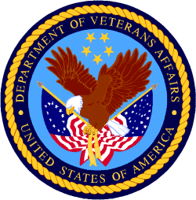

Department of Veterans Affairs

Programs:

Supportive Services for Veteran Families
VA Supportive Services for Veteran Families Program
Synopsis 2
Document Type: | Grants Notice
Funding Opportunity Number: | VA-SSVF-2025
Funding Opportunity Title: | VA Supportive Services for Veteran Families Program
Opportunity Category: | Discretionary
Opportunity Category Explanation:
Funding Instrument Type: | Grant
Category of Funding Activity: | Housing
Category Explanation:
Expected Number of Awards: | 256
CFDA Number(s): | 64.033 -- VA Supportive Services for Veteran Families Program
Cost Sharing or Matching Requirement: | No
Version: | Synopsis 2
Posted Date: | Dec 05, 2023
Last Updated Date: | Dec 05, 2023
Original Closing Date for Applications: | Feb 23, 2024
Current Closing Date for Applications: | Feb 23, 2024
Archive Date: | Mar 24, 2024
Estimated Total Program Funding:
Award Ceiling: | $740,000,000
Award Floor: | $0
Eligibility
Eligible Applicants: | Nonprofits having a 501(c)(3) status with the IRS, other than institutions of higher education
Additional Information on Eligibility:
Additional Information
Agency Name: | Supportive Services for Veteran Families
Description: | The Department of Veterans Affairs (VA) plans to announce the availability of funds for supportive services grants under the  Supportive Services for Veteran Families (SSVF) Program. This NOFA will contain information concerning the SSVF Program,  renewal services grant application processes, and the amount of funding available. Awards made for supportive services grants will fund  operations beginning October 1, 2024.  This NOFA announces the availability of funds for supportive services grants under the SSVF Program and pertains to proposals for renewal of existing supportive services grant programs. New applications for SSVF grant awards will not be funded through this NOFA.
Link to Additional Information: | Link to UDPaaS Grant Management System
Grantor Contact Information: | If you have difficulty accessing the full announcement electronically, please contact:  SSVF  National SSVF Inbox
https://www.grants.gov/search-results-detail/350029

Reminders:

National Veterans Sports Programs
Grants for Adaptive Sports Programs for Disabled Veterans and Disabled Members of the Armed Forces (Equine Assisted Therapy)
Forecast 1
Document Type: Grants Notice  Opportunity Number: VA-EQUINE-24  Opportunity Title: Grants for Adaptive Sports Programs for Disabled Veterans and Disabled Members of the Armed Forces (Equine Assisted Therapy)  Opportunity Category: Discretionary  Opportunity Category Explanation:  Funding Instrument Type: Grant  Category of Funding Activity: Other (see text field entitled "Explanation of Other Category of Funding Activity" for clarification)  Category Explanation: Adaptive Sports and Equine Therapy Activities for Disabled Veterans and Disabled Members of the Armed Forces as authorized by 38 U.S.C. 521A.  Expected Number of Awards:  CFDA Number(s): 64.034 -- VA Grants for Adaptive Sports Programs for Disabled Veterans and Disabled Members of the Armed Forces  Cost Sharing or Matching Requirement: No | Version: Forecast 1  Forecasted Date: Aug 30, 2023  Last Updated Date: Aug 30, 2023  Estimated Post Date: Nov 15, 2023  Estimated Application Due Date: Jan 15, 2024  Estimated Award Date: Sep 30, 2024  Estimated Project Start Date: Oct 01, 2024  Fiscal Year: 2024  Archive Date:  Estimated Total Program Funding:  Award Ceiling:  Award Floor:
Eligibility
Eligible Applicants: | Others (see text field entitled "Additional Information on Eligibility" for clarification)
Additional Information on Eligibility: | Eligible applicants must qualify as a non-Federal Government entity with significant experience in managing a large-scale adaptive sports program for persons with disabilities if those disabilities are those that disabled Veterans and disabled members of the Armed Forces may have.
Additional Information
Agency Name: | National Veterans Sports Programs
Description: | Eligible applicants must qualify as a non-Federal Government entity with significant experience in managing a large-scale adaptive sports program for persons with disabilities if those disabilities are those that disabled Veterans and disabled members of the Armed Forces may have.  The Adaptive Sports Grant Program provides grants to eligible adaptive sports entities to plan, develop, manage, and implement programs to provide adaptive sports activities for Veterans and members of the Armed Forces with disabilities. For the purpose of this program, adaptive sports activities include: (1) instruction, participation, and competition in adaptive sports; (2) training and technical assistance to program administrators, coaches, recreation therapists, instructors, VA employees, and other appropriate individuals; (3) coordination, Paralympic classification of athletes, athlete assessment, sport-specific training techniques, program development (including programs at the local level), sports equipment, supplies, program evaluation, and other activities related to the implementation and operation of the program.  The primary goal for this Notice of Funding Availability (NOFA) is to ensure that appropriate levels of resources are provided to eligible adaptive sports entities with capabilities that are well-suited to meet the needs and priorities for Veterans with disabilities and members of the Armed Forces with disabilities.  This NOFA announces the availability of $1,500,000 to be awarded for proposals providing equine therapy targeted for Veterans and members of the Armed Forces with disabilities related to mental health issues. Adaptive Sports proposals not focused on equine therapy should apply to VA-SPORTS-24.
Link to Additional Information: | https://www.blogs.va.gov/nvspse/grant-program/
Grantor Contact Information: | Vanietta Armstrong Supervisory Grants Management Spc  Grants4vets@va.gov  Adaptive Sports
https://www.grants.gov/web/grants/view-opportunity.html?oppId=350047

National Veterans Sports Programs
Grants for Adaptive Sports Programs for Disabled Veterans and Members of the Armed Forces program
Forecast 1
Document Type: Grants Notice  Opportunity Number: VA-SPORTS-24  Opportunity Title: Grants for Adaptive Sports Programs for Disabled Veterans and Members of the Armed Forces program  Opportunity Category: Discretionary  Opportunity Category Explanation:  Funding Instrument Type: Grant  Category of Funding Activity: Other (see text field entitled "Explanation of Other Category of Funding Activity" for clarification)  Category Explanation: Adaptive Sports and Equine Therapy Activities for Disabled Veterans and Disabled Members of the Armed Forces as authorized by 38 U.S.C. 521A  Expected Number of Awards:  CFDA Number(s): 64.034 -- VA Grants for Adaptive Sports Programs for Disabled Veterans and Disabled Members of the Armed Forces  Cost Sharing or Matching Requirement: No | Version: Forecast 1  Forecasted Date: Aug 30, 2023  Last Updated Date: Aug 30, 2023  Estimated Post Date: Nov 15, 2023  Estimated Application Due Date: Jan 15, 2024  Estimated Award Date: Sep 30, 2024  Estimated Project Start Date: Oct 01, 2024  Fiscal Year: 2024  Archive Date:  Estimated Total Program Funding:  Award Ceiling:  Award Floor:

Eligible Applicants: | Others (see text field entitled "Additional Information on Eligibility" for clarification)
Additional Information on Eligibility: | Eligible applicants must qualify as a non-Federal Government entity with significant experience in managing a large-scale adaptive sports program for persons with disabilities if those disabilities are those that disabled Veterans and disabled members of the Armed Forces may have.

Agency Name: | National Veterans Sports Programs
Description: | The Adaptive Sports Grant Program provides grants to eligible adaptive sports entities to plan, develop, manage, and implement programs to provide adaptive sports activities for Veterans and members of the Armed Forces with disabilities. For the purpose of this program, adaptive sports activities include: (1) instruction, participation, and competition in adaptive sports; (2) training and technical assistance to program administrators, coaches, recreation therapists, instructors, VA employees, and other appropriate individuals; (3) coordination, Paralympic classification of athletes, athlete assessment, sport-specific training techniques, program development (including programs at the local level), sports equipment, supplies, program evaluation, and other activities related to the implementation and operation of the program.  The primary goal for this Notice of Funding Availability (NOFA) is to ensure that appropriate levels of resources are provided to eligible adaptive sports entities with capabilities that are well-suited to meet the needs and priorities for Veterans with disabilities and members of the Armed Forces with disabilities.  This NOFA announces the availability of up to $14,500,000 for initial grants to provide adaptive sports activities under the Adaptive Sports Grant Program to Veterans, and members of the Armed Forces, with disabilities. Proposals with a focus on providing equine therapy targeted for Veterans and members of the Armed Forces should apply to VA-SPORTS-24.
Link to Additional Information: | https://www.blogs.va.gov/nvspse/grant-program/
Grantor Contact Information: | Vanietta Armstrong Supervisory Grants Management Spc  Grants4vets@va.gov  Adaptive Sports
https://www.grants.gov/web/grants/view-opportunity.html?oppId=350048

Veterans Legacy Grant Program
Forecast 1
Document Type: Grants Notice  Opportunity Number: VLGP-FY2024  Opportunity Title: Veterans Legacy Grant Program  Opportunity Category: Discretionary  Opportunity Category Explanation:  Funding Instrument Type: Grant  Category of Funding Activity: Other (see text field entitled "Explanation of Other Category of Funding Activity" for clarification)  Category Explanation: Veterans Legacy Grant Program  Expected Number of Awards: 10  CFDA Number(s): 64.204 -- Veterans Legacy Grants Program  Cost Sharing or Matching Requirement: No | Version: Forecast 1  Forecasted Date: Aug 31, 2023  Last Updated Date: Aug 31, 2023  Estimated Post Date: Apr 01, 2024  Estimated Application Due Date: May 01, 2024  Estimated Award Date: Jul 31, 2024  Estimated Project Start Date: Sep 01, 2024  Fiscal Year: 2024  Archive Date:  Estimated Total Program Funding: $2,200,000  Award Ceiling: $500,000  Award Floor:

Eligible Applicants: | Public and State controlled institutions of higher education  Private institutions of higher education  Independent school districts  Nonprofits having a 501(c)(3) status with the IRS, other than institutions of higher education
Additional Information on Eligibility: | Veterans Service Organizations

Agency Name: | Veterans Legacy Grants Program
Description: | The Department of Veterans Affairs (VA) National Cemetery Administration (NCA) is awarding grants for a maximum of $500,000 per awardee through the Veterans Legacy Grants Program (VLGP), authorized under 38 U.S.C. 2400 note to provide funding to educational institutions and other eligible entities to conduct cemetery research and produce educational tools for the public to utilize and learn about the histories of Veterans interred in VA national cemeteries and VA grant-funded State and Tribal Veterans’ cemeteries. This notice includes information about the process for applying for a VLGP grant; criteria for evaluating applications; priorities related to the award of grants; and other requirements and guidance regarding VLGP grants.
Link to Additional Information: | VA’s Veterans Legacy Grant Program website
Grantor Contact Information: | John D Williams  vlgp@va.gov  Veterans Legacy Grant Program inbox
https://www.grants.gov/web/grants/view-opportunity.html?oppId=350062

VA accesses resources to increase housing assistance for vulnerable Veterans
The Department of Veterans Affairs updated regulations Nov. 10 governing the Supportive Services for Veteran Families grant program to provide a more effective subsidy to Veterans in high-cost rental markets and to increase the cap in general housing assistance available to the most vulnerable Veteran families.
Under the new regulations, in certain communities, the SSVF grant will cover up to 50%, an increase from 35% of eligible Veterans’ reasonable rent for two years without need for recertification.
“We know Veterans are increasingly vulnerable to homelessness and housing insecurity,” said VA Secretary Denis McDonough. “The updated regulations give Supportive Services for Veteran Families grantees more flexibility and tools to keep Veterans housed while also helping them increase their income and access permanent affordable housing solutions.”
The new rule also expands the maximum stay in emergency housing for unsheltered Veterans.
The original rule authorized placement for a Veteran and his or her spouse with dependents in emergency housing for up to 45 days, which proved often not enough time to locate stable and affordable permanent housing in highly competitive rental markets.
A Veteran and his or her spouse with dependents can now stay in emergency housing for a maximum of 60 days. The 15-day increase in length-of-stay is expected to have the most significant benefit to Veteran families in rental markets with few vacancies, as well as unsheltered homeless Veterans families.
Ending Veteran homelessness is a top priority for VA, aligned with the White House’s priority to promote housing stability by supporting vulnerable tenants.
Learn more about VA’s mission to end homelessness among Veterans and how you can help.

PART 2 – GENERAL FEDERAL AGENCY GRANTS INFORMATION
DECEMBER 2023

Please review each department’s General Grant and Funding Overview. These overviews are the key web pages on each departmental website dedicated to the agency’s funding opportunities. Check back often to note the department updates.

(See Part 1 for current grant opportunity notices)

Federal Agencies Discretionary Grants and Contract Website Links

Native Hawaiian Programs

U.S. Department of Agriculture

Grants and Loans Overview

Department of Commerce

Grants at Commerce

Economic Development Administration Hawaiʻi Contacts

Corporation for National and Community Service

General Program Overview

National Service in Hawaiʻi

Department of Defense

Doing Business with the Department of Defense

Department of Education

Grant Programs Overview

US Department of Energy

Grants Overview

Environmental Protection Agency

Grants and Contracts Overview

Department of Health and Human Services

Grants Overview

Department of Homeland Security
Grants Overview

Department of Housing and Urban Development

HUD - Notice of Funds Available

Institute of Museum and Library Services
Grants Overview

IMLS is on Facebook!

Department of Interior

Grants and Contract Overview

Department of Justice

Grants and Contract Overview

Hawaiʻi State Administrative Agency Contacts
________________________________________________________________________

Department of Labor

Grants and Contract General Overview

National Aeronautics and Space Administration

Research Grant and Contract General Overview
_______________________________________________________________
National Archives and Records Administration

Grant Opportunities General Overview
_______________________________________________________________
National Endowment for the Arts

Grant Opportunities General Overview
_______________________________________________________________

National Endowment for the Humanities

Grant Opportunities General Overview
_______________________________________________________________
National Science Foundation

Grant Opportunities General Overview

Small Business Administration

General Overview Finding Loans & Grants

Links Specific to Hawaiʻi

State Department

General Overview and Resources for Program Administrators

_________________________________________________________________________________

U.S. Department of Transportation

General Grant Program Overview

Department of the Treasury

Overview

US Agency for International Development

General Funding Opportunity Overview

Department of Veterans Affairs

Programs

Grants.Gov Links

Grant Writing Resources

SBIR – Small Business Innovation Research

Federal Agency Discretionary Grant and Contract Websites and Overviews

Please review each department’s General Grant and Funding Overview. These overviews are the key web pages on each departmental website dedicated to the agency’s funding opportunities. Check back often to note the department updates.

(See Part 2 for current grant opportunity notices)

Federal Offices of Likely Interest to Native Hawaiians
- U.S. Department of Education
Office of Elementary and Secondary Education
Native Hawaiian Education Programs
White House Initiative on Asian Americans and Pacific Islanders
- U.S. Department of Health and Human Services
Health Resources & Services Administration
Native Hawaiian Health Care Systems
Office of Regional Operations Region 9 Office
Administration for Native Americans
ANA Pacific Region Training and Technical Assistance Center
- U.S. Department of Housing and Urban Development
Federal Housing Administration
Insured Mortgages on Hawaiian Home Lands, FHA Section 247
Office of Native American Programs
Native Hawaiian Housing
Hawaiʻi State Home Page
- U.S. Department of the Interior
National Park Service
Hawaiʻi Parks
National NAGPRA Program
U.S. Fish and Wildlife Service
Pacific Islands Fish and Wildlife Office
Office of the Region One Tribal Liaison
U.S. Geological Survey
Pacific Region - Hawaiʻi
- U.S. Department of Agriculture
Cooperative Research and Extension Services
Farm Service Agency - Hawaiʻi and Pacific Basin
Natural Resources Conservation Services - Pacific Islands Area
Rural Development - Hawaiʻi
- U.S. Department of Defense
Office of the Deputy Under Secretary of Defense (Installations & Environment)
Senior Advisor and Liaison for Native American Affairs
Native Hawaiian Affairs
- Advisory Council on Historic Preservation
Office of Native American Affairs
- U.S. Department of Commerce
U.S. Economic Development Administration
University Center Economic Development Program
Representative covering the State of Hawaiʻi
National Oceanic and Atmospheric Administration
NOAA in Your State - Hawaiʻi
- U.S. Small Business Administration
Hawaiʻi District Office
8(a) Business Development Program (open to qualified Native Hawaiian businesses)
- U.S. Department of the Treasury
Community Development Financial Institution Fund (CDFI Fund)
- U.S. Department of Veteran Affairs
Center for Minority Veterans
Office of Diversity and Inclusion

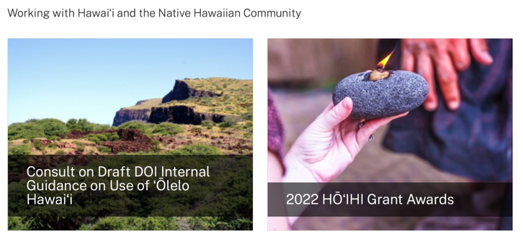
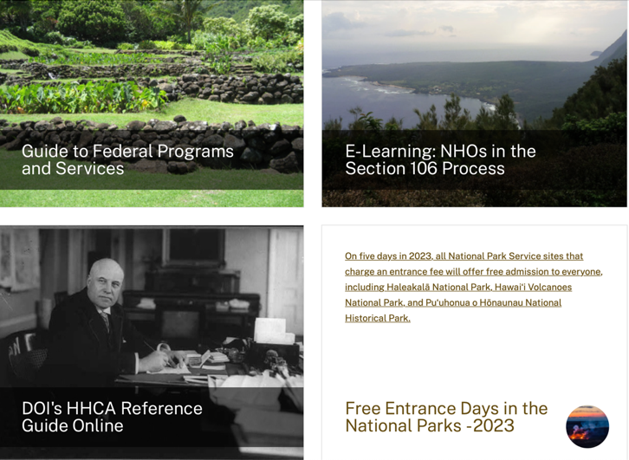
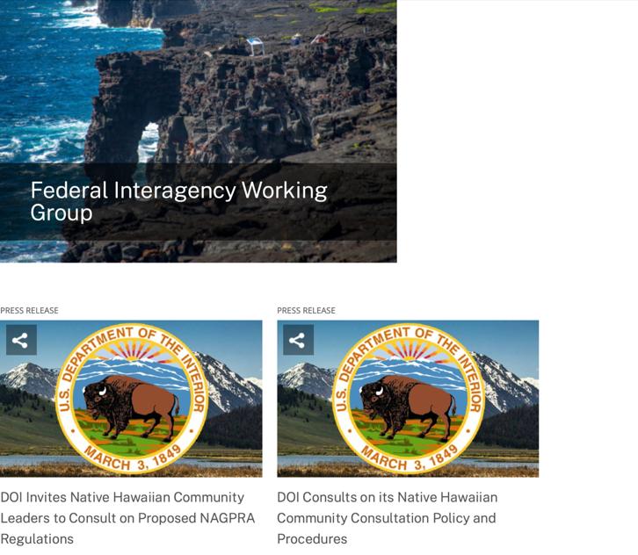
https://www.doi.gov/Hawaiian

Office of Hawaiian Affairs Community Grants Program
Grants – The purpose of the Office of Hawaiian Affairs Grants Program is to support Hawaiʻi based nonprofit organizations that have projects, programs, and initiatives to serve our Lāhui in alignment with OHA’s Strategic Foundations, Directions & Outcomes.
Reminder, to be eligible for funding consideration, an applicant shall:
- Be registered to do business in the State of Hawaiʻi
- Provide services to Native Hawaiians and/or Native Hawaiian community(ies) in the State of Hawaiʻi
- Have an IRS letter of Determination
- Compliant with Hawaiʻi Compliance Express

https://www.oha.org/resources/

Resources
Providing resources is among the key ways that the Office of Hawaiian Affairs fulfills its purpose.
The best possible Native Hawaiian historical and cultural information has been just a click away since the launch in April 2013 of the Kipuka Database. It is a searchable online geographic information system that makes data that once would have taken long to compile, now available within seconds. The database helps complement our other key research tools, such as the Native Hawaiian Data Book and the Papakilo Database, which is a digital library for Native Hawaiian historical and cultural information.
In addition, we launched Kamakako’i, an issues-based digital media tool that has been years in the making. The cutting-edge website provides a platform to quickly engage key audiences and inspire action on policy matters important to the Native Hawaiian community.

Resources
- Grants – The purpose of the Office of Hawaiian Affairs Community Grants Program is to support projects, programs and initiatives that address OHA’s six Strategic Priorities and accompanying Strategic Results contained in OHA’s 2010-2018 Strategic Plan.
- Kamakakoʻi – A cutting edge tool that leverages technology to engage, inform, activate and rally the Hawaiʻi community around voices on the cutting edge of community issues. It is produced and maintained by the Office of Hawaiian Affairs.
- Ka Wai Ola – Ka Wai Ola is a monthly newspaper published by OHA. The Ka Wai Ola operates under the Communications division of Community Engagement. The Ka Wai Ola has about 60,000 subscribers and strives to create rich content geared toward captivating the Hawaiian community.
- Kīpuka Database – A geographical information system (GIS) that utilizes the latest mapping technologies to provide a window into native Hawaiian land, culture and history.
- Loans – The Office of Hawaiians Affairs is committed to ensuring Native Hawaiians and their ‘ohana have access to resources to assist them in pursuing their financial goals.
- OHA Native Hawaiian Data Book – A compilation of basic demographic data on Hawaiians and data to identify gaps and important issues to ensure OHA’s actions and initiatives are based on the best information available.
- Papakilo Data Base – A comprehensive “Database of Databases” consisting of varied collections of data pertaining to historically and culturally significant places, events, and documents in Hawaiʻi ’s history.
- Reports and Research – A collection of reports and surveys intended to help guide strategic direction and policy decisions.
- Scholarships – Each year OHA provides funding for scholarships through its Higher Education Scholarship Programs.

U.S. Department of Agriculture

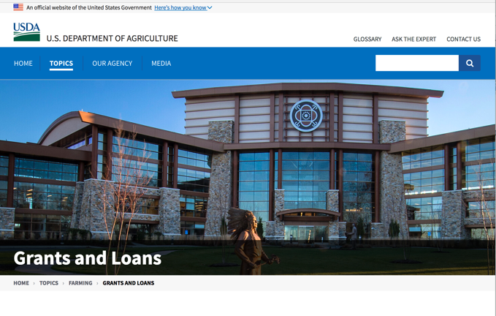

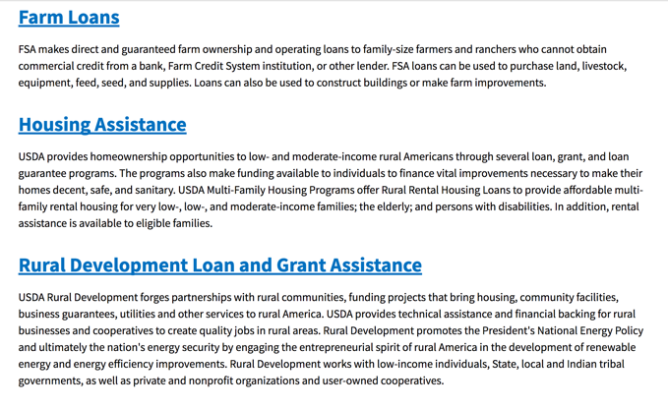

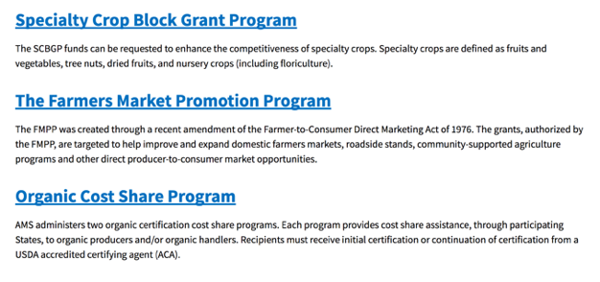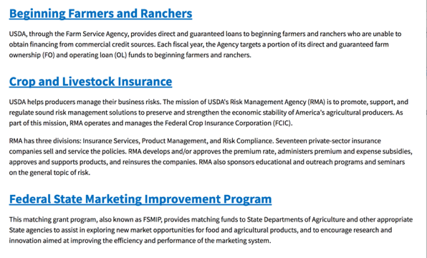
https://www.usda.gov/topics/farming/grants-and-loans
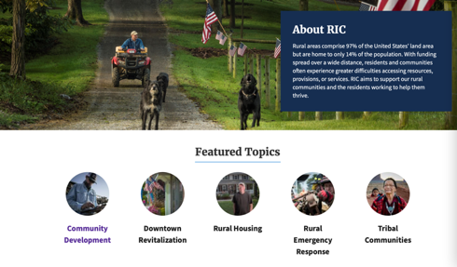https://www.nal.usda.gov/ric/community-development-resources

Department of Commerce

Grants, Contracting, and Trade Opportunities at Commerce
Learn more information about grants, contracting and trade opportunities at the Department of Commerce using the information below
https://www.commerce.gov/work-with-us/grants-and-contract-opportunities
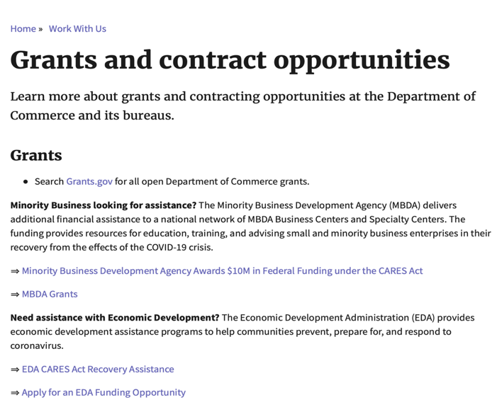

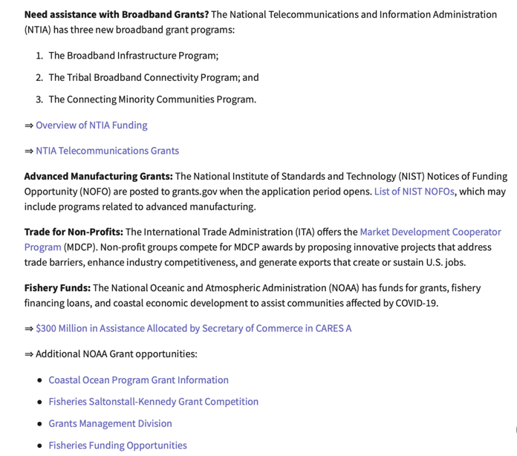
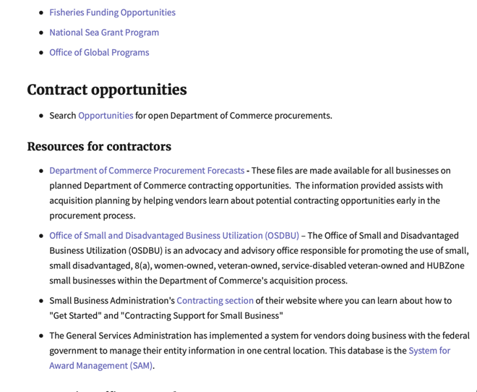
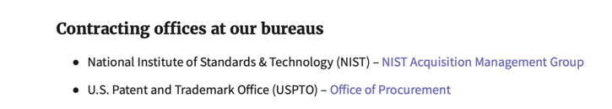
DOC Grant Making Bureaus
Economic Development Administration (EDA)
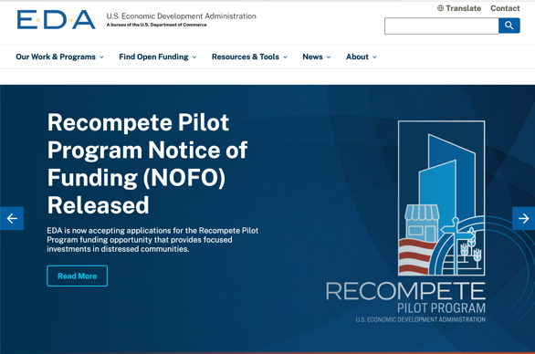
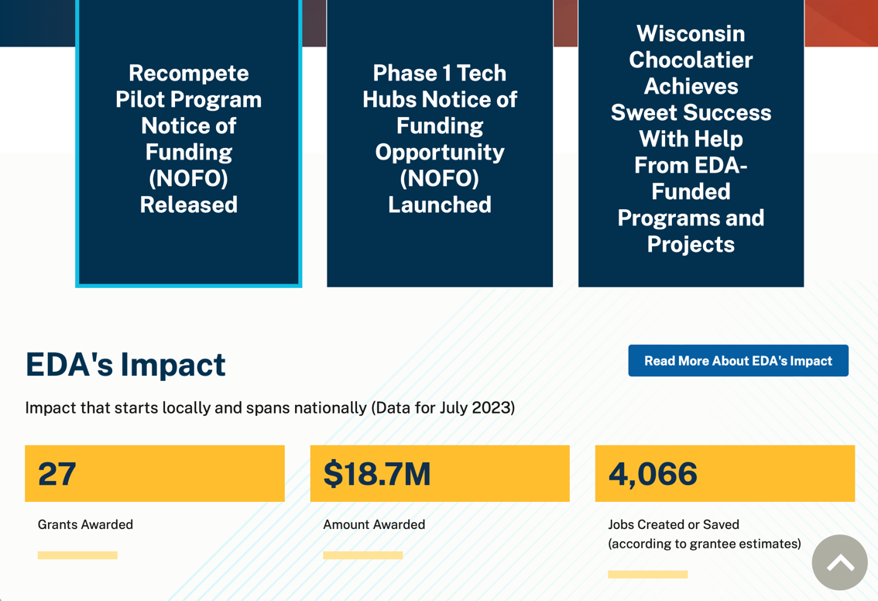
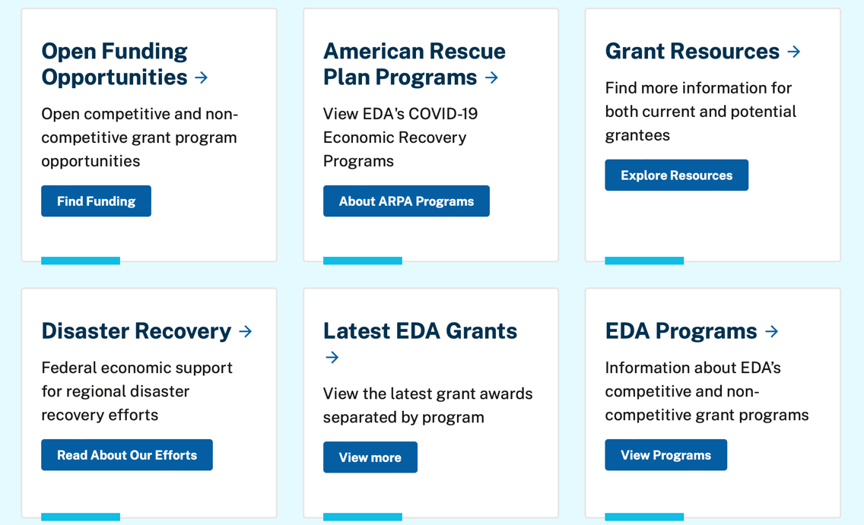

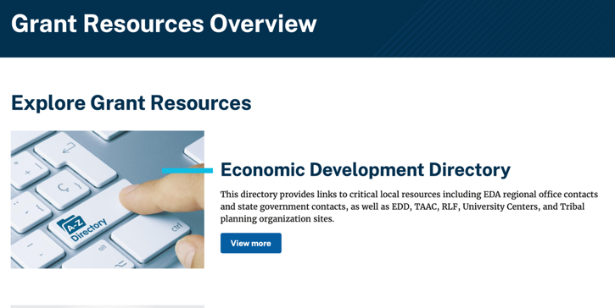
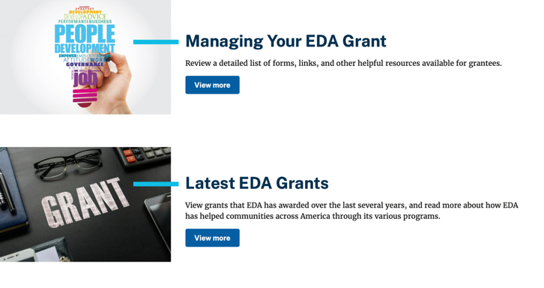

https://www.eda.gov/grant-resources

Economic Development Administration Hawaiʻi Contacts

https://www.eda.gov/archives/2016/resources/economic-development-directory/states/hi.htm

International Trade Administration (ITA)
- Market Development Cooperator Program
- Special American Business Internship Training Program (SABIT). A technical assistance initiative of the International Trade Administration of the U.S. Department of Commerce, SABIT offers organizations competitive grants and an opportunity to host industry-specific delegations. SABIT serves as an initial entry point for U.S. businesses seeking funding to establish long-term relationships with potential customers, distributors, or partners in the former Soviet Union. The program trains Eurasian managers and scientists in commonly accepted business practices as a means of facilitating cross border relationships. In turn, these personal relationships serve as a basis for business development and reduce market access barriers for U.S. businesses.
National Institute of Standards & Technology (NIST)
- Funding Opportunities
National Telecommunications & Information Administration (NTIA)
- Telecommunications Grants
National Oceanic & Atmospheric Administration (NOAA)
- Coastal Ocean Program Grant Information
- Fisheries Saltonstall Kennedy Grant Program
- National Undersea Research Program Funding Opportunities
- Grants Management Division
- Fisheries Grants Program
- National Sea Grant
- Office of Global Programs
Contracting Resources for Contractors
- Office of Small and Disadvantaged Business Utilization (OSDBU) - the Office of Small and Disadvantaged Business Utilization (OSDBU) is an advocacy and advisory office responsible for promoting the use of small, small disadvantaged, 8(a), women-owned, veteran-owned, service-disabled veteran-owned, and HUBZone small businesses within the U.S. Department of Commerce's (DOC) acquisition process.
- Business.USA.gov's Find Opportunities Wizard where in a few quick steps, it will guide you towards federal government contracting programs and opportunities for your business!
- Planned Acquisitions: the Department of Commerce's search tool for our planned acquisitions over $100,000. As requirements change, these acquisition plans are updated by department personnel and this search tool is automatically updated.
- Small Business Administration's Contracting section of their web site where you can learn about how to "Get Started" and "Contracting Support for Small Business."
- The General Services Administration (GSA) has implemented a system for vendors doing business with the Federal Government to manage their entity information in one central location. This new database is the System for Award Management (SAM).
DOC Contracting Offices
- Patent and Trademark Office (PTO)
  - Office of Procurement

- National Institute of Standards & Technology (NIST)
Trade Opportunities through Commerce
http://www.commerce.gov

Corporation for National and Community Service

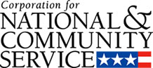

General Program Overview

AmeriCorps provides resources, both human and financial, to organizations that engage Americans in intensive service to meet our country’s critical needs.
Grantees use the funding to support AmeriCorps members for intensive service in their community. AmeriCorps grants partially cover the expense of operating an AmeriCorps program and do not cover general organizational expenses. A cash and in-kind match are required.

The main website can be accessed here: http://www.nationalservice.gov

For access to further funding information: https://americorps.gov/partner/funding-opportunities

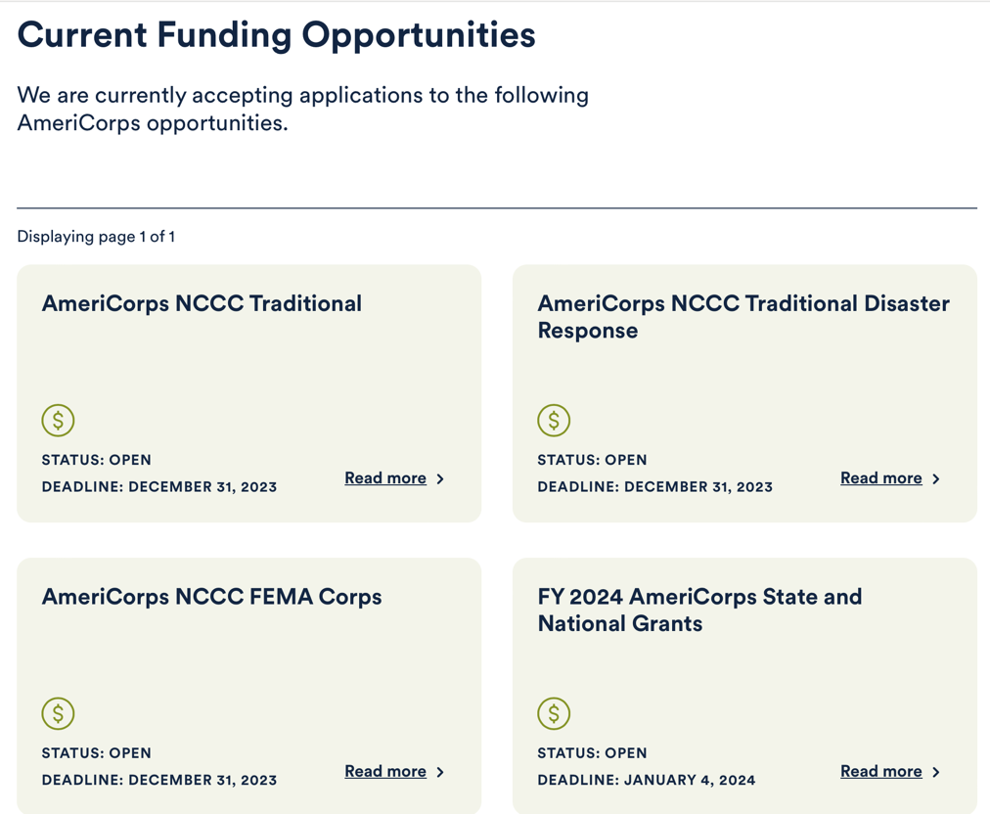
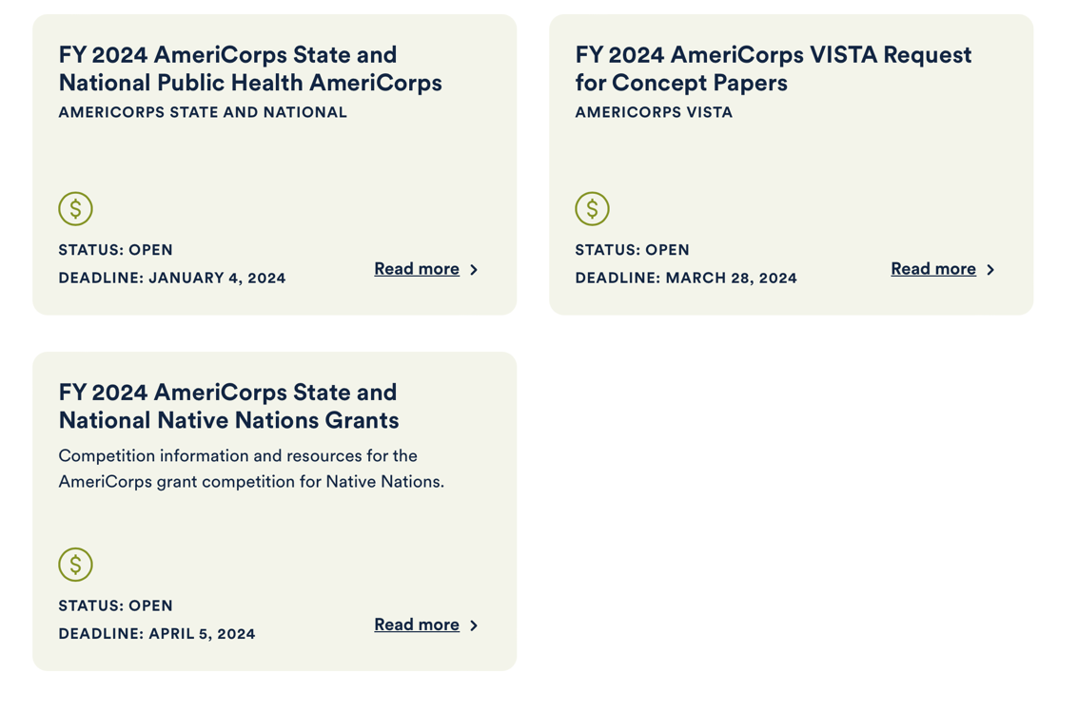
Read more

Closed Funding Opportunities
Past funding opportunities, archived for public record.

Funded Grants
AmeriCorps, AmeriCorps Seniors, and Day of Service awards.

https://www.americorps.gov/partner/funding-opportunities

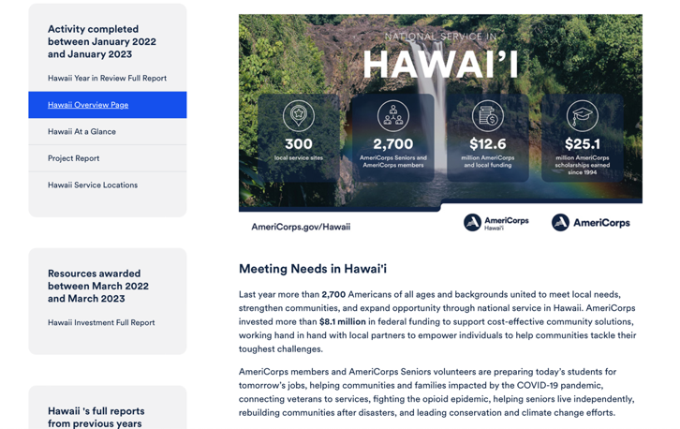
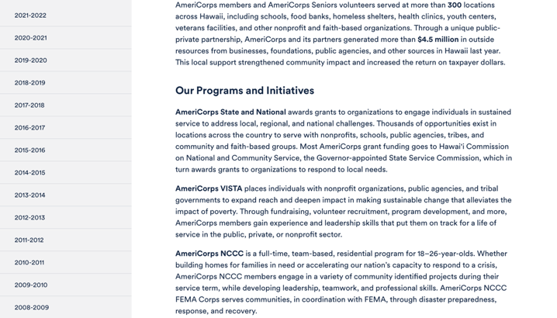
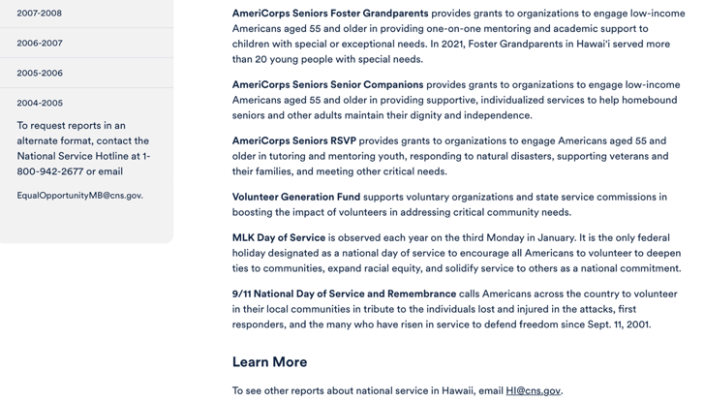

Learn More https://americorps.gov/national-service-report/hi
To see other reports about national service in Hawaiʻi , please contact HI@cns.gov.
The Corporation for National and Community Service is a federal agency that improves lives, strengthens communities, and fosters civic engagement through service and volunteering. To learn more, visit www.NationalService.gov or call 202-606-5000 or TTY 1-800-833-3722.

U.S. Department of Defense

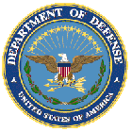

Doing Business with the Department of Defense

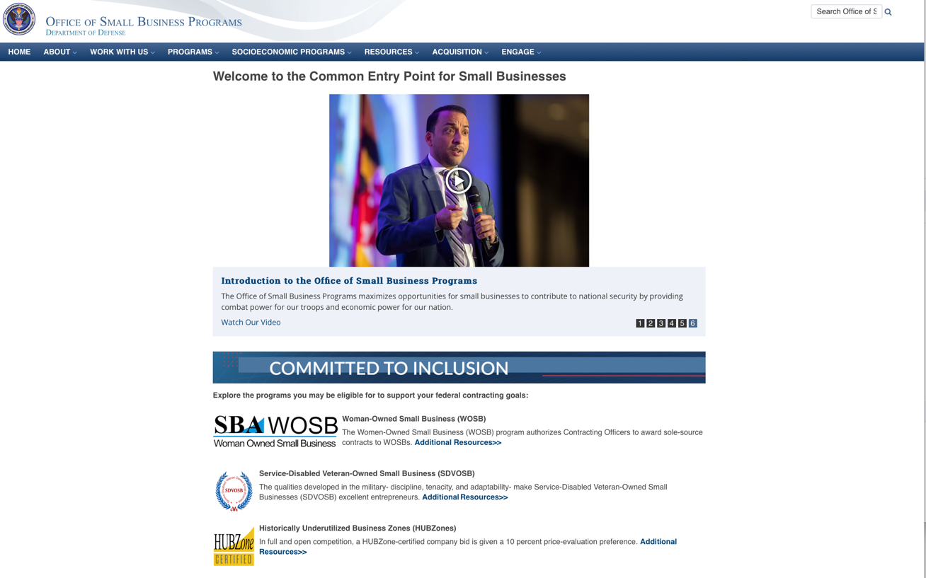

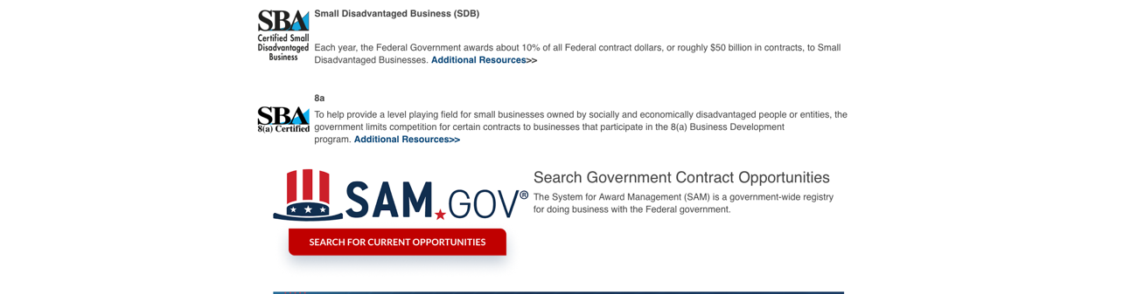

http://business.defense.gov

Department of Education


Grant Programs Overview at the Department of Education

The general information page for Education Grant funding is an excellent resource describing the three types of grants awarded by the Department of Education. See the screen shot of the Department of Education web page below:

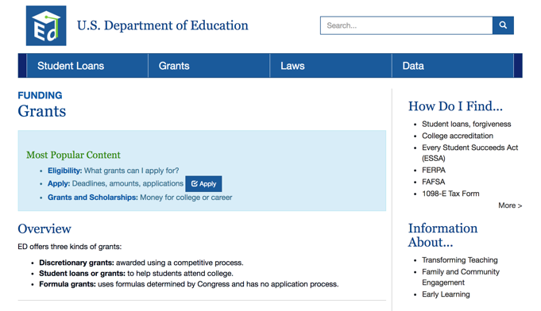
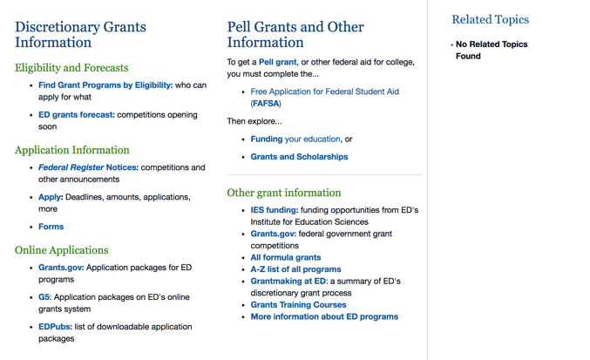

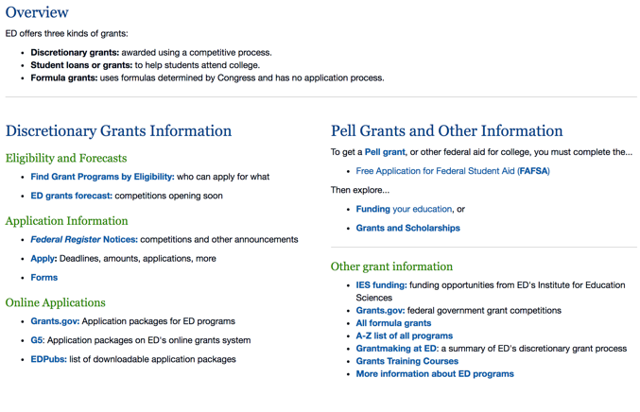

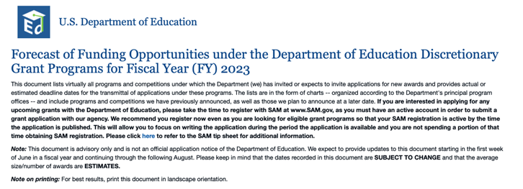

https://www2.ed.gov/fund/grant/find/edlite-forecast.html

U.S. Department of Energy

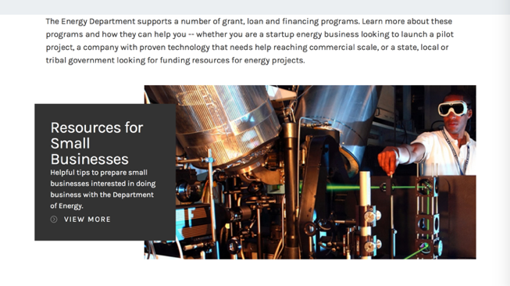
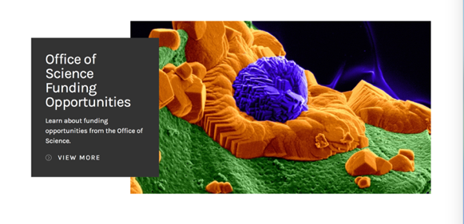

https://www.energy.gov/energy-economy/funding-financing

Environmental Protection Agency

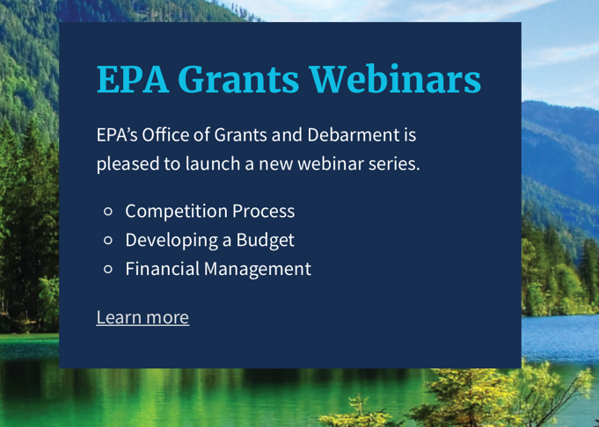

Quick Links

EPA References
- EPA’s Grants Management Plan
- EPA Financial Services (Receive a Payment)
- Disadvantaged Business Enterprises (DBE)
- Financial Assistance Infrastructure Programs Subject to BABAA
- Financial Assistance Programs subject to Executive Order 12372 (Intergovernmental Review)

Federal Grants Websites
- Grants.gov
- System for Award Management (SAM)
- EPA Assistance Listings
- USASpending.gov

https://www.epa.gov/grants/epa-grants-webinars

https://www.epa.gov/grants

Department of Health and Human Services

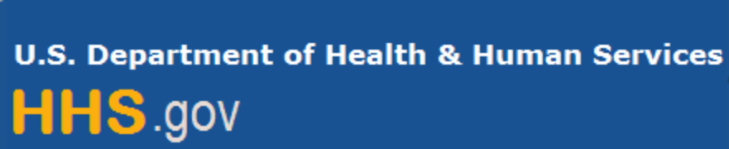

Grants Forecast and Overview

The Department of Health and Human Services’ Grants Forecast is a database of planned grant opportunities proposed by its agencies. Each Forecast record contains actual or estimated dates and funding levels for grants that the agency intends to award during the fiscal year. Forecast opportunities are subject to change based on enactment of congressional appropriations.

For more general information about HHS Grants and Funding go to the website below at:

https://www.hhs.gov/grants/grants/index.html

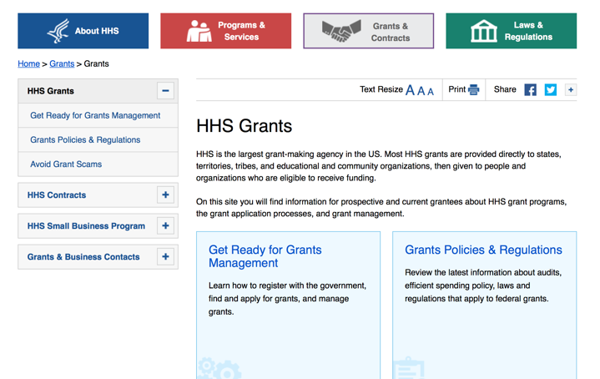

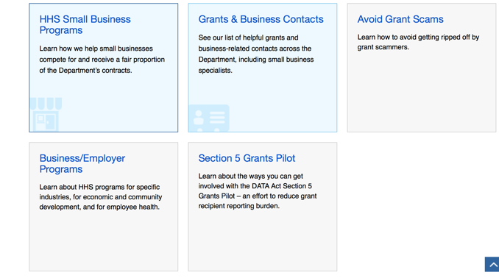

Department of Homeland Security



The Department of Homeland Security enhances the ability of states, local and tribal jurisdictions, and other regional authorities in the preparation, prevention, and response to terrorist attacks and other disasters, by distributing grant funds. Localities can use grants for planning, equipment, training and exercise needs.

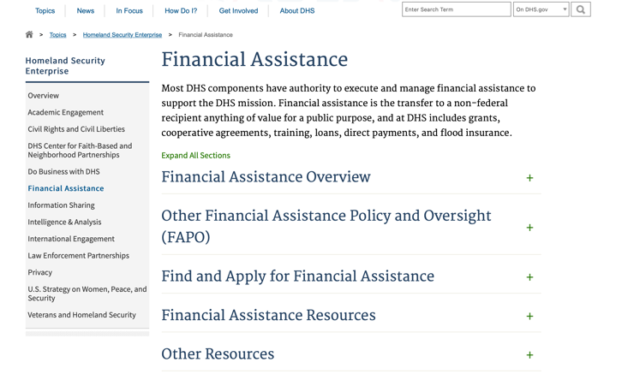

Webpage can be viewed at: https://www.dhs.gov/dhs-financial-assistance#2

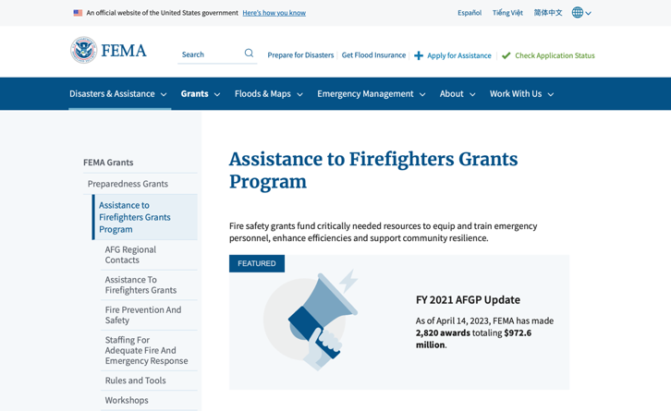
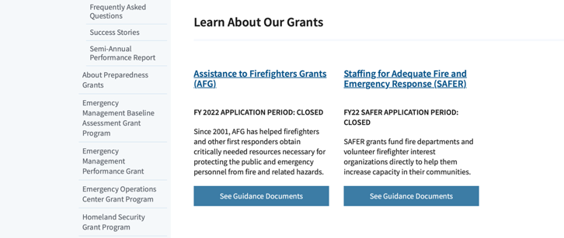
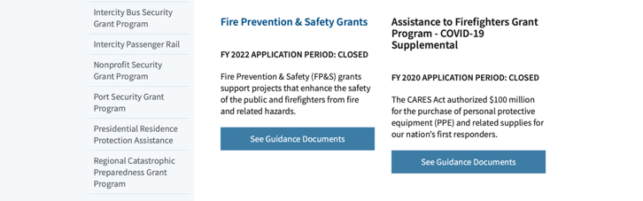

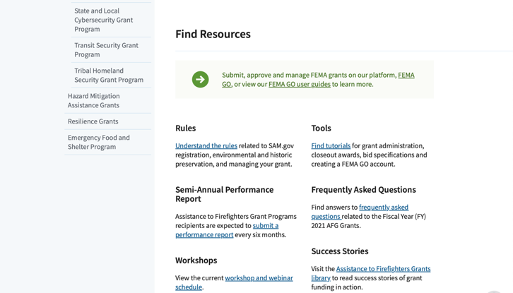
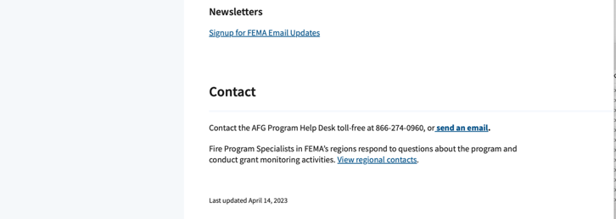
(Most recent update as of 8/8/2023)

https://www.fema.gov/welcome-assistance-firefighters-grant-program

For AFG program guidance materials, please visit our Documents page.

Resources

AFG Help Desk
Contact the AFG Program Help Desk toll-free at 866-274-0960, or email us at firegrants@dhs.gov.
The AFG Program has Fire Program Specialists in 10 federal regional centers. These Regional Fire Program Specialists respond to questions about the AFG program and carry out grant monitoring activities. View regional contacts

Popular AFG links
- Assistance to Firefighters Grants (AFG)
- AFG Awards List
- Staffing for Adequate Fire & Emergency Response (SAFER) Grants (SAFER)
- SAFER Awards List
- SAFER Success Stories
- Fire Prevention & Safety (FP&S) Grants
- FP&S Awards List
- FP&S Success Stories
- Grant Closeout Tutorial
- Assistance to Firefighters Grant (AFG) Email Alert Archive
- Frequently Asked Questions
Contact Information For The Assistance to Firefighters Grant (AFG) Program and Help Desk

Federal Funding Alternative To AFG

https://www.fema.gov

Department of Housing and Urban Development

https://www.hud.gov/program_offices/spm/gmomgmt/grantsinfo

HUD - Notice of Funds Available
For detailed information click here

Fiscal Year 2023 Funding Opportunities
HUD awards discretionary funding through over 20 Grant programs that support HUD initiatives, including Affordable Housing Development and Preservation, Community and Economic Development, Environment and Energy, Fair Housing, Homelessness, Homeownership, Rental Assistance, Supportive Housing and Services.
Notice of Funding Opportunity (NOFO) – The Notice of Funding Opportunities (NOFO) is a published each year on Grants.gov for HUD’s Discretionary Funding Programs. These NOFOs describe the type of funding available on a competitive basis and provides information on submission of an application, typically up to 30 to 90 days from the date of the NOFO publication on grants.gov.

Additional Information Related to HUD's Funding Opportunities
- 2 CFR Crosswalk - On August 13, 2020, the Office of Management and Budget (OMB) revised Federal Guidance for Grants and Agreements, to include 2 CFR 25, 2 CFR 170, 2 CFR 183, and 2 CFR 200. An index of those changes was consolidated in a document for reference. Here is the link to the document: https://www.cfo.gov/wp-content/uploads/2020/12/2-CFR-Crosswalk_20201106.xlsx
- Part 200 of Title 2 of the Code of Federal Regulations (2 CFR Part 200)
- Eligibility Requirements for Applicants of HUD's Grants Programs - 2023
- Eligibility Requirements for Applicants of HUD's Grants Programs - 2022
- Administrative, National & Departmental Policy Requirements and Terms for HUDs Financial Assistance - 2023
- Administrative, National & Departmental Policy Requirements and Terms for HUDs Financial Assistance - 2022
- Build American, Buy America Act (BABA)
  - This site provides a comprehensive collection of proposed, currently effective, and expired waivers (as they become available) of the Build America, Buy America Act (BABA) domestic content procurement preference as applied to HUD’s Federal Financial Assistance programs
- Environmental Requirements
  - E.O. 12898 Federal Actions to Address Environmental Justice
  - E.O. 14008 Tackling the Climate Crisis
- Code of Conducts Page

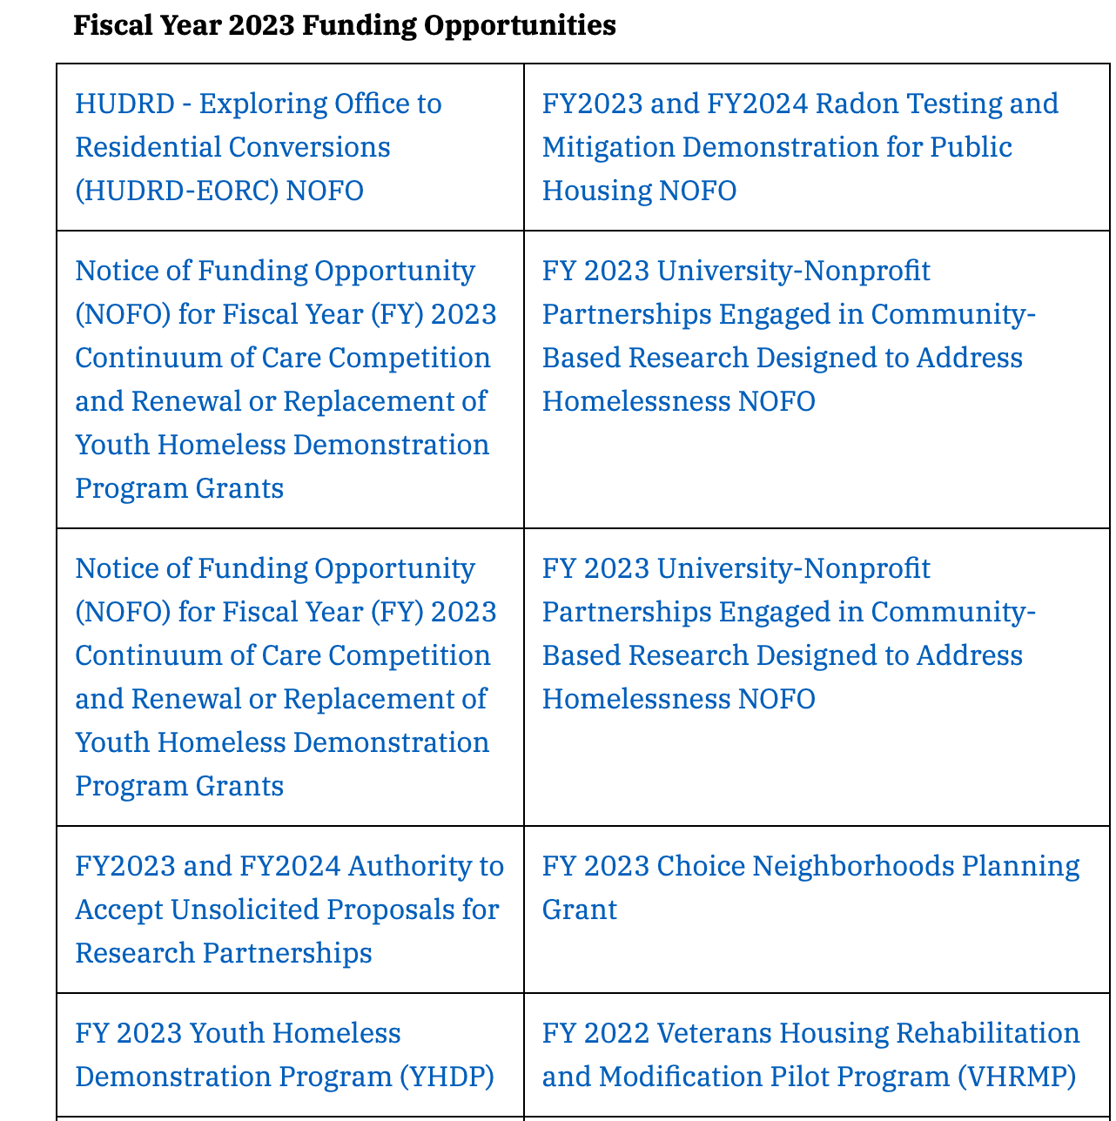
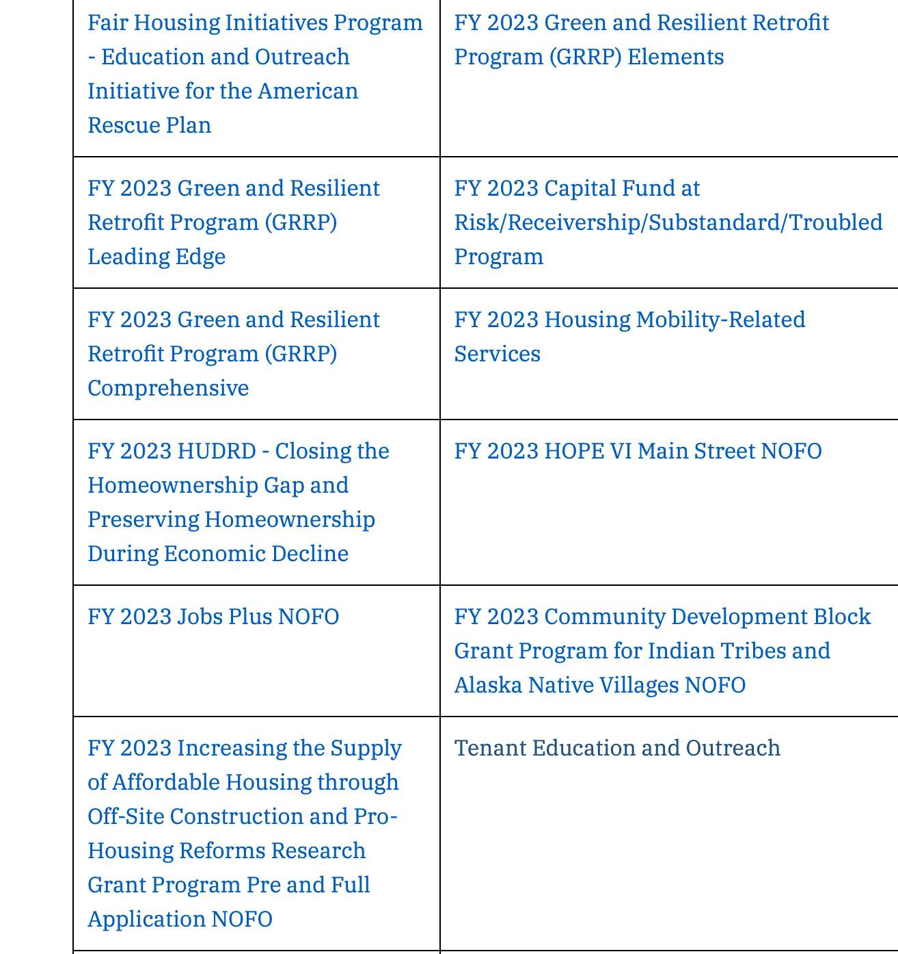
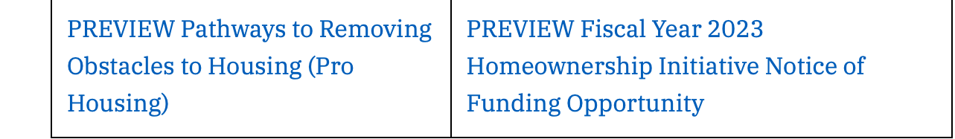

Forecast for Expected Fiscal Year 2023 Funding Opportunities
The Department of Housing and Urban Development NOFO Forecast list below identifies competitive grant opportunities that may be available for Fiscal Year (FY) 2023. The inclusion or exclusion of an opportunity in the listing below does not constitute a guarantee that a specific opportunity will become available or not be available. Forecast opportunities are subject to change based on enactment of Congressional appropriations and other considerations.
When funding is available, HUD will issue a Notice of Funding Opportunity (NOFO), which will be published on Grants.gov and the Funds Available webpage will be updated to indicate the NOFO has been published. Each NOFA provides guidance on how to apply for funding.
Office of Community Planning and Development (CPD)
- Self-Help Homeownership Opportunity Program (SHOP)
- Section 4 Capacity Building for Community Development and Affordable Housing (RCB)
- The Youth Homelessness Systems Improvement Program
- Continuum of Care Competition and Renewal or Replacement of Youth Homeless Demonstration Program
- Housing Opportunities for Persons with AIDS (HOPWA) Competitive Grant: Housing Interventions HINT) to End the HIV Epidemic
- Community Development Block Grant (CDBG) Pro – Housing
- Community Development Block Grant (CDBG) Price
Office of Fair Housing and Equal Opportunity (FHEO)
- Fair Housing Initiatives Program – Education Outreach Initiative
- Fair Housing Initiatives Program – Fair Housing Organization Initiative
- Fair Housing Initiatives Program – Private Enforcement Initiative

Office of Healthy Homes Lead Hazard Control (OHHLHC)
- FY2023 and FY2024 Radon Testing and Mitigation Demonstration for Public Housing
- Lead and Healthy Homes Technical Studies (LHHTS) Grant Program Pre- and Full Application
- Healthy Homes Production Grant Program
- Older Adult Modification Grant Program
- Healthy Homes Weatherization Cooperative Demonstration
Office of Housing (HSNG)
- Green and Resilient Retrofit Program Comprehensive
- Green and Resilient Retrofit Program Elements
- Green and Resilient Retrofit Program Leading Edge
- Section 811 Supportive Housing for Persons with Disabilities - Capitol Advance
- Section 811 Supportive Housing for Persons with Disabilities – Project Rental Assistance
- Fiscal Years 2022 and 2023 Homeownership Initiative Grant
- Comprehensive Housing Counseling Grant Program
- Service Coordinators in Multifamily Housing (SCMF) Discretionary
- Tenant Education and Outreach
Office of Policy Development and Research (PD&R)
- FY23 HUDRD - FHA’s Role in Closing the Homeownership Gap and Preserving Homeownership During Economic Decline
- FY2023 and FY2024 Authority to Accept Unsolicited Proposals for Research Partnerships
- Increasing the Supply of Affordable Housing through Off-Site Construction and Pro-Housing Reforms Research Grant Program Pre and Full Application
- Eviction Protection Grant Program

Office of Public and Indian Housing (PIH)
- Community Development Block Grant Program for Indian Tribes and Alaska Native Villages
- Housing Mobility-Related Services
- Indian Community Development Block Grant
- Capital Fund at Risk/Receivership/ Substandard/ Troubled Program
- Foster Youth to Independence (FYI) Competitive
- Resident Opportunity and Self-Sufficiency (ROSS) Service Coordinator Program
- Jobs Plus NOFO
- FY2023 HOPE VI Main Street Grant Program
- Choice Neighborhoods Implementation Grants

Updated 12/11/2023

http://portal.hud.gov/hudportal/HUD?src=/program_offices/Administration/grants/fundsavail

Institute of Museum and Library Services

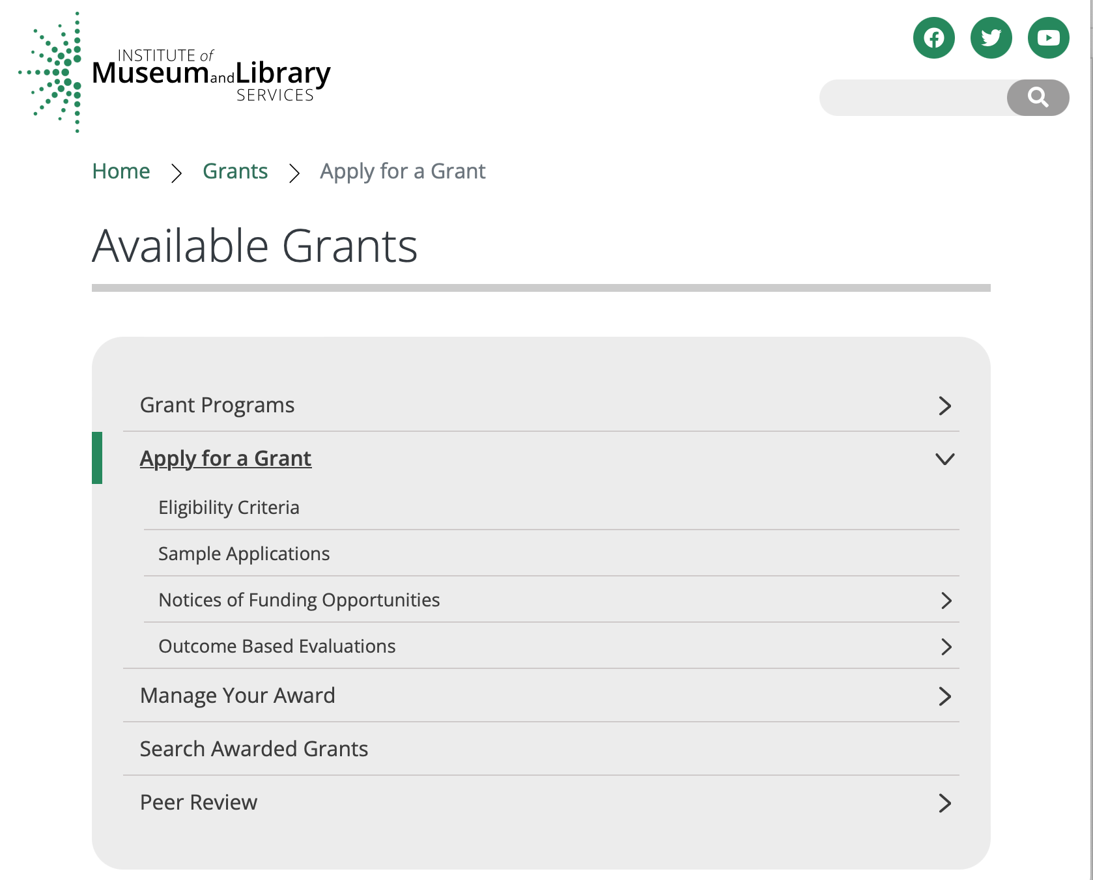

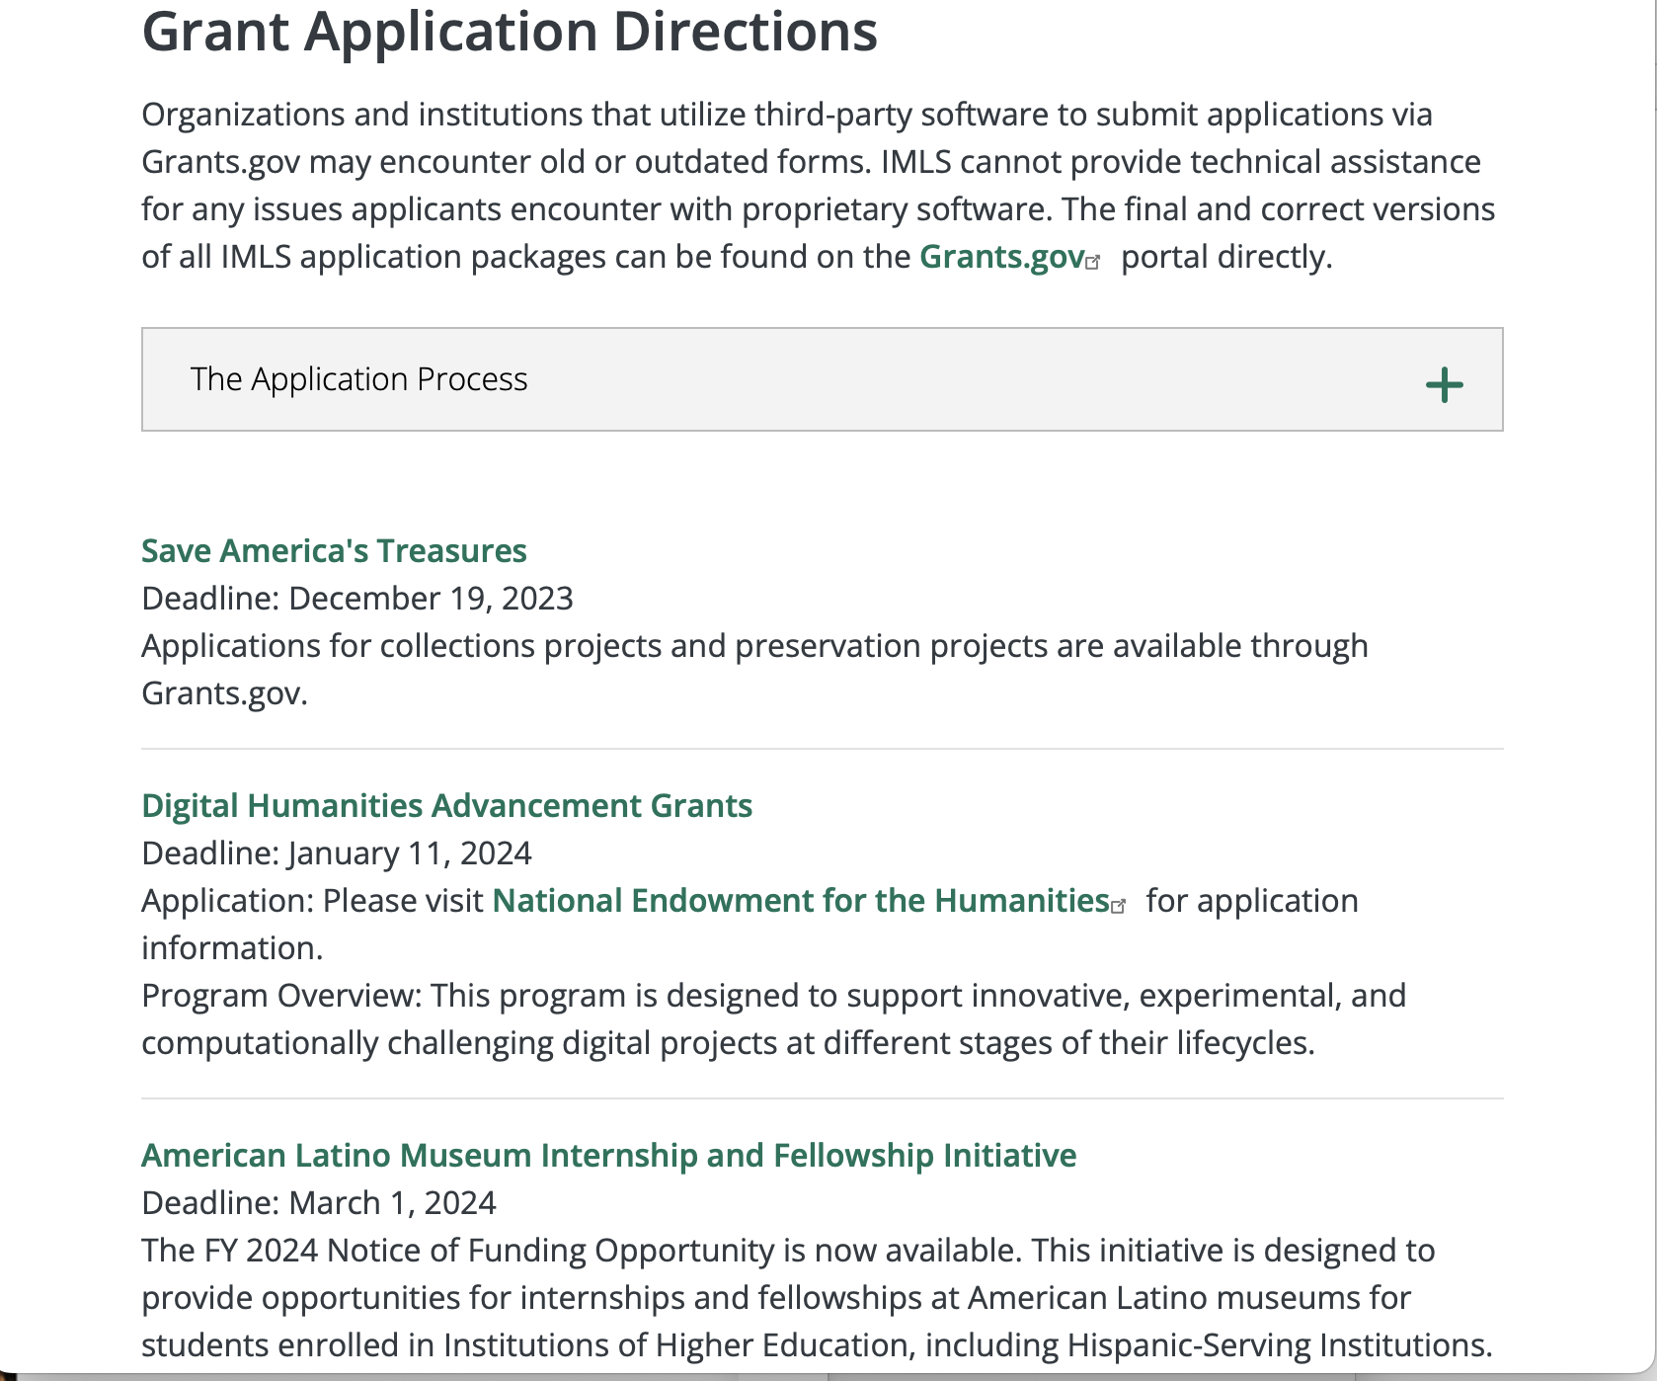

https://www.imls.gov/grants/apply-grant/available-grants

https://www.imls.gov/grants/apply-grant/available-grants

The Application Process
1. Search for available grants
Grant programs and deadlines can be searched by name, by eligible institution type, and by project type.
2. Check eligibility requirements
Eligibility criteria will vary by program. Checking the program-specific criteria will help you ensure you're applying for the right grant for your institution. Read more.
3. Read application Notice of Funding Opportunities
Read through the application Notice of Funding Opportunities carefully to get all the information you need on the grant program. Read more.
4. Compose your application
Use the following Applicant Tools & Materials links to help you compose a stronger, more competitive application.
a. Sample Applications - Examples of successful applications from previous years
b. Outcome Based Evaluations - Introduction to and resources for successful program evaluation
c. Shaping Outcomes - An IMLS-funded online course on outcomes-based planning and evaluation, which will help participants improve program designs and evaluations.
d. Grantee Requirements - Administration and dissemination requirements for all grantees
e. Reviewer Materials - Guidelines and handbooks used during application review
5. Contact an IMLS Staff Member
We welcome calls from applicants and are happy to answer any questions about the grant application and review process. Conversations with staff can provide useful guidance and help you to explore how your idea may match the goals of a grant program. To reach an IMLS staff member please click on a link below for the grant program in which you are interested.
6. Submit your application via Grants.gov
Consult our Grants.gov guidelines to ensure we will receive your application, complete and on-time. Read more.
7. What happens next?
Learn how applications are reviewed and when grant announcements are made. Read more.
Digital Humanities Advancement Grants
Deadline: January 11, 2024
Application: Please visit National Endowment for the Humanities for application information.
Program Overview: This program is designed to support innovative, experimental, and computationally challenging digital projects at different stages of their lifecycles.

Each grant program has specific eligibility requirements. The links below provide general eligibility criteria for museums, libraries, and tribal organizations, but please note that additional organizations may be eligible for grants under certain programs. Additionally, ineligible organizations may still be able to participate in grant programs through partnerships with eligible organizations. Please click on the links below to see general criteria and review Applications and Guidelines for specific information.
Museums Libraries
Institutions: Archives, Federally Recognized Native American Tribe, Historical Society, Library, Nonprofits that serve Native Hawaiians, Professional Association, Public or Private Non-profit Institutions of Higher Education, Regional Organization, State Library Administrative Agency, State or Local Government.

Check out IMLS's Facebook page at:
https://www.facebook.com/USIMLS/

Department of the Interior
The Interior Department provides assistance to the public, local governments and businesses through a number of programs.

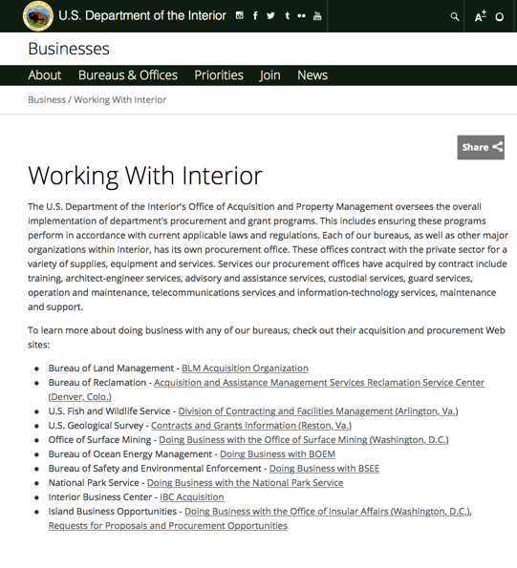

http://www.doi.gov/businesses/working-with-interior.cfm

Department of Justice

http://www.justice.gov/business/

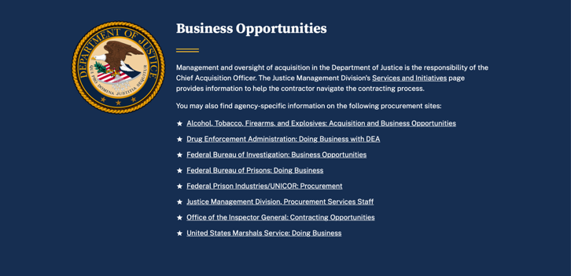

The DOJ agencies listed below also have sites that provide grant information specific to that agency. Examples of what can be found on these sites are programs, funding opportunities, application assistance, and other useful information.

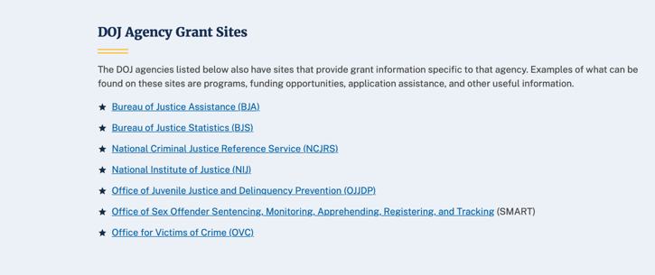

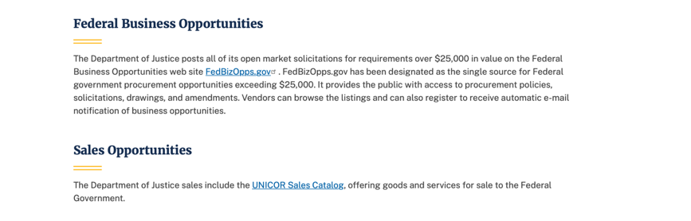

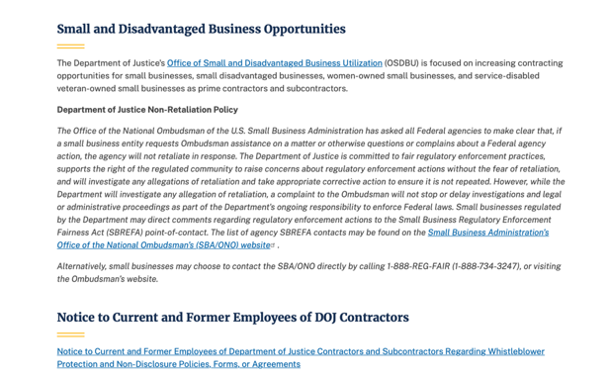

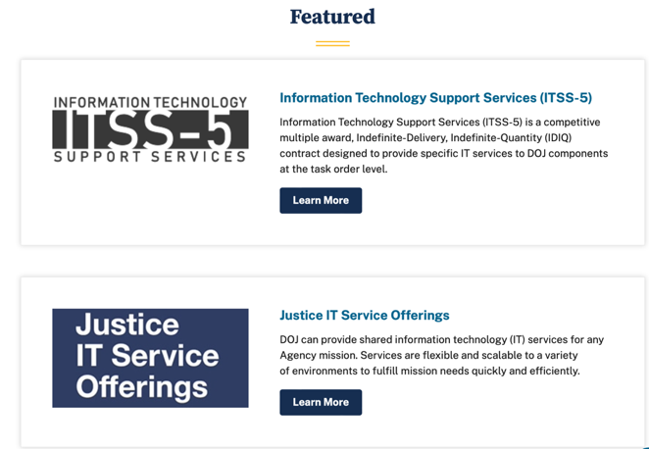

Bureau of Justice Assistance (BJA)

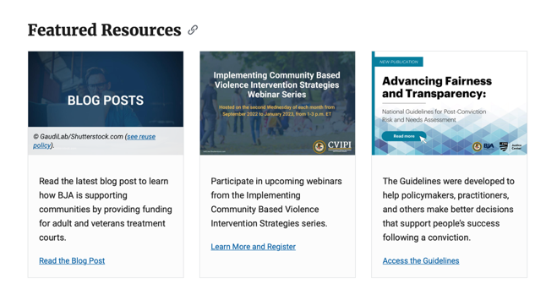

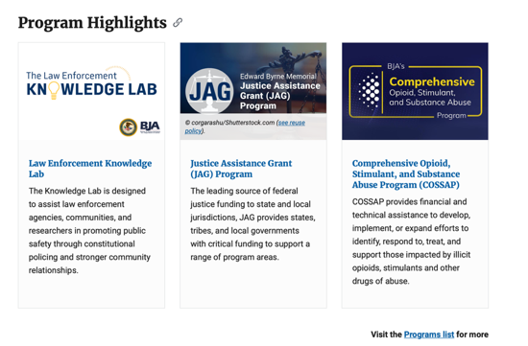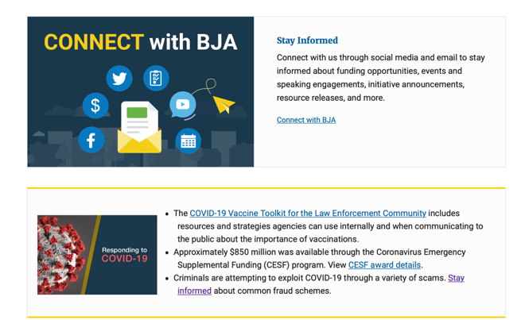

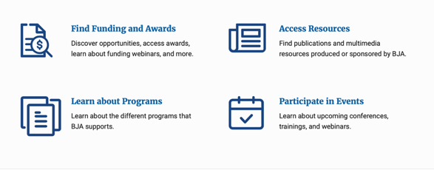

Bureau of Justice Statistics (BJS)

National Criminal Justice Reference Service (NCJRS)

National Institute of Justice (NIJ)

Office of Sex Offender Sentencing, Monitoring, Apprehending, Registering, and Tracking (SMART)

Hawaiʻi State Administrative Agency Contacts

HAWAIʻI DEPARTMENT OF THE ATTORNEY GENERAL, CRIME PREVENTION & JUSTICE ASSISTANCE DIVISION
235 S Beretania Street, Suite 401
Honolulu, HI 96813
(808) 586-1150
Agency Head: Julie Ebato, Administrator
JAG Contact: Shaleigh Tice, Grants & Planning Branch Chief
SAC Director: Paul Perrone, Chief of Research and Statistics

https://ag.Hawaiʻi .gov/cpja/gp/

Department of Labor

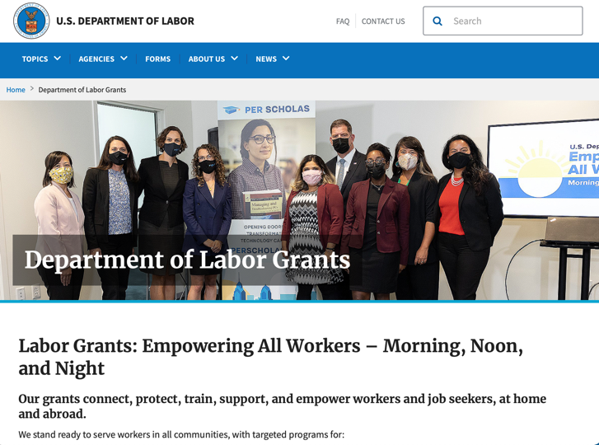
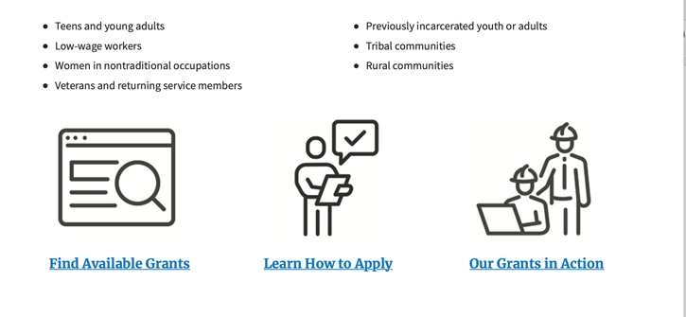

https://www.dol.gov/general/grants/howto

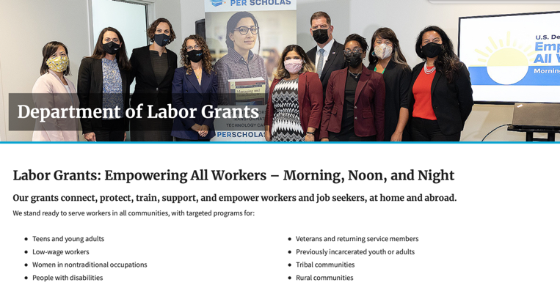

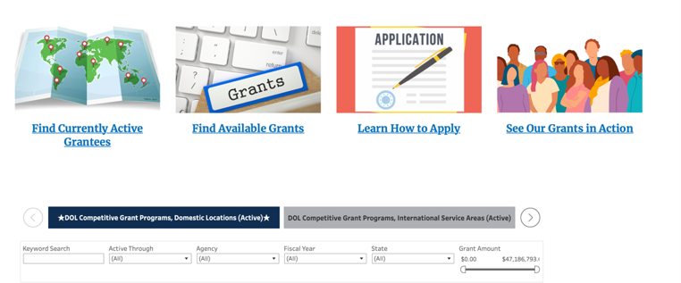

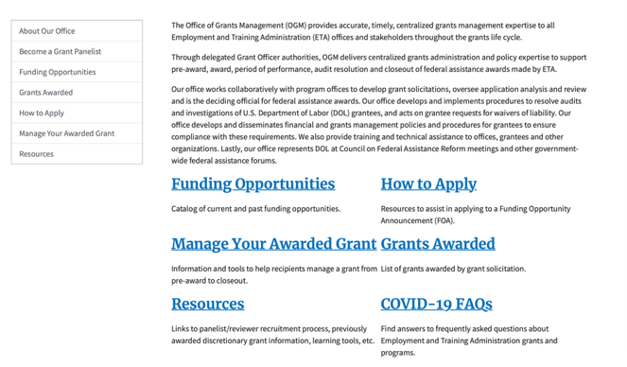

https://www.doleta.gov/grants/

Agency Grants and Contract General Overview

DOL Resources
Apply for DOL Agency-Specific Grants:
- Employment and Training Administration (ETA)
- Occupational Safety and Health Administration (OSHA)
- Bureau of International Labor Affairs (ILAB)
- Veterans' Employment and Training Service (VETS)
- Office of Disability Employment Policy (ODEP)
- Office of the Assistant Secretary for Administration and Management (OASAM)

Other Grant Resources:

DOL Resources and Instructions for Applying for a Grant
- DOL Guidance Clarifying the Effect of the Religious Freedom Restoration Act on Faith-Based Organizations
- Grant and Contract Information
- More Information About Grants

Other Federal Government Grant Information
- Grant Opportunities (Catalog of Federal Domestic Assistance)

Department of Labor Grant Programs

- Bureau of International Labor Affairs (ILAB): provides grants (cooperative agreements) for the implementation of projects designed to assist developing countries combat the worse forms of child labor, forced labor, and human trafficking; and support worker rights and improve working conditions. http://www.dol.gov/general/business.
- Bureau of Labor Statistics (BLS): provides project grants (cooperative agreements) and the dissemination of technical statistical data and related information on labor force activities; provides data on prices (CPI) and cost of living; data on productivity and technology data; data on compensation and working conditions; data on employment projections.
- Employment and Training (ETA): ETA Administers financial assistance programs pursuant to the Workforce Investment Act (WIA), administering State formula grant programs for youth, adults and dislocated workers, national emergency grants for workers affected by mass layoffs, plant closures, and disasters; grant programs for workers with disabilities, Indians and Native Americans, and for migrant and seasonal farmworkers. ETA also administers grant programs for older American workers, apprenticeship programs, Trade Adjustment Assistance (TAA) programs, and assistance for research and development of workforce programs. In addition, ETA is responsible for the operation and maintenance of a national system of public employment service offices and for the national unemployment insurance program.
- Mine Safety and Health (MSHA): provides grants for research, education and training programs to ensure an adequate and competent staff of trained inspectors; and assistance for establishing or improving State mine health and safety programs through technical assistance.
- Occupational Safety and Health (OSHA): provides grants to non-profit organizations to provide training, educational services, and technical assistance; assistance to states to administer and enforce state programs; assistance to states to provide occupational safety and health technical assistance and consultant services.
- Office of Disability Employment Policy (ODEP): The Office of Disability Employment Policy awards competitive grants establishing short-term pilot and technical assistance projects designed to identify, develop, test, evaluate, and disseminate policies to increase employment by expanding access to training, education, employment supports, assistive and systems technology, integrated employment, entrepreneurial development, and small business opportunities for adults and youth with disabilities. Current pilots projects focus on customized employment, Olmstead populations, and innovative demonstration youth grants, among others. Solicitations for grant applications are published in the Federal Register and announced at www.dol.gov/odep. ODEP grants are awarded by the OASAM grant office.
- Veterans' Employment and Training (VETS): provides special employment and training assistance for veterans through the Disabled Veterans' Outreach Program (DVOP) Solicitation for Grant Applications; the Local Veterans' Employment Representative Program (LVER); Veterans' Workforce Investment Program (VWIP); elaws Advisor on veterans' employment and reemployment rights; and the Homeless Veterans Reintegration Project (HVRP). VETS grants are awarded by the OASAM grant office.

https://www.dol.gov/general/grants/howto

National Aeronautics and Space Administration

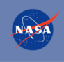 NASA Research Opportunities Online

- Various NASA offices publish their research announcements over the Internet, broadening the opportunity for researchers to apply for funding. This site provides access to current research announcements along with their specific due dates.

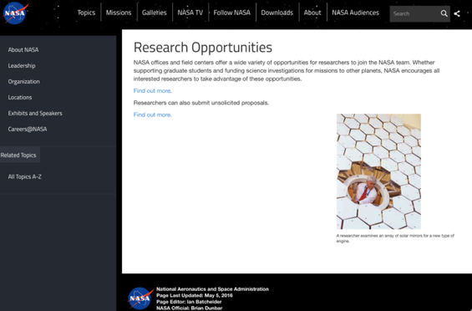
http://nspires.nasaprs.com/external/

National Archives and Records Administration

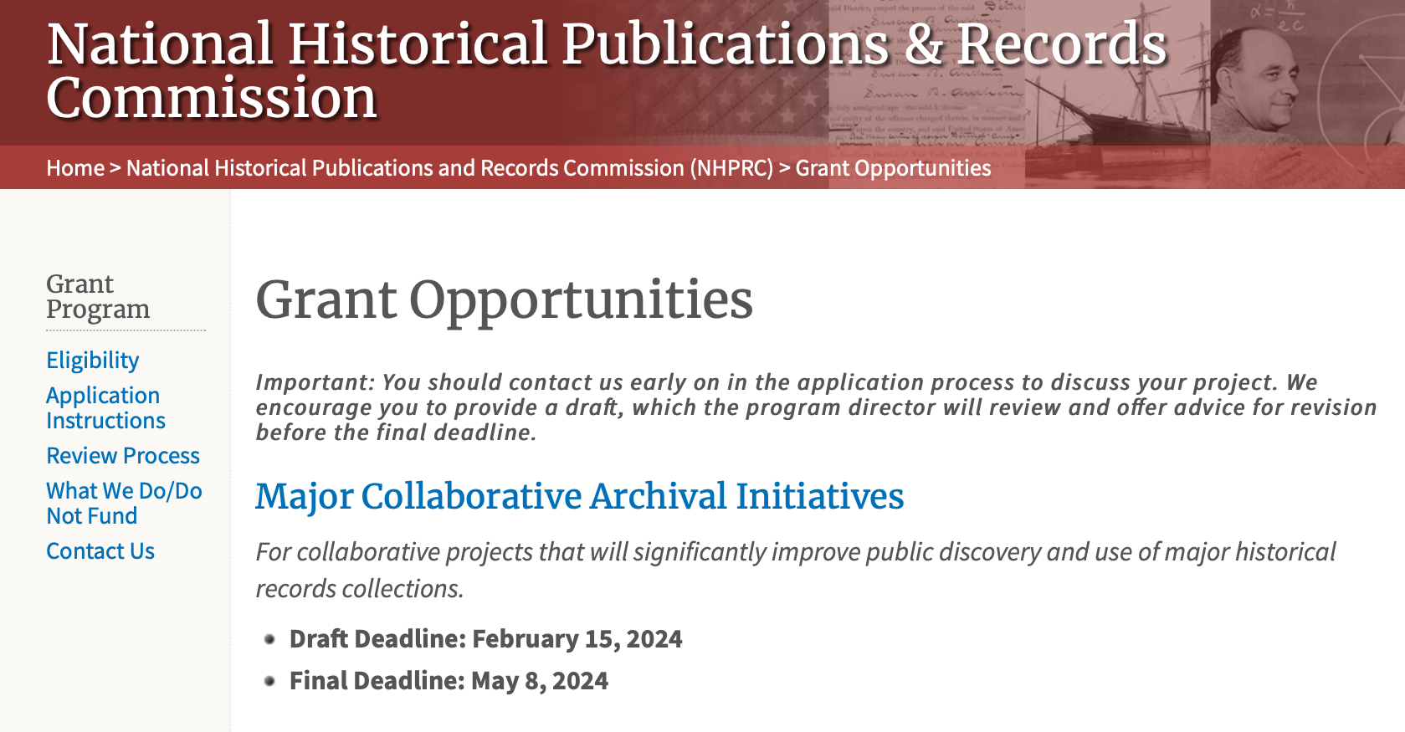

Archives Collaboratives
For projects to plan and develop a working collaborative designed to enhance the capacity of small and diverse organizations with historical records collections.
- Draft Deadline: February 15, 2024
- Final Deadline: May 8, 2024

State Board Programming Grants
For projects that strengthen the nation’s archival network through activities undertaken by state historical records advisory boards.
- Draft Deadline: February 15, 2024
- Final Deadline: May 8, 2024

Publishing Historical Records in Collaborative Digital Editions
For projects to publish documentary editions of historical records. This program has two application cycles.

First cycle:
- Draft Deadline: February 15, 2024
- Final Deadline: May 8, 2024

Second Cycle:
- Draft Deadline: August 15, 2024
- Final Deadline: November 7, 2024

The deadline for the opportunities listed below has passed. These guidelines may be used for reference, but should NOT be used to prepare an application. New announcements will be published in May 2024.

​Archival Projects
For projects that ensure online public discovery and use of historical records collections.
- Draft Deadline (optional): August 15, 2023
- Final Deadline: November 2, 2023

Public Engagement with Historical Records
For projects that encourage public engagement with historical records.
- Draft Deadline (optional): August 15, 2023
- Final Deadline: November 2, 2023

This page was last reviewed on November 27, 2023.

This page was last reviewed on 8/8/ 2023
To access the information above: click here

https://www.archives.gov/nhprc/announcement

National Endowment for the Arts

CHALLENGE AMERICA
Challenge America grants are awarded at $10,000 each to reach historically underserved communities with rich and dynamic cultural identities. This program may be a good entry point for organizations that are new to applying for federal funding. Grants are awarded in all artistic disciplines for a wide variety of arts projects.
* Deadline: April 25, 2024.

GRANTS FOR ARTS PROJECTS
Grants for Arts Projects provides expansive funding opportunities to strengthen the nation’s arts and culture ecosystem. Grants are available for arts projects in a wide variety of artistic disciplines. To leverage the greatest opportunities for federal support and to strengthen the ecosystem, each artistic discipline has identified the types of projects that are of greatest interest within this program as well as the characteristics of competitive applications.
* Deadlines: February 15, 2024 and July 11, 2024.

OUR TOWN
Our Town is our creative placemaking grants program, using arts, culture, and design to strengthen communities and advance local priorities such as health, community development, environment/climate, and public safety, among other community issues and aspirations.
* Deadlines have passed.

PARTNERSHIP AGREEMENT GRANTS
Grants are awarded to the nation’s 56 state and jurisdictional arts agencies (SAAs), and the six regional arts organizations (RAOs) whose members comprise SAAs. Partnership support is also available to the national service organization for the state arts agencies.
* Deadlines have passed.

RESEARCH AWARDS
Deadlines have passed. Guidelines for FY25 will be posted in early 2024.

Grants for Individuals

CREATIVE WRITING FELLOWSHIPS
The Literature Fellowships program awards grants in prose (fiction and creative nonfiction) and poetry to published creative writers that enable the recipients to set aside time for writing, research, travel, and general career advancement. Grants to individuals are only available in Literature.
* Deadline: March 13, 2024.

TRANSLATION PROJECTS
Through fellowships to published translators, the NEA supports projects for the translation of specific works of prose, poetry, or drama from other languages into English.
* Deadline: January 18, 2024.

Program Solicitations

Program Solicitation: Shakespeare in American Communities
The purpose of this Program Solicitation is to select an organization (Cooperator) to administer the SIAC program for the 2025-2026 school year.
* Proposal Receipt Deadline: January 18, 2024

Program Solicitation: Creative Placemaking Technical Assistance Program
The purpose of this Program Solicitation is to select an organization (Cooperator) to administer the Creative Placemaking Technical Assistance Program.
* Proposal Receipt Deadline: January 18, 2024

Program Solicitation: NEA Big Read
The purpose of this Program Solicitation is to select a U.S. Regional Arts Organization (RAO) to administer the 2025-2026 cycle of the NEA Big Read initiative.
Proposal Receipt Deadline: January 18, 2024

See more at: https://www.arts.gov/grants

National Endowment for the Humanities

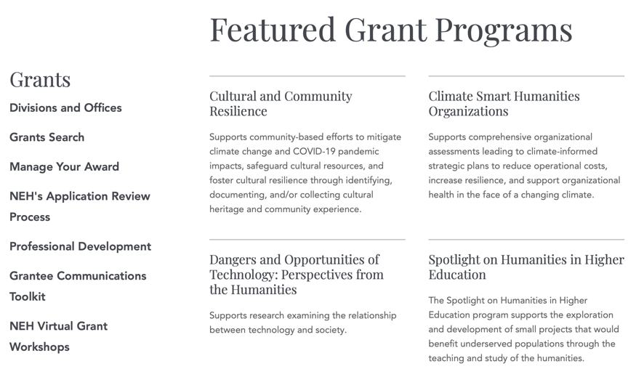
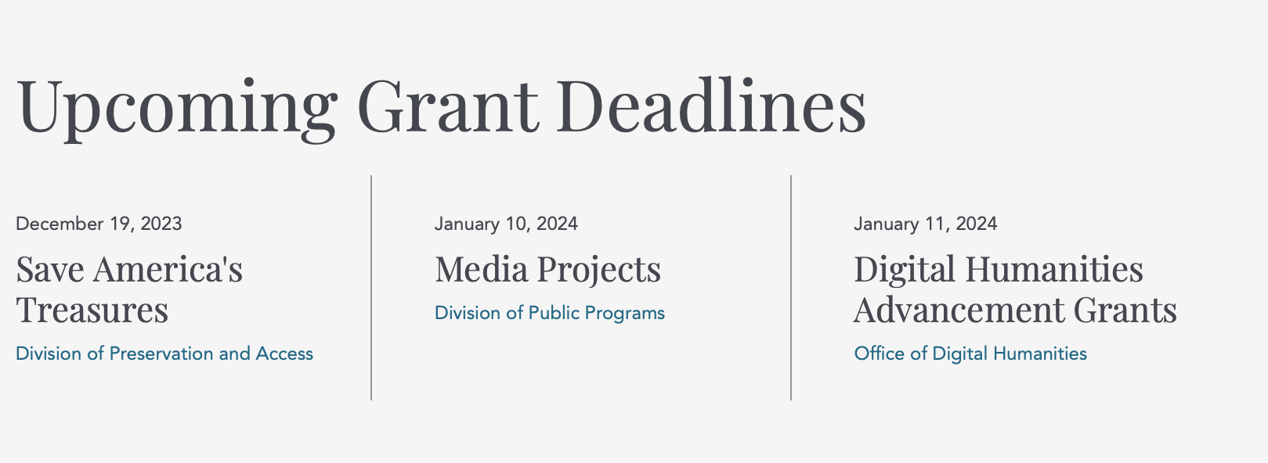

https://www.neh.gov/grants

National Science Foundation



For assistance: https://nsf.gov/funding/aboutfunding.jsp

The National Science Foundation funds research and education in most fields of science and engineering. It does this through grants, and cooperative agreements to more than 2,000 colleges, universities, K-12 school systems, businesses, informal science organizations and other research organizations throughout the United States. The Foundation accounts for about one-fourth of federal support to academic institutions for basic research.
NSF receives approximately 40,000 proposals each year for research, education and training projects, of which approximately 11,000 are funded. In addition, the Foundation receives several thousand applications for graduate and postdoctoral fellowships.
The agency operates no laboratories itself but does support National Research Centers, user facilities, certain oceanographic vessels and Antarctic research stations. The Foundation also supports cooperative research between universities and industry, US participation in international scientific and engineering efforts, and educational activities at every academic level.

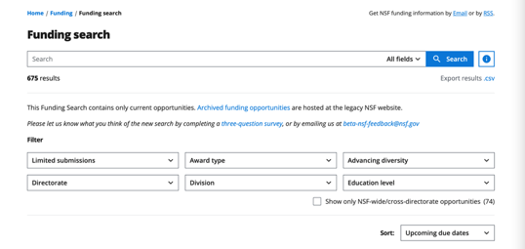

For details on active funding deadline dates: http://nsf.gov/funding/pgm_list.jsp?org=NSF&ord=date

Small Business Administration

https://www.sba.gov/funding-programs/loans
Federal, state and local governments offer a wide range of financing programs to help small businesses start and grow their operations. These programs include low-interest loans, venture capital, and scientific and economic development grants.
Use SBA.gov's Loans and Grants Search Tool to get a list of financing programs for which you may qualify, or visit the resources below to learn more about small business financing programs.

https://www.sba.gov/funding-programs/grants
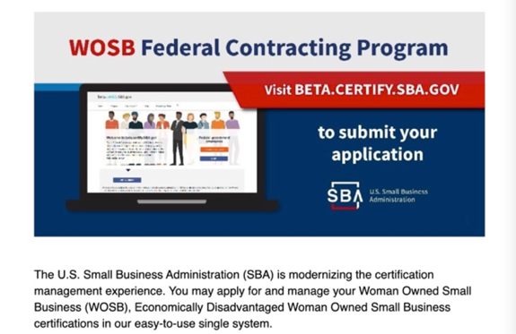
Learn more
https://www.sba.gov/learning-center

SBA Trainings

https://www.sba.gov/learning-center
Upcoming Trainings: Check out SBA's Online Training!
- Financing Options for Small Businesses
For Specific Information in Hawaiʻi see the following links:

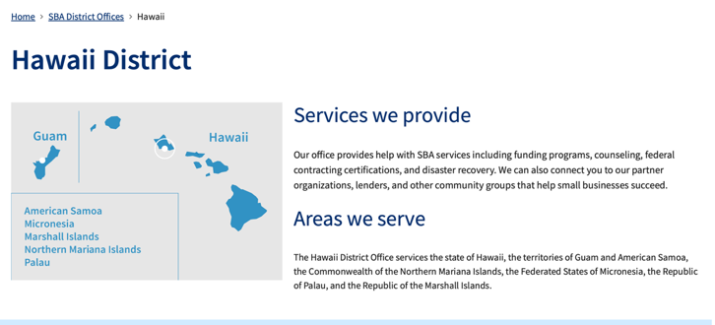
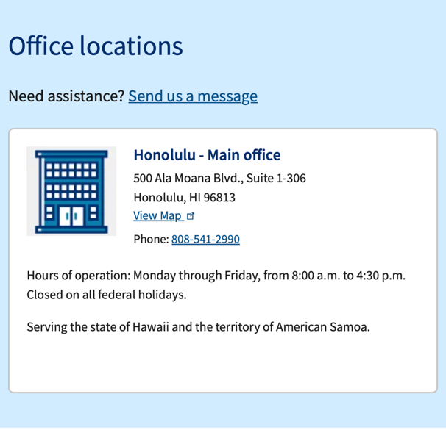

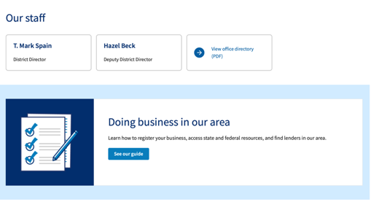

https://www.sba.gov/offices/district/hi/Honolulu

State Department

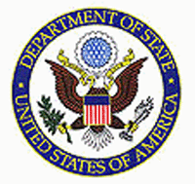

https://eca.state.gov/about-bureau/organizational-structure/grants-division

http://eca.state.gov/search/solr/grants?search_referrer=node/237

https://eca.state.gov/organizational-funding/open-grant-solicitations

http://eca.state.gov/organizational-funding/applying-grant

General Information:
- Bureau of Educational and Cultural Affairs Grants Division
- Open Grant Opportunities (Requests for Grant Proposals)

For General Information click here

Department of Transportation

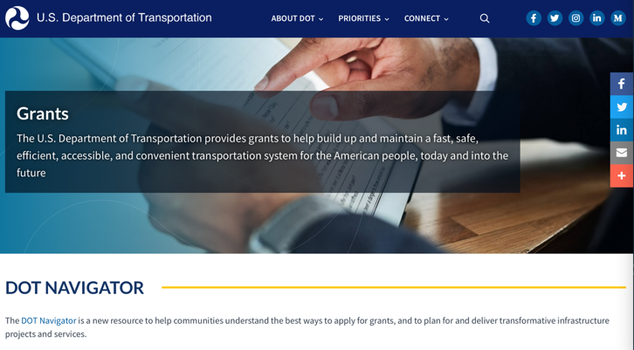

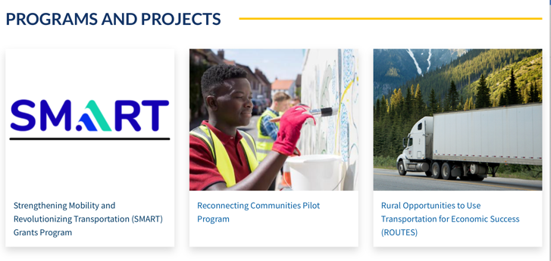

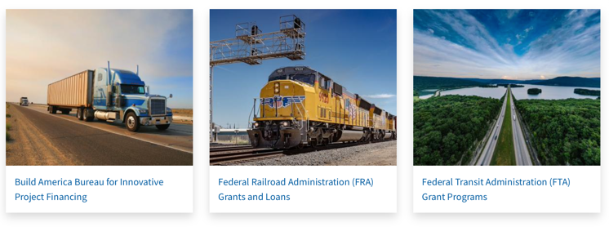

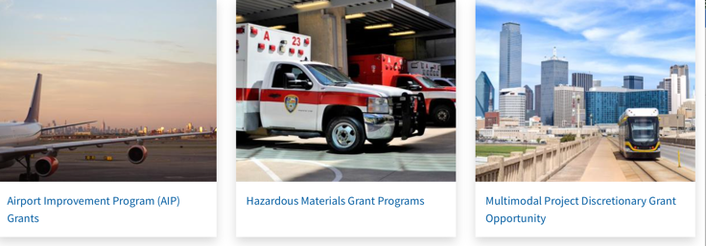

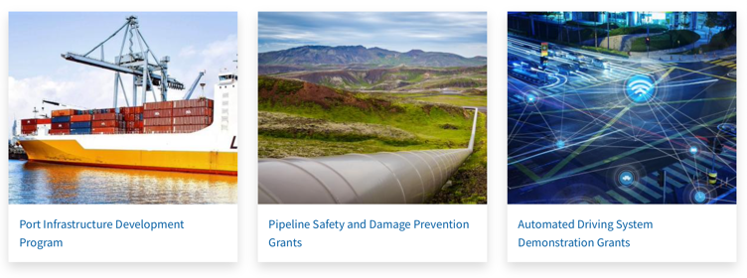
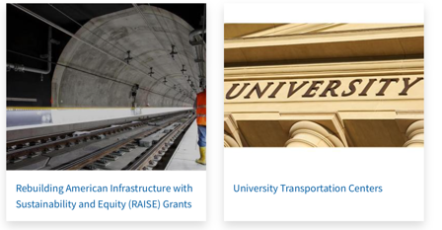

General Grant Program Overview https://www.transportation.gov/grants

Department of the Treasury

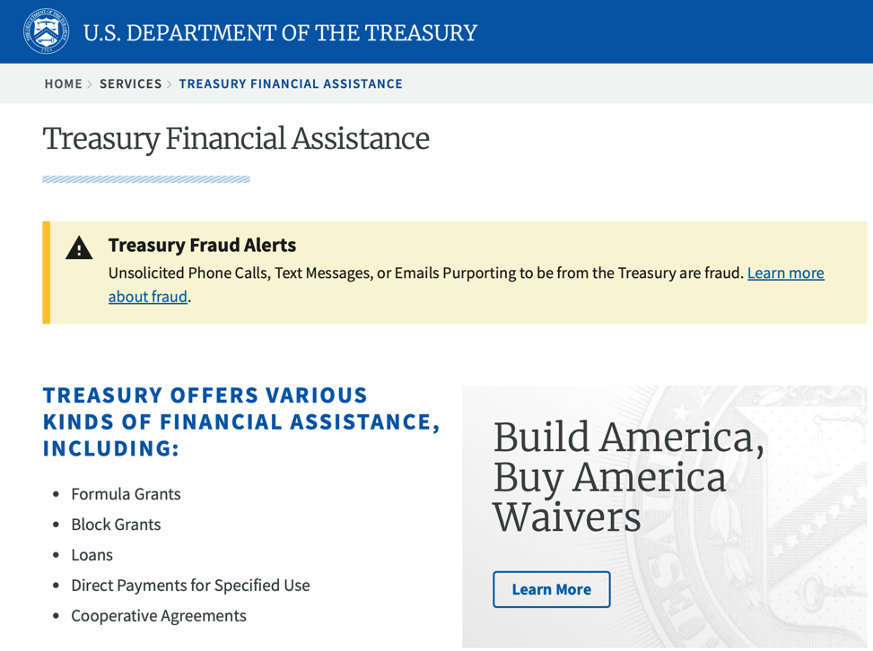
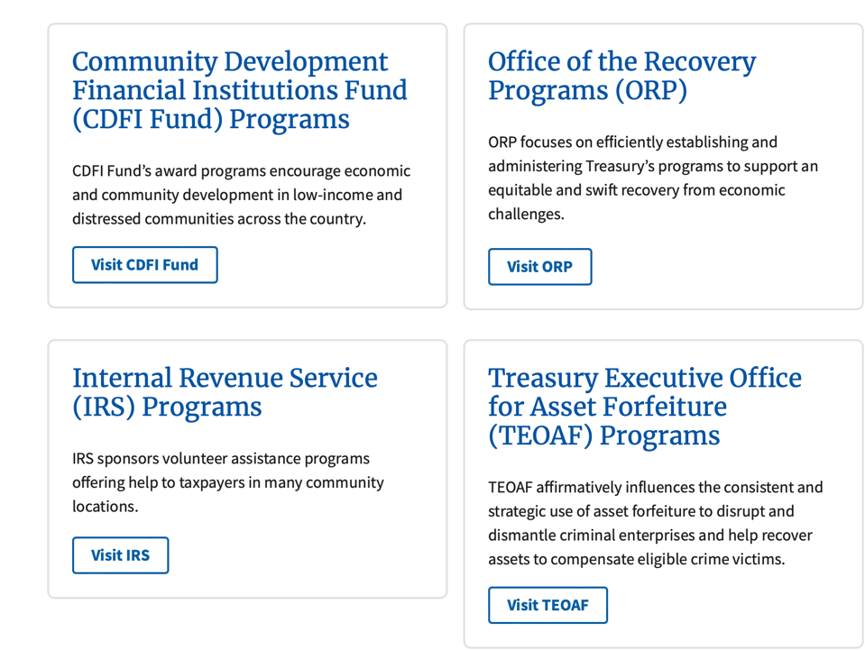

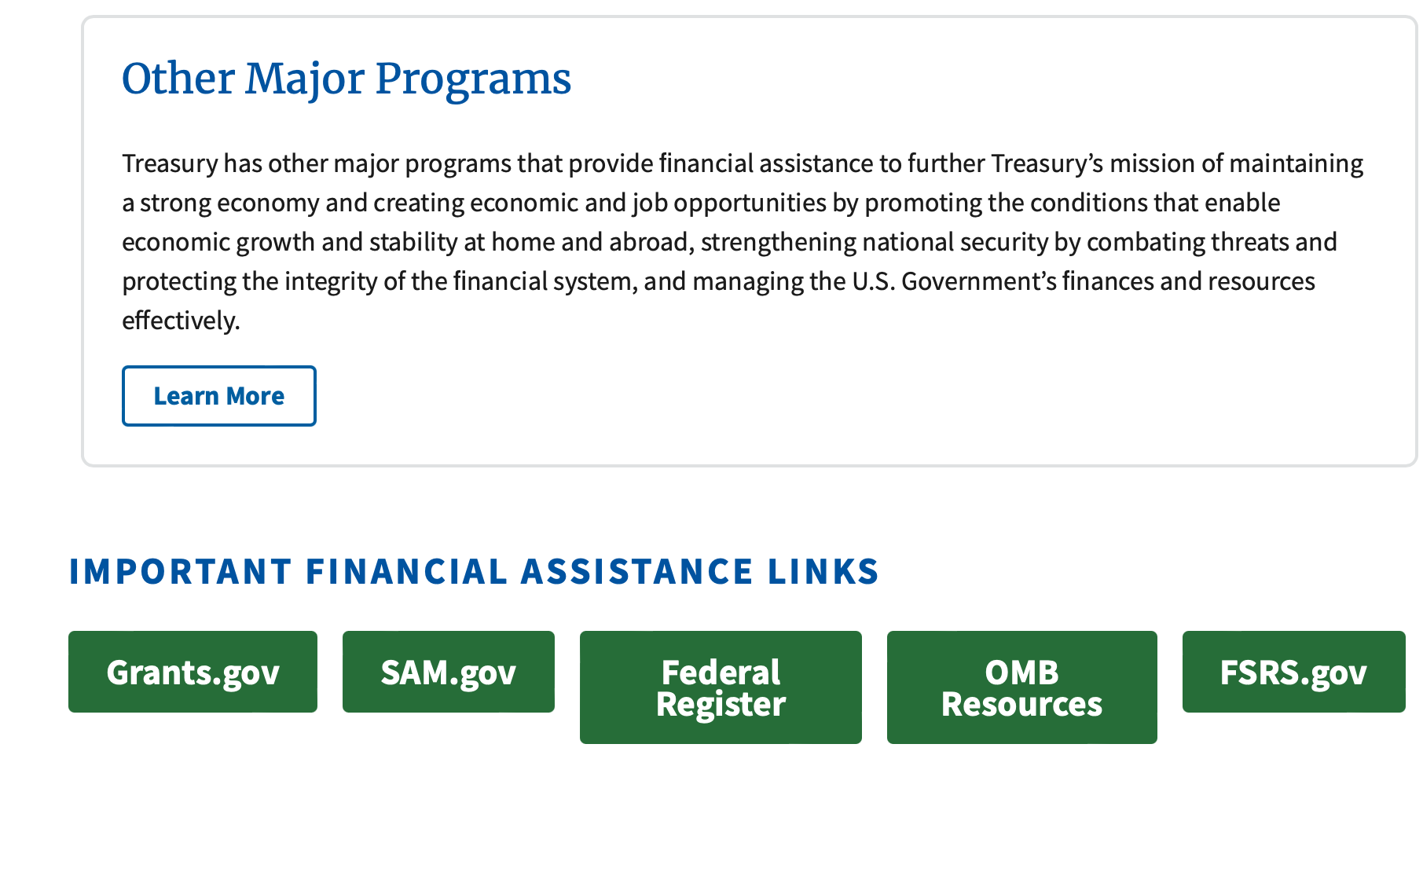
https://home.treasury.gov/services/grant-programs

U.S. Agency for International Development
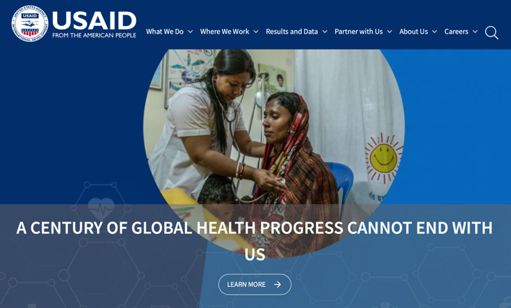

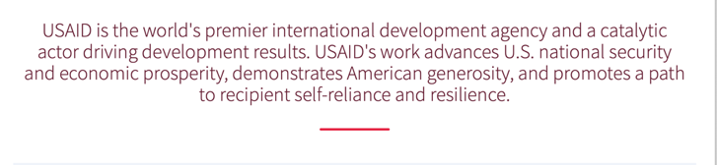

www.usaid.gov

General Overview Funding Opportunities

USAID has working relationships with thousands of American companies and hundreds of U.S.-based private voluntary organizations. For more information on our business and procurement opportunities, \

Department of Veterans Affairs

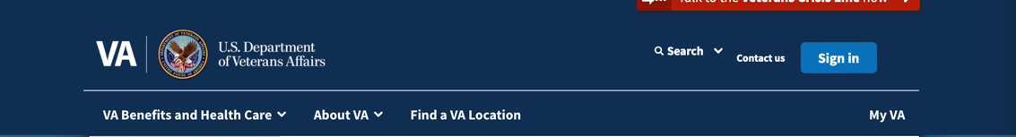

VA Homeless Programs

Grant and Per Diem Program

Program Description
VA's Grant and Per Diem (GPD) Program is offered annually (as funding permits) by the Department of Veterans Affairs to fund community agencies providing services to Veterans experiencing homelessness. The purpose of the transitional housing component of the program is to promote the development and provision of supportive housing and services with the goal of helping homeless Veterans achieve residential stability, increase their skill levels and/or income, and obtain greater self-determination. Additionally, the GPD Program offers Case Management grants to support housing retention for Veterans who were previously homeless and are transitioning to permanent housing.
Operational costs, including salaries, may be funded by the per diem component. For supportive housing, the maximum amount payable under the per diem is $64.52 per day per Veteran housed. Veterans in supportive housing may be asked to pay rent if it does not exceed 30% of the Veteran's monthly-adjusted income. In addition, "reasonable" fees may be charged for services not paid with per diem funds. The maximum hourly per diem rate for a service center not connected with supportive housing is 1/8 of the daily cost of care, not to exceed $8.06 per hour. Payment for a Veteran in a service center will not exceed 8 hours in any day.
Applications are only accepted in response to a Notice of Funding Opportunity (NOFO) published in Grants.gov. Funds will be awarded to programs determined to be the most qualified. Chelsea Watson is the director of the GPD Program. Ms. Watson and the GPD team may be contacted via email at GPDgrants@va.gov.

GPD Grants & Funding Fact Sheet
Access our GPD Fact Sheet here to learn more.

GPD Works! Success Stories

Feature Article:
- How VA's Grant and Per Diem Program Reduces Long-Term Homelessness Among Veterans

Good News Stories:
- How GPD Has Evolved to Meet Veterans’ Needs - VA Homeless Programs
- “I only dreamed of this.” VA program finds Veteran Lorenzo Campbell a home - VAntage Point
- VA and Volunteers of America help Veteran Robert Irvin go from homeless to home - VAntage Point
- Army Veteran finds employment and housing in months thanks to HUD-VASH - VAntage Point

Active GPD Awards
Per Diem Only (PDO) Award List (October 2023)
Transition In Place (TIP) Award List (October 2023)
Case Management Award List (October 2023)
Capital Grant Awards List (Published March 2022)
Special Need Award List (March 2022)
Capital Grant Awards List (Published August 2021)

Grant Applicant Resources
- Case Management Notice of Funding Opportunity (NOFO)
- TIP Notice of Funding Opportunity (NOFO)
- PDO Notice of Funding Opportunity (NOFO)
- Electronic Grants Management System (eGMS) Login Page
- How-to: Register a New Organization in eGMS
- How-to: Add or Update Contacts in eGMS
- Application for Federal Assistance (SF-424) (NOTE: first download and save any SF PDF files to your computer and then open it from the saved location)
- Certification of De Minimis Indirect Cost Rate
- Assurances for Non-Construction Programs (SF-424B) - (for awareness, applicants are not required to submit the SF-424B)
- GPD General Terms and Conditions of Award (May 2020)
- GPD Regulations (38 CFR part 61.0)
Back to Top

Helpful Resources
Grants.gov *
Federal Register *
Electronic Uniform Administrative Requirements (2 CFR part 200) *
GPD Provider Webpage
eGMS Login Page*
*Links will take you outside of the Department of Veterans Affairs website. VA does not endorse and is not responsible for the content of the linked websites.
Back to Top

Other Sites of Interest
Housing & Urban Development (HUD) *
HUD Vet Resource Center *
Health & Human Services (HHS) *
Social Security Administration (SSA) *
Department of Labor (DOL) *
SAMHSA Homelessness Resource Center *
National Coalition for Homeless Veterans *
National Law Center *
United States Department of Justice *
State Side Legal *
*Links will take you outside of the Department of Veterans Affairs website. VA does not endorse and is not responsible for the content of the linked websites.
Back to Top


Make the Call
Dial 1-877-4AID-VET
(1-877-424-3838)
Access VA’s services for homeless and at-risk Veterans, available 24/7.


Chat Online
Homeless Veteran Chat
Confidential, 24/7 online support for Veterans and friends
Chat Now

VA Medical Center
(VAMC) Locator
Locate Your Local
VA Medical Center Now
Veterans who are homeless or at risk of homelessness can call or visit their local VA Medical Center (VAMC) and ask for a Homeless Coordinator. Use the VA locator tool www.va.gov/directory to find your nearest VAMC and call or visit today.
return to top
Learn what the PACT Act means for your VA benefits
Last updated: October 4, 2023

Page reviewed on 9/4 2023

https://www.va.gov/homeless/gpd.asp

Locations

Spark M. Matsunaga Department of Veterans Affairs Medical Center
459 Patterson Road
Honolulu, HI 96819-1522
Get directions on Google Mapsto Spark M. Matsunaga Department of Veterans Affairs Medical Center
Main phone: 800-214-1306
Mental health care: 808-433-0660
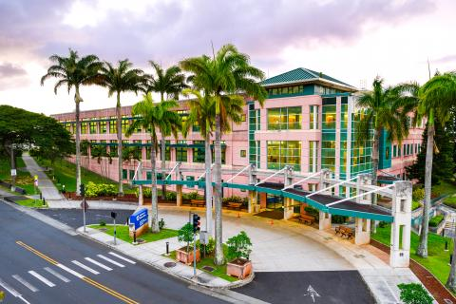
See all locations

Manage your health online
Refill and track your prescriptions
Send a secure message to your health care team
Schedule and manage health appointments
Download your VA medical records (Blue Button)
View your lab and test results
Order hearing aid batteries
and accessories

In the spotlight at VA Pacific Islands health care
Get help from a patient advocate Access your health records Find a phone number
Check your billing, insurance, and payment options Volunteer or donate Women Veterans Care

Get updates from VA Pacific Islands health care
Subscribe to VA Pacific Islands health care news and announcements
Subscribe to VA Pacific Islands health care emergency notifications
VA Pacific Islands health care operating status
VA Pacific Islands Healthcare System Facebook page

https://www.va.gov/pacific-islands-health-care/

Grants General Tips and Information

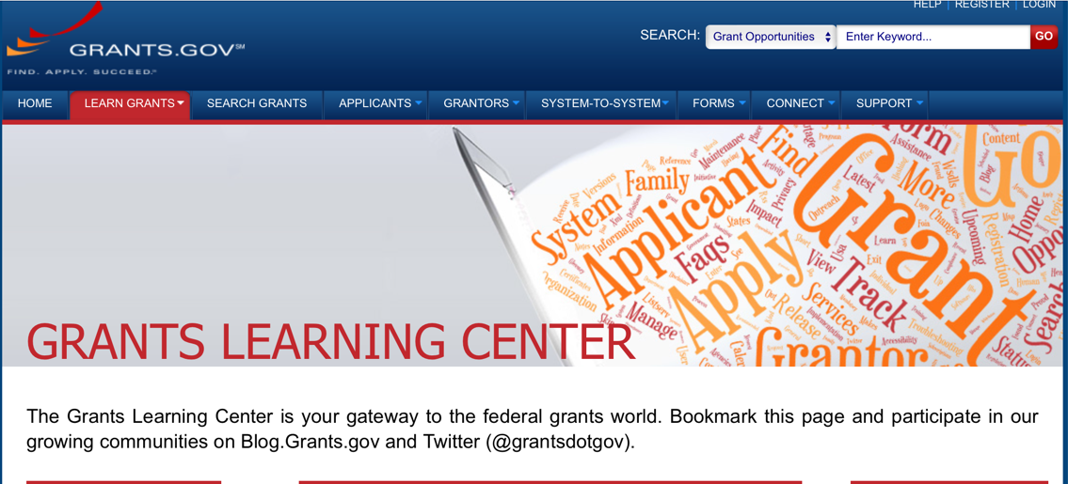

Provides a Grants Learning Center as a gateway to the federal grants world. Bookmark the following link and participate at blog.grants.gov or on twitter @grantsdotgov

Topics include: Grants 101, Grant Policies, Grant Eligibility, Grant Terms, Grant Agencies , Grant Systems, Grant Programs, Grant Careers, Grant Reporting, Grant Fraud and Grant Events

https://www.grants.gov/web/grants/learn-grants.html

Grants.gov maintains a blog. This reprinted article provides some helpful tips:

Grant Writing: 3 Tips for Crafting Need Statements in Federal Grant Proposals
Originally Posted on March 27, 2019 by Grants.gov
In this space, we have previously shared tips about the pre-writing phase of completing a federal grant application – for example, the importance of reading (and re-reading) the grant announcement, and the importance of understanding the criteria by which your application will be evaluated.
In this post, we dip our toes into the grant writing process itself and share some tips about crafting a need statement. These tips are adapted from the U.S. Department of Health and Human Services Health Resources & Services Administration’s grant writing guide, titled “Tips for Writing and Submitting Good Grant Proposals”. Along with each tip, we also include an excerpt from an award-winning federal grant proposal that can be viewed in full on the website of the Institute of Museum and Library Services. (IMLS has an excellent collection of proposals that are worthy of review – especially for new federal grant applicants.)

https://grantsgovprod.wordpress.com/2019/03/27/3-tips-for-crafting-need-statements-in-federal-grant-proposals/?utm_source=newsletter&utm_medium=email&utm_campaign=noprofile&utm_content=june2020

Grant Writing Resources

The following links are a great resource for Faith-Based Non-profits and other community organizations:

U.S. Department of Justice
Task Force for Faith-Based and Community Initiatives

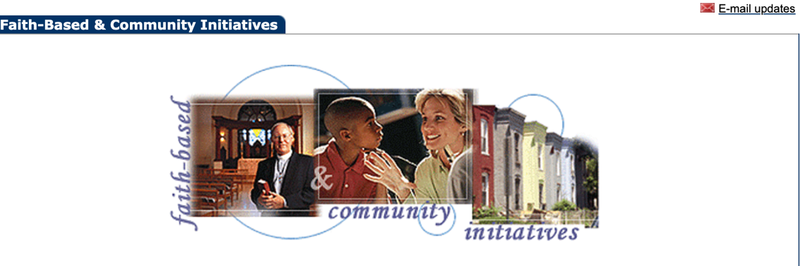

Foundation Center
Proposal Writing Short Course

USDA Rural Information Center
A Guide to Funding Resources

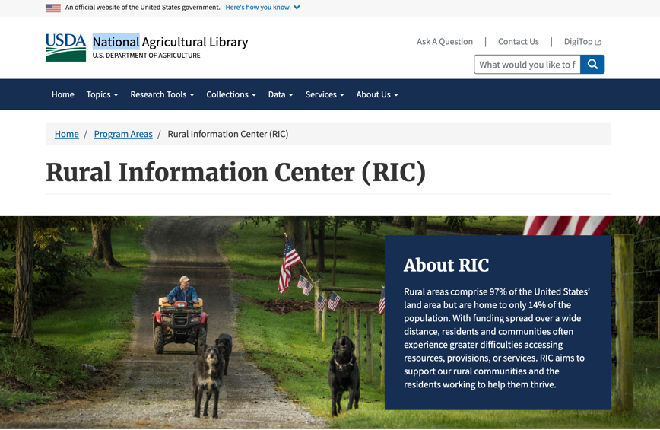

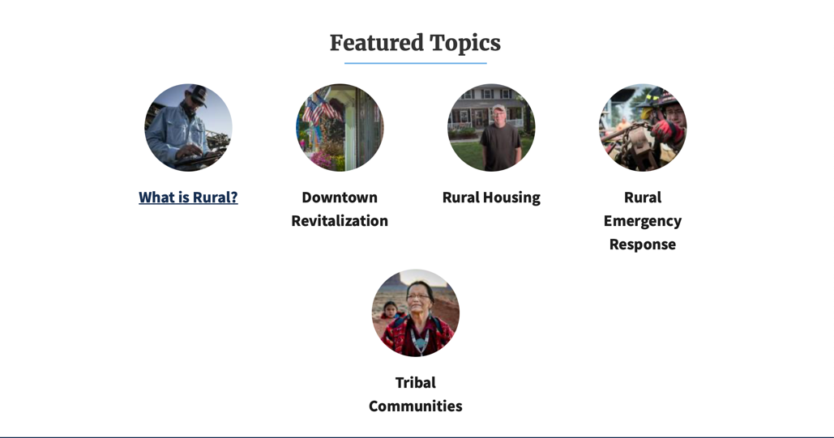
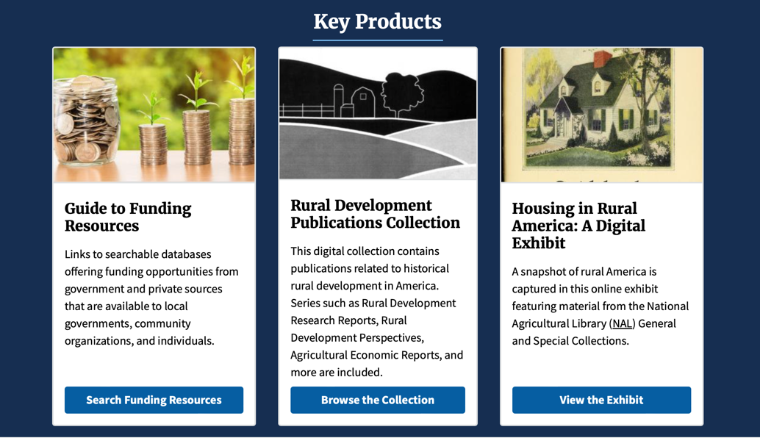
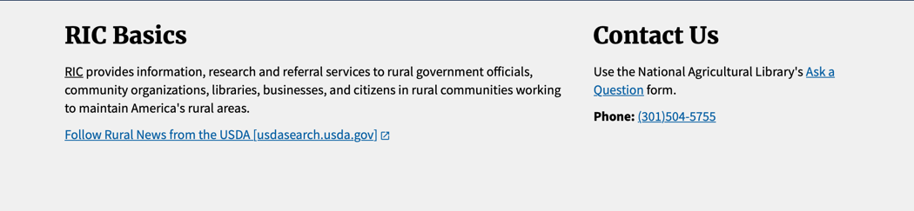

The Small Business Innovative Research Program - SBIR Program

The Small Business Innovation Research (SBIR) program is a highly competitive program that encourages domestic small businesses to engage in Federal Research/Research and Development (R/R&D) that has the potential for commercialization. Through a competitive awards-based program, SBIR enables small businesses to explore their technological potential and provides the incentive to profit from its commercialization. By including qualified small businesses in the nation's R&D arena, high-tech innovation is stimulated, and the United States gains entrepreneurial spirit as it meets its specific research and development needs.

SBIR Mission and Program Goals
The mission of the SBIR program is to support scientific excellence and technological innovation through the investment of Federal research funds in critical American priorities to build a strong national economy.
The program’s goals are four-fold:
- Stimulate technological innovation
- Meet Federal research and development needs.
- Foster and encourage participation in innovation and entrepreneurship by socially and economically disadvantaged persons.
- Increase private-sector commercialization of innovations derived from Federal research and development funding.

SBIR-Participating Agencies
Each year, Federal agencies with extramural research and development (R&D) budgets that exceed $100 million are required to allocate 2.5 percent of their R&D budget to these programs. Currently,
- eDepartment of Commerce - National Institute of Standards and Technology
- Department of Energy
- Department of Health and Human Services
- Department of Transportation
- National Aeronautics and Space Administration
- National Science Foundation
Each agency administers its own individual program within guidelines established by Congress. These agencies designate R&D topics in their solicitations and accept proposals from small businesses. Awards are made on a competitive basis after proposal evaluation.

Three-Phase Program
The SBIR Program is structured in three phases:
Phase I. The objective of Phase I is to establish the technical merit, feasibility, and commercial potential of the proposed R/R&D efforts and to determine the quality of performance of the small business awardee organization prior to providing further Federal support in Phase II. SBIR Phase I awards normally do not exceed $150,000 total costs for 6 months.
Phase II. The objective of Phase II is to continue the R/R&D efforts initiated in Phase I. Funding is based on the results achieved in Phase I and the scientific and technical merit and commercial potential of the project proposed in Phase II. Only Phase I awardees are eligible for a Phase II award. SBIR Phase II awards normally do not exceed $1,000,000 total costs for 2 years.
Phase III. The objective of Phase III, where appropriate, is for the small business to pursue commercialization objectives resulting from the Phase I/II R/R&D activities. The SBIR program does not fund Phase III. Some Federal agencies, Phase III may involve follow-on non-SBIR funded R&D or production contracts for products, processes or services intended for use by the U.S. Government

