Senator Mazie Hirono

Grants Assistance Information Newsletter
December 2015

G.A.I.N. INDEX

Click on Index Links below to read summaries of the announcements by agency in this document.
Once you reach the item, if you cannot open the links for further information, copy the selected
URL website address into your browser.

Modified sections from previous listings are shown in a GREY background

Notices is Teal are items with immediate deadline dates.

Notices in Yellow are of special interest.

Notices is Green are items of special interest with immediate deadline dates.

Items in this type color are aimed at Small Businesses

Items in this type color have a Faith-Based Organization component

Special Federal Program Notices

SBIR – Small Business Innovation Research

Programs specific to Hawaii

Current Notices

FY2016 NOAA Bay Watershed Education and Training (B-WET) Hawaii Program Grant

Reminders

See Individual Departments for information and webpages representing the best and most accessible information on the agency funding opportunities

Federal Grant and Cooperative Agreement Program Summaries

U.S. Department of Agriculture

Grants and Loans Overview

Programs

National Institute of Food and Agriculture
Small Business Innovation Research Program Phase II Fiscal Year 2016 Grant

Modifications

Reminders

Farm Service Agency
Outreach and Education, Technical Assistance, and Financial Education for FSA Programs, Functions, and Activities Grant

Utilities Programs
Solid Waste Management Grant Program FY16 Grant

Utilities Programs
TAT Grant Program FY16

Business and Cooperative Programs
Renewable Energy Systems and Energy Efficiency Improvements Program Grant

Business and Cooperative Programs
REAP Energy Audit and Renewable Energy Development Assistance Program Grant

Utilities Programs
Assistance to High Energy Cost Rural Communities Grant

National Institute of Food and Agriculture
Beginning Farmer and Rancher Development Program Grant

National Institute of Food and Agriculture
Biotechnology Risk Assessment Grants Program

Farm Service Agency
Outreach and Education, Technical Assistance, and Financial Education for FSA Programs, Functions, and Activities Grant

Department of Commerce

Programs

2016 Marine Education and Training Mini Grant Program

National Estuarine Research Reserve System (NERRS) Land Acquisition and Construction Program for Fiscal Year 2016 Grant

FY 2016 Air Quality Research and Forecasting Grant

Fiscal Year 2016 NMFS-Sea Grant Fellowships in Marine Resource Economics Grant
And Modification 1

Next Round of Research to Operations Initiative: NGGPS and HFIP Grant

Next Round of Research to Operations Initiative: NOAA Testbeds Grant

Strengthening the Public's and/or K-12 Students' Environmental Literacy for Community Resilience to Extreme Weather Events and Other Environmental Hazards Grant

Modifications

Reminders

Fiscal Year 2017 National Sea Grant College Program Dean John A. Knauss Marine Policy Fellowship
Grant

FY 2016 Economic Development Assistance Programs ­ Application submission and program requirements for EDA’s Public Works and Economic Adjustment Assistance Programs

National Institute of Standards and Technology
Professional Research Experience Program – Communications Technology Laboratory (PREP-CTL) Grant

FY16 Nancy Foster Scholarship Program Grant

MBDA Business Centers (5) Grant

FY16 Coral Reef Conservation Program, Domestic Coral Reef Conservation Grants
FY16 CRCP Coral Reef NGO Partnership Grant

CZM Projects of Special Merit Competition - FY2016
And Modification 1

2016 Ecological Effects of Sea Level Rise Program - Advancing Predictive Capabilities to Evaluate Natural and Nature-based Features Grant

Ocean Exploration 2016 Funding Opportunity Grant

Climate Program Office FY 2016 Grant

Economic Development Administration
Planning Program and Local Technical Assistance Program Grant

Corporation for National and Community Service

General Program Overview

Reminders

AmeriCorps State and National Grants FY 2016
Modification 2

National Service in Hawaii

Department of Defense

Doing Business with the Department of Defense

DoD Small Business Opportunities and Forecasting

Research Grants

Modifications

Reminders

Dept. of the Army -- Materiel Command
Army Research Office Broad Agency Announcement for Basic and Applied Scientific Research
Modification 8

Department of Education

Grant Programs Overview

Programs

Modifications

Reminders

OSERS-OSEP: Preparation in Special Education, Early Intervention, and Related Services: Focus Area B Preparing Personnel to Serve School-Age Children with Low Incidence Disabilities. CFDA Number 84.325K-2 Grant

OSERS-OSEP: Preparation in Special Education, Early Intervention, and Related Services: Focus Area A: Preparing Personnel to Serve Infants, Toddlers, and Preschool- Age Children with Disabilities CFDA Number 84.325K-1 Grant

OSERS-OSEP: Preparation in Special Education, Early Intervention, and Related Services: Focus Area C Preparing Personnel to Provide Related Services to Children, Including Infants and Toddlers, with Disabilities. CFDA Number 84.325K-3 Grant

OSERS-OSEP: Preparation in Special Education, Early Intervention, and Related Services: Focus Area D Preparing Personnel in Minority Institutions of Higher Education to Serve Children, Including Infants and Toddlers with Disabilities CFDA Number 84.325K-4 Grant

OSERS-OSEP: Personnel Development to Improve Services and Results for Children with Disabilities: Preparation of Special Education, Early Intervention, and Related Services Leadership Personnel CFDA Number 84.325D Grant

Institute of Education Sciences (IES): Education Research: Low-Cost, Short-Duration Evaluation of Education Interventions CFDA Number 84.305L Grant

Institute of Education Science (IES): Special Education Research: Low-Cost, Short-Duration Evaluation of Special Education Interventions CFDA Number 84.324L Grant

US Department of Energy

Grants Overview

Programs

Modifications

Reminders

Environmental Protection Agency

Grants and Contracts Overview

Programs

Environmental Protection Agency
Technical Assistance To Brownfields Communities Grant

FY16 Environmental Workforce Development And Job Grant

Modifications

Environmental Justice Collaborative Problem Solving (EJCPS) Cooperative Agreement
Grant

Reminders

13th Annual P3 Awards: A National Student Design Competition for Sustainability Focusing on People, Prosperity and the Planet
Modification 1

FY16 Guidelines for Brownfields Assessment Grants
Modification 1

FY16 Guidelines for Brownfields Cleanup Grants

FY16 Guidelines for Brownfields Revolving Loan Fund Grant

13th Annual P3 Awards: A National Student Design Competition for Sustainability Focusing on People, Prosperity and the Planet Grant

13th Annual P3 Awards: A National Student Design Competition for Sustainability Focusing on People, Prosperity and the Planet Grant

13th Annual P3 Awards: A National Student Design Competition for Sustainability Focusing on People, Prosperity and the Planet Grant

FY 2015 Support for Water Quality Framework Training Workshop, Nonpoint Source Agriculture Training and Technical Assistance, and Hypoxia and Agricultural Nutrient Outreach and Technical Assistance Request for Proposals Grant

FY 2016 National Environmental Information Exchange Network Grant Program

Department of Health and Human Services

Grants Overview

Program

Research Grants

Modifications

Reminders

National Institutes of Health
PHS 2015-02 Omnibus Solicitation of the NIH, CDC, FDA and ACF for Small Business Innovation Research Grant Applications (Parent SBIR [R43/R44]) Grant

Department of Homeland Security
Grants Overview

Programs

Modifications

Reminders

Department of Housing and Urban Development

HUD - Notice of Funds Available

Programs

Modifications

Choice Neighborhoods Planning Grants Program
Modification 1

Reminders

Juvenile Reentry Assistance Program (JRAP)
Modification 1

Pay for Success Permanent Supportive Housing Demonstration Grant

Self-Help Homeownership Opportunity Program (SHOP) Grant

General Section to HUD's Fiscal Year 2016 Notice[s] of Funding Availability for Discretionary Programs (General Section)
Modification 1

Institute of Museum and Library Services
Grants Overview

IMLS is on Facebook!

Modifications

Reminders

National Leadership Grants for Libraries Grant

Laura Bush 21st Century Librarian Program Grant

Department of Interior

Grants and Contract Overview

Programs

Fish and Wildlife Service
National Fish Passage Program Grant

Department of the Interior
Fish and Wildlife Service
2016 National Fish Habitat Action Plan
Modification 1

Modifications

Reminders

National Park Service
American Battlefield Protection Program Battlefield Preservation Planning Project Grants

Department of Justice

Grants and Contract Overview

Programs

Office of Justice Programs
Consolidated Grant Program to Address Children and Youth Experiencing Domestic and Sexual Assault and Engage Men and Boys as Allies Grant

Office of Justice Programs
Office on Violence Against Women
OVW FY 2016 Justice for Families Program Grant

Modifications

Reminders

Office of Justice Programs
National Institute of Justice
NIJ FY 16 Research and Development in Forensic Science for Criminal Justice Purposes
Modification 4

Office of Justice Programs
National Institute of Justice
NIJ FY 16 Graduate Research Fellowship in Science, Technology, Engineering, and Mathematics Grant

Office of Justice Programs
National Institute of Justice
NIJ FY 16 Graduate Research Fellowship Program in the Social and Behavioral Sciences Grant

Department of Labor

Grants and Contract General Overview

Programs

Employment and Training Administration
Tech Hire Partnership Grants

Modifications

Reminders

Employment and Training Administration
Training to Work 3 – Adult Reentry, FOA-ETA-15-07-A Grant

National Aeronautics and Space Administration

Research Grant and Contract General Overview

Programs

Modifications
_______________________________________________________________
National Archives and Records Administration

Grant Opportunities General Overview

State Board Programming Grants

Publishing Historical Records in Documentary Editions Grant

Access to Historical Records Grant

Reminders

_______________________________________________________________
National Endowment for the Arts

Grant Opportunities General Overview

Programs

Modifications

Reminders
_______________________________________________________________

National Endowment for the Humanities

Grant Opportunities General Overview

Programs

Media Projects Grants

Museums, Libraries, and Cultural Organizations Grants

Digital Humanities Implementation Grants

Modifications

Reminders

Next Generation Humanities PhD Grants

National Digital Newspaper Program Grant

National Science Foundation

Grant Opportunities General Overview

Research and Program Grants

Modifications

Reminders

Nuclear Regulatory Commission

U.S. Nuclear Regulatory Commission Funding Opportunity Announcement (FOA), Scholarship and Fellowship Education Grant, Faculty Development Grant, and Trade School and Community College Scholarship Grant, Fiscal Year (FY) 2016 Grant

Small Business Administration

General Overview Finding Loans & Grants

Reminders

Upcoming Trainings

Links Specific to Hawaii

State Department

General Overview and Resources for Program Administrators

Programs

Modifications

Reminders

Bureau Of Educational and Cultural Affairs
FY 2016 community college Initiative Program Grant

U.S. Department of Transportation

General Grant Program Overview

Modifications

Reminders

Department of the Treasury

Modifications

Reminders

US Agency for International Development

General Funding Opportunity Overview

Programs
Modifications

Reminders

Department of Veterans Affairs

Reminders

General Notice
The Small Business Innovative Research Program - SBIR Program

Special Federal Program Notices

SBIR

The Small Business Innovative Research Program - SBIR Program
The Small Business Innovation Research (SBIR) program is a highly competitive program that encourages domestic small businesses to engage in Federal Research/Research and Development (R/R&D) that has the potential for commercialization. Through a competitive awards-based program, SBIR enables small businesses to explore their technological potential and provides the incentive to profit from its commercialization. By including qualified small businesses in the nation's R&D arena, high-tech innovation is stimulated and the United States gains entrepreneurial spirit as it meets its specific research and development needs.

SBIR Mission and Program Goals
The mission of the SBIR program is to support scientific excellence and technological innovation through the investment of Federal research funds in critical American priorities to build a strong national economy.
The program’s goals are four-fold:
- Stimulate technological innovation
- Meet Federal research and development needs.
- Foster and encourage participation in innovation and entrepreneurship by socially and economically disadvantaged persons.
- Increase private-sector commercialization of innovations derived from Federal research and development funding.

SBIR-Participating Agencies
Each year, Federal agencies with extramural research and development (R&D) budgets that exceed $100 million are required to allocate 2.5 percent of their R&D budget to these programs. Currently, eleven Federal agencies participate in the program:
- Department of Agriculture
- Department of Commerce - National Institute of Standards and Technology
- Department of Commerce - National Oceanic and Atmospheric Administration
- Department of Defense
- Department of Education
- Department of Energy
- Department of Health and Human Services
- Department of Homeland Security
- Department of Transportation
- Environmental Protection Agency
- National Aeronautics and Space Administration
- National Science Foundation
Each agency administers its own individual program within guidelines established by Congress. These agencies designate R&D topics in their solicitations and accept proposals from small businesses. Awards are made on a competitive basis after proposal evaluation.

Three-Phase Program
The SBIR Program is structured in three phases:
Phase I. The objective of Phase I is to establish the technical merit, feasibility, and commercial potential of the proposed R/R&D efforts and to determine the quality of performance of the small business awardee organization prior to providing further Federal support in Phase II. SBIR Phase I awards normally do not exceed $150,000 total costs for 6 months.
Phase II. The objective of Phase II is to continue the R/R&D efforts initiated in Phase I. Funding is based on the results achieved in Phase I and the scientific and technical merit and commercial potential of the project proposed in Phase II. Only Phase I awardees are eligible for a Phase II award. SBIR Phase II awards normally do not exceed $1,000,000 total costs for 2 years.
Phase III. The objective of Phase III, where appropriate, is for the small business to pursue commercialization objectives resulting from the Phase I/II R/R&D activities. The SBIR program does not fund Phase III. Some Federal agencies, Phase III may involve follow-on non-SBIR funded R&D or production contracts for products, processes or services intended for use by the U.S. Government
SBIR NewsLetter

- SBIR Newsletter
Sign up for e-mail updates

HAWAII APPLICANTS ENCOURAGED

FY2016 NOAA Bay Watershed Education and Training (B-WET) Hawaii Program Grant

Document Type: | Grants Notice
Funding Opportunity Number: | NOAA-NOS-OCM-2016-2004576
Funding Opportunity Title: | FY2016 NOAA Bay Watershed Education and Training (B-WET) Hawaii Program
Opportunity Category: | Discretionary
Funding Instrument Type: | Cooperative Agreement  Grant
Category of Funding Activity: | Environment  Natural Resources  Science and Technology and other Research and Development
Category Explanation:
Expected Number of Awards: | 15
CFDA Number(s): | 11.473 -- Office for Coastal Management
Cost Sharing or Matching Requirement: | No
Posted Date: | Oct 14, 2015
Creation Date: | Oct 14, 2015
Original Closing Date for Applications: | Jan 19, 2016
Current Closing Date for Applications: | Jan 19, 2016
Archive Date: | Feb 18, 2016
Estimated Total Program Funding: | $1,000,000
Award Ceiling: | $150,000
Award Floor: | $25,000
Eligible Applicants: | Small businesses  Public and State controlled institutions of higher education  Independent school districts  Private institutions of higher education  Special district governments  County governments  Native American tribal governments (Federally recognized)  City or township governments  For profit organizations other than small businesses  Nonprofits that do not have a 501(c)(3) status with the IRS, other than institutions of higher education  Nonprofits having a 501(c)(3) status with the IRS, other than institutions of higher education  State governments
Agency Name: | Department of Commerce
Description: | The NOAA Bay Watershed Education and Training (B-WET) Hawaii Program is a federal funding opportunity which meets NOAA's mission of science, service and stewardship. This B-WET program supports the vision of a future where societies and their ecosystems are healthy and resilient in the face of sudden or prolonged change. The purpose for this financial assistance is to support our communities by developing a well-informed citizenry involved in decision-making that positively impacts our coastal, marine and watershed ecosystems in the State of Hawaii. This opportunity is a competitively-based grant that provides funding to assist in the development of new programs, encourage innovative partnerships among environmental education programs and support geographically targeted programs to advance environmental education efforts that complement national and state school requirements. The B-WET Hawaii Program plays a foundational role as an environmental education program that promotes locally relevant, experiential learning in the K-12 environment on priority topics, such understanding climate, ocean and earth sciences and community resilience to hazards. Funded projects provide meaningful watershed educational experiences for students, professional development for teachers, service learning opportunities for students, and support regional education and environmental priorities.
Link to Additional Information:
Contact Information: | If you have difficulty accessing the full announcement electronically, please contact:  Stephanie Bennett NOAA/NOS Office for Coastal Management - Pacific Islands 1845 Wasp Blvd., Bldg 176 Honolulu, Hawaii 96818 808-725-525  work

http://www.grants.gov/web/grants/view-opportunity.html?oppId=279642

Reminders:

Reminders:

Please review each department’s General Grant and Funding Overview. These overviews are the key web pages on each departmental website dedicated to the agency’s funding opportunities. Check back often to note the department updates and use these sources to assist you in your planning.

Federal Grant and Cooperative Agreement Program Summaries

U.S. Department of Agriculture



Grants and Loans Overview

http://usda.gov/wps/portal/usda/usdahome?navid=GRANTS_LOANS

USDA posts rural funding guide for local governments
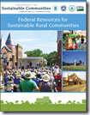
The U.S. Department of Agriculture (USDA) recently posted a useful guide outlining federal funding programs available to support rural communities.

Federal Resources for Sustainable Rural Communities (PDF 44p 6MB) is a guide to programs from the Partnership for Sustainable Communities and the U.S. Department of Agriculture (USDA) that rural communities can use to promote economic competitiveness, protect healthy environments, and enhance quality of life. It is a collaborative effort among USDA, the Department of Housing and Urban Development, the Department of Transportation and the Environmental Protection Agency.

The guide has key information on funding and technical assistance opportunities available from the four agencies, as well as examples of how rural communities across the country have benefitted from federal resources. The resource guide can be accessed here.

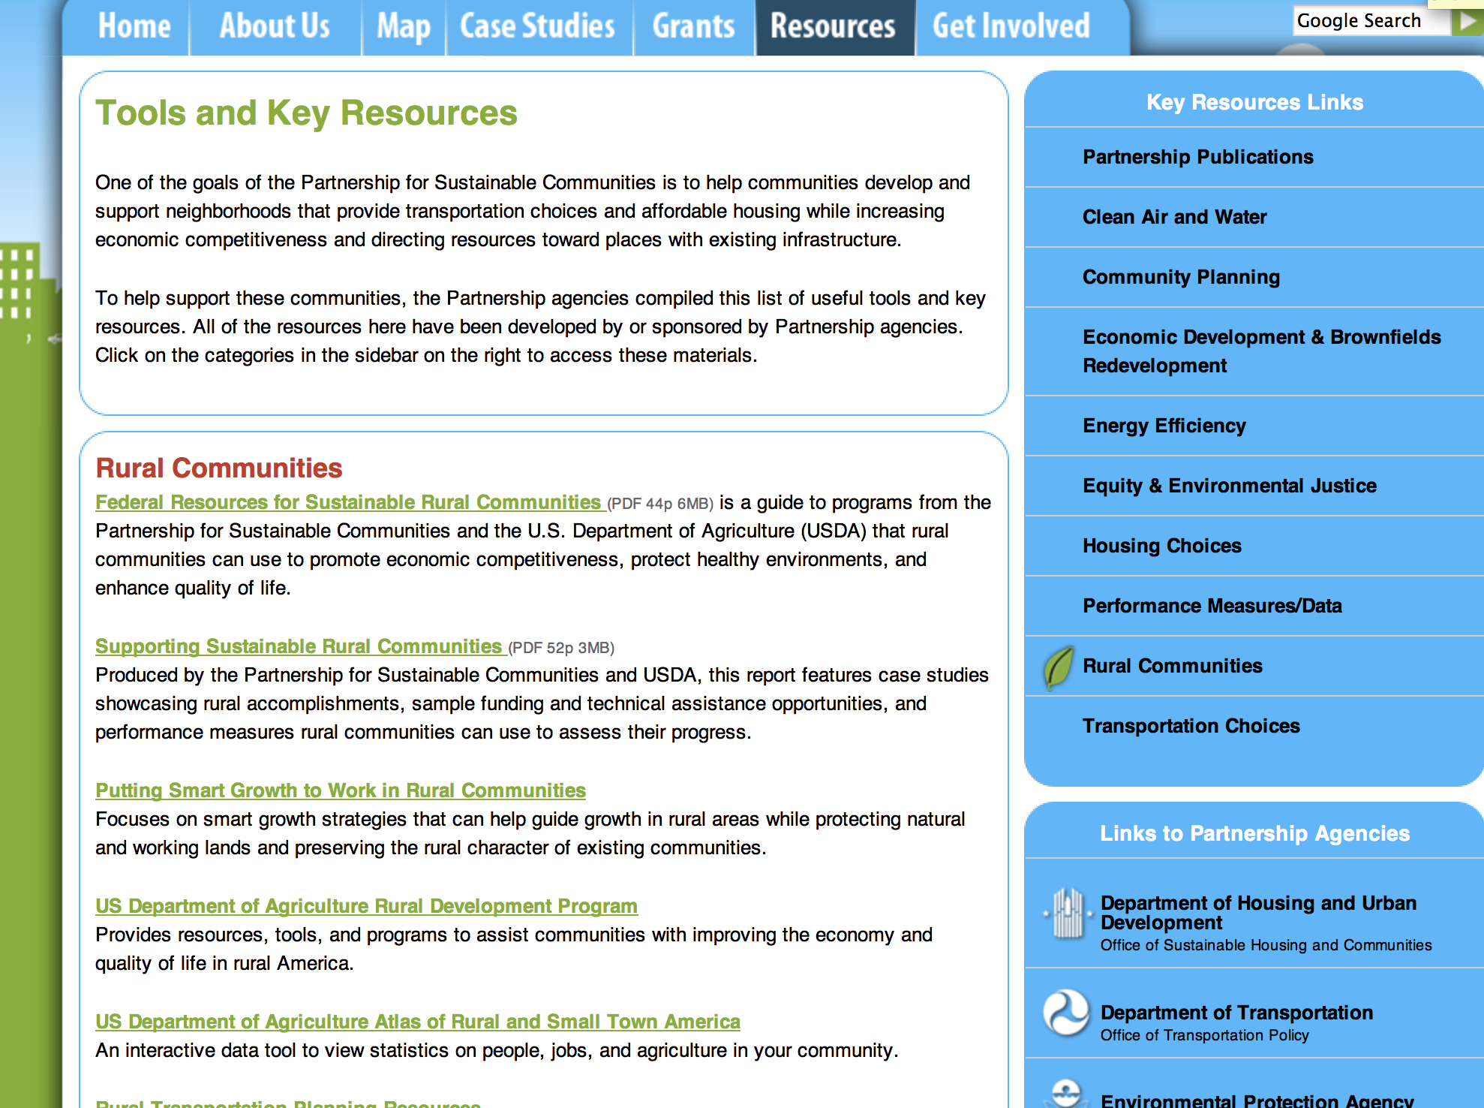
http://www.sustainablecommunities.gov/toolsKeyResources.html

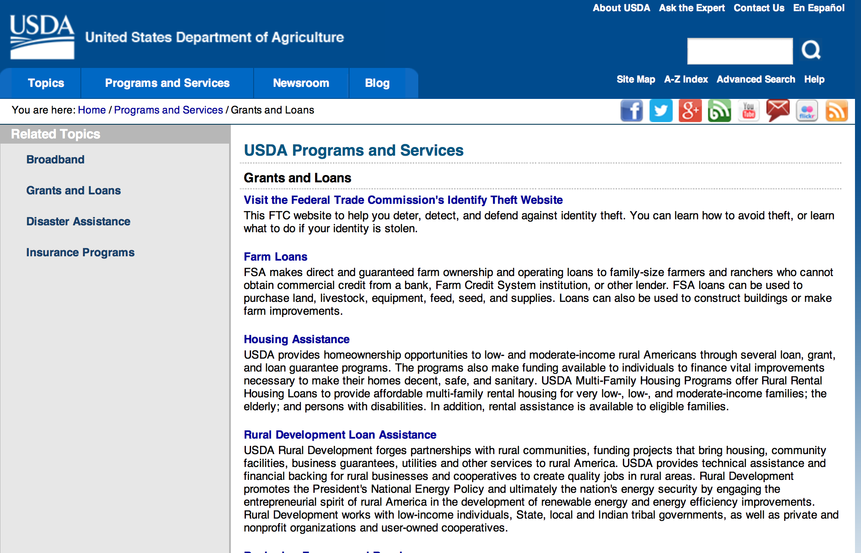

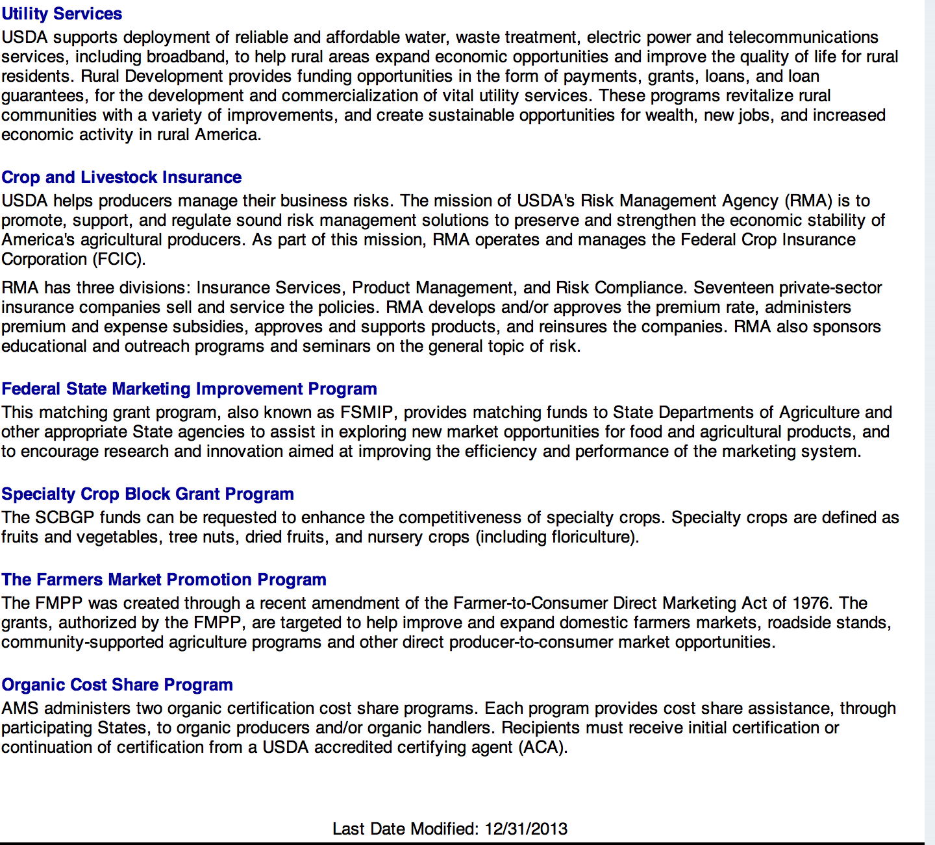

http://usda.gov/wps/portal/usda/usdahome?navid=GRANTS_LOANS

Programs:

National Institute of Food and Agriculture
Small Business Innovation Research Program Phase II Fiscal Year 2016 Grant

Document Type: | Grants Notice
Funding Opportunity Number: | USDA-NIFA-SBIR-005455
Funding Opportunity Title: | Small Business Innovation Research Program Phase II Fiscal Year 2016
Opportunity Category: | Discretionary
Funding Instrument Type: | Grant
Category of Funding Activity: | Agriculture  Science and Technology and other Research and Development
Category Explanation:
Expected Number of Awards:
CFDA Number(s): | 10.212 -- Small Business Innovation Research
Cost Sharing or Matching Requirement: | No
Posted Date: | Nov 10, 2015
Creation Date: | Nov 10, 2015
Original Closing Date for Applications: | Feb 25, 2016
Current Closing Date for Applications: | Feb 25, 2016
Archive Date: | Mar 26, 2016
Estimated Total Program Funding: | $12,000,000
Eligible Applicants: | Others (see text field entitled "Additional Information on Eligibility" for clarification)
Additional Information on Eligibility: | Only previous Phase I winners who have not previously applied for Phase II support are eligible to apply for Phase II support through this FY 2016 solicitation. A Phase I project may apply for Phase II funding one time only. Therefore, if a Phase I awardee has previously applied for Phase II funding and was not successful; the awardee is not allowed to resubmit the same project under this program solicitation. Proposals for Phase II normally may only be submitted to the Federal agency from which the Phase I award was received.
Agency Name: | National Institute of Food and Agriculture
Description: | All Phase II projects must have previously completed a successful USDA Phase I project before applying for a Phase II grant. Success rates for applicants have been 50-60% for Phase II. Projects dealing with agriculturally related manufacturing and alternative and renewable energy technologies are encouraged across all 2015 SBIR topic areas. USDA SBIR's flexible research areas ensure innovative projects consistent with USDA's vision of a healthy and productive nation in harmony with the land, air, and water. USDA SBIR has awarded over 2000 research and development projects since 1983, allowing hundreds of small businesses to explore their technological potential, and providing an incentive to profit from the commercialization of innovative ideas. Click below for more SBIR information.
Link to Additional Information: | Small Business Innovation Research Program Phase II Fiscal Year 2016
Contact Information: | If you have difficulty accessing the full announcement electronically, please contact:  NIFA Help Desk Phone: 202-401-5048 Business hours are M-F, 7:00 am -5:00 pm ET, excluding Federal holidays  If you have any questions related to preparing application content

http://www.grants.gov/web/grants/view-opportunity.html?oppId=280022

Modifications:

Reminders:

Farm Service Agency
Outreach and Education, Technical Assistance, and Financial Education for FSA Programs, Functions, and Activities Grant
And Modification1

Document Type: | Grants Notice
Funding Opportunity Number: | USDA-FSA-CA-2016-001
Funding Opportunity Title: | Outreach and Education, Technical Assistance, and Financial Education for FSA Programs, Functions, and Activities
Opportunity Category: | Discretionary
Funding Instrument Type: | Cooperative Agreement
Category of Funding Activity: | Agriculture
Category Explanation:
Expected Number of Awards: | 125
CFDA Number(s):
Cost Sharing or Matching Requirement: | No
Posted Date: | Oct 20, 2015
Creation Date: | Oct 20, 2015
Original Closing Date for Applications: | May 27, 2016
Current Closing Date for Applications: | May 27, 2016
Archive Date: | Jun 26, 2016
Estimated Total Program Funding: | $2,500,000
Award Ceiling: | $99,999
Award Floor: | $20,000
Eligible Applicants: | Nonprofits having a 501(c)(3) status with the IRS, other than institutions of higher education  Public and State controlled institutions of higher education
Agency Name: | Farm Service Agency
Description: | As part of our mission supporting farmers and ranchers, the Farm Service Agency (FSA) provides extensive education and outreach for producers. This typically involves public meetings, mailings, news releases, and interactions with individual producers seeking additional information or to enroll in a program. However, there remains a need for additional outreach and education that could benefit potential participants in FSA’s portfolio of programs. This RFA seeks proposals to further support and expand FSA’s existing outreach and education efforts. The additional outreach and education could, for example, be public meetings, training sessions, and/or workshops for producers including new and beginning farmers, veterans, underserved communities, and/or established producers. Emphasis will be afforded to proposals that propose to address producers who are ethnic minorities, women, new and beginning, veterans, urban, or who grow non-commodity crops (e.g., fruits and vegetables or specialty crops). Proposals may include innovative outreach approaches that ease the learning curve for farmers and ranchers through training on best practices, common challenges and solutions, and local networking opportunities. The subject matter should include an introduction to FSA, its programs, and common provisions that generally apply. FSA’s common provisions include maintenance of producer-level records regarding payment eligibility and limitations, conservation compliance, and name and address, payments, and farm and tract information. Additional information regarding FSA is available at www.fsa.usda.gov.
Link to Additional Information: | FSA Outreach Staff
Contact Information: | If you have difficulty accessing the full announcement electronically, please contact:  Robert Stephenson Director, Office of Business and Program Integration Phone: 202-720-4019  Help Desk

http://www.grants.gov/web/grants/view-opportunity.html?oppId=279761

Utilities Programs
Solid Waste Management Grant Program FY16 Grant

Document Type: | Grants Notice
Funding Opportunity Number: | SWMFY16
Funding Opportunity Title: | Solid Waste Management Grant Program FY16
Opportunity Category: | Discretionary
Funding Instrument Type: | Grant
Category of Funding Activity: | Other (see text field entitled "Explanation of Other Category of Funding Activity" for clarification)
Category Explanation: | The Solid Waste Management (SWM) Grant Program has been established to assist communities through free technical assistance and/or training provided by the grant recipients. Qualified organizations will receive SWM grant funds to reduce or eliminate pollution of water resources in rural areas, and improve planning and management of solid waste sites in rural areas.
Expected Number of Awards: | 30
CFDA Number(s): | 10.762 -- Solid Waste Management Grants
Cost Sharing or Matching Requirement: | No
Posted Date: | Oct 1, 2015
Creation Date: | Oct 1, 2015
Original Closing Date for Applications: | Dec 31, 2015
Current Closing Date for Applications: | Dec 31, 2015
Archive Date: | Jan 30, 2016
Estimated Total Program Funding: | $4,000,000
Eligible Applicants: | Others (see text field entitled "Additional Information on Eligibility" for clarification)
Additional Information on Eligibility: | An organization is eligible to receive a SWM grant if it: a. Is a private, non-profit organization that has tax-exempt status from the United States Internal Revenue Service (IRS);b. Is a Public body’s. Is a federally acknowledged or State-recognized Native American tribe or grouped. Is an Academic institution’s. Is legally established and located within one of the following: a state within the United States; the District of Columbia; the Commonwealth of Puerto Rico; a United States territory. Has the legal capacity and authority to carry out the grant purposing. Has a proven record of successfully providing technical assistance and/or training to rural areas’. Has capitalization acceptable to the Agency, and is composed of at least 51 percent of the outstanding interest or membership being citizens of the United States or individuals who reside in the United States after being legally admitted for permanent residence; I. Has no delinquent debt to the Federal Government or no outstanding judgments to repay a Federal debt’s. Demonstrates that it possesses the financial, technical, and managerial capability to comply with Federal and State laws and requirements’. Contracts with a nonaffiliated organization for not more than 49 percent of the grant to provide the proposed assistance.
Agency Name: | Utilities Programs
Description: | Funds may be used to: Evaluate current landfill conditions to determine threats to water resources in rural areas; provide technical assistance and/or training to enhance operator skills in the maintenance and operation of active landfills in rural areas; provide technical assistance and/or training to help associations reduce the solid waste stream; and provide technical assistance and/or training for operators of landfills in rural areas which are closed or will be closed in the near future with the development/implementation of closure plans, future land use plans, safety and maintenance planning, and closure scheduling within permit requirements. Grant funds may not be used to: Recruit preapplications/applications for any loan and/or grant program including RUS Water and Waste Disposal Loan and/or Grant Program; duplication of current services, replacement or substitution of support previously provided such as those performed by an association's consultant in developing a project; fund political activities; pay for capital assets, the purchase of real estate or vehicles, improve and renovate office space, or repair and maintain privately-owned property; pay for construction or operation and maintenance costs of water and waste facilities; and pay costs incurred prior to the effective date of grants made under this subpart.
Link to Additional Information: | Website Address
Contact Information: | If you have difficulty accessing the full announcement electronically, please contact:  LaVonda Pernell Loan Specialist Phone 202-720-9635  Government Address

http://www.grants.gov/web/grants/view-opportunity.html?oppId=279357

Utilities Programs
TAT Grant Program FY16

Document Type: | Grants Notice
Funding Opportunity Number: | TATFY16
Funding Opportunity Title: | TAT Grant Program FY16
Opportunity Category: | Discretionary
Funding Instrument Type: | Grant
Category of Funding Activity: | Other (see text field entitled "Explanation of Other Category of Funding Activity" for clarification)
Category Explanation: | The Technical Assistance and Training (TAT) Grant Program has been established to assist communities with water or wastewater systems through free technical assistance and/or training provided by the grant recipients. Qualified private non-profit organizations will receive TAT grant funds to identify and evaluate solutions to water and waste disposal problems in rural areas, assist applicants in preparing applications for water and waste grants made at the State level offices, and improve operation and maintenance of existing water and waste disposal facilities in rural areas.
Expected Number of Awards: | 17
CFDA Number(s): | 10.761 -- Technical Assistance and Training Grants
Cost Sharing or Matching Requirement: | No
Posted Date: | Oct 1, 2015
Creation Date: | Oct 1, 2015
Original Closing Date for Applications: | Dec 31, 2015
Current Closing Date for Applications: | Dec 31, 2015
Archive Date: | Jan 30, 2016
Estimated Total Program Funding: | $19,000,000
Eligible Applicants: | Others (see text field entitled "Additional Information on Eligibility" for clarification)
Additional Information on Eligibility: | Eligibility criteria for TAT grants is as follows:(a) Entities eligible for grants must be private nonprofit organizations with tax exempt status, designated by the Internal Revenue Service. A nonprofit organization is defined as any corporation, trust, association, cooperative, or other organization that:(1) Is operated primarily for scientific, education, service, charitable, or similar purposes in the public interest. (2) Is not organized primarily for profit. (3) Uses its net proceeds to maintain, improve, and/or expand its operations. (b) Entities must be legally established and located within a state as defined in 1775.2. (c) Organizations must be incorporated by December 31 of the year the application period occurs to be eligible for funds. (d) Private businesses, Federal agencies, public bodies, and individuals are ineligible for these grants. (e) Applicants must also have the proven ability, background, experience (as evidenced by the organization's satisfactory completion of project(s)similar to those proposed), legal authority, and actual capacity to provide technical assistance and/or training on a regional basis to associations as provided in 7 CFR 1775.33. To meet the requirement of actual capacity, an applicant must either:(1) Have the necessary resources to provide technical assistance and/or training to associations in rural areas through its staff, or (2) Be assisted by an affiliate or member organization which has such background and experience and which agrees, in writing, that it will provide the assistance, or (3) Contract with a nonaffiliated organization for not more than 49 percent of the grant to provide the proposed assistance.
Agency Name: | Utilities Programs
Description: | Funds may be used to pay expenses associated with providing technical assistance and/or training (TAT) to identify and evaluate solutions to water problems relating to source, storage, treatment, and distribution, and to waste disposal problems relating to collection, treatment, and disposal; assist applicants that have filed a preapplication with RUS in the preparation of water and/or waste disposal loan and/or grant applications; and to provide training that will improve the management, operation and maintenance of water and waste disposal facilities. Grant funds may not be used to recruit applications, duplicate current services such as those performed by a consultant in developing a project, fund political activities, pay for capital assets, purchase real estate or vehicles, improve and renovate office space or repair and maintain privately owned property, pay construction or O&M costs, and pay costs incurred prior to the effective date of grants made.
Link to Additional Information: | Website Address
Contact Information: | If you have difficulty accessing the full announcement electronically, please contact:  Anita OBrien Loan Specialist Phone 202-690-3789  Government Address

http://www.grants.gov/web/grants/view-opportunity.html?oppId=279333

Business and Cooperative Programs
Renewable Energy Systems and Energy Efficiency Improvements Program Grant

Document Type: | Grants Notice
Funding Opportunity Number: | RDBCP-REAP-RES-EEI-2016
Funding Opportunity Title: | Renewable Energy Systems and Energy Efficiency Improvements Program
Opportunity Category: | Mandatory
Funding Instrument Type: | Grant
Category of Funding Activity: | Agriculture  Business and Commerce  Energy
Category Explanation:
Expected Number of Awards: | 1000
CFDA Number(s): | 10.868 -- Rural Energy for America Program
Cost Sharing or Matching Requirement: | Yes
Posted Date: | Oct 13, 2015
Creation Date: | Oct 13, 2015
Original Closing Date for Applications: | REAP Applications are accepted year-round. For applicants requesting grants of $20,000 or less, that wish to have their application compete for the "Grants of $20,000 or less set aside", complete applications must be received no later than 4:30pm local time on: November 2, 2015, or May 2, 2016. For applicants requesting grant funds of over $20,000 or funding for a combination grant and guaranteed loan, complete applications must be received no later than 4:30pm local time on May 2, 2016.
Current Closing Date for Applications: | REAP Applications are accepted year-round. For applicants requesting grants of $20,000 or less, that wish to have their application compete for the "Grants of $20,000 or less set aside", complete applications must be received no later than 4:30pm local time on: November 2, 2015, or May 2, 2016. For applicants requesting grant funds of over $20,000 or funding for a combination grant and guaranteed loan, complete applications must be received no later than 4:30pm local time on May 2, 2016.
Archive Date:
Estimated Total Program Funding: | $35,400,000
Award Ceiling: | $500,000
Award Floor: | $1,500
Eligible Applicants: | Native American tribal organizations (other than Federally recognized tribal governments)  Small businesses  Others (see text field entitled "Additional Information on Eligibility" for clarification)
Additional Information on Eligibility: | Agricultural Producers
Agency Name: | Business and Cooperative Programs
Description: | REAP Renewable Energy Systems and Energy Efficiency Improvement Program. Refer to Application Package AND Application Instruction links to obtain all necessary forms for a complete application. Contact State Energy Coordinators with questions: http://www.rd.usda.gov/files/RBS_StateEnergyCoordinators.pdf
Link to Additional Information: | REAP Renewable Energy Systems and Energy Efficiency Improvements Program
Contact Information: | If you have difficulty accessing the full announcement electronically, please contact:  State Energy Coordinator http://www.rd.usda.gov/files/RBS_StateEnergyCoordinators.pdf  Refer to energy coordinator list via link posted above.

http://www.grants.gov/web/grants/view-opportunity.html?oppId=279638

Business and Cooperative Programs
REAP Energy Audit and Renewable Energy Development Assistance Program Grant

Document Type: | Grants Notice
Funding Opportunity Number: | RDBCP-REAP-EA-REDA-2016
Funding Opportunity Title: | REAP Energy Audit and Renewable Energy Development Assistance Program
Opportunity Category: | Mandatory
Funding Instrument Type: | Grant
Category of Funding Activity: | Education  Energy  Environment  Regional Development
Category Explanation:
Expected Number of Awards: | 23
CFDA Number(s): | 10.868 -- Rural Energy for America Program
Cost Sharing or Matching Requirement: | Yes
Posted Date: | Oct 13, 2015
Creation Date: | Oct 13, 2015
Original Closing Date for Applications: | Feb 1, 2016
Current Closing Date for Applications: | Feb 1, 2016
Archive Date:
Estimated Total Program Funding: | $1,864,000
Award Ceiling: | $100,000
Award Floor: | $1
Eligible Applicants: | Others (see text field entitled "Additional Information on Eligibility" for clarification)  Native American tribal organizations (other than Federally recognized tribal governments)  County governments  Public and State controlled institutions of higher education  State governments  Native American tribal governments (Federally recognized)  City or township governments  Private institutions of higher education
Additional Information on Eligibility: | Resource Conservation and Development Districts
Agency Name: | Business and Cooperative Programs
Description: | REAP Energy Audit and Renewable Energy Development Assistance Program. Refer to Application Package AND Application Instruction links to obtain all necessary forms for a complete application. Contact State Energy Coordinator with questions: http://www.rd.usda.gov/files/RBS_StateEnergyCoordinators.pdf
Link to Additional Information: | REAP Energy Audits and Renewable Energy Development Assistance
Contact Information: | If you have difficulty accessing the full announcement electronically, please contact:  Contact your State Energy Coordinator: http://www.rd.usda.gov/files/RBS_StateEnergyCoordinators.pdf  Refer to coordinator list via link posted above.

http://www.grants.gov/web/grants/view-opportunity.html?oppId=279639

Utilities Programs
Assistance to High Energy Cost Rural Communities Grant

Document Type: | Grants Notice
Funding Opportunity Number: | RD-RUS-HECG15
Funding Opportunity Title: | Assistance to High Energy Cost Rural Communities
Opportunity Category: | Discretionary
Funding Instrument Type: | Grant
Category of Funding Activity: | Business and Commerce  Community Development  Energy
Category Explanation:
Expected Number of Awards: | 12
CFDA Number(s): | 10.859 -- Assistance to High Energy Cost Rural Communities
Cost Sharing or Matching Requirement: | No
Posted Date: | Oct 28, 2015
Creation Date: | Oct 28, 2015
Original Closing Date for Applications: | Dec 14, 2015
Current Closing Date for Applications: | Dec 14, 2015
Archive Date: | Jan 13, 2016
Estimated Total Program Funding: | $10,000,000
Award Ceiling: | $3,000,000
Award Floor: | $50,000
Eligible Applicants: | Individuals  Public and State controlled institutions of higher education  For profit organizations other than small businesses  Special district governments  Native American tribal organizations (other than Federally recognized tribal governments)  Nonprofits having a 501(c)(3) status with the IRS, other than institutions of higher education  Independent school districts  Small businesses  Nonprofits that do not have a 501(c)(3) status with the IRS, other than institutions of higher education  Others (see text field entitled "Additional Information on Eligibility" for clarification)  Native American tribal governments (Federally recognized)  State governments  Public housing authorities/Indian housing authorities  City or township governments  County governments  Private institutions of higher education
Additional Information on Eligibility: | Individuals may apply on behalf of unincorporated community organizations. Awards will not be made directly to individuals. Eligible applicants also include sole proprietorships, legally organized for-profit or nonprofit organizations such as, but not limited to, a corporation, association, partnership (including a limited liability partnership), cooperative, or trust. Applicant must be located in the United States, a U.S. Territory or other area authorized by law to participate in programs of the Rural Utilities Service or under the Rural Electrification Act.
Agency Name: | Utilities Programs
Description: | The Rural Utilities Service (RUS), an agency of the United States Department of Agriculture (USDA), announces the availability of up to $10 million in competitive grants to assist communities with extremely high energy costs. The grant funds may be used to acquire, construct, or improve energy generation, transmission, or distribution facilities serving communities where average annual residential expenditure for home energy exceeding 275 percent of the national average. Eligible projects also include on-grid and off-grid renewable energy projects and implementation of energy efficiency, and energy conservation projects for eligible communities. Projects cannot be for the primary benefit of a single household or business. Grant funds may not be used for the preparation of the grant application, payment of utility bills, fuel purchases, routine maintenance or other routine operating costs, or for the purchase of any equipment, structures, or real estate not directly associated with provision of community energy services. See the published Notice of Solicitation of Applications, which describes the eligibility and application requirements, the criteria that will be used by RUS to award funding, and information on how to obtain application materials.
Link to Additional Information: | High Energy Cost Grant Program Home Page.
Contact Information: | If you have difficulty accessing the full announcement electronically, please contact:  Robin Meigel Finance Specialist Phone: 202-720-9452  Robin.Meigel@wdc.usda.gov

http://www.grants.gov/web/grants/view-opportunity.html?oppId=279877

National Institute of Food and Agriculture
Beginning Farmer and Rancher Development Program Grant

Document Type: | Grants Notice
Funding Opportunity Number: | USDA-NIFA-BFR-005436
Funding Opportunity Title: | Beginning Farmer and Rancher Development Program
Opportunity Category: | Mandatory
Funding Instrument Type: | Grant
Category of Funding Activity: | Agriculture
Category Explanation:
Expected Number of Awards:
CFDA Number(s): | 10.311 -- Beginning Farmer and Rancher Development Program
Cost Sharing or Matching Requirement: | Yes
Posted Date: | Oct 29, 2015
Creation Date: | Oct 29, 2015
Original Closing Date for Applications: | Jan 21, 2016
Current Closing Date for Applications: | Jan 21, 2016
Archive Date: | Feb 20, 2016
Estimated Total Program Funding: | $18,000,000
Eligible Applicants: | Others (see text field entitled "Additional Information on Eligibility" for clarification)
Additional Information on Eligibility: | Applications may only be submitted by a collaborative state, tribal, local, or regionally-based network or partnership of qualified public and/or private entities. These collaborations may include the following entities: State Cooperative Extension Services; Federal, State, or tribal agencies; community based organizations (CBOs); nongovernmental organizations (NGOs); junior and four-year colleges or universities or foundations maintained by a college or university; private for-profit organizations. Inclusion of beginning and/or non-beginning farmers and ranchers as part of the collaborative group is strongly encouraged. Applications submitted by individuals, or by organizations that do not involve other entities in a network or partnership, are not eligible for consideration under any category applicable to the BFRDP.
Agency Name: | National Institute of Food and Agriculture
Description: | Beginning farmer education for adult and young audiences in the United States can be generally traced back to the advent of the 1862 and the 1890 Morrill Land Grant Acts. But for the first time, the Food, Conservation, and Energy Act of 2008 (Pub .L. No. 110-234, Section 7410), appropriated $75 million for FY 2009 to FY 2012 to develop and offer education, training, outreach and mentoring programs to enhance the sustainability of the next generation of farmers. The Agriculture Act of 2014 provided an additional $20 million per year for 2014 through 2018. The reasons for the renewed interest in beginning farmer and rancher programs are: the rising average age of U.S. farmers, the 8% projected decrease in the number of farmers and ranchers between 2008 and 2018, and the growing recognition that new programs are needed to address the needs of the next generation of beginning farmers and ranchers.
Link to Additional Information: | Beginning Farmer and Rancher Development Program
Contact Information: | If you have difficulty accessing the full announcement electronically, please contact:  NIFA Help Desk Phone: 202-401-5048 Business hours are M-F, 7:00 am -5:00 pm ET, excluding Federal holidays  If you have any questions related to preparing application content

http://www.grants.gov/web/grants/view-opportunity.html?oppId=279882

National Institute of Food and Agriculture
Biotechnology Risk Assessment Grants Program
Document Type: | Grants Notice
Funding Opportunity Number: | USDA-NIFA-BRAP-005435
Funding Opportunity Title: | Biotechnology Risk Assessment Grants Program
Opportunity Category: | Discretionary
Funding Instrument Type: | Grant
Category of Funding Activity: | Agriculture
Category Explanation:
Expected Number of Awards:
CFDA Number(s): | 10.219 -- Biotechnology Risk Assessment Research
Cost Sharing or Matching Requirement: | Yes
Posted Date: | Oct 29, 2015
Creation Date: | Oct 29, 2015
Original Closing Date for Applications: | Apr 15, 2016 Letter of Intent (LOI) should be received by 5:00 p.m., Eastern Time on February 12, 2016.
Current Closing Date for Applications: | Apr 15, 2016 Letter of Intent (LOI) should be received by 5:00 p.m., Eastern Time on February 12, 2016.
Archive Date: | May 15, 2016
Estimated Total Program Funding: | $4,000,000
Eligible Applicants: | Others (see text field entitled "Additional Information on Eligibility" for clarification)
Additional Information on Eligibility: | Applications may only be submitted by United States public or private research or educational institution or organization.
Agency Name: | National Institute of Food and Agriculture
Description: | The purpose of the BRAG program is to support the generation of new information that will assist Federal regulatory agencies in making science-based decisions about the effects of introducing into the environment genetically engineered organisms (GE), including plants, microorganisms (including fungi, bacteria, and viruses), arthropods, fish, birds, mammals and other animals excluding humans. Investigations of effects on both managed and natural environments are relevant. The BRAG program accomplishes its purpose by providing Federal regulatory agencies with scientific information relevant to regulatory issues. See RFA for details.
Link to Additional Information: | Biotechnology Risk Assessment Grants Program
Contact Information: | If you have difficulty accessing the full announcement electronically, please contact:  NIFA Help Desk Phone: 202-401-5048 Business hours are M-F, 7:00 am -5:00 pm ET, excluding Federal holidays  If you have any questions related to preparing application content

http://www.grants.gov/web/grants/view-opportunity.html?oppId=279885

Farm Service Agency
Outreach and Education, Technical Assistance, and Financial Education for FSA Programs, Functions, and Activities Grant

Document Type: | Grants Notice
Funding Opportunity Number: | USDA-FSA-CA-2016-001
Funding Opportunity Title: | Outreach and Education, Technical Assistance, and Financial Education for FSA Programs, Functions, and Activities
Opportunity Category: | Discretionary
Funding Instrument Type: | Cooperative Agreement
Category of Funding Activity: | Agriculture
Category Explanation:
Expected Number of Awards: | 125
CFDA Number(s):
Cost Sharing or Matching Requirement: | No
Posted Date: | Sep 22, 2015
Creation Date: | Sep 22, 2015
Original Closing Date for Applications: | May 27, 2016
Current Closing Date for Applications: | May 27, 2016
Archive Date: | Jun 26, 2016
Estimated Total Program Funding: | $2,500,000
Award Ceiling: | $99,999
Award Floor: | $20,000
Eligible Applicants: | Nonprofits having a 501(c)(3) status with the IRS, other than institutions of higher education  Public and State controlled institutions of higher education
Additional Information on Eligibility:
Agency Name: | Farm Service Agency
Description: | As part of our mission supporting farmers and ranchers, the Farm Service Agency (FSA) provides extensive education and outreach for producers. This typically involves public meetings, mailings, news releases, and interactions with individual producers seeking additional information or to enroll in a program. However, there remains a need for additional outreach and education that could benefit potential participants in FSA’s portfolio of programs. This RFA seeks proposals to further support and expand FSA’s existing outreach and education efforts. The additional outreach and education could, for example, be public meetings, training sessions, and/or workshops for producers including new and beginning farmers, veterans, underserved communities, and/or established producers. Emphasis will be afforded to proposals that propose to address producers who are ethnic minorities, women, new and beginning, veterans, urban, or who grow non-commodity crops (e.g., fruits and vegetables or specialty crops). Proposals may include innovative outreach approaches that ease the learning curve for farmers and ranchers through training on best practices, common challenges and solutions, and local networking opportunities. The subject matter should include an introduction to FSA, its programs, and common provisions that generally apply. FSA’s common provisions include maintenance of producer-level records regarding payment eligibility and limitations, conservation compliance, and name and address, payments, and farm and tract information. Additional information regarding FSA is available at www.fsa.usda.gov.
Link to Additional Information: | FSA RFA Announcement 2016-001
Contact Information: | If you have difficulty accessing the full announcement electronically, please contact:  Robert Stephenson; Director, Office of Business and Program Integration; Phone 202-720-4019  Help Desk

http://www.grants.gov/web/grants/view-opportunity.html?oppId=279153

Department of Commerce

Grants, Contracting, and Trade Opportunities at Commerce
Learn more information about grants, contracting and trade opportunities at the Department of Commerce using the information below.

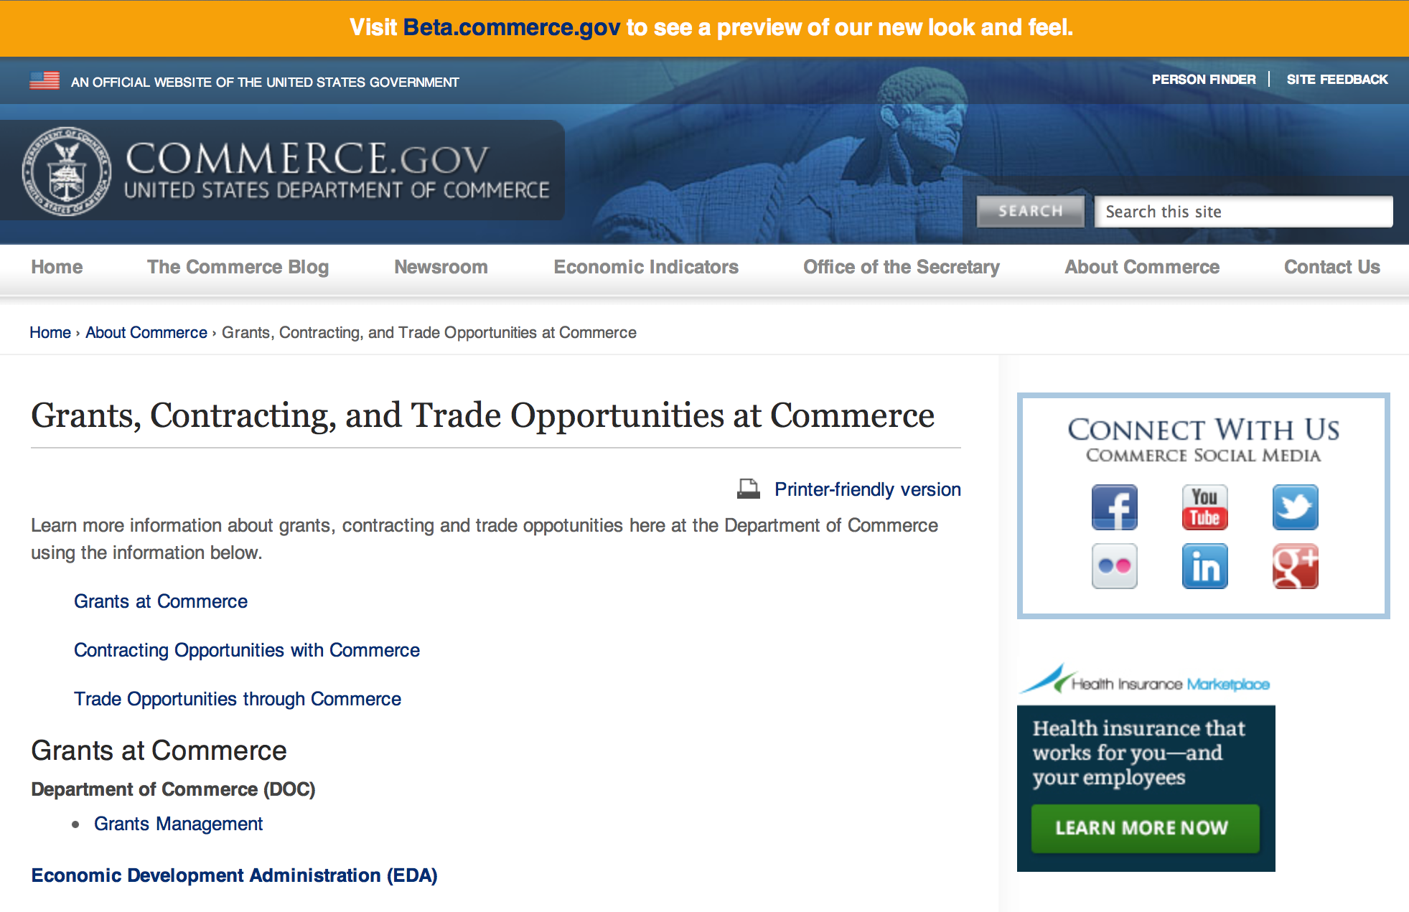
Grants at Commerce
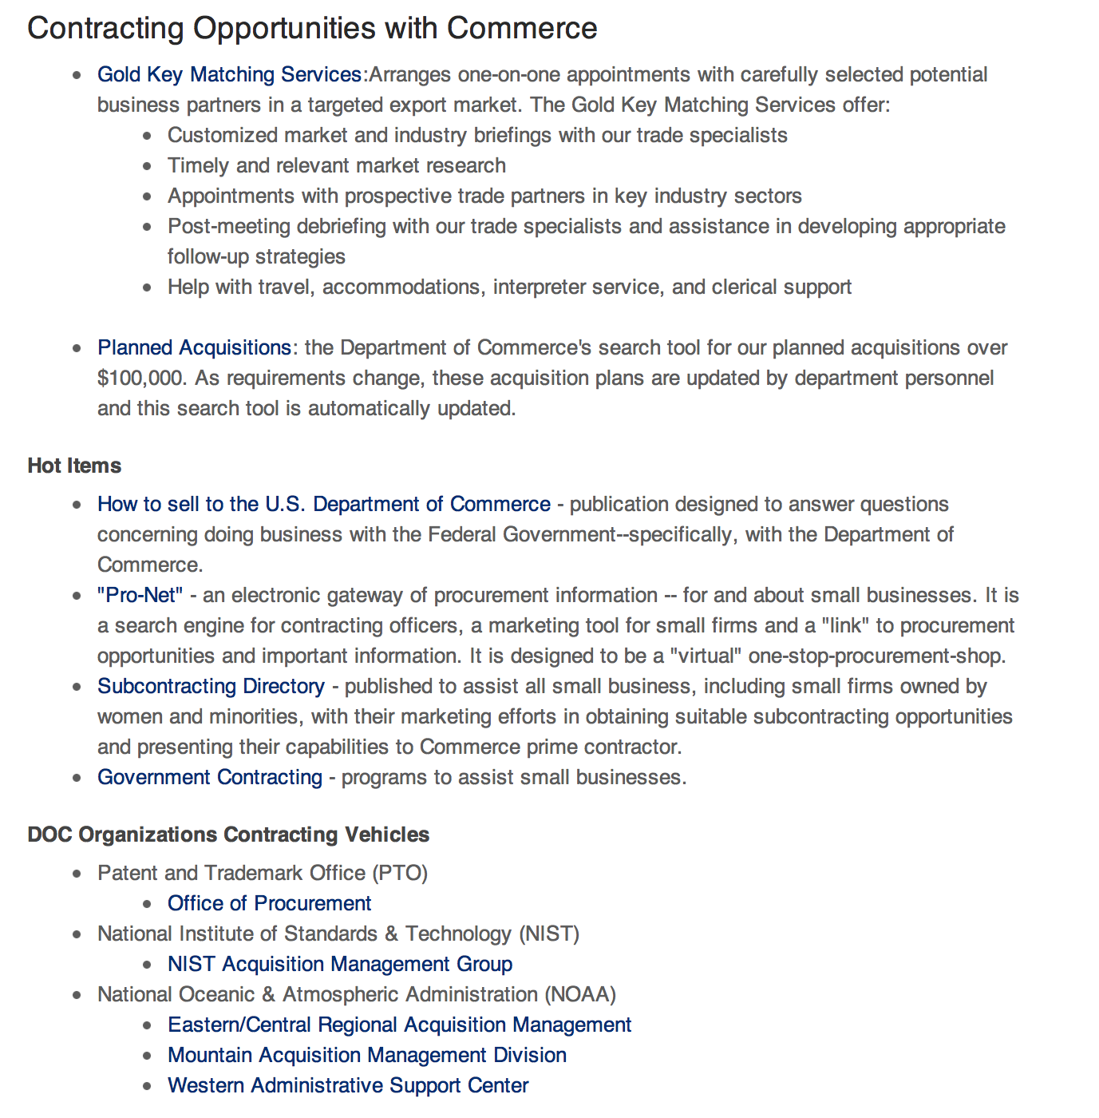

Contracting Opportunities with Commerce
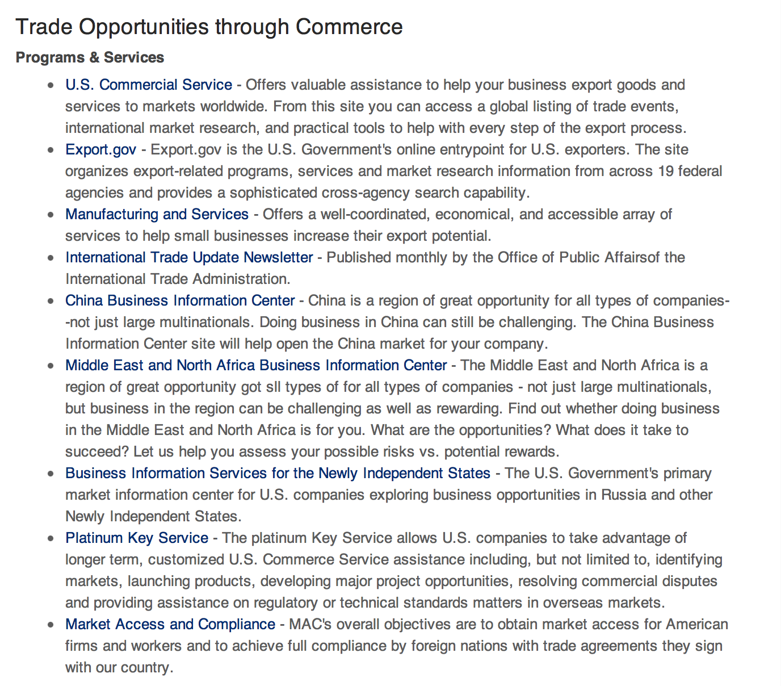

Trade Opportunities through Commerce
http://www.commerce.gov/about-commerce/grants-contracting-trade-opportunities

Programs:

2016 Marine Education and Training Mini Grant Program

Document Type: | Grants Notice
Funding Opportunity Number: | NOAA-NMFS-PIRO-2016-2004728
Funding Opportunity Title: | 2016 Marine Education and Training Mini Grant Program
Opportunity Category: | Discretionary
Funding Instrument Type: | Cooperative Agreement  Grant
Category of Funding Activity: | Environment  Natural Resources  Science and Technology and other Research and Development
Category Explanation:
Expected Number of Awards: | 20
CFDA Number(s): | 11.452 -- Unallied Industry Projects
Cost Sharing or Matching Requirement: | No
Posted Date: | Nov 5, 2015
Creation Date: | Nov 5, 2015
Original Closing Date for Applications: | Feb 3, 2016
Current Closing Date for Applications: | Feb 3, 2016
Archive Date: | Mar 4, 2016
Estimated Total Program Funding: | $200,000
Award Ceiling: | $15,000
Award Floor: | $1
Eligible Applicants: | Others (see text field entitled "Additional Information on Eligibility" for clarification)
Additional Information on Eligibility: | Eligible applicants are individuals, institutions of higher education, nonprofits, commercial organizations, state, local and Indian tribal governments. Federal agencies, Federal instrumentalities, or employees of Federal agencies, are not eligible to apply. Eligible applicants are limited to those within the Western Pacific Regional Fishery Management areas.
Agency Name: | Department of Commerce
Description: | The National Marine Fisheries Service (NOAA/NMFS) is soliciting competitive applications for the 2016 Pacific Islands Region Marine Education and Training Mini-Grant Program. Projects are being solicited to improve communication, education, and training on marine resource issues throughout the region and increase scientific education for marine-related professions among coastal community residents, including indigenous Pacific islanders, Native Hawaiians and other underrepresented groups in the region.
Link to Additional Information:
Contact Information: | If you have difficulty accessing the full announcement electronically, please contact:  Ms. Kara Miller, NOAA Fisheries Service, Pacific Islands Regional Office, 1845 Wasp Blvd, Building 176, Honolulu, HI 96818; Phone: (808) 725-5056; Email: Kara.Miller@noaa.gov.  Work

http://www.grants.gov/web/grants/view-opportunity.html?oppId=279985

National Estuarine Research Reserve System (NERRS) Land Acquisition and Construction Program for Fiscal Year 2016 Grant

Document Type: | Grants Notice
Funding Opportunity Number: | NOAA-NOS-OCM-2016-2004712
Funding Opportunity Title: | National Estuarine Research Reserve System (NERRS) Land Acquisition and Construction Program for Fiscal Year 2016
Opportunity Category: | Discretionary
Funding Instrument Type: | Grant
Category of Funding Activity: | Environment  Natural Resources  Science and Technology and other Research and Development
Category Explanation:
Expected Number of Awards: | 10
CFDA Number(s): | 11.420 -- Coastal Zone Management Estuarine Research Reserves
Cost Sharing or Matching Requirement: | Yes
Posted Date: | Nov 13, 2015
Creation Date: | Nov 13, 2015
Original Closing Date for Applications: | Jan 29, 2016
Current Closing Date for Applications: | Jan 29, 2016
Archive Date: | Feb 28, 2016
Estimated Total Program Funding: | $1,700,000
Award Ceiling: | $800,000
Award Floor: | $20,000
Eligible Applicants: | Others (see text field entitled "Additional Information on Eligibility" for clarification)
Additional Information on Eligibility: | Eligible applicants are NERRS lead state agencies or universities in coastal states including the Pacific, Gulf, Atlantic Coast and Great Lakes. Eligible applicants should meet requirements as stated in the NERRS regulations codified at 15 C.F.R. Part 921, which are available online at http://www.nerrs.noaa.gov.
Agency Name: | Department of Commerce
Description: | The National Estuarine Research Reserve System (NERRS or System) consists of estuarine areas of the United States and its territories designated and managed for research and educational purposes. Each Reserve within the system is chosen to represent a different bio-geographic region and to include a variety of ecosystem types in accordance with the classification scheme of the national program as specified in 15 C.F.R. Part 921. By funding designated Reserve agencies and universities to conduct land acquisition and construction projects that support the NERRS mission, NOAA will strengthen protection of key land and water areas, enhance long-term protection of Reserve areas for research and education, and provide for facility and exhibit construction that meet the highest sustainable design standards possible. NOAA anticipates approximately $1.7 million in Fiscal Year 2016 will be available to designated lead Reserve agencies or universities in coastal states for approximately 1-10 construction and acquisition projects, from approximately $20,000 to $800,000 each and with project periods typically covering 12-36 months, depending on the availability of funds.
Link to Additional Information:
Contact Information: | If you have difficulty accessing the full announcement electronically, please contact:  Nina Garfield, program coordinator, at NOAA/Office for Coastal Management, 1305 East-West Highway, SSMC4, 10th Floor, Silver Spring, MD 20910 or via phone: 301-563-1171, email: contact Nina.Garfield@noaa.gov. The program website can be accessed at coast.noaa.gov. or Erica Seiden at (301) 563-1172 or at Erica.Seiden@noaa.gov.  Work

http://www.grants.gov/web/grants/view-opportunity.html?oppId=280059

FY 2016 Air Quality Research and Forecasting Grant

Document Type: | Grants Notice
Funding Opportunity Number: | NOAA-OAR-OWAQ-2016-2004717
Funding Opportunity Title: | FY 2016 Air Quality Research and Forecasting
Opportunity Category: | Discretionary
Funding Instrument Type: | Cooperative Agreement  Grant
Category of Funding Activity: | Environment  Natural Resources  Science and Technology and other Research and Development
Category Explanation:
Expected Number of Awards: | 6
CFDA Number(s): | 11.459 -- Weather and Air Quality Research
Cost Sharing or Matching Requirement: | No
Posted Date: | Nov 6, 2015
Creation Date: | Nov 6, 2015
Original Closing Date for Applications: | Jan 29, 2016
Current Closing Date for Applications: | Jan 29, 2016
Archive Date: | Feb 28, 2016
Estimated Total Program Funding: | $700,000
Award Ceiling: | $150,000
Award Floor: | $50,000
Eligible Applicants: | Nonprofits having a 501(c)(3) status with the IRS, other than institutions of higher education  Native American tribal governments (Federally recognized)  Small businesses  Public and State controlled institutions of higher education  State governments  Nonprofits that do not have a 501(c)(3) status with the IRS, other than institutions of higher education  City or township governments  Special district governments  For profit organizations other than small businesses  Private institutions of higher education  County governments
Agency Name: | Department of Commerce
Description: | Through the U.S. Weather Research Program (USWRP), OAR’s Office of Weather and Air Quality (OWAQ) is soliciting proposals to conduct air quality research and development activities related to advancing air quality forecasting that will improve NOAA’s operational predictions of ozone and PM2.5 in particular over the coming 5 to 10 years.
Link to Additional Information:
Contact Information: | If you have difficulty accessing the full announcement electronically, please contact:  Richard Fulton  work

http://www.grants.gov/web/grants/view-opportunity.html?oppId=279987

Fiscal Year 2016 NMFS-Sea Grant Fellowships in Marine Resource Economics Grant
And Modification 1

Document Type: | Grants Notice
Funding Opportunity Number: | NOAA-OAR-SG-2016-2004720
Funding Opportunity Title: | Fiscal Year 2016 NMFS-Sea Grant Fellowships in Marine Resource Economics
Opportunity Category: | Discretionary
Funding Instrument Type: | Cooperative Agreement
Category of Funding Activity: | Environment  Natural Resources  Science and Technology and other Research and Development
Category Explanation:
Expected Number of Awards: | 8
CFDA Number(s): | 11.417 -- Sea Grant Support
Cost Sharing or Matching Requirement: | Yes
Posted Date: | Dec 3, 2015
Creation Date: | Dec 4, 2015
Original Closing Date for Applications: | Feb 3, 2016
Current Closing Date for Applications: | Feb 26, 2016
Archive Date: | Mar 27, 2016
Estimated Total Program Funding: | $320,000
Award Ceiling: | $43,500
Award Floor: | $33,000
Eligible Applicants: | Others (see text field entitled "Additional Information on Eligibility" for clarification)
Additional Information on Eligibility: | Prospective Fellows must be United States citizens. At the time of application, prospective Marine Resource Economics Fellows must be admitted to a PhD degree program in resource or environmental economics at an institution of higher education in the United States or its territories, or submit a signed letter from the institution indicating provisional acceptance to a PhD degree program conditional on obtaining financial support such as this Fellowship. Applications must come from Sea Grant programs.
Agency Name: | Department of Commerce
Description: | The Fellowship Program generally awards two new PhD Fellowships each year to students who are interested in careers related to the development and implementation of quantitative methods for assessing the economics of the conservation and management of living marine resources. Fellows will work on thesis problems of public interest and relevance to NMFS under the guidance of NMFS mentors at participating NMFS Science Centers or Offices. The NMFS-Sea Grant Fellowship in Marine Resource Economics meets NOAA's Healthy Oceans goal of "Marine fisheries, habitats, biodiversity sustained with healthy and productive ecosystems." The expected annual award per Fellow will be $46,000 (federal plus matching funds), which is funded jointly by NOAA Fisheries and Sea Grant.
Link to Additional Information:
Contact Information: | If you have difficulty accessing the full announcement electronically, please contact:  Julia Galkiewicz 301-734-1067  work

http://www.grants.gov/web/grants/view-opportunity.html?oppId=280317

Next Round of Research to Operations Initiative: NGGPS and HFIP Grant

Document Type: | Grants Notice
Funding Opportunity Number: | NOAA-NWS-NWSPO-2016-2004713
Funding Opportunity Title: | Next Round of Research to Operations Initiative: NGGPS and HFIP
Opportunity Category: | Discretionary
Funding Instrument Type: | Cooperative Agreement
Category of Funding Activity: | Environment  Natural Resources  Science and Technology and other Research and Development
Category Explanation:
Expected Number of Awards: | 16
CFDA Number(s): | 11.468 -- Applied Meteorological Research
Cost Sharing or Matching Requirement: | No
Posted Date: | Dec 2, 2015
Creation Date: | Dec 2, 2015
Original Closing Date for Applications: | Feb 29, 2016
Current Closing Date for Applications: | Feb 29, 2016
Archive Date: | Mar 30, 2016
Estimated Total Program Funding: | $2,600,000
Award Ceiling: | $200,000
Award Floor: | $100,000
Eligible Applicants: | Others (see text field entitled "Additional Information on Eligibility" for clarification)  Public and State controlled institutions of higher education  Private institutions of higher education
Additional Information on Eligibility: | Federally funded educational institutions
Agency Name: | Department of Commerce
Description: | This program announcement is for projects to be conducted for a two-year period with an anticipated start date of September 1, 2016 unless otherwise directed. Eligible applicants are institutions of higher education and federally funded educational institutions such as the Naval Postgraduate School. The purpose of the NOAA Research to Operations (R2O) Initiative is to expand and accelerate critical weather forecasting research to operations to address growing service demands and increase the accuracy of weather forecasts. This will be achieved through: (1) accelerated development and implementation of improved global weather prediction models, and inclusion of the coupling of atmosphere, ocean, wave, land surface and ice system components; (2) improved data assimilation techniques; (3) nested regional prediction capabilities; (4) improved hurricane and tropical cyclone modeling techniques; (5) improved ensemble techniques; (6) post-processing forecast tools and techniques; and (7) improved software architecture and system engineering. The NOAA R2O Initiative is soliciting proposals for projects involving applied science, modeling and/or data assimilation that support development of the Next Generation Global Prediction System (NGGPS) at global and regional scales. The NOAA R2O Initiative is also soliciting proposals for the Hurricane Forecast Improvement Project (HFIP) initiative to engage and coordinate hurricane research required to improve operational hurricane forecasts to meet societal requirements to effectively mitigate economic disruption. This notice provides guidelines for submission of proposals. This notice also describes opportunities and application procedures to demonstrate capabilities that have the potential to be incorporated into operational NWS numerical weather prediction (NWP) analyses and forecasts. The R2O initiative addresses NOAA's Weather Ready Nation (WRN) strategic goal and supporting objectives. The Program also represents an NOAA/NWS effort to foster a cost-effective transition from basic and applied research to operations and services through collaborative research and developmental testing between institutions which have expertise in the environmental sciences and operational forecast scientists. These activities will engage researchers in applied research of interest with the operational meteorological community and will improve the accuracy of forecasts and warnings of environmental hazards by applying scientific knowledge and information to operational products and services.
Link to Additional Information:
Contact Information: | If you have difficulty accessing the full announcement electronically, please contact:  Christopher Hedge NOAA/NWS 1325 East-West Highway, Room 15328 Silver Spring, MD 20910 301-427-9242

http://www.grants.gov/web/grants/view-opportunity.html?oppId=280274

Next Round of Research to Operations Initiative: NOAA Testbeds Grant

Document Type: | Grants Notice
Funding Opportunity Number: | NOAA-NWS-NWSPO-2016-2004610
Funding Opportunity Title: | Next Round of Research to Operations Initiative: NOAA Testbeds
Opportunity Category: | Discretionary
Funding Instrument Type: | Cooperative Agreement
Category of Funding Activity: | Environment  Natural Resources  Science and Technology and other Research and Development
Category Explanation:
Expected Number of Awards: | 7
CFDA Number(s): | 11.468 -- Applied Meteorological Research
Cost Sharing or Matching Requirement: | No
Posted Date: | Dec 2, 2015
Creation Date: | Dec 2, 2015
Original Closing Date for Applications: | Feb 29, 2016
Current Closing Date for Applications: | Feb 29, 2016
Archive Date: | Mar 30, 2016
Estimated Total Program Funding: | $1,000,000
Award Ceiling: | $200,000
Award Floor: | $100,000
Eligible Applicants: | Special district governments  Native American tribal governments (Federally recognized)  Small businesses  Private institutions of higher education  Nonprofits having a 501(c)(3) status with the IRS, other than institutions of higher education  Nonprofits that do not have a 501(c)(3) status with the IRS, other than institutions of higher education  City or township governments  For profit organizations other than small businesses  County governments  State governments  Public and State controlled institutions of higher education
Agency Name: | Department of Commerce
Description: | This program announcement is for projects to be conducted for a two-year period with an anticipated start date of September 1, 2016 unless otherwise directed. All public or private sources may submit to this Federal Funding Opportunity; however, partnering with universities is highly encouraged. Eligible applicants are institutions of higher education; other nonprofits; commercial organizations; state, local and Indian tribal governments; and Federal agencies. Applicants for this opportunity must work in partnership with NOAA testbeds and proving grounds (listed under www.testbeds.noaa.gov). NOAA's testbeds and proving grounds facilitate the orderly transition of research capabilities to operational implementation through development testing in testbeds, and pre-deployment testing and operational readiness/suitability evaluation in operational proving grounds. The purpose of the NOAA Research to Operations (R2O) Initiative is to expand and accelerate critical weather forecasting research to operations to address growing service demands and increase the accuracy of weather forecasts. This will be achieved through: (1) accelerated development and implementation of improved global weather prediction models and inclusion of the coupling among atmosphere, ocean, wave, land surface and ice system components; (2) improved data assimilation techniques; (3) nested regional prediction capabilities; (4) improved hurricane and tropical cyclone modeling techniques; (5) improved ensemble techniques; (6) post-processing forecast tools and techniques; and (7) improved software architecture and system engineering. The NOAA R2O Initiative is soliciting proposals for projects involving applied science, modeling and/or data assimilation that supports development of effective assimilation for environmental observations at global and regional scales, and hurricane and other high-impact weather forecast models that meet societal requirements to effectively mitigate economic disruption. This notice provides guidelines for submission of proposals. This notice also describes opportunities and application procedures to demonstrate capabilities that have the potential to be incorporated into operational NWS numerical weather prediction (NWP) analyses and forecasts. The R2O initiative addresses NOAA's Weather Ready Nation (WRN) strategic goal and supporting objectives. The Program also represents an NOAA/NWS effort to foster a cost-effective transition from basic and applied research to operations and services through collaborative research and developmental testing between institutions which have expertise in the environmental sciences and operational forecast scientists. These activities will engage researchers in applied research of interest with the operational meteorological community and will improve the accuracy of forecasts and warnings of environmental hazards by applying scientific knowledge and information to operational products and services.
Link to Additional Information:
Contact Information: | If you have difficulty accessing the full announcement electronically, please contact:  Christopher Hedge NOAA/NWS 1325 East-West Highway, Room 15328 Silver Spring, MD 20910 301-427-9242  work

http://www.grants.gov/web/grants/view-opportunity.html?oppId=280275

Strengthening the Public's and/or K-12 Students' Environmental Literacy for Community Resilience to Extreme Weather Events and Other Environmental Hazards Grant
Document Type: | Grants Notice
Funding Opportunity Number: | NOAA-SEC-OED-2016-2004737
Funding Opportunity Title: | Strengthening the Public's and/or K-12 Students' Environmental Literacy for Community Resilience to Extreme Weather Events and Other Environmental Hazards
Opportunity Category: | Discretionary
Funding Instrument Type: | Cooperative Agreement
Category of Funding Activity: | Environment  Natural Resources  Science and Technology and other Research and Development
Category Explanation:
Expected Number of Awards: | 8
CFDA Number(s): | 11.008 -- NOAA Mission-Related Education Awards
Cost Sharing or Matching Requirement: | No
Posted Date: | Dec 2, 2015
Creation Date: | Dec 2, 2015
Original Closing Date for Applications: | Feb 8, 2016
Current Closing Date for Applications: | Feb 8, 2016
Archive Date: | Mar 9, 2016
Estimated Total Program Funding: | $2,000,000
Award Ceiling: | $500,000
Award Floor: | $250,000
Eligible Applicants: | Private institutions of higher education  Nonprofits having a 501(c)(3) status with the IRS, other than institutions of higher education  Public and State controlled institutions of higher education  County governments  Nonprofits that do not have a 501(c)(3) status with the IRS, other than institutions of higher education  Independent school districts  Native American tribal governments (Federally recognized)  City or township governments  State governments  Special district governments
Agency Name: | Department of Commerce
Description: | The goal of this Federal Funding Opportunity (FFO) is to strengthen the public’s and/or K-12 students’ environmental literacy to enable informed decision-making necessary for community resilience to extreme weather events and other environmental hazards. Many U.S. communities are contending with issues related to preventing, withstanding, and recovering from disruptions caused by environmental threats and vulnerabilities (U.S. Department of Commerce FY2014-FY2018 Strategic Plan). These threats and vulnerabilities include but are not limited to severe storms, tornadoes, hurricanes, flooding, heavy precipitation events, persistent drought, heat waves, increased global temperatures, acidification of the ocean, and sea level rise (Weather-ready Nation: NOAA’s National Weather Service Strategic Plan 2011; The Third National Climate Assessment, 2014). Preparing for and responding effectively to present and future environmental challenges enhances the resilience of communities. Projects should build the environmental literacy necessary for community resilience by focusing on geographic awareness and an understanding of Earth systems and the threats and vulnerabilities that are associated with a community’s location. In order for communities to become more resilient, their members must have the ability to reason about the ways that human and natural systems function and interact; to understand the scientific process and uncertainty; to reason about the ways that people and places are connected to each other across time and space; and to weigh the potential impacts of their decisions systematically. Projects will be based on the established scientific evidence about current and future natural hazards and stresses facing communities and consider socio-economic and ecological factors. Projects should also (1) leverage and incorporate relevant state and local hazard mitigation and/or adaptation plans and (2) collaborate with institutions that are involved in efforts to develop or implement those plans. Projects may focus on a single type of environmental hazard or a range of hazards that may impact a community or communities. NOAA will consider funding a wide range of project types, but all projects must actively engage participants in learning and addressing real-world issues. In addition, projects must utilize NOAA’s vast scientific data, data access tools, data visualizations, and/or other physical and intellectual assets available on these topics. In order to facilitate the use of NOAA’s assets, projects are strongly encouraged to partner with relevant NOAA entities (offices, programs, etc.) and/or NOAA employees and affiliates. NOAA's education website (www.education.noaa.gov) and an additional list of relevant assets (http://www.oesd.noaa.gov/grants/resilience_assets.html) provide links to NOAA datasets, potential NOAA partners, and other resilience-related assets from federal and non-federal organizations. Projects must be implemented within the United States and its territories. They may be implemented on local to regional scales. Project topics must relate to NOAA's mission in the areas of ocean, coastal, Great Lakes, weather, and climate sciences and stewardship and should focus on one or more of the goals of NOAA's Next Generation Strategic Plan (http://www.ppi.noaa.gov/goals/): healthy oceans; weather-ready nation; climate adaptation and mitigation; and resilient coastal communities and economies. Eligible applicants for this funding opportunity are limited to institutions of higher education; other nonprofits, including informal education institutions such as museums, zoos, and aquariums; K-12 public and independent schools and school systems; and state, local and Indian tribal governments in the United States. For-profit organizations, foreign institutions, and individuals are not eligible to apply. Proposed projects must be between 2 and 5 years in duration and have total federal requests of $250,000 to $500,000 for all years of the project. It is anticipated that awards funded under this announcement during this fiscal year will be made by September 30, 2016 and that the projects funded under this announcement will have a start date no earlier than October 1, 2016. Note: Links to helpful information for applying to this opportunity are available at http://www.oesd.noaa.gov/grants/elg.html#page=funding.
Link to Additional Information:
Contact Information: | If you have difficulty accessing the full announcement electronically, please contact:  Carrie McDougall, John McLaughlin, Sarah Schoedinger, or Christopher Nelson  work

http://www.grants.gov/web/grants/view-opportunity.html?oppId=280298

Modifications:

Reminders:

Fiscal Year 2017 National Sea Grant College Program Dean John A. Knauss Marine Policy Fellowship
Grant

Document Type: | Grants Notice
Funding Opportunity Number: | NOAA-OAR-SG-2017-2004620
Funding Opportunity Title: | Fiscal Year 2017 National Sea Grant College Program Dean John A. Knauss Marine Policy Fellowship
Opportunity Category: | Discretionary
Funding Instrument Type: | Cooperative Agreement
Category of Funding Activity: | Environment  Natural Resources  Science and Technology and other Research and Development
Category Explanation:
Expected Number of Awards: | 30
CFDA Number(s): | 11.417 -- Sea Grant Support
Cost Sharing or Matching Requirement: | No
Posted Date: | Oct 28, 2015
Creation Date: | Oct 28, 2015
Original Closing Date for Applications: | Feb 12, 2016
Current Closing Date for Applications: | Feb 12, 2016
Archive Date: | Mar 13, 2016
Estimated Total Program Funding: | $1,695,000
Award Ceiling: | $66,500
Award Floor: | $56,500
Eligible Applicants: | Others (see text field entitled "Additional Information on Eligibility" for clarification)
Additional Information on Eligibility: | An eligible applicant is any student, regardless of citizenship, who, on February 12, 2016, is enrolled towards a degree in a graduate program, that have an interest in ocean, coastal and Great Lakes resources and in the national policy decisions affecting those resources. The graduate degree needs to be awarded through a United States accredited institution of higher education in the United States or U.S. Territories.
Agency Name: | Department of Commerce
Description: | This notice announces that applications may be submitted for the 2017 National Sea Grant College Program Dean John A. Knauss Marine Policy Fellowship (Sea Grant Knauss Fellowship Program). Sea Grant anticipates funding not less than 30 selected applicants, of which those assigned to the Legislative branch may be limited to 12. Each award will be funded at a total of $56,500 in federal funding, with the option by the host office to add no more than $10,000 for fellow travel related to host office duties, for a maximum of $66,500.
Link to Additional Information:
Contact Information: | If you have difficulty accessing the full announcement electronically, please contact:  Julia Galkiewcz Sea Grant Knauss Fellowship Program Manager National Sea Grant College Program 1315 East-West Highway, R/SG, Room 11861 Silver Spring, MD 20910 (301) 734-1067  work

http://www.grants.gov/web/grants/view-opportunity.html?oppId=278911

FY 2016 Economic Development Assistance Programs ­ Application submission and program requirements for EDA’s Public Works and Economic Adjustment Assistance Programs Grant

Document Type: | Grants Notice
Funding Opportunity Number: | EDAP2016
Funding Opportunity Title: | FY 2016 Economic Development Assistance Programs ­ Application submission and program requirements for EDA’s Public Works and Economic Adjustment Assistance programs.
Opportunity Category: | Discretionary
Funding Instrument Type: | Cooperative Agreement  Grant
Category of Funding Activity: | Other (see text field entitled "Explanation of Other Category of Funding Activity" for clarification)
Category Explanation: | The Economic Development Administration's (EDA's) mission is to lead the Federal economic development agenda by promoting innovation and competitiveness, preparing American regions for economic growth and success in the worldwide economy. EDA fulfills this mission through strategic investments and partnerships that create the regional economic ecosystems required to foster globally competitive regions throughout the United States. EDA supports development in economically distressed areas of the United States by fostering job creation and attracting private investment. Specifically, under the Economic Development Assistance programs (EDAP) Federal Funding Opportunity (FFO) announcement, EDA will make construction, non-construction, and revolving loan fund investments under the Public Works and Economic Adjustment Assistance (EAA) Programs. Grants made under these programs will leverage regional assets to support the implementation of regional economic development strategies designed to create jobs, leverage private capital, encourage economic development, and strengthen America's ability to compete in the global marketplace. Through the EDAP FFO, EDA solicits applications from rural and urban communities to develop initiatives that advance new ideas and creative approaches to address rapidly evolving economic conditions.
Expected Number of Awards:
CFDA Number(s): | 11.300 -- Investments for Public Works and Economic Development Facilities  11.307 -- Economic Adjustment Assistance
Cost Sharing or Matching Requirement: | Yes
Posted Date: | Oct 26, 2015
Creation Date: | Oct 26, 2015
Original Closing Date for Applications: | There are no submission deadlines under this opportunity. Proposals and applications will be accepted on an ongoing basis until the publication of a new EDAP FFO.
Current Closing Date for Applications: | There are no submission deadlines under this opportunity. Proposals and applications will be accepted on an ongoing basis until the publication of a new EDAP FFO.
Archive Date:
Estimated Total Program Funding:
Award Ceiling: | $3,000,000
Award Floor: | $100,000
Eligible Applicants: | Others (see text field entitled "Additional Information on Eligibility" for clarification)  State governments  City or township governments  Native American tribal organizations (other than Federally recognized tribal governments)  Native American tribal governments (Federally recognized)  Private institutions of higher education  Special district governments  Nonprofits having a 501(c)(3) status with the IRS, other than institutions of higher education  County governments  Nonprofits that do not have a 501(c)(3) status with the IRS, other than institutions of higher education  Public and State controlled institutions of higher education
Additional Information on Eligibility: | Eligible applicants for EDA financial assistance under the Public Works and EAA programs include a(n): (i) District Organization of a designated Economic Development District; (ii) Indian Tribe or a consortium of Indian Tribes; (iii) State, county, city, or other political subdivision of a State, including a special purpose unit of a State or local government engaged in economic or infrastructure development activities, or a consortium of political subdivisions; (iv) institution of higher education or a consortium of institutions of higher education; or (v) public or private non-profit organization or association acting in cooperation with officials of a political subdivision of a State. See Section 3 of the Public Works and Economic Development Act of 1965 (PWEDA) (42 U.S.C. § 3122) and 13 C.F.R. § 300.3. EDA is not authorized to provide grants or cooperative agreements to individuals or to for profit entities. Requests from such entities will not be considered for funding.
Agency Name: | Economic Development Administration
Description: | Under this FFO, EDA solicits applications from applicants in rural and urban areas to provide investments that support construction, non-construction, technical assistance, and revolving loan fund projects under EDA’s Public Works and EAA programs. Grants and cooperative agreements made under these programs are designed to leverage existing regional assets and support the implementation of economic development strategies that advance new ideas and creative approaches to advance economic prosperity in distressed communities. EDA provides strategic investments on a competitive- merit-basis to support economic development, foster job creation, and attract private investment in economically distressed areas of the United States.
Link to Additional Information: | www.eda.gov
Contact Information: | If you have difficulty accessing the full announcement electronically, please contact:  the EDA representative for your state. A complete list of EDA representatives is available on EDA's website at http://www.eda.gov/contact/

http://www.grants.gov/web/grants/view-opportunity.html?oppId=279842

National Institute of Standards and Technology
Professional Research Experience Program – Communications Technology Laboratory (PREP-CTL) Grant

Document Type: | Grants Notice
Funding Opportunity Number: | 2016-NIST-PREP-CTL-01
Funding Opportunity Title: | Professional Research Experience Program – Communications Technology Laboratory (PREP-CTL)
Opportunity Category: | Discretionary
Funding Instrument Type: | Cooperative Agreement
Category of Funding Activity: | Other (see text field entitled "Explanation of Other Category of Funding Activity" for clarification)
Category Explanation: | Science, Technology, Business, and/or Education Outreach
Expected Number of Awards:
CFDA Number(s): | 11.620 -- Science, Technology, Business and/or Education Outreach
Cost Sharing or Matching Requirement: | No

Posted Date: | Oct 26, 2015
Creation Date: | Oct 26, 2015
Original Closing Date for Applications: | Dec 28, 2015 Applications must be received no later than 11:59 p.m. Eastern Time, Monday, December 28, 2015. Applications received after this deadline will not be reviewed or considered. Applicants should be aware, and factor in their application submission planning, that the Grants.gov system will be closed for routine maintenance from 12:01 Eastern Time, Saturday, December 19, 2015 until Monday, December 21, 2015 at 6:00 a.m. Eastern Time, and that applications cannot be submitted during that span. NIST considers the date and time stamped on the validation generated by www.grants.gov as the official time the application is received.
Eligible Applicants: | Others (see text field entitled "Additional Information on Eligibility" for clarification)
Additional Information on Eligibility: | Eligibility for PREP-CTL is limited to accredited institutions of higher education that offer undergraduate and graduate degrees in academic disciplines relevant to the technical programs of the NIST Communications Technology Laboratory (see http://www.nist.gov/ctl/) in Gaithersburg, Maryland. For the purposes of this FFO, these disciplines include (but may not be limited to) computer science, computer engineering, electrical engineering or electronics. Institutions must offer both four-year undergraduate and graduate degree plans and also offer post-doctoral fellowships.
Agency Name: | National Institute of Standards and Technology
Description: | NIST is soliciting applications from eligible applicants to provide undergraduate students, graduate students, and post-doctoral fellows with fellowship opportunities and financial assistance to obtain laboratory experiences within the NIST Communications Technology Laboratory (CTL) in Gaithersburg, Maryland. The recipients will work with NIST to foster collaborative research relationships among NIST staff, undergraduate/graduate students, post-doctoral fellows, and the students’ academic institutions.
Link to Additional Information: | 2016-NIST-PREP-CTL-01 Full Announcement/FFO document
Contact Information: | If you have difficulty accessing the full announcement electronically, please contact:  Christopher Hunton Grants Technical Assistant Phone 301-975-5718  Agency Contact
http://www.grants.gov/web/grants/view-opportunity.html?oppId=279845

FY16 Nancy Foster Scholarship Program Grant

Document Type: | Grants Notice
Funding Opportunity Number: | NOAA-NOS-ONMS-2016-2004680
Funding Opportunity Title: | FY16 Nancy Foster Scholarship Program
Opportunity Category: | Discretionary
Funding Instrument Type: | Cooperative Agreement
Category of Funding Activity: | Education  Environment  Natural Resources  Science and Technology and other Research and Development
Category Explanation:
Expected Number of Awards: | 4
CFDA Number(s): | 11.429 -- Marine Sanctuary Program
Cost Sharing or Matching Requirement: | No
Posted Date: | Oct 5, 2015
Creation Date: | Oct 5, 2015
Original Closing Date for Applications: | Dec 10, 2015
Current Closing Date for Applications: | Dec 10, 2015
Archive Date: | Jan 9, 2016
Estimated Total Program Funding: | $500,000
Award Ceiling: | $196,000
Award Floor: | $42,000
Eligible Applicants: | Individuals
Agency Name: | Department of Commerce
Description: | The Dr. Nancy Foster Scholarship Program is authorized at 16 U.S.C. 1445c-1 and 16 U.S.C. 1445c to recognize outstanding achievement in master’s and doctoral studies in oceanography, marine biology, maritime archaeology and all other science, engineering, social science and resource management disciplines involving ocean and coastal areas, and particularly encourages women and members of minority groups to apply. The scholarship supports independent graduate level research through financial support of graduate studies in such fields. Gender and minority status are not considered when selecting award recipients. However, special outreach efforts are employed to solicit applications from women and minorities. Scholarships are distributed by disciplines, institutions, and geography, and by degree sought, with selections within distributions based on financial need, the potential for success in a graduate level studies program (academic achievement), and the potential for achieving research and career goals. The program is administered through the NOAA Office of National Marine Sanctuaries and is funded annually with 1% of the amount appropriated each fiscal year to carry out the National Marine Sanctuaries Act.
Link to Additional Information:
Contact Information: | If you have difficulty accessing the full announcement electronically, please contact:  Seaberry Nachbar Phone: (240) 472-9892  Information eMail

http://www.grants.gov/web/grants/view-opportunity.html?oppId=279488

Economic Development Administration
MBDA Business Centers (5)
And Modification 1

Document Type: | Grants Notice
Funding Opportunity Number: | MBDA-OBD-2016-2004579
Funding Opportunity Title: | MBDA Business Centers (5)
Opportunity Category: | Discretionary
Funding Instrument Type: | Cooperative Agreement
Category of Funding Activity: | Business and Commerce  Environment  Natural Resources  Science and Technology and other Research and Development
Category Explanation:
Expected Number of Awards: | 5
CFDA Number(s): | 11.805 -- MBDA Business Center
Cost Sharing or Matching Requirement: | Yes
Posted Date: | Oct 19, 2015
Creation Date: | Oct 20, 2015
Original Closing Date for Applications: | Dec 19, 2015
Current Closing Date for Applications: | Dec 21, 2015
Archive Date: | Jan 18, 2016
Estimated Total Program Funding: | $1,540,225
Award Ceiling: | $321,800
Award Floor: | $285,400
Eligible Applicants: | Others (see text field entitled "Additional Information on Eligibility" for clarification)
Additional Information on Eligibility: | For-profit entities (including but not limited to sole-proprietorships, partnerships, limited liability companies and corporations), non-profit organizations, state and local government entities, Native American Tribes and educational institutions are eligible to apply to operate MBDA Business Centers. Successful applicants will possess experience in assisting minority firms in obtaining large scale contracts/procurements and financing awards; accessing established supply chains; educating and assisting minority firms in joint ventures, teaming arrangements, mergers and acquisitions; minority business advocacy; and, facilitating entry and large scale transactions in global markets. It is also anticipated that the mission of successful applicant organizations will align with both the mission of MBDA and the MBDA Business Center program objectives.
Agency Name: | Department of Commerce
Description: | This Federal Funding Opportunity (FFO or Announcement) announces the anticipated availability of funding for the MBDA Business Center (“Center”) program, and solicits competitive applications for operators of MBDA Business Centers in (5) five locations. MBDA Business Centers are established to provide technical assistance and business development services. The technical assistance and business development services are provided through federal financial assistance awards to generate increased financing and contract opportunities for minority business enterprises (MBEs). In addition, the services provided will assist MBEs in creating and retaining jobs.
Link to Additional Information:
Contact Information: | If you have difficulty accessing the full announcement electronically, please contact:  Ms. Joann J. Hill, Chief MBDA Office of Business Development U.S. Department of Commerce 1401 Constitution Ave., N.W., Room 5079 Washington, DC 20230 Tel: 202-482-1940 Nakita Chambers MBDA Program Manager U.S. Department of Commerce 1401 Constitution Ave., N.W., Room 5079 Washington, DC 20230 Tel: 202-482-0065  work

http://www.grants.gov/web/grants/view-opportunity.html?oppId=279731

FY16 Coral Reef Conservation Program, Domestic Coral Reef Conservation Grants

Document Type: | Grants Notice
Funding Opportunity Number: | NOAA-NOS-OCM-2016-2004574
Funding Opportunity Title: | FY16 Coral Reef Conservation Program, Domestic Coral Reef Conservation Grants
Opportunity Category: | Discretionary
Funding Instrument Type: | Grant
Category of Funding Activity: | Environment  Natural Resources  Science and Technology and other Research and Development
Category Explanation:
Expected Number of Awards: | 15
CFDA Number(s): | 11.482 -- Coral Reef Conservation Program
Cost Sharing or Matching Requirement: | Yes
Posted Date: | Oct 15, 2015
Creation Date: | Oct 15, 2015
Original Closing Date for Applications: | Jan 6, 2016
Current Closing Date for Applications: | Jan 6, 2016
Archive Date: | Feb 5, 2016
Estimated Total Program Funding: | $1,000,000
Award Ceiling: | $80,000
Award Floor: | $30,000
Eligible Applicants: | Others (see text field entitled "Additional Information on Eligibility" for clarification)
Additional Information on Eligibility: | Institutions of higher education, non-profit organizations, for-profit organizations, and local and Indian tribal government agencies are eligible to apply for funding under this funding category. U.S. federal agencies, state, territory, and commonwealth governments and Regional Fishery Management Councils are not eligible to apply under this funding announcement, as NOAA funds their coral reef work in separate programs. They may contribute cost share that does not originate from a Federal source, serve as collaborative project partners , acknowledge support, and provide any necessary licenses, permits, etc. Federal agencies and employees are not allowed to receive funds under this announcement but may serve as collaborative project partners. Federal agencies and employees ‘in-kind services cannot be considered as part of an applicant’s match on shared costs. If federal agencies are collaborators, applicants should provide detail on the expected level of federal engagement in the application. Examples might include, but are not limited to partnership services; serving in a review capacity; or participating in priority task teams, working groups, or leadership teams. The lead applicant on any proposal will be responsible for ensuring that allocated funds are used for the purposes of, and in a manner consistent with, this program, including any funds awarded to an eligible sub-awardee.
Agency Name: | Department of Commerce
Description: | The NOAA Coral Reef Conservation Grant Program, 16 U.S.C. §§ 6401-6409, provides matching grants of financial assistance through the Domestic Coral Reef Conservation Grant program to institutions of higher education, non-profit organizations, for-profit organizations, and local and Indian tribal government agencies. These awards are intended to support coral reef conservation projects in shallow water coral reef ecosystems, including reefs at mesophotic depths, in American Samoa, the Commonwealth of the Northern Mariana Islands, Florida, Guam, Hawaii, Puerto Rico, the U.S. Virgin Islands, and coral-dominated banks in U.S. portions of the Gulf of Mexico. Projects may be proposed in the Northwestern Hawaiian Islands and the U.S. Pacific Remote Island Areas, but these locations are not considered geographic priorities under this announcement. Proposals submitted to this competition must address at least one of the following four categories: 1) Fishing Impacts; 2) Land-Based Sources of Pollution; 3) Climate Change; and 4) Local and Emerging Management Issues. Each category is described in more detail in the Federal Funding Opportunity announcement. All proposed work must be consistent with Coral Reef Conservation Program (CRCP) National Goals and Objectives 2010-2015 (http://coralreef.noaa.gov/aboutcrcp/strategy/currentgoals/resources/3threats_go.pdf) and/or the relevant Jurisdictional Coral Reef Management Priorities (http://coralreef.noaa.gov/aboutcrcp/strategy/reprioritization/managementpriorities) developed for each of the seven states and territories. Proposals selected for funding through this solicitation will be implemented through a grant and will require a 1:1 match of non-Federal funds. Funding for this program is subject to the availability of FY 2016 Congressional appropriations and is expected to range between approximately $800,000 to approximately $1,000,000. Funding made available from NOAA's Coral Reef Conservation Program is intended to support priority coral reef management activities as described in Section I(B) of this Federal Funding Opportunity announcement. Funding will be divided among the U.S. Pacific and Atlantic regions to maintain the geographic balance of the CRCP portfolio overall, as required by the Coral Reef Conservation Act of 2000. NOAA expects that each applicant will request Federal funding at a funding level between $30,000 and $80,000 under this solicitation and that the average award size will be approximately $50,000, with a project period of 12 or 18 months.
Link to Additional Information:
Contact Information: | If you have difficulty accessing the full announcement electronically, please contact:  Liz Fairey. She can be reached by phone at 301-427- 8632, by fax at 301-713-1594, by email at Liz.Fairey@noaa.gov or by mail at: Liz Fairey, NOAA Fisheries Office of Habitat Conservation, 1315 East West Highway, SSMC3, 14224, Silver Spring, MD, 20910.  Work

http://www.grants.gov/web/grants/view-opportunity.html?oppId=279650

FY16 CRCP Coral Reef NGO Partnership Grant

Document Type: | Grants Notice
Funding Opportunity Number: | NOAA-NOS-OCM-2016-2004583
Funding Opportunity Title: | FY16 CRCP Coral Reef NGO Partnership
Opportunity Category: | Discretionary
Funding Instrument Type: | Cooperative Agreement
Category of Funding Activity: | Environment  Natural Resources  Science and Technology and other Research and Development
Category Explanation:
Expected Number of Awards: | 4
CFDA Number(s): | 11.482 -- Coral Reef Conservation Program
Cost Sharing or Matching Requirement: | Yes
Posted Date: | Oct 20, 2015
Creation Date: | Oct 20, 2015
Original Closing Date for Applications: | Jan 21, 2016
Current Closing Date for Applications: | Jan 21, 2016
Archive Date: | Feb 20, 2016
Estimated Total Program Funding: | $700,000
Award Ceiling: | $700,000
Award Floor: | $100,000
Eligible Applicants: | Others (see text field entitled "Additional Information on Eligibility" for clarification)
Additional Information on Eligibility: | Non-profit Non-Governmental Organizations that have demonstrated expertise and experience in supporting coral reef management in U. S. States and Territories.
Agency Name: | Department of Commerce
Description: | The purpose of this notice is to invite Non-Governmental Organizations (NGOs) with demonstrated expertise and experience in supporting coral reef management in the United States to submit proposals to establish partnerships with the NOAA Coral Reef Conservation Program (CRCP) to further the conservation of U.S. coral reefs. This document describes the coral reef conservation partnership(s) that the NOAA CRCP envisions, identifies the qualities that NOAA desires in a partner, and describes criteria against which applications will be evaluated for funding consideration. Partnerships selected through this notice will be implemented through a cooperative agreement of up to 48-months (4 years) in duration. Pursuant to Section 6403 of the Coral Reef Conservation Act (CRCA), 16 U.S.C. 6401-6409, and pending Congressional appropriations, CRCP funding of approximately $700,000 is expected to be available for initiating partnership(s) with up to four non-governmental organizations in Fiscal Year (FY) 2016. CRCP will consider funding either a single proposal that includes support for all seven coral reef states and territories or up to two proposals in the Pacific Islands (benefitting Hawaii, American Samoa, Guam, and/or the Commonwealth of the Northern Mariana Islands) and up to two proposals in the Atlantic/Caribbean region (benefitting Florida, Puerto Rico, and the U.S. Virgin Islands). Applications may propose work plan of up to 48 months, in conformance with the requirements of Section IV of this announcement, and may request between $100,000 and $700,000 per year (approximately $100,000 per state or territory), depending on how many of the seven coral states and territories will benefit from the proposed project(s). As required by the CRCA, recipients are required to match NOAA's Federal contributions with non-Federal matching contributions at a minimum ratio of 1:1 unless the applicant is granted a waiver to the matching requirement by the agency.
Link to Additional Information:
Contact Information: | If you have difficulty accessing the full announcement electronically, please contact:  Jenny Waddell NOAA Coral Reef Conservation Program 1305 East West Highway, SSMC4, 10th floor Silver Spring, MD, 20910 301-713-3155 ext. 150  work

http://www.grants.gov/web/grants/view-opportunity.html?oppId=279715

CZM Projects of Special Merit Competition - FY2016
And Modification 1

Document Type: | Grants Notice
Funding Opportunity Number: | NOAA-NOS-OCM-2016-2004595
Funding Opportunity Title: | CZM Projects of Special Merit Competition - FY2016
Opportunity Category: | Discretionary
Funding Instrument Type: | Cooperative Agreement
Category of Funding Activity: | Environment  Natural Resources  Science and Technology and other Research and Development
Category Explanation:
Expected Number of Awards: | 15
CFDA Number(s): | 11.419 -- Coastal Zone Management Administration Awards
Cost Sharing or Matching Requirement: | No
Posted Date: | Oct 13, 2015
Creation Date: | Oct 21, 2015
Original Closing Date for Applications: | Dec 18, 2015
Current Closing Date for Applications: | Dec 18, 2015
Archive Date: | Jan 17, 2016
Estimated Total Program Funding: | $1,500,000
Award Ceiling: | $250,000
Award Floor: | $50,000
Eligible Applicants: | Others (see text field entitled "Additional Information on Eligibility" for clarification)
Additional Information on Eligibility: | Any State or Territorial CMP that has been approved by NOAA pursuant to the Coastal Zone Management Act (16 U.S.C. § 1455) is eligible under this announcement if the requirements established at 15 C.F.R. § 923.121 are met. Specifically, applicants must have an approved Assessment and Strategy for the 2016-2020 assessment period which includes at least one strategy for one or more of the priority enhancement areas identified in Section I.B of this federal funding opportunity (FFO). In addition to strategies that were originally approved as part of a State or Territory's Assessment and Strategy, approved strategies also include strategies that were added or substantially modified and approved by NOAA's Office for Coastal Management prior to the closing date of the competition. See 15 C.F.R. § 923.121 for all requirements. The designated lead agency for implementing each approved CMP is eligible to submit projects for funding under this competition. For the purposes of this competition, the San Francisco Bay Conservation and Development Commission is an eligible applicant. Eligible applicants may submit a proposal on behalf of State agency partners within the approved State CMP network, if applicable. Local governments and nonprofits may participate as partners on the proposed projects; however, projects should be focused upon enhancing the approved State CMP. Each applicant may submit no more than two applications for consideration under this competition.
Agency Name: | Department of Commerce
Description: | Any State or Territorial CMP that has been approved by NOAA pursuant to the Coastal Zone Management Act (16 U.S.C. § 1455) is eligible under this announcement if the requirements established at 15 C.F.R. § 923.121 are met. Specifically, applicants must have an approved Assessment and Strategy for the 2016-2020 assessment period which includes at least one strategy for one or more of the priority enhancement areas identified in Section I.B of this federal funding opportunity (FFO). In addition to strategies that were originally approved as part of a State or Territory's Assessment and Strategy, approved strategies also include strategies that were added or substantially modified and approved by NOAA's Office for Coastal Management prior to the closing date of the competition. See 15 C.F.R. § 923.121 for all requirements. The designated lead agency for implementing each approved CMP is eligible to submit projects for funding under this competition. For the purposes of this competition, the San Francisco Bay Conservation and Development Commission is an eligible applicant. Eligible applicants may submit a proposal on behalf of State agency partners within the approved State CMP network, if applicable. Local governments and nonprofits may participate as partners on the proposed projects; however, projects should be focused upon enhancing the approved State CMP. Each applicant may submit no more than two applications for consideration under this competition.
Link to Additional Information:
Contact Information: | If you have difficulty accessing the full announcement electronically, please contact:  Elizabeth Mountz, NOAA’s Office for Coastal Management, 1305 East West Highway, Silver Spring, MD 20910, or by phone at 301-713-3155 ext. 148, or via email at Elizabeth.Mountz@noaa.gov.  work

http://www.grants.gov/web/grants/view-opportunity.html?oppId=279622

2016 Ecological Effects of Sea Level Rise Program - Advancing Predictive Capabilities to Evaluate Natural and Nature-based Features Grant

Document Type: | Grants Notice
Funding Opportunity Number: | NOAA-NOS-NCCOS-2016-2004616
Funding Opportunity Title: | 2016 Ecological Effects of Sea Level Rise Program - Advancing Predictive Capabilities to Evaluate Natural and Nature-based Features
Opportunity Category: | Discretionary
Funding Instrument Type: | Cooperative Agreement
Category of Funding Activity: | Environment  Natural Resources  Science and Technology and other Research and Development
Category Explanation:
Expected Number of Awards: | 4
CFDA Number(s): | 11.478 -- Center for Sponsored Coastal Ocean Research Coastal Ocean Program
Cost Sharing or Matching Requirement: | No
Posted Date: | Sep 25, 2015
Creation Date: | Sep 25, 2015
Original Closing Date for Applications: | Jan 8, 2016
Current Closing Date for Applications: | Jan 8, 2016
Archive Date: | Feb 7, 2016
Estimated Total Program Funding: | $1,200,000
Award Ceiling: | $300,000
Award Floor: | $100,000
Eligible Applicants: | Nonprofits that do not have a 501(c)(3) status with the IRS, other than institutions of higher education  Small businesses  Nonprofits having a 501(c)(3) status with the IRS, other than institutions of higher education  Others (see text field entitled "Additional Information on Eligibility" for clarification)  For profit organizations other than small businesses  Native American tribal governments (Federally recognized)  Private institutions of higher education  Special district governments  County governments  State governments  City or township governments  Public and State controlled institutions of higher education
Additional Information on Eligibility: | U.S. Territories
Agency Name: | Department of Commerce
Description: | The purpose of this document is to advise the public that NOAA/NOS/National Centers for Coastal Ocean Science (NCCOS)/Center for Sponsored Coastal Ocean Research (CSCOR) is soliciting proposals under the Ecological Effects of Sea Level Rise (EESLR) Program to evaluate and quantify the ability of coastal natural and nature-based features to mitigate the effects of sea level rise (SLR) and inundation (storm surge, nuisance flooding, and/or wave run-up) effects on coastal ecosystems and communities through integrated field research and advancement of dynamic modeling tools. The overall goal of EESLR is to facilitate informed adaptation planning and coastal management decisions through a multidisciplinary research program that results in integrated models and tools of dynamic physical and biological processes capable of evaluating vulnerability and resilience under multiple SLR, inundation, and coastal management scenarios. The geographic scope of this particular EESLR funding announcement is limited to coastal regions of (1) southern California, defined as San Louis Obispo County south to the US/Mexico border, and (2) the Gulf of Mexico. Funding is contingent upon the availability of Fiscal Year 2016 Federal appropriations. It is anticipated that up to $800,000 may be available in Fiscal Year 2016 for the first year of research. Approximately 2 to 4 proposals, for approximately 3-4 years in duration, are expected to be funded at a level not to exceed $300,000 per year per proposal. In addition to this annual funding limit, any proposals submitted with total budgets (across all years) that are greater than $1,200,000 will not be considered for funding. Electronic Access: Background information about NOAA’s Ecological Effects of Sea Level Rise Program can be found at http://coastalscience.noaa.gov/research/climate/sea_level_rise. Proposals should be submitted through Grants.gov, http://www.grants.gov.
Link to Additional Information:
Contact Information: | If you have difficulty accessing the full announcement electronically, please contact:  David Kidwell Program Manager for CSCOR 301-713-3020  work

http://www.grants.gov/web/grants/view-opportunity.html?oppId=279216

Ocean Exploration 2016 Funding Opportunity Grant

Document Type: | Grants Notice
Funding Opportunity Number: | NOAA-OAR-OER-2016-2004629
Funding Opportunity Title: | Ocean Exploration 2016 Funding Opportunity
Opportunity Category: | Discretionary
Funding Instrument Type: | Cooperative Agreement  Grant
Category of Funding Activity: | Environment  Natural Resources  Science and Technology and other Research and Development
Category Explanation:
Expected Number of Awards: | 10
CFDA Number(s): | 11.011 -- Ocean Exploration
Cost Sharing or Matching Requirement: | No
Posted Date: | Sep 22, 2015
Creation Date: | Sep 22, 2015
Original Closing Date for Applications: | Jan 8, 2016
Current Closing Date for Applications: | Jan 8, 2016
Archive Date: | Feb 7, 2016
Estimated Total Program Funding: | $3,000,000
Award Ceiling: | $1,500,000
Award Floor: | $50,000
Eligible Applicants: | Public and State controlled institutions of higher education  For profit organizations other than small businesses  Private institutions of higher education  County governments  Nonprofits that do not have a 501(c)(3) status with the IRS, other than institutions of higher education  Nonprofits having a 501(c)(3) status with the IRS, other than institutions of higher education  State governments  Small businesses  City or township governments  Native American tribal governments (Federally recognized)  Special district governments
Agency Name: | Department of Commerce
Description: | NOAA’s Office of Ocean Exploration & Research (OER) is soliciting pre-proposals followed by full proposals for bold, innovative, multi-partner, interdisciplinary ocean exploration projects in the following areas of interest: 1) physical, chemical and biological characterizations of unknown or poorly known regions of the deep ocean, especially areas deeper than 500 m. 2) baseline characterization of marine archaeological resources at any depth; and 3) technology that advances ocean exploration and has application to NOAA related missions. Through this announcement, NOAA OER anticipates the availability of approximately $3 million. The actual funding amount is contingent upon FY 2016 Congressional appropriations. OER estimates making 3-10 awards that will range from about $50,000 to $1.5 million. Funding for ship or submersible assets, if required, must be included in the proposal. Leveraging with ship time supported outside of this funding opportunity is strongly encouraged.
Link to Additional Information:
Contact Information: | If you have difficulty accessing the full announcement electronically, please contact:  Yvette Jefferson NOAA Office of Ocean Exploration and Research 1315 East West Highway SSMC3, Rm 10315 Silver Spring, Maryland 20910. (301) 734-1002  work

http://www.grants.gov/web/grants/view-opportunity.html?oppId=279152

Climate Program Office FY 2016 Grant

Document Type: | Grants Notice
Funding Opportunity Number: | NOAA-OAR-CPO-2016-2004413
Funding Opportunity Title: | Climate Program Office FY 2016
Opportunity Category: | Discretionary
Funding Instrument Type: | Cooperative Agreement  Grant
Category of Funding Activity: | Environment  Natural Resources  Science and Technology and other Research and Development
Category Explanation:
Expected Number of Awards: | 76
CFDA Number(s): | 11.431 -- Climate and Atmospheric Research
Cost Sharing or Matching Requirement: | No
Posted Date: | Jul 1, 2015
Creation Date: | Jul 1, 2015
Original Closing Date for Applications: | Dec 15, 2015
Current Closing Date for Applications: | Dec 15, 2015
Archive Date: | Jan 14, 2016
Estimated Total Program Funding: | $14,000,000
Award Ceiling: | $300,000
Award Floor: | $50,000
Eligible Applicants: | County governments  Nonprofits having a 501(c)(3) status with the IRS, other than institutions of higher education  For profit organizations other than small businesses  City or township governments  Special district governments  Small businesses  Native American tribal governments (Federally recognized)  Native American tribal organizations (other than Federally recognized tribal governments)  State governments  Public and State controlled institutions of higher education  Nonprofits that do not have a 501(c)(3) status with the IRS, other than institutions of higher education  Private institutions of higher education  Independent school districts
Agency Name: | Department of Commerce
Description: | Climate variability and change present society with significant economic, health, safety, and national security challenges. NOAA advances scientific and technical programs to help society cope with and adapt to today’s variations in climate and to prepare for tomorrow’s. Toward this end, the agency conducts and supports climate research, essential oceanic and atmospheric observations, modeling, information management, assessments, interdisciplinary decision-support research, outreach, education, and partnership development. These investments are key to NOAA’s mission of "Science, Service, and Stewardship" and are guided by the agency’s vision to create and sustain enhanced resilience in ecosystems, communities, and economies, as described in NOAA’s Next Generation Strategic Plan (NGSP). Fostering climate adaptation and mitigation, and, specifically, the development of an informed society anticipating and responding to climate and its impacts is one of the primary pathways through which NOAA plans to advance its mission. The NGSP outlines NOAA’s long-term climate goal, with the following objectives: 1) improved scientific understanding of the changing climate system and its impacts; 2) assessments of current and future states of the climate system that identify potential impacts and inform science, service, and stewardship decisions; 3) mitigation and adaptation choices supported by sustained, reliable, and timely climate services; and 4) a climate-literate public that understands its vulnerabilities to a changing climate and makes informed decisions. NOAA works in partnership with all levels of governing structures (e.g., federal, state, tribal, regional, local) as well as academic, private, and international research entities, and it places a substantial emphasis on productive partnerships and interactions with decision-makers and other stakeholders. Within this context, NOAA’s Climate Program Office (CPO) manages competitive research programs through which NOAA funds high-priority climate science, assessments, decision support research, outreach, education, and capacity-building activities designed to advance our understanding of Earth’s climate system and to foster the application of this knowledge to enable effective decisions. CPO supports research that is conducted across the United States and internationally. CPO also provides strategic guidance for the agency’s climate science and services programs and supports NOAA’s contributions to the U.S. Global Change Research Program (USGCRP) and its National Climate Assessment and similar international endeavors. In seeking to advance the NGSP climate objective of an improved scientific understanding of the changing climate system and its impacts, CPO supports research that advances core capabilities in (a) observing systems, climate monitoring and data stewardship (b) understanding and modeling, (c) predictions and projections, and (d) informing decisions. These core capabilities are, in turn, intended to advance NOAA’s ability to provide sustained, reliable, and timely climate services dealing with the following broad, societal challenge areas: (a) climate impacts on water resources, (b) coasts and climate resilience, (c) sustainability of marine ecosystems, and (d) changes in extremes of weather and climate.
Link to Additional Information:
Contact Information: | If you have difficulty accessing the full announcement electronically, please contact:  Diane Brown, CPO Grants Manager Phone 301 734-1206  Work

http://www.grants.gov/web/grants/view-opportunity.html?oppId=277620

Economic Development Administration
Planning Program and Local Technical Assistance Program Grant

Document Type: | Grants Notice
Funding Opportunity Number: | EDAPLANNING2012
Opportunity Category: | Discretionary
Posted Date: | Aug 03, 2012
Creation Date: | Aug 03, 2012
Original Closing Date for Applications: | Applications are accepted on a continuing basis and processed as received. This Planning and Local Technical Assistance opportunity will remain in effect until superseded by a future announcement.
Current Closing Date for Applications: | Applications are accepted on a continuing basis and processed as received. This Planning and Local Technical Assistance opportunity will remain in effect until superseded by a future announcement.
Archive Date:
Funding Instrument Type: | Cooperative Agreement  Grant
Category of Funding Activity: | Other (see text field entitled "Explanation of Other Category of Funding Activity" for clarification)  Regional Development
Category Explanation: | Regional planning and local technical assistance
Expected Number of Awards: | 425
Estimated Total Program Funding:
Award Ceiling: | $100,000
Award Floor:
CFDA Number(s): | 11.302 -- Economic Development Support for Planning Organizations
 | 11.303 -- Economic Development Technical Assistance
Cost Sharing or Matching Requirement: | Yes

Eligible Applicants
State governments
County governments
City or township governments
Public and State controlled institutions of higher education
Native American tribal governments (Federally recognized)
Nonprofits having a 501(c)(3) status with the IRS, other than institutions of higher education
Nonprofits that do not have a 501(c)(3) status with the IRS, other than institutions of higher education
Private institutions of higher education
Others (see text field entitled "Additional Information on Eligibility" for clarification)

Additional Information on Eligibility:
Pursuant to section 3 of the Public Works and Economic Development Act of 1965 (42 U.S.C. § 3122) (PWEDA) and EDA’s regulation at 13 C.F.R. § 300.3, the following types of entities are eligible to receive funding assistance from EDA: 1. District Organizations (as defined in 13 C.F.R. § 300.3); 2. Indian Tribes or a consortium of Indian Tribes; 3. States, cities, or other political subdivisions of a State, including a special purpose unit of a State or local government engaged in economic or infrastructure development activities, or a consortium of political subdivisions; 4. Institutions of higher education or a consortium of institutions of higher education; or 5. Public or private non-profit organizations or associations acting in cooperation with officials of a political subdivision of a State.

Agency Name
Economic Development Administration

Description
Pursuant to PWEDA, EDA announces general policies and application procedures for grant-based investments under the Planning and Local Technical Assistance programs. Under the Planning program EDA assists eligible recipients in creating regional economic development plans designed to stimulate and guide the economic development efforts of a community or region. As part of this program, EDA supports Partnership Planning investments to facilitate the development, implementation, revision, or replacement of Comprehensive Economic Development Strategies (CEDS), which articulate and prioritize the strategic economic goals of recipients' respective regions. In general, EDA provides Partnership Planning grants to the designated planning organization (e.g., District Organization) serving EDA-designated Economic Development Districts to enable these organizations to develop and implement relevant CEDS. In addition, EDA provides Partnership Planning grants to Indian Tribes to help develop and implement CEDS and associated economic development activities. The Planning program also helps support planning organizations, including District Organizations, Indian Tribes, and other eligible Recipients, with Short Term and State Planning investments designed to guide the eventual creation and retention of higher-skill, higher-wage jobs, particularly for the unemployed and underemployed in the Nation’s most economically distressed regions. The Local Technical Assistance program strengthens the capacity of local or State organizations, institutions of higher education, and other eligible recipients to undertake and promote effective economic development programs through projects such as feasibility analyses and impact studies.

Link to Additional Information

If you have difficulty accessing the full announcement electronically, please contact:
David Ives Planning and Local TA email

http://www.grants.gov/web/grants/view-opportunity.html?oppId=189193

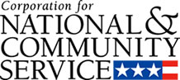

Corporation for National and Community Service

General Program Overview
AmeriCorps provides resources, both human and financial, to organizations that engage Americans in intensive service to meet our country’s critical needs.
Grantees use the funding to support AmeriCorps members for intensive service in their community. AmeriCorps grants partially cover the expense of operating an AmeriCorps program and do not cover general organizational expenses. A cash and in-kind match is required.

The main website can be accessed here: http://www.nationalservice.gov

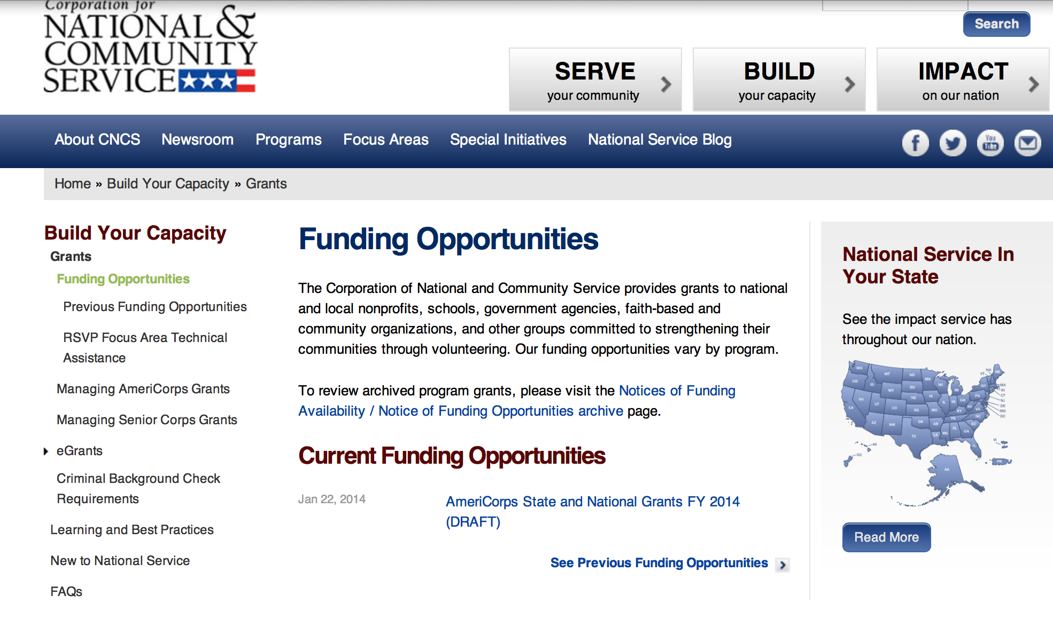

For access to further funding information: click here

http://www.nationalservice.gov/build-your-capacity/grants/funding-opportunities

Reminders:

AmeriCorps State and National Grants FY 2016
Modification 2

Document Type: | Grants Notice
Funding Opportunity Number: | CNCS-08-31-15
Funding Opportunity Title: | AmeriCorps State and National Grants FY 2016
Opportunity Category: | Discretionary
Funding Instrument Type: | Grant
Category of Funding Activity: | Agriculture  Arts (see "Cultural Affairs" in CFDA)  Community Development  Consumer Protection  Disaster Prevention and Relief  Education  Employment, Labor and Training  Energy  Environment  Food and Nutrition  Health  Housing  Income Security and Social Services  Law, Justice and Legal Services  Natural Resources  Regional Development
Category Explanation:
Expected Number of Awards:
CFDA Number(s): | 94.006 -- AmeriCorps
Cost Sharing or Matching Requirement: | Yes
Posted Date: | Aug 31, 2015
Creation Date: | Oct 13, 2015
Original Closing Date for Applications: | Jan 27, 2016
Current Closing Date for Applications: | Jan 27, 2016
Archive Date: | Jan 29, 2016
Eligible Applicants: | Private institutions of higher education  Nonprofits that do not have a 501(c)(3) status with the IRS, other than institutions of higher education  Nonprofits having a 501(c)(3) status with the IRS, other than institutions of higher education  Native American tribal organizations (other than Federally recognized tribal governments)  Independent school districts  Native American tribal governments (Federally recognized)  County governments  State governments  Public and State controlled institutions of higher education  Public housing authorities/Indian housing authorities  Special district governments  City or township governments
Agency Name: | Corporation for National and Community Service
Description: | AmeriCorps grants are awarded to eligible organizations proposing to engage AmeriCorps members in evidence-based or evidence-informed interventions to strengthen communities. An AmeriCorps member is an individual who engages in community service through an approved national service position. Members may receive a living allowance and other benefits while serving. Upon successful completion of their service, members earn a Segal AmeriCorps Education Award from the National Service Trust that members can use to pay for higher education expenses or apply to qualified student loans. Grant awards have two components: operating funds and AmeriCorps member positions. Grant award amounts vary – both in the level of operating funds and in the type and amount of AmeriCorps member positions. Unless otherwise specified, the grant generally covers a three-year project period. In approving a multi-year project period, CNCS generally makes an initial award for the first year of operation. In most cases, the application is submitted with a one-year budget. Continuation funding is not guaranteed. Contact: americorpsgrants@cns.gov202-606-7508
Link to Additional Information: | Link to Grant competition page
Contact Information: | If you have difficulty accessing the full announcement electronically, please contact:  AmeriCorps State and National Program Officers  general mailbox

http://www.grants.gov/web/grants/view-opportunity.html?oppId=278777

National Service In Hawaii

Meeting Community Needs in Hawaii: More than 3,500 people of all ages and backgrounds are helping to meet local needs, strengthen communities, and increase civic engagement through national service in Hawaii. Serving at more than 490 locations throughout the state, these citizens tutor and mentor children, support veterans and military families, provide health services, restore the environment, respond to disasters, increase economic opportunity, and recruit and manage volunteers. This year, the Corporation for National and Community Service (CNCS) will commit more than $5,460,000 to support Hawaii communities through national service initiatives. Through a unique public-private partnership, this federal investment will leverage an additional $2,610,000 in other resources to strengthen community impact, build local support, and increase return on taxpayer dollars.
AmeriCorps
This year, AmeriCorps will provide more than 510 individuals the opportunity to provide intensive, results-driven service to meet education, environmental, health, economic, and other pressing needs in communities across Hawaii. Most AmeriCorps grant funding goes to the Hawaii Commission on National & Community Service, which in turn awards grants to nonprofit groups to respond to local needs. Most of the remainder of the grant funding is distributed by CNCS directly to multi-state and national organizations through a competitive grants process. Other individuals serve through AmeriCorps VISTA, whose members help bring individuals and communities out of poverty by serving full-time to fight illiteracy, improve health services, create businesses, and increase housing opportunities, and AmeriCorps NCCC (National Civilian Community Corps), a 10-month, full time residential program for men and women between the ages of 18 and 24. In exchange for their service, AmeriCorps members earn an education award that can be used to pay for college or to pay back qualified student loans. Since 1994, more than 4,900 Hawaii residents have served more than 5.1 million hours and have qualified for Segal AmeriCorps Education Awards totaling more than $11,250,000.
Download: AmeriCorps in Hawaii (PDF)

Senior Corps
More than 3,000 seniors in Hawaii contribute their time and talents in one of three Senior Corps programs. Foster Grandparents serve one-on-one as tutors and mentors to more than 480 young people who have special needs. Senior Companions help more than 250 homebound seniors and other adults maintain independence in their own homes. RSVP volunteers conduct safety patrols, renovate homes, protect the environment, tutor and mentor youth, respond to natural disasters, and provide other services through more than 290 groups across Hawaii.
Download: Senior Corps in Hawaii (PDF)

The Corporation for National and Community Service is a federal agency that improves lives, strengthens communities, and fosters civic engagement through service and volunteering. CNCS annually engages more than five million Americans in service to meet local needs through Senior Corps, AmeriCorps, and national days of service; improves communities through the Social Innovation Fund, and leads President Obama's national call to service initiative, United We Serve. To learn more visit NationalService.gov or Serve.gov or call 202-606-5000 or TTY 1-800-833-3722.

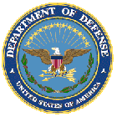

U.S. Department of Defense

Doing Business with the Department of Defense

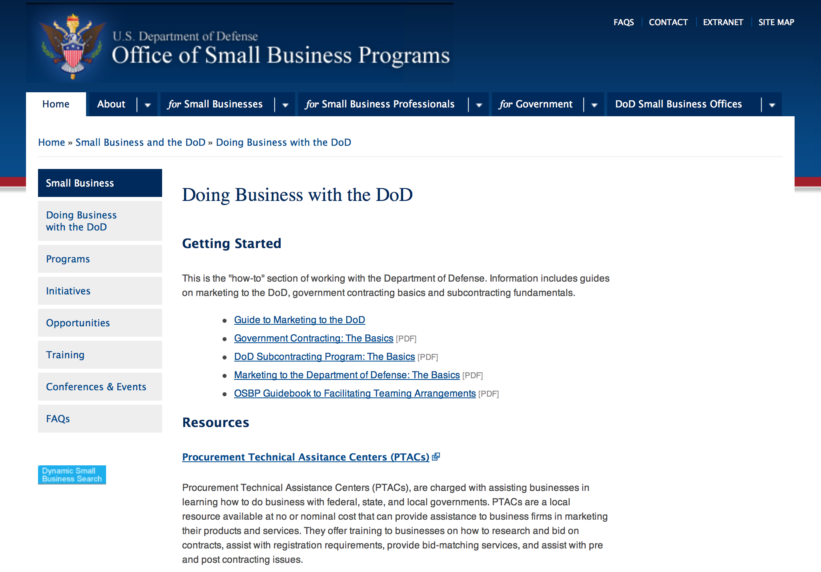

http://www.acq.osd.mil/osbp/doing_business/index.htm

Doing Business with DOD

- Air Force Contract Opportunities
  - Doing Business with the Air Force
- Army Contract Opportunities
  - Army Business Opportunities
- DOD Contract Opportunities
  - Doing Business with DOD
  - Guide to DOD Contracting Opportunities
  - DOD Office of Small Business Programs
  - Small Business Innovation Research Programs and Other Helpful Links
- DOD Contract Award Announcements
- Defense Acquisition University
- Defense Federal Acquisition Regulation (DFAR)
  - Procedures, Guidance, and Information
- Federal Acquisition Regulation (FAR)
  - FAR Documents, Information and Links
  - A list of quarterly video magazines that provides a discussion of recent changes to the FAR and DFARS, insights into the regulatory process, and news/issues on the horizon. DPAP and DAU have embarked on this joint venture to provide contracting personnel with the latest news regarding actions effecting the FAR and DFARS.
- Navy Contract Opportunities
  - Navy Acquisition One Source
  - Business Opportunities
- OSBP Programs
  - Small Business Innovation Research (SBIR) Program
  - Small Business Technology Transfer (STTR) Program
  - Indian Incentive Program
  - Women-Owned Small Business Program
  - Historically Black Colleges and Universities / Minority Institutions Technical Assistance Program
  - Comprehensive Subcontracting Test Program
  - DOD Regional Councils for Small Business Education and Advocacy
  - Service-Disabled Veteran-Owned Small Business Program
  - Historically Underutilized Business Zones Program (HUBZone)
- Recovery & Reinvestment Act Opportunities
  - Search Opportunities
- Subcontracting Opportunities
  - Subcontracting Opportunities with DOD Major Prime Contractors
Doing Business with DOD

http://www.defense.gov/landing/contract_resources.aspx

DoD Small Business Opportunities
The purpose of this section is to identify areas of potential small business growth that are new, developing, or have recently come to the attention of this office. The intent is not to duplicate information which exists through traditional acquisition tools.
DoD Service Forecasts
Future acquisition forecasts are prepared by a number of organizations within DoD. Forecasting methodologies vary by service but constitute the 'best estimate' of each.
ARMY
Navy
- MSC
- NAVAIR
- NAVAIR NAWCTSD
- NAVFAC
- NAVSUP
- NAVSUP WSS
- SPAWAR
- SSP
- USMC I&L

Air Force
- Air Force OSBP
- Hanscom AFB

Defense Logistics Agency

Research:

Air Force -- Research Lab
AFRL RD/RV University Cooperative Agreement Grant
http://www.grants.gov/web/grants/view-opportunity.html?oppId=280237

Dept. of the Army -- Materiel Command
ACC-APG-Detrick
Medical Countermeasure Systems Broad Agency Announcement Grant
http://www.grants.gov/web/grants/view-opportunity.html?oppId=279996

Dept. of the Army -- Materiel Command
ACC-APG-Detrick
Deployed Warfighter Protection Program FY 16 Call For Research Grant
http://www.grants.gov/web/grants/view-opportunity.html?oppId=280134

Dept. of the Army -- Materiel Command
ACC-APG-Detrick
Deployed Warfighters Protection Program Grant
http://www.grants.gov/web/grants/view-opportunity.html?oppId=279997

Defense Advanced Research Projects Agency
DARPA - Defense Sciences Office
Complex Adaptive System Composition And Design Environment (CASCADE) Grant
http://www.grants.gov/web/grants/view-opportunity.html?oppId=280208

Office of Naval Research
Funding Opportunity Announcement for the Navy and Marine Corps Science, Technology,
Engineering Grant
http://www.grants.gov/web/grants/view-opportunity.html?oppId=280020

Office of Naval Research
Undersea Technologies for Autonomous Detection and Communications Grant
http://www.grants.gov/web/grants/view-opportunity.html?oppId=280063

Modifications:

Air Force -- Research Lab
AFRL Research Collaboration Program
Modification 3
http://www.grants.gov/web/grants/view-opportunity.html?oppId=212295

Dept. of the Army -- USAMRAA
DoD DMRDP JPC-8 Clinical and Rehabilitative Medicine
Modification 2
http://www.grants.gov/web/grants/view-opportunity.html?oppId=279726

Dept. of the Army -- USAMRAA
DoD FY15 Extremity Regeneration Technology/Therapeutic Development Award
Modification 1
http://www.grants.gov/web/grants/view-opportunity.html?oppId=279628

Defense Threat Reduction Agency
FY2011 – 2016 Basic Research for Combating Weapons of Mass Destruction (C-WMD) Broad Agency Announcement (BAA)
Modification 5
http://www.grants.gov/web/grants/view-opportunity.html?oppId=75633

Office of Naval Research
Real-Time Full Spectrum Cyber Science and Technology
Modification 1
http://www.grants.gov/web/grants/view-opportunity.html?oppId=280168

Reminders:

Dept. of the Army -- Materiel Command
Army Research Office Broad Agency Announcement for Basic and Applied Scientific Research
Modification 8

Document Type: | Grants Notice
Funding Opportunity Number: | W911NF-12-R-0012
Funding Opportunity Title: | Army Research Office Broad Agency Announcement for Basic and Applied Scientific Research
Opportunity Category: | Discretionary
Funding Instrument Type: | Cooperative Agreement  Grant  Other  Procurement Contract
Category of Funding Activity: | Science and Technology and other Research and Development
Category Explanation:
Expected Number of Awards: | 1000
CFDA Number(s): | 12.431 -- Basic Scientific Research
Cost Sharing or Matching Requirement: | No
Posted Date: | Mar 27, 2015
Creation Date: | Mar 27, 2015
Original Closing Date for Applications: | Mar 31, 2017
Current Closing Date for Applications: | Mar 31, 2017
Archive Date: | Apr 30, 2017
Eligible Applicants: | Unrestricted (i.e., open to any type of entity above), subject to any clarification in text field entitled "Additional Information on Eligibility"
Agency Name: | Dept. of the Army -- Materiel Command
Description: | The purpose of this Broad Agency Announcement (BAA) is to solicit research proposals in the engineering, physical, life, and information sciences for submission to the Army Research Office (ARO) for consideration for possible funding. For ease of reference, this BAA is an extraction of the ARO sections of the Army Research Laboratory BAA. (www.arl.army.mil/www/default.cfm?page=8).
Link to Additional Information: | ARO CORE BAA-W911NF-12-R-0012-Mod 03
Contact Information: | If you have difficulty accessing the full announcement electronically, please contact:  ANDREW L. FISKE Procurement Analyst Army Contracting Command Aberdeen Proving Ground Research Triangle Park Division Phone: (919) 549-4338 FAX: (919) 549-4388 andrew.l.fiske.civ@mail.mil  Administrative POC

http://www.grants.gov/web/grants/view-opportunity.html?oppId=173593



Department of Education

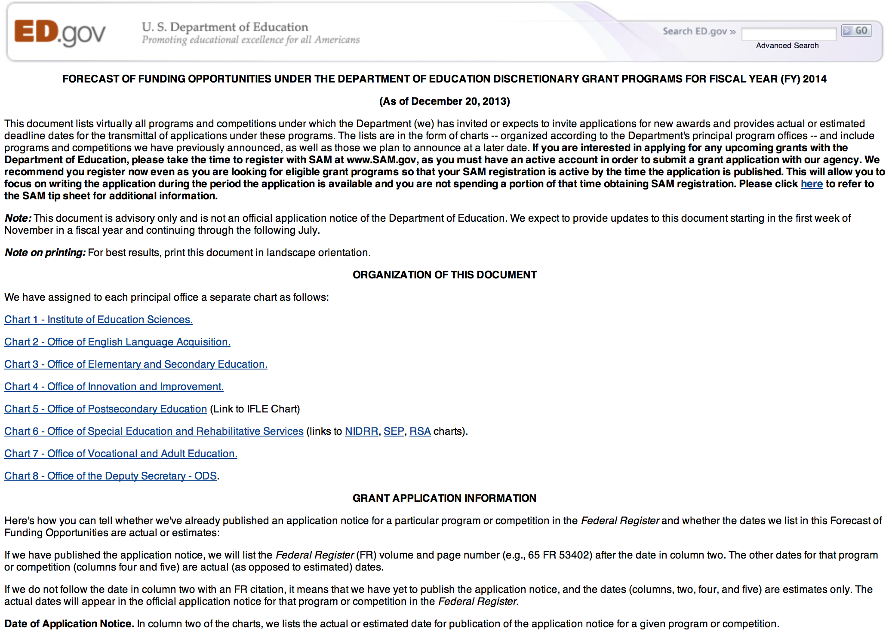
Grant Programs Overview at the Department of Education

To see the complete document click here: http://www2.ed.gov/fund/grant/find/edlite-forecast.html

The general information page for Education Grant funding is an excellent resource describing the three types of grants awarded by the Department of Education. See the screen shot of the Department of Education web page below:

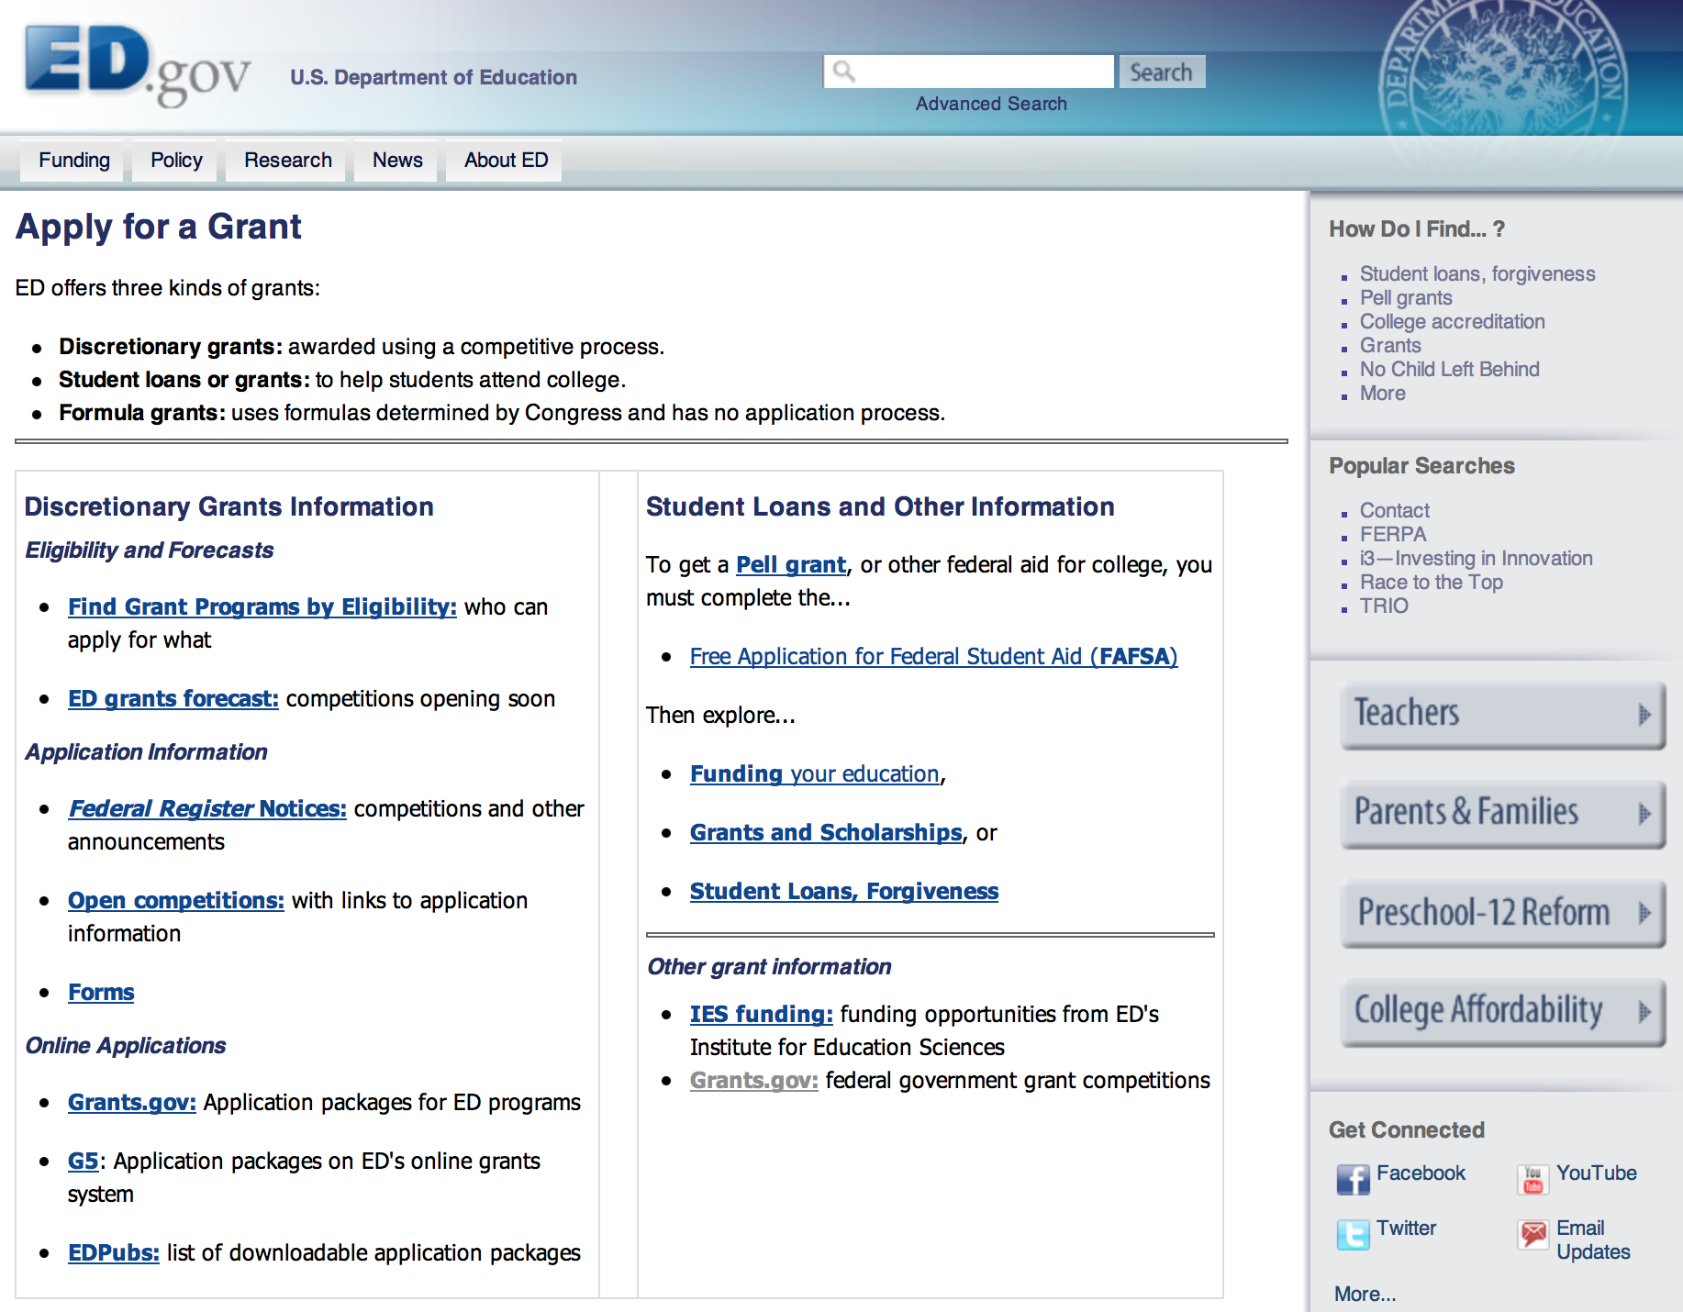

http://www.ed.gov/fund/grants-apply.html

Programs:

Modifications:

Reminders:

OSERS-OSEP: Preparation in Special Education, Early Intervention, and Related Services: Focus Area B Preparing Personnel to Serve School-Age Children with Low Incidence Disabilities. CFDA Number 84.325K-2 Grant

Document Type: | Grants Notice
Funding Opportunity Number: | ED-GRANTS-101515-002
Funding Opportunity Title: | OSERS-OSEP: Preparation in Special Education, Early Intervention, and Related Services: Focus Area B Preparing Personnel to Serve School-Age Children with Low Incidence Disabilities. CFDA Number 84.325K-2
Opportunity Category: | Discretionary
Funding Instrument Type: | Grant
Category of Funding Activity: | Education
Category Explanation:
Expected Number of Awards: | 14
CFDA Number(s): | 84.325 -- Special Education - Personnel Development to Improve Services and Results for Children with Disabilities
Cost Sharing or Matching Requirement: | No
Posted Date: | Oct 15, 2015
Creation Date: | Oct 15, 2015
Original Closing Date for Applications: | Dec 14, 2015 Applications Available: October 15, 2015. Deadline for Transmittal of Applications: December 14, 2015.
Current Closing Date for Applications: | Dec 14, 2015 Applications Available: October 15, 2015. Deadline for Transmittal of Applications: December 14, 2015.
Archive Date: | Jan 13, 2016
Estimated Total Program Funding: | $3,500,000
Award Ceiling: | $250,000
Eligible Applicants: | Others (see text field entitled "Additional Information on Eligibility" for clarification)  Nonprofits that do not have a 501(c)(3) status with the IRS, other than institutions of higher education  Nonprofits having a 501(c)(3) status with the IRS, other than institutions of higher education  Public and State controlled institutions of higher education  Private institutions of higher education
Additional Information on Eligibility: | Eligible Applicants: IHEs and private nonprofit organizations.
Agency Name: | Department of Education
Description: | Note: Each funding opportunity description is a synopsis of information in the Federal Register application notice. For specific information about eligibility, please see the official application notice. The official version of this document is the document published in the Federal Register. Free Internet access to the official edition of the Federal Register and the Code of Federal Regulations is available on GPO Access at: http://www.access.gpo.gov/nara/index.html. Please review the official application notice for pre-application and application requirements, application submission information, performance measures, priorities and program contact information. Purpose of Program: The purposes of this program are to (1) help address State-identified needs for personnel preparation in special education, early intervention, related services, and regular education to work with children, including infants and toddlers, with disabilities; and (2) ensure that those personnel have the necessary skills and knowledge, derived from practices that have been determined through scientifically based research and experience, to be successful in serving those children. Catalog of Federal Domestic Assistance (CFDA) Number: 84.325K. Applications for grants under the Personnel Preparation in Special Education, Early Intervention, and Related Services competition, CFDA number 84.325K, must be submitted electronically using the Governmentwide Grants.gov Apply site at www.Grants.gov. Through this site, you will be able to download a copy of the application package, complete it offline, and then upload and submit your application. You may not email an electronic copy of a grant application to us. You may access the electronic grant application for the Personnel Preparation in Special Education, Early Intervention, and Related Services competition at www.Grants.gov. You must search for the downloadable application package for this program by the CFDA number. Do not include the CFDA number's alpha suffix in your search (e.g., search for 84.325, not 84.325K)
Link to Additional Information: | OSERS-OSEP: Preparation in Special Education, Early Intervention, and Related Services: Focus Area B Preparing Personnel to Serve School-Age Children with Low Incidence Disabilities. CFDA Number 84.325K-2; Notice Inviting Applications
Contact Information: | If you have difficulty accessing the full announcement electronically, please contact:  Julius Cotton ED Grants.gov FIND Systems Admin. Phone 202-245-6288 EducationGrantInquiries@ed.gov Program Manager: Maryann McDermott U.S. Department of Education 400 Maryland Avenue SW. Room 4062. Potomac Center Plaza (PCP). Washington, DC 20202-2600. Telephone: 202-245-7439, e-Mail: maryann.mcdermott@ed.gov.  e-Mail: Program Manager

http://www.grants.gov/web/grants/view-opportunity.html?oppId=279636

OSERS-OSEP: Preparation in Special Education, Early Intervention, and Related Services: Focus Area A: Preparing Personnel to Serve Infants, Toddlers, and Preschool- Age Children with Disabilities CFDA Number 84.325K-1 Grant

Document Type: | Grants Notice
Funding Opportunity Number: | ED-GRANTS-101515-001
Funding Opportunity Title: | OSERS-OSEP: Preparation in Special Education, Early Intervention, and Related Services: Focus Area A: Preparing Personnel to Serve Infants, Toddlers, and Preschool- Age Children with Disabilities CFDA Number 84.325K-1
Opportunity Category: | Discretionary
Funding Instrument Type: | Grant
Category of Funding Activity: | Education
Category Explanation:
Expected Number of Awards: | 6
CFDA Number(s): | 84.325 -- Special Education - Personnel Development to Improve Services and Results for Children with Disabilities
Cost Sharing or Matching Requirement: | No
Posted Date: | Oct 15, 2015
Creation Date: | Oct 15, 2015
Original Closing Date for Applications: | Dec 14, 2015 Applications Available: October 15, 2015. Deadline for Transmittal of Applications: December 14, 2015.
Current Closing Date for Applications: | Dec 14, 2015 Applications Available: October 15, 2015. Deadline for Transmittal of Applications: December 14, 2015.
Archive Date: | Jan 13, 2016
Estimated Total Program Funding: | $1,500,000
Award Ceiling: | $250,000
Eligible Applicants: | Nonprofits that do not have a 501(c)(3) status with the IRS, other than institutions of higher education  Public and State controlled institutions of higher education  Private institutions of higher education  Nonprofits having a 501(c)(3) status with the IRS, other than institutions of higher education  Others (see text field entitled "Additional Information on Eligibility" for clarification)
Additional Information on Eligibility: | Eligible Applicants: IHEs and private nonprofit organizations.
Agency Name: | Department of Education
Description: | Note: Each funding opportunity description is a synopsis of information in the Federal Register application notice. For specific information about eligibility, please see the official application notice. The official version of this document is the document published in the Federal Register. Free Internet access to the official edition of the Federal Register and the Code of Federal Regulations is available on GPO Access at: http://www.access.gpo.gov/nara/index.html. Please review the official application notice for pre-application and application requirements, application submission information, performance measures, priorities and program contact information. Purpose of Program: The purposes of this program are to (1) help address State-identified needs for personnel preparation in special education, early intervention, related services, and regular education to work with children, including infants and toddlers, with disabilities; and (2) ensure that those personnel have the necessary skills and knowledge, derived from practices that have been determined through scientifically based research and experience, to be successful in serving those children. Catalog of Federal Domestic Assistance (CFDA) Number: 84.325K. Applications for grants under the Personnel Preparation in Special Education, Early Intervention, and Related Services competition, CFDA number 84.325K, must be submitted electronically using the Governmentwide Grants.gov Apply site at www.Grants.gov. Through this site, you will be able to download a copy of the application package, complete it offline, and then upload and submit your application. You may not email an electronic copy of a grant application to us. You may access the electronic grant application for the Personnel Preparation in Special Education, Early Intervention, and Related Services competition at www.Grants.gov. You must search for the downloadable application package for this program by the CFDA number. Do not include the CFDA number's alpha suffix in your search (e.g., search for 84.325, not 84.325K).
Link to Additional Information: | Preparation in Special Education, Early Intervention, and Related Services: Focus Area A: Preparing Personnel to Serve Infants, Toddlers, and Preschool- Age Children with Disabilities CFDA Number 84.325K-1: Notice Inviting Applications
Contact Information: | If you have difficulty accessing the full announcement electronically, please contact:  Julius Cotton ED Grants.gov FIND Systems Admin. Phone 202-245-6288 EducationGrantInquiries@ed.gov Program Manager: Maryann McDermott U.S. Department of Education 400 Maryland Avenue SW. Room 4062. Potomac Center Plaza (PCP). Washington, DC 20202-2600. Telephone: 202-245-7439, e-Mail: maryann.mcdermott@ed.gov.  e-Mail: Program Manager

http://www.grants.gov/web/grants/view-opportunity.html?oppId=279651

OSERS-OSEP: Preparation in Special Education, Early Intervention, and Related Services: Focus Area C Preparing Personnel to Provide Related Services to Children, Including Infants and Toddlers, with Disabilities. CFDA Number 84.325K-3 Grant
Document Type: | Grants Notice
Funding Opportunity Number: | ED-GRANTS-101515-003
Funding Opportunity Title: | OSERS-OSEP: Preparation in Special Education, Early Intervention, and Related Services: Focus Area C Preparing Personnel to Provide Related Services to Children, Including Infants and Toddlers, with Disabilities. CFDA Number 84.325K-3
Opportunity Category: | Discretionary
Funding Instrument Type: | Grant
Category of Funding Activity: | Education
Category Explanation:
Expected Number of Awards: | 8
CFDA Number(s): | 84.325 -- Special Education - Personnel Development to Improve Services and Results for Children with Disabilities
Cost Sharing or Matching Requirement: | No
Posted Date: | Oct 15, 2015
Creation Date: | Oct 15, 2015
Original Closing Date for Applications: | Dec 14, 2015 Applications Available: October 15, 2015. Deadline for Transmittal of Applications: December 14, 2015.
Current Closing Date for Applications: | Dec 14, 2015 Applications Available: October 15, 2015. Deadline for Transmittal of Applications: December 14, 2015.
Archive Date: | Jan 13, 2016
Estimated Total Program Funding: | $2,000,000
Award Ceiling: | $250,000
Eligible Applicants: | Nonprofits that do not have a 501(c)(3) status with the IRS, other than institutions of higher education  Others (see text field entitled "Additional Information on Eligibility" for clarification)  Nonprofits having a 501(c)(3) status with the IRS, other than institutions of higher education  Private institutions of higher education  Public and State controlled institutions of higher education
Additional Information on Eligibility: | Eligible Applicants: IHEs and private nonprofit organizations.
Agency Name: | Department of Education
Description: | Note: Each funding opportunity description is a synopsis of information in the Federal Register application notice. For specific information about eligibility, please see the official application notice. The official version of this document is the document published in the Federal Register. Free Internet access to the official edition of the Federal Register and the Code of Federal Regulations is available on GPO Access at: http://www.access.gpo.gov/nara/index.html. Please review the official application notice for pre-application and application requirements, application submission information, performance measures, priorities and program contact information. Purpose of Program: The purposes of this program are to (1) help address State-identified needs for personnel preparation in special education, early intervention, related services, and regular education to work with children, including infants and toddlers, with disabilities; and (2) ensure that those personnel have the necessary skills and knowledge, derived from practices that have been determined through scientifically based research and experience, to be successful in serving those children. Catalog of Federal Domestic Assistance (CFDA) Number: 84.325K. Applications for grants under the Personnel Preparation in Special Education, Early Intervention, and Related Services competition, CFDA number 84.325K, must be submitted electronically using the Governmentwide Grants.gov Apply site at www.Grants.gov. Through this site, you will be able to download a copy of the application package, complete it offline, and then upload and submit your application. You may not email an electronic copy of a grant application to us. You may access the electronic grant application for the Personnel Preparation in Special Education, Early Intervention, and Related Services competition at www.Grants.gov. You must search for the downloadable application package for this program by the CFDA number. Do not include the CFDA number's alpha suffix in your search (e.g., search for 84.325, not 84.325K)
Link to Additional Information: | OSERS-OSEP: Preparation in Special Education, Early Intervention, and Related Services: Focus Area C Preparing Personnel to Provide Related Services to Children, Including Infants and Toddlers, with Disabilities. CFDA Number 84.325K-3; Notice
Contact Information: | If you have difficulty accessing the full announcement electronically, please contact:  Julius Cotton ED Grants.gov FIND Systems Admin. Phone 202-245-6288 EducationGrantInquiries@ed.gov Program Manager: Sarah Allen U.S. Department of Education 400 Maryland Avenue SW., Room 4105 Potomac Center Plaza (PCP) Washington, DC 20202 Telephone Number: (202) 245-7875 or e-Mail: sarah.allen@ed.gov.  e-Mail: program Manager
http://www.grants.gov/web/grants/view-opportunity.html?oppId=279657

OSERS-OSEP: Preparation in Special Education, Early Intervention, and Related Services: Focus Area D Preparing Personnel in Minority Institutions of Higher Education to Serve Children, Including Infants and Toddlers with Disabilities CFDA Number 84.325K-4 Grant

Document Type: | Grants Notice
Funding Opportunity Number: | ED-GRANTS-101515-004
Funding Opportunity Title: | OSERS-OSEP: Preparation in Special Education, Early Intervention, and Related Services: Focus Area D Preparing Personnel in Minority Institutions of Higher Education to Serve Children, Including Infants and Toddlers with Disabilities CFDA Number 84.325K-4
Opportunity Category: | Discretionary
Funding Instrument Type: | Grant
Category of Funding Activity: | Education
Category Explanation:
Expected Number of Awards: | 10
CFDA Number(s): | 84.325 -- Special Education - Personnel Development to Improve Services and Results for Children with Disabilities
Cost Sharing or Matching Requirement: | No
Posted Date: | Oct 15, 2015
Creation Date: | Oct 15, 2015
Original Closing Date for Applications: | Dec 14, 2015 Applications Available: October 15, 2015. Deadline for Transmittal of Applications: December 14, 2015.
Current Closing Date for Applications: | Dec 14, 2015 Applications Available: October 15, 2015. Deadline for Transmittal of Applications: December 14, 2015.
Archive Date: | Jan 13, 2016
Estimated Total Program Funding: | $2,500,000
Award Ceiling: | $250,000
Eligible Applicants: | Private institutions of higher education  Public and State controlled institutions of higher education  Nonprofits having a 501(c)(3) status with the IRS, other than institutions of higher education  Others (see text field entitled "Additional Information on Eligibility" for clarification)  Nonprofits that do not have a 501(c)(3) status with the IRS, other than institutions of higher education
Additional Information on Eligibility: | Eligible Applicants: IHEs and private nonprofit organizations.
Agency Name: | Department of Education
Description: | Note: Each funding opportunity description is a synopsis of information in the Federal Register application notice. For specific information about eligibility, please see the official application notice. The official version of this document is the document published in the Federal Register. Free Internet access to the official edition of the Federal Register and the Code of Federal Regulations is available on GPO Access at: http://www.access.gpo.gov/nara/index.html. Please review the official application notice for pre-application and application requirements, application submission information, performance measures, priorities and program contact information. Purpose of Program: The purposes of this program are to (1) help address State-identified needs for personnel preparation in special education, early intervention, related services, and regular education to work with children, including infants and toddlers, with disabilities; and (2) ensure that those personnel have the necessary skills and knowledge, derived from practices that have been determined through scientifically based research and experience, to be successful in serving those children. Catalog of Federal Domestic Assistance (CFDA) Number: 84.325K. Applications for grants under the Personnel Preparation in Special Education, Early Intervention, and Related Services competition, CFDA number 84.325K, must be submitted electronically using the Governmentwide Grants.gov Apply site at www.Grants.gov. Through this site, you will be able to download a copy of the application package, complete it offline, and then upload and submit your application. You may not email an electronic copy of a grant application to us. You may access the electronic grant application for the Personnel Preparation in Special Education, Early Intervention, and Related Services competition at www.Grants.gov. You must search for the downloadable application package for this program by the CFDA number. Do not include the CFDA number's alpha suffix in your search (e.g., search for 84.325, not 84.325K).
Link to Additional Information: | Preparation in Special Education, Early Intervention, and Related Services: Focus Area D Preparing Personnel in Minority Institutions of Higher Education to Serve Children, Including Infants and Toddlers with Disabilities CFDA Number 84.325K-4
Contact Information: | If you have difficulty accessing the full announcement electronically, please contact:  Julius Cotton ED Grants.gov FIND Systems Admin. Phone 202-245-6288 EducationGrantInquiries@ed.gov Program Manager: Dawn Ellis U.S. Department of Education 400 Maryland Avenue SW. Room 4092. Potomac Center Plaza (PCP). Washington, DC 20202-2600. Telephone: 202-245-6417, e-Mail: dawn.ellis@ed.gov.  e-Mail: Program Manager

http://www.grants.gov/web/grants/view-opportunity.html?oppId=279659

OSERS-OSEP: Personnel Development to Improve Services and Results for Children with Disabilities: Preparation of Special Education, Early Intervention, and Related Services Leadership Personnel CFDA Number 84.325D Grant

Document Type: | Grants Notice
Funding Opportunity Number: | ED-GRANTS-100915-001
Funding Opportunity Title: | OSERS-OSEP: Personnel Development to Improve Services and Results for Children with Disabilities: Preparation of Special Education, Early Intervention, and Related Services Leadership Personnel CFDA Number 84.325D
Opportunity Category: | Discretionary
Funding Instrument Type: | Grant
Category of Funding Activity: | Education
Category Explanation:
Expected Number of Awards: | 14
CFDA Number(s): | 84.325 -- Special Education - Personnel Development to Improve Services and Results for Children with Disabilities
Cost Sharing or Matching Requirement: | No
Posted Date: | Oct 9, 2015
Creation Date: | Oct 9, 2015
Original Closing Date for Applications: | Dec 8, 2015 Applications Available: October 9, 2015. Deadline for Transmittal of Applications: December 8, 2015.
Current Closing Date for Applications: | Dec 8, 2015 Applications Available: October 9, 2015. Deadline for Transmittal of Applications: December 8, 2015.
Archive Date: | Jan 7, 2016
Estimated Total Program Funding: | $3,500,000
Award Ceiling: | $250,000
Eligible Applicants: | Nonprofits having a 501(c)(3) status with the IRS, other than institutions of higher education  Public and State controlled institutions of higher education  Special district governments  Independent school districts  State governments  Private institutions of higher education  Nonprofits that do not have a 501(c)(3) status with the IRS, other than institutions of higher education  Others (see text field entitled "Additional Information on Eligibility" for clarification)  City or township governments  County governments
Additional Information on Eligibility: | Eligible Applicants: IHEs, private nonprofit organizations.
Agency Name: | Department of Education
Description: | Note: Each funding opportunity description is a synopsis of information in the Federal Register application notice. For specific information about eligibility, please see the official application notice. The official version of this document is the document published in the Federal Register. Free Internet access to the official edition of the Federal Register and the Code of Federal Regulations is available on GPO Access at: http://www.access.gpo.gov/nara/index.html. Please review the official application notice for pre-application and application requirements, application submission information, performance measures, priorities and program contact information. Purpose of Program: The purposes of this program are to (1) help address State-identified needs for personnel preparation in special education, early intervention, related services, and regular education to work with children, including infants and toddlers, with disabilities; and (2) ensure that those personnel have the necessary skills and knowledge, derived from practices that have been determined through scientifically based research and experience, to be successful in serving those children. Catalog of Federal Domestic Assistance (CFDA) Number: 84.325D. Applications for grants under the Preparation of Special Education, Early Intervention, and Related Services Leadership Personnel competition, CFDA number 84.325D, must be submitted electronically using the Governmentwide Grants.gov Apply site at www.Grants.gov. Through this site, you will be able to download a copy of the application package, complete it offline, and then upload and submit your application. You may not email an electronic copy of a grant application to us. You may access the electronic grant application for the Preparation of Special Education, Early Intervention, and Related Services Leadership Personnel competition at www.Grants.gov. You must search for the downloadable application package for this competition by the CFDA number. Do not include the CFDA number's alpha suffix in your search (e.g., search for 84.325, not 84.325D).
Link to Additional Information: | OSERS-OSEP: Personnel Development to Improve Services and Results for Children with Disabilities: Preparation of Special Education, Early Intervention, and Related Services Leadership Personnel CFDA Number 84.325D; Notice Inviting Applications
Contact Information: | If you have difficulty accessing the full announcement electronically, please contact:  Julius Cotton ED Grants.gov FIND Systems Admin. Phone 202-245-6288 EducationGrantInquiries@ed.gov Program Manager: Celia Rosenquist, U.S. Department of Education, 400 Maryland Avenue SW., Room 4070, Potomac Center Plaza (PCP), Washington, DC 20202-2600. Telephone: (202) 245-7373 or e-Mail: Celia.Rosenquist@ed.gov.  e-Mail: Program Manager

http://www.grants.gov/web/grants/view-opportunity.html?oppId=279587

Institute of Education Sciences (IES): Education Research: Low-Cost, Short-Duration Evaluation of Education Interventions CFDA Number 84.305L Grant

Document Type: | Grants Notice
Funding Opportunity Number: | ED-GRANTS-092815-001
Funding Opportunity Title: | Institute of Education Sciences (IES): Education Research: Low-Cost, Short-Duration Evaluation of Education Interventions CFDA Number 84.305L
Opportunity Category: | Discretionary
Funding Instrument Type: | Grant
Category of Funding Activity: | Education
Category Explanation:
Expected Number of Awards:
CFDA Number(s): | 84.305 -- Education Research, Development and Dissemination
Cost Sharing or Matching Requirement: | No
Posted Date: | Sep 28, 2015
Creation Date: | Sep 28, 2015
Original Closing Date for Applications: | Jan 12, 2016 Request for Applications Available: September 30, 2015. Requests for Applications and Other Information: Information regarding program and application requirements for the two competitions will be contained in the NCER and NCSER Requests for Applications (RFAs), which will be available on the Institute's Web site at: http://ies.ed.gov/funding/. The selection criteria, requirements concerning the content of an application, and review procedures for the competitions are contained in the RFAs. Applications Available: November 12, 2015. Separate application packages for the two competitions will be available on November 12, 2015. Deadline for Transmittal of Applications: January 12, 2016.
Current Closing Date for Applications: | Jan 12, 2016 Request for Applications Available: September 30, 2015. Requests for Applications and Other Information: Information regarding program and application requirements for the two competitions will be contained in the NCER and NCSER Requests for Applications (RFAs), which will be available on the Institute's Web site at: http://ies.ed.gov/funding/. The selection criteria, requirements concerning the content of an application, and review procedures for the competitions are contained in the RFAs. Applications Available: November 12, 2015. Separate application packages for the two competitions will be available on November 12, 2015. Deadline for Transmittal of Applications: January 12, 2016.
Archive Date: | Feb 11, 2016
Estimated Total Program Funding: | $1,000,000
Award Ceiling: | $250,000
Eligible Applicants: | Others (see text field entitled "Additional Information on Eligibility" for clarification)
Additional Information on Eligibility: | Eligible Applicants: Research partnerships involving at least one research institution and at least one SEA or LEA. The partnership must choose one principal investigator from either the research institution or the SEA or LEA to have overall responsibility for the administration of the award. Applicants that have the ability and capacity to conduct scientifically valid research are eligible to apply as the research institution partner. These include, but are not limited to, nonprofit and for-profit organizations and public and private agencies and institutions, such as colleges and universities. SEAs and LEAs (public agencies whose primary responsibility is the education of students in prekindergarten, K-12, postsecondary, and/or adult education) are eligible to apply as the education agency partner.
Agency Name: | Department of Education
Description: | Note: Each funding opportunity description is a synopsis of information in the Federal Register application notice. For specific information about eligibility, please see the official application notice. The official version of this document is the document published in the Federal Register. Free Internet access to the official edition of the Federal Register and the Code of Federal Regulations is available on GPO Access at: http://www.access.gpo.gov/nara/index.html. Please review the official application notice for pre-application and application requirements, application submission information, performance measures, priorities and program contact information. SUMMARY: The Deputy Director for Policy and Research, delegated the duties of the Director, of the Institute of Education Sciences (Institute) announces the Institute's FY 2016 grant competition for Low-Cost, Short-Duration Evaluation of Education Interventions and Low- Cost, Short-Duration Evaluation of Special Education Interventions. The Deputy Director for Policy and Research takes this action under the Education Sciences Reform Act of 2002. The Institute's purpose in awarding these grants is to support rigorous evaluations of education interventions that State educational agencies (SEAs) or local educational agencies (LEAs) believe will produce meaningful improvements in student outcomes within a short period (for example, within a single semester or academic year), that can be conducted at low cost, and that will provide policymakers with valid and useful results more rapidly than is typically achieved in education research. Purpose of Program: The purpose of the Low-Cost, Short-Duration Evaluation of Education Interventions and Low-Cost, Short-Duration Evaluation of Special Education Interventions grant programs is to support rigorous evaluations of education interventions implemented by SEAs and LEAs that have important implications for improving student education outcomes. The evaluations are low cost because they rely on administrative records or other available data and are completed within a two-year period. The evaluations are rigorous because they use randomized controlled trials or regression discontinuity designs that, if well implemented, would meet What Works Clearinghouse evidence standards without reservations for determining the effectiveness of interventions. The evaluations are to be carried out by partnerships between research institutions and SEAs or LEAs. Implementation of the intervention to be evaluated is to be supported by the SEA and/or LEA and not by the grant. The education intervention to be evaluated should be implemented and the key outcomes collected within the first year of the project, and the analysis and dissemination should be completed by the end of the second year of the project. In order to meet this schedule, projects should focus on interventions that are expected to produce meaningful results quickly (for example, within one semester or school year) and that rely on outcome measures that are readily available to researchers. Competitions in This Notice: The Institute's National Center for Education Research (NCER) will hold one competition for the Low-Cost, Short-Duration Evaluation of Education Interventions Grant Program (84.305L). The Institute's National Center for Special Education Research (NCSER) will hold one competition for the Low-Cost, Short-Duration Evaluation of Special Education Interventions Grant Program (84.324L). Catalog of Federal Domestic Assistance (CFDA) Number: 84.305L. Applications for grants under Low-Cost, Short-Duration Evaluation of Education Interventions, CFDA number 84.305L, and Low-Cost, Short-Duration Evaluation of Special Education Interventions, CFDA number 84.324L, must be submitted electronically using the Governmentwide Grants.gov Apply site at www.Grants.gov. Through this site, you will be able to download a copy of the application package, complete it offline, and then upload and submit your application. You may not email an electronic copy of a grant application to us. You may access the electronic grant applications for the Low-Cost, Short-Duration Evaluation of Education Interventions competition and the Low-Cost, Short-Duration Evaluation of Special Education Interventions competition at www.Grants.gov. You must search for the downloadable application packages for these competitions by the CFDA number, 84.305L or 84.324L.
Link to Additional Information: | Institute of Education Sciences (IES): Education Research: Low-Cost, Short-Duration Evaluation of Education Interventions CFDA Number 84.305L; Notice inviting applications for new awards for fiscal year (FY) 2016.
Contact Information: | If you have difficulty accessing the full announcement electronically, please contact:  Julius Cotton ED Grants.gov FIND Systems Admin. Phone 202-245-6288 EducationGrantInquiries@ed.gov Program Managers: Regarding CFDA number 84.305L--Dr. Phill Gagne at Phill.Gagne@ed.gov, or Dr. Allen Ruby at Allen.Ruby@ed.gov.  e-Mail: Program Manager

http://www.grants.gov/web/grants/view-opportunity.html?oppId=279259

Institute of Education Science (IES): Special Education Research: Low-Cost, Short-Duration Evaluation of Special Education Interventions CFDA Number 84.324L Grant

Document Type: | Grants Notice
Funding Opportunity Number: | ED-GRANTS-092815-002
Funding Opportunity Title: | Institute of Education Science (IES): Special Education Research: Low-Cost, Short-Duration Evaluation of Special Education Interventions CFDA Number 84.324L
Opportunity Category: | Discretionary
Funding Instrument Type: | Grant
Category of Funding Activity: | Education
Category Explanation:
Expected Number of Awards:
CFDA Number(s): | 84.324 -- Research in Special Education
Cost Sharing or Matching Requirement: | No
Posted Date: | Sep 28, 2015
Creation Date: | Sep 28, 2015
Original Closing Date for Applications: | Jan 12, 2016 Request for Applications Available: September 30, 2015. Information regarding program and application requirements for the two competitions will be contained in the NCER and NCSER Requests for Applications (RFAs), which will be available on the Institute's Web site at: http://ies.ed.gov/funding/. The selection criteria, requirements concerning the content of an application, and review procedures for the competitions are contained in the RFAs. Applications Available: November 12, 2015. Separate application packages for the two competitions will be available on November 12, 2015. Deadline for Transmittal of Applications: January 12, 2016.
Current Closing Date for Applications: | Jan 12, 2016 Request for Applications Available: September 30, 2015. Information regarding program and application requirements for the two competitions will be contained in the NCER and NCSER Requests for Applications (RFAs), which will be available on the Institute's Web site at: http://ies.ed.gov/funding/. The selection criteria, requirements concerning the content of an application, and review procedures for the competitions are contained in the RFAs. Applications Available: November 12, 2015. Separate application packages for the two competitions will be available on November 12, 2015. Deadline for Transmittal of Applications: January 12, 2016.
Archive Date: | Feb 11, 2016
Estimated Total Program Funding: | $1,000,000
Award Ceiling: | $250,000
Eligible Applicants: | Others (see text field entitled "Additional Information on Eligibility" for clarification)
Additional Information on Eligibility: | Eligible Applicants: Research partnerships involving at least one research institution and at least one SEA or LEA. The partnership must choose one principal investigator from either the research institution or the SEA or LEA to have overall responsibility for the administration of the award. Applicants that have the ability and capacity to conduct scientifically valid research are eligible to apply as the research institution partner. These include, but are not limited to, nonprofit and for-profit organizations and public and private agencies and institutions, such as colleges and universities. SEAs and LEAs (public agencies whose primary responsibility is the education of students in prekindergarten, K-12, postsecondary, and/or adult education) are eligible to apply as the education agency partner.
Agency Name: | Department of Education
Description: | Note: Each funding opportunity description is a synopsis of information in the Federal Register application notice. For specific information about eligibility, please see the official application notice. The official version of this document is the document published in the Federal Register. Free Internet access to the official edition of the Federal Register and the Code of Federal Regulations is available on GPO Access at: http://www.access.gpo.gov/nara/index.html. Please review the official application notice for pre-application and application requirements, application submission information, performance measures, priorities and program contact information. The Deputy Director for Policy and Research, delegated the duties of the Director, of the Institute of Education Sciences (Institute) announces the Institute's FY 2016 grant competition for Low-Cost, Short-Duration Evaluation of Education Interventions and Low-Cost, Short-Duration Evaluation of Special Education Interventions. The Deputy Director for Policy and Research takes this action under the Education Sciences Reform Act of 2002. The Institute's purpose in awarding these grants is to support rigorous evaluations of education interventions that State educational agencies (SEAs) or local educational agencies (LEAs) believe will produce meaningful improvements in student outcomes within a short period (for example, within a single semester or academic year), that can be conducted at low cost, and that will provide policymakers with valid and useful results more rapidly than is typically achieved in education research. Purpose of Program: The purpose of the Low-Cost, Short-Duration Evaluation of Education Interventions and Low-Cost, Short-Duration Evaluation of Special Education Interventions grant programs is to support rigorous evaluations of education interventions implemented by SEAs and LEAs that have important implications for improving student education outcomes. The evaluations are low cost because they rely on administrative records or other available data and are completed within a two-year period. The evaluations are rigorous because they use randomized controlled trials or regression discontinuity designs that, if well implemented, would meet What Works Clearinghouse evidence standards without reservations for determining the effectiveness of interventions. The evaluations are to be carried out by partnerships between research institutions and SEAs or LEAs. Implementation of the intervention to be evaluated is to be supported by the SEA and/or LEA and not by the grant. The education intervention to be evaluated should be implemented and the key outcomes collected within the first year of the project, and the analysis and dissemination should be completed by the end of the second year of the project. In order to meet this schedule, projects should focus on interventions that are expected to produce meaningful results quickly (for example, within one semester or school year) and that rely on outcome measures that are readily available to researchers. Competitions in This Notice: The Institute's National Center for Education Research (NCER) will hold one competition for the Low-Cost, Short-Duration Evaluation of Education Interventions Grant Program (84.305L). The Institute's National Center for Special Education Research (NCSER) will hold one competition for the Low-Cost, Short-Duration Evaluation of Special Education Interventions Grant Program (84.324L). Program Authority: 20 U.S.C. 9501 et seq. Catalog of Federal Domestic Assistance (CFDA) Number: 84.324L. Applications for grants under Low-Cost, Short-Duration Evaluation of Education Interventions, CFDA number 84.305L, and Low-Cost, Short-Duration Evaluation of Special Education Interventions, CFDA number 84.324L, must be submitted electronically using the Governmentwide Grants.gov Apply site at www.Grants.gov. Through this site, you will be able to download a copy of the application package, complete it offline, and then upload and submit your application. You may not email an electronic copy of a grant application to us. You may access the electronic grant applications for the Low-Cost, Short-Duration Evaluation of Education Interventions competition and the Low-Cost, Short-Duration Evaluation of Special Education Interventions competition at www.Grants.gov. You must search for the downloadable application packages for these competitions by the CFDA number, 84.305L or 84.324L.
Link to Additional Information: | Institute of Education Science (IES): Special Education Research: Low-Cost, Short-Duration Evaluation of Special Education Interventions CFDA Number 84.324L; Notice inviting applications for new awards for fiscal year (FY) 2016
Contact Information: | If you have difficulty accessing the full announcement electronically, please contact:  Julius Cotton ED Grants.gov FIND Systems Admin. Phone 202-245-6288 EducationGrantInquiries@ed.gov Program Manager: Regarding CFDA number 84.324L--Dr. Robert Ochsendorf at Robert.Ochsendorf@ed.gov.  e-Mail: Program Manager

http://www.grants.gov/web/grants/view-opportunity.html?oppId=279281



U.S. Department of Energy
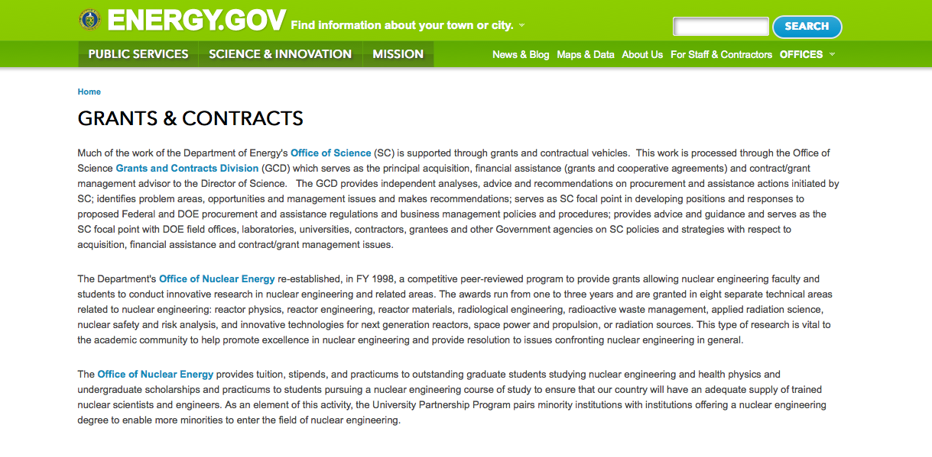
http://www.doe.gov/grants-contracts

Programs:

Golden Field Office
DE-FOA-0001395: Building America Industry Partnerships For High Performance Housing Innovation Grant
http://www.grants.gov/web/grants/view-opportunity.html?oppId=280131

PAMS
Department of Energy - Office of Science
Office of Science
Systems Biology Enabled Research on the Roles of Microbial Communities in Carbon Cycle Processes Grant
http://www.grants.gov/web/grants/view-opportunity.html?oppId=280206

Modifications:

Golden Field Office
Mineral Recovery Phase II - Geothermal Concepts And Approaches To Validate Extraction
Modification 1
http://www.grants.gov/web/grants/view-opportunity.html?oppId=280267

Reminders:

- 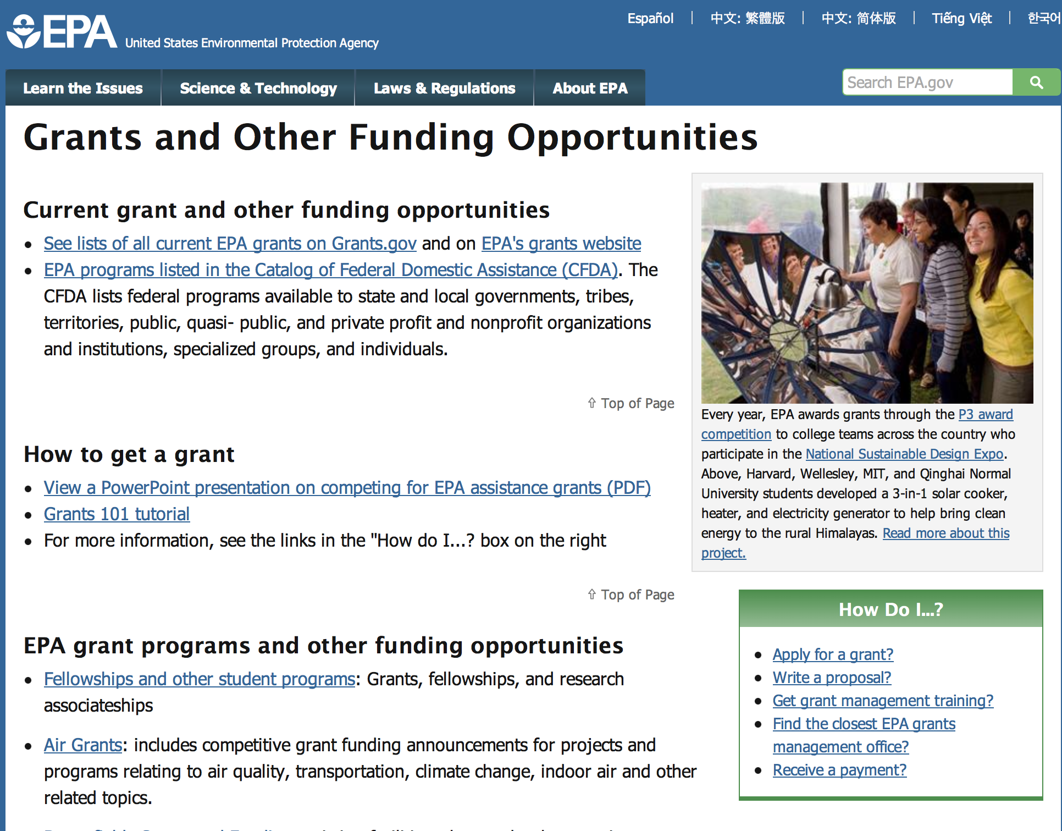

http://www.epa.gov/epahome/grants.htm

Programs:

Environmental Protection Agency
Technical Assistance To Brownfields Communities Grant

Document Type: | Grants Notice
Funding Opportunity Number: | EPA-OSWER-OBLR-16-02
Funding Opportunity Title: | TECHNICAL ASSISTANCE TO BROWNFIELDS COMMUNITIES
Opportunity Category: | Discretionary
Funding Instrument Type: | Cooperative Agreement
Category of Funding Activity: | Environment
Category Explanation:
Expected Number of Awards: | 11
CFDA Number(s): | 66.814 -- Brownfields Training, Research, and Technical Assistance Grants and Cooperative Agreements
Cost Sharing or Matching Requirement: | No
Posted Date: | Nov 5, 2015
Creation Date: | Nov 5, 2015
Original Closing Date for Applications: | Dec 21, 2015 See Section IV of the announcement for more details.
Current Closing Date for Applications: | Dec 21, 2015 See Section IV of the announcement for more details.
Archive Date: | Jan 20, 2016
Estimated Total Program Funding: | $11,000,000
Award Ceiling: | $1,000,000
Eligible Applicants: | Others (see text field entitled "Additional Information on Eligibility" for clarification)
Additional Information on Eligibility: | See Section III of the announcement for eligibility information.
Agency Name: | Environmental Protection Agency
Description: | This notice announces the availability of funds and solicits proposals from eligible entities (including eligible non-profit organizations) to provide technical assistance to communities on brownfield issues.
Link to Additional Information: | TECHNICAL ASSISTANCE TO BROWNFIELDS COMMUNITIES
Contact Information: | If you have difficulty accessing the full announcement electronically, please contact:  Debi Morey U.S. EPA, Office of Brownfields Cleanup and Redevelopment (MC 5105-T), 1200 Pennsylvania Avenue, NW, Washington, DC 20460 Phone (202)566-2735  morey.debi@epa.gov

http://www.grants.gov/web/grants/view-opportunity.html?oppId=279966

FY16 Environmental Workforce Development And Job Grant

Document Type: | Grants Notice
Funding Opportunity Number: | EPA-OSWER-OBLR-16-01
Funding Opportunity Title: | FY16 ENVIRONMENTAL WORKFORCE DEVELOPMENT AND JOB TRAINING (EWDJT) GRANTS
Opportunity Category: | Discretionary
Funding Instrument Type: | Cooperative Agreement
Category of Funding Activity: | Environment
Category Explanation:
Expected Number of Awards: | 18
CFDA Number(s): | 66.815 -- Environmental Workforce Development and Job Training Cooperative Agreements
Cost Sharing or Matching Requirement: | No
Posted Date: | Nov 13, 2015
Creation Date: | Nov 18, 2015
Original Closing Date for Applications: | Jan 14, 2016 Please refer to the full announcement, including Section IV, for additional information on submission methods and due dates.
Current Closing Date for Applications: | Jan 14, 2016 Please refer to the full announcement, including Section IV, for additional information on submission methods and due dates.
Archive Date: | Feb 13, 2016
Estimated Total Program Funding: | $3,500,000
Award Ceiling: | $200,000
Eligible Applicants: | Others (see text field entitled "Additional Information on Eligibility" for clarification)
Additional Information on Eligibility: | See Section III of the announcement for additional eligibility information.
Agency Name: | Environmental Protection Agency
Description: | SUMMARY: This notice announces the availability of funds and solicits proposals from eligible entities, including nonprofit organizations, to deliver environmental workforce development and job training programs that recruit, train, and place local, unemployed and under-employed residents with the skills needed to secure full-time employment in the environmental field, with focus on solid and hazardous waste remediation, environmental health and safety, integrated pest management, and wastewater-related training. While Environmental Workforce Development and Job Training grants require that Hazardous Waste Operations and Emergency Response (HAZWOPER) training be provided to all individuals being trained, as outlined in Section III.C., applicants may design their own curricula and choose what types of supplemental environmental training they want to deliver as referenced in Section I.C. Additionally, under this competition, applicants also may choose to deliver training in various other environmental media as referenced in Section I.B. EPA encourages applicants to develop their curricula based on local labor market assessments and employers ‘hiring needs, while also delivering comprehensive training that results in graduates securing multiple certifications. For the purposes of these guidelines, the term “grant” refers to the cooperative agreement that EPA will award to a successful applicant. Please refer to Section II.C for a description of EPA’s anticipated substantial involvement in the financial assistance agreements awarded under these guidelines. NOTE: EPA also urges applicants to review the Frequently Asked Questions, which can be found at: www.epa.gov/sites/production/files/2015-11/documents/fy16_ewdjt_faqs.pdf.
Link to Additional Information: | FY16 ENVIRONMENTAL WORKFORCE DEVELOPMENT AND JOB TRAINING (EWDJT) GRANTS
Contact Information: | If you have difficulty accessing the full announcement electronically, please contact:  EPA Oregon Operations Office; Attn: Joseph Bruss; 805 SW Broadway, Suite 500; MS: OOO; Portland, OR 97205; Phone:(503) 326-5874  bruss.joseph@epa.gov

http://www.grants.gov/web/grants/view-opportunity.html?oppId=280040

Modifications:

Environmental Justice Collaborative Problem Solving (EJCPS) Cooperative Agreement
Modification 2

Document Type: | Grants Notice
Funding Opportunity Number: | EPA-OECA-OEJ-16-01
Funding Opportunity Title: | Environmental Justice Collaborative Problem Solving (EJCPS) Cooperative Agreement
Opportunity Category: | Discretionary
Funding Instrument Type: | Cooperative Agreement
Category of Funding Activity: | Environment
Category Explanation:
Expected Number of Awards: | 10
CFDA Number(s): | 66.306 -- Environmental Justice Collaborative Problem-Solving Cooperative Agreement Program
Cost Sharing or Matching Requirement: | No
Posted Date: | Oct 23, 2015
Creation Date: | Nov 25, 2015
Original Closing Date for Applications: | Feb 12, 2016 Please refer to the announcement, including Section IV, for additional information on submission methods and due dates.
Current Closing Date for Applications: | Feb 12, 2016 Please refer to the announcement, including Section IV, for additional information on submission methods and due dates.
Archive Date: | Mar 13, 2016
Estimated Total Program Funding: | $1,200,000
Award Ceiling: | $120,000
Eligible Applicants: | Others (see text field entitled "Additional Information on Eligibility" for clarification)
Additional Information on Eligibility: | See Section III of the announcement for eligibility information.
Agency Name: | Environmental Protection Agency
Description: | The Environmental Justice Collaborative Problem-Solving (EJCPS) Cooperative Agreement Program provides funding for eligible applicants for projects which demonstrate the use of the Environmental Justice Collaborative Problem Solving Model. The purpose of the EJCSPS program is to support community-based organizations to collaborate and partner with other stakeholders (e.g., industry, government, academia, etc.) as they develop and implement solutions that address environment and/or public health issue(s) at the local level. Organizations are encouraged to have a connection between the proposed project activities and applicable neighborhood, local, city, or regional land use planning efforts.
Link to Additional Information: | Environmental Justice Collaborative Problem Solving (EJCPS) Cooperative Agreement
Contact Information: | If you have difficulty accessing the full announcement electronically, please contact:  Sheila Lewis, Phone: 202-564-0152  Sheila Lewis

http://www.grants.gov/web/grants/view-opportunity.html?oppId=279772

Reminders:

FY16 Guidelines for Brownfields Cleanup Grants

Document Type: | Grants Notice
Funding Opportunity Number: | EPA-OSWER-OBLR-15-06
Funding Opportunity Title: | FY16 Guidelines for Brownfields Cleanup Grants
Opportunity Category: | Discretionary
Funding Instrument Type: | Cooperative Agreement
Category of Funding Activity: | Environment
Category Explanation:
Expected Number of Awards: | 60
CFDA Number(s): | 66.818 -- Brownfields Assessment and Cleanup Cooperative Agreements
Cost Sharing or Matching Requirement: | Yes
Posted Date: | Oct 20, 2015
Creation Date: | Oct 20, 2015
Original Closing Date for Applications: | Dec 18, 2015 Please see the announcement including Section IV for additional submission information
Current Closing Date for Applications: | Dec 18, 2015 Please see the announcement including Section IV for additional submission information
Archive Date: | Jan 17, 2016
Estimated Total Program Funding: | $11,900,000
Award Ceiling: | $200,000
Award Floor: | $0
Eligible Applicants: | Others (see text field entitled "Additional Information on Eligibility" for clarification)
Additional Information on Eligibility: | Please see the announcement including Section III for additional eligibility information
Agency Name: | Environmental Protection Agency
Description: | The Small Business Liability Relief and Brownfields Revitalization Act (“Brownfields Law”, P.L. 107-118) requires the U.S. Environmental Protection Agency (EPA) to publish guidance to assist applicants in preparing proposals for grants to assess and clean up brownfield sites. EPA’s Brownfields Program provides funds to empower states, communities, tribes, and nonprofits to prevent, inventory, assess, clean up, and reuse brownfield sites. EPA provides brownfields funding for three types of grants: 1. Brownfields Assessment Grants – provides funds to inventory, characterize, assess, and conduct planning (including cleanup planning) and community involvement related to brownfield sites. 2. Brownfields Revolving Loan Fund (RLF) Grants – provides funding for a grant recipient to capitalize a revolving fund and to make loans and provide subgrants to conduct cleanup activities at brownfield sites. 3. Brownfields Cleanup Grants – provides funds to conduct cleanup activities at a specific brownfield site owned by the applicant. Under these guidelines, EPA is seeking proposals for Cleanup Grants only. If you are interested in requesting funding for Assessment and/or Revolving Loan Fund Grants, please refer to announcement EPA-OSWER-OBLR-15-04 (Assessment Grant guidelines) or EPA-OSWER-OBLR-15-05 (Revolving Loan Fund Grant guidelines) posted separately on www.grants.gov and www2.epa.gov/brownfields/apply-brownfields-grant-funding.
Link to Additional Information: | FY16 Guidelines for Brownfields Cleanup Grants
Contact Information: | If you have difficulty accessing the full announcement electronically, please contact:  See Section VII of announcement  See Section VII of announcement

http://www.grants.gov/web/grants/view-opportunity.html?oppId=279737

FY16 Guidelines for Brownfields Revolving Loan Fund Grant

Document Type: | Grants Notice
Funding Opportunity Number: | EPA-OSWER-OBLR-15-05
Funding Opportunity Title: | FY16 Guidelines for Brownfields Revolving Loan Fund Grants
Opportunity Category: | Discretionary
Funding Instrument Type: | Cooperative Agreement
Category of Funding Activity: | Environment
Category Explanation:
Expected Number of Awards: | 12
CFDA Number(s): | 66.818 -- Brownfields Assessment and Cleanup Cooperative Agreements
Cost Sharing or Matching Requirement: | Yes
Posted Date: | Oct 20, 2015
Creation Date: | Oct 20, 2015
Original Closing Date for Applications: | Dec 18, 2015 Please see the announcement including Section IV for additional submission information
Current Closing Date for Applications: | Dec 18, 2015 Please see the announcement including Section IV for additional submission information
Archive Date: | Jan 17, 2016
Estimated Total Program Funding: | $8,500,000
Award Ceiling: | $1,000,000
Award Floor: | $0
Eligible Applicants: | Others (see text field entitled "Additional Information on Eligibility" for clarification)
Additional Information on Eligibility: | Please see the announcement including Section III for additional eligibility information
Agency Name: | Environmental Protection Agency
Description: | The Small Business Liability Relief and Brownfields Revitalization Act (“Brownfields Law”, P.L. 107-118) requires the U.S. Environmental Protection Agency (EPA) to publish guidance to assist applicants in preparing proposals for grants to assess and clean up brownfield sites. EPA’s Brownfields Program provides funds to empower states, communities, tribes, and nonprofits to prevent, inventory, assess, clean up, and reuse brownfield sites. EPA provides brownfields funding for three types of grants. 1. Brownfields Assessment Grants – provides funds to inventory, characterize, assess, and conduct planning (including cleanup planning) and community involvement related to brownfield sites. 2. Brownfields Revolving Loan Fund (RLF) Grants – provides funding for a grant recipient to capitalize a revolving fund and to make loans and provide subgrants to conduct cleanup activities at brownfield sites. 3. Brownfields Cleanup Grants – provides funds to conduct cleanup activities at a specific brownfield site owned by the applicant. Under these guidelines, EPA is seeking proposals for Revolving Loan Fund Grants only. If you are interested in requesting funding for Assessment and/or Cleanup Grants, please refer to announcement EPA-OSWER-OBLR-15-04 (Assessment Grant guidelines) or EPA-OSWER-OBLR-15-06 (Cleanup Grant guidelines) posted separately on www.grants.gov and www2.epa.gov/brownfields/apply-brownfields-grant-funding.
Link to Additional Information: | FY16 Guidelines for Brownfields Revolving Loan Fund Grants
Contact Information: | If you have difficulty accessing the full announcement electronically, please contact:  See Section VII of announcement  See Section VII of announcement

http://www.grants.gov/web/grants/view-opportunity.html?oppId=279716

13th Annual P3 Awards: A National Student Design Competition for Sustainability Focusing on People, Prosperity and the Planet Grant

Document Type: | Grants Notice
Funding Opportunity Number: | EPA-G2016-P3-Q2
Funding Opportunity Title: | 13th Annual P3 Awards: A National Student Design Competition for Sustainability Focusing on People, Prosperity and the Planet
Opportunity Category: | Discretionary
Funding Instrument Type: | Grant
Category of Funding Activity: | Environment
Category Explanation:
Expected Number of Awards: | 41
CFDA Number(s): | 66.516 -- P3 Award: National Student Design Competition for Sustainability
Cost Sharing or Matching Requirement: | No
Posted Date: | Oct 6, 2015
Creation Date: | Oct 6, 2015
Original Closing Date for Applications: | Dec 8, 2015 See the announcement including Section IV for additional submission information
Current Closing Date for Applications: | Dec 8, 2015 See the announcement including Section IV for additional submission information
Archive Date: | Jan 7, 2016
Estimated Total Program Funding: | $975,000
Award Ceiling: | $15,000
Award Floor: | $0
Eligible Applicants: | Others (see text field entitled "Additional Information on Eligibility" for clarification)
Additional Information on Eligibility: | See the announcement including Section III for eligibility information
Agency Name: | Environmental Protection Agency
Description: | The U.S. Environmental Protection Agency (EPA), as part of the P3-People, Prosperity and the Planet Award Program, is seeking applications proposing to research, develop, and design solutions to real world challenges involving the overall sustainability of human society. The P3 competition highlights the use of scientific principles in creating innovative projects focused on sustainability. The P3 Award program was developed to foster progress toward sustainability by achieving the mutual goals of improved quality of life, economic prosperity and protection of the planet -- people, prosperity, and the planet – the three pillars of sustainability. The EPA offers the P3 competition in order to respond to the technical needs of the world while moving towards the goal of sustainability.
Link to Additional Information: | 13th Annual P3 Awards: A National Student Design Competition for Sustainability Focusing on People, Prosperity and the Planet
Contact Information: | If you have difficulty accessing the full announcement electronically, please contact:  See Section VII of announcement  See Section VII of announcement

http://www.grants.gov/web/grants/view-opportunity.html?oppId=279531

13th Annual P3 Awards: A National Student Design Competition for Sustainability Focusing on People, Prosperity and the Planet Grant

Document Type: | Grants Notice
Funding Opportunity Number: | EPA-G2016-P3-Q3
Funding Opportunity Title: | 13th Annual P3 Awards: A National Student Design Competition for Sustainability Focusing on People, Prosperity and the Planet
Opportunity Category: | Discretionary
Funding Instrument Type: | Grant
Category of Funding Activity: | Environment
Category Explanation:
Expected Number of Awards: | 41
CFDA Number(s): | 66.516 -- P3 Award: National Student Design Competition for Sustainability
Cost Sharing or Matching Requirement: | No
Posted Date: | Oct 6, 2015
Creation Date: | Oct 6, 2015
Original Closing Date for Applications: | Dec 8, 2015 See the announcement including Section IV for additional submission information
Current Closing Date for Applications: | Dec 8, 2015 See the announcement including Section IV for additional submission information
Archive Date: | Jan 7, 2016
Estimated Total Program Funding: | $975,000
Award Ceiling: | $15,000
Award Floor: | $0
Eligible Applicants: | Others (see text field entitled "Additional Information on Eligibility" for clarification)
Additional Information on Eligibility: | See the announcement including Section III for eligibility information
Agency Name: | Environmental Protection Agency
Description: | The U.S. Environmental Protection Agency (EPA), as part of the P3-People, Prosperity and the Planet Award Program, is seeking applications proposing to research, develop, and design solutions to real world challenges involving the overall sustainability of human society. The P3 competition highlights the use of scientific principles in creating innovative projects focused on sustainability. The P3 Award program was developed to foster progress toward sustainability by achieving the mutual goals of improved quality of life, economic prosperity and protection of the planet -- people, prosperity, and the planet – the three pillars of sustainability. The EPA offers the P3 competition in order to respond to the technical needs of the world while moving towards the goal of sustainability.
Link to Additional Information: | 13th Annual P3 Awards: A National Student Design Competition for Sustainability Focusing on People, Prosperity and the Planet
Contact Information: | If you have difficulty accessing the full announcement electronically, please contact:  See Section VII of announcement  See Section VII of announcement

http://www.grants.gov/web/grants/view-opportunity.html?oppId=279532

13th Annual P3 Awards: A National Student Design Competition for Sustainability Focusing on People, Prosperity and the Planet Grant

Document Type: | Grants Notice
Funding Opportunity Number: | EPA-G2016-P3-Q4
Funding Opportunity Title: | 13th Annual P3 Awards: A National Student Design Competition for Sustainability Focusing on People, Prosperity and the Planet
Opportunity Category: | Discretionary
Funding Instrument Type: | Grant
Category of Funding Activity: | Environment
Category Explanation:
Expected Number of Awards: | 41
CFDA Number(s): | 66.516 -- P3 Award: National Student Design Competition for Sustainability
Cost Sharing or Matching Requirement: | No
Posted Date: | Oct 6, 2015
Creation Date: | Oct 6, 2015
Original Closing Date for Applications: | Dec 8, 2015 See the announcement including Section IV for submission information
Current Closing Date for Applications: | Dec 8, 2015 See the announcement including Section IV for submission information
Archive Date: | Jan 7, 2016
Estimated Total Program Funding: | $975,000
Award Ceiling: | $15,000
Award Floor: | $0
Eligible Applicants: | Others (see text field entitled "Additional Information on Eligibility" for clarification)
Additional Information on Eligibility: | See the announcement including Section III for eligibility information
Agency Name: | Environmental Protection Agency
Description: | The U.S. Environmental Protection Agency (EPA), as part of the P3-People, Prosperity and the Planet Award Program, is seeking applications proposing to research, develop, and design solutions to real world challenges involving the overall sustainability of human society. The P3 competition highlights the use of scientific principles in creating innovative projects focused on sustainability. The P3 Award program was developed to foster progress toward sustainability by achieving the mutual goals of improved quality of life, economic prosperity and protection of the planet -- people, prosperity, and the planet – the three pillars of sustainability. The EPA offers the P3 competition in order to respond to the technical needs of the world while moving towards the goal of sustainability.
Link to Additional Information: | 13th Annual P3 Awards: A National Student Design Competition for Sustainability Focusing on People, Prosperity and the Planet
Contact Information: | If you have difficulty accessing the full announcement electronically, please contact:  See Section VII of announcement  See Section VII of announcement

http://www.grants.gov/web/grants/view-opportunity.html?oppId=279533

Environmental Justice Collaborative Problem Solving (EJCPS) Cooperative Agreement Grant

Document Type: | Grants Notice
Funding Opportunity Number: | EPA-OECA-OEJ-16-01
Funding Opportunity Title: | Environmental Justice Collaborative Problem Solving (EJCPS) Cooperative Agreement
Opportunity Category: | Discretionary
Funding Instrument Type: | Cooperative Agreement
Category of Funding Activity: | Environment
Category Explanation:
Expected Number of Awards: | 10
CFDA Number(s): | 66.306 -- Environmental Justice Collaborative Problem-Solving Cooperative Agreement Program
Cost Sharing or Matching Requirement: | No
Posted Date: | Oct 23, 2015
Creation Date: | Nov 4, 2015
Original Closing Date for Applications: | Feb 12, 2016 Please refer to the announcement, including Section IV, for additional information on submission methods and due dates.
Current Closing Date for Applications: | Feb 12, 2016 Please refer to the announcement, including Section IV, for additional information on submission methods and due dates.
Archive Date: | Mar 13, 2016
Estimated Total Program Funding: | $1,200,000
Award Ceiling: | $120,000
Award Floor: | $0
Eligible Applicants: | Others (see text field entitled "Additional Information on Eligibility" for clarification)
Additional Information on Eligibility: | See Section III of the announcement for eligibility information.
Agency Name: | Environmental Protection Agency
Description: | The Environmental Justice Collaborative Problem-Solving (EJCPS) Cooperative Agreement Program provides funding for eligible applicants for projects which demonstrate the use of the Environmental Justice Collaborative Problem Solving Model. The purpose of the EJCSPS program is to support community-based organizations to collaborate and partner with other stakeholders (e.g., industry, government, academia, etc.) as they develop and implement solutions that address environment and/or public health issue(s) at the local level. Organizations are encouraged to have a connection between the proposed project activities and applicable neighborhood, local, city, or regional land use planning efforts.
Link to Additional Information: | Environmental Justice Collaborative Problem Solving (EJCPS) Cooperative Agreement
Contact Information: | If you have difficulty accessing the full announcement electronically, please contact:  Sheila Lewis, Phone: 202-564-0152  Sheila Lewis

http://www.grants.gov/web/grants/view-opportunity.html?oppId=279772

FY 2015 Support for Water Quality Framework Training Workshop, Nonpoint Source Agriculture Training and Technical Assistance, and Hypoxia and Agricultural Nutrient Outreach and Technical Assistance Request for Proposals Grant

Document Type: | Grants Notice
Funding Opportunity Number: | EPA-OW-OWOW-15-04
Funding Opportunity Title: | FY 2015 Support for Water Quality Framework Training Workshop, Nonpoint Source Agriculture Training and Technical Assistance, and Hypoxia and Agricultural Nutrient Outreach and Technical Assistance Request for Proposals
Opportunity Category: | Discretionary
Funding Instrument Type: | Cooperative Agreement
Category of Funding Activity: | Environment
Category Explanation:
Expected Number of Awards: | 8
CFDA Number(s): | 66.436 -- Surveys, Studies, Investigations, Demonstrations, and Training Grants and Cooperative Agreements - Section 104(b)(3) of
Cost Sharing or Matching Requirement: | No
Posted Date: | Oct 29, 2015
Creation Date: | Oct 29, 2015
Original Closing Date for Applications: | Dec 14, 2015 Please refer to the announcement, including Section IV, for additional information on submission methods and due dates.
Current Closing Date for Applications: | Dec 14, 2015 Please refer to the announcement, including Section IV, for additional information on submission methods and due dates.
Archive Date: | Jan 13, 2016
Estimated Total Program Funding: | $1,450,000
Award Ceiling: | $600,000
Award Floor: | $100,000
Eligible Applicants: | Others (see text field entitled "Additional Information on Eligibility" for clarification)
Additional Information on Eligibility: | See Section III of the announcement for eligibility information.
Agency Name: | Environmental Protection Agency
Description: | The U.S. Environmental Protection Agency (EPA) is soliciting proposals from eligible applicants to provide support for training and technical assistance activities to build the capacity of state and tribal officials and nongovernmental stakeholders in the Clean Water Act (CWA) Sections 303(d), 305(b), and TMDL Programs. The National Priority Activities identified in this announcement are: 1) to plan, prepare and conduct three State and Tribal Data Management and Data Sharing Training Workshops in support of CWA Section 303(d), CWA Section 305(b), TMDLs, and water quality monitoring and assessment; 2) to provide and advance Nonpoint Source Agriculture Training and Technical Assistance; and 3) to provide training and technical assistance on Gulf of Mexico Hypoxia and Agricultural-Related Nutrient Issues. Funds awarded under this announcement for training and technical assistance support activities may be used to promote participation and to support travel expenses of non-federal personnel to attend workshops.
Link to Additional Information: | FY2015 Support for Water Quality Framework Training Workshop, Nonpoint Source Agriculture Training and Technical Assistance, and Hypoxia and Agricultural Nutrient Outreach and Technical Assistance Request for Proposals
Contact Information: | If you have difficulty accessing the full announcement electronically, please contact:  Concepcion Cahanap, Phone: 202-566-1382  Email: Concepcion Cahanap

http://www.grants.gov/web/grants/view-opportunity.html?oppId=279871

13th Annual P3 Awards: A National Student Design Competition for Sustainability Focusing on People, Prosperity and the Planet
Modification 1

Document Type: | Grants Notice
Funding Opportunity Number: | EPA-G2016-P3-Q1
Funding Opportunity Title: | 13th Annual P3 Awards: A National Student Design Competition for Sustainability Focusing on People, Prosperity and the Planet
Opportunity Category: | Discretionary
Funding Instrument Type: | Grant
Category of Funding Activity: | Environment
Category Explanation:
Expected Number of Awards: | 41
CFDA Number(s): | 66.516 -- P3 Award: National Student Design Competition for Sustainability
Cost Sharing or Matching Requirement: | No
Posted Date: | Oct 6, 2015
Creation Date: | Oct 6, 2015
Original Closing Date for Applications: | Dec 8, 2015 See the announcement including Section IV for additional submission information
Current Closing Date for Applications: | Dec 8, 2015 See the announcement including Section IV for additional submission information
Archive Date: | Jan 7, 2016
Estimated Total Program Funding: | $975,000
Award Ceiling: | $15,000
Award Floor: | $0
Eligible Applicants: | Others (see text field entitled "Additional Information on Eligibility" for clarification)
Additional Information on Eligibility: | See the announcement including Section III for eligibility information
Agency Name: | Environmental Protection Agency
Description: | The U.S. Environmental Protection Agency (EPA), as part of the P3-People, Prosperity and the Planet Award Program, is seeking applications proposing to research, develop, and design solutions to real world challenges involving the overall sustainability of human society. The P3 competition highlights the use of scientific principles in creating innovative projects focused on sustainability. The P3 Award program was developed to foster progress toward sustainability by achieving the mutual goals of improved quality of life, economic prosperity and protection of the planet -- people, prosperity, and the planet – the three pillars of sustainability. The EPA offers the P3 competition in order to respond to the technical needs of the world while moving towards the goal of sustainability.
Link to Additional Information: | 13th Annual P3 Awards: A National Student Design Competition for Sustainability Focusing on People, Prosperity and the Planet
Contact Information: | If you have difficulty accessing the full announcement electronically, please contact:  See Section VII of announcement  See Section VII of announcement

http://www.grants.gov/web/grants/view-opportunity.html?oppId=279514

FY16 Guidelines for Brownfields Assessment Grants
Modification 1

Document Type: | Grants Notice
Funding Opportunity Number: | EPA-OSWER-OBLR-15-04
Funding Opportunity Title: | FY16 Guidelines for Brownfields Assessment Grants
Opportunity Category: | Discretionary
Funding Instrument Type: | Cooperative Agreement
Category of Funding Activity: | Environment
Category Explanation:
Expected Number of Awards: | 151
CFDA Number(s): | 66.818 -- Brownfields Assessment and Cleanup Cooperative Agreements
Cost Sharing or Matching Requirement: | No
Posted Date: | Oct 20, 2015
Creation Date: | Oct 20, 2015
Original Closing Date for Applications: | Dec 18, 2015 Please see the announcement including Section IV for additional submission information.
Current Closing Date for Applications: | Dec 18, 2015 Please see the announcement including Section IV for additional submission information.
Archive Date: | Jan 17, 2016
Estimated Total Program Funding: | $34,100,000
Award Ceiling: | $600,000
Award Floor: | $0
Eligible Applicants: | Others (see text field entitled "Additional Information on Eligibility" for clarification)
Additional Information on Eligibility: | Please see the announcement including Section III for additional eligibility information.
Agency Name: | Environmental Protection Agency
Description: | The Small Business Liability Relief and Brownfields Revitalization Act (“Brownfields Law”, P.L. 107-118) requires the U.S. Environmental Protection Agency (EPA) to publish guidance to assist applicants in preparing proposals for grants to assess and clean up brownfield sites. EPA’s Brownfields Program provides funds to empower states, communities, tribes, and nonprofits to prevent, inventory, assess, clean up, and reuse brownfield sites. EPA provides brownfields funding for three types of grants: 1. Brownfields Assessment Grants – provides funds to inventory, characterize, assess, and conduct planning (including cleanup planning) and community involvement related to brownfield sites.2. Brownfields Revolving Loan Fund (RLF) Grants – provides funds for a grant recipient to capitalize a revolving fund and to make loans and provide subgrants to conduct cleanup activities at brownfield sites.3. Brownfields Cleanup Grants – provides funds to conduct cleanup activities at a specific brownfield site owned by the applicant. Under these guidelines, EPA is seeking proposals for Assessment Grants only. If you are interested in requesting funding for Cleanup and/or Revolving Loan Fund Grants, please refer to announcement EPA-OSWER-OBLR-15-06 (Cleanup Grant guidelines) or EPA-OSWER-OBLR-15-05 (Revolving Loan Fund Grant guidelines) posted separately on www.grants.gov and www2.epa.gov/brownfields/apply-brownfields-grant-funding.
Link to Additional Information: | FY16 Guidelines for Brownfields Assessment Grants
Contact Information: | If you have difficulty accessing the full announcement electronically, please contact:  See Section VII of announcement  See Section VII of announcement

http://www.grants.gov/web/grants/view-opportunity.html?oppId=279714

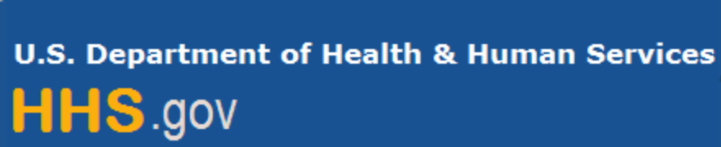

Department of Health and Human Services

Grants Forecast and Overview

The Department of Health and Human Services’ Grants Forecast is a database of planned grant opportunities proposed by its agencies. Each Forecast record contains actual or estimated dates and funding levels for grants that the agency intends to award during the fiscal year. Forecast opportunities are subject to change based on enactment of congressional appropriations.

Go to the webpage below for more information.
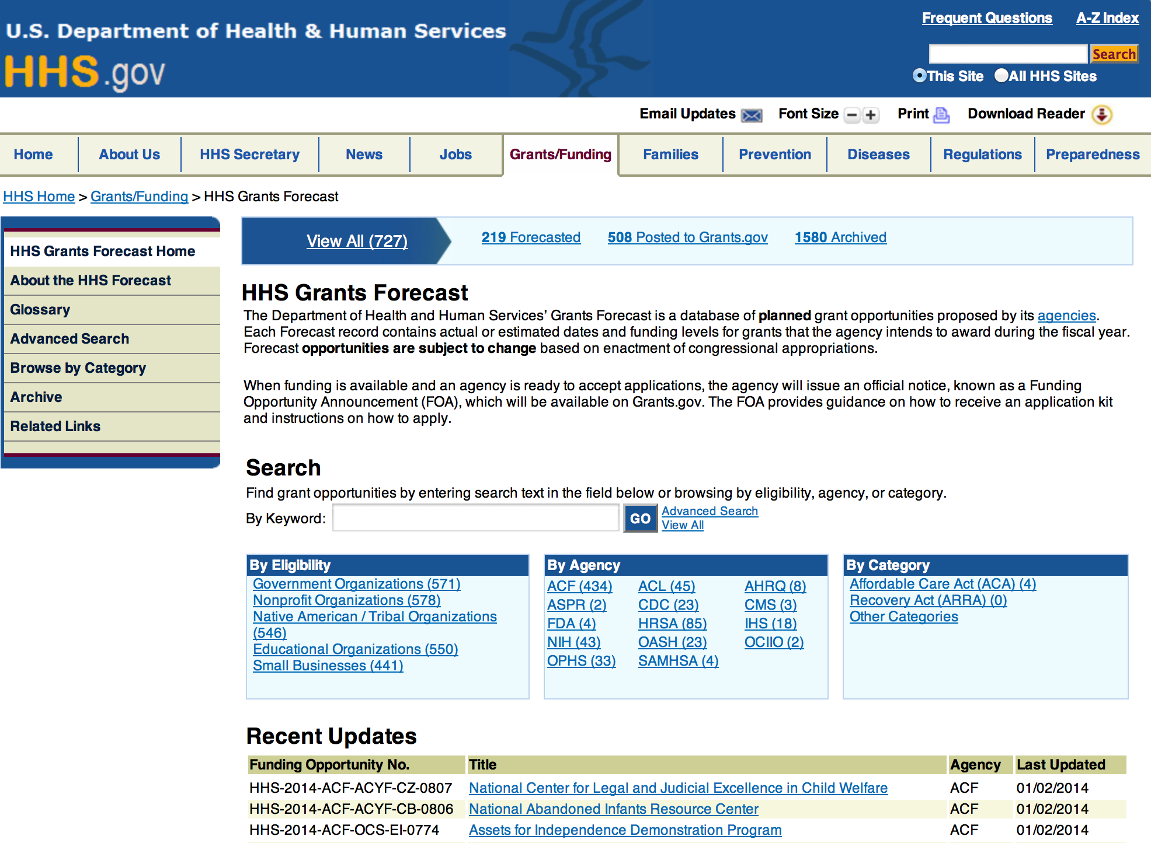

For more general information about HHS Grants and Funding go to the website below at: http://www.hhs.gov/grants/ .

Recent Updates
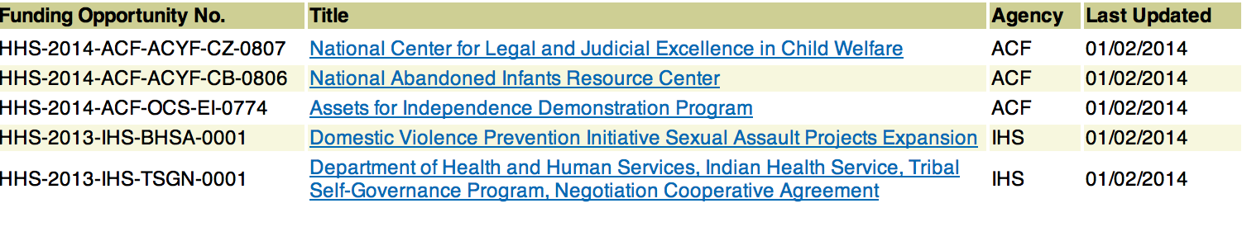

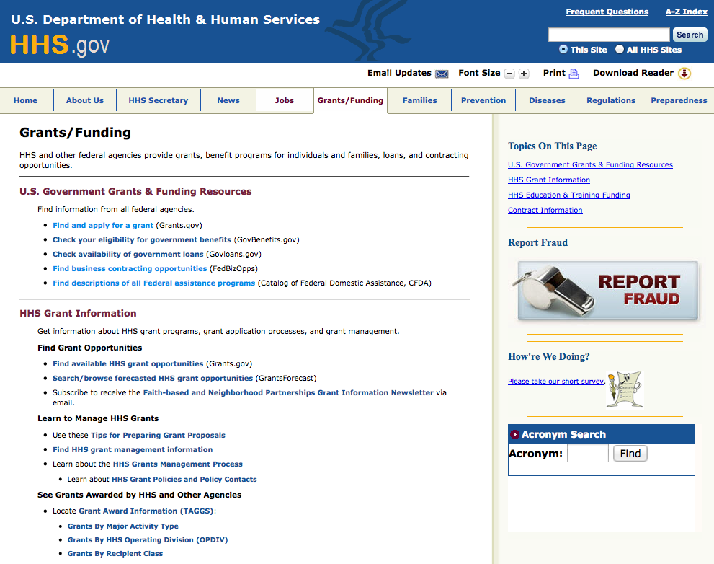

Programs:

Research:

Agency for Health Care Research and Quality
Increasing Access to Medication-Assisted Treatment (MAT) in Rural Primary Care Practices (R18) Grant
http://www.grants.gov/web/grants/view-opportunity.html?oppId=280314

Centers for Disease Control and Prevention
Enhanced Surveillance for New Vaccine Preventable Diseases Grant
http://www.grants.gov/web/grants/view-opportunity.html?oppId=280064

Centers for Disease Control and Prevention
Protecting and Improving Public Health Globally: Building and Strengthening Public Health Impact, Systems, Capacity and Security Grant
http://www.grants.gov/web/grants/view-opportunity.html?oppId=280280

Centers for Disease Control and Prevention
Annual Estimates of Influenza Vaccine Effectiveness for Preventing Medically Attended Laboratory-Confirmed Influenza in the United States Grant
http://www.grants.gov/web/grants/view-opportunity.html?oppId=279983

Centers for Disease Control and Prevention
Enhanced Surveillance for New Vaccine Preventable Diseases Grant
http://www.grants.gov/web/grants/view-opportunity.html?oppId=280047

Centers for Disease Control and Prevention
NCCDPHP
National Collaboration to Support Health, Wellness and Academic Success of School-Age Children Grant
http://www.grants.gov/web/grants/view-opportunity.html?oppId=280120

Centers for Disease Control and Prevention
NCCDPHP
Improving Epilepsy Programs, Services, and Outcomes through National Partnerships Grant
http://www.grants.gov/web/grants/view-opportunity.html?oppId=280292

Health Resources and Services Administration
Health Center Controlled Networks Grant
http://www.grants.gov/web/grants/view-opportunity.html?oppId=280276

National Institutes of Health
Pediatric Heart Network Clinical Research Centers (UG1) Grant
http://www.grants.gov/web/grants/view-opportunity.html?oppId=280279

Health Resources and Services Administration
AIDS Education and Training Center National Clinician Consultation Center Grant
http://www.grants.gov/web/grants/view-opportunity.html?oppId=280268

Health Resources and Services Administration
Ryan White HIV/AIDS Program Part D Grants for Coordinated HIV Services and Access to Research for Women, Infants, Children, and Youth (WICY) Supplemental Grant
http://www.grants.gov/web/grants/view-opportunity.html?oppId=280269

Health Resources and Services Administration
Oral Health Service Expansion Grant
http://www.grants.gov/web/grants/view-opportunity.html?oppId=280107

Health Resources and Services Administration
Advanced Nursing Education Program Grant
http://www.grants.gov/web/grants/view-opportunity.html?oppId=280099

Health Resources and Services Administration
Emergency Medical Services for Children State Partnership Regionalization of Care Grant
http://www.grants.gov/web/grants/view-opportunity.html?oppId=280007

Health Resources and Services Administration
MCH Pipeline Training Program Grant
http://www.grants.gov/web/grants/view-opportunity.html?oppId=280209

Health Resources and Services Administration
Scholarships for Disadvantaged Students (SDS) Grant
http://www.grants.gov/web/grants/view-opportunity.html?oppId=280235

National Institutes of Health
Revision Applications for Validation of Mobile/Wireless Health Tools for Measurement and Intervention (R01) Grant
http://www.grants.gov/web/grants/view-opportunity.html?oppId=280215

National Institutes of Health
Image-guided Drug Delivery (R01) Grant
http://www.grants.gov/web/grants/view-opportunity.html?oppId=280227

National Institutes of Health
Drug Discovery For Nervous System Disorders (R01) Grant
http://www.grants.gov/web/grants/view-opportunity.html?oppId=280228

National Institutes of Health
Planning Grant for Emerging Epidemic Virus Research Training for West African Countries with Widespread Transmission of Ebola- Guinea, Liberia, and Sierra Leone (D71) Grant
http://www.grants.gov/web/grants/view-opportunity.html?oppId=280229

National Institutes of Health
BRAIN Initiative: Non-Invasive Neuromodulation - Mechanisms and Dose/Response Relationships for Targeted CNS Effects (R01) Grant
http://www.grants.gov/web/grants/view-opportunity.html?oppId=280230

National Institutes of Health
Pediatric Diagnostic Biomarkers for Active Pulmonary TB Disease (R01) Grant
http://www.grants.gov/web/grants/view-opportunity.html?oppId=280238

National Institutes of Health
Drug Discovery For Nervous System Disorders (R21) Grant
http://www.grants.gov/web/grants/view-opportunity.html?oppId=280239

National Institutes of Health
BRAIN Initiative: Non-Invasive Neuromodulation - New Tools and Techniques for Spatiotemporal Precision (R01) Grant
http://www.grants.gov/web/grants/view-opportunity.html?oppId=280240

National Institutes of Health
NIDCR Award for Sustaining Outstanding Achievement in Research (SOAR) (R35) Grant
http://www.grants.gov/web/grants/view-opportunity.html?oppId=280236

National Institutes of Health
Stimulating Hematology Investigation: New Endeavors (SHINE) (R01) Grant
http://www.grants.gov/web/grants/view-opportunity.html?oppId=279969

National Institutes of Health
Advancing Understanding, Prevention and Management of Infections Transmitted from Women to their Infants (R21) Grant
http://www.grants.gov/web/grants/view-opportunity.html?oppId=279980

National Institutes of Health
Advancing Understanding, Prevention, and Management of Infections Transmitted from Women to their Infants (R01) Grant
http://www.grants.gov/web/grants/view-opportunity.html?oppId=279962

National Institutes of Health
Breast Cancer and the Environment Communication Research Initiative (R03) Grant
http://www.grants.gov/web/grants/view-opportunity.html?oppId=279964

National Institutes of Health
NHLBI Progenitor Cell Translational Consortium (U01) Grant
http://www.grants.gov/web/grants/view-opportunity.html?oppId=280001

National Institutes of Health
Breast Cancer and the Environment Communication Research Initiative (R21) Grant
http://www.grants.gov/web/grants/view-opportunity.html?oppId=279984

National Institutes of Health
Improving Outcomes in Cancer Treatment-Related Cardiotoxicity (R01) Grant
http://www.grants.gov/web/grants/view-opportunity.html?oppId=280121

National Institutes of Health
Improving Outcomes in Cancer Treatment-Related Cardiotoxicity (R21) Grant
http://www.grants.gov/web/grants/view-opportunity.html?oppId=280122

National Institutes of Health
NEI Clinical Study Planning Grant Program (R34)
http://www.grants.gov/web/grants/view-opportunity.html?oppId=280141

National Institutes of Health
Human Immunology Project Consortium (U19) Grant
http://www.grants.gov/web/grants/view-opportunity.html?oppId=280136

National Institutes of Health
Development of New Technologies and Bioengineering Solutions for the Advancement of Cell Replacement Therapies for Type 1 Diabetes (R43/R44) Grant
http://www.grants.gov/web/grants/view-opportunity.html?oppId=280165

National Institutes of Health
BRAIN Initiative: New Technologies and Novel Approaches for Large-Scale Recording and Modulation in the Nervous System (U01) Grant
http://www.grants.gov/web/grants/view-opportunity.html?oppId=280111

National Institutes of Health
BRAIN Initiative: Optimization of Transformative Technologies for Large Scale Recording and Modulation in the Nervous System (U01) Grant
http://www.grants.gov/web/grants/view-opportunity.html?oppId=280112

National Institutes of Health
NHLBI Clinical Trial Pilot Studies (R34) Grant
http://www.grants.gov/web/grants/view-opportunity.html?oppId=280113

National Institutes of Health
BRAIN Initiative: Development and Validation of Novel Tools to Analyze Cell-Specific and Circuit-Specific Processes in the Brain (R01) Grant
http://www.grants.gov/web/grants/view-opportunity.html?oppId=280114

National Institutes of Health
Pre-application: Stimulating Peripheral Activity to Relieve Conditions (SPARC): Comprehensive Functional Mapping of Neuroanatomy and Neurobiology of Organs (OT1) Grant
http://www.grants.gov/web/grants/view-opportunity.html?oppId=280095

National Institutes of Health
Pulmonary and Cardiovascular Consequences of Inhaled Nicotine (R01) Grant
http://www.grants.gov/web/grants/view-opportunity.html?oppId=280116

National Institutes of Health
Limited Competition - Stimulating Peripheral Activity to Relieve Conditions (SPARC): Foundational Functional Mapping of Neuroanatomy and Neurobiology of Organs (OT2) Grant
http://www.grants.gov/web/grants/view-opportunity.html?oppId=280117

National Institutes of Health
Limited Competition - Stimulating Peripheral Activity to Relieve Conditions (SPARC): Comprehensive Functional Mapping of Neuroanatomy and Neurobiology of Organs (OT2) Grant
http://www.grants.gov/web/grants/view-opportunity.html?oppId=280096

National Institutes of Health
Pre-application: Stimulating Peripheral Activity to Relieve Conditions (SPARC): Foundational Functional Mapping of Neuroanatomy and Neurobiology of Organs (OT1) Grant
http://www.grants.gov/web/grants/view-opportunity.html?oppId=280106

National Institutes of Health
Precision Medicine Initiative Cohort Program Healthcare Provider Organization Enrollment Centers (UG3/UH3) Grant
http://www.grants.gov/web/grants/view-opportunity.html?oppId=280088

National Institutes of Health
Ancillary Studies to Major Ongoing Clinical Research Studies to Advance Areas of Scientific Interest within the Mission of the NIDDK (R01) Grant
http://www.grants.gov/web/grants/view-opportunity.html?oppId=279991

National Institutes of Health
Developmental Centers for Interdisciplinary Research in Benign Urology (P20) Grant
http://www.grants.gov/web/grants/view-opportunity.html?oppId=280281

National Institutes of Health
Risk of Adolescence and Injury in HIV Susceptibility (RAIS) (R01) Grant
http://www.grants.gov/web/grants/view-opportunity.html?oppId=280344

National Institutes of Health
Administrative Supplements to NIH Awards for Validation Studies of Analytical Methods for Natural Products (Admin Supp) Grant
http://www.grants.gov/web/grants/view-opportunity.html?oppId=280326

Department of Health and Human Services
Substance Abuse & Mental Health Services Administration
National Child Traumatic Stress Initiative – Category III Community Treatment and Services (CTS) Centers Grant
http://www.grants.gov/web/grants/view-opportunity.html?oppId=280297

Substance Abuse & Mental Health Services Administration
Statewide Family Network Program Grant
http://www.grants.gov/web/grants/view-opportunity.html?oppId=280108

Substance Abuse & Mental Health Services Administration
Statewide Consumer Network Program Grant
http://www.grants.gov/web/grants/view-opportunity.html?oppId=280080

Substance Abuse & Mental Health Services Administration
Screening, Brief Intervention, and Referral to Treatment (SBIRT) Health Professions Student Training (SBIRT- Student Training) Grant
http://www.grants.gov/web/grants/view-opportunity.html?oppId=279965

Modifications:

Agency for Health Care Research and Quality
Health Services Research Demonstration and Dissemination Projects for Prevention and Management of Healthcare-Associated Infections (R18)
Modification 1
http://www.grants.gov/web/grants/view-opportunity.html?oppId=185293

Administration for Children and Families
Administration for Children and Families - OCS
Assets for Independence Demonstration Program
Modification 4
http://www.grants.gov/web/grants/view-opportunity.html?oppId=275744

Centers for Disease Control and Prevention
Childhood Obesity Research Demonstration 2.0
Modifications 2 & 4
http://www.grants.gov/web/grants/view-opportunity.html?oppId=280155

Centers for Disease Control and Prevention
NCBDDD
National Centers on Health Promotion for People with Disabilities
Modifications 3, 7 & 11
http://www.grants.gov/web/grants/view-opportunity.html?oppId=280062

Centers for Disease Control and Prevention
The CDC National Centers of Excellence in Youth Violence Prevention: Building the Evidence for Community- and Policy-Level Prevention
Modification 7
http://www.grants.gov/web/grants/view-opportunity.html?oppId=272228

Centers for Medicare & Medicaid Services
Connecting Kids to Coverage Outreach and Enrollment Cooperative Agreements
Modification 1
http://www.grants.gov/web/grants/view-opportunity.html?oppId=280091

Health Resources and Services Administration
Graduate Psychology Education (GPE) Program
Modification 3
http://www.grants.gov/web/grants/view-opportunity.html?oppId=279627

National Institutes of Health
Advances in Polycystic Kidney Disease (R01)
Modification 1
http://www.grants.gov/web/grants/view-opportunity.html?oppId=212613

National Institutes of Health
Human Immunology Project Consortium (U19)
Modification 1
http://www.grants.gov/web/grants/view-opportunity.html?oppId=280136

National Institutes of Health
Stimulating Hematology Investigation: New Endeavors (SHINE) (R01)
Modification 1
http://www.grants.gov/web/grants/view-opportunity.html?oppId=209013

National Institutes of Health
BRAIN Initiative: Research Opportunities Using Invasive Neural Recording and Stimulating Technologies in the Human Brain (U01)
Modification 1
http://www.grants.gov/web/grants/view-opportunity.html?oppId=279501

National Institutes of Health
Population Dynamics Centers Research Infrastructure Program FY 2016 (P2C)
Modification 1
http://www.grants.gov/web/grants/view-opportunity.html?oppId=279284

National Institutes of Health
NHLBI Clinical Trial Pilot Studies (R34)
Modification 1
http://www.grants.gov/web/grants/view-opportunity.html?oppId=203035

National Institutes of Health
NIAMS Clinical Trial Planning Cooperative Agreement (U34)
Modification 1
http://www.grants.gov/web/grants/view-opportunity.html?oppId=275530

Reminders:

National Institutes of Health
PHS 2015-02 Omnibus Solicitation of the NIH, CDC, FDA and ACF for Small Business Innovation Research Grant Applications (Parent SBIR [R43/R44]) Grant

Document Type: | Grants Notice
Funding Opportunity Number: | PA-15-269
Funding Opportunity Title: | PHS 2015-02 Omnibus Solicitation of the NIH, CDC, FDA and ACF for Small Business Innovation Research Grant Applications (Parent SBIR [R43/R44])
Opportunity Category: | Discretionary
Funding Instrument Type: | Grant
Category of Funding Activity: | Education  Environment  Food and Nutrition  Health  Income Security and Social Services
Category Explanation:
Expected Number of Awards:
CFDA Number(s): | 93.061 -- Innovations in Applied Public Health Research  93.103 -- Food and Drug Administration Research  93.113 -- Environmental Health  93.121 -- Oral Diseases and Disorders Research  93.136 -- Injury Prevention and Control Research and State and Community Based Programs  93.172 -- Human Genome Research  93.173 -- Research Related to Deafness and Communication Disorders  93.213 -- Research and Training in Complementary and Integrative Health  93.233 -- National Center on Sleep Disorders Research  93.242 -- Mental Health Research Grants  93.262 -- Occupational Safety and Health Program  93.273 -- Alcohol Research Programs  93.279 -- Drug Abuse and Addiction Research Programs  93.282 -- Mental Health National Research Service Awards for Research Training  93.283 -- Centers for Disease Control and Prevention Investigations and Technical Assistance  93.286 -- Discovery and Applied Research for Technological Innovations to Improve Human Health  93.307 -- Minority Health and Health Disparities Research  93.350 -- National Center for Advancing Translational Sciences  93.351 -- Research Infrastructure Programs  93.361 -- Nursing Research  93.393 -- Cancer Cause and Prevention Research  93.394 -- Cancer Detection and Diagnosis Research  93.395 -- Cancer Treatment Research  93.396 -- Cancer Biology Research  93.399 -- Cancer Control  93.595 -- Welfare Reform Research, Evaluations and National Studies  93.647 -- Social Services Research and Demonstration  93.823 -- Ebola Support: Transmission and Prevention Control, Public Health Preparedness, Vaccine Development  93.837 -- Cardiovascular Diseases Research  93.838 -- Lung Diseases Research  93.839 -- Blood Diseases and Resources Research  93.846 -- Arthritis, Musculoskeletal and Skin Diseases Research  93.847 -- Diabetes, Digestive, and Kidney Diseases Extramural Research  93.853 -- Extramural Research Programs in the Neurosciences and Neurological Disorders  93.855 -- Allergy, Immunology and Transplantation Research  93.856 -- Microbiology and Infectious Diseases Research  93.859 -- Biomedical Research and Research Training  93.865 -- Child Health and Human Development Extramural Research  93.866 -- Aging Research  93.867 -- Vision Research  93.879 -- Medical Library Assistance
Cost Sharing or Matching Requirement: | No
Posted Date: | Jun 4, 2015
Creation Date: | Jun 4, 2015
Original Closing Date for Applications: | Apr 5, 2016
Current Closing Date for Applications: | Apr 5, 2016
Archive Date: | May 6, 2016
Eligible Applicants: | Small businesses
Additional Information on Eligibility: | Other Eligible Applicants include the following: Non-domestic (non-U.S.) Entities (Foreign Institutions) are not eligible to apply. Non-domestic (non-U.S.) components of U.S. Organizations are not eligible to apply. Foreign components, as defined in the NIH Grants Policy Statement, may be allowed.
Agency Name: | National Institutes of Health
Description: | This Funding Opportunity Announcement (FOA) issued by the National Institutes of Health (NIH), the Centers for Disease Control and Prevention (CDC), the Food and Drug Administration (FDA) and the Administration for Children and Families (ACF) invites eligible United States small business concerns (SBCs) to submit Small Business Innovation Research (SBIR) grant applications. United States SBCs that have the research capabilities and technological expertise to contribute to the R and D mission(s) of the NIH, CDC, FDA or ACF awarding components identified in this FOA are encouraged to submit SBIR grant applications in response to identified topics (see PHS 2015-2 SBIR/STTR Program Descriptions and Research Topics for NIH, CDC, FDA and ACF.
Link to Additional Information: | http://grants.nih.gov/grants/guide/pa-files/PA-15-269.html
Contact Information: | If you have difficulty accessing the full announcement electronically, please contact:  NIH OER Webmaster FBOWebmaster@OD.NIH.GOV  If you have any problems linking to this funding announcement, please contact the NIH OER Webmaster

http://www.grants.gov/web/grants/view-opportunity.html?oppId=276977

Department of Homeland Security

The Department of Homeland Security enhances the ability of states, local and tribal jurisdictions, and other regional authorities in the preparation, prevention, and response to terrorist attacks and other disasters, by distributing grant funds. Localities can use grants for planning, equipment, training and exercise needs.

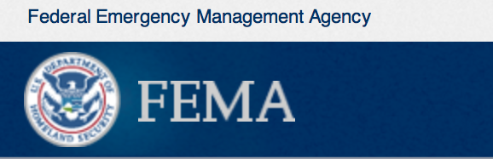

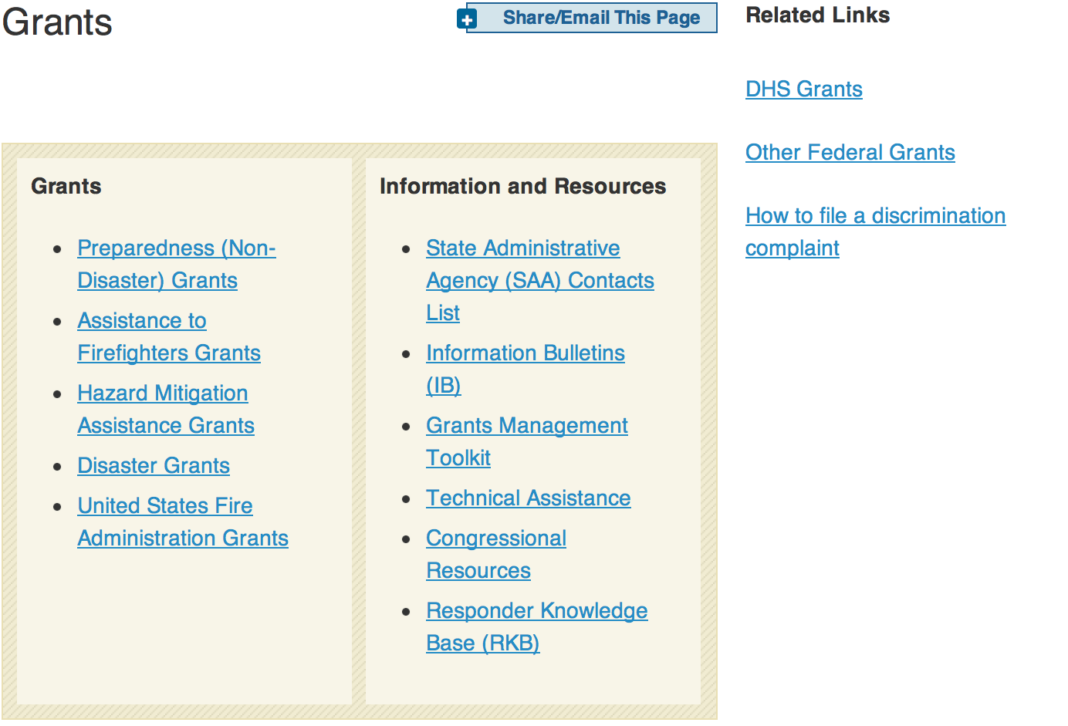
OMB Circulars
Assistance to State and Local Governments OMB Circular A-87 OMB Circular A-102
Assistance to Colleges and Universities OMB Circular A-21 OMB Circular A-110
Assistance to Non-profit Organizations OMB Circular A-110 OMB Circular A-122
Audit Guidance OMB Circular A-133
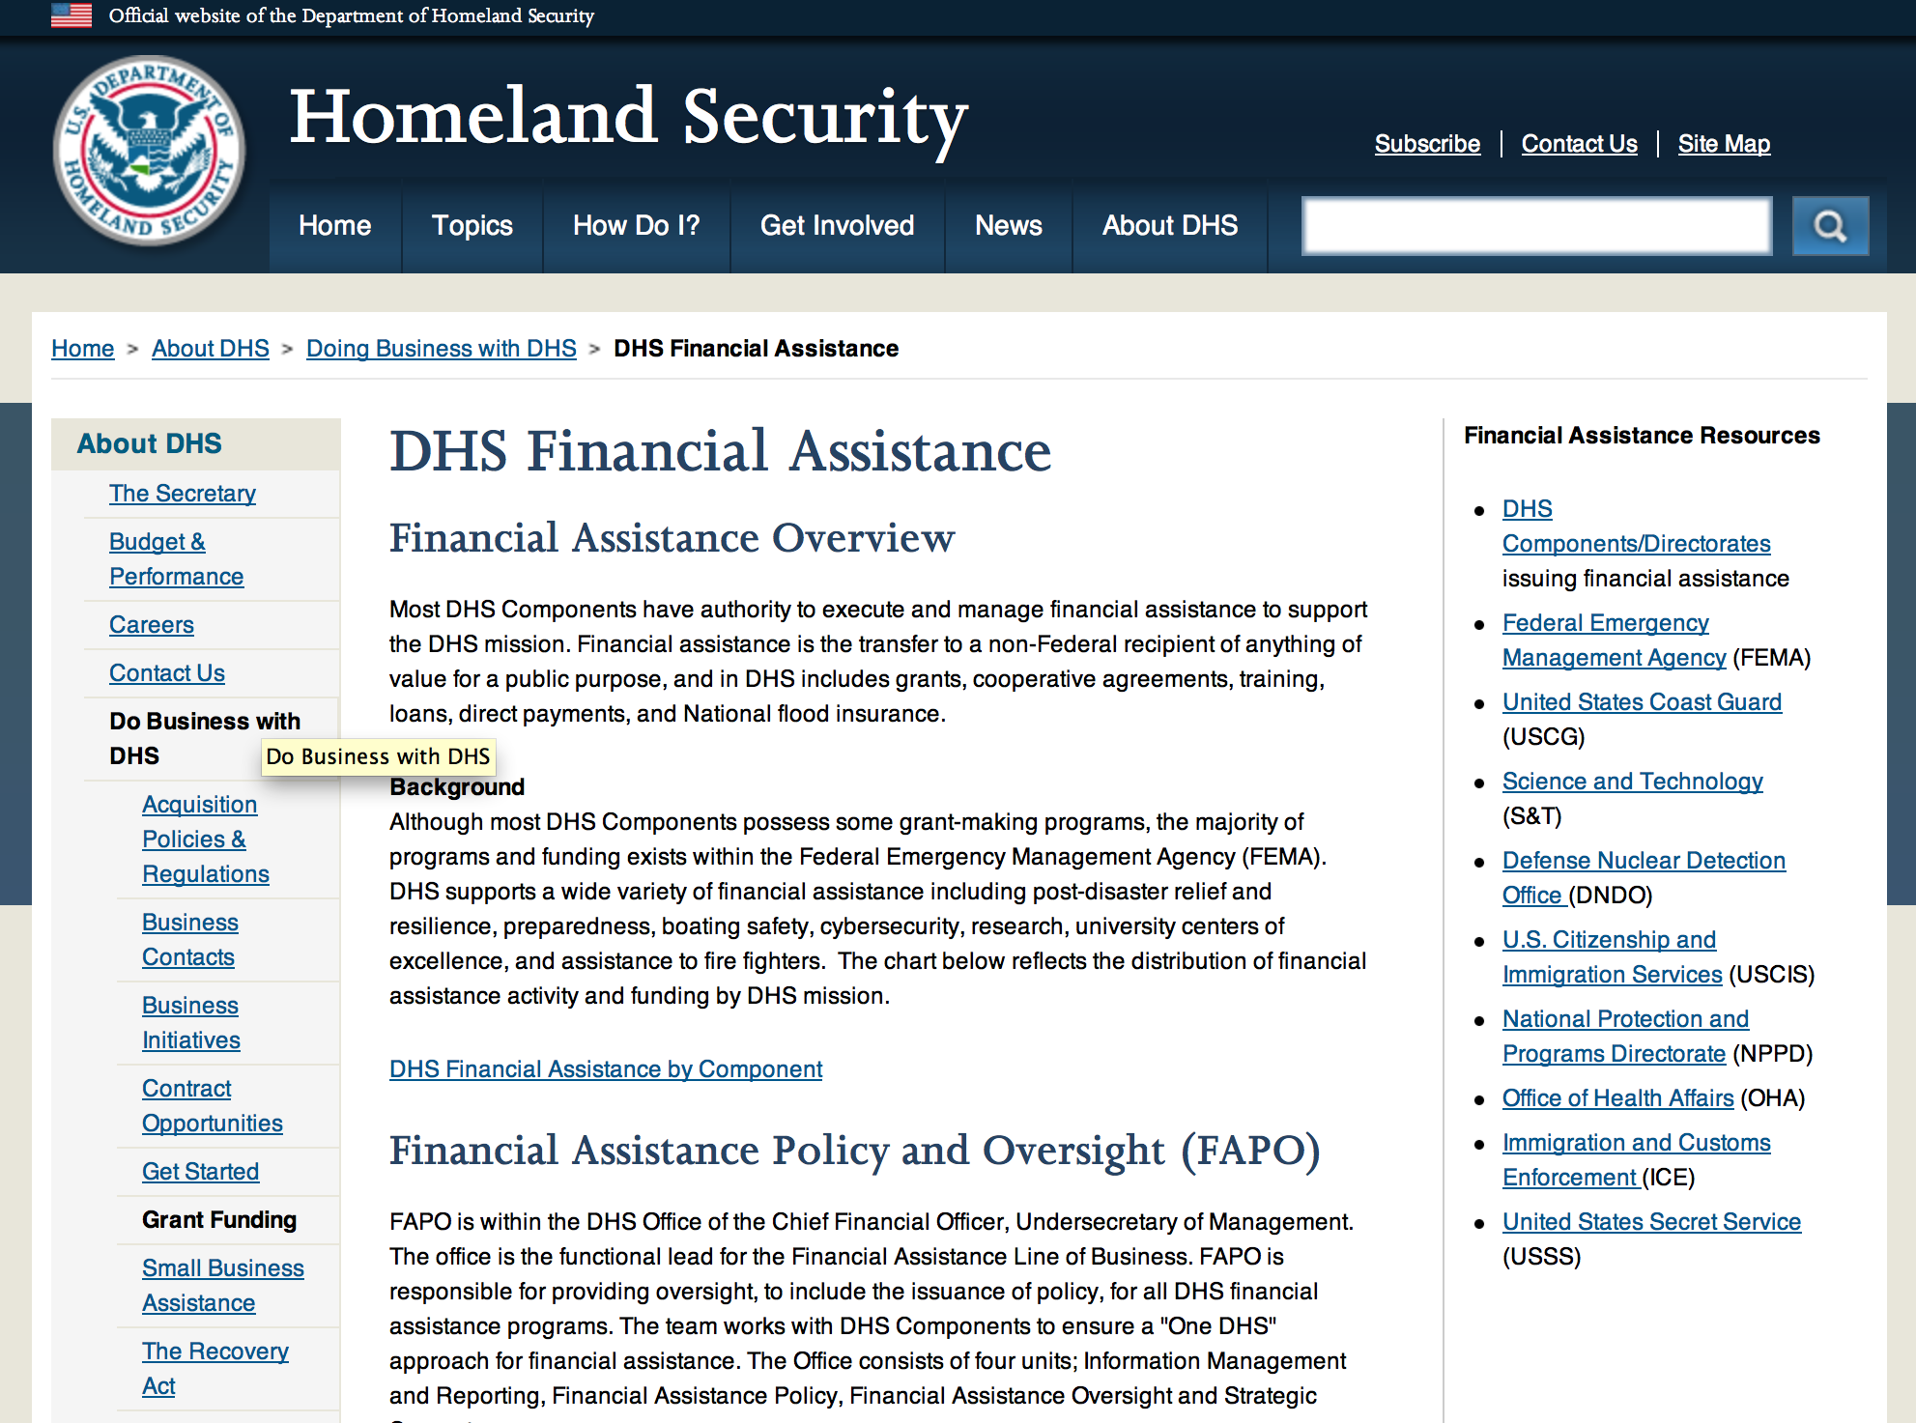

Webpage can be viewed at: http://www.dhs.gov/xopnbiz/grants/index.shtm#2

Download these updated grant application tools and start planning your grant request now.
- FY 2012 FP&S Grants Get Ready Guide. This short guide will help you kick-start your grant application. It identifies the most important elements of all the grant application questions.
- FY 2012 FP&S Grant Self-Evaluation Sheet. This tool is based on the application scoring dimensions used by the peer reviewers. It can help you assess your organization's readiness to apply for a grant and help you plan your application.
Video Resources
Two short Fire Prevention and Safety Program videos provide information that can help potential applicants.
- The FP&S Grants video gives an overview of the FP&S Grant Program, describing the purpose of the grants, eligible activities, and evaluation criteria.
- The Community Risk Assessment video describes the different types of risk assessments that applicants can use and explains how the risk assessment's information can support grant requests. Community risk assessments are critical to creating an effective fire prevention and safety project, and they are required to obtain a FP&S grant.
Website Resources
Visit the FP&S Grants home page on the Assistance to Firefighters Grants (AFG) website to find more information about recent awardees and models of successful FP&S projects.

Federal Funding Alternative To AFG

State Administrative Agencies (SAA) apply for and administer Federal grants on behalf of their States, including FEMA Preparedness Grants. The SAA will work with eligible organizations to comply with the general requirements of grant programs or cooperative agreements. Contact your State’s SAA to find out what current Federal funding opportunities may be available to your organization. A listing of the SAAs and points of contact can be found at http://www.fema.gov/library/viewRecord.do?id=6363.

Programs:

Modifications:

Reminders:



Department of Housing and Urban Development

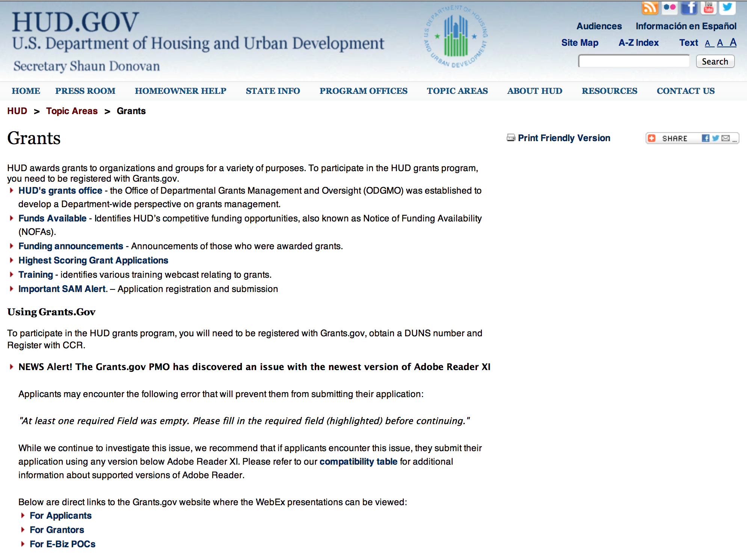

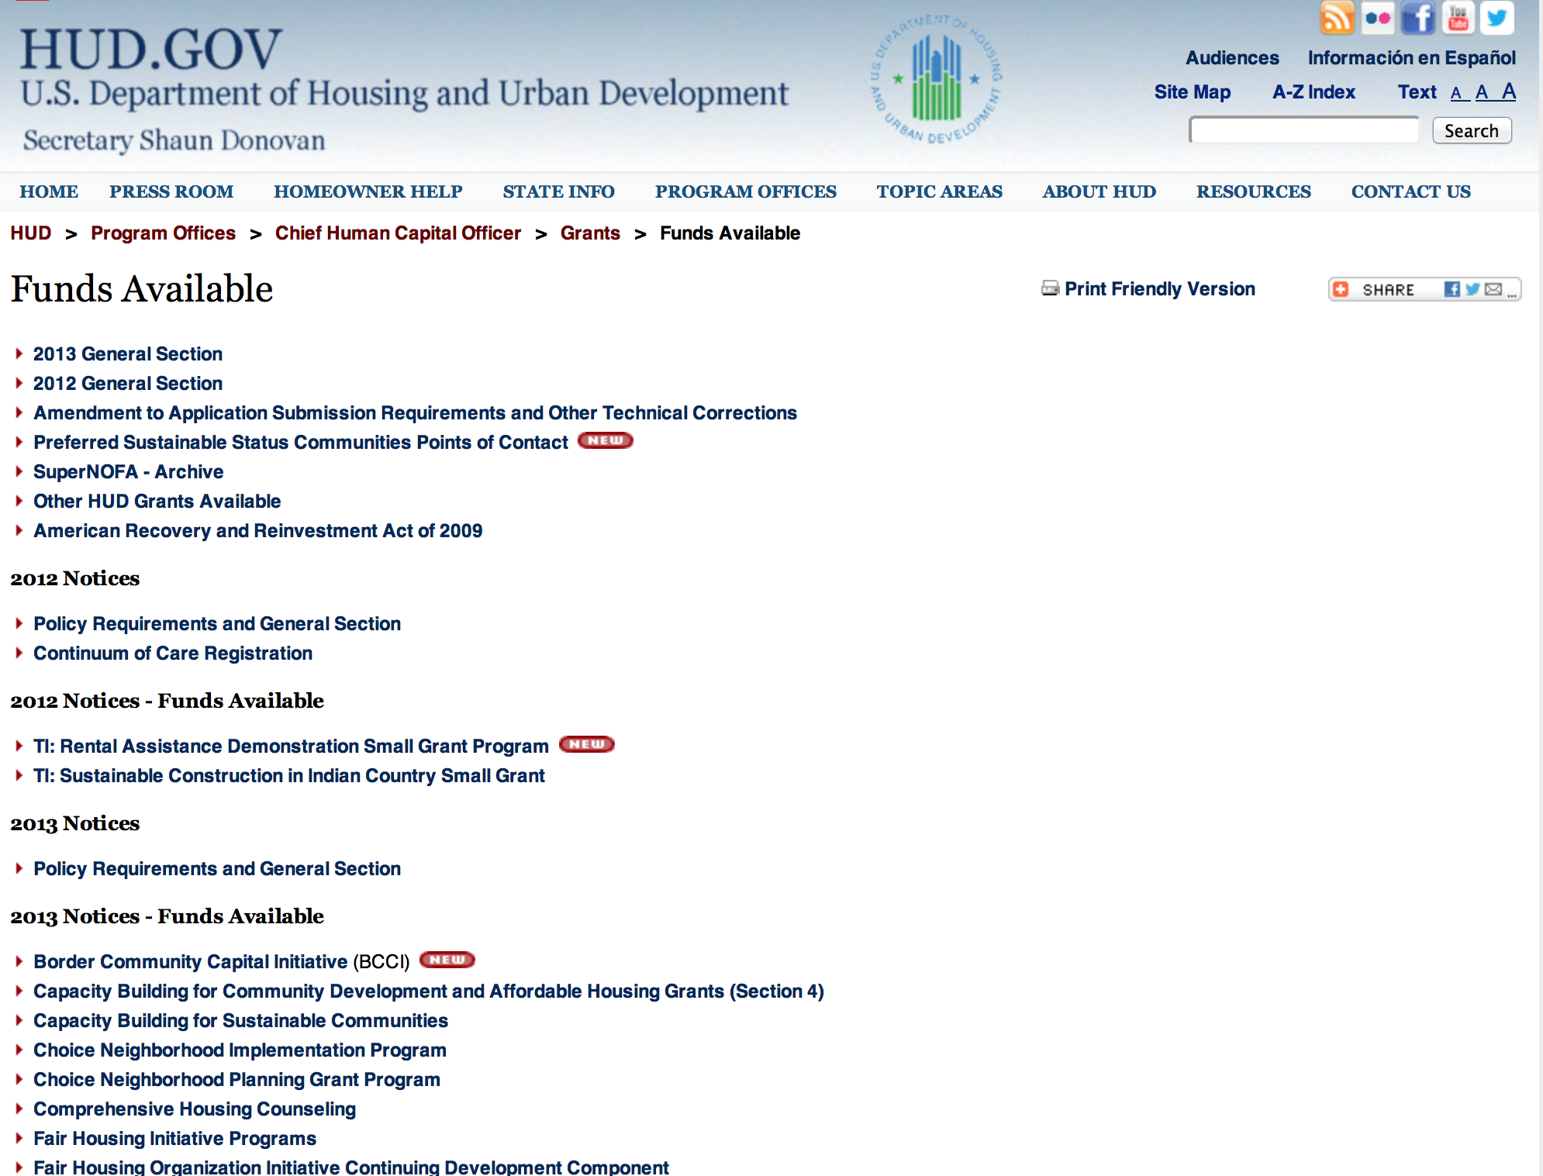

HUD - Notice of Funds Available

For detailed information click here

FY 2013 Notice of Funding Availability (NOFA) Policy Requirements and General Section to HUD’s FY2013 NOFAs for Discretionary Programs
This Notice provides prospective applicants for HUD's competitive funding with the opportunity to become familiar with the General Section to HUD's FY2013 Notices of Funding Availability (NOFAs) for Discretionary Funding (program NOFA), in advance of publication of any individual FY2013 program NOFAs. This General Section and the individual FY2013 program NOFA Sections comprise the entirety of the FY2013 NOFA instructions.
- General Section
- FONSI
- New Application Attachment Filename Requirement

Programs

Modifications:

Choice Neighborhoods Planning Grants Program
Modification 1

Document Type: | Grants Notice
Funding Opportunity Number: | FR-5900-N-14
Funding Opportunity Title: | Choice Neighborhoods Planning Grants Program
Opportunity Category: | Discretionary
Funding Instrument Type: | Grant
Category of Funding Activity: | Housing
Category Explanation:
Expected Number of Awards: | 8
CFDA Number(s): | 14.892 -- Choice Neighborhoods Planning Grants
Cost Sharing or Matching Requirement: | Yes
Posted Date: | Nov 23, 2015
Creation Date: | Nov 23, 2015
Original Closing Date for Applications: | Feb 9, 2016 Electronically submitted applications must be submitted no later than 11:59:59 p.m., ET, on the listed application due date.
Current Closing Date for Applications: | Feb 9, 2016 Electronically submitted applications must be submitted no later than 11:59:59 p.m., ET, on the listed application due date.
Archive Date: | Mar 10, 2016
Estimated Total Program Funding: | $10,000,000
Award Ceiling: | $2,000,000
Award Floor: | $0
Eligible Applicants: | Others (see text field entitled "Additional Information on Eligibility" for clarification)
Additional Information on Eligibility: | Eligible applicants are Public Housing Authorities (PHAs), local governments, tribal entities, and nonprofits. See the Statutory and Regulatory Requirements in section III.C.1 for additional details and the definitions in section I.A.3.f for definitions of related terms. Individuals, foreign entities, and sole proprietorship organizations are not eligible to compete for, or receive, awards made under this announcement.
Agency Name: | Department of Housing and Urban Development
Description: | To be completed by drafter.
Link to Additional Information: | http://portal.hud.gov/hudportal/HUD?src=/program_offices/administration/grants/fundsavail
Contact Information: | If you have difficulty accessing the full announcement electronically, please contact:  Before the application deadline date, HUD staff will be available to provide you with general guidance and technical assistance. However, HUD staff are not permitted to assist in preparing your application. If you have a question or need a clarification, you may send an e-mail to address below.  Grants Policy

http://www.grants.gov/web/grants/view-opportunity.html?oppId=280203

Reminders

Juvenile Reentry Assistance Program (JRAP)
Modification 1

Document Type: | Grants Notice
Funding Opportunity Number: | FR-5900-N-09
Funding Opportunity Title: | Juvenile Reentry Assistance Program (JRAP)
Opportunity Category: | Discretionary
Funding Instrument Type: | Grant
Category of Funding Activity: | Housing
Category Explanation:
Expected Number of Awards: | 18
CFDA Number(s): | 14.897 -- Juvenile Reentry Assistance Program Juvenile Reentry Assistance Program (JRAP)
Cost Sharing or Matching Requirement: | Yes
Posted Date: | Nov 2, 2015
Creation Date: | Nov 2, 2015
Original Closing Date for Applications: | Jan 4, 2016 Electronically submitted applications must be submitted no later than 11:59:59 p.m., ET, on the listed application due date.
Current Closing Date for Applications: | Jan 4, 2016 Electronically submitted applications must be submitted no later than 11:59:59 p.m., ET, on the listed application due date.
Archive Date: | Feb 3, 2016
Estimated Total Program Funding: | $1,750,000
Award Ceiling: | $100,000
Award Floor: | $10,000
Eligible Applicants: | Others (see text field entitled "Additional Information on Eligibility" for clarification)
Additional Information on Eligibility: | Eligible applicants are only Public Housing Authorities (PHAs) who have established a partnership with a legal aid organization, university legal center, public defenders office, or other legal service organization that is a non-profit and has experience providing legal services to juveniles. Individuals, foreign entities, and sole proprietorship organizations are not eligible to compete for, or receive, awards made under this announcement.
Agency Name: | Department of Housing and Urban Development
Description: | On any given day, approximately 60,000 youth are confined in juvenile detention and correctional facilities and hundreds of thousands more are on probation. This system contact can have a significant impact on adolescents lives and their prospects for long-term success in adulthood in obtaining academic degrees, finding work, and securing housing. Collateral consequences (including the lack of records expungement) for juveniles who have come into contact with the juvenile justice system can hinder the ability of young people to integrate into their communities and become successful, thriving adults and increase their chances of recidivism. Barriers to housing, education, employment, health care, and insurance as well as serious immigration consequences and financial repercussions are chief among the tangible consequences. Social, emotional and psychological consequences such as trauma, and a sense of shame and humiliation, are also of great concern. Having a juvenile conviction on your record keeps individuals from fully realizing their potential.
Link to Additional Information: | http://portal.hud.gov/hudportal/HUD?src=/program_offices/administration/grants/fundsavail
Contact Information: | If you have difficulty accessing the full announcement electronically, please contact:  JRAP@hud.gov  Grants Policy

http://www.grants.gov/web/grants/view-opportunity.html?oppId=279942

Pay for Success Permanent Supportive Housing Demonstration Grant

Document Type: | Grants Notice
Funding Opportunity Number: | FR-5900-N-26
Funding Opportunity Title: | Pay for Success Permanent Supportive Housing Demonstration
Opportunity Category: | Discretionary
Funding Instrument Type: | Cooperative Agreement
Category of Funding Activity: | Housing
Category Explanation:
Expected Number of Awards: | 6
CFDA Number(s): | 14.273 -- Pay for Success Permanent Supportive Housing Demonstration
Cost Sharing or Matching Requirement: | No
Posted Date: | Oct 15, 2015
Creation Date: | Oct 15, 2015
Original Closing Date for Applications: | Feb 12, 2016 Electronically submitted applications must be submitted no later than 11:59:59 p.m., ET, on the listed application due date.
Current Closing Date for Applications: | Feb 12, 2016 Electronically submitted applications must be submitted no later than 11:59:59 p.m., ET, on the listed application due date.
Archive Date: | Mar 13, 2016
Estimated Total Program Funding: | $8,679,000
Award Ceiling: | $1,300,000
Eligible Applicants: | Public and State controlled institutions of higher education  Nonprofits that do not have a 501(c)(3) status with the IRS, other than institutions of higher education  Nonprofits having a 501(c)(3) status with the IRS, other than institutions of higher education  Private institutions of higher education
Additional Information on Eligibility: | 1. Eligible Applicants. Applicants are applying to fulfill the role of intermediary as described in Section I.A.1.b.iv.(a). of this NOFA. See Section IV.B.1. of this NOFA for information regarding documentation substantiating eligibility. In accordance with the faith-based initiative, HUD welcomes eligible faith-based and other community organizations that meet the criteria of an eligible applicant as defined in this NOFA. Applicants should be aware that HUD does not provide any funding to nor does it accept applications from individuals through its competitive NOFA process. 2. Experience. A successful applicant should demonstrate its, or its mentor's, knowledge of and experience in carrying out a PFS model as well as the capacity to implement a PSH Intervention by working with partners and identifying the resources necessary to manage and operate the demonstration. Competitive applicants will meet some or all the following criteria: a. High-performing with a consistently successful record of past performance; b. Experience in completing a PFS Feasibility Analysis; structuring a PFS Contract that successfully closed; or other relevant experience with social finance or social innovation; c. Experience in facilitating partnerships between public and private entities; d. Advanced knowledge of and experience with the PSH model using a Housing First approach; e. Knowledge of the research base for PSH; f. Expertise and experience in the operationalization of research methods. Individuals, foreign entities, and sole proprietorship organizations are not eligible to compete for, or receive, awards made under this announcement.
Agency Name: | Department of Housing and Urban Development
Description: | The purpose of the Department of Justice's (DOJ's) and Department of Housing and Urban Development's (HUD's) PFS Demonstration is to strengthen communities; ability to prevent and end homelessness and reduce avoidable incarceration by increasing the provision of Permanent Supportive Housing (PSH), a proven evidenced-based practice. The PFS Demonstration is an opportunity to equip communities with a new financing mechanism for funding PSH projects that will prevent returns to homelessness and reduce recidivism among the reentry population. The PFS Demonstration is also a valuable opportunity to test ways of achieving greater cost efficiency effectiveness in providing homelessness assistance while expanding communities; access to available funding for PSH.
Link to Additional Information: | http://portal.hud.gov/hudportal/HUD?src=/program_offices/administration/grants/fundsavail
Contact Information: | If you have difficulty accessing the full announcement electronically, please contact:  Marlisa Grogan Marlisa.M.Grogan@hud.gov  Grants Policy

http://www.grants.gov/web/grants/view-opportunity.html?oppId=279652

Self-Help Homeownership Opportunity Program (SHOP) Grant

Document Type: | Grants Notice
Funding Opportunity Number: | FR-5900-N-19
Funding Opportunity Title: | Self-Help Homeownership Opportunity Program (SHOP)
Opportunity Category: | Discretionary
Funding Instrument Type: | Grant
Category of Funding Activity: | Housing
Category Explanation:
Expected Number of Awards: | 4
CFDA Number(s): | 14.247 -- Self-Help Homeownership Opportunity Program
Cost Sharing or Matching Requirement: | Yes
Posted Date: | Nov 2, 2015
Creation Date: | Nov 2, 2015
Original Closing Date for Applications: | Jan 4, 2016 Electronically submitted applications must be submitted no later than 11:59:59 p.m., ET, on the listed application due date.
Current Closing Date for Applications: | Jan 4, 2016 Electronically submitted applications must be submitted no later than 11:59:59 p.m., ET, on the listed application due date.
Archive Date: | Feb 3, 2016
Estimated Total Program Funding: | $9,977,500
Award Ceiling: | $9,977,500
Award Floor: | $0
Eligible Applicants: | Others (see text field entitled "Additional Information on Eligibility" for clarification)
Additional Information on Eligibility: | Applicants must be a public or private non-profit organization, or a consortium of public or private non-profit organizations, as defined below, that have the capacity and experience to provide or facilitate self-help homeownership housing opportunities on a national or regional basis. Applicants must propose to undertake eligible SHOP activities directly and/or enter into a written agreement with one or more non-profit affiliate organizations to carry out eligible SHOP activities. The term; as used in this NOFA refers to the SHOP applicant, including all consortium members. The term; refers to all consortium members. The term; refers to a successful SHOP applicant, including all consortium members, that have been awarded SHOP grant funds under this NOFA. The term; refers to an eligible non-profit organization that is an affiliate of a SHOP grantee. Individuals, foreign entities, and sole proprietorship organizations are not eligible to compete for, or receive, awards made under this announcement.
Agency Name: | Department of Housing and Urban Development
Description: | This SHOP NOFA announces the availability of $10,000,000 in FY2015 SHOP Grant funds to be awarded to national and regional non-profit organizations and consortia to facilitate and encourage innovative homeownership opportunities on a national, geographically diverse basis through the provision of self-help homeownership housing programs. Applicants must propose to use a significant amount of SHOP Grant funds in at least two states. Individuals are not eligible to apply for SHOP Grant funds. SHOP Grant funds must be used for land acquisition, infrastructure improvements, and for reasonable and necessary planning, administration and management costs (not to exceed 20 percent). The construction or rehabilitation costs of each SHOP unit must be funded with other leveraged public and private funds. The average SHOP Grant expenditure for the combined costs of land acquisition and infrastructure improvements must not exceed $15,000 per SHOP unit. SHOP units must be decent, safe, and sanitary non-luxury dwellings that comply with state and local codes, ordinances, and zoning requirements, and with all other SHOP requirements, including but not limited to, the requirements for energy-efficiency, water conservation and accessibility). The SHOP units must be sold to homebuyers at prices below the prevailing market price. Homebuyers must be low-income and must contribute a significant amount of sweat equity towards the development of the SHOP units. A homebuyer’s sweat equity contribution must not be mortgaged or otherwise restricted upon future sale of the SHOP unit. Volunteer labor is also required SHOP Grantees may award SHOP Grant funds to local non-profit affiliate organizations to carry out the Grantee’s SHOP program. These affiliate organizations must be located within the Grantee’s service area.
Link to Additional Information: | http://portal.hud.gov/hudportal/HUD?src=/program_offices/administration/grants/fundsavail
Contact Information: | If you have difficulty accessing the full announcement electronically, please contact:  Martha Murray Martha.W.Murray@hud.gov  Grants Policy

http://www.grants.gov/web/grants/view-opportunity.html?oppId=279943

General Section to HUD's Fiscal Year 2016 Notice[s] of Funding Availability for Discretionary Programs (General Section)
Modification 1

Document Type: | Grants Notice
Funding Opportunity Number: | FR-6000-N-01
Funding Opportunity Title: | General Section to HUD's Fiscal Year 2016 Notice[s] of Funding Availability for Discretionary Programs (General Section)
Opportunity Category: | Discretionary
Funding Instrument Type: | Grant
Category of Funding Activity: | Community Development
Category Explanation:
Expected Number of Awards: | 0
CFDA Number(s):
Cost Sharing or Matching Requirement: | No
Posted Date: | Sep 24, 2015
Creation Date: | Sep 24, 2015
Original Closing Date for Applications: | Dec 30, 2016 Electronically submitted applications must be submitted no later than 11:59:59 p.m., ET, on the listed application due date published in the individual program NOFA.
Current Closing Date for Applications: | Dec 30, 2016 Electronically submitted applications must be submitted no later than 11:59:59 p.m., ET, on the listed application due date published in the individual program NOFA.
Archive Date: | Jan 29, 2017
Eligible Applicants: | Others (see text field entitled "Additional Information on Eligibility" for clarification)
Additional Information on Eligibility: | This Document is a policy document only. The individual program Notices of Funds Available (NOFA) will identify eligible applicants for each competition. Each Program NOFA will describe additional eligibility requirements for applicants. All applicants must have valid, active Registration in the System for Award Management (SAM) prior to submission of applications for financial assistance. HUD does not provide direct services or products to individuals through its formula-based programs or its competitive Program NOFA process. Individuals seeking financial assistance should refer to www.GovBenefits.gov. Individuals, foreign entities, and sole proprietorship organizations are not eligible to compete for, or receive, awards made under this announcement.
Agency Name: | Department of Housing and Urban Development
Description: | The General Section describes the requirements that are applicable to all HUD FY 2015 Program NOFAs. The General Section also provides information on HUD’s priorities and strategic goals. Each Program NOFA will describe additional applicable procedures and requirements, including a description of the eligible applicants, eligible activities, threshold requirements, cross-program requirements such as nondiscrimination, environmental protection, and any additional program requirements or limitations. To adequately address all of the application requirements for any program, please carefully read and respond to both this General Section and any applicable Program NOFA.
Link to Additional Information: | http://portal.hud.gov/hudportal/HUD?src=/program_offices/administration/grants/fundsavail
Contact Information: | If you have difficulty accessing the full announcement electronically, please contact:  Loyd LaMois loyd.lamois@hud.gov  Grants Policy

http://www.grants.gov/web/grants/view-opportunity.html?oppId=279206



Institute of Museum and Library Services

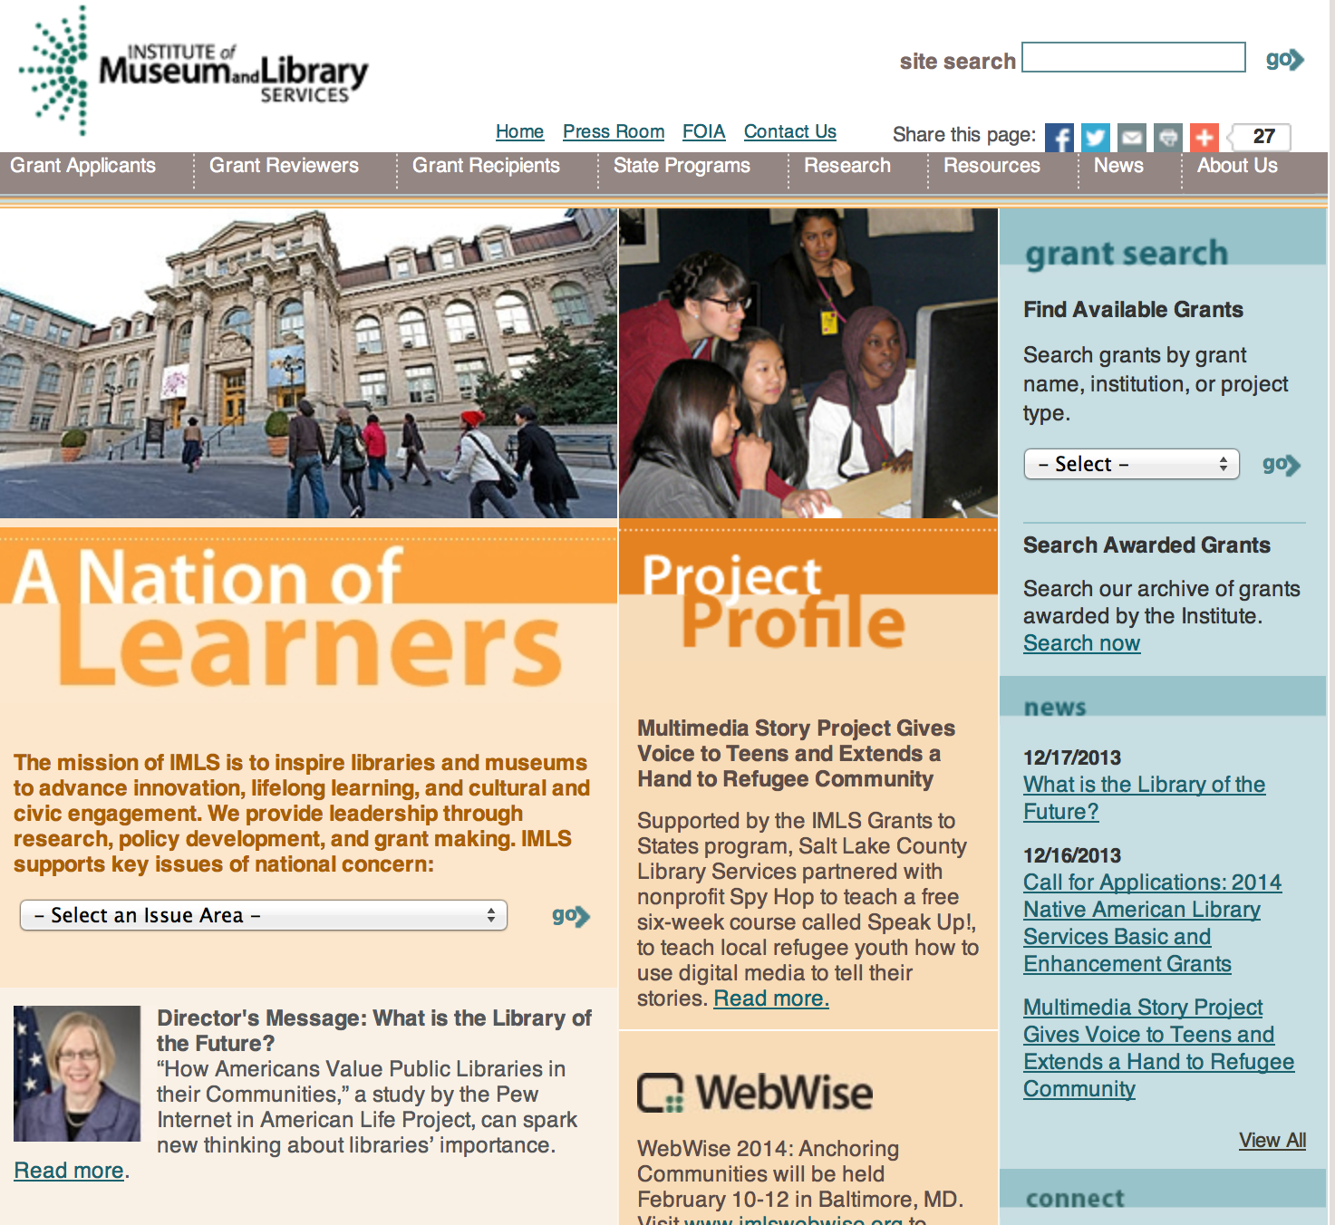

www.imls.gov

To search for awards see chart below:
Also, take advantage of the information with these links:

- Available Grants
  - By Grant Name
  - By Institution Type
  - By Project Type
- Eligibility Criteria
- Sample Applications
- Grants.gov
- Program Guidelines
- After You Apply

Outcome Based Evaluation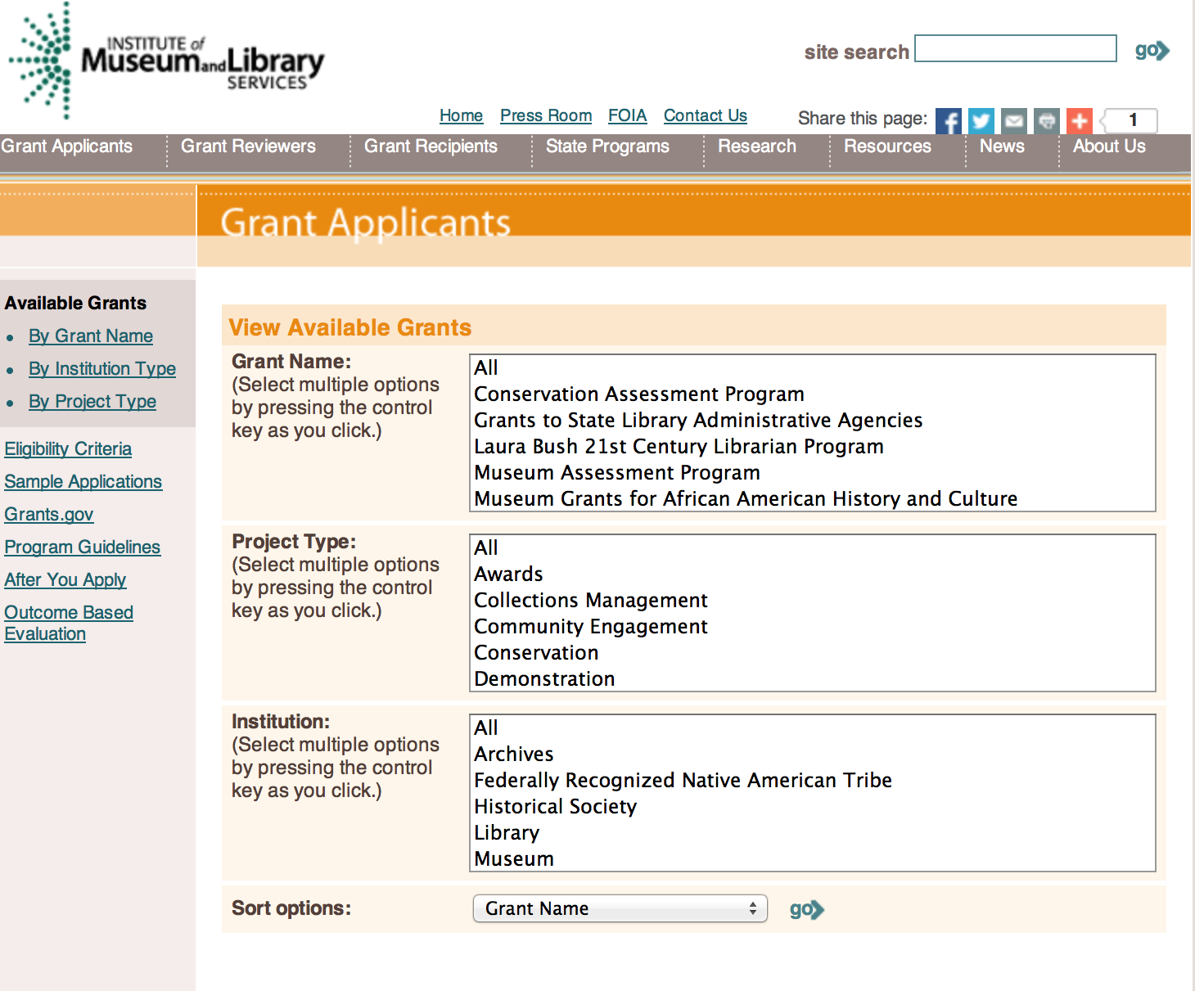

http://www.imls.gov/applicants/available_grants.aspx

Each grant program has specific eligibility requirements. The links below provide general eligibility criteria for museums, libraries, and tribal organizations, but please note that additional organizations may be eligible for grants under certain programs. Additionally, ineligible organizations may still be able to participate in grant programs through partnerships with eligible organizations. Please click on the links below to see general criteria and review Applications and Guidelines for specific information.
Museums Libraries Tribal Organizations

Institutions: Archives, Federally Recognized Native American Tribe, Historical Society, Library, Nonprofits that serve Native Hawaiians, Professional Association, Public or Private Non-profit Institutions of Higher Education, Regional Organization, State Library Administrative Agency, State or Local Government

Check out IMLS's new Facebook page at:
https://www.facebook.com/USIMLS

Modifications:

Reminders:

National Leadership Grants for Libraries Grant
Document Type: | Grants Notice
Funding Opportunity Number: | NLG-LIBRARIES-FY16
Funding Opportunity Title: | National Leadership Grants for Libraries
Opportunity Category: | Discretionary
Funding Instrument Type: | Grant
Category of Funding Activity: | Arts (see "Cultural Affairs" in CFDA)  Humanities (see "Cultural Affairs" in CFDA)
Category Explanation:
Expected Number of Awards: | 20
CFDA Number(s): | 45.312 -- National Leadership Grants
Cost Sharing or Matching Requirement: | Yes
Posted Date: | Aug 31, 2015
Creation Date: | Aug 31, 2015
Original Closing Date for Applications: | Jan 15, 2016 The application process for this round of the NLG program is a two phase process. In the first phase, all applicants must submit a two page preliminary proposal by October 1, 2015, describing the proposal, its relevance to one of the two agency priorities (if applicable), its potential impact, its projected performance goals and outcomes and its estimated budget. Those applicants, whose preliminary proposals are the most promising and best aligned with the IMLS’s agency priorities, will be invited to participate in the second phase of the process by submitting a full proposal and complete application by January 15, 2016.
Current Closing Date for Applications: | Jan 15, 2016 The application process for this round of the NLG program is a two phase process. In the first phase, all applicants must submit a two page preliminary proposal by October 1, 2015, describing the proposal, its relevance to one of the two agency priorities (if applicable), its potential impact, its projected performance goals and outcomes and its estimated budget. Those applicants, whose preliminary proposals are the most promising and best aligned with the IMLS’s agency priorities, will be invited to participate in the second phase of the process by submitting a full proposal and complete application by January 15, 2016.
Archive Date: | Feb 14, 2016
Estimated Total Program Funding: | $12,000,000
Award Ceiling: | $2,000,000
Award Floor: | $10,000
Eligible Applicants: | Others (see text field entitled "Additional Information on Eligibility" for clarification)
Additional Information on Eligibility: | To be eligible as an applicant for this National Leadership Grants for Libraries Program, you must: be either a unit of State or local government or be a private nonprofit organization that has tax-exempt status under the Internal Revenue Code; be located in one of the 50 States of the United States of America, the District of Columbia, the Commonwealth of Puerto Rico, the U.S. Virgin Islands, Guam, American Samoa, the Commonwealth of the Northern Mariana Islands, the Republic of the Marshall Islands, the Federated States of Micronesia, or the Republic of Palau; and qualify as one of the following: a library or a parent organization, such as a school district, a municipality, a State agency, or an academic institution, that is responsible for the administration of a library. Eligible libraries include public libraries, public elementary and secondary school libraries, college and university libraries, research libraries and archives that are not an integral part of an institution of higher education and that make publicly available library services and materials that are suitable for scholarly research and not otherwise available. Research libraries must be under the supervision of at least one permanent professional staff librarian and be either generally recognized as possessing unique, scholarly research materials and services that are made available to the public, or able to demonstrate that such is the case when submitting an application to IMLS a private library or other special library, but only if the State in which it is located determines that the library should be considered a library for purposes of Library Services and Technology (see 20 U.S.C. 9121-9165) an academic or administrative unit, such as a graduate school of library and information science that is part of an institution of higher education through which it would make application a digital library, if it makes library materials publicly available and provides library services, including selection, organization, description, reference, and preservation, under the supervision of at least one permanent professional staff librarian a library agency that is an official agency of a State or other unit of government and is charged by the law governing it with the extension and development of public library services within its jurisdiction a library consortium that is a local, statewide, regional, interstate, or international cooperative association of library entities that provides for the systematic and effective coordination of the resources of eligible libraries, as defined above, and information centers that work to improve the services delivered to the clientele of these libraries or a library association that exists on a permanent basis; serves libraries or library professionals on a national, regional, State, or local level; and engages in activities designed to advance the well-being of libraries and the library profession Note to applicants: In order to receive an IMLS award, you must be in compliance with applicable requirements and be in good standing on all active IMLS awards.
Agency Name: | Institute of Museum and Library Services
Description: | National Leadership Grants for Libraries (NLG) support projects that address challenges faced by the library and archive fields and that have the potential to advance practice in those fields. Successful proposals will generate results such as new tools, research findings, models, services, practices, or alliances that can be widely used, adapted, scaled, or replicated to extend the benefits of federal investment. We anticipate two FY16 National Leadership Grants for Libraries funding opportunities with two separate deadlines. In addition to the opportunity described in this Notice of Funding Opportunity, an additional NLG funding opportunity is anticipated to be announced in December 2015 with an application submission due date in February 2016.
Link to Additional Information: | http://www.imls.gov/applicants/detail.aspx?GrantId=14
Contact Information: | If you have difficulty accessing the full announcement electronically, please contact:  Tim Carrigan Senior Library Program Officer 202-653-4639 tcarrigan@imls.gov Trevor Owens Senior Library Program Officer 202-653-4654 tjowens@imls.gov Sandra Toro Senior Library Program Officer 202-653-4662 storo@imls.gov Sarah Fuller Library Program Specialist 202-653-4783 sfuller@imls.gov  tcarrigan@imls.gov

http://www.grants.gov/web/grants/view-opportunity.html?oppId=278768

Laura Bush 21st Century Librarian Program Grant

Document Type: | Grants Notice
Funding Opportunity Number: | LB21-FY16
Funding Opportunity Title: | Laura Bush 21st Century Librarian Program
Opportunity Category: | Discretionary
Funding Instrument Type: | Grant
Category of Funding Activity: | Arts (see "Cultural Affairs" in CFDA)  Humanities (see "Cultural Affairs" in CFDA)
Category Explanation:
Expected Number of Awards: | 22
CFDA Number(s): | 45.313 -- Laura Bush 21st Century Librarian Program
Cost Sharing or Matching Requirement: | Yes
Posted Date: | Aug 31, 2015
Creation Date: | Aug 31, 2015
Original Closing Date for Applications: | Jan 15, 2016 The application process for this round of the LB21 program is a two phase process. In the first phase, all applicants must submit a two page preliminary proposal by October 1, 2015, describing the proposal, its relevance to one of the two agency priorities (if applicable), its potential impact, its projected performance goals and outcomes and its estimated budget. Those applicants, whose preliminary proposals are the most promising and best aligned with the IMLS’s funding priorities, will be invited to participate in the second phase of the process by submitting a full proposal and complete application by January 15, 2016.
Current Closing Date for Applications: | Jan 15, 2016 The application process for this round of the LB21 program is a two phase process. In the first phase, all applicants must submit a two page preliminary proposal by October 1, 2015, describing the proposal, its relevance to one of the two agency priorities (if applicable), its potential impact, its projected performance goals and outcomes and its estimated budget. Those applicants, whose preliminary proposals are the most promising and best aligned with the IMLS’s funding priorities, will be invited to participate in the second phase of the process by submitting a full proposal and complete application by January 15, 2016.
Archive Date: | Feb 14, 2016
Estimated Total Program Funding: | $10,000,000
Award Ceiling: | $1,000,000
Award Floor: | $50,000
Eligible Applicants: | Others (see text field entitled "Additional Information on Eligibility" for clarification)
Additional Information on Eligibility: | To be eligible for LB21, you must be either a unit of State or local government or a private nonprofit organization that has tax-exempt status under the Internal Revenue Code and be located in one of the 50 States of the United States of America, the District of Columbia, the Commonwealth of Puerto Rico, Guam, American Samoa, the U.S. Virgin Islands, the Commonwealth of the Northern Mariana Islands, the Republic of the Marshall Islands, the Federated States of Micronesia, or the Republic of Palau. In addition, you must be one of the following six types of organizations: A library or a parent organization, such as a school district, a municipality, a State agency, or an academic institution, that is responsible for the administration of a library. Eligible libraries include the following: Public libraries Public elementary and secondary school libraries College and university libraries Research libraries and archives that are not an integral part of an institution of higher education and that make publicly available library services and materials that are suitable for scholarly research and not otherwise available (Research libraries must be under the supervision of at least one permanent professional staff and must be either generally recognized as possessing unique scholarly research materials and services that are made available to the public, or able to demonstrate that such is the case when submitting an application to IMLS.) Private or special libraries that have been deemed eligible to participate in this program by the State in which the library is located An academic or administrative unit, such as a graduate school of library and information science that is part of an institution of higher education through which it would make application (See below for additional conditions of eligibility that might apply to such applicants) A digital library, if it makes library materials publicly available and provides library services, including selection, organization, description, reference, and preservation, under the supervision of at least one permanent professional staff person A library agency that is an official agency of a State or other unit of government and is charged by the law governing it with the extension and development of public library services within its jurisdiction A library consortium that is a local, statewide, regional, interstate, or international cooperative association of library entities that provides for the systematic and effective coordination of the resources of eligible libraries, as defined above, and information centers that work to improve the services delivered to the clientele of these libraries A library association that exists on a permanent basis; serves libraries or library professionals on a national, regional, state, or local level; and engages in activities designed to advance the well-being of libraries and the library profession We recognize the potential for valuable contributions to the overall goals of the LB21 program by entities that do not meet the eligibility requirements above. Although such entities may not serve as the official applicants, they are encouraged to participate in projects. Federally operated libraries and museums may not apply for LB21 grants, but they may participate with applicants. Contact us before submitting a proposal involving a federal agency or federal collection. Non-Federal entities may serve as subrecipients or contractors and may receive IMLS grant funds as a result of the project. Consult with us about any eligibility questions before submitting an application.
Agency Name: | Institute of Museum and Library Services
Description: | The Laura Bush 21st Century Librarian Program (LB21) supports professional development, graduate education and continuing education to help libraries and archives develop the human capital capacity they need to meet the changing learning and information needs of the American public. We anticipate two FY16 Laura Bush 21st Century Librarian Program funding opportunities with two separate deadlines. In addition to the opportunity described in this Notice of Funding Opportunity, an additional LB21 funding opportunity is anticipated to be announced in December 2015 with an application submission due date in February 2016.
Link to Additional Information: | http://www.imls.gov/applicants/detail.aspx?GrantId=9
Contact Information: | If you have difficulty accessing the full announcement electronically, please contact:  Mary Alice Ball Senior Library Program Officer 202-653-4730 mball@imls.gov Tim Carrigan Senior Library Program Officer 202-653-4639 tcarrigan@imls.gov Trevor Owens Senior Library Program Officer 202-653-4654 tjowens@imls.gov Sandra Toro Senior Library Program Officer 202-653-4662 storo@imls.gov Emily Reynolds Library Program Specialist 202-653-4665 ereynolds@imls.gov  mball@imls.gov

http://www.grants.gov/web/grants/view-opportunity.html?oppId=278788

Department of the Interior
Working with Interior

The Interior Department provides assistance to the public, local governments and businesses through a number of programs. For a general overview see: http://www.doi.gov/index.cfm

Businesses should go to: http://www.doi.gov/businesses/index.cfm

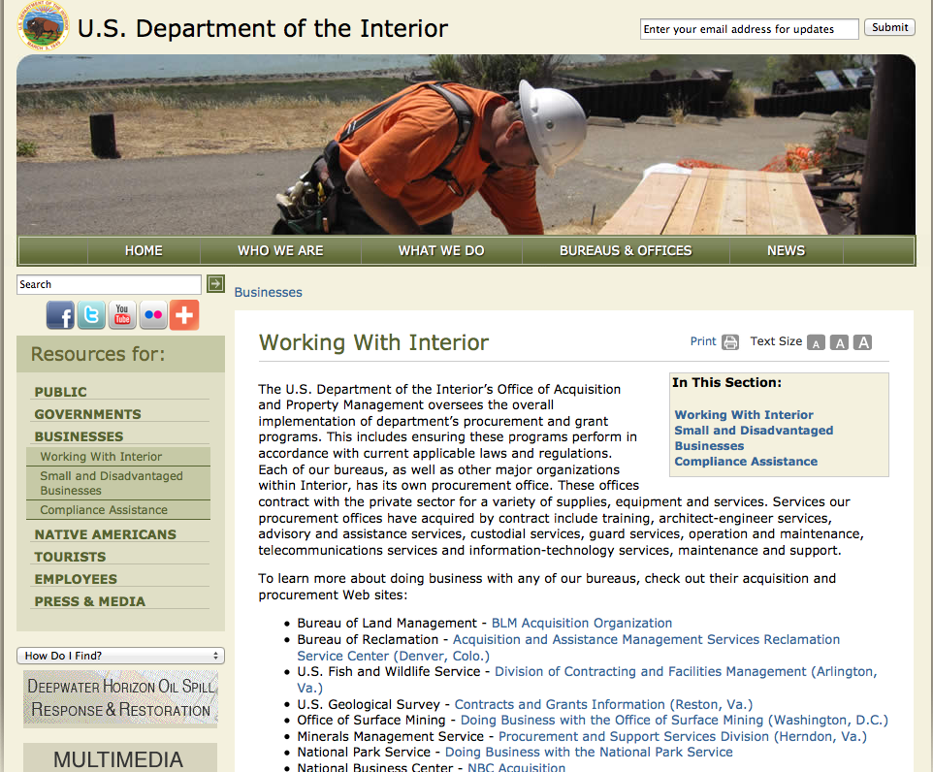

http://www.doi.gov/businesses/working-with-interior.cfm

Programs:

Fish and Wildlife Service
National Fish Passage Program Grant

Document Type: | Grants Notice
Funding Opportunity Number: | F16AS00041
Funding Opportunity Title: | National Fish Passage Program
Opportunity Category: | Discretionary
Funding Instrument Type: | Cooperative Agreement
Category of Funding Activity: | Natural Resources
Category Explanation:
Expected Number of Awards:
CFDA Number(s): | 15.608 -- Fish and Wildlife Management Assistance
Cost Sharing or Matching Requirement: | Yes
Posted Date: | Dec 1, 2015
Creation Date: | Nov 30, 2015
Original Closing Date for Applications: | Sep 1, 2016
Current Closing Date for Applications: | Sep 1, 2016
Archive Date: | Sep 20, 2016
Eligible Applicants: | Unrestricted (i.e., open to any type of entity above), subject to any clarification in text field entitled "Additional Information on Eligibility"
Additional Information on Eligibility: | To receive funding, NFPP projects must be implemented in coordination with FAC staff. Applicants can be, but not limited to: state and federal agencies, private lands, tribes, local municipalities, and non-governmental organizations.
Agency Name: | Fish and Wildlife Service
Description: | The National Fish Passage Program (NFPP) is a voluntary program that provides direct technical assistance and financial assistance in the form of cooperative agreements to partners to provide fish (and other aquatic organisms) passage and restore aquatic connectivity for the benefit of federal trust resources. The NFPP is delivered through more than 65 Fisheries and Aquatic Conservation (FAC) Field Offices across all States and territories. FAC staff coordinates with project partners, stakeholders and other Service programs to identify and collaboratively implement projects within Regional priority areas. Project work plans are developed strategically, in coordination with partners, and with substantial involvement from FAC staff. Projects must advance our mission, promote biological diversity, and be based upon sound scientific biological principles. FAC and Fish and Wildlife Service (FWS) strategic plans inform the types of projects funded under this opportunity. Applicants seeking funding under this program should review the program strategic plan and also contact the regional NFPP Coordinator for local FAC contacts prior to submitting an application for funding.
Link to Additional Information: | http://www.grants.gov
Contact Information: | If you have difficulty accessing the full announcement electronically, please contact:  Stephanie Long, 703-358-1749 Stephanie_A_Long@fws.gov  Stephanie_A_Long@fws.gov

http://www.grants.gov/web/grants/view-opportunity.html?oppId=280260

Fish and Wildlife Service
2016 National Fish Habitat Action Plan
Modification 1

Document Type: | Grants Notice
Funding Opportunity Number: | F16AS00029
Funding Opportunity Title: | 2016 National Fish Habitat Action Plan
Opportunity Category: | Discretionary
Funding Instrument Type: | Cooperative Agreement  Grant
Category of Funding Activity: | Natural Resources
Category Explanation:
Expected Number of Awards: | 70
CFDA Number(s): | 15.608 -- Fish and Wildlife Management Assistance
Cost Sharing or Matching Requirement: | No
Posted Date: | Nov 16, 2015
Creation Date: | Nov 17, 2015
Original Closing Date for Applications: | Applications are accepted on a rolling basis.
Current Closing Date for Applications: | Applications are accepted on a rolling basis.
Archive Date: | Sep 30, 2016
Estimated Total Program Funding: | $0
Award Ceiling: | $300,000
Award Floor: | $1,000
Eligible Applicants: | Unrestricted (i.e., open to any type of entity above), subject to any clarification in text field entitled "Additional Information on Eligibility"
Agency Name: | Fish and Wildlife Service
Description: | The National Fish Habitat Action Plan is a national investment strategy to leverage federal and privately raised funds to protect, restore, and enhance the nation's fish and aquatic habitats through partnerships that foster fish habitat conservation. Funds appropriated to the U.S. Fish and Wildlife Service's (Service) Fish and Aquatic Conservation (FAC) Program specifically to implement the Action Plan will be utilized in collaboration with the National Fish Habitat Board and Fish Habitat Partnerships. Fish Habitat Partnerships are the primary work units of the Action Plan, formed around distinct geographic areas, "keystone" fish species, or system types (e.g. large lakes, impoundments, estuaries). Funds will support national and regional science and coordination activities to protect, restore, or enhance fish habitats. All or a portion or project funds may be transferred to partner organizations if the Service lacks the capability to implement a project. Projects must protect, restore, or enhance fish and aquatic habitats or otherwise directly support habitat-related priorities of Fish Habitat Partnerships or the National Fish Habitat Board. Every project must be identified in the Fisheries Operational Needs System (FONS), a database that identifies the operational needs of FAC field stations, including fish habitat project needs. FAC field offices will work with Fish Habitat Partnerships to identify fish habitat projects, and enter them into the FONS. Entities that seek to propose a fish habitat conservation project for consideration should contact a local or regional office of the Service FAC Program.
Link to Additional Information: | http://www.grants.gov
Contact Information: | If you have difficulty accessing the full announcement electronically, please contact:  Cecilia M. Lewis, National Coordinator National Fish Habitat Partnership Fish and Aquatic Conservation Program 703-358-2102  cecilia_lewis@fws.gov
http://www.grants.gov/web/grants/view-opportunity.html?oppId=280034

Modifications:

Reminders:

National Park Service
American Battlefield Protection Program Battlefield Preservation Planning Project Grants

Document Type: | Grants Notice
Funding Opportunity Number: | P15AS00175
Funding Opportunity Title: | American Battlefield Protection Program Battlefield Preservation Planning Project Grants
Opportunity Category: | Discretionary
Funding Instrument Type: | Grant
Category of Funding Activity: | Arts (see "Cultural Affairs" in CFDA)  Community Development  Environment  Natural Resources  Other (see text field entitled "Explanation of Other Category of Funding Activity" for clarification)  Regional Development
Category Explanation: | Historic Preservation, Cultural Resources, Battlefield Landscapes
Expected Number of Awards: | 25
CFDA Number(s): | 15.926 -- American Battlefield Protection
Cost Sharing or Matching Requirement: | No
Posted Date: | Sep 29, 2015
Creation Date: | Sep 22, 2015
Original Closing Date for Applications: | Jan 14, 2016 Applications must be received either by hard copy submission through the mail/delivery service to the ABPP office or by electronic submission through Grants.gov by 4 pm (EST) January 14, 2016. See Application Guidance for more information.
Current Closing Date for Applications: | Jan 14, 2016 Applications must be received either by hard copy submission through the mail/delivery service to the ABPP office or by electronic submission through Grants.gov by 4 pm (EST) January 14, 2016. See Application Guidance for more information.
Archive Date: | Feb 14, 2016
Estimated Total Program Funding: | $1,200,000
Eligible Applicants: | City or township governments  County governments  Nonprofits having a 501(c)(3) status with the IRS, other than institutions of higher education  Special district governments  Native American tribal organizations (other than Federally recognized tribal governments)  Public housing authorities/Indian housing authorities  State governments  Private institutions of higher education  Nonprofits that do not have a 501(c)(3) status with the IRS, other than institutions of higher education  Native American tribal governments (Federally recognized)  Public and State controlled institutions of higher education  Independent school districts
Agency Name: | National Park Service
Description: | The purpose of this grant program is to provide seed money for projects that lead directly to the identification, preservation, and interpretation of battlefield land or historic sites associated with battlefields.
Link to Additional Information: | http://www.nps.gov/abpp/grants/planninggrants.htm
Contact Information: | If you have difficulty accessing the full announcement electronically, please contact:  Kristen McMasters, Archeologist and Grants Manager, 202-354-2037 Kristen_McMasters@nps.gov Gregory Hindsley, 202-354-2010 Greg_Hindsley@nps.gov  Kristen_McMasters@nps.gov

http://www.grants.gov/web/grants/view-opportunity.html?oppId=279155

Department of Justice

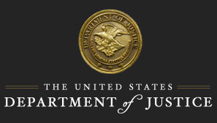

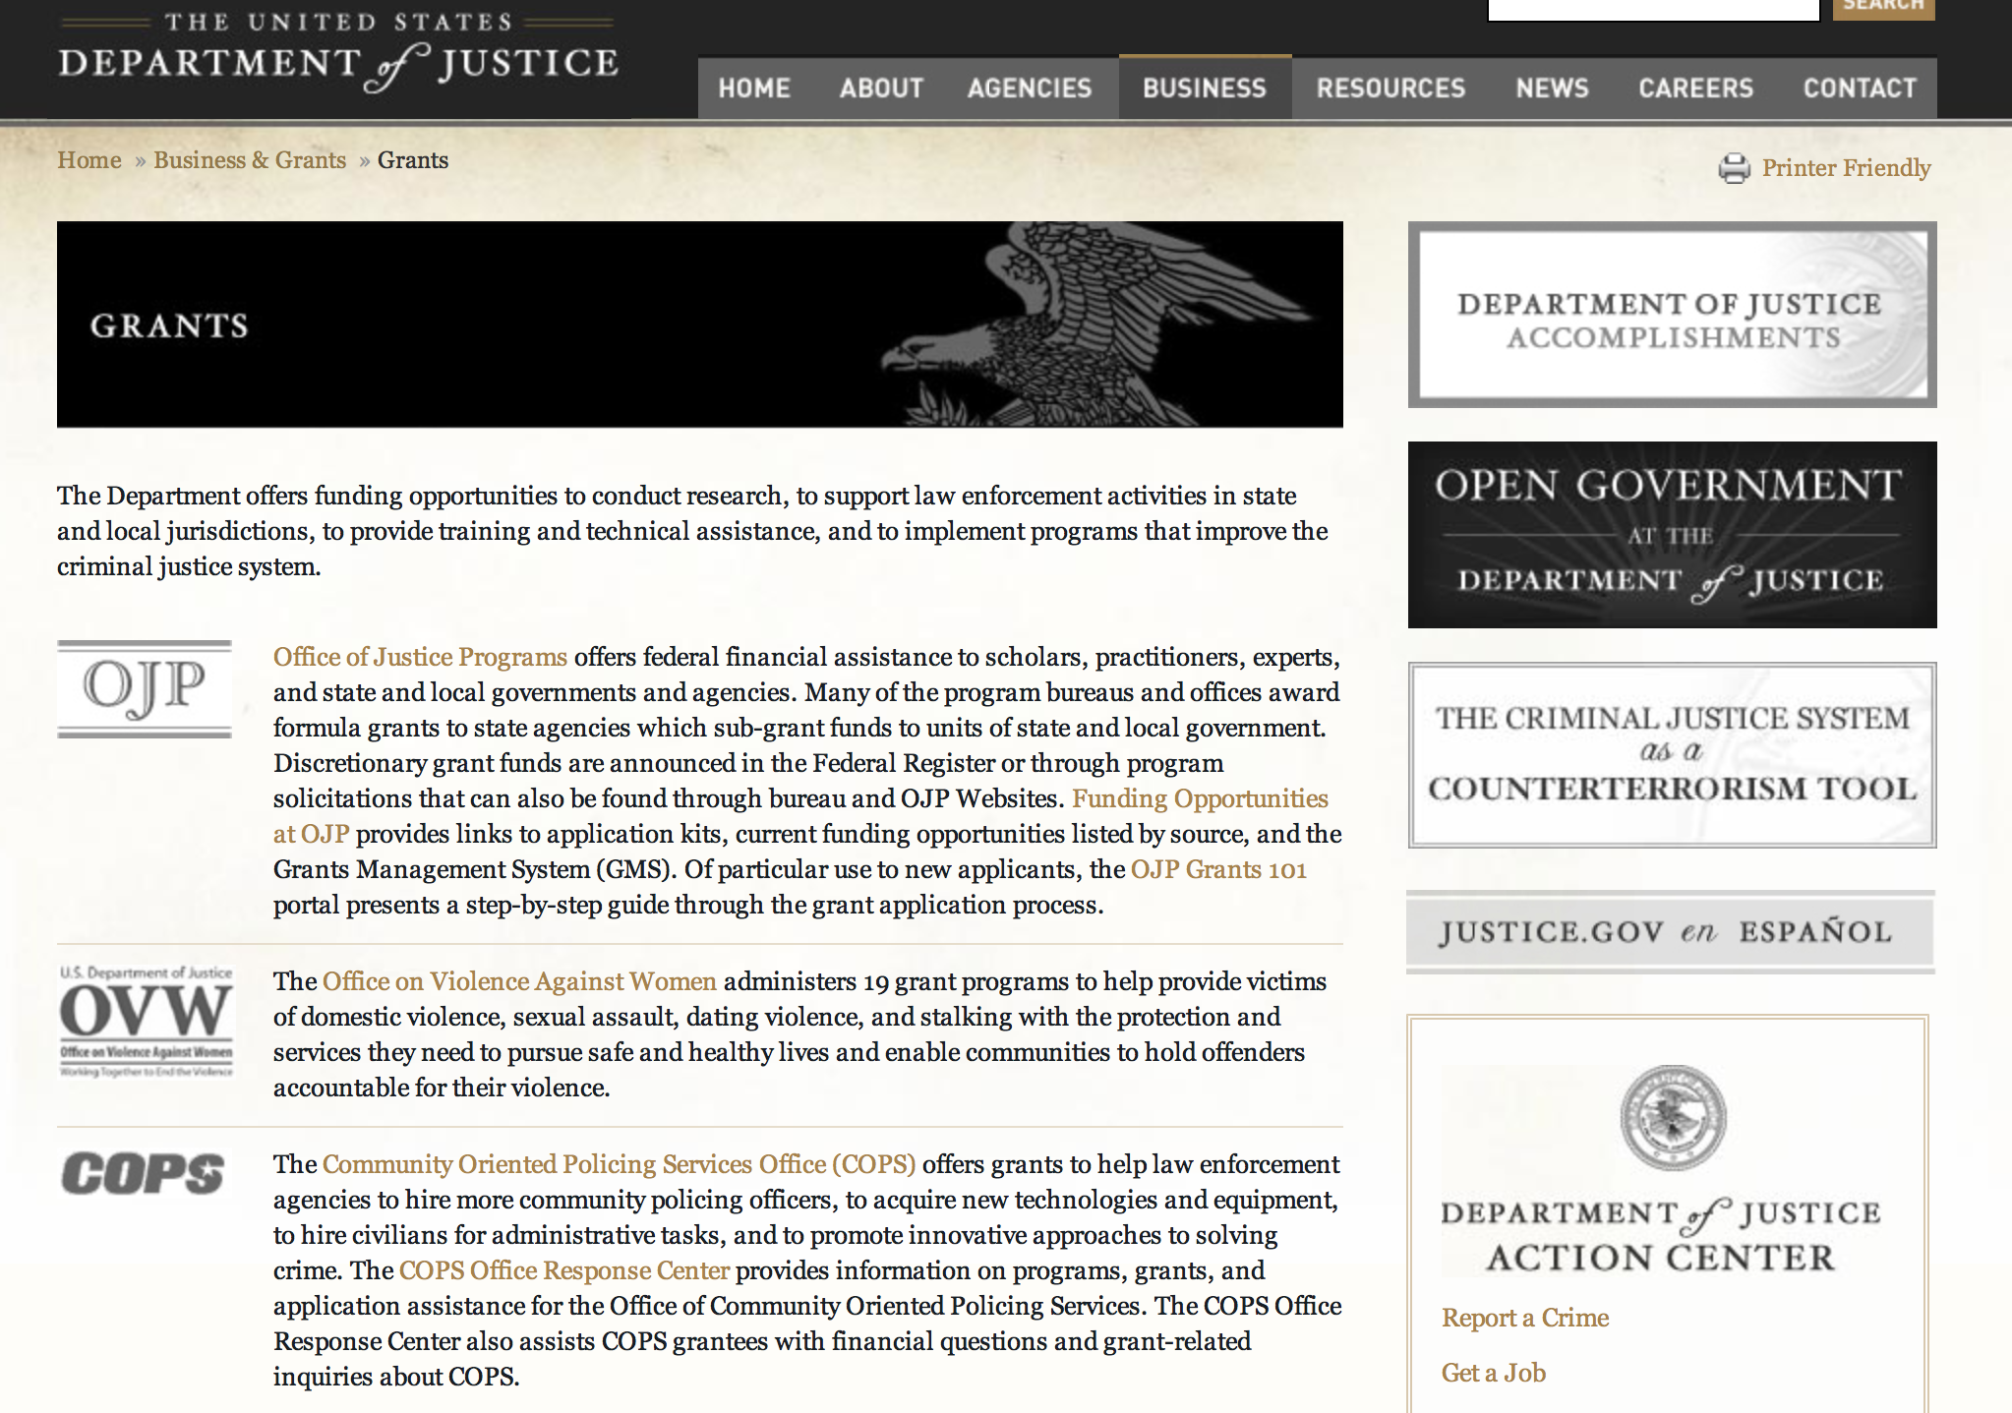

http://www.justice.gov/business/

Grants and Contract Overview

The Department offers funding opportunities to conduct research, to support law enforcement activities in state and local jurisdictions, to provide training and technical assistance, and to implement programs that improve the criminal justice system.

The DOJ agencies listed below also have sites that provide grant information specific to that agency. Examples of what can be found on these sites are programs, funding opportunities, application assistance, and other useful information.
- Bureau of Justice Assistance (BJA)
- Bureau of Justice Statistics (BJS)
- National Criminal Justice Reference Service (NCJRS)
- National Institute of Justice (NIJ)
- Office of Juvenile Justice and Delinquency Prevention (OJJDP)
- Office of Sex Offender Sentencing, Monitoring, Apprehending, Registering, and Tracking (SMART)
- Office for Victims of Crime (OVC)

Programs:

Office of Justice Programs
Consolidated Grant Program to Address Children and Youth Experiencing Domestic and Sexual Assault and Engage Men and Boys as Allies Grant

Document Type: | Grants Notice
Funding Opportunity Number: | OVW-2016-9002
Funding Opportunity Title: | Consolidated Grant Program to Address Children and Youth Experiencing Domestic and Sexual Assault and Engage Men and Boys as Allies
Opportunity Category: | Discretionary
Funding Instrument Type: | Grant
Category of Funding Activity: | Other (see text field entitled "Explanation of Other Category of Funding Activity" for clarification)
Category Explanation: | Victim Services
Expected Number of Awards: | 14
CFDA Number(s): | 16.888 -- Consolidated And Technical Assistance Grant Program to Address Children and Youth Experiencing Domestic and Sexual Viole
Cost Sharing or Matching Requirement: | No
Posted Date: | Nov 23, 2015
Creation Date: | Nov 23, 2015
Original Closing Date for Applications: | Jan 19, 2016
Current Closing Date for Applications: | Jan 19, 2016
Archive Date:
Estimated Total Program Funding: | $10,000,000
Award Ceiling: | $750,000
Award Floor: | $350,000
Eligible Applicants: | City or township governments  Native American tribal organizations (other than Federally recognized tribal governments)  Nonprofits having a 501(c)(3) status with the IRS, other than institutions of higher education  Native American tribal governments (Federally recognized)  County governments
Agency Name: | Office of Justice Programs
Description: | The Consolidated Grant Program to Address Children and Youth Experiencing Domestic and Sexual Assault and Engage Men and Boys as Allies (hereafter referred to as the Consolidated Youth Program) was enacted in the FY 2012, 2013, 2014, and 2015 appropriation acts, which consolidated four previously authorized and appropriated programs into one comprehensive program. The four programs included in the FY 2012, FY 2013, FY 2014, and FY 2015 consolidations were: Services to Advocate for and Respond to Youth (Youth Services), Grants to Assist Children and Youth Exposed to Violence (CEV), Engaging Men and Youth in Preventing Domestic Violence (EMY), and Supporting Teens through Education and Prevention (STEP). The Consolidated Youth Program supports projects designed to provide coordinated community responses that support child, youth and young adult victims through direct services, training, coordination and collaboration, effective intervention, treatment, response, and prevention strategies. The Consolidated Youth Program creates a unique opportunity for communities to increase collaboration among non-profit victim service providers; violence prevention, and children (0-10), youth (11-18), young adult (19-24) and men-serving organizations; tribes and tribal governments; local government agencies; schools; and programs that support men’s role in combating sexual assault, domestic violence, dating violence and stalking.
Link to Additional Information: | Full Announcement
Contact Information: | If you have difficulty accessing the full announcement electronically, please contact:  Anne Hamilton 202-353-2794 ovw.consolyouth@usdoj.gov  ovw.consolyouth@usdoj.gov

http://www.grants.gov/web/grants/view-opportunity.html?oppId=280219

Office of Justice Programs
Office on Violence Against Women
OVW FY 2016 Justice for Families Program Grant

Document Type: | Grants Notice
Funding Opportunity Number: | OVW-2016-9003
Funding Opportunity Title: | OVW FY 2016 Justice for Families Program
Opportunity Category: | Discretionary
Funding Instrument Type: | Grant
Category of Funding Activity: | Law, Justice and Legal Services  Other (see text field entitled "Explanation of Other Category of Funding Activity" for clarification)
Category Explanation: | The Justice for Families Program supports projects to improve the response of all aspects of the civil and criminal justice system to families with a history of domestic violence, dating violence, sexual assault, and stalking, or in cases involving allegations of child sexual abuse.
Expected Number of Awards: | 25
CFDA Number(s): | 16.021 -- Justice Systems Response to Families
Cost Sharing or Matching Requirement: | No
Posted Date: | Nov 24, 2015
Creation Date: | Nov 24, 2015
Original Closing Date for Applications: | Jan 20, 2016
Current Closing Date for Applications: | Jan 20, 2016
Archive Date: | Feb 19, 2016
Estimated Total Program Funding: | $11,000,000
Award Ceiling: | $600,000
Award Floor: | $450,000
Eligible Applicants: | City or township governments  Others (see text field entitled "Additional Information on Eligibility" for clarification)  County governments  Nonprofits having a 501(c)(3) status with the IRS, other than institutions of higher education
Additional Information on Eligibility: | states, units of local government, courts (including juvenile courts), Indian tribal governments, nonprofit organizations, legal services providers, and victim service providers
Agency Name: | Office on Violence Against Women
Description: | The Grants to Support Families in the Justice System program (referred to as the Justice for Families Program) was authorized in the Violence Against Women Reauthorization Act (VAWA) of 2013 to improve the response of all aspects of the civil and criminal justice system to families with a history of domestic violence, dating violence, sexual assault, and stalking, or in cases involving allegations of child sexual abuse. The program supports the following activities for improving the capacity of communities and courts to respond to families affected by the four crimes: court-based and court-related programs; supervised visitation and safe exchange by and between parents; training and technical assistance for people who work with families in the court system; civil legal services; provision of resources in juvenile court matters; and development or promotion of legislation, model codes, policies, and best practices.
Link to Additional Information: | OVW FY 2016 Justice for Families Program
Contact Information: | If you have difficulty accessing the full announcement electronically, please contact:  Carrie Mitchell Phone 202-307-6026  OVW.JFF@usdoj.gov

http://www.grants.gov/web/grants/view-opportunity.html?oppId=280241

Modifications:

Reminders:

Office of Justice Programs
National Institute of Justice
NIJ FY 16 Research and Development in Forensic Science for Criminal Justice Purposes
Modification 4

Document Type: | Grants Notice
Funding Opportunity Number: | NIJ-2016-4305
Funding Opportunity Title: | NIJ FY 16 Research and Development in Forensic Science for Criminal Justice Purposes
Opportunity Category: | Discretionary
Funding Instrument Type: | Grant
Category of Funding Activity: | Science and Technology and other Research and Development
Category Explanation:
Expected Number of Awards: | 50
CFDA Number(s): | 16.560 -- National Institute of Justice Research, Evaluation, and Development Project Grants
Cost Sharing or Matching Requirement: | No
Posted Date: | Sep 2, 2015
Creation Date: | Oct 21, 2015
Original Closing Date for Applications: | Jan 31, 2016
Current Closing Date for Applications: | Feb 1, 2016
Archive Date: | Mar 1, 2016
Estimated Total Program Funding: | $20,000,000
Award Ceiling: | $1,500,000
Award Floor: | $1,000
Eligible Applicants: | County governments  Private institutions of higher education  State governments  For profit organizations other than small businesses  Native American tribal organizations (other than Federally recognized tribal governments)  Individuals  Native American tribal governments (Federally recognized)  Independent school districts  Nonprofits having a 501(c)(3) status with the IRS, other than institutions of higher education  City or township governments  Public and State controlled institutions of higher education  Public housing authorities/Indian housing authorities  Nonprofits that do not have a 501(c)(3) status with the IRS, other than institutions of higher education
Agency Name: | National Institute of Justice
Description: | NIJ is seeking proposals for basic or applied research and development projects that will: (1) increase the body of knowledge to guide and inform forensic science policy and practice, or (2) result in the production of useful materials, devices, systems, or methods that have the potential for forensic application. The intent of this program is to direct the findings of basic scientific research, research and development in broader scientific fields applicable to forensic science, and ongoing forensic science research toward the development of highly discriminating, accurate, reliable, cost-effective, and rapid methods for the identification, analysis, and interpretation of physical evidence for criminal justice purposes. The operational needs and requirements discussed at NIJ’s 2015 Forensic Science Technology Working Group (TWG) meeting may be found at the following link and are intended to assist you in your proposal development: http://www.nij.gov/topics/forensics/pages/forensic-operational-requirements.aspx
Link to Additional Information: | Full Solicitation
Contact Information: | If you have difficulty accessing the full announcement electronically, please contact:  forensic.research@usdoj.gov  Program Manager

http://www.grants.gov/web/grants/view-opportunity.html?oppId=278839

Office of Justice Programs
National Institute of Justice
NIJ FY 16 Graduate Research Fellowship in Science, Technology, Engineering, and Mathematics
Modification 7
Document Type: | Grants Notice
Funding Opportunity Number: | NIJ-2016-4320
Funding Opportunity Title: | NIJ FY 16 Graduate Research Fellowship in Science, Technology, Engineering, and Mathematics
Opportunity Category: | Discretionary
Funding Instrument Type: | Grant
Category of Funding Activity: | Science and Technology and other Research and Development
Category Explanation:
Expected Number of Awards: | 20
CFDA Number(s): | 16.562 -- Criminal Justice Research and Development Graduate Research Fellowships
Cost Sharing or Matching Requirement: | No
Posted Date: | Aug 26, 2015
Creation Date: | Sep 23, 2015
Original Closing Date for Applications: | Dec 15, 2015
Current Closing Date for Applications: | Dec 15, 2015
Archive Date: | Jan 14, 2016
Estimated Total Program Funding: | $1,000,000
Award Ceiling: | $50,000
Award Floor: | $1,000
Eligible Applicants: | Private institutions of higher education  Public and State controlled institutions of higher education
Agency Name: | National Institute of Justice
Description: | The Graduate Research Fellowship in Science, Technology, Engineering, and Mathematics (GRF-STEM) provides awards to accredited academic institutions to support graduate research leading to doctoral degrees in areas that are relevant to ensuring public safety, preventing and controlling crime, and ensuring the fair and impartial administration of criminal justice in the United States.
Link to Additional Information: | Full Solicitation
Contact Information: | If you have difficulty accessing the full announcement electronically, please contact:  GRF-STEM@usdoj.gov  Program Manager

http://www.grants.gov/web/grants/view-opportunity.html?oppId=278685

Office of Justice Programs
National Institute of Justice
NIJ FY 16 Graduate Research Fellowship Program in the Social and Behavioral Sciences Grant
Document Type: | Grants Notice
Funding Opportunity Number: | NIJ-2016-4321
Funding Opportunity Title: | NIJ FY 16 Graduate Research Fellowship Program in the Social and Behavioral Sciences
Opportunity Category: | Discretionary
Funding Instrument Type: | Grant
Category of Funding Activity: | Law, Justice and Legal Services
Category Explanation:
Expected Number of Awards: | 8
CFDA Number(s): | 16.562 -- Criminal Justice Research and Development Graduate Research Fellowships
Cost Sharing or Matching Requirement: | No
Posted Date: | Aug 27, 2015
Creation Date: | Aug 27, 2015
Original Closing Date for Applications: | Dec 15, 2015
Current Closing Date for Applications: | Dec 15, 2015
Archive Date: | Jan 14, 2016
Estimated Total Program Funding:
Award Ceiling: | $500,000
Award Floor: | $1,000
Eligible Applicants: | Private institutions of higher education  Public and State controlled institutions of higher education
Agency Name: | National Institute of Justice
Description: | The Graduate Research Fellowship Program in Social and Behavioral Sciences provides awards to accredited academic institutions to support graduate research leading to doctoral degrees in areas that are relevant to ensuring public safety, preventing and controlling crime, and ensuring the fair and impartial administration of criminal justice in the United States. NIJ is investing in doctoral education by supporting universities that sponsor students who demonstrate the potential to successfully complete doctoral degree programs in disciplines relevant to the mission of NIJ and who are in the final stages of graduate study.
Link to Additional Information: | Full Solicitation
Contact Information: | If you have difficulty accessing the full announcement electronically, please contact:  GRF@usdoj.gov  Administration Assistance

http://www.grants.gov/web/grants/view-opportunity.html?oppId=278693



Department of Labor

Agency Grants and Contract General Overview

Department of Labor Grant Programs

- Bureau of International Labor Affairs (ILAB): provides grants (cooperative agreements) for the implementation of projects designed to assist developing countries combat the worse forms of child labor, forced labor, and human trafficking; and support worker rights and improve working conditions. Solicitations for grant applications are announced on www.grants.gov/ and at www.dol.gov/ILAB/grants/main.htm. ILAB grants are awarded by the OASAM grant office.
- Bureau of Labor Statistics (BLS): provides project grants (cooperative agreements) and the dissemination of technical statistical data and related information on labor force activities; provides data on prices (CPI) and cost of living; data on productivity and technology data; data on compensation and working conditions; data on employment projections.
- Employment and Training (ETA): ETA administers financial assistance programs pursuant to the Workforce Investment Act (WIA), administering State formula grant programs for youth, adults and dislocated workers, national emergency grants for workers affected by mass layoffs, plant closures, and disasters; grant programs for workers with disabilities, Indians and Native Americans, and for migrant and seasonal farmworkers. ETA also administers grant programs for older American workers, apprenticeship programs, Trade Adjustment Assistance (TAA) programs, and assistance for research and development of workforce programs. In addition, ETA is responsible for the operation and maintenance of a national system of public employment service offices and for the national unemployment insurance program.
- Mine Safety and Health (MSHA): provides grants for research, education and training programs to ensure an adequate and competent staff of trained inspectors; and assistance for establishing or improving State mine health and safety programs through technical assistance.
- Occupational Safety and Health (OSHA): provides grants to non-profit organizations to provide training, educational services, and technical assistance; assistance to states to administer and enforce state programs; assistance to states to provide occupational safety and health technical assistance and consultant services.
- Office of Disability Employment Policy (ODEP): The Office of Disability Employment Policy awards competitive grants establishing short-term pilot and technical assistance projects designed to identify, develop, test, evaluate, and disseminate policies to increase employment by expanding access to training, education, employment supports, assistive and systems technology, integrated employment, entrepreneurial development, and small business opportunities for adults and youth with disabilities. Current pilots projects focus on customized employment, Olmstead populations, and innovative demonstration youth grants, among others. Solicitations for grant applications are published in the Federal Register and announced at www.dol.gov/odep. ODEP grants are awarded by the OASAM grant office.
- Veterans' Employment and Training (VETS): provides special employment and training assistance for veterans through the Disabled Veterans' Outreach Program (DVOP) Solicitation for Grant Applications; the Local Veterans' Employment Representative Program (LVER); Veterans' Workforce Investment Program (VWIP); elaws Advisor on veterans' employment and reemployment rights; and the Homeless Veterans Reintegration Project (HVRP). VETS grants are awarded by the OASAM grant office.

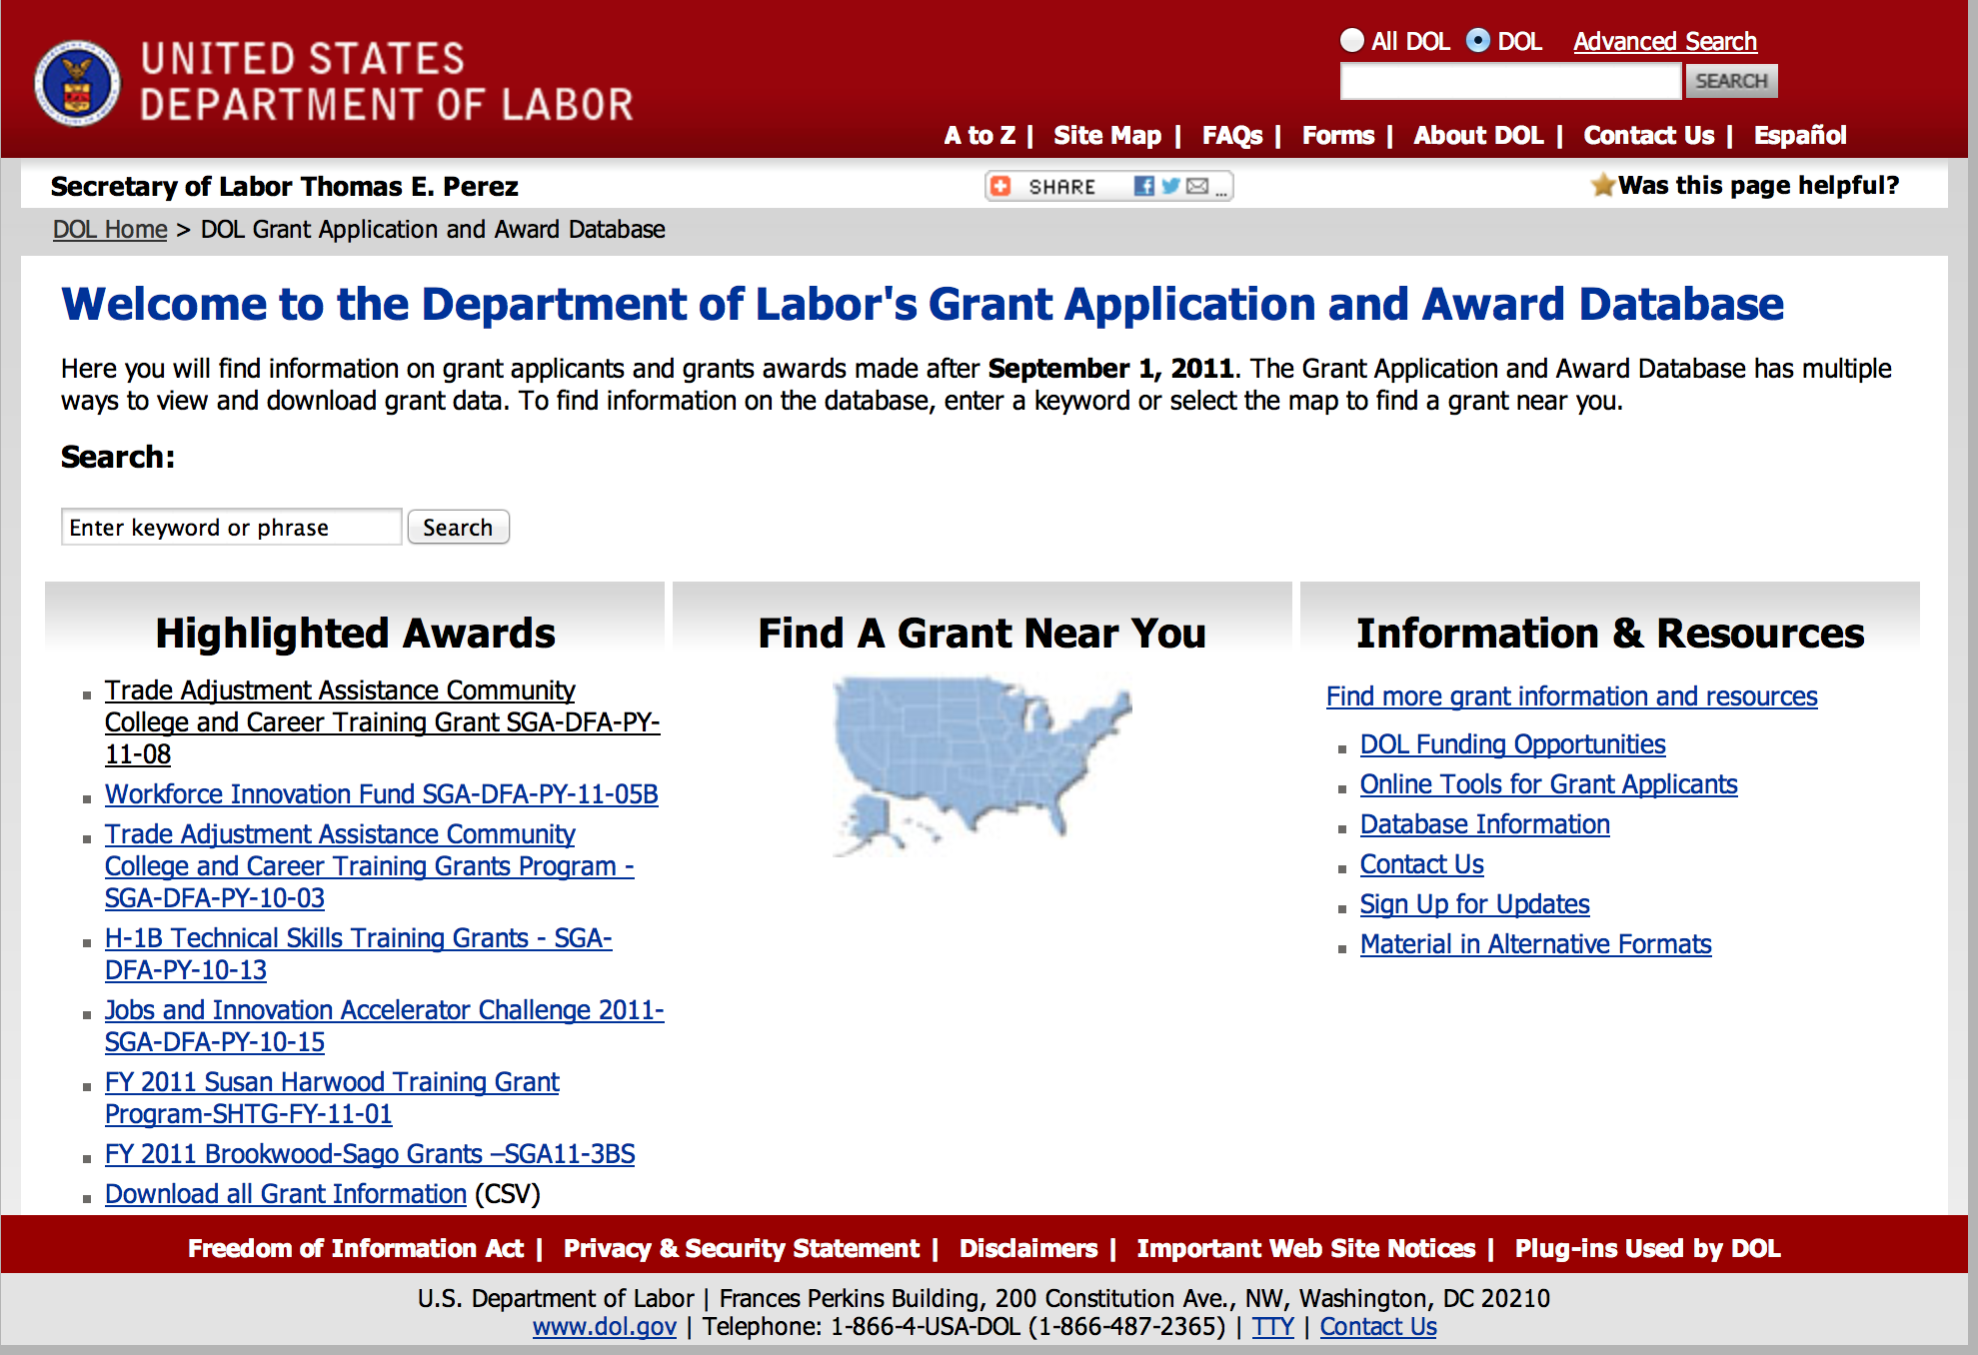

http://www.dol.gov/dol/grants/

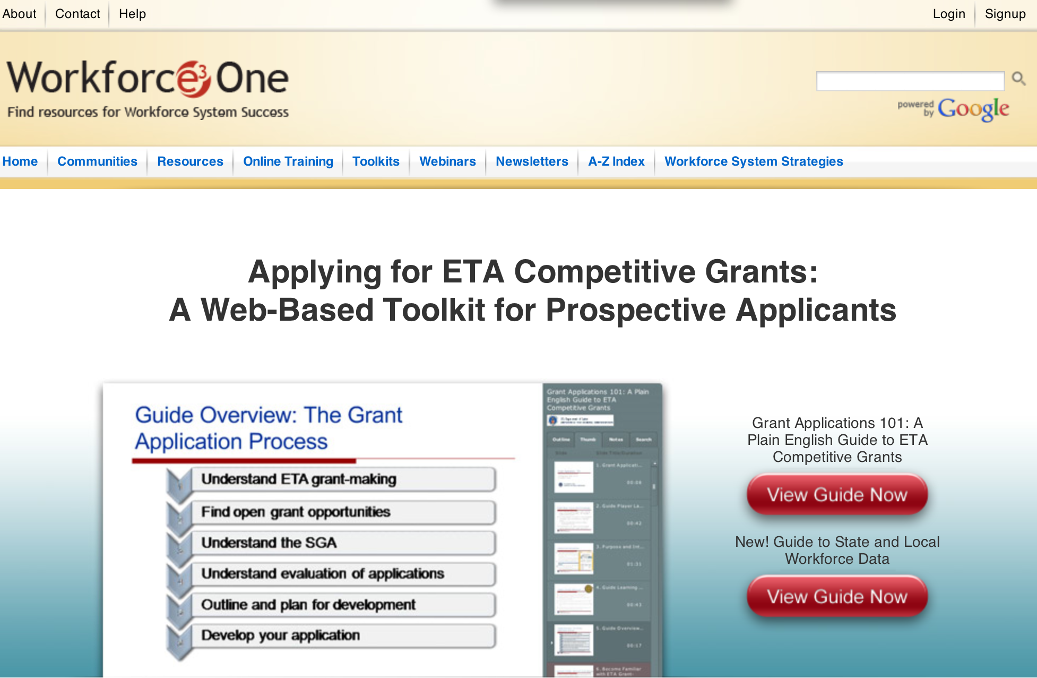

https://www.workforce3one.org/ws/www/pages/grants_toolkit.aspx?pparams=/

Programs

Employment and Training Administration
Tech Hire Partnership Grants

Document Type: | Grants Notice
Funding Opportunity Number: | FOA-ETA-16-01
Funding Opportunity Title: | Tech Hire Partnership Grants
Opportunity Category: | Discretionary
Funding Instrument Type: | Grant
Category of Funding Activity: | Employment, Labor and Training
Category Explanation:
Expected Number of Awards: | 35
CFDA Number(s): | 17.268 -- H-1B Job Training Grants
Cost Sharing or Matching Requirement: | No
Posted Date: | Nov 17, 2015
Creation Date: | Nov 17, 2015
Original Closing Date for Applications: | Mar 11, 2016 Applications must be received no later than 4:00:00 p.m. Eastern Time.
Current Closing Date for Applications: | Mar 11, 2016 Applications must be received no later than 4:00:00 p.m. Eastern Time.
Archive Date: | Apr 10, 2016
Estimated Total Program Funding: | $100,000,000
Award Ceiling: | $5,000,000
Award Floor: | $2,000,000
Eligible Applicants: | Others (see text field entitled "Additional Information on Eligibility" for clarification)
Additional Information on Eligibility: | Grants will be awarded to the lead applicant, which will serve as the grantee and have overall fiscal and administrative responsibility for the grant. Eligible lead applicants must be public or non-profit organizations that: 1) meet the definition of one of the three types of eligible entities described below; and 2) apply in partnership with at least one representative of each of the three types of eligible entities (including the lead applicant), which collectively form the “primary partnership.” An eligible entity cannot serve as more than one type of entity for the purpose of meeting the requirements to include three types of entities in the primary partnership. To be eligible for consideration, applications must include at least one representative of each of the following three types of entities: a) the workforce investment system; b) education and training providers; and c) business-related nonprofit organizations, an organization functioning as a workforce intermediary for the express purpose of serving the needs of businesses, or a consortium of three or more businesses, or at least three independent businesses. Applications that do not include all three entities mentioned above will be considered non-responsive and will not be reviewed. Detailed eligibility requirements for each type of entity are provided in Section III of the announcement.
Agency Name: | Employment and Training Administration
Description: | The Employment and Training Administration (ETA), U.S. Department of Labor (DOL, or the Department, or we), announces the availability of approximately $100,000,000 in grant funds for the TechHire partnership grant program. This grant program is designed to equip individuals with the skills they need through innovative approaches that can rapidly train workers for and connect them to well-paying, middle- and high-skilled, and high-growth jobs across a diversity of H-1B industries such as Information Technology (IT), healthcare, advanced manufacturing, financial services, and broadband. Projects funded by this grant program will help participants begin careers in H-1B occupations and industries which are in-demand and/or high growth in the area applicants are proposing to serve. On a limited basis, this grant program will also enable applicants to work with companies on increasing the skills of existing workers in lower-skilled jobs to move into more highly skilled positions requiring technology-related skills. These grants will pilot and scale public-private partnerships among the workforce investment system, education and training providers, and business-related nonprofit organizations to address the following goals for the target populations: 1) Expand access to accelerated learning options that provide the fastest paths to good jobs, such as “bootcamp” style programs, online options, and competency-based programs to give people the skills required for employment in three months to two years among people with historic barriers to accessing employment and training; 2) Improve the likelihood that those populations complete training and enter employment, through specialized training strategies, supportive services and other focused participant services that assist targeted populations to overcome barriers, including networking and job search, active job development, transportation, mentoring, and financial counseling; 3) Connect those who have received training or who already have the skills required for employment, but are being overlooked, to employment, paid internships, or Registered Apprenticeship opportunities that allow them to get work experience and prove themselves to hiring employers; 4) Demonstrate strong commitment to customer-centered design and excellence in customer experience, so that the programs and services reflect real need of employers and participants, through human centered design methodology and other methods of design thinking; and 5) Ensure that innovations form the basis for broader change and sustainability over time and that a clear strategy exists for adapting to rapidly changing market needs after the initial period of the grant.
Link to Additional Information:
Contact Information: | If you have difficulty accessing the full announcement electronically, please contact:  Aiyana Pucci Grants Management Specialist  pucci.aiyana@dol.gov

http://www.grants.gov/web/grants/view-opportunity.html?oppId=280094

Modifications

Reminders

Employment and Training Administration
Training to Work 3 – Adult Reentry, FOA-ETA-15-07-A Grant

Document Type: | Grants Notice
Funding Opportunity Number: | FOA-ETA-15-07-A
Funding Opportunity Title: | Training to Work 3 – Adult Reentry, FOA-ETA-15-07-A
Opportunity Category: | Discretionary
Funding Instrument Type: | Grant
Category of Funding Activity: | Employment, Labor and Training
Category Explanation:
Expected Number of Awards: | 14
CFDA Number(s): | 17.270 -- Reintegration of Ex-Offenders
Cost Sharing or Matching Requirement: | No
Posted Date: | Oct 29, 2015
Creation Date: | Oct 29, 2015
Original Closing Date for Applications: | Jan 15, 2016 Applications must be received no later than 4:00:00 p.m. Eastern Time.
Current Closing Date for Applications: | Jan 15, 2016 Applications must be received no later than 4:00:00 p.m. Eastern Time.
Archive Date: | Feb 14, 2016
Estimated Total Program Funding: | $20,000,000
Award Ceiling: | $1,360,000
Award Floor: | $0
Eligible Applicants: | Others (see text field entitled "Additional Information on Eligibility" for clarification)
Additional Information on Eligibility: | Nonprofit Organization with IRS 501(c)(3) Status. Proof of 501(c)(3) status should be included as an attachment to the application (see Section IV.B.4 for more information). Applicants must also be located in an urbanized area or urban cluster, as defined by the U.S. Census Bureau.
Agency Name: | Employment and Training Administration
Description: | The Employment and Training Administration (ETA), U.S. Department of Labor (DOL, or the Department, or we), announces the availability of approximately $20 million in grant funds authorized by the Workforce Innovation and Opportunity Act (WIOA) and the Second Chance Act of 2007 for Training to Work 3 – Adult Reentry. This Training to Work 3 – Adult Reentry (T2W3) Funding Opportunity Announcement (FOA) provides the opportunity for organizations to develop and implement career pathways programs in demand sectors and occupations for men and women, including veterans, and people with disabilities, who are at least 18 years old and who are enrolled in work release programs (WRP). Additionally, grantees must provide a strategy to prioritize services to veterans that are in these WRPs. Career pathways are frameworks that help to define and map out a sequence of education, training and workforce skills training resulting in skilled workers that meet employers’ needs. Career pathways link and coordinate education and training services in ways that enable workers to attain necessary credentials and, ultimately, employment. T2W3 is aligned with the Department’s goal to make our Federal employment and training programs more job-driven.
Link to Additional Information:
Contact Information: | If you have difficulty accessing the full announcement electronically, please contact:  Brinda Ruggles Grants Management Specialist Phone 202-693-3437  T2W3@dol.gov

http://www.grants.gov/web/grants/view-opportunity.html?oppId=279876



National Aeronautics and Space Administration

Research and Contracting Opportunities

NASA Research Opportunities Online

- Various NASA offices publish their research announcements over the Internet, broadening the opportunity for researchers to apply for funding. This site provides access to current research announcements along with their specific due dates.

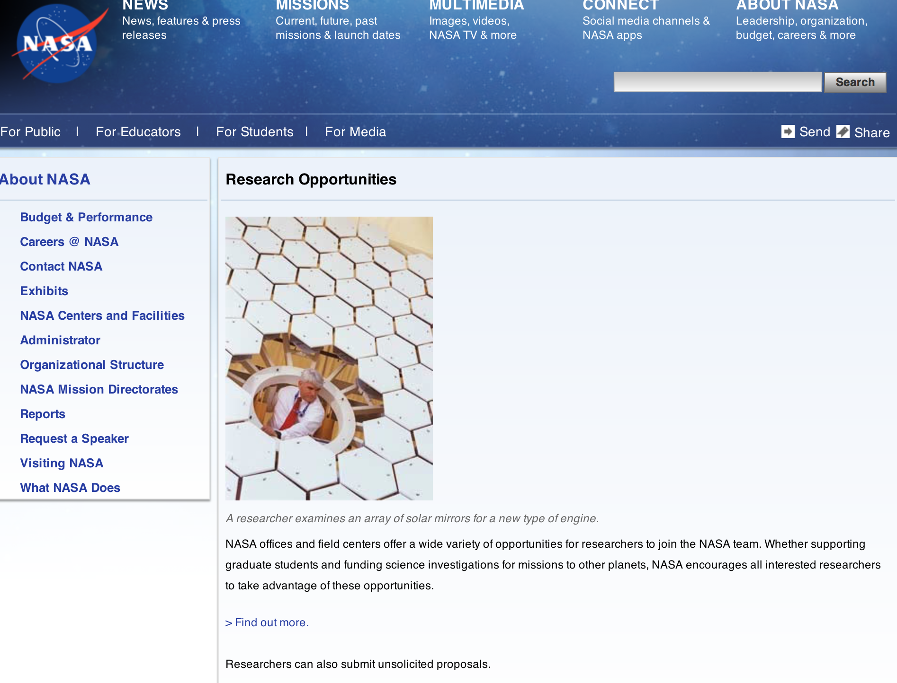

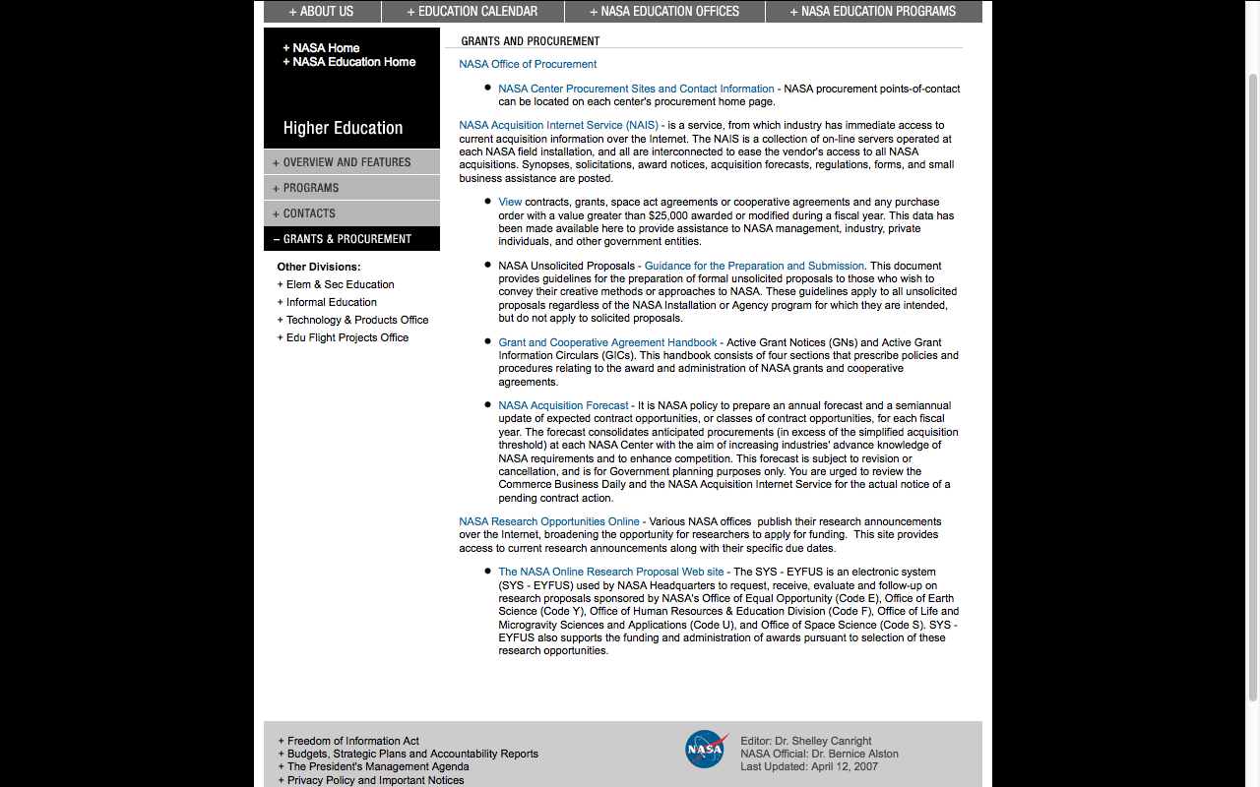

http://education1.nasa.gov/divisions/higher/grants/index.html

Programs

NASA Headquarters
SMART-NAS Test Bed for Safe, Trajectory-Based Operation Project Grant
http://www.grants.gov/web/grants/view-opportunity.html?oppId=280220

NASA Headquarters
ROSES 2015: Early Career Fellowship Program Grant
http://www.grants.gov/web/grants/view-opportunity.html?oppId=280205

Modifications:

NASA Johnson Space Center
Human Exploration Research Opportunities NASA Research Announcement
Modification 2
http://www.grants.gov/web/grants/view-opportunity.html?oppId=277989

NASA Headquarters
ROSES 2015: Solar System Workings
Modification 2
http://www.grants.gov/web/grants/view-opportunity.html?oppId=276587

National Archives and Records Administration

Grant Opportunities General Overview

To access the information below: click here

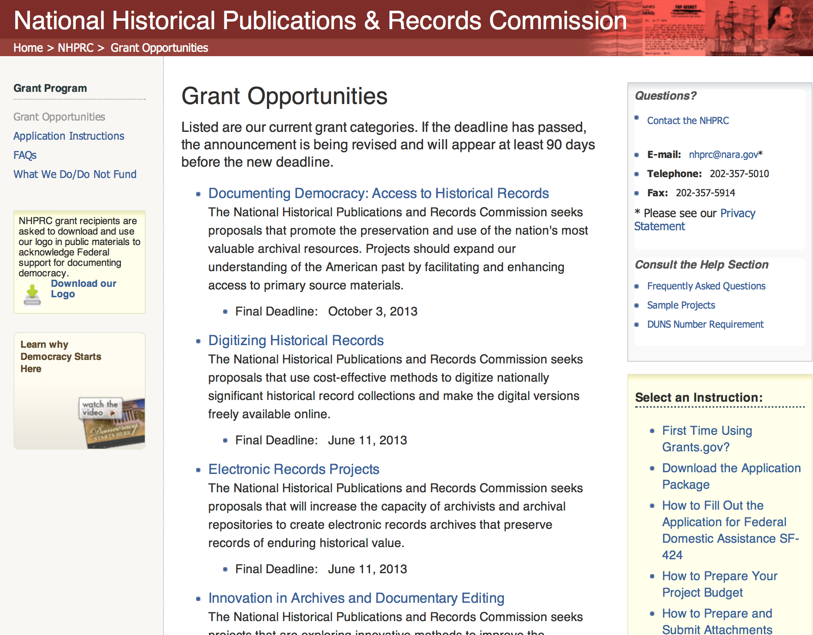

State Board Programming Grants

Document Type: | Grants Notice
Funding Opportunity Number: | STATE-201606
Funding Opportunity Title: | State Board Programming Grants
Opportunity Category: | Discretionary
Funding Instrument Type: | Grant
Category of Funding Activity: | Humanities (see "Cultural Affairs" in CFDA)
Category Explanation:
Expected Number of Awards: | 25
CFDA Number(s): | 89.003 -- National Historical Publications and Records Grants
Cost Sharing or Matching Requirement: | Yes
Posted Date: | Nov 24, 2015
Creation Date: | Nov 23, 2015
Original Closing Date for Applications: | Jun 15, 2016
Current Closing Date for Applications: | Jun 15, 2016
Archive Date: | Jul 15, 2016
Estimated Total Program Funding: | $650,000
Award Ceiling: | $80,000
Award Floor: | $0
Eligible Applicants: | State governments  Public and State controlled institutions of higher education  Others (see text field entitled "Additional Information on Eligibility" for clarification)  Nonprofits having a 501(c)(3) status with the IRS, other than institutions of higher education
Additional Information on Eligibility: | These grants are awarded only to SHRABs in each state, or to the state agency responsible for the SHRAB, ordinarily the state archives. Another state agency, or a non-profit organization, such as a foundation or university, acting on behalf of the designated state agency may apply. States also include the District of Columbia, the Commonwealth of Puerto Rico, and United States territories.
Agency Name: | National Archives and Records Administration
Description: | The National Historical Publications and Records Commission seeks proposals that strengthen the nation’s archival network through activities undertaken by state historical records advisory boards (SHRABs). The purpose of this grant program is to assist state boards to enhance access to historical records, increase citizen engagement with records, and provide learning and development opportunities for students, citizens and professional archivists. The Commission will award grants to State Historical Records Advisory Boards to: • Provide educational and outreach programs, workshops, and other activities that enhance citizen and student engagement with historical records • Operate state-based regrant and scholarship programs that advance access to historical records • Collaborate on projects with other organizations to address common problems or shared opportunities within a state or among a consortium of state archives • Hold or participate in meetings and public forums on statewide or national archival issues. For a comprehensive list of Commission limitations on funding, please see What We Do and Do Not Fund. Applications that consist entirely of ineligible activities will not be considered. Award Information A grant is for one year and for up to $40,000 or for two years and for up to $80,000. The NHPRC expects to award approximately 25 grants in this program. The total amount allocated for this program is up to $650,000. Grants begin no earlier than January 1, 2017. The Commission requires that grant recipients acknowledge NHPRC grant assistance in all publicity, publications, and other products that result from its support. Eligibility These grants are awarded only to SHRABs in each state, or to the state agency responsible for the SHRAB, ordinarily the state archives. Another state agency, or a non-profit organization, such as a foundation or university, acting on behalf of the designated state agency may apply. States also include the District of Columbia, the Commonwealth of Puerto Rico, and United States territories. Cost Sharing The total costs of a project are shared between the NHPRC and the applicant organization. The Commission provides no more than 75 per cent of total direct project costs in the State Board Programming Grants category. NHPRC grant recipients are not permitted to use grant funds for indirect costs (as indicated in 2 CFR 2600.101). Cost sharing is required. The applicant’s financial contribution may include both direct and indirect expenses, in-kind contributions, non-Federal third-party contributions, and any income earned directly by the project. Indirect costs must be listed under the applicant’s cost sharing contribution. Other Requirements Applicant organizations must be registered in System for Award Management (SAM) prior to submitting an application, maintain SAM registration throughout the application and award process, and include a valid DUNS number in their application. Details on SAM registration and requesting a DUNS number can be found at the System for Award Management website at https://sam.gov. Please refer to the User Guides section and the Grants Registrations PDF. A complete application includes the Application for Federal Assistance (Standard Form 424), Assurances - Non-Construction Programs (Standard Form 424B), a Project Narrative, Summary, Supplementary Materials, and Budget. Applications lacking these items will not be considered. Ineligible applications will not be reviewed.
Link to Additional Information: | Link to full grant announcement, including additional requirements
Contact Information: | If you have difficulty accessing the full announcement electronically, please contact:  Jeff de la Concepcion Grant Program Specialist Phone 202-357-5022  Grant Program Specialist

http://www.grants.gov/web/grants/view-opportunity.html?oppId=280200

Publishing Historical Records in Documentary Editions Grant

Document Type: | Grants Notice
Funding Opportunity Number: | EDITIONS-201606
Funding Opportunity Title: | Publishing Historical Records in Documentary Editions
Opportunity Category: | Discretionary
Funding Instrument Type: | Grant
Category of Funding Activity: | Humanities (see "Cultural Affairs" in CFDA)
Category Explanation:
Expected Number of Awards: | 25
CFDA Number(s): | 89.003 -- National Historical Publications and Records Grants
Cost Sharing or Matching Requirement: | Yes
Posted Date: | Nov 24, 2015
Creation Date: | Nov 23, 2015
Original Closing Date for Applications: | Jun 15, 2016
Current Closing Date for Applications: | Jun 15, 2016
Archive Date: | Jul 15, 2016
Estimated Total Program Funding: | $2,500,000
Award Ceiling: | $200,000
Award Floor: | $0
Eligible Applicants: | County governments  Native American tribal governments (Federally recognized)  City or township governments  Private institutions of higher education  Nonprofits having a 501(c)(3) status with the IRS, other than institutions of higher education  State governments  Public and State controlled institutions of higher education
Agency Name: | National Archives and Records Administration
Description: | The National Historical Publications and Records Commission seeks proposals to publish documentary editions of historical records. Projects may focus on the papers of major figures from American history or cover broad historical movements in politics, military, business, social reform, the arts, and other aspects of the national experience. The historical value of the records and their expected usefulness to broad audiences must justify the costs of the project. The goal of this program is to provide access to, and editorial context for, the historical documents and records that tell the American story. The NHPRC encourages projects, whenever possible and appropriate, to provide access to these materials in a free and open online environment, without precluding other forms of publication. Applicants should demonstrate familiarity with the best practices recommended by the Association for Documentary Editing or the Modern Language Association Committee on Scholarly Editions. Projects may also prepare print editions as part of their overall publishing plan. However, projects that do not have definitive plans for digital dissemination and preservation in place at the time of application will not be considered. It is also expected that the contents of any print volumes produced will be made available online within a reasonable period of time following print publication. Grants are awarded for collecting, describing, preserving, compiling, transcribing, annotating, editing, encoding, and publishing documentary source materials in print and online. Because of the focus on documentary sources, grants do not support preparation of critical editions of published works unless such works are just a small portion of the larger project. All applicants should be aware that the application process is highly competitive. Ongoing projects: Applicants from ongoing projects must demonstrate that they have successfully achieved the performance objectives associated with previous NHPRC awards; provide updated, current information, including a description of the new activities as well as description and significance of the specific materials to be edited during the proposed grant period; show progress towards completing the edition; and justify costs in a new budget. For a comprehensive list of Commission's limitations on funding, please see What We Do and Do Not Fund. Applications that consist entirely of ineligible activities will not be considered. Award Information A grant is for one year and for up to $200,000. The Commission expects to make up to 25 grants in this category for a total of up to $2,500,000. Grants begin no earlier than January 1, 2017. The Commission requires that grant recipients acknowledge NHPRC grant assistance in all publications and other products that result from its support. Eligibility U.S. nonprofit organizations or institutions U.S. colleges, universities, and other academic institutions State or local government agencies Federally-acknowledged or state-recognized Native American tribes or groups Cost Sharing The total costs of a project are shared between the NHPRC and the applicant organization. The Commission provides no more than 50 per cent of total direct project costs in the Publishing Historical Records in Documentary Editions category. NHPRC grant recipients are not permitted to use grant funds for indirect costs (as indicated in 2 CFR 2600.101). Cost sharing is required. The applicant’s financial contribution may include both direct and indirect expenses, in-kind contributions, non-Federal third-party contributions, and any income earned directly by the project. Indirect costs must be listed under the applicant’s cost sharing contribution. Other Requirements Applicant organizations must be registered in the System for Award Management (SAM) prior to submitting an application, maintain SAM registration throughout the application and award process, and include a valid DUNS number in their application. Details on SAM registration and requesting a DUNS number can be found at the System for Award Management website at https://sam.gov. Please refer to the User Guides section and the Grants Registrations PDF. A complete application includes the Application for Federal Assistance (Standard Form 424), Assurances -- Non-Construction Programs (Standard Form 424B), a Project Narrative, Summary, Supplementary Materials, and Budget. Applications lacking these items will not be considered. Ineligible applications will not be reviewed.
Link to Additional Information: | Link to full grant announcement, including additional requirements
Contact Information: | If you have difficulty accessing the full announcement electronically, please contact:  Jeff de la Concepcion Grant Program Specialist Phone 202-357-5022  Grant Program Specialist

http://www.grants.gov/web/grants/view-opportunity.html?oppId=280201

Publishing Historical Records in Documentary Editions Grant

Document Type: | Grants Notice
Funding Opportunity Number: | EDITIONS-201610
Funding Opportunity Title: | Publishing Historical Records in Documentary Editions
Opportunity Category: | Discretionary
Funding Instrument Type: | Grant
Category of Funding Activity: | Humanities (see "Cultural Affairs" in CFDA)
Category Explanation:
Expected Number of Awards: | 25
CFDA Number(s): | 89.003 -- National Historical Publications and Records Grants
Cost Sharing or Matching Requirement: | Yes
Posted Date: | Nov 24, 2015
Creation Date: | Nov 23, 2015
Original Closing Date for Applications: | Oct 6, 2016
Current Closing Date for Applications: | Oct 6, 2016
Archive Date: | Nov 4, 2016
Estimated Total Program Funding: | $2,500,000
Award Ceiling: | $200,000
Award Floor: | $0
Eligible Applicants: | Private institutions of higher education  County governments  City or township governments  Public and State controlled institutions of higher education  Native American tribal governments (Federally recognized)  Nonprofits having a 501(c)(3) status with the IRS, other than institutions of higher education  State governments
Agency Name: | National Archives and Records Administration
Description: | The National Historical Publications and Records Commission seeks proposals to publish documentary editions of historical records. Projects may focus on the papers of major figures from American history or cover broad historical movements in politics, military, business, social reform, the arts, and other aspects of the national experience. The historical value of the records and their expected usefulness to broad audiences must justify the costs of the project. The goal of this program is to provide access to, and editorial context for, the historical documents and records that tell the American story. The NHPRC encourages projects, whenever possible and appropriate, to provide access to these materials in a free and open online environment, without precluding other forms of publication. Applicants should demonstrate familiarity with the best practices recommended by the Association for Documentary Editing or the Modern Language Association Committee on Scholarly Editions. Projects may also prepare print editions as part of their overall publishing plan. However, projects that do not have definitive plans for digital dissemination and preservation in place at the time of application will not be considered. It is also expected that the contents of any print volumes produced will be made available online within a reasonable period of time following print publication. Grants are awarded for collecting, describing, preserving, compiling, transcribing, annotating, editing, encoding, and publishing documentary source materials in print and online. Because of the focus on documentary sources, grants do not support preparation of critical editions of published works unless such works are just a small portion of the larger project. All applicants should be aware that the application process is highly competitive. Ongoing projects: Applicants from ongoing projects must demonstrate that they have successfully achieved the performance objectives associated with previous NHPRC awards; provide updated, current information, including a description of the new activities as well as description and significance of the specific materials to be edited during the proposed grant period; show progress towards completing the edition; and justify costs in a new budget. For a comprehensive list of Commission's limitations on funding, please see What We Do and Do Not Fund. Applications that consist entirely of ineligible activities will not be considered. Award Information A grant is for one year and for up to $200,000. The Commission expects to make up to 25 grants in this category for a total of up to $2,500,000. Grants begin no earlier than January 1, 2017. The Commission requires that grant recipients acknowledge NHPRC grant assistance in all publications and other products that result from its support. Eligibility U.S. nonprofit organizations or institutions U.S. colleges, universities, and other academic institutions State or local government agencies Federally-acknowledged or state-recognized Native American tribes or groups Cost Sharing The total costs of a project are shared between the NHPRC and the applicant organization. The Commission provides no more than 50 per cent of total direct project costs in the Publishing Historical Records in Documentary Editions category. NHPRC grant recipients are not permitted to use grant funds for indirect costs (as indicated in 2 CFR 2600.101). Cost sharing is required. The applicant’s financial contribution may include both direct and indirect expenses, in-kind contributions, non-Federal third-party contributions, and any income earned directly by the project. Indirect costs must be listed under the applicant’s cost sharing contribution. Other Requirements Applicant organizations must be registered in the System for Award Management (SAM) prior to submitting an application, maintain SAM registration throughout the application and award process, and include a valid DUNS number in their application. Details on SAM registration and requesting a DUNS number can be found at the System for Award Management website at https://sam.gov. Please refer to the User Guides section and the Grants Registrations PDF. A complete application includes the Application for Federal Assistance (Standard Form 424), Assurances -- Non-Construction Programs (Standard Form 424B), a Project Narrative, Summary, Supplementary Materials, and Budget. Applications lacking these items will not be considered. Ineligible applications will not be reviewed.
Link to Additional Information: | Link to full grant announcement, including additional requirements
Contact Information: | If you have difficulty accessing the full announcement electronically, please contact:  Jeff de la Concepcion Grant Program Specialist Phone 202-357-5022  Grant Program Specialist

http://www.grants.gov/web/grants/view-opportunity.html?oppId=280202

Access to Historical Records Grant

Document Type: | Grants Notice
Funding Opportunity Number: | ACCESS-201606
Funding Opportunity Title: | Access to Historical Records
Opportunity Category: | Discretionary
Funding Instrument Type: | Grant
Category of Funding Activity: | Humanities (see "Cultural Affairs" in CFDA)
Category Explanation:
Expected Number of Awards: | 14
CFDA Number(s): | 89.003 -- National Historical Publications and Records Grants
Cost Sharing or Matching Requirement: | Yes
Posted Date: | Nov 24, 2015
Creation Date: | Nov 23, 2015
Original Closing Date for Applications: | Jun 15, 2016
Current Closing Date for Applications: | Jun 15, 2016
Archive Date: | Jul 15, 2016
Estimated Total Program Funding: | $1,000,000
Award Ceiling: | $200,000
Eligible Applicants: | Public and State controlled institutions of higher education  State governments  City or township governments  Nonprofits having a 501(c)(3) status with the IRS, other than institutions of higher education  Private institutions of higher education  Native American tribal governments (Federally recognized)  County governments
Agency Name: | National Archives and Records Administration
Description: | The National Historical Publications and Records Commission seeks proposals that promote the preservation and use of historical records collections to broaden understanding of our democracy, history, and culture. This grant program is designed to support archival repositories in preserving and processing primary source materials. The program emphasizes the creation of online tools that facilitate the public discovery of historical records. The Commission looks to fund projects that undertake one or more of the following activities: • Preservation, arrangement, and online description of historical records in all formats • Digital preservation of electronic records and unstable audio or moving image formats After completing arrangement and description activities, applicants may also propose to digitize materials to provide online access to collections. For a comprehensive list of Commission limitations on funding, please see “What we do and do not fund” (http://www.archives.gov/nhprc/apply/eligibility.html). Applications that consist entirely of ineligible activities will not be considered. Award Information A grant is for one to two years and for up to $200,000. The Commission expects to make up to 14 grants in this category for a total of up to $1,000,000. Grants begin no earlier than January 1, 2017. The Commission requires that grant recipients acknowledge NHPRC grant assistance in all publicity, publications, and other products that result from its support. Eligibility Information Eligible applicants: • Nonprofit organizations or institutions • Colleges, universities, and other academic institutions • State or local government agencies • Federally-acknowledged or state-recognized Native American tribes or groups Cost Sharing - The total costs of a project are shared between the NHPRC and the applicant organization. The Commission provides no more than 50 per cent of total direct project costs in the Access to Historical Records category. NHPRC grant recipients are not permitted to use grant funds for indirect costs (as indicated in 2 CFR 2600.101). Cost sharing is required. The applicant’s financial contribution may include both direct and indirect expenses, in-kind contributions, non-Federal third-party contributions, and any income earned directly by the project. Indirect costs must be listed under the applicant’s cost sharing contribution. Other Requirements - Applicant organizations must be registered in the System for Award Management (SAM) prior to submitting an application, maintain SAM registration throughout the application and award process, and include a valid DUNS number in their application. Details on SAM registration and requesting a DUNS number can be found at the System for Award Management website at http://sam.gov. Please refer to the User Guides section and the Grants Registrations PDF. A complete application includes the Application for Federal Assistance (Standard Form 424), Assurances -- Non-Construction Programs (Standard Form 424B), a Project Narrative, Summary, Supplementary Materials, and Budget. Applications lacking these items will not be considered. Ineligible applications will not be reviewed.
Link to Additional Information: | Link to full grant announcement, including additional requirements
Contact Information: | If you have difficulty accessing the full announcement electronically, please contact:  Jeff de la Concepcion Grant Program Specialist Phone 202-357-5022  Grant Program Specialist

http://www.grants.gov/web/grants/view-opportunity.html?oppId=280217

Reminders:

National Endowment for the Arts

Agency Grant Overview - http://nea.gov/grants/apply/index.html

For an overview of the NEA's funding opportunities, please see the NEA Grants Workshop presentation.
The series of Arts Works guidelines webinars for each discipline has now concluded. All of the sessions are archived on our YouTube channel.

http://arts.gov/grants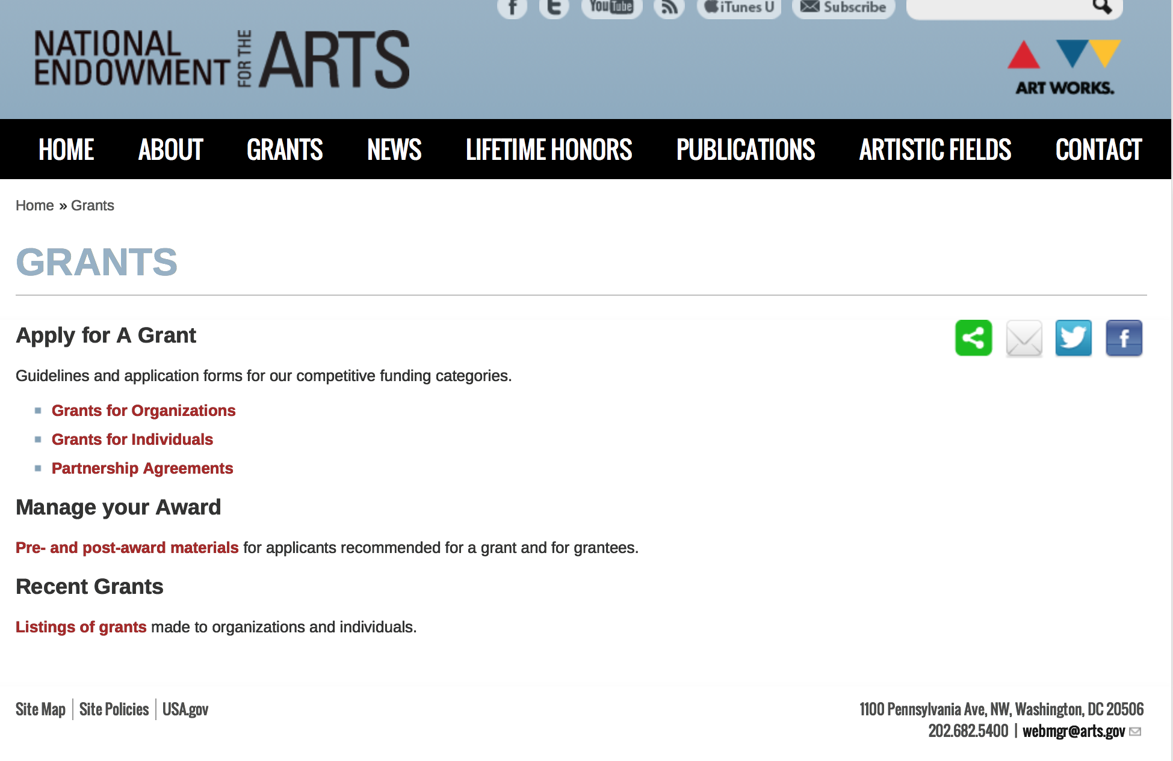
Grants for Organizations
We fund projects only. Projects may consist of one or more specific events or activities. Projects do not have to be new. Excellent existing projects can be just as competitive as new activities. Projects do not need to be big either; we welcome small projects that can make a difference in their community or field.

Art Works
To support the creation of art that meets the highest standards of excellence, public engagement with diverse and excellent art, lifelong learning in the arts, and the strengthening of communities through the arts.

Matching grants generally range from $10,000 to $100,000.
Deadline: February 19, 2015
Notification: November 2015
Earliest Start Date: January 1, 2016
Deadline: July 23, 2015
Notification: April 2016
Earliest Start Date: June 1, 2016

Challenge America
To support projects that extend the reach of the arts to underserved populations. Matching grants are for $10,000.
Deadline: April 16, 2015
Notification: December 2015
Earliest Start Date: January 1, 2016

Our Town
Organizations may apply for creative placemaking projects that contribute to the livability of communities and place the arts at their core. Our Town offers support for projects in two areas:
- Arts Engagement, Cultural Planning, and Design Projects that represent the distinct character and quality of their communities. Matching grants range from $25,000 to $200,000.
- Projects that Build Knowledge About Creative Placemaking. Matching grants range from $25,000 to $100,000.
Deadline: December 15, 2014 Notification: July 2015 Earliest Start Date: October 1, 2015

Research: Art Works
New guidelines will be available in August.

See more at: http://arts.gov/grants/apply-grant/grants-organizations - sthash.EquFoUvs.yLCIsZHu.dpuf

Programs:

Modifications:

Reminders:

National Endowment for the Humanities

Grant Overview -

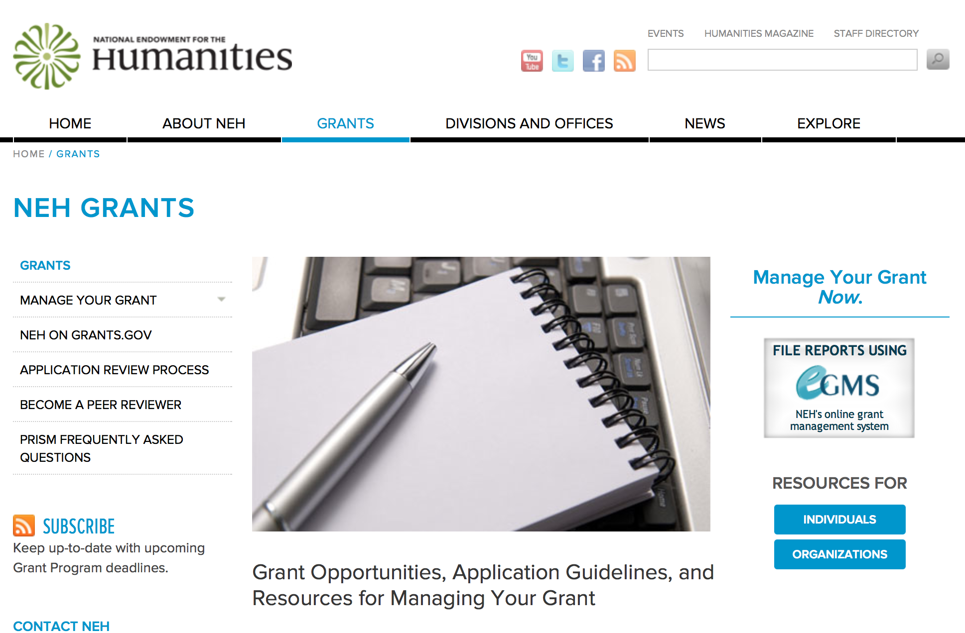

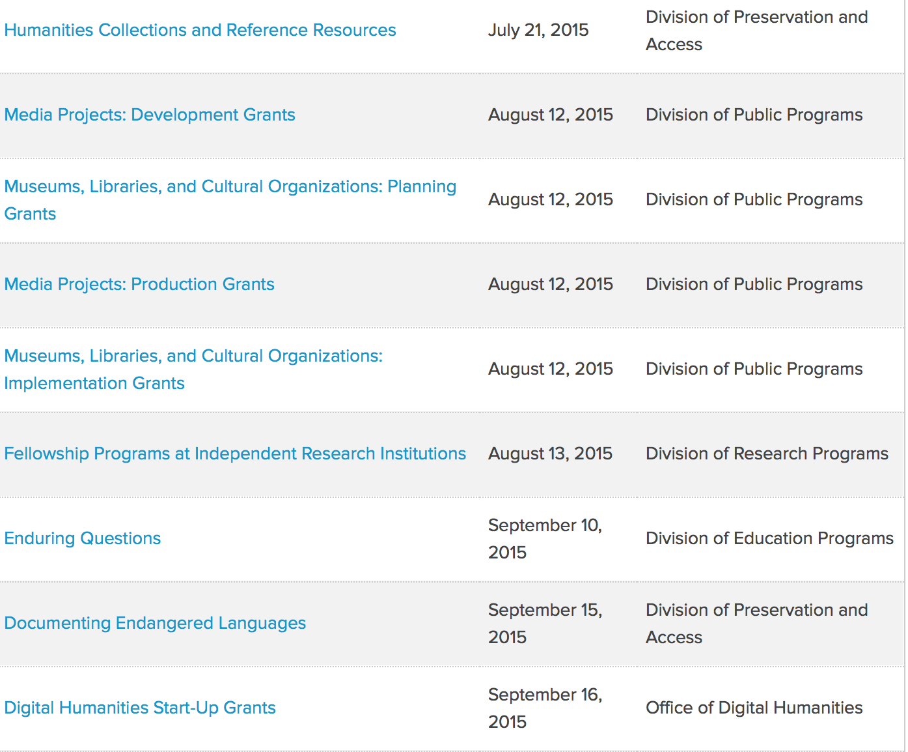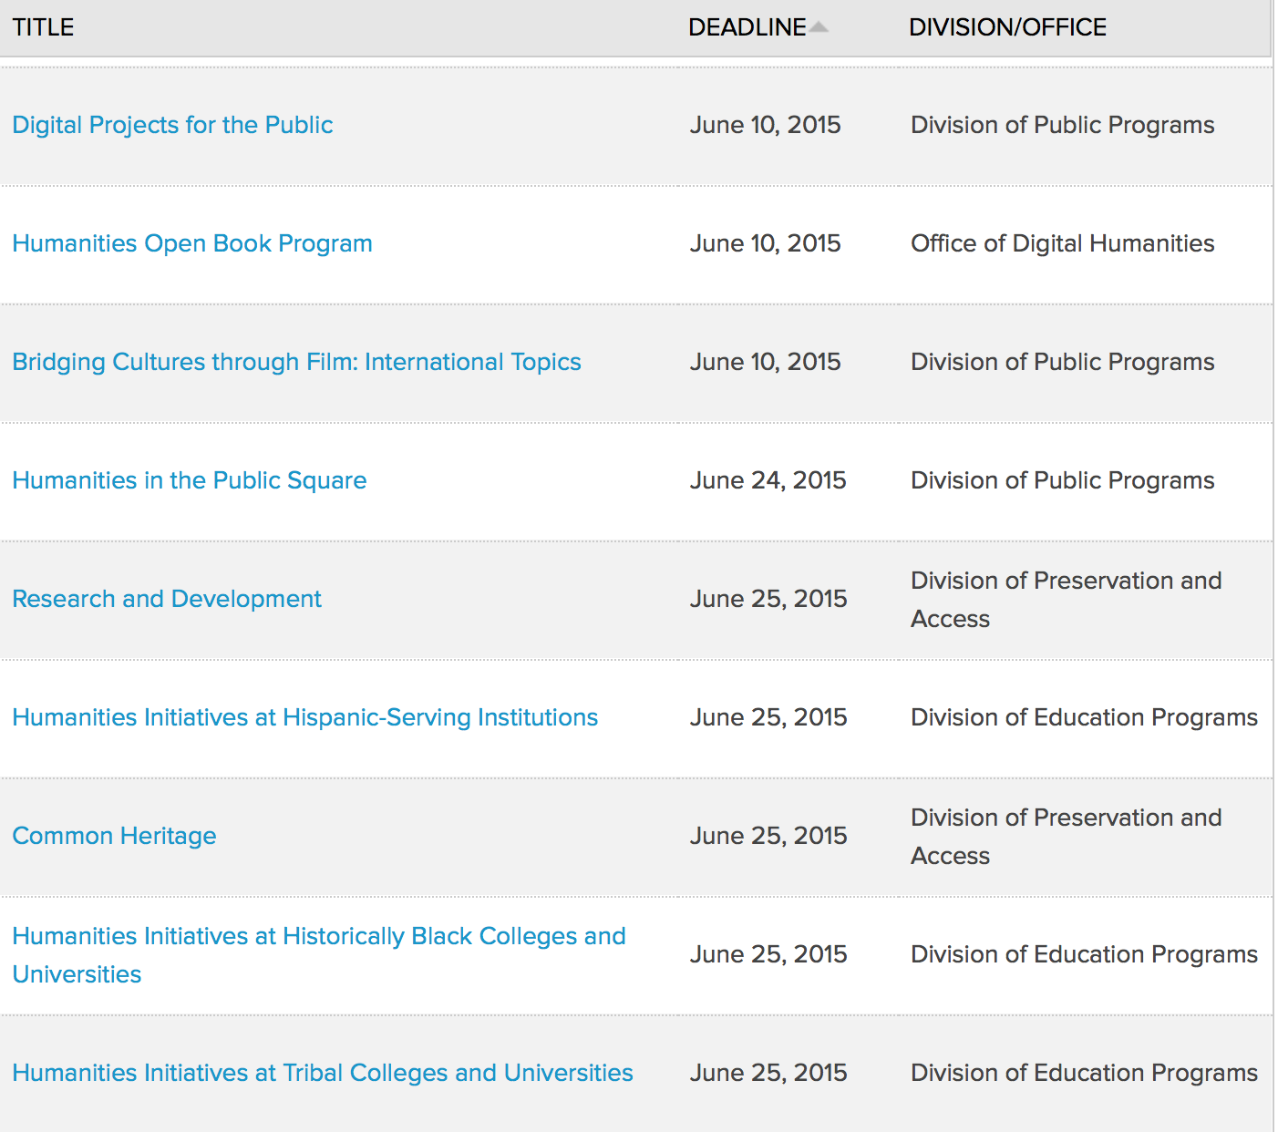

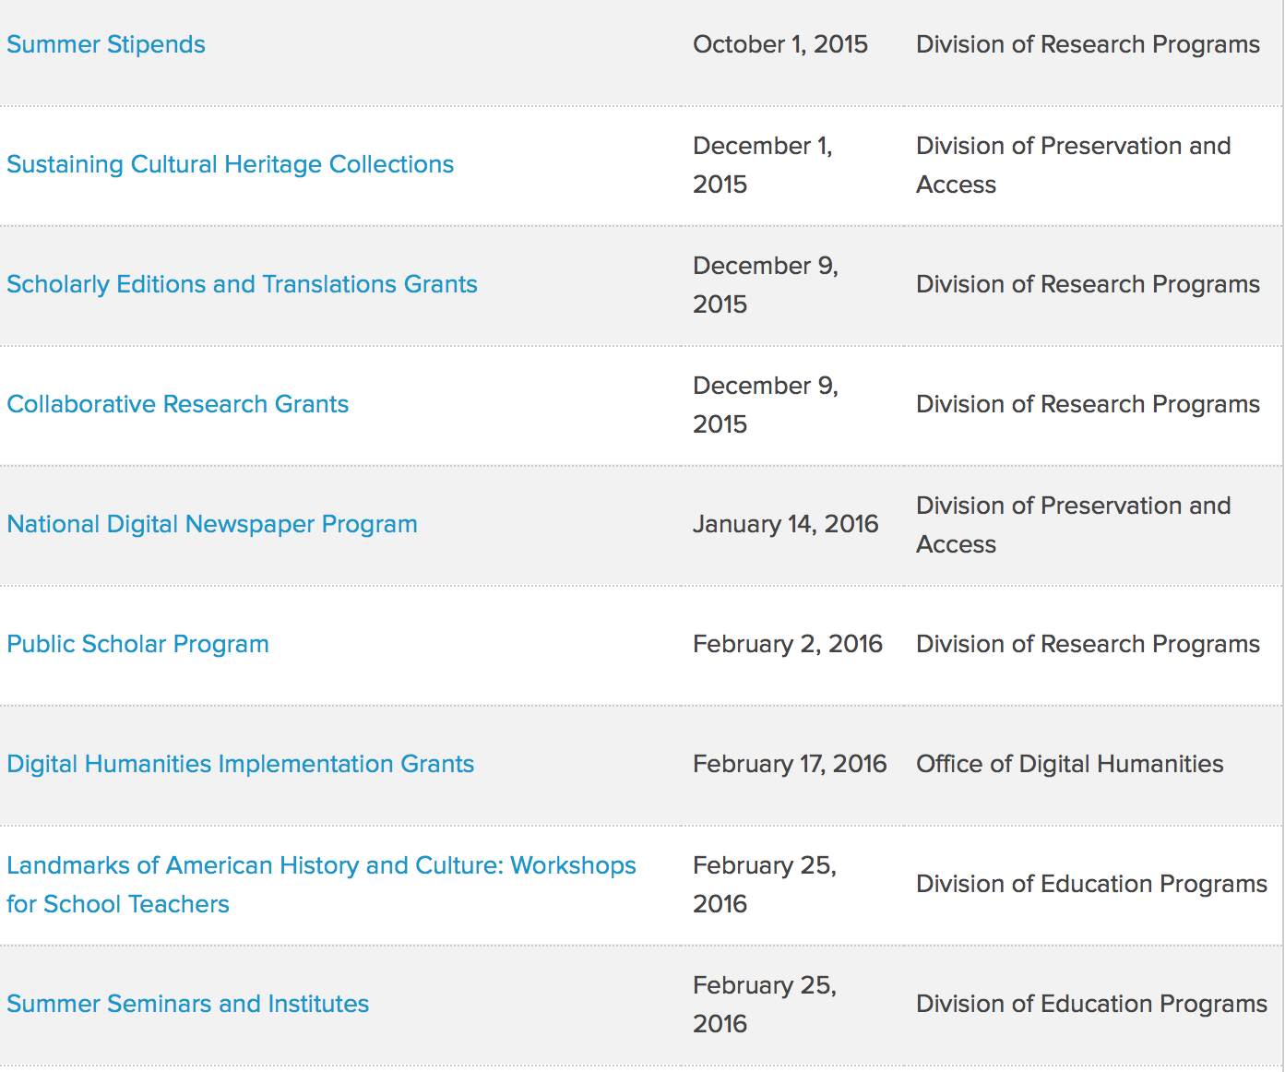
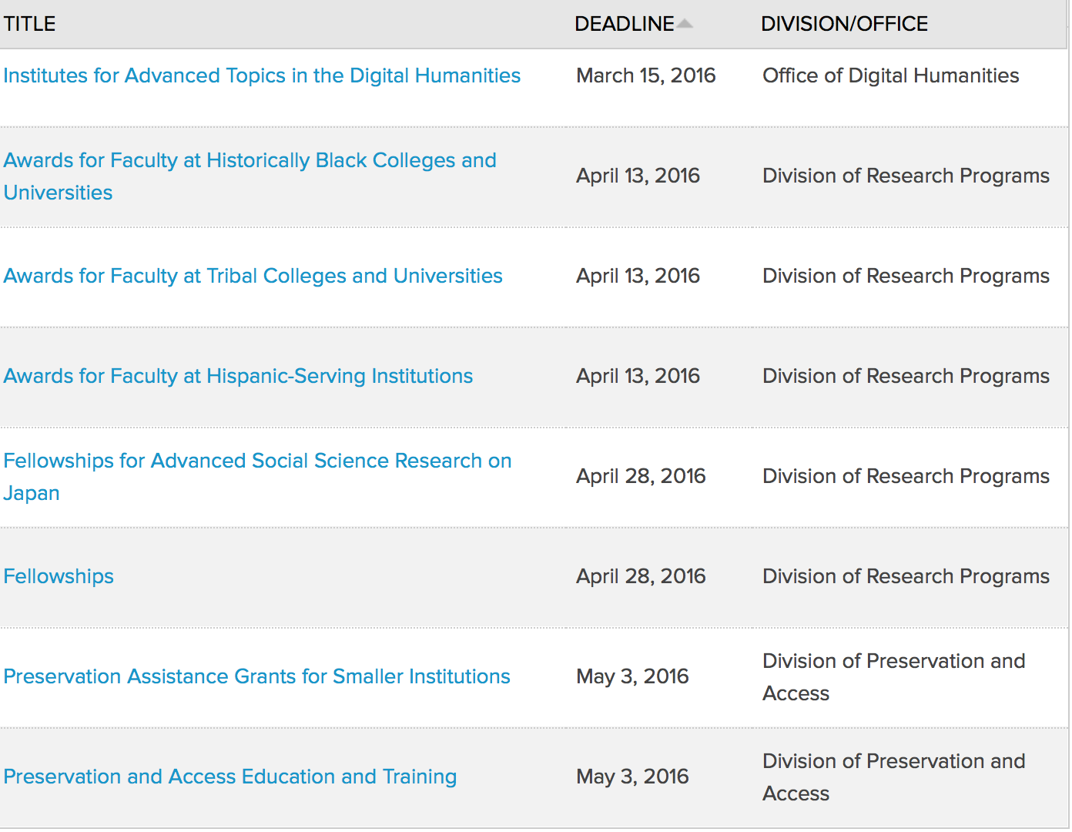

http://www.neh.gov/grants/grantsbydivision.html

Programs:

Media Projects Grants

Document Type: | Grants Notice
Funding Opportunity Number: | 20160113-TD
Funding Opportunity Title: | Media Projects Grants
Opportunity Category: | Discretionary
Funding Instrument Type: | Grant
Category of Funding Activity: | Humanities (see "Cultural Affairs" in CFDA)
Category Explanation:
Expected Number of Awards:
CFDA Number(s): | 45.164 -- Promotion of the Humanities Public Programs
Cost Sharing or Matching Requirement: | No
Posted Date: | Nov 12, 2015
Creation Date: | Nov 12, 2015
Original Closing Date for Applications: | Jan 13, 2016
Current Closing Date for Applications: | Jan 13, 2016
Archive Date:
Estimated Total Program Funding:
Award Ceiling: | $1,000,000
Award Floor: | $1
Eligible Applicants: | Private institutions of higher education  Nonprofits having a 501(c)(3) status with the IRS, other than institutions of higher education  State governments  City or township governments  Nonprofits that do not have a 501(c)(3) status with the IRS, other than institutions of higher education  Native American tribal governments (Federally recognized)  Public and State controlled institutions of higher education  County governments  Special district governments
Agency Name: | National Endowment for the Humanities
Description: | Media Projects Grants support film, television, and radio projects for general audiences that encourage active engagement with humanities ideas in creative and appealing ways. All projects must be grounded in humanities scholarship in disciplines such as history, art history, film studies, literature, drama, religious studies, philosophy, or anthropology. Projects must also demonstrate an approach that is thoughtful, balanced, and analytical (rather than celebratory). The approach to the subject matter must go beyond the mere presentation of factual information to explore its larger significance and stimulate critical thinking. NEH is a national funding agency, so the projects we support must demonstrate the potential to attract a broad general audience. Film and television projects may be single programs or a series addressing significant figures, events, or ideas. Programs must be intended for national distribution, via traditional carriage or online distribution. The Division of Public Programs welcomes projects that range in length from short-form to broadcast-length video. Radio projects, including podcasts, may involve single programs, limited series, or segments within an ongoing program. They may also develop new humanities content to augment existing radio programming or add greater historical background or humanities analysis to the subjects of existing programs. They may be intended for regional or national distribution. NEH encourages projects that engage public audiences through multiple formats in the exploration of humanities ideas. Proposed projects might include complementary components to a film, television, or radio project. These components should deepen the audience’s understanding of the subject in a supplementary manner: for example, book/film discussion programs, supplementary educational websites, or museum exhibitions. Development grants enable media producers to collaborate with scholars to develop humanities content and to prepare programs for production. Grants should result in a script or detailed treatment and may also yield a plan for outreach and public engagement. Production grants support the production and distribution of films, television programs, and radio programs that promise to engage a broad public audience.
Link to Additional Information: | http://www.neh.gov/grants/mp
Contact Information: | If you have difficulty accessing the full announcement electronically, please contact:  Division of Public Programs National Endowment for the Humanities 400 Seventh Street, SW Washington, DC 20506 202-606-8269 publicpgms@neh.gov publicpgms@neh.gov  publicpgms@neh.gov

http://www.grants.gov/web/grants/view-opportunity.html?oppId=280010

Museums, Libraries, and Cultural Organizations Grants

Document Type: | Grants Notice
Funding Opportunity Number: | 20160113-GE
Funding Opportunity Title: | Museums, Libraries, and Cultural Organizations Grants
Opportunity Category: | Discretionary
Funding Instrument Type: | Grant
Category of Funding Activity: | Humanities (see "Cultural Affairs" in CFDA)
Category Explanation:
Expected Number of Awards:
CFDA Number(s): | 45.164 -- Promotion of the Humanities Public Programs
Cost Sharing or Matching Requirement: | No
Posted Date: | Nov 12, 2015
Creation Date: | Nov 12, 2015
Original Closing Date for Applications: | Jan 13, 2016
Current Closing Date for Applications: | Jan 13, 2016
Archive Date:
Estimated Total Program Funding:
Award Ceiling: | $1,000,000
Award Floor: | $1
Eligible Applicants: | City or township governments  Native American tribal governments (Federally recognized)  Nonprofits having a 501(c)(3) status with the IRS, other than institutions of higher education  Private institutions of higher education  Special district governments  Nonprofits that do not have a 501(c)(3) status with the IRS, other than institutions of higher education  State governments  County governments  Public and State controlled institutions of higher education
Agency Name: | National Endowment for the Humanities
Description: | This grant program supports projects for general audiences that encourage active engagement with humanities ideas in creative and appealing ways. Many different formats are supported, including permanent and traveling exhibitions, book or film discussion programs, historic site or district interpretations, living history presentations, and other face-to-face programs in public venues. All projects must be grounded in humanities scholarship in disciplines such as history, art history, film studies, literature, religious studies, philosophy, or anthropology. Projects must also demonstrate an approach that is thoughtful, balanced, and analytical (rather than celebratory). The approach to the subject matter must go beyond the mere presentation of factual information to explore its larger significance and stimulate critical thinking. NEH is a national funding agency, so the projects we support must demonstrate the potential to attract a broad general audience. We welcome humanities projects tailored to particular groups, such as families, youth (including K-12 students), teachers, seniors, at-risk communities, and veterans, but they should also strive to cultivate a more inclusive public audience. NEH encourages projects that explore humanities ideas through multiple formats. Proposed projects might include complementary components that deepen an audience’s understanding of a subject: for example, a museum exhibition might be accompanied by a website, mobile app, or discussion programs. Planning grants are used to refine the content, format, and interpretive approach of a humanities project; develop the project’s preliminary design; test project components; and conduct audience evaluation. Implementation grants are used to support final scholarly research and consultation, design development, production, and installation of a project for presentation to the public.
Link to Additional Information: | http://www.neh.gov/grants/mlco
Contact Information: | If you have difficulty accessing the full announcement electronically, please contact:  Division of Public Programs National Endowment for the Humanities 400 Seventh Street, SW Washington, DC 20506 202-606-8269 publicpgms@neh.gov publicpgms@neh.gov  publicpgms@neh.gov

http://www.grants.gov/web/grants/view-opportunity.html?oppId=280031

Digital Humanities Implementation Grants

Document Type: | Grants Notice
Funding Opportunity Number: | 20160217-HK
Funding Opportunity Title: | Digital Humanities Implementation Grants
Opportunity Category: | Discretionary
Funding Instrument Type: | Grant
Category of Funding Activity: | Humanities (see "Cultural Affairs" in CFDA)
Category Explanation:
Expected Number of Awards:
CFDA Number(s): | 45.169 -- Promotion of the Humanities Office of Digital Humanities
Cost Sharing or Matching Requirement: | No
Posted Date: | Dec 1, 2015
Creation Date: | Dec 1, 2015
Original Closing Date for Applications: | Feb 17, 2016
Current Closing Date for Applications: | Feb 17, 2016
Archive Date:
Estimated Total Program Funding:
Award Ceiling: | $325,000
Award Floor: | $100,000
Eligible Applicants: | Native American tribal governments (Federally recognized)  Public and State controlled institutions of higher education  State governments  City or township governments  Special district governments  Private institutions of higher education  Nonprofits that do not have a 501(c)(3) status with the IRS, other than institutions of higher education  County governments  Nonprofits having a 501(c)(3) status with the IRS, other than institutions of higher education
Agency Name: | National Endowment for the Humanities
Description: | The Digital Humanities Implementation Grants program awards substantial grants to support the implementation of experimental projects that have successfully completed a start-up phase and demonstrated their value to the humanities. Such projects might enhance our understanding of central problems in the humanities, raise new questions in the humanities, or develop new digital applications and approaches for use in the humanities. The program can support innovative digital humanities projects that address multiple audiences, including scholars, teachers, librarians, and the public. Applications from recipients of NEH’s Digital Humanities Start-Up Grants are welcome. Unlike NEH’s Digital Humanities Start-Up Grants program, which emphasizes basic research, prototyping, experimentation, and potential impact, the Digital Humanities Implementation Grants program seeks to identify projects that have successfully completed their start-up phase and are well positioned to have a major impact. Proposals are welcome for digital initiatives in any area of the humanities.
Link to Additional Information: | http://www.neh.gov/grants/odh/digital-humanities-implementation-grants
Contact Information: | If you have difficulty accessing the full announcement electronically, please contact:  If you have questions about the program, contact the ODH staff at odh@neh.gov. Applicants wishing to speak to a staff member by telephone should provide in an e-mail message a telephone number and a preferred time to call. odh@neh.gov  odh@neh.gov

http://www.grants.gov/web/grants/view-opportunity.html?oppId=280266

Modifications:

Reminders:

Next Generation Humanities PhD Grants

Document Type: | Grants Notice
Funding Opportunity Number: | 20160217-ZA
Funding Opportunity Title: | Next Generation Humanities PhD Grants
Opportunity Category: | Discretionary
Funding Instrument Type: | Grant
Category of Funding Activity: | Humanities (see "Cultural Affairs" in CFDA)
Category Explanation:
Expected Number of Awards:
CFDA Number(s): | 45.130 -- Promotion of the Humanities Challenge Grants
Cost Sharing or Matching Requirement: | No
Posted Date: | Oct 20, 2015
Creation Date: | Oct 20, 2015
Original Closing Date for Applications: | Feb 17, 2016
Current Closing Date for Applications: | Feb 17, 2016
Archive Date:
Estimated Total Program Funding:
Award Ceiling: | $350,000
Award Floor: | $1
Eligible Applicants: | Others (see text field entitled "Additional Information on Eligibility" for clarification)
Additional Information on Eligibility: | The only eligible applicants are U.S. nonprofit institutions of higher learning with PhD programs in the humanities.
Agency Name: | National Endowment for the Humanities
Description: | In recent years, research published by Humanities Indicators, among others, has revealed that humanities PhDs pursue careers in many different professions—both inside and outside academia. Yet most humanities PhD programs in the United States still prepare students primarily for tenure-track professor positions at colleges and universities. The increasing shortage of such positions has changed students’ expected career outcomes. NEH therefore hopes to assist universities in devising a new model of doctoral education, which can both transform the understanding of what it means to be a humanities scholar and promote the integration of the humanities in the public sphere. Next Generation Humanities PhD Planning Grants support universities in preparing to institute wide-ranging changes in humanities doctoral programs. Humanities knowledge and methods can make an even more substantial impact on society if students are able to translate what they learn in doctoral programs into a multitude of careers. Next Generation PhD Planning Grants are designed to bring together various important constituencies to discuss and strategize, and then to produce plans that will transform scholarly preparation in the humanities at the doctoral level. Students will be prepared to undertake various kinds of careers, and humanities PhD programs will increase their relevance for the twenty-first century. Next Generation Humanities PhD Implementation Grants support universities in instituting wide-ranging changes in humanities doctoral programs. Humanities knowledge and methods can make an even more substantial impact on society if students are able to translate what they learn in doctoral programs into a multitude of careers. Next Generation PhD Implementation Grants are designed to produce plans that will transform scholarly preparation in the humanities at the doctoral level. Students will be prepared to undertake various kinds of careers, and humanities PhD programs will increase their relevance for the twenty-first century. NEH will support activities specific to each institution’s needs: these may include (but are not limited to) multi-departmental collaboration, transformations in curricula, modifications in stipend structures, altered formats for dissertations, commitment to collection of alumni career information and outcomes, partnerships with non-university entities, as well as a pledge to encourage doctoral students to explore and prepare for multiple career trajectories. NEH intends the Implementation Grants program to promote best practices on the part of its awardee institutions, and thereby to establish a new model for graduate education in the humanities. Grantee institutions must provide funds (either their own funds or funds raised from nonfederal third parties) equal to the grant funds released by NEH.
Link to Additional Information: | http://www.neh.gov/grants/next-generation
Contact Information: | If you have difficulty accessing the full announcement electronically, please contact:  challenge@neh.gov 202-606-8309 challenge@neh.gov  challenge@neh.gov

http://www.grants.gov/web/grants/view-opportunity.html?oppId=279734

National Digital Newspaper Program Grant

Document Type: | Grants Notice
Funding Opportunity Number: | 20160114-PJ
Funding Opportunity Title: | National Digital Newspaper Program
Opportunity Category: | Discretionary
Funding Instrument Type: | Cooperative Agreement
Category of Funding Activity: | Humanities (see "Cultural Affairs" in CFDA)
Category Explanation:
Expected Number of Awards:
CFDA Number(s): | 45.149 -- Promotion of the Humanities Division of Preservation and Access
Cost Sharing or Matching Requirement: | No
Posted Date: | Oct 27, 2015
Creation Date: | Oct 27, 2015
Original Closing Date for Applications: | Jan 14, 2016
Current Closing Date for Applications: | Jan 14, 2016
Archive Date:
Estimated Total Program Funding:
Award Ceiling: | $325,000
Award Floor: | $1
Eligible Applicants: | County governments  Native American tribal governments (Federally recognized)  Public and State controlled institutions of higher education  Private institutions of higher education  Special district governments  City or township governments  Nonprofits that do not have a 501(c)(3) status with the IRS, other than institutions of higher education  Nonprofits having a 501(c)(3) status with the IRS, other than institutions of higher education  State governments
Agency Name: | National Endowment for the Humanities
Description: | NEH is soliciting proposals from institutions to participate in the National Digital Newspaper Program (NDNP). NDNP is creating a national digital resource of historically significant newspapers published between 1836 and 1922, from all the states and U.S. territories. This searchable database will be permanently maintained at the Library of Congress (LC) and will be freely accessible via the Internet. (See the website, Chronicling America: Historic American Newspapers.) An accompanying national newspaper directory of bibliographic and holdings information on the website directs users to newspaper titles available in all types of formats. During the course of its partnership with NEH, LC will also digitize and contribute to the NDNP database a significant number of newspaper pages drawn from its own collections. NEH intends to support projects in all states and U.S. territories, provided that sufficient funds allocated for this purpose are available. One organization within each U.S. state or territory will receive an award to collaborate with relevant state partners in this effort. Previously funded projects will be eligible to receive supplements for continued work, but the program will give priority to new projects. In particular, the program will give priority to projects from states and territories that have not received NDNP funding. Applications that involve collaboration between previously funded and new projects are welcome. Such collaborations might involve, for example, arranging with current awardees to manage the creation and delivery of digital files; offering regular and ongoing consultation on managing aspects of the project; or providing formal training for project staff at an onsite institute or workshop. Over a period of two years, successful applicants will select newspapers—published in their state or territory between 1836 and 1922—and convert approximately 100,000 pages into digital files (primarily from microfilm), according to the technical guidelines (PDF) outlined by the Library of Congress. Applicants may select titles published in any language with a valid ISO 639-2 language code. Newspapers with valid language codes will be included in the searchable database maintained at the Library of Congress. Search engine support may vary by language, as detailed in the Library of Congress technical guidelines.
Link to Additional Information: | http://www.neh.gov/grants/preservation/national-digital-newspaper-program
Contact Information: | If you have difficulty accessing the full announcement electronically, please contact:  National Digital Newspaper Program Division of Preservation and Access National Endowment for the Humanities 400 Seventh Street, SW Washington, DC 20506 preservation@neh.gov 202-606-8570 preservation@neh.gov  preservation@neh.gov

http://www.grants.gov/web/grants/view-opportunity.html?oppId=279847

Public Scholar Program Grant

http://www.grants.gov/web/grants/view-opportunity.html?oppId=280251



National Science Foundation

General Funding Overview

The National Science Foundation funds research and education in most fields of science and engineering. It does this through grants, and cooperative agreements to more than 2,000 colleges, universities, K-12 school systems, businesses, informal science organizations and other research organizations throughout the United States. The Foundation accounts for about one-fourth of federal support to academic institutions for basic research.
NSF receives approximately 40,000 proposals each year for research, education and training projects, of which approximately 11,000 are funded. In addition, the Foundation receives several thousand applications for graduate and postdoctoral fellowships.
The agency operates no laboratories itself but does support National Research Centers, user facilities, certain oceanographic vessels and Antarctic research stations. The Foundation also supports cooperative research between universities and industry, US participation in international scientific and engineering efforts, and educational activities at every academic level.

For assistance in finding funding: http://nsf.gov/funding/

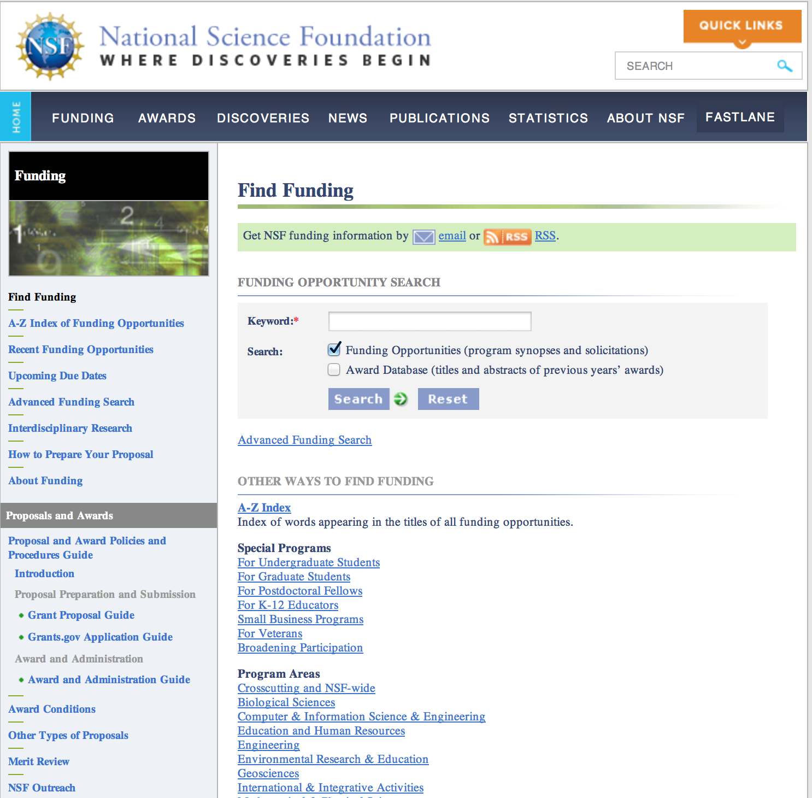

Research and Program Grants:

Algorithms in the Field Grant
http://www.grants.gov/web/grants/view-opportunity.html?oppId=280319

Critical Techniques, Technologies and Methodologies for Advancing Foundations and Applications of Big Data Sciences and Engineering Grant
http://www.grants.gov/web/grants/view-opportunity.html?oppId=279974

EarthCube: Grant
http://www.grants.gov/web/grants/view-opportunity.html?oppId=280271

Scalable Nanomanufacturing Grant
http://www.grants.gov/web/grants/view-opportunity.html?oppId=280028

Modifications:

Reminders:

Nuclear Regulatory Commission

U.S. Nuclear Regulatory Commission Funding Opportunity Announcement (FOA), Scholarship and Fellowship Education Grant, Faculty Development Grant, and Trade School and Community College Scholarship Grant, Fiscal Year (FY) 2016 Grant

Document Type: | Grants Notice
Funding Opportunity Number: | NRC-HQ-84-16-FOA-0001
Funding Opportunity Title: | U.S. Nuclear Regulatory Commission Funding Opportunity Announcement (FOA), Scholarship and Fellowship Education Grant, Faculty Development Grant, and Trade School and Community College Scholarship Grant, Fiscal Year (FY) 2016
Opportunity Category: | Discretionary
Funding Instrument Type: | Grant
Category of Funding Activity: | Education
Category Explanation:
Expected Number of Awards: | 50
CFDA Number(s): | 77.008 -- U.S. Nuclear Regulatory Commission Scholarship and Fellowship Program
Cost Sharing or Matching Requirement: | No
Posted Date: | Dec 1, 2015
Creation Date: | Dec 2, 2015
Original Closing Date for Applications: | Feb 1, 2016
Current Closing Date for Applications: | Feb 1, 2016
Archive Date: | Mar 2, 2016
Estimated Total Program Funding: | $15,000,000
Award Ceiling: | $450,000
Award Floor: | $100,000
Eligible Applicants: | Public and State controlled institutions of higher education
Additional Information on Eligibility: | • Public/State Controlled Institutions of Higher Education • Private Institutions of Higher Education • Hispanic-Serving Institutions• Historically Black Colleges and Universities (HBCUs)• Tribally Controlled Colleges and Universities (TCCUs) • Alaska Native and Native Hawaiian Serving Institutions• Predominately Black Institutions• Asian American and Native American Pacific Islander Serving Institutions
Agency Name: | Nuclear Regulatory Commission
Description: | •Scholarship• The primary objective is to support scholarships for nuclear science, engineering, technology and related disciplines to develop a workforce capable of supporting the design, construction, operation, and regulation of nuclear facilities and the safe handling of nuclear materials. The nuclear-related discipline supported by this funding is intended to benefit the nuclear sector broadly.•Fellowship•The primary objective is to support fellowships for nuclear science, engineering, technology and related disciplines to develop a workforce capable of supporting the design, construction, operation, and regulation of nuclear facilities and the safe handling of nuclear materials. The nuclear related discipline supported by this funding is intended to benefit the nuclear sector broadly. •Faculty Development•The primary objective is to support faculty development for nuclear science, engineering, technology and related disciplines to develop a workforce capable of supporting the design, construction, operation, and regulation of nuclear facilities and the safe handling of nuclear materials. The objectives are to attract and retain highly-qualified individuals in academic teaching careers. The grants specifically target probationary, tenure-track faculty during the first 6 years of their career and new faculty hires in the following academic areas: Nuclear Engineering, Health Physics, Radiochemistry, Probabilistic Risk Assessment (Levels 2 & 3), Seismology, and related disciplines. Grants may include support for developing applications for new research or continuing research projects in their areas of expertise. The program provides support to enable newer faculty to enhance their careers as professors and researchers in the university department where employed. The research supported by this announcement is intended to benefit the nuclear sector broadly. •Trade School and Community College Scholarships• The primary objective is to support scholarships for nuclear science, engineering, technology, and related disciplines to develop a workforce capable of supporting the design, construction, operation, and regulation of nuclear facilities and the safe handling of nuclear materials. The nuclear-related discipline supported by this funding is intended to benefit the nuclear sector broadly.
Link to Additional Information:
Contact Information: | If you have difficulty accessing the full announcement electronically, please contact:  M`Lita Carr Grant and Contract Specialist Phone 301-415-6869  Office

http://www.grants.gov/web/grants/view-opportunity.html?oppId=280254



Small Business Administration

General Overview Finding Loans & Grants
Federal, state and local governments offer a wide range of financing programs to help small businesses start and grow their operations. These programs include low-interest loans, venture capital, and scientific and economic development grants.
Use SBA.gov's Loans and Grants Search Tool to get a list of financing programs for which you may qualify, or visit the resources below to learn more about small business financing programs. To get to the main SBA.gov funding page click here

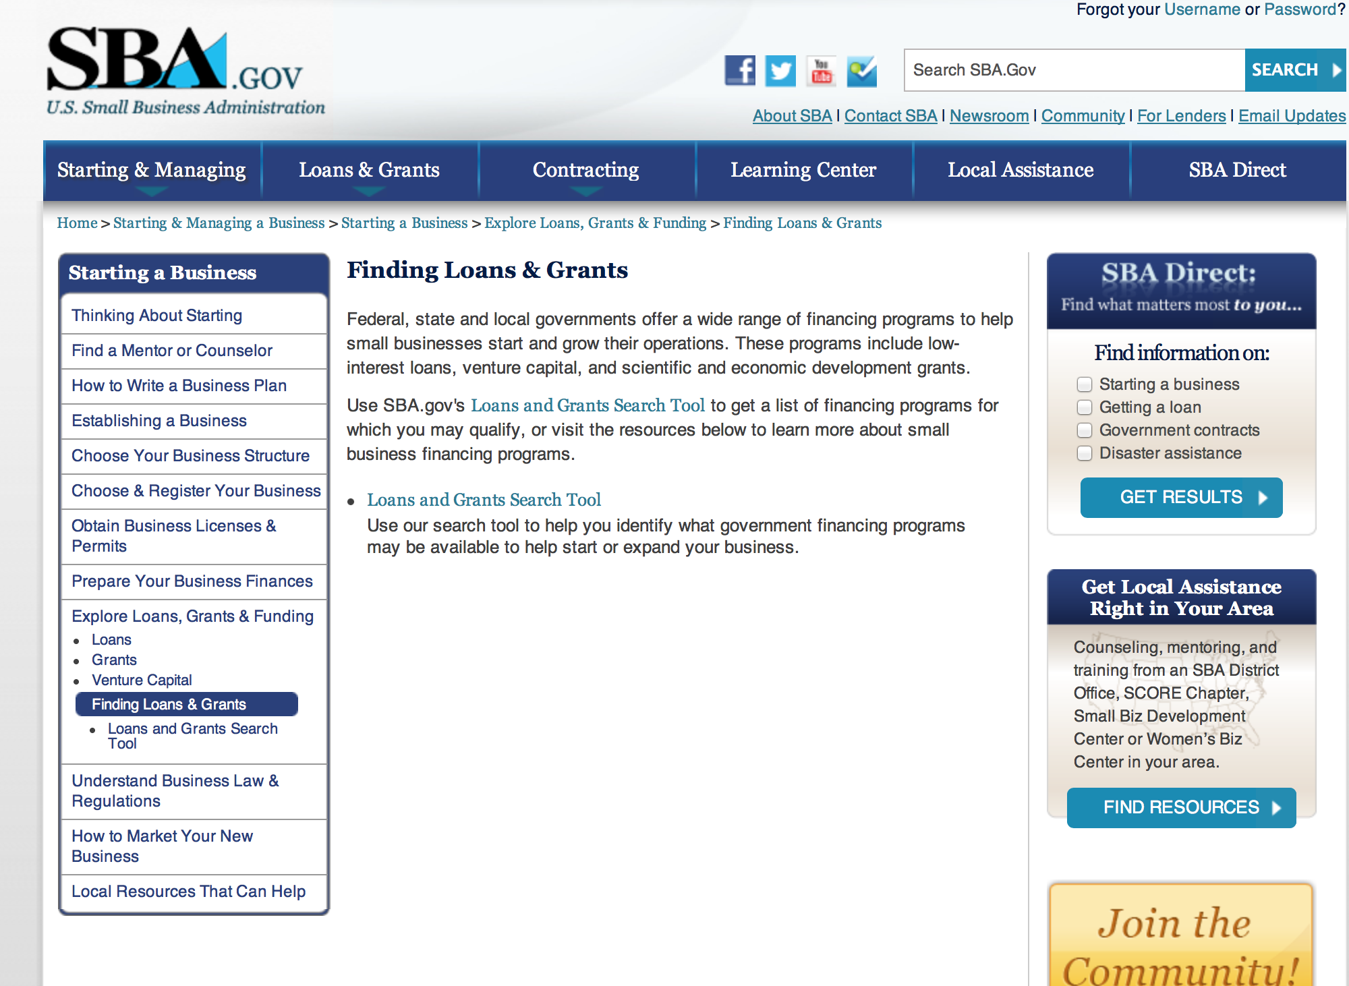
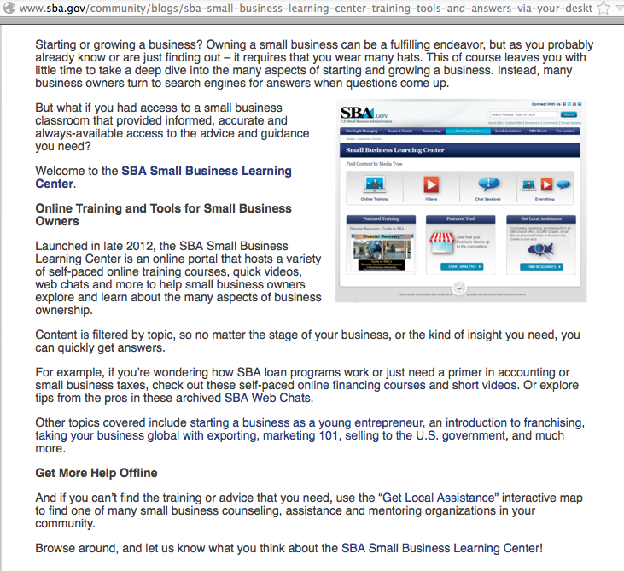

Reminders:

SBA Trainings

Small Business Resources at your Fingertips
http://content.govdelivery.com/accounts/USSBA/bulletins/d23b63

Contracting Opportunities for Veteran Entrepreneurs
This self-paced training exercise is an introduction to Federal contracting opportunities for Veterans.
Topics include basic information about Veteran-owned businesses and opportunities, services available to small Veteran-owned businesses, small business incentives, and government procurement methods.
Duration: 00:30:00

http://www.sba.gov/tools/sba-learning-center/training/contracting-opportunities-veteran-entrepreneurs

Interested in Exporting? These Four Resources Can Help
Did you know that two-thirds of the world’s purchasing power is in foreign countries? As the numbers show, the international marketplace is a big one. So if you’re interested in exploring the world of exporting – or have gotten started but could use some guidance – check out these resources to help.
- Read more

Upcoming Trainings:

Check out SBA's Online Training!
- Financing Options for Small Businesses
How to Prepare Government Contract Proposals

Getting Started With Exporting: Training and Educational Resources
Exporting represents a big opportunity to tap in to new markets, expand your customer base and grow your business. But getting started with exporting can sometimes feel like a maze of regulations, policies, and other barriers. Here are some free training and educational resources to help.
> Read more

For Specific Information in Hawaii see the following links:
Hawaii SBA Resource Guide

Hawaii Express Lenders List

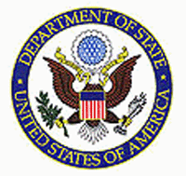

State Department

General Overview and Resources for Program Administrators
Advice on Funding Opportunities:
- The Bureau of Educational & Cultural Affairs Grant Process (PDF)
- Proposal Solicitation Eligibility and Process (PDF)
- Making Your Grant Proposal Competitive (PDF)
- Grantee Recipients - Alumni Outreach, Tracking and Engagement (PDF)
General Information:
- Bureau of Educational and Cultural Affairs Grants Division
- Open Grant Opportunities (Requests for Grant Proposals)

For General Information below click here
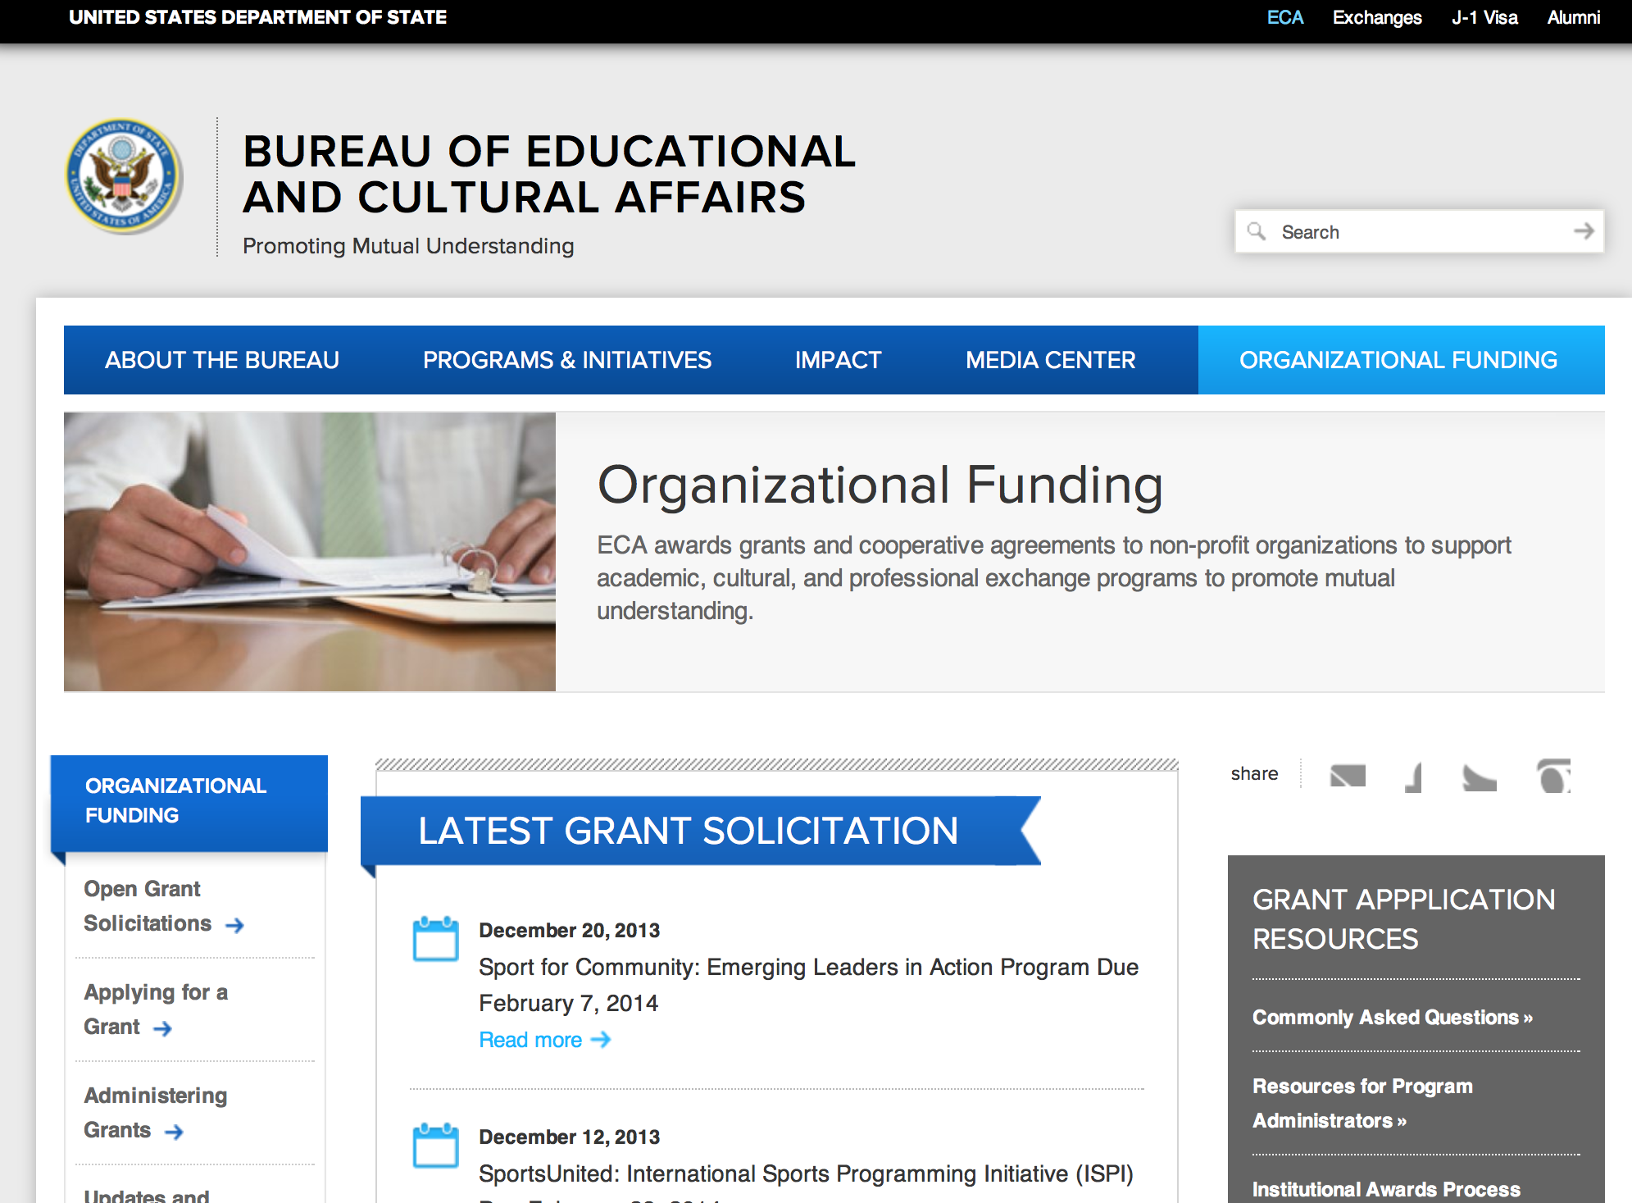

Program Grants:

DRL Request for Statements of Interest on Projects to Address Transitional Justice Processes including Bolstering Accountability for Gross Human Rights Violations Grant
http://www.grants.gov/web/grants/view-opportunity.html?oppId=280012

DRL Request Statement of Interest on Forensic Assistance to Address Legacies of Gross Human Rights Violations Grant
http://www.grants.gov/web/grants/view-opportunity.html?oppId=280013

Bureau of Democracy, Human Rights and Labor
DRL Request Statement of Interest on Forensic Assistance to Address Legacies of Gross Human Rights Violations Grant
http://www.grants.gov/web/grants/view-opportunity.html?oppId=280036

Bureau of Democracy, Human Rights and Labor
DRL Request for Statements of Interest on Projects to Address Transitional Justice Processes including Bolstering Accountability for Gross Human Rights Violations Grant
http://www.grants.gov/web/grants/view-opportunity.html?oppId=280035

Bureau of Democracy, Human Rights and Labor
DRL Request for Statements of Interest on Programs to Support Democratic Reform and Human Rights in Burma Grant
http://www.grants.gov/web/grants/view-opportunity.html?oppId=280357

Bureau of Democracy, Human Rights and Labor
Promoting Increased Civic Engagement in the Lead-Up to Elections in the Democratic Republic of Congo (DRC) Grant
http://www.grants.gov/web/grants/view-opportunity.html?oppId=280286

Bureau of International Security and Nonproliferation
Global Biosecurity Engagement Activities Grant
http://www.grants.gov/web/grants/view-opportunity.html?oppId=280004

Bureau of Near Eastern Affairs
Near East Affairs - Assistance Coordination
MEPI Local Grants Annual Program Statement Grant
http://www.grants.gov/web/grants/view-opportunity.html?oppId=280100

Bureau of International Security and Nonproliferation
Global Chemical Security Activities Grant
http://www.grants.gov/web/grants/view-opportunity.html?oppId=280140

International Narcotics and Law Enforcement Affair
Community Based Policing development in the Kyrgyz Republic Grant
http://www.grants.gov/web/grants/view-opportunity.html?oppId=280000

International Narcotics and Law Enforcement Affair
Criminal Defense Community Development in the Kyrgyz Republic Grant
http://www.grants.gov/web/grants/view-opportunity.html?oppId=280038

Office to Monitor/Combat Trafficking in Persons
J/TIP FY 2016 International Programs to Combat Trafficking in Persons Request for SOIs Grant
http://www.grants.gov/web/grants/view-opportunity.html?oppId=280243

U.S. Mission Mexico Annual Program Statement Grant
http://www.grants.gov/web/grants/view-opportunity.html?oppId=280242

Modifications:

Bureau of Democracy, Human Rights and Labor
Promoting the United Nations Guiding Principles on Business and Human Rights in East Africa
Modifications 2 & 3
http://www.grants.gov/web/grants/view-opportunity.html?oppId=279961

Bureau of International Security and Nonproliferation
Global Biosecurity Engagement Activities
Modification 1
http://www.grants.gov/web/grants/view-opportunity.html?oppId=280004

Bureau of International Security and Nonproliferation
Global Nuclear Security Engagement Activities
Modification 2
http://www.grants.gov/web/grants/view-opportunity.html?oppId=279993

U.S. Mission to Nigeria
U.S. Mission to Nigeria: Ambassadors Fund for Cultural Preservation
Modification 4
http://www.grants.gov/web/grants/view-opportunity.html?oppId=280093

U.S. Mission to Nigeria
Economic support funds to promote countering violent extremism objectives in the West Africa/Sahel region
Modification 4
http://www.grants.gov/web/grants/view-opportunity.html?oppId=280146

U.S. Embassy Colombo Public Affairs Section Grants Program
Modification 1
http://www.grants.gov/web/grants/view-opportunity.html?oppId=280102

Reminders:

Department of Transportation

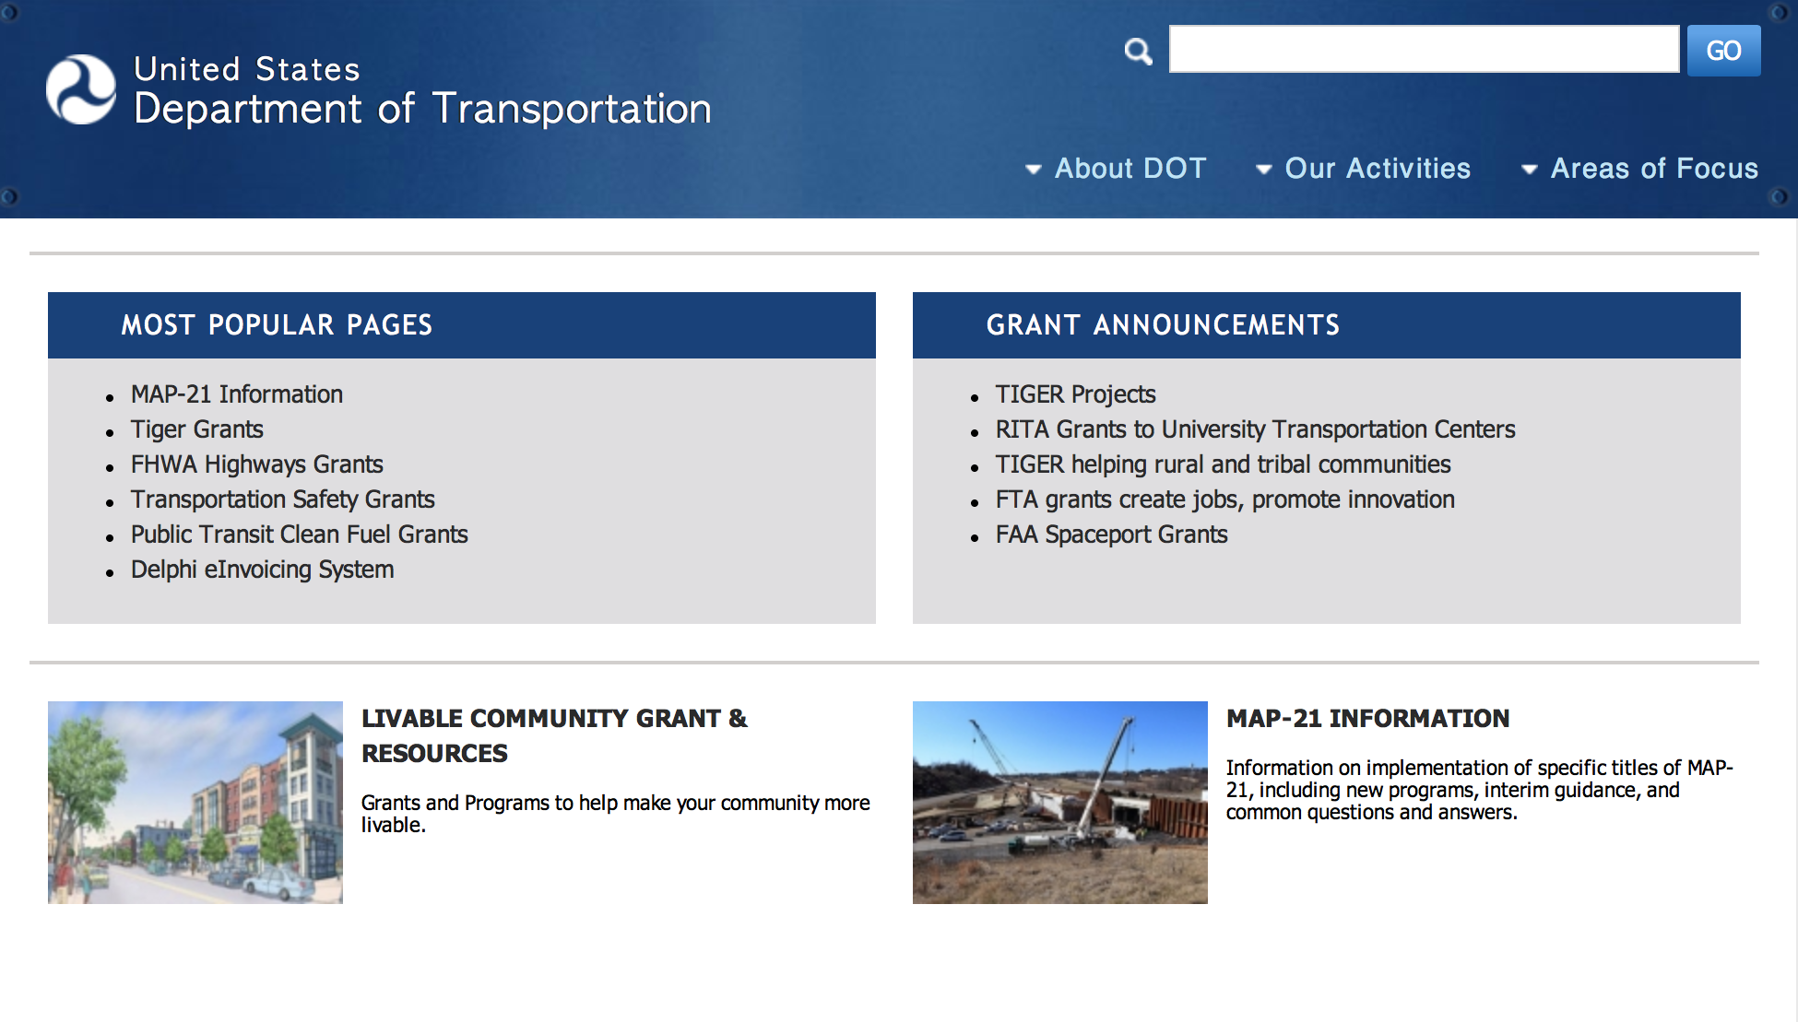
General Grant Program Overview ----- http://www.dot.gov/grants

Modifications:

Reminders:

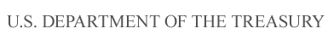

Department of the Treasury

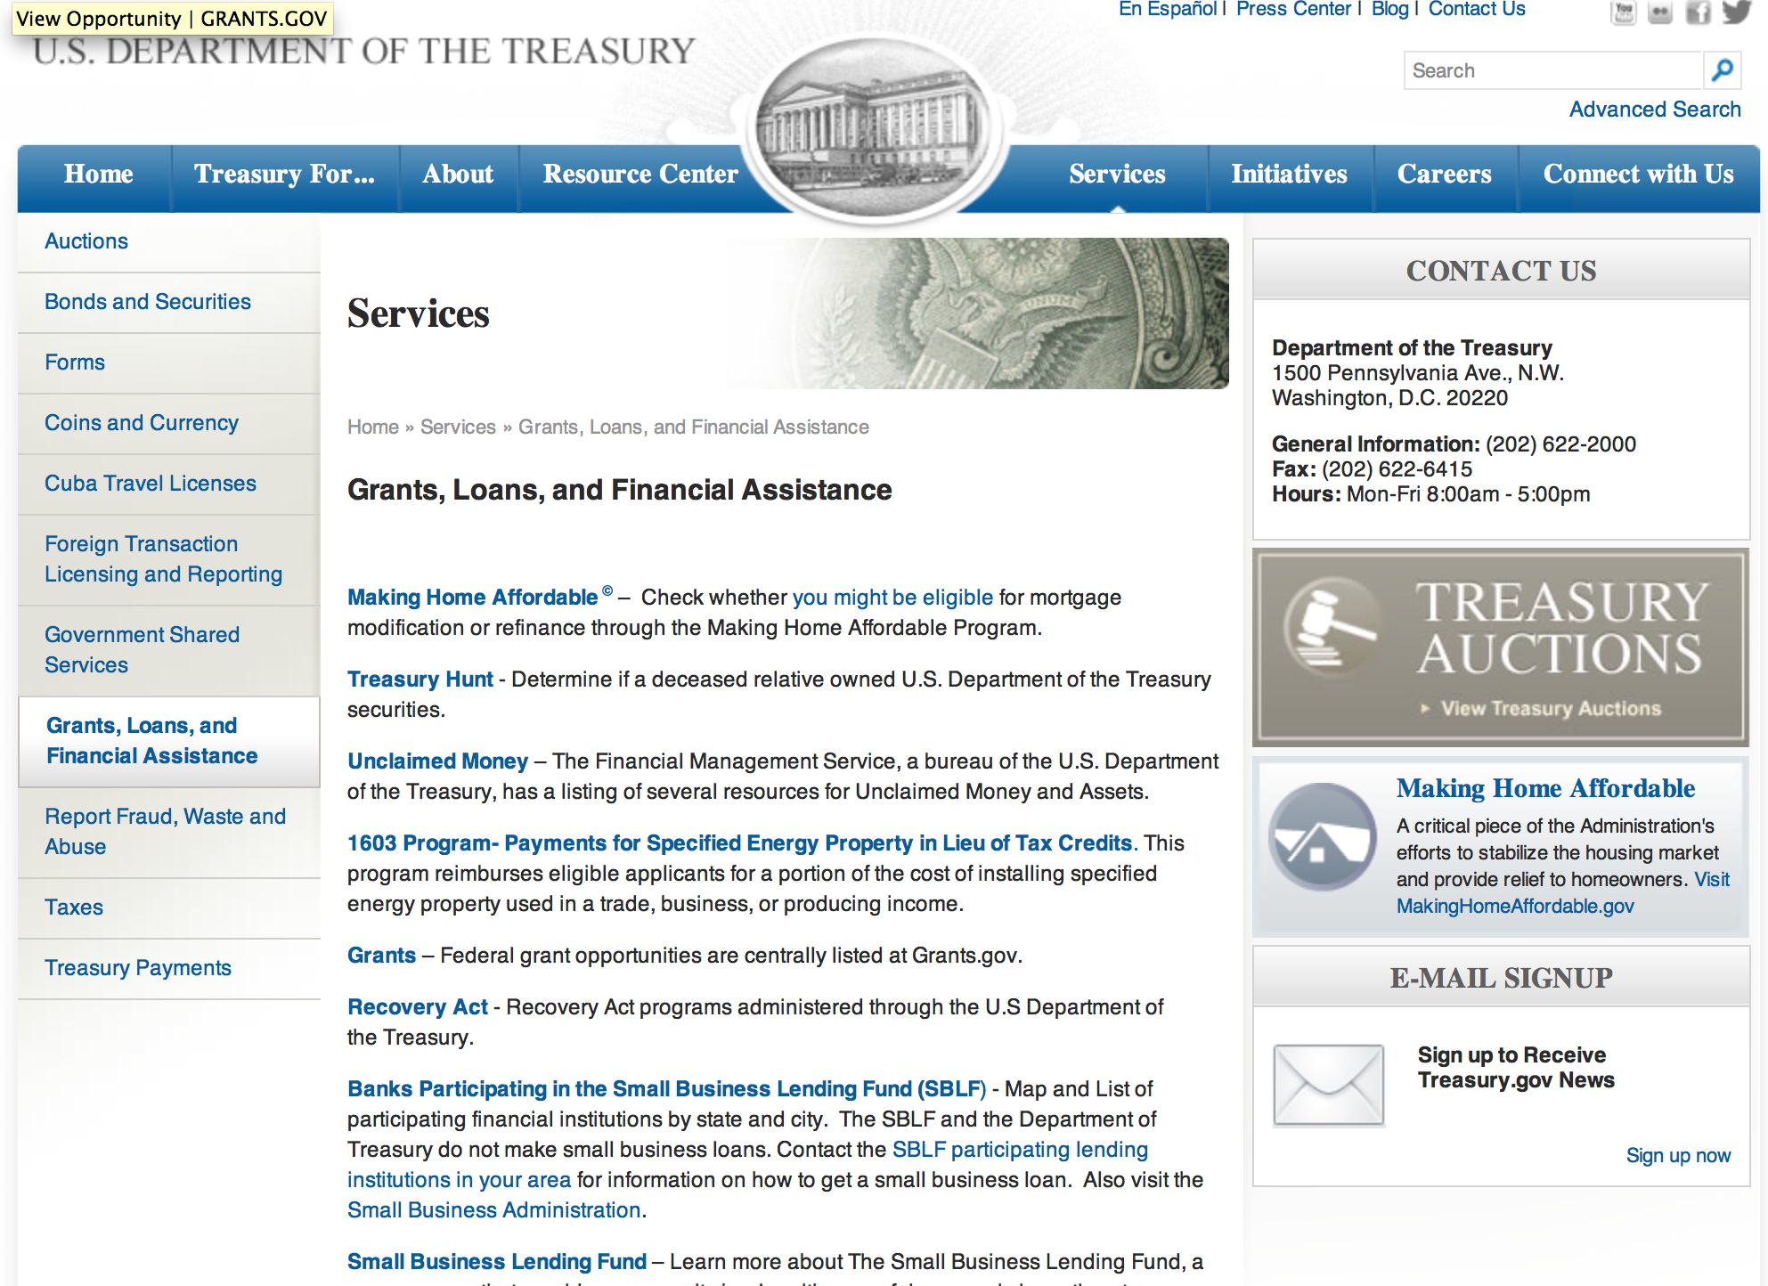

http://www.treasury.gov/services/Pages/Grants-Loans-and-Financial-Assistance.aspx

Modifications:

Reminders:

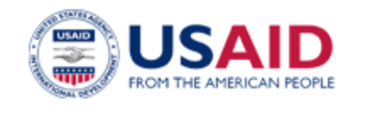

U.S. Agency for International Development

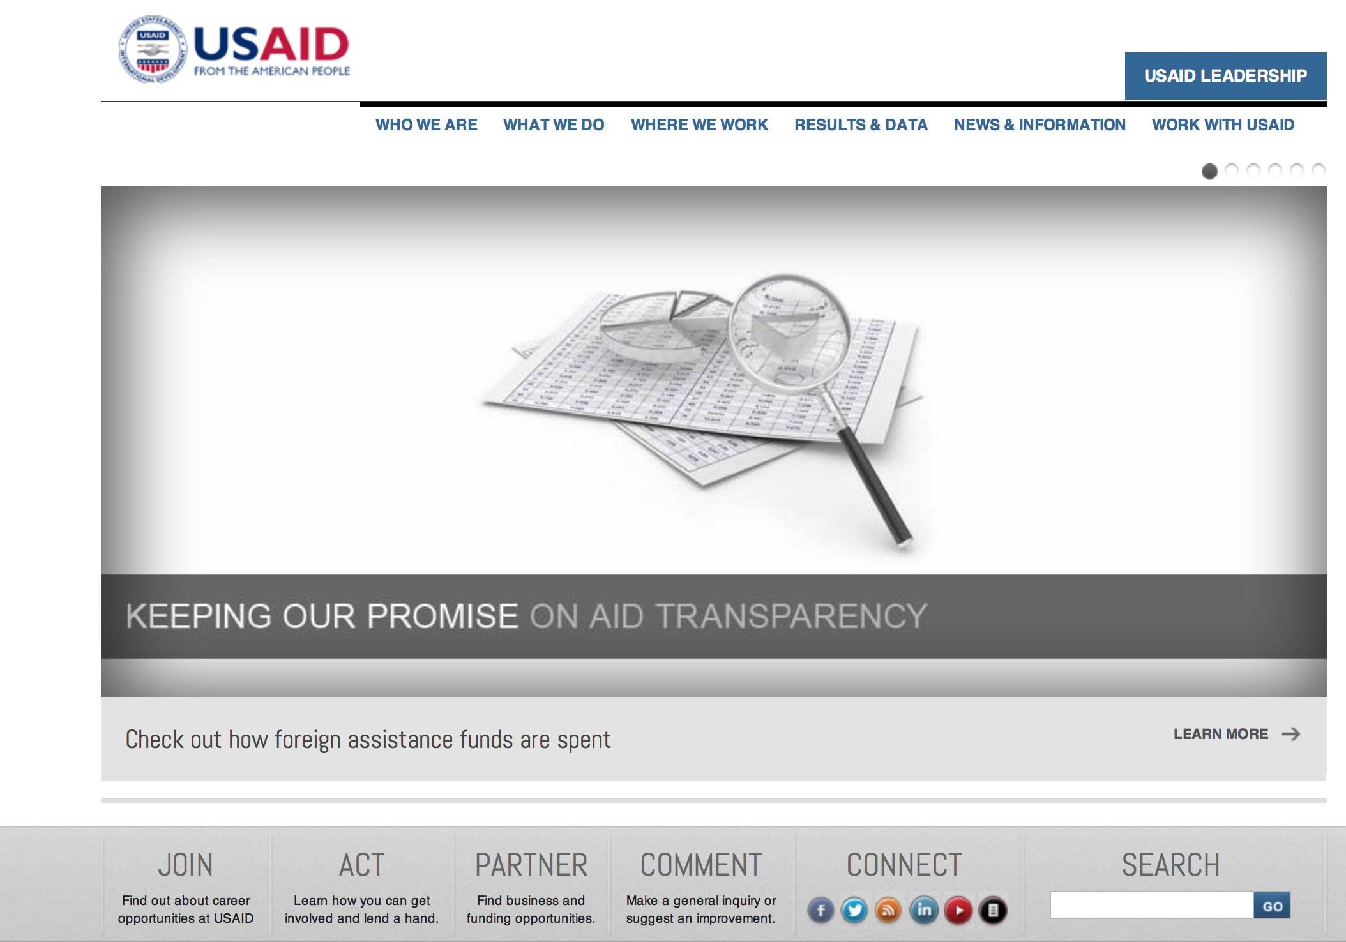
www.usaid.gov

General Overview Funding Opportunities

USAID has working relationships with thousands of American companies and hundreds of U.S.-based private voluntary organizations. For more information on our business and procurement opportunities, please visit our Business section.

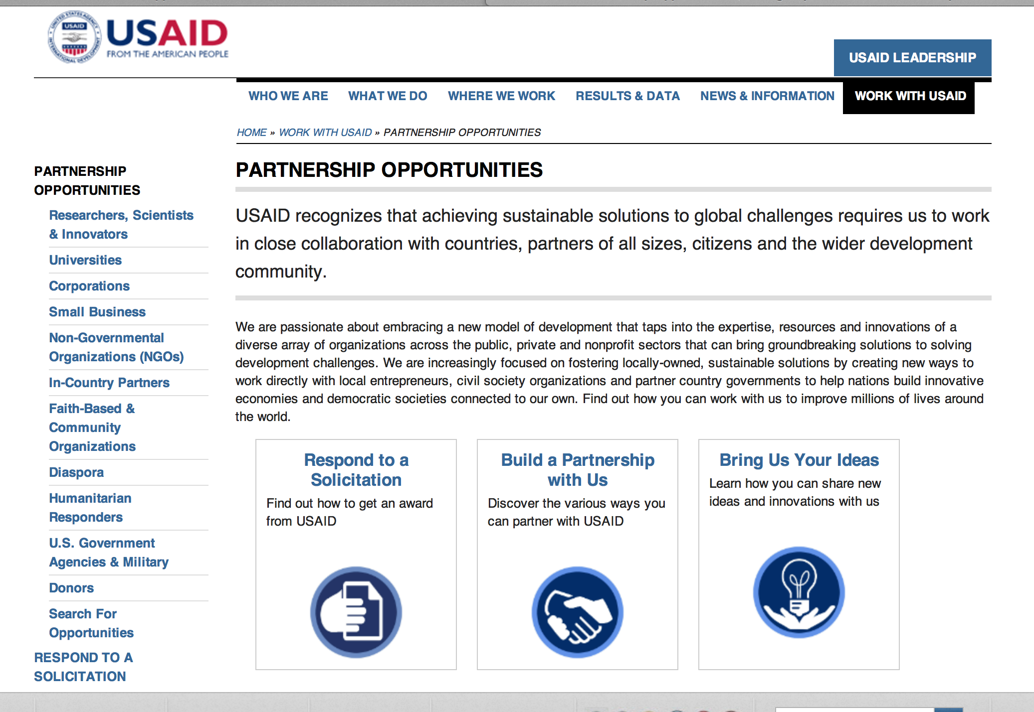
http://www.usaid.gov/partnerships

Programs:

USAID Child Blindness Program Grant
http://www.grants.gov/web/grants/view-opportunity.html?oppId=280061

Health Service Delivery Grant
http://www.grants.gov/web/grants/view-opportunity.html?oppId=280218

Bureau of International Security and Nonproliferation
Global Nuclear Security Engagement Activities Grant
http://www.grants.gov/web/grants/view-opportunity.html?oppId=279993

Bureau of Democracy, Human Rights and Labor
Promoting the United Nations Guiding Principles on Business and Human Rights in Sub-Saharan Africa Grant
http://www.grants.gov/web/grants/view-opportunity.html?oppId=279961

Bureau of Democracy, Human Rights and Labor
DRL FY15 Supporting Human Rights in Afghanistan Grant
http://www.grants.gov/web/grants/view-opportunity.html?oppId=279963

South Africa USAID-Pretoria
Call for Partnership Concept Papers in Support of Power Africa Initiative under Existing Global Development Alliance Annual Program Statement No.APS-OAA-14-000001 Grant
http://www.grants.gov/web/grants/view-opportunity.html?oppId=280133

Catalyzing Private Investment Grant
http://www.grants.gov/web/grants/view-opportunity.html?oppId=280212

Modifications:

Ocean Freight Reimbursement (OFR) Program FY2016 & FY2017
Modification 1
http://www.grants.gov/web/grants/view-opportunity.html?oppId=280226

Development Innovation Ventures
Modification 4
http://www.grants.gov/web/grants/view-opportunity.html?oppId=279760

Peru USAID-Lima
Brazil Partnership Development Program
Modification 1
http://www.grants.gov/web/grants/view-opportunity.html?oppId=274694

The USAID Development Innovation Accelerator BAA
Modification 3
http://www.grants.gov/web/grants/view-opportunity.html?oppId=255248

Reminders:

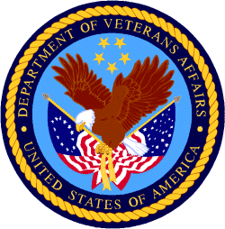

Department of Veterans Affairs

