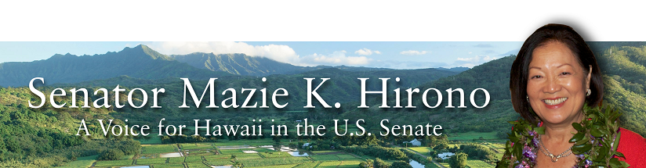
Grants Assistance Information
Newsletter
February 2016

G.A.I.N. INDEX

Click on Index Links below to read summaries of the announcements by agency in this document.
Once you reach the item, if you cannot open the links for further information, copy the selected
URL website address into your browser.

Modified sections from previous listings are shown in a GREY background

Notices is Teal are items with immediate deadline dates.

Notices in Yellow are of special interest.

Notices is Green are items of special interest with immediate deadline dates.

Items in this type color are aimed at Small Businesses

Items in this type color have a Faith-Based Organization component

Special Federal Program Notices

SBIR – Small Business Innovation Research

Programs specific to Hawaii

Current Notices

National Park Service
NAGPRA Consultation/Documentation Grants FY16
Modification 2

Department of the Interior
National Park Service
FY 2016 Historic Preservation Fund Tribal Heritage Grants
Modification 1

Reminders

See Individual Departments for information and webpages representing the best and most accessible information on the agency funding opportunities

Federal Grant and Cooperative Agreement Program Summaries

U.S. Department of Agriculture

Grants and Loans Overview

Programs

Utilities Programs
Distance Learning and Telemedicine Grant Program

National Institute of Food and Agriculture
Agriculture and Food Research Initiative - Food, Agriculture, Natural Resources and Human Sciences Education and Literacy Initiative Grant

National Institute of Food and Agriculture
Capacity Building Grants for Non Land Grant Colleges of Agriculture (NLGCA) Grant

National Institute of Food and Agriculture
FY '16 Farm Business Management and Benchmarking (FBMB) Competitive Grants Program RFA Grant

Modifications

Natural Resources Conservation Service
Wetlands Mitigation Banking Program
Modification 2

Reminders

National Institute of Food and Agriculture
Organic Agriculture Research and Extension Initiative Grant

National Institute of Food and Agriculture
Small Business Innovation Research Program Phase II fiscal year 2016 Grant

Farm Service Agency
Outreach and Education, Technical Assistance, and Financial Education for FSA Programs, Functions, and Activities Grant

Business and Cooperative Programs
Renewable Energy Systems and Energy Efficiency Improvements Program Grant

National Institute of Food and Agriculture
Biotechnology Risk Assessment Grants Program

Farm Service Agency
Outreach and Education, Technical Assistance, and Financial Education for FSA Programs, Functions, and Activities Grant

Department of Commerce

Programs

Market Development Cooperator Program 2016 Grant

National Sea Grant College Program 2016-17 Special Projects Grant

Modifications

National Institute of Standards and Technology
National Strategy for Trusted Identities in Cyberspace (NSTIC) State Pilots Cooperative Agreement Program
Modification 2

Reminders

FY 2016 – FY 2019 EDA Planning Program and Local Technical Assistance Program Grant

Fisheries International Cooperation and Assistance Program Grant

Fiscal Year 2016 NMFS-Sea Grant Fellowships in Population and Ecosystem Dynamics Grant

National Institute of Standards and Technology
Summer Undergraduate Research Fellowship (SURF) Program Grant

National Institute of Standards and Technology
NIST Research Experience for Teachers (NIST RET) Program Grant

National Institute of Standards and Technology
NIST Summer Institute for Middle School Science Teachers (NIST Summer Institute) Program Grant

National Institute of Standards and Technology
Hollings Manufacturing Extension Partnership (MEP) State Partnership Support Project Grant

Fiscal Year 2016 NMFS-Sea Grant Fellowships in Marine Resource Economics Grant
And Modification 1

Next Round of Research to Operations Initiative: NGGPS and HFIP Grant

Next Round of Research to Operations Initiative: NOAA Testbeds Grant

Fiscal Year 2017 National Sea Grant College Program Dean John A. Knauss Marine Policy Fellowship
Grant

FY 2016 Economic Development Assistance Programs ­ Application submission and program requirements for EDA’s Public Works and Economic Adjustment Assistance Programs

Economic Development Administration
Planning Program and Local Technical Assistance Program Grant

Corporation for National and Community Service

General Program Overview

Reminders

FY 2016 Social Innovation Fund Pay for Success Cooperative Agreement Grant

National Service in Hawaii

Department of Defense

Doing Business with the Department of Defense

DoD Small Business Opportunities and Forecasting

Research Grants

Modifications

Reminders

Dept. of the Army -- Materiel Command
Army Research Office Broad Agency Announcement for Basic and Applied Scientific Research
Modification 8

Department of Education

Grant Programs Overview

Programs

Modifications

Office of Elementary and Secondary Education (OESE): College Assistance Migrant Program (CAMP) CFDA Number 84.149A
Modification 1

Office of Elementary and Secondary Education (OESE): High School Equivalency Program (HEP) CFDA Number 84.141A
Modification 1

Reminders

The National Professional Development (NPD) Program (84.365Z) Grant

US Department of Energy

Grants Overview

Programs

Modifications

Reminders

Environmental Protection Agency

Grants and Contracts Overview

Programs

Modifications

Reminders

Department of Health and Human Services

Grants Overview

Program

Office of the Assistant Secretary for Health
Announcement Availability of Funds for the College Sexual Assault Policy and Prevention Initiative
Modification 2

Research Grants

Modifications

Reminders

Substance Abuse & Mental Health Services Administration
Drug-Free Communities (DFC) Support Program Grant

National Institutes of Health
PHS 2015-02 Omnibus Solicitation of the NIH, CDC, FDA and ACF for Small Business Innovation Research Grant Applications (Parent SBIR [R43/R44]) Grant

Department of Homeland Security
Grants Overview

Programs

Modifications

Reminders

United States Coast Guard
National Non-Profit Organization Grant Program

Department of Housing and Urban Development

HUD - Notice of Funds Available

Programs

Housing Opportunities for Persons With AIDS (HOPWA) Project Demonstration and Violence Against Women Act (VAWA) Grant

Supportive Services Demonstration for Elderly Households in HUD-Assisted Multifamily Housing
Grant

Modifications

Reminders

Pay for Success Permanent Supportive Housing Demonstration Grant

General Section to HUD's Fiscal Year 2016 Notice[s] of Funding Availability for Discretionary Programs (General Section)
Modification 1

Institute of Museum and Library Services

Grants Overview

IMLS is on Facebook!

STEM Expert Facilitation of Family Learning in Libraries and Museums

Modifications

Reminders

National Leadership Grants for Libraries Grant

Laura Bush 21st Century Librarian Program Grant

Department of Interior

Grants and Contract Overview

Programs

Modifications

Request for Pre-Proposals to develop and or improve climate change actions' affect on linkages between ecological and human resources
Modification 1

Reminders

Fish and Wildlife Service
National Fish Passage Program Grant

Department of the Interior
Fish and Wildlife Service
2016 National Fish Habitat Action Plan
Modification 1

Department of Justice

Grants and Contract Overview

Programs

Office of Justice Programs
National Institute of Justice
Developing Improved Means to Collect Digital Evidence Grant

Office of Justice Programs
Office on Violence Against Women
OVW FY 2016 Technical Assistance Initiative Solicitation Grant

Office of Justice Programs
National Institute of Justice
Postconviction Testing of DNA Evidence to Exonerate the Innocent Grant

Office of Justice Programs
National Institute of Justice
Research and Evaluation for the Testing and Interpretation of Physical Evidence in Publicly Funded Forensic Laboratories Grant

Office of Justice Programs
Office on Violence Against Women
OVW FY 2016 Training and Services to End Violence Against Women with Disabilities Grant Program

Modifications

Office of Justice Programs
Office of Juvenile Justice Delinquency Prevention
OJJDP FY 16 Second Chance Act Strengthening Relationships Between Young Fathers, Young Mothers, and Their Children
Modification 2

Office of Justice Programs
Office of Juvenile Justice Delinquency Prevention
OJJDP FY 16 Mentoring for Child Victims of Commercial Sexual Exploitation and Domestic Sex Trafficking Initiative
Modifications 2 & 3

Office of Justice Programs
Office on Violence Against Women
OVW FY 2016 Improving Criminal Justice Responses to Sexual Assault, Domestic Violence, Dating Violence, and Stalking Grant Program (also known as the Arrest Program)
Modification 1

Office of Justice Programs
Office on Violence Against Women
OVW FY 2016 Grants to Reduce Sexual Assault, Domestic Violence, Dating Violence, and Stalking on Campus Program
Modification 1

Reminders

Office of Justice Programs
Office on Violence Against Women
OVW FY 2016 Enhanced Training and Services to End Abuse in Later Life Program Grant

Office of Justice Programs
Office on Violence Against Women
OVW FY 2016 Transitional Housing Assistance Grants for Victims of Domestic Violence, Dating Violence, Stalking or Sexual Assault Program Grant

Office of Justice Programs
Office of Juvenile Justice Delinquency Prevention
OJJDP FY 16 Internet Crimes Against Children Task Force National Training Program Grant

Office of Justice Programs
Office of Juvenile Justice Delinquency Prevention
OJJDP FY 16 VOCA Regional Children Advocacy Center Program Grant

Office of Justice Programs
Office of Juvenile Justice Delinquency Prevention
OJJDP FY 16 Mentoring for Child Victims of Commercial Sexual Exploitation and Domestic Sex Trafficking Initiative
Modification 1

Office of Justice Programs
Office on Violence Against Women
OVW FY 2016 Grants to Enhance Culturally Specific Services for Victims of Sexual Assault, Domestic Violence, Dating Violence and Stalking Program Solicitation
Modification 1

Department of Labor

Grants and Contract General Overview

Programs

Modifications

Reminders

Employment and Training Administration
Strengthening Working Families Initiative Grant

Employment and Training Administration
Tech Hire Partnership Grants

National Aeronautics and Space Administration

Research Grant and Contract General Overview

Programs

Modifications

_______________________________________________________________
National Archives and Records Administration

Grant Opportunities General Overview

Reminders

State Board Programming Grants

Publishing Historical Records in Documentary Editions Grant

Access to Historical Records Grant

_______________________________________________________________
National Endowment for the Arts

Grant Opportunities General Overview

Programs

2017 National Heritage Fellowships Awards Program Grant
2017 Mayor's Institute on City Design (MICD) Grant

Modifications

Reminders

NEA Art Works I Application, FY2017 Grant

NEA Art Works Creativity Connects Projects, FY2017 Grant

NEA Challenge America Application, FY2017 Grant

NEA Literature (Poetry) Fellowships, FY2017 Grant

_______________________________________________________________

National Endowment for the Humanities

Grant Opportunities General Overview

Programs

Modifications

Reminders

Landmarks of American History and Culture: Workshops for School Teachers Grant

Summer Seminars and Institutes Grant

Digital Humanities Implementation Grants

Next Generation Humanities PhD Grants

National Science Foundation

Grant Opportunities General Overview

Research and Program Grants

Modifications

Reminders

Nuclear Regulatory Commission

Reminders

Small Business Administration

General Overview Finding Loans & Grants

Reminders

Upcoming Trainings

Links Specific to Hawaii

State Department

General Overview and Resources for Program Administrators

Programs

Modifications

Reminders

U.S. Department of Transportation

General Grant Program Overview

DOT Federal Highway Administration
National Summer Transportation Institute Grant

Modifications

DOT/Federal Motor Carrier Safety Administration
FY2016 Commercial Motor Vehicle Operator Safety Training Grant Program

DOT/Federal Motor Carrier Safety Administration
FY 2016 Commercial Drivers License Program Implementation Notice of Funding Availability
And Modifications 1 & 4

Reminders

Pipeline &Hazardous Material Safety Administration
PHMSA Hazmat Grants
FY2016 Hazardous Materials Instructor Training (HMIT) Grant

DOT Federal Aviation Administration
DOT - FAA Aviation Research Grants
FAA Aviation Research and Development Grants
Modification 3

Department of the Treasury

Modifications

Reminders

US Agency for International Development

General Funding Opportunity Overview

Programs
Modifications

Reminders

Department of Veterans Affairs

VA Loan Guaranty Service
Specially Adapted Housing Assistive Technology Grant

Reminders

Special Federal Program Notices

The Small Business Innovative Research Program - SBIR Program
The Small Business Innovation Research (SBIR) program is a highly competitive program that encourages domestic small businesses to engage in Federal Research/Research and Development (R/R&D) that has the potential for commercialization. Through a competitive awards-based program, SBIR enables small businesses to explore their technological potential and provides the incentive to profit from its commercialization. By including qualified small businesses in the nation's R&D arena, high-tech innovation is stimulated and the United States gains entrepreneurial spirit as it meets its specific research and development needs.

SBIR Mission and Program Goals
The mission of the SBIR program is to support scientific excellence and technological innovation through the investment of Federal research funds in critical American priorities to build a strong national economy.
The program’s goals are four-fold:
- Stimulate technological innovation
- Meet Federal research and development needs.
- Foster and encourage participation in innovation and entrepreneurship by socially and economically disadvantaged persons.
- Increase private-sector commercialization of innovations derived from Federal research and development funding.

SBIR-Participating Agencies
Each year, Federal agencies with extramural research and development (R&D) budgets that exceed $100 million are required to allocate 2.5 percent of their R&D budget to these programs. Currently, eleven Federal agencies participate in the program:
- Department of Agriculture
- Department of Commerce - National Institute of Standards and Technology
- Department of Commerce - National Oceanic and Atmospheric Administration
- Department of Defense
- Department of Education
- Department of Energy
- Department of Health and Human Services
- Department of Homeland Security
- Department of Transportation
- Environmental Protection Agency
- National Aeronautics and Space Administration
- National Science Foundation
Each agency administers its own individual program within guidelines established by Congress. These agencies designate R&D topics in their solicitations and accept proposals from small businesses. Awards are made on a competitive basis after proposal evaluation.

Three-Phase Program
The SBIR Program is structured in three phases:
Phase I. The objective of Phase I is to establish the technical merit, feasibility, and commercial potential of the proposed R/R&D efforts and to determine the quality of performance of the small business awardee organization prior to providing further Federal support in Phase II. SBIR Phase I awards normally do not exceed $150,000 total costs for 6 months.
Phase II. The objective of Phase II is to continue the R/R&D efforts initiated in Phase I. Funding is based on the results achieved in Phase I and the scientific and technical merit and commercial potential of the project proposed in Phase II. Only Phase I awardees are eligible for a Phase II award. SBIR Phase II awards normally do not exceed $1,000,000 total costs for 2 years.
Phase III. The objective of Phase III, where appropriate, is for the small business to pursue commercialization objectives resulting from the Phase I/II R/R&D activities. The SBIR program does not fund Phase III. Some Federal agencies, Phase III may involve follow-on non-SBIR funded R&D or production contracts for products, processes or services intended for use by the U.S. Government
SBIR NewsLetter

- SBIR Newsletter
Sign up for e-mail updates

HAWAII APPLICANTS ENCOURAGED

Current Notices:

National Park Service
NAGPRA Consultation/Documentation Grants FY16
Modification 2

Document Type: | Grants Notice
Funding Opportunity Number: | P16AS00002
Funding Opportunity Title: | NAGPRA Consultation/Documentation Grants FY16
Opportunity Category: | Discretionary
Funding Instrument Type: | Grant
Category of Funding Activity: | Other (see text field entitled "Explanation of Other Category of Funding Activity" for clarification)
Category Explanation: | Cultural Resources
Expected Number of Awards: | 20
CFDA Number(s): | 15.922 -- Native American Graves Protection and Repatriation Act
Cost Sharing or Matching Requirement: | No
Posted Date: | Dec 15, 2015
Creation Date: | Jan 6, 2016
Original Closing Date for Applications: | Mar 11, 2016
Current Closing Date for Applications: | Mar 11, 2016
Archive Date: | Apr 11, 2016
Estimated Total Program Funding: | $1,750,000
Award Ceiling: | $0
Award Floor: | $0
Eligible Applicants: | Private institutions of higher education  Nonprofits having a 501(c)(3) status with the IRS, other than institutions of higher education  Native American tribal organizations (other than Federally recognized tribal governments)  Native American tribal governments (Federally recognized)  Public and State controlled institutions of higher education
Agency Name: | National Park Service
Description: | Consultation. Museums and Federal agencies must consult with known Indian tribes and Native Hawaiian organizations in compiling a NAGPRA inventory and when responding to claims and interests of potential claimants to items in the NAGPRA summary. Consultation should lead to determining control, treatment and disposition of NAGPRA-related human remains and objects. The consultation process is outlined in 43 CFR 10.5, 10.8 (a),10.9 (b) and 10.11.Documentation. The term documentation refers to data that will lead to determining the geographical origin, cultural affiliation, and basic facts surrounding the acquisition of Native American human remains and cultural items to further the NAGPRA process.
Link to Additional Information: | http://www.nps.gov/nagpra/GRANTS/INDEX.HTM
Contact Information: | If you have difficulty accessing the full announcement electronically, please contact:  Melanie O'Brien, 202-354-2201 Nagpra_Grants@nps.gov  Nagpra_Grants@nps.gov

http://www.grants.gov/web/grants/view-opportunity.html?oppId=279655

Department of the Interior
National Park Service
FY 2016 Historic Preservation Fund Tribal Heritage Grants
Modification 1

Document Type: | Grants Notice
Funding Opportunity Number: | P16AS00042
Funding Opportunity Title: | FY 2016 Historic Preservation Fund Tribal Heritage Grants
Opportunity Category: | Discretionary
Funding Instrument Type: | Grant
Category of Funding Activity: | Other (see text field entitled "Explanation of Other Category of Funding Activity" for clarification)
Category Explanation: | Cultural Heritage and Historic Preservation
Expected Number of Awards: | 13
CFDA Number(s): | 15.904 -- Historic Preservation Fund Grants-In-Aid
Cost Sharing or Matching Requirement: | No
Posted Date: | Jan 29, 2016
Creation Date: | Feb 1, 2016
Original Closing Date for Applications: | Mar 31, 2016
Current Closing Date for Applications: | Mar 31, 2016
Archive Date: | Apr 1, 2016
Estimated Total Program Funding: | $450,000
Award Ceiling: | $55,000
Award Floor: | $5,000
Eligible Applicants: | Others (see text field entitled "Additional Information on Eligibility" for clarification)  Native American tribal governments (Federally recognized)
Additional Information on Eligibility: | Federally recognized Indian Tribes, Alaskan Natives, and Native Hawaiian Organizations as defined by 54 U.S.C. 300314.
Agency Name: | National Park Service
Description: | The National Historic Preservation Act of 1966 authorizes grants to Federally recognized Indian tribes for cultural and historic preservation projects. These grants assist Indian Tribes, Alaskan Natives, and Native Hawaiian Organizations in protecting and promoting their unique cultural heritage and traditions.
Link to Additional Information: | http://www.nps.gov/thpo/tribal-heritage/
Contact Information: | If you have difficulty accessing the full announcement electronically, please contact:  Madeline Konz 202-354-2064 Madeline_Konz@nps.gov  madeline_konz@nps.gov

http://www.grants.gov/web/grants/view-opportunity.html?oppId=281184

Reminders:

Reminders:

Please review each department’s General Grant and Funding Overview. These overviews are the key web pages on each departmental website dedicated to the agency’s funding opportunities. Check back often to note the department updates and use these sources to assist you in your planning.

Federal Grant and Cooperative Agreement Program Summaries

U.S. Department of Agriculture



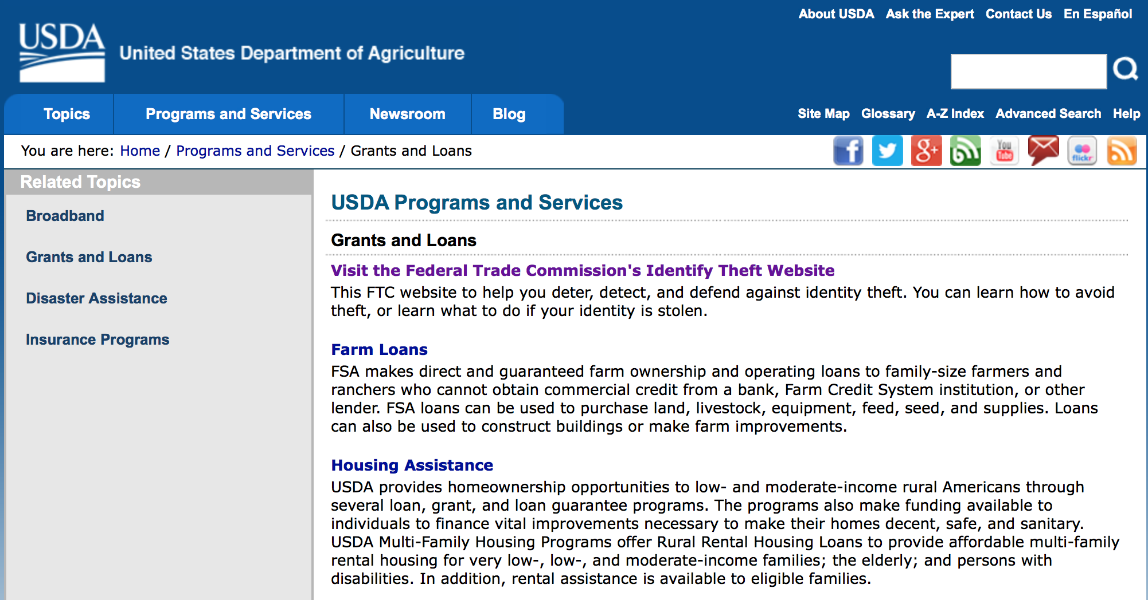
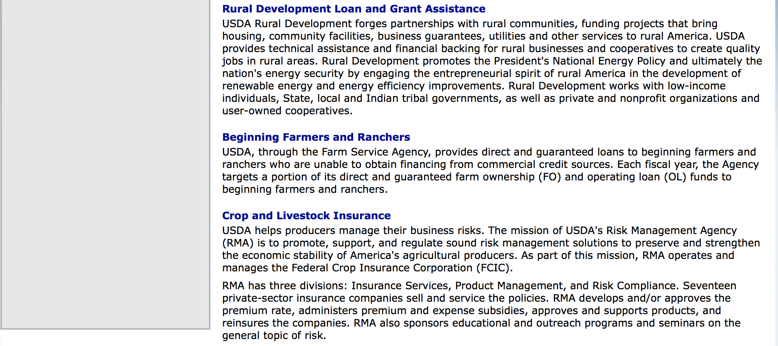

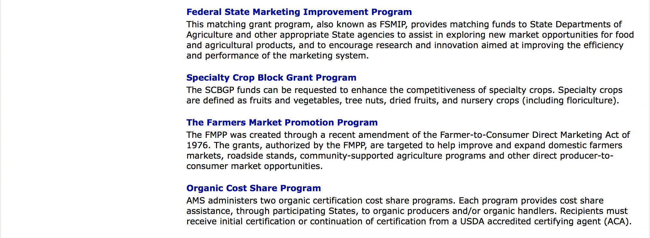

http://usda.gov/wps/portal/usda/usdahome?navid=GRANTS_LOANS

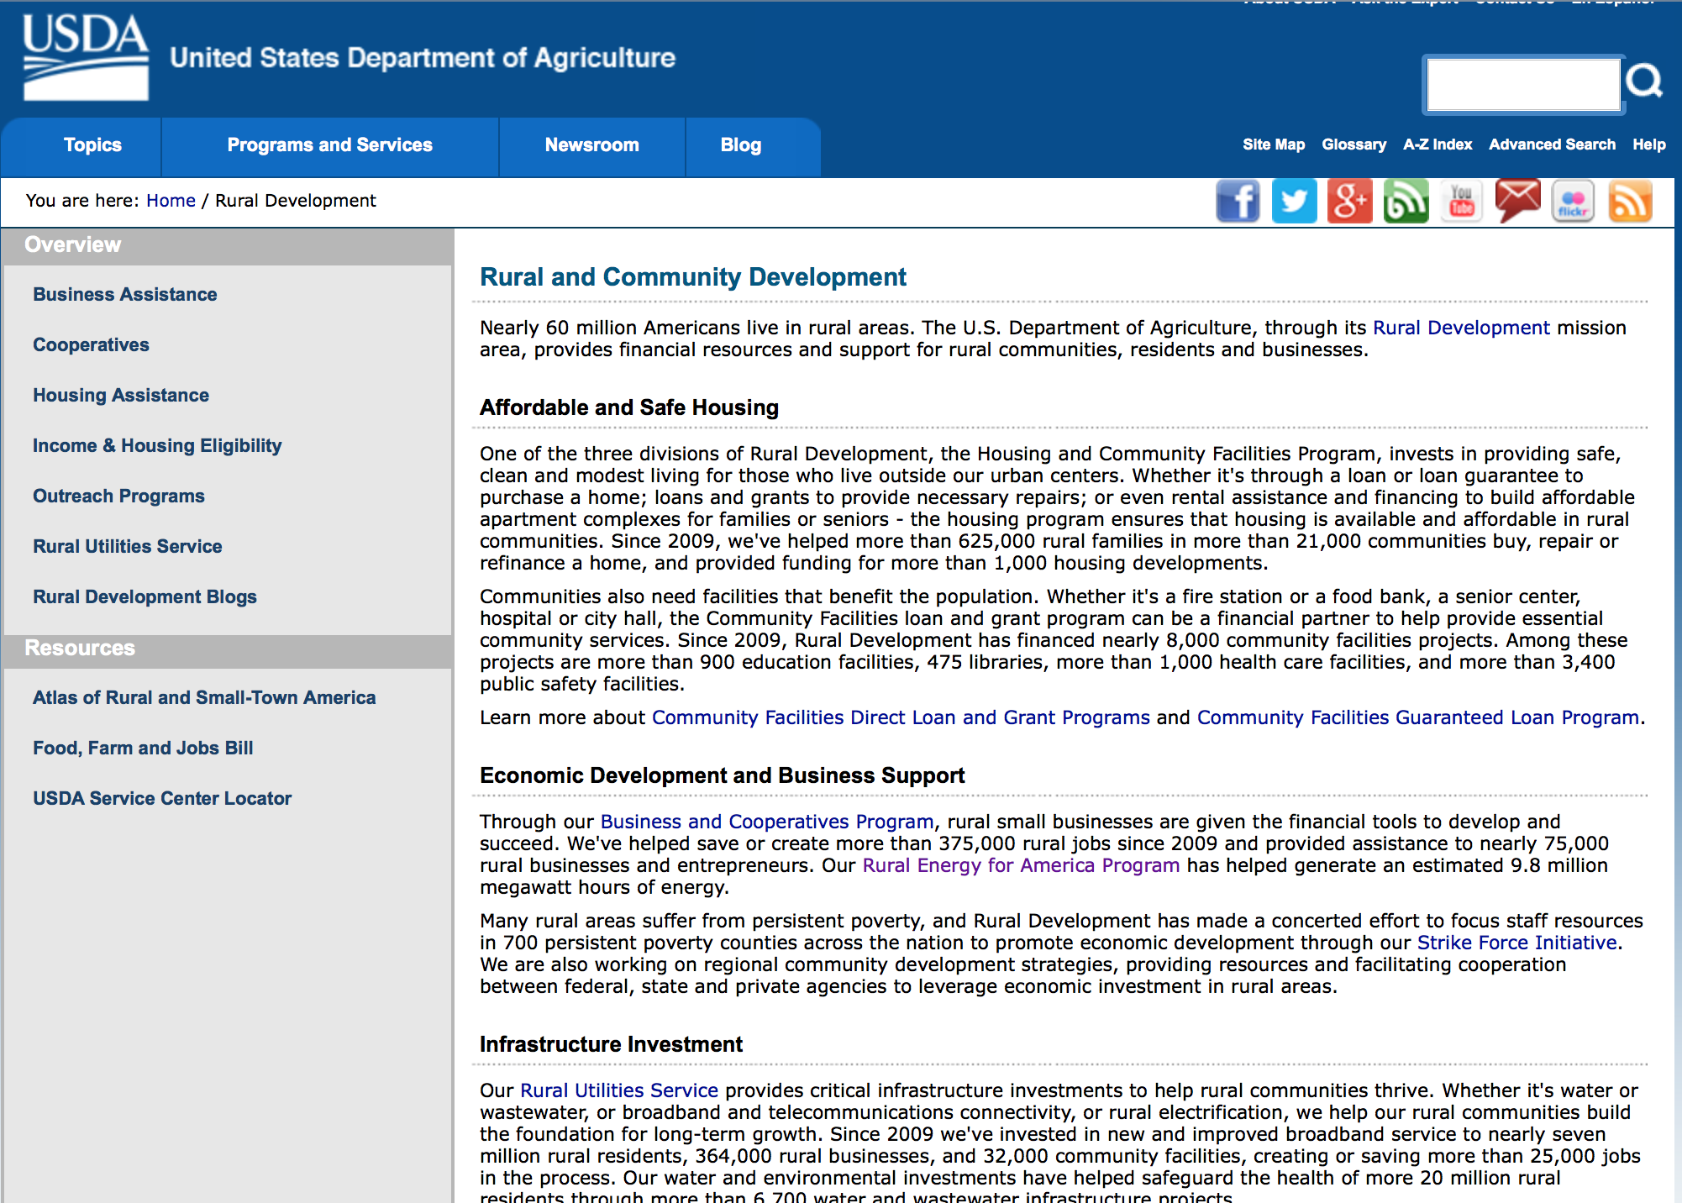

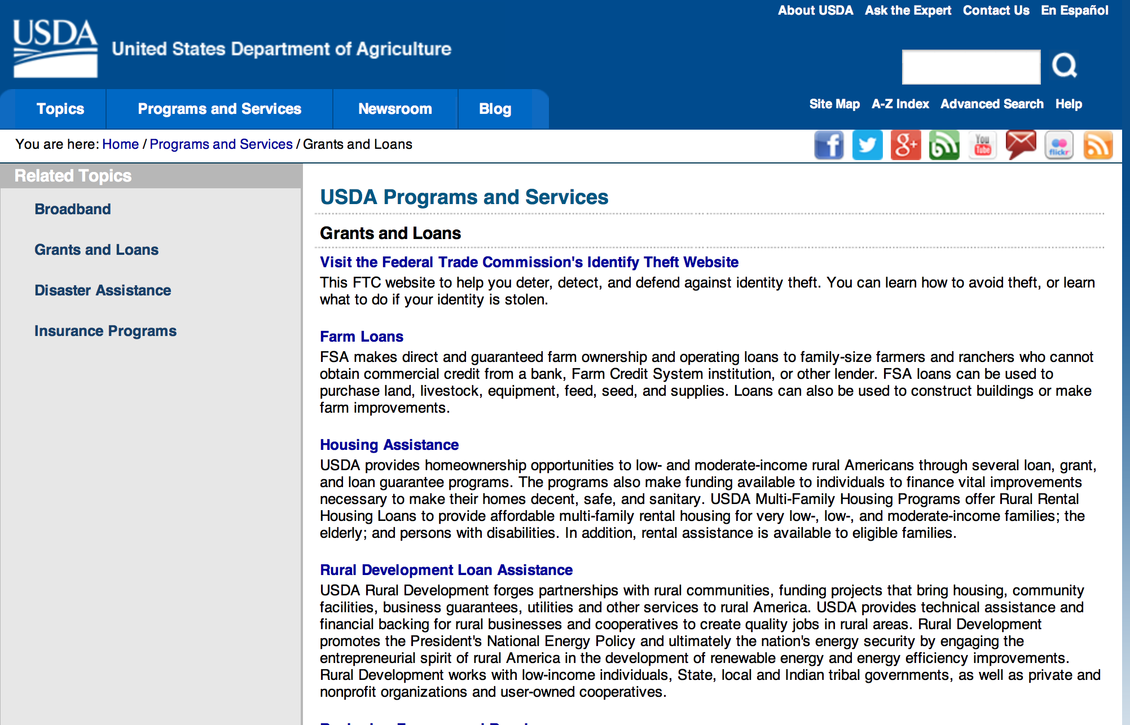

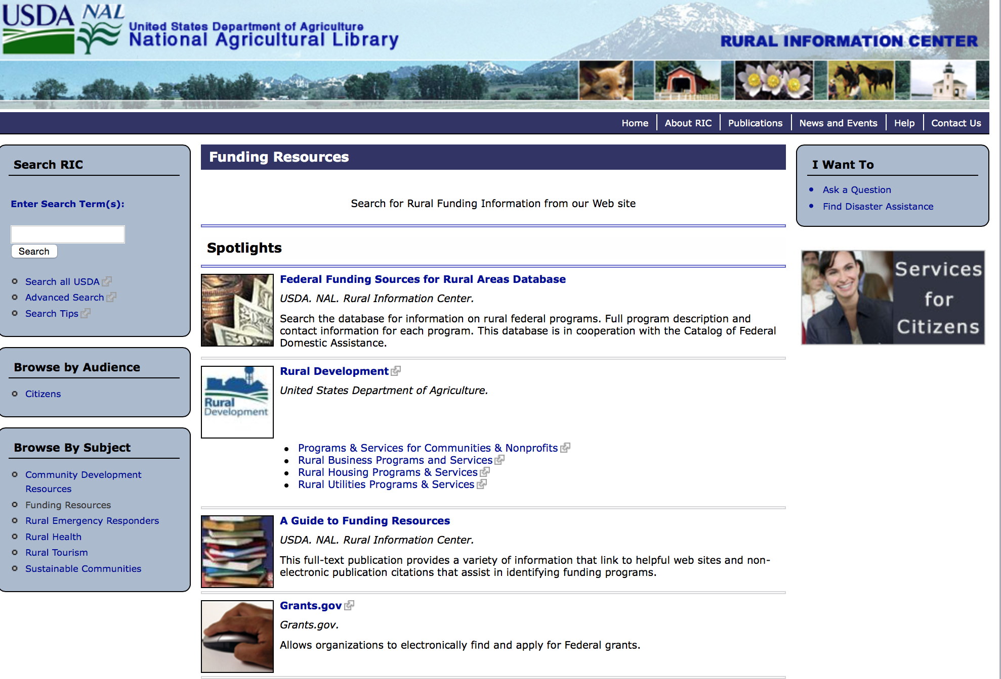

Federal Faith-Based Centers and Community Initiatives
USDA. NAL. Rural Information Center.
- Center for Faith-Based and Community Initiatives (link is external) , U.S. Department of Education
- Center for Faith-Based and Community Initiatives (link is external) , U.S. Department of Health and Human Services
- Center for Faith-Based and Community Initiatives (link is external) , U.S. Department of Labor
- Faith-Based and Community Initiatives (link is external) , U.S. Agency for International Development
- Faith-Based and Community Initiatives (link is external) , U.S. Department of Agriculture
- Faith-Based and Community Initiatives (link is external) , U.S. Department of Housing and Urban Development
- Faith-Based and Other Community Initiatives (link is external) , Corporation for National Community Service
- Task Force for Faith-Based and Community Initiatives (link is external) , U.S. Department of Justice

Grant Writing Resources
- Proposal Writing Short Course (link is external) Foundation Center.
- Data Universal Numbering System Fact sheet (link is external) [PDF | 302.2KB] USDA Rural Development.
- General Tips on Writing a Competitive Grant Proposal (link is external) U.S. Environmental Protection Agency.
- How to Write a Grant Proposal (link is external) Appalachian Regional Commission.<.li>

A Guide to Funding Resources USDA Rural Information Center.

http://ric.nal.usda.gov/funding-resources

http://usda.gov/wps/portal/usda/usdahome?navid=GRANTS_LOANS

Programs:

Utilities Programs
Distance Learning and Telemedicine Grant Program

Document Type: | Grants Notice
Funding Opportunity Number: | RUS-16-01-DLT
Funding Opportunity Title: | Distance Learning and Telemedicine Grant Program
Opportunity Category: | Discretionary
Funding Instrument Type: | Grant
Category of Funding Activity: | Community Development  Education  Health
Category Explanation:
Expected Number of Awards: | 65
CFDA Number(s): | 10.855 -- Distance Learning and Telemedicine Loans and Grants
Cost Sharing or Matching Requirement: | Yes
Posted Date: | Jan 14, 2016
Creation Date: | Jan 14, 2016
Original Closing Date for Applications: | Mar 14, 2016
Current Closing Date for Applications: | Mar 14, 2016
Archive Date: | Apr 13, 2016
Estimated Total Program Funding: | $19,000,000
Award Ceiling: | $500,000
Award Floor: | $50,000
Eligible Applicants: | Native American tribal organizations (other than Federally recognized tribal governments)  Small businesses  Independent school districts  Nonprofits having a 501(c)(3) status with the IRS, other than institutions of higher education  Public and State controlled institutions of higher education  Native American tribal governments (Federally recognized)  State governments  Private institutions of higher education  County governments  City or township governments  For profit organizations other than small businesses  Special district governments  Nonprofits that do not have a 501(c)(3) status with the IRS, other than institutions of higher education
Agency Name: | Utilities Programs
Description: | Distance Learning and Telemedicine Grant Program
Link to Additional Information: | Program Web Site
Contact Information: | If you have difficulty accessing the full announcement electronically, please contact:  Randall Millhiser DLT Coordinator Phone 2027200800  Agency Contact

http://www.grants.gov/web/grants/view-opportunity.html?oppId=280973

National Institute of Food and Agriculture
Agriculture and Food Research Initiative - Food, Agriculture, Natural Resources and Human Sciences Education and Literacy Initiative Grant

Document Type: | Grants Notice
Funding Opportunity Number: | USDA-NIFA-AFRI-005576
Funding Opportunity Title: | Agriculture and Food Research Initiative - Food, Agriculture, Natural Resources and Human Sciences Education and Literacy Initiative
Opportunity Category: | Discretionary
Funding Instrument Type: | Grant
Category of Funding Activity: | Agriculture  Education
Category Explanation:
Expected Number of Awards:
CFDA Number(s): | 10.310 -- Agriculture and Food Research Initiative (AFRI)
Cost Sharing or Matching Requirement: | Yes
Posted Date: | Jan 7, 2016
Creation Date: | Jan 7, 2016
Original Closing Date for Applications: | Mar 24, 2016 February 11, 2016 (for the Predoctoral and Postdoctoral Fellowships Programs), March 18, 2016 (for the Professional Development Opportunities for Secondary School Teachers Programs) and March 24, 2016 (for the Research and Extension Experiential Learning for Undergraduate Fellowships)
Current Closing Date for Applications: | Mar 24, 2016 February 11, 2016 (for the Predoctoral and Postdoctoral Fellowships Programs), March 18, 2016 (for the Professional Development Opportunities for Secondary School Teachers Programs) and March 24, 2016 (for the Research and Extension Experiential Learning for Undergraduate Fellowships)
Archive Date: | Apr 23, 2016
Estimated Total Program Funding: | $18,900,000
Eligible Applicants: | Others (see text field entitled "Additional Information on Eligibility" for clarification)
Additional Information on Eligibility: | See Part III, A., Eligible Applicants. Eligibility is linked to the project type. All project types are described beginning in Part II, C.
Agency Name: | National Institute of Food and Agriculture
Description: | The AFRI Food, Agriculture, Natural Resources, and Human Sciences Education and Literacy Initiative (ELI) provides fellowships to undergraduate, predoctoral, and postdoctoral students in the agricultural sciences.
Link to Additional Information: | Agriculture and Food Research Initiative - Food, Agriculture, Natural Resources and Human Sciences Education and Literacy Initiative
Contact Information: | If you have difficulty accessing the full announcement electronically, please contact:  NIFA Help Desk Phone: 202-401-5048 Business hours are M-F, 7:00 am -5:00 pm ET, excluding Federal holidays  If you have any questions related to preparing application content

http://www.grants.gov/web/grants/view-opportunity.html?oppId=280861

National Institute of Food and Agriculture
Capacity Building Grants for Non Land Grant Colleges of Agriculture (NLGCA) Grant

Document Type: | Grants Notice
Funding Opportunity Number: | USDA-NIFA-NLGCA-005637
Funding Opportunity Title: | Capacity Building Grants for Non Land Grant Colleges of Agriculture (NLGCA)
Opportunity Category: | Discretionary
Funding Instrument Type: | Grant
Category of Funding Activity: | Agriculture
Category Explanation:
Expected Number of Awards:
CFDA Number(s): | 10.326 -- Capacity Building for Non-Land Grant Colleges of Agriculture (NLGCA)
Cost Sharing or Matching Requirement: | No
Posted Date: | Jan 27, 2016
Creation Date: | Jan 27, 2016
Original Closing Date for Applications: | Apr 22, 2016
Current Closing Date for Applications: | Apr 22, 2016
Archive Date: | May 22, 2016
Estimated Total Program Funding: | $4,650,000
Award Ceiling: | $750,000
Award Floor: | $30,000
Eligible Applicants: | Others (see text field entitled "Additional Information on Eligibility" for clarification)
Additional Information on Eligibility: | Applications may only be submitted by a Non-Land Grant College of Agriculture (NLGCAs) certified as such by the National Institute of Food and Agriculture. In order for an institution to qualify as a NLGCA, it must be a public college or university offering a baccalaureate or higher degree in the study of food and agricultural sciences, as defined in 7 U.S.C. 3103(9). A list of NLGCA’s certified by NIFA can be found on the NIFA website.
Agency Name: | National Institute of Food and Agriculture
Description: | NLGCA Institutions may use the funds: (a) to successfully compete for funds from Federal grants and other sources to carry out educational, research, and outreach activities that address priority concerns of national, regional, State, and local interest; (b) to disseminate information relating to priority concerns to interested members of the agriculture, renewable resources, and other relevant communities, the public, and any other interested entity; (c) to encourage members of the agriculture, renewable resources, and other relevant communities to participate in priority education, research, and outreach activities by providing matching funding to leverage grant funds; and (d) through: (1) the purchase or other acquisition of equipment and other infrastructure (not including alteration, repair, renovation, or construction of buildings); (2) the professional growth and development of the faculty of the NLGCA Institution; and (3) the development of graduate assistantships.
Link to Additional Information: | Capacity Building Grants for Non Land Grant Colleges of Agriculture (NLGCA)
Contact Information: | If you have difficulty accessing the full announcement electronically, please contact:  NIFA Help Desk Phone: 202-401-5048 Business hours are M-F, 7:00 am -5:00 pm ET, excluding Federal holidays  If you have any questions related to preparing application content

http://www.grants.gov/web/grants/view-opportunity.html?oppId=281187

National Institute of Food and Agriculture
FY '16 Farm Business Management and Benchmarking (FBMB) Competitive Grants Program RFA Grant

Document Type: | Grants Notice
Funding Opportunity Number: | USDA-NIFA-FBMB-005638
Funding Opportunity Title: | FY '16 Farm Business Management and Benchmarking (FBMB) Competitive Grants Program RFA
Opportunity Category: | Discretionary
Funding Instrument Type: | Grant
Category of Funding Activity: | Agriculture
Category Explanation:
Expected Number of Awards:
CFDA Number(s): | 10.319 -- Farm Business Management and Benchmarking Competitive Grants Program
Cost Sharing or Matching Requirement: | Yes
Posted Date: | Feb 1, 2016
Creation Date: | Feb 1, 2016
Original Closing Date for Applications: | Apr 11, 2016
Current Closing Date for Applications: | Apr 11, 2016
Archive Date: | May 11, 2016
Estimated Total Program Funding: | $1,350,000
Eligible Applicants: | Others (see text field entitled "Additional Information on Eligibility" for clarification)
Additional Information on Eligibility: | Applications may be submitted by numerous entities. Pursuant to 7 U.S.C. 450i(b)(7), eligible applicants means: (A) State agricultural experiment stations; (B) Colleges and universities; (C) University research foundations; (D) Other research institutions and organizations; (E) Federal agencies; (F) National laboratories; (G) Private organizations or corporations: (H) Individuals; or (I) Any group consisting of two (2) or more of the entities described in subparagraphs (A) through (H).
Agency Name: | National Institute of Food and Agriculture
Description: | The Farm Business Management and Benchmarking (FBMB) Competitive Grants Program provides funds to (1) improve the farm management knowledge and skills of agricultural producers; and (2) establish and maintain a national, publicly available farm financial management database to support improved farm management
Link to Additional Information: | FY '16 Farm Business Management and Benchmarking Competitive Grants Program RFA
Contact Information: | If you have difficulty accessing the full announcement electronically, please contact:  NIFA Help Desk Phone: 202-401-5048 Business hours are M-F, 7:00 am -5:00 pm ET, excluding Federal holidays  If you have any questions related to preparing application content

http://www.grants.gov/web/grants/view-opportunity.html?oppId=281273

Modifications:

Natural Resources Conservation Service
Wetlands Mitigation Banking Program
Modification 2

Document Type: | Grants Notice
Funding Opportunity Number: | USDA-NRCS-NHQ-WMBP-16-01
Funding Opportunity Title: | Wetlands Mitigation Banking Program
Opportunity Category: | Discretionary
Funding Instrument Type: | Grant
Category of Funding Activity: | Agriculture  Environment  Natural Resources
Category Explanation:
Expected Number of Awards: | 20
CFDA Number(s): | 10.933 -- Wetlands Mitigation Banking Program
Cost Sharing or Matching Requirement: | No
Posted Date: | Jan 28, 2016
Creation Date: | Jan 28, 2016
Original Closing Date for Applications: | Mar 18, 2016 Applications must be received by 5pm, EST.
Current Closing Date for Applications: | Mar 28, 2016 Applications must be received by 5pm, EST.
Archive Date: | Apr 17, 2016
Estimated Total Program Funding: | $9,000,000
Award Ceiling: | $1,000,000
Eligible Applicants: | State governments  Nonprofits having a 501(c)(3) status with the IRS, other than institutions of higher education  Native American tribal governments (Federally recognized)  City or township governments  Special district governments  County governments  For profit organizations other than small businesses
Agency Name: | Natural Resources Conservation Service
Description: | EXECUTIVE SUMMARY: The Natural Resources Conservation Service (NRCS), an agency under the United States Department of Agriculture (USDA), works with farmers, ranchers, and private forest landowners nationwide to identify and address natural resource objectives in balance with operational goals to benefit soil, water, wildlife, and related natural resources locally, regionally, and nationally. The purpose of this notice is to announce the availability of Wetland Mitigation Banking Program grant funds for the development and establishment of mitigation banks and banking opportunities solely for agricultural producers with wetlands subject to the Wetland Conservation Compliance provisions of the 1985 Food Security Act (as amended). NRCS has up to $9 million available for obligation through a nationwide competitive process. The maximum grant award is $1 million. Agreements governing the establishment of mitigation banks will last for up to 5 years in duration. NRCS will accept proposals from eligible entities that include federally recognized Indian Tribes, State and local units of government, for-profit entities, and nongovernmental organizations. Proposals will be accepted from applicants in any of the 50 States, the District of Columbia, the Caribbean Area (Puerto Rico and the U.S. Virgin Islands), and the Pacific Islands Area (Guam, American Samoa, and the Commonwealth of the Northern Mariana Islands). NRCS will give priority to proposals from geographic areas with significant numbers of cropped agricultural wetlands. This notice identifies the objectives, eligibility criteria, and application instructions for mitigation bank proposals. Proposals will be screened for completeness and compliance with the provisions of this notice. Incomplete and noncompliant proposals will be eliminated from the competitive ranking process, and notification of elimination will be sent to the applicant. Selected applicants will work directly with NRCS to develop a mitigation banking instrument that will establish an operational bank, and offer mitigation credits to interested USDA program participants for the purposes of addressing wetland conservation compliance. Program funds cannot be used to acquire any interest in land, including an interest acquired through an easement.
Link to Additional Information: | NRCS Homepage
Contact Information: | If you have difficulty accessing the full announcement electronically, please contact:  Frankie Comfort Grants & Agreements Specialist Phone 202-720-0242  Administrative Contact

http://www.grants.gov/web/grants/view-opportunity.html?oppId=281191

Reminders:

National Institute of Food and Agriculture
Organic Agriculture Research and Extension Initiative Grant

Document Type: | Grants Notice
Funding Opportunity Number: | USDA-NIFA-ICGP-005517
Funding Opportunity Title: | Organic Agriculture Research and Extension Initiative
Opportunity Category: | Mandatory
Funding Instrument Type: | Grant
Category of Funding Activity: | Agriculture
Category Explanation:
Expected Number of Awards:
CFDA Number(s): | 10.307 -- Organic Agriculture Research and Extension Initiative
Cost Sharing or Matching Requirement: | Yes
Posted Date: | Dec 10, 2015
Creation Date: | Dec 10, 2015
Original Closing Date for Applications: | Mar 10, 2016
Current Closing Date for Applications: | Mar 10, 2016
Archive Date: | Apr 9, 2016
Estimated Total Program Funding: | $18,000,000
Award Ceiling: | $2,000,000
Award Floor: | $50,000
Eligible Applicants: | Others (see text field entitled "Additional Information on Eligibility" for clarification)
Additional Information on Eligibility: | The following entities are eligible to apply for and receive a grant under this program. 1. State agricultural experiment stations; 2. Colleges and universities; 3. University research foundations; 4. Other research institutions and organizations; 5. Federal agencies; 6. National laboratories; 7. Private organizations, foundations, or corporations; 8. Individuals who are United States citizens or nationals; or 9. A group consisting of two or more of the entities described in subparagraphs (1) through (8).
Agency Name: | National Institute of Food and Agriculture
Description: | The OREI seeks to solve critical organic agriculture issues, priorities, or problems through the integration of research, education, and extension activities. The purpose of this program is to fund projects that will enhance the ability of producers and processors who have already adopted organic standards to grow and market high quality organic agricultural products. Priority concerns include biological, physical, and social sciences, including economics. The OREI is particularly interested in projects that emphasize research, education and outreach that assist farmers and ranchers with whole farm planning by delivering practical research-based information. Projects should plan to deliver applied production information to producers. Fieldwork must be done on certified organic land or on land in transition to organic certification, as appropriate to project goals and objectives. Refer to the USDA National Organic Program (http://www.ams.usda.gov/nop) for organic production standards. Visit the NIFA website to access a factsheet on the Center of Excellence (COE) designation process, including COE criteria, and a list of programs offering COE opportunities in fiscal year 2016. You can also review a recording of COE outreach webinars held in February and March of 2015 from the site. The COE webpages will be updated throughout FY 2016 with additional information, such as a summary of comments received from stakeholders.
Link to Additional Information: | Organic Agriculture Research and Extension Initiative
Contact Information: | If you have difficulty accessing the full announcement electronically, please contact:  NIFA Help Desk Phone: 202-401-5048 Business hours are M-F, 7:00 am -5:00 pm ET, excluding Federal holidays  If you have any questions related to preparing application content

http://www.grants.gov/web/grants/view-opportunity.html?oppId=280448

National Institute of Food and Agriculture
Small Business Innovation Research Program Phase II Fiscal Year 2016 Grant

Document Type: | Grants Notice
Funding Opportunity Number: | USDA-NIFA-SBIR-005455
Funding Opportunity Title: | Small Business Innovation Research Program Phase II Fiscal Year 2016
Opportunity Category: | Discretionary
Funding Instrument Type: | Grant
Category of Funding Activity: | Agriculture  Science and Technology and other Research and Development
Category Explanation:
Expected Number of Awards:
CFDA Number(s): | 10.212 -- Small Business Innovation Research
Cost Sharing or Matching Requirement: | No
Posted Date: | Nov 10, 2015
Creation Date: | Nov 10, 2015
Original Closing Date for Applications: | Feb 25, 2016
Current Closing Date for Applications: | Feb 25, 2016
Archive Date: | Mar 26, 2016
Estimated Total Program Funding: | $12,000,000
Eligible Applicants: | Others (see text field entitled "Additional Information on Eligibility" for clarification)
Additional Information on Eligibility: | Only previous Phase I winners who have not previously applied for Phase II support are eligible to apply for Phase II support through this FY 2016 solicitation. A Phase I project may apply for Phase II funding one time only. Therefore, if a Phase I awardee has previously applied for Phase II funding and was not successful; the awardee is not allowed to resubmit the same project under this program solicitation. Proposals for Phase II normally may only be submitted to the Federal agency from which the Phase I award was received.
Agency Name: | National Institute of Food and Agriculture
Description: | All Phase II projects must have previously completed a successful USDA Phase I project before applying for a Phase II grant. Success rates for applicants have been 50-60% for Phase II. Projects dealing with agriculturally related manufacturing and alternative and renewable energy technologies are encouraged across all 2015 SBIR topic areas. USDA SBIR's flexible research areas ensure innovative projects consistent with USDA's vision of a healthy and productive nation in harmony with the land, air, and water. USDA SBIR has awarded over 2000 research and development projects since 1983, allowing hundreds of small businesses to explore their technological potential, and providing an incentive to profit from the commercialization of innovative ideas. Click below for more SBIR information.
Link to Additional Information: | Small Business Innovation Research Program Phase II Fiscal Year 2016
Contact Information: | If you have difficulty accessing the full announcement electronically, please contact:  NIFA Help Desk Phone: 202-401-5048 Business hours are M-F, 7:00 am -5:00 pm ET, excluding Federal holidays  If you have any questions related to preparing application content

http://www.grants.gov/web/grants/view-opportunity.html?oppId=280022

Farm Service Agency
Outreach and Education, Technical Assistance, and Financial Education for FSA Programs, Functions, and Activities Grant
And Modification1

Document Type: | Grants Notice
Funding Opportunity Number: | USDA-FSA-CA-2016-001
Funding Opportunity Title: | Outreach and Education, Technical Assistance, and Financial Education for FSA Programs, Functions, and Activities
Opportunity Category: | Discretionary
Funding Instrument Type: | Cooperative Agreement
Category of Funding Activity: | Agriculture
Category Explanation:
Expected Number of Awards: | 125
CFDA Number(s):
Cost Sharing or Matching Requirement: | No
Posted Date: | Oct 20, 2015
Creation Date: | Oct 20, 2015
Original Closing Date for Applications: | May 27, 2016
Current Closing Date for Applications: | May 27, 2016
Archive Date: | Jun 26, 2016
Estimated Total Program Funding: | $2,500,000
Award Ceiling: | $99,999
Award Floor: | $20,000
Eligible Applicants: | Nonprofits having a 501(c)(3) status with the IRS, other than institutions of higher education  Public and State controlled institutions of higher education
Agency Name: | Farm Service Agency
Description: | As part of our mission supporting farmers and ranchers, the Farm Service Agency (FSA) provides extensive education and outreach for producers. This typically involves public meetings, mailings, news releases, and interactions with individual producers seeking additional information or to enroll in a program. However, there remains a need for additional outreach and education that could benefit potential participants in FSA’s portfolio of programs. This RFA seeks proposals to further support and expand FSA’s existing outreach and education efforts. The additional outreach and education could, for example, be public meetings, training sessions, and/or workshops for producers including new and beginning farmers, veterans, underserved communities, and/or established producers. Emphasis will be afforded to proposals that propose to address producers who are ethnic minorities, women, new and beginning, veterans, urban, or who grow non-commodity crops (e.g., fruits and vegetables or specialty crops). Proposals may include innovative outreach approaches that ease the learning curve for farmers and ranchers through training on best practices, common challenges and solutions, and local networking opportunities. The subject matter should include an introduction to FSA, its programs, and common provisions that generally apply. FSA’s common provisions include maintenance of producer-level records regarding payment eligibility and limitations, conservation compliance, and name and address, payments, and farm and tract information. Additional information regarding FSA is available at www.fsa.usda.gov.
Link to Additional Information: | FSA Outreach Staff
Contact Information: | If you have difficulty accessing the full announcement electronically, please contact:  Robert Stephenson Director, Office of Business and Program Integration Phone: 202-720-4019  Help Desk

http://www.grants.gov/web/grants/view-opportunity.html?oppId=279761

Business and Cooperative Programs
Renewable Energy Systems and Energy Efficiency Improvements Program Grant

Document Type: | Grants Notice
Funding Opportunity Number: | RDBCP-REAP-RES-EEI-2016
Funding Opportunity Title: | Renewable Energy Systems and Energy Efficiency Improvements Program
Opportunity Category: | Mandatory
Funding Instrument Type: | Grant
Category of Funding Activity: | Agriculture  Business and Commerce  Energy
Category Explanation:
Expected Number of Awards: | 1000
CFDA Number(s): | 10.868 -- Rural Energy for America Program
Cost Sharing or Matching Requirement: | Yes
Posted Date: | Oct 13, 2015
Creation Date: | Oct 13, 2015
Original Closing Date for Applications: | REAP Applications are accepted year-round. For applicants requesting grants of $20,000 or less, that wish to have their application compete for the "Grants of $20,000 or less set aside", complete applications must be received no later than 4:30pm local time on: November 2, 2015, or May 2, 2016. For applicants requesting grant funds of over $20,000 or funding for a combination grant and guaranteed loan, complete applications must be received no later than 4:30pm local time on May 2, 2016.
Current Closing Date for Applications: | REAP Applications are accepted year-round. For applicants requesting grants of $20,000 or less, that wish to have their application compete for the "Grants of $20,000 or less set aside", complete applications must be received no later than 4:30pm local time on: November 2, 2015, or May 2, 2016. For applicants requesting grant funds of over $20,000 or funding for a combination grant and guaranteed loan, complete applications must be received no later than 4:30pm local time on May 2, 2016.
Archive Date:
Estimated Total Program Funding: | $35,400,000
Award Ceiling: | $500,000
Award Floor: | $1,500
Eligible Applicants: | Native American tribal organizations (other than Federally recognized tribal governments)  Small businesses  Others (see text field entitled "Additional Information on Eligibility" for clarification)
Additional Information on Eligibility: | Agricultural Producers
Agency Name: | Business and Cooperative Programs
Description: | REAP Renewable Energy Systems and Energy Efficiency Improvement Program. Refer to Application Package AND Application Instruction links to obtain all necessary forms for a complete application. Contact State Energy Coordinators with questions: http://www.rd.usda.gov/files/RBS_StateEnergyCoordinators.pdf
Link to Additional Information: | REAP Renewable Energy Systems and Energy Efficiency Improvements Program
Contact Information: | If you have difficulty accessing the full announcement electronically, please contact:  State Energy Coordinator http://www.rd.usda.gov/files/RBS_StateEnergyCoordinators.pdf  Refer to energy coordinator list via link posted above.

http://www.grants.gov/web/grants/view-opportunity.html?oppId=279638

National Institute of Food and Agriculture
Biotechnology Risk Assessment Grants Program

Document Type: | Grants Notice
Funding Opportunity Number: | USDA-NIFA-BRAP-005435
Funding Opportunity Title: | Biotechnology Risk Assessment Grants Program
Opportunity Category: | Discretionary
Funding Instrument Type: | Grant
Category of Funding Activity: | Agriculture
Category Explanation:
Expected Number of Awards:
CFDA Number(s): | 10.219 -- Biotechnology Risk Assessment Research
Cost Sharing or Matching Requirement: | Yes
Posted Date: | Oct 29, 2015
Creation Date: | Oct 29, 2015
Original Closing Date for Applications: | Apr 15, 2016 Letter of Intent (LOI) should be received by 5:00 p.m., Eastern Time on February 12, 2016.
Current Closing Date for Applications: | Apr 15, 2016 Letter of Intent (LOI) should be received by 5:00 p.m., Eastern Time on February 12, 2016.
Archive Date: | May 15, 2016
Estimated Total Program Funding: | $4,000,000
Eligible Applicants: | Others (see text field entitled "Additional Information on Eligibility" for clarification)
Additional Information on Eligibility: | Applications may only be submitted by United States public or private research or educational institution or organization.
Agency Name: | National Institute of Food and Agriculture
Description: | The purpose of the BRAG program is to support the generation of new information that will assist Federal regulatory agencies in making science-based decisions about the effects of introducing into the environment genetically engineered organisms (GE), including plants, microorganisms (including fungi, bacteria, and viruses), arthropods, fish, birds, mammals and other animals excluding humans. Investigations of effects on both managed and natural environments are relevant. The BRAG program accomplishes its purpose by providing Federal regulatory agencies with scientific information relevant to regulatory issues. See RFA for details.
Link to Additional Information: | Biotechnology Risk Assessment Grants Program
Contact Information: | If you have difficulty accessing the full announcement electronically, please contact:  NIFA Help Desk Phone: 202-401-5048 Business hours are M-F, 7:00 am -5:00 pm ET, excluding Federal holidays  If you have any questions related to preparing application content

http://www.grants.gov/web/grants/view-opportunity.html?oppId=279885

Farm Service Agency
Outreach and Education, Technical Assistance, and Financial Education for FSA Programs, Functions, and Activities Grant

Document Type: | Grants Notice
Funding Opportunity Number: | USDA-FSA-CA-2016-001
Funding Opportunity Title: | Outreach and Education, Technical Assistance, and Financial Education for FSA Programs, Functions, and Activities
Opportunity Category: | Discretionary
Funding Instrument Type: | Cooperative Agreement
Category of Funding Activity: | Agriculture
Category Explanation:
Expected Number of Awards: | 125
CFDA Number(s):
Cost Sharing or Matching Requirement: | No
Posted Date: | Sep 22, 2015
Creation Date: | Sep 22, 2015
Original Closing Date for Applications: | May 27, 2016
Current Closing Date for Applications: | May 27, 2016
Archive Date: | Jun 26, 2016
Estimated Total Program Funding: | $2,500,000
Award Ceiling: | $99,999
Award Floor: | $20,000
Eligible Applicants: | Nonprofits having a 501(c)(3) status with the IRS, other than institutions of higher education  Public and State controlled institutions of higher education
Additional Information on Eligibility:
Agency Name: | Farm Service Agency
Description: | As part of our mission supporting farmers and ranchers, the Farm Service Agency (FSA) provides extensive education and outreach for producers. This typically involves public meetings, mailings, news releases, and interactions with individual producers seeking additional information or to enroll in a program. However, there remains a need for additional outreach and education that could benefit potential participants in FSA’s portfolio of programs. This RFA seeks proposals to further support and expand FSA’s existing outreach and education efforts. The additional outreach and education could, for example, be public meetings, training sessions, and/or workshops for producers including new and beginning farmers, veterans, underserved communities, and/or established producers. Emphasis will be afforded to proposals that propose to address producers who are ethnic minorities, women, new and beginning, veterans, urban, or who grow non-commodity crops (e.g., fruits and vegetables or specialty crops). Proposals may include innovative outreach approaches that ease the learning curve for farmers and ranchers through training on best practices, common challenges and solutions, and local networking opportunities. The subject matter should include an introduction to FSA, its programs, and common provisions that generally apply. FSA’s common provisions include maintenance of producer-level records regarding payment eligibility and limitations, conservation compliance, and name and address, payments, and farm and tract information. Additional information regarding FSA is available at www.fsa.usda.gov.
Link to Additional Information: | FSA RFA Announcement 2016-001
Contact Information: | If you have difficulty accessing the full announcement electronically, please contact:  Robert Stephenson; Director, Office of Business and Program Integration; Phone 202-720-4019  Help Desk

http://www.grants.gov/web/grants/view-opportunity.html?oppId=279153

Department of Commerce

Grants, Contracting, and Trade Opportunities at Commerce
Learn more information about grants, contracting and trade opportunities at the Department of Commerce using the information below.

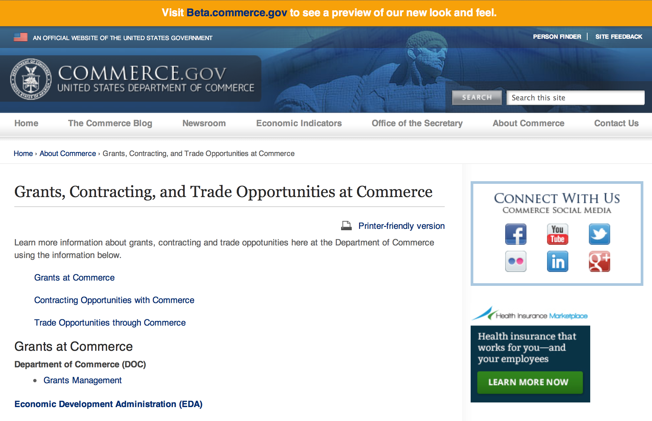
Grants at Commerce
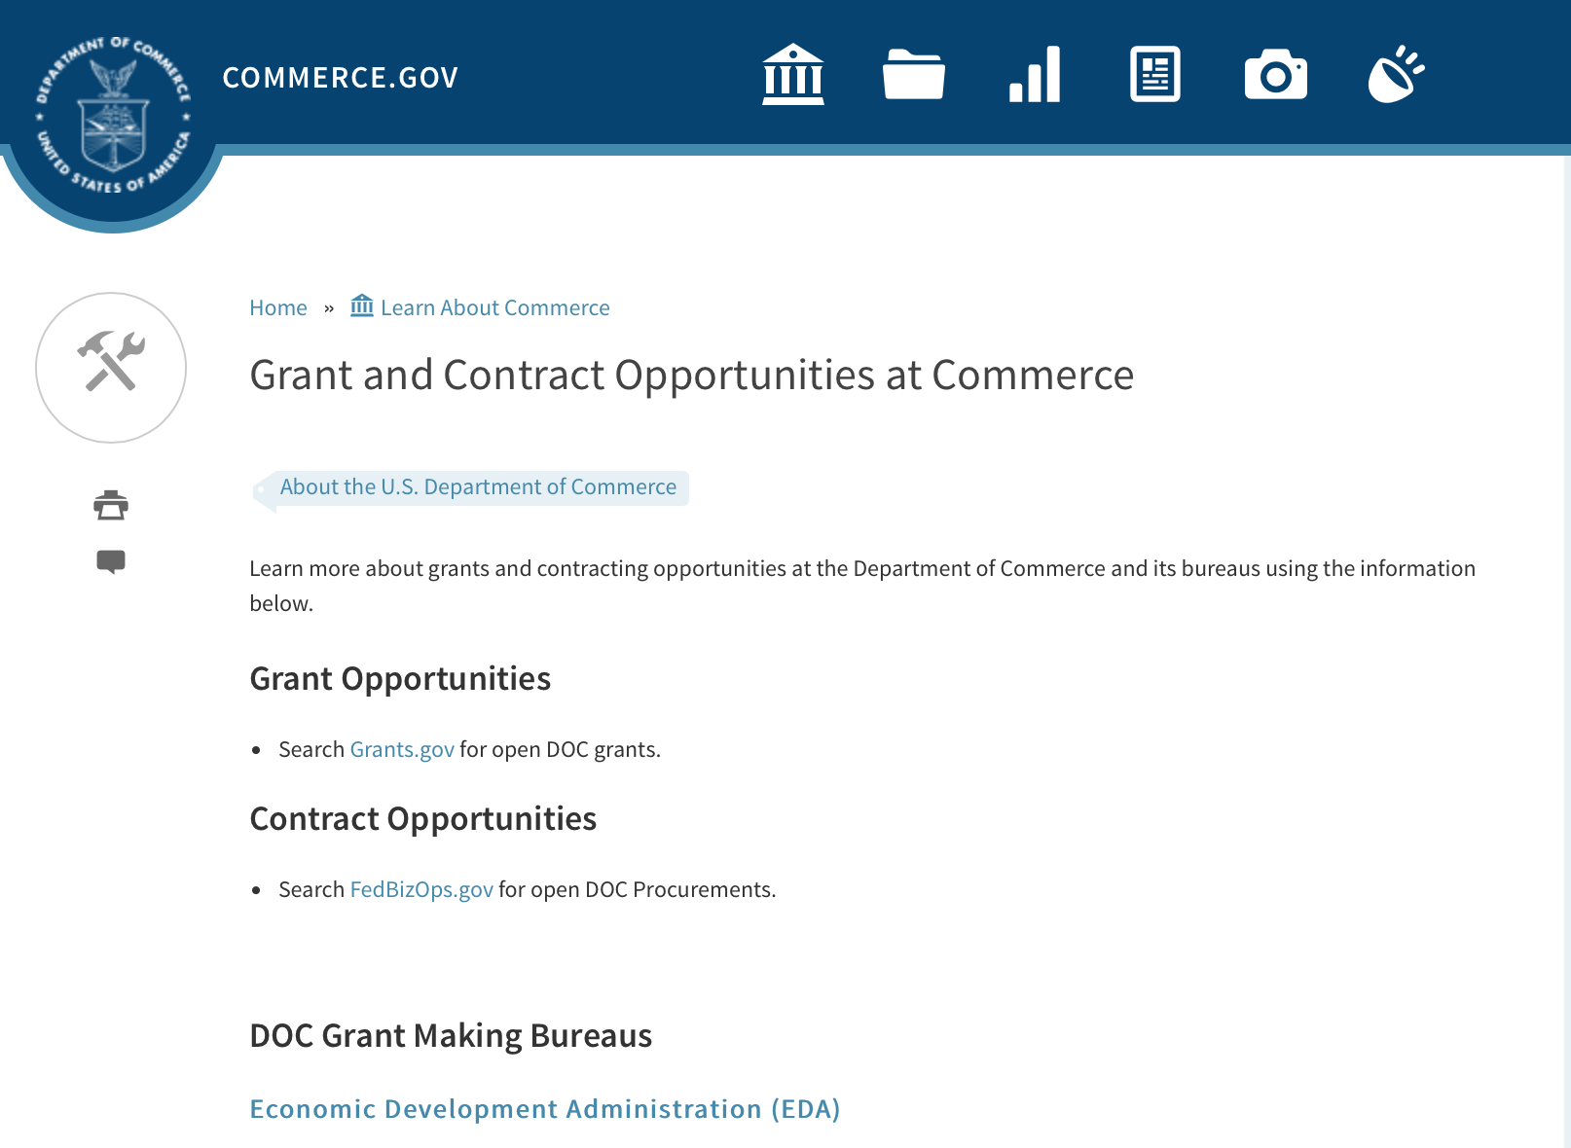

DOC Grant Making Bureaus
Economic Development Administration (EDA)
International Trade Administration (ITA)
- Market Development Cooperator Program
- Special American Business Internship Training Program (SABIT). A technical assistance initiative of the International Trade Administration of the U.S. Department of Commerce, SABIT offers organizations competitive grants and an opportunity to host industry-specific delegations. SABIT serves as an initial entry point for U.S. businesses seeking funding to establish long-term relationships with potential customers, distributors, or partners in the former Soviet Union. The program trains Eurasian managers and scientists in commonly accepted business practices as a means of facilitating cross border relationships. In turn, these personal relationships serve as a basis for business development and reduce market access barriers for U.S. businesses
National Institute of Standards & Technology (NIST)
- Funding Opportunities
National Telecommunications & Information Administration (NTIA)
- Telecommunications Grants
National Oceanic & Atmospheric Administration (NOAA)
- Coastal Ocean Program Grant Information
- Fisheries Saltonstall Kennedy Grant Program
- National Undersea Research Program Funding Opportunities
- Grants Management Division
- Fisheries Grants Program
- National Sea Grant
- Office of Global Programs
Contracting Resources for Contractors
- Office of Small and Disadvantaged Business Utilization (OSDBU) - he Office of Small and Disadvantaged Business Utilization (OSDBU) is an advocacy and advisory office responsible for promoting the use of small, small disadvantaged, 8(a), women-owned, veteran-owned, service-disabled veteran-owned, and HUBZone small businesses within the U.S. Department of Commerce's (DOC) acquisition process.
- Business.USA.gov's Find Opportunities Wizard where in a few quick steps, it will guide you towards federal government contracting programs and opportunities for your business!
- Planned Acquisitions: the Department of Commerce's search tool for our planned acquisitions over $100,000. As requirements change, these acquisition plans are updated by department personnel and this search tool is automatically updated.
- Small Business Administration's Contracting section of their web site where you can learn about how to "Get Started" and "Contracting Support for Small Business"
- The General Services Administration (GSA) has implemented a system for vendors doing business with the Federal Government to manage their entity information in one central location. This new database is the System for Award Management (SAM).

DOC Contracting Offices
- Patent and Trademark Office (PTO)
  - Office of Procurement
- National Institute of Standards & Technology (NIST)
NIST Acquisition Management Group
Contracting Opportunities with Commerce
Trade Opportunities through Commerce
http://www.commerce.gov/about-commerce/grants-contracting-trade-opportunities

Programs:

Market Development Cooperator Program 2016 Grant

Document Type: | Grants Notice
Funding Opportunity Number: | ITA-INA-OPCM-2016-2004724
Funding Opportunity Title: | Market Development Cooperator Program 2016
Opportunity Category: | Discretionary
Funding Instrument Type: | Cooperative Agreement
Category of Funding Activity: | Environment  Natural Resources  Science and Technology and other Research and Development
Category Explanation:
Expected Number of Awards: | 10
CFDA Number(s): | 11.112 -- Market Development Cooperator Program
Cost Sharing or Matching Requirement: | Yes
Posted Date: | Jan 15, 2016
Creation Date: | Jan 15, 2016
Original Closing Date for Applications: | Mar 15, 2016
Current Closing Date for Applications: | Mar 15, 2016
Archive Date: | Apr 14, 2016
Estimated Total Program Funding: | $2,000,000
Award Ceiling: | $300,000
Award Floor: | $50,000
Eligible Applicants: | Others (see text field entitled "Additional Information on Eligibility" for clarification)
Additional Information on Eligibility: | Entities that fall within the following categories are generally found to be eligible to apply for an MDCP award: trade associations; state departments of trade and their regional associations; and non-profit industry organizations, including organizations such as World Trade Centers, centers for international trade development, and small business development centers. In cases where no entity described above represents the industry, private industry firms or groups of firms may be eligible to apply for an MDCP award. Such private industry firms or groups of firms must provide documentation in their eligibility determination request demonstrating that no entity in the first three categories listed below represents their industry
Agency Name: | Department of Commerce
Description: | ITA requests that eligible organizations submit proposals (applications) for the fiscal year (FY) 2016 competition for MDCP awards. ITA creates economic opportunity for U.S. workers and firms by promoting international trade and investment, strengthening industry competitiveness, and ensuring fair trade.
Link to Additional Information:
Contact Information: | If you have difficulty accessing the full announcement electronically, please contact:  Mr. Brad Hess Director, Market Development Cooperator Program Industry & Analysis, ITA U.S. Department of Commerce 1401 Constitution Avenue, N.W., Room 20023 Washington, D.C. 20230 202-482-2969  work

http://www.grants.gov/web/grants/view-opportunity.html?oppId=281029

National Sea Grant College Program 2016-17 Special Projects Grant

Document Type: | Grants Notice
Funding Opportunity Number: | NOAA-OAR-SG-2016-2004772
Funding Opportunity Title: | National Sea Grant College Program 2016-17 Special Projects
Opportunity Category: | Discretionary
Funding Instrument Type: | Cooperative Agreement  Grant
Category of Funding Activity: | Environment  Natural Resources  Science and Technology and other Research and Development
Category Explanation:
Expected Number of Awards: | 30
CFDA Number(s): | 11.417 -- Sea Grant Support
Cost Sharing or Matching Requirement: | Yes
Posted Date: | Jan 7, 2016
Creation Date: | Jan 7, 2016
Original Closing Date for Applications: | Sep 30, 2017
Current Closing Date for Applications: | Sep 30, 2017
Archive Date: | Oct 30, 2017
Estimated Total Program Funding: | $4,000,000
Award Ceiling: | $1,000,000
Award Floor: | $1
Eligible Applicants: | Others (see text field entitled "Additional Information on Eligibility" for clarification)
Additional Information on Eligibility: | Sea Grant Programs (Sea Grant Colleges, Institutions, or Coherent Area Programs), the National Sea Grant Law Center, and the National Sea Grant Library.
Agency Name: | Department of Commerce
Description: | The purpose of this notice is to request proposals for special projects associated with the National Sea Grant College Program’s (Sea Grant) strategic focus areas, and to provide the general public with information and guidelines on how Sea Grant will select proposals and administer Federal assistance under this announcement. This announcement is a mechanism to encourage research or other projects that are not normally funded through Sea Grant national competitions. This opportunity is open only to Sea Grant Programs. Section III of this announcement describes eligibility requirements in more detail. Funding has not yet been made available to support applications submitted to this Federal Funding Opportunity (FFO), but such funding may become available during the year. Section II.A. below describes individual competition announcements that will be used to announce when funding is available; any restrictions or requirements on such funding, such as matching funds; and other funding details. Awards will be made under this FFO only if funds have been announced as provided in this FFO.
Link to Additional Information:
Contact Information: | If you have difficulty accessing the full announcement electronically, please contact:  Special Projects Competition Manager, NOAA R/SG National Sea Grant Office 1315 East-West Highway, Rm 11839 Silver Spring, MD 20910 301-734-1066  work

http://www.grants.gov/web/grants/view-opportunity.html?oppId=280846

Modifications:

National Institute of Standards and Technology
National Strategy for Trusted Identities in Cyberspace (NSTIC) State Pilots Cooperative Agreement Program
Modification 2

Document Type: | Grants Notice
Funding Opportunity Number: | 2016-NIST-NSTIC-01
Funding Opportunity Title: | National Strategy for Trusted Identities in Cyberspace (NSTIC) State Pilots Cooperative Agreement Program
Opportunity Category: | Discretionary
Funding Instrument Type: | Cooperative Agreement
Category of Funding Activity: | Other (see text field entitled "Explanation of Other Category of Funding Activity" for clarification)
Category Explanation: | Arrangements for Interdisciplinary Research Infrastructure
Expected Number of Awards:
CFDA Number(s): | 11.619 -- Arrangements for Interdisciplinary Research Infrastructure
Cost Sharing or Matching Requirement: | No
Posted Date: | Dec 18, 2015
Creation Date: | Jan 20, 2016
Original Closing Date for Applications: | Feb 18, 2016
Current Closing Date for Applications: | Feb 18, 2016
Archive Date: | Mar 19, 2016
Eligible Applicants: | Others (see text field entitled "Additional Information on Eligibility" for clarification)
Additional Information on Eligibility: | All applicants must meet one of the following conditions to be eligible: State, local, or Indian tribal governments located in the United States and its territories, or Commercial or nonprofit organizations or institutions of higher education located in the United States that have at least two state, local, or tribal government agencies representing two different governmental jurisdictions participating in the pilot through enabling online access to one or more state, local, or tribal government service(s). Federal agencies may participate in projects but may not receive NIST funding.
Agency Name: | National Institute of Standards and Technology
Description: | NIST is soliciting applications from eligible applicants to pilot online identity solutions that embrace the Identity Ecosystem Steering Group’s (IDESG) Identity Ecosystem Framework (IDEF). Specifically, identity solutions must: 1. Enable online access to one or more state, local, or tribal government service(s). 2. Provide for a federated, verified digital identity that enables multi-factor authentication and an effective identity proofing process meeting the risk needs of the service(s). 3. Aligns with the Identity Ecosystem Framework Requirements. 4. Allow for interoperability with other federations in use in the public and private sectors. NIST encourages pilots that maximize their contribution to the ongoing development and adoption of the Identity Ecosystem Framework, the OpenID Foundation iGov Working Group, and other public fora.
Link to Additional Information: | 2016-NIST-NSTIC-01 Full Announcement/FFO Document
Contact Information: | If you have difficulty accessing the full announcement electronically, please contact:  Christopher Hunton Management and Program Analyst Phone 301-975-5718  Agency Contact

http://www.grants.gov/web/grants/view-opportunity.html?oppId=280647

Reminders:

FY 2016 – FY 2019 EDA Planning Program and Local Technical Assistance Program Grant

Document Type: | Grants Notice
Funding Opportunity Number: | EDA-HDQ-TA-HDQ-2016-2004759
Funding Opportunity Title: | FY 2016 – FY 2019 EDA Planning Program and Local Technical Assistance Program
Opportunity Category: | Discretionary
Funding Instrument Type: | Cooperative Agreement  Grant
Category of Funding Activity: | Other (see text field entitled "Explanation of Other Category of Funding Activity" for clarification)  Regional Development
Category Explanation: | Regional planning and local technical assistance
Expected Number of Awards:
CFDA Number(s): | 11.302 -- Economic Development Support for Planning Organizations  11.303 -- Economic Development Technical Assistance
Cost Sharing or Matching Requirement: | No
Posted Date: | Dec 10, 2015
Creation Date: | Dec 10, 2015
Original Closing Date for Applications: | Applications are accepted on a continuing basis and processed as received. This Planning and Local Technical Assistance opportunity will remain in effect until superseded by a future announcement.
Current Closing Date for Applications: | Applications are accepted on a continuing basis and processed as received. This Planning and Local Technical Assistance opportunity will remain in effect until superseded by a future announcement.
Archive Date:
Estimated Total Program Funding:
Award Ceiling: | $300,000
Award Floor: | $0
Eligible Applicants: | Nonprofits having a 501(c)(3) status with the IRS, other than institutions of higher education  City or township governments  Nonprofits that do not have a 501(c)(3) status with the IRS, other than institutions of higher education  Others (see text field entitled "Additional Information on Eligibility" for clarification)  Private institutions of higher education  Native American tribal governments (Federally recognized)  Public and State controlled institutions of higher education  State governments  Special district governments  County governments
Additional Information on Eligibility: | Pursuant to section 3 of the Public Works and Economic Development Act of 1965 (42 U.S.C. § 3122) (PWEDA) and EDA’s regulation at 13 C.F.R. § 300.3, the following types of entities are eligible to receive funding assistance from EDA: 1. District Organizations (as defined in 13 C.F.R. § 300.3); 2. Indian Tribes or a consortium of Indian Tribes; 3. States, cities, or other political subdivisions of a State, including a special purpose unit of a State or local government engaged in economic or infrastructure development activities, or a consortium of political subdivisions; 4. Institutions of higher education or a consortium of institutions of higher education; or 5. Public or private non-profit organizations or associations acting in cooperation with officials of a political subdivision of a State.
Agency Name: | Department of Commerce
Description: | Pursuant to PWEDA, EDA announces general policies and application procedures for grant-based investments under the Planning and Local Technical Assistance programs. Under the Planning program EDA assists eligible recipients in creating regional economic development plans designed to build capacity and guide the economic prosperity and resiliency of an area or region. As part of this program, EDA supports Partnership Planning investments to facilitate the development, implementation, revision, or replacement of Comprehensive Economic Development Strategies (CEDS), which articulate and prioritize the strategic economic goals of recipients’ respective regions. In general, EDA provides Partnership Planning grants to the designated planning organization (e.g., District Organization) serving EDA designated Economic Development Districts to enable these organizations to develop and implement relevant CEDS. In addition, EDA provides Partnership Planning grants to Indian Tribes to help develop and implement CEDS and associated economic development activities. The Planning program also helps support organizations, including District Organizations, Indian Tribes, and other eligible recipients, with Short Term and State Planning investments designed to guide the eventual creation and retention of high-quality jobs, particularly for the unemployed and underemployed in the Nation’s most economically distressed regions. The Local Technical Assistance program strengthens the capacity of local or State organizations, institutions of higher education, and other eligible recipients to undertake and promote effective economic development programs through projects such as feasibility analyses and impact studies.
Link to Additional Information: | www.eda.gov
Contact Information: | If you have difficulty accessing the full announcement electronically, please contact:  The EDA representative for your state. A complete list of EDA representatives is available on EDA's website at http://www.eda.gov/contact/

http://www.grants.gov/web/grants/view-opportunity.html?oppId=280447

Fisheries International Cooperation and Assistance Program Grant

Document Type: | Grants Notice
Funding Opportunity Number: | NOAA-NMFS-FHQ-2016-2004689
Funding Opportunity Title: | Fisheries International Cooperation and Assistance Program
Opportunity Category: | Discretionary
Funding Instrument Type: | Cooperative Agreement  Grant
Category of Funding Activity: | Environment  Natural Resources  Science and Technology and other Research and Development
Category Explanation:
Expected Number of Awards: | 20
CFDA Number(s): | 11.463 -- Habitat Conservation
Cost Sharing or Matching Requirement: | No
Posted Date: | Dec 7, 2015
Creation Date: | Dec 7, 2015
Original Closing Date for Applications: | Mar 31, 2016
Current Closing Date for Applications: | Mar 31, 2016
Archive Date: | Apr 30, 2016
Estimated Total Program Funding: | $1,500,000
Award Ceiling: | $100,000
Award Floor: | $25,000
Eligible Applicants: | Others (see text field entitled "Additional Information on Eligibility" for clarification)
Additional Information on Eligibility: | Eligible applicants are institutions of higher education, nonprofits, for-profit commercial organizations, international or foreign organizations or foreign public entities, organizations under the jurisdiction of foreign governments, individuals, and state, local and Indian Tribal governments. If the applicant is a university that has a NOAA Joint or Cooperative Institute (CI), the institution is encouraged to submit an application that will be associated with the CI. The application must specify the name of the CI, its most recent award number, and the NOAA- approved research theme applicable to the work to be performed in the project narrative. The application must use the facilities and administrative rate (F&A or Indirect Cost Rate) associated with most recent CI award. If the application is selected for funding, NMFS will notify the university that a separate competitive award will be issued with its own award number. However, the competitive award will include a Special Award Condition (SAC) that evidences the link between it and the CI award. The SAC will provide (1) that the university has submitted the proposal to be associated with the CI; (2) that any existing University/NOAA Memorandum Of Agreement will be incorporated by reference into the terms of the competitive award, and (3) that any progress report(s) for the competitive award must follow the timetable of and be submitted by the CI directly to the funding program. Copies of these progress reports will be attached to the CI's performance report as an appendix.
Agency Name: | Department of Commerce
Description: | The purpose of this notice is to request applications for special projects and programs associated with NMFS Office of International Affairs and Seafood Inspection (IASI) strategic plan and mission goals (http://www.nmfs.noaa.gov/ia/), as well as to provide the general public with information and guidelines on how IASI will select proposals and administer discretionary Federal assistance under this National Marine Fisheries Service Fisheries International Cooperation and Assistance Program (FICAP) - FY 2016 Announcement. This program is a mechanism to encourage research, policy, and outreach, innovative projects, or sponsorship that are not addressed through our other competitive discretionary programs. Funding for potential projects in this notice is contingent upon the availability of Fiscal Year 2016 appropriations. Applicants are hereby given notice that funds have not yet been appropriated for any potential activities in this notice. Publication of this announcement does not oblige IASI to review an application, or to award any specific project, or to obligate any available funds.
Link to Additional Information:
Contact Information: | If you have difficulty accessing the full announcement electronically, please contact:  For further information about IASI, please visit NOAA Fisheries Office of International Affairs and Seafood Inspection website at: http://www.nmfs.noaa.gov/ia/ Or contact: National Marine Fisheries Service (NMFS) Christopher Rogers Phone Number: 301-427-8375 Email: Christopher.Rogers@noaa.gov 1315 East-West Hwy Suite 10648 Silver Spring, MD 20910-3282  Work

http://www.grants.gov/web/grants/view-opportunity.html?oppId=280408

National Institute of Standards and Technology
Summer Undergraduate Research Fellowship (SURF) Program Grant

Document Type: | Grants Notice
Funding Opportunity Number: | 2016-NIST-SURF-01
Funding Opportunity Title: | Summer Undergraduate Research Fellowship (SURF) Program
Opportunity Category: | Discretionary
Funding Instrument Type: | Cooperative Agreement
Category of Funding Activity: | Other (see text field entitled "Explanation of Other Category of Funding Activity" for clarification)
Category Explanation: | Science, Technology, Business and/or Education Outreach
Expected Number of Awards:
CFDA Number(s): | 11.620 -- Science, Technology, Business and/or Education Outreach
Cost Sharing or Matching Requirement: | No
Posted Date: | Dec 7, 2015
Creation Date: | Dec 7, 2015
Original Closing Date for Applications: | Feb 12, 2016
Current Closing Date for Applications: | Feb 12, 2016
Archive Date: | Mar 13, 2016
Eligible Applicants: | Others (see text field entitled "Additional Information on Eligibility" for clarification)
Additional Information on Eligibility: | Colleges and universities (includes 2-year and 4-year institutions) in the U.S. and its territories with degree-granting programs in biology, chemistry, computer science, engineering, materials science, mathematics, nanoscale science, neutron research, and/or physics. Due to the size of SURF Boulder, applicants that apply to SURF Boulder are limited to nominating no more than eight (8) undergraduate students for participation. SURF Gaithersburg does not have an applicant limit at this time. Each undergraduate student nominated to participate in the SURF Program from the applicant college or university must meet the requirements in Section III.1. of the Full Announcement/FFO document.
Agency Name: | National Institute of Standards and Technology
Description: | NIST is soliciting applications from eligible colleges and universities in the U.S. and its territories, nominating undergraduate students to participate in the Summer Undergraduate Research Fellowship (SURF) Program. The SURF Program will provide research opportunities for undergraduate students to work with NIST scientists and engineers, to expose them to cutting-edge research and promote the pursuit of graduate degrees in science and engineering.
Link to Additional Information: | 2016-NIST-SURF-01 Full Announcement/FFO document
Contact Information: | If you have difficulty accessing the full announcement electronically, please contact:  Christopher Hunton Management and Program Analyst Phone 301-975-5718  Agency Contact

http://www.grants.gov/web/grants/view-opportunity.html?oppId=280404

National Institute of Standards and Technology
NIST Research Experience for Teachers (NIST RET) Program Grant

Document Type: | Grants Notice
Funding Opportunity Number: | 2016-NIST-RET-01
Funding Opportunity Title: | NIST Research Experience for Teachers (NIST RET) Program
Opportunity Category: | Discretionary
Funding Instrument Type: | Cooperative Agreement
Category of Funding Activity: | Other (see text field entitled "Explanation of Other Category of Funding Activity" for clarification)
Category Explanation: | Science, Technology, Business and/or Education Outreach
Expected Number of Awards:
CFDA Number(s): | 11.620 -- Science, Technology, Business and/or Education Outreach
Cost Sharing or Matching Requirement: | No
Posted Date: | Dec 10, 2015
Creation Date: | Dec 10, 2015
Current Closing Date for Applications: | Mar 4, 2016 Electronic applications must be received no later than 11:59 p.m. Eastern Time, Friday, March 4, 2016. Paper applications must be received by NIST by 5:00 p.m. Eastern Time, Friday, March 4, 2016. Applications received after the respective deadline will not be reviewed or considered. Electronic applicants should be aware, and factor in their application submission planning, that the Grants.gov system will be closed for routine maintenance at these times: from 12:01 a.m. Eastern Time, Saturday, January 16, 2016 until Tuesday, January 19, 2016 at 6:00 a.m. Eastern Time; and also from 12:01 a.m. Eastern Time, Saturday, February 20, 2016 until Monday, February 22, 2016 at 6:00 a.m. Eastern Time; and that applications cannot be submitted during those time spans. The earliest anticipated start date for awards under this FFO is expected to be June 1, 2016. The selected teachers will attend the NIST RET Program during the summer of 2016 for six (6) continuous weeks (exact dates to be decided by the teachers and NIST scientists and engineers).
Archive Date: | Apr 3, 2016
Eligible Applicants: | Others (see text field entitled "Additional Information on Eligibility" for clarification)
Additional Information on Eligibility: | Public school districts and accredited private educational institutions in the U.S. and its territories that offer science classes at grade levels six (6), seven (7), and/or eight (8) (often termed middle school), and whose nominated teachers have successfully completed the NIST Summer Institute Program. Applicant school districts and institutions must offer instruction in general science fields, such as earth science, physical science, chemistry, physics, and/or biology. Individual public school teachers and individual public middle schools are not eligible to submit applications directly to NIST and instead must be nominated by their school district. Individual teachers at private educational institutions are not eligible to submit applications directly to NIST and instead must be nominated by their private educational institution. Individual teachers nominated to participate in the NIST RET Program must meet the eligibility requirements in Section III.1. of this FFO.
Agency Name: | National Institute of Standards and Technology
Description: | NIST is soliciting applications from eligible public school districts and accredited private educational institutions in the U.S. and its territories. These eligible institutions would nominate science teachers in grades six (6), seven (7), and/or eight (8), who have successfully completed the NIST Summer Institute for Middle School Science Teachers (NIST Summer Institute) Program. The nominated teachers must have completed the NIST Summer Institute Program prior to applying to participate in the NIST RET Program. The NIST RET Program will allow the selected teachers to participate in scientific research with NIST scientists and engineers at the NIST Campus in Gaithersburg, Maryland during the summer of 2016 for six (6) continuous weeks (exact dates to be decided by the teachers and NIST scientists and engineers).
Link to Additional Information: | 2016-NIST-RET-01 Full Announcement/FFO document
Contact Information: | If you have difficulty accessing the full announcement electronically, please contact:  Christopher Hunton Management and Program Analyst Phone 301-975-5718  Agency Contact

http://www.grants.gov/web/grants/view-opportunity.html?oppId=280476

National Institute of Standards and Technology
NIST Summer Institute for Middle School Science Teachers (NIST Summer Institute) Program Grant

Document Type: | Grants Notice
Funding Opportunity Number: | 2016-NIST-SUMMER-INSTITUTE-01
Funding Opportunity Title: | NIST Summer Institute for Middle School Science Teachers (NIST Summer Institute) Program
Opportunity Category: | Discretionary
Funding Instrument Type: | Cooperative Agreement
Category of Funding Activity: | Other (see text field entitled "Explanation of Other Category of Funding Activity" for clarification)
Category Explanation: | Science, Technology, Business and/or Education Outreach
Expected Number of Awards:
CFDA Number(s): | 11.620 -- Science, Technology, Business and/or Education Outreach
Cost Sharing or Matching Requirement: | No
Posted Date: | Dec 10, 2015
Creation Date: | Dec 10, 2015
Current Closing Date for Applications: | Mar 4, 2016 Electronic applications must be received no later than 11:59 p.m. Eastern Time, Friday, March 4, 2016. Paper applications must be received by NIST by 5:00 p.m. Eastern Time, Friday, March 4, 2016. Applications received after the respective deadline will not be reviewed or considered. Electronic applicants should be aware, and factor in their application submission planning, that the Grants.gov system will be closed for routine maintenance at these times: from 12:01 a.m. Eastern Time, Saturday, January 16, 2016 until Tuesday, January 19, 2016 at 6:00 a.m. Eastern Time; and also from 12:01 a.m. Eastern Time, Saturday, February 20, 2016 until Monday, February 22, 2016 at 6:00 a.m. Eastern Time; and that applications cannot be submitted during those time spans.
Archive Date: | Apr 3, 2016
Eligible Applicants: | Others (see text field entitled "Additional Information on Eligibility" for clarification)
Additional Information on Eligibility: | Public school districts and accredited private educational institutions in the U.S. and its territories that offer science classes at grade levels six (6), seven (7) and/or eight (8) (often termed middle school). Applicant school districts and institutions must offer instruction in general science fields, such as earth science, physical science, chemistry, physics, and/or biology. Individual public school teachers and individual public middle schools are not eligible to submit applications directly to NIST and instead must be nominated by their school district. Individual teachers at private educational institutions are not eligible to submit applications directly to NIST and instead must be nominated by their private educational institution. Individual teachers nominated to participate in the NIST Summer Institute Program must meet the eligibility requirements in Section III.1. of this FFO.
Agency Name: | National Institute of Standards and Technology
Description: | NIST is soliciting applications from eligible public school districts and accredited private educational institutions in the U.S. and its territories. These eligible institutions would nominate middle school science teachers in grades six (6), seven (7), and/or eight (8), to participate in the NIST Summer Institute Program. The NIST Summer Institute Program will provide selected teachers hands-on activities, lectures, tours, and visits with NIST scientists and engineers at the NIST Campus in Gaithersburg, Maryland.
Link to Additional Information: | 2016-NIST-SUMMER-INSTITUTE-01 Full Announcement/FFO document
Contact Information: | If you have difficulty accessing the full announcement electronically, please contact:  Christopher Hunton Management and Program Analyst Phone 301-975-5718  Agency Contact

http://www.grants.gov/web/grants/view-opportunity.html?oppId=280499

National Institute of Standards and Technology
Hollings Manufacturing Extension Partnership (MEP) State Partnership Support Project Grant

Document Type: | Grants Notice
Funding Opportunity Number: | 2016-NIST-MEP-STATE-PARTNERSHIP-01
Funding Opportunity Title: | Hollings Manufacturing Extension Partnership (MEP) State Partnership Support Project
Opportunity Category: | Discretionary
Funding Instrument Type: | Cooperative Agreement
Category of Funding Activity: | Other (see text field entitled "Explanation of Other Category of Funding Activity" for clarification)
Category Explanation: | Manufacturing Extension Partnership
Expected Number of Awards:
CFDA Number(s): | 11.611 -- Manufacturing Extension Partnership
Cost Sharing or Matching Requirement: | No
Posted Date: | Dec 16, 2015
Creation Date: | Dec 16, 2015
Original Closing Date for Applications: | Feb 29, 2016
Current Closing Date for Applications: | Feb 29, 2016
Archive Date: | Mar 30, 2016
Eligible Applicants: | Others (see text field entitled "Additional Information on Eligibility" for clarification)
Additional Information on Eligibility: | Applicants must be a U.S.-based for-profit or not-for-profit institution or organization. An eligible organization may work individually or may include proposed sub-awards to eligible organizations or proposed contracts with any other organization as part of the applicant’s proposal, effectively forming a team.
Agency Name: | National Institute of Standards and Technology
Description: | NIST invites proposals from eligible organizations to provide in-depth collaborative support in developing and advancing stakeholder relationships that are critical to the success of the MEP program, based on the recipient’s expertise and knowledge of State manufacturing and technology agendas. NIST MEP is a federal-state-industry partnership program. The MEP system of Centers and field offices throughout the U.S. provides a mechanism to integrate federal and state public policy goals, respond to market forces and address the needs of manufacturing sectors and of individual manufacturers. To make the most of this partnership, NIST MEP strives to balance the priorities of U.S. national policy with those of state partners to create a robust and effective program providing U.S. manufacturers with the tools they need to grow and remain globally competitive. Stakeholders include not only state-based partners but also sub-state partners that are based at the county, community, and city levels, as well as regional partners that extend beyond state boundary lines.
Link to Additional Information: | 2016-NIST-MEP-STATE-PARTNERSHIP-01 Full Announcement/FFO document
Contact Information: | If you have difficulty accessing the full announcement electronically, please contact:  Christopher Hunton Management and Program Analyst Phone 301-975-5718  Agency Contact

http://www.grants.gov/web/grants/view-opportunity.html?oppId=280581

Fiscal Year 2016 NMFS-Sea Grant Fellowships in Marine Resource Economics Grant
And Modifications 1 and 2

Document Type: | Grants Notice
Funding Opportunity Number: | NOAA-OAR-SG-2016-2004720
Funding Opportunity Title: | Fiscal Year 2016 NMFS-Sea Grant Fellowships in Marine Resource Economics
Opportunity Category: | Discretionary
Funding Instrument Type: | Cooperative Agreement
Category of Funding Activity: | Environment  Natural Resources  Science and Technology and other Research and Development
Category Explanation:
Expected Number of Awards: | 8
CFDA Number(s): | 11.417 -- Sea Grant Support
Cost Sharing or Matching Requirement: | Yes
Posted Date: | Dec 3, 2015
Creation Date: | Dec 4, 2015
Original Closing Date for Applications: | Feb 3, 2016
Current Closing Date for Applications: | Feb 26, 2016
Archive Date: | Mar 27, 2016
Estimated Total Program Funding: | $320,000
Award Ceiling: | $43,500
Award Floor: | $33,000
Eligible Applicants: | Others (see text field entitled "Additional Information on Eligibility" for clarification)
Additional Information on Eligibility: | Prospective Fellows must be United States citizens. At the time of application, prospective Marine Resource Economics Fellows must be admitted to a PhD degree program in resource or environmental economics at an institution of higher education in the United States or its territories, or submit a signed letter from the institution indicating provisional acceptance to a PhD degree program conditional on obtaining financial support such as this Fellowship. Applications must come from Sea Grant programs.
Agency Name: | Department of Commerce
Description: | The Fellowship Program generally awards two new PhD Fellowships each year to students who are interested in careers related to the development and implementation of quantitative methods for assessing the economics of the conservation and management of living marine resources. Fellows will work on thesis problems of public interest and relevance to NMFS under the guidance of NMFS mentors at participating NMFS Science Centers or Offices. The NMFS-Sea Grant Fellowship in Marine Resource Economics meets NOAA's Healthy Oceans goal of "Marine fisheries, habitats, biodiversity sustained with healthy and productive ecosystems." The expected annual award per Fellow will be $46,000 (federal plus matching funds), which is funded jointly by NOAA Fisheries and Sea Grant.
Link to Additional Information:
Contact Information: | If you have difficulty accessing the full announcement electronically, please contact:  Julia Galkiewicz 301-734-1067  work

http://www.grants.gov/web/grants/view-opportunity.html?oppId=280317

Next Round of Research to Operations Initiative: NGGPS and HFIP Grant

Document Type: | Grants Notice
Funding Opportunity Number: | NOAA-NWS-NWSPO-2016-2004713
Funding Opportunity Title: | Next Round of Research to Operations Initiative: NGGPS and HFIP
Opportunity Category: | Discretionary
Funding Instrument Type: | Cooperative Agreement
Category of Funding Activity: | Environment  Natural Resources  Science and Technology and other Research and Development
Category Explanation:
Expected Number of Awards: | 16
CFDA Number(s): | 11.468 -- Applied Meteorological Research
Cost Sharing or Matching Requirement: | No
Posted Date: | Dec 2, 2015
Creation Date: | Dec 2, 2015
Original Closing Date for Applications: | Feb 29, 2016
Current Closing Date for Applications: | Feb 29, 2016
Archive Date: | Mar 30, 2016
Estimated Total Program Funding: | $2,600,000
Award Ceiling: | $200,000
Award Floor: | $100,000
Eligible Applicants: | Others (see text field entitled "Additional Information on Eligibility" for clarification)  Public and State controlled institutions of higher education  Private institutions of higher education
Additional Information on Eligibility: | Federally funded educational institutions
Agency Name: | Department of Commerce
Description: | This program announcement is for projects to be conducted for a two-year period with an anticipated start date of September 1, 2016 unless otherwise directed. Eligible applicants are institutions of higher education and federally funded educational institutions such as the Naval Postgraduate School. The purpose of the NOAA Research to Operations (R2O) Initiative is to expand and accelerate critical weather forecasting research to operations to address growing service demands and increase the accuracy of weather forecasts. This will be achieved through: (1) accelerated development and implementation of improved global weather prediction models, and inclusion of the coupling of atmosphere, ocean, wave, land surface and ice system components; (2) improved data assimilation techniques; (3) nested regional prediction capabilities; (4) improved hurricane and tropical cyclone modeling techniques; (5) improved ensemble techniques; (6) post-processing forecast tools and techniques; and (7) improved software architecture and system engineering. The NOAA R2O Initiative is soliciting proposals for projects involving applied science, modeling and/or data assimilation that support development of the Next Generation Global Prediction System (NGGPS) at global and regional scales. The NOAA R2O Initiative is also soliciting proposals for the Hurricane Forecast Improvement Project (HFIP) initiative to engage and coordinate hurricane research required to improve operational hurricane forecasts to meet societal requirements to effectively mitigate economic disruption. This notice provides guidelines for submission of proposals. This notice also describes opportunities and application procedures to demonstrate capabilities that have the potential to be incorporated into operational NWS numerical weather prediction (NWP) analyses and forecasts. The R2O initiative addresses NOAA's Weather Ready Nation (WRN) strategic goal and supporting objectives. The Program also represents an NOAA/NWS effort to foster a cost-effective transition from basic and applied research to operations and services through collaborative research and developmental testing between institutions which have expertise in the environmental sciences and operational forecast scientists. These activities will engage researchers in applied research of interest with the operational meteorological community and will improve the accuracy of forecasts and warnings of environmental hazards by applying scientific knowledge and information to operational products and services.
Link to Additional Information:
Contact Information: | If you have difficulty accessing the full announcement electronically, please contact:  Christopher Hedge NOAA/NWS 1325 East-West Highway, Room 15328 Silver Spring, MD 20910 301-427-9242

http://www.grants.gov/web/grants/view-opportunity.html?oppId=280274

Next Round of Research to Operations Initiative: NOAA Testbeds Grant

Document Type: | Grants Notice
Funding Opportunity Number: | NOAA-NWS-NWSPO-2016-2004610
Funding Opportunity Title: | Next Round of Research to Operations Initiative: NOAA Testbeds
Opportunity Category: | Discretionary
Funding Instrument Type: | Cooperative Agreement
Category of Funding Activity: | Environment  Natural Resources  Science and Technology and other Research and Development
Category Explanation:
Expected Number of Awards: | 7
CFDA Number(s): | 11.468 -- Applied Meteorological Research
Cost Sharing or Matching Requirement: | No
Posted Date: | Dec 2, 2015
Creation Date: | Dec 2, 2015
Original Closing Date for Applications: | Feb 29, 2016
Current Closing Date for Applications: | Feb 29, 2016
Archive Date: | Mar 30, 2016
Estimated Total Program Funding: | $1,000,000
Award Ceiling: | $200,000
Award Floor: | $100,000
Eligible Applicants: | Special district governments  Native American tribal governments (Federally recognized)  Small businesses  Private institutions of higher education  Nonprofits having a 501(c)(3) status with the IRS, other than institutions of higher education  Nonprofits that do not have a 501(c)(3) status with the IRS, other than institutions of higher education  City or township governments  For profit organizations other than small businesses  County governments  State governments  Public and State controlled institutions of higher education
Agency Name: | Department of Commerce
Description: | This program announcement is for projects to be conducted for a two-year period with an anticipated start date of September 1, 2016 unless otherwise directed. All public or private sources may submit to this Federal Funding Opportunity; however, partnering with universities is highly encouraged. Eligible applicants are institutions of higher education; other nonprofits; commercial organizations; state, local and Indian tribal governments; and Federal agencies. Applicants for this opportunity must work in partnership with NOAA testbeds and proving grounds (listed under www.testbeds.noaa.gov). NOAA's testbeds and proving grounds facilitate the orderly transition of research capabilities to operational implementation through development testing in testbeds, and pre-deployment testing and operational readiness/suitability evaluation in operational proving grounds. The purpose of the NOAA Research to Operations (R2O) Initiative is to expand and accelerate critical weather forecasting research to operations to address growing service demands and increase the accuracy of weather forecasts. This will be achieved through: (1) accelerated development and implementation of improved global weather prediction models and inclusion of the coupling among atmosphere, ocean, wave, land surface and ice system components; (2) improved data assimilation techniques; (3) nested regional prediction capabilities; (4) improved hurricane and tropical cyclone modeling techniques; (5) improved ensemble techniques; (6) post-processing forecast tools and techniques; and (7) improved software architecture and system engineering. The NOAA R2O Initiative is soliciting proposals for projects involving applied science, modeling and/or data assimilation that supports development of effective assimilation for environmental observations at global and regional scales, and hurricane and other high-impact weather forecast models that meet societal requirements to effectively mitigate economic disruption. This notice provides guidelines for submission of proposals. This notice also describes opportunities and application procedures to demonstrate capabilities that have the potential to be incorporated into operational NWS numerical weather prediction (NWP) analyses and forecasts. The R2O initiative addresses NOAA's Weather Ready Nation (WRN) strategic goal and supporting objectives. The Program also represents an NOAA/NWS effort to foster a cost-effective transition from basic and applied research to operations and services through collaborative research and developmental testing between institutions which have expertise in the environmental sciences and operational forecast scientists. These activities will engage researchers in applied research of interest with the operational meteorological community and will improve the accuracy of forecasts and warnings of environmental hazards by applying scientific knowledge and information to operational products and services.
Link to Additional Information:
Contact Information: | If you have difficulty accessing the full announcement electronically, please contact:  Christopher Hedge NOAA/NWS 1325 East-West Highway, Room 15328 Silver Spring, MD 20910 301-427-9242  work

http://www.grants.gov/web/grants/view-opportunity.html?oppId=280275

Fiscal Year 2017 National Sea Grant College Program Dean John A. Knauss Marine Policy Fellowship
Grant

Document Type: | Grants Notice
Funding Opportunity Number: | NOAA-OAR-SG-2017-2004620
Funding Opportunity Title: | Fiscal Year 2017 National Sea Grant College Program Dean John A. Knauss Marine Policy Fellowship
Opportunity Category: | Discretionary
Funding Instrument Type: | Cooperative Agreement
Category of Funding Activity: | Environment  Natural Resources  Science and Technology and other Research and Development
Category Explanation:
Expected Number of Awards: | 30
CFDA Number(s): | 11.417 -- Sea Grant Support
Cost Sharing or Matching Requirement: | No
Posted Date: | Oct 28, 2015
Creation Date: | Oct 28, 2015
Original Closing Date for Applications: | Feb 12, 2016
Current Closing Date for Applications: | Feb 12, 2016
Archive Date: | Mar 13, 2016
Estimated Total Program Funding: | $1,695,000
Award Ceiling: | $66,500
Award Floor: | $56,500
Eligible Applicants: | Others (see text field entitled "Additional Information on Eligibility" for clarification)
Additional Information on Eligibility: | An eligible applicant is any student, regardless of citizenship, who, on February 12, 2016, is enrolled towards a degree in a graduate program, that have an interest in ocean, coastal and Great Lakes resources and in the national policy decisions affecting those resources. The graduate degree needs to be awarded through a United States accredited institution of higher education in the United States or U.S. Territories.
Agency Name: | Department of Commerce
Description: | This notice announces that applications may be submitted for the 2017 National Sea Grant College Program Dean John A. Knauss Marine Policy Fellowship (Sea Grant Knauss Fellowship Program). Sea Grant anticipates funding not less than 30 selected applicants, of which those assigned to the Legislative branch may be limited to 12. Each award will be funded at a total of $56,500 in federal funding, with the option by the host office to add no more than $10,000 for fellow travel related to host office duties, for a maximum of $66,500.
Link to Additional Information:
Contact Information: | If you have difficulty accessing the full announcement electronically, please contact:  Julia Galkiewcz Sea Grant Knauss Fellowship Program Manager National Sea Grant College Program 1315 East-West Highway, R/SG, Room 11861 Silver Spring, MD 20910 (301) 734-1067  work

http://www.grants.gov/web/grants/view-opportunity.html?oppId=278911

FY 2016 Economic Development Assistance Programs ­ Application submission and program requirements for EDA’s Public Works and Economic Adjustment Assistance Programs Grant

Document Type: | Grants Notice
Funding Opportunity Number: | EDAP2016
Funding Opportunity Title: | FY 2016 Economic Development Assistance Programs ­ Application submission and program requirements for EDA’s Public Works and Economic Adjustment Assistance programs.
Opportunity Category: | Discretionary
Funding Instrument Type: | Cooperative Agreement  Grant
Category of Funding Activity: | Other (see text field entitled "Explanation of Other Category of Funding Activity" for clarification)
Category Explanation: | The Economic Development Administration's (EDA's) mission is to lead the Federal economic development agenda by promoting innovation and competitiveness, preparing American regions for economic growth and success in the worldwide economy. EDA fulfills this mission through strategic investments and partnerships that create the regional economic ecosystems required to foster globally competitive regions throughout the United States. EDA supports development in economically distressed areas of the United States by fostering job creation and attracting private investment. Specifically, under the Economic Development Assistance programs (EDAP) Federal Funding Opportunity (FFO) announcement, EDA will make construction, non-construction, and revolving loan fund investments under the Public Works and Economic Adjustment Assistance (EAA) Programs. Grants made under these programs will leverage regional assets to support the implementation of regional economic development strategies designed to create jobs, leverage private capital, encourage economic development, and strengthen America's ability to compete in the global marketplace. Through the EDAP FFO, EDA solicits applications from rural and urban communities to develop initiatives that advance new ideas and creative approaches to address rapidly evolving economic conditions.
Expected Number of Awards:
CFDA Number(s): | 11.300 -- Investments for Public Works and Economic Development Facilities  11.307 -- Economic Adjustment Assistance
Cost Sharing or Matching Requirement: | Yes
Posted Date: | Oct 26, 2015
Creation Date: | Oct 26, 2015
Original Closing Date for Applications: | There are no submission deadlines under this opportunity. Proposals and applications will be accepted on an ongoing basis until the publication of a new EDAP FFO.
Current Closing Date for Applications: | There are no submission deadlines under this opportunity. Proposals and applications will be accepted on an ongoing basis until the publication of a new EDAP FFO.
Archive Date:
Estimated Total Program Funding:
Award Ceiling: | $3,000,000
Award Floor: | $100,000
Eligible Applicants: | Others (see text field entitled "Additional Information on Eligibility" for clarification)  State governments  City or township governments  Native American tribal organizations (other than Federally recognized tribal governments)  Native American tribal governments (Federally recognized)  Private institutions of higher education  Special district governments  Nonprofits having a 501(c)(3) status with the IRS, other than institutions of higher education  County governments  Nonprofits that do not have a 501(c)(3) status with the IRS, other than institutions of higher education  Public and State controlled institutions of higher education
Additional Information on Eligibility: | Eligible applicants for EDA financial assistance under the Public Works and EAA programs include a(n): (i) District Organization of a designated Economic Development District; (ii) Indian Tribe or a consortium of Indian Tribes; (iii) State, county, city, or other political subdivision of a State, including a special purpose unit of a State or local government engaged in economic or infrastructure development activities, or a consortium of political subdivisions; (iv) institution of higher education or a consortium of institutions of higher education; or (v) public or private non-profit organization or association acting in cooperation with officials of a political subdivision of a State. See Section 3 of the Public Works and Economic Development Act of 1965 (PWEDA) (42 U.S.C. § 3122) and 13 C.F.R. § 300.3. EDA is not authorized to provide grants or cooperative agreements to individuals or to for profit entities. Requests from such entities will not be considered for funding.
Agency Name: | Economic Development Administration
Description: | Under this FFO, EDA solicits applications from applicants in rural and urban areas to provide investments that support construction, non-construction, technical assistance, and revolving loan fund projects under EDA’s Public Works and EAA programs. Grants and cooperative agreements made under these programs are designed to leverage existing regional assets and support the implementation of economic development strategies that advance new ideas and creative approaches to advance economic prosperity in distressed communities. EDA provides strategic investments on a competitive- merit-basis to support economic development, foster job creation, and attract private investment in economically distressed areas of the United States.
Link to Additional Information: | www.eda.gov
Contact Information: | If you have difficulty accessing the full announcement electronically, please contact:  the EDA representative for your state. A complete list of EDA representatives is available on EDA's website at http://www.eda.gov/contact/

http://www.grants.gov/web/grants/view-opportunity.html?oppId=279842

Economic Development Administration
Planning Program and Local Technical Assistance Program Grant

Document Type: | Grants Notice
Funding Opportunity Number: | EDAPLANNING2012
Opportunity Category: | Discretionary
Posted Date: | Aug 03, 2012
Creation Date: | Aug 03, 2012
Original Closing Date for Applications: | Applications are accepted on a continuing basis and processed as received. This Planning and Local Technical Assistance opportunity will remain in effect until superseded by a future announcement.
Current Closing Date for Applications: | Applications are accepted on a continuing basis and processed as received. This Planning and Local Technical Assistance opportunity will remain in effect until superseded by a future announcement.
Archive Date:
Funding Instrument Type: | Cooperative Agreement  Grant
Category of Funding Activity: | Other (see text field entitled "Explanation of Other Category of Funding Activity" for clarification)  Regional Development
Category Explanation: | Regional planning and local technical assistance
Expected Number of Awards: | 425
Estimated Total Program Funding:
Award Ceiling: | $100,000
Award Floor:
CFDA Number(s): | 11.302 -- Economic Development Support for Planning Organizations
 | 11.303 -- Economic Development Technical Assistance
Cost Sharing or Matching Requirement: | Yes

Eligible Applicants
State governments
County governments
City or township governments
Public and State controlled institutions of higher education
Native American tribal governments (Federally recognized)
Nonprofits having a 501(c)(3) status with the IRS, other than institutions of higher education
Nonprofits that do not have a 501(c)(3) status with the IRS, other than institutions of higher education
Private institutions of higher education
Others (see text field entitled "Additional Information on Eligibility" for clarification)

Additional Information on Eligibility:
Pursuant to section 3 of the Public Works and Economic Development Act of 1965 (42 U.S.C. § 3122) (PWEDA) and EDA’s regulation at 13 C.F.R. § 300.3, the following types of entities are eligible to receive funding assistance from EDA: 1. District Organizations (as defined in 13 C.F.R. § 300.3); 2. Indian Tribes or a consortium of Indian Tribes; 3. States, cities, or other political subdivisions of a State, including a special purpose unit of a State or local government engaged in economic or infrastructure development activities, or a consortium of political subdivisions; 4. Institutions of higher education or a consortium of institutions of higher education; or 5. Public or private non-profit organizations or associations acting in cooperation with officials of a political subdivision of a State.

Agency Name
Economic Development Administration

Description
Pursuant to PWEDA, EDA announces general policies and application procedures for grant-based investments under the Planning and Local Technical Assistance programs. Under the Planning program EDA assists eligible recipients in creating regional economic development plans designed to stimulate and guide the economic development efforts of a community or region. As part of this program, EDA supports Partnership Planning investments to facilitate the development, implementation, revision, or replacement of Comprehensive Economic Development Strategies (CEDS), which articulate and prioritize the strategic economic goals of recipients' respective regions. In general, EDA provides Partnership Planning grants to the designated planning organization (e.g., District Organization) serving EDA-designated Economic Development Districts to enable these organizations to develop and implement relevant CEDS. In addition, EDA provides Partnership Planning grants to Indian Tribes to help develop and implement CEDS and associated economic development activities. The Planning program also helps support planning organizations, including District Organizations, Indian Tribes, and other eligible Recipients, with Short Term and State Planning investments designed to guide the eventual creation and retention of higher-skill, higher-wage jobs, particularly for the unemployed and underemployed in the Nation’s most economically distressed regions. The Local Technical Assistance program strengthens the capacity of local or State organizations, institutions of higher education, and other eligible recipients to undertake and promote effective economic development programs through projects such as feasibility analyses and impact studies.

Link to Additional Information

If you have difficulty accessing the full announcement electronically, please contact:
David Ives Planning and Local TA email

http://www.grants.gov/web/grants/view-opportunity.html?oppId=189193

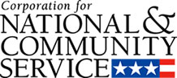

Corporation for National and Community Service

General Program Overview
AmeriCorps provides resources, both human and financial, to organizations that engage Americans in intensive service to meet our country’s critical needs.
Grantees use the funding to support AmeriCorps members for intensive service in their community. AmeriCorps grants partially cover the expense of operating an AmeriCorps program and do not cover general organizational expenses. A cash and in-kind match is required.

The main website can be accessed here: http://www.nationalservice.gov

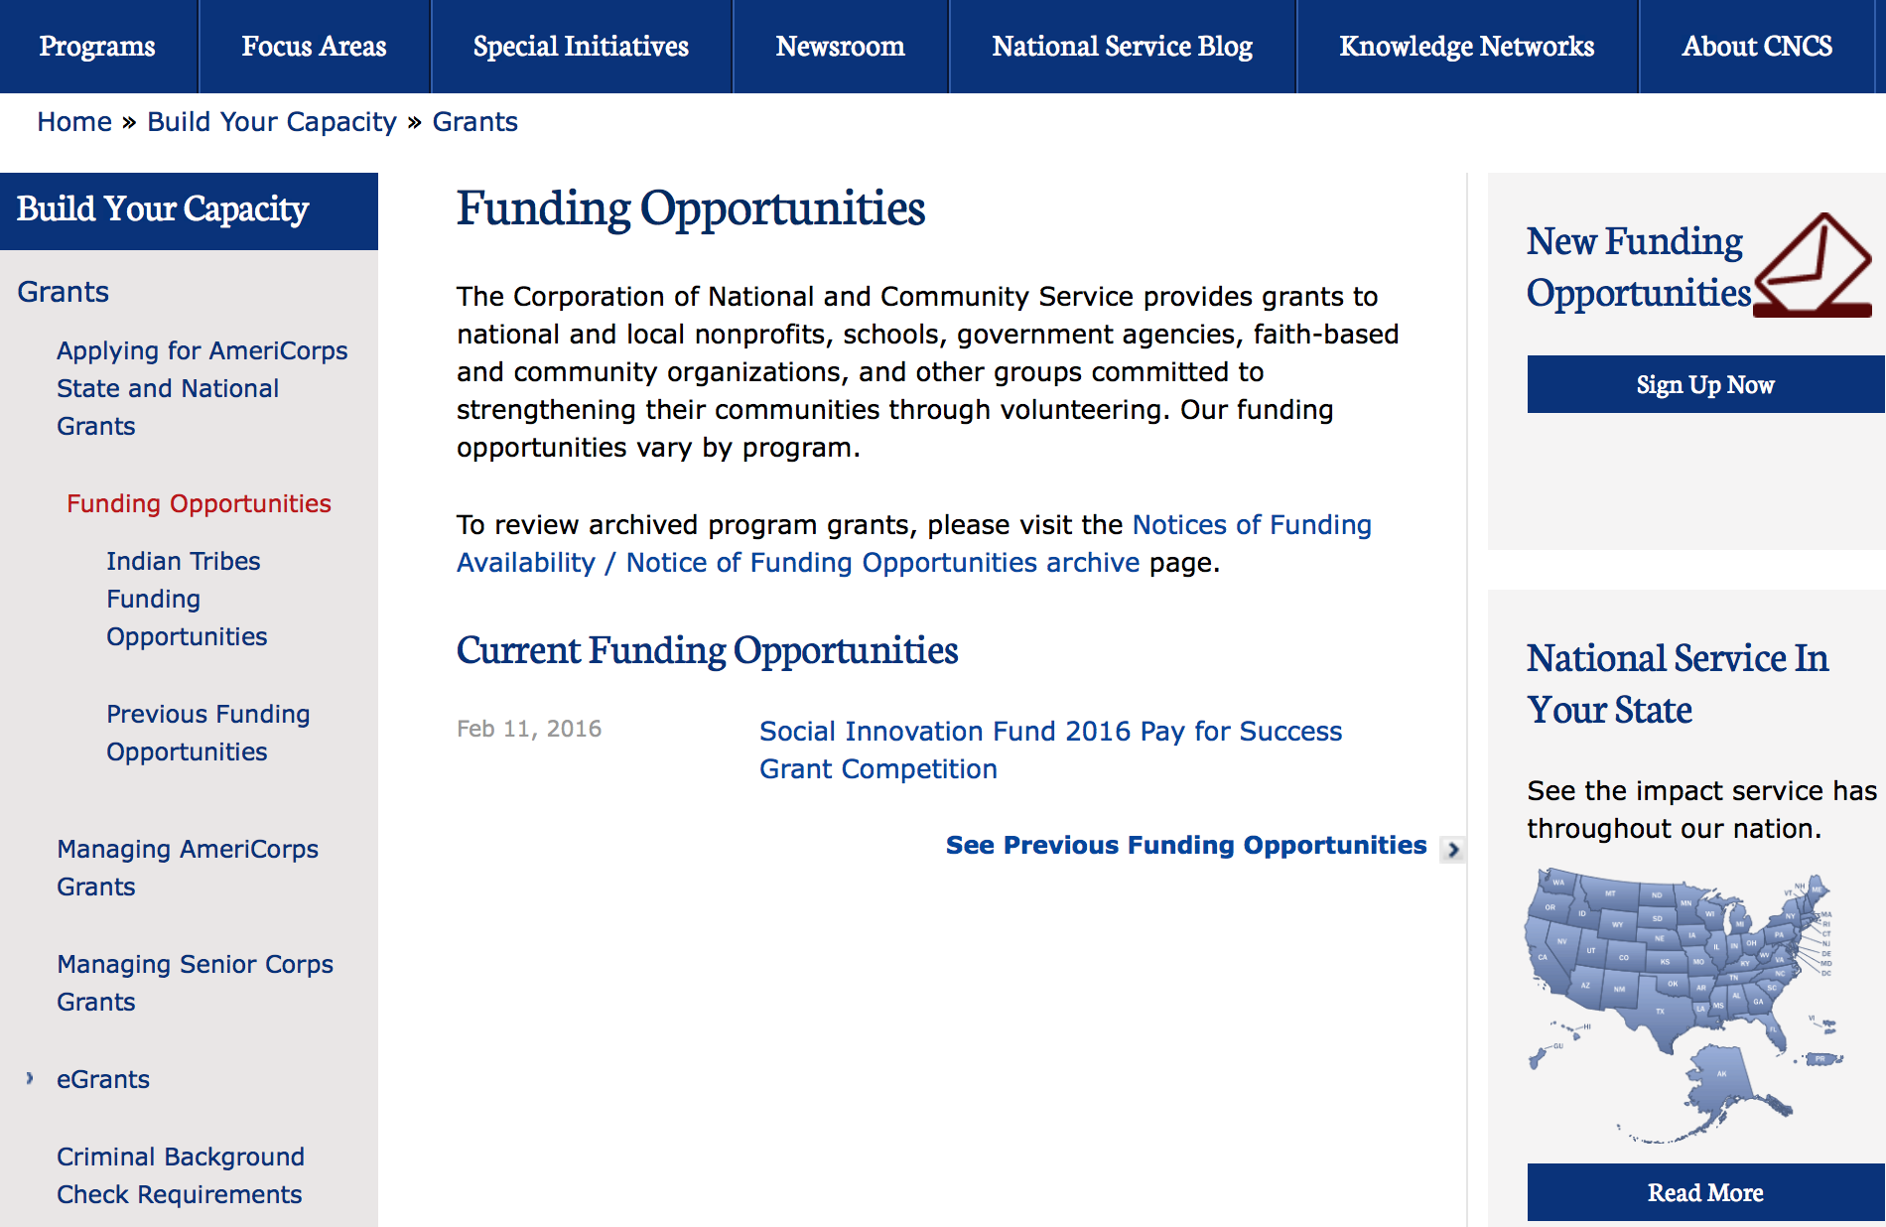

For access to further funding information: click here

http://www.nationalservice.gov/build-your-capacity/grants/funding-opportunities

Reminders:

FY 2016 Social Innovation Fund Pay for Success Cooperative Agreement Grant

Document Type: | Grants Notice
Funding Opportunity Number: | CNCS-12-09-15
Funding Opportunity Title: | FY 2016 Social Innovation Fund Pay for Success Cooperative Agreement
Opportunity Category: | Other
Funding Instrument Type: | Cooperative Agreement
Category of Funding Activity: | Community Development  Education  Employment, Labor and Training  Health  Housing  Regional Development
Category Explanation:
Expected Number of Awards: | 4
CFDA Number(s): | 94.024 -- Social Innovation Fund Pay for Success
Cost Sharing or Matching Requirement: | Yes
Posted Date: | Dec 9, 2015
Creation Date: | Dec 9, 2015
Original Closing Date for Applications: | Feb 11, 2016 Optional Letter of Intent due on January 13, 2016
Current Closing Date for Applications: | Feb 11, 2016 Optional Letter of Intent due on January 13, 2016
Archive Date: | Feb 12, 2016
Estimated Total Program Funding: | $10,600,000
Award Ceiling: | $5,400,000
Award Floor: | $1,050,000
Eligible Applicants: | State governments  Nonprofits having a 501(c)(3) status with the IRS, other than institutions of higher education  City or township governments  Native American tribal governments (Federally recognized)  Private institutions of higher education  Native American tribal organizations (other than Federally recognized tribal governments)  County governments
Agency Name: | Corporation for National and Community Service
Description: | The Social Innovation Fund (SIF) Pay for Success (PFS) Grants Competition seeks to advance and develop emerging models that direct resources toward interventions that produce measurable outcomes. Consistent with the broader mission of the SIF, the PFS Competition intends to encourage the implementation of PFS projects in order to enhance the reach and impact of innovative community-based solutions in low-income communities.
Link to Additional Information: | Funding Opportunity Webpage
Contact Information: | If you have difficulty accessing the full announcement electronically, please contact:  Pay for Success Program Office (202) 606-3223  Competition email address

http://www.grants.gov/web/grants/view-opportunity.html?oppId=280464

National Service In Hawaii
National Service in Your State - Hawaii
2014-2015
Meeting Community Needs in Hawaii: More than 3,800 people of all ages and backgrounds are helping to meet local needs, strengthen communities, and increase civic engagement through national service in Hawaii. Serving at more than 350 locations throughout the state, these citizens tutor and mentor children, support veterans and military families, provide health services, restore the environment, respond to disasters, increase economic opportunity, and recruit and manage volunteers. This year, the Corporation for National and Community Service (CNCS) will commit more than $6,260,000 to support Hawaii communities through national service initiatives. Through a unique public-private partnership, this federal investment will leverage an additional $3,640,000 in other resources to strengthen community impact, build local support, and increase return on taxpayer dollars.

AmeriCorps
This year, AmeriCorps will provide more than 540 individuals the opportunity to provide intensive, results-driven service to meet education, environmental, health, economic, and other pressing needs in communities across Hawaii. Most AmeriCorps grant funding goes to the Hawaii Commission on National & Community Service, which in turn awards grants to nonprofit groups to respond to local needs. Most of the remainder of the grant funding is distributed by CNCS directly to multi-state and national organizations through a competitive grants process. Other individuals serve through AmeriCorps VISTA, whose members help bring individuals and communities out of poverty by serving full-time to fight illiteracy, improve health services, create businesses, and increase housing opportunities, and AmeriCorps NCCC (National Civilian Community Corps), a 10-month, full time residential program for men and women between the ages of 18 and 24. In exchange for their service, AmeriCorps members earn an education award that can be used to pay for college or to pay back qualified student loans. Since 1994, more than 5,600 Hawaii residents have served more than 5.8 million hours and have qualified for Segal AmeriCorps Education Awards totaling more than $13,510,000.

Senior Corps
More than 3,200 seniors in Hawaii contribute their time and talents in one of three Senior Corps programs. Foster Grandparents serve one-on-one as tutors and mentors to more than 340 young people who have special needs. Senior Companions help more than 200 homebound seniors and other adults maintain independence in their own homes. RSVP volunteers conduct safety patrols, renovate homes, protect the environment, tutor and mentor youth, respond to natural disasters, and provide other services through more than 170 groups across Hawaii.

The Corporation for National and Community Service is a federal agency that improves lives, strengthens communities, and fosters civic engagement through service and volunteering. CNCS annually engages more than five million Americans in service to meet local needs through Senior Corps, AmeriCorps, and national days of service; improves communities through the Social Innovation Fund, and leads President Obama's national call to service initiative, United We Serve. To learn more visit NationalService.gov or Serve.gov or call 202-606-5000 or TTY 1-800-833-3722.

http://www.nationalservice.gov/impact-our-nation/state-profiles/hi

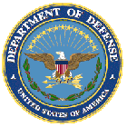

U.S. Department of Defense

Doing Business with the Department of Defense

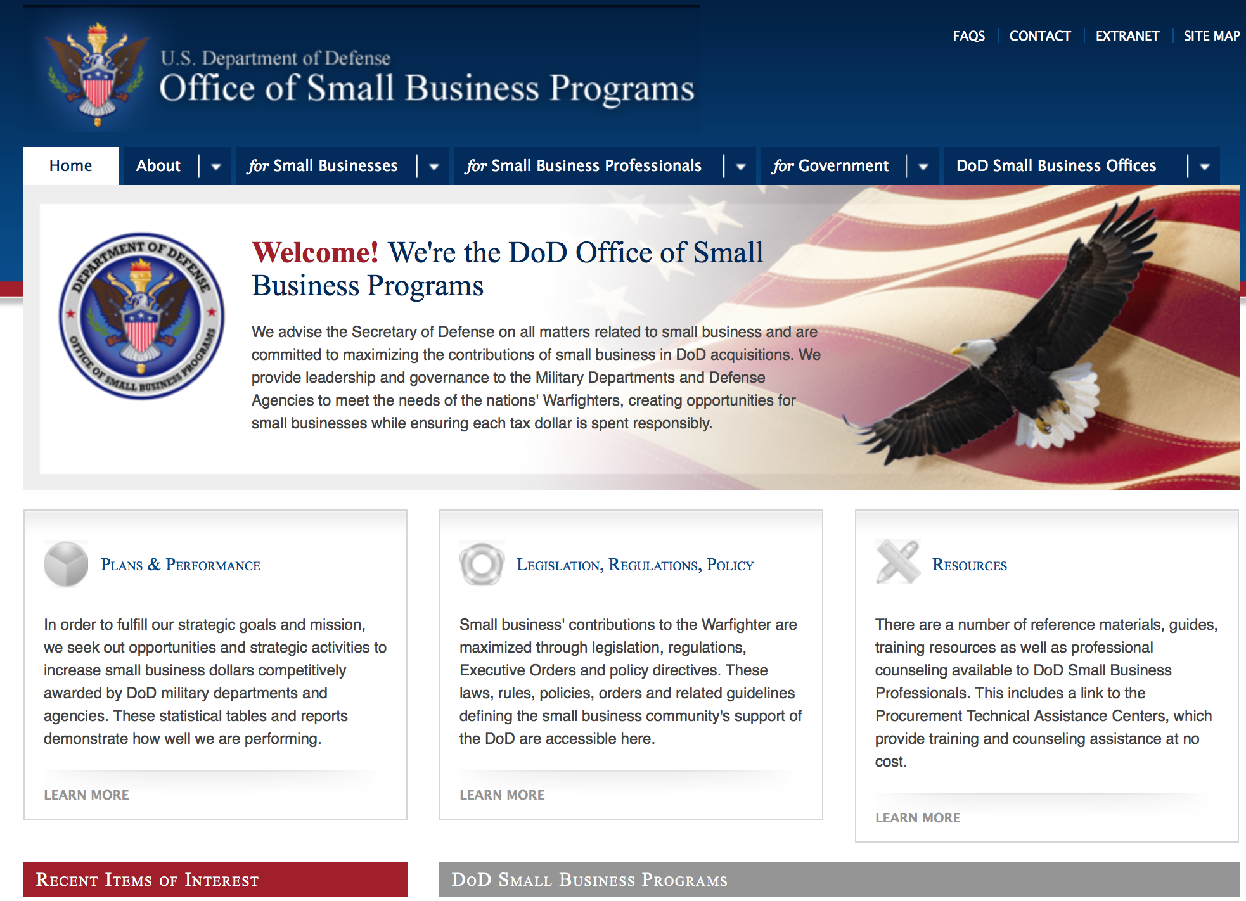

http://www.acq.osd.mil/osbp/

Doing Business with the DoD

Resources

Procurement Technical Assistance Centers (PTACs)

Procurement Technical Assistance Centers (PTACs), are charged with assisting businesses in learning how to do business with federal, state, and local governments. PTACs are a local resource available at no or nominal cost that can provide assistance to business firms in marketing their products and services. They offer training to businesses on how to research and bid on contracts, assist with registration requirements, provide bid-matching services, and assist with pre and post contracting issues.

Prime Contractors with Subcontracting Plans [xlsx]

Directory updated 4/19/11

This FY 2014 directory is intended for small business concerns seeking opportunities with DoD prime contractors. The directory is a listing of large business prime contractors who are required to establish subcontracting plans with goals. The report is generated from data contained in the Individual Subcontract Reports (ISRs) submitted in the Electronic Subcontracting Reporting System (eSRS) by contractors and from data contained in the Federal Procurement Data System (FPDS). The directory includes the name of the prime contractor; the major product/service code (PSC) provided to DoD; the major NAICS of the company; name, telephone number and email address of the company’s point of contact; contract number with the effective date and completion date, ultimate contract value and obligated dollars. In addition, many companies have websites with additional information which may be useful in your search for subcontracting opportunities or teaming arrangements.

Locate a Small Business Professional

Small Business Professionals serve as the primary liaison between private-sector small businesses seeking to do business with government agencies. Specialists advise small businesses regarding current acquisitions contracts available from the federal government.

Procurement Forecasts & the Department of Defense

The Department of Defense, due to its size and scope, does not have a single, comprehensive source for future procurements. Procurements are made locally and within the various services and agencies.

Business Intelligence, relative to future procurement planning, would be gathered at the local level.

For the purposes of forecasting, knowledge of past behavior is useful. Click here for a table of DoD acquisitions in FY10 summarized by NAICS code. The FY10 data has been validated but FPDS data is dynamic and changes continuously.

Non-Appropriated Fund Customers

Non-appropriated fund customers operate similar to non-profit organizations and include commissaries, exchanges, recreation and fitness centers, dining at officer/enlisted/civilian clubs, and barber/beauty services, just to name a few. For more information click here.

Research:

Dept. of the Army -- Corps of Engineers
Engineer Research and Development Center
2016 Broad Agency Announcement Grant
http://www.grants.gov/web/grants/view-opportunity.html?oppId=281223

Dept. of the Army -- Materiel Command
Army Research Institute for the Behavioral and Social Sciences FY16 Foundational Science Research Unit Broad Agency Announcement Grant
http://www.grants.gov/web/grants/view-opportunity.html?oppId=281272

Minerva Research Initiative Grant
http://www.grants.gov/web/grants/view-opportunity.html?oppId=280923

Modifications:

Dept. of the Army -- USAMRAA
DoD Joint Program Committee-2/Military Infectious Diseases Applied Research Award
Modification 2
http://www.grants.gov/web/grants/view-opportunity.html?oppId=280590

Dept. of the Army -- USAMRAA
DoD Joint Program Committee/Military Infectious Diseases Clinical Study Award
Modification 1
http://www.grants.gov/web/grants/view-opportunity.html?oppId=280604

Defense Threat Reduction Agency
FY2011 – 2016 Basic Research for Combating Weapons of Mass Destruction (C-WMD) Broad Agency Announcement (BAA)
Modification 6
http://www.grants.gov/web/grants/view-opportunity.html?oppId=75633

Office of Naval Research
Naval Supply Systems Command
FY16 PROJECT ON ADVANCED SYSTEMS AND CONCEPTS FOR COUNTERING WMD (PASCC)
Modification 3
http://www.grants.gov/web/grants/view-opportunity.html?oppId=276120

Reminders:

Dept. of the Army -- Materiel Command
Army Research Office Broad Agency Announcement for Basic and Applied Scientific Research
Modification 8

Document Type: | Grants Notice
Funding Opportunity Number: | W911NF-12-R-0012
Funding Opportunity Title: | Army Research Office Broad Agency Announcement for Basic and Applied Scientific Research
Opportunity Category: | Discretionary
Funding Instrument Type: | Cooperative Agreement  Grant  Other  Procurement Contract
Category of Funding Activity: | Science and Technology and other Research and Development
Category Explanation:
Expected Number of Awards: | 1000
CFDA Number(s): | 12.431 -- Basic Scientific Research
Cost Sharing or Matching Requirement: | No
Posted Date: | Mar 27, 2015
Creation Date: | Mar 27, 2015
Original Closing Date for Applications: | Mar 31, 2017
Current Closing Date for Applications: | Mar 31, 2017
Archive Date: | Apr 30, 2017
Eligible Applicants: | Unrestricted (i.e., open to any type of entity above), subject to any clarification in text field entitled "Additional Information on Eligibility"
Agency Name: | Dept. of the Army -- Materiel Command
Description: | The purpose of this Broad Agency Announcement (BAA) is to solicit research proposals in the engineering, physical, life, and information sciences for submission to the Army Research Office (ARO) for consideration for possible funding. For ease of reference, this BAA is an extraction of the ARO sections of the Army Research Laboratory BAA. (www.arl.army.mil/www/default.cfm?page=8).
Link to Additional Information: | ARO CORE BAA-W911NF-12-R-0012-Mod 03
Contact Information: | If you have difficulty accessing the full announcement electronically, please contact:  ANDREW L. FISKE Procurement Analyst Army Contracting Command Aberdeen Proving Ground Research Triangle Park Division Phone: (919) 549-4338 FAX: (919) 549-4388 andrew.l.fiske.civ@mail.mil  Administrative POC

http://www.grants.gov/web/grants/view-opportunity.html?oppId=173593



Department of Education

Grant Programs Overview at the Department of Education

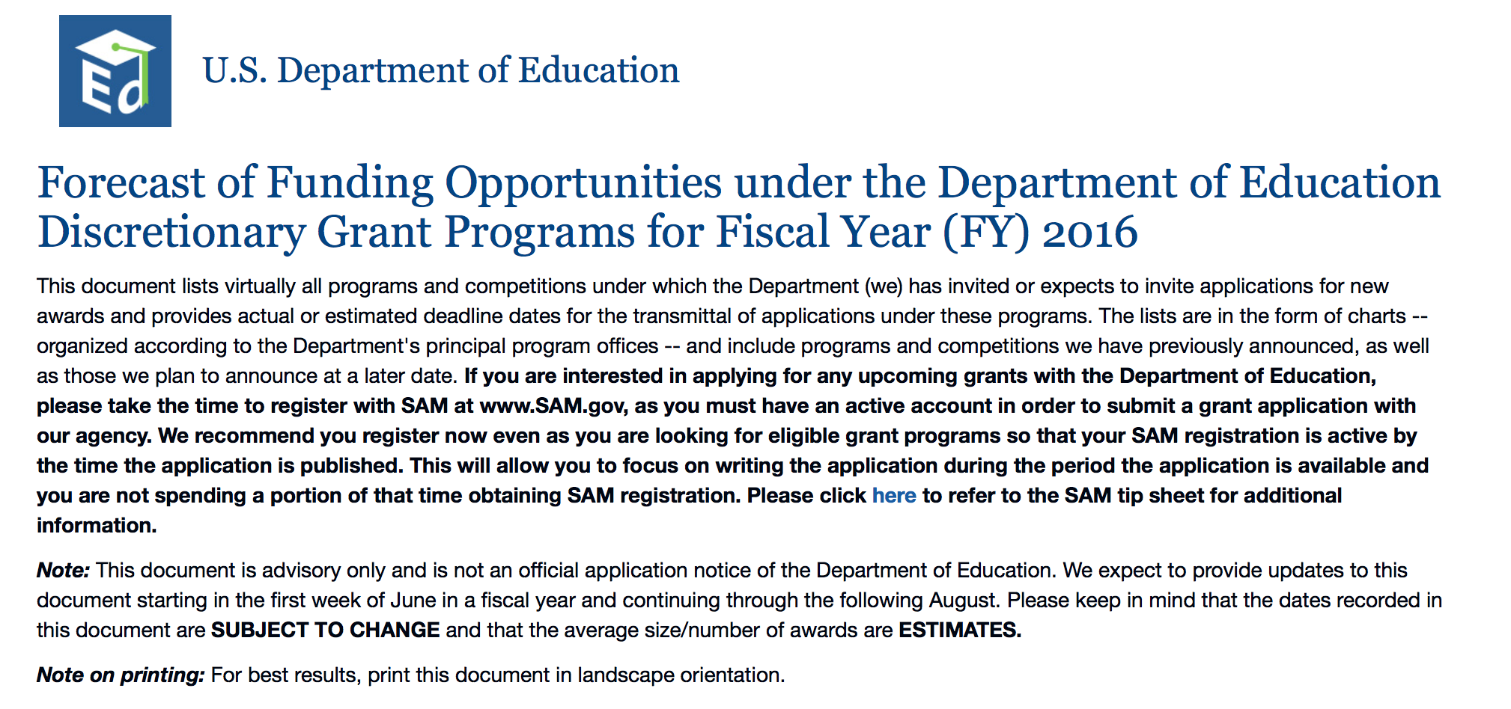To see the complete document click here: http://www2.ed.gov/fund/grant/find/edlite-forecast.html

The general information page for Education Grant funding is an excellent resource describing the three types of grants awarded by the Department of Education. See the screen shot of the Department of Education web page below:

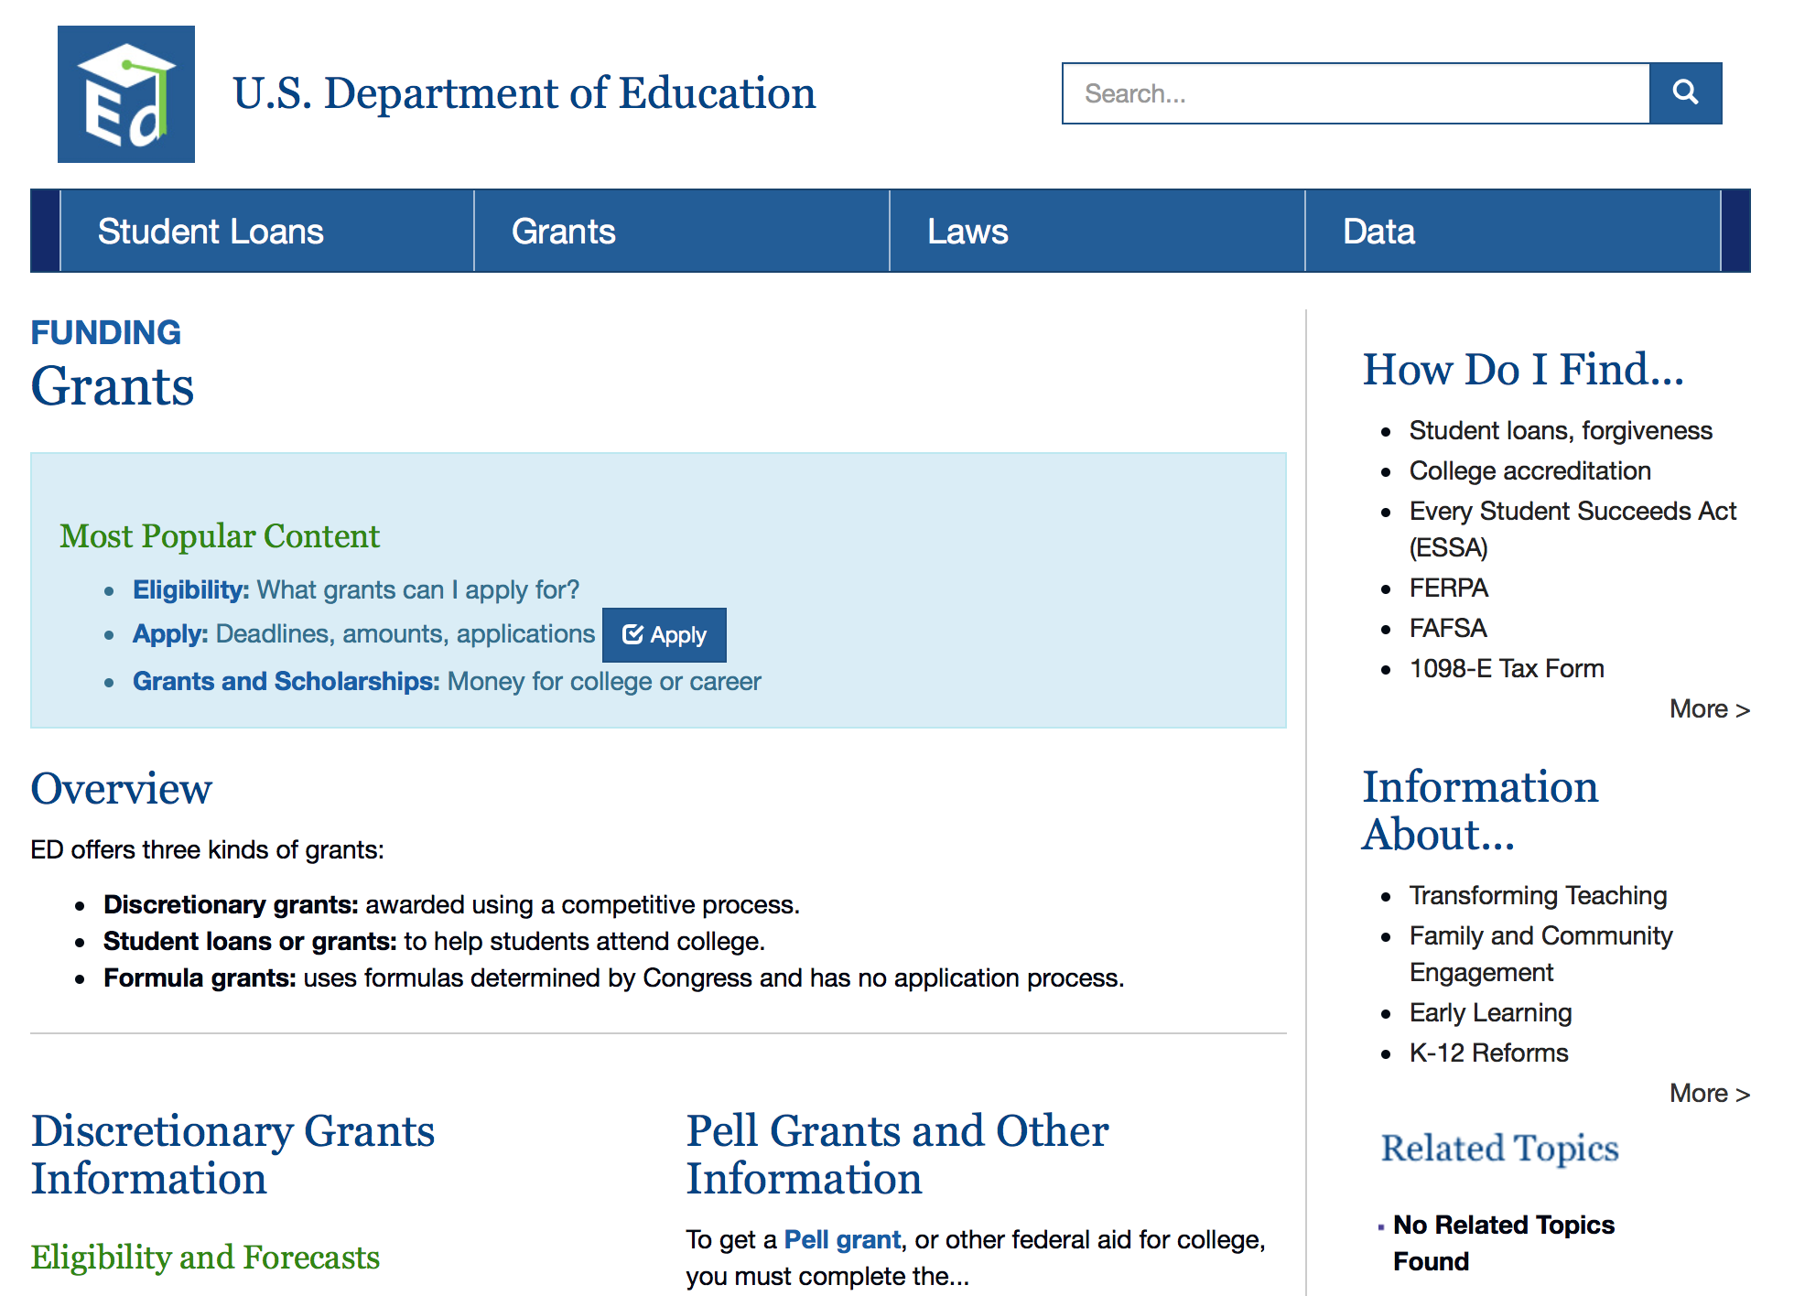

http://www.ed.gov/fund/grants-apply.html

Programs:

Modifications:

Office of Elementary and Secondary Education (OESE): College Assistance Migrant Program (CAMP) CFDA Number 84.149A
Modification 1

Document Type: | Grants Notice
Funding Opportunity Number: | ED-GRANTS-010716-001
Funding Opportunity Title: | Office of Elementary and Secondary Education (OESE): College Assistance Migrant Program (CAMP) CFDA Number 84.149A
Opportunity Category: | Discretionary
Funding Instrument Type: | Grant
Category of Funding Activity: | Education
Category Explanation:
Expected Number of Awards: | 5
CFDA Number(s): | 84.149 -- Migrant Education College Assistance Migrant Program
Cost Sharing or Matching Requirement: | No
Posted Date: | Jan 7, 2016
Creation Date: | Jan 7, 2016
Original Closing Date for Applications: | Mar 7, 2016 Applications Available: January 7, 2016. Deadline for Transmittal of Applications: March 7, 2016.
Current Closing Date for Applications: | Mar 7, 2016 Applications Available: January 7, 2016. Deadline for Transmittal of Applications: March 7, 2016.
Archive Date: | Apr 6, 2016
Estimated Total Program Funding: | $5,407,472
Award Ceiling: | $425,000
Award Floor: | $180,000
Eligible Applicants: | Nonprofits that do not have a 501(c)(3) status with the IRS, other than institutions of higher education  Private institutions of higher education  Public and State controlled institutions of higher education  Others (see text field entitled "Additional Information on Eligibility" for clarification)  Nonprofits having a 501(c)(3) status with the IRS, other than institutions of higher education
Additional Information on Eligibility: | Eligible Applicants: IHEs or private non-profit organizations (including faith-based organizations) that plan their projects in cooperation with an IHE and propose to operate the project with the facilities of the IHE.
Agency Name: | Department of Education
Description: | Note: Each funding opportunity description is a synopsis of information in the Federal Register application notice. For specific information about eligibility, please see the official application notice. The official version of this document is the document published in the Federal Register. Free Internet access to the official edition of the Federal Register and the Code of Federal Regulations is available on GPO Access at: http://www.access.gpo.gov/nara/index.html. Please review the official application notice for pre-application and application requirements, application submission information, performance measures, priorities and program contact information. Purpose of Program: The purpose of CAMP is to provide academic and financial support to help migrant and seasonal farmworkers and members of their immediate family complete their first year of college and continue in postsecondary education. Catalog of Federal Domestic Assistance (CFDA) Number: 84.149A.Applications for grants under CAMP, CFDA number 84.149A, must be submitted electronically using the Governmentwide Grants.gov Apply site at www.Grants.gov. Through this site, you will be able to download a copy of the application package, complete it offline, and then upload and submit your application. You may not email an electronic copy of a grant application to us. You may access the electronic grant application for CAMP at www.Grants.gov. You must search for the downloadable application package for this competition by the CFDA number. Do not include the CFDA number's alpha suffix in your search (e.g., search for 84.149, not 84.149A).
Link to Additional Information: | Office of Elementary and Secondary Education (OESE): College Assistance Migrant Program (CAMP) CFDA Number 84.149A; Notice inviting applications for new awards for fiscal year (FY) 2016
Contact Information: | If you have difficulty accessing the full announcement electronically, please contact:  Julius Cotton ED Grants.gov FIND Systems Admin. Phone 202-245-6288 EducationGrantInquiries@ed.gov Program Manager: Emily Bank, U.S. Department of Education, 400 Maryland Avenue SW., Room 3E338, Washington, DC 20202-6135. Telephone: (202) 453-6389 or by email: emily.bank@ed.gov.  e-Mail: Program Manager

http://www.grants.gov/web/grants/view-opportunity.html?oppId=280845

Office of Elementary and Secondary Education (OESE): High School Equivalency Program (HEP) CFDA Number 84.141A
Modification 1

Document Type: | Grants Notice
Funding Opportunity Number: | ED-GRANTS-010716-002
Funding Opportunity Title: | Office of Elementary and Secondary Education (OESE): High School Equivalency Program (HEP) CFDA Number 84.141A
Opportunity Category: | Discretionary
Funding Instrument Type: | Grant
Category of Funding Activity: | Education
Category Explanation:
Expected Number of Awards: | 9
CFDA Number(s): | 84.141 -- Migrant Education High School Equivalency Program
Cost Sharing or Matching Requirement: | No
Posted Date: | Jan 7, 2016
Creation Date: | Jan 7, 2016
Original Closing Date for Applications: | Mar 7, 2016 Applications Available: January 7, 2016. Deadline for Transmittal of Applications: March 7, 2016.
Current Closing Date for Applications: | Mar 7, 2016 Applications Available: January 7, 2016. Deadline for Transmittal of Applications: March 7, 2016.
Archive Date: | Apr 6, 2016
Estimated Total Program Funding: | $4,082,415
Award Ceiling: | $475,000
Award Floor: | $180,000
Eligible Applicants: | Nonprofits having a 501(c)(3) status with the IRS, other than institutions of higher education  Private institutions of higher education  Nonprofits that do not have a 501(c)(3) status with the IRS, other than institutions of higher education  Others (see text field entitled "Additional Information on Eligibility" for clarification)  Public and State controlled institutions of higher education
Additional Information on Eligibility: | Eligible Applicants: IHEs or private non-profit organizations (including faith-based organizations) that plan their projects in cooperation with an IHE and propose to operate some aspects of the project with the facilities of the IHE.
Agency Name: | Department of Education
Description: | Note: Each funding opportunity description is a synopsis of information in the Federal Register application notice. For specific information about eligibility, please see the official application notice. The official version of this document is the document published in the Federal Register. Free Internet access to the official edition of the Federal Register and the Code of Federal Regulations is available on GPO Access at: http://www.access.gpo.gov/nara/index.html. Please review the official application notice for pre-application and application requirements, application submission information, performance measures, priorities and program contact information. Purpose of Program: The purposes of HEP are to help migrant and seasonal farmworkers and members of their immediate family: (1) Obtain a general education diploma that meets the guidelines for high school equivalency (HSE) established by the State in which the HEP project is conducted; and (2) gain employment or be placed in an institution of higher education (IHE) or other postsecondary education or training. Catalog of Federal Domestic Assistance (CFDA) Number: 84.141A. Applications for grants under HEP, CFDA number 84.141A, must be submitted electronically using the Governmentwide Grants.gov Apply site at www.Grants.gov. Through this site, you will be able to download a copy of the application package, complete it offline, and then upload and submit your application. You may not email an electronic copy of a grant application to us. You may access the electronic grant application for HEP at www.Grants.gov. You must search for the downloadable application package for this competition by the CFDA number. Do not include the CFDA number's alpha suffix in your search (e.g., search for 84.141, not 84.141A).
Link to Additional Information: | Office of Elementary and Secondary Education (OESE): High School Equivalency Program (HEP) CFDA Number 84.141A; Notice inviting applications for new awards for fiscal year (FY) 2016
Contact Information: | If you have difficulty accessing the full announcement electronically, please contact:  Julius Cotton ED Grants.gov FIND Systems Admin. Phone 202-245-6288 EducationGrantInquiries@ed.gov Program Manager: Emily Bank, U.S. Department of Education, 400 Maryland Avenue SW., Room 3E338, Washington, DC 20202-6135. Telephone: (202) 453-6389 or by email: emily.bank@ed.gov.  e-Mail: Program Manager

http://www.grants.gov/web/grants/view-opportunity.html?oppId=280857

Reminders:

The National Professional Development (NPD) Program (84.365Z) Grant
And Modification 4

Document Type: | Grants Notice
Funding Opportunity Number: | ED-GRANTS-121115-001
Funding Opportunity Title: | Office of English Language Acquisition (OELA): National Professional Development Program CFDA Number 84.365Z
Opportunity Category: | Discretionary
Funding Instrument Type: | Grant
Category of Funding Activity: | Education
Category Explanation:
Expected Number of Awards: | 53
CFDA Number(s): | 84.365 -- English Language Acquisition State Grants
Cost Sharing or Matching Requirement: | No
Posted Date: | Dec 11, 2015
Creation Date: | Dec 14, 2015
Original Closing Date for Applications: | Feb 19, 2016
Current Closing Date for Applications: | Feb 19, 2016 Applications Available: December 11, 2015. Deadline for Notice of Intent to Apply: December 31, 2015. Deadline for Transmittal of Applications: February 19, 2016.
Archive Date: | Mar 20, 2016
Estimated Total Program Funding: | $23,850,000
Eligible Applicants: | Others (see text field entitled "Additional Information on Eligibility" for clarification)
Additional Information on Eligibility: | Entities eligible to apply for NPD grants are IHEs in consortia with LEAs or SEAs.
Agency Name: | Department of Education
Description: | •Note: Each funding opportunity description is a synopsis of information in the Federal Register application notice. For specific information about eligibility, please see the official application notice. The official version of this document is the document published in the Federal Register. Free Internet access to the official edition of the Federal Register and the Code of Federal Regulations is available on GPO Access at: http://www.access.gpo.gov/nara/index.html Purpose: The National Professional Development (NPD) program, authorized by section 3131 of the Elementary and Secondary Education Act of 1965, as amended (ESEA), awards grants on a competitive basis, for a period of not more than five years, to institutions of higher education (IHEs), in consortia with State educational agencies (SEAs) or local educational agencies (LEAs). The purpose of these grants is to support professional development activities that will improve classroom instruction for English Learners (ELs) and assist educational personnel working with such children to meet high professional standards, including standards for certification and licensure for teachers who work in language instruction educational programs to serve ELs. Applications for grants under the NPD program, CFDA number 84.365Z, must be submitted electronically using the Grants.gov Apply site (Grants.gov). You must search for the downloadable application package for this competition by the CFDA number. Do not include the CFDA number's alpha suffix in your search (e.g., search for 84.365, not 84.365Z). The telephone number for the Grants.gov Helpdesk is 1-800-518-4726 or e-mail: support@grants.gov.
Link to Additional Information: | Office of English Language Acquisition (OELA): National Professional Development Program CFDA Number 84.365Z; Notice Inviting Applications for New Awards
Contact Information: | If you have difficulty accessing the full announcement electronically, please contact:  Joyce Mays, (202)245-6122 Samuel Lopez, (202)401-4300  Program Manager

http://www.grants.gov/web/grants/view-opportunity.html?oppId=280483



U.S. Department of Energy
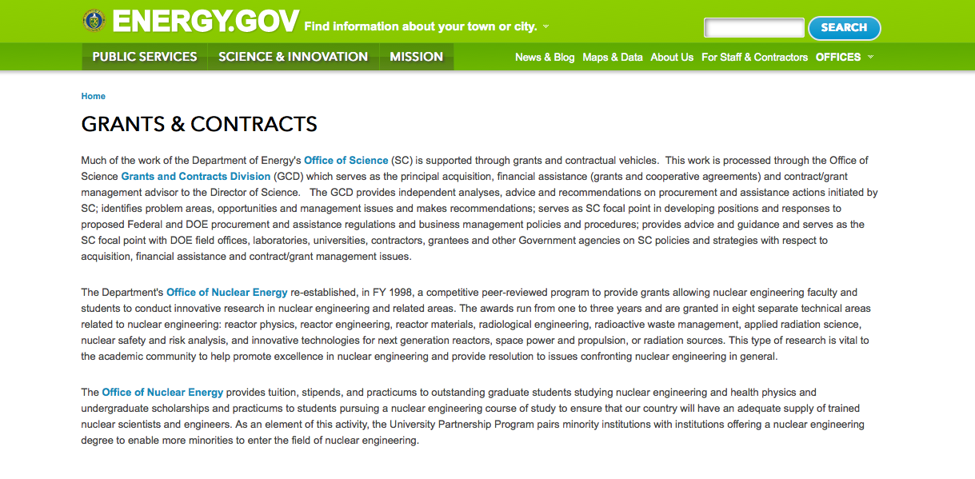
http://www.doe.gov/grants-contracts

Programs:

National Energy Technology Laboratory
Solid Oxide Fuel Cell Innovative Concepts and Core Technology Grant
http://www.grants.gov/web/grants/view-opportunity.html?oppId=281030

Golden Field Office
ADVANCEMENTS IN ALGAL BIOMASS YIELD, PHASE 2 (ABY2) Grant
http://www.grants.gov/web/grants/view-opportunity.html?oppId=281033

RFI - DOE R Grant
http://www.grants.gov/web/grants/view-opportunity.html?oppId=280932

RFI -DOE Infrastructure Work Scope Development Grant
http://www.grants.gov/web/grants/view-opportunity.html?oppId=280970

Notice of Intent (NOI) Solar Energy Evolution and Diffusion Studies II – State Energy Strategies Grant
http://www.grants.gov/web/grants/view-opportunity.html?oppId=281158

National Energy Technology Laboratory
Support of Fossil Energy Research at U.S. Colleges and Universities including University Coal Research (UCR) and Research by Historically Black Colleges and Universities and Other Minority Institutions (HBCU/OMI) Grant
http://www.grants.gov/web/grants/view-opportunity.html?oppId=281248

Modifications:

National Energy Technology Laboratory
Fiscal Year 2016 Vehicle Technologies Program Wide Funding Opportunity Announcement
Modification 2
http://www.grants.gov/web/grants/view-opportunity.html?oppId=281101

Golden Field Office
BUILDINGS ENERGY EFFICIENCY FRONTIERS & INNOVATION TECHNOLOGIES (BENEFIT) – 2016
Modification 1
http://www.grants.gov/web/grants/view-opportunity.html?oppId=280560

National Energy Technology Laboratory
Pre-Project Planning for Advanced Combustion Pilot Plants
Modification 1
http://www.grants.gov/web/grants/view-opportunity.html?oppId=281094

National Energy Technology Laboratory
Pre-Project Planning for Advanced Combustion Pilot Plants
Modification 2
http://www.grants.gov/web/grants/view-opportunity.html?oppId=281094

Reminders:

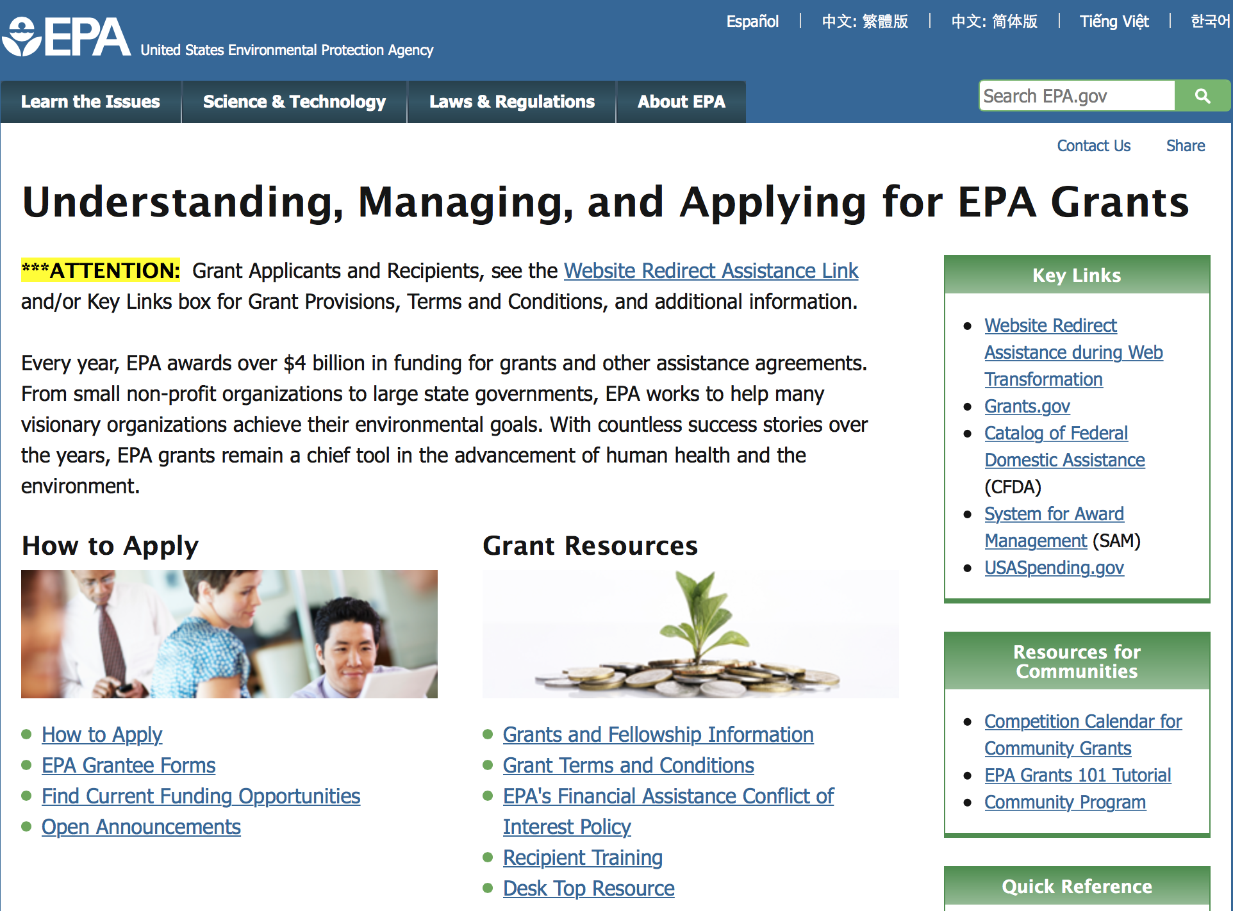

http://www.epa.gov/epahome/grants.htm

Programs:

Modifications:

Reminders:

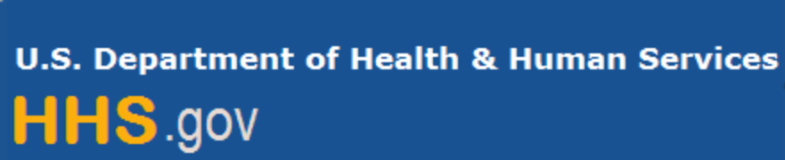

Department of Health and Human Services

Grants Forecast and Overview

The Department of Health and Human Services’ Grants Forecast is a database of planned grant opportunities proposed by its agencies. Each Forecast record contains actual or estimated dates and funding levels for grants that the agency intends to award during the fiscal year. Forecast opportunities are subject to change based on enactment of congressional appropriations. Go to the webpage below for more information.

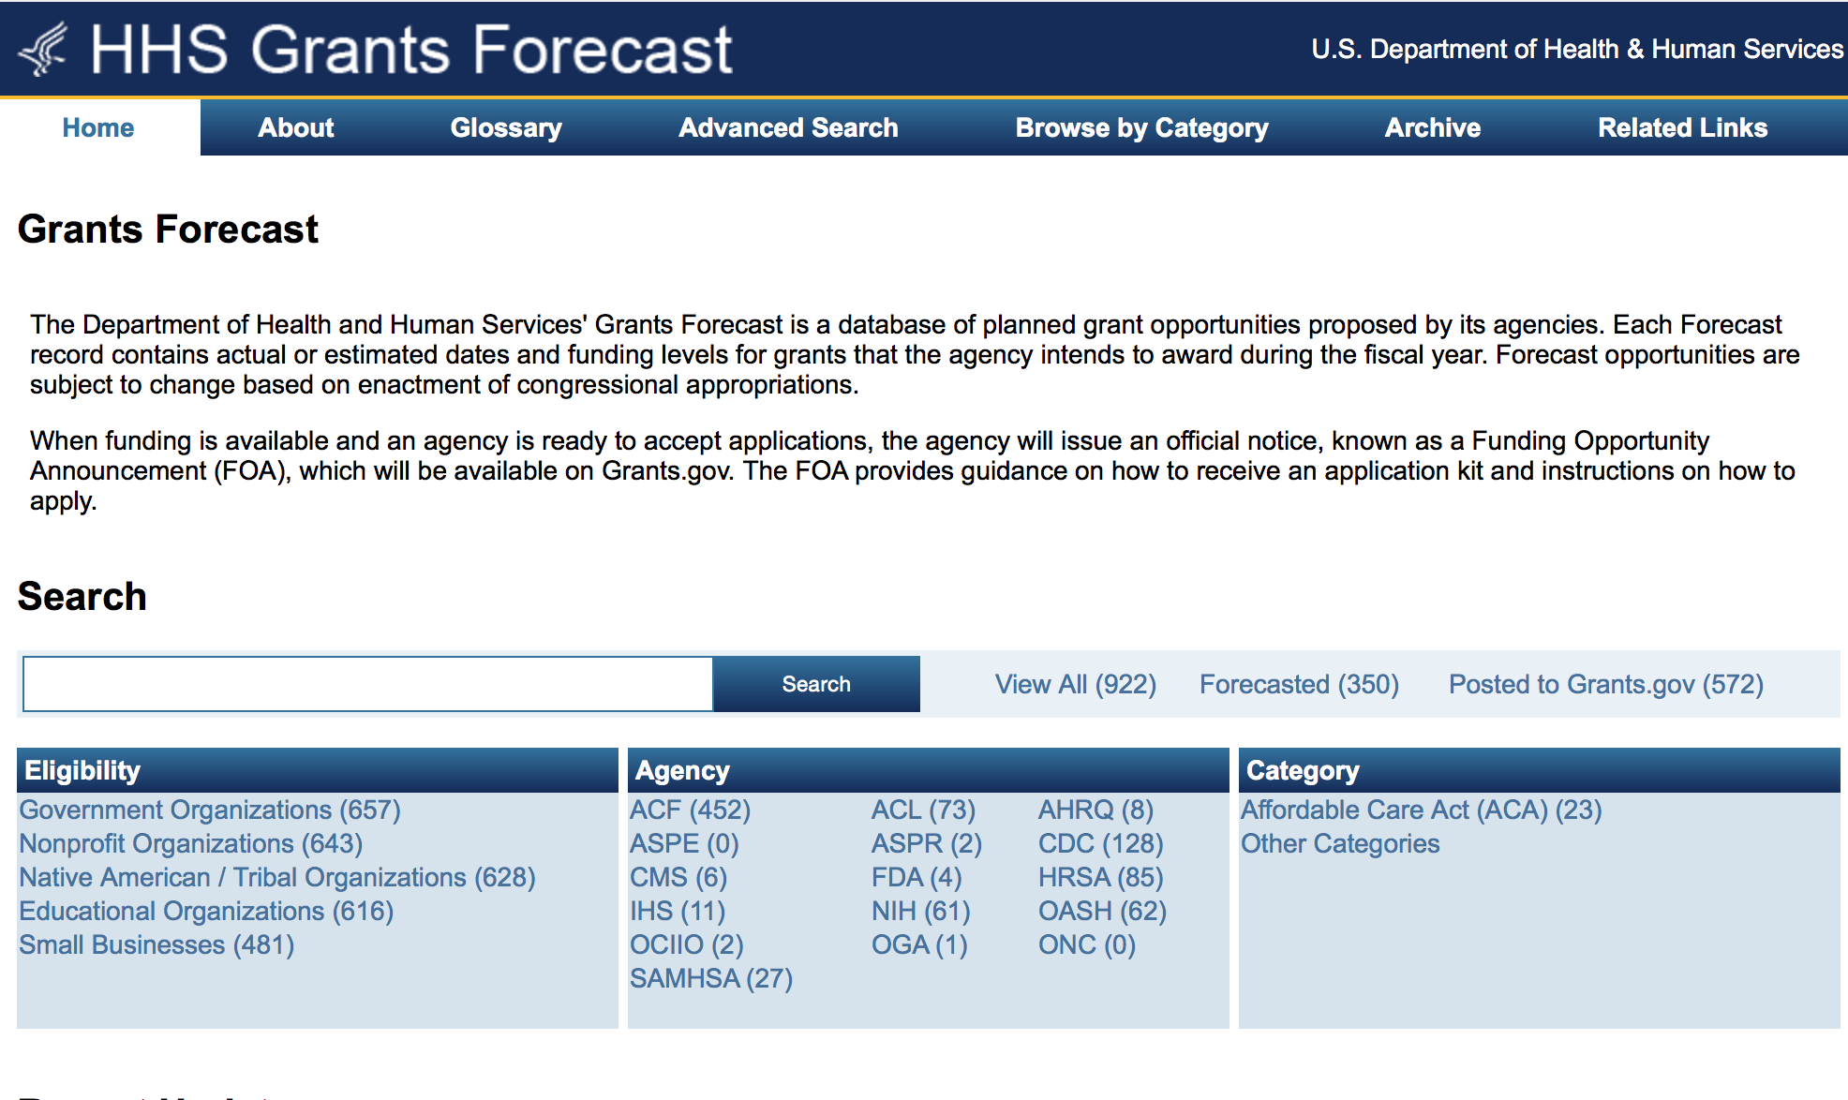
For more general information about HHS Grants and Funding go to the website below at: http://www.hhs.gov/grants/ .

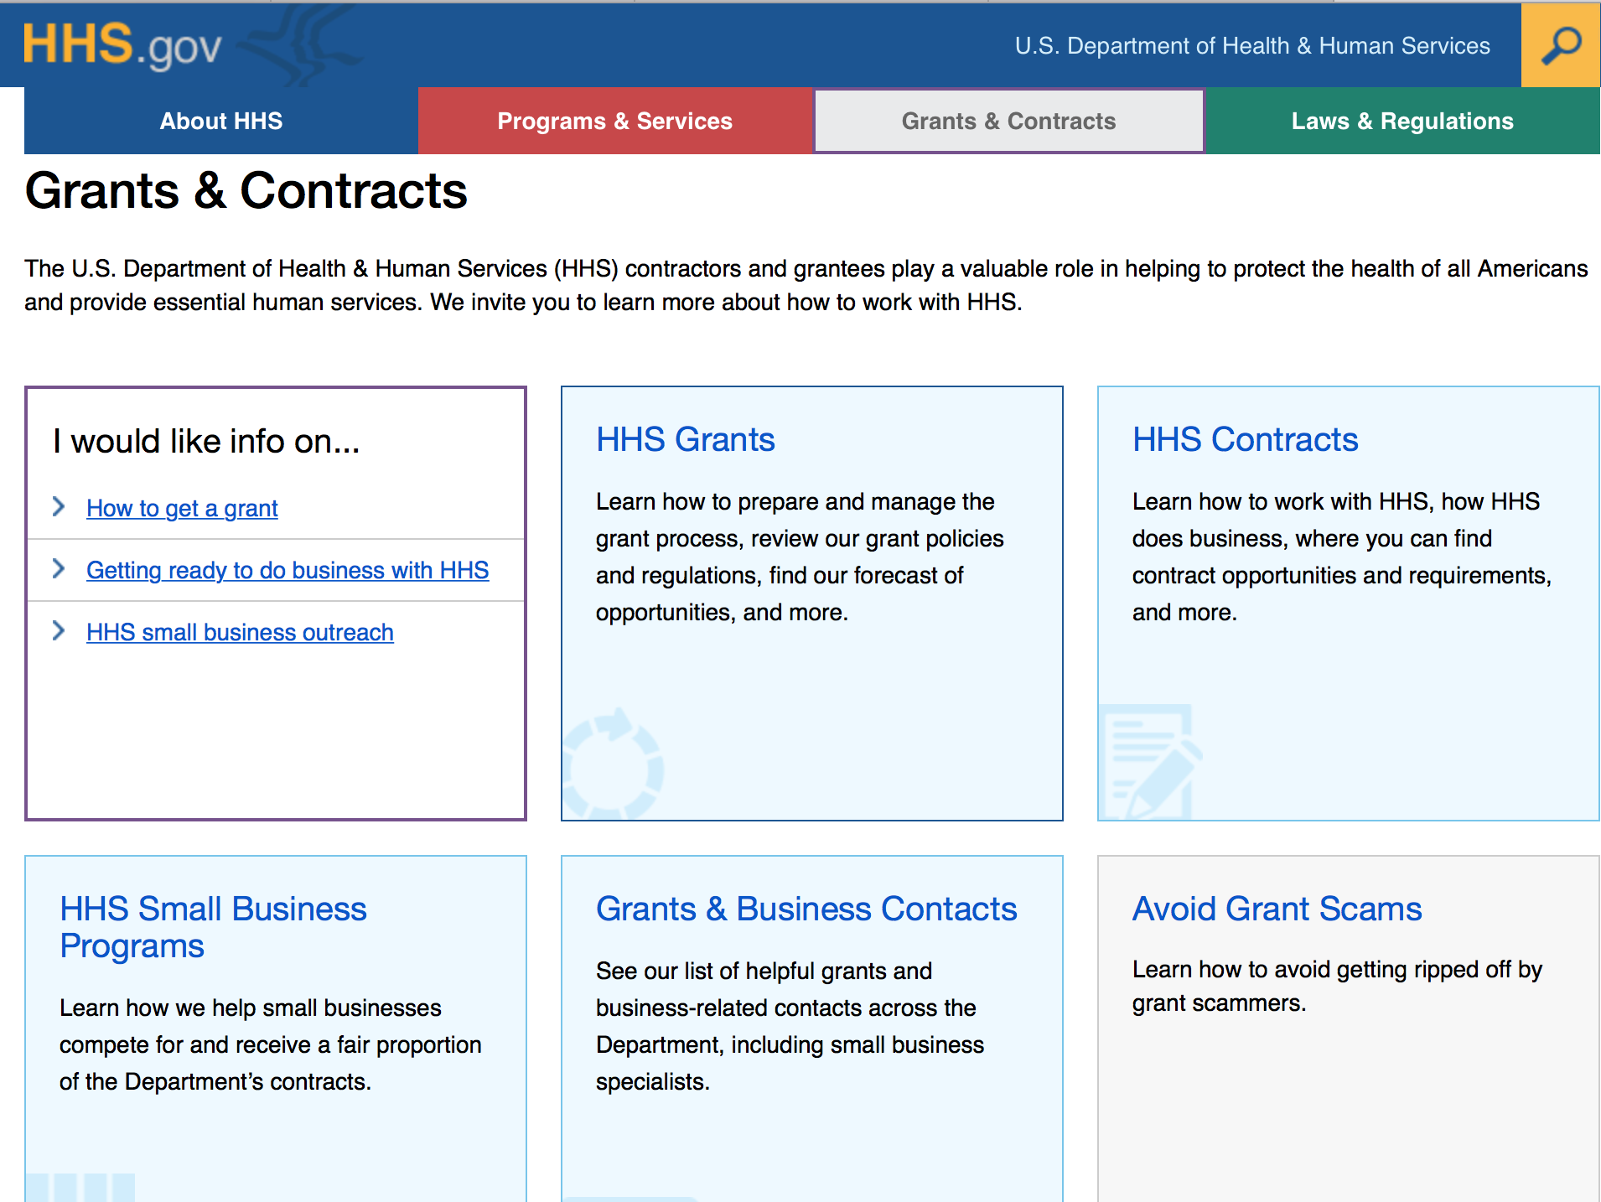

Programs:

Office of the Assistant Secretary for Health
Announcement Availability of Funds for the College Sexual Assault Policy and Prevention Initiative
Modification 2

Document Type: | Grants Notice
Funding Opportunity Number: | WH-AST-16-001
Funding Opportunity Title: | Announcement Availability of Funds for the College Sexual Assault Policy and Prevention Initiative
Opportunity Category: | Discretionary
Funding Instrument Type: | Cooperative Agreement
Category of Funding Activity: | Health
Category Explanation:
Expected Number of Awards: | 10
CFDA Number(s): | 93.088 -- Advancing System Improvements for Key Issues in Women's Health
Cost Sharing or Matching Requirement: | No
Posted Date: | Jan 19, 2016
Creation Date: | Jan 20, 2016
Original Closing Date for Applications: | Apr 8, 2016 No Explanation
Current Closing Date for Applications: | Apr 8, 2016 No Explanation
Archive Date: | May 8, 2016
Estimated Total Program Funding:
Award Ceiling: | $250,000
Award Floor: | $100,000
Eligible Applicants: | Others (see text field entitled "Additional Information on Eligibility" for clarification)
Additional Information on Eligibility: | Any public or private entity is eligible to apply.
Agency Name: | Office of the Assistant Secretary for Health
Description: | The Centers for Disease Control and Prevention (CDC)defines sexual violence as a sexual act committed against someone without that persons freely given consent. Sexual violence can include sexual harassment, sexual assault, and rape. Sexual violence is divided into the following types: Completed or attempted forced penetration of a victim Completed or attempted alcohol/drug-facilitated penetration of a victim Completed or attempted forced acts in which a victim is made to penetrate a perpetrator or someone else Completed or attempted alcohol/drug-facilitated acts in which a victim is made to penetrate a perpetrator or someone else Non-physically forced penetration which occurs after a person is pressured verbally or through intimidation or misuse of authority to consent or acquiesce Unwanted sexual contact Non-contact unwanted sexual experiences The CDC estimates 23 million women have experienced completed or attempted rape in their lifetimes. Nearly 80% of female victims of completed rape or sexual assault reported the episode occurred before their 25th birthday, with 40% having experienced their first rape between the ages 18 and 24. Currently, one in five female college students report having been sexually assaulted. Further, the Association of American Universities(AAU) published results in September 2015 from a new survey finding 23% of female undergraduate students have reported experiencing sexual assault since enrolling in college. AAU surveyed over 150,000 students across 27 colleges and universities. More than 20 percent of female undergraduates at an array of prominent universities said they were victims of sexual assault and misconduct this year. Most often it happens her freshman or sophomore year by someone she knows, but it is not reported. In most cases, the perpetrator is an acquaintance, classmate, friend or (ex) boyfriend of the victim, and she was drugged, drunk, passed out, or otherwise incapacitated. There are approximately 3,000 four-year and 2,000 two-year colleges and universities in the U.S. Yet many post-secondary schools have no or limited policies and procedures in place to prevent sexual assault. For this initiative, each grantee will: Partner with organizations in position to influence policies and practices at post- secondary schools to disseminate sexual assault policy information and prevention strategies; and Partner with a cadre of post-secondary schools to institute policies and practices, and prevention strategies that prevent sexual assaults from occurring. Technical assistance for policy advancement should focus on 1) identifying the campus climate; 2) implementing bystander education and other prevention programs; and 3) effectively responding when a student is sexually assaulted. Grantees will achieve their objectives for this funding opportunity with substantial involvement from OWH. Specifically, OWH will: Actively participate in the development of prevention strategies and policies to ensure the inclusion of steps recommended by the White House Task Force on Campus Sexual Assault to: 1. Identify the scope of the problem on college campuses; 2. Help prevent sexual assault on campus; 3. Help schools respond effectively when a student is sexually assaulted; and 4. Improve the federal governments enforcement efforts, and make them more transparent. Facilitate collaboration among grantees to share best practices and lessons learned. Partner in identifying platforms for dissemination of evidence-based results.
Link to Additional Information: | Announcement Availability of Funds for the College Sexual Assault Policy and Prevention Initiative
Contact Information: | If you have difficulty accessing the full announcement electronically, please contact:  Grants.gov Contact Center Phone Number: 1-800-518-4726 Hours of operation are 24 hours a day, 7 days a week. The contact center is closed on federal holidays. support@grants.gov  Grants.gov Customer Support

http://www.grants.gov/web/grants/view-opportunity.html?oppId=281052

Research:

Administration for Community Living
Switzer Research Fellowships Program Grant
http://www.grants.gov/web/grants/view-opportunity.html?oppId=280971

Centers for Disease Control and Prevention
Operations Research (Implementation Science) for Strengthening Program Implementation through the Presidents Emergency Plan for AIDS Relief (PEPFAR) Grant
http://www.grants.gov/web/grants/view-opportunity.html?oppId=280844

Centers for Disease Control and Prevention
NCCDPHP
Sodium Reduction in Communities Grant
http://www.grants.gov/web/grants/view-opportunity.html?oppId=280919

Centers for Medicare & Medicaid Services
Accountable Health Communities Grant
http://www.grants.gov/web/grants/view-opportunity.html?oppId=280812

Health Resources and Services Administration
Small Health Care Provider Quality Improvement Program Grant
http://www.grants.gov/web/grants/view-opportunity.html?oppId=280808

Health Resources and Services Administration
Telehealth Resource Center Grant Program
http://www.grants.gov/web/grants/view-opportunity.html?oppId=280809

Health Resources and Services Administration
Rural Health Research Center Cooperative Agreement Grant
http://www.grants.gov/web/grants/view-opportunity.html?oppId=280998

Health Resources and Services Administration
Ryan White HIV/AIDS Program Part F Dental Reimbursement Program
Grant
http://www.grants.gov/web/grants/view-opportunity.html?oppId=280979

Health Resources and Services Administration
Ryan White HIV/AIDS Part C Capacity Development Program Grant
http://www.grants.gov/web/grants/view-opportunity.html?oppId=280980

Health Resources and Services Administration
Early Comprehensive Childhood Systems Impact (ECCS Impact) Grant
http://www.grants.gov/web/grants/view-opportunity.html?oppId=281007

National Institutes of Health
Administrative Supplements for Research on Sex/Gender Differences (Admin Supp) Grant
http://www.grants.gov/web/grants/view-opportunity.html?oppId=280829

National Institutes of Health
NIH Pathway to Independence Award (Parent K99/R00) Grant
http://www.grants.gov/web/grants/view-opportunity.html?oppId=280855

National Institutes of Health
Computational Analysis of the Encyclopedia of DNA Elements (ENCODE) Data (U01) Grant
http://www.grants.gov/web/grants/view-opportunity.html?oppId=281020

National Institutes of Health
Characterizing the Functional Elements in the Encyclopedia of DNA Elements (ENCODE) Catalog (UM1) Grant
http://www.grants.gov/web/grants/view-opportunity.html?oppId=281021

National Institutes of Health
Feasibility Studies to Build Collaborative Partnerships in Cancer Research (P20) Grant
http://www.grants.gov/web/grants/view-opportunity.html?oppId=281022

National Institutes of Health
Expanding the Encyclopedia of DNA Elements (ENCODE) in the Human and Mouse (UM1)
Grant
http://www.grants.gov/web/grants/view-opportunity.html?oppId=281024

National Institutes of Health
Education and Health: New Frontiers (R03) Grant
http://www.grants.gov/web/grants/view-opportunity.html?oppId=280942

National Institutes of Health
Education and Health: New Frontiers (R21) Grant
http://www.grants.gov/web/grants/view-opportunity.html?oppId=280943

National Institutes of Health
NIA Clinical Research Project Planning Grant Program (R34) Grant
http://www.grants.gov/web/grants/view-opportunity.html?oppId=281031

National Institutes of Health
Clinical Development of Minimally-Invasive Bioassays to Support Outpatient Clinical Trials of Therapeutics for Substance Use Disorders (R21) Grant
http://www.grants.gov/web/grants/view-opportunity.html?oppId=280873

National Institutes of Health
Behavioral Science Track Award for Rapid Transition (B/Start)(R03) Grant
http://www.grants.gov/web/grants/view-opportunity.html?oppId=280874

National Institutes of Health
NIDCR Small Research Grants for Data Analysis and Statistical Methodology Applied to Genome-wide Data (R03) Grant
http://www.grants.gov/web/grants/view-opportunity.html?oppId=280875

National Institutes of Health
Behavioral and Integrative Treatment Development Program (R01) Grant
http://www.grants.gov/web/grants/view-opportunity.html?oppId=280876

National Institutes of Health
Behavioral and Integrative Treatment Development Program (R03) Grant
http://www.grants.gov/web/grants/view-opportunity.html?oppId=280877

National Institutes of Health
Behavioral and Integrative Treatment Development Program (R34) Grant
http://www.grants.gov/web/grants/view-opportunity.html?oppId=280878

National Institutes of Health
Clinical Development of Minimally-Invasive Bioassays to Support Outpatient Clinical Trials of Therapeutics for Substance Use Disorders (R01) Grant
http://www.grants.gov/web/grants/view-opportunity.html?oppId=280879

National Institutes of Health
Supplements to Promote Clinical Research Studies on Pediatric Burkitt Lymphoma in Low- and Middle-Income Countries (Admin Supp) Grant
http://www.grants.gov/web/grants/view-opportunity.html?oppId=281054

National Institutes of Health
The Neural Mechanisms of Integrated Emotional and Social Representation (R01) Grant
http://www.grants.gov/web/grants/view-opportunity.html?oppId=281185

National Institutes of Health
The Neural Mechanisms of Multi-Dimensional Emotional and Social Representation (R21) Grant
http://www.grants.gov/web/grants/view-opportunity.html?oppId=281186

National Institutes of Health
Noise-Induced Synaptopathy in the Human Auditory System (R01) Grant
http://www.grants.gov/web/grants/view-opportunity.html?oppId=281114

National Institutes of Health
Oocyte Mitochondrial Function in Relation to Fertility, Aging, and Mitochondrial Diseases (R21)
Grant
http://www.grants.gov/web/grants/view-opportunity.html?oppId=281130

National Institutes of Health
Oocyte Mitochondrial Function in Relation to Fertility, Aging, and Mitochondrial Diseases (R01)
Grant
http://www.grants.gov/web/grants/view-opportunity.html?oppId=281131

National Institutes of Health
Imaging and Biomarkers for Early Cancer Detection (U01) Grant
http://www.grants.gov/web/grants/view-opportunity.html?oppId=281143

National Institutes of Health
Regional Consortia for High Resolution Cryoelectron Microscopy (U24) Grant
http://www.grants.gov/web/grants/view-opportunity.html?oppId=281204

National Institutes of Health
Small Business Alzheimer's Disease Research (R43/R44) Grant
http://www.grants.gov/web/grants/view-opportunity.html?oppId=281268

National Institutes of Health
Small Business Alzheimer's Disease Research (R41/R42) Grant
http://www.grants.gov/web/grants/view-opportunity.html?oppId=281247

Modifications:

Agency for Health Care Research and Quality
AHRQ Mentored Clinical Scientist Research Career Development Award (K08)
Modification 2
http://www.grants.gov/web/grants/view-opportunity.html?oppId=210633

Centers for Disease Control and Prevention
Conducting Public Health Research in Kenya
Modification 6
http://www.grants.gov/web/grants/view-opportunity.html?oppId=281000

Centers for Disease Control and Prevention
CGH
Supporting Sustainable Implementation of HIV and TB Services for Epidemic Control in The Republic of Mozambique under the President’s Emergency Plan for AIDS Relief (PEPFAR)
Modification 2
http://www.grants.gov/web/grants/view-opportunity.html?oppId=280556

Centers for Disease Control and Prevention
Research to Advance Primary Care-Pharmacy Linkage for Medication Review to Reduce Older Adult Falls
Modification 2
http://www.grants.gov/web/grants/view-opportunity.html?oppId=280152

Centers for Disease Control and Prevention
Centers for Disease Control and Prevention
Childhood Obesity Research Demonstration 2.0
Modifications 7 & 8
http://www.grants.gov/web/grants/view-opportunity.html?oppId=280155

Centers for Disease Control and Prevention
Research Grants for Preventing Violence and Violence Related Injury (R01)
Modification 3
http://www.grants.gov/web/grants/view-opportunity.html?oppId=280263

Centers for Disease Control and Prevention
NIOSH Exploratory/Developmental Grant Program (R21)
Modification 5
http://www.grants.gov/web/grants/view-opportunity.html?oppId=188173

Centers for Disease Control and Prevention
Centers for Autism and Developmental Disabilities Research and Epidemiology (CADDRE): Study to Explore Early Development (SEED) 3
Modification 3
http://www.grants.gov/web/grants/view-opportunity.html?oppId=280289

Centers for Disease Control and Prevention
The CDC National Centers of Excellence in Youth Violence Prevention: Building the Evidence for Community- and Policy-Level Prevention
Modification 8
http://www.grants.gov/web/grants/view-opportunity.html?oppId=272228

Centers for Disease Control and Prevention
CGH
Programmatic Implementation and Technical Assistance (TA) for HIV/AIDS and Tuberculosis (TB) Prevention, Care, and Treatment Services throughout the Health System in South Africa under the President’s Emergency Plan for AIDS Relief (PEPFAR)
Modification 6
http://www.grants.gov/web/grants/view-opportunity.html?oppId=280534

Centers for Disease Control and Prevention
CGH
Supporting the Development of a HIV-Related Proficiency Testing Network and Quality Management Systems Program for PEPFAR-Supported Countries, including PEPFAR-Supported African Francophone Countries, under the President’s Emergency Plan for AIDS Relief Modification 5
http://www.grants.gov/web/grants/view-opportunity.html?oppId=280528

National Institutes of Health
Safe and Effective Instruments and Devices for Use in Neonatal and Pediatric Care Settings (R43/R44)
Modification 1
http://www.grants.gov/web/grants/view-opportunity.html?oppId=217338

National Institutes of Health
Safe and Effective Instruments and Devices for Use in Neonatal and Pediatric Care Settings (R41/R42)
Modification 1
http://www.grants.gov/web/grants/view-opportunity.html?oppId=217340

National Institutes of Health
Early Stage Development of Technologies in Biomedical Computing, Informatics, and Big Data Science (R43/R44)
Modification 1
http://www.grants.gov/web/grants/view-opportunity.html?oppId=252514

National Institutes of Health
Early Stage Development of Technologies in Biomedical Computing, Informatics, and Big Data Science (R41/R42)
Modification 1
http://www.grants.gov/web/grants/view-opportunity.html?oppId=252517

National Institutes of Health
Novel Tools for Investigating Brain-derived GPCRs in Mental Health Research (R41/R42)
Modification 1
http://www.grants.gov/web/grants/view-opportunity.html?oppId=253463

National Institutes of Health
Novel Tools for Investigating Brain-derived GPCRs in Mental Health Research (R43/R44)
Modification 1
http://www.grants.gov/web/grants/view-opportunity.html?oppId=253464

National Institutes of Health
Complex Technologies and Therapeutics Development for Mental Health Research and Practice (R41/R42)
Modification 1
http://www.grants.gov/web/grants/view-opportunity.html?oppId=254524

National Institutes of Health
Complex Technologies and Therapeutics Development for Mental Health Research and Practice (R43/R44)
Modification 1
http://www.grants.gov/web/grants/view-opportunity.html?oppId=254525

National Institutes of Health
Reagents for Glucagon and Incretin Research (R41/R42)
Modification 1
http://www.grants.gov/web/grants/view-opportunity.html?oppId=254608

National Institutes of Health
Lab to Marketplace: Tools for Brain and Behavioral Research (R43/R44)
Modification 1
http://www.grants.gov/web/grants/view-opportunity.html?oppId=256806

National Institutes of Health
Improvement of Animal Models and Development of Technologies for Stem Cell-Based Regenerative Medicine (STTR)(R41/R42)
Modification 1
http://www.grants.gov/web/grants/view-opportunity.html?oppId=233713

National Institutes of Health
NINDS Renewal Awards of SBIR Phase II Grants (Phase IIB) for Pre-Clinical Research (R44)
Modification 1
http://www.grants.gov/web/grants/view-opportunity.html?oppId=254810

National Institutes of Health
NINDS Renewal Awards of SBIR Phase II Grants (Phase IIB) for Exploratory Clinical Trials and Clinical Research (R44)
Modification 1
http://www.grants.gov/web/grants/view-opportunity.html?oppId=254811

National Institutes of Health
Renewal Awards of SBIR Phase IIB Grants for Brain and Behavior Tools (R44)
Modification 1
http://www.grants.gov/web/grants/view-opportunity.html?oppId=255169

National Institutes of Health
Development and Commercialization of Technologies to Create, Characterize or Improve Animal Models of Human Disease (STTR)(R41/R42)
Modification 1
http://www.grants.gov/web/grants/view-opportunity.html?oppId=217715

National Institutes of Health
Development and Commercialization of Technologies to Create, Characterize or Improve Animal Models of Human Disease (SBIR)(R43/R44)
Modification 1
http://www.grants.gov/web/grants/view-opportunity.html?oppId=217716

National Institutes of Health
Improvement of Animal Models and Development of Technologies for Stem Cell-Based Regenerative Medicine (SBIR)(R43/R44)
Modification 1
http://www.grants.gov/web/grants/view-opportunity.html?oppId=233693

Office of the Assistant Secretary for Health
Announcement of the Availability of Funds for Conferences on Research Integrity
Modification 1
http://www.grants.gov/web/grants/view-opportunity.html?oppId=280981

Office of the Assistant Secretary for Health
Announcement of the Availability of Funds for Phase I Research on Research Integrity
Modification 1
http://www.grants.gov/web/grants/view-opportunity.html?oppId=280999

Office of the Assistant Secretary for Health
Announcement of Availability of Funds for Providing Capacity Building Assistance to Office of Adolescent Health (OAH) Teen Pregnancy Prevention (TPP) Grantees
Modification 1
http://www.grants.gov/web/grants/view-opportunity.html?oppId=280828

Office of the Assistant Secretary for Health
Announcement of Availability of Funds for the Female Genital Cutting (FGC) Community-Centered Health Care and Prevention Project
Modification 1
http://www.grants.gov/web/grants/view-opportunity.html?oppId=281078

Substance Abuse and Mental Health Services Admin
Targeted Capacity Expansion-Peer-to-Peer (Short Title: TCE-PTP)
Modification 1
http://www.grants.gov/web/grants/view-opportunity.html?oppId=280471

Reminders:

Substance Abuse & Mental Health Services Administration
Drug-Free Communities (DFC) Support Program Grant

Document Type: | Grants Notice
Funding Opportunity Number: | SP-16-001
Funding Opportunity Title: | Drug-Free Communities (DFC) Support Program
Opportunity Category: | Discretionary
Funding Instrument Type: | Grant
Category of Funding Activity: | Health
Category Explanation:
Expected Number of Awards: | 70
CFDA Number(s): | 93.276 -- Drug-Free Communities Support Program Grants
Cost Sharing or Matching Requirement: | Yes
Posted Date: | Dec 16, 2015
Creation Date: | Dec 16, 2015
Original Closing Date for Applications: | Mar 18, 2016
Current Closing Date for Applications: | Mar 18, 2016
Archive Date: | Apr 17, 2016
Estimated Total Program Funding: | $8,750,000
Award Ceiling: | $125,000
Award Floor: | $0
Eligible Applicants: | Others (see text field entitled "Additional Information on Eligibility" for clarification)
Additional Information on Eligibility: | Eligible applicants are community-based coalitions addressing youth substance use that have never received a DFC grant; or have previously received a DFC grant, but experienced a lapse in funding; or have concluded the first five-year funding cycle and are applying for a second five-year funding cycle. Applicants must meet all Statutory Eligibility Requirements. See Section III-1 of this FOA for complete eligibility information.
Agency Name: | Substance Abuse & Mental Health Services Adminis.
Description: | The DFC Program was created by the Drug-Free Communities Act of 1997 (Public Law 105-20). The DFC Support Program has two goals: 1. Establish and strengthen collaboration among communities, public and private non-profit agencies; as well as federal, state, local, and tribal governments to support the efforts of community coalitions working to prevent and reduce substance use among youth*. 2. Reduce substance use among youth and, over time, reduce substance abuse among adults by addressing the factors in a community that increase the risk of substance abuse and promoting the factors that minimize the risk of substance abuse. *For the purposes of this FOA, “youth” is defined as individuals 18 years of age and younger.
Link to Additional Information: | Drug-Free Communities (DFC) Support Program
Contact Information: | If you have difficulty accessing the full announcement electronically, please contact:  Jennifer Cramer, Division of Grants Management, SAMHSA, 7-1109, 1 Choke Cherry Road, Rockville, MD 20857 Phone: (240) 276-1422  DGMSAMHSA@samhsa. .gov

http://www.grants.gov/web/grants/view-opportunity.html?oppId=280572

National Institutes of Health
PHS 2015-02 Omnibus Solicitation of the NIH, CDC, FDA and ACF for Small Business Innovation Research Grant Applications (Parent SBIR [R43/R44]) Grant

Document Type: | Grants Notice
Funding Opportunity Number: | PA-15-269
Funding Opportunity Title: | PHS 2015-02 Omnibus Solicitation of the NIH, CDC, FDA and ACF for Small Business Innovation Research Grant Applications (Parent SBIR [R43/R44])
Opportunity Category: | Discretionary
Funding Instrument Type: | Grant
Category of Funding Activity: | Education  Environment  Food and Nutrition  Health  Income Security and Social Services
Category Explanation:
Expected Number of Awards:
CFDA Number(s): | 93.061 -- Innovations in Applied Public Health Research  93.103 -- Food and Drug Administration Research  93.113 -- Environmental Health  93.121 -- Oral Diseases and Disorders Research  93.136 -- Injury Prevention and Control Research and State and Community Based Programs  93.172 -- Human Genome Research  93.173 -- Research Related to Deafness and Communication Disorders  93.213 -- Research and Training in Complementary and Integrative Health  93.233 -- National Center on Sleep Disorders Research  93.242 -- Mental Health Research Grants  93.262 -- Occupational Safety and Health Program  93.273 -- Alcohol Research Programs  93.279 -- Drug Abuse and Addiction Research Programs  93.282 -- Mental Health National Research Service Awards for Research Training  93.283 -- Centers for Disease Control and Prevention Investigations and Technical Assistance  93.286 -- Discovery and Applied Research for Technological Innovations to Improve Human Health  93.307 -- Minority Health and Health Disparities Research  93.350 -- National Center for Advancing Translational Sciences  93.351 -- Research Infrastructure Programs  93.361 -- Nursing Research  93.393 -- Cancer Cause and Prevention Research  93.394 -- Cancer Detection and Diagnosis Research  93.395 -- Cancer Treatment Research  93.396 -- Cancer Biology Research  93.399 -- Cancer Control  93.595 -- Welfare Reform Research, Evaluations and National Studies  93.647 -- Social Services Research and Demonstration  93.823 -- Ebola Support: Transmission and Prevention Control, Public Health Preparedness, Vaccine Development  93.837 -- Cardiovascular Diseases Research  93.838 -- Lung Diseases Research  93.839 -- Blood Diseases and Resources Research  93.846 -- Arthritis, Musculoskeletal and Skin Diseases Research  93.847 -- Diabetes, Digestive, and Kidney Diseases Extramural Research  93.853 -- Extramural Research Programs in the Neurosciences and Neurological Disorders  93.855 -- Allergy, Immunology and Transplantation Research  93.856 -- Microbiology and Infectious Diseases Research  93.859 -- Biomedical Research and Research Training  93.865 -- Child Health and Human Development Extramural Research  93.866 -- Aging Research  93.867 -- Vision Research  93.879 -- Medical Library Assistance
Cost Sharing or Matching Requirement: | No
Posted Date: | Jun 4, 2015
Creation Date: | Jun 4, 2015
Original Closing Date for Applications: | Apr 5, 2016
Current Closing Date for Applications: | Apr 5, 2016
Archive Date: | May 6, 2016
Eligible Applicants: | Small businesses
Additional Information on Eligibility: | Other Eligible Applicants include the following: Non-domestic (non-U.S.) Entities (Foreign Institutions) are not eligible to apply. Non-domestic (non-U.S.) components of U.S. Organizations are not eligible to apply. Foreign components, as defined in the NIH Grants Policy Statement, may be allowed.
Agency Name: | National Institutes of Health
Description: | This Funding Opportunity Announcement (FOA) issued by the National Institutes of Health (NIH), the Centers for Disease Control and Prevention (CDC), the Food and Drug Administration (FDA) and the Administration for Children and Families (ACF) invites eligible United States small business concerns (SBCs) to submit Small Business Innovation Research (SBIR) grant applications. United States SBCs that have the research capabilities and technological expertise to contribute to the R and D mission(s) of the NIH, CDC, FDA or ACF awarding components identified in this FOA are encouraged to submit SBIR grant applications in response to identified topics (see PHS 2015-2 SBIR/STTR Program Descriptions and Research Topics for NIH, CDC, FDA and ACF.
Link to Additional Information: | http://grants.nih.gov/grants/guide/pa-files/PA-15-269.html
Contact Information: | If you have difficulty accessing the full announcement electronically, please contact:  NIH OER Webmaster FBOWebmaster@OD.NIH.GOV  If you have any problems linking to this funding announcement, please contact the NIH OER Webmaster

http://www.grants.gov/web/grants/view-opportunity.html?oppId=276977

Department of Homeland Security

The Department of Homeland Security enhances the ability of states, local and tribal jurisdictions, and other regional authorities in the preparation, prevention, and response to terrorist attacks and other disasters, by distributing grant funds. Localities can use grants for planning, equipment, training and exercise needs.

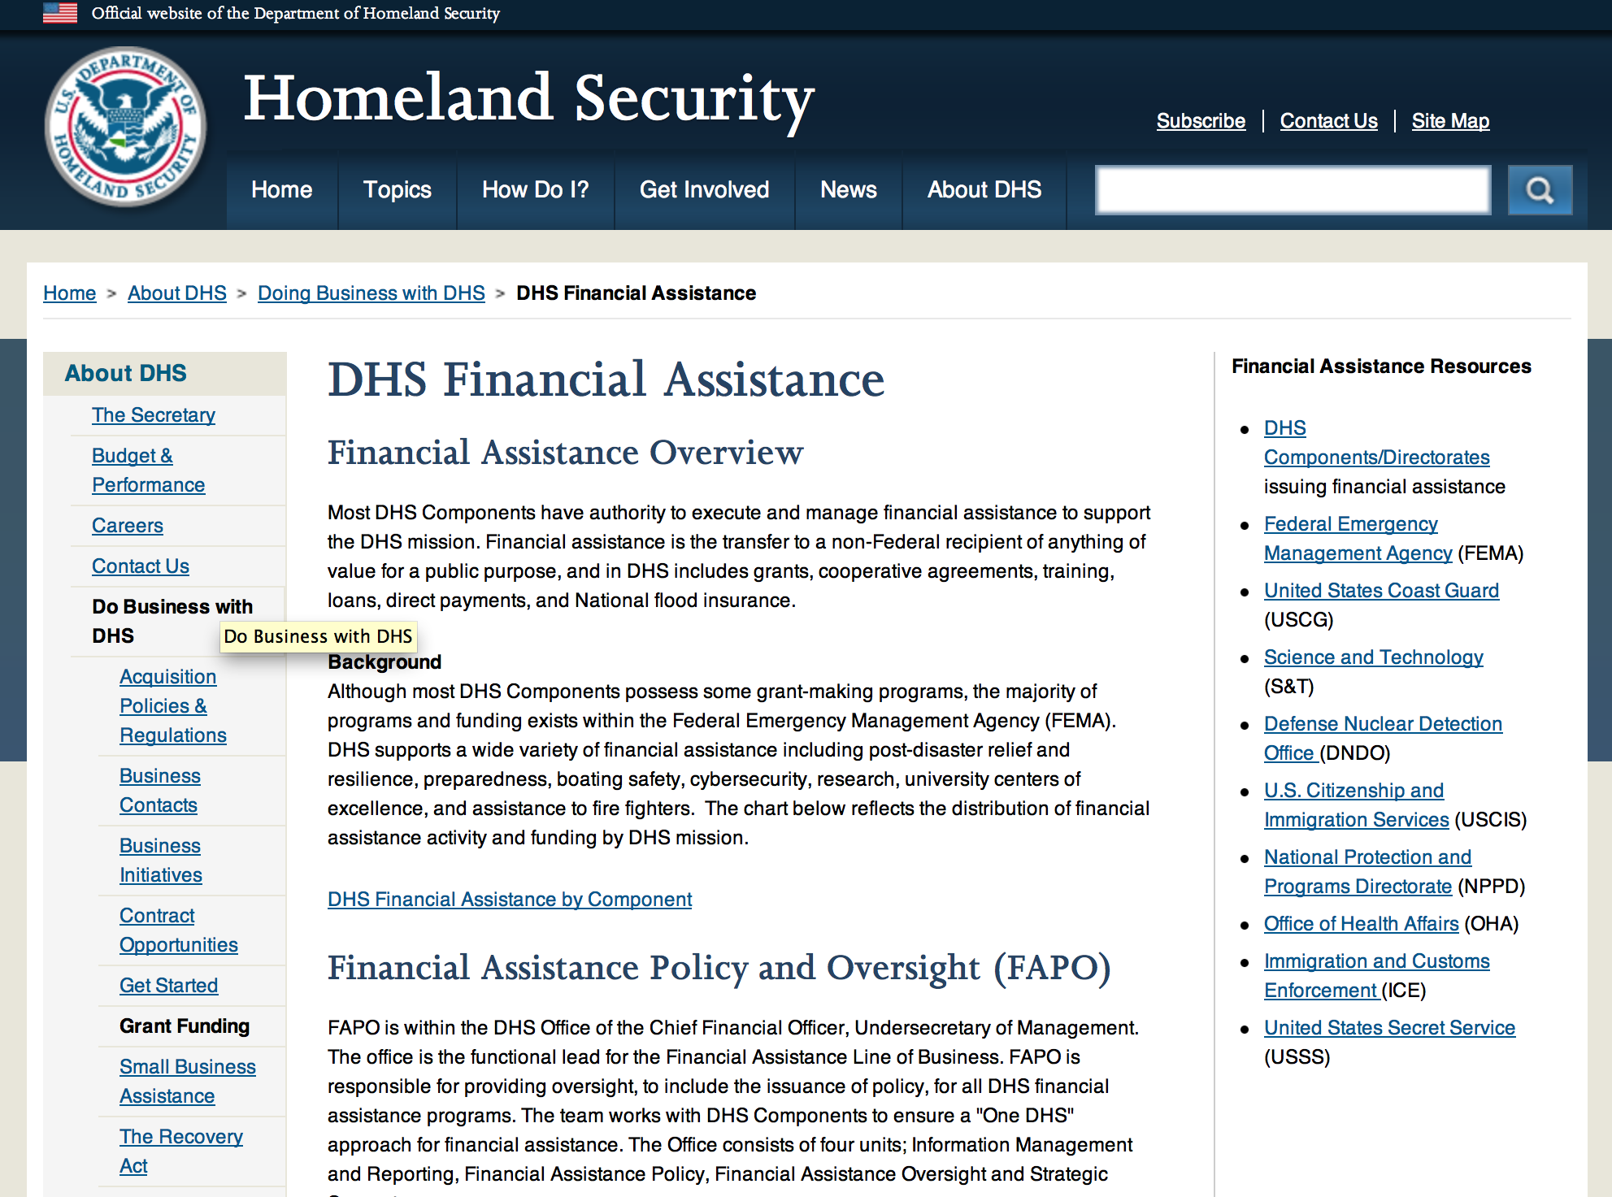

Webpage can be viewed at: http://www.dhs.gov/xopnbiz/grants/index.shtm#2

The FY 2015 Assistance to Firefighters Grants (AFG) Application Period Has Closed.
For AFG program guidance materials, please visit our Documents page.
FY 2015 FIRE PREVENTION & SAFETY (FP&S) Grants
- FY 2015 Application Information Coming Soon
- FP&S Success Stories
FY 2014 FIRE PREVENTION & SAFETY (FP&S) Grants
- FY 2014 FP&S Award Announcements - View Awards List
FY 2015 STAFFING FOR ADEQUATE FIRE and EMERGENCY RESPONSE (SAFER) Grants
- FY 2015 Application Information Coming Soon
- SAFER Success Stories
FY 2014 STAFFING FOR ADEQUATE FIRE and EMERGENCY RESPONSE (SAFER) Grants
- FY 2014 FP&S Award Announcements - View Awards List
FP&S Success Stories

Resources

AFG Help Desk
Contact the AFG Program Help Desk toll-free at 866-274-0960, or email us at firegrants@dhs.gov.
The AFG Program has Fire Program Specialists in 10 federal regional centers. These Regional Fire Program Specialists respond to questions about the AFG program and carry out grant monitoring activities. View regional contacts

Popular AFG links
- AFG Workshop Schedule
- Assistance to Firefighters Grants (AFG)
- AFG Awards List
- AFG Success Stories
- Staffing for Adequate Fire & Emergency Response (SAFER) Grants (SAFER)
- SAFER Awards List
- SAFER Success Stories
- Fire Prevention & Safety (FP&S) Grants
- FP&S Awards List
- FP&S Success Stories
- Grant Closeout Tutorial
- Assistance to Firefighters Grant (AFG) Email Alert Archive
- Frequently Asked Questions
Contact Information For The Assistance to Firefighters Grant (AFG) Program and Help Desk

Federal Funding Alternative To AFG

State Administrative Agencies (SAA) apply for and administer Federal grants on behalf of their States, including FEMA Preparedness Grants. The SAA will work with eligible organizations to comply with the general requirements of grant programs or cooperative agreements. Contact your State’s SAA to find out what current Federal funding opportunities may be available to your organization. A listing of the SAAs and points of contact can be found at http://www.fema.gov/library/viewRecord.do?id=6363.

Programs:

Modifications:

Reminders:

United States Coast Guard
National Non-Profit Organization Grant Program

Document Type: | Grants Notice
Funding Opportunity Number: | DHS-USCG-2016-001
Funding Opportunity Title: | National Non-Profit Organization Grant Program
Opportunity Category: | Discretionary
Funding Instrument Type: | Grant
Category of Funding Activity: | Other (see text field entitled "Explanation of Other Category of Funding Activity" for clarification)
Category Explanation: | Recreational Boating Safety
Expected Number of Awards: | 30
CFDA Number(s): | 97.012 -- Boating Safety Financial Assistance
Cost Sharing or Matching Requirement: | No
Posted Date: | Dec 23, 2015
Creation Date: | Dec 23, 2015
Original Closing Date for Applications: | Mar 25, 2016
Current Closing Date for Applications: | Mar 25, 2016
Archive Date: | Apr 24, 2016
Estimated Total Program Funding: | $5,200,000
Eligible Applicants: | Nonprofits having a 501(c)(3) status with the IRS, other than institutions of higher education
Agency Name: | United States Coast Guard
Description: | The purpose of the National Recreational Boating Safety Program is to reduce the number of accidents, injuries and deaths on America's waterways and provide a safe enjoyable experience for the boating public. The program also encourages greater non-profit organizations participation and uniformity in boating safety efforts.
Link to Additional Information: | United States Coast Guard Boating Safety
Contact Information: | If you have difficulty accessing the full announcement electronically, please contact:  Carlin Hertz Grant Coordinator Phone 202-372-1060  Non Profit Grants Coordinator

http://www.grants.gov/web/grants/view-opportunity.html?oppId=280672

Department of Housing and Urban Development

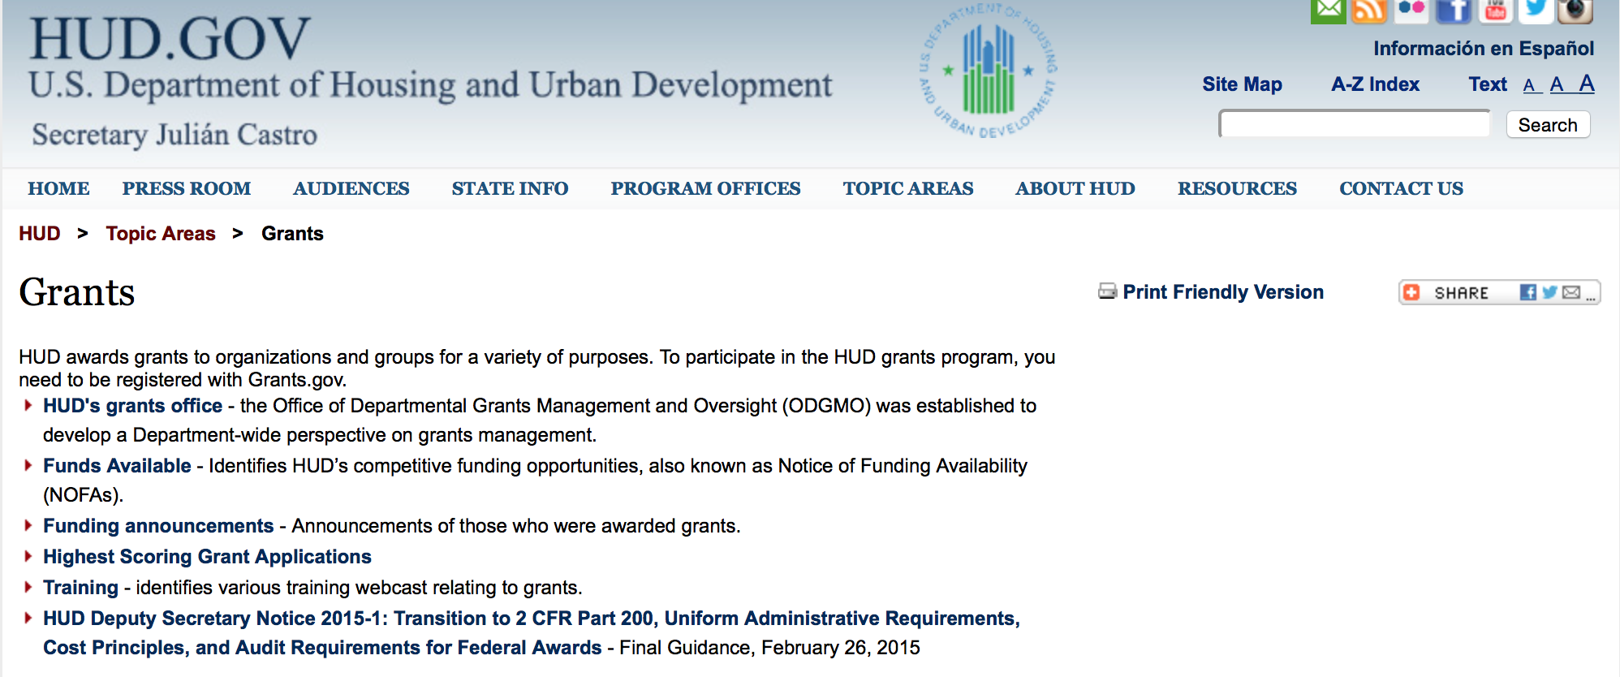

http://portal.hud.gov/hudportal/HUD?src=/topics/grants

HUD - Notice of Funds Available

For detailed information click here

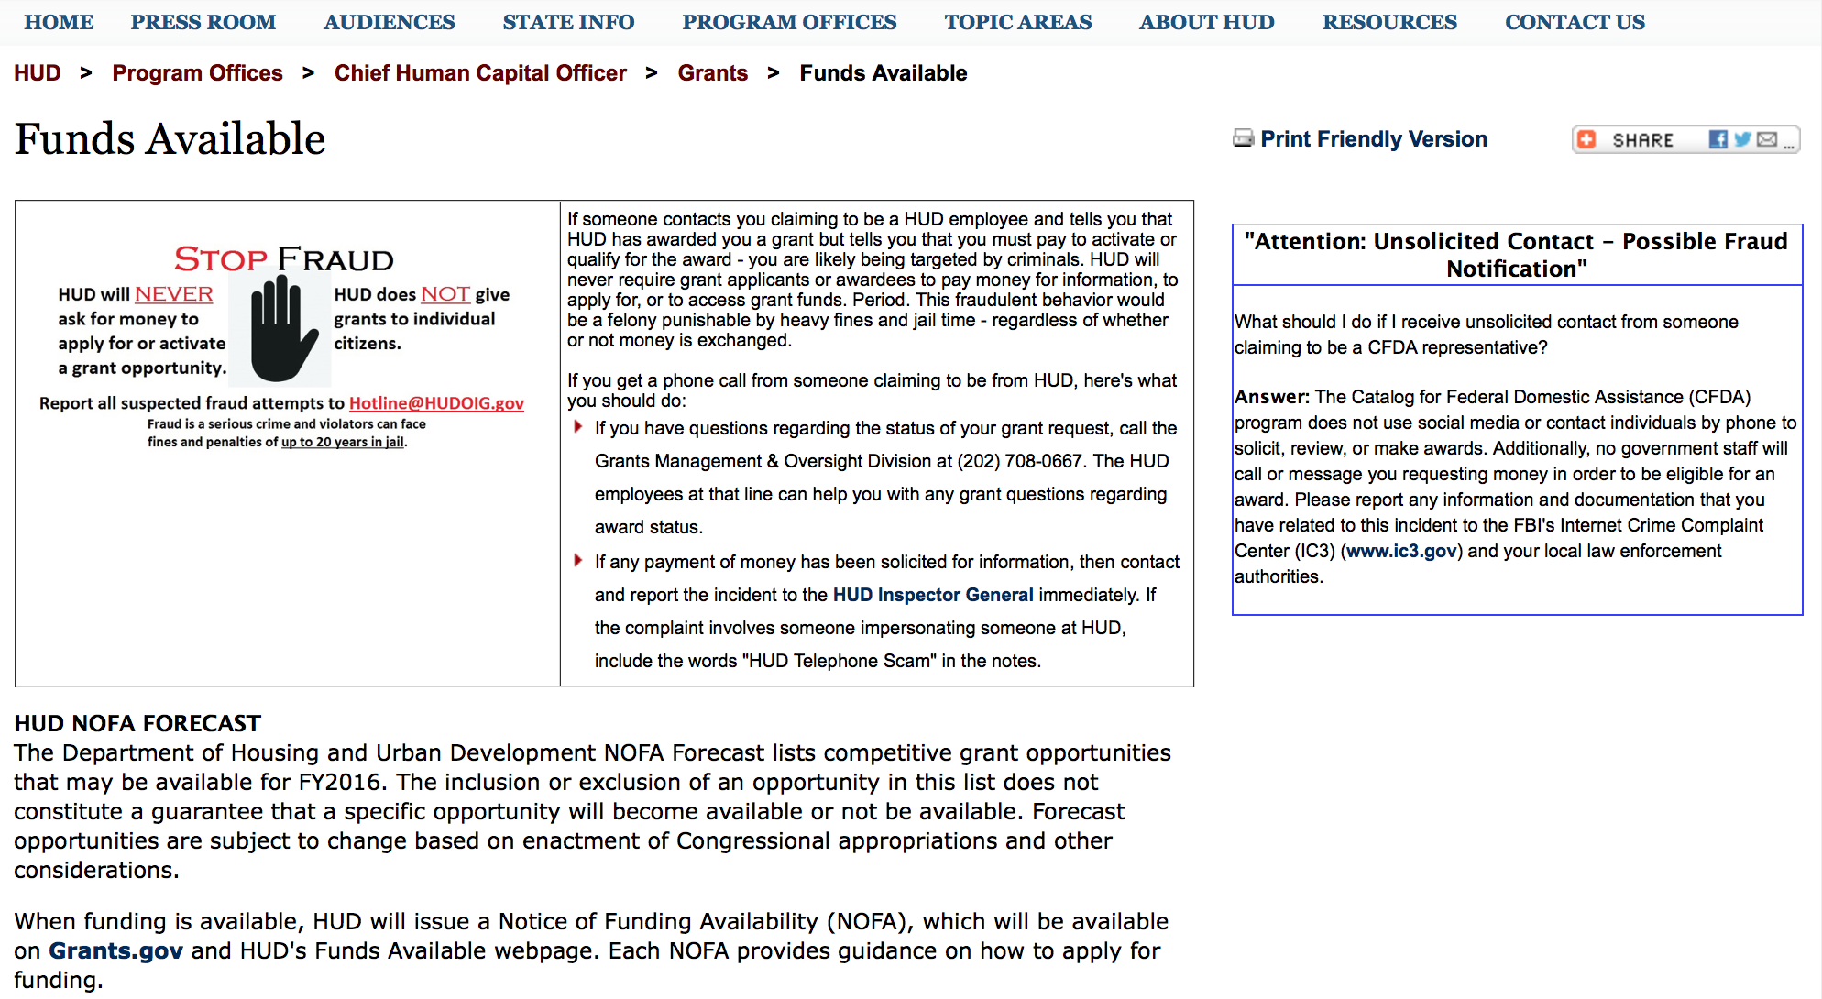

http://portal.hud.gov/hudportal/HUD?src=/program_offices/administration/grants/fundsavail

FY 2013 Notice of Funding Availability (NOFA) Policy Requirements and General Section to HUD’s FY2013 NOFAs for Discretionary Programs
This Notice provides prospective applicants for HUD's competitive funding with the opportunity to become familiar with the General Section to HUD's FY2013 Notices of Funding Availability (NOFAs) for Discretionary Funding (program NOFA), in advance of publication of any individual FY2013 program NOFAs. This General Section and the individual FY2013 program NOFA Sections comprise the entirety of the FY2013 NOFA instructions.
- General Section
- FONSI
- New Application Attachment Filename Requirement

Programs

Housing Opportunities for Persons With AIDS (HOPWA) Project Demonstration and Violence Against Women Act (VAWA) Grant

Document Type: | Grants Notice
Funding Opportunity Number: | FR-5900-N-11B
Funding Opportunity Title: | Housing Opportunities for Persons With AIDS (HOPWA) Project Demonstration and Violence Against Women Act (VAWA)
Opportunity Category: | Discretionary
Funding Instrument Type: | Grant
Category of Funding Activity: | Housing
Category Explanation:
Expected Number of Awards: | 9
CFDA Number(s): | 14.241 -- Housing Opportunities for Persons with AIDS
Cost Sharing or Matching Requirement: | No
Posted Date: | Jan 5, 2016
Creation Date: | Jan 5, 2016
Original Closing Date for Applications: | Mar 8, 2016 Electronically submitted applications must be submitted no later than 11:59:59 p.m., ET, on the listed application due date.
Current Closing Date for Applications: | Mar 8, 2016 Electronically submitted applications must be submitted no later than 11:59:59 p.m., ET, on the listed application due date.
Archive Date: | Apr 7, 2016
Estimated Total Program Funding: | $9,109,000
Award Ceiling: | $1,300,000
Award Floor: | $625,000
Eligible Applicants: | Others (see text field entitled "Additional Information on Eligibility" for clarification)
Additional Information on Eligibility: | Eligible applicants for funding under this NOFA are States, units of local government, and nonprofit organizations. Because selected applicants will receive a HOPWA grant and a Transitional Housing Assistance Program grant, eligibility under this demonstration will be limited to entities that are eligible to receive grant funding under both programs. Individuals, foreign entities, and sole proprietorship organizations are not eligible to compete for, or receive, awards made under this announcement.
Agency Name: | Department of Housing and Urban Development
Description: | Grants funded under this initiative will implement one of the recommendations of the Interagency Federal Working Group on the Intersection of HIV/AIDS, Violence against Women and Girls, and Gender-Related Health Disparities: to enhance federal efforts to address HIV and intimate partner violence (IPV) among homeless and marginally housed women and girls. These grants will also help further the goals and objectives of the National HIV/AIDS Strategy (NHAS), which calls for enhanced collaboration at the Federal, State and community level, among diverse agencies and partners to maximize efficient use of resources to achieve its goals. The activities funded under this NOFA will support the NHAS goals; to reduce HIV infection; to increase access to care and improve health outcomes for person living with HIV/AIDS; and to reduce HIV-related disparities. These goals will be accomplished through improved cross-agency coordination, resource utilization and service integration among HIV/AIDS housing providers and domestic violence service providers. This NOFA announces funds available for projects that provide housing assistance and supportive services to low-income persons living with HIV/AIDS who are also victims of domestic violence, dating violence, sexual assault, or stalking, including any minors and dependents living with such persons. Each successful applicant under this initiative will receive two separate one-time only, non-renewable grants from HUD: (1) a HOPWA grant, and (2) a Transitional Housing Assistance Program grant. HOPWA grant funds will be used for housing assistance for program participants, coordination and planning activities, and grant management and administration. Transitional Housing Assistance grant funds will be used to provide supportive services for program participants. As a result of project efforts, communities will be assisted in the development of a Housing and Services (HAS) Model to be issued at the end of the third year of operation. This HAS Model document will be an administrative function and should provide clear lessons learned and best practices for providing housing assistance and appropriate supportive services for persons living with HIV/AIDS who are victims of domestic violence, dating violence, sexual assault, or stalking. Each HAS Model will be shared with the public, and lessons learned through these grantee efforts will help inform national and community policy and actions.
Link to Additional Information: | http://www.grants.gov/web/grants/applicants/apply-for-grants.html
Contact Information: | If you have difficulty accessing the full announcement electronically, please contact:  Lisa Steinhauer Lisa.A.Steinhauer@hud.gov  Grants Policy

http://www.grants.gov/web/grants/view-opportunity.html?oppId=280825

Supportive Services Demonstration for Elderly Households in HUD-Assisted Multifamily Housing
Grant

Document Type: | Grants Notice
Funding Opportunity Number: | FR-5900-N-22
Funding Opportunity Title: | Supportive Services Demonstration for Elderly Households in HUD-Assisted Multifamily Housing
Opportunity Category: | Discretionary
Funding Instrument Type: | Cooperative Agreement
Category of Funding Activity: | Housing
Category Explanation:
Expected Number of Awards: | 80
CFDA Number(s): | 14.191 -- Multifamily Housing Service Coordinators
Cost Sharing or Matching Requirement: | No
Posted Date: | Jan 20, 2016
Creation Date: | Jan 20, 2016
Original Closing Date for Applications: | Apr 18, 2016 Electronically submitted applications must be submitted no later than 11:59:59 p.m., ET, on the listed application due date.
Current Closing Date for Applications: | Apr 18, 2016 Electronically submitted applications must be submitted no later than 11:59:59 p.m., ET, on the listed application due date.
Archive Date: | May 18, 2016
Estimated Total Program Funding: | $15,000,000
Eligible Applicants: | Others (see text field entitled "Additional Information on Eligibility" for clarification)
Additional Information on Eligibility: | Applicants must be owners of existing eligible federally assisted multifamily properties. 1. Eligible Multifamily Property: a. Must be a HUD-assisted development with at least 50 assisted housing units - Unit count may be a combined count of total number in a campus setting. The development must be occupied by Eligible Tenants as defined below. b. HUD-Assisted housing types are limited to: (1) Housing that is assisted under section 202 of the Housing Act of 1959 (12 U.S.C. 1701q), including housing that is assisted under section 202 as such section existed before the enactment of the National Affordable Housing Act (Public Law 101-625); (2) Housing for which project-based assistance is provided under section 8 of the United States Housing Act of 1937 (42 U.S.C. 1437f), including Section 515 rural housing projects, as authorized under section 515 of the Housing Act of 1949 (42 U.S.C. 1485), receiving Section 8 rental assistance; (3) Housing financed by a loan or mortgage insured under section 221(d)(3) of the National Housing Act (12 U.S.C. 1715) that bears interest at a rate determined under section 221(d)(5) of such Act; or (4) Housing insured, assisted, or held by the Secretary, a State, or a state agency under section 236 of the National Housing Act (12 U.S.C. 1715z&ndash;1); c. Properties meeting the requirements of 1.a. and 1.b. of this subsection with an existing service coordinator on staff may apply for funding under this NOFA in order to hire the Wellness Nurse and implement this enhanced supportive service model. Acceptance of funding under this NOFA will require the Owner to comply with the requirements as detailed in this NOFA. Individuals, foreign entities, and sole proprietorship organizations are not eligible to compete for, or receive, awards made under this announcement.
Agency Name: | Department of Housing and Urban Development
Description: | HUD’s investment under this Demonstration program is intended to facilitate aging in place by providing a supportive services subsidy to certain elderly restricted HUD assisted independent housing developments. The supportive service subsidy will (1) cover all reasonable cost related to the provision of a full-time enhanced service coordinator and part-time preventive health nurse as well as (2) allocate a nominal amount towards eligible services expenses for our aging residents. Elderly persons who have access to affordable, safe and accessible housing, who practice healthy behaviors, take advantage of wellness, preventive and long-term care services and supports, and those who continue to engage with family and friends are more likely to achieve better health outcomes, live independently, age in place and incur fewer health-related costs. Under this NOFA, HUD will evaluate the extent to which the selected housing plus supportive service models allow elderly persons to live independently and age in place, including improving general well being, improving health outcomes and health-care utilization, and preventing or delaying institutionalization. Funding priority will be given to those sponsors that evidence the ability to accomplish the following three goals: Strengthen the Availability of Supportive Services by effectively using the Service Coordinator to create and support partnerships between housing and supportive service providers to support aging in place; Support Aging-in-Place by fostering an environment that allows for elderly persons to live independently by accessing home and community-based supportive services that are designed to promote general well being, improved health outcomes; and Improve the evidence base on the effectiveness of Section 202 housing as a platform to improve health outcomes by participating in an effort led by HUD (or its contractors and/or grantees) to develop standard procedures to be implemented by all sponsors/owners for (1) measurement of outcomes related to general well being; health and health-care utilization; and costs to the health care system; (2) implementation of the enhanced service coordinator model in the same way in all sites; and (3) enrollment of eligible applicants into a random assignment study. To achieve these goals, Sponsors/Owners must have a comprehensive approach to strategically implement a supportive services model that can support the needs of all residents. As a condition of the receipt of financial assistance under this program NOFA, all Sponsors/Owners will be required to cooperate with HUD staff, contractors, or grantees who perform HUD-funded evaluation of the 202 housing program. HUD envisions the study will be undertaken by independent researchers in collaboration with Sponsors/Owners.
Link to Additional Information: | http://portal.hud.gov/hudportal/HUD?src=/program_offices/administration/grants/fundsavail
Contact Information: | If you have difficulty accessing the full announcement electronically, please contact:  Alicia Anderson Alicia.Anderson@hud.gov  Grants Policy

http://www.grants.gov/web/grants/view-opportunity.html?oppId=281074
Modifications:

Reminders

Pay for Success Permanent Supportive Housing Demonstration Grant

Document Type: | Grants Notice
Funding Opportunity Number: | FR-5900-N-26
Funding Opportunity Title: | Pay for Success Permanent Supportive Housing Demonstration
Opportunity Category: | Discretionary
Funding Instrument Type: | Cooperative Agreement
Category of Funding Activity: | Housing
Category Explanation:
Expected Number of Awards: | 6
CFDA Number(s): | 14.273 -- Pay for Success Permanent Supportive Housing Demonstration
Cost Sharing or Matching Requirement: | No
Posted Date: | Oct 15, 2015
Creation Date: | Oct 15, 2015
Original Closing Date for Applications: | Feb 12, 2016 Electronically submitted applications must be submitted no later than 11:59:59 p.m., ET, on the listed application due date.
Current Closing Date for Applications: | Feb 12, 2016 Electronically submitted applications must be submitted no later than 11:59:59 p.m., ET, on the listed application due date.
Archive Date: | Mar 13, 2016
Estimated Total Program Funding: | $8,679,000
Award Ceiling: | $1,300,000
Eligible Applicants: | Public and State controlled institutions of higher education  Nonprofits that do not have a 501(c)(3) status with the IRS, other than institutions of higher education  Nonprofits having a 501(c)(3) status with the IRS, other than institutions of higher education  Private institutions of higher education
Additional Information on Eligibility: | 1. Eligible Applicants. Applicants are applying to fulfill the role of intermediary as described in Section I.A.1.b.iv.(a). of this NOFA. See Section IV.B.1. of this NOFA for information regarding documentation substantiating eligibility. In accordance with the faith-based initiative, HUD welcomes eligible faith-based and other community organizations that meet the criteria of an eligible applicant as defined in this NOFA. Applicants should be aware that HUD does not provide any funding to nor does it accept applications from individuals through its competitive NOFA process. 2. Experience. A successful applicant should demonstrate its, or its mentor's, knowledge of and experience in carrying out a PFS model as well as the capacity to implement a PSH Intervention by working with partners and identifying the resources necessary to manage and operate the demonstration. Competitive applicants will meet some or all the following criteria: a. High-performing with a consistently successful record of past performance; b. Experience in completing a PFS Feasibility Analysis; structuring a PFS Contract that successfully closed; or other relevant experience with social finance or social innovation; c. Experience in facilitating partnerships between public and private entities; d. Advanced knowledge of and experience with the PSH model using a Housing First approach; e. Knowledge of the research base for PSH; f. Expertise and experience in the operationalization of research methods. Individuals, foreign entities, and sole proprietorship organizations are not eligible to compete for, or receive, awards made under this announcement.
Agency Name: | Department of Housing and Urban Development
Description: | The purpose of the Department of Justice's (DOJ's) and Department of Housing and Urban Development's (HUD's) PFS Demonstration is to strengthen communities; ability to prevent and end homelessness and reduce avoidable incarceration by increasing the provision of Permanent Supportive Housing (PSH), a proven evidenced-based practice. The PFS Demonstration is an opportunity to equip communities with a new financing mechanism for funding PSH projects that will prevent returns to homelessness and reduce recidivism among the reentry population. The PFS Demonstration is also a valuable opportunity to test ways of achieving greater cost efficiency effectiveness in providing homelessness assistance while expanding communities; access to available funding for PSH.
Link to Additional Information: | http://portal.hud.gov/hudportal/HUD?src=/program_offices/administration/grants/fundsavail
Contact Information: | If you have difficulty accessing the full announcement electronically, please contact:  Marlisa Grogan Marlisa.M.Grogan@hud.gov  Grants Policy

http://www.grants.gov/web/grants/view-opportunity.html?oppId=279652

General Section to HUD's Fiscal Year 2016 Notice[s] of Funding Availability for Discretionary Programs (General Section)
Modification 1

Document Type: | Grants Notice
Funding Opportunity Number: | FR-6000-N-01
Funding Opportunity Title: | General Section to HUD's Fiscal Year 2016 Notice[s] of Funding Availability for Discretionary Programs (General Section)
Opportunity Category: | Discretionary
Funding Instrument Type: | Grant
Category of Funding Activity: | Community Development
Category Explanation:
Expected Number of Awards: | 0
CFDA Number(s):
Cost Sharing or Matching Requirement: | No
Posted Date: | Sep 24, 2015
Creation Date: | Sep 24, 2015
Original Closing Date for Applications: | Dec 30, 2016 Electronically submitted applications must be submitted no later than 11:59:59 p.m., ET, on the listed application due date published in the individual program NOFA.
Current Closing Date for Applications: | Dec 30, 2016 Electronically submitted applications must be submitted no later than 11:59:59 p.m., ET, on the listed application due date published in the individual program NOFA.
Archive Date: | Jan 29, 2017
Eligible Applicants: | Others (see text field entitled "Additional Information on Eligibility" for clarification)
Additional Information on Eligibility: | This Document is a policy document only. The individual program Notices of Funds Available (NOFA) will identify eligible applicants for each competition. Each Program NOFA will describe additional eligibility requirements for applicants. All applicants must have valid, active Registration in the System for Award Management (SAM) prior to submission of applications for financial assistance. HUD does not provide direct services or products to individuals through its formula-based programs or its competitive Program NOFA process. Individuals seeking financial assistance should refer to www.GovBenefits.gov. Individuals, foreign entities, and sole proprietorship organizations are not eligible to compete for, or receive, awards made under this announcement.
Agency Name: | Department of Housing and Urban Development
Description: | The General Section describes the requirements that are applicable to all HUD FY 2015 Program NOFAs. The General Section also provides information on HUD’s priorities and strategic goals. Each Program NOFA will describe additional applicable procedures and requirements, including a description of the eligible applicants, eligible activities, threshold requirements, cross-program requirements such as nondiscrimination, environmental protection, and any additional program requirements or limitations. To adequately address all of the application requirements for any program, please carefully read and respond to both this General Section and any applicable Program NOFA.
Link to Additional Information: | http://portal.hud.gov/hudportal/HUD?src=/program_offices/administration/grants/fundsavail
Contact Information: | If you have difficulty accessing the full announcement electronically, please contact:  Loyd LaMois loyd.lamois@hud.gov  Grants Policy

http://www.grants.gov/web/grants/view-opportunity.html?oppId=279206



Institute of Museum and Library Services

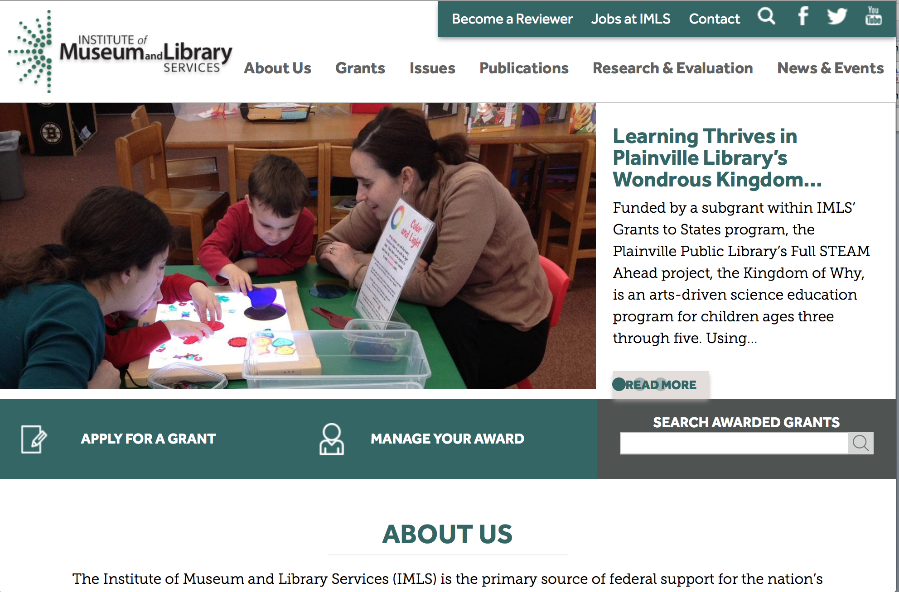

www.imls.gov

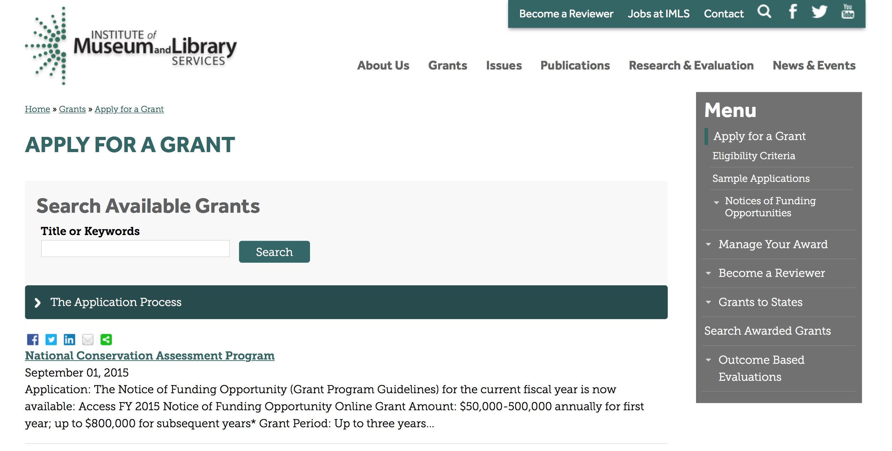
http://www.imls.gov/applicants/available_grants.aspx

Each grant program has specific eligibility requirements. The links below provide general eligibility criteria for museums, libraries, and tribal organizations, but please note that additional organizations may be eligible for grants under certain programs. Additionally, ineligible organizations may still be able to participate in grant programs through partnerships with eligible organizations. Please click on the links below to see general criteria and review Applications and Guidelines for specific information.
Museums Libraries

Institutions: Archives, Federally Recognized Native American Tribe, Historical Society, Library, Nonprofits that serve Native Hawaiians, Professional Association, Public or Private Non-profit Institutions of Higher Education, Regional Organization, State Library Administrative Agency, State or Local Government

Check out IMLS's Facebook page at:
https://www.facebook.com/USIMLS/

STEM Expert Facilitation of Family Learning in Libraries and Museums (STEMeX) – A National Leadership Grants Special Initiative – FY16 Notice of Funding Opportunity Grant

Document Type: | Grants Notice
Funding Opportunity Number: | NLGSPECIALINITIATIVE-STEMEX-FY16
Funding Opportunity Title: | STEM Expert Facilitation of Family Learning in Libraries and Museums (STEMeX) – A National Leadership Grants Special Initiative – FY16 Notice of Funding Opportunity
Opportunity Category: | Discretionary
Funding Instrument Type: | Grant
Category of Funding Activity: | Arts (see "Cultural Affairs" in CFDA)  Humanities (see "Cultural Affairs" in CFDA)
Category Explanation:
Expected Number of Awards: | 3
CFDA Number(s): | 45.312 -- National Leadership Grants
Cost Sharing or Matching Requirement: | No
Posted Date: | Feb 1, 2016
Creation Date: | Feb 1, 2016
Original Closing Date for Applications: | May 1, 2016
Current Closing Date for Applications: | May 1, 2016
Archive Date: | May 31, 2016
Estimated Total Program Funding: | $2,500,000
Award Ceiling: | $1,000,000
Award Floor: | $500,000
Eligible Applicants: | Others (see text field entitled "Additional Information on Eligibility" for clarification)
Additional Information on Eligibility: | The information below outlines eligibility requirements for a museum entity or library entity, and some institutions may be eligible as both. An institution will not be asked to identify as a museum or library, but will be asked to identify the organization type on the SF424S and the organization unit type on the Program Information Sheet (Section f). To be eligible as library entity, you must: be either a unit of State or local government or be a private nonprofit organization that has tax-exempt status under the Internal Revenue Code; be located in one of the 50 States of the United States of America, the District of Columbia, the Commonwealth of Puerto Rico, the U.S. Virgin Islands, Guam, American Samoa, the Commonwealth of the Northern Mariana Islands, the Republic of the Marshall Islands, the Federated States of Micronesia, or the Republic of Palau; and qualify as one of the following: a library or a parent organization, such as a school district, a municipality, a State agency, or an academic institution, that is responsible for the administration of a library. Eligible libraries include public libraries, public elementary and secondary school libraries, college and university libraries, research libraries and archives that are not an integral part of an institution of higher education and that make publicly available library services and materials that are suitable for scholarly research and not otherwise available. Research libraries must be under the supervision of at least one permanent professional staff librarian and be either generally recognized as possessing unique, scholarly research materials and services that are made available to the public, or able to demonstrate that such is the case when submitting an application to IMLS a private library or other special library, but only if the State in which it is located determines that the library should be considered a library for purposes of Library Services and Technology (see 20 U.S.C. 9121-9165) an academic or administrative unit, such as a graduate school of library and information science that is part of an institution of higher education through which it would make application a digital library, if it makes library materials publicly available and provides library services, including selection, organization, description, reference, and preservation, under the supervision of at least one permanent professional staff librarian a library agency that is an official agency of a State or other unit of government and is charged by the law governing it with the extension and development of public library services within its jurisdiction a library consortium that is a local, statewide, regional, interstate, or international cooperative association of library entities that provides for the systematic and effective coordination of the resources of eligible libraries, as defined above, and information centers that work to improve the services delivered to the clientele of these libraries or a library association that exists on a permanent basis; serves libraries or library professionals on a national, regional, State, or local level; and engages in activities designed to advance the well-being of libraries and the library profession To be eligible as a museum entity, you must meet all three of the following criteria: You must be either a unit of State or local government or be a private nonprofit organization that has tax-exempt status under the Internal Revenue Code; You must be located in one of the 50 States of the United States of America, the District of Columbia, the Commonwealth of Puerto Rico, the U.S. Virgin Islands, Guam, American Samoa, the Commonwealth of the Northern Mariana Islands, the Republic of the Marshall Islands, the Federated States of Micronesia, or the Republic of Palau; and You must qualify as one of the following: (a) A museum that, using a professional staff,
Agency Name: | Institute of Museum and Library Services
Description: | This special joint NLG-Libraries and NLG-Museums initiative invites proposals for research on informal educational approaches that leverage community Science, Technology, Engineering, and Math (STEM) professionals in the broadest sense. Funded research projects will create a foundation for reaching children and families from diverse economic, social, and cultural backgrounds, with different levels of knowledge about STEM. We are interested in proposals for design-based research projects that develop and explore models for inquiry-based STEM programs delivered by scientists, engineers, and related technical practitioners (STEM experts) to children ages 6-10 and their families. In particular, proposals should address the role of expert oral narratives (e.g., storytelling, personal histories, and analogies) as part of object-based science inquiry. Proposals should include information about how findings from this research will be applicable in both museum and library settings.
Link to Additional Information: | https://www.imls.gov/grants/available/stem-expert-facilitation-family-learning-libraries-and-museums-stemex
Contact Information: | If you have difficulty accessing the full announcement electronically, please contact:  Libraries: Sandra Toro Senior Library Program Officer 202-653-4662 storo@imls.gov Trevor Owens Senior Library Program Officer 202-653-4654 tjowens@imls.gov Museums: Helen Wechsler Supervisory Grants Management Specialist 202-653-4779 hwechsler@imls.gov Sandra Narva Senior Program Officer 202-653-4634 snarva@imls.gov  storo@imls.gov

STEM Expert Facilitation of Family Learning in Libraries and Museums

IMLS is inviting proposals for special grants for research on informal educational approaches that leverage Science, Technology, Engineering, and Math (STEM) expertise within communities in the broadest sense. The STEM Expert Facilitation of Family Learning in Libraries and Museums, or STEMeX, initiative will provide grants up to $1,000,000 for projects of up to two years. The deadline for applications is May 1, 2016.

Through STEMeX, IMLS seeks design-based research projects that develop and explore models for inquiry-based STEM programs delivered by scientists, engineers, and related technical practitioners (STEM experts) to children ages 6-10 and their families. In particular, proposals should address the role of experts’ oral narratives (e.g., storytelling, personal histories, and analogies) as part of object-based science inquiry. Proposals should include information about how findings from this research will be applicable in both museum and library settings. Funded research projects will create a foundation for reaching children and families from diverse geographic, economic, social, and cultural backgrounds, who have different levels of knowledge about STEM.

This special initiative falls jointly under the National Leadership Grants for Libraries (NLG-Libraries) and National Leadership Grants for Museums (NLG-Museums) programs. National Leadership grants support projects that address challenges faced by the library and museum fields and that have the potential to advance practice in those fields with new tools, research findings, models, services, practices, or alliances that can be widely used, adapted, scaled, or replicated.

“There is an opportunity to further define best practice models about how scientific and technical experts--whether medical researchers and road engineers or art conservators and dental hygienists--can successfully engage young children and their families in STEM activities and inspire interest in STEM-based careers. Every community has those experts to draw upon to enhance their informal educational STEM efforts. That is why I am particularly excited to announce this special funding initiative,” said IMLS Director Dr. Kathryn K. Matthew. “There has already been fruitful and substantive work in this area, enabled by IMLS and others, and this effort will build on those prior investments. The research from this initiative will focus on maximizing the stories and narratives provided by STEM experts as part of programs offered by museums and libraries."

Eligibility: Museums; libraries; public or private nonprofit agencies, organizations, or associations that engage in activities designed to advance libraries and museums may apply. In addition, institutions of higher education, including public and non-profit universities, are eligible.
See the Notice of Funding Opportunity (NOFO) for FY 2016 for full details.

Webinars: To learn more, participate on one of these upcoming webinars:
- Wednesday, February 17, 2016, 4:00 – 5:00 p.m. EST
- Thursday, February 18, 2016, 3:00 – 4:00 p.m. EST

See the IMLS website for information about joining the webinars.

Program Contacts:
You may also contact any of the staff listed under the category that best fits your project.

Office of Library Services
Dr. Sandra Toro, Senior Program Officer, storo@imls.gov
202-653-4662
Dr. Trevor Owens, Senior Program Officer, towens@imls.gov
(link sends e-mail)
202-653-4654

Office of Museum Services
Helen Wechsler, Supervisory Grants Management Specialist, hwechsler@imls.gov
202-653-4779
Sandra Narva, Senior Program Officer, snarva@imls.gov
202-653-4634

Issues:
STEM (Science, Technology, Engineering, Math)

21st Century Skills

National Leadership Grants for Libraries
National Leadership Grants for Museums

http://www.grants.gov/web/grants/view-opportunity.html?oppId=281271

Modifications:

Reminders:

National Leadership Grants for Libraries Grant

Document Type: | Grants Notice
Funding Opportunity Number: | NLG-LIBRARIES-FY16-2
Funding Opportunity Title: | National Leadership Grants for Libraries
Opportunity Category: | Discretionary
Funding Instrument Type: | Grant
Category of Funding Activity: | Arts (see "Cultural Affairs" in CFDA)  Humanities (see "Cultural Affairs" in CFDA)
Category Explanation:
Expected Number of Awards: | 20
CFDA Number(s): | 45.312 -- National Leadership Grants
Cost Sharing or Matching Requirement: | Yes
Posted Date: | Dec 21, 2015
Creation Date: | Dec 21, 2015
Original Closing Date for Applications: | Jun 1, 2016
Current Closing Date for Applications: | Jun 1, 2016
Archive Date: | Jul 1, 2016
Estimated Total Program Funding: | $12,000,000
Award Ceiling: | $2,000,000
Award Floor: | $10,000
Eligible Applicants: | Others (see text field entitled "Additional Information on Eligibility" for clarification)
Additional Information on Eligibility: | To be eligible as an applicant for this National Leadership Grants for Libraries Program, you must: be either a unit of State or local government or be a private nonprofit organization that has tax-exempt status under the Internal Revenue Code; be located in one of the 50 States of the United States of America, the District of Columbia, the Commonwealth of Puerto Rico, the U.S. Virgin Islands, Guam, American Samoa, the Commonwealth of the Northern Mariana Islands, the Republic of the Marshall Islands, the Federated States of Micronesia, or the Republic of Palau; and qualify as one of the following: a library or a parent organization, such as a school district, a municipality, a State agency, or an academic institution, that is responsible for the administration of a library. Eligible libraries include public libraries, public elementary and secondary school libraries, college and university libraries, research libraries and archives that are not an integral part of an institution of higher education and that make publicly available library services and materials that are suitable for scholarly research and not otherwise available. Research libraries must be under the supervision of at least one permanent professional staff librarian and be either generally recognized as possessing unique, scholarly research materials and services that are made available to the public, or able to demonstrate that such is the case when submitting an application to IMLS a private library or other special library, but only if the State in which it is located determines that the library should be considered a library for purposes of Library Services and Technology (see 20 U.S.C. 9121-9165) an academic or administrative unit, such as a graduate school of library and information science that is part of an institution of higher education through which it would make application a digital library, if it makes library materials publicly available and provides library services, including selection, organization, description, reference, and preservation, under the supervision of at least one permanent professional staff librarian a library agency that is an official agency of a State or other unit of government and is charged by the law governing it with the extension and development of public library services within its jurisdiction a library consortium that is a local, statewide, regional, interstate, or international cooperative association of library entities that provides for the systematic and effective coordination of the resources of eligible libraries, as defined above, and information centers that work to improve the services delivered to the clientele of these libraries or a library association that exists on a permanent basis; serves libraries or library professionals on a national, regional, State, or local level; and engages in activities designed to advance the well-being of libraries and the library profession Note to applicants: In order to receive an IMLS award, you must be in compliance with applicable requirements and be in good standing on all active IMLS awards.
Agency Name: | Institute of Museum and Library Services
Description: | National Leadership Grants for Libraries (NLG) support projects that address challenges faced by the library and archive fields and that have the potential to advance practice in those fields. Successful proposals will generate results such as new tools, research findings, models, services, practices, or alliances that can be widely used, adapted, scaled, or replicated to extend the benefits of federal investment. For FY16, there are two National Leadership Grants for Libraries funding opportunities with two separate deadlines. In addition to the opportunity described in this Notice of Funding Opportunity, an additional NLG funding opportunity was announced in September 2015 with an application submission due date in October 2015.
Link to Additional Information: | https://www.imls.gov/grants/available/national-leadership-grants-libraries
Contact Information: | If you have difficulty accessing the full announcement electronically, please contact:  Tim Carrigan Senior Library Program Officer 202-653-4639 tcarrigan@imls.gov Trevor Owens Senior Library Program Officer 202-653-4654 tjowens@imls.gov Sandra Toro Senior Library Program Officer 202-653-4662 storo@imls.gov Sarah Fuller Library Program Officer 202-653-4783 sfuller@imls.gov  tcarrigan@imls.gov

http://www.grants.gov/web/grants/view-opportunity.html?oppId=280677

Laura Bush 21st Century Librarian Program Grant

Document Type: | Grants Notice
Funding Opportunity Number: | LB21-FY16-2
Funding Opportunity Title: | Laura Bush 21st Century Librarian Program
Opportunity Category: | Discretionary
Funding Instrument Type: | Grant
Category of Funding Activity: | Arts (see "Cultural Affairs" in CFDA)  Humanities (see "Cultural Affairs" in CFDA)
Category Explanation:
Expected Number of Awards: | 22
CFDA Number(s): | 45.313 -- Laura Bush 21st Century Librarian Program
Cost Sharing or Matching Requirement: | Yes
Posted Date: | Dec 21, 2015
Creation Date: | Dec 21, 2015
Original Closing Date for Applications: | Jun 1, 2016
Current Closing Date for Applications: | Jun 1, 2016
Archive Date: | Jul 1, 2016
Estimated Total Program Funding: | $10,000,000
Award Ceiling: | $1,000,000
Award Floor: | $50,000
Eligible Applicants: | Others (see text field entitled "Additional Information on Eligibility" for clarification)
Additional Information on Eligibility: | To be eligible for LB21, you must be either a unit of State or local government or a private nonprofit organization that has tax-exempt status under the Internal Revenue Code and be located in one of the 50 States of the United States of America, the District of Columbia, the Commonwealth of Puerto Rico, Guam, American Samoa, the U.S. Virgin Islands, the Commonwealth of the Northern Mariana Islands, the Republic of the Marshall Islands, the Federated States of Micronesia, or the Republic of Palau. In addition, you must be one of the following six types of organizations: A library or a parent organization, such as a school district, a municipality, a State agency, or an academic institution, that is responsible for the administration of a library. Eligible libraries include the following: Public libraries Public elementary and secondary school libraries College and university libraries Research libraries and archives that are not an integral part of an institution of higher education and that make publicly available library services and materials that are suitable for scholarly research and not otherwise available (Research libraries must be under the supervision of at least one permanent professional staff person and must be either generally recognized as possessing unique scholarly research materials and services that are made available to the public, or able to demonstrate that such is the case when submitting an application to IMLS.) Private or special libraries that have been deemed eligible to participate in this program by the State in which the library is located An academic or administrative unit, such as a graduate school of library and information science that is part of an institution of higher education through which it would make application (See below for additional conditions of eligibility that might apply to such applicants) A digital library, if it makes library materials publicly available and provides library services, including selection, organization, description, reference, and preservation, under the supervision of at least one permanent professional staff person A library agency that is an official agency of a State or other unit of government and is charged by the law governing it with the extension and development of public library services within its jurisdiction A library consortium that is a local, statewide, regional, interstate, or international cooperative association of library entities that provides for the systematic and effective coordination of the resources of eligible libraries, as defined above, and information centers that work to improve the services delivered to the clientele of these libraries A library association that exists on a permanent basis; serves libraries or library professionals on a national, regional, state, or local level; and engages in activities designed to advance the well-being of libraries and the library profession We recognize the potential for valuable contributions to the overall goals of the LB21 program by entities that do not meet the eligibility requirements above. Although such entities may not serve as the official applicants, they are encouraged to participate in projects. Federally operated libraries and museums may not apply for LB21 grants, but they may participate with applicants. Contact us before submitting a proposal involving a federal agency or federal collection. Non-Federal entities may serve as subrecipients or contractors and may receive IMLS grant funds as a result of the project. Consult with us about any eligibility questions before submitting an application.
Agency Name: | Institute of Museum and Library Services
Description: | The Laura Bush 21st Century Librarian Program (LB21) supports professional development, graduate education and continuing education to help libraries and archives develop the human capital capacity they need to meet the changing learning and information needs of the American public. For FY16, there are two Laura Bush 21st Century Librarian Program funding opportunities with two separate deadlines. In addition to the opportunity described in this Notice of Funding Opportunity, an additional LB21 funding opportunity was announced in September 2015 with an application submission due date in October 2015.
Link to Additional Information: | https://www.imls.gov/grants/available/laura-bush-21st-century-librarian-program
Contact Information: | If you have difficulty accessing the full announcement electronically, please contact:  Mary Alice Ball Senior Library Program Officer 202-653-4730 mball@imls.gov Tim Carrigan Senior Library Program Officer 202-653-4639 tcarrigan@imls.gov Trevor Owens Senior Library Program Officer 202-653-4654 tjowens@imls.gov Sandra Toro Senior Library Program Officer 202-653-4662 storo@imls.gov Emily Reynolds Library Program Officer 202-653-4665 ereynolds@imls.gov  mball@imls.gov

http://www.grants.gov/web/grants/view-opportunity.html?oppId=280678

Department of the Interior
Working with Interior

The Interior Department provides assistance to the public, local governments and businesses through a number of programs. For a general overview see: http://www.doi.gov/index.cfm

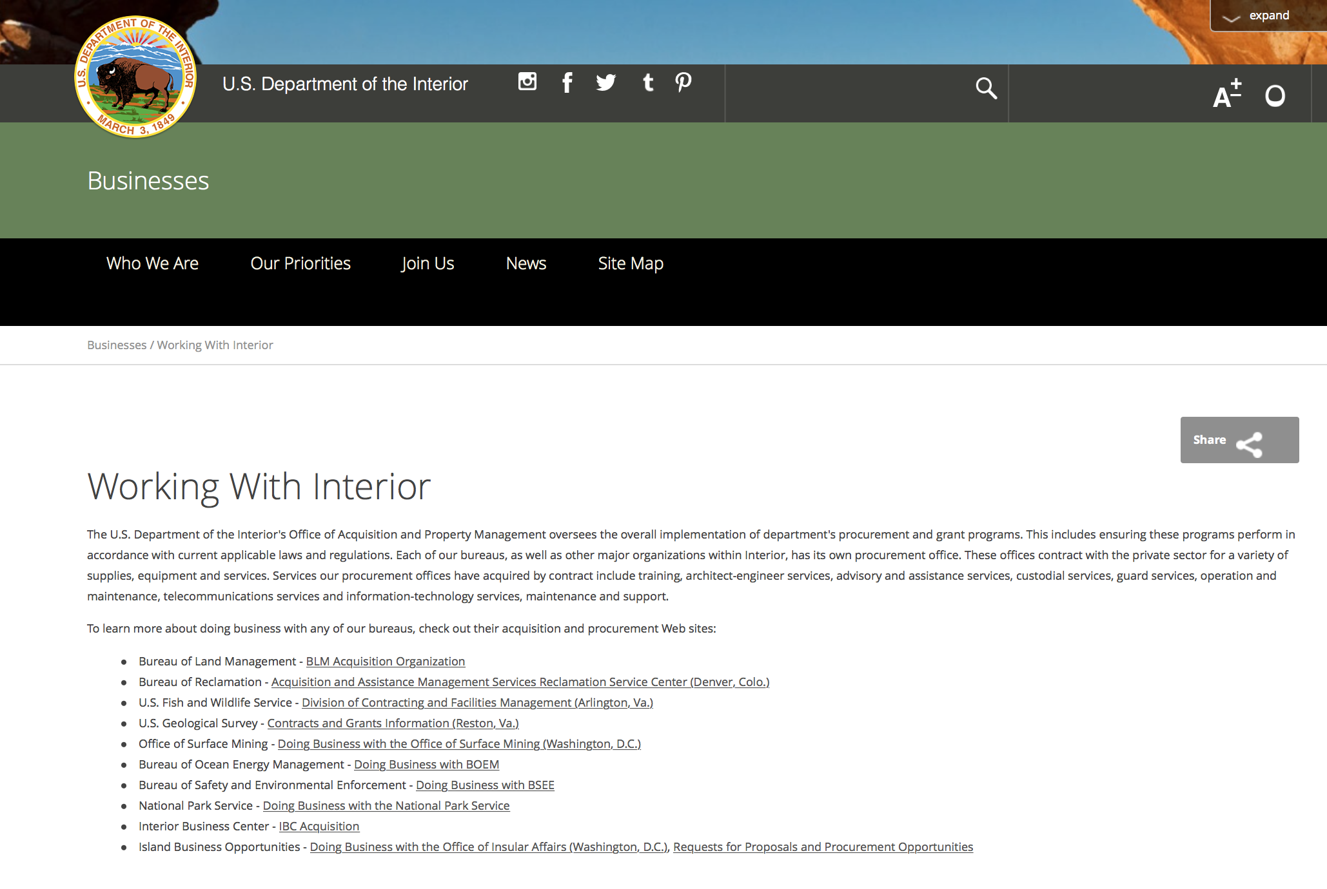

http://www.doi.gov/businesses/working-with-interior.cfm

Programs:

Modifications:

Fish and Wildlife Service

Request for Pre-Proposals to develop and or improve climate change actions' affect on linkages between ecological and human resources
Modification 1
Document Type: | Grants Notice
Funding Opportunity Number: | F16AS00086
Funding Opportunity Title: | Request for PreProposals to develop and or improve climate change actions' affect on linkages between ecological and human resources.
Opportunity Category: | Discretionary
Funding Instrument Type: | Cooperative Agreement
Category of Funding Activity: | Environment  Information and Statistics  Natural Resources  Science and Technology and other Research and Development
Category Explanation:
Expected Number of Awards: | 5
CFDA Number(s): | 15.669 -- Cooperative Landscape Conservation
Cost Sharing or Matching Requirement: | No
Posted Date: | Jan 19, 2016
Creation Date: | Feb 1, 2016
Original Closing Date for Applications: | Mar 18, 2016
Current Closing Date for Applications: | Mar 18, 2016
Archive Date: | Mar 19, 2016
Estimated Total Program Funding: | $200,000
Award Ceiling: | $50,000
Award Floor: | $10,000
Eligible Applicants: | Unrestricted (i.e., open to any type of entity above), subject to any clarification in text field entitled "Additional Information on Eligibility"
Agency Name: | Fish and Wildlife Service
Description: | Seeking proposals addressing this activity area that will directly benefit natural and cultural resource managers by informing policy, conservation and sustainable resource management decisions and actions. Project proposals must address natural and cultural resource managers¿¿ needs as they work to understand and adapt to our regions changing climate and/or other landscape-scale stressors. Project proposals should be developed in coordination with end-users and decision-relevant needs/outcomes must be clearly identified.
Link to Additional Information: | http://www.grants.gov
Contact Information: | If you have difficulty accessing the full announcement electronically, please contact:  Connie Sauer 503-872-2826 Mary_Mahaffy@fws.gov  MAHAFFY DU PBHJV

http://www.grants.gov/web/grants/view-opportunity.html?oppId=281069

Reminders:

Fish and Wildlife Service
National Fish Passage Program Grant

Document Type: | Grants Notice
Funding Opportunity Number: | F16AS00041
Funding Opportunity Title: | National Fish Passage Program
Opportunity Category: | Discretionary
Funding Instrument Type: | Cooperative Agreement
Category of Funding Activity: | Natural Resources
Category Explanation:
Expected Number of Awards:
CFDA Number(s): | 15.608 -- Fish and Wildlife Management Assistance
Cost Sharing or Matching Requirement: | Yes
Posted Date: | Dec 1, 2015
Creation Date: | Nov 30, 2015
Original Closing Date for Applications: | Sep 1, 2016
Current Closing Date for Applications: | Sep 1, 2016
Archive Date: | Sep 20, 2016
Eligible Applicants: | Unrestricted (i.e., open to any type of entity above), subject to any clarification in text field entitled "Additional Information on Eligibility"
Additional Information on Eligibility: | To receive funding, NFPP projects must be implemented in coordination with FAC staff. Applicants can be, but not limited to: state and federal agencies, private lands, tribes, local municipalities, and non-governmental organizations.
Agency Name: | Fish and Wildlife Service
Description: | The National Fish Passage Program (NFPP) is a voluntary program that provides direct technical assistance and financial assistance in the form of cooperative agreements to partners to provide fish (and other aquatic organisms) passage and restore aquatic connectivity for the benefit of federal trust resources. The NFPP is delivered through more than 65 Fisheries and Aquatic Conservation (FAC) Field Offices across all States and territories. FAC staff coordinates with project partners, stakeholders and other Service programs to identify and collaboratively implement projects within Regional priority areas. Project work plans are developed strategically, in coordination with partners, and with substantial involvement from FAC staff. Projects must advance our mission, promote biological diversity, and be based upon sound scientific biological principles. FAC and Fish and Wildlife Service (FWS) strategic plans inform the types of projects funded under this opportunity. Applicants seeking funding under this program should review the program strategic plan and also contact the regional NFPP Coordinator for local FAC contacts prior to submitting an application for funding.
Link to Additional Information: | http://www.grants.gov
Contact Information: | If you have difficulty accessing the full announcement electronically, please contact:  Stephanie Long, 703-358-1749 Stephanie_A_Long@fws.gov  Stephanie_A_Long@fws.gov

http://www.grants.gov/web/grants/view-opportunity.html?oppId=280260

Fish and Wildlife Service
2016 National Fish Habitat Action Plan
Modification 1

Document Type: | Grants Notice
Funding Opportunity Number: | F16AS00029
Funding Opportunity Title: | 2016 National Fish Habitat Action Plan
Opportunity Category: | Discretionary
Funding Instrument Type: | Cooperative Agreement  Grant
Category of Funding Activity: | Natural Resources
Category Explanation:
Expected Number of Awards: | 70
CFDA Number(s): | 15.608 -- Fish and Wildlife Management Assistance
Cost Sharing or Matching Requirement: | No
Posted Date: | Nov 16, 2015
Creation Date: | Nov 17, 2015
Original Closing Date for Applications: | Applications are accepted on a rolling basis.
Current Closing Date for Applications: | Applications are accepted on a rolling basis.
Archive Date: | Sep 30, 2016
Estimated Total Program Funding: | $0
Award Ceiling: | $300,000
Award Floor: | $1,000
Eligible Applicants: | Unrestricted (i.e., open to any type of entity above), subject to any clarification in text field entitled "Additional Information on Eligibility"
Agency Name: | Fish and Wildlife Service
Description: | The National Fish Habitat Action Plan is a national investment strategy to leverage federal and privately raised funds to protect, restore, and enhance the nation's fish and aquatic habitats through partnerships that foster fish habitat conservation. Funds appropriated to the U.S. Fish and Wildlife Service's (Service) Fish and Aquatic Conservation (FAC) Program specifically to implement the Action Plan will be utilized in collaboration with the National Fish Habitat Board and Fish Habitat Partnerships. Fish Habitat Partnerships are the primary work units of the Action Plan, formed around distinct geographic areas, "keystone" fish species, or system types (e.g. large lakes, impoundments, estuaries). Funds will support national and regional science and coordination activities to protect, restore, or enhance fish habitats. All or a portion or project funds may be transferred to partner organizations if the Service lacks the capability to implement a project. Projects must protect, restore, or enhance fish and aquatic habitats or otherwise directly support habitat-related priorities of Fish Habitat Partnerships or the National Fish Habitat Board. Every project must be identified in the Fisheries Operational Needs System (FONS), a database that identifies the operational needs of FAC field stations, including fish habitat project needs. FAC field offices will work with Fish Habitat Partnerships to identify fish habitat projects, and enter them into the FONS. Entities that seek to propose a fish habitat conservation project for consideration should contact a local or regional office of the Service FAC Program.
Link to Additional Information: | http://www.grants.gov
Contact Information: | If you have difficulty accessing the full announcement electronically, please contact:  Cecilia M. Lewis, National Coordinator National Fish Habitat Partnership Fish and Aquatic Conservation Program 703-358-2102  cecilia_lewis@fws.gov
http://www.grants.gov/web/grants/view-opportunity.html?oppId=280034

Department of Justice

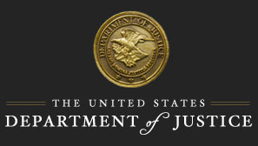

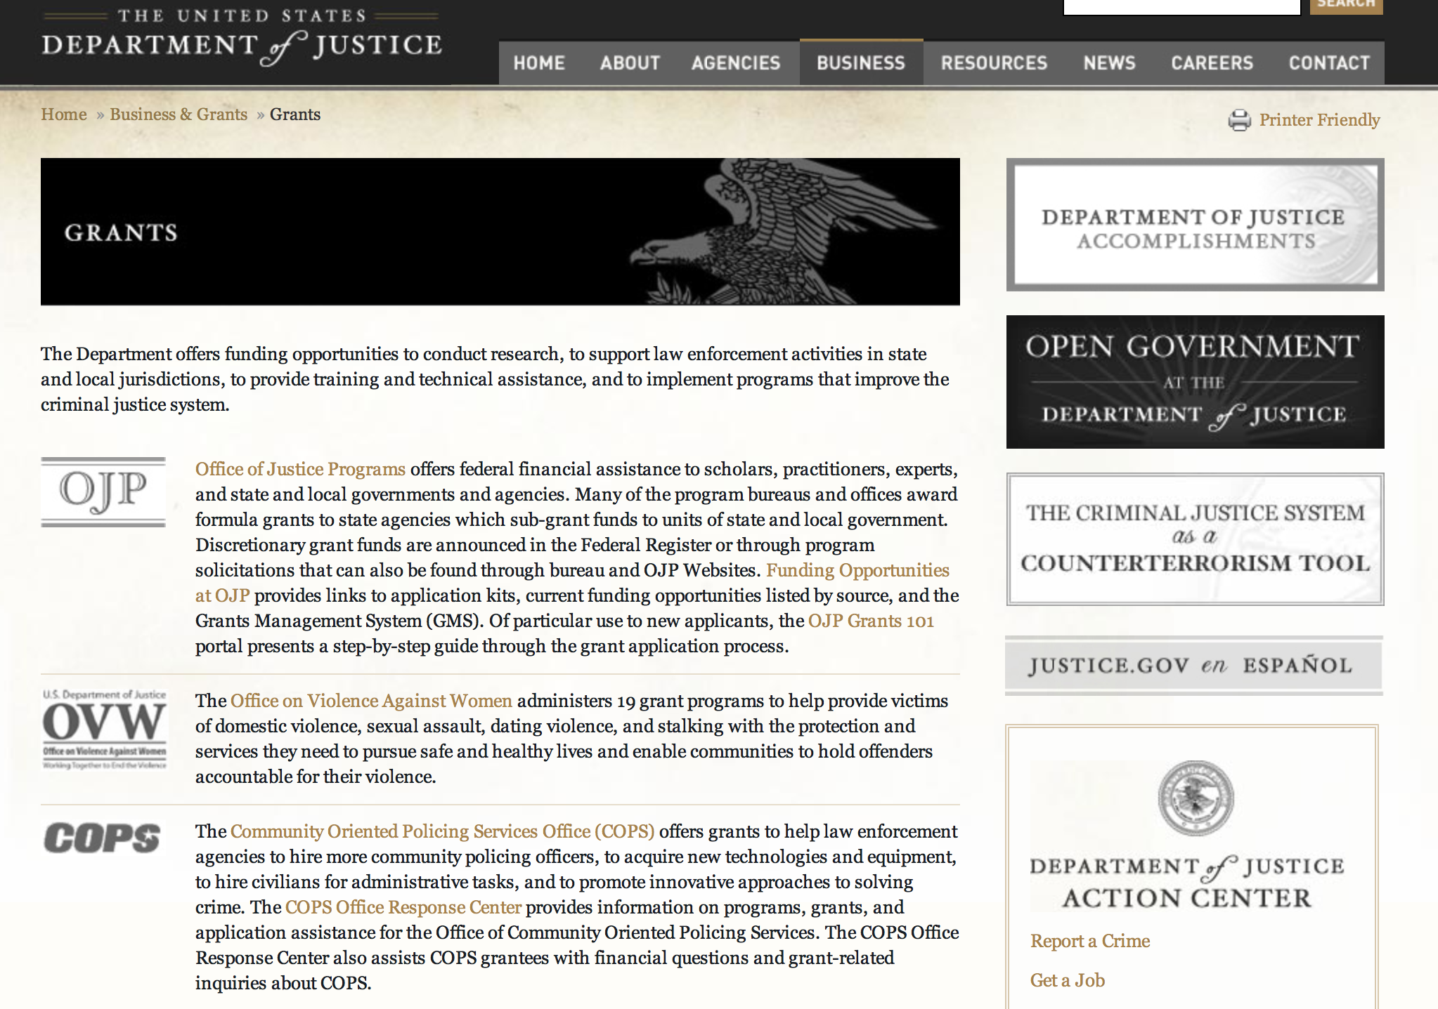

The DOJ agencies listed below also have sites that provide grant information specific to that agency. Examples of what can be found on these sites are programs, funding opportunities, application assistance, and other useful information.

Bureau of Justice Assistance (BJA)

Bureau of Justice Statistics (BJS)

National Criminal Justice Reference Service (NCJRS)

National Institute of Justice (NIJ)

Office of Juvenile Justice and Delinquency Prevention (OJJDP)

Office of Sex Offender Sentencing, Monitoring, Apprehending, Registering, and Tracking (SMART)

Office for Victims of Crime (OVC)

http://www.justice.gov/business/

Programs:

Office of Justice Programs
National Institute of Justice
Developing Improved Means to Collect Digital Evidence Grant

Document Type: | Grants Notice
Funding Opportunity Number: | NIJ-2016-8976
Funding Opportunity Title: | Developing Improved Means to Collect Digital Evidence
Opportunity Category: | Discretionary
Funding Instrument Type: | Cooperative Agreement
Category of Funding Activity: | Law, Justice and Legal Services
Category Explanation:
Expected Number of Awards: | 3
CFDA Number(s): | 16.560 -- National Institute of Justice Research, Evaluation, and Development Project Grants
Cost Sharing or Matching Requirement: | No
Posted Date: | Jan 15, 2016
Creation Date: | Jan 15, 2016
Original Closing Date for Applications: | Apr 14, 2016
Current Closing Date for Applications: | Apr 14, 2016
Archive Date:
Estimated Total Program Funding: | $1,500,000
Award Ceiling: | $1,500,000
Eligible Applicants: | Private institutions of higher education  Native American tribal governments (Federally recognized)  Individuals  Nonprofits that do not have a 501(c)(3) status with the IRS, other than institutions of higher education  Nonprofits having a 501(c)(3) status with the IRS, other than institutions of higher education  City or township governments  County governments  State governments  For profit organizations other than small businesses  Small businesses  Public and State controlled institutions of higher education
Agency Name: | National Institute of Justice
Description: | With this solicitation, NIJ seeks proposals for funding to conduct research and technology development leading to the introduction into practice of new and innovative tools to: -Process large-scale computer networks for digital evidence in a forensically sound manner that preserves the probative value of the evidence that the computer network may contain; or -Process mobile devices voluntarily surrendered to law enforcement by witnesses or victims of an alleged crime, which will discriminate between data that is germane to that crime and that which is not, and which will only collect data that is germane; or -Automatically detect children in pornographic videos of varying quality. Individual applicants may propose to address one or more of these topics, but most do so in separate, discrete applications. Single applications proposing to address more than one topic will not be accepted.
Link to Additional Information: | http://nij.gov/funding/Documents/solicitations/NIJ-2016-8976.pdf
Contact Information: | If you have difficulty accessing the full announcement electronically, please contact:  NCJRS Call Center grants@ncjrs.gov  Technical Support

http://www.grants.gov/web/grants/view-opportunity.html?oppId=281004

Office of Justice Programs
Office on Violence Against Women
OVW FY 2016 Technical Assistance Initiative Solicitation Grant

Document Type: | Grants Notice
Funding Opportunity Number: | OVW-2016-9146
Funding Opportunity Title: | OVW FY 2016 Technical Assistance Initiative Solicitation
Opportunity Category: | Discretionary
Funding Instrument Type: | Cooperative Agreement
Category of Funding Activity: | Other (see text field entitled "Explanation of Other Category of Funding Activity" for clarification)
Category Explanation: | Training and Technical Assistance on Violence Against Women Issues
Expected Number of Awards: | 60
CFDA Number(s): | 16.526 -- OVW Technical Assistance Initiative
Cost Sharing or Matching Requirement: | No
Posted Date: | Jan 14, 2016
Creation Date: | Jan 14, 2016
Original Closing Date for Applications: | Mar 1, 2016
Current Closing Date for Applications: | Mar 1, 2016
Archive Date: | Mar 31, 2016
Estimated Total Program Funding: | $34,400,000
Eligible Applicants: | Others (see text field entitled "Additional Information on Eligibility" for clarification)
Additional Information on Eligibility: | National, tribal, statewide or other nonprofit organizations with the capacity to provide national training and technical assistance. OVW will support state, local or tribal governments or governmental agencies (e.g., police departments, prosecutor’s offices, or probation departments), or local non-profit organizations however, in such circumstances, those entities must describe in detail their demonstrated history of providing training and technical assistance, and documentation that they have delivered training and TA to a national audience.
Agency Name: | Office on Violence Against Women
Description: | The primary purpose of the OVW Technical Assistance Program is to provide direct technical assistance to existing and potential grantees and sub grantees to enhance and support their efforts to successfully implement projects supported by OVW grant funds. In addition, OVW is focused on building the capacity of criminal justice and victim services organizations to respond effectively to sexual assault, domestic violence, dating violence and stalking and fostering partnerships among organizations that have not traditionally worked together to address violence against women.
Link to Additional Information: | OVW FY 2016 Technical Assistance Initiative Solicitation - Full Announcement
Contact Information: | If you have difficulty accessing the full announcement electronically, please contact:  Ayesha A. Gaston Phone 202-514-0412  ayesha.gaston@usdoj.gov

http://www.grants.gov/web/grants/view-opportunity.html?oppId=280934

Office of Justice Programs
National Institute of Justice
Postconviction Testing of DNA Evidence to Exonerate the Innocent Grant

Document Type: | Grants Notice
Funding Opportunity Number: | NIJ-2016-8998
Funding Opportunity Title: | Postconviction Testing of DNA Evidence to Exonerate the Innocent
Opportunity Category: | Discretionary
Funding Instrument Type: | Cooperative Agreement
Category of Funding Activity: | Law, Justice and Legal Services
Category Explanation:
Expected Number of Awards: | 8
CFDA Number(s): | 16.820 -- Postconviction Testing of DNA Evidence to Exonerate the Innocent
Cost Sharing or Matching Requirement: | No
Posted Date: | Jan 8, 2016
Creation Date: | Jan 8, 2016
Original Closing Date for Applications: | Apr 7, 2016
Current Closing Date for Applications: | Apr 7, 2016
Archive Date:
Estimated Total Program Funding: | $3,600,000
Award Ceiling: | $3,600,000
Eligible Applicants: | County governments  Public and State controlled institutions of higher education  City or township governments  State governments
Agency Name: | National Institute of Justice
Description: | NIJ seeks proposals for funding to assist in defraying the costs associated with postconviction DNA testing in cases of violent felony offenses (as defined by State law) in which actual innocence might be demonstrated. Funds may be used to identify and review such postconviction cases and to locate and analyze associated biological evidence.
Link to Additional Information: | http://nij.gov/funding/Documents/solicitations/NIJ-2016-8998.pdf
Contact Information: | If you have difficulty accessing the full announcement electronically, please contact:  NCJRS Call Center grants@ncjrs.gov  Technical Support

http://www.grants.gov/web/grants/view-opportunity.html?oppId=280881

Office of Justice Programs
National Institute of Justice
Research and Evaluation for the Testing and Interpretation of Physical Evidence in Publicly Funded Forensic Laboratories Grant

Document Type: | Grants Notice
Funding Opportunity Number: | NIJ-2016-9011
Funding Opportunity Title: | Research and Evaluation for the Testing and Interpretation of Physical Evidence in Publicly Funded Forensic Laboratories
Opportunity Category: | Discretionary
Funding Instrument Type: | Grant
Category of Funding Activity: | Law, Justice and Legal Services
Category Explanation:
Expected Number of Awards: | 12
CFDA Number(s): | 16.560 -- National Institute of Justice Research, Evaluation, and Development Project Grants
Cost Sharing or Matching Requirement: | No
Posted Date: | Jan 7, 2016
Creation Date: | Jan 7, 2016
Original Closing Date for Applications: | Apr 6, 2016
Current Closing Date for Applications: | Apr 6, 2016
Archive Date:
Estimated Total Program Funding: | $3,000,000
Award Ceiling: | $3,000,000
Eligible Applicants: | State governments  County governments  City or township governments  Native American tribal governments (Federally recognized)
Agency Name: | National Institute of Justice
Description: | With this solicitation, NIJ seeks proposals for research and evaluation projects that will: 1. Identify and inform the forensic community of best practices through the evaluation of existing laboratory protocols; and 2. Have a direct and immediate impact on laboratory efficiency and assist in making laboratory policy decisions. The intent of this program is to direct the findings of the research and evaluation toward the identification of the most efficient, accurate, reliable, and cost-effective methods for the identification, analysis, and interpretation of physical evidence for criminal justice purposes.
Link to Additional Information: | http://nij.gov/funding/Documents/solicitations/NIJ-2016-9011.pdf
Contact Information: | If you have difficulty accessing the full announcement electronically, please contact:  NCJRS Call Center grants@ncjrs.gov  Technical Support

http://www.grants.gov/web/grants/view-opportunity.html?oppId=280868

Office of Justice Programs
Office on Violence Against Women
OVW FY 2016 Training and Services to End Violence Against Women with Disabilities Grant Program

Document Type: | Grants Notice
Funding Opportunity Number: | OVW-2016-9147
Funding Opportunity Title: | OVW FY 2016 Training and Services to End Violence Against Women with Disabilities Grant Program
Opportunity Category: | Discretionary
Funding Instrument Type: | Cooperative Agreement
Category of Funding Activity: | Other (see text field entitled "Explanation of Other Category of Funding Activity" for clarification)
Category Explanation: | Training; disability; Deaf; domestic violence, dating violence, sexual violence and stalking;
Expected Number of Awards: | 15
CFDA Number(s): | 16.529 -- Education, Training, and Enhanced Services to End Violence Against and Abuse of Women with Disabilities
Cost Sharing or Matching Requirement: | No
Posted Date: | Jan 27, 2016
Creation Date: | Jan 27, 2016
Original Closing Date for Applications: | Mar 10, 2016
Current Closing Date for Applications: | Mar 10, 2016
Archive Date: | Apr 9, 2016
Estimated Total Program Funding: | $6,000,000
Award Ceiling: | $425,000
Award Floor: | $300,000
Eligible Applicants: | Nonprofits having a 501(c)(3) status with the IRS, other than institutions of higher education  Native American tribal organizations (other than Federally recognized tribal governments)  State governments  City or township governments  Native American tribal governments (Federally recognized)  County governments
Agency Name: | Office on Violence Against Women
Description: | This program is authorized by 42 U.S.C. 3796gg-7. The goal of the Disability Grant Program is to create sustainable change within and between organizations that results in increased capacity to respond to individuals with disabilities and Deaf individuals who are victims of sexual assault, domestic violence, dating violence, and stalking and to hold perpetrators of such crimes accountable. Disability Grant Program funds will be used to establish and strengthen multidisciplinary collaborative relationships; increase organizational capacity to provide accessible, safe, and effective services to individuals with disabilities and Deaf individuals who are victims of violence and abuse; and identify needs within the grantee’s organization and/or service area, and develop a plan to address those identified needs that builds a strong foundation for future work.
Link to Additional Information: | OVW FY 2016 Training and Services to End Violence Against Women with Disabilities Grant Program
Contact Information: | If you have difficulty accessing the full announcement electronically, please contact:  Amy Loder Associate Director Phone 202.305.2971  Amy.Loder@usdoj.gov

http://www.grants.gov/web/grants/view-opportunity.html?oppId=281165

Modifications:

Office of Justice Programs
Office of Juvenile Justice Delinquency Prevention
OJJDP FY 16 Second Chance Act Strengthening Relationships Between Young Fathers, Young Mothers, and Their Children
Modification 2

Document Type: | Grants Notice
Funding Opportunity Number: | OJJDP-2016-9135
Funding Opportunity Title: | OJJDP FY 16 Second Chance Act Strengthening Relationships Between Young Fathers, Young Mothers, and Their Children
Opportunity Category: | Discretionary
Funding Instrument Type: | Grant
Category of Funding Activity: | Law, Justice and Legal Services
Category Explanation:
Expected Number of Awards: | 8
CFDA Number(s): | 16.831 -- Children of Incarcerated Parents
Cost Sharing or Matching Requirement: | No
Posted Date: | Dec 21, 2015
Creation Date: | Jan 4, 2016
Original Closing Date for Applications: | Mar 3, 2016
Current Closing Date for Applications: | Mar 3, 2016
Archive Date:
Estimated Total Program Funding: | $2,800,000
Award Ceiling: | $350,000
Eligible Applicants: | Nonprofits having a 501(c)(3) status with the IRS, other than institutions of higher education  Others (see text field entitled "Additional Information on Eligibility" for clarification)  Native American tribal governments (Federally recognized)
Additional Information on Eligibility: | Category 1: Young Fathers and Their Children Eligible applicants are limited to nonprofit organizations (including faith-based, tribal, and community nonprofit organizations) and federally recognized Indian tribes, as determined by the Secretary of the Interior, to provide comprehensive reentry support services, including mentoring, that will help justice-involved young fathers reintegrate into their communities and that address the purpose and goals listed in this solicitation. Category 2: Young Mothers and Their Children Eligible applicants are limited to nonprofit organizations (including faith-based, tribal, and community nonprofit organizations) and federally recognized Indian tribes, as determined by the Secretary of the Interior, to provide comprehensive reentry support services, including mentoring, that will help justice-involved young mothers reintegrate into their communities and that address the purpose and the goals listed in this solicitation. Applicants must submit letters of support or memoranda of understanding with juvenile justice or adult correctional agencies that oversee the reentry process for young fathers or mothers (younger than 25 years old). OJJDP strongly encourages applicants to partner with other community-based agencies that can enhance their project or leverage existing resources and local mental health or substance abuse treatment providers to provide holistic reentry support services, including the mentoring component. However, one eligible entity must be the applicant, and the others must be proposed as subrecipients. The applicant must be the entity with primary responsibility for administering the funding and managing the entire project. OJJDP will consider only one application per lead applicant; however, subrecipients may be part of multiple proposals.
Agency Name: | Office of Juvenile Justice Delinquency Prevention
Description: | The Fiscal Year (FY) 2016 Second Chance Act Strengthening Relationships Between Young Fathers, Young Mothers, and Their Children initiative will provide funding to support the successful transition for young fathers and mothers as they return to their families and communities from detention, out-of-home placement or incarceration. This program will fund coordinated and comprehensive strategies that incorporate (1) mentoring and transitional reentry services proven to reduce recidivism; (2) effective parenting skills development and parent/child relationship engagement for young fathers or mothers; and (3) private and community service partnerships that promote public safety and support added positive outcomes for young parents and their children. This solicitation has the following two categories: Category 1: Young Fathers and Their Children; and Category 2: Young Mothers and Their Children.
Link to Additional Information: | Full Announcement
Contact Information: | If you have difficulty accessing the full announcement electronically, please contact:  For technical assistance with submitting an application, contact the Grants.gov Customer Support Hotline at 800-518-4726 or 606-545-5035, or via e-mail to support@grants.gov. Hotline hours of operation are 24 hours a day, 7 days a week, except federal holidays. For assistance with any other requirements of this solicitation, contact the Response Center by telephone at 800-851-3420 or TTY: 301-240-6310 (Hearing impaired only), by e-mail at grants@ncjrs.gov, or by web chat. Response Center hours of operation are 10 a.m. to 6 p.m. ET, Monday through Friday. grants@ncjrs.gov  E-mail

http://www.grants.gov/web/grants/view-opportunity.html?oppId=280681

Office of Justice Programs
Office of Juvenile Justice Delinquency Prevention
OJJDP FY 16 Mentoring for Child Victims of Commercial Sexual Exploitation and Domestic Sex Trafficking Initiative
Modifications 2 & 3

Document Type: | Grants Notice
Funding Opportunity Number: | OJJDP-2016-9143
Funding Opportunity Title: | OJJDP FY 16 Mentoring for Child Victims of Commercial Sexual Exploitation and Domestic Sex Trafficking Initiative
Opportunity Category: | Discretionary
Funding Instrument Type: | Grant
Category of Funding Activity: | Law, Justice and Legal Services
Category Explanation:
Expected Number of Awards: | 10
CFDA Number(s): | 16.726 -- Juvenile Mentoring Program
Cost Sharing or Matching Requirement: | No
Posted Date: | Dec 30, 2015
Creation Date: | Jan 7, 2016
Original Closing Date for Applications: | Mar 7, 2016
Current Closing Date for Applications: | Mar 7, 2016
Archive Date:
Estimated Total Program Funding: | $1,350,000
Award Ceiling: | $450,000
Eligible Applicants: | Nonprofits having a 501(c)(3) status with the IRS, other than institutions of higher education  Native American tribal governments (Federally recognized)  Public and State controlled institutions of higher education  City or township governments  Others (see text field entitled "Additional Information on Eligibility" for clarification)  Private institutions of higher education  County governments  For profit organizations other than small businesses  Small businesses  State governments
Additional Information on Eligibility: | Eligible applicants are limited to states (including territories), units of local government (including federally recognized tribal governments, as determined by the Secretary of the Interior), nonprofit and for-profit organizations (including tribal nonprofit and for-profit organizations), and institutions of higher education (including tribal institutions of higher education). Eligible applicants must initiate mentoring services to youth who are 17 years old or younger. Recipient organizations, including for-profit organizations, must agree to forgo any profit or management fee. OJJDP welcomes applications that involve two or more eligible entities; however, one eligible entity must be the lead applicant and the others must be proposed as subrecipients. The lead applicant must be the entity with primary responsibility for administering the funding and managing the entire project. OJJDP will consider only one application per lead applicant; however, subrecipients may be part of multiple proposals.
Agency Name: | Office of Juvenile Justice Delinquency Prevention
Description: | This program supports efforts of eligible applicant organizations to develop or enhance their mentoring capacity, facilitate outreach efforts, and increase the availability of direct services for child victims (17 years old or younger) of commercial sexual exploitation (CSE) and domestic sex trafficking (DST). Under this initiative, OJJDP expects successful applicants to join current and previously funded grantees and to work with s training and technical assistance provider to develop or enhance mentoring service models and mentor training based on best practices to focus on the needs of girls and boys, including lesbian, gay, bisexual, transgender, and questioning (LGBTQ) youth who are at risk or are victims of CSE/DST; develop or update strategies to recruit and maintain mentors to serve this target population; begin or enhance efforts to identify and enroll girls and boys, including LGBTQ youth, who are in need of services; and provide needed services to these youth.
Link to Additional Information: | Full Announcement
Contact Information: | If you have difficulty accessing the full announcement electronically, please contact:  For technical assistance with submitting an application, contact the Grants.gov Customer Support Hotline at 800-518-4726 or 606-545-5035, or via e-mail to support@grants.gov. Hotline hours of operation are 24 hours a day, 7 days a week, except federal holidays. For assistance with any other requirements of this solicitation, contact the Response Center by telephone at 800-851-3420 or TTY: 301-240-6310 (Hearing impaired only), by e-mail at grants@ncjrs.gov, or by web chat. Response Center hours of operation are 10 a.m. to 6 p.m. ET, Monday through Friday. Answers to frequently asked questions that may assist applicants are posted at www.ojjdp.gov/grants/solicitations/FY2016/FAQ/MentoringCSEDSTFAQ.pdf. grants@ncjrs.gov  Email

http://www.grants.gov/web/grants/view-opportunity.html?oppId=280766

Office of Justice Programs
Office on Violence Against Women
OVW FY 2016 Improving Criminal Justice Responses to Sexual Assault, Domestic Violence, Dating Violence, and Stalking Grant Program (also known as the Arrest Program)
Modification 1

Document Type: | Grants Notice
Funding Opportunity Number: | OVW-2016-9206
Funding Opportunity Title: | OVW FY 2016 Improving Criminal Justice Responses to Sexual Assault, Domestic Violence, Dating Violence, and Stalking Grant Program (also known as the Arrest Program)
Opportunity Category: | Discretionary
Funding Instrument Type: | Grant
Category of Funding Activity: | Law, Justice and Legal Services
Category Explanation:
Expected Number of Awards: | 48
CFDA Number(s): | 16.590 -- Grants to Encourage Arrest Policies and Enforcement of Protection Orders Program
Cost Sharing or Matching Requirement: | No
Posted Date: | Jan 7, 2016
Creation Date: | Jan 7, 2016
Original Closing Date for Applications: | Mar 3, 2016
Current Closing Date for Applications: | Mar 3, 2016
Archive Date: | Apr 2, 2016
Estimated Total Program Funding: | $50,000,000
Award Ceiling: | $900,000
Eligible Applicants: | Nonprofits having a 501(c)(3) status with the IRS, other than institutions of higher education  City or township governments  State governments  Others (see text field entitled "Additional Information on Eligibility" for clarification)  County governments  Native American tribal governments (Federally recognized)
Additional Information on Eligibility: | State or tribal sexual assault or domestic violence coalitions, and certain governmental rape crisis centers (in a state other than a territory). State, local, tribal, and territorial courts (including juvenile courts).
Agency Name: | Office on Violence Against Women
Description: | The United States Department of Justice, Office on Violence Against Women (OVW) (www.ovw.usdoj.gov) is pleased to announce that it is seeking applications for the Improving Criminal Justice Responses to Sexual Assault, Domestic Violence, Dating Violence, and Stalking Grant Program (also known as the Grants to Encourage Arrest and Enforcement of Protection Orders Program). This program furthers the Department of Justice’s mission by encouraging partnerships between state, local, and tribal governments, courts, victim service providers, coalitions and rape crisis centers, to ensure that sexual assault, domestic violence, dating violence, and stalking are treated as serious violations of criminal law requiring the coordinated involvement of the entire criminal justice system and community-based victim service organizations.
Link to Additional Information: | OVW FY 2016 Improving Criminal Justice Responses to Sexual Assault, Domestic Violence, Dating Violence, and Stalking Grant Program (also known as the Arrest Program)
Contact Information: | If you have difficulty accessing the full announcement electronically, please contact:  Sue Pugliese Phone (202) 305-1660  Suzanne.Pugliese@usdoj.gov

http://www.grants.gov/web/grants/view-opportunity.html?oppId=280869

Office of Justice Programs
Office on Violence Against Women
OVW FY 2016 Grants to Reduce Sexual Assault, Domestic Violence, Dating Violence, and Stalking on Campus Program
Modification 1

Document Type: | Grants Notice
Funding Opportunity Number: | OVW-2016-9145
Funding Opportunity Title: | OVW FY 2016 Grants to Reduce Sexual Assault, Domestic Violence, Dating Violence, and Stalking on Campus Program
Opportunity Category: | Discretionary
Funding Instrument Type: | Grant
Category of Funding Activity: | Education  Other (see text field entitled "Explanation of Other Category of Funding Activity" for clarification)
Category Explanation: | Victim Services
Expected Number of Awards: | 40
CFDA Number(s): | 16.525 -- Grants to Reduce Domestic Violence, Dating Violence, Sexual Assault, and Stalking on Campus
Cost Sharing or Matching Requirement: | No
Posted Date: | Jan 7, 2016
Creation Date: | Jan 7, 2016
Original Closing Date for Applications: | Mar 3, 2016
Current Closing Date for Applications: | Mar 3, 2016
Archive Date: | Apr 2, 2016
Estimated Total Program Funding: | $20,000,000
Award Ceiling: | $750,000
Eligible Applicants: | Public and State controlled institutions of higher education  Private institutions of higher education
Agency Name: | Office on Violence Against Women
Description: | Sexual assault, domestic violence, dating violence, and stalking are serious problems on college and university campuses. Congress created the Grants to Reduce Sexual Assault, Domestic Violence, Dating Violence, and Stalking on Campus Program (hereinafter referred to as the Campus Program) in recognition of the unique issues and challenges that colleges and universities face in preventing and responding to these crimes. This program is authorized by 42 U.S.C. § 14045b. The Campus Program encourages a comprehensive coordinated community approach that enhances victim safety, provides services for victims and supports efforts to hold offenders accountable. The funding supports activities that develop and strengthen victim services and strategies to prevent, investigate, respond to and prosecute these crimes. The development of campus-wide coordinated responses involving campus victim service providers, law enforcement officers, health providers, housing officials, administrators, student leaders, faith-based leaders, representatives from student organizations, and disciplinary board members is critical. To be effective, campus responses must also link to local off-campus criminal justice agencies and service providers, including local law enforcement agencies, prosecutors’ offices, courts, and nonprofit, nongovernmental victim advocacy and victim services organizations. Campuses are encouraged to create or revitalize large-scale efforts that treat sexual assault, domestic violence, dating violence, and stalking as serious offenses by adopting policies and protocols, developing victim services and programs that prioritize victim safety, ensuring offender accountability, and implementing effective prevention approaches. Colleges and universities should demonstrate to every student that these crimes will not be tolerated, that perpetrators will face serious consequences, and that holistic services are available for victims. Please see the Campus TA supplemental document at http://www.justice.gov/tribal/file/811236/download for more information on strategies that campuses can use to implement the program requirements.
Link to Additional Information: | OVW FY 2016 Grants to Reduce Sexual Assault, Domestic Violence, Dating Violence, and Stalking on Campus Program
Contact Information: | If you have difficulty accessing the full announcement electronically, please contact:  Latinisha Lewis Phone 202-353-9167  latinisha.m.lewis@usdoj.gov

http://www.grants.gov/web/grants/view-opportunity.html?oppId=280859

Reminders:

Office of Justice Programs
Office on Violence Against Women
OVW FY 2016 Enhanced Training and Services to End Abuse in Later Life Program Grant

Document Type: | Grants Notice
Funding Opportunity Number: | OVW-2016-9085
Funding Opportunity Title: | OVW FY 2016 Enhanced Training and Services to End Abuse in Later Life Program
Opportunity Category: | Discretionary
Funding Instrument Type: | Cooperative Agreement
Category of Funding Activity: | Income Security and Social Services  Law, Justice and Legal Services
Category Explanation:
Expected Number of Awards: | 8
CFDA Number(s): | 16.528 -- Enhanced Training and Services to End Violence and Abuse of Women Later in Life
Cost Sharing or Matching Requirement: | No
Posted Date: | Dec 10, 2015
Creation Date: | Dec 9, 2015
Original Closing Date for Applications: | Feb 11, 2016
Current Closing Date for Applications: | Feb 11, 2016
Archive Date: | Mar 12, 2016
Estimated Total Program Funding: | $3,000,000
Award Ceiling: | $400,000
Eligible Applicants: | City or township governments  State governments  Native American tribal governments (Federally recognized)  Special district governments  Nonprofits having a 501(c)(3) status with the IRS, other than institutions of higher education  Others (see text field entitled "Additional Information on Eligibility" for clarification)  County governments  Native American tribal organizations (other than Federally recognized tribal governments)
Additional Information on Eligibility: | state, tribal, or territorial domestic violence or sexual assault coalitions
Agency Name: | Office on Violence Against Women
Description: | The Enhanced Training and Services to End Abuse in Later Life Program provides or enhances training and services to address elder abuse, neglect, and exploitation, including sexual assault, domestic violence, dating violence, or stalking, involving victims who are 50 years of age or older.
Link to Additional Information: | OVW FY 2016 Enhanced Training and Services to End Abuse in Later Life Program
Contact Information: | If you have difficulty accessing the full announcement electronically, please contact:  Janice A. Green Phone 202-616-6728  janice.a.green@usdoj.gov

http://www.grants.gov/web/grants/view-opportunity.html?oppId=280461

Office of Justice Programs
Office on Violence Against Women
OVW FY 2016 Transitional Housing Assistance Grants for Victims of Domestic Violence, Dating Violence, Stalking or Sexual Assault Program Grant

Document Type: | Grants Notice
Funding Opportunity Number: | OVW-2016-9007
Funding Opportunity Title: | OVW FY 2016 Transitional Housing Assistance Grants for Victims of Domestic Violence, Dating Violence, Stalking or Sexual Assault Program
Opportunity Category: | Discretionary
Funding Instrument Type: | Grant
Category of Funding Activity: | Housing  Other (see text field entitled "Explanation of Other Category of Funding Activity" for clarification)
Category Explanation: | Violence Against Women, Sexual Assault, Domestic Violence, Dating Violence, Stalking
Expected Number of Awards: | 68
CFDA Number(s): | 16.736 -- Transitional Housing Assistance for Victims of Domestic Violence, Dating Violence, Stalking, or Sexual Assault
Cost Sharing or Matching Requirement: | No
Posted Date: | Dec 21, 2015
Creation Date: | Dec 18, 2015
Original Closing Date for Applications: | Feb 24, 2016
Current Closing Date for Applications: | Feb 24, 2016
Archive Date: | Mar 25, 2016
Eligible Applicants: | Native American tribal governments (Federally recognized)  Public housing authorities/Indian housing authorities  City or township governments  County governments  State governments  Native American tribal organizations (other than Federally recognized tribal governments)  Nonprofits having a 501(c)(3) status with the IRS, other than institutions of higher education
Agency Name: | Office on Violence Against Women
Description: | The Transitional Housing Assistance Grants for Victims of Sexual Assault, Domestic Violence, Dating Violence, and Stalking Program focuses on a holistic, victim-centered approach to providing transitional housing services that move survivors into permanent housing. Awards support programs that provide assistance to victims of sexual assault, domestic violence, dating violence, and/or stalking who are in need of transitional housing, short-term housing assistance, and related support services. Successful transitional housing programs provide a wide range of optional services that reflect the unique needs of victims and promote victim choice and autonomy. Transitional housing programs may offer support services, such as counseling, support groups, safety planning, advocacy, child care, employment services, transportation vouchers, and referrals to other agencies. Trained staff work with survivors to help them determine and reach their goals for permanent housing.
Link to Additional Information: | OVW FY 2016 Transitional Housing Assistance Grants for Victims of Domestic Violence, Dating Violence, Stalking or Sexual Assault Program
Contact Information: | If you have difficulty accessing the full announcement electronically, please contact:  Sharon Elliott Phone (202) 307-6026  ovw.transitionalhousing@usdoj.gov

http://www.grants.gov/web/grants/view-opportunity.html?oppId=280650

Office of Justice Programs
Office of Juvenile Justice Delinquency Prevention
OJJDP FY 16 Internet Crimes Against Children Task Force National Training Program Grant

Document Type: | Grants Notice
Funding Opportunity Number: | OJJDP-2016-9156
Funding Opportunity Title: | OJJDP FY 16 Internet Crimes Against Children Task Force National Training Program
Opportunity Category: | Discretionary
Funding Instrument Type: | Cooperative Agreement
Category of Funding Activity: | Law, Justice and Legal Services
Category Explanation:
Expected Number of Awards: | 3
CFDA Number(s): | 16.543 -- Missing Children's Assistance
Cost Sharing or Matching Requirement: | No
Posted Date: | Dec 23, 2015
Creation Date: | Dec 23, 2015
Original Closing Date for Applications: | Mar 1, 2016
Current Closing Date for Applications: | Mar 1, 2016
Archive Date:
Estimated Total Program Funding: | $3,000,000
Award Ceiling: | $1,100,000
Award Floor: | $500,000
Eligible Applicants: | For profit organizations other than small businesses  Small businesses  Private institutions of higher education  Public and State controlled institutions of higher education  Nonprofits having a 501(c)(3) status with the IRS, other than institutions of higher education
Agency Name: | Office of Juvenile Justice Delinquency Prevention
Description: | The Office of Juvenile Justice and Delinquency Prevention (OJJDP) seeks to identify training providers to serve the Internet Crimes Against Children (ICAC) Task Force Program. The state and regional ICAC task forces work collaboratively as a national network of law enforcement and prosecutorial agencies that prevent, interdict, and investigate technology-facilitated child sexual exploitation and Internet crimes against children. This program furthers the Department's mission by providing training and support to enhance the effectiveness of law enforcement, prosecutors, and other professionals involved in investigating and prosecuting technology-facilitated child sexual exploitation.
Link to Additional Information: | The Office of Juvenile Justice and Delinquency Prevention (OJJDP) seeks to identify training providers to serve the Internet Crimes Against Children (ICAC) Task Force Program.
Contact Information: | If you have difficulty accessing the full announcement electronically, please contact:  For technical assistance with submitting an application, contact the Grants.gov Customer Support Hotline at 800-518-4726 or 606-545-5035, or via e-mail to support@grants.gov. Hotline hours of operation are 24 hours a day, 7 days a week, except federal holidays. For assistance with any other requirements of this solicitation, contact the Response Center by telephone at 800-851-3420or TTY: 301-240-6310 (Hearing impaired only), by e-mail at grants@ncjrs.gov, or by web chat. Response Center hours of operation are 10 a.m. to 6 p.m. ET, Monday through Friday. grants@ncjrs.gov  Email

http://www.grants.gov/web/grants/view-opportunity.html?oppId=280695

Office of Justice Programs
Office of Juvenile Justice Delinquency Prevention
OJJDP FY 16 Second Chance Act Strengthening Relationships Between Young Fathers, Young Mothers, and Their Children Grant
And Modification 1

Document Type: | Grants Notice
Funding Opportunity Number: | OJJDP-2016-9135
Funding Opportunity Title: | OJJDP FY 16 Second Chance Act Strengthening Relationships Between Young Fathers, Young Mothers, and Their Children
Opportunity Category: | Discretionary
Funding Instrument Type: | Grant
Category of Funding Activity: | Law, Justice and Legal Services
Category Explanation:
Expected Number of Awards: | 8
CFDA Number(s): | 16.831 -- Children of Incarcerated Parents
Cost Sharing or Matching Requirement: | No
Posted Date: | Dec 21, 2015
Creation Date: | Dec 22, 2015
Original Closing Date for Applications: | Mar 3, 2016
Current Closing Date for Applications: | Mar 3, 2016
Archive Date:
Estimated Total Program Funding: | $2,800,000
Award Ceiling: | $350,000
Eligible Applicants: | Native American tribal governments (Federally recognized)  Nonprofits having a 501(c)(3) status with the IRS, other than institutions of higher education  Others (see text field entitled "Additional Information on Eligibility" for clarification)
Additional Information on Eligibility: | Category 1: Young Fathers and Their Children Eligible applicants are limited to nonprofit organizations (including faith-based, tribal, and community nonprofit organizations) and federally recognized Indian tribes, as determined by the Secretary of the Interior, to provide comprehensive reentry support services, including mentoring, that will help justice-involved young fathers reintegrate into their communities and that address the purpose and goals listed in this solicitation. Category 2: Young Mothers and Their Children Eligible applicants are limited to nonprofit organizations (including faith-based, tribal, and community nonprofit organizations) and federally recognized Indian tribes, as determined by the Secretary of the Interior, to provide comprehensive reentry support services, including mentoring, that will help justice-involved young mothers reintegrate into their communities and that address the purpose and the goals listed in this solicitation. Applicants must submit letters of support or memoranda of understanding with juvenile justice or adult correctional agencies that oversee the reentry process for young fathers or mothers (younger than 25 years old). OJJDP strongly encourages applicants to partner with other community-based agencies that can enhance their project or leverage existing resources and local mental health or substance abuse treatment providers to provide holistic reentry support services, including the mentoring component. However, one eligible entity must be the applicant, and the others must be proposed as subrecipients. The applicant must be the entity with primary responsibility for administering the funding and managing the entire project. OJJDP will consider only one application per lead applicant; however, subrecipients may be part of multiple proposals.
Agency Name: | Office of Juvenile Justice Delinquency Prevention
Description: | The Fiscal Year (FY) 2016 Second Chance Act Strengthening Relationships Between Young Fathers, Young Mothers, and Their Children initiative will provide funding to support the successful transition for young fathers and mothers as they return to their families and communities from detention, out-of-home placement or incarceration. This program will fund coordinated and comprehensive strategies that incorporate (1) mentoring and transitional reentry services proven to reduce recidivism; (2) effective parenting skills development and parent/child relationship engagement for young fathers or mothers; and (3) private and community service partnerships that promote public safety and support added positive outcomes for young parents and their children.
Link to Additional Information: | The Office of Juvenile Justice and Delinquency Prevention (OJJDP) envisions a nation where our children are healthy, educated, and free from violence. If they come into contact with the juvenile justice system, the contact should be rare, fair, and b
Contact Information: | If you have difficulty accessing the full announcement electronically, please contact:  For technical assistance with submitting an application, contact the Grants.gov Customer Support Hotline at 800-518-4726 or 606-545-5035, or via e-mail to support@grants.gov. Hotline hours of operation are 24 hours a day, 7 days a week, except federal holidays. For assistance with any other requirements of this solicitation, contact the Response Center by telephone at 800-851-3420 or TTY: 301-240-6310 (Hearing impaired only), by e-mail at grants@ncjrs.gov, or by web chat. Response Center hours of operation are 10 a.m. to 6 p.m. ET, Monday through Friday. grants@ncjrs.gov  E-mail

http://www.grants.gov/web/grants/view-opportunity.html?oppId=280681

Office of Justice Programs
Office of Juvenile Justice Delinquency Prevention
OJJDP FY 16 VOCA Regional Children Advocacy Center Program Grant

Document Type: | Grants Notice
Funding Opportunity Number: | OJJDP-2016-9155
Funding Opportunity Title: | OJJDP FY 16 VOCA Regional Children Advocacy Center Program
Opportunity Category: | Discretionary
Funding Instrument Type: | Cooperative Agreement
Category of Funding Activity: | Law, Justice and Legal Services
Category Explanation:
Expected Number of Awards: | 4
CFDA Number(s): | 16.758 -- Improving the Investigation and Prosecution of Child Abuse and the Regional and Local Children's Advocacy Centers
Cost Sharing or Matching Requirement: | No
Posted Date: | Dec 30, 2015
Creation Date: | Dec 30, 2015
Original Closing Date for Applications: | Mar 7, 2016
Current Closing Date for Applications: | Mar 7, 2016
Archive Date:
Estimated Total Program Funding: | $5,000,000
Award Ceiling: | $1,250,000
Eligible Applicants: | Small businesses  Nonprofits having a 501(c)(3) status with the IRS, other than institutions of higher education  Others (see text field entitled "Additional Information on Eligibility" for clarification)  For profit organizations other than small businesses
Additional Information on Eligibility: | Eligible applicants are limited to local public and private nonprofit children’s advocacy center agencies and organizations that can demonstrate a minimum of 5 years of experience providing regional or national training and technical assistance to a wide range of multidisciplinary professionals and others (including children’s advocacy center staff) with respect to the judicial handling and investigative response to child abuse and neglect cases. For-profit organizations must agree to forgo any profit or management fee. Nonprofit organizations that hold money in offshore accounts for the purpose of avoiding paying the tax described in 26 U.S.C. 511(a) are not eligible to apply. OJJDP welcomes applications from two or more entities; however, one eligible entity must be the applicant and the others must be proposed as subrecipients. The applicant must be the entity with primary responsibility for administering the funding and managing the entire program. Only one application per lead applicant will be considered; however, subrecipients may be part of multiple proposals. OJJDP may elect to make awards for applications submitted under this solicitation in future fiscal years, dependent on the merit of the applications and on the availability of appropriations. For additional eligibility information, see Section C. Eligibility Information.
Agency Name: | Office of Juvenile Justice Delinquency Prevention
Description: | Children's advocacy centers provide a coordinated response to victims of child abuse through multidisciplinary teams composed of representatives from community agencies and professionals involved with intervention, prevention, prosecution, and investigation systems that respond to child abuse cases. The program objectives of a CAC are to: Assist communities in developing child-focused, community-oriented, facility-based programs to improve the resources available to child victims and families. Provide support for nonoffending family members. Enhance coordination among community agencies and professionals involved in the intervention, prevention, prosecution, and investigation systems that respond to child abuse cases. Train physicians and other healthcare and mental healthcare professionals in the multidisciplinary approach to child abuse.
Link to Additional Information: | The Victims of Child Abuse Regional Children’s Advocacy Centers program supports four regional centers, one situated within each of the four U.S. Census regions.
Contact Information: | If you have difficulty accessing the full announcement electronically, please contact:  For technical assistance with submitting an application, contact the Grants.gov Customer Support Hotline at 800–518–4726 or 606–545–5035, or via e-mail to support@grants.gov. Hotline hours of operation are 24 hours a day, 7 days a week, except federal holidays. For assistance with any other requirements of this solicitation, contact the Response Center by telephone at 800-851-3420 or TTY: 301-240-6310 (Hearing impaired only), by e-mail at grants@ncjrs.gov, or by web chat. Response Center hours of operation are 10 a.m. to 6 p.m. ET, Monday through Friday. grants@ncjrs.gov  Email

http://www.grants.gov/web/grants/view-opportunity.html?oppId=280754

Office of Justice Programs
Office of Juvenile Justice Delinquency Prevention
OJJDP FY 16 Mentoring for Child Victims of Commercial Sexual Exploitation and Domestic Sex Trafficking Initiative
Modification 1

Document Type: | Grants Notice
Funding Opportunity Number: | OJJDP-2016-9143
Funding Opportunity Title: | OJJDP FY 16 Mentoring for Child Victims of Commercial Sexual Exploitation and Domestic Sex Trafficking Initiative
Opportunity Category: | Discretionary
Funding Instrument Type: | Grant
Category of Funding Activity: | Law, Justice and Legal Services
Category Explanation:
Expected Number of Awards: | 10
CFDA Number(s): | 16.726 -- Juvenile Mentoring Program
Cost Sharing or Matching Requirement: | No
Posted Date: | Dec 30, 2015
Creation Date: | Dec 30, 2015
Original Closing Date for Applications: | Mar 7, 2016
Current Closing Date for Applications: | Mar 7, 2016
Archive Date:
Estimated Total Program Funding: | $1,350,000
Award Ceiling: | $450,000
Eligible Applicants: | Others (see text field entitled "Additional Information on Eligibility" for clarification)  City or township governments  Private institutions of higher education  Public and State controlled institutions of higher education  County governments  State governments  For profit organizations other than small businesses  Native American tribal governments (Federally recognized)  Small businesses  Nonprofits having a 501(c)(3) status with the IRS, other than institutions of higher education
Additional Information on Eligibility: | Eligible applicants are limited to states (including territories), units of local government (including federally recognized tribal governments, as determined by the Secretary of the Interior), nonprofit and for-profit organizations (including tribal nonprofit and for-profit organizations), and institutions of higher education (including tribal institutions of higher education). Eligible applicants must initiate mentoring services to youth who are 17 years old or younger. Recipient organizations, including for-profit organizations, must agree to forgo any profit or management fee. OJJDP welcomes applications that involve two or more eligible entities; however, one eligible entity must be the lead applicant and the others must be proposed as subrecipients. The lead applicant must be the entity with primary responsibility for administering the funding and managing the entire project. OJJDP will consider only one application per lead applicant; however, subrecipients may be part of multiple proposals.
Agency Name: | Office of Juvenile Justice Delinquency Prevention
Description: | This program supports efforts of eligible applicant organizations to develop or enhance their mentoring capacity, facilitate outreach efforts, and increase the availability of direct services for child victims (17 years old or younger) of commercial sexual exploitation (CSE) and domestic sex trafficking (DST). Under this initiative, OJJDP expects successful applicants to join current and previously funded grantees and to work with OJJDP's training and technical assistance provider to develop or enhance mentoring service models and mentor training based on best practices to focus on the needs of girls and boys, including lesbian, gay, bisexual, transgender, and questioning (LGBTQ) youth who are at risk or are victims of CSE/DST; develop or update strategies to recruit and maintain mentors to serve this target population; begin or enhance efforts to identify and enroll girls and boys, including LGBTQ youth, who are in need of services; and provide needed services to these youth.
Link to Additional Information: | This program supports the development or enhancement of mentoring programs and increases the availability of direct services for child victims (17 years old or younger) of commercial sexual exploitation and domestic sex trafficking.
Contact Information: | If you have difficulty accessing the full announcement electronically, please contact:  For technical assistance with submitting an application, contact the Grants.gov Customer Support Hotline at 800-518-4726 or 606-545-5035, or via e-mail to support@grants.gov. Hotline hours of operation are 24 hours a day, 7 days a week, except federal holidays. For assistance with any other requirements of this solicitation, contact the Response Center by telephone at 800-851-3420 or TTY: 301-240-6310 (Hearing impaired only), by e-mail at grants@ncjrs.gov, or by web chat. Response Center hours of operation are 10 a.m. to 6 p.m. ET, Monday through Friday. Answers to frequently asked questions that may assist applicants are posted at www.ojjdp.gov/grants/solicitations/FY2016/FAQ/MentoringCSEDSTFAQ.pdf. grants@ncjrs.gov  Email

http://www.grants.gov/web/grants/view-opportunity.html?oppId=280766

Office of Justice Programs
Office on Violence Against Women
OVW FY 2016 Grants to Enhance Culturally Specific Services for Victims of Sexual Assault, Domestic Violence, Dating Violence and Stalking Program Solicitation
Modification 1

Document Type: | Grants Notice
Funding Opportunity Number: | OVW-2016-9149
Funding Opportunity Title: | OVW FY 2016 Grants to Enhance Culturally Specific Services for Victims of Sexual Assault, Domestic Violence, Dating Violence and Stalking Program Solicitation
Opportunity Category: | Discretionary
Funding Instrument Type: | Grant
Category of Funding Activity: | Education  Employment, Labor and Training  Health  Housing  Humanities (see "Cultural Affairs" in CFDA)  Income Security and Social Services  Law, Justice and Legal Services
Category Explanation:
Expected Number of Awards: | 20
CFDA Number(s): | 16.016 -- Culturally and Linguistically Specific Services Program
Cost Sharing or Matching Requirement: | No
Posted Date: | Dec 21, 2015
Creation Date: | Dec 29, 2015
Original Closing Date for Applications: | Feb 24, 2016
Current Closing Date for Applications: | Feb 24, 2016
Archive Date: | Mar 25, 2016
Estimated Total Program Funding:
Award Ceiling: | $300,000
Eligible Applicants: | Nonprofits that do not have a 501(c)(3) status with the IRS, other than institutions of higher education  Native American tribal organizations (other than Federally recognized tribal governments)  Nonprofits having a 501(c)(3) status with the IRS, other than institutions of higher education
Agency Name: | Office on Violence Against Women
Description: | The Grants to Enhance Culturally Specific Services for Victims of Sexual Assault, Domestic Violence, Dating Violence and Stalking Program supports community-based non-profit organizations in providing culturally relevant services to victims of sexual assault, domestic violence, dating violence, and stalking.
Link to Additional Information: | OVW FY 2016 Grants to Enhance Culturally Specific Services for Victims of Sexual Assault, Domestic Violence, Dating Violence and Stalking Program Solicitation
Contact Information: | If you have difficulty accessing the full announcement electronically, please contact:  Paule Tessier Phone (202) 353-8408  Paule.Tessier@usdoj.gov

http://www.grants.gov/web/grants/view-opportunity.html?oppId=280684



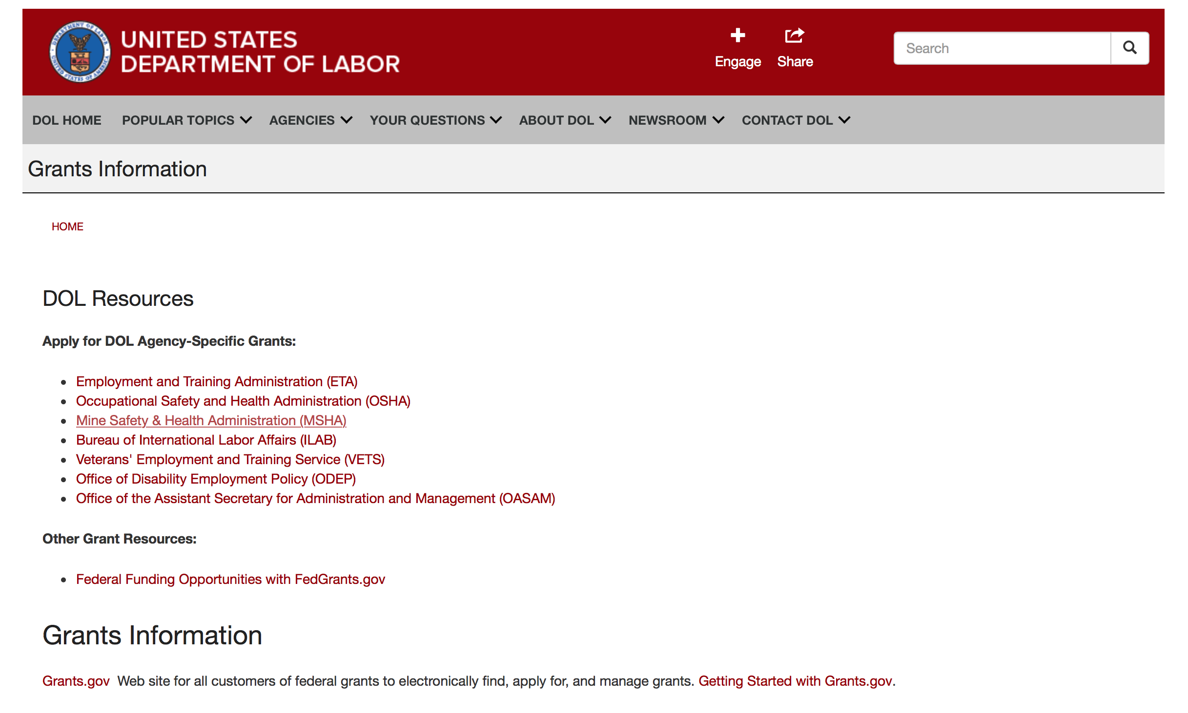

Agency Grants and Contract General Overview

DOL Resources
Apply for DOL Agency-Specific Grants:
- Employment and Training Administration (ETA)
- Occupational Safety and Health Administration (OSHA)
- Mine Safety & Health Administration (MSHA)
- Bureau of International Labor Affairs (ILAB)
- Veterans' Employment and Training Service (VETS)
- Office of Disability Employment Policy (ODEP)
- Office of the Assistant Secretary for Administration and Management (OASAM)

Other Grant Resources:
- Federal Funding Opportunities with FedGrants.gov
Grants Information
Grants.gov — Web site for all customers of federal grants to electronically find, apply for, and manage grants. Getting Started with Grants.gov.

DOL Resources and Instructions for Applying for a Grant
- DOL Guidance Clarifying the Effect of the Religious Freedom Restoration Act on Faith-Based Organizations
- Grant and Contract Information
- Contracting and Grant Program Overview
- Annual Acquisition Plan & Procurement Forecast
- Civil Rights Enforcement for Department of Labor Grant Recipients
- More Information About Grants
- Use of Contracts, Grants & Cooperative Agreements

Other Federal Government Grant Information
- List of Parties Excluded From Federal Procurement and Nonprocurement Programs (as created and maintained by GSA)
- Grant Opportunities (Catalog of Federal Domestic Assistance)

Department of Labor Grant Programs

- Bureau of International Labor Affairs (ILAB): provides grants (cooperative agreements) for the implementation of projects designed to assist developing countries combat the worse forms of child labor, forced labor, and human trafficking; and support worker rights and improve working conditions. http://www.dol.gov/general/business.
- Bureau of Labor Statistics (BLS): provides project grants (cooperative agreements) and the dissemination of technical statistical data and related information on labor force activities; provides data on prices (CPI) and cost of living; data on productivity and technology data; data on compensation and working conditions; data on employment projections.
- Employment and Training (ETA): ETA administers financial assistance programs pursuant to the Workforce Investment Act (WIA), administering State formula grant programs for youth, adults and dislocated workers, national emergency grants for workers affected by mass layoffs, plant closures, and disasters; grant programs for workers with disabilities, Indians and Native Americans, and for migrant and seasonal farmworkers. ETA also administers grant programs for older American workers, apprenticeship programs, Trade Adjustment Assistance (TAA) programs, and assistance for research and development of workforce programs. In addition, ETA is responsible for the operation and maintenance of a national system of public employment service offices and for the national unemployment insurance program.
- Mine Safety and Health (MSHA): provides grants for research, education and training programs to ensure an adequate and competent staff of trained inspectors; and assistance for establishing or improving State mine health and safety programs through technical assistance.
- Occupational Safety and Health (OSHA): provides grants to non-profit organizations to provide training, educational services, and technical assistance; assistance to states to administer and enforce state programs; assistance to states to provide occupational safety and health technical assistance and consultant services.
- Office of Disability Employment Policy (ODEP): The Office of Disability Employment Policy awards competitive grants establishing short-term pilot and technical assistance projects designed to identify, develop, test, evaluate, and disseminate policies to increase employment by expanding access to training, education, employment supports, assistive and systems technology, integrated employment, entrepreneurial development, and small business opportunities for adults and youth with disabilities. Current pilots projects focus on customized employment, Olmstead populations, and innovative demonstration youth grants, among others. Solicitations for grant applications are published in the Federal Register and announced at www.dol.gov/odep. ODEP grants are awarded by the OASAM grant office.
- Veterans' Employment and Training (VETS): provides special employment and training assistance for veterans through the Disabled Veterans' Outreach Program (DVOP) Solicitation for Grant Applications; the Local Veterans' Employment Representative Program (LVER); Veterans' Workforce Investment Program (VWIP); elaws Advisor on veterans' employment and reemployment rights; and the Homeless Veterans Reintegration Project (HVRP). VETS grants are awarded by the OASAM grant office.

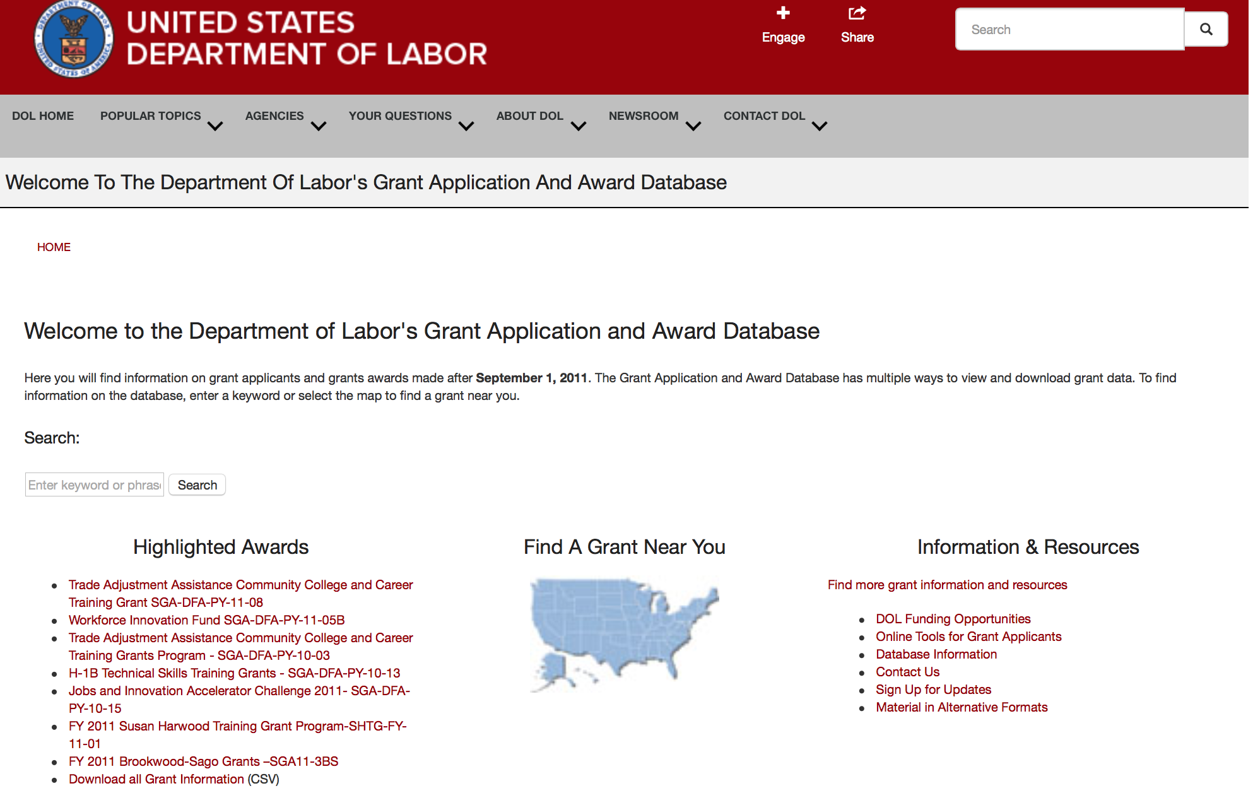

http://www.dol.gov/dol/grants/

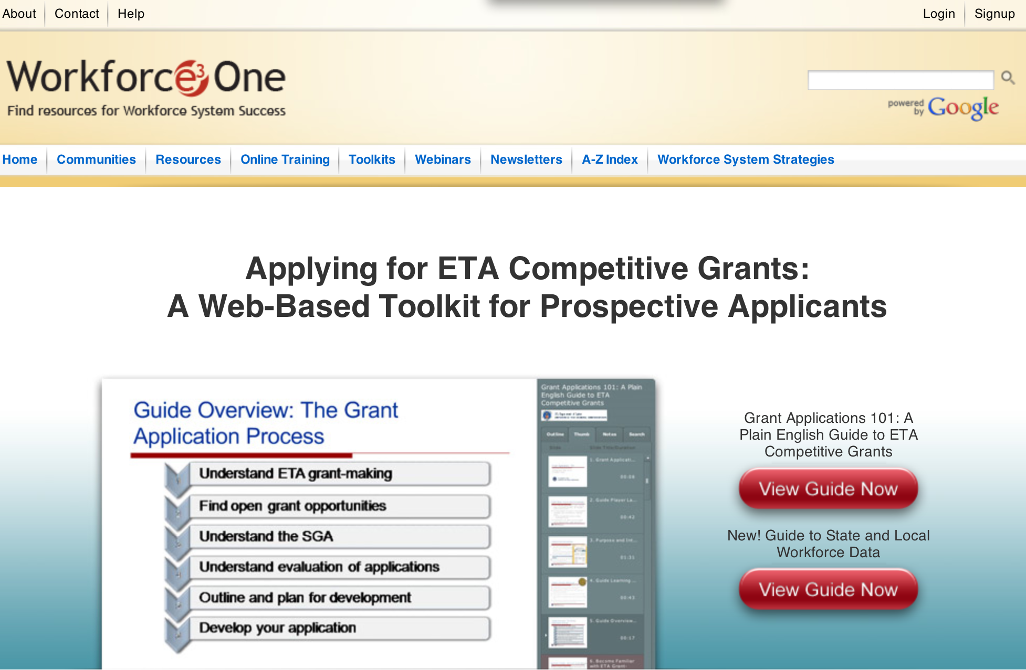

https://www.workforce3one.org/ws/www/pages/grants_toolkit.aspx?pparams=/

Programs

Modifications

Reminders

Employment and Training Administration
Strengthening Working Families Initiative Grant

Document Type: | Grants Notice
Funding Opportunity Number: | FOA-ETA-16-05
Funding Opportunity Title: | Strengthening Working Families Initiative
Opportunity Category: | Discretionary
Funding Instrument Type: | Grant
Category of Funding Activity: | Employment, Labor and Training
Category Explanation:
Expected Number of Awards: | 10
CFDA Number(s): | 17.268 -- H-1B Job Training Grants
Cost Sharing or Matching Requirement: | No
Posted Date: | Dec 17, 2015
Creation Date: | Dec 17, 2015
Original Closing Date for Applications: | Mar 16, 2016 Applications must be received no later than 4:00:00 p.m. Eastern Time.
Current Closing Date for Applications: | Mar 16, 2016 Applications must be received no later than 4:00:00 p.m. Eastern Time.
Archive Date: | Apr 15, 2016
Estimated Total Program Funding: | $25,000,000
Award Ceiling: | $4,000,000
Award Floor: | $0
Eligible Applicants: | Others (see text field entitled "Additional Information on Eligibility" for clarification)
Additional Information on Eligibility: | In keeping with the authority provided by Congress under Section 414 (c) of ACWIA, grants will be awarded to the lead applicant of a public and private partnership of entities that includes: • The public workforce investment system; • Education and training providers, such as community colleges, community-based and faith-based organizations, and “bootcamp” style tech programs; and • Business entities. Applications must include significant employer engagement, including a minimum of at least three employer partners, or an employer or regional industry association consisting of at least three employers, with demonstrated engagement in the project. Additional partners that reflect the character and resources of the local or regional economy and the community are strongly encouraged.
Agency Name: | Employment and Training Administration
Description: | This announcement solicits applications for the Strengthening Working Families Initiative (SWFI) grant program. On June 23, 2014, President Obama convened the White House Summit on Working Families, which was jointly hosted by the Department of Labor, Center for American Progress and the White House Council on Women and Girls. During the Summit, participants (including businesses, economists, labor leaders, legislators, advocates, the media and ordinary citizens) discussed issues that working families face. The Summit was the beginning of a larger conversation about the changes necessary in society, business policies, and in our laws to ensure that all Americans have the opportunity to have a job and a family. Working parents, particularly those with low incomes and low skills, face significant barriers to employment. Six out of ten households with children have all parents working (married working or single working parents), increasing the need for affordable and quality child care. With more parents working, greater access to affordable, high-quality child care is needed but is difficult to find due to steadily increasing child care costs and relatively stagnant funding to cover the costs of child care. Even where affordable child care exists, parents have to deal with unpredictable situations where child care may be unavailable, such as when their child is sick, the child care provider is closed, they are attending professional development sessions, and other emergencies that may result in parents needing alternative solutions. Additionally, an increasing number of families have employers who shift the family member’s work schedule with minimal notice, making stable child care harder to find. It can be difficult to handle these unexpected situations, particularly for low-wage workers who cannot afford to take unpaid leave and are less likely to have flexibility in the workplace. While training and education can help move parents into better paying jobs, some of the barriers to employment also serve as barriers to training and education. The lack of access to affordable and consistent child care can keep parents from attending training and educational programs. Of the 21 million low-income parents, only 1 in 10 participates in education and training. For those low-income parents participating in education and training, almost half were working at the same time, resulting in the additional burden of arranging for and paying the cost of child care while at work, while in training, and while commuting. As education and earnings are strongly linked, this FOA supports providing access to education and training to help move parents along a career pathway that will lead to better paying jobs. This FOA also encourages applicants to develop an approach that provides skills training leading to family-supporting jobs for low- to middle-skilled parents while simultaneously developing and implementing a plan for the applicant’s community or region that helps families better navigate the existing complex systems of supportive services, including increased access to child care. To help meet these objectives, the Department is interested in supporting evidence-based strategies or innovations based on these models that remove a range of barriers to training, including child care and other needs that working families face, by investing in education and skills training in combination with customized participant supportive services. Of particular interest are new promising ideas developed through human centered design methodology and behavioral insight research. Program strategies must include moving lower- to middle-skilled individuals into middle- to high-skilled jobs, with the goals of increasing family-supporting wages and enabling the success of the parent. In particular, the Department is interested in supporting parents – defined as custodial parent, legal guardian, foster parent, or other person standing in loco parentis – who face a barrier to training, including child care and other participant supportive service needs, and are in need of increasing skills and competencies that will either prepare them for entry into an H-1B-aligned career pathway or advancement along an H-1B-aligned career pathway and into middle- or high-skilled jobs. Through this FOA, the Department aims to address education and training barriers for low- to middle-skilled parents by prioritizing the needs of this targeted population; addressing child care needs for parents seeking education and training; increasing access to child care resources; and bridging the gap between the workforce development and child care systems. As applicants design their training strategies to meet the needs of working parents, they should consider the delivery methods and scheduling of training as important factors in providing the flexibility that working parents may require for participation in training. This may include adjusting curriculum design to provide flexible course offerings, expanding asynchronous learning options, or providing online courses. It could also include delivering training through banded schedules to enable parents to accommodate their work schedules and make it easier for working parents to make child care arrangements. Another possibility is the inclusion of training onsite at the workplace, particularly if child care is provided in the same location. An important element of this FOA is the need for communities to address how local areas will help parents navigate complex systems and access the child care services they need. The SWFI grants will provide the platform for strengthening partnerships between systems (workforce training providers and child care providers) to ensure consistency in care and flexibility in services. To support these efforts, applicants are required to leverage cash or in-kind resources amounting to at least 25 percent of the total award.
Link to Additional Information:
Contact Information: | If you have difficulty accessing the full announcement electronically, please contact:  Elizabeth DeHart Grants Management Specialist  dehart.elizabeth@dol.gov

http://www.grants.gov/web/grants/view-opportunity.html?oppId=280609

Employment and Training Administration
Tech Hire Partnership Grants

Document Type: | Grants Notice
Funding Opportunity Number: | FOA-ETA-16-01
Funding Opportunity Title: | Tech Hire Partnership Grants
Opportunity Category: | Discretionary
Funding Instrument Type: | Grant
Category of Funding Activity: | Employment, Labor and Training
Category Explanation:
Expected Number of Awards: | 35
CFDA Number(s): | 17.268 -- H-1B Job Training Grants
Cost Sharing or Matching Requirement: | No
Posted Date: | Nov 17, 2015
Creation Date: | Nov 17, 2015
Original Closing Date for Applications: | Mar 11, 2016 Applications must be received no later than 4:00:00 p.m. Eastern Time.
Current Closing Date for Applications: | Mar 11, 2016 Applications must be received no later than 4:00:00 p.m. Eastern Time.
Archive Date: | Apr 10, 2016
Estimated Total Program Funding: | $100,000,000
Award Ceiling: | $5,000,000
Award Floor: | $2,000,000
Eligible Applicants: | Others (see text field entitled "Additional Information on Eligibility" for clarification)
Additional Information on Eligibility: | Grants will be awarded to the lead applicant, which will serve as the grantee and have overall fiscal and administrative responsibility for the grant. Eligible lead applicants must be public or non-profit organizations that: 1) meet the definition of one of the three types of eligible entities described below; and 2) apply in partnership with at least one representative of each of the three types of eligible entities (including the lead applicant), which collectively form the “primary partnership.” An eligible entity cannot serve as more than one type of entity for the purpose of meeting the requirements to include three types of entities in the primary partnership. To be eligible for consideration, applications must include at least one representative of each of the following three types of entities: a) the workforce investment system; b) education and training providers; and c) business-related nonprofit organizations, an organization functioning as a workforce intermediary for the express purpose of serving the needs of businesses, or a consortium of three or more businesses, or at least three independent businesses. Applications that do not include all three entities mentioned above will be considered non-responsive and will not be reviewed. Detailed eligibility requirements for each type of entity are provided in Section III of the announcement.
Agency Name: | Employment and Training Administration
Description: | The Employment and Training Administration (ETA), U.S. Department of Labor (DOL, or the Department, or we), announces the availability of approximately $100,000,000 in grant funds for the TechHire partnership grant program. This grant program is designed to equip individuals with the skills they need through innovative approaches that can rapidly train workers for and connect them to well-paying, middle- and high-skilled, and high-growth jobs across a diversity of H-1B industries such as Information Technology (IT), healthcare, advanced manufacturing, financial services, and broadband. Projects funded by this grant program will help participants begin careers in H-1B occupations and industries which are in-demand and/or high growth in the area applicants are proposing to serve. On a limited basis, this grant program will also enable applicants to work with companies on increasing the skills of existing workers in lower-skilled jobs to move into more highly skilled positions requiring technology-related skills. These grants will pilot and scale public-private partnerships among the workforce investment system, education and training providers, and business-related nonprofit organizations to address the following goals for the target populations: 1) Expand access to accelerated learning options that provide the fastest paths to good jobs, such as “bootcamp” style programs, online options, and competency-based programs to give people the skills required for employment in three months to two years among people with historic barriers to accessing employment and training; 2) Improve the likelihood that those populations complete training and enter employment, through specialized training strategies, supportive services and other focused participant services that assist targeted populations to overcome barriers, including networking and job search, active job development, transportation, mentoring, and financial counseling; 3) Connect those who have received training or who already have the skills required for employment, but are being overlooked, to employment, paid internships, or Registered Apprenticeship opportunities that allow them to get work experience and prove themselves to hiring employers; 4) Demonstrate strong commitment to customer-centered design and excellence in customer experience, so that the programs and services reflect real need of employers and participants, through human centered design methodology and other methods of design thinking; and 5) Ensure that innovations form the basis for broader change and sustainability over time and that a clear strategy exists for adapting to rapidly changing market needs after the initial period of the grant.
Link to Additional Information:
Contact Information: | If you have difficulty accessing the full announcement electronically, please contact:  Aiyana Pucci Grants Management Specialist  pucci.aiyana@dol.gov

http://www.grants.gov/web/grants/view-opportunity.html?oppId=280094



National Aeronautics and Space Administration

Research and Contracting Opportunities

NASA Research Opportunities Online

- Various NASA offices publish their research announcements over the Internet, broadening the opportunity for researchers to apply for funding. This site provides access to current research announcements along with their specific due dates.

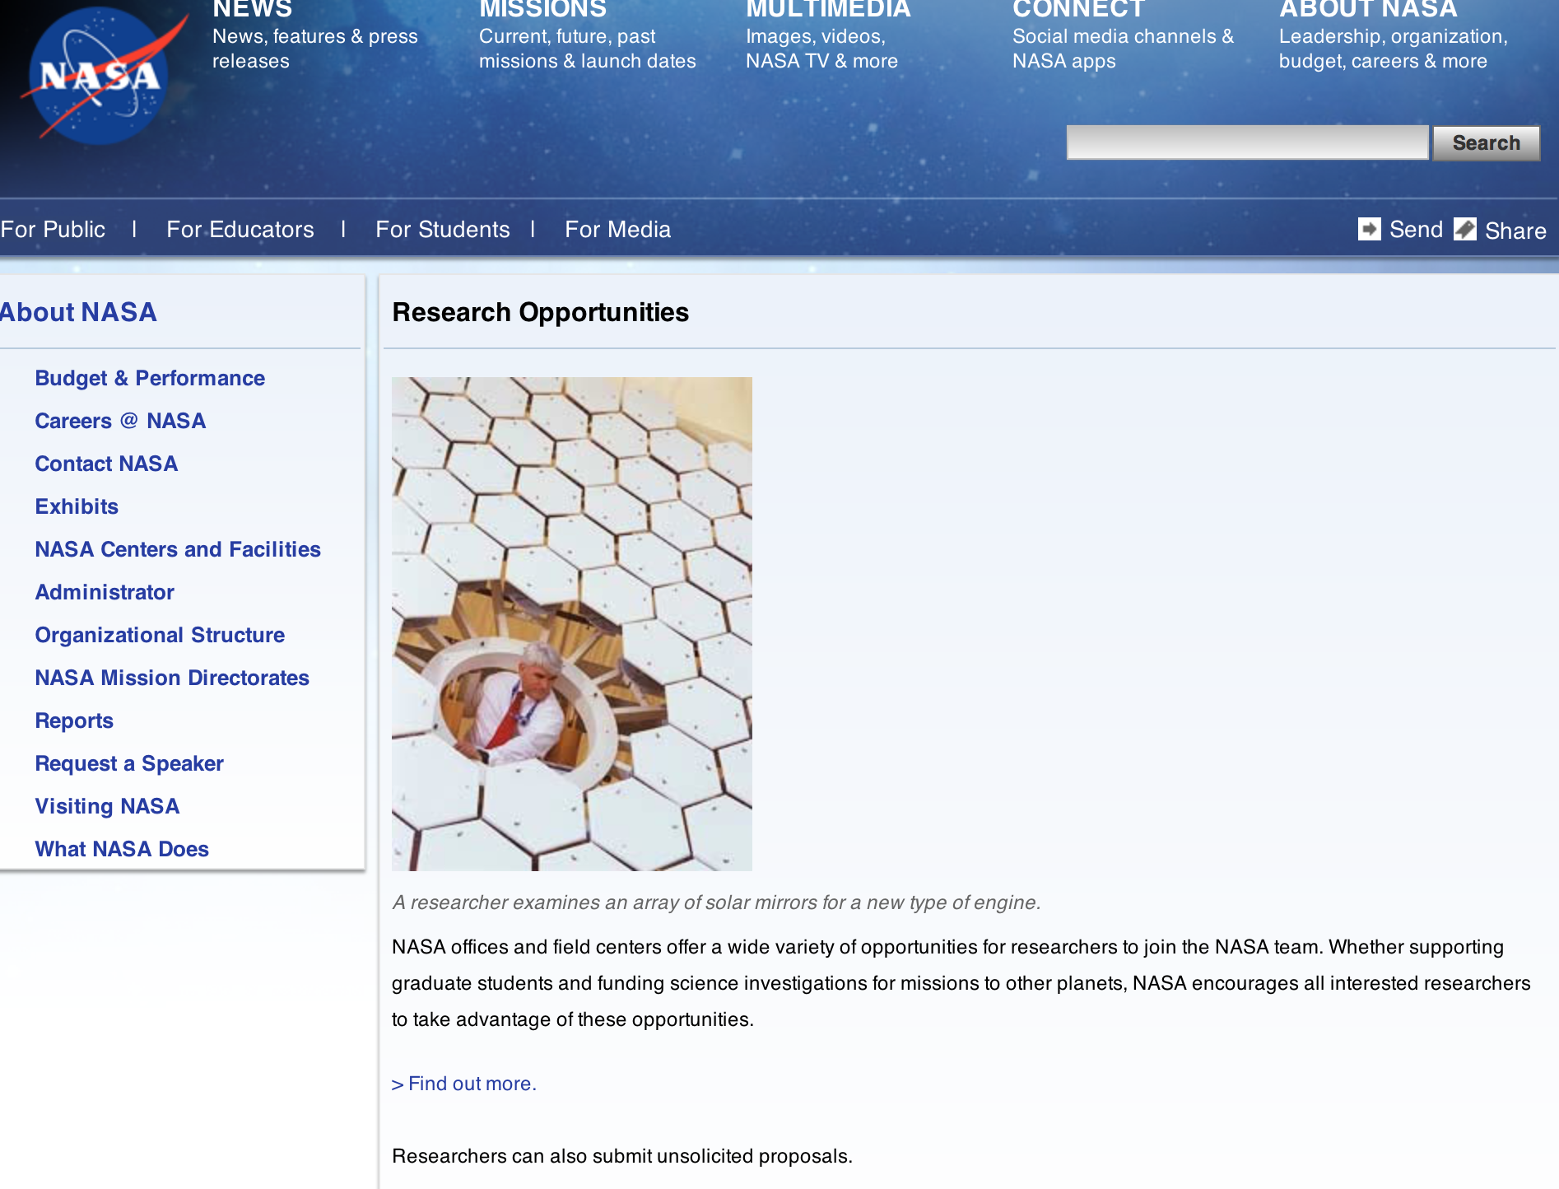

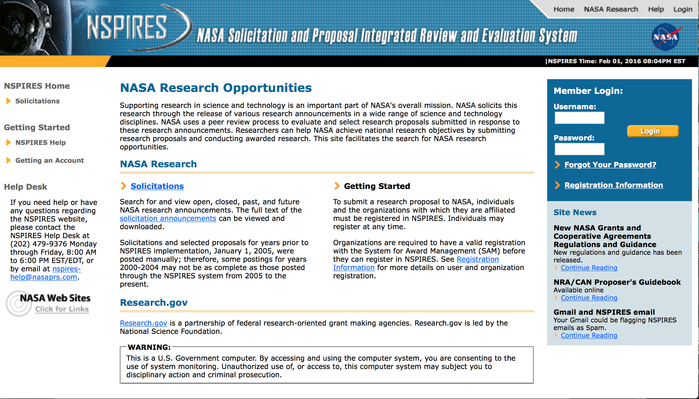

http://nspires.nasaprs.com/external/

Programs

NASA Headquarters
ROSES 2015: Carbon Monitoring System Grant
http://www.grants.gov/web/grants/view-opportunity.html?oppId=280851

Modifications:

NASA Stennis Space Center
Cooperative Agreement Notice (CAN) 2016 at NASA John C. Stennis Center
Modification 2
http://www.grants.gov/web/grants/view-opportunity.html?oppId=281164

National Archives and Records Administration

Grant Opportunities General Overview

To access the information below: click here

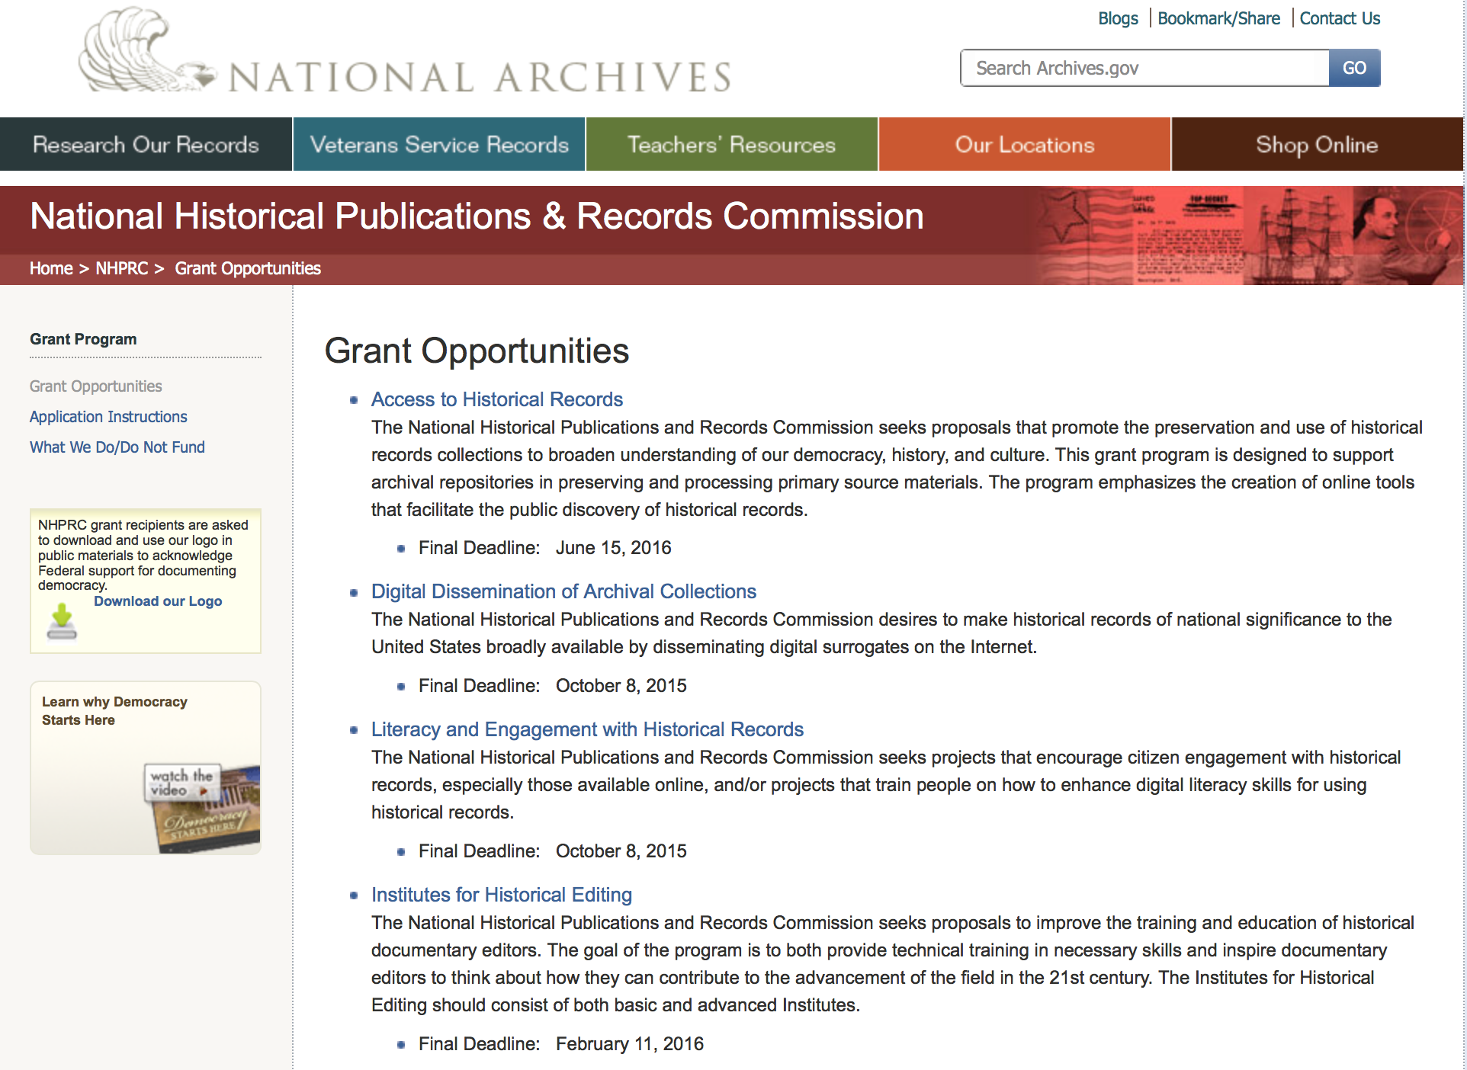

Reminders:

State Board Programming Grants

Document Type: | Grants Notice
Funding Opportunity Number: | STATE-201606
Funding Opportunity Title: | State Board Programming Grants
Opportunity Category: | Discretionary
Funding Instrument Type: | Grant
Category of Funding Activity: | Humanities (see "Cultural Affairs" in CFDA)
Category Explanation:
Expected Number of Awards: | 25
CFDA Number(s): | 89.003 -- National Historical Publications and Records Grants
Cost Sharing or Matching Requirement: | Yes
Posted Date: | Nov 24, 2015
Creation Date: | Nov 23, 2015
Original Closing Date for Applications: | Jun 15, 2016
Current Closing Date for Applications: | Jun 15, 2016
Archive Date: | Jul 15, 2016
Estimated Total Program Funding: | $650,000
Award Ceiling: | $80,000
Award Floor: | $0
Eligible Applicants: | State governments  Public and State controlled institutions of higher education  Others (see text field entitled "Additional Information on Eligibility" for clarification)  Nonprofits having a 501(c)(3) status with the IRS, other than institutions of higher education
Additional Information on Eligibility: | These grants are awarded only to SHRABs in each state, or to the state agency responsible for the SHRAB, ordinarily the state archives. Another state agency, or a non-profit organization, such as a foundation or university, acting on behalf of the designated state agency may apply. States also include the District of Columbia, the Commonwealth of Puerto Rico, and United States territories.
Agency Name: | National Archives and Records Administration
Description: | The National Historical Publications and Records Commission seeks proposals that strengthen the nation’s archival network through activities undertaken by state historical records advisory boards (SHRABs). The purpose of this grant program is to assist state boards to enhance access to historical records, increase citizen engagement with records, and provide learning and development opportunities for students, citizens and professional archivists. The Commission will award grants to State Historical Records Advisory Boards to: • Provide educational and outreach programs, workshops, and other activities that enhance citizen and student engagement with historical records • Operate state-based regrant and scholarship programs that advance access to historical records • Collaborate on projects with other organizations to address common problems or shared opportunities within a state or among a consortium of state archives • Hold or participate in meetings and public forums on statewide or national archival issues. For a comprehensive list of Commission limitations on funding, please see What We Do and Do Not Fund. Applications that consist entirely of ineligible activities will not be considered. Award Information A grant is for one year and for up to $40,000 or for two years and for up to $80,000. The NHPRC expects to award approximately 25 grants in this program. The total amount allocated for this program is up to $650,000. Grants begin no earlier than January 1, 2017. The Commission requires that grant recipients acknowledge NHPRC grant assistance in all publicity, publications, and other products that result from its support. Eligibility These grants are awarded only to SHRABs in each state, or to the state agency responsible for the SHRAB, ordinarily the state archives. Another state agency, or a non-profit organization, such as a foundation or university, acting on behalf of the designated state agency may apply. States also include the District of Columbia, the Commonwealth of Puerto Rico, and United States territories. Cost Sharing The total costs of a project are shared between the NHPRC and the applicant organization. The Commission provides no more than 75 per cent of total direct project costs in the State Board Programming Grants category. NHPRC grant recipients are not permitted to use grant funds for indirect costs (as indicated in 2 CFR 2600.101). Cost sharing is required. The applicant’s financial contribution may include both direct and indirect expenses, in-kind contributions, non-Federal third-party contributions, and any income earned directly by the project. Indirect costs must be listed under the applicant’s cost sharing contribution. Other Requirements Applicant organizations must be registered in System for Award Management (SAM) prior to submitting an application, maintain SAM registration throughout the application and award process, and include a valid DUNS number in their application. Details on SAM registration and requesting a DUNS number can be found at the System for Award Management website at https://sam.gov. Please refer to the User Guides section and the Grants Registrations PDF. A complete application includes the Application for Federal Assistance (Standard Form 424), Assurances - Non-Construction Programs (Standard Form 424B), a Project Narrative, Summary, Supplementary Materials, and Budget. Applications lacking these items will not be considered. Ineligible applications will not be reviewed.
Link to Additional Information: | Link to full grant announcement, including additional requirements
Contact Information: | If you have difficulty accessing the full announcement electronically, please contact:  Jeff de la Concepcion Grant Program Specialist Phone 202-357-5022  Grant Program Specialist

http://www.grants.gov/web/grants/view-opportunity.html?oppId=280200

Publishing Historical Records in Documentary Editions Grant

Document Type: | Grants Notice
Funding Opportunity Number: | EDITIONS-201606
Funding Opportunity Title: | Publishing Historical Records in Documentary Editions
Opportunity Category: | Discretionary
Funding Instrument Type: | Grant
Category of Funding Activity: | Humanities (see "Cultural Affairs" in CFDA)
Category Explanation:
Expected Number of Awards: | 25
CFDA Number(s): | 89.003 -- National Historical Publications and Records Grants
Cost Sharing or Matching Requirement: | Yes
Posted Date: | Nov 24, 2015
Creation Date: | Nov 23, 2015
Original Closing Date for Applications: | Jun 15, 2016
Current Closing Date for Applications: | Jun 15, 2016
Archive Date: | Jul 15, 2016
Estimated Total Program Funding: | $2,500,000
Award Ceiling: | $200,000
Award Floor: | $0
Eligible Applicants: | County governments  Native American tribal governments (Federally recognized)  City or township governments  Private institutions of higher education  Nonprofits having a 501(c)(3) status with the IRS, other than institutions of higher education  State governments  Public and State controlled institutions of higher education
Agency Name: | National Archives and Records Administration
Description: | The National Historical Publications and Records Commission seeks proposals to publish documentary editions of historical records. Projects may focus on the papers of major figures from American history or cover broad historical movements in politics, military, business, social reform, the arts, and other aspects of the national experience. The historical value of the records and their expected usefulness to broad audiences must justify the costs of the project. The goal of this program is to provide access to, and editorial context for, the historical documents and records that tell the American story. The NHPRC encourages projects, whenever possible and appropriate, to provide access to these materials in a free and open online environment, without precluding other forms of publication. Applicants should demonstrate familiarity with the best practices recommended by the Association for Documentary Editing or the Modern Language Association Committee on Scholarly Editions. Projects may also prepare print editions as part of their overall publishing plan. However, projects that do not have definitive plans for digital dissemination and preservation in place at the time of application will not be considered. It is also expected that the contents of any print volumes produced will be made available online within a reasonable period of time following print publication. Grants are awarded for collecting, describing, preserving, compiling, transcribing, annotating, editing, encoding, and publishing documentary source materials in print and online. Because of the focus on documentary sources, grants do not support preparation of critical editions of published works unless such works are just a small portion of the larger project. All applicants should be aware that the application process is highly competitive. Ongoing projects: Applicants from ongoing projects must demonstrate that they have successfully achieved the performance objectives associated with previous NHPRC awards; provide updated, current information, including a description of the new activities as well as description and significance of the specific materials to be edited during the proposed grant period; show progress towards completing the edition; and justify costs in a new budget. For a comprehensive list of Commission's limitations on funding, please see What We Do and Do Not Fund. Applications that consist entirely of ineligible activities will not be considered. Award Information A grant is for one year and for up to $200,000. The Commission expects to make up to 25 grants in this category for a total of up to $2,500,000. Grants begin no earlier than January 1, 2017. The Commission requires that grant recipients acknowledge NHPRC grant assistance in all publications and other products that result from its support. Eligibility U.S. nonprofit organizations or institutions U.S. colleges, universities, and other academic institutions State or local government agencies Federally-acknowledged or state-recognized Native American tribes or groups Cost Sharing The total costs of a project are shared between the NHPRC and the applicant organization. The Commission provides no more than 50 per cent of total direct project costs in the Publishing Historical Records in Documentary Editions category. NHPRC grant recipients are not permitted to use grant funds for indirect costs (as indicated in 2 CFR 2600.101). Cost sharing is required. The applicant’s financial contribution may include both direct and indirect expenses, in-kind contributions, non-Federal third-party contributions, and any income earned directly by the project. Indirect costs must be listed under the applicant’s cost sharing contribution. Other Requirements Applicant organizations must be registered in the System for Award Management (SAM) prior to submitting an application, maintain SAM registration throughout the application and award process, and include a valid DUNS number in their application. Details on SAM registration and requesting a DUNS number can be found at the System for Award Management website at https://sam.gov. Please refer to the User Guides section and the Grants Registrations PDF. A complete application includes the Application for Federal Assistance (Standard Form 424), Assurances -- Non-Construction Programs (Standard Form 424B), a Project Narrative, Summary, Supplementary Materials, and Budget. Applications lacking these items will not be considered. Ineligible applications will not be reviewed.
Link to Additional Information: | Link to full grant announcement, including additional requirements
Contact Information: | If you have difficulty accessing the full announcement electronically, please contact:  Jeff de la Concepcion Grant Program Specialist Phone 202-357-5022  Grant Program Specialist

http://www.grants.gov/web/grants/view-opportunity.html?oppId=280201

Publishing Historical Records in Documentary Editions Grant

Document Type: | Grants Notice
Funding Opportunity Number: | EDITIONS-201610
Funding Opportunity Title: | Publishing Historical Records in Documentary Editions
Opportunity Category: | Discretionary
Funding Instrument Type: | Grant
Category of Funding Activity: | Humanities (see "Cultural Affairs" in CFDA)
Category Explanation:
Expected Number of Awards: | 25
CFDA Number(s): | 89.003 -- National Historical Publications and Records Grants
Cost Sharing or Matching Requirement: | Yes
Posted Date: | Nov 24, 2015
Creation Date: | Nov 23, 2015
Original Closing Date for Applications: | Oct 6, 2016
Current Closing Date for Applications: | Oct 6, 2016
Archive Date: | Nov 4, 2016
Estimated Total Program Funding: | $2,500,000
Award Ceiling: | $200,000
Award Floor: | $0
Eligible Applicants: | Private institutions of higher education  County governments  City or township governments  Public and State controlled institutions of higher education  Native American tribal governments (Federally recognized)  Nonprofits having a 501(c)(3) status with the IRS, other than institutions of higher education  State governments
Agency Name: | National Archives and Records Administration
Description: | The National Historical Publications and Records Commission seeks proposals to publish documentary editions of historical records. Projects may focus on the papers of major figures from American history or cover broad historical movements in politics, military, business, social reform, the arts, and other aspects of the national experience. The historical value of the records and their expected usefulness to broad audiences must justify the costs of the project. The goal of this program is to provide access to, and editorial context for, the historical documents and records that tell the American story. The NHPRC encourages projects, whenever possible and appropriate, to provide access to these materials in a free and open online environment, without precluding other forms of publication. Applicants should demonstrate familiarity with the best practices recommended by the Association for Documentary Editing or the Modern Language Association Committee on Scholarly Editions. Projects may also prepare print editions as part of their overall publishing plan. However, projects that do not have definitive plans for digital dissemination and preservation in place at the time of application will not be considered. It is also expected that the contents of any print volumes produced will be made available online within a reasonable period of time following print publication. Grants are awarded for collecting, describing, preserving, compiling, transcribing, annotating, editing, encoding, and publishing documentary source materials in print and online. Because of the focus on documentary sources, grants do not support preparation of critical editions of published works unless such works are just a small portion of the larger project. All applicants should be aware that the application process is highly competitive. Ongoing projects: Applicants from ongoing projects must demonstrate that they have successfully achieved the performance objectives associated with previous NHPRC awards; provide updated, current information, including a description of the new activities as well as description and significance of the specific materials to be edited during the proposed grant period; show progress towards completing the edition; and justify costs in a new budget. For a comprehensive list of Commission's limitations on funding, please see What We Do and Do Not Fund. Applications that consist entirely of ineligible activities will not be considered. Award Information A grant is for one year and for up to $200,000. The Commission expects to make up to 25 grants in this category for a total of up to $2,500,000. Grants begin no earlier than January 1, 2017. The Commission requires that grant recipients acknowledge NHPRC grant assistance in all publications and other products that result from its support. Eligibility U.S. nonprofit organizations or institutions U.S. colleges, universities, and other academic institutions State or local government agencies Federally-acknowledged or state-recognized Native American tribes or groups Cost Sharing The total costs of a project are shared between the NHPRC and the applicant organization. The Commission provides no more than 50 per cent of total direct project costs in the Publishing Historical Records in Documentary Editions category. NHPRC grant recipients are not permitted to use grant funds for indirect costs (as indicated in 2 CFR 2600.101). Cost sharing is required. The applicant’s financial contribution may include both direct and indirect expenses, in-kind contributions, non-Federal third-party contributions, and any income earned directly by the project. Indirect costs must be listed under the applicant’s cost sharing contribution. Other Requirements Applicant organizations must be registered in the System for Award Management (SAM) prior to submitting an application, maintain SAM registration throughout the application and award process, and include a valid DUNS number in their application. Details on SAM registration and requesting a DUNS number can be found at the System for Award Management website at https://sam.gov. Please refer to the User Guides section and the Grants Registrations PDF. A complete application includes the Application for Federal Assistance (Standard Form 424), Assurances -- Non-Construction Programs (Standard Form 424B), a Project Narrative, Summary, Supplementary Materials, and Budget. Applications lacking these items will not be considered. Ineligible applications will not be reviewed.
Link to Additional Information: | Link to full grant announcement, including additional requirements
Contact Information: | If you have difficulty accessing the full announcement electronically, please contact:  Jeff de la Concepcion Grant Program Specialist Phone 202-357-5022  Grant Program Specialist

http://www.grants.gov/web/grants/view-opportunity.html?oppId=280202

Access to Historical Records Grant

Document Type: | Grants Notice
Funding Opportunity Number: | ACCESS-201606
Funding Opportunity Title: | Access to Historical Records
Opportunity Category: | Discretionary
Funding Instrument Type: | Grant
Category of Funding Activity: | Humanities (see "Cultural Affairs" in CFDA)
Category Explanation:
Expected Number of Awards: | 14
CFDA Number(s): | 89.003 -- National Historical Publications and Records Grants
Cost Sharing or Matching Requirement: | Yes
Posted Date: | Nov 24, 2015
Creation Date: | Nov 23, 2015
Original Closing Date for Applications: | Jun 15, 2016
Current Closing Date for Applications: | Jun 15, 2016
Archive Date: | Jul 15, 2016
Estimated Total Program Funding: | $1,000,000
Award Ceiling: | $200,000
Eligible Applicants: | Public and State controlled institutions of higher education  State governments  City or township governments  Nonprofits having a 501(c)(3) status with the IRS, other than institutions of higher education  Private institutions of higher education  Native American tribal governments (Federally recognized)  County governments
Agency Name: | National Archives and Records Administration
Description: | The National Historical Publications and Records Commission seeks proposals that promote the preservation and use of historical records collections to broaden understanding of our democracy, history, and culture. This grant program is designed to support archival repositories in preserving and processing primary source materials. The program emphasizes the creation of online tools that facilitate the public discovery of historical records. The Commission looks to fund projects that undertake one or more of the following activities: • Preservation, arrangement, and online description of historical records in all formats • Digital preservation of electronic records and unstable audio or moving image formats After completing arrangement and description activities, applicants may also propose to digitize materials to provide online access to collections. For a comprehensive list of Commission limitations on funding, please see “What we do and do not fund” (http://www.archives.gov/nhprc/apply/eligibility.html). Applications that consist entirely of ineligible activities will not be considered. Award Information A grant is for one to two years and for up to $200,000. The Commission expects to make up to 14 grants in this category for a total of up to $1,000,000. Grants begin no earlier than January 1, 2017. The Commission requires that grant recipients acknowledge NHPRC grant assistance in all publicity, publications, and other products that result from its support. Eligibility Information Eligible applicants: • Nonprofit organizations or institutions • Colleges, universities, and other academic institutions • State or local government agencies • Federally-acknowledged or state-recognized Native American tribes or groups Cost Sharing - The total costs of a project are shared between the NHPRC and the applicant organization. The Commission provides no more than 50 per cent of total direct project costs in the Access to Historical Records category. NHPRC grant recipients are not permitted to use grant funds for indirect costs (as indicated in 2 CFR 2600.101). Cost sharing is required. The applicant’s financial contribution may include both direct and indirect expenses, in-kind contributions, non-Federal third-party contributions, and any income earned directly by the project. Indirect costs must be listed under the applicant’s cost sharing contribution. Other Requirements - Applicant organizations must be registered in the System for Award Management (SAM) prior to submitting an application, maintain SAM registration throughout the application and award process, and include a valid DUNS number in their application. Details on SAM registration and requesting a DUNS number can be found at the System for Award Management website at http://sam.gov. Please refer to the User Guides section and the Grants Registrations PDF. A complete application includes the Application for Federal Assistance (Standard Form 424), Assurances -- Non-Construction Programs (Standard Form 424B), a Project Narrative, Summary, Supplementary Materials, and Budget. Applications lacking these items will not be considered. Ineligible applications will not be reviewed.
Link to Additional Information: | Link to full grant announcement, including additional requirements
Contact Information: | If you have difficulty accessing the full announcement electronically, please contact:  Jeff de la Concepcion Grant Program Specialist Phone 202-357-5022  Grant Program Specialist

http://www.grants.gov/web/grants/view-opportunity.html?oppId=280217

National Endowment for the Arts

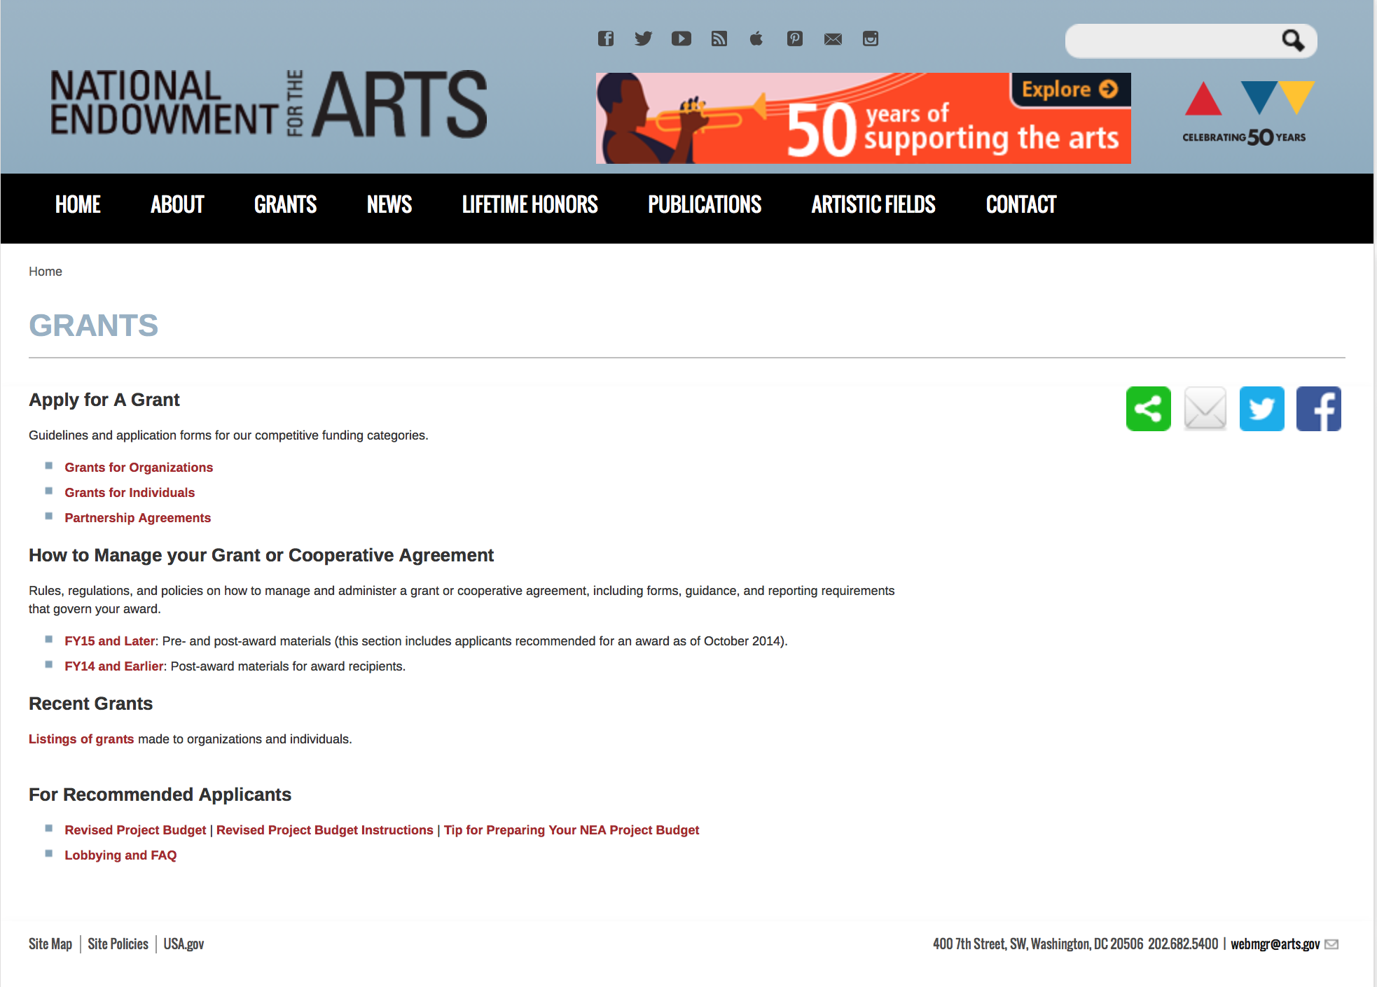

http://arts.gov/grants

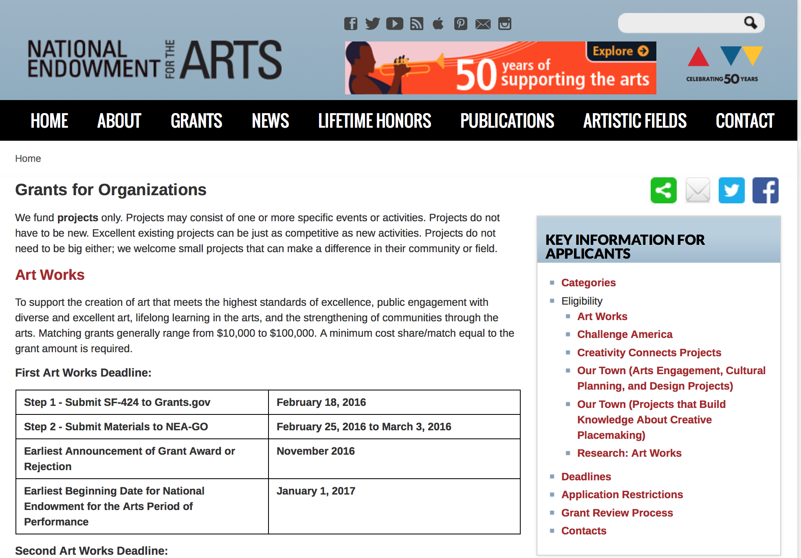
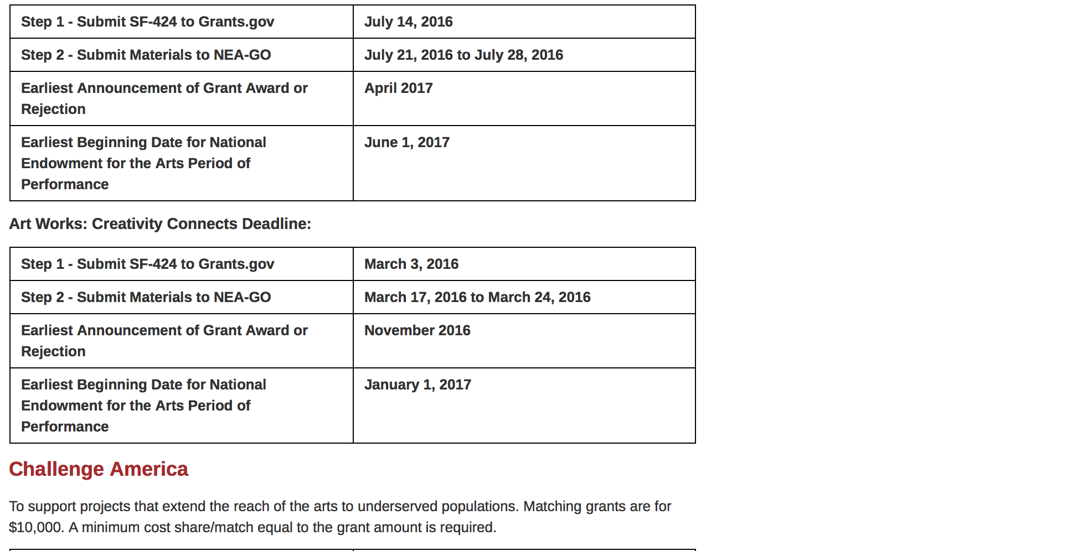
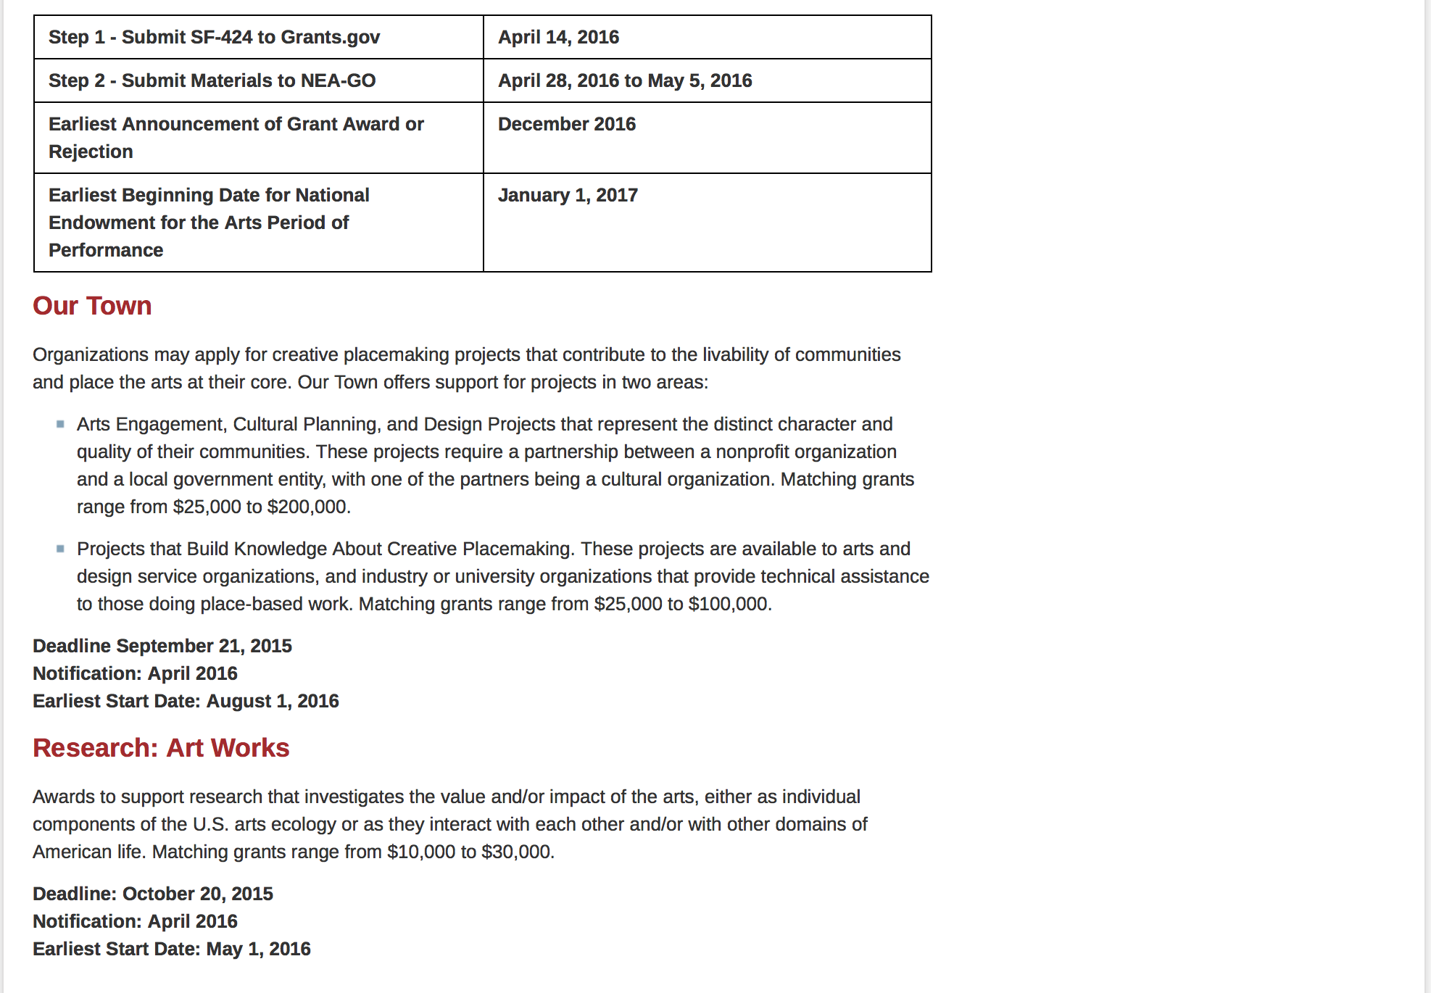
See more at: https://www.arts.gov/grants/apply-grant/grants-organizations

Programs:

2017 National Heritage Fellowships Awards Program Grant

Document Type: | Grants Notice
Funding Opportunity Number: | NEAPS1504
Funding Opportunity Title: | 2017 National Heritage Fellowships Awards Program
Opportunity Category: | Discretionary
Funding Instrument Type: | Grant
Category of Funding Activity: | Arts (see "Cultural Affairs" in CFDA)
Category Explanation:
Expected Number of Awards:
CFDA Number(s): | 45.024 -- Promotion of the Arts Grants to Organizations and Individuals
Cost Sharing or Matching Requirement: | No
Posted Date: | Jan 28, 2016
Creation Date: | Jan 28, 2016
Original Closing Date for Applications: | Apr 5, 2016 The Grants.gov system must receive your proposal no later than 11:59 p.m., Eastern Time, on April 5, 2016. We strongly recommend that you submit your application by March 25, 2016 to give yourself ample time to resolve any problems that you might encounter.
Current Closing Date for Applications: | Apr 5, 2016 The Grants.gov system must receive your proposal no later than 11:59 p.m., Eastern Time, on April 5, 2016. We strongly recommend that you submit your application by March 25, 2016 to give yourself ample time to resolve any problems that you might encounter.
Archive Date: | May 5, 2016
Estimated Total Program Funding:
Award Ceiling: | $310,000
Award Floor: | $310,000
Eligible Applicants: | Special district governments  Nonprofits having a 501(c)(3) status with the IRS, other than institutions of higher education  County governments  Independent school districts  Private institutions of higher education  Native American tribal governments (Federally recognized)  State governments  City or township governments  Public and State controlled institutions of higher education
Additional Information on Eligibility: | Applicant Eligibility Nonprofit, tax-exempt 501(c)(3), U.S. organizations; units of state or local government; or federally recognized tribal communities or tribes may apply. To be eligible, the applicant organization must: • Meet the Arts Endowment's "Legal Requirements" at the time of application. • Have submitted acceptable Final Report packages by the due date(s) for all Arts Endowment award(s) previously received. An organization may submit only one proposal under this program solicitation. You may apply to other National Endowment for the Arts funding opportunities, including Art Works and Our Town, in addition to this program solicitation. In each case, the request must be for a distinctly different project.
Agency Name: | National Endowment for the Arts
Description: | An organization may submit only one proposal under this program solicitation. This Cooperative Agreement may begin no earlier than December 1, 2016, and may extend for up to 12 months. Description The purpose of this Program Solicitation is to select an organization to assist the National Endowment for the Arts with the 2017 National Heritage Fellowships Awards program by coordinating a concert, ceremony and reception, awardee dinner, and associated events. Each year, the National Endowment for the Arts awards a limited number of lifetime honors to individuals in recognition of their outstanding contributions to our nation’s artistic heritage. One of these programs, the NEA National Heritage Fellowship Awards, pays tribute and draws public attention to the excellence and diversity of our nation’s folk and traditional arts. The one-time-only awards go to significant traditional artists from across the country in recognition of their contributions to a particular traditional art form and to the American public through their artistic work. Since 1982, new awardees have travelled to Washington, DC to receive our nation’s highest honor in this field in a public ceremony and perform in a concert. Through this Program Solicitation, the National Endowment for the Arts seeks a Cooperator to assist in the production and execution of the award program’s public events including bringing the recipients to Washington, DC and coordinating the various events surrounding the official presentation of the 2017 National Heritage Fellowship awards.
Link to Additional Information: | Complete NEA Website Announcement
Contact Information: | If you have difficulty accessing the full announcement electronically, please contact:  NEA Web Manager  NEA Web Manager

http://www.grants.gov/web/grants/view-opportunity.html?oppId=281176

2017 Mayor's Institute on City Design (MICD) Grant

Document Type: | Grants Notice
Funding Opportunity Number: | NEAPS1505
Funding Opportunity Title: | 2017 Mayor's Institute on City Design (MICD)
Opportunity Category: | Discretionary
Funding Instrument Type: | Grant
Category of Funding Activity: | Arts (see "Cultural Affairs" in CFDA)
Category Explanation:
Expected Number of Awards:
CFDA Number(s): | 45.024 -- Promotion of the Arts Grants to Organizations and Individuals
Cost Sharing or Matching Requirement: | Yes
Posted Date: | Jan 28, 2016
Creation Date: | Jan 28, 2016
Original Closing Date for Applications: | Mar 29, 2016 The Grants.gov system must receive your proposal no later than 11:59 p.m., Eastern Time, on March 29, 2016. We strongly recommend that you submit your application by March 19, 2016 to give yourself ample time to resolve any problems that you might encounter.
Current Closing Date for Applications: | Mar 29, 2016 The Grants.gov system must receive your proposal no later than 11:59 p.m., Eastern Time, on March 29, 2016. We strongly recommend that you submit your application by March 19, 2016 to give yourself ample time to resolve any problems that you might encounter.
Archive Date: | Apr 28, 2016
Estimated Total Program Funding:
Award Ceiling: | $450,000
Award Floor: | $450,000
Eligible Applicants: | Special district governments  County governments  City or township governments  Independent school districts  Native American tribal governments (Federally recognized)  Private institutions of higher education  Nonprofits having a 501(c)(3) status with the IRS, other than institutions of higher education  State governments  Public and State controlled institutions of higher education
Additional Information on Eligibility: | Applicant Eligibility Nonprofit, tax-exempt 501(c)(3), U.S. organizations; units of state or local government; or federally recognized tribal communities or tribes may apply. To be eligible, the applicant organization must: • Meet the National Endowment for the Arts’ "Legal Requirements" including nonprofit, tax-exempt status at the time of application. • Have submitted acceptable Final Report packages by the due date(s) for all NEA award(s) previously received. • Have, at the time of application, at least a three-year history with education and advocacy regarding policies and practices affecting the design of American cities. An organization may submit only one proposal under this program solicitation.
Agency Name: | National Endowment for the Arts
Description: | An organization may submit only one proposal under this program solicitation. This Cooperative Agreement may begin no earlier than October 1, 2016, and may extend for up to 12 months. Description The purpose of this Program Solicitation is to select an organization (Cooperator) to administer the Mayors’ Institute on City Design (MICD), a program of the National Endowment for the Arts (NEA). MICD brings U.S. mayors together with design professionals in workshops to assist mayors with urban design challenges, to promote design excellence, and to enhance the livability of communities across the country. Since 1986, the MICD has helped transform communities through design by training more than 1,000 mayors to be the chief urban designers of their cities. MICD achieves its mission by organizing sessions where mayors engage with leading design experts to find solutions to the most critical urban design challenges facing their cities. Institutes are organized around case-study problems in closed-door sessions. Each mayor presents a problem from his or her city and receives feedback from other mayors and design experts. Every year, the MICD hosts at least six institutes held throughout the country. Each 2½-day institute is limited to fewer than twenty participants consisting of two equal cohorts: mayors and a resource team of city design and development professionals. Mayors present a case study that might include a range of challenges, such as waterfront redevelopment, downtown revitalization, transportation planning, and the design of new public buildings such as libraries and arts centers. Following each presentation, mayors and the resource team identify important issues, offer suggestions, and discuss potential solutions. This interchange generates creative solutions to urban design challenges. MICD’s success stories are well documented on the program’s website. The program has also been recognized with a number of awards, including a Presidential Award for Design Excellence in 2000. The National Endowment for the Arts will provide general guidance and financial support for the MICD through this Cooperative Agreement. As a federal agency, we regularly issue Program Solicitations for organizations to manage collaborative projects.
Link to Additional Information: | Complete NEA Website Announcement
Contact Information: | If you have difficulty accessing the full announcement electronically, please contact:  NEA Web Manager  NEA Web Manager

http://www.grants.gov/web/grants/view-opportunity.html?oppId=281199

Modifications:

Reminders:

NEA Art Works I Application, FY2017 Grant

Document Type: | Grants Notice
Funding Opportunity Number: | 2016NEA01AW1
Funding Opportunity Title: | NEA Art Works I Application, FY2017
Opportunity Category: | Discretionary
Funding Instrument Type: | Grant
Category of Funding Activity: | Arts (see "Cultural Affairs" in CFDA)
Category Explanation:
Expected Number of Awards:
CFDA Number(s): | 45.024 -- Promotion of the Arts Grants to Organizations and Individuals
Cost Sharing or Matching Requirement: | Yes
Posted Date: | Dec 15, 2015
Creation Date: | Dec 15, 2015
Original Closing Date for Applications: | Feb 18, 2016 “The Grants.gov system must receive your validated and accepted application no later than 11:59 p.m., Eastern Time, on February 18, 2016.”
Current Closing Date for Applications: | Feb 18, 2016 “The Grants.gov system must receive your validated and accepted application no later than 11:59 p.m., Eastern Time, on February 18, 2016.”
Archive Date: | Mar 19, 2016
Estimated Total Program Funding:
Award Ceiling: | $100,000
Award Floor: | $10,000
Eligible Applicants: | Private institutions of higher education  City or township governments  County governments  State governments  Public and State controlled institutions of higher education  Nonprofits having a 501(c)(3) status with the IRS, other than institutions of higher education  Independent school districts  Special district governments  Native American tribal governments (Federally recognized)
Additional Information on Eligibility: | The Arts Endowment's support of a project may start on or after January 1, 2017. Generally, a period of performance of up to two years is allowed. Nonprofit, tax-exempt 501(c)(3), U.S. organizations; units of state or local government; or federally recognized tribal communities or tribes may apply. Applicants may be arts organizations, local arts agencies, arts service organizations, local education agencies (school districts), and other organizations that can help advance the goals of the National Endowment for the Arts. To be eligible, the applicant organization must: • Meet the National Endowment for the Arts’ "Legal Requirements" including nonprofit, tax-exempt status at the time of application. (All organizations must apply directly on their own behalf. Applications through a fiscal sponsor are not allowed. See more information on fiscal sponsors.) • Have a three-year history of programming prior to the application deadline. • Have submitted acceptable Final Report packages by the due date(s) for all National Endowment for the Arts grant(s) previously received.
Agency Name: | National Endowment for the Arts
Description: | An organization may submit only one application through one of the following FY 2017 categories: Art Works or Challenge America. An organization may submit one additional application under the Art Works category for a Creativity Connects project. The Arts Endowment's support of a project may start on or after January 1, 2017. Generally, a period of performance of up to two years is allowed. Grant Program Description The guiding principle of "Art Works" is at the center of everything we do at the NEA. "Art Works" refers to three things: the works of art themselves, the ways art works on audiences, and the fact that art is work for the artists and arts professionals who make up the field. Art works by enhancing the value of individuals and communities, by connecting us to each other and to something greater than ourselves, and by empowering creativity and innovation in our society and economy. The arts exist for beauty itself, but they also are an inexhaustible source of meaning and inspiration. The NEA recognizes these catalytic effects of excellent art, and the key role that arts and design organizations play in revitalizing them. To deepen and extend the arts' value, including their ability to foster new connections and to exemplify creativity and innovation, we welcome projects that: • Are likely to prove transformative with the potential for meaningful change, whether in the development or enhancement of new or existing art forms, new approaches to the creation or presentation of art, or new ways of engaging the public with art; • Are distinctive, offering fresh insights and new value for their fields and/or the public through unconventional solutions; and • Have the potential to be shared and/or emulated, or are likely to lead to other advances in the field. Beyond encouraging projects that demonstrate these characteristics, we want to achieve the following four objectives through the Art Works category: • Creation: The creation of art that meets the highest standards of excellence, • Engagement: Public engagement with diverse and excellent art, • Learning: Lifelong learning in the arts, and • Livability: The strengthening of communities through the arts.
Link to Additional Information: | Complete NEA Website Announcement
Contact Information: | If you have difficulty accessing the full announcement electronically, please contact:  NEA Web Manager  NEA Web Manager

http://www.grants.gov/web/grants/view-opportunity.html?oppId=280551

NEA Art Works Creativity Connects Projects, FY2017 Grant

Document Type: | Grants Notice
Funding Opportunity Number: | 2016NEA01AWCC
Funding Opportunity Title: | NEA Art Works Creativity Connects Projects, FY2017
Opportunity Category: | Discretionary
Funding Instrument Type: | Grant
Category of Funding Activity: | Arts (see "Cultural Affairs" in CFDA)
Category Explanation:
Expected Number of Awards:
CFDA Number(s): | 45.024 -- Promotion of the Arts Grants to Organizations and Individuals
Cost Sharing or Matching Requirement: | Yes
Posted Date: | Dec 15, 2015
Creation Date: | Dec 15, 2015
Original Closing Date for Applications: | Mar 3, 2016 “The Grants.gov system must receive your validated and accepted application no later than 11:59 p.m., Eastern Time, on March 3, 2016.”
Current Closing Date for Applications: | Mar 3, 2016 “The Grants.gov system must receive your validated and accepted application no later than 11:59 p.m., Eastern Time, on March 3, 2016.”
Archive Date: | Apr 2, 2016
Estimated Total Program Funding:
Award Ceiling: | $100,000
Award Floor: | $20,000
Eligible Applicants: | County governments  Nonprofits having a 501(c)(3) status with the IRS, other than institutions of higher education  Native American tribal governments (Federally recognized)  Special district governments  Private institutions of higher education  Independent school districts  Public and State controlled institutions of higher education  State governments  City or township governments
Additional Information on Eligibility: | The official applicant must be an arts organization. An organization may submit only one application for an Art Work: Creativity Connects grant. An organization that submits an application to Art Works: Creativity Connects is still eligible to submit an application to other National Endowment for the Arts funding opportunities. In each case, the request must be for a distinctly different project. The Arts Endowment's support of a project may start on or after January 1, 2017. Generally, a period of performance of up to two years is allowed.
Agency Name: | National Endowment for the Arts
Description: | The Arts Endowment's support of a project may start on or after January 1, 2017. Generally, a period of performance of up to two years is allowed. The official applicant must be an arts organization. An organization may submit only one application for an Art Work: Creativity Connects grant. Grant Program Description Creativity Connects* is an initiative that will show how the arts are central to the country’s creativity ecosystem, investigate how support systems for the arts have changed, explore how the arts connect with other industries, and invest in innovative projects to spark new ideas for the arts field. A key component to the Creativity Connects initiative is a pilot grant opportunity in the Art Works category to support partnerships between arts organizations and organizations from non-arts sectors that include, but are not limited to, business, education, environment, faith, finance, food, health, law, science, and technology. Art Works: Creativity Connects grants will seek to benefit the arts and non-arts sectors by: • Demonstrating the value of working with the arts. • Supporting the infrastructure for the arts to work in new ways with new sectors. • Building bridges that create new relationships and constituencies. • Creating innovative partnership projects to advance common goals.
Link to Additional Information: | NEA Complete Website Announcement
Contact Information: | If you have difficulty accessing the full announcement electronically, please contact:  NEA Web Manager  NEA Web Manager

http://www.grants.gov/web/grants/view-opportunity.html?oppId=280553

NEA Challenge America Application, FY2017 Grant

Document Type: | Grants Notice
Funding Opportunity Number: | 2016NEA01CA
Funding Opportunity Title: | NEA Challenge America Application, FY2017
Opportunity Category: | Discretionary
Funding Instrument Type: | Grant
Category of Funding Activity: | Arts (see "Cultural Affairs" in CFDA)
Category Explanation:
Expected Number of Awards:
CFDA Number(s): | 45.024 -- Promotion of the Arts Grants to Organizations and Individuals
Cost Sharing or Matching Requirement: | Yes
Posted Date: | Dec 15, 2015
Creation Date: | Dec 15, 2015
Original Closing Date for Applications: | Apr 14, 2016 “The Grants.gov system must receive your validated and accepted application no later than 11:59 p.m., Eastern Time, on April 14, 2016.”
Current Closing Date for Applications: | Apr 14, 2016 “The Grants.gov system must receive your validated and accepted application no later than 11:59 p.m., Eastern Time, on April 14, 2016.”
Archive Date: | May 14, 2016
Estimated Total Program Funding:
Award Ceiling: | $10,000
Award Floor: | $10,000
Eligible Applicants: | County governments  Private institutions of higher education  Native American tribal governments (Federally recognized)  State governments  Public and State controlled institutions of higher education  Independent school districts  Special district governments  Nonprofits having a 501(c)(3) status with the IRS, other than institutions of higher education  City or township governments
Additional Information on Eligibility: | The Arts Endowment's support of a project may start on or after January 1, 2017. Grants awarded under these guidelines generally may cover a period of performance of up to two years. An organization that has received Challenge America grants in FY 2014, 2015, and 2016 may not apply for a Challenge America grant under these FY 2017 guidelines. Applicant Eligibility Nonprofit, tax-exempt 501(c)(3), U.S. organizations; units of state or local government; or federally recognized tribal communities or tribes may apply. Applicants may be arts organizations, local arts agencies, arts service organizations, local education agencies (school districts), and other organizations that can help advance the goals of the National Endowment for the Arts.
Agency Name: | National Endowment for the Arts
Description: | The Arts Endowment's support of a project may start on or after January 1, 2017. Grants awarded under these guidelines generally may cover a period of performance of up to two years. An organization that has received Challenge America grants in FY 2014, 2015, and 2016 may not apply for a Challenge America grant under these FY 2017 guidelines. Grant Program Description The Challenge America category offers support primarily to small and mid-sized organizations for projects that extend the reach of the arts to underserved populations -- those whose opportunities to experience the arts are limited by geography, ethnicity, economics, or disability. Age alone (e.g., youth, seniors) does not qualify a group as underserved; at least one of the underserved characteristics noted above also must be present. Grants are available for professional arts programming and for projects that emphasize the potential of the arts in community development. This category encourages and supports the following objective: • Engagement: Engaging the public with diverse and excellent art.
Link to Additional Information: | NEA Complete Website Announcement
Contact Information: | If you have difficulty accessing the full announcement electronically, please contact:  NEA Web Manager  NEA Web Manager

http://www.grants.gov/web/grants/view-opportunity.html?oppId=280532

NEA Literature (Poetry) Fellowships, FY2017 Grant

Document Type: | Grants Notice
Funding Opportunity Number: | 2016NEA03LFCW
Funding Opportunity Title: | NEA Literature (Poetry) Fellowships, FY2017
Opportunity Category: | Discretionary
Funding Instrument Type: | Grant
Category of Funding Activity: | Arts (see "Cultural Affairs" in CFDA)
Category Explanation:
Expected Number of Awards:
CFDA Number(s): | 45.024 -- Promotion of the Arts Grants to Organizations and Individuals
Cost Sharing or Matching Requirement: | No
Posted Date: | Dec 15, 2015
Creation Date: | Dec 15, 2015
Original Closing Date for Applications: | Mar 9, 2016 The Grants.gov system must receive your validated and accepted application no later than 11:59 p.m., Eastern Time, on March 9, 2016.
Current Closing Date for Applications: | Mar 9, 2016 The Grants.gov system must receive your validated and accepted application no later than 11:59 p.m., Eastern Time, on March 9, 2016.
Archive Date: | Apr 8, 2016
Estimated Total Program Funding:
Award Ceiling: | $25,000
Award Floor: | $25,000
Eligible Applicants: | Individuals
Additional Information on Eligibility: | The Arts Endowment’s support of a project may begin any time between January 1, 2017, and January 1, 2018, and extend for up to two years. You may submit only one application per year. You may not apply for a Literature Fellowship (in poetry or prose) and a Translation Fellowship in the same year. Applicant Eligibility Creative writers who meet the publication requirements are eligible to apply. Applicants must be citizens or permanent residents of the United States.
Agency Name: | National Endowment for the Arts
Description: | The Arts Endowment’s support of a project may begin any time between January 1, 2017, and January 1, 2018, and extend for up to two years. You may submit only one application per year. You may not apply for a Literature Fellowship (in poetry or prose) and a Translation Fellowship in the same year. Grant Program Description The National Endowment for the Arts’ Literature Fellowships program offers $25,000 grants in prose (fiction and creative nonfiction) and poetry to published creative writers that enable recipients to set aside time for writing, research, travel, and general career advancement. Applications are reviewed through an anonymous process in which the only criteria for review are artistic excellence and artistic merit. To review the applications, we assemble a different advisory panel every year, each diverse with regard to geography, race and ethnicity, and artistic points of view. The Literature Fellowships program operates on a two-year cycle with fellowships in prose and poetry available in alternating years. For FY 2017, which is covered by these guidelines, fellowships in poetry are available. Fellowships in prose (fiction and creative nonfiction) will be offered in FY 2018 and guidelines will be available in the winter of 2017. You may apply only once each year. Competition for fellowships is extremely rigorous. We typically receive more than 1,200 applications each year in this category and award fellowships to fewer than 5% of applicants. You should consider carefully whether your work will be competitive at the national level.
Link to Additional Information: | NEA Complete Website Announcement
Contact Information: | If you have difficulty accessing the full announcement electronically, please contact:  NEA Web Manager  NEA Web Manager

http://www.grants.gov/web/grants/view-opportunity.html?oppId=280533

National Endowment for the Humanities

Grant Overview -

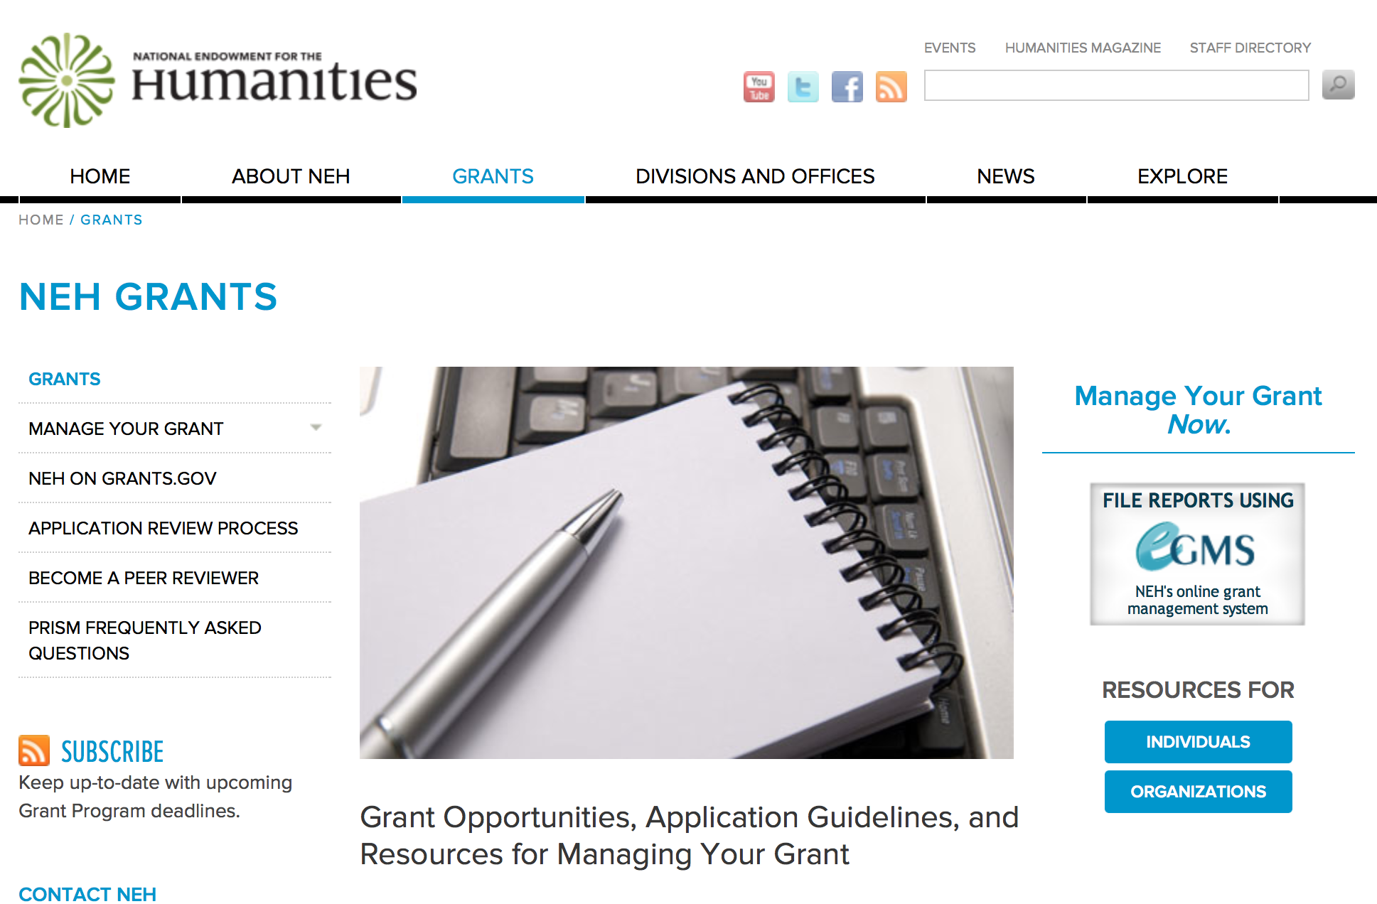

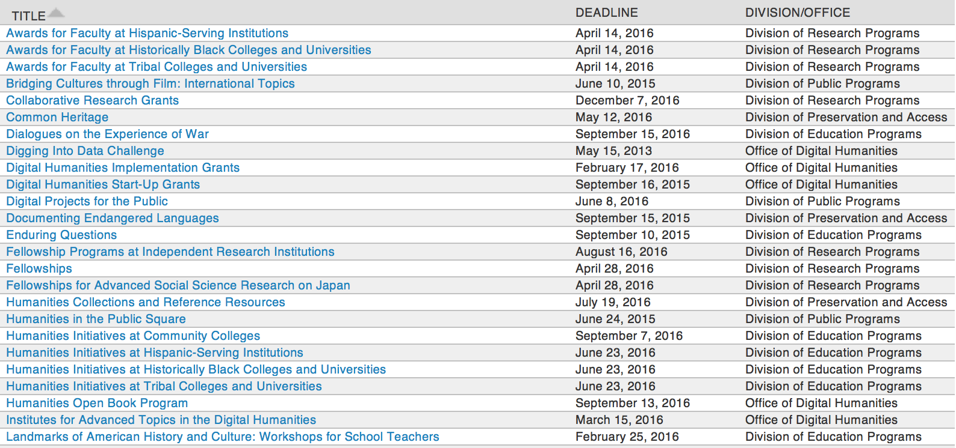

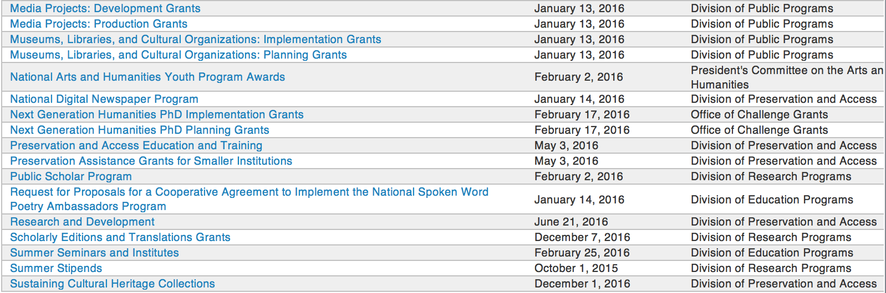

http://www.neh.gov/grants/grantsbydivision.html

Programs:

Modifications:

Reminders:

Landmarks of American History and Culture: Workshops for School Teachers Grant

Document Type: | Grants Notice
Funding Opportunity Number: | 20160225-BH
Funding Opportunity Title: | Landmarks of American History and Culture: Workshops for School Teachers
Opportunity Category: | Discretionary
Funding Instrument Type: | Grant
Category of Funding Activity: | Humanities (see "Cultural Affairs" in CFDA)
Category Explanation:
Expected Number of Awards:
CFDA Number(s): | 45.163 -- Promotion of the Humanities Professional Development
Cost Sharing or Matching Requirement: | No
Posted Date: | Dec 10, 2015
Creation Date: | Dec 10, 2015
Original Closing Date for Applications: | Feb 25, 2016
Current Closing Date for Applications: | Feb 25, 2016
Archive Date:
Estimated Total Program Funding:
Award Ceiling: | $180,000
Award Floor: | $1
Eligible Applicants: | Private institutions of higher education  County governments  Native American tribal governments (Federally recognized)  Public and State controlled institutions of higher education  Special district governments  Nonprofits that do not have a 501(c)(3) status with the IRS, other than institutions of higher education  State governments  Nonprofits having a 501(c)(3) status with the IRS, other than institutions of higher education  City or township governments
Agency Name: | National Endowment for the Humanities
Description: | The Landmarks of American History and Culture program supports a series of one-week workshops for K-12 educators. NEH Landmarks of American History and Culture Workshops use historic sites to address central themes and issues in American history, government, literature, art, music, and related subjects in the humanities. Each workshop is offered twice during the summer. Workshops accommodate thirty-six school teachers (NEH Summer Scholars) at each one-week session. At least one workshop week must serve a national audience and provide housing for participants. The other workshop week may also serve a national audience; alternatively, it may limit its audience to participants who are able to commute and do not require housing. The goals of the workshops are to • increase knowledge and appreciation of subjects, ideas, and places significant to American history and culture through humanities reading and site study; • build communities of inquiry and provide models of civility and of excellent scholarship and teaching; • provide teachers with expertise in the use and interpretation of historical sites and of material and archival resources; and • foster interaction between K-12 educators and scholarly experts. NEH Landmarks Workshops are academically rigorous and focus on primary sources and scholarly works relevant to major themes of American history and culture. Leading scholars should serve as lecturers or session leaders. Workshops should also enable participants to work with primary documents and develop a project. NEH Landmarks Workshops are held at or near sites important to American history and culture, such as presidential residences or libraries; colonial-era settlements; major battlefields; historic districts; parks and preserves; sites of key economic, social, political, and constitutional developments; and places associated with major writers, artists, and musicians. Applicants should make a compelling case for the historical significance of the site(s), the material resources available for use, and the ways in which the site(s) will enhance the workshop.
Link to Additional Information: | http://www.neh.gov/grants/education/landmarks-american-history-and-culture-workshops-school-teachers
Contact Information: | If you have difficulty accessing the full announcement electronically, please contact:  Landmarks of American History and Culture: Workshops for School Teachers Division of Education Programs National Endowment for the Humanities 400 Seventh Street, SW Washington, DC 20506 202-606-8380 landmarks@neh.gov landmarks@neh.gov  landmarks@neh.gov

http://www.grants.gov/web/grants/view-opportunity.html?oppId=280449

Summer Seminars and Institutes Grant

Document Type: | Grants Notice
Funding Opportunity Number: | 20160225-FS
Funding Opportunity Title: | Summer Seminars and Institutes
Opportunity Category: | Discretionary
Funding Instrument Type: | Grant
Category of Funding Activity: | Humanities (see "Cultural Affairs" in CFDA)
Category Explanation:
Expected Number of Awards:
CFDA Number(s): | 45.163 -- Promotion of the Humanities Professional Development
Cost Sharing or Matching Requirement: | No
Posted Date: | Dec 10, 2015
Creation Date: | Dec 10, 2015
Original Closing Date for Applications: | Feb 25, 2016
Current Closing Date for Applications: | Feb 25, 2016
Archive Date:
Estimated Total Program Funding:
Award Ceiling: | $225,000
Award Floor: | $50,000
Eligible Applicants: | Special district governments  County governments  City or township governments  State governments  Nonprofits that do not have a 501(c)(3) status with the IRS, other than institutions of higher education  Public and State controlled institutions of higher education  Private institutions of higher education  Nonprofits having a 501(c)(3) status with the IRS, other than institutions of higher education  Native American tribal governments (Federally recognized)
Agency Name: | National Endowment for the Humanities
Description: | These grants support professional development programs in the humanities for school teachers and for college and university faculty. NEH Summer Seminars and Institutes may be as short as one week or as long as four weeks. NEH Summer Seminars and Institutes • provide models of excellent teaching; • provide models of excellent scholarship; • broaden and deepen understanding of the humanities; • focus on the study and teaching of significant topics, texts, and other sources; • contribute to the intellectual vitality of participants; and • build communities of inquiry. An NEH Summer Seminar or Institute may be hosted by a college, university, learned society, center for advanced study, library or other repository, cultural or professional organization, or school or school system. The host site must be suitable for the project, providing facilities for collegial interaction and scholarship. These programs are designed for a national audience of participants.
Link to Additional Information: | http://www.neh.gov/grants/education/summer-seminars-and-institutes
Contact Information: | If you have difficulty accessing the full announcement electronically, please contact:  Division of Education Programs National Endowment for the Humanities 400 Seventh Street, SW Washington, DC 20506 202-606-8471 sem-inst@neh.gov sem-inst@neh.gov  sem-inst@neh.gov

http://www.grants.gov/web/grants/view-opportunity.html?oppId=280472

Digital Humanities Implementation Grants

Document Type: | Grants Notice
Funding Opportunity Number: | 20160217-HK
Funding Opportunity Title: | Digital Humanities Implementation Grants
Opportunity Category: | Discretionary
Funding Instrument Type: | Grant
Category of Funding Activity: | Humanities (see "Cultural Affairs" in CFDA)
Category Explanation:
Expected Number of Awards:
CFDA Number(s): | 45.169 -- Promotion of the Humanities Office of Digital Humanities
Cost Sharing or Matching Requirement: | No
Posted Date: | Dec 1, 2015
Creation Date: | Dec 1, 2015
Original Closing Date for Applications: | Feb 17, 2016
Current Closing Date for Applications: | Feb 17, 2016
Archive Date:
Estimated Total Program Funding:
Award Ceiling: | $325,000
Award Floor: | $100,000
Eligible Applicants: | Native American tribal governments (Federally recognized)  Public and State controlled institutions of higher education  State governments  City or township governments  Special district governments  Private institutions of higher education  Nonprofits that do not have a 501(c)(3) status with the IRS, other than institutions of higher education  County governments  Nonprofits having a 501(c)(3) status with the IRS, other than institutions of higher education
Agency Name: | National Endowment for the Humanities
Description: | The Digital Humanities Implementation Grants program awards substantial grants to support the implementation of experimental projects that have successfully completed a start-up phase and demonstrated their value to the humanities. Such projects might enhance our understanding of central problems in the humanities, raise new questions in the humanities, or develop new digital applications and approaches for use in the humanities. The program can support innovative digital humanities projects that address multiple audiences, including scholars, teachers, librarians, and the public. Applications from recipients of NEH’s Digital Humanities Start-Up Grants are welcome. Unlike NEH’s Digital Humanities Start-Up Grants program, which emphasizes basic research, prototyping, experimentation, and potential impact, the Digital Humanities Implementation Grants program seeks to identify projects that have successfully completed their start-up phase and are well positioned to have a major impact. Proposals are welcome for digital initiatives in any area of the humanities.
Link to Additional Information: | http://www.neh.gov/grants/odh/digital-humanities-implementation-grants
Contact Information: | If you have difficulty accessing the full announcement electronically, please contact:  If you have questions about the program, contact the ODH staff at odh@neh.gov. Applicants wishing to speak to a staff member by telephone should provide in an e-mail message a telephone number and a preferred time to call. odh@neh.gov  odh@neh.gov

http://www.grants.gov/web/grants/view-opportunity.html?oppId=280266

Next Generation Humanities PhD Grants

Document Type: | Grants Notice
Funding Opportunity Number: | 20160217-ZA
Funding Opportunity Title: | Next Generation Humanities PhD Grants
Opportunity Category: | Discretionary
Funding Instrument Type: | Grant
Category of Funding Activity: | Humanities (see "Cultural Affairs" in CFDA)
Category Explanation:
Expected Number of Awards:
CFDA Number(s): | 45.130 -- Promotion of the Humanities Challenge Grants
Cost Sharing or Matching Requirement: | No
Posted Date: | Oct 20, 2015
Creation Date: | Oct 20, 2015
Original Closing Date for Applications: | Feb 17, 2016
Current Closing Date for Applications: | Feb 17, 2016
Archive Date:
Estimated Total Program Funding:
Award Ceiling: | $350,000
Award Floor: | $1
Eligible Applicants: | Others (see text field entitled "Additional Information on Eligibility" for clarification)
Additional Information on Eligibility: | The only eligible applicants are U.S. nonprofit institutions of higher learning with PhD programs in the humanities.
Agency Name: | National Endowment for the Humanities
Description: | In recent years, research published by Humanities Indicators, among others, has revealed that humanities PhDs pursue careers in many different professions—both inside and outside academia. Yet most humanities PhD programs in the United States still prepare students primarily for tenure-track professor positions at colleges and universities. The increasing shortage of such positions has changed students’ expected career outcomes. NEH therefore hopes to assist universities in devising a new model of doctoral education, which can both transform the understanding of what it means to be a humanities scholar and promote the integration of the humanities in the public sphere. Next Generation Humanities PhD Planning Grants support universities in preparing to institute wide-ranging changes in humanities doctoral programs. Humanities knowledge and methods can make an even more substantial impact on society if students are able to translate what they learn in doctoral programs into a multitude of careers. Next Generation PhD Planning Grants are designed to bring together various important constituencies to discuss and strategize, and then to produce plans that will transform scholarly preparation in the humanities at the doctoral level. Students will be prepared to undertake various kinds of careers, and humanities PhD programs will increase their relevance for the twenty-first century. Next Generation Humanities PhD Implementation Grants support universities in instituting wide-ranging changes in humanities doctoral programs. Humanities knowledge and methods can make an even more substantial impact on society if students are able to translate what they learn in doctoral programs into a multitude of careers. Next Generation PhD Implementation Grants are designed to produce plans that will transform scholarly preparation in the humanities at the doctoral level. Students will be prepared to undertake various kinds of careers, and humanities PhD programs will increase their relevance for the twenty-first century. NEH will support activities specific to each institution’s needs: these may include (but are not limited to) multi-departmental collaboration, transformations in curricula, modifications in stipend structures, altered formats for dissertations, commitment to collection of alumni career information and outcomes, partnerships with non-university entities, as well as a pledge to encourage doctoral students to explore and prepare for multiple career trajectories. NEH intends the Implementation Grants program to promote best practices on the part of its awardee institutions, and thereby to establish a new model for graduate education in the humanities. Grantee institutions must provide funds (either their own funds or funds raised from nonfederal third parties) equal to the grant funds released by NEH.
Link to Additional Information: | http://www.neh.gov/grants/next-generation
Contact Information: | If you have difficulty accessing the full announcement electronically, please contact:  challenge@neh.gov 202-606-8309 challenge@neh.gov  challenge@neh.gov

http://www.grants.gov/web/grants/view-opportunity.html?oppId=279734



National Science Foundation

General Funding Overview

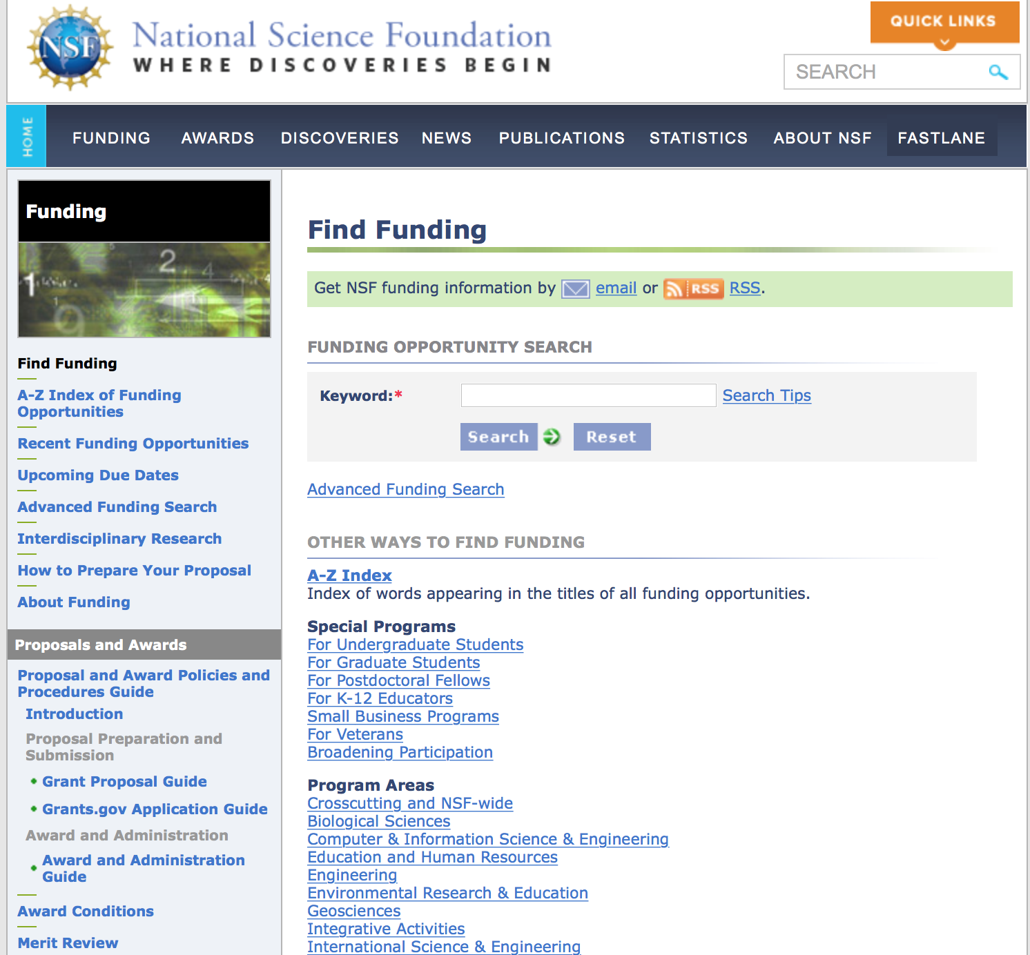
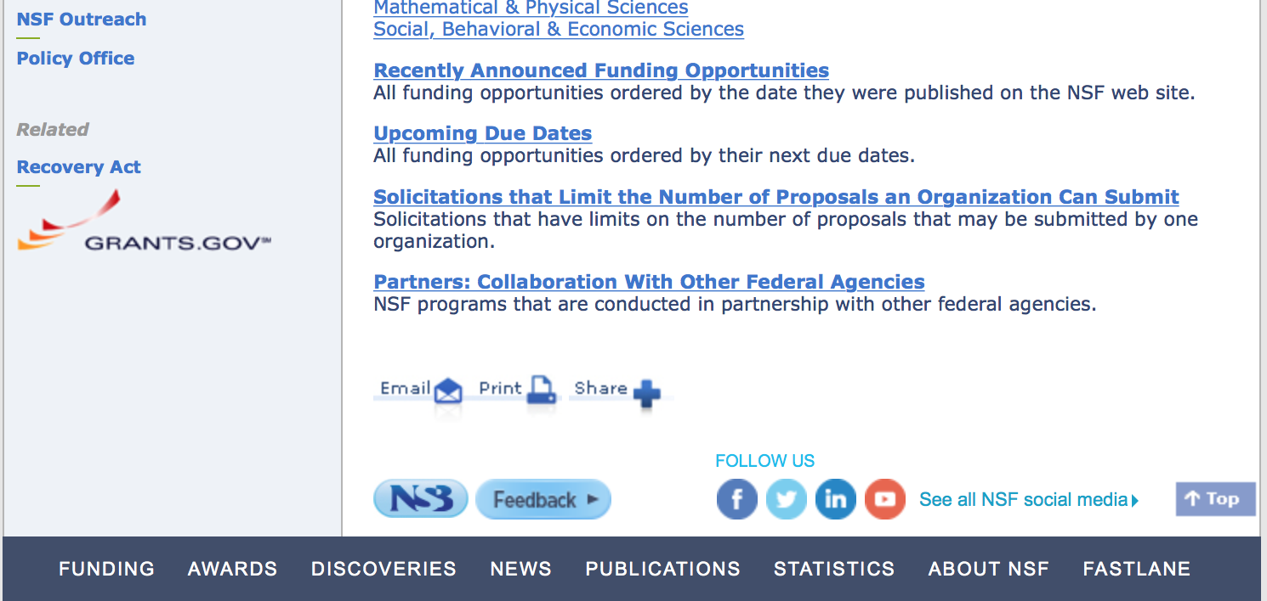

For assistance in finding funding: http://nsf.gov/funding/index.jsp - areas

The National Science Foundation funds research and education in most fields of science and engineering. It does this through grants, and cooperative agreements to more than 2,000 colleges, universities, K-12 school systems, businesses, informal science organizations and other research organizations throughout the United States. The Foundation accounts for about one-fourth of federal support to academic institutions for basic research.
NSF receives approximately 40,000 proposals each year for research, education and training projects, of which approximately 11,000 are funded. In addition, the Foundation receives several thousand applications for graduate and postdoctoral fellowships.
The agency operates no laboratories itself but does support National Research Centers, user facilities, certain oceanographic vessels and Antarctic research stations. The Foundation also supports cooperative research between universities and industry, US participation in international scientific and engineering efforts, and educational activities at every academic level.

For details on active funding deadline dates: http://nsf.gov/funding/pgm_list.jsp?org=NSF&ord=date

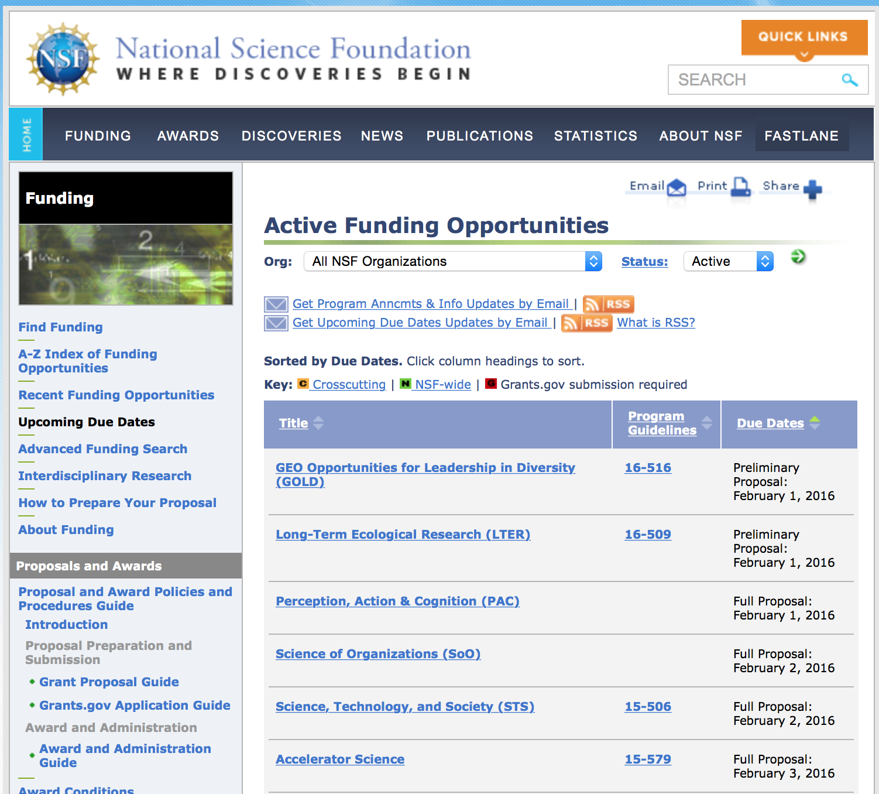

Research and Program Grants:

Analysis Grant
http://www.grants.gov/web/grants/view-opportunity.html?oppId=281243

Data Infrastructure Building Blocks Grant
http://www.grants.gov/web/grants/view-opportunity.html?oppId=280838

Petascale Computing Resource Allocations Grant
http://www.grants.gov/web/grants/view-opportunity.html?oppId=280823

Presidential Awards for Excellence in Science, Mathematics and Engineering Mentoring Grant
http://www.grants.gov/web/grants/view-opportunity.html?oppId=281097

Software Infrastructure for Sustained Innovation - SSE & SSI Grant
http://www.grants.gov/web/grants/view-opportunity.html?oppId=281071

Modifications:

Reminders:

Nuclear Regulatory Commission

Reminders:

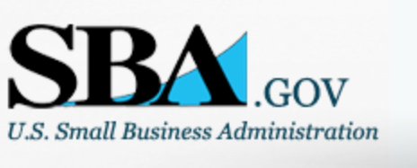

Small Business Administration

General Overview Finding Loans & Grants

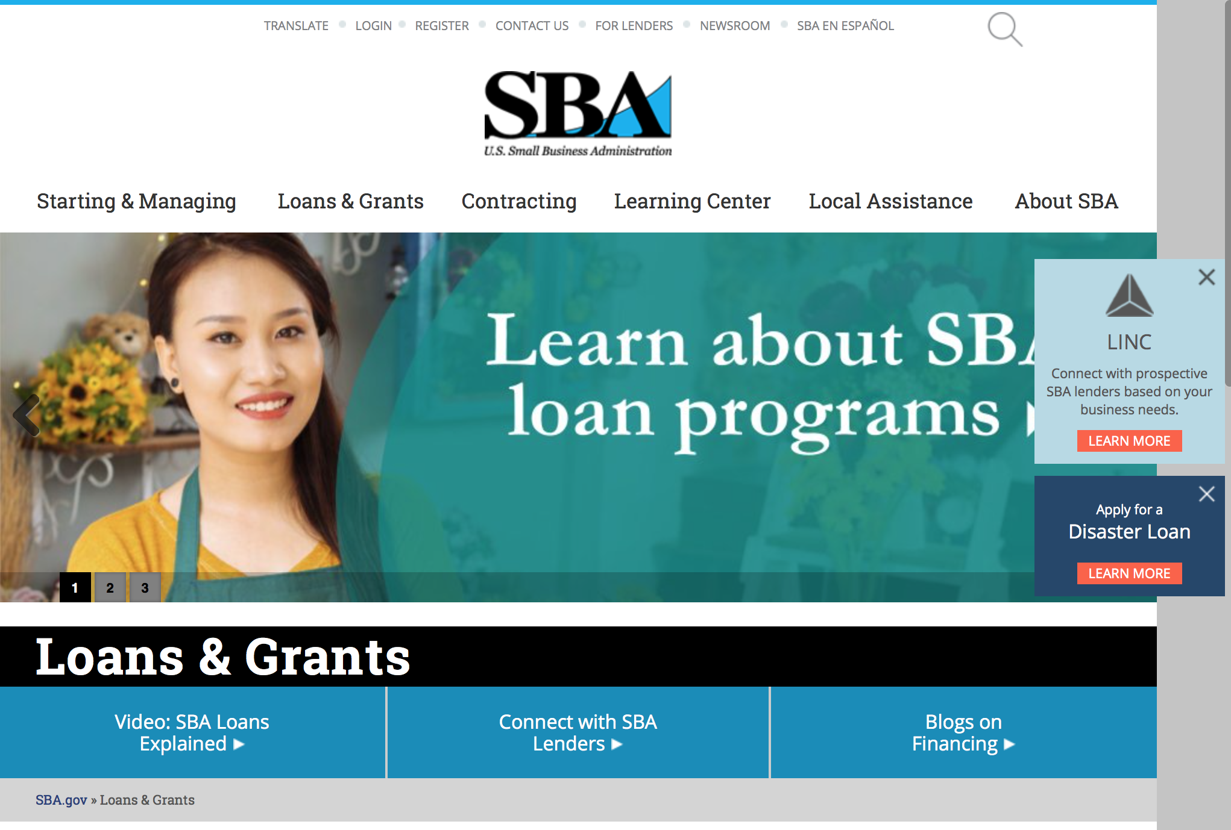
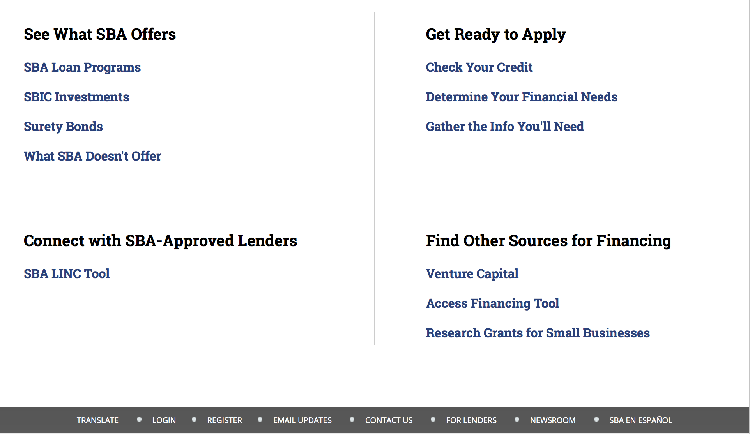

https://www.sba.gov/category/navigation-structure/loans-grants
Federal, state and local governments offer a wide range of financing programs to help small businesses start and grow their operations. These programs include low-interest loans, venture capital, and scientific and economic development grants.

Use SBA.gov's Loans and Grants Search Tool to get a list of financing programs for which you may qualify, or visit the resources below to learn more about small business financing programs. 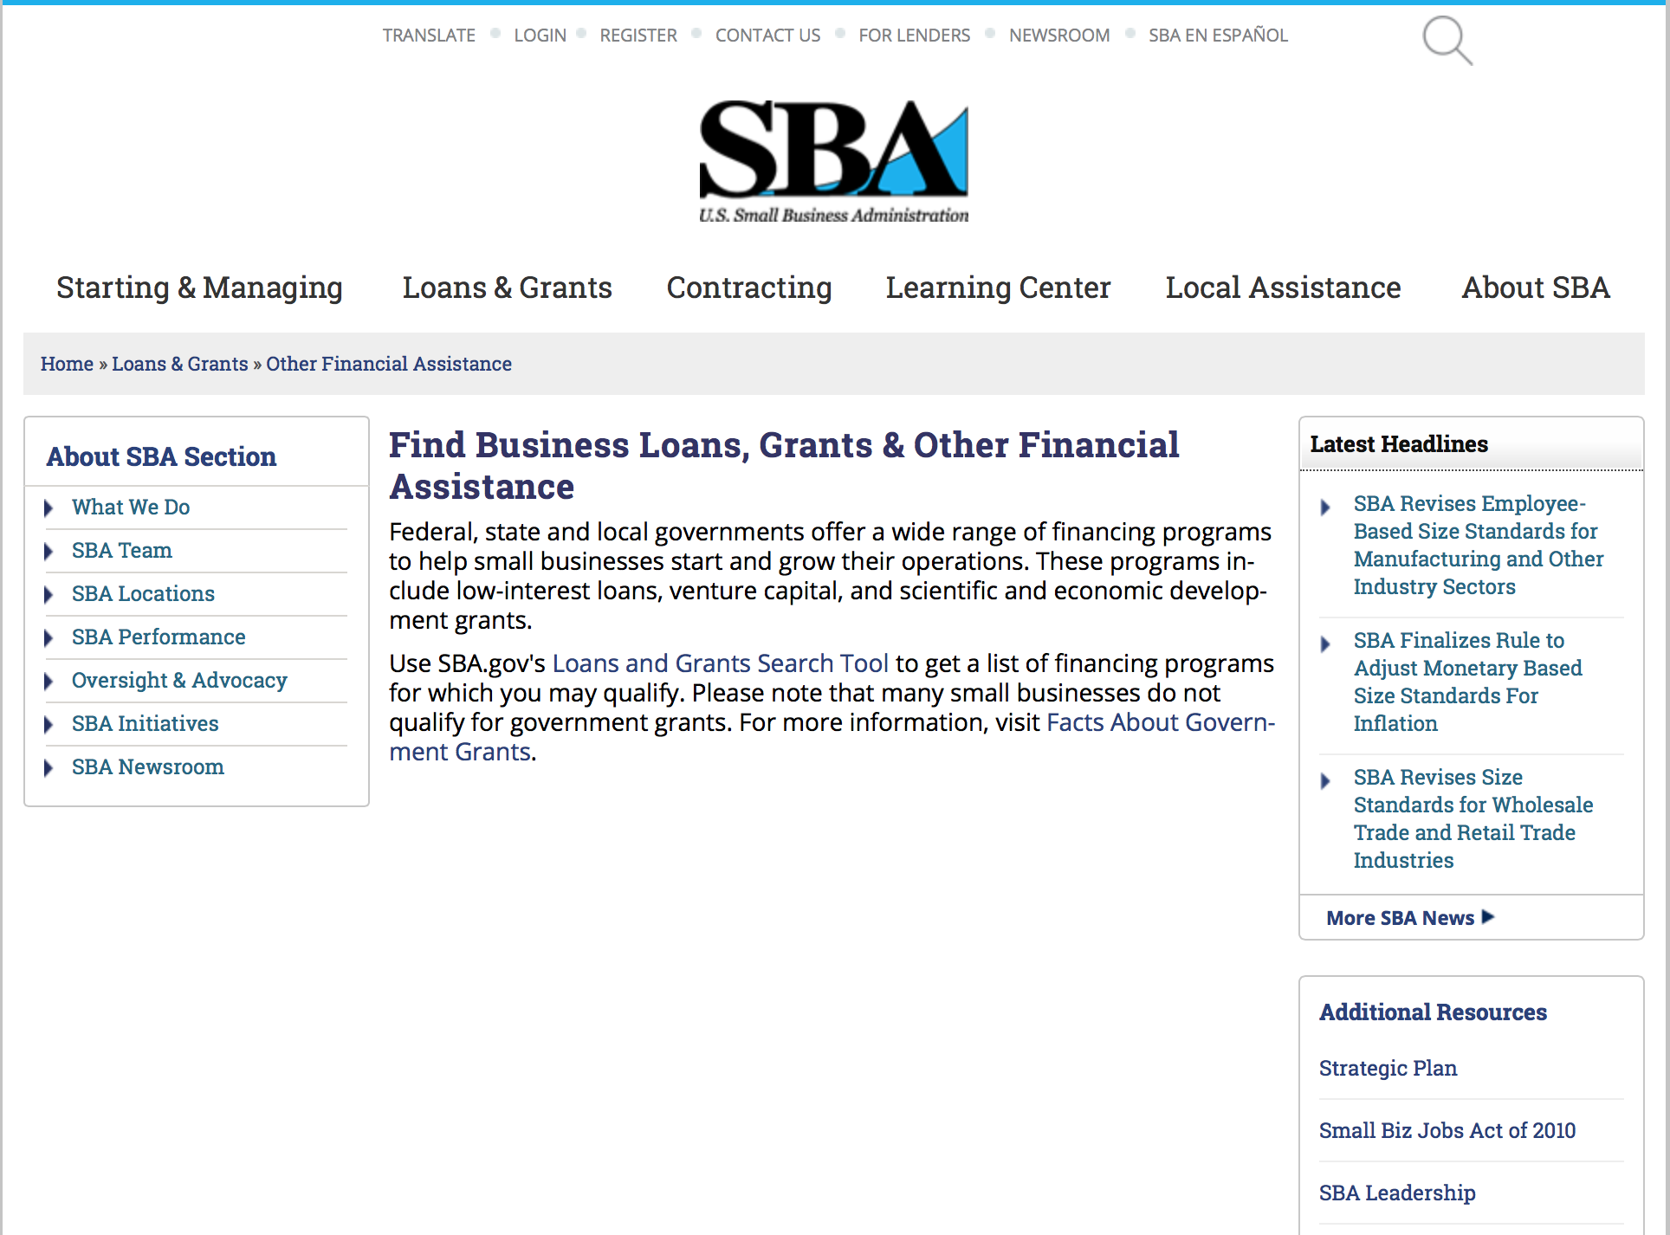
To get to the main SBA.gov funding page click here
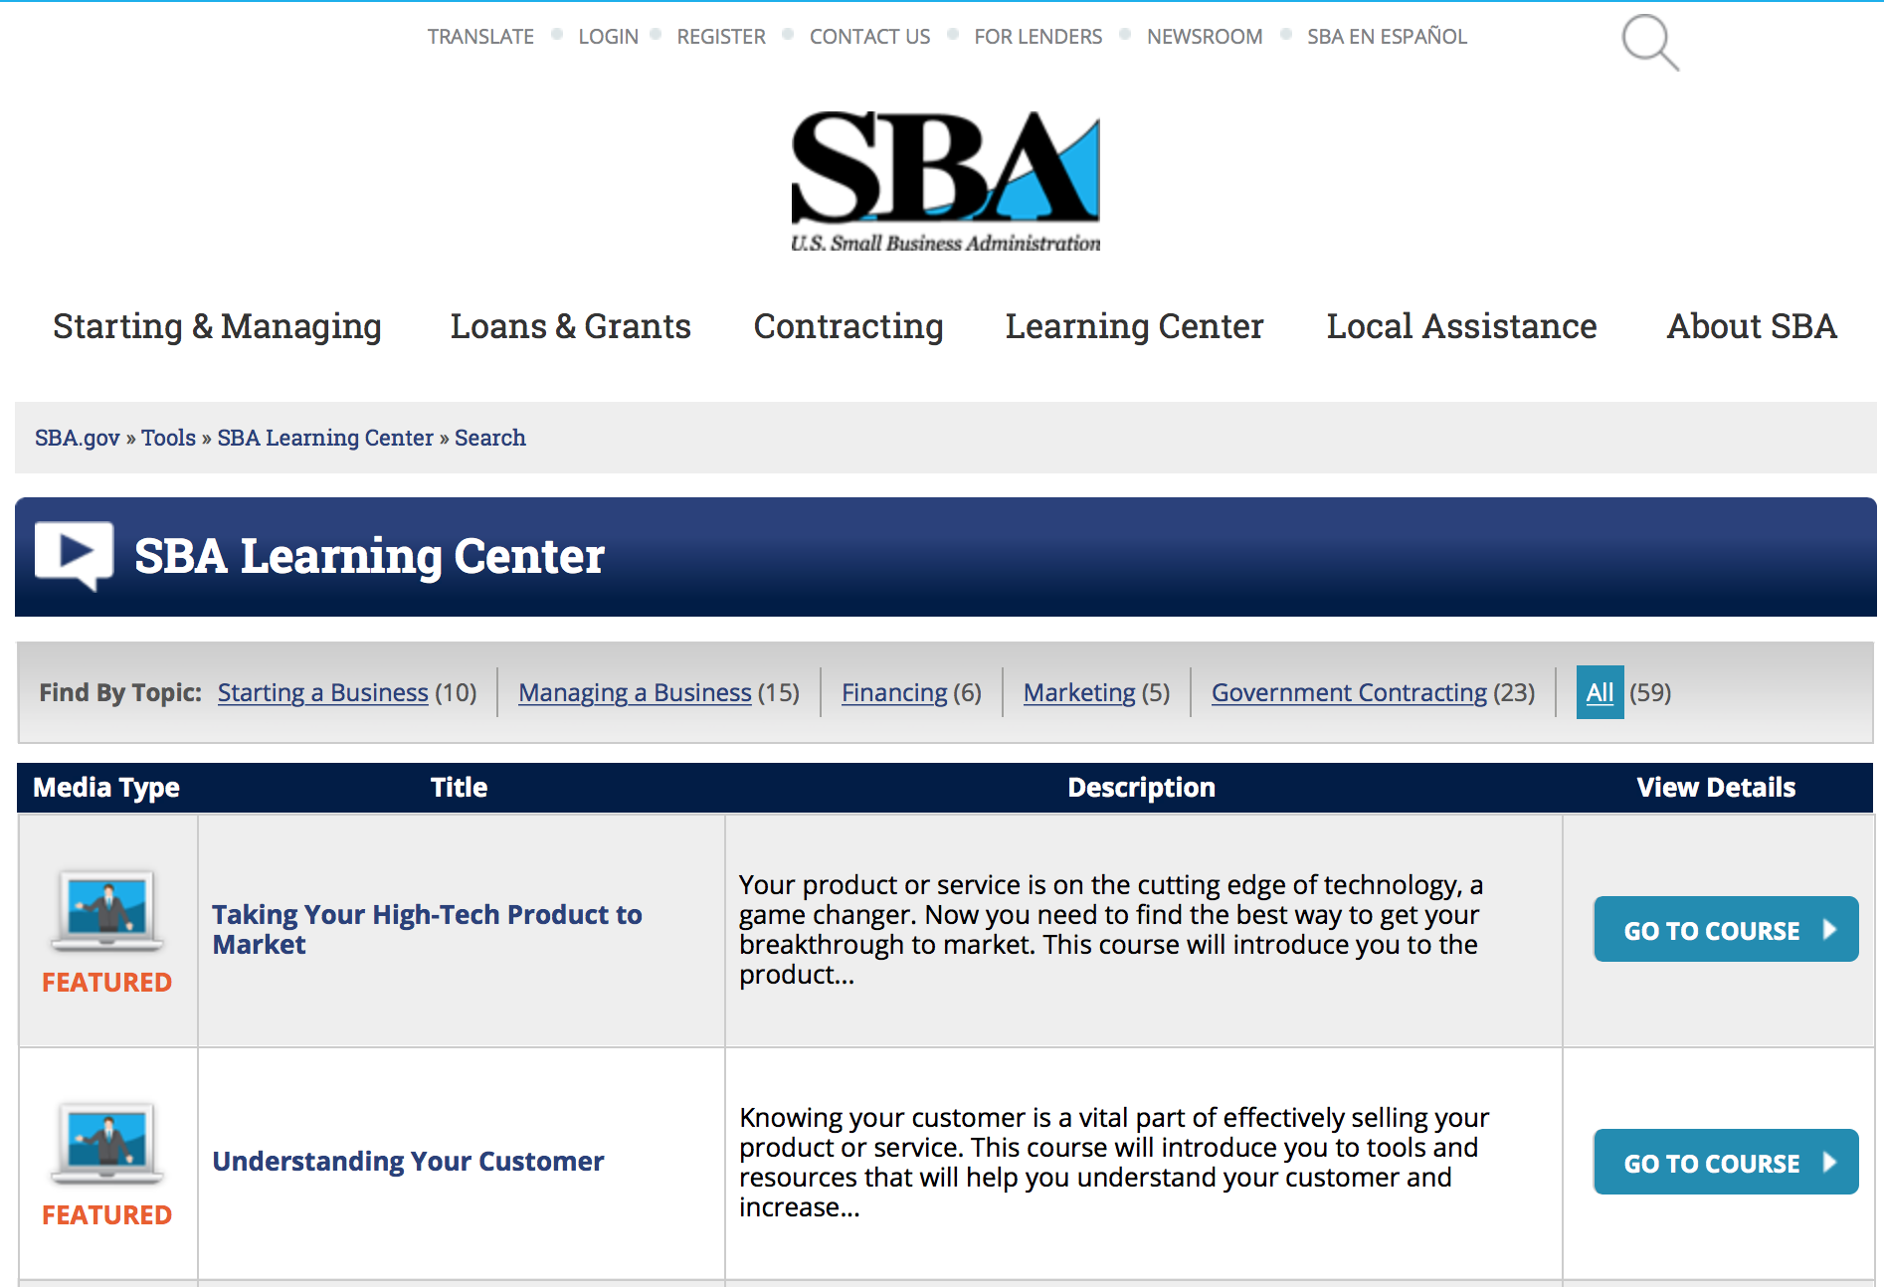
https://www.sba.gov/tools/sba-learning-center/search/training

Reminders:

SBA Trainings

Contracting Opportunities for Veteran Entrepreneurs
This self-paced training exercise is an introduction to Federal contracting opportunities for Veterans.
Topics include basic information about Veteran-owned businesses and opportunities, services available to small Veteran-owned businesses, small business incentives, and government procurement methods.
Duration: 00:30:00

http://www.sba.gov/tools/sba-learning-center/training/contracting-opportunities-veteran-entrepreneurs

Interested in Exporting? These Four Resources Can Help
Did you know that two-thirds of the world’s purchasing power is in foreign countries? As the numbers show, the international marketplace is a big one. So if you’re interested in exploring the world of exporting – or have gotten started but could use some guidance – check out these resources to help.
- Read more

Upcoming Trainings: Check out SBA's Online Training!
- Financing Options for Small Businesses
How to Prepare Government Contract Proposals
Getting Started With Exporting: Training and Educational Resources
Exporting represents a big opportunity to tap in to new markets, expand your customer base and grow your business. But getting started with exporting can sometimes feel like a maze of regulations, policies, and other barriers. Here are some free training and educational resources to help.
> Read more

For Specific Information in Hawaii see the following links:
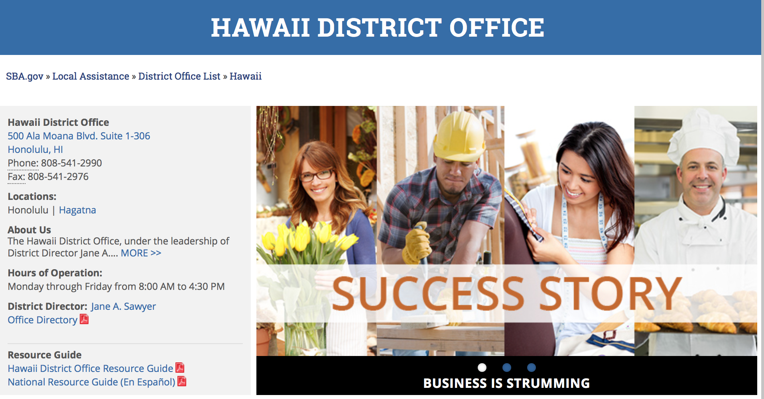

https://www.sba.gov/offices/district/hi/Honolulu

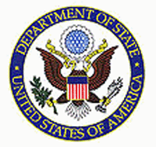

State Department General Overview and Resources for Program Administrators

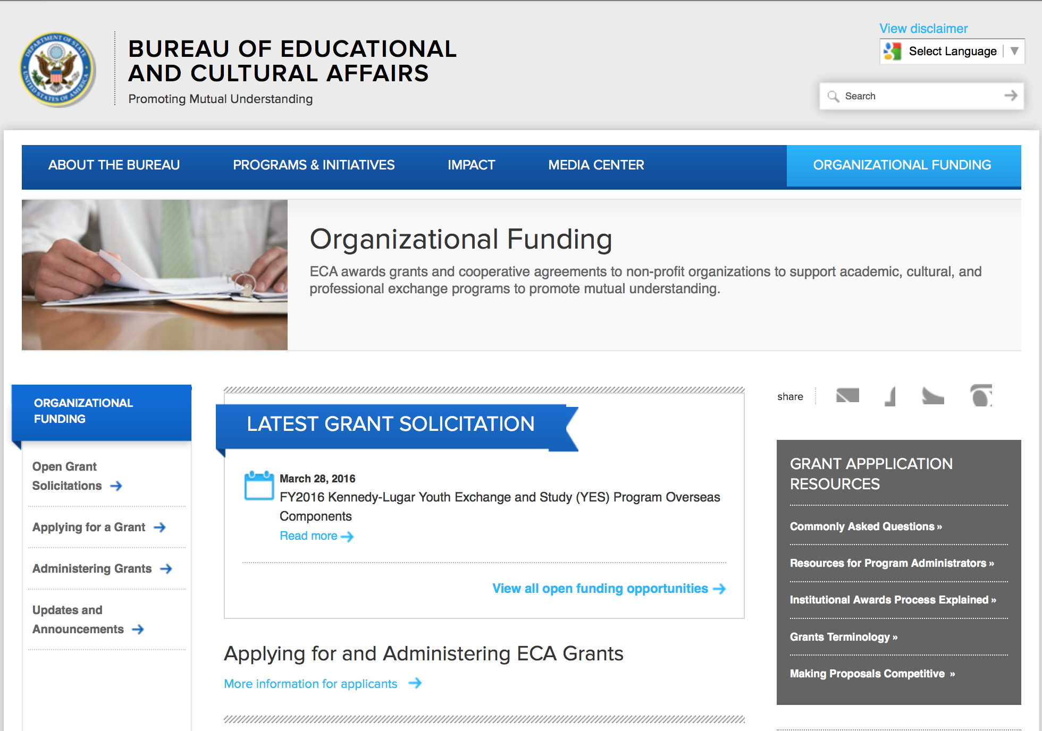
http://eca.state.gov/search/solr/grants?search_referrer=node/237
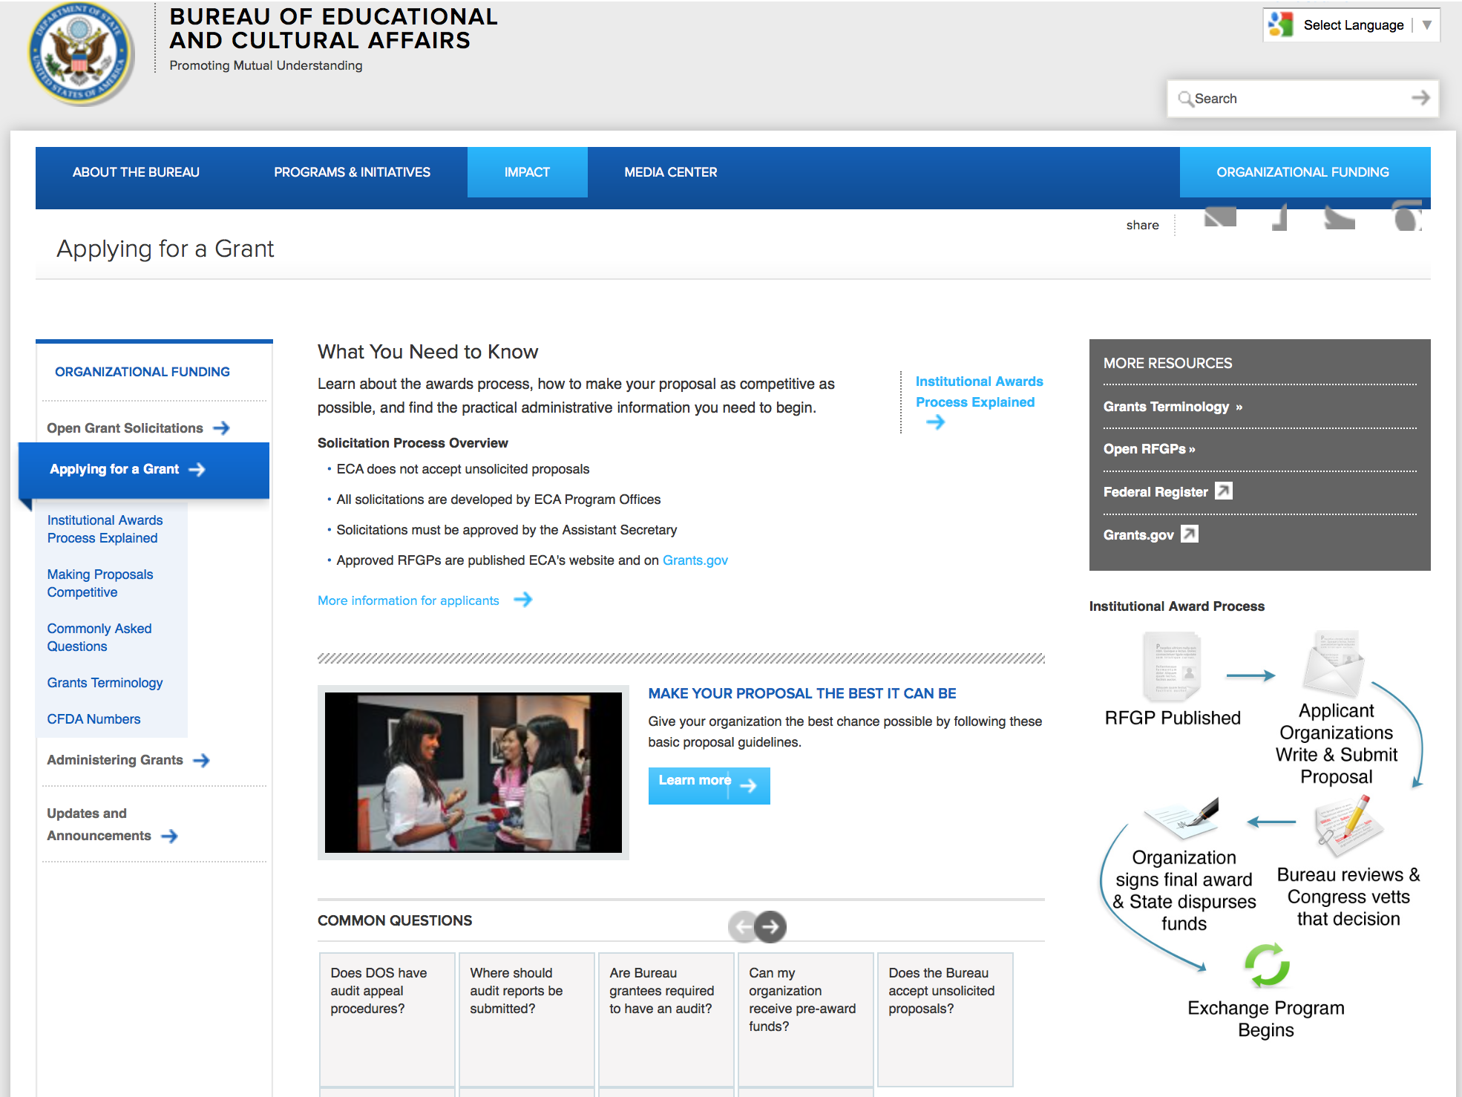

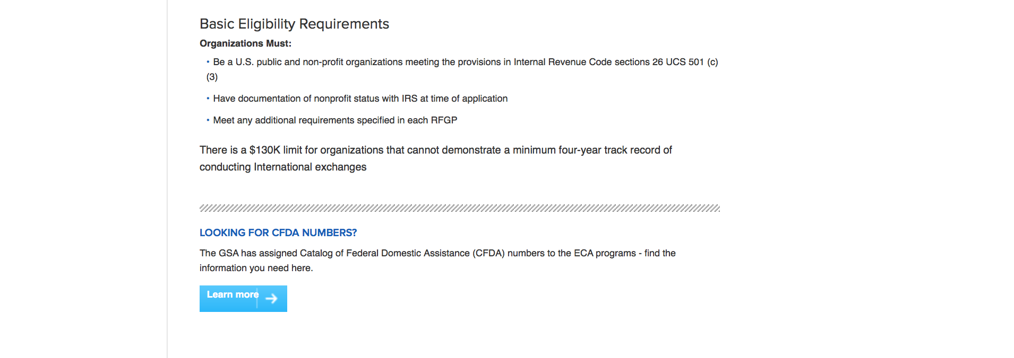
http://eca.state.gov/organizational-funding/applying-grant

General Information:
- Bureau of Educational and Cultural Affairs Grants Division
- Open Grant Opportunities (Requests for Grant Proposals)

For General Information click here

Program Grants:
Bureau of Democracy, Human Rights and Labor
Bureau of Democracy, Human Rights and Labor: Programs Fostering Civil, Political, and Labor Rights in Cuba FY16 Grant
http://www.grants.gov/web/grants/view-opportunity.html?oppId=280842
Bureau of Population, Refugees and Migration
FY 2016 Request for PRM Humanitarian Research Concept Notes
Modification 2
http://www.grants.gov/web/grants/view-opportunity.html?oppId=280918
Bureau of Democracy, Human Rights and Labor
Request for Statements of Interest: Democracy, Human Rights, and Rule of Law in Iraq.
Grant
http://www.grants.gov/web/grants/view-opportunity.html?oppId=280933

Bureau of Population, Refugees and Migration
FY 2016 Request for PRM Humanitarian Research Concept Notes Grant
http://www.grants.gov/web/grants/view-opportunity.html?oppId=280918

Bureau Of Educational and Cultural Affairs
FY 2016 Benjamin A. Gilman International Scholarship Grant
http://www.grants.gov/web/grants/view-opportunity.html?oppId=280938

Dominican Republic USAID-Santo Domingo
Increasing Local Capacity Activity in the Eastern and Souther Caribbean Grant
http://www.grants.gov/web/grants/view-opportunity.html?oppId=281118

International Narcotics and Law Enforcement Affair
Evaluation of Regional Money Laundering Risks within Colombia Grant
http://www.grants.gov/web/grants/view-opportunity.html?oppId=281193

International Narcotics and Law Enforcement Affair
Legal Education Support Program for Pakistan Grant
http://www.grants.gov/web/grants/view-opportunity.html?oppId=281138

U.S. Mission to Jamaica
2016 Ambassadors Fund for Cultural Preservation Large Grants Program http://www.grants.gov/web/grants/view-opportunity.html?oppId=281005

U.S. Mission to Maseru-Lesotho
U.S. Ambassador’s Special Self Help 2016, U.S. Embassy Maseru Grant
http://www.grants.gov/web/grants/view-opportunity.html?oppId=280810

U.S. Mission to China
Cultural Programming in the People's Republic of China Grant
http://www.grants.gov/web/grants/view-opportunity.html?oppId=280968

DRL FY16 Supporting Human Rights and Civic Education, and Building Community Resilience in Tajikistan Grant
http://www.grants.gov/web/grants/view-opportunity.html?oppId=281109

U.S. Mission to South Africa
HIV and AIDS Community Grants Program
http://www.grants.gov/web/grants/view-opportunity.html?oppId=281112

PEPFAR Small Grants Program 2016, U.S. Embassy, Kampala Grant
http://www.grants.gov/web/grants/view-opportunity.html?oppId=281245

Modifications:

Bureau of Population, Refugees and Migration
FY 2016 Notice of Funding Opportunity for NGO programs benefiting refugees and other vulnerable populations in Egypt
Modification 3
http://www.grants.gov/web/grants/view-opportunity.html?oppId=281177

Reminders:

Department of Transportation

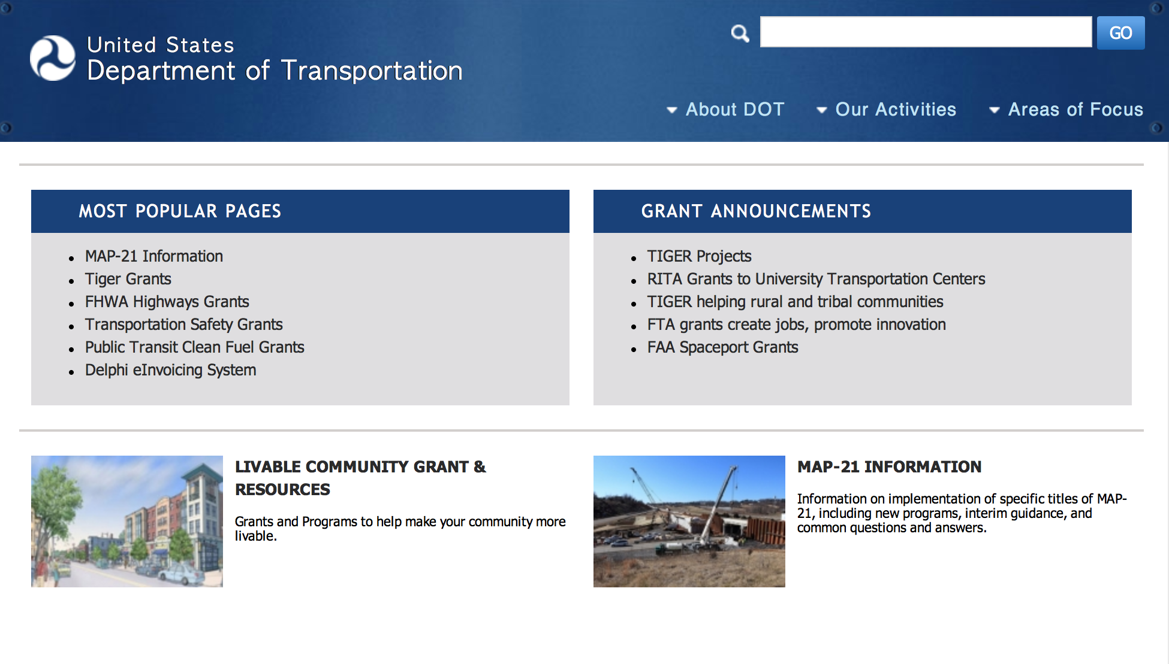
General Grant Program Overview https://www.transportation.gov/grants

Programs:

DOT Federal Highway Administration
National Summer Transportation Institute Grant

Document Type: | Grants Notice
Funding Opportunity Number: | FY16
Funding Opportunity Title: | National Summer Transportation Institute
Opportunity Category: | Discretionary
Funding Instrument Type: | Grant
Category of Funding Activity: | Education
Category Explanation:
Expected Number of Awards: | 100
CFDA Number(s): | 20.215 -- Highway Training and Education
Cost Sharing or Matching Requirement: | No
Posted Date: | Jan 29, 2016
Creation Date: | Jan 29, 2016
Current Closing Date for Applications: | Mar 31, 2016 Applications must be submitted to your State DOT by Close Date.
Archive Date: | Apr 30, 2016
Estimated Total Program Funding: | $2,000,000
Award Ceiling: | $100,000
Award Floor: | $20,000
Eligible Applicants: | Public and State controlled institutions of higher education
Agency Name: | DOT Federal Highway Administration
Description: | The Federal Highway Administration (FHWA) Headquarters' Civil Rights (HCR) Office requests Statements of Work (SOWs) for the Fiscal Year (FY) 2016 NSTI Program. The NSTI program is a Science, Technology and Math (STEM) focused program for high school and junior high school students. It is administered by accredited colleges, community colleges and universities, accredited Tribal colleges, Historically Black Colleges and Universities (HBCUs), Minority Serving Institutions (MSIs), Hispanic Serving Institutions (HSIs) and Asian-American Native American Pacific Island Serving Institutions (ANAPISI) throughout the United States, the District of Columbia, the Commonwealth of Puerto Rico, Pacific Island territories and the U.S. Virgin Islands. These institutions make application to the State DOT (State DOTs) to serve as NSTI Host sites. State DOTs provide NSTI program oversight to the host sites. The FHWA Division Offices Civil Rights Specialists provide program guidance to the State DOTs in their oversight of the NSTI program. Academic institutions interested in serving as host sites must complete and submit their application package to the State DOT. The NSTI program objectives are to improve STEM skills, provide awareness to middle and high school students - particularly minority, female and disadvantaged youth - about transportation careers, and encourage them to consider transportation-related courses of study in their higher education pursuits. Host sites are required to commit significant program time to classroom participation. The length of the program is typically 2-4 consecutive weeks. Host sites may choose to be student day programs or residential programs in which room and board are provided by the Host Sites to the students. For more information including the application packet and deadline for submission, please contact your State DOT Representative.
Link to Additional Information:
Contact Information: | If you have difficulty accessing the full announcement electronically, please contact:  Joyce Gottlieb Program Analyst Phone 202-366-3664  FHWA-Headquarters Office of Civil Rights

http://www.grants.gov/web/grants/view-opportunity.html?oppId=281260

Modifications:

DOT/Federal Motor Carrier Safety Administration
FY2016 Commercial Motor Vehicle Operator Safety Training Grant Program

Document Type: | Grants Notice
Funding Opportunity Number: | FM-DTG-16-001
Funding Opportunity Title: | FY2016 Commercial Motor Vehicle Operator Safety Training Grant Program
Opportunity Category: | Discretionary
Funding Instrument Type: | Grant
Category of Funding Activity: | Transportation
Category Explanation:
Expected Number of Awards: | 10
CFDA Number(s): | 20.235 -- Commercial Motor Vehicle Operator Training Grants
Cost Sharing or Matching Requirement: | Yes
Posted Date: | Jan 5, 2016
Creation Date: | Jan 13, 2016
Original Closing Date for Applications: | Apr 5, 2016 No Explanation
Current Closing Date for Applications: | Apr 5, 2016 No Explanation
Archive Date: | May 5, 2016
Eligible Applicants: | Native American tribal governments (Federally recognized)  Others (see text field entitled "Additional Information on Eligibility" for clarification)  Nonprofits having a 501(c)(3) status with the IRS, other than institutions of higher education  Small businesses  County governments  Private institutions of higher education  Public and State controlled institutions of higher education  For profit organizations other than small businesses  Special district governments  City or township governments  State governments
Additional Information on Eligibility: | Vocational Technical Schools and Truck Training Schools
Agency Name: | DOT/Federal Motor Carrier Safety Administration
Description: | The Federal Motor Carrier Safety Administration (FMCSA) announces the Fiscal Year (FY) 2016 CMVOST grant program Notice of Funding Availability (NOFA) to solicit applications from organizations that provide CMV operator training, including accredited public or private colleges, universities, vocational-technical schools, post-secondary educational institutions, truck driver training schools, associations, and State and local governments, including Federally-recognized Native American Tribal governments that support CMVOST activities. The CMVOST grant is a nationwide Federal financial assistance program intended to reduce the severity and number of crashes on U.S. roads involving CMV by training operators and future operators in the safe use of such vehicles.
Link to Additional Information: | FY2016 Commercial Motor Vehicle Operator Safety Training Grant Program
Contact Information: | If you have difficulty accessing the full announcement electronically, please contact:  Grants.gov Contact Center Phone Number: 1-800-518-4726 Hours of operation are 24 hours a day, 7 days a week. The contact center is closed on federal holidays. support@grants.gov  Grants.gov Customer Support

http://www.grants.gov/web/grants/view-opportunity.html?oppId=280837

DOT/Federal Motor Carrier Safety Administration
FY 2016 Commercial Drivers License Program Implementation Notice of Funding Availability
And Modifications 1 & 4

Document Type: | Grants Notice
Funding Opportunity Number: | FM-CDL-16-002
Funding Opportunity Title: | FY 2016 Commercial Drivers License Program Implementation Notice of Funding Availability
Opportunity Category: | Discretionary
Funding Instrument Type: | Cooperative Agreement  Grant
Category of Funding Activity: | Transportation
Category Explanation:
Expected Number of Awards: | 45
CFDA Number(s): | 20.232 -- Commercial Driver's License Program Improvement Grant
Cost Sharing or Matching Requirement: | No
Posted Date: | Jan 5, 2016
Creation Date: | Jan 14, 2016
Original Closing Date for Applications: | Apr 5, 2016 No Explanation
Current Closing Date for Applications: | Apr 5, 2016 No Explanation
Archive Date: | May 5, 2016
Estimated Total Program Funding: | $30,000,000
Eligible Applicants: | Private institutions of higher education  Others (see text field entitled "Additional Information on Eligibility" for clarification)  City or township governments  Nonprofits having a 501(c)(3) status with the IRS, other than institutions of higher education  Special district governments  Public and State controlled institutions of higher education  County governments  State governments  Individuals
Additional Information on Eligibility: | Applications will be accepted from applications from State agencies, local governments, as well as other persons and organizations representing government agencies that support CDLPI activities. Note that applications must support the public purpose of the program.
Agency Name: | DOT/Federal Motor Carrier Safety Administration
Description: | The Federal Motor Carrier Safety Administration (FMCSA) announces the Fiscal Year (FY) 2016 Commercial Driver's License Program Implementation (CDLPI) grant program Notice of Funding Availability (NOFA) to solicit applications from State agencies, local governments, as well as other persons and organizations representing government agencies that support CDLPI activities. The goal of the national Commercial Drivers License (CDL) program is to reduce the number and severity of commercial motor vehicle crashes in the United States by ensuring that only qualified drivers are eligible to receive and retain a CDL. This goal focuses on maintaining the concept that for every driver, there is only one driving record and only one licensing document, commonly referred to as "One Driver One License One Record". States are required to conduct knowledge and skills testing before issuing a CDL; to maintain a complete and accurate driver history record for anyone who obtains a CDL; and to impose driver disqualifications as appropriate.
Link to Additional Information: | FY 2016 Commercial Drivers License Program Implementation Notice of Funding Availability
Contact Information: | If you have difficulty accessing the full announcement electronically, please contact:  Grants.gov Contact Center Phone Number: 1-800-518-4726 Hours of operation are 24 hours a day, 7 days a week. The contact center is closed on federal holidays. support@grants.gov  Grants.gov Customer Support

http://www.grants.gov/web/grants/view-opportunity.html?oppId=280835

Reminders:

Pipeline &Hazardous Material Safety Administration
PHMSA Hazmat Grants
FY2016 Hazardous Materials Instructor Training (HMIT) Grant

Document Type: | Grants Notice
Funding Opportunity Number: | HM-HMI-16-001
Funding Opportunity Title: | FY2016 Hazardous Materials Instructor Training (HMIT)Grant
Opportunity Category: | Discretionary
Funding Instrument Type: | Grant
Category of Funding Activity: | Transportation
Category Explanation:
Expected Number of Awards: | 10
CFDA Number(s): | 20.703 -- Interagency Hazardous Materials Public Sector Training and Planning Grants
Cost Sharing or Matching Requirement: | No
Posted Date: | Dec 30, 2015
Creation Date: | Dec 30, 2015
Original Closing Date for Applications: | Feb 15, 2016 No Explanation
Current Closing Date for Applications: | Feb 15, 2016 No Explanation
Archive Date: | Mar 16, 2016
Estimated Total Program Funding: | $4,000,000
Award Ceiling: | $1,000,000
Award Floor: | $250,000
Eligible Applicants: | Others (see text field entitled "Additional Information on Eligibility" for clarification)
Additional Information on Eligibility: | Per the statutory requirements at 49 U.S.C part 5107(e), the HMIT grant program is open to nonprofit organizations that demonstrate: (A) Expertise in conducting a training program for hazmat employees that work with the transporting of hazardous materials. (B) The ability to reach and involve in a training program a target population of hazmat employees. For the purposes of the HMIT grants program: Non-profit organization, as defined at 2 CFR part 200.70, means any corporation, trust, association, cooperative, or other organization which: (1) Is operated primarily for scientific, educational, service, charitable, or similar purposes in the public interest; (2) Is not organized primarily for profit; and (3) Uses its net proceeds to maintain, improve, and/or expand its operations. Non-profit organizations described in Section 501(c)(4) of the Internal Revenue Code that engage in lobbying activities as defined in Section 3 of the Lobbying Disclosure Act of 1995 are not eligible applicants. For profit organizations are not eligible applicants for the HMIT grant program.
Agency Name: | PHMSA Hazmat Grants
Description: | PHMSA is soliciting proposals on a competitive basis to receive grant funds for training instructors who will then train employees involved in the transportation of hazardous materials. The HMIT grant program is authorized under 49 U.S.C part 5107 (e) to provide grants to nonprofit organizations to deliver training to instructors to train hazmat employees, and for such instructors to train hazmat employees. Instructors trained under this program will be able to offer training at or in close proximity to their places of employment. Additionally, funds awarded in accordance with the HMIT Grants Program may be used to train instructors and, to the extent determined to be appropriate, for such instructors to train hazmat employees. As provided by statute, funds awarded to an organization under this grant program are to be used to train instructors to conduct hazardous material training programs, to purchase training equipment used exclusively to train instructors to conduct those training programs, and to disseminate information and materials necessary for the conduct of those training programs. PHMSA will make a grant to an organization under this program only if the organization enters into an agreement with PHMSA to train instructors, on a nondiscriminatory basis, to conduct hazardous materials training programs for hazmat employees. Train the trainer means to train hazmat instructors who will be capable of training hazmat employees. Applicants are encouraged to seek letters of commitment from hazmat employers or employing state and local governments, indicating that the individuals) receiving instructor training will have authority to conduct training to his or her colleagues within the place of business or department regardless of union status.
Link to Additional Information: | FY2016 Hazardous Materials Instructor Training (HMIT)Grant
Contact Information: | If you have difficulty accessing the full announcement electronically, please contact:  Grants.gov Contact Center Phone Number: 1-800-518-4726 Hours of operation are 24 hours a day, 7 days a week. The contact center is closed on federal holidays. support@grants.gov  Grants.gov Customer Support

http://www.grants.gov/web/grants/view-opportunity.html?oppId=280778

DOT Federal Aviation Administration
DOT - FAA Aviation Research Grants
FAA Aviation Research and Development Grants
Modification 3

Document Type: | Grants Notice
Funding Opportunity Number: | 12-01
Funding Opportunity Title: | FAA Aviation Research and Development Grants
Opportunity Category: | Discretionary
Funding Instrument Type: | Grant
Category of Funding Activity: | Transportation
Category Explanation:
Expected Number of Awards:
CFDA Number(s): | 20.108 -- Aviation Research Grants
Cost Sharing or Matching Requirement: | No
Posted Date: | Jan 1, 2012
Creation Date: | Dec 9, 2015
Original Closing Date for Applications: | Dec 31, 2019
Current Closing Date for Applications: | Dec 31, 2019
Archive Date: | Jan 30, 2020
Estimated Total Program Funding:
Award Ceiling: | $5,000,000
Eligible Applicants: | Private institutions of higher education  Nonprofits having a 501(c)(3) status with the IRS, other than institutions of higher education  Public and State controlled institutions of higher education
Agency Name: | DOT - FAA Aviation Research Grants
Description: | The FAA is soliciting proposals for research grants and cooperative agreements to pursue the long-term growth and short-term technical needs of civil aviation. In order to streamline the application process, it is recommended that all prospective grantees submit a white paper (letter of intent) for agency technical review before complete proposal submission. Please be sure to identify the specific area of interest (Solicitation FAA-12-01 – Chapter I. FAA Research Grants Program, Technical Areas of Research #1-#9). The white paper shall be no longer than three (3) pages and shall detail overall research objectives.
Link to Additional Information:
Contact Information: | If you have difficulty accessing the full announcement electronically, please contact:  Robert Boggi Grants Specialist Phone 609-485-6911  business

http://www.grants.gov/web/grants/view-opportunity.html?oppId=134953

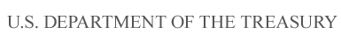

Department of the Treasury

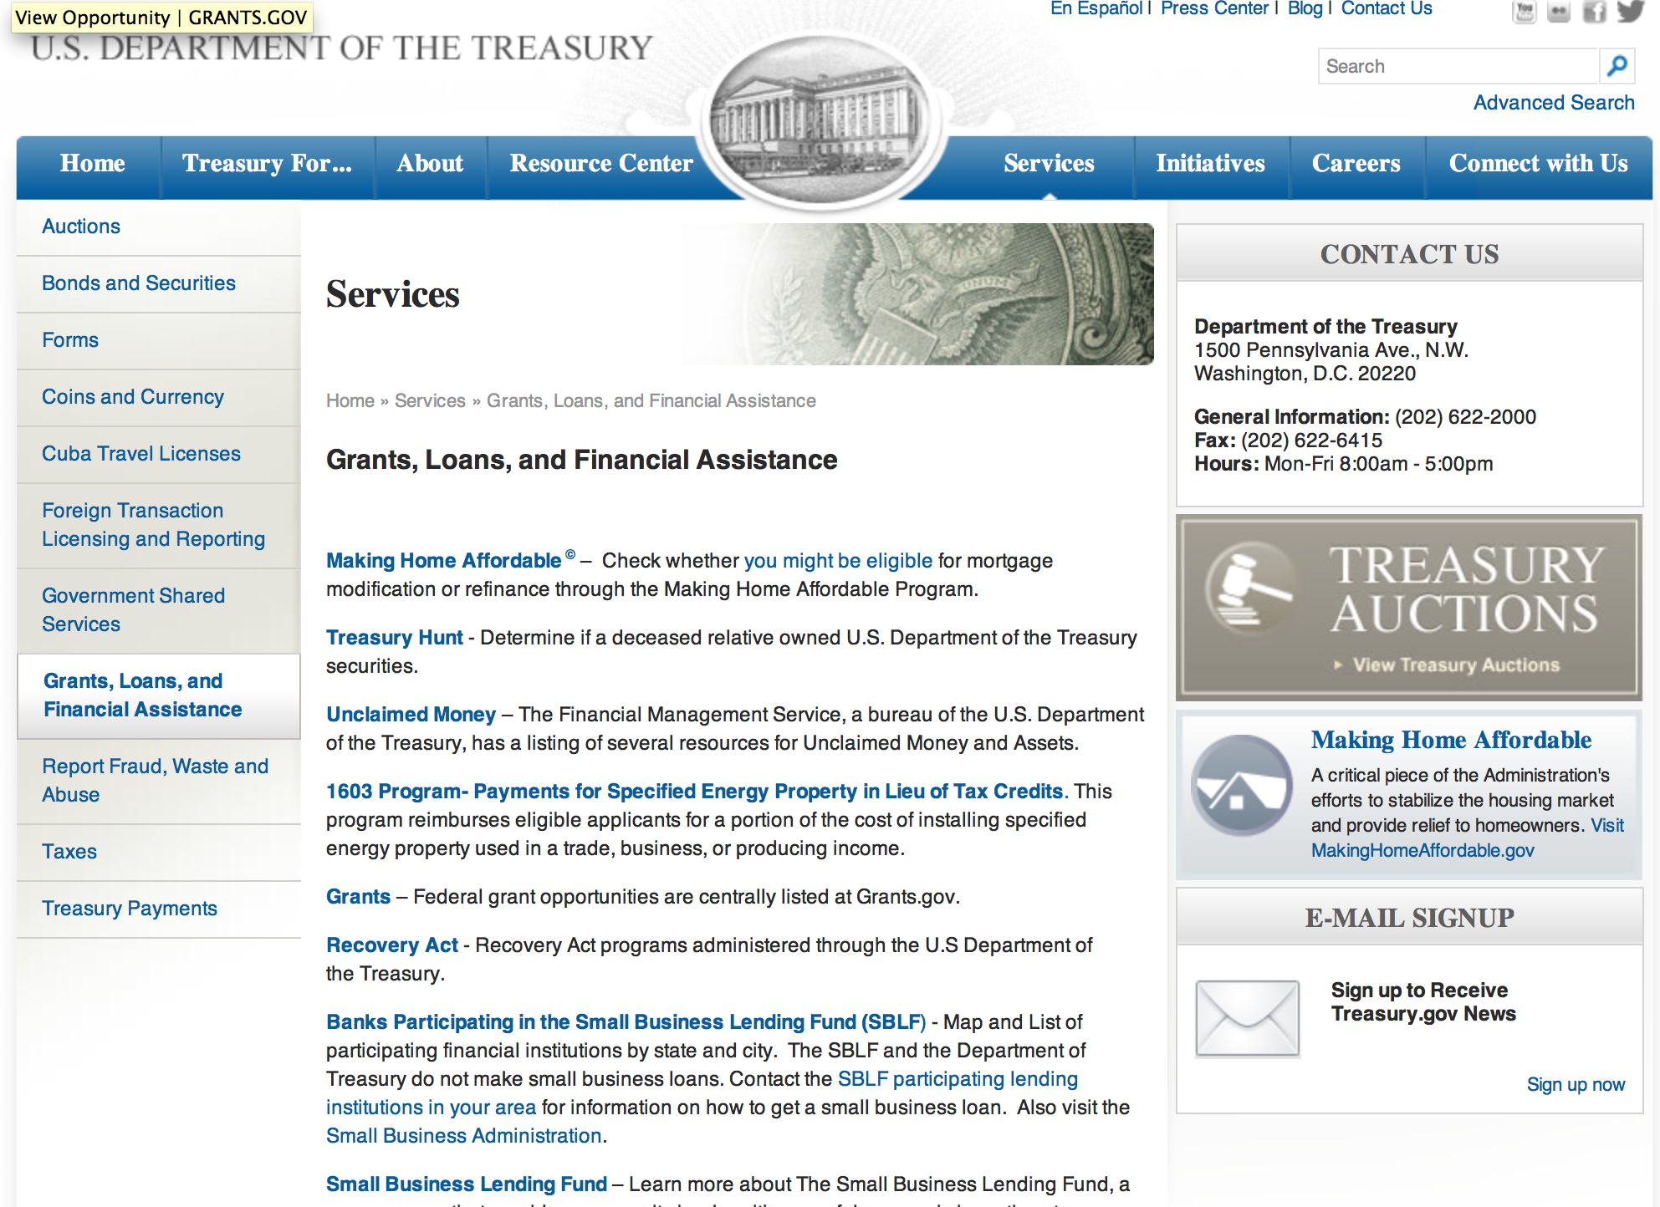

http://www.treasury.gov/services/Pages/Grants-Loans-and-Financial-Assistance.aspx

Programs:

Modifications:

Reminders:

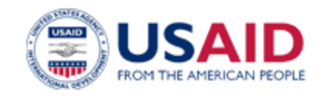

U.S. Agency for International Development

www.usaid.gov

General Overview Funding Opportunities

USAID has working relationships with thousands of American companies and hundreds of U.S.-based private voluntary organizations. For more information on our business and procurement opportunities, please visit our Business section.

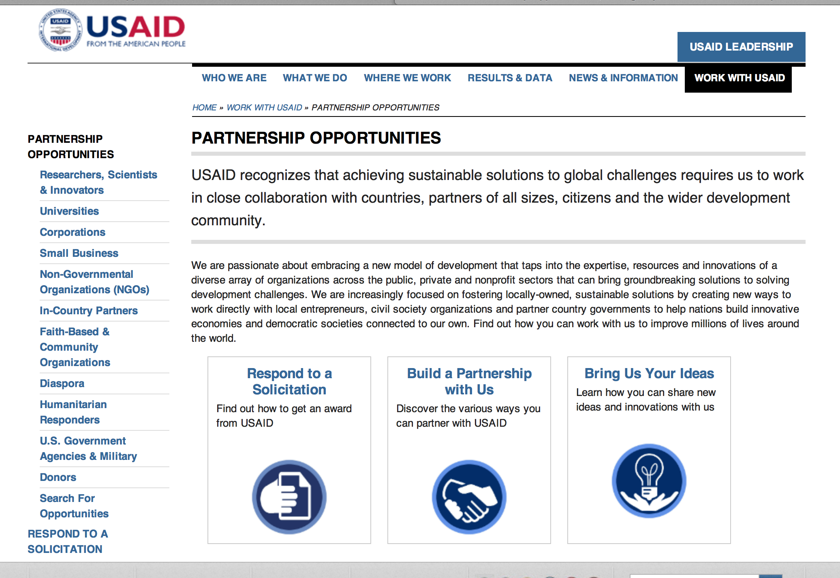
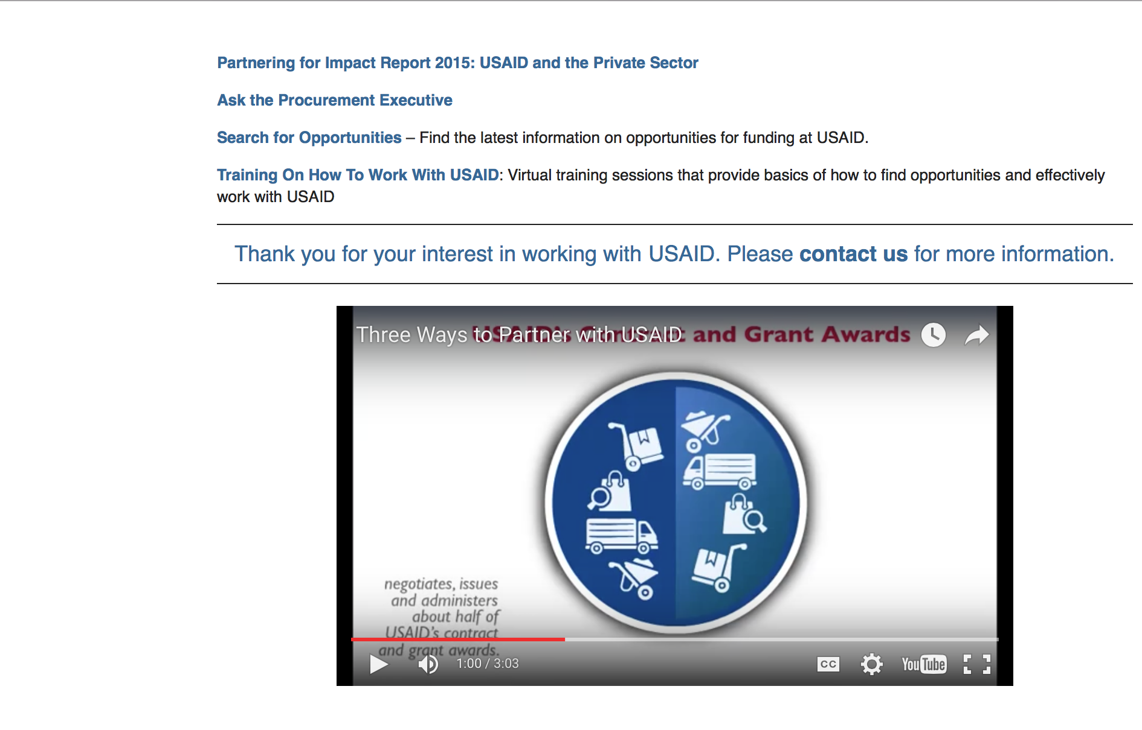

http://www.usaid.gov/partnerships

Programs:

Sustainable WASH Systems BAA Grant
http://www.grants.gov/web/grants/view-opportunity.html?oppId=281079

Modifications:

The USAID Development Innovation Accelerator (DIA) Broad Agency Announcement (BAA) for Global Forestry and Biodiversity Conservation
Modification 1
http://www.grants.gov/web/grants/view-opportunity.html?oppId=271284

Ukraine USAID-Kiev
Expanding Participation of People with Disabilities Program – FY 2015 Disability Funding
Modification 2
http://www.grants.gov/web/grants/view-opportunity.html?oppId=280930

Jordan USAID-Amman
Health Finance and Governance Activity
Modification 1
http://www.grants.gov/web/grants/view-opportunity.html?oppId=281163

Dominican Republic USAID-Santo Domingo
Expanding Participation of People with Disabilities
Modification 1
http://www.grants.gov/web/grants/view-opportunity.html?oppId=281180

Indonesia USAID-Jakarta
USAID/Indonesia - Maternal and Newborn Health Activity Grant
http://www.grants.gov/web/grants/view-opportunity.html?oppId=281262

Reminders:

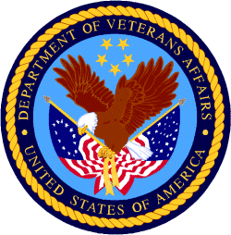

Department of Veterans Affairs

VA Loan Guaranty Service
Specially Adapted Housing Assistive Technology Grant

Document Type: | Grants Notice
Funding Opportunity Number: | VA-SAHAT-16-01
Funding Opportunity Title: | Specially Adapted Housing Assistive Technology Grant
Opportunity Category: | Discretionary
Funding Instrument Type: | Grant
Category of Funding Activity: | Science and Technology and other Research and Development
Category Explanation:
Expected Number of Awards:
CFDA Number(s): | 64.051 -- Specially Adapted Housing Assistive Technology Grant Program
Cost Sharing or Matching Requirement: | No
Posted Date: | Jan 6, 2016
Creation Date: | Jan 6, 2016
Original Closing Date for Applications: | Feb 29, 2016
Current Closing Date for Applications: | Feb 29, 2016
Archive Date: | Mar 30, 2016
Estimated Total Program Funding: | $1,000,000
Award Ceiling: | $200,000
Eligible Applicants: | Unrestricted (i.e., open to any type of entity above), subject to any clarification in text field entitled "Additional Information on Eligibility"
Agency Name: | VA Loan Guaranty Service
Description: | The Loan Guaranty Service (LGY), which is an office of the Veterans Benefits Administration (VBA), Department of Veterans Affairs (VA), is announcing the availability of funds for the SAHAT Grant Program. The objective of the grant is to encourage the development of new assistive technologies for specially adapted housing. The Department of Veterans Affairs acknowledges there are many emerging technologies that could improve home adaptations or otherwise enhance a Veteran’s or Service member’s ability to live independently. Therefore, VA has defined ‘‘new assistive technology’’ as an advancement that the Secretary determines could aid or enhance the ability of a Veteran or Service member to live in an adapted home.
Link to Additional Information:
Contact Information: | If you have difficulty accessing the full announcement electronically, please contact:  Ms. Iyabo Morrison Program Analyst Phone 202-461-8351  Specially Adapted Housing Assistive Technology Grant Management Staff

http://www.grants.gov/web/grants/view-opportunity.html?oppId=280097

