Senator Mazie Hirono

Grants Assistance Information Newsletter

FEBRUARY 2018

G.A.I.N. INDEX

Click on Index Links below to read summaries of the announcements by agency in this document. Once you reach the item, if you cannot open the links for further information, copy the selected URL website address into your browser.

Modified sections from previous listings are shown in a GREY background

Notices is Teal are items with immediate deadline dates.

Notices in Yellow are of special interest.

Notices is Green are items of special interest with immediate deadline dates.

Items in this type color are aimed at Small Businesses

Items in this type color have a Faith-Based Organization component

Special Federal Program Notices

Grant Writing Resources

SAM and Grants.Gov Information

SBIR – Small Business Innovation Research

Highlighted

Consumer Product Safety Commission
Pool Safely Grant Program

Programs specific to Hawaii

Current Notices

Native American Library Services Basic Grants Program

Environmental Education Local Grants Program for Region 9 -- Solicitation Notice for 2018
National Institute of Food and Agriculture
Alaska Native-Serving and Native Hawaiian-Serving Institutions Education Competitive Grants Program (ANNH)

Reminders

Department of Commerce
2018 MET Mini Grant Program

See Individual Departments for information and webpages representing the best and most accessible information on the agency funding opportunities

Federal Grant and Cooperative Agreement Program Summaries

U.S. Department of Agriculture

Grants and Loans Overview

Programs
Foreign Agricultural Service
Food for Progress Program

USDA-NRCS-NHQ
Announcement for Program Funding for NRCS' Conservation Innovation Grants (CIG) for Federal fiscal year (FY) 2018
Foreign Agricultural Service
McGovern-Dole International Food For Education and Child Nutrition Program
Forest Service
2019 National Urban and Community Forestry Grant Program
Research

National Institute of Food and Agriculture
Organic Agriculture Research and Extension Initiative
National Institute of Food and Agriculture
Organic Transitions
Modifications

National Institute of Food and Agriculture
Secondary Agriculture Education Challenge Grant Program

Reminders

Deleted:

Department of Commerce

Grants at Commerce

Programs

Modifications

Research

FY 2018 Joint Technology Transfer Initiative
National Institute of Standards and Technology
NIST Public Safety Innovation Accelerator Program – Point Cloud City
National Institute of Standards and Technology
FY 2018 Small Business Innovation Research (SBIR) Program

Reminders

Climate and Societal Interactions
NOAA National Sea Grant College Program 2018 Ocean, Coastal and Great Lakes National Aquaculture Initiative
2018 Bycatch Reduction Engineering Program (BREP)
Environmental Literacy Grants: Supporting the education of K-12 students and the public for community resilience

National Sea Grant College Program 2018-19 Special Projects
Fiscal Year 2019 National Sea Grant College Program Dean John A. Knauss Marine Policy Fellowship
FY18-19 CRCP International Coral Reef Conservation Cooperative Agreements

Economic Development Administration
FY 2017 Economic Development Assistance Programs ­ Application submission and program requirements for EDA’s Public Works and Economic Adjustment Assistance programs.

National Institute of Standards and Technology
Embedding MEP in Manufacturing USA Institutes Pilot Projects – Round 3

National Institute of Standards and Technology
Measurement Science and Engineering (MSE) Research Grant Programs

FY 2016 – FY 2019 EDA Planning Program and Local Technical Assistance Program Grant

Economic Development Administration
Planning Program and Local Technical Assistance Program Grant

Deleted

Corporation for National and Community Service

General Program Overview

Programs

2018 AmeriCorps State and National Grants - Targeted Priority
Reminders

National Service in Hawaii

Department of Defense

Doing Business with the Department of Defense

DoD Small Business Opportunities and Forecasting

Research Grants

Modifications

Deleted

Reminders

Department of Education

Grant Programs Overview

Programs

Research

Modifications

Reminders

Deleted

US Department of Energy

Grants Overview

Research

Modifications

Reminders

Environmental Protection Agency

Grants and Contracts Overview

Programs

Modifications

Research

Reminders

Environmental Justice Collaborative Problem-Solving (EJCPS) Cooperative Agreement (Program)

Department of Health and Human Services

Grants Overview

Program

Substance Abuse and Mental Health Services Adminis
Drug Free Communities - New

Substance Abuse and Mental Health Services Administration
Treatment for Individuals with Serious Mental Illness, Serious Emotional Disturbance or Co-Occurring Disorders Experiencing Homelessness (Short Title: Treatment for Individuals Experiencing Homelessness)

Substance Abuse and Mental Health Services Administration
Grants to Establish and Expand Jail Diversion

Substance Abuse and Mental Health Services Administration
Minority AIDS: Integration of HIV-related Mental Health and Primary Care

Research Grants

Modifications

Deleted

Reminders

Administration for Children and Families - ACYF/CB (Program)
Strengthening Child Welfare Systems to Achieve Expected Child and Family Outcomes

Department of Homeland Security
Grants Overview

Programs

Modifications

Reminders

Department of Housing and Urban Development

HUD - Notice of Funds Available

Programs

Lead-Based Paint Capital Fund Program (LBPCF)
Modifications

Youth Homelessness Demonstration Program
Deleted

Reminders

Institute of Museum and Library Services

Grants Overview

IMLS is on Facebook!

Programs

Modifications

Reminders

Museums Empowered: Professional Development Opportunities for Museum Staff - A Museums for America Special Initiative
National Leadership Grants for Libraries

Deleted

Department of Interior

Grants and Contract Overview

Programs

National Park Service
NAGPRA Consultation/Documentation Grants FY2018

Office of Surface Mining
Not-for Profit Acid Mine Drainage Watershed Cooperative Agreement Programs (WCAP)

Modifications

Reminders

National Park Service
Save America's Treasures - Preservation (Construction) Projects
National Park Service
Save America's Treasures - Collections

Deleted

Department of Justice

Grants and Contract Overview

Programs
Office on Violence Against Women
OVW Fiscal Year 2018 Training and Technical Assistance Initiative
Office on Violence Against Women
OVW FY 2018 Improving Criminal Justice Responses to Sexual Assault, Domestic Violence, Dating Violence, and Stalking Grant Program (formerly known as the Arrest Program)
Office on Violence Against Women
OVW FY 2018 Transitional Housing Assistance Grants for Victims of Sexual Assault, Domestic Violence, Dating Violence and Stalking
Office on Violence Against Women
OVW FY 2018 Sexual Assault Services Culturally Specific Program Solicitation
Office on Violence Against Women
OVW FY 2018 Grants to Enhance Culturally Specific Services for Victims of Sexual Assault, Domestic Violence, Dating Violence, and Stalking Program Solicitation
Office on Violence Against Women
OVW FY 2018 Grants to Reduce Sexual Assault, Domestic Violence, Dating Violence and Stalking on Campus Program
Office on Violence Against Women
OVW FY 2018 Grants to Reduce Sexual Assault, Domestic Violence, Dating Violence and Stalking on Campus Program-Updated
Research

Office on Violence Against Women
OVW FY 2018 Research and Evaluation Initiative
National Institute of Justice
NIJ FY18 Graduate Research Fellowship in Science, Technology, Engineering, and Mathematics
National Institute of Justice
NIJ FY18 Graduate Research Fellowship in Social and Behavioral Sciences
National Institute of Justice
NIJ FY18 Research and Evaluation on Violence Against Women: Sexual Violence, Intimate Partner Violence, Stalking, and Teen Dating Violence

Modifications

Deleted

Reminders

________________________________________________________________________

Department of Labor

Grants and Contract General Overview

Programs

Modifications

Veterans Employment and Training Service
Announcement of Stand Down Grants

Reminders

National Aeronautics and Space Administration

Research Grant and Contract General Overview

Programs

Modifications

_______________________________________________________________
National Archives and Records Administration

Grant Opportunities General Overview

Programs

Reminders

Publishing Historical Records in Documentary Editions

State Board Programming Grants
Access to Historical Records: Major Initiatives

_______________________________________________________________
National Endowment for the Arts

Grant Opportunities General Overview

Programs

Modifications

Reminders

NEA Art Works I, FY2019

NEA Literature Fellowships: Creative Writing, FY2019

_______________________________________________________________

National Endowment for the Humanities

Grant Opportunities General Overview

Programs

Institutes for Advanced Topics in the Digital Humanities
Infrastructure and Capacity Building Challenge Grants
Fellowships
Synopsis 1
https://www.grants.gov/web/grants/view-opportunity.html?oppId=300454

Reminders

Public Scholar Program
Landmarks of American History and Culture: Workshops for School Teachers
Summer Seminars and Institutes

_______________________________________________________________
National Science Foundation

Grant Opportunities General Overview

Research and Program Grants

Modifications

Reminders

Deleted

Nuclear Regulatory Commission

Reminders

Small Business Administration

General Overview Finding Loans & Grants

Programs

Modifications

Reminders

Women’s Business Center - Initial Phase Grant
Women’s Business Center - Initial Phase Grant

Deleted

Upcoming Trainings

Links Specific to Hawaii

State Department

General Overview and Resources for Program Administrators

Programs

Modifications

Reminders

U.S. Department of Transportation

General Grant Program Overview

Programs

Research

Modifications

Reminders

DOT Federal Aviation Administration
DOT - FAA Aviation Research Grants
FAA Aviation Research and Development Grants
Modifications 3,4& 6

Deleted

Department of the Treasury

Programs

Community Development Financial Institutions
Fiscal Year 2018 CDFI Program

Modifications

Reminders

US Agency for International Development

General Funding Opportunity Overview

Programs
Modifications

Deleted

Department of Veterans Affairs

VA Loan Guaranty Service
Specially Adapted Housing Assistive Technology Grant Program

VA Loan Guaranty Service
Specially Adapted Housing Assistive Technology Grant Program

Special Federal Program Notices

Grant Writing Resources

The following links are a great resource for faith-based non-profits and other community organizations :

- Center for Faith-Based and Community Initiatives (link is external) , U.S. Department of Labor

- http://www.usaid.gov/partnership-opportunities/fbci. U.S. Agency for International Development

- Faith-Based and Other Community Initiatives (link is external) , Corporation for National Community Service

- Task Force for Faith-Based and Community Initiatives (link is external) , U.S. Department of Justice

- Proposal Writing Short Course (link is external) Foundation Center.
- General Tips on Writing a Competitive Grant Proposal (link is external) U.S. Environmental Protection Agency.
- How to Write a Grant Proposal (link is external) Appalachian Regional Commission.
- A Guide to Funding Resources USDA Rural Information Center.

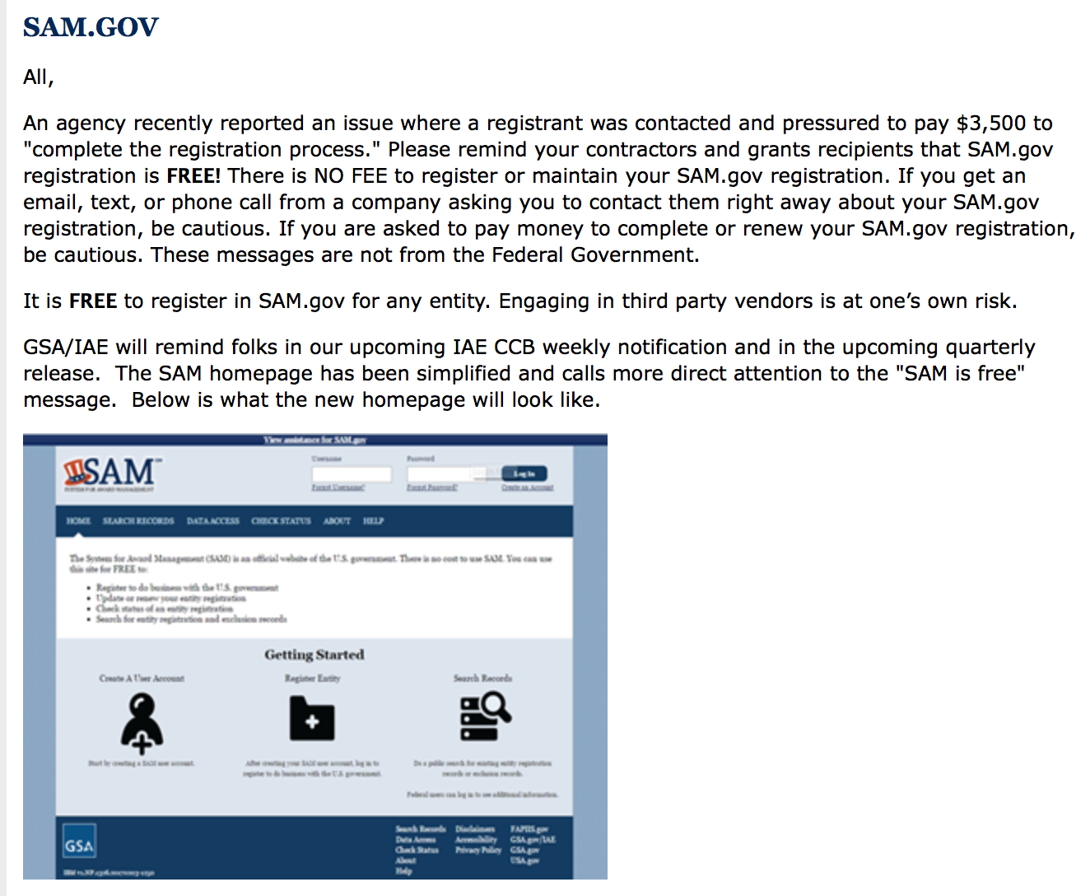

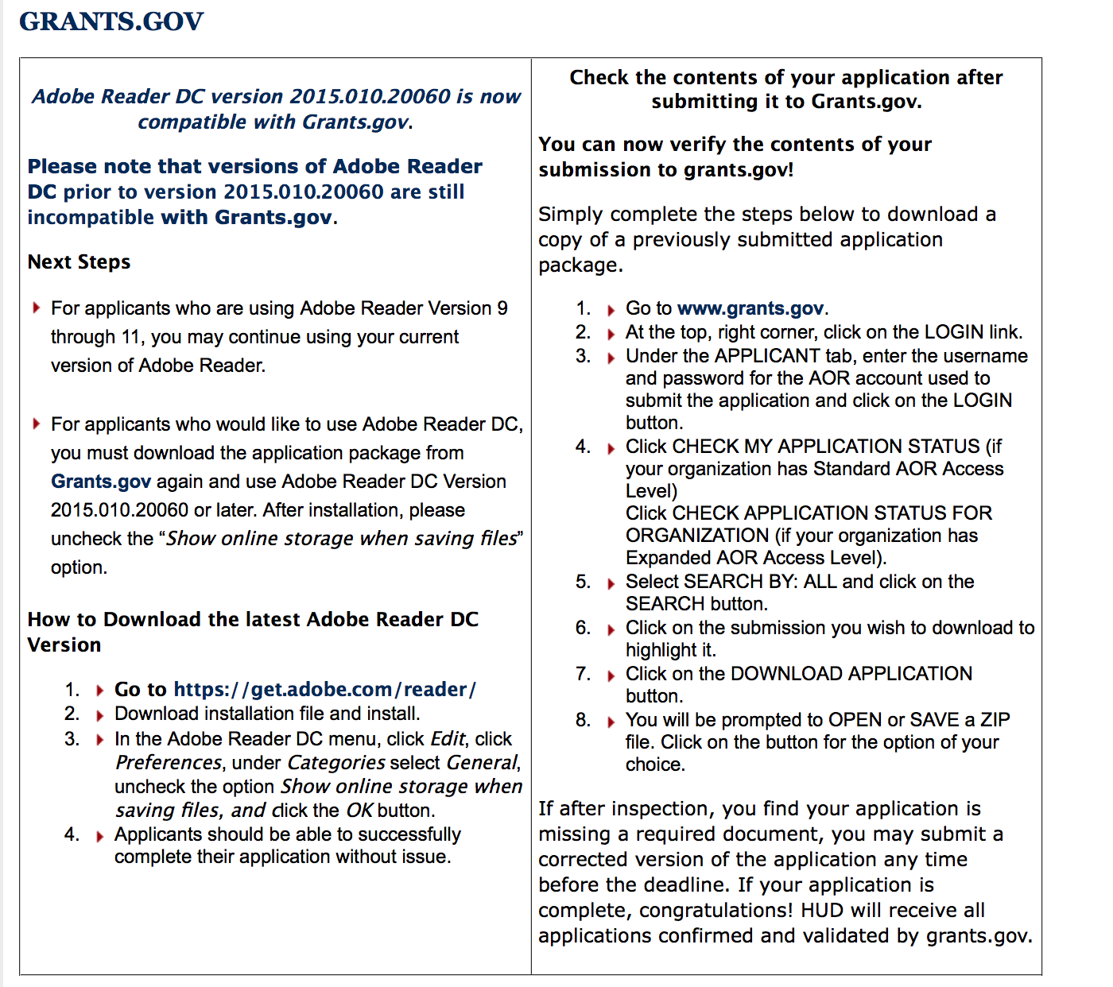

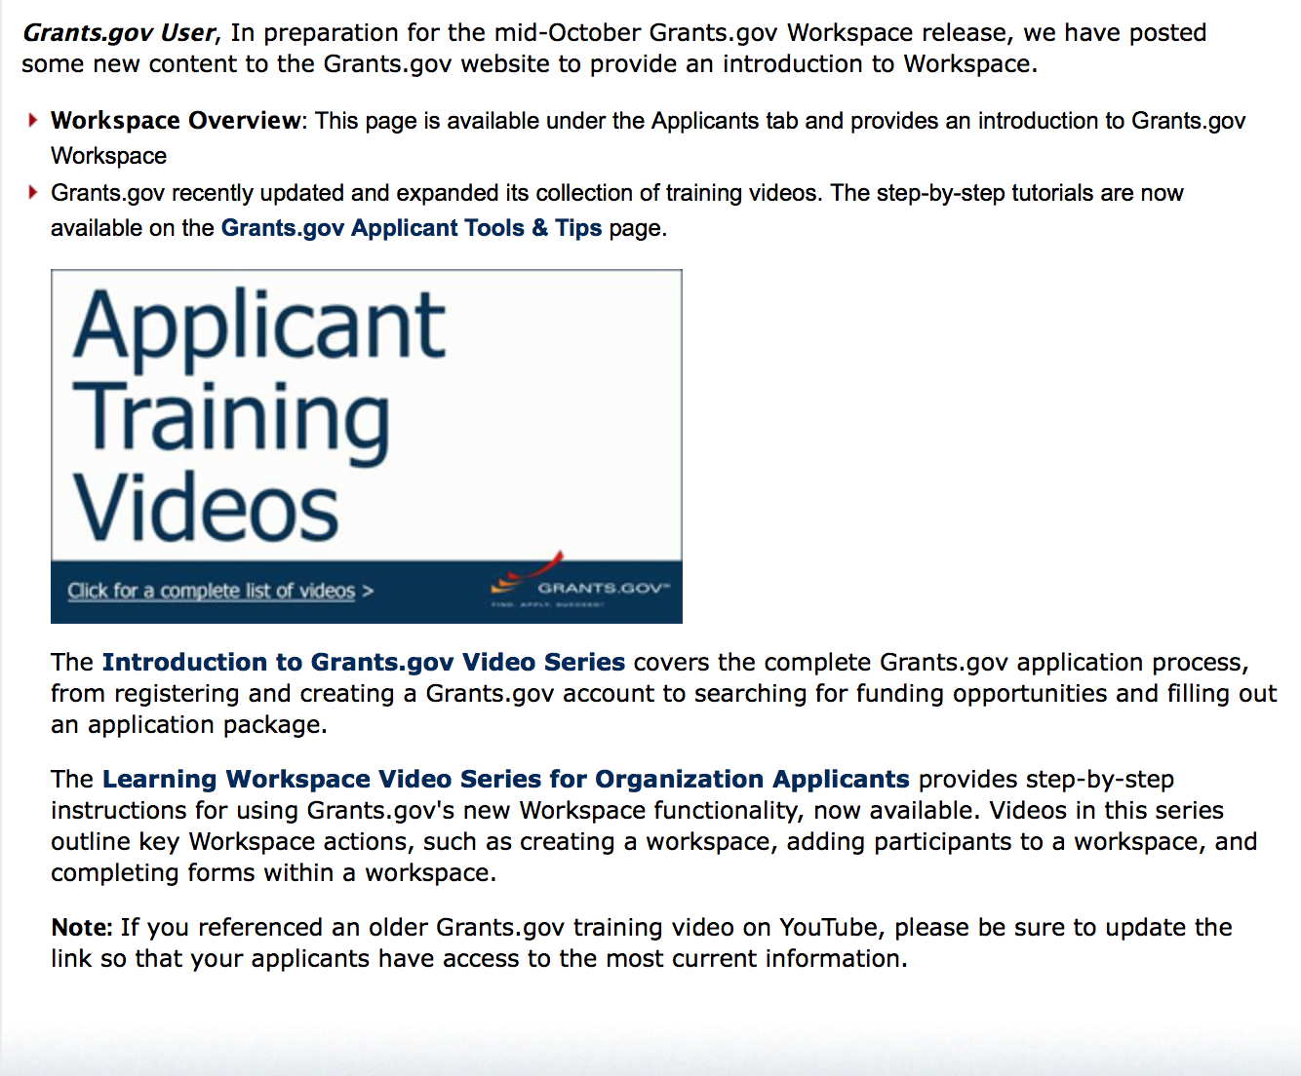
https://portal.hud.gov/hudportal/HUD?src=/program_offices/administration/grants/fundsavail

The Small Business Innovative Research Program - SBIR Program

The Small Business Innovation Research (SBIR) program is a highly competitive program that encourages domestic small businesses to engage in Federal Research/Research and Development (R/R&D) that has the potential for commercialization. Through a competitive awards-based program, SBIR enables small businesses to explore their technological potential and provides the incentive to profit from its commercialization. By including qualified small businesses in the nation's R&D arena, high-tech innovation is stimulated and the United States gains entrepreneurial spirit as it meets its specific research and development needs.

SBIR Mission and Program Goals
The mission of the SBIR program is to support scientific excellence and technological innovation through the investment of Federal research funds in critical American priorities to build a strong national economy.
The program’s goals are four-fold:
- Stimulate technological innovation
- Meet Federal research and development needs.
- Foster and encourage participation in innovation and entrepreneurship by socially and economically disadvantaged persons.
- Increase private-sector commercialization of innovations derived from Federal research and development funding.

SBIR-Participating Agencies
Each year, Federal agencies with extramural research and development (R&D) budgets that exceed $100 million are required to allocate 2.5 percent of their R&D budget to these programs. Currently, eleven Federal agencies participate in the program:
- Department of Agriculture
- Department of Commerce - National Institute of Standards and Technology
- Department of Commerce - National Oceanic and Atmospheric Administration
- Department of Defense
- Department of Education
- Department of Energy
- Department of Health and Human Services
- Department of Homeland Security
- Department of Transportation
- Environmental Protection Agency
- National Aeronautics and Space Administration
- National Science Foundation
Each agency administers its own individual program within guidelines established by Congress. These agencies designate R&D topics in their solicitations and accept proposals from small businesses. Awards are made on a competitive basis after proposal evaluation.

Three-Phase Program
The SBIR Program is structured in three phases:
Phase I. The objective of Phase I is to establish the technical merit, feasibility, and commercial potential of the proposed R/R&D efforts and to determine the quality of performance of the small business awardee organization prior to providing further Federal support in Phase II. SBIR Phase I awards normally do not exceed $150,000 total costs for 6 months.
Phase II. The objective of Phase II is to continue the R/R&D efforts initiated in Phase I. Funding is based on the results achieved in Phase I and the scientific and technical merit and commercial potential of the project proposed in Phase II. Only Phase I awardees are eligible for a Phase II award. SBIR Phase II awards normally do not exceed $1,000,000 total costs for 2 years.
Phase III. The objective of Phase III, where appropriate, is for the small business to pursue commercialization objectives resulting from the Phase I/II R/R&D activities. The SBIR program does not fund Phase III. Some Federal agencies, Phase III may involve follow-on non-SBIR funded R&D or production contracts for products, processes or services intended for use by the U.S. Government
SBIR NewsLetter

- SBIR Newsletter
Sign up for e-mail updates

Highlighted Programs

Consumer Product Safety Commission
Pool Safely Grant Program
Synopsis 1

General Information
Document Type: Grants Notice  Funding Opportunity Number: CPSC-18-001  Funding Opportunity Title: Pool Safely Grant Program  Opportunity Category: Discretionary  Opportunity Category Explanation:  Funding Instrument Type: Grant  Category of Funding Activity: Consumer Protection  Category Explanation:  Expected Number of Awards:  CFDA Number(s): 87.002 -- Virginia Graeme Baker Pool and Spa Safety  Cost Sharing or Matching Requirement: Yes | Version: Synopsis 1  Posted Date: Jan 02, 2018  Last Updated Date: Jan 02, 2018  Original Closing Date for Applications: Apr 02, 2018  Current Closing Date for Applications: Apr 02, 2018  Archive Date: May 02, 2018  Estimated Total Program Funding: $1,100,000  Award Ceiling: $250,000  Award Floor: $50,000
Eligibility
Eligible Applicants: | County governments  State governments  City or township governments
Additional Information on Eligibility:
Additional Information
Agency Name: | Consumer Product Safety Commission
Description: | This announcement solicits applications for the Pool Safely Grant Program, as authorized by Pub. L. No. 110-140, Virginia Graeme Baker Pool and Spa Safety Act (VGB Act), section 1405. The CPSC anticipates awarding up to, but no more than, $1.1 million in FY 2018 through competitive project grant awards to eligible state and local governments that meet the requirements under the VGB Act, for a 2-year project period. This announcement provides potential applicants with the details of requirements for applying, processing, and evaluating applications for financial assistance under the FY 2018 PSGP program.
Link to Additional Information: | Pool Safely Grant Program website
Grantor Contact Information: | If you have difficulty accessing the full announcement electronically, please contact:  U.S. Consumer Product Safety Commission Office of Communications/Grants Management 4330 East West Highway, Rm. 717 Bethesda, MD 20814 Tel: 301.504.7908 E-mail: Grants@cpsc.gov  Office of Communications/Grants Management

https://www.grants.gov/web/grants/view-opportunity.html?oppId=299778

HAWAII APPLICANTS ENCOURAGED

Current Notices:

Department of Agriculture

National Institute of Food and Agriculture
Alaska Native-Serving and Native Hawaiian-Serving Institutions Education Competitive Grants Program (ANNH)
Synopsis 1

Document Type: | Grants Notice
Funding Opportunity Number: | USDA-NIFA-AHSI-006489
Funding Opportunity Title: | Alaska Native-Serving and Native Hawaiian-Serving Institutions Education Competitive Grants Program (ANNH)
Opportunity Category: | Discretionary
Opportunity Category Explanation:
Funding Instrument Type: | Grant
Category of Funding Activity: | Agriculture
Category Explanation:
Expected Number of Awards:
CFDA Number(s): | 10.228 -- Alaska Native Serving and Native Hawaiian Serving Institutions Education Grants
Cost Sharing or Matching Requirement: | No
Version: | Synopsis 1
Posted Date: | Feb 02, 2018
Last Updated Date: | Feb 02, 2018
Original Closing Date for Applications: | Mar 30, 2018
Current Closing Date for Applications: | Mar 30, 2018
Archive Date: | Apr 29, 2018
Estimated Total Program Funding: | $3,000,000
Award Ceiling: | $1,450,000
Award Floor: | $150,000

Eligibility
Eligible Applicants: | Others (see text field entitled "Additional Information on Eligibility" for clarification)
Additional Information on Eligibility: | For the purpose of the ANNH Grants Program, an eligible institution means an individual public or private, nonprofit Alaska Native-Serving and Native Hawaiian-Serving Institutions of higher education that meet the definitions of Alaska-Serving Institutions or Native Hawaiian-Serving Institution established in Title III, Part A of the Higher Education Act of 1965, as amended (20 U.S.C. 1059d.). Applicants not meeting an eligibility criterion by the due date may result in the application being excluded from consideration or, even though an application may be reviewed, will preclude NIFA from making an award. Please see the RFA for additional information.
Additional Information
Agency Name: | National Institute of Food and Agriculture
Description: | The purpose of this program is to promote and strengthen the ability of Alaska Native-Serving Institutions and Native Hawaiian-Serving Institutions to carry out education, applied research, and related community development programs. NIFA intends this program to address educational needs, as determined by each institution, within a broadly defined arena of food and agricultural sciences-related disciplines. Priority will be given to those projects that enhance educational equity for underrepresented students; strengthen institutional educational capacities; prepare students for careers related to the food, agricultural, and natural resource systems of the United States; and maximize the development and use of resources to improve food and agricultural sciences teaching programs.
Link to Additional Information: | Alaska Native-Serving and Native Hawaiian-Serving Institutions Education Competitive Grants Program (ANNH)
Grantor Contact Information: | If you have difficulty accessing the full announcement electronically, please contact:  NIFA Help Desk Phone: 202-401-5048 Business hours are M-F, 7:00 am -5:00 pm ET, excluding Federal holidays  If you have any questions related to preparing application content

https://www.grants.gov/web/grants/view-opportunity.html?oppId=300439

Institute for Museum and Library Services

Native American Library Services Basic Grants Program
Synopsis 1

General Information
Document Type: Grants Notice  Funding Opportunity Number: NAG-BASIC-FY18  Funding Opportunity Title: Native American Library Services Basic Grants Program  Opportunity Category: Discretionary  Opportunity Category Explanation:  Funding Instrument Type: Grant  Category of Funding Activity: Arts (see "Cultural Affairs" in CFDA) Humanities (see "Cultural Affairs" in CFDA)  Category Explanation:  Expected Number of Awards: 240  CFDA Number(s): 45.311 -- Native American and Native Hawaiian Library Services  Cost Sharing or Matching Requirement: No | Version: Synopsis 1  Posted Date: Jan 02, 2018  Last Updated Date: Jan 02, 2018  Original Closing Date for Applications: Apr 02, 2018  Current Closing Date for Applications: Apr 02, 2018  Archive Date: May 02, 2018  Estimated Total Program Funding: $2,400,000  Award Ceiling: $10,000  Award Floor: $6,000
Eligibility
Eligible Applicants: | Others (see text field entitled "Additional Information on Eligibility" for clarification)
Additional Information on Eligibility: | Please see the Notice of Funding Opportunity for eligibility information.
Additional Information
Agency Name: | Institute of Museum and Library Services
Description: | The goal of the FY 2018 Native American Library Services Basic Grants Program is to support existing library operations and maintain core library services. Effective for this FY 2018 Native American Library Services Basic Grants Program, there is no separate Education/Assessment Option. Funding for tribal library staff to: attend library-related continuing education courses or training workshops; attend or give presentations at conferences related to library services; and/or hire a consultant for an onsite professional library assessment should be included in the Library Services Plan and the Budget. No more than $3,000 of the total $10,000 may be allotted for education/assessment activities or travel. For this FY 2018 Native American Library Services Basic Grants Program, Basic Grants are only available for a one year period.
Link to Additional Information: | https://www.imls.gov/grants/available/native-american-library-services-basic-grants
Grantor Contact Information: | If you have difficulty accessing the full announcement electronically, please contact:  Sandra Toro, PhD, Senior Program Officer 202-653-4662 storo@imls.gov  storo@imls.gov

https://www.grants.gov/web/grants/view-opportunity.html?oppId=299796

Environmental Protection Agency
Environmental Education Local Grants Program for Region 9 -- Solicitation Notice for 2018
Synopsis 1

General Information
Document Type: Grants Notice  Funding Opportunity Number: EPA-EE-18-09  Funding Opportunity Title: Environmental Education Local Grants Program for Region 9 -- Solicitation Notice for 2018  Opportunity Category: Discretionary  Opportunity Category Explanation:  Funding Instrument Type: Grant  Category of Funding Activity: Environment  Category Explanation:  Expected Number of Awards: 4  CFDA Number(s): 66.951 -- Environmental Education Grants  Cost Sharing or Matching Requirement: Yes | Version: Synopsis 1  Posted Date: Jan 11, 2018  Last Updated Date: Jan 11, 2018  Original Closing Date for Applications: Mar 15, 2018 Please see Section IV of the announcement for additional submission information  Current Closing Date for Applications: Mar 15, 2018 Please see Section IV of the announcement for additional submission information  Archive Date: Apr 14, 2018  Estimated Total Program Funding: $300,000  Award Ceiling: $100,000  Award Floor: $50,000
Eligibility
Eligible Applicants: | Others (see text field entitled "Additional Information on Eligibility" for clarification)
Additional Information on Eligibility: | Please see Section III of the announcement for additional eligibility information
Additional Information
Agency Name: | Environmental Protection Agency
Description: | The purpose of the Environmental Education Local Grants Program in Region 9 is to support locally-focused environmental education projects that increase public awareness and knowledge about environmental and conservation issues and provide the skills that participants in its funded projects need to make informed decisions and take responsible actions toward the environment
Link to Additional Information: | Environmental Education Local Grants Program for Region 9 -- Solicitation Notice for 2018
Grantor Contact Information: | If you have difficulty accessing the full announcement electronically, please contact:  U.S. EPA Headquarters Environmental Education Grant Program, Office of Environmental Education Karen Scott  EEGrants@EPA.gov

https://www.grants.gov/web/grants/view-opportunity.html?oppId=300014

Reminders:

Department of Commerce
2018 MET Mini Grant Program
Synopsis 1
Document Type: | Grants Notice
Funding Opportunity Number: | NOAA-NMFS-PIRO-2018-2005476
Funding Opportunity Title: | 2018 MET Mini Grant Program
Opportunity Category: | Discretionary
Opportunity Category Explanation:
Funding Instrument Type: | Cooperative Agreement  Grant
Category of Funding Activity: | Environment  Natural Resources  Science and Technology and other Research and Development
Category Explanation:
Expected Number of Awards: | 15
CFDA Number(s): | 11.452 -- Unallied Industry Projects
Cost Sharing or Matching Requirement: | Yes
Version: | Synopsis 1
Posted Date: | Dec 20, 2017
Last Updated Date: | Dec 20, 2017
Original Closing Date for Applications: | Feb 21, 2018
Current Closing Date for Applications: | Feb 21, 2018
Archive Date: | Mar 23, 2018
Estimated Total Program Funding: | $150,000
Award Ceiling: | $15,000
Award Floor: | $1
Eligible Applicants: | Others (see text field entitled "Additional Information on Eligibility" for clarification)
Additional Information on Eligibility: | Eligible applicants are individuals, institutions of higher education, nonprofits, commercial organizations, state, local and Indian tribal governments. Federal agencies and instrumentalities, including their employees, are not eligible to apply. Eligible applicants are limited to projects within the Western Pacific Regional Fishery Management areas.
Agency Name: | Department of Commerce
Description: | The National Marine Fisheries Service (NOAA/NMFS) is soliciting competitive applications for the 2018 Pacific Islands Region Marine Education and Training (MET) Mini-Grant Program. Projects are being solicited to improve communication, education, and training on marine resource issues throughout the region and increase scientific education for marine-related professions among coastal community residents, including indigenous Pacific islanders, Native Hawaiians and other underrepresented groups in the region.
Link to Additional Information:
Grantor Contact Information: | If you have difficulty accessing the full announcement electronically, please contact:  Mr. Scott W.S. Bloom 808.725-5055 1845 Wasp Blvd., Building 176, Honolulu, HI 96818  Work
https://www.grants.gov/web/grants/view-opportunity.html?oppId=299577

Please review each department’s General Grant and Funding Overview. These overviews are the key web pages on each departmental website dedicated to the agency’s funding opportunities. Check back often to note the department updates and use these sources to assist you in your planning.

Federal Grant and Cooperative Agreement Program Summaries

U.S. Department of Agriculture

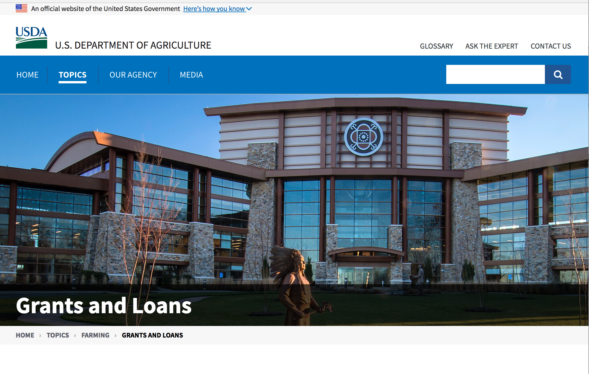

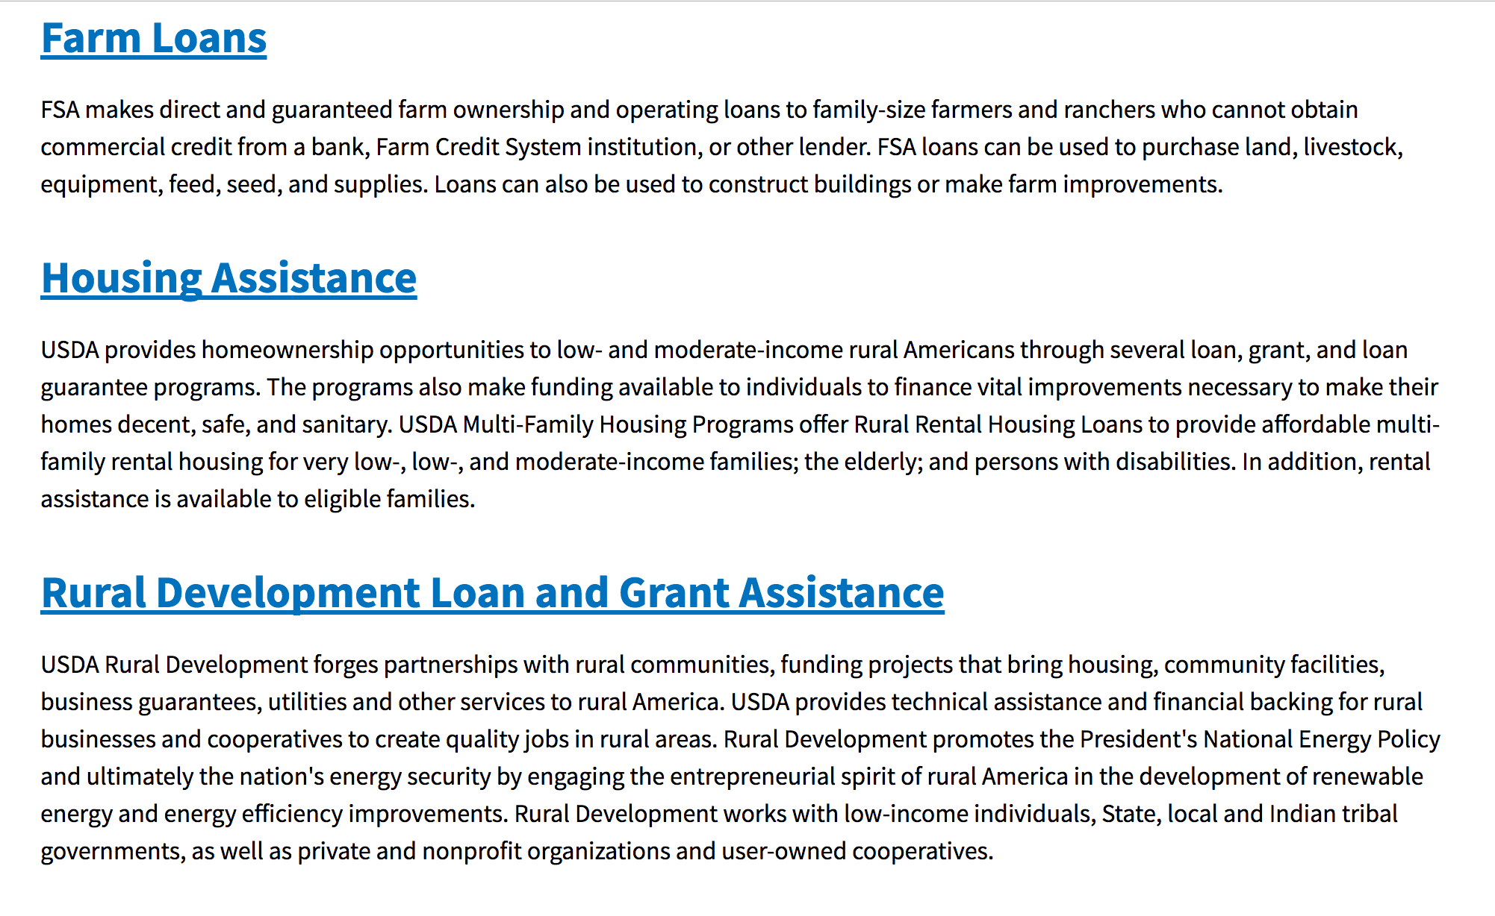

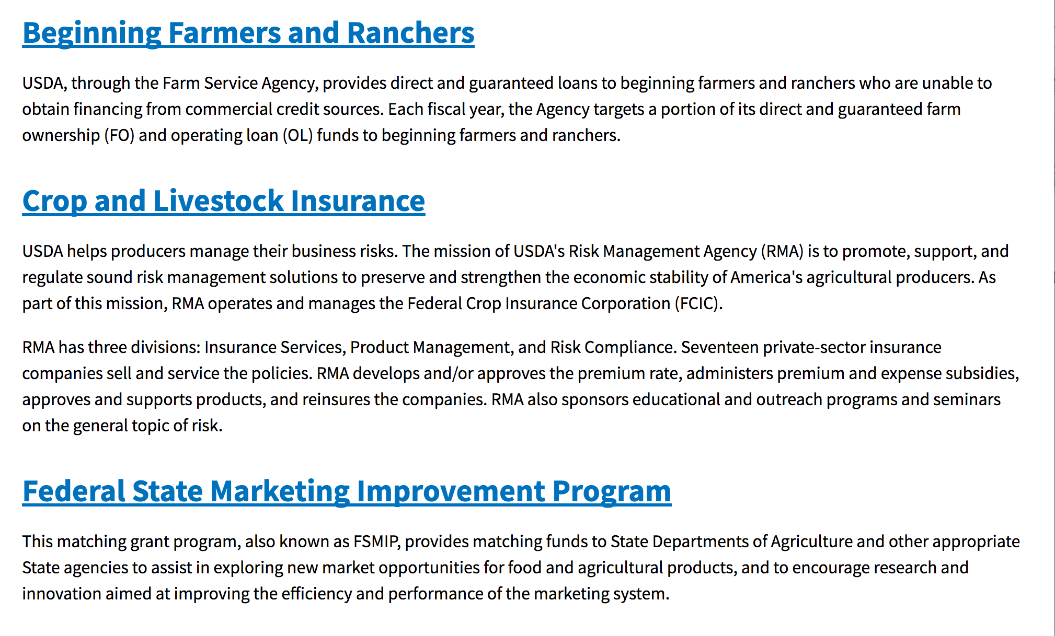
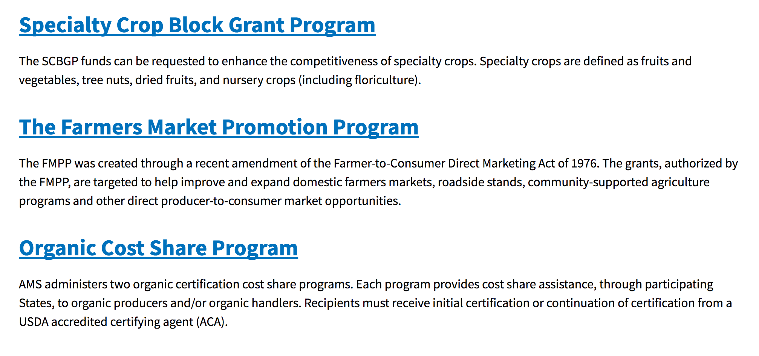
https://www.usda.gov/topics/farming/grants-and-loans

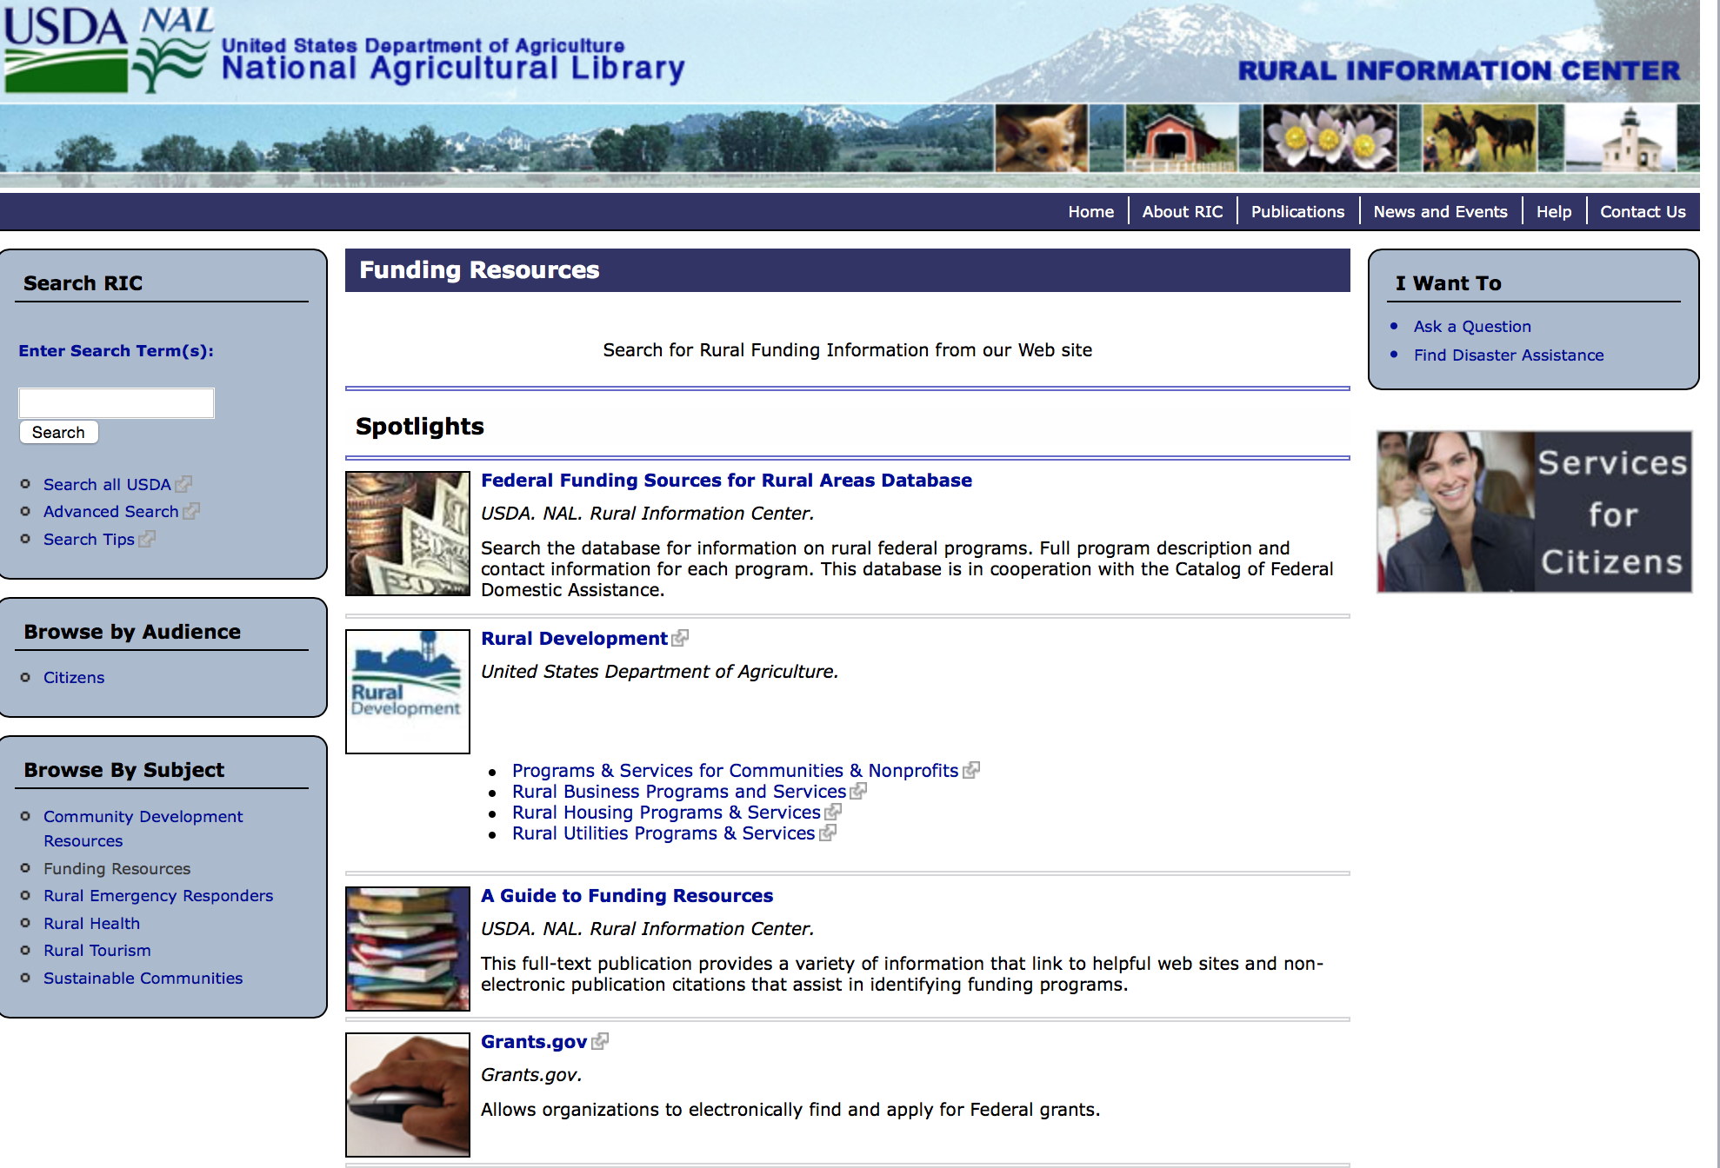

http://ric.nal.usda.gov/funding-resources

Programs:

Foreign Agricultural Service
Food for Progress Program
Synopsis 1

Document Type: | Grants Notice
Funding Opportunity Number: | USDA-FAS-FFPR-18
Funding Opportunity Title: | Food for Progress Program
Opportunity Category: | Discretionary
Opportunity Category Explanation:
Funding Instrument Type: | Cooperative Agreement
Category of Funding Activity: | Agriculture  Community Development  Employment, Labor and Training  Food and Nutrition  Regional Development
Category Explanation:
Expected Number of Awards: | 6
CFDA Number(s): | 10.606 -- Food for Progress
Cost Sharing or Matching Requirement: | No
Version: | Synopsis 1
Posted Date: | Dec 07, 2017
Last Updated Date: | Dec 07, 2017
Original Closing Date for Applications: | Jan 31, 2018 Phase I of Notice of Funding Opportunity
Current Closing Date for Applications: | Jan 31, 2018 Phase I of Notice of Funding Opportunity
Archive Date:
Estimated Total Program Funding: | $155,000,000
Award Ceiling: | $35,000,000
Award Floor: | $10,000,000
Eligible Applicants: | Others (see text field entitled "Additional Information on Eligibility" for clarification)
Additional Information on Eligibility: | Private voluntary organizations, cooperatives, intergovernmental organizations, foreign governments; (Public universities, including their subsidiaries, are not eligible to apply)
Agency Name: | Foreign Agricultural Service
Description: | The Food for Progress program provides for the donation of U.S. agricultural commodities to developing countries and emerging democracies that are committed to introducing or expanding free enterprise in their agricultural economies. Donated U.S. commodities are typically 'monetized' (sold on the local market in the beneficiary country) and the proceeds are used to fund agricultural development activities.
Link to Additional Information: | USDA Foreign Agricultural Service Food Aid Information System Website
Grantor Contact Information: | If you have difficulty accessing the full announcement electronically, please contact:  Mark Rosmann International Program Specialist Phone 2026901927  Email of Synopsis Author
https://www.grants.gov/web/grants/view-opportunity.html?oppId=299314

USDA-NRCS-NHQ
Announcement for Program Funding for NRCS' Conservation Innovation Grants (CIG) for Federal fiscal year (FY) 2018
Synopsis 1
Document Type: | Grants Notice
Funding Opportunity Number: | USDA-NRCS-NHQ-CIG-001
Funding Opportunity Title: | Announcement for Program Funding for NRCS' Conservation Innovation Grants (CIG) for Federal fiscal year (FY) 2018
Opportunity Category: | Discretionary
Opportunity Category Explanation:
Funding Instrument Type: | Grant
Category of Funding Activity: | Agriculture  Environment  Natural Resources  Science and Technology and other Research and Development
Category Explanation:
Expected Number of Awards:
CFDA Number(s): | 10.912 -- Environmental Quality Incentives Program
Cost Sharing or Matching Requirement: | Yes
Version: | Synopsis 1
Posted Date: | Dec 18, 2017
Last Updated Date: | Dec 18, 2017
Original Closing Date for Applications: | Feb 26, 2018
Current Closing Date for Applications: | Feb 26, 2018
Archive Date: | Mar 28, 2018
Estimated Total Program Funding: | $10,000,000
Award Ceiling: | $2,000,000
Award Floor: | $0
Eligible Applicants: | Unrestricted (i.e., open to any type of entity above), subject to any clarification in text field entitled "Additional Information on Eligibility"
Additional Information on Eligibility: | All U.S.-based non-federal entities and individuals, with the exception of Federal agencies, are eligible to apply.
Agency Name: | USDA-NRCS-NHQ
Description: | NRCS is announcing the availability of CIG to stimulate the development and adoption of innovative conservation approaches and technologies. Applications will be accepted from eligible entities in any of the 50 States, the District of Columbia, the Caribbean Area (Puerto Rico and the U.S. Virgin Islands), and the Pacific Islands Area (Guam, American Samoa, and the Commonwealth of the Northern Mariana Islands). A total of up to $10 million is available for CIG in FY 2018. All United States (U.S.)-based non-Federal entities (NFE) and individuals are invited to apply, with the sole exception of Federal agencies. Projects may be between 1 and 3 years in duration. The maximum award amount for a single award in FY 2018 is $2 million.
Link to Additional Information: | USDA NRCS CIG Program Website
Grantor Contact Information: | If you have difficulty accessing the full announcement electronically, please contact:  USDA NRCS CIG Staff Phone: (202) 720-1895 Email: nrcscig@wdc.usda.gov USDA-NRCS 1400 Independence Avenue, SW, Room 6143-S Washington, D.C. 20250  USDA NRCS CIG Staff
https://www.grants.gov/web/grants/view-opportunity.html?oppId=299499

Foreign Agricultural Service
McGovern-Dole International Food For Education and Child Nutrition Program
Synopsis 1
Document Type: | Grants Notice
Funding Opportunity Number: | USDA-FAS-MCGOVERN-DOLE-18
Funding Opportunity Title: | McGovern-Dole International Food For Education and Child Nutrition Program
Opportunity Category: | Discretionary
Opportunity Category Explanation:
Funding Instrument Type: | Cooperative Agreement
Category of Funding Activity: | Agriculture  Education  Food and Nutrition
Category Explanation: | Food Aid, Food Assistance, School Feeding, Food for Education, International Development
Expected Number of Awards:
CFDA Number(s): | 10.608 -- Food for Education
Cost Sharing or Matching Requirement: | No
Version: | Synopsis 1
Posted Date: | Jan 16, 2018
Last Updated Date: | Jan 16, 2018
Original Closing Date for Applications: | Mar 30, 2018 Deadline for application submissions is 5:00 pm Eastern Daylight Savings Time (EDT) on Friday, March 30, 2018.
Current Closing Date for Applications: | Mar 30, 2018 Deadline for application submissions is 5:00 pm Eastern Daylight Savings Time (EDT) on Friday, March 30, 2018.
Archive Date: | Apr 29, 2018
Eligible Applicants: | Others (see text field entitled "Additional Information on Eligibility" for clarification)
Additional Information on Eligibility: | Private voluntary organizations, cooperatives, and other organizations that are not intergovernmental organizations
Agency Name: | Foreign Agricultural Service
Description: | The McGovern-Dole International Food for Education and Child Nutrition (McGovern-Dole) program supports feeding of school-aged children, reduces hunger, promotes literacy (especially for girls), promotes food security and enhances nutrition for mothers and their children in low-income, food-deficit countries committed to education and school meals. The program provides U.S. commodities and financial and technical assistance to achieve these goals. While McGovern-Dole projects are typically funded for five years, all projects in this announcement will be funded subject to availability of a fiscal year 2018 budget for McGovern-Dole.
Link to Additional Information: | USDA Foreign Agricultural Service Food Aid Information System Website
Grantor Contact Information: | If you have difficulty accessing the full announcement electronically, please contact:  If you have difficulty accessing the full announcement electronically, please contact Ingrid Ardjosoediro, Branch Chief, 202-720-2737  Email account for all inquiries and questions.
https://www.grants.gov/web/grants/view-opportunity.html?oppId=300112

Forest Service
2019 National Urban and Community Forestry Grant Program
Synopsis 1
 | Document Type: | Grants Notice
 | Funding Opportunity Number: | USDA-FS-UCF-01-2019
 | Funding Opportunity Title: | 2019 National Urban and Community Forestry Grant Program
 | Opportunity Category: | Discretionary
 | Opportunity Category Explanation:
 | Funding Instrument Type: | Grant
 | Category of Funding Activity: | Environment  Natural Resources  Science and Technology and other Research and Development
 | Category Explanation:
 | Expected Number of Awards: | 10
 | CFDA Number(s): | 10.675 -- Urban and Community Forestry Program
 | Cost Sharing or Matching Requirement: | Yes
 | Version: | Synopsis 4
 | Posted Date: | Jan 31, 2018
 | Last Updated Date: | Feb 01, 2018
 | Original Closing Date for Applications: | Apr 30, 2018
 | Current Closing Date for Applications: | Apr 30, 2018
 | Archive Date: | May 30, 2018
 | Estimated Total Program Funding: | $900,000
 | Award Ceiling: | $200,000
 | Award Floor: | $75,000
 | Eligible Applicants: | Native American tribal governments (Federally recognized)  Public and State controlled institutions of higher education  County governments  Special district governments  State governments  Private institutions of higher education  Nonprofits having a 501(c)(3) status with the IRS, other than institutions of higher education  Public housing authorities/Indian housing authorities  Independent school districts  City or township governments
Agency Name: |  | Forest Service
Description: |  | The Secretary of Agriculture has a congressionally designated advisory council that assists the U.S. Forest Service in establishing the grant categories and recommendations of final proposals for the Forest Service to consider. This is the National Urban and Community Forestry Advisory Council (Council). The Council serves to advise the Secretary of Agriculture on the status of the nation’s urban and community forests and related natural resources. The Council seeks to establish sustainable urban and community forests, by encouraging communities of all sizes to manage and protect their natural resources, which, if well managed, improves the public’s health, well-being, economic vitality, and creates resilient ecosystems for present and future generations. Urban and Community Forestry Program Requirements The Council recommends urban and community forestry projects that have national or multi-state application and impact through the U.S. Forest Service’s competitive Urban and Community Forestry Challenge Cost-Share Grant Program. A proposal’s content must meet the Urban and Community Forestry program authorities as designated by Congress in the Cooperative Forestry Assistance Act, (Section 9 PDF, pp. 19-24) State & Private Cooperative Forestry Handbook of Programs and the annual criteria set forth by the Council. A listing of the previously funded projects can be viewed at Urban Forestry South list of past NUCFAC grants
Link to Additional Information: |  | National Urban and Community Forestry Advisory Council Website
Grantor Contact Information: |  | If you have difficulty accessing the full announcement electronically, please contact:  Nancy Stremple Urban Forestry Program Specialist Phone 202-309-9873  Work email
https://www.grants.gov/web/grants/view-opportunity.html?oppId=300327

Research:

National Institute of Food and Agriculture
Organic Agriculture Research and Extension Initiative
Synopsis 1
https://www.grants.gov/web/grants/view-opportunity.html?oppId=299697

National Institute of Food and Agriculture
Organic Transitions
Synopsis 1
https://www.grants.gov/web/grants/view-opportunity.html?oppId=299897

Modifications:

National Institute of Food and Agriculture
Secondary Agriculture Education Challenge Grant Program
Synopsis 2

Document Type: | Grants Notice
Funding Opportunity Number: | USDA-NIFA-SAECP-006488
Funding Opportunity Title: | Secondary Agriculture Education Challenge Grant Program
Opportunity Category: | Discretionary
Opportunity Category Explanation:
Funding Instrument Type: | Grant
Category of Funding Activity: | Agriculture
Category Explanation:
Expected Number of Awards:
CFDA Number(s): | 10.226 -- Secondary and Two-Year Postsecondary Agriculture Education Challenge Grants
Cost Sharing or Matching Requirement: | Yes
Version: | Synopsis 2
Posted Date: | Feb 01, 2018
Last Updated Date: | Feb 01, 2018
Original Closing Date for Applications: | Apr 04, 2018
Current Closing Date for Applications: | Apr 04, 2018
Archive Date: | May 04, 2018
Estimated Total Program Funding: | $800,000
Eligible Applicants: | Others (see text field entitled "Additional Information on Eligibility" for clarification)
Additional Information on Eligibility: | Applications may only be submitted by: (1) public secondary schools, (2) public or private nonprofit junior and community colleges, (3) institutions of higher education, or (4) nonprofit organizations (Attach IRS 501(c)(3) status under R&R ‘Other Project Information’ Field 12 Other Attachments). Failure to meet an eligibility criterion by the application deadline may result in the application being excluded from consideration or, even though an application may be reviewed, will preclude NIFA from making an award.
Agency Name: | National Institute of Food and Agriculture
Description: | The Secondary Education, Two-Year Postsecondary Education, and Agriculture in the K-12 Classroom Challenge Grants (SPECA) program seeks to: (a) promote and strengthen secondary education and two-year postsecondary education in the food, agriculture, natural resources and human (FANH) sciences in order to help ensure the existence of a workforce in the United States that's qualified to serve the FANH sciences system; and (b) promote complementary and synergistic linkages among secondary, two-year postsecondary, and higher education programs in the FANH sciences in order to advance excellence in education and encourage more young Americans to pursue and complete a baccalaureate or higher degree in the FANH sciences.
Link to Additional Information: | Secondary Education, Two-Year Postsecondary Education, and Agriculture in the K-12 Classroom Challenge Grants Program (SPECA)
Grantor Contact Information: | If you have difficulty accessing the full announcement electronically, please contact:  NIFA Help Desk Phone: 202-401-5048 Business hours are M-F, 7:00 am -5:00 pm ET, excluding Federal holidays  If you have any questions related to preparing application content
https://www.grants.gov/web/grants/view-opportunity.html?oppId=300389

Reminders:

Deleted:

Department of Commerce

Grants, Contracting, and Trade Opportunities at Commerce
Learn more information about grants, contracting and trade opportunities at the Department of Commerce using the information below.

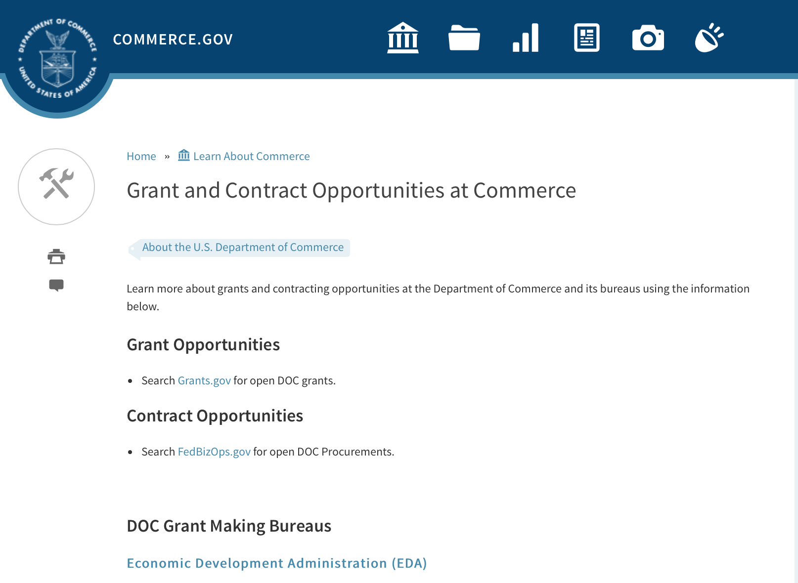
Grants at Commerce
DOC Grant Making Bureaus
Economic Development Administration (EDA)
International Trade Administration (ITA)
- Market Development Cooperator Program
- Special American Business Internship Training Program (SABIT). A technical assistance initiative of the International Trade Administration of the U.S. Department of Commerce, SABIT offers organizations competitive grants and an opportunity to host industry-specific delegations. SABIT serves as an initial entry point for U.S. businesses seeking funding to establish long-term relationships with potential customers, distributors, or partners in the former Soviet Union. The program trains Eurasian managers and scientists in commonly accepted business practices as a means of facilitating cross border relationships. In turn, these personal relationships serve as a basis for business development and reduce market access barriers for U.S. businesses
National Institute of Standards & Technology (NIST)
- Funding Opportunities
National Telecommunications & Information Administration (NTIA)
- Telecommunications Grants
National Oceanic & Atmospheric Administration (NOAA)
- Coastal Ocean Program Grant Information
- Fisheries Saltonstall Kennedy Grant Program
- National Undersea Research Program Funding Opportunities
- Grants Management Division
- Fisheries Grants Program
- National Sea Grant
- Office of Global Programs
Contracting Resources for Contractors
- Office of Small and Disadvantaged Business Utilization (OSDBU) - he Office of Small and Disadvantaged Business Utilization (OSDBU) is an advocacy and advisory office responsible for promoting the use of small, small disadvantaged, 8(a), women-owned, veteran-owned, service-disabled veteran-owned, and HUBZone small businesses within the U.S. Department of Commerce's (DOC) acquisition process.
- Business.USA.gov's Find Opportunities Wizard where in a few quick steps, it will guide you towards federal government contracting programs and opportunities for your business!
- Planned Acquisitions: the Department of Commerce's search tool for our planned acquisitions over $100,000. As requirements change, these acquisition plans are updated by department personnel and this search tool is automatically updated.
- Small Business Administration's Contracting section of their web site where you can learn about how to "Get Started" and "Contracting Support for Small Business"
- The General Services Administration (GSA) has implemented a system for vendors doing business with the Federal Government to manage their entity information in one central location. This new database is the System for Award Management (SAM).

DOC Contracting Offices
- Patent and Trademark Office (PTO)
  - Office of Procurement
- National Institute of Standards & Technology (NIST)
NIST Acquisition Management Group
Contracting Opportunities with Commerce
Trade Opportunities through Commerce
http://www.commerce.gov/about-commerce/grants-contracting-trade-opportunities

Programs:

Modifications:

Research:

FY 2018 Joint Technology Transfer Initiative
Synopsis 1
https://www.grants.gov/web/grants/view-opportunity.html?oppId=300187

National Institute of Standards and Technology
NIST Public Safety Innovation Accelerator Program – Point Cloud City
Synopsis 2
https://www.grants.gov/web/grants/view-opportunity.html?oppId=299846

National Institute of Standards and Technology
FY 2018 Small Business Innovation Research (SBIR) Program
Synopsis 1
https://www.grants.gov/web/grants/view-opportunity.html?oppId=300178

Reminders:

Climate and Societal Interactions
Synopsis 1

Document Type: | Grants Notice
Funding Opportunity Number: | NOAA-OAR-CPO-2018-2005445
Funding Opportunity Title: | Climate and Societal Interactions
Opportunity Category: | Discretionary
Opportunity Category Explanation:
Funding Instrument Type: | Cooperative Agreement
Category of Funding Activity: | Environment  Natural Resources  Science and Technology and other Research and Development
Category Explanation:
Expected Number of Awards:
CFDA Number(s): | 11.431 -- Climate and Atmospheric Research
Cost Sharing or Matching Requirement: | No
Version: | Synopsis 1
Posted Date: | Dec 04, 2017
Last Updated Date: | Dec 04, 2017
Original Closing Date for Applications: | Mar 16, 2018
Current Closing Date for Applications: | Mar 16, 2018
Archive Date: | Apr 15, 2018
Estimated Total Program Funding:
Award Ceiling: | $1,000,000
Award Floor: | $50,000
Eligible Applicants: | Others (see text field entitled "Additional Information on Eligibility" for clarification)
Additional Information on Eligibility: | Eligible applicants are institutions of higher education, other nonprofits, commercial organizations, international organizations, and state, local and Indian tribal governments. Federal agencies interested in receiving financial support for projects should contact the appropriate competition manager.
Agency Name: | Department of Commerce
Description: | The mission of the NOAA Climate and Societal Interactions (CSI) research portfolio is to inform improvements in planning and preparedness in diverse socio-economic regions and sectors throughout the U.S. and abroad via the integration of knowledge and information about extreme weather and climate. Our research advances the nation’s understanding of climate-related risks and vulnerabilities across sectors and regions - within and beyond our borders - and the development of tools to foster more informed decision-making. These efforts support NOAA's vision to create and sustain enhanced resilience in ecosystems, communities, and economies. The overall objectives of the CSI portfolio are the following: 1. Support innovative, applicable, and transferable approaches for decision making, especially for risk characterization in the context of a variable and changing climate; 2. Establishment of a network of regionally scoped, long-term efforts to inform climate risk management and decision making; and 3. Promotion of the transfer of climate knowledge, tools, products, and services within NOAA, across the federal government, nationally, and internationally. These objectives are pursued through four complementary, interdisciplinary research programs: the Regional Integrated Sciences and Assessment (RISA) Program; the International Research and Applications Project (IRAP); the Sectoral Applications Research Program (SARP); and the Coastal and Ocean Climate Applications program (COCA). RISA supports research teams that conduct innovative, interdisciplinary, user-inspired, and regionally relevant research that informs resource management, planning, and public policy. IRAP supports activities to link science and assessments to practical risk management challenges in regions where weather and climate affect U.S. interests at home and abroad. COCA supports interdisciplinary applications research on the impacts of climate variability and change on coastal communities and coastal and marine ecosystems to inform decision-making. SARP addresses the needs of a specific stakeholder or set of stakeholders within key socioeconomic sectors (e.g., water resources, agriculture, health, etc.) grappling with pressing climate-related issues. The FY18 SARP competitions was published in the CPO FFO in May 2017. CSI is an active partner in NOAA’s efforts to enhance and support services. This partnership brings together NOAA Regional Climate Services Directors (RCSDs), other NOAA service line offices, and close external partners such as RISA teams, Regional Climate Centers, State Climatologists, Sea Grant and other U.S. Government agencies to help make weather and climate information and products relevant, accessible and actionable to people across the U.S. CSI activities address the societal challenges identified in NOAA’s Next-Generation Strategic Plan (NGSP): i) climate impacts on water resources; ii) coasts and climate resilience; iii) sustainability of marine ecosystems; and iv) changes in the extremes of weather and climate. CSI programs support NOAA’s vision to create and sustain enhanced resilience in ecosystems, communities, and economies, as outlined in the NGSP. Three (3) CSI programs are holding a competition under this Federal Funding Opportunity: RISA, COCA, and IRAP. RISA - South Central Region COCA & RISA Pilot on Coastal Climate Extension Competition IRAP: Decision Support Research on Climate-Sensitive Health Risks
Link to Additional Information:
Grantor Contact Information: | If you have difficulty accessing the full announcement electronically, please contact:  Diane Brown CPO Grants Manager 1315 East West Highway, Suite 12112 Silver Spring, MD 20910-5644 301-734-1206 diane.brown@noaa.gov  Work
https://www.grants.gov/web/grants/view-opportunity.html?oppId=299217

NOAA National Sea Grant College Program 2018 Ocean, Coastal and Great Lakes National Aquaculture Initiative
Synopsis 1

Document Type: | Grants Notice
Funding Opportunity Number: | NOAA-OAR-SG-2018-2005489
Funding Opportunity Title: | NOAA National Sea Grant College Program 2018 Ocean, Coastal and Great Lakes National Aquaculture Initiative
Opportunity Category: | Discretionary
Opportunity Category Explanation:
Funding Instrument Type: | Cooperative Agreement  Grant
Category of Funding Activity: | Environment  Natural Resources  Science and Technology and other Research and Development
Category Explanation:
Expected Number of Awards:
CFDA Number(s): | 11.417 -- Sea Grant Support
Cost Sharing or Matching Requirement: | Yes
Version: | Synopsis 3
Posted Date: | Dec 14, 2017
Last Updated Date: | Dec 15, 2017
Original Closing Date for Applications: | Mar 30, 2018
Current Closing Date for Applications: | Mar 30, 2018
Archive Date: | Apr 29, 2018
Estimated Total Program Funding:
Award Ceiling: | $750,000
Award Floor: | $1
Eligible Applicants: | Others (see text field entitled "Additional Information on Eligibility" for clarification)
Additional Information on Eligibility: | The following entities are eligible and encouraged to participate in this funding opportunity, in conjunction with a Sea Grant program: any individual; any public or private corporation, partnership, or other association or entity (including any Sea Grant College, Sea Grant Institute or other institution); or any State, political subdivision of a State, Tribal government or agency or officer thereof. Federal agencies and their personnel are not permitted to receive federal funding under this competition; however, federal scientists and other employees can serve as uncompensated partners or co-Principal Investigators on applications. Federal labs and offices can also make available specialized expertise, facilities or equipment to applicants but cannot be compensated under this competition for their use, nor can the value of such assets be used as match.
Agency Name: | Department of Commerce
Description: | Please note that this FFO contains an additional deadline of March 2 by which certain actions must be taken to be eligible for this competition. Please read the FFO carefully for more details. Depending on appropriations, NOAA National Sea Grant College Program (NOAA Sea Grant) expects to have available a total of $7,000,000 to $11,500,000 across fiscal years 2018, 2019 and 2020 as part of the Sea Grant National Aquaculture Initiative (NAI). As part of the NAI, this competition is designed to foster the expansion of a sustainable U.S. ocean, coastal and Great Lakes aquaculture sector by addressing one or more of the following priorities: (a) supporting the development of emerging systems or technologies that will advance aquaculture in the U.S., including projects that will help stimulate aquaculture production by nascent industries; (b) developing and implementing actionable methods of communicating accurate, science based messages and information about the benefits and risks of U.S. marine aquaculture to the public; and (c) increasing the resiliency of aquaculture systems to natural hazards and changing conditions. Successful applications must describe projects that clearly address major constraints, barriers or hurdles limiting aquaculture production in the U.S. The overall objectives of the Sea Grant NAI are to: 1) address the needs of the U.S. ocean, coastal and Great Lakes aquaculture sector by supporting research, technology transfer, and best practices related to the sustainable aquaculture of ocean, coastal, or Great Lakes fish, shellfish, or algae species (including state- and federally-managed species), 2) increase production of such species in federal waters and the coastal zone of state waters (as defined by the Coastal Zone Management Act to include the Great Lakes), and 3) address major constraints, barriers, or hurdles of domestic aquaculture development that currently limit increased production (this can include research, extension, technology transfer, regulatory/policy and/or legal activities to support production, market access, distribution, etc.). Sea Grant encourages proposals that: 1) utilize a team approach that fully integrates at least one Sea Grant program and at least one end-user or public-private partnership in the effort, 2) involve Sea Grant Extension personnel and include a technology transfer component, where appropriate, 3) address how project impacts will be applicable to a broader geographic area through regional or topical partnerships, and 4) discuss how, upon completion, the work will have a high likelihood of increasing aquaculture production or address how the work will stimulate or advance nascent aquaculture industry(ies). Proposals should meet the program objectives to the extent practicable. This Federal Funding Opportunity includes the information needed and the criteria for applications requesting up to $750,000 in total federal funding for a one- to three-year period. Non-federal matching funds of at least a running total of 50% is required for each year of requested funding (e.g., Year 1 = $250,000 requested would require $125,000 match; Year 2 = $250,000 requested would require $125,000 match; Year 3 = $250,000 requested would require $125,000 match). Please note that, per law, grant applications from Guam Sea Grant waive the first $200,000 of federal matching requirements; thus no match is required for Federal shares up to $400,000. Match would then be required for balances above $400,000 (e.g., $800,000 requested would require Guam Sea Grant project to provide $200,000 in match). NOAA anticipates funding projects ranging from lesser amounts up to the maximum amount ($750,000) to ensure a diversity of priorities are addressed with the available funding. Awards are anticipated to start on September 1, 2018. Additional applications from this competition may be selected for funding in subsequent fiscal years based on future appropriated funds.
Link to Additional Information:
Grantor Contact Information: | If you have difficulty accessing the full announcement electronically, please contact:  Attention: Aquaculture, NOAA Sea Grant 1315 East-West Highway, SSMC3, R/SG Silver Spring, MD 20910 oar.hq.sg.aquaculture@noaa.gov  Work
https://www.grants.gov/web/grants/view-opportunity.html?oppId=299412

2018 Bycatch Reduction Engineering Program (BREP)
Synopsis 1
Document Type: | Grants Notice
Funding Opportunity Number: | NOAA-NMFS-FHQ-2018-2005482
Funding Opportunity Title: | 2018 Bycatch Reduction Engineering Program (BREP)
Opportunity Category: | Discretionary
Opportunity Category Explanation:
Funding Instrument Type: | Cooperative Agreement
Category of Funding Activity: | Environment  Natural Resources  Science and Technology and other Research and Development
Category Explanation:
Expected Number of Awards: | 25
CFDA Number(s): | 11.472 -- Unallied Science Program
Cost Sharing or Matching Requirement: | No
Version: | Synopsis 1
Posted Date: | Dec 27, 2017
Last Updated Date: | Dec 27, 2017
Original Closing Date for Applications: | Mar 30, 2018
Current Closing Date for Applications: | Mar 30, 2018
Archive Date: | Apr 29, 2018
Estimated Total Program Funding: | $2,500,000
Award Ceiling: | $250,000
Award Floor: | $50,000
Eligible Applicants: | Others (see text field entitled "Additional Information on Eligibility" for clarification)
Additional Information on Eligibility: | Eligible applicants are individuals, institutions of higher education, other nonprofits, for-profit organizations, foreign public entities or foreign organizations, and state, local and Indian tribal governments. Federal agencies or instrumentalities are not eligible to receive Federal assistance under this notice. The Department of Commerce/ National Oceanic and Atmospheric Administration (DOC/NOAA) is strongly committed to broadening the participation of historically black colleges and universities, Hispanic serving institutions, tribal colleges and universities, and institutions that work in underserved areas. If the applicant is a university that has a NOAA Cooperative Institute (CI), the institution is encouraged to submit an application that will be associated with the CI. The application must specify the name of the CI, its most recent award number, and the NOAA-approved research theme applicable to the work to be performed in the Project Narrative. The application will use the facilities and administrative rate (F&A or Indirect Cost Rate) associated with the most recent CI award. If the CI-related application is selected for funding, NOAA will notify the university that a separate competitive award will be issued with its own award grant number. However, the BREP competitive award will include a Special Award Condition (SAC) that evidences the link between it and the CI award. The SAC will provide: (1) that the university has submitted the proposal to be associated with the CI; (2) that any existing University/NOAA memorandum of agreement (MOA) will be incorporated by reference into the terms of the BREP competitive award; and (3) that any progress report(s) for the BREP competitive award must follow the timetable of and be submitted by the CI directly to the funding program. Copies of these progress reports will be attached to the CI's performance report as an appendix.
Agency Name: | Department of Commerce
Description: | The mission of the National Bycatch Reduction Engineering Program (BREP) is to support the development of technological solutions and changes in fishing practices designed to minimize bycatch of fish (including sponges, deep–sea corals, and shallow (tropical) corals) and protected species (including marine mammals, sturgeon, seabirds, and sea turtles) as well as minimize mortality and injury of bycaught species (including post-release injury and mortality). Projects should produce outcomes that can directly influence management needs of federally managed living marine resources.
Link to Additional Information:
Grantor Contact Information: | If you have difficulty accessing the full announcement electronically, please contact:  Erin Wilkinson 301-427-8561 1315 EAST WEST HWY, Silver Spring, MD 20910-3282  Work
https://www.grants.gov/web/grants/view-opportunity.html?oppId=299698

Environmental Literacy Grants: Supporting the education of K-12 students and the public for community resilience
Synopsis 1
Document Type: | Grants Notice
Funding Opportunity Number: | NOAA-SEC-OED-2018-2005455
Funding Opportunity Title: | Environmental Literacy Grants: Supporting the education of K-12 students and the public for community resilience
Opportunity Category: | Discretionary
Opportunity Category Explanation:
Funding Instrument Type: | Cooperative Agreement
Category of Funding Activity: | Environment  Natural Resources  Science and Technology and other Research and Development
Category Explanation:
Expected Number of Awards: | 6
CFDA Number(s): | 11.008 -- NOAA Mission-Related Education Awards
Cost Sharing or Matching Requirement: | No
Version: | Synopsis 1
Posted Date: | Nov 07, 2017
Last Updated Date: | Nov 07, 2017
Original Closing Date for Applications: | Apr 06, 2018
Current Closing Date for Applications: | Apr 06, 2018
Archive Date: | May 06, 2018
Estimated Total Program Funding: | $2,000,000
Award Ceiling: | $500,000
Award Floor: | $250,000
Eligible Applicants: | Others (see text field entitled "Additional Information on Eligibility" for clarification)
Additional Information on Eligibility: | Eligible applicants for this funding opportunity are limited to institutions of higher education; K-12 public and independent schools and school systems, other nonprofits, including informal education institutions such as museums, zoos, and aquariums; state and local government agencies; and Indian tribal governments in the United States. For-profit organizations, foreign institutions, and individuals are not eligible to apply; however, for-profit organizations, foreign institutions, and individuals may participate with an eligible applicant as a project partner. Likewise, federal agencies are not eligible to receive federal assistance under this announcement, but may be project partners. It is strongly encouraged that an individual serve as a Principal Investigator (PI) on only one application submitted to this funding opportunity. Institutions may submit more than one application and individuals may serve as co-PIs or key personnel on more than one application. Federal employees may not serve as PIs or co-PIs on any application, although they may be included as key personnel.
Agency Name: | Department of Commerce
Description: | The goal of this Federal Funding Opportunity (FFO) is to support the education of K-12 students and the public so they are knowledgeable of the ways in which their community can become more resilient to extreme weather events and/or other environmental hazards, and become involved in achieving that resilience. Many U.S. communities are increasingly contending with issues related to preventing, withstanding, and recovering from disruptions caused by extreme weather and other environmental hazards (U.S. Department of Commerce FY2014-FY2018 Strategic Plan). These hazards include but are not limited to severe storms, tornadoes, hurricanes, flooding, heavy precipitation events, persistent drought, heat waves, increased global temperatures, acidification of the ocean, and sea level rise (Weather-ready Nation: NOAA’s National Weather Service Strategic Plan 2011; Melillo et al., 2014). These extreme weather and climate events put stress on infrastructure, ecological systems, and the humans that live in the impacted places. U.S. communities can become more resilient to such events by exploring the hazards they face, assessing their specific vulnerabilities and risks, considering options, prioritizing and planning, and finally taking action (U.S. Climate Resilience Toolkit). This process is typically performed by scientists and municipal planners, but in order for resilience to occur, other members of a community must have some understanding of the hazards they face and how to mitigate them, both at the individual and the community level. Education projects focused on resilience enable and empower community members, including children and youth, to protect themselves and their communities from these hazards. Projects should build the environmental literacy necessary for communities to become more resilient to extreme weather and other environmental hazards they face. In order for communities to become more resilient, their members must have the ability to reason about the ways that human and natural systems function and interact; to understand the scientific process and uncertainty; to reason about the ways that people and places are connected to each other across time and space; and to weigh the potential impacts of their decisions systematically. Projects should leverage and incorporate relevant state and local hazard mitigation and/or adaptation plans and collaborate with institutions that are involved in efforts to develop or implement those plans. Projects may focus on a single type of environmental hazard or a range of hazards that may impact a community or communities. Projects will be based on the established scientific evidence about current and future natural hazards and stresses facing communities and should consider relevant socio-economic and ecological factors in the targeted geographic area(s). Projects should engage participants in active learning activities. In addition, projects must utilize NOAA’s scientific data, data access tools, data visualizations, and/or other physical and intellectual assets available on these topics. In order to facilitate the use of NOAA’s assets, projects are strongly encouraged to partner with relevant NOAA entities (offices, programs, etc.) and/or NOAA employees and affiliates. Applicants are also strongly encouraged to review the resilience education projects funded by this program since 2015 and proposed projects should be informed by the lessons learned by these current grantees. Projects must be implemented within the United States and its territories. Projects will likely be implemented at the local level, but may occur in more than one locality. Project topics must relate to NOAA's mission in the areas of ocean, coastal, Great Lakes, weather, and climate sciences and stewardship and should focus on one or more of the goals of NOAA's Next Generation Strategic Plan: healthy oceans; weather-ready nation; climate adaptation and mitigation; and resilient coastal communities and economies. Eligible applicants for this funding opportunity are limited to institutions of higher education; other nonprofits, including informal education institutions such as museums, zoos, and aquariums; K-12 public and independent schools and school systems; and state, local and Indian tribal governments in the United States. Federal agencies, for-profit organizations, foreign institutions, and individuals are not eligible to apply. Proposed projects must be between 2 and 5 years in duration and have total federal requests of $250,000 to $500,000 for all years of the project. It is anticipated that awards funded under this announcement during this fiscal year will be made by September 30, 2018 and that the projects funded under this announcement will have a start date no earlier than October 1, 2018. Note: Links to helpful information for applying to this opportunity are available at http://www.noaa.gov/office-education/elp/grants/apply.
Link to Additional Information:
Grantor Contact Information: | If you have difficulty accessing the full announcement electronically, please contact:  Environmental Literacy Program Grants Team  Work group email
http://www.grants.gov/web/grants/view-opportunity.html?oppId=298495

National Sea Grant College Program 2018-19 Special Projects
Synopsis 1
Document Type: | Grants Notice
Funding Opportunity Number: | NOAA-OAR-SG-2018-2005457
Funding Opportunity Title: | National Sea Grant College Program 2018-19 Special Projects
Opportunity Category: | Discretionary
Opportunity Category Explanation:
Funding Instrument Type: | Cooperative Agreement  Grant
Category of Funding Activity: | Environment  Natural Resources  Science and Technology and other Research and Development
Category Explanation:
Expected Number of Awards:
CFDA Number(s): | 11.417 -- Sea Grant Support
Cost Sharing or Matching Requirement:

Version: | Synopsis 1
Posted Date: | Nov 15, 2017
Last Updated Date: | Nov 15, 2017
Original Closing Date for Applications: | Sep 30, 2019
Current Closing Date for Applications: | Sep 30, 2019
Archive Date: | Oct 30, 2019
Estimated Total Program Funding:
Award Ceiling: | $1
Award Floor: | $1
Eligible Applicants: | Others (see text field entitled "Additional Information on Eligibility" for clarification)
Additional Information on Eligibility: | Eligible applicants are: Sea Grant Programs (Sea Grant Colleges, Institutions, or Coherent Area Programs), the National Sea Grant Law Center, and the National Sea Grant Library. Individual competition announcements may restrict eligibility to a subset of these applicants.
Agency Name: | Department of Commerce
Description: | The purpose of this notice is to request proposals for special projects consistent with the focus areas outlined in the National Sea Grant College Program’s (Sea Grant) strategic plan, and to provide the general public with information and guidelines on how Sea Grant will select proposals and administer Federal assistance under this announcement. This announcement is a mechanism to encourage research or other projects that are not normally funded through Sea Grant national competitions. This opportunity is open only to Sea Grant Programs. Section III of this announcement describes eligibility requirements in more detail. Funding has not yet been made available to support applications submitted to this Federal Funding Opportunity (FFO), but such funding may become available during the year. Section II.A. below describes individual competition announcements that will be used to announce when funding is available, any restrictions or requirements such as cost share, and other funding details. Awards will be made under this FFO only to applications that are responsive to individual competition announcements; unsolicited applications will not be reviewed.
Link to Additional Information:
Grantor Contact Information: | If you have difficulty accessing the full announcement electronically, please contact:  Special Projects Competition Manager NOAA R/SG, National Sea Grant Office 1315 East-West Highway, Rm 11839 Silver Spring, MD 20910 Telephone: 301-734-1066 oar.hq.sg.competitions@noaa.gov  Work
http://www.grants.gov/web/grants/view-opportunity.html?oppId=298706

Fiscal Year 2019 National Sea Grant College Program Dean John A. Knauss Marine Policy Fellowship
Synopsis 1
Document Type: | Grants Notice
Funding Opportunity Number: | NOAA-OAR-SG-2019-2005447
Funding Opportunity Title: | Fiscal Year 2019 National Sea Grant College Program Dean John A. Knauss Marine Policy Fellowship
Opportunity Category: | Discretionary
Opportunity Category Explanation:
Funding Instrument Type: | Cooperative Agreement
Category of Funding Activity: | Environment  Natural Resources  Science and Technology and other Research and Development
Category Explanation:
Expected Number of Awards:
CFDA Number(s): | 11.417 -- Sea Grant Support
Cost Sharing or Matching Requirement: | No
Version: | Synopsis 1
Posted Date: | Nov 15, 2017
Last Updated Date: | Nov 15, 2017
Original Closing Date for Applications: | Apr 06, 2018
Current Closing Date for Applications: | Apr 06, 2018
Archive Date: | May 06, 2018
Estimated Total Program Funding:
Award Ceiling: | $61,500
Award Floor: | $61,500
Eligible Applicants: | Others (see text field entitled "Additional Information on Eligibility" for clarification)
Additional Information on Eligibility: | An eligible applicant is any student, regardless of citizenship, who, on February 21, 2018, is enrolled towards a degree in a graduate program, that has an interest in ocean, coastal and Great Lakes resources and in the national policy decisions affecting those resources. The graduate degree must be awarded through an accredited institution of higher education in the United States or U.S. Territories.
Agency Name: | Department of Commerce
Description: | This notice announces that applications may be submitted for the 2019 National Sea Grant College Program Dean John A. Knauss Marine Policy Fellowship (Sea Grant Knauss Fellowship Program). The National Sea Grant College Program anticipates funding not less than 35 selected applicants, of which those assigned to the Legislative branch will be approximately 12. Each award will be funded at a total of $61,500 in federal funding, with the option to add additional funds for fellowship related travel.
Link to Additional Information:
Grantor Contact Information: | If you have difficulty accessing the full announcement electronically, please contact:  Sea Grant Knauss Fellowship Program Manager National Sea Grant College Program 1315 East-West Highway, R/SG, Room 11861 Silver Spring, MD 20910 Tel: (301) 734-1088 E-mail: oar.sg.fellows@noaa.gov  Work
http://www.grants.gov/web/grants/view-opportunity.html?oppId=298724

FY18-19 CRCP International Coral Reef Conservation Cooperative Agreements
Synopsis 1

Document Type: | Grants Notice
Funding Opportunity Number: | NOAA-NOS-OCM-2018-2005319
Funding Opportunity Title: | FY18-19 CRCP International Coral Reef Conservation Cooperative Agreements
Opportunity Category: | Discretionary
Opportunity Category Explanation:
Funding Instrument Type: | Cooperative Agreement
Category of Funding Activity: | Environment  Natural Resources  Science and Technology and other Research and Development
Category Explanation:
Expected Number of Awards: | 10
CFDA Number(s): | 11.482 -- Coral Reef Conservation Program
Cost Sharing or Matching Requirement: | Yes
Version: | Synopsis 1
Posted Date: | Aug 30, 2017
Last Updated Date: | Aug 30, 2017
Original Closing Date for Applications: | Feb 15, 2018
Current Closing Date for Applications: | Feb 15, 2018
Archive Date: | Mar 17, 2018
Estimated Total Program Funding: | $600,000
Award Ceiling: | $300,000
Award Floor: | $75,000
Eligible Applicants: | Others (see text field entitled "Additional Information on Eligibility" for clarification)
Additional Information on Eligibility: | Eligible applicants are institutions of higher education, non-profit organizations, non-U.S. government natural resource management agencies, foreign public entities and foreign organizations, and for-profit organizations. An eligible organization may include proposed sub-recipients, contractors, or other collaborators, which may include governmental authorities, effectively forming a team. Federal agencies and employees may participate in projects as collaborative project partners at the agency’s expense, as this announcement does not cover their funding. Federal agencies’ and employees’ in-kind services and equipment are generally not allowed as part of an applicant’s match on shared costs. If an applicant proposes federal agency collaborators, applicants should provide detail on the expected level of federal engagement in the application. Examples might include, but are not limited to partnership services; serving in a review capacity; or participating in priority task teams, working groups, or leadership teams. Proposals are expected to target the following specific countries: 1) For proposals that address the NOAA-GCFI Assessment, projects must be conducted in at least two of the following Non-US countries and territories of the Wider Caribbean: Bahamas, Belize, British Virgin Islands, Grenada, Honduras, Mexico, Saba and St. Eustatius, St. Lucia, St. Vincent and the Grenadines, and Turks and Caicos Islands. For eligible MPA sites in each country please refer to the above Section B., Program Priorities. 2) Proposals for the South East Asia and South Pacific regions must be conducted in one or more of the following countries: Cook Islands, Federated States of Micronesia, Fiji, Indonesia, Kiribati, Malaysia, Nauru, Niue, Palau, Papua New Guinea, Philippines, Republic of the Marshall Islands, Samoa, Solomon Islands, Timor-Leste, Tonga, Tuvalu, and Vanuatu. 3) For Micronesia proposals, the project must only be conducted in all of the following independent countries under compacts of free association with the United States: the Republic of the Marshall Islands; the Republic of Palau; and the Federated States of Micronesia.
Agency Name: | Department of Commerce
Description: | The NOAA Coral Reef Conservation Program (CRCP) provides matching grants for international coral reef conservation projects. CRCP solicits proposals that will support the NOAA Coral Reef Conservation Program’s International Strategy 2010-2015 (International Strategy). The International Strategy focuses on supporting existing regional efforts in four priority regions based on their interconnections with U.S. reef ecosystems and existing initiatives and partnerships. The following three priority regions will be considered under this Federal Funding Opportunity: the Wider Caribbean, South East Asia and South Pacific, and Micronesia. Funding for the Fiscal Year 2018 competition is subject to the availability of Congressional appropriations and is expected to be approximately $600,000. NOAA expects each applicant will request between $75,000 and $300,000 annually for an award with a project period up to two years. Funding after the first year generally depends on future Congressional appropriations, NOAA/CRCP priorities, and recipient performance in the first year(s) of the award.
Link to Additional Information:
Grantor Contact Information: | If you have difficulty accessing the full announcement electronically, please contact:  Scot Frew NOAA/OCM Corel Reef Program 1305 East West Highway 10th Floor, N/OCM6 Silver Spring, MD 20910 (240) 533-0774  Work email

http://www.grants.gov/web/grants/view-opportunity.html?oppId=296927

Economic Development Administration
FY 2017 Economic Development Assistance Programs ­ Application submission and program requirements for EDA’s Public Works and Economic Adjustment Assistance programs.
Synopsis 1
Document Type: | Grants Notice
Funding Opportunity Number: | EDAP-2017
Funding Opportunity Title: | FY 2017 Economic Development Assistance Programs Application submission and program requirements for EDA’s Public Works and Economic Adjustment Assistance programs.
Opportunity Category: | Discretionary
Opportunity Category Explanation:
Funding Instrument Type: | Cooperative Agreement  Grant
Category of Funding Activity: | Other (see text field entitled "Explanation of Other Category of Funding Activity" for clarification)
Category Explanation: | The Economic Development Administration's (EDA's) mission is to lead the Federal economic development agenda by promoting innovation and competitiveness, preparing American regions for economic growth and success in the worldwide economy. EDA fulfills this mission through strategic investments and partnerships that create the regional economic ecosystems required to foster globally competitive regions throughout the United States. EDA supports development in economically distressed areas of the United States by fostering job creation and attracting private investment. Specifically, under the Economic Development Assistance programs (EDAP) Notice of Funding Availability (NOFA), EDA will make construction, non-construction, and revolving loan fund investments under the Public Works and Economic Adjustment Assistance (EAA) Programs. Through this NOFA, EDA will also designate a portion of its EAA funding to support communities and regions that have been negatively impacted by changes in the coal economy (Assistance to Coal Communities, or ACC 2017). Grants made under these programs will leverage regional assets to support the implementation of regional economic development strategies designed to create jobs, leverage private capital, encourage economic development, and strengthen America's ability to compete in the global marketplace. Through the EDAP NOFA, EDA solicits applications from rural and urban communities to develop initiatives that advance new ideas and creative approaches to address rapidly evolving economic conditions.
Expected Number of Awards:
CFDA Number(s): | 11.300 -- Investments for Public Works and Economic Development Facilities  11.307 -- Economic Adjustment Assistance
Cost Sharing or Matching Requirement: | Yes
Version: | Synopsis 1
Posted Date: | Jun 19, 2017
Last Updated Date: | Jun 19, 2017
Original Closing Date for Applications: | There are no submission deadlines under this opportunity. Proposals and applications will be accepted on an ongoing basis until the publication of a new EDAP NOFA.
Current Closing Date for Applications: | There are no submission deadlines under this opportunity. Proposals and applications will be accepted on an ongoing basis until the publication of a new EDAP NOFA.
Archive Date:
Estimated Total Program Funding:
Award Ceiling: | $3,000,000
Award Floor: | $100,000
Eligible Applicants: | Native American tribal organizations (other than Federally recognized tribal governments)  Special district governments  Others (see text field entitled "Additional Information on Eligibility" for clarification)  Private institutions of higher education  County governments  Native American tribal governments (Federally recognized)  City or township governments  Nonprofits that do not have a 501(c)(3) status with the IRS, other than institutions of higher education  State governments  Nonprofits having a 501(c)(3) status with the IRS, other than institutions of higher education  Public and State controlled institutions of higher education
Additional Information on Eligibility: | Eligible applicants for EDA financial assistance under the Public Works and EAA programs (including ACC 2017 funding) include a(n): (i) District Organization of a designated Economic Development District; (ii) Indian Tribe or a consortium of Indian Tribes; (iii) State, county, city, or other political subdivision of a State, including a special purpose unit of a State or local government engaged in economic or infrastructure development activities, or a consortium of political subdivisions; (iv) institution of higher education or a consortium of institutions of higher education; or (v) public or private non-profit organization or association acting in cooperation with officials of a political subdivision of a State. See Section 3 of the Public Works and Economic Development Act of 1965 (PWEDA) (42 U.S.C. § 3122) and 13 C.F.R. § 300.3. EDA is not authorized to provide grants or cooperative agreements to individuals or to for profit entities. Requests from such entities will not be considered for funding. For ACC 2017 funding, projects must be located within and targeted to communities or regions that have been impacted, or can reasonably demonstrate that they will be impacted, by coal mining or coal power plant employment loss, or employment loss in the supply chain industries of either.
Agency Name: | Economic Development Administration
Description: | Under this NOFA, EDA solicits applications from applicants in rural and urban areas to provide investments that support construction, non-construction, technical assistance, and revolving loan fund projects under EDA’s Public Works and EAA programs. Grants and cooperative agreements made under these programs are designed to leverage existing regional assets and support the implementation of economic development strategies that advance new ideas and creative approaches to advance economic prosperity in distressed communities, including communities and regions that have been impacted, or can reasonably demonstrate that they will be impacted, by coal mining or coal power plant employment loss, or employment loss in the supply chain industries of either. EDA provides strategic investments on a competitive- merit-basis to support economic development, foster job creation, and attract private investment in economically distressed areas of the United States. This EDAP NOFA supersedes the EDAP Federal Funding Opportunity dated December 23, 2016.
Link to Additional Information: | Economic Development Administration
Grantor Contact Information: | If you have difficulty accessing the full announcement electronically, please contact:  If you have difficulty accessing the full announcement electronically, please contact: the EDA representative for your state. A complete list of EDA representatives is available on EDA's website at http://www.eda.gov/contact/  http://www.eda.gov/contact/

http://www.grants.gov/web/grants/view-opportunity.html?oppId=294771

National Institute of Standards and Technology
Measurement Science and Engineering (MSE) Research Grant Programs

Document Type: | Grants Notice
Funding Opportunity Number: | 2016-NIST-MSE-01
Funding Opportunity Title: | Measurement Science and Engineering (MSE) Research Grant Programs
Opportunity Category: | Discretionary
Opportunity Category Explanation:
Funding Instrument Type: | Cooperative Agreement  Grant
Category of Funding Activity: | Science and Technology and other Research and Development
Category Explanation:
Expected Number of Awards:
CFDA Number(s):
Cost Sharing or Matching Requirement: | No
Posted Date: | Feb 19, 2016
Last Updated Date: | Feb 19, 2016
Original Closing Date for Applications: | Applications will be accepted and considered on a rolling basis as they are received. See Section IV.4. in the text of the Full Announcement/FFO document. Applications may be submitted by paper or electronically through Grants.gov. Carefully read Section IV. of the Full Announcement/FFO document for details applying to electronic submissions and to paper submissions.
Current Closing Date for Applications: | Applications will be accepted and considered on a rolling basis as they are received. See Section IV.4. in the text of the Full Announcement/FFO document. Applications may be submitted by paper or electronically through Grants.gov. Carefully read Section IV. of the Full Announcement/FFO document for details applying to electronic submissions and to paper submissions.
Eligible Applicants: | Others (see text field entitled "Additional Information on Eligibility" for clarification)
Additional Information on Eligibility: | Eligibility for all programs listed in this FFO is open to all non-Federal entities. Eligible applicants include institutions of higher education, non-profit organizations, for-profit organizations, state and local governments, Indian tribes, hospitals, foreign public entities, and foreign governments. Applicants selected for awards under 15 U.S.C. § 278g-1 are encouraged, but not required, to select underrepresented minorities for participation. In addition, NIST is not able to accept an application from an individual unaffiliated with a sponsoring applicant organization.
Agency Name: | National Institute of Standards and Technology
Description: | NIST is soliciting applications for financial assistance for Fiscal Year 2016 (FY16) within the following NIST Laboratory grant programs: (1) the Material Measurement Laboratory (MML) Grant Program; (2) the Physical Measurement Laboratory (PML) Grant Program; (3) the Engineering Laboratory (EL) Grant Program; (4) the Fire Research (FR) Grant Program; (5) the Information Technology Laboratory (ITL) Grant Program; (6) the Communications Technology Laboratory (CTL) Grant Program; (7) the NIST Center for Neutron Research (NCNR) Grant Program; (8) the Center for Nanoscale Science and Technology (CNST) Grant Program; (9) the Special Programs Office (SPO) Grant Program; (10) the Standards Coordination Office (SCO) Grant Program; (11) the International and Academic Affairs Office (IAAO) Grant Program; and (12) the Associate Director for Laboratory Programs (ADLP) Grant Program.
Link to Additional Information: | 2016-NIST-MSE-01 Full Announcement/FFO document
Contact Information: | If you have difficulty accessing the full announcement electronically, please contact:  Christopher Hunton Management and Program Analyst Phone 301-975-5718  Agency Contact

http://www.grants.gov/web/grants/view-opportunity.html?oppId=281689

FY 2016 – FY 2019 EDA Planning Program and Local Technical Assistance Program Grant

Document Type: | Grants Notice
Funding Opportunity Number: | EDA-HDQ-TA-HDQ-2016-2004759
Funding Opportunity Title: | FY 2016 – FY 2019 EDA Planning Program and Local Technical Assistance Program
Opportunity Category: | Discretionary
Funding Instrument Type: | Cooperative Agreement  Grant
Category of Funding Activity: | Other (see text field entitled "Explanation of Other Category of Funding Activity" for clarification)  Regional Development
Category Explanation: | Regional planning and local technical assistance
Expected Number of Awards:
CFDA Number(s): | 11.302 -- Economic Development Support for Planning Organizations  11.303 -- Economic Development Technical Assistance
Cost Sharing or Matching Requirement: | No
Posted Date: | Dec 10, 2015
Creation Date: | Dec 10, 2015
Original Closing Date for Applications: | Applications are accepted on a continuing basis and processed as received. This Planning and Local Technical Assistance opportunity will remain in effect until superseded by a future announcement.
Current Closing Date for Applications: | Applications are accepted on a continuing basis and processed as received. This Planning and Local Technical Assistance opportunity will remain in effect until superseded by a future announcement.
Archive Date:
Estimated Total Program Funding:
Award Ceiling: | $300,000
Award Floor: | $0
Eligible Applicants: | Nonprofits having a 501(c)(3) status with the IRS, other than institutions of higher education  City or township governments  Nonprofits that do not have a 501(c)(3) status with the IRS, other than institutions of higher education  Others (see text field entitled "Additional Information on Eligibility" for clarification)  Private institutions of higher education  Native American tribal governments (Federally recognized)  Public and State controlled institutions of higher education  State governments  Special district governments  County governments
Additional Information on Eligibility: | Pursuant to section 3 of the Public Works and Economic Development Act of 1965 (42 U.S.C. § 3122) (PWEDA) and EDA’s regulation at 13 C.F.R. § 300.3, the following types of entities are eligible to receive funding assistance from EDA: 1. District Organizations (as defined in 13 C.F.R. § 300.3); 2. Indian Tribes or a consortium of Indian Tribes; 3. States, cities, or other political subdivisions of a State, including a special purpose unit of a State or local government engaged in economic or infrastructure development activities, or a consortium of political subdivisions; 4. Institutions of higher education or a consortium of institutions of higher education; or 5. Public or private non-profit organizations or associations acting in cooperation with officials of a political subdivision of a State.
Agency Name: | Department of Commerce
Description: | Pursuant to PWEDA, EDA announces general policies and application procedures for grant-based investments under the Planning and Local Technical Assistance programs. Under the Planning program EDA assists eligible recipients in creating regional economic development plans designed to build capacity and guide the economic prosperity and resiliency of an area or region. As part of this program, EDA supports Partnership Planning investments to facilitate the development, implementation, revision, or replacement of Comprehensive Economic Development Strategies (CEDS), which articulate and prioritize the strategic economic goals of recipients’ respective regions. In general, EDA provides Partnership Planning grants to the designated planning organization (e.g., District Organization) serving EDA designated Economic Development Districts to enable these organizations to develop and implement relevant CEDS. In addition, EDA provides Partnership Planning grants to Indian Tribes to help develop and implement CEDS and associated economic development activities. The Planning program also helps support organizations, including District Organizations, Indian Tribes, and other eligible recipients, with Short Term and State Planning investments designed to guide the eventual creation and retention of high-quality jobs, particularly for the unemployed and underemployed in the Nation’s most economically distressed regions. The Local Technical Assistance program strengthens the capacity of local or State organizations, institutions of higher education, and other eligible recipients to undertake and promote effective economic development programs through projects such as feasibility analyses and impact studies.
Link to Additional Information: | www.eda.gov
Contact Information: | If you have difficulty accessing the full announcement electronically, please contact:  The EDA representative for your state. A complete list of EDA representatives is available on EDA's website at http://www.eda.gov/contact/

http://www.grants.gov/web/grants/view-opportunity.html?oppId=280447

Economic Development Administration
Planning Program and Local Technical Assistance Program Grant

Document Type: | Grants Notice
Funding Opportunity Number: | EDAPLANNING2012
Opportunity Category: | Discretionary
Posted Date: | Aug 03, 2012
Creation Date: | Aug 03, 2012
Original Closing Date for Applications: | Applications are accepted on a continuing basis and processed as received. This Planning and Local Technical Assistance opportunity will remain in effect until superseded by a future announcement.
Current Closing Date for Applications: | Applications are accepted on a continuing basis and processed as received. This Planning and Local Technical Assistance opportunity will remain in effect until superseded by a future announcement.
Archive Date:
Funding Instrument Type: | Cooperative Agreement  Grant
Category of Funding Activity: | Other (see text field entitled "Explanation of Other Category of Funding Activity" for clarification)  Regional Development
Category Explanation: | Regional planning and local technical assistance
Expected Number of Awards: | 425
Estimated Total Program Funding:
Award Ceiling: | $100,000
Award Floor:
CFDA Number(s): | 11.302 -- Economic Development Support for Planning Organizations
 | 11.303 -- Economic Development Technical Assistance
Cost Sharing or Matching Requirement: | Yes

Eligible Applicants
State governments
County governments
City or township governments
Public and State controlled institutions of higher education
Native American tribal governments (Federally recognized)
Nonprofits having a 501(c)(3) status with the IRS, other than institutions of higher education
Nonprofits that do not have a 501(c)(3) status with the IRS, other than institutions of higher education
Private institutions of higher education
Others (see text field entitled "Additional Information on Eligibility" for clarification)

Additional Information on Eligibility:
Pursuant to section 3 of the Public Works and Economic Development Act of 1965 (42 U.S.C. § 3122) (PWEDA) and EDA’s regulation at 13 C.F.R. § 300.3, the following types of entities are eligible to receive funding assistance from EDA: 1. District Organizations (as defined in 13 C.F.R. § 300.3); 2. Indian Tribes or a consortium of Indian Tribes; 3. States, cities, or other political subdivisions of a State, including a special purpose unit of a State or local government engaged in economic or infrastructure development activities, or a consortium of political subdivisions; 4. Institutions of higher education or a consortium of institutions of higher education; or 5. Public or private non-profit organizations or associations acting in cooperation with officials of a political subdivision of a State.

Agency Name
Economic Development Administration

Description
Pursuant to PWEDA, EDA announces general policies and application procedures for grant-based investments under the Planning and Local Technical Assistance programs. Under the Planning program EDA assists eligible recipients in creating regional economic development plans designed to stimulate and guide the economic development efforts of a community or region. As part of this program, EDA supports Partnership Planning investments to facilitate the development, implementation, revision, or replacement of Comprehensive Economic Development Strategies (CEDS), which articulate and prioritize the strategic economic goals of recipients' respective regions. In general, EDA provides Partnership Planning grants to the designated planning organization (e.g., District Organization) serving EDA-designated Economic Development Districts to enable these organizations to develop and implement relevant CEDS. In addition, EDA provides Partnership Planning grants to Indian Tribes to help develop and implement CEDS and associated economic development activities. The Planning program also helps support planning organizations, including District Organizations, Indian Tribes, and other eligible Recipients, with Short Term and State Planning investments designed to guide the eventual creation and retention of higher-skill, higher-wage jobs, particularly for the unemployed and underemployed in the Nation’s most economically distressed regions. The Local Technical Assistance program strengthens the capacity of local or State organizations, institutions of higher education, and other eligible recipients to undertake and promote effective economic development programs through projects such as feasibility analyses and impact studies.

Link to Additional Information

If you have difficulty accessing the full announcement electronically, please contact:
David Ives Planning and Local TA email

http://www.grants.gov/web/grants/view-opportunity.html?oppId=189193

Deleted:

ITA-INA-OPCM-2017-2004912 - Market Development Cooperator Program 2017
Deletion Comments: Opportunity deleted. Per the Program Officer email dated 3/22/17 this FFO is being deleted.

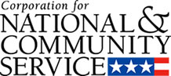

Corporation for National and Community Service

General Program Overview
AmeriCorps provides resources, both human and financial, to organizations that engage Americans in intensive service to meet our country’s critical needs.
Grantees use the funding to support AmeriCorps members for intensive service in their community. AmeriCorps grants partially cover the expense of operating an AmeriCorps program and do not cover general organizational expenses. A cash and in-kind match is required.

The main website can be accessed here: http://www.nationalservice.gov

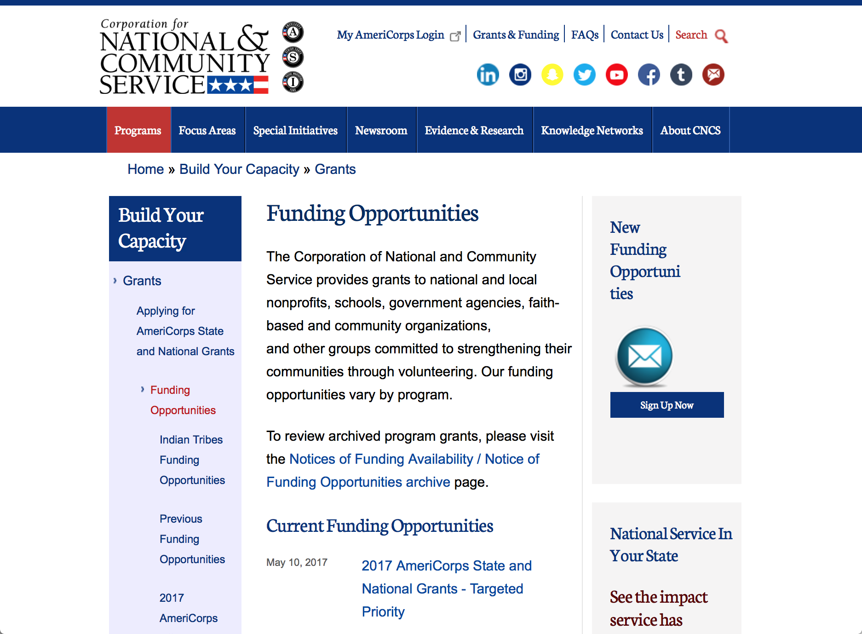

Current Funding Opportunities
There are no current funding opportunities.

For access to further funding information: click here

http://www.nationalservice.gov/build-your-capacity/grants/funding-opportunities

Programs:

2018 AmeriCorps State and National Grants - Targeted Priority
Synopsis 1

Document Type: | Grants Notice
Funding Opportunity Number: | CNCS-02-01-18
Funding Opportunity Title: | 2018 AmeriCorps State and National Grants - Targeted Priority
Opportunity Category: | Discretionary
Opportunity Category Explanation:
Funding Instrument Type: | Grant
Category of Funding Activity: | Community Development  Disaster Prevention and Relief  Education  Employment, Labor and Training  Environment  Food and Nutrition  Health  Housing  Natural Resources
Category Explanation:
Expected Number of Awards:
CFDA Number(s): | 94.006 -- AmeriCorps
Cost Sharing or Matching Requirement: | Yes
Version: | Synopsis 1
Posted Date: | Feb 01, 2018
Last Updated Date: | Feb 01, 2018
Original Closing Date for Applications: | May 02, 2018
Current Closing Date for Applications: | May 02, 2018
Archive Date: | May 03, 2018
Eligible Applicants: | Independent school districts  State governments  Native American tribal governments (Federally recognized)  Nonprofits having a 501(c)(3) status with the IRS, other than institutions of higher education  Native American tribal organizations (other than Federally recognized tribal governments)  County governments  Private institutions of higher education  Public and State controlled institutions of higher education  Special district governments  Nonprofits that do not have a 501(c)(3) status with the IRS, other than institutions of higher education  City or township governments  Public housing authorities/Indian housing authorities
Agency Name: | Corporation for National and Community Service
Description: | AmeriCorps grants are awarded to eligible organizations proposing to engage AmeriCorps members in evidence-based or evidence-informed interventions to strengthen communities. An AmeriCorps member is an individual who engages in community service through an approved national service position. Members may receive a living allowance and other benefits while serving. Upon successful completion of their service, members earn a Segal AmeriCorps Education Award from the National Service Trust that members can use to pay for higher education expenses or apply to qualified student loans.
Link to Additional Information: | Full competition information and resources
Grantor Contact Information: | If you have difficulty accessing the full announcement electronically, please contact:  202-606-7508  Competition inbox

https://www.grants.gov/web/grants/view-opportunity.html?oppId=300415

Research:

Reminders:

National Service In Hawaii
National Service in Your State - Hawaii
2015-2016

Meeting Community Needs in Hawaii: More than 3,100 people of all ages and backgrounds are helping to meet local needs, strengthen communities, and increase civic engagement through national service in Hawaii. Serving at more than 450 locations throughout the state, these citizens tutor and mentor children, support veterans and military families, provide health services, restore the environment, respond to disasters, increase economic opportunity, and recruit and manage volunteers. This year, the Corporation for National and Community Service (CNCS) will commit more than $6,260,000 to support Hawaii communities through national service initiatives. Through a unique public-private partnership, this federal investment will leverage an additional $9,060,000 in other resources to strengthen community impact, build local support, and increase return on taxpayer dollars. Nationwide, CNCS, its grantees, and project sponsors generated more than $1.25 billion in outside resources from businesses, foundations, public agencies, and other sources in FY 2015.

AmeriCorps
This year, AmeriCorps will provide more than 560 individuals the opportunity to provide intensive, results-driven service to meet education, environmental, health, economic, and other pressing needs in communities across Hawaii. Most AmeriCorps grant funding goes to the Hawaii Commission on National & Community Service, which in turn awards grants to nonprofit groups to respond to local needs. Most of the remainder of the grant funding is distributed by CNCS directly to multi-state and national organizations through a competitive grants process. Other individuals serve through AmeriCorps VISTA, whose members help bring individuals and communities out of poverty by serving full-time to fight illiteracy, improve health services, create businesses, and increase housing opportunities, and AmeriCorps NCCC (National Civilian Community Corps), a 10-month, full time residential program for men and women between the ages of 18 and 24. In exchange for their service, AmeriCorps members earn an education award that can be used to pay for college or to pay back qualified student loans. Since 1994, more than 5,900 Hawaii residents have served more than 6.4 million hours and have qualified for Segal AmeriCorps Education Awards totaling more than $14,980,000.
Download: AmeriCorps in Hawaii (PDF)
Senior Corps
More than 2,500 seniors in Hawaii contribute their time and talents in one of three Senior Corps programs. Foster Grandparents serve one-on-one as tutors and mentors to more than 310 young people who have special needs. Senior Companions help more than 220 homebound seniors and other adults maintain independence in their own homes. RSVP volunteers conduct safety patrols, renovate homes, protect the environment, tutor and mentor youth, respond to natural disasters, and provide other services through more than 250 groups across Hawaii.
Download: Senior Corps in Hawaii (PDF)

The Corporation for National and Community Service is a federal agency that improves lives, strengthens communities, and fosters civic engagement through service and volunteering. CNCS annually engages more than five million Americans in service to meet local needs through Senior Corps, AmeriCorps, and national days of service; improves communities through the Social Innovation Fund, and leads President Obama's national call to service initiative, United We Serve. To learn more visit NationalService.gov or Serve.gov or call 202-606-5000 or TTY 1-800-833-3722.

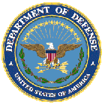

U.S. Department of Defense

Doing Business with the Department of Defense

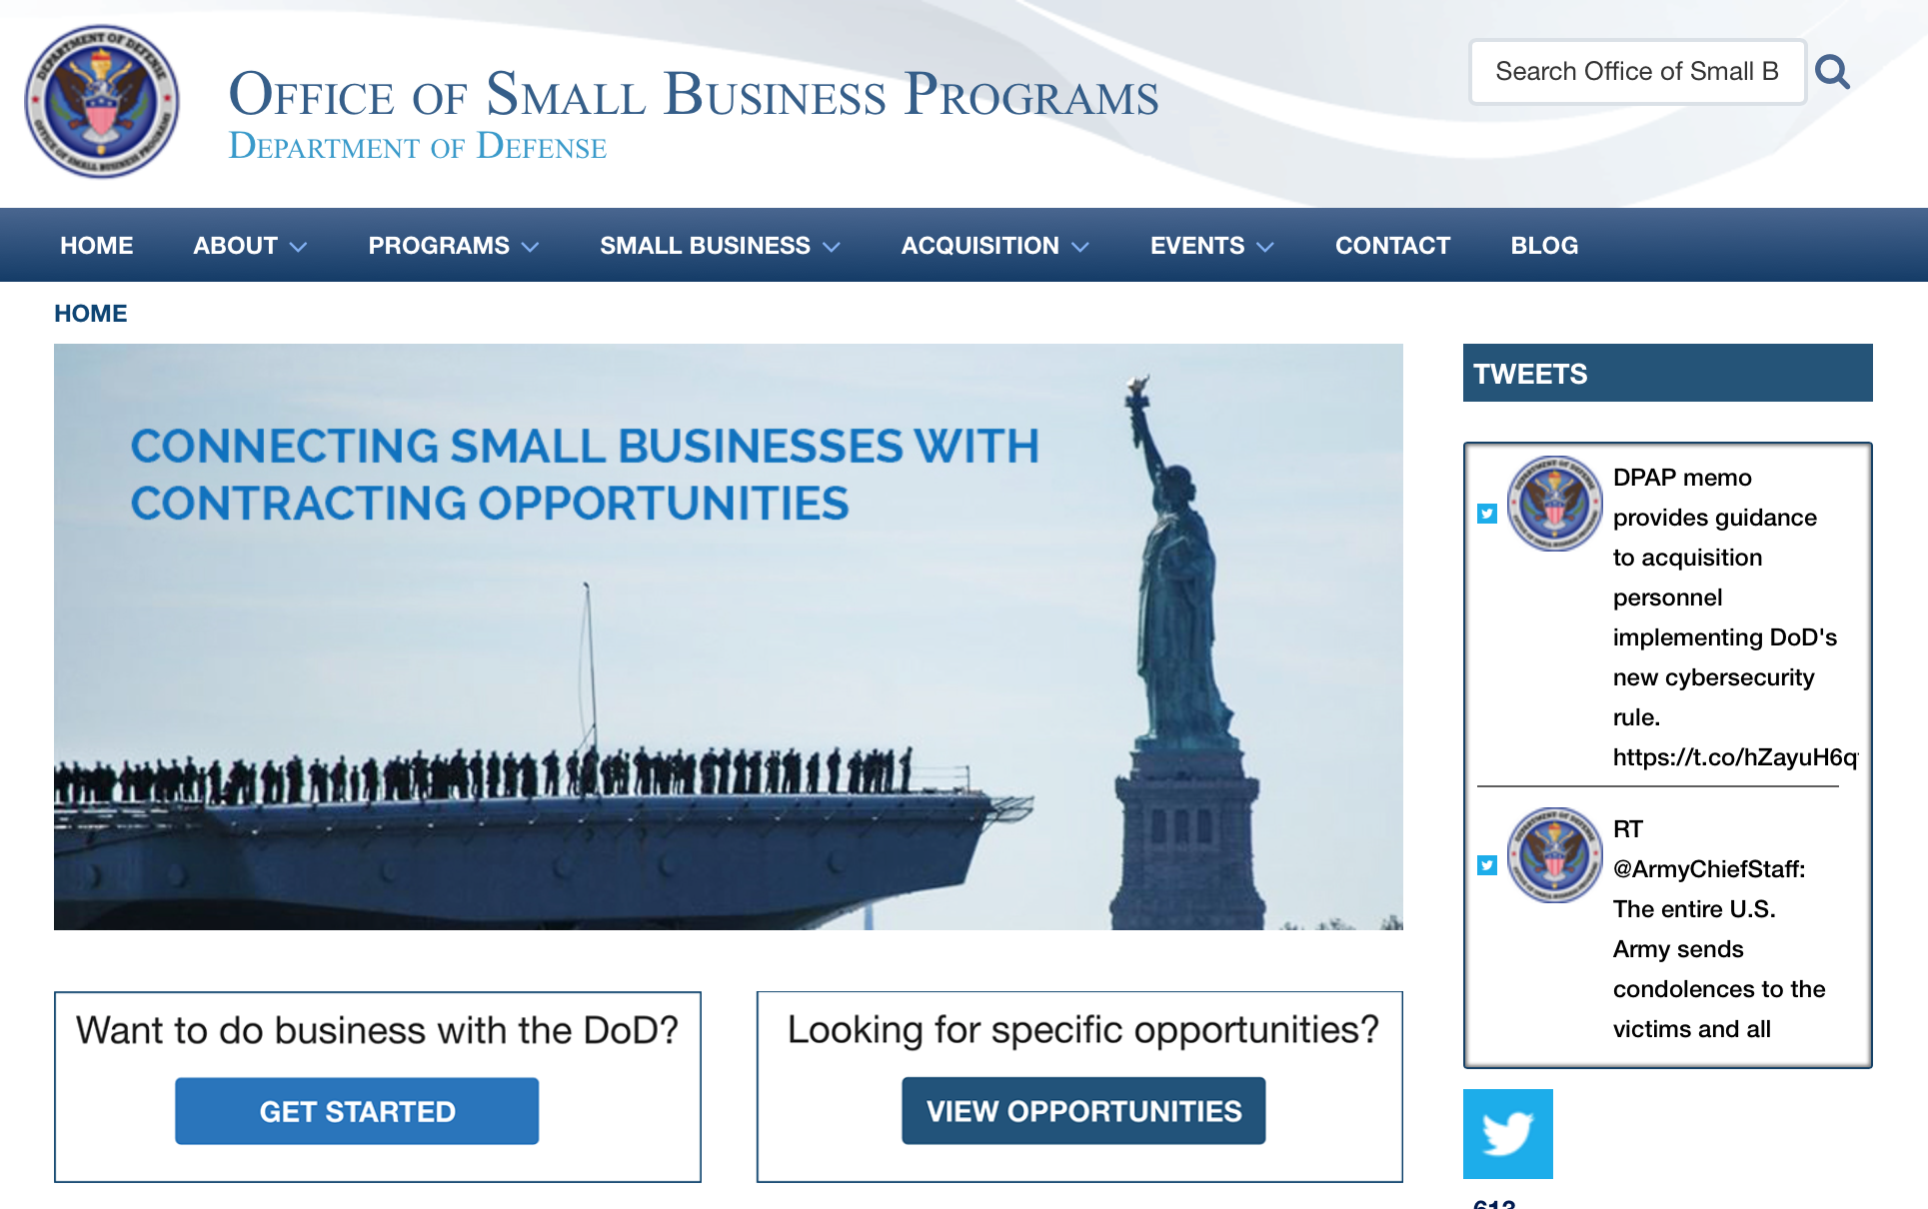

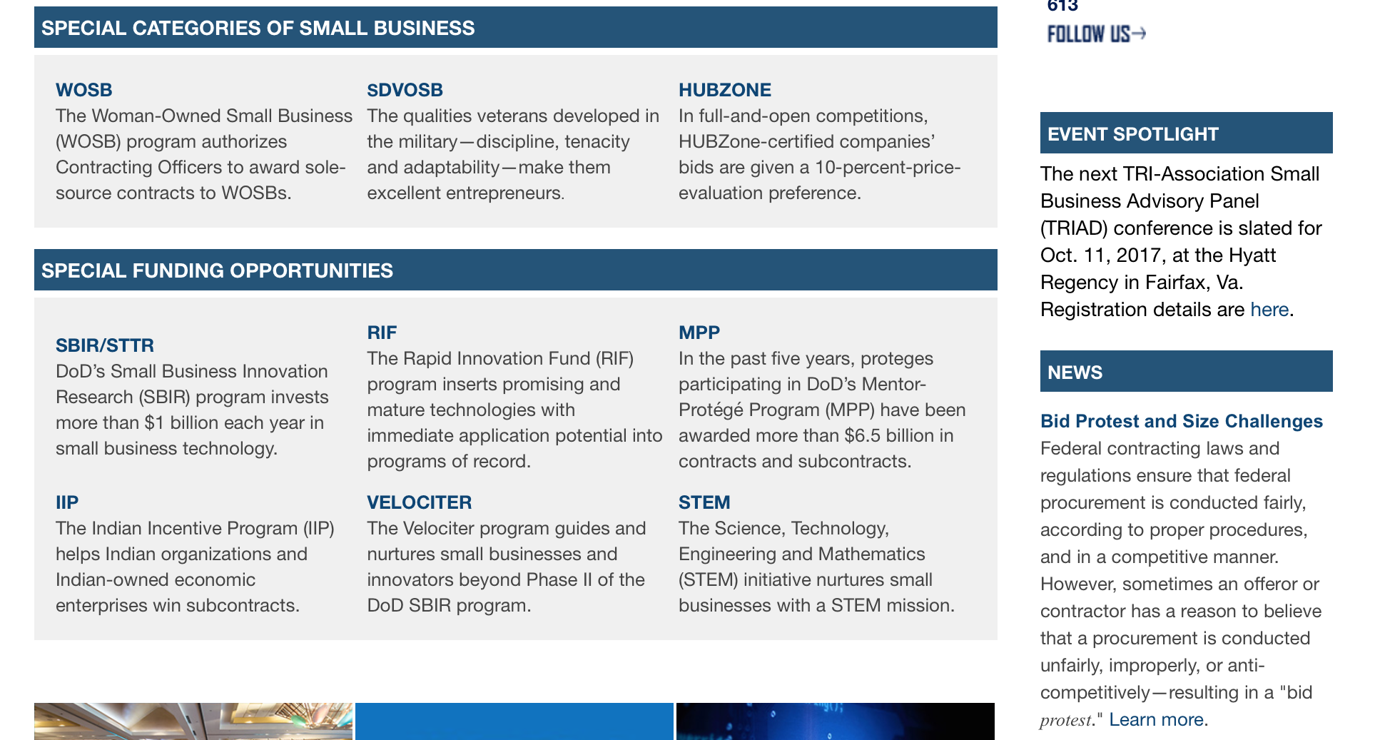

http://business.defense.gov

http://www.acq.osd.mil/osbp/

Doing Business with the DoD

Resources

Procurement Technical Assistance Centers (PTACs)

Procurement Technical Assistance Centers (PTACs) are charged with assisting businesses in learning how to do business with federal, state, and local governments. PTACs are a local resource available at no or nominal cost that can provide assistance to business firms in marketing their products and services. They offer training to businesses on how to research and bid on contracts, assist with registration requirements, provide bid-matching services, and assist with pre and post contracting issues.

Prime Contractors with Subcontracting Plans [xlsx]

Directory last updated 6/2017

This FY 2014 directory is intended for small business concerns seeking opportunities with DoD prime contractors. The directory is a listing of large business prime contractors who are required to establish subcontracting plans with goals. The report is generated from data contained in the Individual Subcontract Reports (ISRs) submitted in the Electronic Subcontracting Reporting System (eSRS) by contractors and from data contained in the Federal Procurement Data System (FPDS). The directory includes the name of the prime contractor; the major product/service code (PSC) provided to DoD; the major NAICS of the company; name, telephone number and email address of the company’s point of contact; contract number with the effective date and completion date, ultimate contract value and obligated dollars. In addition, many companies have websites with additional information which may be useful in your search for subcontracting opportunities or teaming arrangements.

Locate a Small Business Professional

Non-Appropriated Fund Customers

Non-appropriated fund customers operate similar to non-profit organizations and include commissaries, exchanges, recreation and fitness centers, dining at officer/enlisted/civilian clubs, and barber/beauty services, just to name a few.

For more information click here.

Research:

Air Force -- Research Lab
Secretary of the Air Force (SecAF) 2030 Science and Technology (S&T) Study
Synopsis 1
https://www.grants.gov/web/grants/view-opportunity.html?oppId=299847

DARPA - Defense Sciences Office
Driven and Nonequilibrium Quantum Systems (DRINQS)
Synopsis 1
https://www.grants.gov/web/grants/view-opportunity.html?oppId=300375

Engineer Research and Development Center
2018 ERDC Broad Agency Announcement
Synopsis 1
https://www.grants.gov/web/grants/view-opportunity.html?oppId=300459

Office of Naval Research
Fiscal Year (FY) 2018 Funding Opportunity Announcement (FOA) for the Office of Naval Research (ONR), on behalf of the Office of the Secretary of Defense (OSD), for the Manufacturing Engineering Education Program
Synopsis 1
https://www.grants.gov/web/grants/view-opportunity.html?oppId=300040

Modifications:

DARPA - Biological Technologies Office
PREventing EMerging Pathogenic Threats
Synopsis 2
https://www.grants.gov/web/grants/view-opportunity.html?oppId=300198

Deleted:

Reminders:



Department of Education
Grant Programs Overview at the Department of Education

The general information page for Education Grant funding is an excellent resource describing the three types of grants awarded by the Department of Education. See the screen shot of the Department of Education web page below:

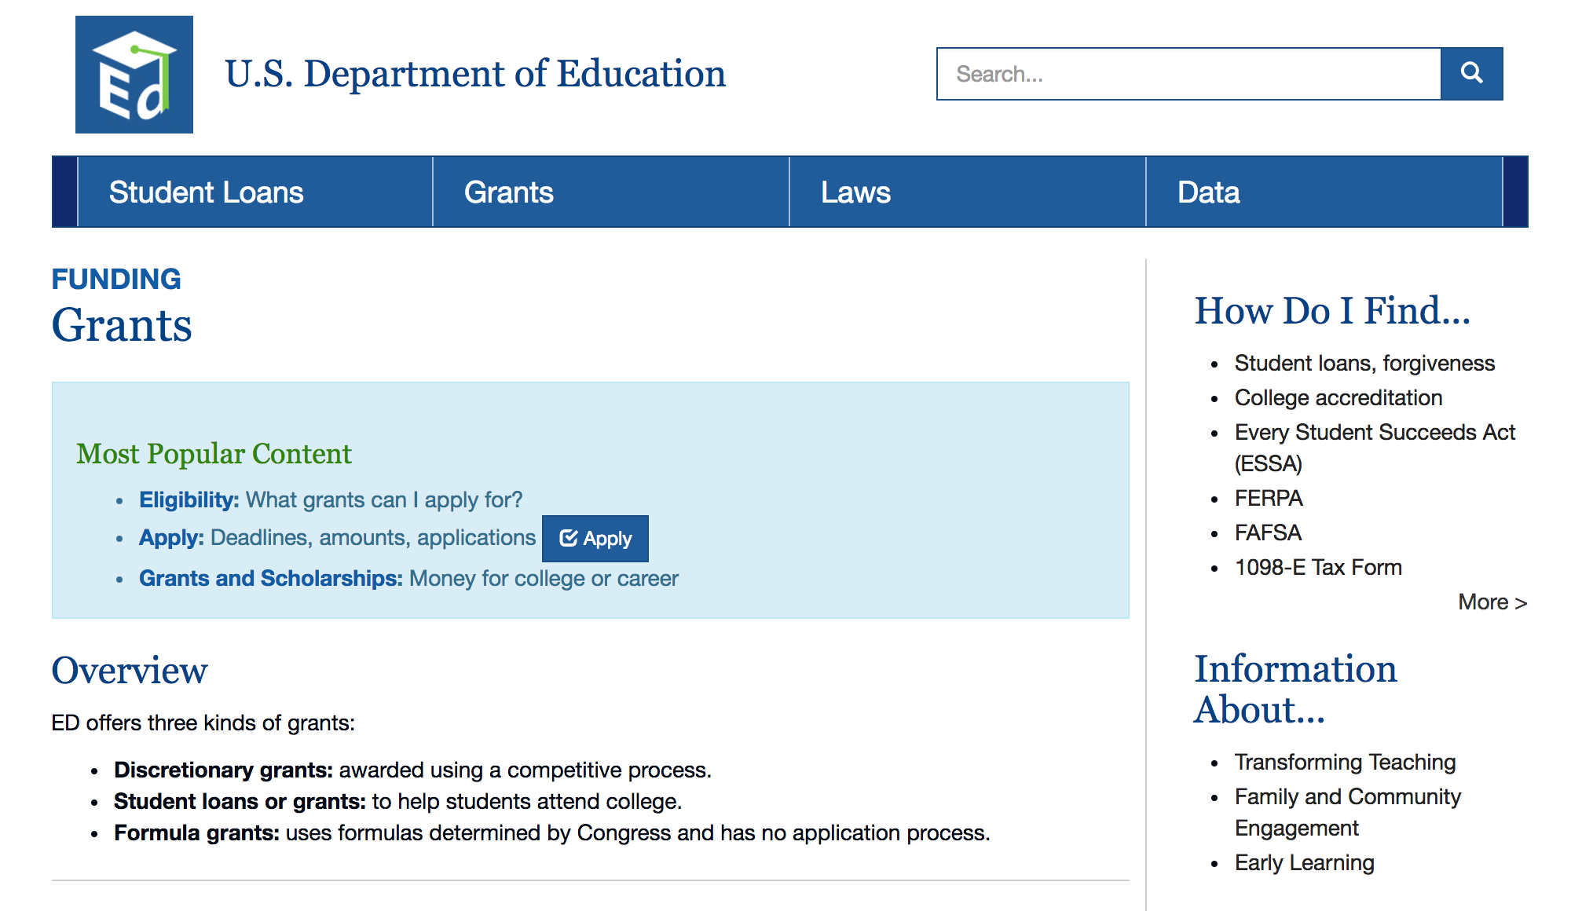
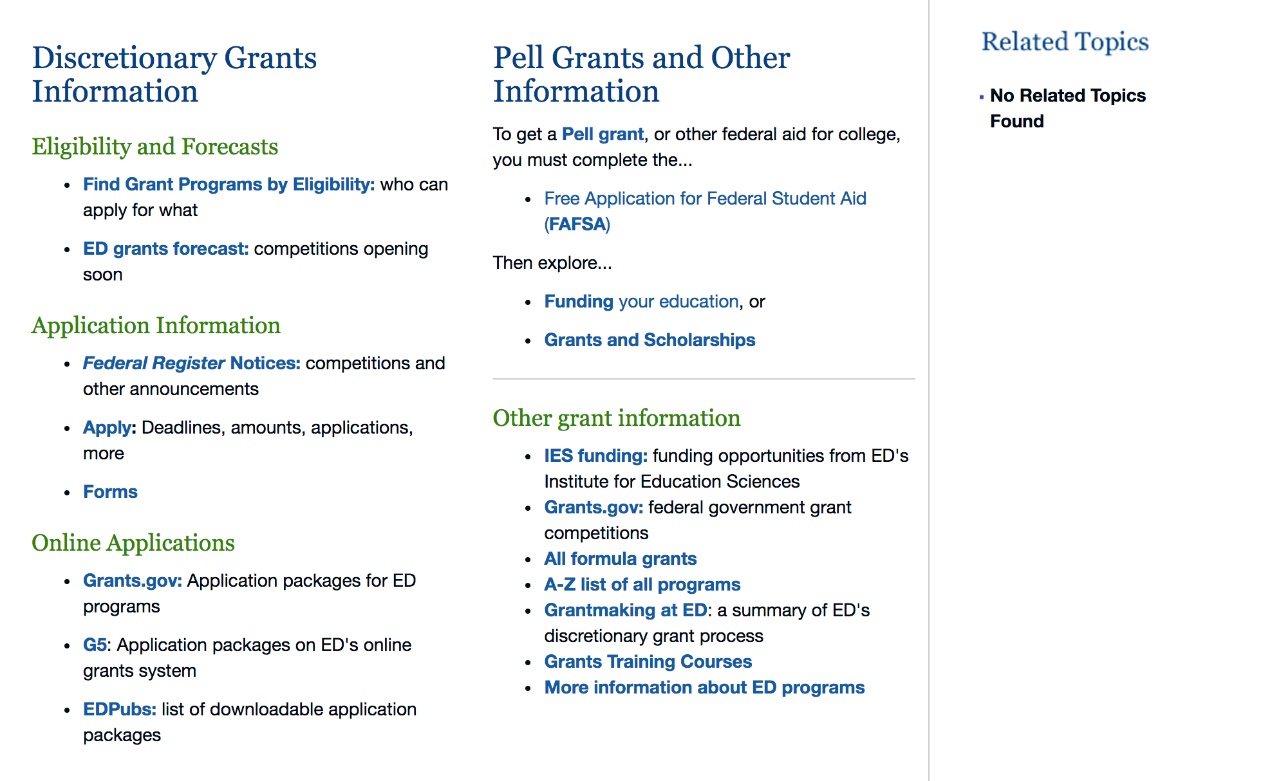

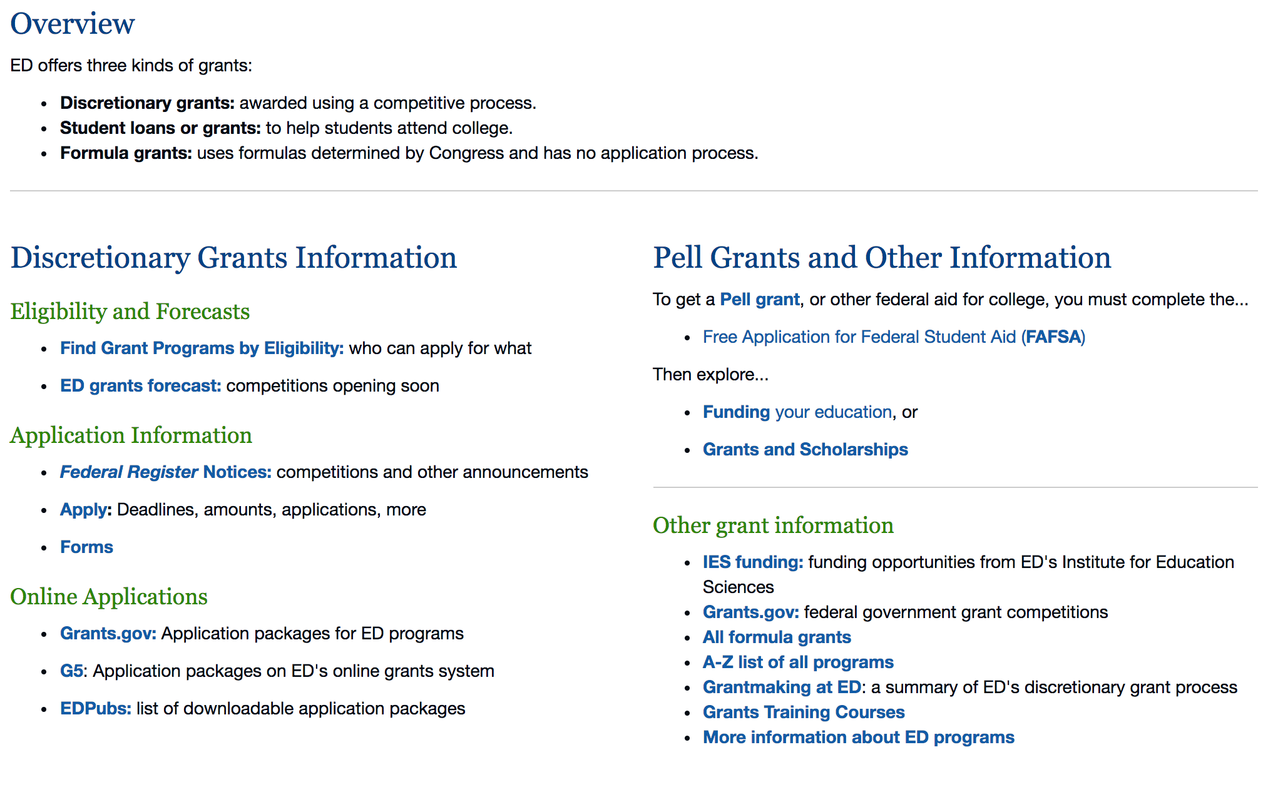

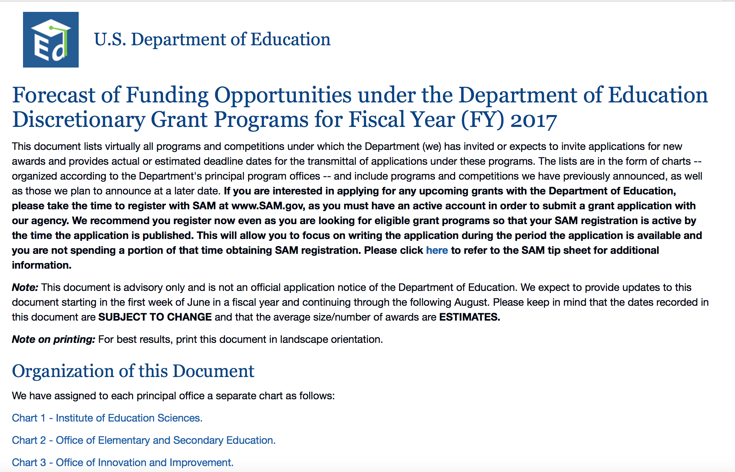
https://www2.ed.gov/fund/grants-apply.html?src=pn

https://www2.ed.gov/fund/grant/find/edlite-forecast.html

Programs:

Research:

Modifications:

Reminders:

Deleted:

U.S. Department of Energy

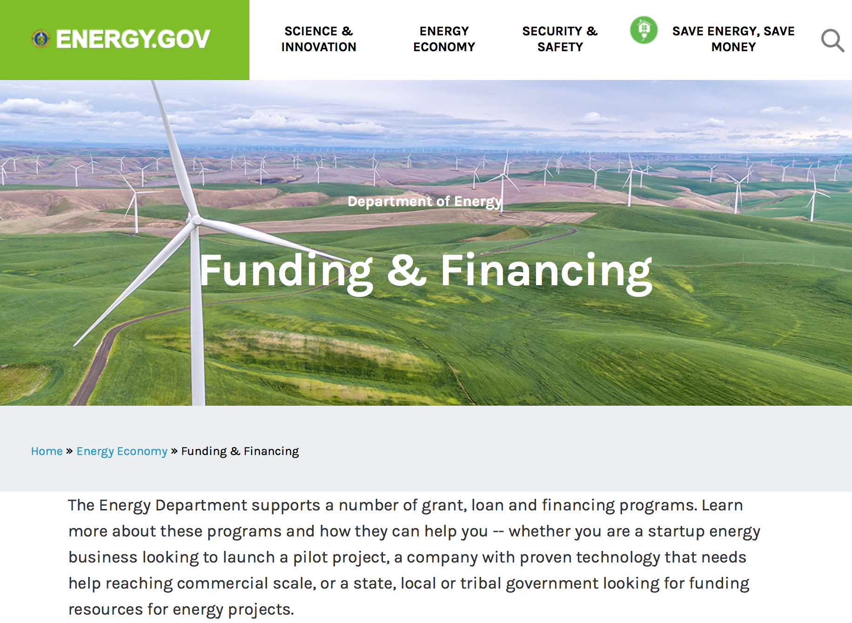

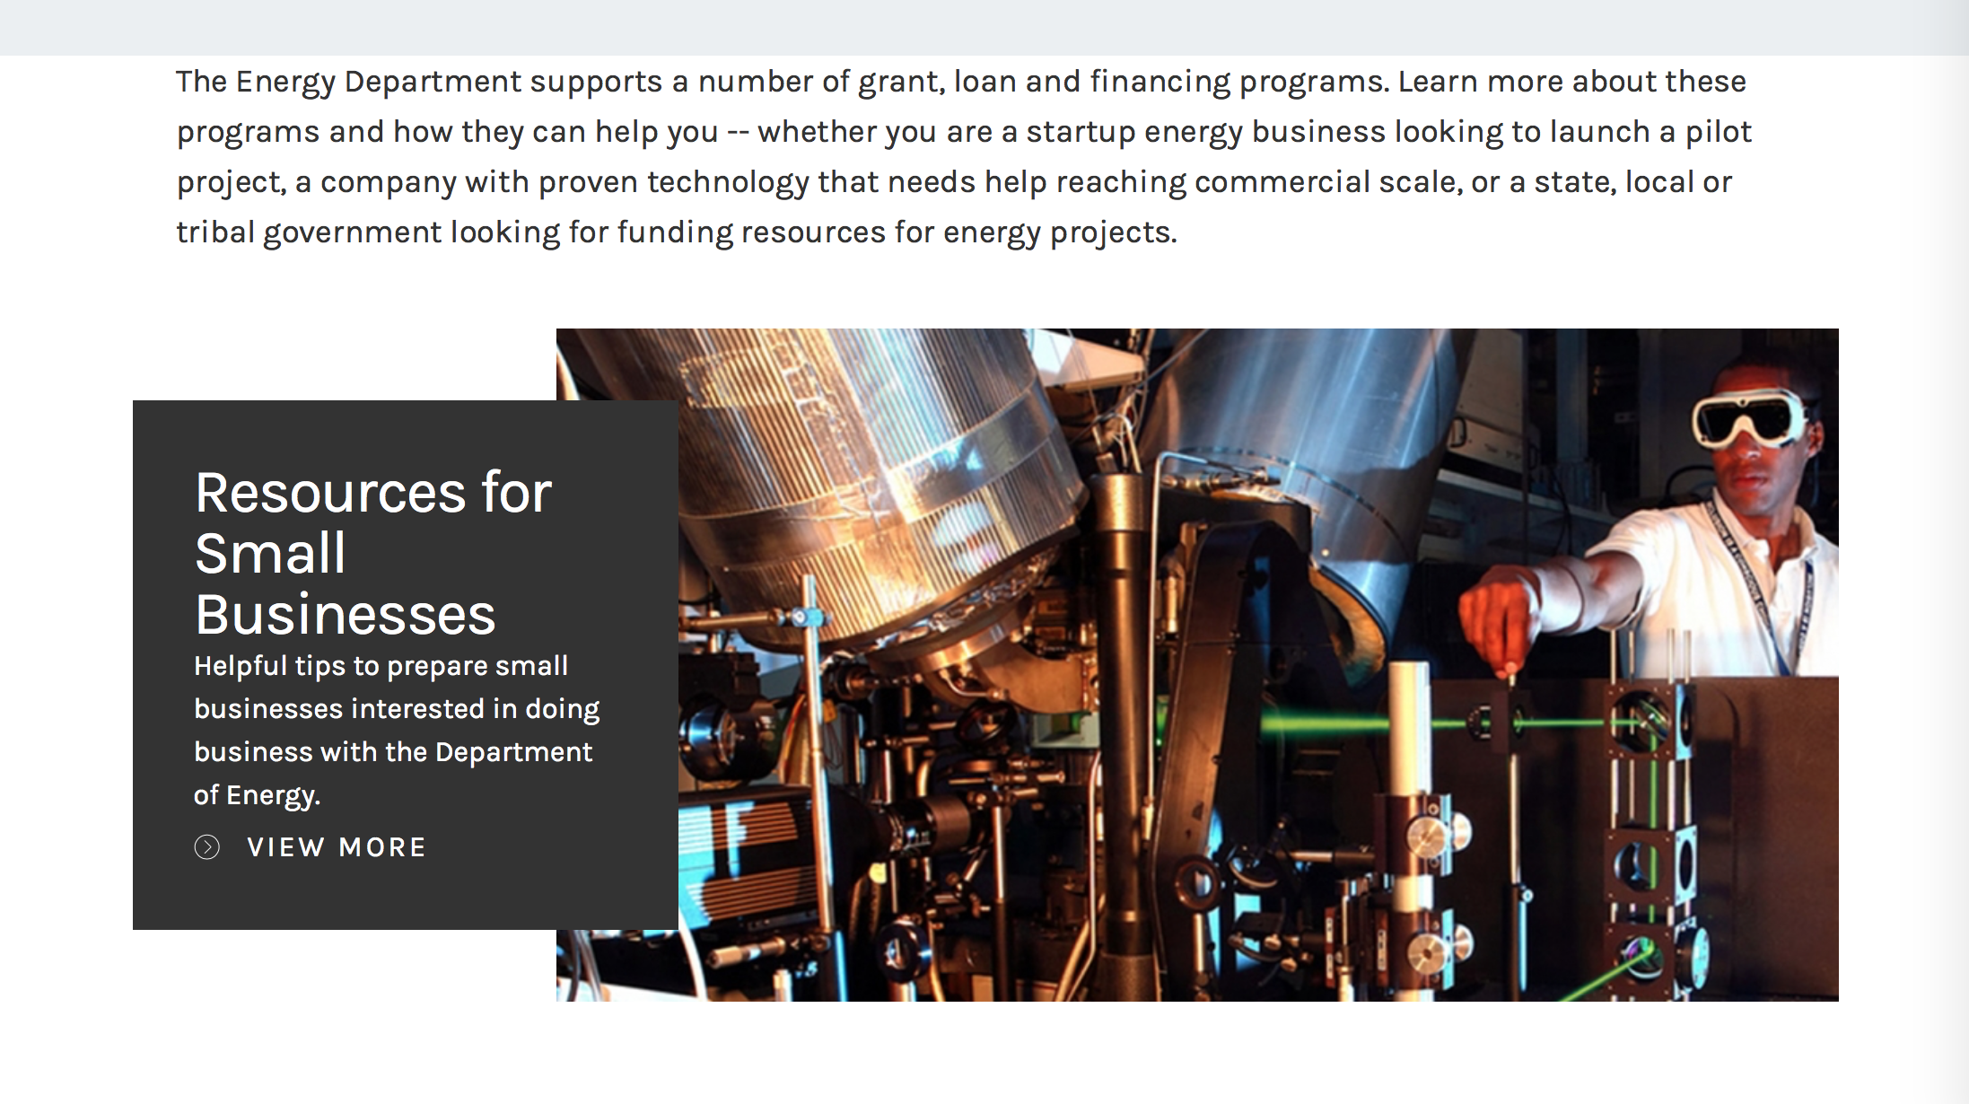

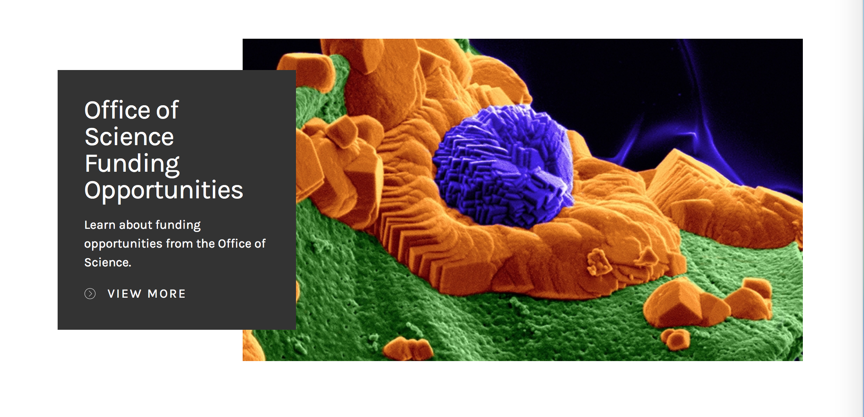

https://www.energy.gov/energy-economy/funding-financing

Research:

National Energy Technology Laboratory
Notice of Intent to Issue Funding Opportunity Announcement entitled “Innovative Technology Development to Enhance Fossil Power System Operability, Reliability, and Economic Performance”
Synopsis 1
https://www.grants.gov/web/grants/view-opportunity.html?oppId=299917

Office of Science
Plant Feedstock Genomics for Bioenergy
Synopsis 1
https://www.grants.gov/web/grants/view-opportunity.html?oppId=300049

Modifications:

Reminders:

Environmental Protection Agency

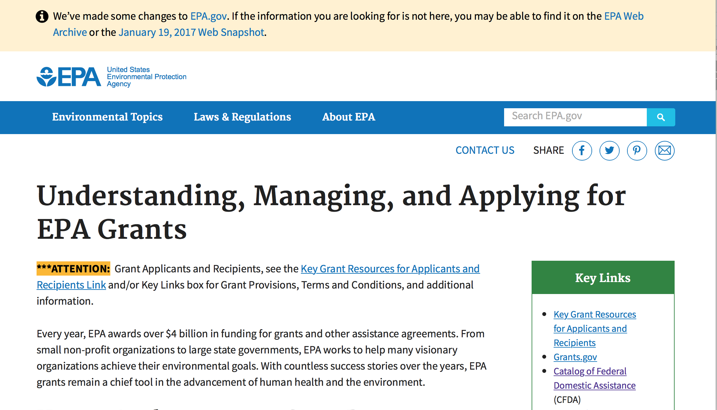
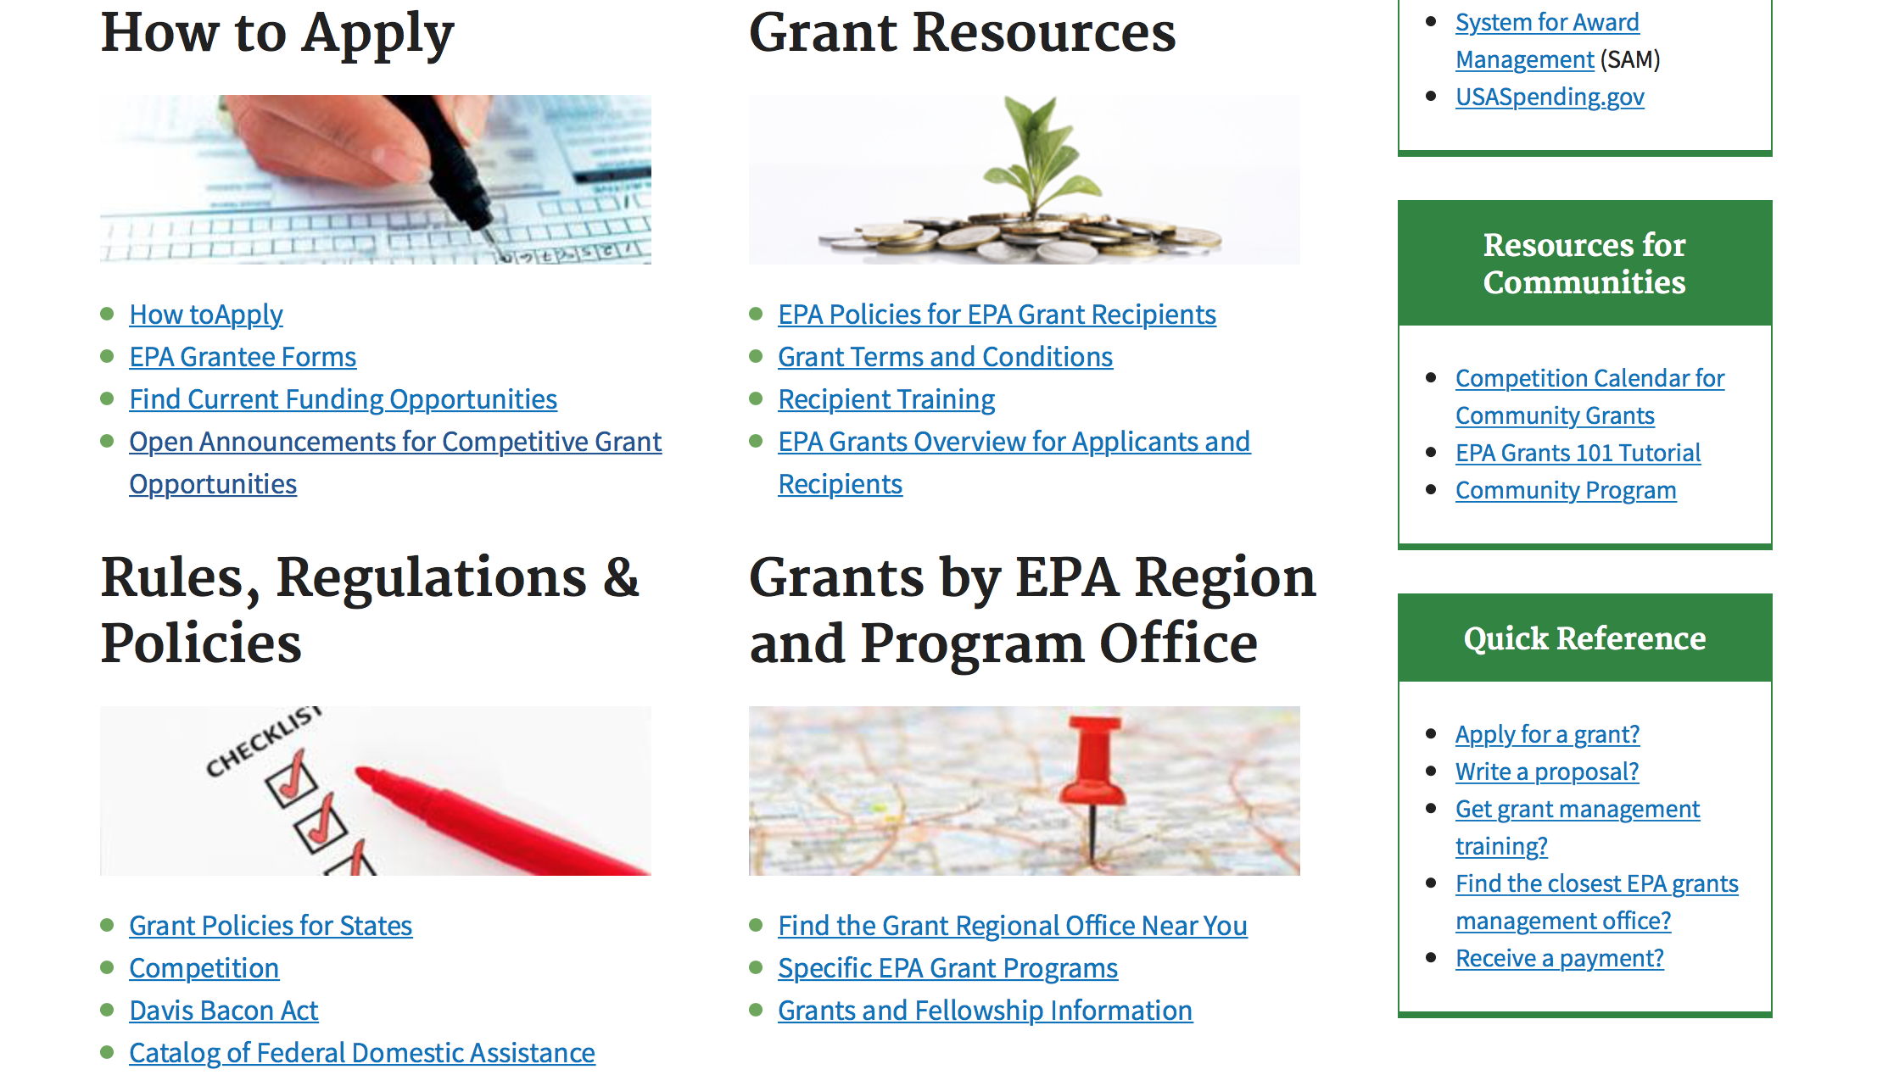

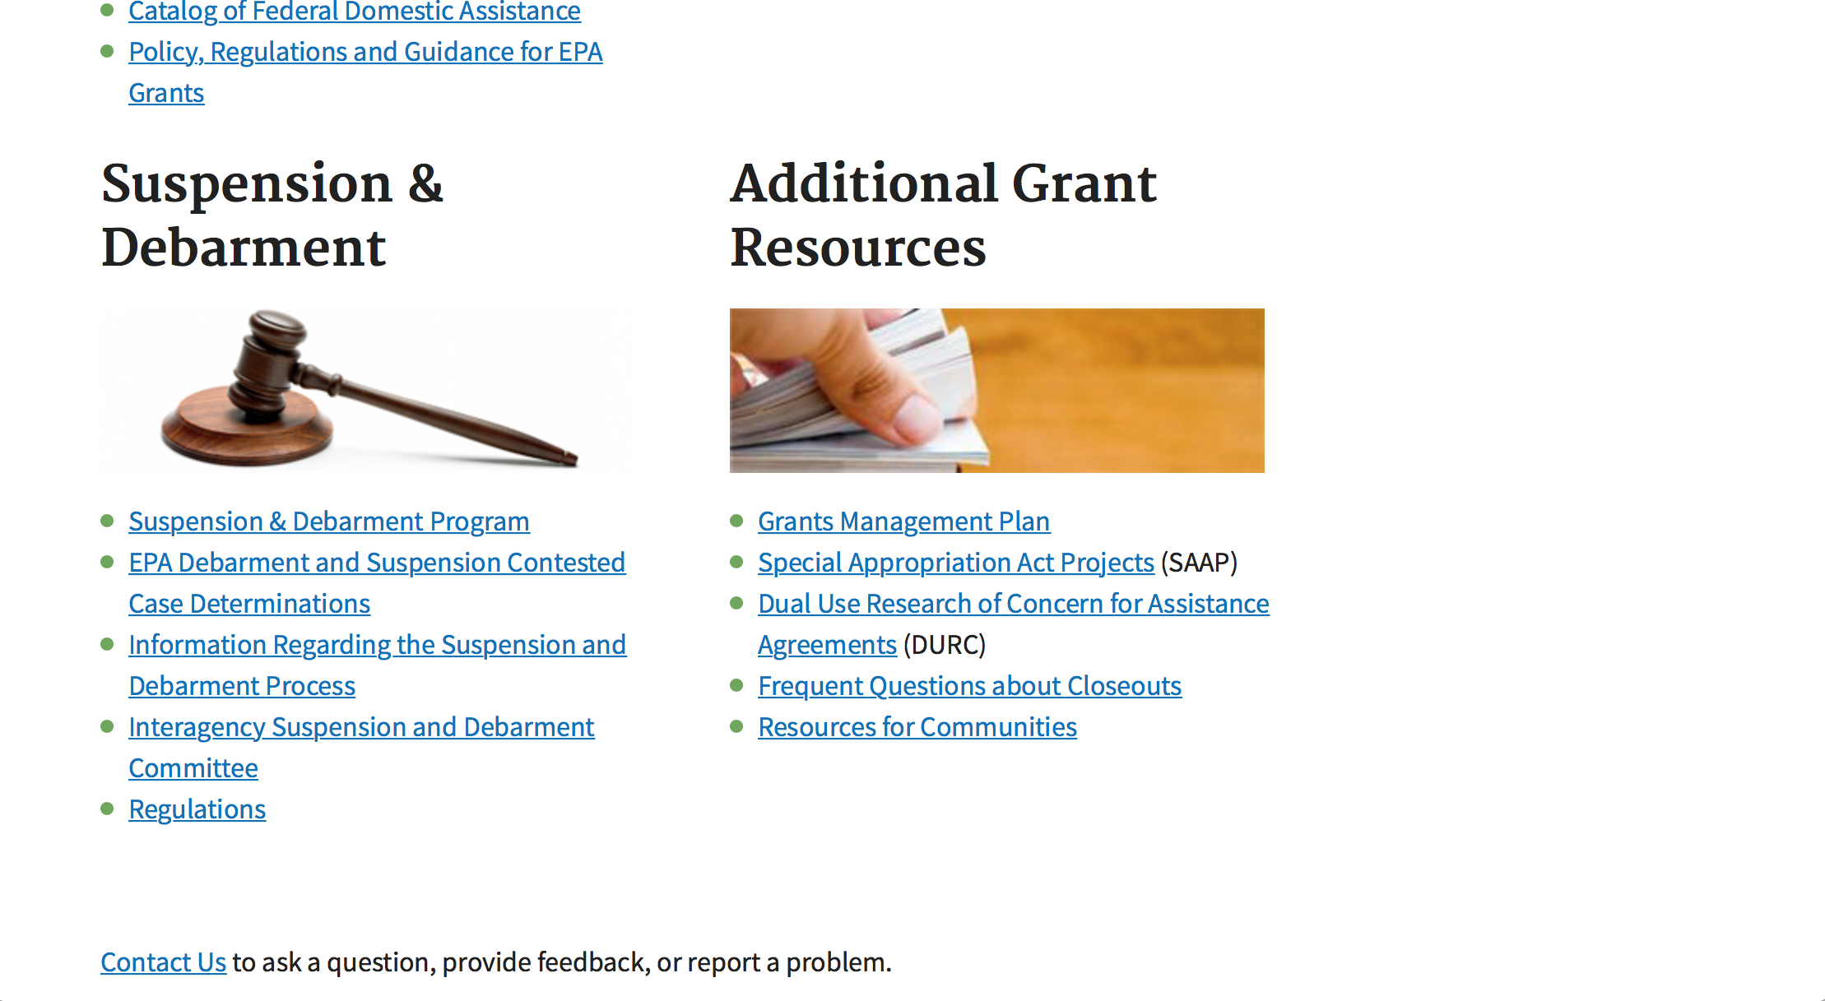

http://www.epa.gov/epahome/grants.htm

Programs:

Research:

Modifications:

Reminders:

Environmental Justice Collaborative Problem-Solving (EJCPS) Cooperative Agreement (Program)
Synopsis 1
Document Type: | Grants Notice
Funding Opportunity Number: | EPA-OP-OEJ-18-01
Funding Opportunity Title: | Environmental Justice Collaborative Problem-Solving (EJCPS) Cooperative Agreement
Opportunity Category: | Discretionary
Opportunity Category Explanation:
Funding Instrument Type: | Cooperative Agreement
Category of Funding Activity: | Environment
Category Explanation:
Expected Number of Awards: | 10
CFDA Number(s): | 66.306 -- Environmental Justice Collaborative Problem-Solving Cooperative Agreement Program
Cost Sharing or Matching Requirement: | No
Version: | Synopsis 1
Posted Date: | Nov 15, 2017
Last Updated Date: | Nov 15, 2017
Original Closing Date for Applications: | Feb 16, 2018 Please see the announcement for additional submission information.
Current Closing Date for Applications: | Feb 16, 2018 Please see the announcement for additional submission information.
Archive Date: | Mar 18, 2018
Estimated Total Program Funding: | $1,200,000
Award Ceiling: | $120,000
Award Floor: | $0
Eligible Applicants: | Others (see text field entitled "Additional Information on Eligibility" for clarification)
Additional Information on Eligibility: | Please see the announcement including Section III for additional eligibility information.
Agency Name: | Environmental Protection Agency
Description: | The Environmental Justice Collaborative Problem-Solving (EJCPS) Cooperative Agreement Program provides funding to support community-based organizations in their efforts to collaborate and partner with local stakeholder groups (e.g., local businesses and industry, local government, medical providers, and academia) as they develop and implement solutions that address environmental and/or public health issues for underserved communities. For purposes of this announcement, the term “underserved community” refers to a community with environmental justice concerns and/or vulnerable populations, including minority, low income, rural, tribal, and indigenous populations. Eligible projects must demonstrate use of the Environmental Justice Collaborative Problem-Solving Model to support their collaborative efforts during the project period. Applying organizations should have a direct connection to the underserved community impacted by the environmental harms and risks detailed in the workplan.
Link to Additional Information: | Environmental Justice Collaborative Problem-Solving (EJCPS) Cooperative Agreement
Grantor Contact Information: | If you have difficulty accessing the full announcement electronically, please contact:  Jacob Burney, 202-564-2907  Jacob Burney
http://www.grants.gov/web/grants/view-opportunity.html?oppId=298732

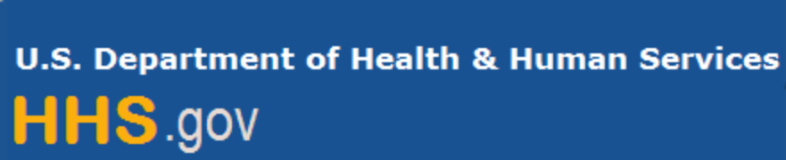

Department of Health and Human Services

Grants Forecast and Overview

The Department of Health and Human Services’ Grants Forecast is a database of planned grant opportunities proposed by its agencies. Each Forecast record contains actual or estimated dates and funding levels for grants that the agency intends to award during the fiscal year. Forecast opportunities are subject to change based on enactment of congressional appropriations.

For more general information about HHS Grants and Funding go to the website below at:

https://www.hhs.gov/grants/grants/index.html

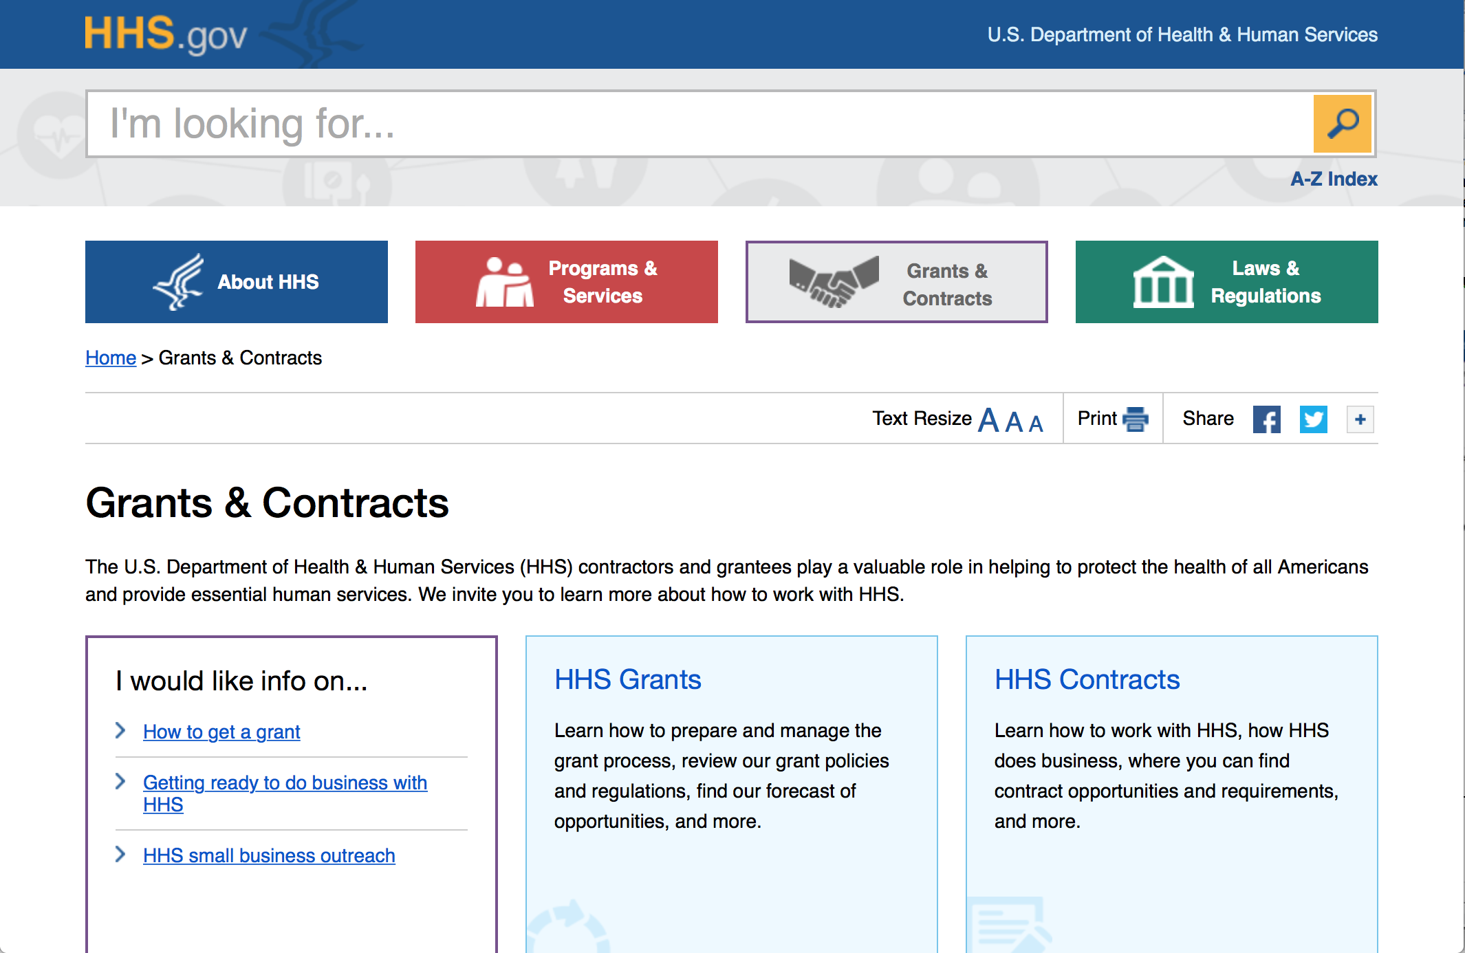

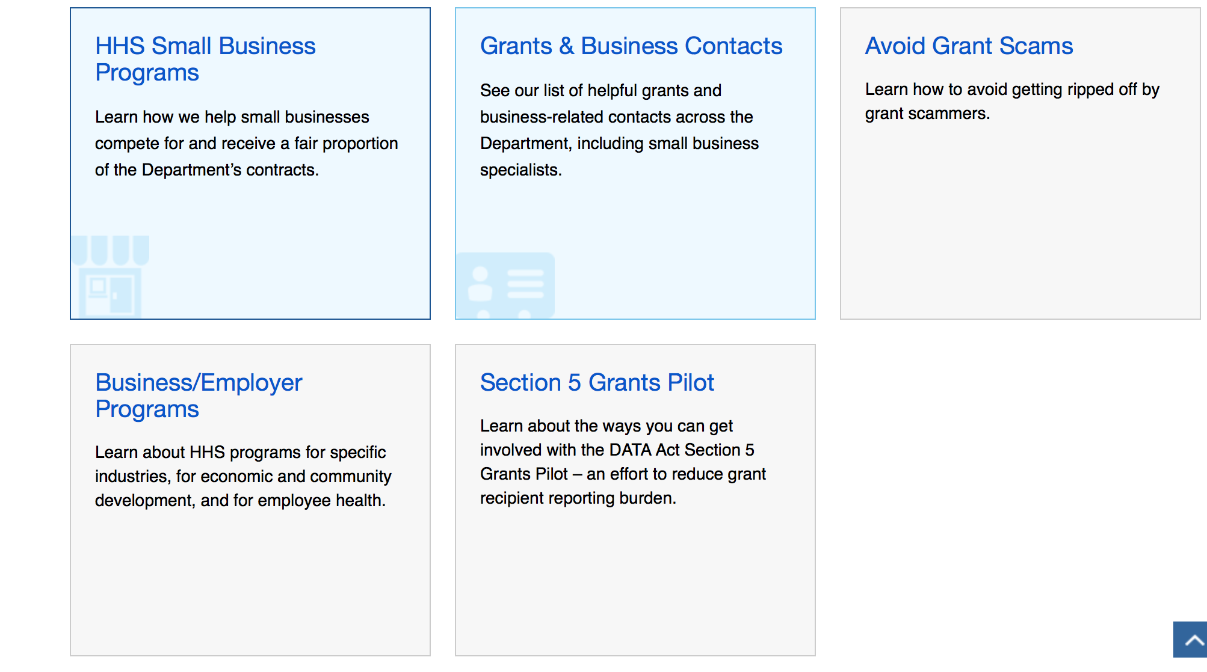

Programs:

Substance Abuse and Mental Health Services Administration
Drug Free Communities - New
Synopsis 1

Document Type: Grants Notice  Funding Opportunity Number: SP-18-002  Funding Opportunity Title: Drug Free Communities - New  Opportunity Category: Discretionary  Opportunity Category Explanation:  Funding Instrument Type: Grant  Category of Funding Activity: Health  Category Explanation:  Expected Number of Awards: 120  CFDA Number(s): 93.276 -- Drug-Free Communities Support Program Grants  Cost Sharing or Matching Requirement: Yes | Version: Synopsis 1  Posted Date: Jan 12, 2018  Last Updated Date: Jan 12, 2018  Original Closing Date for Applications: Mar 29, 2018  Current Closing Date for Applications: Mar 29, 2018  Archive Date: Apr 28, 2018  Estimated Total Program Funding: $15,000,000  Award Ceiling: $125,000  Award Floor: $0
Eligibility
Eligible Applicants: | Others (see text field entitled "Additional Information on Eligibility" for clarification)
Additional Information on Eligibility: | Eligible applicants are community-based coalitions addressing youth substance use that have never received a DFC grant. Applicants must meet all Statutory Eligibility Requirements. See Section III-1 of this FOA for complete eligibility information.
Additional Information
Agency Name: | Substance Abuse and Mental Health Services Administration
Description: | The DFC Program was created by the Drug-Free Communities Act of 1997 (Public Law 105-20). The DFC Support Program has two goals: 1. Establish and strengthen collaboration among communities, public and private non-profit agencies; as well as federal, state, local, and tribal governments to support the efforts of community coalitions working to prevent and reduce substance use among youth*. 2. Reduce substance use among youth and, over time, reduce substance abuse among adults by addressing the factors in a community that increase the risk of substance abuse and promoting the factors that minimize the risk of substance abuse. *For the purposes of this FOA, “youth” is defined as individuals 18 years of age and younger.
Link to Additional Information: | Fiscal Year 2018 Drug-Free Communities (DFC) Support Program New Funding Opportunity Announcement
Grantor Contact Information: | If you have difficulty accessing the full announcement electronically, please contact:  Odessa Crocker, Division of Grants Management, SAMHSA, Room 17E25D, 5600 Fishers Lane, Rockville, MD 20857 Phone: (240) 276-1400  DGMSAMHSA@samhsa.hhs.gov
https://www.grants.gov/web/grants/view-opportunity.html?oppId=298776

Substance Abuse and Mental Health Services Administration
Treatment for Individuals with Serious Mental Illness, Serious Emotional Disturbance or Co-Occurring Disorders Experiencing Homelessness (Short Title: Treatment for Individuals Experiencing Homelessness)
Synopsis 1
Document Type: | Grants Notice
Funding Opportunity Number: | SM-18-014
Funding Opportunity Title: | Treatment for Individuals with Serious Mental Illness, Serious Emotional Disturbance or Co-Occurring Disorders Experiencing Homelessness (Short Title: Treatment for Individuals Experiencing Homelessness)
Opportunity Category: | Discretionary
Opportunity Category Explanation:
Funding Instrument Type: | Grant
Category of Funding Activity: | Health
Category Explanation:
Expected Number of Awards: | 16
CFDA Number(s): | 93.243 -- Substance Abuse and Mental Health Services Projects of Regional and National Significance
Cost Sharing or Matching Requirement: | No
Version: | Synopsis 1
Posted Date: | Jan 08, 2018
Last Updated Date: | Jan 08, 2018
Original Closing Date for Applications: | Mar 09, 2018
Current Closing Date for Applications: | Mar 09, 2018
Archive Date: | Apr 08, 2018
Estimated Total Program Funding: | $10,393,000
Award Ceiling: | $1,000,000
Eligible Applicants: | Others (see text field entitled "Additional Information on Eligibility" for clarification)
Additional Information on Eligibility: | Eligible applicants are domestic public and private nonprofit entities. For example: • State governments and territories, including the District of Columbia, Guam, the Commonwealth of Puerto Rico, the Northern Mariana Islands, the Virgin Islands, American Samoa, the Federated States of Micronesia, the Republic of the Marshall Islands, and the Republic of Palau o Eligible state applicants are either the State Mental Health Agency (SMHA) or the Single State Agency (SSA) for Substance Abuse. However, SAMHSA’s expectation is that both the SSA and the SMHA will work in partnership to fulfill the requirements of the grant. To demonstrate this collaboration, applicants must provide a letter of commitment from the partnering entity in Attachment 5 of the application. If the SMHA and the SSA are one entity, applicants must include a statement to that effect in Attachment 5. • Governmental units within political subdivisions of a state, such as a county, city or town. • Federally recognized American Indian/Alaska Native (AI/AN) tribes, tribal organizations, Urban Indian Organizations, and consortia of tribes or tribal organizations. • Public or private universities and colleges. • Community- and faith-based organizations. Recipients that received an award under the FY 2017 (TI-17-009) Grants for the Benefit of Homeless Individuals (GBHI) FOA, or the FY 2016 and FY 2017 (SM-16-007) Cooperative Agreements to Benefit Homeless Individuals (CABHI) FOA, are not eligible to apply. If you submitted an application for the FY 2017 GBHI FOA and receive an award in FY 2018, you are not eligible to receive an award under this FOA program.
Additional Information
Agency Name: | Substance Abuse and Mental Health Services Administration
Description: | The Substance Abuse and Mental Health Services Administration (SAMHSA), Center for Mental Health Services (CMHS), is accepting applications for fiscal year (FY) 2018 –Treatment for Individuals with Serious Mental Illness, Serious Emotional Disturbance or Co-Occurring Disorders Experiencing Homelessness (Short Title: Treatment for Individuals Experiencing Homelessness). The purpose of this program is to support the development and/or expansion of the local implementation of an infrastructure that integrates behavioral health treatment and recovery support services for individuals, youth, and families with a serious mental illness, serious emotional disturbance or co-occurring disorder (i.e., a serious mental illness [SMI] and substance use disorder [SUD] or a serious emotional disturbance [SED] and SUD who are experiencing homelessness. The goal of this program is to increase capacity and provide accessible, effective, comprehensive, coordinated, integrated, and evidence-based treatment services, peer support and other recovery support services, and linkages to sustainable permanent housing. To achieve this goal, SAMHSA will support three types of activities: (1) integrated behavioral health treatment and other recovery-oriented services; (2) efforts to engage and connect clients to enrollment resources for health insurance, Medicaid, and mainstream benefits (e.g. Supplemental Security Income (SSI)/Social Security Disability Insurance (SSDI), Temporary Assistance for Needy Families (TANF), Supplemental Nutrition Assistance Program (SNAP), etc.); and (3) coordination of housing and services that support sustainable permanent housing.
Link to Additional Information: | Treatment for Individuals Experiencing Homelessness
Grantor Contact Information: | If you have difficulty accessing the full announcement electronically, please contact:  Gwendolyn Simpson Office of Financial Resources, Division of Grants Management Substance Abuse and Mental Health Services Administration 240-276-1408  FOACMHS@samhsa.hhs.gov
https://www.grants.gov/web/grants/view-opportunity.html?oppId=299880

Substance Abuse and Mental Health Services Administration
Grants to Establish and Expand Jail Diversion
Synopsis 1
Document Type: | Grants Notice
Funding Opportunity Number: | SM-18-005
Funding Opportunity Title: | Grants to Establish and Expand Jail Diversion
Opportunity Category: | Discretionary
Opportunity Category Explanation:
Funding Instrument Type: | Grant
Category of Funding Activity: | Health
Category Explanation:
Expected Number of Awards: | 8
CFDA Number(s): | 93.243 -- Substance Abuse and Mental Health Services Projects of Regional and National Significance
Cost Sharing or Matching Requirement: | Yes
Version: | Synopsis 1
Posted Date: | Jan 05, 2018
Last Updated Date: | Jan 05, 2018
Original Closing Date for Applications: | Mar 05, 2018
Current Closing Date for Applications: | Mar 05, 2018
Archive Date: | Apr 04, 2018
Estimated Total Program Funding: | $2,751,000
Award Ceiling: | $330,000
Award Floor: | $0
Eligible Applicants: | Others (see text field entitled "Additional Information on Eligibility" for clarification)
Additional Information on Eligibility: | Eligibility is statutorily limited by Section 9002, 21st Century Cures Act (P.L. 114-255) to states; political subdivisions of states; and Indian tribes and tribal organizations as defined in Section 4 of the Indian Self-Determination and Education Assistance Act or through agreements with other public and private non-profit entities. For example, • States and territories, including the District of Columbia, Guan, the Commonwealth of Puerto Rico, the Northern Mariana Islands, the Virgin Islands, American Samoa, the Federated States of Micronesia, the Republic of the Marshall Islands., and the Republic of Palau. • Governmental units within political subdivisions of a state (e.g., counties, cities, towns, villages). • Federally recognized American Indian/Alaska Native (AI/AN) tribes, tribal organizations, and consortia of tribes or tribal organizations. Tribal organization means the recognized body of any AI/AN tribe; any legally established organization of AI/ANs which is controlled, sanctioned, or chartered by such governing body, or which is democratically elected by the adult members of the Indian community to be served by such organization, and which includes the maximum participation of AI/ANs in all phases of its activities. Consortia of tribes or tribal organizations are eligible to apply, but each participating entity must indicate its approval. A single tribe in the consortium must be the legal applicant, the recipient of the award, and the entity legally responsible for satisfying the grant requirements.
Additional Information
Agency Name: | Substance Abuse and Mental Health Services Administration
Description: | The Substance Abuse and Mental Health Services Administration (SAMHSA), Center for Mental Health Services (CMHS), is accepting applications for fiscal year (FY) 2018 Law Enforcement and Behavioral Health Partnerships for Early Diversion grants. The purpose of this program is to establish or expand programs that divert adults with a serious mental illness (SMI) or a co-occurring disorder (COD) from the criminal justice system to community-based services prior to arrest and booking. Special consideration will be given to applicants proposing to use grant funding to support early diversion services for veterans. Data indicate that a significant number of individuals that come in contact with law enforcement and the criminal justice system have a mental disorder. The U.S. Department of Justice, Office of Justice Programs, reported that 1 in 7 state and federal prisoners (14 percent) and 1 in 4 jail inmates (26 percent) reported experiences that met the threshold for serious psychological distress. Approximately one-quarter of a million individuals with serious mental illnesses are incarcerated at any given moment – about half are arrested for non-violent offenses, such as trespassing or disorderly conduct. Approximately one quarter of a million individuals with serious mental illnesses are incarcerated at any given moment—about half arrested for non-violent offenses, such as trespassing or disorderly conduct . Effective diversion programs begins with establishing collaborative partnerships between law enforcement and community providers. Establishing clearly defined and sustainable partnerships is the first of four core strategies in the International Association of Chiefs of Police’ One Mind Campaign (http://www.theiacp. org/onemindcampaign) and the first element of the Crisis Intervention Team’s ten core elements http://cit.memphis.edu/pdf/.
Link to Additional Information: | Law Enforcement and Behavioral Health Partnerships for Early Diversion (Short Title: Early Diversion Grants)
Grantor Contact Information: | If you have difficulty accessing the full announcement electronically, please contact:  Gwendolyn Simpson 240-276-1408  FOACMHS@samhsa.hhs.gov
https://www.grants.gov/web/grants/view-opportunity.html?oppId=298771

Substance Abuse and Mental Health Services Administration
Minority AIDS: Integration of HIV-related Mental Health and Primary Care
Synopsis 1
Document Type: | Grants Notice
Funding Opportunity Number: | SM-18-004
Funding Opportunity Title: | Minority AIDS: Integration of HIV-related Mental Health and Primary Care
Opportunity Category: | Discretionary
Opportunity Category Explanation:
Funding Instrument Type: | Grant
Category of Funding Activity: | Health
Category Explanation:
Expected Number of Awards: | 10
CFDA Number(s): | 93.243 -- Substance Abuse and Mental Health Services Projects of Regional and National Significance
Cost Sharing or Matching Requirement: | No
Version: | Synopsis 1
Posted Date: | Jan 05, 2018
Last Updated Date: | Jan 05, 2018
Original Closing Date for Applications: | Mar 05, 2018
Current Closing Date for Applications: | Mar 05, 2018
Archive Date: | Apr 04, 2018
Estimated Total Program Funding: | $4,360,000
Award Ceiling: | $485,000
Eligible Applicants: | Others (see text field entitled "Additional Information on Eligibility" for clarification)
Additional Information on Eligibility: | Eligible applicants are domestic public and private non-profit entities. For example: • Governmental units within political subdivisions of a state, such as a county, city or town. • Federally recognized American Indian/Alaska Native (AI/AN) tribes, tribal organizations, Urban Indian Organizations, and consortia of tribes or tribal organizations. • Public or private universities and colleges. • Community- and faith-based organizations. • State governments, including territories (the District of Columbia, Guam, the Commonwealth of Puerto Rico, the Northern Mariana Islands, the Virgin Islands, American Samoa, the Federated States of Micronesia, the Republic of the Marshall Islands, and the Republic of Palau). Tribal organization means the recognized governing body of any Indian tribe; or any legally established organization of Indians which is controlled, sanctioned, or chartered by such governing body, or which is democratically elected by the adult members of the Indian community to be served by such organization, and which includes the maximum participation of Indians in all phases of its activities. Consortia of tribes or tribal organizations are eligible to apply, but each participating entity must indicate its approval. A single tribe in the consortium must be the legal applicant, the recipient of the award, and the entity legally responsible for satisfying the grant requirements. Urban Indian Organization (UIO) (as identified by the Office of Indian Health Service Urban Indian Health Programs through active Title V grants/contracts) means a non-profit corporate body situated in an urban center governed by an urban Indian-controlled board of directors, and providing for the maximum participation of all interested Individuals and groups, which body is capable of legally cooperating with other public and private entities for the purpose of performing the activities described in 503(a) of 25 U .S.C. § 1603. UIOs are not tribes or tribal governments and do not have the same consultation rights or trust relationship with the federal government.
Agency Name: | Substance Abuse and Mental Health Services Administration
Description: | The Substance Abuse and Mental Health Services Administration (SAMHSA), Center for Mental Health Services (CMHS), is accepting applications for fiscal year (FY) 2018 Minority AIDS Initiative: Service Integration grant program. The purpose of this program is to integrate evidence-based, culturally competent mental and substance use disorder treatment with HIV primary care and prevention services. The population of focus is individuals with a serious mental illness (SMI) or co-occurring disorder (COD) living with or at risk for HIV and/or hepatitis in at-risk populations, including racial and ethnic minority communities. SAMHSA expects that this program will reduce the incidence of HIV and improve overall health outcomes for individuals with SMI or COD. While there has been an overall decline in new HIV infections in the U.S. from 2008-2014, racial and ethnic minority communities continue to experience disproportionate impacts of HIV. The Centers for Disease Control and Prevention (CDC) reports significantly higher rates for HIV among racial and ethnic minority communities compared to the general population . In addition, rates of HIV and other blood-borne infections have remained higher for individuals with a SMI throughout the epidemic . When untreated, mental disorders affect access to and maintenance in HIV care. A recent study demonstrates a lower rate of HIV testing in some public mental health settings, which serves as an indicator of unmet needs for this population . The MAI-SI program objectives align with the National HIV AIDS Strategy and the National Viral Hepatitis Action Plan.
Link to Additional Information: | Minority AIDS Initiative – Service Integration (Short Title: MAI-SI)
Grantor Contact Information: | If you have difficulty accessing the full announcement electronically, please contact:  Gwendolyn Simpson 240-276-1408  Gwendolyn.simpson@samhsa.hhs.gov
https://www.grants.gov/web/grants/view-opportunity.html?oppId=298750

Research:

Administration for Community Living
Pension Counseling & Information Projects
Forecast 1
https://www.grants.gov/web/grants/view-opportunity.html?oppId=300054

Administration for Community Living
Senior Medicare Patrol (SMP) Projects
Forecast 1
https://www.grants.gov/web/grants/view-opportunity.html?oppId=300034
Agency for Health Care Research and Quality
Patient Safety Learning Laboratories: Pursuing Safety in Diagnosis and Treatment at the Intersection of Design, Systems Engineering, and Health Services Research (R18)
Synopsis 1
https://www.grants.gov/web/grants/view-opportunity.html?oppId=300046
Centers for Disease Control - NCHHSTP
National Center for HIV/AIDS, Viral Hepatitis, Sexually Transmitted Diseases and Tuberculosis Prevention (NCHHSTP) Public Health Conference Support
Synopsis 1
https://www.grants.gov/web/grants/view-opportunity.html?oppId=298667

Centers for Disease Control - NCCDPHP
Improving Student Health and Academic Achievement through Nutrition, Physical Activity and the Management of Chronic Conditions in Schools
Synopsis 1
https://www.grants.gov/web/grants/view-opportunity.html?oppId=299783

Centers for Disease Control - OPHPR
Hospital Preparedness Program - Public Health Emergency Preparedness Cooperative Agreement Department of Health and Human Services
Forecast 1
https://www.grants.gov/web/grants/view-opportunity.html?oppId=300313
Centers for Disease Control - NCCDPHP
State Public Health Approaches to Addressing Arthritis
Synopsis 1
https://www.grants.gov/web/grants/view-opportunity.html?oppId=298290
Food and Drug Administration
Pediatric Device Consortia Grants Program (P50)
Synopsis 1
https://www.grants.gov/web/grants/view-opportunity.html?oppId=300115

Health Resources and Services Administration
Grants to States to Support Oral Health Workforce Activities
Synopsis 1
https://www.grants.gov/web/grants/view-opportunity.html?oppId=300015

National Institutes of Health
Discovery of the Genetic Basis of Childhood Cancers and of Structural Birth Defects: Gabriella Miller Kids First Pediatric Research Program (X01, Clinical Trials Not Allowed)
Synopsis 1
https://www.grants.gov/web/grants/view-opportunity.html?oppId=300113

National Institutes of Health
Health Services and Economic Research on the Prevention and Treatment of Drug, Alcohol, and Tobacco Abuse (R01, Clinical Trial Optional)
Synopsis 1
https://www.grants.gov/web/grants/view-opportunity.html?oppId=300135

National Institutes of Health
Medications Development for the Treatment of Alcohol Use Disorder - CT optional (U01)
Synopsis 1
https://www.grants.gov/web/grants/view-opportunity.html?oppId=300143
National Institutes of Health
PHS 2018-02 Omnibus Solicitation of the NIH, CDC, and FDA for Small Business Innovation Research Grant Applications (Parent SBIR [R43/R44] Clinical Trial Not Allowed)
Synopsis 1
https://www.grants.gov/web/grants/view-opportunity.html?oppId=300111

National Institutes of Health
PHS 2018-02 Omnibus Solicitation of the NIH, CDC, and FDA for Small Business Innovation Research Grant Applications (Parent SBIR [R43/R44] Clinical Trial Required)
Synopsis 1
https://www.grants.gov/web/grants/view-opportunity.html?oppId=300130
National Institutes of Health
PHS 2018-02 Omnibus Solicitation of the NIH, CDC, and FDA for Small Business Technology Transfer Grant Applications (Parent STTR [R41/R42] Clinical Trial Required)
Synopsis 1
https://www.grants.gov/web/grants/view-opportunity.html?oppId=300131
National Institutes of Health
PHS 2018-02 Omnibus Solicitation of the NIH, CDC, and FDA for Small Business Technology Transfer Grant Applications (Parent STTR [R41/R42] Clinical Trial Not Allowed)
Synopsis 1
https://www.grants.gov/web/grants/view-opportunity.html?oppId=300132

National Institutes of Health
Competing Renewal Awards of SBIR Phase IIB Grants for Brain and Behavior Tools (R44 Clinical Trial Optional)
Synopsis 1
https://www.grants.gov/web/grants/view-opportunity.html?oppId=299922
National Institutes of Health
Complex Technologies and Therapeutics Development for Mental Health Research and Practice (R43/R44 Clinical Trial Optional)
Synopsis 1
https://www.grants.gov/web/grants/view-opportunity.html?oppId=300047
National Institutes of Health
Complex Technologies and Therapeutics Development for Mental Health Research and Practice (R41/R42)
Synopsis 1
https://www.grants.gov/web/grants/view-opportunity.html?oppId=300059
National Institutes of Health
Cutting-Edge Basic Research Awards (CEBRA) (R21-Clinical Trial Optional)
Synopsis 1
https://www.grants.gov/web/grants/view-opportunity.html?oppId=299918
National Institutes of Health
Emotional Function in Normal Aging and/or MCI and AD/ADRD (R01 - Clinical Trial Optional)
Synopsis 1
https://www.grants.gov/web/grants/view-opportunity.html?oppId=300052
National Institutes of Health
Emotional Function in Normal Aging and/or MCI and AD/ADRD (R21 - Clinical Trial Not Allowed)
Synopsis 1
https://www.grants.gov/web/grants/view-opportunity.html?oppId=300062
National Institutes of Health
Hearing Health Care for Adults: Improving Access and Affordability (R21 Clinical Trial Optional)
Synopsis 1
https://www.grants.gov/web/grants/view-opportunity.html?oppId=299935
National Institutes of Health
International Research Collaboration on Drug Abuse and Addiction Research (R01, Clinical Trial Optional)
Synopsis 1
https://www.grants.gov/web/grants/view-opportunity.html?oppId=299940
National Institutes of Health
Investigational New Drug (IND)-enabling Development of Medications to Treat Alcohol Use disorder and Alcohol-related disorders (UT2 -Clinical Trial Optional)
Synopsis 1
https://www.grants.gov/web/grants/view-opportunity.html?oppId=300042

National Institutes of Health
Investigational New Drug (IND)-enabling Development of Medications to Treat Alcohol Use disorder and Alcohol-related disorders (U44 - Clinical Trial Optional)
Synopsis 1
https://www.grants.gov/web/grants/view-opportunity.html?oppId=300056

National Institutes of Health
Lab to Marketplace: Tools for Brain and Behavioral Research (R43/R44 - Clinical Trial Optional
Synopsis 1
https://www.grants.gov/web/grants/view-opportunity.html?oppId=299939

National Institutes of Health
New Epidemiology Cohort Studies in Heart, Lung, Blood, and Sleep Diseases and Disorders (U01 - Clinical Trials Not Allowed)
Synopsis 1
https://www.grants.gov/web/grants/view-opportunity.html?oppId=300057
National Institutes of Health
NIDCD Mentored Career Development Award for Postdoctorate Au.D./Ph.D. Audiologists (K01 Clinical Trial Required)
Synopsis 1
https://www.grants.gov/web/grants/view-opportunity.html?oppId=299926

National Institutes of Health
NIDCD Research Career Enhancement Award for Established Investigators (K18 -Clinical Trials Required)
Synopsis 1
https://www.grants.gov/web/grants/view-opportunity.html?oppId=299936
National Institutes of Health
NIDCD Research Career Enhancement Award for Established Investigators (K18 - No Independent Clinical Trials)
Synopsis 1
https://www.grants.gov/web/grants/view-opportunity.html?oppId=299937

National Institutes of Health
NIH StrokeNet Clinical Trials and Biomarker Studies for Stroke Treatment, Recovery, and Prevention (U01 - Clinical Trial Optional)
Synopsis 1
https://www.grants.gov/web/grants/view-opportunity.html?oppId=299923

National Institutes of Health
NIH StrokeNet Small Business Innovation Clinical Trials and Biomarker Studies for Stroke Treatment, Recovery, and Prevention (U44 - Clinical Trials Optional)
Synopsis 1
https://www.grants.gov/web/grants/view-opportunity.html?oppId=299941

National Institutes of Health
Underactive Bladder and Detrusor Activity in Aging (R01 Clinical Trial Optional)
Synopsis 1
https://www.grants.gov/web/grants/view-opportunity.html?oppId=300000

National Institutes of Health
Underactive Bladder and Detrusor Activity in Aging (R03 Clinical Trial Optional)
Synopsis 1
https://www.grants.gov/web/grants/view-opportunity.html?oppId=300019

National Institutes of Health
Underactive Bladder and Detrusor Activity in Aging (R21 Clinical Trial Optional)
Synopsis 1
https://www.grants.gov/web/grants/view-opportunity.html?oppId=300020

National Institutes of Health
Cancer Prevention and Control Clinical Trials Grant Program (R01 Clinical Trial Required)
Synopsis 1
https://www.grants.gov/web/grants/view-opportunity.html?oppId=299822

National Institutes of Health
National Cancer Institute's Investigator-Initiated Early Phase Clinical Trials for Cancer Treatment and Diagnosis (R01 Clinical Trials Required)
Synopsis 1
https://www.grants.gov/web/grants/view-opportunity.html?oppId=299845

National Institutes of Health
NIDCD Clinical Research Center Grant (P50 - Clinical Trials Optional)
Synopsis 1
https://www.grants.gov/web/grants/view-opportunity.html?oppId=299776
National Institutes of Health
Notice of Intent to Publish a Funding Opportunity Announcement for First in Human and Early Stage Clinical Trials of Novel Investigational Drugs or Devices for Psychiatric Disorders (U01-Clinical Trial Required)
Forecast 1
https://www.grants.gov/web/grants/view-opportunity.html?oppId=299852

National Institutes of Health
Notice of Intent to Publish a Funding Opportunity Announcement for Diversity Program Consortium Dissemination and Translation Awards (U01 - Clinical Trial Not Allowed)
Forecast 1
https://www.grants.gov/web/grants/view-opportunity.html?oppId=299854
National Institutes of Health
Notice of Intent to Publish a Funding Opportunity Announcement for Analytical and Clinical Validation of Candidate Biomarkers for Neurological Diseases (U01)
Forecast 1
https://www.grants.gov/web/grants/view-opportunity.html?oppId=299855
National Institutes of Health
Notice of Intent to Publish a Funding Opportunity Announcement for the National Research Mentoring Network: The Science of Mentoring, Networking, and Navigating Career Transition Points (U01 - Clinical Trial Not Allowed)
Forecast 1
https://www.grants.gov/web/grants/view-opportunity.html?oppId=299856
National Institutes of Health
Research on Comparative Effectiveness and Implementation of HIV/AIDS and Alcohol Interventions (R01 - Clinical Trials Optional)
Synopsis 1
https://www.grants.gov/web/grants/view-opportunity.html?oppId=299793

National Institutes of Health
Understanding and Modifying Temporal Dynamics of Coordinated Neural Activity (R21 Clinical Trial Optional)
Synopsis 1
https://www.grants.gov/web/grants/view-opportunity.html?oppId=299775

National Institutes of Health
Understanding and Modifying Temporal Dynamics of Coordinated Neural Activity (R01) and Clinical Trial Optional
Synopsis 1
https://www.grants.gov/web/grants/view-opportunity.html?oppId=299794

National Institutes of Health
Clinical Observational (CO) Studies in Musculoskeletal, Rheumatic, and Skin Diseases (R01 Clinical Trial Not Allowed)
Synopsis 1
https://www.grants.gov/web/grants/view-opportunity.html?oppId=300333

National Institutes of Health
Coordination Center for Programs to Increase Diversity Among Individuals Engaged in Health-Related Research (PRIDE) (U24 Clinical Trial Not Allowed)
Synopsis 1
https://www.grants.gov/web/grants/view-opportunity.html?oppId=300330

National Institutes of Health
High-End Instrumentation (HEI) Grant Program (S10 Clinical Trial Not Allowed)
Synopsis 1
https://www.grants.gov/web/grants/view-opportunity.html?oppId=300320

National Institutes of Health
Leveraging Cognitive Neuroscience to Improve Assessment of Cancer Treatment-Related Cognitive Impairment (R01 Clinical Trial Optional)
Synopsis 1
https://www.grants.gov/web/grants/view-opportunity.html?oppId=300332

National Institutes of Health
Leveraging Cognitive Neuroscience to Improve Assessment of Cancer Treatment-Related Cognitive Impairment (R21 Clinical Trial Optional)
Synopsis 1
https://www.grants.gov/web/grants/view-opportunity.html?oppId=300346

National Institutes of Health
Methods Development in Natural Products Chemistry (R41/R42 Clinical Trial Not Allowed)
Synopsis 1
https://www.grants.gov/web/grants/view-opportunity.html?oppId=300348

National Institutes of Health
Methods Development in Natural Products Chemistry (R43/R44 Clinical Trial Not Allowed)
Synopsis 1
https://www.grants.gov/web/grants/view-opportunity.html?oppId=300353

National Institutes of Health
Programs to Increase Diversity Among Individuals Engaged in Health-Related Research (PRIDE) (R25 Clinical Trial Not Allowed)
Synopsis 1
https://www.grants.gov/web/grants/view-opportunity.html?oppId=300331

National Institutes of Health
Research on Current Topics in Alzheimer's Disease and Its Related Dementias (R01 Clinical Trial Optional)
Synopsis 1
https://www.grants.gov/web/grants/view-opportunity.html?oppId=300334

National Institutes of Health
Shared Instrumentation Grant (SIG) Program (S10 Clinical Trial Not Allowed)
Synopsis 1
https://www.grants.gov/web/grants/view-opportunity.html?oppId=300336

National Institutes of Health
Shared Instrumentation for Animal Research (SIFAR) Grant Program (S10 Clinical Trial Not Allowed)
Synopsis 1
https://www.grants.gov/web/grants/view-opportunity.html?oppId=300338

National Institutes of Health
Women and Sex/Gender Differences in Drug and Alcohol Abuse/Dependence (R01 Clinical Trial Optional)
Synopsis 1
https://www.grants.gov/web/grants/view-opportunity.html?oppId=300321

National Institutes of Health
Women and Sex/Gender Differences in Drug and Alcohol Abuse/Dependence (R21 Clinical Trial Optional)
Synopsis 1
https://www.grants.gov/web/grants/view-opportunity.html?oppId=300339
National Institutes of Health
Women and Sex/Gender Differences in Drug and Alcohol Abuse/Dependence (R03 Clinical Trial Optional)
Synopsis 1
https://www.grants.gov/web/grants/view-opportunity.html?oppId=300340

National Institutes of Health
Development of Novel and Emerging Technologies for Cryogenic or Long-term Preservation and Revival of Drosophila and Zebrafish Genetic Stocks (R43/R44 Clinical Trial Not Allowed)
Synopsis 1
https://www.grants.gov/web/grants/view-opportunity.html?oppId=300376

National Institutes of Health
Development of Novel and Emerging Technologies for Cryogenic or Long-term Preservation and Revival of Drosophila and Zebrafish Genetic Stocks (R41/R42 Clinical Trial Not Allowed)
Synopsis 1
https://www.grants.gov/web/grants/view-opportunity.html?oppId=300394

National Institutes of Health
Mechanistic investigations of psychosocial stress effects on opioid use patterns (R01- Clinical Trial Optional)
Synopsis 1
https://www.grants.gov/web/grants/view-opportunity.html?oppId=300441

National Institutes of Health
Mechanistic investigations of psychosocial stress effects on opioid use patterns (R21- Clinical Trial Optional)
Synopsis 1
https://www.grants.gov/web/grants/view-opportunity.html?oppId=300442
National Institutes of Health
Mentored Career Transition Award for Intramural Fellows (K22 Clinical Trials Required)
Synopsis 1
https://www.grants.gov/web/grants/view-opportunity.html?oppId=300377

National Institutes of Health
Mentored Career Transition Award for Intramural Fellows (K22 Clinical Trials Not Allowed)
Synopsis 1
https://www.grants.gov/web/grants/view-opportunity.html?oppId=300397

National Institutes of Health
NIDA Small Research Grant Program (R03 Clinical Trial Required)
Synopsis 1
https://www.grants.gov/web/grants/view-opportunity.html?oppId=300457
National Institutes of Health
NIDA Academic Research Enhancement Award (R15, Clinical Trials Required)
Synopsis 1
https://www.grants.gov/web/grants/view-opportunity.html?oppId=300458

National Institutes of Health
NINDS Exploratory Clinical Trials for Small Business (R42) - Clinical Trial Required
Synopsis 1
https://www.grants.gov/web/grants/view-opportunity.html?oppId=300387

National Institutes of Health
NINDS Exploratory Clinical Trials for Small Business (R44) - Clinical Trial Required
Synopsis 1
https://www.grants.gov/web/grants/view-opportunity.html?oppId=300390

National Institutes of Health
Pilot and Feasibility Studies of HIV and Animal Models for HIV Infection within the Mission of NIDDK (R21 Clinical Trial Optional)
Synopsis 1
https://www.grants.gov/web/grants/view-opportunity.html?oppId=300401

National Institutes of Health
Traceback Testing: Increasing Identification and Genetic Counseling of Mutation Carriers through Family-based Outreach (U01 Clinical Trial Optional)
Synopsis 1
https://www.grants.gov/web/grants/view-opportunity.html?oppId=300386

National Institutes of Health
Training Modules to Enhance the Rigor and Reproducibility of Biomedical Research (R25 Clinical Trial Not Allowed)
Synopsis 1
https://www.grants.gov/web/grants/view-opportunity.html?oppId=300392

National Institutes of Health
Understanding Processes of Recovery in the Treatment of Alcohol Use Disorder (R21 - Clinical Trial Optional)
Synopsis 1
https://www.grants.gov/web/grants/view-opportunity.html?oppId=300435
Modifications:

Centers for Disease Control - OSTLTS
Technical Assistance for Response to Public Health or Healthcare Crises
Synopsis 3
https://www.grants.gov/web/grants/view-opportunity.html?oppId=298696

Centers for Disease Control - OSTLTS
Strengthening Public Health Systems and Services Through National Partnerships to Improve and Protect the Nation's Health
Synopsis 2
https://www.grants.gov/web/grants/view-opportunity.html?oppId=300318

Food and Drug Administration
Vet-LIRN Network Capacity-Building Projects
Synopsis 3
https://www.grants.gov/web/grants/view-opportunity.html?oppId=300344

Office of the Assistant Secretary for Health
FY18 The National Lupus Training, Outreach, and Clinical Trial Education Program (Lupus Program)
Synopsis 5
https://www.grants.gov/web/grants/view-opportunity.html?oppId=299881

Deleted:

Reminders:

Administration for Children and Families - ACYF/CB (Program)
Strengthening Child Welfare Systems to Achieve Expected Child and Family Outcomes
Forecast 1
Document Type: | Grants Notice
Opportunity Number: | HHS-2018-ACF-ACYF-CO-1360
Opportunity Title: | Strengthening Child Welfare Systems to Achieve Expected Child and Family Outcomes
Opportunity Category: | Discretionary
Opportunity Category Explanation:
Funding Instrument Type: | Cooperative Agreement
Category of Funding Activity: | Income Security and Social Services
Category Explanation:
Expected Number of Awards: | 5
CFDA Number(s): | 93.652 -- Adoption Opportunities
Cost Sharing or Matching Requirement: | No
Version: | Forecast 1
Posted Date: | Nov 07, 2017
Last Updated Date: | Nov 07, 2017
Estimated Synopsis Post Date: | Feb 07, 2018
Estimated Application Due Date: | Apr 08, 2018 Electronically submitted applications must be submitted no later than 11:59 p.m., ET, on the listed application due date.
Estimated Award Date: | Sep 29, 2018
Estimated Project Start Date: | Sep 30, 2018
Fiscal Year: | 2018
Archive Date:
Estimated Total Program Funding: | $8,750,000
Award Ceiling: | $1,750,000
Award Floor: | $1,000,000
Eligible Applicants: | County governments  State governments
Additional Information on Eligibility: | Courts are required partners. Partnerships with other public and private child and family serving agencies and organizations are encouraged. Applications from individuals (including sole proprietorships) and foreign entities are not eligible and will be disqualified from competitive review and from funding under this announcement.
Agency Name: | Administration for Children and Families - ACYF/CB
Description: | Child and Family Services Reviews have consistently found that many child welfare agencies are not achieving substantial conformity on permanency outcomes, including failure to make concerted efforts towards timely permanency for adoption and preserving family connections. Findings related to child and family outcomes, include, but are not limited to, lack of service provision, child and parent engagement in case planning, and child visitations; delays in establishing the goal of adoption; inadequate concurrent permanency goal planning; and lengthy appeal processes for contested termination of parental rights. These outcomes relate to basic social work practices that also have effects on the safety and well-being of children in care. The purpose of this funding opportunity is to award up to five 5-year cooperative agreements for the development, implementation, and evaluation of strategies that focus on improving basic social work practices, policies, and procedures in order to improve outcomes and eliminate systemic barriers to adoption and other forms of permanency. Due to the intersection of permanency, safety, and well-being, an effective system reform effort focused on improving concurrent planning and reducing time to permanency will also require attention to safety and well-being outcomes. Therefore, through these grant awards, the Children's Bureau (CB) aims to support states with resources to implement and sustain child welfare system improvement efforts, including technical assistance support, in order to assist grantees in strengthening outcomes related to permanency, safety, and well-being. Using Child and Family Services Review findings, as well as Program Improvement Plans, Child and Family Services Plans, and/or Annual Progress and Services Reports, applicants will identify barriers, challenges, and potential solutions to: ensuring child safety; enhanced engagement with and service delivery to children and families, including fathers; maintaining family relationships and connections; supporting placement of children in kinship care arrangements, preadoptive, or adoptive homes; and/or permanency planning and achievement. During the project period, grantees will address these barriers and challenges through the development, implementation, and evaluation of intervention strategies that focus on improving basic child welfare practices - including family-focused approaches - and systemic factors. Applicants will be required to partner with courts and other systems that are involved with state or county-level child welfare initiatives and must demonstrate buy-in from appropriate leadership.
Link to Additional Information:
Grantor Contact Information: | Serena L. Parks  (202) 205-8175  Serena.Parks@acf.hhs.gov
http://www.grants.gov/web/grants/view-opportunity.html?oppId=298470

Department of Homeland Security

The Department of Homeland Security enhances the ability of states, local and tribal jurisdictions, and other regional authorities in the preparation, prevention, and response to terrorist attacks and other disasters, by distributing grant funds. Localities can use grants for planning, equipment, training and exercise needs.

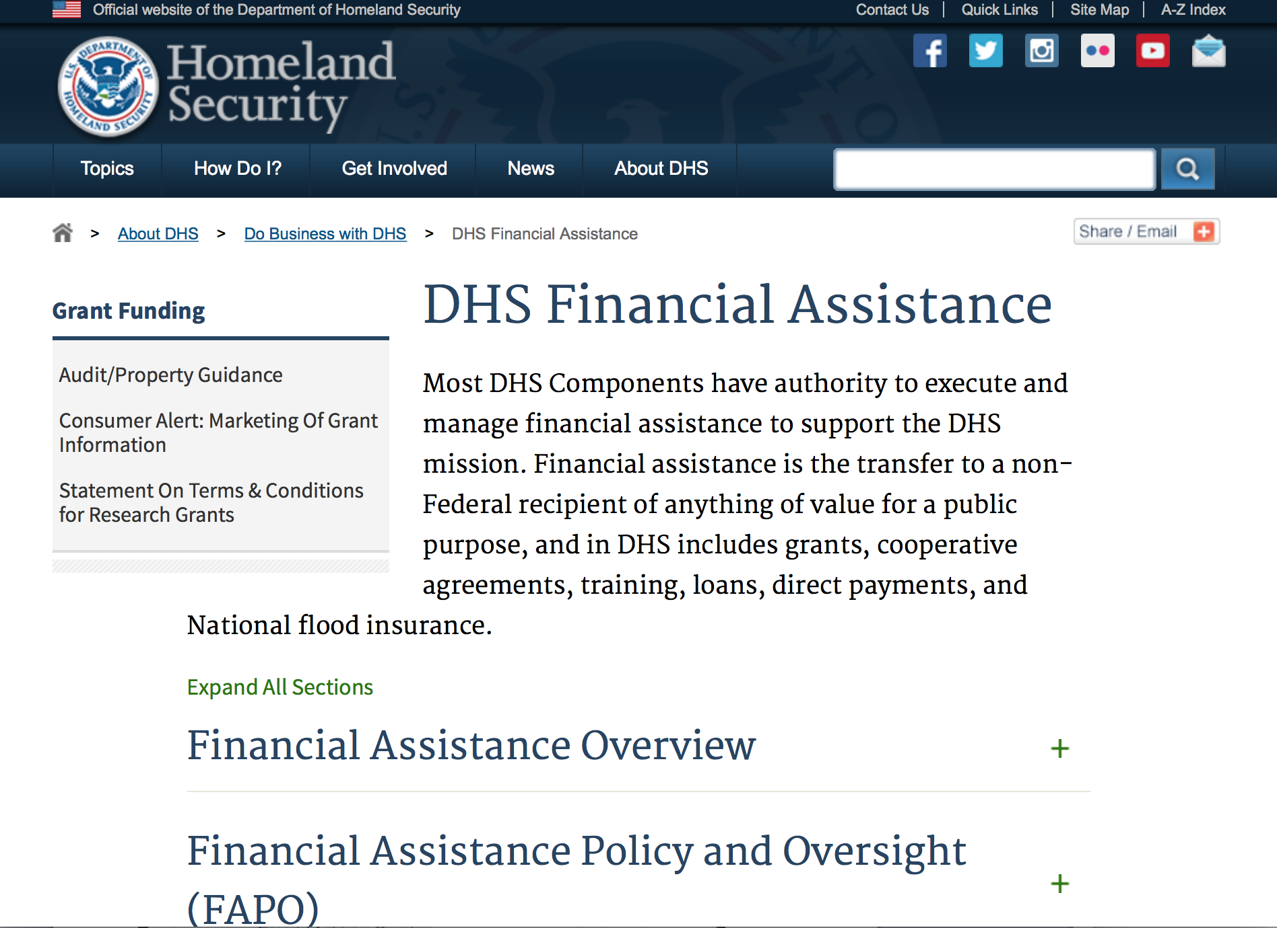
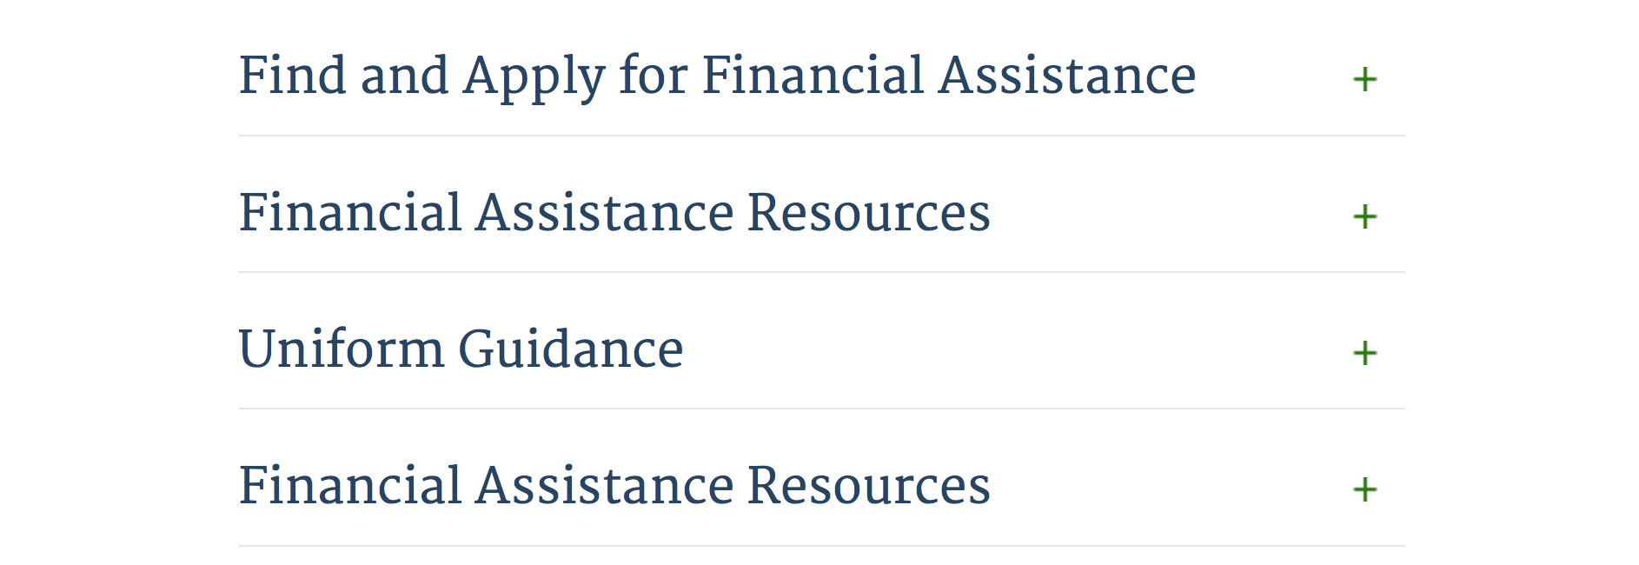

Webpage can be viewed at: http://www.dhs.gov/xopnbiz/grants/index.shtm#2

Information about 2016 for reference only
The FY 2016 Assistance to Firefighters Grants (AFG)
FY 2016 ASSISTANCE TO FIREFIGHTERS (AFG) GRANTS IS CLOSED AT THIS TIME
- FY 2016 Application Workshop Schedule
- FY 2016 AFG Application Guidance Materials The following documents are now available:
  - FY 2016 Notice of Funding Opportunity (NOFO) – Available Now
  - FY 2016 AFG Grant Application Get Ready Guide
  - FY 2016 AFG Narrative Get Ready Guide
  - FY 2016 AFG Self-Evaluation - Operations and Safety
  - FY 2016 AFG Self-Evaluation - Vehicle Acquisition
  - FY 2016 AFG Application Checklist
  - FY 2016 AFG Cost Share Calculator
FY 2016 AFG FAQs
For AFG program guidance materials, please visit our Documents page.

Resources

AFG Help Desk
Contact the AFG Program Help Desk toll-free at 866-274-0960, or email us at firegrants@dhs.gov.
The AFG Program has Fire Program Specialists in 10 federal regional centers. These Regional Fire Program Specialists respond to questions about the AFG program and carry out grant monitoring activities. View regional contacts

Popular AFG links
- AFG Workshop Schedule
- Assistance to Firefighters Grants (AFG)
- AFG Awards List
- AFG Success Stories
- Staffing for Adequate Fire & Emergency Response (SAFER) Grants (SAFER)
- SAFER Awards List
- SAFER Success Stories
- Fire Prevention & Safety (FP&S) Grants
- FP&S Awards List
- FP&S Success Stories
- Grant Closeout Tutorial
- Assistance to Firefighters Grant (AFG) Email Alert Archive
- Frequently Asked Questions
Contact Information For The Assistance to Firefighters Grant (AFG) Program and Help Desk

Federal Funding Alternative To AFG

State Administrative Agencies (SAA) apply for and administer Federal grants on behalf of their States, including FEMA Preparedness Grants. The SAA will work with eligible organizations to comply with the general requirements of grant programs or cooperative agreements. Contact your State’s SAA to find out what current Federal funding opportunities may be available to your organization. A listing of the SAAs and points of contact can be found at http://www.fema.gov/library/viewRecord.do?id=6363.

Programs:

Modifications:

Reminders:

Department of Housing and Urban Development

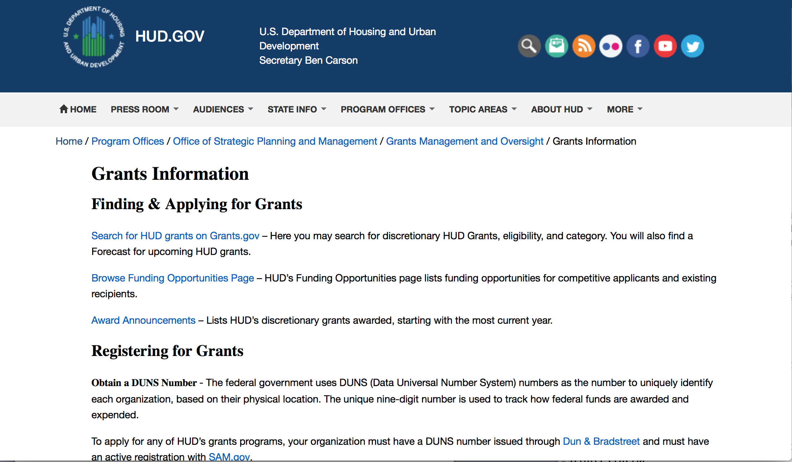
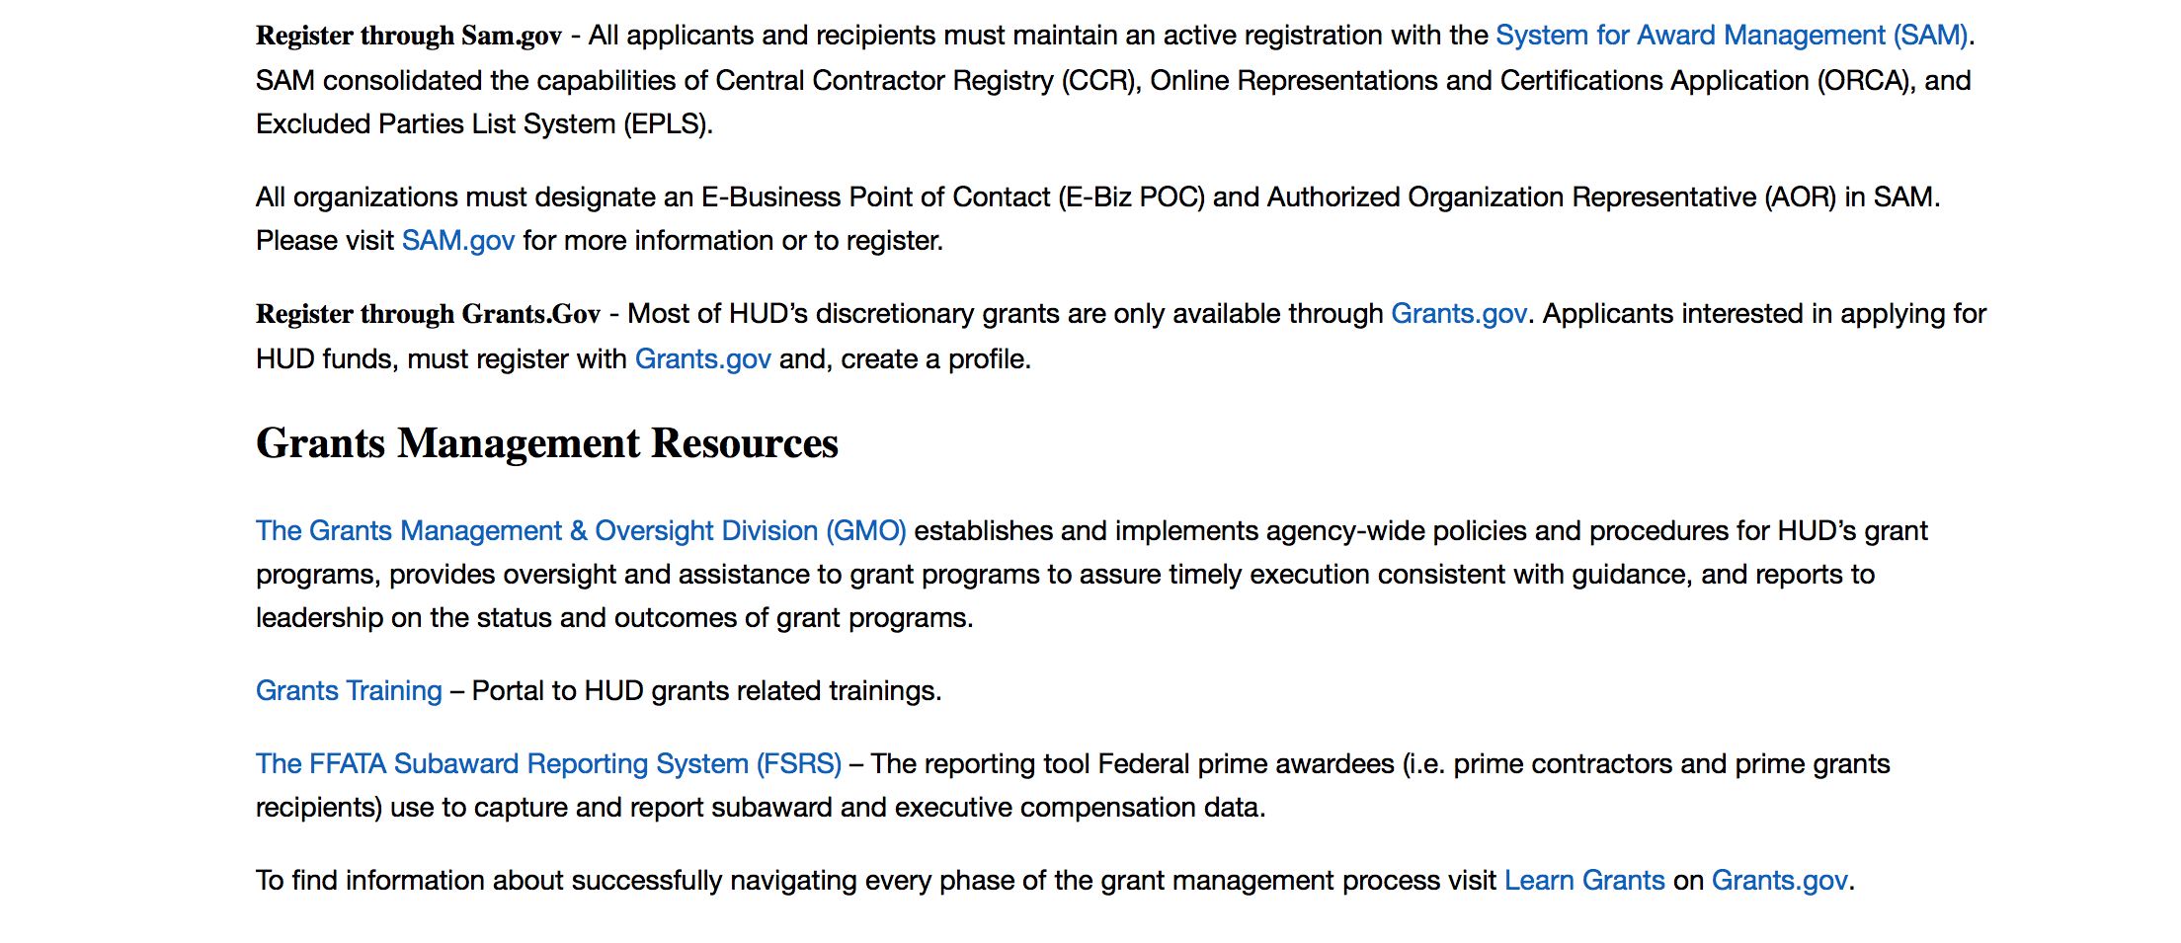
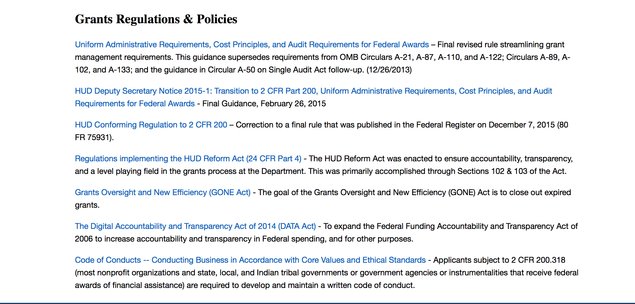

http://portal.hud.gov/hudportal/HUD?src=/topics/grants

HUD - Notice of Funds Available
For detailed information click here

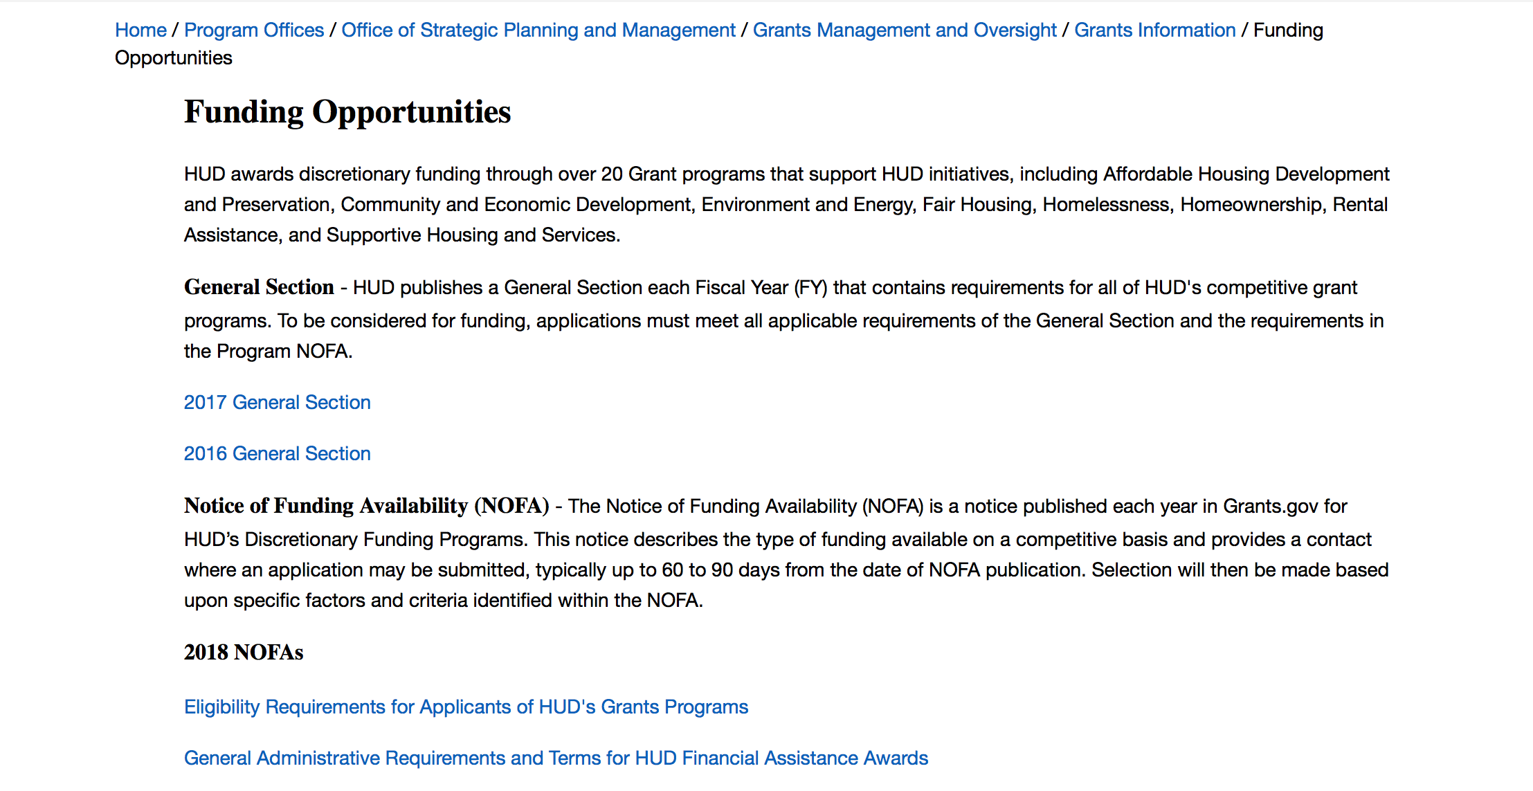

http://portal.hud.gov/hudportal/HUD?src=/program_offices/administration/grants/fundsavail

HUD NOFA FORECAST
The Department of Housing and Urban Development NOFA Forecast lists competitive grant opportunities that may be available for FY2016. The inclusion or exclusion of an opportunity in this list does not constitute a guarantee that a specific opportunity will become available or not be available. Forecast opportunities are subject to change based on enactment of Congressional appropriations and other considerations.
When funding is available, HUD will issue a Notice of Funding Availability (NOFA), which will be available on Grants.gov

Programs:

Lead-Based Paint Capital Fund Program (LBPCF)
Synopsis 1
Document Type: | Grants Notice
Funding Opportunity Number: | FR-6100-N-42
Funding Opportunity Title: | Lead-Based Paint Capital Fund Program (LBPCF)
Opportunity Category: | Discretionary
Opportunity Category Explanation:
Funding Instrument Type: | Grant
Category of Funding Activity: | Housing
Category Explanation:
Expected Number of Awards: | 30
CFDA Number(s): | 14.888 -- Lead-Based Paint Capital Fund Program
Cost Sharing or Matching Requirement: | No
Version: | Synopsis 2
Posted Date: | Jan 16, 2018
Last Updated Date: | Jan 17, 2018
Original Closing Date for Applications: | Mar 20, 2018 Electronically submitted applications must be submitted no later than 11:59 p.m., ET, on the listed application due date.
Current Closing Date for Applications: | Mar 20, 2018 Electronically submitted applications must be submitted no later than 11:59 p.m., ET, on the listed application due date.
Archive Date: | Apr 19, 2018
Estimated Total Program Funding: | $25,000,000
Award Ceiling: | $1,000,000
Award Floor: | $25,000
Eligible Applicants: | Others (see text field entitled "Additional Information on Eligibility" for clarification)
Additional Information on Eligibility: | Public Housing Authorities (PHAs) with the legal authority to develop, own, modernize and operate a public housing development in accordance with the 1937 Act, under an Annual Contributions Contract (ACC), are eligible to apply. A PHA that is troubled or under the direction of HUD is eligible for funding, provided the PHA is in compliance with any current Memorandum of Agreement or Recovery Agreement. Tribes and tribally designated housing entities (TDHEs), nonprofit organizations, and resident associations are not eligible to apply. Individuals, foreign entities, and sole proprietorship organizations are not eligible to compete for, or receive, awards made under this announcement.
Additional Information
Agency Name: | Department of Housing and Urban Development
Description: | As authorized under the Consolidated Appropriations Act, 2017, $25,000,000 shall be available for competitive grants to public housing agencies to evaluate and reduce lead-based paint hazards in public housing by carrying out the activities of risk assessments, abatement, and interim controls (as those terms are defined in section 1004 of the Residential Lead-Based Paint Hazard Reduction Act of 1992 (42 U.S.C. 4851b))
Link to Additional Information: | https://hud.gov/program_offices/spm/gmomgmt/grantsinfo/fundingopps
Grantor Contact Information: | If you have difficulty accessing the full announcement electronically, please contact:  PIHOCI@HUD.gov Mailbox  email for questions regarding this NOFA
https://www.grants.gov/web/grants/view-opportunity.html?oppId=300095

Modifications:

Youth Homelessness Demonstration Program
Synopsis 2
Document Type: | Grants Notice
Funding Opportunity Number: | FR-6100-N-35
Funding Opportunity Title: | Youth Homelessness Demonstration Program
Opportunity Category: | Discretionary
Opportunity Category Explanation:
Funding Instrument Type: | Grant
Category of Funding Activity: | Community Development
Category Explanation:
Expected Number of Awards: | 11
CFDA Number(s): | 14.276 -- Youth Homelessness Demonstration Program
Cost Sharing or Matching Requirement: | Yes
Version: | Synopsis 3
Posted Date: | Jan 17, 2018
Last Updated Date: | Jan 19, 2018
Original Closing Date for Applications: | Apr 17, 2018 Electronically submitted applications must be submitted no later than 11:59 p.m., ET, on the listed application due date.
Current Closing Date for Applications: | Apr 17, 2018 Electronically submitted applications must be submitted no later than 11:59 p.m., ET, on the listed application due date.
Archive Date: | May 17, 2018
Estimated Total Program Funding: | $43,000,000
Award Ceiling: | $15,000,000
Award Floor: | $1,000,000
Eligible Applicants: | State governments  Others (see text field entitled "Additional Information on Eligibility" for clarification)  City or township governments  Nonprofits having a 501(c)(3) status with the IRS, other than institutions of higher education  County governments
Additional Information on Eligibility: | Community Selection application: Available to Collaborative Applicants designated by CoCs registered through the FY 2017 CoC Program Registration process. The Collaborative Applicant can apply for any community located within its CoC's geographic area. The Collaborative Applicant can also apply for multiple communities located within its CoC's geographic area. Project application: Project applicants that are designated during the application process by the Collaborative Applicant are eligible to apply for grant funds as well as be subrecipients of grant funds. The Collaborative Applicant may apply for projects under this Demonstration as well. The Collaborative Applicants that are not UFAs may also designate an eligible applicant to be the recipient of the planning grant. For-profit entities are not eligible to apply for grants or to be subrecipients of grant funds. To be considered for funding, project applicants must complete the information required by HUD, and receive the approval of the CoC to apply for funding, as signed off on by the Collaborative Applicant or its designee. This NOFA application is for community selection only. Project application will occur after communities have been selected. Requirements for applying for projects are detailed in Appendix A. HUD does not award grants to individuals. For-profit entities, Indian Tribes and Indian Housing Authorities are ineligible applicants. HUD will not evaluate applications from ineligible applicants. As required in the Code of Federal Regulations (CFR) at 2 CFR 25.200 and 24 CFR Part 5 Subpart K, all applicants for financial assistance must have an active Data Universal Numbering System (DUNS) number (http://fedgov.dnb.com/webform) and have an active registration in the System for Award Management (SAM) (www.sam.gov) before submitting an application. Getting a DUNS number and completing SAM registration can take up to four weeks. Therefore, applicants should start this process or check their status early. See also Section IV.B for necessary form and content information. Individuals, foreign entities, and sole proprietorship organizations are not eligible to compete for, or receive, awards made under this announcement.
Agency Name: | Department of Housing and Urban Development
Description: | NOFA Highlights: HUD will select up to 11 communities to participate in the Youth Homelessness Demonstration Program (YHDP) to develop and execute a coordinated community approach to preventing and ending youth homelessness. Five of the 11 selected communities will be rural communities. [Section I.A.1] Only CoC Collaborative Applicants may apply to this NOFA [Section III.A] Applications are submitted through grants.gov, and are due by April 17, 2018 Communities represented by the CoC Collaborative Applicant must include a youth collaboration board, the local or state public child welfare agency, and a broad array of other partners [Sections III.C.1, III.C.3.b, and V.A] The rating and ranking criteria included in this NOFA will be used to competitively select the communities [Section V.A] The selection of the 11 communities will be announced in the Summer of 2018 [Section V.C] Selected Communities will: Develop and implement a Coordinated Community Plan to prevent and end youth homelessness [Section III.C.3.b] Apply for project funding up to an amount between $1 million and $15 million per community, based on each community's youth population size and poverty rate, for a total demonstration amount of up to $43 million [Section II.C] Request project funding on a rolling [Appendix A] Requests funding for all project types allowed under the CoC Program to support homeless and at risk youth, as well as innovative project types that may require a waiver of CoC Program or McKinney-Vento Act requirements [Appendix A and Appendix B] Request funding for a 2-year grant term that will be eligible for renewal under the CoC Program, as long as the project meets statutory CoC Program requirements [Section II.B] Receive a dedicated team of technical assistance providers to advise the development and implementation of the Coordinated Community Plan [Section II.C.3.b] Participate in an evaluation that will inform the federal strategy for preventing and ending youth homelessness [Section I.A and VI.B.] NOFA Priority The purpose of the YHDP is to learn how communities can successfully approach the goal of preventing and ending youth homelessness by building comprehensive systems of care for young people rather than implementing individual or unconnected projects that serve this population. In order to effectively implement a system that addresses the needs of youth experiencing homelessness, Continuums of Care (CoCs) must understand the subgroups of homeless youth; including unaccompanied youth, pregnant and parenting, Lesbian, Gay, Bisexual, Transgender, and Questioning (LGBTQ), and minor age youth &; experiencing homelessness and the unique challenges they face within their communities. Additionally, CoCs must ensure that the appropriate type of housing assistance and level of services that are effective in providing safe and stable housing are available within the community and must reach out and partner with a comprehensive set of traditional and non-traditional youth homelessness stakeholders that provide youth with resources and services, advocate for them, and set policy on their behalf. Finally, CoCs must incorporate the experiences of homeless or formerly homeless unaccompanied youth &; which is vital to understanding the needs, strengths, and perspectives of the youth in the community &; and incorporate those understandings into the YHDP coordinated community plan and awarded projects. All of this will require CoCs to use innovative practices to design better projects and strong comprehensive plans to prevent and end youth homelessness. Background In 2010, the United States Interagency Council on Homelessness (USICH) presented Opening Doors: The Federal Strategic Plan to Prevent and End Homelessness to the President and Congress, identifying youth as one of four special populations and articulating a goal of preventing and ending youth homelessness by 2020. A coordinated community approach lies at the heart of the strategies advocated by Opening Doors[1]. By engaging in a system-wide crisis response, communities can better understand their system level needs and assets, plan for and allocate new and existing resources, prevent and quickly divert youth from homelessness, and identify, engage, and respond to the needs of youth experiencing homelessness. These concepts are described in the 2012 release of the Framework to End Youth Homelessness [2], and Preventing and Ending Youth Homelessness: A Coordinated Community Response by USICH in December of 2015[3]. The 2015 release included a Preliminary Vision for a Community Response; and illustrates the general components believed necessary for each community to prevent and end youth homelessness. Federal partner agencies with a stake in preventing and ending youth homelessness are working tirelessly together to build on that vision. This work together with a commitment to developing and supporting a coordinated community approach, guides HUD's effort to prevent and end youth homelessness, and serves as the cornerstone value for the YHDP. http ://dev2 .usich .gov/resources /uploads /asses_library/USICH_OpeningDo ors_A mendment20 15_FINAL .pdf https ://www .usich .gov/tools -for-actio n/frame work-for-endin g -youth -homel essne ss https ://www .usich .gov/resources /uploads /asset_library/Youth_Home lessness_C oordi nated_Resp onse .pdf
Link to Additional Information: | https://hud.gov/program_offices/spm/gmomgmt/grantsinfo/fundingopps
Grantor Contact Information: | If you have difficulty accessing the full announcement electronically, please contact:  Sidhartha Nilakanta Sidhartha.Nilakanta@hud.gov  Grants Policy
https://www.grants.gov/web/grants/view-opportunity.html?oppId=300136

Deleted:

Reminders:

Institute of Museum and Library Services

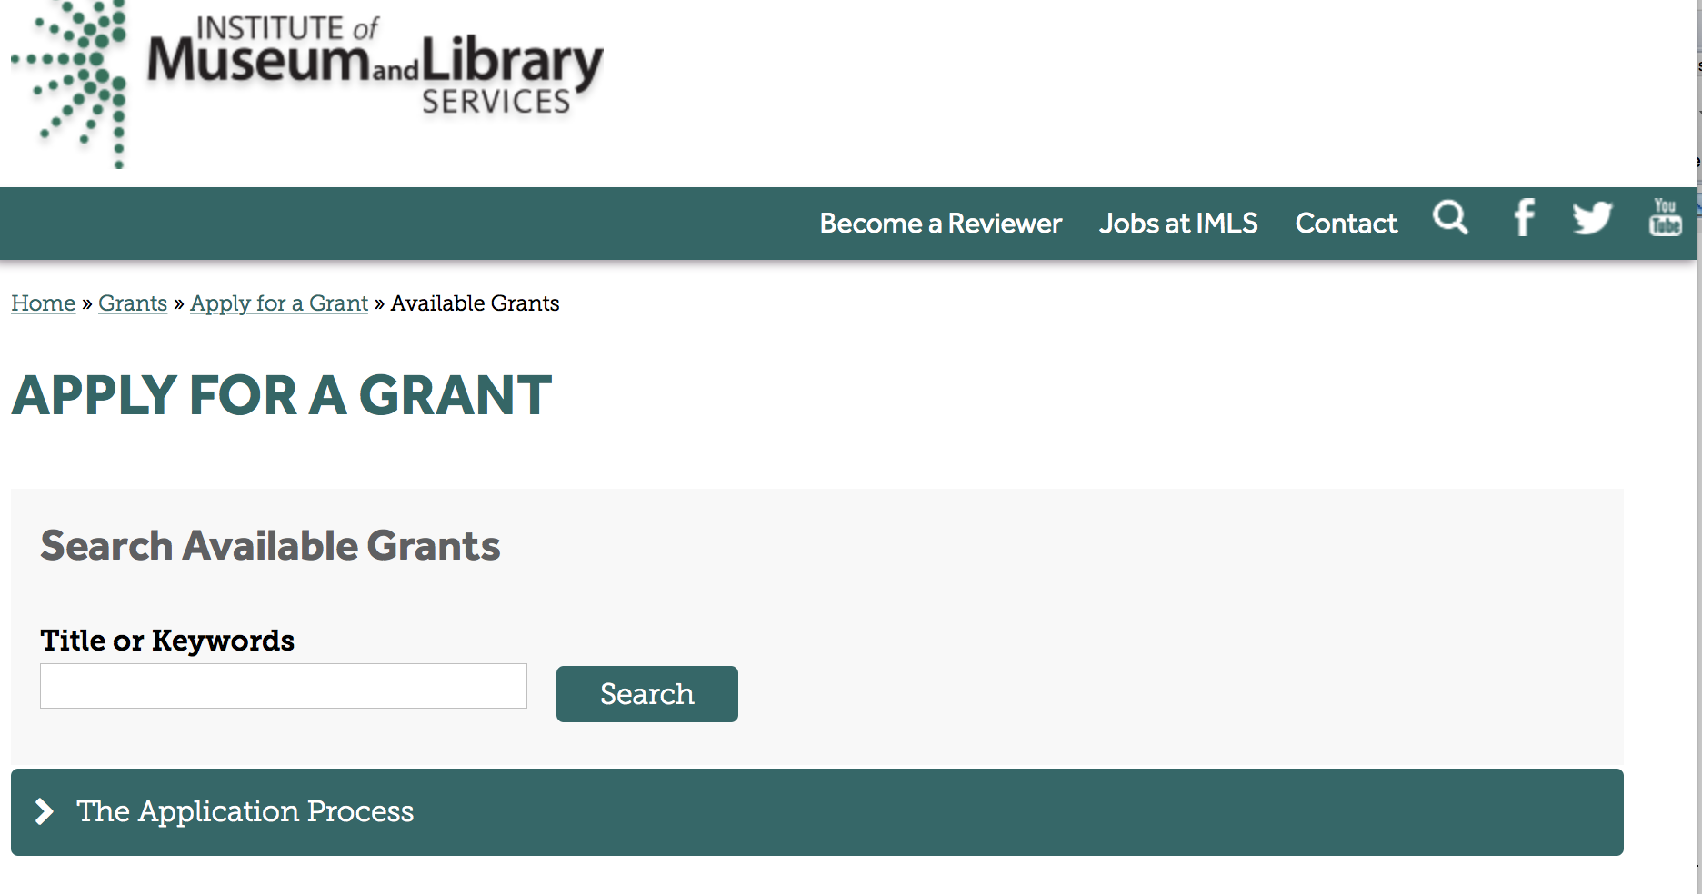

https://www.imls.gov/grants/apply-grant/available-grants

Each grant program has specific eligibility requirements. The links below provide general eligibility criteria for museums, libraries, and tribal organizations, but please note that additional organizations may be eligible for grants under certain programs. Additionally, ineligible organizations may still be able to participate in grant programs through partnerships with eligible organizations. Please click on the links below to see general criteria and review Applications and Guidelines for specific information.
Museums Libraries

Institutions: Archives, Federally Recognized Native American Tribe, Historical Society, Library, Nonprofits that serve Native Hawaiians, Professional Association, Public or Private Non-profit Institutions of Higher Education, Regional Organization, State Library Administrative Agency, State or Local Government

Check out IMLS's Facebook page at:
https://www.facebook.com/USIMLS/

Programs:

Modifications:

Reminders:

Museums Empowered: Professional Development Opportunities for Museum Staff - A Museums for America Special Initiative
Synopsis 1

Document Type: | Grants Notice
Funding Opportunity Number: | ME-FY18
Funding Opportunity Title: | Museums Empowered: Professional Development Opportunities for Museum Staff - A Museums for America Special Initiative
Opportunity Category: | Discretionary
Opportunity Category Explanation:
Funding Instrument Type: | Grant
Category of Funding Activity: | Arts (see "Cultural Affairs" in CFDA)  Humanities (see "Cultural Affairs" in CFDA)
Category Explanation:
Expected Number of Awards: | 28
CFDA Number(s): | 45.301 -- Museums for America
Cost Sharing or Matching Requirement: | Yes
Version: | Synopsis 1
Posted Date: | Dec 08, 2017
Last Updated Date: | Dec 08, 2017
Original Closing Date for Applications: | Mar 01, 2018
Current Closing Date for Applications: | Mar 01, 2018
Archive Date: | Mar 31, 2018
Estimated Total Program Funding: | $2,000,000
Award Ceiling: | $250,000
Award Floor: | $5,000
Eligible Applicants: | Others (see text field entitled "Additional Information on Eligibility" for clarification)
Additional Information on Eligibility: | See Notice of Funding Opportunity for additional information on eligibility.
Agency Name: | Institute of Museum and Library Services
Description: | The goal of the Museums for America (MFA) program is to support projects that strengthen the ability of an individual museum to serve its public. Museums Empowered: Professional Development Opportunities for Museum Staff is a special MFA initiative with the goal of strengthening the ability of an individual museum to serve its public through professional development activities that cross-cut various departments to generate systemic change within the museum.
Link to Additional Information: | https://www.imls.gov/grants/available/museums-empowered-professional-development-opportunities-museum-staff
Grantor Contact Information: | If you have difficulty accessing the full announcement electronically, please contact:  Mark Isaksen Senior Program Officer misaksen@imls.gov 202-653-4667 Jill Connors-Joyner Museum Program Specialist jconnors-joyner@imls.gov 202-653-4791  Mark Isaksen, Senior Program Officer
https://www.grants.gov/web/grants/view-opportunity.html?oppId=299334

National Leadership Grants for Libraries
Synopsis 1
Document Type: | Grants Notice
Funding Opportunity Number: | NLG-LIBRARIES-FY18-2
Funding Opportunity Title: | National Leadership Grants for Libraries
Opportunity Category: | Discretionary
Opportunity Category Explanation:
Funding Instrument Type: | Grant
Category of Funding Activity: | Arts (see "Cultural Affairs" in CFDA)  Humanities (see "Cultural Affairs" in CFDA)
Category Explanation:
Expected Number of Awards: | 12
CFDA Number(s): | 45.312 -- National Leadership Grants
Cost Sharing or Matching Requirement: | Yes
Version: | Synopsis 1
Posted Date: | Nov 29, 2017
Last Updated Date: | Nov 29, 2017
Original Closing Date for Applications: | Jun 08, 2018
Current Closing Date for Applications: | Jun 08, 2018
Archive Date: | Jul 08, 2018
Estimated Total Program Funding: | $5,700,000
Award Ceiling: | $2,000,000
Award Floor: | $25,000
Eligible Applicants: | Others (see text field entitled "Additional Information on Eligibility" for clarification)
Additional Information on Eligibility: | Please see Notice of Funding Opportunity for eligibility specifics.
Agency Name: | Institute of Museum and Library Services
Description: | National Leadership Grants for Libraries (NLG-L) support projects that address significant challenges and opportunities facing the library and archives fields and that have the potential to advance theory and practice. Successful proposals will generate results such as new tools, research findings, models, services, practices, or alliances that will be widely used, adapted, scaled, or replicated to extend the benefits of federal investment. We have two FY18 NLG-L funding opportunities, each with two separate deadlines. In addition to the opportunity described in this Notice of Funding Opportunity, a separate NLG-L funding opportunity was announced in July 2017 with a preliminary proposal application submission due date in September 2017. Both opportunities are subject to the availability of funds and IMLS discretion and procedures.
Link to Additional Information: | https://www.imls.gov/grants/available/national-leadership-grants-libraries
Grantor Contact Information: | If you have difficulty accessing the full announcement electronically, please contact:  Tim Carrigan, Senior Program Officer 202-653-4639 tcarrigan@imls.gov Sarah Fuller, Senior Program Officer 202-653-4783 sfuller@imls.gov James Neal, Senior Program Officer 202-653-4740 jneal@imls.gov Emily Reynolds, Senior Program Officer 202-635-4665 ereynolds@imls.gov Ashley Sands, PhD, Senior Program Officer 202-653-4730 asands@imls.gov Sandra Toro, PhD, Senior Program Officer 202-653-4662 storo@imls.gov  Emily Reynolds, Senior Program Officer
https://www.grants.gov/web/grants/view-opportunity.html?oppId=299122

Deleted:

Department of the Interior
Working with Interior

The Interior Department provides assistance to the public, local governments and businesses through a number of programs. For a general overview see: http://www.doi.gov/index.cfm

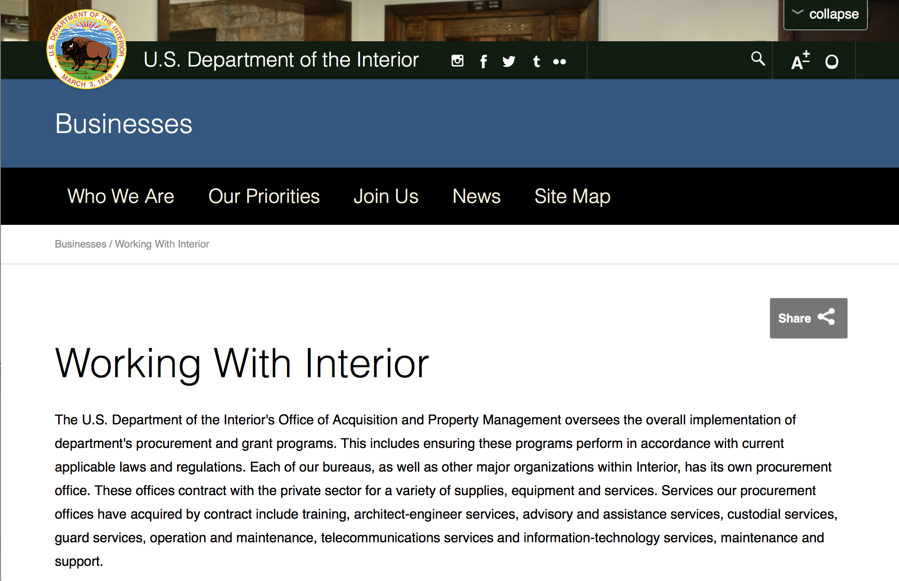

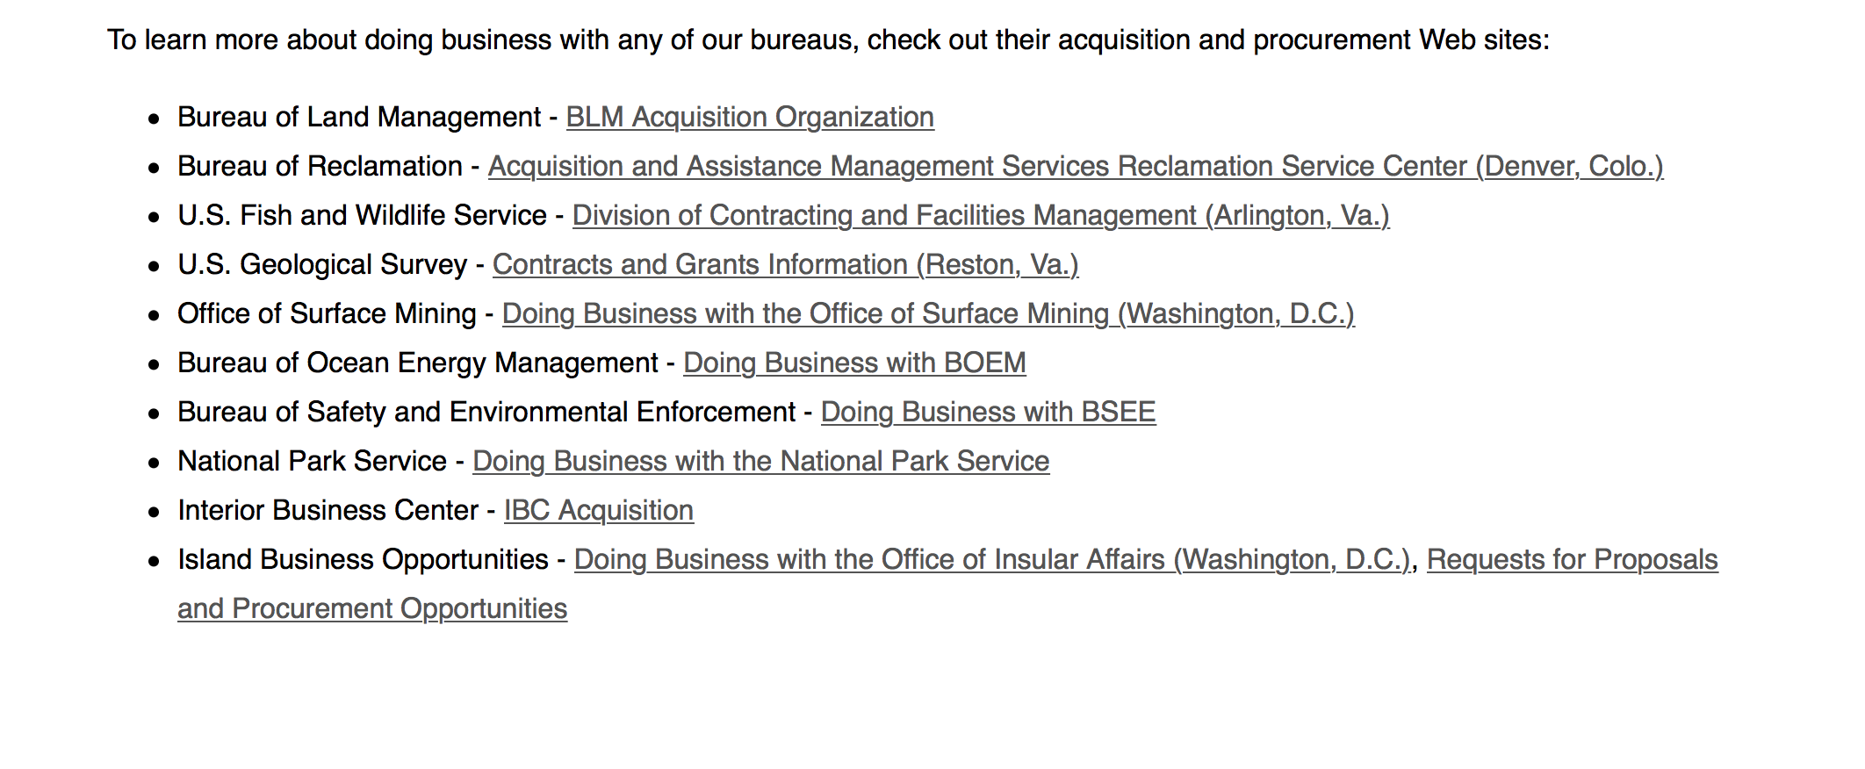
http://www.doi.gov/businesses/working-with-interior.cfm

Programs:

National Park Service
NAGPRA Consultation/Documentation Grants FY2018
Synopsis 1

Document Type: | Grants Notice
Funding Opportunity Number: | P18AS00051
Funding Opportunity Title: | NAGPRA Consultation/Documentation Grants FY2018
Opportunity Category: | Discretionary
Opportunity Category Explanation:
Funding Instrument Type: | Grant
Category of Funding Activity: | Arts (see "Cultural Affairs" in CFDA)  Education  Humanities (see "Cultural Affairs" in CFDA)  Law, Justice and Legal Services  Other (see text field entitled "Explanation of Other Category of Funding Activity" for clarification)
Category Explanation: | Cultural Resources
Expected Number of Awards: | 25
CFDA Number(s): | 15.922 -- Native American Graves Protection and Repatriation Act
Cost Sharing or Matching Requirement: | No
Version: | Synopsis 1
Posted Date: | Jan 02, 2018
Last Updated Date: | Jan 02, 2018
Original Closing Date for Applications: | Mar 09, 2018
Current Closing Date for Applications: | Mar 09, 2018
Archive Date: | Sep 09, 2018
Estimated Total Program Funding: | $1,654,000
Award Ceiling: | $90,000
Award Floor: | $5,000
Eligible Applicants: | Others (see text field entitled "Additional Information on Eligibility" for clarification)  Nonprofits having a 501(c)(3) status with the IRS, other than institutions of higher education  Native American tribal governments (Federally recognized)  State governments  City or township governments  Public and State controlled institutions of higher education  County governments  Private institutions of higher education
Additional Information on Eligibility: | Native Hawaiian organizations including any organization that serves and represents the interests of Native Hawaiians, has as a primary purpose the provision of services to Native Hawaiians, and has expertise in Native Hawaiian affairs.
Agency Name: | National Park Service
Description: | Grant funds must be used for CONSULTATION and DOCUMENTATION under NAGPRA. Consultation projects support efforts related to compiling or revising a NAGPRA inventory and making or responding to requests for items in a NAGPRA summary. Documentation projects support determining the geographical origin, cultural affiliation, and other basic facts surrounding the acquisition of Native American cultural items. Consultation and documentation projects should lead to determining control, treatment, and disposition of NAGPRA cultural items.
Link to Additional Information: | Grants.gov
Grantor Contact Information: | If you have difficulty accessing the full announcement electronically, please contact:  Grant Coordinator Sarah Glass 202-354-1479 nagpra_grants@nps.gov  nagpra_grants@nps.gov
https://www.grants.gov/web/grants/view-opportunity.html?oppId=299797

Office of Surface Mining
Not-for Profit Acid Mine Drainage Watershed Cooperative Agreement Programs (WCAP)
Synopsis
Document Type: | Grants Notice
Funding Opportunity Number: | S18AS00003
Funding Opportunity Title: | Not-for Profit Acid Mine Drainage Watershed Cooperative Agreement Programs (WCAP)
Opportunity Category: | Discretionary
Opportunity Category Explanation:
Funding Instrument Type: | Cooperative Agreement
Category of Funding Activity: | Science and Technology and other Research and Development
Category Explanation:
Expected Number of Awards: | 20
CFDA Number(s): | 15.253 -- Not-for-Profit AMD Reclamation
Cost Sharing or Matching Requirement: | No
Version: | Synopsis 1
Posted Date: | Jan 19, 2018
Last Updated Date: | Jan 19, 2018
Original Closing Date for Applications: | Aug 31, 2018
Current Closing Date for Applications: | Aug 31, 2018
Archive Date: | Sep 30, 2018
Estimated Total Program Funding: | $1,500,000
Award Ceiling: | $100,000
Award Floor: | $100,000
Eligible Applicants: | Nonprofits having a 501(c)(3) status with the IRS, other than institutions of higher education
Agency Name: | Office of Surface Mining
Description: | The funding priorities and technical focus for this announcement are to restore streams affected by AMD to a level that will support a diverse biological community and provide recreational opportunities for the public, water quality improvement, pollutants removed, stream segments improved or restored, aquatic habitat improved or restored, public water supply improved, fisheries improved, recreation opportunities enhanced, educational opportunities created, aesthetic enhancement, community benefits/pride generated, associated land restoration, and health & safety hazards eliminated.
Link to Additional Information:
Grantor Contact Information: | If you have difficulty accessing the full announcement electronically, please contact:  Prouda Adams Grants Specialist Phone 202-208-2230  Work
https://www.grants.gov/web/grants/view-opportunity.html?oppId=300194

Modifications:

Reminders:

National Park Service
Save America's Treasures - Preservation (Construction) Projects
Synopsis 1
Document Type: | Grants Notice
Funding Opportunity Number: | P18AS00044
Funding Opportunity Title: | Save America's Treasures - Preservation (Construction) Projects
Opportunity Category: | Discretionary
Opportunity Category Explanation:
Funding Instrument Type: | Grant
Category of Funding Activity: | Humanities (see "Cultural Affairs" in CFDA)  Other (see text field entitled "Explanation of Other Category of Funding Activity" for clarification)
Category Explanation: | Historic Preservation Cultural Preservation
Expected Number of Awards: | 7
CFDA Number(s): | 15.904 -- Historic Preservation Fund Grants-In-Aid
Cost Sharing or Matching Requirement: | Yes
Version: | Synopsis 1
Posted Date: | Dec 20, 2017
Last Updated Date: | Dec 20, 2017
Original Closing Date for Applications: | Feb 21, 2018
Current Closing Date for Applications: | Feb 21, 2018
Archive Date: | Dec 28, 2018
Estimated Total Program Funding: | $4,800,000
Award Ceiling: | $500,000
Award Floor: | $125,000
Eligible Applicants: | Nonprofits that do not have a 501(c)(3) status with the IRS, other than institutions of higher education  City or township governments  Others (see text field entitled "Additional Information on Eligibility" for clarification)  Private institutions of higher education  Nonprofits having a 501(c)(3) status with the IRS, other than institutions of higher education  County governments  Native American tribal governments (Federally recognized)  State governments  Public and State controlled institutions of higher education
Additional Information on Eligibility: | Federal agencies funded by the Department of the Interior and Related Agencies Appropriations Act with the exception of the National Park Service
Agency Name: | National Park Service
Description: | Save America's Treasures grants from the Historic Preservation Fund provide preservation assistance to nationally significant historic properties. Grants are awarded through a competitive process and require a dollar-for-dollar, non-Federal match, which can be cash or documented in-kind. The grants are administered by the National Park Service (NPS) in partnership with the National Endowment for the Arts (NEA), the National Endowment for the Humanities (NEH), and the Institute of Museum and Library Services (IMLS).
Link to Additional Information: | https://www.nps.gov/preservation-grants/sat/index.html
Grantor Contact Information: | If you have difficulty accessing the full announcement electronically, please contact:  Chief, State, Tribal, Local Plans and Grants Megan Brown 202 354 2020 Preservation_Grants_Info@nps.gov  STLPG Grants Email Inbox

https://www.grants.gov/web/grants/view-opportunity.html?oppId=299560

National Park Service
Save America's Treasures - Collections
Synopsis 1
Document Type: | Grants Notice
Funding Opportunity Number: | P18AS00045
Funding Opportunity Title: | Save America's Treasures - Collections
Opportunity Category: | Discretionary
Opportunity Category Explanation:
Funding Instrument Type: | Grant
Category of Funding Activity: | Humanities (see "Cultural Affairs" in CFDA)  Other (see text field entitled "Explanation of Other Category of Funding Activity" for clarification)
Category Explanation: | Historic Preservation Cultural Preservation
Expected Number of Awards: | 9
CFDA Number(s): | 15.904 -- Historic Preservation Fund Grants-In-Aid
Cost Sharing or Matching Requirement: | Yes
Version: | Synopsis 1
Posted Date: | Dec 20, 2017
Last Updated Date: | Dec 20, 2017
Original Closing Date for Applications: | Feb 21, 2018
Current Closing Date for Applications: | Feb 21, 2018
Archive Date: | Dec 27, 2018
Estimated Total Program Funding: | $4,800,000
Award Ceiling: | $500,000
Award Floor: | $25,000
Eligible Applicants: | City or township governments  Nonprofits that do not have a 501(c)(3) status with the IRS, other than institutions of higher education  Nonprofits having a 501(c)(3) status with the IRS, other than institutions of higher education  State governments  Public and State controlled institutions of higher education  County governments  Others (see text field entitled "Additional Information on Eligibility" for clarification)  Private institutions of higher education  Native American tribal governments (Federally recognized)  Independent school districts
Additional Information on Eligibility: | Federal agencies funded by the Department of the Interior and Related Agencies Appropriations Act, with the exception of the National Park Service (NPS).
Agency Name: | National Park Service
Description: | Save America's Treasures grants from the Historic Preservation Fund provide preservation and/or conservation assistance to nationally significant historic collections. Grants are awarded through a competitive process and require a dollar-for-dollar, non-Federal match, which can be cash or documented in-kind. The grants are administered by the National Park Service (NPS) in partnership with the National Endowment for the Arts (NEA), the National Endowment for the Humanities (NEH), and the Institute of Museum and Library Services (IMLS).
Link to Additional Information: | https://www.nps.gov/preservation-grants/sat/index.htmlhttps://www.nps.gov/preservation-grants/sat/index.html
Grantor Contact Information: | If you have difficulty accessing the full announcement electronically, please contact:  Chief, State, Tribal, Local Plans and Grants Megan Brown 202 354 2020 Preservation_Grants_Info@nps.gov  STLPG Grants Email Inbox
https://www.grants.gov/web/grants/view-opportunity.html?oppId=299562

Deleted:

Department of Justice

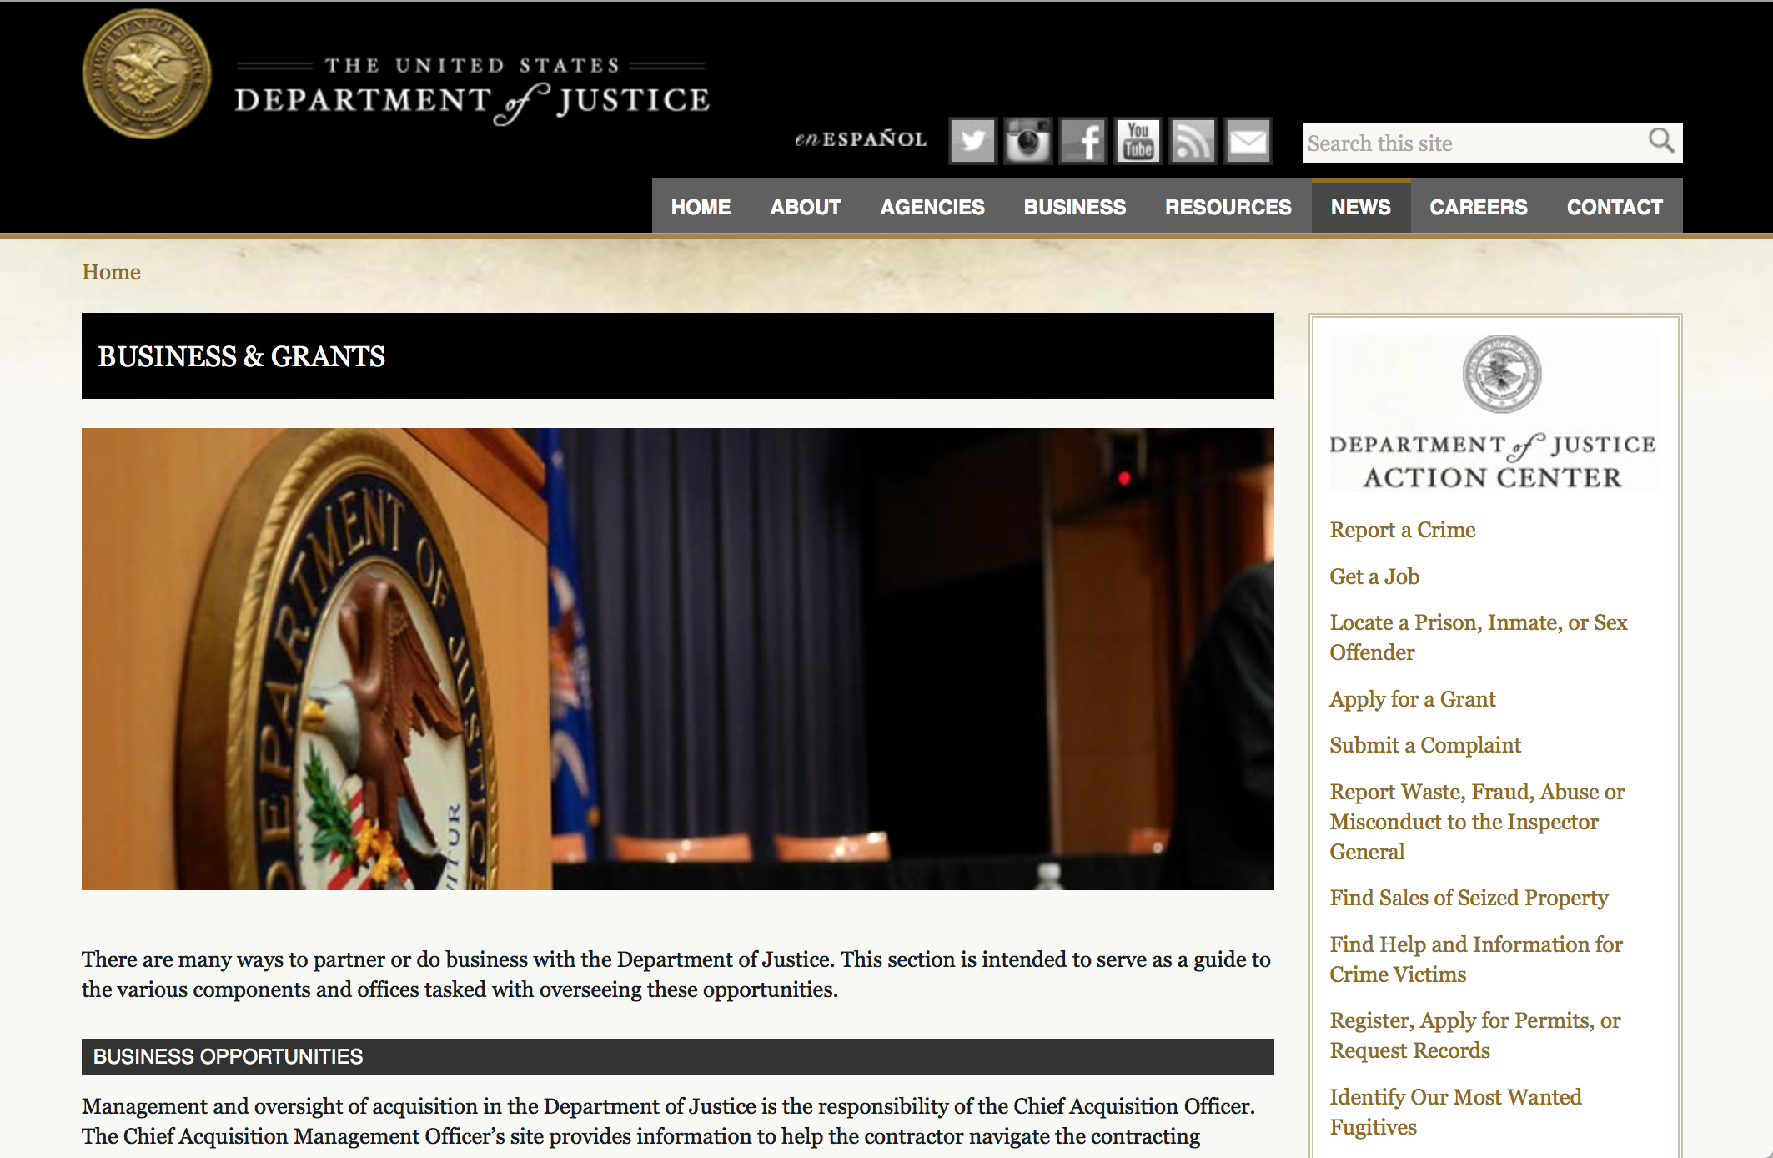

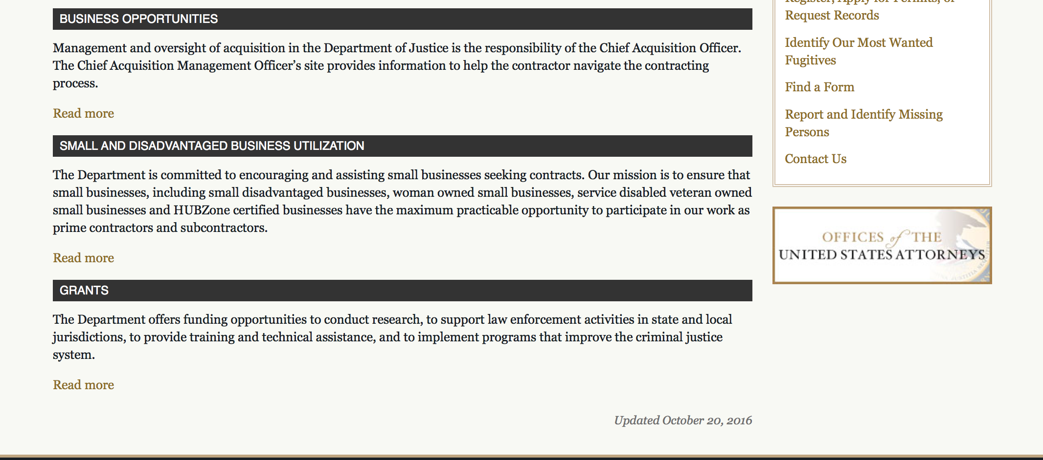

The DOJ agencies listed below also have sites that provide grant information specific to that agency. Examples of what can be found on these sites are programs, funding opportunities, application assistance, and other useful information.

Bureau of Justice Assistance (BJA)

Bureau of Justice Statistics (BJS)

National Criminal Justice Reference Service (NCJRS)

National Institute of Justice (NIJ)

Office of Sex Offender Sentencing, Monitoring, Apprehending, Registering, and Tracking (SMART)

http://www.justice.gov/business/

Programs:

Office on Violence Against Women
OVW Fiscal Year 2018 Training and Technical Assistance Initiative
Synopsis 1
General Information
Document Type: Grants Notice  Funding Opportunity Number: OVW-2018-14107  Funding Opportunity Title: OVW Fiscal Year 2018 Training and Technical Assistance Initiative  Opportunity Category: Discretionary  Opportunity Category Explanation:  Funding Instrument Type: Cooperative Agreement  Category of Funding Activity: Other (see text field entitled "Explanation of Other Category of Funding Activity" for clarification)  Category Explanation: Training focused on sexual assault, domestic violence, dating violence and stalking  Expected Number of Awards: 65  CFDA Number(s): 16.526 -- OVW Technical Assistance Initiative  Cost Sharing or Matching Requirement: No | Version: Synopsis 2  Posted Date: Jan 03, 2018  Last Updated Date: Jan 04, 2018  Original Closing Date for Applications: Feb 15, 2018  Current Closing Date for Applications: Feb 15, 2018  Archive Date:  Estimated Total Program Funding: $32,000,000  Award Ceiling: $2,000,000  Award Floor: $200,000
Eligibility
Eligible Applicants: | Native American tribal organizations (other than Federally recognized tribal governments)  Private institutions of higher education  Nonprofits having a 501(c)(3) status with the IRS, other than institutions of higher education  Public and State controlled institutions of higher education
Additional Information on Eligibility:
Additional Information
Agency Name: | Office on Violence Against Women
Description: | The primary purpose of the OVW Training and Technical Assistance (TA) Initiative is to provide direct TA to existing and potential grantees and sub-grantees to enhance and support their efforts to successfully implement projects supported by OVW grant funds. OVW’s TA is designed to build and enhance the national capacity of civil and criminal justice system professionals and victim services providers to respond effectively to sexual assault, domestic violence, dating violence and stalking and foster partnerships among organizations that have not traditionally worked together to address violence against women.
Link to Additional Information: | Full Announcement
Grantor Contact Information: | If you have difficulty accessing the full announcement electronically, please contact:  Neelam J. Patel Team Lead for Training and Technical Assistance 202-353-4338 Neelam.J.Patel@usdoj.gov  Neelam.J.Patel@usdoj.gov
https://www.grants.gov/web/grants/view-opportunity.html?oppId=299785

Office on Violence Against Women
OVW FY 2018 Improving Criminal Justice Responses to Sexual Assault, Domestic Violence, Dating Violence, and Stalking Grant Program (formerly known as the Arrest Program)
Synopsis 1
General Information
Document Type: Grants Notice  Funding Opportunity Number: OVW-2018-13827  Funding Opportunity Title: OVW FY 2018 Improving Criminal Justice Responses to Sexual Assault, Domestic Violence, Dating Violence, and Stalking Grant Program (formerly known as the Arrest Program)  Opportunity Category: Discretionary  Opportunity Category Explanation:  Funding Instrument Type: Grant  Category of Funding Activity: Law, Justice and Legal Services  Category Explanation:  Expected Number of Awards: 58  CFDA Number(s): 16.590 -- Grants to Encourage Arrest Policies and Enforcement of Protection Orders Program  Cost Sharing or Matching Requirement: No | Version: Synopsis 1  Posted Date: Jan 04, 2018  Last Updated Date: Jan 04, 2018  Original Closing Date for Applications: Feb 27, 2018  Current Closing Date for Applications: Feb 27, 2018  Archive Date:  Estimated Total Program Funding: $53,000,000  Award Ceiling: $900,000  Award Floor: $0
Eligibility
Eligible Applicants: | City or township governments  Native American tribal governments (Federally recognized)  Nonprofits having a 501(c)(3) status with the IRS, other than institutions of higher education  County governments  State governments  Others (see text field entitled "Additional Information on Eligibility" for clarification)
Additional Information on Eligibility: | State, tribal, or territorial sexual assault or domestic violence coalitions and government rape crisis centers (in a state other than a territory).
Additional Information
Agency Name: | Office on Violence Against Women
Description: | The United States Department of Justice, Office on Violence Against Women (OVW) (www.ovw.usdoj.gov) is pleased to announce that it is seeking applications for the Improving Criminal Justice Responses to Sexual Assault, Domestic Violence, Dating Violence, and Stalking Grant Program (formerly known as the Grants to Encourage Arrest Policies and Enforcement of Protection Orders Program). This program furthers the Department of Justice’s mission by encouraging partnerships between state, local, and tribal governments, courts, victim service providers, coalitions and rape crisis centers, to ensure that sexual assault, domestic violence, dating violence, and stalking are treated as serious violations of criminal law requiring the coordinated involvement of the entire criminal justice system and community-based victim service organizations.
Link to Additional Information: | Full Announcement
Grantor Contact Information: | If you have difficulty accessing the full announcement electronically, please contact:  Cailin Crockett Program Specialist (202) 616-5342 cailin.crockett@usdoj.gov  cailin.crockett@usdoj.gov

https://www.grants.gov/web/grants/view-opportunity.html?oppId=299810
__________________________________________________________________________
Office on Violence Against Women
OVW FY 2018 Transitional Housing Assistance Grants for Victims of Sexual Assault, Domestic Violence, Dating Violence and Stalking
Synopsis 1
General Information
Document Type: Grants Notice  Funding Opportunity Number: OVW-2018-13826  Funding Opportunity Title: OVW FY 2018 Transitional Housing Assistance Grants for Victims of Sexual Assault, Domestic Violence, Dating Violence and Stalking  Opportunity Category: Discretionary  Opportunity Category Explanation:  Funding Instrument Type: Grant  Category of Funding Activity: Housing Other (see text field entitled "Explanation of Other Category of Funding Activity" for clarification)  Category Explanation: transitional housing and voluntary support services including victim services  Expected Number of Awards: 70  CFDA Number(s): 16.736 -- Transitional Housing Assistance for Victims of Domestic Violence, Dating Violence, Stalking, or Sexual Assault  Cost Sharing or Matching Requirement: No | Version: Synopsis 1  Posted Date: Jan 04, 2018  Last Updated Date: Jan 04, 2018  Original Closing Date for Applications: Feb 16, 2018  Current Closing Date for Applications: Feb 16, 2018  Archive Date:  Estimated Total Program Funding: $20,000,000  Award Ceiling: $350,000  Award Floor: $0
Eligibility
Eligible Applicants: | County governments  City or township governments  Others (see text field entitled "Additional Information on Eligibility" for clarification)  State governments  Native American tribal governments (Federally recognized)
Additional Information on Eligibility: | Eligible applicants are limited to: states, units of local government, Indian tribes, and other organizations, including sexual assault and domestic violence victim service providers, sexual assault and domestic violence coalitions, other nonprofit, nongovernmental organizations, or community-based and culturally specific organizations, that have a documented history of effective work concerning sexual assault, domestic violence, dating violence, or stalking.
Additional Information
Agency Name: | Office on Violence Against Women
Description: | The Transitional Housing Program makes grants to programs to provide 6-24 months of transitional housing with support services for victims who are homeless, or in need of transitional housing, as a result of a situation of sexual assault, domestic violence, dating violence, or stalking; and for whom emergency shelter services or other crisis intervention services are unavailable or insufficient. OVW is interested in programs with a holistic, victim-centered approach to providing transitional housing services that move survivors into permanent housing. Transitional housing can be provided in facilities that are owned by the applicant, in units that are leased by the applicant, or by providing rental assistance for units leased directly to victims. Support services offered should help transitional housing participants locate and secure permanent housing, secure employment, and integrate into a community. Examples of support services include employment counseling, occupational training, transportation, counseling, child care services, safety planning, case management, and other assistance. Support services must be offered to survivors on a voluntary basis. Voluntary support services are designed with survivor-input to meet the individual needs of each survivor. When implementing a voluntary services model through a trauma-informed approach, effective transitional housing supports the self-determination of survivors and adapts services to their individual needs. Staff who has been trained in working with victims of sexual assault, domestic violence, dating violence, or stalking may also be funded to support transitional housing participants.
Link to Additional Information: | Full Announcement
Grantor Contact Information: | If you have difficulty accessing the full announcement electronically, please contact:  Sharon Elliott (202) 307-6026 ovw.transitionalhousing@usdoj.gov  ovw.transitionalhousing@usdoj.gov

https://www.grants.gov/web/grants/view-opportunity.html?oppId=299836

Office on Violence Against Women
OVW FY 2018 Sexual Assault Services Culturally Specific Program Solicitation
Synopsis 1
General Information
Document Type: Grants Notice  Funding Opportunity Number: OVW-2018-13830  Funding Opportunity Title: OVW FY 2018 Sexual Assault Services Culturally Specific Program Solicitation  Opportunity Category: Discretionary  Opportunity Category Explanation:  Funding Instrument Type: Grant  Category of Funding Activity: Other (see text field entitled "Explanation of Other Category of Funding Activity" for clarification)  Category Explanation: Sexual assault victim services and advocacy  Expected Number of Awards: 12  CFDA Number(s): 16.023 -- Sexual Assault Services Culturally Specific Program  Cost Sharing or Matching Requirement: No | Version: Synopsis 1  Posted Date: Jan 05, 2018  Last Updated Date: Jan 05, 2018  Original Closing Date for Applications: Feb 15, 2018  Current Closing Date for Applications: Feb 15, 2018  Archive Date:  Estimated Total Program Funding: $3,500,000  Award Ceiling: $300,000  Award Floor: $0
Eligibility
Eligible Applicants: | Nonprofits having a 501(c)(3) status with the IRS, other than institutions of higher education
Additional Information on Eligibility:
Additional Information
Agency Name: | Office on Violence Against Women
Description: | The goal of the SAS Culturally Specific Program is create, maintain, and expand sustainable sexual assault services provided by culturally specific organizations, which are uniquely situated to respond to respond to the needs of sexual assault victims within culturally specific populations.
Link to Additional Information: | Full Announcement
Grantor Contact Information: | If you have difficulty accessing the full announcement electronically, please contact:  Tonette Ngassa Program Specialist 202-305-2379 tonette.ngassa@usdoj.gov  tonette.ngassa@usdoj.gov
https://www.grants.gov/web/grants/view-opportunity.html?oppId=299848

Office on Violence Against Women
OVW FY 2018 Grants to Enhance Culturally Specific Services for Victims of Sexual Assault, Domestic Violence, Dating Violence, and Stalking Program Solicitation
Synopsis 1

General Information
Document Type: Grants Notice  Funding Opportunity Number: OVW-2018-13822  Funding Opportunity Title: OVW FY 2018 Grants to Enhance Culturally Specific Services for Victims of Sexual Assault, Domestic Violence, Dating Violence, and Stalking Program Solicitation  Opportunity Category: Discretionary  Opportunity Category Explanation:  Funding Instrument Type: Grant  Category of Funding Activity: Arts (see "Cultural Affairs" in CFDA) Education Humanities (see "Cultural Affairs" in CFDA) Income Security and Social Services  Category Explanation:  Expected Number of Awards: 20  CFDA Number(s): 16.016 -- Culturally and Linguistically Specific Services Program  Cost Sharing or Matching Requirement: No | Version: Synopsis 1  Posted Date: Jan 09, 2018  Last Updated Date: Jan 09, 2018  Original Closing Date for Applications: Feb 21, 2018  Current Closing Date for Applications: Feb 21, 2018  Archive Date:  Estimated Total Program Funding: $7,000,000  Award Ceiling: $300,000  Award Floor: $0
Eligibility
Eligible Applicants: | Nonprofits that do not have a 501(c)(3) status with the IRS, other than institutions of higher education  Native American tribal organizations (other than Federally recognized tribal governments)  Nonprofits having a 501(c)(3) status with the IRS, other than institutions of higher education
Additional Information on Eligibility:
Additional Information
Agency Name: | Office on Violence Against Women
Description: | Grants to Enhance Culturally Specific Services for Victims of Sexual Assault, Domestic Violence, Dating Violence and Stalking Program supports community-based organizations in providing culturally relevant services to victims of sexual assault, domestic violence, dating violence, and stalking.
Link to Additional Information: | Full Announcement
Grantor Contact Information: | If you have difficulty accessing the full announcement electronically, please contact:  Paule Tessier Program Specialist 202-353-8408 Paule.Tessier@usdoj.gov  Paule.Tessier@usdoj.gov
https://www.grants.gov/web/grants/view-opportunity.html?oppId=299924

Office on Violence Against Women
OVW FY 2018 Grants to Reduce Sexual Assault, Domestic Violence, Dating Violence and Stalking on Campus Program
Synopsis 1

General Information
Document Type: Grants Notice  Funding Opportunity Number: OVW-2018-13820  Funding Opportunity Title: OVW FY 2018 Grants to Reduce Sexual Assault, Domestic Violence, Dating Violence and Stalking on Campus Program  Opportunity Category: Discretionary  Opportunity Category Explanation:  Funding Instrument Type: Grant  Category of Funding Activity: Education Other (see text field entitled "Explanation of Other Category of Funding Activity" for clarification)  Category Explanation: Victim Services, Prevention and Education  Expected Number of Awards: 45  CFDA Number(s): 16.525 -- Grants to Reduce Domestic Violence, Dating Violence, Sexual Assault, and Stalking on Campus  Cost Sharing or Matching Requirement: No | Version: Synopsis 1  Posted Date: Jan 09, 2018  Last Updated Date: Jan 09, 2018  Original Closing Date for Applications: Feb 22, 2018  Current Closing Date for Applications: Feb 22, 2018  Archive Date:  Estimated Total Program Funding: $20,000,000  Award Ceiling: $750,000  Award Floor: $0
Eligibility
Eligible Applicants: | Public and State controlled institutions of higher education  Private institutions of higher education
Additional Information on Eligibility:
Additional Information
Agency Name: | Office on Violence Against Women
Description: | The Campus Program encourages a comprehensive coordinated community approach that enhances victim safety, provides services for victims and supports efforts to hold offenders accountable. The funding supports activities that develop and strengthen trauma informed victim services and strategies to prevent, investigate, respond to sexual assault, domestic violence, dating violence and stalking. Developing campus-wide coordinated responses involving campus victim service providers, law enforcement/campus safety officers, health providers, housing officials, administrators, student leaders, faith-based leaders, representatives from student organizations, and disciplinary board members is critical. To be effective, campus responses must also link to local off-campus criminal justice agencies and service providers, including local law enforcement agencies, prosecutors' offices, courts, and nonprofit, nongovernmental victim advocacy and victim services organizations. Campuses are encouraged to create or revitalize large-scale efforts that treat sexual assault, domestic violence, dating violence, and stalking as serious offenses by adopting effective, culturally relevant policies and protocols, developing victim services and advocacy programs, and implementing effective prevention approaches. Colleges and universities should demonstrate to every student that these crimes will not be tolerated, that perpetrators will face serious consequences, and that holistic services are available for victims.
Link to Additional Information: | Full Announcement
Grantor Contact Information: | If you have difficulty accessing the full announcement electronically, please contact:  Rudelle Handy Program Specialist 202-305-7493 Rudelle.handy@usdoj.gov  Rudelle.handy@usdoj.gov
https://www.grants.gov/web/grants/view-opportunity.html?oppId=299933

Office on Violence Against Women
OVW FY 2018 Grants to Reduce Sexual Assault, Domestic Violence, Dating Violence and Stalking on Campus Program-Updated
Synopsis 1
Document Type: | Grants Notice
Funding Opportunity Number: | OVW-2018-14263
Funding Opportunity Title: | OVW FY 2018 Grants to Reduce Sexual Assault, Domestic Violence, Dating Violence and Stalking on Campus Program-Updated
Opportunity Category: | Discretionary
Opportunity Category Explanation:
Funding Instrument Type: | Grant
Category of Funding Activity: | Education  Other (see text field entitled "Explanation of Other Category of Funding Activity" for clarification)
Category Explanation: | Victim Services, Prevention and Education
Expected Number of Awards: | 45
CFDA Number(s): | 16.525 -- Grants to Reduce Domestic Violence, Dating Violence, Sexual Assault, and Stalking on Campus
Cost Sharing or Matching Requirement: | No
Version: | Synopsis 1
Posted Date: | Feb 01, 2018
Last Updated Date: | Feb 01, 2018
Original Closing Date for Applications: | Mar 07, 2018
Current Closing Date for Applications: | Mar 07, 2018
Archive Date:
Estimated Total Program Funding: | $20,000,000
Award Ceiling: | $750,000
Award Floor: | $0
Eligible Applicants: | Public and State controlled institutions of higher education  Private institutions of higher education
Agency Name: | Office on Violence Against Women
Description: | The Campus Program encourages a comprehensive coordinated community approach that enhances victim safety, provides services for victims and supports efforts to hold offenders accountable. The funding supports activities that develop and strengthen trauma informed victim services and strategies to prevent, investigate, respond and prosecute sexual assault, domestic violence, dating violence and stalking. The development of campus-wide coordinated responses involving campus victim service providers, law enforcement/campus safety officers, health providers, housing officials, administrators, student leaders, faith-based leaders, representatives from student organizations, and disciplinary board members is critical. To be effective, campus responses must also link to local off-campus criminal justice agencies and service providers, including local law enforcement agencies, prosecutors’ offices, courts, and nonprofit, nongovernmental victim advocacy and victim services organizations. Campuses are encouraged to create or revitalize large-scale efforts that treat sexual assault, domestic violence, dating violence, and stalking as serious offenses by adopting effective policies and protocols, developing victim services and programs that prioritize victim safety, ensuring offender accountability, and implementing effective prevention approaches. Colleges and universities should demonstrate to every student that these crimes will not be tolerated, that perpetrators will face serious consequences, and that holistic services are available for victims.
Link to Additional Information: | Full Announcement
Grantor Contact Information: | If you have difficulty accessing the full announcement electronically, please contact:  Rudelle Handy Program Specialist 202-305-7493 Rudelle.handy@usdoj.gov  Rudelle.handy@usdoj.gov

https://www.grants.gov/web/grants/view-opportunity.html?oppId=300391

Research:

Office on Violence Against Women
OVW FY 2018 Research and Evaluation Initiative
Synopsis 1
https://www.grants.gov/web/grants/view-opportunity.html?oppId=300012

National Institute of Justice
NIJ FY18 Graduate Research Fellowship in Science, Technology, Engineering, and Mathematics
Synopsis 2
https://www.grants.gov/web/grants/view-opportunity.html?oppId=299999

National Institute of Justice
NIJ FY18 Graduate Research Fellowship in Social and Behavioral Sciences
Synopsis 3
https://www.grants.gov/web/grants/view-opportunity.html?oppId=300018

National Institute of Justice
NIJ FY18 Research and Evaluation on Violence Against Women: Sexual Violence, Intimate Partner Violence, Stalking, and Teen Dating Violence
Synopsis 1
https://www.grants.gov/web/grants/view-opportunity.html?oppId=300337

Modifications:

Deleted:

Reminders:



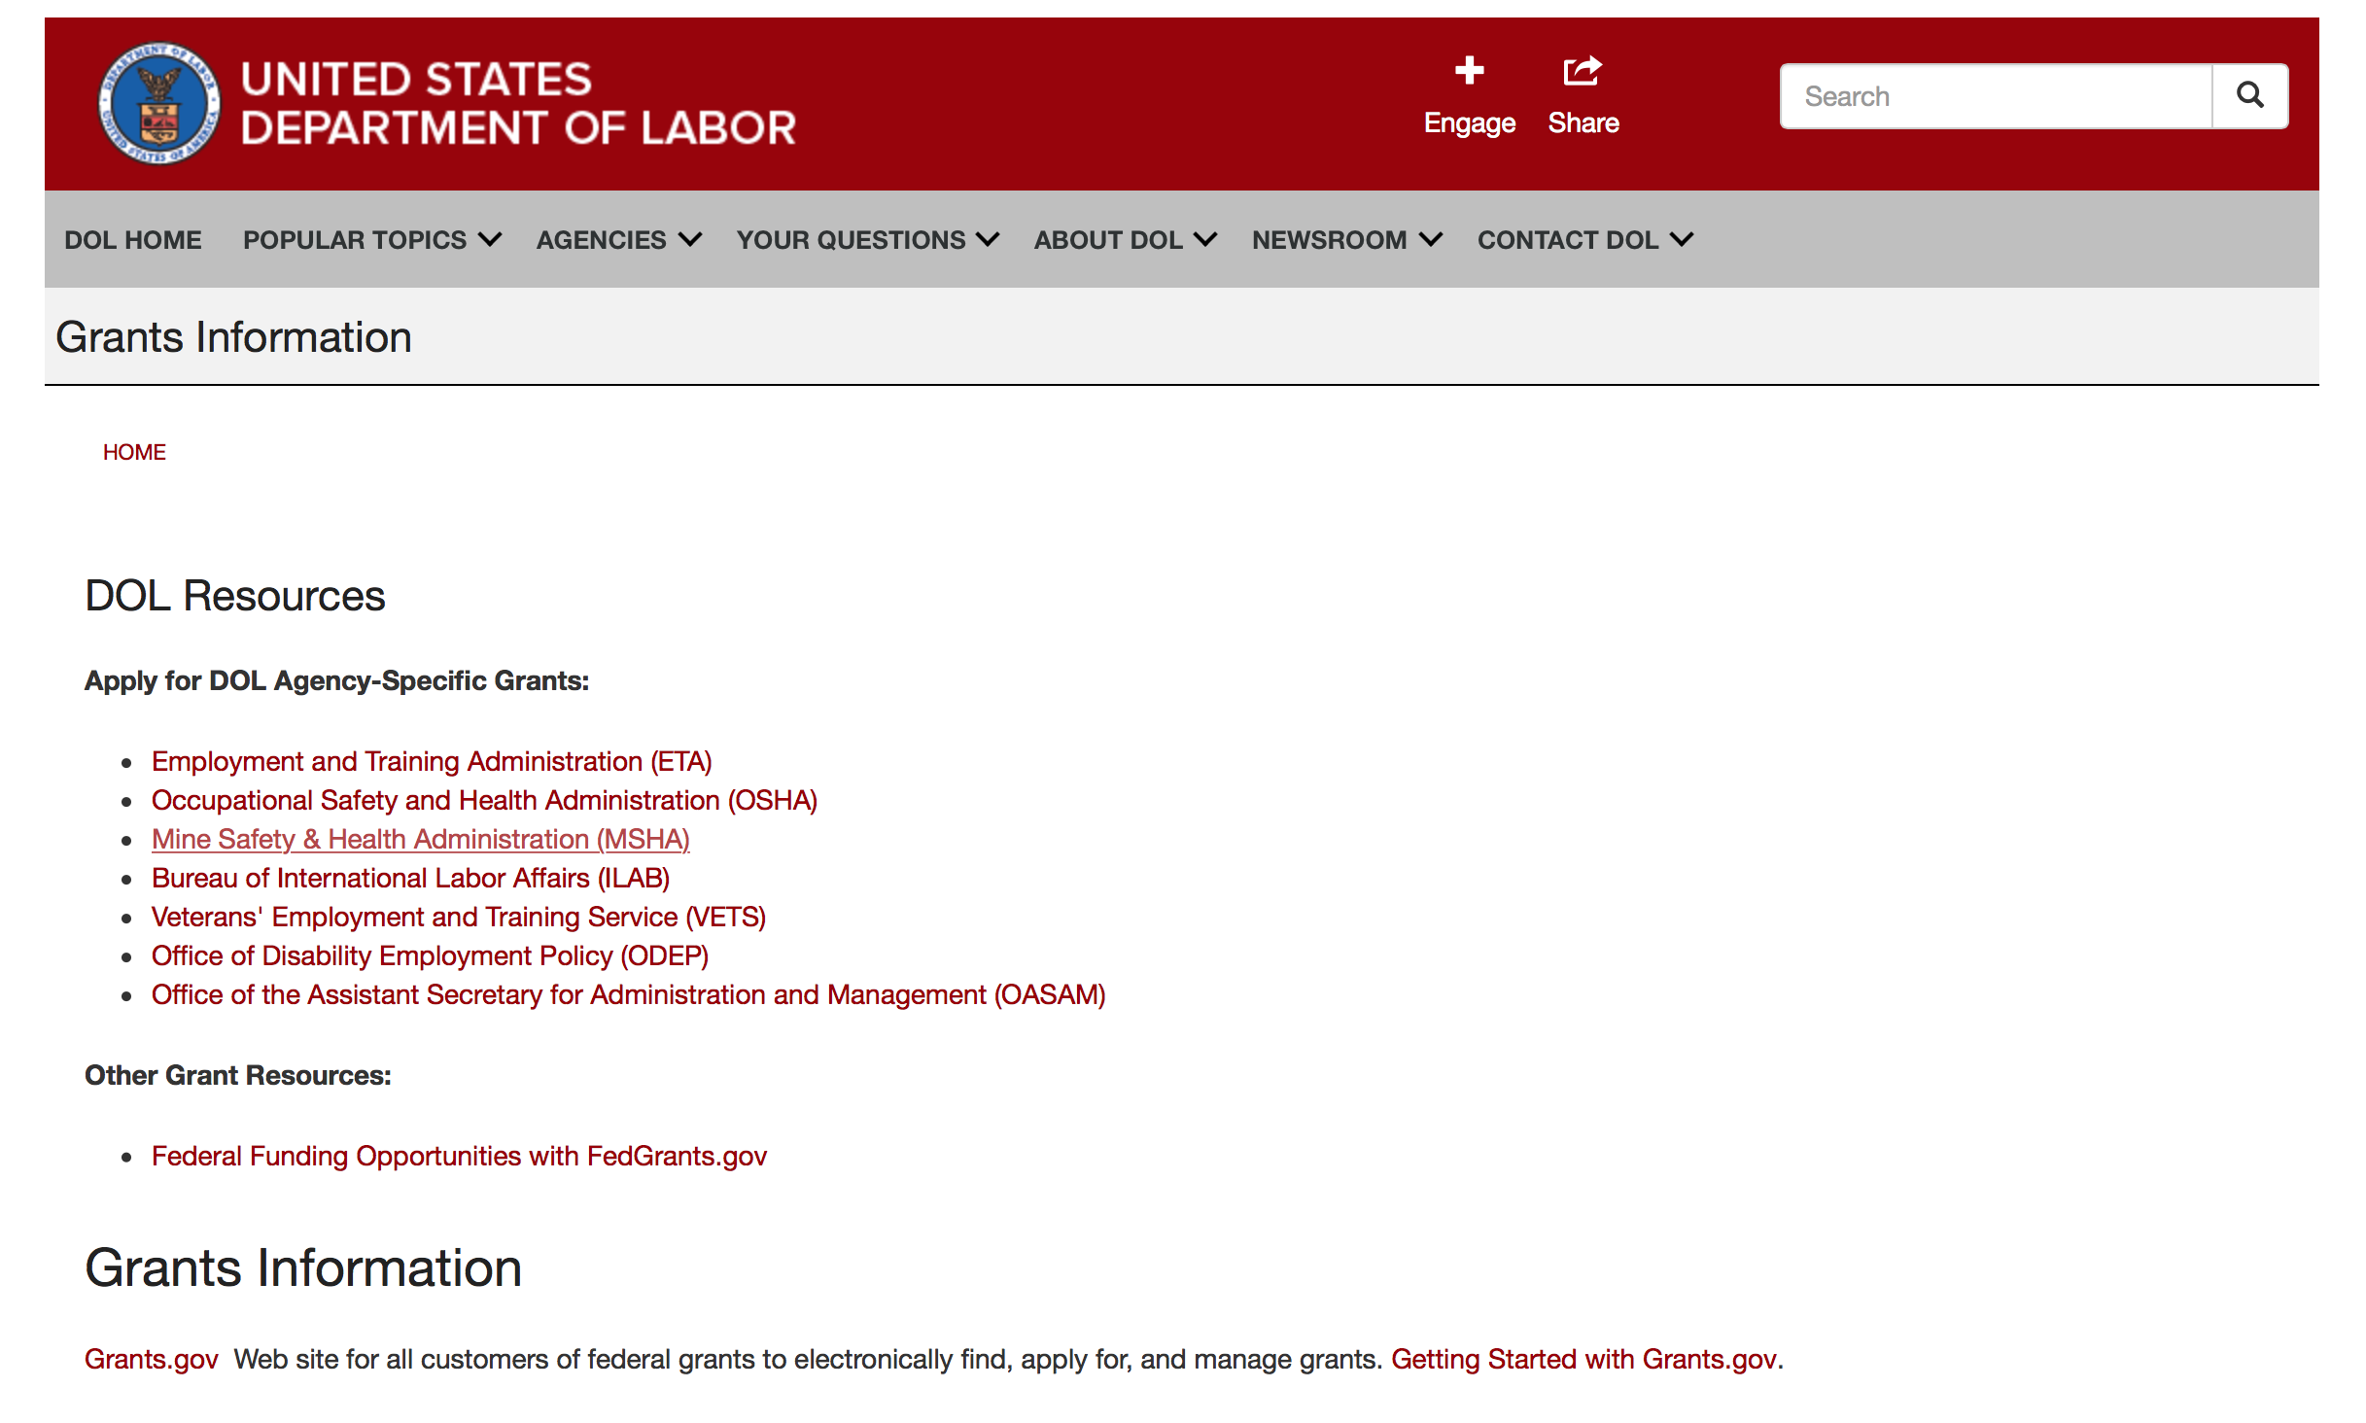

Agency Grants and Contract General Overview

DOL Resources
Apply for DOL Agency-Specific Grants:
- Employment and Training Administration (ETA)
- Occupational Safety and Health Administration (OSHA)
- Mine Safety & Health Administration (MSHA)
- Bureau of International Labor Affairs (ILAB)
- Veterans' Employment and Training Service (VETS)
- Office of Disability Employment Policy (ODEP)
- Office of the Assistant Secretary for Administration and Management (OASAM)

Other Grant Resources:
- Federal Funding Opportunities with FedGrants.gov
Grants Information
Grants.gov — Web site for all customers of federal grants to electronically find, apply for, and manage grants. Getting Started with Grants.gov.

DOL Resources and Instructions for Applying for a Grant
- DOL Guidance Clarifying the Effect of the Religious Freedom Restoration Act on Faith-Based Organizations
- Grant and Contract Information
- Contracting and Grant Program Overview
- Civil Rights Enforcement for Department of Labor Grant Recipients
- More Information About Grants
- Use of Contracts, Grants & Cooperative Agreements

Other Federal Government Grant Information
- Grant Opportunities (Catalog of Federal Domestic Assistance)

Department of Labor Grant Programs

- Bureau of International Labor Affairs (ILAB): provides grants (cooperative agreements) for the implementation of projects designed to assist developing countries combat the worse forms of child labor, forced labor, and human trafficking; and support worker rights and improve working conditions. http://www.dol.gov/general/business.
- Bureau of Labor Statistics (BLS): provides project grants (cooperative agreements) and the dissemination of technical statistical data and related information on labor force activities; provides data on prices (CPI) and cost of living; data on productivity and technology data; data on compensation and working conditions; data on employment projections.
- Employment and Training (ETA): ETA administers financial assistance programs pursuant to the Workforce Investment Act (WIA), administering State formula grant programs for youth, adults and dislocated workers, national emergency grants for workers affected by mass layoffs, plant closures, and disasters; grant programs for workers with disabilities, Indians and Native Americans, and for migrant and seasonal farmworkers. ETA also administers grant programs for older American workers, apprenticeship programs, Trade Adjustment Assistance (TAA) programs, and assistance for research and development of workforce programs. In addition, ETA is responsible for the operation and maintenance of a national system of public employment service offices and for the national unemployment insurance program.
- Mine Safety and Health (MSHA): provides grants for research, education and training programs to ensure an adequate and competent staff of trained inspectors; and assistance for establishing or improving State mine health and safety programs through technical assistance.
- Occupational Safety and Health (OSHA): provides grants to non-profit organizations to provide training, educational services, and technical assistance; assistance to states to administer and enforce state programs; assistance to states to provide occupational safety and health technical assistance and consultant services.
- Office of Disability Employment Policy (ODEP): The Office of Disability Employment Policy awards competitive grants establishing short-term pilot and technical assistance projects designed to identify, develop, test, evaluate, and disseminate policies to increase employment by expanding access to training, education, employment supports, assistive and systems technology, integrated employment, entrepreneurial development, and small business opportunities for adults and youth with disabilities. Current pilots projects focus on customized employment, Olmstead populations, and innovative demonstration youth grants, among others. Solicitations for grant applications are published in the Federal Register and announced at www.dol.gov/odep. ODEP grants are awarded by the OASAM grant office.
- Veterans' Employment and Training (VETS): provides special employment and training assistance for veterans through the Disabled Veterans' Outreach Program (DVOP) Solicitation for Grant Applications; the Local Veterans' Employment Representative Program (LVER); Veterans' Workforce Investment Program (VWIP); elaws Advisor on veterans' employment and reemployment rights; and the Homeless Veterans Reintegration Project (HVRP). VETS grants are awarded by the OASAM grant office.

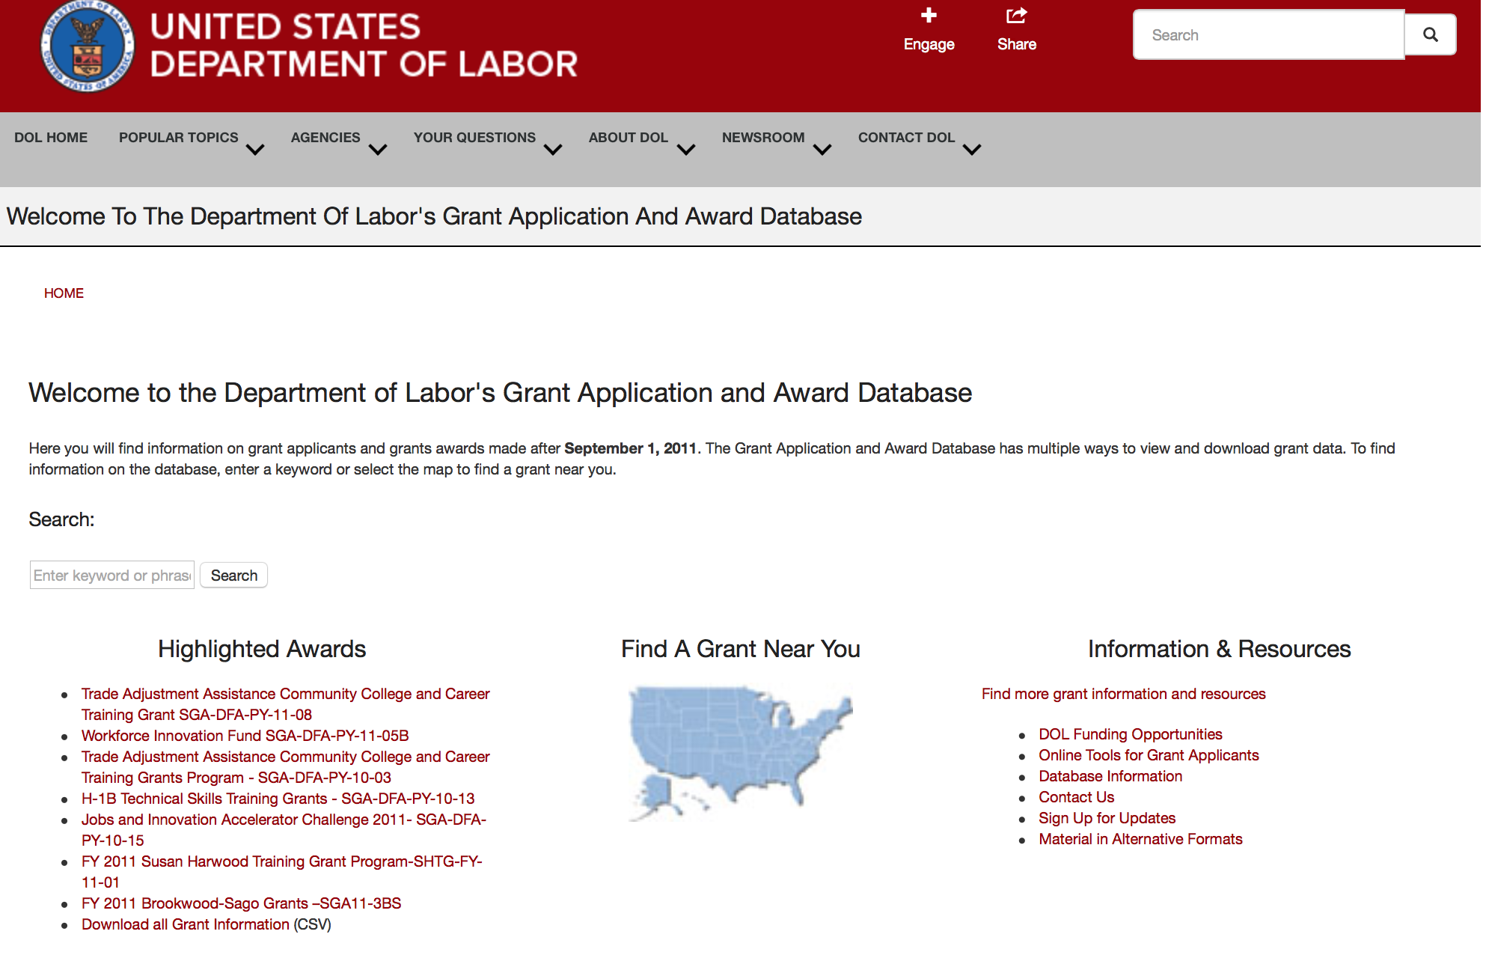

http://www.dol.gov/dol/grants/

Programs

Modifications

Veterans Employment and Training Service
Announcement of Stand Down Grants
Synopsis 2

Document Type: | Grants Notice
Funding Opportunity Number: | VPL-02-18
Funding Opportunity Title: | Announcement of Stand Down Grants
Opportunity Category: | Discretionary
Opportunity Category Explanation:
Funding Instrument Type: | Grant
Category of Funding Activity: | Other (see text field entitled "Explanation of Other Category of Funding Activity" for clarification)
Category Explanation: | Veterans' Employment and Training Service
Expected Number of Awards:
CFDA Number(s): | 17.805 -- Homeless Veterans� Reintegration Program
Cost Sharing or Matching Requirement: | No
Version: | Synopsis 2
Posted Date: | Jan 02, 2018
Last Updated Date: | Jan 02, 2018
Original Closing Date for Applications: | Dec 31, 2020
Current Closing Date for Applications: | Dec 31, 2020
Archive Date: | Jan 30, 2021
Estimated Total Program Funding:
Award Ceiling: | $10,000
Award Floor: | $7,000
Eligible Applicants: | Others (see text field entitled "Additional Information on Eligibility" for clarification)
Additional Information on Eligibility: | The following organizations and entities may apply for grant funds for Stand Down events: State and Local Workforce Development Boards, Veteran Service Organizations, local public agencies, tribal governments, and non-profit organizations including community and faith-based organizations. Organizations registered with the Internal Revenue Service as 501(c)(4) entities are not eligible to apply for this funding opportunity.
Additional Information
Agency Name: | Veterans Employment and Training Service
Description: | DOL VETS supports local Stand Down (SD) events that assist homeless veterans by providing a wide variety of employment, social, and health services. A homeless veteran is a veteran, as defined in 38 U.S.C. 101(2), who is “homeless” as that term is defined at 42 U.S.C. 11302(a)-(b), as amended by the Homeless Emergency Assistance and Rapid Transition to Housing Act of 2009 (Public Law 111-22).Stand Down grant funds must be used to enhance employment and training opportunities or to promote the self-sufficiency of homeless veterans through paid work. Veterans experiencing homelessness do not always have access to basic hygiene supplies necessary to maintain their health and appearance. Lack of shelter limits their ability to prepare for and present themselves at job interviews or be contacted for follow-up. Basic services such as showers, haircuts, attention to health concerns, and other collaborative services provided at SD events can give participants a greater sense of self and an opportunity to improve their chances of securing and maintaining employment. Each year, VETS sets funds aside from the Homeless Veterans’ Reintegration Program (HVRP) budget activity to award SD grants. Stand Down funding is a non-competitive grant awarded on a first-come, first-served basis until available annual funding is exhausted. VETS will continue to accept applications and process when additional funds become available. The maximum amount that can be awarded, per applicant for a geographic area, in a fiscal year (October 1 – September 30) is $7,000 for a one-day event and $10,000 for a multi-day event. Grants may be awarded to multiple organizations that conduct SD events in the same general area so long as there is no commingling of federal funds. In the event of a significant natural or man-made disaster, VETS may elect to accept and award grants for SD events in excess of the $10,000 limit. VETS recognizes the following as circumstances that may justify awarding SD grants in higher amounts: emergencies or major disasters, as defined in the Stafford Act, which have been declared eligible for public assistance by the Federal Emergency Management Agency (FEMA). In addition, emergencies or disaster situations of national significance, natural or man-made, that could result in a potentially large loss of employment, as declared or otherwise recognized in writing by the chief official of the Federal Agency with jurisdiction over the Federal response to the emergency or disaster. If the VETS Assistant Secretary determines it is appropriate to award increased grants for SD events due to a disaster, the VETS Assistant Secretary will announce such a determination in writing, including the maximum amount that can be awarded on account of such an identified disaster, in order to provide notice to entities proposing to conduct SD events in those geographic areas where a disaster has been declared or to which a substantial number of veterans have relocated or been relocated. Acceptable uses of Stand Down grant funds do not change in such circumstances. All applications should be emailed to the appropriate DVET of the state in which the SD event is planned.
Link to Additional Information:
Grantor Contact Information: | If you have difficulty accessing the full announcement electronically, please contact:  Questions regarding a SD grant application should be referred to the DVET in the state in which the event will take place. DVET contact information is available at: https://www.dol.gov/vets/aboutvets/regionaloffices/map.htm.  https://www.dol.gov/vets/aboutvets/regionaloffices/map.htm
https://www.grants.gov/web/grants/view-opportunity.html?oppId=299798

Reminders

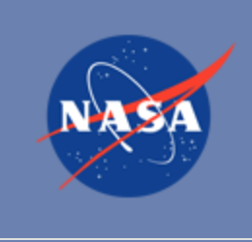

National Aeronautics and Space Administration

Research and Contracting Opportunities

NASA Research Opportunities Online

- Various NASA offices publish their research announcements over the Internet, broadening the opportunity for researchers to apply for funding. This site provides access to current research announcements along with their specific due dates.

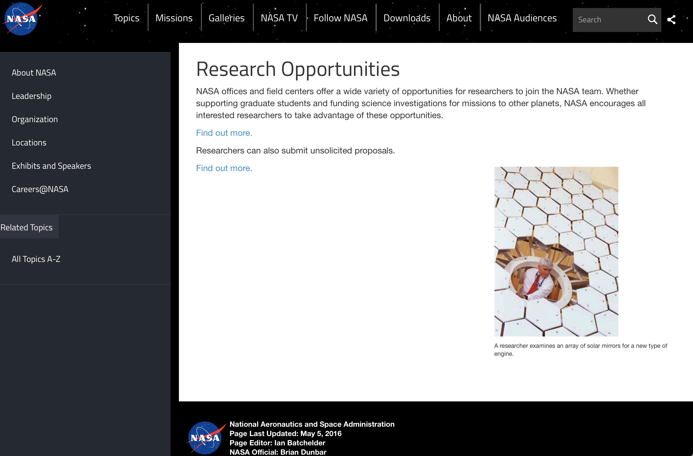

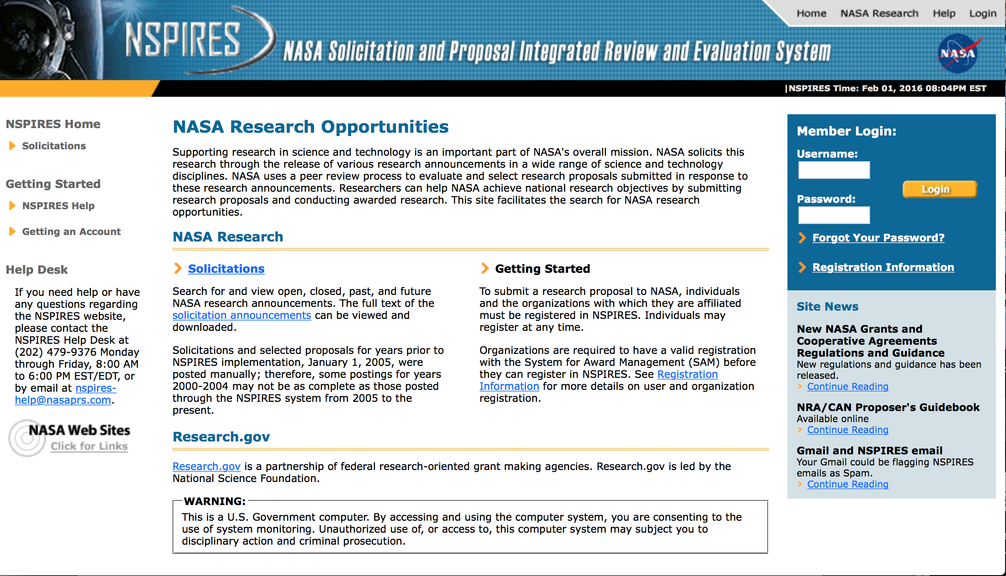
http://nspires.nasaprs.com/external/

Research Programs:

NASA Headquarters
ROSES 2017: Space Weather Operations-to-Research
Synopsis 1
https://www.grants.gov/web/grants/view-opportunity.html?oppId=300345

NASA Headquarters
ROSES 2017: Earth System Science Pathfinder (ESSP) Venture-class Science Investigations: Earth Venture Suborbital-3
Synopsis 1
https://www.grants.gov/web/grants/view-opportunity.html?oppId=299839

EONS 2018: Appendix E Minority University Research and Education Project (MUREP) Aerospace Academy – (MAA)
Synopsis 1
https://www.grants.gov/web/grants/view-opportunity.html?oppId=299943

NASA Headquarters
ROSES 2017: In-Space Validation of Earth Science Technologies
Synopsis 1
https://www.grants.gov/web/grants/view-opportunity.html?oppId=299914

NASA Education Fellowship Activity, 2018
Synopsis 1
https://www.grants.gov/web/grants/view-opportunity.html?oppId=300156

Modifications:

National Archives and Records Administration

Grant Opportunities General Overview

To access the information below: click here

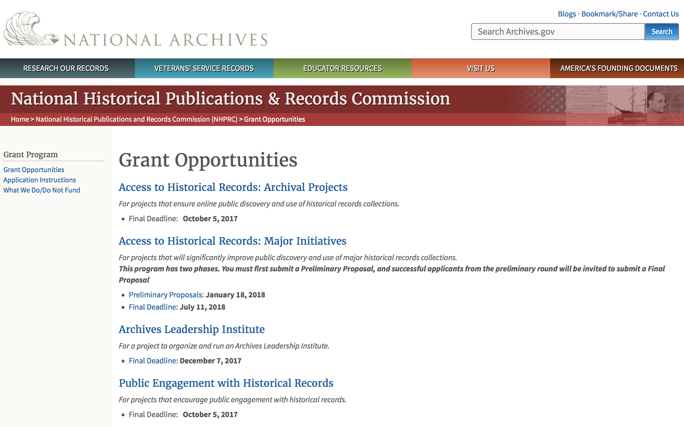

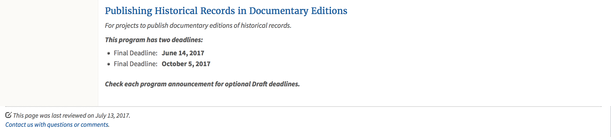
https://www.archives.gov/nhprc/announcement

Programs:

Reminders:

Publishing Historical Records in Documentary Editions
Synopsis 1
Document Type: | Grants Notice
Funding Opportunity Number: | EDITIONS-201810
Funding Opportunity Title: | Publishing Historical Records in Documentary Editions
Opportunity Category: | Discretionary
Opportunity Category Explanation:
Funding Instrument Type: | Grant
Category of Funding Activity: | Humanities (see "Cultural Affairs" in CFDA)
Category Explanation:
Expected Number of Awards: | 25
CFDA Number(s): | 89.003 -- National Historical Publications and Records Grants
Cost Sharing or Matching Requirement: | Yes
Version: | Synopsis 1
Posted Date: | Nov 29, 2017
Last Updated Date: | Nov 29, 2017
Original Closing Date for Applications: | Oct 04, 2018
Current Closing Date for Applications: | Oct 04, 2018
Archive Date:
Estimated Total Program Funding: | $2,500,000
Award Ceiling: | $200,000
Award Floor: | $1
Eligible Applicants: | Public and State controlled institutions of higher education  State governments  City or township governments  Nonprofits having a 501(c)(3) status with the IRS, other than institutions of higher education  Native American tribal governments (Federally recognized)  County governments  Private institutions of higher education
Agency Name: | National Archives and Records Administration
Description: | The National Historical Publications and Records Commission seeks proposals to publish documentary editions of historical records. Projects may focus on the papers of major figures from American history or cover broad historical movements in politics, social reform, business, military, the arts, and other aspects of the national experience. The historical value of the records and their expected usefulness to broad audiences must justify the costs of the project. The goal of this program is to provide access to, and editorial context for, the historical documents and records that tell the American story. Applicants should demonstrate familiarity with the best practices recommended by the Association for Documentary Editing or the Modern Language Association Committee on Scholarly Editions. All new projects (those which have never received NHPRC funding) must publish a digital edition, which provides online access to a searchable collection of all documents. (Ebooks or volumes in PDF do not qualify for the purposes of this grant program.) New projects may also prepare print editions as part of their overall publishing plan, but the contents of those volumes must be published online within a reasonable period of time following print publication. The NHPRC encourages projects to provide free access to online editions. Projects that do not have definitive plans for digital dissemination and preservation in place at the time of application will not be considered. Grants are awarded for collecting, describing, preserving, compiling, transcribing, annotating, editing, encoding, and publishing documentary source materials online and in print. Because of the focus on documentary sources, grants do not support preparation of critical editions of published works unless such works are just a small portion of the larger project. All applicants should be aware that the application process is highly competitive. For a comprehensive list of Commission's limitations on funding, please see What We Do and Do Not Fund. Applications that consist entirely of ineligible activities will not be considered. Ongoing projects: Applicants from ongoing projects must demonstrate that they have successfully achieved the performance objectives associated with previous NHPRC awards; provide updated, current information, including a description of the new activities; describe the content and historical significance of the specific materials to be edited during the proposed grant period; show progress towards completing the edition; and justify costs in a new budget. Award Information A grant is for one year and for up to $200,000. The Commission expects to make up to 25 grants in this category for a total of up to $2,500,000. Grants begin no earlier than January 1, 2019. The Commission requires that grant recipients acknowledge NHPRC grant assistance in all publications, publicity, and other products that result from its support. Eligibility • U.S. nonprofit organizations or institutions • U.S. colleges, universities, and other academic institutions • State or local government agencies • Federally-acknowledged or state-recognized Native American tribes or groups Cost Sharing The total costs of a project are shared between the NHPRC and the applicant organization. The Commission provides no more than 50 per cent of total direct project costs in the Publishing Historical Records in Documentary Editions category. NHPRC grant recipients are not permitted to use grant funds for indirect costs (as indicated in 2 CFR 2600.101). Cost sharing is required. The applicant’s financial contribution may include both direct and indirect expenses, in-kind contributions, non-Federal third-party contributions, and any income earned directly by the project. Indirect costs must be listed under the applicant’s cost sharing contribution. Other Requirements Applicant organizations must be registered in the System for Award Management (SAM) prior to submitting an application, maintain SAM registration throughout the application and award process, and include a valid DUNS number in their application. Details on SAM registration and requesting a DUNS number can be found at the System for Award Management website at https://sam.gov. Please refer to the User Guides section and the Grants Registrations PDF. A complete application includes the Application for Federal Assistance (Standard Form 424), Assurances -- Non-Construction Programs (Standard Form 424B), a Project Narrative, Summary, Supplementary Materials, and Budget. Applications lacking these items will not be considered. Ineligible applications will not be reviewed.
Link to Additional Information: | Link to full grant announcement, including additional requirements
Grantor Contact Information: | If you have difficulty accessing the full announcement electronically, please contact:  Jeff de la Concepcion Jeff.delaconcepcion@nara.gov  Grant Information Specialist
https://www.grants.gov/web/grants/view-opportunity.html?oppId=299091

Publishing Historical Records in Documentary Editions
Synopsis 1
Document Type: | Grants Notice
Funding Opportunity Number: | EDITIONS-201806
Funding Opportunity Title: | Publishing Historical Records in Documentary Editions
Opportunity Category: | Discretionary
Opportunity Category Explanation:
Funding Instrument Type: | Grant
Category of Funding Activity: | Humanities (see "Cultural Affairs" in CFDA)
Category Explanation:
Expected Number of Awards: | 25
CFDA Number(s): | 89.003 -- National Historical Publications and Records Grants
Cost Sharing or Matching Requirement: | No
Version: | Synopsis 1
Posted Date: | Nov 29, 2017
Last Updated Date: | Nov 29, 2017
Original Closing Date for Applications: | Jun 13, 2018
Current Closing Date for Applications: | Jun 13, 2018
Archive Date:
Estimated Total Program Funding: | $2,500,000
Award Ceiling: | $200,000
Award Floor: | $1
https://www.grants.gov/web/grants/view-opportunity.html?oppId=299108

State Board Programming Grants
Synopsis 1
Document Type: | Grants Notice
Funding Opportunity Number: | STATE-201806
Funding Opportunity Title: | State Board Programming Grants
Opportunity Category: | Discretionary
Opportunity Category Explanation:
Funding Instrument Type: | Grant
Category of Funding Activity: | Humanities (see "Cultural Affairs" in CFDA)
Category Explanation:
Expected Number of Awards: | 20
CFDA Number(s): | 89.003 -- National Historical Publications and Records Grants
Cost Sharing or Matching Requirement: | Yes
Version: | Synopsis 1
Posted Date: | Nov 29, 2017
Last Updated Date: | Nov 29, 2017
Original Closing Date for Applications: | Jun 13, 2018
Current Closing Date for Applications: | Jun 13, 2018
Archive Date:
Estimated Total Program Funding: | $625,000
Award Ceiling: | $80,000
Award Floor: | $1
Eligible Applicants: | Private institutions of higher education  State governments  Public and State controlled institutions of higher education  Nonprofits having a 501(c)(3) status with the IRS, other than institutions of higher education  Others (see text field entitled "Additional Information on Eligibility" for clarification)
Additional Information on Eligibility: | States also include the District of Columbia, the Commonwealth of Puerto Rico, and United States territories
Agency Name: | National Archives and Records Administration
Description: | The National Historical Publications and Records Commission seeks proposals that strengthen the nation’s archival network through activities undertaken by state historical records advisory boards. The purpose of this grant program is to assist state boards to broaden preservation of, and increased online access to, historical records; develop and promote best practices; support activities that put the American people in touch with primary sources in their communities and online; promote the institutional advancement of organizations in underserved communities; and assist locally based repositories with training and tools to improve their stewardship abilities. The Commission will award grants to state historical records advisory boards to: • Operate state-based regrant programs that preserve historical records and make them available online • Provide educational and outreach programs, workshops, and other activities that enhance citizen and student engagement with historical records • Offer scholarships, training opportunities, and other programs that support institutional advancement among records repositories, especially those in underserved communities • Collaborate on projects with other organizations to address common problems or shared opportunities within a state or among a consortium of state archives • Hold or participate in meetings and public forums on statewide or national archival issues. The NHPRC encourages organizations to actively engage the public in the work of the project. For a comprehensive list of Commission limitations on funding, please see: "What we do and do not fund" (http://www.archives.gov/nhprc/apply/eligibility.html). Applications that consist entirely of ineligible activities will not be considered. Award Information A grant is for one and for up to $40,000 or for two years and for up to $80,000. The Commission expects to make up to 20 grants in this category for a total of up to $625,000. Grants begin no earlier than January 1, 2019. The Commission requires that grant recipients acknowledge NHPRC grant assistance in all publicity, publications, and other products that result from its support. Eligibility These grants are awarded only to state historical records advisory boards in each state, or to the state agency responsible for the state board, ordinarily the state archives. Another state agency, or a non-profit organization, such as a foundation or university, acting on behalf of the designated state agency may apply. States also include the District of Columbia, the Commonwealth of Puerto Rico, and United States territories. Cost Sharing The total costs of a project are shared between the NHPRC and the applicant organization. The Commission provides no more than 75 per cent of total project costs in the State Board Programming Grants category. NHPRC grant recipients are not permitted to use grant funds for indirect costs (as indicated in 2 CFR 2600.101). Cost sharing is required. The applicant's financial contribution may include both direct and indirect expenses, in-kind contributions, non-Federal third-party contributions, and any income earned directly by the project. Indirect costs must be listed under the applicant's cost sharing contribution. Other Requirements Applicant organizations must be registered in the System for Award Management (SAM) prior to submitting an application, maintain SAM registration throughout the application and award process, and include a valid DUNS number in their application. Details on SAM registration and requesting a DUNS number can be found at the System for Award Management website at https://sam.gov. Please refer to the User Guides section and the Grants Registrations PDF. Ineligible applications will not be reviewed.
Link to Additional Information: | Link to full grant announcement, including additional requirements
Grantor Contact Information: | If you have difficulty accessing the full announcement electronically, please contact:  Jeff de la Concepcion Jeff.delaconcepcion@nara.gov  Grant Information Specialist
https://www.grants.gov/web/grants/view-opportunity.html?oppId=299107

Access to Historical Records: Major Initiatives
Synopsis 1

Document Type: | Grants Notice
Funding Opportunity Number: | MAJOR-201807
Funding Opportunity Title: | Access to Historical Records: Major Initiatives
Opportunity Category: | Discretionary
Opportunity Category Explanation:
Funding Instrument Type: | Grant
Category of Funding Activity: | Humanities (see "Cultural Affairs" in CFDA)
Category Explanation:
Expected Number of Awards: | 5
CFDA Number(s): | 89.003 -- National Historical Publications and Records Grants
Cost Sharing or Matching Requirement: | Yes
Version: | Synopsis 1
Posted Date: | Jul 14, 2017
Last Updated Date: | Jul 14, 2017
Original Closing Date for Applications: | Jul 11, 2018
Current Closing Date for Applications: | Jul 11, 2018
Archive Date:
Estimated Total Program Funding: | $1,000,000
Award Ceiling: | $350,000
Award Floor: | $100,000
Eligible Applicants: | Public and State controlled institutions of higher education  County governments  Nonprofits having a 501(c)(3) status with the IRS, other than institutions of higher education  State governments  City or township governments  Private institutions of higher education  Native American tribal governments (Federally recognized)
Agency Name: | National Archives and Records Administration
Description: | The National Historical Publications and Records Commission seeks projects that will significantly improve public discovery and use of major historical records collections. All types of historical records are eligible, including documents, photographs, born-digital records, and analog audio and moving images. Projects may: • Digitize historical records collections, or related collections, held by a single institution and make them freely available online • Provide access to born-digital records • Create new freely-available virtual collections drawn from historical records held by multiple institutions • Create new tools and methods for users to access records The NHPRC welcomes collaborative projects, particularly for bringing together related records from multiple institutions. Projects that address significant needs in the field and result in replicable and scalable approaches will be more competitive. We also encourage organizations to actively engage the public in the work of the project. Applicants should also consult Access to Historical Records: Archival Projects program, which has different requirements and award amounts. For a comprehensive list of Commission limitations on funding, please see: "What we do and do not fund" (http://www.archives.gov/nhprc/apply/eligibility.html). Applications that consist entirely of ineligible activities will not be considered. Award Information A grant is for one to three years and between $100,000 and $350,000. We expect to make up to five grants in this category for a total of up to $1,000,000. Grants begin no earlier than January 1, 2019. The Commission requires that grant recipients acknowledge NHPRC grant assistance in all publicity, publications, and other products that result from its support. Eligibility Eligible applicants: • U.S. nonprofit organizations or institutions • U.S. colleges, universities, and other academic institutions • State or local government agencies • Federally-acknowledged or state-recognized Native American tribes or groups Cost Sharing The total costs of a project are shared between the NHPRC and the applicant organization. The Commission provides no more than 50 per cent of total project costs in the Access to Historical Records: Major Initiatives category. NHPRC grant recipients are not permitted to use grant funds for indirect costs (as indicated in 2 CFR 2600.101). Cost sharing is required. The applicant's financial contribution may include both direct and indirect expenses, in-kind contributions, non-Federal third-party contributions, and any income earned directly by the project. Indirect costs must be listed under the applicant's cost sharing contribution. Other Requirements Applicant organizations must be registered in the System for Award Management (SAM) prior to submitting an application, maintain SAM registration throughout the application and award process, and include a valid DUNS number in their application. Details on SAM registration and requesting a DUNS number can be found at the System for Award Management website at https://sam.gov. Please refer to the User Guides section and the Grants Registrations PDF. Application Information You must use Grants.gov to submit your Full Proposal. All information necessary to apply is included in this announcement, the Application Instructions, and the forms on Grants.gov. If you need the information supplied in an alternative format, please call the NHPRC at 202-357-5010. In order to ensure eligibility, applicants should first review the rules and regulations governing NHPRC grants under the Administering an NHPRC Grant section. Applying to the Access to Historical Records: Major Initiatives program is a two-phase process. Phase One • All applicants must have submitted a Preliminary Proposal by January 18, 2018. • Only those applicants who have successfully completed Phase One and who have been invited by the Commission to submit a full proposal to the Access to Historical Records: Major Initiatives program are eligible to participate in the second phase of the process. Phase Two • If you have been invited, prepare and submit a complete application to the full Major Initiatives grant announcement via Grants.gov by July 11, 2018. • Applicants may consult with the Director of the Access Program, Alex Lorch (alexander.lorch@nara.gov), or with the Director for Technology Initiatives, Nancy Melley (nancy.melley@nara.gov), during both the preliminary and full proposal project phases.
Link to Additional Information: | Link to full grant announcement, including additional requirements
Grantor Contact Information: | If you have difficulty accessing the full announcement electronically, please contact:  Jeff de la Concepcion Jeff.delaconcepcion@nara.gov  Grant Information Specialist

http://www.grants.gov/web/grants/view-opportunity.html?oppId=295496

National Endowment for the Arts

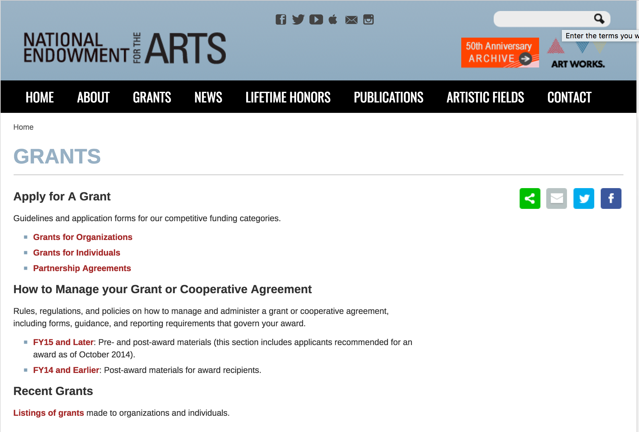

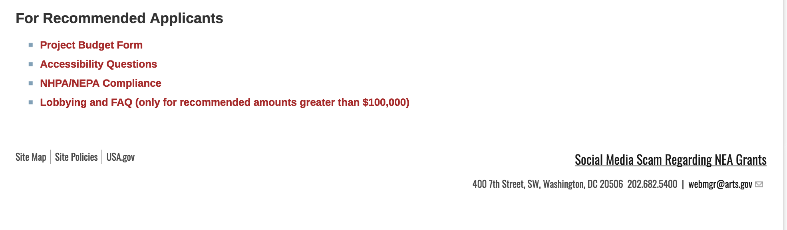
See more at: https://www.arts.gov/grants

Programs:

Modifications:

Reminders:

NEA Art Works I, FY2019
Synopsis 1
Document Type: | Grants Notice
Funding Opportunity Number: | 2018NEA01AW1
Funding Opportunity Title: | NEA Art Works I, FY2019
Opportunity Category: | Discretionary
Opportunity Category Explanation:
Funding Instrument Type: | Grant
Category of Funding Activity: | Arts (see "Cultural Affairs" in CFDA)
Category Explanation:
Expected Number of Awards:
CFDA Number(s): | 45.024 -- Promotion of the Arts Grants to Organizations and Individuals
Cost Sharing or Matching Requirement: | Yes
Version: | Synopsis 1
Posted Date: | Dec 06, 2017
Last Updated Date: | Dec 06, 2017
Original Closing Date for Applications: | Feb 15, 2018
Current Closing Date for Applications: | Feb 15, 2018
Archive Date:
Estimated Total Program Funding:
Award Ceiling: | $100,000
Award Floor: | $10,000
Eligible Applicants: | State governments  Special district governments  Public and State controlled institutions of higher education  Native American tribal governments (Federally recognized)  Private institutions of higher education  Nonprofits having a 501(c)(3) status with the IRS, other than institutions of higher education  County governments  City or township governments  Independent school districts
Agency Name: | National Endowment for the Arts
Description: | An organization may submit only one application through one of the following FY 2019 categories: Art Works or Challenge America. If an organization applies to the Challenge America category, it may not submit another application to the Art Works category. The Arts Endowment's support of a project may start on or after January 1, 2019. Generally, a period of performance of up to two years is allowed. Art Works Program Description To support artistically excellent projects that celebrate our creativity and cultural heritage, invite mutual respect for differing beliefs and values, and enrich humanity. Matching grants generally range from $10,000 to $100,000. A minimum cost share/match equal to the grant amount is required.
Link to Additional Information: | NEA Website Announcement
Grantor Contact Information: | If you have difficulty accessing the full announcement electronically, please contact:  NEA Web Manager webmgr@arts.gov  NEA Web Manager
https://www.grants.gov/web/grants/view-opportunity.html?oppId=299275

NEA Literature Fellowships: Creative Writing, FY2019
Synopsis 1
Document Type: | Grants Notice
Funding Opportunity Number: | 2018NEA03LFCW
Funding Opportunity Title: | NEA Literature Fellowships: Creative Writing, FY2019
Opportunity Category: | Discretionary
Opportunity Category Explanation:
Funding Instrument Type: | Grant
Category of Funding Activity: | Arts (see "Cultural Affairs" in CFDA)
Category Explanation:
Expected Number of Awards:
CFDA Number(s): | 45.024 -- Promotion of the Arts Grants to Organizations and Individuals
Cost Sharing or Matching Requirement: | No
Version: | Synopsis 1
Posted Date: | Nov 07, 2017
Last Updated Date: | Nov 08, 2017
Original Closing Date for Applications: | Mar 07, 2018
Current Closing Date for Applications: | Mar 07, 2018
Archive Date:
Estimated Total Program Funding:
Award Ceiling: | $25,000
Award Floor: | $25,000
Eligible Applicants: | Individuals
Agency Name: | National Endowment for the Arts
Description: | You may submit only one application for FY 2019 funding. You may not apply for both a Literature Fellowship under this deadline and a Translation Project under the December 5, 2017 deadline. Grant Program Description The National Endowment for the Arts Literature Fellowships program offers $25,000 grants in prose (fiction and creative nonfiction) and poetry to published creative writers that enable recipients to set aside time for writing, research, travel, and general career advancement. Applications are reviewed through an anonymous process in which the only criteria for review are artistic excellence and artistic merit. To review the applications, the National Endowment for the Arts assembles a different advisory panel every year, each diverse with regard to geography, race and ethnicity, and artistic points of view. The National Endowment for the Arts Literature Fellowships program operates on a two-year cycle with fellowships in prose and poetry available in alternating years. For FY 2019, which is covered by these guidelines, fellowships in poetry are available. Fellowships in prose (fiction and creative nonfiction) will be offered in FY 2020 and guidelines will be available in January 2019. You may apply only once each year. Competition for fellowships is extremely rigorous. We typically receive more than 1,000 applications each year in this category and award fellowships to fewer than 5% of applicants. You should consider carefully whether your work will be competitive at the national level.
Link to Additional Information: | NEA Complete Website Announcement
Grantor Contact Information: | If you have difficulty accessing the full announcement electronically, please contact:  NEA Web Manager webmgr@arts.gov  NEA Web Manager
http://www.grants.gov/web/grants/view-opportunity.html?oppId=298531

National Endowment for the Humanities

Grant Overview -

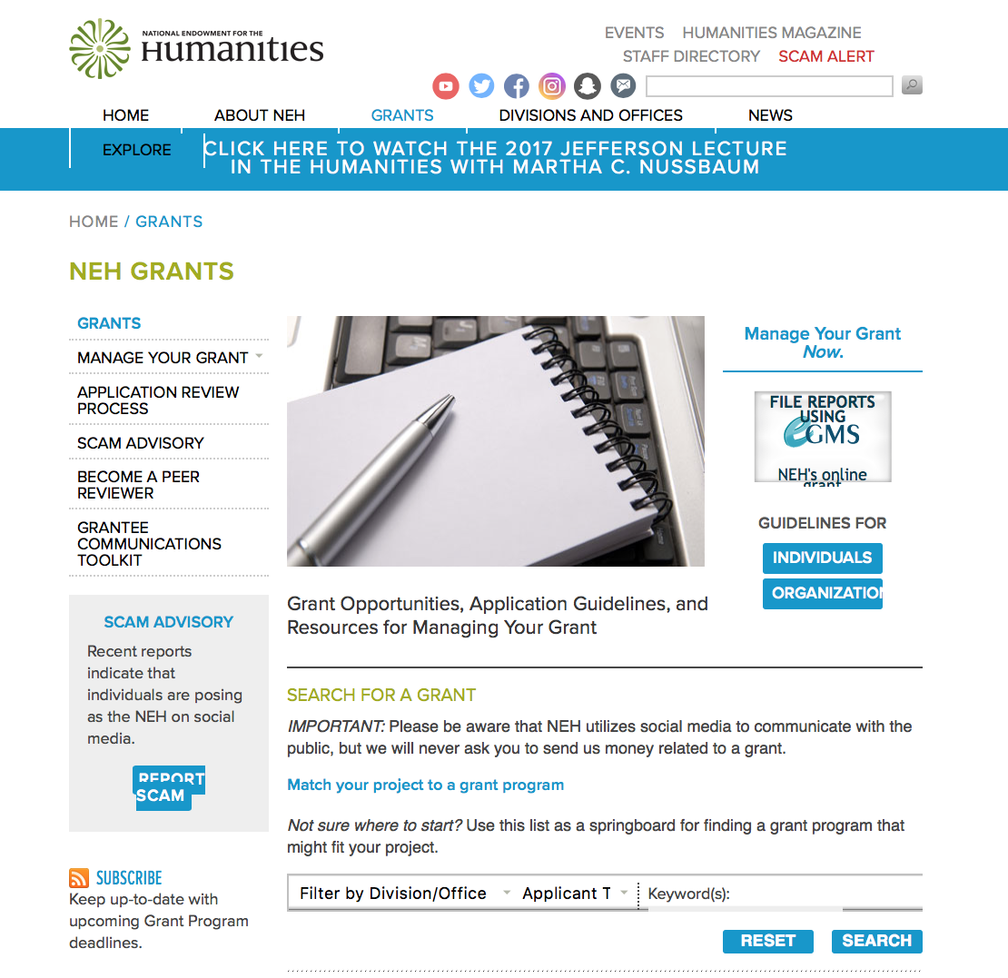

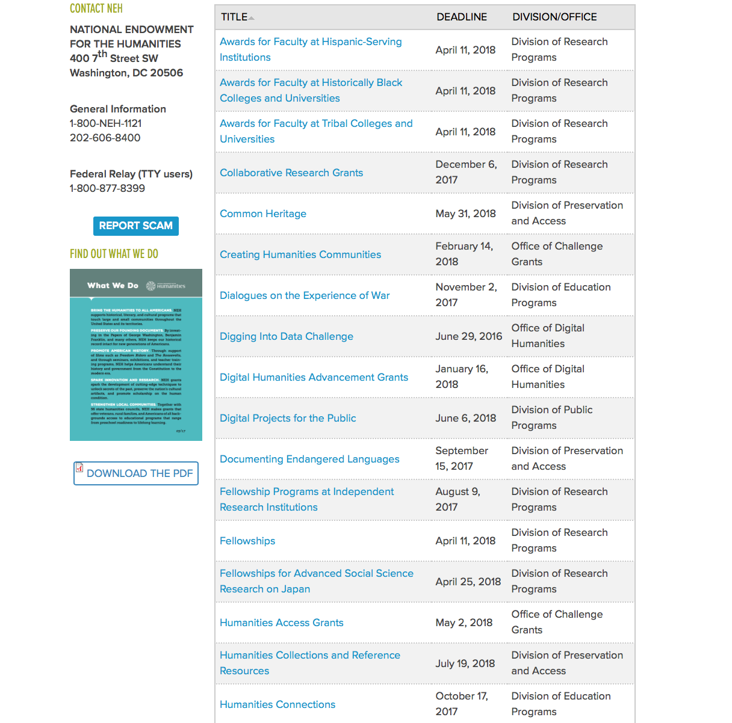

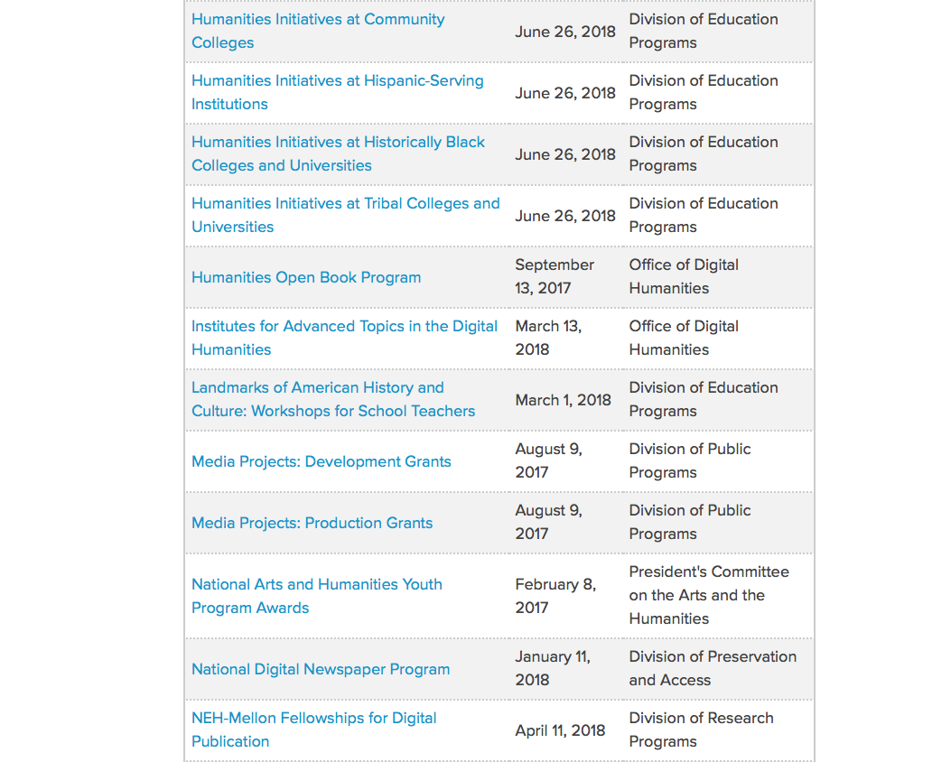

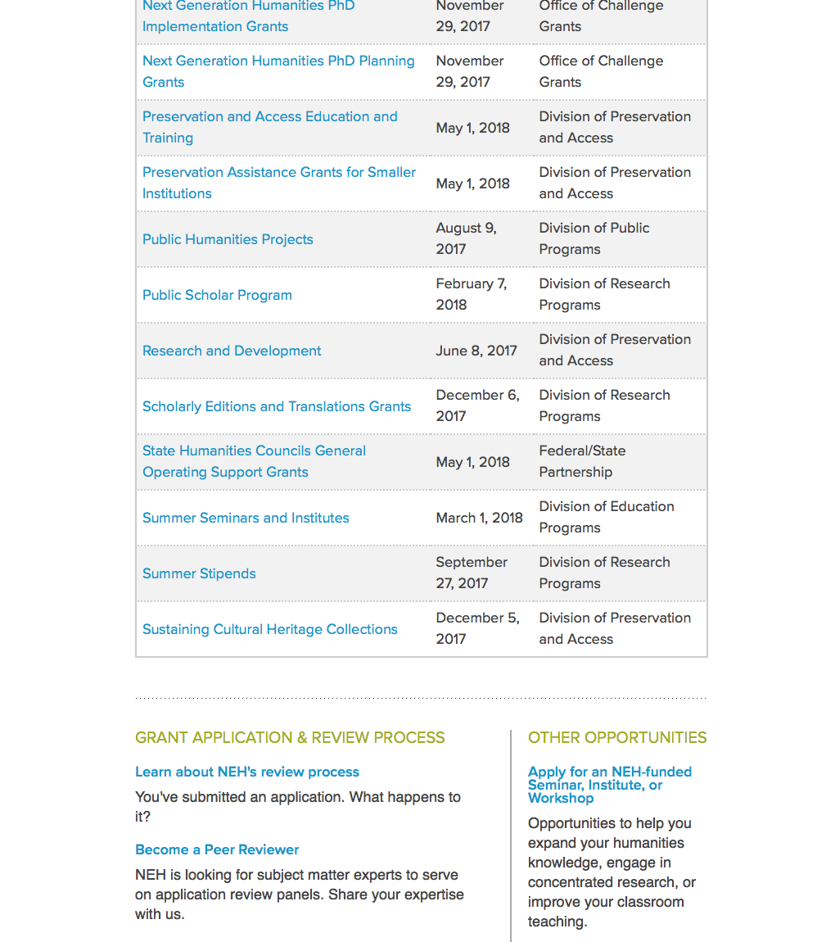

https://www.neh.gov/grants

Programs:

Institutes for Advanced Topics in the Digital Humanities
Synopsis 1

General Information
Document Type: Grants Notice  Funding Opportunity Number: 20180313-HT  Funding Opportunity Title: Institutes for Advanced Topics in the Digital Humanities  Opportunity Category: Discretionary  Opportunity Category Explanation:  Funding Instrument Type: Grant  Category of Funding Activity: Humanities (see "Cultural Affairs" in CFDA)  Category Explanation:  Expected Number of Awards:  CFDA Number(s): 45.169 -- Promotion of the Humanities Office of Digital Humanities  Cost Sharing or Matching Requirement: No | Version: Synopsis 1  Posted Date: Jan 11, 2018  Last Updated Date: Jan 11, 2018  Original Closing Date for Applications: Mar 13, 2018  Current Closing Date for Applications: Mar 13, 2018  Archive Date:  Estimated Total Program Funding:  Award Ceiling: $250,000  Award Floor: $1
Eligibility
Eligible Applicants: | Nonprofits having a 501(c)(3) status with the IRS, other than institutions of higher education  State governments  Special district governments  City or township governments  Native American tribal governments (Federally recognized)  Public and State controlled institutions of higher education  Private institutions of higher education  County governments
Additional Information on Eligibility:
Additional Information
Agency Name: | National Endowment for the Humanities
Description: | The Institutes for Advanced Topics in the Digital Humanities (IATDH) program supports national or regional (multistate) training programs for scholars, humanities professionals, and advanced graduate students to broaden and extend their knowledge of digital humanities. Through this program NEH seeks to increase the number of humanities scholars and practitioners using digital technology in their research and to broadly disseminate knowledge about advanced technology tools and methodologies relevant to the humanities. The institutes may be a single opportunity or offered multiple times to different audiences. Institutes may be as short as a few days and held at multiple locations or as long as six weeks at a single site. For example, training opportunities could be offered before or after regularly occurring scholarly meetings, during the summer months, or during appropriate times of the academic year. The duration of a program should allow for full and thorough treatment of the topic. These professional development programs may focus on a particular computational method, such as network or spatial analysis. They may also target the needs of a particular humanities discipline or audience.
Link to Additional Information: | https://www.neh.gov/grants/odh/institutes-advanced-topics-in-the-digital-humanities
Grantor Contact Information: | If you have difficulty accessing the full announcement electronically, please contact:  If you have questions about the program, contact the ODH staff at odh@neh.gov. Applicants wishing to speak to a staff member by telephone should provide in an e-mail message a telephone number and a preferred time to call. odh@neh.gov  odh@neh.gov

https://www.grants.gov/web/grants/view-opportunity.html?oppId=300001

Infrastructure and Capacity Building Challenge Grants
Synopsis 1
General Information
Document Type: | Grants Notice
Funding Opportunity Number: | 20180315-CHA
Funding Opportunity Title: | Infrastructure and Capacity Building Challenge Grants
Opportunity Category: | Discretionary
Opportunity Category Explanation:
Funding Instrument Type: | Grant
Category of Funding Activity: | Humanities (see "Cultural Affairs" in CFDA)
Category Explanation:
Expected Number of Awards:
CFDA Number(s): | 45.130 -- Promotion of the Humanities Challenge Grants
Cost Sharing or Matching Requirement: | Yes
Version: | Synopsis 1
Posted Date: | Jan 16, 2018
Last Updated Date: | Jan 16, 2018
Original Closing Date for Applications: | Mar 15, 2018
Current Closing Date for Applications: | Mar 15, 2018
Archive Date:
Estimated Total Program Funding:
Award Ceiling: | $1,000,000
Award Floor: | $1

Eligibility
Eligible Applicants: | City or township governments  Public and State controlled institutions of higher education  Private institutions of higher education  County governments  Nonprofits having a 501(c)(3) status with the IRS, other than institutions of higher education  Native American tribal governments (Federally recognized)  Special district governments
Additional Information on Eligibility:
Additional Information
Agency Name: | National Endowment for the Humanities
Description: | The mission of this Challenge Grants program is to strengthen the institutional base of the humanities by enabling infrastructure development and capacity building. Grants aim to help institutions secure long-term support for their core activities and expand efforts to preserve and create access to outstanding humanities materials. Applications are welcome from colleges and universities, museums, public libraries, research institutions, historical societies and historic sites, scholarly associations, state humanities councils, and other nonprofit humanities entities. Programs that involve collaboration among multiple institutions are eligible as well, but one institution must serve as the lead agent and formal applicant of record. Through these grants organizations can increase their humanities capacity with spend-down funds that generate expendable earnings to support and enhance ongoing program activities. Eligible activities include the documentation of cultural heritage materials that are lost or imperiled; the preservation and conservation of humanities materials; and the sustaining of digital scholarly infrastructure. Challenge grants may also provide capital directly supporting the purchase of equipment and software; the design, purchase, construction, restoration, or renovation of facilities needed for humanities activities; and collections sharing. Such direct expenditures bring long-term benefits to the institution and to the humanities more broadly. Grantee institutions may also expend up to 10 percent of total grant funds (federal funds plus matching funds) to defray costs of fundraising to meet the NEH challenge. Challenge grant funds (both federal and nonfederal together) must enhance the humanities in the long term. Challenge grant funds should not merely replace funds already being expended, but instead should reflect careful strategic planning to strengthen and enrich an institution’s humanities activities. Institutions may use challenge grant funds to meet both ongoing and one-time humanities-related costs, provided that the long-term benefit of the expenditure can be demonstrated.
Link to Additional Information: | https://www.neh.gov/grants/preservation/infrastructure-and-capacity-building-challenge-grants
Grantor Contact Information: | If you have difficulty accessing the full announcement electronically, please contact:  Division of Preservation and Access National Endowment for the Humanities 400 Seventh Street, SW Washington, DC 20506 202-606-8309 challenge@neh.gov challenge@neh.gov  challenge@neh.gov

https://www.grants.gov/web/grants/view-opportunity.html?oppId=300114

Fellowships
Synopsis 1

Document Type: | Grants Notice
Funding Opportunity Number: | 20180411-FEL
Funding Opportunity Title: | Fellowships
Opportunity Category: | Discretionary
Opportunity Category Explanation:
Funding Instrument Type: | Grant
Category of Funding Activity: | Humanities (see "Cultural Affairs" in CFDA)
Category Explanation:
Expected Number of Awards:
CFDA Number(s): | 45.160 -- Promotion of the Humanities Fellowships and Stipends
Cost Sharing or Matching Requirement: | No
Version: | Synopsis 1
Posted Date: | Feb 02, 2018
Last Updated Date: | Feb 02, 2018
Original Closing Date for Applications: | Apr 11, 2018
Current Closing Date for Applications: | Apr 11, 2018
Archive Date:
Estimated Total Program Funding:
Award Ceiling: | $60,000
Award Floor: | $30,000
Eligible Applicants: | Individuals
Additional Information on Eligibility:
Additional Information
Agency Name: | National Endowment for the Humanities
Description: | Fellowships support individuals pursuing advanced research that is of value to humanities scholars, general audiences, or both. Recipients usually produce articles, monographs, books, digital materials, archaeological site reports, translations, editions, or other scholarly resources in the humanities. Through NEH-Mellon Fellowships for Digital Publication, the National Endowment for the Humanities and The Andrew W. Mellon Foundation jointly support individual scholars pursuing interpretive research projects that require digital expression and digital publication. To be eligible for this special opportunity, an applicant’s plans for digital publication must be essential to the project’s research goals. That is, the project must be conceived as digital because the nature of the research and the topics being addressed demand presentation beyond traditional print publication. Successful projects will likely incorporate visual, audio, and/or other multimedia materials or flexible reading pathways that could not be included in traditionally published books, as well as an active distribution plan.
Link to Additional Information: | https://www.neh.gov/grants/fellowships
Grantor Contact Information: | If you have difficulty accessing the full announcement electronically, please contact:  Division of Research Programs National Endowment for the Humanities 400 Seventh Street, SW Washington, DC 20506 202-606-8200 fellowships@neh.gov fellowships@neh.gov  fellowships@neh.gov

https://www.grants.gov/web/grants/view-opportunity.html?oppId=300454

Modifications:

Reminders:

Public Scholar Program
Synopsis 1

Document Type: | Grants Notice
Funding Opportunity Number: | 20180207-FZ
Funding Opportunity Title: | Public Scholar Program
Opportunity Category: | Discretionary
Opportunity Category Explanation:
Funding Instrument Type: | Grant
Category of Funding Activity: | Humanities (see "Cultural Affairs" in CFDA)
Category Explanation:
Expected Number of Awards:
CFDA Number(s): | 45.160 -- Promotion of the Humanities Fellowships and Stipends
Cost Sharing or Matching Requirement: | No
Version: | Synopsis 1
Posted Date: | Dec 07, 2017
Last Updated Date: | Dec 07, 2017
Original Closing Date for Applications: | Feb 07, 2018
Current Closing Date for Applications: | Feb 07, 2018
Archive Date:
Estimated Total Program Funding:
Award Ceiling: | $50,400
Award Floor: | $25,200
Eligible Applicants: | Individuals
Agency Name: | National Endowment for the Humanities
Description: | The Public Scholar Program supports well-researched books in the humanities intended to reach a broad readership. Some humanities scholarship is necessarily specialized, but the humanities can also engage broad audiences in exploring subjects of general interest. Such scholarship might present a narrative history, tell the stories of important individuals, analyze significant texts, provide a synthesis of ideas, revive interest in a neglected subject, or examine the latest thinking on a topic. Books supported by this program must be grounded in humanities research and scholarship, making appropriate use of primary and/or secondary sources. They must also be written in a readily accessible style, addressing significant humanities themes in a way that will appeal to a large audience of general readers. Applications to write books directed primarily to scholars are not appropriate for this program. By establishing the Public Scholar Program, NEH has entered a long-term commitment to encourage scholarship in the humanities for general audiences. The program is open to both individuals affiliated with scholarly institutions and to independent scholars, researchers, and writers. Projects may be at any stage of development.
Link to Additional Information: | https://www.neh.gov/grants/research/public-scholar-program
Grantor Contact Information: | If you have difficulty accessing the full announcement electronically, please contact:  Division of Research Programs National Endowment for the Humanities Washington, DC 20506 202-606-8200 publicscholar@neh.gov publicscholar@neh.gov  publicscholar@neh.gov
https://www.grants.gov/web/grants/view-opportunity.html?oppId=299313

Landmarks of American History and Culture: Workshops for School Teachers
Synopsis 1
Document Type: | Grants Notice
Funding Opportunity Number: | 20180222-BH
Funding Opportunity Title: | Landmarks of American History and Culture: Workshops for School Teachers
Opportunity Category: | Discretionary
Opportunity Category Explanation:
Funding Instrument Type: | Grant
Category of Funding Activity: | Humanities (see "Cultural Affairs" in CFDA)
Category Explanation:
Expected Number of Awards:
CFDA Number(s): | 45.163 -- Promotion of the Humanities Professional Development
Cost Sharing or Matching Requirement: | No
Version: | Synopsis 1
Posted Date: | Dec 22, 2017
Last Updated Date: | Dec 22, 2017
Original Closing Date for Applications: | Feb 22, 2018
Current Closing Date for Applications: | Feb 22, 2018
Archive Date:
Estimated Total Program Funding:
Award Ceiling: | $170,000
Award Floor: | $1
Eligible Applicants: | Special district governments  Nonprofits having a 501(c)(3) status with the IRS, other than institutions of higher education  City or township governments  County governments  Native American tribal governments (Federally recognized)  Public and State controlled institutions of higher education  State governments  Private institutions of higher education
Agency Name: | National Endowment for the Humanities
Description: | The Landmarks of American History and Culture program supports a series of one-week workshops for a national audience of K-12 educators that enhance and strengthen humanities teaching at the K-12 level. The program defines a landmark as a site of historic importance within the United States and its territories that offers educators a unique and compelling opportunity to deepen and expand their knowledge of the diverse histories, cultures, traditions, languages, and perspectives of the American people. Projects employ a place-based approach, teaching historic sites through critical interpretation in order to explore central themes in American history and government, as well as in literature, art, music, and related humanities subjects. Each workshop accommodates thirty-six participants (NEH Summer Scholars) and is offered twice during the summer (for a total of seventy-two participants). Workshops may be hosted by institutions such as community colleges, universities, four-year colleges, learned societies, libraries or other repositories, centers for advanced study, cultural organizations, professional associations, and schools or school systems. Host institutions provide facilities and arrange for accommodations for participants, who receive a stipend. NEH expects host institutions to furnish facilities conducive to scholarly engagement with topics and sites.
Link to Additional Information: | https://www.neh.gov/grants/education/landmarks-american-history-and-culture-workshops-school-teachers
Grantor Contact Information: | If you have difficulty accessing the full announcement electronically, please contact:  Landmarks of American History and Culture: Workshops for School Teachers Division of Education Programs National Endowment for the Humanities 400 Seventh Street, SW Washington, DC 20506 202-606-8500 landmarks@neh.gov landmarks@neh.gov  landmarks@neh.gov
https://www.grants.gov/web/grants/view-opportunity.html?oppId=299639

Summer Seminars and Institutes
Synopsis 1
Document Type: | Grants Notice
Funding Opportunity Number: | 20180222-FS
Funding Opportunity Title: | Summer Seminars and Institutes
Opportunity Category: | Discretionary
Opportunity Category Explanation:
Funding Instrument Type: | Grant
Category of Funding Activity: | Humanities (see "Cultural Affairs" in CFDA)
Category Explanation:
Expected Number of Awards:
CFDA Number(s): | 45.163 -- Promotion of the Humanities Professional Development
Cost Sharing or Matching Requirement: | No
Version: | Synopsis 1
Posted Date: | Dec 22, 2017
Last Updated Date: | Dec 22, 2017
Original Closing Date for Applications: | Feb 22, 2018
Current Closing Date for Applications: | Feb 22, 2018
Archive Date:
Estimated Total Program Funding:
Award Ceiling: | $200,000
Award Floor: | $1
Eligible Applicants: | Special district governments  Native American tribal governments (Federally recognized)  City or township governments  County governments  Private institutions of higher education  State governments  Public and State controlled institutions of higher education  Nonprofits having a 501(c)(3) status with the IRS, other than institutions of higher education
Agency Name: | National Endowment for the Humanities
Description: | NEH Summer Seminars and Institutes grants broaden and deepen understanding of the humanities in supporting professional development programs, specifically designed for a national audience of K-12 educators or college and university faculty. The programs provide one- to four-week opportunities for participants (NEH Summer Scholars) to explore a variety of topics relevant to K-12 or undergraduate education in the humanities. NEH Summer Seminars and Institutes • focus on the study and teaching of significant texts and other resources; • provide models of excellent scholarship and teaching; • contribute to the intellectual growth of the of participants; and • build lasting communities of inquiry. An NEH Summer Seminar or Institute may be hosted by a college, university, learned society, center for advanced study, library or other repository, cultural or professional organization, or school or school system. The host site must provide facilities for collegial interaction and scholarship. The program must be held only in the United States and its territories. Seminars and Institutes are designed either for K-12 educators or for college and university faculty. Programs for K-12 educators must involve someone with significant K-12 experience in both project planning and implementation and must respond to K-12 curricular needs. Seminars A Seminar provides an intimate and focused environment in which sixteen participants study a specific humanities topic under the guidance of one or two established scholars. Seminars have few, if any, visiting faculty. They emphasize sustained interaction among the participants and director(s) through discussion of common readings, conversations about teaching, and advising on independent projects. Institutes An Institute allows twenty-five to thirty-six participants to pursue an intensive program of study under a team of scholarly experts, who present a range of perspectives on a humanities topic. Participants and scholars mutually explore connections between scholarship about and the teaching of the topic.
Link to Additional Information: | https://www.neh.gov/grants/education/summer-seminars-and-institutes
Grantor Contact Information: | If you have difficulty accessing the full announcement electronically, please contact:  Division of Education Programs National Endowment for the Humanities 400 Seventh Street, SW Washington, DC 20506 202-606-8471 sem-inst@neh.gov sem-inst@neh.gov  sem-inst@neh.gov
https://www.grants.gov/web/grants/view-opportunity.html?oppId=299653



National Science Foundation

General Funding Overview

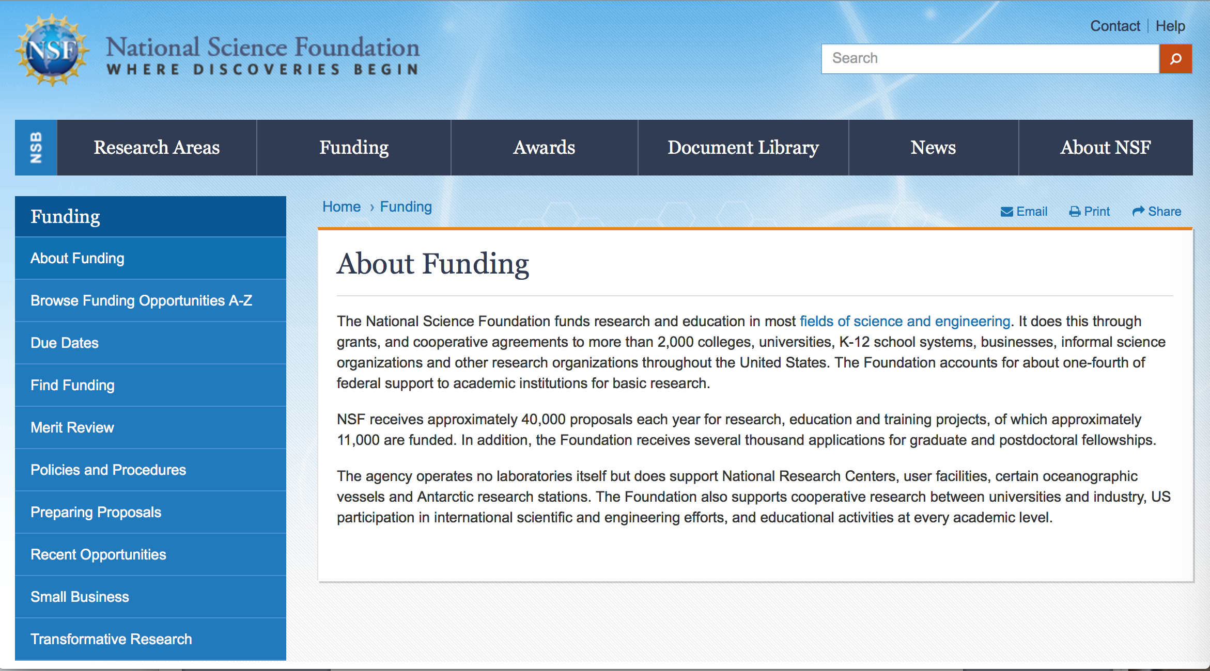

For assistance: https://nsf.gov/funding/aboutfunding.jsp

The National Science Foundation funds research and education in most fields of science and engineering. It does this through grants, and cooperative agreements to more than 2,000 colleges, universities, K-12 school systems, businesses, informal science organizations and other research organizations throughout the United States. The Foundation accounts for about one-fourth of federal support to academic institutions for basic research.
NSF receives approximately 40,000 proposals each year for research, education and training projects, of which approximately 11,000 are funded. In addition, the Foundation receives several thousand applications for graduate and postdoctoral fellowships.
The agency operates no laboratories itself but does support National Research Centers, user facilities, certain oceanographic vessels and Antarctic research stations. The Foundation also supports cooperative research between universities and industry, US participation in international scientific and engineering efforts, and educational activities at every academic level.

For details on active funding deadline dates: http://nsf.gov/funding/pgm_list.jsp?org=NSF&ord=date

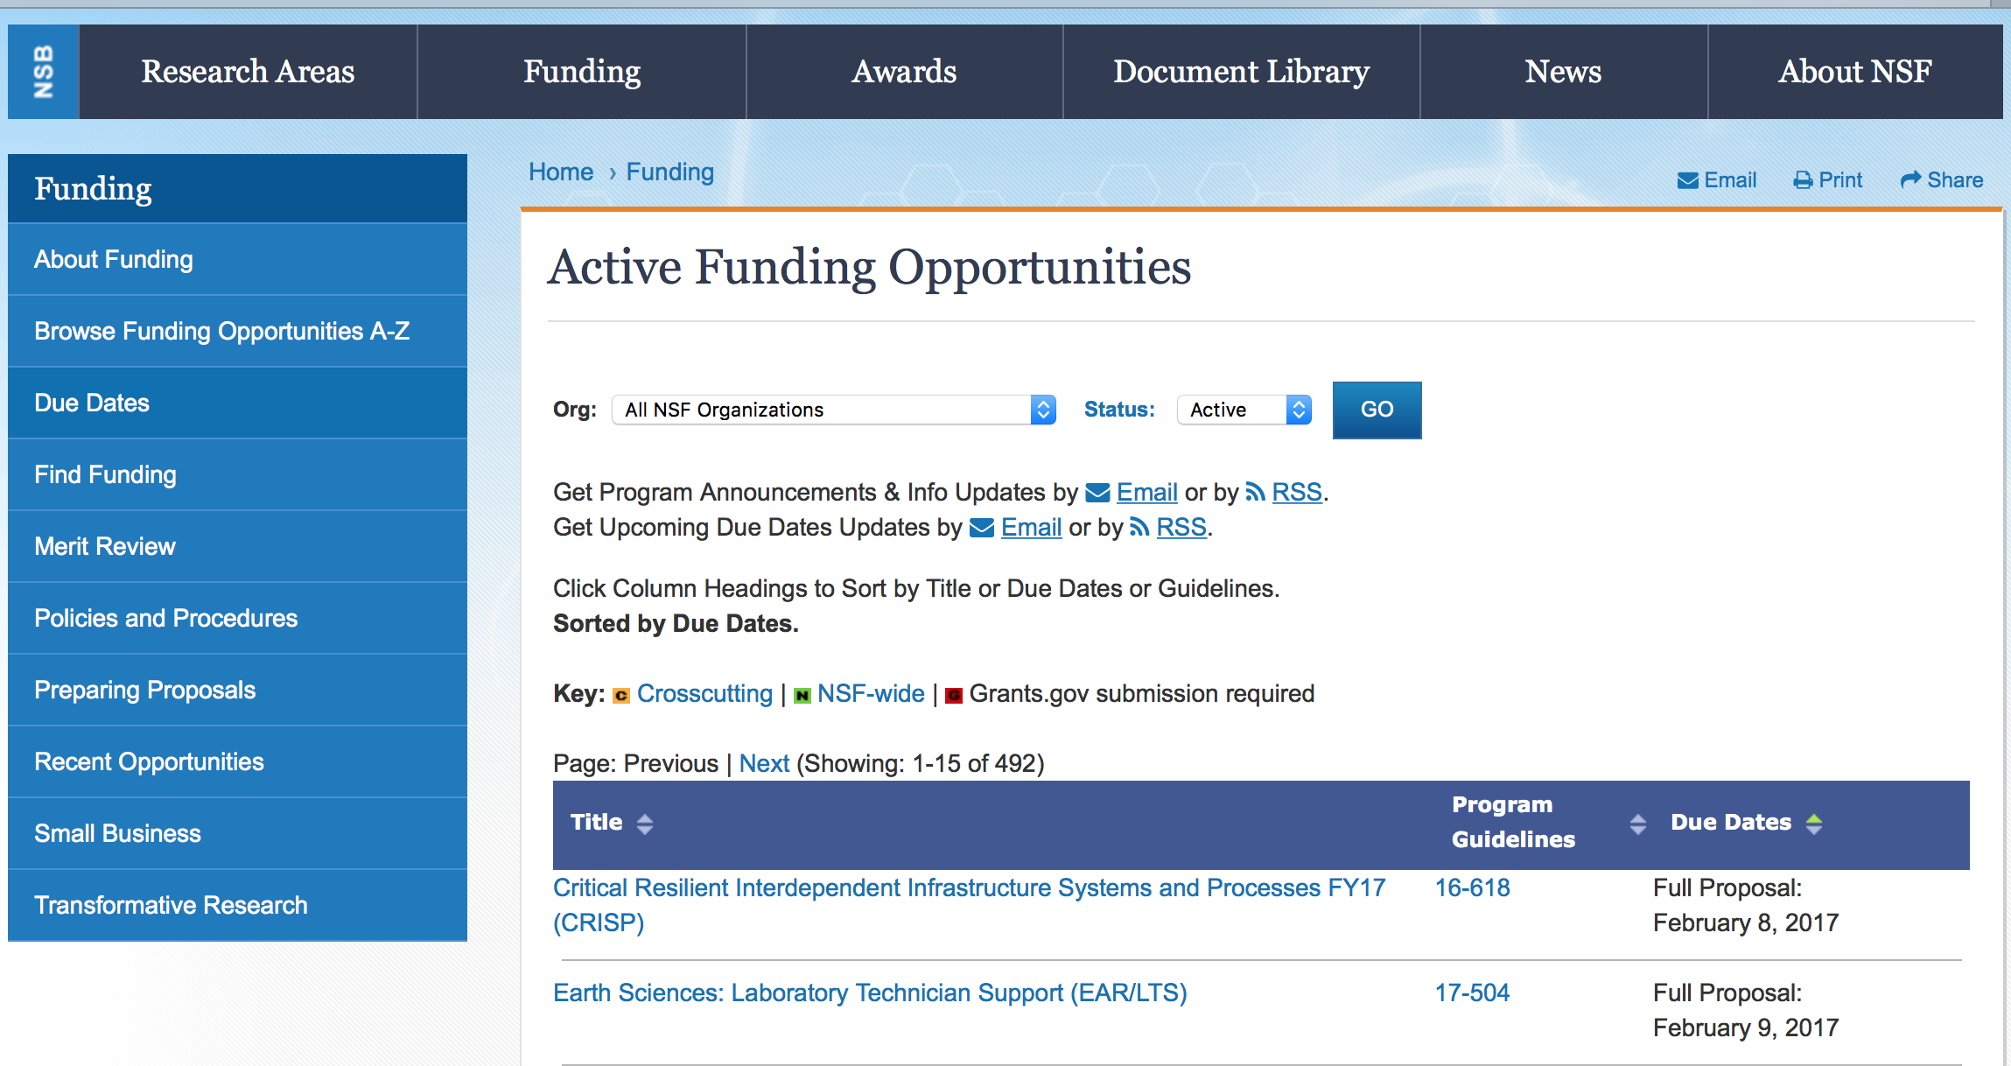

Antarctic Research
Synopsis 1
https://www.grants.gov/web/grants/view-opportunity.html?oppId=300033

Cultivating Cultures for Ethical STEM
Synopsis 1
https://www.grants.gov/web/grants/view-opportunity.html?oppId=300183

Cyberinfrastructure for Sustained Scientific Innovation (CSSI) - Data and Software:
Synopsis 1
https://www.grants.gov/web/grants/view-opportunity.html?oppId=300153

Integrative Strategies for Understanding Neural and Cognitive Systems
Synopsis 1
https://www.grants.gov/web/grants/view-opportunity.html?oppId=300182

Operator Selection for Two Regional Class Research Vessels (RCRV 2 and RCRV 3)
Synopsis 1
https://www.grants.gov/web/grants/view-opportunity.html?oppId=300202

Modifications:

Reminders:

Deleted:

Nuclear Regulatory Commission

Reminders:

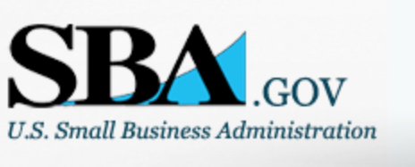

Small Business Administration

General Overview Finding Loans & Grants

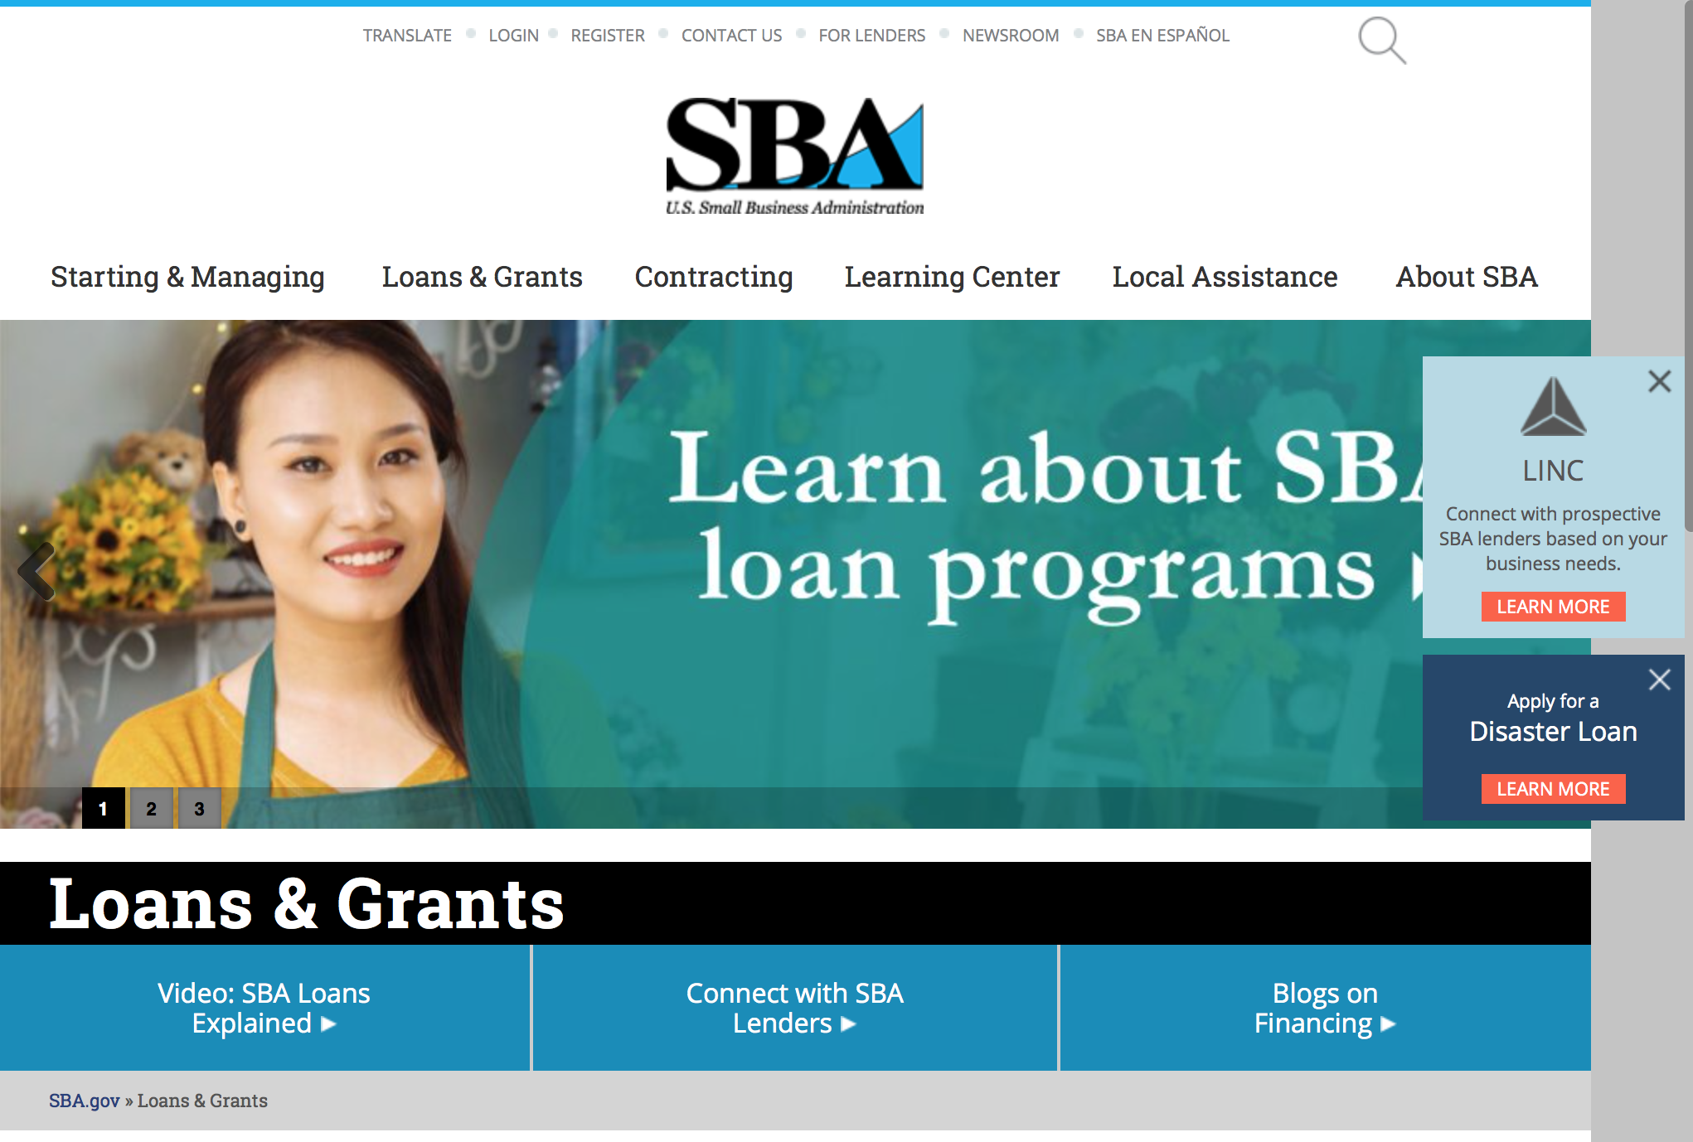
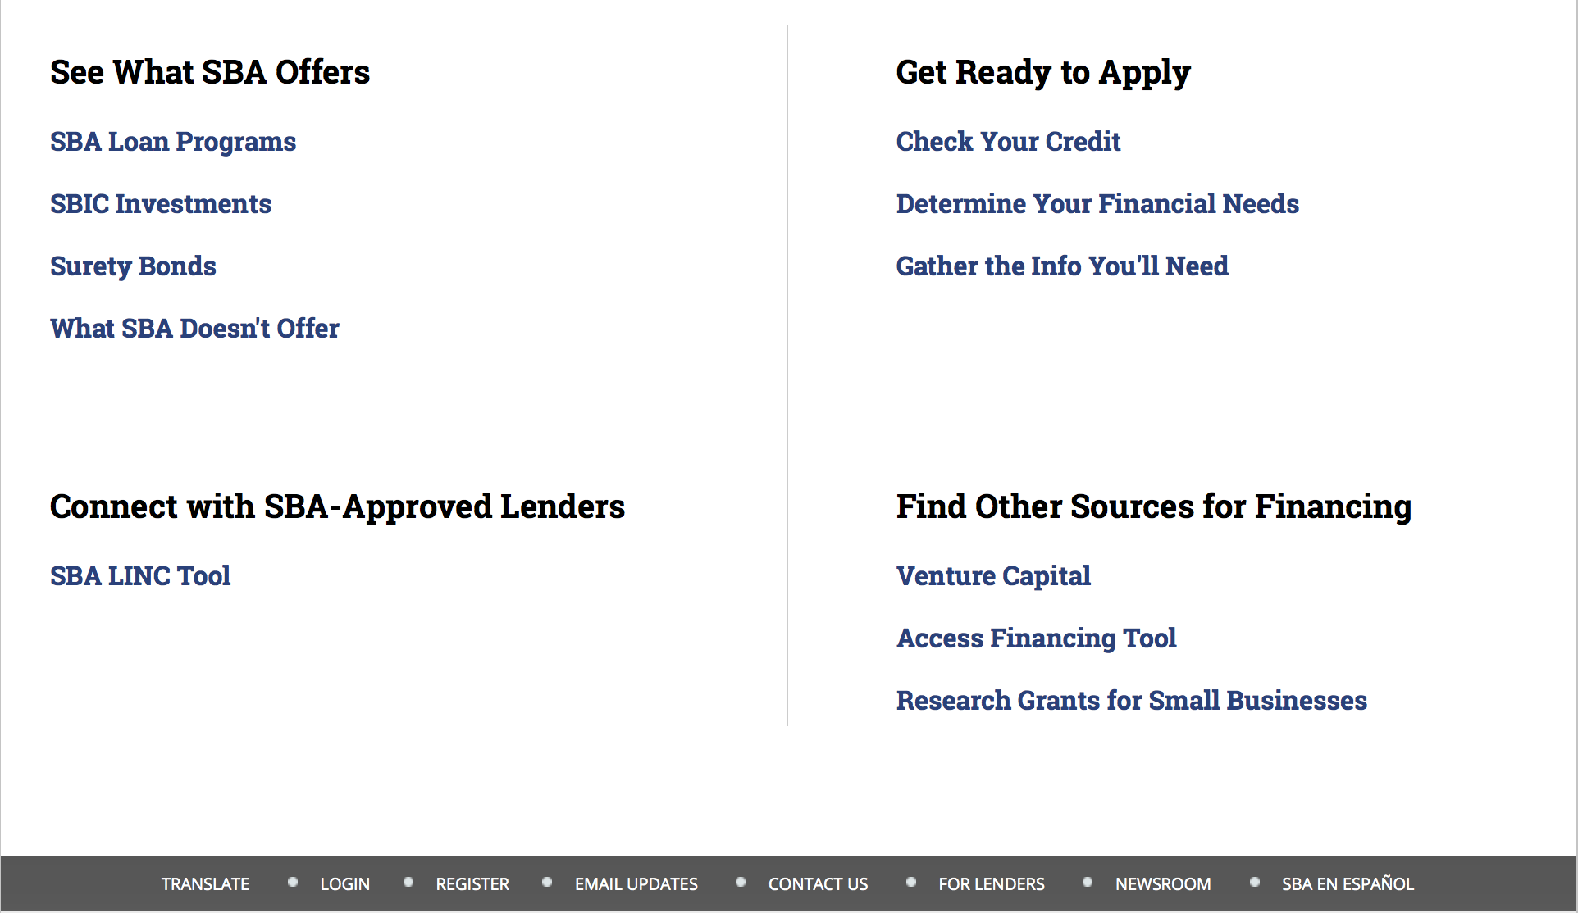

https://www.sba.gov/category/navigation-structure/loans-grants
Federal, state and local governments offer a wide range of financing programs to help small businesses start and grow their operations. These programs include low-interest loans, venture capital, and scientific and economic development grants.
Use SBA.gov's Loans and Grants Search Tool to get a list of financing programs for which you may qualify, or visit the resources below to learn more about small business financing programs.
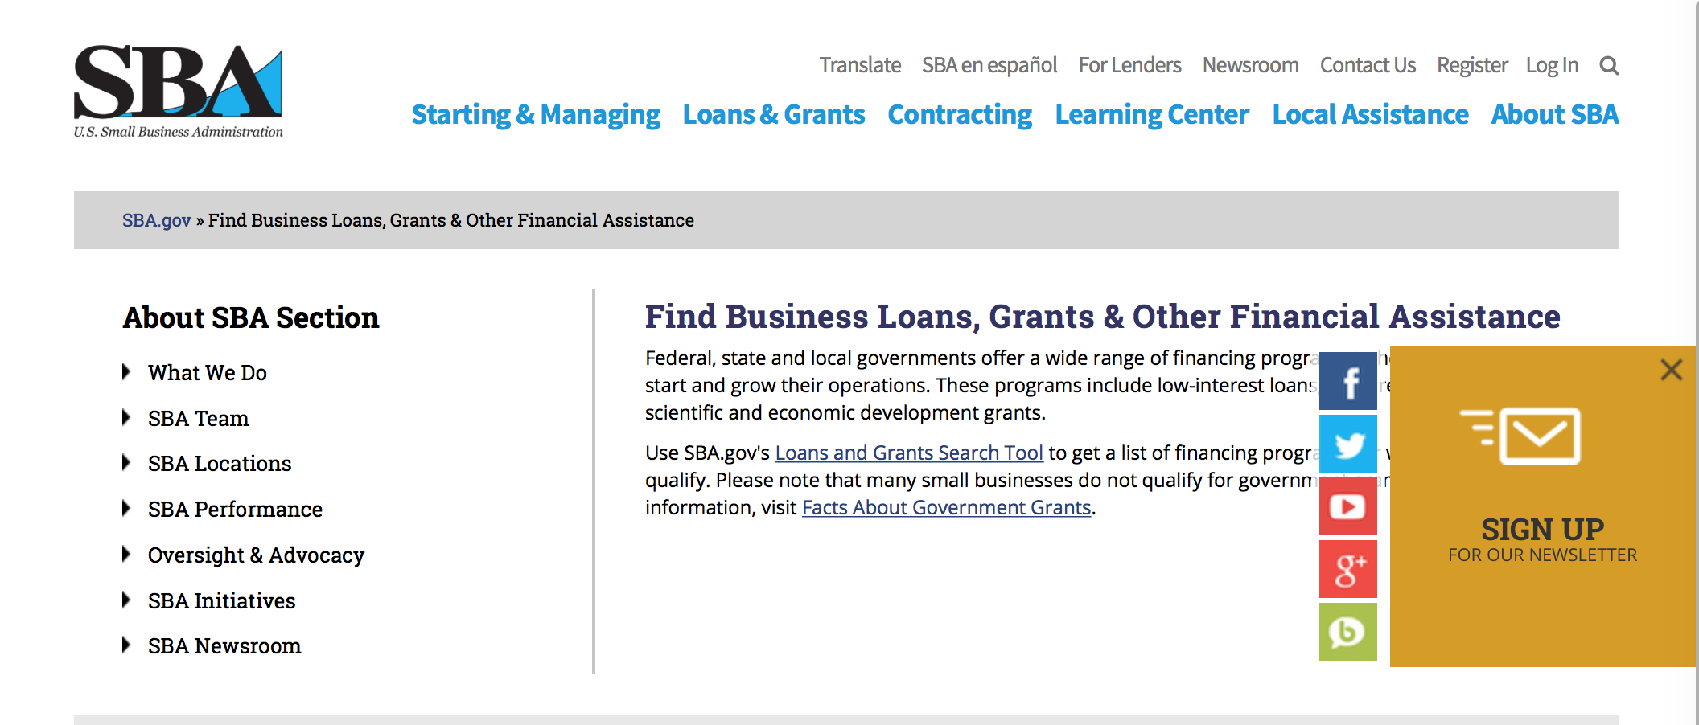
To get to the main SBA.gov funding page click here
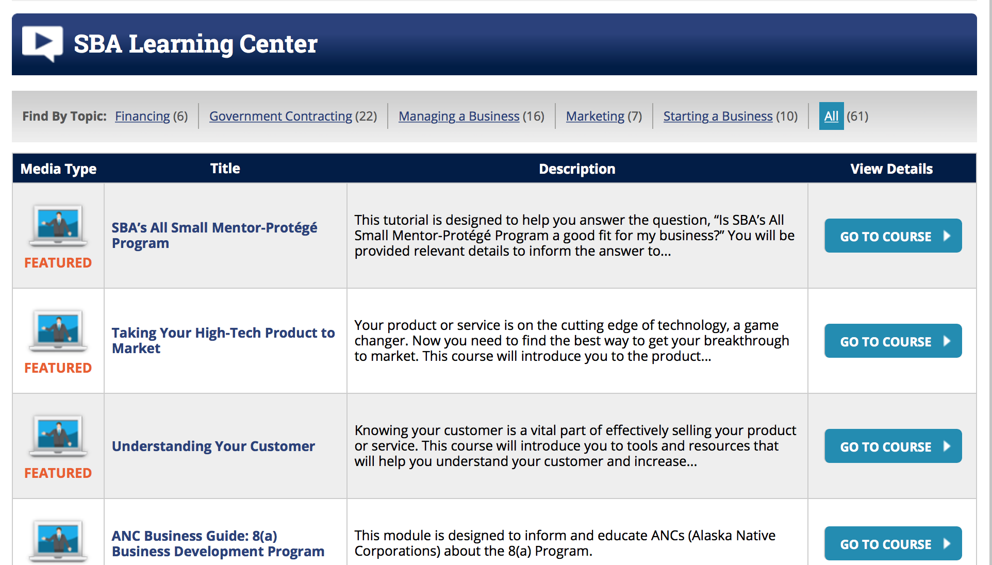
https://www.sba.gov/tools/sba-learning-center/search/training

Programs:

Modifications

Reminders:

Women’s Business Center - Initial Phase Grant
Synopsis 1

Document Type: | Grants Notice
Funding Opportunity Number: | OWBO-2017-01-1
Funding Opportunity Title: | Women’s Business Center - Initial Phase Grant
Opportunity Category: | Discretionary
Opportunity Category Explanation:
Funding Instrument Type: | Cooperative Agreement
Category of Funding Activity: | Business and Commerce
Category Explanation:
Expected Number of Awards: | 6
CFDA Number(s): | 59.043 -- Women's Business Ownership Assistance
Cost Sharing or Matching Requirement: | Yes
Version: | Synopsis 2
Posted Date: | Dec 29, 2017
Last Updated Date: | Dec 29, 2017
Original Closing Date for Applications: | Feb 12, 2018
Current Closing Date for Applications: | Feb 12, 2018
Archive Date:
Estimated Total Program Funding: | $450,000
Award Ceiling: | $75,000
Award Floor: | $75,000
Eligible Applicants: | Others (see text field entitled "Additional Information on Eligibility" for clarification)
Additional Information on Eligibility: | In order to be eligible for this funding opportunity, Applicants must be a private non-profit organization certified under § 501(c)- of the Internal Revenue Code of 1986 and have been providing technical services to women entrepreneurs.
Agency Name: | Small Business Administration
Description: | Since its inception in 1953, the Small Business Administration (SBA) has served to aid, counsel, assist and protect the interests of small businesses. While the SBA is best known for its financial support of small businesses through its many lending programs, the Agency also plays a critical role in providing funding to organizations that deliver technical assistance in the form of counseling and training to small business concerns and nascent entrepreneurs in order to promote growth, expansion, innovation, increased productivity and management improvement. The mission of the WBC Program is to act as the catalyst for providing in-depth, substantive, outcome-oriented business services to women entrepreneurs, both nascent and established businesses, a representative number of which are socially and economically disadvantaged. This mission is accomplished through the award of financial assistance to private, 501(c)- certified non-profit organizations to enable them to affect substantial economic impact in their communities, as measured by successful business start-ups, job creation and retention, and increased company revenues. The purpose of this funding opportunity announcement is to provide funding for up to six eligible non-profit organizations (as defined in Section 3.2) to start a new, community-based Women’s Business Center (WBC) in the geographic areas of SBA’s six District offices that do not have a WBC in their respective service area. Eligible applicants must be private, non-profit organizations with 501(c) tax-exempt status from the U.S. Treasury/Internal Revenue Service and must provide services to the population within one of the following states. Applicants proposing to provide services within the District office territories must provide services to the population within the counties listed.
Link to Additional Information:
Grantor Contact Information: | If you have difficulty accessing the full announcement electronically, please contact:  U.S. SBA Office of Women’s Business Ownership E-mail: OWBO@sba.gov Phone: (202) 205-6673  Email
https://www.grants.gov/web/grants/view-opportunity.html?oppId=299733

Women’s Business Center - Initial Phase Grant
Synopsis 1
Document Type: | Grants Notice
Funding Opportunity Number: | OWBO-2017-01-2
Funding Opportunity Title: | Women’s Business Center - Initial Phase Grant
Opportunity Category: | Discretionary
Opportunity Category Explanation:
Funding Instrument Type: | Cooperative Agreement
Category of Funding Activity: | Business and Commerce
Category Explanation:
Expected Number of Awards:
CFDA Number(s): | 59.043 -- Women's Business Ownership Assistance
Cost Sharing or Matching Requirement: | No
Version: | Synopsis 1
Posted Date: | Dec 29, 2017
Last Updated Date: | Dec 28, 2017
Original Closing Date for Applications: | Feb 12, 2018
Current Closing Date for Applications: | Feb 12, 2018
Archive Date: | Mar 14, 2018
Estimated Total Program Funding: | $525,000
Award Ceiling: | $75,000
Award Floor: | $75,000
Eligible Applicants: | Nonprofits having a 501(c)(3) status with the IRS, other than institutions of higher education
Agency Name: | Small Business Administration
Description: | The Women’s Business Center (WBC) Program was established by the Women’s Business Ownership Act of 1988 (Public Law No. 100-533) as the Women’s Business Demonstration Pilot, providing grants to private non-profit organizations to aid and encourage the development and growth of small women-owned businesses through long-term training and counseling. The program was expanded and made permanent in 2007 when the WBC Sustainability Grant Program, established in 1999, was replaced with the WBC Renewal Grant Program. The purpose of this funding opportunity announcement is to provide funding for up to seven existing private non-profit organizations (host organizations) of a Women’s Business Center (WBC) that have met their performance goals for the past 2 years and is in good standing with both performance and compliances to start a new, community-based WBC. The WBC must be located in an area that is not being served or adequately served. The host organizations must have sufficient match to meet the match requirements of any existing grants along with any new grants.
Link to Additional Information:
Grantor Contact Information: | If you have difficulty accessing the full announcement electronically, please contact:  U.S. SBA Office of Women’s Business Ownership E-mail: OWBO@sba.gov Phone: (202) 205-6673  Email
https://www.grants.gov/web/grants/view-opportunity.html?oppId=299736

Deleted:

SBA Trainings

Contracting Opportunities for Veteran Entrepreneurs
This self-paced training exercise is an introduction to Federal contracting opportunities for Veterans.
Topics include basic information about Veteran-owned businesses and opportunities, services available to small Veteran-owned businesses, small business incentives, and government procurement methods.
Duration: 00:30:00

http://www.sba.gov/tools/sba-learning-center/training/contracting-opportunities-veteran-entrepreneurs

Interested in Exporting? These Four Resources Can Help
Did you know that two-thirds of the world’s purchasing power is in foreign countries? As the numbers show, the international marketplace is a big one. So if you’re interested in exploring the world of exporting – or have gotten started but could use some guidance – check out these resources to help.
- Read more

Upcoming Trainings: Check out SBA's Online Training!
- Financing Options for Small Businesses
How to Prepare Government Contract Proposals
Getting Started With Exporting: Training and Educational Resources
Exporting represents a big opportunity to tap in to new markets, expand your customer base and grow your business. But getting started with exporting can sometimes feel like a maze of regulations, policies, and other barriers. Here are some free training and educational resources to help.
- Read more

For Specific Information in Hawaii see the following links:
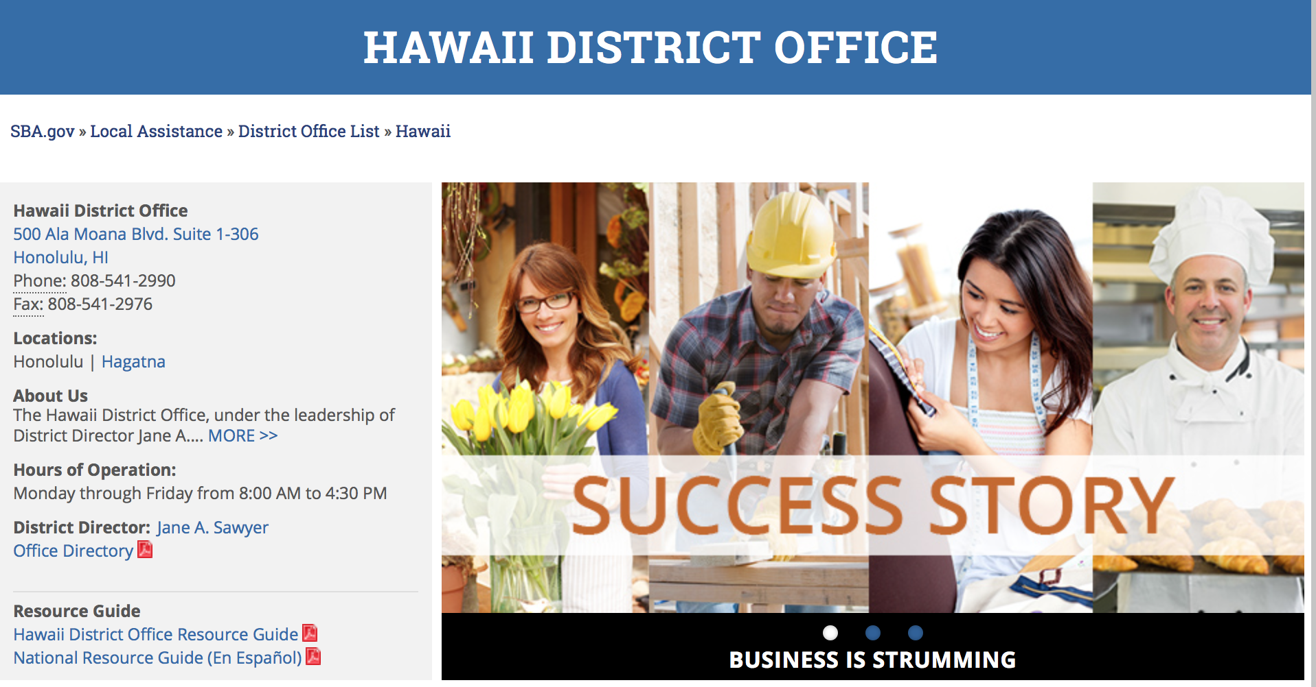

https://www.sba.gov/offices/district/hi/Honolulu

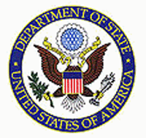

State Department General Overview and Resources for Program Administrators

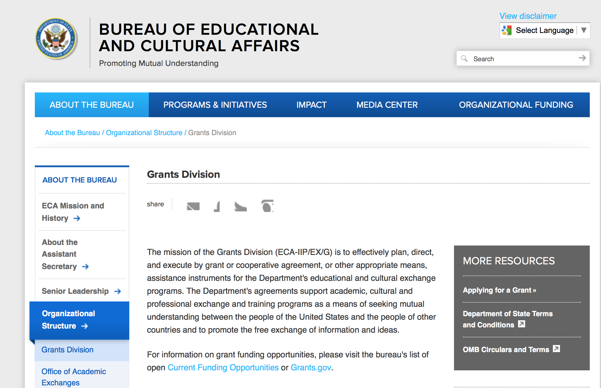

https://eca.state.gov/about-bureau/organizational-structure/grants-division

http://eca.state.gov/search/solr/grants?search_referrer=node/237

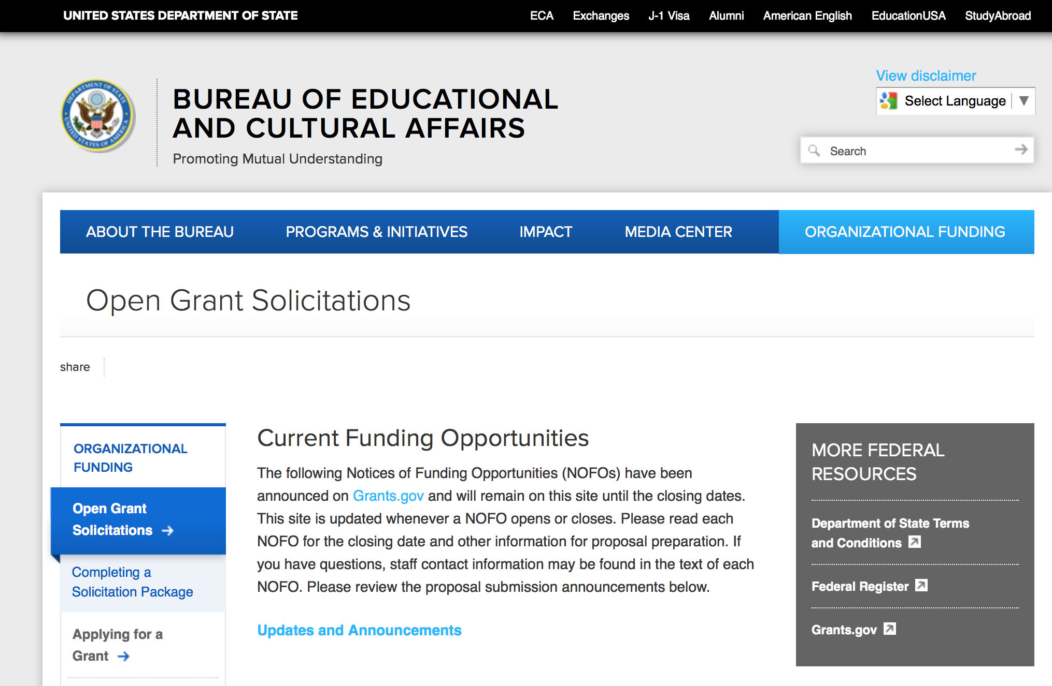
https://eca.state.gov/organizational-funding/open-grant-solicitations

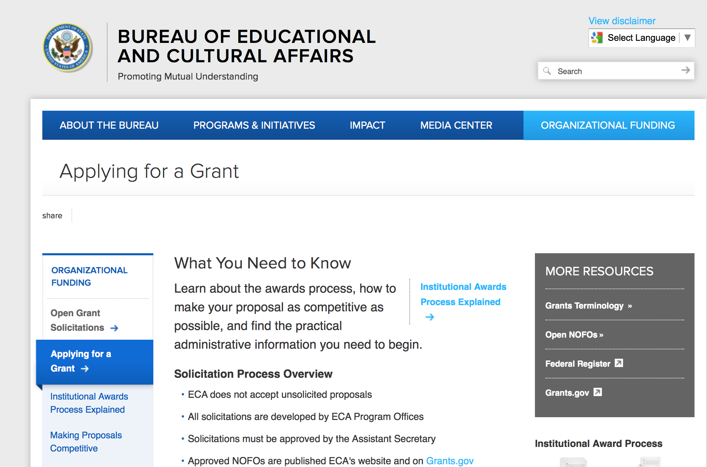
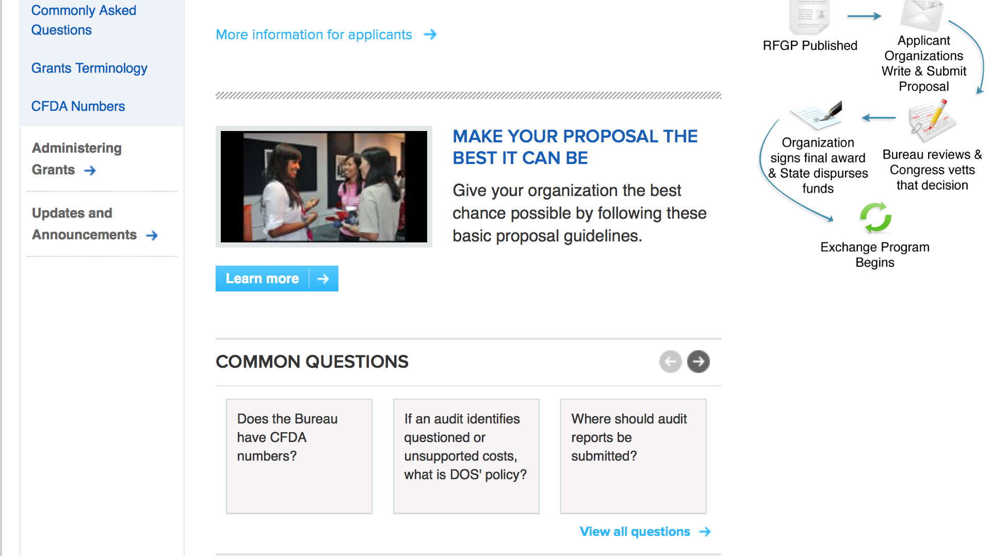
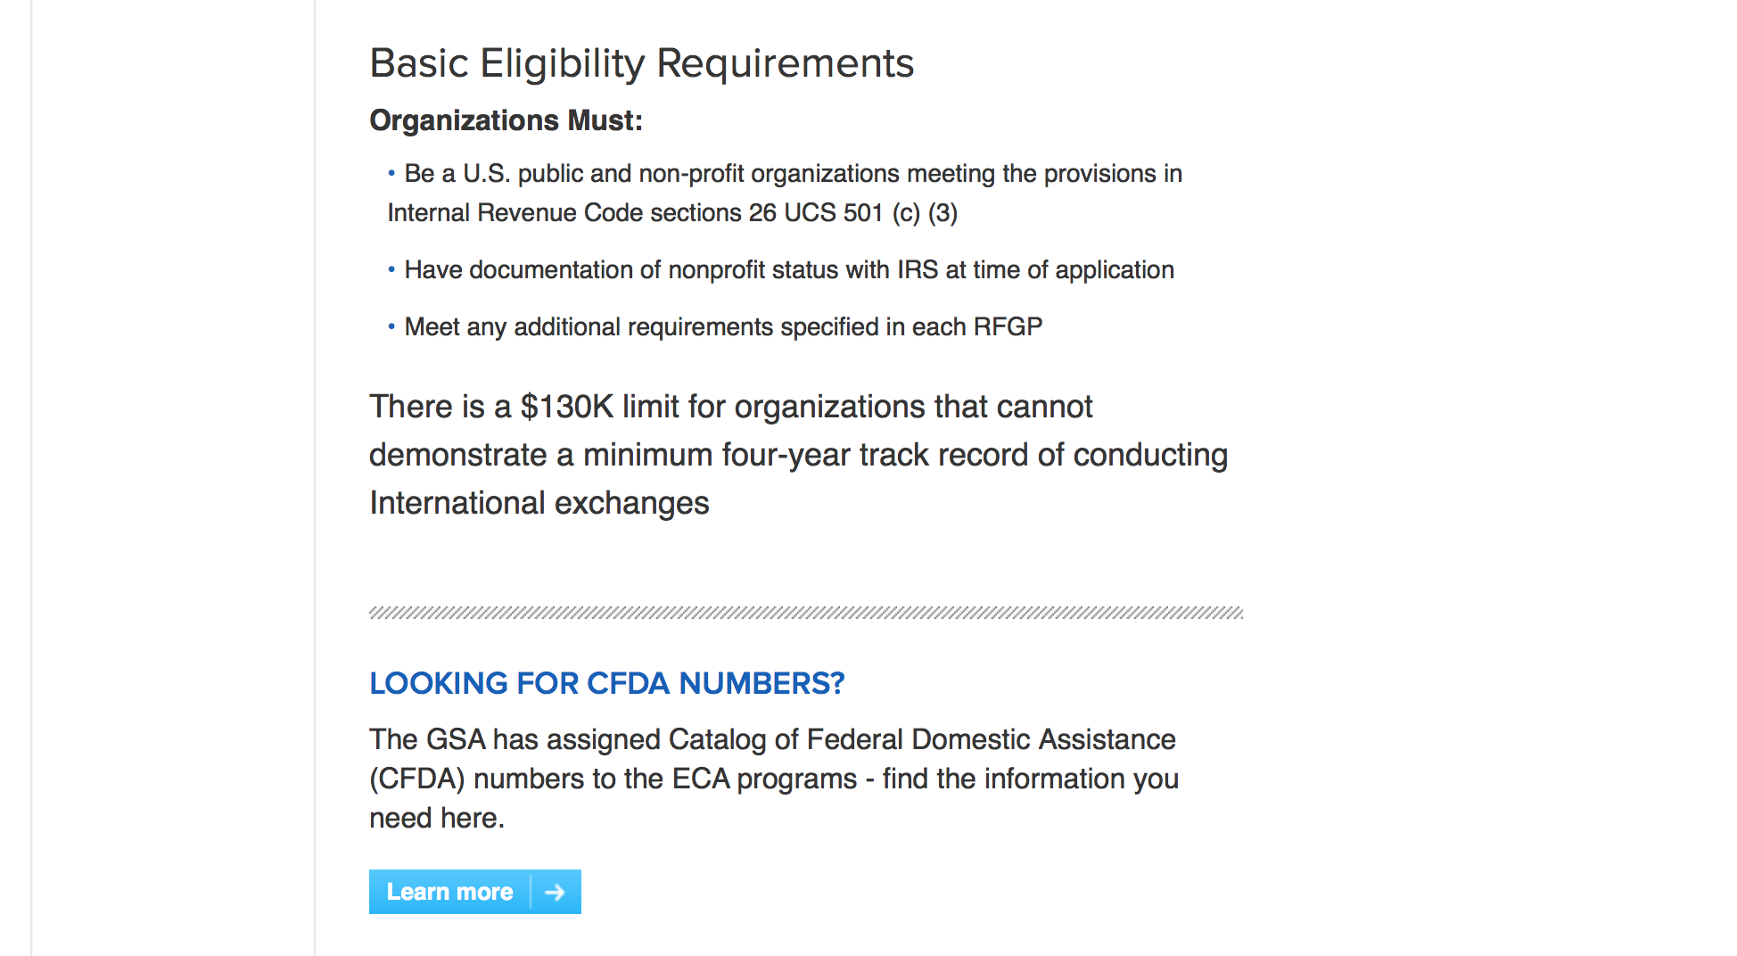
http://eca.state.gov/organizational-funding/applying-grant

General Information:
- Bureau of Educational and Cultural Affairs Grants Division
- Open Grant Opportunities (Requests for Grant Proposals)

For General Information click here

Program Grants:

Bureau Of Educational and Cultural Affairs
FY 2018 American English E-Teacher Program
Synopsis 1
https://www.grants.gov/web/grants/view-opportunity.html?oppId=300022

Bureau Of Educational and Cultural Affairs
FY2018 Young Southeast Asian Leaders Initiative (YSEALI) Academic Fellowship
Synopsis 1
https://www.grants.gov/web/grants/view-opportunity.html?oppId=300041

Bureau Of Educational and Cultural Affairs
FY 2018 English Access Microscholarship Program
Synopsis 1
https://www.grants.gov/web/grants/view-opportunity.html?oppId=300043
Bureau of South and Central Asian Affairs
APS Lahore - Grants for Punjab Province
Synopsis 1
https://www.grants.gov/web/grants/view-opportunity.html?oppId=300144

Bureau of South and Central Asian Affairs
APS - Grants for Khyber & FATA, U.S. Consulate General Peshawar
Synopsis 1
https://www.grants.gov/web/grants/view-opportunity.html?oppId=300145

U.S. Mission to Cameroon
Ambassador’s Special Self-Help Annual Program Statement, POL/ECON, U.S. Embassy Yaounde
Synopsis 1
https://www.grants.gov/web/grants/view-opportunity.html?oppId=300328
U.S. Mission to China
Programming in the People’s Republic of China
Synopsis 1
https://www.grants.gov/web/grants/view-opportunity.html?oppId=300314

U.S. Mission to Kazakhstan
U.S. Embassy Small Grants Program
Synopsis 1
https://www.grants.gov/web/grants/view-opportunity.html?oppId=300374

U. S. Mission to Lesotho
U.S. Ambassador’s Special Self Help 2018, U.S. Embassy Maseru
Synopsis 1
https://www.grants.gov/web/grants/view-opportunity.html?oppId=300384

U. S. Mission to Lesotho
PEPFAR Small Grants Program 2018-2019, U.S. Embassy Maseru
Synopsis 1
https://www.grants.gov/web/grants/view-opportunity.html?oppId=300398

U.S. Mission to Moldova
Grants for Media Program: Informational Cinema
Synopsis 2
https://www.grants.gov/web/grants/view-opportunity.html?oppId=300316
U.S. Mission to Moldova
Media Program: American Film Showcase
Synopsis 2
https://www.grants.gov/web/grants/view-opportunity.html?oppId=300317

U.S. Mission to Senegal
Trans-Sahara Counterterrorism Partnership (TSCTP) Countering Violent Extremism (CVE) Project- Senegal
Synopsis 1
https://www.grants.gov/web/grants/view-opportunity.html?oppId=299994

U.S. Mission to Pakistan
Cultural Affairs – Pakistani Partnerships
Synopsis 1
https://www.grants.gov/web/grants/view-opportunity.html?oppId=300406

U.S. Mission to Pakistan
Cultural Affairs Annual Program Statement - Public Affairs Section, U.S. Embassy Islamabad
Synopsis 1
https://www.grants.gov/web/grants/view-opportunity.html?oppId=300444

U.S. Mission to the United Kingdom
Future Cybersecurity Leaders Exchange
Synopsis 1
https://www.grants.gov/web/grants/view-opportunity.html?oppId=300002

U.S. Mission to the United Kingdom
Youth Exchange on Social Cohesion
Synopsis 1
https://www.grants.gov/web/grants/view-opportunity.html?oppId=300024
U.S. Mission to Cameroon
Julia Taft Refugee Fund Annual Program Statement, POL/ECON, U.S. Embassy Yaounde
Synopsis 1
https://www.grants.gov/web/grants/view-opportunity.html?oppId=299786

U.S. Mission to South Africa
PEPFAR HIV and AIDS Community Grants
Synopsis 1
https://www.grants.gov/web/grants/view-opportunity.html?oppId=300134

U.S. Mission to South Korea
U.S. Embassy Seoul PAS Annual Program Statement
Synopsis 1
https://www.grants.gov/web/grants/view-opportunity.html?oppId=300181

Modifications:

U.S. Mission to Australia
U.S. Embassy Canberra PAS Annual Program Statement
Synopsis 2
https://www.grants.gov/web/grants/view-opportunity.html?oppId=299875
Bureau of Population Refugees and Migration
FY 2018 Request for Concept Notes for NGO Programs Benefiting Refugees and Other Vulnerable Populations in Iraq, Jordan, Lebanon, and Turkey
Synopsis 3
https://www.grants.gov/web/grants/view-opportunity.html?oppId=299879

Bureau of Population Refugees and Migration
2018 Notice of Funding Opportunity for NGO projects benefiting non-Syrian refugees in Turkey
Synopsis 2
https://www.grants.gov/web/grants/view-opportunity.html?oppId=300413

Bureau of Population Refugees and Migration
2018 Chad and Cameroon
Synopsis 2
https://www.grants.gov/web/grants/view-opportunity.html?oppId=300186

U.S. Mission to Cambodia
U.S. Embassy Phnom Penh PAS Annual Program
Synopsis 2
https://www.grants.gov/web/grants/view-opportunity.html?oppId=300154

U.S. Mission to Moldova
Cultural/Alumni/English-Language Small Grants Program
Synopsis 5
https://www.grants.gov/web/grants/view-opportunity.html?oppId=299996

Reminders:

Deleted:

Department of Transportation

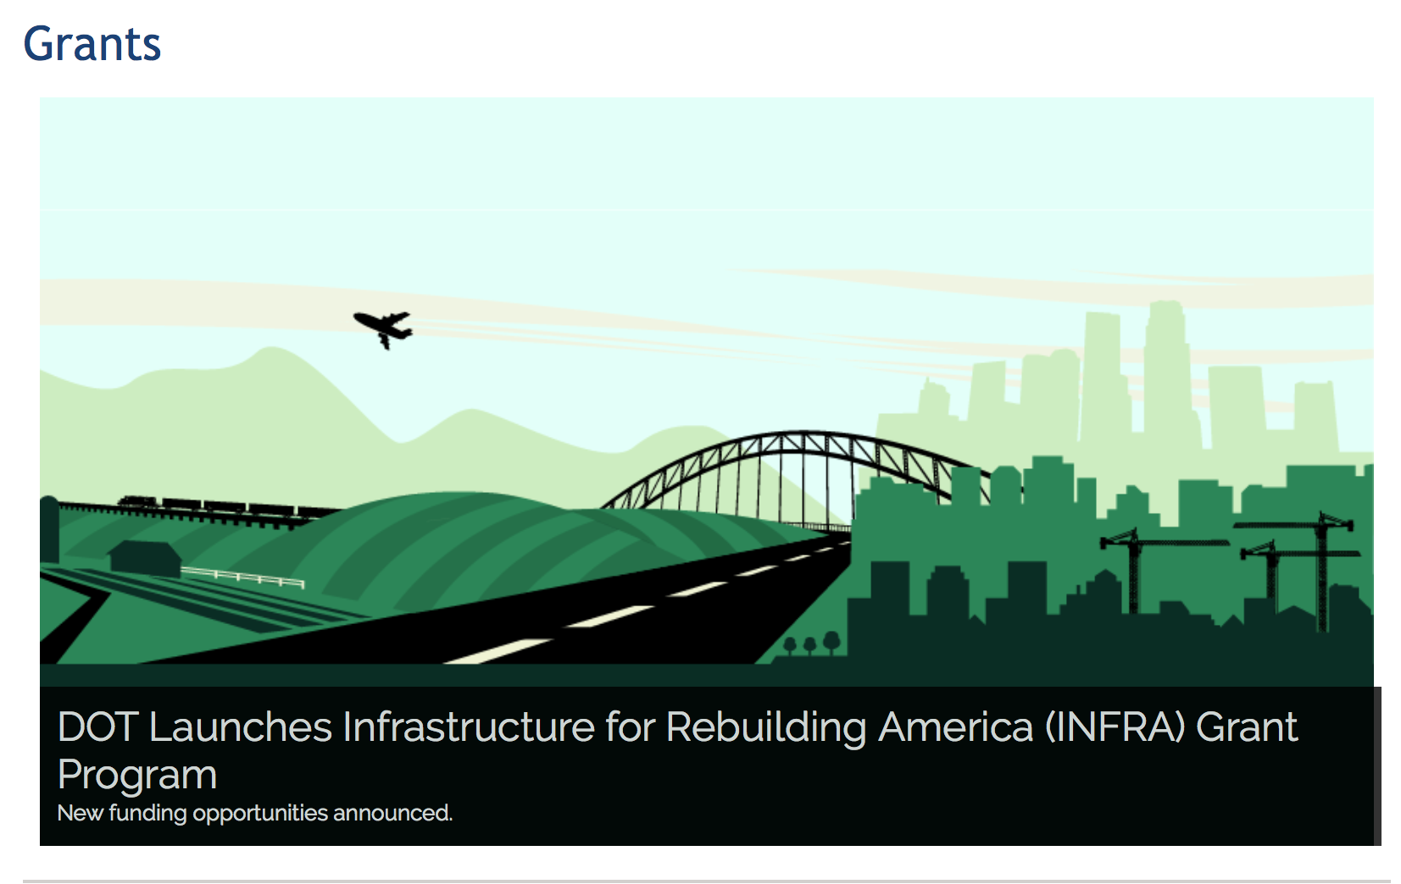

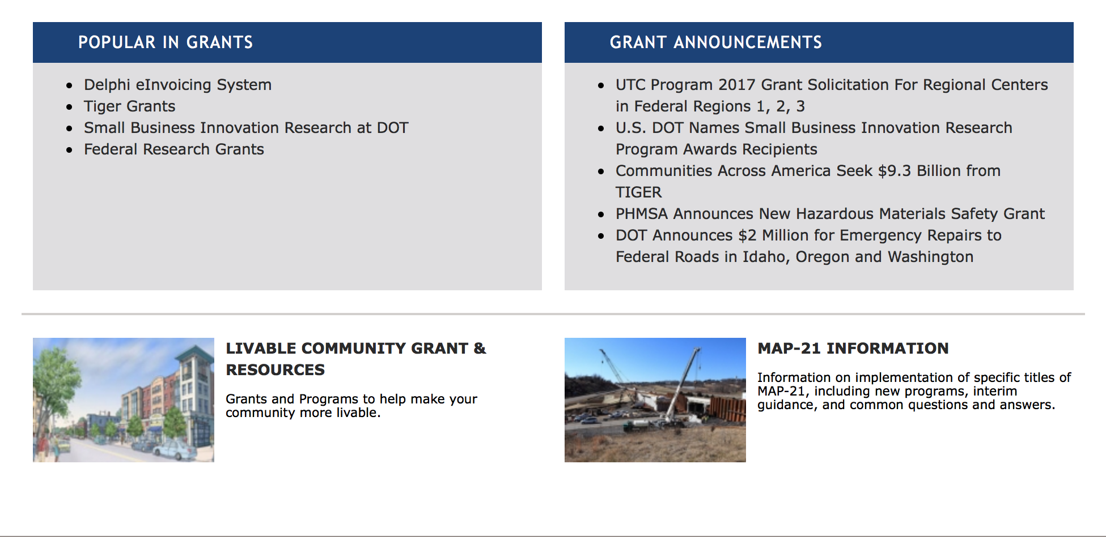

General Grant Program Overview https://www.transportation.gov/grants

Programs:

Modifications:

Research:

Reminders:

DOT - FAA Aviation Research Grants
FAA Aviation Research and Development Grants
Synopsis 3, 4 & 6

Document Type: | Grants Notice
Funding Opportunity Number: | 12-01
Funding Opportunity Title: | FAA Aviation Research and Development Grants
Opportunity Category: | Discretionary
Opportunity Category Explanation:
Funding Instrument Type: | Grant
Category of Funding Activity: | Transportation
Category Explanation:
Expected Number of Awards:
CFDA Number(s): | 20.108 -- Aviation Research Grants
Cost Sharing or Matching Requirement: | No
Version: | Synopsis 6
Posted Date: | Jan 01, 2012
Last Updated Date: | Oct 18, 2017
Original Closing Date for Applications: | Dec 31, 2019
Current Closing Date for Applications: | Dec 31, 2019
Archive Date: | Jan 30, 2020
Estimated Total Program Funding:
Award Ceiling: | $5,000,000
Eligible Applicants: | Private institutions of higher education  Nonprofits having a 501(c)(3) status with the IRS, other than institutions of higher education  Public and State controlled institutions of higher education
Agency Name: | DOT - FAA Aviation Research Grants
Description: | The FAA is soliciting proposals for research grants and cooperative agreements to pursue the long-term growth and short-term technical needs of civil aviation. In order to streamline the application process, it is recommended that all prospective grantees submit a white paper (letter of intent) for agency technical review before complete proposal submission. Please be sure to identify the specific area of interest (Solicitation FAA-12-01 – Chapter I. FAA Research Grants Program, Technical Areas of Research #1-#9). The white paper shall be no longer than three (3) pages and shall detail overall research objectives.
Link to Additional Information:
Grantor Contact Information: | If you have difficulty accessing the full announcement electronically, please contact:  Nicole Saiauskie Grants Officer Phone 609-485-4781  business

http://www.grants.gov/web/grants/view-opportunity.html?oppId=134953

Deleted:

Department of the Treasury

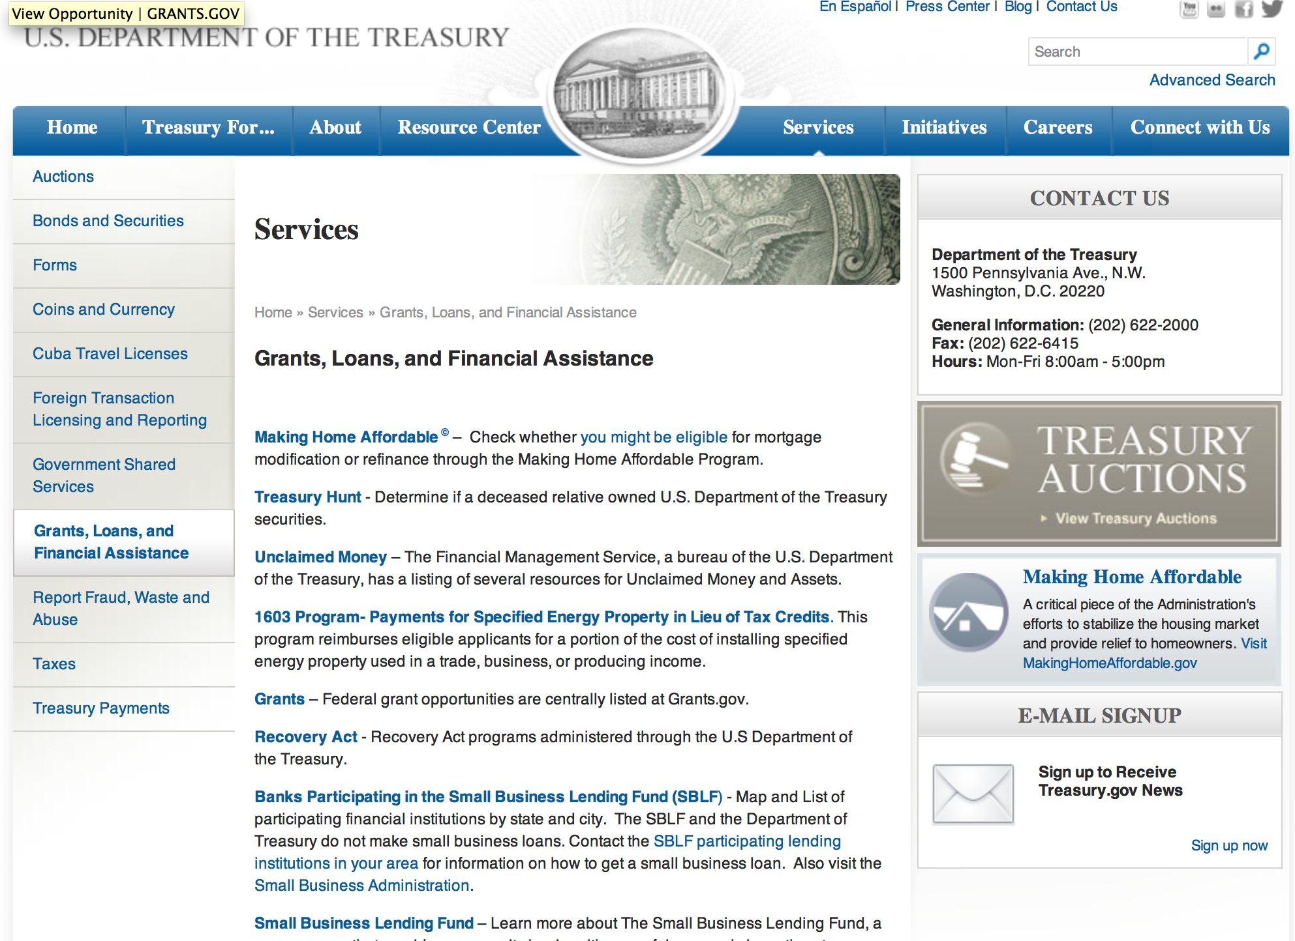

http://www.treasury.gov/services/Pages/Grants-Loans-and-Financial-Assistance.aspx

Programs:

Community Development Financial Institutions
Fiscal Year 2018 CDFI Program
Synopsis 1

Document Type: | Grants Notice
Funding Opportunity Number: | CDFI-2018-FATA
Funding Opportunity Title: | Fiscal Year 2018 CDFI Program
Opportunity Category: | Discretionary
Opportunity Category Explanation:
Funding Instrument Type: | Grant
Category of Funding Activity: | Community Development
Category Explanation:
Expected Number of Awards: | 245
CFDA Number(s): | 21.020 -- Community Development Financial Institutions Program
Cost Sharing or Matching Requirement: | Yes
Version: | Synopsis 1
Posted Date: | Jan 30, 2018
Last Updated Date: | Jan 30, 2018
Original Closing Date for Applications: | Mar 02, 2018
Current Closing Date for Applications: | Mar 02, 2018
Archive Date: | Apr 01, 2018
Estimated Total Program Funding: | $183,500,000
Award Ceiling: | $1,000,000
Award Floor: | $100,000
Eligible Applicants: | Others (see text field entitled "Additional Information on Eligibility" for clarification)
Additional Information on Eligibility: | Eligibility requirements for the Financial Assistance and Technical Assistance components of the FY 2018 CDFI Program can be found in the FY 2018 Notice of Funds Availability (NOFA).

Agency Name: | Community Development Financial Institutions
Description: | Through the CDFI Program, the CDFI Fund provides (i) FA awards of up to $1 million to Certified Community Development Financial Institutions (CDFIs) to build their financial capacity to lend to their Target Markets, and (ii) TA grants of up to $125,000 to build Certified, Certifiable, and Emerging CDFIs’ organizational capacity to serve their Target Markets. For more detailed information, please refer to the NOFA found on the CDFI Fund's website.
Link to Additional Information: | A webpage on the CDFI Fund's website with all the relevant details regarding the CDFI Program.
Grantor Contact Information: | If you have difficulty accessing the full announcement electronically, please contact:  CDFI Fund Help Desk (202) 653-0421  CDFI Fund Help Desk
https://www.grants.gov/web/grants/view-opportunity.html?oppId=300354

Modifications:

Reminders:

U.S. Agency for International Development

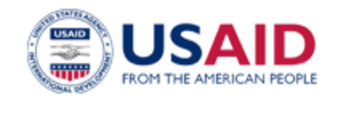

www.usaid.gov

General Overview Funding Opportunities

USAID has working relationships with thousands of American companies and hundreds of U.S.-based private voluntary organizations. For more information on our business and procurement opportunities, please visit our Business section.

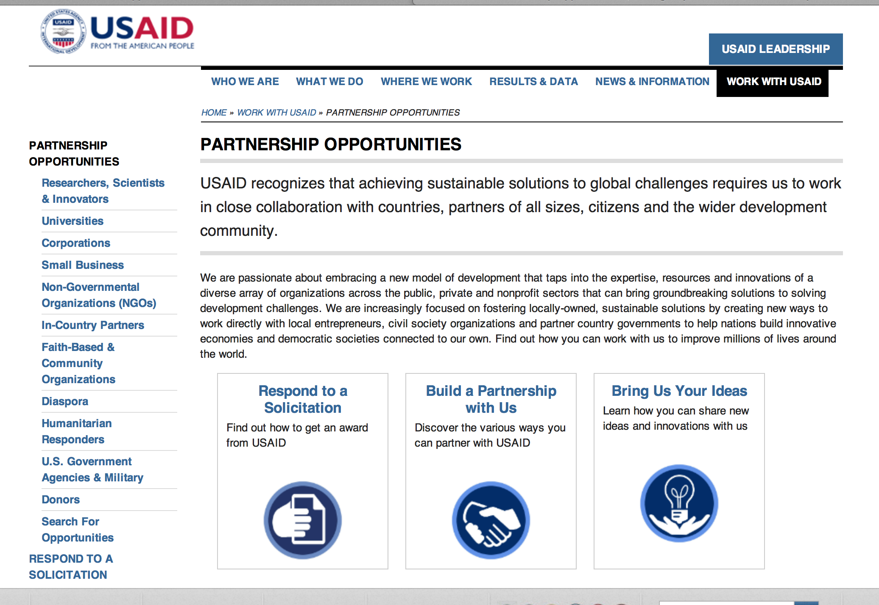
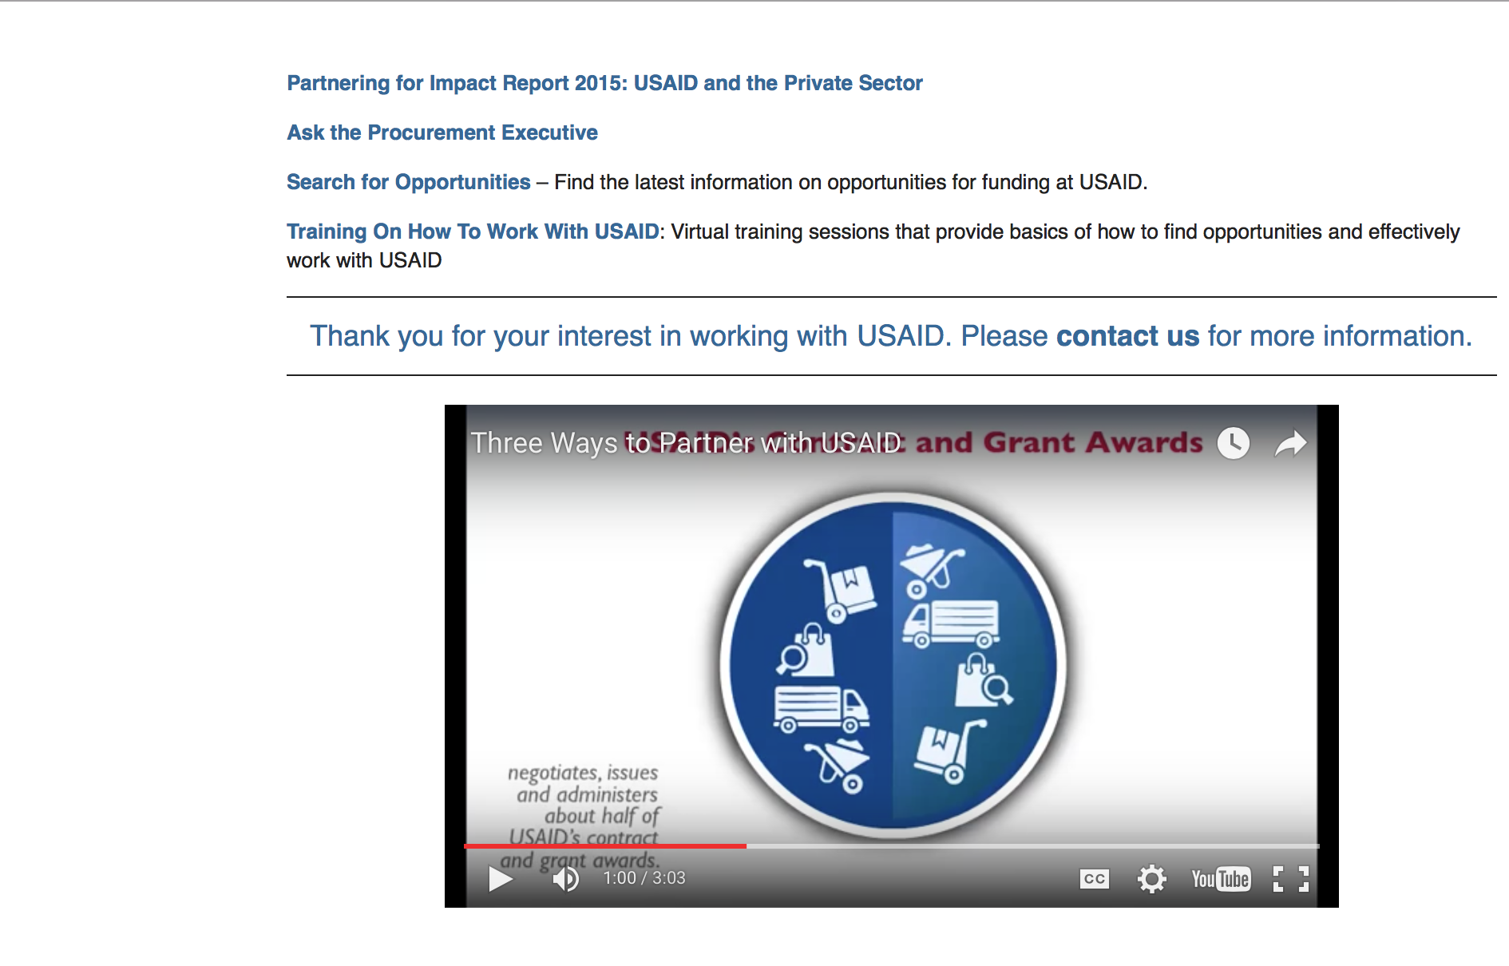

http://www.usaid.gov/partnerships

Programs:

Guatemala USAID-Guatemala City
Tanzania Malaria Surveillance and Monitoring (TMSM)
Synopsis 1
https://www.grants.gov/web/grants/view-opportunity.html?oppId=299840

Mexico USAID-Mexico City
Strategic Alliances for Mexico (SAM)
Synopsis 1
https://www.grants.gov/web/grants/view-opportunity.html?oppId=299795

Peru USAID-Lima
Amazon Indigenous Rights& Resources
Synopsis 1
https://www.grants.gov/web/grants/view-opportunity.html?oppId=299978

Tanzania USAID-Dar es Salaam
Tanzania Malaria Surveillance and Monitoring (TMSM)
Synopsis 1
https://www.grants.gov/web/grants/view-opportunity.html?oppId=299877
USAID-Funded Community Based Counter Wildlife Trafficking Activity
Synopsis 1
https://www.grants.gov/web/grants/view-opportunity.html?oppId=299780

USAID-VIETNAM
Sustainable Model for Improving the Inclusion of Persons with Disabilities
Synopsis 1
https://www.grants.gov/web/grants/view-opportunity.html?oppId=299876

Modifications:

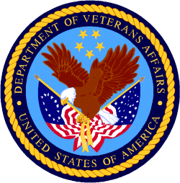

Department of Veterans Affairs

VA Loan Guaranty Service
Specially Adapted Housing Assistive Technology Grant Program
Synopsis 3
Document Type: | Grants Notice
Funding Opportunity Number: | VA-SAHAT-18-03
Funding Opportunity Title: | Specially Adapted Housing Assistive Technology Grant Program
Opportunity Category: | Discretionary
Opportunity Category Explanation:
Funding Instrument Type: | Grant
Category of Funding Activity: | Science and Technology and other Research and Development
Category Explanation:
Expected Number of Awards: | 5
CFDA Number(s): | 64.051 -- Specially Adapted Housing Assistive Technology Grant Program
Cost Sharing or Matching Requirement: | No
Version: | Synopsis 4
Posted Date: | Jan 29, 2018
Last Updated Date: | Feb 01, 2018
Original Closing Date for Applications: | Mar 04, 2018
Current Closing Date for Applications: | Mar 04, 2018
Archive Date: | Mar 27, 2018
Estimated Total Program Funding: | $1,000,000
Award Ceiling: | $200,000
Award Floor: | $0
Eligible Applicants: | Unrestricted (i.e., open to any type of entity above), subject to any clarification in text field entitled "Additional Information on Eligibility"
Additional Information on Eligibility:
Additional Information
Agency Name: | VA Loan Guaranty Service
Description: | The Loan Guaranty Service (LGY), which is an office of the Veterans Benefits Administration (VBA), Department of Veterans Affairs (VA), is announcing the availability of funds for the Specially Adapted Housing Assistive Technology (SAHAT) Grant Program. The objective of the grant is to encourage the development of new assistive technologies for specially adapted housing. Veterans Affairs acknowledges there are many emerging technologies that could improve home adaptations or otherwise enhance a Veteran’s or Servicemember’s ability to live independently. Therefore, VA has defined ‘‘new assistive technology’’ as an advancement the Secretary determines could aid or enhance the ability of a Veteran or Servicemember to live in an adapted home. PLEASE NOTE: SAHAT funding does not support the construction or modification of residential dwellings for accessibility. Veterans and Servicemembers interested in receiving assistance to adapt a home are encouraged to contact their local Veterans Affairs Regional Benefits Office, Regional Loan Center, or Medical Center for more information, or visit: http://www.benefits.va.gov/homeloans/adaptedhousing.asp **Note: Some documents may contain an application expiration date of February 25, 2018, that date has been extended to March 4, 2018.
Link to Additional Information: | Specially Adapted Housing Assistive Technology Website
Grantor Contact Information: | If you have difficulty accessing the full announcement electronically, please contact:  Oscar Hines Grantor Phone 202-461-8316  Specially Adapted Housing Assistive Technology Grant Program

https://www.grants.gov/web/grants/view-opportunity.html?oppId=300248

VA Loan Guaranty Service
Specially Adapted Housing Assistive Technology Grant Program
Forecast 2 & 3

Document Type: | Grants Notice
Opportunity Number: | VA-SAHAT-18-03
Opportunity Title: | Specially Adapted Housing Assistive Technology Grant Program
Opportunity Category: | Discretionary
Opportunity Category Explanation:
Funding Instrument Type: | Grant
Category of Funding Activity: | Science and Technology and other Research and Development
Category Explanation:
Expected Number of Awards: | 5
CFDA Number(s): | 64.051 -- Specially Adapted Housing Assistive Technology Grant Program
Cost Sharing or Matching Requirement: | No
Version: | Forecast 3
Posted Date: | Jan 05, 2018
Last Updated Date: | Jan 05, 2018
Estimated Synopsis Post Date: | Jan 05, 2018
Estimated Application Due Date: | Feb 25, 2018
Estimated Award Date: | Mar 26, 2018
Estimated Project Start Date: | Apr 02, 2018
Fiscal Year: | 2018
Archive Date: | Jan 09, 2018
Estimated Total Program Funding: | $1,000,000
Award Ceiling: | $200,000
Award Floor: | $0
Eligible Applicants: | Unrestricted (i.e., open to any type of entity above), subject to any clarification in text field entitled "Additional Information on Eligibility"
Agency Name: | VA Loan Guaranty Service
Description: | The Loan Guaranty Service (LGY), which is an office of the Veterans Benefits Administration (VBA), Department of Veterans Affairs (VA), is announcing the availability of funds for the Specially Adapted Housing Assistive Technology (SAHAT) Grant Program. The objective of the grant is to encourage the development of new assistive technologies for specially adapted housing. Veterans Affairs acknowledges there are many emerging technologies that could improve home adaptations or otherwise enhance a Veteran’s or Servicemember’s ability to live independently. Therefore, VA has defined ‘‘new assistive technology’’ as an advancement the Secretary determines could aid or enhance the ability of a Veteran or Servicemember to live in an adapted home. PLEASE NOTE: SAHAT funding does not support the construction or modification of residential dwellings for accessibility. Veterans and Servicemembers interested in receiving assistance to adapt a home are encouraged to contact their local Veterans Affairs Regional Benefits Office, Regional Loan Center, or Medical Center for more information, or visit: http://www.benefits.va.gov/homeloans/adaptedhousing.asp
Link to Additional Information: | Specially Adapted Housing Assistive Technology Website
Grantor Contact Information: | Specially Adapted Housing Program Loan Guaranty Service (VBA) U.S. Department of Veterans Affairs  202-461-8316  SAH Assistive Technology General Mailbox
https://www.grants.gov/web/grants/view-opportunity.html?oppId=299302

