Senator Mazie Hirono

Grants Assistance Information Newsletter

NOVEMBER 2020

PART 1 – CURRENT FEDERAL AGENCY DISCRETIONARY GRANT OPPORTUNITIES

PART 2 – GENERAL FEDERAL AGENCY GRANTS INFORMATION

Current Federal Agency Grant and Cooperative Agreement Discretionary Program Summaries

Click on Index Links below to find summaries of the current announcements listed by agency in this document. Once you reach the item, if you cannot open the links for further information, copy the selected URL website address into your browser.

Notices is Teal are items with immediate deadline dates.

Notices in Yellow are of special interest.

Notices is Green are items of special interest with immediate deadline dates.

Several Agencies have research or program opportunities that are not individually listed because they are for very technical or specific audiences. Click on the Agency Index Research or Program designation to review those grant and contract notices.

If an Agency does not have listings, it is due to the lack of competitive open opportunities at that Agency this month. Please review Part 2 for general information not specific to a current deadline date for general funding cycle information.

Special Notice

General Federal Government Coronavirus Responses

Specific Agency Coronavirus Responses

Corona Virus Response for Small Business

Programs specific to Hawaii

Current Notices

National Institute of Food and Agriculture
Alaska Native-Serving and Native Hawaiian-Serving Institutions Education Competitive Grants Program (ANNH)
2021 Recreational Fisheries Competition for the Pacific Islands
Office of Science
Established Program to Stimulate Competitive Research (DOE ESPCoR) Implementation Grants
Environmental Education Local Grants Program for Region 9-- Solicitation Notice for 2020
Administration for Children and Families - ANA
Native American Language Preservation and Maintenance
Administration for Children and Families - ANA
Native American Language Preservation and Maintenance-Esther Martinez Immersion

Administration for Children and Families - ANA
Social and Economic Development Strategies -SEDS
Administration for Children and Families - ANA
Social and Economic Development Strategies - Growing Organizations (GO)

Reminders
Bureau of Reclamation
WaterSMART Cooperative Watershed Management Program Phase II
Native American/Native Hawaiian Museum Services (2021)

National Institutes of Health
Intervention Research to Improve Native American Health (R01 Clinical Trial Optional)

National Institutes of Health
Research to Improve Native American Health (R21 Clinical Trials Optional)
Air Force Office of Scientific Research
(FY20) Defense Established Program to Stimulate Competitive Research (DEPSCoR)

U.S. Department of Agriculture

Programs
National Institute of Food and Agriculture
Organic Agriculture Research and Extension Initiative (OREI)

National Institute of Food and Agriculture
Farm Business Management and Benchmarking

National Institute of Food and Agriculture
Higher Education Challenge (HEC) Grants Program

National Institute of Food and Agriculture
Rural Health and Safety Education Competitive Grants Program (RHSE)
National Institute of Food and Agriculture
Secondary Education, Two-Year Postsecondary Education, and Agriculture in the K-12 Classroom Challenge Grants Program (SPECA)
National Institute of Food and Agriculture
Women and Minorities in Science, Technology, Engineering, and Mathematics Fields Program (WAMS)
Research

Modifications

Food and Nutrition Service
FY 2021 Farm to School Grants

Forest Service
Community Wood Energy and Wood Innovation Program

Forest Service
2021 Wood Innovations Funding Opportunity

Utilities Programs
Solid Waste Management Grant Program

Reminders

Utilities Programs
Community Connect Grant Program

National Institute of Food and Agriculture
Agriculture and Food Research Initiative - Foundational and Applied Science

Department of Commerce

Programs

National Estuarine Research Reserve System (NERRS) Land Acquisition and Construction Program for Fiscal Year 2021

Fiscal Year 2022 National Sea Grant College Program Dean John A. Knauss Marine Policy Fellowship

Research
NOAA SBIR FY 2021 Phase I

Modifications

Addressing the Impacts of Multiple Stressors on Shellfish Aquaculture through Research/Industry Partnerships

Reminders
FY2021 Marine Debris Research

FY21 Effects of Sea Level Rise (ESLR)

CZM Projects of Special Merit Competition - FY 2021

FY2021 Weather Program Office Research Programs

FY2021 Marine Debris Removal

Climate Program Office FY2021

FY21 Saltonstall-Kennedy Competition

National Institute of Standards and Technology
NIST Public Safety Innovation Accelerator Program (PSIAP) – Follow-on Funding for Technical and Business Assistance and Demonstration Projects with Public Safety Agencies
FY 2021 Implementation of the U.S. Integrated Ocean Observing System (IOOS®)
Ocean Exploration Fiscal Year 2021 Funding Opportunity

National Institute of Standards and Technology
NIST Manufacturing USA National Emergency Assistance Program
Economic Development Administration
FY 2020 EDA Public Works and Economic Adjustment Assistance Programs

Consumer Product Safety Commission

Corporation for National and Community Service

Programs

Reminders

FY 2021 AmeriCorps State and National Grants

Department of Defense

Programs

Research Grants

Modifications

Reminders

Department of Education

Programs
Research

Modifications

Reminders
Office of Postsecondary Education (OPE): Fund for the Improvement of Postsecondary Education (FIPSE): Open Textbooks Pilot Program CFDA Number 84.116T

US Department of Energy

Research

Modifications

Reminders

Environmental Protection Agency

Programs

Early Career: Interventions and Communication Strategies to Reduce Health Risks of Wildland Fire Smoke Exposures
Interventions and Communication Strategies to Reduce Health Risks of Wildland Fire Smoke Exposures
Fiscal Year 2020 and Fiscal Year 2021 National Wetland Program Development Grants

Approaches To Reduce Nutrient Loadings For Harmful Algal Blooms Management

Research

Viral Pathogen and Surrogate Approaches for Assessing Treatment Performance in Water Reuse

Modifications

Reminders

Federal Mediation and Conciliation Service

Programs

Reminders

Department of Health and Human Services

Programs

Research Grants

Modifications

Reminders
Health Resources and Services Administration
Ending the HIV Epidemic - Primary Care HIV Prevention (PCHP) Supplement
Forecast 1

Health Resources and Services Administration
Rural Health Network Development Planning Program
Health Resources and Services Administration
Service Area Competition
Forecast 1

Health Resources and Services Administration
Behavioral Health Workforce Education and Training (BHWET) Program - Paraprofessionals
Forecast 1
Health Resources and Services Administration
Behavioral Health Workforce Education and Training (BHWET) Program - Professionals
Forecast 1
Office of the Assistant Secretary for Health
SARS-CoV-2 (COVID-19) Program Activities
Health Resources and Services Administration
Sickle Cell Disease Newborn Screening Follow-up Program

Department of Homeland Security
Programs

Modifications

Reminders

Department of Housing and Urban Development

Programs

Modifications

Reminders

FY2020 Choice Neighborhoods Implementation Grant Program

Jobs Plus Initiative

Resident Opportunity and Self-Sufficiency Program

Institute of Museum and Library Services
Programs

Modifications

Reminders
Inspire! Grants for Small Museums (2021)
Museums for America (2021)
National Leadership Grants for Museums (2021)
Museums Empowered (2021)

Department of Interior

Programs

Bureau of Safety and Environmental Enforcement
Operation and Maintenance of the Ocean Energy Safety Institute (OESI 2.0)
Fish and Wildlife Service
Candidate Species Conservation Fund
Fish and Wildlife Service
Endangered Species Recovery Implementation
U. S. Geological Survey
The Educational Component of the National Cooperative Geologic Mapping Program

Modifications

Reminders

U. S. Geological Survey
Cooperative Research Units Program FY 2021

Department of Justice

Programs

Modifications

Reminders

________________________________________________________________________

Department of Labor

Programs

Modifications

Employment and Training Administration
Job Corps Scholars Program
Office of Disability Employment Policy
Retaining Employment and Talent after Injury/Illness Network (RETAIN) Demonstration Projects – Phase 2

Reminders

Employment and Training Administration
National Dislocated Worker Grants Program Guidance

Veterans Employment and Training Service
Announcement of Stand Down Grants

National Aeronautics and Space Administration

Research

Modifications

_______________________________________________________________
National Archives and Records Administration

Programs

Reminders

_______________________________________________________________
National Endowment for the Arts

Programs
NEA National Folklife Network, FY2021
NEA Creative Forces: Clinical Component, FY2020

Modifications

Reminders

NEA Arts & Artifacts Domestic Indemnity Program, FY2021

_______________________________________________________________

National Endowment for the Humanities

Programs

Institutes for Advanced Topics in the Digital Humanities
National Digital Newspaper Program
Modifications

Reminders

Digital Humanities Advancement Grants

Public Scholars
Collaborative Research
Preservation Assistance Grants for Smaller Institutions

Public Humanities Projects
Media Projects
Short Documentaries

Fellowships Open Book Program

Scholarly Editions and Scholarly Translations

_______________________________________________________________
National Science Foundation

Research and Program Grants

Modifications

Reminders

Nuclear Regulatory Commission

Programs

Small Business Administration

Programs
Modifications

Reminders

Small Business Development Centers

State Department

Programs

Modifications

Reminders

U.S. Department of Transportation

Programs

Research

Modifications
Reminders

Department of the Treasury

Programs

Modifications

Reminders

US Agency for International Development

Programs

Department of Veterans Affairs

Programs

Reminders

Current Federal Agency Grant and Cooperative Agreement Discretionary Program Summaries

Special Programs:
For all Federal Government reports on Coronavirus see:
https://www.coronavirus.gov

For specific agency links on Coronavirus see:

Department of Agriculture
https://www.usda.gov/coronavirus

Department of Commerce:
https://www.commerce.gov/coronavirus

Corporation for National and Community Service:
https://www.nationalservice.gov/about-cncs/coronavirus-disease-2019-covid-19

Department of Defense
-- https://business.defense.gov/COVID-19-SMALL-BUSINESS-RESOURCES/

Department of Education
https://www.ed.gov/coronavirus?%3F=

Department of Energy
https://www.energy.gov/covid-19-hub

Environmental Protection Agency
https://www.epa.gov/grants/epa-frequent-questions-grant-issues-response-novel-coronavirus-covid-19-public-health

Department of Health and Human Services
https://www.hhs.gov/coronavirus/cares-act-provider-relief-fund/index.html

Department of Homeland Security
https://www.dhs.gov/news/2020/10/02/weekly-update-dhs-response-covid-19

Department of Housing and Urban Development
https://www.hud.gov/coronavirus

Institute of Museum and Library Services
https://www.imls.gov/coronavirus-covid-19-updates

Department of Justice
https://www.justice.gov/coronavirus

Department of Labor
https://www.dol.gov/coronavirus

National Endowment for the Arts
https://www.arts.gov/covid-19-resources-for-artists-and-arts-organizations

National Endowment for the Humanities
https://www.neh.gov/coronavirus

National Science Foundation
https://www.nsf.gov/news/special_reports/coronavirus/

Small Business Administration
https://www.sba.gov/page/coronavirus-covid-19-small-business-guidance-loan-resources

Department of State
https://covid19.state.gov

Department of Transportation
https://www.transportation.gov/coronavirus

Department of Treasury
https://home.treasury.gov/policy-issues/cares/state-and-local-governments

USAID
https://www.usaid.gov/coronavirus

HAWAII SPECIFIC APPLICANTS ENCOURAGED

Current Notices

National Institute of Food and Agriculture
Alaska Native-Serving and Native Hawaiian-Serving Institutions Education Competitive Grants Program (ANNH)
Synopsis 1
Document Type: Grants Notice  Funding Opportunity Number: USDA-NIFA-AHSI-007832  Funding Opportunity Title: Alaska Native-Serving and Native Hawaiian-Serving Institutions Education Competitive Grants Program (ANNH)  Opportunity Category: Discretionary  Opportunity Category Explanation:  Funding Instrument Type: Grant  Category of Funding Activity: Agriculture  Category Explanation:  Expected Number of Awards: 5  CFDA Number(s): 10.228 -- Alaska Native Serving and Native Hawaiian Serving Institutions Education Grants  Cost Sharing or Matching Requirement: No | Version: Synopsis 2  Posted Date: Oct 16, 2020  Last Updated Date: Oct 17, 2020  Original Closing Date for Applications: Feb 25, 2021  Current Closing Date for Applications: Feb 25, 2021  Archive Date: Mar 27, 2021  Estimated Total Program Funding: $3,000,000  Award Ceiling: $1,000,000  Award Floor: $150,000
Eligibility
Eligible Applicants: | Others (see text field entitled "Additional Information on Eligibility" for clarification)
Additional Information on Eligibility: | For the purpose of the ANNH Grants Program, an eligible institution means an individual public or private, nonprofit Alaska Native-Serving and Native Hawaiian-Serving Institutions of higher education that meet the definitions of Alaska-Serving Institutions or Native Hawaiian-Serving Institution established in Title III, Part A of the Higher Education Act of 1965, as amended (20 U.S.C. 1059d.).
Additional Information
Agency Name: | National Institute of Food and Agriculture
Description: | The purpose of this program is to promote and strengthen the ability of Alaska Native-Serving Institutions and Native Hawaiian-Serving Institutions to carry out education, applied research, and related community development programs. NIFA intends this program to address educational needs, as determined by each institution, within a broadly defined arena of food and agricultural sciences-related disciplines. Priority will be given to those projects that enhance educational equity for underrepresented students; strengthen institutional educational capacities; prepare students for careers related to the food, agricultural, and natural resource systems of the United States; and maximize the development and use of resources to improve food and agricultural sciences teaching programs.
Link to Additional Information: | Alaska Native-Serving Institutions and Native Hawaiian-Serving Institutions
Grantor Contact Information: | If you have difficulty accessing the full announcement electronically, please contact:  NIFA Support Business hours are M-F, 7:00 am -5:00 pm ET, excluding Federal holidays  If you have any questions related to preparing application content.
https://www.grants.gov/web/grants/view-opportunity.html?oppId=329464

2021 Recreational Fisheries Competition for the Pacific Islands
Synopsis 1
Document Type: Grants Notice  Funding Opportunity Number: NOAA-NMFS-PIRO-2021-2006715  Funding Opportunity Title: 2021 Recreational Fisheries Competition for the Pacific Islands  Opportunity Category: Discretionary  Opportunity Category Explanation:  Funding Instrument Type: Cooperative Agreement Grant  Category of Funding Activity: Environment Natural Resources Science and Technology and other Research and Development  Category Explanation:  Expected Number of Awards: 5  CFDA Number(s): 11.454 -- Unallied Management Projects  Cost Sharing or Matching Requirement: No | Version: Synopsis 1  Posted Date: Oct 30, 2020  Last Updated Date: Oct 30, 2020  Original Closing Date for Applications: Jan 27, 2021  Current Closing Date for Applications: Jan 27, 2021  Archive Date: Feb 26, 2021  Estimated Total Program Funding: $100,000  Award Ceiling: $30,000  Award Floor: $1

Eligible Applicants: | Others (see text field entitled "Additional Information on Eligibility" for clarification)
Additional Information on Eligibility: | Eligible applicants are individuals, institutions of higher education, nonprofits, commercial organizations, state, local and Indian tribal governments. Federal agencies and their employees, as well as Federal instrumentalities (including employees and members), are not eligible to apply. Projects must be conducted within Hawaii, Guam, the Commonwealth of the Northern Mariana Islands (CNMI), or American Samoa.

Agency Name: | Department of Commerce
Description: | The National Marine Fisheries Service (NMFS) is soliciting competitive applications for the fiscal year 2021 Recreational and Non- Commercial Fisheries Competition for the Pacific Islands Region (Guam, the Commonwealth of the Northern Mariana Islands, American Samoa, and Hawaii). This competition seeks to support recreational and non-commercial fishing projects in the Pacific Island Region (PIR) that improve sustainable fishing opportunities, maintain stability of fish stocks, and protect cultural fishing traditions.
Link to Additional Information: | See Related Documents
Grantor Contact Information: | If you have difficulty accessing the full announcement electronically, please contact:  Penny Larin (808) 725-5057 NOAA Inouye Regional Center 1845 Wasp Blvd., Building 176 Honolulu, HI 96818  Work
https://www.grants.gov/web/grants/view-opportunity.html?oppId=329646

Office of Science
Established Program to Stimulate Competitive Research (DOE ESPCoR) Implementation Grants
Synopsis 1
Document Type: Grants Notice  Funding Opportunity Number: DE-FOA-0002431  Funding Opportunity Title: Established Program to Stimulate Competitive Research (DOE ESPCoR) Implementation Grants  Opportunity Category: Discretionary  Opportunity Category Explanation:  Funding Instrument Type: Grant  Category of Funding Activity: Science and Technology and other Research and Development  Category Explanation:  Expected Number of Awards:  CFDA Number(s): 81.049 -- Office of Science Financial Assistance Program  Cost Sharing or Matching Requirement: No | Version: Synopsis 1  Posted Date: Oct 27, 2020  Last Updated Date: Oct 26, 2020  Original Closing Date for Applications: Mar 02, 2021  Current Closing Date for Applications: Mar 02, 2021  Archive Date: Apr 01, 2021  Estimated Total Program Funding: $24,000,000  Award Ceiling: $2,500,000  Award Floor: $1,000,000

Eligible Applicants: | Others (see text field entitled "Additional Information on Eligibility" for clarification)
Additional Information on Eligibility: | While the academic, non-profit and industrial research community is welcome to lead or to participate in applications, a strong component of graduate student education is required for all applicants. DOE EPSCoR currently follows eligibility determinations made by the National Science Foundation Established Program to Stimulate Competitive Research (NSF EPSCoR). Thus, entities located within the following jurisdictions will be eligible to apply under this FOA: Alabama, Alaska, Arkansas, Delaware, Guam, Hawaii, Idaho, Iowa, Kansas, Kentucky, Louisiana, Maine, Mississippi, Montana, Nebraska, Nevada, New Hampshire, New Mexico, North Dakota, Oklahoma, Puerto Rico, Rhode Island, South Carolina, South Dakota, Vermont, Virgin Islands, West Virginia, and Wyoming.

Agency Name: | Office of Science
Description: | The DOE Established Program to Stimulate Competitive Research (DOE EPSCoR) hereby announces its interest in receiving new and renewal applications from eligible jurisdictions for Implementation Grants. Grants awarded under this program are intended to improve research capability through the support of a group of scientists and engineers, including graduate students and post-doctoral fellows, working on a common scientific theme in one or more EPSCoR jurisdictions. These awards are not appropriate mechanisms to provide support for individual faculty science and technology research projects.  While the academic, non-profit and industrial research community is welcome to lead or to participate in applications, a strong component of graduate student education is required for all applicants. DOE EPSCoR currently follows eligibility determinations made by the National Science Foundation Established Program to Stimulate Competitive Research (NSF EPSCoR). Thus, entities located within the following jurisdictions will be eligible to apply under this FOA: Alabama, Alaska, Arkansas, Delaware, Guam, Hawaii, Idaho, Iowa, Kansas, Kentucky, Louisiana, Maine, Mississippi, Montana, Nebraska, Nevada, New Hampshire, New Mexico, North Dakota, Oklahoma, Puerto Rico, Rhode Island, South Carolina, South Dakota, Vermont, Virgin Islands, West Virginia, and Wyoming.
Link to Additional Information: | See Related Documents
Grantor Contact Information: | If you have difficulty accessing the full announcement electronically, please contact:  Tim Fitzsimmons Program Manager  tim.fitzsimmons@science.doe.gov
https://www.grants.gov/web/grants/view-opportunity.html?oppId=329576

Environmental Education Local Grants Program for Region 9-- Solicitation Notice for 2020
Synopsis 1
Document Type: Grants Notice  Funding Opportunity Number: EPA-EE-20-09  Funding Opportunity Title: Environmental Education Local Grants Program for Region 9-- Solicitation Notice for 2020  Opportunity Category: Discretionary  Opportunity Category Explanation:  Funding Instrument Type: Grant  Category of Funding Activity: Environment  Category Explanation:  Expected Number of Awards: 4  CFDA Number(s): 66.951 -- Environmental Education Grants  Cost Sharing or Matching Requirement: Yes | Version: Synopsis 1  Posted Date: Oct 24, 2019  Last Updated Date: Oct 24, 2019  Original Closing Date for Applications: Jan 06, 2020 See Section IV of the solicitation for close date information.  Current Closing Date for Applications: Jan 06, 2020 See Section IV of the solicitation for close date information.  Archive Date: Feb 05, 2020  Estimated Total Program Funding: $300,000  Award Ceiling: $100,000  Award Floor: $50,000

Eligible Applicants: | Others (see text field entitled "Additional Information on Eligibility" for clarification)
Additional Information on Eligibility: | See Section III of the solicitation for eligibility information.

Agency Name: | Environmental Protection Agency
Description: | The purpose of the Environmental Education Local Grants Program in Region 9 is to support locally-focused environmental education projects that increase public awareness and knowledge about environmental and conservation issues and provide the skills that participants in its funded projects need to make informed decisions and take responsible actions toward the environment.
Link to Additional Information: | Environmental Education (EE) Grant Solicitation Notice
Grantor Contact Information: | If you have difficulty accessing the full announcement electronically, please contact:  Michael Band  EEGrants@EPA.gov
https://www.grants.gov/web/grants/view-opportunity.html?oppId=321851

Administration for Children and Families - ANA
Native American Language Preservation and Maintenance
Forecast 1
Document Type: Grants Notice  Opportunity Number: HHS-2021-ACF-ANA-NL-1924  Opportunity Title: Native American Language Preservation and Maintenance  Opportunity Category: Discretionary  Opportunity Category Explanation:  Funding Instrument Type: Grant  Category of Funding Activity: Income Security and Social Services  Category Explanation:  Expected Number of Awards: 15  CFDA Number(s): 93.587 -- Promote the Survival and Continuing Vitality of Native American Languages  Cost Sharing or Matching Requirement: Yes | Version: Forecast 1  Forecasted Date: Oct 22, 2020  Last Updated Date: Oct 22, 2020  Estimated Post Date: Feb 22, 2021  Estimated Application Due Date: Apr 23, 2021 Electronically submitted applications must be submitted no later than 11:59 p.m., ET, on the listed application due date.  Estimated Award Date: Jul 01, 2021  Estimated Project Start Date: Jul 01, 2021  Fiscal Year: 2021  Archive Date:  Estimated Total Program Funding: $2,500,000  Award Ceiling: $300,000  Award Floor: $100,000

Eligible Applicants: | Nonprofits having a 501(c)(3) status with the IRS, other than institutions of higher education  Native American tribal governments (Federally recognized)  Native American tribal organizations (other than Federally recognized tribal governments)  Nonprofits that do not have a 501(c)(3) status with the IRS, other than institutions of higher education  Others (see text field entitled "Additional Information on Eligibility" for clarification)
Additional Information on Eligibility: | Non-profit organizations representing American Indians, Alaska Natives, Native Hawaiians, and other Native American Pacific Islanders, including American Samoa, Guam, and the Commonwealth of the Northern Mariana Islands are eligible applicants under this announcement. A full listing of eligible entities under this announcement will be published in the funding opportunity announcement. Faith-based and community organizations that meet the eligibility requirements are eligible to receive awards under this funding opportunity announcement. Applications from individuals (including sole proprietorships) and foreign entities are not eligible and will be disqualified from competitive review and from funding under this announcement.

Agency Name: | Administration for Children and Families - ANA
Description: | The Administration for Children and Families (ACF), Administration for Native Americans (ANA) announces that it will be soliciting applications for the Native American Language Preservation and Maintenance program. This program provides funding for projects to support assessments of the status of the native languages in an established community, as well as the planning, designing, restoration, and implementing of native language curriculum and education projects to support a community's language preservation goals. Native American communities include American Indian tribes (federally-recognized and non-federally recognized), Native Hawaiians, Alaskan Natives, and Native American Pacific Islanders.
Link to Additional Information:
Grantor Contact Information: | Carmelia Strickland  (202) 401-6741  Carmelia.Strickland@acf.hhs.gov
https://www.grants.gov/web/grants/view-opportunity.html?oppId=329540
Administration for Children and Families - ANA
Native American Language Preservation and Maintenance-Esther Martinez Immersion
Forecast 1
Document Type: Grants Notice  Opportunity Number: HHS-2021-ACF-ANA-NB-1958  Opportunity Title: Native American Language Preservation and Maintenance-Esther Martinez Immersion  Opportunity Category: Discretionary  Opportunity Category Explanation:  Funding Instrument Type: Grant  Category of Funding Activity: Income Security and Social Services  Category Explanation:  Expected Number of Awards: 8  CFDA Number(s): 93.587 -- Promote the Survival and Continuing Vitality of Native American Languages  Cost Sharing or Matching Requirement: Yes | Version: Forecast 1  Forecasted Date: Oct 22, 2020  Last Updated Date: Oct 22, 2020  Estimated Post Date: Feb 22, 2021  Estimated Application Due Date: Apr 23, 2021 Electronically submitted applications must be submitted no later than 11:59 p.m., ET, on the listed application due date.  Estimated Award Date: Jul 01, 2021  Estimated Project Start Date: Jul 01, 2021  Fiscal Year: 2021  Archive Date:  Estimated Total Program Funding: $1,500,000  Award Ceiling: $300,000  Award Floor: $100,000

Eligible Applicants: | Native American tribal governments (Federally recognized)  Nonprofits that do not have a 501(c)(3) status with the IRS, other than institutions of higher education  Native American tribal organizations (other than Federally recognized tribal governments)  Others (see text field entitled "Additional Information on Eligibility" for clarification)  Nonprofits having a 501(c)(3) status with the IRS, other than institutions of higher education
Additional Information on Eligibility: | Non-profit organizations representing American Indians, Alaska Natives, Native Hawaiians, and other Native American Pacific Islanders, including American Samoa, Guam, and the Commonwealth of the Northern Mariana Islands are eligible applicants under this announcement. A full listing of eligible entities will be published in the funding opportunity announcement. Applications from individuals (including sole proprietorships) and foreign entities are not eligible and will be disqualified from competitive review and from funding under this announcement.

Agency Name: | Administration for Children and Families - ANA
Description: | The Administration for Children and Families, Administration for Native Americans announces that it will be soliciting applications for the Native American Language Preservation and Maintenance - Esther Martinez Immersion program (EMI). The program provides funding for community-based projects that ensure continuing vitality of Native languages through immersion-based instruction. Programs funded under the EMI funding opportunity announcement must meet the requirements for either a Native American Language Nest, or a Native American Survival School. As defined by Esther Martinez Native American Languages Preservation Act (42 U.S.C. 2991b-3(b)(7)), Language Nests are "site-based educational programs that- (i) provide instruction and child care through the use of a Native American language for at least 5 children under the age of 7 for an average of at least 500 hours per year per student," and Native American Survival Schools are "site-based educational programs for school-age students that- (i) provide an average of at least 500 hours of instruction through the use of 1 or more Native American languages for at least 10 students for whom a Native American language survival school is their principal place of instruction."
Link to Additional Information:
Grantor Contact Information: | Carmelia Strickland  (202) 401-6741  Carmelia.Strickland@acf.hhs.gov
https://www.grants.gov/web/grants/view-opportunity.html?oppId=329541

Administration for Children and Families - ANA
Social and Economic Development Strategies -SEDS
Forecast 1
Document Type: Grants Notice  Opportunity Number: HHS-2021-ACF-ANA-NA-1906  Opportunity Title: Social and Economic Development Strategies -SEDS  Opportunity Category: Discretionary  Opportunity Category Explanation:  Funding Instrument Type: Grant  Category of Funding Activity: Income Security and Social Services  Category Explanation:  Expected Number of Awards: 28  CFDA Number(s): 93.612 -- Native American Programs  Cost Sharing or Matching Requirement: Yes | Version: Forecast 1  Forecasted Date: Oct 23, 2020  Last Updated Date: Oct 23, 2020  Estimated Post Date: Feb 22, 2021  Estimated Application Due Date: May 23, 2021 Electronically submitted applications must be submitted no later than 11:59 p.m., ET, on the listed application due date.  Estimated Award Date: Sep 30, 2021  Estimated Project Start Date: Sep 30, 2021  Fiscal Year: 2021  Archive Date:  Estimated Total Program Funding: $8,500,000  Award Ceiling: $400,000  Award Floor: $100,000

Eligible Applicants: | Nonprofits having a 501(c)(3) status with the IRS, other than institutions of higher education  Nonprofits that do not have a 501(c)(3) status with the IRS, other than institutions of higher education  Native American tribal organizations (other than Federally recognized tribal governments)  Others (see text field entitled "Additional Information on Eligibility" for clarification)  Native American tribal governments (Federally recognized)
Additional Information on Eligibility: | Non-profit organizations representing American Indians, Alaska Natives, Native Hawaiians, and other Native American Pacific Islanders, including American Samoa, Guam, and the Commonwealth of the Northern Mariana Islands are eligible applicants under this announcement. A full listing of eligible entities under this announcement will be published in the funding opportunity announcement. Applications from individuals (including sole proprietorships) and foreign entities are not eligible and will be disqualified from competitive review and from funding under this announcement.

Agency Name: | Administration for Children and Families - ANA
Description: | The Administration for Children and Families (ACF), Administration for Native Americans (ANA) announces the availability of Fiscal Year (FY) 2021 funds for the Social and Economic Development Strategies (SEDS) program. This program is focused on community-driven projects designed to grow local economies, strengthen Native American families, including the preservation of Native American cultures, and decrease the high rate of current challenges caused by the lack of community-based businesses, and social and economic infrastructure in Native American communities. Native American communities include American Indian tribes (federally-recognized and non-federally recognized), Native Hawaiians, Alaska Natives, and Native American Pacific Islanders.
Link to Additional Information:
Grantor Contact Information: | Carmelia Strickland  (202) 401-6741  Carmelia.Strickland@acf.hhs.gov
https://www.grants.gov/web/grants/view-opportunity.html?oppId=329546
Administration for Children and Families - ANA
Social and Economic Development Strategies - Growing Organizations (GO)
Forecast 1
Document Type: Grants Notice  Opportunity Number: HHS-2021-ACF-ANA-NN-1918  Opportunity Title: Social and Economic Development Strategies - Growing Organizations (GO)  Opportunity Category: Discretionary  Opportunity Category Explanation:  Funding Instrument Type: Grant  Category of Funding Activity: Income Security and Social Services  Category Explanation:  Expected Number of Awards: 5  CFDA Number(s): 93.612 -- Native American Programs  Cost Sharing or Matching Requirement: Yes | Version: Forecast 1  Forecasted Date: Oct 22, 2020  Last Updated Date: Oct 22, 2020  Estimated Post Date: Feb 21, 2021  Estimated Application Due Date: Jun 14, 2021 Electronically submitted applications must be submitted no later than 11:59 p.m., ET, on the listed application due date.  Estimated Award Date: Sep 30, 2021  Estimated Project Start Date: Sep 30, 2021  Fiscal Year: 2021  Archive Date:  Estimated Total Program Funding: $1,000,000  Award Ceiling: $200,000  Award Floor: $50,000

Eligible Applicants: | Native American tribal governments (Federally recognized)  Others (see text field entitled "Additional Information on Eligibility" for clarification)  Native American tribal organizations (other than Federally recognized tribal governments)
Additional Information on Eligibility: | Non-profit organizations representing American Indians, Alaska Natives, Native Hawaiians, and other Native American Pacific Islanders, including American Samoa, Guam, and the Commonwealth of the Northern Mariana Islands are eligible applicants under this announcement. A full listing of eligible entities will be published in the funding opportunity announcement. Applications from individuals (including sole proprietorships) and foreign entities are not eligible and will be disqualified from competitive review and from funding under this announcement.

Agency Name: | Administration for Children and Families - ANA
Description: | The Administration for Children and Families (ACF), Administration for Native Americans (ANA) announces that it will be soliciting applications for Social Economic Development Strategies for Growing Organizations (SEDS-GO). The goal of this program is to build capacity within Tribes, Native Non-Profits, and other entities which are eligible for ANA funding to strengthen their organizational capacity to compete for and sustain federal grants. The purpose of the Social Economic Development Strategies for Growing Organizations (SEDS-GO) is to provide financial assistance to Tribes and Native organizations that need to build internal capacity in order to better serve the communities where services are provided. The SEDS-GO is a funding opportunity that has the flexibility for up to a three-year project period with an award ceiling of $200,000 per budget period.
Link to Additional Information:
Grantor Contact Information: | Carmelia Strickland  (202) 401-6741  Carmelia.Strickland@acf.hhs.gov
https://www.grants.gov/web/grants/view-opportunity.html?oppId=329543

Reminders:

Bureau of Reclamation
WaterSMART Cooperative Watershed Management Program Phase II
Synopsis 1

Document Type: Grants Notice  Funding Opportunity Number: BOR-DO-21-F002  Funding Opportunity Title: WaterSMART Cooperative Watershed Management Program Phase II  Opportunity Category: Discretionary  Opportunity Category Explanation:  Funding Instrument Type: Cooperative Agreement Grant  Category of Funding Activity: Natural Resources  Category Explanation:  Expected Number of Awards: 10  CFDA Number(s): 15.554 -- Cooperative Watershed Management  Cost Sharing or Matching Requirement: Yes | Version: Synopsis 1  Posted Date: Sep 16, 2020  Last Updated Date: Sep 16, 2020  Original Closing Date for Applications: Nov 17, 2020  Current Closing Date for Applications: Nov 17, 2020  Archive Date: Dec 17, 2020  Estimated Total Program Funding: $2,000,000  Award Ceiling: $300,000  Award Floor: $0

Eligible Applicants: | Others (see text field entitled "Additional Information on Eligibility" for clarification)
Additional Information on Eligibility: | Established watershed groups as defined in the Section 6001(5) of the Cooperative Watershed Management Act (Act) that also meet the requirements outlined in Section 6002(c)(2)(A)(iv) of the Act, and are located in the Western United States or United States Territories including Alaska, Arizona, California, Colorado, Hawaii, Idaho, Kansas, Montana, Nebraska, Nevada, New Mexico, North Dakota, Oklahoma, Oregon, South Dakota, Texas, Utah, Washington, Wyoming, American Samoa, Guam, the Northern Mariana Islands, and the Virgin Islands, or a fiscal agent of an established watershed group as described in Section C.1. of this FOA

Agency Name: | Bureau of Reclamation
Description: | The objective of this FOA is to invite established watershed groups comprised of a diverse group of stakeholders, which have completed a watershed restoration plan, and are capable of promoting the sustainable use of water resources to submit proposals for watershed management projects under Phase II of the CWMP. Funding provided under this FOA may be used to implement on-the-ground watershed management projects, collaboratively developed by members of a watershed group, that will address critical water supply needs, water quality concerns, and restoration needs, helping water users meet competing demands and avoid conflicts over water.  A “watershed group, “as defined in Section 6001(5) (see Section A.2. Statutory Authority for full citation) of the Cooperative Watershed Management Act is a grassroots, non-regulatory entity that addresses water availability and quality issues within the relevant watershed, is capable of promoting the sustainable use of water resources in the watershed, makes decisions on a consensus basis, and represents a diverse group of stakeholders, including hydroelectric producers, livestock grazing, timber production, land development, recreation or tourism, irrigated agriculture, the environment, municipal water supplies, private property owners, Federal, state and local governments, and tribes.  Eligible projects may include, but are not limited to:  - Improving stream channel structure and complexity;  - Improving channel/floodplain connectivity;  - Protecting and stabilizing stream and riverbanks;  - Reducing erosion;  - Improving water delivery systems to increase efficiency or other projects to address water  supply needs;  - Providing fish passage;  - Removing invasive species and restoring vegetation;  - Influencing water temperature or improving the timing or volume of available flows at  particular locations to improve aquatic conditions; and  - Other watershed management projects that will address water supply needs, water quality  concerns, and restoration needs in the watershed.  Please see the related documents tab above for the full Opportunity Document
Link to Additional Information: | Cooperative Watershed Management Program information
Grantor Contact Information: | If you have difficulty accessing the full announcement electronically, please contact:  Edmund Weakland Grants Management Specialist Phone: 303-445-3757  Application Submission Contact
https://www.grants.gov/web/grants/view-opportunity.html?oppId=329050

Native American/Native Hawaiian Museum Services (2021)
Synopsis 1

Document Type: Grants Notice  Funding Opportunity Number: NANH-FY21  Funding Opportunity Title: Native American/Native Hawaiian Museum Services (2021)  Opportunity Category: Discretionary  Opportunity Category Explanation:  Funding Instrument Type: Grant  Category of Funding Activity: Arts (see "Cultural Affairs" in CFDA) Humanities (see "Cultural Affairs" in CFDA)  Category Explanation:  Expected Number of Awards: 20  CFDA Number(s): 45.308 -- Native American/Native Hawaiian Museum Services Program  Cost Sharing or Matching Requirement: No | Version: Synopsis 1  Posted Date: Aug 18, 2020  Last Updated Date: Aug 18, 2020  Original Closing Date for Applications: Nov 16, 2020  Current Closing Date for Applications: Nov 16, 2020  Archive Date:  Estimated Total Program Funding: $1,772,000  Award Ceiling: $100,000  Award Floor: $5,000
Eligibility
Eligible Applicants: | Others (see text field entitled "Additional Information on Eligibility" for clarification)
Additional Information on Eligibility: | Please see Notice of Funding Opportunity for eligibility information
Additional Information
Agency Name: | Institute of Museum and Library Services
Description: | Native American/Native Hawaiian Museum Services grants support Indian tribes and organizations that primarily serve and represent Native Hawaiians. They are intended to provide opportunities to sustain heritage, culture, and knowledge through strengthened activities in areas such as exhibitions, educational services and programming, professional development, and collections stewardship.
Link to Additional Information: | https://www.imls.gov/grants/available/native-americannative-hawaiian-museum-services-program
Grantor Contact Information: | If you have difficulty accessing the full announcement electronically, please contact:  Mark Feitl, Senior Museum Program Officer, 202-653-4635, mfeitl@imls.gov; Laura Zamarripa, Museum Program Specialist, 202-653-4753, lzamarripa@imls.gov imls-museumgrants@imls.gov  imls-museumgrants@imls.gov

https://www.grants.gov/web/grants/view-opportunity.html?oppId=328731

National Institutes of Health
Intervention Research to Improve Native American Health (R01 Clinical Trial Optional)
Synopsis 1
Document Type: Grants Notice  Funding Opportunity Number: PAR-20-238  Funding Opportunity Title: Intervention Research to Improve Native American Health (R01 Clinical Trial Optional)  Opportunity Category: Discretionary  Opportunity Category Explanation:  Funding Instrument Type: Grant  Category of Funding Activity: Education Environment Health  Category Explanation:  Expected Number of Awards:  CFDA Number(s): 93.113 -- Environmental Health 93.121 -- Oral Diseases and Disorders Research 93.242 -- Mental Health Research Grants 93.273 -- Alcohol Research Programs 93.279 -- Drug Abuse and Addiction Research Programs 93.286 -- Discovery and Applied Research for Technological Innovations to Improve Human Health 93.307 -- Minority Health and Health Disparities Research 93.361 -- Nursing Research 93.399 -- Cancer Control 93.846 -- Arthritis, Musculoskeletal and Skin Diseases Research 93.855 -- Allergy and Infectious Diseases Research 93.879 -- Medical Library Assistance  Cost Sharing or Matching Requirement: No | Version: Synopsis 1  Posted Date: Aug 17, 2020  Last Updated Date: Aug 17, 2020  Original Closing Date for Applications: Sep 07, 2023  Current Closing Date for Applications: Sep 07, 2023  Archive Date: Oct 13, 2023  Estimated Total Program Funding:  Award Ceiling:  Award Floor:

Eligible Applicants: | Nonprofits that do not have a 501(c)(3) status with the IRS, other than institutions of higher education  Small businesses  Others (see text field entitled "Additional Information on Eligibility" for clarification)  County governments  City or township governments  State governments  Public and State controlled institutions of higher education  Native American tribal governments (Federally recognized)  Independent school districts  Native American tribal organizations (other than Federally recognized tribal governments)  Special district governments  Nonprofits having a 501(c)(3) status with the IRS, other than institutions of higher education  Private institutions of higher education  Public housing authorities/Indian housing authorities  For profit organizations other than small businesses
Additional Information on Eligibility: | Other Eligible Applicants include the following: Alaska Native and Native Hawaiian Serving Institutions; Asian American Native American Pacific Islander Serving Institutions (AANAPISISs); Eligible Agencies of the Federal Government; Faith-based or Community-based Organizations; Hispanic-serving Institutions; Historically Black Colleges and Universities (HBCUs); Indian/Native American Tribal Governments (Other than Federally Recognized); Regional Organizations; Tribally Controlled Colleges and Universities (TCCUs) ; U.S. Territory or Possession; Non-domestic (non-U.S.) Entities (Foreign Institutions) are not eligible to apply. Non-domestic (non-U.S.) components of U.S. Organizations are not eligible to apply. Foreign components, as defined in the NIH Grants Policy Statement, are allowed.

Agency Name: | National Institutes of Health
Description: | The purpose of this funding opportunity announcement (FOA) is to support research on interventions to improve health in Native American (NA) populations. This includes 1) etiologic research, where there is a significant gap in knowledge, that will directly inform intervention development or adaptations, 2) research that develops, adapts, or tests the efficacy or effectiveness of health promotion and disease prevention interventions, 3) research that tests culturally informed treatment or recovery interventions and 4) where a sufficient body of knowledge on intervention efficacy exists, research on dissemination and implementation that develops and tests strategies to overcome barriers to the adoption, integration, scale-up, and sustainability of effective interventions. Existing data suggest that significant acute and chronic disease inequities exist for NA populations. Concurrently, NA populations experience unique sociopolitical, historical, and environmental stressors and risks that may exacerbate health conditions and/or impact the effectiveness of existing solutions to address the conditions. They also possess unique strengths and resiliencies that can mitigate stressors or inform intervention strategies. Through this initiative, intervention and related research is sought to build upon community knowledge, resources, and resilience to test science-based, culturally appropriate solutions to reduce morbidity and mortality through identification and remediation of precursors to diseases and disorders and through culturally informed treatment. Interventions should be designed with a consideration for sustainability within the communities where they are tested, and have the flexibility to be readily adapted, disseminated, and scaled up to other communities where culturally appropriate. For the purposes of this FOA, Native Americans include the following populations: Alaska Natives, American Indians (whose ancestral lands fall at least partially within the U.S. ma
Link to Additional Information: | http://grants.nih.gov/grants/guide/pa-files/PAR-20-238.html
Grantor Contact Information: | If you have difficulty accessing the full announcement electronically, please contact:  NIH OER Webmaster FBOWebmaster@OD.NIH.GOV  If you have any problems linking to this funding announcement, please contact the NIH OER Webmaster
https://www.grants.gov/web/grants/view-opportunity.html?oppId=328725

National Institutes of Health
Research to Improve Native American Health (R21 Clinical Trials Optional)
Synopsis 1
Document Type: Grants Notice  Funding Opportunity Number: PAR-20-214  Funding Opportunity Title: Research to Improve Native American Health (R21 Clinical Trials Optional)  Opportunity Category: Discretionary  Opportunity Category Explanation:  Funding Instrument Type: Grant  Category of Funding Activity: Education Environment Health  Category Explanation:  Expected Number of Awards:  CFDA Number(s): 93.113 -- Environmental Health 93.121 -- Oral Diseases and Disorders Research 93.213 -- Research and Training in Complementary and Integrative Health 93.242 -- Mental Health Research Grants 93.273 -- Alcohol Research Programs 93.279 -- Drug Abuse and Addiction Research Programs 93.307 -- Minority Health and Health Disparities Research 93.350 -- National Center for Advancing Translational Sciences 93.361 -- Nursing Research 93.399 -- Cancer Control 93.846 -- Arthritis, Musculoskeletal and Skin Diseases Research 93.879 -- Medical Library Assistance  Cost Sharing or Matching Requirement: No | Version: Synopsis 1  Posted Date: Aug 17, 2020  Last Updated Date: Aug 17, 2020  Original Closing Date for Applications: Sep 07, 2023  Current Closing Date for Applications: Sep 07, 2023  Archive Date: Oct 13, 2023  Estimated Total Program Funding:  Award Ceiling: $200,000  Award Floor:

Eligible Applicants: | Public and State controlled institutions of higher education  Nonprofits that do not have a 501(c)(3) status with the IRS, other than institutions of higher education  For profit organizations other than small businesses  Private institutions of higher education  Small businesses  Others (see text field entitled "Additional Information on Eligibility" for clarification)  Native American tribal organizations (other than Federally recognized tribal governments)  State governments  Nonprofits having a 501(c)(3) status with the IRS, other than institutions of higher education  Independent school districts  Public housing authorities/Indian housing authorities  County governments  City or township governments  Special district governments  Native American tribal governments (Federally recognized)
Additional Information on Eligibility: | Other Eligible Applicants include the following: Alaska Native and Native Hawaiian Serving Institutions; Asian American Native American Pacific Islander Serving Institutions (AANAPISISs); Eligible Agencies of the Federal Government; Faith-based or Community-based Organizations; Hispanic-serving Institutions; Historically Black Colleges and Universities (HBCUs); Indian/Native American Tribal Governments (Other than Federally Recognized); Regional Organizations; Tribally Controlled Colleges and Universities (TCCUs) ; U.S. Territory or Possession; Non-domestic (non-U.S.) Entities (Foreign Institutions) are not eligible to apply. Non-domestic (non-U.S.) components of U.S. Organizations are not eligible to apply. Foreign components, as defined in the NIH Grants Policy Statement, are allowed.

Agency Name: | National Institutes of Health
Description: | The purpose of this funding opportunity announcement (FOA) is to support developmental/exploratory studies in preparation for health promotion, disease prevention, treatment, or treatment services research to improve health in Native American (NA) populations. Applications may include 1) etiologic research, where there is a significant gap in knowledge, that will directly inform intervention development or adaptations, 2) research to develop and pilot test new or adapted interventions for feasibility, acceptability, and scalability, 3) research to test the short-term efficacy of interventions, 4) where a sufficient body of knowledge on intervention efficacy exists, research on strategies to overcome barriers to the adoption, integration, scale-up, and sustainability of effective interventions. Existing data suggest that significant acute and chronic disease inequities exist for NA populations. Concurrently, NA populations experience unique sociopolitical, historical, and environmental stressors and risks that may exacerbate health conditions and/or impact the effectiveness of existing solutions to address the conditions. They also possess unique strengths and resiliencies that can mitigate stressors or inform intervention strategies. Through this announcement, culturally informed exploratory/developmental research is sought that builds upon community knowledge, resources, and resilience to provide foundational knowledge for future science-based, culturally appropriate solutions to reduce morbidity and mortality through identification and remediation of precursors to diseases and disorders and through culturally informed treatment. For the purposes of this FOA, Native Americans include the following populations: Alaska Natives, American Indians (whose ancestral lands fall at least partially within the U.S. mainland border), and Native Hawaiians. The term Native Hawaiian means any individual any of whose ancestors were natives, prior to 1778, of the area which
Link to Additional Information: | http://grants.nih.gov/grants/guide/pa-files/PAR-20-214.html
Grantor Contact Information: | If you have difficulty accessing the full announcement electronically, please contact:  NIH OER Webmaster FBOWebmaster@OD.NIH.GOV  If you have any problems linking to this funding announcement, please contact the NIH OER Webmaster
https://www.grants.gov/web/grants/view-opportunity.html?oppId=328702

Air Force Office of Scientific Research
(FY20) Defense Established Program to Stimulate Competitive Research (DEPSCoR)
Synopsis 10

Document Type: Grants Notice  Funding Opportunity Number: FOA-AFRL-AFOSR-2020-0004  Funding Opportunity Title: (FY20) Defense Established Program to Stimulate Competitive Research (DEPSCoR)  Opportunity Category: Discretionary  Opportunity Category Explanation:  Funding Instrument Type: Grant  Category of Funding Activity: Science and Technology and other Research and Development  Category Explanation:  Expected Number of Awards: 12  CFDA Number(s): 12.431 -- Basic Scientific Research  Cost Sharing or Matching Requirement: No | Version: Synopsis 10  Posted Date: May 05, 2020  Last Updated Date: May 05, 2020  Original Closing Date for Applications: Feb 15, 2021 The Close Date for Full Proposal Submissions (by invitation only) is due electronically on the Grants.gov website no later than 11:59PM Eastern Standard Time on the Close Date identified.  Current Closing Date for Applications: Feb 15, 2021 The Close Date for Full Proposal Submissions (by invitation only) is due electronically on the Grants.gov website no later than 11:59PM Eastern Standard Time on the Close Date identified.  Archive Date: Mar 17, 2021  Estimated Total Program Funding: $7,200,000  Award Ceiling: $600,000  Award Floor: $200,000

Eligible Applicants: | Others (see text field entitled "Additional Information on Eligibility" for clarification)
Additional Information on Eligibility: | This funding opportunity aims to create basic research collaborations between a pair of researchers, namely 1) Applicant/Principal Investigator (PI), henceforth referred to as Applicant, a full-time faculty member who has never served as a PI on a prior DoD-funded award and 2) Collaborator/co-Principal Investigator (co-PI), henceforth referred to as Collaborator, an investigator who will provide mentorship to the Applicant and has served as a PI on a DoD-funded research award actively between 1 October 2013 and 30 September 2020. This structure is aimed at introducing potential applicants to the DoD’s unique research challenges and its supportive research ecosystem. The website https://discover.dtic.mil/products-services/ is a non-comprehensive repository of government-funded scientific, technical, and engineering information for the DoD. Researchers new to DoD and Applicants are encouraged to visit the site as a starting point for identifying past and present DoD-funded researchers. While each member of the collaboration should be in a tenure-track appointment or tenured at IHE in DEPSCoR-eligible States/Territories, you do not need to be in the same state. Likewise, the Applicant and Collaborator can have appointments at the same IHE. Though this is a collaboration between the Applicant and Collaborator, the Applicant’s IHE will submit the proposal. The Applicant and Collaborator are eligible to apply to this announcement if both IHE are located in an eligible State/Territory. States/Territories are deemed eligible to submit proposals for DEPSCoR research grants based on meeting both of the following criteria: 1. Falls into a specific range of DoD R&D S&E funding to IHE in that State/Territory as defined in legislation -- AND -- 2. Contains an advanced degree granting program in science, mathematics, and/or engineering. IHE in the following 37 States/Territories are eligible to receive awards under this announcement: Alabama, Alaska, Arizona, Arkansas, Connecticut, Delaware, District of Columbia, Guam, Hawaii, Idaho, Indiana, Iowa, Kansas, Kentucky, Louisiana, Maine, Minnesota, Mississippi, Missouri, Montana, Nebraska, Nevada, New Hampshire, New Mexico, North Dakota, Oklahoma, Oregon, Puerto Rico, Rhode Island, South Carolina, South Dakota, Tennessee, U.S. Virgin Islands, Vermont, West Virginia, Wisconsin, and Wyoming.

Agency Name: | Air Force Office of Scientific Research
Description: | The Department of Defense (DoD) announces the fiscal year 2020 (FY20) Defense Established Program to Stimulate Competitive Research (DEPSCoR). The program is sponsored and managed by the Basic Research Office, Office of the Under Secretary of Defense for Research and Engineering (OUSD [R&E]), awarded by the Air Force Office of Scientific Research (AFOSR), and Administered through the Office of Naval Research (ONR). The DoD plans to award FY20 DEPSCoR appropriations through this announcement.  The aim of DEPSCoR is to improve the research capabilities at institutions of higher education (IHE) in eligible States/Territories to perform competitive basic research in science and engineering that is relevant to the DoD mission and reflect national security priorities.  The Basic Research Office anticipates approximately $7.2 million in total funding will be made available for this program to fund approximately twelve (12) awards up to $600,000 (total cost) each. Each award will be funded up to $200,000 (total cost) per year for three (3) years in the form of a grant.  The FY20 DEPSCoR competition seeks proposals addressing the following topic areas as detailed in the full announcement in the Related Documents folder:  - Cognitive and Computational Neurosciences  - Space Science  - Agile Science of Test and Evaluation  - Materials with Extreme Properties  - Propulsion and Energetics  - Computational Architectures and Visualization  - Optoelectronics  - Probability and Statistics  - Molecular Structure and Dynamics  - Social and Behavioral Science  - Biotronics  - Aerospace Structures and Materials  - Ocean Acoustics  - Machine Learning, Reasoning, and Intelligence  - Power Electronics & Electromagnetism, Adaptive & Machinery Controls and Advanced Machinery Systems
Link to Additional Information: | OUSD Basic Research Directorate FY20 DEPSCoR Pilot
Grantor Contact Information: | If you have difficulty accessing the full announcement electronically, please contact:  Elaina L Barker Grants Officer  If you have difficulty accessing the full announcement electronically, contact the Grants Officer.
https://www.grants.gov/web/grants/view-opportunity.html?oppId=326765

U.S. Department of Agriculture

Programs:

National Institute of Food and Agriculture
Organic Agriculture Research and Extension Initiative (OREI)
Synopsis 1
Document Type: Grants Notice  Funding Opportunity Number: USDA-NIFA-ICGP-007872  Funding Opportunity Title: Organic Agriculture Research and Extension Initiative (OREI)  Opportunity Category: Discretionary  Opportunity Category Explanation:  Funding Instrument Type: Grant  Category of Funding Activity: Agriculture  Category Explanation:  Expected Number of Awards:  CFDA Number(s): 10.307 -- Organic Agriculture Research and Extension Initiative  Cost Sharing or Matching Requirement: Yes | Version: Synopsis 2  Posted Date: Oct 29, 2020  Last Updated Date: Oct 30, 2020  Original Closing Date for Applications: Jan 14, 2021  Current Closing Date for Applications: Jan 14, 2021  Archive Date: Feb 13, 2021  Estimated Total Program Funding: $25,000,000  Award Ceiling: $3,000,000  Award Floor: $50,000

Eligible Applicants: | Others (see text field entitled "Additional Information on Eligibility" for clarification)
Additional Information on Eligibility: | A. Eligible Applicants Applications may only be submitted by the following entities:1. State agricultural experiment stations;2. Colleges and universities;3. University research foundations;4. Other research institutions and organizations;5. Federal agencies;6. National laboratories;7. Private organizations, foundations, or corporations;8. Individuals who are United States citizens or nationals; or9. A group consisting of two or more of the entities described in subparagraphs(1) through (8).Award recipients may subcontract to organizations not eligible to apply provided such organizations are necessary for the conduct of the project. Failure to meet an eligibility criterion by the application deadline may result in the application being excluded from consideration or, even though an application may be reviewed, will preclude NIFA from making an award. For those new to Federal financial assistance, a grants overview page is available on the NIFA website. This page includes information about free Grants 101 Training and other resources that are highly recommended for those seeking an understanding of Federal awards.

Agency Name: | National Institute of Food and Agriculture
Description: | The Organic Agriculture Research and Extension Initiative (OREI) seeks to solve critical organic agriculture issues, priorities, or problems through the integration of research, education, and extension activities. The purpose of this program is to fund projects that will enhance the ability of producers and processors who have already adopted organic standards to grow and market high quality organic agricultural products. Priority concerns include biological, physical, and social sciences, including economics. The OREI is particularly interested in projects that emphasize research, education and outreach that assist farmers and ranchers with whole farm planning by delivering practical research-based information. Projects should plan to deliver applied production information to producers. Fieldwork must be done on certified organic land or on land in transition to organic certification, as appropriate to project goals and objectives. Refer to the USDA National Organic Program for organic production standards.
Link to Additional Information: | Organic Agriculture Research and Extension Initiative (OREI)
Grantor Contact Information: | If you have difficulty accessing the full announcement electronically, please contact:  NIFA Support Key Information: Business hours: Monday thru Friday, 7a.m. – 5p.m. ET, except federal holidays  If you have any questions related to preparing application content.
https://www.grants.gov/web/grants/view-opportunity.html?oppId=329637

National Institute of Food and Agriculture
Farm Business Management and Benchmarking
Synopsis 1
Document Type: Grants Notice  Funding Opportunity Number: USDA-NIFA-FBMB-007854  Funding Opportunity Title: Farm Business Management and Benchmarking  Opportunity Category: Discretionary  Opportunity Category Explanation:  Funding Instrument Type: Grant  Category of Funding Activity: Agriculture  Category Explanation:  Expected Number of Awards:  CFDA Number(s): 10.319 -- Farm Business Management and Benchmarking Competitive Grants Program  Cost Sharing or Matching Requirement: No | Version: Synopsis 1  Posted Date: Oct 15, 2020  Last Updated Date: Oct 15, 2020  Original Closing Date for Applications: Apr 08, 2021  Current Closing Date for Applications: Apr 08, 2021  Archive Date: May 08, 2021  Estimated Total Program Funding: $1,850,000  Award Ceiling: $500,000  Award Floor: $0

Eligible Applicants: | Others (see text field entitled "Additional Information on Eligibility" for clarification)
Additional Information on Eligibility: | Farm Business Management and Benchmarking Competitive Grants Program (FBMB) A. Eligibility Requirements Applicants for the FBMB must meet all the requirements discussed in this RFA. Failure to meet the eligibility criteria by the application deadline may result in exclusion from consideration or, preclude NIFA from making an award. For those new to Federal financial assistance, NIFA’s Grants Overview provides highly recommended information about grants and other resources to help understand the Federal awards process. Applications may be submitted by numerous entities. Pursuant to 7 U.S.C. 3157(b)(7), eligible applicant means: 1. State agricultural experiment station; 2. College and universities; 3. University research foundation; 4. Other research institutions and organizations; 5. Federal agencies; 6. National laboratories; 7. Private organizations or corporations; 8. Individuals; or 9. Any group consisting of two (2) or more of the entities described in subparagraphs (A) through (H).

Agency Name: | National Institute of Food and Agriculture
Description: | The Farm Business Management and Benchmarking (FBMB) Competitive Grants Program provides funds for improving the farm management knowledge and skills of agricultural producers by maintaining and expanding a national, publicly available farm financial management database to support improved farm management.
Link to Additional Information: | Farm Business Management and Benchmarking
Grantor Contact Information: | If you have difficulty accessing the full announcement electronically, please contact:  NIFA Support Key Information: Business hours: Monday thru Friday, 7a.m. – 5p.m. ET, except federal holidays  If you have any questions related to preparing application content
https://www.grants.gov/web/grants/view-opportunity.html?oppId=329447

National Institute of Food and Agriculture
Higher Education Challenge (HEC) Grants Program
Synopsis 1
Document Type: Grants Notice  Funding Opportunity Number: USDA-NIFA-CGP-007858  Funding Opportunity Title: Higher Education Challenge (HEC) Grants Program  Opportunity Category: Discretionary  Opportunity Category Explanation:  Funding Instrument Type: Grant  Category of Funding Activity: Agriculture  Category Explanation:  Expected Number of Awards:  CFDA Number(s): 10.217 -- Higher Education - Institution Challenge Grants Program  Cost Sharing or Matching Requirement: No | Version: Synopsis 1  Posted Date: Oct 16, 2020  Last Updated Date: Oct 16, 2020  Original Closing Date for Applications: Mar 18, 2021  Current Closing Date for Applications: Mar 18, 2021  Archive Date: Apr 17, 2021  Estimated Total Program Funding: $4,500,000  Award Ceiling: $750,000  Award Floor: $30,000

Eligible Applicants: | Others (see text field entitled "Additional Information on Eligibility" for clarification)
Additional Information on Eligibility: | A. Eligibility Requirements Applicants for the HEC must meet all the requirements discussed in this RFA. Applications may be submitted by: (a) U.S. public or private nonprofit colleges and universities offering a baccalaureate or first professional degree in at least one discipline or area of the food and agricultural sciences; (a) land-grant colleges and universities, (including land grant institutions in the Insular Areas); (b) colleges and universities having significant minority enrollments and a demonstrable capacity to carry out the teaching of food and agricultural sciences; and (c) other colleges and universities having a demonstrable capacity to carry out the teaching of food and agricultural sciences. An applicant also must meet the definition of an Eligible Institution/Organization as stated in this RFA (see Appendix III). For the purposes of this program, the individual branches of a state university or other system of higher education that are separately accredited as degree-granting institutions are treated as separate institutions and are therefore eligible for HEC awards. Separate branches or campuses of a college or university that are not individually accredited as degree-granting institutions are not treated as separate institutions. An institution eligible to receive an award under this program includes a research foundation maintained by an eligible college or university. Accreditation must be by an agency or association recognized by the Secretary of the U.S. Department of Education. United States citizenship is not required of faculty that wish to serve as PD, co-PD, or key personnel on a HEC grant. Any individual (eligible participant) receiving Federal funds (for developmental activities) must be a citizen or national of the United States, as defined in this RFA (see Appendix III). Failure to meet an eligibility criterion by the time of application deadline may result in the application being excluded from consideration or, even though an application may be reviewed, will preclude NIFA from making an award. The following applies to CG1 and CG2 applicants only: The applicant institution must meet the definition of “eligible institution” as specified in §3405.2(i); the other institutions participating in a CG1 and CG2 project proposals are not required to meet the definition of “eligible institution” as specified in §3405.2(i), nor required to meet the definition of “college” or “university” as specified in §3405.2(f). Award recipients may subcontract to organizations not eligible to apply, provided such organizations are necessary for the conduct of the project. Failure to meet the eligibility criteria by the application deadline may result in exclusion from consideration or, preclude NIFA from making an award. For those new to Federal financial assistance, NIFA’s Grants Overview provides highly recommended information about grants and other resources to help understand the Federal awards process.

Agency Name: | National Institute of Food and Agriculture
Description: | Projects supported by the Higher Education Challenge Grants Program will: (1) address a state, regional, national, or international educational need; (2) involve a creative or non-traditional approach toward addressing that need that can serve as a model to others; (3) encourage and facilitate better working relationships in the university science and education community, as well as between universities and the private sector, to enhance program quality and supplement available resources; and (4) result in benefits that will likely transcend the project duration and USDA support.
Link to Additional Information: | Higher Education Challenge (HEC) Grants Program
Grantor Contact Information: | If you have difficulty accessing the full announcement electronically, please contact:  NIFA SUPPORT Key Information: Business hours: Monday thru Friday, 7a.m. – 5p.m. ET, except federal holidays  If you have any questions related to preparing application content.
https://www.grants.gov/web/grants/view-opportunity.html?oppId=329477

National Institute of Food and Agriculture
Rural Health and Safety Education Competitive Grants Program (RHSE)
Synopsis 1
Document Type: Grants Notice  Funding Opportunity Number: USDA-NIFA-RHSE-007857  Funding Opportunity Title: Rural Health and Safety Education Competitive Grants Program (RHSE)  Opportunity Category: Discretionary  Opportunity Category Explanation:  Funding Instrument Type: Grant  Category of Funding Activity: Agriculture  Category Explanation:  Expected Number of Awards:  CFDA Number(s): 10.516 -- Rural Health and Safety Education Competitive Grants Program  Cost Sharing or Matching Requirement: No | Version: Synopsis 1  Posted Date: Oct 16, 2020  Last Updated Date: Oct 16, 2020  Original Closing Date for Applications: Apr 29, 2021  Current Closing Date for Applications: Apr 29, 2021  Archive Date: May 29, 2021  Estimated Total Program Funding: $4,000,000  Award Ceiling: $350,000  Award Floor: $0

Eligible Applicants: | Others (see text field entitled "Additional Information on Eligibility" for clarification)
Additional Information on Eligibility: | Applicants for the RHSE must meet all the requirements discussed in this RFA. Failure to meet the eligibility criteria by the application deadline may result in exclusion from consideration or, preclude NIFA from making an award. For those new to Federal financial assistance, NIFA’s Grants Overview provides highly recommended information about grants and other resources to help understand the Federal awards process. Applications may be submitted by 1862 and 1890 Land Grant colleges and universities that are eligible to receive funds under the Act of July 2, 1862 (7 U.S.C. 301 et seq.), and the Act of August 30, 1890 (7 U.S.C. 321 et seq.), including Central State University, Tuskegee University, and West Virginia State University. Applications also may be submitted by any of the Tribal colleges and universities designated as 1994 Land Grant Institutions under the Educational Land-Grant Status Act of 1994, as amended. Award recipients may subcontract to organizations not eligible to apply provided such organizations are necessary for the conduct of the project. Duplicate or Multiple Submissions – duplicate or multiple submissions is not allowed. NIFA will disqualify both applications if an applicant submits duplicate or multiple submissions. For those new to Federal financial assistance, NIFA’s Grants Overview provides highly recommended information about grants and other resources to help understand the Federal awards process.

Agency Name: | National Institute of Food and Agriculture
Description: | The RHSE program proposals are expected to be community-based outreach education programs, such as those conducted through Human Science extension outreach that provide individuals and families with: information as to the value of good health at any age; information to increase individual or family’s motivation to take more responsibility for their own health; information regarding rural environmental health issues that directly impact human health; information about and access to health promotion and educational activities; and training for volunteers and health services providers concerning health promotion and health care services for individuals and families in cooperation with state, local, and community partners.
Link to Additional Information: | Rural Health and Safety Education Competitive Grants Program (RHSE)
Grantor Contact Information: | If you have difficulty accessing the full announcement electronically, please contact:  NIFA Support Key Information: Business hours: Monday thru Friday, 7a.m. – 5p.m. ET, except federal holidays  If you have any questions related to preparing application content.
https://www.grants.gov/web/grants/view-opportunity.html?oppId=329476

National Institute of Food and Agriculture
Secondary Education, Two-Year Postsecondary Education, and Agriculture in the K-12 Classroom Challenge Grants Program (SPECA)
Synopsis 1
Document Type: Grants Notice  Funding Opportunity Number: USDA-NIFA-SAECP-007855  Funding Opportunity Title: Secondary Education, Two-Year Postsecondary Education, and Agriculture in the K-12 Classroom Challenge Grants Program (SPECA)  Opportunity Category: Discretionary  Opportunity Category Explanation:  Funding Instrument Type: Grant  Category of Funding Activity: Agriculture  Category Explanation:  Expected Number of Awards:  CFDA Number(s): 10.226 -- Secondary and Two-Year Postsecondary Agriculture Education Challenge Grants  Cost Sharing or Matching Requirement: No | Version: Synopsis 3  Posted Date: Oct 16, 2020  Last Updated Date: Oct 17, 2020  Original Closing Date for Applications: Feb 04, 2022  Current Closing Date for Applications: Feb 04, 2022  Archive Date: Mar 06, 2022  Estimated Total Program Funding: $800,000  Award Ceiling: $300,000  Award Floor: $50,000

Eligible Applicants: | Others (see text field entitled "Additional Information on Eligibility" for clarification)
Additional Information on Eligibility: | Applicants for the SPECA must meet all the requirements discussed in this RFA. Applications may only be submitted by: (1) public secondary schools, (2) public or private nonprofit junior and community colleges, (3) institutions of higher education, or (4) nonprofit organizations (Attach IRS 501(c)(3) status under R&R ‘Other Project Information’ Field 12 Other Attachments). Failure to meet the eligibility criteria by the application deadline may result in exclusion from consideration or, preclude NIFA from making an award. For those new to Federal financial assistance, NIFA’s Grants Overview provides highly recommended information about grants and other resources to help understand the Federal awards process. School boards are not eligible as legal recipients of the award

Agency Name: | National Institute of Food and Agriculture
Description: | The Secondary Education, Two-Year Postsecondary Education, and Agriculture in the K-12 Classroom Challenge Grants (SPECA) program seeks to: (a) promote and strengthen secondary education and two-year postsecondary education in the food, agriculture, natural resources and human (FANH) sciences in order to help ensure the existence of a workforce in the United States that's qualified to serve the FANH sciences system; and (b) promote complementary and synergistic linkages among secondary, two-year postsecondary, and higher education programs in the FANH sciences in order to advance excellence in education and encourage more young Americans to pursue and complete a baccalaureate or higher degree in the FANH sciences.
Link to Additional Information: | Secondary Education, Two-Year Postsecondary Education, and Agriculture in the K-12 Classroom Challenge Grants Program (SPECA)
Grantor Contact Information: | If you have difficulty accessing the full announcement electronically, please contact:  NIFA Support Business Hours are M-F, 7:00 am - 5:00 pm ET, excluding Federal Holidays  If you have any questions related to preparing application content.
https://www.grants.gov/web/grants/view-opportunity.html?oppId=329465
National Institute of Food and Agriculture
Women and Minorities in Science, Technology, Engineering, and Mathematics Fields Program (WAMS)
Synopsis 1
Document Type: Grants Notice  Funding Opportunity Number: USDA-NIFA-WAMS-007852  Funding Opportunity Title: Women and Minorities in Science, Technology, Engineering, and Mathematics Fields Program (WAMS)  Opportunity Category: Discretionary  Opportunity Category Explanation:  Funding Instrument Type: Grant  Category of Funding Activity: Agriculture  Category Explanation:  Expected Number of Awards:  CFDA Number(s): 10.318 -- Women and Minorities in Science, Technology, Engineering, and Mathematics Fields  Cost Sharing or Matching Requirement: Yes | Version: Synopsis 1  Posted Date: Oct 15, 2020  Last Updated Date: Oct 15, 2020  Original Closing Date for Applications: Jan 21, 2021  Current Closing Date for Applications: Jan 21, 2021  Archive Date: Feb 20, 2021  Estimated Total Program Funding: $384,000  Award Ceiling: $100,000  Award Floor: $0

Eligible Applicants: | Others (see text field entitled "Additional Information on Eligibility" for clarification)
Additional Information on Eligibility: | As contained in Section 7204 of the Food, Conservation, and Energy Act of 2008 (FCEA) (Pub.L. 110-246 which amends Section 1672 of the Food, Agriculture, Conservation, and Trade Act of 1990 (7 U.S.C. 5925)), applications may only be submitted by the following eligible applicants: (a) State agricultural experiment stations; (b) colleges and universities; (c) university research foundations; (d) other research institutions and organizations; (e) Federal agencies; (f) national laboratories; (g) private organizations or corporations; and, (h) individuals. Applicants for the WAMS program must meet all the requirements discussed in this RFA. Failure to meet the eligibility criteria by the application deadline may result in exclusion from consideration or, preclude NIFA from making an award. For those new to Federal financial assistance, NIFA’s Grants Overview provides highly recommended information about grants and other resources to help understand the Federal awards process. Duplicate or Multiple Submission – duplicate or multiple submission is not allowed. NIFA will disqualify both applications if an applicant submits duplicate or multiple submissions. For those new to Federal financial assistance, NIFA’s Grants Overview provides highly recommended information about grants and other resources to help understand the Federal awards process.

Agency Name: | National Institute of Food and Agriculture
Description: | The purpose of this program is to support research, education/teaching, and extension projects that increase participation by women and underrepresented minorities from rural areas in STEM. NIFA intends this program to address educational needs within broadly defined areas of food, agriculture, natural resources, and human (FANH) sciences. Applications recommended for funding must highlight and emphasize the development of a competent and qualified workforce in the FAHN sciences. WAMS-funded projects improve the economic health and viability of rural communities by developing research and extension initiatives that focus on new and emerging employment opportunities in STEM occupations. Projects that contribute to the economic viability of rural communities are also encouraged.
Link to Additional Information: | Women and Minorities in Science, Technology, Engineering, and Mathematics Fields Program (WAMS)
Grantor Contact Information: | If you have difficulty accessing the full announcement electronically, please contact:  NIFA Support Key Information: Business hours: Monday thru Friday, 7a.m. – 5p.m. ET, except federal holidays  If you have any questions related to preparing application content.
https://www.grants.gov/web/grants/view-opportunity.html?oppId=329446

Modifications:

Food and Nutrition Service
FY 2021 Farm to School Grants
Synopsis 3
Document Type: Grants Notice  Funding Opportunity Number: USDA-FNS-F2S-2021  Funding Opportunity Title: FY 2021 Farm to School Grants  Opportunity Category: Discretionary  Opportunity Category Explanation:  Funding Instrument Type: Grant  Category of Funding Activity: Agriculture Food and Nutrition Health  Category Explanation:  Expected Number of Awards: 150  CFDA Number(s): 10.575 -- Farm to School Grant Program  Cost Sharing or Matching Requirement: Yes | Version: Synopsis 5  Posted Date: Oct 16, 2020  Last Updated Date: Oct 20, 2020  Original Closing Date for Applications: Jan 08, 2021  Current Closing Date for Applications: Jan 08, 2021  Archive Date: Feb 07, 2021  Estimated Total Program Funding: $10,000,000  Award Ceiling: $100,000  Award Floor:

Eligible Applicants: | City or township governments  Nonprofits having a 501(c)(3) status with the IRS, other than institutions of higher education  State governments  Independent school districts  Others (see text field entitled "Additional Information on Eligibility" for clarification)  County governments  Native American tribal governments (Federally recognized)  Small businesses  Native American tribal organizations (other than Federally recognized tribal governments)
Additional Information on Eligibility: | The following eligible entities are described in more detail below:• Institutions, including schools, school districts, and non-school based sites, that operate the National School Lunch and/or Breakfast Program(s), CACFP, and/or SFSP. On the coversheet, any applicant to whom this definition applies should select “Eligible school” for entity type;• State agencies;• Local agencies;• Indian tribal organizations;• Agricultural producers or groups of agricultural producers; and• Non-profit entities. Entity type must be clearly indicated and unambiguous in all application materials. If USDA cannot determine the applicant to be an eligible entity based on information contained within the application, the applicant may be subject to removal from consideration. Eligible schools are defined as schools or institutions that participate in the National

Agency Name: | Food and Nutrition Service
Description: | The Richard B. Russell National School Lunch Act (NSLA) establishes a Farm to School Program in order to assist eligible entities, through grants and technical assistance, in implementing farm to school programs that improve access to local foods in eligible schools.  To fulfill the farm to school mandate in the NSLA, $5 million is provided to the Department of Agriculture (USDA) on an annual basis to support grants, technical assistance, and the Federal Administrative costs related to USDA’s Farm to School Program. The USDA Farm to School Grant  Program is housed within the Food and Nutrition Services’ (FNS) Office of Community Food Systems (OCFS). Additional funding for the Farm to School Grant Program was made available through agricultural appropriations and, as a result, up to $10 million will be awarded under this solicitation.
Link to Additional Information: | Farm to School Website
Grantor Contact Information: | If you have difficulty accessing the full announcement electronically, please contact:  Kimberly Shields Grants Officer  Grant Officer E-mail address
https://www.grants.gov/web/grants/view-opportunity.html?oppId=329449

Forest Service
Community Wood Energy and Wood Innovation Program
Synopsis 2
Document Type: Grants Notice  Funding Opportunity Number: USDA-FS-COMMUNITY-WOOD-2021  Funding Opportunity Title: Community Wood Energy and Wood Innovation Program  Opportunity Category: Discretionary  Opportunity Category Explanation:  Funding Instrument Type: Grant  Category of Funding Activity: Natural Resources  Category Explanation:  Expected Number of Awards:  CFDA Number(s): 10.708 -- Community Wood Energy and Wood Innovation Program  Cost Sharing or Matching Requirement: No | Version: Synopsis 2  Posted Date: Oct 20, 2020  Last Updated Date: Oct 19, 2020  Original Closing Date for Applications: Feb 03, 2021  Current Closing Date for Applications: Feb 03, 2021  Archive Date: Mar 05, 2021  Estimated Total Program Funding: $5,000,000  Award Ceiling: $1,000,000  Award Floor: $10,000

Eligible Applicants: | Others (see text field entitled "Additional Information on Eligibility" for clarification)
Additional Information on Eligibility: | Eligible applicants are non-profits; local, state, and tribal governments; businesses, companies, corporations (for profit); institutions of higher education; and special purpose districts (public utility districts, fire districts, conservation districts, school districts, and ports.)

Agency Name: | Forest Service
Description: | The U.S. Forest Service (Forest Service) requests proposals for projects to install a thermally led community wood energy system or build an innovative wood product facility. The grants awarded under this announcement are authorized by the Agriculture Improvement Act of 2018 (7 U.S. Code § 8113) and intended to support forest health and stimulate local economies by expanding renewable wood energy use and innovative wood products manufacturing capacity.  The Forest Service solicits proposals for projects that will achieve the following:  - Expand thermally led community wood energy or innovative wood product opportunities  - Improve forest health; and  - Stimulate local economies.  This funding opportunity is intended for shovel ready projects that will not require additional funding or time to complete after the award period.  Examples of eligible projects include, but are not limited to:  - Install a thermally led community wood energy system for heating, cooling, and/or electricity that replaces fossil fuels such as coal, oil, propane, or natural gas.  - Purchase and install manufacturing equipment at a mass timber production facility.  - Expand a sawmill to add higher value production lines that incorporate innovative technologies and cost cutting measures.  - Purchase and install equipment at a new facility to produce renewable natural gas or other biofuels from forest residues.  All awards are based on funding availability. The Forest Service plans to award approximately $5 million in total awards under this announcement. The maximum for each award is $1 million to pay for up to 35% of total capital costs. The Forest Service may consider awarding up to $1.5 million (for up to 50% of total capital costs) for a proposal that warrants special consideration, especially for projects located in areas of high unemployment.  Matching funds are not required; however, leveraging is required. Applicants must contribute the remaining funds (leveraged funds) necessary to complete the project above and beyond the requested Forest Service funding. For example, if an applicant requests Forest Service funding for 35% of the total capital costs of the project, then the applicant must commit to providing 65% of the total capital costs of the project. In this example, the 65% of the total capital costs are considered the required leveraged funds. Even though leveraged funds have a lower reporting burden and fewer legal requirements than matching funds, applicants must adhere to requirements for leveraged funds.  Leveraged funds must be from non-federal sources and be committed within the grant timeframe. Moreover, if third-party organizations contribute to the leveraged funds requirement, then applicants must submit with their proposal package commitment letters from the third-party organizations confirming the amount of leveraging being committed.  The Forest Service will hold an informational pre-application webinar on this and another related grant opportunity on Tuesday, November 10, 2020 at 2:00 p.m. Eastern Standard Time to provide information and answer questions. The webinar can be accessed at: https://usfs.adobeconnect.com/wood-innovations/. To call in by phone, dial: 888-844-9904 and use access code 9780832.  Individuals who use telecommunication devices for the deaf (TDD) may call the Federal Relay Service at 800-877-8339, 24 hours a day, every day of the year, including holidays. https://www.federalrelay.us/tty
Link to Additional Information: | USDA Forest Service Wood Innovations Program
Grantor Contact Information: | If you have difficulty accessing the full announcement electronically, please contact:  Julie Tucker, USDA Forest Service, Renewable Wood Energy, 202-253-6483  USDA Forest Service e-mail address
https://www.grants.gov/web/grants/view-opportunity.html?oppId=329495

Forest Service
2021 Wood Innovations Funding Opportunity
Synopsis 5
Document Type: Grants Notice  Funding Opportunity Number: USDA-FS-WERC-2021  Funding Opportunity Title: 2021 Wood Innovations Funding Opportunity  Opportunity Category: Discretionary  Opportunity Category Explanation:  Funding Instrument Type: Grant  Category of Funding Activity: Natural Resources  Category Explanation:  Expected Number of Awards: 30  CFDA Number(s): 10.674 -- Wood Utilization Assistance  Cost Sharing or Matching Requirement: Yes | Version: Synopsis 5  Posted Date: Oct 20, 2020  Last Updated Date: Oct 19, 2020  Original Closing Date for Applications: Jan 20, 2021  Current Closing Date for Applications: Jan 20, 2021  Archive Date: Feb 19, 2021  Estimated Total Program Funding: $8,000,000  Award Ceiling: $250,000  Award Floor: $10,000

Eligible Applicants: | Others (see text field entitled "Additional Information on Eligibility" for clarification)
Additional Information on Eligibility: | Eligible applicants are for-profit entities; state, local, and tribal governments; school districts; community, not-for-profit organizations; institutions of higher education; and special purpose districts (e.g., public utilities districts, fire districts, conservation districts, and ports).

Agency Name: | Forest Service
Description: | The U.S. Forest Service (Forest Service) requests proposals for projects that will substantially expand and accelerate wood products and wood energy markets throughout the United States to support forest management needs on National Forest System and other forest lands.  The grants and agreements awarded under this announcement will support the Agriculture Improvement Act of 2018 (Pub. L. 115-334), Rural Revitalization Technologies (7 U.S.C. 6601), and the nationwide challenge of disposing of hazardous fuels and other wood residues from the National Forest System and other U.S. forest lands in a manner that supports wood products and wood energy markets.  This Request for Proposals focuses on the Wood Innovations program goals:  - Reduce hazardous fuels and improve forest health on National Forest System and other forest lands.  - Reduce the costs of forest management on all land types.  - Promote economic and environmental health of communities.  Examples of eligible projects include, but are not limited to:  - Completing requirements, such as architectural and engineering designs, cost analyses, and permitting necessary for 1) commercial construction projects that use wood as a primary building material, and 2) wood energy project development to secure financing. Early phase project development proposals and feasibility studies will not be competitive.  - Establishing or increasing wood products manufacturing capacity and/or markets that support forest ecosystem restoration  - Showcasing quantifiable environmental and economic benefits of using wood as a sustainable building material in a constructed commercial building to increase acceptance and encourage growth in the construction industry.  - Establishing statewide wood utilization teams or statewide wood energy teams. Only proposals from States without an existing or former team will be considered. Current teams are found on this map (https://www.fs.usda.gov/naspf/sites/default/files/media_wysiwyg/swet_swut_map_20201001_0.jpg).  - Developing a cluster of wood energy projects in a geographic area or specific sector; or installing a wood energy system at a facility (e.g., prisons, hospitals, universities, manufacturing or industrial sector) that will use forest woody biomass or forest products manufacturing residues.  - Developing commercial wood biomass and wood product utilization industrial parks.  - Overcoming market barriers and stimulating expansion of wood energy in the institutional, commercial, or industrial sectors.  - Implementing applied research projects that engage with or involve industry partners to resolve gaps in practical knowledge that can lead to readily applied advances in the wood products or wood energy market.  - Stationary wood energy equipment.  All awards are based on funding availability. The Forest Service plans to award up to $8 million under this announcement. The maximum for each award is generally $250,000; however, the Forest Service may consider awarding more to a proposal that demonstrates the ability to have a significant and sizeable impact on wood product or energy markets.  Applicants must contribute matching funds equal to at least 100% of the Forest Service requested funds. This means for every $1 of Federal funding requested applicants must provide at least $1 in match. For example, if the requested Federal amount is $100,000, the applicant match must be at least $100,000 or more. Applicant match must come from non-Federal sources. The match may include cash or in-kind contributions. All matching funds must be directly related to the proposed project.  The Forest Service will hold an informational Pre-Application Webinar on this and another related grant opportunity on Tuesday, November 10, 2020 at 2:00 p.m. Eastern Standard Time to provide information and answer questions. The webinar can be accessed at: https://usfs.adobeconnect.com/wood-innovations/. To call in by phone, dial: 888-844-9904 and use access code 9780832.  Individuals who use telecommunication devices for the deaf (TDD) may call the Federal Relay Service (FRS) at 800-877-8339, 24 hours a day, every day of the year, including holidays.
Link to Additional Information: | USDA Forest Service Wood Innovations Program
Grantor Contact Information: | If you have difficulty accessing the full announcement electronically, please contact:  Kevin Naranjo, USDA Forest Service, Wood Innovations, 404-673-3482  USDA Forest Service e-mail address
https://www.grants.gov/web/grants/view-opportunity.html?oppId=329480

Utilities Programs
Solid Waste Management Grant Program
Synopsis 2
Document Type: Grants Notice  Funding Opportunity Number: SWMFY2021  Funding Opportunity Title: Solid Waste Management Grant Program  Opportunity Category: Discretionary  Opportunity Category Explanation:  Funding Instrument Type: Grant  Category of Funding Activity: Community Development Environment  Category Explanation: The Solid Waste Management (SWM) Grant Program has been established to assist communities through free technical assistance and/or training provided by the grant recipients. Qualified organizations will receive SWM grant funds to reduce or eliminate pollution of water resources in rural areas, and improve planning and management of solid waste sites in rural areas.  Expected Number of Awards: 30  CFDA Number(s): 10.762 -- Solid Waste Management Grants  Cost Sharing or Matching Requirement: No | Version: Synopsis 2  Posted Date: Oct 07, 2020  Last Updated Date: Oct 07, 2020  Original Closing Date for Applications: Dec 31, 2020  Current Closing Date for Applications: Dec 31, 2020  Archive Date: Jan 30, 2021  Estimated Total Program Funding: $4,000,000  Award Ceiling: $1,000,000  Award Floor: $0

Eligible Applicants: | Others (see text field entitled "Additional Information on Eligibility" for clarification)
Additional Information on Eligibility: | An organization is eligible to receive a SWM grant if it: a) is a private, non-profit organization that has tax-exempt status from the U.S. Internal Revenue Service (IRS); b) Is a Public Body; c) Is a federally acknowledged or State-recognized Native American tribe or group; d) Is an Academic Institution; e) Is legally established and located within one of the following: a state within the U.S.; the District of Columbia; the Commonwealth of Puerto Rico; a U.S territory. f) Has the legal capacity and authority to carry out the grant purpose; g) Has a proven record of successfully providing technical assistance and/or training to rural areas; h) Has capitalization acceptable to the Agency and is composed of at least 51 percent of the outstanding interest or membership being citizens of the U.S. or individuals who reside in the U.S. after being legally admitted for permanent residence; I) Has no delinquent debt to the Federal Government or no outstanding judgments to repay a Federal debt; j) Demonstrates that it possesses the financial, technical, and managerial capability to comply with Federal and State laws and requirements; k)Contracts with a non-affiliated organization for not more than 49 percent of the grant to provide proposed assistance.

Agency Name: | Utilities Programs
Description: | Funds may be used to:  Evaluating current landfill conditions to determine threats to water resources; provide technical assistance and/or training to enhance operator skills in the operation and maintenance of active landfills; provide technical assistance and/or training to help communities reduce the solid waste stream; provide technical assistance and/or training for operators of landfills which are closed or will be closed in the near future with the development and implementation of closure plans, future land use plans, safety and maintenance planning, and closure scheduling within permit requirements. Grant funds may not be used to: recruit applications for the Agency’s water and waste loan and/or any loan and/or grant program; duplicate current services, or replace or substitute support normally provided by other means, such as those performed by an association’s consultant in developing a project, including feasibility, design, and cost estimates; fund political or lobbying activities; pay for capital assets; purchase real estate or vehicles, improve or renovate office space, or repair and maintain privately owned property; pay the costs for construction, improvement, rehabilitation, modification or operation and maintenance of water, wastewater, and solid waste disposal facilities and pay costs incurred prior to effective date of grants made under 7 CFR 1775.
Link to Additional Information: | government website
Grantor Contact Information: | If you have difficulty accessing the full announcement electronically, please contact:  CHRIS ADAMCHAK Community Programs Specialist Phone 352-363-0550  Grant Manager
https://www.grants.gov/web/grants/view-opportunity.html?oppId=329288

Research:

Reminders:

Utilities Programs
Community Connect Grant Program
Synopsis 3

Document Type: Grants Notice  Funding Opportunity Number: RDRUS-CC-2021  Funding Opportunity Title: Community Connect Grant Program  Opportunity Category: Discretionary  Opportunity Category Explanation:  Funding Instrument Type: Grant  Category of Funding Activity: Business and Commerce Community Development Regional Development  Category Explanation:  Expected Number of Awards: 20  CFDA Number(s): 10.863 -- Community Connect Grant Program  Cost Sharing or Matching Requirement: Yes | Version: Synopsis 3  Posted Date: Sep 24, 2020  Last Updated Date: Sep 24, 2020  Original Closing Date for Applications: Dec 23, 2020  Current Closing Date for Applications: Dec 23, 2020  Archive Date: Jan 22, 2021  Estimated Total Program Funding:  Award Ceiling: $3,000,000  Award Floor: $100,000

Eligible Applicants: | Independent school districts  Public and State controlled institutions of higher education  Nonprofits having a 501(c)(3) status with the IRS, other than institutions of higher education  Small businesses  City or township governments  Native American tribal governments (Federally recognized)  Native American tribal organizations (other than Federally recognized tribal governments)  Nonprofits that do not have a 501(c)(3) status with the IRS, other than institutions of higher education  Special district governments  Private institutions of higher education  County governments  For profit organizations other than small businesses  State governments
Additional Information on Eligibility:

Agency Name: | Utilities Programs
Description: | The Community Connect Grant Program provides financial assistance to eligible applicants that will provide service at or above the Broadband Grant Speed to all premises in rural, economically-challenged communities where broadband service does not exist. The deployment of broadband services on a “community-oriented connectivity” basis stimulates economic development and provides enhanced educational and health care opportunities in rural areas. RUS will give priority to rural areas that demonstrate the greatest need for broadband services, based on the criteria contained herein.  The regulation for the Community Connect Grant Program can be found at 7 CFR part 1739.  All applicants should carefully review and prepare their applications according to instructions in the FY 2021 Community Connect Grant Program Application Guide (Application Guide) and program resources. This Application Guide can be found at https://www.rd.usda.gov/community-connect. Expenses incurred in developing applications will be at the applicant’s own risk. Applications will be submitted through the Community Connect Portal application system available on the program web site.  The Agency encourages applications that will help improve life in rural America. See information on the Interagency Task Force on Agriculture and Rural Prosperity found at www.usda.gov/ruralprosperity. Applicants are encouraged to consider projects that provide measurable results in helping rural communities build robust and sustainable economies through strategic investments in infrastructure, partnerships and innovation. Key strategies include:  - Achieving e-Connectivity for Rural America  - Developing the Rural Economy  - Harnessing Technological Innovation  - Supporting a Rural Workforce  - Improving Quality of Life
Link to Additional Information: | Community Connect Web Site
Grantor Contact Information: | If you have difficulty accessing the full announcement electronically, please contact:  Scott D Steiner Supervisory Electronics Engineer Phone 202-720-0800  Community Connect Help Desk
https://www.grants.gov/web/grants/view-opportunity.html?oppId=329191

National Institute of Food and Agriculture
Agriculture and Food Research Initiative - Foundational and Applied Science
Synopsis 2

Document Type: Grants Notice  Funding Opportunity Number: USDA-NIFA-AFRI-007692  Funding Opportunity Title: Agriculture and Food Research Initiative - Foundational and Applied Science  Opportunity Category: Discretionary  Opportunity Category Explanation:  Funding Instrument Type: Grant  Category of Funding Activity: Agriculture  Category Explanation:  Expected Number of Awards: 500  CFDA Number(s): 10.310 -- Agriculture and Food Research Initiative (AFRI)  Cost Sharing or Matching Requirement: Yes | Version: Synopsis 2  Posted Date: Jul 17, 2020  Last Updated Date: Jul 17, 2020  Original Closing Date for Applications: Jul 29, 2021  Current Closing Date for Applications: Jul 29, 2021 Conference Grants - Letter of Intent required, Letter of Intent Deadline - Minimum of 195 days before the conference begins; Application Deadline Dates - Dates vary by program area priority, see Program Area Descriptions for additional information (See Part I, C.).  Archive Date: Aug 28, 2021  Estimated Total Program Funding: $290,000,000  Award Ceiling:  Award Floor:

Eligible Applicants: | Others (see text field entitled "Additional Information on Eligibility" for clarification)
Additional Information on Eligibility: | Additional Information on Eligibility: Applications may only be submitted by eligible entities. Failure to meet an eligibility criterion by the application deadline may result in the application being excluded from consideration or, even though an application may be reviewed, will preclude NIFA from making an award. Eligibility is linked to the project type as specified in the RFA.

Agency Name: | National Institute of Food and Agriculture
Description: | The AFRI Foundational and Applied Science Program supports grants in six AFRI priority areas to advance knowledge in both fundamental and applied sciences important to agriculture. The six priority areas are: Plant Health and Production and Plant Products; Animal Health and Production and Animal Products; Food Safety, Nutrition, and Health; Bioenergy, Natural Resources, and Environment; Agriculture Systems and Technology; and Agriculture Economics and Rural Communities. Research-only, extension-only, and integrated research, education and/or extension projects are solicited in this Request for Applications (RFA). See Foundational and Applied Science RFA for specific details.
Link to Additional Information: | Agriculture and Food Research Initiative - Foundational and Applied Science Program
Grantor Contact Information: | If you have difficulty accessing the full announcement electronically, please contact:  NIFA Help Desk Business hours are M-F, 7:00 am -5:00 pm ET, excluding Federal holidays  If you have any questions related to preparing application content.
https://www.grants.gov/web/grants/view-opportunity.html?oppId=328182

National Institute of Food and Agriculture
Agriculture and Food Research Initiative - Foundational and Applied Science
Synopsis 3
Document Type: Grants Notice  Funding Opportunity Number: USDA-NIFA-AFRI-007052  Funding Opportunity Title: Agriculture and Food Research Initiative - Foundational and Applied Science  Opportunity Category: Discretionary  Opportunity Category Explanation:  Funding Instrument Type: Grant  Category of Funding Activity: Agriculture  Category Explanation:  Expected Number of Awards:  CFDA Number(s): 10.310 -- Agriculture and Food Research Initiative (AFRI)  Cost Sharing or Matching Requirement: Yes | Version: Synopsis 3  Posted Date: Dec 18, 2019  Last Updated Date: Dec 18, 2019  Original Closing Date for Applications: Nov 18, 2020  Current Closing Date for Applications: Nov 18, 2020 Agricultural Innovation through Gene Editing - Letter of Intent required, Letter of Intent Deadline - February 19, 2020; Agricultural Microbiomes - Letter of Intent required, Letter of Intent Deadline - March 10, 2020; Tactical Sciences for Agricultural Biosecurity - Letter of Intent required, Letter of Intent Deadline - March 10, 2020; All Conference Grants - Letter of Intent required, Letter of Intent Deadline - Minimum of 135 days before the conference begins; Application Deadline Dates - Dates vary by program area priority, see Program Area Descriptions for additional information (See Part I, C.).  Archive Date: Dec 18, 2020  Estimated Total Program Funding: $192,600,000  Award Ceiling:  Award Floor:

Eligible Applicants: | Others (see text field entitled "Additional Information on Eligibility" for clarification)
Additional Information on Eligibility: | Applications may only be submitted by eligible entities. Failure to meet an eligibility criterion by the application deadline may result in the application being excluded from consideration or, even though an application may be reviewed, will preclude NIFA from making an award. Eligibility is linked to the project type as specified in the RFA.

Agency Name: | National Institute of Food and Agriculture
Description: | The AFRI Foundational and Applied Science Program supports grants in six AFRI priority areas to advance knowledge in both fundamental and applied sciences important to agriculture. The six priority areas are: Plant Health and Production and Plant Products; Animal Health and Production and Animal Products; Food Safety, Nutrition, and Health; Bioenergy, Natural Resources, and Environment; Agriculture Systems and Technology; and Agriculture Economics and Rural Communities. Research-only, extension-only, and integrated research, education and/or extension projects are solicited in this Request for Applications (RFA). See Foundational and Applied Science RFA for specific details.
Link to Additional Information: | Agriculture and Food Research Initiative - Foundational and Applied Science Program
Grantor Contact Information: | If you have difficulty accessing the full announcement electronically, please contact:  NIFA Help Desk Phone: 202-401-5048 Business hours are M-F, 7:00 am -5:00 pm ET, excluding Federal holidays  If you have any questions related to preparing application content
https://www.grants.gov/web/grants/view-opportunity.html?oppId=323147

Department of Commerce

Programs:

National Estuarine Research Reserve System (NERRS) Land Acquisition and Construction Program for Fiscal Year 2021
Synopsis 1

Document Type: Grants Notice  Funding Opportunity Number: NOAA-NOS-OCM-2021-2006713  Funding Opportunity Title: National Estuarine Research Reserve System (NERRS) Land Acquisition and Construction Program for Fiscal Year 2021  Opportunity Category: Discretionary  Opportunity Category Explanation:  Funding Instrument Type: Grant  Category of Funding Activity: Environment Natural Resources Science and Technology and other Research and Development  Category Explanation:  Expected Number of Awards:  CFDA Number(s): 11.420 -- Coastal Zone Management Estuarine Research Reserves  Cost Sharing or Matching Requirement: Yes | Version: Synopsis 1  Posted Date: Oct 30, 2020  Last Updated Date: Oct 30, 2020  Original Closing Date for Applications: Feb 12, 2021  Current Closing Date for Applications: Feb 12, 2021  Archive Date: Mar 14, 2021  Estimated Total Program Funding: $4,500,000  Award Ceiling: $1,000,000  Award Floor: $20,000

Eligible Applicants: | Others (see text field entitled "Additional Information on Eligibility" for clarification)
Additional Information on Eligibility: | Eligible applicants are NERRS lead state agencies or universities designated to receive NERRS operations funding through a Memorandum of Understanding with NOAA in coastal states and territories including the Pacific, Gulf of Mexico, Caribbean, Atlantic Coast and Great Lakes. Eligible applicants should meet requirements as stated in the NERRS regulations codified at 15 CFR 921.32 which are available online at http://go.usa.gov/xkGEf. Federal agencies and employees are not allowed to receive funds under this announcement but may serve as collaborative project partners. Federal agencies and employees’ ‘in-kind’ services cannot be considered as part of an applicant’s match on shared costs. If federal agencies are collaborators, applicants are expected to provide detail on the planned level of federal engagement in the application. Examples might include, but are not limited to partnership services; serving in a review capacity; or participating in priority task teams, working groups, or leadership teams.
Additional Information
Agency Name: | Department of Commerce
Description: | The National Estuarine Research Reserve System (NERRS) consists of estuarine areas of the United States and its territories designated and managed for research and educational purposes (Reserve). Each Reserve within the NERRS is chosen to represent a different bio-geographic region and to include a variety of ecosystem types in accordance with the classification scheme of the national program as specified in 15 CFR Part 921. By funding Reserve lead agencies and universities to conduct land acquisition and construction projects that support the NERRS mission, NOAA will strengthen protection of key land and water areas, enhance long-term protection of Reserve areas for research and education, and provide for facility and exhibit construction that meet the highest sustainable design standards possible.  NOAA anticipates approximately $4.5 million in Fiscal Year 2021 will be available to designated lead Reserve agencies or universities in coastal states for approximately 5-20 construction and acquisition projects, and expected to range from approximately $20,000 to $1,000,000 per project and with project periods typically covering 12-36 months, depending on the availability of funds.
Link to Additional Information: | See Related Documents
Grantor Contact Information: | If you have difficulty accessing the full announcement electronically, please contact:  For Administrative and technical questions regarding the program and application process, please contact Matthew Chasse, Program Coordinator, at NOAA/Office for Coastal Management, 1305 East-West Highway, SSMC4, 10th Floor, Silver Spring, MD 20910 or via phone: 240-533-0808, email: contact Matt.Chasse@noaa.gov  work email

https://www.grants.gov/web/grants/view-opportunity.html?oppId=329645

Fiscal Year 2022 National Sea Grant College Program Dean John A. Knauss Marine Policy Fellowship
Synopsis 1
Document Type: Grants Notice  Funding Opportunity Number: NOAA-OAR-SG-2022-2006631  Funding Opportunity Title: Fiscal Year 2022 National Sea Grant College Program Dean John A. Knauss Marine Policy Fellowship  Opportunity Category: Discretionary  Opportunity Category Explanation:  Funding Instrument Type: Cooperative Agreement  Category of Funding Activity: Environment Natural Resources Science and Technology and other Research and Development  Category Explanation:  Expected Number of Awards:  CFDA Number(s): 11.417 -- Sea Grant Support  Cost Sharing or Matching Requirement: No | Version: Synopsis 2  Posted Date: Oct 21, 2020  Last Updated Date: Oct 23, 2020  Original Closing Date for Applications: Feb 19, 2021  Current Closing Date for Applications: Apr 02, 2021  Archive Date: May 03, 2021  Estimated Total Program Funding: $6,300,000  Award Ceiling: $84,000  Award Floor: $66,500

Eligible Applicants: | Others (see text field entitled "Additional Information on Eligibility" for clarification)
Additional Information on Eligibility: | Any student, regardless of citizenship, is eligible to submit to this opportunity if:(1) The student is enrolled towards a degree in a graduate program at any point between the onset of the 2020 Fall Term (quarter, trimester, semester, etc.) and February 19, 2021;(2) The graduate degree will be awarded through an accredited institution of higher education in the United States or U.S. Territories, and; (3) The student has an interest in ocean, coastal, and Great Lakes resources and in the national policy decisions affecting those resources. Application submission is through an application to the Sea Grant program in the state in which the student is earning their degree. If there is no Sea Grant program, a Sea Grant program will be assigned (see Section IV.D.)The National Sea Grant College Program champions diversity, equity, and inclusion (DEI) by working to create a marine science workforce that reflects the communities we serve. We are recruiting, retaining, and preparing a diverse workforce, and proactively engaging and serving the diverse populations of coastal communities. Sea Grant is committed to building inclusive research, extension, communication, and education programs that serve people with unique backgrounds, circumstances, needs, perspectives, and ways of thinking. We encourage applicants of all ages, races, ethnicities, national origins, gender identities, sexual orientations, disabilities, cultures, religions, citizenship types, marital statuses, education levels, job classifications, veteran status types, and income, and socioeconomic status types to apply for this opportunity.

Agency Name: | Department of Commerce
Description: | The National Sea Grant College Program was enacted by U.S. Congress in 1966 (amended in 2008, Public Law 110-394) to support federal and state partnerships that harness the intellectual capacity of the nation’s universities and research institutions to solve problems and generate opportunities in coastal communities.  This notice announces that applications may be submitted for the 2022 National Sea Grant College Program Dean John A. Knauss Marine Policy Fellowship (Sea Grant Knauss Fellowship Program). The National Sea Grant College Program (Sea Grant) anticipates funding not less than 35 applicants, of which approximately 17 will be assigned to the Legislative branch. Application packages will each propose a total of $84,000 in funding. Detailed breakout of this funding is described in Section II.A and Section III.F of this announcement.  Applicants are strongly encouraged to reach out to the Sea Grant Program in their state/territory at least one to two months prior to the state application deadline to receive application support and provide notification of intent to apply. The applicant should allow sufficient time to schedule an interview with the eligible Sea Grant program at the program’s request.  This document describes requirements for submitting to NOAA-OAR-SG-2022-2006631. Additional guidance and tips on how best to prepare an application are provided in the Sea Grant General Application Guide available at: https://seagrant.noaa.gov/Portals/1/Guidance/SeaGrantGeneralApplicationGuide.pdf
Link to Additional Information: | See Related Documents
Grantor Contact Information: | If you have difficulty accessing the full announcement electronically, please contact:  Contact the Sea Grant Knauss Fellowship Program Manager, National Sea Grant College Program, 1315 East-West Highway, R/SG, Room 11861, Silver Spring, MD 20910; Tel: (240) 507-3712; E-mail: oar.sg.fellows@noaa.gov  work email
https://www.grants.gov/web/grants/view-opportunity.html?oppId=329537

Research:

NOAA SBIR FY 2021 Phase I
Synopsis 1
Document Type: Grants Notice  Funding Opportunity Number: NOAA-OAR-OAR-TPO-2021-2006702  Funding Opportunity Title: NOAA SBIR FY 2021 Phase I  Opportunity Category: Discretionary  Opportunity Category Explanation:  Funding Instrument Type: Grant  Category of Funding Activity: Environment Natural Resources Science and Technology and other Research and Development  Category Explanation:  Expected Number of Awards: 20  CFDA Number(s): 11.021 -- NOAA Small Business Innovation Research (SBIR) Program  Cost Sharing or Matching Requirement: No | Version: Synopsis 1  Posted Date: Oct 15, 2020  Last Updated Date: Oct 15, 2020  Original Closing Date for Applications: Jan 13, 2021  Current Closing Date for Applications: Jan 13, 2021  Archive Date: Feb 12, 2021  Estimated Total Program Funding: $3,750,000  Award Ceiling: $150,000  Award Floor: $100,000

Eligible Applicants: | Others (see text field entitled "Additional Information on Eligibility" for clarification)
Additional Information on Eligibility: | Each applicant must qualify as a small business concern for research or research and development (R/R&D) purposes, as defined in Section 1.7 of this NOFO, at the time of the award and at any other time set forth in the SBA’s regulations at 13 CFR 121.701- 121.705. Each awardee, at the time of the award (but not at the time of the application), must submit a certification (See Appendix A) stating that it meets the size, ownership, and other requirements of the SBIR Program and at any other time set forth in SBA’s regulations at 13 CFR 121.701-705 in order to qualify for the award. In addition, the primary employment of the principal investigator (PI) must be with the small business concern (SBC) at the time of the award and during the conduct of the proposed project. Primary employment means that more than one-half of the Principal Investigator’s (PI’s) time is spent in the employ of the SBC. Primary employment with a SBC precludes full-time employment with another organization. Further, a small business may only replace the principal investigator on an SBIR Phase I award if the NOAA Grants Officer provides prior written approval. The R/R&D work must be performed in the United States. Requests for an exemption must be submitted in writing at the time of application submission. Only rare and unique circumstances will be considered for an exemption. The NOAA Grants Officer must approve each exemption and its terms in writing. For Phase I, a minimum of two-thirds of the research and/or analytical effort must be performed by the awardee. The total cost for all consultant fees, facility leases, usage fees, and other subcontract/sub-award or purchase agreements may not exceed one-third of the total award. For Phase II, a minimum of one-half of the research and/or analytical effort must be performed by the awardee. The total cost for all consultant fees, facility leases, usage fees, and other subcontract/sub-award or purchase agreements may not exceed one-half of the total award. Venture Capital Participation: NOAA elects not to use the authority that would allow venture capital operating companies (VCOCs), hedge funds or private equity firms to participate in the SBIR Program. Therefore, applications in which work would be performed by VCOCs will not be considered for award. Applications not responding to topics listed herein are not eligible for SBIR awards. Only proposals that are directly responsive to the topics as described in Section 9 will be considered. Applicants (and any affiliated individuals) may not participate in the selection of any topic. Additionally, they may not participate in the review of proposals. All associated entities to applicants to this NOFO (including Guest Researchers, Cooperative Research and Development Agreement (CRADA) partners and others working with NOAA) may only submit a proposal if they: • Had no role in developing or reviewing the topic • Have not been the recipient of any information on the topic not available in the NOFO or by other public means; and • Have not received any assistance from DOC in preparing the proposal for this specific NOFO (including any 'informal' reviews) prior to submission. NOAA may not enter into, or continue, an existing CRADA with an awardee under this program. Each applicant will be required to provide certain information via www.sbir.gov as well as other information required by the SBIR Policy Directive (see Appendices V-VI), found at https://www.sbir.gov/sites/default/files/sbir_pd_with_1-8-14_amendments_2-24- 14.pdf. Each Small Business Concern (SBC) applying for an award is required to update the appropriate information in SBIR.gov for any of its existing and prior SBIR awards.

Agency Name: | Department of Commerce
Description: | The Department of Commerce (DOC) National Oceanic and Atmospheric Administration (NOAA) invites small businesses to submit research proposals under this NOFO. Firms with the capability to conduct research and development (R&D) in any of the topic areas listed in Section 9 of this announcement and to commercialize the results of that R&D are encouraged to participate. The Small Business Innovation Research (SBIR) Program is not a substitute for existing unsolicited proposal mechanisms. Unsolicited proposals are not accepted under the SBIR program.  Only FY 2021 Phase I applications may be submitted in response to this NOFO. Phase II applications are not being accepted at this time. NOAA will publish a Phase II NOFO approximately 30 days prior to the end of the previous year’s Phase I period of performance to request Phase II applications. That NOFO will provide instructions for Phase I awardees to prepare a Phase II application and the closing date for submission of applications; only the previous year’s Phase I awardees are eligible to submit a Phase II application.  The Small Business Innovation Research (SBIR) program was originally established in 1982 by the Small Business Innovation Development Act (P.L. 97-219), codified at 15  U.S.C. § 638. It was then expanded and extended by the Small Business Research and Development (R&D) Enhancement Act of 1992 (P.L. 102-564), and received subsequent reauthorization and extensions, the most recent of which extends the SBIR program through 2022. (P.L. 114-328).  Eleven federal agencies set aside a portion of their extramural R&D budget each year to fund research proposals from small science and technology-based firms. The objectives of the SBIR program are to: stimulate technological innovation in the private sector; strengthen the role of small business in meeting Federal R&D needs; foster and encourage participation by businesses owned by socially and economically disadvantaged persons and women-owned small business concerns in technological innovation; and increase private sector commercialization of innovations derived from federal research and development funding. The NOAA SBIR Program identifies and solicits proposals in topics that fall within NOAA’s mission.  NOAA is not obligated to make any awards under this NOFO, and all awards are subject to the availability of funds. NOAA is not responsible for any costs expended by the applicant in the development of the proposal and prior to award of any finance assistance award.
Link to Additional Information: | See Related Documents
Grantor Contact Information: | If you have difficulty accessing the full announcement electronically, please contact:  Programmatic Questions – SBIR Program Office NOAA.SBIR@NOAA.GOV Subject Line: NOAA-OAR-OAR-TPO-2021-2006702 Electronic Application Submission through Grants.gov at https://www.grants.gov/ Grants.gov Phone: 1-800-518-4726 Email: support@grants.gov Grant Administrative Rules and Regulations Lamar Revis Phone: (301) 628-1308 Email: Lamar.Revis@noaa.gov  Work email address
https://www.grants.gov/web/grants/view-opportunity.html?oppId=329444

Modifications:

Addressing the Impacts of Multiple Stressors on Shellfish Aquaculture through Research/Industry Partnerships
Synopsis 2
Document Type: Grants Notice  Funding Opportunity Number: NOAA-OAR-SG-2021-2006704  Funding Opportunity Title: Addressing the Impacts of Multiple Stressors on Shellfish Aquaculture through Research/Industry Partnerships  Opportunity Category: Discretionary  Opportunity Category Explanation:  Funding Instrument Type: Cooperative Agreement Grant  Category of Funding Activity: Environment Natural Resources Science and Technology and other Research and Development  Category Explanation:  Expected Number of Awards: 10  CFDA Number(s): 11.417 -- Sea Grant Support  Cost Sharing or Matching Requirement: Yes | Version: Synopsis 5  Posted Date: Oct 19, 2020  Last Updated Date: Nov 02, 2020  Original Closing Date for Applications: Mar 16, 2021  Current Closing Date for Applications: Mar 16, 2021  Archive Date: Apr 15, 2021  Estimated Total Program Funding: $2,000,000  Award Ceiling: $300,000  Award Floor: $100,000

Eligible Applicants: | Others (see text field entitled "Additional Information on Eligibility" for clarification)
Additional Information on Eligibility: | Eligible applicants are United States institutions of higher education; other nonprofits; commercial organizations; state, local, and tribal governments. PLEASE NOTE: Federal employees may act as co-PIs but may NOT act as the PI that submits the application package to grants.gov. In addition, federal labs and offices can make available specialized expertise, facilities, and equipment to applicants as part of a proposal, however the value of such assets CANNOT be used as match (see FAQs found at, https://seagrant.noaa.gov/Funding). If your application includes federal partners, please reach out to the agency contacts listed in section VII of this notice; you will need additional information regarding your budget. PLEASE NOTE: Before non-NOAA federal applicants may be funded, they must demonstrate that they have legal authority to receive funds from another federal agency in excess of their appropriation. Because this announcement is not proposing to procure goods or services from applicants, the Economy Act (31 USC 1535) is not an appropriate legal basis. Proposals selected for funding from non-federal applicants will be funded through a grant or cooperative agreement as described above in section II. C. of this notice. Proposals selected for funding with NOAA researchers shall be affected by an intra-agency fund transfer. Proposals selected for funding from a non-NOAA federal agency will be funded through an inter-agency transfer. If none of the co-PIs listed on an application are affiliated with a Sea Grant program, then it is recommended, but not required, that the co-PIs receive a letter of support for their application from their local Sea Grant director. Letters of support should be submitted with the full proposal application.

Agency Name: | Department of Commerce
Description: | The National Sea Grant Office (NSGO) and the Ocean Acidification Program (OAP) are seeking applications that establish, continue, and/or expand collaborations between researchers and the shellfish aquaculture industry. Specifically, applications to this competition should utilize new or existing research/industry partnerships to study how ocean and coastal acidification in combination with other stressors impacts shellfish aquaculture. Projects should utilize multiple parameter physical, chemical, or biological observing systems and/or conduct multiple stressor experimental research. The priorities of this funding opportunity are to (1) build or strengthen relationships between the shellfish aquaculture industry and the aquaculture research community (including university, industry, private sector, tribal, state, and/or federal scientists representing diverse perspectives), (2) develop scientific knowledge on the impact of ocean and coastal acidification in combination with other stressors to shellfish aquaculture, and (3) create data products, tools, technologies, management practices, or other deliverables that are broadly applicable to building resilience within the shellfish aquaculture sector.  Subject to the availability of funding, NSGO and OAP anticipate approximately $2,000,000 total will be available to support approximately 2-6 projects, with each project funded at the approximate level of $100,000 - $300,000 per year for 1-3 years.  This document sets out requirements for submitting to NOAA-OAR-SG-2021-2006704. Additional guidance and tips on how best to prepare an application are provided in the Sea Grant General Application Guide available at (https://seagrant.noaa.gov/Portals/1/Guidance/SeaGrantGeneralApplicationGuide.pdf)
Link to Additional Information: | See Related Documents
Grantor Contact Information: | If you have difficulty accessing the full announcement electronically, please contact:  Rebecca Certner Sea Grant Office of Oceanic AND Atmospheric Research 1315 East West Hwy, Silver Spring, MD 20910-3282  Work group email address
https://www.grants.gov/web/grants/view-opportunity.html?oppId=329496

Reminders:

FY2021 Marine Debris Research
Synopsis 1

Document Type: Grants Notice  Funding Opportunity Number: NOAA-NOS-ORR-2021-2006620  Funding Opportunity Title: FY2021 Marine Debris Research  Opportunity Category: Discretionary  Opportunity Category Explanation:  Funding Instrument Type: Cooperative Agreement  Category of Funding Activity: Environment Natural Resources Science and Technology and other Research and Development  Category Explanation:  Expected Number of Awards: 5  CFDA Number(s): 11.999 -- Marine Debris Program  Cost Sharing or Matching Requirement: Yes | Version: Synopsis 2  Posted Date: Sep 15, 2020  Last Updated Date: Sep 16, 2020  Original Closing Date for Applications: Feb 08, 2021  Current Closing Date for Applications: Feb 08, 2021  Archive Date: Mar 10, 2021  Estimated Total Program Funding: $2,000,000  Award Ceiling: $350,000  Award Floor: $75,000

Eligible Applicants: | Others (see text field entitled "Additional Information on Eligibility" for clarification)
Additional Information on Eligibility: | As outlined in the Marine Debris Act, eligible applicants are state, local, tribal, and territory governments whose activities affect research or regulation of marine debris and any institution of higher education, nonprofit organization, or commercial (for-profit) organization with expertise in a field related to marine debris. Applications from federal agencies or employees of federal agencies will not be considered. Interested federal agencies may collaborate with eligible applicants but may not receive funds through this competition. All projects must take place within the United States or territories or their adjacent waterways. Foreign organizations and foreign public entities are not eligible to apply as the primary applicant but can be involved as project partners. NOAA is strongly committed to broadening the participation of veterans, minority-serving institutions, and entities that work in underserved areas. The NOAA MDP encourages proposals from, or involving any of the above types of institutions. Applications that have been submitted to other NOAA grant programs or as part of another NOAA grant may be considered under this solicitation. Applicants should indicate if the proposal has been submitted elsewhere for funding as described in the Budget Justification referenced in Section IV.B. of this announcement.

Agency Name: | Department of Commerce
Description: | The NOAA Marine Debris Program (MDP), authorized in the Marine Debris Act (33 U.S.C. 1951-1958), provides funding to support eligible organizations to conduct research directly related to marine debris through field, laboratory, and modeling experiments. NOAA MDP invites applications for research that investigates and identifies the critical input pathways for marine debris introduction into the coastal zone (shoreline or nearshore), including evaluation of appropriate simultaneous pathways of riverine transport downstream, surface runoff, stormwater discharge, and wind-driven transport, and degradation and fragmentation of debris during transport. Projects should be original, hypothesis-driven projects that have not previously been addressed to scientific standards. Successful proposals through this solicitation will be funded through cooperative agreements. Funding of up to $2,000,000 is expected to be available for Marine Debris Research grants in Fiscal Year 2021 (FY21). Typical awards will range from $150,000 - $300,000. Funding for this grant competition comes through the NOAA Marine Debris Program as annual or supplemental appropriations to the Office of Response and Restoration, National Ocean Service.  This funding opportunity has a pre-proposal requirement; a Letter of Intent (LOI) must be submitted before full proposals will be invited. LOIs must follow the content and form described in the notice of funding opportunity. LOIs must be submitted via email to grants.marinedebris@noaa.gov (as an attachment) no later than 11:59 p.m. ET, November 5, 2020. If invited per the instructions in this announcement, full proposals must then be submitted through and validated by Grants.gov on or before 11:59 p.m. ET, February 8, 2021.
Link to Additional Information: | See Related Documents
Grantor Contact Information: | If you have difficulty accessing the full announcement electronically, please contact:  Tom Barry tom.barry@noaa.gov, 202-870-2863  Work
https://www.grants.gov/web/grants/view-opportunity.html?oppId=329047

FY21 Effects of Sea Level Rise (ESLR)
Synopsis 2
Document Type: Grants Notice  Funding Opportunity Number: NOAA-NOS-NCCOS-2021-2006594  Funding Opportunity Title: FY21 Effects of Sea Level Rise (ESLR)  Opportunity Category: Discretionary  Opportunity Category Explanation:  Funding Instrument Type: Cooperative Agreement  Category of Funding Activity: Environment Natural Resources Science and Technology and other Research and Development  Category Explanation:  Expected Number of Awards: 8  CFDA Number(s): 11.478 -- Center for Sponsored Coastal Ocean Research Coastal Ocean Program  Cost Sharing or Matching Requirement: No | Version: Synopsis 2  Posted Date: Sep 10, 2020  Last Updated Date: Sep 10, 2020  Original Closing Date for Applications: Jan 07, 2021  Current Closing Date for Applications: Jan 07, 2021  Archive Date: Feb 06, 2021  Estimated Total Program Funding: $1,200,000  Award Ceiling: $500,000  Award Floor: $200,000

Eligible Applicants: | Others (see text field entitled "Additional Information on Eligibility" for clarification)
Additional Information on Eligibility: | Eligible applicants for Federal financial assistance in this competition are institutions of higher education, other non-profits, state, local, Indian Tribal Governments, U.S. Territories, and for-profit organizations. Federal agencies that possess the statutory authority to receive transfers of funds are eligible to submit applications for intra- or inter-agency funds transfers through this competition. Department of Commerce (DOC)/NOAA supports cultural and gender diversity and encourages women and minority individuals and groups to submit applications its programs. In addition, DOC/NOAA is strongly committed to broadening the participation of historically black colleges and universities, Hispanic serving institutions, tribal colleges and universities, and institutions that work in underserved areas. DOC/NOAA encourages applications involving any of the above institutions to apply. Please note that:(1) PIs must be employees of an eligible entity listed above; and applications must be submitted through that entity. Non-Federal researchers should comply with their institutional requirements for application submission.(2) Non-Federal researchers affiliated with NOAA-University Cooperative/Joint Institutes will be funded through cooperative agreements. (3) Foreign researchers must apply as subawards or contracts through an eligible U.S. entity. (4) Federal applicants are eligible to submit applications for intra- or inter-agency funds transfers through this competition. Non-NOAA Federal applicants will be required to submit certifications or documentation showing that they have specific legal authority to accept funds for this type of research. (5) An eligible U.S. entity may propose Federal agency researchers as funded or unfunded collaborators. If Federal agency researchers are proposed as funded collaborators, the applicant should present the collaborator's funding request in the application in the same way documentation is provided for a subrecipient for purposes of project evaluation, even though intra- or inter-agency funding transfers will generally be used if the project is selected.(6) NCCOS researchers may apply through an eligible U.S. entity as funded or unfunded collaborators, but cannot be the lead PI on the application. NOAA federal salaries will not be paid.

Agency Name: | Department of Commerce
Description: | The purpose of this document is to advise the public that NOAA/NOS/National Centers for Coastal Ocean Science (NCCOS)/Competitive Research Program (CRP) [formerly Center for Sponsored Coastal Ocean Research (CSCOR)/Coastal Ocean Program (COP)], is soliciting proposals for the Effects of Sea Level Rise Program (ESLR). The program name was shortened in 2020, and was formerly known as the Ecological Effects of Sea Level Rise Program (EESLR). This solicitation is to improve adaptation and planning in response to regional and local effects of sea level rise and coastal inundation through targeted research on key technologies, natural and nature-based infrastructure, physical and biological processes, and model evaluation. The overall goal of the ESLR Program is to facilitate informed adaptation planning and coastal management decisions through a multidisciplinary research program that results in integrated models of dynamic physical and biological processes capable of evaluating vulnerability and resilience under multiple SLR, inundation, and management scenarios. Funding is contingent upon the availability of Fiscal Year 2021 Federal appropriations. It is anticipated that projects funded under this announcement will have a September 1, 2021 or September 1, 2022 start date.  Total funding for this research:  There are two distinct focal areas for this solicitation that will compete separately, 1) Coastal Resilience and 2) Surface Transportation Resilience.  It is anticipated that approximately $1,200,000 may be available in Fiscal Year 2021 for the first year for some projects in each focus area, while an additional $1,200,000 could be available in Fiscal Year 2022 for the first year for additional projects selected from this opportunity.  Approximately 2-4 projects of 2-4 years in duration are expected to be funded under the Coastal Resilience focus area at a level of approximately $200,000 to $400,000 per year per proposal, with a total budget (across all years) that is less than $1,600,000 for the Coastal Resilience focus area.  Approximately 2-4 projects of 2-4 years in duration are expected to be funded under the Surface Transportation Resilience focus area at a level of approximately $200,000 to $500,000 per year per proposal with a total budget (across all years) that is less than $2,000,000 for the Surface Transportation Resilience focus area.  Electronic Access: Background information about the ESLR Program, including additional information on this Announcement, details on the timing of an informational webinar, and eventually a recording of the webinar can be found at https://coastalscience.noaa.gov/research/coastal-change/ecological-effects-sea-level-rise-program.  The required LOI should be sent by e-mail to nccos.grant.awards@noaa.gov. Full proposals will not be considered if a LOI was not submitted.  Full proposals should be submitted through Grants.gov, http://www.grants.gov. Sign up to receive any potential amendments to this Announcement via www.grants.gov.
Link to Additional Information: | See Related Documents
Grantor Contact Information: | If you have difficulty accessing the full announcement electronically, please contact:  Technical Information: David Kidwell, Director, NCCOS/CRP, 240-533-0286, David.Kidwell@noaa.gov. Grants Administration Information: Jennifer Hinden, NCCOS, Business Support Branch, 240-533-0197, Jennifer.Hinden@noaa.gov  work email
https://www.grants.gov/web/grants/view-opportunity.html?oppId=328992

CZM Projects of Special Merit Competition - FY 2021
Synopsis 1
Document Type: Grants Notice  Funding Opportunity Number: NOAA-NOS-OCM-2021-2006621  Funding Opportunity Title: CZM Projects of Special Merit Competition - FY 2021  Opportunity Category: Discretionary  Opportunity Category Explanation:  Funding Instrument Type: Cooperative Agreement  Category of Funding Activity: Environment Natural Resources Science and Technology and other Research and Development  Category Explanation:  Expected Number of Awards: 8  CFDA Number(s): 11.419 -- Coastal Zone Management Administration Awards  Cost Sharing or Matching Requirement: No | Version: Synopsis 1  Posted Date: Sep 15, 2020  Last Updated Date: Sep 15, 2020  Original Closing Date for Applications: Jan 15, 2021  Current Closing Date for Applications: Jan 15, 2021  Archive Date: Feb 14, 2021  Estimated Total Program Funding: $1,500,000  Award Ceiling: $250,000  Award Floor: $50,000

Eligible Applicants: | Others (see text field entitled "Additional Information on Eligibility" for clarification)
Additional Information on Eligibility: | Any coastal State or Territorial CMP that has been approved by NOAA pursuant to the Coastal Zone Management Act (16 U.S.C. § 1455) is eligible under this announcement if the requirements established at 15 C.F.R. § 923.121 are met. Specifically, applicants must have an approved Assessment and Strategy for the 2021-2025 assessment period that includes at least one strategy for one or more of the priority enhancement areas identified in Section I.B of this Notice of Funding Opportunity (NOFO). In addition to strategies that were originally approved as part of a State or Territory's Assessment and Strategy, approved strategies also include strategies that were added or substantially modified and approved by NOAA's Office for Coastal Management prior to the closing date of the competition. See 15 C.F.R. § 923.121 for all requirements. The designated lead agency for implementing each approved CMP is eligible to submit projects for funding under this competition. For the purposes of this competition, the San Francisco Bay Conservation and Development Commission is an eligible applicant. Eligible applicants may submit a proposal on behalf of State agency partners within the approved State CMP network, if applicable. Local governments and nonprofits may participate as partners on the proposed projects; however, projects should be focused upon enhancing the approved State CMP. Each applicant may submit no more than two applications for consideration under this competition. NOAA employees are not permitted to assist in the preparation of applications. For proposals that involve collaboration with current NOAA projects or staff, NOAA employees may provide a limited statement verifying the nature and extent of the collaboration and confirming prior coordination activities. Letters of support from NOAA employees are not allowable and will not be included among the application materials considered by merit reviewers. Federal agencies and employees are not allowed to receive funds under this announcement, but may serve as collaborative project partners. In-kind services from federal agencies and employees cannot be considered as part of an applicant’s match on shared costs. If Federal agencies are collaborators, applicants are expected to provide detail on the planned level of federal engagement in the application. Examples may include, but are not limited to, partnership services, serving in a review capacity, or participating in priority task teams, working groups, or leadership teams. DOC/NOAA supports cultural and gender diversity and is strongly committed to broadening the participation of historically black colleges and universities, Hispanic serving institutions, tribal colleges and universities, and institutions that work in underserved areas. While this program limits applicants to state and territorial CMPs, DOC/NOAA encourages applicants to include partners and contributors from any of the above groups or institutions.

Agency Name: | Department of Commerce
Description: | The purpose of this document is to advise eligible applicants that NOAA is soliciting proposals for competitive funding under the Coastal Zone Management Act (CZMA)’s Enhancement Program Projects of Special Merit, authorized under Section 309 of the CZMA (16 U.S.C. §1456b). The objective of Section 309 assistance is to encourage each State or Territory with a federally-approved coastal management program (CMP) to continually improve its program in specified areas of national importance. The intent of Projects of Special Merit (PSM) funding is to offer CMPs the opportunity to develop innovative projects that further their approved enhancement area strategies and focus on the following national enhancement area priorities: Coastal Hazards, Ocean and Great Lakes Resources, and Public Access. In order to apply for this funding opportunity, CMPs must be approved by NOAA pursuant to the Coastal Zone Management Act (16 U.S.C. §1455) and have an approved 2021-2025 Section 309 Assessment and Strategy. Additionally, CMPs can only apply for priorities for which they have a corresponding approved strategy. Coastal Zone Management Program Regulations at 15 C.F.R. Part 923 apply to this Announcement, and program policies and procedures are further implemented through the provisions in this announcement.
Link to Additional Information: | See Related Documents
Grantor Contact Information: | If you have difficulty accessing the full announcement electronically, please contact:  For Administrative or technical questions regarding the announcement, contact the competition manager: Kris Wall, NOAA’s Office for Coastal Management, at 541-776-4303 x262, or via email at Kris.Wall@noaa.gov.  Work email address
https://www.grants.gov/web/grants/view-opportunity.html?oppId=329031

FY2021 Weather Program Office Research Programs
Synopsis 1
Document Type: Grants Notice  Funding Opportunity Number: NOAA-OAR-WPO-2021-2006592  Funding Opportunity Title: FY2021 Weather Program Office Research Programs  Opportunity Category: Discretionary  Opportunity Category Explanation:  Funding Instrument Type: Cooperative Agreement Grant  Category of Funding Activity: Environment Natural Resources Science and Technology and other Research and Development  Category Explanation:  Expected Number of Awards: 32  CFDA Number(s): 11.459 -- Weather and Air Quality Research  Cost Sharing or Matching Requirement: No | Version: Synopsis 1  Posted Date: Aug 12, 2020  Last Updated Date: Aug 12, 2020  Original Closing Date for Applications: Nov 18, 2020  Current Closing Date for Applications: Nov 18, 2020  Archive Date: Dec 18, 2020  Estimated Total Program Funding: $7,750,000  Award Ceiling: $500,000  Award Floor: $100,000

Eligible Applicants: | Others (see text field entitled "Additional Information on Eligibility" for clarification)
Additional Information on Eligibility: | Applicants are responsible for ensuring that they are eligible for the competition for which they are applying. If any applicants requesting funding are ineligible, the application(s) will be rejected without review. Eligible applicants are U.S. institutions of higher education; other nonprofits; Cooperative Institutes; U.S.-based commercial organizations; state, local and Indian tribal governments in the U.S.; and other U.S. non-profit organizations. No foreign (based outside of the U.S.) applicants may request funding. NOAA federal employees and contractors proposing to perform work directly for NOAA may serve as co-PIs or co-Investigators (co-Is) but are ineligible for their salary costs and are required to partner with one or more eligible non-federal institution(s) who would submit the application for the competition through Grants.gov per instructions in Section IV.G “Other Submission Requirements”. Restrictions on requesting federal employee salary and other costs are described in Section IV.F “Funding Restrictions”. Eligibility also depends on the statutory authority that permits NOAA to fund the proposed activity. Any NOAA federal employee listed as a co-PI, co-I, or collaborator on the title page of a proposal (if eligible) must have provided explicit pre-approval to the PI to be identified as a contributor to the proposed project prior to submission of the application. Do not add a NOAA federal employee to the application without their explicit agreement to participate in your project. Each collaborating NOAA federal institution (including NOAA centers, laboratories, and testbeds) should complete a NOAA Collaborator Acknowledgment Form (attached to this announcement; see Section IV.B.2.h) and attach it to the proposal upon submission. All funded investigators must assure and verify if requested that they will not be allocated for greater than 100% of their annual employment time should their proposal be selected for funding. NOAA will verify this requirement if the proposal is recommended for funding.

Agency Name: | Department of Commerce
Description: | NOAA’s Weather Program Office (WPO; formerly OWAQ, the Office of Weather and Air Quality) is soliciting proposals for weather, air quality, and earth-system modeling and observations research reflecting multiple science objectives spanning time scales from hours to seasons, and from weather and water observations and earth system modeling to social, and behavioral, and economic science. There will be three grant competitions from this notification valued at approximately $7,750,000 as follows: 1) Joint Technology Transfer Initiative (JTTI), 2) Observations, and 3) Social, Behavioral, and Economic Sciences (SBES).  In alignment with the Weather Forecasting and Innovation Act of 2017 (Public Law 115-25), the funded projects should improve the weather community’s understanding and ultimately its services of weather and water forecasting through engagement with the external scientific community on key science gaps of mutual interest. Through this funding opportunity, NOAA will support new weather, water, climate, earth system, and air quality observing and forecasting applications, including improved analysis techniques, better statistical or dynamic forecast models and techniques, and communication of that information to better inform the public.  To achieve success with these objectives, selected projects should focus on advancing science and technology from the research stage to transitionable outputs or prototype products that NOAA or external partners could further develop into practical applications and operations. For the purposes of NOAA-funded projects, the maturity of projects is broadly classified using Readiness Levels (RLs), as adopted by NOAA and other federal agencies. The numerical RL scale from 1 to 9 is designed to track project maturity across the progressive spectrum from research to development to demonstration to deployment. RLs are defined in the context of NOAA’s overall process for transitioning funded research into operations, commercialization, or other applications in NOAA’s Policy on Research and Development Transitions described in NOAA Administrative Order 216-105B and in Section VIII. Additional information can be found in the Procedural Handbook for NOAA’s Policy on Research & Development Transitions at https://www.noaa.gov/organization/Administration/nao-216-105b-policy-on-research-and-development-transitions.  Depending on the program objectives, the individual competitions within this notice of funding opportunity may favor projects at specific stages of maturity as signified by their estimated current RL. Program-specific project maturity considerations for funding are included in Section I.A “Program Objective.” While all programs in this funding opportunity encourage an acceleration of research toward operationalization and/or other application, no program directly supports an actual research-to-NOAA operations transition (i.e., the RL 8-to-9 transition) itself; the funded projects are, however, expected to work with NOAA operational center representatives to develop strategies if future transitions to NOAA are anticipated.  NOAA, OAR, and WPO encourage applicants and awardees to support the principles of diversity and inclusion when writing their proposals and performing their work. Diversity is defined as a collection of individual attributes that together help organizations achieve objectives. Inclusion is defined as a culture that connects each employee to the organization. Promoting diversity and inclusion improves creativity, productivity, and the vitality of the weather and water research community in which WPO engages.
Link to Additional Information: | See Related Documents
Grantor Contact Information: | If you have difficulty accessing the full announcement electronically, please contact:  For general questions about this announcement, please contact WPO at oar.wpo.competitions@noaa.gov. For specific questions about a specific competition, please contact the appropriate Federal Program Manager below: JTTI: Dr. Chandra Kondragunta (chandra.kondragunta@noaa.gov; 301-734-1034) Observations: Dr. Mark Vincent (mark.vincent@noaa.gov; 301-734-1026) SBES: Dr. Gina Eosco (gina.eosco@noaa.gov; 301-734-1068)  Work email address
https://www.grants.gov/web/grants/view-opportunity.html?oppId=328644

FY2021 Marine Debris Removal
Synopsis 2
Document Type: Grants Notice  Funding Opportunity Number: NOAA-NOS-ORR-2021-2006587  Funding Opportunity Title: FY2021 Marine Debris Removal  Opportunity Category: Discretionary  Opportunity Category Explanation:  Funding Instrument Type: Cooperative Agreement  Category of Funding Activity: Environment Natural Resources Science and Technology and other Research and Development  Category Explanation:  Expected Number of Awards: 8  CFDA Number(s): 11.999 -- Marine Debris Program  Cost Sharing or Matching Requirement: Yes | Version: Synopsis 2  Posted Date: Jul 15, 2020  Last Updated Date: Jul 15, 2020  Original Closing Date for Applications: Dec 04, 2020  Current Closing Date for Applications: Dec 04, 2020  Archive Date: Jan 03, 2021  Estimated Total Program Funding: $2,500,000  Award Ceiling: $250,000  Award Floor: $50,000

Eligible Applicants: | Others (see text field entitled "Additional Information on Eligibility" for clarification)
Additional Information on Eligibility: | As outlined in the Marine Debris Act, eligible applicants are state, local, tribal, and territory governments whose activities affect research or regulation of marine debris and any institution of higher education, nonprofit organization, or commercial (for-profit) organization with expertise in a field related to marine debris. Applications from federal agencies or employees of federal agencies will not be considered. Interested federal agencies may collaborate with eligible applicants but may not receive funds through this competition. All projects should take place within the United States or territories or their adjacent waterways and have clear benefits to NOAA trust resources. Foreign organizations and foreign public entities are not eligible to apply as the primary applicant but can be involved as project partners. NOAA is strongly committed to broadening the participation of veterans, minority-serving institutions, and entities that work in underserved areas. The NOAA MDP encourages proposals from, or involving any of the above types of institutions. Applications that have been submitted to other NOAA grant programs or as part of another NOAA grant may be considered under this solicitation.

Agency Name: | Department of Commerce
Description: | This funding opportunity requires a Letter of Intent (LOI) to be submitted before full proposals will be invited. LOIs must be received via email to grants.marinedebris@noaa.gov (as an attachment) no later than 11:59 p.m. Eastern time, September 4, 2020. If invited per the instructions in this announcement, full proposals must then be submitted through and validated by Grants.gov on or before 11:59 p.m. EST, December 4, 2020. The NOAA Marine Debris Program, authorized in the Marine Debris Act, codified at 33 U.S.C. § 1951 et seq., supports the development and implementation of locally-driven, marine debris assessment, removal and prevention projects that benefit coastal habitat, waterways, and NOAA trust resources. Projects awarded through this grant competition will create long-term, quantifiable ecological benefits and habitat improvements for NOAA trust resources through on-the-ground marine debris removal activities, with highest priority for those targeting derelict fishing gear and other medium- and large-scale debris. Projects should also foster awareness of the sources and effects of marine debris to further the conservation of living marine resource habitats, and contribute to the understanding of marine debris composition, distribution and impacts. Successful proposals through this solicitation will be funded through cooperative agreements. Funding of up to $2,500,000 is expected to be available for Marine Debris Removal grants in Fiscal Year 2021. The typical funding level for the federal share of project awards ranges from $50,000 to $150,000. Funding for this grant competition comes through the NOAA Marine Debris Program as annual or supplemental appropriations to the Office of Response and Restoration, National Ocean Service.
Link to Additional Information: | See Related Documents
Grantor Contact Information: | If you have difficulty accessing the full announcement electronically, please contact:  For further information contact Tom Barry (tom.barry@noaa.gov, 202-870-2863)  work email
https://www.grants.gov/web/grants/view-opportunity.html?oppId=328110

Climate Program Office FY2021
Synopsis 2
Document Type: Grants Notice  Funding Opportunity Number: NOAA-OAR-CPO-2021-2006389  Funding Opportunity Title: Climate Program Office FY2021  Opportunity Category: Discretionary  Opportunity Category Explanation:  Funding Instrument Type: Cooperative Agreement Grant  Category of Funding Activity: Environment Natural Resources Science and Technology and other Research and Development  Category Explanation:  Expected Number of Awards:  CFDA Number(s): 11.431 -- Climate and Atmospheric Research  Cost Sharing or Matching Requirement: No | Version: Synopsis 2  Posted Date: Jul 21, 2020  Last Updated Date: Jul 21, 2020  Original Closing Date for Applications: Nov 30, 2020 Full applications for all competitions must be received by 5:00 p.m. Eastern Time, on November 30, 2020. For the AC4 only competition, the full applications must be received by 5:00 p.m. Eastern Time on October 19, 2020.  Current Closing Date for Applications: Nov 30, 2020 Full applications for all competitions must be received by 5:00 p.m. Eastern Time, on November 30, 2020. For the AC4 only competition, the full applications must be received by 5:00 p.m. Eastern Time on October 19, 2020.  Archive Date: Dec 30, 2020  Estimated Total Program Funding: $10,000,000  Award Ceiling: $300,000  Award Floor: $50,000

Eligible Applicants: | Others (see text field entitled "Additional Information on Eligibility" for clarification)
Additional Information on Eligibility: | Eligible applicants are institutions of higher education, other nonprofits, commercial organizations, international organizations, and state, local and Indian tribal governments. Federal agencies or institutions are not eligible to receive Federal assistance under this notice.

Agency Name: | Department of Commerce
Description: | Climate variability and change present society with significant economic, health, safety, and security challenges. As part of the National Oceanic and Atmospheric Administration (NOAA) climate portfolio within the Office of Oceanic and Atmospheric Research (OAR), the Climate Program Office (CPO) addresses these climate challenges by managing competitive research programs through which high-priority climate science, assessments, decision support research, outreach, education, and capacity-building activities are funded to advance our understanding of the Earth’s climate system, and to foster the application and use of this knowledge to improve the resilience of our Nation and its partners. Through this announcement, CPO is seeking applications for 6 individual competitions in FY21. Several of these competitions are relevant to high-priority climate risk areas CPO is organizing some of its activities around to improve science understanding and/or capabilities that result in user-driven outcomes in four initial risk areas: Coastal Inundation, Marine Ecosystems, Water Resources and Extreme Heat https://cpo.noaa.gov/News/ArtMID/7875/ArticleID/1945/NOAA%E2%80%99s-Climate-Program-Office-launches-Climate-Risk-Areas-Initiative.  NOAA, OAR, and CPO encourage applicants and awardees to support the principles of diversity and inclusion when writing their proposals and performing their work. Diversity is defined as a collection of individual attributes that together help organizations achieve objectives. Inclusion is defined as a culture that connects each employee to the organization. Promoting diversity and inclusion improves creativity, productivity, and the vitality of the climate research community in which CPO engages.
Link to Additional Information: | See Related Documents
Grantor Contact Information: | If you have difficulty accessing the full announcement electronically, please contact:  Please visit the CPO website for further information at or contact the CPO Grants Manager, Diane Brown, by mail or at diane.brown@noaa.gov. Please allow up to two weeks after receipt for a response.  work email
https://www.grants.gov/web/grants/view-opportunity.html?oppId=328266

FY21 Saltonstall-Kennedy Competition
Synopsis 1

Document Type: Grants Notice  Funding Opportunity Number: NOAA-NMFS-FHQ-2021-2006561  Funding Opportunity Title: FY21 Saltonstall-Kennedy Competition  Opportunity Category: Discretionary  Opportunity Category Explanation:  Funding Instrument Type: Cooperative Agreement Grant  Category of Funding Activity: Environment Natural Resources Science and Technology and other Research and Development  Category Explanation:  Expected Number of Awards: 30  CFDA Number(s): 11.427 -- Fisheries Development and Utilization Research and Development Grants and Cooperative Agreements Program  Cost Sharing or Matching Requirement: No | Version: Synopsis 1  Posted Date: Jun 08, 2020  Last Updated Date: Jun 08, 2020  Original Closing Date for Applications: Nov 20, 2020  Current Closing Date for Applications: Nov 20, 2020  Archive Date: Dec 20, 2020  Estimated Total Program Funding: $10,000,000  Award Ceiling: $300,000  Award Floor: $25,000

Eligible Applicants: | Others (see text field entitled "Additional Information on Eligibility" for clarification)
Additional Information on Eligibility: | You are eligible to apply for a grant or a cooperative agreement under the Saltonstall- Kennedy Grant Competition if: 1. You are a citizen or national of the United States; 2. You represent an entity that is a corporation, partnership, association, or other non- Federal entity, non-profit or otherwise (including Indian tribes), if such entity is a citizen of the United States within the meaning of section 2 of the Shipping Act, 1916, as amended (46 U.S.C. app. 802); or 3. You are a citizen of the Republic of the Marshall Islands, Republic of Palau, or the States of Micronesia. We recognize the interest of the Secretaries of Commerce and Interior in defining appropriate fisheries policies and programs that meet the needs of the U.S. insular areas, so we encourage applications from individuals, government entities, and businesses in U.S. insular areas. We support cultural and gender diversity in our programs and encourage women and minority individuals and groups to submit applications. We are also committed to broadening the participation of Minority Serving Institutions (MSIs), which include Historically Black Colleges and Universities, Hispanic Serving Institutions, and Tribal Colleges and Universities, in our grant programs. To find out more about MSIs go to http://www2.ed.gov/about/offices/list/ocr/edlite-minorityinst.html We encourage applications from members of the fishing community and applications that involve fishing community cooperation and participation. We will consider the extent of fishing community involvement when evaluating the potential benefit of funding a proposal. Eligible Applicants must submit a pre-proposal that meets the submission requirements listed in this NOFO by the established due date. Full proposals will not be reviewed or evaluated if a pre-proposal was not received on time and ranked. Non Eligible Applicants You are not eligible to submit an application under this program if you are an employee of any Federal agency; a Regional Fishery Management Council (Council); or an employee of a Council. However, Council members who are not Federal employees can submit an application to the S-K Grant Competition.

Agency Name: | Department of Commerce
Description: | The Saltonstall-Kennedy Act established a fund (known as the S-K fund) used by the Secretary of Commerce to provide grants or cooperative agreements for fisheries research and development projects addressing aspects of U.S. fisheries, including, but not limited to, harvesting, processing, marketing, and associated business infrastructures (see section IV, F; Funding Restrictions). Under this authority, grants and cooperative agreements are made on a competitive basis (subject to availability of funding) to assist in carrying out projects to expand domestic and foreign markets related to U.S. commercial and recreational fisheries.  The term “fisheries” encompasses wild capture, marine aquaculture and recreational fishing. The objective of the S-K Research and Development Program, referred to throughout this document as the S-K Program, is to address the needs of the fisheries and fishing communities in optimizing economic benefits by building and maintaining sustainable fisheries and practices, dealing with the impacts of conservation and management measures, and increasing other opportunities to use existing infrastructure to support keeping working waterfronts viable. U.S. fisheries include any fishery, commercial or recreational, that is, or may be, engaged in by citizens or nationals of the United States or other eligible applicants.  Proposals submitted to this competition must address at least one of the following priorities: Promotion, Development, and Marketing; Science or Technology that Promotes Sustainable U.S. Seafood Production and Harvesting. This Notice of Funding Opportunity (NOFO) includes information on application and criteria for research proposals requesting a maximum of $300,000 in Federal funding for up to a two-year period. Matching funds are not required, nor will they be considered during the evaluation process. Awards are anticipated to start no earlier than September 1, 2021.
Link to Additional Information: | See Related Documents
Grantor Contact Information: | If you have difficulty accessing the full announcement electronically, please contact:  Regional S-K Program point of contacts: Headquarters - Program Manager – Clifford Cosgrove, telephone (301) 427-8736 email: clifford.cosgrove@noaa.gov, Alaska Region: Shawn Carey, telephone: (907) 586-7845; email: Shawn.Carey@noaa.gov; Greater Atlantic Region: Nicole MacDonald, telephone (978) 281-9229; email: Nicole.MacDonald@noaa.gov; Pacific Islands Region: Scott Bloom, telephone: (808) 725-5055; email: Scott.Bloom@noaa.gov, Southeast Region: Robert Sadler, telephone: (727) 551-5760; email: Robert.Sadler@noaa.gov; West Coast Region: Kim Raneses, telephone: (206) 526- 6131; email: Kim.Raneses@noaa.gov.  Work email address
https://www.grants.gov/web/grants/view-opportunity.html?oppId=327534

National Institute of Standards and Technology
NIST Public Safety Innovation Accelerator Program (PSIAP) – Follow-on Funding for Technical and Business Assistance and Demonstration Projects with Public Safety Agencies
Synopsis 1
Document Type: Grants Notice  Funding Opportunity Number: 2020-NIST-PSIAP-TABA-01  Funding Opportunity Title: NIST Public Safety Innovation Accelerator Program (PSIAP) – Follow-on Funding for Technical and Business Assistance and Demonstration Projects with Public Safety Agencies  Opportunity Category: Discretionary  Opportunity Category Explanation:  Funding Instrument Type: Cooperative Agreement Grant  Category of Funding Activity: Science and Technology and other Research and Development  Category Explanation:  Expected Number of Awards:  CFDA Number(s): 11.620 -- Science, Technology, Business and/or Education Outreach  Cost Sharing or Matching Requirement: No | Version: Synopsis 1  Posted Date: May 14, 2020  Last Updated Date: May 14, 2020  Original Closing Date for Applications: Applications will be accepted and considered on a rolling basis as they are received. This announcement will remain open until the next version is published. See Section IV.4 in the Full Announcement Text of this NOFO.  Current Closing Date for Applications: Applications will be accepted and considered on a rolling basis as they are received. This announcement will remain open until the next version is published. See Section IV.4 in the Full Announcement Text of this NOFO.  Archive Date:  Estimated Total Program Funding:  Award Ceiling:  Award Floor:

Eligible Applicants: | Others (see text field entitled "Additional Information on Eligibility" for clarification)
Additional Information on Eligibility: | This NOFO is open to entities that have been awarded a grant or cooperative agreement (including Small Business Innovation Research and Small Business Technology Transfer awards originally made in the form of a procurement contract), or received an award as part of a prize challenge, from a federal agency (“entities with a previous award”) for a public-safety focused communication technology innovation. NIST will only consider one application per applicant, for a single technology innovation, at a time. Applicants may only request funding for either (1) technical and business assistance or (2) a demonstration project, in a single application. Entities with multiple eligible technology innovation awards may submit multiple applications, but only one application per technology innovation will be considered at a time. After the applicant has completed their proposed technical and business assistance or demonstration project (or been notified that their initial application will not be funded), they may reapply to this NOFO for the other funding opportunity (i.e., the same technology innovation may not receive two technical and business assistance awards or two demonstration project awards, but may receive one of each type).

Agency Name: | National Institute of Standards and Technology
Description: | The NIST PSIAP is seeking applications from eligible organizations - entities that previously were awarded a grant, cooperative agreement, prize challenge, including a Small Business Innovation Research or Small Business Technology Transfer award originally made in the form of a procurement contract, or subaward by a federal entity (‘entities with a previous award”), such as NIST Public Safety Communications Research Division, National Telecommunications and Information Administration, Department of Homeland Security, etc., for a public-safety focused communication technology innovation - to propose activities that will either: (1) more rapidly advance their prototypes through needed technical and business assistance or (2) a demonstration project with a partnering public safety agency, to provide additional testing and research.
Link to Additional Information: | See Related Documents
Grantor Contact Information: | If you have difficulty accessing the full announcement electronically, please contact:  Christopher Hunton NOFO Coordinator Phone 301-975-5718  Agency Contact
https://www.grants.gov/web/grants/view-opportunity.html?oppId=327052

FY 2021 Implementation of the U.S. Integrated Ocean Observing System (IOOS®)
Synopsis 1
Document Type: Grants Notice  Funding Opportunity Number: NOAA-NOS-IOOS-2021-2006475  Funding Opportunity Title: FY 2021 Implementation of the U.S. Integrated Ocean Observing System (IOOS®)  Opportunity Category: Discretionary  Opportunity Category Explanation:  Funding Instrument Type: Cooperative Agreement  Category of Funding Activity: Environment Natural Resources Science and Technology and other Research and Development  Category Explanation:  Expected Number of Awards: 11  CFDA Number(s): 11.012 -- Integrated Ocean Observing System (IOOS)  Cost Sharing or Matching Requirement: No | Version: Synopsis 1  Posted Date: May 22, 2020  Last Updated Date: May 22, 2020  Original Closing Date for Applications: Dec 31, 2020  Current Closing Date for Applications: Dec 31, 2020  Archive Date: Jan 30, 2021  Estimated Total Program Funding: $40,000,000  Award Ceiling: $6,000,000  Award Floor: $300,000

Eligible Applicants: | Others (see text field entitled "Additional Information on Eligibility" for clarification)
Additional Information on Eligibility: | Eligible funding applicants for this competition are institutions of higher education, non- profit and for-profit organizations, and state, local and tribal governments. Federal agencies or institutions and foreign governments may not be the primary recipient of awards under this announcement, but are encouraged to partner with applicants when appropriate. If requesting funds under this award, Federal partners must identify the relevant statutory authorities that will allow for the receipt of funds. Because of the nature of this competition, the Economy Act (31 U.S.C. 1535) is not an appropriate authority. As the implementing program for this competition, the U.S. IOOS Office expects lead grantees to use subcontracts or other appropriate mechanisms to provide funds to its non- Federal partner(s). If a partner is a NOAA office or laboratory, the U.S. IOOS Office will transfer the funds internally. Applicants should note that before an award will be issued, they must obtain written assurance (to include the specific legal citation) from the receiving Federal agency regarding its legal authority to take in the funds and to carry out the identified work.

Agency Name: | Department of Commerce
Description: | The U.S. Integrated Ocean Observing System (IOOS®) is a national and regional partnership working to produce, integrate, and communicate high quality ocean, coastal, and Great Lakes data that meets the safety, economic, and stewardship needs of the nation. NOAA is requesting proposals for coordinated regional efforts that further the IOOS in two topic areas; Implementation and Development of Regional Coastal Ocean Observing Systems (Topic Area 1), and Advancing the National Data Management and Cyberinfrastructure System Architecture (Topic Area 2).  ﻿The U.S. IOOS Office, in conjunction with the National Oceanographic Partnership Program (NOPP), is seeking to fund projects, subject to the availability of funds, which meet the following criteria in each topic area. The NOPP was established by Congress via Title II, subtitle E, of Public Law 104-201 to promote the national goals of ensuring national security, advancing economic development, protecting quality of life, and strengthening science education and communication by improving knowledge of the ocean. There are over twenty agencies participating in the NOPP. They are identified on the NOPP website: www.nopp.org.  NOAA invites applicants to submit proposals for one or both of these topic areas, described in  detail below, and requests applicants submit separate applications for each topic area. For  each proposal, clearly identify the topic area and present all required information such that merit reviewers can associate proposal elements (project description, partners, budgets) with the specific topic area.  NOAA anticipates making multiple awards, subject to the availability of funds for Topic Area 1 of up to $6,000,000 per proposal per year, for up to five years; for Topic Area 2 of up to $300,000 per year for up to three years.
Link to Additional Information: | See Related Documents
Grantor Contact Information: | If you have difficulty accessing the full announcement electronically, please contact:  For questions regarding this announcement, contact: Oriana Villar, US IOOS Office; 1315 East West Highway, 2nd Floor, Silver Spring, Maryland 20910; or by phone at 240-533-9466, or by fax 301-713-3281, or via email at oriana.villar@noaa.gov.  Work email address
https://www.grants.gov/web/grants/view-opportunity.html?oppId=327286

National Institute of Standards and Technology
NIST Manufacturing USA National Emergency Assistance Program
Synopsis 1
Document Type: Grants Notice  Funding Opportunity Number: 2020-NIST-MFGUSA-NEAP-01  Funding Opportunity Title: NIST Manufacturing USA National Emergency Assistance Program  Opportunity Category: Discretionary  Opportunity Category Explanation:  Funding Instrument Type: Cooperative Agreement Grant  Category of Funding Activity: Science and Technology and other Research and Development  Category Explanation:  Expected Number of Awards:  CFDA Number(s): 11.620 -- Science, Technology, Business and/or Education Outreach  Cost Sharing or Matching Requirement: No | Version: Synopsis 1  Posted Date: Mar 30, 2020  Last Updated Date: Mar 27, 2020  Original Closing Date for Applications: Applications for funding pursuant to this NOFO will be reviewed and considered on a rolling basis as they are received. Applications will be accepted until an amendment indicating 90 days to close this NOFO, subject to the publication of a superseding NOFO. Funding is subject to availability.  Current Closing Date for Applications: Applications for funding pursuant to this NOFO will be reviewed and considered on a rolling basis as they are received. Applications will be accepted until an amendment indicating 90 days to close this NOFO, subject to the publication of a superseding NOFO. Funding is subject to availability.  Archive Date:  Estimated Total Program Funding:  Award Ceiling:  Award Floor:

Eligible Applicants: | Others (see text field entitled "Additional Information on Eligibility" for clarification)
Additional Information on Eligibility: | NIST invites applications from current Manufacturing USA institutes not receiving financial assistance under Section 1741(e) of the National Defense Authorization Act for Fiscal Year 2020 ((Pub. L. 116-92, December 20, 2019), to be codified at 15 U.S.C. § 278s(e)) at the time of proposal submission. An institute may work individually or may include proposed subawards to other institutes and/or proposed contracts with other organizations as part of the applicant’s proposal.

Agency Name: | National Institute of Standards and Technology
Description: | NIST invites Manufacturing USA institutes to propose high-impact projects designed to respond to the COVID-19 pandemic.
Link to Additional Information: | See Related Documents
Grantor Contact Information: | If you have difficulty accessing the full announcement electronically, please contact:  Leon Sampson NOFO Coordinator Phone 301-975-3086  Agency Contact
https://www.grants.gov/web/grants/view-opportunity.html?oppId=325811

Economic Development Administration
FY 2020 EDA Public Works and Economic Adjustment Assistance Programs
Synopsis 1
Document Type: Grants Notice  Funding Opportunity Number: PWEAA2020  Funding Opportunity Title: FY 2020 EDA Public Works and Economic Adjustment Assistance Programs  Opportunity Category: Discretionary  Opportunity Category Explanation:  Funding Instrument Type: Cooperative Agreement  Category of Funding Activity: Other (see text field entitled "Explanation of Other Category of Funding Activity" for clarification)  Category Explanation: The Economic Development Administration's (EDA's) mission is to lead the Federal economic development agenda by promoting innovation and competitiveness, preparing American regions for economic growth and success in the worldwide economy. EDA fulfills this mission through strategic investments and partnerships that create the regional economic ecosystems required to foster globally competitive regions throughout the United States. EDA supports development in economically distressed areas of the United States by fostering job creation and attracting private investment. Under this NOFO, EDA solicits applications from applicants in order to provide investments that support construction, non-construction, planning, technical assistance, and revolving loan fund projects under EDA’s Public Works program and EAA program (which includes Assistance to Coal Communities). Grants and cooperative agreements made under these programs are designed to leverage existing regional assets and support the implementation of economic development strategies that advance new ideas and creative approaches to advance economic prosperity in distressed communities, including those negatively impacted by changes to the coal economy.  Expected Number of Awards: 500  CFDA Number(s): 11.300 -- Investments for Public Works and Economic Development Facilities 11.307 -- Economic Adjustment Assistance  Cost Sharing or Matching Requirement: Yes | Version: Synopsis 1  Posted Date: Oct 18, 2019  Last Updated Date: Oct 18, 2019  Original Closing Date for Applications: There are no submission deadlines under this opportunity. Applications will be accepted on an ongoing basis until the publication of a new PWEAA NOFO.  Current Closing Date for Applications: There are no submission deadlines under this opportunity. Applications will be accepted on an ongoing basis until the publication of a new PWEAA NOFO.  Archive Date:  Estimated Total Program Funding:  Award Ceiling: $3,000,000  Award Floor: $100,000

Eligible Applicants: | Nonprofits that do not have a 501(c)(3) status with the IRS, other than institutions of higher education  Native American tribal governments (Federally recognized)  State governments  Special district governments  Others (see text field entitled "Additional Information on Eligibility" for clarification)  County governments  City or township governments  Private institutions of higher education  Public and State controlled institutions of higher education  Nonprofits having a 501(c)(3) status with the IRS, other than institutions of higher education
Additional Information on Eligibility: | Eligible applicants for EDA financial assistance under the Public Works and EAA programs include a(n): (i) District Organization of a designated Economic Development District; (ii) Indian Tribe or a consortium of Indian Tribes; (iii) State, county, city, or other political subdivision of a State, including a special purpose unit of a State or local government engaged in economic or infrastructure development activities, or a consortium of political subdivisions; (iv) institution of higher education or a consortium of institutions of higher education; or (v) public or private non-profit organization or association acting in cooperation with officials of a political subdivision of a State. See Section 3 of the Public Works and Economic Development Act of 1965 (PWEDA) (42 U.S.C. § 3122) and 13 C.F.R. § 300.3. EDA is not authorized to provide grants or cooperative agreements to individuals or to for profit entities. Requests from such entities will not be considered for funding. For ACC funding, projects must be located within and targeted to communities or regions that have been impacted, or can reasonably demonstrate that they will be impacted, by coal mining or coal power plant employment loss, or employment loss in the supply chain industries of either.

Agency Name: | Economic Development Administration
Description: | Under this NOFO, EDA solicits applications from applicants in rural and urban areas to provide investments that support construction, non-construction, technical assistance, and revolving loan fund projects under EDA’s Public Works and EAA programs. Grants and cooperative agreements made under these programs are designed to leverage existing regional assets and support the implementation of economic development strategies that advance new ideas and creative approaches to advance economic prosperity in distressed communities. EDA provides strategic investments on a competitive- merit-basis to support economic development, foster job creation, and attract private investment in economically distressed areas of the United States.
Link to Additional Information: | EDA Website
Grantor Contact Information: | If you have difficulty accessing the full announcement electronically, please contact:  If you have difficulty accessing the full announcement electronically, please contact: the EDA representative for your state. A complete list of EDA representatives is available on EDA's website at http://www.eda.gov/contact/  http://www.eda.gov/contact/
https://www.grants.gov/web/grants/view-opportunity.html?oppId=321695

Consumer Product Safety Commission

Corporation for National and Community Service

Programs:

Research:

Reminders:

FY 2021 AmeriCorps State and National Grants
Synopsis 2
Document Type: Grants Notice  Funding Opportunity Number: CNCS-09-11-20  Funding Opportunity Title: FY 2021 AmeriCorps State and National Grants  Opportunity Category: Discretionary  Opportunity Category Explanation:  Funding Instrument Type: Grant  Category of Funding Activity: Community Development Disaster Prevention and Relief Education Employment, Labor and Training Environment Food and Nutrition Health Housing Natural Resources  Category Explanation:  Expected Number of Awards:  CFDA Number(s): 94.006 -- AmeriCorps  Cost Sharing or Matching Requirement: Yes | Version: Synopsis 2  Posted Date: Sep 11, 2020  Last Updated Date: Sep 11, 2020  Original Closing Date for Applications: Jan 06, 2021  Current Closing Date for Applications: Jan 06, 2021  Archive Date: Jan 07, 2021  Estimated Total Program Funding:  Award Ceiling:  Award Floor:

Eligible Applicants: | Public and State controlled institutions of higher education  State governments  Nonprofits that do not have a 501(c)(3) status with the IRS, other than institutions of higher education  Special district governments  Nonprofits having a 501(c)(3) status with the IRS, other than institutions of higher education  Public housing authorities/Indian housing authorities  Native American tribal organizations (other than Federally recognized tribal governments)  Independent school districts  Private institutions of higher education  City or township governments  County governments  Native American tribal governments (Federally recognized)
Additional Information on Eligibility:

Agency Name: | Corporation for National and Community Service
Description: | AmeriCorps grants are awarded to eligible organizations proposing to engage AmeriCorps members in evidence-based or evidence-informed interventions to strengthen communities. An AmeriCorps member is an individual who engages in community service through an approved national service position. Members may receive a living allowance and other benefits while serving. Upon successful completion of their service, members earn a Segal AmeriCorps Education Award from the National Service Trust that members can use to pay for higher education expenses or apply to qualified student loans.
Link to Additional Information: | Full competition information and resources
Grantor Contact Information: | If you have difficulty accessing the full announcement electronically, please contact:  Phone (202) 606-7508  Competition Inbox
https://www.grants.gov/web/grants/view-opportunity.html?oppId=329024

U.S. Department of Defense

Programs:

Research:

Dept of the Army -- Materiel Command
CCDC Annual Historically Black Colleges and Universities (HBCU)/Minority-Serving Institutions (MSI) Undergraduate Student Design Competition
Synopsis 1
https://www.grants.gov/web/grants/view-opportunity.html?oppId=321896
DARPA - Defense Sciences Office
Young Faculty Award (YFA)
Synopsis 1
https://www.grants.gov/web/grants/view-opportunity.html?oppId=329291

DARPA - Information Innovation Office
Information Innovation Office (I2O) Office-wide
Synopsis 1
https://www.grants.gov/web/grants/view-opportunity.html?oppId=329580

DARPA - Tactical Technology Office
RACER
Synopsis 1
https://www.grants.gov/web/grants/view-opportunity.html?oppId=329512

Defense Logistics Agency
Procurement Technical Assistance Program Option Period Step 2
Synopsis 1
https://www.grants.gov/web/grants/view-opportunity.html?oppId=329499

Modifications:

Dept of the Army -- Materiel Command
Department of Army Energetics Basic Research Center Fiscal Year 2022
Synopsis 3
https://www.grants.gov/web/grants/view-opportunity.html?oppId=329459

Office of Naval Research
Science & Technology for Advanced Manufacturing Projects (STAMP)
Synopsis 2
https://www.grants.gov/web/grants/view-opportunity.html?oppId=329699
Request for Information - HBCU/MI Quantum Sciences Research Capabilities
Synopsis 4
https://www.grants.gov/web/grants/view-opportunity.html?oppId=321863

Reminders:

Department of Education

Programs:

Research:

Modifications:

Reminders:

Office of Postsecondary Education (OPE): Fund for the Improvement of Postsecondary Education (FIPSE): Open Textbooks Pilot Program CFDA Number 84.116T
Synopsis 1

Document Type: Grants Notice  Funding Opportunity Number: ED-GRANTS-091520-001  Funding Opportunity Title: Office of Postsecondary Education (OPE): Fund for the Improvement of Postsecondary Education (FIPSE): Open Textbooks Pilot Program CFDA Number 84.116T  Opportunity Category: Discretionary  Opportunity Category Explanation:  Funding Instrument Type: Grant  Category of Funding Activity: Education  Category Explanation:  Expected Number of Awards: 12  CFDA Number(s): 84.116 -- Fund for the Improvement of Postsecondary Education  Cost Sharing or Matching Requirement: No | Version: Synopsis 1  Posted Date: Sep 15, 2020  Last Updated Date: Sep 15, 2020  Original Closing Date for Applications: Nov 16, 2020 Applications available: September 15, 2020. Deadline for transmittal of applications: November 16, 2020. FOR FURTHER INFORMATION CONTACT: Stacey Slijepcevic, U.S. Department of Education, 400 Maryland Avenue, SW, room 268-34, Washington, DC 20202. Telephone: (202) 453-6150. Email: stacey.slijepcevic@ed.gov.  Current Closing Date for Applications: Nov 16, 2020 Applications available: September 15, 2020. Deadline for transmittal of applications: November 16, 2020. FOR FURTHER INFORMATION CONTACT: Stacey Slijepcevic, U.S. Department of Education, 400 Maryland Avenue, SW, room 268-34, Washington, DC 20202. Telephone: (202) 453-6150. Email: stacey.slijepcevic@ed.gov.  Archive Date:  Estimated Total Program Funding: $6,029,425  Award Ceiling: $2,000,000  Award Floor:

Eligible Applicants: | Public and State controlled institutions of higher education  Private institutions of higher education  Others (see text field entitled "Additional Information on Eligibility" for clarification)
Additional Information on Eligibility: | 1. Eligible Applicants: Eligible applicants are IHEs as defined in section 101 of the HEA (20 U.S.C. 1001), or State higher education agencies that: (a) Lead the activities of a consortium that is comprised of at least: (i) Three IHEs as defined in section 101 of the HEA; (ii) An educational technology or electronic curriculum design expert (which may include such experts that are employed by one or more of the consortium institutions); and (iii) An advisory group of at least three employers, workforce organizations, or sector partners; and (b) Have demonstrated experience in the development and implementation of open educational resources.

Agency Name: | Department of Education
Description: | Note: Each funding opportunity description is a synopsis of information in the Federal Register application notice. For specific information about eligibility, please see the official application notice. The official version of this document is the document published in the Federal Register. Free Internet access to the official edition of the Federal Register and the Code of Federal Regulations is available on GPO Access at: http://www.access.gpo.gov/nara/index.html. Please review the official application notice for pre-application and application requirements, application submission information, performance measures, priorities and program contact information.  For the addresses for obtaining and submitting an application, please refer to our Common Instructions for Applicants to Department of Education Discretionary Grant Programs, published in the Federal Register on February 13, 2019 (84 FR 3768),or at www.govinfo.gov/​content/​pkg/​FR-2019-02-13/​pdf/​2019-02206.pdf.  Purpose of Program: The Open Textbooks Pilot program supports projects at eligible institutions of higher education (IHEs) that create new open textbooks (as defined in this notice) and expand the use of open textbooks in courses that are part of a degree-granting program, particularly those with high enrollments. Applicants are encouraged to develop projects that demonstrate the greatest potential to achieve the highest level of savings for students through sustainable, expanded use of open textbooks in high-enrollment courses (as defined in this notice) or in programs that prepare individuals for in-demand fields.  Catalog of Federal Domestic Assistance (CFDA) number 84.116T.
Link to Additional Information: | Office of Postsecondary Education (OPE): Fund for the Improvement of Postsecondary Education (FIPSE): Open Textbooks Pilot Program CFDA Number 84.116T; Notice Inviting Applications for New Awards for Fiscal Year (FY) 2020
Grantor Contact Information: | If you have difficulty accessing the full announcement electronically, please contact:  Julius C Cotton ED Grants.gov FIND Systems Admin. Phone 202-245-6288 julius.cotton@ed.gov Program Manager: Stacey Slijepcevic, U.S. Department of Education, 400 Maryland Avenue, SW, room 268-34, Washington, DC 20202. Telephone: (202) 453-6150. Email: stacey.slijepcevic@ed.gov.  e-Mail: Program Manager
https://www.grants.gov/web/grants/view-opportunity.html?oppId=329025

U.S. Department of Energy

Research:

Golden Field Office
Notice of Opportunity for Technical Assistance (NOTA): Improving Hydropower’s Value through Informed Decision Making
Synopsis 1
https://www.grants.gov/web/grants/view-opportunity.html?oppId=329422

Golden Field Office
Connected Communities
Synopsis 1
https://www.grants.gov/web/grants/view-opportunity.html?oppId=329414

Office of Science
Atmospheric System Research (ASR)
Synopsis 1
https://www.grants.gov/web/grants/view-opportunity.html?oppId=329520
Office of Science
FY2021 Phase II Release 1
Synopsis 1
https://www.grants.gov/web/grants/view-opportunity.html?oppId=329482

Office of Science
Early Career Research Program
Synopsis 2
https://www.grants.gov/web/grants/view-opportunity.html?oppId=329485

Idaho Field Office
Integrated University Program – Scholarship and Fellowship Support
Synopsis 2
https://www.grants.gov/web/grants/view-opportunity.html?oppId=329436

Office of Science
Computational Chemical Sciences
Synopsis 3
https://www.grants.gov/web/grants/view-opportunity.html?oppId=329588

Reminders:

Environmental Protection Agency

Programs:

Early Career: Interventions and Communication Strategies to Reduce Health Risks of Wildland Fire Smoke Exposures
Synopsis 1
Document Type: Grants Notice  Funding Opportunity Number: EPA-G2021-STAR-G2  Funding Opportunity Title: Early Career: Interventions and Communication Strategies to Reduce Health Risks of Wildland Fire Smoke Exposures  Opportunity Category: Discretionary  Opportunity Category Explanation:  Funding Instrument Type: Cooperative Agreement Grant  Category of Funding Activity: Environment  Category Explanation:  Expected Number of Awards: 4  CFDA Number(s): 66.509 -- Science To Achieve Results (STAR) Research Program  Cost Sharing or Matching Requirement: No | Version: Synopsis 2  Posted Date: Oct 09, 2020  Last Updated Date: Oct 13, 2020  Original Closing Date for Applications: Dec 15, 2020 See Section IV for close date information.  Current Closing Date for Applications: Dec 15, 2020 See Section IV for close date information.  Archive Date: Jan 14, 2021  Estimated Total Program Funding: $2,200,000  Award Ceiling: $550,000  Award Floor:

Eligible Applicants: | Others (see text field entitled "Additional Information on Eligibility" for clarification)
Additional Information on Eligibility: | The U.S. Environmental Protection Agency (EPA), as part of its Science to Achieve Results (STAR) program, is seeking applications proposing research that will address behavioral, technical and practical aspects of interventions and communication strategies to reduce exposures and/or health risks of wildland fire smoke. This solicitation provides the opportunity for the submission of applications for projects that may involve human subjects research. Human subjects research supported by the EPA is governed by EPA Regulation 40 CFR Part 26 (Protection of Human Subjects). This includes the Common Rule at subpart A and prohibitions and additional protections for pregnant women and fetuses, nursing women, and children at subparts B, C, and D. Research meeting the regulatory

Agency Name: | Environmental Protection Agency
Description: | The U.S. Environmental Protection Agency (EPA), as part of its Science to Achieve Results (STAR) program, is seeking applications proposing research that will address behavioral, technical and practical aspects of interventions and communication strategies to reduce exposures and/or health risks of wildland fire smoke.  This solicitation provides the opportunity for the submission of applications for projects that may involve human subjects research. Human subjects research supported by the EPA is governed by EPA Regulation 40 CFR Part 26 (Protection of Human Subjects). This includes the Common Rule at subpart A and prohibitions and additional protections for pregnant women and fetuses, nursing women, and children at subparts B, C, and D. Research meeting the regulatory definition of intentional exposure research found in subpart B is prohibited by that subpart in pregnant women, nursing women, and children. Research meeting the regulatory definition of observational research found in subparts C and D is subject to the additional protections found in those subparts for pregnant women and fetuses (subpart C) and children (subpart D). All applications must include a Human Subjects Research Statement (HSRS, as described in Section IV.C.6.c of this solicitation), and if the project involves human subjects research, it will be subject to an additional level of review prior to funding decisions being made as described in Sections V.D and V.F of this solicitation.
Link to Additional Information: | Interventions and Communication Strategies to Reduce Health Risks of Wildland Fire Smoke Exposures
Grantor Contact Information: | If you have difficulty accessing the full announcement electronically, please contact:  Technical Contact: Serena Chung; phone: 202-564-6069; email: chung.serena@epa.gov Eligibility Contact: Ron Josephson; phone: 202-564-7823; email: josephson.ron@epa.gov Electronic Submissions Contact: Debra M. Jones; phone: 202-564-7839; email: jones.debram@epa.gov  jones.debram@epa.gov
https://www.grants.gov/web/grants/view-opportunity.html?oppId=329384

Interventions and Communication Strategies to Reduce Health Risks of Wildland Fire Smoke Exposures
Synopsis 1
Document Type: Grants Notice  Funding Opportunity Number: EPA-G2021-STAR-G1  Funding Opportunity Title: Interventions and Communication Strategies to Reduce Health Risks of Wildland Fire Smoke Exposures  Opportunity Category: Discretionary  Opportunity Category Explanation:  Funding Instrument Type: Cooperative Agreement Grant  Category of Funding Activity: Environment  Category Explanation:  Expected Number of Awards: 5  CFDA Number(s): 66.509 -- Science To Achieve Results (STAR) Research Program  Cost Sharing or Matching Requirement: No | Version: Synopsis 3  Posted Date: Oct 09, 2020  Last Updated Date: Oct 13, 2020  Original Closing Date for Applications: Dec 15, 2020 See Section IV for close date info.  Current Closing Date for Applications: Dec 15, 2020 See Section IV for close date info.  Archive Date: Jan 14, 2021  Estimated Total Program Funding: $5,000,000  Award Ceiling: $1,000,000  Award Floor:

Eligible Applicants: | Others (see text field entitled "Additional Information on Eligibility" for clarification)
Additional Information on Eligibility: | See Section III for eligibility information.

Agency Name: | Environmental Protection Agency
Description: | The U.S. Environmental Protection Agency (EPA), as part of its Science to Achieve Results (STAR) program, is seeking applications proposing research that will address behavioral, technical and practical aspects of interventions and communication strategies to reduce exposures and/or health risks of wildland fire smoke.  This solicitation provides the opportunity for the submission of applications for projects that may involve human subjects research. Human subjects research supported by the EPA is governed by EPA Regulation 40 CFR Part 26 (Protection of Human Subjects). This includes the Common Rule at subpart A and prohibitions and additional protections for pregnant women and fetuses, nursing women, and children at subparts B, C, and D. Research meeting the regulatory definition of intentional exposure research found in subpart B is prohibited by that subpart in pregnant women, nursing women, and children. Research meeting the regulatory definition of observational research found in subparts C and D is subject to the additional protections found in those subparts for pregnant women and fetuses (subpart C) and children (subpart D). All applications must include a Human Subjects Research Statement (HSRS, as described in Section IV.C.6.c of this solicitation), and if the project involves human subjects research, it will be subject to an additional level of review prior to funding decisions being made as described in Sections V.D and V.F of this solicitation.
Link to Additional Information: | Interventions and Communication Strategies to Reduce Health Risks of Wildland Fire Smoke Exposures
Grantor Contact Information: | If you have difficulty accessing the full announcement electronically, please contact:  Technical Contact: Serena Chung; phone: 202-564-6069; email: chung.serena@epa.gov Eligibility Contact: Ron Josephson; phone: 202-564-7823; email: josephson.ron@epa.gov Electronic Submissions Contact: Debra M. Jones; phone: 202-564-7839; email: jones.debram@epa.gov  jones.debram@epa.gov
https://www.grants.gov/web/grants/view-opportunity.html?oppId=329383

Fiscal Year 2020 and Fiscal Year 2021 National Wetland Program Development Grants
Synopsis 3
Document Type: Grants Notice  Funding Opportunity Number: EPA-OW-OWOW-20-04  Funding Opportunity Title: Fiscal Year 2020 and Fiscal Year 2021 National Wetland Program Development Grants  Opportunity Category: Discretionary  Opportunity Category Explanation:  Funding Instrument Type: Cooperative Agreement Grant  Category of Funding Activity: Environment  Category Explanation:  Expected Number of Awards: 6  CFDA Number(s): 66.462 -- National Wetland Program Development Grants and Five-Star Restoration Training Grant  Cost Sharing or Matching Requirement: Yes | Version: Synopsis 3  Posted Date: Oct 30, 2020  Last Updated Date: Oct 30, 2020  Original Closing Date for Applications: Jan 12, 2021 Please see Section IV of the announcement for additional submission information  Current Closing Date for Applications: Jan 12, 2021 Please see Section IV of the announcement for additional submission information  Archive Date: Feb 11, 2021  Estimated Total Program Funding: $660,000  Award Ceiling: $220,000  Award Floor: $75,000

Eligible Applicants: | Others (see text field entitled "Additional Information on Eligibility" for clarification)
Additional Information on Eligibility: | Please see Section III of the announcement for additional eligibility information

Agency Name: | Environmental Protection Agency
Description: | The U.S. Environmental Protection Agency (EPA) is soliciting applications from eligible applicants for projects that develop or refine state, tribal, or local government wetland programs as a whole, or individual components of those programs. Applications for projects submitted under this announcement for Wetland Program Development Grants (WPDGs) must address the National Priority Area identified in Section I.B.
Link to Additional Information: | Fiscal Year 2020 and Fiscal Year 2021 National Wetland Program Development Grants
Grantor Contact Information: | If you have difficulty accessing the full announcement electronically, please contact:  Myra Price, 202-566-1225  Myra Price
https://www.grants.gov/web/grants/view-opportunity.html?oppId=329641

Approaches To Reduce Nutrient Loadings For Harmful Algal Blooms Management
Synopsis 1
Document Type: Grants Notice  Funding Opportunity Number: EPA-G2020-STAR-A1  Funding Opportunity Title: APPROACHES TO REDUCE NUTRIENT LOADINGS FOR HARMFUL ALGAL BLOOMS MANAGEMENT  Opportunity Category: Discretionary  Opportunity Category Explanation:  Funding Instrument Type: Grant  Category of Funding Activity: Environment  Category Explanation:  Expected Number of Awards: 6  CFDA Number(s): 66.509 -- Science To Achieve Results (STAR) Research Program  Cost Sharing or Matching Requirement: No | Version: Synopsis 1  Posted Date: Oct 25, 2019  Last Updated Date: Oct 25, 2019  Original Closing Date for Applications: Dec 10, 2019 Please see Section IV of the announcement for additional submission information.  Current Closing Date for Applications: Dec 10, 2019 Please see Section IV of the announcement for additional submission information.  Archive Date: Jan 09, 2020  Estimated Total Program Funding: $6,000,000  Award Ceiling: $1,000,000  Award Floor: $0

Eligible Applicants: | Others (see text field entitled "Additional Information on Eligibility" for clarification)
Additional Information on Eligibility: | Please see Section III of the announcement for additional eligibility information.

Agency Name: | Environmental Protection Agency
Description: | The U.S. Environmental Protection Agency (EPA), as part of its Science to Achieve Results (STAR) program, aims to promote scientific progress towards preventing and controlling harmful algal blooms (HABs) by seeking applications proposing research to: (1) determine the effectiveness of existing nutrient treatment technologies; (2) evaluate the scale-up of emerging nutrient treatment technologies and develop new technologies; and (3) develop best management practices to help both rural and urban communities control nutrients in their watersheds.
Link to Additional Information: | APPROACHES TO REDUCE NUTRIENT LOADINGS FOR HARMFUL ALGAL BLOOMS MANAGEMENT
Grantor Contact Information: | If you have difficulty accessing the full announcement electronically, please contact:  Technical Contact: Benjamin Packard,202-564-7673; Eligibility Contact: Ron Josephson,202-564-7823; Electronic Submissions Contact: Debra M. Jones, 202-564-7839.  Benjamin Packard; Ron Josephson; Debra M. Jones
https://www.grants.gov/web/grants/view-opportunity.html?oppId=321901
Research:

Viral Pathogen and Surrogate Approaches for Assessing Treatment Performance in Water Reuse
Synopsis 1
Document Type: Grants Notice  Funding Opportunity Number: EPA-G2021-STAR-A1  Funding Opportunity Title: Viral Pathogen and Surrogate Approaches for Assessing Treatment Performance in Water Reuse  Opportunity Category: Discretionary  Opportunity Category Explanation:  Funding Instrument Type: Grant  Category of Funding Activity: Environment  Category Explanation:  Expected Number of Awards: 5  CFDA Number(s): 66.509 -- Science To Achieve Results (STAR) Research Program  Cost Sharing or Matching Requirement: No | Version: Synopsis 1  Posted Date: Oct 29, 2020  Last Updated Date: Oct 29, 2020  Original Closing Date for Applications: Jan 06, 2021 Please refer to the announcement, including Section IV, for additional information on submission methods and due dates.  Current Closing Date for Applications: Jan 06, 2021 Please refer to the announcement, including Section IV, for additional information on submission methods and due dates.  Archive Date: Feb 05, 2021  Estimated Total Program Funding: $6,200,000  Award Ceiling: $1,240,000  Award Floor: $0

Eligible Applicants: | Others (see text field entitled "Additional Information on Eligibility" for clarification)
Additional Information on Eligibility: | Please see Section III of the announcement for eligibility information.

Agency Name: | Environmental Protection Agency
Description: | The U.S. Environmental Protection Agency (EPA), as part of its Science to Achieve Results (STAR) program, is seeking applications proposing to conduct research on existing and novel surrogates for the detection and monitoring of the presence of human enteric viral pathogens and surrogates in water reuse applications, where wastewater is the source water. Additionally, proposals should aim to identify quantitative reductions of infectious viral pathogens and surrogates across unit treatment processes and full treatment trains to improve viral risk assessments; viral log reduction targets; and unit process credits for water reuse applications.
Link to Additional Information: | Viral Pathogen and Surrogate Approaches for Assessing Treatment Performance in Water Reuse
Grantor Contact Information: | If you have difficulty accessing the full announcement electronically, please contact:  Sarah Ludwig-Monty, Phone: 202-566-1072  Sarah Ludwig-Monty, Technical Contact
https://www.grants.gov/web/grants/view-opportunity.html?oppId=329621

Modifications:

Reminders:

Federal Mediation and Conciliation Service

Programs:

Reminders:

Department of Health and Human Services

Programs:

Research:

Administration for Community Living
Field Initiated Projects Program (Development)
Synopsis 1
https://www.grants.gov/web/grants/view-opportunity.html?oppId=329239

Administration for Children and Families - OCS
Community Services Block Grant (CSBG) CARES Act Rapid-Cycle Impact Projects
Forecast 1
https://www.grants.gov/web/grants/view-opportunity.html?oppId=329386

Administration for Children & Families - ACYF/FYSB
Family Violence Prevention and Services Discretionary Grants: Specialized Services for Abused Parents and Their Children (Demonstration Projects)
Forecast 1
https://www.grants.gov/web/grants/view-opportunity.html?oppId=321843
Administration for Children and Families - OPRE
Head Start University Research Partnerships
Forecast 1
https://www.grants.gov/web/grants/view-opportunity.html?oppId=321777

Administration for Children & Families - ACYF/FYSB
Family Violence Prevention and Services Discretionary Grants: Specialized Services for Abused Parents and Their Children (Demonstration Projects)
Forecast 1
https://www.grants.gov/web/grants/view-opportunity.html?oppId=321843
Administration for Children and Families - OPRE
Head Start University Research Partnerships
Forecast 1
https://www.grants.gov/web/grants/view-opportunity.html?oppId=321777
Administration for Community Living
Field Initiated Projects Program (Research)
Forecast 1
https://www.grants.gov/web/grants/view-opportunity.html?oppId=329272
Administration for Community Living
Switzer Research Fellowships Program
Forecast 1
https://www.grants.gov/web/grants/view-opportunity.html?oppId=329269

Centers for Disease Control and Prevention - ERA
Research Grants to Develop or Identify Effective Strategies to Prevent Overdose Involving Illicit Stimulants and Polysubstance Use Involving Stimulants
Forecast 1
https://www.grants.gov/web/grants/view-opportunity.html?oppId=329359

Centers for Disease Control - NCBDDD
Advancing Population-Based Surveillance of Birth Defects
Synopsis 1
https://www.grants.gov/web/grants/view-opportunity.html?oppId=327986
Centers for Disease Control - CGH
Enhancing Global Health Security: Strengthening Public Health Surveillance Systems and Preparedness Globally
Forecast 1
https://www.grants.gov/web/grants/view-opportunity.html?oppId=329410
Centers for Disease Control - CGH
Strengthening Public Health Capacity to Prevent, Detect, and Control the Spread of Epidemic-Prone Infectious Diseases in Liberia
Forecast 1
https://www.grants.gov/web/grants/view-opportunity.html?oppId=329441

Centers for Disease Control and Prevention - ERA
The CDC National Centers of Excellence in Youth Violence Prevention (YVPCs): Rigorous Evaluation of Prevention Strategies to Prevent and Reduce Community Rates of Youth Violence
Forecast 1
https://www.grants.gov/web/grants/view-opportunity.html?oppId=329607

Centers for Disease Control and Prevention - ERA
Identify and Evaluate Potential Risk Factors for Amyotrophic Lateral Sclerosis (ALS)
Forecast 1
https://www.grants.gov/web/grants/view-opportunity.html?oppId=329684

Centers for Disease Control and Prevention - ERA
Strengthening Public Health Research and Implementation Science (Operations Research) to Control and Eliminate Infectious Diseases Globally
Forecast 1
https://www.grants.gov/web/grants/view-opportunity.html?oppId=329700

Centers for Disease Control - NCEH
Childhood Lead Poisoning Prevention and Surveillance of Blood Lead Levels in Children
Forecast 1
https://www.grants.gov/web/grants/view-opportunity.html?oppId=329557

Centers for Disease Control - NCEZID
Global Healthcare Detection and Response
Forecast 1
https://www.grants.gov/web/grants/view-opportunity.html?oppId=329558

Centers for Disease Control and Prevention - ERA
PrEP Choice: Increasing the Use of HIV Pre-exposure Prophylaxis in an Era of Choices
Synopsis 1
https://www.grants.gov/web/grants/view-opportunity.html?oppId=328319v

Food and Drug Administration
Analgesic, Anesthetic and Addiction Clinical Trials Innovations, Opportunities, and Networks (ACTTION)
Forecast 1
https://www.grants.gov/web/grants/view-opportunity.html?oppId=329610
Food and Drug Administration
CFD Models to aid the development of generic inhalation products
Forecast 1
https://www.grants.gov/web/grants/view-opportunity.html?oppId=329612

Food and Drug Administration
SmartTots (Strategies for Mitigating Anesthesia-Related neuroToxicity in Tots) Public-Private Partnership
Forecast 1
https://www.grants.gov/web/grants/view-opportunity.html?oppId=329611
Health Resources and Services Administration
Regional Telehealth Resource Center Program
Synopsis 1
https://www.grants.gov/web/grants/view-opportunity.html?oppId=328966

Health Resources and Services Administration
Maternal and Child Health (MCH) Leadership, Education, and Advancement in Undergraduate Pathways (LEAP) Training Program
Synopsis 1
https://www.grants.gov/web/grants/view-opportunity.html?oppId=328459
Health Resources and Services Administration
Behavioral Health Workforce Education and Training (BHWET) Program for Professionals
Synopsis 1
https://www.grants.gov/web/grants/view-opportunity.html?oppId=328444

Health Resources and Services Administration
Increasing Organ Donation Awareness Program
Synopsis 1
https://www.grants.gov/web/grants/view-opportunity.html?oppId=315883
Health Resources and Services Administration
Ryan White HIV/AIDS Program Part D -- Women, Infants, Children, and Youth (WICY) Grants Supplemental Funding
Synopsis 1
https://www.grants.gov/web/grants/view-opportunity.html?oppId=328440
Health Resources and Services Administration
Increasing Organ Donation Awareness Program
Synopsis 1
https://www.grants.gov/web/grants/view-opportunity.html?oppId=315883
National Institutes of Health
Ethical Issues in Translational Science Research (R01 Clinical Trial Optional)
Synopsis 1
https://www.grants.gov/web/grants/view-opportunity.html?oppId=321861

National Institutes of Health
Getting To Zero: Understanding HIV Viral Suppression and Transmission in the United States (R01 Clinical Trial Optional)
Synopsis 1
https://www.grants.gov/web/grants/view-opportunity.html?oppId=321878
National Institutes of Health
Innovations to Foster Healthy Longevity in Low-Income Settings (R03 Clinical Trial Not Allowed)
Synopsis 1
https://www.grants.gov/web/grants/view-opportunity.html?oppId=321838

National Institutes of Health
Limited Competition: Biospecimen Banks to support NCI National Clinical Trials Network (NCTN)(U24 Clinical Trial Not Allowed)
Synopsis 1
https://www.grants.gov/web/grants/view-opportunity.html?oppId=321879

National Institutes of Health
Support of Competitive Research (SCORE) Pilot Project Award (SC2 - Clinical Trial Not Allowed)
Synopsis 1
https://www.grants.gov/web/grants/view-opportunity.html?oppId=321880

National Institutes of Health
Support of Competitive Research (SCORE) Research Advancement Award (SC1 - Clinical Trial Not Allowed)
Synopsis 1
https://www.grants.gov/web/grants/view-opportunity.html?oppId=321852
National Institutes of Health
Support of Competitive Research (SCORE) Research Continuance Award (SC3 - Clinical Trial Not Allowed)
Synopsis 1
https://www.grants.gov/web/grants/view-opportunity.html?oppId=321893

National Institutes of Health
Multi-Level HIV Prevention Interventions for Individuals at the Highest Risk of HIV Infection (R01 Clinical Trial Optional)
Synopsis 1
https://www.grants.gov/web/grants/view-opportunity.html?oppId=329716

National Institutes of Health
Mechanistic Ancillary Studies to Ongoing Clinical Projects (R21 Clinical Trial Not Allowed)
Synopsis 1
https://www.grants.gov/web/grants/view-opportunity.html?oppId=329555
National Institutes of Health
Mechanistic Ancillary Studies to Ongoing Clinical Projects (R01 Clinical Trial Not Allowed)
Synopsis 1
https://www.grants.gov/web/grants/view-opportunity.html?oppId=329556
National Institutes of Health
Pilot Projects Enhancing Utility and Usage of Common Fund Data Sets (R03 Clinical Trial Not Allowed)
Synopsis 1
https://www.grants.gov/web/grants/view-opportunity.html?oppId=329739
National Institutes of Health
Ethical Issues in Translational Science Research (R01 Clinical Trial Optional)
Synopsis 1
https://www.grants.gov/web/grants/view-opportunity.html?oppId=321861

National Institutes of Health
Notice of Intent to Publish a Funding Opportunity Announcement for Aging Effects on Osteoimmunology (Clinical Trials Not Allowed)
Forecast 1
https://www.grants.gov/web/grants/view-opportunity.html?oppId=329679
National Institutes of Health
Notice of Intent to Publish a Funding Opportunity Announcement for Early Intervention to Promote Cardiovascular Health of Mothers and Children (ENRICH) Multisite (UG3/UH3) with Coordinating Center (U24)
Forecast 1
https://www.grants.gov/web/grants/view-opportunity.html?oppId=329680

National Institutes of Health
Notice of Intent to Publish a Funding Opportunity Announcement for NLM Institutional Grants for Research Training in Biomedical Informatics and Data Science (T15 Clinical Trial Not Allowed)
Forecast 1
https://www.grants.gov/web/grants/view-opportunity.html?oppId=329683

National Institutes of Health
Notice of Intent to Publish a Funding Opportunity Announcement for Tobacco Regulatory Science (R01 Clinical Trial Optional)
Forecast 1
https://www.grants.gov/web/grants/view-opportunity.html?oppId=329682
National Institutes of Health
Getting To Zero: Understanding HIV Viral Suppression and Transmission in the United States (R01 Clinical Trial Optional)
Synopsis 1
https://www.grants.gov/web/grants/view-opportunity.html?oppId=321878
National Institutes of Health
Innovations to Foster Healthy Longevity in Low-Income Settings (R03 Clinical Trial Not Allowed)
Synopsis 1
https://www.grants.gov/web/grants/view-opportunity.html?oppId=321838

National Institutes of Health
Limited Competition: Biospecimen Banks to support NCI National Clinical Trials Network (NCTN)(U24 Clinical Trial Not Allowed)
Synopsis 1
https://www.grants.gov/web/grants/view-opportunity.html?oppId=321879

National Institutes of Health
Collaborative Approaches to Engineer Biology for Cancer Applications (U01 Clinical Trial Not Allowed)
Synopsis 1
https://www.grants.gov/web/grants/view-opportunity.html?oppId=329461
National Institutes of Health
Elucidation of mechanisms underlying complex morbidities of SUD and other mental Illnesses in people living with HIV/AIDS (R01 Clinical Trial Optional)
Synopsis 1
https://www.grants.gov/web/grants/view-opportunity.html?oppId=329462
National Institutes of Health
From Genomic Association to Causation: A Convergent Neuroscience Approach to Linking Levels of Analysis for Understanding Neuropsychiatric Disorders (U19 Clinical Trial Optional)
Synopsis 1
https://www.grants.gov/web/grants/view-opportunity.html?oppId=329413
National Institutes of Health
A Multidisciplinary Approach to Study Vaccine-elicited Immunity and Efficacy against Malaria (U01 Clinical Trial Not Allowed)
Synopsis 1
https://www.grants.gov/web/grants/view-opportunity.html?oppId=329354

National Institutes of Health
Successor-in-Interest (Type 6 Parent Clinical Trial Optional)
Synopsis 1
https://www.grants.gov/web/grants/view-opportunity.html?oppId=329275

National Institutes of Health
AIDS Research Center on Mental Health and HIV/AIDS (P30 Clinical Trial Optional)
Synopsis 1
https://www.grants.gov/web/grants/view-opportunity.html?oppId=329377

National Institutes of Health
Developmental AIDS Research Center on Mental Health and HIV/AIDS (P30 Clinical Trial Optional)
Synopsis 1
https://www.grants.gov/web/grants/view-opportunity.html?oppId=329375

National Institutes of Health
Late-Stage Translation of Biomedical and Behavioral Research Results in Arthritis and Musculoskeletal and Skin Diseases from Academic/Non-profit Lab to Marketplace (SBIR [R43/R44] Clinical Trial Not Allowed)
Synopsis 1
https://www.grants.gov/web/grants/view-opportunity.html?oppId=329363
National Institutes of Health
National Dental Practice-Based Research Network Clinical Trial or Observational Study Planning and Implementation Cooperative Agreement (UG3/UH3 Clinical Trial Optional)
Synopsis 1
https://www.grants.gov/web/grants/view-opportunity.html?oppId=329378
National Institutes of Health
Administrative Supplements to Existing NIH Grants and Cooperative Agreements (Parent Admin Supp Clinical Trial Optional)
Synopsis 1
https://www.grants.gov/web/grants/view-opportunity.html?oppId=329395

National Institutes of Health
Assay Validation of High Quality Markers for Clinical Studies in Cancer (UH3 Clinical Trials Not Allowed)
Synopsis 1
https://www.grants.gov/web/grants/view-opportunity.html?oppId=329417
National Institutes of Health
Assay Validation of High Quality Markers for Clinical Studies in Cancer (UH2/UH3 Clinical Trial Not Allowed)
Synopsis 1
https://www.grants.gov/web/grants/view-opportunity.html?oppId=329418
National Institutes of Health
Integrative Neuroscience Initiative on Alcoholism (INIA) Consortia (U01 Clinical Trial Optional)
Synopsis 1
https://www.grants.gov/web/grants/view-opportunity.html?oppId=329405

National Institutes of Health
Integrative Neuroscience Initiative on Alcoholism (INIA) Consortia Research Resource (U24) (Clinical Trial Optional)
Synopsis 1
https://www.grants.gov/web/grants/view-opportunity.html?oppId=329427
National Institutes of Health
New Cohorts for Environmental Exposures and Cancer Risk (CEECR; UG3/UH3 Clinical Trial Not Allowed)
Synopsis 1
https://www.grants.gov/web/grants/view-opportunity.html?oppId=329430

National Institutes of Health
Utilizing In Vitro Functional Genomics Advances for Gene-Environment (G x E) Discovery and Validation (R01 Clinical Trial Not Allowed)
Synopsis 1
https://www.grants.gov/web/grants/view-opportunity.html?oppId=329420
National Institutes of Health
Regional Technology Transfer Accelerator Hubs for IDeA States (STTR) (UT2 - Clinical Trial Not Allowed)
Synopsis 1
https://www.grants.gov/web/grants/view-opportunity.html?oppId=329642

National Institutes of Health
Discovery of the Genetic Basis of Childhood Cancers and of Structural Birth Defects: Gabriella Miller Kids First Pediatric Research Program (X01 Clinical Trial Not Allowed)
Synopsis 1
https://www.grants.gov/web/grants/view-opportunity.html?oppId=329604

National Institutes of Health
NCI Pathway to Independence Award for Outstanding Early Stage Postdoctoral Researchers (K99/R00 Independent Clinical Trial Not Allowed)
Synopsis 1
https://www.grants.gov/web/grants/view-opportunity.html?oppId=329589

National Institutes of Health
NCI Pathway to Independence Award for Outstanding Early Stage Postdoctoral Researchers (K99/R00 - Independent Basic Experimental Studies with Humans Required)
Synopsis 1
https://www.grants.gov/web/grants/view-opportunity.html?oppId=329613

National Institutes of Health
NCI Pathway to Independence Award for Outstanding Early Stage Postdoctoral Researchers (K99/R00 Independent Clinical Trial Required)
Synopsis 1
https://www.grants.gov/web/grants/view-opportunity.html?oppId=329614
National Institutes of Health
NINDS Research Education Programs for Residents and Fellows in Neurological Disorders and Stroke (R25 - Clinical Trial Not Allowed)
Synopsis 1
https://www.grants.gov/web/grants/view-opportunity.html?oppId=329581
National Institutes of Health
Ruth L. Kirschstein National Research Service Award (NRSA) Individual Fellowship for Students at Institutions with NIH-Funded Institutional Predoctoral Dual-Degree Training Programs (Parent F30)
Synopsis 1
https://www.grants.gov/web/grants/view-opportunity.html?oppId=329599

National Institutes of Health
Ruth L. Kirschstein National Research Service Award (NRSA) Individual Fellowship for Students at Institutions Without NIH-Funded Institutional Predoctoral Dual-Degree Training Programs (Parent F30)
Synopsis 1
https://www.grants.gov/web/grants/view-opportunity.html?oppId=329577

National Institutes of Health
Ruth L. Kirschstein National Research Service Award (NRSA) Individual Postdoctoral Fellowship (Parent F32)
Synopsis 1
https://www.grants.gov/web/grants/view-opportunity.html?oppId=329598

National Institutes of Health
Ruth L. Kirschstein National Research Service Award (NRSA) Individual Predoctoral Fellowship to Promote Diversity in Health-Related Research (Parent F31-Diversity)
Synopsis 1
https://www.grants.gov/web/grants/view-opportunity.html?oppId=329590

National Institutes of Health
Treatments for Lewy Body Dementias--Exploratory Clinical Trial (U01 Clinical Trial Required)
Synopsis 1
https://www.grants.gov/web/grants/view-opportunity.html?oppId=329615
Substance Abuse and Mental Health Services Administration
Statewide Family Network
Synopsis 1
https://www.grants.gov/web/grants/view-opportunity.html?oppId=329717
Substance Abuse and Mental Health Services Administration
National Child Traumatic Stress Initiative – Category II
Synopsis 1
https://www.grants.gov/web/grants/view-opportunity.html?oppId=321841
Substance Abuse and Mental Health Services Administration
National Child Traumatic Stress Initiative – Category III - Community Treatment and Service (CTS) Centers
Synopsis 1
https://www.grants.gov/web/grants/view-opportunity.html?oppId=321857
National Institutes of Health
BRAIN Initiative Cell Census Network (BICCN) Scalable Technologies and Tools for Brain Cell Census (R01 Clinical Trial Not Allowed)
Synopsis 1
https://www.grants.gov/web/grants/view-opportunity.html?oppId=329535
National Institutes of Health
Global Infectious Disease Research Administration Development Award for Low-and Middle-Income Country Institutions (G11 Clinical Trial Not Allowed)
Synopsis 1
https://www.grants.gov/web/grants/view-opportunity.html?oppId=329515

National Institutes of Health
New Technologies for the In vivo Delivery of Gene Therapeutics for an HIV Cure (R01 Clinical Trial Not Allowed)
Synopsis 1
https://www.grants.gov/web/grants/view-opportunity.html?oppId=329516
National Institutes of Health
NIDDK Education Program Grants (R25 Clinical Trial Not Allowed)
Synopsis 1
https://www.grants.gov/web/grants/view-opportunity.html?oppId=329486

National Institutes of Health
Ruth L. Kirschstein National Research Service Award (NRSA) Individual Predoctoral Fellowship (Parent F31)
Synopsis 1
https://www.grants.gov/web/grants/view-opportunity.html?oppId=329536

Modifications:

Administration for Community Living
Field Initiated Projects Program (Research)
Synopsis 2
https://www.grants.gov/web/grants/view-opportunity.html?oppId=329272

Administration for Community Living
Switzer Research Fellowships Program
Synopsis 2
https://www.grants.gov/web/grants/view-opportunity.html?oppId=329269

Centers for Disease Control and Prevention - ERA
State Occupational Safety and Health Surveillance Program (U60)
Synopsis 2
https://www.grants.gov/web/grants/view-opportunity.html?oppId=329250
Centers for Disease Control and Prevention - ERA
Cooperative Research Agreements Related to the World Trade Center Health Program (U01)
Synopsis 2
https://www.grants.gov/web/grants/view-opportunity.html?oppId=329315
Substance Abuse and Mental Health Services Administration
Recovery Community Services Program
Synopsis 2
https://www.grants.gov/web/grants/view-opportunity.html?oppId=321840

Reminders:

Health Resources and Services Administration
Ending the HIV Epidemic - Primary Care HIV Prevention (PCHP) Supplement
Forecast 1
Document Type: Grants Notice  Opportunity Number: HRSA-21-010  Opportunity Title: Ending the HIV Epidemic - Primary Care HIV Prevention (PCHP) Supplement  Opportunity Category: Discretionary  Opportunity Category Explanation:  Funding Instrument Type: Grant  Category of Funding Activity: Health  Category Explanation:  Expected Number of Awards: 325  CFDA Number(s): 93.527 -- Grants for New and Expanded Services under the Health Center Program  Cost Sharing or Matching Requirement: No | Version: Forecast 1  Forecasted Date: Jul 30, 2020  Last Updated Date: Jul 30, 2020  Estimated Post Date: Oct 07, 2020  Estimated Application Due Date: Jan 12, 2021  Estimated Award Date:  Estimated Project Start Date: May 01, 2021  Fiscal Year: 2021  Archive Date:  Estimated Total Program Funding: $83,000,000  Award Ceiling:  Award Floor:

Eligible Applicants: | Others (see text field entitled "Additional Information on Eligibility" for clarification)
Additional Information on Eligibility: | .

Agency Name: | Health Resources and Services Administration
Description: | Existing health centers will use fiscal year (FY) 2021 Ending the HIV Epidemic - Primary Care HIV Prevention (PCHP) supplemental funding to expand HIV prevention services that decrease the risk of HIV transmission in geographic locations identified in Ending the HIV Epidemic: A Plan for America, focusing on supporting access to and use of pre-exposure prophylaxis (PrEP).
Link to Additional Information:
Grantor Contact Information: | BPHC PCHP Team  (301) 594-4300  RLevine2@hrsa.gov
https://www.grants.gov/web/grants/view-opportunity.html?oppId=328412

Health Resources and Services Administration
Rural Health Network Development Planning Program
Synopsis 1
Document Type: | Grants Notice
Funding Opportunity Number: | HRSA-21-021
Funding Opportunity Title: | Rural Health Network Development Planning Program
Opportunity Category: | Discretionary
Opportunity Category Explanation:
Funding Instrument Type: | Grant
Category of Funding Activity: | Health
Category Explanation: | https://grants.hrsa.gov/2010/Web2External/Interface/FundingCycle/ExternalView.aspx?fCycleID=6415755d-04e5-4ae3-90e5-d3d6a5d88681
Expected Number of Awards: | 20
CFDA Number(s): | 93.912 -- Rural Health Care Services Outreach, Rural Health Network Development and Small Health Care Provider Quality Improvement
Cost Sharing or Matching Requirement: | No
Version: |  | Synopsis 1
Posted Date: |  | Aug 18, 2020
Last Updated Date: |  | Aug 18, 2020
Original Closing Date for Applications: |  | Nov 16, 2020
Current Closing Date for Applications: |  | Nov 16, 2020
Archive Date: |  | Jan 15, 2021
Estimated Total Program Funding: |  | $2,000,000
Award Ceiling: |  | $100,000
Award Floor: |  | $0
Eligible Applicants: |  |  | Others (see text field entitled "Additional Information on Eligibility" for clarification)
Additional Information on Eligibility: |  |  | Eligible applicants shall be domestic public or private, non-profit or for-profit entities, including faith-based, community-based, tribes and tribal organizations. The applicant organization may be located in a rural or urban area, but must have demonstrated experience serving, or the capacity to serve, rural underserved populations. Urban applicants should describe how they will ensure a high degree of local rural control in the project. Applicants should list the rural areas (counties) that will be served. Proposed counties should be fully rural, but if counties are partially rural counties, please include the rural census tract(s) in the Project Abstract. The applicant organization should also describe their experience and/or capacity serving rural populations in the Project Abstract section of the application. It is important that applicants list the rural counties (or rural census tract(s) if the county is partially rural) that will be served through their proposed project, as this will be one of the factors that will determine the applicant organization’s eligibility to apply for this grant funding.

Agency Name: | Health Resources and Services Administration
Description: | This notice announces the opportunity to apply for funding under the Rural Health Network Development Planning Program (“Network Planning Grants”). The purpose of the Network Planning Grants Program is to promote the development of integrated health care networks in order to: (i) achieve efficiencies; (ii) expand access to, coordinate, and improve the quality of basic health care services; and (iii) strengthen the rural health care system as a whole. This program brings together key parts of a rural health care delivery system, particularly those entities that may not have collaborated in the past, to work together to establish or improve local capacity and coordination of care. The grant program supports one year of planning to develop and assist integrated health care networks in becoming operational. For purposes of this program, an integrated health care network is defined as an organizational arrangement among at least three (3) regional or local health care organizations that come together to develop strategies for improving health services delivery systems in a community. An integrated health care network should be an independent organization with signed agreements, defined policies and, often by-laws based on a long-term vision for achieving systemic change. Decision-making is shared and distributed among members and the programmatic focus adapts to changing priorities. Integrated health care networks can be an effective strategy to help smaller rural health care providers and health care service organizations align resources, achieve economies of scale and efficiencies, share decision-making authority, collaboratively address community challenges, and create impactful, innovative solutions as a group rather than as single providers. For example, a critical access hospital, a rural health clinic, and a public health department may collaborate to form a network around a shared purpose. These networks can include a wide range of community partners including social service agencies, State Rural Health Associations, Primary Care Associations, academic medical centers, mental health agencies, charitable organizations, educational institutions, employers, local government agencies or other entities with an interest in a community’s health care system. The Network Planning Grants Program offers rural health care organizations the opportunity to better address community needs and respond to challenges such as supporting providers in the transition from volume-based to value-based care through the formation of an integrated health care network. The intent is for health networks to expand access to care, increase the use of health information technology, explore alternative health care delivery models, and continue to achieve quality health care across the continuum of care.
Link to Additional Information:
Grantor Contact Information: | If you have difficulty accessing the full announcement electronically, please contact:  Department of Health and Human Services, Health Resources and Services Administration JCausey@hrsa.gov  Contact Jillian Causey at (301)443-1493 or email JCausey@hrsa.gov
https://www.grants.gov/web/grants/view-opportunity.html?oppId=326598

Health Resources and Services Administration
Service Area Competition
Forecast 1
Document Type: Grants Notice  Opportunity Number: HRSA-21-007  Opportunity Title: Service Area Competition  Opportunity Category: Discretionary  Opportunity Category Explanation:  Funding Instrument Type: Grant  Category of Funding Activity: Health  Category Explanation:  Expected Number of Awards: 6  CFDA Number(s): 93.224 -- Health Center Program (Community Health Centers, Migrant Health Centers, Health Care for the Homeless, and Public Housing Primary Care)  Cost Sharing or Matching Requirement: No | Version: Forecast 1  Forecasted Date: Jul 30, 2020  Last Updated Date: Jul 30, 2020  Estimated Post Date: Sep 17, 2020  Estimated Application Due Date: Dec 17, 2020  Estimated Award Date:  Estimated Project Start Date: Jun 01, 2021  Fiscal Year: 2021  Archive Date:  Estimated Total Program Funding: $12,173,443  Award Ceiling:  Award Floor:

Eligible Applicants: | Others (see text field entitled "Additional Information on Eligibility" for clarification)
Additional Information on Eligibility: | .

Agency Name: | Health Resources and Services Administration
Description: | The purpose of the Service Area Competition (SAC) grant is to improve the health of the Nation’s underserved communities and vulnerable populations by assuring continued access to affordable, accessible, quality and cost effective primary health care services. SAC funding ensures ongoing services to underserved individuals in areas already served by HRSA’s Health Center Program.
Link to Additional Information:
Grantor Contact Information: | BPHC SAC Team  (301) 594-4300  BPHCSAC@hrsa.gov
https://www.grants.gov/web/grants/view-opportunity.html?oppId=328409

Health Resources and Services Administration
Behavioral Health Workforce Education and Training (BHWET) Program - Paraprofessionals
Forecast 1
Document Type: Grants Notice  Opportunity Number: HRSA-21-090  Opportunity Title: Behavioral Health Workforce Education and Training (BHWET) Program - Paraprofessionals  Opportunity Category: Discretionary  Opportunity Category Explanation:  Funding Instrument Type: Grant  Category of Funding Activity: Health  Category Explanation:  Expected Number of Awards: 37  CFDA Number(s): 93.732 -- Mental and Behavioral Health Education and Training Grants  Cost Sharing or Matching Requirement: No | Version: Forecast 1  Forecasted Date: Jul 31, 2020  Last Updated Date: Jul 31, 2020  Estimated Post Date: Nov 06, 2020  Estimated Application Due Date: Feb 04, 2021  Estimated Award Date:  Estimated Project Start Date: Jul 01, 2021  Fiscal Year: 2021  Archive Date:  Estimated Total Program Funding: $13,800,000  Award Ceiling:  Award Floor:

Eligible Applicants: | Others (see text field entitled "Additional Information on Eligibility" for clarification)
Additional Information on Eligibility: | .

Agency Name: | Health Resources and Services Administration
Description: | The purpose of the BHWET Paraprofessionals program is to improve the supply and distribution of behavioral health paraprofessionals fully equipped to practice in integrated, interprofessional team based settings, trained in high quality services to populations across the lifespan, and working in rural and medically underserved areas.
Link to Additional Information:
Grantor Contact Information: | Hannah Reisner  (301) 443-3327  HReisner@hrsa.gov
https://www.grants.gov/web/grants/view-opportunity.html?oppId=328445
Health Resources and Services Administration
Behavioral Health Workforce Education and Training (BHWET) Program - Professionals
Forecast 1
Document Type: Grants Notice  Opportunity Number: HRSA-21-089  Opportunity Title: Behavioral Health Workforce Education and Training (BHWET) Program - Professionals  Opportunity Category: Discretionary  Opportunity Category Explanation:  Funding Instrument Type: Grant  Category of Funding Activity: Health  Category Explanation:  Expected Number of Awards: 92  CFDA Number(s): 93.732 -- Mental and Behavioral Health Education and Training Grants  Cost Sharing or Matching Requirement: No | Version: Forecast 1  Forecasted Date: Jul 31, 2020  Last Updated Date: Jul 31, 2020  Estimated Post Date: Nov 06, 2020  Estimated Application Due Date: Feb 04, 2021  Estimated Award Date:  Estimated Project Start Date: Jul 01, 2021  Fiscal Year: 2021  Archive Date:  Estimated Total Program Funding: $44,200,000  Award Ceiling:  Award Floor:

Eligible Applicants: | Others (see text field entitled "Additional Information on Eligibility" for clarification)
Additional Information on Eligibility: | .

Agency Name: | Health Resources and Services Administration
Description: | To improve the supply and distribution of behavioral health professionals fully equipped to practice in integrated, interprofessional team based settings, trained in high quality services to populations across the lifespan, and working in rural and medically underserved areas.
Link to Additional Information:
Grantor Contact Information: | Isabel Nieto  (301) 443-2351  lNieto@hrsa.gov
https://www.grants.gov/web/grants/view-opportunity.html?oppId=328444

Office of the Assistant Secretary for Health
SARS-CoV-2 (COVID-19) Program Activities
Forecast 1
Document Type: Grants Notice  Opportunity Number: OS-PAW-20-001  Opportunity Title: SARS-CoV-2 (COVID-19) Program Activities  Opportunity Category: Discretionary  Opportunity Category Explanation:  Funding Instrument Type: Cooperative Agreement  Category of Funding Activity: Disaster Prevention and Relief Health Science and Technology and other Research and Development  Category Explanation:  Expected Number of Awards: 10  CFDA Number(s): 93.311 -- Mobilization For Health: National Prevention Partnership Awards 93.990 -- National Health Promotion  Cost Sharing or Matching Requirement: No | Version: Forecast 1  Forecasted Date: Jul 10, 2020  Last Updated Date: Jul 10, 2020  Estimated Post Date: Jul 10, 2020  Estimated Application Due Date: To be determined based on public health emergency needs.  Estimated Award Date:  Estimated Project Start Date:  Fiscal Year: 2020  Archive Date:  Estimated Total Program Funding: $100,000,000  Award Ceiling: $25,000,000  Award Floor:

Eligible Applicants: | City or township governments  Private institutions of higher education  Special district governments  Native American tribal organizations (other than Federally recognized tribal governments)  Nonprofits that do not have a 501(c)(3) status with the IRS, other than institutions of higher education  Individuals  Small businesses  Nonprofits having a 501(c)(3) status with the IRS, other than institutions of higher education  County governments  State governments  Public and State controlled institutions of higher education  Native American tribal governments (Federally recognized)  Independent school districts  For profit organizations other than small businesses  Public housing authorities/Indian housing authorities
Additional Information on Eligibility:

Agency Name: | Office of the Assistant Secretary for Health
Description: | The Office of the Assistant Secretary for Health (OASH) has established the Laboratory and Diagnostics Working Group (LDWG) seeking submissions to a Broad Agency Announcement (BAA) “to prevent, prepare for, and respond to coronavirus, domestically or internationally, for necessary expenses to research, develop, validate, manufacture, purchase, Administrate, and expand capacity for COVID–19 tests to effectively monitor and suppress COVID–19…” (Paycheck Protection Program and Healthcare Enhancement Act (P.L. 116-139)). OASH/LDWG seeks proposals for projects that will further enable the coordination and development of testing and associated products that meet the current and future needs, and the effective transition of technology into broad use without impediments. The primary areas of focus should specifically include (1) Scaling and Networking of Technologies, and (2) Testing Demonstrations & Technical Assistance. Specifically, OASH is interested in submissions that will substantially increase our testing capacity and quality in the near term, and do not fall within the scope of other HHS programs.  When posted, the funding opportunity announcement (FOA) will provide guidance for applicants on the submission of short white papers, which after review, may be followed by full proposal submissions for consideration for funding. Applicants will have the option of forgoing the white paper submission for direct submission of a full proposals. Applications will be accepted and reviewed on a rolling basis to address immediate public needs. Applicants must submit white papers and applications through Grants.gov according to the instructions in the FOA. Applicants must have an active SAM registration at the time of submission and maintain an active registration throughout the review process and during any award that may result.  BACKGROUND: On January 31, 2020, HHS Secretary Alex M. Azar II declared a public health emergency in response to the 2019 novel coronavirus, now known as SARS-CoV-2, or COVID-19. Testing is vital to prevent and contain outbreaks that may occur as economic and social activities expand across the country. Accordingly, the Paycheck Protection Program and Healthcare Enhancement Act (P.L. 116-139) provides funding to HHS to “to prevent, prepare for, and respond to coronavirus, domestically or internationally, for necessary expenses to research, develop, validate, manufacture, purchase, administrate, and expand capacity for COVID–19 tests to effectively monitor and suppress COVID–19…” As part of the response to this requirement, and in order to administrate agency actions to mitigate the pandemic, the Office of the Assistant Secretary for Health (OASH) Laboratory and Diagnostics Working Group (LDWG) complements existing efforts within the Department. To meet current and future challenges with the least possible risk, the nation needs more testing - with increasingly diverse, accurate, and affordable platforms – that are tailored to specific use cases.
Link to Additional Information:
Grantor Contact Information: | Eric West Office of Grants & Acquisitions Management  240-453-8822  Office of Grants & Acquisitions Management

https://www.grants.gov/web/grants/view-opportunity.html?oppId=328065

Health Resources and Services Administration
Sickle Cell Disease Newborn Screening Follow-up Program
Forecast 1
Document Type: Grants Notice  Opportunity Number: HRSA-21-036  Opportunity Title: Sickle Cell Disease Newborn Screening Follow-up Program  Opportunity Category: Discretionary  Opportunity Category Explanation:  Funding Instrument Type: Cooperative Agreement  Category of Funding Activity: Health  Category Explanation:  Expected Number of Awards: 15  CFDA Number(s): 93.110 -- Maternal and Child Health Federal Consolidated Programs  Cost Sharing or Matching Requirement: No | Version: Forecast 1  Forecasted Date: Jul 31, 2020  Last Updated Date: Jul 31, 2020  Estimated Post Date: Jan 11, 2021  Estimated Application Due Date: Apr 12, 2021  Estimated Award Date:  Estimated Project Start Date: Sep 01, 2021  Fiscal Year: 2021  Archive Date:  Estimated Total Program Funding: $2,904,400  Award Ceiling:  Award Floor:

Eligible Applicants: | Others (see text field entitled "Additional Information on Eligibility" for clarification)
Additional Information on Eligibility: | .

Agency Name: | Health Resources and Services Administration
Description: | The purpose of this program is to provide support for a Sickle Cell Newborn Screening Technical Assistance Center (TAC) that will improve the care and reduce rates of loss to follow-up of individuals identified with sickle cell disease (SCD) and sickle cell trait through universal newborn screening by supporting efforts of community-based organizations (CBOs) on sickle cell disease education and service coordination.
Link to Additional Information:
Grantor Contact Information: | Mia Morrison  (301) 443-2521  Mmorrison@hrsa.gov

https://www.grants.gov/web/grants/view-opportunity.html?oppId=328460

Department of Homeland Security

Programs:

Modifications:

Reminders:

Department of Housing and Urban Development

Programs:

Modifications:

Reminders:

FY2020 Choice Neighborhoods Implementation Grant Program
Synopsis 1
Document Type: Grants Notice  Funding Opportunity Number: FR-6400-N-34  Funding Opportunity Title: FY2020 Choice Neighborhoods Implementation Grant Program  Opportunity Category: Discretionary  Opportunity Category Explanation:  Funding Instrument Type: Grant  Category of Funding Activity: Housing  Category Explanation:  Expected Number of Awards: 5  CFDA Number(s): 14.889 -- Choice Neighborhoods Implementation Grants  Cost Sharing or Matching Requirement: Yes | Version: Synopsis 1  Posted Date: Aug 24, 2020  Last Updated Date: Aug 24, 2020  Original Closing Date for Applications: Dec 16, 2020 The application deadline is 11:59:59 pm Eastern Standard time on  Current Closing Date for Applications: Dec 16, 2020 The application deadline is 11:59:59 pm Eastern Standard time on  Archive Date:  Estimated Total Program Funding: $182,000,000  Award Ceiling: $35,000,000  Award Floor: $1

Eligible Applicants: | Public housing authorities/Indian housing authorities  Others (see text field entitled "Additional Information on Eligibility" for clarification)  City or township governments
Additional Information on Eligibility: | The local government of jurisdiction must be either the Lead Applicant or Co-Applicant. The Lead Applicant can be either a Public Housing Authority (PHA), local government, or tribal entity. A Co-Applicant can be a local government, PHA, tribal entity, or the owner of the target HUD-assisted housing (e.g. nonprofit or for-profit developer). Individuals, foreign entities, and sole proprietorship organizations are not eligible to compete for, or receive, awards made under this announcement.

Agency Name: | Department of Housing and Urban Development
Description: | Choice Neighborhoods Implementation Grants support the implementation of comprehensive neighborhood revitalization plans that are expected to achieve the following three core goals: 1. Housing: Replace distressed public and assisted housing with high-quality mixed-income housing that is well-managed and responsive to the needs of the surrounding neighborhood; 2. People: Improve outcomes of households living in the target housing related to employment and income, health, and children’s education; and 3. Neighborhood: Create the conditions necessary for public and private reinvestment in distressed neighborhoods to offer the kinds of amenities and assets, including safety, good schools, and commercial activity, that are important to families’ choices about their community.
Link to Additional Information: | https://www.hud.gov/cn
Grantor Contact Information: | If you have difficulty accessing the full announcement electronically, please contact:  Choice Neighborhoods office ChoiceNeighborhoods@hud.gov  ChoiceNeighborhoods@hud.gov
https://www.grants.gov/web/grants/view-opportunity.html?oppId=328780

Jobs Plus Initiative
Synopsis 1
Document Type: Grants Notice  Funding Opportunity Number: FR-6400-N-14  Funding Opportunity Title: Jobs Plus Initiative  Opportunity Category: Discretionary  Opportunity Category Explanation:  Funding Instrument Type: Grant  Category of Funding Activity: Housing Opportunity Zone Benefits  Category Explanation:  Expected Number of Awards: 5  CFDA Number(s): 14.895 -- Jobs-Plus Pilot Initiative  Cost Sharing or Matching Requirement: Yes | Version: Synopsis 1  Posted Date: Aug 25, 2020  Last Updated Date: Aug 25, 2020  Original Closing Date for Applications: Dec 01, 2020 The application deadline is 11:59:59 pm Eastern Standard time on  Current Closing Date for Applications: Dec 01, 2020 The application deadline is 11:59:59 pm Eastern Standard time on  Archive Date:  Estimated Total Program Funding: $15,000,000  Award Ceiling: $3,700,000  Award Floor: $1,500,000

Eligible Applicants: | Others (see text field entitled "Additional Information on Eligibility" for clarification)
Additional Information on Eligibility: | Eligible applicants are only public housing authorities (PHAs) that operate one or more public housing projects that meet the criteria outlined in this NOFA. PHAs that received a Jobs Plus program grant for FY 2016, FY 2017, FY 2018, or FY 2019 are not eligible for FY 2020 grant funds. PHAs that received FY 2014 or FY 2015 Jobs Plus grants may apply for funding under this NOFA. However, public housing projects previously funded through a FY 2014 or FY 2015 Jobs Plus grant may not be the target of an FY 2020 Jobs Plus application. Federally designated tribes and tribally designated housing entities are not eligible applicants for this NOFA. Individuals, foreign entities, and sole proprietorship organizations are not eligible to compete for, or receive, awards made under this announcement.

Agency Name: | Department of Housing and Urban Development
Description: | The Jobs Plus program develops locally-based, job-driven approaches that increase earnings and advance employment outcomes through work readiness, employer linkages, job placement, educational advancement, technology skills, and financial literacy for residents of public housing. The place-based Jobs Plus program addresses poverty among public housing residents by incentivizing and enabling employment through earned income disregards for working residents and a set of services designed to support work including employer linkages, job placement and counseling, educational advancement, and financial counseling. Ideally, these incentives will saturate the target developments, building a culture of work and making working residents the norm. The Jobs Plus program comprises these three core components (further described below): Employment-Related Services Financial Incentives – Jobs Plus Earned Income Disregard (JPEID) Community Supports for Work Applicants are encouraged to develop key partnerships to connect participants with any other needed services to remove barriers to work. An Individualized Training and Services Plan (ITSP) should be developed for each participant to establish goals and service strategies, and to track progress.
Link to Additional Information:
Grantor Contact Information: | If you have difficulty accessing the full announcement electronically, please contact:  n/a JobsPlus@hud.gov  JobsPlus@hud.gov
https://www.grants.gov/web/grants/view-opportunity.html?oppId=328783

Resident Opportunity and Self-Sufficiency Program
Synopsis 2
Document Type: Grants Notice  Funding Opportunity Number: FR-6400-N-05  Funding Opportunity Title: Resident Opportunity and Self-Sufficiency Program  Opportunity Category: Discretionary  Opportunity Category Explanation:  Funding Instrument Type: Grant  Category of Funding Activity: Housing Opportunity Zone Benefits  Category Explanation:  Expected Number of Awards: 120  CFDA Number(s): 14.870 -- Resident Opportunity and Supportive Services - Service Coordinators  Cost Sharing or Matching Requirement: Yes | Version: Synopsis 2  Posted Date: Aug 18, 2020  Last Updated Date: Aug 18, 2020  Original Closing Date for Applications: Nov 19, 2020 The application deadline is 11:59:59 pm Eastern Standard time on  Current Closing Date for Applications: Nov 19, 2020 The application deadline is 11:59:59 pm Eastern Standard time on  Archive Date:  Estimated Total Program Funding: $35,000,000  Award Ceiling: $717,750  Award Floor: $100,000

Eligible Applicants: | Nonprofits that do not have a 501(c)(3) status with the IRS, other than institutions of higher education  Nonprofits having a 501(c)(3) status with the IRS, other than institutions of higher education  Others (see text field entitled "Additional Information on Eligibility" for clarification)  Native American tribal governments (Federally recognized)
Additional Information on Eligibility: | Resident Associations (RAs) are also eligible to apply. RAs and non-profit applicants that are not RAs must have either locally-incorporated nonprofit status (usually designated by the state) or 501(c)(3) nonprofit status designated by the IRS. All applicants with nonprofit status must submit documentation attesting to their nonprofit status. See &#34;Definitions&#34; for more information. Indian Tribes as defined in Section 4(13) of NAHASDA are eligible to apply for FY20 ROSS funding. Tribally-designated housing entities (TDHEs) as defined in section 4(22) of NAHASDA (25 U.S.C. 4103) are also eligible to apply for FY20 ROSS funding. For-profit entities are not eligible to apply. EDSC Provision: PHAs that are currently eligible to receive annual funding under the Elderly/Disabled Service Coordinator (EDSC) program from the Public Housing Operating Fund that apply to serve elderly/disabled resident through this NOFA will forgo all future eligibility for EDSC funding through the Operating Fund. If you are receiving EDSC funds, you may apply to serve families only on the HUD-52768 to not risk your EDSC funding. To confirm if your PHA is affected by this EDSC provision, please see the list of PHAs that are eligible to receive EDSC funding: https://www.hud.gov/sites/dfiles/PIH/documents/CY2020-EDSC-List.pdf. Individuals, foreign entities, and sole proprietorship organizations are not eligible to compete for, or receive, awards made under this announcement.

Agency Name: | Department of Housing and Urban Development
Description: | The Resident Opportunity & Self Sufficiency Service Coordinator (ROSS-SC) program is designed to assist residents of Public and Indian Housing make progress towards economic and housing self-sufficiency by removing the educational, professional and health barriers they face. Self-sufficiency is defined as an individual’s ability to support their household by maintaining financial, housing, and personal/family stability. To achieve self-sufficiency, an individual moves along a continuum towards economic independence and stability; such movement is facilitated by the achievement of individual educational, professional, and health-related goals.
Link to Additional Information: | https://www.hud.gov/grantshttps://www.hud.gov/program_offices/spm/gmomgmt/grantsinfo/fundingopps
Grantor Contact Information: | If you have difficulty accessing the full announcement electronically, please contact:  U.S. Department of Housing & Urban Development ROSS-PIH@hud.gov  ROSS-PIH@hud.gov
https://www.grants.gov/web/grants/view-opportunity.html?oppId=328734

Institute of Museum and Library Services

Programs:

Modifications:

Reminders:

Inspire! Grants for Small Museums (2021)
Synopsis 1
Document Type: Grants Notice  Funding Opportunity Number: IGSM-FY21  Funding Opportunity Title: Inspire! Grants for Small Museums (2021)  Opportunity Category: Discretionary  Opportunity Category Explanation:  Funding Instrument Type: Grant  Category of Funding Activity: Arts (see "Cultural Affairs" in CFDA) Humanities (see "Cultural Affairs" in CFDA)  Category Explanation:  Expected Number of Awards: 25  CFDA Number(s): 45.301 -- Museums for America  Cost Sharing or Matching Requirement: No | Version: Synopsis 1  Posted Date: Aug 18, 2020  Last Updated Date: Aug 18, 2020  Original Closing Date for Applications: Nov 16, 2020  Current Closing Date for Applications: Nov 16, 2020  Archive Date:  Estimated Total Program Funding: $1,000,000  Award Ceiling: $50,000  Award Floor: $5,000

Eligible Applicants: | Others (see text field entitled "Additional Information on Eligibility" for clarification)
Additional Information on Eligibility: | Please see Notice of Funding Opportunity for eligibility information

Agency Name: | Institute of Museum and Library Services
Description: | Inspire! Grants for Small Museums is a special initiative of the Museums for America program. It is designed to help small museums implement projects that address priorities identified in their strategic plans.
Link to Additional Information: | https://www.imls.gov/grants/available/inspire-grants-small-museums
Grantor Contact Information: | If you have difficulty accessing the full announcement electronically, please contact:  Reagan Moore, Senior Museum Program Officer, 202-653-4637, rmoore@imls.gov; Laura Zamarripa, Museum Program Specialist, 202-653-4753, lzamarripa@imls.gov; Ashley Jones, Museum Program Specialist, 202-653-4782, ajones@imls.gov imls-museumgrants@imls.gov  imls-museumgrants@imls.gov
https://www.grants.gov/web/grants/view-opportunity.html?oppId=328712

Museums for America (2021)
Synopsis 1
Document Type: Grants Notice  Funding Opportunity Number: MFA-FY21  Funding Opportunity Title: Museums for America (2021)  Opportunity Category: Discretionary  Opportunity Category Explanation:  Funding Instrument Type: Grant  Category of Funding Activity: Arts (see "Cultural Affairs" in CFDA) Humanities (see "Cultural Affairs" in CFDA)  Category Explanation:  Expected Number of Awards: 120  CFDA Number(s): 45.301 -- Museums for America  Cost Sharing or Matching Requirement: Yes | Version: Synopsis 1  Posted Date: Aug 18, 2020  Last Updated Date: Aug 18, 2020  Original Closing Date for Applications: Nov 16, 2020  Current Closing Date for Applications: Nov 16, 2020  Archive Date:  Estimated Total Program Funding: $19,900,000  Award Ceiling: $250,000  Award Floor: $5,000

Eligible Applicants: | Others (see text field entitled "Additional Information on Eligibility" for clarification)
Additional Information on Eligibility: | Please see Notice of Funding Opportunity for eligibility information

Agency Name: | Institute of Museum and Library Services
Description: | The Museums for America program supports projects that strengthen the ability of an individual museum to serve its public. Museums for America has three project categories: Lifelong Learning, Community Anchors and Catalysts, and Collections Stewardship and Public Access.
Link to Additional Information: | https://www.imls.gov/grants/available/museums-america
Grantor Contact Information: | If you have difficulty accessing the full announcement electronically, please contact:  Steve Shwartzman, Senior Museum Program Officer, 202-653-4641, sshwartzman@imls.gov; Mark Feitl, Senior Museum Program Officer, 202-653-4635, mfeitl@imls.gov; Helen Wechsler, Supervisory Grants Management Specialist, 202-653-4779, hwechsler@imls.gov; Mark Isaksen, Supervisory Grants Management Specialist, 202-653-4667, misaksen@imls.gov imls-museumgrants@imls.gov  imls-museumgrants@imls.gov
https://www.grants.gov/web/grants/view-opportunity.html?oppId=328709
National Leadership Grants for Museums (2021)
Synopsis 1
Document Type: Grants Notice  Funding Opportunity Number: NLG-M-FY21  Funding Opportunity Title: National Leadership Grants for Museums (2021)  Opportunity Category: Discretionary  Opportunity Category Explanation:  Funding Instrument Type: Grant  Category of Funding Activity: Arts (see "Cultural Affairs" in CFDA) Humanities (see "Cultural Affairs" in CFDA)  Category Explanation:  Expected Number of Awards: 12  CFDA Number(s): 45.312 -- National Leadership Grants  Cost Sharing or Matching Requirement: Yes | Version: Synopsis 1  Posted Date: Aug 18, 2020  Last Updated Date: Aug 18, 2020  Original Closing Date for Applications: Nov 16, 2020  Current Closing Date for Applications: Nov 16, 2020  Archive Date:  Estimated Total Program Funding: $5,250,000  Award Ceiling: $1,000,000  Award Floor: $5,000

Eligible Applicants: | Others (see text field entitled "Additional Information on Eligibility" for clarification)
Additional Information on Eligibility: | Please see Notice of Funding Opportunity for eligibility information

Agency Name: | Institute of Museum and Library Services
Description: | National Leadership Grants for Museums support projects that address critical needs of the museum field and that have the potential to advance practice in the profession so that museums can improve services for the American public. This program has five project categories: Collections Care and Public Access; Data, Analysis, and Assessment; Digital Platforms and Applications; Diversity and Inclusion; and Professional Development.
Link to Additional Information: | https://www.imls.gov/grants/available/national-leadership-grants-museums
Grantor Contact Information: | If you have difficulty accessing the full announcement electronically, please contact:  Helen Wechsler, Supervisory Grants Management Specialist, 202-653-4779, hwechsler@imls.gov; Mark Isaksen, Supervisory Grants Management Specialist, 202-653-4667, misaksen@imls.gov imls-museumgrants@imls.gov  imls-museumgrants@imls.gov
https://www.grants.gov/web/grants/view-opportunity.html?oppId=328711

Museums Empowered (2021)
Synopsis 2
Document Type: Grants Notice  Funding Opportunity Number: ME-FY21  Funding Opportunity Title: Museums Empowered (2021)  Opportunity Category: Discretionary  Opportunity Category Explanation:  Funding Instrument Type: Grant  Category of Funding Activity: Arts (see "Cultural Affairs" in CFDA) Humanities (see "Cultural Affairs" in CFDA)  Category Explanation:  Expected Number of Awards: 20  CFDA Number(s): 45.301 -- Museums for America  Cost Sharing or Matching Requirement: Yes | Version: Synopsis 2  Posted Date: Aug 18, 2020  Last Updated Date: Aug 18, 2020  Original Closing Date for Applications: Nov 16, 2020  Current Closing Date for Applications: Nov 16, 2020  Archive Date:  Estimated Total Program Funding: $3,000,000  Award Ceiling: $250,000  Award Floor: $5,000

Eligible Applicants: | Others (see text field entitled "Additional Information on Eligibility" for clarification)
Additional Information on Eligibility: | Please see Notice of Funding Opportunity for eligibility information

Agency Name: | Institute of Museum and Library Services
Description: | Museums Empowered: Professional Development Opportunities for Museum Staff, a special initiative of the Museums for America grant program, supports staff capacity building projects that use professional development to generate systemic change within a museum. Museums Empowered has four project categories: Digital Technology, Diversity and Inclusion, Evaluation, and Organizational Management.
Link to Additional Information: | https://www.imls.gov/grants/available/museums-empowered-professional-development-opportunities-museum-staff
Grantor Contact Information: | If you have difficulty accessing the full announcement electronically, please contact:  Mark Isaksen, Supervisory Grants Management Specialist, 202-653-4667, misaksen@imls.gov; Laura Zamarripa, Museum Program Specialist, 202-653-4753, lzamarripa@imls.gov imls-museumgrants@imls.gov  imls-museumgrants@imls.gov
https://www.grants.gov/web/grants/view-opportunity.html?oppId=328730

Department of the Interior
Programs:

Bureau of Safety and Environmental Enforcement
Operation and Maintenance of the Ocean Energy Safety Institute (OESI 2.0)
Synopsis 1
Document Type: Grants Notice  Funding Opportunity Number: S21AS00165  Funding Opportunity Title: Operation and Maintenance of the Ocean Energy Safety Institute (OESI 2.0)  Opportunity Category: Discretionary  Opportunity Category Explanation:  Funding Instrument Type: Cooperative Agreement  Category of Funding Activity: Environment  Category Explanation:  Expected Number of Awards:  CFDA Number(s): 15.441 -- Safety and Environmental Enforcement Research and Data Collection for Offshore Energy and Mineral Activities  Cost Sharing or Matching Requirement: No | Version: Synopsis 1  Posted Date: Oct 28, 2020  Last Updated Date: Oct 28, 2020  Original Closing Date for Applications: Dec 28, 2020 Electronically submitted applications must be submitted no later than 5:00 p.m., ET, on the listed application due date.  Current Closing Date for Applications: Dec 28, 2020 Electronically submitted applications must be submitted no later than 5:00 p.m., ET, on the listed application due date.  Archive Date: Jan 28, 2021  Estimated Total Program Funding: $40,000,000  Award Ceiling: $40,000,000  Award Floor: $0

Eligible Applicants: | Public and State controlled institutions of higher education  Others (see text field entitled "Additional Information on Eligibility" for clarification)

Agency Name: | Bureau of Safety and Environmental Enforcement
Description: | Up to $40 million will be made available for the operation of the Ocean Energy Safety Institute (OESI) through this cooperative agreement, that includes substantial involvement with BSEE and the Department of Energy (DOE), during the 5-year project period. The BSEE will accept proposals for the operation and maintenance of an institute that will facilitate research and development and other related tasks to support improvements in safety and environmental protection for offshore oil and gas and wind developments. OESI will be a collaborative initiative involving government, academia and scientific experts. The recipient institution receiving the award will be responsible for managing OESI, providing input on yearly objectives, conducting certain work to further the attainment of those objectives, and being a focal point for collaboration on issues within the OESI mandate. While OESI will operate independently of BSEE and DOE, both agencies will be substantially involved in the institute through a Joint Steering Committee (JSC), which will include representatives from each agency with expertise related to oil and gas, offshore wind and marine and hydrokinetic (MHK) energy technologies. The JSC will provide input to OESI on its technology roadmaps, annual plans, and review and approve its major deliverables. The complete funding opportunity description is included under the Related Documents tab.
Link to Additional Information: | See Related Documents
Grantor Contact Information: | If you have difficulty accessing the full announcement electronically, please contact:  Christy Tardiff christy.tardiff@bsee.gov  Point of Contact for Questions
https://www.grants.gov/web/grants/view-opportunity.html?oppId=329616
Fish and Wildlife Service
Candidate Species Conservation Fund
Synopsis 1
Document Type: Grants Notice  Funding Opportunity Number: F21AS00156  Funding Opportunity Title: Candidate Species Conservation Fund  Opportunity Category: Discretionary  Opportunity Category Explanation:  Funding Instrument Type: Cooperative Agreement Grant  Category of Funding Activity: Natural Resources  Category Explanation: The principle objective of this Candidate Species Conservation funding opportunity is to accomplish conservation tasks for high priority candidate species (based on our annual Candidate Species Assessments) or other at-risk species in the United States, such that identified threats to the species may be reduced or eliminated. These efforts are based on cooperative relationships with states, non-governmental organizations, private landowners and those interested in habitat restoration or undertaking candidate and at-risk species research, surveys and monitoring, or educational outreach efforts.  Expected Number of Awards:  CFDA Number(s): 15.660 -- Candidate Species Conservation  Cost Sharing or Matching Requirement: No | Version: Synopsis 1  Posted Date: Oct 28, 2020  Last Updated Date: Oct 28, 2020  Original Closing Date for Applications: Sep 30, 2021 Electronically submitted applications must be submitted no later than 11:59 p.m., ET, on the listed application due date.  Current Closing Date for Applications: Sep 30, 2021 Electronically submitted applications must be submitted no later than 11:59 p.m., ET, on the listed application due date.  Archive Date:  Estimated Total Program Funding: $500,000  Award Ceiling: $500,000  Award Floor: $1,000

Eligible Applicants: | City or township governments  Private institutions of higher education  Nonprofits that do not have a 501(c)(3) status with the IRS, other than institutions of higher education  Special district governments  For profit organizations other than small businesses  Public and State controlled institutions of higher education  Nonprofits having a 501(c)(3) status with the IRS, other than institutions of higher education  Individuals  State governments  Small businesses  Independent school districts  County governments  Native American tribal governments (Federally recognized)  Native American tribal organizations (other than Federally recognized tribal governments)
Additional Information on Eligibility: | Applicants are expected to have demonstrated knowledge and understanding of the biology of the involved candidate or at-risk species and its ecosystem, including preferably having worked with the species in the field.

Agency Name: | Fish and Wildlife Service
Description: | The principle objective of this Candidate Species Conservation funding opportunity is to accomplish conservation tasks for high priority candidate species (based on our annual Candidate Species Assessments) or other at-risk species in the United States, such that identified threats to the species may be reduced or eliminated. These efforts are based on cooperative relationships with states, non-governmental organizations, private landowners and those interested in habitat restoration or undertaking candidate and at-risk species research, surveys and monitoring, or educational outreach efforts.
Link to Additional Information: | See Related Documents
Grantor Contact Information: | If you have difficulty accessing the full announcement electronically, please contact:  Amanda Murnane amanda_murnane@fws.gov  amanda_murnane@fws.gov
https://www.grants.gov/web/grants/view-opportunity.html?oppId=329585
Fish and Wildlife Service
Endangered Species Recovery Implementation
Synopsis 1
Document Type: Grants Notice  Funding Opportunity Number: F21AS00155  Funding Opportunity Title: Endangered Species Recovery Implementation  Opportunity Category: Discretionary  Opportunity Category Explanation:  Funding Instrument Type: Cooperative Agreement Grant  Category of Funding Activity: Natural Resources  Category Explanation: The principal objective of this Recovery Implementation funding opportunity is to support the implementation of priority recovery actions for federally endangered and threatened species. The ESA conveys the importance of recovery plans as a central organizing tool for guiding each species&#8217; recovery process by requiring their development for every listed species. Recovery plans establish an overall recovery vision that, among other things: &#8226; Defines the point at which protections under the Endangered Species Act (ESA) are no longer needed, &#8226; Identifies and prioritizes the most effective and feasible suite of recovery actions that will promote species survival and recovery, &#8226; Provides the public and policy makers with an overall estimate of the time and cost to recover species, and the ability to measure success and resources needs, and &#8226; Aids the Service in working with others to improve the status for imperiled species.  Expected Number of Awards:  CFDA Number(s): 15.657 -- Endangered Species Recovery Implementation  Cost Sharing or Matching Requirement: No | Version: Synopsis 1  Posted Date: Oct 28, 2020  Last Updated Date: Oct 28, 2020  Original Closing Date for Applications: Sep 30, 2021 Electronically submitted applications must be submitted no later than 11:59 p.m., ET, on the listed application due date.  Current Closing Date for Applications: Sep 30, 2021 Electronically submitted applications must be submitted no later than 11:59 p.m., ET, on the listed application due date.  Archive Date:  Estimated Total Program Funding: $14,000,000  Award Ceiling: $2,000,000  Award Floor: $1,000

Eligible Applicants: | Small businesses  Native American tribal governments (Federally recognized)  Independent school districts  Nonprofits that do not have a 501(c)(3) status with the IRS, other than institutions of higher education  Public and State controlled institutions of higher education  Nonprofits having a 501(c)(3) status with the IRS, other than institutions of higher education  State governments  County governments  City or township governments  For profit organizations other than small businesses  Native American tribal organizations (other than Federally recognized tribal governments)  Private institutions of higher education  Individuals  Special district governments
Additional Information on Eligibility: | Applicants are expected to have demonstrated knowledge and understanding of the biology of the involved endangered or threatened species and their ecosystem, including preferably having worked with the species in the field and holding a currently valid Endangered Species Act permit, issued by the Service, authorizing them to work with these species (or that have previously held a permit to do so). If funding is awarded, applicants that do not currently hold a valid permit for the proposed activity may need to apply for and obtain a Service permit before beginning the proposed activity. For more information about the permit requirements, please visit our Ecological Services Program&#8217;s permit website at http: //www.fws.gov/endangered/permits/index.html.

Agency Name: | Fish and Wildlife Service
Description: | The principal objective of this Recovery Implementation funding opportunity is to support the implementation of priority recovery actions for federally endangered and threatened species. The ESA conveys the importance of recovery plans as a central organizing tool for guiding each species’ recovery process by requiring their development for every listed species. Recovery plans establish an overall recovery vision that, among other things: • Defines the point at which protections under the Endangered Species Act (ESA) are no longer needed, • Identifies and prioritizes the most effective and feasible suite of recovery actions that will promote species survival and recovery, • Provides the public and policy makers with an overall estimate of the time and cost to recover species, and the ability to measure success and resources needs, and • Aids the Service in working with others to improve the status for imperiled species.
Link to Additional Information: | See Related Documents
Grantor Contact Information: | If you have difficulty accessing the full announcement electronically, please contact:  Amanda Murnane amanda_murnane@fws.gov  amanda_murnane@fws.gov
https://www.grants.gov/web/grants/view-opportunity.html?oppId=329584

U. S. Geological Survey
The Educational Component of the National Cooperative Geologic Mapping Program
Synopsis 1
Document Type: Grants Notice  Funding Opportunity Number: G21AS00005  Funding Opportunity Title: The Educational Component of the National Cooperative Geologic Mapping Program  Opportunity Category: Discretionary  Opportunity Category Explanation:  Funding Instrument Type: Cooperative Agreement  Category of Funding Activity: Education  Category Explanation:  Expected Number of Awards: 35  CFDA Number(s): 15.810 -- National Cooperative Geologic Mapping  Cost Sharing or Matching Requirement: Yes | Version: Synopsis 1  Posted Date: Oct 19, 2020  Last Updated Date: Oct 19, 2020  Original Closing Date for Applications: Dec 15, 2020  Current Closing Date for Applications: Dec 15, 2020  Archive Date: Jan 14, 2021  Estimated Total Program Funding: $800,000  Award Ceiling: $50,000  Award Floor: $0

Eligible Applicants: | Others (see text field entitled "Additional Information on Eligibility" for clarification)
Additional Information on Eligibility: | U.S. accredited university Geoscience or related Departments are eligible for EDMAP funds. University professors must write and submit the proposals. EDMAP cooperative agreements are intended to fund students doing geologic mapping in the field. While it is proper for the professors advisors to ask for some logistical support so that they may be with their student(s) in the field for a credible amount of time, the bulk of the award is intended to support the students mapping efforts. EDMAP cooperative agreements do not support faculty salaries. Masters and Doctoral students of Geoscience or related Departments at accredited United States colleges and universities are eligible applicants to the EDMAP Program. In addition, qualified undergraduate Juniors and Seniors are also eligible. These undergraduates should have received some basic mineralogy, petrology and structural geology training prior to the time they will do the geologic mapping proposed in this proposal.

Agency Name: | Geological Survey
Description: | The primary objective of the EDMAP component of the NCGMP is to train the next generation of geologic mappers. To do this NCGMP provides funds for graduate and selected undergraduate students in academic research projects that involve geologic mapping as a major component. Through these cooperative agreements NCGMP hopes to expand the research and educational capacity of academic programs that teach earth science students the techniques of geologic mapping and field data analysis. Another important goal is to increase the level of communication between the Nations geologic surveys (both State Geological Surveys and the USGS) and geologic mappers in the academic community. We hope that this improved communication will have two results: 1) that the academic mapping community will learn more about the societal needs that drive geologic mapping projects at the USGS and State Geologic Surveys, and 2) more geologic maps produced in academia will eventually be made available to the public.
Link to Additional Information: | Grants.gov
Grantor Contact Information: | If you have difficulty accessing the full announcement electronically, please contact:  Virginia Carter Grants Management Specialist Phone 703-648-7487  Grants Management Specialist
https://www.grants.gov/web/grants/view-opportunity.html?oppId=329483

Modifications:

U. S. Geological Survey
Cooperative Research Units Program FY 2021
Synopsis 2
Document Type: Grants Notice  Funding Opportunity Number: G21AS00004  Funding Opportunity Title: Cooperative Research Units Program FY 2021  Opportunity Category: Discretionary  Opportunity Category Explanation:  Funding Instrument Type: Cooperative Agreement  Category of Funding Activity: Environment Natural Resources Science and Technology and other Research and Development  Category Explanation:  Expected Number of Awards: 50  CFDA Number(s): 15.812 -- Cooperative Research Units  Cost Sharing or Matching Requirement: No | Version: Synopsis 2  Posted Date: Sep 23, 2020  Last Updated Date: Sep 23, 2020  Original Closing Date for Applications: June 19, 2019 (new or changes in scope of work or total estimated cost) August 6, 2020 (other changes not involving change to scope of work or total estimated cost)  Current Closing Date for Applications: Aug 06, 2021 June 18, 2021 (new or changes in scope of work or total estimated cost) August 6, 2021 (other changes not involving change to scope of work or total estimated cost)  Archive Date: Oct 31, 2021  Estimated Total Program Funding: $0  Award Ceiling: $1,000,000  Award Floor: $1

Eligible Applicants: | Others (see text field entitled "Additional Information on Eligibility" for clarification)
Additional Information on Eligibility: | Only CRU Cooperating Universities are eligible to apply to the RWO component of the Cooperative Research Unit Program pursuant to the Cooperative Research Unit Act (Public Law 86-686).

Agency Name: | Geological Survey
Description: | The Cooperative Research Units Program is a unique collaborative relationship between States, Universities, the Federal government and a non-profit organization. The program is comprised of 40 Cooperative Fish and Wildlife Research Units on university campuses in 38 states. Since the original nine Units were established in the 1930s, additional Units were established by Congress at specified universities. The 40 units in the program are jointly supported by the US Geological Survey, Host Universities, State Natural Resource Agencies, Wildlife Management Institute, and the US Fish and Wildlife Service.
Link to Additional Information: | Grants.gov
Grantor Contact Information: | If you have difficulty accessing the full announcement electronically, please contact:  Laura Mahoney 703-648-7344 lmahoney@usgs.gov  USGS Grants.gov POC
https://www.grants.gov/web/grants/view-opportunity.html?oppId=329197

Reminders:

U. S. Geological Survey
Cooperative Research Units Program FY 2021
Synopsis 2
Document Type: Grants Notice  Funding Opportunity Number: G21AS00004  Funding Opportunity Title: Cooperative Research Units Program FY 2021  Opportunity Category: Discretionary  Opportunity Category Explanation:  Funding Instrument Type: Cooperative Agreement  Category of Funding Activity: Environment Natural Resources Science and Technology and other Research and Development  Category Explanation:  Expected Number of Awards: 50  CFDA Number(s): 15.812 -- Cooperative Research Units  Cost Sharing or Matching Requirement: No | Version: Synopsis 2  Posted Date: Sep 23, 2020  Last Updated Date: Sep 23, 2020  Original Closing Date for Applications: June 19, 2019 (new or changes in scope of work or total estimated cost) August 6, 2020 (other changes not involving change to scope of work or total estimated cost)  Current Closing Date for Applications: Aug 06, 2021 June 18, 2021 (new or changes in scope of work or total estimated cost) August 6, 2021 (other changes not involving change to scope of work or total estimated cost)  Archive Date: Oct 31, 2021  Estimated Total Program Funding: $0  Award Ceiling: $1,000,000  Award Floor: $1

Eligible Applicants: | Others (see text field entitled "Additional Information on Eligibility" for clarification)
Additional Information on Eligibility: | Only CRU Cooperating Universities are eligible to apply to the RWO component of the Cooperative Research Unit Program pursuant to the Cooperative Research Unit Act (Public Law 86-686).

Agency Name: | Geological Survey
Description: | The Cooperative Research Units Program is a unique collaborative relationship between States, Universities, the Federal government and a non-profit organization. The program is comprised of 40 Cooperative Fish and Wildlife Research Units on university campuses in 38 states. Since the original nine Units were established in the 1930s, additional Units were established by Congress at specified universities. The 40 units in the program are jointly supported by the US Geological Survey, Host Universities, State Natural Resource Agencies, Wildlife Management Institute, and the US Fish and Wildlife Service.
Link to Additional Information: | Grants.gov
Grantor Contact Information: | If you have difficulty accessing the full announcement electronically, please contact:  Laura Mahoney 703-648-7344 lmahoney@usgs.gov  USGS Grants.gov POC
https://www.grants.gov/web/grants/view-opportunity.html?oppId=329197

Department of Justice

Programs:

Research:

Modifications:

Reminders:

Department of Labor

Programs:

Modifications

Employment and Training Administration
Job Corps Scholars Program
Synopsis 3
Document Type: Grants Notice  Funding Opportunity Number: FOA-ETA-20-03  Funding Opportunity Title: Job Corps Scholars Program  Opportunity Category: Discretionary  Opportunity Category Explanation:  Funding Instrument Type: Grant  Category of Funding Activity: Employment, Labor and Training  Category Explanation:  Expected Number of Awards: 20  CFDA Number(s): 17.287 -- Job Corps Experimental Projects and Technical Assistance  Cost Sharing or Matching Requirement: No | Version: Synopsis 3  Posted Date: Oct 23, 2019  Last Updated Date: Oct 23, 2019  Original Closing Date for Applications: Jan 08, 2020 The closing date for receipt of applications under this announcement is January 8, 2020. Applications must be received no later than 4:00:00 p.m. Eastern Time.  Current Closing Date for Applications: Jan 08, 2020 The closing date for receipt of applications under this announcement is January 8, 2020. Applications must be received no later than 4:00:00 p.m. Eastern Time.  Archive Date: Feb 07, 2020  Estimated Total Program Funding: $23,738,000  Award Ceiling: $1,186,900  Award Floor: $0

Eligible Applicants: | Others (see text field entitled "Additional Information on Eligibility" for clarification)
Additional Information on Eligibility: | Accredited, two-year, public community colleges; accredited, public, two- and four-year historically Black colleges and universities or HBCUs, and accredited, two- and four-year tribal colleges and universities or TCCUs with at least one certification training program that can be completed in 12 months or less.

Agency Name: | Employment and Training Administration
Description: | Approximately 20 successful applicants will receive awards of $1,186,900. Through this announcement, the Job Corps Scholars Program will serve Job Corps eligible youth enrolled at selected community colleges, HBCUs and TCCUs. For students designated by the grantees as “Job Corps Scholars,” these educational institutions will provide free tuition for their first year in the Job Corps Scholars program, career technical training, and intensive personal and career counseling services to support and facilitate completion of the program. In addition, employment counseling services will be provided, including follow-up employment services. These projects will serve low income young adults between the ages of 16 to 24 who have at least one characteristic that is a barrier to education and employment listed in the FOA.
Link to Additional Information: | See Related Documents
Grantor Contact Information: | If you have difficulty accessing the full announcement electronically, please contact:  Elizabeth DeHart Grants Management Specialist  dehart.elizabeth@dol.gov
https://www.grants.gov/web/grants/view-opportunity.html?oppId=321659

Office of Disability Employment Policy
Retaining Employment and Talent after Injury/Illness Network (RETAIN) Demonstration Projects – Phase 2
Synopsis 7

Document Type: Grants Notice  Funding Opportunity Number: FOA-ODEP-21-01  Funding Opportunity Title: Retaining Employment and Talent after Injury/Illness Network (RETAIN) Demonstration Projects – Phase 2  Opportunity Category: Discretionary  Opportunity Category Explanation:  Funding Instrument Type: Cooperative Agreement  Category of Funding Activity: Other (see text field entitled "Explanation of Other Category of Funding Activity" for clarification)  Category Explanation: Office of Disability Employment Policy  Expected Number of Awards: 5  CFDA Number(s): 17.720 -- Disability Employment Policy Development  Cost Sharing or Matching Requirement: No | Version: Synopsis 7  Posted Date: Oct 15, 2020  Last Updated Date: Oct 15, 2020  Original Closing Date for Applications: Jan 15, 2021 The closing date for receipt of applications under this announcement is 1/15/2021. Applications must be received no later than 4:00:00 p.m. Eastern Time.  Current Closing Date for Applications: Jan 15, 2021 The closing date for receipt of applications under this announcement is 1/15/2021. Applications must be received no later than 4:00:00 p.m. Eastern Time.  Archive Date: Feb 14, 2021  Estimated Total Program Funding: $108,000,000  Award Ceiling: $21,600,000  Award Floor: $0

Eligible Applicants: | Others (see text field entitled "Additional Information on Eligibility" for clarification)
Additional Information on Eligibility: | Only recipients of RETAIN Phase 1 cooperative agreements are eligible to apply for or receive RETAIN Phase 2 funds.

Agency Name: | Office of Disability Employment Policy
Description: | This Announcement solicits applications for RETAIN Phase 2 – Implementation cooperative agreements for the RETAIN Demonstration Projects. The purpose of the RETAIN initiative is to implement and evaluate promising early intervention strategies to support injured or ill workers in remaining at or returning to work. The awardees will accomplish this by providing coordinated health and employment services to these workers starting within 12 weeks of work disability onset, and continuing for up to six (6) months after RETAIN program entry.
Link to Additional Information: | See Related Documents
Grantor Contact Information: | If you have difficulty accessing the full announcement electronically, please contact:  Marc Purvis Grants Management Specialist Purvis.marc@dol.gov  Purvis.marc@dol.gov

https://www.grants.gov/web/grants/view-opportunity.html?oppId=329440

Reminders

Employment and Training Administration
National Dislocated Worker Grants Program Guidance
Synopsis 1

Document Type: Grants Notice  Funding Opportunity Number: ETA-TEGL-12-19  Funding Opportunity Title: National Dislocated Worker Grants Program Guidance  Opportunity Category: Discretionary  Opportunity Category Explanation:  Funding Instrument Type: Grant  Category of Funding Activity: Employment, Labor and Training  Category Explanation:  Expected Number of Awards: 150  CFDA Number(s): 17.277 -- WIOA National Dislocated Worker Grants / WIA National Emergency Grants  Cost Sharing or Matching Requirement: No | Version: Synopsis 2  Posted Date: Mar 19, 2020  Last Updated Date: Apr 10, 2020  Original Closing Date for Applications: ETA-TEGL-12-19 is a rolling grant solicitation. Currently, there is no closing date for this opportunity.  Current Closing Date for Applications: ETA-TEGL-12-19 is a rolling grant solicitation. Currently, there is no closing date for this opportunity.  Archive Date:  Estimated Total Program Funding: $300,000,000  Award Ceiling: $100,000,000  Award Floor: $150,000

Eligible Applicants: | Others (see text field entitled "Additional Information on Eligibility" for clarification)
Additional Information on Eligibility: | Eligibility varies depending upon the type of National Dislocated Worker Grant requested, as noted below. Please reference the text of TEGL 12-19 for additional requirements. Disaster Recovery DWGs: 1. States, as defined by the Workforce Innovation and Opportunity Act (WIOA) in Section 3(56);2. Outlying areas as defined by WIOA, Section 3(45); and,3. Indian tribal governments as defined by the Stafford Act, 42 U.S.C. 5122(6) Employment Recovery DWGs: 1. a state or outlying area (as defined by WIOA, Section 3), or a consortium of states;2. a local Workforce Development Board (WDB) or a consortium of WDBs;3. an entity eligible for funding through the Indian and Native American program in WIOA Section 166(c);4. entities determined to be appropriate by the governor of the state or outlying area involved; and,5. entities that demonstrate to the Secretary of Labor their capability to effectively respond to circumstances related to particular dislocations.

Agency Name: | Employment and Training Administration
Description: | National Dislocated Worker Grants (DWGs) are discretionary grants awarded by the Secretary of Labor under Section 170 of the Workforce Innovation and Opportunity Act (WIOA) to provide employment-related services for dislocated workers. The Department funds two types of DWGs: Disaster Recovery and Employment Recovery.  Disaster Recovery DWGs provide funding to create temporary employment opportunities to assist with clean-up and recovery efforts when an area impacted by an emergency or major disaster is declared eligible for public assistance by the Federal Emergency Management Agency (FEMA), or is declared, or otherwise recognized, as an emergency or disaster of national significance by a Federal agency with authority or jurisdiction over Federal response to the disaster or emergency.  Employment Recovery DWGs temporarily expand capacity to serve dislocated workers and to meet the increased demand for employment and training services following a qualifying event. Qualifying events include major economic dislocations, such as plant closures, mass layoffs, or higher-than-average demand for employment and training activities for dislocated members of the Armed Forces and their spouses. Under 20 CFR 687.110(a)(5), the Secretary of Labor may determine other major dislocations eligible for Employment Recovery DWGs.
Link to Additional Information: | See Related Documents
Grantor Contact Information: | If you have difficulty accessing the full announcement electronically, please contact:  Jenifer McEnery Grants Management Specialist McEnery.Jenifer@dol.gov  McEnery.Jenifer@dol.gov
https://www.grants.gov/web/grants/view-opportunity.html?oppId=325616

Veterans Employment and Training Service
Announcement of Stand Down Grants
Synopsis 2

Document Type: | Grants Notice
Funding Opportunity Number: | VPL-02-18
Funding Opportunity Title: | Announcement of Stand Down Grants
Opportunity Category: | Discretionary
Opportunity Category Explanation:
Funding Instrument Type: | Grant
Category of Funding Activity: | Other (see text field entitled "Explanation of Other Category of Funding Activity" for clarification)
Category Explanation: | Veterans' Employment and Training Service
Expected Number of Awards:
CFDA Number(s): | 17.805 -- Homeless Veterans Reintegration Program
Cost Sharing or Matching Requirement: | No
Version: | Synopsis 2
Posted Date: | Jan 02, 2018
Last Updated Date: | Jan 02, 2018
Original Closing Date for Applications: | Dec 31, 2020
Current Closing Date for Applications: | Dec 31, 2020
Archive Date: | Jan 30, 2021
Estimated Total Program Funding:
Award Ceiling: | $10,000
Award Floor: | $7,000
Eligible Applicants: | Others (see text field entitled "Additional Information on Eligibility" for clarification)
Additional Information on Eligibility: | The following organizations and entities may apply for grant funds for Stand Down events: State and Local Workforce Development Boards, Veteran Service Organizations, local public agencies, tribal governments, and non-profit organizations including community and faith-based organizations. Organizations registered with the Internal Revenue Service as 501(c)(4) entities are not eligible to apply for this funding opportunity.

Agency Name: | Veterans Employment and Training Service
Description: | DOL VETS supports local Stand Down (SD) events that assist homeless veterans by providing a wide variety of employment, social, and health services. A homeless veteran is a veteran, as defined in 38 U.S.C. 101(2), who is “homeless” as that term is defined at 42 U.S.C. 11302(a)-(b), as amended by the Homeless Emergency Assistance and Rapid Transition to Housing Act of 2009 (Public Law 111-22).Stand Down grant funds must be used to enhance employment and training opportunities or to promote the self-sufficiency of homeless veterans through paid work. Veterans experiencing homelessness do not always have access to basic hygiene supplies necessary to maintain their health and appearance. Lack of shelter limits their ability to prepare for and present themselves at job interviews or be contacted for follow-up. Basic services such as showers, haircuts, attention to health concerns, and other collaborative services provided at SD events can give participants a greater sense of self and an opportunity to improve their chances of securing and maintaining employment. Each year, VETS sets funds aside from the Homeless Veterans’ Reintegration Program (HVRP) budget activity to award SD grants. Stand Down funding is a non-competitive grant awarded on a first-come, first-served basis until available annual funding is exhausted. VETS will continue to accept applications and process when additional funds become available. The maximum amount that can be awarded, per applicant for a geographic area, in a fiscal year (October 1 – September 30) is $7,000 for a one-day event and $10,000 for a multi-day event. Grants may be awarded to multiple organizations that conduct SD events in the same general area so long as there is no commingling of federal funds. In the event of a significant natural or man-made disaster, VETS may elect to accept and award grants for SD events in excess of the $10,000 limit. VETS recognizes the following as circumstances that may justify awarding SD grants in higher amounts: emergencies or major disasters, as defined in the Stafford Act, which have been declared eligible for public assistance by the Federal Emergency Management Agency (FEMA). In addition, emergencies or disaster situations of national significance, natural or man-made, that could result in a potentially large loss of employment, as declared or otherwise recognized in writing by the chief official of the Federal Agency with jurisdiction over the Federal response to the emergency or disaster. If the VETS Assistant Secretary determines it is appropriate to award increased grants for SD events due to a disaster, the VETS Assistant Secretary will announce such a determination in writing, including the maximum amount that can be awarded on account of such an identified disaster, in order to provide notice to entities proposing to conduct SD events in those geographic areas where a disaster has been declared or to which a substantial number of veterans have relocated or been relocated. Acceptable uses of Stand Down grant funds do not change in such circumstances. All applications should be emailed to the appropriate DVET of the state in which the SD event is planned.
Link to Additional Information:
Grantor Contact Information: | If you have difficulty accessing the full announcement electronically, please contact:  Questions regarding a SD grant application should be referred to the DVET in the state in which the event will take place. DVET contact information is available at: https://www.dol.gov/vets/aboutvets/regionaloffices/map.htm.  https://www.dol.gov/vets/aboutvets/regionaloffices/map.htm
https://www.grants.gov/web/grants/view-opportunity.html?oppId=299798

National Aeronautics and Space Administration

Research Programs:
NASA Goddard Space Flight Center
Cooperative Agreement Notice for Goddard Earth Sciences Technology and Research II (GESTAR II)
Forecast 1
https://www.grants.gov/web/grants/view-opportunity.html?oppId=329560
NASA Headquarters
ROSES 2020: Planetary Major Equipment and Facilities
Synopsis 1
https://www.grants.gov/web/grants/view-opportunity.html?oppId=329544

NASA Headquarters
ROSES 2020: Concepts for Ocean worlds Life Detection Technology (COLDTech): Autonomy, Communications, and Radiation-Hard Devices
Synopsis 1
https://www.grants.gov/web/grants/view-opportunity.html?oppId=329640

NASA Headquarters
ROSES 2020: Payloads and Research Investigations on the Surface of the Moon
Synopsis 1
https://www.grants.gov/web/grants/view-opportunity.html?oppId=329694

NASA Headquarters
ROSES 2020: Support for Open Source Tools, Frameworks, and Libraries
Synopsis 1
https://www.grants.gov/web/grants/view-opportunity.html?oppId=329481
NASA Headquarters
ROSES 2020: Supplemental Open Source Software awards
Synopsis 1
https://www.grants.gov/web/grants/view-opportunity.html?oppId=329603

NASA Headquarters
ROSES 2019: Heliophysics System Observatory Connect
Synopsis 1
https://www.grants.gov/web/grants/view-opportunity.html?oppId=321913

NASA Headquarters
ROSES 2020: Future Investigators in NASA Earth and Space Science and Technology
Synopsis 1
https://www.grants.gov/web/grants/view-opportunity.html?oppId=329677

Modifications:

National Archives and Records Administration

Programs:

Reminders:

National Endowment for the Arts

Programs:

NEA National Folklife Network, FY2021
Synopsis 1

Document Type: Grants Notice  Funding Opportunity Number: NEAPS2003  Funding Opportunity Title: NEA National Folklife Network, FY2021  Opportunity Category: Discretionary  Opportunity Category Explanation:  Funding Instrument Type: Cooperative Agreement  Category of Funding Activity: Arts (see "Cultural Affairs" in CFDA)  Category Explanation:  Expected Number of Awards:  CFDA Number(s): 45.024 -- Promotion of the Arts Grants to Organizations and Individuals  Cost Sharing or Matching Requirement: No | Version: Synopsis 1  Posted Date: Oct 14, 2020  Last Updated Date: Oct 14, 2020  Original Closing Date for Applications: Dec 17, 2020  Current Closing Date for Applications: Dec 17, 2020  Archive Date:  Estimated Total Program Funding:  Award Ceiling: $1,000,000  Award Floor: $1,000,000

Eligible Applicants: | City or township governments  Public and State controlled institutions of higher education  Special district governments  County governments  Private institutions of higher education  Native American tribal governments (Federally recognized)  Independent school districts  State governments  Nonprofits having a 501(c)(3) status with the IRS, other than institutions of higher education
Additional Information on Eligibility:

Agency Name: | National Endowment for the Arts
Description: | The purpose of this Program Solicitation is to select an organization (the “Cooperator”) to establish and administer the National Folklife Network. This Cooperative Agreement will begin no earlier than June 1, 2021, and may extend for up to 24 months. Program Description: For more than 50 years, the National Endowment for the Arts (Arts Endowment) has acknowledged the variety of ways that the folk & traditional arts enrich everyday life. In recent years, the Arts Endowment has convened practitioners from across the country to discuss how to honor and sustain folk & traditional artists and their communities. In Fall 2019, the Arts Endowment released Living Traditions, a portfolio analysis of the agency’s folk & traditional arts program. The report identified significant gaps in the map of national arts funding for the folk & traditional arts, centered primarily in seven regions within the United States (four rural and three urban). The report also articulated a need to identify and connect related organizations and individuals within each region to promote and strengthen the folk & traditional arts.
Link to Additional Information: | NEA Website Announcement
Grantor Contact Information: | If you have difficulty accessing the full announcement electronically, please contact:  NEA Web Manager webmgr@arts.gov  NEA Web Manager
https://www.grants.gov/web/grants/view-opportunity.html?oppId=329403
NEA Creative Forces: Clinical Component, FY2020
Synopsis 1
Document Type: Grants Notice  Funding Opportunity Number: NEAPS1904  Funding Opportunity Title: NEA Creative Forces: Clinical Component, FY2020  Opportunity Category: Discretionary  Opportunity Category Explanation:  Funding Instrument Type: Cooperative Agreement  Category of Funding Activity: Arts (see "Cultural Affairs" in CFDA)  Category Explanation:  Expected Number of Awards:  CFDA Number(s): 45.024 -- Promotion of the Arts Grants to Organizations and Individuals  Cost Sharing or Matching Requirement: No | Version: Synopsis 1  Posted Date: Oct 22, 2019  Last Updated Date: Oct 22, 2019  Original Closing Date for Applications: Dec 03, 2019  Current Closing Date for Applications: Dec 03, 2019  Archive Date:  Estimated Total Program Funding:  Award Ceiling: $4,400,000  Award Floor: $4,400,000

Eligible Applicants: | State governments  County governments  Special district governments  Independent school districts  Public and State controlled institutions of higher education  Nonprofits having a 501(c)(3) status with the IRS, other than institutions of higher education  Native American tribal governments (Federally recognized)  City or township governments  Private institutions of higher education
Additional Information on Eligibility:

Agency Name: | National Endowment for the Arts
Description: | The Cooperative Agreement will begin no earlier than June 1, 2020, and may extend for up to 24 months. Program Description: More than 500,000 members of the United States armed services live with traumatic brain injuries and related psychological health conditions. The Creative Forces: NEA Military Healing Arts Network (Creative Forces)—a program of the National Endowment for the Arts (Arts Endowment) in partnership with the U.S. Departments of Defense (DoD) and Veterans Affairs (VA) and state and local arts agencies—places creative arts therapies at the core of patient-centered care for the military patients and veterans who are affected by these conditions, as well as their caregivers and families. Since it was established in 2012, Creative Forces has reached more than 7,000 service members and currently treats approximately 3,500 new patients annually at 11 military and veterans facilities. Up to six additional facilities, for a new total of 17, are expected to join the Creative Forces network by the end of 2020.
Link to Additional Information: | NEA Website Announcement
Grantor Contact Information: | If you have difficulty accessing the full announcement electronically, please contact:  If you have questions about programmatic requirements, contact the Arts Endowment: Bill O’Brien Senior Advisor for Innovation and Director of Creative Forces obrienb@arts.gov If you have questions about administrative requirements, contact: Nicki Jacobs Director, Office of Grants Management 202-682-5403 jacobsn@arts.gov webmgr@arts.gov  NEA Web Manager

https://www.grants.gov/web/grants/view-opportunity.html?oppId=321814

Modifications:

Reminders:

NEA Arts & Artifacts Domestic Indemnity Program, FY2021
Synopsis 1

Document Type: Grants Notice  Funding Opportunity Number: 2021FCAHDOM01  Funding Opportunity Title: NEA Arts & Artifacts Domestic Indemnity Program, FY2021  Opportunity Category: Discretionary  Opportunity Category Explanation:  Funding Instrument Type: Grant  Category of Funding Activity: Arts (see "Cultural Affairs" in CFDA)  Category Explanation:  Expected Number of Awards:  CFDA Number(s): 45.201 -- Arts and Artifacts Indemnity  Cost Sharing or Matching Requirement: No | Version: Synopsis 1  Posted Date: Jul 14, 2020  Last Updated Date: Jul 14, 2020  Original Closing Date for Applications: Dec 14, 2020  Current Closing Date for Applications: Dec 14, 2020  Archive Date:  Estimated Total Program Funding:  Award Ceiling: $100,000  Award Floor: $10,000

Eligible Applicants: | County governments  Native American tribal governments (Federally recognized)  City or township governments  Private institutions of higher education  Public and State controlled institutions of higher education  State governments  Nonprofits having a 501(c)(3) status with the IRS, other than institutions of higher education  Independent school districts  Special district governments
Additional Information on Eligibility:

Agency Name: | National Endowment for the Arts
Description: | To allow time to resolve any problems you might encounter, we strongly recommend that you submit your application to Grants.gov by at least December 4, 2020, ten days prior to the Part 1 deadline.
Link to Additional Information: | Complete Web Site Announcement
Grantor Contact Information: | If you have difficulty accessing the full announcement electronically, please contact:  NEA Web Manager webmgr@arts.gov  NEA Web Manager
https://www.grants.gov/web/grants/view-opportunity.html?oppId=328090

National Endowment for the Humanities

Programs:

Institutes for Advanced Topics in the Digital Humanities
Synopsis 1
Document Type: Grants Notice  Funding Opportunity Number: 20210302-HT  Funding Opportunity Title: Institutes for Advanced Topics in the Digital Humanities  Opportunity Category: Discretionary  Opportunity Category Explanation:  Funding Instrument Type: Grant  Category of Funding Activity: Humanities (see "Cultural Affairs" in CFDA)  Category Explanation:  Expected Number of Awards: 5  CFDA Number(s): 45.169 -- Promotion of the Humanities Office of Digital Humanities  Cost Sharing or Matching Requirement: No | Version: Synopsis 1  Posted Date: Oct 30, 2020  Last Updated Date: Oct 30, 2020  Original Closing Date for Applications: Mar 02, 2021  Current Closing Date for Applications: Mar 02, 2021  Archive Date:  Estimated Total Program Funding: $850,000  Award Ceiling: $250,000  Award Floor: $1

Eligible Applicants: | City or township governments  County governments  Public and State controlled institutions of higher education  Private institutions of higher education  State governments  Special district governments  Nonprofits having a 501(c)(3) status with the IRS, other than institutions of higher education  Native American tribal governments (Federally recognized)
Additional Information on Eligibility:

Agency Name: | National Endowment for the Humanities
Description: | The National Endowment for the Humanities (NEH) Office of Digital Humanities is accepting applications for the Institutes for Advanced Topics in the Digital Humanities program. The purpose of this program is to support national or regional (multistate) training programs for scholars, humanities professionals, and advanced graduate students to broaden and extend their knowledge of digital humanities. Through this program NEH seeks to increase the number of humanities scholars and practitioners using digital technology in their research and to broadly disseminate knowledge about advanced technology tools and methodologies relevant to the humanities.
Link to Additional Information: | https://www.neh.gov/grants/odh/institutes-advanced-topics-in-the-digital-humanities
Grantor Contact Information: | If you have difficulty accessing the full announcement electronically, please contact:  Office of Digital Humanities National Endowment for the Humanities 400 Seventh Street, SW Washington, DC 20506 odh@neh.gov  odh@neh.gov

https://www.grants.gov/web/grants/view-opportunity.html?oppId=329655
National Digital Newspaper Program
Synopsis 1
Document Type: Grants Notice  Funding Opportunity Number: 20210114-PJ  Funding Opportunity Title: National Digital Newspaper Program  Opportunity Category: Discretionary  Opportunity Category Explanation:  Funding Instrument Type: Cooperative Agreement  Category of Funding Activity: Humanities (see "Cultural Affairs" in CFDA)  Category Explanation:  Expected Number of Awards: 10  CFDA Number(s): 45.149 -- Promotion of the Humanities Division of Preservation and Access  Cost Sharing or Matching Requirement: No | Version: Synopsis 1  Posted Date: Oct 23, 2020  Last Updated Date: Oct 23, 2020  Original Closing Date for Applications: Jan 14, 2021  Current Closing Date for Applications: Jan 14, 2021  Archive Date:  Estimated Total Program Funding: $2,000,000  Award Ceiling: $325,000  Award Floor: $1

Eligible Applicants: | Special district governments  Nonprofits having a 501(c)(3) status with the IRS, other than institutions of higher education  County governments  City or township governments  Native American tribal governments (Federally recognized)  Public and State controlled institutions of higher education  State governments  Private institutions of higher education
Additional Information on Eligibility:

Agency Name: | National Endowment for the Humanities
Description: | The National Endowment for the Humanities (NEH) Division of Preservation and Access is accepting applications for the National Digital Newspaper Program. The purpose of this program is to create a national digital resource of historically significant newspapers published between 1690 and 1963 from all the states and U.S. territories. This searchable database will be permanently maintained at the Library of Congress (LC) and will be freely accessible online.
Link to Additional Information: | https://www.neh.gov/grants/preservation/national-digital-newspaper-program
Grantor Contact Information: | If you have difficulty accessing the full announcement electronically, please contact:  Division of Preservation and Access National Endowment for the Humanities 400 Seventh Street, SW Washington, DC 20506 202-606-8570 preservation@neh.gov  preservation@neh.gov
https://www.grants.gov/web/grants/view-opportunity.html?oppId=329565

Modifications:

Reminders:

Digital Humanities Advancement Grants
Synopsis 1
Document Type: Grants Notice  Funding Opportunity Number: 20210115-HAA  Funding Opportunity Title: Digital Humanities Advancement Grants  Opportunity Category: Discretionary  Opportunity Category Explanation:  Funding Instrument Type: Grant  Category of Funding Activity: Humanities (see "Cultural Affairs" in CFDA)  Category Explanation:  Expected Number of Awards: 15  CFDA Number(s): 45.169 -- Promotion of the Humanities Office of Digital Humanities  Cost Sharing or Matching Requirement: No | Version: Synopsis 1  Posted Date: Sep 11, 2020  Last Updated Date: Sep 11, 2020  Original Closing Date for Applications: Jan 15, 2021  Current Closing Date for Applications: Jan 15, 2021  Archive Date:  Estimated Total Program Funding: $2,000,000  Award Ceiling: $375,000  Award Floor: $1

Eligible Applicants: | State governments  Private institutions of higher education  City or township governments  County governments  Native American tribal governments (Federally recognized)  Public and State controlled institutions of higher education  Nonprofits having a 501(c)(3) status with the IRS, other than institutions of higher education  Special district governments
Additional Information on Eligibility:

Agency Name: | National Endowment for the Humanities
Description: | The National Endowment for the Humanities (NEH) Office of Digital Humanities is accepting applications for the Digital Humanities Advancement Grants program. The program supports innovative, experimental, and/or computationally challenging digital projects at different stages of their lifecycles, from early start-up phases through implementation and sustainability. Experimentation, reuse, and extensibility are valued in this program, leading to work that can scale to enhance scholarly research, teaching, and public programming in the humanities. The program also supports scholarship that examines the history, criticism, and philosophy of digital culture or technology and its impact on society.
Link to Additional Information: | https://www.neh.gov/grants/odh/digital-humanities-advancement-grants
Grantor Contact Information: | If you have difficulty accessing the full announcement electronically, please contact:  Office of Digital Humanities National Endowment for the Humanities 400 Seventh Street, SW Washington, DC 20506 odh@neh.gov  odh@neh.gov
https://www.grants.gov/web/grants/view-opportunity.html?oppId=329017

Public Scholars
Synopsis 1
Document Type: Grants Notice  Funding Opportunity Number: 20201216-FZ  Funding Opportunity Title: Public Scholars  Opportunity Category: Discretionary  Opportunity Category Explanation:  Funding Instrument Type: Grant  Category of Funding Activity: Humanities (see "Cultural Affairs" in CFDA)  Category Explanation:  Expected Number of Awards: 25  CFDA Number(s): 45.160 -- Promotion of the Humanities Fellowships and Stipends  Cost Sharing or Matching Requirement: No | Version: Synopsis 1  Posted Date: Sep 09, 2020  Last Updated Date: Sep 09, 2020  Original Closing Date for Applications: Dec 16, 2020  Current Closing Date for Applications: Dec 16, 2020  Archive Date:  Estimated Total Program Funding: $1,500,000  Award Ceiling: $60,000  Award Floor: $30,000

Eligible Applicants: | Individuals
Additional Information on Eligibility: | See section C of the Notice of Funding Opportunity for additional information.

Agency Name: | National Endowment for the Humanities
Description: | The National Endowment for the Humanities (NEH) Division of Research Programs is accepting applications for the Public Scholars program. The purpose of this program is to support the creation of well-researched nonfiction books in the humanities written for the broad public by offering grants to individual authors for research, writing, travel, and other activities leading to publication. The program is intended both to encourage non-academic writers to deepen their engagement with the humanities by strengthening the research underlying their books, and to encourage academic writers in the humanities to communicate the significance of their research to the broadest possible range of readers.
Link to Additional Information: | https://www.neh.gov/grants/research/public-scholar-program
Grantor Contact Information: | If you have difficulty accessing the full announcement electronically, please contact:  Division of Research Programs National Endowment for the Humanities 400 Seventh Street, SW Washington, DC 20506 202-606-8200 publicscholar@neh.gov  publicscholar@neh.gov
https://www.grants.gov/web/grants/view-opportunity.html?oppId=329000

Collaborative Research
Synopsis 1
Document Type: Grants Notice  Funding Opportunity Number: 20201202-RZ  Funding Opportunity Title: Collaborative Research  Opportunity Category: Discretionary  Opportunity Category Explanation:  Funding Instrument Type: Grant  Category of Funding Activity: Humanities (see "Cultural Affairs" in CFDA)  Category Explanation:  Expected Number of Awards: 20  CFDA Number(s): 45.161 -- Promotion of the Humanities Research  Cost Sharing or Matching Requirement: No | Version: Synopsis 1  Posted Date: Sep 23, 2020  Last Updated Date: Sep 23, 2020  Original Closing Date for Applications: Dec 02, 2020  Current Closing Date for Applications: Dec 02, 2020  Archive Date:  Estimated Total Program Funding: $2,500,000  Award Ceiling: $250,000  Award Floor: $1

Eligible Applicants: | County governments  Private institutions of higher education  Nonprofits having a 501(c)(3) status with the IRS, other than institutions of higher education  Public and State controlled institutions of higher education  City or township governments  Special district governments  Native American tribal governments (Federally recognized)  State governments
Additional Information on Eligibility:

Agency Name: | National Endowment for the Humanities
Description: | The National Endowment for the Humanities (NEH) Division of Research Programs is accepting applications for the Collaborative Research program. The purpose of this program is to support groups of two or more scholars seeking to increase humanistic knowledge through convenings, research, manuscript preparation for collaborative publications, and the creation of scholarly digital projects. The collaborative work can take place within a single field of study or across disciplines. Partnerships with researchers from the natural and social sciences are encouraged, but all collaborative projects must address significant humanities questions.
Link to Additional Information: | https://www.neh.gov/grants/research/collaborative-research-grants
Grantor Contact Information: | If you have difficulty accessing the full announcement electronically, please contact:  Division of Research Programs National Endowment for the Humanities 400 Seventh Street, SW Washington, DC 20506 202-606-8200 collaborative@neh.gov  collaborative@neh.gov
https://www.grants.gov/web/grants/view-opportunity.html?oppId=329173

Preservation Assistance Grants for Smaller Institutions
Synopsis 1
Document Type: Grants Notice  Funding Opportunity Number: 20210114-PG  Funding Opportunity Title: Preservation Assistance Grants for Smaller Institutions  Opportunity Category: Discretionary  Opportunity Category Explanation:  Funding Instrument Type: Grant  Category of Funding Activity: Humanities (see "Cultural Affairs" in CFDA)  Category Explanation:  Expected Number of Awards: 55  CFDA Number(s): 45.149 -- Promotion of the Humanities Division of Preservation and Access  Cost Sharing or Matching Requirement: No | Version: Synopsis 1  Posted Date: Sep 25, 2020  Last Updated Date: Sep 25, 2020  Original Closing Date for Applications: Jan 14, 2021  Current Closing Date for Applications: Jan 14, 2021  Archive Date:  Estimated Total Program Funding: $600,000  Award Ceiling: $15,000  Award Floor: $1

Eligible Applicants: | County governments  City or township governments  Special district governments  Private institutions of higher education  Nonprofits having a 501(c)(3) status with the IRS, other than institutions of higher education  Public and State controlled institutions of higher education  State governments  Native American tribal governments (Federally recognized)
Additional Information on Eligibility:

Agency Name: | National Endowment for the Humanities
Description: | The National Endowment for the Humanities (NEH) Division of Preservation and Access is accepting applications for the Preservation Assistance Grants for Smaller Institutions program. The purpose of this program is to help small and mid-sized institutions improve their ability to preserve and care for their significant humanities collections. The program encourages applications from small and mid-sized institutions that have never received an NEH grant.
Link to Additional Information: | https://www.neh.gov/grants/preservation/preservation-assistance-grants-smaller-institutions
Grantor Contact Information: | If you have difficulty accessing the full announcement electronically, please contact:  Division of Preservation and Access National Endowment for the Humanities 400 Seventh Street, SW Washington, DC 20506 202-606-8570 preservation@neh.gov  preservation@neh.gov
https://www.grants.gov/web/grants/view-opportunity.html?oppId=329203

Public Humanities Projects
Synopsis 2
Document Type: Grants Notice  Funding Opportunity Number: 20200907-BP-BR-GE-GG-GI  Funding Opportunity Title: Public Humanities Projects  Opportunity Category: Discretionary  Opportunity Category Explanation:  Funding Instrument Type: Grant  Category of Funding Activity: Humanities (see "Cultural Affairs" in CFDA)  Category Explanation:  Expected Number of Awards: 19  CFDA Number(s): 45.164 -- Promotion of the Humanities Public Programs  Cost Sharing or Matching Requirement: No | Version: Synopsis 2  Posted Date: Aug 06, 2020  Last Updated Date: Aug 06, 2020  Original Closing Date for Applications: Jan 06, 2021  Current Closing Date for Applications: Jan 06, 2021  Archive Date:  Estimated Total Program Funding: $2,735,000  Award Ceiling: $1,000,000  Award Floor: $1

Eligible Applicants: | Nonprofits having a 501(c)(3) status with the IRS, other than institutions of higher education  Public and State controlled institutions of higher education  Native American tribal governments (Federally recognized)  Private institutions of higher education  City or township governments  State governments  County governments  Special district governments
Additional Information on Eligibility:

Agency Name: | National Endowment for the Humanities
Description: | The National Endowment for the Humanities (NEH) Division of Public Programs is accepting applications for the Public Humanities Projects program. The purpose of this program is to support projects that bring the ideas and insights of the humanities to life for general audiences through in-person programming. Projects must engage humanities scholarship to analyze significant themes in disciplines such as history, literature, ethics, and art history. NOTE: This funding opportunity includes two application deadlines: September 8, 2020 and January 6, 2021. Please select the appropriate application package under the “Package” tab.
Link to Additional Information: | https://www.neh.gov/grants/public/public-humanities-projects
Grantor Contact Information: | If you have difficulty accessing the full announcement electronically, please contact:  Division of Public Programs National Endowment for the Humanities 400 Seventh Street, SW Washington, DC 20506 202-606-8269 publicpgms@neh.gov  publicpgms@neh.gov
https://www.grants.gov/web/grants/view-opportunity.html?oppId=328561

Media Projects
Synopsis 1
Document Type: Grants Notice  Funding Opportunity Number: 20200812-TD-TR  Funding Opportunity Title: Media Projects  Opportunity Category: Discretionary  Opportunity Category Explanation:  Funding Instrument Type: Grant  Category of Funding Activity: Humanities (see "Cultural Affairs" in CFDA)  Category Explanation:  Expected Number of Awards: 12  CFDA Number(s): 45.164 -- Promotion of the Humanities Public Programs  Cost Sharing or Matching Requirement: No | Version: Synopsis 1  Posted Date: Jun 25, 2020  Last Updated Date: Jun 25, 2020  Original Closing Date for Applications: Jan 06, 2021  Current Closing Date for Applications: Jan 06, 2021  Archive Date:  Estimated Total Program Funding: $3,500,000  Award Ceiling: $1,000,000  Award Floor: $1

Eligible Applicants: | Private institutions of higher education  City or township governments  State governments  Nonprofits having a 501(c)(3) status with the IRS, other than institutions of higher education  County governments  Special district governments  Public and State controlled institutions of higher education  Native American tribal governments (Federally recognized)
Additional Information on Eligibility:

Agency Name: | National Endowment for the Humanities
Description: | The National Endowment for the Humanities (NEH) Division of Public Programs is accepting applications for the Media Projects program. The purpose of this program is to support collaboration between media producers and scholars to develop humanities content and to prepare documentary film, television, radio, and podcast projects that engage public audiences with humanities ideas in creative and appealing ways. All projects must be grounded in humanities scholarship. Media Projects makes awards at two levels: Development and Production.
Link to Additional Information: | https://www.neh.gov/program/media-projects
Grantor Contact Information: | If you have difficulty accessing the full announcement electronically, please contact:  Division of Public Programs National Endowment for the Humanities 400 Seventh Street, SW Washington, DC 20506 202-606-8269 publicpgms@neh.gov  publicpgms@neh.gov
https://www.grants.gov/web/grants/view-opportunity.html?oppId=327836

Short Documentaries
Synopsis 1
Document Type: Grants Notice  Funding Opportunity Number: 20200812-TT  Funding Opportunity Title: Short Documentaries  Opportunity Category: Discretionary  Opportunity Category Explanation:  Funding Instrument Type: Grant  Category of Funding Activity: Humanities (see "Cultural Affairs" in CFDA)  Category Explanation:  Expected Number of Awards: 9  CFDA Number(s): 45.164 -- Promotion of the Humanities Public Programs  Cost Sharing or Matching Requirement: No | Version: Synopsis 1  Posted Date: Jun 25, 2020  Last Updated Date: Jun 25, 2020  Original Closing Date for Applications: Jan 06, 2021  Current Closing Date for Applications: Jan 06, 2021  Archive Date:  Estimated Total Program Funding: $2,500,000  Award Ceiling: $300,000  Award Floor: $1

Eligible Applicants: | Native American tribal governments (Federally recognized)  State governments  City or township governments  Private institutions of higher education  Public and State controlled institutions of higher education  County governments  Nonprofits having a 501(c)(3) status with the IRS, other than institutions of higher education  Special district governments
Additional Information on Eligibility:

Agency Name: | National Endowment for the Humanities
Description: | The National Endowment for the Humanities (NEH) Division of Public Programs is currently accepting proposals for the Short Documentaries program. The purpose of the program is to support documentary films up to 30 minutes that engage audiences with humanities ideas in appealing ways. The program aims to extend the humanities to new audiences through the medium of short documentary films. Films must be grounded in humanities scholarship. The Short Documentaries program can support single films or a series of thematically-related short films addressing significant figures, events, or ideas. The proposed film(s) must be intended for regional or national distribution, via broadcast, festivals, and/or online distribution. The subject of the film(s) must be related to “A More Perfect Union”: NEH Special Initiative Advancing Civic Education and Commemorating the Nation’s 250th Anniversary.
Link to Additional Information: | https://www.neh.gov/grants/listing/short-documentaries
Grantor Contact Information: | If you have difficulty accessing the full announcement electronically, please contact:  Division of Public Programs National Endowment for the Humanities 400 Seventh Street, SW Washington, DC 20506 202-606-8269 publicpgms@neh.gov  publicpgms@neh.gov
https://www.grants.gov/web/grants/view-opportunity.html?oppId=327843

Fellowships Open Book Program
Synopsis 1
Document Type: Grants Notice  Funding Opportunity Number: 20200316-DR  Funding Opportunity Title: Fellowships Open Book Program  Opportunity Category: Discretionary  Opportunity Category Explanation:  Funding Instrument Type: Grant  Category of Funding Activity: Humanities (see "Cultural Affairs" in CFDA)  Category Explanation:  Expected Number of Awards: 30  CFDA Number(s): 45.169 -- Promotion of the Humanities Office of Digital Humanities  Cost Sharing or Matching Requirement: No | Version: Synopsis 1  Posted Date: Dec 10, 2019  Last Updated Date: Dec 10, 2019  Original Closing Date for Applications: Dec 15, 2020  Current Closing Date for Applications: Dec 15, 2020  Archive Date:  Estimated Total Program Funding: $75,000  Award Ceiling: $5,500  Award Floor: $5,500

Eligible Applicants: | Private institutions of higher education  Nonprofits having a 501(c)(3) status with the IRS, other than institutions of higher education  Public and State controlled institutions of higher education
Additional Information on Eligibility: | Eligibility is limited to publishers who have published within the last three years (or will publish within the period of performance) a book whose research was supported by an NEH fellowship. Publishers must be U.S. nonprofit organizations with 501(c)(3) tax-exempt status, or accredited public or 501(c)(3) institutions of higher education. If previously published, the book must have included an acknowledgement to the relevant NEH award for the author’s research and/or writing to be eligible for this program. See Section C of the notice of funding opportunity for additional information.

Agency Name: | National Endowment for the Humanities
Description: | The National Endowment for the Humanities (NEH) Office of Digital Humanities, in partnership with the NEH Division of Research Programs, is accepting applications for the Fellowships Open Book Program. This limited competition aims to award publishers a $5,500 grant to release open access digital editions of books whose underlying research was funded by one of the following six NEH programs: Fellowships; Awards for Faculty at Hispanic-Serving Institutions; Awards for Faculty at Historically Black Colleges and Universities; Awards for Faculty at Tribal Colleges and University; Fellowships for Advanced Social Science Research on Japan; or Public Scholars. Each ebook shall be released under a Creative Commons license, making those books free for anyone to download. The book could be a forthcoming title (to be open access upon first release) or it could be a book that has been on sale for up to three years before application submission. This program utilizes a greatly streamlined application process and there are three proposal deadlines per year.
Link to Additional Information: | https://www.neh.gov/grants/odh/FOBP
Grantor Contact Information: | If you have difficulty accessing the full announcement electronically, please contact:  Office of Digital Humanities National Endowment for the Humanities 400 Seventh Street, SW Washington, DC 20506 odh@neh.gov  odh@neh.gov
https://www.grants.gov/web/grants/view-opportunity.html?oppId=322968

Scholarly Editions and Scholarly Translations
Synopsis 1

Document Type: Grants Notice  Funding Opportunity Number: 20201202-RQ  Funding Opportunity Title: Scholarly Editions and Scholarly Translations  Opportunity Category: Discretionary  Opportunity Category Explanation:  Funding Instrument Type: Grant  Category of Funding Activity: Humanities (see "Cultural Affairs" in CFDA)  Category Explanation:  Expected Number of Awards: 20  CFDA Number(s): 45.161 -- Promotion of the Humanities Research  Cost Sharing or Matching Requirement: No | Version: Synopsis 1  Posted Date: Sep 01, 2020  Last Updated Date: Sep 01, 2020  Original Closing Date for Applications: Dec 02, 2020  Current Closing Date for Applications: Dec 02, 2020  Archive Date:  Estimated Total Program Funding: $4,000,000  Award Ceiling: $450,000  Award Floor: $1

Eligible Applicants: | Nonprofits having a 501(c)(3) status with the IRS, other than institutions of higher education  Special district governments  Private institutions of higher education  Public and State controlled institutions of higher education  Native American tribal governments (Federally recognized)  State governments  County governments  City or township governments
Additional Information on Eligibility:

Agency Name: | National Endowment for the Humanities
Description: | The National Endowment for the Humanities (NEH) Division of Research Programs is accepting applications for the Scholarly Editions and Scholarly Translations program. The purpose of this program is to support collaborative teams who are editing, annotating, and translating foundational humanities texts that are vital to learning and research but are currently inaccessible or are available only in inadequate editions or translations. Typically, the texts are significant literary, philosophical, and historical materials, but other types of work, such as musical notation, may also be the subject of an edition.
Link to Additional Information: | https://www.neh.gov/grants/research/scholarly-editions-and-translations-grants
Grantor Contact Information: | If you have difficulty accessing the full announcement electronically, please contact:  Division of Research Programs National Endowment for the Humanities 400 Seventh Street, SW Washington, DC 20506 202-606-8200 editions@neh.gov  editions@neh.gov
https://www.grants.gov/web/grants/view-opportunity.html?oppId=328903

National Science Foundation

Programs:

Accelerating Research through International Network-to-Network Collaborations
Synopsis 1
https://www.grants.gov/web/grants/view-opportunity.html?oppId=329355
Addressing Systems Challenges through Engineering Teams
Synopsis 1
https://www.grants.gov/web/grants/view-opportunity.html?oppId=329578

Biology Integration Institutes
Synopsis 1
https://www.grants.gov/web/grants/view-opportunity.html?oppId=321933
Campus Cyberinfrastructure
Synopsis 1
https://www.grants.gov/web/grants/view-opportunity.html?oppId=321853

Designing Materials to Revolutionize and Engineer our Future
Synopsis 1
https://www.grants.gov/web/grants/view-opportunity.html?oppId=329605

Division of Environmental Biology
Synopsis 1
https://www.grants.gov/web/grants/view-opportunity.html?oppId=329294
Division of Integrative Organismal Systems Core Programs
Synopsis 1
https://www.grants.gov/web/grants/view-opportunity.html?oppId=329324
Division of Molecular and Cellular Biosciences: Investigator-initiated research projects
Synopsis 1
https://www.grants.gov/web/grants/view-opportunity.html?oppId=329328

EarthCube
Synopsis 1
https://www.grants.gov/web/grants/view-opportunity.html?oppId=329478

EPSCoR Research Infrastructure Improvement Program: Track-2 Focused EPSCoR Collaborations (RII Track-2 FEC)
Synopsis 1
https://www.grants.gov/web/grants/view-opportunity.html?oppId=329562

Harnessing the Data Revolution (HDR): Institutes for Data-Intensive Research in Science and Engineering
Synopsis 1
https://www.grants.gov/web/grants/view-opportunity.html?oppId=329563

Human Networks and Data Science
Synopsis 1
https://www.grants.gov/web/grants/view-opportunity.html?oppId=329538
Integrative Strategies for Understanding Neural and Cognitive Systems
Synopsis 1
https://www.grants.gov/web/grants/view-opportunity.html?oppId=329564

Infrastructure Capacity for Biological Research
Synopsis 1
https://www.grants.gov/web/grants/view-opportunity.html?oppId=329283

Infrastructure Innovation for Biological Research
Synopsis 1
https://www.grants.gov/web/grants/view-opportunity.html?oppId=329284

Innovation: Research Methods
Synopsis 1
https://www.grants.gov/web/grants/view-opportunity.html?oppId=329286

Law & Science
Synopsis 1
https://www.grants.gov/web/grants/view-opportunity.html?oppId=329432

Mid-Career Advancement
Synopsis 1
https://www.grants.gov/web/grants/view-opportunity.html?oppId=329504

Mid-scale Research Infrastructure-1
Synopsis 1
https://www.grants.gov/web/grants/view-opportunity.html?oppId=329323

NSF/CASIS Collaboration on Tissue Engineering and Mechanobiology on the International Space Station (ISS) to Benefit Life on Earth
Synopsis 1
https://www.grants.gov/web/grants/view-opportunity.html?oppId=329579

Partnerships for Research and Education in Materials
Synopsis 1
https://www.grants.gov/web/grants/view-opportunity.html?oppId=329349
Plant Genome Research Program
Synopsis 1
https://www.grants.gov/web/grants/view-opportunity.html?oppId=329322

Secure and Trustworthy Cyberspace
Synopsis 1
https://www.grants.gov/web/grants/view-opportunity.html?oppId=329285

Transitions to Excellence in Molecular and Cellular Biosciences Research
Synopsis 1
https://www.grants.gov/web/grants/view-opportunity.html?oppId=329329

Modifications:

Reminders:

Nuclear Regulatory Commission

Programs:

Small Business Administration

Programs:

Modifications:

Reminders:

Small Business Development Centers
Synopsis 2
Document Type: Grants Notice  Funding Opportunity Number: OSBDC-2021-02  Funding Opportunity Title: Small Business Development Centers  Opportunity Category: Discretionary  Opportunity Category Explanation:  Funding Instrument Type: Cooperative Agreement  Category of Funding Activity: Business and Commerce Opportunity Zone Benefits  Category Explanation:  Expected Number of Awards: 46  CFDA Number(s): 59.037 -- Small Business Development Centers  Cost Sharing or Matching Requirement: Yes | Version: Synopsis 2  Posted Date: Oct 01, 2020  Last Updated Date: Oct 01, 2020  Original Closing Date for Applications: Nov 16, 2020  Current Closing Date for Applications: Nov 16, 2020  Archive Date: Dec 16, 2020  Estimated Total Program Funding: $135,000,000  Award Ceiling: $7,848,264  Award Floor: $199,999

Eligible Applicants: | Others (see text field entitled "Additional Information on Eligibility" for clarification)

Agency Name: | Small Business Administration
Description: | The U.S. Small Business Administration (SBA) issues Funding Opportunity Announcement No. OSBDC-2022-01 (CY) to invite applications from existing SBDC recipient organization currently funded under the Small Business Development Center (SBDC) program as authorized by Section 21(a) of the Small Business Act, (15 USC Section 648).The SBDC program is the SBA’s largest matching grant, funding a service delivery network to provide high quality business and economic development assistance to small businesses and nascent entrepreneurs in order to promote growth, expansion, innovation, increased productivity and management improvement. The SBDCs, in partnership with SBA’s Office of Small Business Development Centers (OSBDC) and SBA District Offices, develop programs and provide business management and other services that enhance the economic development goals and objectives of SBA and their other respective state and local funding partners. The SBDC program is a broad-based system of assistance for the small business community that links the resources of Federal, state, and local governments with those of the educational community and the private sector. Although SBA is responsible for the general management and oversight of the SBDC program, a partnership exists between SBA and the recipient organization to effectuate the delivery of assistance to the small business community.
Link to Additional Information: | See Related Documents
Grantor Contact Information: | If you have difficulty accessing the full announcement electronically, please contact:  Shaun Minick Director of Financial Oversight  SBDCGrantsq@sba.gov
https://www.grants.gov/web/grants/view-opportunity.html?oppId=329251

State Department

Program Grants:

Bureau Of Educational and Cultural Affairs
U.S. Ambassadors Fund for Cultural Preservation Grants Program
Synopsis 3
https://www.grants.gov/web/grants/view-opportunity.html?oppId=329274

U.S. Mission to Australia
U.S. Embassy Australia FY20 Annual Program Statement
Synopsis 1
https://www.grants.gov/web/grants/view-opportunity.html?oppId=321733

U.S. Mission to Cape Verde
U.S. Embassy Praia Public Affairs Annual Program Statement
Synopsis 1
https://www.grants.gov/web/grants/view-opportunity.html?oppId=329439

U.S. Mission to China
U.S. Consulate General HK, PAS Annual Program Statement
Synopsis 2
https://www.grants.gov/web/grants/view-opportunity.html?oppId=329522
U.S. Mission to the Czech Republic
Embassy Prague Annual Statement
Synopsis 1
https://www.grants.gov/web/grants/view-opportunity.html?oppId=329570

U. S. Mission to Gambia
U.S. Embassy Banjul PAS Annual Program Statement
Synopsis 1
https://www.grants.gov/web/grants/view-opportunity.html?oppId=321859

U.S. Mission to Indonesia
U.S. Mission to Indonesia Annual Program Statement
Synopsis 1
https://www.grants.gov/web/grants/view-opportunity.html?oppId=329690

U.S. Mission to Malaysia
U.S. Embassy KL PAS Annual Program Statement
Synopsis 3
https://www.grants.gov/web/grants/view-opportunity.html?oppId=329503

U.S. Mission to Moldova
Ambassadors Fund for Cultural Preservation 2020 Large Grants Program
Synopsis 1
https://www.grants.gov/web/grants/view-opportunity.html?oppId=321898

U.S. Mission to Myanmar
AFCP 2020 Small Grants Competition
Synopsis 1
https://www.grants.gov/web/grants/view-opportunity.html?oppId=321874

U.S. Mission to Myanmar
AFCP 2020 Large Grants Competition
Synopsis 2
https://www.grants.gov/web/grants/view-opportunity.html?oppId=321848

U.S. Mission to Namibia
U.S. Embassy PAS Annual Program Statement
Synopsis 1
https://www.grants.gov/web/grants/view-opportunity.html?oppId=329705

U.S. Mission to Nicaragua
U.S. Embassy Managua - Annual Program Statement
Synopsis 8
https://www.grants.gov/web/grants/view-opportunity.html?oppId=321817

U.S. Mission to Peru
U.S. Embassy LIMA PAS Annual Program Statement
Synopsis 4
https://www.grants.gov/web/grants/view-opportunity.html?oppId=329706

U.S. Mission to Slovakia
U.S. Embassy Bratislava PAS Annual Program Statement
Synopsis 1
https://www.grants.gov/web/grants/view-opportunity.html?oppId=329596

U.S. Mission to Sri Lanka
NOTICE OF FUNDING OPPORTUNITY FOR U.S. AMBASSADORS FUND FOR CULTURAL PRESERVATION (AFCP) 2020 SMALL GRANTS PROGRAM
Synopsis 1
https://www.grants.gov/web/grants/view-opportunity.html?oppId=321849

U.S. Mission to Sri Lanka
NOTICE OF FUNDING OPPORTUNITY FOR U.S. AMBASSADORS FUND FOR CULTURAL PRESERVATION (AFCP) 2020 LARGE GRANTS PROGRAM
Synopsis 1
https://www.grants.gov/web/grants/view-opportunity.html?oppId=321850

Reminders:

Department of Transportation
Programs:

Modifications:

Research:

Reminders:

Department of the Treasury

Programs:

Modifications:

Reminders:

U.S. Agency for International Development
Programs:

Ethiopia USAID-Addis Ababa
Integrated Youth Activity
Synopsis 1
https://www.grants.gov/web/grants/view-opportunity.html?oppId=329594

Mexico USAID-Mexico City
Strategic Alliances for Mexico (SAM)
Synopsis 1
https://www.grants.gov/web/grants/view-opportunity.html?oppId=329639
Philippines USAID-Manila
NRSM Request for Information
Synopsis 1
https://www.grants.gov/web/grants/view-opportunity.html?oppId=321899
Private Sector Engagement and Market-Based Development: Co-Creating and Partnering for Impact via Global Development Alliances
Synopsis 2
https://www.grants.gov/web/grants/view-opportunity.html?oppId=329434

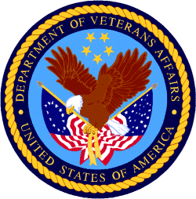

Department of Veterans Affairs

Programs:

Reminders:

PART 2 – GENERAL FEDERAL AGENCY GRANTS INFORMATION
SEPTEMBER 2020

Please review each department’s General Grant and Funding Overview. These overviews are the key web pages on each departmental website dedicated to the agency’s funding opportunities. Check back often to note the department updates.

(See Part 1 for current grant opportunity notices)

Federal Agencies Discretionary Grants and Contract Website Links

Native Hawaiian Programs

U.S. Department of Agriculture

Grants and Loans Overview

Department of Commerce

Grants at Commerce

Economic Development Administration Hawaii Contacts

Corporation for National and Community Service

General Program Overview

National Service in Hawaii

Department of Defense

Doing Business with the Department of Defense

Department of Education

Grant Programs Overview

US Department of Energy

Grants Overview

Environmental Protection Agency

Grants and Contracts Overview

Federal Mediation and Conciliation Service

Grants Overview

Department of Health and Human Services

Grants Overview

Department of Homeland Security
Grants Overview

Department of Housing and Urban Development

HUD - Notice of Funds Available

Institute of Museum and Library Services
Grants Overview

IMLS is on Facebook!

Department of Interior

Grants and Contract Overview

Department of Justice

Grants and Contract Overview

Hawaii State Administrative Agency Contacts
________________________________________________________________________

Department of Labor

Grants and Contract General Overview

National Aeronautics and Space Administration

Research Grant and Contract General Overview
_______________________________________________________________
National Archives and Records Administration

Grant Opportunities General Overview
_______________________________________________________________
National Endowment for the Arts

Grant Opportunities General Overview
_______________________________________________________________

National Endowment for the Humanities

Grant Opportunities General Overview
_______________________________________________________________
National Science Foundation

Grant Opportunities General Overview

Small Business Administration

General Overview Finding Loans & Grants

Links Specific to Hawaii

State Department

General Overview and Resources for Program Administrators

_________________________________________________________________________________

U.S. Department of Transportation

General Grant Program Overview

Department of the Treasury

Overview

US Agency for International Development

General Funding Opportunity Overview

Department of Veterans Affairs

Programs

Grants.Gov Links

Grant Writing Resources

SBIR – Small Business Innovation Research

Federal Agency Discretionary Grant and Contract Websites and Overviews

Native Hawaiian Programs

The Office of Native Hawaiian Relations was authorized by Congress in Public Law 108-199 on January 23, 2004, and in Public Law 104-42 on November 2, 1995. The Office discharges the Secretary's responsibilities for matters related to Native Hawaiians and serves as a conduit for the Department’s field activities in Hawaii

To access the resources in the 2016 guide (the most recent) click on this link:
https://www.doi.gov/sites/doi.gov/files/uploads/NHC%20Guide%20to%20Fed%20Prog%20and%20Services%2002052016%20ONHR.pdf

The listing below can be reviewed online at the following site:
https://www.doi.gov/hawaiian/programs

U.S. Department of Agriculture

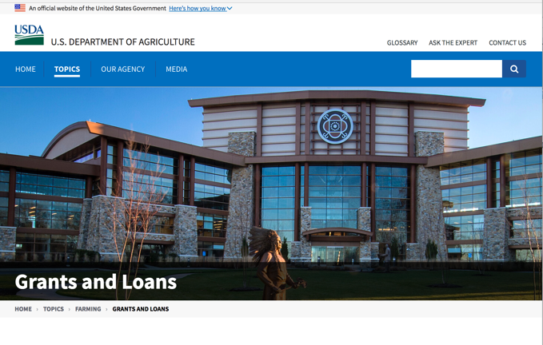

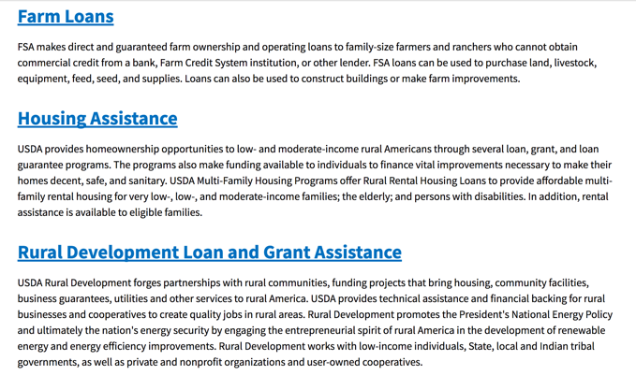
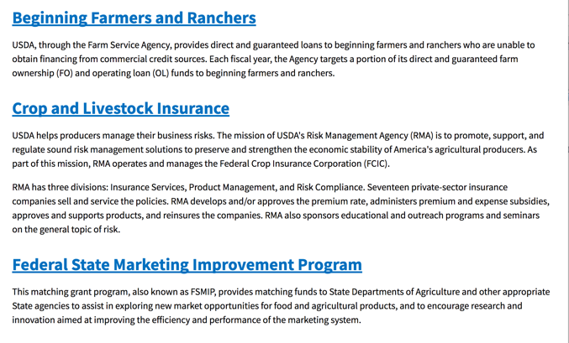
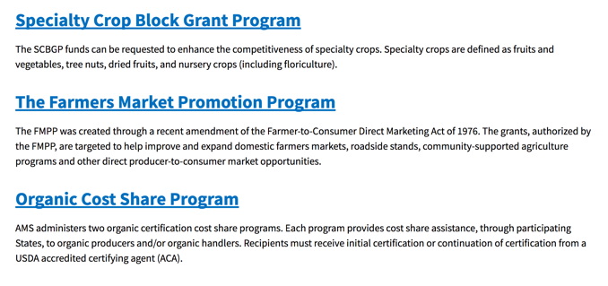
https://www.usda.gov/topics/farming/grants-and-loans

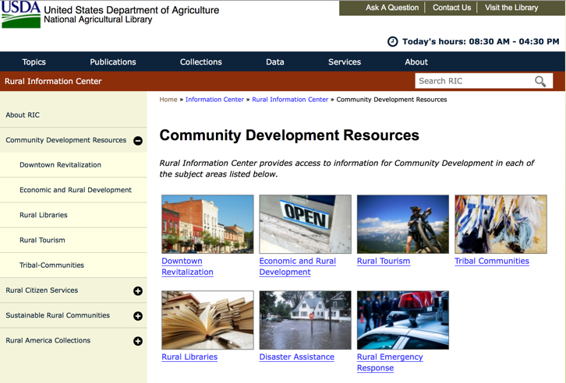

https://www.nal.usda.gov/ric/community-development-resources

Department of Commerce

Grants, Contracting, and Trade Opportunities at Commerce
Learn more information about grants, contracting and trade opportunities at the Department of Commerce using the information below.
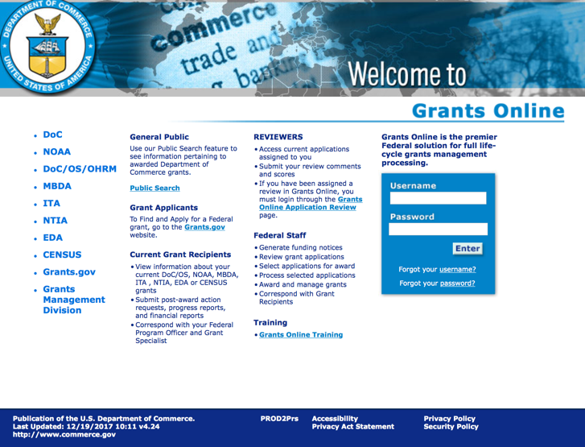
https://grantsonline.rdc.noaa.gov/flows/home/Login/LoginController.jpf

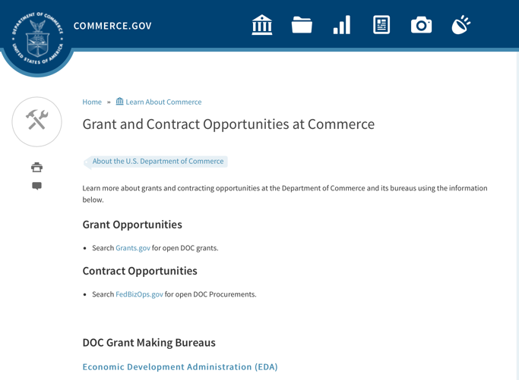
DOC Grant Making Bureaus
Economic Development Administration (EDA)
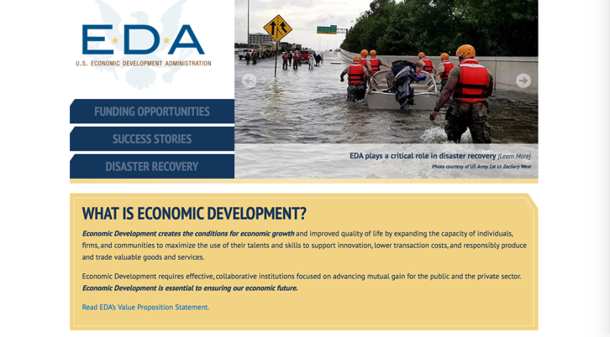
International Trade Administration (ITA)
- Market Development Cooperator Program
- Special American Business Internship Training Program (SABIT). A technical assistance initiative of the International Trade Administration of the U.S. Department of Commerce, SABIT offers organizations competitive grants and an opportunity to host industry-specific delegations. SABIT serves as an initial entry point for U.S. businesses seeking funding to establish long-term relationships with potential customers, distributors, or partners in the former Soviet Union. The program trains Eurasian managers and scientists in commonly accepted business practices as a means of facilitating cross border relationships. In turn, these personal relationships serve as a basis for business development and reduce market access barriers for U.S. businesses
National Institute of Standards & Technology (NIST)
- Funding Opportunities
National Telecommunications & Information Administration (NTIA)
- Telecommunications Grants
National Oceanic & Atmospheric Administration (NOAA)
- Coastal Ocean Program Grant Information
- Fisheries Saltonstall Kennedy Grant Program
- National Undersea Research Program Funding Opportunities
- Grants Management Division
- Fisheries Grants Program
- National Sea Grant
- Office of Global Programs
Contracting Resources for Contractors
- Office of Small and Disadvantaged Business Utilization (OSDBU) - the Office of Small and Disadvantaged Business Utilization (OSDBU) is an advocacy and advisory office responsible for promoting the use of small, small disadvantaged, 8(a), women-owned, veteran-owned, service-disabled veteran-owned, and HUBZone small businesses within the U.S. Department of Commerce's (DOC) acquisition process.
- Business.USA.gov's Find Opportunities Wizard where in a few quick steps, it will guide you towards federal government contracting programs and opportunities for your business!
- Planned Acquisitions: the Department of Commerce's search tool for our planned acquisitions over $100,000. As requirements change, these acquisition plans are updated by department personnel and this search tool is automatically updated.
- Small Business Administration's Contracting section of their web site where you can learn about how to "Get Started" and "Contracting Support for Small Business"
- The General Services Administration (GSA) has implemented a system for vendors doing business with the Federal Government to manage their entity information in one central location. This new database is the System for Award Management (SAM).

DOC Contracting Offices
- Patent and Trademark Office (PTO)
  - Office of Procurement

- National Institute of Standards & Technology (NIST)
NIST Acquisition Management Group
Contracting Opportunities with Commerce
Trade Opportunities through Commerce
http://www.commerce.gov

Economic Development Administration Hawaii Contacts

https://www.eda.gov/resources/economic-development-directory/states/hi.htm

Corporation for National and Community Service

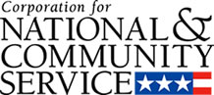

General Program Overview

AmeriCorps provides resources, both human and financial, to organizations that engage Americans in intensive service to meet our country’s critical needs.
Grantees use the funding to support AmeriCorps members for intensive service in their community. AmeriCorps grants partially cover the expense of operating an AmeriCorps program and do not cover general organizational expenses. A cash and in-kind match is required.

The main website can be accessed here: http://www.nationalservice.gov

For access to further funding information: click here

http://www.nationalservice.gov/build-your-capacity/grants/funding-opportunities

National Service In Hawaii
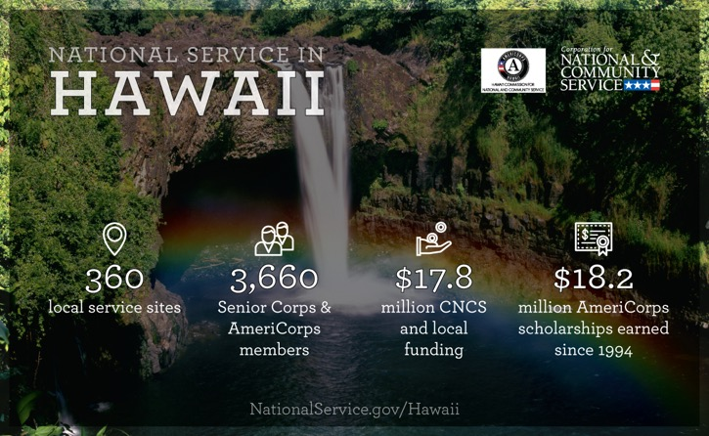
Meeting Community Needs in Hawaii: Last year more than 3,600Americans of all ages and backgrounds met local needs, strengthened communities, and expanded economic opportunity through national service in Hawaii. The Corporation for National and Community Service (CNCS) invested more than $8.1 million to support cost-effective community solutions, working hand in hand with local partners to empower citizens to solve problems. AmeriCorps members and Senior Corps volunteers are preparing today's students for tomorrow's jobs, reducing crime and reviving cities, connecting veterans to services, fighting the opioid epidemic, helping seniors live independently, and rebuilding communities after disasters. Service members served at more than 300 locations across Hawaii, including schools, food banks, homeless shelters, health clinics, youth centers, veterans facilities, and other nonprofit and faith-based organizations. Through a unique public-private partnership, CNCS, its grantees, and project sponsors generated more than $9.6 million in outside resources from businesses, foundations, public agencies, and other sources in FY 2017. This local support strengthened community impact and increased the return on taxpayer dollars.

AmeriCorps
Last year, more than 600 AmeriCorps members met pressing local needs across Hawaii, making a lasting impact in communities while gaining valuable skills and experience to advance their careers. AmeriCorps members serve through one of three programs:
- AmeriCorps State & National engages men and women in intensive service at thousands of locations across the country through nonprofits, schools, public agencies, tribes, and community and faith-based groups. Most AmeriCorps grant funding goes to the Hawaii Commission on National & Community Service, the Governor-appointed State Service Commission, which in turn awards grants to organizations to respond to local needs.
- AmeriCorps VISTA (Volunteers In Service To America) taps the skills, talents, and passion of Americans of all ages to support community efforts to overcome poverty.
- AmeriCorps NCCC (National Civilian Community Corps) is a full-time, team-based residential program for 18-24 year-olds. Members develop leadership skills by serving in public safety, environment, and disaster projects. FEMA Corps, a unit of NCCC, focuses solely on disaster preparedness, response, and recovery.

Senior Corps
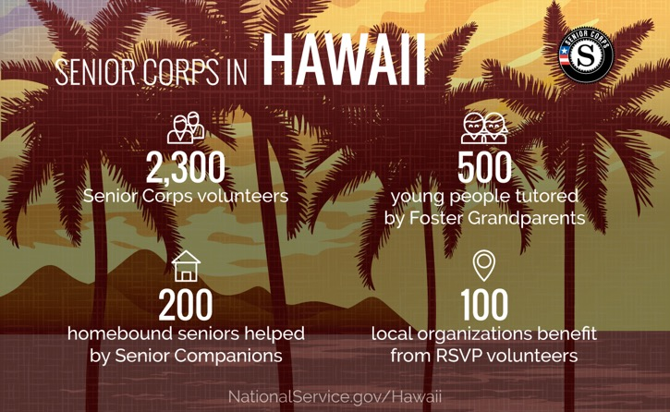
Senior Corps taps the skills, talents, and experience of Americans age 55 and over to meet a wide range of community challenges. Last year, more than 3,000 Hawaii seniors met critical community needs while contributing to longer, healthier lives through one of three Senior Corps programs:
- Foster Grandparents serve one-on-one as tutors and mentors to young people with exceptional needs.
- Senior Companions help homebound seniors and other adults maintain independence primarily in their own homes.
- RSVP volunteers conduct safety patrols, renovate homes, protect the environment, tutor and mentor youth, respond to natural disasters, and provide other services.
Last year in Hawaii, Foster Grandparents tutored and mentored 530young people, Senior Companions helped 290 seniors live independently, and RSVP volunteers strengthened the impact of 150organizations across the state.

Learn More
To see other reports about national service in Hawaii, please contact HI@cns.gov.
The Corporation for National and Community Service is a federal agency that improves lives, strengthens communities, and fosters civic engagement through service and volunteering. To learn more, visit www.NationalService.gov or call 202-606-5000 or TTY 1-800-833-3722.

U.S. Department of Defense

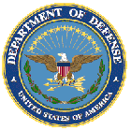

Doing Business with the Department of Defense

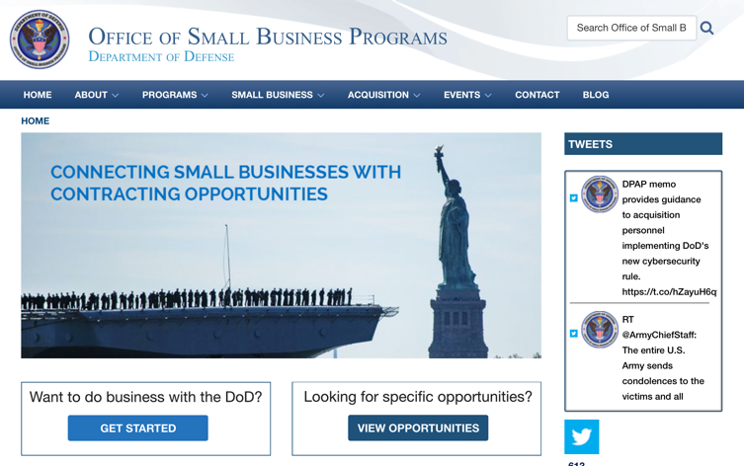

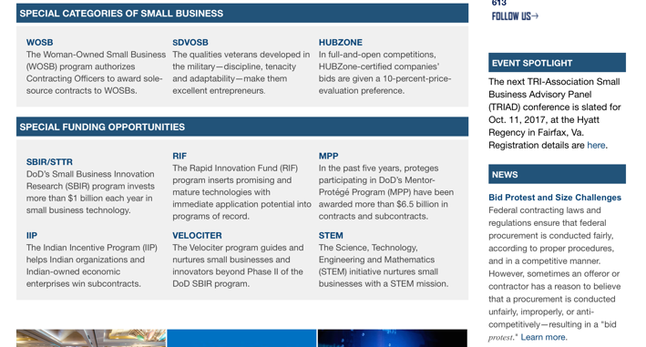

http://business.defense.gov

Corona Virus Response -- https://business.defense.gov/COVID-19-SMALL-BUSINESS-RESOURCES/

Department of Education


Grant Programs Overview at the Department of Education

The general information page for Education Grant funding is an excellent resource describing the three types of grants awarded by the Department of Education. See the screen shot of the Department of Education web page below:

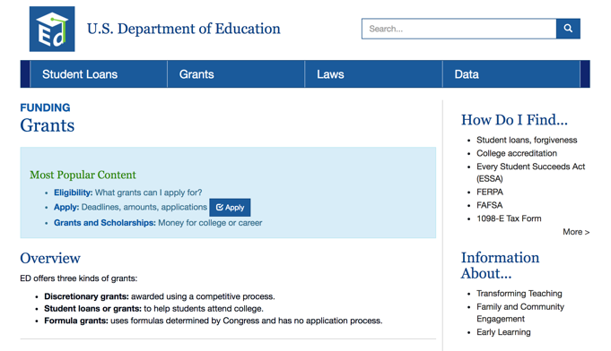
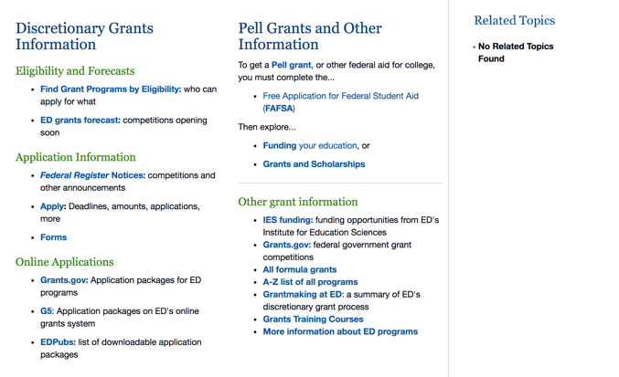

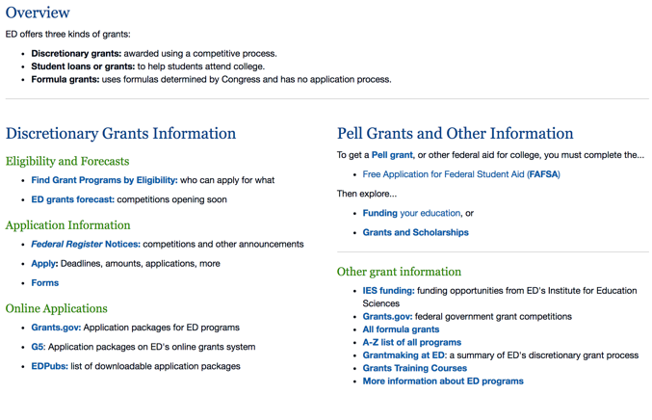

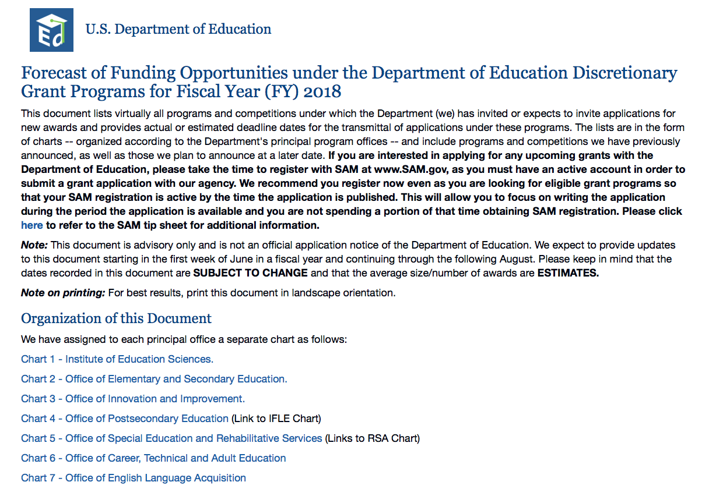

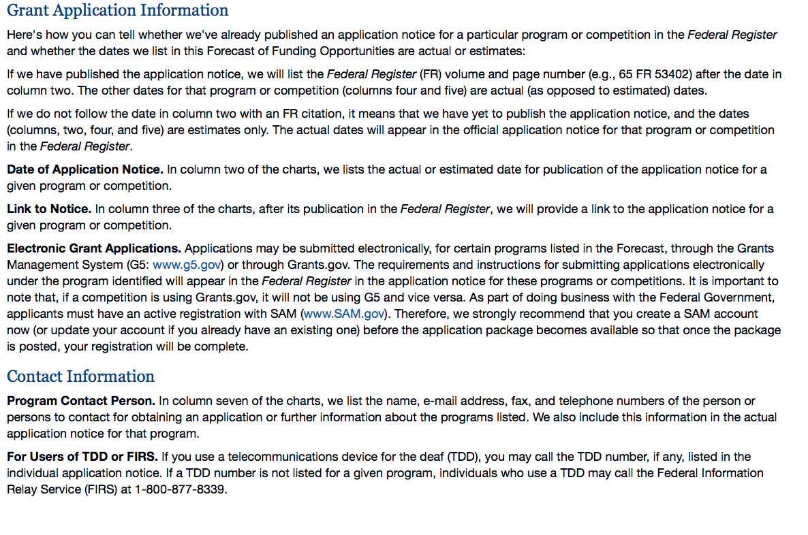

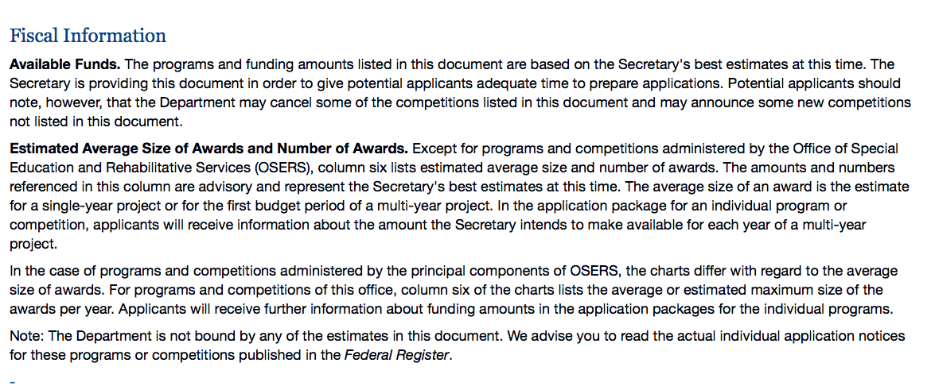

https://www2.ed.gov/fund/grant/find/edlite-forecast.html

U.S. Department of Energy

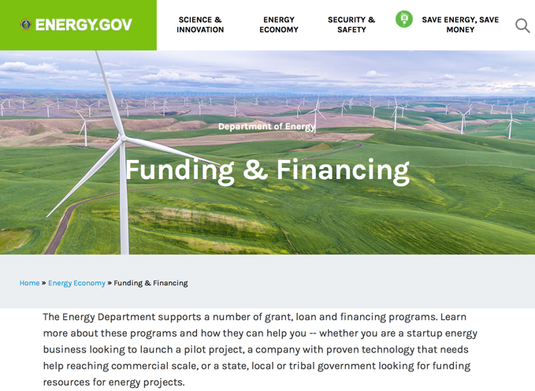

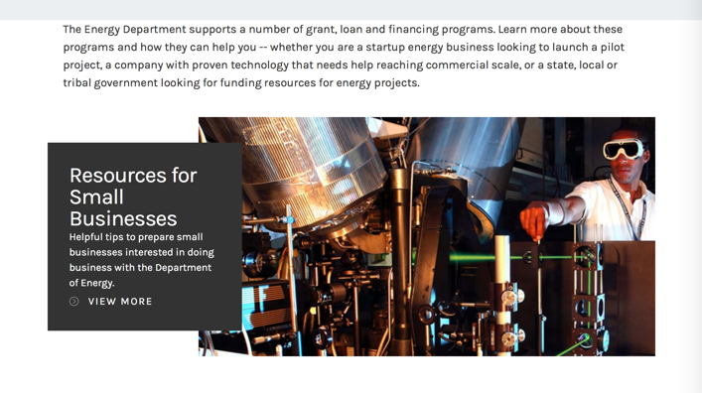

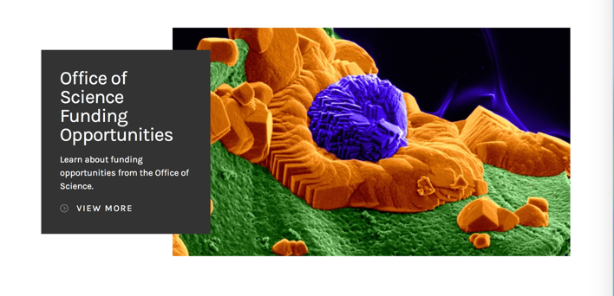

https://www.energy.gov/energy-economy/funding-financing

Environmental Protection Agency

https://www.epa.gov/grants

Federal Mediation and Conciliation Service

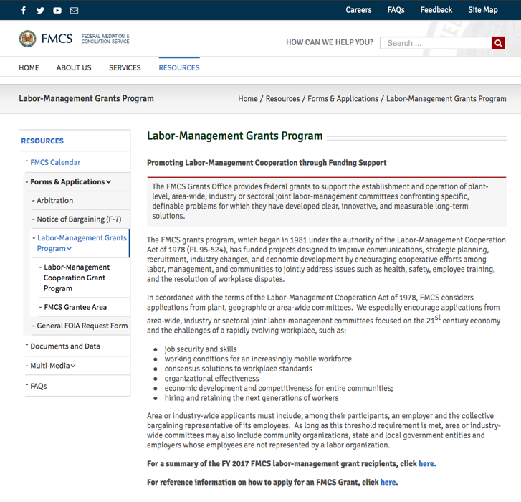
https://www.fmcs.gov/resources/forms-applications/labor-management-grants-program/

Department of Health and Human Services

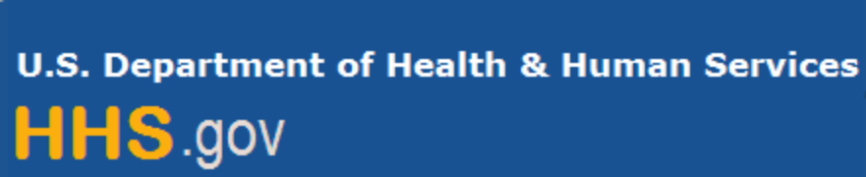

Grants Forecast and Overview

The Department of Health and Human Services’ Grants Forecast is a database of planned grant opportunities proposed by its agencies. Each Forecast record contains actual or estimated dates and funding levels for grants that the agency intends to award during the fiscal year. Forecast opportunities are subject to change based on enactment of congressional appropriations.

For more general information about HHS Grants and Funding go to the website below at:

https://www.hhs.gov/grants/grants/index.html

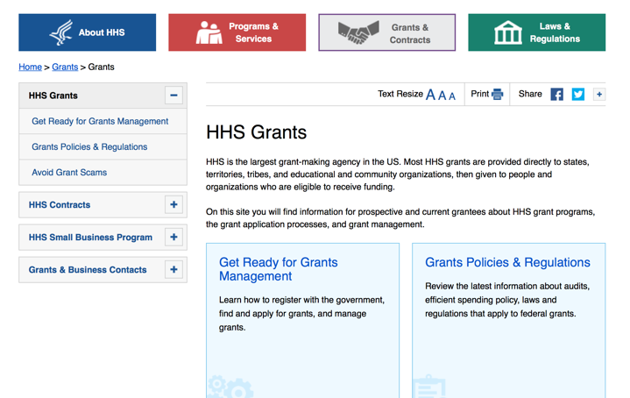

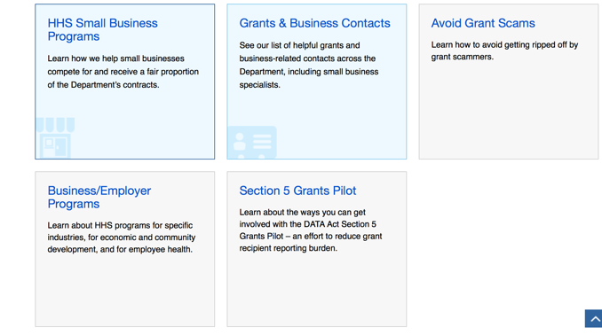

Department of Homeland Security



The Department of Homeland Security enhances the ability of states, local and tribal jurisdictions, and other regional authorities in the preparation, prevention, and response to terrorist attacks and other disasters, by distributing grant funds. Localities can use grants for planning, equipment, training and exercise needs.

Webpage can be viewed at: https://www.dhs.gov/dhs-financial-assistance#2

https://www.fema.gov/welcome-assistance-firefighters-grant-program

For AFG program guidance materials, please visit our Documents page.

Resources

AFG Help Desk
Contact the AFG Program Help Desk toll-free at 866-274-0960, or email us at firegrants@dhs.gov.
The AFG Program has Fire Program Specialists in 10 federal regional centers. These Regional Fire Program Specialists respond to questions about the AFG program and carry out grant monitoring activities. View regional contacts

Popular AFG links
- Assistance to Firefighters Grants (AFG)
- AFG Awards List
- Staffing for Adequate Fire & Emergency Response (SAFER) Grants (SAFER)
- SAFER Awards List
- SAFER Success Stories
- Fire Prevention & Safety (FP&S) Grants
- FP&S Awards List
- FP&S Success Stories
- Grant Closeout Tutorial
- Assistance to Firefighters Grant (AFG) Email Alert Archive
- Frequently Asked Questions
Contact Information For The Assistance to Firefighters Grant (AFG) Program and Help Desk

Federal Funding Alternative To AFG

State Administrative Agencies (SAA) apply for and administer Federal grants on behalf of their States, including FEMA Preparedness Grants. The SAA will work with eligible organizations to comply with the general requirements of grant programs or cooperative agreements. Contact your State’s SAA to find out what current Federal funding opportunities may be available to your organization. A listing of the SAAs and points of contact can be found at http://www.fema.gov/library/viewRecord.do?id=6363.

Department of Housing and Urban Development

https://www.hud.gov/program_offices/spm/gmomgmt/grantsinfo

HUD - Notice of Funds Available
For detailed information click here

http://portal.hud.gov/hudportal/HUD?src=/program_offices/Administration/grants/fundsavail

HUD NOFA FORECAST
The Department of Housing and Urban Development NOFA Forecast lists competitive grant opportunities that may be available for FY2016. The inclusion or exclusion of an opportunity in this list does not constitute a guarantee that a specific opportunity will become available or not be available. Forecast opportunities are subject to change based on enactment of Congressional appropriations and other considerations.
When funding is available, HUD will issue a Notice of Funding Availability (NOFA), which will be available on Grants.gov

Institute of Museum and Library Services

https://www.imls.gov/grants/apply-grant/available-grants

Each grant program has specific eligibility requirements. The links below provide general eligibility criteria for museums, libraries, and tribal organizations, but please note that additional organizations may be eligible for grants under certain programs. Additionally, ineligible organizations may still be able to participate in grant programs through partnerships with eligible organizations. Please click on the links below to see general criteria and review Applications and Guidelines for specific information.
Museums Libraries

Institutions: Archives, Federally Recognized Native American Tribe, Historical Society, Library, Nonprofits that serve Native Hawaiians, Professional Association, Public or Private Non-profit Institutions of Higher Education, Regional Organization, State Library Administrative Agency, State or Local Government

Check out IMLS's Facebook page at:
https://www.facebook.com/USIMLS/

Department of the Interior

Working with Interior

The Interior Department provides assistance to the public, local governments and businesses through a number of programs. For a general overview see: http://www.doi.gov/index.cfm

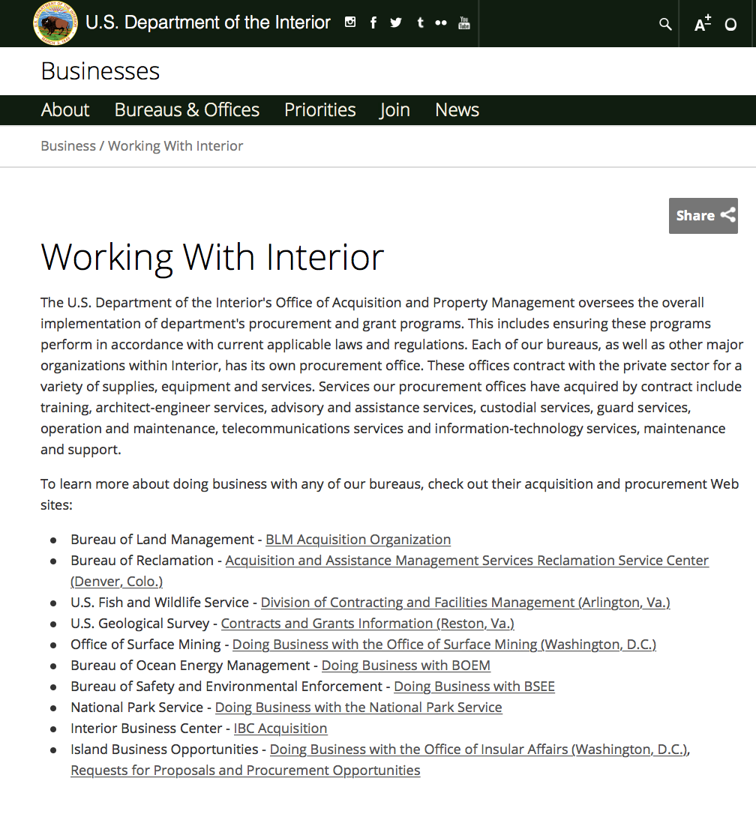

http://www.doi.gov/businesses/working-with-interior.cfm

Department of Justice

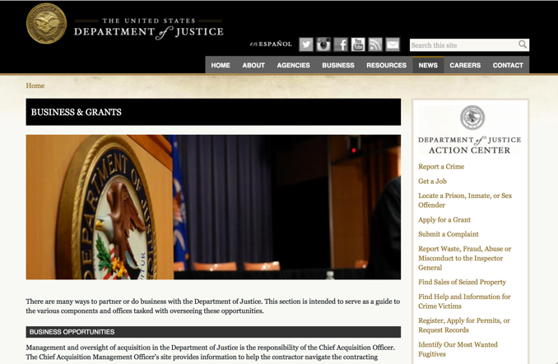

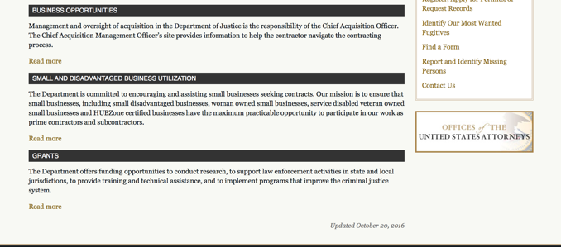

The DOJ agencies listed below also have sites that provide grant information specific to that agency. Examples of what can be found on these sites are programs, funding opportunities, application assistance, and other useful information.

Bureau of Justice Assistance (BJA)

Bureau of Justice Statistics (BJS)

National Criminal Justice Reference Service (NCJRS)

National Institute of Justice (NIJ)

Office of Sex Offender Sentencing, Monitoring, Apprehending, Registering, and Tracking (SMART)

http://www.justice.gov/business/

Hawaii State Administrative Agency Contacts

https://www.ncja.org/state-agencies/about-state-agencies

HAWAII DEPARTMENT OF THE ATTORNEY GENERAL, CRIME PREVENTION & JUSTICE ASSISTANCE DIVISION
235 S Beretania Street, Suite 401
Honolulu, HI 96813
(808) 586-1150
Agency Head: Julie Ebato, Administrator
JAG Contact: Shaleigh Tice, Grants & Planning Branch Chief
SAC Director: Paul Perrone, Chief of Research and Statistics

https://ag.hawaii.gov/cpja/gp/

Department of Labor

https://www.dol.gov/general/grants/howto

https://www.doleta.gov/grants/

Agency Grants and Contract General Overview

DOL Resources
Apply for DOL Agency-Specific Grants:
- Employment and Training Administration (ETA)
- Occupational Safety and Health Administration (OSHA)
- Bureau of International Labor Affairs (ILAB)
- Veterans' Employment and Training Service (VETS)
- Office of Disability Employment Policy (ODEP)
- Office of the Assistant Secretary for Administration and Management (OASAM)

Other Grant Resources:

DOL Resources and Instructions for Applying for a Grant
- DOL Guidance Clarifying the Effect of the Religious Freedom Restoration Act on Faith-Based Organizations
- Grant and Contract Information
- More Information About Grants

Other Federal Government Grant Information
- Grant Opportunities (Catalog of Federal Domestic Assistance)

Department of Labor Grant Programs

- Bureau of International Labor Affairs (ILAB): provides grants (cooperative agreements) for the implementation of projects designed to assist developing countries combat the worse forms of child labor, forced labor, and human trafficking; and support worker rights and improve working conditions. http://www.dol.gov/general/business.
- Bureau of Labor Statistics (BLS): provides project grants (cooperative agreements) and the dissemination of technical statistical data and related information on labor force activities; provides data on prices (CPI) and cost of living; data on productivity and technology data; data on compensation and working conditions; data on employment projections.
- Employment and Training (ETA): ETA Administers financial assistance programs pursuant to the Workforce Investment Act (WIA), administering State formula grant programs for youth, adults and dislocated workers, national emergency grants for workers affected by mass layoffs, plant closures, and disasters; grant programs for workers with disabilities, Indians and Native Americans, and for migrant and seasonal farmworkers. ETA also administers grant programs for older American workers, apprenticeship programs, Trade Adjustment Assistance (TAA) programs, and assistance for research and development of workforce programs. In addition, ETA is responsible for the operation and maintenance of a national system of public employment service offices and for the national unemployment insurance program.
- Mine Safety and Health (MSHA): provides grants for research, education and training programs to ensure an adequate and competent staff of trained inspectors; and assistance for establishing or improving State mine health and safety programs through technical assistance.
- Occupational Safety and Health (OSHA): provides grants to non-profit organizations to provide training, educational services, and technical assistance; assistance to states to administer and enforce state programs; assistance to states to provide occupational safety and health technical assistance and consultant services.
- Office of Disability Employment Policy (ODEP): The Office of Disability Employment Policy awards competitive grants establishing short-term pilot and technical assistance projects designed to identify, develop, test, evaluate, and disseminate policies to increase employment by expanding access to training, education, employment supports, assistive and systems technology, integrated employment, entrepreneurial development, and small business opportunities for adults and youth with disabilities. Current pilots projects focus on customized employment, Olmstead populations, and innovative demonstration youth grants, among others. Solicitations for grant applications are published in the Federal Register and announced at www.dol.gov/odep. ODEP grants are awarded by the OASAM grant office.
- Veterans' Employment and Training (VETS): provides special employment and training assistance for veterans through the Disabled Veterans' Outreach Program (DVOP) Solicitation for Grant Applications; the Local Veterans' Employment Representative Program (LVER); Veterans' Workforce Investment Program (VWIP); elaws Advisor on veterans' employment and reemployment rights; and the Homeless Veterans Reintegration Project (HVRP). VETS grants are awarded by the OASAM grant office.

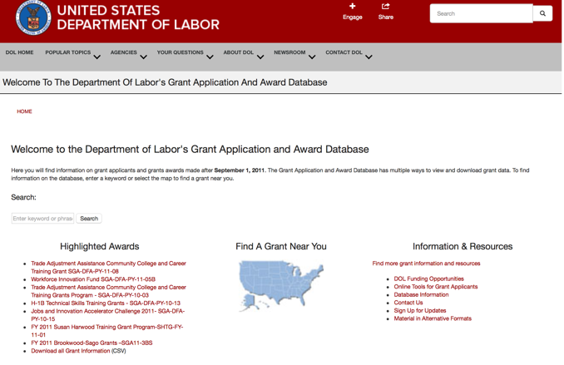

https://www.dol.gov/general/grants/howto

National Aeronautics and Space Administration



NASA Research Opportunities Online

- Various NASA offices publish their research announcements over the Internet, broadening the opportunity for researchers to apply for funding. This site provides access to current research announcements along with their specific due dates.

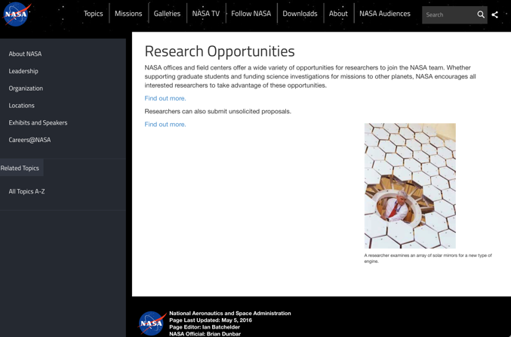

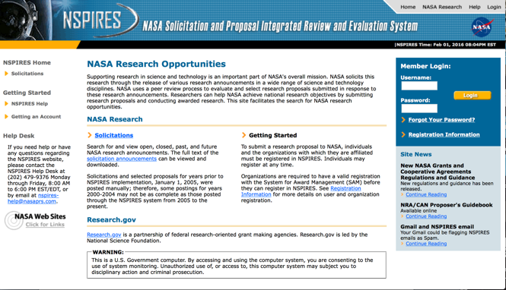
http://nspires.nasaprs.com/external/

National Archives and Records Administration

To access the information above: click here

https://www.archives.gov/nhprc/announcement

National Endowment for the Arts

See more at: https://www.arts.gov/grants

National Endowment for the Humanities

https://www.neh.gov/grants

National Science Foundation



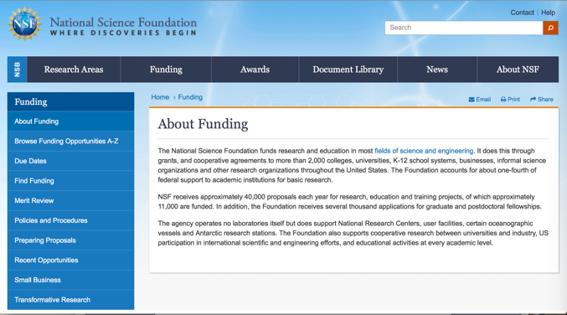

For assistance: https://nsf.gov/funding/aboutfunding.jsp

The National Science Foundation funds research and education in most fields of science and engineering. It does this through grants, and cooperative agreements to more than 2,000 colleges, universities, K-12 school systems, businesses, informal science organizations and other research organizations throughout the United States. The Foundation accounts for about one-fourth of federal support to academic institutions for basic research.
NSF receives approximately 40,000 proposals each year for research, education and training projects, of which approximately 11,000 are funded. In addition, the Foundation receives several thousand applications for graduate and postdoctoral fellowships.
The agency operates no laboratories itself but does support National Research Centers, user facilities, certain oceanographic vessels and Antarctic research stations. The Foundation also supports cooperative research between universities and industry, US participation in international scientific and engineering efforts, and educational activities at every academic level.

For details on active funding deadline dates: http://nsf.gov/funding/pgm_list.jsp?org=NSF&ord=date

Small Business Administration

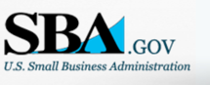


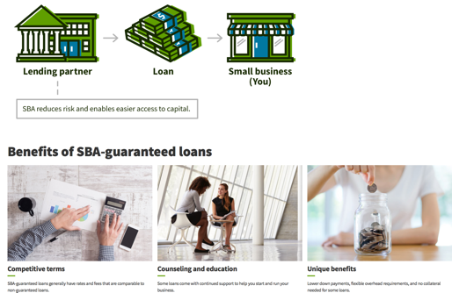

https://www.sba.gov/funding-programs/loans
Federal, state and local governments offer a wide range of financing programs to help small businesses start and grow their operations. These programs include low-interest loans, venture capital, and scientific and economic development grants.
Use SBA.gov's Loans and Grants Search Tool to get a list of financing programs for which you may qualify, or visit the resources below to learn more about small business financing programs.

To get to the main SBA.gov funding page click here
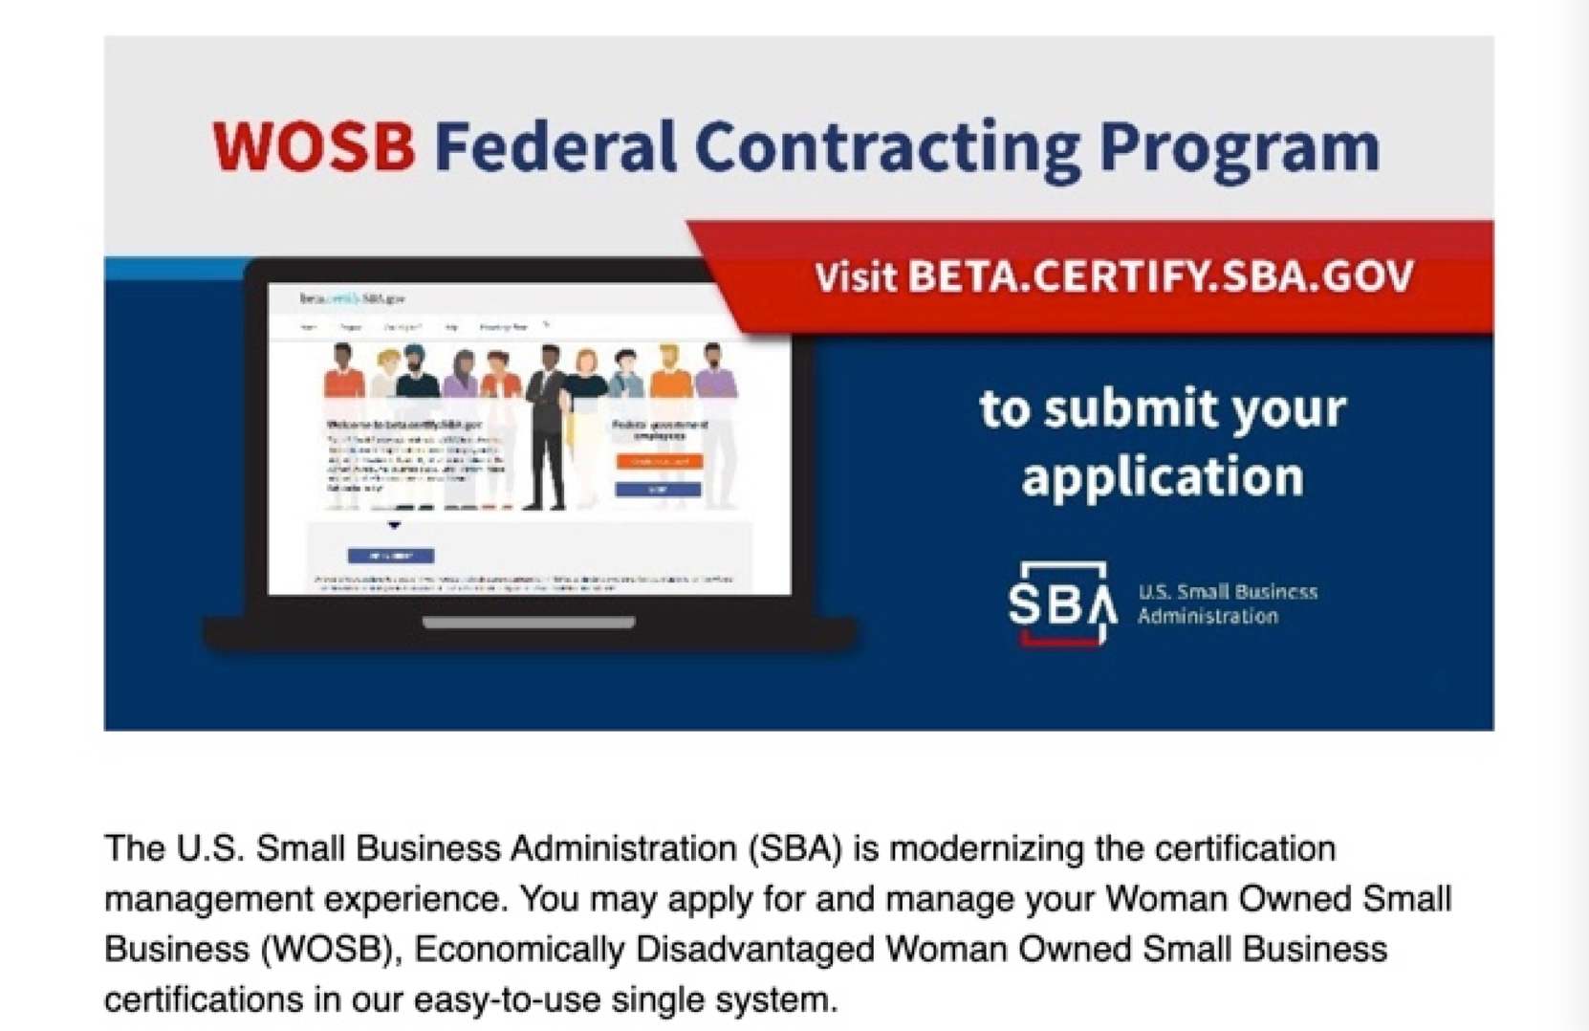
Learn more

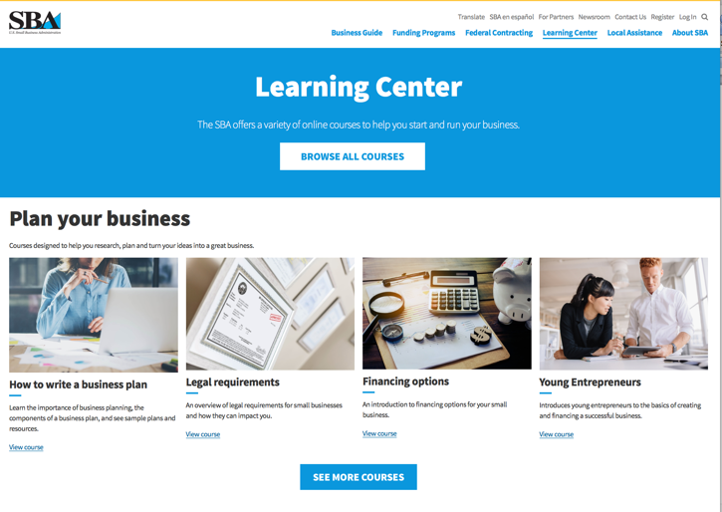
https://www.sba.gov/learning-center

SBA Trainings

https://www.sba.gov/learning-center
Upcoming Trainings: Check out SBA's Online Training!
- Financing Options for Small Businesses

For Specific Information in Hawaii see the following links:
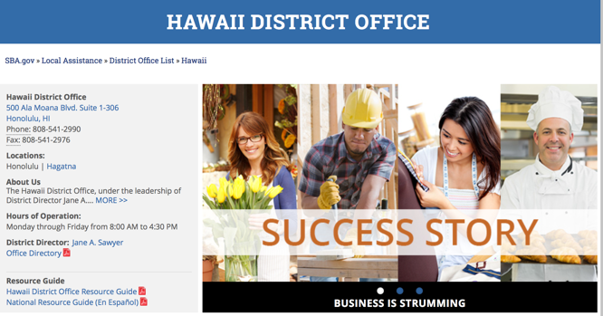

https://www.sba.gov/offices/district/hi/Honolulu

State Department

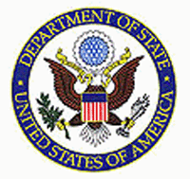

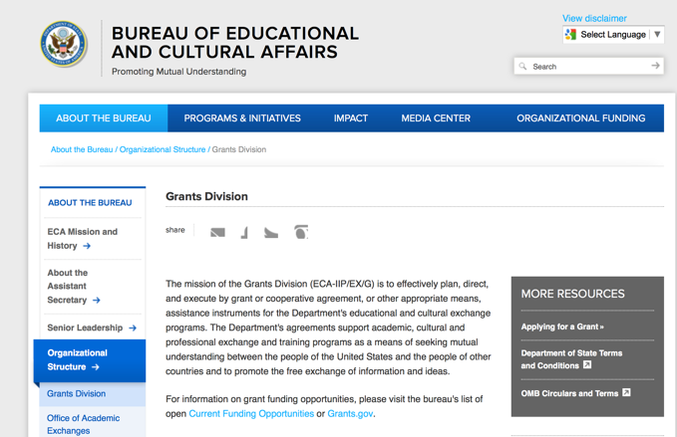

https://eca.state.gov/about-bureau/organizational-structure/grants-division

http://eca.state.gov/search/solr/grants?search_referrer=node/237

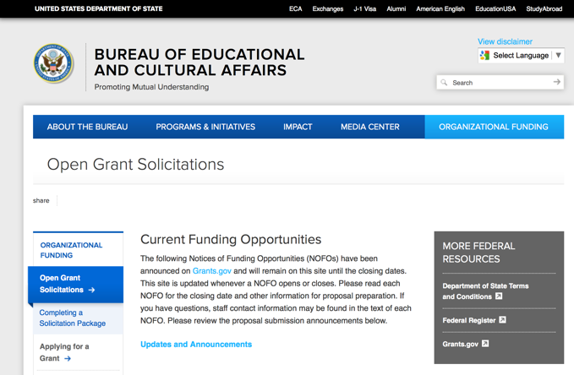
https://eca.state.gov/organizational-funding/open-grant-solicitations

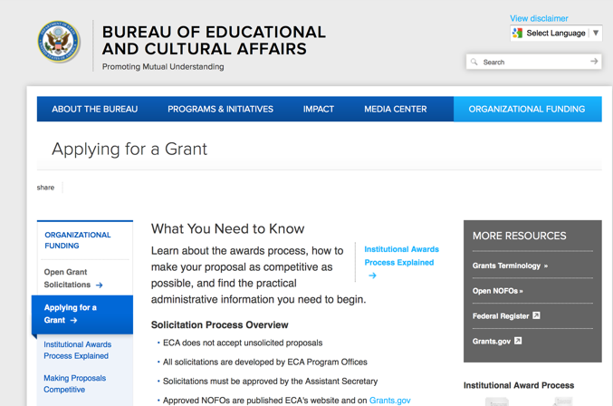
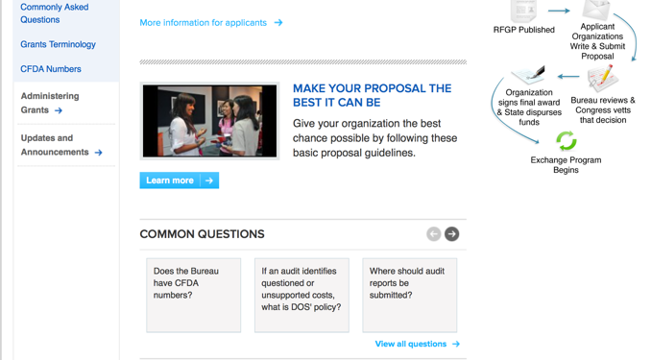
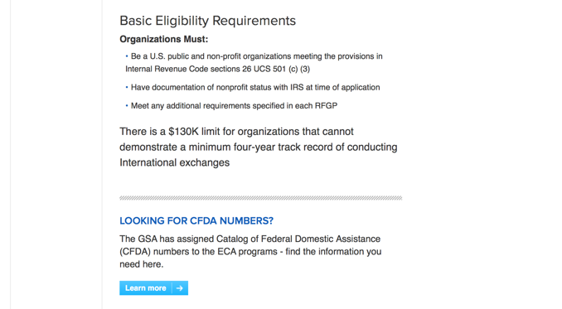
http://eca.state.gov/organizational-funding/applying-grant

General Information:
- Bureau of Educational and Cultural Affairs Grants Division
- Open Grant Opportunities (Requests for Grant Proposals)

For General Information click here

Department of Transportation

General Grant Program Overview https://www.transportation.gov/grants

Department of the Treasury

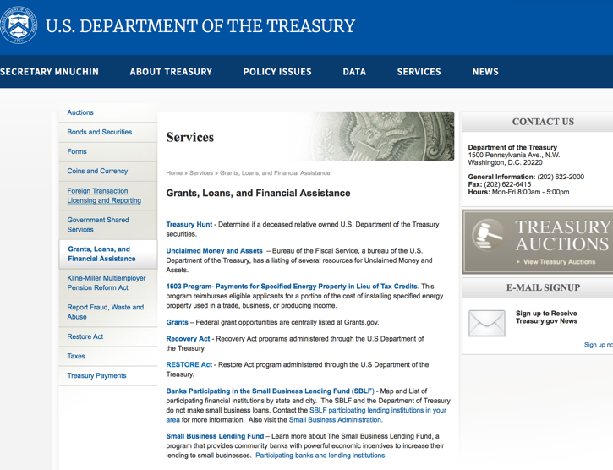

https://www.treasury.gov/services/Pages/Grants-Loans-and-Financial-Assistance.aspx

U.S. Agency for International Development

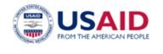
www.usaid.gov

General Overview Funding Opportunities

USAID has working relationships with thousands of American companies and hundreds of U.S.-based private voluntary organizations. For more information on our business and procurement opportunities, please visit our Business section.

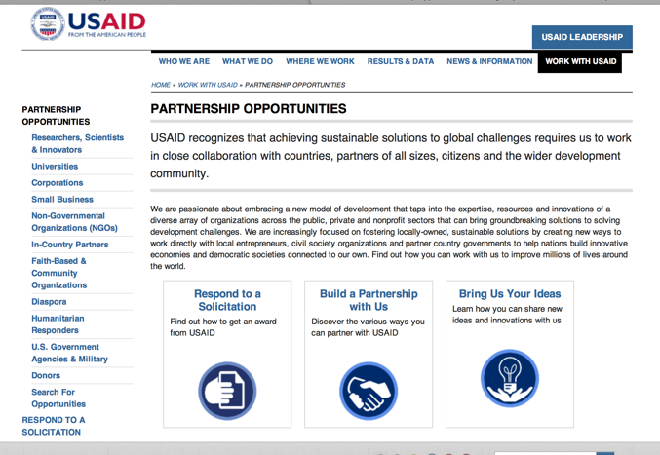

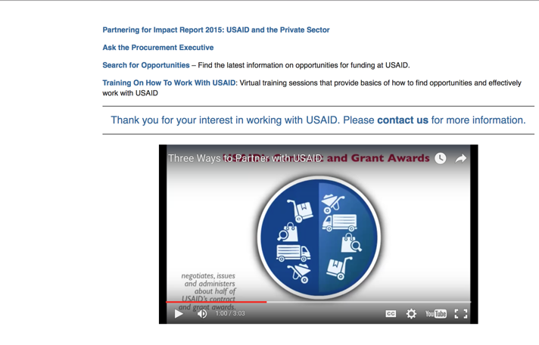

http://www.usaid.gov/partnerships

Department of Veterans Affairs

https://www.va.gov/homeless/gpd.asp
GRANTS.GOV

Provides a Grants Learning Center as a gateway to the federal grants world. Bookmark the following link and participate at blog.grants.gov or on twitter @grantsdotgov

Topics include: Grants 101, Grant Policies, Grant Eligibility, Grant Terms, Grant Agencies , Grant Systems, Grant Programs, Grant Careers, Grant Reporting, Grant Fraud and Grant Events

https://www.grants.gov/web/grants/learn-grants.html

Grants.gov maintains a blog. This reprinted article provides some helpful tips:

Grant Writing: 3 Tips for Crafting Need Statements in Federal Grant Proposals
Posted on March 27, 2019 by Grants.gov
In this space, we have previously shared tips about the pre-writing phase of completing a federal grant application – for example, the importance of reading (and re-reading) the grant announcement, and the importance of understanding the criteria by which your application will be evaluated.
In this post, we dip our toes into the grant writing process itself and share some tips about crafting a need statement. These tips are adapted from the U.S. Department of Health and Human Services Health Resources & Services Administration’s grant writing guide, titled “Tips for Writing and Submitting Good Grant Proposals”. Along with each tip, we also include an excerpt from an award-winning federal grant proposal that can be viewed in full on the website of the Institute of Museum and Library Services. (IMLS has an excellent collection of proposals that are worthy of review – especially for new federal grant applicants.)

https://grantsgovprod.wordpress.com/2019/03/27/3-tips-for-crafting-need-statements-in-federal-grant-proposals/?utm_source=newsletter&utm_medium=email&utm_campaign=noprofile&utm_content=june2020

Grant Writing Resources

The following links are a great resource for Faith-Based Non-profits and other community organizations:

U.S. Agency for International Development
Faith Based and Community Organization Work with USAID

Corporation for National Community Service
Faith-Based and Other Community Initiatives

U.S. Department of Justice
Task Force for Faith-Based and Community Initiatives

Foundation Center
Proposal Writing Short Course

U.S. Environmental Protection Agency
General Tips on Writing a Competitive Grant Proposal

Appalachian Regional Commission
How To Write A Grant Proposal

USDA Rural Information Center
A Guide to Funding Resources

The Small Business Innovative Research Program - SBIR Program

The Small Business Innovation Research (SBIR) program is a highly competitive program that encourages domestic small businesses to engage in Federal Research/Research and Development (R/R&D) that has the potential for commercialization. Through a competitive awards-based program, SBIR enables small businesses to explore their technological potential and provides the incentive to profit from its commercialization. By including qualified small businesses in the nation's R&D arena, high-tech innovation is stimulated, and the United States gains entrepreneurial spirit as it meets its specific research and development needs.

SBIR Mission and Program Goals
The mission of the SBIR program is to support scientific excellence and technological innovation through the investment of Federal research funds in critical American priorities to build a strong national economy.
The program’s goals are four-fold:
- Stimulate technological innovation
- Meet Federal research and development needs.
- Foster and encourage participation in innovation and entrepreneurship by socially and economically disadvantaged persons.
- Increase private-sector commercialization of innovations derived from Federal research and development funding.

SBIR-Participating Agencies
Each year, Federal agencies with extramural research and development (R&D) budgets that exceed $100 million are required to allocate 2.5 percent of their R&D budget to these programs. Currently, eleven Federal agencies participate in the program:
- Department of Agriculture
- Department of Commerce - National Institute of Standards and Technology
- Department of Defense
- Department of Energy
- Department of Health and Human Services
- Department of Homeland Security
- Department of Transportation
- Environmental Protection Agency
- National Aeronautics and Space Administration
- National Science Foundation
Each agency administers its own individual program within guidelines established by Congress. These agencies designate R&D topics in their solicitations and accept proposals from small businesses. Awards are made on a competitive basis after proposal evaluation.

Three-Phase Program
The SBIR Program is structured in three phases:
Phase I. The objective of Phase I is to establish the technical merit, feasibility, and commercial potential of the proposed R/R&D efforts and to determine the quality of performance of the small business awardee organization prior to providing further Federal support in Phase II. SBIR Phase I awards normally do not exceed $150,000 total costs for 6 months.
Phase II. The objective of Phase II is to continue the R/R&D efforts initiated in Phase I. Funding is based on the results achieved in Phase I and the scientific and technical merit and commercial potential of the project proposed in Phase II. Only Phase I awardees are eligible for a Phase II award. SBIR Phase II awards normally do not exceed $1,000,000 total costs for 2 years.
Phase III. The objective of Phase III, where appropriate, is for the small business to pursue commercialization objectives resulting from the Phase I/II R/R&D activities. The SBIR program does not fund Phase III. Some Federal agencies, Phase III may involve follow-on non-SBIR funded R&D or production contracts for products, processes or services intended for use by the U.S. Government

