Senator Mazie Hirono

Grants Assistance Information Newsletter

SEPTEMBER 2020

PART 1 – CURRENT FEDERAL AGENCY DISCRETIONARY GRANT OPPORTUNITIES

PART 2 – GENERAL FEDERAL AGENCY GRANTS INFORMATION

Current Federal Agency Grant and Cooperative Agreement Discretionary Program Summaries

Click on Index Links below to find summaries of the current announcements listed by agency in this document. Once you reach the item, if you cannot open the links for further information, copy the selected URL website address into your browser.

Notices is Teal are items with immediate deadline dates.

Notices in Yellow are of special interest.

Notices is Green are items of special interest with immediate deadline dates.

Several Agencies have research or program opportunities that are not individually listed because they are for very technical or specific audiences. Click on the Agency Index Research or Program designation to review those grant and contract notices.

If an Agency does not have listings, it is due to the lack of competitive open opportunities at that Agency this month. Please review Part 2 for general information not specific to a current deadline date for general funding cycle information.

Special Notice

General Federal Government Coronavirus Responses

Specific Agency Coronavirus Responses

Corona Virus Response for Small Business

Programs specific to Hawaii

Current Notices

Native American/Native Hawaiian Museum Services (2021)

Office of Procurement Operations - Grants Division
2020 DHS SLA for Minority Serving Institutions
National Institutes of Health
Intervention Research to Improve Native American Health (R01 Clinical Trial Optional)

National Institutes of Health
Research to Improve Native American Health (R21 Clinical Trials Optional)

Reminders
Bureau of Land Management
BLM National Interagency Fire Center (NIFC) Joint Fire Science Program (JFSP) Graduate Research Innovation (GRIN) (One Task Statement

Bureau of Land Management
BLM National Interagency Fire Center (NIFC) Joint Fire Science Program (JFSP) Primary Announcement (Two Task Statements)

Air Force Office of Scientific Research
(FY20) Defense Established Program to Stimulate Competitive Research (DEPSCoR)

U.S. Department of Agriculture

Programs
Research

National Institute of Food and Agriculture
FY21 Small Business Innovation Research Phase I
Modifications

Natural Resources Conservation Service
Announcement for Program Funding for NRCS’s Regional Conservation Partnership Program (RCPP) for Federal Fiscal Years (FYs) 2020 and 2021
Reminders

Animal and Plant Health Inspection Service
National Animal Disease Preparedness and Response Program 2020 Cooperative/Interagency Agreements
Business and Cooperative Programs
Socially Disadvantaged Groups Grant

National Institute of Food and Agriculture
Agriculture and Food Research Initiative - Foundational and Applied Science
Cochran Fellowship Prog-Intl Trng 10.962
2020 Cochran Fellowship Program

National Institute of Food and Agriculture
Capacity Building Grants for Non-Land Grant Colleges of Agriculture Program (NLGCA)
National Institute of Food and Agriculture
Agriculture and Food Research Initiative - Education and Workforce Development

National Institute of Food and Agriculture
Agriculture and Food Research Initiative - Foundational and Applied Science

Business and Cooperative Programs
REAP-Renewable Energy Systems and Energy Efficiency Improvements

Department of Commerce

Programs

EDA-HDQ-OIE-2020-STEMTALENT

Research
FY2021 Weather Program Office Research Programs

Modifications

FY 2020 Small Business Innovation Research Phase II

Reminders

John H. Prescott Marine Mammal Rescue Assistance Grant Program (Prescott Grant Program)

FY2021 Marine Debris Removal

Climate Program Office FY2021

FY21 Saltonstall-Kennedy Competition

National Institute of Standards and Technology
NIST Public Safety Innovation Accelerator Program (PSIAP) – Follow-on Funding for Technical and Business Assistance and Demonstration Projects with Public Safety Agencies
FY21 Bluefin Tuna Research Program

FY 2021 Implementation of the U.S. Integrated Ocean Observing System (IOOS®)
Ocean Exploration Fiscal Year 2021 Funding Opportunity

National Institute of Standards and Technology
NIST Manufacturing USA National Emergency Assistance Program
National Sea Grant College Program 2020-2021 Special Projects

Economic Development Administration
FY 2020 EDA Public Works and Economic Adjustment Assistance Programs
National Sea Grant College Program 2020 Special Projects

Consumer Product Safety Commission

Corporation for National and Community Service

Programs

Reminders

Department of Defense

Programs

Research Grants

Modifications

Reminders

Department of Education

Programs
Office of Postsecondary Education (OPE): Fund for the Improvement of Postsecondary Education (FIPSE): Institutional Resilience and Expanded Postsecondary Opportunity (IREPO) Grants Program CFDA Number 84.425P

Research

Modifications

Reminders

Office of Elementary and Secondary Education (OESE): Education Innovation and Research (EIR) Program: Early-Phase Grants CFDA Number 84.411C

Higher Education Emergency Relief Fund-IHE/Institution

Higher Education Emergency Relief Fund – IHEs

US Department of Energy

Research

Modifications

Reminders

Environmental Protection Agency

Programs

FY21 Guidelines For Brownfield Assessment Grants

FY21 Guidelines For Brownfield Cleanup Grants
FY21 Guidelines For Brownfield Multipurpose (MP) Grants

Research

Modifications

Reminders

FY21 Environmental Workforce Development And Job Training (EWDJT) Grants
Reducing Public Exposure to Indoor Pollutants

Federal Mediation and Conciliation Service

Programs

Reminders

Department of Health and Human Services

Programs

Health Resources and Services Administration
Ending the HIV Epidemic - Primary Care HIV Prevention (PCHP) Supplement
Forecast 1

Health Resources and Services Administration
Rural Health Network Development Planning Program
Health Resources and Services Administration
Service Area Competition
Forecast 1

Health Resources and Services Administration
Behavioral Health Workforce Education and Training (BHWET) Program - Paraprofessionals
Forecast 1
Health Resources and Services Administration
Behavioral Health Workforce Education and Training (BHWET) Program - Professionals
Forecast 1

Research Grants

Modifications

Reminders
Office of the Assistant Secretary for Health
SARS-CoV-2 (COVID-19) Program Activities
Administration for Children and Families - OHS
Early Head Start Expansion and Early Head Start-Child Care Partnership Grants
Health Resources and Services Administration
Sickle Cell Disease Newborn Screening Follow-up Program

Department of Homeland Security
Programs
Office of Procurement Operations - Grants Division
Blue Campaign Program Evaluation & Violence Prevention Advisement

Modifications

Reminders

Department of Housing and Urban Development

Programs

FY2020 Choice Neighborhoods Implementation Grant Program

Jobs Plus Initiative
Lead-Based Paint Capital Fund Program (LBPCF)

Modifications

Resident Opportunity and Self-Sufficiency Program

Reminders

HUD's FY 2020 and FY 2021 Community Compass Technical Assistance and Capacity Building Program Notice of Funding Availability (NOFA)
FY 2019-FY 2020 Rural Capacity Building for Community Development and Affordable Housing Grants (RCB)
Choice Neighborhoods Planning Grants NOFA

Institute of Museum and Library Services
Programs

Inspire! Grants for Small Museums (2021)
Museums for America (2021)
National Leadership Grants for Museums (2021)

Modifications

Museums Empowered (2021)
Reminders
Laura Bush 21st Century Library Program (2021)

Department of Interior

Programs
Fish and Wildlife Service
FY21 Neotropical Migratory Bird Conservation Act Grants

Modifications

Reminders

Fish and Wildlife Service
Youth Engagement, Education, and Employment
Fish and Wildlife Service
2020 National Fish Habitat Action Plan

Department of Justice

Programs

Modifications

Reminders

________________________________________________________________________

Department of Labor

Programs

Modifications

Reminders

Employment and Training Administration
National Dislocated Worker Grants Program Guidance

Veterans Employment and Training Service
Announcement of Stand Down Grants
Mine Safety and Health Administration
Brookwood-Sago Mine Safety Grant
Employment and Training Administration
Strengthening Community Colleges Training Grants

National Aeronautics and Space Administration

Research

Modifications

_______________________________________________________________
National Archives and Records Administration

Programs

Reminders
Access to Historical Records: Archival Projects

Public Engagement with Historical Records
Publishing Historical Records in Documentary Editions
_______________________________________________________________
National Endowment for the Arts

Programs
Modifications

Reminders

NEA Arts & Artifacts Domestic Indemnity Program, FY2021

NEA Arts & Artifacts International Indemnity Program, FY2021

_______________________________________________________________

National Endowment for the Humanities

Programs

Archaeological and Ethnographic Field Research
Public Humanities Projects
Dynamic Language Infrastructure – Documenting Endangered Languages Fellowships
Humanities Connections
Dialogues on the Experience of War
Scholarly Editions and Scholarly Translations

Modifications

Reminders

Media Projects
Short Documentaries

Fellowships Open Book Program

Summer Stipends
_______________________________________________________________
National Science Foundation

Research and Program Grants

Modifications

Reminders

Nuclear Regulatory Commission

Programs

Small Business Administration

Programs

OSBDC Portable Assistance Program
Modifications

Renewal Phase WBCs

Option Year WBCs
Reminders

Small Business Development Centers

State Department

Programs

Modifications

Reminders

U.S. Department of Transportation

Programs

DOT Federal Highway Administration
Commuter Authority Rail Safety Improvement (CARSI) Grants

Research

DOT - FAA Aviation Research Grants
FAA Aviation Research Grants Program

Modifications
Reminders

Department of the Treasury

Programs

Modifications

Reminders

US Agency for International Development

Programs

Department of Veterans Affairs

Programs

Reminders

Current Federal Agency Grant and Cooperative Agreement Discretionary Program Summaries

Special Programs:
For all Federal Government reports on Coronavirus see:
https://www.coronavirus.gov

For specific agency links on Coronavirus see:

Department of Agriculture
https://www.usda.gov/coronavirus

Department of Commerce:
https://www.commerce.gov/coronavirus

Corporation for National and Community Service:
https://www.nationalservice.gov/about-cncs/coronavirus-disease-2019-covid-19

Department of Defense
-- https://business.defense.gov/COVID-19-SMALL-BUSINESS-RESOURCES/

Department of Education
https://www.ed.gov/coronavirus?%3F=

Department of Energy
https://www.energy.gov/covid-19-hub

Environmental Protection Agency
https://www.epa.gov/grants/epa-frequent-questions-grant-issues-response-novel-coronavirus-covid-19-public-health

Department of Health and Human Services
https://www.hhs.gov/coronavirus/cares-act-provider-relief-fund/index.html

Department of Homeland Security
https://www.dhs.gov/news/2020/05/04/weekly-update-dhs-response-covid-19

Department of Housing and Urban Development
https://www.hud.gov/coronavirus

Institute of Museum and Library Services
https://www.imls.gov/coronavirus-covid-19-updates

Department of Justice
https://www.justice.gov/coronavirus

Department of Labor
https://www.dol.gov/coronavirus

National Endowment for the Arts
https://www.arts.gov/covid-19-resources-for-artists-and-arts-organizations

National Endowment for the Humanities
https://www.neh.gov/coronavirus

National Science Foundation
https://www.nsf.gov/news/special_reports/coronavirus/

Small Business Administration
https://www.sba.gov/page/coronavirus-covid-19-small-business-guidance-loan-resources

Department of State
https://covid19.state.gov

Department of Transportation
https://www.transportation.gov/coronavirus

Department of Treasury
https://home.treasury.gov/policy-issues/cares/state-and-local-governments

USAID
https://www.usaid.gov/coronavirus

HAWAII SPECIFIC APPLICANTS ENCOURAGED

Current Notices

Native American/Native Hawaiian Museum Services (2021)
Synopsis 1

Document Type: Grants Notice  Funding Opportunity Number: NANH-FY21  Funding Opportunity Title: Native American/Native Hawaiian Museum Services (2021)  Opportunity Category: Discretionary  Opportunity Category Explanation:  Funding Instrument Type: Grant  Category of Funding Activity: Arts (see "Cultural Affairs" in CFDA) Humanities (see "Cultural Affairs" in CFDA)  Category Explanation:  Expected Number of Awards: 20  CFDA Number(s): 45.308 -- Native American/Native Hawaiian Museum Services Program  Cost Sharing or Matching Requirement: No | Version: Synopsis 1  Posted Date: Aug 18, 2020  Last Updated Date: Aug 18, 2020  Original Closing Date for Applications: Nov 16, 2020  Current Closing Date for Applications: Nov 16, 2020  Archive Date:  Estimated Total Program Funding: $1,772,000  Award Ceiling: $100,000  Award Floor: $5,000
Eligibility
Eligible Applicants: | Others (see text field entitled "Additional Information on Eligibility" for clarification)
Additional Information on Eligibility: | Please see Notice of Funding Opportunity for eligibility information
Additional Information
Agency Name: | Institute of Museum and Library Services
Description: | Native American/Native Hawaiian Museum Services grants support Indian tribes and organizations that primarily serve and represent Native Hawaiians. They are intended to provide opportunities to sustain heritage, culture, and knowledge through strengthened activities in areas such as exhibitions, educational services and programming, professional development, and collections stewardship.
Link to Additional Information: | https://www.imls.gov/grants/available/native-americannative-hawaiian-museum-services-program
Grantor Contact Information: | If you have difficulty accessing the full announcement electronically, please contact:  Mark Feitl, Senior Museum Program Officer, 202-653-4635, mfeitl@imls.gov; Laura Zamarripa, Museum Program Specialist, 202-653-4753, lzamarripa@imls.gov imls-museumgrants@imls.gov  imls-museumgrants@imls.gov

https://www.grants.gov/web/grants/view-opportunity.html?oppId=328731

Department of Homeland Security
Office of Procurement Operations - Grants Division
2020 DHS SLA for Minority Serving Institutions
Synopsis 1

Document Type: Grants Notice  Funding Opportunity Number: DHS-20-ST-062-001  Funding Opportunity Title: 2020 DHS SLA for Minority Serving Institutions  Opportunity Category: Discretionary  Opportunity Category Explanation:  Funding Instrument Type: Cooperative Agreement  Category of Funding Activity: Science and Technology and other Research and Development  Category Explanation:  Expected Number of Awards: 7  CFDA Number(s): 97.062 -- Scientific Leadership Awards  Cost Sharing or Matching Requirement: No | Version: Synopsis 1  Posted Date: Aug 10, 2020  Last Updated Date: Aug 10, 2020  Original Closing Date for Applications: Oct 09, 2020  Current Closing Date for Applications: Oct 09, 2020  Archive Date: Nov 08, 2020  Estimated Total Program Funding: $470,000  Award Ceiling: $470,000  Award Floor: $470,000

Eligible Applicants: | Private institutions of higher education  Public and State controlled institutions of higher education
Additional Information on Eligibility: | Successful applicants will be Alaska Native-Serving and Native Hawaiian-Serving Institutions (ANNHs), Asian American and Native American Pacific Islander-Serving Institutions (AANAPISIs), Historically Black Colleges and Universities (HBCUs), Hispanic- Serving Institutions (HSIs), Native American-Serving Nontribal Institutions (NASNTI), Predominately Black Institutions (PBIs), or Tribal College or Universities (TCUs).Institutions must possess the capability to develop an enduring program of undergraduate education and relevant HSE research and development. Institutions must also be able to partner with a community college to provide research experience to its faculty and students, the capability to develop a pathway for students to transition from 2-year to 4-year degrees in HS-related fields, and the means to collaborate with existing DHS Centers of Excellence (COEs), who currently conduct investigations into areas critical to HS.

Agency Name: | Office of Procurement Operations - Grants Division
Description: | DHS S&T Office of University Program (OUP) is requesting applications for the SLAs from accredited U.S. colleges and universities defined as "minority institutions" by § 365(3) of the Higher Education Act (HEA) (20 U.S.C. § 1067k (3)). Awarded institutions will develop programs providing experiential learning activities for students already studying science, technology, engineering, and mathematics an opportunity to connect to ongoing DHS research programs. SLA recipients will engage with local community colleges to identify the strengths of their local communities and promote their degree completion and transition from 2-year to 4-year institutions.
Link to Additional Information: | See Related Documents
Grantor Contact Information: | If you have difficulty accessing the full announcement electronically, please contact:  stephanie h dawkins grants specialist Phone 202-447-0495  stephanie.dawkins@dhs.gov
https://www.grants.gov/web/grants/view-opportunity.html?oppId=328621

National Institutes of Health
Intervention Research to Improve Native American Health (R01 Clinical Trial Optional)
Synopsis 1
Document Type: Grants Notice  Funding Opportunity Number: PAR-20-238  Funding Opportunity Title: Intervention Research to Improve Native American Health (R01 Clinical Trial Optional)  Opportunity Category: Discretionary  Opportunity Category Explanation:  Funding Instrument Type: Grant  Category of Funding Activity: Education Environment Health  Category Explanation:  Expected Number of Awards:  CFDA Number(s): 93.113 -- Environmental Health 93.121 -- Oral Diseases and Disorders Research 93.242 -- Mental Health Research Grants 93.273 -- Alcohol Research Programs 93.279 -- Drug Abuse and Addiction Research Programs 93.286 -- Discovery and Applied Research for Technological Innovations to Improve Human Health 93.307 -- Minority Health and Health Disparities Research 93.361 -- Nursing Research 93.399 -- Cancer Control 93.846 -- Arthritis, Musculoskeletal and Skin Diseases Research 93.855 -- Allergy and Infectious Diseases Research 93.879 -- Medical Library Assistance  Cost Sharing or Matching Requirement: No | Version: Synopsis 1  Posted Date: Aug 17, 2020  Last Updated Date: Aug 17, 2020  Original Closing Date for Applications: Sep 07, 2023  Current Closing Date for Applications: Sep 07, 2023  Archive Date: Oct 13, 2023  Estimated Total Program Funding:  Award Ceiling:  Award Floor:

Eligible Applicants: | Nonprofits that do not have a 501(c)(3) status with the IRS, other than institutions of higher education  Small businesses  Others (see text field entitled "Additional Information on Eligibility" for clarification)  County governments  City or township governments  State governments  Public and State controlled institutions of higher education  Native American tribal governments (Federally recognized)  Independent school districts  Native American tribal organizations (other than Federally recognized tribal governments)  Special district governments  Nonprofits having a 501(c)(3) status with the IRS, other than institutions of higher education  Private institutions of higher education  Public housing authorities/Indian housing authorities  For profit organizations other than small businesses
Additional Information on Eligibility: | Other Eligible Applicants include the following: Alaska Native and Native Hawaiian Serving Institutions; Asian American Native American Pacific Islander Serving Institutions (AANAPISISs); Eligible Agencies of the Federal Government; Faith-based or Community-based Organizations; Hispanic-serving Institutions; Historically Black Colleges and Universities (HBCUs); Indian/Native American Tribal Governments (Other than Federally Recognized); Regional Organizations; Tribally Controlled Colleges and Universities (TCCUs) ; U.S. Territory or Possession; Non-domestic (non-U.S.) Entities (Foreign Institutions) are not eligible to apply. Non-domestic (non-U.S.) components of U.S. Organizations are not eligible to apply. Foreign components, as defined in the NIH Grants Policy Statement, are allowed.

Agency Name: | National Institutes of Health
Description: | The purpose of this funding opportunity announcement (FOA) is to support research on interventions to improve health in Native American (NA) populations. This includes 1) etiologic research, where there is a significant gap in knowledge, that will directly inform intervention development or adaptations, 2) research that develops, adapts, or tests the efficacy or effectiveness of health promotion and disease prevention interventions, 3) research that tests culturally informed treatment or recovery interventions and 4) where a sufficient body of knowledge on intervention efficacy exists, research on dissemination and implementation that develops and tests strategies to overcome barriers to the adoption, integration, scale-up, and sustainability of effective interventions. Existing data suggest that significant acute and chronic disease inequities exist for NA populations. Concurrently, NA populations experience unique sociopolitical, historical, and environmental stressors and risks that may exacerbate health conditions and/or impact the effectiveness of existing solutions to address the conditions. They also possess unique strengths and resiliencies that can mitigate stressors or inform intervention strategies. Through this initiative, intervention and related research is sought to build upon community knowledge, resources, and resilience to test science-based, culturally appropriate solutions to reduce morbidity and mortality through identification and remediation of precursors to diseases and disorders and through culturally informed treatment. Interventions should be designed with a consideration for sustainability within the communities where they are tested, and have the flexibility to be readily adapted, disseminated, and scaled up to other communities where culturally appropriate. For the purposes of this FOA, Native Americans include the following populations: Alaska Natives, American Indians (whose ancestral lands fall at least partially within the U.S. ma
Link to Additional Information: | http://grants.nih.gov/grants/guide/pa-files/PAR-20-238.html
Grantor Contact Information: | If you have difficulty accessing the full announcement electronically, please contact:  NIH OER Webmaster FBOWebmaster@OD.NIH.GOV  If you have any problems linking to this funding announcement, please contact the NIH OER Webmaster
https://www.grants.gov/web/grants/view-opportunity.html?oppId=328725

National Institutes of Health
Research to Improve Native American Health (R21 Clinical Trials Optional)
Synopsis 1
Document Type: Grants Notice  Funding Opportunity Number: PAR-20-214  Funding Opportunity Title: Research to Improve Native American Health (R21 Clinical Trials Optional)  Opportunity Category: Discretionary  Opportunity Category Explanation:  Funding Instrument Type: Grant  Category of Funding Activity: Education Environment Health  Category Explanation:  Expected Number of Awards:  CFDA Number(s): 93.113 -- Environmental Health 93.121 -- Oral Diseases and Disorders Research 93.213 -- Research and Training in Complementary and Integrative Health 93.242 -- Mental Health Research Grants 93.273 -- Alcohol Research Programs 93.279 -- Drug Abuse and Addiction Research Programs 93.307 -- Minority Health and Health Disparities Research 93.350 -- National Center for Advancing Translational Sciences 93.361 -- Nursing Research 93.399 -- Cancer Control 93.846 -- Arthritis, Musculoskeletal and Skin Diseases Research 93.879 -- Medical Library Assistance  Cost Sharing or Matching Requirement: No | Version: Synopsis 1  Posted Date: Aug 17, 2020  Last Updated Date: Aug 17, 2020  Original Closing Date for Applications: Sep 07, 2023  Current Closing Date for Applications: Sep 07, 2023  Archive Date: Oct 13, 2023  Estimated Total Program Funding:  Award Ceiling: $200,000  Award Floor:

Eligible Applicants: | Public and State controlled institutions of higher education  Nonprofits that do not have a 501(c)(3) status with the IRS, other than institutions of higher education  For profit organizations other than small businesses  Private institutions of higher education  Small businesses  Others (see text field entitled "Additional Information on Eligibility" for clarification)  Native American tribal organizations (other than Federally recognized tribal governments)  State governments  Nonprofits having a 501(c)(3) status with the IRS, other than institutions of higher education  Independent school districts  Public housing authorities/Indian housing authorities  County governments  City or township governments  Special district governments  Native American tribal governments (Federally recognized)
Additional Information on Eligibility: | Other Eligible Applicants include the following: Alaska Native and Native Hawaiian Serving Institutions; Asian American Native American Pacific Islander Serving Institutions (AANAPISISs); Eligible Agencies of the Federal Government; Faith-based or Community-based Organizations; Hispanic-serving Institutions; Historically Black Colleges and Universities (HBCUs); Indian/Native American Tribal Governments (Other than Federally Recognized); Regional Organizations; Tribally Controlled Colleges and Universities (TCCUs) ; U.S. Territory or Possession; Non-domestic (non-U.S.) Entities (Foreign Institutions) are not eligible to apply. Non-domestic (non-U.S.) components of U.S. Organizations are not eligible to apply. Foreign components, as defined in the NIH Grants Policy Statement, are allowed.

Agency Name: | National Institutes of Health
Description: | The purpose of this funding opportunity announcement (FOA) is to support developmental/exploratory studies in preparation for health promotion, disease prevention, treatment, or treatment services research to improve health in Native American (NA) populations. Applications may include 1) etiologic research, where there is a significant gap in knowledge, that will directly inform intervention development or adaptations, 2) research to develop and pilot test new or adapted interventions for feasibility, acceptability, and scalability, 3) research to test the short-term efficacy of interventions, 4) where a sufficient body of knowledge on intervention efficacy exists, research on strategies to overcome barriers to the adoption, integration, scale-up, and sustainability of effective interventions. Existing data suggest that significant acute and chronic disease inequities exist for NA populations. Concurrently, NA populations experience unique sociopolitical, historical, and environmental stressors and risks that may exacerbate health conditions and/or impact the effectiveness of existing solutions to address the conditions. They also possess unique strengths and resiliencies that can mitigate stressors or inform intervention strategies. Through this announcement, culturally informed exploratory/developmental research is sought that builds upon community knowledge, resources, and resilience to provide foundational knowledge for future science-based, culturally appropriate solutions to reduce morbidity and mortality through identification and remediation of precursors to diseases and disorders and through culturally informed treatment. For the purposes of this FOA, Native Americans include the following populations: Alaska Natives, American Indians (whose ancestral lands fall at least partially within the U.S. mainland border), and Native Hawaiians. The term Native Hawaiian means any individual any of whose ancestors were natives, prior to 1778, of the area which
Link to Additional Information: | http://grants.nih.gov/grants/guide/pa-files/PAR-20-214.html
Grantor Contact Information: | If you have difficulty accessing the full announcement electronically, please contact:  NIH OER Webmaster FBOWebmaster@OD.NIH.GOV  If you have any problems linking to this funding announcement, please contact the NIH OER Webmaster
https://www.grants.gov/web/grants/view-opportunity.html?oppId=328702

Reminders:

Bureau of Land Management
BLM National Interagency Fire Center (NIFC) Joint Fire Science Program (JFSP) Graduate Research Innovation (GRIN) (One Task Statement)
Synopsis 1
Document Type: Grants Notice  Funding Opportunity Number: L20AS00102  Funding Opportunity Title: BLM National Interagency Fire Center (NIFC) Joint Fire Science Program (JFSP) Graduate Research Innovation (GRIN) (One Task Statement)  Opportunity Category: Discretionary  Opportunity Category Explanation:  Funding Instrument Type: Cooperative Agreement  Category of Funding Activity: Science and Technology and other Research and Development  Category Explanation:  Expected Number of Awards: 20  CFDA Number(s): 15.232 -- Joint Fire Science Program  Cost Sharing or Matching Requirement: No | Version: Synopsis 1  Posted Date: Jul 15, 2020  Last Updated Date: Jul 15, 2020  Original Closing Date for Applications: Sep 30, 2020  Current Closing Date for Applications: Sep 30, 2020  Archive Date: Nov 15, 2020  Estimated Total Program Funding: $500,000  Award Ceiling: $25,000  Award Floor: $0

Eligible Applicants: | Unrestricted (i.e., open to any type of entity above), subject to any clarification in text field entitled "Additional Information on Eligibility"
Additional Information on Eligibility: | The following types of entities are eligible to apply for award under this NOFO. Failure to meet eligibility requirements will result in precluding the BLM from making an award. - State, local government, Native American tribal organizations - Institution of Higher Education (IHE) - Independent School District - Private Institution of Higher Education - Nonprofit Organizations with 501C3 IRS Status* (Other than IHE) - must submit proof - Nonprofit Organizations without 501C3 IRS Status* (Other than IHE)

Agency Name: | Bureau of Land Management
Description: | The Joint Fire Science Program (JFSP) is a partnership of seven federal wildland fire management and research agencies that have a shared need to address problems associated with managing wildland fuels, fires, and fire-impacted ecosystems. The partnering agencies include the U.S. Department of Agriculture (USDA), Forest Service (FS) and five bureaus in the U.S. Department of the Interior (DOI): Bureau of Indian Affairs, Bureau of Land Management, National Park Service, Fish and Wildlife Service, and Geological Survey. The DOI is also represented by the Office of Wildland Fire. Funding to support the program is provided by both DOI and FS. For further background on the JFSP, those considering submitting proposals are encouraged to visit its website at www.firescience.gov.
Link to Additional Information: | Click on the RELATED DOCUMENTS tab to download the full announcement and application instructions.
Grantor Contact Information: | If you have difficulty accessing the full announcement electronically, please contact:  Program Analyst Becky Jenison (208) 387-5958 bjenison@blm.gov  bjenison@blm.gov
https://www.grants.gov/web/grants/view-opportunity.html?oppId=328128

Bureau of Land Management
BLM National Interagency Fire Center (NIFC) Joint Fire Science Program (JFSP) Primary Announcement (Two Task Statements)
Synopsis 1

Document Type: Grants Notice  Funding Opportunity Number: L20AS00103  Funding Opportunity Title: BLM National Interagency Fire Center (NIFC) Joint Fire Science Program (JFSP) Primary Announcement (Two Task Statements)  Opportunity Category: Discretionary  Opportunity Category Explanation:  Funding Instrument Type: Cooperative Agreement  Category of Funding Activity: Science and Technology and other Research and Development  Category Explanation:  Expected Number of Awards: 10  CFDA Number(s): 15.232 -- Joint Fire Science Program  Cost Sharing or Matching Requirement: No | Version: Synopsis 1  Posted Date: Jul 15, 2020  Last Updated Date: Jul 15, 2020  Original Closing Date for Applications: Sep 30, 2020  Current Closing Date for Applications: Sep 30, 2020  Archive Date: Nov 15, 2020  Estimated Total Program Funding: $3,500,000  Award Ceiling: $500,000  Award Floor: $0

Eligible Applicants: | Unrestricted (i.e., open to any type of entity above), subject to any clarification in text field entitled "Additional Information on Eligibility"
Additional Information on Eligibility: | The following types of entities are eligible to apply for award under this NOFO. Failure to meet eligibility requirements will result in precluding the BLM from making an award. - State, local government, Native American tribal organizations - Institution of Higher Education (IHE) - Independent School District - Private Institution of Higher Education - Nonprofit Organizations with 501C3 IRS Status* (Other than IHE) - must submit proof - Nonprofit Organizations without 501C3 IRS Status* (Other than IHE)

Agency Name: | Bureau of Land Management
Description: | The Joint Fire Science Program (JFSP) is a partnership of seven federal wildland fire management and research agencies that have a shared need to address problems associated with managing wildland fuels, fires, and fire-impacted ecosystems. The partnering agencies include the U.S. Department of Agriculture (USDA), Forest Service (FS) and five bureaus in the U.S. Department of the Interior (DOI): Bureau of Indian Affairs, Bureau of Land Management, National Park Service, Fish and Wildlife Service, and Geological Survey. The DOI is also represented by the Office of Wildland Fire. Funding to support the program is provided by both DOI and FS. For further background on the JFSP, those considering submitting proposals are encouraged to visit its website at www.firescience.gov.
Link to Additional Information: | Click on the RELATED DOCUMENTS tab to download the full announcement and application instructions.
Grantor Contact Information: | If you have difficulty accessing the full announcement electronically, please contact:  Program Analyst Becky Jenison (208) 387-5958 bjenison@blm.gov  bjenison@blm.gov
https://www.grants.gov/web/grants/view-opportunity.html?oppId=328129

Air Force Office of Scientific Research
(FY20) Defense Established Program to Stimulate Competitive Research (DEPSCoR)
Synopsis 10

Document Type: Grants Notice  Funding Opportunity Number: FOA-AFRL-AFOSR-2020-0004  Funding Opportunity Title: (FY20) Defense Established Program to Stimulate Competitive Research (DEPSCoR)  Opportunity Category: Discretionary  Opportunity Category Explanation:  Funding Instrument Type: Grant  Category of Funding Activity: Science and Technology and other Research and Development  Category Explanation:  Expected Number of Awards: 12  CFDA Number(s): 12.431 -- Basic Scientific Research  Cost Sharing or Matching Requirement: No | Version: Synopsis 10  Posted Date: May 05, 2020  Last Updated Date: May 05, 2020  Original Closing Date for Applications: Feb 15, 2021 The Close Date for Full Proposal Submissions (by invitation only) is due electronically on the Grants.gov website no later than 11:59PM Eastern Standard Time on the Close Date identified.  Current Closing Date for Applications: Feb 15, 2021 The Close Date for Full Proposal Submissions (by invitation only) is due electronically on the Grants.gov website no later than 11:59PM Eastern Standard Time on the Close Date identified.  Archive Date: Mar 17, 2021  Estimated Total Program Funding: $7,200,000  Award Ceiling: $600,000  Award Floor: $200,000

Eligible Applicants: | Others (see text field entitled "Additional Information on Eligibility" for clarification)
Additional Information on Eligibility: | This funding opportunity aims to create basic research collaborations between a pair of researchers, namely 1) Applicant/Principal Investigator (PI), henceforth referred to as Applicant, a full-time faculty member who has never served as a PI on a prior DoD-funded award and 2) Collaborator/co-Principal Investigator (co-PI), henceforth referred to as Collaborator, an investigator who will provide mentorship to the Applicant and has served as a PI on a DoD-funded research award actively between 1 October 2013 and 30 September 2020. This structure is aimed at introducing potential applicants to the DoD’s unique research challenges and its supportive research ecosystem. The website https://discover.dtic.mil/products-services/ is a non-comprehensive repository of government-funded scientific, technical, and engineering information for the DoD. Researchers new to DoD and Applicants are encouraged to visit the site as a starting point for identifying past and present DoD-funded researchers. While each member of the collaboration should be in a tenure-track appointment or tenured at IHE in DEPSCoR-eligible States/Territories, you do not need to be in the same state. Likewise, the Applicant and Collaborator can have appointments at the same IHE. Though this is a collaboration between the Applicant and Collaborator, the Applicant’s IHE will submit the proposal. The Applicant and Collaborator are eligible to apply to this announcement if both IHE are located in an eligible State/Territory. States/Territories are deemed eligible to submit proposals for DEPSCoR research grants based on meeting both of the following criteria: 1. Falls into a specific range of DoD R&D S&E funding to IHE in that State/Territory as defined in legislation -- AND -- 2. Contains an advanced degree granting program in science, mathematics, and/or engineering. IHE in the following 37 States/Territories are eligible to receive awards under this announcement: Alabama, Alaska, Arizona, Arkansas, Connecticut, Delaware, District of Columbia, Guam, Hawaii, Idaho, Indiana, Iowa, Kansas, Kentucky, Louisiana, Maine, Minnesota, Mississippi, Missouri, Montana, Nebraska, Nevada, New Hampshire, New Mexico, North Dakota, Oklahoma, Oregon, Puerto Rico, Rhode Island, South Carolina, South Dakota, Tennessee, U.S. Virgin Islands, Vermont, West Virginia, Wisconsin, and Wyoming.

Agency Name: | Air Force Office of Scientific Research
Description: | The Department of Defense (DoD) announces the fiscal year 2020 (FY20) Defense Established Program to Stimulate Competitive Research (DEPSCoR). The program is sponsored and managed by the Basic Research Office, Office of the Under Secretary of Defense for Research and Engineering (OUSD [R&E]), awarded by the Air Force Office of Scientific Research (AFOSR), and administered through the Office of Naval Research (ONR). The DoD plans to award FY20 DEPSCoR appropriations through this announcement.  The aim of DEPSCoR is to improve the research capabilities at institutions of higher education (IHE) in eligible States/Territories to perform competitive basic research in science and engineering that is relevant to the DoD mission and reflect national security priorities.  The Basic Research Office anticipates approximately $7.2 million in total funding will be made available for this program to fund approximately twelve (12) awards up to $600,000 (total cost) each. Each award will be funded up to $200,000 (total cost) per year for three (3) years in the form of a grant.  The FY20 DEPSCoR competition seeks proposals addressing the following topic areas as detailed in the full announcement in the Related Documents folder:  - Cognitive and Computational Neurosciences  - Space Science  - Agile Science of Test and Evaluation  - Materials with Extreme Properties  - Propulsion and Energetics  - Computational Architectures and Visualization  - Optoelectronics  - Probability and Statistics  - Molecular Structure and Dynamics  - Social and Behavioral Science  - Biotronics  - Aerospace Structures and Materials  - Ocean Acoustics  - Machine Learning, Reasoning, and Intelligence  - Power Electronics & Electromagnetism, Adaptive & Machinery Controls and Advanced Machinery Systems
Link to Additional Information: | OUSD Basic Research Directorate FY20 DEPSCoR Pilot
Grantor Contact Information: | If you have difficulty accessing the full announcement electronically, please contact:  Elaina L Barker Grants Officer  If you have difficulty accessing the full announcement electronically, contact the Grants Officer.
https://www.grants.gov/web/grants/view-opportunity.html?oppId=326765

U.S. Department of Agriculture

Programs:

Modifications:

Natural Resources Conservation Service
Announcement for Program Funding for NRCS’s Regional Conservation Partnership Program (RCPP) for Federal Fiscal Years (FYs) 2020 and 2021.
Synopsis 6
Document Type: Grants Notice  Funding Opportunity Number: USDA-NRCS-NHQ-RCPPC-21-NOFO0001033  Funding Opportunity Title: Announcement for Program Funding for NRCS’s Regional Conservation Partnership Program (RCPP) for Federal Fiscal Years (FYs) 2020 and 2021.  Opportunity Category: Discretionary  Opportunity Category Explanation:  Funding Instrument Type: Other  Category of Funding Activity: Agriculture Environment Natural Resources  Category Explanation:  Expected Number of Awards:  CFDA Number(s): 10.932 -- Regional Conservation Partnership Program  Cost Sharing or Matching Requirement: Yes | Version: Synopsis 6  Posted Date: Aug 06, 2020  Last Updated Date: Aug 05, 2020  Original Closing Date for Applications: Nov 04, 2020  Current Closing Date for Applications: Nov 04, 2020  Archive Date: Dec 04, 2020  Estimated Total Program Funding: $360,000,000  Award Ceiling: $10,000,000  Award Floor: $250,000

Eligible Applicants: | Others (see text field entitled "Additional Information on Eligibility" for clarification)
Additional Information on Eligibility: | • An agricultural or silvicultural producer association or other group of producers.• A State or unit of local government.• An Indian Tribe.• A farmer cooperative.• A water district, irrigation district, acequia, rural water district or association, or other organization with specific water delivery authority to agricultural producers.• A municipal water or wastewater treatment entity.• An institution of higher education.• An entity, such as an Indian Tribe, State government, local government, or a nongovernmental organization that has a farmland or grassland protection program that purchases agricultural land easements, as defined in 7 CFR Section 1468.3. • A conservation district. .• An organization or entity with an established history of working cooperatively with producers on agricultural land, as determined by NRCS, to address— o Local conservation priorities related to agricultural production, wildlife habitat development, or nonindustrial private forest land management; or o Critical watershed-scale soil erosion, water quality, sediment reduction, or other natural resource issues

Agency Name: | Natural Resources Conservation Service
Description: | EXECUTIVE SUMMARY:  The Regional Conservation Partnership Program (RCPP) promotes coordination of NRCS conservation activities with partners that offer value-added contributions to expand our collective ability to address on-farm, watershed, and regional natural resource concerns. Through RCPP, NRCS seeks to co-invest with partners to implement projects that demonstrate innovative solutions to conservation challenges and provide measurable improvements and outcomes tied to the resource concerns they seek to address.  Using guidance contained in this notice, potential RCPP partners propose projects that generate conservation benefits by addressing specific natural resource objectives in a State/multistate area or address one or more priority resource concerns within an NRCS-designated critical conservation area (CCA). NRCS and partners collaborate to design, promote, and implement RCPP projects on agricultural and nonindustrial private forest land. Through RCPP, NRCS may provide both financial and technical assistance funds to project partners and agricultural producers to carry out projects. RCPP proposals are evaluated through a competitive proposal process based on four criteria: impact, partner contributions, innovation, and partnership and management.  This funding announcement combines RCPP funding for FYs 2020 and 2021 and applies only to this competition. The forthcoming publication of the RCPP final rule may include program changes.  Up to $360 million is available for RCPP projects through this announcement. Proposals are accepted from all 50 States, the Caribbean Area (Puerto Rico and U.S. Virgin Islands), and U.S. territories in the Pacific Island Areas (Guam, American Samoa, and the Commonwealth of the Northern Mariana Islands).  SUBMISSIONS: Proposals must be submitted through the RCPP portal. See section VIII of the 32 page Full Announcement located in the Related Documents tab of this opportunity for information on using the RCPP portal to submit proposals. Registration with USDA’s eAuthentication system is required to access the RCPP portal. Time-sensitive information on registering for eAuthentication access is included in section VIII of the 32 page Full Announcement located in the Related Documents tab of this opportunity  FOR MORE INFORMATION: See the 32 page Full Announcement located in the Related Documents tab of this opportunity  Applicants are encouraged to contact the appropriate RCPP State Coordinator(s) with questions. You can find the names of RCPP Coordinators (as of August 6, 2020) in appendix II of this announcement.  Interested applicants are encouraged to attend information sessions during the proposal open period. A webinar with general program information for RCPP applicants is scheduled for 3 p.m. Eastern Time on August 27, 2020. Information on how to participate in the webinar will be posted on the NRCS RCPP website at  https://www.nrcs.usda.gov/wps/portal/nrcs/main/national/programs/financial/rcpp/.  A second webinar that specifically addresses how to submit an RCPP proposal through the RCPP portal is scheduled for 3 p.m. Eastern Time on September 10, 2020. Details on this webinar will be posted on the NRCS RCPP website at https://www.nrcs.usda.gov/wps/portal/nrcs/main/national/programs/financial/rcpp/.
Link to Additional Information: | See Related Documents
Grantor Contact Information: | If you have difficulty accessing the full announcement electronically, please contact:  NRCS RCPP Staff  NRCS RCPP Staff
https://www.grants.gov/web/grants/view-opportunity.html?oppId=328578

Research:

National Institute of Food and Agriculture
FY21 Small Business Innovation Research Phase I
Synopsis 1
Document Type: Grants Notice  Funding Opportunity Number: USDA-NIFA-SBIR-007712  Funding Opportunity Title: FY21 Small Business Innovation Research Phase I  Opportunity Category: Discretionary  Opportunity Category Explanation:  Funding Instrument Type: Grant  Category of Funding Activity: Agriculture  Category Explanation:  Expected Number of Awards:  CFDA Number(s): 10.212 -- Small Business Innovation Research  Cost Sharing or Matching Requirement: No | Version: Synopsis 2  Posted Date: Aug 17, 2020  Last Updated Date: Aug 19, 2020  Original Closing Date for Applications: Oct 22, 2020  Current Closing Date for Applications: Oct 22, 2020  Archive Date: Nov 21, 2020  Estimated Total Program Funding: $25,000,000  Award Ceiling: $106,500  Award Floor: $0

Eligible Applicants: | Small businesses
Additional Information on Eligibility: | Eligible Applicants Each applicant submitting an application must qualify as a Small Business Concern (SBC) through registration with the SBA for R/R&D purposes at the time of selection (see definitions in section Part VIII). Failure to meet an eligibility criterion by the application deadline may result in the application being excluded from consideration or, even though an application may be reviewed, will preclude NIFA from making an award. For those new to Federal financial assistance, a grants overview page is available on the NIFA website. This page includes information about free Grants 101 Training and other resources that are highly recommended for those seeking an understanding of Federal awards. A potential grantee that is a subsidiary must show that the parent company or parent companies are also a small business entity and the parent company or parent companies must provide documentation supporting their small business status (the documentation should be included in, Other Attachments, of the Research and Related (R&R) Other Project Information form as directed by Part IV of this RFA). If the parent company or one of the parent companies is a nonprofit organization, then the subsidiary is not eligible to submit an SBIR application. In addition, the primary employment of the Project Director/Principal Investigator (PD/PI) must be with the small business concern at the time of award and during the conduct of the proposed research. Eligible primary employment means that more than one-half (51%) of the PD’s/PI’s time is spent in the employ of the small business during the award period of performance. Primary employment with the small business precludes the applicant as a full-time employee with another organization or academic institution. While the PD/PI must work more than one-half (51%) of his/her time for the small business during the entire grant period, there is no time requirement for the PD’s/PI’s work on the proposed research. Prior Federal Employees must provide documentation that post termination requirements from Federal Service has been completed at time of submission.

Agency Name: | National Institute of Food and Agriculture
Description: | Funds may be awarded up to $100,000 for a Phase I project or $106,500 with TABA . Proposed Phase I projects should prove the scientific or technical feasibility of the approach or concept. Projects dealing with agriculturally related manufacturing and alternative and renewable energy technologies are encouraged across all SBIR topic areas. USDA SBIR's flexible research areas ensure innovative projects consistent with USDA's vision of a healthy and productive nation in harmony with the land, air, and water. USDA SBIR Program has awarded over 2000 research and development projects since 1983, allowing hundreds of small businesses to explore their technological potential, and providing an incentive to profit from the commercialization of innovative ideas. Click below for more SBIR information.
Link to Additional Information: | Small Business Innovation Research Program (SBIR) Phase I
Grantor Contact Information: | If you have difficulty accessing the full announcement electronically, please contact:  NIFA Help Desk Phone: 202-401-5048 Business hours are M-F, 7:00 am -5:00 pm ET, excluding Federal holidays  : If you have any questions related to preparing application content.

https://www.grants.gov/web/grants/view-opportunity.html?oppId=328703

Reminders:

Animal and Plant Health Inspection Service
National Animal Disease Preparedness and Response Program 2020 Cooperative/Interagency Agreements
Synopsis 1

Document Type: Grants Notice  Funding Opportunity Number: USDA-APHIS-10025-VSSP0000-20-0001  Funding Opportunity Title: National Animal Disease Preparedness and Response Program 2020 Cooperative/Interagency Agreements  Opportunity Category: Discretionary  Opportunity Category Explanation:  Funding Instrument Type: Cooperative Agreement  Category of Funding Activity: Agriculture  Category Explanation:  Expected Number of Awards:  CFDA Number(s): 10.025 -- Plant and Animal Disease, Pest Control, and Animal Care  Cost Sharing or Matching Requirement: No | Version: Synopsis 1  Posted Date: Jul 15, 2020  Last Updated Date: Jul 15, 2020  Original Closing Date for Applications: Sep 14, 2020 Applications must be received by 11:59 PM Eastern Daylight Savings Time on September 14, 2020. Applications received after this deadline will not be considered for funding.  Current Closing Date for Applications: Sep 14, 2020 Applications must be received by 11:59 PM Eastern Daylight Savings Time on September 14, 2020. Applications received after this deadline will not be considered for funding.  Archive Date: Oct 14, 2020  Estimated Total Program Funding: $15,000,000  Award Ceiling:  Award Floor:

Eligible Applicants: | Others (see text field entitled "Additional Information on Eligibility" for clarification)
Additional Information on Eligibility: | State departments of agriculture; offices of State chief animal health officials; land-grant universities and other entities eligible to receive funds under a capacity and infrastructure program (as defined in section 251(f)(1)(C) of the Department of Agriculture Reorganization Act of 1994 (7 U.S.C. 6971); colleges of veterinary medicine, including veterinary emergency teams at such colleges; State, regional, or national livestock producer organizations with direct and significant economic interest in livestock production; State emergency agencies; State, national, allied, or regional veterinary organizations or specialty boards recognized by the American Veterinary Medical Association; Indian Tribes; or Federal agencies.

Agency Name: | Animal and Plant Health Inspection Service
Description: | This funding opportunity is provided to carry out the NADPRP as described in Section 12101 of the Agriculture Improvement Act of 2018 (aka “2018 Farm Bill”). Through the NADPRP program, APHIS provides funds to support high-value projects that will help prevent the introduction and spread of foreign and emerging animal diseases that threaten U.S. agriculture. Each year, APHIS makes funding available to support projects in priority areas of animal disease preparedness and response that are identified via consultation with eligible entities and stakeholders. Additional details about the program are available on the USDA APHIS NADPRP website.  APHIS will make available up to $15 million in funds to be divided between the NADPRP and NAHLN, with a target of $10 million in funds to NADPRP. In this funding opportunity, the NADPRP is seeking proposals for projects that will (1) advance capabilities and capacities related to rapid large-scale animal depopulation and carcass disposal in a high-consequence animal disease outbreak, or (2) enhance U.S. livestock biosecurity.
Link to Additional Information: | Apply through ezFedGrants at the link provided. If an organization does not currently have access to ezFedGrants, request it. Current system uses can launch ezFedGrants and Search for the opportunity number listed in this Announcement
Grantor Contact Information: | If you have difficulty accessing the full announcement electronically, please contact:  Julie Wallin 970-494-7258  Program Manager of Farm Bill program. Administrative contacts are named in the funding announcement.
https://www.grants.gov/web/grants/view-opportunity.html?oppId=328125

Business and Cooperative Programs
Socially Disadvantaged Groups Grant
Synopsis 1
Document Type: Grants Notice  Funding Opportunity Number: RBCS-SDGG-2020  Funding Opportunity Title: Socially Disadvantaged Groups Grant  Opportunity Category: Discretionary  Opportunity Category Explanation:  Funding Instrument Type: Grant  Category of Funding Activity: Business and Commerce  Category Explanation:  Expected Number of Awards: 30  CFDA Number(s): 10.871 -- Socially-Disadvantaged Groups Grant  Cost Sharing or Matching Requirement: No | Version: Synopsis 1  Posted Date: Jun 25, 2020  Last Updated Date: Jun 25, 2020  Original Closing Date for Applications: Aug 10, 2020  Current Closing Date for Applications: Aug 10, 2020  Archive Date: Sep 09, 2020  Estimated Total Program Funding: $3,000,000  Award Ceiling: $175,000  Award Floor: $0

Eligible Applicants: | Others (see text field entitled "Additional Information on Eligibility" for clarification)  Native American tribal governments (Federally recognized)
Additional Information on Eligibility: | Cooperatives, Groups of Cooperatives, Cooperative Development Centers that serve socially disadvantaged groups

Agency Name: | Business and Cooperative Programs
Description: | The Rural Business-Cooperative Service announces the availability of $3,000,000 in competitive grant funds for the FY 2020 Socially-Disadvantaged Groups Grant (SDGG) program. The purpose of this program is to provide technical assistance to Socially-Disadvantaged Groups in rural areas. Eligible applicants include Cooperatives, Groups of Cooperatives, and Cooperative Development Centers. This program supports Rural Development’s (RD) mission of improving the quality of life for rural Americans and commitment to directing resources to those who most need them.
Link to Additional Information: | SDGG Program Website
Grantor Contact Information: | If you have difficulty accessing the full announcement electronically, please contact:  Program Management Division Phone 202-720-1400  Arti Kshirsagar
https://www.grants.gov/web/grants/view-opportunity.html?oppId=327828

National Institute of Food and Agriculture
Agriculture and Food Research Initiative - Foundational and Applied Science
Synopsis 2

Document Type: Grants Notice  Funding Opportunity Number: USDA-NIFA-AFRI-007692  Funding Opportunity Title: Agriculture and Food Research Initiative - Foundational and Applied Science  Opportunity Category: Discretionary  Opportunity Category Explanation:  Funding Instrument Type: Grant  Category of Funding Activity: Agriculture  Category Explanation:  Expected Number of Awards: 500  CFDA Number(s): 10.310 -- Agriculture and Food Research Initiative (AFRI)  Cost Sharing or Matching Requirement: Yes | Version: Synopsis 2  Posted Date: Jul 17, 2020  Last Updated Date: Jul 17, 2020  Original Closing Date for Applications: Jul 29, 2021  Current Closing Date for Applications: Jul 29, 2021 Conference Grants - Letter of Intent required, Letter of Intent Deadline - Minimum of 195 days before the conference begins; Application Deadline Dates - Dates vary by program area priority, see Program Area Descriptions for additional information (See Part I, C.).  Archive Date: Aug 28, 2021  Estimated Total Program Funding: $290,000,000  Award Ceiling:  Award Floor:

Eligible Applicants: | Others (see text field entitled "Additional Information on Eligibility" for clarification)
Additional Information on Eligibility: | Additional Information on Eligibility: Applications may only be submitted by eligible entities. Failure to meet an eligibility criterion by the application deadline may result in the application being excluded from consideration or, even though an application may be reviewed, will preclude NIFA from making an award. Eligibility is linked to the project type as specified in the RFA.

Agency Name: | National Institute of Food and Agriculture
Description: | The AFRI Foundational and Applied Science Program supports grants in six AFRI priority areas to advance knowledge in both fundamental and applied sciences important to agriculture. The six priority areas are: Plant Health and Production and Plant Products; Animal Health and Production and Animal Products; Food Safety, Nutrition, and Health; Bioenergy, Natural Resources, and Environment; Agriculture Systems and Technology; and Agriculture Economics and Rural Communities. Research-only, extension-only, and integrated research, education and/or extension projects are solicited in this Request for Applications (RFA). See Foundational and Applied Science RFA for specific details.
Link to Additional Information: | Agriculture and Food Research Initiative - Foundational and Applied Science Program
Grantor Contact Information: | If you have difficulty accessing the full announcement electronically, please contact:  NIFA Help Desk Business hours are M-F, 7:00 am -5:00 pm ET, excluding Federal holidays  If you have any questions related to preparing application content.
https://www.grants.gov/web/grants/view-opportunity.html?oppId=328182

Cochran Fellowship Prog-Intl Training 10.962
2020 Cochran Fellowship Program
Synopsis 1
Document Type: Grants Notice  Funding Opportunity Number: USDA-FAS-10962-0700-10-20-0002  Funding Opportunity Title: 2020 Cochran Fellowship Program  Opportunity Category: Discretionary  Opportunity Category Explanation:  Funding Instrument Type: Other  Category of Funding Activity: Agriculture  Category Explanation:  Expected Number of Awards: 54  CFDA Number(s): 10.962 -- Cochran Fellowship Program-International Training-Foreign Participant  Cost Sharing or Matching Requirement: No | Version: Synopsis 3  Posted Date: Apr 15, 2020  Last Updated Date: Apr 17, 2020  Original Closing Date for Applications: Sep 30, 2020  Current Closing Date for Applications: Sep 30, 2020  Archive Date: Oct 30, 2020  Estimated Total Program Funding: $8,000,000  Award Ceiling: $150,000  Award Floor: $1

Eligible Applicants: | Public and State controlled institutions of higher education  Others (see text field entitled "Additional Information on Eligibility" for clarification)  Private institutions of higher education
Additional Information on Eligibility: | U.S. State Cooperative Institutions or other colleges and universities in the United States. A single Principal Investigator (PI) may not host two groups of Fellows simultaneously. The PI must hold a position at an eligible U.S. institution.

Agency Name: | Cochran Fellowship Prog-Intl Training 10.962
Description: | Program Overview, Objectives, and Priorities  The Cochran Fellowship Program is requesting the design and delivery of training activities for Cochran Fellowship Program Fellows.  BACKGROUND  Since 1984, the U.S. Congress has made funds available to the Cochran Fellowship Program for training agriculturalists from middle-income countries, emerging markets, and emerging democracies. Training opportunities are for senior and mid-level specialists and administrators working in agricultural trade and policy, agribusiness development, management, animal, plant, and food sciences, extension services, agricultural marketing, and many other areas. Individuals selected for Cochran trainings come from both the public and private sectors. All training occurs in the United States. Training programs are designed and organized in conjunction with U.S. universities, USDA and other government agencies, agribusinesses, and consultants. The Cochran Fellowship Program is part of the United States Department of Agriculture's Foreign Agricultural Service. Since its start in 1984, the Cochran Fellowship Program has provided U.S.-based training for over 18,900 international participants from 126 countries worldwide.  OBJECTIVES  Training objectives must support the agricultural extension goals of the Cochran Fellowship Program to assist eligible countries to develop agricultural systems necessary to meet the food and fiber needs of their domestic populations and/or strengthen and enhance trade linkages between eligible countries and agricultural interests in the United States by providing fellowships to individuals from eligible countries who specialize in agriculture for study in the United States.  In general, USDA will identify Fellows based on country-specific topics of importance to the international agricultural trading system and place them with U.S. institutions for 1-2 week intensive programs. These programs are expected to contribute to the strategic goals and objectives of the institutions through a hands-on experience in a "real-world" international trade scenario, providing an opportunity for application of research, extension, or teaching agendas. Host institutions will be able to share the knowledge gained through the program in their classroom and extension work with their faculty, students, extension officers, and constituents; and they will be able to continue to maintain professional contacts with the Fellows after their departure from the United States.  Team-specific Objectives  APPENDIX Proposals due June 30, 2020 11:59 EDT  • Overview of U.S. Sanitary/Phytosanitary Standards and Technical Barriers to Trade for Albania (page 18)  • Laboratory and Diagnostic Training for Animal Health and Food Safety Officials from Dominica, Grenada, St. Lucia, and, St. Vincent and the Grenadines (page 20)  • Trade Facilitation for Guatemala, Honduras, and El Salvador (page 22)  • Overview of U.S. Food Safety and International Standards for Ghana, Cote d’Ivoire, and Haiti (page 25)  • U.S. Cuisine and Culinary Arts for Burkina Faso, Mali, The Gambia, Senegal, and Guinea (page 28)  • Risk Management for U.S. Livestock for Algeria (page 30)  • Overview of International Standards for Food Safety for Albania (page 32)  • Overview of Enzyme Regulation for Turkey (page 34)  • Eco-Friendly U.S. Fuel Ethanol for Colombia (page 36)  • U.S. Supermarket Management Applications and Consumer Oriented Products for Mexico, Peru, and Ecuador (page 38)  • Post-Harvest Fruit and Vegetable Management for Mexico (page 40)  • Produce Post-Harvest Handling and Value Chain Development for Costa Rica, Nicaragua, and the Caribbean (page 42)  • U.S. Dairy Processing for Mexico (page 45)  • Introduction to U.S. Gastronomy and Food Ingredients for Argentina and Paraguay (page 47)  • Restaurant Management for Argentina, Paraguay, and Mexico (page 50)  • U.S. Wine and Cheese Export Promotion for Burma (page 53)  • Introduction to U.S. Food Processing Ingredients and Additives for India (page 56)  • Overview of U.S. Beer, Wine, and Spirits for Kenya, Uganda, Tanzania, and Rwanda (page 59)  • U.S. Healthy Food Ingredients for Thailand (page 62)  • Introduction to U.S. Artisanal and Gourmet Cheese for Thailand (page 64)  • U.S. Rice Marketing for Guatemala and Honduras (page 67)  • U.S. Agricultural Policy and International Trade for Bosnia and Herzegovina (page 70)  • U.S. Craft Beer Ingredients and Marketing for Serbia and Bosnia and Herzegovina (page 72)  • Overview of Biotechnology Communication and Policy for Serbia (page 74)  • Overview of Soybean Processing for Ethiopia (page 77)  • U.S. Tourism and Hotel, Restaurant, Institutional Sector Management for Senegal and The Gambia (page 79)  • U.S. Management Practices in Dairy and Livestock Operations for Egypt and Jordan (page 81)  • U.S. Wheat Marketing and Promotion for Morocco and Tunisia (page 83)  • Overview of U.S. Food Safety Regulations and Standards for Bangladesh and the Philippines (page 85)  Trade Facilitation and Import/Export Procedures for Brazil (page 88)  • Import/Export Documentation and Sanitary/Logistical Practices at U.S. Ports for Dominican Republic (page 91)  • Import/Export Documentation and Inspection Processes at U.S. Ports for Kenya, Rwanda, Tanzania, Uganda, and Brazil (page 94)  • Regulatory Protocols on Import/Export Documentation and Sanitary/Logistical Practices for Malaysia (page 97)  • Introduction to Animal and Plant Health Risk Assessment for Sri Lanka (page 100)  • Risk Based Management for Plant and Animal Products for Vietnam (page 103)  • Overview of U.S. Feed Sector for Bangladesh (page 105)  • Intro to U.S. Regulation of Agricultural Biotechnology, Genetic Engineering, and Biosafety for Burma (page 107)  • Overview of U.S. Craft Beer and Ingredients for South Africa (page 109)  • Overview of U.S. Craft Beer and Ingredients for Brazil (page 112)  • Overview of the U.S. Rice Supply Chain for Ghana and Cote d’Ivoire (page 115)  • Consolidated Shipping and Distribution of U.S. Consumer Oriented Products for Nigeria (page 117)  • U.S. Grain Procurement and Storage Management for Algeria (page 119)  • U.S. Cheese Marketing and Promotion for Brazil (page 121)  • U.S. Dry Beans Processing, Promotion and Marketing for Costa Rica, Guatemala, El Salvador, and Honduras (page 123 )  • U.S. Meat Products Processing: Food Additives and Ingredients for Guatemala, El Salvador, and Honduras (page 125 )  • Introduction to U.S. Soybeans Processing, Marketing, and Re-Export Strategies for Pakistan (page 127)  • Introduction to U.S. Supply Chain, Post-Harvest Loss, and Food Distribution Systems for the Philippines (page 129)  • Availability and Marketing of U.S. Tree Nuts and Dried Fruits for Vietnam (page 131)  • Introduction to U.S. Private Label Management for China (page 133)  • Introduction to U.S. Supply Chain Management for China (page 135)  • Availability and Marketing of U.S. Seafood for China (page 137)  • Hops, Malt, and Yeast Management for China (page 139)
Link to Additional Information: | The full announcement is located under the tab "Related Documents" at the top of this synopsis.
Grantor Contact Information: | If you have difficulty accessing the full announcement electronically, please contact:  Desiree Thomas Phone (202) 690-0947  USDA E-mail
https://www.grants.gov/web/grants/view-opportunity.html?oppId=326358

National Institute of Food and Agriculture
Capacity Building Grants for Non-Land Grant Colleges of Agriculture Program (NLGCA)
Synopsis 1
Document Type: Grants Notice  Funding Opportunity Number: USDA-NIFA-NLGCA-007392  Funding Opportunity Title: Capacity Building Grants for Non-Land Grant Colleges of Agriculture Program (NLGCA)  Opportunity Category: Discretionary  Opportunity Category Explanation:  Funding Instrument Type: Grant  Category of Funding Activity: Agriculture  Category Explanation:  Expected Number of Awards:  CFDA Number(s): 10.326 -- Capacity Building for Non-Land Grant Colleges of Agriculture (NLGCA)  Cost Sharing or Matching Requirement: No | Version: Synopsis 1  Posted Date: Apr 17, 2020  Last Updated Date: Apr 17, 2020  Original Closing Date for Applications: Oct 28, 2020  Current Closing Date for Applications: Oct 28, 2020  Archive Date: Nov 27, 2020  Estimated Total Program Funding: $4,700,000  Award Ceiling: $750,000  Award Floor: $30,000

Eligible Applicants: | Others (see text field entitled "Additional Information on Eligibility" for clarification)
Additional Information on Eligibility: | A. Eligibility Requirements Applicants for the NLGCA must meet all the requirements discussed in this RFA. Applications may only be submitted by a Non-Land Grant College of Agriculture (NLGCAs) certified as such by the NIFA at the time of application. A current list of NLGCA’s certified by NIFA can be found at the NLGCA List Resource webpage. Award recipients may subaward to organizations not eligible to apply to this grants program, providing such organizations are necessary for the conduct of the project. All institutions certified as NLGCA prior to December 21, 2018 must reapply for certification and meet the new criteria for NLGCA certification contained in the Federal Register Notice. In order for an institution to qualify as a NLGCA, it must be a public college or university offering a baccalaureate or higher degree in the study of agricultural sciences, forestry, or both, which is any of the 32 specified Areas of Study: Agricultural and domestic animal services; Agricultural and extension education services; Agricultural and food products processing; Agricultural business and management; Agricultural communication or agricultural journalism; Agricultural economics; Agricultural engineering; Agricultural mechanization; Agricultural production operations; Agricultural public services; Agriculture; Animal sciences; Applied horticulture or horticulture operations; Aquaculture; Equestrian/Equine Studies; Floriculture or floristry operations and management; Food science; Forest sciences and biology; Forestry; Greenhouse operations and management; International agriculture; Natural resource economics; Natural resources management and policy; Natural resources or conservation; Ornamental horticulture; Plant nursery operations and management; Plant sciences; Range science and management; Soil sciences; Turf and turfgrass management; Urban forestry; and Wood science and wood products or pulp or paper technology. If you are not sure if you are eligible to request NLGCA designation, you can look at the NLGCA Eligibility Flow Chart. In addition, Section 7102 of the Agriculture Improvement Act of 2018 removed the opt-in, opt-out language that had previously required Hispanic Serving Agricultural Colleges and Universities (HSACU) and McIntire-Stennis Colleges and Universities to relinquish that status if they wanted to pursue NLGCA designation. There are no longer any such limitations. To request that NIFA provide certification of NLGCA status, an Authorized Representative must go to the Non-Land-Grant University designation webpage and complete a web-based form indicating the institution meets the NLGCA qualifications. Within 30 days of submission, NIFA will provide the administrative point of contact specified on the request, with a certification of NLGCA designation or a response indicating why the request for certification is being denied. For the purposes of this program, the individual branches of a college or university that are separately accredited as degree-granting institutions as indicated per the Official List of Certified Non-Land Grant Colleges of Agriculture, are treated as separate institutions, and are therefore eligible to apply for NLGCA Program awards. Separate branches or campuses of a college or university that are not individually accredited as degree-granting institutions are not treated as separate institutions and are therefore not eligible to submit an application. Accreditation must be conferred by an agency or association recognized by the Secretary of the U.S. Department of Education. NLGCA applicants may submit (as the lead applicant) any number of applications in response to this RFA; however, your institution will be limited to a maximum of two grant awards as the lead (applicant) institution. Your institution may participate in any number of NLGCA-funded projects as a partner institution in any given year.

Agency Name: | National Institute of Food and Agriculture
Description: | NLGCA Institutions may use the funds: (a) to successfully compete for funds from Federal grants and other sources to carry out educational, research, and outreach activities that address priority concerns of national, regional, State, and local interest; (b) to disseminate information relating to priority concerns to interested members of the agriculture, renewable resources, and other relevant communities, the public, and any other interested entity; (c) to encourage members of the agriculture, renewable resources, and other relevant communities to participate in priority education, research, and outreach activities by providing matching funding to leverage grant funds; and (d) through: (1) the purchase or other acquisition of equipment and other infrastructure (not including alteration, repair, renovation, or construction of buildings); (2) the professional growth and development of the faculty of the NLGCA Institution; and (3) the development of graduate assistantships.
Link to Additional Information: | Capacity Building Grants for Non-Land Grant Colleges of Agriculture Program (NLGCA)
Grantor Contact Information: | If you have difficulty accessing the full announcement electronically, please contact:  NIFA Help Desk Phone: 202-401-5048 Business hours are M-F, 7:00 am -5:00 pm ET, excluding Federal holidays  If you have any questions related to preparing application content.
https://www.grants.gov/web/grants/view-opportunity.html?oppId=326388

National Institute of Food and Agriculture
Agriculture and Food Research Initiative - Education and Workforce Development
Synopsis 1

Document Type: Grants Notice  Funding Opportunity Number: USDA-NIFA-AFRI-007252  Funding Opportunity Title: Agriculture and Food Research Initiative - Education and Workforce Development  Opportunity Category: Discretionary  Opportunity Category Explanation:  Funding Instrument Type: Grant  Category of Funding Activity: Agriculture  Category Explanation:  Expected Number of Awards:  CFDA Number(s): 10.310 -- Agriculture and Food Research Initiative (AFRI)  Cost Sharing or Matching Requirement: Yes | Version: Synopsis 2  Posted Date: Feb 26, 2020  Last Updated Date: Feb 28, 2020  Original Closing Date for Applications: Sep 25, 2020  Current Closing Date for Applications: Sep 25, 2020  Archive Date: Oct 25, 2020  Estimated Total Program Funding: $49,000,000  Award Ceiling:  Award Floor:

Eligible Applicants: | Others (see text field entitled "Additional Information on Eligibility" for clarification)
Additional Information on Eligibility: | Applications may only be submitted by eligible entities. Eligibility is linked to the project type as specified in the RFA.

Agency Name: | National Institute of Food and Agriculture
Description: | The Agriculture and Food Research Initiative - Education and Workforce Development (EWD) focuses on developing the next generation of research, education, and extension professionals in the food and agricultural sciences. In FY 2019, EWD invites applications in five areas: professional development for agricultural literacy; training of undergraduate students in research and extension; fellowships for predoctoral candidates; fellowships for postdoctoral scholars, and a brand new program for agricultural workforce training. See EWD Request for Applications for specific details.
Link to Additional Information: | Agriculture and Food Research Initiative - Education and Workforce Development
Grantor Contact Information: | If you have difficulty accessing the full announcement electronically, please contact:  NIFA Help Desk Business hours are M-F, 7:00 am -5:00 pm ET, excluding Federal holidays  If you have any questions related to preparing application content
https://www.grants.gov/web/grants/view-opportunity.html?oppId=324869

National Institute of Food and Agriculture
Agriculture and Food Research Initiative - Foundational and Applied Science
Synopsis 3
Document Type: Grants Notice  Funding Opportunity Number: USDA-NIFA-AFRI-007052  Funding Opportunity Title: Agriculture and Food Research Initiative - Foundational and Applied Science  Opportunity Category: Discretionary  Opportunity Category Explanation:  Funding Instrument Type: Grant  Category of Funding Activity: Agriculture  Category Explanation:  Expected Number of Awards:  CFDA Number(s): 10.310 -- Agriculture and Food Research Initiative (AFRI)  Cost Sharing or Matching Requirement: Yes | Version: Synopsis 3  Posted Date: Dec 18, 2019  Last Updated Date: Dec 18, 2019  Original Closing Date for Applications: Nov 18, 2020  Current Closing Date for Applications: Nov 18, 2020 Agricultural Innovation through Gene Editing - Letter of Intent required, Letter of Intent Deadline - February 19, 2020; Agricultural Microbiomes - Letter of Intent required, Letter of Intent Deadline - March 10, 2020; Tactical Sciences for Agricultural Biosecurity - Letter of Intent required, Letter of Intent Deadline - March 10, 2020; All Conference Grants - Letter of Intent required, Letter of Intent Deadline - Minimum of 135 days before the conference begins; Application Deadline Dates - Dates vary by program area priority, see Program Area Descriptions for additional information (See Part I, C.).  Archive Date: Dec 18, 2020  Estimated Total Program Funding: $192,600,000  Award Ceiling:  Award Floor:

Eligible Applicants: | Others (see text field entitled "Additional Information on Eligibility" for clarification)
Additional Information on Eligibility: | Applications may only be submitted by eligible entities. Failure to meet an eligibility criterion by the application deadline may result in the application being excluded from consideration or, even though an application may be reviewed, will preclude NIFA from making an award. Eligibility is linked to the project type as specified in the RFA.

Agency Name: | National Institute of Food and Agriculture
Description: | The AFRI Foundational and Applied Science Program supports grants in six AFRI priority areas to advance knowledge in both fundamental and applied sciences important to agriculture. The six priority areas are: Plant Health and Production and Plant Products; Animal Health and Production and Animal Products; Food Safety, Nutrition, and Health; Bioenergy, Natural Resources, and Environment; Agriculture Systems and Technology; and Agriculture Economics and Rural Communities. Research-only, extension-only, and integrated research, education and/or extension projects are solicited in this Request for Applications (RFA). See Foundational and Applied Science RFA for specific details.
Link to Additional Information: | Agriculture and Food Research Initiative - Foundational and Applied Science Program
Grantor Contact Information: | If you have difficulty accessing the full announcement electronically, please contact:  NIFA Help Desk Phone: 202-401-5048 Business hours are M-F, 7:00 am -5:00 pm ET, excluding Federal holidays  If you have any questions related to preparing application content
https://www.grants.gov/web/grants/view-opportunity.html?oppId=323147

Business and Cooperative Programs
REAP-Renewable Energy Systems and Energy Efficiency Improvements
Synopsis 2

Document Type: Grants Notice  Funding Opportunity Number: RDBCP-11-REAP-RES-EEI-2020  Funding Opportunity Title: REAP-Renewable Energy Systems and Energy Efficiency Improvements  Opportunity Category: Mandatory  Opportunity Category Explanation:  Funding Instrument Type: Grant  Category of Funding Activity: Agriculture Business and Commerce Energy  Category Explanation:  Expected Number of Awards: 2000  CFDA Number(s): 10.868 -- Rural Energy for America Program  Cost Sharing or Matching Requirement: Yes | Version: Synopsis 2  Posted Date: Oct 28, 2019  Last Updated Date: Oct 28, 2019  Original Closing Date for Applications: Sep 30, 2020  Current Closing Date for Applications: Sep 30, 2020  Archive Date:  Estimated Total Program Funding: $70,000,000  Award Ceiling: $500,000  Award Floor:

Eligible Applicants: | Others (see text field entitled "Additional Information on Eligibility" for clarification)
Additional Information on Eligibility: | Eligible applicants are agricultural producers and rural small businesses. All agricultural producers, including farmers and ranchers, who gain 50% or more of their gross income from the agricultural operations are eligible. Small businesses that are located in a rural area can also apply. Rural electric cooperatives may also be eligible to apply. Additional Information on Eligibility: Citizenship - To be eligible, applicants must be individuals or entities at least 51 percent owned by persons who are either: 1) citizens of the United States (U.S.),the Republic of Palau, the Federated States of Micronesia, the Republic of the Marshall Islands, or American Samoa; or 2) legally admitted permanent residents residing in the U.S. Project - The project must be to conduct a feasibility study for a renewable energy system. Eligible technologies include: projects that produce energy from wind, solar, biomass, geothermal, hydro power and hydrogen-based sources. All projects must be located in a rural area and must be owned by the applicant. Legal authority and responsibility - Each applicant must have, or obtain, the legal authority necessary to carry out the purpose of the grant.

Agency Name: | Business and Cooperative Programs
Description: | The Rural Energy for America Program will provide funds to agricultural producers and rural small businesses to install renewable energy systems and energy efficiency improvements. The Rural Energy for America Program is designed to help agricultural producers and rural small businesses reduce energy costs and consumption and help meet the nations critical energy needs. The grants are awarded on a competitive basis.
Link to Additional Information: | Program Notice
Grantor Contact Information: | If you have difficulty accessing the full announcement electronically, please contact:  Maureen Hessel Energy Specialist Phone 202-401-0142  Program Contact
https://www.grants.gov/web/grants/view-opportunity.html?oppId=321976

Department of Commerce

Programs:

EDA-HDQ-OIE-2020-STEMTALENT
Synopsis 1

Document Type: Grants Notice  Funding Opportunity Number: EDA-HDQ-OIE-2020-2006617  Funding Opportunity Title: EDA-HDQ-OIE-2020-STEMTALENT  Opportunity Category: Discretionary  Opportunity Category Explanation:  Funding Instrument Type: Grant  Category of Funding Activity: Employment, Labor and Training Other (see text field entitled "Explanation of Other Category of Funding Activity" for clarification) Regional Development Science and Technology and other Research and Development  Category Explanation: The STEM Talent Challenge seeks to develop or expand regional workforce capacity to support high-growth, high-wage entrepreneurial ventures, industries of the future (which usually includes industries that leverage emerging technologies), and other innovation-driven businesses that have a high likelihood of accelerating economic competitiveness and job creation in their respective regions and in the United States.  Expected Number of Awards: 10  CFDA Number(s): 11.023 -- Science, Technology, Engineering, and Mathematics (STEM) Talent Challenge Program  Cost Sharing or Matching Requirement: Yes | Version: Synopsis 1  Posted Date: Aug 27, 2020  Last Updated Date: Aug 27, 2020  Original Closing Date for Applications: Oct 14, 2020  Current Closing Date for Applications: Oct 14, 2020  Archive Date: Nov 13, 2020  Estimated Total Program Funding: $2,000,000  Award Ceiling: $300,000  Award Floor: $1

Eligible Applicants: | Others (see text field entitled "Additional Information on Eligibility" for clarification)
Additional Information on Eligibility: | Eligible applicants for EDA financial assistance under this NOFO include: • A State; • An Indian tribe; • A city or other political subdivision of a State; • An entity that is— ⋅ a nonprofit organization, ⋅ an institution of higher education, ⋅ a public-private partnership, ⋅ a science or research park, ⋅ a Federal laboratory, ⋅ an economic development organization or similar entity; and has an application that is supported by a State, a political subdivision of a State, or a native organization; or • A consortium of any of the eligible applicants listed above. EDA is not authorized to provide assistance to individuals under this Program. Applications from individuals will not be considered for funding.

Agency Name: | Department of Commerce
Description: | EDA is seeking applications from eligible applicants to create and implement innovative science, technology, engineering and mathematics (STEM) apprenticeship models that complement their respective region’s innovation economy. The STEM Talent Challenge seeks to develop or expand regional workforce capacity to support high-growth, high-wage entrepreneurial ventures, industries of the future (which usually includes industries that leverage emerging technologies), and other innovation-driven businesses that have a high likelihood of accelerating economic competitiveness and job creation in their respective regions and in the United States.
Link to Additional Information: | STEM Opportunity
Grantor Contact Information: | If you have difficulty accessing the full announcement electronically, please contact:  OIE@eda.gov  OIE Email
https://www.grants.gov/web/grants/view-opportunity.html?oppId=328794

Research:

FY2021 Weather Program Office Research Programs
Synopsis 1
Document Type: Grants Notice  Funding Opportunity Number: NOAA-OAR-WPO-2021-2006592  Funding Opportunity Title: FY2021 Weather Program Office Research Programs  Opportunity Category: Discretionary  Opportunity Category Explanation:  Funding Instrument Type: Cooperative Agreement Grant  Category of Funding Activity: Environment Natural Resources Science and Technology and other Research and Development  Category Explanation:  Expected Number of Awards: 32  CFDA Number(s): 11.459 -- Weather and Air Quality Research  Cost Sharing or Matching Requirement: No | Version: Synopsis 1  Posted Date: Aug 12, 2020  Last Updated Date: Aug 12, 2020  Original Closing Date for Applications: Nov 18, 2020  Current Closing Date for Applications: Nov 18, 2020  Archive Date: Dec 18, 2020  Estimated Total Program Funding: $7,750,000  Award Ceiling: $500,000  Award Floor: $100,000

Eligible Applicants: | Others (see text field entitled "Additional Information on Eligibility" for clarification)
Additional Information on Eligibility: | Applicants are responsible for ensuring that they are eligible for the competition for which they are applying. If any applicants requesting funding are ineligible, the application(s) will be rejected without review. Eligible applicants are U.S. institutions of higher education; other nonprofits; Cooperative Institutes; U.S.-based commercial organizations; state, local and Indian tribal governments in the U.S.; and other U.S. non-profit organizations. No foreign (based outside of the U.S.) applicants may request funding. NOAA federal employees and contractors proposing to perform work directly for NOAA may serve as co-PIs or co-Investigators (co-Is) but are ineligible for their salary costs and are required to partner with one or more eligible non-federal institution(s) who would submit the application for the competition through Grants.gov per instructions in Section IV.G “Other Submission Requirements”. Restrictions on requesting federal employee salary and other costs are described in Section IV.F “Funding Restrictions”. Eligibility also depends on the statutory authority that permits NOAA to fund the proposed activity. Any NOAA federal employee listed as a co-PI, co-I, or collaborator on the title page of a proposal (if eligible) must have provided explicit pre-approval to the PI to be identified as a contributor to the proposed project prior to submission of the application. Do not add a NOAA federal employee to the application without their explicit agreement to participate in your project. Each collaborating NOAA federal institution (including NOAA centers, laboratories, and testbeds) should complete a NOAA Collaborator Acknowledgment Form (attached to this announcement; see Section IV.B.2.h) and attach it to the proposal upon submission. All funded investigators must assure and verify if requested that they will not be allocated for greater than 100% of their annual employment time should their proposal be selected for funding. NOAA will verify this requirement if the proposal is recommended for funding.

Agency Name: | Department of Commerce
Description: | NOAA’s Weather Program Office (WPO; formerly OWAQ, the Office of Weather and Air Quality) is soliciting proposals for weather, air quality, and earth-system modeling and observations research reflecting multiple science objectives spanning time scales from hours to seasons, and from weather and water observations and earth system modeling to social, and behavioral, and economic science. There will be three grant competitions from this notification valued at approximately $7,750,000 as follows: 1) Joint Technology Transfer Initiative (JTTI), 2) Observations, and 3) Social, Behavioral, and Economic Sciences (SBES).  In alignment with the Weather Forecasting and Innovation Act of 2017 (Public Law 115-25), the funded projects should improve the weather community’s understanding and ultimately its services of weather and water forecasting through engagement with the external scientific community on key science gaps of mutual interest. Through this funding opportunity, NOAA will support new weather, water, climate, earth system, and air quality observing and forecasting applications, including improved analysis techniques, better statistical or dynamic forecast models and techniques, and communication of that information to better inform the public.  To achieve success with these objectives, selected projects should focus on advancing science and technology from the research stage to transitionable outputs or prototype products that NOAA or external partners could further develop into practical applications and operations. For the purposes of NOAA-funded projects, the maturity of projects is broadly classified using Readiness Levels (RLs), as adopted by NOAA and other federal agencies. The numerical RL scale from 1 to 9 is designed to track project maturity across the progressive spectrum from research to development to demonstration to deployment. RLs are defined in the context of NOAA’s overall process for transitioning funded research into operations, commercialization, or other applications in NOAA’s Policy on Research and Development Transitions described in NOAA Administrative Order 216-105B and in Section VIII. Additional information can be found in the Procedural Handbook for NOAA’s Policy on Research & Development Transitions at https://www.noaa.gov/organization/administration/nao-216-105b-policy-on-research-and-development-transitions.  Depending on the program objectives, the individual competitions within this notice of funding opportunity may favor projects at specific stages of maturity as signified by their estimated current RL. Program-specific project maturity considerations for funding are included in Section I.A “Program Objective.” While all programs in this funding opportunity encourage an acceleration of research toward operationalization and/or other application, no program directly supports an actual research-to-NOAA operations transition (i.e., the RL 8-to-9 transition) itself; the funded projects are, however, expected to work with NOAA operational center representatives to develop strategies if future transitions to NOAA are anticipated.  NOAA, OAR, and WPO encourage applicants and awardees to support the principles of diversity and inclusion when writing their proposals and performing their work. Diversity is defined as a collection of individual attributes that together help organizations achieve objectives. Inclusion is defined as a culture that connects each employee to the organization. Promoting diversity and inclusion improves creativity, productivity, and the vitality of the weather and water research community in which WPO engages.
Link to Additional Information: | See Related Documents
Grantor Contact Information: | If you have difficulty accessing the full announcement electronically, please contact:  For general questions about this announcement, please contact WPO at oar.wpo.competitions@noaa.gov. For specific questions about a specific competition, please contact the appropriate Federal Program Manager below: JTTI: Dr. Chandra Kondragunta (chandra.kondragunta@noaa.gov; 301-734-1034) Observations: Dr. Mark Vincent (mark.vincent@noaa.gov; 301-734-1026) SBES: Dr. Gina Eosco (gina.eosco@noaa.gov; 301-734-1068)  Work email address
https://www.grants.gov/web/grants/view-opportunity.html?oppId=328644

Modifications:

FY 2020 Small Business Innovation Research Phase II
Synopsis 2
Document Type: Grants Notice  Funding Opportunity Number: NOAA-OAR-OAR-TPO-2020-2006595  Funding Opportunity Title: FY 2020 Small Business Innovation Research Phase II  Opportunity Category: Discretionary  Opportunity Category Explanation:  Funding Instrument Type: Cooperative Agreement Grant  Category of Funding Activity: Environment Natural Resources Science and Technology and other Research and Development  Category Explanation:  Expected Number of Awards: 23  CFDA Number(s): 11.021 -- NOAA Small Business Innovation Research (SBIR) Program  Cost Sharing or Matching Requirement: No | Version: Synopsis 2  Posted Date: Jul 31, 2020  Last Updated Date: Jul 31, 2020  Original Closing Date for Applications: Oct 14, 2020  Current Closing Date for Applications: Oct 14, 2020  Archive Date: Nov 13, 2020  Estimated Total Program Funding: $6,400,000  Award Ceiling: $400,000  Award Floor: $100,000

Eligible Applicants: | Others (see text field entitled "Additional Information on Eligibility" for clarification)
Additional Information on Eligibility: | Each applicant must qualify as a small business concern for research or research and development (R/R&D) purposes, as defined in Section 1.7 of this NOFO, at the time of the award and at any other time set forth in the SBA’s regulations at 13 CFR 121.701- 121.705. Each awardee, at the time of the award (but not at the time of the application), must submit a certification (See Appendix A) stating that it meets the size, ownership, and other requirements of the SBIR Program and at any other time set forth in SBA’s regulations at 13 CFR 121.701-705 in order to qualify for the award. Eligible applicants include only those small business concerns as described above that were awarded a NOAA SBIR Phase I grant in response to NOFO number NOAA-OAR-OAR TPO-2019-2005899 that had a performance period start date of January 1, 2020 and an end date no later than September 30, 2020. No other small business concerns are eligible to submit an application in response to this NOFO.

Agency Name: | Department of Commerce
Description: | The U.S. Department of Commerce (DOC) National Oceanic and Atmospheric Administration (NOAA) invites small businesses to submit research proposals under this NOFO. The Small Business Innovation Research (SBIR) Program is not a substitute for existing unsolicited proposal mechanisms. Unsolicited proposals are not accepted under the SBIR program.  Only Fiscal Year (FY) 2020 Phase II applications may be submitted in response to this NOFO. Phase I applications are not being accepted at this time. Only FY 2019 NOAA SBIR Phase I awardees in response to NOFO number NOAA-OAR-OAR TPO-2019-2005899 with project start dates of January 1, 2020 and project end dates of no later than September 30, 2020 are eligible to submit a Phase II application in response to this NOFO.  The Small Business Innovation Research (SBIR) program was originally established in 1982 by the Small Business Innovation Development Act (P.L. 97-219), codified at 15  U.S.C. § 638. It was then expanded and extended by the Small Business Research and Development (R&D) Enhancement Act of 1992 (P.L. 102-564), and received subsequent reauthorization and extensions, the most recent of which extends the SBIR program through 2022. (P.L. 114-328).  Eleven federal agencies set aside a portion of their extramural R&D budget each year to fund research proposals from small science and technology-based firms. The goals of the SBIR program are to: stimulate technological innovation; strengthen the role of small business in meeting Federal R&D needs; foster and encourage participation by socially and economically disadvantaged Small Business Concerns and by women-owned SBCs, in technological innovation; and increase private sector commercialization of innovations derived from federal research and development funding. The NOAA SBIR Program identifies and solicits proposals in subtopics that fall within NOAA’s mission.  NOAA is not obligated to make any awards under this NOFO, and all awards are subject to the availability of funds. NOAA is not responsible for any costs expended by the applicant in the development of the proposal and prior to award of any finance assistance award.
Link to Additional Information: | See Related Documents
Grantor Contact Information: | If you have difficulty accessing the full announcement electronically, please contact:  For programmatic questions: Richard Fulton NOAA SBIR Program Manager Phone: (301) 628-1067 Richard.Fulton@noaa.gov Janet Johnson Russell NOAA SBIR Program Officer Phone: 301-628-1062 Janet.J.Russell@noaa.gov Electronic Application Submission through https://www.grants.gov: Grants.gov Phone: 1-800-518-4726 Email: support@grants.gov For grant administrative rules and regulations: Lamar Revis Phone: (301) 628-1308 Email: Lamar.Revis@noaa.gov  Work email address
https://www.grants.gov/web/grants/view-opportunity.html?oppId=328450

Reminders:

John H. Prescott Marine Mammal Rescue Assistance Grant Program (Prescott Grant Program)
Synopsis 1
Document Type: Grants Notice  Funding Opportunity Number: NOAA-NMFS-PRPO-2021-2006563  Funding Opportunity Title: John H. Prescott Marine Mammal Rescue Assistance Grant Program (Prescott Grant Program)  Opportunity Category: Discretionary  Opportunity Category Explanation:  Funding Instrument Type: Cooperative Agreement Grant  Category of Funding Activity: Environment Natural Resources Science and Technology and other Research and Development  Category Explanation:  Expected Number of Awards: 45  CFDA Number(s): 11.439 -- Marine Mammal Data Program  Cost Sharing or Matching Requirement: Yes | Version: Synopsis 1  Posted Date: Jul 14, 2020  Last Updated Date: Jul 14, 2020  Original Closing Date for Applications: Oct 13, 2020  Current Closing Date for Applications: Oct 13, 2020  Archive Date: Nov 12, 2020  Estimated Total Program Funding: $4,000,000  Award Ceiling: $100,000  Award Floor: $0

Eligible Applicants: | Others (see text field entitled "Additional Information on Eligibility" for clarification)
Additional Information on Eligibility: | Eligible applicants must be: a) Stranding Agreement (SA) holders or their designee organizations recognized by the applicable NMFS Region; or b) Co-Investigators (CI) authorized as Level 3,4, or 5 entanglement responders under the MMHSRP’s MMPA/ESA scientific research and enhancement permit (permit no. 18786- 04); or c) Holders of researcher authorization letters issued by a NMFS Regional Administrator and/or an MMPA and/or ESA scientific research or enhancement permit (when applicable) including Co-Investigator authorization; or d) An eligible Federal, state, or local government personnel or tribal personnel (pursuant to Section 109(h) of the MMPA (16 U.S.C. 1379(h)); or e) Diagnostic or service organizations performing services for the stranding network. Federal agencies in the DOC or Department of the Interior (DOI) are not eligible to receive Federal assistance under this notice. 2) "In Good Standing Criteria". All eligible applicants must meet the following "in good standing" criteria: a) If the applicant is a designated Principal Investigator on a MMPA and/or ESA scientific research or enhancement permit or a Co-Investigator on the MMHSRP's MMPA/ESA scientific research and enhancement permit (permit no. 18786-04), the applicant must have fulfilled all permit requirements. The applicant must not have any pending or outstanding enforcement actions under the MMPA or ESA. b) The applicant must have complied with the terms and responsibilities of the appropriate SA, MMPA Section 109(h) authorization, CI letter, or researcher authorization letter. This includes, but is not limited to: 1) completion of all reporting requirements; 2) cooperation with state, local, and federal officials; 3) cooperation with state and local officials in the disposition of stranded marine mammals; and 4) cooperation with stranding network participants. c) The applicant must have cooperated in a timely manner with NMFS in collecting and submitting Level B and Level C data and samples, when requested. d) The applicant must not have any current enforcement investigations for the take of marine mammals contrary to MMPA or ESA regulations. e) The applicant must not have any pending NMFS notice of violation(s) regarding the policies governing the goals and operations of the Stranding Network and SA, if applicable (e.g., probation, suspension, or termination). 3) Category Specific Criteria. Organizations and individuals must meet all of the following eligibility criteria specific to their category of participation in order for a proposal to be considered for funding: a) SA Holder Participant or SA Designee Participant - SA participants must hold a current, active SA for stranding response and/or rehabilitation from a NMFS Regional Administrator or the Assistant Administrator. SA Designee participants must be holding a current, active letter of designation from a NMFS SA holder authorized by NMFS. Designees cannot request authorization for activities beyond the scope of what is authorized by the SA to the agreement holder. b) Researcher Participant - Researcher participants must hold a current, active authorizing letter for the proposed award period from the appropriate NMFS Regional Administrator or the Assistant Administrator to salvage stranded marine mammal specimens, parts and samples for the purpose of utilization in scientific research (50 CFR 216.22). Researchers who are authorized under a MMPA/ESA scientific research or enhancement permit must still obtain an authorizing letter from the Regional Stranding Coordinator in order to use parts or specimens from stranded animals. Researcher participants that would not require an authorizing letter from the NMFS Regional Administrator (i.e., they will be working with data only and not possessing samples or specimens) must still provide a letter of eligibility from the Regional Stranding Coordinator (see section III.A.3. of this FFO). Researcher participants must also have designated Co-Investigator(s) that are active NMFS authorized Stranding Network participants in good standing, and provide documentation to this effect. c) State, Local, Federal Government Employees or Tribal Participants - State and local government officials or employees participating pursuant to Section 109(h) of the MMPA (16 U.S.C. 1379(h)) for marine mammal species not listed under the ESA must fulfill reporting obligations outlined in 50 CFR § 216.22. d) Diagnostic Laboratories – While diagnostic laboratories performing analyses for Stranding Network members do not need authorization from NMFS to receive and possess samples or specimens from stranded marine mammals (50 CFR § 216.22(c)(8)), diagnostic laboratory applicants must still provide a letter of eligibility from the MMHSRP at NMFS Headquarters (see section IV.B.7.a. of this FFO). When requesting a letter of eligibility, laboratories should submit examples of their diagnostic capabilities, diagnostic services proposed and their testing turn-around time to the MMHSRP (see section VII of this FFO for contact information). e) Service Organizations – Organizations without an existing SA that are receiving parts from the stranding network to perform analyses that are not diagnostic analyses (see Section VIII for definitions) must have a valid transfer authorization letter issued by the applicable NMFS Region. Organizations working with carcasses or live stranded animals in coordination with a stranding network member may or may not require additional authorization depending upon the service. All service organizations must provide a letter of eligibility from the MMHSRP at NMFS Headquarters (see section IV.B.7.a of this FFO). When requesting a letter of eligibility, service organizations should submit examples of their capabilities, services proposed, and their turn-around time (if applicable) to the MMHSRP (see section VII of this FFO for contact information). 4) Letter of Eligibility. All applicants must submit a letter of eligibility issued by the appropriate NMFS Regional Stranding Coordinator (A1, B1 or B2 categories) or the MMHSRP at NMFS Headquarters (for service organizations, diagnostic organizations, and entanglement responders authorized as CIs under the MMHSRP’s permit). This letter is required in order to be considered for an award in this funding cycle. The letter of eligibility states that you are: 1) an eligible Stranding or Entanglement Response Network participant, diagnostic laboratory, service organization, or permitted researcher at the time of the application submission and during the award period; 2) in good standing; 3) have a history of participation in/with the Stranding or Entanglement Response Network or that your organization is from a local area with no pre- existing stranding response and/or rehabilitation capabilities or your organization provides diagnostic or other services. A copy of your SA, CI letter, or research authorization will not be considered as proof of eligibility. Any proposal that does not provide a letter of eligibility from the NMFS Regional Stranding Coordinator (or NMFS Headquarters) will not be considered eligible and will not be considered for further review. Contact the NMFS Regional Stranding Coordinators or the Prescott Grant Program at the address in the Agency Contacts, Section VII of this FFO to request this letter at https://www.fisheries.noaa.gov/contact-directory/marine-mammal-stranding-network- coordinators Federal agencies in the DOC or DOI are not eligible to receive Federal assistance under this notice. In addition, federal employees shall not provide assistance in writing any application, writing letters of support for any application, or otherwise confer any unfair advantage on a particular application. However, for activities involving collaboration with current NOAA programs, NOAA employees can write a letter verifying that they are collaborating with the project. This collaboration letter cannot support or endorse the applicant or project. MMHSRP staff and other Federal Program Officers can provide guidance on application procedures and proper completion of required forms. Applications encompassing activities conducted under the authority of a MMPA/ESA scientific research or enhancement permit issued to the DOC or DOI should include a copy of the permit and a letter from the Principal Investigator (DOC/DOI employee) verifying that the work is being conducted with their approval. Federal employee travel costs or salaries are not allowable costs under this program. Refer any questions about potential collaboration or support by non-DOC/DOI Federal employees to the official listed in Agency Contacts, Section VII. of this FFO.

Agency Name: | Department of Commerce
Description: | NOAA NMFS' Marine Mammal Health and Stranding Response Program is directed under the Marine Mammal Protection Act (MMPA) to facilitate the collection and dissemination of reference data on stranded marine mammals and health trends of marine mammal populations in the wild. The John H. Prescott Marine Mammal Rescue Assistance Grant Program is administered by NOAA to provide Federal assistance to eligible members of the National Marine Mammal Stranding Network to: (1) support basic needs of organizations for response, treatment, and data collection from living and dead stranded marine mammals, (2) fund scientific research objectives designed to answer questions about marine mammal strandings, health, or rehabilitation techniques utilizing data from living and dead stranded marine mammals, and (3) support facility operations directly related to the recovery, treatment, and data collection from living and dead stranded marine mammals. This document describes how to submit proposals for funding in fiscal year (FY) 2021 and how NMFS will determine which proposals may be funded. This announcement should be read in its entirety, as some information has changed from the previous year.
Link to Additional Information: | See Related Documents
Grantor Contact Information: | If you have difficulty accessing the full announcement electronically, please contact:  The point of contact is: Lanni Hall, Prescott Grant Program, NOAA/NMFS/Office of Protected Resources (F/PR), 1315 East-West Highway, Room 13623, Silver Spring, MD 20910; Phone: (301) 427-8402; or e-mail at Lanni.Hall@noaa.gov.  Work email address

https://www.grants.gov/web/grants/view-opportunity.html?oppId=328105

FY2021 Marine Debris Removal
Synopsis 2
Document Type: Grants Notice  Funding Opportunity Number: NOAA-NOS-ORR-2021-2006587  Funding Opportunity Title: FY2021 Marine Debris Removal  Opportunity Category: Discretionary  Opportunity Category Explanation:  Funding Instrument Type: Cooperative Agreement  Category of Funding Activity: Environment Natural Resources Science and Technology and other Research and Development  Category Explanation:  Expected Number of Awards: 8  CFDA Number(s): 11.999 -- Marine Debris Program  Cost Sharing or Matching Requirement: Yes | Version: Synopsis 2  Posted Date: Jul 15, 2020  Last Updated Date: Jul 15, 2020  Original Closing Date for Applications: Dec 04, 2020  Current Closing Date for Applications: Dec 04, 2020  Archive Date: Jan 03, 2021  Estimated Total Program Funding: $2,500,000  Award Ceiling: $250,000  Award Floor: $50,000

Eligible Applicants: | Others (see text field entitled "Additional Information on Eligibility" for clarification)
Additional Information on Eligibility: | As outlined in the Marine Debris Act, eligible applicants are state, local, tribal, and territory governments whose activities affect research or regulation of marine debris and any institution of higher education, nonprofit organization, or commercial (for-profit) organization with expertise in a field related to marine debris. Applications from federal agencies or employees of federal agencies will not be considered. Interested federal agencies may collaborate with eligible applicants but may not receive funds through this competition. All projects should take place within the United States or territories or their adjacent waterways and have clear benefits to NOAA trust resources. Foreign organizations and foreign public entities are not eligible to apply as the primary applicant but can be involved as project partners. NOAA is strongly committed to broadening the participation of veterans, minority-serving institutions, and entities that work in underserved areas. The NOAA MDP encourages proposals from, or involving any of the above types of institutions. Applications that have been submitted to other NOAA grant programs or as part of another NOAA grant may be considered under this solicitation.

Agency Name: | Department of Commerce
Description: | This funding opportunity requires a Letter of Intent (LOI) to be submitted before full proposals will be invited. LOIs must be received via email to grants.marinedebris@noaa.gov (as an attachment) no later than 11:59 p.m. Eastern time, September 4, 2020. If invited per the instructions in this announcement, full proposals must then be submitted through and validated by Grants.gov on or before 11:59 p.m. EST, December 4, 2020. The NOAA Marine Debris Program, authorized in the Marine Debris Act, codified at 33 U.S.C. § 1951 et seq., supports the development and implementation of locally-driven, marine debris assessment, removal and prevention projects that benefit coastal habitat, waterways, and NOAA trust resources. Projects awarded through this grant competition will create long-term, quantifiable ecological benefits and habitat improvements for NOAA trust resources through on-the-ground marine debris removal activities, with highest priority for those targeting derelict fishing gear and other medium- and large-scale debris. Projects should also foster awareness of the sources and effects of marine debris to further the conservation of living marine resource habitats, and contribute to the understanding of marine debris composition, distribution and impacts. Successful proposals through this solicitation will be funded through cooperative agreements. Funding of up to $2,500,000 is expected to be available for Marine Debris Removal grants in Fiscal Year 2021. The typical funding level for the federal share of project awards ranges from $50,000 to $150,000. Funding for this grant competition comes through the NOAA Marine Debris Program as annual or supplemental appropriations to the Office of Response and Restoration, National Ocean Service.
Link to Additional Information: | See Related Documents
Grantor Contact Information: | If you have difficulty accessing the full announcement electronically, please contact:  For further information contact Tom Barry (tom.barry@noaa.gov, 202-870-2863)  work email
https://www.grants.gov/web/grants/view-opportunity.html?oppId=328110

Climate Program Office FY2021
Synopsis 2
Document Type: Grants Notice  Funding Opportunity Number: NOAA-OAR-CPO-2021-2006389  Funding Opportunity Title: Climate Program Office FY2021  Opportunity Category: Discretionary  Opportunity Category Explanation:  Funding Instrument Type: Cooperative Agreement Grant  Category of Funding Activity: Environment Natural Resources Science and Technology and other Research and Development  Category Explanation:  Expected Number of Awards:  CFDA Number(s): 11.431 -- Climate and Atmospheric Research  Cost Sharing or Matching Requirement: No | Version: Synopsis 2  Posted Date: Jul 21, 2020  Last Updated Date: Jul 21, 2020  Original Closing Date for Applications: Nov 30, 2020 Full applications for all competitions must be received by 5:00 p.m. Eastern Time, on November 30, 2020. For the AC4 only competition, the full applications must be received by 5:00 p.m. Eastern Time on October 19, 2020.  Current Closing Date for Applications: Nov 30, 2020 Full applications for all competitions must be received by 5:00 p.m. Eastern Time, on November 30, 2020. For the AC4 only competition, the full applications must be received by 5:00 p.m. Eastern Time on October 19, 2020.  Archive Date: Dec 30, 2020  Estimated Total Program Funding: $10,000,000  Award Ceiling: $300,000  Award Floor: $50,000

Eligible Applicants: | Others (see text field entitled "Additional Information on Eligibility" for clarification)
Additional Information on Eligibility: | Eligible applicants are institutions of higher education, other nonprofits, commercial organizations, international organizations, and state, local and Indian tribal governments. Federal agencies or institutions are not eligible to receive Federal assistance under this notice.

Agency Name: | Department of Commerce
Description: | Climate variability and change present society with significant economic, health, safety, and security challenges. As part of the National Oceanic and Atmospheric Administration (NOAA) climate portfolio within the Office of Oceanic and Atmospheric Research (OAR), the Climate Program Office (CPO) addresses these climate challenges by managing competitive research programs through which high-priority climate science, assessments, decision support research, outreach, education, and capacity-building activities are funded to advance our understanding of the Earth’s climate system, and to foster the application and use of this knowledge to improve the resilience of our Nation and its partners. Through this announcement, CPO is seeking applications for 6 individual competitions in FY21. Several of these competitions are relevant to high-priority climate risk areas CPO is organizing some of its activities around to improve science understanding and/or capabilities that result in user-driven outcomes in four initial risk areas: Coastal Inundation, Marine Ecosystems, Water Resources and Extreme Heat https://cpo.noaa.gov/News/ArtMID/7875/ArticleID/1945/NOAA%E2%80%99s-Climate-Program-Office-launches-Climate-Risk-Areas-Initiative.  NOAA, OAR, and CPO encourage applicants and awardees to support the principles of diversity and inclusion when writing their proposals and performing their work. Diversity is defined as a collection of individual attributes that together help organizations achieve objectives. Inclusion is defined as a culture that connects each employee to the organization. Promoting diversity and inclusion improves creativity, productivity, and the vitality of the climate research community in which CPO engages.
Link to Additional Information: | See Related Documents
Grantor Contact Information: | If you have difficulty accessing the full announcement electronically, please contact:  Please visit the CPO website for further information at or contact the CPO Grants Manager, Diane Brown, by mail or at diane.brown@noaa.gov. Please allow up to two weeks after receipt for a response.  work email
https://www.grants.gov/web/grants/view-opportunity.html?oppId=328266

FY21 Saltonstall-Kennedy Competition
Synopsis 1

Document Type: Grants Notice  Funding Opportunity Number: NOAA-NMFS-FHQ-2021-2006561  Funding Opportunity Title: FY21 Saltonstall-Kennedy Competition  Opportunity Category: Discretionary  Opportunity Category Explanation:  Funding Instrument Type: Cooperative Agreement Grant  Category of Funding Activity: Environment Natural Resources Science and Technology and other Research and Development  Category Explanation:  Expected Number of Awards: 30  CFDA Number(s): 11.427 -- Fisheries Development and Utilization Research and Development Grants and Cooperative Agreements Program  Cost Sharing or Matching Requirement: No | Version: Synopsis 1  Posted Date: Jun 08, 2020  Last Updated Date: Jun 08, 2020  Original Closing Date for Applications: Nov 20, 2020  Current Closing Date for Applications: Nov 20, 2020  Archive Date: Dec 20, 2020  Estimated Total Program Funding: $10,000,000  Award Ceiling: $300,000  Award Floor: $25,000

Eligible Applicants: | Others (see text field entitled "Additional Information on Eligibility" for clarification)
Additional Information on Eligibility: | You are eligible to apply for a grant or a cooperative agreement under the Saltonstall- Kennedy Grant Competition if: 1. You are a citizen or national of the United States; 2. You represent an entity that is a corporation, partnership, association, or other non- Federal entity, non-profit or otherwise (including Indian tribes), if such entity is a citizen of the United States within the meaning of section 2 of the Shipping Act, 1916, as amended (46 U.S.C. app. 802); or 3. You are a citizen of the Republic of the Marshall Islands, Republic of Palau, or the States of Micronesia. We recognize the interest of the Secretaries of Commerce and Interior in defining appropriate fisheries policies and programs that meet the needs of the U.S. insular areas, so we encourage applications from individuals, government entities, and businesses in U.S. insular areas. We support cultural and gender diversity in our programs and encourage women and minority individuals and groups to submit applications. We are also committed to broadening the participation of Minority Serving Institutions (MSIs), which include Historically Black Colleges and Universities, Hispanic Serving Institutions, and Tribal Colleges and Universities, in our grant programs. To find out more about MSIs go to http://www2.ed.gov/about/offices/list/ocr/edlite-minorityinst.html We encourage applications from members of the fishing community and applications that involve fishing community cooperation and participation. We will consider the extent of fishing community involvement when evaluating the potential benefit of funding a proposal. Eligible Applicants must submit a pre-proposal that meets the submission requirements listed in this NOFO by the established due date. Full proposals will not be reviewed or evaluated if a pre-proposal was not received on time and ranked. Non Eligible Applicants You are not eligible to submit an application under this program if you are an employee of any Federal agency; a Regional Fishery Management Council (Council); or an employee of a Council. However, Council members who are not Federal employees can submit an application to the S-K Grant Competition.

Agency Name: | Department of Commerce
Description: | The Saltonstall-Kennedy Act established a fund (known as the S-K fund) used by the Secretary of Commerce to provide grants or cooperative agreements for fisheries research and development projects addressing aspects of U.S. fisheries, including, but not limited to, harvesting, processing, marketing, and associated business infrastructures (see section IV, F; Funding Restrictions). Under this authority, grants and cooperative agreements are made on a competitive basis (subject to availability of funding) to assist in carrying out projects to expand domestic and foreign markets related to U.S. commercial and recreational fisheries.  The term “fisheries” encompasses wild capture, marine aquaculture and recreational fishing. The objective of the S-K Research and Development Program, referred to throughout this document as the S-K Program, is to address the needs of the fisheries and fishing communities in optimizing economic benefits by building and maintaining sustainable fisheries and practices, dealing with the impacts of conservation and management measures, and increasing other opportunities to use existing infrastructure to support keeping working waterfronts viable. U.S. fisheries include any fishery, commercial or recreational, that is, or may be, engaged in by citizens or nationals of the United States or other eligible applicants.  Proposals submitted to this competition must address at least one of the following priorities: Promotion, Development, and Marketing; Science or Technology that Promotes Sustainable U.S. Seafood Production and Harvesting. This Notice of Funding Opportunity (NOFO) includes information on application and criteria for research proposals requesting a maximum of $300,000 in Federal funding for up to a two-year period. Matching funds are not required, nor will they be considered during the evaluation process. Awards are anticipated to start no earlier than September 1, 2021.
Link to Additional Information: | See Related Documents
Grantor Contact Information: | If you have difficulty accessing the full announcement electronically, please contact:  Regional S-K Program point of contacts: Headquarters - Program Manager – Clifford Cosgrove, telephone (301) 427-8736 email: clifford.cosgrove@noaa.gov, Alaska Region: Shawn Carey, telephone: (907) 586-7845; email: Shawn.Carey@noaa.gov; Greater Atlantic Region: Nicole MacDonald, telephone (978) 281-9229; email: Nicole.MacDonald@noaa.gov; Pacific Islands Region: Scott Bloom, telephone: (808) 725-5055; email: Scott.Bloom@noaa.gov, Southeast Region: Robert Sadler, telephone: (727) 551-5760; email: Robert.Sadler@noaa.gov; West Coast Region: Kim Raneses, telephone: (206) 526- 6131; email: Kim.Raneses@noaa.gov.  Work email address
https://www.grants.gov/web/grants/view-opportunity.html?oppId=327534

National Institute of Standards and Technology
NIST Public Safety Innovation Accelerator Program (PSIAP) – Follow-on Funding for Technical and Business Assistance and Demonstration Projects with Public Safety Agencies
Synopsis 1
Document Type: Grants Notice  Funding Opportunity Number: 2020-NIST-PSIAP-TABA-01  Funding Opportunity Title: NIST Public Safety Innovation Accelerator Program (PSIAP) – Follow-on Funding for Technical and Business Assistance and Demonstration Projects with Public Safety Agencies  Opportunity Category: Discretionary  Opportunity Category Explanation:  Funding Instrument Type: Cooperative Agreement Grant  Category of Funding Activity: Science and Technology and other Research and Development  Category Explanation:  Expected Number of Awards:  CFDA Number(s): 11.620 -- Science, Technology, Business and/or Education Outreach  Cost Sharing or Matching Requirement: No | Version: Synopsis 1  Posted Date: May 14, 2020  Last Updated Date: May 14, 2020  Original Closing Date for Applications: Applications will be accepted and considered on a rolling basis as they are received. This announcement will remain open until the next version is published. See Section IV.4 in the Full Announcement Text of this NOFO.  Current Closing Date for Applications: Applications will be accepted and considered on a rolling basis as they are received. This announcement will remain open until the next version is published. See Section IV.4 in the Full Announcement Text of this NOFO.  Archive Date:  Estimated Total Program Funding:  Award Ceiling:  Award Floor:

Eligible Applicants: | Others (see text field entitled "Additional Information on Eligibility" for clarification)
Additional Information on Eligibility: | This NOFO is open to entities that have been awarded a grant or cooperative agreement (including Small Business Innovation Research and Small Business Technology Transfer awards originally made in the form of a procurement contract), or received an award as part of a prize challenge, from a federal agency (“entities with a previous award”) for a public-safety focused communication technology innovation. NIST will only consider one application per applicant, for a single technology innovation, at a time. Applicants may only request funding for either (1) technical and business assistance or (2) a demonstration project, in a single application. Entities with multiple eligible technology innovation awards may submit multiple applications, but only one application per technology innovation will be considered at a time. After the applicant has completed their proposed technical and business assistance or demonstration project (or been notified that their initial application will not be funded), they may reapply to this NOFO for the other funding opportunity (i.e., the same technology innovation may not receive two technical and business assistance awards or two demonstration project awards, but may receive one of each type).

Agency Name: | National Institute of Standards and Technology
Description: | The NIST PSIAP is seeking applications from eligible organizations - entities that previously were awarded a grant, cooperative agreement, prize challenge, including a Small Business Innovation Research or Small Business Technology Transfer award originally made in the form of a procurement contract, or subaward by a federal entity (‘entities with a previous award”), such as NIST Public Safety Communications Research Division, National Telecommunications and Information Administration, Department of Homeland Security, etc., for a public-safety focused communication technology innovation - to propose activities that will either: (1) more rapidly advance their prototypes through needed technical and business assistance or (2) a demonstration project with a partnering public safety agency, to provide additional testing and research.
Link to Additional Information: | See Related Documents
Grantor Contact Information: | If you have difficulty accessing the full announcement electronically, please contact:  Christopher Hunton NOFO Coordinator Phone 301-975-5718  Agency Contact
https://www.grants.gov/web/grants/view-opportunity.html?oppId=327052

FY 2021 Implementation of the U.S. Integrated Ocean Observing System (IOOS®)
Synopsis 1
Document Type: Grants Notice  Funding Opportunity Number: NOAA-NOS-IOOS-2021-2006475  Funding Opportunity Title: FY 2021 Implementation of the U.S. Integrated Ocean Observing System (IOOS®)  Opportunity Category: Discretionary  Opportunity Category Explanation:  Funding Instrument Type: Cooperative Agreement  Category of Funding Activity: Environment Natural Resources Science and Technology and other Research and Development  Category Explanation:  Expected Number of Awards: 11  CFDA Number(s): 11.012 -- Integrated Ocean Observing System (IOOS)  Cost Sharing or Matching Requirement: No | Version: Synopsis 1  Posted Date: May 22, 2020  Last Updated Date: May 22, 2020  Original Closing Date for Applications: Dec 31, 2020  Current Closing Date for Applications: Dec 31, 2020  Archive Date: Jan 30, 2021  Estimated Total Program Funding: $40,000,000  Award Ceiling: $6,000,000  Award Floor: $300,000

Eligible Applicants: | Others (see text field entitled "Additional Information on Eligibility" for clarification)
Additional Information on Eligibility: | Eligible funding applicants for this competition are institutions of higher education, non- profit and for-profit organizations, and state, local and tribal governments. Federal agencies or institutions and foreign governments may not be the primary recipient of awards under this announcement, but are encouraged to partner with applicants when appropriate. If requesting funds under this award, Federal partners must identify the relevant statutory authorities that will allow for the receipt of funds. Because of the nature of this competition, the Economy Act (31 U.S.C. 1535) is not an appropriate authority. As the implementing program for this competition, the U.S. IOOS Office expects lead grantees to use subcontracts or other appropriate mechanisms to provide funds to its non- Federal partner(s). If a partner is a NOAA office or laboratory, the U.S. IOOS Office will transfer the funds internally. Applicants should note that before an award will be issued, they must obtain written assurance (to include the specific legal citation) from the receiving Federal agency regarding its legal authority to take in the funds and to carry out the identified work.

Agency Name: | Department of Commerce
Description: | The U.S. Integrated Ocean Observing System (IOOS®) is a national and regional partnership working to produce, integrate, and communicate high quality ocean, coastal, and Great Lakes data that meets the safety, economic, and stewardship needs of the nation. NOAA is requesting proposals for coordinated regional efforts that further the IOOS in two topic areas; Implementation and Development of Regional Coastal Ocean Observing Systems (Topic Area 1), and Advancing the National Data Management and Cyberinfrastructure System Architecture (Topic Area 2).  ﻿The U.S. IOOS Office, in conjunction with the National Oceanographic Partnership Program (NOPP), is seeking to fund projects, subject to the availability of funds, which meet the following criteria in each topic area. The NOPP was established by Congress via Title II, subtitle E, of Public Law 104-201 to promote the national goals of ensuring national security, advancing economic development, protecting quality of life, and strengthening science education and communication by improving knowledge of the ocean. There are over twenty agencies participating in the NOPP. They are identified on the NOPP website: www.nopp.org.  NOAA invites applicants to submit proposals for one or both of these topic areas, described in  detail below, and requests applicants submit separate applications for each topic area. For  each proposal, clearly identify the topic area and present all required information such that merit reviewers can associate proposal elements (project description, partners, budgets) with the specific topic area.  NOAA anticipates making multiple awards, subject to the availability of funds for Topic Area 1 of up to $6,000,000 per proposal per year, for up to five years; for Topic Area 2 of up to $300,000 per year for up to three years.
Link to Additional Information: | See Related Documents
Grantor Contact Information: | If you have difficulty accessing the full announcement electronically, please contact:  For questions regarding this announcement, contact: Oriana Villar, US IOOS Office; 1315 East West Highway, 2nd Floor, Silver Spring, Maryland 20910; or by phone at 240-533-9466, or by fax 301-713-3281, or via email at oriana.villar@noaa.gov.  Work email address
https://www.grants.gov/web/grants/view-opportunity.html?oppId=327286

FY21 Bluefin Tuna Research Program
Synopsis 1
Document Type: Grants Notice  Funding Opportunity Number: NOAA-NMFS-SE-2021-2006574  Funding Opportunity Title: FY21 Bluefin Tuna Research Program  Opportunity Category: Discretionary  Opportunity Category Explanation:  Funding Instrument Type: Cooperative Agreement  Category of Funding Activity: Environment Natural Resources Science and Technology and other Research and Development  Category Explanation:  Expected Number of Awards: 50  CFDA Number(s): 11.472 -- Unallied Science Program  Cost Sharing or Matching Requirement: No | Version: Synopsis 1  Posted Date: Jun 17, 2020  Last Updated Date: Jun 17, 2020  Original Closing Date for Applications: Sep 25, 2020  Current Closing Date for Applications: Sep 25, 2020  Archive Date: Oct 25, 2020  Estimated Total Program Funding: $600,000  Award Ceiling: $300,000  Award Floor: $25,000

Eligible Applicants: | Others (see text field entitled "Additional Information on Eligibility" for clarification)
Additional Information on Eligibility: | Eligible applicants may be institutions of higher education, nonprofits, commercial organizations, individuals, and state, local, and Indian tribal governments. Federal agencies or institutions are not eligible. Foreign governments, organizations under the jurisdiction of foreign governments, and international organizations are excluded for purposes of this solicitation since the objective of the BTRP is to optimize research and development benefits from U.S. marine fishery resources.

Agency Name: | Department of Commerce
Description: | The objective of the program is to provide a basis for advancing science-based fisheries management for Atlantic bluefin tuna. Such advancement will depend upon improvements in understanding of the fisheries and biology of bluefin tuna, especially regarding the effects of mixing and movement between the eastern and western Atlantic populations. Contracting Parties to the International Convention for the Conservation of Atlantic Tunas (ICCAT), of which the US is one, and other partners have embarked upon a multi-year research program on bluefin tuna as a step toward improving ICCAT's science-based management of Bluefin fisheries. Research sponsored under this funding opportunity represents a contribution to this partnership. Proposals that demonstrate collaborations with the ICCAT Atlantic Bluefin Tuna Research Program and other ICCAT partners are strongly encouraged.
Link to Additional Information: | See Related Documents
Grantor Contact Information: | If you have difficulty accessing the full announcement electronically, please contact:  For questions regarding the application process, you may contact: Dax Ruiz, State/Federal Liaison Branch, (727) 824-5324, or Dax.Ruiz@noaa.gov.  Work
https://www.grants.gov/web/grants/view-opportunity.html?oppId=327776

Ocean Exploration Fiscal Year 2021 Funding Opportunity
Synopsis 1
Document Type: Grants Notice  Funding Opportunity Number: NOAA-OAR-OER-2021-2006431  Funding Opportunity Title: Ocean Exploration Fiscal Year 2021 Funding Opportunity  Opportunity Category: Discretionary  Opportunity Category Explanation:  Funding Instrument Type: Cooperative Agreement Grant  Category of Funding Activity: Environment Natural Resources Science and Technology and other Research and Development  Category Explanation:  Expected Number of Awards: 7  CFDA Number(s): 11.011 -- Ocean Exploration  Cost Sharing or Matching Requirement: No | Version: Synopsis 1  Posted Date: Apr 28, 2020  Last Updated Date: Apr 28, 2020  Original Closing Date for Applications: Oct 22, 2020  Current Closing Date for Applications: Oct 22, 2020  Archive Date: Nov 21, 2020  Estimated Total Program Funding: $3,000,000  Award Ceiling: $750,000  Award Floor: $75,000

Eligible Applicants: | Others (see text field entitled "Additional Information on Eligibility" for clarification)
Additional Information on Eligibility: | Eligible applicants are U.S.-based institutions of higher education; non-profit institutions; state, local, and tribal governments; federal agencies; for-profit organizations; and U.S. territories that possess the statutory authority to accept funding for this type of work. PLEASE NOTE: Before non-NOAA federal applicants may be funded, they must affirm that they have legal authority to receive funds from another federal agency in excess of their appropriation. Because this announcement is not proposing to procure goods or services from the applicants, the Economy Act (31 U.S.C. section 1535) is not an appropriate basis. NOAA and other federal agencies that possess the statutory authority to accept funding for this type of work must agree to take FY 2021 funding for proposed projects (both one and two year projects) and allocate them in FY 2021. The DOC and NOAA support cultural and gender diversity and encourage women and minority individuals and groups to submit applications to this Notice of Funding Opportunity (NOFO). In addition, DOC/NOAA is strongly committed to broadening the participation of historically black colleges and universities, Hispanic serving institutions, tribal colleges and universities, and institutions that work in underserved areas. DOC/NOAA encourages applications involving any of the above institutions.

Agency Name: | Department of Commerce
Description: | NOAA’s Office of Ocean Exploration & Research (OER) is soliciting proposals for ocean exploration in waters under U.S. jurisdiction, including the U.S. Exclusive Economic Zone (EEZ). OER is interested in projects that provide data and information that may inform ocean-related segments of the U.S. economy through mapping, characterization, and exploration of the deep seafloor and water column of the U.S. EEZ as well as marine cultural heritage in U.S. waters. OER is soliciting proposals for three themes:  OCEAN EXPLORATION. Ocean exploration to inform management, sustainable use, and conservation of marine resources in poorly explored deep ocean areas of the U.S. EEZ. Areas proposed for exploration and/or initial characterization must be at water depths of 200 m or more.  TECHNOLOGY. Application of new or novel use of existing ocean technologies or innovative methods that increase the scope and efficiency of acquiring ocean exploration data and improve usability of and access to ocean exploration data. Proposed technologies must be applicable to water depths of 200 m or greater, though testing in shallower water or lab-based testing will be supported. Technology testing may occur outside of U.S. waters.  MARINE ARCHAEOLOGY. Discovery and characterization of underwater cultural heritage to inform decisions on preservation and seabed use, and to identify sources of potential environmental impacts. Marine archaeology proposals can be conducted in any water depth within the U.S. EEZ.  Informational documents on this funding opportunity are accessible through the OER website: https://oceanexplorer.noaa.gov/about/funding-opps/welcome.html.  For the purpose of this opportunity, costs for ship time and/or other ocean data collection platform support (remotely operated vehicles, autonomous underwater vehicles, etc.) are considered rental costs and therefore are not included in Modified Total Direct Cost (MTDC).  The exception is for institutions with a federal negotiated Indirect Cost (IDC) Rate agreement that covers these charges.  Note: Ship time on the NOAA Ship Okeanos Explorer will not be funded through this announcement.  The following checklists are provided to aid in preparing your application.  Pre-proposal stage (due June 18, 2020):  1. OER FFO cover sheet  2. Pre-proposal, max 2 pages  Submit by email to: oer.ffo2021@noaa.gov  Full proposal stage (due October 22, 2020):  1. Updated OER FFO cover sheet  2. Executive summary, max 1 page  3. Project narrative, max 15 pages  4. Data and information sharing plan, max 2 pages  5. Outreach and education plan, max 1 page  6. Statement of diversity and inclusion  7. Previous significant results  8. Summary of current funding support for each principal investigator  9. Curriculum vitae, max 2 pages per each principal investigator  10. Budget justification and budget tables  11. (if applicable) Negotiated Indirect Cost (IDC) Rate memo  12. NEPA questionnaire  13. (optional) Letters of support, e.g. from local State Historic Preservation Office  14. (non-federal only) Forms: SF-424, SF-424A, SF-424B, SF-LLL, Unpaid Tax Liability  15. (optional) Suggested reviewers  All documents required at the full proposal stage must be submitted individually through Grants.gov.
Link to Additional Information: | See Related Documents
Grantor Contact Information: | If you have difficulty accessing the full announcement electronically, please contact:  For further information and for applicants without internet, contact the NOAA Office of Ocean Exploration and Research at (301) 734-1014 or oer.ffo2021@noaa.gov. Email inquiries should include the Principal Investigator's name in the subject heading. Inquiries can also be mailed to: NOAA Office of Ocean Exploration and Research, ATTN: OER FFO 20210, SSMC3, Rm 10316, 1315 East West Highway, Silver Spring, Maryland 20910.  Work group email address
https://www.grants.gov/web/grants/view-opportunity.html?oppId=326583

National Institute of Standards and Technology
NIST Manufacturing USA National Emergency Assistance Program
Synopsis 1
Document Type: Grants Notice  Funding Opportunity Number: 2020-NIST-MFGUSA-NEAP-01  Funding Opportunity Title: NIST Manufacturing USA National Emergency Assistance Program  Opportunity Category: Discretionary  Opportunity Category Explanation:  Funding Instrument Type: Cooperative Agreement Grant  Category of Funding Activity: Science and Technology and other Research and Development  Category Explanation:  Expected Number of Awards:  CFDA Number(s): 11.620 -- Science, Technology, Business and/or Education Outreach  Cost Sharing or Matching Requirement: No | Version: Synopsis 1  Posted Date: Mar 30, 2020  Last Updated Date: Mar 27, 2020  Original Closing Date for Applications: Applications for funding pursuant to this NOFO will be reviewed and considered on a rolling basis as they are received. Applications will be accepted until an amendment indicating 90 days to close this NOFO, subject to the publication of a superseding NOFO. Funding is subject to availability.  Current Closing Date for Applications: Applications for funding pursuant to this NOFO will be reviewed and considered on a rolling basis as they are received. Applications will be accepted until an amendment indicating 90 days to close this NOFO, subject to the publication of a superseding NOFO. Funding is subject to availability.  Archive Date:  Estimated Total Program Funding:  Award Ceiling:  Award Floor:

Eligible Applicants: | Others (see text field entitled "Additional Information on Eligibility" for clarification)
Additional Information on Eligibility: | NIST invites applications from current Manufacturing USA institutes not receiving financial assistance under Section 1741(e) of the National Defense Authorization Act for Fiscal Year 2020 ((Pub. L. 116-92, December 20, 2019), to be codified at 15 U.S.C. § 278s(e)) at the time of proposal submission. An institute may work individually or may include proposed subawards to other institutes and/or proposed contracts with other organizations as part of the applicant’s proposal.

Agency Name: | National Institute of Standards and Technology
Description: | NIST invites Manufacturing USA institutes to propose high-impact projects designed to respond to the COVID-19 pandemic.
Link to Additional Information: | See Related Documents
Grantor Contact Information: | If you have difficulty accessing the full announcement electronically, please contact:  Leon Sampson NOFO Coordinator Phone 301-975-3086  Agency Contact
https://www.grants.gov/web/grants/view-opportunity.html?oppId=325811

National Sea Grant College Program 2020-2021 Special Projects
Synopsis 1
Document Type: Grants Notice  Funding Opportunity Number: NOAA-OAR-SG-2020-2006435  Funding Opportunity Title: National Sea Grant College Program 2020-2021 Special Projects  Opportunity Category: Discretionary  Opportunity Category Explanation:  Funding Instrument Type: Cooperative Agreement  Category of Funding Activity: Environment Natural Resources Science and Technology and other Research and Development  Category Explanation:  Expected Number of Awards: 30  CFDA Number(s): 11.417 -- Sea Grant Support  Cost Sharing or Matching Requirement: Yes | Version: Synopsis 1  Posted Date: Mar 24, 2020  Last Updated Date: Mar 24, 2020  Original Closing Date for Applications: Sep 30, 2021  Current Closing Date for Applications: Sep 30, 2021  Archive Date: Oct 30, 2021  Estimated Total Program Funding: $30,000,000  Award Ceiling: $4,000,000  Award Floor: $5,000

Eligible Applicants: | Others (see text field entitled "Additional Information on Eligibility" for clarification)
Additional Information on Eligibility: | Eligible applicants are: Sea Grant Programs (Sea Grant Colleges, Institutions, or Coherent Area Programs), the National Sea Grant Law Center, and the National Sea Grant Library. Individual competition announcements may restrict eligibility to a subset of these applicants. The National Sea Grant College Program champions diversity, equity, and inclusion (DEI) by recruiting, retaining and preparing a diverse workforce, and proactively engaging and serving the diverse populations of coastal communities. Sea Grant is committed to building inclusive research, extension, communication and education programs that serve people with unique backgrounds, circumstances, needs, perspectives and ways of thinking. We encourage applicants of all ages, races, ethnicities, national origins, gender identities, sexual orientations, disabilities, cultures, religions, citizenship types, marital statuses, education levels, job classifications, veteran status types, and income, and socioeconomic status types to apply for this opportunity

Agency Name: | Department of Commerce
Description: | The National Sea Grant College Program was enacted by U.S. Congress in 1966 (amended in 2008, Public Law 110-394) to support leveraged federal and state partnership that harness the intellectual capacity of the nation’s universities and research institutions to solve problems and generate opportunities in coastal communities.  The purpose of this notice is to request proposals for special projects consistent with the focus areas outlined in the National Sea Grant College Program’s (Sea Grant) strategic plan, and to provide the general public with information and guidelines on how Sea Grant will select proposals and administer Federal assistance under this announcement. This announcement is a mechanism to encourage research or other projects that are not normally funded through Sea Grant national competitions.  This opportunity is open only to Sea Grant Programs. Section III of this announcement describes eligibility requirements in more detail.  Funding has not yet been made available to support applications submitted to this Notice of Funding Opportunity (NOFO), but such funding may become available during the year. Section II.A. below describes individual competition announcements that will be used to announce when funding is available, any restrictions or requirements such as cost share, and other funding details. Awards will be made under this NOFO only to applications that are responsive to individual competition announcements; unsolicited applications will not be reviewed.  This document sets out requirements for submitting to NOAA-OAR-SG-2020-2006435. Additional guidance and tips on how best to prepare an application are provided in the Sea Grant General Application Guide available at (https://seagrant.noaa.gov/Portals/1/Guidance/SeaGrantGeneralApplicationGuide.pdf)
Link to Additional Information: | See Related Documents
Grantor Contact Information: | If you have difficulty accessing the full announcement electronically, please contact:  Chelsea Berg 231-360-7200 Office of Scientific Support Office of Oceanic AND Atmospheric Research 1315 East West Hwy, Silver Spring, MD 20910-3282 Chelsea.Berg@noaa.gov  Work
https://www.grants.gov/web/grants/view-opportunity.html?oppId=325740

Economic Development Administration
FY 2020 EDA Public Works and Economic Adjustment Assistance Programs
Synopsis 1
Document Type: Grants Notice  Funding Opportunity Number: PWEAA2020  Funding Opportunity Title: FY 2020 EDA Public Works and Economic Adjustment Assistance Programs  Opportunity Category: Discretionary  Opportunity Category Explanation:  Funding Instrument Type: Cooperative Agreement  Category of Funding Activity: Other (see text field entitled "Explanation of Other Category of Funding Activity" for clarification)  Category Explanation: The Economic Development Administration's (EDA's) mission is to lead the Federal economic development agenda by promoting innovation and competitiveness, preparing American regions for economic growth and success in the worldwide economy. EDA fulfills this mission through strategic investments and partnerships that create the regional economic ecosystems required to foster globally competitive regions throughout the United States. EDA supports development in economically distressed areas of the United States by fostering job creation and attracting private investment. Under this NOFO, EDA solicits applications from applicants in order to provide investments that support construction, non-construction, planning, technical assistance, and revolving loan fund projects under EDA’s Public Works program and EAA program (which includes Assistance to Coal Communities). Grants and cooperative agreements made under these programs are designed to leverage existing regional assets and support the implementation of economic development strategies that advance new ideas and creative approaches to advance economic prosperity in distressed communities, including those negatively impacted by changes to the coal economy.  Expected Number of Awards: 500  CFDA Number(s): 11.300 -- Investments for Public Works and Economic Development Facilities 11.307 -- Economic Adjustment Assistance  Cost Sharing or Matching Requirement: Yes | Version: Synopsis 1  Posted Date: Oct 18, 2019  Last Updated Date: Oct 18, 2019  Original Closing Date for Applications: There are no submission deadlines under this opportunity. Applications will be accepted on an ongoing basis until the publication of a new PWEAA NOFO.  Current Closing Date for Applications: There are no submission deadlines under this opportunity. Applications will be accepted on an ongoing basis until the publication of a new PWEAA NOFO.  Archive Date:  Estimated Total Program Funding:  Award Ceiling: $3,000,000  Award Floor: $100,000

Eligible Applicants: | Nonprofits that do not have a 501(c)(3) status with the IRS, other than institutions of higher education  Native American tribal governments (Federally recognized)  State governments  Special district governments  Others (see text field entitled "Additional Information on Eligibility" for clarification)  County governments  City or township governments  Private institutions of higher education  Public and State controlled institutions of higher education  Nonprofits having a 501(c)(3) status with the IRS, other than institutions of higher education
Additional Information on Eligibility: | Eligible applicants for EDA financial assistance under the Public Works and EAA programs include a(n): (i) District Organization of a designated Economic Development District; (ii) Indian Tribe or a consortium of Indian Tribes; (iii) State, county, city, or other political subdivision of a State, including a special purpose unit of a State or local government engaged in economic or infrastructure development activities, or a consortium of political subdivisions; (iv) institution of higher education or a consortium of institutions of higher education; or (v) public or private non-profit organization or association acting in cooperation with officials of a political subdivision of a State. See Section 3 of the Public Works and Economic Development Act of 1965 (PWEDA) (42 U.S.C. § 3122) and 13 C.F.R. § 300.3. EDA is not authorized to provide grants or cooperative agreements to individuals or to for profit entities. Requests from such entities will not be considered for funding. For ACC funding, projects must be located within and targeted to communities or regions that have been impacted, or can reasonably demonstrate that they will be impacted, by coal mining or coal power plant employment loss, or employment loss in the supply chain industries of either.

Agency Name: | Economic Development Administration
Description: | Under this NOFO, EDA solicits applications from applicants in rural and urban areas to provide investments that support construction, non-construction, technical assistance, and revolving loan fund projects under EDA’s Public Works and EAA programs. Grants and cooperative agreements made under these programs are designed to leverage existing regional assets and support the implementation of economic development strategies that advance new ideas and creative approaches to advance economic prosperity in distressed communities. EDA provides strategic investments on a competitive- merit-basis to support economic development, foster job creation, and attract private investment in economically distressed areas of the United States.
Link to Additional Information: | EDA Website
Grantor Contact Information: | If you have difficulty accessing the full announcement electronically, please contact:  If you have difficulty accessing the full announcement electronically, please contact: the EDA representative for your state. A complete list of EDA representatives is available on EDA's website at http://www.eda.gov/contact/  http://www.eda.gov/contact/
https://www.grants.gov/web/grants/view-opportunity.html?oppId=321695

National Sea Grant College Program 2020 Special Projects
Synopsis 1
Document Type: Grants Notice  Funding Opportunity Number: NOAA-OAR-SG-2020-2006252  Funding Opportunity Title: National Sea Grant College Program 2020 Special Projects  Opportunity Category: Discretionary  Opportunity Category Explanation:  Funding Instrument Type: Cooperative Agreement Grant  Category of Funding Activity: Environment Natural Resources Science and Technology and other Research and Development  Category Explanation:  Expected Number of Awards: 20  CFDA Number(s): 11.417 -- Sea Grant Support  Cost Sharing or Matching Requirement: Yes | Version: Synopsis 1  Posted Date: Oct 21, 2019  Last Updated Date: Oct 21, 2019  Original Closing Date for Applications: Sep 30, 2020  Current Closing Date for Applications: Sep 30, 2020  Archive Date: Oct 30, 2020  Estimated Total Program Funding: $4,000,000  Award Ceiling: $1,000,000  Award Floor: $10,000

Eligible Applicants: | Others (see text field entitled "Additional Information on Eligibility" for clarification)
Additional Information on Eligibility: | Eligible applicants are: Sea Grant Programs (Sea Grant Colleges, Institutions, or Coherent Area Programs), the National Sea Grant Law Center, and the National Sea Grant Library. Individual competition announcements may restrict eligibility to a subset of these applicants. The National Sea Grant College Program champions diversity, equity, and inclusion (DEI) by recruiting, retaining and preparing a diverse workforce, and proactively engaging and serving the diverse populations of coastal communities. Sea Grant is committed to building inclusive research, extension, communication and education programs that serve people with unique backgrounds, circumstances, needs, perspectives and ways of thinking. We encourage applicants of all ages, races, ethnicities, national origins, gender identities, sexual orientations, disabilities, cultures, religions, citizenship types, marital statuses, education levels, job classifications, veteran status types, and income, and socioeconomic status types to apply for this opportunity.

Agency Name: | Department of Commerce
Description: | The National Sea Grant College Program was enacted by U.S. Congress in 1966 (amended in 2008, Public Law 110-394) to support leveraged federal and state partnership that harness the intellectual capacity of the nation’s universities and research institutions to solve problems and generate opportunities in coastal communities.  The purpose of this notice is to request proposals for special projects consistent with the focus areas outlined in the National Sea Grant College Program’s (Sea Grant) strategic plan, and to provide the general public with information and guidelines on how Sea Grant will select proposals and administer Federal assistance under this announcement. This announcement is a mechanism to encourage research or other projects that are not normally funded through Sea Grant national competitions.  This opportunity is open only to Sea Grant Programs. Section III of this announcement describes eligibility requirements in more detail.  Funding has not yet been made available to support applications submitted to this Notice of Funding Opportunity (NOFO), but such funding may become available during the year. Section II.A. below describes individual competition announcements that will be used to announce when funding is available, any restrictions or requirements such as cost share, and other funding details. Awards will be made under this NOFO only to applications that are responsive to individual competition announcements; unsolicited applications will not be reviewed.  This document sets out requirements for submitting to NOAA-OAR-SG-2020-2006252. Additional guidance and tips on how best to prepare an application are provided in the Sea Grant General Application Guide available at (https://seagrant.noaa.gov/Portals/1/Guidance/SeaGrantGeneralApplicationGuide.pdf)
Link to Additional Information: | See Related Documents
Grantor Contact Information: | If you have difficulty accessing the full announcement electronically, please contact:  Special Projects Competition Manager, NOAA R/SG, National Sea Grant Office, 1315 East-West Highway, Rm 11839, Silver Spring, MD 20910, telephone 301-734-1066; via electronic mail at oar.hq.sg.competitions@noaa.gov. Write “attention Special Projects” in the subject line.  Work group email address
https://www.grants.gov/web/grants/view-opportunity.html?oppId=321773

Consumer Product Safety Commission

Corporation for National and Community Service

Programs:

Research:

Reminders:

U.S. Department of Defense

Programs:

Research:

Dept. of the Army -- USAMRAA
DoD Rare Cancers, Concept Award
Synopsis 1
https://www.grants.gov/web/grants/view-opportunity.html?oppId=328650

Dept. of the Army -- USAMRAA
DoD Rare Cancers, Idea Development Award
Synopsis 1
https://www.grants.gov/web/grants/view-opportunity.html?oppId=328663

DARPA - Defense Sciences Office
Science of Atomic Vapors for New Technologies (SAVaNT)
Synopsis 1
https://www.grants.gov/web/grants/view-opportunity.html?oppId=328762

Modifications:
Acquisition Research Program (ARP)
Synopsis 3
https://www.grants.gov/web/grants/view-opportunity.html?oppId=328676

Reminders:

Department of Education

Programs:

Office of Postsecondary Education (OPE): Fund for the Improvement of Postsecondary Education (FIPSE): Institutional Resilience and Expanded Postsecondary Opportunity (IREPO) Grants Program CFDA Number 84.425P
Synopsis 4

Document Type: Grants Notice  Funding Opportunity Number: ED-GRANTS-082120-001  Funding Opportunity Title: Office of Postsecondary Education (OPE): Fund for the Improvement of Postsecondary Education (FIPSE): Institutional Resilience and Expanded Postsecondary Opportunity (IREPO) Grants Program CFDA Number 84.425P  Opportunity Category: Discretionary  Opportunity Category Explanation:  Funding Instrument Type: Grant  Category of Funding Activity: Education Other (see text field entitled "Explanation of Other Category of Funding Activity" for clarification)  Category Explanation: The Department of Education (Department) is issuing a notice inviting applications (NIA) from eligible applicants for fiscal year (FY) 2020 for Institutional Resilience and Expanded Postsecondary Opportunity (IREPO) Grants under section 18004(a)(3) of the Higher Education Emergency Relief Fund of the Coronavirus Aid, Relief, and Economic Security Act (CARES Act or Act), Catalog of Federal Domestic Assistance (CFDA) number 84.425P.  Expected Number of Awards: 19  CFDA Number(s): 84.425 -- Education Stabilization Fund  Cost Sharing or Matching Requirement: No | Version: Synopsis 4  Posted Date: Aug 21, 2020  Last Updated Date: Aug 21, 2020  Current Closing Date for Applications: Oct 20, 2020 Applications Available: August 21, 2020.Deadline for Notice of Intent to Apply: September 10, 2020.Deadline for Transmittal of Applications: October 20, 2020.Pre-Application Information: The Department will post additional information for prospective applicants on the IREPO program website: https://www2.ed.gov/​about/​offices/​list/​ope/​heerfirepo.html.Notice of Intent to Apply: We will be able to develop a more efficient process for reviewing grant applications if we know the approximate number of applicants that intend to apply for funding under this competition. Therefore, the Secretary strongly encourages each potential applicant to notify us of the applicant’s intent to submit an application by sending an email to Karen.Epps@ed.gov with Intent to Apply in the subject line. Applicants that do not send a notice of intent to apply may still apply for funding. FOR FURTHER INFORMATION CONTACT: Karen Epps, U.S. Department of Education, 400 Maryland Avenue, SW, 250-64, Washington, DC 20202. Telephone: (202) 453-6337. Email: Karen.Epps@ed.gov.  Archive Date: Nov 19, 2020  Estimated Total Program Funding: $28,000,000  Award Ceiling:  Award Floor:

Eligible Applicants: | Public and State controlled institutions of higher education  Private institutions of higher education  Others (see text field entitled "Additional Information on Eligibility" for clarification)
Additional Information on Eligibility: | Eligible Applicants: The eligible applicant is an IHE as defined in section 101 of the HEA, or a consortium of such IHEs.

Agency Name: | Department of Education
Description: | Note: Each funding opportunity description is a synopsis of information in the Federal Register application notice. For specific information about eligibility, please see the official application notice. The official version of this document is the document published in the Federal Register. Free Internet access to the official edition of the Federal Register and the Code of Federal Regulations is available on GPO Access at: http://www.access.gpo.gov/nara/index.html. Please review the official application notice for pre-application and application requirements, application submission information, performance measures, priorities and program contact information.  For the addresses for obtaining and submitting an application, please refer to our Common Instructions for Applicants to Department of Education Discretionary Grant Programs, published in the Federal Register on February 13, 2019 (84 FR 3768),or at www.govinfo.gov/​content/​pkg/​FR-2019-02-13/​pdf/​2019-02206.pdf.  Purpose of Program: The purpose of the IREPO Grants, offered under section 18004(a)(3) of the CARES Act and the Fund for the Improvement of Postsecondary Education (FIPSE), is to provide financial support to institutions of higher education (IHEs) with the greatest unmet needs related to coronavirus to enable them to resume operations, serve the needs of students, reduce disease transmission, and develop more resilient instructional delivery models, such as distance learning, to continue educating students who cannot or choose not to attend classroom-based instruction due to coronavirus.  Catalog of Federal Domestic Assistance (CFDA) number 84.425P.
Link to Additional Information: | Office of Postsecondary Education (OPE): FIPSE: Institutional Resilience and Expanded Postsecondary Opportunity (IREPO) Grants Program CFDA Number 84.425P; Notice Inviting Applications for New Awards for Fiscal Year (FY) 2020
Grantor Contact Information: | If you have difficulty accessing the full announcement electronically, please contact:  Julius C Cotton ED Grants.gov FIND Systems Admin. Phone 202-245-6288 julius.cotton@ed.gov Program Manager: Karen Epps, U.S. Department of Education, 400 Maryland Avenue, SW, 250-64, Washington, DC 20202. Telephone: (202) 453-6337. Email: Karen.Epps@ed.gov.  e-Mail: Program Mailbox
https://www.grants.gov/web/grants/view-opportunity.html?oppId=328761

Research:

Modifications:

Reminders:

Office of Elementary and Secondary Education (OESE): Education Innovation and Research (EIR) Program: Early-Phase Grants CFDA Number 84.411C
Synopsis 1 & 2
Document Type: Grants Notice  Funding Opportunity Number: ED-GRANTS-072920-002  Funding Opportunity Title: Office of Elementary and Secondary Education (OESE): Education Innovation and Research (EIR) Program: Early-Phase Grants CFDA Number 84.411C  Opportunity Category: Discretionary  Opportunity Category Explanation:  Funding Instrument Type: Grant  Category of Funding Activity: Education  Category Explanation:  Expected Number of Awards:  CFDA Number(s): 84.411 -- Education Innovation and Research (formerly Investing in Innovation (i3) Fund)  Cost Sharing or Matching Requirement: Yes | Version: Synopsis 2  Posted Date: Jul 29, 2020  Last Updated Date: Jul 29, 2020  Current Closing Date for Applications: Sep 10, 2020 Applications Available: July 31, 2020. Deadline for Notice of Intent to Apply: August 18, 2020. Deadline for Transmittal of Applications: September 10, 2020. Deadline for Intergovernmental Review: November 10, 2020. Pre-Application Information: The Department will post additional competition information for prospective applicants on the EIR program website: https://oese.ed.gov/offices/office-of-discretionary-grants-support-services/innovation-early-learning/education-innovation-and-research-eir/fy-2020-competition-2/. FOR FURTHER INFORMATION CONTACT: Ashley Brizzo, U.S. Department of Education, 400 Maryland Avenue, SW., room 3E325, Washington, DC 20202-5900. Telephone: (202) 453-7122. Email: eir@ed.gov.  Archive Date: Oct 10, 2020  Estimated Total Program Funding: $178,600,000  Award Ceiling: $12,000,000  Award Floor:

Eligible Applicants: | Public and State controlled institutions of higher education  Private institutions of higher education  Nonprofits that do not have a 501(c)(3) status with the IRS, other than institutions of higher education  Others (see text field entitled "Additional Information on Eligibility" for clarification)  Nonprofits having a 501(c)(3) status with the IRS, other than institutions of higher education
Additional Information on Eligibility: | III. Eligibility Information1. Eligible Applicants: (a) An LEA;(b) An SEA;(c) The Bureau of Indian Education (BIE);(d) A consortium of SEAs or LEAs;(e) A nonprofit organization; and(f) An LEA, an SEA, the BIE, or a consortium described in clause (d), in partnership with--(1) A nonprofit organization;(2) A business;(3) An educational service agency; or(4) An IHE. To qualify as a rural applicant under the EIR program, an applicant must meet both of the following requirements:(a) The applicant is--(1) An LEA with an urban-centric district locale code of 32, 33, 41, 42, or 43, as determined by the Secretary;(2) A consortium of such LEAs;(3) An educational service agency or a nonprofit organization in partnership with such an LEA; or(4) A grantee described in clause (1) or (2) in partnership with an SEA; and (b) A majority of the schools to be served by the program are designated with a locale code of 32, 33, 41, 42, or 43, or a combination of such codes, as determined by the Secretary. Applicants are encouraged to retrieve locale codes from the National Center for Education Statistics School District search tool (https://nces.ed.gov/ccd/districtsearch/), where districts can be looked up individually to retrieve locale codes, and Public School search tool (https://nces.ed.gov/ccd/schoolsearch/), where individual schools can be looked up to retrieve locale codes. More information on rural applicant eligibility is in the application package. If you are a nonprofit organization, under 34 CFR 75.51, you may demonstrate your nonprofit status by providing: (1) proof that the Internal Revenue Service currently recognizes the applicant as an organization to which contributions are tax deductible under section 501(c)(3) of the Internal Revenue Code, (2) a statement from a State taxing body or the State attorney general certifying that the organization is a nonprofit organization operating within the State and that no part of its net earnings may lawfully benefit any private shareholder or individual, (3) a certified copy of the applicant’s certificate of incorporation or similar document if it clearly establishes the nonprofit status of the applicant, or (4) any item described above if that item applies to a State or national parent organization, together with a statement by the State or parent organization that the applicant is a local nonprofit affiliate. In addition, any IHE is eligible to be a partner in an application where an LEA, SEA, BIE, consortium of SEAs or LEAs, or a nonprofit organization is the lead applicant that submits the application. A nonprofit organization, such as a development foundation, that is affiliated with a public IHE can apply for a grant. A public IHE that has 501(c)(3) status would also qualify as a nonprofit organization and could be a lead applicant for an EIR grant. A public IHE without 501(c)(3) status, or that could not provide any other documentation described in 34 CFR 75.51(b), however, would not qualify as a nonprofit organization, and therefore could not apply for and receive an EIR grant.

Agency Name: | Department of Education
Description: | Note: Each funding opportunity description is a synopsis of information in the Federal Register application notice. For specific information about eligibility, please see the official application notice. The official version of this document is the document published in the Federal Register. Free Internet access to the official edition of the Federal Register and the Code of Federal Regulations is available on GPO Access at: http://www.access.gpo.gov/nara/index.html. Please review the official application notice for pre-application and application requirements, application submission information, performance measures, priorities and program contact information.  For the addresses for obtaining and submitting an application, please refer to our Common Instructions for Applicants to Department of Education Discretionary Grant Programs, published in the Federal Register on February 13, 2019 (84 FR 3768),or at www.govinfo.gov/​content/​pkg/​FR-2019-02-13/​pdf/​2019-02206.pdf.  Purpose of Program: The EIR program, established under section 4611 of the Elementary and Secondary Education Act, as amended (ESEA), provides funding to create, develop, implement, replicate, or take to scale entrepreneurial, evidence-based, field-initiated innovations to improve student achievement and attainment for high-need students; and rigorously evaluate such innovations. The EIR program is designed to generate and validate solutions to persistent education challenges and to support the expansion of those solutions to serve substantially larger numbers of students.  The central design element of the EIR program is its multi-tier structure that links the amount of funding an applicant may receive to the quality of the evidence supporting the efficacy of the proposed project, with the expectation that projects that build this evidence will advance through EIR’s grant tiers: “Early-phase,” “Mid-phase,” and “Expansion.” Applicants proposing innovative practices that are supported by limited evidence can receive relatively small grants to support the development, implementation, and initial evaluation of the practices; applicants proposing practices supported by evidence from rigorous evaluations, such as an experimental study (as defined in this notice), can receive larger grant awards to support expansion across the country. This structure provides incentives for applicants to-- (1) explore new ways of addressing persistent challenges that other educators can build on and learn from; (2) build evidence of effectiveness of their practices; and (3) replicate and scale successful practices in new schools, districts, and States while addressing the barriers to scale, such as cost structures and implementation fidelity.  All EIR projects are expected to generate information regarding their effectiveness in order to inform EIR grantees’ efforts to learn about and improve upon their efforts, and to help similar, non-EIR efforts across the country benefit from EIR grantees’ knowledge. By requiring that all grantees conduct independent evaluations of their EIR projects, EIR ensures that its funded projects make a significant contribution to improving the quality and quantity of information available to practitioners and policymakers about which practices improve student achievement and attainment, for which types of students, and in what contexts.  In prior years, the Department has awarded three types of grants under this program: “Early-phase” grants, “Mid-phase” grants, and “Expansion” grants. For FY 2020, the Department will award two types of grants: “Early-phase” grants and “Mid-phase” grants. These grants differ in terms of the level of prior evidence of effectiveness required for consideration for funding, the expectations regarding the kind of evidence and information funded projects should produce, the level of scale funded projects should reach, and, consequently, the amount of funding available to support each type of project.  The Department expects that Early-phase grants provide funding to support the development, implementation, and feasibility testing of a program, which prior research suggests has promise, for the purpose of determining whether the program can successfully improve student achievement and attainment for high need students. Early-phase grants must demonstrate a rationale. These Early-phase grants are not intended simply to implement established practices in additional locations or address needs that are unique to one particular context. The goal is to determine whether and in what ways relatively newer practices can improve student achievement and attainment for high need students.  Catalog of Federal Domestic Assistance (CFDA) number 84.411C (Early-phase Grants).
Link to Additional Information: | Office of Elementary and Secondary Education (OESE): Education Innovation and Research (EIR) Program: Early-Phase Grants CFDA Number 84.411C; Notice Inviting Applications for New Awards for Fiscal Year (FY) 2020
Grantor Contact Information: | If you have difficulty accessing the full announcement electronically, please contact:  Julius C Cotton ED Grants.gov FIND Systems Admin. Phone 202-245-6288 julius.cotton@ed.gov Program Manager: Ashley Brizzo, U.S. Department of Education, 400 Maryland Avenue, SW., room 3E325, Washington, DC 20202-5900. Telephone: (202) 453-7122. Email: eir@ed.gov.  e-Mail: Program Mailbox
https://www.grants.gov/web/grants/view-opportunity.html?oppId=328345

Higher Education Emergency Relief Fund-IHE/Institution
Synopsis 3
Document Type: Grants Notice  Funding Opportunity Number: ED-GRANTS-042120-004  Funding Opportunity Title: Higher Education Emergency Relief Fund-IHE/Institution  Opportunity Category: Mandatory  Opportunity Category Explanation:  Funding Instrument Type: Grant  Category of Funding Activity: Education  Category Explanation:  Expected Number of Awards:  CFDA Number(s): 84.425 -- Education Stabilization Fund  Cost Sharing or Matching Requirement: No | Version: Synopsis 3  Posted Date: Apr 21, 2020  Last Updated Date: Apr 21, 2020  Original Closing Date for Applications: Sep 30, 2020  Current Closing Date for Applications: Sep 30, 2020  Archive Date: Oct 30, 2020  Estimated Total Program Funding:  Award Ceiling:  Award Floor:

Eligible Applicants: | Public and State controlled institutions of higher education  Private institutions of higher education
Additional Information on Eligibility: | Please see the information under Formula Allocations at https://www2.ed.gov/about/offices/list/ope/caresact.html to determine eligibility.

Agency Name: | Department of Education
Description: | CARES Act: Higher Education Emergency Relief Fund.  Funding Opportunity Number ED-GRANTS-042120-004 is for the Higher Education Emergency Relief Fund-IHE/Institution (84.425F) program.
Link to Additional Information: | CARES Act: Higher Education Emergency Relief Fund OPE Website
Grantor Contact Information: | If you have difficulty accessing the full announcement electronically, please contact:  HEERF@ed.gov  Program Inbox
https://www.grants.gov/web/grants/view-opportunity.html?oppId=326434

Higher Education Emergency Relief Fund – IHEs
Synopsis 1
Document Type: Grants Notice  Funding Opportunity Number: ED-GRANTS-041020-003  Funding Opportunity Title: Higher Education Emergency Relief Fund – IHEs  Opportunity Category: Mandatory  Opportunity Category Explanation:  Funding Instrument Type: Grant  Category of Funding Activity: Education  Category Explanation:  Expected Number of Awards:  CFDA Number(s): 84.425 -- Education Stabilization Fund  Cost Sharing or Matching Requirement: No | Version: Synopsis 1  Posted Date: Apr 10, 2020  Last Updated Date: Apr 10, 2020  Original Closing Date for Applications: Sep 30, 2020  Current Closing Date for Applications: Sep 30, 2020  Archive Date: Oct 30, 2020  Estimated Total Program Funding:  Award Ceiling:  Award Floor:

Eligible Applicants: | Public and State controlled institutions of higher education  Private institutions of higher education
Additional Information on Eligibility: | Please see the information under Formula Allocations at https://www2.ed.gov/about/offices/list/ope/caresact.html to determine eligibility.

Agency Name: | Department of Education
Description: | CARES Act: Higher Education Emergency Relief Fund
Link to Additional Information: | CARES Act: Higher Education Emergency Relief Fund OPE Website
Grantor Contact Information: | If you have difficulty accessing the full announcement electronically, please contact:  HEERF@ed.gov  Program Inbox
https://www.grants.gov/web/grants/view-opportunity.html?oppId=326222

Institute of Education Sciences (IES):Research Grants Focused on NAEP Process Data for Learners with Disabilities CFDA 84.324P
Synopsis 1
Document Type: Grants Notice  Funding Opportunity Number: ED-GRANTS-050420-007  Funding Opportunity Title: Institute of Education Sciences (IES):Research Grants Focused on NAEP Process Data for Learners with Disabilities CFDA 84.324P  Opportunity Category: Discretionary  Opportunity Category Explanation:  Funding Instrument Type: Cooperative Agreement Grant  Category of Funding Activity: Education  Category Explanation:  Expected Number of Awards:  CFDA Number(s): 84.324 -- Research in Special Education  Cost Sharing or Matching Requirement: No | Version: Synopsis 1  Posted Date: May 04, 2020  Last Updated Date: May 04, 2020  Original Closing Date for Applications: Aug 20, 2020 Application Package Available: 6/11/2020 Deadline for Transmittal of Applications: 8/20/2020  Current Closing Date for Applications: Aug 20, 2020 Application Package Available: 6/11/2020 Deadline for Transmittal of Applications: 8/20/2020  Archive Date: Sep 19, 2020  Estimated Total Program Funding:  Award Ceiling:  Award Floor:

Eligible Applicants: | County governments  Independent school districts  Public and State controlled institutions of higher education  Private institutions of higher education  City or township governments  Nonprofits that do not have a 501(c)(3) status with the IRS, other than institutions of higher education  Others (see text field entitled "Additional Information on Eligibility" for clarification)  Nonprofits having a 501(c)(3) status with the IRS, other than institutions of higher education  State governments  For profit organizations other than small businesses  Special district governments
Additional Information on Eligibility: | Eligible Applicants: Applicants that have the ability and capacity to conduct scientifically valid research are eligible to apply. Eligible applicants include, but are not limited to, nonprofit and for-profit organizations and public and private agencies and institutions of higher education, such as colleges and universities.

Agency Name: | Department of Education
Description: | Note: Each funding opportunity description is a synopsis of information in the Federal Register application notice. For specific information about eligibility, please see the official application notice. The official version of this document is the document published in the Federal Register. Free Internet access to the official edition of the Federal Register and the Code of Federal Regulations is available on GPO Access at: http://www.access.gpo.gov/nara/index.html. Please review the official application notice for pre-application and application requirements, application submission information, performance measures, priorities and program contact information.  For the addresses for obtaining and submitting an application, please refer to our Common Instructions for Applicants to Department of Education Discretionary Grant Programs, published in the Federal Register on February 13, 2019 (84 FR 3768),or at www.govinfo.gov/​content/​pkg/​FR-2019-02-13/​pdf/​2019-02206.pdf.  Purpose of Program: In awarding these grants, the Institute of Education Sciences (IES) intends to provide national leadership in expanding knowledge and understanding of (1) developmental and school readiness outcomes for infants and toddlers with or at risk for a disability, (2) education outcomes for all learners from early childhood education through postsecondary and adult education, and (3) employment and wage outcomes when relevant (such as for those engaged in career and technical, postsecondary, or adult education). The IES research grant programs are designed to provide interested individuals and the general public with reliable and valid information about education practices that support learning and improve academic achievement and access to education opportunities for all learners. These interested individuals include parents, educators, learners, researchers, and policymakers. In carrying out its grant programs, IES provides support for programs of research in areas of demonstrated national need.  Catalog of Federal Domestic Assistance (CFDA) number 84.324P
Link to Additional Information: | Institute of Education Sciences (IES):Research Grants Focused on NAEP Process Data for Learners with Disabilities CFDA 84.324P Notice for New Applications FY2021
Grantor Contact Information: | If you have difficulty accessing the full announcement electronically, please contact:  Sarah Brasiel Sarah.Brasiel@ed.gov  e-Mail: Program Manager
https://www.grants.gov/web/grants/view-opportunity.html?oppId=326781

U.S. Department of Energy

Research:

NNSA
Commercial Domestic Production of Moly-99 without the Use of Highly Enriched Uranium
Synopsis 1
https://www.grants.gov/web/grants/view-opportunity.html?oppId=328456

Golden Field Office
2020 RFI for Hydrogen and Fuel Cell Technologies Office (HFTO)
Synopsis 1
https://www.grants.gov/web/grants/view-opportunity.html?oppId=328643

Golden Field Office
Solar Energy Technologies Office Fiscal Year 2020 Perovskite Funding Program
Synopsis 1
https://www.grants.gov/web/grants/view-opportunity.html?oppId=328727
Idaho Field Office
Fiscal Year 2021 Scientific Infrastructure Support for Consolidated Innovative Nuclear Research
Synopsis 1
https://www.grants.gov/web/grants/view-opportunity.html?oppId=328931

Reminders:

Environmental Protection Agency

Programs:

FY21 Guidelines For Brownfield Assessment Grants
Synopsis 1
Document Type: Grants Notice  Funding Opportunity Number: EPA-OLEM-OBLR-20-06  Funding Opportunity Title: FY21 GUIDELINES FOR BROWNFIELD ASSESSMENT GRANTS  Opportunity Category: Discretionary  Opportunity Category Explanation:  Funding Instrument Type: Cooperative Agreement  Category of Funding Activity: Environment Opportunity Zone Benefits  Category Explanation:  Expected Number of Awards: 87  CFDA Number(s): 66.818 -- Brownfields Assessment and Cleanup Cooperative Agreements  Cost Sharing or Matching Requirement: No | Version: Synopsis 1  Posted Date: Aug 17, 2020  Last Updated Date: Aug 17, 2020  Original Closing Date for Applications: Oct 28, 2020 Please see Section IV of the announcement for additional submission information  Current Closing Date for Applications: Oct 28, 2020 Please see Section IV of the announcement for additional submission information  Archive Date: Nov 27, 2020  Estimated Total Program Funding: $32,000,000  Award Ceiling: $600,000  Award Floor: $200,000

Eligible Applicants: | Others (see text field entitled "Additional Information on Eligibility" for clarification)
Additional Information on Eligibility: | Please see Section III of the announcement for additional eligibility information,

Agency Name: | Environmental Protection Agency
Description: | The Comprehensive Environmental Response, Compensation, and Liability Act (CERCLA), as amended by the Brownfields Utilization, Investment, and Local Development (BUILD) Act (P.L. 115-141), requires the U.S. Environmental Protection Agency (EPA) to publish guidance for grants to assess and clean up brownfield sites. EPA’s Brownfields Program provides funds to empower states, communities, tribes, and nonprofit organizations to prevent, inventory, assess, clean up, and reuse brownfield sites. This guidance provides information on applying for Assessment Grants.
Link to Additional Information: | FY21 GUIDELINES FOR BROWNFIELD ASSESSMENT GRANTS
Grantor Contact Information: | If you have difficulty accessing the full announcement electronically, please contact:  See Section VII of announcement  See Section VII of announcement
https://www.grants.gov/web/grants/view-opportunity.html?oppId=328707

FY21 Guidelines For Brownfield Cleanup Grants
Synopsis 1
Document Type: Grants Notice  Funding Opportunity Number: EPA-OLEM-OBLR-20-07  Funding Opportunity Title: FY21 GUIDELINES FOR BROWNFIELD CLEANUP GRANTS  Opportunity Category: Discretionary  Opportunity Category Explanation:  Funding Instrument Type: Cooperative Agreement  Category of Funding Activity: Environment Opportunity Zone Benefits  Category Explanation:  Expected Number of Awards: 26  CFDA Number(s): 66.818 -- Brownfields Assessment and Cleanup Cooperative Agreements  Cost Sharing or Matching Requirement: Yes | Version: Synopsis 1  Posted Date: Aug 17, 2020  Last Updated Date: Aug 17, 2020  Original Closing Date for Applications: Oct 28, 2020 Please see Section IV of the announcement for additional submission information  Current Closing Date for Applications: Oct 28, 2020 Please see Section IV of the announcement for additional submission information  Archive Date: Nov 27, 2020  Estimated Total Program Funding: $13,000,000  Award Ceiling: $500,000  Award Floor: $0

Eligible Applicants: | Others (see text field entitled "Additional Information on Eligibility" for clarification)
Additional Information on Eligibility: | Please see Section III of the announcement for additional eligibility information

Agency Name: | Environmental Protection Agency
Description: | The Comprehensive Environmental Response, Compensation, and Liability Act (CERCLA), as amended by the Brownfields Utilization, Investment, and Local Development (BUILD) Act (P.L. 115-141), requires the U.S. Environmental Protection Agency (EPA) to publish guidance for grants to assess and clean up brownfield sites. EPA’s Brownfields Program provides funds to empower states, communities, tribes, and nonprofit organizations to prevent, inventory, assess, clean up, and reuse brownfield sites. This guidance provides information on applying for Cleanup Grants.
Link to Additional Information: | FY21 GUIDELINES FOR BROWNFIELD CLEANUP GRANTS
Grantor Contact Information: | If you have difficulty accessing the full announcement electronically, please contact:  See Section VII of the announcement  See Section VII of the announcement
https://www.grants.gov/web/grants/view-opportunity.html?oppId=328728

FY21 Guidelines For Brownfield Multipurpose (MP) Grants
Synopsis 2
Document Type: Grants Notice  Funding Opportunity Number: EPA-OLEM-OBLR-20-05  Funding Opportunity Title: FY21 GUIDELINES FOR BROWNFIELD MULTIPURPOSE (MP) GRANTS  Opportunity Category: Discretionary  Opportunity Category Explanation:  Funding Instrument Type: Cooperative Agreement  Category of Funding Activity: Environment Opportunity Zone Benefits  Category Explanation:  Expected Number of Awards: 10  CFDA Number(s): 66.818 -- Brownfields Assessment and Cleanup Cooperative Agreements  Cost Sharing or Matching Requirement: Yes | Version: Synopsis 2  Posted Date: Aug 17, 2020  Last Updated Date: Aug 17, 2020  Original Closing Date for Applications: Oct 28, 2020 Please see Section IV of the announcement for additional submission information  Current Closing Date for Applications: Oct 28, 2020 Please see Section IV of the announcement for additional submission information  Archive Date: Nov 27, 2020  Estimated Total Program Funding: $8,000,000  Award Ceiling: $800,000  Award Floor: $0

Eligible Applicants: | Others (see text field entitled "Additional Information on Eligibility" for clarification)
Additional Information on Eligibility: | Please see Section III of the announcement for additional eligibility information

Agency Name: | Environmental Protection Agency
Description: | The Comprehensive Environmental Response, Compensation, and Liability Act (CERCLA), as amended by the Brownfields Utilization, Investment, and Local Development (BUILD) Act (P.L. 115-141), requires the U.S. Environmental Protection Agency (EPA) to publish guidance for grants to assess and clean up brownfield sites. EPA’s Brownfields Program provides funds to empower states, communities, tribes, and nonprofit organizations to prevent, inventory, assess, clean up, and reuse brownfield sites. This guidance provides information on applying for Multipurpose Grants.
Link to Additional Information: | FY21 GUIDELINES FOR BROWNFIELD MULTIPURPOSE (MP) GRANTS
Grantor Contact Information: | If you have difficulty accessing the full announcement electronically, please contact:  See Section VII of the announcement  See Section VII of the announcement
https://www.grants.gov/web/grants/view-opportunity.html?oppId=328706

Research:

Modifications:

Reminders:

FY21 Environmental Workforce Development And Job Training (EWDJT) Grants
Synopsis 1
Document Type: Grants Notice  Funding Opportunity Number: EPA-OLEM-OBLR-20-03  Funding Opportunity Title: FY21 ENVIRONMENTAL WORKFORCE DEVELOPMENT AND JOB TRAINING (EWDJT) GRANTS  Opportunity Category: Discretionary  Opportunity Category Explanation:  Funding Instrument Type: Cooperative Agreement  Category of Funding Activity: Environment Opportunity Zone Benefits  Category Explanation:  Expected Number of Awards: 15  CFDA Number(s): 66.815 -- Environmental Workforce Development and Job Training Cooperative Agreements  Cost Sharing or Matching Requirement: No | Version: Synopsis 1  Posted Date: Jul 27, 2020  Last Updated Date: Jul 27, 2020  Original Closing Date for Applications: Sep 22, 2020 Please see Section IV of the announcement for additional submission information.  Current Closing Date for Applications: Sep 22, 2020 Please see Section IV of the announcement for additional submission information.  Archive Date: Oct 22, 2020  Estimated Total Program Funding: $3,000,000  Award Ceiling: $200,000  Award Floor: $0

Eligible Applicants: | Others (see text field entitled "Additional Information on Eligibility" for clarification)
Additional Information on Eligibility: | Please see Section III of the announcement for additional eligibility information

Agency Name: | Environmental Protection Agency
Description: | This notice announces the availability of funds and solicits applications from eligible entities, including nonprofit organizations, to deliver Environmental Workforce Development and Job Training programs that recruit, train, and place local, unemployed and under-employed residents with the skills needed to secure full-time employment in the environmental field.
Link to Additional Information: | FY21 ENVIRONMENTAL WORKFORCE DEVELOPMENT AND JOB TRAINING (EWDJT) GRANTS
Grantor Contact Information: | If you have difficulty accessing the full announcement electronically, please contact:  Channing Shepherd, (202) 566-1238 and See Section VII of announcement.  Channing Shepherd
https://www.grants.gov/web/grants/view-opportunity.html?oppId=328343

Reducing Public Exposure to Indoor Pollutants
Synopsis 1
Document Type: Grants Notice  Funding Opportunity Number: EPA-OAR-ORIA-20-09  Funding Opportunity Title: Reducing Public Exposure to Indoor Pollutants  Opportunity Category: Discretionary  Opportunity Category Explanation:  Funding Instrument Type: Cooperative Agreement  Category of Funding Activity: Environment  Category Explanation:  Expected Number of Awards: 5  CFDA Number(s): 66.034 -- Surveys, Studies, Research, Investigations, Demonstrations, and Special Purpose Activities Relating to the Clean Air Act  Cost Sharing or Matching Requirement: No | Version: Synopsis 1  Posted Date: Jul 28, 2020  Last Updated Date: Jul 28, 2020  Original Closing Date for Applications: Sep 15, 2020 See Section IV for Submission Information  Current Closing Date for Applications: Sep 15, 2020 See Section IV for Submission Information  Archive Date: Oct 15, 2020  Estimated Total Program Funding: $800,000  Award Ceiling: $200,000  Award Floor: $75,000

Eligible Applicants: | Others (see text field entitled "Additional Information on Eligibility" for clarification)
Additional Information on Eligibility: | See Section III for eligibility information

Agency Name: | Environmental Protection Agency
Description: | EPA’s Office of Air and Radiation (OAR) announces competitive funding announcements for projects and programs relating to air quality, transportation, climate change, indoor air and other related topics. Organizations that can apply (eligible entities) are typically based on the funding announcements’ authorizing statute and catalog of federal domestic assistance (CFDA) listing. This page provides access to information about current funding opportunities under “Open Announcements” and previously announced funding announcements under “Closed Announcements” as a reference. All funding announcements listed on this page are competitive and subject to the Agency's Competition Policy. We encourage you to bookmark this page and visit on a regular basis. This site offers information on grant funding opportunities only. For a detailed listing of OAR contracting opportunities, please refer to the EPA Acquisition Forecast Database.  An Application Kit including application forms and other information is available to assist you in applying for these grants. Also, please visit EPA’s Recipient Training Requirements and Opportunities for more information about applying for and managing EPA grants.
Link to Additional Information: | Air Grants and Funding
Grantor Contact Information: | If you have difficulty accessing the full announcement electronically, please contact:  Yvonne Kenney OAR ORIA IED WJ Clinton Building West, Room 1215-A Mail Code 6609T 1200 Pennsylvania Ave, NW Washington, DC 20460 IndoorAirQualityRFA_2020@epa.gov  Yvonne Kenney
https://www.grants.gov/web/grants/view-opportunity.html?oppId=328389

Federal Mediation and Conciliation Service

Programs:

Reminders:

Department of Health and Human Services

Programs:

Health Resources and Services Administration
Ending the HIV Epidemic - Primary Care HIV Prevention (PCHP) Supplement
Forecast 1
Document Type: Grants Notice  Opportunity Number: HRSA-21-010  Opportunity Title: Ending the HIV Epidemic - Primary Care HIV Prevention (PCHP) Supplement  Opportunity Category: Discretionary  Opportunity Category Explanation:  Funding Instrument Type: Grant  Category of Funding Activity: Health  Category Explanation:  Expected Number of Awards: 325  CFDA Number(s): 93.527 -- Grants for New and Expanded Services under the Health Center Program  Cost Sharing or Matching Requirement: No | Version: Forecast 1  Forecasted Date: Jul 30, 2020  Last Updated Date: Jul 30, 2020  Estimated Post Date: Oct 07, 2020  Estimated Application Due Date: Jan 12, 2021  Estimated Award Date:  Estimated Project Start Date: May 01, 2021  Fiscal Year: 2021  Archive Date:  Estimated Total Program Funding: $83,000,000  Award Ceiling:  Award Floor:

Eligible Applicants: | Others (see text field entitled "Additional Information on Eligibility" for clarification)
Additional Information on Eligibility: | .

Agency Name: | Health Resources and Services Administration
Description: | Existing health centers will use fiscal year (FY) 2021 Ending the HIV Epidemic - Primary Care HIV Prevention (PCHP) supplemental funding to expand HIV prevention services that decrease the risk of HIV transmission in geographic locations identified in Ending the HIV Epidemic: A Plan for America, focusing on supporting access to and use of pre-exposure prophylaxis (PrEP).
Link to Additional Information:
Grantor Contact Information: | BPHC PCHP Team  (301) 594-4300  RLevine2@hrsa.gov
https://www.grants.gov/web/grants/view-opportunity.html?oppId=328412

Health Resources and Services Administration
Rural Health Network Development Planning Program
Synopsis 1
Document Type: | Grants Notice
Funding Opportunity Number: | HRSA-21-021
Funding Opportunity Title: | Rural Health Network Development Planning Program
Opportunity Category: | Discretionary
Opportunity Category Explanation:
Funding Instrument Type: | Grant
Category of Funding Activity: | Health
Category Explanation: | https://grants.hrsa.gov/2010/Web2External/Interface/FundingCycle/ExternalView.aspx?fCycleID=6415755d-04e5-4ae3-90e5-d3d6a5d88681
Expected Number of Awards: | 20
CFDA Number(s): | 93.912 -- Rural Health Care Services Outreach, Rural Health Network Development and Small Health Care Provider Quality Improvement
Cost Sharing or Matching Requirement: | No
Version: |  | Synopsis 1
Posted Date: |  | Aug 18, 2020
Last Updated Date: |  | Aug 18, 2020
Original Closing Date for Applications: |  | Nov 16, 2020
Current Closing Date for Applications: |  | Nov 16, 2020
Archive Date: |  | Jan 15, 2021
Estimated Total Program Funding: |  | $2,000,000
Award Ceiling: |  | $100,000
Award Floor: |  | $0
Eligible Applicants: |  |  | Others (see text field entitled "Additional Information on Eligibility" for clarification)
Additional Information on Eligibility: |  |  | Eligible applicants shall be domestic public or private, non-profit or for-profit entities, including faith-based, community-based, tribes and tribal organizations. The applicant organization may be located in a rural or urban area, but must have demonstrated experience serving, or the capacity to serve, rural underserved populations. Urban applicants should describe how they will ensure a high degree of local rural control in the project. Applicants should list the rural areas (counties) that will be served. Proposed counties should be fully rural, but if counties are partially rural counties, please include the rural census tract(s) in the Project Abstract. The applicant organization should also describe their experience and/or capacity serving rural populations in the Project Abstract section of the application. It is important that applicants list the rural counties (or rural census tract(s) if the county is partially rural) that will be served through their proposed project, as this will be one of the factors that will determine the applicant organization’s eligibility to apply for this grant funding.

Agency Name: | Health Resources and Services Administration
Description: | This notice announces the opportunity to apply for funding under the Rural Health Network Development Planning Program (“Network Planning Grants”). The purpose of the Network Planning Grants Program is to promote the development of integrated health care networks in order to: (i) achieve efficiencies; (ii) expand access to, coordinate, and improve the quality of basic health care services; and (iii) strengthen the rural health care system as a whole. This program brings together key parts of a rural health care delivery system, particularly those entities that may not have collaborated in the past, to work together to establish or improve local capacity and coordination of care. The grant program supports one year of planning to develop and assist integrated health care networks in becoming operational. For purposes of this program, an integrated health care network is defined as an organizational arrangement among at least three (3) regional or local health care organizations that come together to develop strategies for improving health services delivery systems in a community. An integrated health care network should be an independent organization with signed agreements, defined policies and, often by-laws based on a long-term vision for achieving systemic change. Decision-making is shared and distributed among members and the programmatic focus adapts to changing priorities. Integrated health care networks can be an effective strategy to help smaller rural health care providers and health care service organizations align resources, achieve economies of scale and efficiencies, share decision-making authority, collaboratively address community challenges, and create impactful, innovative solutions as a group rather than as single providers. For example, a critical access hospital, a rural health clinic, and a public health department may collaborate to form a network around a shared purpose. These networks can include a wide range of community partners including social service agencies, State Rural Health Associations, Primary Care Associations, academic medical centers, mental health agencies, charitable organizations, educational institutions, employers, local government agencies or other entities with an interest in a community’s health care system. The Network Planning Grants Program offers rural health care organizations the opportunity to better address community needs and respond to challenges such as supporting providers in the transition from volume-based to value-based care through the formation of an integrated health care network. The intent is for health networks to expand access to care, increase the use of health information technology, explore alternative health care delivery models, and continue to achieve quality health care across the continuum of care.
Link to Additional Information:
Grantor Contact Information: | If you have difficulty accessing the full announcement electronically, please contact:  Department of Health and Human Services, Health Resources and Services Administration JCausey@hrsa.gov  Contact Jillian Causey at (301)443-1493 or email JCausey@hrsa.gov
https://www.grants.gov/web/grants/view-opportunity.html?oppId=326598

Health Resources and Services Administration
Service Area Competition
Forecast 1
Document Type: Grants Notice  Opportunity Number: HRSA-21-007  Opportunity Title: Service Area Competition  Opportunity Category: Discretionary  Opportunity Category Explanation:  Funding Instrument Type: Grant  Category of Funding Activity: Health  Category Explanation:  Expected Number of Awards: 6  CFDA Number(s): 93.224 -- Health Center Program (Community Health Centers, Migrant Health Centers, Health Care for the Homeless, and Public Housing Primary Care)  Cost Sharing or Matching Requirement: No | Version: Forecast 1  Forecasted Date: Jul 30, 2020  Last Updated Date: Jul 30, 2020  Estimated Post Date: Sep 17, 2020  Estimated Application Due Date: Dec 17, 2020  Estimated Award Date:  Estimated Project Start Date: Jun 01, 2021  Fiscal Year: 2021  Archive Date:  Estimated Total Program Funding: $12,173,443  Award Ceiling:  Award Floor:

Eligible Applicants: | Others (see text field entitled "Additional Information on Eligibility" for clarification)
Additional Information on Eligibility: | .

Agency Name: | Health Resources and Services Administration
Description: | The purpose of the Service Area Competition (SAC) grant is to improve the health of the Nation’s underserved communities and vulnerable populations by assuring continued access to affordable, accessible, quality and cost effective primary health care services. SAC funding ensures ongoing services to underserved individuals in areas already served by HRSA’s Health Center Program.
Link to Additional Information:
Grantor Contact Information: | BPHC SAC Team  (301) 594-4300  BPHCSAC@hrsa.gov
https://www.grants.gov/web/grants/view-opportunity.html?oppId=328409

Health Resources and Services Administration
Behavioral Health Workforce Education and Training (BHWET) Program - Paraprofessionals
Forecast 1
Document Type: Grants Notice  Opportunity Number: HRSA-21-090  Opportunity Title: Behavioral Health Workforce Education and Training (BHWET) Program - Paraprofessionals  Opportunity Category: Discretionary  Opportunity Category Explanation:  Funding Instrument Type: Grant  Category of Funding Activity: Health  Category Explanation:  Expected Number of Awards: 37  CFDA Number(s): 93.732 -- Mental and Behavioral Health Education and Training Grants  Cost Sharing or Matching Requirement: No | Version: Forecast 1  Forecasted Date: Jul 31, 2020  Last Updated Date: Jul 31, 2020  Estimated Post Date: Nov 06, 2020  Estimated Application Due Date: Feb 04, 2021  Estimated Award Date:  Estimated Project Start Date: Jul 01, 2021  Fiscal Year: 2021  Archive Date:  Estimated Total Program Funding: $13,800,000  Award Ceiling:  Award Floor:

Eligible Applicants: | Others (see text field entitled "Additional Information on Eligibility" for clarification)
Additional Information on Eligibility: | .

Agency Name: | Health Resources and Services Administration
Description: | The purpose of the BHWET Paraprofessionals program is to improve the supply and distribution of behavioral health paraprofessionals fully equipped to practice in integrated, interprofessional team based settings, trained in high quality services to populations across the lifespan, and working in rural and medically underserved areas.
Link to Additional Information:
Grantor Contact Information: | Hannah Reisner  (301) 443-3327  HReisner@hrsa.gov
https://www.grants.gov/web/grants/view-opportunity.html?oppId=328445
Health Resources and Services Administration
Behavioral Health Workforce Education and Training (BHWET) Program - Professionals
Forecast 1
Document Type: Grants Notice  Opportunity Number: HRSA-21-089  Opportunity Title: Behavioral Health Workforce Education and Training (BHWET) Program - Professionals  Opportunity Category: Discretionary  Opportunity Category Explanation:  Funding Instrument Type: Grant  Category of Funding Activity: Health  Category Explanation:  Expected Number of Awards: 92  CFDA Number(s): 93.732 -- Mental and Behavioral Health Education and Training Grants  Cost Sharing or Matching Requirement: No | Version: Forecast 1  Forecasted Date: Jul 31, 2020  Last Updated Date: Jul 31, 2020  Estimated Post Date: Nov 06, 2020  Estimated Application Due Date: Feb 04, 2021  Estimated Award Date:  Estimated Project Start Date: Jul 01, 2021  Fiscal Year: 2021  Archive Date:  Estimated Total Program Funding: $44,200,000  Award Ceiling:  Award Floor:

Eligible Applicants: | Others (see text field entitled "Additional Information on Eligibility" for clarification)
Additional Information on Eligibility: | .

Agency Name: | Health Resources and Services Administration
Description: | To improve the supply and distribution of behavioral health professionals fully equipped to practice in integrated, interprofessional team based settings, trained in high quality services to populations across the lifespan, and working in rural and medically underserved areas.
Link to Additional Information:
Grantor Contact Information: | Isabel Nieto  (301) 443-2351  lNieto@hrsa.gov
https://www.grants.gov/web/grants/view-opportunity.html?oppId=328444

Research:

Agency for Health Care Research and Quality
Disseminating and Implementing Patient-Centered Outcomes Research (PCOR) Evidence into Practice through Interoperable Clinical Decision Support
Synopsis 1
https://www.grants.gov/web/grants/view-opportunity.html?oppId=328723

Administration for Children and Families - ACYF/CB
Family Support through Primary Prevention (FSPP) Demonstration Sites
Forecast 1
https://www.grants.gov/web/grants/view-opportunity.html?oppId=328964

Administration for Children and Families - ACYF/CB
Improving Child Welfare Through Kinship Supports and Foster Care as a Service to Families
Forecast 1
https://www.grants.gov/web/grants/view-opportunity.html?oppId=328960

Administration for Children & Families - ACYF/FYSB
Basic Center Program
Forecast 1
https://www.grants.gov/web/grants/view-opportunity.html?oppId=328867

Administration for Children and Families - OPRE
Coordinated Evaluations of Child Care and Development Fund (CCDF) Policies and Initiatives
Forecast 1
https://www.grants.gov/web/grants/view-opportunity.html?oppId=328865
Administration for Children & Families - ACYF/FYSB
Personal Responsibility Education Program (PREP) Competitive Grants
Forecast 1
https://www.grants.gov/web/grants/view-opportunity.html?oppId=328909
Administration for Children & Families - ACYF/FYSB
Personal Responsibility Education Program Innovative Strategies (PREIS)
Forecast 1
https://www.grants.gov/web/grants/view-opportunity.html?oppId=328908
Administration for Children and Families - ORR
Preferred Communities (PC) Program
Forecast 1
https://www.grants.gov/web/grants/view-opportunity.html?oppId=328868
Administration for Children and Families - ORR
Refugee Career Pathways Program
Forecast 1
https://www.grants.gov/web/grants/view-opportunity.html?oppId=328907

Administration for Children and Families - ORR
Refugee Family Child Care Microenterprise Development Program
Forecast 1
https://www.grants.gov/web/grants/view-opportunity.html?oppId=328906
Administration for Children and Families - ORR
Refugee Microenterprise Development Program (MED)
Forecast 1
https://www.grants.gov/web/grants/view-opportunity.html?oppId=328866

Administration for Children & Families - ACYF/FYSB
Sexual Risk Avoidance Education Program
Forecast 1
https://www.grants.gov/web/grants/view-opportunity.html?oppId=328896
Administration for Children & Families - ACYF/FYSB
Street Outreach Program
Forecast 1
https://www.grants.gov/web/grants/view-opportunity.html?oppId=328897

Administration for Children & Families - ACYF/FYSB
Title V Competitive Sexual Risk Avoidance Education
Forecast 1
https://www.grants.gov/web/grants/view-opportunity.html?oppId=328895

Centers for Disease Control - NCHHSTP
Integrated Viral Hepatitis Surveillance and Prevention Funding for Health Departments
Synopsis 1
https://www.grants.gov/web/grants/view-opportunity.html?oppId=326479

Centers for Disease Control and Prevention - ERA
Annual Estimates of Influenza Vaccine Effectiveness for Preventing Medically Attended Laboratory-Confirmed Influenza in the United States
Forecast 1
https://www.grants.gov/web/grants/view-opportunity.html?oppId=328584
Centers for Disease Control - NCCDPHP
Promoting Population Health through Increased Capacity in Alcohol Epidemiology & the Prevention of Excessive Alcohol Use
Forecast 1
https://www.grants.gov/web/grants/view-opportunity.html?oppId=328583

Centers for Disease Control and Prevention - ERA
Cooperative Research Agreements Related to the World Trade Center Health Program (U01)
Synopsis 1
https://www.grants.gov/web/grants/view-opportunity.html?oppId=325830

Centers for Disease Control and Prevention - ERA
Minority HIV Research Initiative (MARI) to Support Epidemiologic and Implementation Science Research in Racial/Ethnic Minority Communities Disproportionately Affected by HIV and Build Research Capacity Among Historically Underrepresented Researchers
Synopsis 1
https://www.grants.gov/web/grants/view-opportunity.html?oppId=328138
Health Resources and Services Administration
Dental Reimbursement Program
Forecast 1
https://www.grants.gov/web/grants/view-opportunity.html?oppId=328435
Health Resources and Services Administration
Early Childhood Comprehensive Systems (ECCS): Upstream Acceleration
Forecast 1
https://www.grants.gov/web/grants/view-opportunity.html?oppId=328462
Health Resources and Services Administration
Maternal and Child Health Leadership, Education, and Advancement in Undergraduate Pathways (LEAP) Training Program
Forecast 1
https://www.grants.gov/web/grants/view-opportunity.html?oppId=328459
Health Resources and Services Administration
National Research Service Award (NRSA) Institutional Research Training Grant
Forecast 1
https://www.grants.gov/web/grants/view-opportunity.html?oppId=328430
Health Resources and Services Administration
Pediatric Audiology - Supplement to Leadership Education in Neurodevelopmental and Related Disabilities (LEND) Program
Forecast 1
https://www.grants.gov/web/grants/view-opportunity.html?oppId=328446
Health Resources and Services Administration
Rapid Response Rural Data Analysis and Issue Specific Rural Research Studies
Forecast 1
https://www.grants.gov/web/grants/view-opportunity.html?oppId=328414
Health Resources and Services Administration
Ryan White HIV/AIDS Program Part C Capacity Development Program
Forecast 1
https://www.grants.gov/web/grants/view-opportunity.html?oppId=328436

Health Resources and Services Administration
Ryan White HIV/AIDS Program Part D - Women, Infants, Children and Youth Grant Supplemental Funding
Forecast 1
https://www.grants.gov/web/grants/view-opportunity.html?oppId=328440

Health Resources and Services Administration
Ryan White HIV/AIDS Program States/Territories Part B Supplemental Grant Program
Forecast 1
https://www.grants.gov/web/grants/view-opportunity.html?oppId=328443
Health Resources and Services Administration
Sickle Cell Disease Newborn Screening Follow-up Program
Forecast 1
https://www.grants.gov/web/grants/view-opportunity.html?oppId=328460
Health Resources and Services Administration
Regional Telehealth Resource Center Program
Forecast 1
https://www.grants.gov/web/grants/view-opportunity.html?oppId=328966
Health Resources and Services Administration
Rural Communities Opioid Response Program – Implementation
Forecast 1
https://www.grants.gov/web/grants/view-opportunity.html?oppId=328967

Health Resources and Services Administration
Rural Communities Opioid Response Program – Psychostimulant Support
Forecast 1
https://www.grants.gov/web/grants/view-opportunity.html?oppId=328944
National Institutes of Health
Genomic Data Analysis Network: Genomic Data Center (U24 Clinical Trial Not Allowed)
Synopsis 1
https://www.grants.gov/web/grants/view-opportunity.html?oppId=328947
National Institutes of Health
HIV Vaccine Research and Design (HIVRAD) Program (P01 Clinical Trial Not Allowed)
Synopsis 1
https://www.grants.gov/web/grants/view-opportunity.html?oppId=328940
National Institutes of Health
NEI Audacious Goals Initiative: Translation-Enabling Models to Evaluate Survival and Integration of Regenerated Neurons in the Visual System (U24 Clinical Trial Not Allowed)
Synopsis 1
https://www.grants.gov/web/grants/view-opportunity.html?oppId=328945
National Institutes of Health
Tobacco Control Policies to Promote Health Equity (R21 Clinical Trial Optional)
Synopsis 1
https://www.grants.gov/web/grants/view-opportunity.html?oppId=328949

National Institutes of Health
Tobacco Control Policies to Promote Health Equity (R01 Clinical Trial Optional)
Synopsis 1
https://www.grants.gov/web/grants/view-opportunity.html?oppId=328968
National Institutes of Health
HeartShare: Next-Generation Phenomics to Define Heart Failure Subtypes (U01 Clinical Trial Not Allowed)
Synopsis 1
https://www.grants.gov/web/grants/view-opportunity.html?oppId=328869

National Institutes of Health
NIH Blueprint for Neuroscience Research: Functional Neural Circuits of Interoception (R01, Clinical Trial Not Allowed)
Synopsis 1
https://www.grants.gov/web/grants/view-opportunity.html?oppId=328911

National Institutes of Health
Notice of Intent to Publish a Funding Opportunity Announcement for Collaborative Approaches to Engineer Biology for Cancer Applications (U01 Clinical Trial Not Allowed)
Forecast 1
https://www.grants.gov/web/grants/view-opportunity.html?oppId=328919
National Institutes of Health
Notice of Intent to Publish a Funding Opportunity Announcement for Discovery of Cell-based Chemical Probes for Novel Brain Targets (R21 Clinical Trial Not Allowed)
Forecast 1
https://www.grants.gov/web/grants/view-opportunity.html?oppId=328922

National Institutes of Health
Notice of Intent to Publish a Funding Opportunity Announcement for Discovery of in vivo Chemical Probes for the Nervous System (R01 Clinical Trial Not Allowed)
Forecast 1
https://www.grants.gov/web/grants/view-opportunity.html?oppId=328923
National Institutes of Health
Notice of Intent to Publish a Funding Opportunity Announcement for Music and Health: Understanding And Developing Music Medicine (R21)
Forecast 1
https://www.grants.gov/web/grants/view-opportunity.html?oppId=328924

National Institutes of Health
Notice of Intent to Publish Funding Opportunity Announcements for Music and Health: Understanding And Developing Music Medicine (R01)
Forecast 1
https://www.grants.gov/web/grants/view-opportunity.html?oppId=328925
National Institutes of Health
Superfund Hazardous Substance Research and Training Program (P42 Clinical Trial Optional)
Synopsis 1
https://www.grants.gov/web/grants/view-opportunity.html?oppId=328914

National Institutes of Health
Mentored Career Development Program (K01) for Early Stage Investigators Using Nonhuman Primate Research Models (K01 Independent Clinical Trial Not Allowed)
Synopsis 1
https://www.grants.gov/web/grants/view-opportunity.html?oppId=328797

National Institutes of Health
NCI Clinical and Translational Exploratory/Developmental Studies (R21 Clinical Trial Optional)
Synopsis 1
https://www.grants.gov/web/grants/view-opportunity.html?oppId=328798
National Institutes of Health
The NCI Predoctoral to Postdoctoral Fellow Transition Award (F99/K00)
Synopsis 1
https://www.grants.gov/web/grants/view-opportunity.html?oppId=328782
National Institutes of Health
NCI Research Specialist (Core-based Scientist) Award (R50 Clinical Trial Not Allowed)
Synopsis 1
https://www.grants.gov/web/grants/view-opportunity.html?oppId=328812

National Institutes of Health
NCI Research Specialist (Laboratory-based Scientist) Award (R50 Clinical Trial Not Allowed)
Synopsis 1
https://www.grants.gov/web/grants/view-opportunity.html?oppId=328811
National Institutes of Health
RESolution of InflammaTion in EnvirOnmentally Related diseasE (RESTORE) (R01 Clinical Trial Not Allowed)
Synopsis 1
https://www.grants.gov/web/grants/view-opportunity.html?oppId=328796
National Institutes of Health
Toward Elucidating Mechanisms of HIV Pathogenesis within the Mission of the NIDDK (Pathogenesis TEAMS) (R01 Clinical Trial Optional)
Synopsis 1
https://www.grants.gov/web/grants/view-opportunity.html?oppId=328781National Institutes of Health
NLM Information Resource Grants to Reduce Health Disparities (G08 Clinical Trial Not Allowed).
Synopsis 1
https://www.grants.gov/web/grants/view-opportunity.html?oppId=328759

National Institutes of Health
Cellular and Molecular Biology of Complex Brain Disorders (R01 Clinical Trial Not Allowed)
Synopsis 1
https://www.grants.gov/web/grants/view-opportunity.html?oppId=328605
National Institutes of Health
Cellular and Molecular Biology of Complex Brain Disorders (R21 Clinical Trial Not Allowed)
Synopsis 1
https://www.grants.gov/web/grants/view-opportunity.html?oppId=328606
National Institutes of Health
Investigator-Initiated Research on Genetic Counseling Processes and Practices (R21, Clinical Trial Optional)
Synopsis 1
https://www.grants.gov/web/grants/view-opportunity.html?oppId=328407
National Institutes of Health
Investigator-Initiated Research on Genetic Counseling Processes and Practices (R01, Clinical Trial Optional)
Synopsis 1
https://www.grants.gov/web/grants/view-opportunity.html?oppId=328426

National Institutes of Health
Validation Studies of Analytical Methods for Dietary Supplement Constituents (Admin Supp - Clinical Trial Not Allowed)
Synopsis 1
https://www.grants.gov/web/grants/view-opportunity.html?oppId=328410

National Institutes of Health
BRAIN Initiative: Data Archives for the BRAIN Initiative (R24 Clinical Trial Optional)
Synopsis 1
https://www.grants.gov/web/grants/view-opportunity.html?oppId=328616

National Institutes of Health
Emergency Awards: Automatic Detection and Tracing of SARS-CoV-2 (U01 Clinical Trial Not Allowed)
Synopsis 1
https://www.grants.gov/web/grants/view-opportunity.html?oppId=328587

National Institutes of Health
Emergency Awards: Chemosensory Testing as a COVID-19 Screening Tool (U01 Clinical Trial Optional)
Synopsis 1
https://www.grants.gov/web/grants/view-opportunity.html?oppId=328570

National Institutes of Health
Emergency Awards: Exosome-based Non-traditional Technologies Towards Multi-Parametric and Integrated Approaches for SARS-CoV-2 (U18 Clinical Trial Not Allowed)
Synopsis 1
https://www.grants.gov/web/grants/view-opportunity.html?oppId=328568
National Institutes of Health
Emergency Awards: RADx-RAD Multimodal COVID-19 surveillance methods for high risk clustered populations (R01 Clinical Trial Optional)
Synopsis 1
https://www.grants.gov/web/grants/view-opportunity.html?oppId=328567

National Institutes of Health
Emergency Awards RADx-RAD: Novel Biosensing for Screening, Diagnosis and Monitoring of COVID-19 From Skin and The Oral Cavity (R44 Clinical Trial Not Allowed)
Synopsis 1
https://www.grants.gov/web/grants/view-opportunity.html?oppId=328569
National Institutes of Health
Emergency Awards RADx-RAD: Novel Biosensing for Screening, Diagnosis and Monitoring of COVID-19 From Skin and The Oral Cavity (Fast-Track STTR Clinical Trial Not Allowed)
Synopsis 1
https://www.grants.gov/web/grants/view-opportunity.html?oppId=328592
National Institutes of Health
Emergency Awards: RADx-rad Predicting Viral-Associated Inflammatory Disease Severity in Children with Laboratory Diagnostics and Artificial Intelligence (PreVAIL kIds) (R61/R33 Clinical Trial Optional)
Synopsis 1
https://www.grants.gov/web/grants/view-opportunity.html?oppId=328593
National Institutes of Health
Emergency Awards RADx-RAD: Screening for COVID-19 by Electronic-Nose Technology (SCENT) (U18 Clinical Trial Not Allowed)
Synopsis 1
https://www.grants.gov/web/grants/view-opportunity.html?oppId=328589

National Institutes of Health
Emergency Awards: RADx-rad Wastewater Detection of SARS-COV-2 (COVID-19) (U01 - Clinical Trials Not Allowed)
Synopsis 1
https://www.grants.gov/web/grants/view-opportunity.html?oppId=328588
National Institutes of Health
Mechanisms of Pathological Spread of Abnormal Proteins in LBD and FTD (R01 Clinical Trial Not Allowed)
Synopsis 1
https://www.grants.gov/web/grants/view-opportunity.html?oppId=328564
National Institutes of Health
Innovative Research in Cancer Nanotechnology (IRCN) (R01 Clinical Trial Not Allowed)
Synopsis 1
https://www.grants.gov/web/grants/view-opportunity.html?oppId=328661

National Institutes of Health
Limited Competition: Childhood Cancer Survivor Study (U24 Clinical Trial Required)
Synopsis 1
https://www.grants.gov/web/grants/view-opportunity.html?oppId=328664
National Institutes of Health
Liver Cirrhosis Network: Clinical Research Centers (U01 Clinical Trial Required)
Synopsis 1
https://www.grants.gov/web/grants/view-opportunity.html?oppId=328677

National Institutes of Health
Liver Cirrhosis Network: Scientific and Data Coordination Center (U24 Clinical Trial Optional)
Synopsis 1
https://www.grants.gov/web/grants/view-opportunity.html?oppId=328678
National Institutes of Health
Mechanisms of Selective Vulnerability in LBD and FTD (R01 Clinical Trial Not Allowed)
Synopsis 1
https://www.grants.gov/web/grants/view-opportunity.html?oppId=328666

National Institutes of Health
NIAID New Innovators Awards (DP2 Clinical Trial Not Allowed)
Synopsis 1
https://www.grants.gov/web/grants/view-opportunity.html?oppId=328675

National Institutes of Health
Paul B. Beeson Emerging Leaders Career Development Award in Aging (K76 Independent Clinical Trial Not Allowed)
Synopsis 1
https://www.grants.gov/web/grants/view-opportunity.html?oppId=328649

National Institutes of Health
Paul B. Beeson Emerging Leaders Career Development Award in Aging (K76 Clinical Trial Required)
Synopsis 1
https://www.grants.gov/web/grants/view-opportunity.html?oppId=328662

National Institutes of Health
Visualization Methods and Tools Development for Enhancing Cancer Moonshot Data (R33 Clinical Trial Not Allowed)
Synopsis 1
https://www.grants.gov/web/grants/view-opportunity.html?oppId=328745

National Institutes of Health
Clinical Translation of Activated Optical Fluorescence Methods and Technologies for Sensitive Cancer Detection in Vivo (R01 Clinical Trial Optional)
Synopsis 1
https://www.grants.gov/web/grants/view-opportunity.html?oppId=328858

National Institutes of Health
Glioblastoma Therapeutics Network (U19 Clinical Trial Required)
Synopsis 1
https://www.grants.gov/web/grants/view-opportunity.html?oppId=328818

National Institutes of Health
Multi-disciplinary Machine-assisted, Genomic Analysis and Clinical Approaches to Shortening the Rare Diseases Diagnostic Odyssey (UG3/UH3 Clinical Trial Not Allowed)
Synopsis 1
https://www.grants.gov/web/grants/view-opportunity.html?oppId=328841

National Institutes of Health
New Models of Integrated HIV/AIDS, Addiction, and Primary Care Services (R34 - Clinical Trial Optional )
Synopsis 1
https://www.grants.gov/web/grants/view-opportunity.html?oppId=328840
National Institutes of Health
New Models of Integrated HIV/AIDS, Addiction, and Primary Care Services (R01 Clinical Trial Required)
Synopsis 1
https://www.grants.gov/web/grants/view-opportunity.html?oppId=328857
Office of the Assistant Secretary for Health
Addressing Racial and Ethnic Disparities to Improve Health Outcomes
Forecast 1
https://www.grants.gov/web/grants/view-opportunity.html?oppId=328672
Office of the Assistant Secretary for Health
Announcement of Anticipated Availability of Funds for Research on Research Integrity
Forecast 1
https://www.grants.gov/web/grants/view-opportunity.html?oppId=328454

Modifications:

Centers for Disease Control and Prevention - ERA
Exploratory/Developmental Grants Related to the World Trade Center Health Program (R21)
Synopsis 2
https://www.grants.gov/web/grants/view-opportunity.html?oppId=325482
Centers for Disease Control and Prevention - ERA
NIOSH Centers of Excellence for Total Worker Health® (U19)
Forecast 3
https://www.grants.gov/web/grants/view-opportunity.html?oppId=328809

Reminders:

Office of the Assistant Secretary for Health
SARS-CoV-2 (COVID-19) Program Activities
Forecast 1
Document Type: Grants Notice  Opportunity Number: OS-PAW-20-001  Opportunity Title: SARS-CoV-2 (COVID-19) Program Activities  Opportunity Category: Discretionary  Opportunity Category Explanation:  Funding Instrument Type: Cooperative Agreement  Category of Funding Activity: Disaster Prevention and Relief Health Science and Technology and other Research and Development  Category Explanation:  Expected Number of Awards: 10  CFDA Number(s): 93.311 -- Mobilization For Health: National Prevention Partnership Awards 93.990 -- National Health Promotion  Cost Sharing or Matching Requirement: No | Version: Forecast 1  Forecasted Date: Jul 10, 2020  Last Updated Date: Jul 10, 2020  Estimated Post Date: Jul 10, 2020  Estimated Application Due Date: To be determined based on public health emergency needs.  Estimated Award Date:  Estimated Project Start Date:  Fiscal Year: 2020  Archive Date:  Estimated Total Program Funding: $100,000,000  Award Ceiling: $25,000,000  Award Floor:

Eligible Applicants: | City or township governments  Private institutions of higher education  Special district governments  Native American tribal organizations (other than Federally recognized tribal governments)  Nonprofits that do not have a 501(c)(3) status with the IRS, other than institutions of higher education  Individuals  Small businesses  Nonprofits having a 501(c)(3) status with the IRS, other than institutions of higher education  County governments  State governments  Public and State controlled institutions of higher education  Native American tribal governments (Federally recognized)  Independent school districts  For profit organizations other than small businesses  Public housing authorities/Indian housing authorities
Additional Information on Eligibility:

Agency Name: | Office of the Assistant Secretary for Health
Description: | The Office of the Assistant Secretary for Health (OASH) has established the Laboratory and Diagnostics Working Group (LDWG) seeking submissions to a Broad Agency Announcement (BAA) “to prevent, prepare for, and respond to coronavirus, domestically or internationally, for necessary expenses to research, develop, validate, manufacture, purchase, administer, and expand capacity for COVID–19 tests to effectively monitor and suppress COVID–19…” (Paycheck Protection Program and Healthcare Enhancement Act (P.L. 116-139)). OASH/LDWG seeks proposals for projects that will further enable the coordination and development of testing and associated products that meet the current and future needs, and the effective transition of technology into broad use without impediments. The primary areas of focus should specifically include (1) Scaling and Networking of Technologies, and (2) Testing Demonstrations & Technical Assistance. Specifically, OASH is interested in submissions that will substantially increase our testing capacity and quality in the near term, and do not fall within the scope of other HHS programs.  When posted, the funding opportunity announcement (FOA) will provide guidance for applicants on the submission of short white papers, which after review, may be followed by full proposal submissions for consideration for funding. Applicants will have the option of forgoing the white paper submission for direct submission of a full proposals. Applications will be accepted and reviewed on a rolling basis to address immediate public needs. Applicants must submit white papers and applications through Grants.gov according to the instructions in the FOA. Applicants must have an active SAM registration at the time of submission and maintain an active registration throughout the review process and during any award that may result.  BACKGROUND: On January 31, 2020, HHS Secretary Alex M. Azar II declared a public health emergency in response to the 2019 novel coronavirus, now known as SARS-CoV-2, or COVID-19. Testing is vital to prevent and contain outbreaks that may occur as economic and social activities expand across the country. Accordingly, the Paycheck Protection Program and Healthcare Enhancement Act (P.L. 116-139) provides funding to HHS to “to prevent, prepare for, and respond to coronavirus, domestically or internationally, for necessary expenses to research, develop, validate, manufacture, purchase, administer, and expand capacity for COVID–19 tests to effectively monitor and suppress COVID–19…” As part of the response to this requirement, and in order to administer agency actions to mitigate the pandemic, the Office of the Assistant Secretary for Health (OASH) Laboratory and Diagnostics Working Group (LDWG) complements existing efforts within the Department. To meet current and future challenges with the least possible risk, the nation needs more testing - with increasingly diverse, accurate, and affordable platforms – that are tailored to specific use cases.
Link to Additional Information:
Grantor Contact Information: | Eric West Office of Grants & Acquisitions Management  240-453-8822  Office of Grants & Acquisitions Management

https://www.grants.gov/web/grants/view-opportunity.html?oppId=328065

Administration for Children and Families - OHS
Early Head Start Expansion and Early Head Start-Child Care Partnership Grants
Synopsis 1

Document Type: Grants Notice  Funding Opportunity Number: HHS-2020-ACF-OHS-HP-1852  Funding Opportunity Title: Early Head Start Expansion and Early Head Start-Child Care Partnership Grants  Opportunity Category: Discretionary  Opportunity Category Explanation:  Funding Instrument Type: Grant  Category of Funding Activity: Income Security and Social Services  Category Explanation:  Expected Number of Awards: 60  CFDA Number(s): 93.600 -- Head Start  Cost Sharing or Matching Requirement: Yes | Version: Synopsis 1  Posted Date: Jul 23, 2020  Last Updated Date: Jul 23, 2020  Original Closing Date for Applications: Sep 21, 2020 Electronically submitted applications must be submitted no later than 11:59 p.m., ET, on the listed application due date.  Current Closing Date for Applications: Sep 21, 2020 Electronically submitted applications must be submitted no later than 11:59 p.m., ET, on the listed application due date.  Archive Date: Oct 21, 2020  Estimated Total Program Funding: $103,057,319  Award Ceiling: $21,096,468  Award Floor: $750,000

Eligible Applicants: | Nonprofits having a 501(c)(3) status with the IRS, other than institutions of higher education  State governments  Public and State controlled institutions of higher education  For profit organizations other than small businesses  County governments  Nonprofits that do not have a 501(c)(3) status with the IRS, other than institutions of higher education  City or township governments  Public housing authorities/Indian housing authorities  Private institutions of higher education  Native American tribal governments (Federally recognized)  Small businesses  Independent school districts
Additional Information on Eligibility: | Eligible applicants are any public or private non-profit agencies, including community-based and faith-based organizations, or for-profit agencies pursuant to Section 645A(d) of the Head Start Act, 42 U.S.C. &sect; 9840A(d). Entities operating Head Start programs are eligible to operate Early Head Start programs. Faith-based and community organizations that meet the eligibility requirements are eligible to receive awards under this funding opportunity announcement. Applications from individuals (including sole proprietorships) and foreign entities are not eligible and will be disqualified from competitive review and from funding under this announcement.

Agency Name: | Administration for Children and Families - OHS
Description: | The Administration for Children and Families (ACF) announces the availability of approximately $100 million to be competitively awarded for the purpose of expanding access to high-quality, comprehensive services to low-income infants and toddlers and their families through Early Head Start-Child Care (EHS-CC) Partnerships, or through the expansion of Early Head Start services. ACF solicits applications from public entities, including states, or private non-profit organizations, including community-based or faith-based organizations, or for-profit agencies that meet eligibility for applying as stated in section 42 U.S.C. § 9840A of the Head Start Act. Interested applicants may email OHSTech@reviewops.org for additional information. OHS encourages interested applicants to visit https://www.acf.hhs.gov/grants/howto#chapter-4. This webpage provides information on applying for grants, registering and applying through Grants.gov, submitting an application, and understanding the grant review process.
Link to Additional Information: | https://ami.grantsolutions.gov/HHS-2020-ACF-OHS-HP-1852
Grantor Contact Information: | If you have difficulty accessing the full announcement electronically, please contact:  ACF Applications Help Desk app_support@acf.hhs.gov

https://www.grants.gov/web/grants/view-opportunity.html?oppId=327187

Health Resources and Services Administration
Sickle Cell Disease Newborn Screening Follow-up Program
Forecast 1
Document Type: Grants Notice  Opportunity Number: HRSA-21-036  Opportunity Title: Sickle Cell Disease Newborn Screening Follow-up Program  Opportunity Category: Discretionary  Opportunity Category Explanation:  Funding Instrument Type: Cooperative Agreement  Category of Funding Activity: Health  Category Explanation:  Expected Number of Awards: 15  CFDA Number(s): 93.110 -- Maternal and Child Health Federal Consolidated Programs  Cost Sharing or Matching Requirement: No | Version: Forecast 1  Forecasted Date: Jul 31, 2020  Last Updated Date: Jul 31, 2020  Estimated Post Date: Jan 11, 2021  Estimated Application Due Date: Apr 12, 2021  Estimated Award Date:  Estimated Project Start Date: Sep 01, 2021  Fiscal Year: 2021  Archive Date:  Estimated Total Program Funding: $2,904,400  Award Ceiling:  Award Floor:

Eligible Applicants: | Others (see text field entitled "Additional Information on Eligibility" for clarification)
Additional Information on Eligibility: | .

Agency Name: | Health Resources and Services Administration
Description: | The purpose of this program is to provide support for a Sickle Cell Newborn Screening Technical Assistance Center (TAC) that will improve the care and reduce rates of loss to follow-up of individuals identified with sickle cell disease (SCD) and sickle cell trait through universal newborn screening by supporting efforts of community-based organizations (CBOs) on sickle cell disease education and service coordination.
Link to Additional Information:
Grantor Contact Information: | Mia Morrison  (301) 443-2521  Mmorrison@hrsa.gov

https://www.grants.gov/web/grants/view-opportunity.html?oppId=328460

Department of Homeland Security

Programs:

Office of Procurement Operations - Grants Division
Blue Campaign Program Evaluation & Violence Prevention Advisement
Synopsis 1
Grants Notice  Funding Opportunity Number: DHS-ST-20-108-FR01  Funding Opportunity Title: Blue Campaign Program Evaluation & Violence Prevention Advisement  Opportunity Category: Discretionary  Opportunity Category Explanation:  Funding Instrument Type: Cooperative Agreement  Category of Funding Activity: Science and Technology and other Research and Development  Category Explanation:  Expected Number of Awards:  CFDA Number(s): 97.108 -- Homeland Security, Research, Testing, Evaluation, and Demonstration of Technologies  Cost Sharing or Matching Requirement: No | Version: Synopsis 1  Posted Date: Sep 04, 2020  Last Updated Date: Sep 04, 2020  Original Closing Date for Applications: Oct 19, 2020  Current Closing Date for Applications: Oct 19, 2020  Archive Date: Nov 18, 2020  Estimated Total Program Funding: $875,000  Award Ceiling: $775,000  Award Floor: $100,000

Eligible Applicants: | For profit organizations other than small businesses  Nonprofits having a 501(c)(3) status with the IRS, other than institutions of higher education  Nonprofits that do not have a 501(c)(3) status with the IRS, other than institutions of higher education  Private institutions of higher education  Small businesses  Public and State controlled institutions of higher education  Individuals
Additional Information on Eligibility: | To be eligible for this program, must meet the below requirements: 1. Applicants must not be a Government organization. At the time of application, applicants that propose to become the PM must have at least three years of experience performing program evaluations. 2. National laboratory employees may participate in planning, conducting, and analyzing the activities directed by the applicant, but may not direct projects on behalf of the applicant organization. 3. The standards organization may provide funds through its assistance agreement with DHS to an FFRDC for project-specific, non-federal research personnel, supplies, equipment, facilities, data, and other expenses directly related to activities under this cooperative agreement. 4. Federal agencies may not apply. Federal employees are not eligible to serve in a principal leadership role on a grant or cooperative agreement and may not receive salaries or in other ways augment their agency's appropriations through awards made by this program. a. Nonetheless, federal employees may interact substantively with awardees in the form of cooperation. b. Cooperation involves consulting on the planning, management, and coordination of standards organization and/or information sharing and analysis organization activities, sharing or comparing information, indicators, samples, equipment, facilities, data, models, or other support during the conduct of the standards development and related activities in which the interaction is substantial and requires the award of a cooperative agreement, rather than a grant. c. Substantial involvement occurs when the collaboration or cooperation of a federal employee or facility is necessary to achieving the overall goals of the activities supported by this cooperative agreement.

Agency Name: | Office of Procurement Operations - Grants Division
Description: | The U.S. Department of Homeland Security (DHS) is committed to using cutting-edge technologies and providing scientific expertise in its quest to make America safer. The DHS Science and Technology Directorate (S&T) is tasked with researching and organizing the scientific, engineering, and technological resources of the United States and leveraging these resources to develop tools, methods and research to help protect the homeland. The Social Sciences Technology Center (SS-TC) advances technology and knowledge to improve performance, policy, strategy, tactics, techniques, procedures, and operational impacts to enable communities to augment their existing programs and prevention and response plans to ensure that they include effective protocols and strategies to address the immediate and long-term needs of victims, families, first responders and communities after mass violence or terrorism incidents and, human trafficking crimes..  Due to the growing number of threats our nation is combating, SS-TC supports the evolving threat landscape of a dynamic world with changing motivations, actors, communication models, and weaponry. Effective response requires a sophisticated understanding of the threat environment and innovations in technology and applications. These challenging tasks requires access to a broad set of expertise drawn from the fields of psychology, economics, criminology, political science, sociology, biostatistics, and other social and evaluation disciplines. Knowledge and findings from this research will be transferred to federal, state, local, and private organizations to enable education and awareness to reinforce a whole-of-society prevention architecture. These prevention efforts will equip and empower local efforts – including peers, teachers, community leaders, and law enforcement—to minimize a threat as it evolves while enhancing emergency preparedness and response.
Link to Additional Information:
Grantor Contact Information: | If you have difficulty accessing the full announcement electronically, please contact:  Janet Bailey Grants Specialist Phone 202-447-0362  janet.bailey@hq.dhs.gov
https://www.grants.gov/web/grants/view-opportunity.html?oppId=328948

Modifications:

Reminders:

Department of Housing and Urban Development

Programs:

FY2020 Choice Neighborhoods Implementation Grant Program
Synopsis 1
Document Type: Grants Notice  Funding Opportunity Number: FR-6400-N-34  Funding Opportunity Title: FY2020 Choice Neighborhoods Implementation Grant Program  Opportunity Category: Discretionary  Opportunity Category Explanation:  Funding Instrument Type: Grant  Category of Funding Activity: Housing  Category Explanation:  Expected Number of Awards: 5  CFDA Number(s): 14.889 -- Choice Neighborhoods Implementation Grants  Cost Sharing or Matching Requirement: Yes | Version: Synopsis 1  Posted Date: Aug 24, 2020  Last Updated Date: Aug 24, 2020  Original Closing Date for Applications: Dec 16, 2020 The application deadline is 11:59:59 pm Eastern Standard time on  Current Closing Date for Applications: Dec 16, 2020 The application deadline is 11:59:59 pm Eastern Standard time on  Archive Date:  Estimated Total Program Funding: $182,000,000  Award Ceiling: $35,000,000  Award Floor: $1

Eligible Applicants: | Public housing authorities/Indian housing authorities  Others (see text field entitled "Additional Information on Eligibility" for clarification)  City or township governments
Additional Information on Eligibility: | The local government of jurisdiction must be either the Lead Applicant or Co-Applicant. The Lead Applicant can be either a Public Housing Authority (PHA), local government, or tribal entity. A Co-Applicant can be a local government, PHA, tribal entity, or the owner of the target HUD-assisted housing (e.g. nonprofit or for-profit developer). Individuals, foreign entities, and sole proprietorship organizations are not eligible to compete for, or receive, awards made under this announcement.

Agency Name: | Department of Housing and Urban Development
Description: | Choice Neighborhoods Implementation Grants support the implementation of comprehensive neighborhood revitalization plans that are expected to achieve the following three core goals: 1. Housing: Replace distressed public and assisted housing with high-quality mixed-income housing that is well-managed and responsive to the needs of the surrounding neighborhood; 2. People: Improve outcomes of households living in the target housing related to employment and income, health, and children’s education; and 3. Neighborhood: Create the conditions necessary for public and private reinvestment in distressed neighborhoods to offer the kinds of amenities and assets, including safety, good schools, and commercial activity, that are important to families’ choices about their community.
Link to Additional Information: | https://www.hud.gov/cn
Grantor Contact Information: | If you have difficulty accessing the full announcement electronically, please contact:  Choice Neighborhoods office ChoiceNeighborhoods@hud.gov  ChoiceNeighborhoods@hud.gov
https://www.grants.gov/web/grants/view-opportunity.html?oppId=328780

Jobs Plus Initiative
Synopsis 1
Document Type: Grants Notice  Funding Opportunity Number: FR-6400-N-14  Funding Opportunity Title: Jobs Plus Initiative  Opportunity Category: Discretionary  Opportunity Category Explanation:  Funding Instrument Type: Grant  Category of Funding Activity: Housing Opportunity Zone Benefits  Category Explanation:  Expected Number of Awards: 5  CFDA Number(s): 14.895 -- Jobs-Plus Pilot Initiative  Cost Sharing or Matching Requirement: Yes | Version: Synopsis 1  Posted Date: Aug 25, 2020  Last Updated Date: Aug 25, 2020  Original Closing Date for Applications: Dec 01, 2020 The application deadline is 11:59:59 pm Eastern Standard time on  Current Closing Date for Applications: Dec 01, 2020 The application deadline is 11:59:59 pm Eastern Standard time on  Archive Date:  Estimated Total Program Funding: $15,000,000  Award Ceiling: $3,700,000  Award Floor: $1,500,000

Eligible Applicants: | Others (see text field entitled "Additional Information on Eligibility" for clarification)
Additional Information on Eligibility: | Eligible applicants are only public housing authorities (PHAs) that operate one or more public housing projects that meet the criteria outlined in this NOFA. PHAs that received a Jobs Plus program grant for FY 2016, FY 2017, FY 2018, or FY 2019 are not eligible for FY 2020 grant funds. PHAs that received FY 2014 or FY 2015 Jobs Plus grants may apply for funding under this NOFA. However, public housing projects previously funded through a FY 2014 or FY 2015 Jobs Plus grant may not be the target of an FY 2020 Jobs Plus application. Federally designated tribes and tribally designated housing entities are not eligible applicants for this NOFA. Individuals, foreign entities, and sole proprietorship organizations are not eligible to compete for, or receive, awards made under this announcement.

Agency Name: | Department of Housing and Urban Development
Description: | The Jobs Plus program develops locally-based, job-driven approaches that increase earnings and advance employment outcomes through work readiness, employer linkages, job placement, educational advancement, technology skills, and financial literacy for residents of public housing. The place-based Jobs Plus program addresses poverty among public housing residents by incentivizing and enabling employment through earned income disregards for working residents and a set of services designed to support work including employer linkages, job placement and counseling, educational advancement, and financial counseling. Ideally, these incentives will saturate the target developments, building a culture of work and making working residents the norm. The Jobs Plus program comprises these three core components (further described below): Employment-Related Services Financial Incentives – Jobs Plus Earned Income Disregard (JPEID) Community Supports for Work Applicants are encouraged to develop key partnerships to connect participants with any other needed services to remove barriers to work. An Individualized Training and Services Plan (ITSP) should be developed for each participant to establish goals and service strategies, and to track progress.
Link to Additional Information:
Grantor Contact Information: | If you have difficulty accessing the full announcement electronically, please contact:  n/a JobsPlus@hud.gov  JobsPlus@hud.gov
https://www.grants.gov/web/grants/view-opportunity.html?oppId=328783

Lead-Based Paint Capital Fund Program (LBPCF)
Synopsis 1
Document Type: Grants Notice  Funding Opportunity Number: FR-6400-N-42  Funding Opportunity Title: Lead-Based Paint Capital Fund Program (LBPCF)  Opportunity Category: Discretionary  Opportunity Category Explanation:  Funding Instrument Type: Grant  Category of Funding Activity: Housing Opportunity Zone Benefits  Category Explanation:  Expected Number of Awards: 10  CFDA Number(s): 14.888 -- Lead-Based Paint Capital Fund Program  Cost Sharing or Matching Requirement: No | Version: Synopsis 2  Posted Date: Sep 02, 2020  Last Updated Date: Sep 03, 2020  Original Closing Date for Applications: Nov 02, 2020 The application deadline is 11:59:59 pm Eastern Standard time on  Current Closing Date for Applications: Nov 02, 2020 The application deadline is 11:59:59 pm Eastern Standard time on  Archive Date:  Estimated Total Program Funding: $31,000,000  Award Ceiling: $5,000,000  Award Floor: $10,000

Eligible Applicants: | Others (see text field entitled "Additional Information on Eligibility" for clarification)
Additional Information on Eligibility: | Public Housing Authorities with the legal authority to develop, own, modernize, and operate a public housing project in accordance with the 1937 Act are eligible. PHAs that are designated as troubled are eligible for funding if the agency is in compliance with any current Memorandum of Agreement or Recovery Agreements. Tribes and tribally designated housing entities (TDHEs), Indian Housing Authorities (IHAs), nonprofit organizations and resident associations are not eligible to apply. Individuals, foreign entities, and sole proprietorship organizations are not eligible to compete for, or receive, awards made under this announcement.

Agency Name: | Department of Housing and Urban Development
Description: | As authorized under the FY2020 Further Consolidated Appropriations Act, $45,000,000 shall be available for competitive grants to public housing agencies to evaluate and reduce lead-based paint hazards and other housing-related hazards including carbon monoxide and mold in public housing. Provided further, That of the amounts available under the previous proviso, no less than $25,000,000 shall be for competitive grants to public housing agencies to evaluate and reduce lead-based paint hazards in public housing by carrying out the activities of risk assessments, abatement, and interim controls (as those terms are defined in section 1004 of the Residential Lead-Based Paint Hazard Reduction Act of 1992 (42 U.S.C. 4851b)).
Link to Additional Information: | https://www.hud.gov/program_offices/spm/gmomgmt/grantsinfo/fundingopps
Grantor Contact Information: | If you have difficulty accessing the full announcement electronically, please contact:  United States Department of Housing and Urban Development PIHOCI@hud.gov  PIH Office of Capital Improvements
https://www.grants.gov/web/grants/view-opportunity.html?oppId=328913

Modifications:

Resident Opportunity and Self-Sufficiency Program
Synopsis 2
Document Type: Grants Notice  Funding Opportunity Number: FR-6400-N-05  Funding Opportunity Title: Resident Opportunity and Self-Sufficiency Program  Opportunity Category: Discretionary  Opportunity Category Explanation:  Funding Instrument Type: Grant  Category of Funding Activity: Housing Opportunity Zone Benefits  Category Explanation:  Expected Number of Awards: 120  CFDA Number(s): 14.870 -- Resident Opportunity and Supportive Services - Service Coordinators  Cost Sharing or Matching Requirement: Yes | Version: Synopsis 2  Posted Date: Aug 18, 2020  Last Updated Date: Aug 18, 2020  Original Closing Date for Applications: Nov 19, 2020 The application deadline is 11:59:59 pm Eastern Standard time on  Current Closing Date for Applications: Nov 19, 2020 The application deadline is 11:59:59 pm Eastern Standard time on  Archive Date:  Estimated Total Program Funding: $35,000,000  Award Ceiling: $717,750  Award Floor: $100,000

Eligible Applicants: | Nonprofits that do not have a 501(c)(3) status with the IRS, other than institutions of higher education  Nonprofits having a 501(c)(3) status with the IRS, other than institutions of higher education  Others (see text field entitled "Additional Information on Eligibility" for clarification)  Native American tribal governments (Federally recognized)
Additional Information on Eligibility: | Resident Associations (RAs) are also eligible to apply. RAs and non-profit applicants that are not RAs must have either locally-incorporated nonprofit status (usually designated by the state) or 501(c)(3) nonprofit status designated by the IRS. All applicants with nonprofit status must submit documentation attesting to their nonprofit status. See &#34;Definitions&#34; for more information. Indian Tribes as defined in Section 4(13) of NAHASDA are eligible to apply for FY20 ROSS funding. Tribally-designated housing entities (TDHEs) as defined in section 4(22) of NAHASDA (25 U.S.C. 4103) are also eligible to apply for FY20 ROSS funding. For-profit entities are not eligible to apply. EDSC Provision: PHAs that are currently eligible to receive annual funding under the Elderly/Disabled Service Coordinator (EDSC) program from the Public Housing Operating Fund that apply to serve elderly/disabled resident through this NOFA will forgo all future eligibility for EDSC funding through the Operating Fund. If you are receiving EDSC funds, you may apply to serve families only on the HUD-52768 to not risk your EDSC funding. To confirm if your PHA is affected by this EDSC provision, please see the list of PHAs that are eligible to receive EDSC funding: https://www.hud.gov/sites/dfiles/PIH/documents/CY2020-EDSC-List.pdf. Individuals, foreign entities, and sole proprietorship organizations are not eligible to compete for, or receive, awards made under this announcement.

Agency Name: | Department of Housing and Urban Development
Description: | The Resident Opportunity & Self Sufficiency Service Coordinator (ROSS-SC) program is designed to assist residents of Public and Indian Housing make progress towards economic and housing self-sufficiency by removing the educational, professional and health barriers they face. Self-sufficiency is defined as an individual’s ability to support their household by maintaining financial, housing, and personal/family stability. To achieve self-sufficiency, an individual moves along a continuum towards economic independence and stability; such movement is facilitated by the achievement of individual educational, professional, and health-related goals.
Link to Additional Information: | https://www.hud.gov/grantshttps://www.hud.gov/program_offices/spm/gmomgmt/grantsinfo/fundingopps
Grantor Contact Information: | If you have difficulty accessing the full announcement electronically, please contact:  U.S. Department of Housing & Urban Development ROSS-PIH@hud.gov  ROSS-PIH@hud.gov
https://www.grants.gov/web/grants/view-opportunity.html?oppId=328734

Reminders:

HUD's FY 2020 and FY 2021 Community Compass Technical Assistance and Capacity Building Program Notice of Funding Availability (NOFA)
Synopsis 1
Document Type: Grants Notice  Funding Opportunity Number: FR-6400-N-06  Funding Opportunity Title: HUD's FY 2020 and FY 2021 Community Compass Technical Assistance and Capacity Building Program Notice of Funding Availability (NOFA)  Opportunity Category: Discretionary  Opportunity Category Explanation:  Funding Instrument Type: Cooperative Agreement  Category of Funding Activity: Housing  Category Explanation:  Expected Number of Awards: 23  CFDA Number(s): 14.259 -- Community Compass Technical Assistance and Capacity Building  Cost Sharing or Matching Requirement: No | Version: Synopsis 2  Posted Date: Jul 23, 2020  Last Updated Date: Jul 24, 2020  Original Closing Date for Applications: Sep 21, 2020 The application deadline is 11:59:59 pm Eastern Standard time on  Current Closing Date for Applications: Sep 21, 2020 The application deadline is 11:59:59 pm Eastern Standard time on  Archive Date:  Estimated Total Program Funding: $91,125,000  Award Ceiling: $20,000,000  Award Floor: $250,000

Eligible Applicants: | Public housing authorities/Indian housing authorities  Nonprofits having a 501(c)(3) status with the IRS, other than institutions of higher education  County governments  Special district governments  State governments  Nonprofits that do not have a 501(c)(3) status with the IRS, other than institutions of higher education  For profit organizations other than small businesses  Public and State controlled institutions of higher education  Private institutions of higher education  Small businesses  City or township governments  Others (see text field entitled "Additional Information on Eligibility" for clarification)
Additional Information on Eligibility: | In addition to the list above, eligible applicants include: NAHASDA-eligible Indian tribes as defined at Section 4(13) of NAHASDATDHEs as defined at Section 4(22) of NAHASDA National or regional organizations representing Native American housing interests Metropolitan Planning Organizations, Councils of Government, or other regional planning entities HUD will not evaluate applications from ineligible applicants. Individuals, foreign entities, and sole proprietorship organizations are not eligible to compete for, or receive, awards made under this announcement.

Agency Name: | Department of Housing and Urban Development
Description: | Through this NOFA, HUD is announcing the availability of approximately $91,125,000 in FY 2020 funding for its Community Compass Technical Assistance and Capacity Building Program (Community Compass). Contingent upon the availability of FY 2021 appropriations, we reserve the right to award FY 2021 funds based on this single NOFA competition.  As HUD’s integrated technical assistance (TA) and capacity building initiative, Community Compass is designed to help HUD’s customers navigate complex housing and community development challenges by equipping them with the knowledge, skills, tools, capacity, and systems to implement HUD programs and policies successfully and sustainably and provide effective administrative and managerial oversight of HUD funding.  We recognize that our customers often interact with a variety of HUD programs as they deliver housing or community development services. Community Compass brings together TA investments from across HUD program offices, including the offices of Community Planning and Development, Fair Housing and Equal Opportunity, Housing, and Public and Indian Housing. This cross-funding approach allows TA to address the needs of grantees and subgrantees across multiple HUD programs, often within the same engagement, as well as address cross-agency issues. You are encouraged to procure contractors and consultants that demonstrate experience across a wide variety of HUD programs, as well as in specific skill and policy areas. Community Compass is centrally managed by HUD Headquarters with the involvement of our Regional, Field, and Area Offices.
Link to Additional Information: | HUD's Funding Opportunity web page
Grantor Contact Information: | If you have difficulty accessing the full announcement electronically, please contact:  communitycompass@hud.gov  Question regarding NOFO should be directed to email address listed.
https://www.grants.gov/web/grants/view-opportunity.html?oppId=328310

FY 2019-FY 2020 Rural Capacity Building for Community Development and Affordable Housing Grants (RCB)
Synopsis 1
Document Type: Grants Notice  Funding Opportunity Number: FR-6400-N-08  Funding Opportunity Title: FY 2019-FY 2020 Rural Capacity Building for Community Development and Affordable Housing Grants (RCB)  Opportunity Category: Discretionary  Opportunity Category Explanation:  Funding Instrument Type: Grant  Category of Funding Activity: Community Development  Category Explanation:  Expected Number of Awards: 5  CFDA Number(s): 14.265 -- Rural Capacity Building for Community Development and Affordable Housing Grants  Cost Sharing or Matching Requirement: No | Version: Synopsis 1  Posted Date: Jul 28, 2020  Last Updated Date: Jul 28, 2020  Original Closing Date for Applications: Sep 28, 2020 The application deadline is 11:59:59 pm Eastern Standard time on  Current Closing Date for Applications: Sep 28, 2020 The application deadline is 11:59:59 pm Eastern Standard time on  Archive Date:  Estimated Total Program Funding: $10,000,000  Award Ceiling: $3,250,000  Award Floor: $1,250,000

Eligible Applicants: | Nonprofits having a 501(c)(3) status with the IRS, other than institutions of higher education
Additional Information on Eligibility: | Only National Organizations that are 501(c)(3) nonprofits, other than institutions of higher education, may apply for RCB funding. For the purpose of the RCB program, a National Organization must be a single non-profit organization that has ongoing experience conducting RCB eligible capacity building activities in rural areas with RCB eligible beneficiaries serving high need rural communities, as evidenced by work within the last ten years in at least seven of HUD&#8217;s Federal regions. Having relevant experience working in one state in a HUD region is sufficient for counting that region towards the seven-region minimum. HUD&#8217;s Federal regions are described on HUD&#8217;s website at: http://portal.hud.gov/hudportal/HUD?src=/localoffices/regions Individuals, foreign entities, and sole proprietorship organizations are not eligible to compete for, or receive, awards made under this announcement.

Agency Name: | Department of Housing and Urban Development
Description: | Purpose: The Rural Capacity Building program enhances the capacity and ability of rural housing development organizations, Community Development Corporations (CDCs), Community Housing Development Organizations (CHDOs), rural local governments, and Indian tribes (eligible beneficiaries) to carry out affordable housing and community development activities in rural areas for the benefit of low- and moderate-income families and persons. The Rural Capacity Building program achieves this by funding National Organizations with expertise in rural housing and rural community development who work directly to build the capacity of eligible beneficiaries. Eligible Program Activities. RCB program funds are limited to activities that strengthen the organizational infrastructure, management, and governance capabilities of eligible beneficiaries serving rural areas to effectively increase the capacity of the eligible beneficiaries to carry out community development and affordable housing activities that benefit low-income or low- and moderate-income families and persons in rural areas. Training, education, and support. This may include, but is not limited to, building the capacity of eligible beneficiaries to: Conduct organizational assessments; Engage in strategic planning and Board development; Access and implement technological improvements; Engage with rural community stakeholders; Evaluate performance of current and planned rural community efforts; Plan for the use of available rural resources in a comprehensive and holistic manner; Participate in HUD planning efforts to ensure rural participation and the assessment of rural area needs; and Foster regional planning efforts by connecting local, rural community plans with neighboring communities. Financial assistance. Such other activities as may be determined by the grantees in consultation with the Secretary or his or her designee.
Link to Additional Information: | https://www.hud.gov/program_offices/spm/gmomgmt/grantsinfo/fundingopps
Grantor Contact Information: | If you have difficulty accessing the full announcement electronically, please contact:  Anupama Abhyankar CapacityBuilding@hud.gov  CapacityBuilding@hud.gov
https://www.grants.gov/web/grants/view-opportunity.html?oppId=328383

Choice Neighborhoods Planning Grants NOFA
Synopsis 3
Document Type: Grants Notice  Funding Opportunity Number: FR-6400-N-38  Funding Opportunity Title: Choice Neighborhoods Planning Grants NOFA  Opportunity Category: Discretionary  Opportunity Category Explanation:  Funding Instrument Type: Grant  Category of Funding Activity: Housing Opportunity Zone Benefits  Category Explanation:  Expected Number of Awards: 10  CFDA Number(s): 14.892 -- Choice Neighborhoods Planning Grants  Cost Sharing or Matching Requirement: Yes | Version: Synopsis 3  Posted Date: Jul 14, 2020  Last Updated Date: Jul 14, 2020  Original Closing Date for Applications: Sep 14, 2020 The application deadline is 11:59:59 pm Eastern Standard time on  Current Closing Date for Applications: Sep 14, 2020 The application deadline is 11:59:59 pm Eastern Standard time on  Archive Date:  Estimated Total Program Funding: $5,000,000  Award Ceiling: $450,000  Award Floor: $1

Eligible Applicants: | Native American tribal organizations (other than Federally recognized tribal governments)  Nonprofits that do not have a 501(c)(3) status with the IRS, other than institutions of higher education  Native American tribal governments (Federally recognized)  Public housing authorities/Indian housing authorities  City or township governments  Nonprofits having a 501(c)(3) status with the IRS, other than institutions of higher education
Additional Information on Eligibility: | Eligible applicants under this NOFA are Public Housing Agencies (PHAs), local governments, tribal entities, and nonprofits. Refer to the definitions in Section I.A.4 for the program definition of these terms. Key Eligibility Criteria. There are three key eligibility criteria for Choice Neighborhoods funding. In addition to the requirement that an applicant must be eligible, the application must also demonstrate the proposal targets an eligible housing project located in an eligible neighborhood. Individuals, foreign entities, and sole proprietorship organizations are not eligible to compete for, or receive, awards made under this announcement.

Agency Name: | Department of Housing and Urban Development
Description: | Choice Neighborhoods Planning Grants support the development of comprehensive neighborhood revitalization plans which focus on directing resources to address three core goals: Housing, People and Neighborhood. To achieve these core goals, communities must develop and implement a comprehensive neighborhood revitalization strategy, or Transformation Plan. The Transformation Plan will become the guiding document for the revitalization of the public and/or assisted housing units while simultaneously directing the transformation of the surrounding neighborhood and positive outcomes for families.
Link to Additional Information: | https://www.hud.gov/cn
Grantor Contact Information: | If you have difficulty accessing the full announcement electronically, please contact:  Choice Neighborhoods ChoiceNeighborhoods@hud.gov  All potential applicants should submit comments via email to the address provided.
https://www.grants.gov/web/grants/view-opportunity.html?oppId=328120

Institute of Museum and Library Services

Programs:

Inspire! Grants for Small Museums (2021)
Synopsis 1
Document Type: Grants Notice  Funding Opportunity Number: IGSM-FY21  Funding Opportunity Title: Inspire! Grants for Small Museums (2021)  Opportunity Category: Discretionary  Opportunity Category Explanation:  Funding Instrument Type: Grant  Category of Funding Activity: Arts (see "Cultural Affairs" in CFDA) Humanities (see "Cultural Affairs" in CFDA)  Category Explanation:  Expected Number of Awards: 25  CFDA Number(s): 45.301 -- Museums for America  Cost Sharing or Matching Requirement: No | Version: Synopsis 1  Posted Date: Aug 18, 2020  Last Updated Date: Aug 18, 2020  Original Closing Date for Applications: Nov 16, 2020  Current Closing Date for Applications: Nov 16, 2020  Archive Date:  Estimated Total Program Funding: $1,000,000  Award Ceiling: $50,000  Award Floor: $5,000

Eligible Applicants: | Others (see text field entitled "Additional Information on Eligibility" for clarification)
Additional Information on Eligibility: | Please see Notice of Funding Opportunity for eligibility information

Agency Name: | Institute of Museum and Library Services
Description: | Inspire! Grants for Small Museums is a special initiative of the Museums for America program. It is designed to help small museums implement projects that address priorities identified in their strategic plans.
Link to Additional Information: | https://www.imls.gov/grants/available/inspire-grants-small-museums
Grantor Contact Information: | If you have difficulty accessing the full announcement electronically, please contact:  Reagan Moore, Senior Museum Program Officer, 202-653-4637, rmoore@imls.gov; Laura Zamarripa, Museum Program Specialist, 202-653-4753, lzamarripa@imls.gov; Ashley Jones, Museum Program Specialist, 202-653-4782, ajones@imls.gov imls-museumgrants@imls.gov  imls-museumgrants@imls.gov
https://www.grants.gov/web/grants/view-opportunity.html?oppId=328712

Museums for America (2021)
Synopsis 1
Document Type: Grants Notice  Funding Opportunity Number: MFA-FY21  Funding Opportunity Title: Museums for America (2021)  Opportunity Category: Discretionary  Opportunity Category Explanation:  Funding Instrument Type: Grant  Category of Funding Activity: Arts (see "Cultural Affairs" in CFDA) Humanities (see "Cultural Affairs" in CFDA)  Category Explanation:  Expected Number of Awards: 120  CFDA Number(s): 45.301 -- Museums for America  Cost Sharing or Matching Requirement: Yes | Version: Synopsis 1  Posted Date: Aug 18, 2020  Last Updated Date: Aug 18, 2020  Original Closing Date for Applications: Nov 16, 2020  Current Closing Date for Applications: Nov 16, 2020  Archive Date:  Estimated Total Program Funding: $19,900,000  Award Ceiling: $250,000  Award Floor: $5,000

Eligible Applicants: | Others (see text field entitled "Additional Information on Eligibility" for clarification)
Additional Information on Eligibility: | Please see Notice of Funding Opportunity for eligibility information

Agency Name: | Institute of Museum and Library Services
Description: | The Museums for America program supports projects that strengthen the ability of an individual museum to serve its public. Museums for America has three project categories: Lifelong Learning, Community Anchors and Catalysts, and Collections Stewardship and Public Access.
Link to Additional Information: | https://www.imls.gov/grants/available/museums-america
Grantor Contact Information: | If you have difficulty accessing the full announcement electronically, please contact:  Steve Shwartzman, Senior Museum Program Officer, 202-653-4641, sshwartzman@imls.gov; Mark Feitl, Senior Museum Program Officer, 202-653-4635, mfeitl@imls.gov; Helen Wechsler, Supervisory Grants Management Specialist, 202-653-4779, hwechsler@imls.gov; Mark Isaksen, Supervisory Grants Management Specialist, 202-653-4667, misaksen@imls.gov imls-museumgrants@imls.gov  imls-museumgrants@imls.gov
https://www.grants.gov/web/grants/view-opportunity.html?oppId=328709
National Leadership Grants for Museums (2021)
Synopsis 1
Document Type: Grants Notice  Funding Opportunity Number: NLG-M-FY21  Funding Opportunity Title: National Leadership Grants for Museums (2021)  Opportunity Category: Discretionary  Opportunity Category Explanation:  Funding Instrument Type: Grant  Category of Funding Activity: Arts (see "Cultural Affairs" in CFDA) Humanities (see "Cultural Affairs" in CFDA)  Category Explanation:  Expected Number of Awards: 12  CFDA Number(s): 45.312 -- National Leadership Grants  Cost Sharing or Matching Requirement: Yes | Version: Synopsis 1  Posted Date: Aug 18, 2020  Last Updated Date: Aug 18, 2020  Original Closing Date for Applications: Nov 16, 2020  Current Closing Date for Applications: Nov 16, 2020  Archive Date:  Estimated Total Program Funding: $5,250,000  Award Ceiling: $1,000,000  Award Floor: $5,000

Eligible Applicants: | Others (see text field entitled "Additional Information on Eligibility" for clarification)
Additional Information on Eligibility: | Please see Notice of Funding Opportunity for eligibility information

Agency Name: | Institute of Museum and Library Services
Description: | National Leadership Grants for Museums support projects that address critical needs of the museum field and that have the potential to advance practice in the profession so that museums can improve services for the American public. This program has five project categories: Collections Care and Public Access; Data, Analysis, and Assessment; Digital Platforms and Applications; Diversity and Inclusion; and Professional Development.
Link to Additional Information: | https://www.imls.gov/grants/available/national-leadership-grants-museums
Grantor Contact Information: | If you have difficulty accessing the full announcement electronically, please contact:  Helen Wechsler, Supervisory Grants Management Specialist, 202-653-4779, hwechsler@imls.gov; Mark Isaksen, Supervisory Grants Management Specialist, 202-653-4667, misaksen@imls.gov imls-museumgrants@imls.gov  imls-museumgrants@imls.gov
https://www.grants.gov/web/grants/view-opportunity.html?oppId=328711

Modifications:

Museums Empowered (2021)
Synopsis 2
Document Type: Grants Notice  Funding Opportunity Number: ME-FY21  Funding Opportunity Title: Museums Empowered (2021)  Opportunity Category: Discretionary  Opportunity Category Explanation:  Funding Instrument Type: Grant  Category of Funding Activity: Arts (see "Cultural Affairs" in CFDA) Humanities (see "Cultural Affairs" in CFDA)  Category Explanation:  Expected Number of Awards: 20  CFDA Number(s): 45.301 -- Museums for America  Cost Sharing or Matching Requirement: Yes | Version: Synopsis 2  Posted Date: Aug 18, 2020  Last Updated Date: Aug 18, 2020  Original Closing Date for Applications: Nov 16, 2020  Current Closing Date for Applications: Nov 16, 2020  Archive Date:  Estimated Total Program Funding: $3,000,000  Award Ceiling: $250,000  Award Floor: $5,000

Eligible Applicants: | Others (see text field entitled "Additional Information on Eligibility" for clarification)
Additional Information on Eligibility: | Please see Notice of Funding Opportunity for eligibility information

Agency Name: | Institute of Museum and Library Services
Description: | Museums Empowered: Professional Development Opportunities for Museum Staff, a special initiative of the Museums for America grant program, supports staff capacity building projects that use professional development to generate systemic change within a museum. Museums Empowered has four project categories: Digital Technology, Diversity and Inclusion, Evaluation, and Organizational Management.
Link to Additional Information: | https://www.imls.gov/grants/available/museums-empowered-professional-development-opportunities-museum-staff
Grantor Contact Information: | If you have difficulty accessing the full announcement electronically, please contact:  Mark Isaksen, Supervisory Grants Management Specialist, 202-653-4667, misaksen@imls.gov; Laura Zamarripa, Museum Program Specialist, 202-653-4753, lzamarripa@imls.gov imls-museumgrants@imls.gov  imls-museumgrants@imls.gov
https://www.grants.gov/web/grants/view-opportunity.html?oppId=328730

Reminders:

Laura Bush 21st Century Library Program (2021)
Synopsis 1
Document Type: Grants Notice  Funding Opportunity Number: LB21-FY21  Funding Opportunity Title: Laura Bush 21st Century Library Program (2021)  Opportunity Category: Discretionary  Opportunity Category Explanation:  Funding Instrument Type: Grant  Category of Funding Activity: Arts (see "Cultural Affairs" in CFDA) Humanities (see "Cultural Affairs" in CFDA)  Category Explanation:  Expected Number of Awards: 25  CFDA Number(s): 45.313 -- Laura Bush 21st Century Librarian Program  Cost Sharing or Matching Requirement: No | Version: Synopsis 1  Posted Date: Jul 01, 2020  Last Updated Date: Jul 01, 2020  Original Closing Date for Applications: Oct 02, 2020  Current Closing Date for Applications: Oct 02, 2020  Archive Date:  Estimated Total Program Funding: $8,000,000  Award Ceiling: $1,000,000  Award Floor: $50,000

Eligible Applicants: | Others (see text field entitled "Additional Information on Eligibility" for clarification)
Additional Information on Eligibility: | Please see Notice of Funding Opportunity for eligibility information.

Agency Name: | Institute of Museum and Library Services
Description: | The Laura Bush 21st Century Librarian Program (LB21) supports developing a diverse workforce of librarians to better meet the changing learning and information needs of the American public by enhancing the training and professional development of library and archives professionals; developing faculty and library leaders; and recruiting, educating, and retaining the next generation of library and archives professionals. * The application process for the Laura Bush 21st Century Librarian Program consists of two phases. In Phase I, all applicants must submit two-page preliminary proposals. Grants.gov will accept preliminary proposal applications through 11:59 p.m. U.S. Eastern Time on October 2, 2020. For Phase II, selected applicants will be invited to submit full proposals (Invited Full Proposals). Grants.gov will accept Invited Full Proposal applications through 11:59 p.m. U.S. Eastern Time on March 26, 2021.
Link to Additional Information: | https://www.imls.gov/grants/available/laura-bush-21st-century-librarian-program
Grantor Contact Information: | If you have difficulty accessing the full announcement electronically, please contact:  Jill Connors-Joyner, Senior Program Officer 202-653-4791 jconnors-joyner@imls.gov; Sarah Fuller, Senior Program Officer 202-653-4783 sfuller@imls.gov: James Neal, Senior Program Officer 202-653-4740 jneal@imls.gov; Ashley Sands, PhD, Senior Program Officer 202-653-4730 asands@imls.gov imls-librarygrants@imls.gov  imls-librarygrants@imls.gov
https://www.grants.gov/web/grants/view-opportunity.html?oppId=327965

Department of the Interior
Programs:

Fish and Wildlife Service
FY21 Neotropical Migratory Bird Conservation Act Grants
Synopsis 1

Document Type: Grants Notice  Funding Opportunity Number: F21AS00158  Funding Opportunity Title: FY21 Neotropical Migratory Bird Conservation Act Grants  Opportunity Category: Discretionary  Opportunity Category Explanation:  Funding Instrument Type: Grant  Category of Funding Activity: Natural Resources  Category Explanation:  Expected Number of Awards:  CFDA Number(s): 15.635 -- Neotropical Migratory Bird Conservation  Cost Sharing or Matching Requirement: Yes | Version: Synopsis 1  Posted Date: Sep 01, 2020  Last Updated Date: Sep 01, 2020  Original Closing Date for Applications: Nov 05, 2020 Electronically submitted applications must be submitted into www.grants.gov no later than midnight Pacific Time.  Current Closing Date for Applications: Nov 05, 2020 Electronically submitted applications must be submitted into www.grants.gov no later than midnight Pacific Time.  Archive Date: Nov 06, 2020  Estimated Total Program Funding: $4,000,000  Award Ceiling: $200,000  Award Floor: $10,000

Eligible Applicants: | Unrestricted (i.e., open to any type of entity above), subject to any clarification in text field entitled "Additional Information on Eligibility"
Additional Information on Eligibility:

Agency Name: | Fish and Wildlife Service
Description: | The United States Neotropical Migratory Bird Conservation Act (NMBCA) established an annual, competitive grants program to support projects that promote the conservation of neotropical migratory birds and their habitats in the United States, Canada, Latin America and the Caribbean. The U.S. Fish and Wildlife Service's Division of Bird Habitat Conservation (DBHC) is responsible for managing the NMBCA grants program and administers all grants. Applicants submit project proposals, using Grants.gov, to the DBHC during the program's one funding cycle per year. The FWS Director selects the projects for funding. This program supports the DOI and FWS mission of protecting and managing the nation's natural resources by collaborating with partners and stakeholders to conserve land and water and to expand outdoor recreation and access.
Link to Additional Information: | See Related Documents
Grantor Contact Information: | If you have difficulty accessing the full announcement electronically, please contact:  Guy Foulks Guy_B_Foulks@fws.gov  Guy_B_Foulks@fws.gov
https://www.grants.gov/web/grants/view-opportunity.html?oppId=328901
Modifications:

Reminders:

Fish and Wildlife Service
Youth Engagement, Education, and Employment
Synopsis 3
Document Type: Grants Notice  Funding Opportunity Number: F20AS00026  Funding Opportunity Title: Youth Engagement, Education, and Employment  Opportunity Category: Discretionary  Opportunity Category Explanation:  Funding Instrument Type: Cooperative Agreement  Category of Funding Activity: Natural Resources  Category Explanation:  Expected Number of Awards: 250  CFDA Number(s): 15.676 -- Youth Engagement, Education, and Employment  Cost Sharing or Matching Requirement: No | Version: Synopsis 3  Posted Date: Dec 16, 2019  Last Updated Date: Dec 16, 2019  Original Closing Date for Applications: Sep 15, 2020  Current Closing Date for Applications: Sep 15, 2020  Archive Date: Sep 16, 2020  Estimated Total Program Funding: $10,000,000  Award Ceiling: $2,000,000  Award Floor: $1,000

Eligible Applicants: | Special district governments  Native American tribal governments (Federally recognized)  Nonprofits having a 501(c)(3) status with the IRS, other than institutions of higher education  State governments  Private institutions of higher education  County governments  Public and State controlled institutions of higher education  City or township governments  Native American tribal organizations (other than Federally recognized tribal governments)
Additional Information on Eligibility:

Agency Name: | Fish and Wildlife Service
Description: | Federal Program: Department of the Interior, United States (U.S.) Fish and Wildlife Service, HQ National Wildlife Refuge System  Catalog of Federal Domestic Assistance (CFDA) Number: 15.676  Authorizing Legislation: Fish and Wildlife Act,16 U.S.C. §742 et seq.; Fish and Wildlife Coordination Act, 16 U.S.C. §§661-666; National Fish Hatchery System Volunteer Act, 16 U.S.C. §§760aa-760aa-4; National Wildlife Refuge System Administration Act, 16 U.S.C. §§668dd-ee; Public Lands Corps Act - Public Lands Corps, 16 U.S.C. §§1721-1726; Public Lands Corps Act - Youth Conservation Corps, 16 U.S.C. §§1701-1706; and National Park Service Centennial Act, Public Law No: 114-289.  The U.S. Fish and Wildlife Service's (USFWS or Service) National Wildlife Refuge System (NWRS) is accepting proposals from non-profit, state, and local government youth and veteran serving organizations with the interest and capacity to work cooperatively with the USFWS to develop introductory educational experiences in natural resource careers to young people and veterans, including culturally, ethnically and economically diverse students, and underserved communities that traditionally have low participation in outdoor recreation activities through hands-on experience and mentoring at a variety of USFWS programs including but not limited to, national wildlife refuges, fish hatcheries, and ecological services offices. Under this program, individuals and/or groups of youth, young adults, and veterans:  Will be introduced to natural resource careers through hands-on work with, and training by, natural resource professionals employed by the USFWS may be given the opportunity to serve both seasonal and or year-round assignments.  Will enhance conservation stewardship; increase outdoor recreation opportunities for all Americans and improve the management of game species and their habitats for this generation and beyond.  Will be introduced to various real-world conservation and rehabilitation activities such as invasive species management, habitat restoration, wildlife management, public education and interpretation, disaster response and mitigation, and communications, mixed with informal and formal training sessions directed by USFWS employees during assignments.  Will enhance and expand public access to lands and waters.  Will be provided feedback for their future growth and may receive consideration for future employment with the USFWS.  See Full Announcement for application details and instructions.
Link to Additional Information: | https://www.grants.gov
Grantor Contact Information: | If you have difficulty accessing the full announcement electronically, please contact:  Grants Management Specialist Patrick Schulze 703 358 2567 fwhqnwrsfa@fws.gov  NWRS FA
https://www.grants.gov/web/grants/view-opportunity.html?oppId=323101

Fish and Wildlife Service
2020 National Fish Habitat Action Plan
Synopsis 1
Document Type: Grants Notice  Funding Opportunity Number: F20AS00018  Funding Opportunity Title: 2020 National Fish Habitat Action Plan  Opportunity Category: Discretionary  Opportunity Category Explanation:  Funding Instrument Type: Cooperative Agreement Grant  Category of Funding Activity: Natural Resources  Category Explanation:  Expected Number of Awards: 80  CFDA Number(s): 15.608 -- Fish and Wildlife Management Assistance  Cost Sharing or Matching Requirement: No | Version: Synopsis 2  Posted Date: Oct 10, 2019  Last Updated Date: Oct 11, 2019  Original Closing Date for Applications: Contact local FHP to determine submittal deadline.  Current Closing Date for Applications: Contact local FHP to determine submittal deadline.  Archive Date: Sep 30, 2020  Estimated Total Program Funding: $4,000,000  Award Ceiling: $900,000  Award Floor: $1,000

Eligible Applicants: | Unrestricted (i.e., open to any type of entity above), subject to any clarification in text field entitled "Additional Information on Eligibility"
Additional Information on Eligibility: | Applications are accepted on a rolling basis.

Agency Name: | Fish and Wildlife Service
Description: | The Fish and Wildlife Management Assistance Program provides technical and financial assistance to other federal agencies, states, local governments, Native American tribes, non-governmental organizations, citizen groups, and landowners for the conservation and management of fish and wildlife resources. This includes minimizing the establishment, spread, and impact of aquatic invasive species. Specifically, aquatic habitat conservation projects under this program must protect, restore, and enhance fish and aquatic habitats, as outlined in the National Fish Habitat Action Plan (Action Plan). Likewise, projects under this program, directly or indirectly, support and promote public access to recreational fishing opportunities and the sustainable use of other natural resources. Funded projects may be carried out by Fish Habitat Partnerships (FHPs) recognized by the National Fish Habitat Board (Board) or the partners of Board recognized FHPs. More information about the FHPs and their partners can be found online at www.fishhabitat.org.
Link to Additional Information: | http://www.grants.gov
Grantor Contact Information: | If you have difficulty accessing the full announcement electronically, please contact:  Administrative Officer Stephanie Long 703-358-1749 Stephanie_A_Long@fws.gov  Administrative Officer

https://www.grants.gov/web/grants/view-opportunity.html?oppId=321454

Department of Justice

Programs:

Research:

Modifications:

Reminders:

Department of Labor

Programs:

Modifications

Reminders

Employment and Training Administration
National Dislocated Worker Grants Program Guidance
Synopsis 1

Document Type: Grants Notice  Funding Opportunity Number: ETA-TEGL-12-19  Funding Opportunity Title: National Dislocated Worker Grants Program Guidance  Opportunity Category: Discretionary  Opportunity Category Explanation:  Funding Instrument Type: Grant  Category of Funding Activity: Employment, Labor and Training  Category Explanation:  Expected Number of Awards: 150  CFDA Number(s): 17.277 -- WIOA National Dislocated Worker Grants / WIA National Emergency Grants  Cost Sharing or Matching Requirement: No | Version: Synopsis 2  Posted Date: Mar 19, 2020  Last Updated Date: Apr 10, 2020  Original Closing Date for Applications: ETA-TEGL-12-19 is a rolling grant solicitation. Currently, there is no closing date for this opportunity.  Current Closing Date for Applications: ETA-TEGL-12-19 is a rolling grant solicitation. Currently, there is no closing date for this opportunity.  Archive Date:  Estimated Total Program Funding: $300,000,000  Award Ceiling: $100,000,000  Award Floor: $150,000

Eligible Applicants: | Others (see text field entitled "Additional Information on Eligibility" for clarification)
Additional Information on Eligibility: | Eligibility varies depending upon the type of National Dislocated Worker Grant requested, as noted below. Please reference the text of TEGL 12-19 for additional requirements. Disaster Recovery DWGs: 1. States, as defined by the Workforce Innovation and Opportunity Act (WIOA) in Section 3(56);2. Outlying areas as defined by WIOA, Section 3(45); and,3. Indian tribal governments as defined by the Stafford Act, 42 U.S.C. 5122(6) Employment Recovery DWGs: 1. a state or outlying area (as defined by WIOA, Section 3), or a consortium of states;2. a local Workforce Development Board (WDB) or a consortium of WDBs;3. an entity eligible for funding through the Indian and Native American program in WIOA Section 166(c);4. entities determined to be appropriate by the governor of the state or outlying area involved; and,5. entities that demonstrate to the Secretary of Labor their capability to effectively respond to circumstances related to particular dislocations.

Agency Name: | Employment and Training Administration
Description: | National Dislocated Worker Grants (DWGs) are discretionary grants awarded by the Secretary of Labor under Section 170 of the Workforce Innovation and Opportunity Act (WIOA) to provide employment-related services for dislocated workers. The Department funds two types of DWGs: Disaster Recovery and Employment Recovery.  Disaster Recovery DWGs provide funding to create temporary employment opportunities to assist with clean-up and recovery efforts when an area impacted by an emergency or major disaster is declared eligible for public assistance by the Federal Emergency Management Agency (FEMA), or is declared, or otherwise recognized, as an emergency or disaster of national significance by a Federal agency with authority or jurisdiction over Federal response to the disaster or emergency.  Employment Recovery DWGs temporarily expand capacity to serve dislocated workers and to meet the increased demand for employment and training services following a qualifying event. Qualifying events include major economic dislocations, such as plant closures, mass layoffs, or higher-than-average demand for employment and training activities for dislocated members of the Armed Forces and their spouses. Under 20 CFR 687.110(a)(5), the Secretary of Labor may determine other major dislocations eligible for Employment Recovery DWGs.
Link to Additional Information: | See Related Documents
Grantor Contact Information: | If you have difficulty accessing the full announcement electronically, please contact:  Jenifer McEnery Grants Management Specialist McEnery.Jenifer@dol.gov  McEnery.Jenifer@dol.gov
https://www.grants.gov/web/grants/view-opportunity.html?oppId=325616

Veterans Employment and Training Service
Announcement of Stand Down Grants
Synopsis 2

Document Type: | Grants Notice
Funding Opportunity Number: | VPL-02-18
Funding Opportunity Title: | Announcement of Stand Down Grants
Opportunity Category: | Discretionary
Opportunity Category Explanation:
Funding Instrument Type: | Grant
Category of Funding Activity: | Other (see text field entitled "Explanation of Other Category of Funding Activity" for clarification)
Category Explanation: | Veterans' Employment and Training Service
Expected Number of Awards:
CFDA Number(s): | 17.805 -- Homeless Veterans Reintegration Program
Cost Sharing or Matching Requirement: | No
Version: | Synopsis 2
Posted Date: | Jan 02, 2018
Last Updated Date: | Jan 02, 2018
Original Closing Date for Applications: | Dec 31, 2020
Current Closing Date for Applications: | Dec 31, 2020
Archive Date: | Jan 30, 2021
Estimated Total Program Funding:
Award Ceiling: | $10,000
Award Floor: | $7,000
Eligible Applicants: | Others (see text field entitled "Additional Information on Eligibility" for clarification)
Additional Information on Eligibility: | The following organizations and entities may apply for grant funds for Stand Down events: State and Local Workforce Development Boards, Veteran Service Organizations, local public agencies, tribal governments, and non-profit organizations including community and faith-based organizations. Organizations registered with the Internal Revenue Service as 501(c)(4) entities are not eligible to apply for this funding opportunity.

Agency Name: | Veterans Employment and Training Service
Description: | DOL VETS supports local Stand Down (SD) events that assist homeless veterans by providing a wide variety of employment, social, and health services. A homeless veteran is a veteran, as defined in 38 U.S.C. 101(2), who is “homeless” as that term is defined at 42 U.S.C. 11302(a)-(b), as amended by the Homeless Emergency Assistance and Rapid Transition to Housing Act of 2009 (Public Law 111-22).Stand Down grant funds must be used to enhance employment and training opportunities or to promote the self-sufficiency of homeless veterans through paid work. Veterans experiencing homelessness do not always have access to basic hygiene supplies necessary to maintain their health and appearance. Lack of shelter limits their ability to prepare for and present themselves at job interviews or be contacted for follow-up. Basic services such as showers, haircuts, attention to health concerns, and other collaborative services provided at SD events can give participants a greater sense of self and an opportunity to improve their chances of securing and maintaining employment. Each year, VETS sets funds aside from the Homeless Veterans’ Reintegration Program (HVRP) budget activity to award SD grants. Stand Down funding is a non-competitive grant awarded on a first-come, first-served basis until available annual funding is exhausted. VETS will continue to accept applications and process when additional funds become available. The maximum amount that can be awarded, per applicant for a geographic area, in a fiscal year (October 1 – September 30) is $7,000 for a one-day event and $10,000 for a multi-day event. Grants may be awarded to multiple organizations that conduct SD events in the same general area so long as there is no commingling of federal funds. In the event of a significant natural or man-made disaster, VETS may elect to accept and award grants for SD events in excess of the $10,000 limit. VETS recognizes the following as circumstances that may justify awarding SD grants in higher amounts: emergencies or major disasters, as defined in the Stafford Act, which have been declared eligible for public assistance by the Federal Emergency Management Agency (FEMA). In addition, emergencies or disaster situations of national significance, natural or man-made, that could result in a potentially large loss of employment, as declared or otherwise recognized in writing by the chief official of the Federal Agency with jurisdiction over the Federal response to the emergency or disaster. If the VETS Assistant Secretary determines it is appropriate to award increased grants for SD events due to a disaster, the VETS Assistant Secretary will announce such a determination in writing, including the maximum amount that can be awarded on account of such an identified disaster, in order to provide notice to entities proposing to conduct SD events in those geographic areas where a disaster has been declared or to which a substantial number of veterans have relocated or been relocated. Acceptable uses of Stand Down grant funds do not change in such circumstances. All applications should be emailed to the appropriate DVET of the state in which the SD event is planned.
Link to Additional Information:
Grantor Contact Information: | If you have difficulty accessing the full announcement electronically, please contact:  Questions regarding a SD grant application should be referred to the DVET in the state in which the event will take place. DVET contact information is available at: https://www.dol.gov/vets/aboutvets/regionaloffices/map.htm.  https://www.dol.gov/vets/aboutvets/regionaloffices/map.htm
https://www.grants.gov/web/grants/view-opportunity.html?oppId=299798

Mine Safety and Health Administration
Brookwood-Sago Mine Safety Grant
Synopsis 8

Document Type: Grants Notice  Funding Opportunity Number: FOA-BS-2020-1  Funding Opportunity Title: Brookwood-Sago Mine Safety Grant  Opportunity Category: Mandatory  Opportunity Category Explanation:  Funding Instrument Type: Grant  Category of Funding Activity: Education  Category Explanation:  Expected Number of Awards: 20  CFDA Number(s): 17.603 -- Brookwood-Sago Grant  Cost Sharing or Matching Requirement: No | Version: Synopsis 8  Posted Date: Jul 10, 2020  Last Updated Date: Jul 10, 2020  Original Closing Date for Applications: Sep 09, 2020  Current Closing Date for Applications: Sep 09, 2020  Archive Date: Oct 09, 2020  Estimated Total Program Funding: $400,000  Award Ceiling: $400,000  Award Floor: $50,000

Eligible Applicants: | Public and State controlled institutions of higher education  Nonprofits having a 501(c)(3) status with the IRS, other than institutions of higher education  Native American tribal governments (Federally recognized)  County governments  City or township governments  Private institutions of higher education  State governments
Additional Information on Eligibility: | U.S. Territory Indian/Native American Tribal Designated Organization Hispanic-Serving Institution Historical Black Colleges and Universities Alaska Native and Native Hawaiian Serving Institutions

Agency Name: | Mine Safety and Health Administration
Description: | The U.S. Department of Labor (DOL), Mine Safety and Health Administration (MSHA), is making up to $400,000 available in grant funds for education and training programs to help identify, avoid, and prevent unsafe working conditions in and around mines. The focus of these grants for Fiscal Year (FY) 2020 will be training and training materials on powered haulage (in particular, reducing vehicle-on-vehicle collisions, increasing seat belt use, and improving belt conveyor safety), improving safety among contractors, reducing electrocutions, improving training for new and inexperienced miners, mine emergency prevention and preparedness, and other programs to prevent unsafe conditions in mines. Applicants for the grants may be states and other governments (to include the District of Columbia, the Commonwealth of Puerto Rico, the Virgin Islands, American Samoa, Guam, and the Commonwealth of the Northern Mariana Islands) and private or public nonprofit entities (to include Indian tribes, tribal organizations, Alaska Native entities, Indian-controlled organizations serving Indians, and Native Hawaiian organizations). MSHA could award as many as eight grants. The amount of each individual grant will be at least $50,000, and the maximum individual award will be $400,000.  This notice contains all of the information needed to apply for grant funding.  This program provides funding for education and training programs to better identify, avoid, and prevent unsafe working conditions in and around mines. The program uses grant funds to establish and implement education and training programs or to create training materials and programs. The Mine Improvement and New Emergency Response Act of 2006 (MINER Act) requires the Secretary to give priority to mine safety demonstrations and pilot projects with broad applicability. The MINER Act also mandates that the Secretary emphasize programs and materials that target miners in smaller mines, including training mine operators and miners on MSHA standards, high-risk activities, and other identified safety priorities.  MSHA priorities for the FY 2020 funding of the annual Brookwood-Sago Grants will focus on powered haulage (in particular, reducing vehicle-on-vehicle collisions, increasing seat belt use, and improving belt conveyor safety), improving safety among contractors, reducing electrocutions, improving training for new and inexperienced miners, mine emergency prevention and preparedness, and other programs to prevent unsafe conditions in mines. MSHA expects Brookwood-Sago grantees to develop training materials or to develop and provide mine safety training or educational programs, recruit mine operators and miners for the training, and conduct and evaluate the training. MSHA will give special emphasis to programs and materials that target workers at smaller mines, including training miners and employers about new MSHA standards, high risk activities, or hazards identified by MSHA.
Link to Additional Information:
Grantor Contact Information: | If you have difficulty accessing the full announcement electronically, please contact:  Janice M Oates Management and Program Analyst Phone 202-693-9573  Department of Labor
https://www.grants.gov/web/grants/view-opportunity.html?oppId=328056

Mine Safety and Health Administration
Brookwood-Sago Mine Safety Grant
Synopsis 8
Document Type: Grants Notice  Funding Opportunity Number: FOA-BS-2020-1  Funding Opportunity Title: Brookwood-Sago Mine Safety Grant  Opportunity Category: Mandatory  Opportunity Category Explanation:  Funding Instrument Type: Grant  Category of Funding Activity: Education  Category Explanation:  Expected Number of Awards: 20  CFDA Number(s): 17.603 -- Brookwood-Sago Grant  Cost Sharing or Matching Requirement: No | Version: Synopsis 8  Posted Date: Jul 10, 2020  Last Updated Date: Jul 10, 2020  Original Closing Date for Applications: Sep 09, 2020  Current Closing Date for Applications: Sep 09, 2020  Archive Date: Oct 09, 2020  Estimated Total Program Funding: $400,000  Award Ceiling: $400,000  Award Floor: $50,000
Eligibility
Eligible Applicants: | City or township governments  County governments  Nonprofits having a 501(c)(3) status with the IRS, other than institutions of higher education  Private institutions of higher education  Public and State controlled institutions of higher education  Native American tribal governments (Federally recognized)  State governments
Additional Information on Eligibility: | U.S. Territory Indian/Native American Tribal Designated Organization Hispanic-Serving Institution Historical Black Colleges and Universities Alaska Native and Native Hawaiian Serving Institutions
Additional Information
Agency Name: | Mine Safety and Health Administration
Description: | The U.S. Department of Labor (DOL), Mine Safety and Health Administration (MSHA), is making up to $400,000 available in grant funds for education and training programs to help identify, avoid, and prevent unsafe working conditions in and around mines. The focus of these grants for Fiscal Year (FY) 2020 will be training and training materials on powered haulage (in particular, reducing vehicle-on-vehicle collisions, increasing seat belt use, and improving belt conveyor safety), improving safety among contractors, reducing electrocutions, improving training for new and inexperienced miners, mine emergency prevention and preparedness, and other programs to prevent unsafe conditions in mines. Applicants for the grants may be states and other governments (to include the District of Columbia, the Commonwealth of Puerto Rico, the Virgin Islands, American Samoa, Guam, and the Commonwealth of the Northern Mariana Islands) and private or public nonprofit entities (to include Indian tribes, tribal organizations, Alaska Native entities, Indian-controlled organizations serving Indians, and Native Hawaiian organizations). MSHA could award as many as eight grants. The amount of each individual grant will be at least $50,000, and the maximum individual award will be $400,000.  This notice contains all of the information needed to apply for grant funding.  This program provides funding for education and training programs to better identify, avoid, and prevent unsafe working conditions in and around mines. The program uses grant funds to establish and implement education and training programs or to create training materials and programs. The Mine Improvement and New Emergency Response Act of 2006 (MINER Act) requires the Secretary to give priority to mine safety demonstrations and pilot projects with broad applicability. The MINER Act also mandates that the Secretary emphasize programs and materials that target miners in smaller mines, including training mine operators and miners on MSHA standards, high-risk activities, and other identified safety priorities.  MSHA priorities for the FY 2020 funding of the annual Brookwood-Sago Grants will focus on powered haulage (in particular, reducing vehicle-on-vehicle collisions, increasing seat belt use, and improving belt conveyor safety), improving safety among contractors, reducing electrocutions, improving training for new and inexperienced miners, mine emergency prevention and preparedness, and other programs to prevent unsafe conditions in mines. MSHA expects Brookwood-Sago grantees to develop training materials or to develop and provide mine safety training or educational programs, recruit mine operators and miners for the training, and conduct and evaluate the training. MSHA will give special emphasis to programs and materials that target workers at smaller mines, including training miners and employers about new MSHA standards, high risk activities, or hazards identified by MSHA.
Link to Additional Information:
Grantor Contact Information: | If you have difficulty accessing the full announcement electronically, please contact:  Janice M Oates Management and Program Analyst Phone 202-693-9573  Department of Labor

https://www.grants.gov/web/grants/view-opportunity.html?oppId=328056

Employment and Training Administration
Strengthening Community Colleges Training Grants
Synopsis 5
Document Type: Grants Notice  Funding Opportunity Number: FOA-ETA-20-07  Funding Opportunity Title: Strengthening Community Colleges Training Grants  Opportunity Category: Discretionary  Opportunity Category Explanation:  Funding Instrument Type: Grant  Category of Funding Activity: Employment, Labor and Training  Category Explanation:  Expected Number of Awards: 16  CFDA Number(s): 17.261 -- WIOA Pilots, Demonstrations, and Research Projects  Cost Sharing or Matching Requirement: No | Version: Synopsis 5  Posted Date: Jul 08, 2020  Last Updated Date: Jul 08, 2020  Original Closing Date for Applications: Oct 08, 2020 The closing date for receipt of applications under this announcement is October 8, 2020. Applications must be received no later than 4:00:00 p.m. Eastern Time.  Current Closing Date for Applications: Oct 08, 2020 The closing date for receipt of applications under this announcement is October 8, 2020. Applications must be received no later than 4:00:00 p.m. Eastern Time.  Archive Date: Nov 07, 2020  Estimated Total Program Funding: $40,000,000  Award Ceiling: $5,000,000  Award Floor: $0

Eligible Applicants: | Others (see text field entitled "Additional Information on Eligibility" for clarification)
Additional Information on Eligibility: | Single Institution: A community college that is a public institution of higher education as defined in Section 101(a) of the Higher Education Act, and at which the associate’s degree is primarily the highest degree awarded, as shown by the college’s designation as a community college at https://nces.ed.gov/collegenavigator/. A single institution lead applicant must partner with one or more workforce development system partners, and employer partners as described below; otherwise the application will be considered non-responsive and will not be considered. Together, the required and optional partners are referred to as a Strengthening Community Colleges (SCC) Training Grants Partnership. The requirements for required and optional partners are described below in Section III.A.3. SCC Partnership. Consortium Lead: A lead applicant representing a consortium of Institutions of Higher Education (IHEs), as defined in Section 101(a) of the Higher Education Act. The consortium lead must be a community college that is a public institution of higher education as defined in Section 101(a) of the Higher Education Act, and at which the associate’s degree is primarily the highest degree awarded, as shown by the college’s designation as a community college at https://nces.ed.gov/collegenavigator/. Consortium members may include community colleges and public and private, non-profit four-year IHEs, as defined in section 101(a) of the Higher Education Act. For consortium applicants, the Department is requiring IHEs to apply for this funding as a consortium of colleges that will undertake systems change within one state, or across one or more community college districts within a state system. The IHE consortium must partner with an IHE coordinating entity, one or more workforce development system partners, and employer partners as described below; otherwise the application will be considered non-responsive and will not be considered. Together the required and optional partners are referred to as a Strengthening Community Colleges (SCC) Training Grants Partnership. The requirements for required and optional partners are described below in Section III.A.3. SCC Partnership.

Agency Name: | Employment and Training Administration
Description: | The Strengthening Community Colleges Training Grants program (referred to as Strengthening Community Colleges or SCC) will build the capacity of community colleges to collaborate with employers and the public workforce development system to meet local and regional labor market demand for a skilled workforce. The purpose of this grant is (1) to increase the capacity and responsiveness of community colleges to address the skill development needs of employers and dislocated and unemployed workers, incumbent workers, and new entrants to the workforce; (2) to offer this spectrum of workers and other individuals accelerated career pathways that enable them to gain skills and transition from unemployment to (re)employment quickly; and (3) to address the new challenges associated with the COVID-19 health crisis that necessitate social distancing practices and expanding online and technology-enabled learning and migrating services to a virtual environment.
Link to Additional Information: | See Related Documents
Grantor Contact Information: | If you have difficulty accessing the full announcement electronically, please contact:  Steven A Canger Grants Management Specialist Canger.Steven.A@dol.gov  Canger.Steven.A@dol.gov
https://www.grants.gov/web/grants/view-opportunity.html?oppId=327958

National Aeronautics and Space Administration

Research Programs:
NASA Headquarters
ROSES 2020: Carbon Cycle Science
Synopsis 1
https://www.grants.gov/web/grants/view-opportunity.html?oppId=328805

NASA Headquarters
ROSES 2020: Heliophysics Flight Opportunities Studies
Synopsis 1
https://www.grants.gov/web/grants/view-opportunity.html?oppId=328917

ASA Johnson Space Center
2020 HERO Appendix B: NASA Human Research Program Omnibus Opportunity
Synopsis 2
https://www.grants.gov/web/grants/view-opportunity.html?oppId=328476
NASA Johnson Space Center
2020 Human Exploration Research Opportunities (HERO)
Synopsis 2
https://www.grants.gov/web/grants/view-opportunity.html?oppId=328466

NASA Space Technology Graduate Research Opportunities - Fall 2021 (NSTGRO21)
Synopsis 2
https://www.grants.gov/web/grants/view-opportunity.html?oppId=328946

Modifications:

National Archives and Records Administration

Programs:

Reminders:

Access to Historical Records: Archival Projects
Synopsis 1
Document Type: Grants Notice  Funding Opportunity Number: ARCHIVAL-202010  Funding Opportunity Title: Access to Historical Records: Archival Projects  Opportunity Category: Discretionary  Opportunity Category Explanation:  Funding Instrument Type: Grant  Category of Funding Activity: Humanities (see "Cultural Affairs" in CFDA)  Category Explanation:  Expected Number of Awards: 10  CFDA Number(s): 89.003 -- National Historical Publications and Records Grants  Cost Sharing or Matching Requirement: Yes | Version: Synopsis 1  Posted Date: May 15, 2020  Last Updated Date: May 15, 2020  Original Closing Date for Applications: Oct 08, 2020  Current Closing Date for Applications: Oct 08, 2020  Archive Date:  Estimated Total Program Funding: $1,000,000  Award Ceiling: $150,000  Award Floor: $1

Eligible Applicants: | County governments  Native American tribal governments (Federally recognized)  Nonprofits having a 501(c)(3) status with the IRS, other than institutions of higher education  State governments  Private institutions of higher education  City or township governments  Public and State controlled institutions of higher education
Additional Information on Eligibility:

Agency Name: | National Archives and Records Administration
Description: | The NHPRC seeks projects that will significantly improve online public discovery and use of historical records collections. The Commission encourages projects centered on collections of America’s early legal records, such as the records of colonial, territorial, county, and early statehood and tribal proceedings that document the evolution of the nation’s legal history. Additionally, the Commission is especially interested in projects to commemorate the 250th anniversary of the Declaration of Independence. We encourage applications that use collections to examine the ideals behind the founding of the United States and the continual interpretation and debate over those ideals over the past 250 years. We welcome projects that engage the public, expand civic education, and promote understanding of the nation’s history, democracy, and culture from the founding era to the present day. Projects may preserve and process historical records to: • Convert existing description for online access • Create new online finding aids to collections • Digitize historical records collections and make them freely available online All types of historical records are eligible, including documents, photographs, born-digital records, and analog audio and moving images. The successful application will demonstrate the value of the contents of the collections, will outline a project that addresses best practices for the work and that is appropriately staffed, will propose a budget that accomplishes the project in a cost-effective manner, and will outline activities that bring researchers to the collections included in the project as well as the rest of the repository’s holdings. For a comprehensive list of Commission limitations on funding, please see: "What we do and do not fund" (http://www.archives.gov/nhprc/apply/eligibility.html). Award Information A grant is for one or two years and for up to $150,000. The Commission expects to make up to 10 grants in this category for a total of up to $1,000,000. The Commission requires that grant recipients acknowledge NHPRC grant assistance in all publicity, publications, and other products that result from its support. Eligibility Eligible applicants: • Nonprofit organizations or institutions • Colleges, universities, and other academic institutions • State or local government agencies • Federally-recognized or -acknowledged or state-recognized Native American tribes or groups Projects must include at least one of the eligible activities described for this program. Applications must include all required elements (SF424, Narrative, NHPRC Budget form, and Supplemental Materials). Applications that do not meet either of these criteria will not be considered. In order to ensure eligibility, applicants should first review the rules and regulations governing NHPRC grants under the Administering an NHPRC Grant section. Cost Sharing The total costs of a project are shared between the NHPRC and the applicant organization. Cost sharing is required. The applicant's financial contribution may include both direct and indirect expenses, in-kind contributions, non-Federal third-party contributions, and any income earned directly by the project. NHPRC grant recipients are not permitted to use grant funds for indirect costs (as indicated in 2 CFR 2600.101). Indirect costs must be listed under the applicant's cost sharing contribution if they are included in the budget. The Commission provides no more than 75 per cent of total project costs in the Access to Historical Records: Archival Projects category. For example, a request of $75,000 in NHPRC grant funds means the applicant institution must provide at least $25,000 in cost share. Other Requirements Applicant organizations must be registered in the System for Award Management (SAM) prior to submitting an application, maintain SAM registration throughout the application and award process, and include a valid DUNS number in their application. Details on SAM registration and requesting a DUNS number can be found at the System for Award Management website at https://sam.gov. Please refer to the User Guides section and the Grants Registrations PDF.
Link to Additional Information: | Link to full grant announcement, including additional requirements
Grantor Contact Information: | If you have difficulty accessing the full announcement electronically, please contact:  Jeff de la Concepcion Jeff.delaconcepcion@nara.gov  Grant Information Specialist
https://www.grants.gov/web/grants/view-opportunity.html?oppId=327105

Public Engagement with Historical Records
Synopsis 1

Document Type: Grants Notice  Funding Opportunity Number: ENGAGEMENT-202010  Funding Opportunity Title: Public Engagement with Historical Records  Opportunity Category: Discretionary  Opportunity Category Explanation:  Funding Instrument Type: Grant  Category of Funding Activity: Humanities (see "Cultural Affairs" in CFDA)  Category Explanation:  Expected Number of Awards: 5  CFDA Number(s): 89.003 -- National Historical Publications and Records Grants  Cost Sharing or Matching Requirement: Yes | Version: Synopsis 1  Posted Date: May 18, 2020  Last Updated Date: May 18, 2020  Original Closing Date for Applications: Oct 08, 2020  Current Closing Date for Applications: Oct 08, 2020  Archive Date:  Estimated Total Program Funding: $400,000  Award Ceiling: $150,000  Award Floor: $50,000

Eligible Applicants: | State governments  Native American tribal governments (Federally recognized)  Private institutions of higher education  City or township governments  Nonprofits having a 501(c)(3) status with the IRS, other than institutions of higher education  Public and State controlled institutions of higher education  County governments
Additional Information on Eligibility:

Agency Name: | National Archives and Records Administration
Description: | The National Historical Publications and Records Commission seeks projects that encourage public engagement with historical records, including the development of new tools that enable people to engage online. The NHPRC is looking for projects that create models and technologies that other institutions can freely adopt. In general, collaborations between archivists, documentary editors, historians, educators, and/or community-based individuals are more likely to create a competitive proposal. Projects that focus on innovative methods to introduce primary source materials and how to use them in multiple locations also are more likely to create a competitive proposal. Projects might create and develop programs to engage people in the study and use of historical records for institutional, educational or personal reasons. For example, an applicant can: • Enlist volunteer “citizen archivists” in projects to accelerate access to historical records, especially those online. This may include, but is not limited to, efforts to identify, tag, transcribe, annotate, or otherwise enhance digitized historical records. • Develop educational programs for K-12 students, undergraduate classes, or community members that encourage them to engage with historical records already in repositories or that are collected as part of the project. • Collect primary source material from people through public gatherings and sponsor discussions or websites about the results. • Use historical records in workshops for artistic endeavors. This could include K-12 students, undergraduate classes, or community members. Examples include projects that encourage researching and writing life stories for performance; using record facsimiles in painting, sculpture, or audiovisual collages; or using text as lyrics for music or as music. • Develop technologies that encourage the sharing of information about historical records. For a comprehensive list of the Commission’s limitations on funding, please see “What we do and do not fund” (http://www.archives.gov/nhprc/apply/eligibility.html). Applications that consist entirely of ineligible activities will not be considered. Award Information A grant normally is for one to three years. The Commission expects to make up to five grants of between $50,000 and $150,000. The total amount allocated for this program is up to $400,000. Grants begin no earlier than July 1, 2021. The Commission requires that grant recipients acknowledge NHPRC grant assistance in all publications and other products that result from its support. Eligibility Eligible applicants: • Nonprofit organizations or institutions • Colleges, universities, and other academic institutions • State or local government agencies • Federally-recognized or -acknowledged or state-recognized Native American tribes or groups Projects must include at least one of the eligible activities described for this program. Applications must include all required elements (SF424, Narrative, NHPRC Budget form, and Supplemental Materials). Applications that do not meet either of these criteria will not be considered. In order to ensure eligibility, applicants should first review the rules and regulations governing NHPRC grants under the Administering an NHPRC Grant section. Cost Sharing The total costs of a project are shared between the NHPRC and the applicant organization. Cost sharing is required. The applicant's financial contribution may include both direct and indirect expenses, in-kind contributions, non-Federal third-party contributions, and any income earned directly by the project. NHPRC grant recipients are not permitted to use grant funds for indirect costs (as indicated in 2 CFR 2600.101). Indirect costs must be listed under the applicant's cost sharing contribution if they are included in the budget. The Commission provides no more than 50 per cent of total project costs in the Public Engagement with Historical Records category. Other Requirements Applicant organizations must be registered in the System for Award Management (SAM) prior to submitting an application, maintain SAM registration throughout the application and award process, and include a valid DUNS number in their application. Details on SAM registration and requesting a DUNS number can be found at the System for Award Management website at www.sam.gov. Please refer to the User Guides section and the Grants Registrations PDF.
Link to Additional Information: | Link to full grant announcement, including additional requirements
Grantor Contact Information: | If you have difficulty accessing the full announcement electronically, please contact:  Jeff de la Concepcion Jeff.delaconcepcion@nara.gov  Grant Information Specialist
https://www.grants.gov/web/grants/view-opportunity.html?oppId=327164

Publishing Historical Records in Documentary Editions
Synopsis 2
Document Type: Grants Notice  Funding Opportunity Number: EDITIONS-202010  Funding Opportunity Title: Publishing Historical Records in Documentary Editions  Opportunity Category: Discretionary  Opportunity Category Explanation:  Funding Instrument Type: Grant  Category of Funding Activity: Humanities (see "Cultural Affairs" in CFDA)  Category Explanation:  Expected Number of Awards: 25  CFDA Number(s): 89.003 -- National Historical Publications and Records Grants  Cost Sharing or Matching Requirement: Yes | Version: Synopsis 2  Posted Date: Dec 09, 2019  Last Updated Date: Dec 09, 2019  Original Closing Date for Applications: Oct 08, 2020  Current Closing Date for Applications: Oct 08, 2020  Archive Date:  Estimated Total Program Funding: $3,000,000  Award Ceiling: $175,000  Award Floor: $1

Eligible Applicants: | County governments  Private institutions of higher education  City or township governments  Nonprofits having a 501(c)(3) status with the IRS, other than institutions of higher education  Public and State controlled institutions of higher education  State governments  Native American tribal governments (Federally recognized)
Additional Information on Eligibility:

Agency Name: | National Archives and Records Administration
Description: | The National Historical Publications and Records Commission seeks proposals to publish documentary editions of historical records. Projects may focus on broad historical movements in U.S. history, such as law (including the social and cultural history of the law), politics, social reform, business, military, the arts, and other aspects of the national experience, or may be centered on the papers of major figures from American history. Whether conceived as a thematic or a biographical edition, the historical value of the records and their expected usefulness to broad audiences must justify the costs of the project. The Commission is especially interested in projects to commemorate the 250th anniversary of the Declaration of Independence. We encourage applications that use collections to examine the ideals behind the founding of the United States and the continual interpretation and debate over those ideals over the past 250 years. We welcome projects that engage the public, expand civic education, and promote understanding of the nation’s history, democracy, and culture from the founding era to the present day. The goal of this program is to provide access to, and editorial context for, the historical documents and records that tell the American story. Applicants should demonstrate familiarity with the best practices recommended by the Association for Documentary Editing (ADE) or the Modern Language Association (MLA) Committee on Scholarly Editions . All new projects (those which have never received NHPRC funding) must have definitive plans for publishing and preserving a digital edition which provides online access to a searchable, fully-transcribed and annotated collection of documents. New projects may also prepare print editions (including ebooks and searchable PDFs posted online) as part of their overall publishing plan, but the contents of those volumes must be published in a fully-searchable digital edition within a reasonable period of time following print publication. The NHPRC encourages projects to provide free public access to online editions. Projects that do not have definitive plans for digital dissemination and preservation in place at the time of application will not be considered. Grants are awarded to collaborative teams (including at least two scholar-editors, in addition to one or more archivists, digital scholars, data curators, and/or other support and technical staff, as necessary) for collecting, describing, preserving, compiling, transcribing, annotating, editing, encoding, and publishing documentary source materials online and in print. Eligible documentary edition projects typically focus on original manuscript or typewritten documents, but may also include other formats, such as analog audio and/or born-digital records. Because of the focus on historical documentary sources, grants do not support preparation of critical editions of published works unless such works are just a small portion of the larger project. This grant program does not support the production of film or video documentaries. For a comprehensive list of the Commission's limitations on funding, please see What We Do and Do Not Fund. Applications that consist entirely of ineligible activities will not be considered. Ongoing projects: Applicants from ongoing projects must demonstrate that they have successfully achieved the performance objectives associated with previous NHPRC awards; provide updated, current information, including a description of the new activities; describe the content and historical significance of the specific materials to be edited during the proposed grant period; show progress towards completing the edition; and justify costs in a new budget. Award Information A grant is for one year and for up to $175,000 per year. The Commission expects to make up to 25 grants in this category for a total of up to $3,000,000. Grants begin no earlier than January 1, 2021. The Commission requires that grant recipients acknowledge NHPRC grant assistance in all publications, publicity, and other products that result from its support. Eligibility • U.S. nonprofit organizations or institutions • U.S. colleges, universities, and other academic institutions • State or local government agencies • Federally-acknowledged or state-recognized Native American tribes or groups Cost Sharing The total costs of a project are shared between the NHPRC and the applicant organization. The Commission provides no more than 50 per cent of total project costs in the Publishing Historical Records in Documentary Editions category. NHPRC grant recipients are not permitted to use grant funds for indirect costs (as indicated in 2 CFR 2600.101). Cost sharing is required. The applicant’s financial contribution may include both direct and indirect expenses, in-kind contributions, non-Federal third-party contributions, and any income earned directly by the project. Indirect costs must be listed under the applicant’s cost sharing contribution. Other Requirements Applicant organizations must be registered in the System for Award Management (SAM) prior to submitting an application, maintain SAM registration throughout the application and award process, and include a valid DUNS number in their application. Details on SAM registration and requesting a DUNS number can be found at the System for Award Management website at https://sam.gov. Please refer to the User Guides section and the Grants Registrations PDF. Ineligible applications will not be reviewed.
Link to Additional Information: | Link to full grant announcement, including additional requirements
Grantor Contact Information: | If you have difficulty accessing the full announcement electronically, please contact:  Jeff de la Concepcion Jeff.delaconcepcion@nara.gov  Grant Information Specialist
https://www.grants.gov/web/grants/view-opportunity.html?oppId=322942

National Endowment for the Arts

Programs:

Modifications:

Reminders:

NEA Arts & Artifacts Domestic Indemnity Program, FY2021
Synopsis 1

Document Type: Grants Notice  Funding Opportunity Number: 2021FCAHDOM01  Funding Opportunity Title: NEA Arts & Artifacts Domestic Indemnity Program, FY2021  Opportunity Category: Discretionary  Opportunity Category Explanation:  Funding Instrument Type: Grant  Category of Funding Activity: Arts (see "Cultural Affairs" in CFDA)  Category Explanation:  Expected Number of Awards:  CFDA Number(s): 45.201 -- Arts and Artifacts Indemnity  Cost Sharing or Matching Requirement: No | Version: Synopsis 1  Posted Date: Jul 14, 2020  Last Updated Date: Jul 14, 2020  Original Closing Date for Applications: Dec 14, 2020  Current Closing Date for Applications: Dec 14, 2020  Archive Date:  Estimated Total Program Funding:  Award Ceiling: $100,000  Award Floor: $10,000

Eligible Applicants: | County governments  Native American tribal governments (Federally recognized)  City or township governments  Private institutions of higher education  Public and State controlled institutions of higher education  State governments  Nonprofits having a 501(c)(3) status with the IRS, other than institutions of higher education  Independent school districts  Special district governments
Additional Information on Eligibility:

Agency Name: | National Endowment for the Arts
Description: | To allow time to resolve any problems you might encounter, we strongly recommend that you submit your application to Grants.gov by at least December 4, 2020, ten days prior to the Part 1 deadline.
Link to Additional Information: | Complete Web Site Announcement
Grantor Contact Information: | If you have difficulty accessing the full announcement electronically, please contact:  NEA Web Manager webmgr@arts.gov  NEA Web Manager
https://www.grants.gov/web/grants/view-opportunity.html?oppId=328090

NEA Arts & Artifacts International Indemnity Program, FY2021
Synopsis 1
Document Type: Grants Notice  Funding Opportunity Number: 2021FCAH01  Funding Opportunity Title: NEA Arts & Artifacts International Indemnity Program, FY2021  Opportunity Category: Discretionary  Opportunity Category Explanation:  Funding Instrument Type: Grant  Category of Funding Activity: Arts (see "Cultural Affairs" in CFDA)  Category Explanation:  Expected Number of Awards:  CFDA Number(s): 45.201 -- Arts and Artifacts Indemnity  Cost Sharing or Matching Requirement: No | Version: Synopsis 1  Posted Date: Jul 14, 2020  Last Updated Date: Jul 14, 2020  Original Closing Date for Applications: Sep 14, 2020  Current Closing Date for Applications: Sep 14, 2020  Archive Date:  Estimated Total Program Funding:  Award Ceiling: $100,000  Award Floor: $10,000

Eligible Applicants: | City or township governments  Public and State controlled institutions of higher education  Private institutions of higher education  Nonprofits having a 501(c)(3) status with the IRS, other than institutions of higher education  Special district governments  State governments  County governments  Independent school districts  Native American tribal governments (Federally recognized)
Additional Information on Eligibility:

Agency Name: | National Endowment for the Arts
Description: | To allow time to resolve any problems you might encounter, we strongly recommend that you submit to Grants.gov by at least September 4, 2020, ten days prior to the Part 1 deadline.
Link to Additional Information: | Complete Web Site Announcement
Grantor Contact Information: | If you have difficulty accessing the full announcement electronically, please contact:  NEA Web Manager webmgr@arts.gov  NEA Web Manager
https://www.grants.gov/web/grants/view-opportunity.html?oppId=328088

National Endowment for the Humanities

Programs:

Public Humanities Projects
Synopsis 2
Document Type: Grants Notice  Funding Opportunity Number: 20200907-BP-BR-GE-GG-GI  Funding Opportunity Title: Public Humanities Projects  Opportunity Category: Discretionary  Opportunity Category Explanation:  Funding Instrument Type: Grant  Category of Funding Activity: Humanities (see "Cultural Affairs" in CFDA)  Category Explanation:  Expected Number of Awards: 19  CFDA Number(s): 45.164 -- Promotion of the Humanities Public Programs  Cost Sharing or Matching Requirement: No | Version: Synopsis 2  Posted Date: Aug 06, 2020  Last Updated Date: Aug 06, 2020  Original Closing Date for Applications: Jan 06, 2021  Current Closing Date for Applications: Jan 06, 2021  Archive Date:  Estimated Total Program Funding: $2,735,000  Award Ceiling: $1,000,000  Award Floor: $1

Eligible Applicants: | Nonprofits having a 501(c)(3) status with the IRS, other than institutions of higher education  Public and State controlled institutions of higher education  Native American tribal governments (Federally recognized)  Private institutions of higher education  City or township governments  State governments  County governments  Special district governments
Additional Information on Eligibility:

Agency Name: | National Endowment for the Humanities
Description: | The National Endowment for the Humanities (NEH) Division of Public Programs is accepting applications for the Public Humanities Projects program. The purpose of this program is to support projects that bring the ideas and insights of the humanities to life for general audiences through in-person programming. Projects must engage humanities scholarship to analyze significant themes in disciplines such as history, literature, ethics, and art history. NOTE: This funding opportunity includes two application deadlines: September 8, 2020 and January 6, 2021. Please select the appropriate application package under the “Package” tab.
Link to Additional Information: | https://www.neh.gov/grants/public/public-humanities-projects
Grantor Contact Information: | If you have difficulty accessing the full announcement electronically, please contact:  Division of Public Programs National Endowment for the Humanities 400 Seventh Street, SW Washington, DC 20506 202-606-8269 publicpgms@neh.gov  publicpgms@neh.gov
https://www.grants.gov/web/grants/view-opportunity.html?oppId=328561

Dynamic Language Infrastructure – Documenting Endangered Languages Fellowships
Synopsis 1
Document Type: Grants Notice  Funding Opportunity Number: 20200930-FN  Funding Opportunity Title: Dynamic Language Infrastructure – Documenting Endangered Languages Fellowships  Opportunity Category: Discretionary  Opportunity Category Explanation:  Funding Instrument Type: Grant  Category of Funding Activity: Humanities (see "Cultural Affairs" in CFDA)  Category Explanation:  Expected Number of Awards: 5  CFDA Number(s): 45.160 -- Promotion of the Humanities Fellowships and Stipends  Cost Sharing or Matching Requirement: No | Version: Synopsis 2  Posted Date: Aug 17, 2020  Last Updated Date: Aug 20, 2020  Original Closing Date for Applications: Sep 30, 2020  Current Closing Date for Applications: Sep 30, 2020  Archive Date:  Estimated Total Program Funding: $300,000  Award Ceiling: $60,000  Award Floor: $30,000

Eligible Applicants: | Individuals
Additional Information on Eligibility: | See Section C of the Notice of Funding Opportunity for additional information.

Agency Name: | National Endowment for the Humanities
Description: | The National Endowment for the Humanities (NEH) Division of Research Programs is accepting applications for Dynamic Language Infrastructure – Documenting Endangered Languages (DLI-DEL) Fellowships program, offered in partnership with the National Science Foundation (NSF). This program supports individual scholars for six to twelve months to pursue research on documentation and analysis of one or more endangered languages. DLI-DEL Fellowships provide recipients with time for fieldwork to record languages; digital archiving; transcription and annotation; linguistic and ethnographic analysis of findings; and preparation of print or digital research publications. Anticipated products include, but are not limited to, lexicons, grammars, databases, peer-reviewed articles, and monographs.
Link to Additional Information: | https://www.neh.gov/program/dli-del-fellowships
Grantor Contact Information: | If you have difficulty accessing the full announcement electronically, please contact:  Division of Research Programs National Endowment for the Humanities 400 Seventh Street, SW Washington, DC 20506 202-606-8200 fellowships@neh.gov  fellowships@neh.gov
https://www.grants.gov/web/grants/view-opportunity.html?oppId=328724

Humanities Connections
Synopsis 1

Document Type: Grants Notice  Funding Opportunity Number: 20200930-AKA-AKB  Funding Opportunity Title: Humanities Connections  Opportunity Category: Discretionary  Opportunity Category Explanation:  Funding Instrument Type: Grant  Category of Funding Activity: Humanities (see "Cultural Affairs" in CFDA)  Category Explanation:  Expected Number of Awards: 21  CFDA Number(s): 45.162 -- Promotion of the Humanities Teaching and Learning Resources and Curriculum Development  Cost Sharing or Matching Requirement: No | Version: Synopsis 1  Posted Date: Aug 20, 2020  Last Updated Date: Aug 20, 2020  Original Closing Date for Applications: Sep 30, 2020  Current Closing Date for Applications: Sep 30, 2020  Archive Date: Oct 30, 2020  Estimated Total Program Funding: $1,044,000  Award Ceiling: $100,000  Award Floor: $1

Eligible Applicants: | Public and State controlled institutions of higher education  Private institutions of higher education
Additional Information on Eligibility: | See Section C of the Notice of Funding Opportunity for additional eligibility criteria.

Agency Name: | National Endowment for the Humanities
Description: | The National Endowment for the Humanities (NEH) Division of Education Programs is accepting applications for the Humanities Connections program. The purpose of this program is to expand the role of the humanities in undergraduate education at two- and four-year institutions. Awards support innovative curricular approaches that foster productive partnerships among humanities faculty and their counterparts in the social and natural sciences and in pre-service or professional programs (such as business, engineering, health sciences, law, computer science, and other technology-driven fields), in order to encourage and develop new integrative learning opportunities for students.
Link to Additional Information: | https://www.neh.gov/grants/education/humanities-connections
Grantor Contact Information: | If you have difficulty accessing the full announcement electronically, please contact:  Division of Education Programs National Endowment for the Humanities 400 Seventh Street, SW Washington, DC 20506 202-606-8337  humanitiesconnections@neh.gov

https://www.grants.gov/web/grants/view-opportunity.html?oppId=328771

Modifications:

Reminders:

Media Projects
Synopsis 1
Document Type: Grants Notice  Funding Opportunity Number: 20200812-TD-TR  Funding Opportunity Title: Media Projects  Opportunity Category: Discretionary  Opportunity Category Explanation:  Funding Instrument Type: Grant  Category of Funding Activity: Humanities (see "Cultural Affairs" in CFDA)  Category Explanation:  Expected Number of Awards: 12  CFDA Number(s): 45.164 -- Promotion of the Humanities Public Programs  Cost Sharing or Matching Requirement: No | Version: Synopsis 1  Posted Date: Jun 25, 2020  Last Updated Date: Jun 25, 2020  Original Closing Date for Applications: Jan 06, 2021  Current Closing Date for Applications: Jan 06, 2021  Archive Date:  Estimated Total Program Funding: $3,500,000  Award Ceiling: $1,000,000  Award Floor: $1

Eligible Applicants: | Private institutions of higher education  City or township governments  State governments  Nonprofits having a 501(c)(3) status with the IRS, other than institutions of higher education  County governments  Special district governments  Public and State controlled institutions of higher education  Native American tribal governments (Federally recognized)
Additional Information on Eligibility:

Agency Name: | National Endowment for the Humanities
Description: | The National Endowment for the Humanities (NEH) Division of Public Programs is accepting applications for the Media Projects program. The purpose of this program is to support collaboration between media producers and scholars to develop humanities content and to prepare documentary film, television, radio, and podcast projects that engage public audiences with humanities ideas in creative and appealing ways. All projects must be grounded in humanities scholarship. Media Projects makes awards at two levels: Development and Production.
Link to Additional Information: | https://www.neh.gov/program/media-projects
Grantor Contact Information: | If you have difficulty accessing the full announcement electronically, please contact:  Division of Public Programs National Endowment for the Humanities 400 Seventh Street, SW Washington, DC 20506 202-606-8269 publicpgms@neh.gov  publicpgms@neh.gov
https://www.grants.gov/web/grants/view-opportunity.html?oppId=327836

Short Documentaries
Synopsis 1
Document Type: Grants Notice  Funding Opportunity Number: 20200812-TT  Funding Opportunity Title: Short Documentaries  Opportunity Category: Discretionary  Opportunity Category Explanation:  Funding Instrument Type: Grant  Category of Funding Activity: Humanities (see "Cultural Affairs" in CFDA)  Category Explanation:  Expected Number of Awards: 9  CFDA Number(s): 45.164 -- Promotion of the Humanities Public Programs  Cost Sharing or Matching Requirement: No | Version: Synopsis 1  Posted Date: Jun 25, 2020  Last Updated Date: Jun 25, 2020  Original Closing Date for Applications: Jan 06, 2021  Current Closing Date for Applications: Jan 06, 2021  Archive Date:  Estimated Total Program Funding: $2,500,000  Award Ceiling: $300,000  Award Floor: $1

Eligible Applicants: | Native American tribal governments (Federally recognized)  State governments  City or township governments  Private institutions of higher education  Public and State controlled institutions of higher education  County governments  Nonprofits having a 501(c)(3) status with the IRS, other than institutions of higher education  Special district governments
Additional Information on Eligibility:

Agency Name: | National Endowment for the Humanities
Description: | The National Endowment for the Humanities (NEH) Division of Public Programs is currently accepting proposals for the Short Documentaries program. The purpose of the program is to support documentary films up to 30 minutes that engage audiences with humanities ideas in appealing ways. The program aims to extend the humanities to new audiences through the medium of short documentary films. Films must be grounded in humanities scholarship. The Short Documentaries program can support single films or a series of thematically-related short films addressing significant figures, events, or ideas. The proposed film(s) must be intended for regional or national distribution, via broadcast, festivals, and/or online distribution. The subject of the film(s) must be related to “A More Perfect Union”: NEH Special Initiative Advancing Civic Education and Commemorating the Nation’s 250th Anniversary.
Link to Additional Information: | https://www.neh.gov/grants/listing/short-documentaries
Grantor Contact Information: | If you have difficulty accessing the full announcement electronically, please contact:  Division of Public Programs National Endowment for the Humanities 400 Seventh Street, SW Washington, DC 20506 202-606-8269 publicpgms@neh.gov  publicpgms@neh.gov
https://www.grants.gov/web/grants/view-opportunity.html?oppId=327843

Fellowships Open Book Program
Synopsis 1
Document Type: Grants Notice  Funding Opportunity Number: 20200316-DR  Funding Opportunity Title: Fellowships Open Book Program  Opportunity Category: Discretionary  Opportunity Category Explanation:  Funding Instrument Type: Grant  Category of Funding Activity: Humanities (see "Cultural Affairs" in CFDA)  Category Explanation:  Expected Number of Awards: 30  CFDA Number(s): 45.169 -- Promotion of the Humanities Office of Digital Humanities  Cost Sharing or Matching Requirement: No | Version: Synopsis 1  Posted Date: Dec 10, 2019  Last Updated Date: Dec 10, 2019  Original Closing Date for Applications: Dec 15, 2020  Current Closing Date for Applications: Dec 15, 2020  Archive Date:  Estimated Total Program Funding: $75,000  Award Ceiling: $5,500  Award Floor: $5,500

Eligible Applicants: | Private institutions of higher education  Nonprofits having a 501(c)(3) status with the IRS, other than institutions of higher education  Public and State controlled institutions of higher education
Additional Information on Eligibility: | Eligibility is limited to publishers who have published within the last three years (or will publish within the period of performance) a book whose research was supported by an NEH fellowship. Publishers must be U.S. nonprofit organizations with 501(c)(3) tax-exempt status, or accredited public or 501(c)(3) institutions of higher education. If previously published, the book must have included an acknowledgement to the relevant NEH award for the author’s research and/or writing to be eligible for this program. See Section C of the notice of funding opportunity for additional information.

Agency Name: | National Endowment for the Humanities
Description: | The National Endowment for the Humanities (NEH) Office of Digital Humanities, in partnership with the NEH Division of Research Programs, is accepting applications for the Fellowships Open Book Program. This limited competition aims to award publishers a $5,500 grant to release open access digital editions of books whose underlying research was funded by one of the following six NEH programs: Fellowships; Awards for Faculty at Hispanic-Serving Institutions; Awards for Faculty at Historically Black Colleges and Universities; Awards for Faculty at Tribal Colleges and University; Fellowships for Advanced Social Science Research on Japan; or Public Scholars. Each ebook shall be released under a Creative Commons license, making those books free for anyone to download. The book could be a forthcoming title (to be open access upon first release) or it could be a book that has been on sale for up to three years before application submission. This program utilizes a greatly streamlined application process and there are three proposal deadlines per year.
Link to Additional Information: | https://www.neh.gov/grants/odh/FOBP
Grantor Contact Information: | If you have difficulty accessing the full announcement electronically, please contact:  Office of Digital Humanities National Endowment for the Humanities 400 Seventh Street, SW Washington, DC 20506 odh@neh.gov  odh@neh.gov
https://www.grants.gov/web/grants/view-opportunity.html?oppId=322968

Summer Stipends
Forecast 1
Document Type: Grants Notice  Funding Opportunity Number: 20200923-FT  Funding Opportunity Title: Summer Stipends  Opportunity Category: Discretionary  Opportunity Category Explanation:  Funding Instrument Type: Grant  Category of Funding Activity: Humanities (see "Cultural Affairs" in CFDA)  Category Explanation:  Expected Number of Awards: 90  CFDA Number(s): 45.160 -- Promotion of the Humanities Fellowships and Stipends  Cost Sharing or Matching Requirement: No | Version: Synopsis 1  Posted Date: May 05, 2020  Last Updated Date: May 06, 2020  Original Closing Date for Applications: Sep 22, 2021  Current Closing Date for Applications: Sep 22, 2021  Archive Date:  Estimated Total Program Funding: $540,000  Award Ceiling: $6,000  Award Floor: $6,000

Eligible Applicants: | Individuals
Additional Information on Eligibility: | See Section C of the notice of funding opportunity for additional eligibility information.

Agency Name: | National Endowment for the Humanities
Description: | The National Endowment for the Humanities (NEH) Division of Research Programs is accepting applications for the Summer Stipends program. The purpose of this program is to stimulate new research in the humanities and its publication. Summer Stipends support continuous full-time work on a humanities project for a period of two consecutive months. NEH funds may support recipients’ compensation, travel, and other costs related to the proposed scholarly research.
Link to Additional Information: | https://www.neh.gov/grants/research/summer-stipends
Grantor Contact Information: | If you have difficulty accessing the full announcement electronically, please contact:  Division of Research Programs National Endowment for the Humanities 400 Seventh Street, SW Washington, DC 20506 202-606-8200 stipends@neh.gov  stipends@neh.gov

https://www.grants.gov/web/grants/view-opportunity.html?oppId=326771
Archaeological and Ethnographic Field Research
Synopsis 1

Document Type: Grants Notice  Funding Opportunity Number: 20200930-RFW  Funding Opportunity Title: Archaeological and Ethnographic Field Research  Opportunity Category: Discretionary  Opportunity Category Explanation:  Funding Instrument Type: Grant  Category of Funding Activity: Humanities (see "Cultural Affairs" in CFDA)  Category Explanation:  Expected Number of Awards: 10  CFDA Number(s): 45.161 -- Promotion of the Humanities Research  Cost Sharing or Matching Requirement: Yes | Version: Synopsis 1  Posted Date: Jul 21, 2020  Last Updated Date: Jul 21, 2020  Original Closing Date for Applications: Sep 30, 2020  Current Closing Date for Applications: Sep 30, 2020  Archive Date:  Estimated Total Program Funding: $800,000  Award Ceiling: $150,000  Award Floor: $1

Eligible Applicants: | Native American tribal governments (Federally recognized)  Public and State controlled institutions of higher education  Special district governments  State governments  Nonprofits having a 501(c)(3) status with the IRS, other than institutions of higher education  City or township governments  County governments  Private institutions of higher education
Additional Information on Eligibility:

Agency Name: | National Endowment for the Humanities
Description: | The National Endowment for the Humanities (NEH) Division of Research Programs is accepting applications for the Archaeological and Ethnographic Field Research program. The purpose of this program is to provide funding to conduct empirical research in the United States or abroad in order to answer questions of importance to the humanities. While the ultimate expectation of such awards is the dissemination of results through publications and other media, the program supports field costs such as travel, accommodation, field staff, field equipment, and salary replacement for the project director and collaborating scholars.
Link to Additional Information: | https://www.neh.gov/program/archaeological-and-ethnographic-field-research
Grantor Contact Information: | If you have difficulty accessing the full announcement electronically, please contact:  Division of Research Programs National Endowment for the Humanities 400 Seventh Street, SW Washington, DC 20506 202-606-8200 fieldwork@neh.gov  fieldwork@neh.gov

https://www.grants.gov/web/grants/view-opportunity.html?oppId=328284

Dialogues on the Experience of War
Synopsis 1
Document Type: Grants Notice  Funding Opportunity Number: 20201014-AV  Funding Opportunity Title: Dialogues on the Experience of War  Opportunity Category: Discretionary  Opportunity Category Explanation:  Funding Instrument Type: Grant  Category of Funding Activity: Humanities (see "Cultural Affairs" in CFDA)  Category Explanation:  Expected Number of Awards: 10  CFDA Number(s): 45.163 -- Promotion of the Humanities Professional Development  Cost Sharing or Matching Requirement: Yes | Version: Synopsis 2  Posted Date: Sep 01, 2020  Last Updated Date: Sep 02, 2020  Original Closing Date for Applications: Oct 14, 2020  Current Closing Date for Applications: Oct 14, 2020  Archive Date:  Estimated Total Program Funding: $950,000  Award Ceiling: $100,000  Award Floor: $1

Eligible Applicants: | Special district governments  State governments  Private institutions of higher education  City or township governments  Native American tribal governments (Federally recognized)  County governments  Public and State controlled institutions of higher education  Nonprofits having a 501(c)(3) status with the IRS, other than institutions of higher education
Additional Information on Eligibility:

Agency Name: | National Endowment for the Humanities
Description: | The National Endowment for the Humanities (NEH) Division of Education Programs is accepting applications for the Dialogues on the Experience of War program, as part of its current initiative, Standing Together: The Humanities and the Experience of War. The purpose of the program is to support the study and discussion of important humanities sources about war, in the belief that these sources can help U.S. military veterans and others think more deeply about the issues raised by war and military service. Dialogues is designed to reach military veterans; however, men and women in active service, military families, and interested members of the public may also participate.
Link to Additional Information: | https://www.neh.gov/grants/education/dialogues-the-experience-war
Grantor Contact Information: | If you have difficulty accessing the full announcement electronically, please contact:  Division of Education Programs National Endowment for the Humanities 400 Seventh Street, SW Washington, DC 20506 dew@neh.gov  dew@neh.gov
https://www.grants.gov/web/grants/view-opportunity.html?oppId=328873
Scholarly Editions and Scholarly Translations
Synopsis 1

Document Type: Grants Notice  Funding Opportunity Number: 20201202-RQ  Funding Opportunity Title: Scholarly Editions and Scholarly Translations  Opportunity Category: Discretionary  Opportunity Category Explanation:  Funding Instrument Type: Grant  Category of Funding Activity: Humanities (see "Cultural Affairs" in CFDA)  Category Explanation:  Expected Number of Awards: 20  CFDA Number(s): 45.161 -- Promotion of the Humanities Research  Cost Sharing or Matching Requirement: No | Version: Synopsis 1  Posted Date: Sep 01, 2020  Last Updated Date: Sep 01, 2020  Original Closing Date for Applications: Dec 02, 2020  Current Closing Date for Applications: Dec 02, 2020  Archive Date:  Estimated Total Program Funding: $4,000,000  Award Ceiling: $450,000  Award Floor: $1

Eligible Applicants: | Nonprofits having a 501(c)(3) status with the IRS, other than institutions of higher education  Special district governments  Private institutions of higher education  Public and State controlled institutions of higher education  Native American tribal governments (Federally recognized)  State governments  County governments  City or township governments
Additional Information on Eligibility:

Agency Name: | National Endowment for the Humanities
Description: | The National Endowment for the Humanities (NEH) Division of Research Programs is accepting applications for the Scholarly Editions and Scholarly Translations program. The purpose of this program is to support collaborative teams who are editing, annotating, and translating foundational humanities texts that are vital to learning and research but are currently inaccessible or are available only in inadequate editions or translations. Typically, the texts are significant literary, philosophical, and historical materials, but other types of work, such as musical notation, may also be the subject of an edition.
Link to Additional Information: | https://www.neh.gov/grants/research/scholarly-editions-and-translations-grants
Grantor Contact Information: | If you have difficulty accessing the full announcement electronically, please contact:  Division of Research Programs National Endowment for the Humanities 400 Seventh Street, SW Washington, DC 20506 202-606-8200 editions@neh.gov  editions@neh.gov
https://www.grants.gov/web/grants/view-opportunity.html?oppId=328903

National Science Foundation

Programs:

Advanced Computing Systems & Services: Adapting to the Rapid Evolution of Science and Engineering Research
Synopsis 1
https://www.grants.gov/web/grants/view-opportunity.html?oppId=328959

Advancing Informal STEM Learning
Synopsis 1
https://www.grants.gov/web/grants/view-opportunity.html?oppId=328862
Arctic Doctoral Dissertation Research Improvement Grants (Arctic DDRIG) Arctic Social Sciences, Arctic System Sciences, and Arctic Observing Network
Synopsis 1
https://www.grants.gov/web/grants/view-opportunity.html?oppId=328599
Biology Integration Institutes
Synopsis 1
https://www.grants.gov/web/grants/view-opportunity.html?oppId=328766

Collaborative Research in Computational Neuroscience
Synopsis 1
https://www.grants.gov/web/grants/view-opportunity.html?oppId=328950

Community Instruments and Facilities
Synopsis 1
https://www.grants.gov/web/grants/view-opportunity.html?oppId=328572

Computational and Data-Enabled Science and Engineering in Mathematical and Statistical Sciences
Synopsis 1
https://www.grants.gov/web/grants/view-opportunity.html?oppId=328600

Cyberinfrastructure for Sustained Scientific Innovation (CSSI):
Synopsis 1
https://www.grants.gov/web/grants/view-opportunity.html?oppId=328439

Focused Research Hubs in Theoretical Physics
Synopsis 1
https://www.grants.gov/web/grants/view-opportunity.html?oppId=328785
Harnessing the Data Revolution: Coordination Hub (HDR Central)
Synopsis 1
https://www.grants.gov/web/grants/view-opportunity.html?oppId=328697
Improving Undergraduate STEM Education: Hispanic-Serving Institutions
Synopsis 1
https://www.grants.gov/web/grants/view-opportunity.html?oppId=328645
Innovation: Bioinformatics
Synopsis 1
https://www.grants.gov/web/grants/view-opportunity.html?oppId=328763
Innovation: Instrumentation
Synopsis 1
https://www.grants.gov/web/grants/view-opportunity.html?oppId=328765
Innovation: Research Methods
Synopsis 1
https://www.grants.gov/web/grants/view-opportunity.html?oppId=328764
Innovations in Graduate Education (IGE) Program
Synopsis 1
https://www.grants.gov/web/grants/view-opportunity.html?oppId=328598
International Research Experiences for Students
Synopsis 1
https://www.grants.gov/web/grants/view-opportunity.html?oppId=328613

Mathematical Sciences Infrastructure Program
Synopsis 1
https://www.grants.gov/web/grants/view-opportunity.html?oppId=328573

National Artificial Intelligence (AI) Research Institutes
Synopsis 1
https://www.grants.gov/web/grants/view-opportunity.html?oppId=328861

NSF Dynamic Language Infrastructure - NEH Documenting Endangered Languages
Synopsis 1
https://www.grants.gov/web/grants/view-opportunity.html?oppId=328774

Plasma Physics
Synopsis 1
https://www.grants.gov/web/grants/view-opportunity.html?oppId=328614

Research Training Groups in the Mathematical Sciences
Synopsis 1
https://www.grants.gov/web/grants/view-opportunity.html?oppId=328935

Modifications:

Reminders:

Nuclear Regulatory Commission

Programs:

Small Business Administration

Programs:

OSBDC Portable Assistance Program
Synopsis 2
Document Type: Grants Notice  Funding Opportunity Number: OSBDC-2020-03  Funding Opportunity Title: OSBDC Portable Assistance Program  Opportunity Category: Discretionary  Opportunity Category Explanation:  Funding Instrument Type: Cooperative Agreement  Category of Funding Activity: Business and Commerce Opportunity Zone Benefits  Category Explanation:  Expected Number of Awards: 05  CFDA Number(s): 59.037 -- Small Business Development Centers  Cost Sharing or Matching Requirement: No | Version: Synopsis 2  Posted Date: Sep 01, 2020  Last Updated Date: Sep 01, 2020  Original Closing Date for Applications: Oct 15, 2020  Current Closing Date for Applications: Oct 15, 2020  Archive Date: Nov 14, 2020  Estimated Total Program Funding: $500,000  Award Ceiling: $100,000  Award Floor: $75,000
Eligibility
Eligible Applicants: | Others (see text field entitled "Additional Information on Eligibility" for clarification)
Additional Information on Eligibility: | An eligible candidate is an existing SBDC recipient organization currently funded under the Small Business Development (SBDC) Program and in satisfactory standing with the Office of Small Business Development Centers. An application submitted by an entity that is not a current lead SBDC will not be considered.
Additional Information
Agency Name: | Small Business Administration
Description: | Funding Opportunity No. OSBDC-2020-03  U.S. Small Business Administration / Office of Small Business Development Centers (OSBDC)  OPENING DATE: September 1, 2020  CLOSING DATE: October 15, 2020  The U.S. Small Business Administration (SBA) plans to issue Funding Opportunity No. OSBDC-2020-03 to invite applications from existing SBDC Recipient Organizations currently funded under the Small Business Development Center (SBDC) program as authorized by Section 21 of the Small Business Act, (15 USC Section 648. Applicants will develop portable assistance programs to support the start-up and sustainability of small business concerns in communities that are economically challenged as a result of a business or government facility downsizing or closing, resulting in the loss of jobs or small business instability.  The SBDC Program is the SBA’s non-credit service delivery network providing high quality business and economic development assistance to small businesses and nascent entrepreneurs to promote growth, expansion, innovation, increased productivity and management improvement. The SBDC Networks in partnership with SBA’s Office of Small Business Development Centers (OSBDC) and SBA District Offices, develop programs and provide business management and other services that enhance the economic development goals and objectives of SBA and their respective state and local funding partners. The SBDC program is a broad-based system of assistance for the small business community that links the resources of Federal, state and local governments with those of the educational community and the private sector. Although SBA is responsible for the general management and oversight of the SBDC program, a partnership exists between SBA and the Recipient Organization to effectuate the delivery of assistance to the small business community.  Questions about this Funding Opportunity should be directed to the Office of Small Business Development Centers at the SBA, at hq.osbdc@sba.gov.
Link to Additional Information: | See Related Documents
Grantor Contact Information: | If you have difficulty accessing the full announcement electronically, please contact:  Office of Small Business Development Centers at the SBA, SBDCGrantsq@sba.gov  SBDCGrantsq@sba.gov
https://www.grants.gov/web/grants/view-opportunity.html?oppId=328915
Modifications:

Renewal Phase WBCs
Synopsis 3
Document Type: Grants Notice  Funding Opportunity Number: OWBO-2020-06  Funding Opportunity Title: Renewal Phase WBCs  Opportunity Category: Discretionary  Opportunity Category Explanation:  Funding Instrument Type: Cooperative Agreement  Category of Funding Activity: Business and Commerce  Category Explanation:  Expected Number of Awards: 44  CFDA Number(s): 59.043 -- Women's Business Ownership Assistance  Cost Sharing or Matching Requirement: Yes | Version: Synopsis 3  Posted Date: Sep 03, 2020  Last Updated Date: Sep 03, 2020  Original Closing Date for Applications: Sep 10, 2020  Current Closing Date for Applications: Sep 24, 2020  Archive Date: Oct 24, 2020  Estimated Total Program Funding: $6,600,000  Award Ceiling: $150,000  Award Floor: $0

Eligible Applicants: | Others (see text field entitled "Additional Information on Eligibility" for clarification)
Additional Information on Eligibility: | See cover page of FOA #OWBO-2020-06.

Agency Name: | Small Business Administration
Description: | The purpose of this FOA is to provide existing SBA WBC grantees who have successfully completed a five (5) year Initial WBC Project by September 29, 2020, or those WBCs that will have successfully completed a three (3) year Renewal WBC Project by September 29, 2019, the opportunity to apply for a new three (3) year Renewal Grant.
Link to Additional Information: | See Related Documents
Grantor Contact Information: | If you have difficulty accessing the full announcement electronically, please contact:  owbo@sba.gov  Email for inquiries related to FOA OWBO-2020-06
https://www.grants.gov/web/grants/view-opportunity.html?oppId=328957

Option Year WBCs
Synopsis 4
Document Type: Grants Notice  Funding Opportunity Number: OWBO-WKPLN-2020-1  Funding Opportunity Title: Option Year WBCs  Opportunity Category: Discretionary  Opportunity Category Explanation:  Funding Instrument Type: Cooperative Agreement  Category of Funding Activity: Business and Commerce  Category Explanation:  Expected Number of Awards: 72  CFDA Number(s): 59.043 -- Women's Business Ownership Assistance  Cost Sharing or Matching Requirement: Yes | Version: Synopsis 4  Posted Date: Sep 03, 2020  Last Updated Date: Sep 03, 2020  Original Closing Date for Applications: Sep 24, 2020  Current Closing Date for Applications: Sep 24, 2020  Archive Date: Oct 24, 2020  Estimated Total Program Funding: $10,800,000  Award Ceiling: $150,000  Award Floor: $0

Eligible Applicants: | Others (see text field entitled "Additional Information on Eligibility" for clarification)
Additional Information on Eligibility: | Refer to FOA #OWBO-WKPLN-2020-1.

Agency Name: | Small Business Administration
Description: | The purpose of this Funding Opportunity Announcement is to provide Women’s Business Centers (WBCs) currently in SBA’s WBC Program the opportunity for additional funding, specifically the opportunity to apply for Option Year funding.  Eligible WBC’s will either be those who have successfully completed year 1, 2, 3 or 4 of their 5-year Initial WBC Project by September 29, 2020; or WBCs that will have successfully completed year 1 or 2 of their 3-year Renewal WBC Project by September 29, 2020.
Link to Additional Information: | See Related Documents
Grantor Contact Information: | If you have difficulty accessing the full announcement electronically, please contact:  Email: owbo@sba.gov  Email for inquiries related to OWBO-WKPLN-2020-1
https://www.grants.gov/web/grants/view-opportunity.html?oppId=328958

Reminders:

Small Business Development Centers
Synopsis 1
Document Type: Grants Notice  Funding Opportunity Number: OSBDC-2021-01  Funding Opportunity Title: Small Business Development Centers  Opportunity Category: Discretionary  Opportunity Category Explanation:  Funding Instrument Type: Cooperative Agreement  Category of Funding Activity: Business and Commerce  Category Explanation:  Expected Number of Awards: 16  CFDA Number(s): 59.037 -- Small Business Development Centers  Cost Sharing or Matching Requirement: Yes | Version: Synopsis 1  Posted Date: Jul 29, 2020  Last Updated Date: Jul 29, 2020  Original Closing Date for Applications: Sep 18, 2020  Current Closing Date for Applications: Sep 18, 2020  Archive Date: Oct 18, 2020  Estimated Total Program Funding: $135,000,000  Award Ceiling: $7,848,264  Award Floor: $199,999

Eligible Applicants: | Others (see text field entitled "Additional Information on Eligibility" for clarification)
Additional Information on Eligibility: | Eligible Applicants: An eligible candidate is an existing SBDC recipient organization currently funded under the Small Business Development (SBDC) Program which is in good standing regarding accreditation. An application submitted by an entity that is not a current Lead SBDC will not be considered.

Agency Name: | Small Business Administration
Description: | Description: Funding Opportunity Announcement No. OSBDC-2021-01 (FY) The U.S. Small Business Administration (SBA) issues Funding Opportunity Announcement No. OSBDC-2021-01 (FY) to invite applications from existing SBDC recipient organization currently funded under the Small Business Development Center (SBDC) program as authorized by Section 21(a) of the Small Business Act, (15 USC Section 648).The SBDC program is the SBA’s largest matching grant, funding a service delivery network to provide high quality business and economic development assistance to small businesses and nascent entrepreneurs in order to promote growth, expansion, innovation, increased productivity and management improvement. The SBDCs, in partnership with SBA’s Office of Small Business Development Centers (OSBDC) and SBA District Offices, develop programs and provide business management and other services that enhance the economic development goals and objectives of SBA and their other respective state and local funding partners. The SBDC program is a broad-based system of assistance for the small business community that links the resources of Federal, state, and local governments with those of the educational community and the private sector. Although SBA is responsible for the general management and oversight of the SBDC program, a partnership exists between SBA and the recipient organization to effectuate the delivery of assistance to the small business community.
Link to Additional Information: | See Related Documents
Grantor Contact Information: | If you have difficulty accessing the full announcement electronically, please contact:  Shaun Minick Director of Financial Oversight  SBDCGrantsq@sba.gov
https://www.grants.gov/web/grants/view-opportunity.html?oppId=328399

State Department

Program Grants:

Bureau of International Narcotics-Law Enforcement
Rehabilitation and Reintegration of Children in Conflict with Law Project - Herat
Synopsis 1
https://www.grants.gov/web/grants/view-opportunity.html?oppId=328746

Bureau of International Narcotics-Law Enforcement
Assistance to Democratic Republic of the Congo to Combat Money Laundering, Financial Crimes, & Corruption.
Synopsis 1
https://www.grants.gov/web/grants/view-opportunity.html?oppId=328955
Office to Monitor-Combat Trafficking in Persons
2020 TIP Office Annual Program Statement to Address the Impacts of COVID-19
Synopsis 1
https://www.grants.gov/web/grants/view-opportunity.html?oppId=328674

U.S. Mission to Kazakhstan
Kazakhstan American Corners Grants
Synopsis 1
https://www.grants.gov/web/grants/view-opportunity.html?oppId=328635
U.S. Mission to Namibia
U.S. Embassy PAS Annual Program Statement
Synopsis 1
https://www.grants.gov/web/grants/view-opportunity.html?oppId=326093

U.S. Mission to Mexico
Annual Program Statemen PAS US Consulate Juarez
Synopsis 3
https://www.grants.gov/web/grants/view-opportunity.html?oppId=328433
Reminders:

Department of Transportation
Programs:

DOT Federal Highway Administration
Commuter Authority Rail Safety Improvement (CARSI) Grants
Synopsis 1
Document Type: Grants Notice  Funding Opportunity Number: 693JJ320NF00005  Funding Opportunity Title: Commuter Authority Rail Safety Improvement (CARSI) Grants  Opportunity Category: Discretionary  Opportunity Category Explanation:  Funding Instrument Type: Grant  Category of Funding Activity: Transportation  Category Explanation:  Expected Number of Awards:  CFDA Number(s): 20.205 -- Highway Planning and Construction  Cost Sharing or Matching Requirement: Yes | Version: Synopsis 1  Posted Date: Aug 25, 2020  Last Updated Date: Aug 25, 2020  Original Closing Date for Applications: Oct 26, 2020  Current Closing Date for Applications: Oct 26, 2020  Archive Date: Nov 25, 2020  Estimated Total Program Funding: $50,000,000  Award Ceiling: $50,000,000  Award Floor: $0

Eligible Applicants: | Others (see text field entitled "Additional Information on Eligibility" for clarification)
Additional Information on Eligibility: | Eligibility is limited to the following applicants: An applicant must be a “commuter authority” as defined in 49 U.S.C. 24102, which is a State, local, or regional entity established to provide, or make a contract for, commuter rail passenger transportation. An eligible commuter authority must have experienced at least one accident investigated by the National Transportation Safety Board (NTSB) between January 1, 2008, and December 31, 2018, and for which the NTSB issued an accident report. The applicant must be either: (1) a commuter authority that meets the eligibility requirements listed above; OR (2) a public or non-profit entity partnering with an eligible commuter authority. NOTE: Applicants are encouraged to partner with their State DOT to the extent possible. As appropriate, awards may be made to State DOTs as pass-through entities for administration of the funds. A pass-through entity is a non-Federal entity that provides a subaward to a subrecipient to carry out a Federal program.

Agency Name: | DOT Federal Highway Administration
Description: | Funding Opportunity Informational Webinar – September 10, 2020 from 2:00-3:30 pm Eastern: The FHWA will host an Informational Webinar regarding this funding opportunity, to help potential applicants understand the opportunity requirements and answer applicant questions. Participation in this session is not mandatory in order to submit an application under this solicitation. However, we encourage potential applicants to take advantage of this opportunity to gather information regarding this funding opportunity.  Webinar Date: September 10, 2020 from 2:00 – 3:30 pm Eastern  To Register: To participate in the webinar, you must register in advance by sending an email to Sarah.Tarpgaard@DOT.gov, to provide your name, title, organization name, and email. Please register by September 9, 2020. FHWA will provide the webinar link to registered participants by email prior to the webinar.  PLEASE: download the full announcement of NOFO 693JJ320NF00005 under the Related Documents tab for full details and application instructions.  Description of Funding Opportunity: This notice announces the availability of up to $50,000,000 in Federal funding for eligible projects, available to eligible entities. The purpose of this grant program is to improve safety at public railway-highway crossings. The program provides one-time funding to eligible entities for the construction of projects for the elimination of hazards at railway-highway crossings. Specific program goals include:  - Improve safety at railway-highway crossings through the elimination of hazards at public railway-highway crossings;  - Reduce fatalities, serious injuries, and crashes at public railway-highway crossings;  - Reduce the number of existing public at-grade crossings by closure or grade separation; and  - Reduce delays or improve system performance by eliminating hazards posed by blocked grade crossings due to idling trains.  Eligible Projects: The funds must support the construction of projects for the elimination of hazards at railway-highway crossings. Eligible projects under this grant program are limited to the following:  - the separation or protection of grades at crossings;  - the reconstruction of existing railroad grade crossing structures;  - the relocation of highways to eliminate grade crossings; or  - projects at grade crossings to eliminate hazards posed by blocked grade crossings due to idling trains.  NOTE: The proposed location of the project is not required to be the location of the accident previously investigated by the NTSB. The proposed location of the project is up to the discretion of the applicant.  NOTE: A COST SHARE of 10 percent of the project cost is required.
Link to Additional Information: | See Related Documents
Grantor Contact Information: | If you have difficulty accessing the full announcement electronically, please contact:  Sarah E Tarpgaard Contracting Officer Phone 202-366-5750  sarah.tarpgaard@dot.gov
https://www.grants.gov/web/grants/view-opportunity.html?oppId=328801

Modifications:

Research:

DOT - FAA Aviation Research Grants
FAA Aviation Research Grants Program
Synopsis 8
Document Type: Grants Notice  Funding Opportunity Number: 20-01  Funding Opportunity Title: FAA Aviation Research Grants Program  Opportunity Category: Discretionary  Opportunity Category Explanation:  Funding Instrument Type: Grant  Category of Funding Activity: Transportation  Category Explanation:  Expected Number of Awards:  CFDA Number(s): 20.108 -- Aviation Research Grants  Cost Sharing or Matching Requirement: No | Version: Synopsis 8  Posted Date: Sep 08, 2020  Last Updated Date: Sep 04, 2020  Original Closing Date for Applications: Sep 07, 2027  Current Closing Date for Applications: Sep 07, 2027  Archive Date:  Estimated Total Program Funding:  Award Ceiling: $6,000,000  Award Floor: $0

Eligible Applicants: | Nonprofits having a 501(c)(3) status with the IRS, other than institutions of higher education  Public and State controlled institutions of higher education  Private institutions of higher education
Additional Information on Eligibility:

Agency Name: | DOT - FAA Aviation Research Grants
Description: | The FAA hereby announces its continuing interest in receiving applications for aviation research grants and cooperative agreements to pursue the long-term growth and short-term technical needs of civil aviation, under this funding opportunity. Eligibility of applicants for the award of an aviation research grant varies depending on the nature of the proposer's organization, as well as the character of the research being proposed. In general, colleges, universities, and other non- profit research institutions under Section 501(c)(3) of Title 26 of United States Code, are eligible to apply for an aviation research grant.  The FAA Aviation Research Grants Program encourages and supports innovative, advanced research of potential benefit to the long-term growth of civil aviation and commercial space transportation. The pursuit of basic and applied research in scientific and engineering disciplines that have the potential to further knowledge and understanding on a broad front of emerging technologies is crucial to the realization of this goal. The intent is to encourage applied  research and development to enhance technology assimilation, transfer, and development in the FAA. The FAA Aviation Research Grants Program does not require the immediate application to Research and Development (R&D) programs, although this may occur in some cases. The FAA encourages the  submission of proposals that embrace the entire spectrum of physical, chemical, biological, medical, psychological, mathematical, and engineering sciences.  The following list illustrates topics of interest to those who may consider applying for a grant under this funding opportunity:  1. Capacity and Air Traffic Control Technology  2. Communications, Navigation, and Surveillance  3. Aviation Weather  4. Airports  5. Aircraft Safety Technology  6. Human Factors and Aviation Medicine  7. Systems Science/Operations Research  8. Unmanned Aircraft System (UAS) Unmanned Traffic Management (UTM), Class E Upper Airspace Traffic Management (ETM), and Urban Air Mobility (UAM)  For more information, please carefully review FAA Notice of Funding Opportunity 20-01, and any supporting attachments.
Link to Additional Information: | See Related Documents
Grantor Contact Information: | If you have difficulty accessing the full announcement electronically, please contact:  Trina M Bellamy Grants Contracting Officer Aviation Research Grants Program  Grants Management Branch, ANG-A19
https://www.grants.gov/web/grants/view-opportunity.html?oppId=328902

Reminders:

Department of the Treasury

Programs:

Modifications:

Reminders:

U.S. Agency for International Development
Programs:

Colombia USAID-Bogota
USAID/Colombia IPAC
Forecast 1
https://www.grants.gov/web/grants/view-opportunity.html?oppId=328565
Morocco USAID-Rabat
Inclusive Socio-Economic Development Program in the Marrakech-Safi Region (ISED-MS)
Forecast 1
https://www.grants.gov/web/grants/view-opportunity.html?oppId=328668

Critical Infrastructure Cybersecurity (CIC) Annual Program Statement (APS)
Synopsis 2
https://www.grants.gov/web/grants/view-opportunity.html?oppId=328739

Critical Infrastructure Digitalization and Resilience (CIDR) Addendum to the 2020 Critical Infrastructure Cybersecurity (CIC) Annual Program Statement (APS) No. 7200AA20APS00017
Synopsis 2
https://www.grants.gov/web/grants/view-opportunity.html?oppId=328760
Jordan USAID-Amman
Health Service Quality Accelerator
Forecast 3
https://www.grants.gov/web/grants/view-opportunity.html?oppId=328814

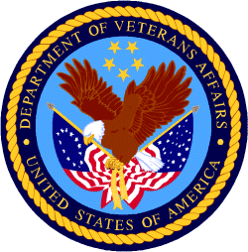

Department of Veterans Affairs

Programs:

Reminders:

PART 2 – GENERAL FEDERAL AGENCY GRANTS INFORMATION
SEPTEMBER 2020

Please review each department’s General Grant and Funding Overview. These overviews are the key web pages on each departmental website dedicated to the agency’s funding opportunities. Check back often to note the department updates.

(See Part 1 for current grant opportunity notices)

Federal Agencies Discretionary Grants and Contract Website Links

Native Hawaiian Programs

U.S. Department of Agriculture

Grants and Loans Overview

Department of Commerce

Grants at Commerce

Economic Development Administration Hawaii Contacts

Corporation for National and Community Service

General Program Overview

National Service in Hawaii

Department of Defense

Doing Business with the Department of Defense

Department of Education

Grant Programs Overview

US Department of Energy

Grants Overview

Environmental Protection Agency

Grants and Contracts Overview

Federal Mediation and Conciliation Service

Grants Overview

Department of Health and Human Services

Grants Overview

Department of Homeland Security
Grants Overview

Department of Housing and Urban Development

HUD - Notice of Funds Available

Institute of Museum and Library Services
Grants Overview

IMLS is on Facebook!

Department of Interior

Grants and Contract Overview

Department of Justice

Grants and Contract Overview

Hawaii State Administrative Agency Contacts
________________________________________________________________________

Department of Labor

Grants and Contract General Overview

National Aeronautics and Space Administration

Research Grant and Contract General Overview
_______________________________________________________________
National Archives and Records Administration

Grant Opportunities General Overview
_______________________________________________________________
National Endowment for the Arts

Grant Opportunities General Overview
_______________________________________________________________

National Endowment for the Humanities

Grant Opportunities General Overview
_______________________________________________________________
National Science Foundation

Grant Opportunities General Overview

Small Business Administration

General Overview Finding Loans & Grants

Links Specific to Hawaii

State Department

General Overview and Resources for Program Administrators

_________________________________________________________________________________

U.S. Department of Transportation

General Grant Program Overview

Department of the Treasury

Overview

US Agency for International Development

General Funding Opportunity Overview

Department of Veterans Affairs

Programs

Grants.Gov Links

Grant Writing Resources

SBIR – Small Business Innovation Research

Federal Agency Discretionary Grant and Contract Websites and Overviews

Native Hawaiian Programs

The Office of Native Hawaiian Relations was authorized by Congress in Public Law 108-199 on January 23, 2004, and in Public Law 104-42 on November 2, 1995. The Office discharges the Secretary's responsibilities for matters related to Native Hawaiians and serves as a conduit for the Department’s field activities in Hawaii

To access the resources in the 2016 guide (the most recent) click on this link:
https://www.doi.gov/sites/doi.gov/files/uploads/NHC%20Guide%20to%20Fed%20Prog%20and%20Services%2002052016%20ONHR.pdf

The listing below can be reviewed online at the following site:
https://www.doi.gov/hawaiian/programs

U.S. Department of Agriculture

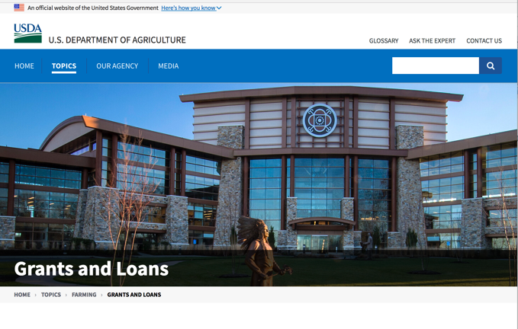

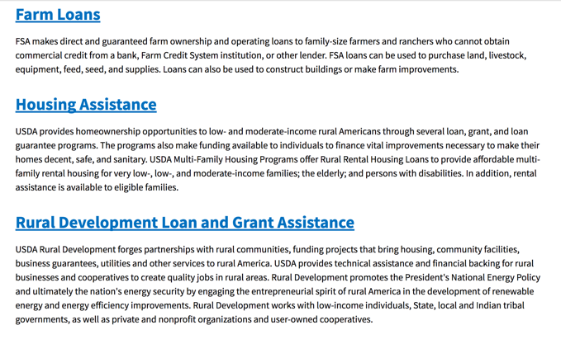

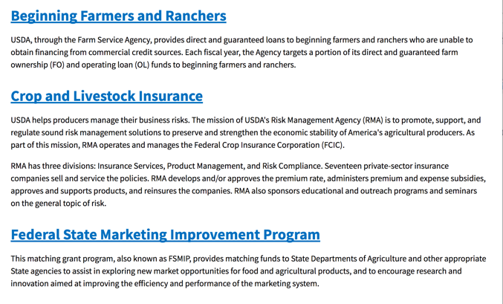
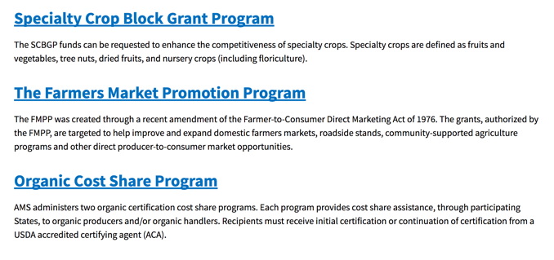
https://www.usda.gov/topics/farming/grants-and-loans

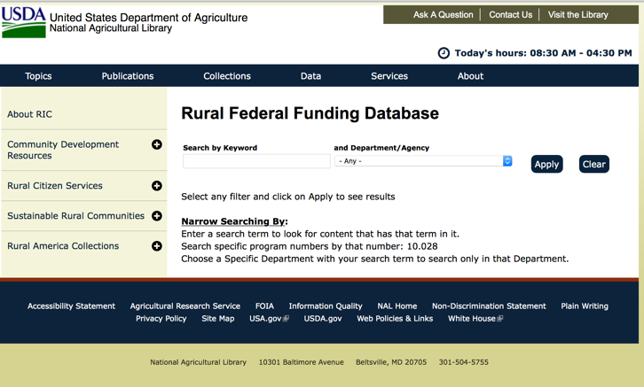

https://www.nal.usda.gov/ric/rural-federal-funding-database

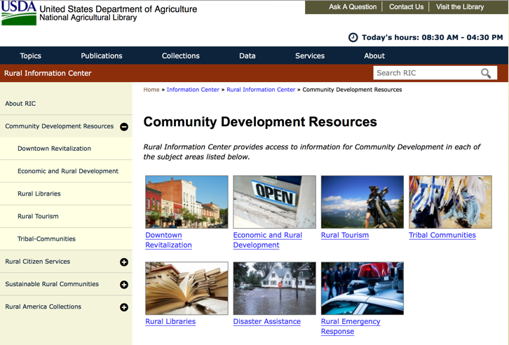

https://www.nal.usda.gov/ric/community-development-resources

Department of Commerce

Grants, Contracting, and Trade Opportunities at Commerce
Learn more information about grants, contracting and trade opportunities at the Department of Commerce using the information below.
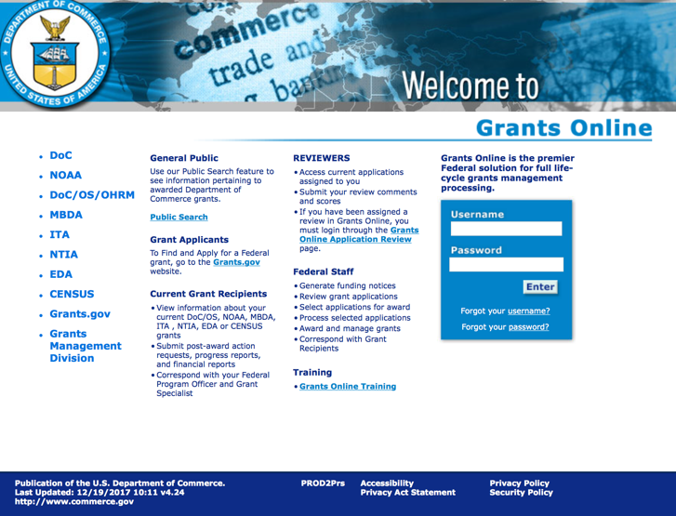
https://grantsonline.rdc.noaa.gov/flows/home/Login/LoginController.jpf

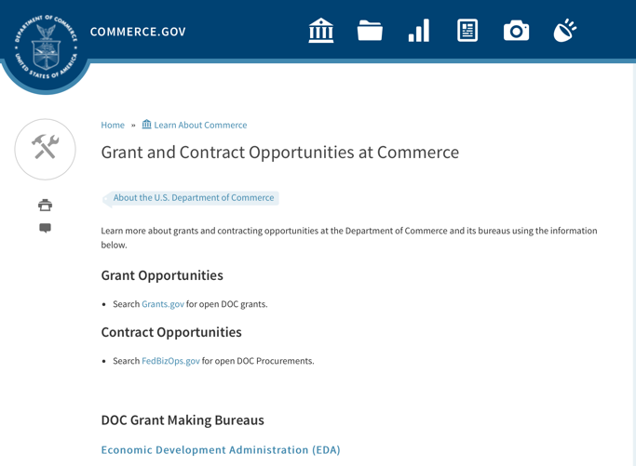
DOC Grant Making Bureaus
Economic Development Administration (EDA)
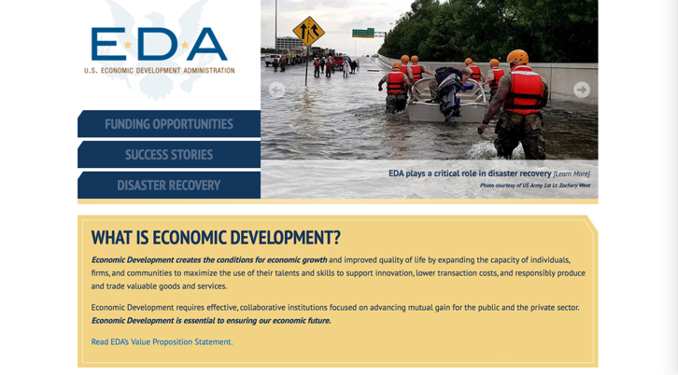
International Trade Administration (ITA)
- Market Development Cooperator Program
- Special American Business Internship Training Program (SABIT). A technical assistance initiative of the International Trade Administration of the U.S. Department of Commerce, SABIT offers organizations competitive grants and an opportunity to host industry-specific delegations. SABIT serves as an initial entry point for U.S. businesses seeking funding to establish long-term relationships with potential customers, distributors, or partners in the former Soviet Union. The program trains Eurasian managers and scientists in commonly accepted business practices as a means of facilitating cross border relationships. In turn, these personal relationships serve as a basis for business development and reduce market access barriers for U.S. businesses
National Institute of Standards & Technology (NIST)
- Funding Opportunities
National Telecommunications & Information Administration (NTIA)
- Telecommunications Grants
National Oceanic & Atmospheric Administration (NOAA)
- Coastal Ocean Program Grant Information
- Fisheries Saltonstall Kennedy Grant Program
- National Undersea Research Program Funding Opportunities
- Grants Management Division
- Fisheries Grants Program
- National Sea Grant
- Office of Global Programs
Contracting Resources for Contractors
- Office of Small and Disadvantaged Business Utilization (OSDBU) - the Office of Small and Disadvantaged Business Utilization (OSDBU) is an advocacy and advisory office responsible for promoting the use of small, small disadvantaged, 8(a), women-owned, veteran-owned, service-disabled veteran-owned, and HUBZone small businesses within the U.S. Department of Commerce's (DOC) acquisition process.
- Business.USA.gov's Find Opportunities Wizard where in a few quick steps, it will guide you towards federal government contracting programs and opportunities for your business!
- Planned Acquisitions: the Department of Commerce's search tool for our planned acquisitions over $100,000. As requirements change, these acquisition plans are updated by department personnel and this search tool is automatically updated.
- Small Business Administration's Contracting section of their web site where you can learn about how to "Get Started" and "Contracting Support for Small Business"
- The General Services Administration (GSA) has implemented a system for vendors doing business with the Federal Government to manage their entity information in one central location. This new database is the System for Award Management (SAM).

DOC Contracting Offices
- Patent and Trademark Office (PTO)
  - Office of Procurement

- National Institute of Standards & Technology (NIST)
NIST Acquisition Management Group
Contracting Opportunities with Commerce
Trade Opportunities through Commerce
http://www.commerce.gov

Economic Development Administration Hawaii Contacts

https://www.eda.gov/resources/economic-development-directory/states/hi.htm

Corporation for National and Community Service

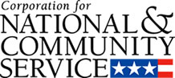

General Program Overview

AmeriCorps provides resources, both human and financial, to organizations that engage Americans in intensive service to meet our country’s critical needs.
Grantees use the funding to support AmeriCorps members for intensive service in their community. AmeriCorps grants partially cover the expense of operating an AmeriCorps program and do not cover general organizational expenses. A cash and in-kind match is required.

The main website can be accessed here: http://www.nationalservice.gov

For access to further funding information: click here

http://www.nationalservice.gov/build-your-capacity/grants/funding-opportunities

National Service In Hawaii
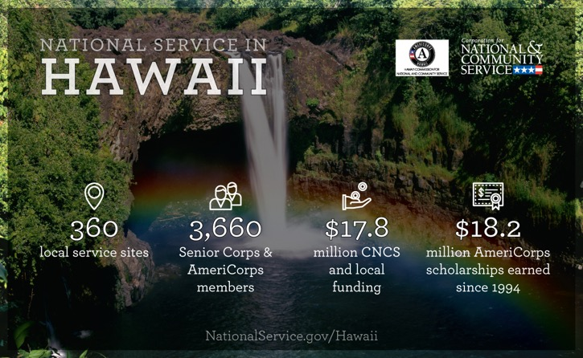
Meeting Community Needs in Hawaii: Last year more than 3,600Americans of all ages and backgrounds met local needs, strengthened communities, and expanded economic opportunity through national service in Hawaii. The Corporation for National and Community Service (CNCS) invested more than $8.1 million to support cost-effective community solutions, working hand in hand with local partners to empower citizens to solve problems. AmeriCorps members and Senior Corps volunteers are preparing today's students for tomorrow's jobs, reducing crime and reviving cities, connecting veterans to services, fighting the opioid epidemic, helping seniors live independently, and rebuilding communities after disasters. Service members served at more than 300 locations across Hawaii, including schools, food banks, homeless shelters, health clinics, youth centers, veterans facilities, and other nonprofit and faith-based organizations. Through a unique public-private partnership, CNCS, its grantees, and project sponsors generated more than $9.6 million in outside resources from businesses, foundations, public agencies, and other sources in FY 2017. This local support strengthened community impact and increased the return on taxpayer dollars.

AmeriCorps
Last year, more than 600 AmeriCorps members met pressing local needs across Hawaii, making a lasting impact in communities while gaining valuable skills and experience to advance their careers. AmeriCorps members serve through one of three programs:
- AmeriCorps State & National engages men and women in intensive service at thousands of locations across the country through nonprofits, schools, public agencies, tribes, and community and faith-based groups. Most AmeriCorps grant funding goes to the Hawaii Commission on National & Community Service, the Governor-appointed State Service Commission, which in turn awards grants to organizations to respond to local needs.
- AmeriCorps VISTA (Volunteers In Service To America) taps the skills, talents, and passion of Americans of all ages to support community efforts to overcome poverty.
- AmeriCorps NCCC (National Civilian Community Corps) is a full-time, team-based residential program for 18-24 year-olds. Members develop leadership skills by serving in public safety, environment, and disaster projects. FEMA Corps, a unit of NCCC, focuses solely on disaster preparedness, response, and recovery.

Senior Corps
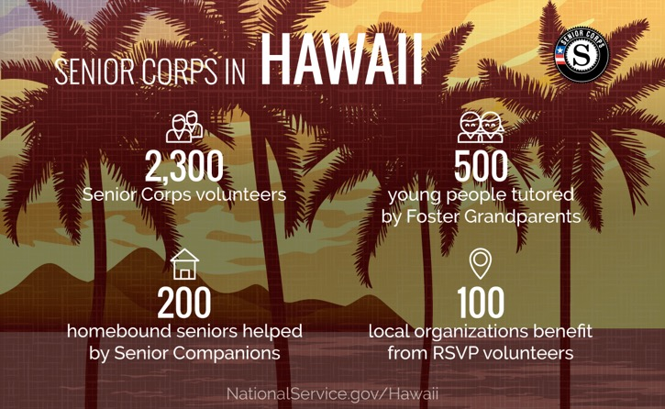
Senior Corps taps the skills, talents, and experience of Americans age 55 and over to meet a wide range of community challenges. Last year, more than 3,000 Hawaii seniors met critical community needs while contributing to longer, healthier lives through one of three Senior Corps programs:
- Foster Grandparents serve one-on-one as tutors and mentors to young people with exceptional needs.
- Senior Companions help homebound seniors and other adults maintain independence primarily in their own homes.
- RSVP volunteers conduct safety patrols, renovate homes, protect the environment, tutor and mentor youth, respond to natural disasters, and provide other services.
Last year in Hawaii, Foster Grandparents tutored and mentored 530young people, Senior Companions helped 290 seniors live independently, and RSVP volunteers strengthened the impact of 150organizations across the state.

Learn More
To see other reports about national service in Hawaii, please contact HI@cns.gov.
The Corporation for National and Community Service is a federal agency that improves lives, strengthens communities, and fosters civic engagement through service and volunteering. To learn more, visit www.NationalService.gov or call 202-606-5000 or TTY 1-800-833-3722.

U.S. Department of Defense

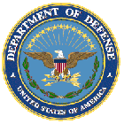

Doing Business with the Department of Defense

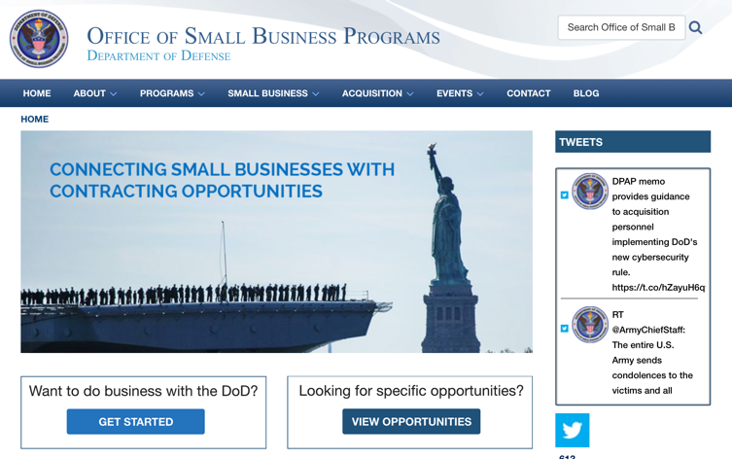

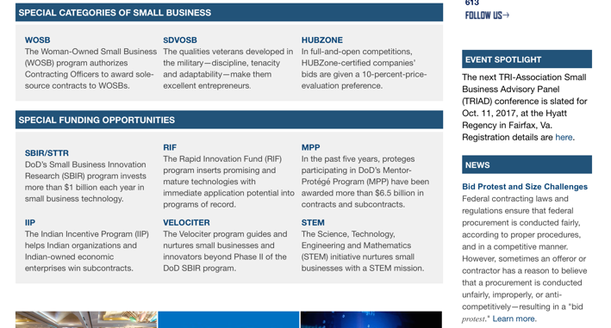

http://business.defense.gov

Corona Virus Response -- https://business.defense.gov/COVID-19-SMALL-BUSINESS-RESOURCES/

Department of Education


Grant Programs Overview at the Department of Education

The general information page for Education Grant funding is an excellent resource describing the three types of grants awarded by the Department of Education. See the screen shot of the Department of Education web page below:

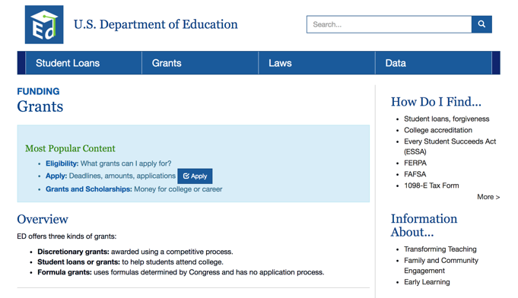
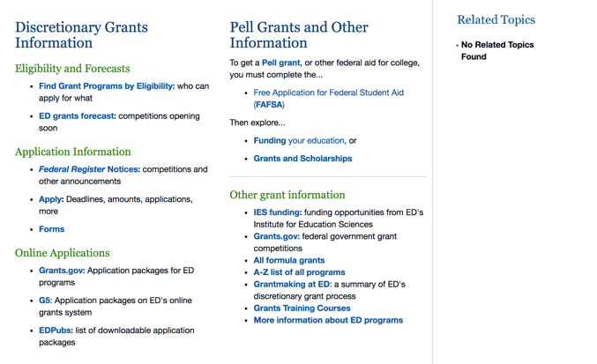

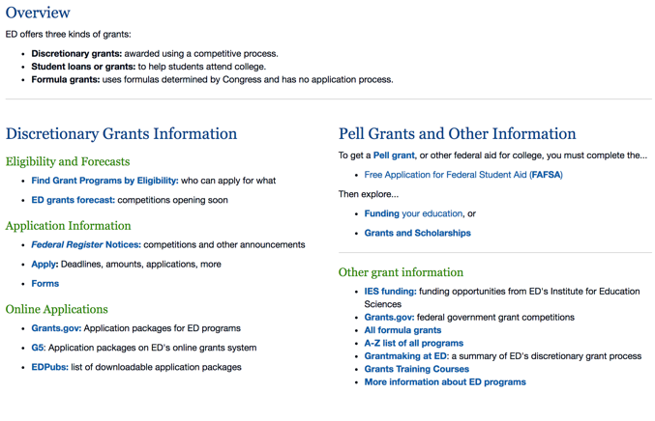

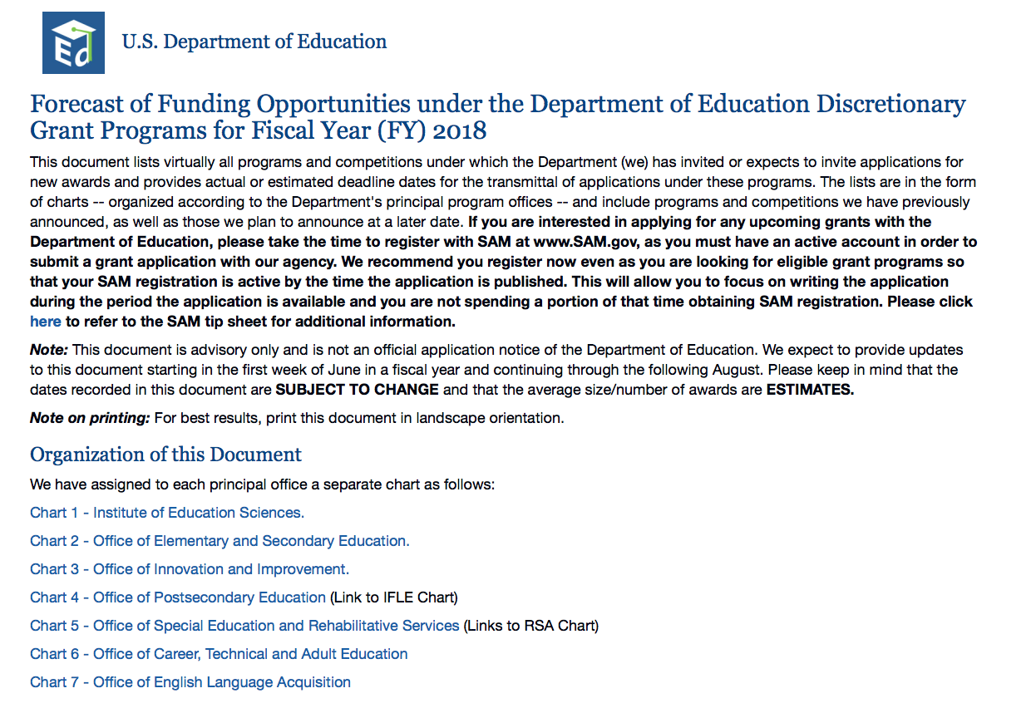

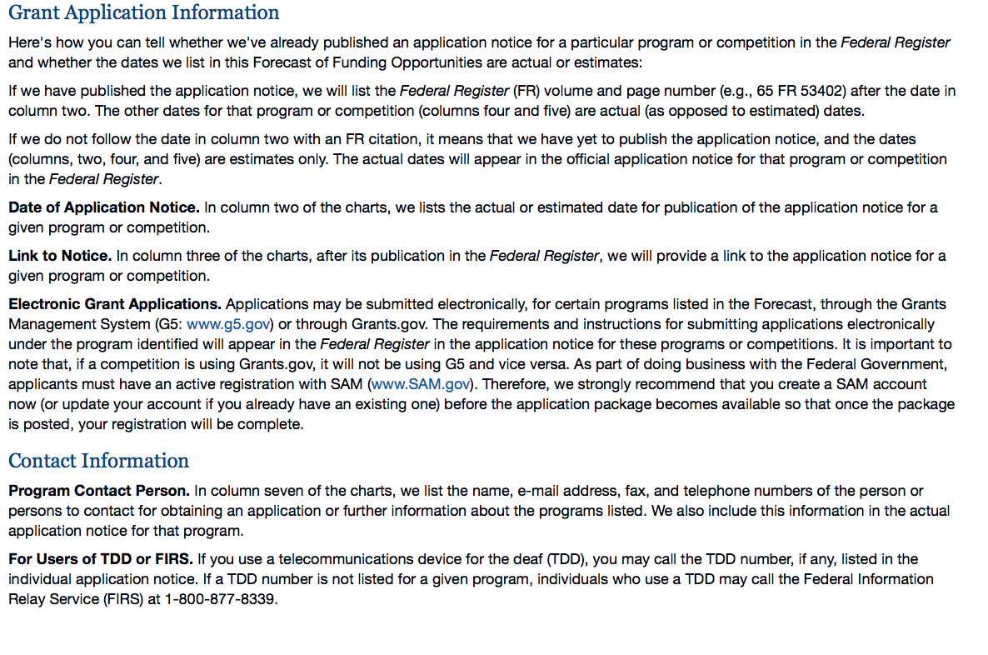

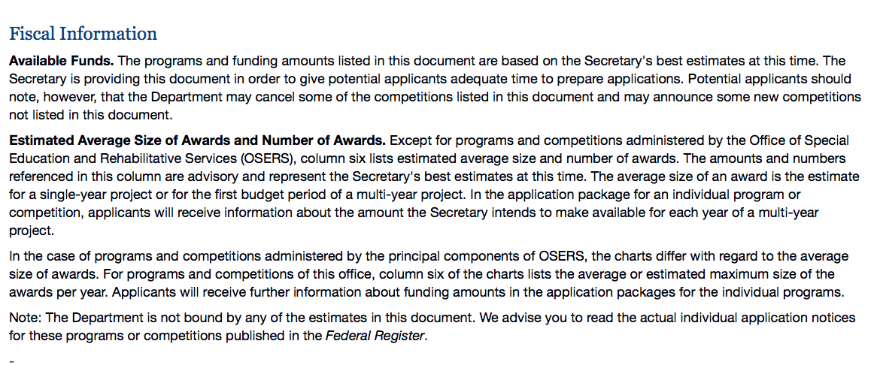

https://www2.ed.gov/fund/grant/find/edlite-forecast.html

U.S. Department of Energy

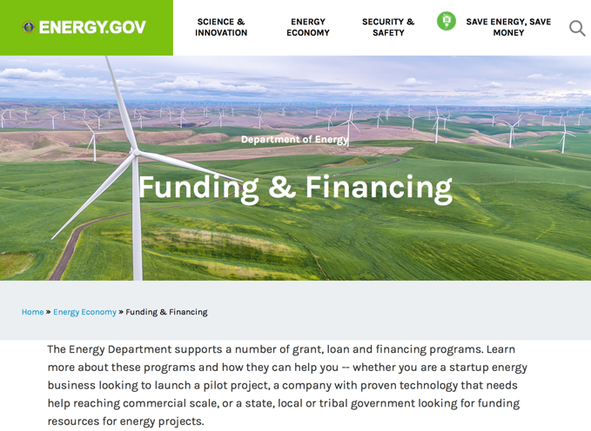

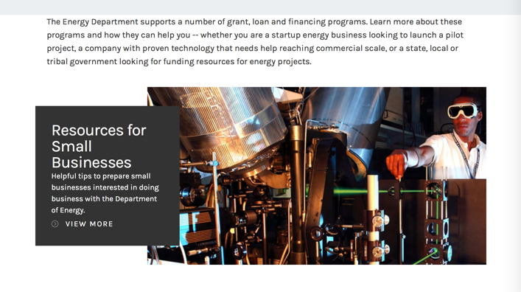

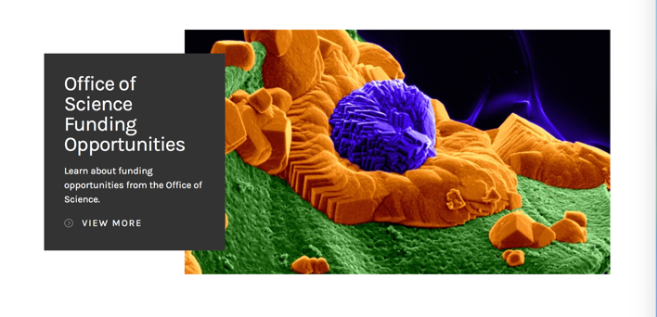

https://www.energy.gov/energy-economy/funding-financing

Environmental Protection Agency

https://www.epa.gov/grants

Federal Mediation and Conciliation Service

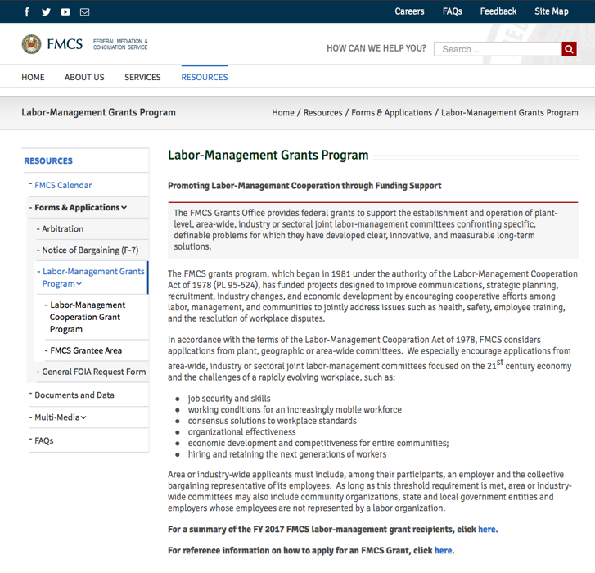
https://www.fmcs.gov/resources/forms-applications/labor-management-grants-program/

Department of Health and Human Services

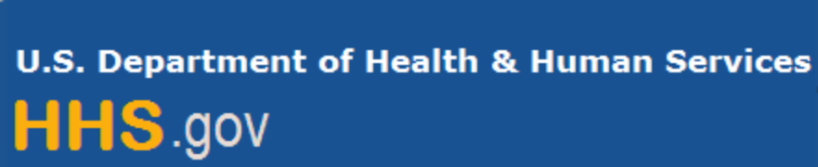

Grants Forecast and Overview

The Department of Health and Human Services’ Grants Forecast is a database of planned grant opportunities proposed by its agencies. Each Forecast record contains actual or estimated dates and funding levels for grants that the agency intends to award during the fiscal year. Forecast opportunities are subject to change based on enactment of congressional appropriations.

For more general information about HHS Grants and Funding go to the website below at:

https://www.hhs.gov/grants/grants/index.html

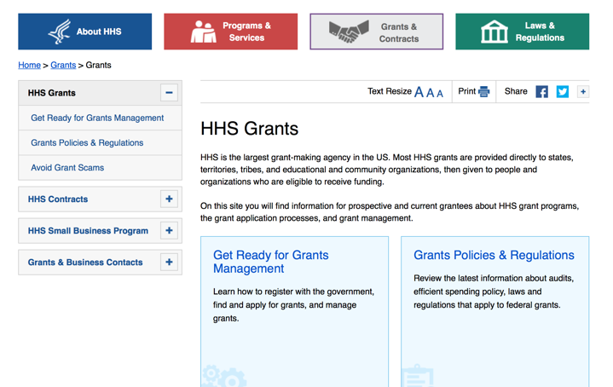

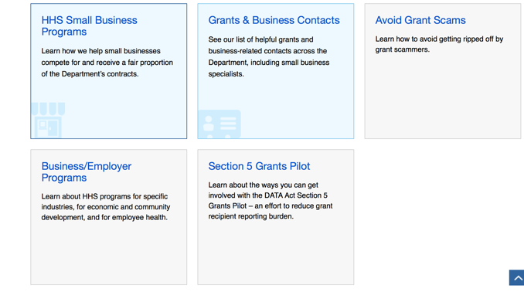

Department of Homeland Security



The Department of Homeland Security enhances the ability of states, local and tribal jurisdictions, and other regional authorities in the preparation, prevention, and response to terrorist attacks and other disasters, by distributing grant funds. Localities can use grants for planning, equipment, training and exercise needs.

Webpage can be viewed at: https://www.dhs.gov/dhs-financial-assistance#2

https://www.fema.gov/welcome-assistance-firefighters-grant-program

For AFG program guidance materials, please visit our Documents page.

Resources

AFG Help Desk
Contact the AFG Program Help Desk toll-free at 866-274-0960, or email us at firegrants@dhs.gov.
The AFG Program has Fire Program Specialists in 10 federal regional centers. These Regional Fire Program Specialists respond to questions about the AFG program and carry out grant monitoring activities. View regional contacts

Popular AFG links
- Assistance to Firefighters Grants (AFG)
- AFG Awards List
- Staffing for Adequate Fire & Emergency Response (SAFER) Grants (SAFER)
- SAFER Awards List
- SAFER Success Stories
- Fire Prevention & Safety (FP&S) Grants
- FP&S Awards List
- FP&S Success Stories
- Grant Closeout Tutorial
- Assistance to Firefighters Grant (AFG) Email Alert Archive
- Frequently Asked Questions
Contact Information For The Assistance to Firefighters Grant (AFG) Program and Help Desk

Federal Funding Alternative To AFG

State Administrative Agencies (SAA) apply for and administer Federal grants on behalf of their States, including FEMA Preparedness Grants. The SAA will work with eligible organizations to comply with the general requirements of grant programs or cooperative agreements. Contact your State’s SAA to find out what current Federal funding opportunities may be available to your organization. A listing of the SAAs and points of contact can be found at http://www.fema.gov/library/viewRecord.do?id=6363.

Department of Housing and Urban Development

https://www.hud.gov/program_offices/spm/gmomgmt/grantsinfo

HUD - Notice of Funds Available
For detailed information click here

http://portal.hud.gov/hudportal/HUD?src=/program_offices/administration/grants/fundsavail

HUD NOFA FORECAST
The Department of Housing and Urban Development NOFA Forecast lists competitive grant opportunities that may be available for FY2016. The inclusion or exclusion of an opportunity in this list does not constitute a guarantee that a specific opportunity will become available or not be available. Forecast opportunities are subject to change based on enactment of Congressional appropriations and other considerations.
When funding is available, HUD will issue a Notice of Funding Availability (NOFA), which will be available on Grants.gov

Institute of Museum and Library Services

https://www.imls.gov/grants/apply-grant/available-grants

Each grant program has specific eligibility requirements. The links below provide general eligibility criteria for museums, libraries, and tribal organizations, but please note that additional organizations may be eligible for grants under certain programs. Additionally, ineligible organizations may still be able to participate in grant programs through partnerships with eligible organizations. Please click on the links below to see general criteria and review Applications and Guidelines for specific information.
Museums Libraries

Institutions: Archives, Federally Recognized Native American Tribe, Historical Society, Library, Nonprofits that serve Native Hawaiians, Professional Association, Public or Private Non-profit Institutions of Higher Education, Regional Organization, State Library Administrative Agency, State or Local Government

Check out IMLS's Facebook page at:
https://www.facebook.com/USIMLS/

Department of the Interior

Working with Interior

The Interior Department provides assistance to the public, local governments and businesses through a number of programs. For a general overview see: http://www.doi.gov/index.cfm

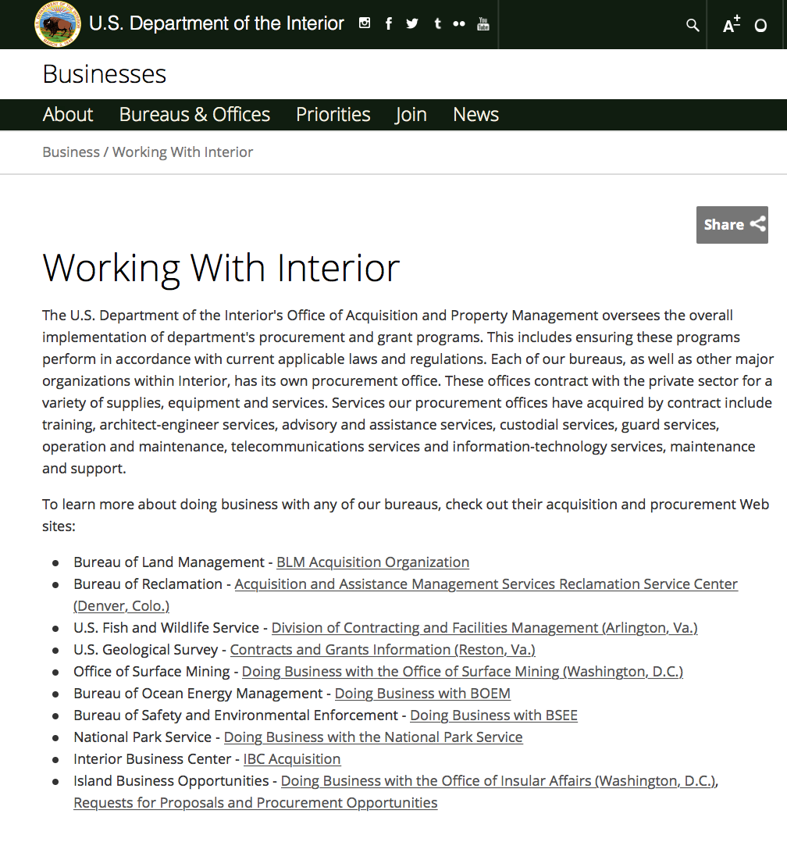

http://www.doi.gov/businesses/working-with-interior.cfm

Department of Justice

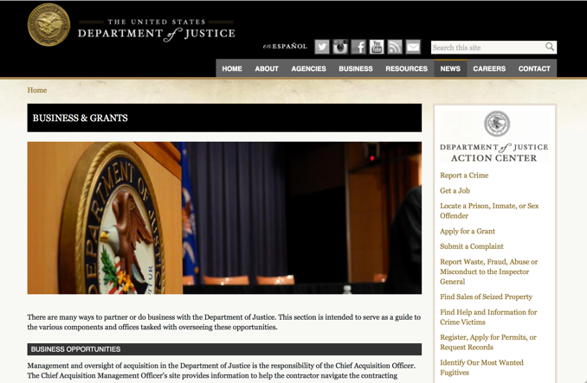

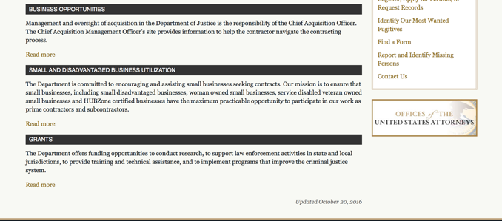

The DOJ agencies listed below also have sites that provide grant information specific to that agency. Examples of what can be found on these sites are programs, funding opportunities, application assistance, and other useful information.

Bureau of Justice Assistance (BJA)

Bureau of Justice Statistics (BJS)

National Criminal Justice Reference Service (NCJRS)

National Institute of Justice (NIJ)

Office of Sex Offender Sentencing, Monitoring, Apprehending, Registering, and Tracking (SMART)

http://www.justice.gov/business/

Hawaii State Administrative Agency Contacts

https://www.ncja.org/state-agencies/about-state-agencies

HAWAII DEPARTMENT OF THE ATTORNEY GENERAL, CRIME PREVENTION & JUSTICE ASSISTANCE DIVISION
235 S Beretania Street, Suite 401
Honolulu, HI 96813
(808) 586-1150
Agency Head: Julie Ebato, Administrator
JAG Contact: Shaleigh Tice, Grants & Planning Branch Chief
SAC Director: Paul Perrone, Chief of Research and Statistics

https://ag.hawaii.gov/cpja/gp/

Department of Labor

https://www.dol.gov/general/grants/howto

https://www.doleta.gov/grants/

Agency Grants and Contract General Overview

DOL Resources
Apply for DOL Agency-Specific Grants:
- Employment and Training Administration (ETA)
- Occupational Safety and Health Administration (OSHA)
- Bureau of International Labor Affairs (ILAB)
- Veterans' Employment and Training Service (VETS)
- Office of Disability Employment Policy (ODEP)
- Office of the Assistant Secretary for Administration and Management (OASAM)

Other Grant Resources:

DOL Resources and Instructions for Applying for a Grant
- DOL Guidance Clarifying the Effect of the Religious Freedom Restoration Act on Faith-Based Organizations
- Grant and Contract Information
- More Information About Grants

Other Federal Government Grant Information
- Grant Opportunities (Catalog of Federal Domestic Assistance)

Department of Labor Grant Programs

- Bureau of International Labor Affairs (ILAB): provides grants (cooperative agreements) for the implementation of projects designed to assist developing countries combat the worse forms of child labor, forced labor, and human trafficking; and support worker rights and improve working conditions. http://www.dol.gov/general/business.
- Bureau of Labor Statistics (BLS): provides project grants (cooperative agreements) and the dissemination of technical statistical data and related information on labor force activities; provides data on prices (CPI) and cost of living; data on productivity and technology data; data on compensation and working conditions; data on employment projections.
- Employment and Training (ETA): ETA administers financial assistance programs pursuant to the Workforce Investment Act (WIA), administering State formula grant programs for youth, adults and dislocated workers, national emergency grants for workers affected by mass layoffs, plant closures, and disasters; grant programs for workers with disabilities, Indians and Native Americans, and for migrant and seasonal farmworkers. ETA also administers grant programs for older American workers, apprenticeship programs, Trade Adjustment Assistance (TAA) programs, and assistance for research and development of workforce programs. In addition, ETA is responsible for the operation and maintenance of a national system of public employment service offices and for the national unemployment insurance program.
- Mine Safety and Health (MSHA): provides grants for research, education and training programs to ensure an adequate and competent staff of trained inspectors; and assistance for establishing or improving State mine health and safety programs through technical assistance.
- Occupational Safety and Health (OSHA): provides grants to non-profit organizations to provide training, educational services, and technical assistance; assistance to states to administer and enforce state programs; assistance to states to provide occupational safety and health technical assistance and consultant services.
- Office of Disability Employment Policy (ODEP): The Office of Disability Employment Policy awards competitive grants establishing short-term pilot and technical assistance projects designed to identify, develop, test, evaluate, and disseminate policies to increase employment by expanding access to training, education, employment supports, assistive and systems technology, integrated employment, entrepreneurial development, and small business opportunities for adults and youth with disabilities. Current pilots projects focus on customized employment, Olmstead populations, and innovative demonstration youth grants, among others. Solicitations for grant applications are published in the Federal Register and announced at www.dol.gov/odep. ODEP grants are awarded by the OASAM grant office.
- Veterans' Employment and Training (VETS): provides special employment and training assistance for veterans through the Disabled Veterans' Outreach Program (DVOP) Solicitation for Grant Applications; the Local Veterans' Employment Representative Program (LVER); Veterans' Workforce Investment Program (VWIP); elaws Advisor on veterans' employment and reemployment rights; and the Homeless Veterans Reintegration Project (HVRP). VETS grants are awarded by the OASAM grant office.

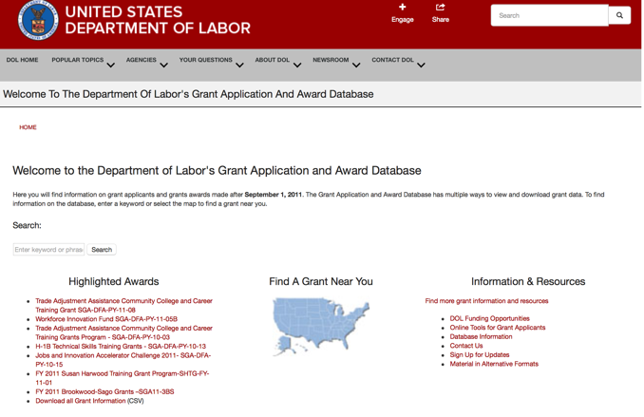

https://www.dol.gov/general/grants/howto

National Aeronautics and Space Administration



NASA Research Opportunities Online

- Various NASA offices publish their research announcements over the Internet, broadening the opportunity for researchers to apply for funding. This site provides access to current research announcements along with their specific due dates.

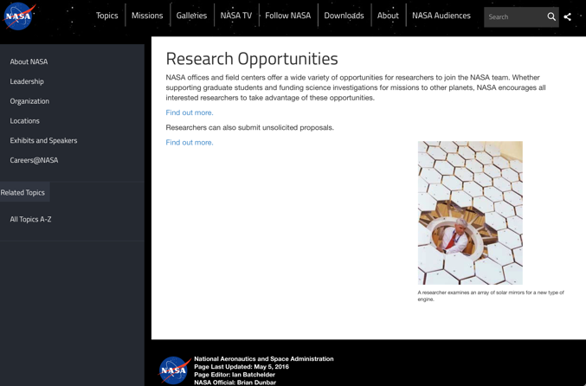

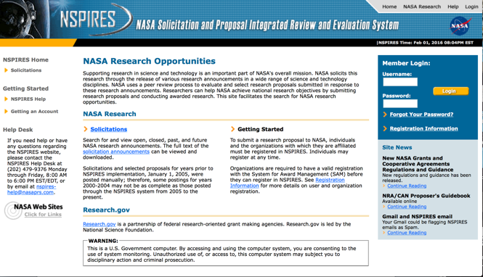
http://nspires.nasaprs.com/external/

National Archives and Records Administration

To access the information above: click here

https://www.archives.gov/nhprc/announcement

National Endowment for the Arts

See more at: https://www.arts.gov/grants

National Endowment for the Humanities

https://www.neh.gov/grants

National Science Foundation



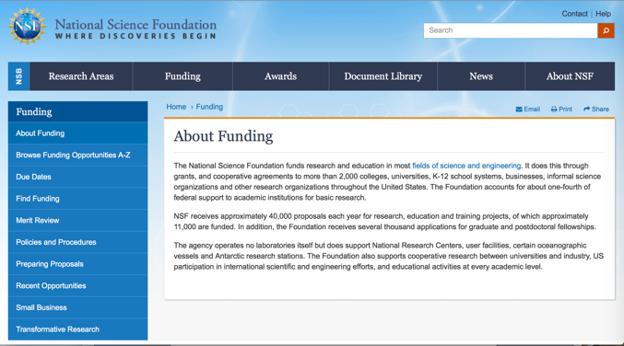

For assistance: https://nsf.gov/funding/aboutfunding.jsp

The National Science Foundation funds research and education in most fields of science and engineering. It does this through grants, and cooperative agreements to more than 2,000 colleges, universities, K-12 school systems, businesses, informal science organizations and other research organizations throughout the United States. The Foundation accounts for about one-fourth of federal support to academic institutions for basic research.
NSF receives approximately 40,000 proposals each year for research, education and training projects, of which approximately 11,000 are funded. In addition, the Foundation receives several thousand applications for graduate and postdoctoral fellowships.
The agency operates no laboratories itself but does support National Research Centers, user facilities, certain oceanographic vessels and Antarctic research stations. The Foundation also supports cooperative research between universities and industry, US participation in international scientific and engineering efforts, and educational activities at every academic level.

For details on active funding deadline dates: http://nsf.gov/funding/pgm_list.jsp?org=NSF&ord=date

Small Business Administration




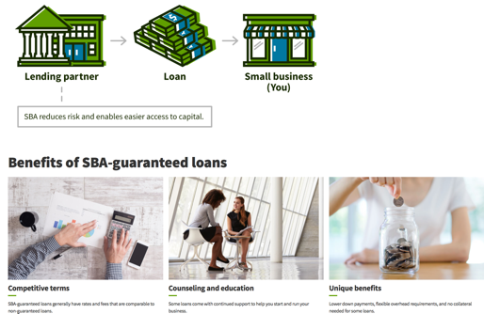

https://www.sba.gov/funding-programs/loans
Federal, state and local governments offer a wide range of financing programs to help small businesses start and grow their operations. These programs include low-interest loans, venture capital, and scientific and economic development grants.
Use SBA.gov's Loans and Grants Search Tool to get a list of financing programs for which you may qualify, or visit the resources below to learn more about small business financing programs.

To get to the main SBA.gov funding page click here
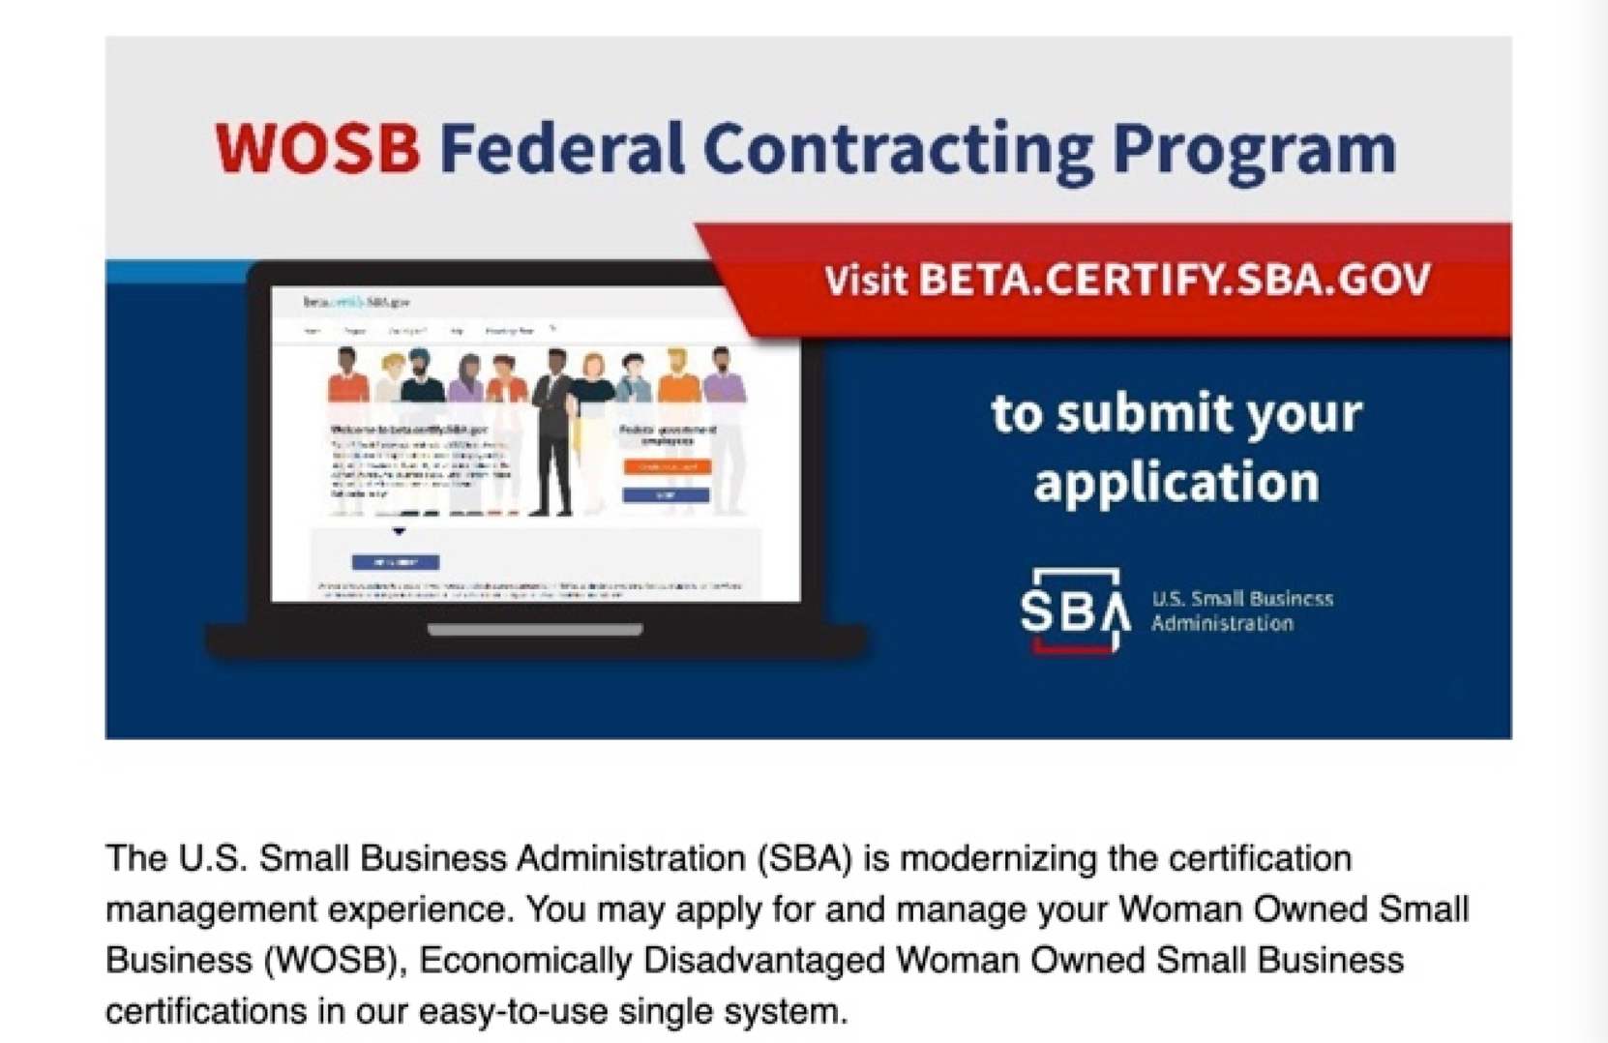
Learn more

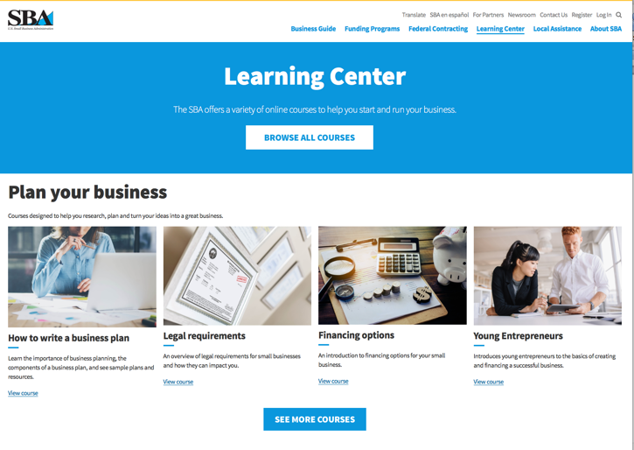
https://www.sba.gov/learning-center

SBA Trainings

https://www.sba.gov/learning-center
Upcoming Trainings: Check out SBA's Online Training!
- Financing Options for Small Businesses

For Specific Information in Hawaii see the following links:
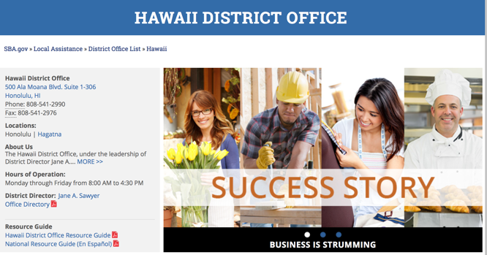

https://www.sba.gov/offices/district/hi/Honolulu

State Department

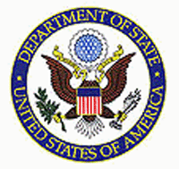

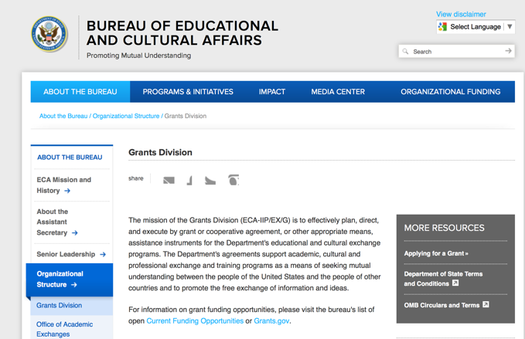

https://eca.state.gov/about-bureau/organizational-structure/grants-division

http://eca.state.gov/search/solr/grants?search_referrer=node/237

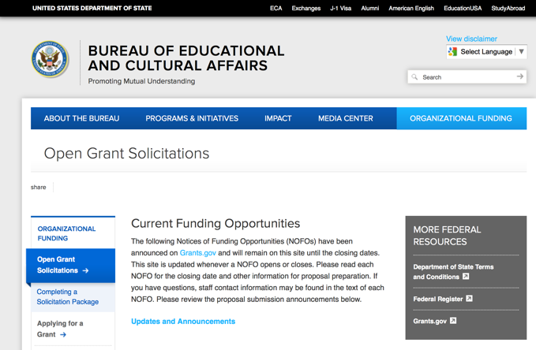
https://eca.state.gov/organizational-funding/open-grant-solicitations

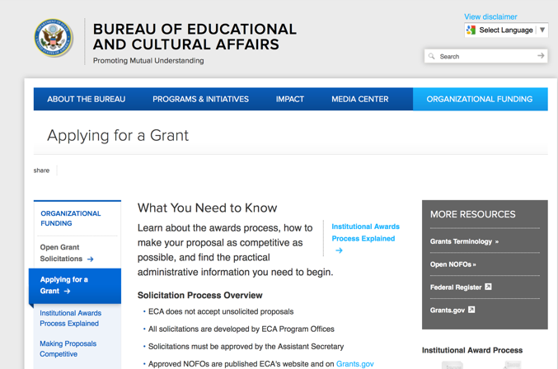
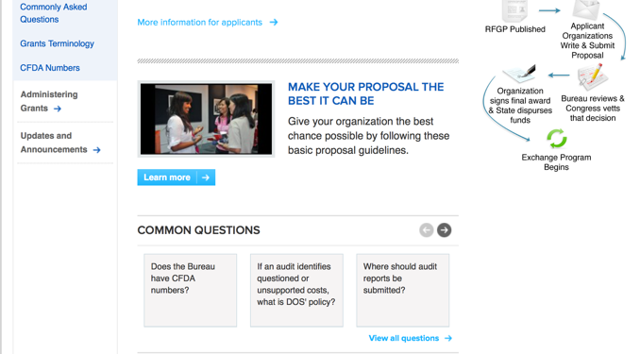
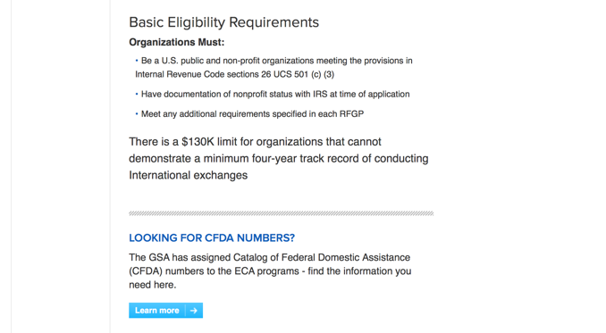
http://eca.state.gov/organizational-funding/applying-grant

General Information:
- Bureau of Educational and Cultural Affairs Grants Division
- Open Grant Opportunities (Requests for Grant Proposals)

For General Information click here

Department of Transportation

General Grant Program Overview https://www.transportation.gov/grants

Department of the Treasury

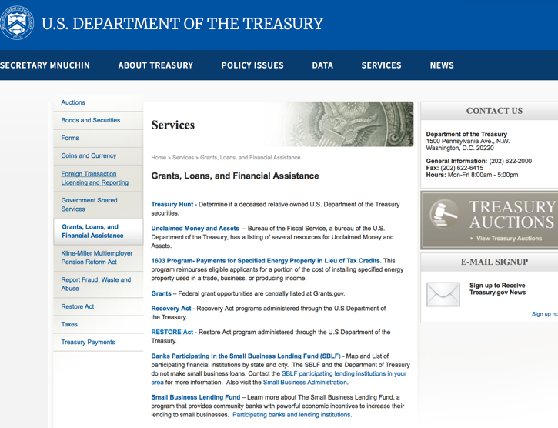

https://www.treasury.gov/services/Pages/Grants-Loans-and-Financial-Assistance.aspx

U.S. Agency for International Development

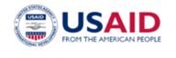
www.usaid.gov

General Overview Funding Opportunities

USAID has working relationships with thousands of American companies and hundreds of U.S.-based private voluntary organizations. For more information on our business and procurement opportunities, please visit our Business section.

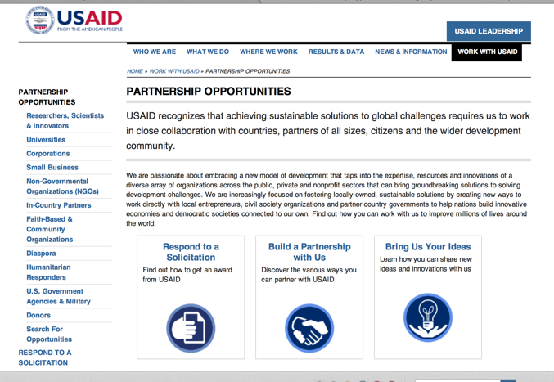

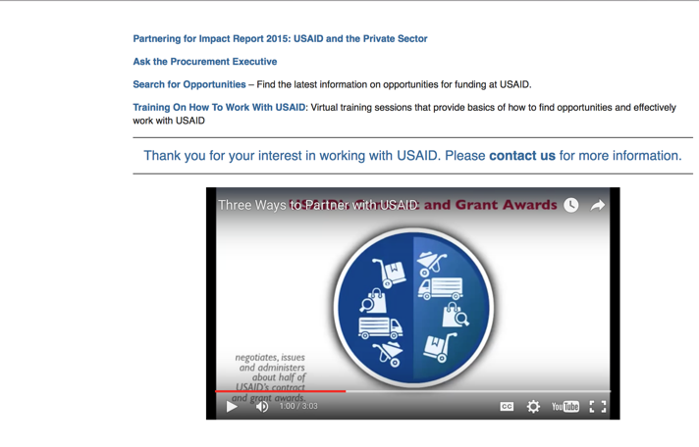

http://www.usaid.gov/partnerships

Department of Veterans Affairs

https://www.va.gov/homeless/gpd.asp
GRANTS.GOV

Provides a Grants Learning Center as a gateway to the federal grants world. Bookmark the following link and participate at blog.grants.gov or on twitter @grantsdotgov

Topics include: Grants 101, Grant Policies, Grant Eligibility, Grant Terms, Grant Agencies , Grant Systems, Grant Programs, Grant Careers, Grant Reporting, Grant Fraud and Grant Events

https://www.grants.gov/web/grants/learn-grants.html

Grants.gov maintains a blog. This reprinted article provides some helpful tips:

Grant Writing: 3 Tips for Crafting Need Statements in Federal Grant Proposals
Posted on March 27, 2019 by Grants.gov
In this space, we have previously shared tips about the pre-writing phase of completing a federal grant application – for example, the importance of reading (and re-reading) the grant announcement, and the importance of understanding the criteria by which your application will be evaluated.
In this post, we dip our toes into the grant writing process itself and share some tips about crafting a need statement. These tips are adapted from the U.S. Department of Health and Human Services Health Resources & Services Administration’s grant writing guide, titled “Tips for Writing and Submitting Good Grant Proposals”. Along with each tip, we also include an excerpt from an award-winning federal grant proposal that can be viewed in full on the website of the Institute of Museum and Library Services. (IMLS has an excellent collection of proposals that are worthy of review – especially for new federal grant applicants.)

https://grantsgovprod.wordpress.com/2019/03/27/3-tips-for-crafting-need-statements-in-federal-grant-proposals/?utm_source=newsletter&utm_medium=email&utm_campaign=noprofile&utm_content=june2020

Grant Writing Resources

The following links are a great resource for Faith-Based Non-profits and other community organizations:

U.S. Agency for International Development
Faith Based and Community Organization Work with USAID

Corporation for National Community Service
Faith-Based and Other Community Initiatives

U.S. Department of Justice
Task Force for Faith-Based and Community Initiatives

Foundation Center
Proposal Writing Short Course

U.S. Environmental Protection Agency
General Tips on Writing a Competitive Grant Proposal

Appalachian Regional Commission
How To Write A Grant Proposal

USDA Rural Information Center
A Guide to Funding Resources

The Small Business Innovative Research Program - SBIR Program

The Small Business Innovation Research (SBIR) program is a highly competitive program that encourages domestic small businesses to engage in Federal Research/Research and Development (R/R&D) that has the potential for commercialization. Through a competitive awards-based program, SBIR enables small businesses to explore their technological potential and provides the incentive to profit from its commercialization. By including qualified small businesses in the nation's R&D arena, high-tech innovation is stimulated, and the United States gains entrepreneurial spirit as it meets its specific research and development needs.

SBIR Mission and Program Goals
The mission of the SBIR program is to support scientific excellence and technological innovation through the investment of Federal research funds in critical American priorities to build a strong national economy.
The program’s goals are four-fold:
- Stimulate technological innovation
- Meet Federal research and development needs.
- Foster and encourage participation in innovation and entrepreneurship by socially and economically disadvantaged persons.
- Increase private-sector commercialization of innovations derived from Federal research and development funding.

SBIR-Participating Agencies
Each year, Federal agencies with extramural research and development (R&D) budgets that exceed $100 million are required to allocate 2.5 percent of their R&D budget to these programs. Currently, eleven Federal agencies participate in the program:
- Department of Agriculture
- Department of Commerce - National Institute of Standards and Technology
- Department of Defense
- Department of Energy
- Department of Health and Human Services
- Department of Homeland Security
- Department of Transportation
- Environmental Protection Agency
- National Aeronautics and Space Administration
- National Science Foundation
Each agency administers its own individual program within guidelines established by Congress. These agencies designate R&D topics in their solicitations and accept proposals from small businesses. Awards are made on a competitive basis after proposal evaluation.

Three-Phase Program
The SBIR Program is structured in three phases:
Phase I. The objective of Phase I is to establish the technical merit, feasibility, and commercial potential of the proposed R/R&D efforts and to determine the quality of performance of the small business awardee organization prior to providing further Federal support in Phase II. SBIR Phase I awards normally do not exceed $150,000 total costs for 6 months.
Phase II. The objective of Phase II is to continue the R/R&D efforts initiated in Phase I. Funding is based on the results achieved in Phase I and the scientific and technical merit and commercial potential of the project proposed in Phase II. Only Phase I awardees are eligible for a Phase II award. SBIR Phase II awards normally do not exceed $1,000,000 total costs for 2 years.
Phase III. The objective of Phase III, where appropriate, is for the small business to pursue commercialization objectives resulting from the Phase I/II R/R&D activities. The SBIR program does not fund Phase III. Some Federal agencies, Phase III may involve follow-on non-SBIR funded R&D or production contracts for products, processes or services intended for use by the U.S. Government

