Senator Mazie Hirono

Grants Assistance Information Newsletter

JANUARY 2017

G.A.I.N. INDEX

Click on Index Links below to read summaries of the announcements by agency in this document. Once you reach the item, if you cannot open the links for further information, copy the selected URL website address into your browser.

Modified sections from previous listings are shown in a GREY background

Notices is Teal are items with immediate deadline dates.

Notices in Yellow are of special interest.

Notices is Green are items of special interest with immediate deadline dates.

Items in this type color are aimed at Small Businesses

Items in this type color have a Faith-Based Organization component

Special Federal Program Notices

SBIR – Small Business Innovation Research

Programs specific to Hawaii

Current Notices

Administration for Children and Families - ANA
Native American Language Preservation and Maintenance-Esther Martinez Immersion

Administration for Children and Families - ANA
Native American Language Preservation and Maintenance

Reminders

2017 Partnerships for Implementing Hawaiian Monk Seal Species in the Spotlight Priority Recovery Actions

Administration for Children and Families - ANA
Native Youth Initiative for Leadership, Empowerment, and Development (I-LEAD)

Bureau of Reclamation
Desalination and Water Purification Research (DWPR) Program Fiscal Year 2017 Pilot Scale Testing Projects
Synopsis 1

National Park Service
NAGPRA Repatriation Grants
Synopsis 1

Bureau of Reclamation
WaterSMART: Water Recycling and Reuse Research under the Title XVI Water Reclamation and Reuse Program for Fiscal Year 2017
Synopsis 3

See Individual Departments for information and webpages representing the best and most accessible information on the agency funding opportunities

Federal Grant and Cooperative Agreement Program Summaries

U.S. Department of Agriculture

Grants and Loans Overview

Programs

National Institute of Food and Agriculture
Small Business Innovation Research Program - Phase II

Modifications

Deleted

Reminders

Fish and Wildlife Service
2017 National Fish Habitat Action Plan

Department of Commerce

Programs

National Institute of Standards and Technology
NIST Summer Institute for Middle School Science Teachers (NIST Summer Institute) Program

National Institute of Standards and Technology
NIST Research Experience for Teachers (NIST RET) Program

National Institute of Standards and Technology
NIST Public Safety Innovation Accelerator Program

National Institute of Standards and Technology
Summer Undergraduate Research Fellowship (SURF) Program: SURF operating on the Boulder, Colorado campus (SURF Boulder) and the Gaithersburg, Maryland campus (SURF Gaithersburg)

DARRP Restoration Implementation Grants

Research

2017 BREP FFO

Modifications

Fiscal Year 2018 National Sea Grant College Program Dean John A. Knauss Marine Policy Fellowship

Reminders

National Estuarine Research Reserve System (NERRS) Land Acquisition and Construction Program for Fiscal Year 2017
Synopsis 2

FY 2017 Joint Technology Transfer Initiative
Synopsis 2

FY17-19 Habitat Blueprint – Coastal and Marine Habitat Focus Area Cooperative Agreements

National Institute of Standards and Technology
Measurement Science and Engineering (MSE) Research Grant Programs

National Sea Grant College Program 2016-17 Special Projects Grant

FY 2016 – FY 2019 EDA Planning Program and Local Technical Assistance Program Grant

FY 2016 Economic Development Assistance Programs ­ Application submission and program requirements for EDA’s Public Works and Economic Adjustment Assistance Programs

Economic Development Administration
Planning Program and Local Technical Assistance Program Grant

Deleted

Corporation for National and Community Service

General Program Overview

Programs

Corporation for National and Community Service
2017 Day of Service Grants

Reminders

National Service in Hawaii

Department of Defense

Doing Business with the Department of Defense

DoD Small Business Opportunities and Forecasting

Research Grants

Modifications

Reminders

Dept. of the Army -- Materiel Command
Army Research Office Broad Agency Announcement for Basic and Applied Scientific Research
Modification 8

Department of Education

Grant Programs Overview

Programs

OSERS-OSEP: Preparation of Special Education, Early Intervention, and Related Services Leadership Personnel CFDA Number 84.325D

OSERS-OSEP: Training and Information for Parents of Children With Disabilities: Community Parent Resource Centers CFDA Number 84.328C

Office of Innovation and Improvement (OII): Magnet Schools Assistance Program (MSAP) CFDA Number 84.165A

Office of Elementary and Secondary Education Opening Doors, Expanding CFDA Number 84.377C

Office of Innovation and Improvement (OII): Teacher and School Leader Incentive Program CFDA Number 84.374A

Office of Innovation and Improvement (OII): Supporting Effective Educator Development (SEED) Grant Program CFDA Number 84.367D

OSERS: OSEP: Interdisciplinary Preparation in Special Education, Early Intervention, and Related Services for Personnel Serving Children With Disabilities Who Have High-Intensity Needs CFDA Number 84.325K

Research

Office of Innovation and Improvement (OII): Education Innovation and Research Program--Early-phase Grants CFDA Number 84.411C

Office of Innovation and Improvement (OII): Education Innovation and Research Program--Expansion Grants CFDA Number 84.411A

Office of Innovation and Improvement (OII): Education Innovation and Research Program--Mid-phase Grants CFDA Number 84.411B

Modifications

Reminders

Deleted

US Department of Energy

Grants Overview

Research

Modifications

Reminders

PAMS
Department of Energy - Office of Science
Office of Science
FY 2017 Continuation of Solicitation for the Office of Science Financial Assistance Program
Synopsis 2

Environmental Protection Agency

Grants and Contracts Overview

Programs

FY17 Environmental Workforce Development And Job Training (EWDJT) Grants

National Indoor Environments Program: Reducing Public Exposure to Indoor Pollutants

14th Annual P3 Awards: A National Student Design Competition for Sustainability Focusing on People, Prosperity and the Planet - Energy

14th Annual P3 Awards: A National Student Design Competition for Sustainability Focusing on People, Prosperity and the Planet - Built Environment

14th Annual P3 Awards: A National Student Design Competition for Sustainability Focusing on People, Prosperity and the Planet - Materials and Chemicals

14th Annual P3 Awards: A National Student Design Competition for Sustainability Focusing on People, Prosperity and the Planet - Water

Modifications

Research

Using a Total Environment Framework (Built, Natural, Social Environments) to Assess Life-long Health Effects of Chemical Exposures

Early Career Awards: Using a Total Environment Framework (Built, Natural, Social Environments) to Assess Life-long Health Effects of Chemical Exposures

Reminders

Environmental Justice Small Grants Program
Synopsis 3

Department of Health and Human Services

Grants Overview

Program

Research Grants

Modifications

Deleted

Reminders

Administration for Children & Families - ACYF/FYSB
Transitional Living Program and Maternity Group Homes
Forecast 1

Administration for Children and Families - ORR
Ethnic Community Self Help Program
Forecast 1

Department of Homeland Security
Grants Overview

Programs

Department of Homeland Security - FEMA
Staffing for Adequate Fire and Emergency Response (SAFER) Grants

Modifications

Reminders

United States Coast Guard
National Non-Profit Organization Grant Program

Department of Housing and Urban Development

HUD - Notice of Funds Available

Programs

Modifications

Deleted

Reminders

Lead-Based Paint Hazard Control (LBPHC) Grant Program

Healthy Homes and Lead Technical Studies Grant Program Pre and Full Application

Lead Hazard Reduction Demonstration (LHRD) Grant Program

Resident Opportunity & Self-Sufficiency Program

Family Self-Sufficiency Program

Jobs Plus Initiative

Institute of Museum and Library Services

Grants Overview

IMLS is on Facebook!

Programs

Modifications

Reminders

Deleted

Department of Interior

Grants and Contract Overview

Programs

Modifications

Reminders

National Fish Passage Program

Fish and Wildlife Service
Fiscal Year 2017 Recovery Implementation Grants

Fish and Wildlife Service
Partners for Fish and Wildlife

Fish and Wildlife Service
Coastal Program

Geological Survey
Cooperative Research Units Program FY 2017
Synopsis 2

Deleted

Department of Justice

Grants and Contract Overview

Programs

Bureau of Justice Assistance
BJA FY 17 Body-Worn Camera Policy and Implementation Program

Bureau of Justice Assistance
BJA FY 17 Smart Policing Initiative

Bureau of Justice Assistance
BJA FY 17 National Sexual Assault Kit Initiative (SAKI)

Bureau of Justice Assistance
BJA FY 17 Adult Drug Court Discretionary Grant Program

Office of Juvenile Justice Delinquency Prevention
OJJDP FY 17 Smart on Juvenile Justice: Enhancing Youth Access to Justice Initiative

Office for Victims of Crime
OVC FY 17 Comprehensive Services for Victims of All Forms of Human Trafficking

Office on Violence Against Women
OVW FY 2017 Grants for Outreach and Services to Underserved Populations Program

Office on Violence Against Women
OVW FY 2017 Sexual Assault Services Culturally Specific Program Solicitation

Office on Violence Against Women
OVW FY 2017 Transitional Housing Assistance Grants for Victims of Sexual Assault, Domestic Violence, Dating Violence and Stalking

Office on Violence Against Women
OVW FY 2017 Legal Assistance for Victims Grant Program Solicitation

Office on Violence Against Women
OVW FY 2017 Enhanced Training and Services to End Abuse in Later Life Program

Office on Violence Against Women
OVW FY 2017 Improving Criminal Justice Responses to Sexual Assault, Domestic Violence, Dating Violence, and Stalking Grant Program (also known as the Arrest Program)

Office on Violence Against Women
OVW FY 2017 Grants to Enhance Culturally Specific Services for Victims of Sexual Assault, Domestic Violence, Dating Violence, and Stalking Program Solicitation

Research

Bureau of Justice Statistics
FY 2017 Graduate Research Fellowship Program for Criminal Justice Statistics

Bureau of Justice Assistance
BJA FY 17 Smart Prosecution Initiative

Bureau of Justice Assistance
BJA FY 17 The Intellectual Property Enforcement Program:Protecting Public Health, Safety, and the Economy from Counterfeit Goods and Product Piracy

National Institute of Justice
NIJ FY17 Research and Evaluation for the Testing and Interpretation of Physical Evidence in Publicly Funded Forensic Laboratories

Office of Juvenile Justice Delinquency Prevention
OJJDP FY 17 Mentoring Research Partners Solicitation

Bureau of Justice Assistance
BJA FY 17 Wrongful Conviction Review Program

National Institute of Justice
NIJ FY17 Research and Evaluation in Safety, Health and Wellness in the Criminal Justice System

Modifications

Office on Violence Against Women
OVW FY 2017 Consolidated Grant Program to Address Children and Youth Experiencing Domestic and Sexual Assault and Engage Men and Boys as Allies Solicitation

Reminders

National Institute of Justice
NIJ FY17 Research and Development in Forensic Science for Criminal Justice Purposes
Synopsis 1 & 2

Department of Labor

Grants and Contract General Overview

Programs

Modifications

Reminders

National Aeronautics and Space Administration

Research Grant and Contract General Overview

Programs

Modifications

_______________________________________________________________
National Archives and Records Administration

Grant Opportunities General Overview

Publishing Historical Records in Documentary Editions

EDITIONS-201710 for Publishing Historical Records in Documentary Editions

Reminders

Access to Historical Records - Major Initiatives

_______________________________________________________________
National Endowment for the Arts

Grant Opportunities General Overview

Programs

NEA Art Works I, FY 2018

NEA Art Works Creativity Connects, FY2018

NEA Challenge America, FY2018

NEA FY2018 Literature Fellowships: Prose

Modifications

Reminders

_______________________________________________________________

National Endowment for the Humanities

Grant Opportunities General Overview

Programs

Summer Seminars and Institutes

Reminders

Public Scholar Program

Creating Humanities Communities
_______________________________________________________________
National Science Foundation

Grant Opportunities General Overview

Research and Program Grants

Modifications

Reminders

Deleted

Nuclear Regulatory Commission

Reminders

Small Business Administration

General Overview Finding Loans & Grants

Programs

Reminders

Deleted

Upcoming Trainings

Links Specific to Hawaii

State Department

General Overview and Resources for Program Administrators

Programs

Modifications

Reminders

U.S. Department of Transportation

General Grant Program Overview

Programs

PHMSA Hazmat Grants
2017 PHMSA HMIT Grant

Research

DOT/Federal Transit Administration
Zero Emission Research Opportunity (ZERO)

Modifications:

Reminders

DOT Federal Aviation Administration
DOT - FAA Aviation Research Grants
FAA Aviation Research and Development Grants
Modifications 3 & 4

Deleted

Department of the Treasury

Programs

Modifications

Reminders

US Agency for International Development

General Funding Opportunity Overview

Programs
Modifications

Deleted

Department of Veterans Affairs

Special Federal Program Notices

The Small Business Innovative Research Program - SBIR Program
The Small Business Innovation Research (SBIR) program is a highly competitive program that encourages domestic small businesses to engage in Federal Research/Research and Development (R/R&D) that has the potential for commercialization. Through a competitive awards-based program, SBIR enables small businesses to explore their technological potential and provides the incentive to profit from its commercialization. By including qualified small businesses in the nation's R&D arena, high-tech innovation is stimulated and the United States gains entrepreneurial spirit as it meets its specific research and development needs.

SBIR Mission and Program Goals
The mission of the SBIR program is to support scientific excellence and technological innovation through the investment of Federal research funds in critical American priorities to build a strong national economy.
The program’s goals are four-fold:
- Stimulate technological innovation
- Meet Federal research and development needs.
- Foster and encourage participation in innovation and entrepreneurship by socially and economically disadvantaged persons.
- Increase private-sector commercialization of innovations derived from Federal research and development funding.

SBIR-Participating Agencies
Each year, Federal agencies with extramural research and development (R&D) budgets that exceed $100 million are required to allocate 2.5 percent of their R&D budget to these programs. Currently, eleven Federal agencies participate in the program:
- Department of Agriculture
- Department of Commerce - National Institute of Standards and Technology
- Department of Commerce - National Oceanic and Atmospheric Administration
- Department of Defense
- Department of Education
- Department of Energy
- Department of Health and Human Services
- Department of Homeland Security
- Department of Transportation
- Environmental Protection Agency
- National Aeronautics and Space Administration
- National Science Foundation
Each agency administers its own individual program within guidelines established by Congress. These agencies designate R&D topics in their solicitations and accept proposals from small businesses. Awards are made on a competitive basis after proposal evaluation.

Three-Phase Program
The SBIR Program is structured in three phases:
Phase I. The objective of Phase I is to establish the technical merit, feasibility, and commercial potential of the proposed R/R&D efforts and to determine the quality of performance of the small business awardee organization prior to providing further Federal support in Phase II. SBIR Phase I awards normally do not exceed $150,000 total costs for 6 months.
Phase II. The objective of Phase II is to continue the R/R&D efforts initiated in Phase I. Funding is based on the results achieved in Phase I and the scientific and technical merit and commercial potential of the project proposed in Phase II. Only Phase I awardees are eligible for a Phase II award. SBIR Phase II awards normally do not exceed $1,000,000 total costs for 2 years.
Phase III. The objective of Phase III, where appropriate, is for the small business to pursue commercialization objectives resulting from the Phase I/II R/R&D activities. The SBIR program does not fund Phase III. Some Federal agencies, Phase III may involve follow-on non-SBIR funded R&D or production contracts for products, processes or services intended for use by the U.S. Government
SBIR NewsLetter

- SBIR Newsletter
Sign up for e-mail updates

HAWAII APPLICANTS ENCOURAGED

Current Notices:

Health and Human Services

Administration for Children and Families - ANA
Native American Language Preservation and Maintenance-Esther Martinez Immersion
Forecast 4 & 6

Document Type: | Grants Notice
Opportunity Number: | HHS-2017-ACF-ANA-NB-1226
Opportunity Title: | Native American Language Preservation and Maintenance-Esther Martinez Immersion
Opportunity Category: | Discretionary
Opportunity Category Explanation:
Funding Instrument Type: | Grant
Category of Funding Activity: | Income Security and Social Services
Category Explanation:
Expected Number of Awards: | 6
CFDA Number(s): | 93.587 -- Promote the Survival and Continuing Vitality of Native American Languages
Cost Sharing or Matching Requirement: | Yes
Version: | Forecast 6
Posted Date: | Aug 24, 2016
Last Updated Date: | Jan 05, 2017
Estimated Synopsis Post Date: | Jan 09, 2017
Estimated Application Due Date: | Mar 10, 2017 Electronically submitted applications must be submitted no later than 11:59 p.m., ET, on the listed application due date.
Estimated Award Date: | Jul 31, 2017
Estimated Project Start Date: | Aug 01, 2017
Fiscal Year: | 2017
Archive Date:
Estimated Total Program Funding: | $1,500,000
Award Ceiling: | $300,000
Award Floor: | $100,000
Eligible Applicants: | Native American tribal organizations (other than Federally recognized tribal governments)  Nonprofits that do not have a 501(c)(3) status with the IRS, other than institutions of higher education  Nonprofits having a 501(c)(3) status with the IRS, other than institutions of higher education  Others (see text field entitled "Additional Information on Eligibility" for clarification)  Native American tribal governments (Federally recognized)
Additional Information on Eligibility: | Pursuant to 42 U.S.C. 2991b and 45 CFR 1336.33, eligible applicants under this announcement are: Federally recognized Indian tribes, as recognized by the Bureau of Indian Affairs; Incorporated non-federally recognized tribes; Incorporated state-recognized Indian tribes; Consortia of Indian tribes; Incorporated non-profit multi-purpose community-based Indian organizations; Urban Indian Centers; Alaska Native villages as defined in the Alaska Native Claims Settlement Act (ANCSA) and/or nonprofit village consortia; Non-profit native organizations in Alaska with village specific projects; Incorporated non-profit Alaska Native multi purpose, community-based organizations; Non-profit Alaska Native Regional Corporations/Associations in Alaska with village-specific projects; Non-profit Alaska Native community entities or tribal governing bodies (Indian Reorganization Act or Traditional Councils) as recognized by the Bureau of Indian Affairs; Public and non-profit private agencies serving Native Hawaiians; National or regional incorporated non-profit Native American organizations with Native American community-specific objectives; Public and non-profit private agencies serving native peoples from Guam, American Samoa, or the Commonwealth of the Northern Mariana Islands; Tribal Colleges and Universities, and colleges and universities located in Hawaii, Guam, American Samoa, or the Commonwealth of the Northern Mariana Islands that serve Native American Pacific Islanders. Applications from individuals (including sole proprietorships) and foreign entities are not eligible and will be disqualified from competitive review and from funding under this announcement.
Agency Name: | Administration for Children and Families - ANA
Description: | The Administration for Children and Families (ACF), Administration for Native Americans (ANA) announces the availability of Fiscal Year (FY) 2017 funds for community-based projects for the Native American Language Preservation and Maintenance - Esther Martinez Immersion. The Esther Martinez Immersion provides funding to support three-year projects being implemented by Native American Language Nests and Survival Schools in accordance with Pub. L. 109-394. Native American communities include American Indian tribes (federally-recognized and non-federally recognized), Native Hawaiians, Alaskan Natives, and Native American Pacific Islanders.
Link to Additional Information:
Grantor Contact Information: | Carmelia Strickland  (202) 401-6741  Carmelia.Strickland@acf.hhs.gov

http://www.grants.gov/web/grants/view-opportunity.html?oppId=287933

Administration for Children and Families - ANA
Native American Language Preservation and Maintenance
Forecast 8

Document Type: | Grants Notice
Opportunity Number: | HHS-2017-ACF-ANA-NL-1235
Opportunity Title: | Native American Language Preservation and Maintenance
Opportunity Category: | Discretionary
Opportunity Category Explanation:
Funding Instrument Type: | Grant
Category of Funding Activity: | Income Security and Social Services
Category Explanation:
Expected Number of Awards: | 10
CFDA Number(s): | 93.587 -- Promote the Survival and Continuing Vitality of Native American Languages
Cost Sharing or Matching Requirement: | Yes
Version: | Forecast 8
Posted Date: | Oct 28, 2016
Last Updated Date: | Jan 05, 2017
Estimated Synopsis Post Date: | Jan 09, 2017
Estimated Application Due Date: | Mar 10, 2017 Electronically submitted applications must be submitted no later than 11:59 p.m., ET, on the listed application due date.
Estimated Award Date: | Jul 31, 2017
Estimated Project Start Date: | Aug 01, 2017
Fiscal Year: | 2017
Archive Date:
Estimated Total Program Funding: | $2,500,000
Award Ceiling: | $300,000
Award Floor: | $100,000
Eligible Applicants: | Native American tribal governments (Federally recognized)  Nonprofits having a 501(c)(3) status with the IRS, other than institutions of higher education  Others (see text field entitled "Additional Information on Eligibility" for clarification)  Native American tribal organizations (other than Federally recognized tribal governments)  Nonprofits that do not have a 501(c)(3) status with the IRS, other than institutions of higher education
Additional Information on Eligibility: | Pursuant to 42 U.S.C. 2991b and 45 CFR 1336.33, eligible applicants under this announcement are: Federally recognized Indian tribes, as recognized by the Bureau of Indian Affairs; Incorporated non-federally recognized tribes; Incorporated state-recognized Indian tribes; Consortia of Indian tribes; Incorporated non-profit multi-purpose community-based Indian organizations; Urban Indian Centers; Alaska Native villages as defined in the Alaska Native Claims Settlement Act (ANCSA) and/or nonprofit village consortia; Non-profit native organizations in Alaska with village specific projects; Incorporated non-profit Alaska Native multi purpose, community-based organizations; Non-profit Alaska Native Regional Corporations/Associations in Alaska with village-specific projects; Non-profit Alaska Native community entities or tribal governing bodies (Indian Reorganization Act or Traditional Councils) as recognized by the Bureau of Indian Affairs; Public and non-profit private agencies serving Native Hawaiians; National or regional incorporated non-profit Native American organizations with Native American community-specific objectives; Public and non-profit private agencies serving native peoples from Guam, American Samoa, or the Commonwealth of the Northern Mariana Islands; Tribal Colleges and Universities, and colleges and universities located in Hawaii, Guam, American Samoa, or the Commonwealth of the Northern Mariana Islands that serve Native American Pacific Islanders. Faith-based and community organizations that meet the eligibility requirements are eligible to receive awards under this funding opportunity announcement. Faith-based organizations are encouraged to review the ACF Policy on Grants to Faith-Based Organizations at: http: //www.acf.hhs.gov/acf-policy-on-grants-to-faith-based-organizations. Applications from individuals (including sole proprietorships) and foreign entities are not eligible and will be disqualified from competitive review and from funding under this announcement.
Agency Name: | Administration for Children and Families - ANA
Description: | The Administration for Children and Families, Administration for Native Americans announces the availability of funds for community-based projects for the Native Language Preservation and Maintenance program. The Native Language Preservation and Maintenance program provides funding for projects to support assessments of the status of the native languages in an established community, as well as the planning, designing, restoration, and implementing of native language curriculum and education projects to support a community's language preservation goals. Native American communities include American Indian tribes (federally-recognized and non-federally recognized), Native Hawaiians, Alaskan Natives, and Native American Pacific Islanders.
Link to Additional Information:
Grantor Contact Information: | Carmelia Strickland  (202) 401-6741  Carmelia.Strickland@acf.hhs.gov

http://www.grants.gov/web/grants/view-opportunity.html?oppId=289774

Reminders:

Department of Health and Human Services

2017 Partnerships for Implementing Hawaiian Monk Seal Species in the Spotlight Priority Recovery Actions
Synopsis 1

Document Type: | Grants Notice
Funding Opportunity Number: | NOAA-NMFS-PIRO-2017-2005112
Funding Opportunity Title: | 2017 Partnerships for Implementing Hawaiian Monk Seal Species in the Spotlight Priority Recovery Actions
Opportunity Category: | Discretionary
Opportunity Category Explanation:
Funding Instrument Type: | Cooperative Agreement  Grant
Category of Funding Activity: | Environment  Natural Resources  Science and Technology and other Research and Development
Category Explanation:
Expected Number of Awards:
CFDA Number(s): | 11.454 -- Unallied Management Projects
Cost Sharing or Matching Requirement: | No
Posted Date: | Dec 02, 2016
Last Updated Date: | Dec 02, 2016
Original Closing Date for Applications: | Feb 28, 2017
Current Closing Date for Applications: | Feb 28, 2017
Archive Date: | Mar 30, 2017
Estimated Total Program Funding: | $150,000
Award Ceiling: | $50,000
Award Floor: | $15,000
Eligible Applicants: | Others (see text field entitled "Additional Information on Eligibility" for clarification)
Additional Information on Eligibility: | Eligible applicants are individuals, institutions of higher education, nonprofits, commercial organizations, state, local, and Indian tribal governments. Federal agencies, Federal instrumentalities, or employees of Federal agencies, are not eligible to apply.
Agency Name: | Department of Commerce
Description: | The National Marine Fisheries Service (hereinafter, "NMFS") is soliciting competitive applications for the fiscal year 2017 Partnerships for Hawaiian Monk Seal Species in the Spotlight Priority Recovery Actions. Projects are being solicited to support specific programmatic activities related to 1) detecting and preventing disease-related mortality, 2) development and implementation of a strategic communications plan and social marketing strategy, and 3) encouraging citizen science in the main Hawaiian Islands.
Link to Additional Information:
Grantor Contact Information: | If you have difficulty accessing the full announcement electronically, please contact:  Ms. Penny Larin NOAA Fisheries Service Pacific Islands Regional Office 1845 Wasp Blvd Building 176 Honolulu, HI 96818 Phone: (808) 725-5057 Email: Penny.Larin@noaa.gov  Work

http://www.grants.gov/web/grants/view-opportunity.html?oppId=290438

Administration for Children and Families - ANA
Native Youth Initiative for Leadership, Empowerment, and Development (I-LEAD)
Forecast 1

Document Type: | Grants Notice
Opportunity Number: | HHS-2017-ACF-ANA-NC-1263
Opportunity Title: | Native Youth Initiative for Leadership, Empowerment, and Development (I-LEAD)
Opportunity Category: | Discretionary
Opportunity Category Explanation:
Funding Instrument Type: | Grant
Category of Funding Activity: | Income Security and Social Services
Category Explanation:
Expected Number of Awards: | 5
CFDA Number(s): | 93.612 -- Native American Programs
Cost Sharing or Matching Requirement: | Yes
Posted Date: | Dec 02, 2016
Last Updated Date: | Dec 02, 2016
Estimated Synopsis Post Date: | Jan 09, 2017
Estimated Application Due Date: | Mar 10, 2017 Electronically submitted applications must be submitted no later than 11:59 p.m., ET, on the listed application due date.
Estimated Award Date: | Sep 29, 2017
Estimated Project Start Date: | Sep 30, 2017
Fiscal Year: | 2017
Archive Date:
Estimated Total Program Funding: | $1,500,000
Award Ceiling: | $300,000
Award Floor: | $100,000
Eligible Applicants: | Others (see text field entitled "Additional Information on Eligibility" for clarification)  Nonprofits having a 501(c)(3) status with the IRS, other than institutions of higher education  Native American tribal organizations (other than Federally recognized tribal governments)  Native American tribal governments (Federally recognized)
Additional Information on Eligibility: | Non-profit organizations representing American Indians, Alaska Natives, Native Hawaiians, and other Native American Pacific Islanders, including American Samoa, Guam, and the Commonwealth of the Northern Mariana Islands are eligible applicants under this announcement. A full listing of eligible entities under this announcement will be published in the funding opportunity announcement. Faith-based and community organizations that meet the eligibility requirements are eligible to receive awards under this funding opportunity announcement. Faith-based organizations are encouraged to review the ACF Policy on Grants to Faith-Based Organizations at: http: //www.acf.hhs.gov/acf-policy-on-grants-to-faith-based-organizations. Applications from individuals (including sole proprietorships) and foreign entities are not eligible and will be disqualified from competitive review and from funding under this announcement.
Agency Name: | Administration for Children and Families - ANA
Description: | The Administration for Native Americans (ANA), within the Administration for Children and Families (ACF), announces the availability of Fiscal Year (FY) 2017 funds for the Native Youth I-LEAD. This program will emphasize a comprehensive, culturally-appropriate approach to ensure that all young Native people can thrive and reach their full potential by fostering Native youth resilience, capacity building, and leadership. Native Youth I-LEAD will specifically focus on implementation of community programs that promote Native youth resiliency and foster protective factors such as connections with Native languages and Elders, positive peer groups, culturally-responsive parenting resources, models of safe sanctuary, and reconnection with traditional healing. Projects will also promote Native youth leadership development through the establishment of local models to instill confidence in Native youth of their value and potential, preparation of older youth to be role models for younger peers, and activities that foster leadership and skills-building. In addition, it is intended that Native youth must be actively involved during the planning and implementation phases of the projects to ensure that they are responsive to the needs of Native youth in the communities to be served and to ensure that youth remain engaged throughout the project period.
Link to Additional Information:
Grantor Contact Information: | Carmelia Strickland  (202) 401-6741  Carmelia.Strickland@acf.hhs.gov

http://www.grants.gov/web/grants/view-opportunity.html?oppId=290439

Department of Interior

Bureau of Reclamation
Desalination and Water Purification Research Program Fiscal Year 2017 Research & Laboratory Scale Projects
Synopsis 2

Document Type: | Grants Notice
Funding Opportunity Number: | BOR-DO-17-F005
Funding Opportunity Title: | Desalination and Water Purification Research Program Fiscal Year 2017 Research & Laboratory Scale Projects
Opportunity Category: | Discretionary
Opportunity Category Explanation:
Funding Instrument Type: | Cooperative Agreement
Category of Funding Activity: | Science and Technology and other Research and Development
Category Explanation:
Expected Number of Awards: | 15
CFDA Number(s): | 15.506 -- Water Desalination Research and Development
Cost Sharing or Matching Requirement: | No
Version: | Synopsis 2
Posted Date: | Nov 03, 2016
Last Updated Date: | Nov 03, 2016
Original Closing Date for Applications: | Jan 18, 2017
Current Closing Date for Applications: | Jan 18, 2017
Archive Date: | Jan 19, 2017
Estimated Total Program Funding:
Award Ceiling: | $150,000
Award Floor: | $150,000
Eligible Applicants: | Nonprofits that do not have a 501(c)(3) status with the IRS, other than institutions of higher education  State governments  Native American tribal organizations (other than Federally recognized tribal governments)  City or township governments  Individuals  For profit organizations other than small businesses  County governments  Special district governments  Native American tribal governments (Federally recognized)  Private institutions of higher education  Others (see text field entitled "Additional Information on Eligibility" for clarification)  Small businesses  Nonprofits having a 501(c)(3) status with the IRS, other than institutions of higher education  Public and State controlled institutions of higher education
Additional Information on Eligibility: | Any responsible research sponsor is eligible to receive an award under this FOA, including:• individuals• institutions of higher education• commercial or industrial organizations• private entities• State and local governmental entities• non-profit organizations• Federally-funded research and development centers• tribal governments and organizations Those not eligible include the following entities:• Federal governmental entities• Foreign entities
Agency Name: | Bureau of Reclamation
Description: | Through DWPR, research sponsors partner with Reclamation to address a broad range of desalting and water purification needs. Reclamation is interested in research where the benefits are widespread but where private-sector entities are not able to make the full investment and assume all the risks. Reclamation is also interested in research that has a national significance – where the issues are of large-scale concern and the benefits accrue to a large sector of the public. The objective of this Funding Opportunity Announcement (FOA) is to invite private industry, universities, water utilities, and other research sponsors to submit proposals to cost share research and laboratory scale projects that address DWPR program goals and objectives. Research & laboratory scale projects are typically bench scale studies involving small flow rates less than 2 gallons per minute. They are used to determine the viability of a novel process, new materials, or process modifications. Research at this stage often involves a high degree of risk and uncertainty.
Link to Additional Information:
Grantor Contact Information: | If you have difficulty accessing the full announcement electronically, please contact:  Janeen Koza Grants Management Specialist Phone 303-445-3446  Grants Management Specialist

http://www.grants.gov/web/grants/view-opportunity.html?oppId=289865

National Park Service
NAGPRA Repatriation Grants
Synopsis 1

Document Type: | Grants Notice
Funding Opportunity Number: | P17AS00003
Funding Opportunity Title: | NAGPRA Repatriation Grants
Opportunity Category: | Discretionary
Opportunity Category Explanation:
Funding Instrument Type: | Grant
Category of Funding Activity: | Arts (see "Cultural Affairs" in CFDA)  Education  Humanities (see "Cultural Affairs" in CFDA)  Law, Justice and Legal Services  Other (see text field entitled "Explanation of Other Category of Funding Activity" for clarification)
Category Explanation: | Cultural Resources
Expected Number of Awards: | 15
CFDA Number(s): | 15.922 -- Native American Graves Protection and Repatriation Act
Cost Sharing or Matching Requirement: | No
Posted Date: | Oct 20, 2016
Last Updated Date: | Oct 20, 2016
Original Closing Date for Applications: | Jun 01, 2017 Applications are accepted ongoing through 11:59pm Pacific Daylight Time on 6/1/17. Applications must be submitted through grants.gov unless a waiver is obtained.
Current Closing Date for Applications: | Jun 01, 2017 Applications are accepted ongoing through 11:59pm Pacific Daylight Time on 6/1/17. Applications must be submitted through grants.gov unless a waiver is obtained.
Archive Date: | Dec 31, 2017
Estimated Total Program Funding: | $1,654,000
Award Ceiling: | $15,000
Award Floor: | $300
Eligible Applicants: | Native American tribal governments (Federally recognized)  Nonprofits having a 501(c)(3) status with the IRS, other than institutions of higher education  Others (see text field entitled "Additional Information on Eligibility" for clarification)  County governments  Private institutions of higher education  Public and State controlled institutions of higher education  City or township governments  State governments
Additional Information on Eligibility: | Native Hawaiian organization including any organization that: a) serves and represents the interests of Native Hawaiians; b) has as a primary and stated purpose the provision of services to Native Hawaiians; and c) has expertise in Native Hawaiian Affairs.
Agency Name: | National Park Service
Description: | Awards to defray costs associated with the packaging, transportation, contamination removal, reburial and/or storage of NAGPRA-related human remains and/or cultural items.
Link to Additional Information: | Program website
Grantor Contact Information: | If you have difficulty accessing the full announcement electronically, please contact:  Grant Coordinator Sarah Glass 202-354-1479 nagpra_grants@nps.gov  nagpra_grants@nps.gov

http://www.grants.gov/web/grants/view-opportunity.html?oppId=289641

Department of the Interior
Bureau of Reclamation
WaterSMART: Water Recycling and Reuse Research under the Title XVI Water Reclamation and Reuse Program for Fiscal Year 2017
Synopsis 3

Document Type: | Grants Notice
Funding Opportunity Number: | BOR-DO-17-F004
Funding Opportunity Title: | WaterSMART: Water Recycling and Reuse Research under the Title XVI Water Reclamation and Reuse Program for Fiscal Year 2017
Opportunity Category: | Discretionary
Opportunity Category Explanation:
Funding Instrument Type: | Cooperative Agreement  Grant
Category of Funding Activity: | Science and Technology and other Research and Development
Category Explanation:
Expected Number of Awards: | 10
CFDA Number(s): | 15.504 -- Title XVI Water Reclamation and Reuse
Cost Sharing or Matching Requirement: | Yes
Version: | Synopsis 3
Posted Date: | Nov 03, 2016
Last Updated Date: | Nov 03, 2016
Original Closing Date for Applications: | Feb 06, 2017
Current Closing Date for Applications: | Feb 06, 2017
Archive Date: | Mar 08, 2017
Estimated Total Program Funding: | $2,000,000
Award Ceiling: | $300,000
Award Floor: | $0
Eligible Applicants: | Others (see text field entitled "Additional Information on Eligibility" for clarification)
Additional Information on Eligibility: | State, regional, or local authorities; Indian tribes or tribal organizations; or other entities such as water district, wastewater district, or rural water district. Applicants must located in the western United States or United States Territories as identified in the Reclamation Act of June 17, 1902, as amended or Hawaii.
Agency Name: | Bureau of Reclamation
Description: | Water reclamation and reuse research helps states, tribes, and local communities tackle water supply challenges. Research funded under the Title XVI Program (Title XVI Research) supports the implementation of water reclamation and reuse projects under development to supplement urban and irrigation water supplies through water reuse, thereby improving efficiency, providing flexibility during water shortages, and diversifying the water supply. Water reclamation and reuse projects provide growing communities with new sources of clean water while promoting water and energy efficiency and environmental stewardship. Water reclamation and reuse projects are an important part of Interior’s implementation of the President’s June 2013 Climate Action Plan and the November 1, 2013, Executive Order, Preparing the United States for the Impacts of Climate Change. Title XVI Research increases water management flexibility, making our water supply more resilient and thereby helping to prepare for the impacts of climate change.
Link to Additional Information:
Grantor Contact Information: | If you have difficulty accessing the full announcement electronically, please contact:  Matthew Reichert Grants Management Specialist Phone: 303-445-3865 E-mail: mreichert@usbr.gov  Grants Management Specialist

http://www.grants.gov/web/grants/view-opportunity.html?oppId=289759

Please review each department’s General Grant and Funding Overview. These overviews are the key web pages on each departmental website dedicated to the agency’s funding opportunities. Check back often to note the department updates and use these sources to assist you in your planning.

Federal Grant and Cooperative Agreement Program Summaries

U.S. Department of Agriculture



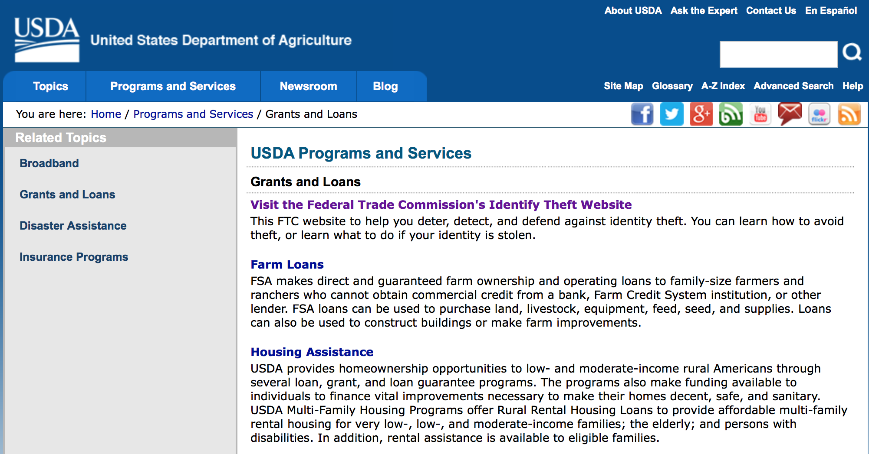
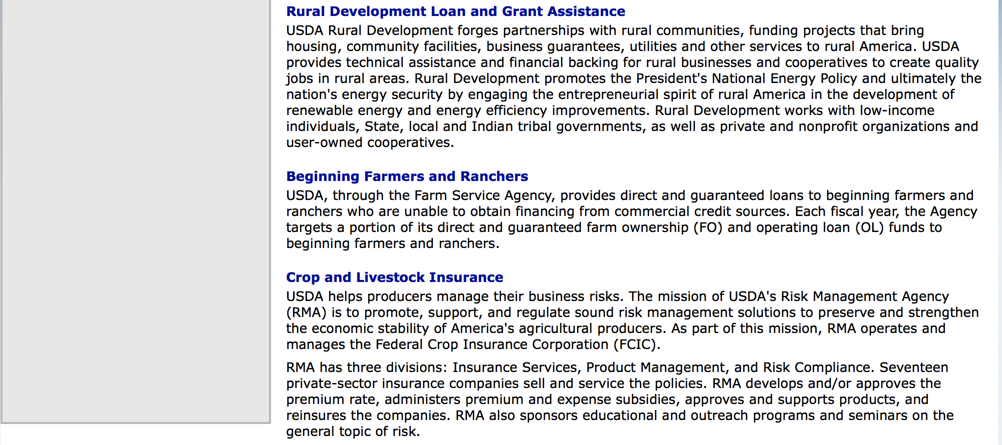

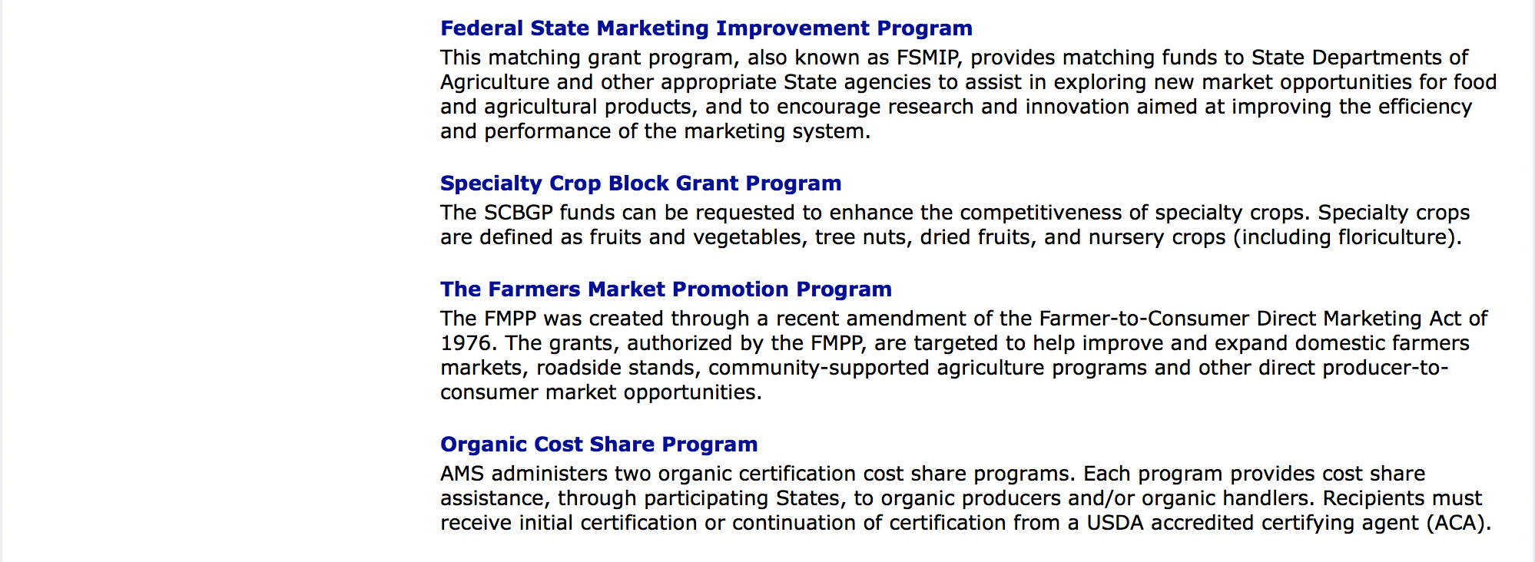

http://usda.gov/wps/portal/usda/usdahome?navid=GRANTS_LOANS

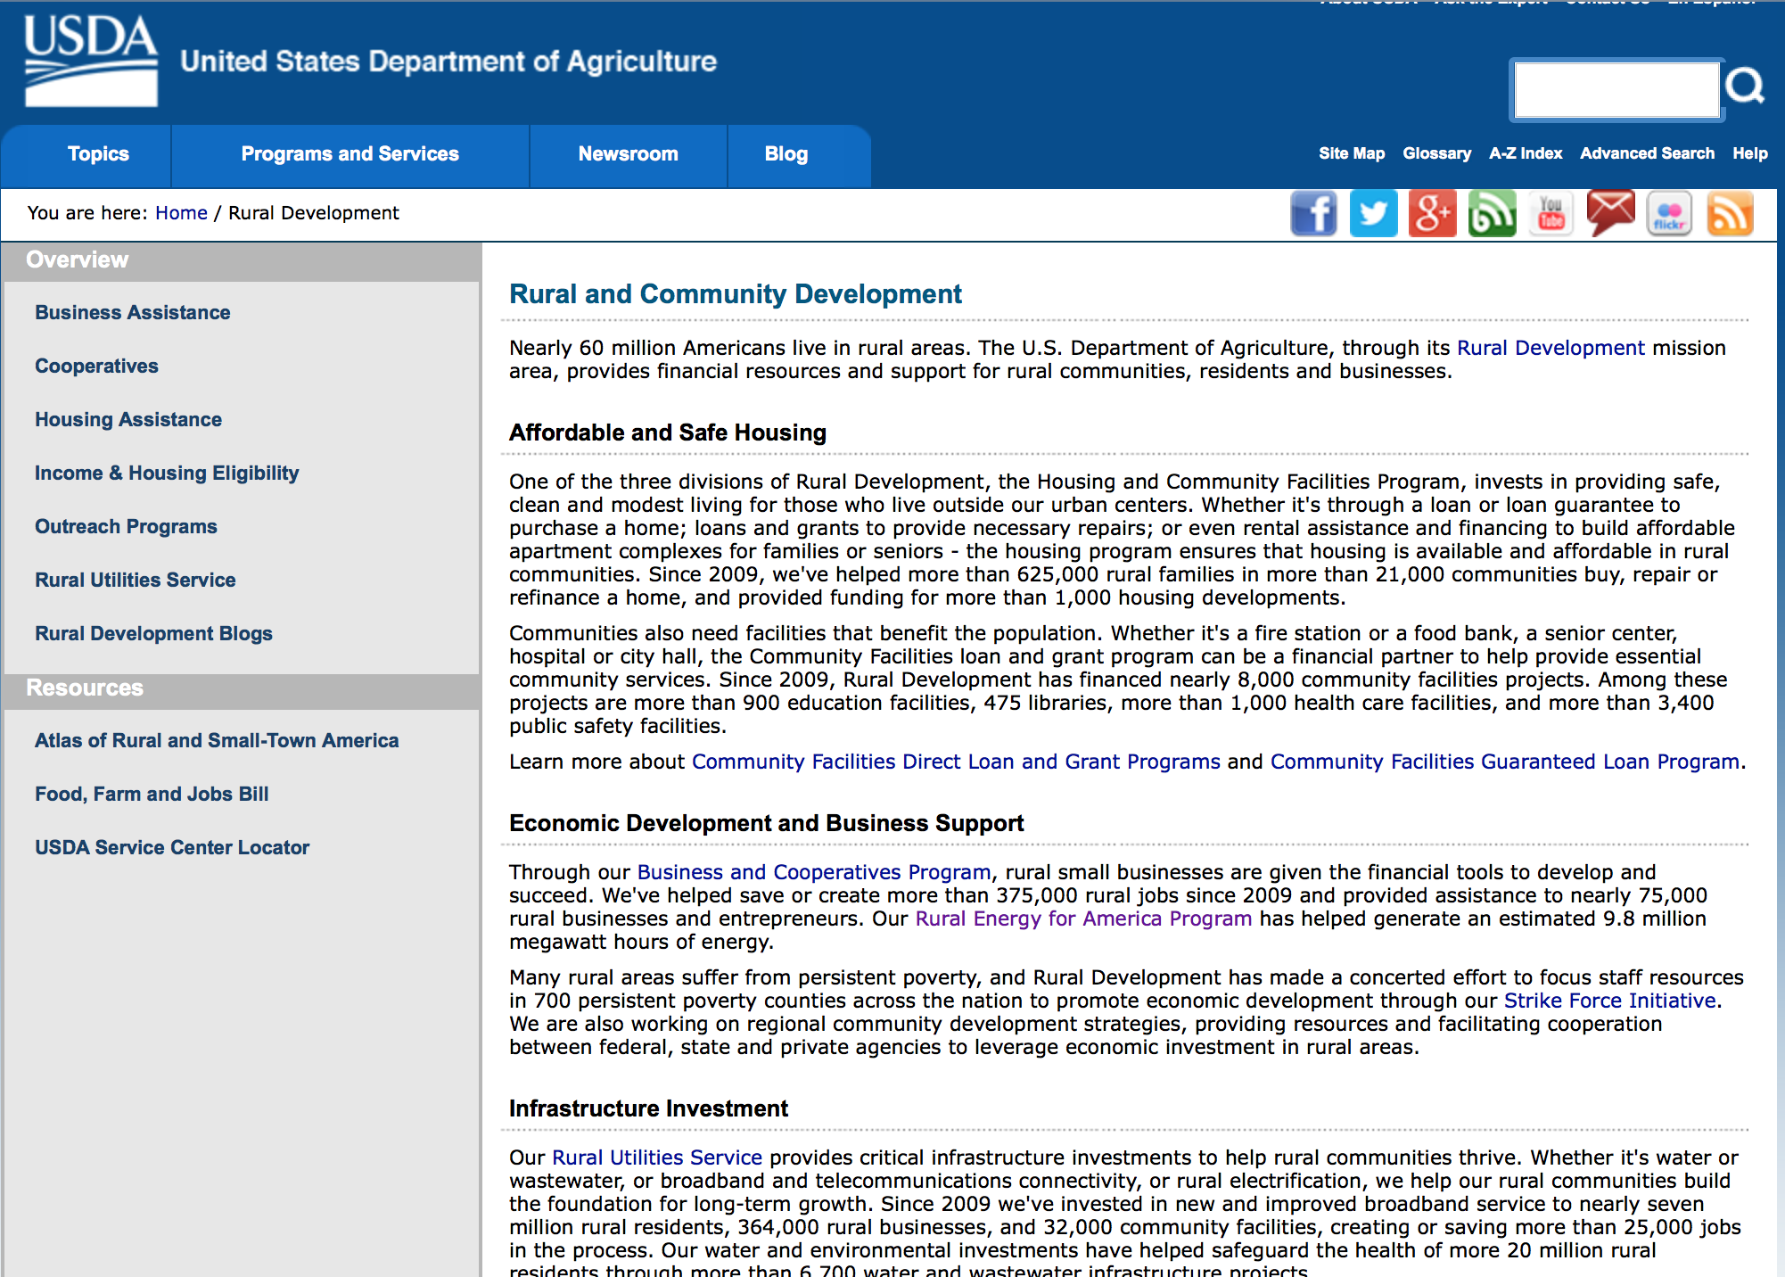

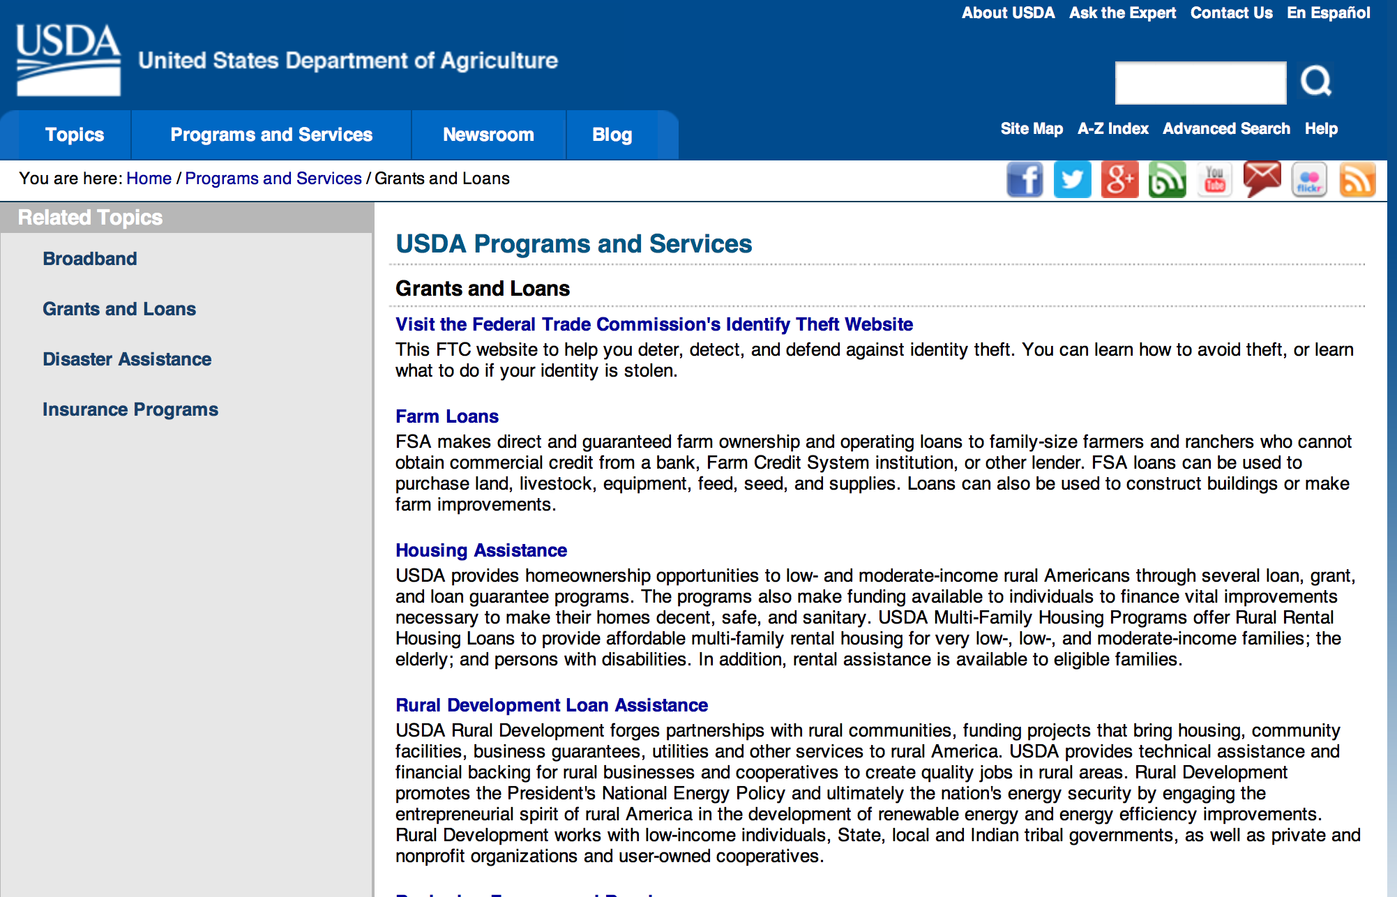

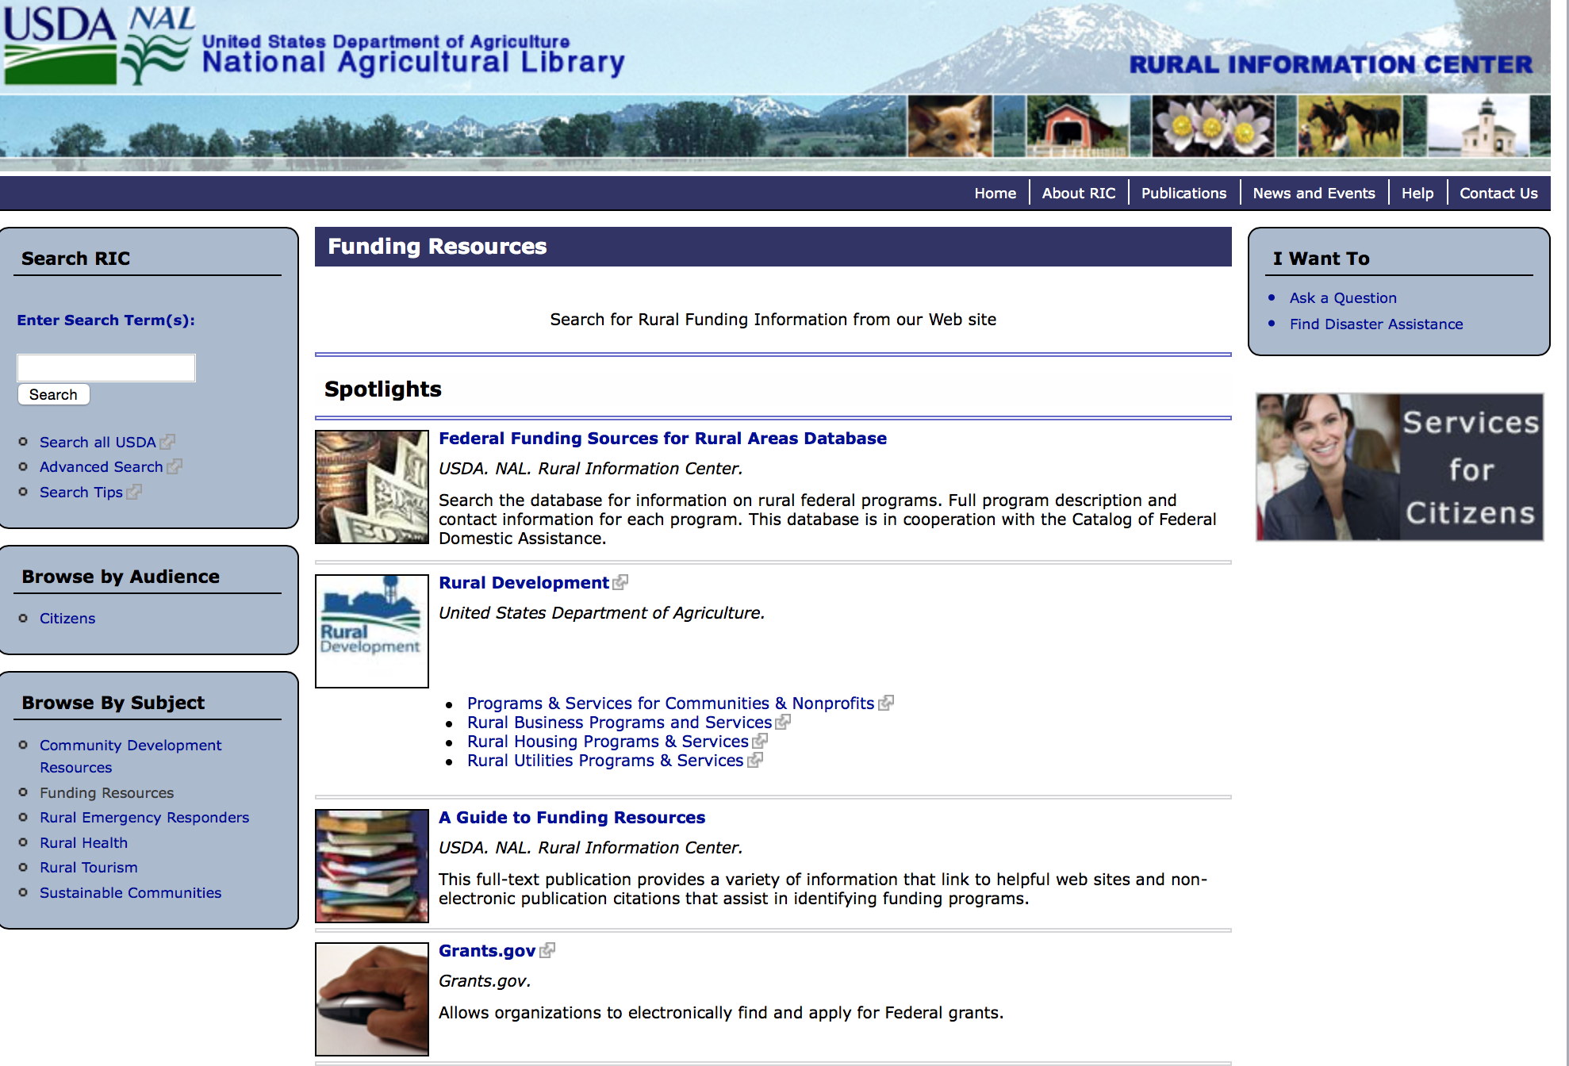

Federal Faith-Based Centers and Community Initiatives
USDA. NAL. Rural Information Center.
- Center for Faith-Based and Community Initiatives (link is external) , U.S. Department of Education
- Center for Faith-Based and Community Initiatives (link is external) , U.S. Department of Health and Human Services
- Center for Faith-Based and Community Initiatives (link is external) , U.S. Department of Labor
- Faith-Based and Community Initiatives (link is external) , U.S. Agency for International Development
- Faith-Based and Community Initiatives (link is external) , U.S. Department of Agriculture
- Faith-Based and Community Initiatives (link is external) , U.S. Department of Housing and Urban Development
- Faith-Based and Other Community Initiatives (link is external) , Corporation for National Community Service
- Task Force for Faith-Based and Community Initiatives (link is external) , U.S. Department of Justice

Grant Writing Resources
- Proposal Writing Short Course (link is external) Foundation Center.
- Data Universal Numbering System Fact sheet (link is external) [PDF | 302.2KB] USDA Rural Development.
- General Tips on Writing a Competitive Grant Proposal (link is external) U.S. Environmental Protection Agency.
- How to Write a Grant Proposal (link is external) Appalachian Regional Commission. <. li>

A Guide to Funding Resources USDA Rural Information Center.

http://ric.nal.usda.gov/funding-resources

http://usda.gov/wps/portal/usda/usdahome?navid=GRANTS_LOANS

Programs:

National Institute of Food and Agriculture
Small Business Innovation Research Program - Phase II
Synopsis 1

Document Type: | Grants Notice
Funding Opportunity Number: | USDA-NIFA-SBIR-006177
Funding Opportunity Title: | Small Business Innovation Research Program - Phase II
Opportunity Category: | Discretionary
Opportunity Category Explanation:
Funding Instrument Type: | Grant
Category of Funding Activity: | Agriculture  Business and Commerce
Category Explanation:
Expected Number of Awards:
CFDA Number(s): | 10.212 -- Small Business Innovation Research
Cost Sharing or Matching Requirement: | No
Version: | Synopsis 1
Posted Date: | Dec 27, 2016
Last Updated Date: | Dec 27, 2016
Original Closing Date for Applications: | Mar 02, 2017
Current Closing Date for Applications: | Mar 02, 2017
Archive Date: | Apr 01, 2017
Eligible Applicants: | Others (see text field entitled "Additional Information on Eligibility" for clarification)
Additional Information on Eligibility: | Only previous USDA SBIR Phase I winners who have not applied for Phase II support are eligible to apply for Phase II support through this FY 2017 RFA. A Phase I project may only apply for a Phase II award once. If a Phase I awardee was unsuccessful in receiving a Phase II award with a previous application then the awardee is not eligible to resubmit the proposal under this program solicitation.
Agency Name: | National Institute of Food and Agriculture
Description: | All Phase II projects must have previously completed a successful USDA Phase I project before applying for a Phase II grant. Success rates for applicants have been 50-60% for Phase II. Projects dealing with agriculturally related manufacturing and alternative and renewable energy technologies are encouraged across all 2017 SBIR topic areas. USDA SBIR's flexible research areas ensure innovative projects consistent with USDA's vision of a healthy and productive nation in harmony with the land, air, and water. USDA SBIR has awarded over 2000 research and development projects since 1983, allowing hundreds of small businesses to explore their technological potential, and providing an incentive to profit from the commercialization of innovative ideas. Click below for more SBIR information.
Link to Additional Information: | Small Business Innovation Research Program - Phase II
Grantor Contact Information: | If you have difficulty accessing the full announcement electronically, please contact:  NIFA Help Desk Phone: 202-401-5048 Business hours are M-F, 7:00 am -5:00 pm ET, excluding Federal holidays  If you have any questions related to preparing application content

http://www.grants.gov/web/grants/view-opportunity.html?oppId=290971

Modifications:

Deleted:

Reminders:

Fish and Wildlife Service
2017 National Fish Habitat Action Plan
Synopsis 1

Document Type: | Grants Notice
Funding Opportunity Number: | F17AS00016
Funding Opportunity Title: | 2017 National Fish Habitat Action Plan
Opportunity Category: | Discretionary
Opportunity Category Explanation:
Funding Instrument Type: | Cooperative Agreement  Grant
Category of Funding Activity: | Natural Resources
Category Explanation:
Expected Number of Awards: | 70
CFDA Number(s): | 15.608 -- Fish and Wildlife Management Assistance
Cost Sharing or Matching Requirement: | No
Posted Date: | Nov 08, 2016
Last Updated Date: | Nov 08, 2016
Original Closing Date for Applications: | Applications are accepted on a rolling basis.
Current Closing Date for Applications: | Applications are accepted on a rolling basis.
Archive Date: | May 31, 2017
Estimated Total Program Funding: | $0
Award Ceiling: | $300,000
Award Floor: | $5,000
Eligible Applicants: | Unrestricted (i.e., open to any type of entity above), subject to any clarification in text field entitled "Additional Information on Eligibility"
Additional Information on Eligibility: | Applications are accepted on a rolling basis.
Agency Name: | Fish and Wildlife Service
Description: | The National Fish Habitat Action Plan is a national investment strategy to leverage federal and privately raised funds to protect, restore, and enhance the nation's fish and aquatic habitats through partnerships that foster fish habitat conservation. Funds appropriated to the U.S. Fish and Wildlife Service's (Service) Fish and Aquatic Conservation (FAC) Program specifically to implement the Action Plan will be utilized in collaboration with the National Fish Habitat Board and Fish Habitat Partnerships. Fish Habitat Partnerships are the primary work units of the Action Plan, formed around distinct geographic areas, "keystone" fish species, or system types (e.g. large lakes, impoundments, estuaries). Funds will support national and regional science and coordination activities to protect, restore, or enhance fish habitats. All or a portion or project funds may be transferred to partner organizations if the Service lacks the capability to implement a project. Projects must protect, restore, or enhance fish and aquatic habitats or otherwise directly support habitat-related priorities of Fish Habitat Partnerships or the National Fish Habitat Board. Every project must be identified in the Fisheries Operational Needs System (FONS), a database that identifies the operational needs of FAC field stations, including fish habitat project needs. FAC field offices will work with Fish Habitat Partnerships to identify fish habitat projects, and enter them into the FONS. Entities that seek to propose a fish habitat conservation project for consideration should contact a local or regional office of the Service FAC Program.
Link to Additional Information: | http://www.grants.gov
Grantor Contact Information: | If you have difficulty accessing the full announcement electronically, please contact:  Cecilia Lewis 703-358-2102 Cecilia_Lewis@fws.gov  Fish Biologist

http://www.grants.gov/web/grants/view-opportunity.html?oppId=289987

Department of Commerce

Grants, Contracting, and Trade Opportunities at Commerce
Learn more information about grants, contracting and trade opportunities at the Department of Commerce using the information below.

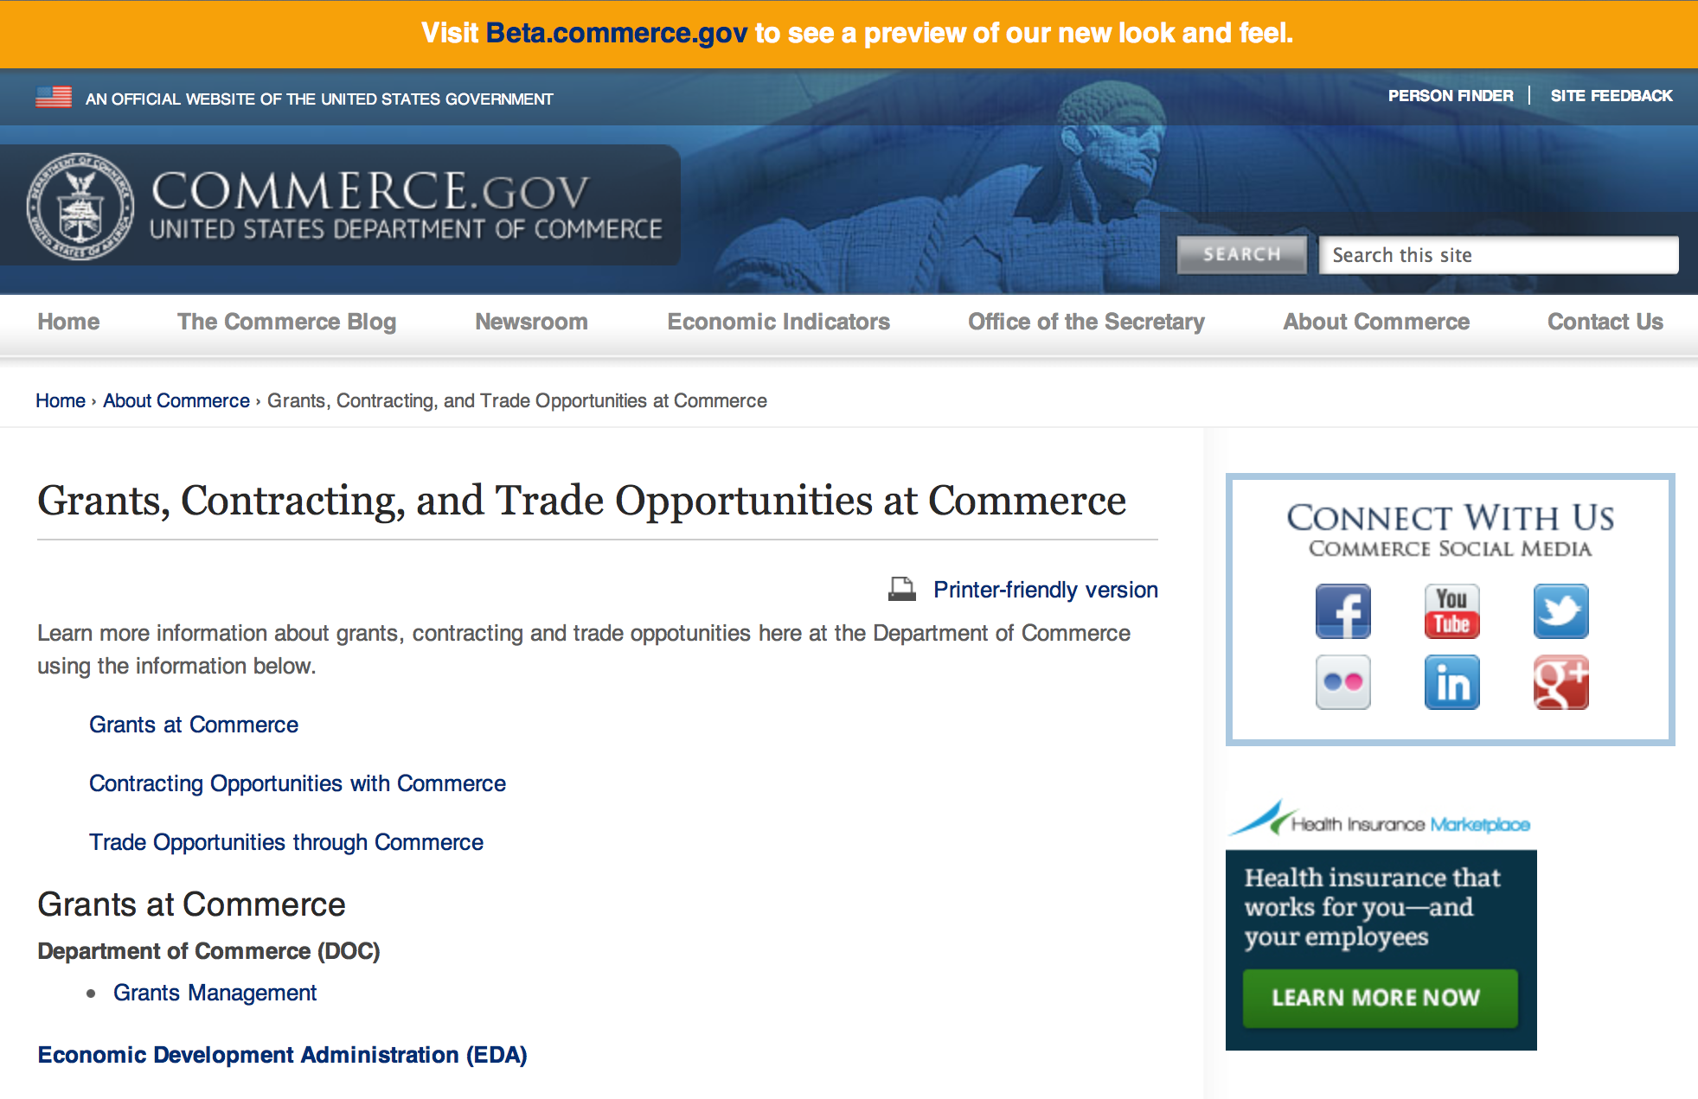

Grants at Commerce
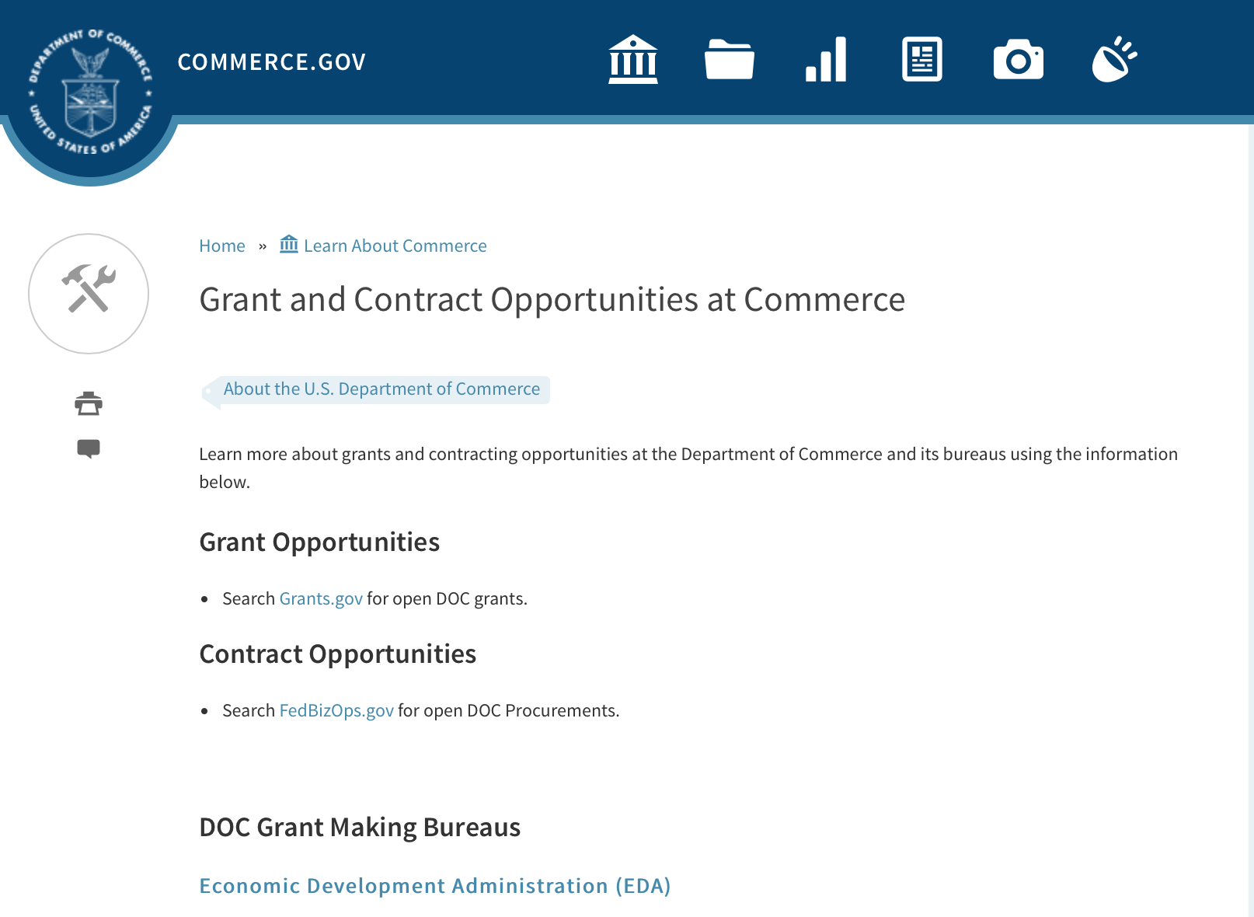

DOC Grant Making Bureaus
Economic Development Administration (EDA)
International Trade Administration (ITA)
- Market Development Cooperator Program
- Special American Business Internship Training Program (SABIT). A technical assistance initiative of the International Trade Administration of the U.S. Department of Commerce, SABIT offers organizations competitive grants and an opportunity to host industry-specific delegations. SABIT serves as an initial entry point for U.S. businesses seeking funding to establish long-term relationships with potential customers, distributors, or partners in the former Soviet Union. The program trains Eurasian managers and scientists in commonly accepted business practices as a means of facilitating cross border relationships. In turn, these personal relationships serve as a basis for business development and reduce market access barriers for U.S. businesses
National Institute of Standards & Technology (NIST)
- Funding Opportunities
National Telecommunications & Information Administration (NTIA)
- Telecommunications Grants
National Oceanic & Atmospheric Administration (NOAA)
- Coastal Ocean Program Grant Information
- Fisheries Saltonstall Kennedy Grant Program
- National Undersea Research Program Funding Opportunities
- Grants Management Division
- Fisheries Grants Program
- National Sea Grant
- Office of Global Programs
Contracting Resources for Contractors
- Office of Small and Disadvantaged Business Utilization (OSDBU) - he Office of Small and Disadvantaged Business Utilization (OSDBU) is an advocacy and advisory office responsible for promoting the use of small, small disadvantaged, 8(a), women-owned, veteran-owned, service-disabled veteran-owned, and HUBZone small businesses within the U.S. Department of Commerce's (DOC) acquisition process.
- Business.USA.gov's Find Opportunities Wizard where in a few quick steps, it will guide you towards federal government contracting programs and opportunities for your business!
- Planned Acquisitions: the Department of Commerce's search tool for our planned acquisitions over $100,000. As requirements change, these acquisition plans are updated by department personnel and this search tool is automatically updated.
- Small Business Administration's Contracting section of their web site where you can learn about how to "Get Started" and "Contracting Support for Small Business"
- The General Services Administration (GSA) has implemented a system for vendors doing business with the Federal Government to manage their entity information in one central location. This new database is the System for Award Management (SAM).

DOC Contracting Offices
- Patent and Trademark Office (PTO)
  - Office of Procurement
- National Institute of Standards & Technology (NIST)
NIST Acquisition Management Group
Contracting Opportunities with Commerce
Trade Opportunities through Commerce
http://www.commerce.gov/about-commerce/grants-contracting-trade-opportunities

Programs:

National Institute of Standards and Technology
NIST Summer Institute for Middle School Science Teachers (NIST Summer Institute) Program
Synopsis 1
Document Type: | Grants Notice
Funding Opportunity Number: | 2017-NIST-SUMMER-INSTITUTE-01
Funding Opportunity Title: | NIST Summer Institute for Middle School Science Teachers (NIST Summer Institute) Program
Opportunity Category: | Discretionary
Opportunity Category Explanation:
Funding Instrument Type: | Cooperative Agreement
Category of Funding Activity: | Other (see text field entitled "Explanation of Other Category of Funding Activity" for clarification)
Category Explanation: | Science, Technology, Business and/or Education Outreach
Expected Number of Awards:
CFDA Number(s): | 11.620 -- Science, Technology, Business and/or Education Outreach
Cost Sharing or Matching Requirement: | No
Version: | Synopsis 1
Posted Date: | Dec 14, 2016
Last Updated Date: | Dec 14, 2016
Original Closing Date for Applications: | Mar 03, 2017
Current Closing Date for Applications: | Mar 03, 2017
Archive Date: | Apr 02, 2017
Eligible Applicants: | Others (see text field entitled "Additional Information on Eligibility" for clarification)
Additional Information on Eligibility: | Public school districts and accredited private educational institutions in the U.S. and its territories that offer science classes at grade levels six (6), seven (7) and/or eight (8) (often termed middle school). Applicant school districts and institutions must offer instruction in general science fields, such as earth science, physical science, chemistry, physics, and/or biology. Individual public school teachers and individual public middle schools are not eligible to submit applications directly to NIST and instead must be nominated by their school district. Individual teachers at private educational institutions are not eligible to submit applications directly to NIST and instead must be nominated by their private educational institution. Individual teachers nominated to participate in the NIST Summer Institute Program must meet the eligibility requirements in Section III.1. of this NOFO.
Agency Name: | National Institute of Standards and Technology
Description: | NIST is soliciting applications from eligible public school districts and accredited private educational institutions in the U.S. and its territories. These eligible institutions would nominate sixth (6th), seventh (7th), and eighth (8th) grade science teachers to participate in the NIST Summer Institute Program. The NIST Summer Institute Program will provide selected teachers hands-on activities, lectures, tours, and visits with NIST scientists and engineers at the NIST Campus in Gaithersburg, Maryland.
Link to Additional Information: | 2017-NIST-SUMMER-INSTITUTE-01 NOFO/Full Announcement
Grantor Contact Information: | If you have difficulty accessing the full announcement electronically, please contact:  Christopher Hunton Management and Program Analyst Phone 301-975-5718  Agency Contact

http://www.grants.gov/web/grants/view-opportunity.html?oppId=290701

National Institute of Standards and Technology
NIST Research Experience for Teachers (NIST RET) Program
Synopsis 1

Document Type: | Grants Notice
Funding Opportunity Number: | 2017-NIST-RET-01
Funding Opportunity Title: | NIST Research Experience for Teachers (NIST RET) Program
Opportunity Category: | Discretionary
Opportunity Category Explanation:
Funding Instrument Type: | Cooperative Agreement
Category of Funding Activity: | Other (see text field entitled "Explanation of Other Category of Funding Activity" for clarification)
Category Explanation: | Science, Technology, Business and/or Education Outreach
Expected Number of Awards:
CFDA Number(s): | 11.620 -- Science, Technology, Business and/or Education Outreach
Cost Sharing or Matching Requirement: | No
Version: | Synopsis 1
Posted Date: | Dec 14, 2016
Last Updated Date: | Dec 14, 2016
Original Closing Date for Applications: | Mar 03, 2017
Current Closing Date for Applications: | Mar 03, 2017
Archive Date: | Apr 02, 2017
Eligible Applicants: | Others (see text field entitled "Additional Information on Eligibility" for clarification)
Additional Information on Eligibility: | Public school districts and accredited private educational institutions in the U.S. and its territories that offer science classes at grade levels six (6), seven (7), and/or eight (8) (often termed middle school), and whose nominated teachers have successfully completed the NIST Summer Institute Program. Applicant school districts and institutions must offer instruction in general science fields, such as earth science, physical science, chemistry, physics, and/or biology. Individual public school teachers and individual public middle schools are not eligible to submit applications directly to NIST and instead must be nominated by their school district. Individual teachers at private educational institutions are not eligible to submit applications directly to NIST and instead must be nominated by their private educational institution. Individual teachers nominated to participate in the NIST RET Program must meet the eligibility requirements in Section III.1. of this NOFO.
Agency Name: | National Institute of Standards and Technology
Description: | NIST is soliciting applications from eligible public school districts and accredited private educational institutions in the U.S. and its territories. These eligible institutions would nominate sixth (6th), seventh (7th) and eighth (8th) grade science teachers to participate in the NIST RET Program. The nominated teachers must have completed the NIST Summer Institute for Middle School Science Teachers (NIST Summer Institute) Program prior to being nominated for the NIST RET Program. The NIST RET Program will allow the selected teachers to participate in scientific research with NIST scientists and engineers at the NIST Campus in Gaithersburg, Maryland during the summer of 2017 for six (6) continuous weeks (exact dates to be decided by the teachers and NIST scientists and engineers).
Link to Additional Information: | 2017-NIST-RET-01 NOFO/Full Announcement
Grantor Contact Information: | If you have difficulty accessing the full announcement electronically, please contact:  Christopher Hunton Management and Program Analyst Phone 301-975-5718  Agency Contact

http://www.grants.gov/web/grants/view-opportunity.html?oppId=290702

National Institute of Standards and Technology
NIST Public Safety Innovation Accelerator Program
Synopsis 1, 3
Document Type: | Grants Notice
Funding Opportunity Number: | 2017-NIST-PSIAP-01
Funding Opportunity Title: | NIST Public Safety Innovation Accelerator Program
Opportunity Category: | Discretionary
Opportunity Category Explanation:
Funding Instrument Type: | Cooperative Agreement  Grant
Category of Funding Activity: | Science and Technology and other Research and Development
Category Explanation:
Expected Number of Awards:
CFDA Number(s): | 11.609 -- Measurement and Engineering Research and Standards
Cost Sharing or Matching Requirement: | No
Version: | Synopsis 3
Posted Date: | Dec 07, 2016
Last Updated Date: | Dec 23, 2016
Original Closing Date for Applications: | Feb 28, 2017
Current Closing Date for Applications: | Feb 28, 2017
Archive Date: | Mar 30, 2017
Eligible Applicants: | Others (see text field entitled "Additional Information on Eligibility" for clarification)
Additional Information on Eligibility: | All awards listed in this NOFO are open to all non-Federal entities. Eligible applicants include institutions of higher education, non-profit organizations, for-profit organizations, state and local governments, Indian tribes, hospitals, foreign public entities, and foreign governments. An eligible organization may propose to work individually or to include proposed sub-awardees, contractors or other collaborators. Please note that individuals and unincorporated sole proprietors are not considered “non-Federal entities” and are not eligible apply under this NOFO.NIST will only consider one application per applicant; however, an applicant entity may be proposed as a sub-recipient, contractor, or unfunded collaborator within applications submitted by other entities. In addition, an applicant may address more than one technology area from the program description, though they should make this very clear in the technical proposal.
Agency Name: | National Institute of Standards and Technology
Description: | The NIST Public Safety Innovation Accelerator Program seeks applications from eligible applicants for activities to accelerate research, development, production, and testing of key broadband technologies and capabilities for first responders as described in Section I. of this Full Announcement/ NOFO.
Link to Additional Information: | 2017-NIST-PSIAP-01 NOFO
Grantor Contact Information: | If you have difficulty accessing the full announcement electronically, please contact:  Christopher Hunton Management and Program Analyst Phone 301-975-5718  Agency Contact

http://www.grants.gov/web/grants/view-opportunity.html?oppId=290542

National Institute of Standards and Technology
Summer Undergraduate Research Fellowship (SURF) Program: SURF operating on the Boulder, Colorado campus (SURF Boulder) and the Gaithersburg, Maryland campus (SURF Gaithersburg)
Synopsis 1

Document Type: | Grants Notice
Funding Opportunity Number: | 2017-NIST-SURF-01
Funding Opportunity Title: | Summer Undergraduate Research Fellowship (SURF) Program: SURF operating on the Boulder, Colorado campus (SURF Boulder) and the Gaithersburg, Maryland campus (SURF Gaithersburg)
Opportunity Category: | Discretionary
Opportunity Category Explanation:
Funding Instrument Type: | Cooperative Agreement
Category of Funding Activity: | Other (see text field entitled "Explanation of Other Category of Funding Activity" for clarification)
Category Explanation: | Science, Technology, Business and/or Education Outreach
Expected Number of Awards:
CFDA Number(s): | 11.620 -- Science, Technology, Business and/or Education Outreach
Cost Sharing or Matching Requirement: | No
Version: | Synopsis 1
Posted Date: | Dec 08, 2016
Last Updated Date: | Dec 08, 2016
Original Closing Date for Applications: | Feb 15, 2017
Current Closing Date for Applications: | Feb 15, 2017
Archive Date: | Mar 17, 2017
Eligible Applicants: | Others (see text field entitled "Additional Information on Eligibility" for clarification)
Additional Information on Eligibility: | Colleges and universities (includes 2-year and 4-year institutions) in the U.S. and its territories with degree-granting programs in biology, chemistry, computer science, engineering, materials science, mathematics, nanoscale science, neutron research, and/or physics. Due to the size of SURF Boulder, applicants that apply to SURF Boulder are limited to nominating no more than eight (8) undergraduate students for participation. SURF Gaithersburg does not have an applicant limit at this time. Each undergraduate student nominated to participate in the SURF Program from the applicant college or university must meet the requirements in Section III.1. of this NOFO/Full Announcement.
Agency Name: | National Institute of Standards and Technology
Description: | NIST is soliciting applications from eligible colleges and universities in the U.S. and its territories, nominating undergraduate students to participate in the Summer Undergraduate Research Fellowship (SURF) Program. The SURF Program will provide research opportunities for undergraduate students to work with NIST scientists and engineers, to expose the students to cutting-edge research and promote the pursuit of graduate degrees in science and engineering.
Link to Additional Information: | 2017-NIST-SURF-01 NOFO/Full Announcement
Grantor Contact Information: | If you have difficulty accessing the full announcement electronically, please contact:  Christopher Hunton Management and Program Analyst Phone 301-975-5718  Agency Contact

http://www.grants.gov/web/grants/view-opportunity.html?oppId=290557

DARRP Restoration Implementation Grants
Synopsis 1

Document Type: | Grants Notice
Funding Opportunity Number: | NOAA-NMFS-HCPO-2017-2005146
Funding Opportunity Title: | DARRP Restoration Implementation Grants
Opportunity Category: | Discretionary
Opportunity Category Explanation:
Funding Instrument Type: | Cooperative Agreement
Category of Funding Activity: | Environment  Natural Resources  Science and Technology and other Research and Development
Category Explanation:
Expected Number of Awards: | 10
CFDA Number(s): | 11.463 -- Habitat Conservation
Cost Sharing or Matching Requirement: | No
Version: | Synopsis 1
Posted Date: | Jan 05, 2017
Last Updated Date: | Jan 05, 2017
Original Closing Date for Applications: | Mar 06, 2017
Current Closing Date for Applications: | Mar 06, 2017
Archive Date: | Apr 05, 2017
Estimated Total Program Funding: | $100,000,000
Award Ceiling: | $100,000,000
Award Floor: | $2,500,000
Eligible Applicants: | Others (see text field entitled "Additional Information on Eligibility" for clarification)
Additional Information on Eligibility: | Eligible applicants are institutions of higher education, non-profits, and commercial (for-profit) organizations. Applications from federal, state, or tribal governments will not be considered, due to their potential role as trustee council members. Applications from local governments will not be considered due to their limited geographic reach. Applications from individuals or employees of federal agencies will also not be considered. Non-eligible organizations are encouraged to work with those that are eligible to apply
Agency Name: | Department of Commerce
Description: | The principal objective of the Damage Assessment, Remediation and Restoration Program (DARRP) 2017 Restoration Implementation Grants is for NOAA to collaborate with non-federal partners to accomplish common marine and coastal habitat conservation and restoration goals related to oil spills, hazardous substance releases, and other natural resource damages. Successful applicants will support and implement restoration activities authorized under the Oil Pollution Act, Comprehensive Environmental Response, Compensation, and Liability Act, Clean Water Act, National Marine Sanctuaries Act, and other federal agencies' authorities related to oil spills, hazardous substance releases, and natural resource damages, such as the RESTORE Act.
Link to Additional Information:
Grantor Contact Information: | If you have difficulty accessing the full announcement electronically, please contact:  David Landsman at 206-526-4720  Work

http://www.grants.gov/web/grants/view-opportunity.html?oppId=291042

Research:

2017 BREP FFO
Synopsis 1
http://www.grants.gov/web/grants/view-opportunity.html?oppId=291025

Modifications:

Fiscal Year 2018 National Sea Grant College Program Dean John A. Knauss Marine Policy Fellowship

Synopsis 2, 3 & 4
Document Type: | Grants Notice
Funding Opportunity Number: | NOAA-OAR-SG-2018-2004993
Funding Opportunity Title: | Fiscal Year 2018 National Sea Grant College Program Dean John A. Knauss Marine Policy Fellowship
Opportunity Category: | Discretionary
Opportunity Category Explanation:
Funding Instrument Type: | Cooperative Agreement
Category of Funding Activity: | Environment  Natural Resources  Science and Technology and other Research and Development
Category Explanation:
Expected Number of Awards: | 30
CFDA Number(s): | 11.417 -- Sea Grant Support
Cost Sharing or Matching Requirement: | No
Version: | Synopsis 2
Posted Date: | Aug 11, 2016
Last Updated Date: | January 7, 2017
Original Closing Date for Applications: | April 7, 2017
Current Closing Date for Applications: | April 7, 2017
Archive Date: | Apr 30, 2017
Estimated Total Program Funding:
Award Ceiling: | $80,000
Award Floor: | $61,500
Eligible Applicants: | Others (see text field entitled "Additional Information on Eligibility" for clarification)
Additional Information on Eligibility: | An eligible applicant is any student, regardless of citizenship, who, on February 21, 2017, is enrolled towards a degree in a graduate program, that have an interest in ocean, coastal and Great Lakes resources and in the national policy decisions affecting those resources. The graduate degree needs to be awarded through a United States accredited institution of higher education in the United States or U.S. Territories. Eligible applicants must provide application materials to the appropriate Sea Grant Program by February 21, 2017.
Agency Name: | Department of Commerce
Description: | This notice announces that applications may be submitted for the 2018 National Sea Grant College Program Dean John A. Knauss Marine Policy Fellowship (Sea Grant Knauss Fellowship Program). Sea Grant anticipates funding not less than 30 selected applicants, of which those assigned to the Legislative branch may be limited to 12. Each award will be funded at a total of $61,500 in federal funding, with the option to add additional funds for fellowship related travel, relocation and other expenses.
Link to Additional Information:
Grantor Contact Information: | If you have difficulty accessing the full announcement electronically, please contact:  The Sea Grant Knauss Fellowship Program Manager National Sea Grant College Program 1315 East-West Highway R/SG, Room 11861 Silver Spring, MD 20910 (301) 734-1088 E-mail: OAR.SG.Fellows@noaa.gov  Work

http://www.grants.gov/web/grants/view-opportunity.html?oppId=287335

Deleted:

Reminders:

National Estuarine Research Reserve System (NERRS) Land Acquisition and Construction Program for Fiscal Year 2017
Synopsis 2

Document Type: | Grants Notice
Funding Opportunity Number: | NOAA-NOS-OCM-2017-2005115
Funding Opportunity Title: | National Estuarine Research Reserve System (NERRS) Land Acquisition and Construction Program for Fiscal Year 2017
Opportunity Category: | Discretionary
Opportunity Category Explanation:
Funding Instrument Type: | Grant
Category of Funding Activity: | Environment  Natural Resources  Science and Technology and other Research and Development
Category Explanation:
Expected Number of Awards: | 10
CFDA Number(s): | 11.420 -- Coastal Zone Management Estuarine Research Reserves
Cost Sharing or Matching Requirement: | Yes
Version: | Synopsis 2
Posted Date: | Nov 15, 2016
Last Updated Date: | Nov 30, 2016
Original Closing Date for Applications: | Feb 03, 2018
Current Closing Date for Applications: | Feb 03, 2017
Archive Date: | Mar 05, 2018
Estimated Total Program Funding: | $1,700,000
Award Ceiling: | $800,000
Award Floor: | $20,000
Eligible Applicants: | Others (see text field entitled "Additional Information on Eligibility" for clarification)
Additional Information on Eligibility: | Eligible applicants are NERRS lead state agencies or universities designated to receive NERRS operations funding through a Memorandum of Understanding with NOAA in coastal states including the Pacific, Gulf, Atlantic Coast and Great Lakes. Eligible applicants should meet requirements as stated in the NERRS regulations codified at 15 CFR 921.32 which are available on line at http://go.usa.gov/xkGEf.Federal agencies and employees are not allowed to receive funds under this announcement but may serve as collaborative project partners. Federal agencies and employees’ ‘in-kind’ services cannot be considered as part of an applicant’s match on shared costs. If federal agencies are collaborators, applicants are expected to provide detail on the planned level of federal engagement in the application. Examples might include, but are not limited to partnership services; serving in a review capacity; or participating in priority task teams, working groups, or leadership teams.
Agency Name: | Department of Commerce
Description: | The National Estuarine Research Reserve System (NERRS or System) consists of estuarine areas of the United States and its territories designated and managed for research and educational purposes. Each Reserve within the system is chosen to represent a different bio-geographic region and to include a variety of ecosystem types in accordance with the classification scheme of the national program as specified in 15 CFR Part 921 By funding Reserve lead agencies and universities to conduct land acquisition and construction projects that support the NERRS mission, NOAA will strengthen protection of key land and water areas, enhance long-term protection of Reserve areas for research and education, and provide for facility and exhibit construction that meet the highest sustainable design standards possible. NOAA anticipates approximately $1.7 million in Fiscal Year 2017 will be available to designated lead Reserve agencies or universities in coastal states for approximately 1-10 construction and acquisition projects, and expected to range from approximately $20,000 to $800,000 per project and with project periods typically covering 12-36 months, depending on the availability of funds.
Link to Additional Information:
Grantor Contact Information: | If you have difficulty accessing the full announcement electronically, please contact:  Nina Garfield Program Coordinator, NOAA/Office for Coastal Management 1305 East-West Highway, SSMC4, 10th Floor Silver Spring, MD 20910 Phone 240-533-0817 Email: Nina.Garfield@noaa.gov or Erica Seiden at 240-533-0781 E-mail Erica.Seiden@noaa.gov.  Work

http://www.grants.gov/web/grants/view-opportunity.html?oppId=290106

FY 2017 Joint Technology Transfer Initiative
Synopsis 2

Document Type: | Grants Notice
Funding Opportunity Number: | NOAA-OAR-OWAQ-2017-2005122
Funding Opportunity Title: | FY 2017 Joint Technology Transfer Initiative
Opportunity Category: | Discretionary
Opportunity Category Explanation:
Funding Instrument Type: | Cooperative Agreement
Category of Funding Activity: | Environment  Natural Resources  Science and Technology and other Research and Development
Category Explanation:
Expected Number of Awards: | 13
CFDA Number(s): | 11.459 -- Weather and Air Quality Research
Cost Sharing or Matching Requirement: | No
Version: | Synopsis 2
Posted Date: | Nov 15, 2016
Last Updated Date: | Nov 22, 2016
Original Closing Date for Applications: | Feb 09, 2017
Current Closing Date for Applications: | Feb 09, 2017
Archive Date: | Mar 11, 2017
Estimated Total Program Funding: | $2,000,000
Award Ceiling: | $300,000
Award Floor: | $150,000
Eligible Applicants: | Others (see text field entitled "Additional Information on Eligibility" for clarification)
Additional Information on Eligibility: | Eligible applicants are institutions of higher education; other nonprofit organizations; and commercial organizations.
Agency Name: | Department of Commerce
Description: | Through the Joint Technology Transfer Initiative (JTTI) Program, OAR's Office of Weather and Air Quality (OWAQ) is soliciting proposals to conduct research and development activities related to advancing the convective scale modeling and water prediction over the coming 1 to 2 years.
Link to Additional Information:
Grantor Contact Information: | If you have difficulty accessing the full announcement electronically, please contact:  Chandra Kondragunta 301-734-1034 Office of Weather and Air Quality, Office of Oceanic and Atmospheric Research, 1315 East-West Hwy, Silver Spring, MD 20910-3282  Work

http://www.grants.gov/web/grants/view-opportunity.html?oppId=290109

FY17-19 Habitat Blueprint – Coastal and Marine Habitat Focus Area Cooperative Agreements
Synopsis 1

Document Type: | Grants Notice
Funding Opportunity Number: | NOAA-NMFS-HCPO-2017-2005105
Funding Opportunity Title: | FY17-19 Habitat Blueprint – Coastal and Marine Habitat Focus Area Cooperative Agreements
Opportunity Category: | Discretionary
Opportunity Category Explanation:
Funding Instrument Type: | Cooperative Agreement
Category of Funding Activity: | Environment  Natural Resources  Science and Technology and other Research and Development
Category Explanation:
Expected Number of Awards:
CFDA Number(s): | 11.463 -- Habitat Conservation
Cost Sharing or Matching Requirement: | No
Posted Date: | Dec 02, 2016
Last Updated Date: | Dec 02, 2016
Original Closing Date for Applications: | Feb 02, 2017
Current Closing Date for Applications: | Feb 02, 2017
Archive Date: | Mar 04, 2017
Estimated Total Program Funding: | $1,500,000
Award Ceiling: | $650,000
Award Floor: | $150,000
Eligible Applicants: | Others (see text field entitled "Additional Information on Eligibility" for clarification)
Additional Information on Eligibility: | Eligible applicants are institutions of higher education, non-profits, commercial (for-profit) organizations, U.S. territories, and state, local and Native American tribal governments. Applications from federal agencies or employees of federal agencies will not be considered. Federal agencies are strongly encouraged to work with states, non-governmental organizations, municipal and county governments, and others that are eligible to apply.
Agency Name: | Department of Commerce
Description: | The principal objective of the National Oceanic and Atmospheric Administration's (NOAA) FY17-19 Habitat Blueprint - Coastal and Marine Habitat Focus Area Cooperative Agreements solicitation is to identify and support comprehensive and cooperative habitat conservation projects in NOAA Habitat Focus Areas (HFAs) that sustain resilient and thriving marine and coastal resources, communities, and economies. Proposals submitted under this solicitation will be selected based on their ability to demonstrate success in achieving the NOAA Habitat Blueprint’s primary goals within nine of the HFAs: Biscayne Bay, Florida; Choptank River, Maryland/Delaware; Kachemak Bay, Alaska; Manell-Geus, Guam; Muskegon Lake Michigan; Northeast Marine Corridor and Culebra Island, Puerto Rico; Penobscot River, Maine; Russian River, California; and West Hawaii, Hawaii. Specific objectives vary from HFA to HFA, and have been selected to effectively protect and/or restore high-priority habitat for managed fisheries, protected species, and other coastal and marine life; foster resilient coastal communities; advance habitat science; and/or lead to increased socio-economic benefits. HFA - specific priorities are identified in this federal funding opportunity, and successful proposals will: 1) address issues/concerns contributing to the loss or deterioration of coastal or marine habitats; 2) identify the project’s outcome(s) and goal(s) and describing in detail the actions and project(s) to be undertaken to achieve those goals; and 3) describe the measurable impact on the issue/concern, including proposed evaluation techniques.
Link to Additional Information:
Grantor Contact Information: | If you have difficulty accessing the full announcement electronically, please contact:  Liz Fairey NOAA Fisheries Office of Habitat Conservation 1315 East West Highway SSMC3, 14224 Silver Spring, MD, 20910 301-427-8632 Liz.Fairey@noaa.gov  Work

http://www.grants.gov/web/grants/view-opportunity.html?oppId=290437

NOAA Climate Program Office’s Regional Integrated Sciences and Assessments (RISA) Program
Synopsis 1

Document Type: | Grants Notice
Funding Opportunity Number: | NOAA-OAR-CPO-2017-2005017
Funding Opportunity Title: | NOAA Climate Program Office’s Regional Integrated Sciences and Assessments (RISA) Program
Opportunity Category: | Discretionary
Opportunity Category Explanation:
Funding Instrument Type: | Cooperative Agreement
Category of Funding Activity: | Environment  Natural Resources  Science and Technology and other Research and Development
Category Explanation:
Expected Number of Awards: | 10
CFDA Number(s): | 11.431 -- Climate and Atmospheric Research
Cost Sharing or Matching Requirement: | No
Posted Date: | Nov 01, 2016
Last Updated Date: | Nov 01, 2016
Original Closing Date for Applications: | Feb 06, 2017
Current Closing Date for Applications: | Feb 06, 2017
Archive Date: | Mar 08, 2017
Estimated Total Program Funding: | $3,500,000
Award Ceiling: | $700,000
Award Floor: | $1
Eligible Applicants: | Others (see text field entitled "Additional Information on Eligibility" for clarification)
Additional Information on Eligibility: | Eligible applicants are institutions of higher education, other nonprofits, commercial organizations, international organizations, and state, local and Indian tribal governments. Federal lead investigators who wish to apply to this Announcement of Opportunity must prepare a proposal according to the FFO guidelines and submit the proposal to the program manager directly, instead of to Grants.gov. Federal co-investigators must submit a proposal identical to the proposal lead's but with personalized budget information.
Agency Name: | Department of Commerce
Description: | The NOAA Climate Program Office’s (CPO) Regional Integrated Sciences and Assessments (RISA) program supports research teams that conduct innovative, interdisciplinary, user-inspired, and regionally relevant research that informs resource management and public policy. CPO funds a network of RISA teams across the United States (US) and Pacific Islands, which is a model for interdisciplinary science and assessment. NOAA’s RISA program is overseen by CPO’s Climate and Societal Interactions (CSI) division. CSI’s mission is to inform improvements in resilience and preparedness in diverse socio-economic regions and sectors throughout the US and abroad through the use of climate knowledge and information. Our research advances the nation’s understanding of climate-related risks and vulnerabilities across sectors and regions, and the development of tools to foster more informed decision making. These efforts support NOAA's vision to create and sustain enhanced resilience in ecosystems, communities, and economies. In addition to RISA, CSI’s programs include the International Research and Applications Project (IRAP), the Sectoral Applications Research Program (SARP), and the Coastal and Ocean Climate Applications program (COCA). CSI is also an active partner with NOAA efforts to provide integrated regional climate services. This partnership brings together NOAA Regional Climate Services Directors (RCSDs), other NOAA offices, and close external partners such as RISA teams, Regional Climate Centers, State Climatologists, and Sea Grant to help make climate information relevant and accessible to people across the US. NOAA seeks to marshal climate assets and partners towards the common goal of assessing regional needs and vulnerabilities and then supporting the development and delivery of timely climate services that aid adaptation and mitigation choices. RISA and CSI activities address the societal challenges identified in NOAA’s Next-Generation Strategic Plan (NGSP): i) climate impacts on water resources; ii) coasts and climate resilience; iii) sustainability of marine ecosystems; and iv) changes in the extremes of weather and climate. These efforts support NOAA’s vision to create and sustain enhanced resilience in ecosystems, communities, and economies, as outlined in the NGSP. In FY 2017, RISA is holding two competitions for research funding focused on three geographies. We are soliciting proposals for: 1) Competition 1: a RISA team focused on the Arizona/New Mexico region of the US; and 2) Competition 2: a RISA team focused on either the California/Nevada region of the US or on the Midwestern region of the US. We estimate that $3-$3.5 million over five years will be available for each competition, pending available funding and budget appropriations. Awards will be at a funding level of $600,000-$700,000 per year for up to 5 years. Please download the RISA Information Sheet for more detailed information (http://www.cpo.noaa.gov/risa/).
Link to Additional Information:
Grantor Contact Information: | If you have difficulty accessing the full announcement electronically, please contact:  Please visit the RISA website for further information at or contact the RISA Program Managers, by mail (see address above) or at oar.cpo.risa@noaa.gov. Please allow up to two weeks after receipt for a response.  Work

http://www.grants.gov/web/grants/view-opportunity.html?oppId=289851

National Institute of Standards and Technology
Measurement Science and Engineering (MSE) Research Grant Programs

Document Type: | Grants Notice
Funding Opportunity Number: | 2016-NIST-MSE-01
Funding Opportunity Title: | Measurement Science and Engineering (MSE) Research Grant Programs
Opportunity Category: | Discretionary
Opportunity Category Explanation:
Funding Instrument Type: | Cooperative Agreement  Grant
Category of Funding Activity: | Science and Technology and other Research and Development
Category Explanation:
Expected Number of Awards:
CFDA Number(s):
Cost Sharing or Matching Requirement: | No
Posted Date: | Feb 19, 2016
Last Updated Date: | Feb 19, 2016
Original Closing Date for Applications: | Applications will be accepted and considered on a rolling basis as they are received. See Section IV.4. in the text of the Full Announcement/FFO document. Applications may be submitted by paper or electronically through Grants.gov. Carefully read Section IV. of the Full Announcement/FFO document for details applying to electronic submissions and to paper submissions.
Current Closing Date for Applications: | Applications will be accepted and considered on a rolling basis as they are received. See Section IV.4. in the text of the Full Announcement/FFO document. Applications may be submitted by paper or electronically through Grants.gov. Carefully read Section IV. of the Full Announcement/FFO document for details applying to electronic submissions and to paper submissions.
Eligible Applicants: | Others (see text field entitled "Additional Information on Eligibility" for clarification)
Additional Information on Eligibility: | Eligibility for all programs listed in this FFO is open to all non-Federal entities. Eligible applicants include institutions of higher education, non-profit organizations, for-profit organizations, state and local governments, Indian tribes, hospitals, foreign public entities, and foreign governments. Applicants selected for awards under 15 U.S.C. § 278g-1 are encouraged, but not required, to select underrepresented minorities for participation. In addition, NIST is not able to accept an application from an individual unaffiliated with a sponsoring applicant organization.
Agency Name: | National Institute of Standards and Technology
Description: | NIST is soliciting applications for financial assistance for Fiscal Year 2016 (FY16) within the following NIST Laboratory grant programs: (1) the Material Measurement Laboratory (MML) Grant Program; (2) the Physical Measurement Laboratory (PML) Grant Program; (3) the Engineering Laboratory (EL) Grant Program; (4) the Fire Research (FR) Grant Program; (5) the Information Technology Laboratory (ITL) Grant Program; (6) the Communications Technology Laboratory (CTL) Grant Program; (7) the NIST Center for Neutron Research (NCNR) Grant Program; (8) the Center for Nanoscale Science and Technology (CNST) Grant Program; (9) the Special Programs Office (SPO) Grant Program; (10) the Standards Coordination Office (SCO) Grant Program; (11) the International and Academic Affairs Office (IAAO) Grant Program; and (12) the Associate Director for Laboratory Programs (ADLP) Grant Program.
Link to Additional Information: | 2016-NIST-MSE-01 Full Announcement/FFO document
Contact Information: | If you have difficulty accessing the full announcement electronically, please contact:  Christopher Hunton Management and Program Analyst Phone 301-975-5718  Agency Contact

http://www.grants.gov/web/grants/view-opportunity.html?oppId=281689

National Sea Grant College Program 2016-17 Special Projects Grant

Document Type: | Grants Notice
Funding Opportunity Number: | NOAA-OAR-SG-2016-2004772
Funding Opportunity Title: | National Sea Grant College Program 2016-17 Special Projects
Opportunity Category: | Discretionary
Funding Instrument Type: | Cooperative Agreement  Grant
Category of Funding Activity: | Environment  Natural Resources  Science and Technology and other Research and Development
Category Explanation:
Expected Number of Awards: | 30
CFDA Number(s): | 11.417 -- Sea Grant Support
Cost Sharing or Matching Requirement: | Yes
Posted Date: | Jan 7, 2016
Creation Date: | Jan 7, 2016
Original Closing Date for Applications: | Sep 30, 2017
Current Closing Date for Applications: | Sep 30, 2017
Archive Date: | Oct 30, 2017
Estimated Total Program Funding: | $4,000,000
Award Ceiling: | $1,000,000
Award Floor: | $1
Eligible Applicants: | Others (see text field entitled "Additional Information on Eligibility" for clarification)
Additional Information on Eligibility: | Sea Grant Programs (Sea Grant Colleges, Institutions, or Coherent Area Programs), the National Sea Grant Law Center, and the National Sea Grant Library.
Agency Name: | Department of Commerce
Description: | The purpose of this notice is to request proposals for special projects associated with the National Sea Grant College Program’s (Sea Grant) strategic focus areas, and to provide the general public with information and guidelines on how Sea Grant will select proposals and administer Federal assistance under this announcement. This announcement is a mechanism to encourage research or other projects that are not normally funded through Sea Grant national competitions. This opportunity is open only to Sea Grant Programs. Section III of this announcement describes eligibility requirements in more detail. Funding has not yet been made available to support applications submitted to this Federal Funding Opportunity (FFO), but such funding may become available during the year. Section II.A. below describes individual competition announcements that will be used to announce when funding is available; any restrictions or requirements on such funding, such as matching funds; and other funding details. Awards will be made under this FFO only if funds have been announced as provided in this FFO.
Link to Additional Information:
Contact Information: | If you have difficulty accessing the full announcement electronically, please contact:  Special Projects Competition Manager, NOAA R/SG National Sea Grant Office 1315 East-West Highway, Rm 11839 Silver Spring, MD 20910 301-734-1066  work

http://www.grants.gov/web/grants/view-opportunity.html?oppId=280846

FY 2016 – FY 2019 EDA Planning Program and Local Technical Assistance Program Grant

Document Type: | Grants Notice
Funding Opportunity Number: | EDA-HDQ-TA-HDQ-2016-2004759
Funding Opportunity Title: | FY 2016 – FY 2019 EDA Planning Program and Local Technical Assistance Program
Opportunity Category: | Discretionary
Funding Instrument Type: | Cooperative Agreement  Grant
Category of Funding Activity: | Other (see text field entitled "Explanation of Other Category of Funding Activity" for clarification)  Regional Development
Category Explanation: | Regional planning and local technical assistance
Expected Number of Awards:
CFDA Number(s): | 11.302 -- Economic Development Support for Planning Organizations  11.303 -- Economic Development Technical Assistance
Cost Sharing or Matching Requirement: | No
Posted Date: | Dec 10, 2015
Creation Date: | Dec 10, 2015
Original Closing Date for Applications: | Applications are accepted on a continuing basis and processed as received. This Planning and Local Technical Assistance opportunity will remain in effect until superseded by a future announcement.
Current Closing Date for Applications: | Applications are accepted on a continuing basis and processed as received. This Planning and Local Technical Assistance opportunity will remain in effect until superseded by a future announcement.
Archive Date:
Estimated Total Program Funding:
Award Ceiling: | $300,000
Award Floor: | $0
Eligible Applicants: | Nonprofits having a 501(c)(3) status with the IRS, other than institutions of higher education  City or township governments  Nonprofits that do not have a 501(c)(3) status with the IRS, other than institutions of higher education  Others (see text field entitled "Additional Information on Eligibility" for clarification)  Private institutions of higher education  Native American tribal governments (Federally recognized)  Public and State controlled institutions of higher education  State governments  Special district governments  County governments
Additional Information on Eligibility: | Pursuant to section 3 of the Public Works and Economic Development Act of 1965 (42 U.S.C. § 3122) (PWEDA) and EDA’s regulation at 13 C.F.R. § 300.3, the following types of entities are eligible to receive funding assistance from EDA: 1. District Organizations (as defined in 13 C.F.R. § 300.3); 2. Indian Tribes or a consortium of Indian Tribes; 3. States, cities, or other political subdivisions of a State, including a special purpose unit of a State or local government engaged in economic or infrastructure development activities, or a consortium of political subdivisions; 4. Institutions of higher education or a consortium of institutions of higher education; or 5. Public or private non-profit organizations or associations acting in cooperation with officials of a political subdivision of a State.
Agency Name: | Department of Commerce
Description: | Pursuant to PWEDA, EDA announces general policies and application procedures for grant-based investments under the Planning and Local Technical Assistance programs. Under the Planning program EDA assists eligible recipients in creating regional economic development plans designed to build capacity and guide the economic prosperity and resiliency of an area or region. As part of this program, EDA supports Partnership Planning investments to facilitate the development, implementation, revision, or replacement of Comprehensive Economic Development Strategies (CEDS), which articulate and prioritize the strategic economic goals of recipients’ respective regions. In general, EDA provides Partnership Planning grants to the designated planning organization (e.g., District Organization) serving EDA designated Economic Development Districts to enable these organizations to develop and implement relevant CEDS. In addition, EDA provides Partnership Planning grants to Indian Tribes to help develop and implement CEDS and associated economic development activities. The Planning program also helps support organizations, including District Organizations, Indian Tribes, and other eligible recipients, with Short Term and State Planning investments designed to guide the eventual creation and retention of high-quality jobs, particularly for the unemployed and underemployed in the Nation’s most economically distressed regions. The Local Technical Assistance program strengthens the capacity of local or State organizations, institutions of higher education, and other eligible recipients to undertake and promote effective economic development programs through projects such as feasibility analyses and impact studies.
Link to Additional Information: | www.eda.gov
Contact Information: | If you have difficulty accessing the full announcement electronically, please contact:  The EDA representative for your state. A complete list of EDA representatives is available on EDA's website at http://www.eda.gov/contact/

http://www.grants.gov/web/grants/view-opportunity.html?oppId=280447

FY 2016 Economic Development Assistance Programs ­ Application submission and program requirements for EDA’s Public Works and Economic Adjustment Assistance Programs Grant

Document Type: | Grants Notice
Funding Opportunity Number: | EDAP2016
Funding Opportunity Title: | FY 2016 Economic Development Assistance Programs ­ Application submission and program requirements for EDA’s Public Works and Economic Adjustment Assistance programs.
Opportunity Category: | Discretionary
Funding Instrument Type: | Cooperative Agreement  Grant
Category of Funding Activity: | Other (see text field entitled "Explanation of Other Category of Funding Activity" for clarification)
Category Explanation: | The Economic Development Administration's (EDA's) mission is to lead the Federal economic development agenda by promoting innovation and competitiveness, preparing American regions for economic growth and success in the worldwide economy. EDA fulfills this mission through strategic investments and partnerships that create the regional economic ecosystems required to foster globally competitive regions throughout the United States. EDA supports development in economically distressed areas of the United States by fostering job creation and attracting private investment. Specifically, under the Economic Development Assistance programs (EDAP) Federal Funding Opportunity (FFO) announcement, EDA will make construction, non-construction, and revolving loan fund investments under the Public Works and Economic Adjustment Assistance (EAA) Programs. Grants made under these programs will leverage regional assets to support the implementation of regional economic development strategies designed to create jobs, leverage private capital, encourage economic development, and strengthen America's ability to compete in the global marketplace. Through the EDAP FFO, EDA solicits applications from rural and urban communities to develop initiatives that advance new ideas and creative approaches to address rapidly evolving economic conditions.
Expected Number of Awards:
CFDA Number(s): | 11.300 -- Investments for Public Works and Economic Development Facilities  11.307 -- Economic Adjustment Assistance
Cost Sharing or Matching Requirement: | Yes
Posted Date: | Oct 26, 2015
Creation Date: | Oct 26, 2015
Original Closing Date for Applications: | There are no submission deadlines under this opportunity. Proposals and applications will be accepted on an ongoing basis until the publication of a new EDAP FFO.
Current Closing Date for Applications: | There are no submission deadlines under this opportunity. Proposals and applications will be accepted on an ongoing basis until the publication of a new EDAP FFO.
Archive Date:
Estimated Total Program Funding:
Award Ceiling: | $3,000,000
Award Floor: | $100,000
Eligible Applicants: | Others (see text field entitled "Additional Information on Eligibility" for clarification)  State governments  City or township governments  Native American tribal organizations (other than Federally recognized tribal governments)  Native American tribal governments (Federally recognized)  Private institutions of higher education  Special district governments  Nonprofits having a 501(c)(3) status with the IRS, other than institutions of higher education  County governments  Nonprofits that do not have a 501(c)(3) status with the IRS, other than institutions of higher education  Public and State controlled institutions of higher education
Additional Information on Eligibility: | Eligible applicants for EDA financial assistance under the Public Works and EAA programs include a(n): (i) District Organization of a designated Economic Development District; (ii) Indian Tribe or a consortium of Indian Tribes; (iii) State, county, city, or other political subdivision of a State, including a special purpose unit of a State or local government engaged in economic or infrastructure development activities, or a consortium of political subdivisions; (iv) institution of higher education or a consortium of institutions of higher education; or (v) public or private non-profit organization or association acting in cooperation with officials of a political subdivision of a State. See Section 3 of the Public Works and Economic Development Act of 1965 (PWEDA) (42 U.S.C. § 3122) and 13 C.F.R. § 300.3. EDA is not authorized to provide grants or cooperative agreements to individuals or to for profit entities. Requests from such entities will not be considered for funding.
Agency Name: | Economic Development Administration
Description: | Under this FFO, EDA solicits applications from applicants in rural and urban areas to provide investments that support construction, non-construction, technical assistance, and revolving loan fund projects under EDA’s Public Works and EAA programs. Grants and cooperative agreements made under these programs are designed to leverage existing regional assets and support the implementation of economic development strategies that advance new ideas and creative approaches to advance economic prosperity in distressed communities. EDA provides strategic investments on a competitive- merit-basis to support economic development, foster job creation, and attract private investment in economically distressed areas of the United States.
Link to Additional Information: | www.eda.gov
Contact Information: | If you have difficulty accessing the full announcement electronically, please contact:  the EDA representative for your state. A complete list of EDA representatives is available on EDA's website at http://www.eda.gov/contact/

http://www.grants.gov/web/grants/view-opportunity.html?oppId=279842

Economic Development Administration
Planning Program and Local Technical Assistance Program Grant

Document Type: | Grants Notice
Funding Opportunity Number: | EDAPLANNING2012
Opportunity Category: | Discretionary
Posted Date: | Aug 03, 2012
Creation Date: | Aug 03, 2012
Original Closing Date for Applications: | Applications are accepted on a continuing basis and processed as received. This Planning and Local Technical Assistance opportunity will remain in effect until superseded by a future announcement.
Current Closing Date for Applications: | Applications are accepted on a continuing basis and processed as received. This Planning and Local Technical Assistance opportunity will remain in effect until superseded by a future announcement.
Archive Date:
Funding Instrument Type: | Cooperative Agreement  Grant
Category of Funding Activity: | Other (see text field entitled "Explanation of Other Category of Funding Activity" for clarification)  Regional Development
Category Explanation: | Regional planning and local technical assistance
Expected Number of Awards: | 425
Estimated Total Program Funding:
Award Ceiling: | $100,000
Award Floor:
CFDA Number(s): | 11.302 -- Economic Development Support for Planning Organizations
 | 11.303 -- Economic Development Technical Assistance
Cost Sharing or Matching Requirement: | Yes

Eligible Applicants
State governments
County governments
City or township governments
Public and State controlled institutions of higher education
Native American tribal governments (Federally recognized)
Nonprofits having a 501(c)(3) status with the IRS, other than institutions of higher education
Nonprofits that do not have a 501(c)(3) status with the IRS, other than institutions of higher education
Private institutions of higher education
Others (see text field entitled "Additional Information on Eligibility" for clarification)

Additional Information on Eligibility:
Pursuant to section 3 of the Public Works and Economic Development Act of 1965 (42 U.S.C. § 3122) (PWEDA) and EDA’s regulation at 13 C.F.R. § 300.3, the following types of entities are eligible to receive funding assistance from EDA: 1. District Organizations (as defined in 13 C.F.R. § 300.3); 2. Indian Tribes or a consortium of Indian Tribes; 3. States, cities, or other political subdivisions of a State, including a special purpose unit of a State or local government engaged in economic or infrastructure development activities, or a consortium of political subdivisions; 4. Institutions of higher education or a consortium of institutions of higher education; or 5. Public or private non-profit organizations or associations acting in cooperation with officials of a political subdivision of a State.

Agency Name
Economic Development Administration

Description
Pursuant to PWEDA, EDA announces general policies and application procedures for grant-based investments under the Planning and Local Technical Assistance programs. Under the Planning program EDA assists eligible recipients in creating regional economic development plans designed to stimulate and guide the economic development efforts of a community or region. As part of this program, EDA supports Partnership Planning investments to facilitate the development, implementation, revision, or replacement of Comprehensive Economic Development Strategies (CEDS), which articulate and prioritize the strategic economic goals of recipients' respective regions. In general, EDA provides Partnership Planning grants to the designated planning organization (e.g., District Organization) serving EDA-designated Economic Development Districts to enable these organizations to develop and implement relevant CEDS. In addition, EDA provides Partnership Planning grants to Indian Tribes to help develop and implement CEDS and associated economic development activities. The Planning program also helps support planning organizations, including District Organizations, Indian Tribes, and other eligible Recipients, with Short Term and State Planning investments designed to guide the eventual creation and retention of higher-skill, higher-wage jobs, particularly for the unemployed and underemployed in the Nation’s most economically distressed regions. The Local Technical Assistance program strengthens the capacity of local or State organizations, institutions of higher education, and other eligible recipients to undertake and promote effective economic development programs through projects such as feasibility analyses and impact studies.

Link to Additional Information

If you have difficulty accessing the full announcement electronically, please contact:
David Ives Planning and Local TA email

http://www.grants.gov/web/grants/view-opportunity.html?oppId=189193

Deleted:

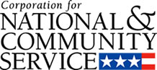

Corporation for National and Community Service

General Program Overview
AmeriCorps provides resources, both human and financial, to organizations that engage Americans in intensive service to meet our country’s critical needs.
Grantees use the funding to support AmeriCorps members for intensive service in their community. AmeriCorps grants partially cover the expense of operating an AmeriCorps program and do not cover general organizational expenses. A cash and in-kind match is required.

The main website can be accessed here: http://www.nationalservice.gov

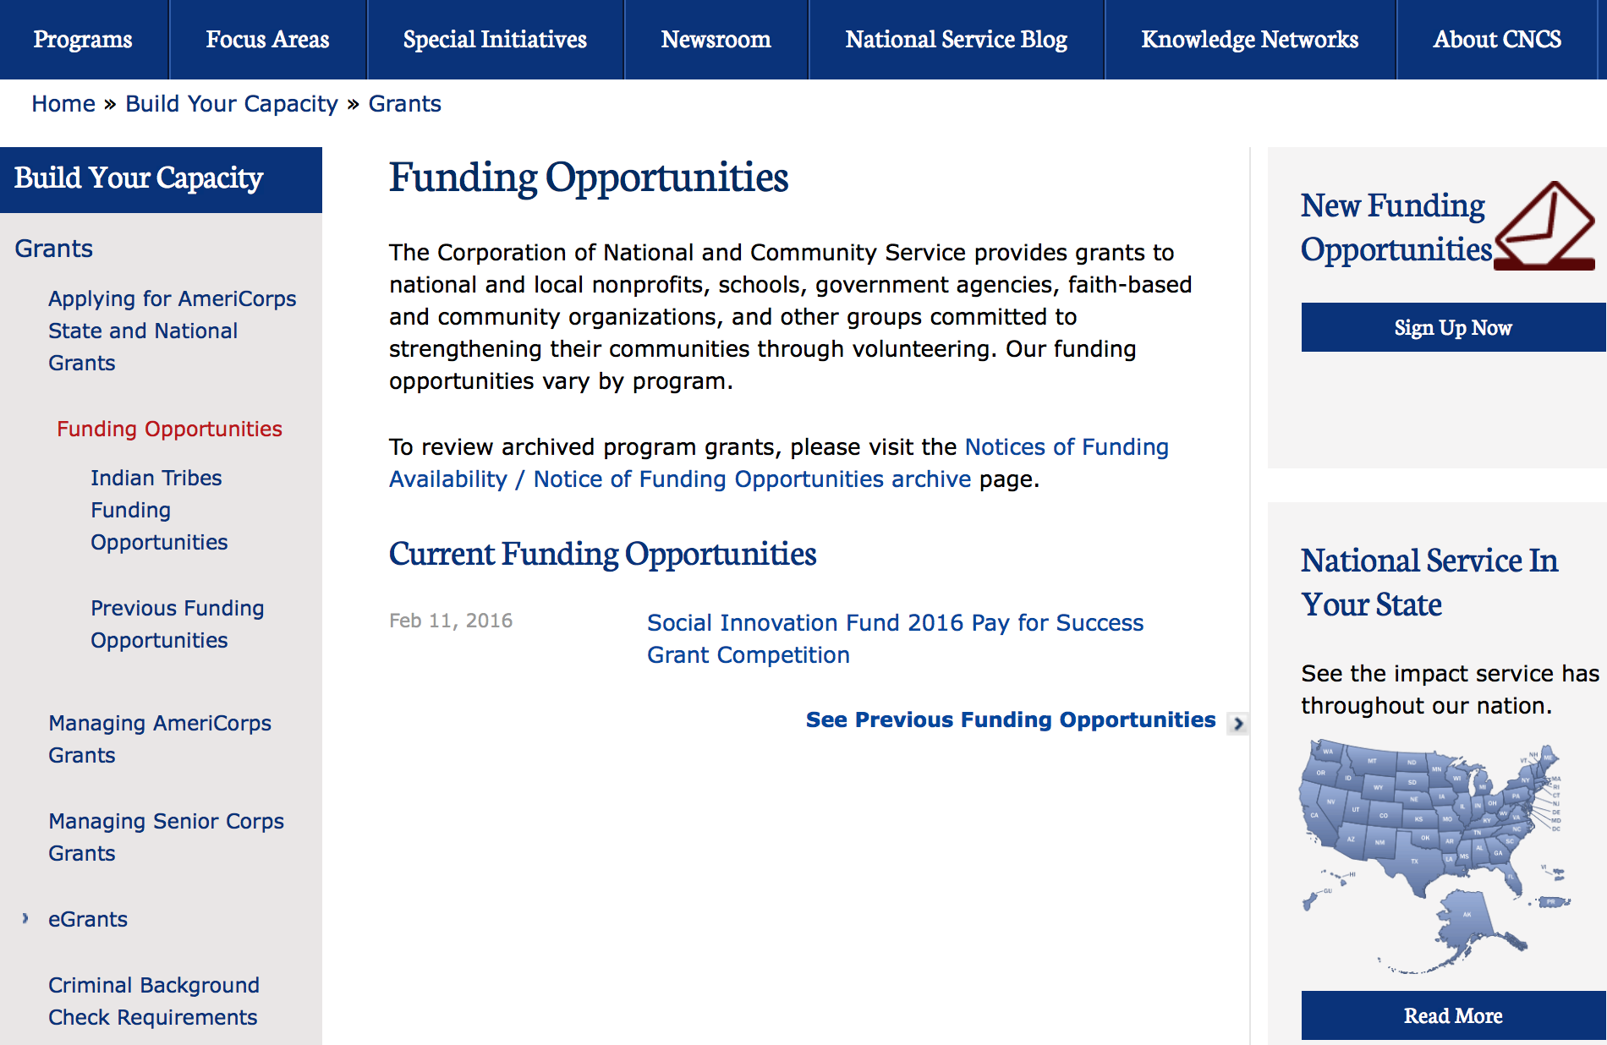

For access to further funding information: click here

http://www.nationalservice.gov/build-your-capacity/grants/funding-opportunities

Programs:

CNCS
Corporation for National and Community Service
2017 Day of Service Grants
Synopsis 1

Document Type: | Grants Notice
Funding Opportunity Number: | CNCS-12-16-16
Funding Opportunity Title: | 2017 Day of Service Grants
Opportunity Category: | Discretionary
Opportunity Category Explanation:
Funding Instrument Type: | Grant
Category of Funding Activity: | Disaster Prevention and Relief  Environment  Health  Housing  Other (see text field entitled "Explanation of Other Category of Funding Activity" for clarification)
Category Explanation: | Volunteerism
Expected Number of Awards: | 15
CFDA Number(s): | 94.012 -- September 11th National Day of Service and Remembrance Grants  94.014 -- Martin Luther King Jr Day of Service Grants
Cost Sharing or Matching Requirement: | Yes
Version: | Synopsis 1
Posted Date: | Dec 16, 2016
Last Updated Date: | Dec 16, 2016
Original Closing Date for Applications: | Feb 22, 2017
Current Closing Date for Applications: | Feb 22, 2017
Archive Date: | Feb 23, 2017
Estimated Total Program Funding:
Award Ceiling: | $150,000
Award Floor: | $50,000
Eligible Applicants: | Independent school districts  County governments  Private institutions of higher education  State governments  Nonprofits that do not have a 501(c)(3) status with the IRS, other than institutions of higher education  Public and State controlled institutions of higher education  Native American tribal governments (Federally recognized)  Native American tribal organizations (other than Federally recognized tribal governments)  Nonprofits having a 501(c)(3) status with the IRS, other than institutions of higher education  City or township governments
Agency Name: | Corporation for National and Community Service
Description: | The Day of Service grant competition includes funding for both September 11th Day of Service and Remembrance (September 11th) and Martin Luther King Jr. Day of Service (MLK). Applicant organizations may apply for either September 11th, MLK, or both. Applicants may not submit more than one application for each Day of Service. The purpose of the September 11th National Day of Service and Remembrance grant funding is to mobilize more Americans to engage in service activities that meet vital community needs and honor the sacrifice of those who lost their lives on September 11, 2001, or who rose in service as a result of that tragedy. The purpose of the Martin Luther King Jr. Day of Service grant funding is to mobilize more Americans to observe the Martin Luther King Jr. federal holiday as a day of service in communities, to encourage those who serve on this holiday to make a long-term commitment to community service, and to bring people together to focus on service to others.
Link to Additional Information: | Full competition information and resources
Grantor Contact Information: | If you have difficulty accessing the full announcement electronically, please contact:  dayofservice@cns.gov  Competition email

http://www.grants.gov/web/grants/view-opportunity.html?oppId=290757

Research:

Reminders:

National Service In Hawaii
National Service in Your State - Hawaii
2015-2016

Meeting Community Needs in Hawaii: More than 3,100 people of all ages and backgrounds are helping to meet local needs, strengthen communities, and increase civic engagement through national service in Hawaii. Serving at more than 450 locations throughout the state, these citizens tutor and mentor children, support veterans and military families, provide health services, restore the environment, respond to disasters, increase economic opportunity, and recruit and manage volunteers. This year, the Corporation for National and Community Service (CNCS) will commit more than $6,260,000 to support Hawaii communities through national service initiatives. Through a unique public-private partnership, this federal investment will leverage an additional $9,060,000 in other resources to strengthen community impact, build local support, and increase return on taxpayer dollars. Nationwide, CNCS, its grantees, and project sponsors generated more than $1.25 billion in outside resources from businesses, foundations, public agencies, and other sources in FY 2015.

AmeriCorps
This year, AmeriCorps will provide more than 560 individuals the opportunity to provide intensive, results-driven service to meet education, environmental, health, economic, and other pressing needs in communities across Hawaii. Most AmeriCorps grant funding goes to the Hawaii Commission on National & Community Service, which in turn awards grants to nonprofit groups to respond to local needs. Most of the remainder of the grant funding is distributed by CNCS directly to multi-state and national organizations through a competitive grants process. Other individuals serve through AmeriCorps VISTA, whose members help bring individuals and communities out of poverty by serving full-time to fight illiteracy, improve health services, create businesses, and increase housing opportunities, and AmeriCorps NCCC (National Civilian Community Corps), a 10-month, full time residential program for men and women between the ages of 18 and 24. In exchange for their service, AmeriCorps members earn an education award that can be used to pay for college or to pay back qualified student loans. Since 1994, more than 5,900 Hawaii residents have served more than 6.4 million hours and have qualified for Segal AmeriCorps Education Awards totaling more than $14,980,000.
Download: AmeriCorps in Hawaii (PDF)
Senior Corps
More than 2,500 seniors in Hawaii contribute their time and talents in one of three Senior Corps programs. Foster Grandparents serve one-on-one as tutors and mentors to more than 310 young people who have special needs. Senior Companions help more than 220 homebound seniors and other adults maintain independence in their own homes. RSVP volunteers conduct safety patrols, renovate homes, protect the environment, tutor and mentor youth, respond to natural disasters, and provide other services through more than 250 groups across Hawaii.
Download: Senior Corps in Hawaii (PDF)

The Corporation for National and Community Service is a federal agency that improves lives, strengthens communities, and fosters civic engagement through service and volunteering. CNCS annually engages more than five million Americans in service to meet local needs through Senior Corps, AmeriCorps, and national days of service; improves communities through the Social Innovation Fund, and leads President Obama's national call to service initiative, United We Serve. To learn more visit NationalService.gov or Serve.gov or call 202-606-5000 or TTY 1-800-833-3722.

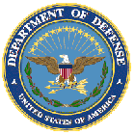

U.S. Department of Defense

Doing Business with the Department of Defense

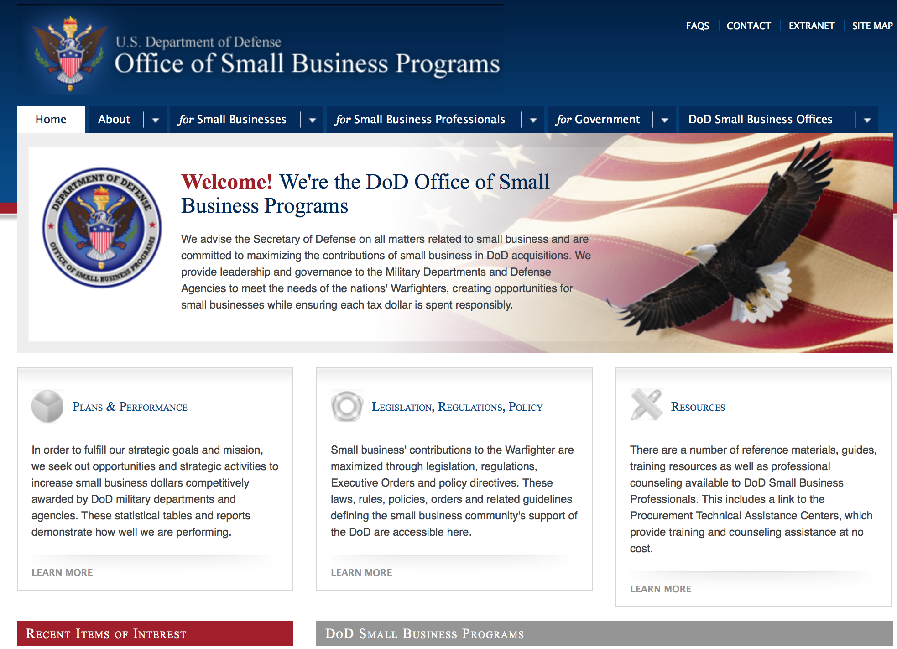

http://www.acq.osd.mil/osbp/

Doing Business with the DoD

Resources

Procurement Technical Assistance Centers (PTACs)

Procurement Technical Assistance Centers (PTACs) are charged with assisting businesses in learning how to do business with federal, state, and local governments. PTACs are a local resource available at no or nominal cost that can provide assistance to business firms in marketing their products and services. They offer training to businesses on how to research and bid on contracts, assist with registration requirements, provide bid-matching services, and assist with pre and post contracting issues.

Prime Contractors with Subcontracting Plans [xlsx]

Directory updated 4/19/11

This FY 2014 directory is intended for small business concerns seeking opportunities with DoD prime contractors. The directory is a listing of large business prime contractors who are required to establish subcontracting plans with goals. The report is generated from data contained in the Individual Subcontract Reports (ISRs) submitted in the Electronic Subcontracting Reporting System (eSRS) by contractors and from data contained in the Federal Procurement Data System (FPDS). The directory includes the name of the prime contractor; the major product/service code (PSC) provided to DoD; the major NAICS of the company; name, telephone number and email address of the company’s point of contact; contract number with the effective date and completion date, ultimate contract value and obligated dollars. In addition, many companies have websites with additional information which may be useful in your search for subcontracting opportunities or teaming arrangements.

Locate a Small Business Professional

Small Business Professionals serve as the primary liaison between private-sector small businesses seeking to do business with government agencies. Specialists advise small businesses regarding current acquisitions contracts available from the federal government.

Procurement Forecasts & the Department of Defense

The Department of Defense, due to its size and scope, does not have a single, comprehensive source for future procurements. Procurements are made locally and within the various services and agencies.

Business Intelligence, relative to future procurement planning, would be gathered at the local level.

For the purposes of forecasting, knowledge of past behavior is useful. Click here for a table of DoD acquisitions in FY10 summarized by NAICS code. The FY10 data has been validated but FPDS data is dynamic and changes continuously.

Non-Appropriated Fund Customers

Non-appropriated fund customers operate similar to non-profit organizations and include commissaries, exchanges, recreation and fitness centers, dining at officer/enlisted/civilian clubs, and barber/beauty services, just to name a few. For more information click here.

Research:

DARPA - Defense Sciences Office
Agile Teams (A-Teams)
Synopsis 1
http://www.grants.gov/web/grants/view-opportunity.html?oppId=290493

DARPA - Microsystems Technology Office
A MEchanically Based Antenna (AMEBA)
Synopsis 1
http://www.grants.gov/web/grants/view-opportunity.html?oppId=290736

Office of Naval Research
Office of Naval Research (ONR) Immersive Sciences for Training, Education, Mission Rehearsal, and Operations
Synopsis 1
http://www.grants.gov/web/grants/view-opportunity.html?oppId=290978

Office of Naval Research
Electronic Warfare Technology
Synopsis 1
http://www.grants.gov/web/grants/view-opportunity.html?oppId=290817

Office of Naval Research
Office of Naval Research (ONR) Additive Manufacturing Alloys for Naval Environments (AMANE)
Synopsis 1
http://www.grants.gov/web/grants/view-opportunity.html?oppId=290665

Modifications:

DARPA - Strategic Technology Office
Strategic Technologies
Synopsis 2
http://www.grants.gov/web/grants/view-opportunity.html?oppId=280674

Dept. of the Army -- USAMRAA
DoD USAMRMC FY17 Broad Agency Announcement for Extramural Medical Research
Synopsis 2
http://www.grants.gov/web/grants/view-opportunity.html?oppId=289274

DARPA - Microsystems Technology Office
Common Heterogeneous Integration and IP Reuse Strategies (CHIPS)
Synopsis 4
http://www.grants.gov/web/grants/view-opportunity.html?oppId=289238

Office of Naval Research
SSBN Security Technology
Synopsis 5
http://www.grants.gov/web/grants/view-opportunity.html?oppId=279399

Reminders:

Dept. of the Army -- Materiel Command
Army Research Office Broad Agency Announcement for Basic and Applied Scientific Research
Modification 8

Document Type: | Grants Notice
Funding Opportunity Number: | W911NF-12-R-0012
Funding Opportunity Title: | Army Research Office Broad Agency Announcement for Basic and Applied Scientific Research
Opportunity Category: | Discretionary
Funding Instrument Type: | Cooperative Agreement  Grant  Other  Procurement Contract
Category of Funding Activity: | Science and Technology and other Research and Development
Category Explanation:
Expected Number of Awards: | 1000
CFDA Number(s): | 12.431 -- Basic Scientific Research
Cost Sharing or Matching Requirement: | No
Posted Date: | Mar 27, 2015
Creation Date: | Mar 27, 2015
Original Closing Date for Applications: | Mar 31, 2017
Current Closing Date for Applications: | Mar 31, 2017
Archive Date: | Apr 30, 2017
Eligible Applicants: | Unrestricted (i.e., open to any type of entity above), subject to any clarification in text field entitled "Additional Information on Eligibility"
Agency Name: | Dept. of the Army -- Materiel Command
Description: | The purpose of this Broad Agency Announcement (BAA) is to solicit research proposals in the engineering, physical, life, and information sciences for submission to the Army Research Office (ARO) for consideration for possible funding. For ease of reference, this BAA is an extraction of the ARO sections of the Army Research Laboratory BAA. (www.arl.army.mil/www/default.cfm?page=8).
Link to Additional Information: | ARO CORE BAA-W911NF-12-R-0012-Mod 03
Contact Information: | If you have difficulty accessing the full announcement electronically, please contact:  ANDREW L. FISKE Procurement Analyst Army Contracting Command Aberdeen Proving Ground Research Triangle Park Division Phone: (919) 549-4338 FAX: (919) 549-4388 andrew.l.fiske.civ@mail.mil  Administrative POC

http://www.grants.gov/web/grants/view-opportunity.html?oppId=173593



Department of Education

Grant Programs Overview at the Department of Education

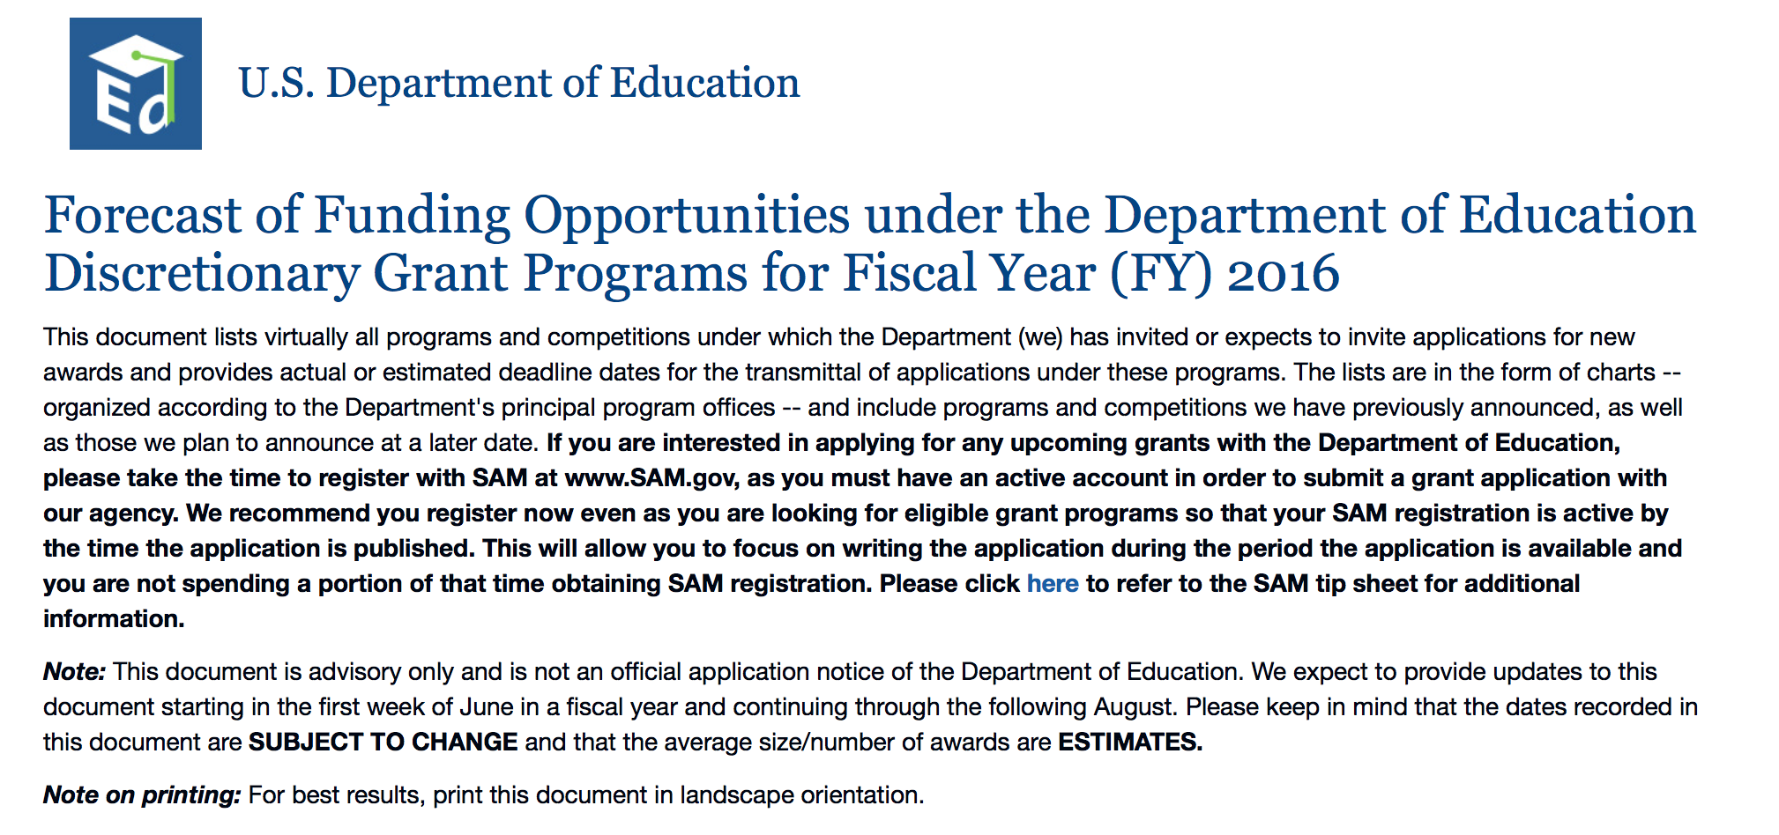To see the complete document click here: http://www2.ed.gov/fund/grant/find/edlite-forecast.html

The general information page for Education Grant funding is an excellent resource describing the three types of grants awarded by the Department of Education. See the screen shot of the Department of Education web page below:

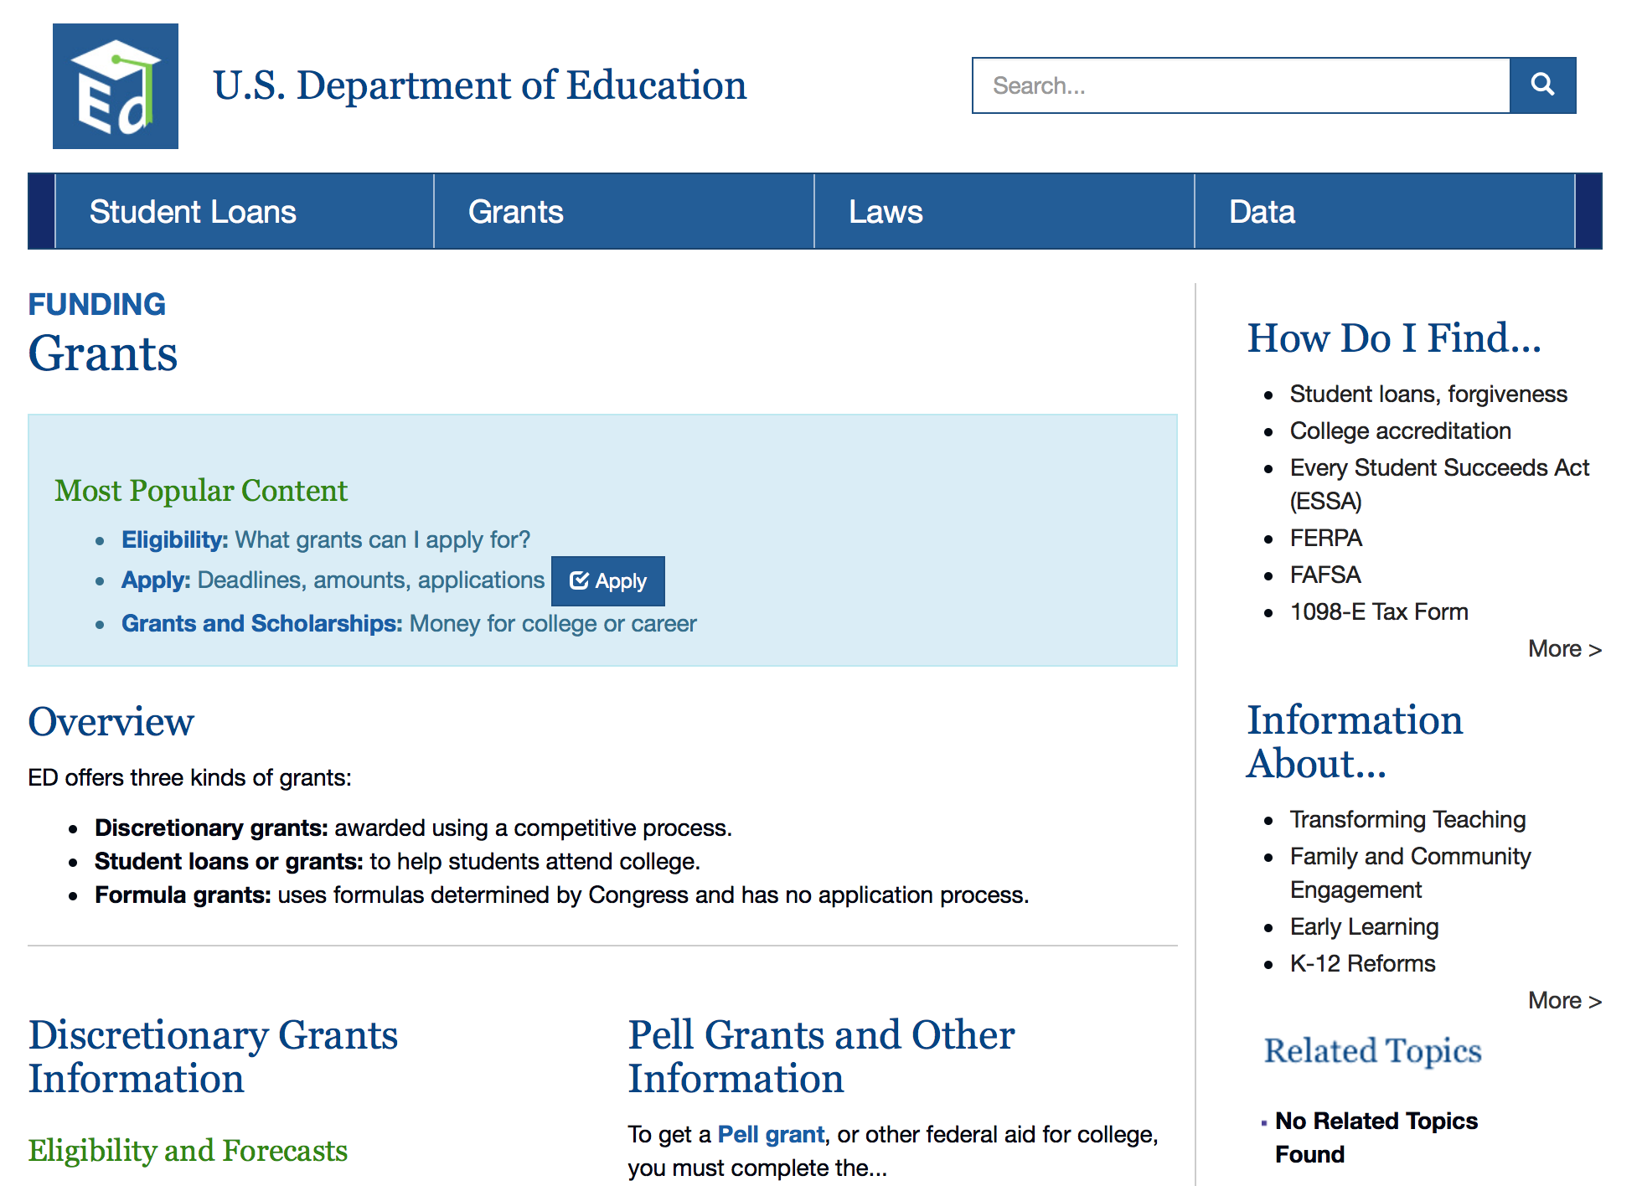

http://www.ed.gov/fund/grants-apply.html

Programs:

OSERS-OSEP: Preparation of Special Education, Early Intervention, and Related Services Leadership Personnel CFDA Number 84.325D
Synopsis 1

Document Type: | Grants Notice
Funding Opportunity Number: | ED-GRANTS-120716-001
Funding Opportunity Title: | OSERS-OSEP: Preparation of Special Education, Early Intervention, and Related Services Leadership Personnel CFDA Number 84.325D
Opportunity Category: | Discretionary
Opportunity Category Explanation:
Funding Instrument Type: | Grant
Category of Funding Activity: | Education
Category Explanation:
Expected Number of Awards: | 13
CFDA Number(s): | 84.325 -- Special Education - Personnel Development to Improve Services and Results for Children with Disabilities
Cost Sharing or Matching Requirement: | No
Version: | Synopsis 2
Posted Date: | Dec 07, 2016
Last Updated Date: | Dec 12, 2016
Original Closing Date for Applications: | Feb 06, 2017 Applications Available: December 7, 2016. Deadline for Transmittal of Applications: February 6, 2017.
Current Closing Date for Applications: | Feb 06, 2017 Applications Available: December 7, 2016. Deadline for Transmittal of Applications: February 6, 2017.
Archive Date: | Mar 08, 2017
Estimated Total Program Funding: | $3,250,000
Award Ceiling: | $250,000
Eligible Applicants: | Nonprofits that do not have a 501(c)(3) status with the IRS, other than institutions of higher education  Private institutions of higher education  Others (see text field entitled "Additional Information on Eligibility" for clarification)  Nonprofits having a 501(c)(3) status with the IRS, other than institutions of higher education  Public and State controlled institutions of higher education
Additional Information on Eligibility: | Eligible Applicants: IHEs, private nonprofit organizations.
Agency Name: | Department of Education
Description: | Note: Each funding opportunity description is a synopsis of information in the Federal Register application notice. For specific information about eligibility, please see the official application notice. The official version of this document is the document published in the Federal Register. Free Internet access to the official edition of the Federal Register and the Code of Federal Regulations is available on GPO Access at: http://www.access.gpo.gov/nara/index.html. Please review the official application notice for pre-application and application requirements, application submission information, performance measures, priorities and program contact information.Purpose of Program: The purposes of this program are to (1) help address State-identified needs for personnel preparation in special education, early intervention, related services, and regular education to work with children, including infants and toddlers, with disabilities; and (2) ensure that those personnel have the necessary skills and knowledge, derived from practices that have been determined through scientifically based research and experience, to be successful in serving those children. Catalog of Federal Domestic Assistance (CFDA) Number: 84.325D.Applications for grants under the Preparation of Special Education, Early Intervention, and Related Services Leadership Personnel competition, CFDA number 84.325D, must be submitted electronically using the Governmentwide Grants.gov Apply site at www.Grants.gov. Through this site, you will be able to download a copy of the application package, complete it offline, and then upload and submit your application. You may not email an electronic copy of a grant application to us. You may access the electronic grant application for the Preparation of Special Education, Early Intervention, and Related Services Leadership Personnel competition at www.Grants.gov. You must search for the downloadable application package for this competition by the CFDA number. Do not include the CFDA number's alpha suffix in your search (e.g., search for 84.325, not 84.325D).
Link to Additional Information:
Grantor Contact Information: | If you have difficulty accessing the full announcement electronically, please contact:  Julius Cotton ED Grants.gov FIND Systems Admin. Phone 202-245-6288 EducationGrantInquiries@ed.gov Program Manager: Celia Rosenquist, U.S. Department of Education, 400 Maryland Avenue SW., Room 5146, Potomac Center Plaza, Washington, DC 20202-5076. Telephone: (202) 245-7373 or e-Mail: Celia.Rosenquist@ed.gov.  e-Mail: Program Manager

http://www.grants.gov/web/grants/view-opportunity.html?oppId=290490

OSERS-OSEP: Training and Information for Parents of Children With Disabilities: Community Parent Resource Centers CFDA NUmber 84.328C
Synopsis 1

Document Type: | Grants Notice
Funding Opportunity Number: | ED-GRANTS-120716-002
Funding Opportunity Title: | OSERS-OSEP: Training and Information for Parents of Children With Disabilities: Community Parent Resource Centers CFDA Number 84.328C
Opportunity Category: | Discretionary
Opportunity Category Explanation:
Funding Instrument Type: | Grant
Category of Funding Activity: | Education
Category Explanation:
Expected Number of Awards: | 7
CFDA Number(s): | 84.328 -- Special Education Parent Information Centers
Cost Sharing or Matching Requirement: | No
Version: | Synopsis 1
Posted Date: | Dec 07, 2016
Last Updated Date: | Dec 07, 2016
Original Closing Date for Applications: | Feb 06, 2017 Applications Available: December 7, 2016. Deadline for Transmittal of Applications: February 6, 2017.
Current Closing Date for Applications: | Feb 06, 2017 Applications Available: December 7, 2016. Deadline for Transmittal of Applications: February 6, 2017.
Archive Date: | Mar 08, 2017
Estimated Total Program Funding: | $700,000
Award Ceiling: | $100,000
Eligible Applicants: | Others (see text field entitled "Additional Information on Eligibility" for clarification)
Additional Information on Eligibility: | Eligible Applicants: Local parent organizations. NOTE: Section 672(a)(2) of IDEA defines a ``local parent organization'' as a parent organization, as defined in section 671(a)(2), that-- (a) Has a board of directors the majority of whom are parents of children with disabilities ages birth through 26 from the community to be served; and (b) Has as its mission serving families of children with disabilities who-- (i) Are ages birth through 26; and (ii) Have the full range of disabilities described in section 602(3) of IDEA.
Agency Name: | Department of Education
Description: | Note: Each funding opportunity description is a synopsis of information in the Federal Register application notice. For specific information about eligibility, please see the official application notice. The official version of this document is the document published in the Federal Register. Free Internet access to the official edition of the Federal Register and the Code of Federal Regulations is available on GPO Access at: http://www.access.gpo.gov/nara/index.html. Please review the official application notice for pre-application and application requirements, application submission information, performance measures, priorities and program contact information. Purpose of Program: The purpose of this program is to ensure that parents of children with disabilities receive training and information to help improve results for their children. Catalog of Federal Domestic Assistance (CFDA) Number: 84.328C. Applications for grants under the Community Parent Resource Centers competition, CFDA number 84.328C, must be submitted electronically using the Governmentwide Grants.gov Apply site at www.Grants.gov. Through this site, you will be able to download a copy of the application package, complete it offline, and then upload and submit your application. You may not email an electronic copy of a grant application to us. You may access the electronic grant application for the Community Parent Resource Centers competition at www.Grants.gov. You must search for the downloadable application package for this competition by the CFDA number. Do not include the CFDA number's alpha suffix in your search (e.g., search for 84.328, not 84.328C).
Link to Additional Information: | OSERS-OSEP: Training and Information for Parents of Children With Disabilities: Community Parent Resource Centers CFDA Number 84.328C; Notice inviting applications for new awards for fiscal year (FY) 2017
Grantor Contact Information: | If you have difficulty accessing the full announcement electronically, please contact:  Julius Cotton ED Grants.gov FIND Systems Admin. Phone 202-245-6288 EducationGrantInquiries@ed.gov Program Manager: Carmen Sanchez, U.S. Department of Education, 400 Maryland Avenue SW., Room 5175, Potomac Center Plaza, Washington, DC 20202-5076. Telephone: (202) 245-6595 or e-Mail: Carmen.Sanchez@ed.gov.  e-Mail: Program Manager

http://www.grants.gov/web/grants/view-opportunity.html?oppId=290532

Magnet Schools Assistance Program (MSAP) CFDA Number 84.165A
Synopsis 1

Document Type: | Grants Notice
Funding Opportunity Number: | ED-GRANTS-121316-001
Funding Opportunity Title: | Office of Innovation and Improvement (OII): Magnet Schools Assistance Program (MSAP) CFDA Number 84.165A
Opportunity Category: | Discretionary
Opportunity Category Explanation:
Funding Instrument Type: | Grant
Category of Funding Activity: | Education
Category Explanation:
Expected Number of Awards: | 30
CFDA Number(s): | 84.165 -- Magnet Schools Assistance
Cost Sharing or Matching Requirement: | No
Version: | Synopsis 4
Posted Date: | Dec 13, 2016
Last Updated Date: | Dec 28, 2016
Original Closing Date for Applications: | Apr 11, 2017 Applications Available: December 13, 2016. Deadline for Notice of Intent To Apply: January 9, 2017. Deadline for Transmittal of Applications: April 11, 2017.
Current Closing Date for Applications: | Apr 11, 2017 Applications Available: December 13, 2016.Deadline for Notice of Intent To Apply: January 9, 2017.Deadline for Transmittal of Applications: April 11, 2017.
Archive Date: | May 11, 2017
Estimated Total Program Funding: | $90,582,483
Eligible Applicants: | Others (see text field entitled "Additional Information on Eligibility" for clarification)
Additional Information on Eligibility: | Eligible Applicants: LEAs or consortia of LEAs implementing a desegregation plan as specified in section III. 3 of this notice.
Agency Name: | Department of Education
Description: | Note: Each funding opportunity description is a synopsis of information in the Federal Register application notice. For specific information about eligibility, please see the official application notice. The official version of this document is the document published in the Federal Register. Free Internet access to the official edition of the Federal Register and the Code of Federal Regulations is available on GPO Access at: http://www.access.gpo.gov/nara/index.html. Please review the official application notice for pre-application and application requirements, application submission information, performance measures, priorities and program contact information. Purpose of Program: The MSAP, authorized under Title IV, Part D of the Elementary and Secondary Education Act (ESEA), as amended by the Every Student Succeeds Act (ESSA), provides grants to local educational agencies (LEAs) and consortia of LEAs to support magnet schools under an approved, required or voluntary, desegregation plan. Applications for grants under MSAP, CFDA number 84.165A, must be submitted electronically using the Governmentwide Grants.gov Apply site at www.Grants.gov. Through this site, you will be able to download a copy of the application package, complete it offline, and then upload and submit your application. You may not email an electronic copy of a grant application to us. You may access the electronic grant application for MSAP at www.Grants.gov. You must search for the downloadable application package for this program by the CFDA number. Do not include the CFDA number's alpha suffix in your search (e.g., search for 84.165, not 84.165A).
Link to Additional Information: | Magnet Schools Assistance Program (MSAP) CFDA Number 84.165A
Grantor Contact Information: | If you have difficulty accessing the full announcement electronically, please contact:  Joyce Mays Management Analyst Phone 202-245-6122 joyce.mays@ed.gov Program Manager: Jennifer Todd  Program Manager:email

http://www.grants.gov/web/grants/view-opportunity.html?oppId=290629

Office of Elementary and Secondary Education (OESE): Opening Doors, Expanding Opportunities CFDA Number 84.377C
Synopsis 1 & 2

Document Type: | Grants Notice
Funding Opportunity Number: | ED-GRANTS-121416-001
Funding Opportunity Title: | Office of Elementary and Secondary Education (OESE): Opening Doors, Expanding Opportunities CFDA Number 84.377C
Opportunity Category: | Discretionary
Opportunity Category Explanation:
Funding Instrument Type: | Grant
Category of Funding Activity: | Education
Category Explanation:
Expected Number of Awards: | 20
CFDA Number(s): | 84.377 -- School Improvement Grants
Cost Sharing or Matching Requirement: | No
Version: | Synopsis 2
Posted Date: | Dec 14, 2016
Last Updated Date: | Dec 15, 2016
Original Closing Date for Applications: | Feb 13, 2017 Applications Available: December 14, 2016. Date of Pre-Application Webinar: January 5, 2017. Deadline for Notice of Intent to Apply (optional): January 13, 2017. Deadline for Transmittal of Applications: February 13, 2017.
Current Closing Date for Applications: | Feb 13, 2017 Applications Available: December 14, 2016.Date of Pre-Application Webinar: January 5, 2017.Deadline for Notice of Intent to Apply (optional): January 13, 2017.Deadline for Transmittal of Applications: February 13, 2017.
Archive Date: | Mar 15, 2017
Estimated Total Program Funding: | $12,000,000
Eligible Applicants: | Others (see text field entitled "Additional Information on Eligibility" for clarification)
Additional Information on Eligibility: | Eligible Applicants: (a) An LEA with at least one SIG School or SIG-Eligible School; and (b) a consortium of LEAs, each with at least one SIG School or SIG-Eligible School in each member LEA.
Agency Name: | Department of Education
Description: | Note: Each funding opportunity description is a synopsis of information in the Federal Register application notice. For specific information about eligibility, please see the official application notice. The official version of this document is the document published in the Federal Register. Free Internet access to the official edition of the Federal Register and the Code of Federal Regulations is available on GPO Access at: http://www.access.gpo.gov/nara/index.html. Please review the official application notice for pre-application and application requirements, application submission information, performance measures, priorities and program contact information. Purpose of Program In an effort to support the implementation of effective school improvement strategies, the U.S. Department of Education (Department) is using a portion of its FY 2016 School Improvement Grants (SIG) national activities funds to initiate the FY 2017 grant competition for the Opening Doors, Expanding Opportunities program. Applications for grants under the Opening Doors, Expanding Opportunities program must be submitted electronically using the Governmentwide Grants.gov Apply site at www.Grants.gov. You may access the electronic grant application for Opening Doors, Expanding Opportunities at www.Grants.gov. You must search for the downloadable application package for this competition by the CFDA number. Do not include the CFDA number's alpha suffix in your search (e.g., search for 84.377, not 84.377C).
Link to Additional Information: | Office of Elementary and Secondary Education Opening Doors, Expanding CFDA Number 84.377C
Grantor Contact Information: | If you have difficulty accessing the full announcement electronically, please contact:  Joyce Mays Management Analyst Phone 202-245-6122 joyce.mays@ed.gov Program Manager:  Program Manager:e-mail

http://www.grants.gov/web/grants/view-opportunity.html?oppId=290698

Office of Innovation and Improvement (OII): Teacher and School Leader Incentive Program CFDA Number 84.374A
Synopsis 1

Document Type: | Grants Notice
Funding Opportunity Number: | ED-GRANTS-122016-001
Funding Opportunity Title: | Office of Innovation and Improvement (OII): Teacher and School Leader Incentive Program CFDA Number 84.374A
Opportunity Category: | Discretionary
Opportunity Category Explanation:
Funding Instrument Type: | Grant
Category of Funding Activity: | Education
Category Explanation:
Expected Number of Awards: | 15
CFDA Number(s): | 84.374 -- Teacher and School Leader Incentive Grants (formerly the Teacher Incentive Fund)
Cost Sharing or Matching Requirement: | Yes
Version: | Synopsis 1
Posted Date: | Dec 20, 2016
Last Updated Date: | Dec 20, 2016
Current Closing Date for Applications: | Mar 24, 2017 Applications Available: December 20, 2016. Deadline for Notice of Intent to Apply: February 4, 2017. Notice of Intent to Apply: We will be able to develop a more efficient process for reviewing grant applications if we can anticipate the number of applicants that intend to apply for funding under this competition. Therefore, we strongly encourage each potential applicant to notify us of the applicant's intent to submit an application for funding by sending a short email message. This short email should provide (1) the applicant organization's name and address; and (2) all priorities the applicant intends to address. Please send this email notification to TSL@ed.gov with ``Intent to Apply'' in the email subject line. Applicants that do not provide this email notification may still apply for funding and are not required to, or prohibited from, addressing priorities they do not mention in their notice of intent to apply. Dates of Pre-Application Workshops: For information about pre-application workshops, visit the TSL Web site at: http://innovation.ed.gov/what-we-do/teacher-quality/teacher-incentive-fund/. Pre-application workshops will be held for this competition shortly after the date that this notice will publish. The workshops are intended to provide technical assistance to all interested grant applicants. Detailed information regarding the pre-application workshops times, and online registration form, can be found on the TSL Web site at: http://innovation.ed.gov/what-we-do/teacher-quality/teacher-incentive-fund/. Deadline for Transmittal of Applications: March 24, 2017.
Archive Date: | Apr 23, 2017
Estimated Total Program Funding: | $159,000,000
Eligible Applicants: | Others (see text field entitled "Additional Information on Eligibility" for clarification)
Additional Information on Eligibility: | 1. Eligible Applicants: (a) An LEA, including a charter school that is an LEA, or a consortium of LEAs. (b) An SEA or other State agency designated by the Chief Executive of a State to participate. (c) The Bureau of Indian Education; or (d) A partnership consisting of-- (i) One or more agencies described in subparagraph (a), (b), or (c); and (ii) At least one nonprofit organization as defined in 2 CFR 200.70 or at least one for-profit entity.
Agency Name: | Department of Education
Description: | Note: Each funding opportunity description is a synopsis of information in the Federal Register application notice. For specific information about eligibility, please see the official application notice. The official version of this document is the document published in the Federal Register. Free Internet access to the official edition of the Federal Register and the Code of Federal Regulations is available on GPO Access at: http://www.access.gpo.gov/nara/index.html. Please review the official application notice for pre-application and application requirements, application submission information, performance measures, priorities and program contact information. Purpose of Program: The purpose of TSL is to assist States, local educational agencies (LEAs), and nonprofit organizations to develop, implement, improve, or expand comprehensive performance-based compensation systems or human capital management systems for teachers, principals, and other school leaders (especially for teachers, principals, and other school leaders in high-need schools) who raise student academic achievement and close the achievement gap between high- and low-performing students. In addition, a portion of TSL funds are dedicated to study the effectiveness, fairness, quality, consistency, and reliability of performance-based compensation systems or human capital management systems for teachers, principals, and other school leaders. Catalog of Federal Domestic Assistance (CFDA) Number: 84.374A. Applications for grants under TSL, CFDA number 84.374A, must be submitted electronically using the Government-wide Grants.gov Apply site at www.Grants.gov. Through this site, you will be able to download a copy of the application package, complete it offline, and then upload and submit your application. You may not email an electronic copy of a grant application to us. You may access the electronic grant application for the TSL competition at www.Grants.gov.You must search for the downloadable application package for this program by the CFDA number. Do not include the CFDA number's alpha suffix in your search (e.g., search for 84.374, not 84.374A).
Link to Additional Information: | Office of Innovation and Improvement (OII): Teacher and School Leader Incentive Program CFDA Number 84.374A; Notice inviting applications for new awards for fiscal year (FY) 2017
Grantor Contact Information: | If you have difficulty accessing the full announcement electronically, please contact:  Julius Cotton ED Grants.gov FIND Systems Admin. Phone 202-245-6288 EducationGrantInquiries@ed.gov Program Manager: Orman Feres, U.S. Department of Education, 400 Maryland Avenue SW., Room 4W109, Washington, DC 20202-6200. Telephone: (202) 453-6921 or by email: TSL@ed.gov.  e-Mail: Program Mailbox

http://www.grants.gov/web/grants/view-opportunity.html?oppId=290851

Office of Innovation and Improvement (OII): Supporting Effective Educator Development (SEED) Grant Program CFDA Number 84.367D
Synopsis 1
Document Type: | Grants Notice
Funding Opportunity Number: | ED-GRANTS-122116-001
Funding Opportunity Title: | Office of Innovation and Improvement (OII): Supporting Effective Educator Development (SEED) Grant Program CFDA Number 84.367D
Opportunity Category: | Discretionary
Opportunity Category Explanation:
Funding Instrument Type: | Grant
Category of Funding Activity: | Education
Category Explanation:
Expected Number of Awards: | 3
CFDA Number(s): | 84.367 -- Supporting Effective Instruction State Grant (formerly Improving Teacher Quality State Grants)
Cost Sharing or Matching Requirement: | No
Version: | Synopsis 1
Posted Date: | Dec 21, 2016
Last Updated Date: | Dec 21, 2016
Current Closing Date for Applications: | Mar 07, 2017 Applications Available: December 21, 2016. Deadline for Notice of Intent to Apply: January 20, 2017. The Department will be able to develop a more efficient process for reviewing grant applications if it has a better understanding of the number of entities that intend to apply for funding under this competition. Therefore, the Department strongly encourages each potential applicant to notify the Department by sending a short email message indicating the applicant's intent to submit an application for funding. The email need not include information regarding the content of the proposed application, only the applicant's intent to submit it. The Department requests that this email notification be sent to the SEED program inbox at: SEED@ed.gov. Eligible entities that fail to provide this email notification may still apply for funding. Date of Informational Webinar: The SEED program intends to hold a Webinar designed to provide technical assistance to interested applicants. Detailed information regarding this Webinar will be provided on the SEED Web site at http://innovation.ed.gov/what-we-do/teacher-quality/supporting-effective-educator-development-grant-program/. Deadline for Transmittal of Applications: March 7, 2017.
Archive Date: | Apr 06, 2017
Estimated Total Program Funding: | $40,000,000
Eligible Applicants: | Others (see text field entitled "Additional Information on Eligibility" for clarification)  Nonprofits having a 501(c)(3) status with the IRS, other than institutions of higher education  Nonprofits that do not have a 501(c)(3) status with the IRS, other than institutions of higher education
Additional Information on Eligibility: | 1. Eligible Applicants: As established in the SEED NFP (78 FR 9815), to be eligible for a SEED program grant, an entity must be a National Not-for-Profit Organization. Each applicant must provide in its application documentation that it is a National Not-for-Profit Organization.
Agency Name: | Department of Education
Description: | Note: Each funding opportunity description is a synopsis of information in the Federal Register application notice. For specific information about eligibility, please see the official application notice. The official version of this document is the document published in the Federal Register. Free Internet access to the official edition of the Federal Register and the Code of Federal Regulations is available on GPO Access at: http://www.access.gpo.gov/nara/index.html. Please review the official application notice for pre-application and application requirements, application submission information, performance measures, priorities and program contact information. Purpose of Program: The SEED program provides funding for grants to National Not-for-Profit Organizations for projects that support teacher or principal training or professional enhancement activities and that are supported by at least Moderate Evidence of Effectiveness. The purpose of the program is to increase the number of Highly Effective Teachers and Principals by developing or expanding the implementation of practices that are demonstrated to have an impact on improving Student Achievement or Student Growth. These grants will allow eligible entities to develop, expand, and evaluate practices that can serve as models that can be sustained and disseminated. Please note that on December 10, 2015, President Obama signed into law the Every Student Succeeds Act (ESSA), which reauthorized the Elementary and Secondary Education Act of 1965 (ESEA). ESSA provided specific statutory authority for the SEED program, under section 2242, for grant competitions beginning with funds appropriated for FY 2017. Accordingly, this FY 2016 SEED competition will be the final SEED competition under the statutory and regulatory provisions in effect prior to enactment of the ESSA. Consequently, except as noted, all references to the ESEA in this notice are to the ESEA as amended by the No Child Left Behind Act. Catalog of Federal Domestic Assistance (CFDA) Number: 84.367D Applications for grants under the SEED program, CFDA number 84.367D, must be submitted electronically using the Governmentwide Grants.gov Apply site at www.Grants.gov. Through this site, you will be able to download a copy of the application package, complete it offline, and then upload and submit your application. You may not email an electronic copy of a grant application to us. You may access the electronic grant application for the SEED program at www.Grants.gov. You must search for the downloadable application package for this competition by the CFDA number. Do not include the CFDA number's alpha suffix in your search (e.g., search for 84.367, not 84.367D).
Link to Additional Information: | Office of Innovation and Improvement (OII): Supporting Effective Educator Development (SEED) Grant Program CFDA Number 84.367D; Notice inviting applications for new awards for fiscal year (FY) 2016
Grantor Contact Information: | If you have difficulty accessing the full announcement electronically, please contact:  Julius Cotton ED Grants.gov FIND Systems Admin. Phone 202-245-6288 EducationGrantInquiries@ed.gov Program Manager: Margarita Mel[eacute]ndez, U.S. Department of Education, 400 Maryland Avenue SW., Room 4W115, Washington, DC 20202-5960. Telephone: (202) 260-3548, or by email: SEED@ed.gov.  e-Mail: Program Mailbox

http://www.grants.gov/web/grants/view-opportunity.html?oppId=290828

OSERS: OSEP: Interdisciplinary Preparation in Special Education, Early Intervention, and Related Services for Personnel Serving Children With Disabilities Who Have High-Intensity Needs CFDA Number 84.325K
Synopsis 1

Document Type: | Grants Notice
Funding Opportunity Number: | ED-GRANTS-010317-001
Funding Opportunity Title: | OSERS: OSEP: Interdisciplinary Preparation in Special Education, Early Intervention, and Related Services for Personnel Serving Children With Disabilities Who Have High-Intensity Needs CFDA Number 84.325K
Opportunity Category: | Discretionary
Opportunity Category Explanation:
Funding Instrument Type: | Grant
Category of Funding Activity: | Education
Category Explanation:
Expected Number of Awards: | 36
CFDA Number(s): | 84.325 -- Special Education - Personnel Development to Improve Services and Results for Children with Disabilities
Cost Sharing or Matching Requirement: | No
Version: | Synopsis 1
Posted Date: | Jan 03, 2017
Last Updated Date: | Jan 03, 2017
Original Closing Date for Applications: | Mar 06, 2017 Applications Available: January 3, 2017. Deadline for Transmittal of Applications: March 6, 2017.
Current Closing Date for Applications: | Mar 06, 2017 Applications Available: January 3, 2017. Deadline for Transmittal of Applications: March 6, 2017.
Archive Date: | Apr 05, 2017
Estimated Total Program Funding: | $9,000,000
Award Ceiling: | $250,000
Eligible Applicants: | Nonprofits having a 501(c)(3) status with the IRS, other than institutions of higher education  Nonprofits that do not have a 501(c)(3) status with the IRS, other than institutions of higher education  Public and State controlled institutions of higher education  Others (see text field entitled "Additional Information on Eligibility" for clarification)  Private institutions of higher education
Additional Information on Eligibility: | Eligible Applicants: IHEs, private nonprofit organizations
Agency Name: | Department of Education
Description: | Note: Each funding opportunity description is a synopsis of information in the Federal Register application notice. For specific information about eligibility, please see the official application notice. The official version of this document is the document published in the Federal Register. Free Internet access to the official edition of the Federal Register and the Code of Federal Regulations is available on GPO Access at: http://www.access.gpo.gov/nara/index.html. Please review the official application notice for pre-application and application requirements, application submission information, performance measures, priorities and program contact information. Purpose of Program: The purposes of this program are to (1) help address State-identified needs for personnel preparation in special education, early intervention, related services, and regular education to work with children, including infants and toddlers, with disabilities; and (2) ensure that those personnel have the necessary skills and knowledge, derived from practices that have been determined through scientifically based research and experience, to be successful in serving those children. Catalog of Federal Domestic Assistance (CFDA) Number: 84.325K. Applications for grants under the Interdisciplinary Preparation in Special Education, Early Intervention, and Related Services for Personnel Serving Children with Disabilities who have High-Intensity Needs competition, CFDA number 84.325K, must be submitted electronically using the Governmentwide Grants.gov Apply site at www.Grants.gov. Through this site, you will be able to download a copy of the application package, complete it offline, and then upload and submit your application. You may not email an electronic copy of a grant application to us. You may access the electronic grant application for the Interdisciplinary Preparation in Special Education, Early Intervention, and Related Services for Personnel Serving Children with Disabilities who have High-Intensity Needs competition at www.Grants.gov. You must search for the downloadable application package for this competition by the CFDA number. Do not include the CFDA number's alpha suffix in your search (e.g., search for 84.325, not 84.325K).
Link to Additional Information: | OSERS: OSEP: Interdisciplinary Preparation in Special Education, Early Intervention, and Related Services for Personnel Serving Children With Disabilities Who Have High-Intensity Needs CFDA Number 84.325K: Notice Inviting Applications for New Awards
Grantor Contact Information: | If you have difficulty accessing the full announcement electronically, please contact:  Julius Cotton ED Grants.gov FIND Systems Admin. Phone 202-245-6288 EducationGrantInquiries@ed.gov Program Manager: Maryann McDermott, U.S. Department of Education, 400 Maryland Avenue SW., Room 5144, Potomac Center Plaza, Washington, DC 20202-5108. Telephone: (202) 245-7439 or e-Mail: Maryann.McDermott@ed.gov.  e-Mail: Program Manager

http://www.grants.gov/web/grants/view-opportunity.html?oppId=291013

Research:

Office of Innovation and Improvement (OII): Education Innovation and Research Program--Early-phase Grants CFDA Number 84.411C
Synopsis 1
http://www.grants.gov/web/grants/view-opportunity.html?oppId=290711

Office of Innovation and Improvement (OII): Education Innovation and Research Program--Expansion Grants CFDA Number 84.411A
Synopsis 1
http://www.grants.gov/web/grants/view-opportunity.html?oppId=290713

Office of Innovation and Improvement (OII): Education Innovation and Research Program--Mid-phase Grants CFDA Number 84.411B
Synopsis 2
http://www.grants.gov/web/grants/view-opportunity.html?oppId=290708

Modifications:

Reminders:

Deleted:

U.S. Department of Energy



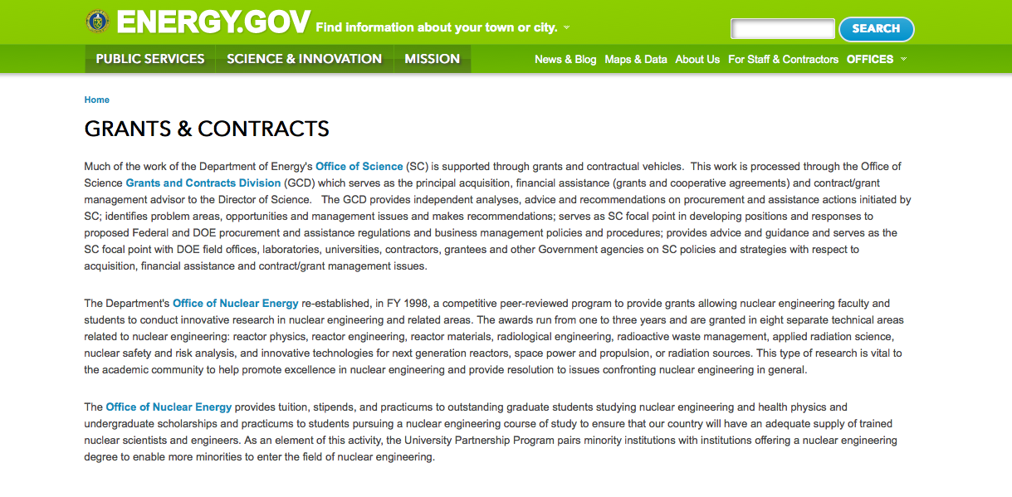
http://www.doe.gov/grants-contracts

Research:

Advanced Research Projects Agency Energy
MACROALGAE RESEARCH INSPIRING NOVEL ENERGY RESOURCES (MARINER)
Synopsis 1
http://www.grants.gov/web/grants/view-opportunity.html?oppId=290781

Golden Field Office
Marine and Hydrokinetic Technology Development and Advancement
Synopsis 1
http://www.grants.gov/web/grants/view-opportunity.html?oppId=290670

Golden Field Office
RFI: Draft Marine and Hydrokinetic Program Strategy
Synopsis 1
http://www.grants.gov/web/grants/view-opportunity.html?oppId=290878

Golden Field Office
Advanced Manufacturing Projects for Emerging Research Exploration
Synopsis 1
http://www.grants.gov/web/grants/view-opportunity.html?oppId=290880

Golden Field Office
Notice of Intent (NOI) DE-FOA-0001707 to Issue Funding Opportunity Announcement No. DE-FOA-0001689
Synopsis 1
http://www.grants.gov/web/grants/view-opportunity.html?oppId=290494

Golden Field Office
Notice of Intent to Issue Funding Opportunity Announcement: Extending Industrial Assessment Centers to Underserved Areas
Synopsis 1
http://www.grants.gov/web/grants/view-opportunity.html?oppId=290677

Golden Field Office
Funding Opportunity Announcement (FOA) Number: DE-FOA-0001628, “Productivity Enhanced Algae and Tool-Kits (PEAK)”
Synopsis 1
http://www.grants.gov/web/grants/view-opportunity.html?oppId=290717

Golden Field Office
Innovative Pathways
Synopsis 1
http://www.grants.gov/web/grants/view-opportunity.html?oppId=290826

National Energy Technology Laboratory
Support of Fossil Energy Research at U.S. Colleges and Universities Including University Coal Research (UCR) and Research by Historically Black Colleges and Universities and Other Minority Institutions (HBCU/OMI)
Synopsis 1
http://www.grants.gov/web/grants/view-opportunity.html?oppId=290836

National Energy Technology Laboratory
Regional Energy Technology Innovation Ecosystems Characterization Assessments
Synopsis 1
http://www.grants.gov/web/grants/view-opportunity.html?oppId=290979

National Energy Technology Laboratory
Fiscal Year 2017 Vehicle Technologies Program Wide Funding Opportunity Announcement
Synopsis 1
http://www.grants.gov/web/grants/view-opportunity.html?oppId=290715

National Energy Technology Laboratory
Fiscal Year 2017 Vehicle Technologies Deployment Funding Opportunity Announcement
Synopsis 1
http://www.grants.gov/web/grants/view-opportunity.html?oppId=290829

PAMS
Department of Energy - Office of Science
Subsurface Biogeochemical Research
Synopsis 1
http://www.grants.gov/web/grants/view-opportunity.html?oppId=290915

PAMS
Department of Energy - Office of Science
Scientific Discovery through Advanced Computing:
Synopsis 1
http://www.grants.gov/web/grants/view-opportunity.html?oppId=290660

Modifications:

Golden Field Office
Request for Information (RFI): Hydrogen and Fuel Cell Manufacturing: Identifying Specific Components for Manufacturing Standardization
Synopsis 3
http://www.grants.gov/web/grants/view-opportunity.html?oppId=290168

Golden Field Office
Deep Direct-Use Feasibility Studies
Synopsis 2
http://www.grants.gov/web/grants/view-opportunity.html?oppId=290110

National Energy Technology Laboratory
Fiscal Year 2017 Vehicle Technologies Deployment Funding Opportunity Announcement
Synopsis 2
http://www.grants.gov/web/grants/view-opportunity.html?oppId=290829

PAMS
Department of Energy - Office of Science
DE-FOA-0001674 - Scientific Discovery through Advanced Computing:
Deletion Comments: Synopsis deleted

Reminders:

PAMS
Department of Energy - Office of Science
Office of Science
FY 2017 Continuation of Solicitation for the Office of Science Financial Assistance Program
Synopsis 2

Document Type: | Grants Notice
Funding Opportunity Number: | DE-FOA-0001664
Funding Opportunity Title: | FY 2017 Continuation of Solicitation for the Office of Science Financial Assistance Program
Opportunity Category: | Discretionary
Opportunity Category Explanation:
Funding Instrument Type: | Cooperative Agreement  Grant
Category of Funding Activity: | Science and Technology and other Research and Development
Category Explanation:
Expected Number of Awards: | 200
CFDA Number(s): | 81.049 -- Office of Science Financial Assistance Program
Cost Sharing or Matching Requirement: | No
Version: | Synopsis 2
Posted Date: | Sep 30, 2016
Last Updated Date: | Oct 04, 2016
Original Closing Date for Applications: | Sep 30, 2017
Current Closing Date for Applications: | Sep 30, 2017
Archive Date: | Oct 30, 2017
Estimated Total Program Funding:
Award Ceiling: | $4,000,000
Award Floor: | $2,000
Eligible Applicants: | Unrestricted (i.e., open to any type of entity above), subject to any clarification in text field entitled "Additional Information on Eligibility"
Agency Name: | Office of Science
Description: | The Office of Science (SC) of the Department of Energy hereby announces its continuing interest in receiving grant applications for support of work in the following program areas: Advanced Scientific Computing Research, Basic Energy Sciences, Biological and Environmental Research, Fusion Energy Sciences, High Energy Physics, and Nuclear Physics. On September 3, 1992, DOE published in the Federal Register the Office of Energy Research Financial Assistance Program (now called the Office of Science Financial Assistance Program), 10 CFR 605, as a Final Rule, which contained a solicitation for this program. Information about submission of applications, eligibility, limitations, evaluation and selection processes and other policies and procedures are specified in 10 CFR 605.
Link to Additional Information: | http://science.energy.gov/~/media/grants/pdf/foas/2017/SC_FOA_0001664.pdf
Grantor Contact Information: | If you have difficulty accessing the full announcement electronically, please contact:  Kimberlie Laing Grant Analyst Phone 301-903-3026  kim.laing@science.doe.gov

http://www.grants.gov/web/grants/view-opportunity.html?oppId=289281

Environmental Protection Agency

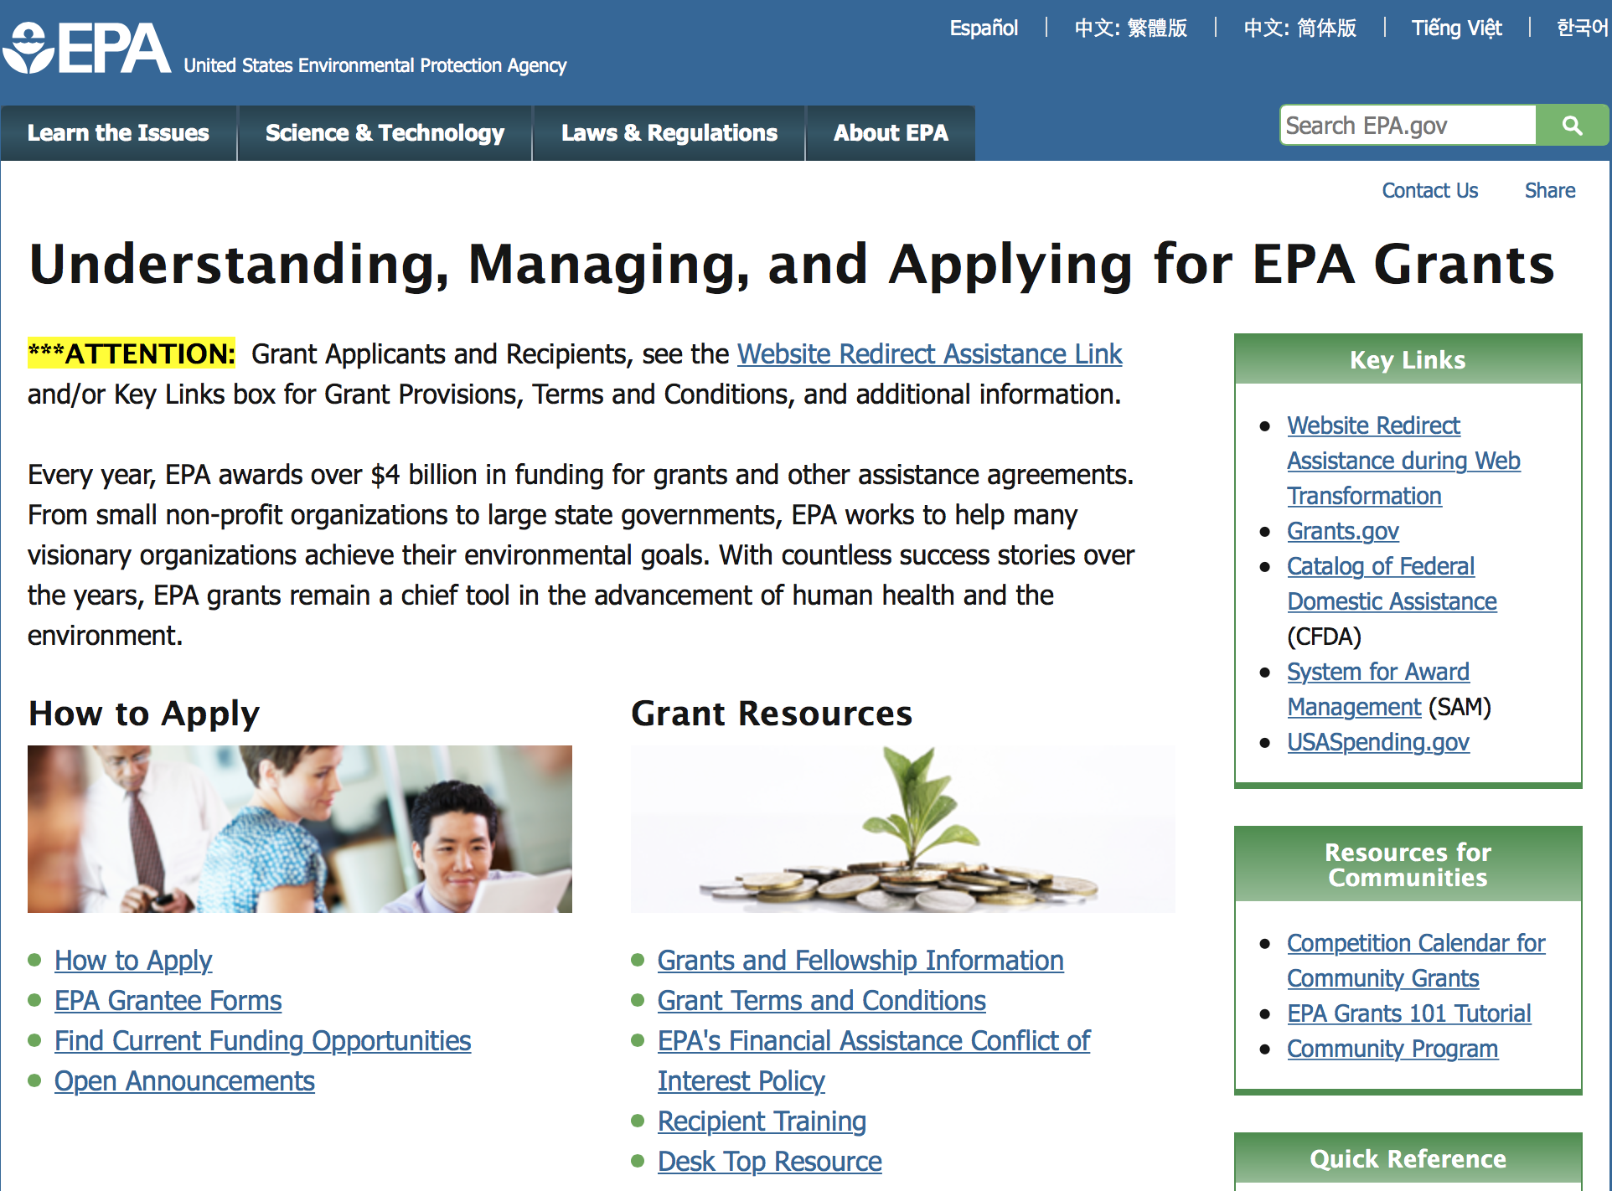

http://www.epa.gov/epahome/grants.htm

Programs:

FY17 ENVIRONMENTAL WORKFORCE DEVELOPMENT AND JOB TRAINING (EWDJT) GRANTS
Synopsis 1

Document Type: | Grants Notice
Funding Opportunity Number: | EPA-OLEM-OBLR-17-01
Funding Opportunity Title: | FY17 ENVIRONMENTAL WORKFORCE DEVELOPMENT AND JOB TRAINING (EWDJT) GRANTS
Opportunity Category: | Discretionary
Opportunity Category Explanation:
Funding Instrument Type: | Cooperative Agreement
Category of Funding Activity: | Environment
Category Explanation:
Expected Number of Awards: | 16
CFDA Number(s): | 66.815 -- Environmental Workforce Development and Job Training Cooperative Agreements
Cost Sharing or Matching Requirement: | No
Version: | Synopsis 1
Posted Date: | Dec 28, 2016
Last Updated Date: | Dec 28, 2016
Original Closing Date for Applications: | Feb 24, 2017 See Section IV of funding opportunity for additional close date information.
Current Closing Date for Applications: | Feb 24, 2017 See Section IV of funding opportunity for additional close date information.
Archive Date: | Mar 26, 2017
Estimated Total Program Funding: | $3,000,000
Award Ceiling: | $200,000
Eligible Applicants: | Others (see text field entitled "Additional Information on Eligibility" for clarification)
Additional Information on Eligibility: | See Section III of funding opportunity announcement for eligibility information.
Agency Name: | Environmental Protection Agency
Description: | This notice announces the availability of funds and solicits proposals from eligible entities, including nonprofit organizations, to deliver Environmental Workforce Development and Job Training programs that recruit, train, and place local, unemployed and under-employed residents with the skills needed to secure full-time employment in the environmental field. While Environmental Workforce Development and Job Training Grants require training in brownfield assessment and/or cleanup, these grants also require that Hazardous Waste Operations and Emergency Response (HAZWOPER) training be provided to all individuals being trained. EPA encourages applicants to develop their curricula based on local labor market assessments and employers’ hiring needs, while also delivering comprehensive training that results in graduates securing multiple certifications.
Link to Additional Information: | FY17 Environmental Workforce Development and Job Training (EWDJT) Grants
Grantor Contact Information: | If you have difficulty accessing the full announcement electronically, please contact:  Rachel Congdon; 1200 Pennsylvania Ave. N.W.; Mail Code: 5105T; Washington, D.C. 20460 Phone: (202) 566-1564.  congdon.rachel@epa.gov

http://www.grants.gov/web/grants/view-opportunity.html?oppId=290955

National Indoor Environments Program: Reducing Public Exposure to Indoor Pollutants
Synopsis 1 & 2

Document Type: | Grants Notice
Funding Opportunity Number: | EPA-OAR-ORIA-17-02
Funding Opportunity Title: | National Indoor Environments Program: Reducing Public Exposure to Indoor Pollutants
Opportunity Category: | Discretionary
Opportunity Category Explanation:
Funding Instrument Type: | Cooperative Agreement
Category of Funding Activity: | Environment
Category Explanation:
Expected Number of Awards: | 20
CFDA Number(s): | 66.034 -- Surveys, Studies, Research, Investigations, Demonstrations, and Special Purpose Activities Relating to the Clean Air Act
Cost Sharing or Matching Requirement: | No
Version: | Synopsis 2
Posted Date: | Dec 15, 2016
Last Updated Date: | Dec 22, 2016
Original Closing Date for Applications: | Feb 17, 2017 Please refer to the announcement, including Section IV, for additional information on submission methods and due dates.
Current Closing Date for Applications: | Feb 17, 2017 Please refer to the announcement, including Section IV, for additional information on submission methods and due dates.
Archive Date: | Mar 19, 2017
Estimated Total Program Funding: | $4,000,000
Award Ceiling: | $200,000
Award Floor: | $100,000
Eligible Applicants: | Others (see text field entitled "Additional Information on Eligibility" for clarification)
Additional Information on Eligibility: | See Section III of the announcement for eligibility information.
Agency Name: | Environmental Protection Agency
Description: | This notice announces the availability of funds and solicits applications from eligible entities for demonstration, training, outreach and/or education projects that seek to reduce exposure to indoor air contaminants. Projects must have a national-scale impact and must yield measurable environmental outcomes.
Link to Additional Information: | National Indoor Environments Program: Reducing Public Exposure to Indoor Pollutants
Grantor Contact Information: | If you have difficulty accessing the full announcement electronically, please contact:  Kim Durkin, Phone: 202-343-9443  E-Mail for Kim Durkin

http://www.grants.gov/web/grants/view-opportunity.html?oppId=290725

14th Annual P3 Awards: A National Student Design Competition for Sustainability Focusing on People, Prosperity and the Planet – Energy

Synopsis 1
Document Type: | Grants Notice
Funding Opportunity Number: | EPA-G2017-P3-Q1
Funding Opportunity Title: | 14th Annual P3 Awards: A National Student Design Competition for Sustainability Focusing on People, Prosperity and the Planet - Energy
Opportunity Category: | Discretionary
Opportunity Category Explanation:
Funding Instrument Type: | Grant
Category of Funding Activity: | Environment
Category Explanation:
Expected Number of Awards: | 25
CFDA Number(s): | 66.516 -- P3 Award: National Student Design Competition for Sustainability
Cost Sharing or Matching Requirement: | No
Version: | Synopsis 1
Posted Date: | Dec 06, 2016
Last Updated Date: | Dec 06, 2016
Original Closing Date for Applications: | Feb 03, 2017 See Section IV of the announcement for additional due date information.
Current Closing Date for Applications: | Feb 03, 2017 See Section IV of the announcement for additional due date information.
Archive Date: | Mar 05, 2017
Estimated Total Program Funding: | $900,000
Award Ceiling: | $15,000
Eligible Applicants: | Others (see text field entitled "Additional Information on Eligibility" for clarification)
Additional Information on Eligibility: | See Section III of announcement for additional eligibility information.
Agency Name: | Environmental Protection Agency
Description: | The U.S. Environmental Protection Agency (EPA) – as part of its People, Prosperity and the Planet (P3) Award Program – is seeking applications proposing to research, develop, and design solutions to real world challenges involving sustainability. The P3 competition highlights the use of scientific principles in creating innovative projects focused on sustainability. The P3 Award Program was developed to foster progress toward sustainability by achieving the mutual goals of improved quality of life, economic prosperity and protection of the planet—people, prosperity, and the planet—the three pillars of sustainability. The EPA offers the P3 competition in order to respond to the technical needs of the world while moving towards the goal of sustainability. Please see the People, Prosperity and the Planet (P3) Student Design Competition website for more details about this program.
Link to Additional Information: | 14th Annual P3 Awards: A National Student Design Competition for Sustainability Focusing on People, Prosperity and the Planet
Grantor Contact Information: | If you have difficulty accessing the full announcement electronically, please contact:  Cynthia McOliver phone: 202-564-7657  mcoliver.cynthia@epa.gov

http://www.grants.gov/web/grants/view-opportunity.html?oppId=290504

14th Annual P3 Awards: A National Student Design Competition for Sustainability Focusing on People, Prosperity and the Planet - Built Environment
Synopsis 1

Agency Name: | Environmental Protection Agency
Description: | The U.S. Environmental Protection Agency (EPA) – as part of its People, Prosperity and the Planet (P3) Award Program – is seeking applications proposing to research, develop, and design solutions to real world challenges involving sustainability. The P3 competition highlights the use of scientific principles in creating innovative projects focused on sustainability. The P3 Award Program was developed to foster progress toward sustainability by achieving the mutual goals of improved quality of life, economic prosperity and protection of the planet—people, prosperity, and the planet—the three pillars of sustainability. The EPA offers the P3 competition in order to respond to the technical needs of the world while moving towards the goal of sustainability. Please see the People, Prosperity and the Planet (P3) Student Design Competition website for more details about this program.
Link to Additional Information: | 14th Annual P3 Awards: A National Student Design Competition for Sustainability Focusing on People, Prosperity and the Planet
Grantor Contact Information: | If you have difficulty accessing the full announcement electronically, please contact:  Cynthia McOliver phone: 202-564-7657  mcoliver.cynthia@epa.gov

http://www.grants.gov/web/grants/view-opportunity.html?oppId=290505

14th Annual P3 Awards: A National Student Design Competition for Sustainability Focusing on People, Prosperity and the Planet - Materials and Chemicals
Synopsis 1
Description: | The U.S. Environmental Protection Agency (EPA) – as part of its People, Prosperity and the Planet (P3) Award Program – is seeking applications proposing to research, develop, and design solutions to real world challenges involving sustainability. The P3 competition highlights the use of scientific principles in creating innovative projects focused on sustainability. The P3 Award Program was developed to foster progress toward sustainability by achieving the mutual goals of improved quality of life, economic prosperity and protection of the planet—people, prosperity, and the planet—the three pillars of sustainability. The EPA offers the P3 competition in order to respond to the technical needs of the world while moving towards the goal of sustainability. Please see the People, Prosperity and the Planet (P3) Student Design Competition website for more details about this program.
Link to Additional Information: | 14th Annual P3 Awards: A National Student Design Competition for Sustainability Focusing on People, Prosperity and the Planet
Grantor Contact Information: | If you have difficulty accessing the full announcement electronically, please contact:  Cynthia McOliver phone: 202-564-7657  mcoliver.cynthia@epa.gov

http://www.grants.gov/web/grants/view-opportunity.html?oppId=290480

14th Annual P3 Awards: A National Student Design Competition for Sustainability Focusing on People, Prosperity and the Planet - Water
Synopsis 1
Description: | The U.S. Environmental Protection Agency (EPA) – as part of its People, Prosperity and the Planet (P3) Award Program – is seeking applications proposing to research, develop, and design solutions to real world challenges involving sustainability. The P3 competition highlights the use of scientific principles in creating innovative projects focused on sustainability. The P3 Award Program was developed to foster progress toward sustainability by achieving the mutual goals of improved quality of life, economic prosperity and protection of the planet—people, prosperity, and the planet—the three pillars of sustainability. The EPA offers the P3 competition in order to respond to the technical needs of the world while moving towards the goal of sustainability. Please see the People, Prosperity and the Planet (P3) Student Design Competition website for more details about this program.
Link to Additional Information: | 14th Annual P3 Awards: A National Student Design Competition for Sustainability Focusing on People, Prosperity and the Planet
Grantor Contact Information: | If you have difficulty accessing the full announcement electronically, please contact:  Cynthia McOliver phone: 202-564-7657  mcoliver.cynthia@epa.gov

http://www.grants.gov/web/grants/view-opportunity.html?oppId=290481

Research:

Using a Total Environment Framework (Built, Natural, Social Environments) to Assess Life-long Health Effects of Chemical Exposures
Synopsis 1
http://www.grants.gov/web/grants/view-opportunity.html?oppId=290472

Early Career Awards: Using a Total Environment Framework (Built, Natural, Social Environments) to Assess Life-long Health Effects of Chemical Exposures
Synopsis 1
http://www.grants.gov/web/grants/view-opportunity.html?oppId=290473

Modifications:

Reminders:

Environmental Justice Small Grants Program
Synopsis 3

Document Type: | Grants Notice
Funding Opportunity Number: | EPA-OECA-OEJ-17-01
Funding Opportunity Title: | ENVIRONMENTAL JUSTICE SMALL GRANTS PROGRAM
Opportunity Category: | Discretionary
Opportunity Category Explanation:
Funding Instrument Type: | Grant
Category of Funding Activity: | Environment
Category Explanation:
Expected Number of Awards: | 40
CFDA Number(s): | 66.604 -- Environmental Justice Small Grant Program
Cost Sharing or Matching Requirement: | No
Version: | Synopsis 3
Posted Date: | Nov 01, 2016
Last Updated Date: | Nov 29, 2016
Original Closing Date for Applications: | Jan 31, 2017 Please see the announcement including Section IV for additional submission information
Current Closing Date for Applications: | Jan 31, 2017 Please see the announcement including Section IV for additional submission information
Archive Date: | Mar 02, 2017
Estimated Total Program Funding: | $1,200,000
Award Ceiling: | $30,000
Award Floor: | $0
Eligible Applicants: | Others (see text field entitled "Additional Information on Eligibility" for clarification)
Additional Information on Eligibility: | Please see the announcement including Section III for additional eligibility information
Agency Name: | Environmental Protection Agency
Description: | The Environmental Justice Small Grants (EJSG) Program provides funding for eligible applicants for projects that address local environmental and public health issues within an affected community. The EJSG Program is designed to help communities understand and address exposure to multiple environmental harms and risks. Applying organizations are encouraged to have a direct connection to the vulnerable affected, community impacted by environmental harms and risks.
Link to Additional Information: | ENVIRONMENTAL JUSTICE SMALL GRANTS PROGRAM
Grantor Contact Information: | If you have difficulty accessing the full announcement electronically, please contact:  See Section VII of announcement  See Section VII of announcement

http://www.grants.gov/web/grants/view-opportunity.html?oppId=289829

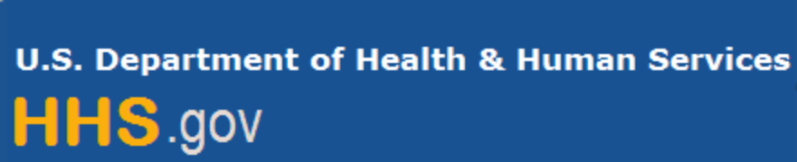

Department of Health and Human Services

Grants Forecast and Overview

The Department of Health and Human Services’ Grants Forecast is a database of planned grant opportunities proposed by its agencies. Each Forecast record contains actual or estimated dates and funding levels for grants that the agency intends to award during the fiscal year. Forecast opportunities are subject to change based on enactment of congressional appropriations. Go to the webpage below for more information.

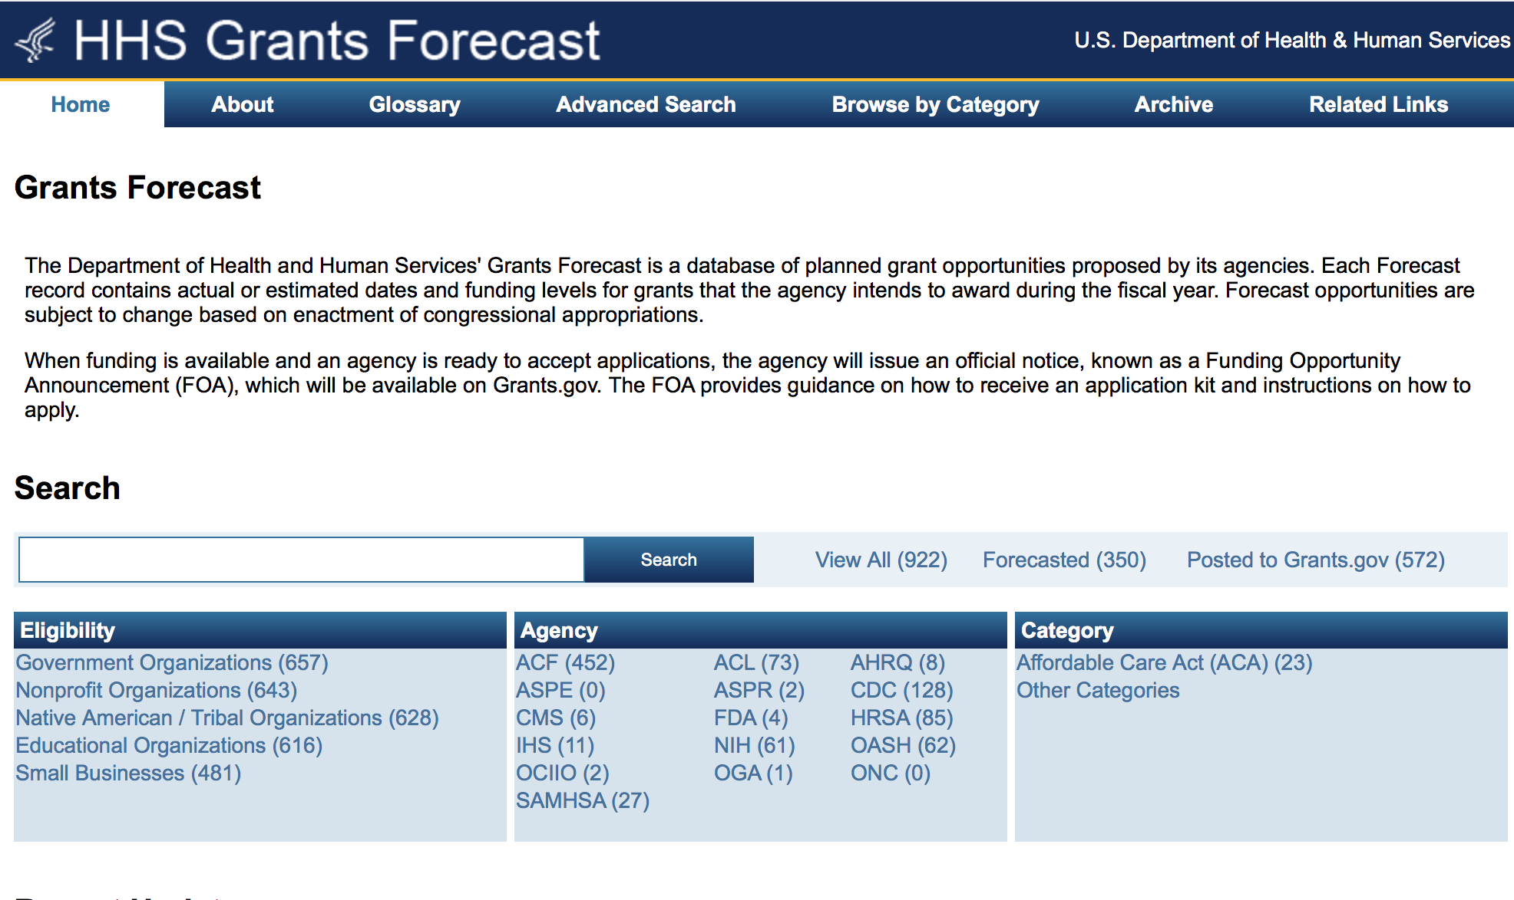
For more general information about HHS Grants and Funding go to the website below at: http://www.hhs.gov/grants/ .

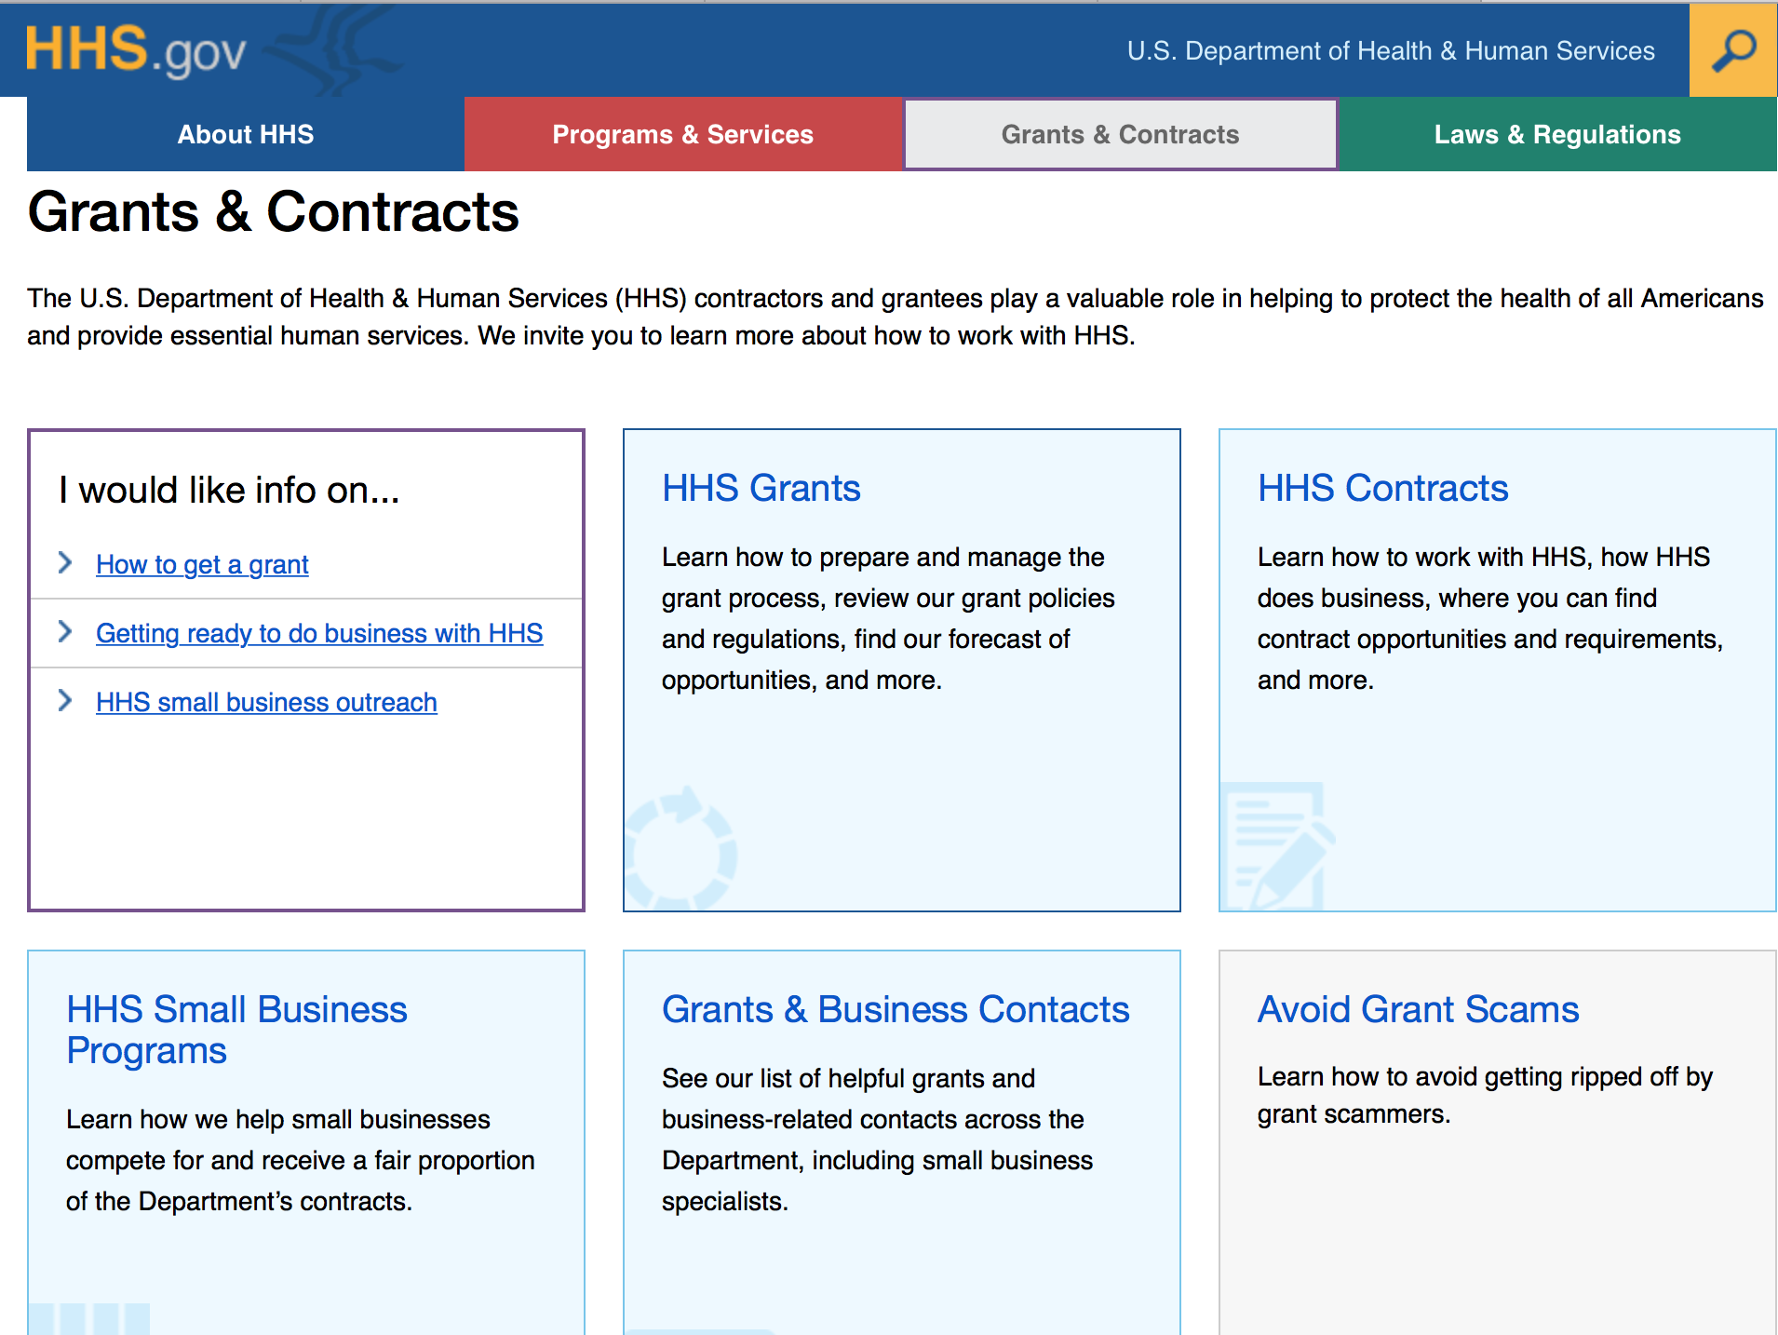

Programs:

Research:

Administration for Community Living
Small Business Innovation Research Program (SBIR) Phase I
Synopsis 1
http://www.grants.gov/web/grants/view-opportunity.html?oppId=290044

Administration for Community Living
Empowering Older Adults and Adults with Disabilities through Chronic Disease Self-Management Education Programs Financed Solely by 2017 Prevention and Public Health Funds (PPHF-2017)
Forecast 1
http://www.grants.gov/web/grants/view-opportunity.html?oppId=290899

Administration for Community Living
Evidence-Based Falls Prevention Programs Financed Solely by 2017 Prevention and Health Funds (PPHF-2017)
Forecast 1
http://www.grants.gov/web/grants/view-opportunity.html?oppId=290900

Administration for Community Living
Disability and Rehabilitation Research Projects (DRRP) Program: Burn Model System (BMS) Centers Program
Forecast 1
http://www.grants.gov/web/grants/view-opportunity.html?oppId=290631

Administration for Community Living
Disability and Rehabilitation Research Projects (DRRP) Program: Traumatic Brain Injury (TBI) Model System Centers Program
Forecast 1
http://www.grants.gov/web/grants/view-opportunity.html?oppId=290612

Agency for Health Care Research and Quality
Utilizing Health Information Technology to Scale and Spread Successful Practice Models Using Patient-reported Outcomes (R18)
Synopsis 1
http://www.grants.gov/web/grants/view-opportunity.html?oppId=290614

Centers for Disease Control and Prevention - ERA
Health Promotion and Disease Prevention Research Centers: Special Interest Project Competitive Supplements (SIPS)
Synopsis 1
http://www.grants.gov/web/grants/view-opportunity.html?oppId=289985

Centers for Disease Control and Prevention - ERA
Community Characteristics Associated with Geographic Disparities in Diabetes and Cardiometabolic Health
Synopsis 1
http://www.grants.gov/web/grants/view-opportunity.html?oppId=289984

Centers for Disease Control - NCTP
TB Centers of Excellence for Training, Education, and Medical Consultation (TB COEs)
Forecast 1
http://www.grants.gov/web/grants/view-opportunity.html?oppId=290511

Centers for Disease Control and Prevention - ERA
Natural Experiments of Policy and Built Environment Impact on Diabetes Risk
Synopsis 1
http://www.grants.gov/web/grants/view-opportunity.html?oppId=289139

Centers for Disease Control - OPHPR
Hospital Preparedness Program - Public Health Emergency Preparedness Cooperative Agreement
Forecast 1
http://www.grants.gov/web/grants/view-opportunity.html?oppId=290860

Centers for Disease Control and Prevention - ERA
Identify and Characterize Potential Environmental Risk Factors for Amyotrophic Lateral Sclerosis (ALS) and Evaluate Their Impact on ALS Disease Incidence and Progression
Forecast 1
http://www.grants.gov/web/grants/view-opportunity.html?oppId=290895

Centers for Disease Control and Prevention - ERA
Miner Safety and Health Training Program-Western United States (U60)
Synopsis 1
http://www.grants.gov/web/grants/view-opportunity.html?oppId=290903

Health Resources and Services Administration
Family Support Centers for Families of Children with or at-risk for Congenital Zika Virus Infection
Forecast 1
http://www.grants.gov/web/grants/view-opportunity.html?oppId=290902

Health Resources and Services Administration
Ryan White HIV/AIDS Part C Capacity Development Program
Synopsis 1
http://www.grants.gov/web/grants/view-opportunity.html?oppId=290882

Health Resources and Services Administration
Area Health Education Centers Program
Synopsis 1
http://www.grants.gov/web/grants/view-opportunity.html?oppId=289066

Health Resources and Services Administration
Ryan White HIV/AIDS Program Part D Coordinated HIV Services and Access to Research for Women, Infants, Children, and Youth (WICY) Existing Geographic Service Areas
Synopsis 1
http://www.grants.gov/web/grants/view-opportunity.html?oppId=290873

Health Resources and Services Administration
Ryan White HIV/AIDS Program States/Territories Part B Supplemental Grant Program
Forecast 1
http://www.grants.gov/web/grants/view-opportunity.html?oppId=290526

Health Resources and Services Administration
Using Evidence Informed Interventions to Improve Health Outcomes among People Living with HIV – Evaluation
Synopsis 1
http://www.grants.gov/web/grants/view-opportunity.html?oppId=290669

Health Resources and Services Administration
Optimizing Momentum – Toward Sustainable Epidemic Control
Forecast 1
http://www.grants.gov/web/grants/view-opportunity.html?oppId=290890

Health Resources and Services Administration
Special Projects of National Significance - Hepatitis C Treatment for People Living with HIV/AIDS - Demonstration Sites
Forecast 1
http://www.grants.gov/web/grants/view-opportunity.html?oppId=290885

Health Resources and Services Administration
Black Lung Clinics Program
Synopsis 1
http://www.grants.gov/web/grants/view-opportunity.html?oppId=284889

Health Resources and Services Administration
Radiation Exposure Screening and Education Program
Synopsis 1
http://www.grants.gov/web/grants/view-opportunity.html?oppId=284891

National Institutes of Health
Planning for Non-Communicable Diseases and Disorders Research Training Programs in Low and Middle Income Countries (D71)
Synopsis 1
http://www.grants.gov/web/grants/view-opportunity.html?oppId=290881

National Institutes of Health
Jointly Sponsored Ruth L. Kirschstein National Research Service Award for Institutional Predoctoral Training Programs in the Neurosciences (T32)
Synopsis 1
http://www.grants.gov/web/grants/view-opportunity.html?oppId=290892

National Institutes of Health
Implementation Science for the Prevention and Treatment of Mental and/or Substance use Disorders in Low- and Middle-income Countries (U01)
Synopsis 1
http://www.grants.gov/web/grants/view-opportunity.html?oppId=290935

National Institutes of Health
Administrative Supplements for Research on Sexual and Gender Minority (SGM) Populations (Admin Supp)
Synopsis 1
http://www.grants.gov/web/grants/view-opportunity.html?oppId=290919

National Institutes of Health
Maximizing Investigators' Research Award (R35)
Synopsis 1
http://www.grants.gov/web/grants/view-opportunity.html?oppId=290863

National Institutes of Health
Fertility Status as a Marker for Overall Health (R01)
Synopsis 1
http://www.grants.gov/web/grants/view-opportunity.html?oppId=290816

National Institutes of Health
Centers for Oceans and Human Health 3: Impacts of Climate Change on Oceans and Great Lakes (COHH3) (P01)
Synopsis 1
http://www.grants.gov/web/grants/view-opportunity.html?oppId=290833

National Institutes of Health
Cancer Center Support Grants (CCSGs) for NCI-designated Cancer Centers (P30)
Synopsis 1
http://www.grants.gov/web/grants/view-opportunity.html?oppId=290865

National Institutes of Health
Revision Awards to Institutional Training Programs to Advance Research on Alzheimers Disease and Alzheimer's Disease Related Dementias (T32)
Synopsis 1
http://www.grants.gov/web/grants/view-opportunity.html?oppId=290582

National Institutes of Health
Potential Effects of Metformin on Aging and Age-Related Conditions: Small-Scale Clinical Studies and Secondary Analysis of Controlled Clinical Studies (R01)
Synopsis 1
http://www.grants.gov/web/grants/view-opportunity.html?oppId=290583

National Institutes of Health
Research Centers in Minority Institutions (U54)
Synopsis 1
http://www.grants.gov/web/grants/view-opportunity.html?oppId=290566

National Institutes of Health
Frontotemporal Degeneration FTD Sequencing Consortium: Discovery, replication and validation (UG3/UH3)
Synopsis 1
http://www.grants.gov/web/grants/view-opportunity.html?oppId=290567

National Institutes of Health
The NCI Predoctoral to Postdoctoral Fellow Transition Award (F99/K00)
Synopsis 1
http://www.grants.gov/web/grants/view-opportunity.html?oppId=290569

National Institutes of Health
Mechanisms of Cancer Drug Resistance and Sensitivity (U54)
Synopsis 1
http://www.grants.gov/web/grants/view-opportunity.html?oppId=290545

National Institutes of Health
Leveraging Electronic Health Records for Alcohol Services Research (R21/R33)
Synopsis 1
http://www.grants.gov/web/grants/view-opportunity.html?oppId=290546

National Institutes of Health
Revision Applications for U.S-South Africa Program for Collaborative Biomedical Research (R01)
Synopsis 1
http://www.grants.gov/web/grants/view-opportunity.html?oppId=290525

National Institutes of Health
Revision Applications for U.S.-South Africa Program for Collaborative Biomedical Research (U01)
Synopsis 1
http://www.grants.gov/web/grants/view-opportunity.html?oppId=290528

National Institutes of Health
Institutional Training Programs to Advance Translational Research on Alzheimers Disease and AD Related Dementias (T32)
Synopsis 1
http://www.grants.gov/web/grants/view-opportunity.html?oppId=290498

National Institutes of Health
Academic-Industrial Partnerships to Translate and Validate in vivo Cancer Imaging Systems (R01)
Synopsis 1
http://www.grants.gov/web/grants/view-opportunity.html?oppId=290859

National Institutes of Health
Pilot Clinical Trials Targeting HIV-1 Reservoirs in Children (U01)
Synopsis 1
http://www.grants.gov/web/grants/view-opportunity.html?oppId=290476

National Institutes of Health
NCI Transition Career Development Award to Promote Diversity (K22)
Synopsis 1
http://www.grants.gov/web/grants/view-opportunity.html?oppId=290509

National Institutes of Health
Optimizing the HIV Care Continuum for Substance Abusing Populations at High-Risk and/or Living with HIV (R01)
Synopsis 1
http://www.grants.gov/web/grants/view-opportunity.html?oppId=290506

National Institutes of Health
Moving Beyond Standard Assessments: Applying Novel Tools to Assess Human Placental Structure and Function in Real Time (R21)
Synopsis 1
http://www.grants.gov/web/grants/view-opportunity.html?oppId=290718

National Institutes of Health
Tobacco Use and HIV in Low and Middle Income Countries (R21)
Synopsis 1
http://www.grants.gov/web/grants/view-opportunity.html?oppId=290714

National Institutes of Health
PDX Development and Trial Centers (PDTCs) (U54)
Synopsis 1
http://www.grants.gov/web/grants/view-opportunity.html?oppId=290507

National Institutes of Health
Maximizing Access to Research Careers Undergraduate - Student Training in Academic Research (MARC U-STAR) (T34)
Synopsis 1
http://www.grants.gov/web/grants/view-opportunity.html?oppId=290479

National Institutes of Health
Moving Beyond Standard Assessments: Applying Novel Tools to Assess Human Placental Structure and Function in Real Time (R01)
Synopsis 1
http://www.grants.gov/web/grants/view-opportunity.html?oppId=290710

National Institutes of Health
Tobacco Use and HIV in Low and Middle Income Countries (R01)
Synopsis 1
http://www.grants.gov/web/grants/view-opportunity.html?oppId=290712

National Institutes of Health
Innovative Programs to Enhance Research Training (IPERT) (R25)
Synopsis 1
http://www.grants.gov/web/grants/view-opportunity.html?oppId=290513

National Institutes of Health
Development of Multipurpose Prevention Technologies: A Strategy for the Prevention of Sexually Transmitted Infections (STIs) (R61/R33)
Synopsis 1
http://www.grants.gov/web/grants/view-opportunity.html?oppId=290531

National Institutes of Health
Novel Analytical Approaches for Metabolomics Data (R03)
Synopsis 1
http://www.grants.gov/web/grants/view-opportunity.html?oppId=290611

National Institutes of Health
Shared Instrumentation Grant (SIG) Program (S10)
Synopsis 1
http://www.grants.gov/web/grants/view-opportunity.html?oppId=290613

National Institutes of Health
Shared Instrumentation for Animal Research (SIFAR) Grant Program (S10)
Synopsis 1
http://www.grants.gov/web/grants/view-opportunity.html?oppId=290615

National Institutes of Health
Innovations for Healthy Living - Improving Population Health and Eliminating Health Disparities (R43/R44)
Synopsis 1
http://www.grants.gov/web/grants/view-opportunity.html?oppId=290616

National Institutes of Health
Technologies for Improving Minority Health and Eliminating Health Disparities (R41/R42)
Synopsis 1
http://www.grants.gov/web/grants/view-opportunity.html?oppId=290617

National Institutes of Health
High-End Instrumentation (HEI) Grant Program (S10)
Synopsis 1
http://www.grants.gov/web/grants/view-opportunity.html?oppId=290633

National Institutes of Health
Administrative Supplement for Research on Sex/Gender Influences (Admin Supp)
Synopsis 1
http://www.grants.gov/web/grants/view-opportunity.html?oppId=290634

National Institutes of Health
Increasing the Use of Medications for the Treatment of Alcohol Use Disorders (R01)
Synopsis 1
http://www.grants.gov/web/grants/view-opportunity.html?oppId=290640

National Institutes of Health
NIH-DoD-VA Pain Management Collaboratory - Pragmatic Clinical Trials Demonstration Projects (UG3/UH3)
Synopsis 1
http://www.grants.gov/web/grants/view-opportunity.html?oppId=290641

National Institutes of Health
Competitive Collaborative Projects for Human Islet Biology (UC4)
Synopsis 1
http://www.grants.gov/web/grants/view-opportunity.html?oppId=290685

National Institutes of Health
Eradication of HIV-1 from Central Nervous system Reservoirs (R01)
Synopsis 1
http://www.grants.gov/web/grants/view-opportunity.html?oppId=290681

National Institutes of Health
NIBIB Biomedical Technology Resource Centers (P41)
Synopsis 1
http://www.grants.gov/web/grants/view-opportunity.html?oppId=290682

National Institutes of Health
NIMH Mentoring Networks for Mental Health Research Education (R25)
Synopsis 1
http://www.grants.gov/web/grants/view-opportunity.html?oppId=290671

National Institutes of Health
NIMH Research Education Programs for Psychiatry Residents (R25)
Synopsis 1
http://www.grants.gov/web/grants/view-opportunity.html?oppId=290672

National Institutes of Health
Clinical Trials to Test the Effectiveness of Treatment, Preventive, and Services Interventions (Collaborative R01)
Synopsis 1
http://www.grants.gov/web/grants/view-opportunity.html?oppId=290649

National Institutes of Health
Confirmatory Efficacy Clinical Trials of Non-Pharmacological Interventions for Mental Disorders (R01)
Synopsis 1
http://www.grants.gov/web/grants/view-opportunity.html?oppId=290650

National Institutes of Health
NIMH Short Courses for Mental Health-Related Research Education (R25)
Synopsis 1
http://www.grants.gov/web/grants/view-opportunity.html?oppId=290652

National Institutes of Health
Development of Psychosocial Therapeutic and Preventive Interventions for Mental Disorders (R61/R33)
Synopsis 1
http://www.grants.gov/web/grants/view-opportunity.html?oppId=290646

National Institutes of Health
Clinical Trials to Test the Effectiveness of Treatment, Preventive, and Services Interventions (R01)
Synopsis 1
http://www.grants.gov/web/grants/view-opportunity.html?oppId=290647

National Institutes of Health
Pilot Effectiveness Trials for Treatment, Preventive and Services Interventions (R34)
Synopsis 1
http://www.grants.gov/web/grants/view-opportunity.html?oppId=290630

National Institutes of Health
Early Stage Testing of Pharmacologic or Device-based Interventions for the Treatment of Mental Disorders (R61/R33)
Synopsis 1
http://www.grants.gov/web/grants/view-opportunity.html?oppId=290644

National Institutes of Health
Early Stage Testing of Pharmacologic or Device-based Interventions for the Treatment of Mental Disorders (R33)
Synopsis 1
http://www.grants.gov/web/grants/view-opportunity.html?oppId=290627

National Institutes of Health
Development of Psychosocial Therapeutic and Preventive Interventions for Mental Disorders (R33)
Synopsis 1
http://www.grants.gov/web/grants/view-opportunity.html?oppId=290625

National Institutes of Health
Therapeutic Targeting Of The Human Islet Environment (UC4)
Synopsis 1
http://www.grants.gov/web/grants/view-opportunity.html?oppId=290656

National Institutes of Health
Exploratory Analyses of Existing Cohorts, Data Sets, and Stored Biospecimens to Address Clinical Aging Research Questions (R21)
Synopsis 1
http://www.grants.gov/web/grants/view-opportunity.html?oppId=290729

National Institutes of Health
Consortium for Pancreatic Ductal Adenocarcinoma (PDAC) Translational Studies on the Tumor Microenvironment (U01)
Synopsis 1
http://www.grants.gov/web/grants/view-opportunity.html?oppId=290730

National Institutes of Health
Secondary Analyses of Existing Cohorts, Data Sets and Stored Biospecimens to Address Clinical Aging Research Questions (R01)
Synopsis 1
http://www.grants.gov/web/grants/view-opportunity.html?oppId=290753

National Institutes of Health
Canine Immunotherapy Trials and Correlative Studies (U01)
Synopsis 1
http://www.grants.gov/web/grants/view-opportunity.html?oppId=290756

National Institutes of Health
NLM Administrative Supplements for Informationist Services in NIH-funded Research Projects (Admin Supp)
Synopsis 1
http://www.grants.gov/web/grants/view-opportunity.html?oppId=290758

National Institutes of Health
Cancer Immune Monitoring and Analysis Centers (U24)
Synopsis 1
http://www.grants.gov/web/grants/view-opportunity.html?oppId=290775

National Institutes of Health
Cancer Immunologic Data Commons (CIDC) (U24)
Synopsis 1
http://www.grants.gov/web/grants/view-opportunity.html?oppId=290776

National Institutes of Health
Integrative Research in Gynecologic Health (R01)
Synopsis 1
http://www.grants.gov/web/grants/view-opportunity.html?oppId=290780

National Institutes of Health
Research on the Health of Women of Underrepresented, Understudied and Underreported (U3) Populations An ORWH FY17 Administrative Supplement (Admin Supp)
Synopsis 1
http://www.grants.gov/web/grants/view-opportunity.html?oppId=291027

National Institutes of Health
HIV-1 infection of the Central Nervous System (R01)
Synopsis 1
http://www.grants.gov/web/grants/view-opportunity.html?oppId=291028

National Institutes of Health
NEI Translational Research Program (TRP) to Develop Novel Therapies and Devices for the Treatment of Visual System Disorders (R24)
Synopsis 1
http://www.grants.gov/web/grants/view-opportunity.html?oppId=291041

National Institutes of Health
National Centers for Cryoelectron Microscopy (U24)
Synopsis 1
http://www.grants.gov/web/grants/view-opportunity.html?oppId=291043

Office of the Assistant Secretary for Health
FY17 Partnerships to Achieve Health Equity
Synopsis 1
http://www.grants.gov/web/grants/view-opportunity.html?oppId=289362

Office of the Assistant Secretary for Health
FY17 Announcement of Anticipated Availability of Funds for Embryo Donation and/or Adoption Grant
Synopsis 1
http://www.grants.gov/web/grants/view-opportunity.html?oppId=289300

Substance Abuse and Mental Health Services Admin
Addiction Technology Transfer Centers Cooperative Agreement (Short Title: ATTC)
Synopsis 1
http://www.grants.gov/web/grants/view-opportunity.html?oppId=290585

FY17 Announcement of the Anticipated Availability of Funds for Conferences on Research Integrity
Synopsis 1
http://www.grants.gov/web/grants/view-opportunity.html?oppId=291071

Modifications:

Administration for Children and Families - ANA
Social and Economic Development Strategies -SEDS
Forecast 3
http://www.grants.gov/web/grants/view-opportunity.html?oppId=289775

Administration for Children and Families - ORR
Refugee Career Pathways Program
Forecast 3
http://www.grants.gov/web/grants/view-opportunity.html?oppId=287809

Administration for Children and Families - ANA
Native American Language Preservation and Maintenance
Forecast 6
http://www.grants.gov/web/grants/view-opportunity.html?oppId=289774

Administration for Community Living
University Centers for Excellence in Developmental Disabilities Education, Research and Service
Synopsis 2
http://www.grants.gov/web/grants/view-opportunity.html?oppId=290092

Agency for Health Care Research and Quality
Developing New Clinical Decision Support to Disseminate and Implement Patient-Centered Outcomes Research Findings (R18)
Synopsis 2
http://www.grants.gov/web/grants/view-opportunity.html?oppId=284106

Centers for Disease Control - NCTP
Strengthening Surveillance in Jurisdictions with High Incidence of Hepatitis C Virus (HCV) and Hepatitis B Virus (HBV) Infections
Synopsis 4
http://www.grants.gov/web/grants/view-opportunity.html?oppId=290367

Centers for Disease Control - OPHPR
Hospital Preparedness Program - Public Health Emergency Preparedness Cooperative Agreement
Forecast 3
http://www.grants.gov/web/grants/view-opportunity.html?oppId=290860

Centers for Disease Control and Prevention - ERA
Community Characteristics Associated with Geographic Disparities in Diabetes and Cardiometabolic Health
Synopsis 5 & 10
http://www.grants.gov/web/grants/view-opportunity.html?oppId=289984

Centers for Disease Control and Prevention - ERA
Natural Experiments of Policy and Built Environment Impact on Diabetes Risk
Synopsis 6 & 10
http://www.grants.gov/web/grants/view-opportunity.html?oppId=289139

Food and Drug Administration
FDA Scientific Conference Grant Program (R13)
Synopsis 2
http://www.grants.gov/web/grants/view-opportunity.html?oppId=286610

Health Resources and Services Administration
Primary Care Medicine and Dentistry Clinician Educator Career Development Award
Forecast 4
http://www.grants.gov/web/grants/view-opportunity.html?oppId=289395

Health Resources and Services Administration
Ryan White HIV/AIDS Program Part D Coordinated HIV Services and Access to Research for Women, Infants, Children, and Youth (WICY) Existing Geographic Service Areas
Synopsis 2
http://www.grants.gov/web/grants/view-opportunity.html?oppId=290873

National Institutes of Health
Notice of Intent to Publish a Funding Opportunity Announcement for an NINDS Postdoctoral Research Career Development Award (K01)
Forecast 2
http://www.grants.gov/web/grants/view-opportunity.html?oppId=284880

National Institutes of Health
Notice of Intent to Publish a Reissue of Funding Opportunity Announcement for the Precision Medicine Initiative® Cohort Program Healthcare Provider Organization Enrollment Centers (UG3/UH3)
Forecast 3
http://www.grants.gov/web/grants/view-opportunity.html?oppId=285995

National Institutes of Health
Women & Sex/Gender Differences in Drug and Alcohol Abuse/Dependence (R21)
Synopsis 2
http://www.grants.gov/web/grants/view-opportunity.html?oppId=249159

National Institutes of Health
Women & Sex/Gender Differences in Drug and Alcohol Abuse/Dependence (R03)
Synopsis 2
http://www.grants.gov/web/grants/view-opportunity.html?oppId=249160

National Institutes of Health
Women & Sex/Gender Differences in Drug and Alcohol Abuse/Dependence (R01)
Synopsis 2
http://www.grants.gov/web/grants/view-opportunity.html?oppId=249161

National Institutes of Health
Notice of Intent to Publish a Funding Opportunity Announcement for Tobacco Centers of Regulatory Science (TCORS) for Research Relevant to the Family Smoking Prevention and Tobacco Control Act (U54)
Forecast 2
http://www.grants.gov/web/grants/view-opportunity.html?oppId=289380

National Institutes of Health
BRAIN Initiative: Proof of Concept Development of Early Stage Next Generation Human Brain Imaging (R01)
Synopsis 2
http://www.grants.gov/web/grants/view-opportunity.html?oppId=289655

National Institutes of Health
BRAIN Initiative: Development of Next Generation Human Brain Imaging Tools and Technologies (U01)
Synopsis 2
http://www.grants.gov/web/grants/view-opportunity.html?oppId=289656

National Institutes of Health
Notice of Intent to Publish a Funding Opportunity Announcement for ImPlementation Research to Develop interventions for People Living with HIV (PRECluDE) (U01)
Forecast 2
http://www.grants.gov/web/grants/view-opportunity.html?oppId=289382

National Institutes of Health
Notice of Intent to Publish a Funding Opportunity Announcement for Myalgic Encephalomyelitis/Chronic Fatigue Syndrome (ME/CFS) Data Management and Coordinating Center (DMCC) (U01)
Forecast 2
http://www.grants.gov/web/grants/view-opportunity.html?oppId=289979

National Institutes of Health
Notice of Intent to Publish a Funding Opportunity Announcement for Blueprint Neurotherapeutics Network (BPN): Small Molecule Drug Discovery and Development for Disorders of the Nervous System (U44)
Forecast 2
http://www.grants.gov/web/grants/view-opportunity.html?oppId=289980

National Institutes of Health
Notice of Intent to Publish a Funding Opportunity Announcement for Blueprint Neurotherapeutics Network (BPN): Small Molecule Drug Discovery and Development for Disorders of the Nervous System (UG3/UH3)
Forecast 2
http://www.grants.gov/web/grants/view-opportunity.html?oppId=289981

National Institutes of Health
Notice of Intent to Publish a Funding Opportunity Announcement for Myalgic Encephalomyelitis/Chronic Fatigue Syndrome (ME/CFS) Collaborative Research Centers (CRCs) (U54)
Forecast 2
http://www.grants.gov/web/grants/view-opportunity.html?oppId=289982

National Institutes of Health
Administrative Supplement for Research on Sex/Gender Influences (Admin Supp)
Synopsis 2
http://www.grants.gov/web/grants/view-opportunity.html?oppId=290634

Office of the Assistant Secretary for Health
FY17National Lupus Outreach and Clinical Trial Education Program
Synopsis 4
http://www.grants.gov/web/grants/view-opportunity.html?oppId=289374

Office of the Assistant Secretary for Health
FY17 Announcement of Anticipated Availability of Funds for Centers for Teen Pregnancy Prevention and Adolescent Health Promotion Research
Synopsis 2
http://www.grants.gov/web/grants/view-opportunity.html?oppId=289373

Deleted:

Centers for Disease Control - NCEZID
CDC-RFA-CK17-1702 - Addressing Emerging Zoonoses and Strengthening Animal and Human Health Systems
Deletion Comments: Opportunity deleted

Centers for Disease Control - NCTP
CDC-RFA-PS17-1712 - Assuring Comprehensive Prevention and Treatment for Families Impacted by HIV to eliminate perinatal HIV transmission in the United States
Deletion Comments: Opportunity deleted

Centers for Disease Control and Prevention - ERA
RFA-OH-17-001 - Occupational Safety and Health Research (R01)
Deletion Comments: Opportunity deleted

Centers for Disease Control - NIOSH
RFA-OH-17-001 - Occupational Safety and Health Research (R01)
Deletion Comments: Opportunity deleted

National Institutes of Health
RFA-CA-17-014 - The NCI Predoctoral to Postdoctoral Fellow Transition Award (F99/K00)
Deletion Comments: Opportunity deleted

Office of the Assistant Secretary for Health
HP-ATP-17-001 - Announcement of the Availability of Funds and Request for Applications for a Cooperative Agreement to Expand Disease Prevention and Health Promotion Efforts
Deletion Comments: Opportunity deleted

Office of the Assistant Secretary for Health
ORI-IR-17-001 - Announcement of the Anticipated Availability of Funds for “Phase I: Research on Research Integrity”
Deletion Comments: Opportunity deleted

Reminders:

Administration for Children & Families - ACYF/FYSB
Transitional Living Program and Maternity Group Homes
Forecast 1
Document Type: | Grants Notice
Opportunity Number: | HHS-2017-ACF-ACYF-CX-1233
Opportunity Title: | Transitional Living Program and Maternity Group Homes
Opportunity Category: | Discretionary
Opportunity Category Explanation:
Funding Instrument Type: | Grant
Category of Funding Activity: | Income Security and Social Services
Category Explanation:
Expected Number of Awards: | 103
CFDA Number(s): | 93.550 -- Transitional Living for Homeless Youth
Cost Sharing or Matching Requirement: | Yes
Version: | Forecast 1
Posted Date: | Sep 27, 2016
Last Updated Date: | Sep 27, 2016
Estimated Synopsis Post Date: | Apr 14, 2017
Estimated Application Due Date: | Jun 13, 2017 Electronically submitted applications must be submitted no later than 11:59 p.m., ET, on the listed application due date.
Estimated Award Date: | Sep 28, 2017
Estimated Project Start Date: | Sep 29, 2017
Fiscal Year: | 2017
Archive Date:
Estimated Total Program Funding: | $20,056,829
Award Ceiling: | $194,726
Award Floor: | $100,000
Eligible Applicants: | Native American tribal governments (Federally recognized)  Public and State controlled institutions of higher education  Nonprofits that do not have a 501(c)(3) status with the IRS, other than institutions of higher education  Native American tribal organizations (other than Federally recognized tribal governments)  Independent school districts  Special district governments  State governments  Others (see text field entitled "Additional Information on Eligibility" for clarification)  Private institutions of higher education  Public housing authorities/Indian housing authorities  City or township governments  Nonprofits having a 501(c)(3) status with the IRS, other than institutions of higher education  County governments
Additional Information on Eligibility: | In accordance with Section 321 of the Runaway and Homeless Youth (RHY) Act, the Secretary is authorized to make grants to provide technical assistance to public and nonprofit private entities to establish and operate transitional living youth projects for homeless youth. In selecting eligible applicants to receive grants under this Funding Opportunity Announcement, priority will be given to applicants who have experience working with runaway and homeless youth as required by the RHY Act. Additionally, ACF ensures that the applicants selected represent diverse geographic regions of the United States. Faith-based and community organizations that meet the eligibility requirements are eligible to receive awards under this funding opportunity announcement. Faith-based organizations are encouraged to review the ACF Policy on Grants to Faith-Based Organizations at: http: //www.acf.hhs.gov/acf-policy-on-grants-to-faith-based-organizations. Applications from individuals (including sole proprietorships) and foreign entities are not eligible and will be disqualified from competitive review and from funding under this announcement.
Agency Name: | Administration for Children & Families - ACYF/FYSB
Description: | The Family and Youth Services Bureau (FYSB) is forecasting a funding opportunity announcement for the Transitional Living Program (TLP) and for Maternity Group Homes (MGH) for a five-year project period. The TLP and MGH projects will work to implement, enhance, and/or support promising intervention strategies for the effective transition of homeless youth (for the purposes of MGH projects, homeless youth and their dependent child(ren)) to self-sufficiency. Both projects must provide safe, stable, and appropriate shelter for up to 21 months and comprehensive services that supports the transition of homeless youth to stable living.
Link to Additional Information:
Grantor Contact Information: | Angie Webley  (202) 401-5490  Angie.Webley@acf.hhs.gov

http://www.grants.gov/web/grants/view-opportunity.html?oppId=289165

Administration for Children and Families - ORR
Ethnic Community Self Help Program
Forecast 1

Document Type: | Grants Notice
Opportunity Number: | HHS-2017-ACF-ORR-RE-1232
Opportunity Title: | Ethnic Community Self Help Program
Opportunity Category: | Discretionary
Opportunity Category Explanation:
Funding Instrument Type: | Grant
Category of Funding Activity: | Income Security and Social Services
Category Explanation:
Expected Number of Awards: | 13
CFDA Number(s): | 93.576 -- Refugee and Entrant Assistance Discretionary Grants
Cost Sharing or Matching Requirement: | No
Version: | Forecast 1
Posted Date: | Sep 21, 2016
Last Updated Date: | Sep 21, 2016
Estimated Synopsis Post Date: | Mar 31, 2017
Estimated Application Due Date: | May 30, 2017 Electronically submitted applications must be submitted no later than 11:59 p.m., ET, on the listed application due date.
Estimated Award Date: | Sep 29, 2017
Estimated Project Start Date: | Sep 30, 2017
Fiscal Year: | 2017
Archive Date:
Estimated Total Program Funding: | $2,000,000
Award Ceiling: | $200,000
Award Floor: | $100,000
Eligible Applicants: | Others (see text field entitled "Additional Information on Eligibility" for clarification)
Additional Information on Eligibility: | This Funding Opportunity Announcement (FOA) is open only to Ethnic Community-Based Organizations (ECBOs). For the purposes of this FOA, the Office of Refugee Resettlement considers an ECBO as a non-profit organization whose board of directors is comprised of at least 60 percent current and/or former refugees. The applicant must demonstrate that at the time of submission its board of directors is comprised of at least 60 percent current and/or former refugees. Faith-based and community organizations that meet the eligibility requirements are eligible to receive awards under this funding opportunity announcement. Faith-based organizations are encouraged to review the ACF Policy on Grants to Faith-Based Organizations at: http: //www.acf.hhs.gov/acf-policy-on-grants-to-faith-based-organizations. Applications from individuals (including sole proprietorships) and foreign entities are not eligible and will be disqualified from competitive review and from funding under this announcement.
Agency Name: | Administration for Children and Families - ORR
Description: | The Administration for Children and Families, Office of Refugee Resettlement invites the submission of applications for funding under the Ethnic Community Self-Help (ECSH) Program. The goal of this program is to support Ethnic Community-Based Organizations (ECBOs) in providing refugee populations with critical services to assist them in becoming integrated members of American society. Under the ECSH Program, the following three main objectives must be implemented: 1) to strengthen ECBOs'; provision of culturally and linguistically appropriate services to refugees within five years after their initial resettlement; 2) to support ECBOs' organizational development and engagement in capacity building by encouraging their collaboration with established refugee service providers and mainstream organizations; and 3) to support ECBOs in promoting community building and civic participation by refugee individuals and refugee community members.
Link to Additional Information:
Grantor Contact Information: | Anastasia Brown  (202) 401-4559  Anastasia.Brown@acf.hhs.gov

http://www.grants.gov/web/grants/view-opportunity.html?oppId=289035

Department of Homeland Security

The Department of Homeland Security enhances the ability of states, local and tribal jurisdictions, and other regional authorities in the preparation, prevention, and response to terrorist attacks and other disasters, by distributing grant funds. Localities can use grants for planning, equipment, training and exercise needs.

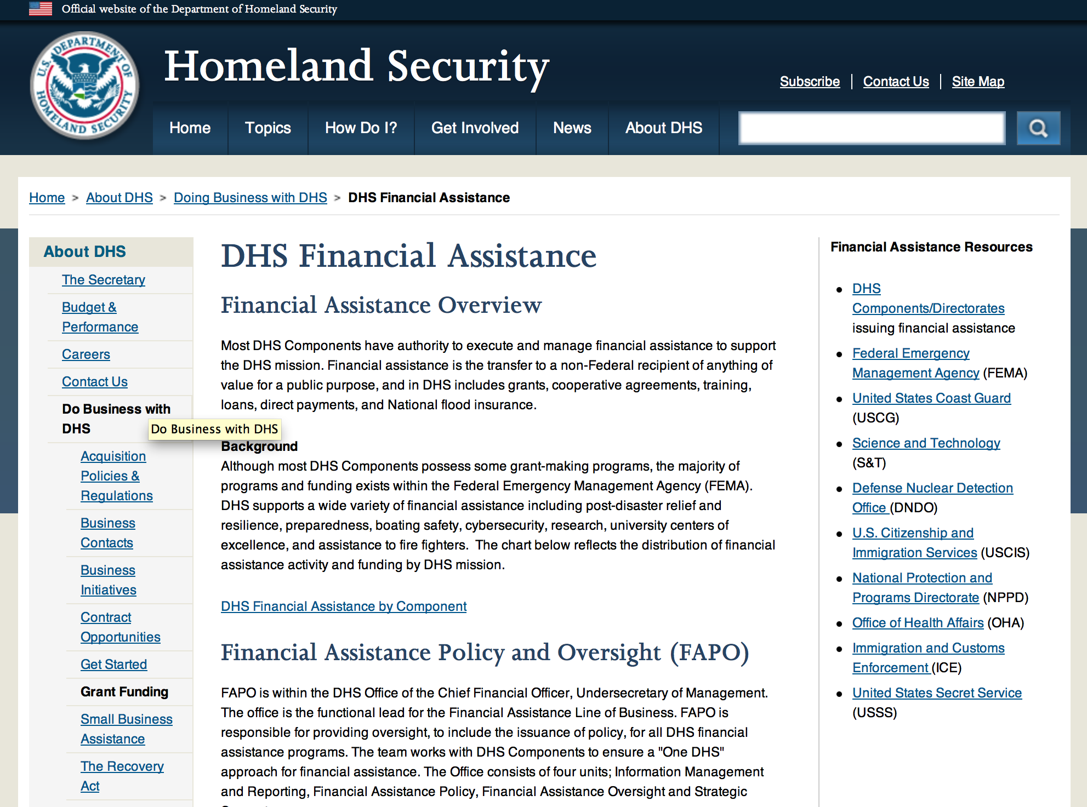

Webpage can be viewed at: http://www.dhs.gov/xopnbiz/grants/index.shtm#2

The FY 2016 Assistance to Firefighters Grants (AFG)
FY 2016 ASSISTANCE TO FIREFIGHTERS (AFG) GRANTS IS CLOSED AT THIS TIME
The FY 2016 AFG Open Application Period Dates Will Be As Follows: 8AM ET OCTOBER 11 through 5PM ET NOVEMBER 18
- FY 2016 Application Workshop Schedule
- FY 2016 AFG Application Guidance Materials The following documents are now available:
  - FY 2016 Notice of Funding Opportunity (NOFO) – Available Now
  - FY 2016 AFG Grant Application Get Ready Guide
  - FY 2016 AFG Narrative Get Ready Guide
  - FY 2016 AFG Self-Evaluation - Operations and Safety
  - FY 2016 AFG Self-Evaluation - Vehicle Acquisition
  - FY 2016 AFG Application Checklist
  - FY 2016 AFG Cost Share Calculator
FY 2016 AFG FAQs
For AFG program guidance materials, please visit our Documents page.

Resources

AFG Help Desk
Contact the AFG Program Help Desk toll-free at 866-274-0960, or email us at firegrants@dhs.gov.
The AFG Program has Fire Program Specialists in 10 federal regional centers. These Regional Fire Program Specialists respond to questions about the AFG program and carry out grant monitoring activities. View regional contacts

Popular AFG links
- AFG Workshop Schedule
- Assistance to Firefighters Grants (AFG)
- AFG Awards List
- AFG Success Stories
- Staffing for Adequate Fire & Emergency Response (SAFER) Grants (SAFER)
- SAFER Awards List
- SAFER Success Stories
- Fire Prevention & Safety (FP&S) Grants
- FP&S Awards List
- FP&S Success Stories
- Grant Closeout Tutorial
- Assistance to Firefighters Grant (AFG) Email Alert Archive
- Frequently Asked Questions
Contact Information For The Assistance to Firefighters Grant (AFG) Program and Help Desk

Federal Funding Alternative To AFG

State Administrative Agencies (SAA) apply for and administer Federal grants on behalf of their States, including FEMA Preparedness Grants. The SAA will work with eligible organizations to comply with the general requirements of grant programs or cooperative agreements. Contact your State’s SAA to find out what current Federal funding opportunities may be available to your organization. A listing of the SAAs and points of contact can be found at http://www.fema.gov/library/viewRecord.do?id=6363.

Programs:

Department of Homeland Security - FEMA
Staffing for Adequate Fire and Emergency Response (SAFER) Grants
Synopsis 1
Document Type: | Grants Notice
Funding Opportunity Number: | DHS-16-GPD-083-000-99
Funding Opportunity Title: | Staffing for Adequate Fire and Emergency Response (SAFER) Grants
Opportunity Category: | Discretionary
Opportunity Category Explanation:
Funding Instrument Type: | Grant
Category of Funding Activity: | Other (see text field entitled "Explanation of Other Category of Funding Activity" for clarification)
Category Explanation: | The hiring firefighters and the recruitment and retention of volunteer firefighters.
Expected Number of Awards: | 300
CFDA Number(s): | 97.083 -- Staffing for Adequate Fire and Emergency Response (SAFER)
Cost Sharing or Matching Requirement: | No
Version: | Synopsis 1
Posted Date: | Jan 03, 2017
Last Updated Date: | Jan 03, 2017
Original Closing Date for Applications: | Feb 10, 2017
Current Closing Date for Applications: | Feb 10, 2017
Archive Date: | Mar 12, 2017
Estimated Total Program Funding: | $345,000,000
Award Ceiling: | $0
Award Floor: | $0
Eligible Applicants: | County governments  City or township governments  Others (see text field entitled "Additional Information on Eligibility" for clarification)
Additional Information on Eligibility: | Fire Departments National, state, local, or tribal organizations representing the interests of volunteer firefighters
Agency Name: | Department of Homeland Security - FEMA
Description: | The Department of Homeland Security (DHS) Federal Emergency Management Agency’s (FEMA) Grant Programs Directorate implements and administers the Staffing for Adequate Fire and Emergency Response (SAFER) Grants. SAFER grants provide financial assistance to help fire departments increase frontline firefighters, rehire firefighters that have been laid off, retain firefighters facing imminent layoffs, or filling of positions that were vacated through attrition. SAFER offers grants to support activities in two categories: 1. Hiring of Firefighters 2. Recruitment and Retention of Volunteer Firefighters The authority for SAFER is derived from the Federal Fire Prevention and Control Act of 1974, as amended (15 U.S.C. §2229a et seq.). The notice of funding opportunity document provides potential applicants with the details of the requirements, processing, and evaluation of an application for financial assistance for both of these activity areas.
Link to Additional Information: | https://www.fema.gov/media-library/assets/documents/127856
Grantor Contact Information: | If you have difficulty accessing the full announcement electronically, please contact:  SAFER Help Desk (866) 274-0960 FireGrants@fema.dhs.gov  FireGrants@fema.dhs.gov

http://www.grants.gov/web/grants/view-opportunity.html?oppId=291031

Modifications:

Reminders:

United States Coast Guard
National Non-Profit Organization Grant Program
Synopsis 2

Document Type: |  | Grants Notice
Funding Opportunity Number: |  | DHS-USCG-2017-001
Funding Opportunity Title: |  | National Non-Profit Organization Grant Program
Opportunity Category: |  | Discretionary
Opportunity Category Explanation:
Funding Instrument Type: |  | Cooperative Agreement
Category of Funding Activity: |  | Other (see text field entitled "Explanation of Other Category of Funding Activity" for clarification)
Category Explanation: |  | Recreational Boating Safety
Expected Number of Awards: |  | 30
CFDA Number(s): |  | 97.012 -- Boating Safety Financial Assistance
Cost Sharing or Matching Requirement: |  | No
Posted Date: |  | Oct 14, 2016
Last Updated Date: |  | Oct 14, 2016
Original Closing Date for Applications: |  | Jan 27, 2017
Current Closing Date for Applications: |  | Jan 27, 2017
Archive Date: |  | Feb 26, 2017
Estimated Total Program Funding: |  | $5,021,274
Eligible Applicants: |  | Nonprofits having a 501(c)(3) status with the IRS, other than institutions of higher education
Agency Name: | United States Coast Guard
Description: | The purpose of the National Recreational Boating Safety Program is to reduce the number of accidents, injuries and deaths on America’s waterways and provide a safe enjoyable experience for the boating public. The program also encourages greater non-profit organizations participation and uniformity in boating safety efforts.
Link to Additional Information: | United States Coast Guard Boating Safety
Grantor Contact Information: | If you have difficulty accessing the full announcement electronically, please contact:  Carlin Hertz Non-Profit Grants Coordinator Phone 202-372-1060  Non-Profit Grants Coordinator

http://www.grants.gov/web/grants/view-opportunity.html?oppId=289478

Department of Housing and Urban Development

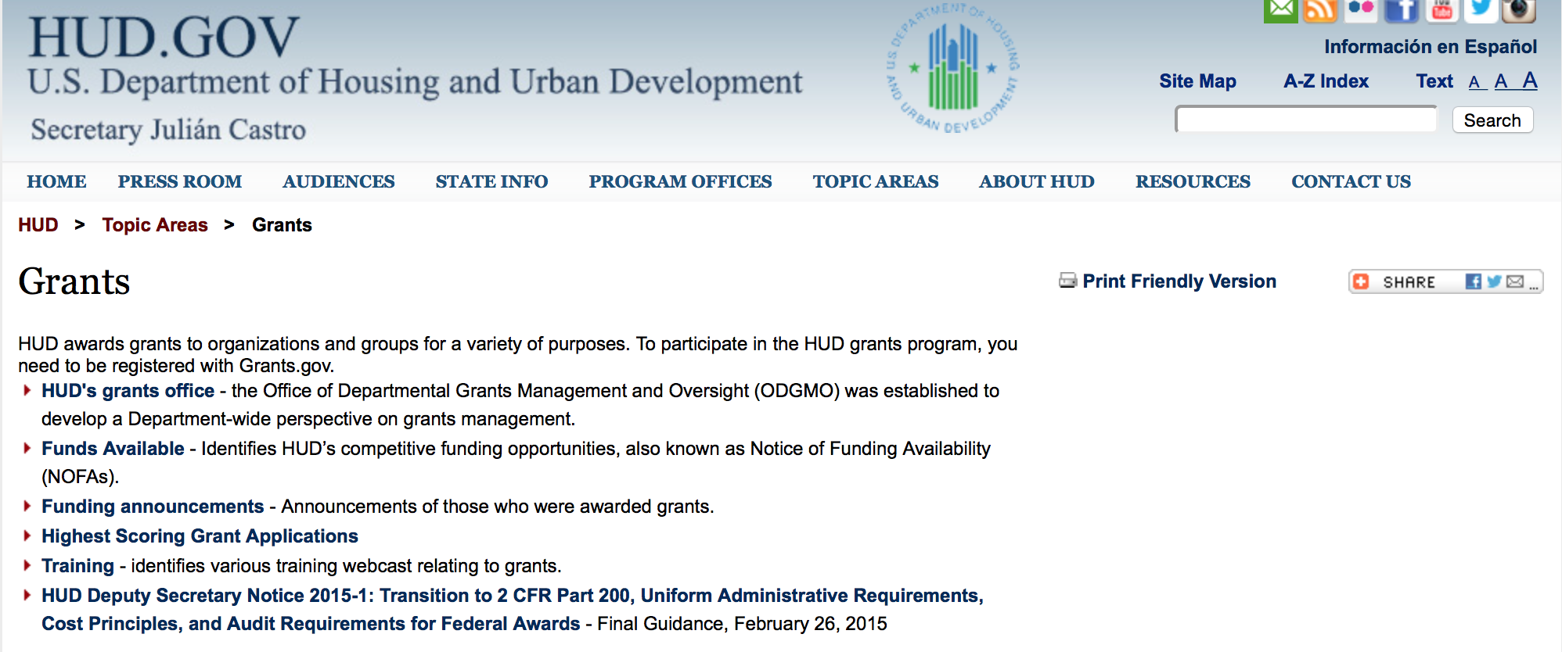

http://portal.hud.gov/hudportal/HUD?src=/topics/grants

HUD - Notice of Funds Available

For detailed information click here

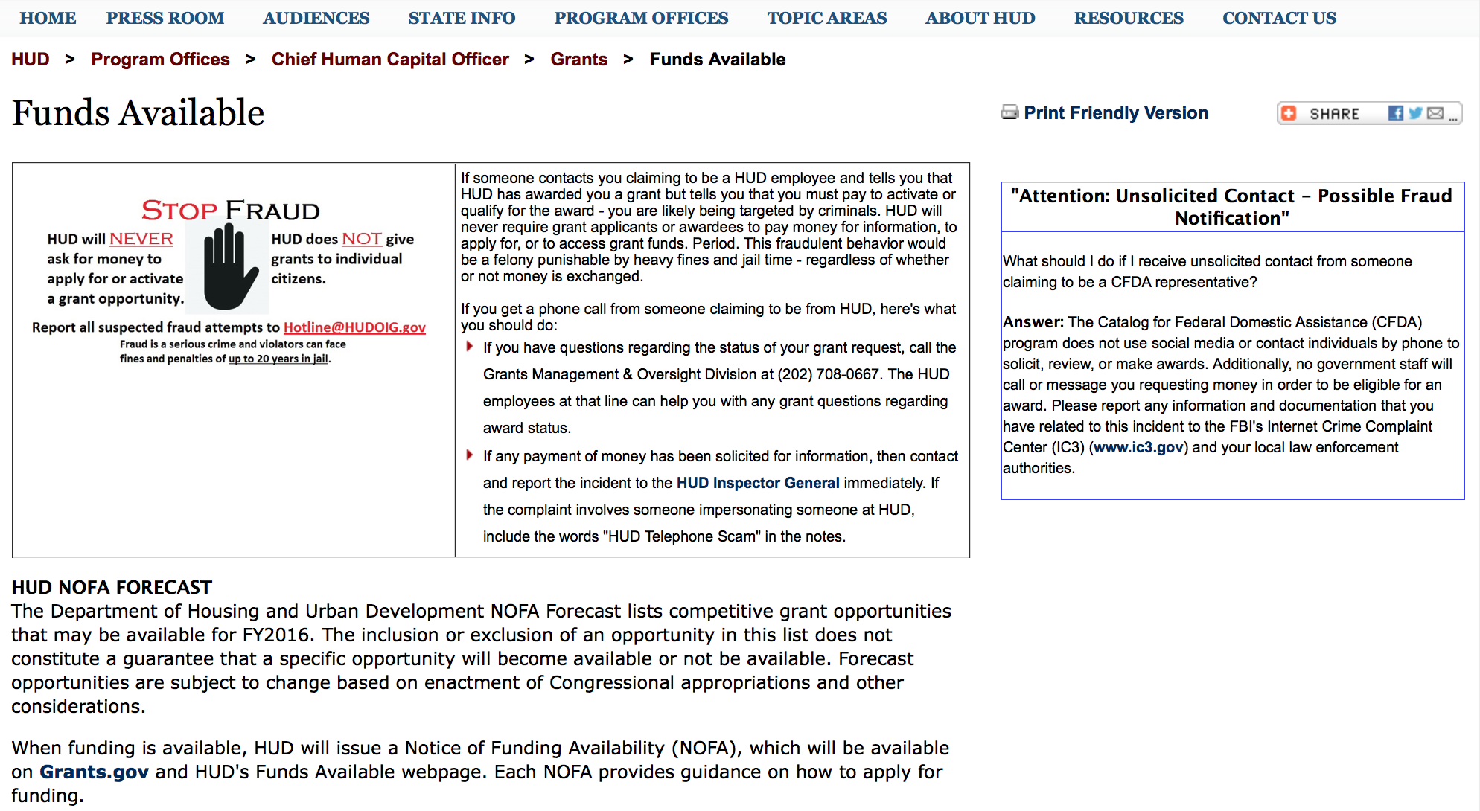

http://portal.hud.gov/hudportal/HUD?src=/program_offices/administration/grants/fundsavail

HUD NOFA FORECAST
The Department of Housing and Urban Development NOFA Forecast lists competitive grant opportunities that may be available for FY2016. The inclusion or exclusion of an opportunity in this list does not constitute a guarantee that a specific opportunity will become available or not be available. Forecast opportunities are subject to change based on enactment of Congressional appropriations and other considerations.
When funding is available, HUD will issue a Notice of Funding Availability (NOFA), which will be available on Grants.gov and HUD's Funds Available webpage. Each NOFA provides guidance on how to apply for funding.
Program Office | Funding Opportunity Title | Funding Opportunity Number | CFDA | Estimated Publication Date | Estimated Application Due Date
GMO | General Section to HUD's Fiscal Year 2016 Notice[s] of Funding Availability for Discretionary Programs (General Section) | FR-6000-N-01 | 14.506 | PUBLISHED | N/A
HSNG | Notice of Funding Availability (NOFA) for the Department's Fiscal Years 2016 and 2017 Comprehensive Housing Counseling Grant Program | FR-6000-N-33 | 14.169 | PUBLISHED | 4/4/2016
HSNG | NOFA for HUD's FY16-17 Housing Counseling Training Grant Program | FR-6000-N-30 | 14.316 | PUBLISHED | 4/4/2016
HSNG | Multifamily Energy and Water Conservation Pay For Success Pilot | FR-6000-N-36 | 14.157 | 9/14/2016 | 11/14/2016
OLHCHH | Lead Hazard Reduction Demonstration (LHRD) Grant Program | FR-6000-N-13 | 14.905 | PUBLISHED | 4/28/2016
OLHCHH | Lead-Based Paint Hazard Control (LBPHC) Grant Program | FR-6000-N-12 | 14.900 | PUBLISHED | 4/28/2016
OLHCHH | Healthy Homes Technical Studies Grant Program Pre and Full Application | FR-6000-N-15 | 14.906 | PUBLISHED | 6/1/2016
PIH | Resident Opportunity & Self-Sufficiency Program | FR-6000-N-05 | 14.870 | PUBLISHED | 5/16/2016
PIH | HOPE VI Main Street Grant Program | FR-6000-N-03 | 14.878 | PUBLISHED | 4/12/2016
PIH | Jobs Plus Initiative | FR-6000-N-14 | 14.895 | PUBLISHED | 6/13/2016
PIH | Family Self-Sufficiency Program | FR-6000-N-04 | 14.896 | PUBLISHED | 4/20/2016
PIH | Community Development Block Grant Program for Indian Tribes and Alaska Native Villages | FR-6000-N-23 | 14.862 | PUBLISHED | 6/14/2016
PIH | Choice Neighborhoods Implementation Grant Program | FR-6000-N-34 | 14.889 | PUBLISHED | 6/28/2016
PIH | Project SOAR | FR-6000-N-27 | 14.889 | 7/20/2016 | 9/19/2016
FHEO | Fair Housing Initiative Program - Private Enforcement Initiative | FR-6000-N-21C | 14.418 | PUBLISHED | 6/23/2016
FHEO | Fair Housing Initiative Program - Fair Housing Organization Initiative | FR-6000-N-21B | 14.417 | PUBLISHED | 6/23/2016
FHEO | Fair Housing Initiative Program - Education and Outreach Initiative | FR-6000-N-21A | 14.416 | PUBLISHED | 6/23/2016
PDR | Research and Evaluation, Demonstration, and Data Analysis and Utilization | FR-5900-N-29 | 14.536 | PUBLISHED | 6/6/2016
PDR | Research and Evaluation, Demonstration, and Data Analysis and Utilization | FR-6000-N-29 | 14.536 | 7/7/2016 | 8/23/2016
CPD | HUD Community Compass Technical Assistance and Capacity Building Program | FR-6000-N-06 | 14.259 | PUBLISHED | 7/19/2016
CPD | Capacity Building for Community Development and Affordable Housing Grants (Section 4) | FR-6000-N-07 | 14.252 | PUBLISHED | 8/9/2016
CPD | Building Capacity to End Youth Homelessness | FR-6000-N-37 | 14.270 | CANCELLED | CANCELLED
CPD | Youth Homelessness Demonstration Project | FR-6000-N-35 | 14.267 | 7/7/2016 | 9/1/2016
CPD | Continuum of Care Program Competition | FR-6000-N-25 | 14.276 | 6/30/2016 | 9/30/2016
CPD | Rural Capacity Building for Community Development and Affordable Housing Grants | FR-6000-N-08 | 14.265 | 7/8/2016 | 9/6/2016
CPD | Self-Help Homeownership Opportunity Program (SHOP) | FR-6000-N-19 | 14.247 | 10/12/2016 | 12/11/2016
- Updated 6/21/2016 General Section
- FONSI
- New Application Attachment Filename Requirement

Programs

Modifications:

Deleted:

FR-6100-N-15 - Healthy Homes and Lead Technical Studies Grant Program Pre and Full Application
Deletion Comments: Opportunity deleted

FR-6100-N-13 - Lead Hazard Reduction Demonstration (LHRD) Grant Program
Deletion Comments: Opportunity deleted

FR-6100-N-05 - Resident Opportunity & Self-Sufficiency Program
Deletion Comments: Opportunity deleted

FR-6100-N-04 - Family Self-Sufficiency Program
Deletion Comments: Opportunity deleted

FR-6100-N-14 - Jobs Plus Initiative
Deletion Comments: Opportunity deleted

Reminders

Lead-Based Paint Hazard Control (LBPHC) Grant Program
Forecast 1

Document Type: | Grants Notice
Opportunity Number: | FR-6100-N-12
Opportunity Title: | Lead-Based Paint Hazard Control (LBPHC) Grant Program
Opportunity Category: | Discretionary
Opportunity Category Explanation:
Funding Instrument Type: | Grant
Category of Funding Activity: | Housing
Category Explanation:
Expected Number of Awards: | 20
CFDA Number(s): | 14.900 -- Lead-Based Paint Hazard Control in Privately-Owned Housing
Cost Sharing or Matching Requirement: | Yes
Version: | Forecast 1
Posted Date: | Nov 21, 2016
Last Updated Date: | Nov 21, 2016
Estimated Synopsis Post Date: | Jan 05, 2017
Estimated Application Due Date: | Feb 21, 2017 Electronically submitted applications must be submitted no later than 11:59 p.m., ET, on the listed application due date.
Estimated Award Date: | May 02, 2017
Estimated Project Start Date: | Jun 30, 2017
Fiscal Year: | 2017
Archive Date: | Jan 18, 2017
Estimated Total Program Funding: | $48,000,000
Award Ceiling: | $2,500,000
Award Floor: | $1,000,000
Eligible Applicants: | Special district governments  County governments  Others (see text field entitled "Additional Information on Eligibility" for clarification)  Native American tribal governments (Federally recognized)  State governments  City or township governments
Additional Information on Eligibility: | If your organization is established under section 501(c) (including any subsidiary sections) of the Internal Revenue Code, you are not eligible to apply for funding under this NOFA. Under the authorizing statute for this grant program, only cities, counties/parishes, and other units of local government, and certain States and Native American Tribes (see below) are eligible to receive funding under this NOFA. State government and Native American tribal applicants (whether they are the principal applicant or partner applicants in a consortium) are eligible to apply for funding under this NOFA only if they have an Environmental Protection Agency (EPA) authorized lead-based paint training and certification program as of the submission deadline date (see www.epa.gov/lead/pubs/traincert.htm). Multiple agencies within a local government, or multiple units of local government, or a state and one or more units of local government may apply as a consortium; however, an eligible principal (lead) applicant that will be responsible for ensuring compliance with all requirements in this NOFA must be identified. Where an application involves multiple entities, each entity must meet the civil rights threshold requirement of Resolution of Civil Rights Matters. If you, the applicant, are not a component of the executive branch of your jurisdiction&rsquo;s government, that is, if your department or agency does not report directly or through a direct chain of command to the chief executive officer of your jurisdiction (e.g., the governor, the county executive (by whatever title), or the mayor (by whatever title), you must identify the law that provides the authority establishing you as a part of the State government or the unit of local government. To do so, you must provide the specific statutory citation(s) (e.g., 1 Mystate Revised Code 2345), and either the relevant wording as an attachment, or the specific web address(es) of the relevant wording in the body of your application. Be sure to verify that each web address cited is active and available without cost. Individuals, foreign entities, and sole proprietorship organizations are not eligible to compete for, or receive, awards made under this announcement.
Agency Name: | Department of Housing and Urban Development
Description: | The LBPHC program funds units of state, local and tribal government to implement comprehensive programs to identify and remediate lead based paint hazards in privately owned rental or owner occupied housing. Healthy Homes Supplemental funds may be used only in homes also receiving HUD-funded lead hazard control work (interim controls or abatement). Grantees must use an inspection tool that identifies all 29 hazards identified in the Healthy Homes Rating System (HHRS) for assessing, prioritizing and repairing the identified health and safety hazards within those units. For more information about the HHRS, see HUD's HHRS webpage.
Link to Additional Information:
Grantor Contact Information: | Shannon Steinbauer  2024026885  Shannon.E.Steinbauer@hud.gov

http://www.grants.gov/web/grants/view-opportunity.html?oppId=290235

Healthy Homes and Lead Technical Studies Grant Program Pre and Full Application
Forecast 1

Document Type: | Grants Notice
Opportunity Number: | FR-6100-N-15
Opportunity Title: | Healthy Homes and Lead Technical Studies Grant Program Pre and Full Application
Opportunity Category: | Discretionary
Opportunity Category Explanation:
Funding Instrument Type: | Cooperative Agreement
Category of Funding Activity: | Housing
Category Explanation:
Expected Number of Awards: | 6
CFDA Number(s): | 14.902 -- Lead Technical Studies Grants  14.906 -- Healthy Homes Technical Studies Grants
Cost Sharing or Matching Requirement: | No
Posted Date: | Nov 21, 2016
Last Updated Date: | Nov 21, 2016
Estimated Synopsis Post Date: | Jan 23, 2017
Estimated Application Due Date: | Feb 22, 2017 Electronically submitted applications must be submitted no later than 11:59 p.m., ET, on the listed application due date.
Estimated Award Date: | Jun 14, 2017
Estimated Project Start Date: | Oct 03, 2017
Fiscal Year: | 2017
Archive Date:
Estimated Total Program Funding: | $3,800,000
Award Ceiling: | $700,000
Award Floor: | $300,000
Eligible Applicants: | For profit organizations other than small businesses  City or township governments  Public and State controlled institutions of higher education  County governments  Native American tribal governments (Federally recognized)  Nonprofits having a 501(c)(3) status with the IRS, other than institutions of higher education  Small businesses  Native American tribal organizations (other than Federally recognized tribal governments)  Special district governments  Private institutions of higher education  State governments  Nonprofits that do not have a 501(c)(3) status with the IRS, other than institutions of higher education  Independent school districts  Public housing authorities/Indian housing authorities
Additional Information on Eligibility: | Applications to supplement existing projects are eligible to compete with applications for new awards. Federal agencies are not eligible to submit applications. If your organization received an award under the FY2015 and FY 2016 Healthy Homes Technical Studies Grant Program cycle, you are not eligible to apply unless you apply with a different Principal Investigator (PI). Individuals, foreign entities, and sole proprietorship organizations are not eligible to compete for, or receive, awards made under this announcement.
Agency Name: | Department of Housing and Urban Development
Description: | To fund technical studies to improve existing methods for detecting and controlling key housing-related health and safety hazards, including lead-based paint hazards; to develop new methods to detect and control these hazards; and to improve our knowledge of these key housing-related health and safety hazards.
Link to Additional Information:
Grantor Contact Information: | Peter Ashley  (202) 402-7595  peter.j.ashley@hud.gov

http://www.grants.gov/web/grants/view-opportunity.html?oppId=290236

Lead Hazard Reduction Demonstration (LHRD) Grant Program
Forecast 1

Document Type: | Grants Notice
Opportunity Number: | FR-6100-N-13
Opportunity Title: | Lead Hazard Reduction Demonstration (LHRD) Grant Program
Opportunity Category: | Discretionary
Opportunity Category Explanation:
Funding Instrument Type: | Grant
Category of Funding Activity: | Housing
Category Explanation:
Expected Number of Awards: | 15
CFDA Number(s): | 14.905 -- Lead Hazard Reduction Demonstration Grant Program
Cost Sharing or Matching Requirement: | Yes
Posted Date: | Nov 21, 2016
Last Updated Date: | Nov 21, 2016
Estimated Synopsis Post Date: | Jan 05, 2017
Estimated Application Due Date: | Feb 21, 2017 Electronically submitted applications must be submitted no later than 11:59 p.m., ET, on the listed application due date.
Estimated Award Date: | May 07, 2017
Estimated Project Start Date: | Jun 30, 2017
Fiscal Year: | 2017
Archive Date: | Feb 21, 2017
Estimated Total Program Funding: | $45,000,000
Award Ceiling: | $3,000,000
Award Floor: | $1,000,000
Eligible Applicants: | County governments  Others (see text field entitled "Additional Information on Eligibility" for clarification)  State governments  Native American tribal governments (Federally recognized)  City or township governments  Special district governments
Additional Information on Eligibility: | If your organization is established under section 501(c) (including any subsidiary sections) of the Internal Revenue Code, you are not eligible to apply for funding under this NOFA. Under the authorizing statute for this grant program, only cities, counties/parishes, and other units of local government, and certain States and Native American Tribes (see below) are eligible to receive funding under this NOFA. State government and Native American tribal applicants (whether they are the principal applicant or partner applicants in a consortium) are eligible to apply for funding under this NOFA only if they have an Environmental Protection Agency (EPA) authorized lead-based paint training and certification program as of the submission deadline date (see www.epa.gov/lead/pubs/traincert.htm). Multiple agencies within a local government, or multiple units of local government, or a state and one or more units of local government may apply as a consortium; however, an eligible principal (lead) applicant that will be responsible for ensuring compliance with all requirements in this NOFA must be identified. Where an application involves multiple entities, each entity must meet the civil rights threshold requirement of Resolution of Civil Rights Matters. If you, the applicant, are not a component of the executive branch of your jurisdiction&rsquo;s government, that is, if your department or agency does not report directly or through a direct chain of command to the chief executive officer of your jurisdiction (e.g., the governor, the county executive (by whatever title), or the mayor (by whatever title), you must identify the law that provides the authority establishing you as a part of the State government or the unit of local government. To do so, you must provide the specific statutory citation(s) (e.g., 1 Mystate Revised Code 2345), and either the relevant wording as an attachment, or the specific web address(es) of the relevant wording in the body of your application. Be sure to verify that each web address cited is active and available without cost. Individuals, foreign entities, and sole proprietorship organizations are not eligible to compete for, or receive, awards made under this announcement.
Agency Name: | Department of Housing and Urban Development
Description: | The LHRD program funds units of state, local and tribal government to implement comprehensive programs to identify and remediate lead based paint hazards in privately owned rental or owner occupied housing. The LHRD program is targeted to urban jurisdictions (either alone or through a consortium) that have at least 3,500 pre-1940 occupied rental housing units. Healthy Homes Supplemental funds may be used only in homes also receiving HUD-funded lead hazard control work (interim controls or abatement). Grantees must use an inspection tool that identifies all 29 hazards identified in the Healthy Homes Rating System (HHRS) for assessing, prioritizing and repairing the identified health and safety hazards within those units. For more information on the HHRS, see HUD's HHRS webpage.
Link to Additional Information:
Grantor Contact Information: | Shannon Steinbauer  (202) 402-6885  Shannon.E.Steinbauer@hud.gov

http://www.grants.gov/web/grants/view-opportunity.html?oppId=290237

Resident Opportunity & Self-Sufficiency Program
Forecast 1

Document Type: | Grants Notice
Opportunity Number: | FR-6100-N-05
Opportunity Title: | Resident Opportunity & Self-Sufficiency Program
Opportunity Category: | Discretionary
Opportunity Category Explanation:
Funding Instrument Type: | Grant
Category of Funding Activity: | Housing
Category Explanation:
Expected Number of Awards: | 110
CFDA Number(s): | 14.870 -- Resident Opportunity and Supportive Services - Service Coordinators
Cost Sharing or Matching Requirement: | Yes
Posted Date: | Nov 21, 2016
Last Updated Date: | Nov 21, 2016
Estimated Synopsis Post Date: | May 01, 2017
Estimated Application Due Date: | Jun 20, 2017 Electronically submitted applications must be submitted no later than 11:59 p.m., ET, on the listed application due date.
Estimated Award Date: | Sep 25, 2017
Estimated Project Start Date: | Oct 16, 2017
Fiscal Year: | 2017
Archive Date:
Estimated Total Program Funding: | $35,000,000
Award Ceiling: | $738,000
Award Floor: | $0
Eligible Applicants: | Public housing authorities/Indian housing authorities  Nonprofits having a 501(c)(3) status with the IRS, other than institutions of higher education  Nonprofits that do not have a 501(c)(3) status with the IRS, other than institutions of higher education  Native American tribal governments (Federally recognized)
Additional Information on Eligibility: | For-profit entities are not eligible to apply. Resident associations of all kinds must have either locally-incorporated nonprofit status (usually designated by the state) or 501(c)(3) nonprofit status designated by the IRS. All applicants with nonprofit status must submit documentation attesting to their nonprofit status. Please see Section XXX for more information. Individuals, foreign entities, and sole proprietorship organizations are not eligible to compete for, or receive, awards made under this announcement.
Agency Name: | Department of Housing and Urban Development
Description: | Program Overview: The Resident Opportunity & Self Sufficiency (ROSS) Service Coordinator (SC) program funds eligible applicants to hire Service Coordinators to coordinate use of assistance under the Public Housing program with public and private resources, for supportive services and resident empowerment activities. Service Coordinators assess the needs of public and Indian housing residents and link them to supportive services that enable participants to increase earned income, reduce or eliminate the need for welfare assistance, and make progress toward achieving economic independence and housing self-sufficiency. In the case of elderly/disabled residents, the Service Coordinator links participants to supportive services which enable them to age/remain in-place thereby avoiding costlier forms of care. Funds awarded to applicants may be used for (1)service coordinator functions, (2) training and travel related to professional and/or program development, (3) and administration cost.
Link to Additional Information:
Grantor Contact Information: | Tremayne Youmans  (202) 402-6621  Tremayne.E.Youmans@hud.gov

http://www.grants.gov/web/grants/view-opportunity.html?oppId=290238

Family Self-Sufficiency Program
Forecast 1

Document Type: | Grants Notice
Opportunity Number: | FR-6100-N-04
Opportunity Title: | Family Self-Sufficiency Program
Opportunity Category: | Discretionary
Opportunity Category Explanation:
Funding Instrument Type: | Grant
Category of Funding Activity: | Housing
Category Explanation:
Expected Number of Awards: | 700
CFDA Number(s): | 14.896 -- Family Self-Sufficiency Program
Cost Sharing or Matching Requirement: | No
Version: | Forecast 1
Posted Date: | Nov 21, 2016
Last Updated Date: | Nov 21, 2016
Estimated Synopsis Post Date: | Feb 20, 2017
Estimated Application Due Date: | Apr 25, 2017 Electronically submitted applications must be submitted no later than 11:59 p.m., ET, on the listed application due date.
Estimated Award Date: | Aug 02, 2017
Estimated Project Start Date: | Jan 01, 2018
Fiscal Year: | 2017
Archive Date: | Apr 21, 2017
Estimated Total Program Funding: | $75,000,000
Award Ceiling: | $72,000
Award Floor: | $0
Eligible Applicants: | Public housing authorities/Indian housing authorities
Additional Information on Eligibility: | 1. Eligible applicants. PHAs (including MTW PHAs) and Indian tribes/TDHEs currently administering an FSS program, that have served at least the minimum number of families required by this NOFA (as described in Section III.E.3. below; "Eligibility Requirement: Number of FSS Families Served") and have met all other funding requirements. Due to the level of funding under this NOFA, you will only be eligible for funding if you meet one of the following criteria: you were funded under any of the FY 2014, FY 2015, and/or FY 2016 FSS NOFAs, or you received a FSS program through a transfer or consolidation from a PHA that was funded under such NOFAs. Appendix D provides a list of applicants who meet the criteria set forth in the bullet points above. If you are not listed in Appendix D, but you believe you meet the criteria set forth in the bullet points above, you may request a review of eligibility from HUD by following the steps described in Section III.A.2 below. HUD does not award grants to individuals. HUD will also not evaluate applications from ineligible applicants. As required in the Code of Federal Regulations (CFR) at 2 CFR 25.200 and 24 CFR Part 5 Subpart K, all applicants for financial assistance must have an active Data Universal Numbering System (DUNS) number (http://fedgov.dnb.com/webform) and have an active registration in the System for Award Management (SAM) (www.sam.gov) before submitting an application. Getting a DUNS number and completing SAM registration can take up to four weeks; therefore, applicants should start this process or check their status See Section V.B.3 of this NOFA for more information on how funding will be distributed among eligible applicants. See also Section IV.B.1 for necessary form and content information. 2. Request for Review of Eligibility. In advance of submitting this grant application, applicants who are not listed in Appendix D but who believe they meet the eligibility criteria in the Section above (Section III.A.1 of this NOFA) must submit a Request for Review of Eligibility via email to fss@hud.gov. The subject line should be "2017 Review of FSS Eligibility." The email must include the applicant's name, PHA number (in the format found in Appendix D), and a brief explanation of why the applicant believes to be eligible. HUD will review and respond within five working days of receipt of the request. That response will be an eligibility approval, eligibility disapproval, or a request for more information. If more information is requested, HUD will respond within five working days upon receipt of the additional information. All initial Requests for Review of Eligibility must be received no later than 20 calendar days prior to the due date of this NOFA. Individuals, foreign entities, and sole proprietorship organizations are not eligible to compete for, or receive, awards made under this announcement.
Agency Name: | Department of Housing and Urban Development
Description: | The FSS program supports the Department's strategic goal of utilizing housing as a platform for improving quality of life by helping HUD-assisted renters increase their economic security and self-sufficiency. The FSS program promotes the development of local strategies to coordinate the use of assistance under the HCV and PH programs with public and private resources to enable participating families to increase earned income and financial literacy, reduce or eliminate the need for welfare assistance, and make progress toward economic independence and self-sufficiency. PHAs or tribes/Tribally Designated Housing Entities (TDHEs) that administer FSS programs enter into five-year contracts with new families on an ongoing basis. The FSS contract spells out the terms and conditions governing participation and the responsibilities of both the PHA (or tribe/TDHE) and the family. PHAs are not permitted to limit FSS participation to those families most likely to succeed because of current education level or job history.
Link to Additional Information:
Grantor Contact Information: | Tremayne Youmans  (202) 402-6621  fss@hud.gov

http://www.grants.gov/web/grants/view-opportunity.html?oppId=290254

Jobs Plus Initiative
Forecast 1

Document Type: | Grants Notice
Opportunity Number: | FR-6100-N-14
Opportunity Title: | Jobs Plus Initiative
Opportunity Category: | Discretionary
Opportunity Category Explanation:
Funding Instrument Type: | Grant
Category of Funding Activity: | Housing
Category Explanation:
Expected Number of Awards: | 12
CFDA Number(s): | 14.895 -- Jobs-Plus Pilot Initiative
Cost Sharing or Matching Requirement: | Yes
Posted Date: | Nov 22, 2016
Last Updated Date: | Nov 22, 2016
Estimated Synopsis Post Date: | Feb 07, 2017
Estimated Application Due Date: | Apr 10, 2017 Electronically submitted applications must be submitted no later than 11:59 p.m., ET, on the listed application due date.
Estimated Award Date: | Jul 17, 2017
Estimated Project Start Date: | Aug 01, 2017
Fiscal Year: | 2017
Archive Date: | Apr 10, 2017
Estimated Total Program Funding: | $35,000,000
Award Ceiling: | $3,000,000
Award Floor: | $1,000,000
Eligible Applicants: | Others (see text field entitled "Additional Information on Eligibility" for clarification)
Additional Information on Eligibility: | Conditions for Eligibility of Public Housing Authorities Eligible applicants are PHAs that operate one or more public housing developments that meet the criteria outlined in this NOFA. A list of developments that meet the criteria is provided in Appendix B however, the mere appearance of a development on this list does not necessarily mean that the development is appropriate for a Jobs Plus program. PHAs that received a Jobs Plus program grant in 2014, 2015 or 2016 are not eligible for 2017 grant funds. Federally designated tribes and tribally designated housing entities are not eligible entities under this award. Successful applicants will be required to implement the full 48 month term of the grant at the public housing site(s) for which funds were awarded and commit to not engaging in any significant redevelopment that would result in resident relocation during the 48-month Jobs Plus implementation timeframe. Successful applicants will be required to inform HUD of any planned Rental Assistance Demonstration (RAD) conversions at the Jobs Plus site. Conversion of Public Housing developments to RAD using project based vouchers will be permitted as long as the planned conversion will take place post award. Criteria for Eligible Developments Size: Minimum development size of 200 non-elderly-only households. Non-elderly-only means households where at least one resident is under age 62. Unemployment: At least 40 percent of the households (excluding elderly-only households) contain no member showing earned income in PIC. Place: Units to be served must be contiguous unless good cause can be shown that the program will be successful in non-contiguous developments. A description as to how the program will be run from one central location and remain accessible to residents of non-contiguous developments will be required. This requirement may disqualify developments on the Eligible Development list if the Asset Management Project (AMP) is for scattered sites. Performance: Developments that belong to a non-performing PHA may be eligible to participate provided HUD has determined the PHA has the capacity to implement and oversee the grant successfully. A non-performing PHA; is defined as a PHA that is designated as a troubled performer under the Public Housing Assessment System (PHAS) as listed on HUD's most recent official Troubled List or is designated a substandard performer based on its most recent published PHAS score. PHAs that have more than one development already listed as eligible in Appendix B may apply to serve more than one of the eligible developments as long as they are contiguous or show in the application that they meet the required criteria for place. No Request for Review of Eligibility is required prior to submitting the application. PHAs that have developments not listed on Appendix B that they believe, when combined, meet the criteria, may submit a request for review of eligibility. PHAs may propose to combine two or more developments to meet the criteria for eligible developments, subject to the following conditions: Parts of developments cannot be combined. Only entire developments may be combined. The combined developments must meet the criteria for size. The combined developments must meet the criteria for unemployment. Individuals, foreign entities, and sole proprietorship organizations are not eligible to compete for, or receive, awards made under this announcement.
Agency Name: | Department of Housing and Urban Development
Description: | 1. Purpose. The purpose of the Jobs Plus Pilot program is to develop locally-based, job-driven approaches to increase earnings and advance employment outcomes through work readiness, employer linkages, job placement, educational advancement, technology skills, and financial literacy for residents of public housing. The place-based Jobs Plus Pilot program addresses poverty among public housing residents by incentivizing and enabling employment through earned income disregards for working families, and a set of services designed to support work including employer linkages, job placement and counseling, educational advancement, and financial counseling. Ideally, these incentives will saturate the target developments, building a culture of work and making working families the norm. The Jobs Plus Pilot program consists of the following three core components: Employment-Related Services Financial Incentives; Jobs Plus Earned Income Disregard (JPEID) Community Supports for Work Applicants are encouraged to develop key partnerships to connect participants with any other needed services to remove barriers to work. An Individualized Training and Services Plan (ITSP) should be developed for each participant to establish goals and service strategies, and to track progress. These grants will employ several principles of the President's Job Driven Training checklist (available at https://www.whitehouse.gov/sites/default/files/docs/ready_to_work_factsheet.pdf) ) to ensure that public housing residents are connected to a program that is using evidence-based practices that work for job seekers and employers. Labor Market Data: Successful programs will first consider the data in their local community; where the jobs are and what industries offer the most opportunities for residents to achieve long-term employment and progression along a career pathway. Career Pathways: Successful programs will also promote a seamless progression from one educational stepping stone to another and across work-based training and education, so individuals are obtaining new training and credentials. Work Experience: Successful programs will support learning opportunities with employers; including on-the-job training, internships and pre-apprenticeships and Registered Apprenticeships; as training paths to employment. Access to Training: Successful programs will break down barriers to accessing job-driven training and hiring for any public housing resident who is willing and able to work, including access to job supports and relevant guidance. Key Partnerships: Finally, a successful Jobs Plus Pilot program is collaboratively designed and implemented by high-performing local housing authorities, residents of public housing developments, Workforce Investment Boards (WIBs) and American Job Centers (AJC's, also known as One Stop Career Centers), local businesses and employers, and other organizations that provide supportive services within that community. Other suggested partners include higher education institutions, philanthropic organizations, human service agencies, vocational rehabilitation agencies, business-related and other non-profit organizations and community and faith based organizations. Background HUD, the Rockefeller Foundation, and the MDRC, through a public-private partnership, designed and supported the Jobs Plus program model between 1998 and 2003. HUD has issued two separate evaluation reports on the demonstration, in an effort to identify and document the most promising approaches to increasing employment among families in public housing. Each evaluation showed ongoing positive effects for residents when the program was well-implemented and included the three core elements. More information on the findings can be found at http://www.mdrc.org/project/jobs-plus-community-revitalization-initiative-public-housing-families#overview. Employment-Related Services Successful applicants must partner with the Department of Labor Workforce Investment Board (WIB) and American Job Center (AJC)/One-Stop in their area to offer multiple employment-related services for residents with a range of employment needs. Local Labor Market Information (LMI) should be used both for initial planning and analysis of which employment opportunities are most available locally, as well as for monitoring ongoing trends. Program services provided on-site should include, but need not be limited to, the following: Career exploration/job readiness workshops Job search and job placement assistance Work experience including on-the-job training, internships, pre-apprenticeships and Registered Apprenticeships (HUD encourages opportunities for residents to be paid while training whenever possible) Facilitated connections to education and training opportunities Rapid re-employment assistance in the event of job loss Proactive post-placement job retention support and career advancement coaching Access to computers, phones, fax, and copy machines and other supplies, for participants; employment-related uses as well as adequate training on how to use these technologies To facilitate these employment services, applicants may consider having dedicated, on-site, workforce system staff to perform job developer and case manager functions. Job developers work directly with the business community to identify and create employment opportunities and act as liaisons with local employment agencies. Case managers work one-on-one with participants to guide them through the employment process and help them achieve employment-related goals. Financial Incentives; Jobs Plus Earned Income Disregard (JPEID) Successful applicants must also implement a financial incentive to program participants, known as the Jobs Plus Earned Income Disregard (JPEID). This component will neutralize any rent increase due to rising income for Jobs Plus participants, removing a major disincentive to employment. Rent incentives offered through JPEID will be reimbursed to the PHA via Jobs Plus appropriations, and should be included in the program budget. Any other compensation to the PHA for lost rent revenues, such as by the standard EID calculation in the Operating Fund, will be offset manually to prevent overpayment of HUD funds to grant recipients. Further guidance will be available at the time of the award. All residents in a Jobs Plus development are eligible to receive the JPEID benefit, but in order to access JPEID they must sign up for the Jobs Plus program even if they do not actively participate in other Jobs Plus Activities. Residents who previously used up some or all of their lifetime EID eligibility are eligible to receive the full JPEID benefit. Disregarded Amount. The JPEID excludes from the Family Rent calculation 100 percent of incremental earned income for the entire period of the Jobs Plus program. Calculation of the JPEID. Once the JPEID is triggered for a family, their baseline income will not change for the duration of the term of the grant (so participants who enroll early may benefit from the JPEID longer than residents who enroll later.) To facilitate reimbursements for rent revenue losses due to the JPEID, grantees must calculate and document each participant's Family Rent both before and after the inclusion of any incremental earned income. The difference between these two rents is the amount to be reimbursed to the PHA through JPEID. These calculations must be provided to HUD when drawing reimbursement funds. As with any government benefit, an increase in earned income may result in the reduction or loss of other benefits that an individual was previously receiving. Grantees, through case management or other means, must be prepared to help residents understand the overall financial impact of an increase in earned income and the JPEID. It is also expected that grantees will encourage participants to take advantage of other financial work incentives they may be entitled to, such as the Earned Income Tax Credit (EITC). Community Supports for Work Successful applicants will incorporate a robust engagement strategy for involving the residents in the targeted development and creating a working community. Engagement is more than signing up; sustained involvement in the program leading to residents' ownership of their own growth and experiences, as well as that of peers, will yield continued benefits for both participants and future residents of the development beyond the grant period. Program outreach should be directed towards residents at all points along the employment spectrum; from unemployed individuals with no work history to working underemployed families with substantial work history. Unless an application specifies that the applicant will target a limited sub-group, the application narrative should include strategies to target this wide range of potential participants, as well as strategies for retention. One key strategy for retention should include the use of residents as Community Coaches. Community Coaches can market the various aspects of the Jobs Plus program, disseminate information about job opportunities and programs via resident social networks in the development, mentor specific individuals or groups who enroll in Jobs Plus, and help shape program offerings and outreach efforts based on their intimate knowledge of the needs and strengths of the community. Partnerships with Local Agencies The comprehensive nature of the Jobs Plus Pilot model requires that PHAs establish partnerships with American Job Centers and other key social service agencies within the community. HUD and DOL have developed a toolkit and webinar which describes effective strategies for establishing partnerships between PHAs and WIBs/AJCs (see; From the Ground Up: Creating Partnerships between Public Housing Authorities and Workforce Investment Boards; at https://www.workforce3one.org/view/5001417448285409284/info) The toolkit provides several models for partnership that prospective applicants may want to consider. These partnerships will serve to strengthen program planning and implementation, as well as streamline access to services for participants. For each partner identified, applicants must describe the role of the partner agency and a description of the services to be provided by the partner agency, as well as the amount of grant funding (if any) that partners will receive. Applicants should demonstrate their ability to build collaboration among all partners, regardless of whether a partner will be receiving grant funding for their services, or if the services will be provided in-kind. Partners should include: Workforce Investment Boards/American Job Centers Local welfare agencies Employment and training organizations Vocational training providers Community colleges and four-year educational institutions Other supportive service agencies providing either direct services or referrals to services that are critical for supporting successful employment In addition to employment, training and educational supports, grantees will have the flexibility to provide other supportive services based on resident needs and local capacity. HUD expects that all services that are generally available to residents of the community will be leveraged in-kind from partners. Grant funds should only be used to procure services that are not already available (either by service type or amount). Examples of the types of services that may be provided by grant funds, formal partners or the program's referral network include but are not limited to the following: Child care services and/or after school programs Transportation assistance Financial literacy workshops Legal services (e.g. expungement) Domestic violence prevention services Services for formerly incarcerated/returning citizens Life Skills Other applicable local business support
Link to Additional Information:
Grantor Contact Information: | Jobs Plus  202-402-3624  jobsplus@hud.gov

http://www.grants.gov/web/grants/view-opportunity.html?oppId=290259



Institute of Museum and Library Services

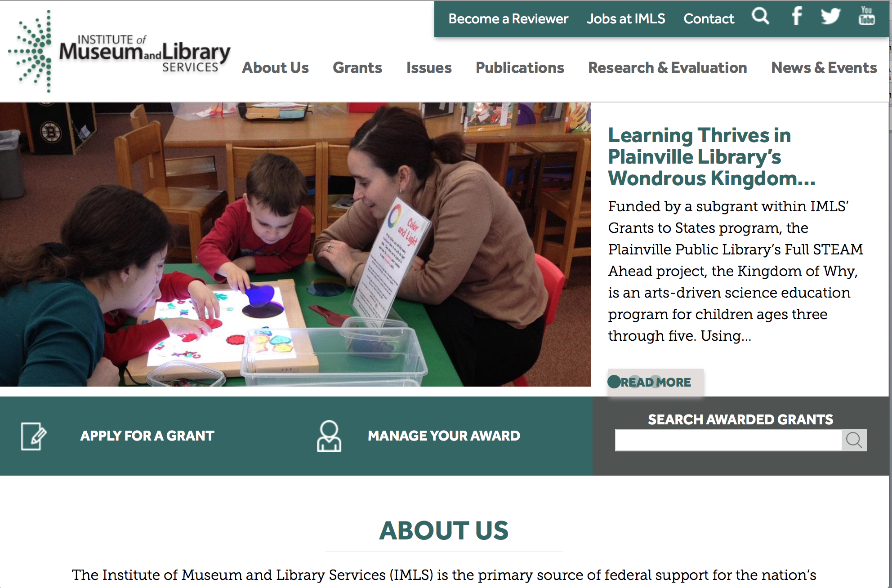

www.imls.gov

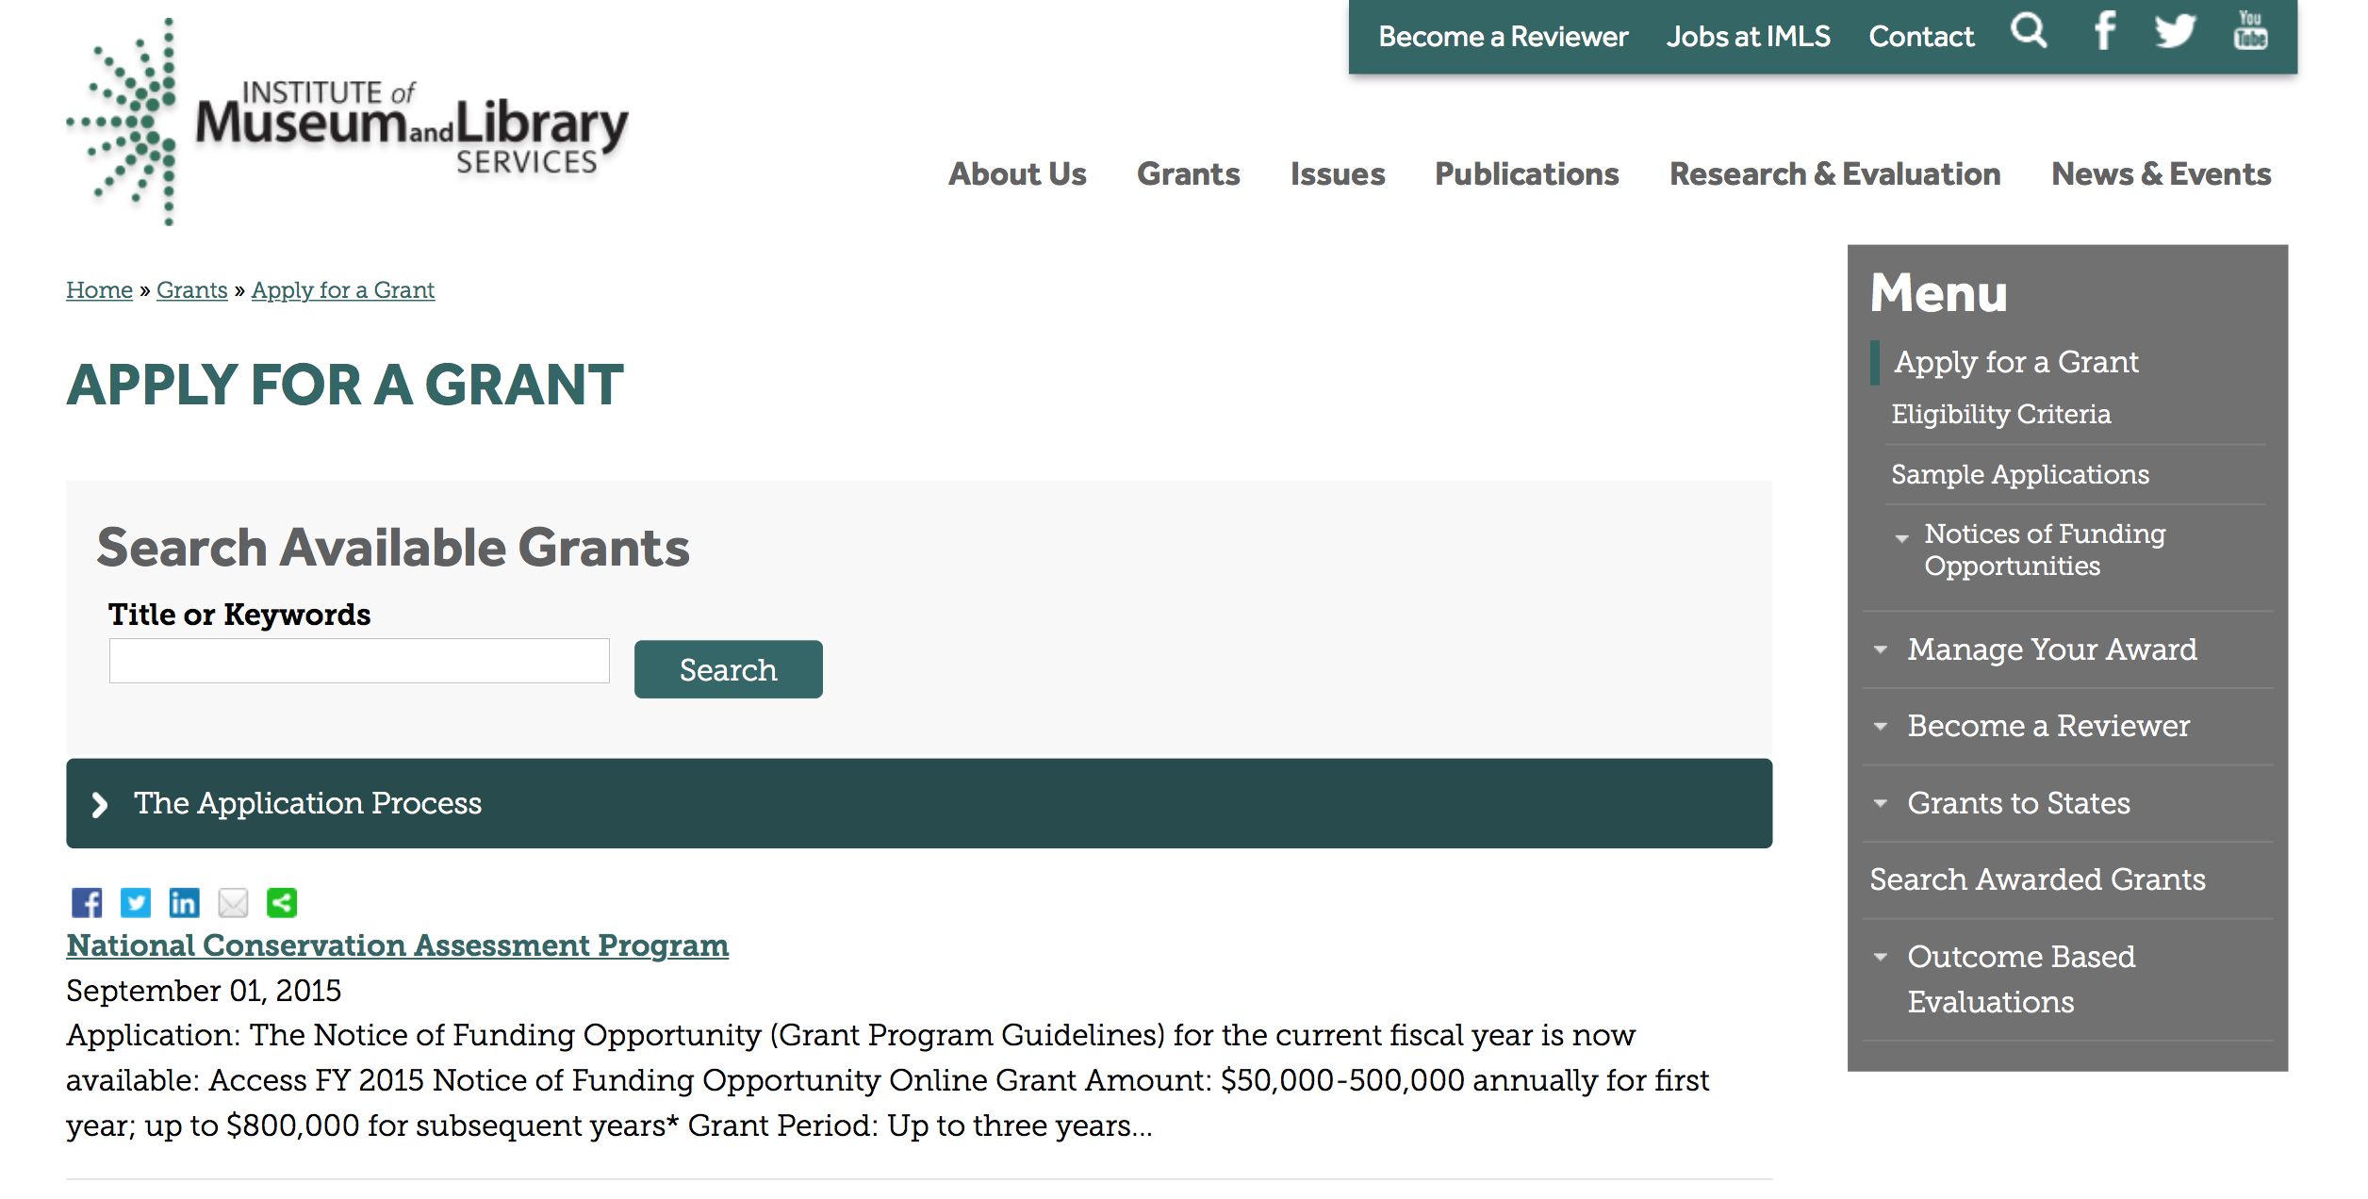
http://www.imls.gov/applicants/available_grants.aspx

Each grant program has specific eligibility requirements. The links below provide general eligibility criteria for museums, libraries, and tribal organizations, but please note that additional organizations may be eligible for grants under certain programs. Additionally, ineligible organizations may still be able to participate in grant programs through partnerships with eligible organizations. Please click on the links below to see general criteria and review Applications and Guidelines for specific information.
Museums Libraries

Institutions: Archives, Federally Recognized Native American Tribe, Historical Society, Library, Nonprofits that serve Native Hawaiians, Professional Association, Public or Private Non-profit Institutions of Higher Education, Regional Organization, State Library Administrative Agency, State or Local Government

Check out IMLS's Facebook page at:
https://www.facebook.com/USIMLS/

Programs:

Modifications:

Reminders:

Deleted:

Department of the Interior
Working with Interior

The Interior Department provides assistance to the public, local governments and businesses through a number of programs. For a general overview see: http://www.doi.gov/index.cfm

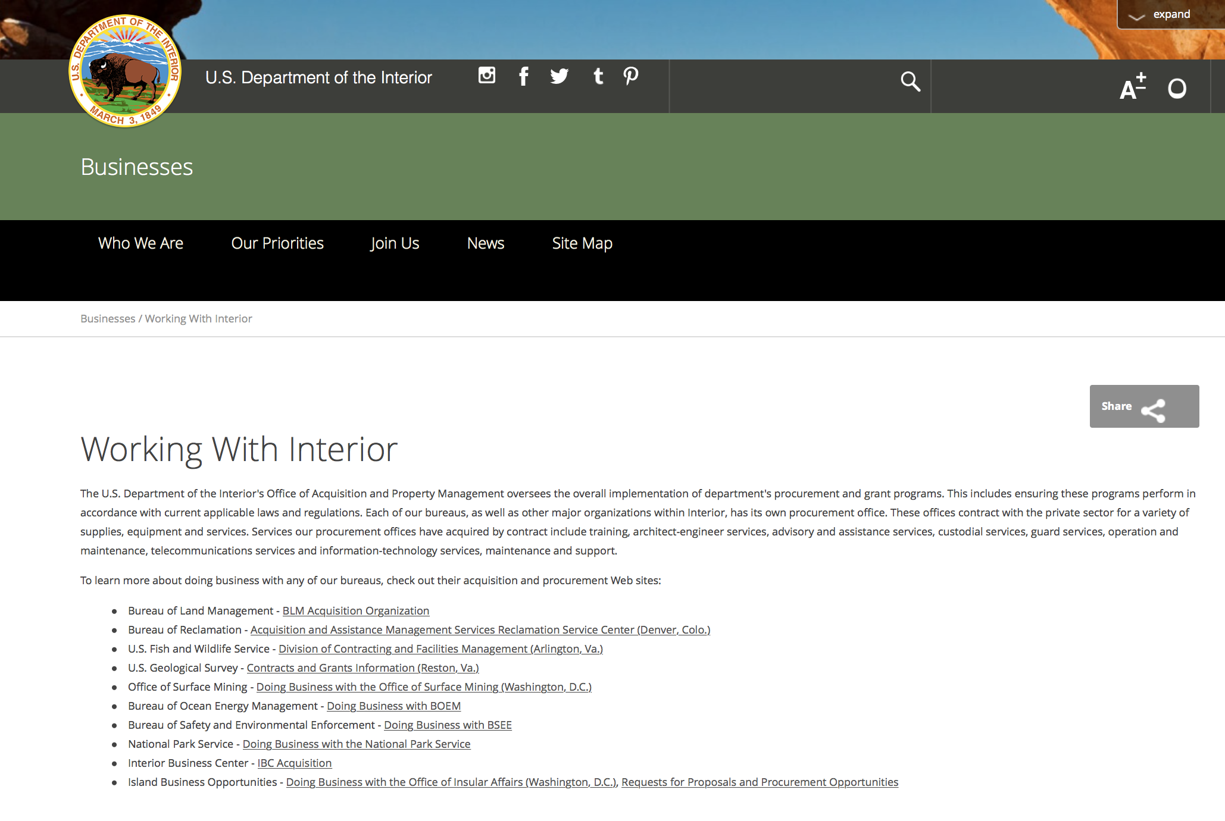

http://www.doi.gov/businesses/working-with-interior.cfm

Programs:

Modifications:

Reminders:

National Fish Passage Program
Synopsis 1

Document Type: | Grants Notice
Funding Opportunity Number: | F17AS00030
Funding Opportunity Title: | National Fish Passage Program
Opportunity Category: | Discretionary
Opportunity Category Explanation:
Funding Instrument Type: | Cooperative Agreement  Grant
Category of Funding Activity: | Natural Resources
Category Explanation:
Expected Number of Awards: | 0
CFDA Number(s): | 15.608 -- Fish and Wildlife Management Assistance
Cost Sharing or Matching Requirement: | Yes
Posted Date: | Nov 23, 2016
Last Updated Date: | Nov 23, 2016
Original Closing Date for Applications: | Sep 30, 2017
Current Closing Date for Applications: | Sep 30, 2017
Archive Date: | Oct 02, 2017
Estimated Total Program Funding: | $0
Award Ceiling: | $2,000,000
Award Floor: | $500
Eligible Applicants: | Unrestricted (i.e., open to any type of entity above), subject to any clarification in text field entitled "Additional Information on Eligibility"
Additional Information on Eligibility: | To receive funding, NFPP projects must be implemented in coordination with FAC staff. Applicants can be, but not limited to: state and federal agencies, private lands, tribes, local municipalities, and non-governmental organizations.
Agency Name: | Fish and Wildlife Service
Description: | The National Fish Passage Program (NFPP) is a voluntary program that provides direct technical assistance and financial assistance in the form of cooperative agreements and grants to partners to provide fish (and other aquatic organisms) passage and restore aquatic connectivity for the benefit of federal trust resources. The NFPP is delivered through more than 65 Fisheries and Aquatic Conservation (FAC) Field Offices across all States and territories. FAC staff coordinates with project partners, stakeholders and other Service programs to identify and collaboratively implement projects within Regional priority areas. Project work plans are developed strategically, in coordination with partners, and with substantial involvement from FAC staff. Projects must advance our mission, promote biological diversity, and be based upon sound scientific biological principles. FAC and Fish and Wildlife Service (FWS) strategic plans inform the types of projects funded under this opportunity. Applicants seeking funding under this program should review the program strategic plan and also contact the regional NFPP Coordinator for local FAC contacts prior to submitting an application for funding.
Link to Additional Information: | http://www.grants.gov
Grantor Contact Information: | If you have difficulty accessing the full announcement electronically, please contact:  Susan Wells 703-358-2523 Susan_Wells@fws.gov  Fish Passage Coordinator

http://www.grants.gov/web/grants/view-opportunity.html?oppId=290297

Fish and Wildlife Service
Fiscal Year

Document Type: | Grants Notice
Funding Opportunity Number: | F17AS00005
Funding Opportunity Title: | Fiscal Year 2017 Recovery Implementation Grants
Opportunity Category: | Discretionary
Opportunity Category Explanation:
Funding Instrument Type: | Cooperative Agreement  Grant  Procurement Contract
Category of Funding Activity: | Environment  Natural Resources
Category Explanation:
Expected Number of Awards: | 0
CFDA Number(s): | 15.657 -- Endangered Species Conservation - Recovery Implementation Funds
Cost Sharing or Matching Requirement: | No
Posted Date: | Oct 18, 2016
Last Updated Date: | Oct 18, 2016
Original Closing Date for Applications: | Applications are due by July 31, 2017. However, you may submit applications throughout the year. Consideration of applications ultimately will be based on the FWS budget cycle.
Current Closing Date for Applications: | Applications are due by July 31, 2017. However, you may submit applications throughout the year. Consideration of applications ultimately will be based on the FWS budget cycle.
Archive Date: | Aug 31, 2017
Estimated Total Program Funding: | $100,000
Award Ceiling: | $100,000
Award Floor: | $1
Eligible Applicants: | Unrestricted (i.e., open to any type of entity above), subject to any clarification in text field entitled "Additional Information on Eligibility"
Additional Information on Eligibility: | Applicants must have a demonstrated knowledge and understanding of the biology of the involved endangered or threatened species in the United States and their ecosystem, including preferably having worked with the species in the field and holding a currently valid Endangered Species Act permit, issued by the FWS, authorizing them to work with these species (or that have previously held a permit to do so). If funding is awarded, applicants that do not currently hold a valid permit for the proposed activity may need to apply for and obtain a permit (http://www.fws.gov/endangered/permits/index.html) before beginning the proposed activity. FWS Regional (or Field Office) contacts will discuss potential proposals with interested parties if needed, and review eligible applications. The FWS Regional Office will refer interested parties to the appropriate FWS Field Office for further consideration as appropriate. For potential proposals submitted directly to the Field Office, the Field Office will conduct the proposal review and selection process. A list of FWS Regional Office contacts is available in the Full Announcement under section VII. Agency Contacts.
Agency Name: | Fish and Wildlife Service
Description: | The FWS Ecological Services Program provides Federal financial assistance on a competitive basis to States, other Federal agencies, landowners, educators, non-profit organizations, researchers, and other partners to secure information about endangered, threatened or candidate species, to aid in the recovery of these species, to avert listing of species pursuant to the Endangered Species Act, and to help conserve the ecosystems upon which these species depend. The FWS and National Marine Fisheries Service (NMFS), which is part of the Department of Commerceï¿½s NOAA Fisheries office, share Endangered Species Act responsibilities for several species such as sea turtles. We have responsibility for sea turtles when they are on land, and NMFS has responsibility for sea turtles when they are in the water. Projects for NMFS-managed species are not included in this funding opportunity. This Recovery Implementation funding opportunity is intended for projects that will contribute to the recovery of FWS-managed endangered and threatened species in the United States, and is limited to projects carrying out actions described in a speciesï¿½ approved recovery plan, in the implementation schedule of a speciesï¿½ approved recovery plan, actions recommended in a completed 5-year status review of the species or in a spotlight species action plan, or projects documenting speciesï¿½ response to climate change. For example: securing scientific information about endangered or threatened species, implementing restoration actions that will lead to delisting of a species, help prevent extinction of a species, or aid in the recovery of a species. Projects that address species response to climate change will receive additional consideration.
Link to Additional Information: | http://www.grants.gov
Grantor Contact Information: | If you have difficulty accessing the full announcement electronically, please contact:  Kelly Niland 703-358-2492 Kelly_Niland@fws.gov  Kelly_Niland@fws.gov

http://www.grants.gov/web/grants/view-opportunity.html?oppId=289600

Fish and Wildlife Service
Partners for Fish and Wildlife
Synopsis 1

Document Type: | Grants Notice
Funding Opportunity Number: | F17AS00015
Funding Opportunity Title: | Partners for Fish and Wildlife
Opportunity Category: | Discretionary
Opportunity Category Explanation:
Funding Instrument Type: | Cooperative Agreement
Category of Funding Activity: | Community Development  Education  Environment  Natural Resources
Category Explanation:
Expected Number of Awards: | 5000
CFDA Number(s): | 15.631 -- Partners for Fish and Wildlife
Cost Sharing or Matching Requirement: | No
Posted Date: | Nov 03, 2016
Last Updated Date: | Nov 03, 2016
Original Closing Date for Applications: | Sep 30, 2017
Current Closing Date for Applications: | Sep 30, 2017
Archive Date: | Oct 07, 2017
Estimated Total Program Funding: | $52,000,000
Award Ceiling: | $500,000
Award Floor: | $1
Eligible Applicants: | For profit organizations other than small businesses  Nonprofits having a 501(c)(3) status with the IRS, other than institutions of higher education  City or township governments  Native American tribal organizations (other than Federally recognized tribal governments)  State governments  Individuals  Small businesses  Public and State controlled institutions of higher education  Nonprofits that do not have a 501(c)(3) status with the IRS, other than institutions of higher education  Native American tribal governments (Federally recognized)  County governments  Private institutions of higher education
Agency Name: | Fish and Wildlife Service
Description: | The Partners for Fish and Wildlife (PFW) Program is a voluntary, incentive-based program that provides direct technical assistance and financial assistance in the form of cooperative agreements to private landowners to restore and conserve fish and wildlife habitat for the benefit of federal trust resources. The PFW Program is delivered through more than 250 full-time staff, active in all 50 States and territories. Partners for Fish and Wildlife Program staff coordinate with project partners, stakeholders and other Service programs to identify geographic focus areas and develop habitat conservation priorities within these focus areas. Geographic focus areas are where the PFW Program directs resources to conserve habitat for federal trust species. Project work plans are developed strategically, in coordination with partners, and with substantial involvement from Service field staff. Projects must advance our mission, promote biological diversity, and be based upon sound scientific biological principles. Program strategic plans inform the types of projects funded under this opportunity. Applicants seeking funding under this program should review the program strategic plan and also contact the regional PFW Program office prior to submitting an application for funding. Authorizing statues include Partners for Fish and Wildlife Act of 2006, 16 U.S.C. 3771-3774; Fish and Wildlife Act of 1956; 16 U.S.C. 742a-c, 742e-j; Fish and Wildlife Coordination Act of 1958, 16 U.S.C. 661-667(e).
Link to Additional Information: | http://www.grants.gov
Grantor Contact Information: | If you have difficulty accessing the full announcement electronically, please contact:  Matthew Filsinger 703-358-2011 matthew_filsinger@fws.gov  Project Officer

http://www.grants.gov/web/grants/view-opportunity.html?oppId=289882

Fish and Wildlife Service
Coastal Program
Synopsis 1

Document Type: | Grants Notice
Funding Opportunity Number: | F17AS00014
Funding Opportunity Title: | Coastal Program
Opportunity Category: | Discretionary
Opportunity Category Explanation:
Funding Instrument Type: | Cooperative Agreement
Category of Funding Activity: | Community Development  Education  Environment  Natural Resources
Category Explanation:
Expected Number of Awards: | 500
CFDA Number(s): | 15.630 -- Coastal
Cost Sharing or Matching Requirement: | No
Posted Date: | Nov 03, 2016
Last Updated Date: | Nov 03, 2016
Original Closing Date for Applications: | Sep 30, 2017
Current Closing Date for Applications: | Sep 30, 2017
Archive Date: | Oct 07, 2017
Estimated Total Program Funding: | $14,000,000
Award Ceiling: | $500,000
Award Floor: | $1
Eligible Applicants: | County governments  Nonprofits having a 501(c)(3) status with the IRS, other than institutions of higher education  City or township governments  Special district governments  Native American tribal governments (Federally recognized)  Private institutions of higher education  Native American tribal organizations (other than Federally recognized tribal governments)  For profit organizations other than small businesses  State governments  Small businesses  Public and State controlled institutions of higher education  Individuals  Nonprofits that do not have a 501(c)(3) status with the IRS, other than institutions of higher education
Agency Name: | Fish and Wildlife Service
Description: | The Coastal Program is a voluntary, incentive-based program that provides direct technical assistance and financial assistance in the form of cooperative agreements to coastal communities and landowners to restore and protect fish and wildlife habitat on public and private lands. Coastal Program staff coordinate with project partners, stakeholders and other Service programs to identify geographic focus areas and develop habitat conservation priorities within these focus areas. Geographic focus areas are where the Coastal Program directs resources to conserve habitat for federal trust species. Project work plans are developed strategically, in coordination with partners, and with substantial involvement from Service field staff. Projects must advance our mission, promote biological diversity, and be based upon sound scientific biological principles. Program strategic plans inform the types of projects funded under this opportunity. Applicants seeking funding under this program should review the program strategic plan and also contact the regional Coastal Program office prior to submitting an application for funding. Authorizing statues include Fish and Wildlife Act of 1956, 16 U.S.C. 742a-c, 747e-742j; and Fish and Wildlife Coordination Act of 1958, 16 U.S.C. 661 667(e).
Link to Additional Information: | http://www.grants.gov
Grantor Contact Information: | If you have difficulty accessing the full announcement electronically, please contact:  Chris Darnell 703-358-2236 chris_darnell@fws.gov  Project Officer

http://www.grants.gov/web/grants/view-opportunity.html?oppId=289863

Geological Survey
Cooperative Research Units Program FY 2017
Synopsis 2

Document Type: | Grants Notice
Funding Opportunity Number: | G17AS00004
Funding Opportunity Title: | Cooperative Research Units Program FY 2017
Opportunity Category: | Discretionary
Opportunity Category Explanation:
Funding Instrument Type: | Cooperative Agreement
Category of Funding Activity: | Environment  Natural Resources  Science and Technology and other Research and Development
Category Explanation:
Expected Number of Awards: | 0
CFDA Number(s): | 15.812 -- Cooperative Research Units
Cost Sharing or Matching Requirement: | No
Version: | Synopsis 2
Posted Date: | Sep 23, 2016
Last Updated Date: | Sep 23, 2016
Original Closing Date for Applications: | June 20, 2017 (new or changes in scope of work or total estimated cost) August 9, 2017 (other changes not involving change to scope of work or total estimated cost)
Current Closing Date for Applications: | June 20, 2017 (new or changes in scope of work or total estimated cost) August 9, 2017 (other changes not involving change to scope of work or total estimated cost)
Archive Date: | Oct 31, 2017
Estimated Total Program Funding: | $0
Award Ceiling: | $0
Award Floor: | $0
Eligible Applicants: | Others (see text field entitled "Additional Information on Eligibility" for clarification)
Additional Information on Eligibility: | Only CRU Cooperating Universities are eligible to apply to the RWO component of the Cooperative Research Unit Program pursuant to the Cooperative Research Unit Act (Public Law 86-686).
Agency Name: | Geological Survey
Description: | The Cooperative Research Units Program is a unique collaborative relationship between States, Universities, the Federal government and a non-profit organization. The program is comprised of 40 Cooperative Fish and Wildlife Research Units on university campuses in 38 states. Since the original nine Units were established in the 1930s, additional Units were established by Congress at specified universities. The 40 units in the program are jointly supported by the US Geological Survey, Host Universities, State Natural Resource Agencies, Wildlife Management Institute, and the US Fish and Wildlife Service.
Link to Additional Information: | http://www.grants.gov/
Grantor Contact Information: | If you have difficulty accessing the full announcement electronically, please contact:  Melissa Thode (703) 648-4265  CRU Headquarters Office

http://www.grants.gov/web/grants/view-opportunity.html?oppId=289097

Deleted:

Department of Justice

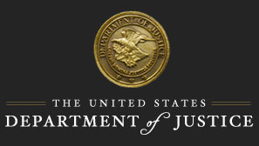

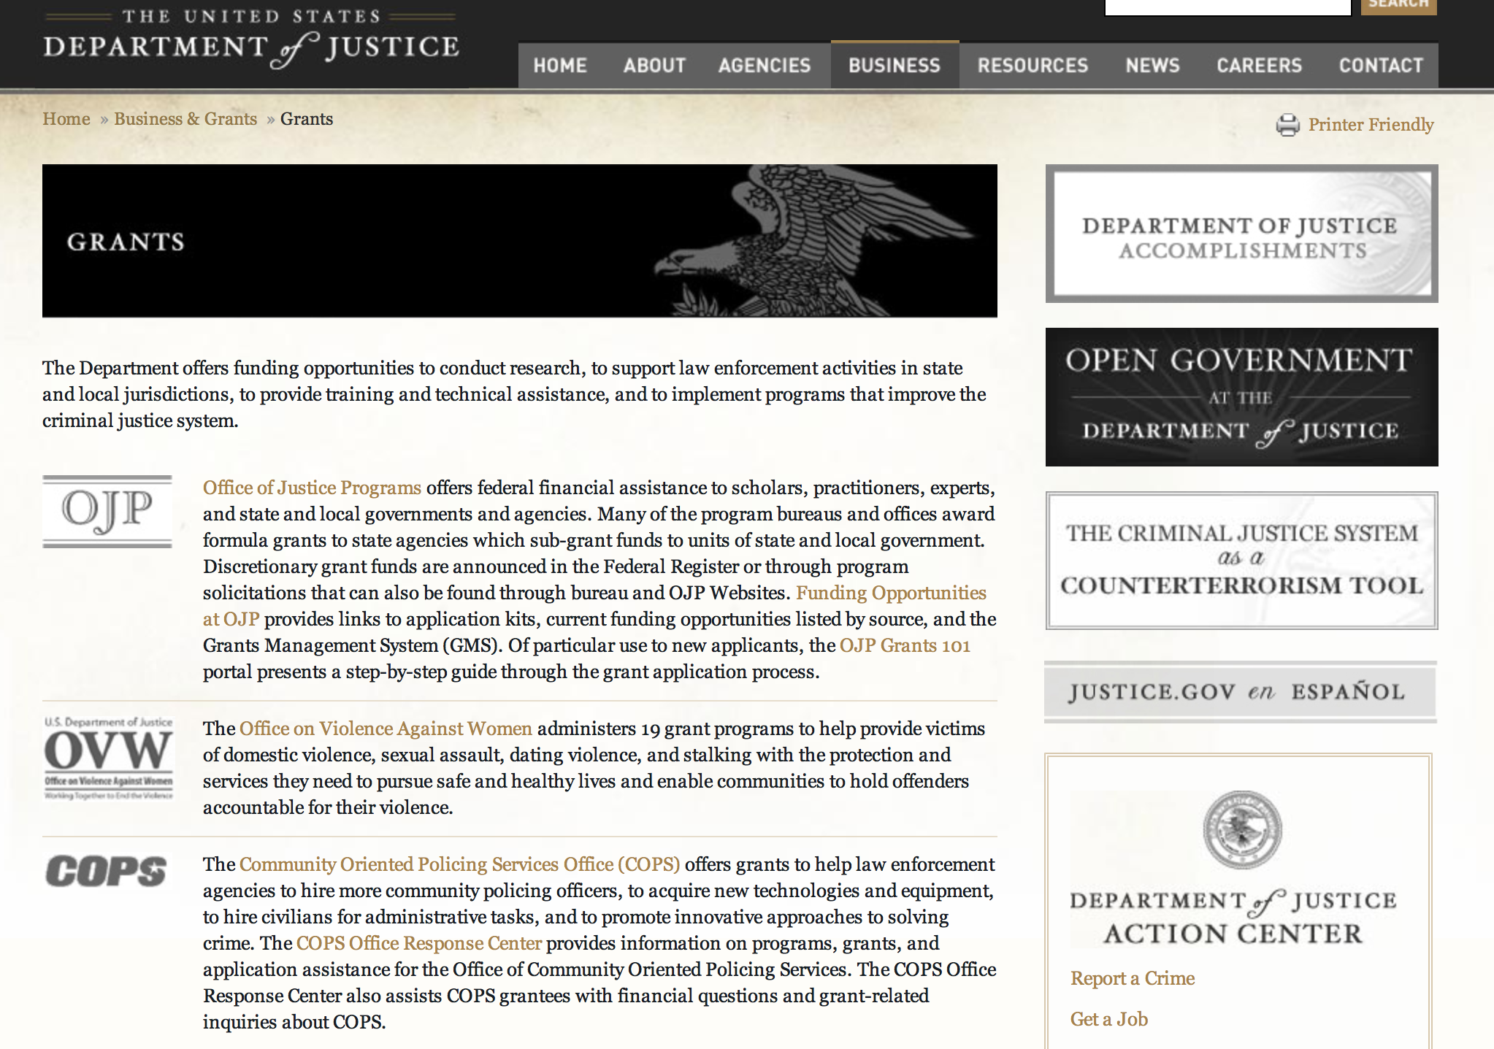

The DOJ agencies listed below also have sites that provide grant information specific to that agency. Examples of what can be found on these sites are programs, funding opportunities, application assistance, and other useful information.

Bureau of Justice Assistance (BJA)

Bureau of Justice Statistics (BJS)

National Criminal Justice Reference Service (NCJRS)

National Institute of Justice (NIJ)

Office of Juvenile Justice and Delinquency Prevention (OJJDP)

Office of Sex Offender Sentencing, Monitoring, Apprehending, Registering, and Tracking (SMART)

Office for Victims of Crime (OVC)

http://www.justice.gov/business/

Programs:

Bureau of Justice Assistance
BJA FY 17 Body-Worn Camera Policy and Implementation Program
Synopsis 1

Document Type: | Grants Notice
Funding Opportunity Number: | BJA-2017-11221
Funding Opportunity Title: | BJA FY 17 Body-Worn Camera Policy and Implementation Program
Opportunity Category: | Discretionary
Opportunity Category Explanation:
Funding Instrument Type: | Grant
Category of Funding Activity: | Law, Justice and Legal Services
Category Explanation:
Expected Number of Awards: | 63
CFDA Number(s): | 16.835 -- Body Worn Camera Policy and Implementation
Cost Sharing or Matching Requirement: | No
Version: | Synopsis 1
Posted Date: | Dec 13, 2016
Last Updated Date: | Dec 13, 2016
Original Closing Date for Applications: | Feb 16, 2017
Current Closing Date for Applications: | Feb 16, 2017
Archive Date:
Estimated Total Program Funding: | $17,000,000
Award Ceiling: | $1,000,000
Eligible Applicants: | County governments  City or township governments  State governments  Native American tribal governments (Federally recognized)
Agency Name: | Bureau of Justice Assistance
Description: | The FY2017 Body Worn Camera (BWC) Policy and Implementation Program will support the implementation, including the purchase, deployment, maintenance, data storage, and policy development of a body-worn camera program, and the necessary policies for law enforcement agencies. The program will play a critical role in the creation, implementation, and evaluation of problem solving approaches that incorporate BWCs into officer practice in selected jurisdictions.
Link to Additional Information: | full announcement
Grantor Contact Information: | If you have difficulty accessing the full announcement electronically, please contact:  For technical assistance with submitting an application, contact the Grants.gov Customer Support Hotline at 800-518-4726 or 606-545-5035, or via email to support@grants.gov. The Grants.gov Support Hotline operates 24 hours a day, 7 days a week, except on federal holidays. support@grants.gov  technical application support

http://www.grants.gov/web/grants/view-opportunity.html?oppId=290674

Bureau of Justice Assistance
BJA FY 17 National Sexual Assault Kit Initiative (SAKI)
Synopsis 1

Document Type: | Grants Notice
Funding Opportunity Number: | BJA-2017-11548
Funding Opportunity Title: | BJA FY 17 National Sexual Assault Kit Initiative (SAKI)
Opportunity Category: | Discretionary
Opportunity Category Explanation:
Funding Instrument Type: | Grant
Category of Funding Activity: | Law, Justice and Legal Services
Category Explanation:
Expected Number of Awards: | 57
CFDA Number(s): | 16.833 -- National Sexual Assault Kit Initiative
Cost Sharing or Matching Requirement: | No
Version: | Synopsis 1
Posted Date: | Dec 20, 2016
Last Updated Date: | Dec 20, 2016
Original Closing Date for Applications: | Mar 02, 2017
Current Closing Date for Applications: | Mar 02, 2017
Archive Date:
Estimated Total Program Funding: | $4,100,000
Award Ceiling: | $3,000,000
Eligible Applicants: | Native American tribal governments (Federally recognized)  City or township governments  County governments  State governments
Agency Name: | Bureau of Justice Assistance
Description: | The purpose of this grant program is to provide funding to test untested sexual assault kits, prevent sexual assaults, and improve the criminal justice system's response to sexual assaults.
Link to Additional Information: | full announcement
Grantor Contact Information: | If you have difficulty accessing the full announcement electronically, please contact:  For technical assistance with submitting an application, contact the Grants.gov Customer Support Hotline at 800-518-4726 or 606-545-5035, or via email to support@grants.gov. The Grants.gov Support Hotline operates 24 hours a day, 7 days a week, except on federal holidays. support@grants.gov  technical application support

http://www.grants.gov/web/grants/view-opportunity.html?oppId=290850

Bureau of Justice Assistance
BJA FY 17 Adult Drug Court Discretionary Grant Program
Synopsis 1

Document Type: | Grants Notice
Funding Opportunity Number: | BJA-2017-11320
Funding Opportunity Title: | BJA FY 17 Adult Drug Court Discretionary Grant Program
Opportunity Category: | Discretionary
Opportunity Category Explanation:
Funding Instrument Type: | Grant
Category of Funding Activity: | Law, Justice and Legal Services
Category Explanation:
Expected Number of Awards: | 40
CFDA Number(s): | 16.585 -- Drug Court Discretionary Grant Program
Cost Sharing or Matching Requirement: | Yes
Version: | Synopsis 1
Posted Date: | Dec 20, 2016
Last Updated Date: | Dec 20, 2016
Original Closing Date for Applications: | Feb 28, 2017
Current Closing Date for Applications: | Feb 28, 2017
Archive Date:
Estimated Total Program Funding: | $45,000,000
Award Ceiling: | $1,500,000
Eligible Applicants: | County governments  City or township governments  Native American tribal governments (Federally recognized)  State governments
Agency Name: | Bureau of Justice Assistance
Description: | BJA is accepting applications to establish new drug courts or enhance existing drug court services, coordination, and offender management and recovery support services. The purpose of the Adult Drug Court Discretionary Grant Program (42 U.S.C. 3797u et seq.) is to provide financial and technical assistance to states, state courts, local courts, units of local government, and Indian tribal governments to develop and implement drug courts that effectively integrate evidenced-based substance abuse treatment, mandatory drug testing, sanctions and incentives, and transitional services in a judicially supervised court setting with jurisdiction over substance-abusing offenders.
Link to Additional Information: | full announcment
Grantor Contact Information: | If you have difficulty accessing the full announcement electronically, please contact:  For technical assistance with submitting an application, contact the Grants.gov Customer Support Hotline at 800-518-4726 or 606-545-5035, or via email to support@grants.gov. The Grants.gov Support Hotline operates 24 hours a day, 7 days a week, except on federal holidays. support@grants.gov  technical application support

http://www.grants.gov/web/grants/view-opportunity.html?oppId=290852

Office of Juvenile Justice Delinquency Prevention
OJJDP FY 17 Smart on Juvenile Justice: Enhancing Youth Access to Justice Initiative
Synopsis 1

Document Type: | Grants Notice
Funding Opportunity Number: | OJJDP-2017-10945
Funding Opportunity Title: | OJJDP FY 17 Smart on Juvenile Justice: Enhancing Youth Access to Justice Initiative
Opportunity Category: | Discretionary
Opportunity Category Explanation:
Funding Instrument Type: | Grant
Category of Funding Activity: | Law, Justice and Legal Services
Category Explanation:
Expected Number of Awards: | 8
CFDA Number(s): | 16.836 -- Indigent Defense
Cost Sharing or Matching Requirement: | No
Version: | Synopsis 2
Posted Date: | Dec 29, 2016
Last Updated Date: | Dec 30, 2016
Original Closing Date for Applications: | Mar 02, 2017
Current Closing Date for Applications: | Mar 02, 2017
Archive Date:
Estimated Total Program Funding: | $3,800,000
Award Ceiling: | $1,500,000
Award Floor: | $300,000
Eligible Applicants: | Private institutions of higher education  Public and State controlled institutions of higher education  For profit organizations other than small businesses  Nonprofits having a 501(c)(3) status with the IRS, other than institutions of higher education  Others (see text field entitled "Additional Information on Eligibility" for clarification)
Additional Information on Eligibility: | This initiative is composed of three categories. Category 1: Juvenile Defense Training and Technical Assistance. Eligible applicants are limited to nonprofit and for-profit organizations (including tribal nonprofit and for-profit organizations) and institutions of higher education (including tribal institutions of higher education. For-profit organizations (as well as other recipients) must forgo any profit or management fee. Category 2: Regional Juvenile Defender Resource Centers. Eligible applicants are limited to nonprofit and for-profit organizations (including tribal nonprofit and for-profit organizations) and institutions of higher education (including tribal institutions of higher education). For-profit organizations (as well as other recipients) must forgo any profit or management fee. Category 3: Second Chance Act Juvenile Reentry Legal Services. Eligible applicants are limited to nonprofit organizations (including tribal nonprofit organizations) and institutions of higher education (including tribal institutions of higher education). OJJDP welcomes applications under which two or more entities would carry out the federal award; however, only one entity may be the applicant. Any others must be proposed as subrecipients (“subgrantees"). The applicant must be the entity that would have primary responsibility for carrying out the award, including administering the funding and managing the entire project. Under this solicitation, only one application by any particular applicant entity will be considered. An entity may, however, be proposed as a subrecipient (“subgrantee”) in more than one application.
Agency Name: | Office of Juvenile Justice Delinquency Prevention
Description: | This initiative is composed of three categories listed below. Eligible applicants are limited to nonprofit organizations having a 501(c)(3) exemption with the Internal Revenue Service; for-profit organizations, including tribal nonprofit and for-profit organizations; and institutions of higher education, including tribal institutions of higher education. For-profit organizations must agree to forgo any profit or management fee. Category 1: Training and Technical Assistance. The Office of Juvenile Justice and Delinquency Prevention (OJJDP) will provide funding to a national training and technical assistance (TTA) provider to deliver intensive assistance to states to develop and implement effective, well-resourced, statewide juvenile defense reform strategic plans. The provider will also work to improve indigent defense, including post-disposition representation, and the overall level of systemic advocacy by providing the juvenile defense bar with cost-effective, innovative training programs, tools and practice guidelines, technical support, capacity-building assistance, and leadership opportunities, and by collaboratively engaging experts and stakeholders. Category 2: State and Tribal Juvenile Defender Resource Centers. Resource centers will be funded to help state, tribal, and local juvenile defense systems enhance the quality of legal representation, leverage resources, and collect and analyze data to measure the effectiveness of services. Category 3: Second Chance Act- Juvenile Reentry Legal Services. This program will provide grants to community based non- profit organizations to provide direct civil legal services, mentoring and reentry planning to justice involved youth that are transitioning or have recently transitioned back to their families and communities following secure confinement or out-of-home placement by providing the youth with direct civil legal services, mentoring and collective advocacy strategies to address the collateral consequences of justice-system involvement and overcome barriers to securing housing, education, and employment in order to reduce recidivism.
Link to Additional Information: | Full Announcement
Grantor Contact Information: | If you have difficulty accessing the full announcement electronically, please contact:  For technical assistance with submitting an application, contact the Grants.gov Customer Support Hotline at 800–518–4726 or 606–545–5035, or via email to support@grants.gov. The Grants.gov Support Hotline operates 24 hours a day, 7 days a week, except on federal holidays. For assistance with any other requirements of this solicitation, contact the Response Center by telephone at 800–851–3420 or TTY: 301–240–6310 (hearing impaired only), by email at grants@ncjrs.gov , or by web chat. Response Center hours of operation are 10 a.m. to 6 p.m. ET, Monday through Friday, and 10 a.m. to 8 p.m. ET on the solicitation close date. Answers to frequently asked questions that may assist applicants are posted at www.ojjdp.gov/grants/solicitations/FY2017/EYA.pdf. grants@ncjrs.gov  email

http://www.grants.gov/web/grants/view-opportunity.html?oppId=290991

Office for Victims of Crime
OVC FY 17 Comprehensive Services for Victims of All Forms of Human Trafficking
Synopsis 1

Document Type: | Grants Notice
Funding Opportunity Number: | OVC-2017-11573
Funding Opportunity Title: | OVC FY 17 Comprehensive Services for Victims of All Forms of Human Trafficking
Opportunity Category: | Discretionary
Opportunity Category Explanation:
Funding Instrument Type: | Cooperative Agreement
Category of Funding Activity: | Income Security and Social Services  Law, Justice and Legal Services
Category Explanation:
Expected Number of Awards: | 13
CFDA Number(s): | 16.320 -- Services for Trafficking Victims
Cost Sharing or Matching Requirement: | Yes
Version: | Synopsis 1
Posted Date: | Dec 20, 2016
Last Updated Date: | Dec 20, 2016
Original Closing Date for Applications: | Feb 21, 2017
Current Closing Date for Applications: | Feb 21, 2017
Archive Date:
Estimated Total Program Funding: | $10,000,000
Award Ceiling: | $750,000
Award Floor: | $0

http://www.grants.gov/web/grants/view-opportunity.html?oppId=290822

Office on Violence Against Women
OVW FY 2017 Sexual Assault Services Culturally Specific Program Solicitation
Synopsis 1 & 2

Document Type: | Grants Notice
Funding Opportunity Number: | OVW-2017-11907
Funding Opportunity Title: | OVW FY 2017 Sexual Assault Services Culturally Specific Program Solicitation
Opportunity Category: | Discretionary
Opportunity Category Explanation:
Funding Instrument Type: | Grant
Category of Funding Activity: | Other (see text field entitled "Explanation of Other Category of Funding Activity" for clarification)
Category Explanation: | Sexual assault victim services and advocacy
Expected Number of Awards: | 11
CFDA Number(s): | 16.023 -- Sexual Assault Services Culturally Specific Program
Cost Sharing or Matching Requirement: | No
Version: | Synopsis 2
Posted Date: | Dec 20, 2016
Last Updated Date: | Dec 21, 2016
Original Closing Date for Applications: | Feb 07, 2017
Current Closing Date for Applications: | Feb 07, 2017
Archive Date:
Estimated Total Program Funding: | $3,500,000
Award Ceiling: | $300,000
Award Floor: | $0
Eligible Applicants: | Nonprofits having a 501(c)(3) status with the IRS, other than institutions of higher education
Agency Name: | Office on Violence Against Women
Description: | The goal of the SAS Culturally Specific Program is create, maintain, and expand sustainable sexual assault services provided by culturally specific organizations, which are uniquely situated to respond to respond to the needs of sexual assault victims within culturally specific populations.
Link to Additional Information: | Full Announcement
Grantor Contact Information: | If you have difficulty accessing the full announcement electronically, please contact:  Tonette Ngassa Program Specialist 202-305-2379 tonette.ngassa@usdoj.gov  tonette.ngassa@usdoj.gov

http://www.grants.gov/web/grants/view-opportunity.html?oppId=290857

Office on Violence Against Women
OVW FY 2017 Transitional Housing Assistance Grants for Victims of Sexual Assault, Domestic Violence, Dating Violence and Stalking
Synopsis 1

Document Type: | Grants Notice
Funding Opportunity Number: | OVW-2017-11820
Funding Opportunity Title: | OVW FY 2017 Transitional Housing Assistance Grants for Victims of Sexual Assault, Domestic Violence, Dating Violence and Stalking
Opportunity Category: | Discretionary
Opportunity Category Explanation:
Funding Instrument Type: | Grant
Category of Funding Activity: | Housing  Other (see text field entitled "Explanation of Other Category of Funding Activity" for clarification)
Category Explanation: | transitional housing and voluntary support services including victim services
Expected Number of Awards: | 70
CFDA Number(s): | 16.736 -- Transitional Housing Assistance for Victims of Domestic Violence, Dating Violence, Stalking, or Sexual Assault
Cost Sharing or Matching Requirement: | No
Version: | Synopsis 1
Posted Date: | Dec 30, 2016
Last Updated Date: | Dec 30, 2016
Original Closing Date for Applications: | Feb 16, 2017
Current Closing Date for Applications: | Feb 16, 2017
Archive Date:
Estimated Total Program Funding: | $25,000,000
Award Ceiling: | $350,000
Award Floor: | $0
Eligible Applicants: | Native American tribal governments (Federally recognized)  State governments  County governments  City or township governments  Others (see text field entitled "Additional Information on Eligibility" for clarification)
Additional Information on Eligibility: | other organizations, including sexual assault and domestic violence victim service providers, sexual assault and domestic violence coalitions, other nonprofit, nongovernmental organizations, or community-based and culturally specific organizations, that have a documented history of effective work concerning sexual assault, domestic violence, dating violence, or stalking
Agency Name: | Office on Violence Against Women
Description: | The Transitional Housing Program makes grants to programs to provide 6-24 months of transitional housing with support services for victims who are homeless, or in need of transitional housing, as a result of a situation of sexual assault, domestic violence, dating violence, or stalking; and for whom emergency shelter services or other crisis intervention services are unavailable or insufficient. OVW is interested in programs with a holistic, victim-centered approach to providing transitional housing services that move survivors into permanent housing. Transitional housing can be provided in facilities that are owned by the applicant, in units that are leased by the applicant, or by providing rental assistance for units leased directly to victims. Support services offered should help transitional housing participants locate and secure permanent housing, secure employment, and integrate into a community. Examples of support services include employment counseling, occupational training, transportation, counseling, child care services, safety planning, case management, and other assistance. Support services must be offered to survivors on a voluntary basis. Voluntary support services are designed with survivor-input to meet the individual needs of each survivor. When implementing a voluntary services model through a trauma-informed approach, effective transitional housing supports the self-determination of survivors and adapts services to their individual needs. Staff who have been trained in working with victims of sexual assault, domestic violence, dating violence, or stalking may also be funded to support transitional housing participants.
Link to Additional Information: | Full Announcement
Grantor Contact Information: | If you have difficulty accessing the full announcement electronically, please contact:  Kara Moller (202) 307-6026 ovw.transitionalhousing@usdoj.gov  ovw.transitionalhousing@usdoj.gov

http://www.grants.gov/web/grants/view-opportunity.html?oppId=290960

Office on Violence Against Women
OVW FY 2017 Legal Assistance for Victims Grant Program Solicitation
Synopsis 1

Document Type: | Grants Notice
Funding Opportunity Number: | OVW-2017-11920
Funding Opportunity Title: | OVW FY 2017 Legal Assistance for Victims Grant Program Solicitation
Opportunity Category: | Discretionary
Opportunity Category Explanation:
Funding Instrument Type: | Grant
Category of Funding Activity: | Law, Justice and Legal Services  Other (see text field entitled "Explanation of Other Category of Funding Activity" for clarification)
Category Explanation: | The Legal Assistance for Victims (LAV) Grant Program supports projects to increase the availability of civil and criminal legal assistance needed to effectively aid adult and youth victims of sexual assault, domestic violence, dating violence, and stalking who are seeking relief in legal matters relating to or arising out of that abuse or violence, at minimum or no cost to the victims.
Expected Number of Awards: | 60
CFDA Number(s): | 16.524 -- Legal Assistance for Victims
Cost Sharing or Matching Requirement: | No
Version: | Synopsis 1
Posted Date: | Jan 04, 2017
Last Updated Date: | Jan 04, 2017
Original Closing Date for Applications: | Feb 16, 2017
Current Closing Date for Applications: | Feb 16, 2017
Archive Date:
Estimated Total Program Funding: | $30,000,000
Award Ceiling: | $800,000
Award Floor: | $400,000
Eligible Applicants: | Nonprofits having a 501(c)(3) status with the IRS, other than institutions of higher education  Native American tribal governments (Federally recognized)  Native American tribal organizations (other than Federally recognized tribal governments)  Public and State controlled institutions of higher education  Nonprofits that do not have a 501(c)(3) status with the IRS, other than institutions of higher education  Private institutions of higher education
Agency Name: | Office on Violence Against Women
Description: | The Legal Assistance for Victims (LAV) Grant Program is intended to increase the availability of civil and criminal legal assistance needed to effectively aid adult and youth victims of sexual assault, domestic violence, dating violence, and stalking who are seeking relief in legal matters relating to or arising out of that abuse or violence, at minimum or no cost to the victims. LAV Grant Program funds may not be used to provide criminal defense services. Grant funds may be used to provide direct legal services to victims of sexual assault, domestic violence, dating violence, and stalking in matters relating to or arising out of that abuse or violence. The objective of the LAV Grant Program is to develop innovative, collaborative projects that provide quality representation to victims of sexual assault, domestic violence, dating violence, and stalking.
Link to Additional Information: | Full Announcement
Grantor Contact Information: | If you have difficulty accessing the full announcement electronically, please contact:  Regina D. Madison Grant Manager 202-307-6026 OVW.LAV@USDOJ.GOV  OVW.LAV@USDOJ.GOV

http://www.grants.gov/web/grants/view-opportunity.html?oppId=291021

Office on Violence Against Women
OVW FY 2017 Enhanced Training and Services to End Abuse in Later Life Program
Synopsis 1

Document Type: | Grants Notice
Funding Opportunity Number: | OVW-2017-11900
Funding Opportunity Title: | OVW FY 2017 Enhanced Training and Services to End Abuse in Later Life Program
Opportunity Category: | Discretionary
Opportunity Category Explanation:
Funding Instrument Type: | Cooperative Agreement
Category of Funding Activity: | Income Security and Social Services  Law, Justice and Legal Services
Category Explanation:
Expected Number of Awards: | 9
CFDA Number(s): | 16.528 -- Enhanced Training and Services to End Violence and Abuse of Women Later in Life
Cost Sharing or Matching Requirement: | No
Version: | Synopsis 1
Posted Date: | Jan 05, 2017
Last Updated Date: | Jan 04, 2017
Original Closing Date for Applications: | Feb 21, 2017
Current Closing Date for Applications: | Feb 21, 2017
Archive Date:
Estimated Total Program Funding: | $3,000,000
Award Ceiling: | $400,000
Award Floor: | $0
Eligible Applicants: | Native American tribal organizations (other than Federally recognized tribal governments)  Others (see text field entitled "Additional Information on Eligibility" for clarification)  Native American tribal governments (Federally recognized)  City or township governments  State governments  Special district governments  County governments  Nonprofits having a 501(c)(3) status with the IRS, other than institutions of higher education
Additional Information on Eligibility: | State, tribal, or territorial domestic violence or sexual assault coalitions
Agency Name: | Office on Violence Against Women
Description: | The Enhanced Training and Services to End Abuse in Later Life Program provides or enhances training and services to address elder abuse, neglect, and exploitation, including sexual assault, domestic violence, dating violence, or stalking, involving victims who are 50 years of age or older.
Link to Additional Information: | Full announcement
Grantor Contact Information: | If you have difficulty accessing the full announcement electronically, please contact:  Janice A. Green Senior Program Specialist 202-616-6728 janice.a.green@usdoj.gov  janice.a.green@usdoj.gov

http://www.grants.gov/web/grants/view-opportunity.html?oppId=291023

Office on Violence Against Women
OVW FY 2017 Improving Criminal Justice Responses to Sexual Assault, Domestic Violence, Dating Violence, and Stalking Grant Program (also known as the Arrest Program)
Synopsis 1

Document Type: | Grants Notice
Funding Opportunity Number: | OVW-2017-11921
Funding Opportunity Title: | OVW FY 2017 Improving Criminal Justice Responses to Sexual Assault, Domestic Violence, Dating Violence, and Stalking Grant Program (also known as the Arrest Program)
Opportunity Category: | Discretionary
Opportunity Category Explanation:
Funding Instrument Type: | Grant
Category of Funding Activity: | Law, Justice and Legal Services
Category Explanation:
Expected Number of Awards: | 55
CFDA Number(s): | 16.590 -- Grants to Encourage Arrest Policies and Enforcement of Protection Orders Program
Cost Sharing or Matching Requirement: | No
Version: | Synopsis 1
Posted Date: | Jan 04, 2017
Last Updated Date: | Jan 04, 2017
Original Closing Date for Applications: | Feb 16, 2017
Current Closing Date for Applications: | Feb 16, 2017
Archive Date:
Estimated Total Program Funding: | $50,000,000
Award Ceiling: | $900,000
Award Floor: | $0
Eligible Applicants: | Others (see text field entitled "Additional Information on Eligibility" for clarification)  City or township governments  Native American tribal governments (Federally recognized)  County governments  State governments
Additional Information on Eligibility: | State, local, tribal, and territorial courts (including juvenile courts), victim services providers (including state, tribal, or territorial domestic violence or sexual assault coalitions and government rape crisis centers (in a state other than a territory))
Agency Name: | Office on Violence Against Women
Description: | The United States Department of Justice, Office on Violence Against Women (OVW) (www.ovw.usdoj.gov) is pleased to announce that it is seeking applications for the Improving Criminal Justice Responses to Sexual Assault, Domestic Violence, Dating Violence, and Stalking Grant Program (formerly known as the Grants to Encourage Arrest and Enforcement of Protection Orders Program). This program furthers the Department of Justice’s mission by encouraging partnerships between state, local, and tribal governments, courts, victim service providers, coalitions and rape crisis centers, to ensure that sexual assault, domestic violence, dating violence, and stalking are treated as serious violations of criminal law requiring the coordinated involvement of the entire criminal justice system and community-based victim service organizations.
Link to Additional Information: | Full Description
Grantor Contact Information: | If you have difficulty accessing the full announcement electronically, please contact:  Michele John Grant Program Specialist 202-616-5342 Michele.John@usdoj.gov  Michele.John@usdoj.gov

http://www.grants.gov/web/grants/view-opportunity.html?oppId=291037

Office on Violence Against Women
OVW FY 2017 Grants to Enhance Culturally Specific Services for Victims of Sexual Assault, Domestic Violence, Dating Violence, and Stalking Program Solicitation
Synopsis 1

Document Type: | Grants Notice
Funding Opportunity Number: | OVW-2017-11903
Funding Opportunity Title: | OVW FY 2017 Grants to Enhance Culturally Specific Services for Victims of Sexual Assault, Domestic Violence, Dating Violence, and Stalking Program Solicitation
Opportunity Category: | Discretionary
Opportunity Category Explanation:
Funding Instrument Type: | Grant
Category of Funding Activity: | Arts (see "Cultural Affairs" in CFDA)  Education  Humanities (see "Cultural Affairs" in CFDA)
Category Explanation:
Expected Number of Awards: | 20
CFDA Number(s): | 16.016 -- Culturally and Linguistically Specific Services Program
Cost Sharing or Matching Requirement: | No
Version: | Synopsis 1
Posted Date: | Jan 05, 2017
Last Updated Date: | Jan 04, 2017
Original Closing Date for Applications: | Feb 16, 2017
Current Closing Date for Applications: | Feb 16, 2017
Archive Date:
Estimated Total Program Funding: | $6,000,000
Award Ceiling: | $300,000
Award Floor: | $0
Eligible Applicants: | Nonprofits having a 501(c)(3) status with the IRS, other than institutions of higher education  Native American tribal organizations (other than Federally recognized tribal governments)
Agency Name: | Office on Violence Against Women
Description: | Grants to Enhance Culturally Specific Services for Victims of Sexual Assault, Domestic Violence, Dating Violence and Stalking Program supports community-based organizations in providing culturally relevant services to victims of sexual assault, domestic violence, dating violence, and stalking.
Link to Additional Information: | Full announcement
Grantor Contact Information: | If you have difficulty accessing the full announcement electronically, please contact:  Paule Tessier Program Specialist 202-353-8408 Paule.Tessier@usdoj.gov  Paule.Tessier@usdoj.gov

http://www.grants.gov/web/grants/view-opportunity.html?oppId=291039

Research:

Bureau of Justice Statistics
FY 2017 Graduate Research Fellowship Program for Criminal Justice Statistics
Synopsis 1
http://www.grants.gov/web/grants/view-opportunity.html?oppId=290719

Bureau of Justice Assistance
BJA FY 17 Smart Prosecution Initiative
Synopsis 1
http://www.grants.gov/web/grants/view-opportunity.html?oppId=290572

Bureau of Justice Assistance
BJA FY 17 The Intellectual Property Enforcement Program:Protecting Public Health, Safety, and the Economy from Counterfeit Goods and Product Piracy
Synopsis 1
http://www.grants.gov/web/grants/view-opportunity.html?oppId=290706

National Institute of Justice
NIJ FY17 Research and Evaluation for the Testing and Interpretation of Physical Evidence in Publicly Funded Forensic Laboratories
Synopsis 1
http://www.grants.gov/web/grants/view-opportunity.html?oppId=290989

Office of Juvenile Justice Delinquency Prevention
OJJDP FY 17 Mentoring Research Partners Solicitation
Synopsis 1
http://www.grants.gov/web/grants/view-opportunity.html?oppId=290847

Bureau of Justice Assistance
BJA FY 17 Wrongful Conviction Review Program
Synopsis 1
http://www.grants.gov/web/grants/view-opportunity.html?oppId=291018

Office for Victims of Crime
OVC FY 17 Enhanced Collaborative Model to Combat Human Trafficking Competitive Solicitation
Synopsis 1
http://www.grants.gov/web/grants/view-opportunity.html?oppId=291019

National Institute of Justice
NIJ FY17 Research and Evaluation in Safety, Health and Wellness in the Criminal Justice System
Synopsis 1
http://www.grants.gov/web/grants/view-opportunity.html?oppId=291029

Modifications:

Office on Violence Against Women
OVW FY 2017 Consolidated Grant Program to Address Children and Youth Experiencing Domestic and Sexual Assault and Engage Men and Boys as Allies Solicitation
Synopsis 2

Document Type: | Grants Notice
Funding Opportunity Number: | OVW-2017-11902
Funding Opportunity Title: | OVW FY 2017 Consolidated Grant Program to Address Children and Youth Experiencing Domestic and Sexual Assault and Engage Men and Boys as Allies Solicitation
Opportunity Category: | Discretionary
Opportunity Category Explanation:
Funding Instrument Type: | Grant
Category of Funding Activity: | Other (see text field entitled "Explanation of Other Category of Funding Activity" for clarification)
Category Explanation: | victim services, children and youth services, education and training, prevention strategies
Expected Number of Awards: | 15
CFDA Number(s): | 16.888 -- Consolidated And Technical Assistance Grant Program to Address Children and Youth Experiencing Domestic and Sexual Viole
Cost Sharing or Matching Requirement: | No
Version: | Synopsis 2
Posted Date: | Jan 04, 2017
Last Updated Date: | Jan 05, 2017
Original Closing Date for Applications: | Feb 16, 2017
Current Closing Date for Applications: | Feb 16, 2017
Archive Date:
Estimated Total Program Funding: | $10,000,000
Award Ceiling: | $750,000
Award Floor: | $0
Eligible Applicants: | County governments  Native American tribal governments (Federally recognized)  Native American tribal organizations (other than Federally recognized tribal governments)  City or township governments  Nonprofits having a 501(c)(3) status with the IRS, other than institutions of higher education
Agency Name: | Office on Violence Against Women
Description: | This program is authorized by the FY 2012, 2013, 2014, 2015, and 2016 federal appropriation acts, which consolidated four previously authorized and appropriated programs into one comprehensive program . The Consolidated Youth and Engaging Men Program funds projects designed to provide coordinated community responses (CCR) that support child, youth and young adult victims through direct services, training, coordination and collaboration, effective intervention, treatment, response, and prevention strategies. The Consolidated Youth and Engaging Men Program provides the opportunity for communities to increase collaboration among non-profit victim service providers, community service organizations including those focused on engaging men as role models, schools, tribes and tribal governments, and local government agencies to enhance prevention, intervention, and response efforts in addressing sexual assault, domestic violence, dating violence and stalking in children, youth and young adults ages 0-24.
Link to Additional Information: | Full Announcement
Grantor Contact Information: | If you have difficulty accessing the full announcement electronically, please contact:  Kellie Greene Grant Program Specialist 202-514-0390 kellie.greene@usdoj.gov  kellie.greene@usdoj.gov

http://www.grants.gov/web/grants/view-opportunity.html?oppId=290959

Reminders:

National Institute of Justice
NIJ FY17 Research and Development in Forensic Science for Criminal Justice Purposes
Synopsis 1 & 2

Document Type: | Grants Notice
Funding Opportunity Number: | NIJ-2017-11080
Funding Opportunity Title: | NIJ FY17 Research and Development in Forensic Science for Criminal Justice Purposes
Opportunity Category: | Discretionary
Opportunity Category Explanation:
Funding Instrument Type: | Grant
Category of Funding Activity: | Science and Technology and other Research and Development
Category Explanation:
Expected Number of Awards: | 50
CFDA Number(s): | 16.560 -- National Institute of Justice Research, Evaluation, and Development Project Grants
Cost Sharing or Matching Requirement: | No
Version: | Synopsis 2
Posted Date: | Nov 18, 2016
Last Updated Date: | Nov 28, 2016
Original Closing Date for Applications: | Feb 28, 2017
Current Closing Date for Applications: | Feb 28, 2017
Archive Date:
Estimated Total Program Funding: | $20,000,000
Award Ceiling: | $20,000,000
Award Floor: | $0
Eligible Applicants: | Nonprofits that do not have a 501(c)(3) status with the IRS, other than institutions of higher education  Small businesses  Individuals  State governments  City or township governments  For profit organizations other than small businesses  Public and State controlled institutions of higher education  Nonprofits having a 501(c)(3) status with the IRS, other than institutions of higher education  Private institutions of higher education  County governments  Native American tribal governments (Federally recognized)
Agency Name: | National Institute of Justice
Description: | With this solicitation, NIJ seeks proposals for basic or applied research and development projects that will: (1) increase the body of knowledge to guide and inform forensic science policy and practice or (2) lead to the production of useful materials, devices, systems, or methods that have the potential for forensic application. The intent of this program is to direct the findings of basic scientific research, research and development in broader scientific fields applicable to forensic science, and ongoing forensic science research toward the development of highly discriminating, accurate, reliable, cost-effective, and rapid methods for the identification, analysis, and interpretation of physical evidence for criminal justice purposes.
Link to Additional Information: | http://nij.gov/funding/Documents/solicitations/NIJ-2017-11080.pdf
Grantor Contact Information: | If you have difficulty accessing the full announcement electronically, please contact:  For assistance with this solicitation, contact the National Criminal Justice Reference Service Response Center by telephone at 800-851-3420 or TTY: 301-240-6310 (Hearing impaired only), by e-mail at grants@ncjrs.gov, or by web chat at https://webcontact.ncjrs.gov/ncjchat/chat.jsp. Response Center hours of operation are 10 a.m. to 6 p.m. ET, Monday through Friday, and 10 a.m. to 8 p.m. ET on the solicitation close date. General information on applying for NIJ awards can be found at www.nij.gov/funding/Pages/welcome.aspx. Answers to frequently asked questions that may assist applicants are posted at www.nij.gov/funding/Pages/faqs.aspx. grants@ncjrs.gov  Technical Support

http://www.grants.gov/web/grants/view-opportunity.html?oppId=290187

Deleted:



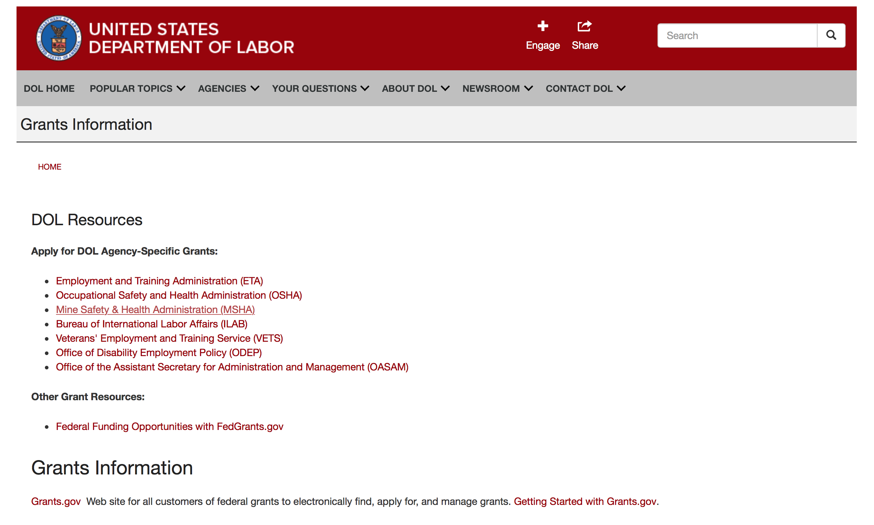

Agency Grants and Contract General Overview

DOL Resources
Apply for DOL Agency-Specific Grants:
- Employment and Training Administration (ETA)
- Occupational Safety and Health Administration (OSHA)
- Mine Safety & Health Administration (MSHA)
- Bureau of International Labor Affairs (ILAB)
- Veterans' Employment and Training Service (VETS)
- Office of Disability Employment Policy (ODEP)
- Office of the Assistant Secretary for Administration and Management (OASAM)

Other Grant Resources:
- Federal Funding Opportunities with FedGrants.gov
Grants Information
Grants.gov — Web site for all customers of federal grants to electronically find, apply for, and manage grants. Getting Started with Grants.gov.

DOL Resources and Instructions for Applying for a Grant
- DOL Guidance Clarifying the Effect of the Religious Freedom Restoration Act on Faith-Based Organizations
- Grant and Contract Information
- Contracting and Grant Program Overview
- Annual Acquisition Plan & Procurement Forecast
- Civil Rights Enforcement for Department of Labor Grant Recipients
- More Information About Grants
- Use of Contracts, Grants & Cooperative Agreements

Other Federal Government Grant Information
- List of Parties Excluded From Federal Procurement and Nonprocurement Programs (as created and maintained by GSA)
- Grant Opportunities (Catalog of Federal Domestic Assistance)

Department of Labor Grant Programs

- Bureau of International Labor Affairs (ILAB): provides grants (cooperative agreements) for the implementation of projects designed to assist developing countries combat the worse forms of child labor, forced labor, and human trafficking; and support worker rights and improve working conditions. http://www.dol.gov/general/business.
- Bureau of Labor Statistics (BLS): provides project grants (cooperative agreements) and the dissemination of technical statistical data and related information on labor force activities; provides data on prices (CPI) and cost of living; data on productivity and technology data; data on compensation and working conditions; data on employment projections.
- Employment and Training (ETA): ETA administers financial assistance programs pursuant to the Workforce Investment Act (WIA), administering State formula grant programs for youth, adults and dislocated workers, national emergency grants for workers affected by mass layoffs, plant closures, and disasters; grant programs for workers with disabilities, Indians and Native Americans, and for migrant and seasonal farmworkers. ETA also administers grant programs for older American workers, apprenticeship programs, Trade Adjustment Assistance (TAA) programs, and assistance for research and development of workforce programs. In addition, ETA is responsible for the operation and maintenance of a national system of public employment service offices and for the national unemployment insurance program.
- Mine Safety and Health (MSHA): provides grants for research, education and training programs to ensure an adequate and competent staff of trained inspectors; and assistance for establishing or improving State mine health and safety programs through technical assistance.
- Occupational Safety and Health (OSHA): provides grants to non-profit organizations to provide training, educational services, and technical assistance; assistance to states to administer and enforce state programs; assistance to states to provide occupational safety and health technical assistance and consultant services.
- Office of Disability Employment Policy (ODEP): The Office of Disability Employment Policy awards competitive grants establishing short-term pilot and technical assistance projects designed to identify, develop, test, evaluate, and disseminate policies to increase employment by expanding access to training, education, employment supports, assistive and systems technology, integrated employment, entrepreneurial development, and small business opportunities for adults and youth with disabilities. Current pilots projects focus on customized employment, Olmstead populations, and innovative demonstration youth grants, among others. Solicitations for grant applications are published in the Federal Register and announced at www.dol.gov/odep. ODEP grants are awarded by the OASAM grant office.
- Veterans' Employment and Training (VETS): provides special employment and training assistance for veterans through the Disabled Veterans' Outreach Program (DVOP) Solicitation for Grant Applications; the Local Veterans' Employment Representative Program (LVER); Veterans' Workforce Investment Program (VWIP); elaws Advisor on veterans' employment and reemployment rights; and the Homeless Veterans Reintegration Project (HVRP). VETS grants are awarded by the OASAM grant office.

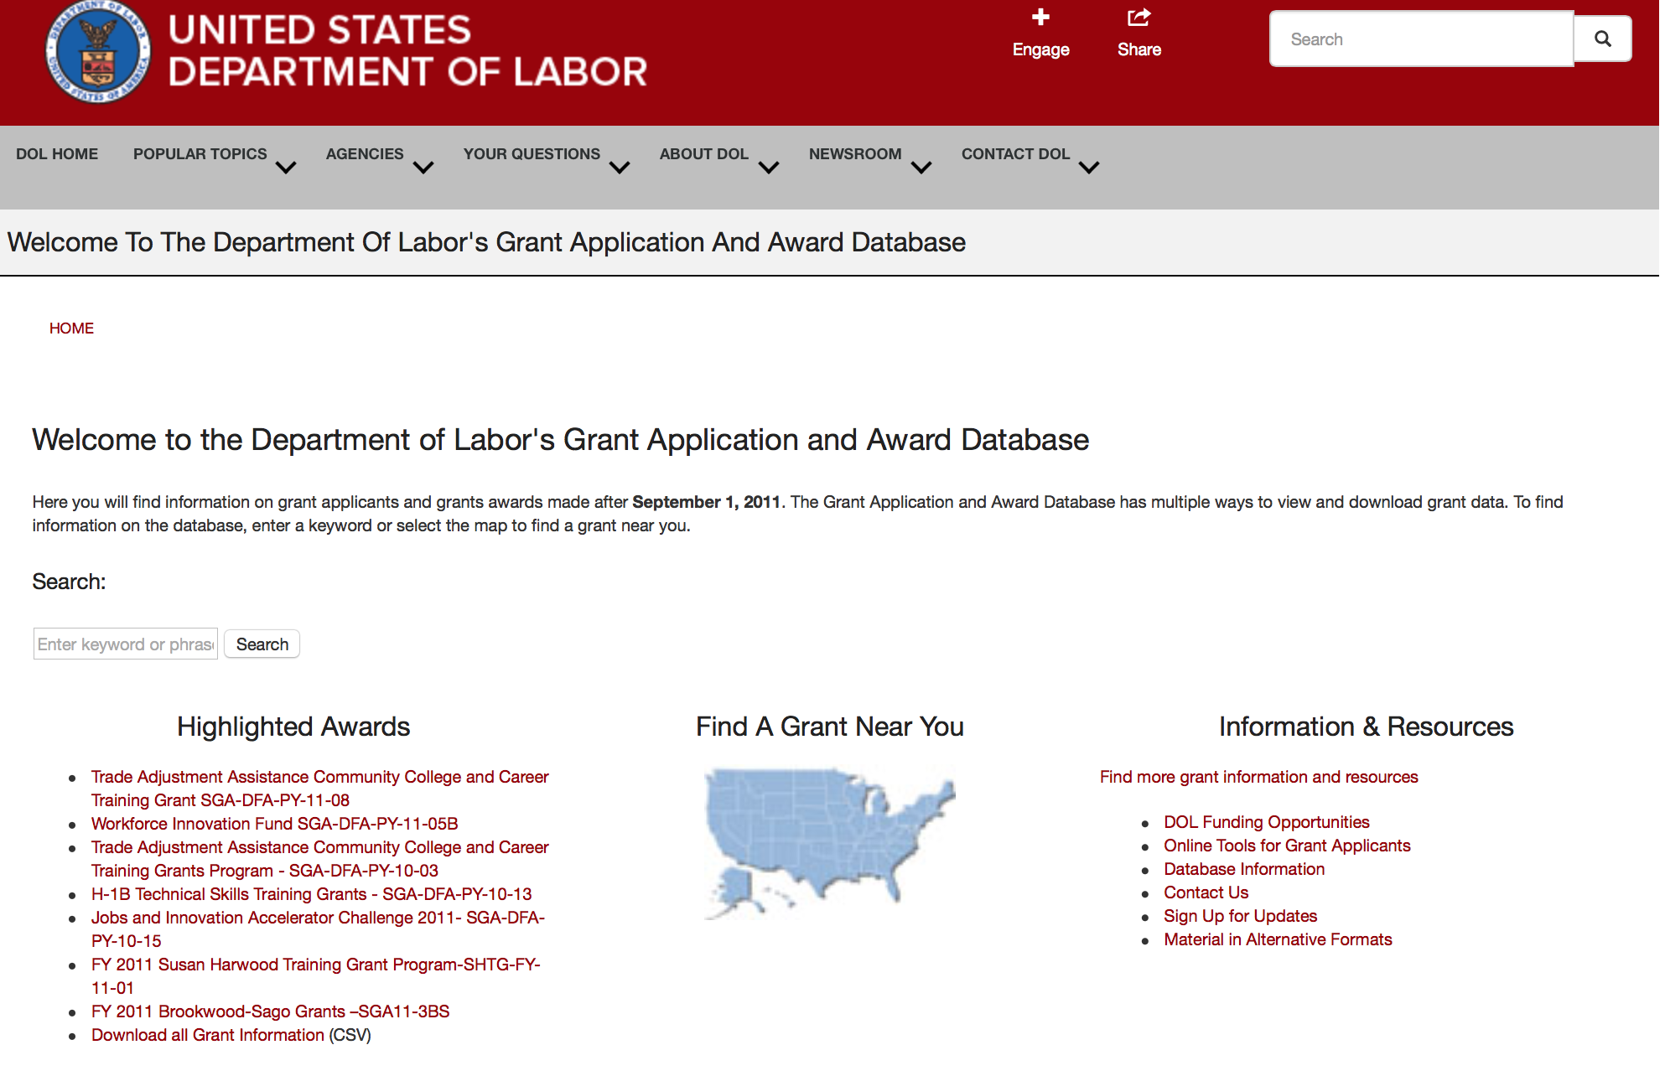

http://www.dol.gov/dol/grants/

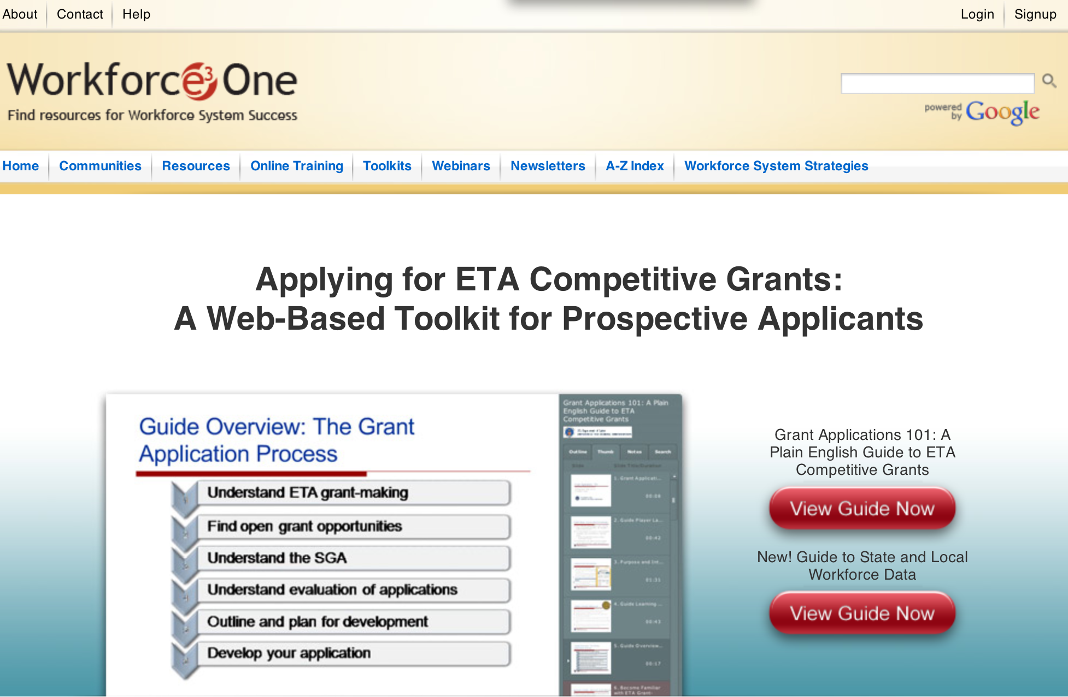

https://www.workforce3one.org/ws/www/pages/grants_toolkit.aspx?pparams=/

Programs

Modifications

Reminders



National Aeronautics and Space Administration

Research and Contracting Opportunities

NASA Research Opportunities Online

- Various NASA offices publish their research announcements over the Internet, broadening the opportunity for researchers to apply for funding. This site provides access to current research announcements along with their specific due dates.

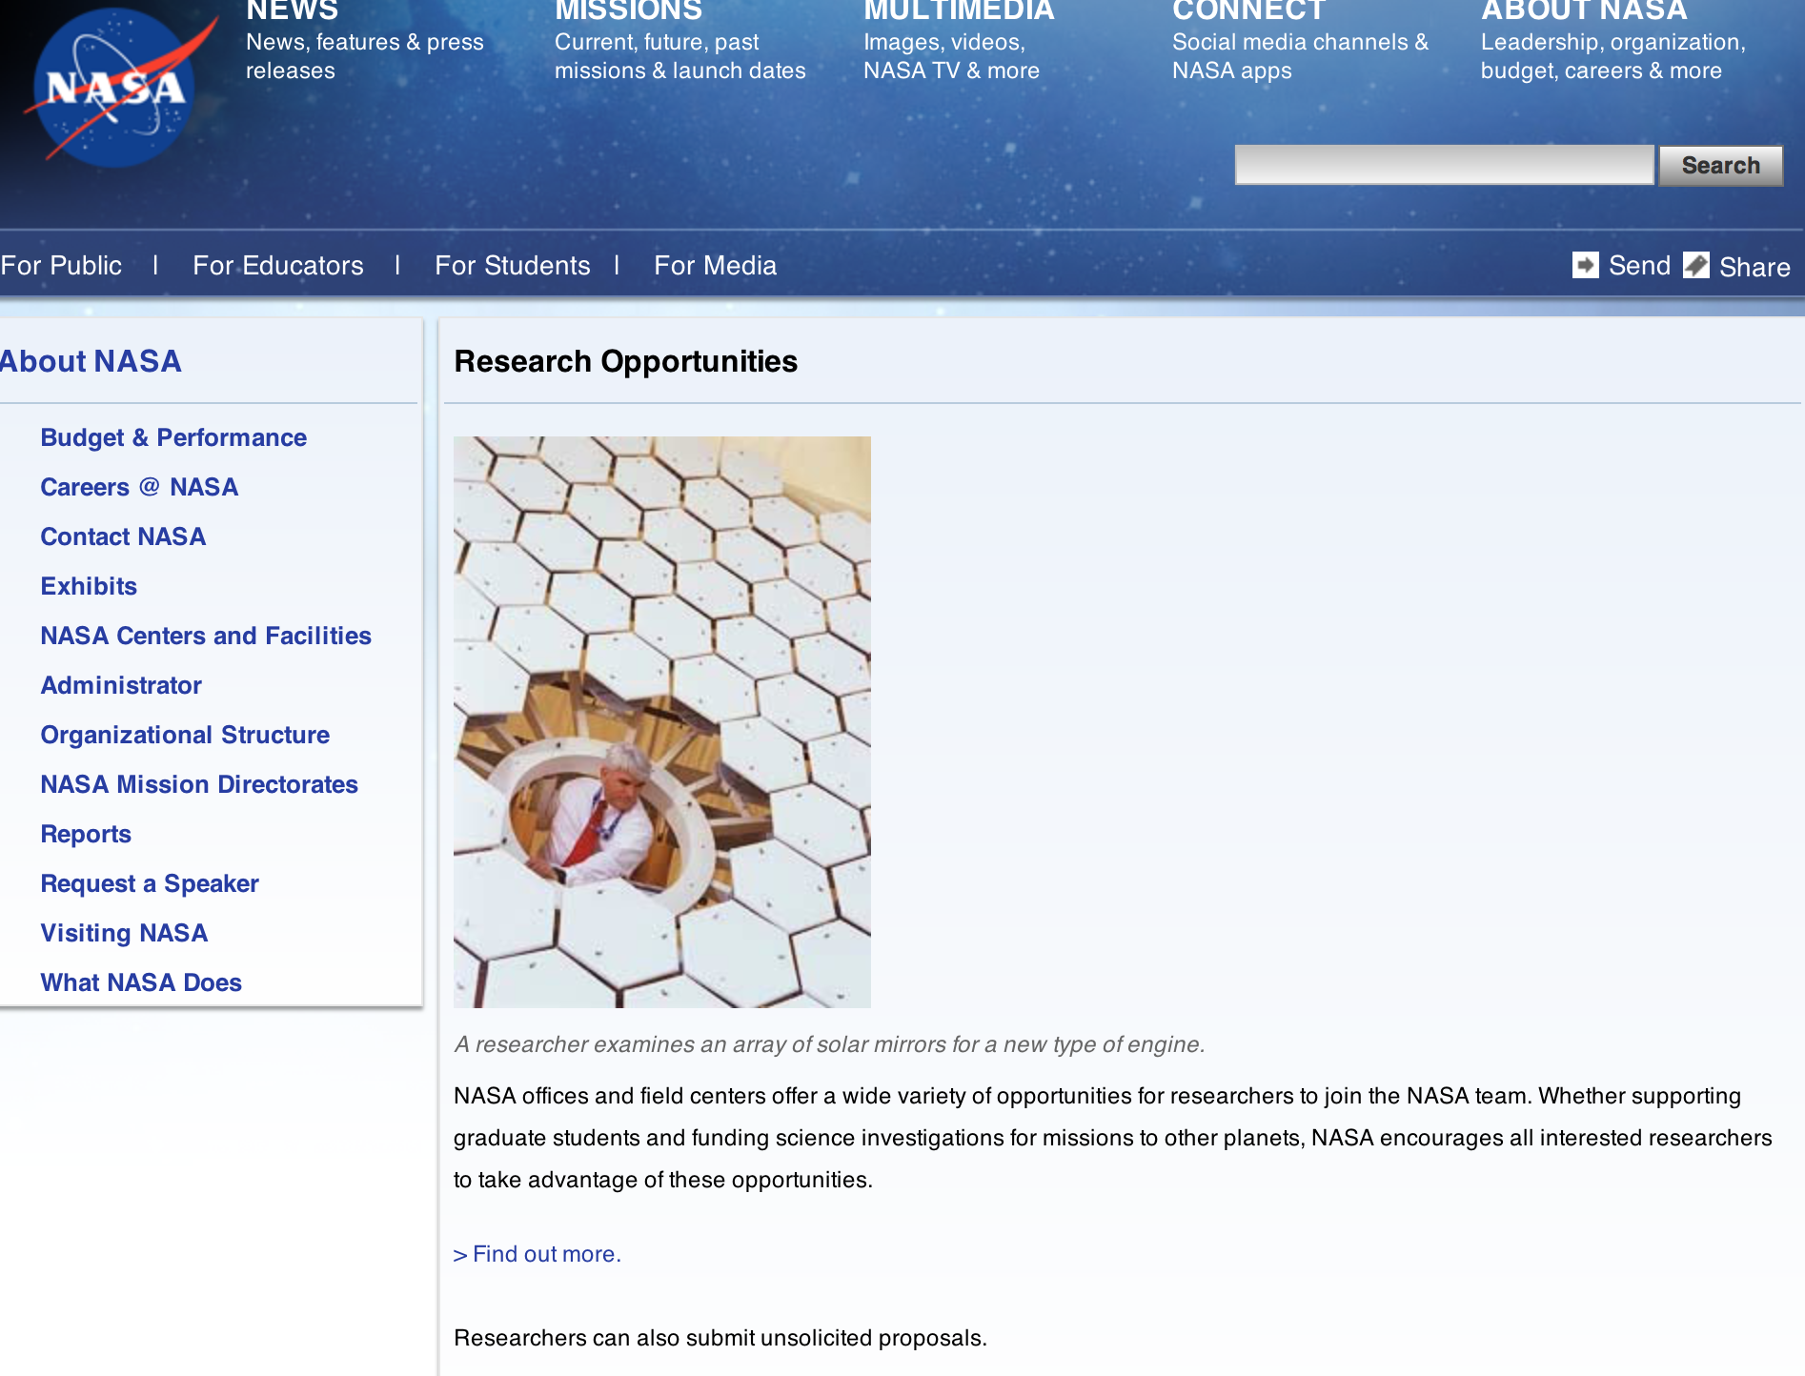

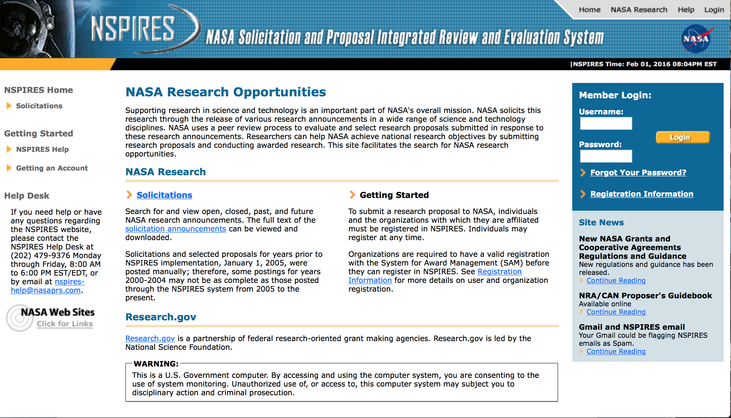

http://nspires.nasaprs.com/external/

Research Programs:

NASA Headquarters
ROSES 2016: Strategic Astrophysics Technology
Synopsis 1
http://www.grants.gov/web/grants/view-opportunity.html?oppId=291024

NASA Headquarters
ROSES 2016: Astrophysics Research and Analysis Program
Synopsis 1
http://www.grants.gov/web/grants/view-opportunity.html?oppId=290626

NASA Headquarters
ROSES 2016: Remote Sensing of Water Quality
Synopsis 1
http://www.grants.gov/web/grants/view-opportunity.html?oppId=290869

NASA Headquarters
ROSES 2016: Group on Earth Observations (GEO) Work Programme
Synopsis 1
http://www.grants.gov/web/grants/view-opportunity.html?oppId=290870

NASA Headquarters
ROSES 2016: New Frontiers Data Analysis Program
Synopsis 1
http://www.grants.gov/web/grants/view-opportunity.html?oppId=290879

2020 Astrophysics Decadal Large Mission Concept, Large Ultraviolet Optical Infrared (LUVOIR) Systems Studies
Synopsis 1
http://www.grants.gov/web/grants/view-opportunity.html?oppId=290934

Modifications:

NASA Headquarters
ROSES 2016: Solar System Workings
Synopsis 2
http://www.grants.gov/web/grants/view-opportunity.html?oppId=289622

FY 2017 NASA EXPERIMENTAL PROGRAM TO STIMULATE COOPERATIVE AGREEMENT NOTICE {CAN}
Synopsis 2
http://www.grants.gov/web/grants/view-opportunity.html?oppId=290474

FY 2017 NASA EXPERIMENTAL PROGRAM TO STIMULATE COOPERATIVE AGREEMENT NOTICE {CAN}
Synopsis 2
http://www.grants.gov/web/grants/view-opportunity.html?oppId=290475

National Archives and Records Administration

Grant Opportunities General Overview

To access the information below: click here

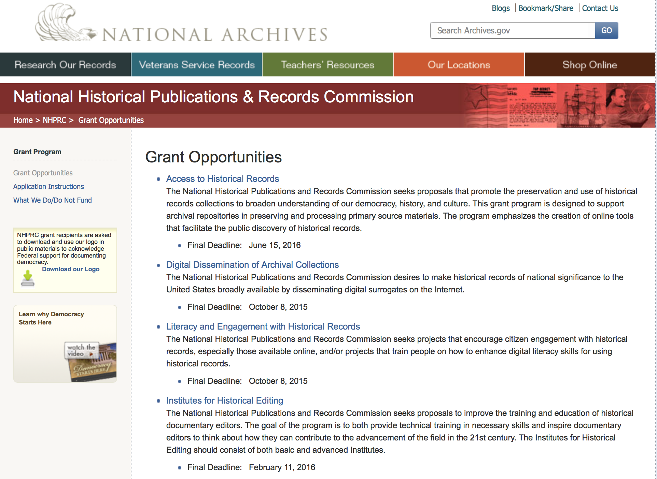

Programs:

Publishing Historical Records in Documentary Editions
Synopsis 1

Document Type: | Grants Notice
Funding Opportunity Number: | EDITIONS-201706
Funding Opportunity Title: | Publishing Historical Records in Documentary Editions
Opportunity Category: | Discretionary
Opportunity Category Explanation:
Funding Instrument Type: | Grant
Category of Funding Activity: | Humanities (see "Cultural Affairs" in CFDA)
Category Explanation:
Expected Number of Awards: | 25
CFDA Number(s): | 89.003 -- National Historical Publications and Records Grants
Cost Sharing or Matching Requirement: | Yes
Version: | Synopsis 1
Posted Date: | Dec 09, 2016
Last Updated Date: | Dec 09, 2016
Original Closing Date for Applications: | Jun 14, 2017
Current Closing Date for Applications: | Jun 14, 2017
Archive Date:
Estimated Total Program Funding: | $2,500,000
Award Ceiling: | $200,000
Award Floor: | $1
Eligible Applicants: | Public and State controlled institutions of higher education  City or township governments  State governments  Private institutions of higher education  Nonprofits having a 501(c)(3) status with the IRS, other than institutions of higher education  Native American tribal governments (Federally recognized)  County governments
Agency Name: | National Archives and Records Administration
Description: | The National Historical Publications and Records Commission seeks proposals to publish documentary editions of historical records. Projects may focus on the papers of major figures from American history or cover broad historical movements in politics, military, business, social reform, the arts, and other aspects of the national experience. The historical value of the records and their expected usefulness to broad audiences must justify the costs of the project. The goal of this program is to provide access to, and editorial context for, the historical documents and records that tell the American story. The NHPRC encourages projects, whenever possible and appropriate, to provide free access to these materials in an open online environment, without precluding other forms of publication. Applicants should demonstrate familiarity with the best practices recommended by the Association for Documentary Editing or the Modern Language Association Committee on Scholarly Editions. Projects may also prepare print editions as part of their overall publishing plan. However, projects that do not have definitive plans for digital dissemination and preservation in place at the time of application will not be considered. It is also expected that the contents of any print volumes produced will be made available online within a reasonable period of time following print publication. Grants are awarded for collecting, describing, preserving, compiling, transcribing, annotating, editing, encoding, and publishing documentary source materials online and in print. Because of the focus on documentary sources, grants do not support preparation of critical editions of published works unless such works are just a small portion of the larger project. All applicants should be aware that the application process is highly competitive. For a comprehensive list of Commission's limitations on funding, please see What We Do and Do Not Fund. Applications that consist entirely of ineligible activities will not be considered. Ongoing projects: Applicants from ongoing projects must demonstrate that they have successfully achieved the performance objectives associated with previous NHPRC awards; provide updated, current information, including a description of the new activities; describe the content and historical significance of the specific materials to be edited during the proposed grant period; show progress towards completing the edition; and justify costs in a new budget. Award Information A grant is for one year and for up to $200,000. The Commission expects to make up to 25 grants in this category for a total of up to $2,500,000. Grants begin no earlier than January 1, 2018. The Commission requires that grant recipients acknowledge NHPRC grant assistance in all publications, publicity, and other products that result from its support. Eligibility • U.S. nonprofit organizations or institutions • U.S. colleges, universities, and other academic institutions • State or local government agencies • Federally-acknowledged or state-recognized Native American tribes or groups Cost Sharing The total costs of a project are shared between the NHPRC and the applicant organization. The Commission provides no more than 50 per cent of total direct project costs in the Publishing Historical Records in Documentary Editions category. NHPRC grant recipients are not permitted to use grant funds for indirect costs (as indicated in 2 CFR 2600.101). Cost sharing is required. The applicant’s financial contribution may include both direct and indirect expenses, in-kind contributions, non-Federal third-party contributions, and any income earned directly by the project. Indirect costs must be listed under the applicant’s cost sharing contribution. Other Requirements Applicant organizations must be registered in the System for Award Management (SAM) prior to submitting an application, maintain SAM registration throughout the application and award process, and include a valid DUNS number in their application. Details on SAM registration and requesting a DUNS number can be found at the System for Award Management website at https://sam.gov. Please refer to the User Guides section and the Grants Registrations PDF. A complete application includes the Application for Federal Assistance (Standard Form 424), Assurances -- Non-Construction Programs (Standard Form 424B), a Project Narrative, Summary, Supplementary Materials, and Budget. Applications lacking these items will not be considered. Ineligible applications will not be reviewed.
Link to Additional Information: | Link to full grant announcement, including additional requirements
Grantor Contact Information: | If you have difficulty accessing the full announcement electronically, please contact:  Jeff de la Concepcion Jeff.delaConcepcion@nara.gov  Grant Information Specialist

http://www.grants.gov/web/grants/view-opportunity.html?oppId=290563

EDITIONS-201710 for Publishing Historical Records in Documentary Editions
Synopsis 1

Document Type: | Grants Notice
Funding Opportunity Number: | EDITIONS-201710
Funding Opportunity Title: | for Publishing Historical Records in Documentary Editions
Opportunity Category: | Discretionary
Opportunity Category Explanation:
Funding Instrument Type: | Grant
Category of Funding Activity: | Humanities (see "Cultural Affairs" in CFDA)
Category Explanation:
Expected Number of Awards: | 25
CFDA Number(s): | 89.003 -- National Historical Publications and Records Grants
Cost Sharing or Matching Requirement: | Yes
Version: | Synopsis 1
Posted Date: | Dec 09, 2016
Last Updated Date: | Dec 09, 2016
Original Closing Date for Applications: | Oct 05, 2017
Current Closing Date for Applications: | Oct 05, 2017
Archive Date:
Estimated Total Program Funding: | $2,500,000
Award Ceiling: | $200,000
Award Floor: | $1
Eligible Applicants: | County governments  Nonprofits having a 501(c)(3) status with the IRS, other than institutions of higher education  Native American tribal governments (Federally recognized)  City or township governments  Public and State controlled institutions of higher education  State governments  Private institutions of higher education
Agency Name: | National Archives and Records Administration
Description: | The National Historical Publications and Records Commission seeks proposals to publish documentary editions of historical records. Projects may focus on the papers of major figures from American history or cover broad historical movements in politics, military, business, social reform, the arts, and other aspects of the national experience. The historical value of the records and their expected usefulness to broad audiences must justify the costs of the project. The goal of this program is to provide access to, and editorial context for, the historical documents and records that tell the American story. The NHPRC encourages projects, whenever possible and appropriate, to provide free access to these materials in an open online environment, without precluding other forms of publication. Applicants should demonstrate familiarity with the best practices recommended by the Association for Documentary Editing or the Modern Language Association Committee on Scholarly Editions. Projects may also prepare print editions as part of their overall publishing plan. However, projects that do not have definitive plans for digital dissemination and preservation in place at the time of application will not be considered. It is also expected that the contents of any print volumes produced will be made available online within a reasonable period of time following print publication. Grants are awarded for collecting, describing, preserving, compiling, transcribing, annotating, editing, encoding, and publishing documentary source materials online and in print. Because of the focus on documentary sources, grants do not support preparation of critical editions of published works unless such works are just a small portion of the larger project. All applicants should be aware that the application process is highly competitive. For a comprehensive list of Commission's limitations on funding, please see What We Do and Do Not Fund. Applications that consist entirely of ineligible activities will not be considered. Ongoing projects: Applicants from ongoing projects must demonstrate that they have successfully achieved the performance objectives associated with previous NHPRC awards; provide updated, current information, including a description of the new activities; describe the content and historical significance of the specific materials to be edited during the proposed grant period; show progress towards completing the edition; and justify costs in a new budget. Award Information A grant is for one year and for up to $200,000. The Commission expects to make up to 25 grants in this category for a total of up to $2,500,000. Grants begin no earlier than January 1, 2018. The Commission requires that grant recipients acknowledge NHPRC grant assistance in all publications, publicity, and other products that result from its support. Eligibility • U.S. nonprofit organizations or institutions • U.S. colleges, universities, and other academic institutions • State or local government agencies • Federally-acknowledged or state-recognized Native American tribes or groups Cost Sharing The total costs of a project are shared between the NHPRC and the applicant organization. The Commission provides no more than 50 per cent of total direct project costs in the Publishing Historical Records in Documentary Editions category. NHPRC grant recipients are not permitted to use grant funds for indirect costs (as indicated in 2 CFR 2600.101). Cost sharing is required. The applicant’s financial contribution may include both direct and indirect expenses, in-kind contributions, non-Federal third-party contributions, and any income earned directly by the project. Indirect costs must be listed under the applicant’s cost sharing contribution. Other Requirements Applicant organizations must be registered in the System for Award Management (SAM) prior to submitting an application, maintain SAM registration throughout the application and award process, and include a valid DUNS number in their application. Details on SAM registration and requesting a DUNS number can be found at the System for Award Management website at https://sam.gov. Please refer to the User Guides section and the Grants Registrations PDF. A complete application includes the Application for Federal Assistance (Standard Form 424), Assurances -- Non-Construction Programs (Standard Form 424B), a Project Narrative, Summary, Supplementary Materials, and Budget. Applications lacking these items will not be considered. Ineligible applications will not be reviewed.
Link to Additional Information: | Link to full grant announcement, including additional requirements
Grantor Contact Information: | If you have difficulty accessing the full announcement electronically, please contact:  Jeff de la Concepcion Jeff.delaConcepcion@nara.gov  Grant Information Specialist

http://www.grants.gov/web/grants/view-opportunity.html?oppId=290564

Reminders:

Access to Historical Records - Major Initiatives

Document Type: | Grants Notice
Funding Opportunity Number: | MAJOR-201707
Funding Opportunity Title: | Access to Historical Records - Major Initiatives
Opportunity Category: | Discretionary
Opportunity Category Explanation:
Funding Instrument Type: | Grant
Category of Funding Activity: | Humanities (see "Cultural Affairs" in CFDA)
Category Explanation:
Expected Number of Awards: | 5
CFDA Number(s): | 89.003 -- National Historical Publications and Records Grants
Cost Sharing or Matching Requirement: | Yes
Posted Date: | Jul 25, 2016
Last Updated Date: | Jul 25, 2016
Current Closing Date for Applications: | Jul 12, 2017
Archive Date: | Aug 11, 2017
Estimated Total Program Funding: | $1,000,000
Award Ceiling: | $350,000
Award Floor: | $1
Eligible Applicants: | Private institutions of higher education  County governments  Native American tribal governments (Federally recognized)  Public and State controlled institutions of higher education  City or township governments  Nonprofits having a 501(c)(3) status with the IRS, other than institutions of higher education  State governments
Agency Name: | National Archives and Records Administration
Description: | The National Historical Publications and Records Commission seeks projects that will significantly improve public discovery and use of major historical records collections. All types of historical records are eligible, including documents, photographs, born-digital records, and analog audio and moving images. Projects may: • Digitize historical records collections, or related collections, held by a single institution and make them freely available online • Provide access to born-digital records • Create new freely-available virtual collections drawn from historical records held by multiple institutions • Create new tools and methods for users to access records The NHPRC welcomes collaborative projects, particularly for bringing together related records from multiple institutions. Projects that address significant needs in the field and result in replicable and scalable approaches will be more competitive. We also encourage organizations to actively engage the public in the work of the project. For a comprehensive list of Commission limitations on funding, please see “What we do and do not fund” (http://www.archives.gov/nhprc/apply/eligibility.html). Applications that consist entirely of ineligible activities will not be considered. Award Information A grant is for one to three years and for up to $350,000. We expect to make up to five grants in this category for a total of up to $1,000,000. Grants begin no earlier than January 1, 2018. Eligible applicants: • Nonprofit organizations or institutions • Colleges, universities, and other academic institutions • State or local government agencies • Federally-acknowledged or state-recognized Native American tribes or groups Cost Sharing The total costs of a project are shared between the NHPRC and the applicant organization. The Commission provides no more than 50 per cent of total project costs in the Access to Historical Records: Major Initiatives category. NHPRC grant recipients are not permitted to use grant funds for indirect costs (as indicated in 2 CFR 2600.101). Cost sharing is required. The applicant’s financial contribution may include both direct and indirect expenses, in-kind contributions, non-Federal third-party contributions, and any income earned directly by the project. Indirect costs must be listed under the applicant’s cost sharing contribution. Other Requirements Applicant organizations must be registered in the System for Award Management (SAM) prior to submitting an application, maintain SAM registration throughout the application and award process, and include a valid DUNS number in their application. Details on SAM registration and requesting a DUNS number can be found at the System for Award Management website at http://sam.gov. Please refer to the User Guides section and the Grants Registrations PDF. APPLICATION AND SUBMISSION INFORMATION You must use Grants.gov to submit a Full Proposal. All information necessary to apply is included in this announcement, the Application Instructions, and the forms on Grants.gov. If you need the information supplied in an alternative format, please call the NHPRC at 202-357-5010. Applying for the Access to Historical Records: Major Initiatives program is a two-phase process. Phase One All applicants must have submitted a five-page preliminary proposal and Application for Federal Domestic Assistance – Short Organizational form SF424 and the Budget Information for Non-Construction Projects form SF424A by January 19, 2017 using the preliminary proposal Major Initiatives grant announcement (insert link). Only those applicants who have successfully completed Phase One and who have been invited by the Commission to submit a full proposal to the Access to Historical Records: Major Initiatives program are eligible to participate in the second phase of the process. Phase Two Using this announcement, invited applicants will prepare and submit a complete application via Grants.gov by July 12, 2017. A complete application includes the Application for Federal Assistance (Standard Form 424), Assurances -- Non-Construction Programs (Standard Form 424B), a Project Narrative, Supplementary Materials, and Budget. Applications lacking any of these items will not be considered. Applicants may consult with the Director of the Access Program, Alex Lorch (alexander.lorch@nara.gov) during both the preliminary and full proposal project phases. In order to ensure eligibility, applicants should first review the rules and regulations governing NHPRC grants under the Administering an NHPRC Grant section.
Link to Additional Information: | Link to full grant announcement, including additional requirements
Grantor Contact Information: | If you have difficulty accessing the full announcement electronically, please contact:  Jeff de la Concepcion Grant Program Specialist Phone 202-357-5022  Grant Information Specialist

http://www.grants.gov/web/grants/view-opportunity.html?oppId=286436

National Endowment for the Arts

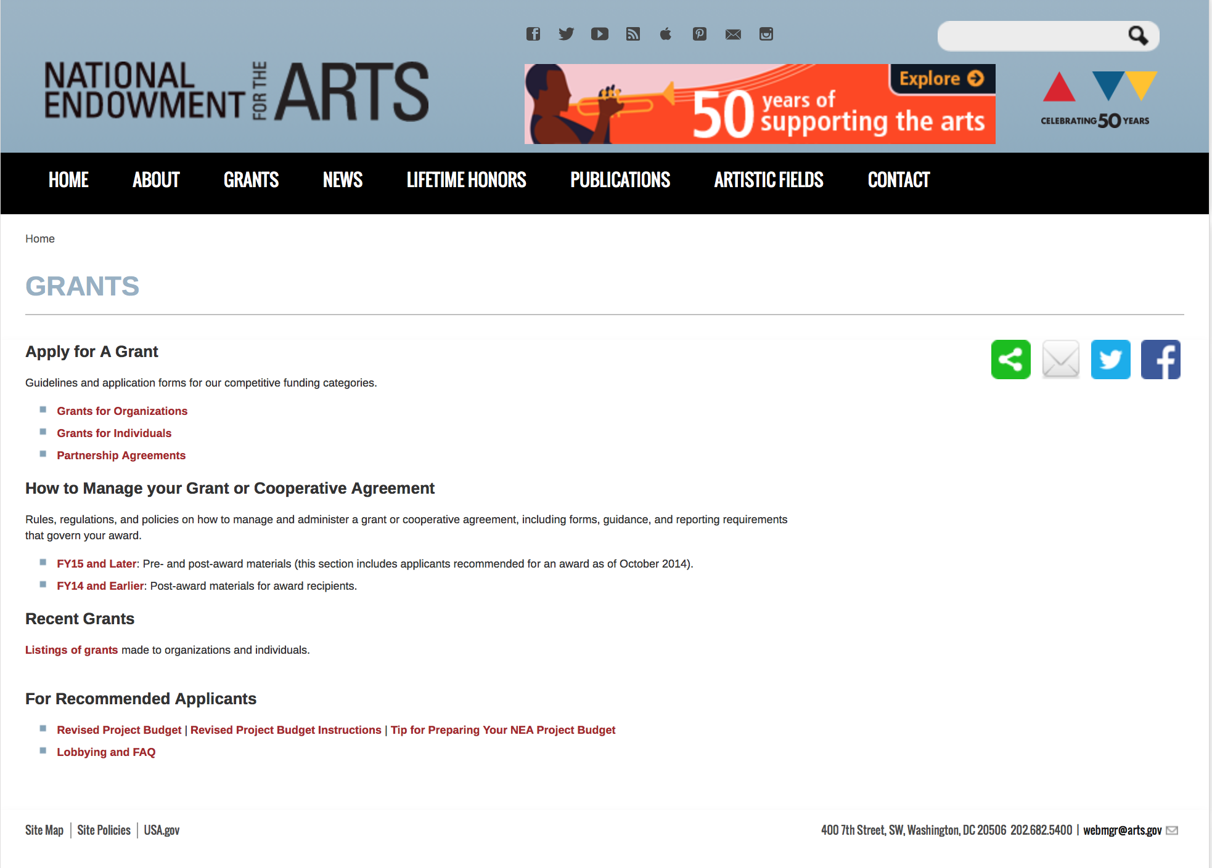

http://arts.gov/grants

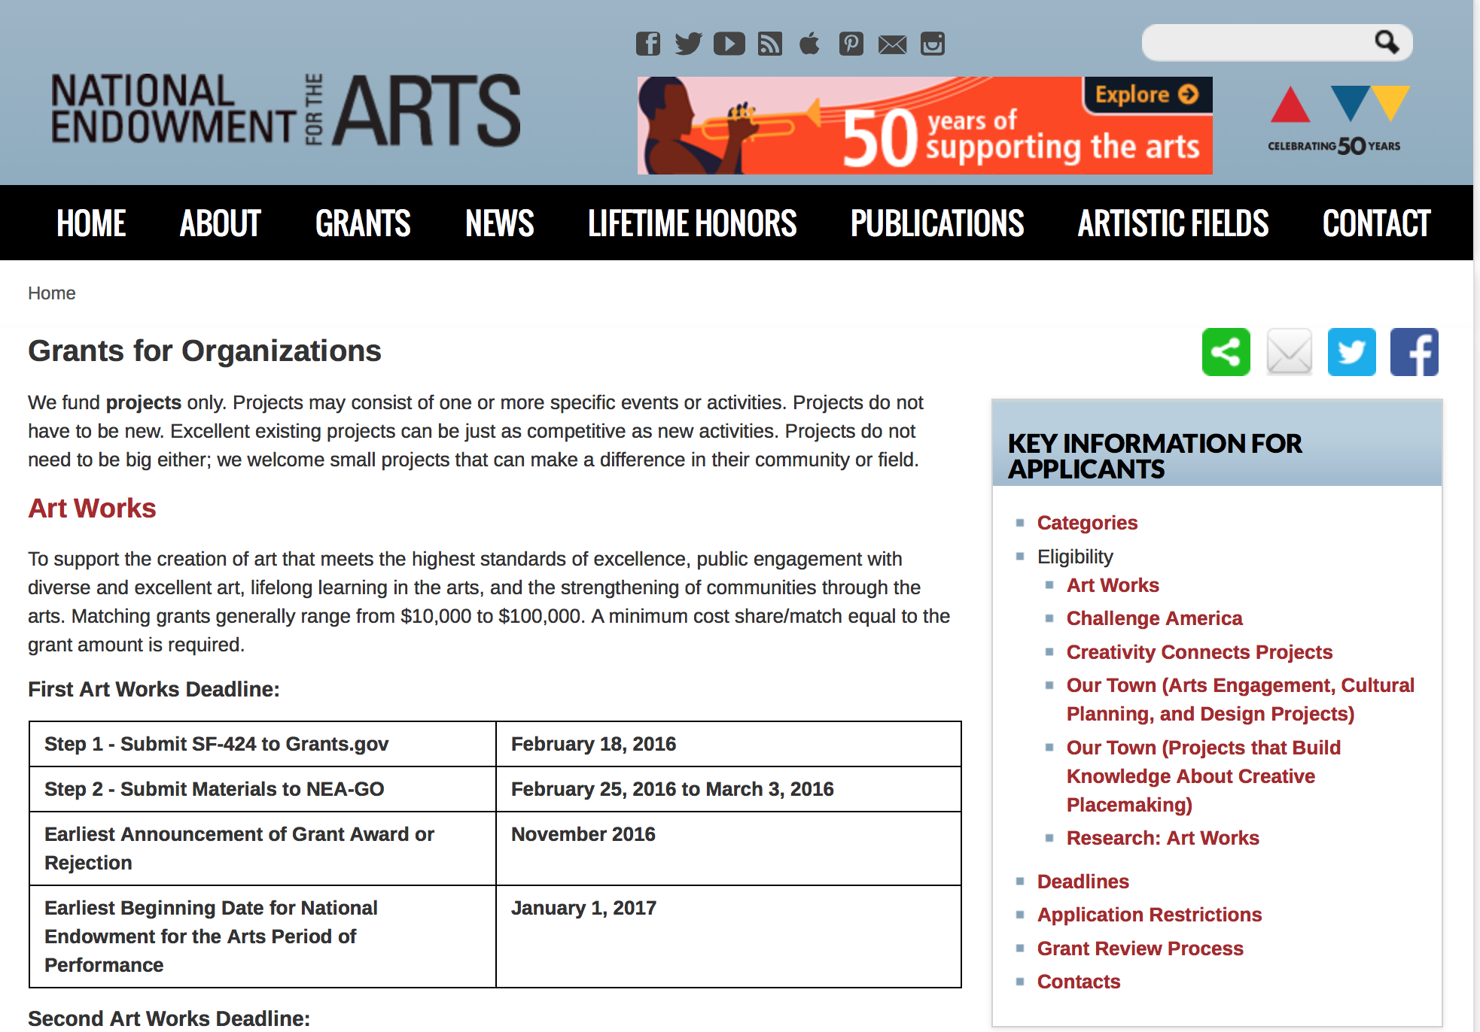
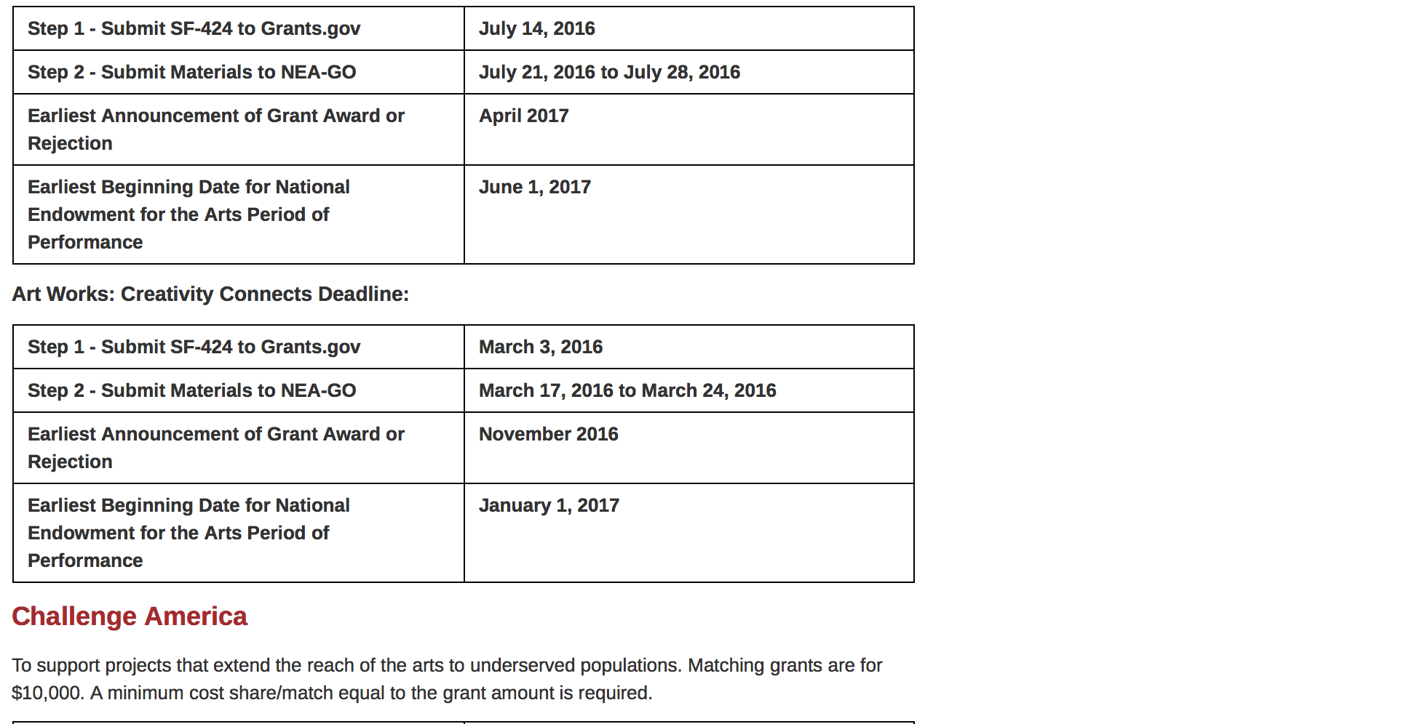
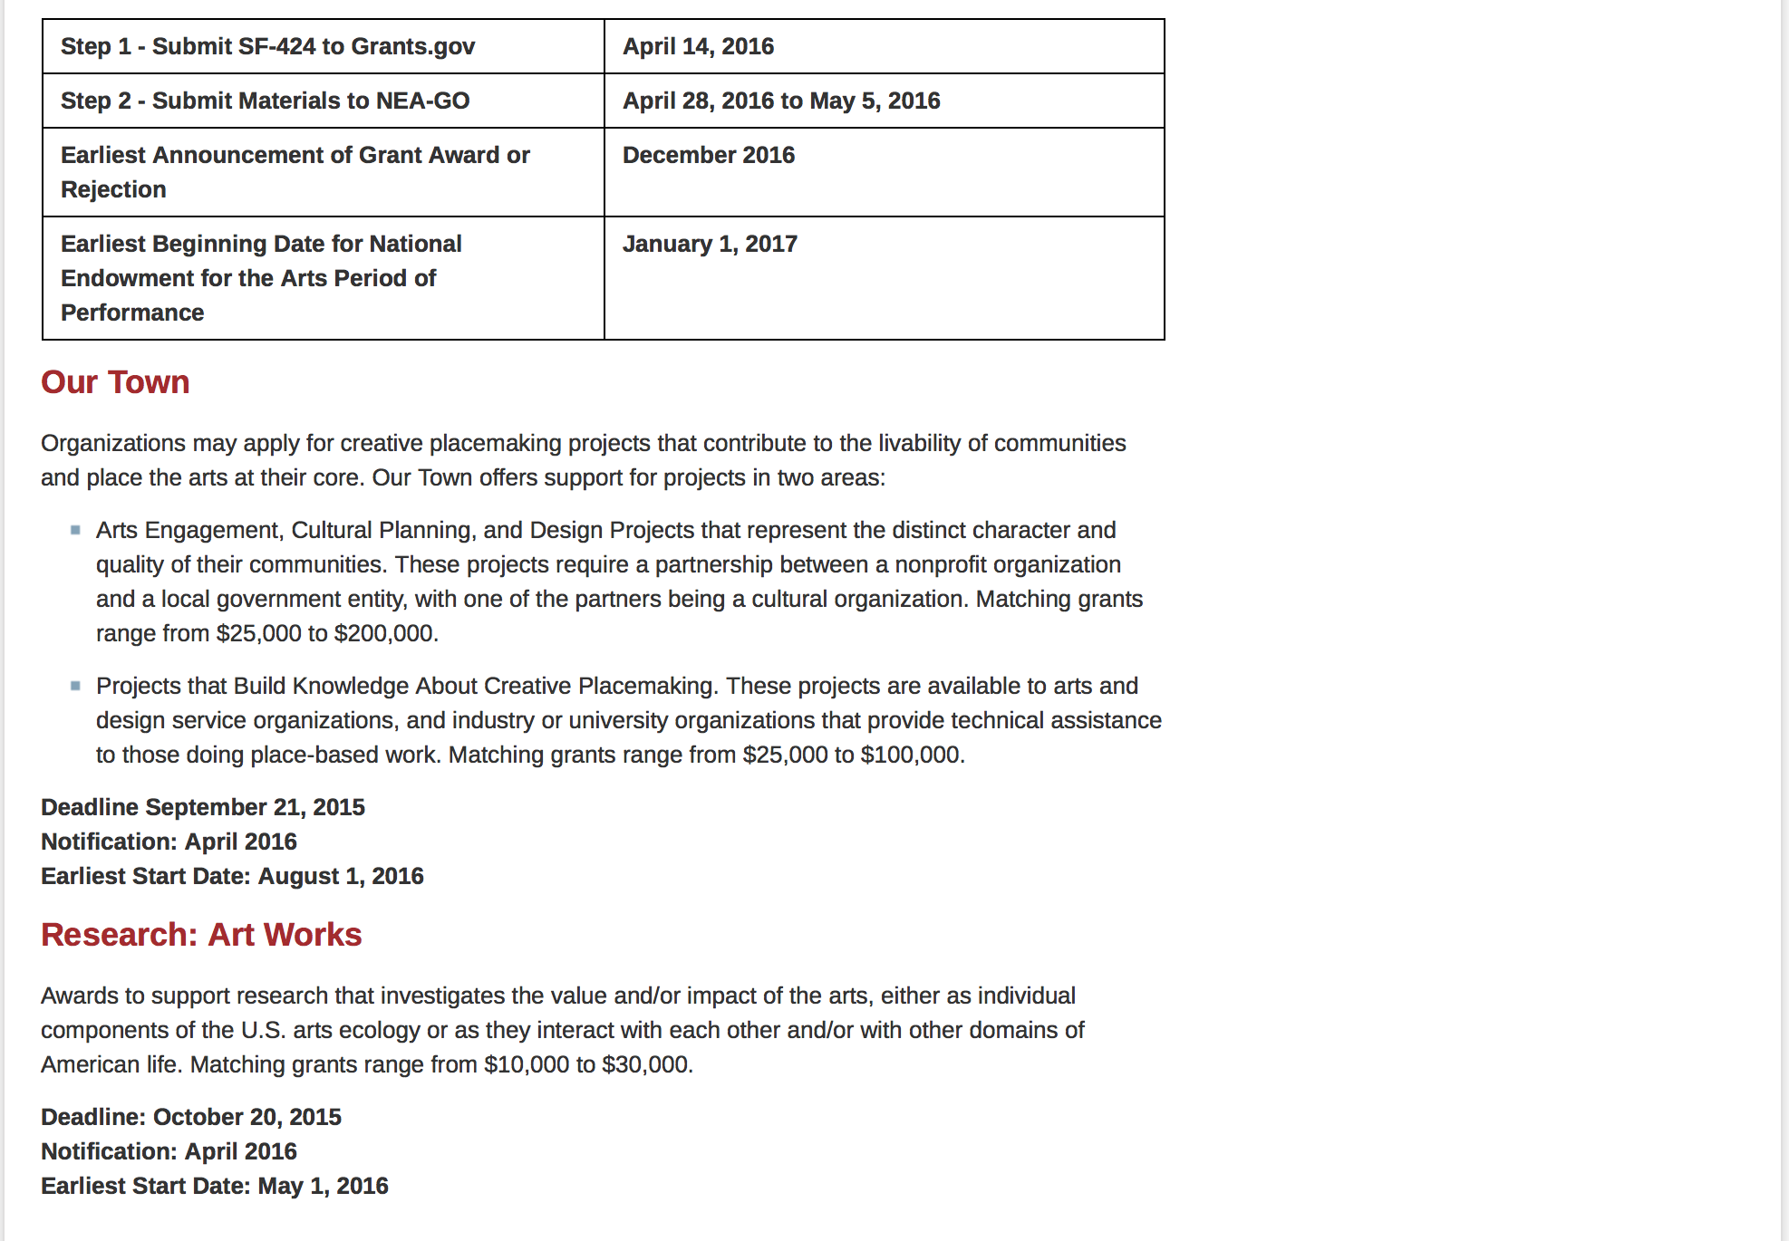
See more at: https://www.arts.gov/grants/apply-grant/grants-organizations

Programs:

NEA Art Works I, FY 2018
Synopsis 1
Document Type: | Grants Notice
Funding Opportunity Number: | 2017NEA01AW1
Funding Opportunity Title: | NEA Art Works I, FY 2018
Opportunity Category: | Discretionary
Opportunity Category Explanation:
Funding Instrument Type: | Grant
Category of Funding Activity: | Arts (see "Cultural Affairs" in CFDA)
Category Explanation:
Expected Number of Awards:
CFDA Number(s): | 45.024 -- Promotion of the Arts Grants to Organizations and Individuals
Cost Sharing or Matching Requirement: | Yes
Version: | Synopsis 1
Posted Date: | Dec 15, 2016
Last Updated Date: | Dec 15, 2016
Original Closing Date for Applications: | Feb 16, 2017 The Grants.gov system must receive your validated and accepted application no later than 11:59 p.m., Eastern Time, on February 16, 2017.
Current Closing Date for Applications: | Feb 16, 2017 The Grants.gov system must receive your validated and accepted application no later than 11:59 p.m., Eastern Time, on February 16, 2017.
Archive Date: | Mar 18, 2017
Estimated Total Program Funding:
Award Ceiling: | $100,000
Award Floor: | $10,000
Eligible Applicants: | State governments  Special district governments  Private institutions of higher education  City or township governments  Native American tribal governments (Federally recognized)  Public and State controlled institutions of higher education  Independent school districts  County governments  Nonprofits having a 501(c)(3) status with the IRS, other than institutions of higher education
Agency Name: | National Endowment for the Arts
Description: | An organization may submit only one application through one of the following FY 2018 categories: Art Works or Challenge America. An organization may submit one additional application under the FY 2018 Art Works category for a Creativity Connects project. The Arts Endowment's support of a project may start on or after January 1, 2018. Generally, a period of performance of up to two years is allowed. The two-year period is intended to allow an applicant sufficient time to plan, execute, and close out its project, not to repeat a one-year project for a second year. Program Description The guiding principle of "Art Works" is at the center of everything we do at the NEA. "Art Works" refers to three things: the works of art themselves, the ways art works on audiences, and the fact that art is work for the artists and arts professionals who make up the field. Art works by enhancing the value of individuals and communities, by connecting us to each other and to something greater than ourselves, and by empowering creativity and innovation in our society and economy. The arts exist for beauty itself, but they also are an inexhaustible source of meaning and inspiration. The NEA recognizes these catalytic effects of excellent art, and the key role that arts and design organizations play in revitalizing them. To deepen and extend the arts' value, including their ability to foster new connections and to exemplify creativity and innovation, we welcome projects that: • Are likely to prove transformative with the potential for meaningful change, whether in the development or enhancement of new or existing art forms, new approaches to the creation or presentation of art, or new ways of engaging the public with art; • Are distinctive, offering fresh insights and new value for their fields and/or the public through unconventional solutions; and • Have the potential to be shared and/or emulated, or are likely to lead to other advances in the field. Beyond encouraging projects that demonstrate these characteristics, we want to achieve the following four objectives through the Art Works category: • Creation: The creation of art that meets the highest standards of excellence, • Engagement: Public engagement with diverse and excellent art, • Learning: Lifelong learning in the arts, and • Livability: The strengthening of communities through the arts.
Link to Additional Information: | NEA Complete Website Announcement
Grantor Contact Information: | If you have difficulty accessing the full announcement electronically, please contact:  NEA Web Manager  NEA Web Manager

http://www.grants.gov/web/grants/view-opportunity.html?oppId=290703

NEA Art Works Creativity Connects, FY2018
Synopsis 1
Document Type: | Grants Notice
Funding Opportunity Number: | 2017NEA01AWCC
Funding Opportunity Title: | NEA Art Works Creativity Connects, FY2018
Opportunity Category: | Discretionary
Opportunity Category Explanation:
Funding Instrument Type: | Grant
Category of Funding Activity: | Arts (see "Cultural Affairs" in CFDA)
Category Explanation:
Expected Number of Awards:
CFDA Number(s): | 45.024 -- Promotion of the Arts Grants to Organizations and Individuals
Cost Sharing or Matching Requirement: | Yes
Version: | Synopsis 1
Posted Date: | Dec 15, 2016
Last Updated Date: | Dec 15, 2016
Original Closing Date for Applications: | May 04, 2017 The Grants.gov system must receive your validated and accepted application no later than 11:59 p.m., Eastern Time, on May 4, 2017.
Current Closing Date for Applications: | May 04, 2017 The Grants.gov system must receive your validated and accepted application no later than 11:59 p.m., Eastern Time, on May 4, 2017.
Archive Date: | Jun 03, 2017
Estimated Total Program Funding:
Award Ceiling: | $100,000
Award Floor: | $20,000
Eligible Applicants: | County governments  Nonprofits having a 501(c)(3) status with the IRS, other than institutions of higher education  State governments  Public and State controlled institutions of higher education  Special district governments  Independent school districts  Native American tribal governments (Federally recognized)  Private institutions of higher education  City or township governments
Agency Name: | National Endowment for the Arts
Description: | Art Works: Creativity Connects grants require a partnership between an arts program and a non-arts organization. The Arts Endowment's support of a project may start on or after June 1, 2018. Generally, a period of performance of up to two years is allowed. An organization that submits an application to Art Works: Creativity Connects is still eligible to submit an application to other National Endowment for the Arts funding opportunities. In each case, the request must be for a distinctly different project or a distinctly different phase of the same project, with a different period of performance and costs. An organization may submit only one application for an Art Works: Creativity Connects grant. Program Description Creativity Connects* is an initiative that shows how the arts contribute to the nation’s creative ecosystem, investigates how support systems for the arts are changing, explores how the arts can connect with other sectors that want and utilize creativity, and invests in innovative projects to spark new, collaborative ideas. A key component of Creativity Connects is a grant opportunity in the Art Works category that supports collaborative, mutually beneficial partnerships between the arts and non-arts sectors, specifically: • Agriculture • Business and Economic Development • Science • Technology • Healthcare • Community • Education • Environment • Military • Transportation Art Works: Creativity Connects projects mutually benefit both the arts and non-arts sectors by: • Demonstrating the beneficial contributions of artists and creative work to societal health. • Supporting the infrastructure for the arts to work in new ways with new sectors. • Building bridges that create new relationships and constituencies. • Creating innovative partnership projects to advance common goals.
Link to Additional Information: | NEA Complete Website Announcement
Grantor Contact Information: | If you have difficulty accessing the full announcement electronically, please contact:  NEA Web Manager  NEA Web Manager

http://www.grants.gov/web/grants/view-opportunity.html?oppId=290705

NEA Challenge America, FY2018
Synopsis 1
Document Type: | Grants Notice
Funding Opportunity Number: | 2017NEA01CA
Funding Opportunity Title: | NEA Challenge America, FY2018
Opportunity Category: | Discretionary
Opportunity Category Explanation:
Funding Instrument Type: | Grant
Category of Funding Activity: | Arts (see "Cultural Affairs" in CFDA)
Category Explanation:
Expected Number of Awards:
CFDA Number(s): | 45.024 -- Promotion of the Arts Grants to Organizations and Individuals
Cost Sharing or Matching Requirement: | Yes
Version: | Synopsis 1
Posted Date: | Dec 15, 2016
Last Updated Date: | Dec 15, 2016
Original Closing Date for Applications: | Apr 13, 2017 The Grants.gov system must receive your validated and accepted application no later than 11:59 p.m., Eastern Time, on April 13, 2017.
Current Closing Date for Applications: | Apr 13, 2017 The Grants.gov system must receive your validated and accepted application no later than 11:59 p.m., Eastern Time, on April 13, 2017.
Archive Date: | May 13, 2017
Estimated Total Program Funding:
Award Ceiling: | $10,000
Award Floor: | $10,000
Eligible Applicants: | Private institutions of higher education  Public and State controlled institutions of higher education  Independent school districts  Special district governments  Native American tribal governments (Federally recognized)  City or township governments  County governments  Nonprofits having a 501(c)(3) status with the IRS, other than institutions of higher education  State governments
Agency Name: | National Endowment for the Arts
Description: | The Arts Endowment's support of a project may start on or after January 1, 2018. Grants awarded under these guidelines generally may cover a period of performance of up to two years. An organization that has received Challenge America grants in FY 2015, 2016, and 2017 may not apply for a Challenge America grant under these FY 2018 guidelines. An organization that applies to the Challenge America category, may not submit another application to the Art Works category except for a Creativity Connects project. You may apply to other National Endowment for the Arts funding opportunities, including Our Town, in addition to Challenge America. In each case, the request must be for a distinctly different project or a distinctly different phase of the same project, with a different period of performance and costs. Program Description The Challenge America category offers support primarily to small and mid-sized organizations for projects that extend the reach of the arts to underserved populations -- those whose opportunities to experience the arts are limited by geography, ethnicity, economics, or disability. Age alone (e.g., youth, seniors) does not qualify a group as underserved; at least one of the underserved characteristics noted above also must be present. Grants are available for professional arts programming and for projects that emphasize the potential of the arts in community development. This category encourages and supports the following objective: • Engagement: Engaging the public with diverse and excellent art. Challenge America grants: • Extend the reach of the arts to underserved populations. • Are limited to the specific types of projects outlined below. • Are for a fixed amount of $10,000 and require a minimum $10,000 match. Partnerships can be valuable to the success of these projects. While not required, applicants are encouraged to consider partnerships among organizations, both in and outside of the arts, as appropriate to their project. To ensure that Challenge America funding reaches new organizations and communities, the NEA has implemented a policy to limit consecutive-year funding.
Link to Additional Information: | NEA Complete Website Announcement
Grantor Contact Information: | If you have difficulty accessing the full announcement electronically, please contact:  NEA Web Manager  NEA Web Manager

http://www.grants.gov/web/grants/view-opportunity.html?oppId=290704

NEA FY2018 Literature Fellowships: Prose
Synopsis 1
Document Type: | Grants Notice
Funding Opportunity Number: | 2017NEA03LFCW
Funding Opportunity Title: | NEA FY2018 Literature Fellowships: Prose
Opportunity Category: | Discretionary
Opportunity Category Explanation:
Funding Instrument Type: | Grant
Category of Funding Activity: | Arts (see "Cultural Affairs" in CFDA)
Category Explanation:
Expected Number of Awards:
CFDA Number(s): | 45.024 -- Promotion of the Arts Grants to Organizations and Individuals
Cost Sharing or Matching Requirement: | No
Version: | Synopsis 1
Posted Date: | Dec 16, 2016
Last Updated Date: | Dec 16, 2016
Original Closing Date for Applications: | Mar 08, 2017 The Grants.gov system must receive your validated and accepted application no later than 11:59 p.m., Eastern Time, on March 8, 2017.
Current Closing Date for Applications: | Mar 08, 2017 The Grants.gov system must receive your validated and accepted application no later than 11:59 p.m., Eastern Time, on March 8, 2017.
Archive Date: | Apr 07, 2017
Estimated Total Program Funding:
Award Ceiling: | $25,000
Award Floor: | $25,000
Eligible Applicants: | Individuals
Agency Name: | National Endowment for the Arts
Description: | The Arts Endowment’s support of a project may begin any time between January 1, 2018, and January 1, 2019, and extend for up to two years. You may submit only one application for FY 2018 funding. You may not apply for a Literature Fellowship (prose) under this deadline and a Translation Project under the December 6, 2016 deadline. Grant Program Description The National Endowment for the Arts Literature Fellowships program offers $25,000 grants in prose (fiction and creative nonfiction) and poetry to published creative writers that enable recipients to set aside time for writing, research, travel, and general career advancement. Applications are reviewed through an anonymous process in which the only criteria for review are artistic excellence and artistic merit. To review the applications, the National Endowment for the Arts assembles a different advisory panel every year, each diverse with regard to geography, race and ethnicity, and artistic points of view. The National Endowment for the Arts Literature Fellowships program operates on a two-year cycle with fellowships in prose and poetry available in alternating years. For FY 2018, which is covered by these guidelines, fellowships in prose (fiction and creative nonfiction) are available. Fellowships in poetry will be offered in FY 2019 and guidelines will be available in January 2018. You may apply only once each year. Competition for fellowships is extremely rigorous. We typically receive more than 1,000 applications each year in this category and award fellowships to fewer than 5% of applicants. You should consider carefully whether your work will be competitive at the national level.
Link to Additional Information: | NEA Complete Website Announcement
Grantor Contact Information: | If you have difficulty accessing the full announcement electronically, please contact:  NEA Web Manager  NEA Web Manager

http://www.grants.gov/web/grants/view-opportunity.html?oppId=290752

Modifications:

Reminders:

National Endowment for the Humanities

Grant Overview -

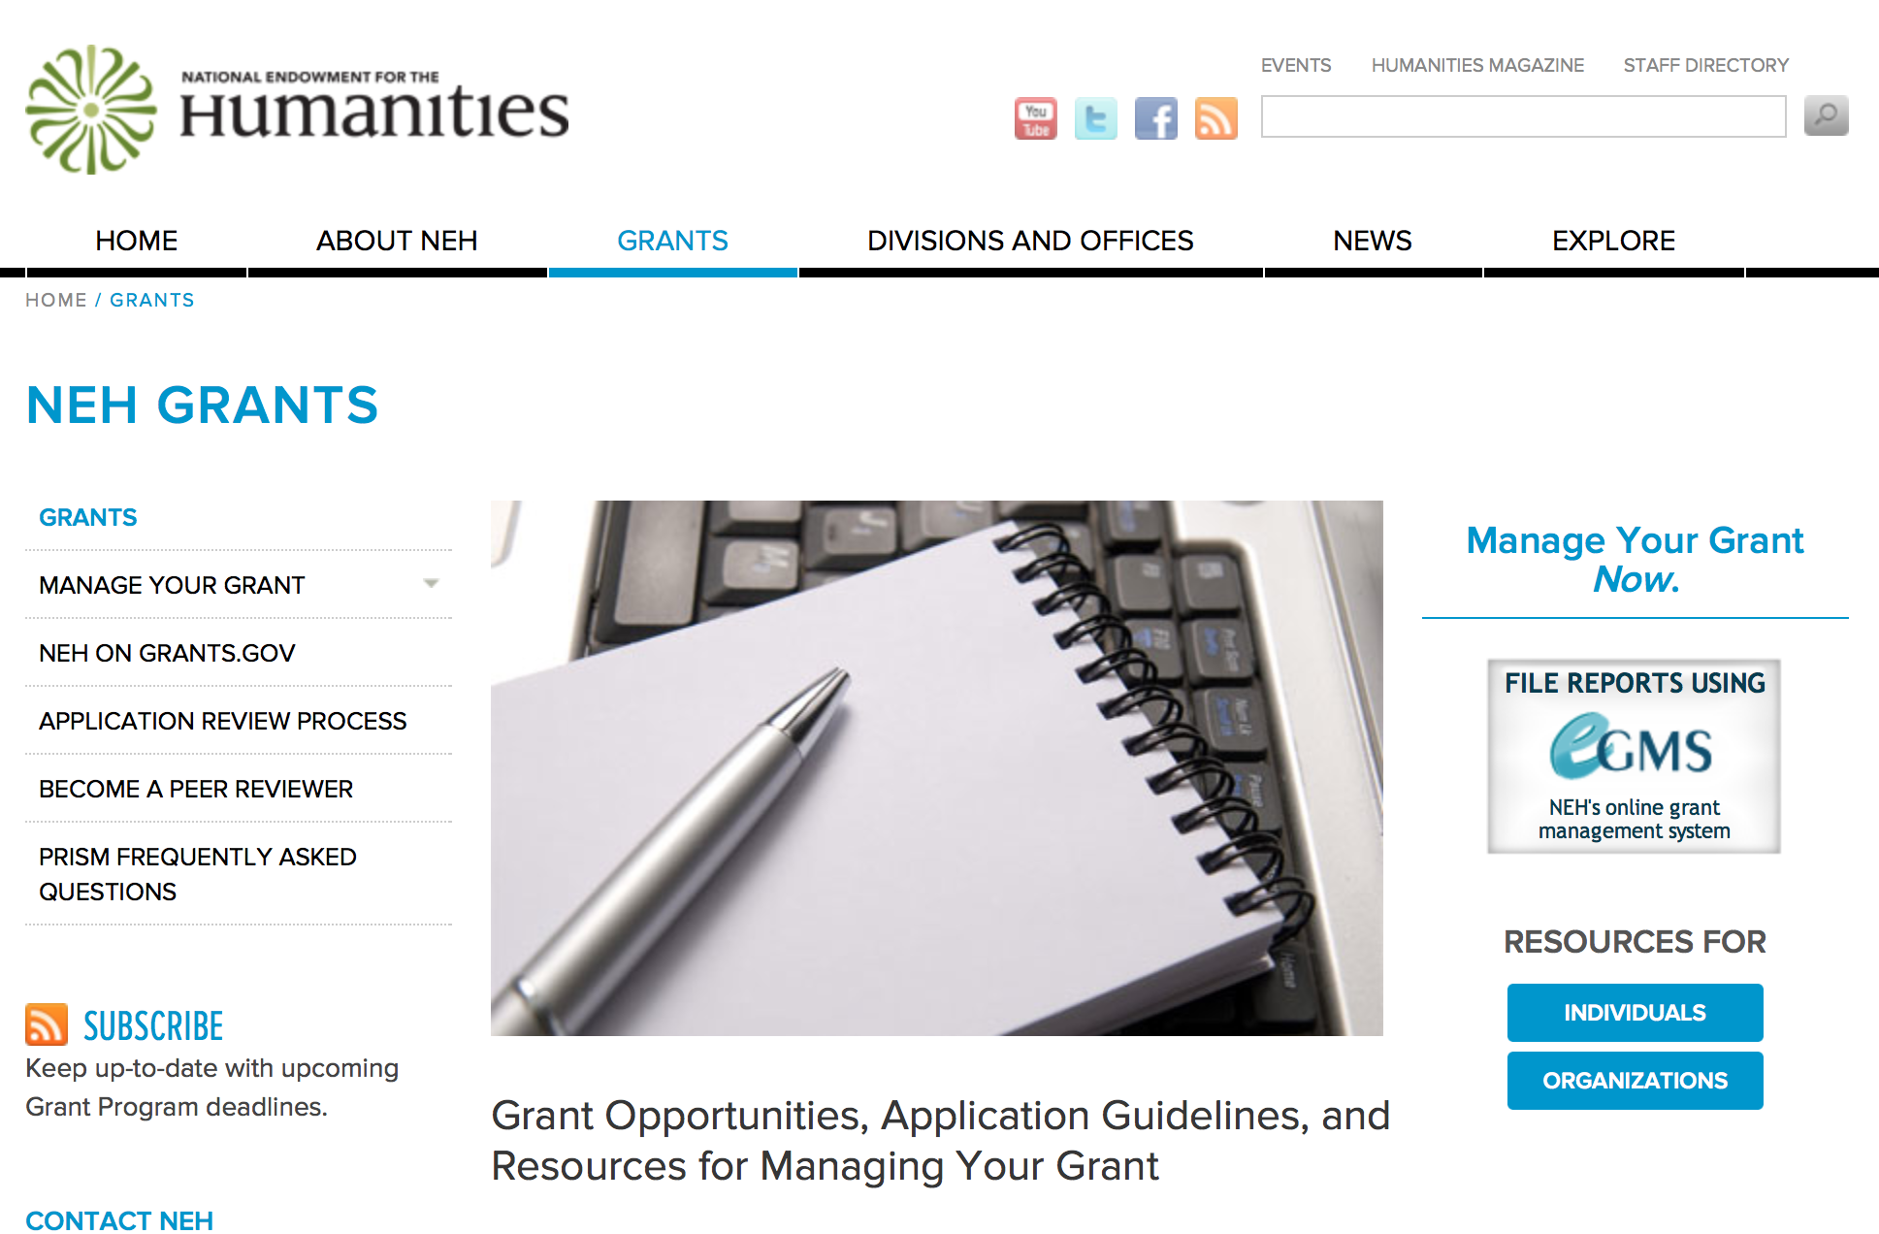

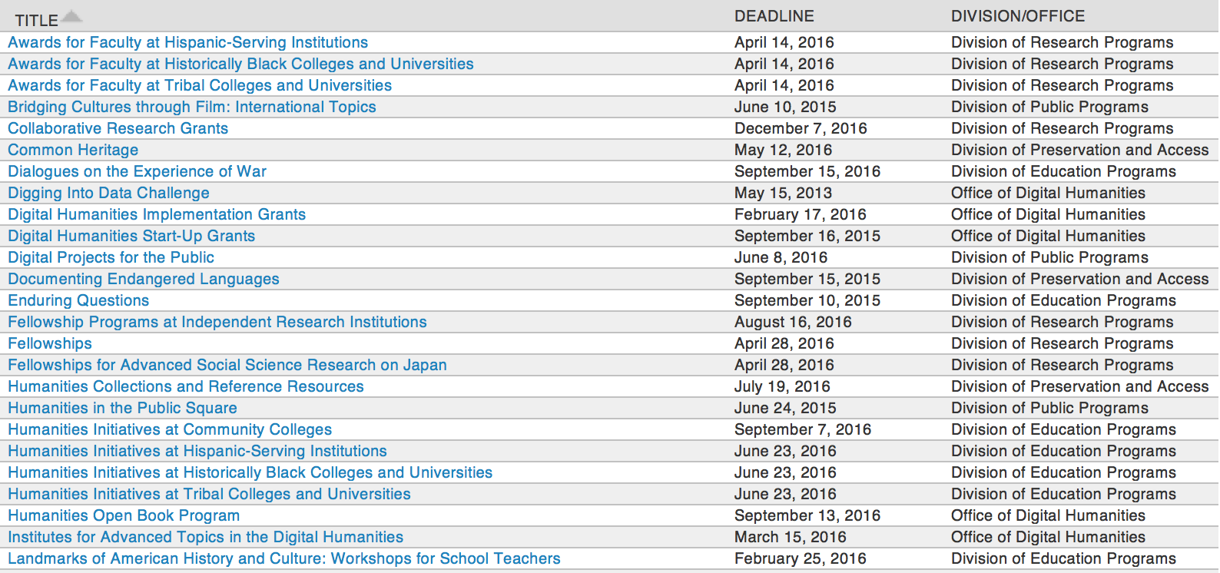

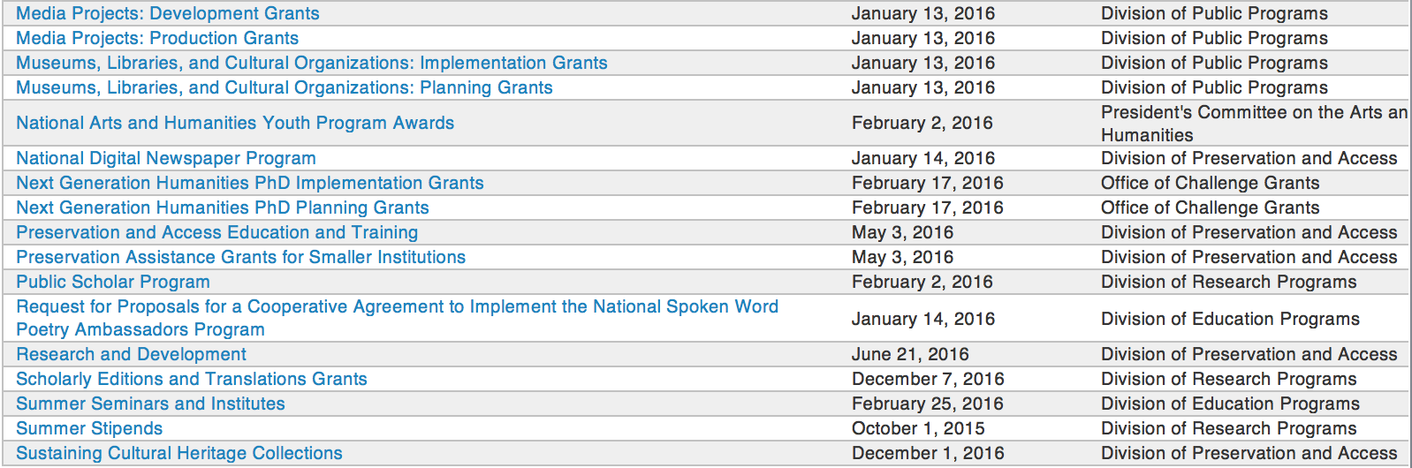

http://www.neh.gov/grants/grantsbydivision.html

Programs:

Summer Seminars and Institutes
Synopsis 1

Document Type: | Grants Notice
Funding Opportunity Number: | 20170301-FS
Funding Opportunity Title: | Summer Seminars and Institutes
Opportunity Category: | Discretionary
Opportunity Category Explanation:
Funding Instrument Type: | Grant
Category of Funding Activity: | Humanities (see "Cultural Affairs" in CFDA)
Category Explanation:
Expected Number of Awards:
CFDA Number(s): | 45.163 -- Promotion of the Humanities Professional Development
Cost Sharing or Matching Requirement: | No
Version: | Synopsis 1
Posted Date: | Dec 16, 2016
Last Updated Date: | Dec 16, 2016
Original Closing Date for Applications: | Mar 01, 2017
Current Closing Date for Applications: | Mar 01, 2017
Archive Date:
Estimated Total Program Funding:
Award Ceiling: | $225,000
Award Floor: | $50,000
Eligible Applicants: | State governments  Public and State controlled institutions of higher education  County governments  Private institutions of higher education  City or township governments  Native American tribal governments (Federally recognized)  Nonprofits having a 501(c)(3) status with the IRS, other than institutions of higher education  Special district governments
Agency Name: | National Endowment for the Humanities
Description: | NEH Summer Seminars and Institutes grants support professional development programs in the humanities for school teachers and for college and university faculty. Seminars and institutes may be as short as one week or as long as four weeks. NEH Summer Seminars and Institutes • provide models of excellent teaching; • provide models of excellent scholarship; • broaden and deepen understanding of the humanities; • focus on the study and teaching of significant topics, texts, and other sources; • contribute to the intellectual vitality of participants; and • build communities of inquiry. An NEH Summer Seminar or Institute may be hosted by a college, university, learned society, center for advanced study, library or other repository, cultural or professional organization, or school or school system. The host site must be suitable for the project, providing facilities for collegial interaction and scholarship. These programs are designed for a national audience of participants.
Link to Additional Information: | https://www.neh.gov/grants/education/summer-seminars-and-institutes
Grantor Contact Information: | If you have difficulty accessing the full announcement electronically, please contact:  Division of Education Programs National Endowment for the Humanities 400 Seventh Street, SW Washington, DC 20506 202-606-8471 sem-inst@neh.gov sem-inst@neh.gov  sem-inst@neh.gov

http://www.grants.gov/web/grants/view-opportunity.html?oppId=290772

Modifications:

Reminders:

Public Scholar Program
Synopsis 1

Document Type: | Grants Notice
Funding Opportunity Number: | 20170201-FZ
Funding Opportunity Title: | Public Scholar Program
Opportunity Category: | Discretionary
Opportunity Category Explanation:
Funding Instrument Type: | Grant
Category of Funding Activity: | Humanities (see "Cultural Affairs" in CFDA)
Category Explanation:
Expected Number of Awards:
CFDA Number(s): | 45.160 -- Promotion of the Humanities Fellowships and Stipends
Cost Sharing or Matching Requirement: | No
Version: | Synopsis 1
Posted Date: | Nov 28, 2016
Last Updated Date: | Nov 28, 2016
Original Closing Date for Applications: | Feb 01, 2017
Current Closing Date for Applications: | Feb 01, 2017
Archive Date:
Estimated Total Program Funding:
Award Ceiling: | $50,400
Award Floor: | $25,200
Eligible Applicants: | Individuals
Agency Name: | National Endowment for the Humanities
Description: | The Public Scholar Program supports well-researched books in the humanities intended to reach a broad readership. Although humanities scholarship can be specialized, the humanities also strive to engage broad audiences in exploring subjects of general interest. They seek to deepen our understanding of the human condition as well as current conditions and contemporary problems. The Public Scholar Program aims to encourage scholarship that will be of broad interest and have lasting impact. Such scholarship might present a narrative history, tell the stories of important individuals, analyze significant texts, provide a synthesis of ideas, revive interest in a neglected subject, or examine the latest thinking on a topic. Books supported by this program must be grounded in humanities research and scholarship. They must address significant humanities themes likely to be of broad interest and must be written in a readily accessible style. Making use of primary and/or secondary sources, they should open up important and appealing subjects for a wide audience. The challenge is to make sense of a significant topic in a way that will appeal to general readers. Applications to write books directed primarily to scholars are not appropriate for this program. By establishing the Public Scholar Program, NEH entered a long-term commitment to encourage scholarship in the humanities for general audiences. The program is open to both individuals affiliated with scholarly institutions and independent scholars or researchers. Projects may be at any stage of development.
Link to Additional Information: | https://www.neh.gov/grants/research/public-scholar-program
Grantor Contact Information: | If you have difficulty accessing the full announcement electronically, please contact:  Division of Research Programs National Endowment for the Humanities Washington, DC 20506 202-606-8200 publicscholar@neh.gov publicscholar@neh.gov  publicscholar@neh.gov

http://www.grants.gov/web/grants/view-opportunity.html?oppId=290373

Creating Humanities Communities
Synopsis 1
Document Type: | Grants Notice
Funding Opportunity Number: | 20170215-ZR
Funding Opportunity Title: | Creating Humanities Communities
Opportunity Category: | Discretionary
Opportunity Category Explanation:
Funding Instrument Type: | Grant
Category of Funding Activity: | Humanities (see "Cultural Affairs" in CFDA)
Category Explanation:
Expected Number of Awards:
CFDA Number(s): | 45.130 -- Promotion of the Humanities Challenge Grants
Cost Sharing or Matching Requirement: | Yes
Version: | Synopsis 1
Posted Date: | Nov 04, 2016
Last Updated Date: | Nov 04, 2016
Original Closing Date for Applications: | Feb 15, 2017
Current Closing Date for Applications: | Feb 15, 2017
Archive Date:
Estimated Total Program Funding:
Award Ceiling: | $150,000
Award Floor: | $30,000
Eligible Applicants: | County governments  Private institutions of higher education  State governments  Nonprofits that do not have a 501(c)(3) status with the IRS, other than institutions of higher education  Native American tribal governments (Federally recognized)  Public and State controlled institutions of higher education  City or township governments  Special district governments  Nonprofits having a 501(c)(3) status with the IRS, other than institutions of higher education
Agency Name: | National Endowment for the Humanities
Description: | The Creating Humanities Communities program provides matching grants to help stimulate and proliferate meaningful humanities activities in states and U.S. territories underserved by NEH’s grantmaking divisions and offices. Grantees will use the funds to establish and undertake new humanities programs. The goal of these grants is to make connections between organizations that will foster community cohesion on a local or regional level. Applicants may define community in a variety of ways (by focusing, for example, on a place such as a village or town, or on a common interest or a common theme), and the programs that the cooperating institutions carry out together must aim to enhance the importance of the humanities in people’s lives. Projects to create a humanities community might include, for example, collaborations linking • a public library and a nearby community college to research, write, and produce a series of video biographies of the town’s important personalities (to be presented in public programs at the local historical movie palace); • several railroad museums throughout a state that join forces to write a transportation-based curriculum module for use in fourth-grade social studies classes; • three Native American tribes to establish a cultural heritage trail highlighting important sites and collections; • a veterans’ group and a high school in developing intergenerational family programs at local historic sites; and • a public radio station and the philosophy department at a local college to host public programs discussing industry and ethics to commemorate the hundredth anniversary of the town’s paper mill. Applicants to this program must form collaborative partnerships with at least two and at most five institutions (including the applicant organization). These partnerships may involve organizations such as public libraries, cultural centers, museums, historical societies, colleges (including community colleges) and universities, archival repositories, historic houses, school districts, civic centers, or other cultural entities.
Link to Additional Information: | https://www.neh.gov/grants/challenge/creating-humanities-communities
Grantor Contact Information: | If you have difficulty accessing the full announcement electronically, please contact:  Office of Challenge Grants National Endowment for the Humanities 400 Seventh Street, SW Washington, DC 20506 202-606-8309 challenge@neh.gov challenge@neh.gov  challenge@neh.gov

http://www.grants.gov/web/grants/view-opportunity.html?oppId=289891



National Science Foundation

General Funding Overview

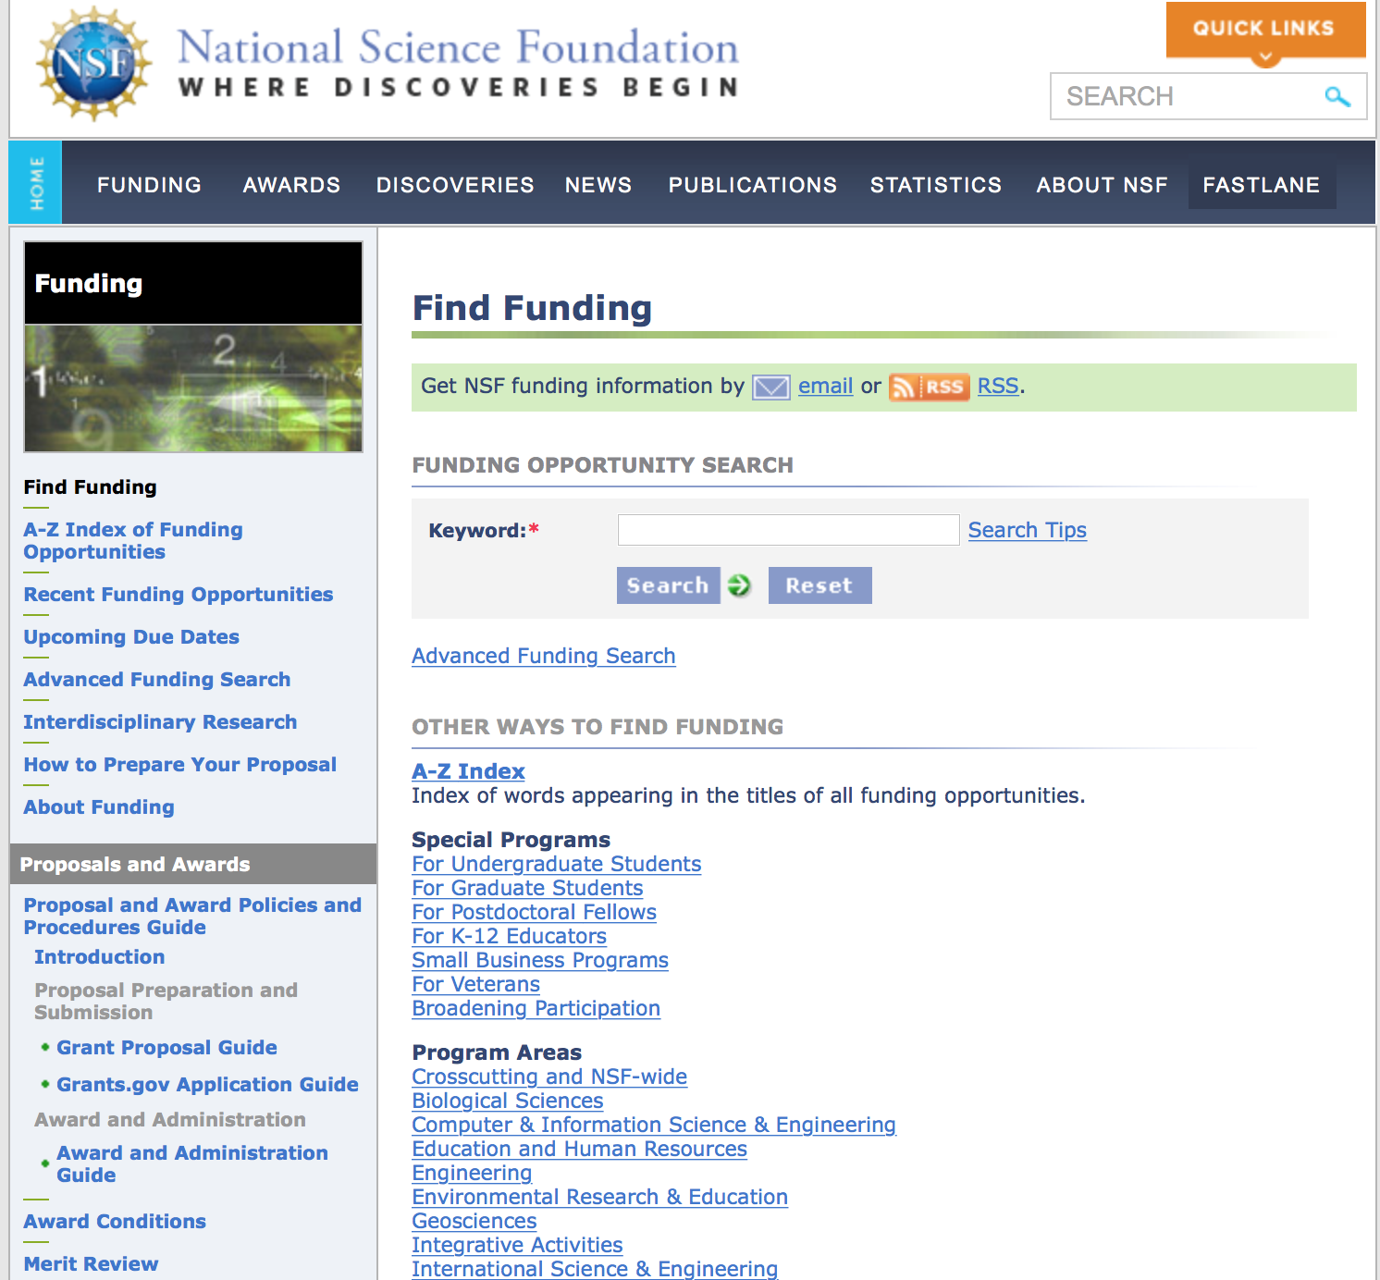
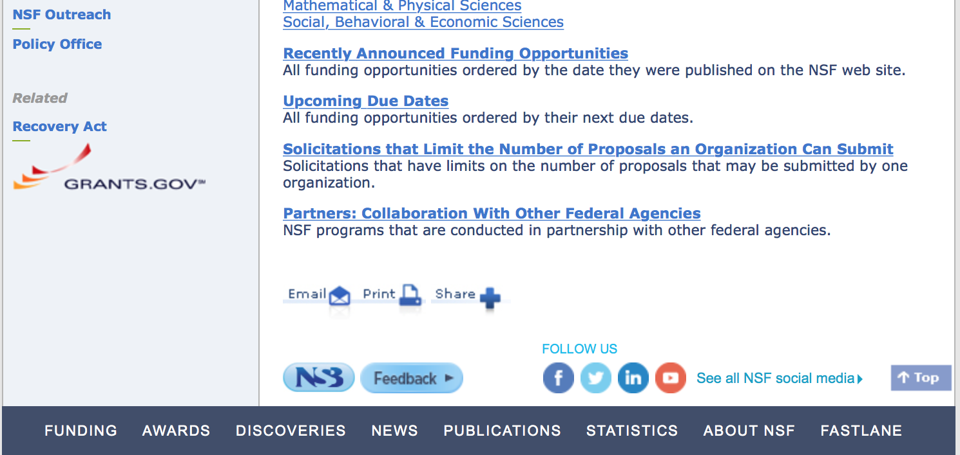

For assistance in finding funding: http://nsf.gov/funding/index.jsp - areas

The National Science Foundation funds research and education in most fields of science and engineering. It does this through grants, and cooperative agreements to more than 2,000 colleges, universities, K-12 school systems, businesses, informal science organizations and other research organizations throughout the United States. The Foundation accounts for about one-fourth of federal support to academic institutions for basic research.
NSF receives approximately 40,000 proposals each year for research, education and training projects, of which approximately 11,000 are funded. In addition, the Foundation receives several thousand applications for graduate and postdoctoral fellowships.
The agency operates no laboratories itself but does support National Research Centers, user facilities, certain oceanographic vessels and Antarctic research stations. The Foundation also supports cooperative research between universities and industry, US participation in international scientific and engineering efforts, and educational activities at every academic level.

For details on active funding deadline dates: http://nsf.gov/funding/pgm_list.jsp?org=NSF&ord=date

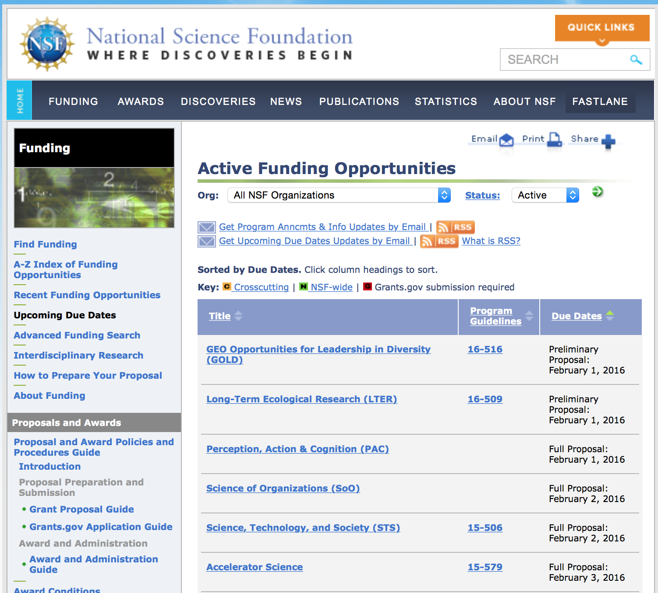

Building Community and Capacity in Data Intensive Research in Education
Synopsis 1
http://www.grants.gov/web/grants/view-opportunity.html?oppId=290727

Critical Techniques, Technologies and Methodologies for Advancing Foundations and Applications of Big Data Sciences and Engineering
Synopsis 1
http://www.grants.gov/web/grants/view-opportunity.html?oppId=290913

Cyber-Physical Systems
Synopsis 1
http://www.grants.gov/web/grants/view-opportunity.html?oppId=290997

Energy-Efficient Computing: from Devices to Architectures
Synopsis 1
http://www.grants.gov/web/grants/view-opportunity.html?oppId=290543

Innovations at the Nexus of Food, Energy and Water Systems
Synopsis 1
http://www.grants.gov/web/grants/view-opportunity.html?oppId=290502

Innovation Corps - Nodes Program
Synopsis 1
http://www.grants.gov/web/grants/view-opportunity.html?oppId=290728

Sedimentary Geology and Paleobiology
Synopsis 1
http://www.grants.gov/web/grants/view-opportunity.html?oppId=291052

STEM + Computing Partnerships
Synopsis 1
http://www.grants.gov/web/grants/view-opportunity.html?oppId=290998

Modifications:

Reminders:

Deleted:

14-577 - Advanced Technological Education
Deletion Comments: Opportunity deleted

16-543 - Joint DMS/NIGMS Initiative to Support Research at the Interface of the Biological and Mathematical Sciences
Deletion Comments: Opportunity deleted

16-536 - Sedimentary Geology and Paleobiology
Deletion Comments: Opportunity deleted

16-539 - Innovation Corps - Nodes Program
Deletion Comments: Opportunity deleted

16-527 - STEM + Computing Partnerships
Deletion Comments: Opportunity deleted

16-582 - NSF/VMware Partnership on Software Defined Infrastructure as a Foundation for Clean-Slate Computing Security
Deletion Comments: Opportunity deleted

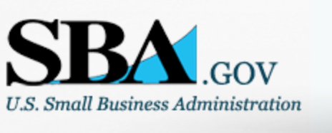

Small Business Administration

General Overview Finding Loans & Grants

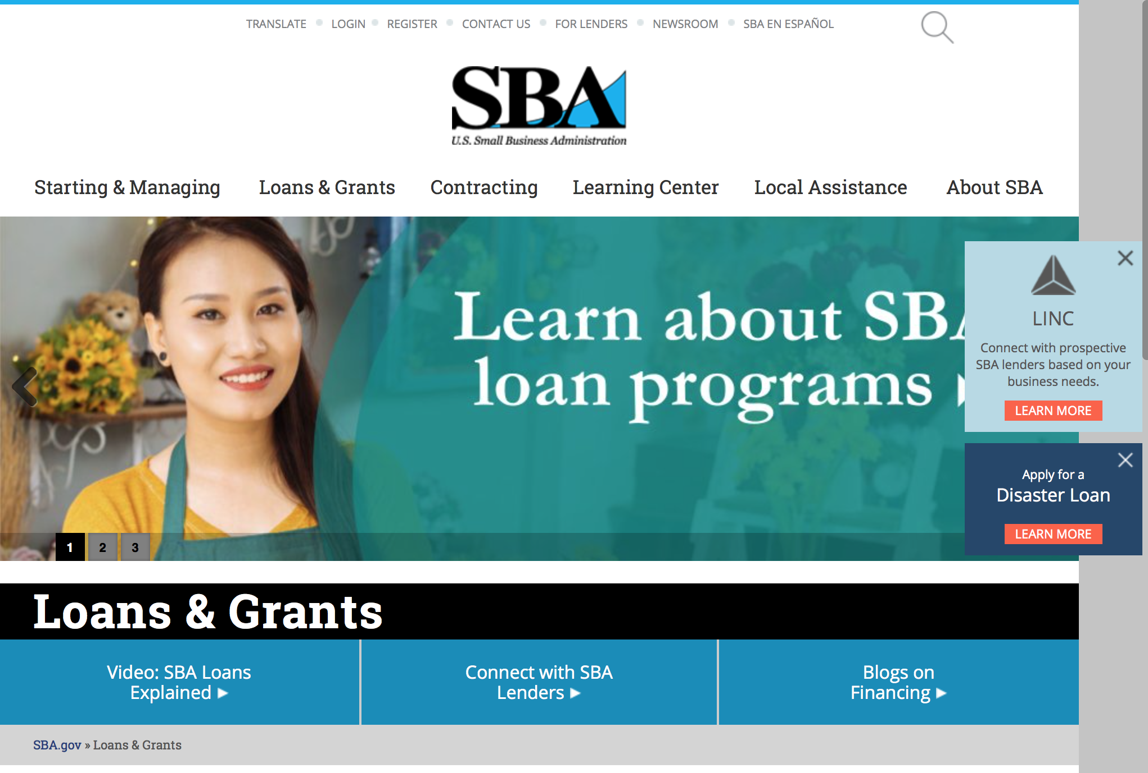
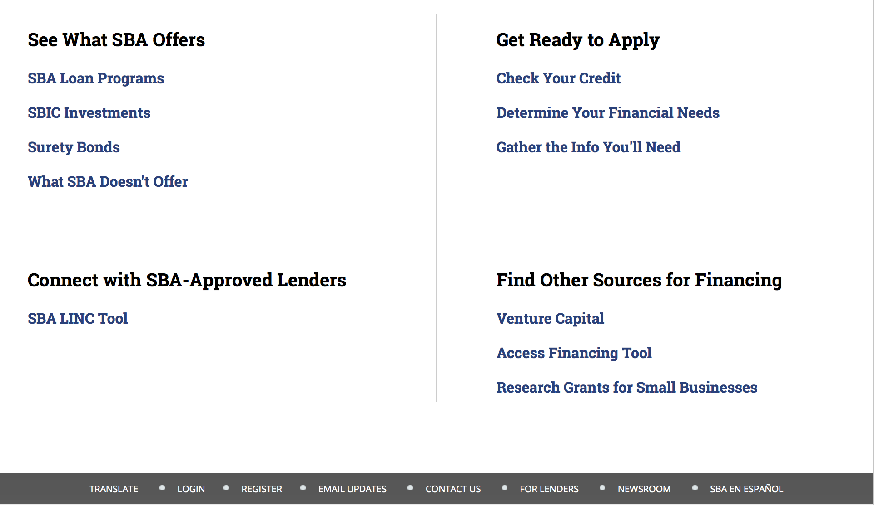

https://www.sba.gov/category/navigation-structure/loans-grants
Federal, state and local governments offer a wide range of financing programs to help small businesses start and grow their operations. These programs include low-interest loans, venture capital, and scientific and economic development grants.
Use SBA.gov's Loans and Grants Search Tool to get a list of financing programs for which you may qualify, or visit the resources below to learn more about small business financing programs.
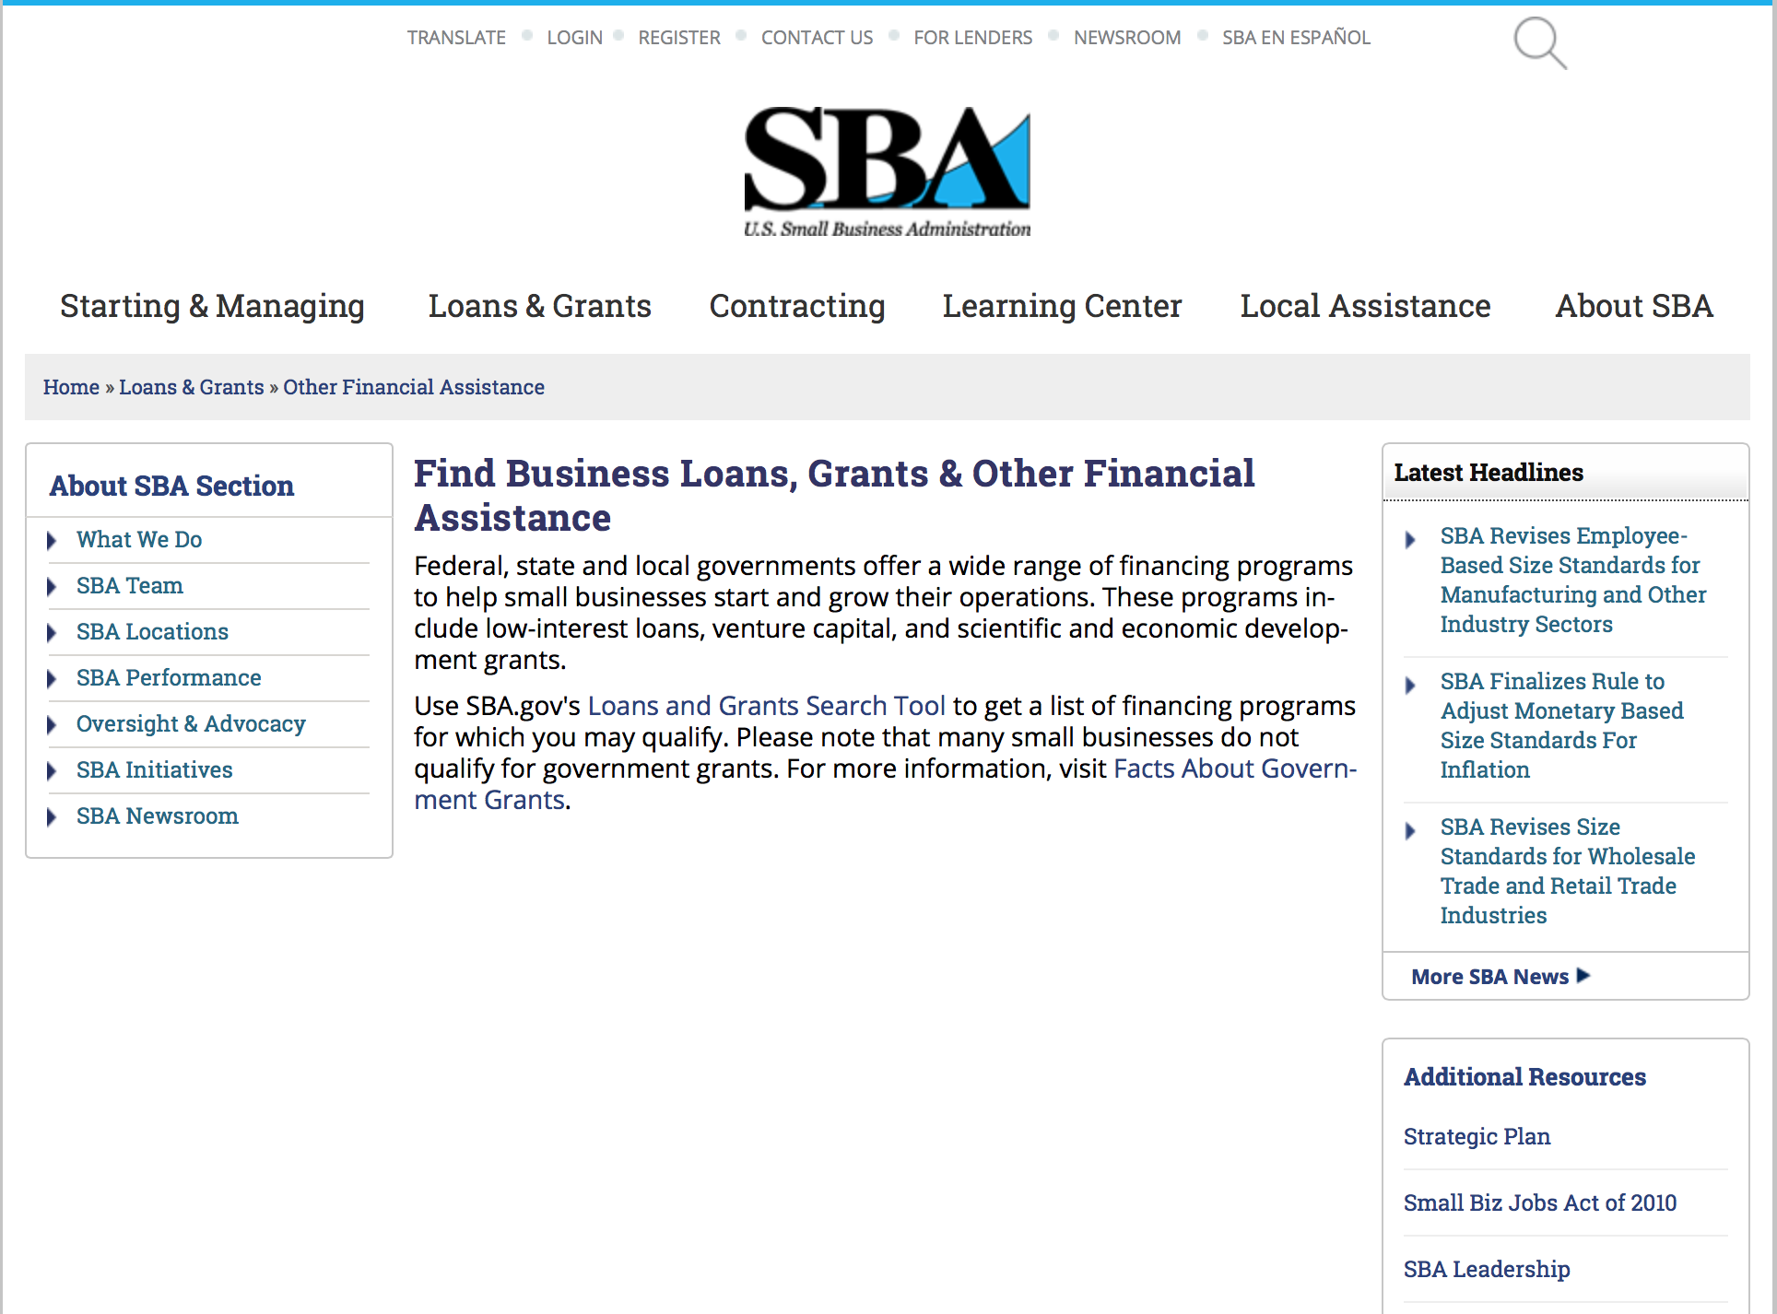
To get to the main SBA.gov funding page click here
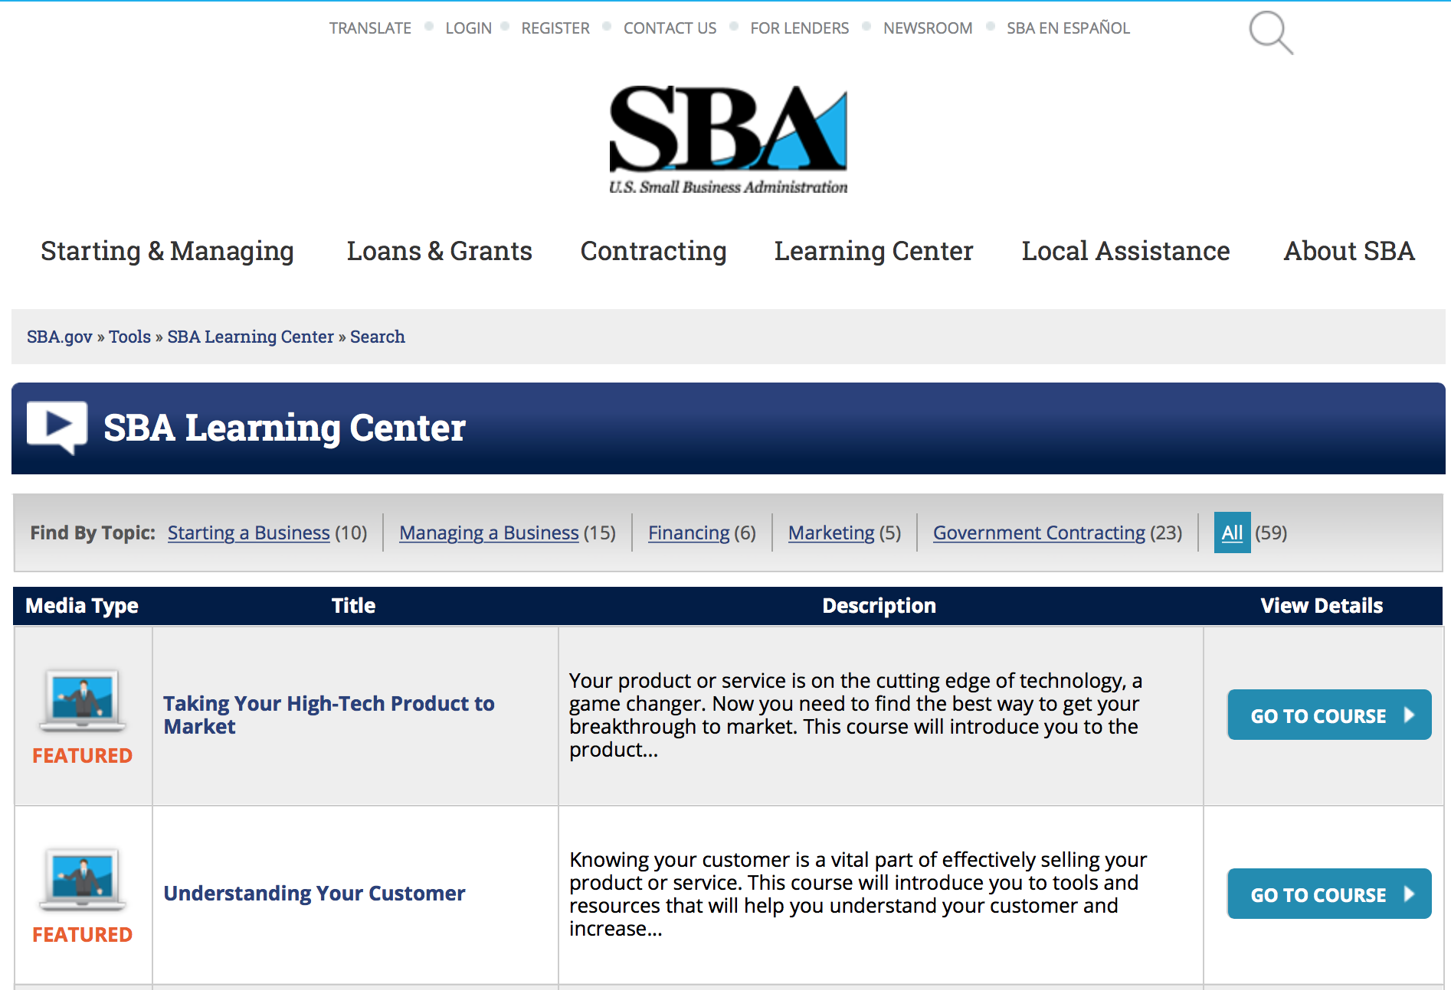
https://www.sba.gov/tools/sba-learning-center/search/training
Programs:

Reminders:

Deleted:

SBA Trainings

Contracting Opportunities for Veteran Entrepreneurs
This self-paced training exercise is an introduction to Federal contracting opportunities for Veterans.
Topics include basic information about Veteran-owned businesses and opportunities, services available to small Veteran-owned businesses, small business incentives, and government procurement methods.
Duration: 00:30:00

http://www.sba.gov/tools/sba-learning-center/training/contracting-opportunities-veteran-entrepreneurs

Interested in Exporting? These Four Resources Can Help
Did you know that two-thirds of the world’s purchasing power is in foreign countries? As the numbers show, the international marketplace is a big one. So if you’re interested in exploring the world of exporting – or have gotten started but could use some guidance – check out these resources to help.
- Read more

Upcoming Trainings: Check out SBA's Online Training!
- Financing Options for Small Businesses
How to Prepare Government Contract Proposals
Getting Started With Exporting: Training and Educational Resources
Exporting represents a big opportunity to tap in to new markets, expand your customer base and grow your business. But getting started with exporting can sometimes feel like a maze of regulations, policies, and other barriers. Here are some free training and educational resources to help.
- Read more

For Specific Information in Hawaii see the following links:
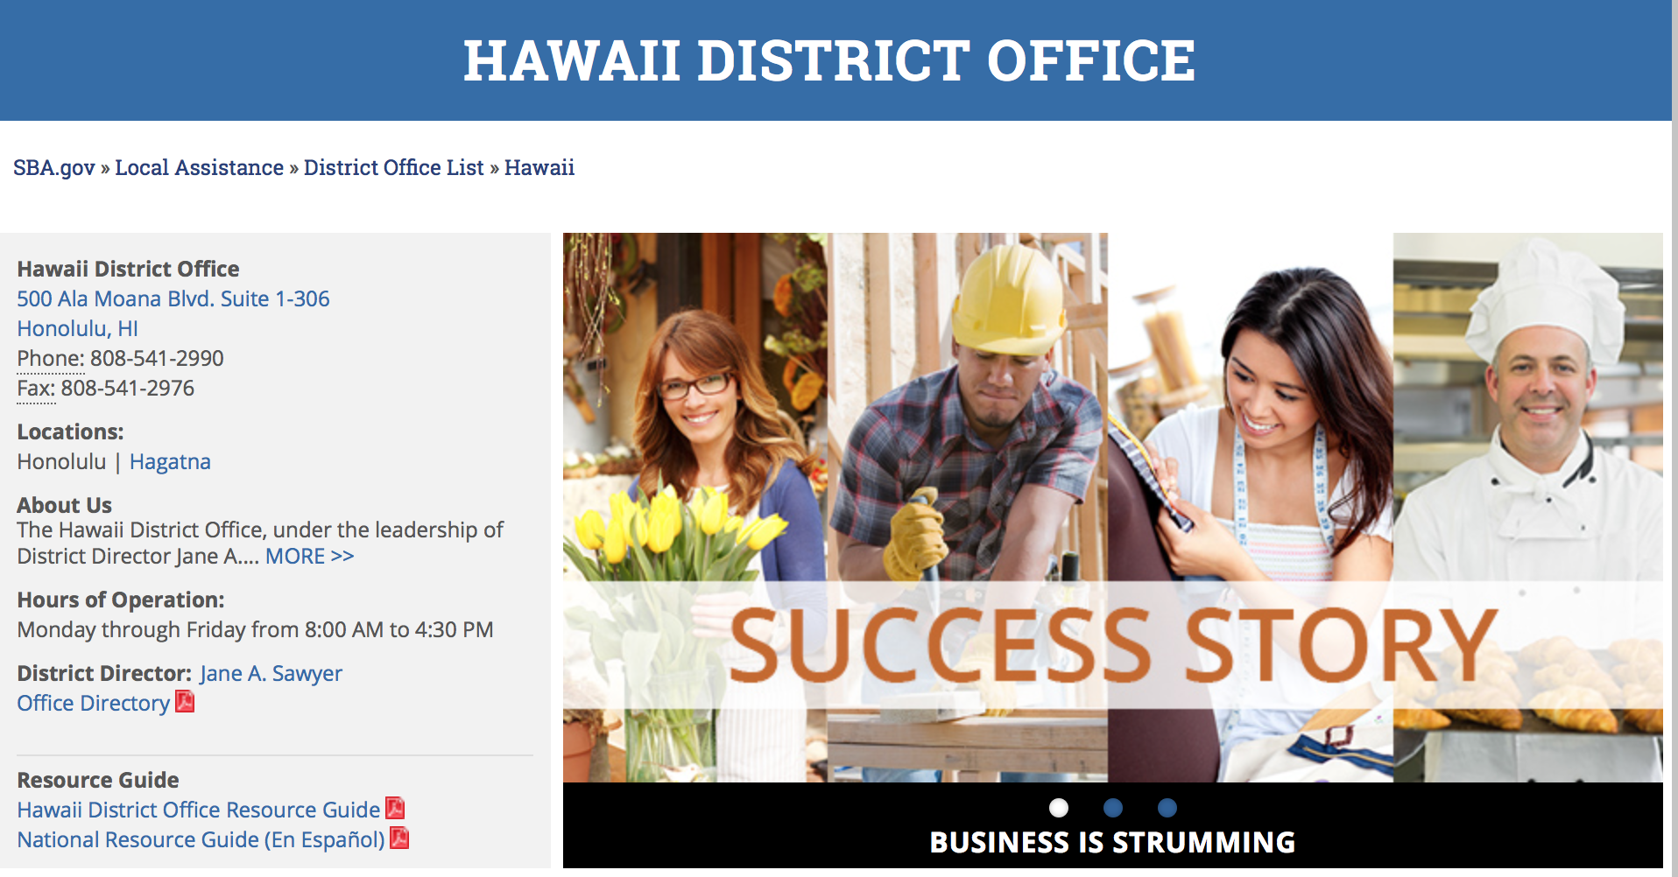

https://www.sba.gov/offices/district/hi/Honolulu

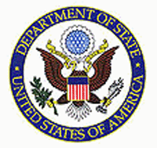

State Department General Overview and Resources for Program Administrators

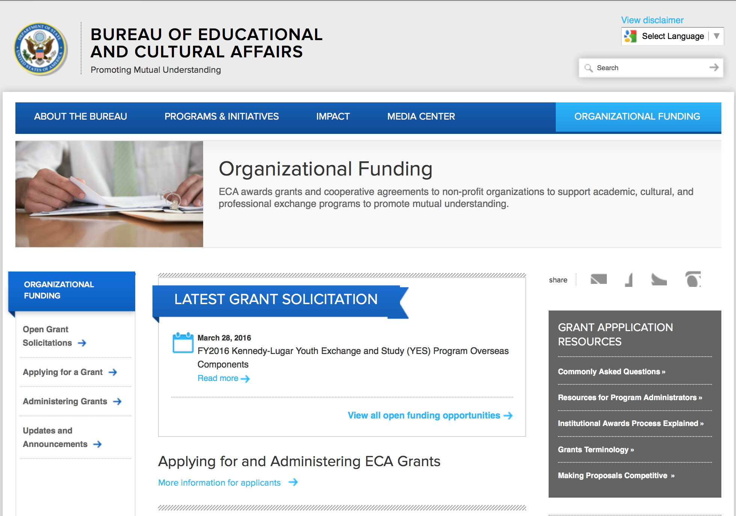
http://eca.state.gov/search/solr/grants?search_referrer=node/237
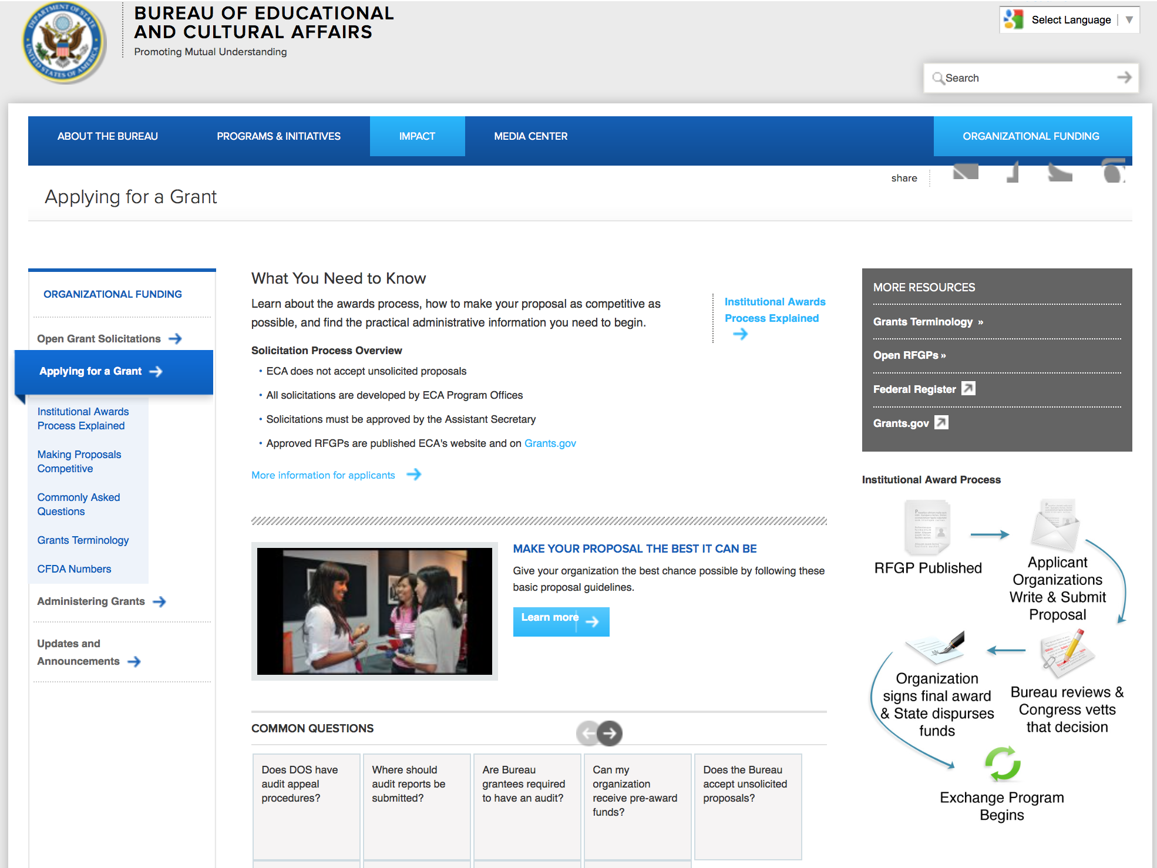

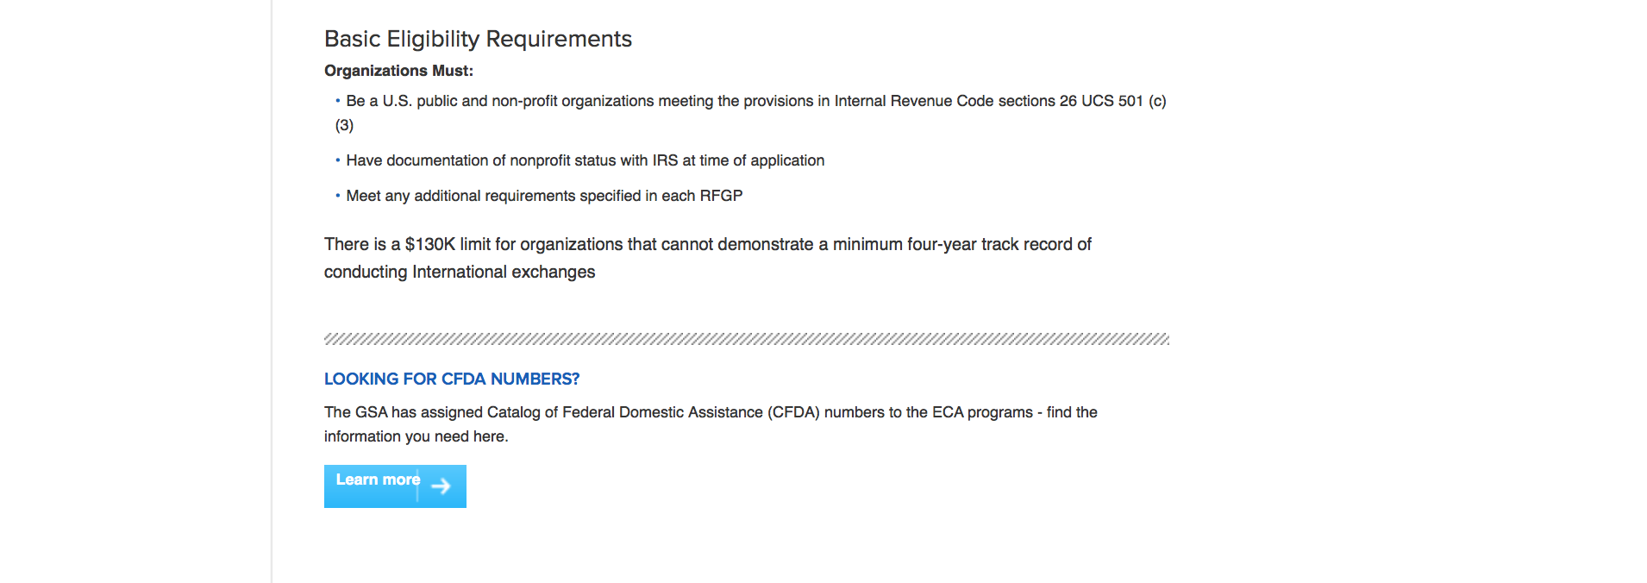
http://eca.state.gov/organizational-funding/applying-grant

General Information:
- Bureau of Educational and Cultural Affairs Grants Division
- Open Grant Opportunities (Requests for Grant Proposals)

For General Information click here

Program Grants:

Bureau of Democracy, Human Rights and Labor
FY16 DRL - Transitional Justice and Reconciliation in Sri Lanka
Synopsis 1
http://www.grants.gov/web/grants/view-opportunity.html?oppId=290618

Bureau Of Educational and Cultural Affairs
FY 2017 National Security Language Initiative for Youth (NSLI-Y)
Synopsis 1
http://www.grants.gov/web/grants/view-opportunity.html?oppId=290508

Bureau of Population, Refugees and Migration
FY 2017 Request for Concept Notes for NGO Programs Benefiting Refugees and Other Vulnerable Populations in Iraq, Jordan, Lebanon, and Turkey
Synopsis 2
http://www.grants.gov/web/grants/view-opportunity.html?oppId=291051

U.S. Mission to Ukraine
Ukraine: USG Public Diplomacy Small Grants Program
Synopsis 1
http://www.grants.gov/web/grants/view-opportunity.html?oppId=290951

Modifications:

U.S. Mission to Korea
U.S. Embassy Seoul PAS Annual Program Statement
Synopsis 5
http://www.grants.gov/web/grants/view-opportunity.html?oppId=289448

Bureau of International Security and Nonproliferation
Regulatory and Licensing Support for Oman
Synopsis 6
http://www.grants.gov/web/grants/view-opportunity.html?oppId=290773

Reminders:

Deleted:

Bureau of Population, Refugees and Migration
PRM-PRMOAPNE-17-003 - 2017 Request for Concept Notes for NGO Programs Benefiting Refugees and Other Vulnerable Populations in Iraq, Jordan, Lebanon, and Turkey
Deletion Comments: Opportunity deleted ( predecessor to program above)

International Narcotics and Law Enforcement Affair
SCO-200-17-GR050 - INL Rural Engagement, Development, and Security (REDS) Colombia - Social Inclusion and Civil Society Engagement for Survivors of Armed Conflict, Landmines, and IEDs
Deletion Comments: Opportunity deleted

Department of Transportation

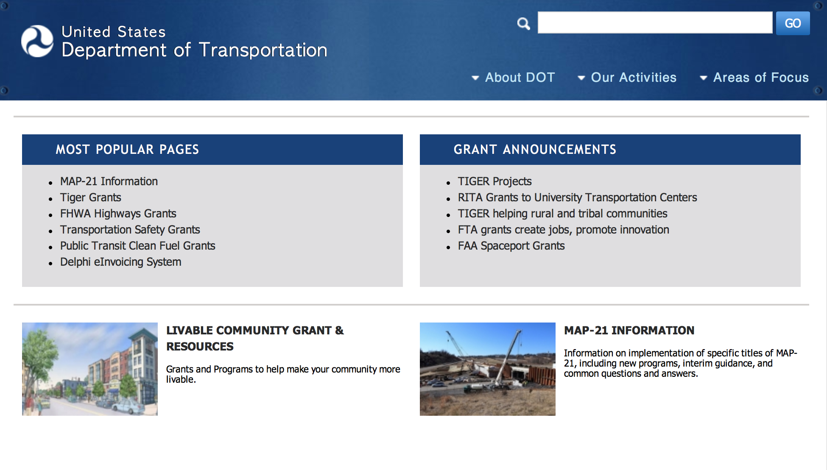
General Grant Program Overview https://www.transportation.gov/grants

Programs:

PHMSA Hazmat Grants
2017 PHMSA HMIT Grant
Synopsis 1

Document Type: | Grants Notice
Funding Opportunity Number: | HM-HMI-17-001
Funding Opportunity Title: | 2017 PHMSA HMIT Grant
Opportunity Category: | Discretionary
Opportunity Category Explanation:
Funding Instrument Type: | Grant
Category of Funding Activity: | Transportation
Category Explanation:
Expected Number of Awards: | 5
CFDA Number(s): | 20.703 -- Interagency Hazardous Materials Public Sector Training and Planning Grants
Cost Sharing or Matching Requirement: | No
Version: | Synopsis 1
Posted Date: | Dec 20, 2016
Last Updated Date: | Dec 19, 2016
Original Closing Date for Applications: | Feb 17, 2017 No Explanation
Current Closing Date for Applications: | Feb 17, 2017 No Explanation
Archive Date: | Mar 19, 2017
Estimated Total Program Funding: | $4,000,000
Award Ceiling: | $1,000,000
Award Floor: | $250,000
Eligible Applicants: | Others (see text field entitled "Additional Information on Eligibility" for clarification)
Additional Information on Eligibility: | Non-profit organizations described in Section 501(c)(4) of the Internal Revenue Code that engage in lobbying activities as defined in Section 3 of the Lobbying Disclosure Act of 1995 are not eligible applicants. "For profit" organizations are not eligible applicants for the HMIT grant program.
Agency Name: | PHMSA Hazmat Grants
Description: | PHMSA is soliciting proposals on a competitive basis to receive HMIT grant funds for training instructors who will then train employees involved in the transportation of hazardous materials. Instructors trained under this program will be able to offer training at or near their places of employment. Consistent with statutory requirements at 49 U.S.C part 5107(e), the HMIT grant program is open to nonprofit organizations that demonstrate: (A)Expertise in conducting a training program for hazmat employees; and (B)The ability to reach and involve in a training program a target population of hazmat employees. For the purposes of the HMIT grants program: Non-profit organization, as defined at 2 CFR 200.70, means any corporation, trust, association, cooperative, or other organization which: (1)Is operated primarily for scientific, educational, service, charitable, or similar purposes in the public interest; (2)Is not organized primarily for profit; and (3)Uses its net proceeds to maintain, improve, and/or expand its operations.
Link to Additional Information: | 2017 PHMSA HMIT Grant
Grantor Contact Information: | If you have difficulty accessing the full announcement electronically, please contact:  Grants.gov Contact Center Phone Number: 1-800-518-4726 Hours of operation are 24 hours a day, 7 days a week. The contact center is closed on federal holidays. support@grants.gov  Grants.gov Customer Support

http://www.grants.gov/web/grants/view-opportunity.html?oppId=290818

Modifications:

Research:

DOT/Federal Transit Administration
Zero Emission Research Opportunity (ZERO)
Synopsis 1
http://www.grants.gov/web/grants/view-opportunity.html?oppId=290356

Reminders:

DOT Federal Aviation Administration
DOT - FAA Aviation Research Grants
FAA Aviation Research and Development Grants
Modifications 3 & 4

Document Type: | Grants Notice
Funding Opportunity Number: | 12-01
Funding Opportunity Title: | FAA Aviation Research and Development Grants
Opportunity Category: | Discretionary
Opportunity Category Explanation:
Funding Instrument Type: | Grant
Category of Funding Activity: | Transportation
Category Explanation:
Expected Number of Awards:
CFDA Number(s): | 20.108 -- Aviation Research Grants
Cost Sharing or Matching Requirement: | No
Version: | Synopsis 5
Posted Date: | Jan 01, 2012
Last Updated Date: | Jun 09, 2016
Original Closing Date for Applications: | Dec 31, 2019
Current Closing Date for Applications: | Dec 31, 2019
Archive Date: | Jan 30, 2020
Estimated Total Program Funding:
Award Ceiling: | $5,000,000
Eligible Applicants: | Nonprofits having a 501(c)(3) status with the IRS, other than institutions of higher education  Private institutions of higher education  Public and State controlled institutions of higher education
Agency Name: | DOT - FAA Aviation Research Grants
Description: | The FAA is soliciting proposals for research grants and cooperative agreements to pursue the long-term growth and short-term technical needs of civil aviation. In order to streamline the application process, it is recommended that all prospective grantees submit a white paper (letter of intent) for agency technical review before complete proposal submission. Please be sure to identify the specific area of interest (Solicitation FAA-12-01 – Chapter I. FAA Research Grants Program, Technical Areas of Research #1-#9). The white paper shall be no longer than three (3) pages and shall detail overall research objectives.
Link to Additional Information:
Grantor Contact Information: | If you have difficulty accessing the full announcement electronically, please contact:  Debra Monzo Grants Officer Phone 609-485-4962  business

http://www.grants.gov/web/grants/view-opportunity.html?oppId=134953

Deleted:

Department of the Treasury

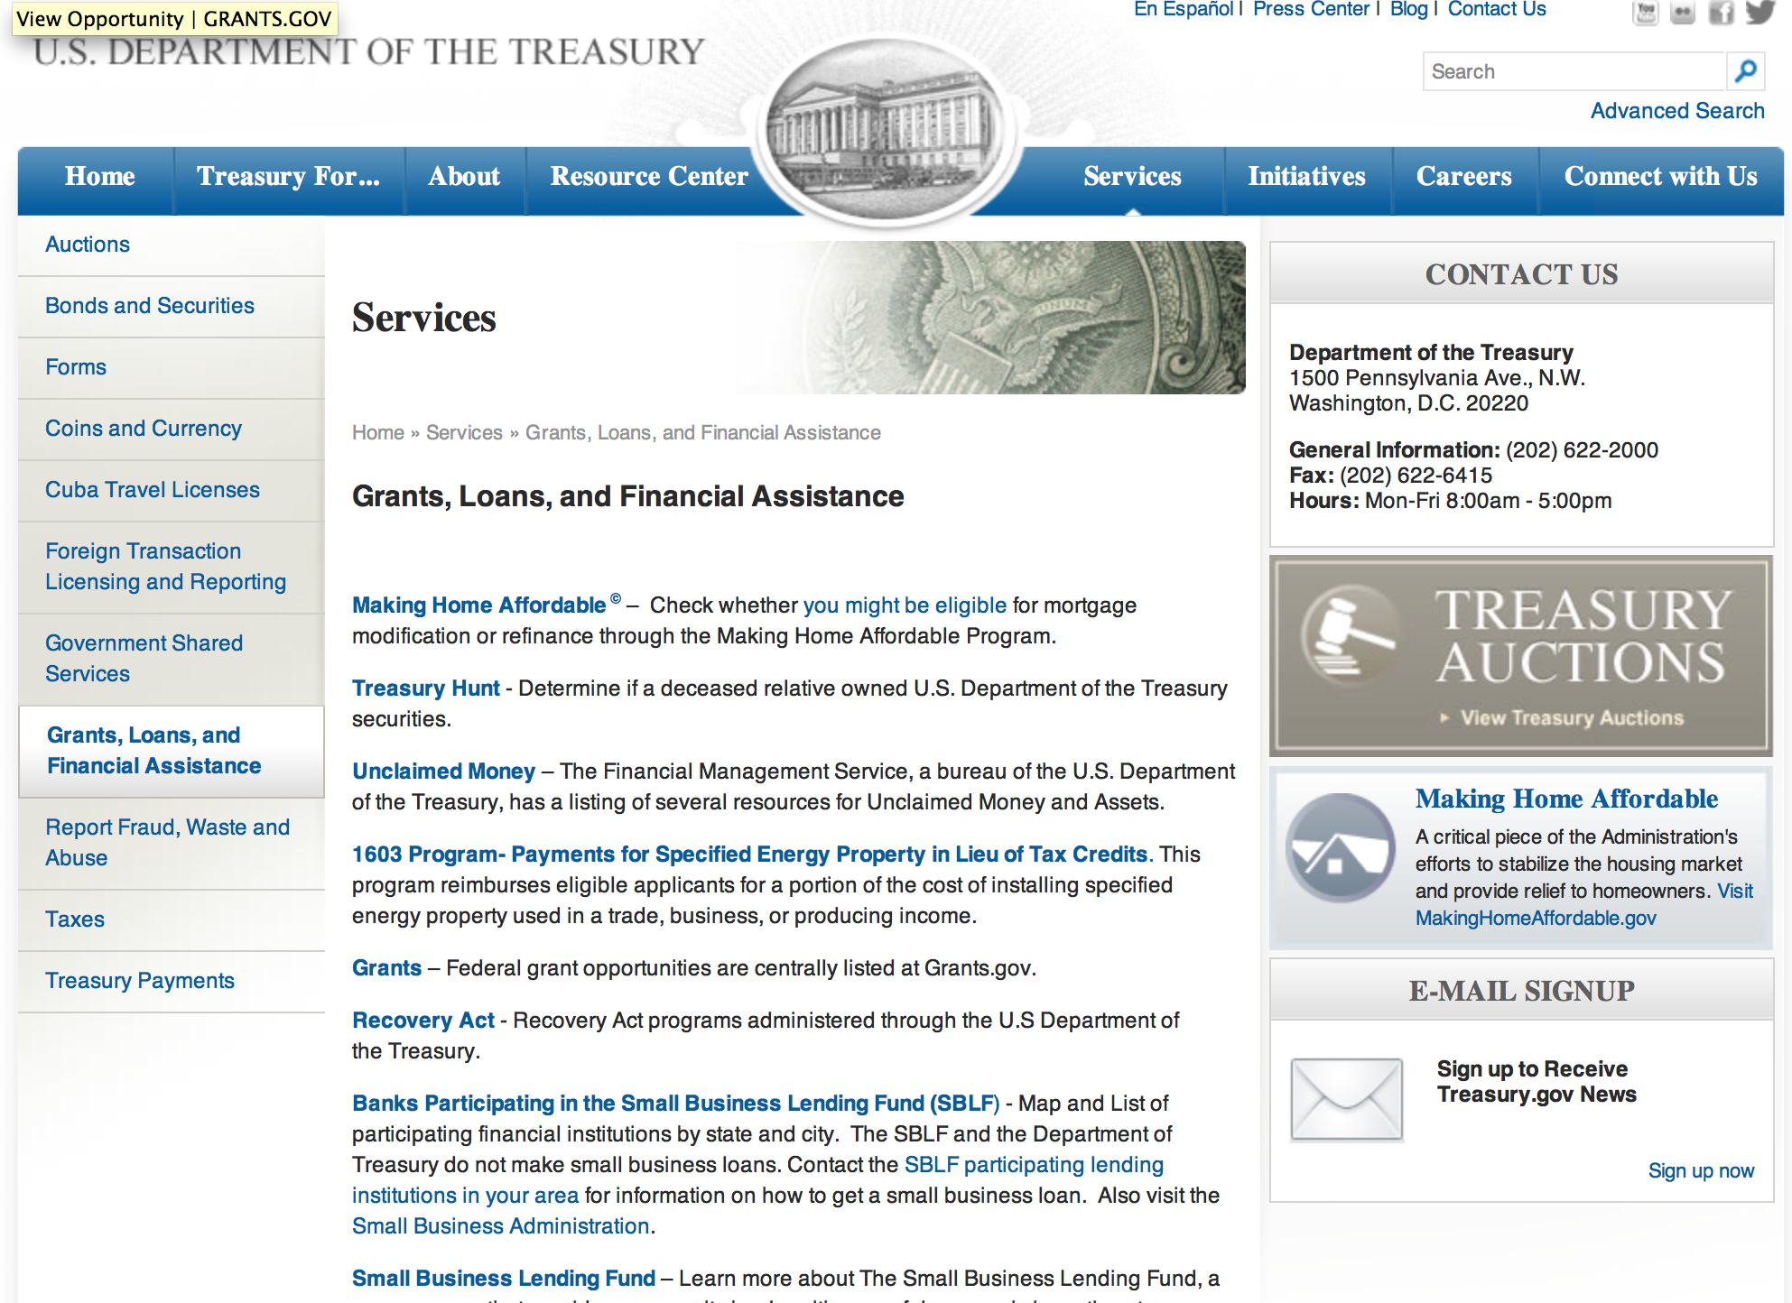

http://www.treasury.gov/services/Pages/Grants-Loans-and-Financial-Assistance.aspx

Programs:

Modifications:

Reminders:

U.S. Agency for International Development

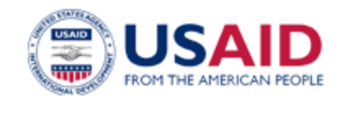

www.usaid.gov

General Overview Funding Opportunities

USAID has working relationships with thousands of American companies and hundreds of U.S.-based private voluntary organizations. For more information on our business and procurement opportunities, please visit our Business section.

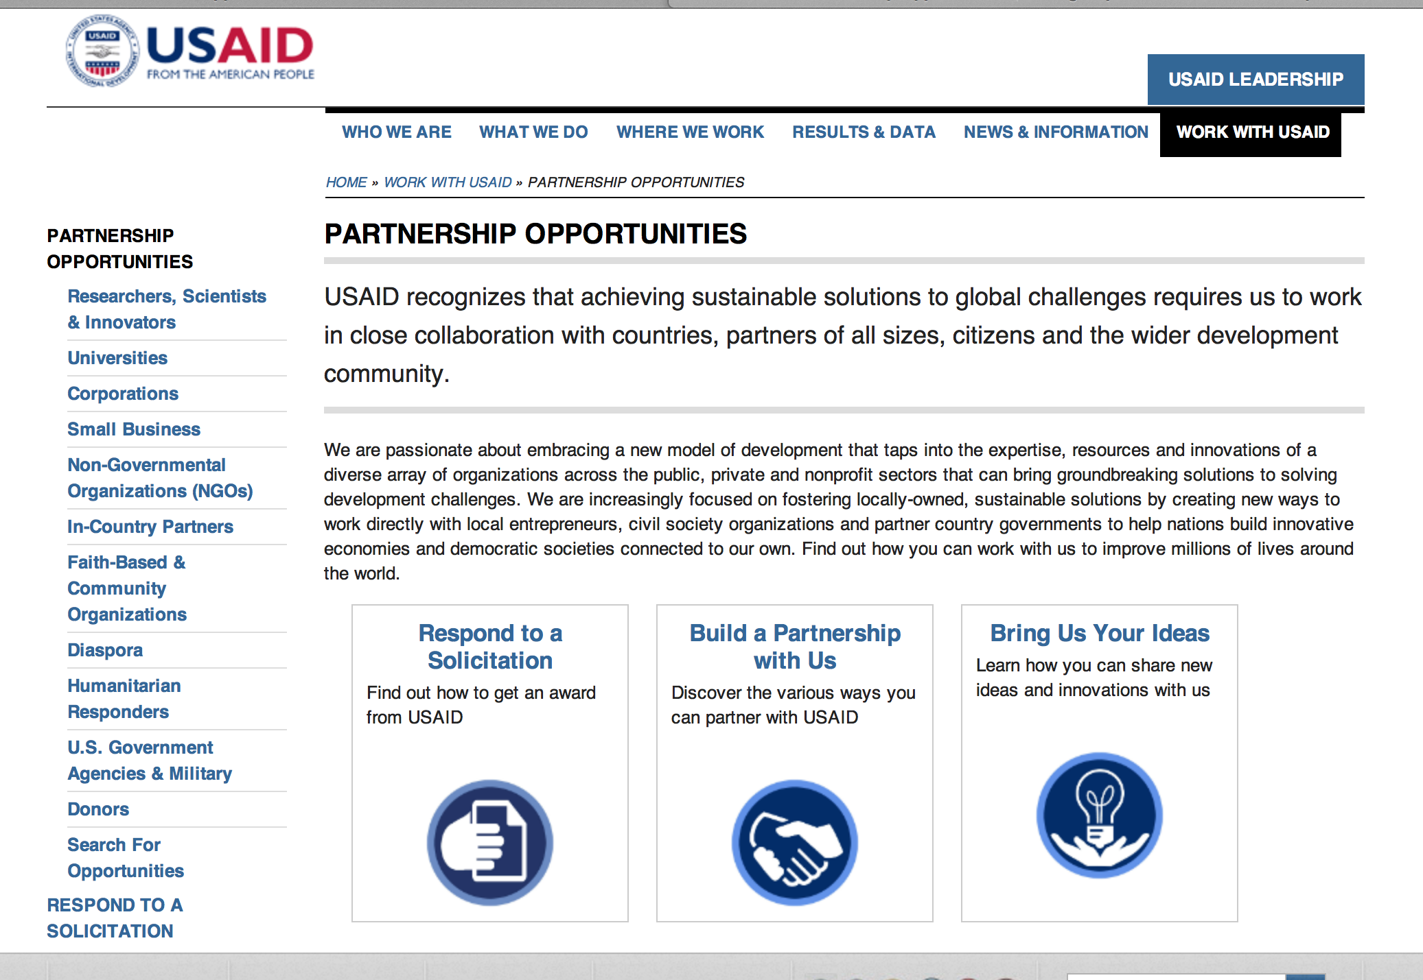
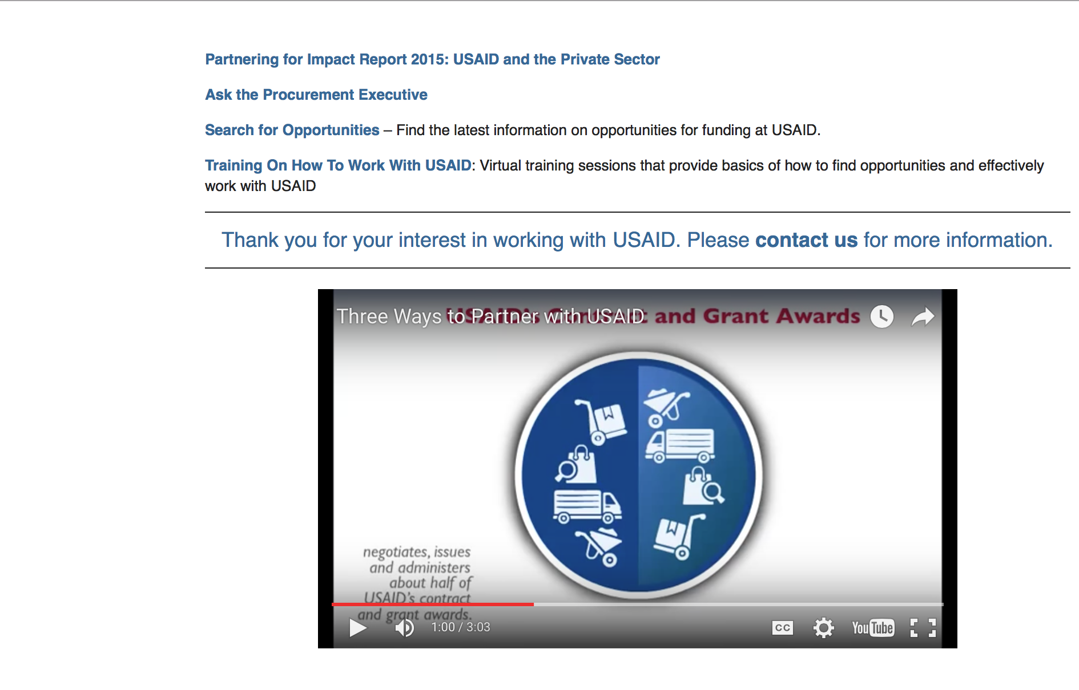

http://www.usaid.gov/partnerships

Programs:

USAID /DCHA/FFP International Emergency Food Assistance
Synopsis 1
http://www.grants.gov/web/grants/view-opportunity.html?oppId=290872

USAID: DIASPORA PARTNERSHIPS
Synopsis 1
http://www.grants.gov/web/grants/view-opportunity.html?oppId=291049

Modifications:

India -New Delhi
India Partnerships Program (IPP)
Synopsis 2
http://www.grants.gov/web/grants/view-opportunity.html?oppId=282644

Developing Next Generation of Humanitarian Leaders
Synopsis 3
http://www.grants.gov/web/grants/view-opportunity.html?oppId=284148

Family Planning and Reproductive Health Methods APS
Synopsis 5
http://www.grants.gov/web/grants/view-opportunity.html?oppId=215873

The Global Health Challenge BAA
Synopsis 6 & 7
http://www.grants.gov/web/grants/view-opportunity.html?oppId=282988

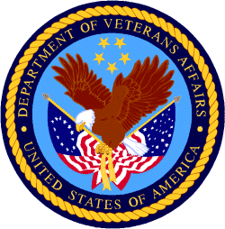

Department of Veterans Affairs

