Senator Mazie Hirono

Grants Assistance Information Newsletter

JANUARY 2018

G.A.I.N. INDEX

Click on Index Links below to read summaries of the announcements by agency in this document. Once you reach the item, if you cannot open the links for further information, copy the selected URL website address into your browser.

Modified sections from previous listings are shown in a GREY background

Notices is Teal are items with immediate deadline dates.

Notices in Yellow are of special interest.

Notices is Green are items of special interest with immediate deadline dates.

Items in this type color are aimed at Small Businesses

Items in this type color have a Faith-Based Organization component

Special Federal Program Notices

Grant Writing Resources

SAM and Grants.Gov Information

SBIR – Small Business Innovation Research

Programs specific to Hawaii

Current Notices

Department of Commerce
2018 MET Mini Grant Program
Reminders

Department of Interior

Bureau of Reclamation
WaterSMART Cooperative Watershed Management Program Phase I Grants for Fiscal Year 2018

See Individual Departments for information and webpages representing the best and most accessible information on the agency funding opportunities

Federal Grant and Cooperative Agreement Program Summaries

U.S. Department of Agriculture

Grants and Loans Overview

Programs
Foreign Agricultural Service
Food for Progress Program

USDA-NRCS-NHQ
Announcement for Program Funding for NRCS' Conservation Innovation Grants (CIG) for Federal fiscal year (FY) 2018
Research

National Institute of Food and Agriculture
Organic Agriculture Research and Extension Initiative

Modifications

Reminders

National Institute of Food and Agriculture
Beginning Farmer and Rancher Development Program
National Institute of Food and Agriculture
Enhancing Agricultural Opportunities for Military Veterans Competitive Grants Program

Forest Service
2018 Wood Innovations Funding Opportunity

Business and Cooperative Programs
VALUE ADDED PRODUCER GRANT

Deleted:

Department of Commerce

Grants at Commerce

Programs

Climate and Societal Interactions
NOAA National Sea Grant College Program 2018 Ocean, Coastal and Great Lakes National Aquaculture Initiative
2018 Bycatch Reduction Engineering Program (BREP)
Modifications

Research

Reminders

Environmental Literacy Grants: Supporting the education of K-12 students and the public for community resilience

National Sea Grant College Program 2018-19 Special Projects
Fiscal Year 2019 National Sea Grant College Program Dean John A. Knauss Marine Policy Fellowship
FY18-19 CRCP International Coral Reef Conservation Cooperative Agreements

Economic Development Administration
FY 2017 Economic Development Assistance Programs ­ Application submission and program requirements for EDA’s Public Works and Economic Adjustment Assistance programs.

National Institute of Standards and Technology
Embedding MEP in Manufacturing USA Institutes Pilot Projects – Round 3

National Institute of Standards and Technology
Measurement Science and Engineering (MSE) Research Grant Programs

FY 2016 – FY 2019 EDA Planning Program and Local Technical Assistance Program Grant

Economic Development Administration
Planning Program and Local Technical Assistance Program Grant

Deleted

Corporation for National and Community Service

General Program Overview

Programs

Reminders

AmeriCorps State and National Grants FY2018

National Service in Hawaii

Department of Defense

Doing Business with the Department of Defense

DoD Small Business Opportunities and Forecasting

Research Grants

Modifications

Deleted

Reminders

Department of Education

Grant Programs Overview

Programs

Research

Modifications

Reminders

Deleted

US Department of Energy

Grants Overview

Research

Modifications

Reminders

Environmental Protection Agency

Grants and Contracts Overview

Programs

15th Annual P3 Awards: A National Student Design Competition Focusing on People, Prosperity and the Planet - Safe and Sustainable Water Resources
15th Annual P3 Awards: A National Student Design Competition Focusing on People, Prosperity and the Planet - Chemical Safety

15th Annual P3 Awards: A National Student Design Competition Focusing on People, Prosperity and the Planet - Air Quality

15th Annual P3 Awards: A National Student Design Competition Focusing on People, Prosperity and the Planet - Sustainable and Healthy Communities

Modifications

Research

Reminders

Environmental Justice Collaborative Problem-Solving (EJCPS) Cooperative Agreement (Program)
FY 2018 National Environmental Information Exchange Network Grant Program

Department of Health and Human Services

Grants Overview

Program

Research Grants

Modifications

Deleted

Reminders

Administration for Children and Families - ACYF/CB (Program)
Strengthening Child Welfare Systems to Achieve Expected Child and Family Outcomes

Department of Homeland Security
Grants Overview

Programs

FEMA
FY 2017 Assistance to Firefighters Grants

Modifications

Reminders

Department of Housing and Urban Development

HUD - Notice of Funds Available

Programs

Modifications

Deleted

Reminders

Self-Help Homeownership Opportunity Program (SHOP)

Institute of Museum and Library Services

Grants Overview

IMLS is on Facebook!

Programs

Museums Empowered: Professional Development Opportunities for Museum Staff - A Museums for America Special Initiative

Modifications

Reminders

National Leadership Grants for Libraries

Deleted

Department of Interior

Grants and Contract Overview

Programs

National Park Service
Save America's Treasures - Preservation (Construction) Projects
National Park Service
Save America's Treasures - Collections

Modifications

Reminders

National Park Service
FY 18 American Battlefield Protection Program Battlefield Preservation Planning Project Grants

Deleted

Department of Justice

Grants and Contract Overview

Programs

Office on Violence Against Women
OVW FY 2018 Legal Assistance for Victims Grant Program Solicitation
Office on Violence Against Women
OVW FY 2018 Rural Sexual Assault, Domestic Violence, Dating Violence and Stalking Program Solicitation
Research

Modifications

Deleted

Reminders

Office on Violence Against Women
OVW FY 2018 Training and Services to End Violence Against Women with Disabilities Grant Program

________________________________________________________________________

Department of Labor

Grants and Contract General Overview

Programs

Modifications

Reminders

National Aeronautics and Space Administration

Research Grant and Contract General Overview

Programs

Modifications

_______________________________________________________________
National Archives and Records Administration

Grant Opportunities General Overview

Programs

Reminders

Publishing Historical Records in Documentary Editions

State Board Programming Grants
Access to Historical Records: Major Initiatives (Preliminary)

Access to Historical Records: Major Initiatives

_______________________________________________________________
National Endowment for the Arts

Grant Opportunities General Overview

Programs

NEA Art Works I, FY2019
Modifications

Reminders

NEA Literature Fellowships: Creative Writing, FY2019

_______________________________________________________________

National Endowment for the Humanities

Grant Opportunities General Overview

Programs

Public Scholar Program
Landmarks of American History and Culture: Workshops for School Teachers
Summer Seminars and Institutes

Reminders

Digital Humanities Advancement Grants

Media Projects Grants

National Digital Newspaper Program

Public Humanities Projects

_______________________________________________________________
National Science Foundation

Grant Opportunities General Overview

Research and Program Grants

Modifications

Reminders

Deleted

Nuclear Regulatory Commission

Reminders

Small Business Administration

General Overview Finding Loans & Grants

Programs

Women’s Business Center - Initial Phase Grant
Women’s Business Center - Initial Phase Grant

Modifications

Reminders

Veterans Business Outreach Center Program (VBOC)

Deleted

Upcoming Trainings

Links Specific to Hawaii

State Department

General Overview and Resources for Program Administrators

Programs

Modifications

Reminders

U.S. Department of Transportation

General Grant Program Overview

Programs

Research

Modifications

Reminders

DOT - Office of Aviation Analysis
Small Community Air Service Development Program

DOT Federal Aviation Administration
DOT - FAA Aviation Research Grants
FAA Aviation Research and Development Grants
Modifications 3,4& 6

Deleted

Department of the Treasury

Programs

Modifications

Reminders

Community Development Financial Institutions
FY 2017 Bank Enterprise Award Program Application

US Agency for International Development

General Funding Opportunity Overview

Programs
Modifications

Deleted

Department of Veterans Affairs

Special Federal Program Notices

Grant Writing Resources

The following links are a great resource for faith-based non-profits and other community organizations :

- Center for Faith-Based and Community Initiatives (link is external) , U.S. Department of Labor

- http://www.usaid.gov/partnership-opportunities/fbci. U.S. Agency for International Development

- Faith-Based and Other Community Initiatives (link is external) , Corporation for National Community Service

- Task Force for Faith-Based and Community Initiatives (link is external) , U.S. Department of Justice

- Proposal Writing Short Course (link is external) Foundation Center.
- General Tips on Writing a Competitive Grant Proposal (link is external) U.S. Environmental Protection Agency.
- How to Write a Grant Proposal (link is external) Appalachian Regional Commission.
- A Guide to Funding Resources USDA Rural Information Center.

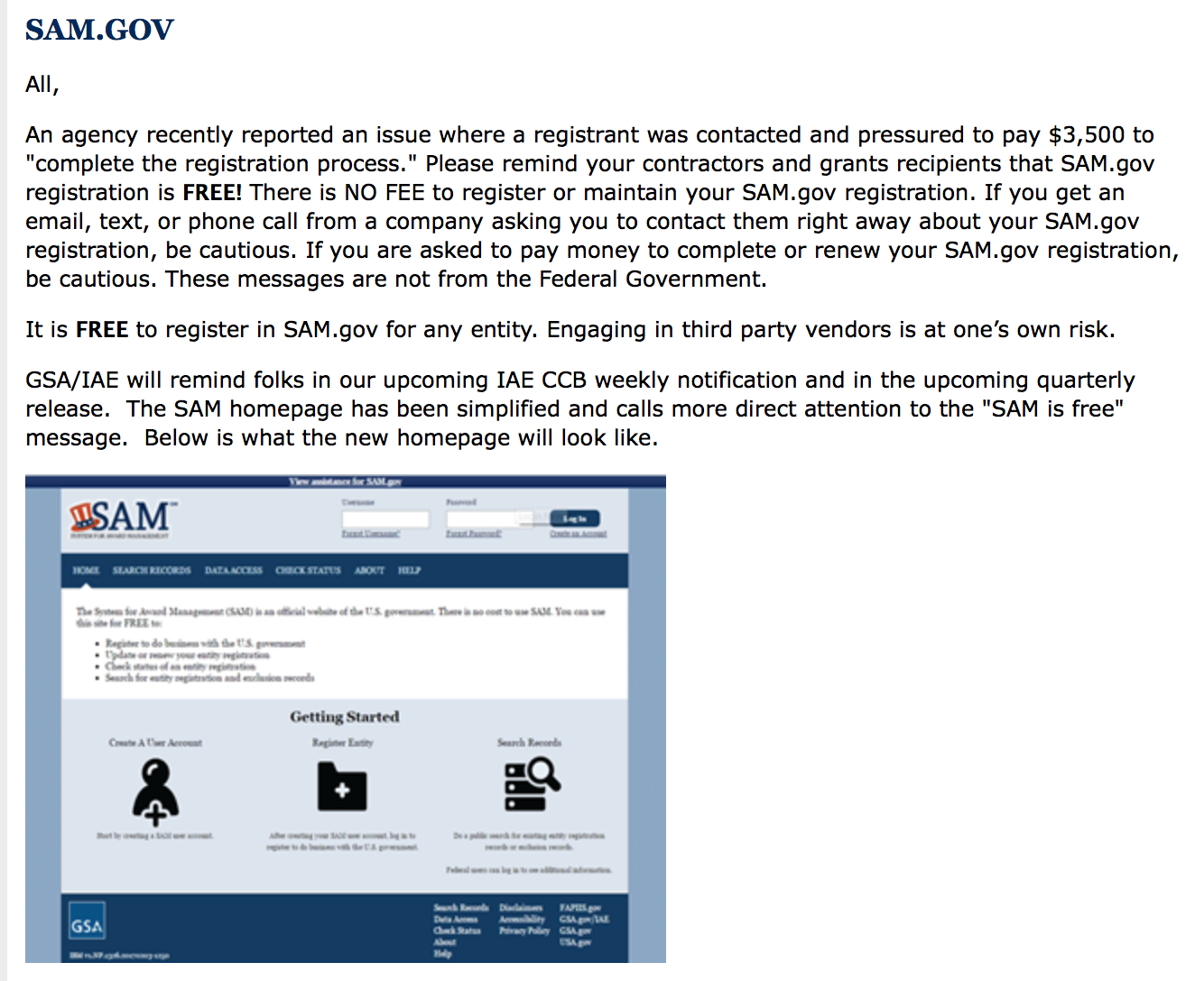

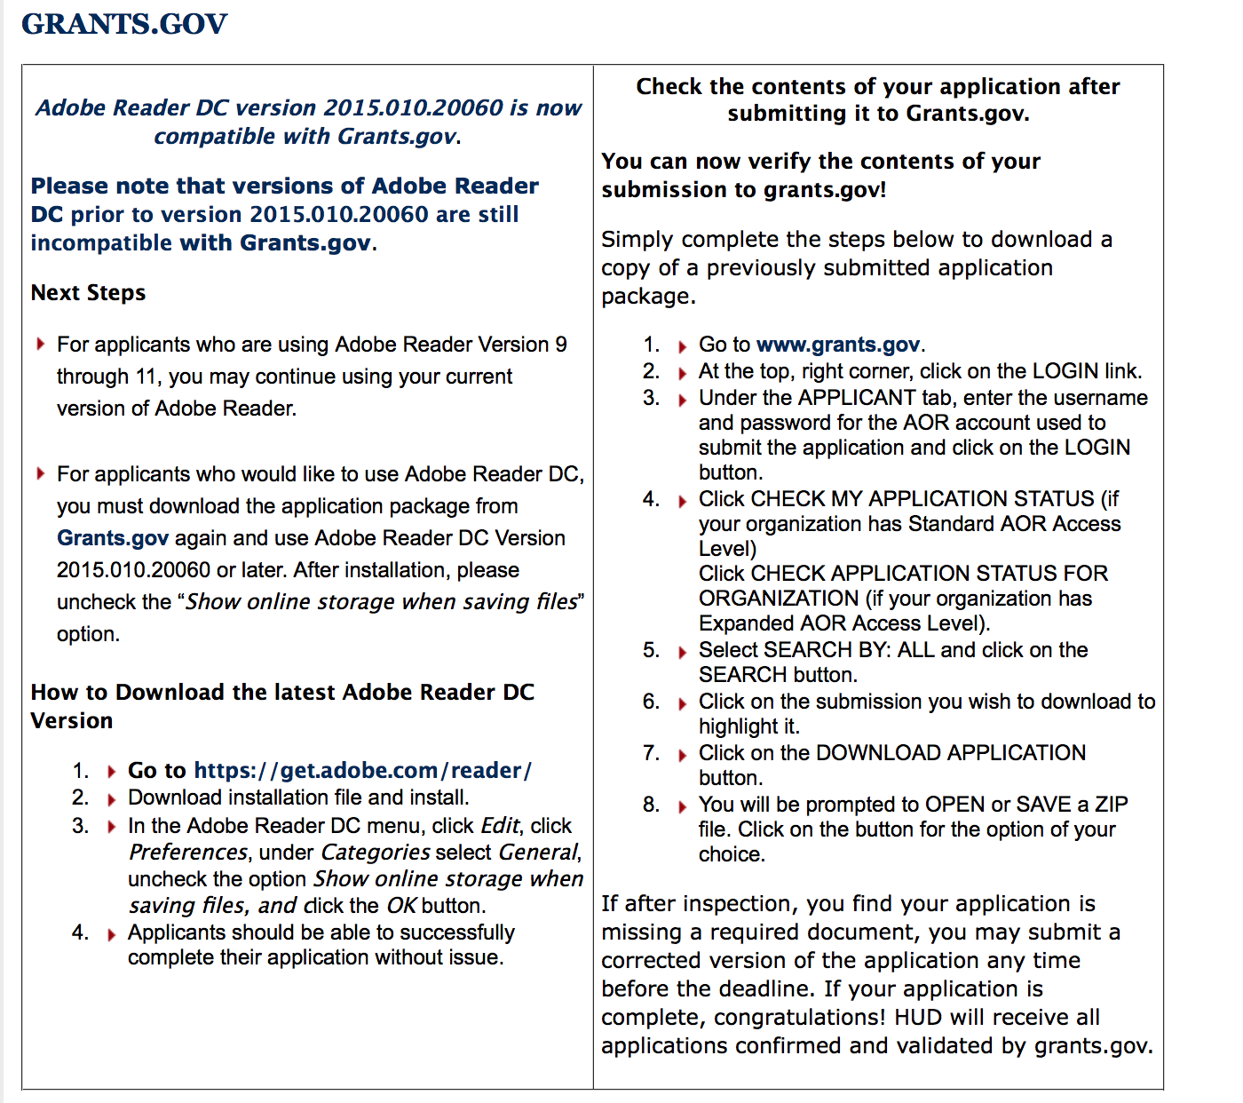

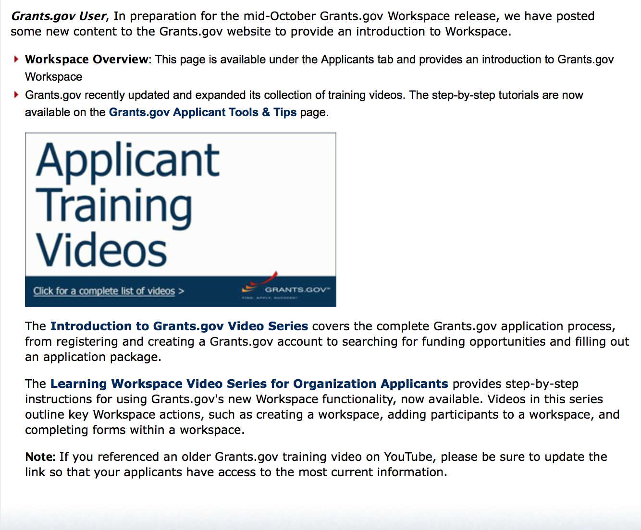
https://portal.hud.gov/hudportal/HUD?src=/program_offices/administration/grants/fundsavail

The Small Business Innovative Research Program - SBIR Program

The Small Business Innovation Research (SBIR) program is a highly competitive program that encourages domestic small businesses to engage in Federal Research/Research and Development (R/R&D) that has the potential for commercialization. Through a competitive awards-based program, SBIR enables small businesses to explore their technological potential and provides the incentive to profit from its commercialization. By including qualified small businesses in the nation's R&D arena, high-tech innovation is stimulated and the United States gains entrepreneurial spirit as it meets its specific research and development needs.

SBIR Mission and Program Goals
The mission of the SBIR program is to support scientific excellence and technological innovation through the investment of Federal research funds in critical American priorities to build a strong national economy.
The program’s goals are four-fold:
- Stimulate technological innovation
- Meet Federal research and development needs.
- Foster and encourage participation in innovation and entrepreneurship by socially and economically disadvantaged persons.
- Increase private-sector commercialization of innovations derived from Federal research and development funding.

SBIR-Participating Agencies
Each year, Federal agencies with extramural research and development (R&D) budgets that exceed $100 million are required to allocate 2.5 percent of their R&D budget to these programs. Currently, eleven Federal agencies participate in the program:
- Department of Agriculture
- Department of Commerce - National Institute of Standards and Technology
- Department of Commerce - National Oceanic and Atmospheric Administration
- Department of Defense
- Department of Education
- Department of Energy
- Department of Health and Human Services
- Department of Homeland Security
- Department of Transportation
- Environmental Protection Agency
- National Aeronautics and Space Administration
- National Science Foundation
Each agency administers its own individual program within guidelines established by Congress. These agencies designate R&D topics in their solicitations and accept proposals from small businesses. Awards are made on a competitive basis after proposal evaluation.

Three-Phase Program
The SBIR Program is structured in three phases:
Phase I. The objective of Phase I is to establish the technical merit, feasibility, and commercial potential of the proposed R/R&D efforts and to determine the quality of performance of the small business awardee organization prior to providing further Federal support in Phase II. SBIR Phase I awards normally do not exceed $150,000 total costs for 6 months.
Phase II. The objective of Phase II is to continue the R/R&D efforts initiated in Phase I. Funding is based on the results achieved in Phase I and the scientific and technical merit and commercial potential of the project proposed in Phase II. Only Phase I awardees are eligible for a Phase II award. SBIR Phase II awards normally do not exceed $1,000,000 total costs for 2 years.
Phase III. The objective of Phase III, where appropriate, is for the small business to pursue commercialization objectives resulting from the Phase I/II R/R&D activities. The SBIR program does not fund Phase III. Some Federal agencies, Phase III may involve follow-on non-SBIR funded R&D or production contracts for products, processes or services intended for use by the U.S. Government
SBIR NewsLetter

- SBIR Newsletter
Sign up for e-mail updates

HAWAII APPLICANTS ENCOURAGED

Current Notices:

Department of Commerce
2018 MET Mini Grant Program
Synopsis 1
Document Type: | Grants Notice
Funding Opportunity Number: | NOAA-NMFS-PIRO-2018-2005476
Funding Opportunity Title: | 2018 MET Mini Grant Program
Opportunity Category: | Discretionary
Opportunity Category Explanation:
Funding Instrument Type: | Cooperative Agreement  Grant
Category of Funding Activity: | Environment  Natural Resources  Science and Technology and other Research and Development
Category Explanation:
Expected Number of Awards: | 15
CFDA Number(s): | 11.452 -- Unallied Industry Projects
Cost Sharing or Matching Requirement: | Yes
Version: | Synopsis 1
Posted Date: | Dec 20, 2017
Last Updated Date: | Dec 20, 2017
Original Closing Date for Applications: | Feb 21, 2018
Current Closing Date for Applications: | Feb 21, 2018
Archive Date: | Mar 23, 2018
Estimated Total Program Funding: | $150,000
Award Ceiling: | $15,000
Award Floor: | $1
Eligible Applicants: | Others (see text field entitled "Additional Information on Eligibility" for clarification)
Additional Information on Eligibility: | Eligible applicants are individuals, institutions of higher education, nonprofits, commercial organizations, state, local and Indian tribal governments. Federal agencies and instrumentalities, including their employees, are not eligible to apply. Eligible applicants are limited to projects within the Western Pacific Regional Fishery Management areas.
Agency Name: | Department of Commerce
Description: | The National Marine Fisheries Service (NOAA/NMFS) is soliciting competitive applications for the 2018 Pacific Islands Region Marine Education and Training (MET) Mini-Grant Program. Projects are being solicited to improve communication, education, and training on marine resource issues throughout the region and increase scientific education for marine-related professions among coastal community residents, including indigenous Pacific islanders, Native Hawaiians and other underrepresented groups in the region.
Link to Additional Information:
Grantor Contact Information: | If you have difficulty accessing the full announcement electronically, please contact:  Mr. Scott W.S. Bloom 808.725-5055 1845 Wasp Blvd., Building 176, Honolulu, HI 96818  Work
https://www.grants.gov/web/grants/view-opportunity.html?oppId=299577

Reminders:

Department of Interior

Bureau of Reclamation
WaterSMART Cooperative Watershed Management Program Phase I Grants for Fiscal Year 2018
Synopsis 1

Document Type: | Grants Notice
Funding Opportunity Number: | BOR-DO-18-F005
Funding Opportunity Title: | WaterSMART Cooperative Watershed Management Program Phase I Grants for Fiscal Year 2018
Opportunity Category: | Discretionary

Opportunity Category Explanation:
Funding Instrument Type: | Grant
Category of Funding Activity: | Natural Resources

Category Explanation:

Expected Number of Awards:
CFDA Number(s): | 15.554 -- Cooperative Watershed Management
Cost Sharing or Matching Requirement: | No
Version: | Synopsis 1
Posted Date: | Nov 15, 2017
Last Updated Date: | Nov 15, 2017
Original Closing Date for Applications: | Jan 31, 2018
Current Closing Date for Applications: | Jan 31, 2018
Archive Date: | Feb 02, 2018

Estimated Total Program Funding:
Award Ceiling: | $100,000
Eligible Applicants: | Others (see text field entitled "Additional Information on Eligibility" for clarification)
Additional Information on Eligibility: | New Watershed Group: States, Indian tribes, local and special districts (e.g., irrigation and water districts, etc.), local governmental entities, interstate organizations, and non-profit organizations. Existing Watershed Groups: In order to be eligible to receive an award for funding as an Existing Watershed Group, the applicant must be an eligible entity as described immediately above for New Watershed Groups, and must be either be: (1) An existing watershed group, (i.e., a grassroots, non-regulatory legal entity that otherwise meets the definition of a watershed group as described in Section A.2., Objective of this Funding Opportunity Announcement; or (2) a participant in an existing watershed group.
Agency Name: | Bureau of Reclamation
Description: | Entities not eligible include, but are not limited to: • Federal Governmental entities • Institutes of higher education, except cooperative watershed management organizations sponsored by institutes of higher education • 501(c)(4) organizations • 501(c)(6) organizations • Individuals

Link to Additional Information:
Grantor Contact Information: | If you have difficulty accessing the full announcement electronically, please contact:  Darren Olson Grants Management Specialist Phone 303 445-3697  Grants Management Specialist

http://www.grants.gov/web/grants/view-opportunity.html?oppId=298735

Please review each department’s General Grant and Funding Overview. These overviews are the key web pages on each departmental website dedicated to the agency’s funding opportunities. Check back often to note the department updates and use these sources to assist you in your planning.

Federal Grant and Cooperative Agreement Program Summaries

U.S. Department of Agriculture

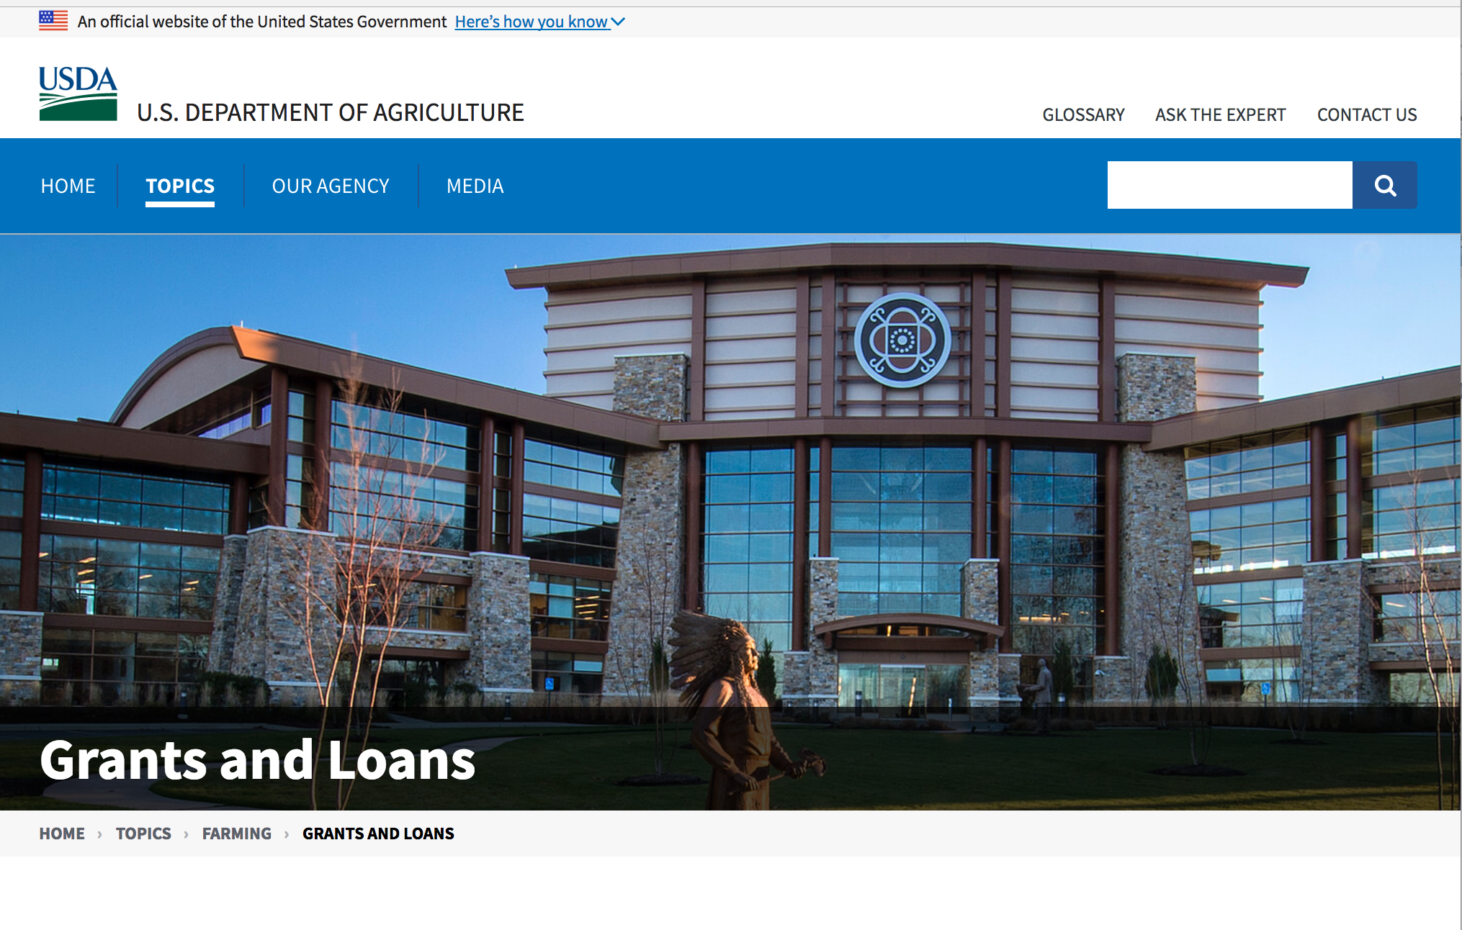

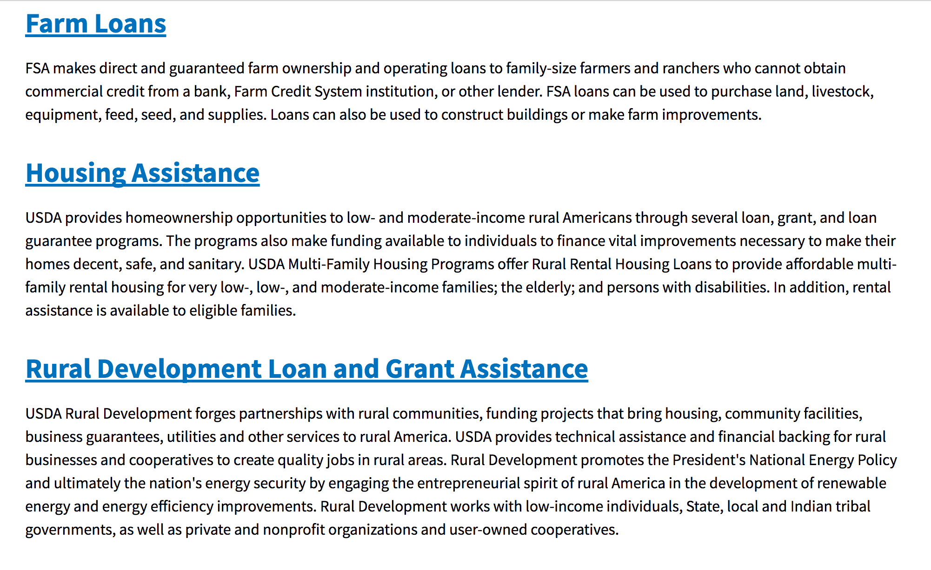

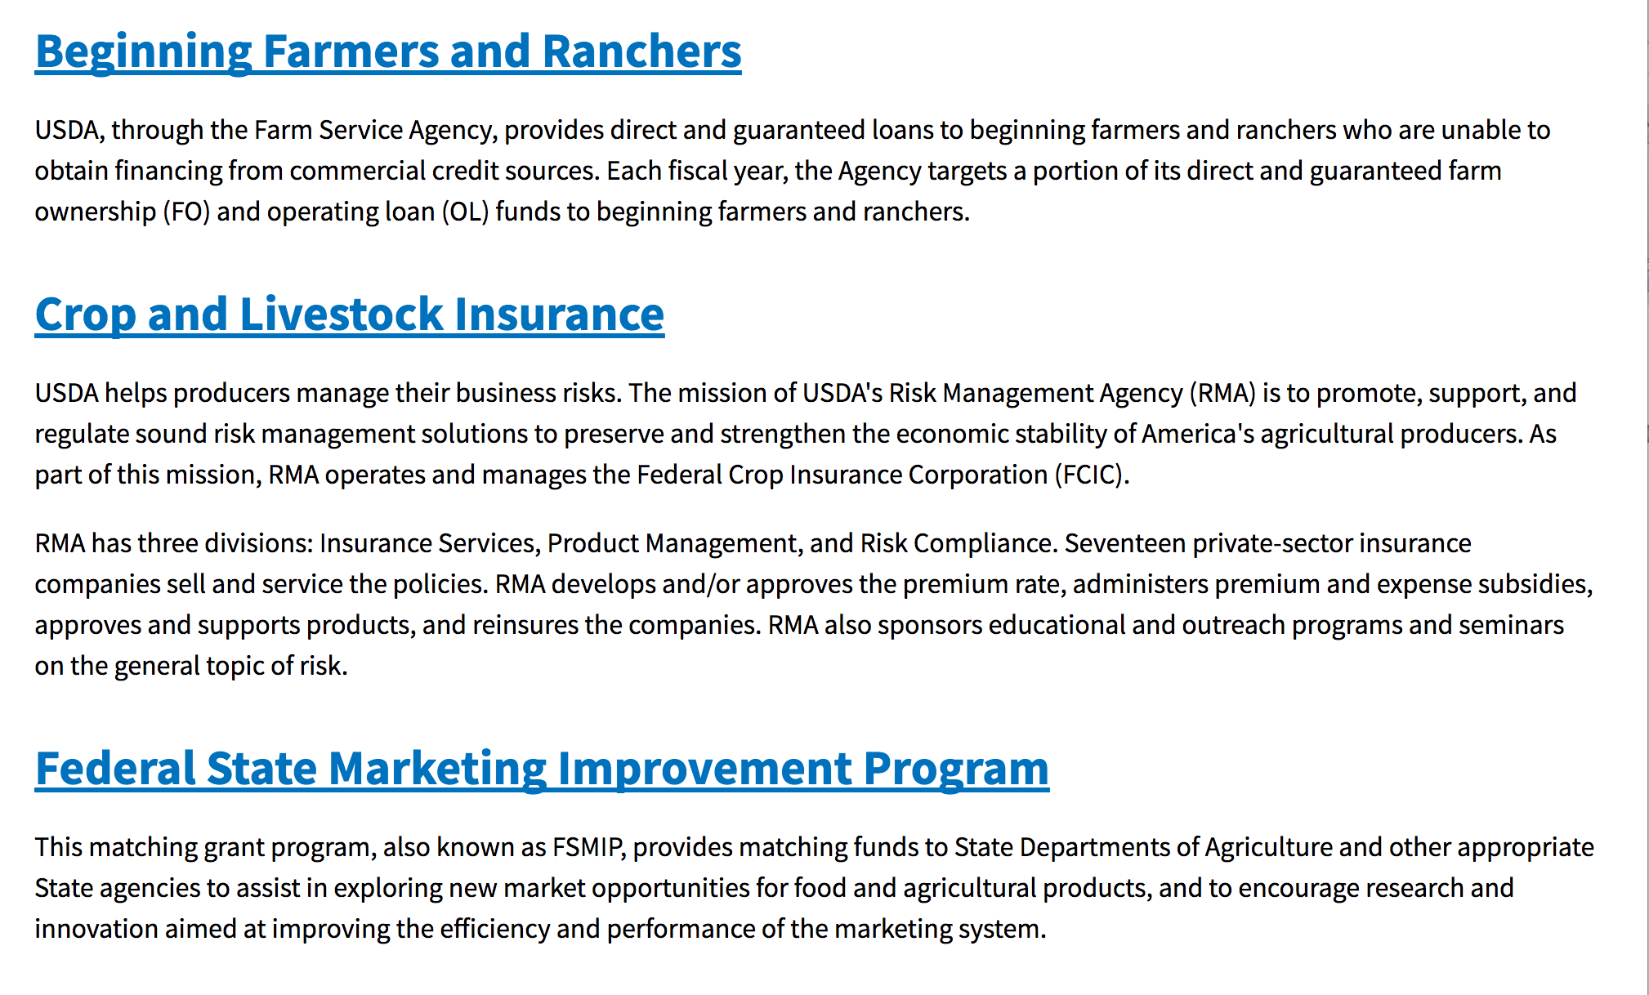
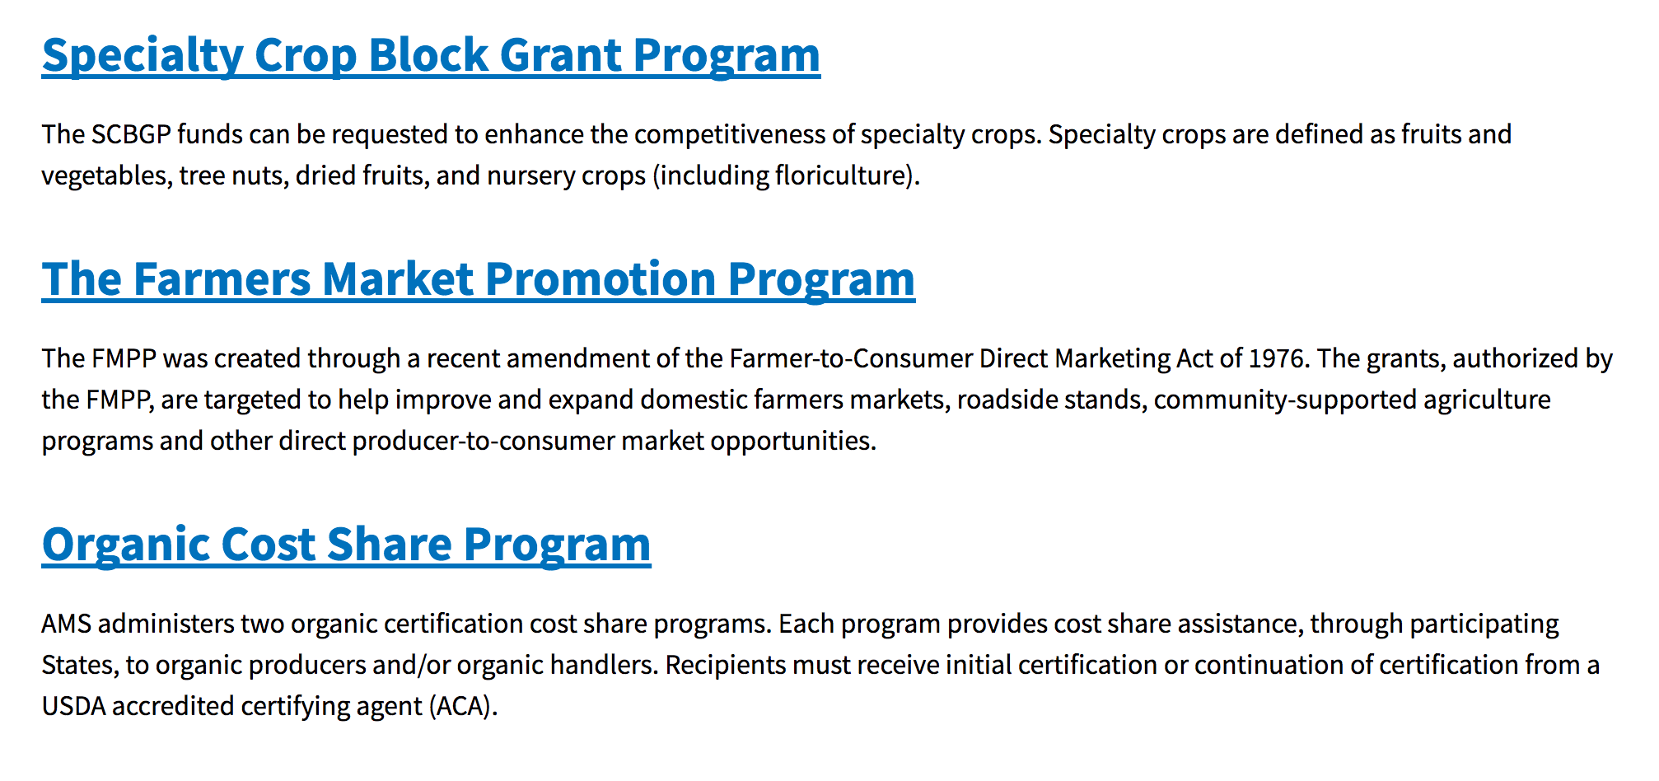
https://www.usda.gov/topics/farming/grants-and-loans

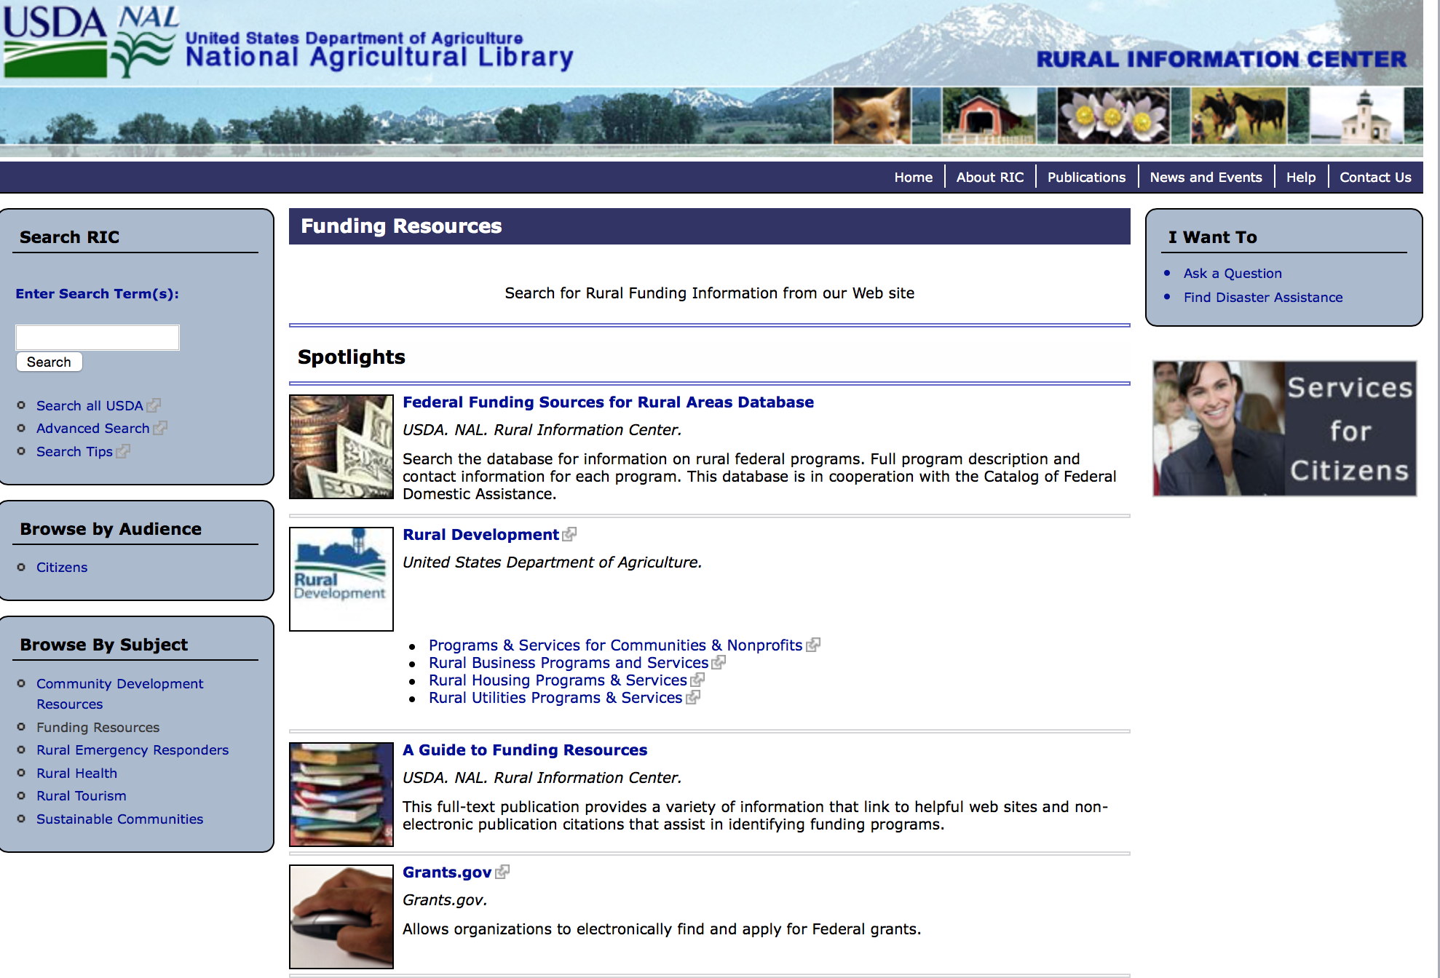

http://ric.nal.usda.gov/funding-resources

Programs:

Foreign Agricultural Service
Food for Progress Program
Synopsis 1

Document Type: | Grants Notice
Funding Opportunity Number: | USDA-FAS-FFPR-18
Funding Opportunity Title: | Food for Progress Program
Opportunity Category: | Discretionary
Opportunity Category Explanation:
Funding Instrument Type: | Cooperative Agreement
Category of Funding Activity: | Agriculture  Community Development  Employment, Labor and Training  Food and Nutrition  Regional Development
Category Explanation:
Expected Number of Awards: | 6
CFDA Number(s): | 10.606 -- Food for Progress
Cost Sharing or Matching Requirement: | No
Version: | Synopsis 1
Posted Date: | Dec 07, 2017
Last Updated Date: | Dec 07, 2017
Original Closing Date for Applications: | Jan 31, 2018 Phase I of Notice of Funding Opportunity
Current Closing Date for Applications: | Jan 31, 2018 Phase I of Notice of Funding Opportunity
Archive Date:
Estimated Total Program Funding: | $155,000,000
Award Ceiling: | $35,000,000
Award Floor: | $10,000,000
Eligible Applicants: | Others (see text field entitled "Additional Information on Eligibility" for clarification)
Additional Information on Eligibility: | Private voluntary organizations, cooperatives, intergovernmental organizations, foreign governments; (Public universities, including their subsidiaries, are not eligible to apply)
Agency Name: | Foreign Agricultural Service
Description: | The Food for Progress program provides for the donation of U.S. agricultural commodities to developing countries and emerging democracies that are committed to introducing or expanding free enterprise in their agricultural economies. Donated U.S. commodities are typically 'monetized' (sold on the local market in the beneficiary country) and the proceeds are used to fund agricultural development activities.
Link to Additional Information: | USDA Foreign Agricultural Service Food Aid Information System Website
Grantor Contact Information: | If you have difficulty accessing the full announcement electronically, please contact:  Mark Rosmann International Program Specialist Phone 2026901927  Email of Synopsis Author
https://www.grants.gov/web/grants/view-opportunity.html?oppId=299314

USDA-NRCS-NHQ
Announcement for Program Funding for NRCS' Conservation Innovation Grants (CIG) for Federal fiscal year (FY) 2018
Synopsis 1
Document Type: | Grants Notice
Funding Opportunity Number: | USDA-NRCS-NHQ-CIG-001
Funding Opportunity Title: | Announcement for Program Funding for NRCS' Conservation Innovation Grants (CIG) for Federal fiscal year (FY) 2018
Opportunity Category: | Discretionary
Opportunity Category Explanation:
Funding Instrument Type: | Grant
Category of Funding Activity: | Agriculture  Environment  Natural Resources  Science and Technology and other Research and Development
Category Explanation:
Expected Number of Awards:
CFDA Number(s): | 10.912 -- Environmental Quality Incentives Program
Cost Sharing or Matching Requirement: | Yes
Version: | Synopsis 1
Posted Date: | Dec 18, 2017
Last Updated Date: | Dec 18, 2017
Original Closing Date for Applications: | Feb 26, 2018
Current Closing Date for Applications: | Feb 26, 2018
Archive Date: | Mar 28, 2018
Estimated Total Program Funding: | $10,000,000
Award Ceiling: | $2,000,000
Award Floor: | $0
Eligible Applicants: | Unrestricted (i.e., open to any type of entity above), subject to any clarification in text field entitled "Additional Information on Eligibility"
Additional Information on Eligibility: | All U.S.-based non-federal entities and individuals, with the exception of Federal agencies, are eligible to apply.
Agency Name: | USDA-NRCS-NHQ
Description: | NRCS is announcing the availability of CIG to stimulate the development and adoption of innovative conservation approaches and technologies. Applications will be accepted from eligible entities in any of the 50 States, the District of Columbia, the Caribbean Area (Puerto Rico and the U.S. Virgin Islands), and the Pacific Islands Area (Guam, American Samoa, and the Commonwealth of the Northern Mariana Islands). A total of up to $10 million is available for CIG in FY 2018. All United States (U.S.)-based non-Federal entities (NFE) and individuals are invited to apply, with the sole exception of Federal agencies. Projects may be between 1 and 3 years in duration. The maximum award amount for a single award in FY 2018 is $2 million.
Link to Additional Information: | USDA NRCS CIG Program Website
Grantor Contact Information: | If you have difficulty accessing the full announcement electronically, please contact:  USDA NRCS CIG Staff Phone: (202) 720-1895 Email: nrcscig@wdc.usda.gov USDA-NRCS 1400 Independence Avenue, SW, Room 6143-S Washington, D.C. 20250  USDA NRCS CIG Staff
https://www.grants.gov/web/grants/view-opportunity.html?oppId=299499

Research:

National Institute of Food and Agriculture
Organic Agriculture Research and Extension Initiative
Synopsis 1
https://www.grants.gov/web/grants/view-opportunity.html?oppId=299697

Modifications:

Reminders:
National Institute of Food and Agriculture
Beginning Farmer and Rancher Development Program
Synopsis 1
Document Type: | Grants Notice
Funding Opportunity Number: | USDA-NIFA-BFR-006411
Funding Opportunity Title: | Beginning Farmer and Rancher Development Program
Opportunity Category: | Discretionary
Opportunity Category Explanation:
Funding Instrument Type: | Grant
Category of Funding Activity: | Agriculture
Category Explanation:
Expected Number of Awards: | 35
CFDA Number(s): | 10.311 -- Beginning Farmer and Rancher Development Program
Cost Sharing or Matching Requirement: | No
Version: | Synopsis 1
Posted Date: | Nov 24, 2017
Last Updated Date: | Nov 24, 2017
Original Closing Date for Applications: | Feb 08, 2018
Current Closing Date for Applications: | Feb 08, 2018
Archive Date: | Mar 10, 2018
Estimated Total Program Funding: | $17,700,000
Award Ceiling: | $600,000
Award Floor: | $300,000
Eligible Applicants: | Others (see text field entitled "Additional Information on Eligibility" for clarification)
Additional Information on Eligibility: | Applications may only be submitted by a collaborative state, tribal, local, or regionally-based network or partnership of qualified public and/or private entities. These collaborations may include the following entities: State Cooperative Extension Services; Federal, State, or tribal agencies; community based organizations (CBOs); nongovernmental organizations (NGOs); junior and four-year colleges or universities or foundations maintained by a college or university; and private for-profit organizations. Inclusion of beginning and/or non-beginning farmers and ranchers as part of the collaborative group is strongly encouraged. Applications submitted by individuals, or by organizations that do not involve other entities in a network or partnership, are not eligible for consideration under any category applicable to the BFRDP and will be excluded from review.
Agency Name: | National Institute of Food and Agriculture
Description: | Beginning farmer education for adult and young audiences in the United States can generally be traced back to the advent of the 1862 and 1890 Morrill Land Grant Acts. But for the first time, the Food, Conservation, and Energy Act of 2008 (Pub .L. No. 110-234, Section 7410) appropriated $75 million for FY 2009 to FY 2012 to develop and offer education, training, outreach and mentoring programs to enhance the sustainability of the next generation of farmers. The Agriculture Act of 2014 provided an additional $20 million per year for 2014 through 2018. The reasons for the renewed interest in beginning farmer and rancher programs are as follows: the rising average age of U.S. farmers; the 8% projected decrease in the number of farmers and ranchers between 2008 and 2018; and the growing recognition that new programs are needed to address the needs of the next generation of beginning farmers and ranchers.
Link to Additional Information: | FY 2018 Beginning Farmer and Rancher Development Program RFA
Grantor Contact Information: | If you have difficulty accessing the full announcement electronically, please contact:  NIFA Help Desk Phone: 202-401-5048 Business hours are M-F, 7:00 am - 5:00 pm ET, excluding Federal holidays  If you have any questions related to preparing application content.
https://www.grants.gov/web/grants/view-opportunity.html?oppId=298993

National Institute of Food and Agriculture
Enhancing Agricultural Opportunities for Military Veterans Competitive Grants Program
Synopsis 1
Document Type: | Grants Notice
Funding Opportunity Number: | USDA-NIFA-OP-006410
Funding Opportunity Title: | Enhancing Agricultural Opportunities for Military Veterans Competitive Grants Program
Opportunity Category: | Discretionary
Opportunity Category Explanation:
Funding Instrument Type: | Grant
Category of Funding Activity: | Agriculture
Category Explanation:
Expected Number of Awards:
CFDA Number(s): | 10.334 -- Enhancing Agricultural Opportunities for Military Veterans Competitive Grants Program
Cost Sharing or Matching Requirement: | No
Version: | Synopsis 1
Posted Date: | Nov 21, 2017
Last Updated Date: | Nov 21, 2017
Original Closing Date for Applications: | Feb 08, 2018 Letters of Intent must be received by 5 p.m. Eastern Time on January 11, 2018.
Current Closing Date for Applications: | Feb 08, 2018 Letters of Intent must be received by 5 p.m. Eastern Time on January 11, 2018.
Archive Date: | Mar 10, 2018
Estimated Total Program Funding: | $4,797,500
Eligible Applicants: | Others (see text field entitled "Additional Information on Eligibility" for clarification)
Additional Information on Eligibility: | AgVets applicants must be nonprofit organizations. The Uniform Administrative Requirements, Cost Principles, and Audit Requirements for Federal Awards, 2 CFR part 200, defines the term “nonprofit organization” as follows: Nonprofit organization means any corporation, trust, association, cooperative, or other organization, not including institutions of higher education (IHEs), that: (a) Is operated primarily for scientific, educational, service, charitable, or similar purposes in the public interest; (b) Is not organized primarily for profit; and (c) Uses net proceeds to maintain, improve, or expand the operations of the organization.
Agency Name: | National Institute of Food and Agriculture
Description: | NIFA requests applications for the AgVets for fiscal year 2017 (FY17) to provide grants to nonprofit organizations for training programs and services to establish and enhance farming and ranching opportunities for military veterans.
Link to Additional Information: | Enhancing Agricultural Opportunities for Military Veterans Competitive Grants Program
Grantor Contact Information: | If you have difficulty accessing the full announcement electronically, please contact:  NIFA Help Desk Phone: 202-401-5048 Business hours are M-F, 7:00 am -5:00 pm ET, excluding Federal holidays  If you have any questions related to preparing application content
https://www.grants.gov/web/grants/view-opportunity.html?oppId=298885

Forest Service
2018 Wood Innovations Funding Opportunity
Synopsis 1

Document Type: | Grants Notice
Funding Opportunity Number: | USDA-FS-WERC-2018
Funding Opportunity Title: | 2018 Wood Innovations Funding Opportunity
Opportunity Category: | Discretionary
Opportunity Category Explanation:
Funding Instrument Type: | Grant
Category of Funding Activity: | Natural Resources
Category Explanation:
Expected Number of Awards: | 28
CFDA Number(s): | 10.674 -- Wood Utilization Assistance
Cost Sharing or Matching Requirement: | Yes
Version: | Synopsis 1
Posted Date: | Oct 18, 2017
Last Updated Date: | Oct 18, 2017
Original Closing Date for Applications: | Jan 22, 2018
Current Closing Date for Applications: | Jan 22, 2018
Archive Date: | Feb 21, 2018
Estimated Total Program Funding: | $7,000,000
Award Ceiling: | $250,000
Award Floor: | $10,000
Eligible Applicants: | Others (see text field entitled "Additional Information on Eligibility" for clarification)
Additional Information on Eligibility: | Eligible applicants are for-profit entities; State, local, and Tribal governments; school districts; communities; not-for-profit organizations; institutions of higher education; and special purpose districts (e.g., public utilities districts, fire districts, conservation districts, and ports).
Agency Name: | Forest Service
Description: | Important Dates: October 18, 2017 - Issuance of Request for Proposals. January 22, 2018 - Proposal submission deadline. May 1, 2018 - Approximate date to notify applicants of results. July 1, 2018 - Approximate date of award. Synopsis of Funding Opportunity: The U.S. Forest Service requests proposals to substantially expand and accelerate wood energy and wood products markets throughout the United States to support forest management needs on National Forest System and other forest lands. This Request for Proposals focuses on the following priorities to: • Reduce hazardous fuels and improve forest health on National Forest System and other forest lands. • Reduce costs of forest management on all land types. • Promote economic and environmental health of communities. Funding will be awarded in two separate categories. Grant Category 1: Expansion of Wood Energy Markets - The intent of this category is to: 1. Stimulate, expand, or support wood energy markets that depend on forest residues or forest byproducts generated from all land types. Projects can include, but are not limited to: a. Develop a cluster of wood energy projects in a geographic area or specific sector (e.g., prisons, hospitals, universities, manufacturing sector, or industrial sector). b. Overcome market barriers and stimulate expansion of wood energy in the commercial sector. 2. Complete requirements, such as engineering designs, cost analyses, and permitting, necessary in the later stages of wood energy project development to secure financing. Grant Category 2: Expansion of Wood Products Markets - The intent of this category is to promote markets that create or expand the demand for non-energy based wood products. Preference will be given to projects that support commercial building markets or other markets that use innovative wood products. Wood energy projects will not be considered under this category because those projects can apply for funding under Grant Category 1. Demonstration projects and applied research will be considered, but applicants are strongly encouraged to first consult with their designed Forest Service Regional Biomass Coordinator to determine whether such projects will be competitive. Specific details, including the application and instructions, can be viewed and downloaded at the website listed below.
Link to Additional Information: | U.S. Forest Service web site
Grantor Contact Information: | If you have difficulty accessing the full announcement electronically, please contact:  Edward Cesa Deputy Director - WERC Phone 304-285-1530  U.S. Forest Service email address

http://www.grants.gov/web/grants/view-opportunity.html?oppId=298037

Business and Cooperative Programs
VALUE ADDED PRODUCER GRANT
Synopsis 3
Document Type: | Grants Notice
Funding Opportunity Number: | RDBCP-VAPG-2017
Funding Opportunity Title: | VALUE ADDED PRODUCER GRANT
Opportunity Category: | Discretionary
Opportunity Category Explanation:
Funding Instrument Type: | Grant
Category of Funding Activity: | Agriculture
Category Explanation:
Expected Number of Awards: | 200
CFDA Number(s): | 10.352 -- Value-Added Producer Grants
Cost Sharing or Matching Requirement: | Yes
Version: | Synopsis 3
Posted Date: | Aug 29, 2017
Last Updated Date: | Aug 29, 2017
Original Closing Date for Applications: | Jan 31, 2018
Current Closing Date for Applications: | Jan 24, 2018
Archive Date: | Mar 02, 2018
Estimated Total Program Funding:
Award Ceiling: | $250,000
Eligible Applicants: | Others (see text field entitled "Additional Information on Eligibility" for clarification)
Additional Information on Eligibility: | Independent Producers, Agricultural Producer Groups, Farmer or Rancher Cooperatives, or Majority-Controlled Producer-Based Business
Agency Name: | Business and Cooperative Programs
Description: | This Notice announces that the Rural Business-Cooperative Service (Agency) is accepting applications for the Value-Added Producer Grant (VAPG) program. Approximately $18 million is currently available. The Agency may also utilize any funding that become available after publishing this notice. Enactment of a continuing resolution or an appropriations act may affect the availability or level of funding for this program. The Agency will publish the program funding level on the Rural Development website (https://www.rd.usda.gov/programs-services/value-added-producer-grants ). Section VII also announces solicitation of non-Federal independent grant reviewers to evaluate and score applications submitted under this Notice.
Link to Additional Information: | Link to Federal Register
Grantor Contact Information: | If you have difficulty accessing the full announcement electronically, please contact:  Shantelle Gordon Management Analyst Phone 2026901374  CPGrants@wdc.usda.gov

http://www.grants.gov/web/grants/view-opportunity.html?oppId=296903

Deleted:

Department of Commerce

Grants, Contracting, and Trade Opportunities at Commerce
Learn more information about grants, contracting and trade opportunities at the Department of Commerce using the information below.

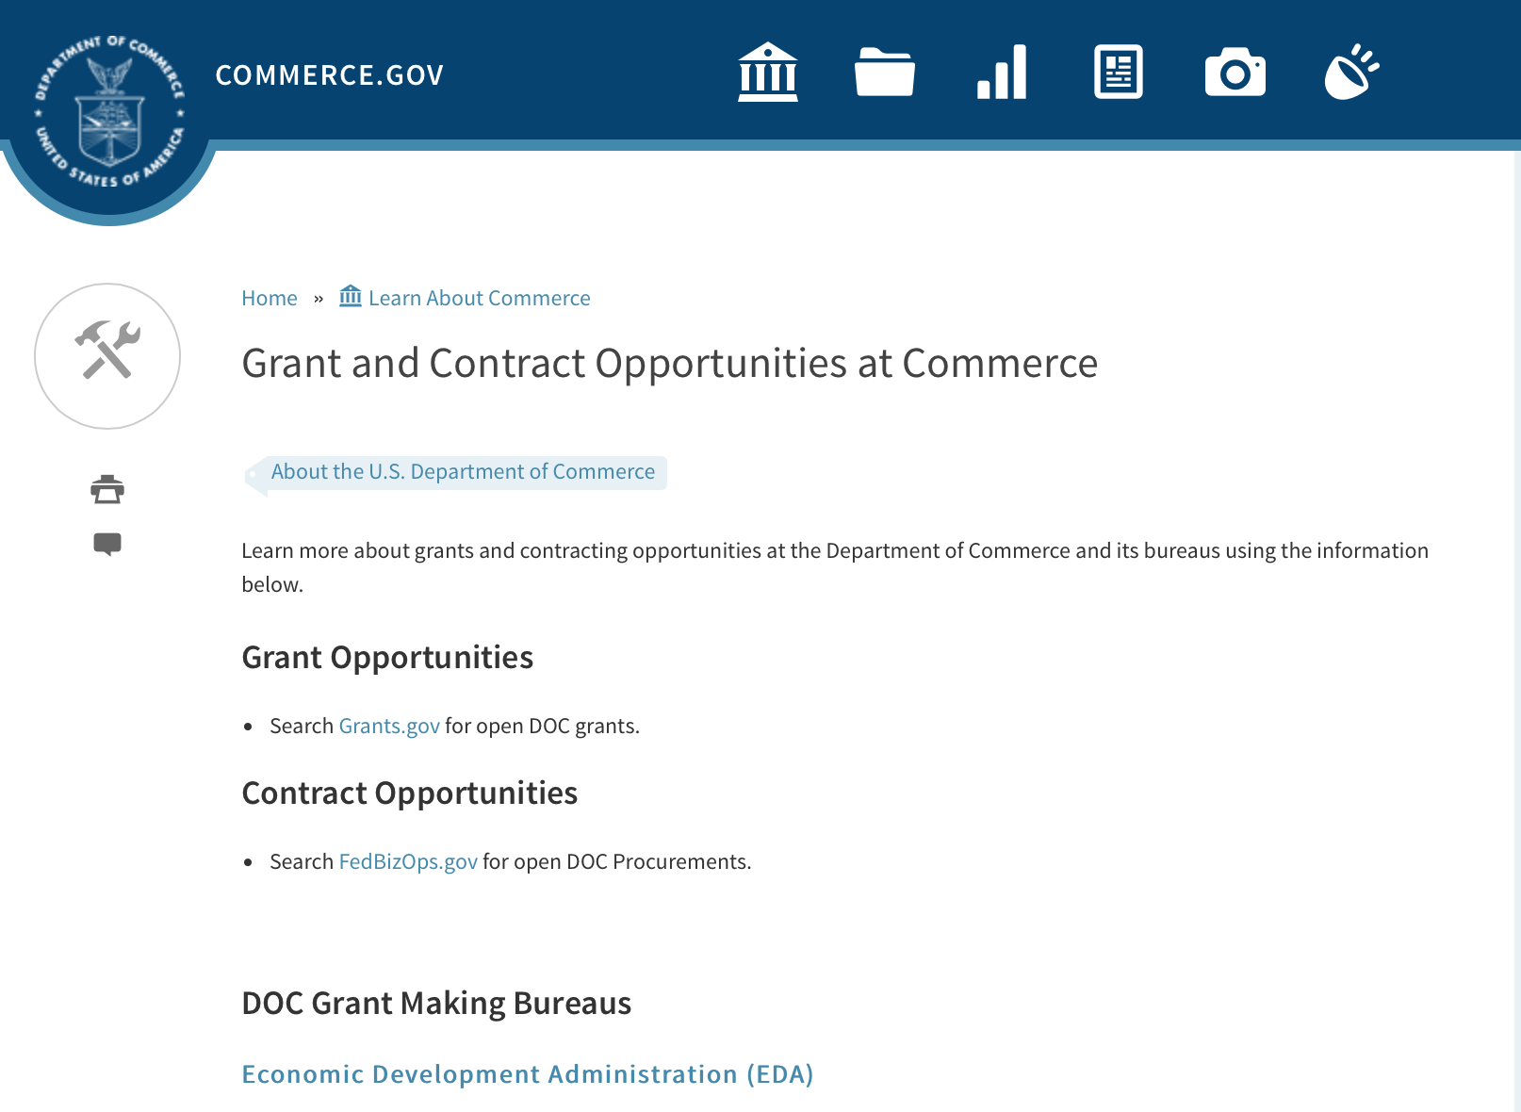
Grants at Commerce
DOC Grant Making Bureaus
Economic Development Administration (EDA)
International Trade Administration (ITA)
- Market Development Cooperator Program
- Special American Business Internship Training Program (SABIT). A technical assistance initiative of the International Trade Administration of the U.S. Department of Commerce, SABIT offers organizations competitive grants and an opportunity to host industry-specific delegations. SABIT serves as an initial entry point for U.S. businesses seeking funding to establish long-term relationships with potential customers, distributors, or partners in the former Soviet Union. The program trains Eurasian managers and scientists in commonly accepted business practices as a means of facilitating cross border relationships. In turn, these personal relationships serve as a basis for business development and reduce market access barriers for U.S. businesses
National Institute of Standards & Technology (NIST)
- Funding Opportunities
National Telecommunications & Information Administration (NTIA)
- Telecommunications Grants
National Oceanic & Atmospheric Administration (NOAA)
- Coastal Ocean Program Grant Information
- Fisheries Saltonstall Kennedy Grant Program
- National Undersea Research Program Funding Opportunities
- Grants Management Division
- Fisheries Grants Program
- National Sea Grant
- Office of Global Programs
Contracting Resources for Contractors
- Office of Small and Disadvantaged Business Utilization (OSDBU) - he Office of Small and Disadvantaged Business Utilization (OSDBU) is an advocacy and advisory office responsible for promoting the use of small, small disadvantaged, 8(a), women-owned, veteran-owned, service-disabled veteran-owned, and HUBZone small businesses within the U.S. Department of Commerce's (DOC) acquisition process.
- Business.USA.gov's Find Opportunities Wizard where in a few quick steps, it will guide you towards federal government contracting programs and opportunities for your business!
- Planned Acquisitions: the Department of Commerce's search tool for our planned acquisitions over $100,000. As requirements change, these acquisition plans are updated by department personnel and this search tool is automatically updated.
- Small Business Administration's Contracting section of their web site where you can learn about how to "Get Started" and "Contracting Support for Small Business"
- The General Services Administration (GSA) has implemented a system for vendors doing business with the Federal Government to manage their entity information in one central location. This new database is the System for Award Management (SAM).

DOC Contracting Offices
- Patent and Trademark Office (PTO)
  - Office of Procurement
- National Institute of Standards & Technology (NIST)
NIST Acquisition Management Group
Contracting Opportunities with Commerce
Trade Opportunities through Commerce
http://www.commerce.gov/about-commerce/grants-contracting-trade-opportunities

Programs:

Climate and Societal Interactions
Synopsis 1

Document Type: | Grants Notice
Funding Opportunity Number: | NOAA-OAR-CPO-2018-2005445
Funding Opportunity Title: | Climate and Societal Interactions
Opportunity Category: | Discretionary
Opportunity Category Explanation:
Funding Instrument Type: | Cooperative Agreement
Category of Funding Activity: | Environment  Natural Resources  Science and Technology and other Research and Development
Category Explanation:
Expected Number of Awards:
CFDA Number(s): | 11.431 -- Climate and Atmospheric Research
Cost Sharing or Matching Requirement: | No
Version: | Synopsis 1
Posted Date: | Dec 04, 2017
Last Updated Date: | Dec 04, 2017
Original Closing Date for Applications: | Mar 16, 2018
Current Closing Date for Applications: | Mar 16, 2018
Archive Date: | Apr 15, 2018
Estimated Total Program Funding:
Award Ceiling: | $1,000,000
Award Floor: | $50,000
Eligible Applicants: | Others (see text field entitled "Additional Information on Eligibility" for clarification)
Additional Information on Eligibility: | Eligible applicants are institutions of higher education, other nonprofits, commercial organizations, international organizations, and state, local and Indian tribal governments. Federal agencies interested in receiving financial support for projects should contact the appropriate competition manager.
Agency Name: | Department of Commerce
Description: | The mission of the NOAA Climate and Societal Interactions (CSI) research portfolio is to inform improvements in planning and preparedness in diverse socio-economic regions and sectors throughout the U.S. and abroad via the integration of knowledge and information about extreme weather and climate. Our research advances the nation’s understanding of climate-related risks and vulnerabilities across sectors and regions - within and beyond our borders - and the development of tools to foster more informed decision-making. These efforts support NOAA's vision to create and sustain enhanced resilience in ecosystems, communities, and economies. The overall objectives of the CSI portfolio are the following: 1. Support innovative, applicable, and transferable approaches for decision making, especially for risk characterization in the context of a variable and changing climate; 2. Establishment of a network of regionally scoped, long-term efforts to inform climate risk management and decision making; and 3. Promotion of the transfer of climate knowledge, tools, products, and services within NOAA, across the federal government, nationally, and internationally. These objectives are pursued through four complementary, interdisciplinary research programs: the Regional Integrated Sciences and Assessment (RISA) Program; the International Research and Applications Project (IRAP); the Sectoral Applications Research Program (SARP); and the Coastal and Ocean Climate Applications program (COCA). RISA supports research teams that conduct innovative, interdisciplinary, user-inspired, and regionally relevant research that informs resource management, planning, and public policy. IRAP supports activities to link science and assessments to practical risk management challenges in regions where weather and climate affect U.S. interests at home and abroad. COCA supports interdisciplinary applications research on the impacts of climate variability and change on coastal communities and coastal and marine ecosystems to inform decision-making. SARP addresses the needs of a specific stakeholder or set of stakeholders within key socioeconomic sectors (e.g., water resources, agriculture, health, etc.) grappling with pressing climate-related issues. The FY18 SARP competitions was published in the CPO FFO in May 2017. CSI is an active partner in NOAA’s efforts to enhance and support services. This partnership brings together NOAA Regional Climate Services Directors (RCSDs), other NOAA service line offices, and close external partners such as RISA teams, Regional Climate Centers, State Climatologists, Sea Grant and other U.S. Government agencies to help make weather and climate information and products relevant, accessible and actionable to people across the U.S. CSI activities address the societal challenges identified in NOAA’s Next-Generation Strategic Plan (NGSP): i) climate impacts on water resources; ii) coasts and climate resilience; iii) sustainability of marine ecosystems; and iv) changes in the extremes of weather and climate. CSI programs support NOAA’s vision to create and sustain enhanced resilience in ecosystems, communities, and economies, as outlined in the NGSP. Three (3) CSI programs are holding a competition under this Federal Funding Opportunity: RISA, COCA, and IRAP. RISA - South Central Region COCA & RISA Pilot on Coastal Climate Extension Competition IRAP: Decision Support Research on Climate-Sensitive Health Risks
Link to Additional Information:
Grantor Contact Information: | If you have difficulty accessing the full announcement electronically, please contact:  Diane Brown CPO Grants Manager 1315 East West Highway, Suite 12112 Silver Spring, MD 20910-5644 301-734-1206 diane.brown@noaa.gov  Work
https://www.grants.gov/web/grants/view-opportunity.html?oppId=299217

NOAA National Sea Grant College Program 2018 Ocean, Coastal and Great Lakes National Aquaculture Initiative
Synopsis 1

Document Type: | Grants Notice
Funding Opportunity Number: | NOAA-OAR-SG-2018-2005489
Funding Opportunity Title: | NOAA National Sea Grant College Program 2018 Ocean, Coastal and Great Lakes National Aquaculture Initiative
Opportunity Category: | Discretionary
Opportunity Category Explanation:
Funding Instrument Type: | Cooperative Agreement  Grant
Category of Funding Activity: | Environment  Natural Resources  Science and Technology and other Research and Development
Category Explanation:
Expected Number of Awards:
CFDA Number(s): | 11.417 -- Sea Grant Support
Cost Sharing or Matching Requirement: | Yes
Version: | Synopsis 3
Posted Date: | Dec 14, 2017
Last Updated Date: | Dec 15, 2017
Original Closing Date for Applications: | Mar 30, 2018
Current Closing Date for Applications: | Mar 30, 2018
Archive Date: | Apr 29, 2018
Estimated Total Program Funding:
Award Ceiling: | $750,000
Award Floor: | $1
Eligible Applicants: | Others (see text field entitled "Additional Information on Eligibility" for clarification)
Additional Information on Eligibility: | The following entities are eligible and encouraged to participate in this funding opportunity, in conjunction with a Sea Grant program: any individual; any public or private corporation, partnership, or other association or entity (including any Sea Grant College, Sea Grant Institute or other institution); or any State, political subdivision of a State, Tribal government or agency or officer thereof. Federal agencies and their personnel are not permitted to receive federal funding under this competition; however, federal scientists and other employees can serve as uncompensated partners or co-Principal Investigators on applications. Federal labs and offices can also make available specialized expertise, facilities or equipment to applicants but cannot be compensated under this competition for their use, nor can the value of such assets be used as match.
Agency Name: | Department of Commerce
Description: | Please note that this FFO contains an additional deadline of March 2 by which certain actions must be taken to be eligible for this competition. Please read the FFO carefully for more details. Depending on appropriations, NOAA National Sea Grant College Program (NOAA Sea Grant) expects to have available a total of $7,000,000 to $11,500,000 across fiscal years 2018, 2019 and 2020 as part of the Sea Grant National Aquaculture Initiative (NAI). As part of the NAI, this competition is designed to foster the expansion of a sustainable U.S. ocean, coastal and Great Lakes aquaculture sector by addressing one or more of the following priorities: (a) supporting the development of emerging systems or technologies that will advance aquaculture in the U.S., including projects that will help stimulate aquaculture production by nascent industries; (b) developing and implementing actionable methods of communicating accurate, science based messages and information about the benefits and risks of U.S. marine aquaculture to the public; and (c) increasing the resiliency of aquaculture systems to natural hazards and changing conditions. Successful applications must describe projects that clearly address major constraints, barriers or hurdles limiting aquaculture production in the U.S. The overall objectives of the Sea Grant NAI are to: 1) address the needs of the U.S. ocean, coastal and Great Lakes aquaculture sector by supporting research, technology transfer, and best practices related to the sustainable aquaculture of ocean, coastal, or Great Lakes fish, shellfish, or algae species (including state- and federally-managed species), 2) increase production of such species in federal waters and the coastal zone of state waters (as defined by the Coastal Zone Management Act to include the Great Lakes), and 3) address major constraints, barriers, or hurdles of domestic aquaculture development that currently limit increased production (this can include research, extension, technology transfer, regulatory/policy and/or legal activities to support production, market access, distribution, etc.). Sea Grant encourages proposals that: 1) utilize a team approach that fully integrates at least one Sea Grant program and at least one end-user or public-private partnership in the effort, 2) involve Sea Grant Extension personnel and include a technology transfer component, where appropriate, 3) address how project impacts will be applicable to a broader geographic area through regional or topical partnerships, and 4) discuss how, upon completion, the work will have a high likelihood of increasing aquaculture production or address how the work will stimulate or advance nascent aquaculture industry(ies). Proposals should meet the program objectives to the extent practicable. This Federal Funding Opportunity includes the information needed and the criteria for applications requesting up to $750,000 in total federal funding for a one- to three-year period. Non-federal matching funds of at least a running total of 50% is required for each year of requested funding (e.g., Year 1 = $250,000 requested would require $125,000 match; Year 2 = $250,000 requested would require $125,000 match; Year 3 = $250,000 requested would require $125,000 match). Please note that, per law, grant applications from Guam Sea Grant waive the first $200,000 of federal matching requirements; thus no match is required for Federal shares up to $400,000. Match would then be required for balances above $400,000 (e.g., $800,000 requested would require Guam Sea Grant project to provide $200,000 in match). NOAA anticipates funding projects ranging from lesser amounts up to the maximum amount ($750,000) to ensure a diversity of priorities are addressed with the available funding. Awards are anticipated to start on September 1, 2018. Additional applications from this competition may be selected for funding in subsequent fiscal years based on future appropriated funds.
Link to Additional Information:
Grantor Contact Information: | If you have difficulty accessing the full announcement electronically, please contact:  Attention: Aquaculture, NOAA Sea Grant 1315 East-West Highway, SSMC3, R/SG Silver Spring, MD 20910 oar.hq.sg.aquaculture@noaa.gov  Work
https://www.grants.gov/web/grants/view-opportunity.html?oppId=299412

2018 Bycatch Reduction Engineering Program (BREP)
Synopsis 1
Document Type: | Grants Notice
Funding Opportunity Number: | NOAA-NMFS-FHQ-2018-2005482
Funding Opportunity Title: | 2018 Bycatch Reduction Engineering Program (BREP)
Opportunity Category: | Discretionary
Opportunity Category Explanation:
Funding Instrument Type: | Cooperative Agreement
Category of Funding Activity: | Environment  Natural Resources  Science and Technology and other Research and Development
Category Explanation:
Expected Number of Awards: | 25
CFDA Number(s): | 11.472 -- Unallied Science Program
Cost Sharing or Matching Requirement: | No
Version: | Synopsis 1
Posted Date: | Dec 27, 2017
Last Updated Date: | Dec 27, 2017
Original Closing Date for Applications: | Mar 30, 2018
Current Closing Date for Applications: | Mar 30, 2018
Archive Date: | Apr 29, 2018
Estimated Total Program Funding: | $2,500,000
Award Ceiling: | $250,000
Award Floor: | $50,000
Eligible Applicants: | Others (see text field entitled "Additional Information on Eligibility" for clarification)
Additional Information on Eligibility: | Eligible applicants are individuals, institutions of higher education, other nonprofits, for-profit organizations, foreign public entities or foreign organizations, and state, local and Indian tribal governments. Federal agencies or instrumentalities are not eligible to receive Federal assistance under this notice. The Department of Commerce/ National Oceanic and Atmospheric Administration (DOC/NOAA) is strongly committed to broadening the participation of historically black colleges and universities, Hispanic serving institutions, tribal colleges and universities, and institutions that work in underserved areas. If the applicant is a university that has a NOAA Cooperative Institute (CI), the institution is encouraged to submit an application that will be associated with the CI. The application must specify the name of the CI, its most recent award number, and the NOAA-approved research theme applicable to the work to be performed in the Project Narrative. The application will use the facilities and administrative rate (F&A or Indirect Cost Rate) associated with the most recent CI award. If the CI-related application is selected for funding, NOAA will notify the university that a separate competitive award will be issued with its own award grant number. However, the BREP competitive award will include a Special Award Condition (SAC) that evidences the link between it and the CI award. The SAC will provide: (1) that the university has submitted the proposal to be associated with the CI; (2) that any existing University/NOAA memorandum of agreement (MOA) will be incorporated by reference into the terms of the BREP competitive award; and (3) that any progress report(s) for the BREP competitive award must follow the timetable of and be submitted by the CI directly to the funding program. Copies of these progress reports will be attached to the CI's performance report as an appendix.
Agency Name: | Department of Commerce
Description: | The mission of the National Bycatch Reduction Engineering Program (BREP) is to support the development of technological solutions and changes in fishing practices designed to minimize bycatch of fish (including sponges, deep–sea corals, and shallow (tropical) corals) and protected species (including marine mammals, sturgeon, seabirds, and sea turtles) as well as minimize mortality and injury of bycaught species (including post-release injury and mortality). Projects should produce outcomes that can directly influence management needs of federally managed living marine resources.
Link to Additional Information:
Grantor Contact Information: | If you have difficulty accessing the full announcement electronically, please contact:  Erin Wilkinson 301-427-8561 1315 EAST WEST HWY, Silver Spring, MD 20910-3282  Work
https://www.grants.gov/web/grants/view-opportunity.html?oppId=299698

Modifications:

Research:

Reminders:

Environmental Literacy Grants: Supporting the education of K-12 students and the public for community resilience
Synopsis 1
Document Type: | Grants Notice
Funding Opportunity Number: | NOAA-SEC-OED-2018-2005455
Funding Opportunity Title: | Environmental Literacy Grants: Supporting the education of K-12 students and the public for community resilience
Opportunity Category: | Discretionary
Opportunity Category Explanation:
Funding Instrument Type: | Cooperative Agreement
Category of Funding Activity: | Environment  Natural Resources  Science and Technology and other Research and Development
Category Explanation:
Expected Number of Awards: | 6
CFDA Number(s): | 11.008 -- NOAA Mission-Related Education Awards
Cost Sharing or Matching Requirement: | No
Version: | Synopsis 1
Posted Date: | Nov 07, 2017
Last Updated Date: | Nov 07, 2017
Original Closing Date for Applications: | Apr 06, 2018
Current Closing Date for Applications: | Apr 06, 2018
Archive Date: | May 06, 2018
Estimated Total Program Funding: | $2,000,000
Award Ceiling: | $500,000
Award Floor: | $250,000
Eligible Applicants: | Others (see text field entitled "Additional Information on Eligibility" for clarification)
Additional Information on Eligibility: | Eligible applicants for this funding opportunity are limited to institutions of higher education; K-12 public and independent schools and school systems, other nonprofits, including informal education institutions such as museums, zoos, and aquariums; state and local government agencies; and Indian tribal governments in the United States. For-profit organizations, foreign institutions, and individuals are not eligible to apply; however, for-profit organizations, foreign institutions, and individuals may participate with an eligible applicant as a project partner. Likewise, federal agencies are not eligible to receive federal assistance under this announcement, but may be project partners. It is strongly encouraged that an individual serve as a Principal Investigator (PI) on only one application submitted to this funding opportunity. Institutions may submit more than one application and individuals may serve as co-PIs or key personnel on more than one application. Federal employees may not serve as PIs or co-PIs on any application, although they may be included as key personnel.
Agency Name: | Department of Commerce
Description: | The goal of this Federal Funding Opportunity (FFO) is to support the education of K-12 students and the public so they are knowledgeable of the ways in which their community can become more resilient to extreme weather events and/or other environmental hazards, and become involved in achieving that resilience. Many U.S. communities are increasingly contending with issues related to preventing, withstanding, and recovering from disruptions caused by extreme weather and other environmental hazards (U.S. Department of Commerce FY2014-FY2018 Strategic Plan). These hazards include but are not limited to severe storms, tornadoes, hurricanes, flooding, heavy precipitation events, persistent drought, heat waves, increased global temperatures, acidification of the ocean, and sea level rise (Weather-ready Nation: NOAA’s National Weather Service Strategic Plan 2011; Melillo et al., 2014). These extreme weather and climate events put stress on infrastructure, ecological systems, and the humans that live in the impacted places. U.S. communities can become more resilient to such events by exploring the hazards they face, assessing their specific vulnerabilities and risks, considering options, prioritizing and planning, and finally taking action (U.S. Climate Resilience Toolkit). This process is typically performed by scientists and municipal planners, but in order for resilience to occur, other members of a community must have some understanding of the hazards they face and how to mitigate them, both at the individual and the community level. Education projects focused on resilience enable and empower community members, including children and youth, to protect themselves and their communities from these hazards. Projects should build the environmental literacy necessary for communities to become more resilient to extreme weather and other environmental hazards they face. In order for communities to become more resilient, their members must have the ability to reason about the ways that human and natural systems function and interact; to understand the scientific process and uncertainty; to reason about the ways that people and places are connected to each other across time and space; and to weigh the potential impacts of their decisions systematically. Projects should leverage and incorporate relevant state and local hazard mitigation and/or adaptation plans and collaborate with institutions that are involved in efforts to develop or implement those plans. Projects may focus on a single type of environmental hazard or a range of hazards that may impact a community or communities. Projects will be based on the established scientific evidence about current and future natural hazards and stresses facing communities and should consider relevant socio-economic and ecological factors in the targeted geographic area(s). Projects should engage participants in active learning activities. In addition, projects must utilize NOAA’s scientific data, data access tools, data visualizations, and/or other physical and intellectual assets available on these topics. In order to facilitate the use of NOAA’s assets, projects are strongly encouraged to partner with relevant NOAA entities (offices, programs, etc.) and/or NOAA employees and affiliates. Applicants are also strongly encouraged to review the resilience education projects funded by this program since 2015 and proposed projects should be informed by the lessons learned by these current grantees. Projects must be implemented within the United States and its territories. Projects will likely be implemented at the local level, but may occur in more than one locality. Project topics must relate to NOAA's mission in the areas of ocean, coastal, Great Lakes, weather, and climate sciences and stewardship and should focus on one or more of the goals of NOAA's Next Generation Strategic Plan: healthy oceans; weather-ready nation; climate adaptation and mitigation; and resilient coastal communities and economies. Eligible applicants for this funding opportunity are limited to institutions of higher education; other nonprofits, including informal education institutions such as museums, zoos, and aquariums; K-12 public and independent schools and school systems; and state, local and Indian tribal governments in the United States. Federal agencies, for-profit organizations, foreign institutions, and individuals are not eligible to apply. Proposed projects must be between 2 and 5 years in duration and have total federal requests of $250,000 to $500,000 for all years of the project. It is anticipated that awards funded under this announcement during this fiscal year will be made by September 30, 2018 and that the projects funded under this announcement will have a start date no earlier than October 1, 2018. Note: Links to helpful information for applying to this opportunity are available at http://www.noaa.gov/office-education/elp/grants/apply.
Link to Additional Information:
Grantor Contact Information: | If you have difficulty accessing the full announcement electronically, please contact:  Environmental Literacy Program Grants Team  Work group email
http://www.grants.gov/web/grants/view-opportunity.html?oppId=298495

National Sea Grant College Program 2018-19 Special Projects
Synopsis 1
Document Type: | Grants Notice
Funding Opportunity Number: | NOAA-OAR-SG-2018-2005457
Funding Opportunity Title: | National Sea Grant College Program 2018-19 Special Projects
Opportunity Category: | Discretionary
Opportunity Category Explanation:
Funding Instrument Type: | Cooperative Agreement  Grant
Category of Funding Activity: | Environment  Natural Resources  Science and Technology and other Research and Development
Category Explanation:
Expected Number of Awards:
CFDA Number(s): | 11.417 -- Sea Grant Support
Cost Sharing or Matching Requirement:

Version: | Synopsis 1
Posted Date: | Nov 15, 2017
Last Updated Date: | Nov 15, 2017
Original Closing Date for Applications: | Sep 30, 2019
Current Closing Date for Applications: | Sep 30, 2019
Archive Date: | Oct 30, 2019
Estimated Total Program Funding:
Award Ceiling: | $1
Award Floor: | $1
Eligible Applicants: | Others (see text field entitled "Additional Information on Eligibility" for clarification)
Additional Information on Eligibility: | Eligible applicants are: Sea Grant Programs (Sea Grant Colleges, Institutions, or Coherent Area Programs), the National Sea Grant Law Center, and the National Sea Grant Library. Individual competition announcements may restrict eligibility to a subset of these applicants.
Agency Name: | Department of Commerce
Description: | The purpose of this notice is to request proposals for special projects consistent with the focus areas outlined in the National Sea Grant College Program’s (Sea Grant) strategic plan, and to provide the general public with information and guidelines on how Sea Grant will select proposals and administer Federal assistance under this announcement. This announcement is a mechanism to encourage research or other projects that are not normally funded through Sea Grant national competitions. This opportunity is open only to Sea Grant Programs. Section III of this announcement describes eligibility requirements in more detail. Funding has not yet been made available to support applications submitted to this Federal Funding Opportunity (FFO), but such funding may become available during the year. Section II.A. below describes individual competition announcements that will be used to announce when funding is available, any restrictions or requirements such as cost share, and other funding details. Awards will be made under this FFO only to applications that are responsive to individual competition announcements; unsolicited applications will not be reviewed.
Link to Additional Information:
Grantor Contact Information: | If you have difficulty accessing the full announcement electronically, please contact:  Special Projects Competition Manager NOAA R/SG, National Sea Grant Office 1315 East-West Highway, Rm 11839 Silver Spring, MD 20910 Telephone: 301-734-1066 oar.hq.sg.competitions@noaa.gov  Work
http://www.grants.gov/web/grants/view-opportunity.html?oppId=298706

Fiscal Year 2019 National Sea Grant College Program Dean John A. Knauss Marine Policy Fellowship
Synopsis 1
Document Type: | Grants Notice
Funding Opportunity Number: | NOAA-OAR-SG-2019-2005447
Funding Opportunity Title: | Fiscal Year 2019 National Sea Grant College Program Dean John A. Knauss Marine Policy Fellowship
Opportunity Category: | Discretionary
Opportunity Category Explanation:
Funding Instrument Type: | Cooperative Agreement
Category of Funding Activity: | Environment  Natural Resources  Science and Technology and other Research and Development
Category Explanation:
Expected Number of Awards:
CFDA Number(s): | 11.417 -- Sea Grant Support
Cost Sharing or Matching Requirement: | No
Version: | Synopsis 1
Posted Date: | Nov 15, 2017
Last Updated Date: | Nov 15, 2017
Original Closing Date for Applications: | Apr 06, 2018
Current Closing Date for Applications: | Apr 06, 2018
Archive Date: | May 06, 2018
Estimated Total Program Funding:
Award Ceiling: | $61,500
Award Floor: | $61,500
Eligible Applicants: | Others (see text field entitled "Additional Information on Eligibility" for clarification)
Additional Information on Eligibility: | An eligible applicant is any student, regardless of citizenship, who, on February 21, 2018, is enrolled towards a degree in a graduate program, that has an interest in ocean, coastal and Great Lakes resources and in the national policy decisions affecting those resources. The graduate degree must be awarded through an accredited institution of higher education in the United States or U.S. Territories.
Agency Name: | Department of Commerce
Description: | This notice announces that applications may be submitted for the 2019 National Sea Grant College Program Dean John A. Knauss Marine Policy Fellowship (Sea Grant Knauss Fellowship Program). The National Sea Grant College Program anticipates funding not less than 35 selected applicants, of which those assigned to the Legislative branch will be approximately 12. Each award will be funded at a total of $61,500 in federal funding, with the option to add additional funds for fellowship related travel.
Link to Additional Information:
Grantor Contact Information: | If you have difficulty accessing the full announcement electronically, please contact:  Sea Grant Knauss Fellowship Program Manager National Sea Grant College Program 1315 East-West Highway, R/SG, Room 11861 Silver Spring, MD 20910 Tel: (301) 734-1088 E-mail: oar.sg.fellows@noaa.gov  Work
http://www.grants.gov/web/grants/view-opportunity.html?oppId=298724

FY18-19 CRCP International Coral Reef Conservation Cooperative Agreements
Synopsis 1

Document Type: | Grants Notice
Funding Opportunity Number: | NOAA-NOS-OCM-2018-2005319
Funding Opportunity Title: | FY18-19 CRCP International Coral Reef Conservation Cooperative Agreements
Opportunity Category: | Discretionary
Opportunity Category Explanation:
Funding Instrument Type: | Cooperative Agreement
Category of Funding Activity: | Environment  Natural Resources  Science and Technology and other Research and Development
Category Explanation:
Expected Number of Awards: | 10
CFDA Number(s): | 11.482 -- Coral Reef Conservation Program
Cost Sharing or Matching Requirement: | Yes
Version: | Synopsis 1
Posted Date: | Aug 30, 2017
Last Updated Date: | Aug 30, 2017
Original Closing Date for Applications: | Feb 15, 2018
Current Closing Date for Applications: | Feb 15, 2018
Archive Date: | Mar 17, 2018
Estimated Total Program Funding: | $600,000
Award Ceiling: | $300,000
Award Floor: | $75,000
Eligible Applicants: | Others (see text field entitled "Additional Information on Eligibility" for clarification)
Additional Information on Eligibility: | Eligible applicants are institutions of higher education, non-profit organizations, non-U.S. government natural resource management agencies, foreign public entities and foreign organizations, and for-profit organizations. An eligible organization may include proposed sub-recipients, contractors, or other collaborators, which may include governmental authorities, effectively forming a team. Federal agencies and employees may participate in projects as collaborative project partners at the agency’s expense, as this announcement does not cover their funding. Federal agencies’ and employees’ in-kind services and equipment are generally not allowed as part of an applicant’s match on shared costs. If an applicant proposes federal agency collaborators, applicants should provide detail on the expected level of federal engagement in the application. Examples might include, but are not limited to partnership services; serving in a review capacity; or participating in priority task teams, working groups, or leadership teams. Proposals are expected to target the following specific countries: 1) For proposals that address the NOAA-GCFI Assessment, projects must be conducted in at least two of the following Non-US countries and territories of the Wider Caribbean: Bahamas, Belize, British Virgin Islands, Grenada, Honduras, Mexico, Saba and St. Eustatius, St. Lucia, St. Vincent and the Grenadines, and Turks and Caicos Islands. For eligible MPA sites in each country please refer to the above Section B., Program Priorities. 2) Proposals for the South East Asia and South Pacific regions must be conducted in one or more of the following countries: Cook Islands, Federated States of Micronesia, Fiji, Indonesia, Kiribati, Malaysia, Nauru, Niue, Palau, Papua New Guinea, Philippines, Republic of the Marshall Islands, Samoa, Solomon Islands, Timor-Leste, Tonga, Tuvalu, and Vanuatu. 3) For Micronesia proposals, the project must only be conducted in all of the following independent countries under compacts of free association with the United States: the Republic of the Marshall Islands; the Republic of Palau; and the Federated States of Micronesia.
Agency Name: | Department of Commerce
Description: | The NOAA Coral Reef Conservation Program (CRCP) provides matching grants for international coral reef conservation projects. CRCP solicits proposals that will support the NOAA Coral Reef Conservation Program’s International Strategy 2010-2015 (International Strategy). The International Strategy focuses on supporting existing regional efforts in four priority regions based on their interconnections with U.S. reef ecosystems and existing initiatives and partnerships. The following three priority regions will be considered under this Federal Funding Opportunity: the Wider Caribbean, South East Asia and South Pacific, and Micronesia. Funding for the Fiscal Year 2018 competition is subject to the availability of Congressional appropriations and is expected to be approximately $600,000. NOAA expects each applicant will request between $75,000 and $300,000 annually for an award with a project period up to two years. Funding after the first year generally depends on future Congressional appropriations, NOAA/CRCP priorities, and recipient performance in the first year(s) of the award.
Link to Additional Information:
Grantor Contact Information: | If you have difficulty accessing the full announcement electronically, please contact:  Scot Frew NOAA/OCM Corel Reef Program 1305 East West Highway 10th Floor, N/OCM6 Silver Spring, MD 20910 (240) 533-0774  Work email

http://www.grants.gov/web/grants/view-opportunity.html?oppId=296927

Economic Development Administration
FY 2017 Economic Development Assistance Programs ­ Application submission and program requirements for EDA’s Public Works and Economic Adjustment Assistance programs.
Synopsis 1
Document Type: | Grants Notice
Funding Opportunity Number: | EDAP-2017
Funding Opportunity Title: | FY 2017 Economic Development Assistance Programs Application submission and program requirements for EDA’s Public Works and Economic Adjustment Assistance programs.
Opportunity Category: | Discretionary
Opportunity Category Explanation:
Funding Instrument Type: | Cooperative Agreement  Grant
Category of Funding Activity: | Other (see text field entitled "Explanation of Other Category of Funding Activity" for clarification)
Category Explanation: | The Economic Development Administration's (EDA's) mission is to lead the Federal economic development agenda by promoting innovation and competitiveness, preparing American regions for economic growth and success in the worldwide economy. EDA fulfills this mission through strategic investments and partnerships that create the regional economic ecosystems required to foster globally competitive regions throughout the United States. EDA supports development in economically distressed areas of the United States by fostering job creation and attracting private investment. Specifically, under the Economic Development Assistance programs (EDAP) Notice of Funding Availability (NOFA), EDA will make construction, non-construction, and revolving loan fund investments under the Public Works and Economic Adjustment Assistance (EAA) Programs. Through this NOFA, EDA will also designate a portion of its EAA funding to support communities and regions that have been negatively impacted by changes in the coal economy (Assistance to Coal Communities, or ACC 2017). Grants made under these programs will leverage regional assets to support the implementation of regional economic development strategies designed to create jobs, leverage private capital, encourage economic development, and strengthen America's ability to compete in the global marketplace. Through the EDAP NOFA, EDA solicits applications from rural and urban communities to develop initiatives that advance new ideas and creative approaches to address rapidly evolving economic conditions.
Expected Number of Awards:
CFDA Number(s): | 11.300 -- Investments for Public Works and Economic Development Facilities  11.307 -- Economic Adjustment Assistance
Cost Sharing or Matching Requirement: | Yes
Version: | Synopsis 1
Posted Date: | Jun 19, 2017
Last Updated Date: | Jun 19, 2017
Original Closing Date for Applications: | There are no submission deadlines under this opportunity. Proposals and applications will be accepted on an ongoing basis until the publication of a new EDAP NOFA.
Current Closing Date for Applications: | There are no submission deadlines under this opportunity. Proposals and applications will be accepted on an ongoing basis until the publication of a new EDAP NOFA.
Archive Date:
Estimated Total Program Funding:
Award Ceiling: | $3,000,000
Award Floor: | $100,000
Eligible Applicants: | Native American tribal organizations (other than Federally recognized tribal governments)  Special district governments  Others (see text field entitled "Additional Information on Eligibility" for clarification)  Private institutions of higher education  County governments  Native American tribal governments (Federally recognized)  City or township governments  Nonprofits that do not have a 501(c)(3) status with the IRS, other than institutions of higher education  State governments  Nonprofits having a 501(c)(3) status with the IRS, other than institutions of higher education  Public and State controlled institutions of higher education
Additional Information on Eligibility: | Eligible applicants for EDA financial assistance under the Public Works and EAA programs (including ACC 2017 funding) include a(n): (i) District Organization of a designated Economic Development District; (ii) Indian Tribe or a consortium of Indian Tribes; (iii) State, county, city, or other political subdivision of a State, including a special purpose unit of a State or local government engaged in economic or infrastructure development activities, or a consortium of political subdivisions; (iv) institution of higher education or a consortium of institutions of higher education; or (v) public or private non-profit organization or association acting in cooperation with officials of a political subdivision of a State. See Section 3 of the Public Works and Economic Development Act of 1965 (PWEDA) (42 U.S.C. § 3122) and 13 C.F.R. § 300.3. EDA is not authorized to provide grants or cooperative agreements to individuals or to for profit entities. Requests from such entities will not be considered for funding. For ACC 2017 funding, projects must be located within and targeted to communities or regions that have been impacted, or can reasonably demonstrate that they will be impacted, by coal mining or coal power plant employment loss, or employment loss in the supply chain industries of either.
Agency Name: | Economic Development Administration
Description: | Under this NOFA, EDA solicits applications from applicants in rural and urban areas to provide investments that support construction, non-construction, technical assistance, and revolving loan fund projects under EDA’s Public Works and EAA programs. Grants and cooperative agreements made under these programs are designed to leverage existing regional assets and support the implementation of economic development strategies that advance new ideas and creative approaches to advance economic prosperity in distressed communities, including communities and regions that have been impacted, or can reasonably demonstrate that they will be impacted, by coal mining or coal power plant employment loss, or employment loss in the supply chain industries of either. EDA provides strategic investments on a competitive- merit-basis to support economic development, foster job creation, and attract private investment in economically distressed areas of the United States. This EDAP NOFA supersedes the EDAP Federal Funding Opportunity dated December 23, 2016.
Link to Additional Information: | Economic Development Administration
Grantor Contact Information: | If you have difficulty accessing the full announcement electronically, please contact:  If you have difficulty accessing the full announcement electronically, please contact: the EDA representative for your state. A complete list of EDA representatives is available on EDA's website at http://www.eda.gov/contact/  http://www.eda.gov/contact/

http://www.grants.gov/web/grants/view-opportunity.html?oppId=294771

National Institute of Standards and Technology
Measurement Science and Engineering (MSE) Research Grant Programs

Document Type: | Grants Notice
Funding Opportunity Number: | 2016-NIST-MSE-01
Funding Opportunity Title: | Measurement Science and Engineering (MSE) Research Grant Programs
Opportunity Category: | Discretionary
Opportunity Category Explanation:
Funding Instrument Type: | Cooperative Agreement  Grant
Category of Funding Activity: | Science and Technology and other Research and Development
Category Explanation:
Expected Number of Awards:
CFDA Number(s):
Cost Sharing or Matching Requirement: | No
Posted Date: | Feb 19, 2016
Last Updated Date: | Feb 19, 2016
Original Closing Date for Applications: | Applications will be accepted and considered on a rolling basis as they are received. See Section IV.4. in the text of the Full Announcement/FFO document. Applications may be submitted by paper or electronically through Grants.gov. Carefully read Section IV. of the Full Announcement/FFO document for details applying to electronic submissions and to paper submissions.
Current Closing Date for Applications: | Applications will be accepted and considered on a rolling basis as they are received. See Section IV.4. in the text of the Full Announcement/FFO document. Applications may be submitted by paper or electronically through Grants.gov. Carefully read Section IV. of the Full Announcement/FFO document for details applying to electronic submissions and to paper submissions.
Eligible Applicants: | Others (see text field entitled "Additional Information on Eligibility" for clarification)
Additional Information on Eligibility: | Eligibility for all programs listed in this FFO is open to all non-Federal entities. Eligible applicants include institutions of higher education, non-profit organizations, for-profit organizations, state and local governments, Indian tribes, hospitals, foreign public entities, and foreign governments. Applicants selected for awards under 15 U.S.C. § 278g-1 are encouraged, but not required, to select underrepresented minorities for participation. In addition, NIST is not able to accept an application from an individual unaffiliated with a sponsoring applicant organization.
Agency Name: | National Institute of Standards and Technology
Description: | NIST is soliciting applications for financial assistance for Fiscal Year 2016 (FY16) within the following NIST Laboratory grant programs: (1) the Material Measurement Laboratory (MML) Grant Program; (2) the Physical Measurement Laboratory (PML) Grant Program; (3) the Engineering Laboratory (EL) Grant Program; (4) the Fire Research (FR) Grant Program; (5) the Information Technology Laboratory (ITL) Grant Program; (6) the Communications Technology Laboratory (CTL) Grant Program; (7) the NIST Center for Neutron Research (NCNR) Grant Program; (8) the Center for Nanoscale Science and Technology (CNST) Grant Program; (9) the Special Programs Office (SPO) Grant Program; (10) the Standards Coordination Office (SCO) Grant Program; (11) the International and Academic Affairs Office (IAAO) Grant Program; and (12) the Associate Director for Laboratory Programs (ADLP) Grant Program.
Link to Additional Information: | 2016-NIST-MSE-01 Full Announcement/FFO document
Contact Information: | If you have difficulty accessing the full announcement electronically, please contact:  Christopher Hunton Management and Program Analyst Phone 301-975-5718  Agency Contact

http://www.grants.gov/web/grants/view-opportunity.html?oppId=281689

FY 2016 – FY 2019 EDA Planning Program and Local Technical Assistance Program Grant

Document Type: | Grants Notice
Funding Opportunity Number: | EDA-HDQ-TA-HDQ-2016-2004759
Funding Opportunity Title: | FY 2016 – FY 2019 EDA Planning Program and Local Technical Assistance Program
Opportunity Category: | Discretionary
Funding Instrument Type: | Cooperative Agreement  Grant
Category of Funding Activity: | Other (see text field entitled "Explanation of Other Category of Funding Activity" for clarification)  Regional Development
Category Explanation: | Regional planning and local technical assistance
Expected Number of Awards:
CFDA Number(s): | 11.302 -- Economic Development Support for Planning Organizations  11.303 -- Economic Development Technical Assistance
Cost Sharing or Matching Requirement: | No
Posted Date: | Dec 10, 2015
Creation Date: | Dec 10, 2015
Original Closing Date for Applications: | Applications are accepted on a continuing basis and processed as received. This Planning and Local Technical Assistance opportunity will remain in effect until superseded by a future announcement.
Current Closing Date for Applications: | Applications are accepted on a continuing basis and processed as received. This Planning and Local Technical Assistance opportunity will remain in effect until superseded by a future announcement.
Archive Date:
Estimated Total Program Funding:
Award Ceiling: | $300,000
Award Floor: | $0
Eligible Applicants: | Nonprofits having a 501(c)(3) status with the IRS, other than institutions of higher education  City or township governments  Nonprofits that do not have a 501(c)(3) status with the IRS, other than institutions of higher education  Others (see text field entitled "Additional Information on Eligibility" for clarification)  Private institutions of higher education  Native American tribal governments (Federally recognized)  Public and State controlled institutions of higher education  State governments  Special district governments  County governments
Additional Information on Eligibility: | Pursuant to section 3 of the Public Works and Economic Development Act of 1965 (42 U.S.C. § 3122) (PWEDA) and EDA’s regulation at 13 C.F.R. § 300.3, the following types of entities are eligible to receive funding assistance from EDA: 1. District Organizations (as defined in 13 C.F.R. § 300.3); 2. Indian Tribes or a consortium of Indian Tribes; 3. States, cities, or other political subdivisions of a State, including a special purpose unit of a State or local government engaged in economic or infrastructure development activities, or a consortium of political subdivisions; 4. Institutions of higher education or a consortium of institutions of higher education; or 5. Public or private non-profit organizations or associations acting in cooperation with officials of a political subdivision of a State.
Agency Name: | Department of Commerce
Description: | Pursuant to PWEDA, EDA announces general policies and application procedures for grant-based investments under the Planning and Local Technical Assistance programs. Under the Planning program EDA assists eligible recipients in creating regional economic development plans designed to build capacity and guide the economic prosperity and resiliency of an area or region. As part of this program, EDA supports Partnership Planning investments to facilitate the development, implementation, revision, or replacement of Comprehensive Economic Development Strategies (CEDS), which articulate and prioritize the strategic economic goals of recipients’ respective regions. In general, EDA provides Partnership Planning grants to the designated planning organization (e.g., District Organization) serving EDA designated Economic Development Districts to enable these organizations to develop and implement relevant CEDS. In addition, EDA provides Partnership Planning grants to Indian Tribes to help develop and implement CEDS and associated economic development activities. The Planning program also helps support organizations, including District Organizations, Indian Tribes, and other eligible recipients, with Short Term and State Planning investments designed to guide the eventual creation and retention of high-quality jobs, particularly for the unemployed and underemployed in the Nation’s most economically distressed regions. The Local Technical Assistance program strengthens the capacity of local or State organizations, institutions of higher education, and other eligible recipients to undertake and promote effective economic development programs through projects such as feasibility analyses and impact studies.
Link to Additional Information: | www.eda.gov
Contact Information: | If you have difficulty accessing the full announcement electronically, please contact:  The EDA representative for your state. A complete list of EDA representatives is available on EDA's website at http://www.eda.gov/contact/

http://www.grants.gov/web/grants/view-opportunity.html?oppId=280447

Economic Development Administration
Planning Program and Local Technical Assistance Program Grant

Document Type: | Grants Notice
Funding Opportunity Number: | EDAPLANNING2012
Opportunity Category: | Discretionary
Posted Date: | Aug 03, 2012
Creation Date: | Aug 03, 2012
Original Closing Date for Applications: | Applications are accepted on a continuing basis and processed as received. This Planning and Local Technical Assistance opportunity will remain in effect until superseded by a future announcement.
Current Closing Date for Applications: | Applications are accepted on a continuing basis and processed as received. This Planning and Local Technical Assistance opportunity will remain in effect until superseded by a future announcement.
Archive Date:
Funding Instrument Type: | Cooperative Agreement  Grant
Category of Funding Activity: | Other (see text field entitled "Explanation of Other Category of Funding Activity" for clarification)  Regional Development
Category Explanation: | Regional planning and local technical assistance
Expected Number of Awards: | 425
Estimated Total Program Funding:
Award Ceiling: | $100,000
Award Floor:
CFDA Number(s): | 11.302 -- Economic Development Support for Planning Organizations
 | 11.303 -- Economic Development Technical Assistance
Cost Sharing or Matching Requirement: | Yes

Eligible Applicants
State governments
County governments
City or township governments
Public and State controlled institutions of higher education
Native American tribal governments (Federally recognized)
Nonprofits having a 501(c)(3) status with the IRS, other than institutions of higher education
Nonprofits that do not have a 501(c)(3) status with the IRS, other than institutions of higher education
Private institutions of higher education
Others (see text field entitled "Additional Information on Eligibility" for clarification)

Additional Information on Eligibility:
Pursuant to section 3 of the Public Works and Economic Development Act of 1965 (42 U.S.C. § 3122) (PWEDA) and EDA’s regulation at 13 C.F.R. § 300.3, the following types of entities are eligible to receive funding assistance from EDA: 1. District Organizations (as defined in 13 C.F.R. § 300.3); 2. Indian Tribes or a consortium of Indian Tribes; 3. States, cities, or other political subdivisions of a State, including a special purpose unit of a State or local government engaged in economic or infrastructure development activities, or a consortium of political subdivisions; 4. Institutions of higher education or a consortium of institutions of higher education; or 5. Public or private non-profit organizations or associations acting in cooperation with officials of a political subdivision of a State.

Agency Name
Economic Development Administration

Description
Pursuant to PWEDA, EDA announces general policies and application procedures for grant-based investments under the Planning and Local Technical Assistance programs. Under the Planning program EDA assists eligible recipients in creating regional economic development plans designed to stimulate and guide the economic development efforts of a community or region. As part of this program, EDA supports Partnership Planning investments to facilitate the development, implementation, revision, or replacement of Comprehensive Economic Development Strategies (CEDS), which articulate and prioritize the strategic economic goals of recipients' respective regions. In general, EDA provides Partnership Planning grants to the designated planning organization (e.g., District Organization) serving EDA-designated Economic Development Districts to enable these organizations to develop and implement relevant CEDS. In addition, EDA provides Partnership Planning grants to Indian Tribes to help develop and implement CEDS and associated economic development activities. The Planning program also helps support planning organizations, including District Organizations, Indian Tribes, and other eligible Recipients, with Short Term and State Planning investments designed to guide the eventual creation and retention of higher-skill, higher-wage jobs, particularly for the unemployed and underemployed in the Nation’s most economically distressed regions. The Local Technical Assistance program strengthens the capacity of local or State organizations, institutions of higher education, and other eligible recipients to undertake and promote effective economic development programs through projects such as feasibility analyses and impact studies.

Link to Additional Information

If you have difficulty accessing the full announcement electronically, please contact:
David Ives Planning and Local TA email

http://www.grants.gov/web/grants/view-opportunity.html?oppId=189193

Deleted:

ITA-INA-OPCM-2017-2004912 - Market Development Cooperator Program 2017
Deletion Comments: Opportunity deleted. Per the Program Officer email dated 3/22/17 this FFO is being deleted.

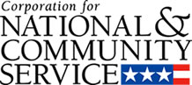

Corporation for National and Community Service

General Program Overview
AmeriCorps provides resources, both human and financial, to organizations that engage Americans in intensive service to meet our country’s critical needs.
Grantees use the funding to support AmeriCorps members for intensive service in their community. AmeriCorps grants partially cover the expense of operating an AmeriCorps program and do not cover general organizational expenses. A cash and in-kind match is required.

The main website can be accessed here: http://www.nationalservice.gov

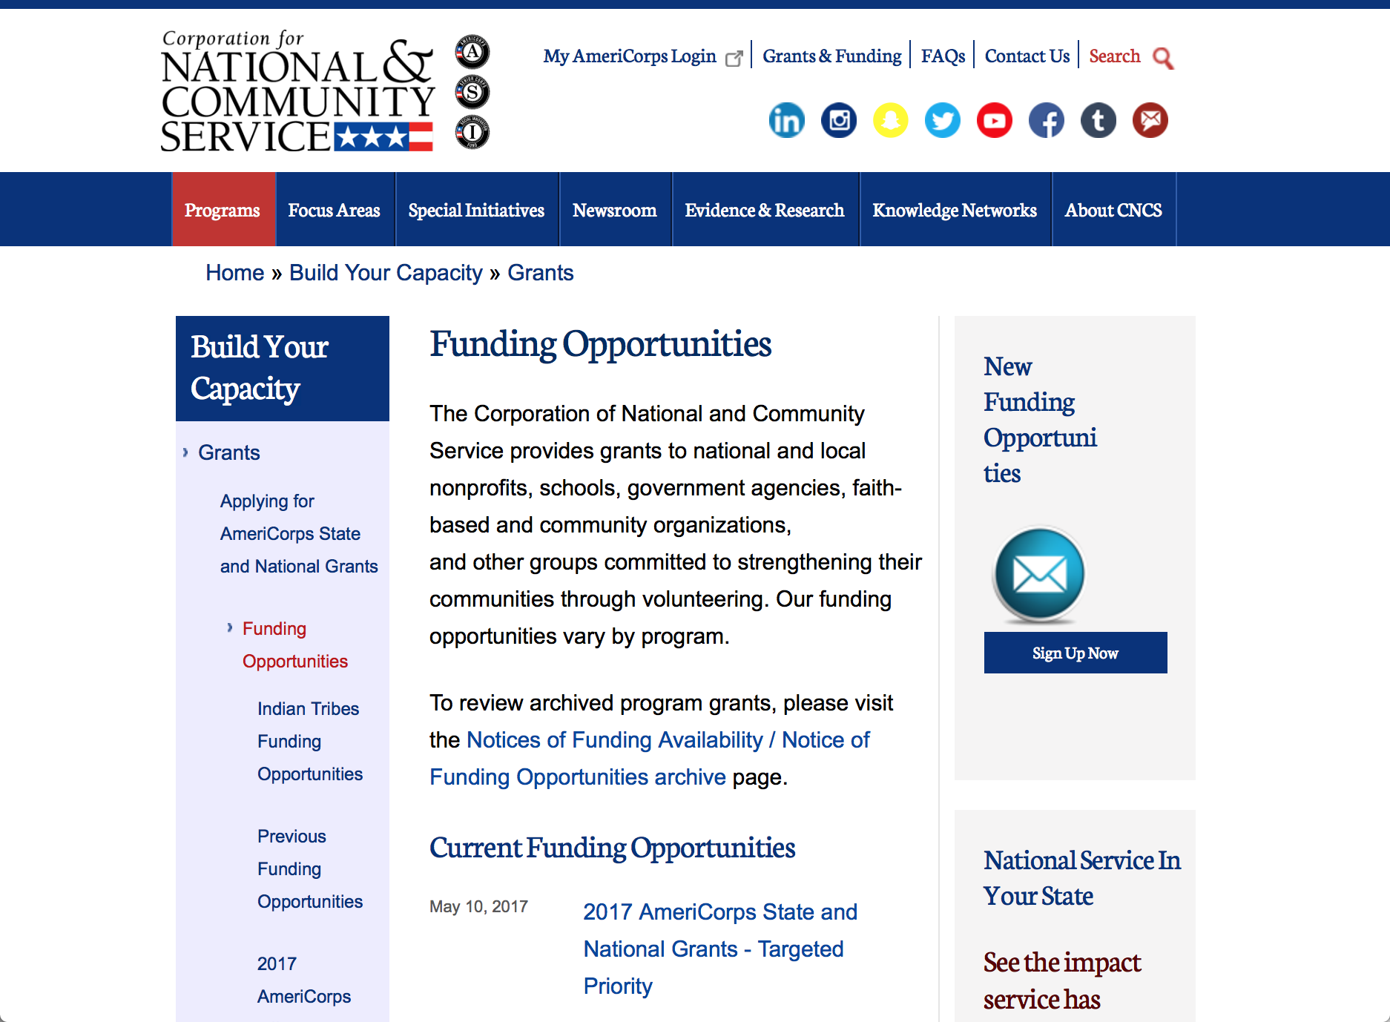

Current Funding Opportunities
There are no current funding opportunities.

For access to further funding information: click here

http://www.nationalservice.gov/build-your-capacity/grants/funding-opportunities

Programs:

Research:

Reminders:

AmeriCorps State and National Grants FY2018
Synopsis 1
Document Type: | Grants Notice
Funding Opportunity Number: | CNCS-08-24-17
Funding Opportunity Title: | AmeriCorps State and National Grants FY2018
Opportunity Category: | Discretionary
Opportunity Category Explanation:
Funding Instrument Type: | Grant
Category of Funding Activity: | Community Development  Disaster Prevention and Relief  Education  Employment, Labor and Training  Environment  Food and Nutrition  Health  Housing  Natural Resources
Category Explanation:
Expected Number of Awards:
CFDA Number(s): | 94.006 -- AmeriCorps
Cost Sharing or Matching Requirement: | Yes
Version: | Synopsis 1
Posted Date: | Aug 24, 2017
Last Updated Date: | Aug 24, 2017
Original Closing Date for Applications: | Jan 17, 2018
Current Closing Date for Applications: | Jan 17, 2018
Archive Date: | Jan 18, 2018
Eligible Applicants: | Private institutions of higher education  City or township governments  State governments  Nonprofits that do not have a 501(c)(3) status with the IRS, other than institutions of higher education  Nonprofits having a 501(c)(3) status with the IRS, other than institutions of higher education  Native American tribal organizations (other than Federally recognized tribal governments)  Public housing authorities/Indian housing authorities  Public and State controlled institutions of higher education  Native American tribal governments (Federally recognized)  County governments  Special district governments  Independent school districts
Additional Information on Eligibility:
Agency Name: | Corporation for National and Community Service
Description: | AmeriCorps grants are awarded to eligible organizations proposing to engage AmeriCorps members in evidence-based or evidence-informed interventions to strengthen communities. An AmeriCorps member is an individual who engages in community service through an approved national service position. Members may receive a living allowance and other benefits while serving. Upon successful completion of their service, members earn a Segal AmeriCorps Education Award from the National Service Trust that members can use to pay for higher education expenses or apply to qualified student loans.
Link to Additional Information: | Full competition information and resources.
Grantor Contact Information: | If you have difficulty accessing the full announcement electronically, please contact:  (202) 606-7508  Competition inbox

http://www.grants.gov/web/grants/view-opportunity.html?oppId=296773

National Service In Hawaii
National Service in Your State - Hawaii
2015-2016

Meeting Community Needs in Hawaii: More than 3,100 people of all ages and backgrounds are helping to meet local needs, strengthen communities, and increase civic engagement through national service in Hawaii. Serving at more than 450 locations throughout the state, these citizens tutor and mentor children, support veterans and military families, provide health services, restore the environment, respond to disasters, increase economic opportunity, and recruit and manage volunteers. This year, the Corporation for National and Community Service (CNCS) will commit more than $6,260,000 to support Hawaii communities through national service initiatives. Through a unique public-private partnership, this federal investment will leverage an additional $9,060,000 in other resources to strengthen community impact, build local support, and increase return on taxpayer dollars. Nationwide, CNCS, its grantees, and project sponsors generated more than $1.25 billion in outside resources from businesses, foundations, public agencies, and other sources in FY 2015.

AmeriCorps
This year, AmeriCorps will provide more than 560 individuals the opportunity to provide intensive, results-driven service to meet education, environmental, health, economic, and other pressing needs in communities across Hawaii. Most AmeriCorps grant funding goes to the Hawaii Commission on National & Community Service, which in turn awards grants to nonprofit groups to respond to local needs. Most of the remainder of the grant funding is distributed by CNCS directly to multi-state and national organizations through a competitive grants process. Other individuals serve through AmeriCorps VISTA, whose members help bring individuals and communities out of poverty by serving full-time to fight illiteracy, improve health services, create businesses, and increase housing opportunities, and AmeriCorps NCCC (National Civilian Community Corps), a 10-month, full time residential program for men and women between the ages of 18 and 24. In exchange for their service, AmeriCorps members earn an education award that can be used to pay for college or to pay back qualified student loans. Since 1994, more than 5,900 Hawaii residents have served more than 6.4 million hours and have qualified for Segal AmeriCorps Education Awards totaling more than $14,980,000.
Download: AmeriCorps in Hawaii (PDF)
Senior Corps
More than 2,500 seniors in Hawaii contribute their time and talents in one of three Senior Corps programs. Foster Grandparents serve one-on-one as tutors and mentors to more than 310 young people who have special needs. Senior Companions help more than 220 homebound seniors and other adults maintain independence in their own homes. RSVP volunteers conduct safety patrols, renovate homes, protect the environment, tutor and mentor youth, respond to natural disasters, and provide other services through more than 250 groups across Hawaii.
Download: Senior Corps in Hawaii (PDF)

The Corporation for National and Community Service is a federal agency that improves lives, strengthens communities, and fosters civic engagement through service and volunteering. CNCS annually engages more than five million Americans in service to meet local needs through Senior Corps, AmeriCorps, and national days of service; improves communities through the Social Innovation Fund, and leads President Obama's national call to service initiative, United We Serve. To learn more visit NationalService.gov or Serve.gov or call 202-606-5000 or TTY 1-800-833-3722.

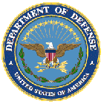

U.S. Department of Defense

Doing Business with the Department of Defense

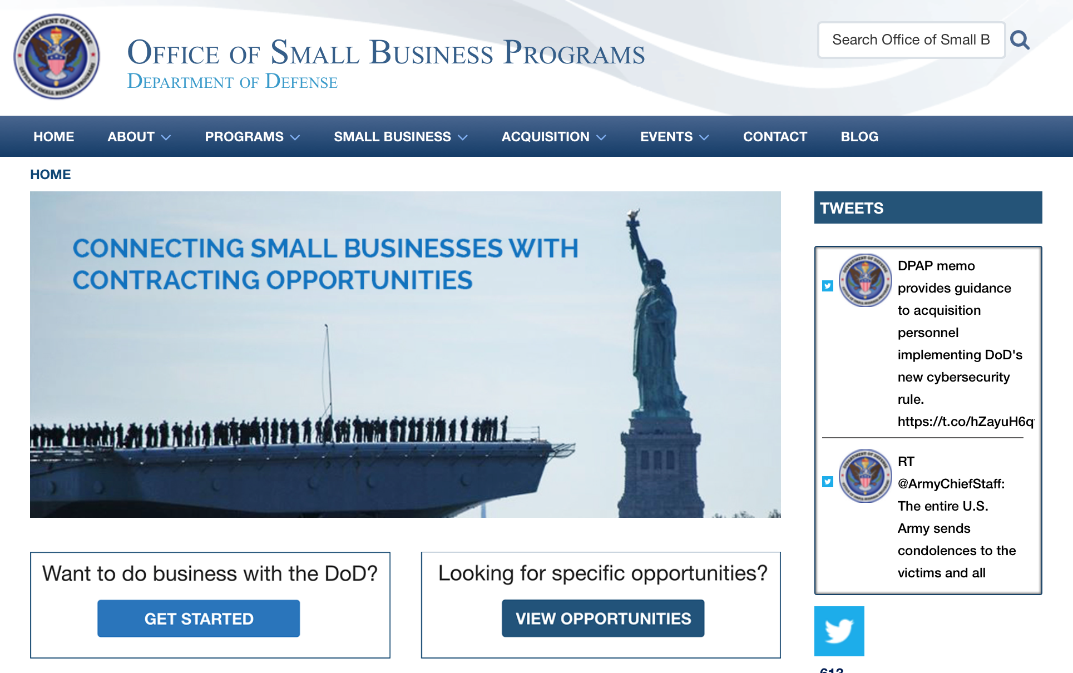

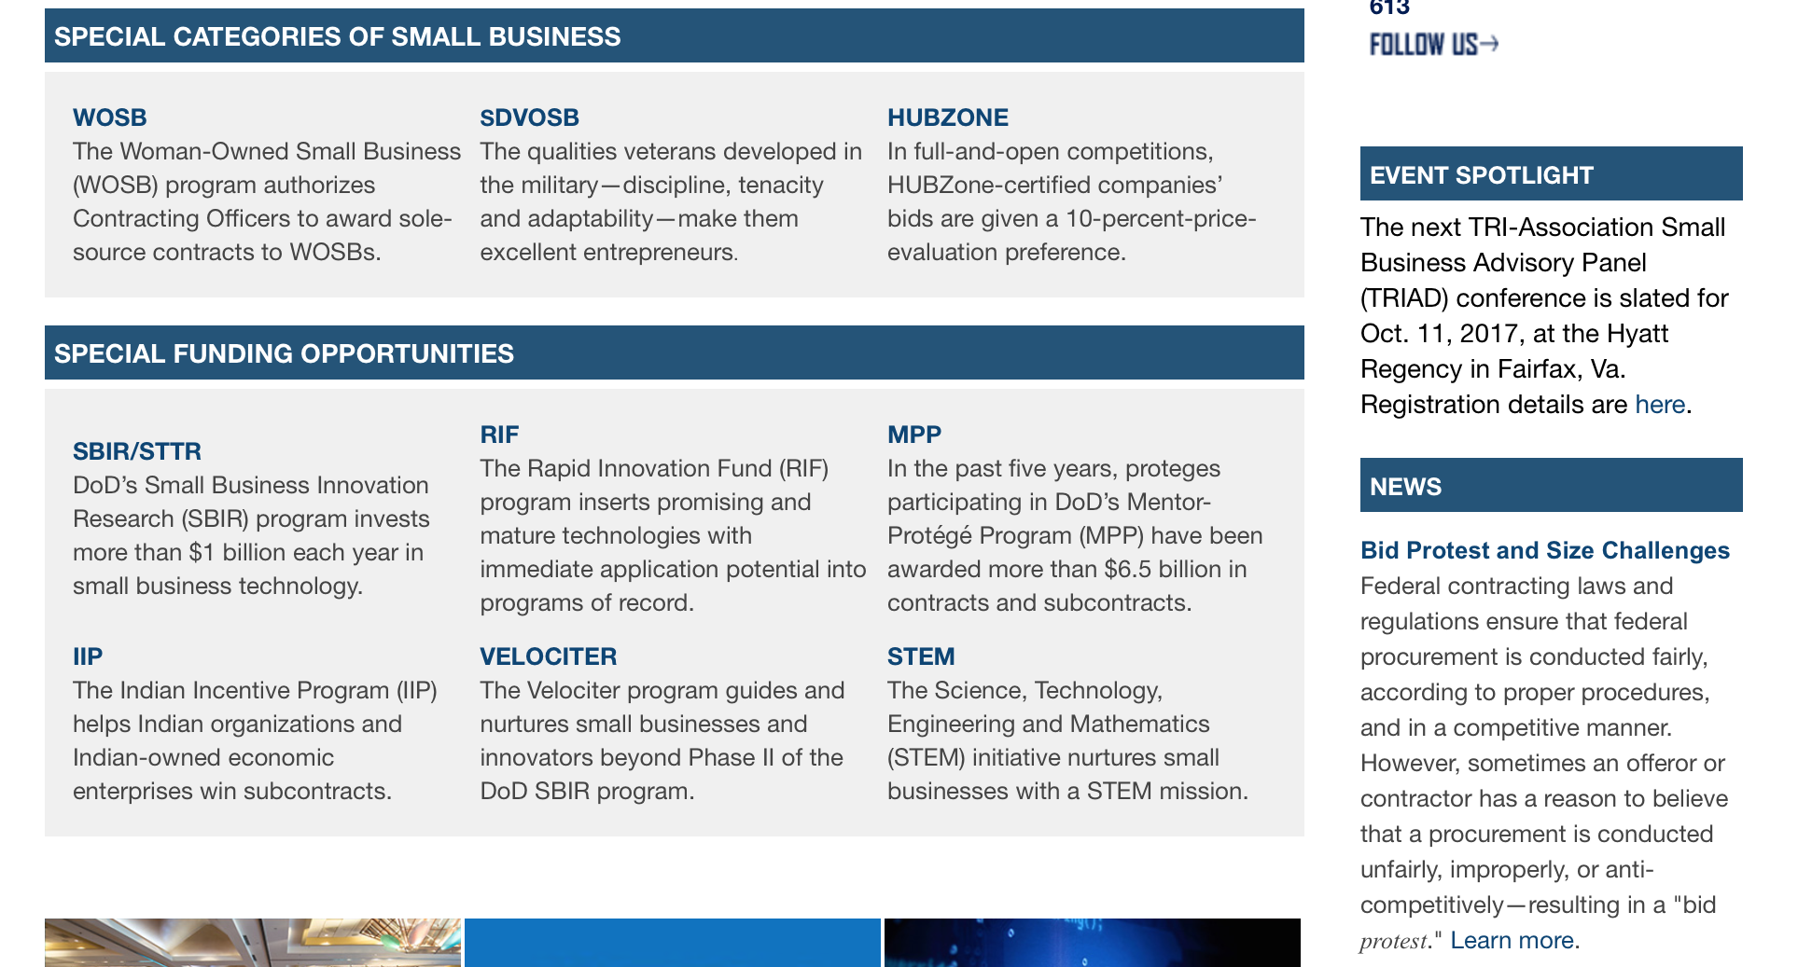

http://business.defense.gov

http://www.acq.osd.mil/osbp/

Doing Business with the DoD

Resources

Procurement Technical Assistance Centers (PTACs)

Procurement Technical Assistance Centers (PTACs) are charged with assisting businesses in learning how to do business with federal, state, and local governments. PTACs are a local resource available at no or nominal cost that can provide assistance to business firms in marketing their products and services. They offer training to businesses on how to research and bid on contracts, assist with registration requirements, provide bid-matching services, and assist with pre and post contracting issues.

Prime Contractors with Subcontracting Plans [xlsx]

Directory last updated 6/2017

This FY 2014 directory is intended for small business concerns seeking opportunities with DoD prime contractors. The directory is a listing of large business prime contractors who are required to establish subcontracting plans with goals. The report is generated from data contained in the Individual Subcontract Reports (ISRs) submitted in the Electronic Subcontracting Reporting System (eSRS) by contractors and from data contained in the Federal Procurement Data System (FPDS). The directory includes the name of the prime contractor; the major product/service code (PSC) provided to DoD; the major NAICS of the company; name, telephone number and email address of the company’s point of contact; contract number with the effective date and completion date, ultimate contract value and obligated dollars. In addition, many companies have websites with additional information which may be useful in your search for subcontracting opportunities or teaming arrangements.

Locate a Small Business Professional

Non-Appropriated Fund Customers

Non-appropriated fund customers operate similar to non-profit organizations and include commissaries, exchanges, recreation and fitness centers, dining at officer/enlisted/civilian clubs, and barber/beauty services, just to name a few.

For more information click here.

Research:

DARPA - Information Innovation Office
Configuration Security (ConSec)
Synopsis 1
https://www.grants.gov/web/grants/view-opportunity.html?oppId=299359

Modifications:

Deleted:

Reminders:



Department of Education
Grant Programs Overview at the Department of Education

The general information page for Education Grant funding is an excellent resource describing the three types of grants awarded by the Department of Education. See the screen shot of the Department of Education web page below:

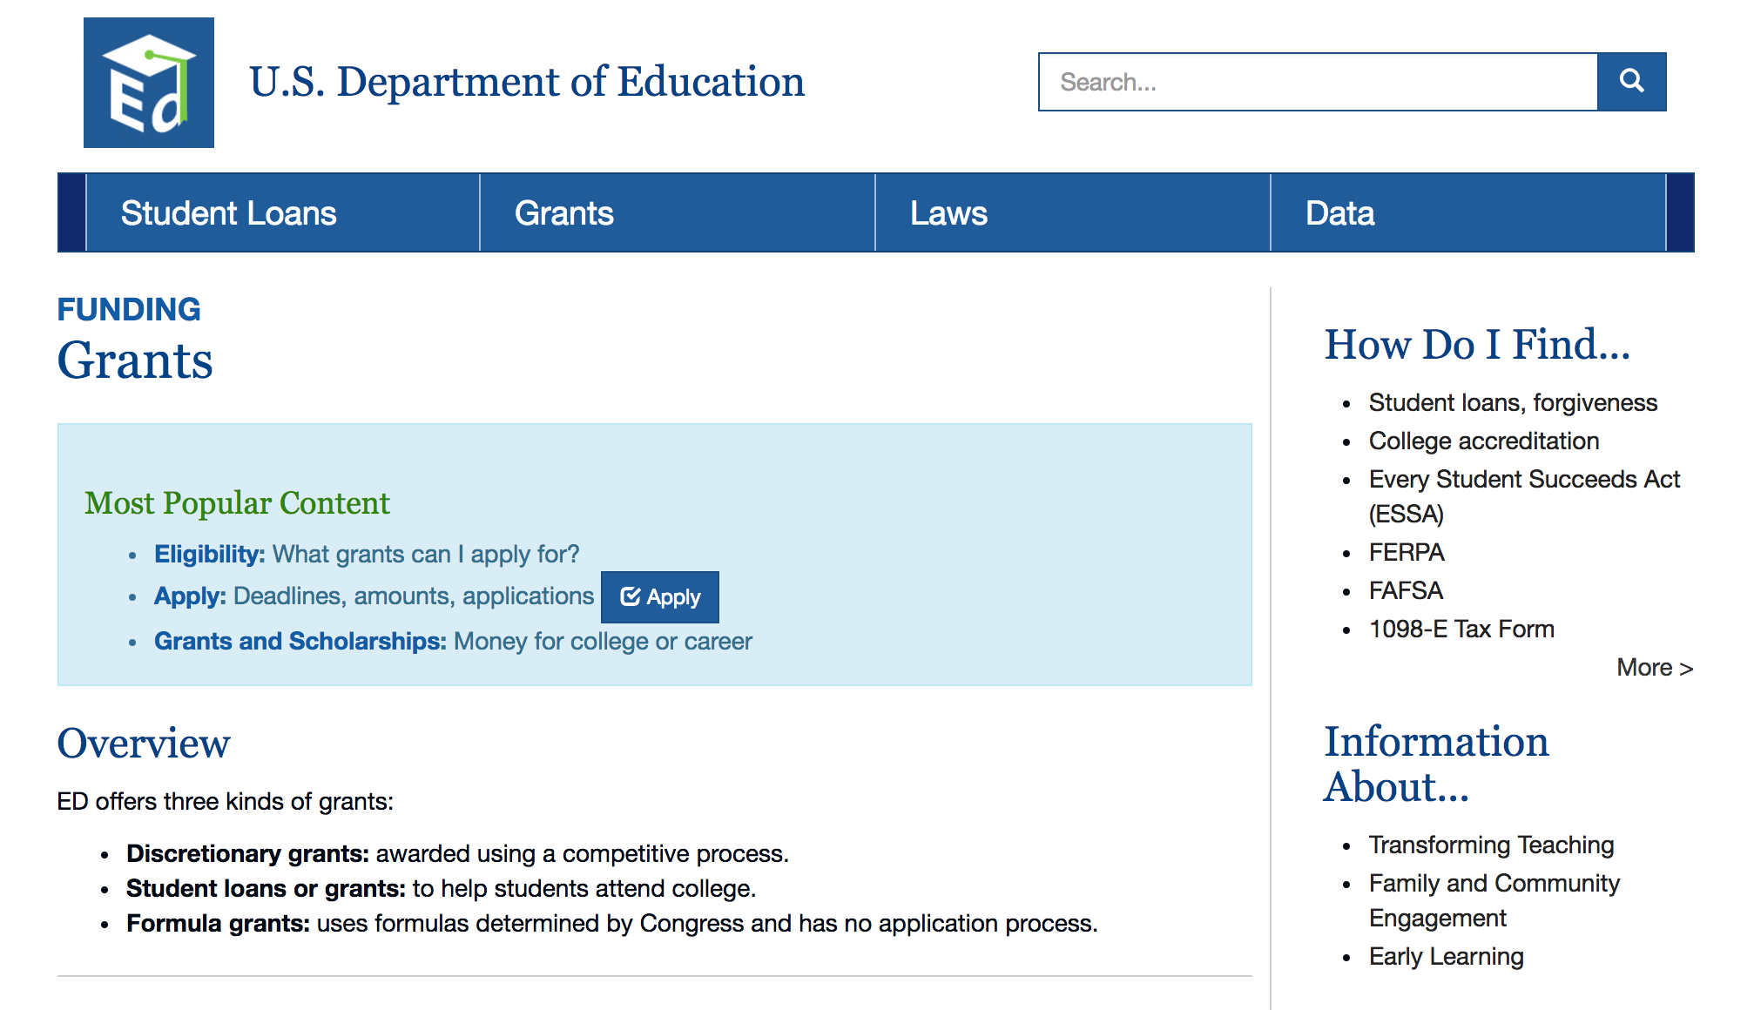
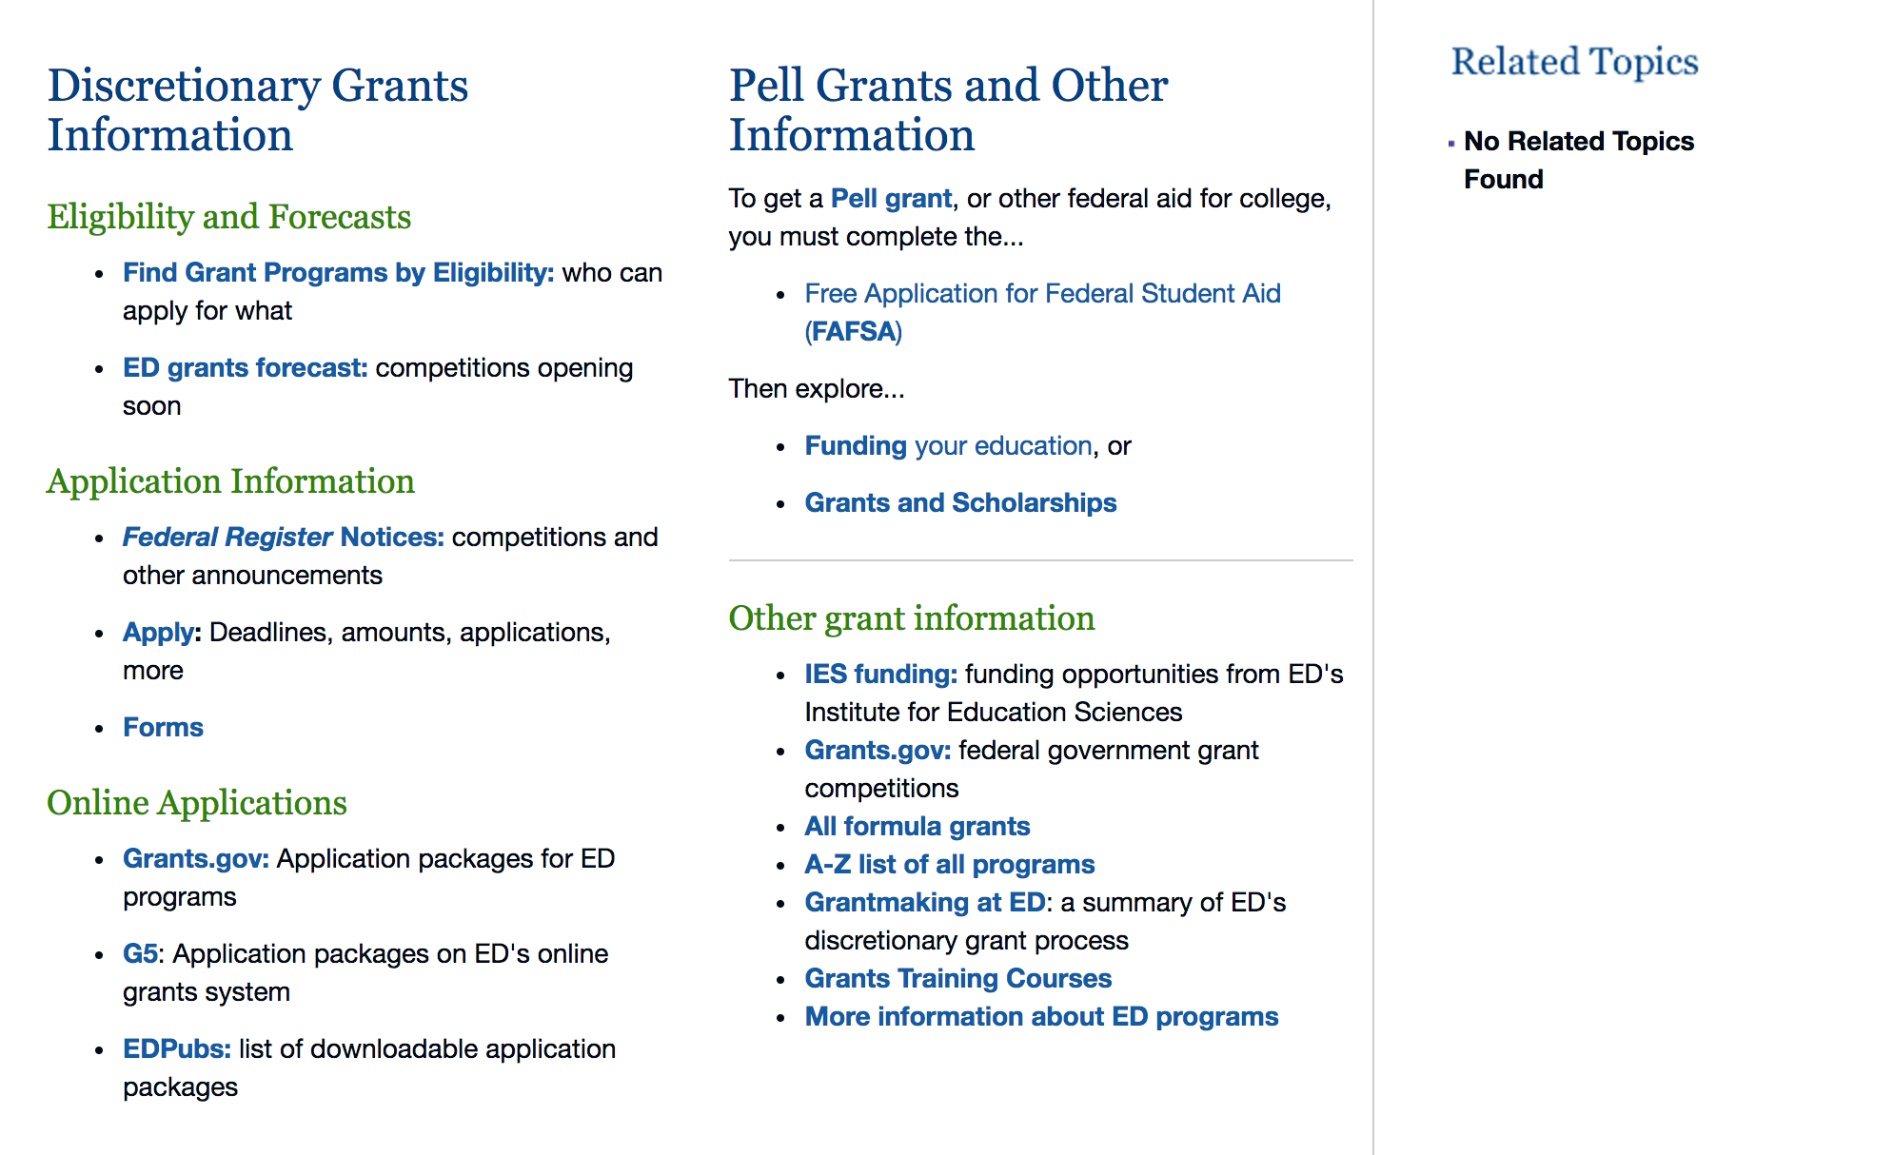

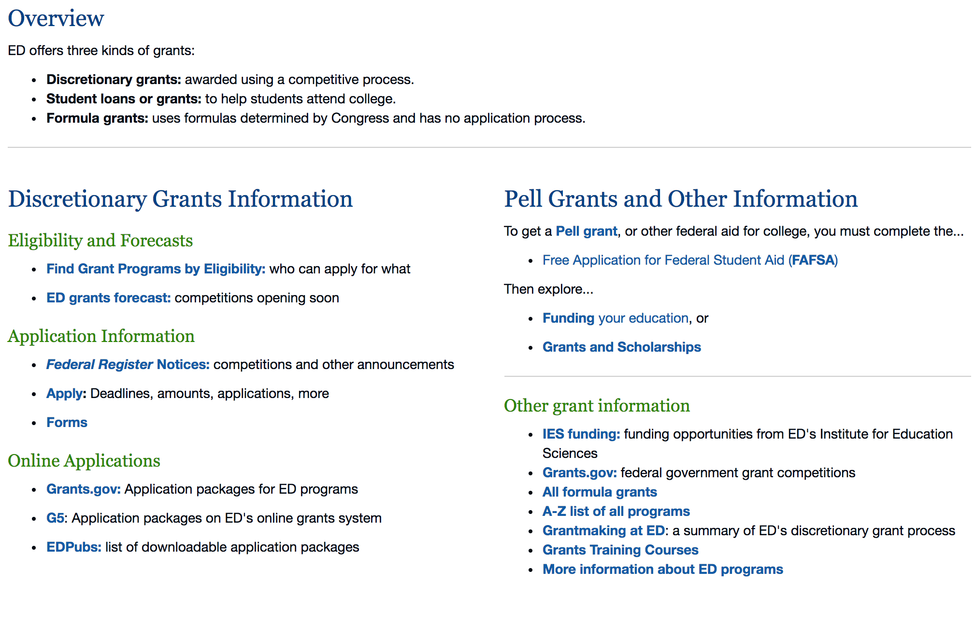

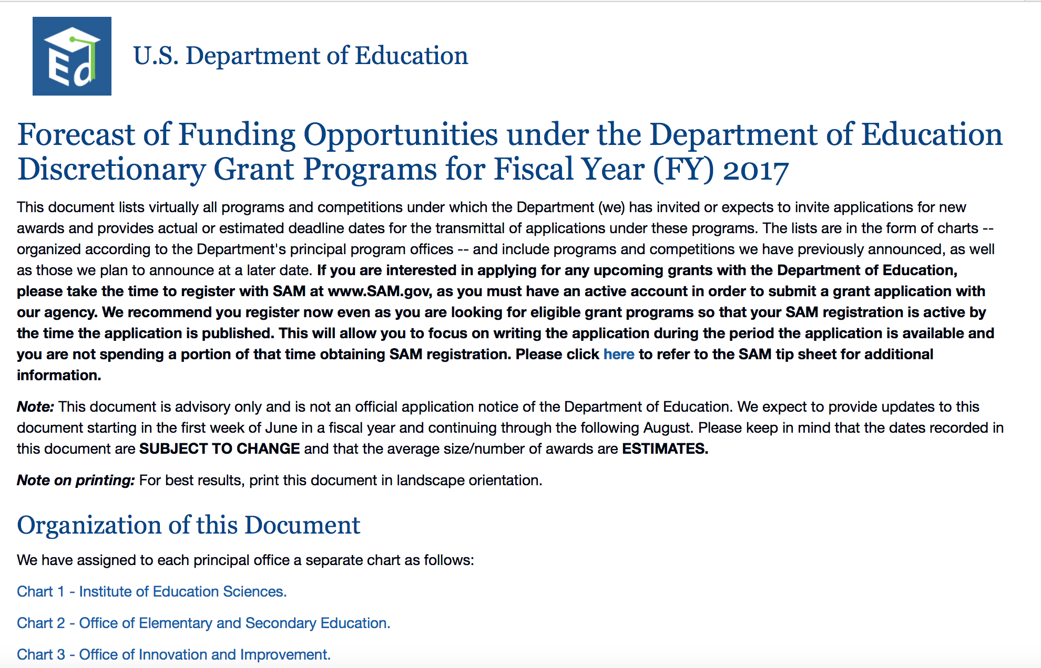
https://www2.ed.gov/fund/grants-apply.html?src=pn

https://www2.ed.gov/fund/grant/find/edlite-forecast.html

Programs:

Research:

Modifications:

Reminders:

Deleted:

U.S. Department of Energy

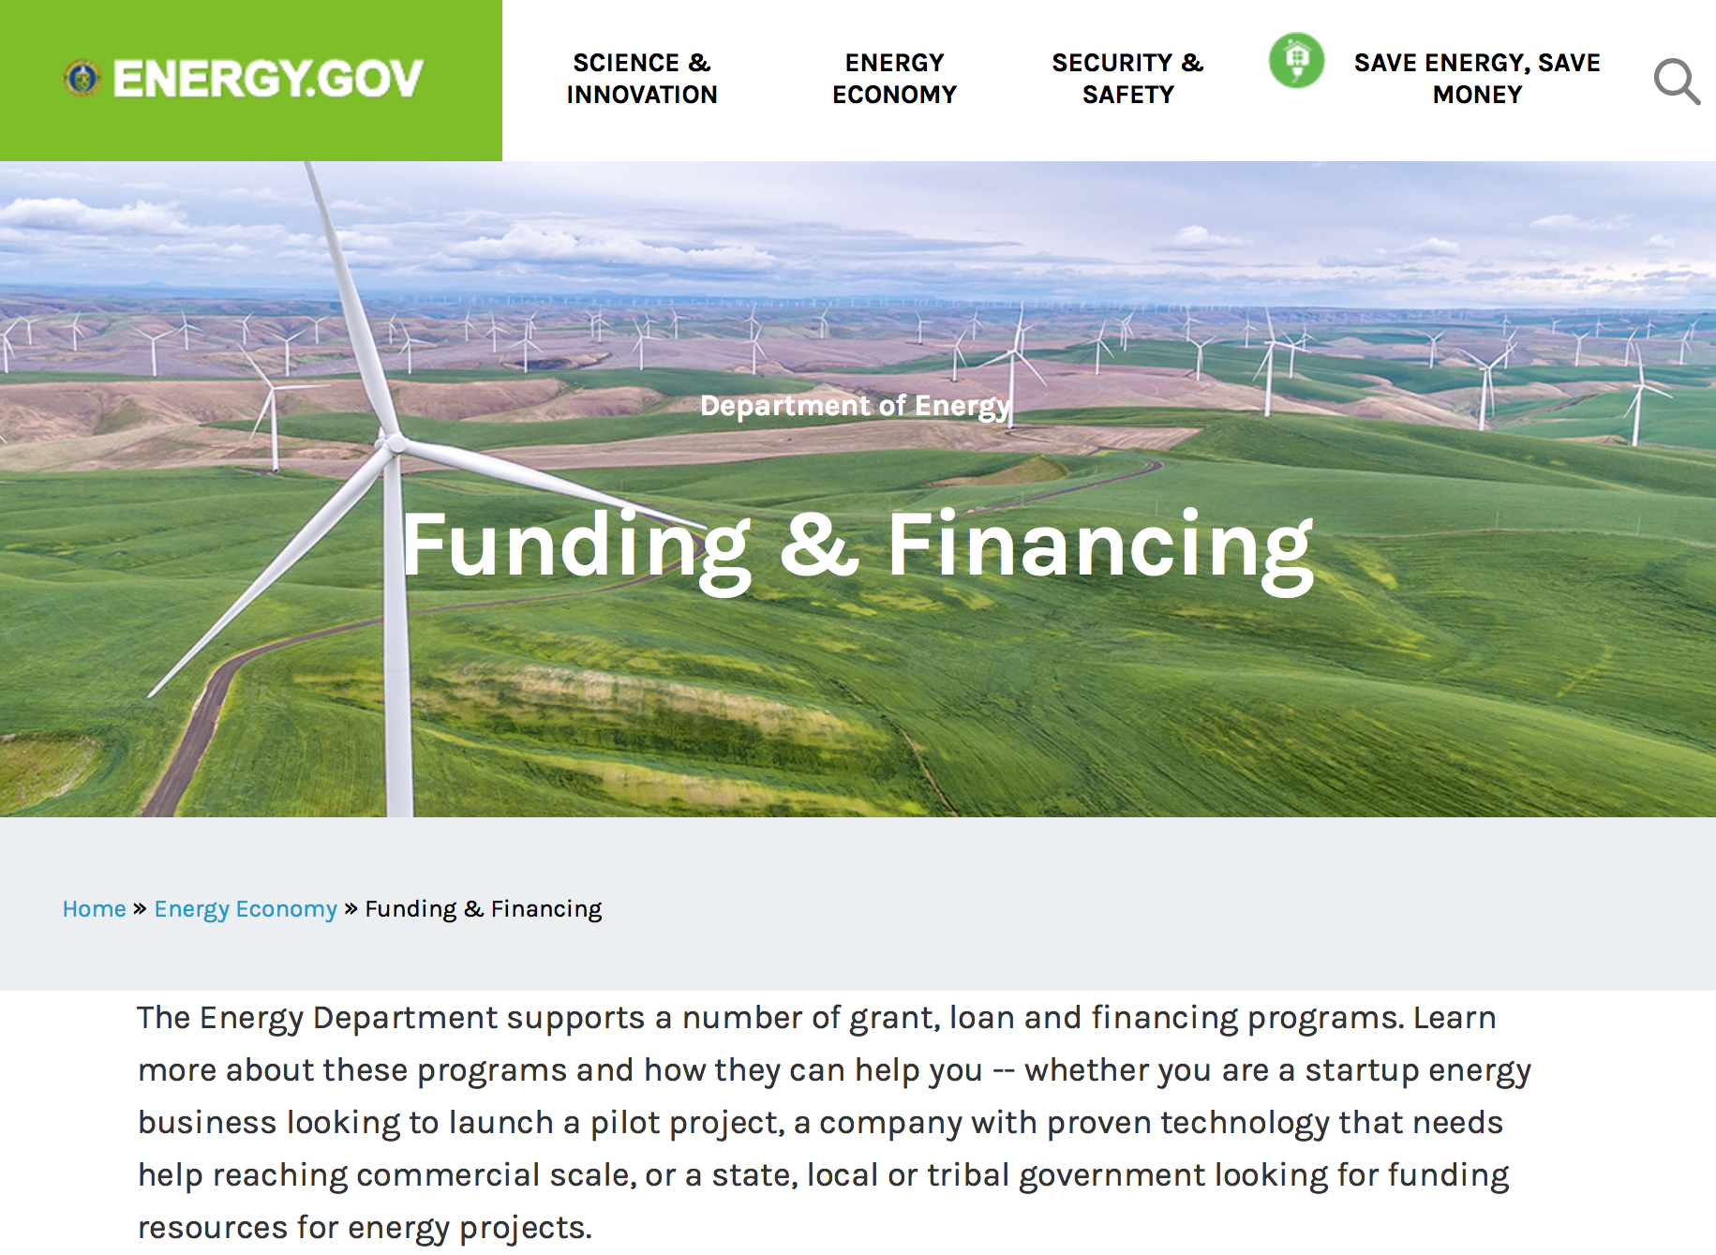

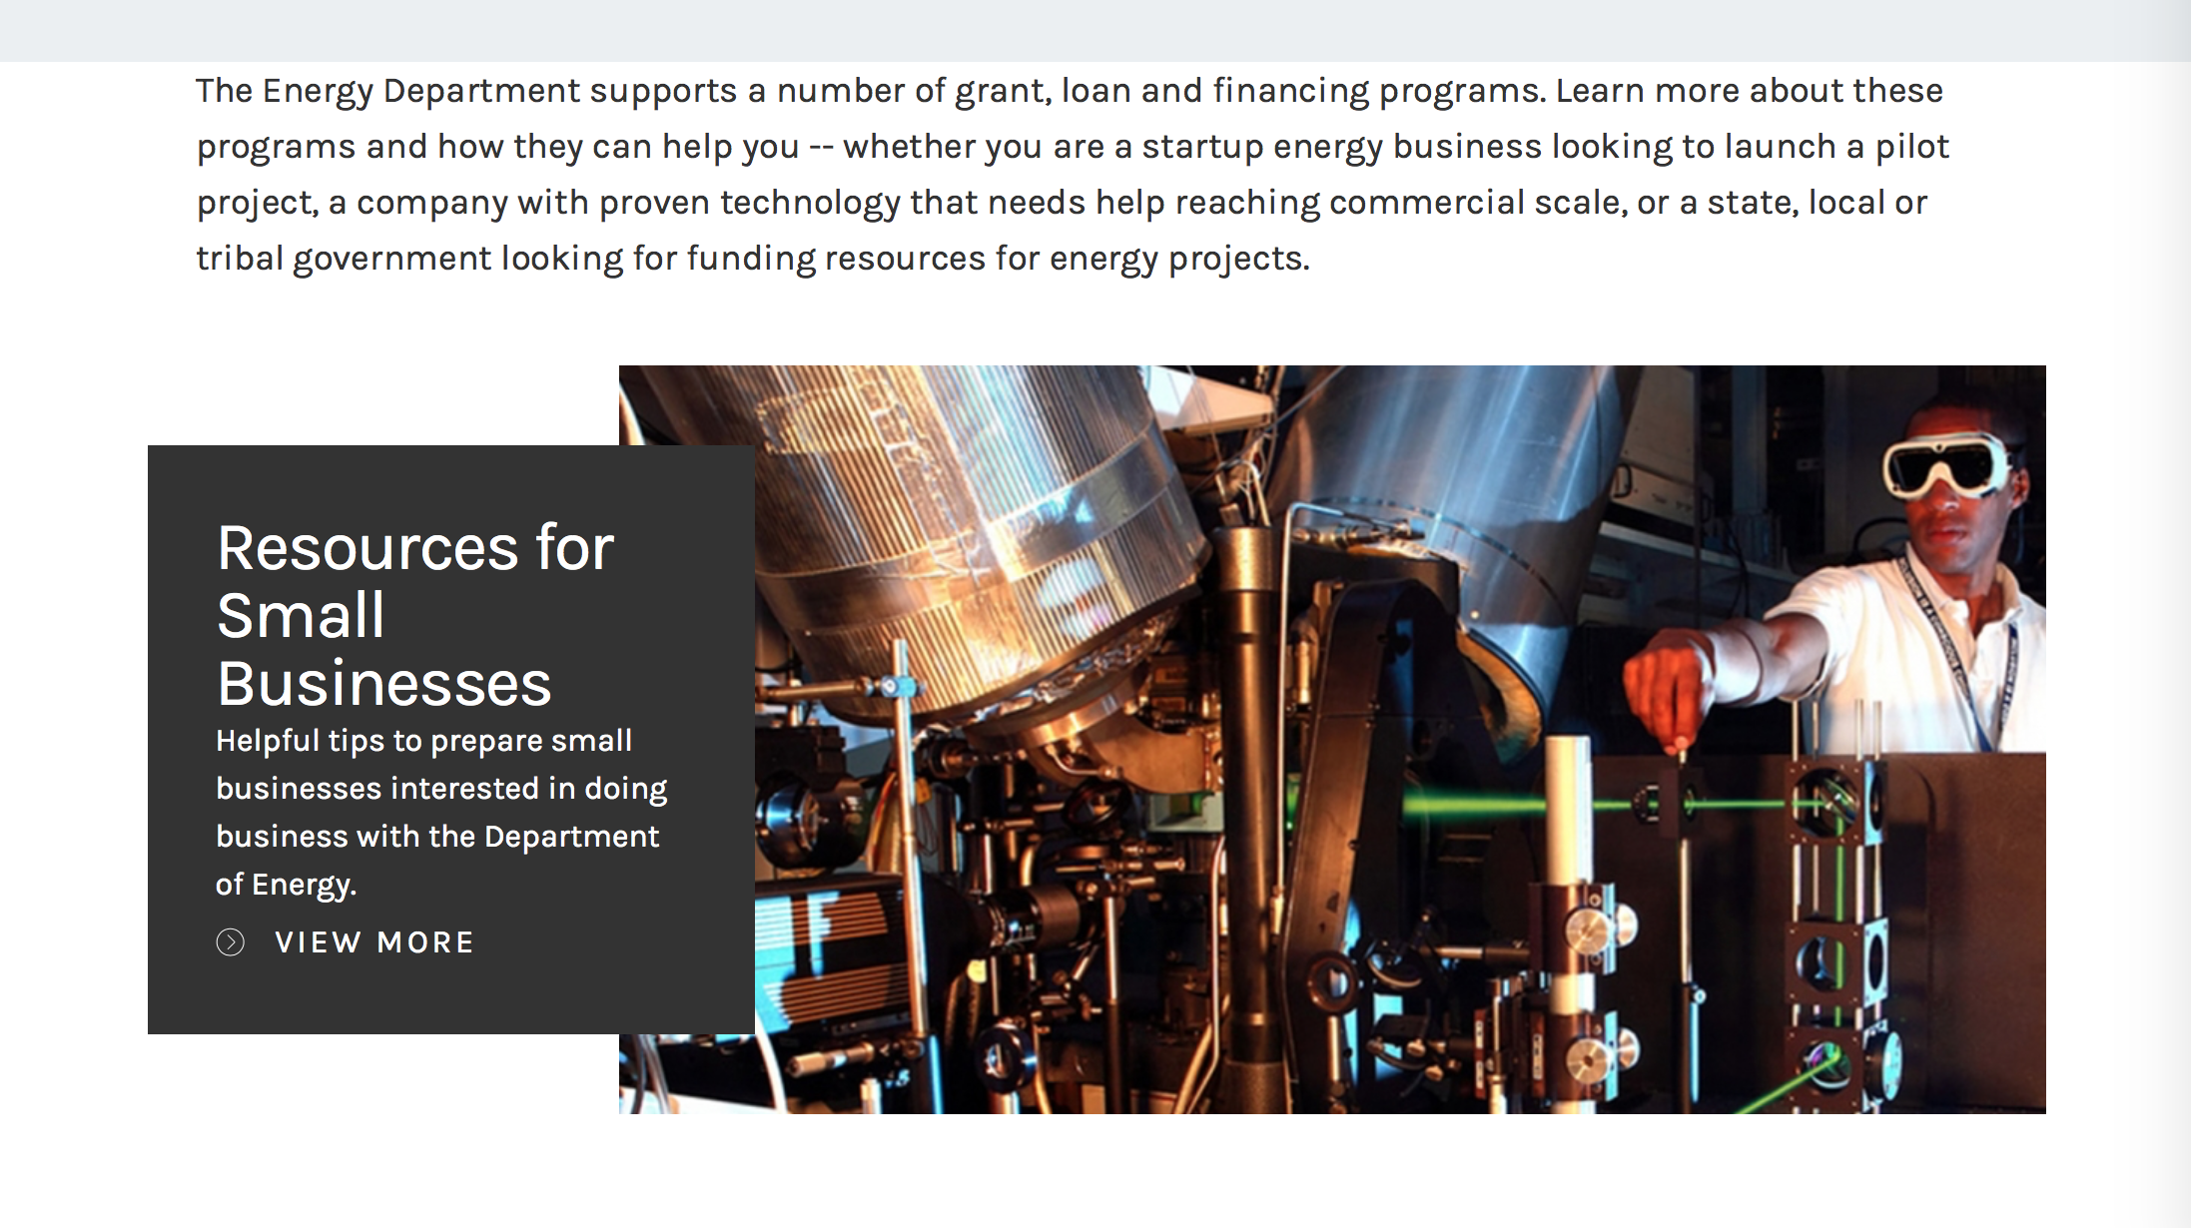

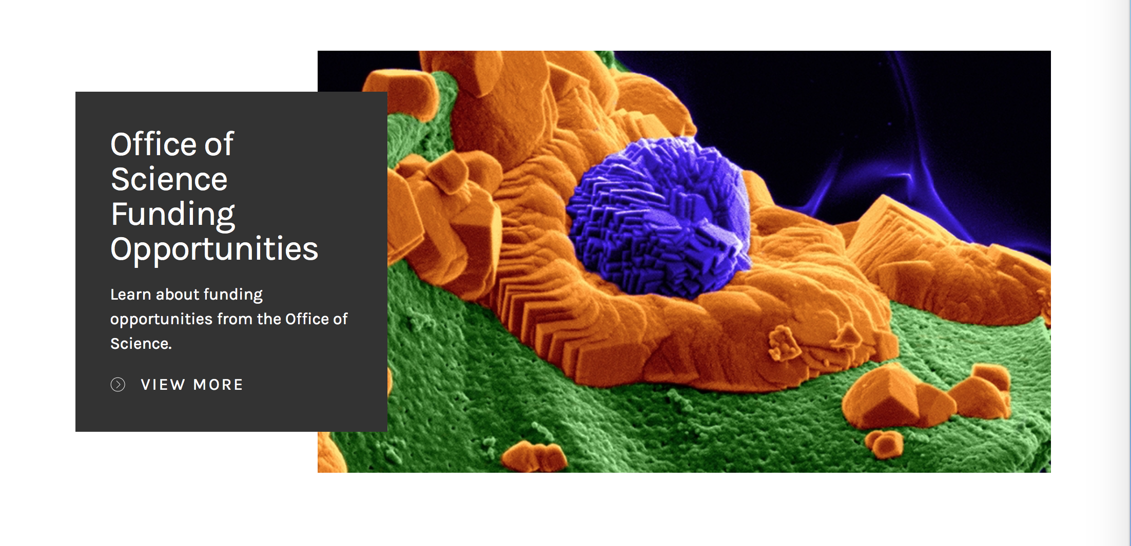

https://www.energy.gov/energy-economy/funding-financing

Research:

Advanced Research Projects Agency Energy
OPEN 2018
Synopsis 1
https://www.grants.gov/web/grants/view-opportunity.html?oppId=299398

Idaho Field Office
U.S. Industry Opportunities for Advanced Nuclear Technology Development
Synopsis 1
https://www.grants.gov/web/grants/view-opportunity.html?oppId=299283

Office of Science
Bioimaging Research and Approaches for Bioenergy
Synopsis 1
https://www.grants.gov/web/grants/view-opportunity.html?oppId=299636

Office of Science
Early Career Research Program
Synopsis 1
https://www.grants.gov/web/grants/view-opportunity.html?oppId=299514

Modifications:

Office of Science
Systems Biology of Bioenergy-Relevant Microbes to Enable Production of Next-Generation Biofuels and Bioproducts
Synopsis 2
https://www.grants.gov/web/grants/view-opportunity.html?oppId=299263

Reminders:

Environmental Protection Agency

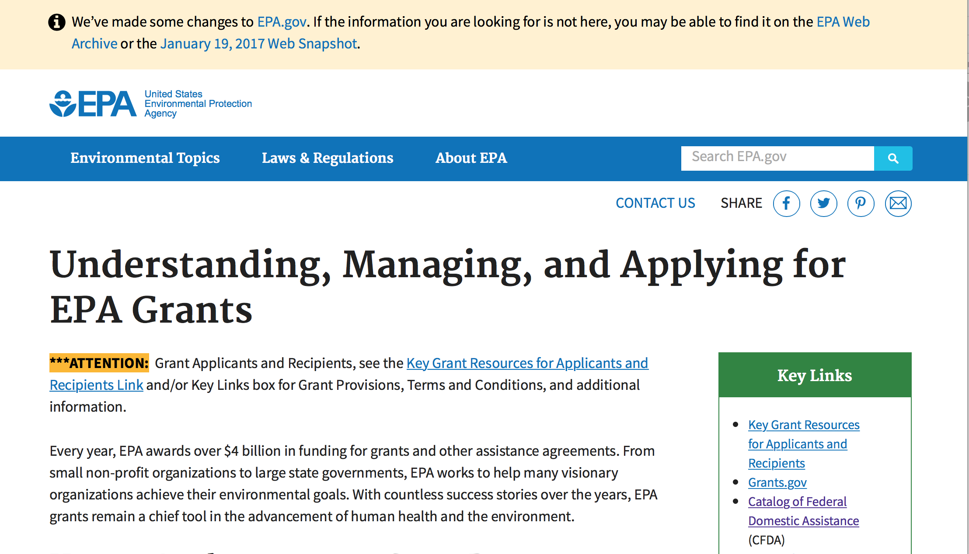
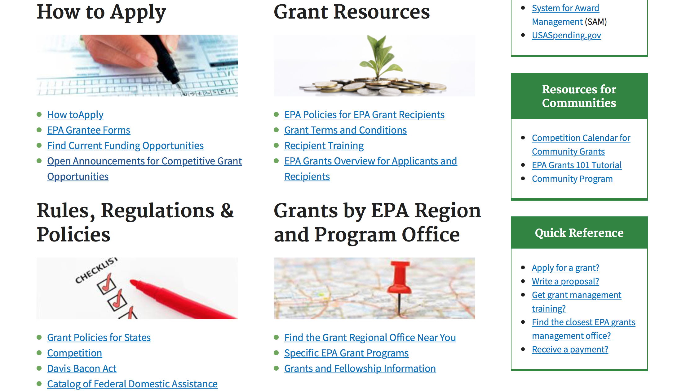

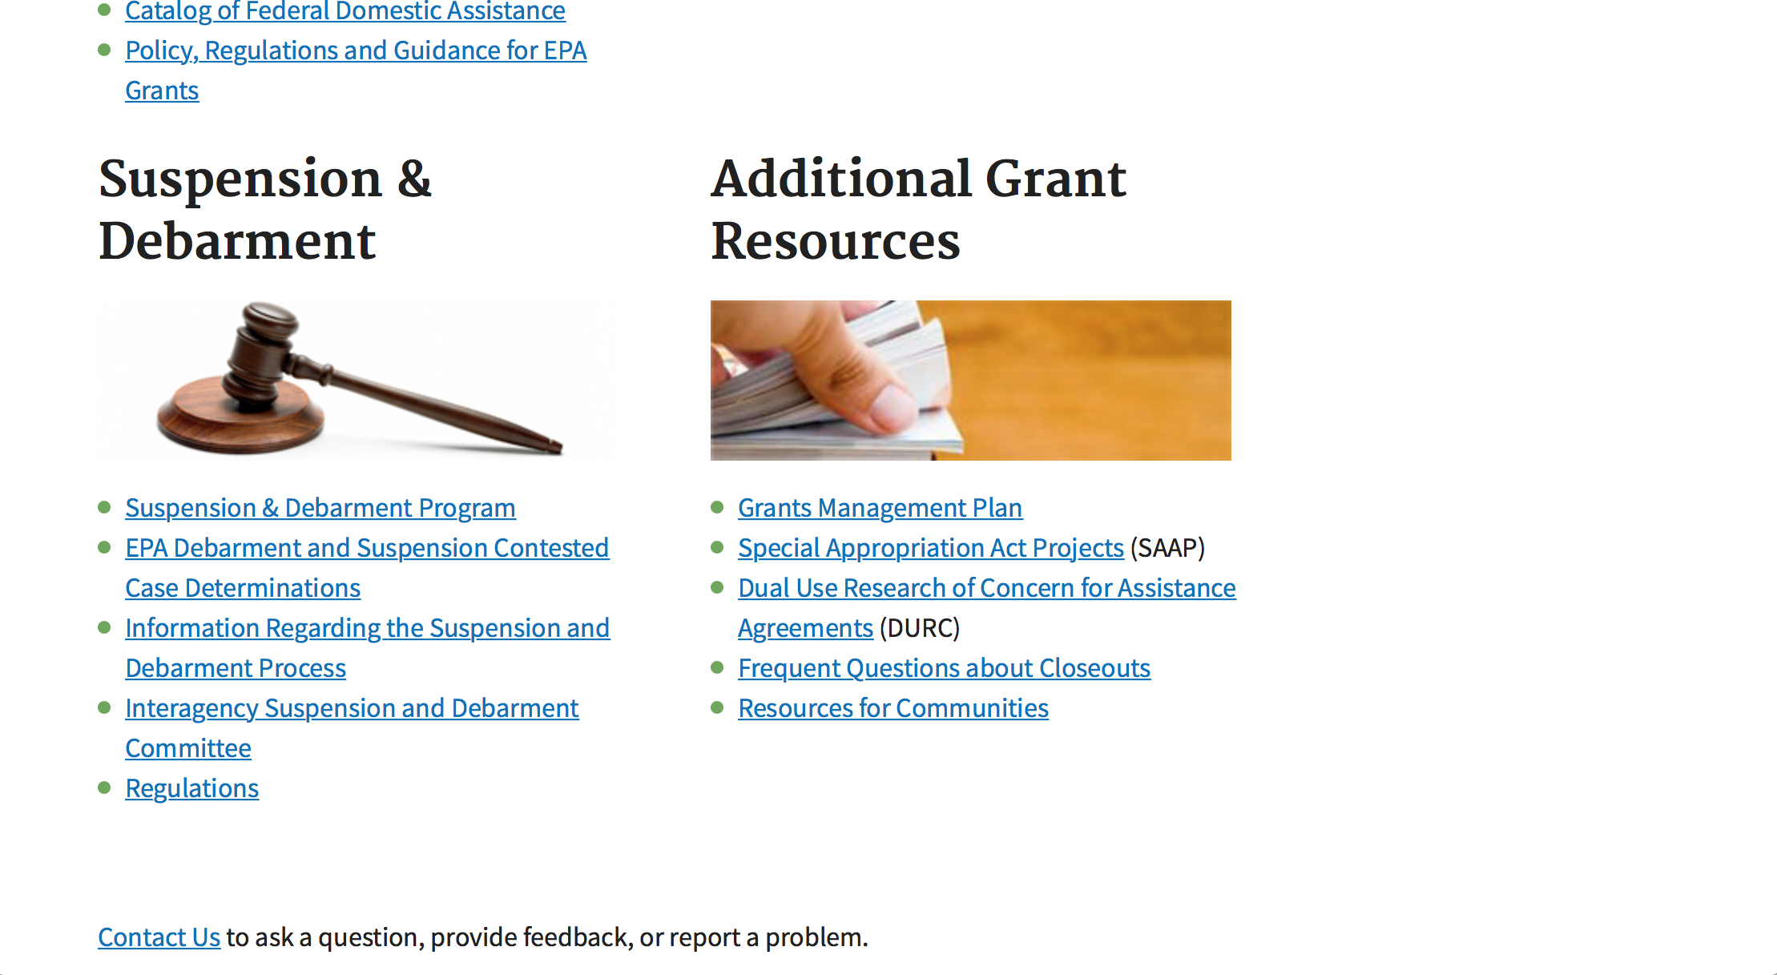

http://www.epa.gov/epahome/grants.htm

Programs:

15th Annual P3 Awards: A National Student Design Competition Focusing on People, Prosperity and the Planet - Safe and Sustainable Water Resources
Synopsis 1
Document Type: | Grants Notice
Funding Opportunity Number: | EPA-G2018-P3-Q2
Funding Opportunity Title: | 15th Annual P3 Awards: A National Student Design Competition Focusing on People, Prosperity and the Planet - Safe and Sustainable Water Resources
Opportunity Category: | Discretionary
Opportunity Category Explanation:
Funding Instrument Type: | Grant
Category of Funding Activity: | Environment
Category Explanation:
Expected Number of Awards: | 20
CFDA Number(s): | 66.516 -- P3 Award: National Student Design Competition for Sustainability
Cost Sharing or Matching Requirement: | No
Version: | Synopsis 1
Posted Date: | Dec 22, 2017
Last Updated Date: | Dec 22, 2017
Original Closing Date for Applications: | Feb 07, 2018 See Section IV of solicitation for close date information.
Current Closing Date for Applications: | Feb 07, 2018 See Section IV of solicitation for close date information.
Archive Date: | Mar 09, 2018
Estimated Total Program Funding: | $600,000
Award Ceiling: | $15,000
Eligible Applicants: | Others (see text field entitled "Additional Information on Eligibility" for clarification)
Additional Information on Eligibility: | See Section III of solicitation for eligibility information.
Agency Name: | Environmental Protection Agency
Description: | The U.S. Environmental Protection Agency (EPA) – as part of its People, Prosperity and the Planet (P3) Award Program – is seeking applications proposing to research, develop, design, and demonstrate solutions to real world challenges. The P3 competition highlights the use of scientific principles in creating innovative technology-based projects that achieve the mutual goals of improved quality of life, economic prosperity, and protection of the planet – people, prosperity, and the planet. The EPA offers the P3 competition in order to respond to the needs of people in the United States (U.S.)—e.g., those in small, rural, tribal, and disadvantaged communities. Please see the P3 website for more details about this program. Proposed projects must embody the P3 approach, which is that they have the intention and capability to simultaneously improve the quality of people’s lives, provide economic benefits, and protect the environment.
Link to Additional Information: | 15th Annual P3 Awards: A National Student Design Competition Focusing on People, Prosperity and the Planet
Grantor Contact Information: | If you have difficulty accessing the full announcement electronically, please contact:  Technical Contact: Angela Page; Phone: 202-564-7957; Email: page.angelad@epa.gov Eligibility Contact: Ron Josephson; Phone: 202-564-7823; Email: josephson.ron@epa.gov Electronic Submissions: Debra M. Jones; Phone: 202-564-7839; Email: jones.debram@epa.gov  jones.debram@epa.gov

https://www.grants.gov/web/grants/view-opportunity.html?oppId=299640

15th Annual P3 Awards: A National Student Design Competition Focusing on People, Prosperity and the Planet - Chemical Safety
Synopsis 1
Document Type: | Grants Notice
Funding Opportunity Number: | EPA-G2018-P3-Q4
Funding Opportunity Title: | 15th Annual P3 Awards: A National Student Design Competition Focusing on People, Prosperity and the Planet - Chemical Safety
Opportunity Category: | Discretionary
Opportunity Category Explanation:
Funding Instrument Type: | Grant
Category of Funding Activity: | Environment
Category Explanation:
Expected Number of Awards: | 20
CFDA Number(s): | 66.516 -- P3 Award: National Student Design Competition for Sustainability
Cost Sharing or Matching Requirement: | No
Version: | Synopsis 1
Posted Date: | Dec 22, 2017
Last Updated Date: | Dec 22, 2017
Original Closing Date for Applications: | Feb 07, 2018 See Section IV of the solicitation for close date information.
Current Closing Date for Applications: | Feb 07, 2018 See Section IV of the solicitation for close date information.
Archive Date: | Mar 09, 2018
Estimated Total Program Funding: | $600,000
Award Ceiling: | $15,000
Eligible Applicants: | Others (see text field entitled "Additional Information on Eligibility" for clarification)
Additional Information on Eligibility: | See Section III of the solicitation for eligibility information.
Agency Name: | Environmental Protection Agency
Description: | The U.S. Environmental Protection Agency (EPA) – as part of its People, Prosperity and the Planet (P3) Award Program – is seeking applications proposing to research, develop, design, and demonstrate solutions to real world challenges. The P3 competition highlights the use of scientific principles in creating innovative technology-based projects that achieve the mutual goals of improved quality of life, economic prosperity, and protection of the planet – people, prosperity, and the planet. The EPA offers the P3 competition in order to respond to the needs of people in the United States (U.S.)—e.g., those in small, rural, tribal, and disadvantaged communities. Please see the P3 website for more details about this program. Proposed projects must embody the P3 approach, which is that they have the intention and capability to simultaneously improve the quality of people’s lives, provide economic benefits, and protect the environment.
Link to Additional Information: | 15th Annual P3 Awards: A National Student Design Competition Focusing on People, Prosperity and the Planet
Grantor Contact Information: | If you have difficulty accessing the full announcement electronically, please contact:  Technical Contact: Angela Page; Phone: 202-564-7957; Email: page.angelad@epa.gov Eligibility Contact: Ron Josephson; Phone: 202-564-7823; Email: josephson.ron@epa.gov Electronic Submissions: Debra M. Jones; Phone: 202-564-7839; Email: jones.debram@epa.gov  jones.debram@epa.gov
https://www.grants.gov/web/grants/view-opportunity.html?oppId=299642

15th Annual P3 Awards: A National Student Design Competition Focusing on People, Prosperity and the Planet - Air Quality
Synopsis 1
Document Type: | Grants Notice
Funding Opportunity Number: | EPA-G2018-P3-Q1
Funding Opportunity Title: | 15th Annual P3 Awards: A National Student Design Competition Focusing on People, Prosperity and the Planet - Air Quality
Opportunity Category: | Discretionary
Opportunity Category Explanation:
Funding Instrument Type: | Grant
Category of Funding Activity: | Environment
Category Explanation:
Expected Number of Awards: | 20
CFDA Number(s): | 66.516 -- P3 Award: National Student Design Competition for Sustainability
Cost Sharing or Matching Requirement: | No
Version: | Synopsis 1
Posted Date: | Dec 22, 2017
Last Updated Date: | Dec 22, 2017
Original Closing Date for Applications: | Feb 07, 2018 See Section IV of solicitation for close date information.
Current Closing Date for Applications: | Feb 07, 2018 See Section IV of solicitation for close date information.
Archive Date: | Mar 09, 2018
Estimated Total Program Funding: | $600,000
Award Ceiling: | $15,000
Eligible Applicants: | Others (see text field entitled "Additional Information on Eligibility" for clarification)
Additional Information on Eligibility: | See Section III of the solicitation for eligibility information.
Agency Name: | Environmental Protection Agency
Description: | The U.S. Environmental Protection Agency (EPA) – as part of its People, Prosperity and the Planet (P3) Award Program – is seeking applications proposing to research, develop, design, and demonstrate solutions to real world challenges. The P3 competition highlights the use of scientific principles in creating innovative technology-based projects that achieve the mutual goals of improved quality of life, economic prosperity, and protection of the planet – people, prosperity, and the planet. The EPA offers the P3 competition in order to respond to the needs of people in the United States (U.S.)—e.g., those in small, rural, tribal, and disadvantaged communities. Please see the P3 website for more details about this program. Proposed projects must embody the P3 approach, which is that they have the intention and capability to simultaneously improve the quality of people’s lives, provide economic benefits, and protect the environment.
Link to Additional Information: | 15th Annual P3 Awards: A National Student Design Competition Focusing on People, Prosperity and the Planet
Grantor Contact Information: | If you have difficulty accessing the full announcement electronically, please contact:  Technical Contact: Angela Page; Phone: 202-564-7957; Email: page.angelad@epa.gov Eligibility Contact: Ron Josephson; Phone: 202-564-7823; Email: josephson.ron@epa.gov Electronic Submissions: Debra M. Jones; Phone: 202-564-7839; Email: jones.debram@epa.gov  jones.debram@epa.gov
https://www.grants.gov/web/grants/view-opportunity.html?oppId=299654

15th Annual P3 Awards: A National Student Design Competition Focusing on People, Prosperity and the Planet - Sustainable and Healthy Communities
Synopsis 1

Document Type: | Grants Notice
Funding Opportunity Number: | EPA-G2018-P3-Q3
Funding Opportunity Title: | 15th Annual P3 Awards: A National Student Design Competition Focusing on People, Prosperity and the Planet - Sustainable and Healthy Communities
Opportunity Category: | Discretionary
Opportunity Category Explanation:
Funding Instrument Type: | Grant
Category of Funding Activity: | Environment
Category Explanation:
Expected Number of Awards: | 20
CFDA Number(s): | 66.516 -- P3 Award: National Student Design Competition for Sustainability
Cost Sharing or Matching Requirement: | No
Version: | Synopsis 1
Posted Date: | Dec 22, 2017
Last Updated Date: | Dec 22, 2017
Original Closing Date for Applications: | Feb 07, 2018 See Section IV of solicitation for close date information.
Current Closing Date for Applications: | Feb 07, 2018 See Section IV of solicitation for close date information.
Archive Date: | Mar 09, 2018
Estimated Total Program Funding: | $600,000
Award Ceiling: | $15,000
Eligible Applicants: | Others (see text field entitled "Additional Information on Eligibility" for clarification)
Additional Information on Eligibility: | See Section III of solicitation for eligibility information.
Agency Name: | Environmental Protection Agency
Description: | The U.S. Environmental Protection Agency (EPA) – as part of its People, Prosperity and the Planet (P3) Award Program – is seeking applications proposing to research, develop, design, and demonstrate solutions to real world challenges. The P3 competition highlights the use of scientific principles in creating innovative technology-based projects that achieve the mutual goals of improved quality of life, economic prosperity, and protection of the planet – people, prosperity, and the planet. The EPA offers the P3 competition in order to respond to the needs of people in the United States (U.S.)—e.g., those in small, rural, tribal, and disadvantaged communities. Please see the P3 website for more details about this program. Proposed projects must embody the P3 approach, which is that they have the intention and capability to simultaneously improve the quality of people’s lives, provide economic benefits, and protect the environment.
Link to Additional Information: | 15th Annual P3 Awards: A National Student Design Competition Focusing on People, Prosperity and the Planet
Grantor Contact Information: | If you have difficulty accessing the full announcement electronically, please contact:  Technical Contact: Angela Page; Phone: 202-564-7957; Email: page.angelad@epa.gov Eligibility Contact: Ron Josephson; Phone: 202-564-7823; Email: josephson.ron@epa.gov Electronic Submissions: Debra M. Jones; Phone: 202-564-7839; Email: jones.debram@epa.gov  jones.debram@epa.gov
https://www.grants.gov/web/grants/view-opportunity.html?oppId=299660

Research:

Modifications:

Reminders:

Environmental Justice Collaborative Problem-Solving (EJCPS) Cooperative Agreement (Program)
Synopsis 1
Document Type: | Grants Notice
Funding Opportunity Number: | EPA-OP-OEJ-18-01
Funding Opportunity Title: | Environmental Justice Collaborative Problem-Solving (EJCPS) Cooperative Agreement
Opportunity Category: | Discretionary
Opportunity Category Explanation:
Funding Instrument Type: | Cooperative Agreement
Category of Funding Activity: | Environment
Category Explanation:
Expected Number of Awards: | 10
CFDA Number(s): | 66.306 -- Environmental Justice Collaborative Problem-Solving Cooperative Agreement Program
Cost Sharing or Matching Requirement: | No
Version: | Synopsis 1
Posted Date: | Nov 15, 2017
Last Updated Date: | Nov 15, 2017
Original Closing Date for Applications: | Feb 16, 2018 Please see the announcement for additional submission information.
Current Closing Date for Applications: | Feb 16, 2018 Please see the announcement for additional submission information.
Archive Date: | Mar 18, 2018
Estimated Total Program Funding: | $1,200,000
Award Ceiling: | $120,000
Award Floor: | $0
Eligible Applicants: | Others (see text field entitled "Additional Information on Eligibility" for clarification)
Additional Information on Eligibility: | Please see the announcement including Section III for additional eligibility information.
Agency Name: | Environmental Protection Agency
Description: | The Environmental Justice Collaborative Problem-Solving (EJCPS) Cooperative Agreement Program provides funding to support community-based organizations in their efforts to collaborate and partner with local stakeholder groups (e.g., local businesses and industry, local government, medical providers, and academia) as they develop and implement solutions that address environmental and/or public health issues for underserved communities. For purposes of this announcement, the term “underserved community” refers to a community with environmental justice concerns and/or vulnerable populations, including minority, low income, rural, tribal, and indigenous populations. Eligible projects must demonstrate use of the Environmental Justice Collaborative Problem-Solving Model to support their collaborative efforts during the project period. Applying organizations should have a direct connection to the underserved community impacted by the environmental harms and risks detailed in the workplan.
Link to Additional Information: | Environmental Justice Collaborative Problem-Solving (EJCPS) Cooperative Agreement
Grantor Contact Information: | If you have difficulty accessing the full announcement electronically, please contact:  Jacob Burney, 202-564-2907  Jacob Burney
http://www.grants.gov/web/grants/view-opportunity.html?oppId=298732

FY 2018 NATIONAL ENVIRONMENTAL INFORMATION EXCHANGE NETWORK GRANT PROGRAM
Synopsis 2
Document Type: | Grants Notice
Funding Opportunity Number: | EPA-OEI-18-01
Funding Opportunity Title: | FY 2018 NATIONAL ENVIRONMENTAL INFORMATION EXCHANGE NETWORK GRANT PROGRAM
Opportunity Category: | Discretionary
Opportunity Category Explanation:
Funding Instrument Type: | Cooperative Agreement  Grant
Category of Funding Activity: | Environment
Category Explanation:
Expected Number of Awards: | 25
CFDA Number(s): | 66.608 -- Environmental Information Exchange Network Grant Program and Related Assistance
Cost Sharing or Matching Requirement: | No
Version: | Synopsis 2
Posted Date: | Nov 16, 2017
Last Updated Date: | Nov 16, 2017
Original Closing Date for Applications: | Jan 26, 2018 Please refer to the announcement, including Section IV, for additional information on submission methods and due dates.
Current Closing Date for Applications: | Jan 26, 2018 Please refer to the announcement, including Section IV, for additional information on submission methods and due dates.
Archive Date: | Feb 25, 2018
Estimated Total Program Funding: | $6,000,000
Award Ceiling: | $400,000
Award Floor: | $50,000
Eligible Applicants: | Others (see text field entitled "Additional Information on Eligibility" for clarification)
Additional Information on Eligibility: | Please see Section III of the announcement for eligibility information.
Agency Name: | Environmental Protection Agency
Description: | The Exchange Network Grant Program provides funding for projects that develop the Network and enable timely, on-demand access to environmental data through innovative technologies, improved support systems, and expanded collaboration using shared tools and services.
Link to Additional Information: | FY 2018 National Environmental Information Exchange Network Grant Program
Grantor Contact Information: | If you have difficulty accessing the full announcement electronically, please contact:  Salena Reynolds, Phone: 202-566-0466  Salena Reynolds

http://www.grants.gov/web/grants/view-opportunity.html?oppId=298738

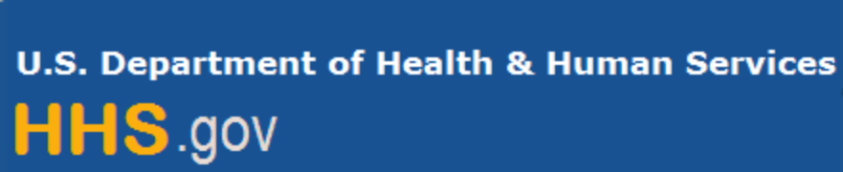

Department of Health and Human Services

Grants Forecast and Overview

The Department of Health and Human Services’ Grants Forecast is a database of planned grant opportunities proposed by its agencies. Each Forecast record contains actual or estimated dates and funding levels for grants that the agency intends to award during the fiscal year. Forecast opportunities are subject to change based on enactment of congressional appropriations.

For more general information about HHS Grants and Funding go to the website below at:

https://www.hhs.gov/grants/grants/index.html

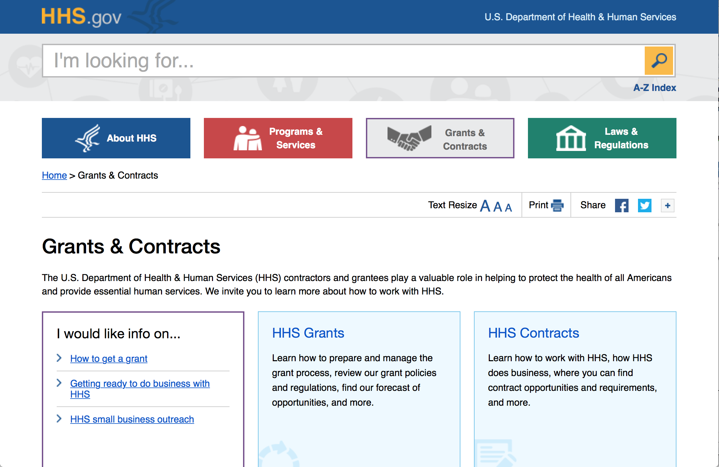

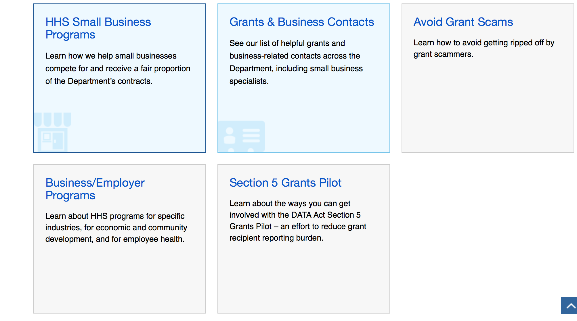

Programs:

Research:

Administration for Community Living
Switzer Research Fellowships Program
Synopsis 1
https://www.grants.gov/web/grants/view-opportunity.html?oppId=298653

Administration for Community Living
University Centers for Excellence in Developmental Disabilities Education, Research and Service
Forecast 1
https://www.grants.gov/web/grants/view-opportunity.html?oppId=299457

Administration for Community Living
2018 Empowering Older Adults and Adults with Disabilities through Chronic Disease Self-Management Education Programs Financed by the Prevention and Public Health Fund
Forecast 1
https://www.grants.gov/web/grants/view-opportunity.html?oppId=299734
Administration for Community Living
2018 Evidence-Based Falls Prevention Program financed by Prevention and Public Health Fund
Forecast 1
https://www.grants.gov/web/grants/view-opportunity.html?oppId=299735

Centers for Disease Control - NCCDPHP
Sudden Unexpected Infant Death (SUID) and Sudden Death in the Young (SDY) Case Registry
Forecast 1
https://www.grants.gov/web/grants/view-opportunity.html?oppId=299338
Centers for Disease Control - NCCDPHP
Tribal Practices for Wellness In Indian Country
Synopsis 1
https://www.grants.gov/web/grants/view-opportunity.html?oppId=299475

Centers for Disease Control and Prevention - ERA
Birth Defects Study To Evaluate Pregnancy exposureS (BD-STEPS) II
Synopsis 1
https://www.grants.gov/web/grants/view-opportunity.html?oppId=299628

Centers for Disease Control and Prevention - ERA
Health Promotion and Disease Prevention Research Centers: Special Interest Project Competitive Supplements (SIPS)
Synopsis 1
https://www.grants.gov/web/grants/view-opportunity.html?oppId=298669

Centers for Disease Control - NCCDPHP
Sudden Unexpected Infant Death (SUID) and Sudden Death in the Young (SDY) Case Registry
Synopsis 1
https://www.grants.gov/web/grants/view-opportunity.html?oppId=299338

Centers for Disease Control - NCCDPHP
The State Physical Activity and Nutrition Program
Forecast 1
https://www.grants.gov/web/grants/view-opportunity.html?oppId=299540

Food and Drug Administration
Flexible Funding Model - Infrastructure Development and Maintenance for State Manufactured Food Regulatory Programs (U18)
Synopsis 1
https://www.grants.gov/web/grants/view-opportunity.html?oppId=299265

Health Resources and Services Administration
Implementation of Evidence-Informed Behavioral Health Models to Improve HIV Health Outcomes for Black Men Who Have Sex with Men - Demonstration Sites
Synopsis 1
https://www.grants.gov/web/grants/view-opportunity.html?oppId=299247

Health Resources and Services Administration
Ryan White HIV/AIDS Program Part D -- Women, Infants, Children, and Youth (WICY) Grants Supplemental Funding
Synopsis 1
https://www.grants.gov/web/grants/view-opportunity.html?oppId=295221
Health Resources and Services Administration
Developmental-Behavioral Pediatrics Training Program
Synopsis 1
https://www.grants.gov/web/grants/view-opportunity.html?oppId=299630
Health Resources and Services Administration
Nurse Anesthetist Traineeship (NAT) Program
Synopsis 1
https://www.grants.gov/web/grants/view-opportunity.html?oppId=299601
Health Resources and Services Administration
Rural Health Network Development Planning Program
Synopsis 1
https://www.grants.gov/web/grants/view-opportunity.html?oppId=295219

Health Resources and Services Administration
Ryan White HIV/AIDS Program Part C Capacity Development Program
Synopsis 1
https://www.grants.gov/web/grants/view-opportunity.html?oppId=295224

National Institutes of Health
Cancer Research Education Grants Program - Curriculum or Methods Development (R25)
Synopsis 1
https://www.grants.gov/web/grants/view-opportunity.html?oppId=299244
National Institutes of Health
Cancer Research Education Grants Program - Research Experiences (R25)
Synopsis 1
https://www.grants.gov/web/grants/view-opportunity.html?oppId=299245

National Institutes of Health
Cancer Research Education Grants Program - Courses for Skills Development (R25)
Synopsis 1
https://www.grants.gov/web/grants/view-opportunity.html?oppId=299246

National Institutes of Health
Clinical and Translational Science Award U54 (Clinical Trial Optional)
Synopsis 1
https://www.grants.gov/web/grants/view-opportunity.html?oppId=299262

National Institutes of Health
Cooperative Centers on Human Immunology (U19 Clinical Trial Optional)
Synopsis 1
https://www.grants.gov/web/grants/view-opportunity.html?oppId=299214

National Institutes of Health
Detecting and Preventing Suicide Behavior, Ideation and Self-Harm in Youth in Contact with the Juvenile Justice System (R01- Clinical Trial Required)
Synopsis 1
https://www.grants.gov/web/grants/view-opportunity.html?oppId=299315

National Institutes of Health
Developing the Therapeutic Potential of the Endocannabinoid System for Pain Treatment (R01, Clinical Trial Optional)
Synopsis 1
https://www.grants.gov/web/grants/view-opportunity.html?oppId=299274

National Institutes of Health
Effectiveness Trials for Post-Acute Interventions and Services and Services to Optimize Longer-Term Outcomes (R01-Clinical Trials Required)
Synopsis 1
https://www.grants.gov/web/grants/view-opportunity.html?oppId=299307

National Institutes of Health
First in Human and Early Stage Clinical Trials of Novel Investigational Drugs or Devices for Psychiatric Disorders (U01-Clinical Trial Required)
Synopsis 1
https://www.grants.gov/web/grants/view-opportunity.html?oppId=299299

National Institutes of Health
Initiation of a Mental Health Family Navigator Model to Promote Early Access, Engagement and Coordination of Needed Mental Health Services for Children and Adolescents (R01- Clinical Trial Required)
Synopsis 1
https://www.grants.gov/web/grants/view-opportunity.html?oppId=299261
National Institutes of Health
The NCI Transition Career Development Award (K22 - Independent Clinical Trial Not Allowed)
Synopsis 1
https://www.grants.gov/web/grants/view-opportunity.html?oppId=299276

National Institutes of Health
The NCI Transition Career Development Award (K22 Independent Clinical Trial Required)
Synopsis 1
https://www.grants.gov/web/grants/view-opportunity.html?oppId=299295

National Institutes of Health
NEI Audacious Goals Initiative: Translation-Enabling Models to Evaluate Survival and Integration of Regenerated Neurons in the Visual System (U24 Clinical Trials Not Allowed)
Synopsis 1
https://www.grants.gov/web/grants/view-opportunity.html?oppId=299316

National Institutes of Health
NIBIB Supplements to NCATS CTSA Programs for Translational Research Teams of Quantitative Researchers and Clinician-Scientists (Admin Supp)
Synopsis 1
https://www.grants.gov/web/grants/view-opportunity.html?oppId=299300
National Institutes of Health
NICHD Small Grant Program (R03 - Clinical Trial Optional)
Synopsis 1
https://www.grants.gov/web/grants/view-opportunity.html?oppId=299264
National Institutes of Health
NICHD Research Project Grant (R01 - Clinical Trial Required)
Synopsis 1
https://www.grants.gov/web/grants/view-opportunity.html?oppId=299308
National Institutes of Health
NICHD Exploratory/Developmental Research Grant (R21 - Clinical Trial Optional)
Synopsis 1
https://www.grants.gov/web/grants/view-opportunity.html?oppId=299309

National Institutes of Health
NIDA Avant-Garde Award Program for HIV/AIDS and Drug Use Research (DP1, Clinical Trial Optional)
Synopsis 1
https://www.grants.gov/web/grants/view-opportunity.html?oppId=299269

National Institutes of Health
NIH Exploratory/Developmental Research Grant Program ( Parent R21 Clinical Trial Not Allowed)
Synopsis 1
https://www.grants.gov/web/grants/view-opportunity.html?oppId=299306

National Institutes of Health
NIH Research Project Grant (Parent R01 Clinical Trial Not Allowed)
Synopsis 1
https://www.grants.gov/web/grants/view-opportunity.html?oppId=299297
National Institutes of Health
NIH Small Research Grant Program (Parent R03 Clinical Trial Not Allowed)
Synopsis 1
https://www.grants.gov/web/grants/view-opportunity.html?oppId=299305
National Institutes of Health
NINDS Advanced Postdoctoral Career Transition Award to Promote Diversity in Neuroscience Research (K22) - Clinical Trial Not Allowed
Synopsis 1
https://www.grants.gov/web/grants/view-opportunity.html?oppId=299218

National Institutes of Health
NINDS Advanced Postdoctoral Career Transition Award to Promote Diversity in Neuroscience Research (K22) - Clinical Trial Required
Synopsis 1
https://www.grants.gov/web/grants/view-opportunity.html?oppId=299219

National Institutes of Health
NINDS Faculty Development Award to Promote Diversity in Neuroscience Research (K01) - Clinical Trial Not Allowed
Synopsis 1
https://www.grants.gov/web/grants/view-opportunity.html?oppId=299284
National Institutes of Health
NINDS Faculty Development Award to Promote Diversity in Neuroscience Research (K01) - Clinical Trial Required
Synopsis 1
https://www.grants.gov/web/grants/view-opportunity.html?oppId=299285
National Institutes of Health
Notice of Intent to Publish a Funding Opportunity Announcement for National Centers for Translational Research in Reproduction and Infertility (P50)
Forecast 1
https://www.grants.gov/web/grants/view-opportunity.html?oppId=299270
National Institutes of Health
Notice of Intent to Publish a Funding Opportunity Announcement for Genetics of Tolerance (R01- Clinical Trial Not Allowed)
Forecast 1
https://www.grants.gov/web/grants/view-opportunity.html?oppId=299271

National Institutes of Health
Notice of Intent to Publish a Funding Opportunity Announcement for Genetics of Tolerance (R01- Clinical Trial Not Allowed)
Forecast 1
https://www.grants.gov/web/grants/view-opportunity.html?oppId=299272

National Institutes of Health
Notice of Intent to Publish a Funding Opportunity Announcement for International Research Collaboration on Drug Abuse and Addiction Research (R01, Clinical Trial Optional)
Forecast 1
https://www.grants.gov/web/grants/view-opportunity.html?oppId=299293

National Institutes of Health
Obesity and Asthma: Awareness and Self- Management (R01 Clinical Trial Optional)
Synopsis 1
https://www.grants.gov/web/grants/view-opportunity.html?oppId=299213

National Institutes of Health
Pilot Effectiveness Trials for Post-Acute Interventions and Services to Optimize Longer-Term Outcomes (R34-Clinical Trials Required)
Synopsis 1
https://www.grants.gov/web/grants/view-opportunity.html?oppId=299278

National Institutes of Health
Pilot Studies to Test the Initiation of a Mental Health, Family Navigator Model to Promote Early Access, Engagement and Coordination of needed Mental Health Services for Children and Adolescents (R34-Clinical Trial Required)
Synopsis 1
https://www.grants.gov/web/grants/view-opportunity.html?oppId=299260

National Institutes of Health
Planning Grant to Develop Phase III Clinical Trials for Lewy Body Dementia (R34 clinical Trial Not Allowed)
Synopsis 1
https://www.grants.gov/web/grants/view-opportunity.html?oppId=299279

National Institutes of Health
Prevention and Treatment Research to Address HIV/AIDS Disparities in Women in the US (R01-Accepting applications that either propose or do not propose clinical trial(s))
Synopsis 1
https://www.grants.gov/web/grants/view-opportunity.html?oppId=299286

National Institutes of Health
Understanding Immunopathogenesis of Tuberculosis in HIV-1 Infected and Exposed Children (R01 Clinical Trial Not Allowed)
Synopsis 1
https://www.grants.gov/web/grants/view-opportunity.html?oppId=299221

National Institutes of Health
Academic Research Enhancement Award in Diseases within the Mission of NIDDK (R15 - Clinical Trial Required)
Synopsis 1
https://www.grants.gov/web/grants/view-opportunity.html?oppId=299375

National Institutes of Health
Academic Research Enhancement Award (Parent R15 Clinical Trial Not Allowed)
Synopsis 1
https://www.grants.gov/web/grants/view-opportunity.html?oppId=299400

National Institutes of Health
Advancing the Science of Geriatric Palliative Care (R21 - Clinical Trial Optional)
Synopsis 1
https://www.grants.gov/web/grants/view-opportunity.html?oppId=299448
National Institutes of Health
Advancing the Science of Geriatric Palliative Care (R01 - Clinical Trial Optional)
Synopsis 1
https://www.grants.gov/web/grants/view-opportunity.html?oppId=299449

National Institutes of Health
BRAIN Initiative: Biology and Biophysics of Neural Stimulation (R01 - Clinical Trials Optional)
Synopsis 1
https://www.grants.gov/web/grants/view-opportunity.html?oppId=299453

National Institutes of Health
BRAIN Initiative: Targeted BRAIN Circuits Planning Projects TargetedBCPP (R34 - Clinical Trials Not Allowed)
Synopsis 1
https://www.grants.gov/web/grants/view-opportunity.html?oppId=299456

National Institutes of Health
BRAIN Initiative: Development, Optimization, and Validation of Novel Tools and Technologies for Neuroscience Research (SBIR)(R43/R44 Clinical Trial Not Allowed)
Synopsis 1
https://www.grants.gov/web/grants/view-opportunity.html?oppId=299467

National Institutes of Health
Deciphering the Molecular Landscape of Lung Aging in Humans (U01 - Clinical Trial Not Allowed)
Synopsis 1
https://www.grants.gov/web/grants/view-opportunity.html?oppId=299432

National Institutes of Health
Development of Medications to Prevent and Treat Opioid Use Disorders and Overdose (UG3/UH3) (Clinical Trials Optional)
Synopsis 1
https://www.grants.gov/web/grants/view-opportunity.html?oppId=299429

National Institutes of Health
Device-Based Treatments for Substance Use Disorders (UG3/UH3) (Clinical Trial Optional)
Synopsis 1
https://www.grants.gov/web/grants/view-opportunity.html?oppId=299447

National Institutes of Health
Discovery and Biological Signatures of Diet Derived Microbial Metabolites (R01 Clinical Trial Optional)
Synopsis 1
https://www.grants.gov/web/grants/view-opportunity.html?oppId=299472

National Institutes of Health
End-of-Life and Palliative Care Health Literacy: Improving Outcomes in Serious, Advanced Illness (R21 Clinical Trial Optional)
Synopsis 1
https://www.grants.gov/web/grants/view-opportunity.html?oppId=299443

National Institutes of Health
End-of-Life and Palliative Care Health Literacy: Improving Outcomes in Serious, Advanced Illness (R01 Clinical Trial Optional)
Synopsis 1
https://www.grants.gov/web/grants/view-opportunity.html?oppId=299444

National Institutes of Health
Human Subjects Mechanistic and Minimal Risk Studies (R21 Clinical Trial Optional)
Synopsis 1
https://www.grants.gov/web/grants/view-opportunity.html?oppId=299466

National Institutes of Health
Interdisciplinary Research to Understand the Complex Biology of Resilience to Alzheimers Disease Risk (R01 - Clinical Trial Not Allowed)
Synopsis 1
https://www.grants.gov/web/grants/view-opportunity.html?oppId=299462

National Institutes of Health
Microphysiological Systems (MPS) for Modeling Diabetes (UG3/UH3 Clinical Trial Not Allowed)
Synopsis 1
https://www.grants.gov/web/grants/view-opportunity.html?oppId=299377

National Institutes of Health
NIBIB Exploratory/Developmental Research Grant Program (R21) (Clinical Trial Optional)
Synopsis 1
https://www.grants.gov/web/grants/view-opportunity.html?oppId=299465

National Institutes of Health
NIDCD Early Career Research (ECR) Award (R21 - Clinical Trials Optional)
Synopsis 1
https://www.grants.gov/web/grants/view-opportunity.html?oppId=299353

National Institutes of Health
NIDCR Dental Specialty and PhD Program (DSPP)(K12-Clinical Trials Not Allowed)
Synopsis 1
https://www.grants.gov/web/grants/view-opportunity.html?oppId=299357

National Institutes of Health
NIDCR Dual Degree Dentist Scientist Pathway to Independence Award (K99/R00-Clinical Trial Required)
Synopsis 1
https://www.grants.gov/web/grants/view-opportunity.html?oppId=299471
National Institutes of Health
Non-Invasive Diagnostics to Improve Gynecologic Health (R43/R44 - Clinical Trial Optional)
Synopsis 1
https://www.grants.gov/web/grants/view-opportunity.html?oppId=299454

National Institutes of Health
Pragmatic Trials of Managing Multimorbidity in Alzheimers Disease (R01 Clinical Trial Required)
Synopsis 1
https://www.grants.gov/web/grants/view-opportunity.html?oppId=299464

National Institutes of Health
Promoting Research in Basic Neuroscience (R01)
Synopsis 1
https://www.grants.gov/web/grants/view-opportunity.html?oppId=299336

National Institutes of Health
The Role of Stem/Progenitor Cells in the Pathogenesis and Treatment of Gynecologic Disorders (R01 - Clinical Trial Optional)
Synopsis 1
https://www.grants.gov/web/grants/view-opportunity.html?oppId=299337

National Institutes of Health
Sleep disorders and circadian clock disruption in Alzheimers disease and other dementias of aging (R01 Clinical Trial Not Allowed)
Synopsis 1
https://www.grants.gov/web/grants/view-opportunity.html?oppId=299441

National Institutes of Health
Studies in Neonatal and Pediatric Resuscitation (R01 Clinical Trial Optional)
Synopsis 1
https://www.grants.gov/web/grants/view-opportunity.html?oppId=299354
National Institutes of Health
Studies in Neonatal and Pediatric Resuscitation (R03 - Clinical Trial Optional)
Synopsis 1
https://www.grants.gov/web/grants/view-opportunity.html?oppId=299373

National Institutes of Health
Synthetic Biology for Engineering Applications (R01) (Clinical Trial Optional)
Synopsis 1
https://www.grants.gov/web/grants/view-opportunity.html?oppId=299463

National Institutes of Health
Using Information Technology to Support Systematic Screening and Treatment of Depression in Cancer (R01 Clinical Trial Optional)
Synopsis 1
https://www.grants.gov/web/grants/view-opportunity.html?oppId=299355

National Institutes of Health
Using Information Technology to Support Systematic Screening and Treatment of Depression in Cancer (R21 Clinical Trial Optional)
Synopsis 1
https://www.grants.gov/web/grants/view-opportunity.html?oppId=299356

National Institutes of Health
Academic-Industrial Partnerships for Translation of Technologies for Diagnosis and Treatment (R01 - Clinical Trial Optional)
Synopsis 1
https://www.grants.gov/web/grants/view-opportunity.html?oppId=299595

National Institutes of Health
Advancing Basic Neurobiology Toward Translation Through Assay Development (R01 Clinical Trials Not Allowed)
Synopsis 1
https://www.grants.gov/web/grants/view-opportunity.html?oppId=299500

National Institutes of Health
Alzheimer's Clinical Trials Consortium (ACTC) Clinical Trials (R01 Clinical Trial Required)
Synopsis 1
https://www.grants.gov/web/grants/view-opportunity.html?oppId=299502

National Institutes of Health
Analytical Validation of Candidate Biomarkers for Neurological Disease (U01 Clinical Trial Optional)
Synopsis 1
https://www.grants.gov/web/grants/view-opportunity.html?oppId=299659
National Institutes of Health
Analytical Validation of a Candidate Biomarker for Neurological Disease (U44 - Clinical Trial Optional)
Synopsis 1
https://www.grants.gov/web/grants/view-opportunity.html?oppId=299662
National Institutes of Health
Ancillary Studies to the NIDDK Inflammatory Bowel Disease Genetics Consortium (R21 - Clinical Trial Optional)
Synopsis 1
https://www.grants.gov/web/grants/view-opportunity.html?oppId=299517
National Institutes of Health
Ancillary Studies to the NIDDK Inflammatory Bowel Disease Genetics Consortium (R01- Clinical Trial Optional)
Synopsis 1
https://www.grants.gov/web/grants/view-opportunity.html?oppId=299531
National Institutes of Health
Basic and Translation Research on Decision Making in Aging and Alzheimer's Disease (R21 - Clinical Trial Optional)
Synopsis 1
https://www.grants.gov/web/grants/view-opportunity.html?oppId=299624

National Institutes of Health
Basic and Translational Research on Decision Making in Aging and Alzheimer's Disease (R01 - Clinical Trial Optional)
Synopsis 1
https://www.grants.gov/web/grants/view-opportunity.html?oppId=299626

National Institutes of Health
Biobehavioral and Technological Interventions to Attenuate Cognitive Decline in Individuals with Cognitive Impairment or Dementia (R21 Clinical Trial Optional)
Synopsis 1
https://www.grants.gov/web/grants/view-opportunity.html?oppId=299494

National Institutes of Health
Biobehavioral and Technological Interventions to Attenuate Cognitive Decline in Individuals with Cognitive Impairment or Dementia (R15 Clinical Trial Not Allowed)
Synopsis 1
https://www.grants.gov/web/grants/view-opportunity.html?oppId=299495

National Institutes of Health
Biobehavioral and Technological Interventions to Attenuate Cognitive Decline in Individuals with Cognitive Impairment or Dementia (R01 Clinical Trial Optional)
Synopsis 1
https://www.grants.gov/web/grants/view-opportunity.html?oppId=299516
National Institutes of Health
Blueprint Neurotherapeutics Network (BPN): Small Molecule Drug Discovery and Development for Disorders of the Nervous System (U44) - Clinical Trial Optional
Synopsis 1
https://www.grants.gov/web/grants/view-opportunity.html?oppId=299598

National Institutes of Health
Blueprint Neurotherapeutics Network (BPN): Small Molecule Drug Discovery and Development of Disorders of the Nervous System (UG3/UH3) - Clinical Trial Optional
Synopsis 1
https://www.grants.gov/web/grants/view-opportunity.html?oppId=299625

National Institutes of Health
BRAIN Initiative: Next-Generation Invasive Devices for Recording and Modulation in the Human Central Nervous System (UG3/UH3 - Clinical Trial Required)
Synopsis 1
https://www.grants.gov/web/grants/view-opportunity.html?oppId=299614

National Institutes of Health
BRAIN Initiative: Next-Generation Invasive Devices for Recording and Modulation in the Human Central Nervous System (U44 Clinical Trial Required)
Synopsis 1
https://www.grants.gov/web/grants/view-opportunity.html?oppId=299616
National Institutes of Health
BRAIN Initiative: Clinical Studies to Advance Next-Generation Invasive Devices for Recording and Modulation in the Human Central Nervous System (UH3 - Clinical Trial Required)
Synopsis 1
https://www.grants.gov/web/grants/view-opportunity.html?oppId=299617

National Institutes of Health
Clinical Trial Readiness for Rare Neurological and Neuromuscular Diseases (U01)
Synopsis 1
https://www.grants.gov/web/grants/view-opportunity.html?oppId=299544

National Institutes of Health
Clinical Validation of a Candidate Biomarker for Neurological Disease (U44 - Clinical Trial Optional)
Synopsis 1
https://www.grants.gov/web/grants/view-opportunity.html?oppId=299661

National Institutes of Health
Community Partnerships to Advance Research (CPAR) (R21 Clinical Trial Optional)
Synopsis 1
https://www.grants.gov/web/grants/view-opportunity.html?oppId=299498

National Institutes of Health
Community Partnerships to Advance Research (CPAR) (R01 Clinical Trial Optional)
Synopsis 1
https://www.grants.gov/web/grants/view-opportunity.html?oppId=299520
National Institutes of Health
Community Partnerships to Advance Research (CPAR) (R15 Clinical Trial Not Allowed)
Synopsis 1
https://www.grants.gov/web/grants/view-opportunity.html?oppId=299521

National Institutes of Health
Consequences of amyloid protein polymorphisms in Alzheimer's disease (R01 - Clinical Trial Not Allowed)
Synopsis 1
https://www.grants.gov/web/grants/view-opportunity.html?oppId=299528

National Institutes of Health
CREATE Bio Development Track: Preclinical and Early-Phase Clinical Development for Biologics (U44 SBIR- Clinical Trial Optional)
Synopsis 1
https://www.grants.gov/web/grants/view-opportunity.html?oppId=299549
National Institutes of Health
Development of New Technologies and Bioengineering Solutions for the Advancement of Cell Replacement Therapies for Type 1 Diabetes (R43/44 Clinical Trial Not Allowed)
Synopsis 1
https://www.grants.gov/web/grants/view-opportunity.html?oppId=299619

National Institutes of Health
Discovery of Molecular Targets for Pregnancy-Related/Induced Diseases and Development of Therapeutics to Prevent/Treat These Diseases (R01 - Clinical Trial Optional)
Synopsis 1
https://www.grants.gov/web/grants/view-opportunity.html?oppId=299537

National Institutes of Health
Drug Repurposing for Conditions Affecting Neonates and Pregnant Women (R01 - Clinical Trial Optional)
Synopsis 1
https://www.grants.gov/web/grants/view-opportunity.html?oppId=299522
National Institutes of Health
Early-life Factors and Cancer Development Later in Life (R03 - Clinical Trial Not Allowed)
Synopsis 1
https://www.grants.gov/web/grants/view-opportunity.html?oppId=299547
National Institutes of Health
Early-life Factors and Cancer Development Later in Life (R21 - Clinical Trial Not Allowed)
Synopsis 1
https://www.grants.gov/web/grants/view-opportunity.html?oppId=299568
National Institutes of Health
Early-life Factors and Cancer Development Later in Life (R01 - Clinical Trial Not Allowed)
Synopsis 1
https://www.grants.gov/web/grants/view-opportunity.html?oppId=299569

National Institutes of Health
Effects of In Utero Alcohol Exposure on Adult Health and Disease (R01 - Clinical Trial Optional)
Synopsis 1
https://www.grants.gov/web/grants/view-opportunity.html?oppId=299525

National Institutes of Health
Effects of In Utero Alcohol Exposure on Adult Health and Disease (R21 - Clinical Trial Optional)
Synopsis 1
https://www.grants.gov/web/grants/view-opportunity.html?oppId=299536
National Institutes of Health
Health-professional Education Partnership Initiative (HEPI) (R25 Clinical Trial Not Allowed)
Synopsis 1
https://www.grants.gov/web/grants/view-opportunity.html?oppId=299515

National Institutes of Health
Human Cell Biology of Alzheimer's Disease Genetic Variants (R01 - Clinical Trial Not Allowed)
Synopsis 1
https://www.grants.gov/web/grants/view-opportunity.html?oppId=299558

National Institutes of Health
Identification of Biomarkers of HIV-1 Pathogenesis and Substance Abuse Comorbidity (R01- Clinical Trial Not Allowed)
Synopsis 1
https://www.grants.gov/web/grants/view-opportunity.html?oppId=299621

National Institutes of Health
Improving Implementation of Seek, Test, Treat and Retain Strategies among People Who Inject Drugs in Low to Middle Income Countries (R01-Clinical Trial Required)
Synopsis 1
https://www.grants.gov/web/grants/view-opportunity.html?oppId=299600

National Institutes of Health
Innovation Corps (I-Corps) at NIH Program for NIH and CDC Translational Research (Admin Supp - Clinical Trial Not Allowed)
Synopsis 1
https://www.grants.gov/web/grants/view-opportunity.html?oppId=299535

National Institutes of Health
Innovative Questions in Symptom Science and Genomics (R15 Clinical Trial Not Allowed)
Synopsis 1
https://www.grants.gov/web/grants/view-opportunity.html?oppId=299504
National Institutes of Health
Institutional Training Programs to Advance Translational Research on Alzheimer's Disease and AD Related Dementias (T32 - Clinical Trial Not Allowed)
Synopsis 1
https://www.grants.gov/web/grants/view-opportunity.html?oppId=299620
National Institutes of Health
International Research Scientist Development Award (IRSDA) (K01) - Independent Clinical Trial Not Allowed
Synopsis 1
https://www.grants.gov/web/grants/view-opportunity.html?oppId=299597

National Institutes of Health
International Research Scientist Development Award (IRSDA) (K01) - Independent Clinical Trial Required
Synopsis 1
https://www.grants.gov/web/grants/view-opportunity.html?oppId=299622

National Institutes of Health
Limited Competition: Clinical Research Sites for MACS/WIHS Combined Cohort Study, MACS/WIHS-CCS (U01-Clinical Trials Not Allowed)
Synopsis 1
https://www.grants.gov/web/grants/view-opportunity.html?oppId=299637

National Institutes of Health
Limited Competition: Data Analysis and Coordination Center for the MACS/WIHS Combined Cohort Study, MACS/WIHS-CCS (U01 Clinical Trials Not Allowed)
Synopsis 1
https://www.grants.gov/web/grants/view-opportunity.html?oppId=299655
National Institutes of Health
Limited Competition: Revision Applications for International Centers of Excellence for Malaria Research (U19 Clinical Trial Optional)
Synopsis 1
https://www.grants.gov/web/grants/view-opportunity.html?oppId=299658

National Institutes of Health
NEI Collaborative Clinical Vision Project: Resource Center Grant (UG1- Clinical Trial Required)
Synopsis 1
https://www.grants.gov/web/grants/view-opportunity.html?oppId=299541

National Institutes of Health
NEI Collaborative Clinical Vision Research Project: Coordinating Center Grant (UG1 Clinical Trial Required)
Synopsis 1
https://www.grants.gov/web/grants/view-opportunity.html?oppId=299559
National Institutes of Health
NEI Collaborative Clinical Vision Research : Chair's Grant (UG1-Clinical Trial Required)
Synopsis 1
https://www.grants.gov/web/grants/view-opportunity.html?oppId=299561

National Institutes of Health
NeuroNEXT Clinical Trials (U01 - Clinical Trial Optional)
Synopsis 1
https://www.grants.gov/web/grants/view-opportunity.html?oppId=299594
National Institutes of Health
NextGen Tissue Chip Testing Centers: Validating Microphysiological Systems (U24 Clinical Trial Not Allowed)
Synopsis 1
https://www.grants.gov/web/grants/view-opportunity.html?oppId=299548
National Institutes of Health
NIDCD Research Grants for Translating Basic Research into Clinical Tools (R01- Clinical Trials Optional)
Synopsis 1
https://www.grants.gov/web/grants/view-opportunity.html?oppId=299613
National Institutes of Health
NIDCR Clinical Trial Planning and Implementation Cooperative Agreement (UG3/UH3) - Clinical Trial Required
Synopsis 1
https://www.grants.gov/web/grants/view-opportunity.html?oppId=299629

National Institutes of Health
NINDS CREATE Bio Development Track: Preclinical Development for Biotechnology Products and Biologics (U01 - Clinical Trial Optional)
Synopsis 1
https://www.grants.gov/web/grants/view-opportunity.html?oppId=299572

National Institutes of Health
Partnership for Aging and Cancer Research (U01 - Clinical Trial Not Allowed)
Synopsis 1
https://www.grants.gov/web/grants/view-opportunity.html?oppId=299638

National Institutes of Health
Personalized Strategies to Manage Symptoms of Chronic Illness (R15 Clinical Trial Not Allowed)
Synopsis 1
https://www.grants.gov/web/grants/view-opportunity.html?oppId=299506

National Institutes of Health
Radiological/Nuclear Medical Countermeasure Product Development Program (SBIR) (R43/R44 Clinical Trial Not Allowed)
Synopsis 1
https://www.grants.gov/web/grants/view-opportunity.html?oppId=299553

National Institutes of Health
Research on the Mechanisms and/or Behavioral Outcomes of Multisensory Processing (R01 - Clinical Trial Optional)
Synopsis 1
https://www.grants.gov/web/grants/view-opportunity.html?oppId=299596
National Institutes of Health
Self-Management for Health in Chronic Conditions (R21 Clinical Trial Optional)
Synopsis 1
https://www.grants.gov/web/grants/view-opportunity.html?oppId=299501

National Institutes of Health
Self-Management for Health in Chronic Conditions (R15 Clinical Trial Not Allowed)
Synopsis 1
https://www.grants.gov/web/grants/view-opportunity.html?oppId=299523

National Institutes of Health
Self-Management for Health in Chronic Conditions (R01 Clinical Trial Optional)
Synopsis 1
https://www.grants.gov/web/grants/view-opportunity.html?oppId=299524

National Institutes of Health
Sensory and motor system changes as predictors of preclinical Alzheimers disease (R01 - Clinical Trial Not Allowed)
Synopsis 1
https://www.grants.gov/web/grants/view-opportunity.html?oppId=299563

National Institutes of Health
Support for Small Business Innovation Research to Develop New Open and Closed-Loop Automated Technologies for Better Type 1 Diabetes Therapy and Monitoring (SBIR) (R43/R44- Clinical Trial Not Allowed)
Synopsis 1
https://www.grants.gov/web/grants/view-opportunity.html?oppId=299618
National Institutes of Health
Synthetic Psychoactive Drugs and Strategic Approaches to Counteract Their Deleterious Effects (R21 Clinical Trial Optional )
Synopsis 1
https://www.grants.gov/web/grants/view-opportunity.html?oppId=299507

National Institutes of Health
Synthetic Psychoactive Drugs and Strategic Approaches to Counteract Their Deleterious Effects (R03 Clinical Trial Optional)
Synopsis 1
https://www.grants.gov/web/grants/view-opportunity.html?oppId=299508

National Institutes of Health
Synthetic Psychoactive Drugs and Strategic Approaches to Counteract Their Deleterious Effects (R01 )
Synopsis 1
https://www.grants.gov/web/grants/view-opportunity.html?oppId=299509

National Institutes of Health
Testing Lifespan-Healthspan-Extension Interventions in the Models of Alzheimers Disease (AD/ADRD) (R41/R42 Clinical Trial Not Allowed)
Synopsis 1
https://www.grants.gov/web/grants/view-opportunity.html?oppId=299543
National Institutes of Health
Testing Lifespan/Healthspan-Extension Interventions in the Models of Alzheimers Disease (AD/ADRD) (R43/R44 Clinical Trial Not Allowed)
Synopsis 1
https://www.grants.gov/web/grants/view-opportunity.html?oppId=299565
National Institutes of Health
Tissue Mapping Centers for the Human BioMolecular Atlas Program (U54 Clinical Trials Not Allowed)
Synopsis 1
https://www.grants.gov/web/grants/view-opportunity.html?oppId=299511

National Institutes of Health
Transformative Technology Development for the Human BioMolecular Atlas Program (UG3/UH3 Clinical Trials Not Allowed)
Synopsis 1
https://www.grants.gov/web/grants/view-opportunity.html?oppId=299510

National Institutes of Health
Understanding the Effects of ApoE2 on the Interaction between Aging and Alzheimers Disease (R01 - Clinical Trial Not Allowed)
Synopsis 1
https://www.grants.gov/web/grants/view-opportunity.html?oppId=299615

Substance Abuse and Mental Health Services Adminis
Collegiate Behavioral Health Prevention, Identification, and Intervention Grant Program
Synopsis 1
https://www.grants.gov/web/grants/view-opportunity.html?oppId=298747

Substance Abuse and Mental Health Services Adminis
SAMHSA Treatment Drug Courts
Synopsis 1
https://www.grants.gov/web/grants/view-opportunity.html?oppId=298784

Substance Abuse and Mental Health Services Adminis
SBIRT-State
Synopsis 1
https://www.grants.gov/web/grants/view-opportunity.html?oppId=298783

Substance Abuse and Mental Health Services Adminis
Minority Fellowship Program
Synopsis 1
https://www.grants.gov/web/grants/view-opportunity.html?oppId=298786

Modifications:

Deleted:

Reminders:

Administration for Children and Families - ACYF/CB (Program)
Strengthening Child Welfare Systems to Achieve Expected Child and Family Outcomes
Forecast 1
Document Type: | Grants Notice
Opportunity Number: | HHS-2018-ACF-ACYF-CO-1360
Opportunity Title: | Strengthening Child Welfare Systems to Achieve Expected Child and Family Outcomes
Opportunity Category: | Discretionary
Opportunity Category Explanation:
Funding Instrument Type: | Cooperative Agreement
Category of Funding Activity: | Income Security and Social Services
Category Explanation:
Expected Number of Awards: | 5
CFDA Number(s): | 93.652 -- Adoption Opportunities
Cost Sharing or Matching Requirement: | No
Version: | Forecast 1
Posted Date: | Nov 07, 2017
Last Updated Date: | Nov 07, 2017
Estimated Synopsis Post Date: | Feb 07, 2018
Estimated Application Due Date: | Apr 08, 2018 Electronically submitted applications must be submitted no later than 11:59 p.m., ET, on the listed application due date.
Estimated Award Date: | Sep 29, 2018
Estimated Project Start Date: | Sep 30, 2018
Fiscal Year: | 2018
Archive Date:
Estimated Total Program Funding: | $8,750,000
Award Ceiling: | $1,750,000
Award Floor: | $1,000,000
Eligible Applicants: | County governments  State governments
Additional Information on Eligibility: | Courts are required partners. Partnerships with other public and private child and family serving agencies and organizations are encouraged. Applications from individuals (including sole proprietorships) and foreign entities are not eligible and will be disqualified from competitive review and from funding under this announcement.
Agency Name: | Administration for Children and Families - ACYF/CB
Description: | Child and Family Services Reviews have consistently found that many child welfare agencies are not achieving substantial conformity on permanency outcomes, including failure to make concerted efforts towards timely permanency for adoption and preserving family connections. Findings related to child and family outcomes, include, but are not limited to, lack of service provision, child and parent engagement in case planning, and child visitations; delays in establishing the goal of adoption; inadequate concurrent permanency goal planning; and lengthy appeal processes for contested termination of parental rights. These outcomes relate to basic social work practices that also have effects on the safety and well-being of children in care. The purpose of this funding opportunity is to award up to five 5-year cooperative agreements for the development, implementation, and evaluation of strategies that focus on improving basic social work practices, policies, and procedures in order to improve outcomes and eliminate systemic barriers to adoption and other forms of permanency. Due to the intersection of permanency, safety, and well-being, an effective system reform effort focused on improving concurrent planning and reducing time to permanency will also require attention to safety and well-being outcomes. Therefore, through these grant awards, the Children's Bureau (CB) aims to support states with resources to implement and sustain child welfare system improvement efforts, including technical assistance support, in order to assist grantees in strengthening outcomes related to permanency, safety, and well-being. Using Child and Family Services Review findings, as well as Program Improvement Plans, Child and Family Services Plans, and/or Annual Progress and Services Reports, applicants will identify barriers, challenges, and potential solutions to: ensuring child safety; enhanced engagement with and service delivery to children and families, including fathers; maintaining family relationships and connections; supporting placement of children in kinship care arrangements, preadoptive, or adoptive homes; and/or permanency planning and achievement. During the project period, grantees will address these barriers and challenges through the development, implementation, and evaluation of intervention strategies that focus on improving basic child welfare practices - including family-focused approaches - and systemic factors. Applicants will be required to partner with courts and other systems that are involved with state or county-level child welfare initiatives and must demonstrate buy-in from appropriate leadership.
Link to Additional Information:
Grantor Contact Information: | Serena L. Parks  (202) 205-8175  Serena.Parks@acf.hhs.gov
http://www.grants.gov/web/grants/view-opportunity.html?oppId=298470

Department of Homeland Security

The Department of Homeland Security enhances the ability of states, local and tribal jurisdictions, and other regional authorities in the preparation, prevention, and response to terrorist attacks and other disasters, by distributing grant funds. Localities can use grants for planning, equipment, training and exercise needs.

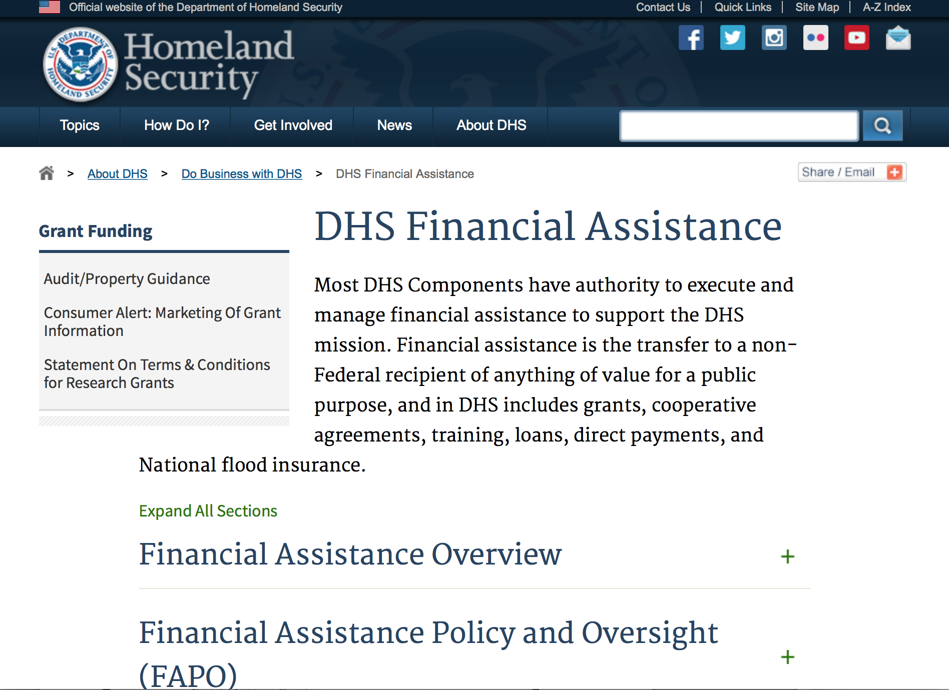
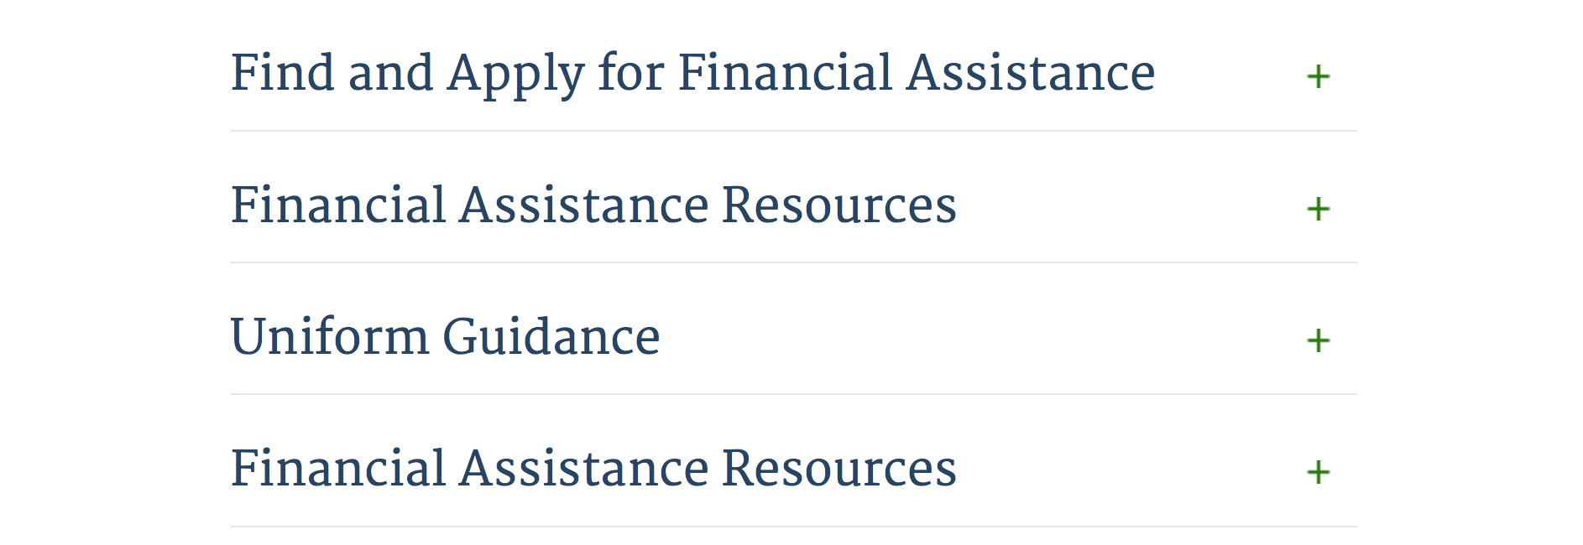

Webpage can be viewed at: http://www.dhs.gov/xopnbiz/grants/index.shtm#2

Information about 2016 for reference only
The FY 2016 Assistance to Firefighters Grants (AFG)
FY 2016 ASSISTANCE TO FIREFIGHTERS (AFG) GRANTS IS CLOSED AT THIS TIME
- FY 2016 Application Workshop Schedule
- FY 2016 AFG Application Guidance Materials The following documents are now available:
  - FY 2016 Notice of Funding Opportunity (NOFO) – Available Now
  - FY 2016 AFG Grant Application Get Ready Guide
  - FY 2016 AFG Narrative Get Ready Guide
  - FY 2016 AFG Self-Evaluation - Operations and Safety
  - FY 2016 AFG Self-Evaluation - Vehicle Acquisition
  - FY 2016 AFG Application Checklist
  - FY 2016 AFG Cost Share Calculator
FY 2016 AFG FAQs
For AFG program guidance materials, please visit our Documents page.

Resources

AFG Help Desk
Contact the AFG Program Help Desk toll-free at 866-274-0960, or email us at firegrants@dhs.gov.
The AFG Program has Fire Program Specialists in 10 federal regional centers. These Regional Fire Program Specialists respond to questions about the AFG program and carry out grant monitoring activities. View regional contacts

Popular AFG links
- AFG Workshop Schedule
- Assistance to Firefighters Grants (AFG)
- AFG Awards List
- AFG Success Stories
- Staffing for Adequate Fire & Emergency Response (SAFER) Grants (SAFER)
- SAFER Awards List
- SAFER Success Stories
- Fire Prevention & Safety (FP&S) Grants
- FP&S Awards List
- FP&S Success Stories
- Grant Closeout Tutorial
- Assistance to Firefighters Grant (AFG) Email Alert Archive
- Frequently Asked Questions
Contact Information For The Assistance to Firefighters Grant (AFG) Program and Help Desk

Federal Funding Alternative To AFG

State Administrative Agencies (SAA) apply for and administer Federal grants on behalf of their States, including FEMA Preparedness Grants. The SAA will work with eligible organizations to comply with the general requirements of grant programs or cooperative agreements. Contact your State’s SAA to find out what current Federal funding opportunities may be available to your organization. A listing of the SAAs and points of contact can be found at http://www.fema.gov/library/viewRecord.do?id=6363.

Programs:

FEMA
FY 2017 Assistance to Firefighters Grants
Synopsis 1
Document Type: | Grants Notice
Funding Opportunity Number: | DHS-17-GPD-044-00-99
Funding Opportunity Title: | FY 2017 Assistance to Firefighters Grants
Opportunity Category: | Discretionary
Opportunity Category Explanation:
Funding Instrument Type: | Grant
Category of Funding Activity: | Other (see text field entitled "Explanation of Other Category of Funding Activity" for clarification)
Category Explanation: | Firefighting equipment, training, and wellness.
Expected Number of Awards: | 2500
CFDA Number(s): | 97.044 -- Assistance to Firefighters Grant
Cost Sharing or Matching Requirement: | Yes
Version: | Synopsis 1
Posted Date: | Dec 19, 2017
Last Updated Date: | Dec 19, 2017
Original Closing Date for Applications: | Feb 02, 2018
Current Closing Date for Applications: | Feb 02, 2018
Archive Date: | Mar 04, 2018
Estimated Total Program Funding: | $310,500,000
Award Ceiling: | $9,000,000
Award Floor: | $0
Eligible Applicants: | Others (see text field entitled "Additional Information on Eligibility" for clarification)  Native American tribal governments (Federally recognized)  City or township governments  Public and State controlled institutions of higher education  County governments  Nonprofits having a 501(c)(3) status with the IRS, other than institutions of higher education
Additional Information on Eligibility: | Fire Departments, State Fire Training Academies, Non-Affiliated Emergency Medical Services
Agency Name: | Department of Homeland Security - FEMA
Description: | The Department of Homeland Security (DHS) Federal Emergency Management Agency's (FEMA) Grants Programs Directorate is responsible for the implementation and administrations of the Assistance to Firefighters Grant (AFG) Program. The purpose of the AFG Program is to enhance the safety of the public and firefighters with respect to fire and fire-related hazards. The program guidance document provides potential applicants with the details of the requirements, processing, and evaluation of an application for financial assistance for eligible activities.
Link to Additional Information: | www.fema.gov/firegrants
Grantor Contact Information: | If you have difficulty accessing the full announcement electronically, please contact:  AFG Help Desk 1-866-274-0960 firegrants@dhs.gov  AFG Help Desk
https://www.grants.gov/web/grants/view-opportunity.html?oppId=299534

Modifications:

Reminders:

Department of Housing and Urban Development

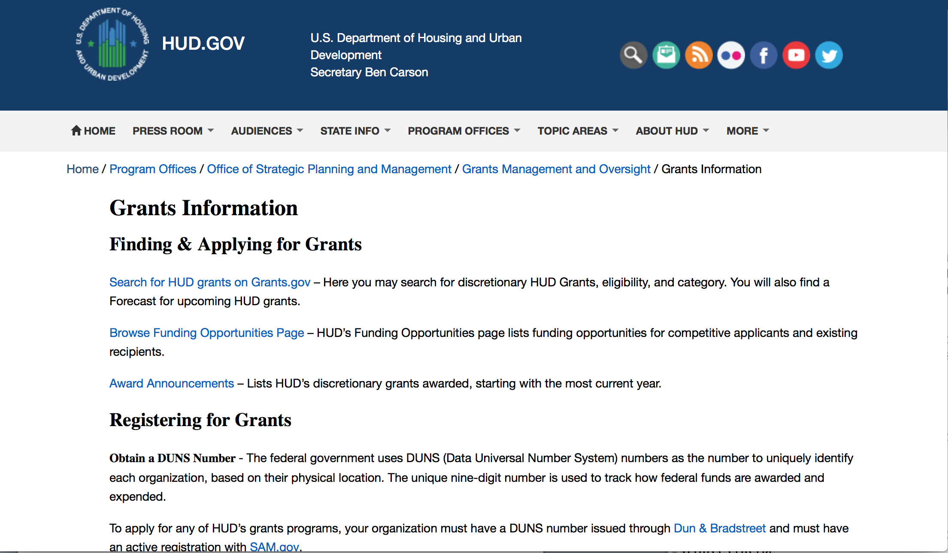
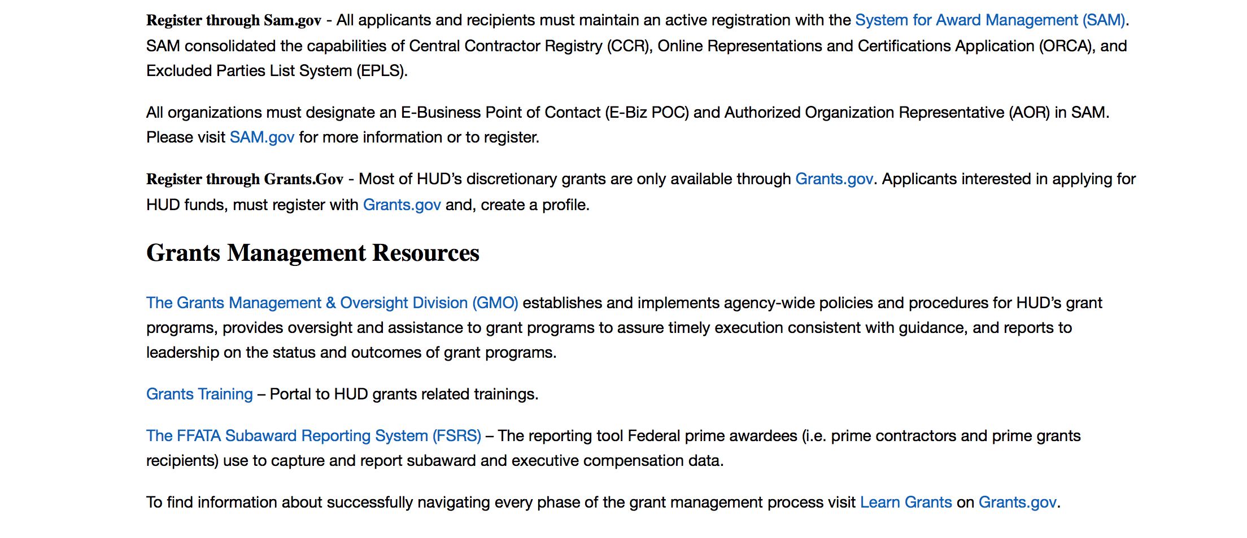
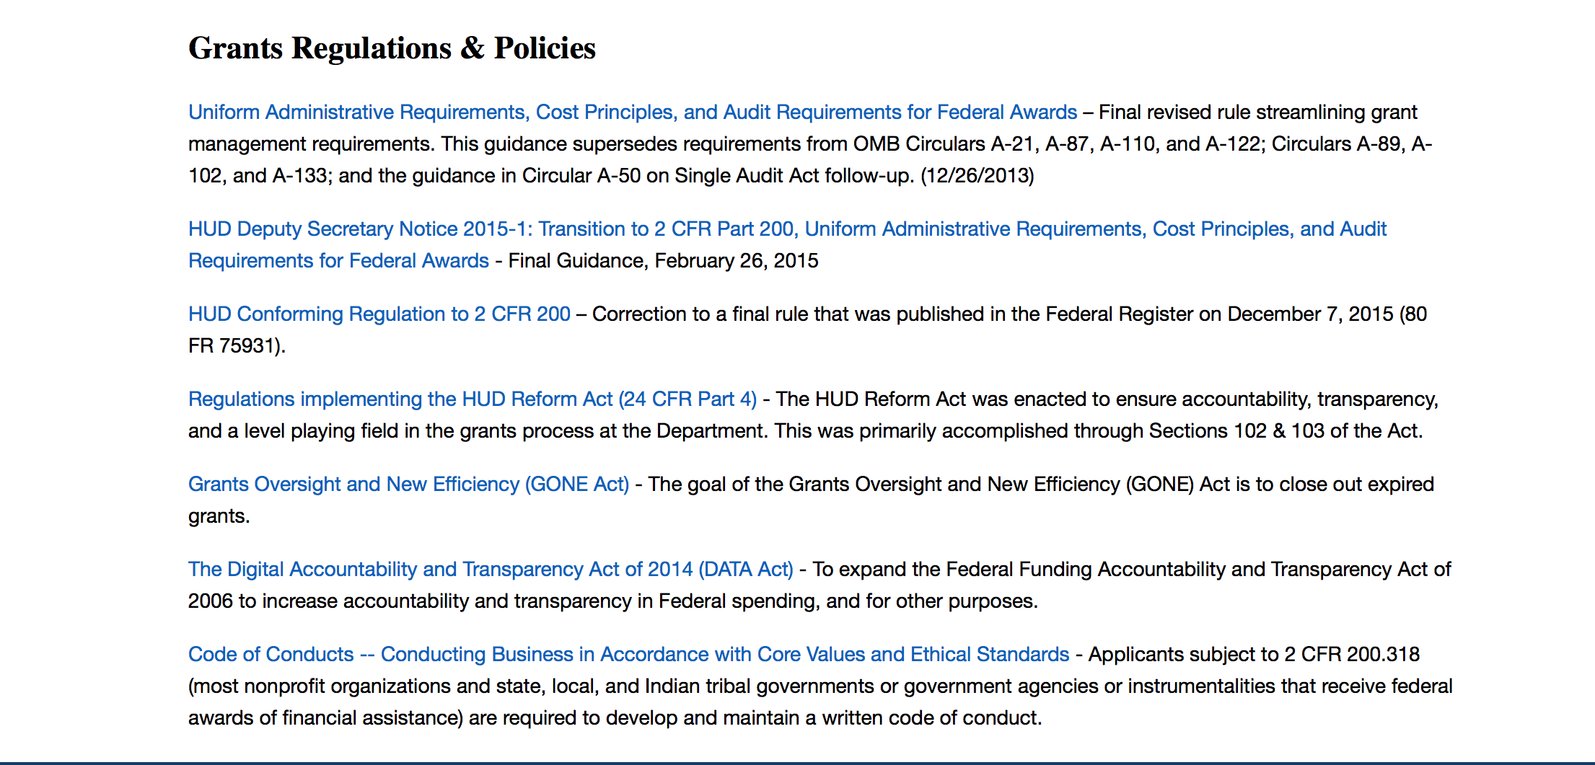

http://portal.hud.gov/hudportal/HUD?src=/topics/grants

HUD - Notice of Funds Available
For detailed information click here

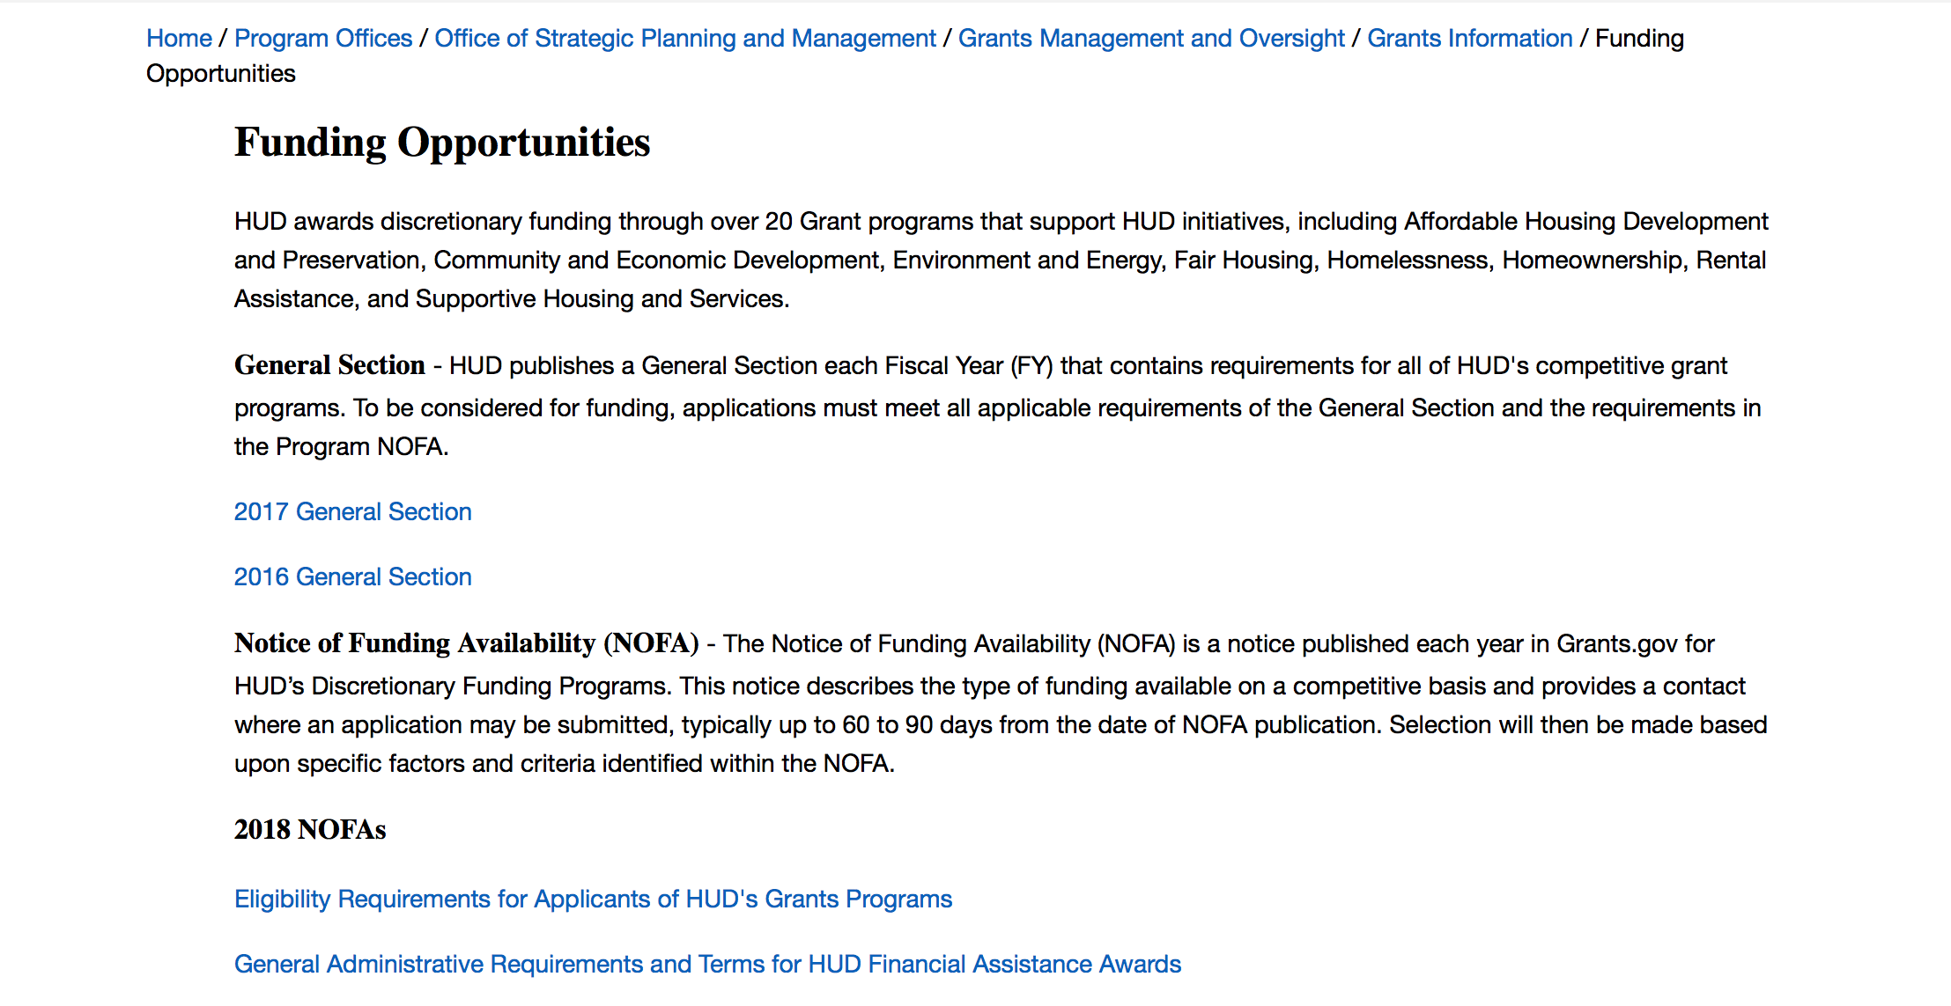

http://portal.hud.gov/hudportal/HUD?src=/program_offices/administration/grants/fundsavail

HUD NOFA FORECAST
The Department of Housing and Urban Development NOFA Forecast lists competitive grant opportunities that may be available for FY2016. The inclusion or exclusion of an opportunity in this list does not constitute a guarantee that a specific opportunity will become available or not be available. Forecast opportunities are subject to change based on enactment of Congressional appropriations and other considerations.
When funding is available, HUD will issue a Notice of Funding Availability (NOFA), which will be available on Grants.gov

Programs:

Modifications:

Deleted:

Reminders:

Self-Help Homeownership Opportunity Program (SHOP)
Synopsis 1

Document Type: | Grants Notice
Funding Opportunity Number: | FR-6100-N-19
Funding Opportunity Title: | Self-Help Homeownership Opportunity Program (SHOP)
Opportunity Category: | Discretionary
Opportunity Category Explanation:
Funding Instrument Type: | Grant
Category of Funding Activity: | Housing
Category Explanation:
Expected Number of Awards: | 4
CFDA Number(s): | 14.247 -- Self-Help Homeownership Opportunity Program
Cost Sharing or Matching Requirement: | Yes
Version: | Synopsis 1
Posted Date: | Oct 25, 2017
Last Updated Date: | Oct 25, 2017
Original Closing Date for Applications: | Jan 25, 2018 Electronically submitted applications must be submitted no later than 11:59 p.m., ET, on the listed application due date.
Current Closing Date for Applications: | Jan 25, 2018 Electronically submitted applications must be submitted no later than 11:59 p.m., ET, on the listed application due date.
Archive Date: | Feb 24, 2018
Estimated Total Program Funding: | $10,000,000
Award Ceiling: | $10,000,000
Award Floor: | $450,000
Eligible Applicants: | Nonprofits having a 501(c)(3) status with the IRS, other than institutions of higher education
Additional Information on Eligibility: | Eligible applicants include public or private non-profit organizations, or a consortium of public or private non-profit organizations, that have the capacity and experience to provide or facilitate self-help homeownership opportunities on a national or regional basis. Grantees must directly undertake eligible SHOP activities and/or enter into a written agreement with one or more non-profit affiliate organizations to carry out eligible SHOP activities. Individuals, foreign entities, and sole proprietorship organizations are not eligible to compete for, or receive, awards made under this announcement.
Agency Name: | Department of Housing and Urban Development
Description: | This SHOP NOFA announces the availability of $10,000,000 in FY2017 SHOP Grant funds to be awarded to national and regional non-profit organizations and consortia to facilitate and encourage innovative homeownership opportunities on a national, geographically diverse basis through the provision of self-help homeownership housing programs. Applicants must propose to use a significant amount of SHOP Grant funds in at least two states. Individuals are not eligible to apply for SHOP Grant funds. SHOP Grant funds must be used for land acquisition, infrastructure improvements, and for reasonable and necessary planning, administration and management costs (not to exceed 20 percent). The construction or rehabilitation costs of each SHOP unit must be funded with other leveraged public and private funds. The average SHOP Grant expenditure for the combined costs of land acquisition and infrastructure improvements must not exceed $15,000 per SHOP unit. SHOP units must be decent, safe, and sanitary non-luxury dwellings that comply with state and local codes, ordinances, and zoning requirements, and with all other SHOP requirements, including but not limited to, the requirements for energy-efficiency, water conservation and accessibility). The SHOP units must be sold to homebuyers at prices below the prevailing market price. Homebuyers must be low-income and must contribute a significant amount of sweat equity towards the development of the SHOP units. A homebuyer's sweat equity contribution must not be mortgaged or otherwise restricted upon future sale of the SHOP unit. Volunteer labor is also required SHOP Grantees may award SHOP Grant funds to local non-profit affiliate organizations to carry out the Grantee's SHOP program. These affiliate organizations must be located within the Grantee's service area.
Link to Additional Information: | https://hud.gov/program_offices/spm/gmomgmt/grantsinfo/fundingopps
Grantor Contact Information: | If you have difficulty accessing the full announcement electronically, please contact:  Thann Young Thann.Young@hud.gov  Grants Policy

http://www.grants.gov/web/grants/view-opportunity.html?oppId=298120

Institute of Museum and Library Services

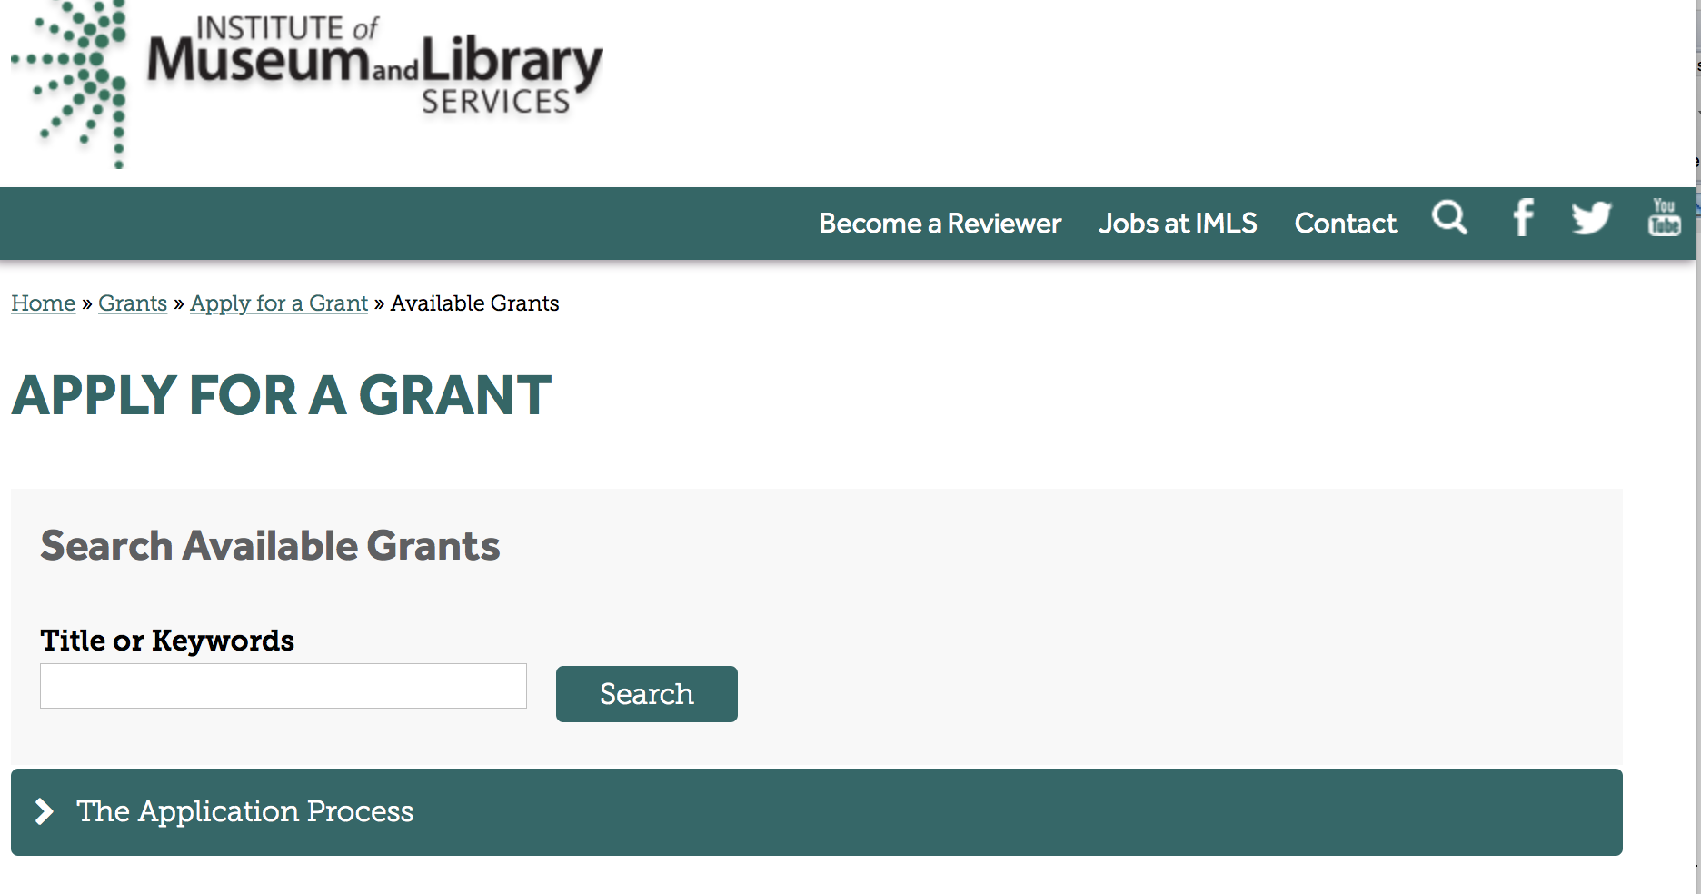

https://www.imls.gov/grants/apply-grant/available-grants

Each grant program has specific eligibility requirements. The links below provide general eligibility criteria for museums, libraries, and tribal organizations, but please note that additional organizations may be eligible for grants under certain programs. Additionally, ineligible organizations may still be able to participate in grant programs through partnerships with eligible organizations. Please click on the links below to see general criteria and review Applications and Guidelines for specific information.
Museums Libraries

Institutions: Archives, Federally Recognized Native American Tribe, Historical Society, Library, Nonprofits that serve Native Hawaiians, Professional Association, Public or Private Non-profit Institutions of Higher Education, Regional Organization, State Library Administrative Agency, State or Local Government

Check out IMLS's Facebook page at:
https://www.facebook.com/USIMLS/

Programs:

Museums Empowered: Professional Development Opportunities for Museum Staff - A Museums for America Special Initiative
Synopsis 1

Document Type: | Grants Notice
Funding Opportunity Number: | ME-FY18
Funding Opportunity Title: | Museums Empowered: Professional Development Opportunities for Museum Staff - A Museums for America Special Initiative
Opportunity Category: | Discretionary
Opportunity Category Explanation:
Funding Instrument Type: | Grant
Category of Funding Activity: | Arts (see "Cultural Affairs" in CFDA)  Humanities (see "Cultural Affairs" in CFDA)
Category Explanation:
Expected Number of Awards: | 28
CFDA Number(s): | 45.301 -- Museums for America
Cost Sharing or Matching Requirement: | Yes
Version: | Synopsis 1
Posted Date: | Dec 08, 2017
Last Updated Date: | Dec 08, 2017
Original Closing Date for Applications: | Mar 01, 2018
Current Closing Date for Applications: | Mar 01, 2018
Archive Date: | Mar 31, 2018
Estimated Total Program Funding: | $2,000,000
Award Ceiling: | $250,000
Award Floor: | $5,000
Eligible Applicants: | Others (see text field entitled "Additional Information on Eligibility" for clarification)
Additional Information on Eligibility: | See Notice of Funding Opportunity for additional information on eligibility.
Agency Name: | Institute of Museum and Library Services
Description: | The goal of the Museums for America (MFA) program is to support projects that strengthen the ability of an individual museum to serve its public. Museums Empowered: Professional Development Opportunities for Museum Staff is a special MFA initiative with the goal of strengthening the ability of an individual museum to serve its public through professional development activities that cross-cut various departments to generate systemic change within the museum.
Link to Additional Information: | https://www.imls.gov/grants/available/museums-empowered-professional-development-opportunities-museum-staff
Grantor Contact Information: | If you have difficulty accessing the full announcement electronically, please contact:  Mark Isaksen Senior Program Officer misaksen@imls.gov 202-653-4667 Jill Connors-Joyner Museum Program Specialist jconnors-joyner@imls.gov 202-653-4791  Mark Isaksen, Senior Program Officer
https://www.grants.gov/web/grants/view-opportunity.html?oppId=299334

Modifications:

Reminders:

National Leadership Grants for Libraries
Synopsis 1
Document Type: | Grants Notice
Funding Opportunity Number: | NLG-LIBRARIES-FY18-2
Funding Opportunity Title: | National Leadership Grants for Libraries
Opportunity Category: | Discretionary
Opportunity Category Explanation:
Funding Instrument Type: | Grant
Category of Funding Activity: | Arts (see "Cultural Affairs" in CFDA)  Humanities (see "Cultural Affairs" in CFDA)
Category Explanation:
Expected Number of Awards: | 12
CFDA Number(s): | 45.312 -- National Leadership Grants
Cost Sharing or Matching Requirement: | Yes
Version: | Synopsis 1
Posted Date: | Nov 29, 2017
Last Updated Date: | Nov 29, 2017
Original Closing Date for Applications: | Jun 08, 2018
Current Closing Date for Applications: | Jun 08, 2018
Archive Date: | Jul 08, 2018
Estimated Total Program Funding: | $5,700,000
Award Ceiling: | $2,000,000
Award Floor: | $25,000
Eligible Applicants: | Others (see text field entitled "Additional Information on Eligibility" for clarification)
Additional Information on Eligibility: | Please see Notice of Funding Opportunity for eligibility specifics.
Agency Name: | Institute of Museum and Library Services
Description: | National Leadership Grants for Libraries (NLG-L) support projects that address significant challenges and opportunities facing the library and archives fields and that have the potential to advance theory and practice. Successful proposals will generate results such as new tools, research findings, models, services, practices, or alliances that will be widely used, adapted, scaled, or replicated to extend the benefits of federal investment. We have two FY18 NLG-L funding opportunities, each with two separate deadlines. In addition to the opportunity described in this Notice of Funding Opportunity, a separate NLG-L funding opportunity was announced in July 2017 with a preliminary proposal application submission due date in September 2017. Both opportunities are subject to the availability of funds and IMLS discretion and procedures.
Link to Additional Information: | https://www.imls.gov/grants/available/national-leadership-grants-libraries
Grantor Contact Information: | If you have difficulty accessing the full announcement electronically, please contact:  Tim Carrigan, Senior Program Officer 202-653-4639 tcarrigan@imls.gov Sarah Fuller, Senior Program Officer 202-653-4783 sfuller@imls.gov James Neal, Senior Program Officer 202-653-4740 jneal@imls.gov Emily Reynolds, Senior Program Officer 202-635-4665 ereynolds@imls.gov Ashley Sands, PhD, Senior Program Officer 202-653-4730 asands@imls.gov Sandra Toro, PhD, Senior Program Officer 202-653-4662 storo@imls.gov  Emily Reynolds, Senior Program Officer
https://www.grants.gov/web/grants/view-opportunity.html?oppId=299122

Deleted:

Department of the Interior
Working with Interior

The Interior Department provides assistance to the public, local governments and businesses through a number of programs. For a general overview see: http://www.doi.gov/index.cfm

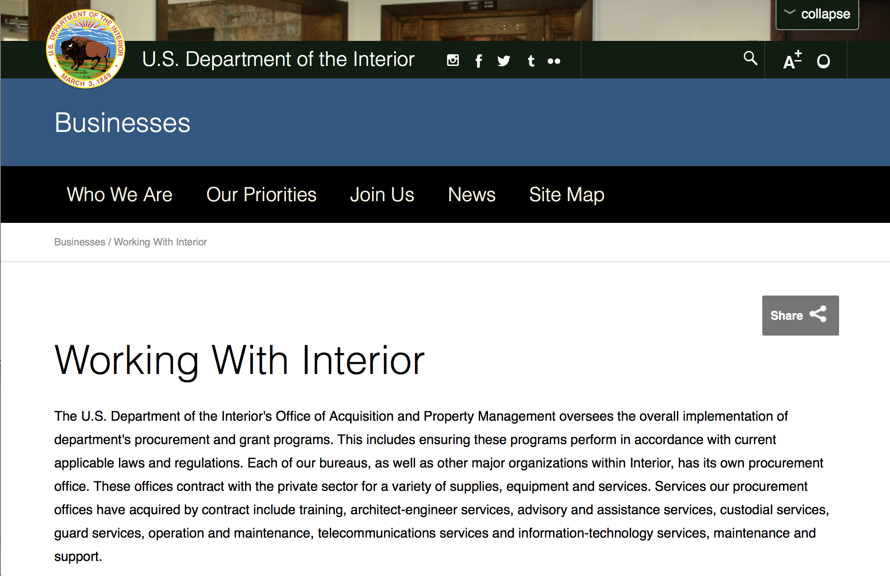

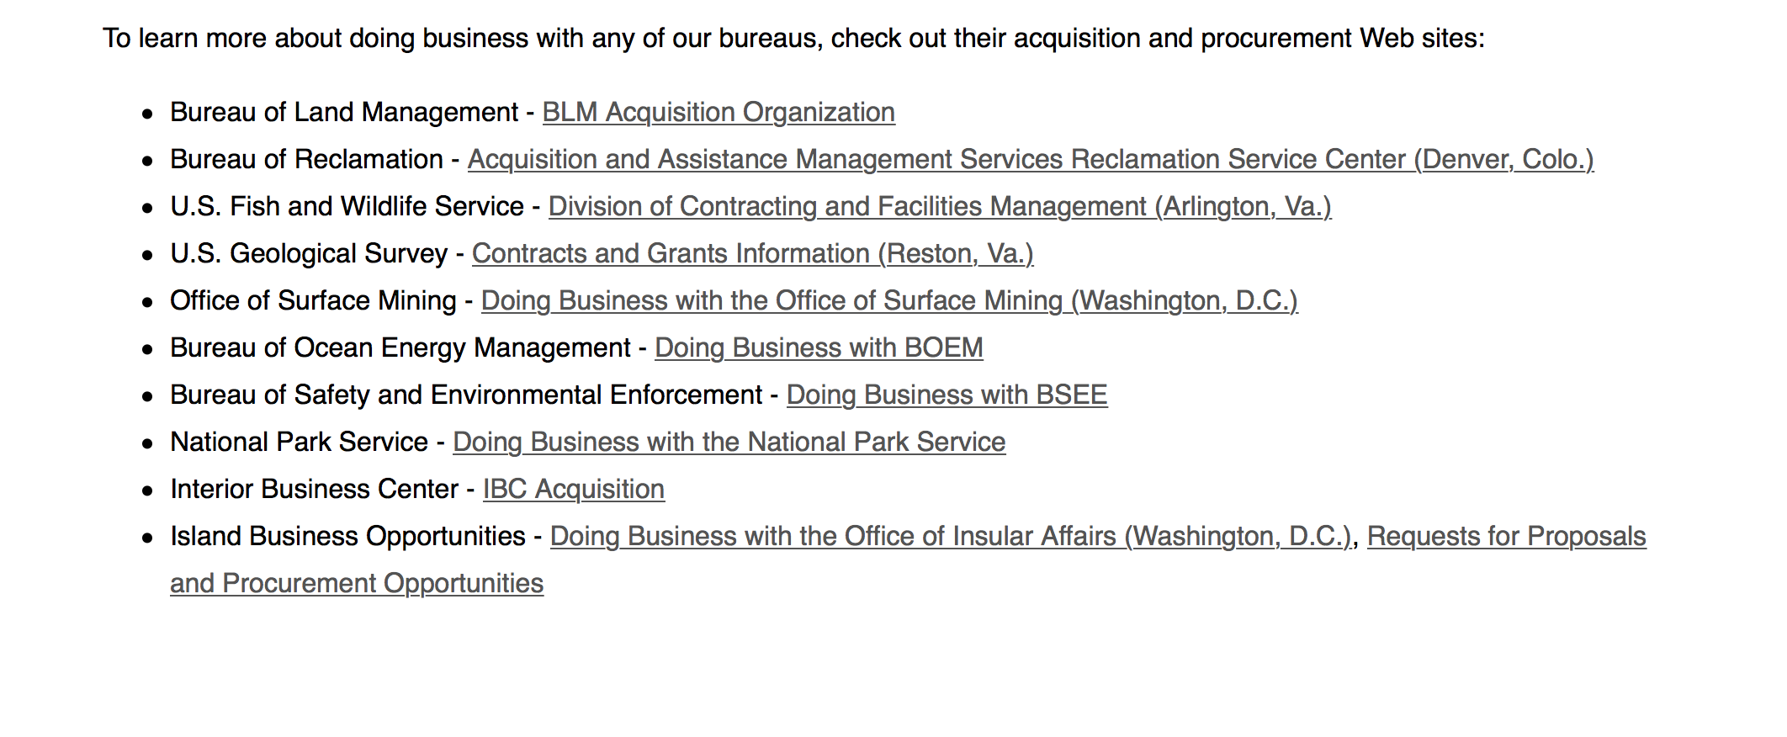
http://www.doi.gov/businesses/working-with-interior.cfm

Programs:

National Park Service
Save America's Treasures - Preservation (Construction) Projects
Synopsis 1
Document Type: | Grants Notice
Funding Opportunity Number: | P18AS00044
Funding Opportunity Title: | Save America's Treasures - Preservation (Construction) Projects
Opportunity Category: | Discretionary
Opportunity Category Explanation:
Funding Instrument Type: | Grant
Category of Funding Activity: | Humanities (see "Cultural Affairs" in CFDA)  Other (see text field entitled "Explanation of Other Category of Funding Activity" for clarification)
Category Explanation: | Historic Preservation Cultural Preservation
Expected Number of Awards: | 7
CFDA Number(s): | 15.904 -- Historic Preservation Fund Grants-In-Aid
Cost Sharing or Matching Requirement: | Yes
Version: | Synopsis 1
Posted Date: | Dec 20, 2017
Last Updated Date: | Dec 20, 2017
Original Closing Date for Applications: | Feb 21, 2018
Current Closing Date for Applications: | Feb 21, 2018
Archive Date: | Dec 28, 2018
Estimated Total Program Funding: | $4,800,000
Award Ceiling: | $500,000
Award Floor: | $125,000
Eligible Applicants: | Nonprofits that do not have a 501(c)(3) status with the IRS, other than institutions of higher education  City or township governments  Others (see text field entitled "Additional Information on Eligibility" for clarification)  Private institutions of higher education  Nonprofits having a 501(c)(3) status with the IRS, other than institutions of higher education  County governments  Native American tribal governments (Federally recognized)  State governments  Public and State controlled institutions of higher education
Additional Information on Eligibility: | Federal agencies funded by the Department of the Interior and Related Agencies Appropriations Act with the exception of the National Park Service
Agency Name: | National Park Service
Description: | Save America's Treasures grants from the Historic Preservation Fund provide preservation assistance to nationally significant historic properties. Grants are awarded through a competitive process and require a dollar-for-dollar, non-Federal match, which can be cash or documented in-kind. The grants are administered by the National Park Service (NPS) in partnership with the National Endowment for the Arts (NEA), the National Endowment for the Humanities (NEH), and the Institute of Museum and Library Services (IMLS).
Link to Additional Information: | https://www.nps.gov/preservation-grants/sat/index.html
Grantor Contact Information: | If you have difficulty accessing the full announcement electronically, please contact:  Chief, State, Tribal, Local Plans and Grants Megan Brown 202 354 2020 Preservation_Grants_Info@nps.gov  STLPG Grants Email Inbox

https://www.grants.gov/web/grants/view-opportunity.html?oppId=299560

National Park Service
Save America's Treasures - Collections
Synopsis 1
Document Type: | Grants Notice
Funding Opportunity Number: | P18AS00045
Funding Opportunity Title: | Save America's Treasures - Collections
Opportunity Category: | Discretionary
Opportunity Category Explanation:
Funding Instrument Type: | Grant
Category of Funding Activity: | Humanities (see "Cultural Affairs" in CFDA)  Other (see text field entitled "Explanation of Other Category of Funding Activity" for clarification)
Category Explanation: | Historic Preservation Cultural Preservation
Expected Number of Awards: | 9
CFDA Number(s): | 15.904 -- Historic Preservation Fund Grants-In-Aid
Cost Sharing or Matching Requirement: | Yes
Version: | Synopsis 1
Posted Date: | Dec 20, 2017
Last Updated Date: | Dec 20, 2017
Original Closing Date for Applications: | Feb 21, 2018
Current Closing Date for Applications: | Feb 21, 2018
Archive Date: | Dec 27, 2018
Estimated Total Program Funding: | $4,800,000
Award Ceiling: | $500,000
Award Floor: | $25,000
Eligible Applicants: | City or township governments  Nonprofits that do not have a 501(c)(3) status with the IRS, other than institutions of higher education  Nonprofits having a 501(c)(3) status with the IRS, other than institutions of higher education  State governments  Public and State controlled institutions of higher education  County governments  Others (see text field entitled "Additional Information on Eligibility" for clarification)  Private institutions of higher education  Native American tribal governments (Federally recognized)  Independent school districts
Additional Information on Eligibility: | Federal agencies funded by the Department of the Interior and Related Agencies Appropriations Act, with the exception of the National Park Service (NPS).
Agency Name: | National Park Service
Description: | Save America's Treasures grants from the Historic Preservation Fund provide preservation and/or conservation assistance to nationally significant historic collections. Grants are awarded through a competitive process and require a dollar-for-dollar, non-Federal match, which can be cash or documented in-kind. The grants are administered by the National Park Service (NPS) in partnership with the National Endowment for the Arts (NEA), the National Endowment for the Humanities (NEH), and the Institute of Museum and Library Services (IMLS).
Link to Additional Information: | https://www.nps.gov/preservation-grants/sat/index.htmlhttps://www.nps.gov/preservation-grants/sat/index.html
Grantor Contact Information: | If you have difficulty accessing the full announcement electronically, please contact:  Chief, State, Tribal, Local Plans and Grants Megan Brown 202 354 2020 Preservation_Grants_Info@nps.gov  STLPG Grants Email Inbox
https://www.grants.gov/web/grants/view-opportunity.html?oppId=299562

Modifications:

Reminders:

National Park Service
FY 18 American Battlefield Protection Program Battlefield Preservation Planning Project Grants
Synopsis 1
Document Type: | Grants Notice
Funding Opportunity Number: | P18AS00003
Funding Opportunity Title: | FY 18 American Battlefield Protection Program Battlefield Preservation Planning Project Grants
Opportunity Category: | Discretionary
Opportunity Category Explanation:
Funding Instrument Type: | Grant
Category of Funding Activity: | Other (see text field entitled "Explanation of Other Category of Funding Activity" for clarification)
Category Explanation: | Battlefield Planning Grant
Expected Number of Awards: | 25
CFDA Number(s): | 15.926 -- American Battlefield Protection
Cost Sharing or Matching Requirement: | No
Version: | Synopsis 1
Posted Date: | Oct 18, 2017
Last Updated Date: | Oct 18, 2017
Original Closing Date for Applications: | Jan 18, 2018 Applications can be submitted through Grants.gov, by mail, or by hand. All applications must be submitted to Grants.gov or be received in the ABPP office by 3:00PM EST on January 18, 2018. Late applications will be discarded without notification.
Current Closing Date for Applications: | Jan 18, 2018 Applications can be submitted through Grants.gov, by mail, or by hand. All applications must be submitted to Grants.gov or be received in the ABPP office by 3:00PM EST on January 18, 2018. Late applications will be discarded without notification.
Archive Date: | Oct 10, 2020
Estimated Total Program Funding: | $0
Award Ceiling: | $100,000
Award Floor: | $5,000
Eligible Applicants: | Nonprofits that do not have a 501(c)(3) status with the IRS, other than institutions of higher education  Public and State controlled institutions of higher education  County governments  State governments  Native American tribal governments (Federally recognized)  City or township governments
Agency Name: | National Park Service
Description: | A. Program Background Information The purpose of this grant program is to provide seed money for projects that lead directly to the identification, preservation, and interpretation of battlefield land or historic sites associated with battlefields. B. Program Objectives The ABPP encourages an interdisciplinary, holistic approach to battlefield preservation. Grant proposals for projects that fit into a larger vision for the site are favored. To maximize effectiveness of battlefield protection efforts, applicant organizations are encouraged to work with partner organizations and Federal, State and local government agencies as early as possible to integrate their efforts into a larger battle site protection strategy. C. Term of the Agreement terms for funded projects is estimated to range between one and two years, depending on the negotiated project scope. Agreements are not effective until fully executed with signature from the NPS Awarding Officer. In most cases an agreement will expire after five years from the effective date, unless terminated earlier in accordance with 2 CFR, Part 200, Sections 200.338 and 200.339.
Link to Additional Information:
Grantor Contact Information: | If you have difficulty accessing the full announcement electronically, please contact:  Historian Philip Bailey (202) 513-7126 Philip_Bailey@nps.gov  Philip_Bailey@nps.gov

http://www.grants.gov/web/grants/view-opportunity.html?oppId=298024

Deleted:

Department of Justice

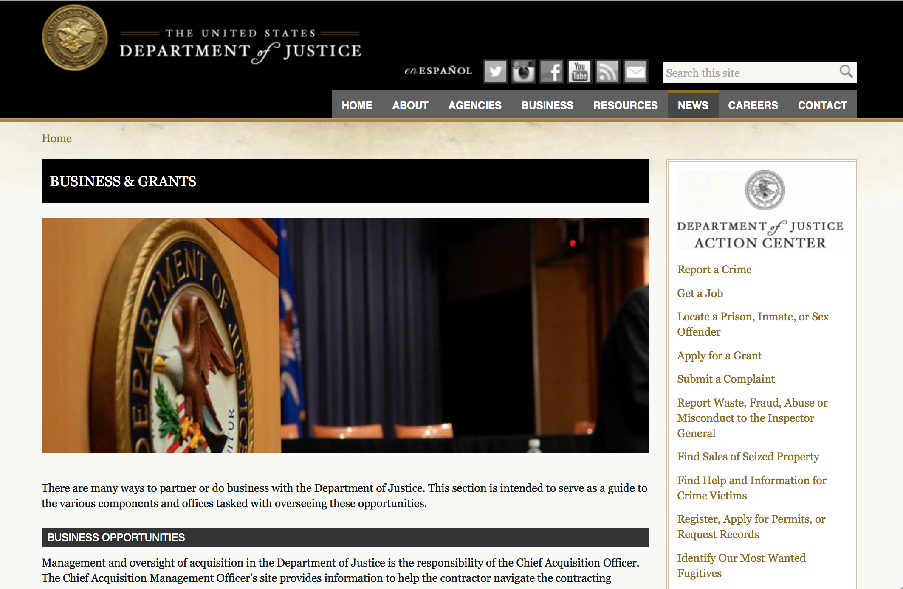

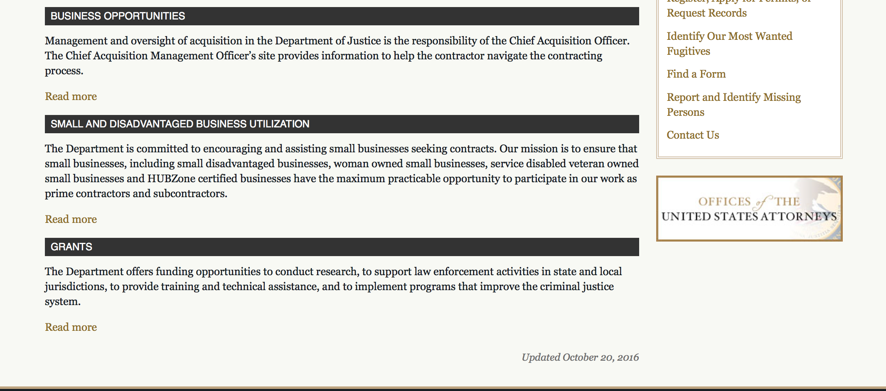

The DOJ agencies listed below also have sites that provide grant information specific to that agency. Examples of what can be found on these sites are programs, funding opportunities, application assistance, and other useful information.

Bureau of Justice Assistance (BJA)

Bureau of Justice Statistics (BJS)

National Criminal Justice Reference Service (NCJRS)

National Institute of Justice (NIJ)

Office of Sex Offender Sentencing, Monitoring, Apprehending, Registering, and Tracking (SMART)

http://www.justice.gov/business/

Programs:

Office on Violence Against Women
OVW FY 2018 Legal Assistance for Victims Grant Program Solicitation
Synopsis 1
Document Type: | Grants Notice
Funding Opportunity Number: | OVW-2018-13828
Funding Opportunity Title: | OVW FY 2018 Legal Assistance for Victims Grant Program Solicitation
Opportunity Category: | Discretionary
Opportunity Category Explanation:
Funding Instrument Type: | Grant
Category of Funding Activity: | Other (see text field entitled "Explanation of Other Category of Funding Activity" for clarification)
Category Explanation: | The Legal Assistance for Victims (LAV) Grant Program supports projects to increase availability of civil and criminal legal assistance needed to effectively aid adult and youth victims of sexual assault, domestic violence, dating violence, and stalking who are seeking relief in legal matters relating to or arising out of that abuse or violence, at minimum or no cost to victims.
Expected Number of Awards: | 55
CFDA Number(s): | 16.524 -- Legal Assistance for Victims
Cost Sharing or Matching Requirement: | No
Version: | Synopsis 1
Posted Date: | Dec 07, 2017
Last Updated Date: | Dec 07, 2017
Original Closing Date for Applications: | Feb 01, 2018
Current Closing Date for Applications: | Feb 01, 2018
Archive Date:
Estimated Total Program Funding: | $34,000,000
Award Ceiling: | $800,000
Award Floor: | $300,000
Eligible Applicants: | Nonprofits having a 501(c)(3) status with the IRS, other than institutions of higher education  Public and State controlled institutions of higher education  Private institutions of higher education  Native American tribal governments (Federally recognized)  Nonprofits that do not have a 501(c)(3) status with the IRS, other than institutions of higher education  Native American tribal organizations (other than Federally recognized tribal governments)
Agency Name: | Office on Violence Against Women
Description: | The Legal Assistance for Victims (LAV) Grant Program is intended to increase the availability of civil and criminal legal assistance needed to effectively aid adult and youth victims of sexual assault, domestic violence, dating violence, and stalking who are seeking relief in legal matters relating to or arising out of that abuse or violence, at minimum or no cost to the victims. LAV Grant Program funds may not be used to provide criminal defense services. Grant funds may be used to provide direct legal services to victims of sexual assault, domestic violence, dating violence, and stalking in matters relating to or arising out of that abuse or violence. The objective of the LAV Grant Program is to develop innovative, collaborative projects that provide quality representation to victims of sexual assault, domestic violence, dating violence, and stalking.
Link to Additional Information: | Full Announcement
Grantor Contact Information: | If you have difficulty accessing the full announcement electronically, please contact:  Shannon R. Maultsby Grant Manager 202-307-6026 OVW.LAV@USDOJ.GOV  OVW.LAV@USDOJ.GOV
https://www.grants.gov/web/grants/view-opportunity.html?oppId=299318

Office on Violence Against Women
OVW FY 2018 Rural Sexual Assault, Domestic Violence, Dating Violence and Stalking Program Solicitation
Synopsis 1
Document Type: | Grants Notice
Funding Opportunity Number: | OVW-2018-13829
Funding Opportunity Title: | OVW FY 2018 Rural Sexual Assault, Domestic Violence, Dating Violence and Stalking Program Solicitation
Opportunity Category: | Discretionary
Opportunity Category Explanation:
Funding Instrument Type: | Grant
Category of Funding Activity: | Housing  Humanities (see "Cultural Affairs" in CFDA)  Law, Justice and Legal Services
Category Explanation:
Expected Number of Awards: | 45
CFDA Number(s): | 16.589 -- Rural Domestic Violence, Dating Violence, Sexual Assault, and Stalking Assistance Program
Cost Sharing or Matching Requirement: | No
Version: | Synopsis 1
Posted Date: | Dec 15, 2017
Last Updated Date: | Dec 15, 2017
Original Closing Date for Applications: | Jan 31, 2018
Current Closing Date for Applications: | Jan 31, 2018
Archive Date:
Estimated Total Program Funding: | $35,000,000
Award Ceiling: | $750,000
Award Floor: | $0
Eligible Applicants: | State governments  Special district governments  Nonprofits having a 501(c)(3) status with the IRS, other than institutions of higher education  Native American tribal governments (Federally recognized)  Native American tribal organizations (other than Federally recognized tribal governments)  County governments  Public and State controlled institutions of higher education  City or township governments
Agency Name: | Office on Violence Against Women
Description: | Victims of sexual assault, domestic violence, dating violence, and stalking in rural communities face unique challenges and barriers to receiving assistance rarely encountered in urban areas. The geographic isolation, transportation barriers, economic structure, particularly strong social and cultural pressures, and lack of available services in rural jurisdictions significantly compound the problems confronted by those seeking support and services to end the violence in their lives. These factors also complicate the ability of the criminal justice system to investigate and prosecute sexual assault, domestic violence, dating violence, and stalking cases. In addition, socio-cultural, economic, and geographic barriers create difficulties for victim services providers to identify and assist victims of these crimes. The United States Department of Justice, Office on Violence Against Women (OVW) (www.ovw.usdoj.gov) is pleased to announce that it is seeking applications for the Fiscal Year 2018 Rural Sexual Assault, Domestic Violence, Dating Violence, and Stalking Assistance Program. This program furthers the Department’s mission by supporting projects designed to address and prevent sexual assault, domestic violence, dating violence, and stalking in rural jurisdictions.
Link to Additional Information: | Full Announcement
Grantor Contact Information: | If you have difficulty accessing the full announcement electronically, please contact:  Charlotte Turpin Grant Program Specialist 202 532-4629 charlotte.turpin@usdoj.gov  charlotte.turpin@usdoj.gov
https://www.grants.gov/web/grants/view-opportunity.html?oppId=299476

Research:

Modifications:

Deleted:

Reminders:

Office on Violence Against Women
OVW FY 2018 Training and Services to End Violence Against Women with Disabilities Grant Program
Synopsis 1
Document Type: | Grants Notice
Funding Opportunity Number: | OVW-2018-13823
Funding Opportunity Title: | OVW FY 2018 Training and Services to End Violence Against Women with Disabilities Grant Program
Opportunity Category: | Discretionary
Opportunity Category Explanation:
Funding Instrument Type: | Cooperative Agreement
Category of Funding Activity: | Education  Other (see text field entitled "Explanation of Other Category of Funding Activity" for clarification)
Category Explanation: | Training; Disability, Deaf, Domestic Violence, Dating Violence, Sexual Violence and Stalking
Expected Number of Awards: | 10
CFDA Number(s): | 16.529 -- Education, Training, and Enhanced Services to End Violence Against and Abuse of Women with Disabilities
Cost Sharing or Matching Requirement: | No
Version: | Synopsis 1
Posted Date: | Nov 20, 2017
Last Updated Date: | Nov 20, 2017
Original Closing Date for Applications: | Jan 26, 2018
Current Closing Date for Applications: | Jan 26, 2018
Archive Date:
Estimated Total Program Funding: | $4,275,000
Award Ceiling: | $500,000
Award Floor: | $325,000
Eligible Applicants: | Nonprofits having a 501(c)(3) status with the IRS, other than institutions of higher education  County governments  State governments  Native American tribal governments (Federally recognized)  Native American tribal organizations (other than Federally recognized tribal governments)
Agency Name: | Office on Violence Against Women
Description: | This program is authorized by 34 U.S.C § 20122. The goal of the Disability Grant Program is to create sustainable change within and between organizations that results in increased capacity to respond to individuals with disabilities and Deaf individuals who are victims of sexual assault, domestic violence, dating violence, and stalking and to hold perpetrators of such crimes accountable. Disability Grant Program funds will be used to establish and strengthen multidisciplinary collaborative relationships; increase organizational capacity to provide accessible, safe, and effective services to individuals with disabilities and Deaf individuals who are victims of violence and abuse; and identify needs within the grantee’s organization and/or service area, and develop a plan to address those identified needs that builds a strong foundation for future work.
Link to Additional Information: | Full announcement
Grantor Contact Information: | If you have difficulty accessing the full announcement electronically, please contact:  Sylvia Pauling Grant Program Specialist 202-514-0748 sylvia.pauling@usdoj.gov  sylvia.pauling@usdoj.gov
https://www.grants.gov/web/grants/view-opportunity.html?oppId=298903



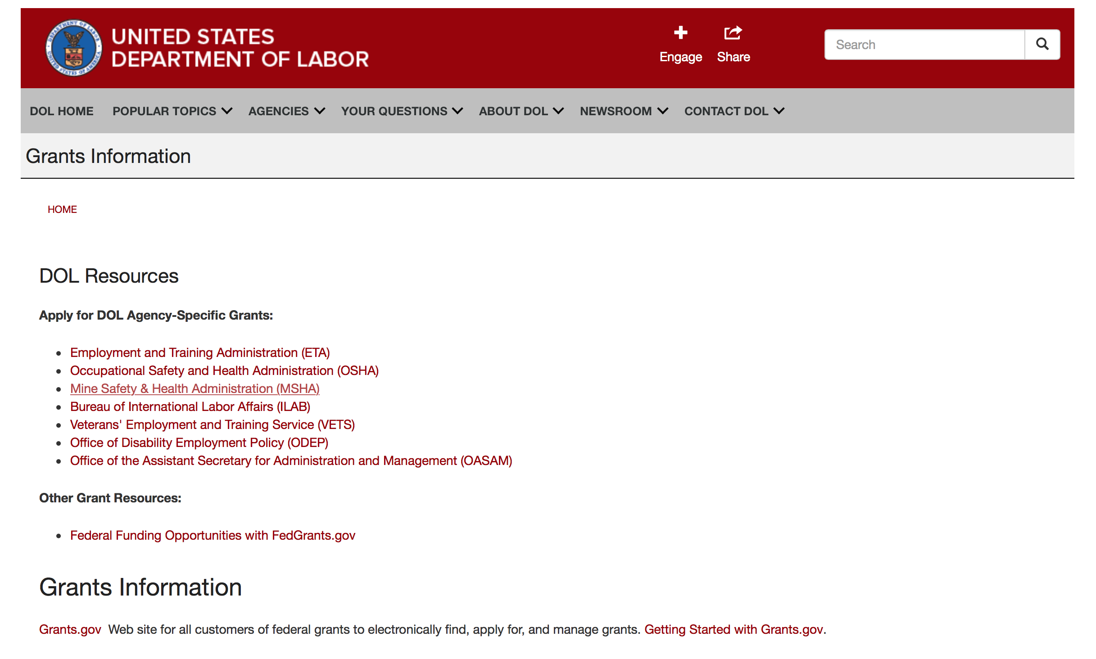

Agency Grants and Contract General Overview

DOL Resources
Apply for DOL Agency-Specific Grants:
- Employment and Training Administration (ETA)
- Occupational Safety and Health Administration (OSHA)
- Mine Safety & Health Administration (MSHA)
- Bureau of International Labor Affairs (ILAB)
- Veterans' Employment and Training Service (VETS)
- Office of Disability Employment Policy (ODEP)
- Office of the Assistant Secretary for Administration and Management (OASAM)

Other Grant Resources:
- Federal Funding Opportunities with FedGrants.gov
Grants Information
Grants.gov — Web site for all customers of federal grants to electronically find, apply for, and manage grants. Getting Started with Grants.gov.

DOL Resources and Instructions for Applying for a Grant
- DOL Guidance Clarifying the Effect of the Religious Freedom Restoration Act on Faith-Based Organizations
- Grant and Contract Information
- Contracting and Grant Program Overview
- Civil Rights Enforcement for Department of Labor Grant Recipients
- More Information About Grants
- Use of Contracts, Grants & Cooperative Agreements

Other Federal Government Grant Information
- Grant Opportunities (Catalog of Federal Domestic Assistance)

Department of Labor Grant Programs

- Bureau of International Labor Affairs (ILAB): provides grants (cooperative agreements) for the implementation of projects designed to assist developing countries combat the worse forms of child labor, forced labor, and human trafficking; and support worker rights and improve working conditions. http://www.dol.gov/general/business.
- Bureau of Labor Statistics (BLS): provides project grants (cooperative agreements) and the dissemination of technical statistical data and related information on labor force activities; provides data on prices (CPI) and cost of living; data on productivity and technology data; data on compensation and working conditions; data on employment projections.
- Employment and Training (ETA): ETA administers financial assistance programs pursuant to the Workforce Investment Act (WIA), administering State formula grant programs for youth, adults and dislocated workers, national emergency grants for workers affected by mass layoffs, plant closures, and disasters; grant programs for workers with disabilities, Indians and Native Americans, and for migrant and seasonal farmworkers. ETA also administers grant programs for older American workers, apprenticeship programs, Trade Adjustment Assistance (TAA) programs, and assistance for research and development of workforce programs. In addition, ETA is responsible for the operation and maintenance of a national system of public employment service offices and for the national unemployment insurance program.
- Mine Safety and Health (MSHA): provides grants for research, education and training programs to ensure an adequate and competent staff of trained inspectors; and assistance for establishing or improving State mine health and safety programs through technical assistance.
- Occupational Safety and Health (OSHA): provides grants to non-profit organizations to provide training, educational services, and technical assistance; assistance to states to administer and enforce state programs; assistance to states to provide occupational safety and health technical assistance and consultant services.
- Office of Disability Employment Policy (ODEP): The Office of Disability Employment Policy awards competitive grants establishing short-term pilot and technical assistance projects designed to identify, develop, test, evaluate, and disseminate policies to increase employment by expanding access to training, education, employment supports, assistive and systems technology, integrated employment, entrepreneurial development, and small business opportunities for adults and youth with disabilities. Current pilots projects focus on customized employment, Olmstead populations, and innovative demonstration youth grants, among others. Solicitations for grant applications are published in the Federal Register and announced at www.dol.gov/odep. ODEP grants are awarded by the OASAM grant office.
- Veterans' Employment and Training (VETS): provides special employment and training assistance for veterans through the Disabled Veterans' Outreach Program (DVOP) Solicitation for Grant Applications; the Local Veterans' Employment Representative Program (LVER); Veterans' Workforce Investment Program (VWIP); elaws Advisor on veterans' employment and reemployment rights; and the Homeless Veterans Reintegration Project (HVRP). VETS grants are awarded by the OASAM grant office.

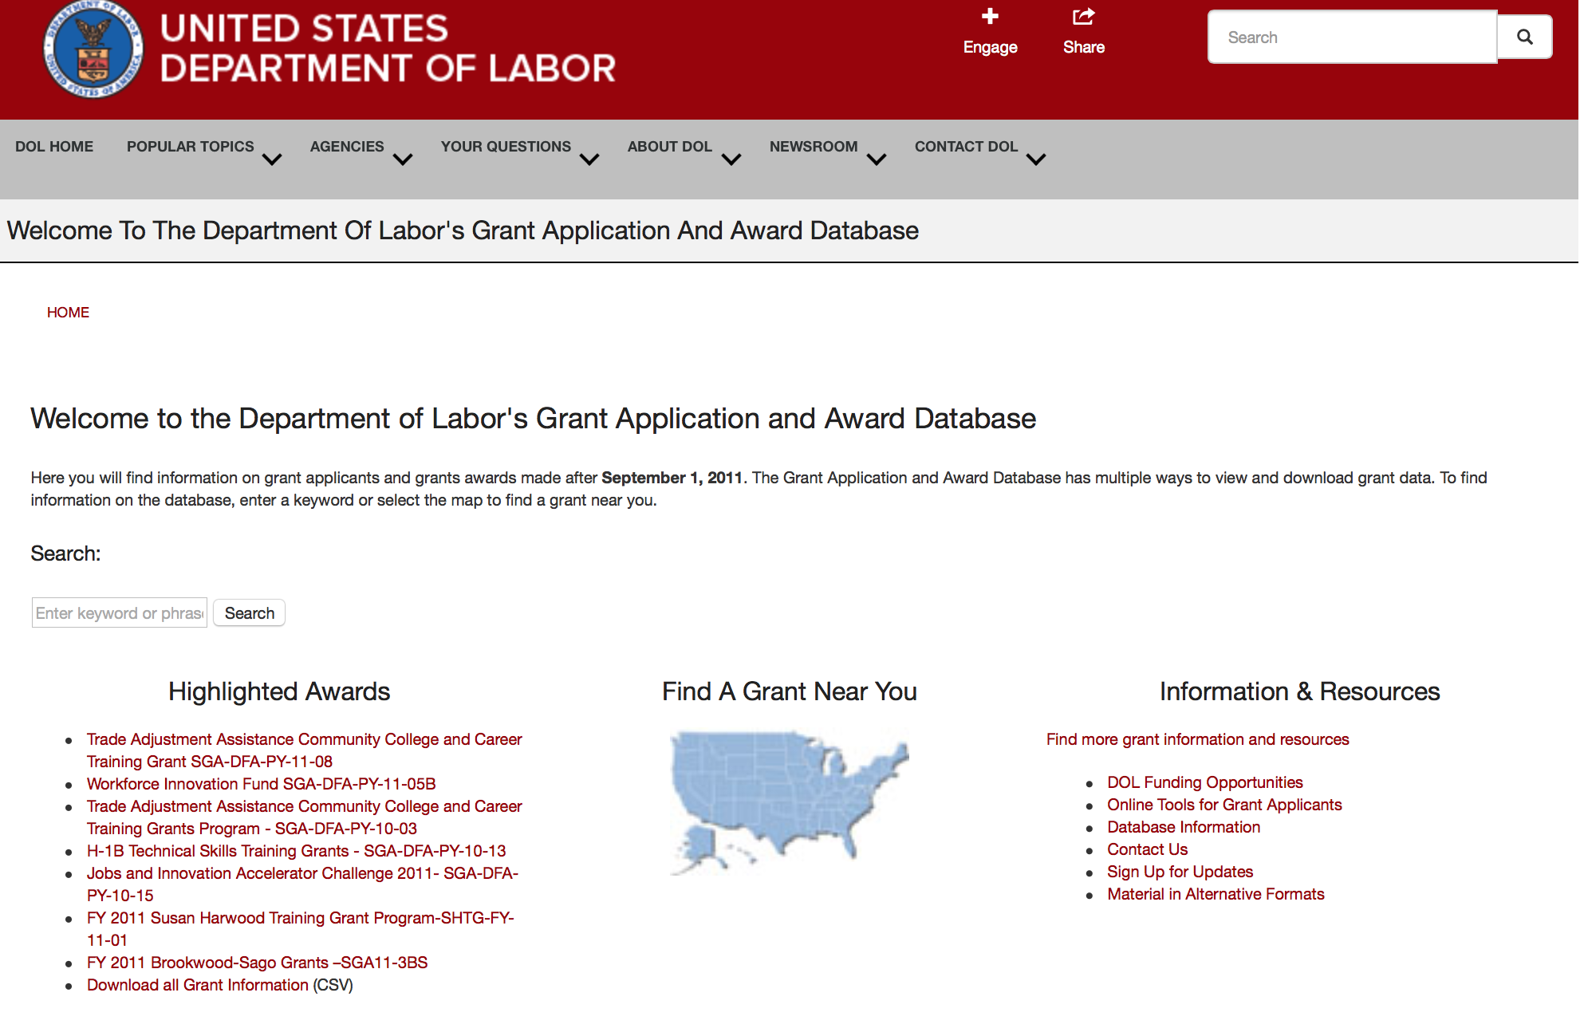

http://www.dol.gov/dol/grants/

Programs

Modifications

Reminders

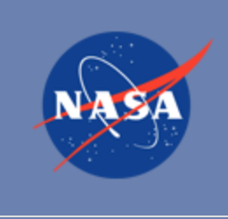

National Aeronautics and Space Administration

Research and Contracting Opportunities

NASA Research Opportunities Online

- Various NASA offices publish their research announcements over the Internet, broadening the opportunity for researchers to apply for funding. This site provides access to current research announcements along with their specific due dates.

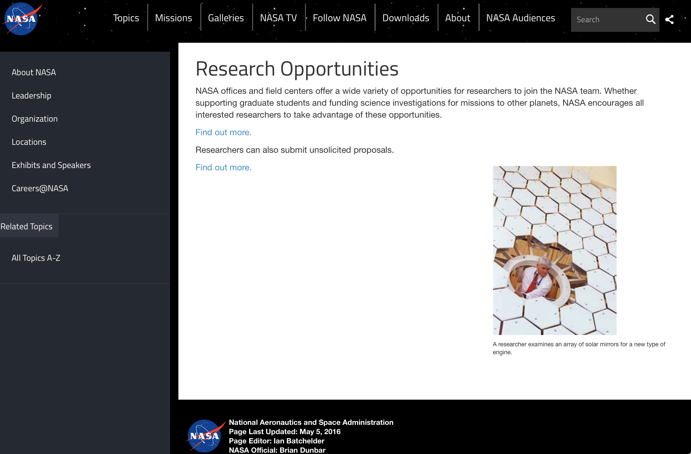

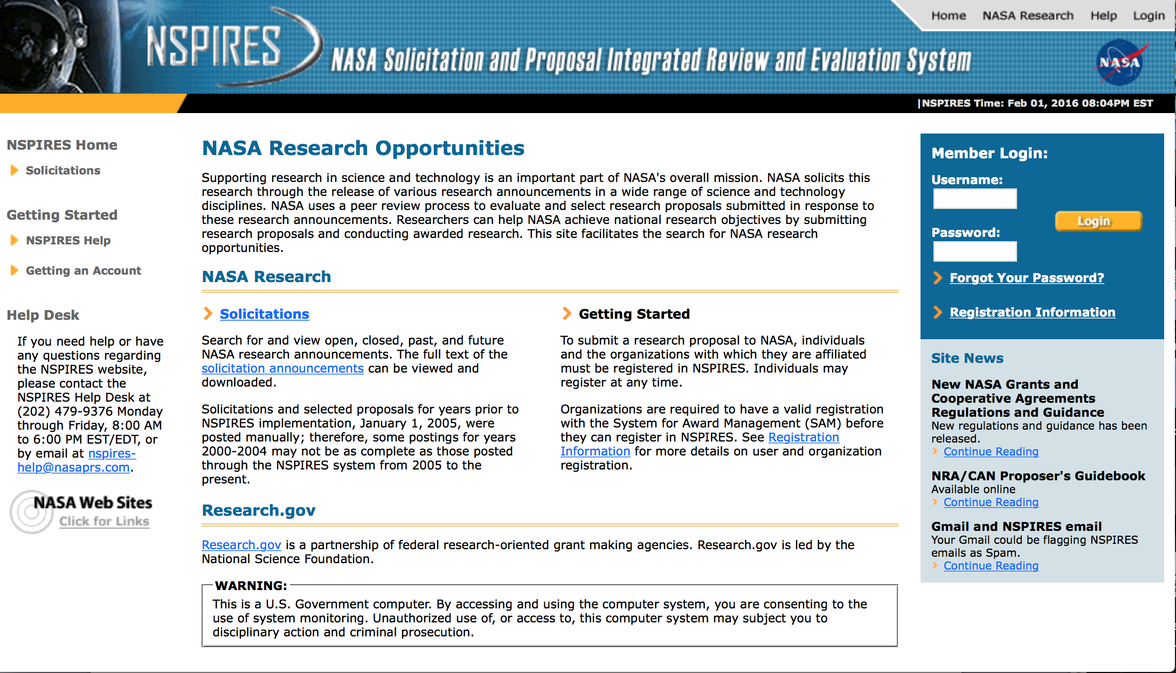
http://nspires.nasaprs.com/external/

Research Programs:

NASA Stennis Space Center
Dual Use Technology Development Cooperative Agreement Notice (CAN) 2018
Synopsis 1
https://www.grants.gov/web/grants/view-opportunity.html?oppId=299298

NASA Headquarters
ROSES 2017: Advancing Collaborative Connections for Earth System Science
Synopsis 1
https://www.grants.gov/web/grants/view-opportunity.html?oppId=299321

Modifications:

National Archives and Records Administration

Grant Opportunities General Overview

To access the information below: click here

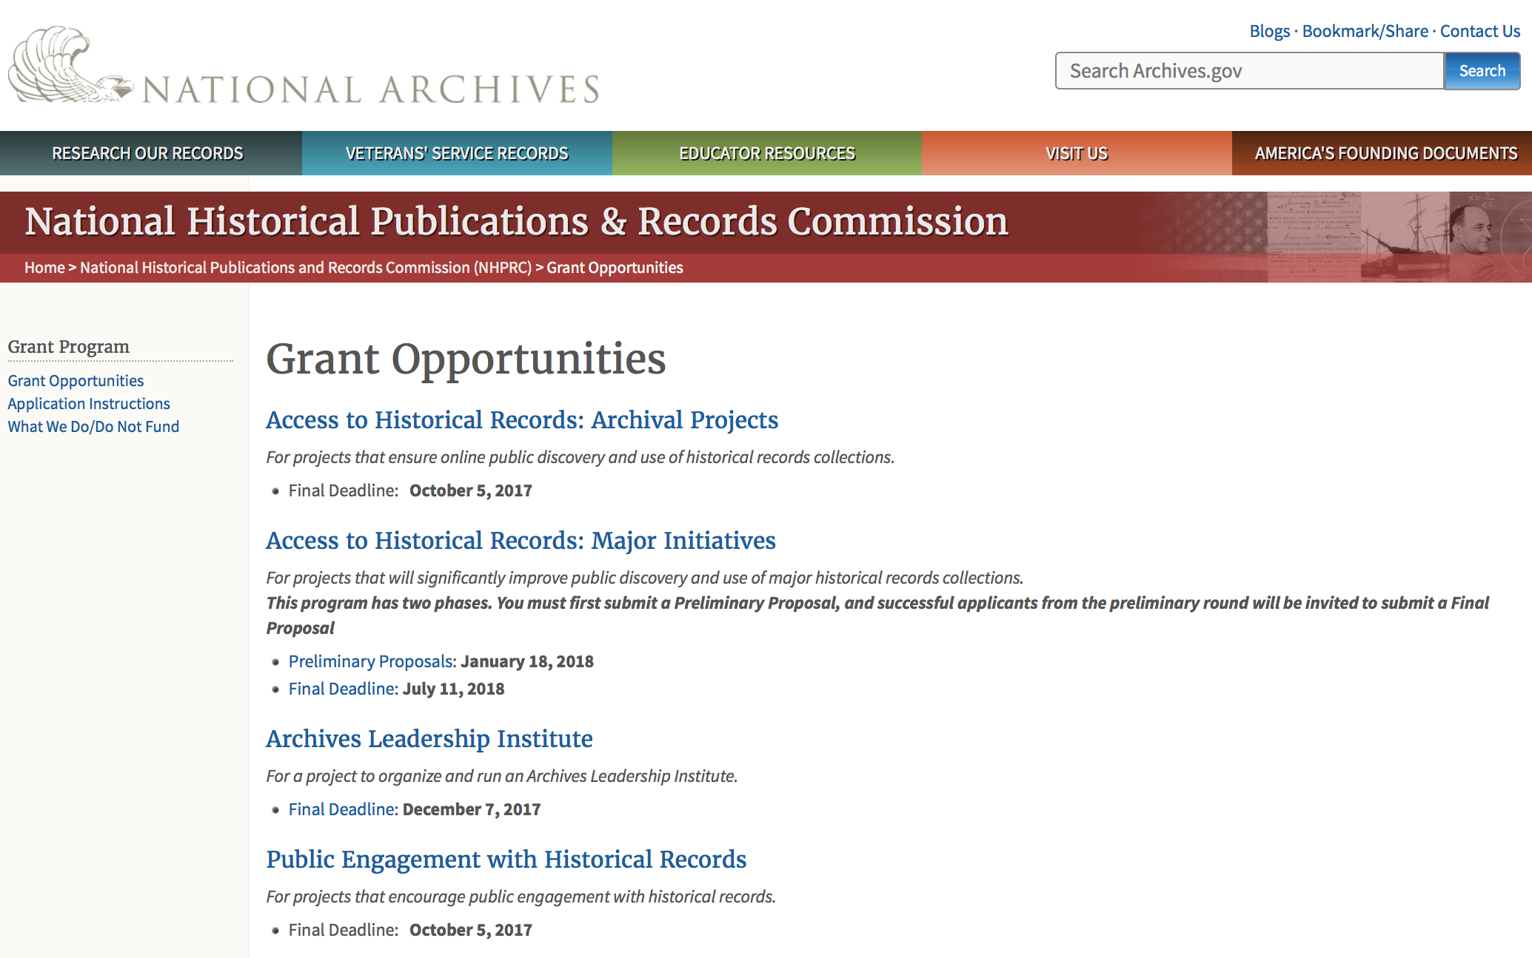

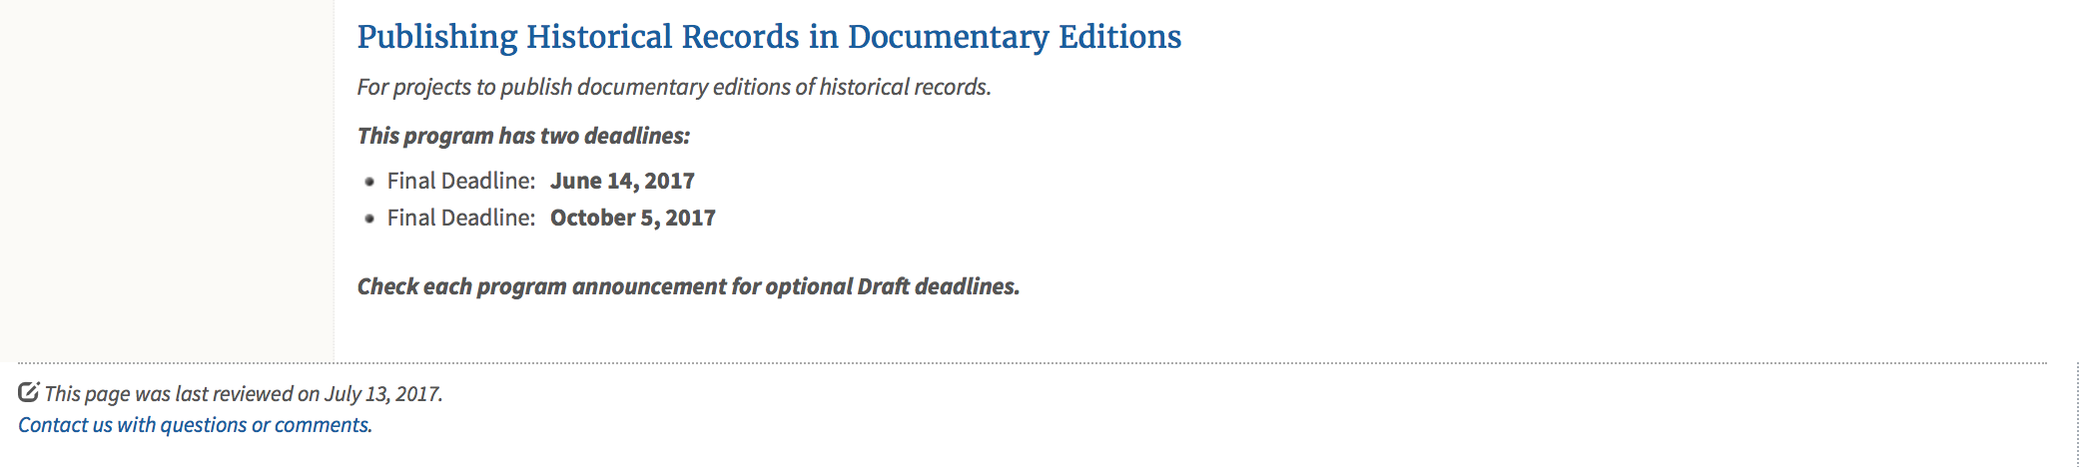
https://www.archives.gov/nhprc/announcement

Programs:

Reminders:

Publishing Historical Records in Documentary Editions
Synopsis 1
Document Type: | Grants Notice
Funding Opportunity Number: | EDITIONS-201810
Funding Opportunity Title: | Publishing Historical Records in Documentary Editions
Opportunity Category: | Discretionary
Opportunity Category Explanation:
Funding Instrument Type: | Grant
Category of Funding Activity: | Humanities (see "Cultural Affairs" in CFDA)
Category Explanation:
Expected Number of Awards: | 25
CFDA Number(s): | 89.003 -- National Historical Publications and Records Grants
Cost Sharing or Matching Requirement: | Yes
Version: | Synopsis 1
Posted Date: | Nov 29, 2017
Last Updated Date: | Nov 29, 2017
Original Closing Date for Applications: | Oct 04, 2018
Current Closing Date for Applications: | Oct 04, 2018
Archive Date:
Estimated Total Program Funding: | $2,500,000
Award Ceiling: | $200,000
Award Floor: | $1
Eligible Applicants: | Public and State controlled institutions of higher education  State governments  City or township governments  Nonprofits having a 501(c)(3) status with the IRS, other than institutions of higher education  Native American tribal governments (Federally recognized)  County governments  Private institutions of higher education
Agency Name: | National Archives and Records Administration
Description: | The National Historical Publications and Records Commission seeks proposals to publish documentary editions of historical records. Projects may focus on the papers of major figures from American history or cover broad historical movements in politics, social reform, business, military, the arts, and other aspects of the national experience. The historical value of the records and their expected usefulness to broad audiences must justify the costs of the project. The goal of this program is to provide access to, and editorial context for, the historical documents and records that tell the American story. Applicants should demonstrate familiarity with the best practices recommended by the Association for Documentary Editing or the Modern Language Association Committee on Scholarly Editions. All new projects (those which have never received NHPRC funding) must publish a digital edition, which provides online access to a searchable collection of all documents. (Ebooks or volumes in PDF do not qualify for the purposes of this grant program.) New projects may also prepare print editions as part of their overall publishing plan, but the contents of those volumes must be published online within a reasonable period of time following print publication. The NHPRC encourages projects to provide free access to online editions. Projects that do not have definitive plans for digital dissemination and preservation in place at the time of application will not be considered. Grants are awarded for collecting, describing, preserving, compiling, transcribing, annotating, editing, encoding, and publishing documentary source materials online and in print. Because of the focus on documentary sources, grants do not support preparation of critical editions of published works unless such works are just a small portion of the larger project. All applicants should be aware that the application process is highly competitive. For a comprehensive list of Commission's limitations on funding, please see What We Do and Do Not Fund. Applications that consist entirely of ineligible activities will not be considered. Ongoing projects: Applicants from ongoing projects must demonstrate that they have successfully achieved the performance objectives associated with previous NHPRC awards; provide updated, current information, including a description of the new activities; describe the content and historical significance of the specific materials to be edited during the proposed grant period; show progress towards completing the edition; and justify costs in a new budget. Award Information A grant is for one year and for up to $200,000. The Commission expects to make up to 25 grants in this category for a total of up to $2,500,000. Grants begin no earlier than January 1, 2019. The Commission requires that grant recipients acknowledge NHPRC grant assistance in all publications, publicity, and other products that result from its support. Eligibility • U.S. nonprofit organizations or institutions • U.S. colleges, universities, and other academic institutions • State or local government agencies • Federally-acknowledged or state-recognized Native American tribes or groups Cost Sharing The total costs of a project are shared between the NHPRC and the applicant organization. The Commission provides no more than 50 per cent of total direct project costs in the Publishing Historical Records in Documentary Editions category. NHPRC grant recipients are not permitted to use grant funds for indirect costs (as indicated in 2 CFR 2600.101). Cost sharing is required. The applicant’s financial contribution may include both direct and indirect expenses, in-kind contributions, non-Federal third-party contributions, and any income earned directly by the project. Indirect costs must be listed under the applicant’s cost sharing contribution. Other Requirements Applicant organizations must be registered in the System for Award Management (SAM) prior to submitting an application, maintain SAM registration throughout the application and award process, and include a valid DUNS number in their application. Details on SAM registration and requesting a DUNS number can be found at the System for Award Management website at https://sam.gov. Please refer to the User Guides section and the Grants Registrations PDF. A complete application includes the Application for Federal Assistance (Standard Form 424), Assurances -- Non-Construction Programs (Standard Form 424B), a Project Narrative, Summary, Supplementary Materials, and Budget. Applications lacking these items will not be considered. Ineligible applications will not be reviewed.
Link to Additional Information: | Link to full grant announcement, including additional requirements
Grantor Contact Information: | If you have difficulty accessing the full announcement electronically, please contact:  Jeff de la Concepcion Jeff.delaconcepcion@nara.gov  Grant Information Specialist
https://www.grants.gov/web/grants/view-opportunity.html?oppId=299091

Publishing Historical Records in Documentary Editions
Synopsis 1
Document Type: | Grants Notice
Funding Opportunity Number: | EDITIONS-201806
Funding Opportunity Title: | Publishing Historical Records in Documentary Editions
Opportunity Category: | Discretionary
Opportunity Category Explanation:
Funding Instrument Type: | Grant
Category of Funding Activity: | Humanities (see "Cultural Affairs" in CFDA)
Category Explanation:
Expected Number of Awards: | 25
CFDA Number(s): | 89.003 -- National Historical Publications and Records Grants
Cost Sharing or Matching Requirement: | No
Version: | Synopsis 1
Posted Date: | Nov 29, 2017
Last Updated Date: | Nov 29, 2017
Original Closing Date for Applications: | Jun 13, 2018
Current Closing Date for Applications: | Jun 13, 2018
Archive Date:
Estimated Total Program Funding: | $2,500,000
Award Ceiling: | $200,000
Award Floor: | $1
https://www.grants.gov/web/grants/view-opportunity.html?oppId=299108

State Board Programming Grants
Synopsis 1
Document Type: | Grants Notice
Funding Opportunity Number: | STATE-201806
Funding Opportunity Title: | State Board Programming Grants
Opportunity Category: | Discretionary
Opportunity Category Explanation:
Funding Instrument Type: | Grant
Category of Funding Activity: | Humanities (see "Cultural Affairs" in CFDA)
Category Explanation:
Expected Number of Awards: | 20
CFDA Number(s): | 89.003 -- National Historical Publications and Records Grants
Cost Sharing or Matching Requirement: | Yes
Version: | Synopsis 1
Posted Date: | Nov 29, 2017
Last Updated Date: | Nov 29, 2017
Original Closing Date for Applications: | Jun 13, 2018
Current Closing Date for Applications: | Jun 13, 2018
Archive Date:
Estimated Total Program Funding: | $625,000
Award Ceiling: | $80,000
Award Floor: | $1
Eligible Applicants: | Private institutions of higher education  State governments  Public and State controlled institutions of higher education  Nonprofits having a 501(c)(3) status with the IRS, other than institutions of higher education  Others (see text field entitled "Additional Information on Eligibility" for clarification)
Additional Information on Eligibility: | States also include the District of Columbia, the Commonwealth of Puerto Rico, and United States territories
Agency Name: | National Archives and Records Administration
Description: | The National Historical Publications and Records Commission seeks proposals that strengthen the nation’s archival network through activities undertaken by state historical records advisory boards. The purpose of this grant program is to assist state boards to broaden preservation of, and increased online access to, historical records; develop and promote best practices; support activities that put the American people in touch with primary sources in their communities and online; promote the institutional advancement of organizations in underserved communities; and assist locally based repositories with training and tools to improve their stewardship abilities. The Commission will award grants to state historical records advisory boards to: • Operate state-based regrant programs that preserve historical records and make them available online • Provide educational and outreach programs, workshops, and other activities that enhance citizen and student engagement with historical records • Offer scholarships, training opportunities, and other programs that support institutional advancement among records repositories, especially those in underserved communities • Collaborate on projects with other organizations to address common problems or shared opportunities within a state or among a consortium of state archives • Hold or participate in meetings and public forums on statewide or national archival issues. The NHPRC encourages organizations to actively engage the public in the work of the project. For a comprehensive list of Commission limitations on funding, please see: "What we do and do not fund" (http://www.archives.gov/nhprc/apply/eligibility.html). Applications that consist entirely of ineligible activities will not be considered. Award Information A grant is for one and for up to $40,000 or for two years and for up to $80,000. The Commission expects to make up to 20 grants in this category for a total of up to $625,000. Grants begin no earlier than January 1, 2019. The Commission requires that grant recipients acknowledge NHPRC grant assistance in all publicity, publications, and other products that result from its support. Eligibility These grants are awarded only to state historical records advisory boards in each state, or to the state agency responsible for the state board, ordinarily the state archives. Another state agency, or a non-profit organization, such as a foundation or university, acting on behalf of the designated state agency may apply. States also include the District of Columbia, the Commonwealth of Puerto Rico, and United States territories. Cost Sharing The total costs of a project are shared between the NHPRC and the applicant organization. The Commission provides no more than 75 per cent of total project costs in the State Board Programming Grants category. NHPRC grant recipients are not permitted to use grant funds for indirect costs (as indicated in 2 CFR 2600.101). Cost sharing is required. The applicant's financial contribution may include both direct and indirect expenses, in-kind contributions, non-Federal third-party contributions, and any income earned directly by the project. Indirect costs must be listed under the applicant's cost sharing contribution. Other Requirements Applicant organizations must be registered in the System for Award Management (SAM) prior to submitting an application, maintain SAM registration throughout the application and award process, and include a valid DUNS number in their application. Details on SAM registration and requesting a DUNS number can be found at the System for Award Management website at https://sam.gov. Please refer to the User Guides section and the Grants Registrations PDF. Ineligible applications will not be reviewed.
Link to Additional Information: | Link to full grant announcement, including additional requirements
Grantor Contact Information: | If you have difficulty accessing the full announcement electronically, please contact:  Jeff de la Concepcion Jeff.delaconcepcion@nara.gov  Grant Information Specialist
https://www.grants.gov/web/grants/view-opportunity.html?oppId=299107

Access to Historical Records: Major Initiatives (Preliminary)
Synopsis 1

Document Type: | Grants Notice
Funding Opportunity Number: | PRELIM-201801
Funding Opportunity Title: | Access to Historical Records: Major Initiatives (Preliminary)
Opportunity Category: | Discretionary
Opportunity Category Explanation:
Funding Instrument Type: | Grant
Category of Funding Activity: | Humanities (see "Cultural Affairs" in CFDA)
Category Explanation:
Expected Number of Awards: | 5
CFDA Number(s): | 89.003 -- National Historical Publications and Records Grants
Cost Sharing or Matching Requirement: | Yes
Version: | Synopsis 3
Posted Date: | Jul 14, 2017
Last Updated Date: | Jul 24, 2017
Original Closing Date for Applications: | Jan 18, 2018
Current Closing Date for Applications: | Jan 18, 2018
Archive Date:
Estimated Total Program Funding: | $1,000,000
Award Ceiling: | $350,000
Award Floor: | $100,000
Eligible Applicants: | State governments  County governments  Nonprofits having a 501(c)(3) status with the IRS, other than institutions of higher education  Private institutions of higher education  Native American tribal governments (Federally recognized)  Public and State controlled institutions of higher education  City or township governments
Agency Name: | National Archives and Records Administration
Description: | The National Historical Publications and Records Commission seeks projects that will significantly improve public discovery and use of major historical records collections. All types of historical records are eligible, including documents, photographs, born-digital records, and analog audio and moving images. Projects may: • Digitize historical records collections, or related collections, held by a single institution and make them freely available online• Provide access to born-digital records• Create new freely-available virtual collections drawn from historical records held by multiple institutions• Create new tools and methods for users to access records The NHPRC welcomes collaborative projects, particularly for bringing together related records from multiple institutions. Projects that address significant needs in the field and result in replicable and scalable approaches will be more competitive. We also encourage organizations to actively engage the public in the work of the project. Applicants should also consult Access to Historical Records: Archival Projects program, which has different requirements and award amounts. For a comprehensive list of Commission limitations on funding, please see: "What we do and do not fund" (http://www.archives.gov/nhprc/apply/eligibility.html). Applications that consist entirely of ineligible activities will not be considered. Award Information A grant is for one to three years and for between $100,000 and $350,000. We expect to make up to five grants in this category for a total of up to $1,000,000. Grants begin no earlier than January 1, 2019.The Commission requires that grant recipients acknowledge NHPRC grant assistance in all publications and other products that result from its support. Eligibility Eligible applicants:• Nonprofit organizations or institutions• Colleges, universities, and other academic institutions• State or local government agencies• Federally-acknowledged or state-recognized Native American tribes or groups Cost Sharing The total costs of a project are shared between the NHPRC and the applicant organization. The Commission provides no more than 50 per cent of total project costs in the Access to Historical Records: Major Initiatives category. NHPRC grant recipients are not permitted to use grant funds for indirect costs (as indicated in 2 CFR 2600.101).Cost sharing is required. The applicant's financial contribution may include both direct and indirect expenses, in-kind contributions, non-Federal third-party contributions, and any income earned directly by the project. Indirect costs must be listed under the applicant's cost sharing contribution. Other Requirements Applicant organizations must be registered in the System for Award Management (SAM) prior to submitting an application, maintain SAM registration throughout the application and award process, and include a valid DUNS number in their application. Details on SAM registration and requesting a DUNS number can be found at the System for Award Management website at https://sam.gov. Please refer to the User Guides section and the Grants Registrations PDF. Application Information You must use Grants.gov to submit a Preliminary Proposal. All information necessary to apply is included in this announcement, the Application Instructions, and the forms on Grants.gov. If you need the information supplied in an alternative format, please call the NHPRC at 202-357-5010.In order to ensure eligibility, applicants should first review the rules and regulations governing NHPRC grants under the Administering an NHPRC Grant section. Applying to the Access to Historical Records: Major Initiatives program is a two-phase process. Phase One• Using this announcement, all applicants must submit an Application Package that includes the Application for Federal Domestic Assistance Form SF424, a completed NHPRC Budget, and five-page Project Narrative via Grants.gov by January 18, 2018.• Preliminary proposals will then undergo peer and staff review. Based on those reviews, a selection of promising applicants will be invited by April 16, 2018 to participate in the second phase of the process. Phase Two• Invited applicants will then prepare and submit a complete application to the full Major Initiatives grant announcement via Grants.gov by July 11, 2018. • Applicants may consult with the Director of the Access Program, Alex Lorch (alexander.lorch@nara.gov), or with the Director for Technology Initiatives, Nancy Melley (nancy.melley@nara.gov), during both the preliminary and full proposal project phases. • In order to ensure eligibility, applicants should first review the rules and regulations governing NHPRC grants under the Administering an NHPRC Grant section.
Link to Additional Information: | Link to full grant announcement, including additional requirements
Grantor Contact Information: | If you have difficulty accessing the full announcement electronically, please contact:  Jeff de la Concepcion Jeff.delaconcepcion@Nara.gov  Grant Information Specialist

http://www.grants.gov/web/grants/view-opportunity.html?oppId=295495

Access to Historical Records: Major Initiatives
Synopsis 1

Document Type: | Grants Notice
Funding Opportunity Number: | MAJOR-201807
Funding Opportunity Title: | Access to Historical Records: Major Initiatives
Opportunity Category: | Discretionary
Opportunity Category Explanation:
Funding Instrument Type: | Grant
Category of Funding Activity: | Humanities (see "Cultural Affairs" in CFDA)
Category Explanation:
Expected Number of Awards: | 5
CFDA Number(s): | 89.003 -- National Historical Publications and Records Grants
Cost Sharing or Matching Requirement: | Yes
Version: | Synopsis 1
Posted Date: | Jul 14, 2017
Last Updated Date: | Jul 14, 2017
Original Closing Date for Applications: | Jul 11, 2018
Current Closing Date for Applications: | Jul 11, 2018
Archive Date:
Estimated Total Program Funding: | $1,000,000
Award Ceiling: | $350,000
Award Floor: | $100,000
Eligible Applicants: | Public and State controlled institutions of higher education  County governments  Nonprofits having a 501(c)(3) status with the IRS, other than institutions of higher education  State governments  City or township governments  Private institutions of higher education  Native American tribal governments (Federally recognized)
Agency Name: | National Archives and Records Administration
Description: | The National Historical Publications and Records Commission seeks projects that will significantly improve public discovery and use of major historical records collections. All types of historical records are eligible, including documents, photographs, born-digital records, and analog audio and moving images. Projects may: • Digitize historical records collections, or related collections, held by a single institution and make them freely available online • Provide access to born-digital records • Create new freely-available virtual collections drawn from historical records held by multiple institutions • Create new tools and methods for users to access records The NHPRC welcomes collaborative projects, particularly for bringing together related records from multiple institutions. Projects that address significant needs in the field and result in replicable and scalable approaches will be more competitive. We also encourage organizations to actively engage the public in the work of the project. Applicants should also consult Access to Historical Records: Archival Projects program, which has different requirements and award amounts. For a comprehensive list of Commission limitations on funding, please see: "What we do and do not fund" (http://www.archives.gov/nhprc/apply/eligibility.html). Applications that consist entirely of ineligible activities will not be considered. Award Information A grant is for one to three years and between $100,000 and $350,000. We expect to make up to five grants in this category for a total of up to $1,000,000. Grants begin no earlier than January 1, 2019. The Commission requires that grant recipients acknowledge NHPRC grant assistance in all publicity, publications, and other products that result from its support. Eligibility Eligible applicants: • U.S. nonprofit organizations or institutions • U.S. colleges, universities, and other academic institutions • State or local government agencies • Federally-acknowledged or state-recognized Native American tribes or groups Cost Sharing The total costs of a project are shared between the NHPRC and the applicant organization. The Commission provides no more than 50 per cent of total project costs in the Access to Historical Records: Major Initiatives category. NHPRC grant recipients are not permitted to use grant funds for indirect costs (as indicated in 2 CFR 2600.101). Cost sharing is required. The applicant's financial contribution may include both direct and indirect expenses, in-kind contributions, non-Federal third-party contributions, and any income earned directly by the project. Indirect costs must be listed under the applicant's cost sharing contribution. Other Requirements Applicant organizations must be registered in the System for Award Management (SAM) prior to submitting an application, maintain SAM registration throughout the application and award process, and include a valid DUNS number in their application. Details on SAM registration and requesting a DUNS number can be found at the System for Award Management website at https://sam.gov. Please refer to the User Guides section and the Grants Registrations PDF. Application Information You must use Grants.gov to submit your Full Proposal. All information necessary to apply is included in this announcement, the Application Instructions, and the forms on Grants.gov. If you need the information supplied in an alternative format, please call the NHPRC at 202-357-5010. In order to ensure eligibility, applicants should first review the rules and regulations governing NHPRC grants under the Administering an NHPRC Grant section. Applying to the Access to Historical Records: Major Initiatives program is a two-phase process. Phase One • All applicants must have submitted a Preliminary Proposal by January 18, 2018. • Only those applicants who have successfully completed Phase One and who have been invited by the Commission to submit a full proposal to the Access to Historical Records: Major Initiatives program are eligible to participate in the second phase of the process. Phase Two • If you have been invited, prepare and submit a complete application to the full Major Initiatives grant announcement via Grants.gov by July 11, 2018. • Applicants may consult with the Director of the Access Program, Alex Lorch (alexander.lorch@nara.gov), or with the Director for Technology Initiatives, Nancy Melley (nancy.melley@nara.gov), during both the preliminary and full proposal project phases.
Link to Additional Information: | Link to full grant announcement, including additional requirements
Grantor Contact Information: | If you have difficulty accessing the full announcement electronically, please contact:  Jeff de la Concepcion Jeff.delaconcepcion@nara.gov  Grant Information Specialist

http://www.grants.gov/web/grants/view-opportunity.html?oppId=295496

National Endowment for the Arts

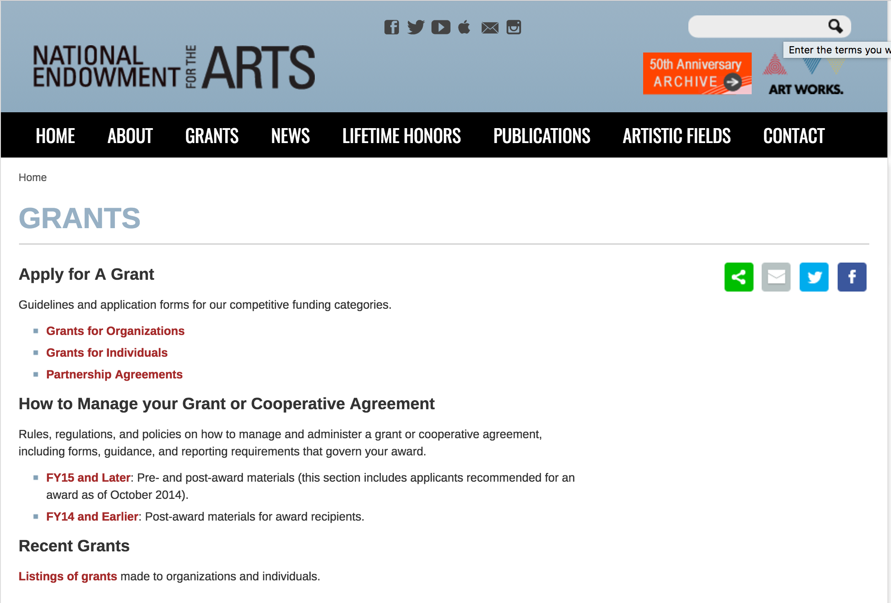

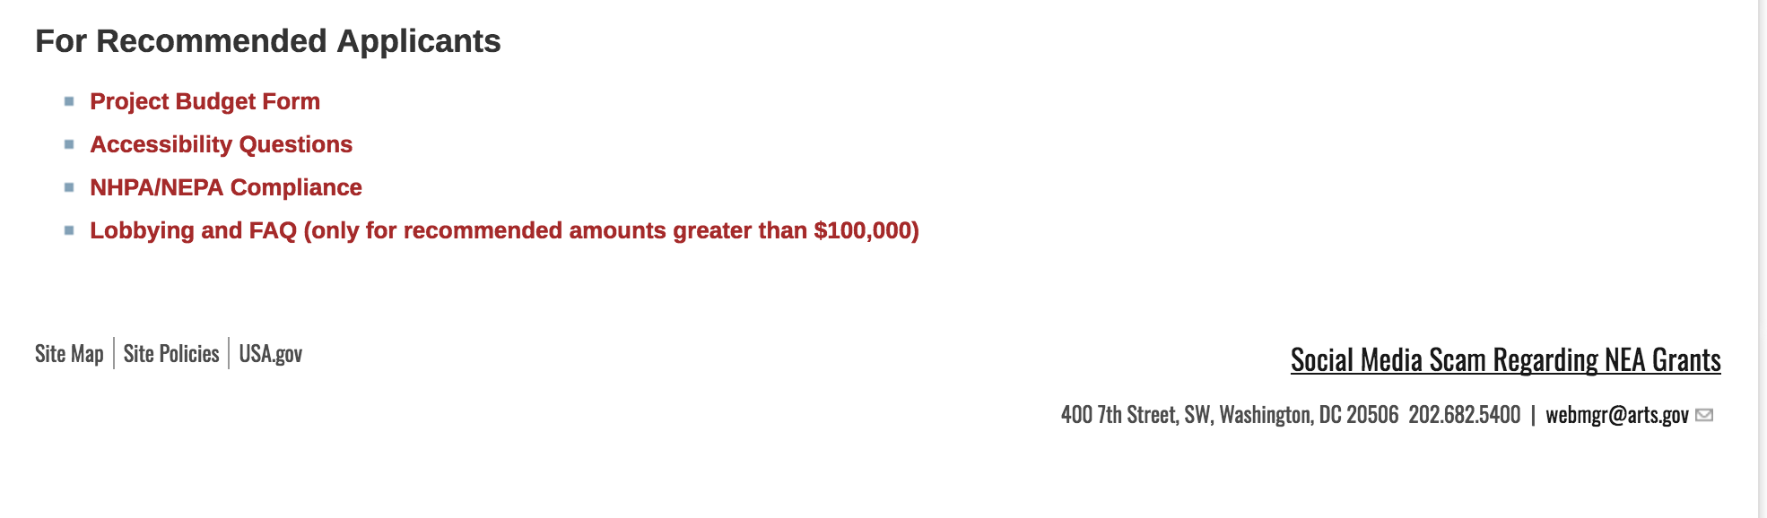
See more at: https://www.arts.gov/grants

Programs:

NEA Art Works I, FY2019
Synopsis 1
Document Type: | Grants Notice
Funding Opportunity Number: | 2018NEA01AW1
Funding Opportunity Title: | NEA Art Works I, FY2019
Opportunity Category: | Discretionary
Opportunity Category Explanation:
Funding Instrument Type: | Grant
Category of Funding Activity: | Arts (see "Cultural Affairs" in CFDA)
Category Explanation:
Expected Number of Awards:
CFDA Number(s): | 45.024 -- Promotion of the Arts Grants to Organizations and Individuals
Cost Sharing or Matching Requirement: | Yes
Version: | Synopsis 1
Posted Date: | Dec 06, 2017
Last Updated Date: | Dec 06, 2017
Original Closing Date for Applications: | Feb 15, 2018
Current Closing Date for Applications: | Feb 15, 2018
Archive Date:
Estimated Total Program Funding:
Award Ceiling: | $100,000
Award Floor: | $10,000
Eligible Applicants: | State governments  Special district governments  Public and State controlled institutions of higher education  Native American tribal governments (Federally recognized)  Private institutions of higher education  Nonprofits having a 501(c)(3) status with the IRS, other than institutions of higher education  County governments  City or township governments  Independent school districts
Agency Name: | National Endowment for the Arts
Description: | An organization may submit only one application through one of the following FY 2019 categories: Art Works or Challenge America. If an organization applies to the Challenge America category, it may not submit another application to the Art Works category. The Arts Endowment's support of a project may start on or after January 1, 2019. Generally, a period of performance of up to two years is allowed. Art Works Program Description To support artistically excellent projects that celebrate our creativity and cultural heritage, invite mutual respect for differing beliefs and values, and enrich humanity. Matching grants generally range from $10,000 to $100,000. A minimum cost share/match equal to the grant amount is required.
Link to Additional Information: | NEA Website Announcement
Grantor Contact Information: | If you have difficulty accessing the full announcement electronically, please contact:  NEA Web Manager webmgr@arts.gov  NEA Web Manager
https://www.grants.gov/web/grants/view-opportunity.html?oppId=299275

Modifications:

Reminders:

NEA Literature Fellowships: Creative Writing, FY2019
Synopsis 1
Document Type: | Grants Notice
Funding Opportunity Number: | 2018NEA03LFCW
Funding Opportunity Title: | NEA Literature Fellowships: Creative Writing, FY2019
Opportunity Category: | Discretionary
Opportunity Category Explanation:
Funding Instrument Type: | Grant
Category of Funding Activity: | Arts (see "Cultural Affairs" in CFDA)
Category Explanation:
Expected Number of Awards:
CFDA Number(s): | 45.024 -- Promotion of the Arts Grants to Organizations and Individuals
Cost Sharing or Matching Requirement: | No
Version: | Synopsis 1
Posted Date: | Nov 07, 2017
Last Updated Date: | Nov 08, 2017
Original Closing Date for Applications: | Mar 07, 2018
Current Closing Date for Applications: | Mar 07, 2018
Archive Date:
Estimated Total Program Funding:
Award Ceiling: | $25,000
Award Floor: | $25,000
Eligible Applicants: | Individuals
Agency Name: | National Endowment for the Arts
Description: | You may submit only one application for FY 2019 funding. You may not apply for both a Literature Fellowship under this deadline and a Translation Project under the December 5, 2017 deadline. Grant Program Description The National Endowment for the Arts Literature Fellowships program offers $25,000 grants in prose (fiction and creative nonfiction) and poetry to published creative writers that enable recipients to set aside time for writing, research, travel, and general career advancement. Applications are reviewed through an anonymous process in which the only criteria for review are artistic excellence and artistic merit. To review the applications, the National Endowment for the Arts assembles a different advisory panel every year, each diverse with regard to geography, race and ethnicity, and artistic points of view. The National Endowment for the Arts Literature Fellowships program operates on a two-year cycle with fellowships in prose and poetry available in alternating years. For FY 2019, which is covered by these guidelines, fellowships in poetry are available. Fellowships in prose (fiction and creative nonfiction) will be offered in FY 2020 and guidelines will be available in January 2019. You may apply only once each year. Competition for fellowships is extremely rigorous. We typically receive more than 1,000 applications each year in this category and award fellowships to fewer than 5% of applicants. You should consider carefully whether your work will be competitive at the national level.
Link to Additional Information: | NEA Complete Website Announcement
Grantor Contact Information: | If you have difficulty accessing the full announcement electronically, please contact:  NEA Web Manager webmgr@arts.gov  NEA Web Manager
http://www.grants.gov/web/grants/view-opportunity.html?oppId=298531

National Endowment for the Humanities

Grant Overview -

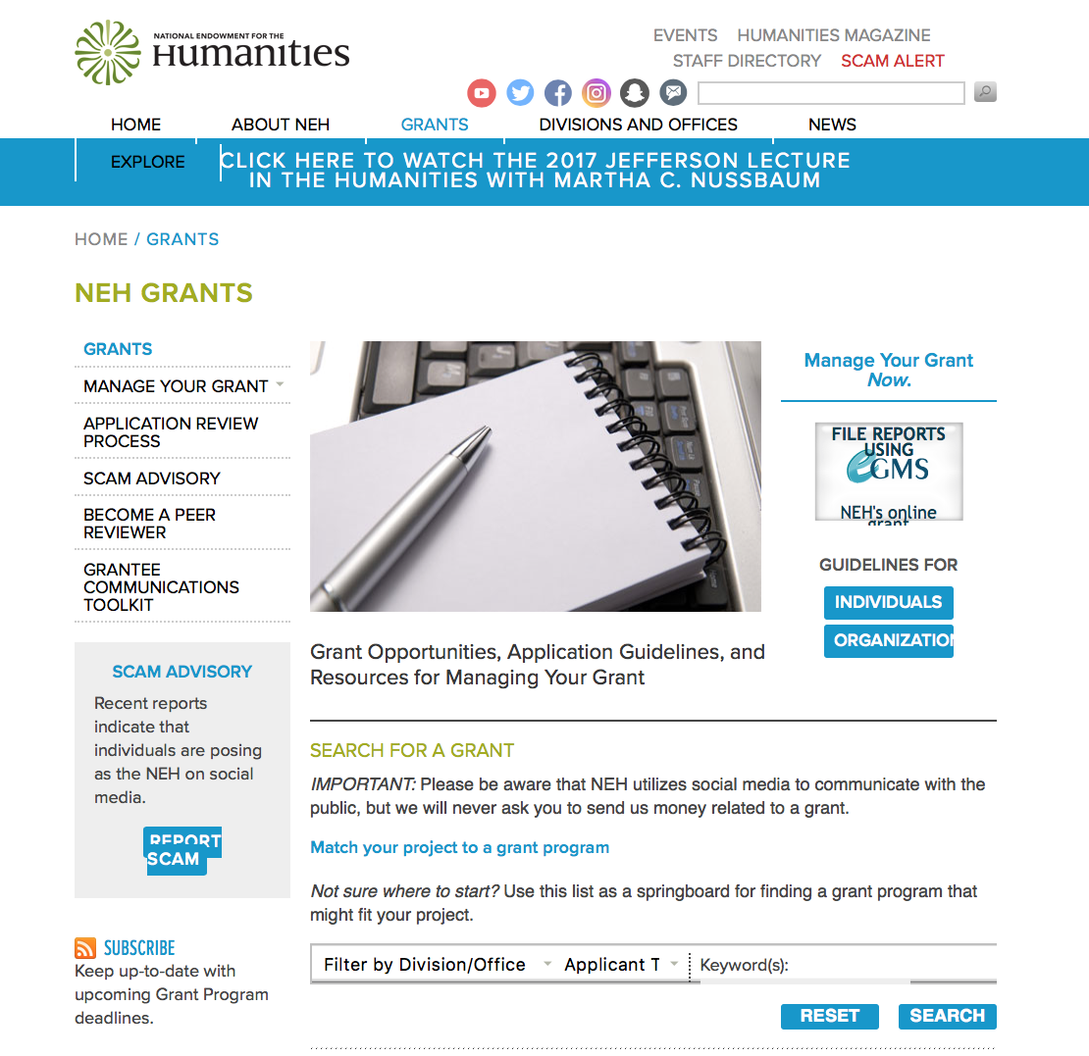

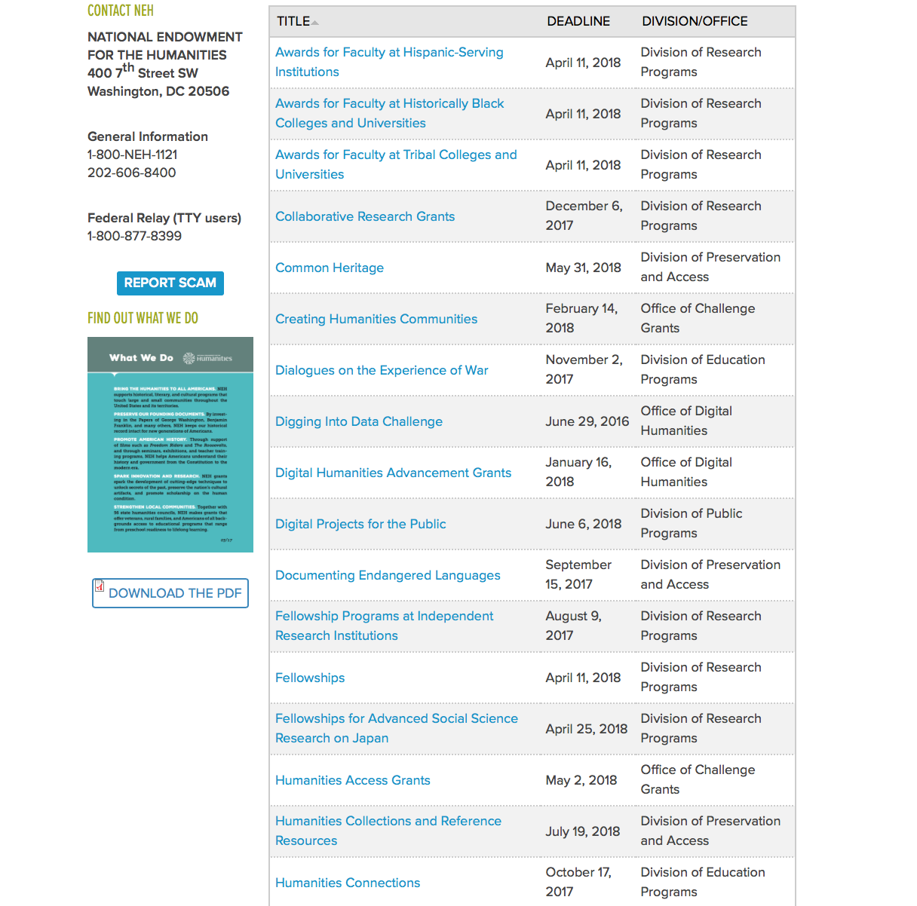

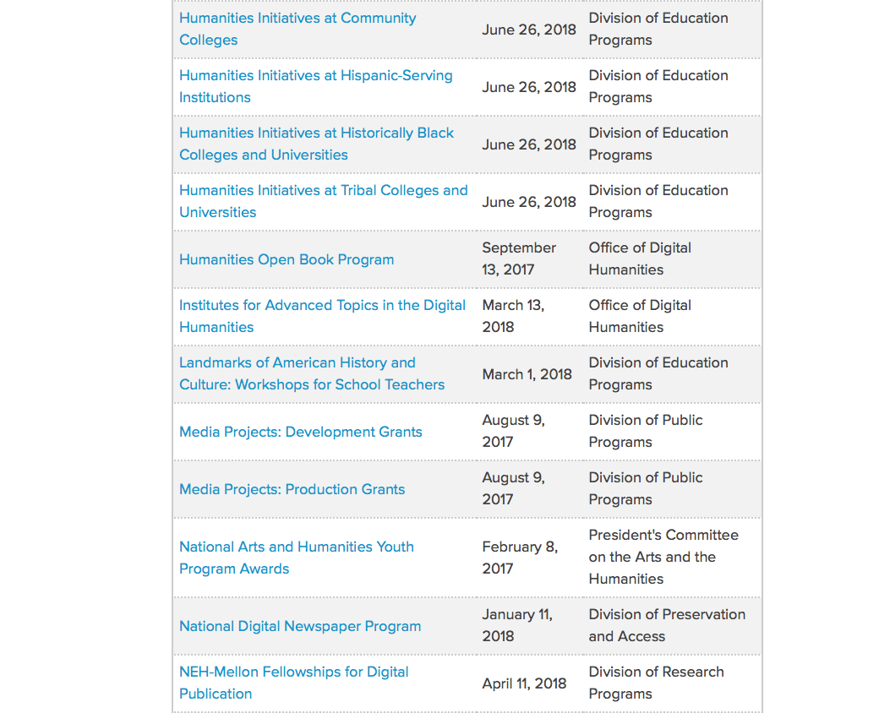

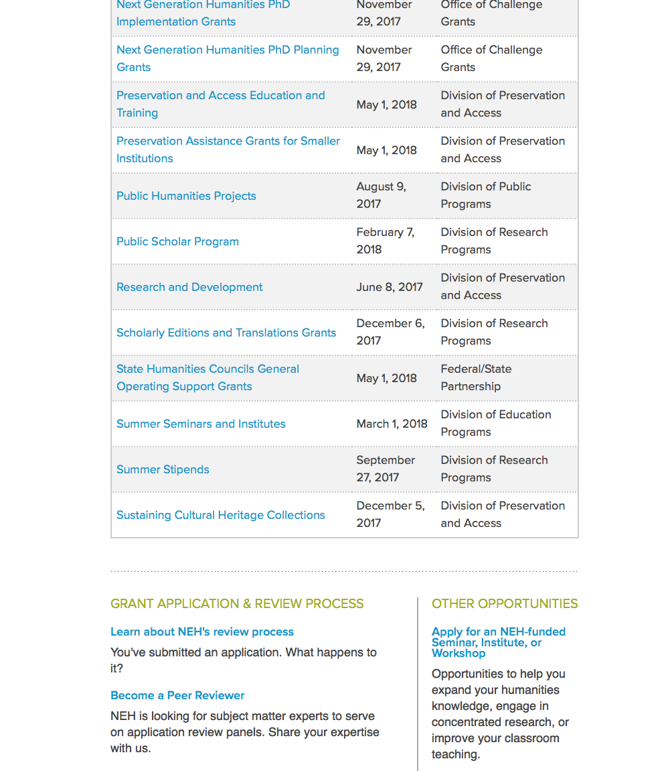

https://www.neh.gov/grants

Programs:

Public Scholar Program
Synopsis 1

Document Type: | Grants Notice
Funding Opportunity Number: | 20180207-FZ
Funding Opportunity Title: | Public Scholar Program
Opportunity Category: | Discretionary
Opportunity Category Explanation:
Funding Instrument Type: | Grant
Category of Funding Activity: | Humanities (see "Cultural Affairs" in CFDA)
Category Explanation:
Expected Number of Awards:
CFDA Number(s): | 45.160 -- Promotion of the Humanities Fellowships and Stipends
Cost Sharing or Matching Requirement: | No
Version: | Synopsis 1
Posted Date: | Dec 07, 2017
Last Updated Date: | Dec 07, 2017
Original Closing Date for Applications: | Feb 07, 2018
Current Closing Date for Applications: | Feb 07, 2018
Archive Date:
Estimated Total Program Funding:
Award Ceiling: | $50,400
Award Floor: | $25,200
Eligible Applicants: | Individuals
Agency Name: | National Endowment for the Humanities
Description: | The Public Scholar Program supports well-researched books in the humanities intended to reach a broad readership. Some humanities scholarship is necessarily specialized, but the humanities can also engage broad audiences in exploring subjects of general interest. Such scholarship might present a narrative history, tell the stories of important individuals, analyze significant texts, provide a synthesis of ideas, revive interest in a neglected subject, or examine the latest thinking on a topic. Books supported by this program must be grounded in humanities research and scholarship, making appropriate use of primary and/or secondary sources. They must also be written in a readily accessible style, addressing significant humanities themes in a way that will appeal to a large audience of general readers. Applications to write books directed primarily to scholars are not appropriate for this program. By establishing the Public Scholar Program, NEH has entered a long-term commitment to encourage scholarship in the humanities for general audiences. The program is open to both individuals affiliated with scholarly institutions and to independent scholars, researchers, and writers. Projects may be at any stage of development.
Link to Additional Information: | https://www.neh.gov/grants/research/public-scholar-program
Grantor Contact Information: | If you have difficulty accessing the full announcement electronically, please contact:  Division of Research Programs National Endowment for the Humanities Washington, DC 20506 202-606-8200 publicscholar@neh.gov publicscholar@neh.gov  publicscholar@neh.gov
https://www.grants.gov/web/grants/view-opportunity.html?oppId=299313

Landmarks of American History and Culture: Workshops for School Teachers
Synopsis 1
Document Type: | Grants Notice
Funding Opportunity Number: | 20180222-BH
Funding Opportunity Title: | Landmarks of American History and Culture: Workshops for School Teachers
Opportunity Category: | Discretionary
Opportunity Category Explanation:
Funding Instrument Type: | Grant
Category of Funding Activity: | Humanities (see "Cultural Affairs" in CFDA)
Category Explanation:
Expected Number of Awards:
CFDA Number(s): | 45.163 -- Promotion of the Humanities Professional Development
Cost Sharing or Matching Requirement: | No
Version: | Synopsis 1
Posted Date: | Dec 22, 2017
Last Updated Date: | Dec 22, 2017
Original Closing Date for Applications: | Feb 22, 2018
Current Closing Date for Applications: | Feb 22, 2018
Archive Date:
Estimated Total Program Funding:
Award Ceiling: | $170,000
Award Floor: | $1
Eligible Applicants: | Special district governments  Nonprofits having a 501(c)(3) status with the IRS, other than institutions of higher education  City or township governments  County governments  Native American tribal governments (Federally recognized)  Public and State controlled institutions of higher education  State governments  Private institutions of higher education
Agency Name: | National Endowment for the Humanities
Description: | The Landmarks of American History and Culture program supports a series of one-week workshops for a national audience of K-12 educators that enhance and strengthen humanities teaching at the K-12 level. The program defines a landmark as a site of historic importance within the United States and its territories that offers educators a unique and compelling opportunity to deepen and expand their knowledge of the diverse histories, cultures, traditions, languages, and perspectives of the American people. Projects employ a place-based approach, teaching historic sites through critical interpretation in order to explore central themes in American history and government, as well as in literature, art, music, and related humanities subjects. Each workshop accommodates thirty-six participants (NEH Summer Scholars) and is offered twice during the summer (for a total of seventy-two participants). Workshops may be hosted by institutions such as community colleges, universities, four-year colleges, learned societies, libraries or other repositories, centers for advanced study, cultural organizations, professional associations, and schools or school systems. Host institutions provide facilities and arrange for accommodations for participants, who receive a stipend. NEH expects host institutions to furnish facilities conducive to scholarly engagement with topics and sites.
Link to Additional Information: | https://www.neh.gov/grants/education/landmarks-american-history-and-culture-workshops-school-teachers
Grantor Contact Information: | If you have difficulty accessing the full announcement electronically, please contact:  Landmarks of American History and Culture: Workshops for School Teachers Division of Education Programs National Endowment for the Humanities 400 Seventh Street, SW Washington, DC 20506 202-606-8500 landmarks@neh.gov landmarks@neh.gov  landmarks@neh.gov
https://www.grants.gov/web/grants/view-opportunity.html?oppId=299639

Summer Seminars and Institutes
Synopsis 1
Document Type: | Grants Notice
Funding Opportunity Number: | 20180222-FS
Funding Opportunity Title: | Summer Seminars and Institutes
Opportunity Category: | Discretionary
Opportunity Category Explanation:
Funding Instrument Type: | Grant
Category of Funding Activity: | Humanities (see "Cultural Affairs" in CFDA)
Category Explanation:
Expected Number of Awards:
CFDA Number(s): | 45.163 -- Promotion of the Humanities Professional Development
Cost Sharing or Matching Requirement: | No
Version: | Synopsis 1
Posted Date: | Dec 22, 2017
Last Updated Date: | Dec 22, 2017
Original Closing Date for Applications: | Feb 22, 2018
Current Closing Date for Applications: | Feb 22, 2018
Archive Date:
Estimated Total Program Funding:
Award Ceiling: | $200,000
Award Floor: | $1
Eligible Applicants: | Special district governments  Native American tribal governments (Federally recognized)  City or township governments  County governments  Private institutions of higher education  State governments  Public and State controlled institutions of higher education  Nonprofits having a 501(c)(3) status with the IRS, other than institutions of higher education
Agency Name: | National Endowment for the Humanities
Description: | NEH Summer Seminars and Institutes grants broaden and deepen understanding of the humanities in supporting professional development programs, specifically designed for a national audience of K-12 educators or college and university faculty. The programs provide one- to four-week opportunities for participants (NEH Summer Scholars) to explore a variety of topics relevant to K-12 or undergraduate education in the humanities. NEH Summer Seminars and Institutes • focus on the study and teaching of significant texts and other resources; • provide models of excellent scholarship and teaching; • contribute to the intellectual growth of the of participants; and • build lasting communities of inquiry. An NEH Summer Seminar or Institute may be hosted by a college, university, learned society, center for advanced study, library or other repository, cultural or professional organization, or school or school system. The host site must provide facilities for collegial interaction and scholarship. The program must be held only in the United States and its territories. Seminars and Institutes are designed either for K-12 educators or for college and university faculty. Programs for K-12 educators must involve someone with significant K-12 experience in both project planning and implementation and must respond to K-12 curricular needs. Seminars A Seminar provides an intimate and focused environment in which sixteen participants study a specific humanities topic under the guidance of one or two established scholars. Seminars have few, if any, visiting faculty. They emphasize sustained interaction among the participants and director(s) through discussion of common readings, conversations about teaching, and advising on independent projects. Institutes An Institute allows twenty-five to thirty-six participants to pursue an intensive program of study under a team of scholarly experts, who present a range of perspectives on a humanities topic. Participants and scholars mutually explore connections between scholarship about and the teaching of the topic.
Link to Additional Information: | https://www.neh.gov/grants/education/summer-seminars-and-institutes
Grantor Contact Information: | If you have difficulty accessing the full announcement electronically, please contact:  Division of Education Programs National Endowment for the Humanities 400 Seventh Street, SW Washington, DC 20506 202-606-8471 sem-inst@neh.gov sem-inst@neh.gov  sem-inst@neh.gov
https://www.grants.gov/web/grants/view-opportunity.html?oppId=299653

Modifications:

Reminders:

Digital Humanities Advancement Grants
Synopsis 1
Document Type: | Grants Notice
Funding Opportunity Number: | 20180116-HAA
Funding Opportunity Title: | Digital Humanities Advancement Grants
Opportunity Category: | Discretionary
Opportunity Category Explanation:
Funding Instrument Type: | Grant
Category of Funding Activity: | Humanities (see "Cultural Affairs" in CFDA)
Category Explanation:
Expected Number of Awards:
CFDA Number(s): | 45.169 -- Promotion of the Humanities Office of Digital Humanities
Cost Sharing or Matching Requirement: | No
Version: | Synopsis 1
Posted Date: | Nov 15, 2017
Last Updated Date: | Nov 15, 2017
Original Closing Date for Applications: | Jan 16, 2018
Current Closing Date for Applications: | Jan 16, 2018
Archive Date:
Estimated Total Program Funding:
Award Ceiling: | $375,000
Award Floor: | $10,000
Eligible Applicants: | Nonprofits having a 501(c)(3) status with the IRS, other than institutions of higher education  Special district governments  Private institutions of higher education  Public and State controlled institutions of higher education  City or township governments  County governments  State governments  Native American tribal governments (Federally recognized)
Agency Name: | National Endowment for the Humanities
Description: | Digital Humanities Advancement Grants (DHAG) support digital projects throughout their lifecycles, from early start-up phases through implementation and long-term sustainability. Experimentation, reuse, and extensibility are hallmarks of this grant category, leading to innovative work that can scale to enhance research, teaching, and public programming in the humanities. You can find a discussion of the forms that experimentation can take in the Frequently Asked Questions document, which is available on the program resource page. This program is offered twice per year. Proposals are welcome for digital initiatives in any area of the humanities. Through a special partnership, the Institute of Museum and Library Services (IMLS) anticipates providing additional funding to this program to encourage innovative collaborations between museum or library professionals and humanities professionals to advance preservation of, access to, use of, and engagement with digital collections and services. Through this partnership, IMLS and NEH may jointly fund some DHAG projects that involve collaborations with museums and/or libraries. Digital Humanities Advancement Grants may involve • creating or enhancing experimental, computationally-based methods, techniques, or infrastructure that contribute to the humanities; • pursuing scholarship that examines the history, criticism, and philosophy of digital culture and its impact on society, or explores the philosophical or practical implications and impact of digital humanities in specific fields or disciplines; or • revitalizing and/or recovering existing digital projects that promise to contribute substantively to scholarship, teaching, or public knowledge of the humanities.
Link to Additional Information: | https://www.neh.gov/grants/odh/digital-humanities-advancement-grants
Grantor Contact Information: | If you have difficulty accessing the full announcement electronically, please contact:  If you have questions about the program, contact the ODH staff at odh@neh.gov. Applicants wishing to speak to a staff member by telephone should provide in an e-mail message a telephone number and a preferred time to call. odh@neh.gov  odh@neh.gov
http://www.grants.gov/web/grants/view-opportunity.html?oppId=298688

Media Projects Grants
Synopsis 1
Document Type: | Grants Notice
Funding Opportunity Number: | 20180110-TD
Funding Opportunity Title: | Media Projects Grants
Opportunity Category: | Discretionary
Opportunity Category Explanation:
Funding Instrument Type: | Grant
Category of Funding Activity: | Humanities (see "Cultural Affairs" in CFDA)
Category Explanation:
Expected Number of Awards:
CFDA Number(s): | 45.164 -- Promotion of the Humanities Public Programs
Cost Sharing or Matching Requirement: | No
Version: | Synopsis 1
Posted Date: | Nov 09, 2017
Last Updated Date: | Nov 09, 2017
Original Closing Date for Applications: | Jan 10, 2018
Current Closing Date for Applications: | Jan 10, 2018
Archive Date:
Estimated Total Program Funding:
Award Ceiling: | $1,000,000
Award Floor: | $1
Eligible Applicants: | Nonprofits having a 501(c)(3) status with the IRS, other than institutions of higher education  Special district governments  City or township governments  Native American tribal governments (Federally recognized)  State governments  Public and State controlled institutions of higher education  County governments  Private institutions of higher education
Agency Name: | National Endowment for the Humanities
Description: | The Media Projects program supports film, television, and radio projects that engage public audiences with humanities ideas in creative and appealing ways. All projects must be grounded in humanities scholarship in disciplines such as history, art history, film studies, literature, drama, religious studies, philosophy, or anthropology. Projects must also demonstrate an approach that is thoughtful, balanced, and analytical (rather than celebratory). The approach to the subject matter must go beyond the mere presentation of factual information to explore its larger significance and stimulate critical thinking. NEH is a national funding agency, so the projects that we support must demonstrate the potential to attract a broad general audience. Film and television projects may be single programs or a series addressing significant figures, events, or ideas. Programs must be intended for national distribution, via traditional carriage or online distribution. The Division of Public Programs welcomes projects that range in length from short-form to broadcast-length video. The Division of Public Programs also encourages film and television projects that examine international themes and subjects in the humanities, in order to spark Americans’ engagement with the broader world beyond the United States. These projects should demonstrate international collaboration by enlisting scholars based both in the United States and abroad, and/or by working with an international media team. The collaborations should bring broad cross-cultural perspectives to the proposed topics and should be intended primarily for U.S. public audiences. Radio projects, including podcasts, may involve single programs, limited series, or segments within an ongoing program. They may also develop new humanities content to augment existing radio programming or add greater historical background or humanities analysis to the subjects of existing programs. They may be intended for regional or national distribution. NEH encourages projects that engage public audiences through multiple formats in the exploration of humanities ideas. Proposed projects might include complementary components to a film, television, or radio project. These components should deepen the audience’s understanding of the subject in a supplementary manner: for example, book/film discussion programs, supplementary educational websites, or museum exhibitions. Development grants enable media producers to collaborate with scholars to develop humanities content and to prepare programs for production. Grants should result in a script (for a film or television project) or a detailed treatment (for a radio or podcast project) and may also yield a plan for outreach and public engagement. Production grants support the production and distribution of films, television programs, and radio programs or podcasts that promise to engage a broad public audience.
Link to Additional Information: | https://www.neh.gov/grants/mp
Grantor Contact Information: | If you have difficulty accessing the full announcement electronically, please contact:  Division of Public Programs National Endowment for the Humanities 400 Seventh Street, SW Washington, DC 20506 202-606-8269 publicpgms@neh.gov publicpgms@neh.gov  publicpgms@neh.gov
http://www.grants.gov/web/grants/view-opportunity.html?oppId=298572

National Digital Newspaper Program
Synopsis 1

Document Type: | Grants Notice
Funding Opportunity Number: | 20180111-PJ
Funding Opportunity Title: | National Digital Newspaper Program
Opportunity Category: | Discretionary
Opportunity Category Explanation:
Funding Instrument Type: | Cooperative Agreement
Category of Funding Activity: | Humanities (see "Cultural Affairs" in CFDA)
Category Explanation:
Expected Number of Awards:
CFDA Number(s): | 45.149 -- Promotion of the Humanities Division of Preservation and Access
Cost Sharing or Matching Requirement: | No
Version: | Synopsis 1
Posted Date: | Nov 08, 2017
Last Updated Date: | Nov 08, 2017
Original Closing Date for Applications: | Jan 11, 2018
Current Closing Date for Applications: | Jan 11, 2018
Archive Date:
Estimated Total Program Funding:
Award Ceiling: | $325,000
Award Floor: | $1
Eligible Applicants: | City or township governments  Private institutions of higher education  Native American tribal governments (Federally recognized)  Public and State controlled institutions of higher education  Special district governments  State governments  Nonprofits having a 501(c)(3) status with the IRS, other than institutions of higher education  County governments
Agency Name: | National Endowment for the Humanities
Description: | The National Digital Newspaper Program (NDNP) is a partnership between NEH and the Library of Congress to create a national digital resource of historically significant newspapers published between 1690 and 1963, from all the states and U.S. territories. This searchable database will be permanently maintained at the Library of Congress (LC) and will be freely accessible via the Internet. (See the Chronicling America: Historic American Newspapers website.) An accompanying national newspaper directory of bibliographic and holdings information on the website directs users to newspaper titles available in all types of formats. During the course of its partnership with NEH, LC will also digitize and contribute to the NDNP database a significant number of newspaper pages drawn from its own collections. Forty-five states and one territory have joined the NDNP so far. Previous award recipients include Alaska, Arizona, Arkansas, California, Colorado, Connecticut, Delaware, Florida, Georgia, Hawaii, Idaho, Illinois, Indiana, Iowa, Kansas, Kentucky, Louisiana, Maine, Maryland, Michigan, Minnesota, Mississippi, Missouri, Montana, Nebraska, Nevada, New Jersey, New Mexico, New York, North Carolina, North Dakota, Ohio, Oklahoma, Oregon, Pennsylvania, Puerto Rico, South Carolina, South Dakota, Tennessee, Texas, Utah, Vermont, Virginia, Washington, West Virginia, and Wisconsin. NEH intends to support projects in all states and U.S. territories. Awards are made to an organization within each U.S. state or territory, which typically collaborates with relevant state partners in this effort. After their initial NDNP awards, state partners are encouraged to seek second and third awards, to produce a total of approximately 300,000 pages of digitized newspapers per state. Awardees may receive support for continued work beyond the third award, but the program gives priority to applications from those states and territories that have not received NDNP funding—as well as applications from states and territories that have received fewer than three awards.
Link to Additional Information: | https://www.neh.gov/grants/preservation/national-digital-newspaper-program
Grantor Contact Information: | If you have difficulty accessing the full announcement electronically, please contact:  preservation@neh.gov 202-606-8570 National Digital Newspaper Program Division of Preservation and Access National Endowment for the Humanities 400 Seventh Street, SW Washington, DC 20506 preservation@neh.gov  preservation@neh.gov
http://www.grants.gov/web/grants/view-opportunity.html?oppId=298539

Public Humanities Projects
Synopsis 1
Document Type: | Grants Notice
Funding Opportunity Number: | 20180110-GW
Funding Opportunity Title: | Public Humanities Projects
Opportunity Category: | Discretionary
Opportunity Category Explanation:
Funding Instrument Type: | Grant
Category of Funding Activity: | Humanities (see "Cultural Affairs" in CFDA)
Category Explanation:
Expected Number of Awards:
CFDA Number(s): | 45.164 -- Promotion of the Humanities Public Programs
Cost Sharing or Matching Requirement: | No
Version: | Synopsis 1
Posted Date: | Nov 09, 2017
Last Updated Date: | Nov 09, 2017
Original Closing Date for Applications: | Jan 10, 2018
Current Closing Date for Applications: | Jan 10, 2018
Archive Date:
Estimated Total Program Funding:
Award Ceiling: | $1,000,000
Award Floor: | $1
Eligible Applicants: | State governments  Nonprofits having a 501(c)(3) status with the IRS, other than institutions of higher education  City or township governments  Native American tribal governments (Federally recognized)  County governments  Private institutions of higher education  Public and State controlled institutions of higher education  Special district governments
Agency Name: | National Endowment for the Humanities
Description: | Public Humanities Projects grants support projects that bring the ideas and insights of the humanities to life for general audiences. Projects must engage humanities scholarship to analyze significant themes in disciplines such as history, literature, ethics, and art history. NEH encourages projects that involve members of the public in collaboration with humanities scholars or that invite contributions from the community in the development and delivery of humanities programming. This grant program supports a variety of forms of audience engagement. Applications should follow the parameters set out below for one of the following three formats: • Community Conversations: This format supports one- to two-year-long series of community-wide in-person public programs that are centered on one or more significant humanities resources, such as historic artifacts, artworks, literature, musical compositions, or films. These resources should be chosen to engage a diverse public audience. The programs must be anchored through perspectives drawn from humanities disciplines. Applicants must demonstrate prior experience conducting public dialogues. • Exhibitions: This format supports the creation of permanent exhibitions (on view for at least three years) and single-site temporary exhibitions (open to the public for a minimum of four to six months), as well as travelling exhibitions that will be available to public audiences in at least two venues in the United States (including the originating location). • Historic Places: This format supports long-term interpretive programs for historic sites, houses, neighborhoods, and regions that are intended to be presented to the public for at least three years. Such programs might include living history presentations, guided tours, exhibitions, and public programs. NEH encourages projects that explore humanities ideas through multiple formats. Proposed projects may include complementary components: for example, a museum exhibition might be accompanied by a website, mobile app, or discussion programs. Your application must identify one primary format for your project and follow the application instructions for that format.
Link to Additional Information: | https://www.neh.gov/grants/public/public-humanities-projects
Grantor Contact Information: | If you have difficulty accessing the full announcement electronically, please contact:  Division of Public Programs National Endowment for the Humanities 400 Seventh Street, SW Washington, DC 20506 202-606-8269 publicpgms@neh.gov publicpgms@neh.gov  publicpgms@neh.gov
http://www.grants.gov/web/grants/view-opportunity.html?oppId=298594



National Science Foundation

General Funding Overview

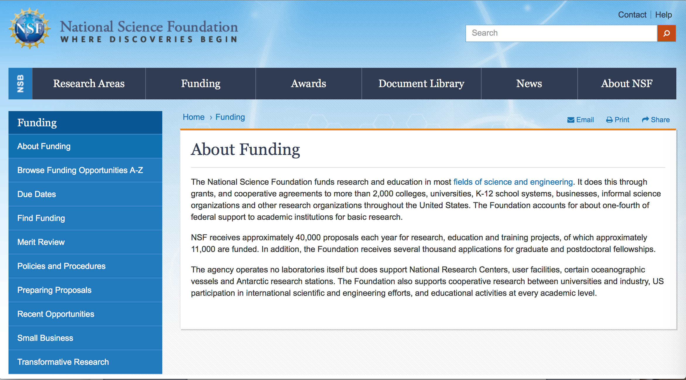

For assistance: https://nsf.gov/funding/aboutfunding.jsp

The National Science Foundation funds research and education in most fields of science and engineering. It does this through grants, and cooperative agreements to more than 2,000 colleges, universities, K-12 school systems, businesses, informal science organizations and other research organizations throughout the United States. The Foundation accounts for about one-fourth of federal support to academic institutions for basic research.
NSF receives approximately 40,000 proposals each year for research, education and training projects, of which approximately 11,000 are funded. In addition, the Foundation receives several thousand applications for graduate and postdoctoral fellowships.
The agency operates no laboratories itself but does support National Research Centers, user facilities, certain oceanographic vessels and Antarctic research stations. The Foundation also supports cooperative research between universities and industry, US participation in international scientific and engineering efforts, and educational activities at every academic level.

For details on active funding deadline dates: http://nsf.gov/funding/pgm_list.jsp?org=NSF&ord=date

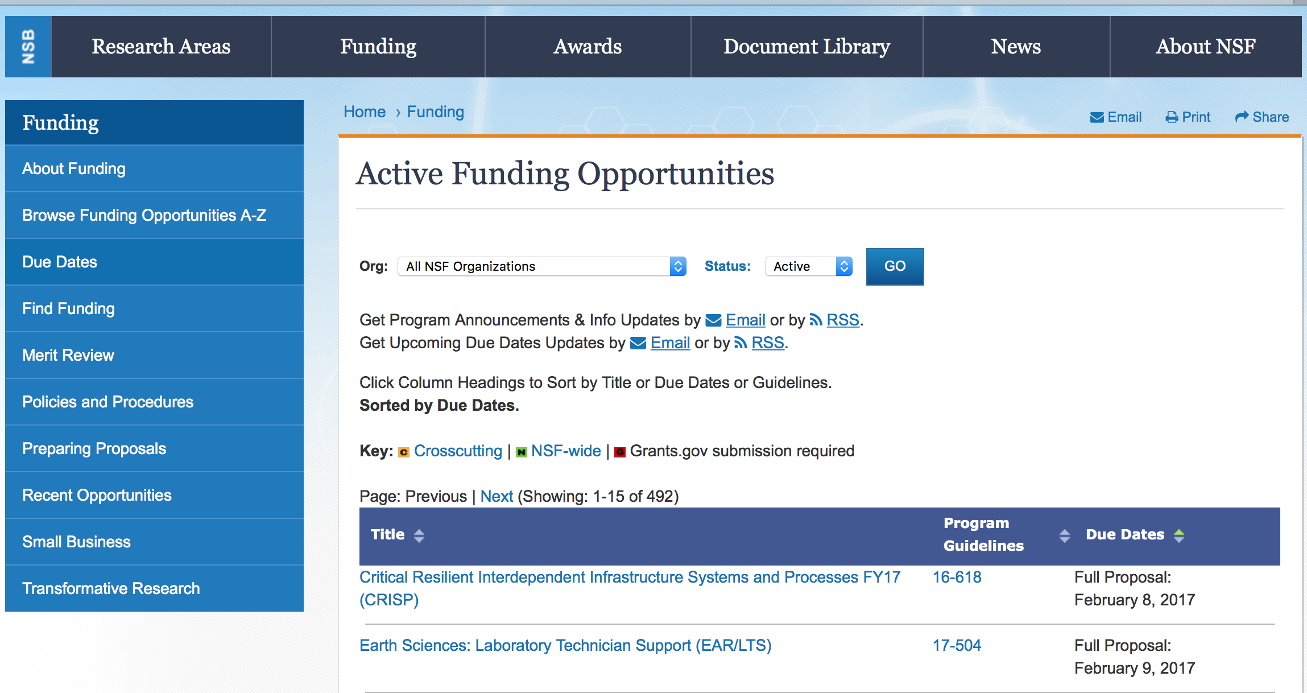

Critical Resilient Interdependent Infrastructure Systems and Processes
Synopsis 1
https://www.grants.gov/web/grants/view-opportunity.html?oppId=299266

EPSCoR Research Infrastructure Improvement Track 4: EPSCoR Research Fellows
Synopsis 1
https://www.grants.gov/web/grants/view-opportunity.html?oppId=299407

Improving Undergraduate STEM Education: Hispanic-Serving Institutions
Synopsis 1
https://www.grants.gov/web/grants/view-opportunity.html?oppId=299280

Ocean Observatories Initiative Facility Board (OOIFB) Administrative Support Office
Synopsis 1
https://www.grants.gov/web/grants/view-opportunity.html?oppId=299673

Modifications:

Reminders:

Deleted:

Nuclear Regulatory Commission

Reminders:

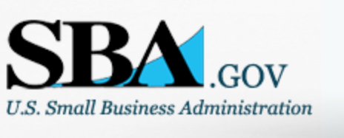

Small Business Administration

General Overview Finding Loans & Grants

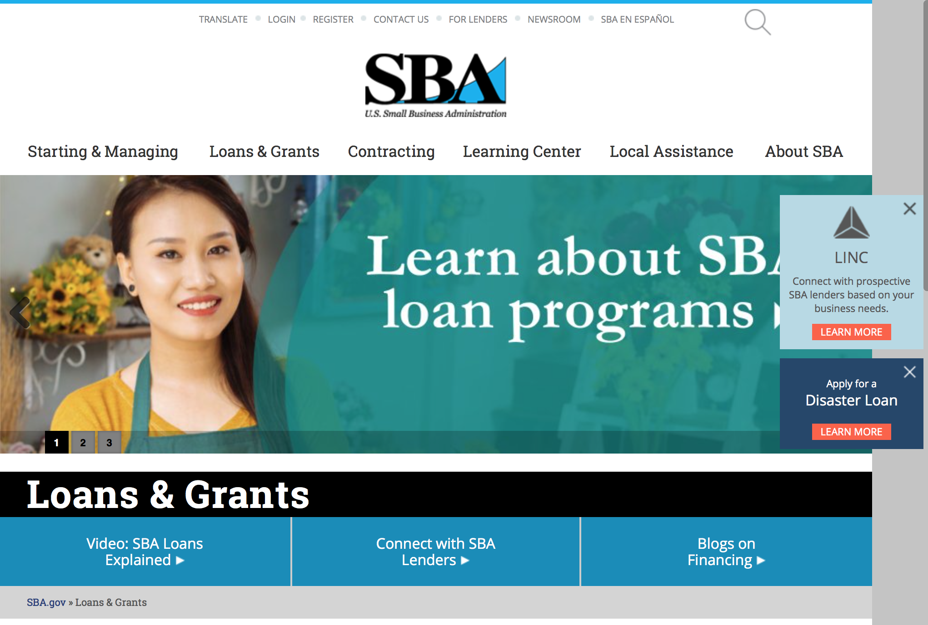
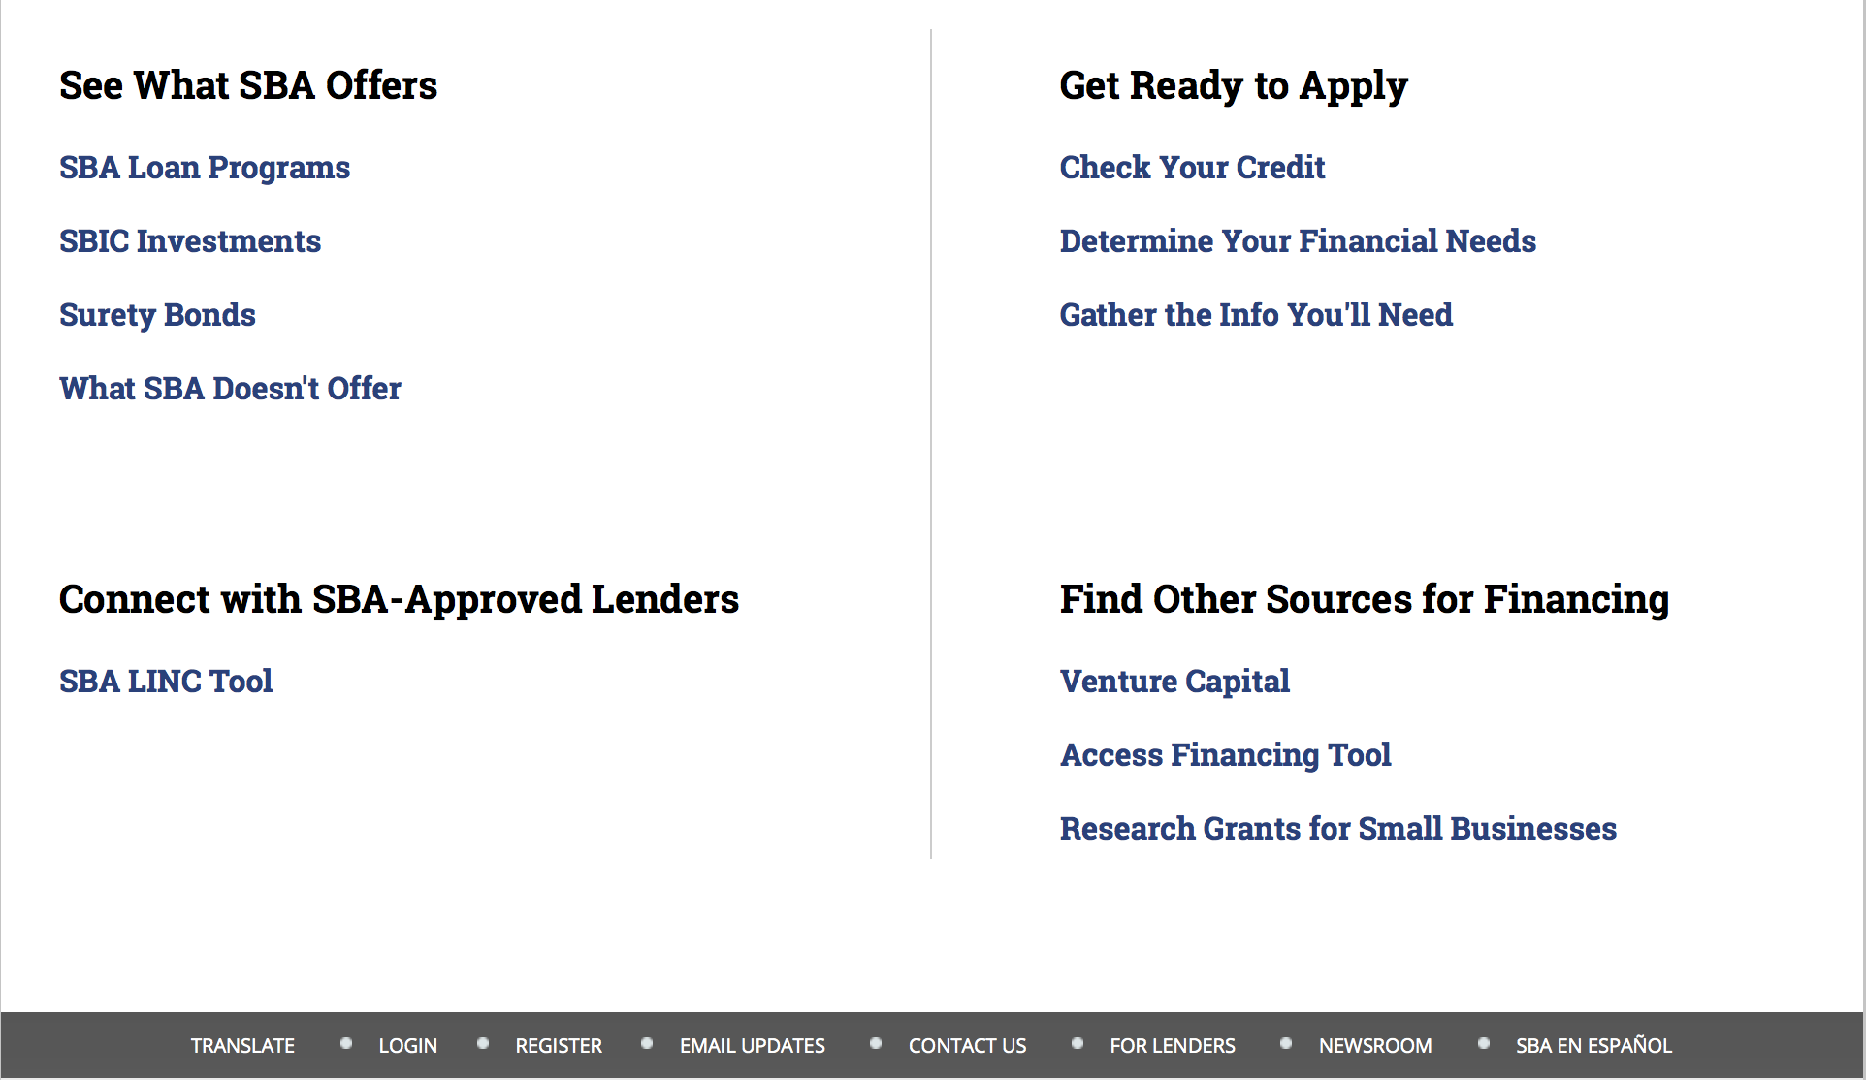

https://www.sba.gov/category/navigation-structure/loans-grants
Federal, state and local governments offer a wide range of financing programs to help small businesses start and grow their operations. These programs include low-interest loans, venture capital, and scientific and economic development grants.
Use SBA.gov's Loans and Grants Search Tool to get a list of financing programs for which you may qualify, or visit the resources below to learn more about small business financing programs.
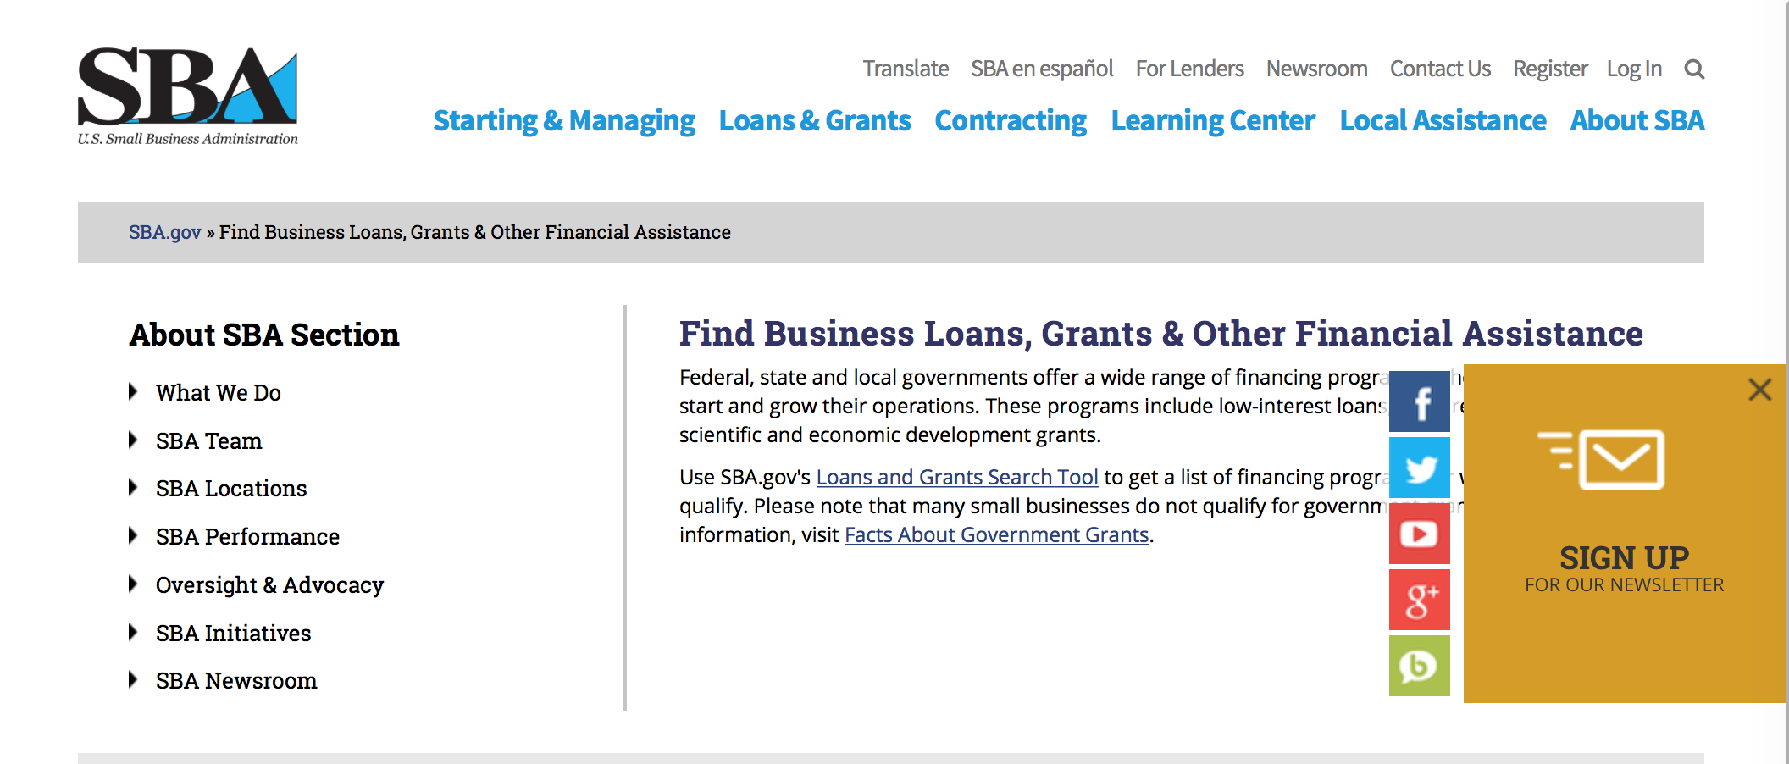
To get to the main SBA.gov funding page click here
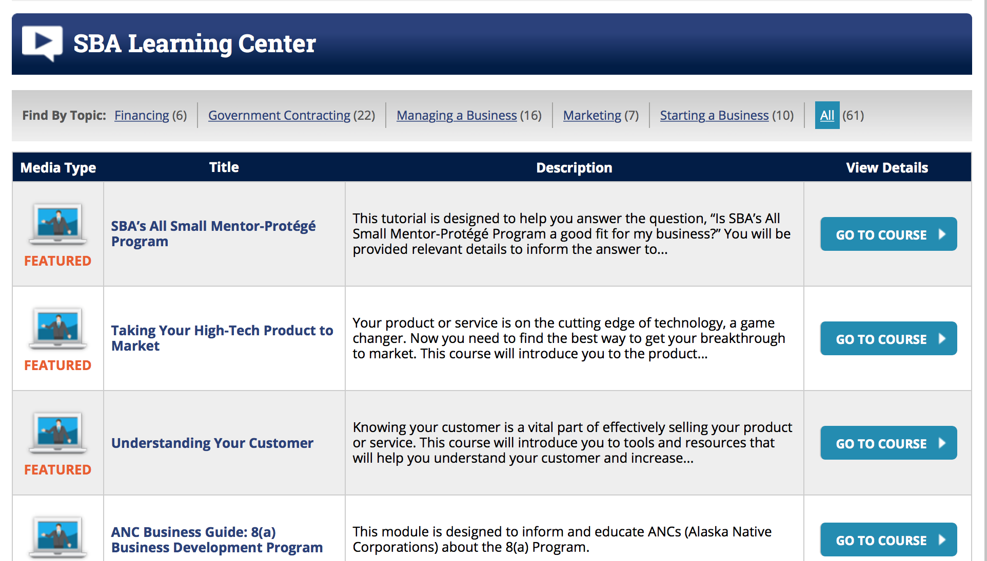
https://www.sba.gov/tools/sba-learning-center/search/training

Programs:

Women’s Business Center - Initial Phase Grant
Synopsis 1

Document Type: | Grants Notice
Funding Opportunity Number: | OWBO-2017-01-1
Funding Opportunity Title: | Women’s Business Center - Initial Phase Grant
Opportunity Category: | Discretionary
Opportunity Category Explanation:
Funding Instrument Type: | Cooperative Agreement
Category of Funding Activity: | Business and Commerce
Category Explanation:
Expected Number of Awards: | 6
CFDA Number(s): | 59.043 -- Women's Business Ownership Assistance
Cost Sharing or Matching Requirement: | Yes
Version: | Synopsis 2
Posted Date: | Dec 29, 2017
Last Updated Date: | Dec 29, 2017
Original Closing Date for Applications: | Feb 12, 2018
Current Closing Date for Applications: | Feb 12, 2018
Archive Date:
Estimated Total Program Funding: | $450,000
Award Ceiling: | $75,000
Award Floor: | $75,000
Eligible Applicants: | Others (see text field entitled "Additional Information on Eligibility" for clarification)
Additional Information on Eligibility: | In order to be eligible for this funding opportunity, Applicants must be a private non-profit organization certified under § 501(c)- of the Internal Revenue Code of 1986 and have been providing technical services to women entrepreneurs.
Agency Name: | Small Business Administration
Description: | Since its inception in 1953, the Small Business Administration (SBA) has served to aid, counsel, assist and protect the interests of small businesses. While the SBA is best known for its financial support of small businesses through its many lending programs, the Agency also plays a critical role in providing funding to organizations that deliver technical assistance in the form of counseling and training to small business concerns and nascent entrepreneurs in order to promote growth, expansion, innovation, increased productivity and management improvement. The mission of the WBC Program is to act as the catalyst for providing in-depth, substantive, outcome-oriented business services to women entrepreneurs, both nascent and established businesses, a representative number of which are socially and economically disadvantaged. This mission is accomplished through the award of financial assistance to private, 501(c)- certified non-profit organizations to enable them to affect substantial economic impact in their communities, as measured by successful business start-ups, job creation and retention, and increased company revenues. The purpose of this funding opportunity announcement is to provide funding for up to six eligible non-profit organizations (as defined in Section 3.2) to start a new, community-based Women’s Business Center (WBC) in the geographic areas of SBA’s six District offices that do not have a WBC in their respective service area. Eligible applicants must be private, non-profit organizations with 501(c) tax-exempt status from the U.S. Treasury/Internal Revenue Service and must provide services to the population within one of the following states. Applicants proposing to provide services within the District office territories must provide services to the population within the counties listed.
Link to Additional Information:
Grantor Contact Information: | If you have difficulty accessing the full announcement electronically, please contact:  U.S. SBA Office of Women’s Business Ownership E-mail: OWBO@sba.gov Phone: (202) 205-6673  Email
https://www.grants.gov/web/grants/view-opportunity.html?oppId=299733

Women’s Business Center - Initial Phase Grant
Synopsis 1
Document Type: | Grants Notice
Funding Opportunity Number: | OWBO-2017-01-2
Funding Opportunity Title: | Women’s Business Center - Initial Phase Grant
Opportunity Category: | Discretionary
Opportunity Category Explanation:
Funding Instrument Type: | Cooperative Agreement
Category of Funding Activity: | Business and Commerce
Category Explanation:
Expected Number of Awards:
CFDA Number(s): | 59.043 -- Women's Business Ownership Assistance
Cost Sharing or Matching Requirement: | No
Version: | Synopsis 1
Posted Date: | Dec 29, 2017
Last Updated Date: | Dec 28, 2017
Original Closing Date for Applications: | Feb 12, 2018
Current Closing Date for Applications: | Feb 12, 2018
Archive Date: | Mar 14, 2018
Estimated Total Program Funding: | $525,000
Award Ceiling: | $75,000
Award Floor: | $75,000
Eligible Applicants: | Nonprofits having a 501(c)(3) status with the IRS, other than institutions of higher education
Agency Name: | Small Business Administration
Description: | The Women’s Business Center (WBC) Program was established by the Women’s Business Ownership Act of 1988 (Public Law No. 100-533) as the Women’s Business Demonstration Pilot, providing grants to private non-profit organizations to aid and encourage the development and growth of small women-owned businesses through long-term training and counseling. The program was expanded and made permanent in 2007 when the WBC Sustainability Grant Program, established in 1999, was replaced with the WBC Renewal Grant Program. The purpose of this funding opportunity announcement is to provide funding for up to seven existing private non-profit organizations (host organizations) of a Women’s Business Center (WBC) that have met their performance goals for the past 2 years and is in good standing with both performance and compliances to start a new, community-based WBC. The WBC must be located in an area that is not being served or adequately served. The host organizations must have sufficient match to meet the match requirements of any existing grants along with any new grants.
Link to Additional Information:
Grantor Contact Information: | If you have difficulty accessing the full announcement electronically, please contact:  U.S. SBA Office of Women’s Business Ownership E-mail: OWBO@sba.gov Phone: (202) 205-6673  Email
https://www.grants.gov/web/grants/view-opportunity.html?oppId=299736

Modifications

Reminders:

Veterans Business Outreach Center Program (VBOC)
Synopsis 1

Document Type: | Grants Notice
Funding Opportunity Number: | VBOC-2018-01
Funding Opportunity Title: | Veterans Business Outreach Center Program (VBOC)
Opportunity Category: | Discretionary
Opportunity Category Explanation:
Funding Instrument Type: | Cooperative Agreement
Category of Funding Activity: | Business and Commerce
Category Explanation:
Expected Number of Awards: | 23
CFDA Number(s): | 59.044 -- Veterans Outreach Program
Cost Sharing or Matching Requirement: | No
Version: | Synopsis 1
Posted Date: | Nov 20, 2017
Last Updated Date: | Nov 17, 2017
Original Closing Date for Applications: | Jan 08, 2018
Current Closing Date for Applications: | Jan 08, 2018
Archive Date:
Estimated Total Program Funding: | $6,000,000
Award Ceiling: | $375,000
Award Floor: | $225,000
Eligible Applicants: | County governments  Private institutions of higher education  Nonprofits having a 501(c)(3) status with the IRS, other than institutions of higher education  Others (see text field entitled "Additional Information on Eligibility" for clarification)  City or township governments  State governments
Additional Information on Eligibility: | • Be a nonprofit organization, local or state agencies, private sector firm or institute of higher learning. • Demonstrate a history of providing quality entrepreneurship and/or business management training to aspiring entrepreneurs or existing small business owners that are members of the following populations: veterans, service-disabled veterans, Reserve Component members or National Guard, transitioning service members, spouses of service members or veterans, and other beneficiaries interested in starting or growing a small enterprise. The quality of a program can be demonstrated by new business starts, business expansions or diversifications number of contracts awarded and loans approved, as well as jobs created and/or retained, and connection to other programs such as SBA resource partners.
Agency Name: | Small Business Administration
Description: | Eligible organizations (as defined in Section 3.2) may apply for an Initial Phase VBOC Award of financial assistance under this Funding Opportunity to fund implementation of a Veterans Business Outreach Center in the geographic coverage areas defined in Appendix A. Applicants are limited to the defined coverage areas and can apply for all, or part, of a defined coverage area. As a major component of the VBOC program Applicants are expected to provide entrepreneurship training through the Boots to Business (B2B) and Reboot Training programs to transitioning military personnel and veteran small business owners and entrepreneurs. VBOCs will be expected to cover 100% of the Boots to Business classes within their coverage area. Additionally, funds will be used to offer traditional business counseling and technical assistance to veterans, service-members, military spouses, and others interested in starting or growing a small business.
Link to Additional Information:
Grantor Contact Information: | If you have difficulty accessing the full announcement electronically, please contact:  Janet Moorman Program Officer Phone (202) 205-7419  janet.moorman@sba.gov

https://www.grants.gov/web/grants/view-opportunity.html?oppId=298820

Deleted:

SBA Trainings

Contracting Opportunities for Veteran Entrepreneurs
This self-paced training exercise is an introduction to Federal contracting opportunities for Veterans.
Topics include basic information about Veteran-owned businesses and opportunities, services available to small Veteran-owned businesses, small business incentives, and government procurement methods.
Duration: 00:30:00

http://www.sba.gov/tools/sba-learning-center/training/contracting-opportunities-veteran-entrepreneurs

Interested in Exporting? These Four Resources Can Help
Did you know that two-thirds of the world’s purchasing power is in foreign countries? As the numbers show, the international marketplace is a big one. So if you’re interested in exploring the world of exporting – or have gotten started but could use some guidance – check out these resources to help.
- Read more

Upcoming Trainings: Check out SBA's Online Training!
- Financing Options for Small Businesses
How to Prepare Government Contract Proposals
Getting Started With Exporting: Training and Educational Resources
Exporting represents a big opportunity to tap in to new markets, expand your customer base and grow your business. But getting started with exporting can sometimes feel like a maze of regulations, policies, and other barriers. Here are some free training and educational resources to help.
- Read more

For Specific Information in Hawaii see the following links:
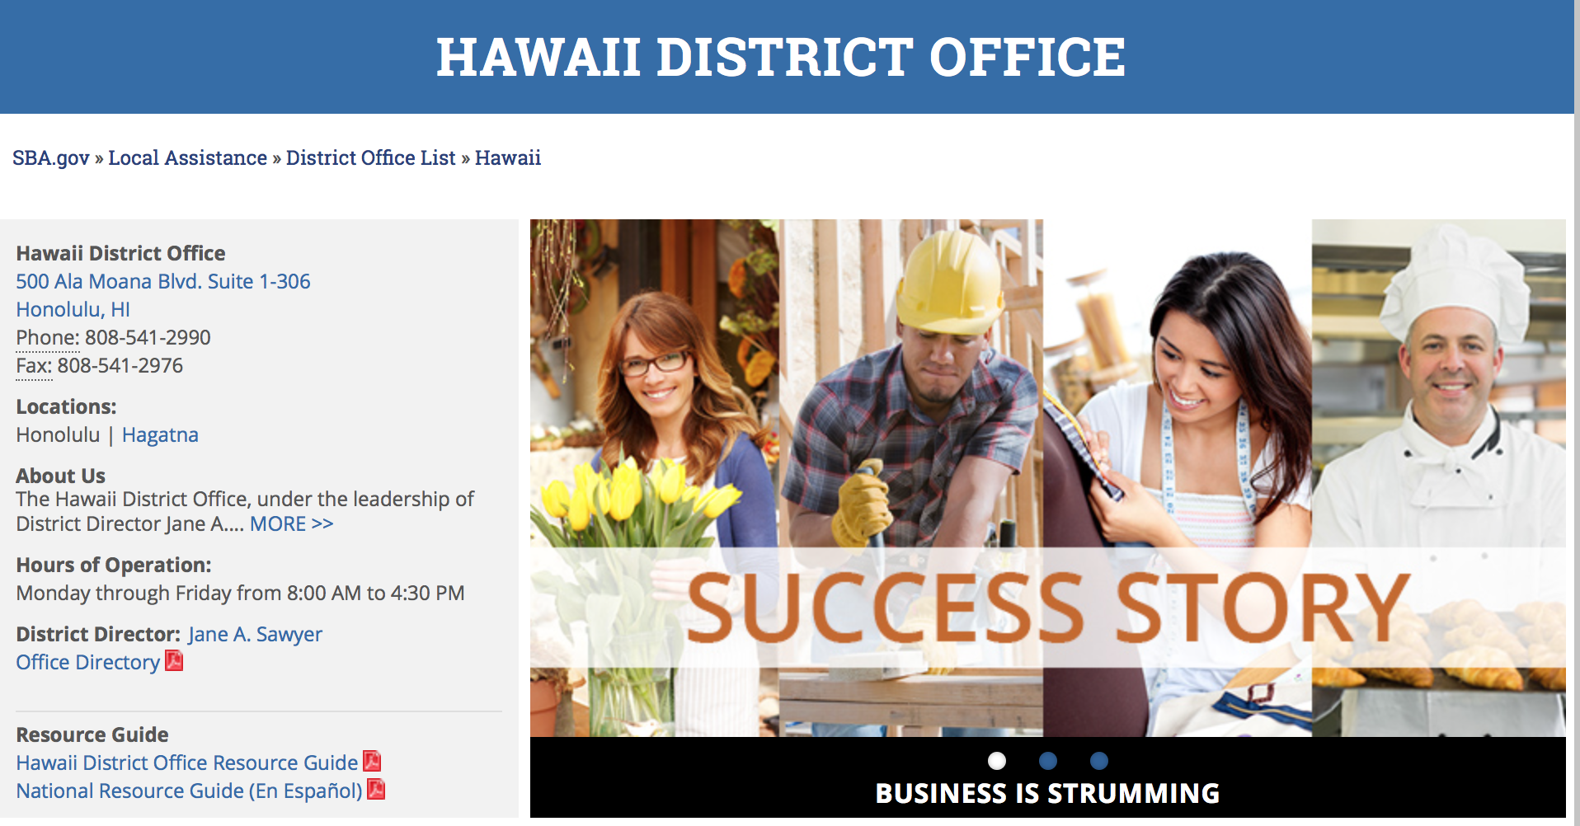

https://www.sba.gov/offices/district/hi/Honolulu

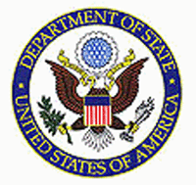

State Department General Overview and Resources for Program Administrators

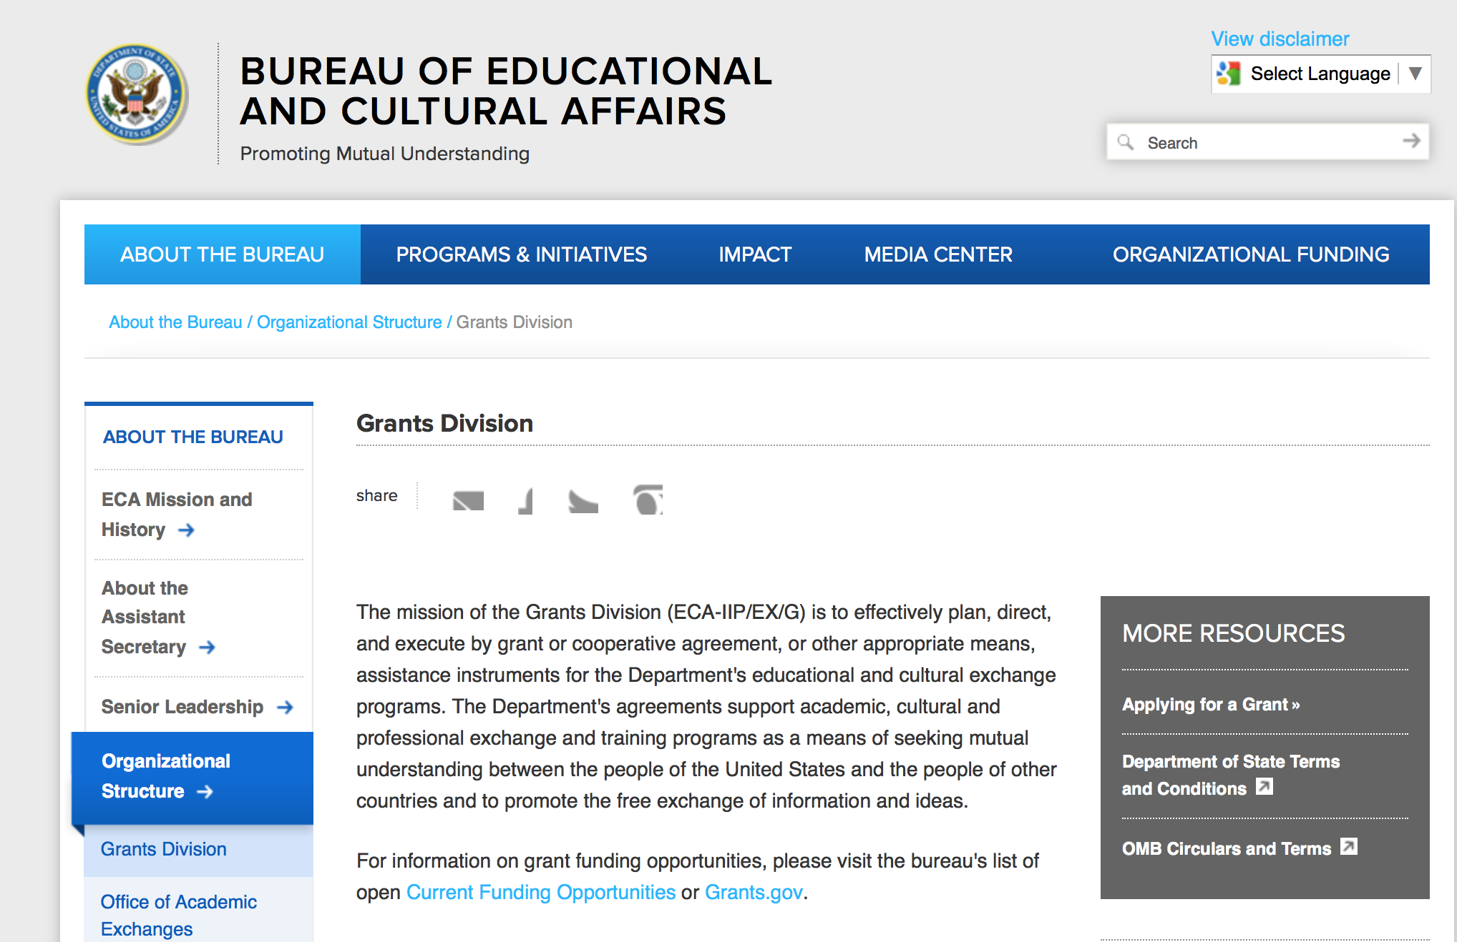

https://eca.state.gov/about-bureau/organizational-structure/grants-division

http://eca.state.gov/search/solr/grants?search_referrer=node/237

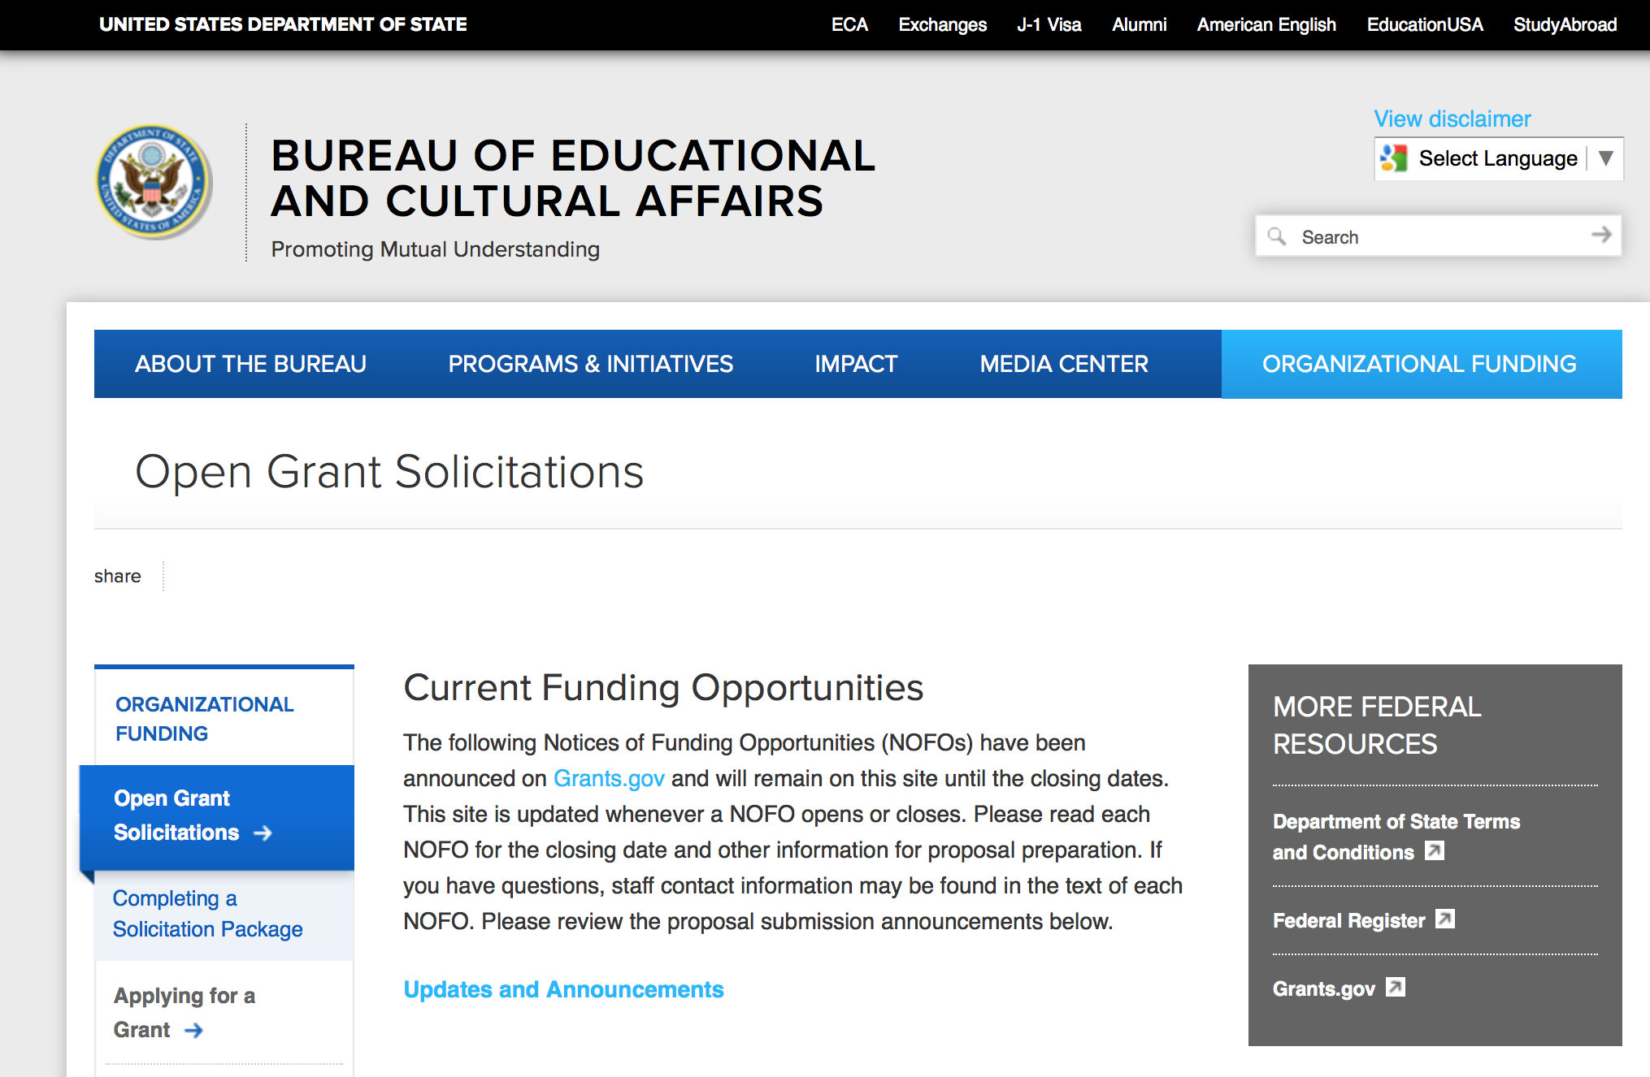
https://eca.state.gov/organizational-funding/open-grant-solicitations

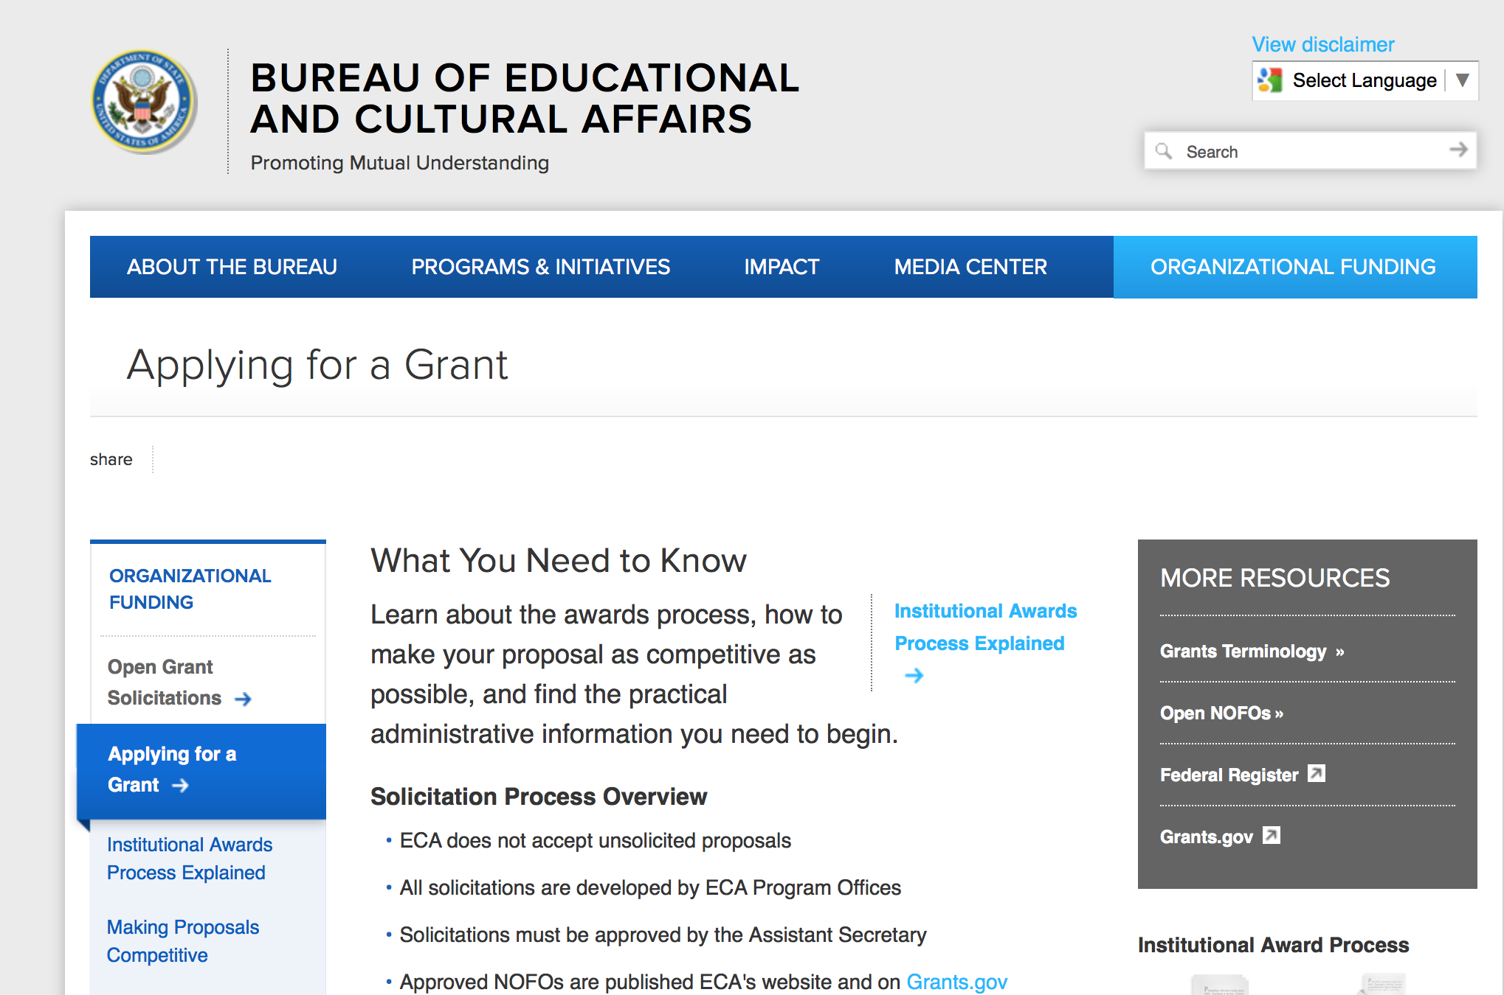
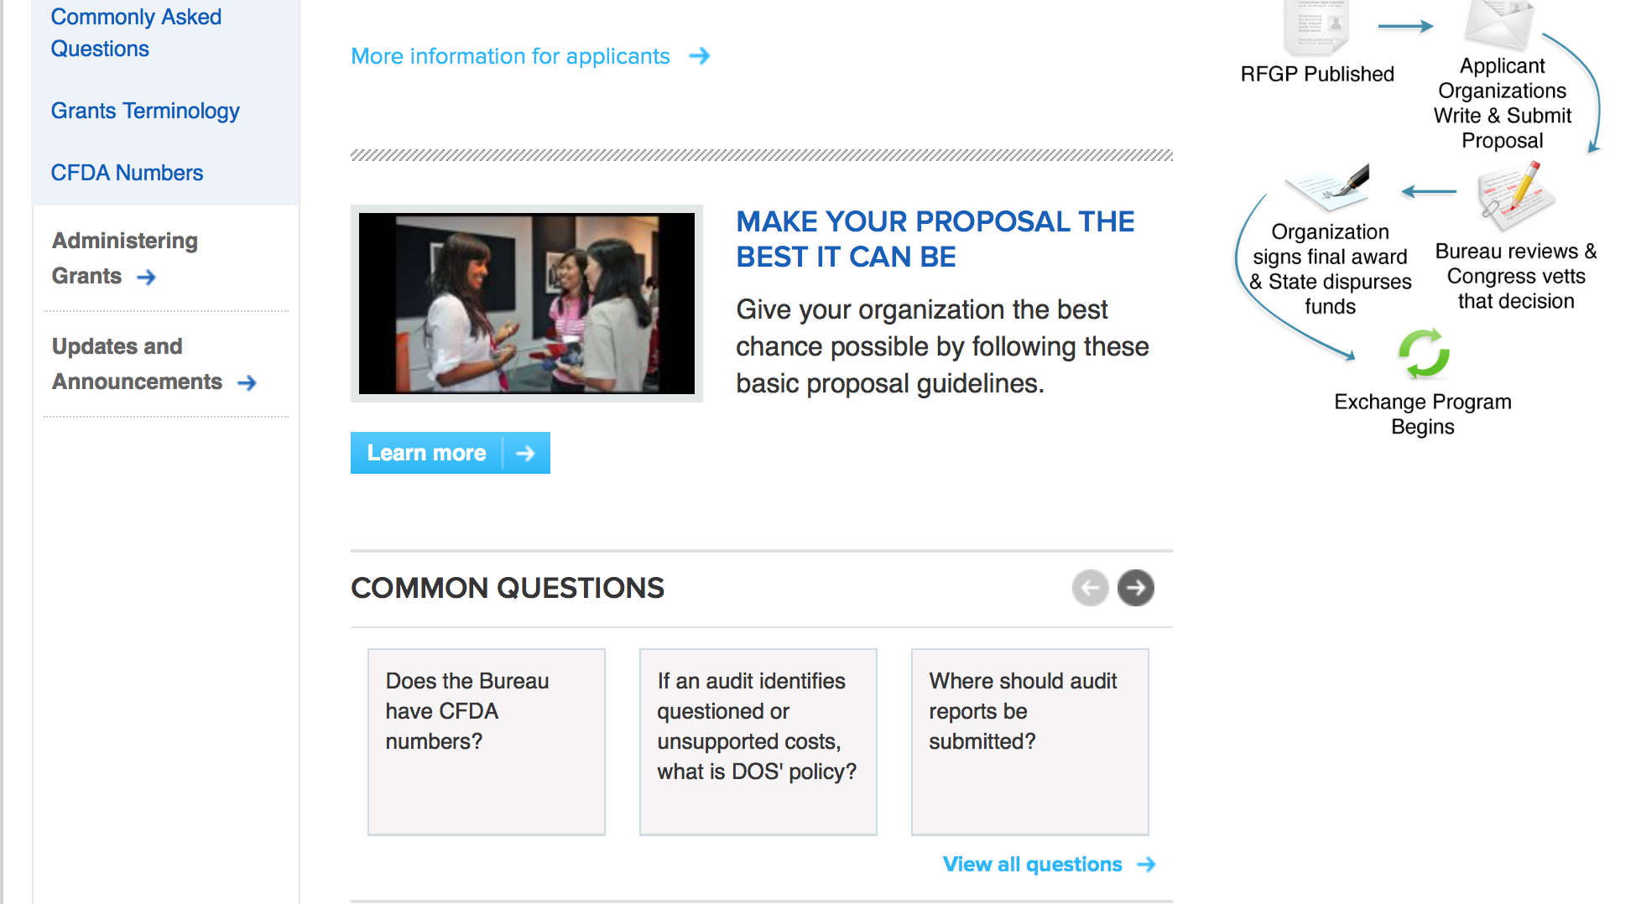
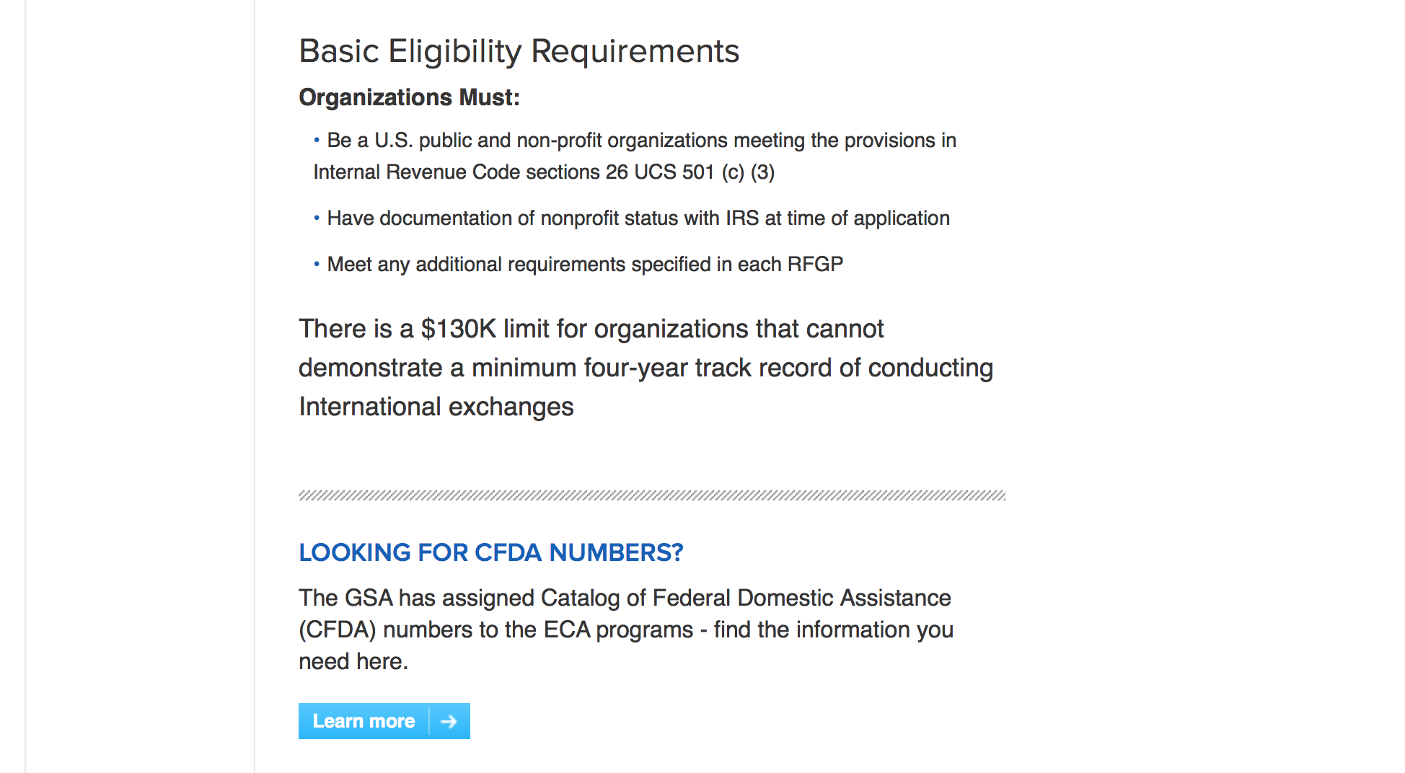
http://eca.state.gov/organizational-funding/applying-grant

General Information:
- Bureau of Educational and Cultural Affairs Grants Division
- Open Grant Opportunities (Requests for Grant Proposals)

For General Information click here

Program Grants:

Bureau Of Educational and Cultural Affairs
FY 2018 Mandela Washington Fellowship for Young African Leaders
Synopsis 1
https://www.grants.gov/web/grants/view-opportunity.html?oppId=299593

U.S. Mission to Bangladesh
FY 18 Annual Program Statement
Synopsis 1
https://www.grants.gov/web/grants/view-opportunity.html?oppId=299310
U.S. Mission to India
English Access Microscholarship Alumni Engagement
Synopsis 1
https://www.grants.gov/web/grants/view-opportunity.html?oppId=299604

U.S. Mission to India
Social Action Lab
Synopsis 1
https://www.grants.gov/web/grants/view-opportunity.html?oppId=299694

U.S. Mission to Sri Lanka
U.S. DEPARTMENT OF STATE U.S. EMBASSY COLOMBO PUBLIC AFFAIRS SECTION GRANTS PROGRAM FOR MALDIVES
Synopsis 1
https://www.grants.gov/web/grants/view-opportunity.html?oppId=299250

Modifications:

U.S. Mission to Sri Lanka
U.S. EMBASSY COLOMBO PUBLIC AFFAIRS SECTION GRANTS PROGRAM FOR SRI LANKA
Synopsis 2
https://www.grants.gov/web/grants/view-opportunity.html?oppId=299249

U.S. Mission to Cote d Ivoire
U.S. Embassy Abidjan, Annual Program Statement
Synopsis 2
https://www.grants.gov/web/grants/view-opportunity.html?oppId=299399

U.S. Mission to Moldova
Media Grants Program
Synopsis 2
https://www.grants.gov/web/grants/view-opportunity.html?oppId=299493

Reminders:

Deleted:

Department of Transportation

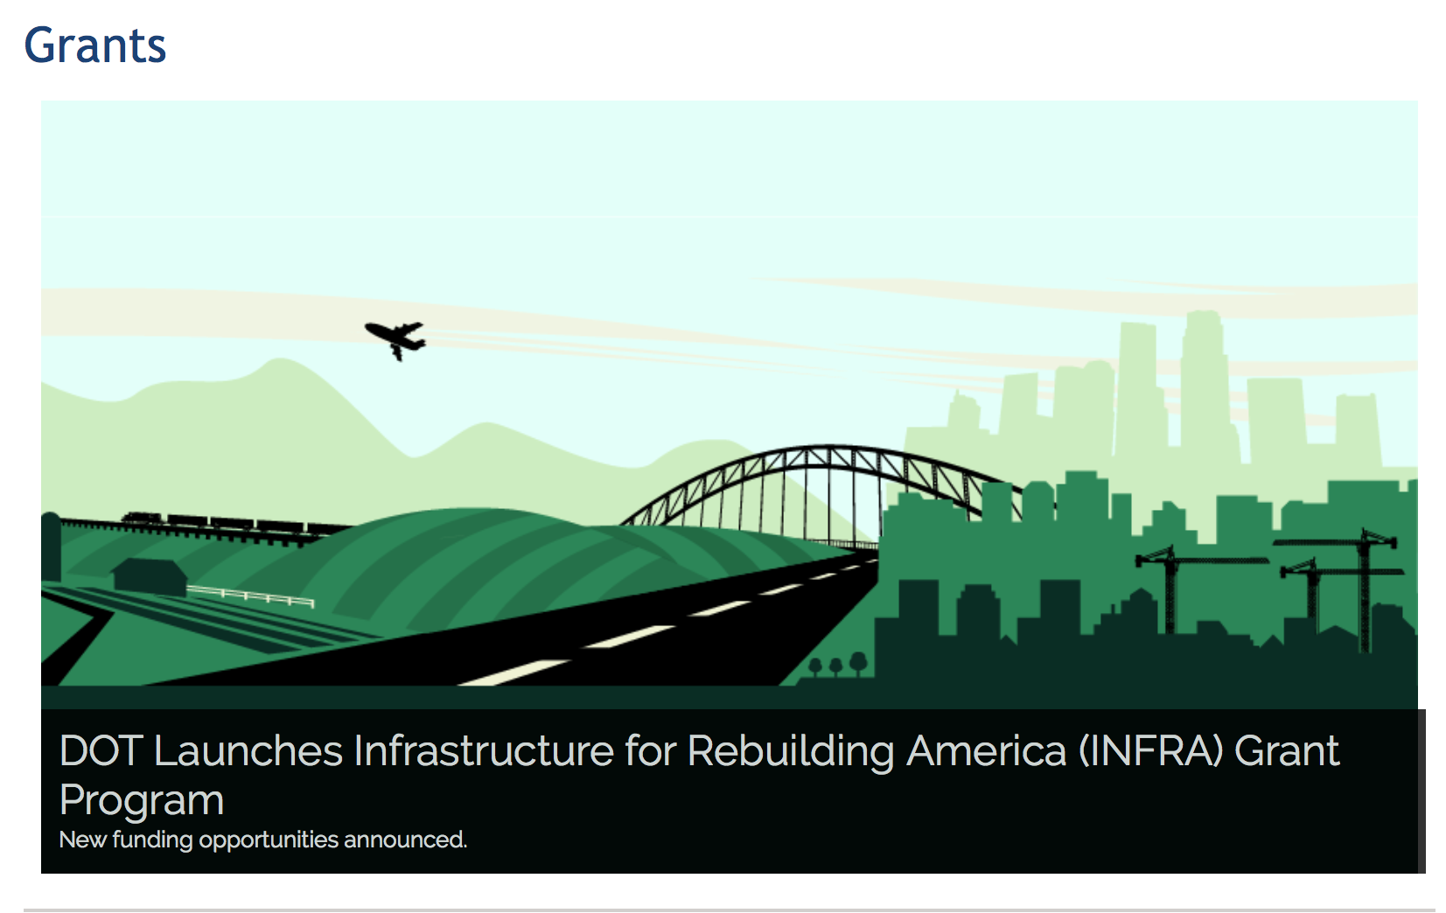

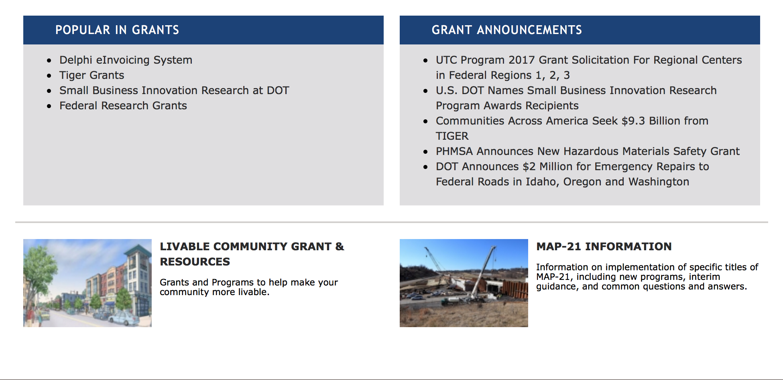

General Grant Program Overview https://www.transportation.gov/grants

Programs:

Modifications:

Research:

Reminders:

DOT - FAA Aviation Research Grants
FAA Aviation Research and Development Grants
Synopsis 3, 4 & 6

Document Type: | Grants Notice
Funding Opportunity Number: | 12-01
Funding Opportunity Title: | FAA Aviation Research and Development Grants
Opportunity Category: | Discretionary
Opportunity Category Explanation:
Funding Instrument Type: | Grant
Category of Funding Activity: | Transportation
Category Explanation:
Expected Number of Awards:
CFDA Number(s): | 20.108 -- Aviation Research Grants
Cost Sharing or Matching Requirement: | No
Version: | Synopsis 6
Posted Date: | Jan 01, 2012
Last Updated Date: | Oct 18, 2017
Original Closing Date for Applications: | Dec 31, 2019
Current Closing Date for Applications: | Dec 31, 2019
Archive Date: | Jan 30, 2020
Estimated Total Program Funding:
Award Ceiling: | $5,000,000
Eligible Applicants: | Private institutions of higher education  Nonprofits having a 501(c)(3) status with the IRS, other than institutions of higher education  Public and State controlled institutions of higher education
Agency Name: | DOT - FAA Aviation Research Grants
Description: | The FAA is soliciting proposals for research grants and cooperative agreements to pursue the long-term growth and short-term technical needs of civil aviation. In order to streamline the application process, it is recommended that all prospective grantees submit a white paper (letter of intent) for agency technical review before complete proposal submission. Please be sure to identify the specific area of interest (Solicitation FAA-12-01 – Chapter I. FAA Research Grants Program, Technical Areas of Research #1-#9). The white paper shall be no longer than three (3) pages and shall detail overall research objectives.
Link to Additional Information:
Grantor Contact Information: | If you have difficulty accessing the full announcement electronically, please contact:  Nicole Saiauskie Grants Officer Phone 609-485-4781  business

http://www.grants.gov/web/grants/view-opportunity.html?oppId=134953

Deleted:

Department of the Treasury

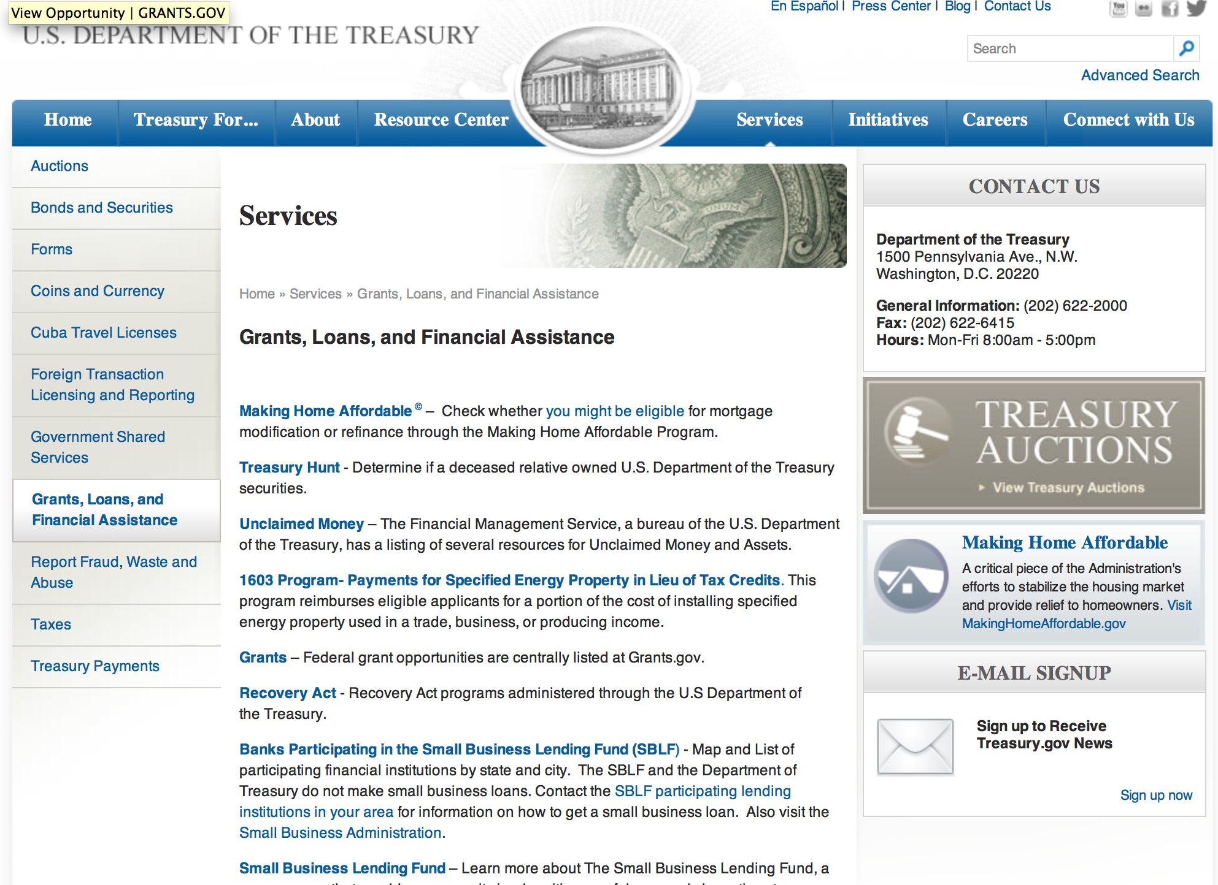

http://www.treasury.gov/services/Pages/Grants-Loans-and-Financial-Assistance.aspx

Programs:

Modifications:

Reminders:

U.S. Agency for International Development

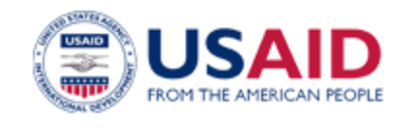

www.usaid.gov

General Overview Funding Opportunities

USAID has working relationships with thousands of American companies and hundreds of U.S.-based private voluntary organizations. For more information on our business and procurement opportunities, please visit our Business section.

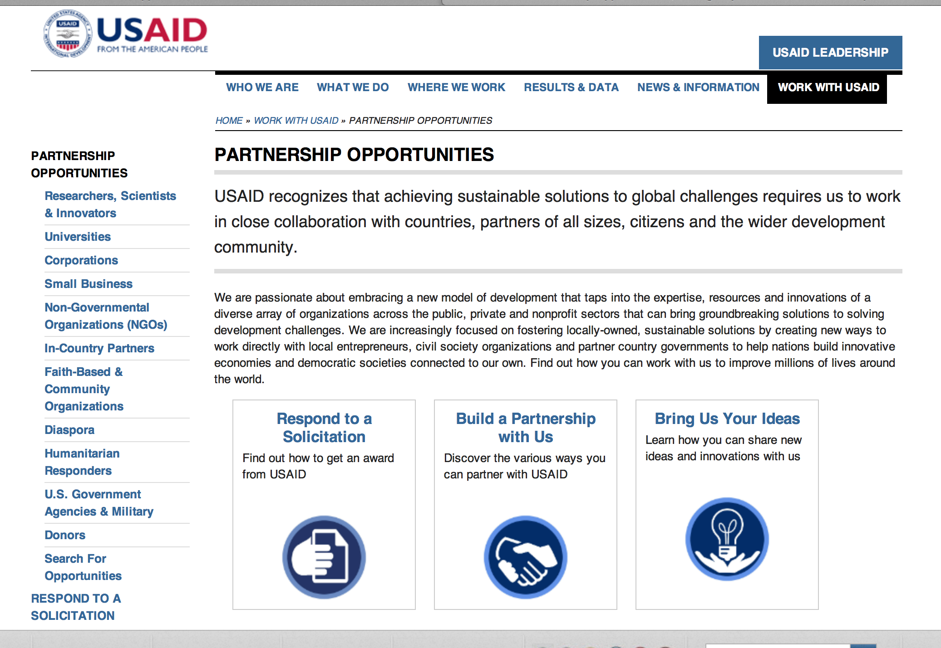
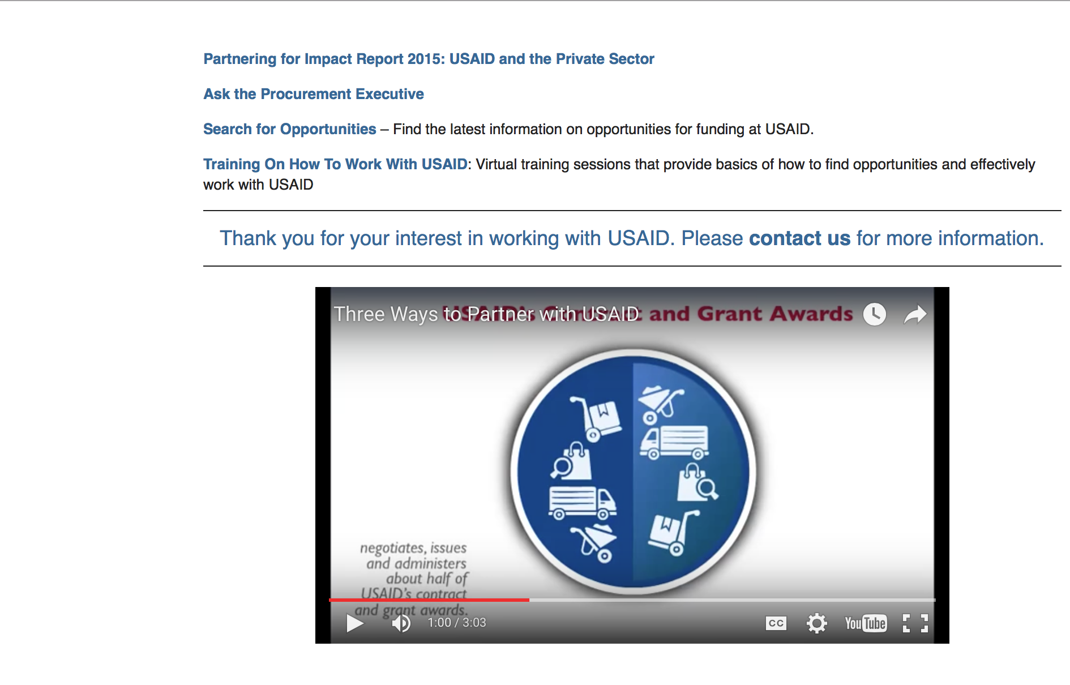

http://www.usaid.gov/partnerships

Programs:

Long-term Assistance and Services for Research (LASER)
Synopsis 1
https://www.grants.gov/web/grants/view-opportunity.html?oppId=299303
School Doors: Bringing out-of-school children back into the classroom
Synopsis 1
https://www.grants.gov/web/grants/view-opportunity.html?oppId=299259
USAID/DRC Broad Agency Announcement: Establishing Conflict Free Supply Chains in Eastern DRC and Reducing the Vulnerability of Artisanal and Small-Scale Mining Communities to Conflict
Synopsis 1
https://www.grants.gov/web/grants/view-opportunity.html?oppId=299713

Modifications:

The Farmer-to-Farmer Program
Synopsis 2
https://www.grants.gov/web/grants/view-opportunity.html?oppId=299699

South Africa USAID-Pretoria
Strengthening Local Governance to Improve Gender Based Violence (GBV) Response Project
Synopsis 2
https://www.grants.gov/web/grants/view-opportunity.html?oppId=299281

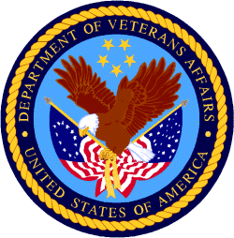

Department of Veterans Affairs

