Senator Mazie Hirono

Grants Assistance Information Newsletter

JANUARY 2019

G.A.I.N. INDEX

Click on Index Links below to read summaries of the announcements by agency in this document. Once you reach the item, if you cannot open the links for further information, copy the selected URL website address into your browser.

Modified sections from previous listings are shown in a GREY background

Notices is Teal are items with immediate deadline dates.

Notices in Yellow are of special interest.

Notices is Green are items of special interest with immediate deadline dates.

Items in this type color are aimed at Small Businesses

Items in this type color have a Faith-Based Organization component

Special Federal Program Notices

Highlighted

Federal Agency Shutdown Notices

Reminders

Programs specific to Hawaii

Current Notices

National Park Service
NAGPRA Consultation/Documentation Grants FY2019
National Park Service
NAGPRA Repatriation Grants FY2019
Reminders

2019 Pacific Islands Region Marine Turtle Management and Conservation Program

FY19 Coral Reef Conservation Program, Domestic Coral Reef Conservation Grants

FY2019 NOAA Bay Watershed Education and Training (B-WET) Hawaii Program

Grant Writing Resources

SAM and Grants.Gov Information

SBIR – Small Business Innovation Research

See Individual Departments for information and webpages representing the best and most accessible information on the agency funding opportunities

Federal Grant and Cooperative Agreement Program Summaries

U.S. Department of Agriculture

Grants and Loans Overview

Programs

Business and Cooperative Programs
REAP Energy Audit and Renewable Energy Development Assistance Program

Research

National Institute of Food and Agriculture
FY19 Small Business Innovation Research Program Phase II
Modifications
Reminders

National Institute of Food and Agriculture
Food and Agricultural Sciences National Needs Graduate and Postgraduate Fellowship (NNF) Grants Program

Food and Nutrition Service
FY_19_TIG_Grant

National Institute of Food and Agriculture
Biotechnology Risk Assessment Grants Program

Business and Cooperative Programs
Renewable Energy Systems and Energy Efficiency Improvements Program
Deleted:

Department of Commerce

Grants at Commerce

Programs

2019 Bycatch Reduction Engineering Program
Research

Modifications

Reminders

FY 2019 Community-based Restoration Program Coastal and Marine Habitat Restoration Grants
Fiscal Year 2020 National Sea Grant College Program Dean John A. Knauss Marine Policy Fellowship

National Estuarine Research Reserve System (NERRS) Land Acquisition and Construction Program for Fiscal Year 2019
Economic Development Administration
FY 2017 Economic Development Assistance Programs ­ Application submission and program requirements for EDA’s Public Works and Economic Adjustment Assistance programs.

FY 2016 – FY 2019 EDA Planning Program and Local Technical Assistance Program Grant

Economic Development Administration
Planning Program and Local Technical Assistance Program Grant

Deleted

Corporation for National and Community Service

General Program Overview

Programs

Reminders

AmeriCorps State and National Grants FY2019
National Service in Hawaii

Department of Defense

Doing Business with the Department of Defense

DoD Small Business Opportunities and Forecasting

Research Grants

Modifications

Deleted

Reminders

Department of Education

Grant Programs Overview

Programs

Research

Modifications

Reminders

Office of Innovation and Improvement (OII): Expanding Opportunity Through Quality Charter Schools Program (CSP): Grants to Charter Management Organizations for the Replication and Expansion of High-Quality Charter Schools CFDA Number 84.282M
Institute of Education Sciences (IES): Low-Cost, Short-Duration Evaluation of Education Interventions CFDA Number 84.305L
Institute of Education Sciences (IES): Low-Cost, Short-Duration Evaluation of Special Education Interventions CFDA Number 84.324L
Deleted

US Department of Energy

Grants Overview

Office of Science
FY2019 Continuation of Solicitation for the Office of Science Financial Assistance Program
Synopsis 1

Research

Modifications

Reminders

Environmental Protection Agency

Grants and Contracts Overview

Programs

Clean Diesel Funding Assistance Program FY 2019
Modifications

Research

Reminders

Environmental Justice Small Grants Program
FY19 Guidelines For Brownfields Assessment Grants
FY19 Guidelines For Brownfields Cleanup Grants
FY19 Guidelines For Brownfields Multipurpose (MP) Grants

Federal Mediation and Conciliation Service

Programs

Reminders

Department of Health and Human Services

Grants Overview

Program

Research Grants

Modifications

Deleted

Reminders

Department of Homeland Security
Grants Overview

Programs
Modifications

Reminders

United States Coast Guard
National Nonprofit Organization Grant Program

Department of Housing and Urban Development

HUD - Notice of Funds Available

Programs

HUD's FY 2018 and FY 2019 Community Compass Technical Assistance and Capacity Building Program Notice of Funding Availability (NOFA)

Lead-Based Paint Capital Fund Program (LBPCF) - Update and Reissue

Modifications

Deleted

Reminders
Notice of Funding Availability for the Fiscal Year (FY) 2017 Homeless Management Information System Capacity Building Project

Institute of Museum and Library Services

Grants Overview

IMLS is on Facebook!

Programs

Modifications

Reminders
Accelerating Promising Practices for Small Libraries

Department of Interior

Grants and Contract Overview

Programs
National Park Service
Historic Revitalization Subgrant Program (HRSP)
Fish and Wildlife Service
Marine Turtle Conservation Fund and Combating Wildlife Trafficking Strategy and Partnerships Program

Modifications

Reminders

Fish and Wildlife Service
Partners for Fish and Wildlife
Fish and Wildlife Service
Coastal

Deleted

Department of Justice

Grants and Contract Overview

Programs
Office on Violence Against Women
OVW FY 2019 Grants for Outreach and Services to Underserved Populations
Office on Violence Against Women
OVW FY 2019 Rural Sexual Assault, Domestic Violence, Dating Violence and Stalking Program
Office on Violence Against Women
OVW FY 2019 Transitional Housing Assistance Grants for Victims of Sexual Assault, Domestic Violence, Dating Violence and Stalking Program
Office on Violence Against Women
OVW FY 2019 Grants to Enhance Culturally Specific Services for Victims of Sexual Assault, Domestic Violence, Dating Violence and Stalking Program
Office on Violence Against Women
OVW FY 2019 Sexual Assault Services Culturally Specific Program

Research

Modifications

National Institute of Corrections
Facilitating Behavior Change with Persons under Community Supervision

Deleted

Reminders

Office of Juvenile Justice Delinquency Prevention
OJJDP FY 19 VOCA Regional Children's Advocacy Centers (RCAC)

Office on Violence Against Women
OVW FY 2019 Legal Assistance for Victims Grant Program Solicitation

Office on Violence Against Women
OVW FY 2019 Training and Services to End Violence Against Women with Disabilities Grant Program
Office on Violence Against Women
OVW FY 2019 Justice for Families Program Solicitation
________________________________________________________________________

Department of Labor

Grants and Contract General Overview

Programs

Mine Safety and Health Administration
Mine Health and Safety Grants
Modifications

Reminders

Veterans Employment and Training Service
Announcement of Stand Down Grants

National Aeronautics and Space Administration

Research Grant and Contract General Overview

Programs

Modifications

_______________________________________________________________
National Archives and Records Administration

Grant Opportunities General Overview

Programs

Reminders

Archives Collaboratives
Publishing Historical Records in Documentary Editions
Publishing Historical Records in Documentary Editions
Access to Historical Records: Major Initiatives (Preliminary)
_______________________________________________________________
National Endowment for the Arts

Grant Opportunities General Overview

Programs

NEA Art Works 1, FY2020

NEA Challenge America, FY2020
Modifications

Reminders

NEA Literature Fellowships: Prose, FY2020

NEA Performing Arts Discovery, FY2019

NEA Performing Arts Global Exchange, FY2019
NEA Shakespeare in American Communities, FY2019
NEA USArtists International, FY2019

_______________________________________________________________

National Endowment for the Humanities

Grant Opportunities General Overview

Programs

Landmarks of American History and Culture: Workshops for School Teachers

Preservation Assistance Grants

Public Scholar Program
Summer Seminars and Institutes for Higher Education Faculty
Summer Seminars and Institutes for K-12 Educators

Reminders

National Digital Newspaper Program
Sustaining Cultural Heritage Collections

Digital Humanities Advancement Grants

_______________________________________________________________
National Science Foundation

Grant Opportunities General Overview

Research and Program Grants

Modifications

Reminders

Deleted

Small Business Administration

General Overview Finding Loans & Grants

Programs
Modifications

Reminders

Deleted

Upcoming Trainings

Links Specific to Hawaii

State Department

General Overview and Resources for Program Administrators

Programs

Modifications

Reminders

U.S. Department of Transportation

General Grant Program Overview

Programs

69A345 Office of the Under Secretary for Policy
INFRA Grants

Research

Modifications

DOT Federal Highway Administration
Automated Driving System (ADS) Demonstration Grants
Reminders

DOT Federal Aviation Administration
DOT - FAA Aviation Research Grants
FAA Aviation Research and Development Grants
Modifications 3,4& 6

Deleted

Department of the Treasury

Programs

Modifications

Reminders

US Agency for International Development

General Funding Opportunity Overview

Programs
Modifications

Deleted

Department of Veterans Affairs

Special Federal Program Notices

Highlighted Programs

The January Newsletter was prepared during the partial Federal Agency shutdown. The shutdown is not in effect for every agency. In fact, several agencies are operating because their appropriations were not impacted.

Deadline dates for all notices in the newsletter should be in effect until further notice. Unfortunately, since the closed agencies are operating with skeletal staffs, exact determinations are unclear. At agencies subject to the shutdown, no information is available other than the notices compiled below.

Grants.Gov has made the following statement:
During a lapse in federal appropriations, the Grants.gov system will remain in an operational status. Additionally, the Grants.gov Support Center will remain available to provide assistance to applicants.

See notices below specific to agencies that are currently not operational:

- The Department of Agriculture

This website will not be updated during a lapse in federal funding. Content on this website will not be current or maintained until funding issues have been resolved.

- Department of Commerce

Shutdown Due to Lapse of Congressional Appropriations
Funding for a portion of the federal government expired on December 21, 2018. The Department is prepared for a lapse in funding that would necessitate a significant reduction in operations and is currently implementing its plan.
Read the United States Department of Commerce Plan for Orderly Shutdown Due to Lapse of Congressional Appropriations (updated December 18, 2018).
In compliance with the restrictions of the Antideficiency Act, the Department of Commerce will maintain the following services and activities during a lapse in appropriations:
- Weather, water, and climate observing, prediction, forecast, warning and support
- Law enforcement activities for the protection of marine fisheries
- Fisheries management activities including quota monitoring, observer activities and regulatory actions to prevent overfishing.
- Water level data for ships entering U.S. ports, critical nautical chart updates and accurate position information.
- Patent and trademark application processing
- Operation of the national timing and synchronization infrastructure as well as the National Vulnerability Database
- Maintenance, continuity and protection of certain research property and critical data records
- All services of the National Technical Information Service (NTIS)
- Export enforcement – the ongoing conduct of criminal investigations, and prosecutions, and coordination with other law enforcement and intelligence agencies in furtherance of our national security
- Support for excepted activities under a shutdown
- Assignment of radio frequencies to federal agencies for critical national security and public safety purposes
- All the functions of the First Responder Network Authority (FirstNet)
The following services and activities will not be available during a lapse except to extent funded by other than current year annual appropriations:
- Most research activities at NIST and NOAA (excluding real-time regular models on research computers used for hurricane and FAA flight planning)
- Assistance and support to recipients of grant funding
- Technical oversight of non-mission essential contracts
- Services and activities provided by:
  - Bureau of Economic Analysis (BEA)
  - Economic Development Administration (EDA)
  - Economics and Statistics Administration (ESA)
  - Minority Business Development Agency (MBDA)
  - U.S. Census Bureau with the exception of the support of the Decennial Census, which remains funded and activities funded by other agencies and non-Federal entities through reimbursable agreements.
- Most services and activities provided by the International Trade Administration (ITA)

- Environmental Protection Agency

Due to a lapse in appropriations, EPA websites will not be regularly updated. In the event of an environmental emergency imminently threatening the safety of human life or where necessary to protect certain property, the EPA website will be updated with appropriate information. Please note that all information on the EPA website may not be up to date, and transactions and inquiries submitted to the EPA website may not be processed or responded to until appropriations are enacted.

- Department of Homeland Security (DHS)

Due to the lapse in federal funding, this website will not be actively managed.
More info.

NOTICE: Due to the lapse in federal funding, this website will not be actively managed. This website was last updated on December 21, 2018 and will not be updated until after funding is enacted. As such, information on this website may not be up to date. Transactions submitted via this website might not be processed and we will not be able to respond to inquiries until after appropriations are enacted.

Department of Housing and Urban Development

Due to the lapse in Congressional Appropriations for Fiscal Year 2019, the U.S. Department of Housing and Urban Development (HUD) is closed. HUD websites will not be updated until further notice. For more information, see HUD Contingency Plan for Possible Lapse in Appropriations
https://www.hud.gov/sites/documents/HUDCONTINGENCYPLANFINAL.PDF

- Department of Interior

Due to the current lapse of federal appropriations:
- this website may not be up to date
- transactions/messages submitted via this website might not be processed until appropriations are enacted
- we may not be able to respond to inquiries until appropriations are enacted.
For more information, please visit the Department of the Interior shutdown page.

Contingency Plans for Operations in the Absence of Appropriations
- Assistant Secretary for Indian Affairs (ASIA)
- Bureau of Indian Affairs (BIA)
- Bureau of Indian Education (BIE)
- Bureau of Land Management (BLM)
- Bureau of Ocean Energy Management (BOEM)
- Bureau of Reclamation (BOR)
- Bureau of Safety and Environmental Enforcement (BSEE)
- U.S. Fish and Wildlife Service (FWS)
- National Park Service (NPS)
- Office of Insular Affairs (OIA)
- Office of the Inspector General (OIG)
- Office of the Secretary (OS)
- Office of Surface Mining Reclamation and Enforcement (OSMRE)
- Office of the Special Trustee for American Indians (OST)
- Solicitor's Office (SOL)
- U.S. Geological Survey (USGS)
- Frequently asked Questions (FAQ)
- Travel During a Government Shutdown (FAQ)
- Interior Digital Properties
- Ethics

- Department of Justice

Due to the lapse in appropriations, Department of Justice websites will not be regularly updated. The Department’s essential law enforcement and national security functions will continue. Please refer to the Department of Justice’s contingency plan for more information.

Grant Programs (Office of Justice Programs, Office of Community Oriented Policing Services, Office on Violence Against Women): As Presidential Appointees, the OVW and COPS Directors, and the Assistant Attorney General for OJP, are not subject to furlough. The grants awarded by the Department are funded from no-year appropriations, as are the employees who administer those grants. As a result, these activities may continue during a lapse as long as sufficient S&E carryover funds remain and based upon input from Department leadership regarding mission requirements. However, for the sake of the FY 2019 contingency exercise and consistent with prior plans, OJP is reflecting the level of personnel who would be needed if they had to reduce the personnel to only those most critical during a shutdown, which is approximately 41 (or 6%). OVW and COPS anticipate sufficient carryover funding to support their full complement of employees on-board for some time during a lapse in appropriations and display an excepted rate of 100% for planning purposes.

- NASA

NASA is currently CLOSED due to a lapse in Government funding
Orderly Shutdown Will Begin December 26, 2018
https://nasapeople.nasa.gov/shutdown/Revised_Shutdown_Plan.pdf

- National Archives and Records Administration

Due to the shutdown of the Federal Government, National Archives facilities are closed, websites and social media are not being updated or monitored, and activities are canceled, with the following exceptions which remain open and operational: Federal Records Centers, Federal Register, the Ronald Reagan Museum, and the George W. Bush Museum.
View the NARA Contingency Plan for Agency Operations During Funding Lapse for more information.

- National Endowment for the Arts

During the Lapse in Appropriation, the NEA will not be posting content or responding to comments or messages.

- National Endowment for the Humanities

Due to the unavailability of appropriated funds to continue the operations of the National Endowment for the Humanities, the agency has been shut down. Consequently, this website is not being maintained and the information it displays may not be up to date. The Endowment will not be able to update information, process any transactions submitted via the website, or respond to any inquiries until funding for NEH is restored and the agency resumes its operations.

- National Science Foundation
Due to a lapse in appropriations, NSF is closed. NSF will continue to accept proposals in accordance with published deadlines. Please continue to watch this site for changes to NSF’s operating status, reopening guidance for employees and, if necessary, general instructions for awardees.
Additional information for Panelists | Proposers and Grantees | NSF Employees

- Small Business Administration
Parts of the U.S. Government are closed. This site will not be updated; however, information about disaster assistance is available.
Learn more

- Department of State

Note: Due to a lapse in appropriations, website updates will be limited until full operations resume.

- Department of Transportation

DOT 2018 Plan for Appropriation Lapse
consolidated-december-2018-shutdown-plan-final.pdf

- Department of the Treasury

The Department of the Treasury has implemented its Lapse in Appropriations Contingency Plan

A MESSAGE FOR TREASURY CONTRACTORS: SHUTDOWN FOR A LAPSE IN APPROPRIATIONS
As many of you are aware, annual funding for the government expired on December 21 at midnight.
We will provide updates to Treasury’s operating status on www.treasury.gov. Contractors are also encouraged to stay tuned to local and national news reports and to verify the Federal government’s operating status at OPM.gov.

- USAID
This site is not currently being updated due to a lapse in appropriations.

Reminders:

HAWAII APPLICANTS ENCOURAGED

Current Notices:

National Park Service
NAGPRA Consultation/Documentation Grants FY2019
Synopsis 1
Document Type: | Grants Notice
Funding Opportunity Number: | P19AS00010
Funding Opportunity Title: | NAGPRA Consultation/Documentation Grants FY2019
Opportunity Category: | Discretionary
Opportunity Category Explanation:
Funding Instrument Type: | Grant
Category of Funding Activity: | Arts (see "Cultural Affairs" in CFDA)  Education  Humanities (see "Cultural Affairs" in CFDA)  Law, Justice and Legal Services  Other (see text field entitled "Explanation of Other Category of Funding Activity" for clarification)
Category Explanation: | Cultural Resources
Expected Number of Awards: | 25
CFDA Number(s): | 15.922 -- Native American Graves Protection and Repatriation Act
Cost Sharing or Matching Requirement: | No
Version: | Synopsis 1
Posted Date: | Dec 21, 2018
Last Updated Date: | Dec 21, 2018
Original Closing Date for Applications: | Mar 08, 2019
Current Closing Date for Applications: | Mar 08, 2019
Archive Date: | Sep 08, 2019
Estimated Total Program Funding: | $1,654,000
Award Ceiling: | $90,000
Award Floor: | $5,000
Eligible Applicants: | Native American tribal governments (Federally recognized)  Nonprofits having a 501(c)(3) status with the IRS, other than institutions of higher education  State governments  Public and State controlled institutions of higher education  County governments  Private institutions of higher education  City or township governments  Others (see text field entitled "Additional Information on Eligibility" for clarification)
Additional Information on Eligibility: | Native Hawaiian organizations including any organization that serves and represents the interests of Native Hawaiians, has as a primary purpose the provision of services to Native Hawaiians, and has expertise in Native Hawaiian affairs.
Additional Information
Agency Name: | National Park Service
Description: | Grant funds must be used for CONSULTATION and DOCUMENTATION projects under NAGPRA. Consultation projects support efforts related to compiling or revising a NAGPRA inventory and making or responding to requests for items in a NAGPRA summary. Documentation projects support determining the geographical origin, cultural affiliation, and other basic facts surrounding the acquisition of Native American cultural items. Consultation and documentation projects should lead to determining control, treatment, and disposition of NAGPRA cultural items.
Link to Additional Information: | https://www.grants.gov
Grantor Contact Information: | If you have difficulty accessing the full announcement electronically, please contact:  Grant Coordinator Sarah Glass 202-354-2201 nagpra_grants@nps.gov  nagpra_grants@nps.gov
https://www.grants.gov/web/grants/view-opportunity.html?oppId=311509

National Park Service
NAGPRA Repatriation Grants FY2019
Synopsis 1

Document Type: | Grants Notice
Funding Opportunity Number: | P19AS00009
Funding Opportunity Title: | NAGPRA Repatriation Grants FY2019
Opportunity Category: | Discretionary

Opportunity Category Explanation:
Funding Instrument Type: | Grant
Category of Funding Activity: | Arts (see "Cultural Affairs" in CFDA)  Education  Humanities (see "Cultural Affairs" in CFDA)  Law, Justice and Legal Services  Other (see text field entitled "Explanation of Other Category of Funding Activity" for clarification)
Category Explanation: | Cultural Resources
Expected Number of Awards: | 15
CFDA Number(s): | 15.922 -- Native American Graves Protection and Repatriation Act
Cost Sharing or Matching Requirement: | No
Version: | Synopsis 1
Posted Date: | Dec 21, 2018
Last Updated Date: | Dec 21, 2018
Original Closing Date for Applications: | May 17, 2019
Current Closing Date for Applications: | May 17, 2019
Archive Date: | Nov 21, 2019
Estimated Total Program Funding: | $1,654,000
Award Ceiling: | $15,000
Award Floor: | $1,000
Eligible Applicants: | Others (see text field entitled "Additional Information on Eligibility" for clarification)  State governments  City or township governments  Native American tribal governments (Federally recognized)  County governments  Public and State controlled institutions of higher education  Private institutions of higher education  Nonprofits having a 501(c)(3) status with the IRS, other than institutions of higher education
Additional Information on Eligibility: | Native Hawaiian organizations including any organization that serves and represents the interests of Native Hawaiians, has as a primary and stated purpose the provision of services to Native Hawaiians, and has expertise in Native Hawaiian Affairs.

Additional Information
Agency Name: | National Park Service
Description: | Grant funds must be used for REPATRIATION under NAGPRA, which means the transfer of control of Native American human remains and cultural items to lineal descendants, Indian tribes, and Native Hawaiian organizations. Repatriation includes disposition of culturally unidentifiable Native American human remains(CUI) according to 43 CFR 10.11. Repatriation projects defray costs associated with the packaging, transportation, contamination removal, reburial, and storage of NAGPRA related human remains and cultural items.
Link to Additional Information: | https://www.grants.gov
Grantor Contact Information: | If you have difficulty accessing the full announcement electronically, please contact:  Grant Coordinator Sarah Glass 202-354-2201 nagpra_grants@nps.gov  nagpra_grants@nps.gov

https://www.grants.gov/web/grants/view-opportunity.html?oppId=311524

Reminders:

Department of Commerce

2019 Pacific Islands Region Marine Turtle Management and Conservation Program
Synopsis 1
Document Type: | Grants Notice
Funding Opportunity Number: | NOAA-NMFS-PIRO-2019-2005913
Funding Opportunity Title: | 2019 Pacific Islands Region Marine Turtle Management and Conservation Program
Opportunity Category: | Discretionary

Opportunity Category Explanation:
Funding Instrument Type: | Cooperative Agreement  Grant
Category of Funding Activity: | Environment  Natural Resources  Science and Technology and other Research and Development

Category Explanation:
Expected Number of Awards: | 8
CFDA Number(s): | 11.454 -- Unallied Management Projects
Cost Sharing or Matching Requirement: | No
Version: | Synopsis 1
Posted Date: | Dec 04, 2018
Last Updated Date: | Dec 04, 2018
Original Closing Date for Applications: | Feb 06, 2019
Current Closing Date for Applications: | Feb 06, 2019
Archive Date: | Mar 08, 2019
Estimated Total Program Funding: | $350,000
Award Ceiling: | $85,000
Award Floor: | $10,000
Eligible Applicants: | Others (see text field entitled "Additional Information on Eligibility" for clarification)
Additional Information on Eligibility: | Eligible applicants are individuals, institutions of higher education, nonprofits, commercial organizations, foreign institutions, foreign organizations, State, local, and Indian tribal governments. Federal agencies, Federal instrumentalities, or employees of these Federal entities, are not eligible to apply.

Additional Information
Agency Name: | Department of Commerce
Description: | The National Marine Fisheries Service (NOAA/NMFS) is soliciting competitive applications for the FY2019 Pacific Islands Region Marine Turtle Management and Conservation Program (MTMCP). This program supports conservation, protection, or management actions supporting recovery of Endangered Species Act (ESA) listed sea turtle species occurring within the Pacific Islands Region (PIR) or of aggregations (or species) with linkages to the PIR. Such species may migrate through, nest or forage within the PIR, or are impacted by PIR federally managed activities and relevant to NOAA/NMFS management and recovery obligations. For the FY2019 funding competition, we are soliciting projects located in Hawai’i, and, for internationally-shared sea turtle populations, projects located in Fiji (for, Central South Pacific Green Turtle Distinct Population Segment), Japan (for, North Pacific Loggerhead Turtle Distinct Population Segment), and the Western Pacific (for nesting or foraging habitats of western Pacific leatherback turtles).

Link to Additional Information:
Grantor Contact Information: | If you have difficulty accessing the full announcement electronically, please contact:  Penny Larin (808) 725-5057 NOAA Inouye Regional Center 1845 Wasp Blvd., Building 176 Honolulu, HI 96818  Work

https://www.grants.gov/web/grants/view-opportunity.html?oppId=310856

FY19 Coral Reef Conservation Program, Domestic Coral Reef Conservation Grants
Synopsis 1

Document Type: | Grants Notice
Funding Opportunity Number: | NOAA-NOS-OCM-2019-2005879
Funding Opportunity Title: | FY19 Coral Reef Conservation Program, Domestic Coral Reef Conservation Grants
Opportunity Category: | Discretionary
Opportunity Category Explanation:
Funding Instrument Type: | Cooperative Agreement  Grant
Category of Funding Activity: | Environment  Natural Resources  Science and Technology and other Research and Development
Category Explanation:
Expected Number of Awards: | 15
CFDA Number(s): | 11.482 -- Coral Reef Conservation Program
Cost Sharing or Matching Requirement: | No

Version: | Synopsis 1
Posted Date: | Nov 19, 2018
Last Updated Date: | Nov 19, 2018
Original Closing Date for Applications: | Jan 29, 2019
Current Closing Date for Applications: | Jan 29, 2019
Archive Date: | Feb 28, 2019
Estimated Total Program Funding: | $1,000,000
Award Ceiling: | $80,000
Award Floor: | $30,000
Eligible Applicants: | Others (see text field entitled "Additional Information on Eligibility" for clarification)
Additional Information on Eligibility: | Institutions of higher education, non-profit organizations, for-profit organizations, and local (as defined at 2 C.F.R. § 200.64, which includes counties, municipalities, and cities) and Indian tribal government agencies are eligible to apply for funding under this funding category. U.S. federal agencies, state, territory, and commonwealth governments and Regional Fishery Management Councils are not eligible to apply under this funding announcement, as NOAA funds their coral reef work in separate programs. NOAA employees and contractors are not permitted to assist in the preparation of applications or write letters of support for any application. However, the CRCP staff is available to provide general information on programmatic goals and objectives, ongoing coral reef conservation programs/activities, and regional funding priorities. NOAA or other federal collaboration on applications submitted to this program may only include 1) providing federally collected data not yet publicly available or 2) significant NOAA or Federal staff time to assist with in-water work or laboratory analysis. This does not include attending workshops, playing the role as liaison to connect applicant with other local resource managers, or reviewing documents and, in these cases, NOAA employees may not be listed as project collaborators in the application. If the applicant desires NOAA collaboration on the proposed project, NOAA staff, NOAA employees and contractors may provide a statement confirming the degree and nature of the collaboration. As noted in Section II.C above, NOAA may also propose to become substantially involved in a project selected for funding regardless of whether an applicant proposes substantial Federal involvement. For applications working in National Marine Sanctuaries or with protected species, NOAA employees may provide a statement acknowledging the utility of the proposed work to meet management priorities in the application. All letters of support from NOAA employees and contract staff will be removed from application materials prior to technical review.
Additional Information
Agency Name: | Department of Commerce
Description: | The NOAA Coral Reef Conservation Grant Program (CRCP), 16 USC §§ 6401-6409, provides matching grants of financial assistance through the Domestic Coral Reef Conservation Grant program to institutions of higher education, non-profit organizations, for-profit organizations, and local (as defined at 2 CFR § 200.64, which includes counties, municipalities, and cities) and Indian tribal government agencies. These awards are intended to support coral reef conservation projects in shallow water coral reef ecosystems, including reefs at mesophotic depths, in American Samoa, the Commonwealth of the Northern Mariana Islands, Florida, Guam, Hawaii, Puerto Rico, the U.S. Virgin Islands, and coral-dominated banks in the U.S. portions of the Gulf of Mexico. Projects may be proposed in the Northwestern Hawaiian Islands and the U.S. Pacific Remote Island Areas, but these locations are not considered geographic priorities under this announcement. Proposals submitted to this competition must address at least one of the following five categories: 1) Improve Fisheries Sustainability; 2) Reduce Land-Based Sources of Pollution; 3) Increasing Resilience to Climate Change; 4) Restore Viable Coral Populations; and 5) Local and Emerging Management Issues. Each category is described in more detail in the Federal Funding Opportunity announcement. Proposals selected for funding through this solicitation will be implemented through a grant or cooperative agreement and will require a 1:1 match of non-Federal funds.  Funding for this program is subject to the availability of Fiscal Year (FY) 2019 Congressional appropriations and is expected to range between approximately $800,000 to approximately $1,000,000. Funding made available from NOAA's CRCP is intended to support priority coral reef management activities as described in Section I.B. of this Federal Funding Opportunity announcement. Funding will be divided among the U.S. Pacific and Atlantic regions to maintain the geographic balance of the CRCP Grant Program portfolio overall, as required by the Coral Reef Conservation Act of 2000. NOAA expects that each applicant will request Federal funding at a funding level between $30,000 and $80,000 under this solicitation and that the average award size will be approximately $50,000.
Link to Additional Information:
Grantor Contact Information: | If you have difficulty accessing the full announcement electronically, please contact:  For administrative or technical questions regarding this announcement, contact the competition manager: Liz Fairey. She can be reached by phone at 301-427- 8632, by fax at 301-713-1594, by email at Liz.Fairey@noaa.gov or by mail at: Liz Fairey, NOAA Fisheries Office of Habitat Conservation, 1315 East West Highway, SSMC3, 14224, Silver Spring, MD, 20910.  work email address
https://www.grants.gov/web/grants/view-opportunity.html?oppId=310476

FY2019 NOAA Bay Watershed Education and Training (B-WET) Hawaii Program
Synopsis 1

Document Type: | Grants Notice
Funding Opportunity Number: | NOAA-NOS-OCM-2019-2005858
Funding Opportunity Title: | FY2019 NOAA Bay Watershed Education and Training (B-WET) Hawaii Program
Opportunity Category: | Discretionary
Opportunity Category Explanation:
Funding Instrument Type: | Cooperative Agreement  Grant
Category of Funding Activity: | Environment  Natural Resources  Science and Technology and other Research and Development
Category Explanation:
Expected Number of Awards: | 10
CFDA Number(s): | 11.473 -- Office for Coastal Management
Cost Sharing or Matching Requirement: | No
Version: | Synopsis 1
Posted Date: | Nov 05, 2018
Last Updated Date: | Nov 05, 2018
Original Closing Date for Applications: | Feb 05, 2019
Current Closing Date for Applications: | Feb 05, 2019
Archive Date: | Mar 07, 2019
Estimated Total Program Funding: | $1,000,000
Award Ceiling: | $150,000
Award Floor: | $25,000
Eligible Applicants: | Others (see text field entitled "Additional Information on Eligibility" for clarification)
Additional Information on Eligibility: | Eligible funding applicants are K-12 public and independent schools and school systems, institutions of higher education, commercial and nonprofit organizations, state or local government agencies, and Indian tribal governments conducting projects in Hawaii (Islands of Hawaii, Maui, Lanai, Molokai, Oahu, Kauai, Kahoolawe, Niihau, and/or the Northwestern Hawaiian Islands). Individual applicants and Federal agencies are not eligible. Existing recipients selected during the FY 2017 (NOAA-NOS-OCM-2017-2004984) and FY 2018 (NOAA-NOS-OCM-2018-2005344) Hawaii B-WET competitions are eligible to apply as competitive renewal projects and are required to re-apply to receive consideration for further funding. Federal agencies and employees are not allowed to receive funds under this announcement but may serve as collaborative project partners and may contribute services in kind. Federal agencies and employees’ ‘in-kind services’ cannot be considered as part of an applicant’s match on shared costs. If federal agencies are collaborators, applicants must provide detail on the expected level of federal engagement in the application. Examples might include but are not limited to partnership services; serving in a review capacity; or participating in priority task teams, working groups, or leadership teams.
Additional Information
Agency Name: | Department of Commerce
Description: | The NOAA Bay Watershed Education and Training (B-WET) Hawaii Program is a federal funding opportunity which meets NOAA's mission of science, service and stewardship. The B-WET Hawaii Program supports a vision of a future where societies and ecosystems are healthy and resilient in the face of sudden or prolonged change. The purpose for this financial assistance is to support our communities by developing a well-informed citizenry involved in decision-making that positively impacts our coastal, marine and watershed ecosystems in the State of Hawaii. This is a competitive opportunity for grants to assist in the development of new programs, encourage innovative partnerships among environmental education programs, and support geographically targeted programs to advance environmental education efforts that complement national and state school requirements. The-WET Hawaii Program plays a foundational role as an environmental education program that promotes locally relevant, experiential learning in the K-12 environment on priority topics such understanding ocean, earth and atmospheric sciences, community resilience to hazards, and place-based environmental management. Funded projects provide meaningful watershed educational experiences for students, professional development for teachers, service-learning opportunities for students, and support regional education and environmental priorities. More information about the B-WET program is online athttp://www.noaa.gov/office-education/bwet.
Link to Additional Information:
Grantor Contact Information: | If you have difficulty accessing the full announcement electronically, please contact:  For administrative and technical questions regarding this announcement, contact Jim Foley, B-WET Hawaii Coordinator, at NOAA/NOS Office for Coastal Management - Pacific Islands, 1845 Wasp Blvd., Bldg. 176, Honolulu, Hawaii 96818, ATTN: Jim Foley, or by phone at (808) 725-5284, or via email at jim.foley@noaa.gov. Questions may also be addressed to Stephanie Bennett by phone at (808) 725-5254 or via email at stephanie.bennett@noaa.gov.  Work email address
https://www.grants.gov/web/grants/view-opportunity.html?oppId=310157

Grant Writing Resources

The following links are a great resource for faith-based non-profits and other community organizations :

- Center for Faith-Based and Community Initiatives (link is external) , U.S. Department of Labor

- http://www.usaid.gov/partnership-opportunities/fbci. U.S. Agency for International Development

- Faith-Based and Other Community Initiatives (link is external) , Corporation for National Community Service

- Task Force for Faith-Based and Community Initiatives (link is external) , U.S. Department of Justice

- Proposal Writing Short Course (link is external) Foundation Center.
- General Tips on Writing a Competitive Grant Proposal (link is external) U.S. Environmental Protection Agency.
- How to Write a Grant Proposal (link is external) Appalachian Regional Commission.
- A Guide to Funding Resources USDA Rural Information Center.

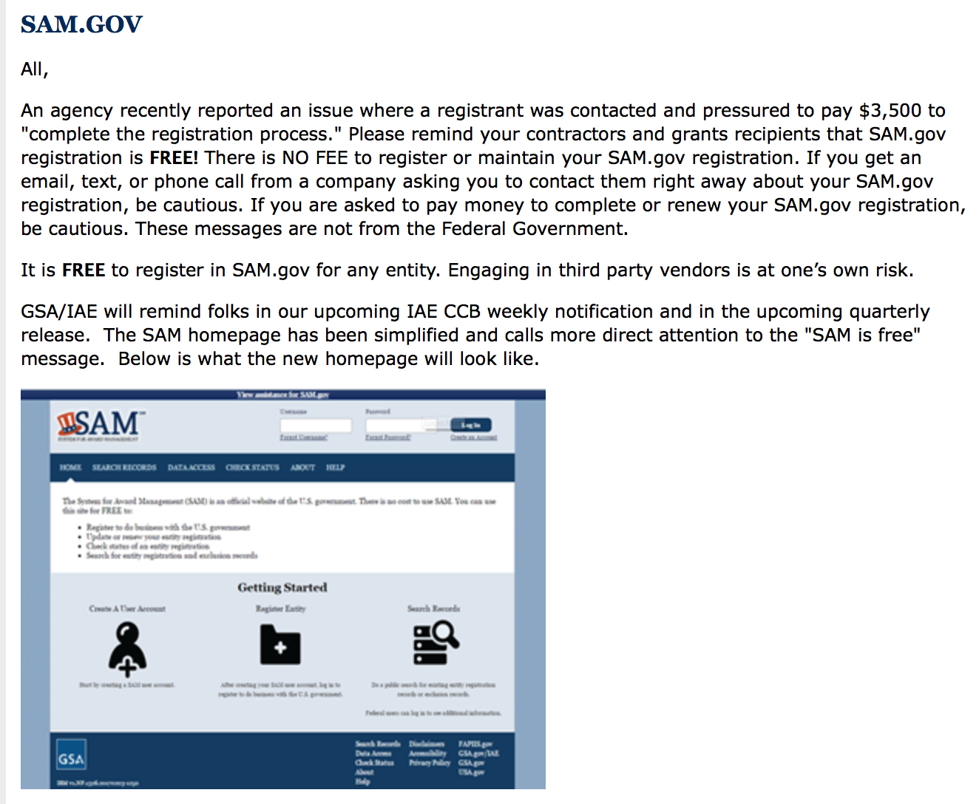

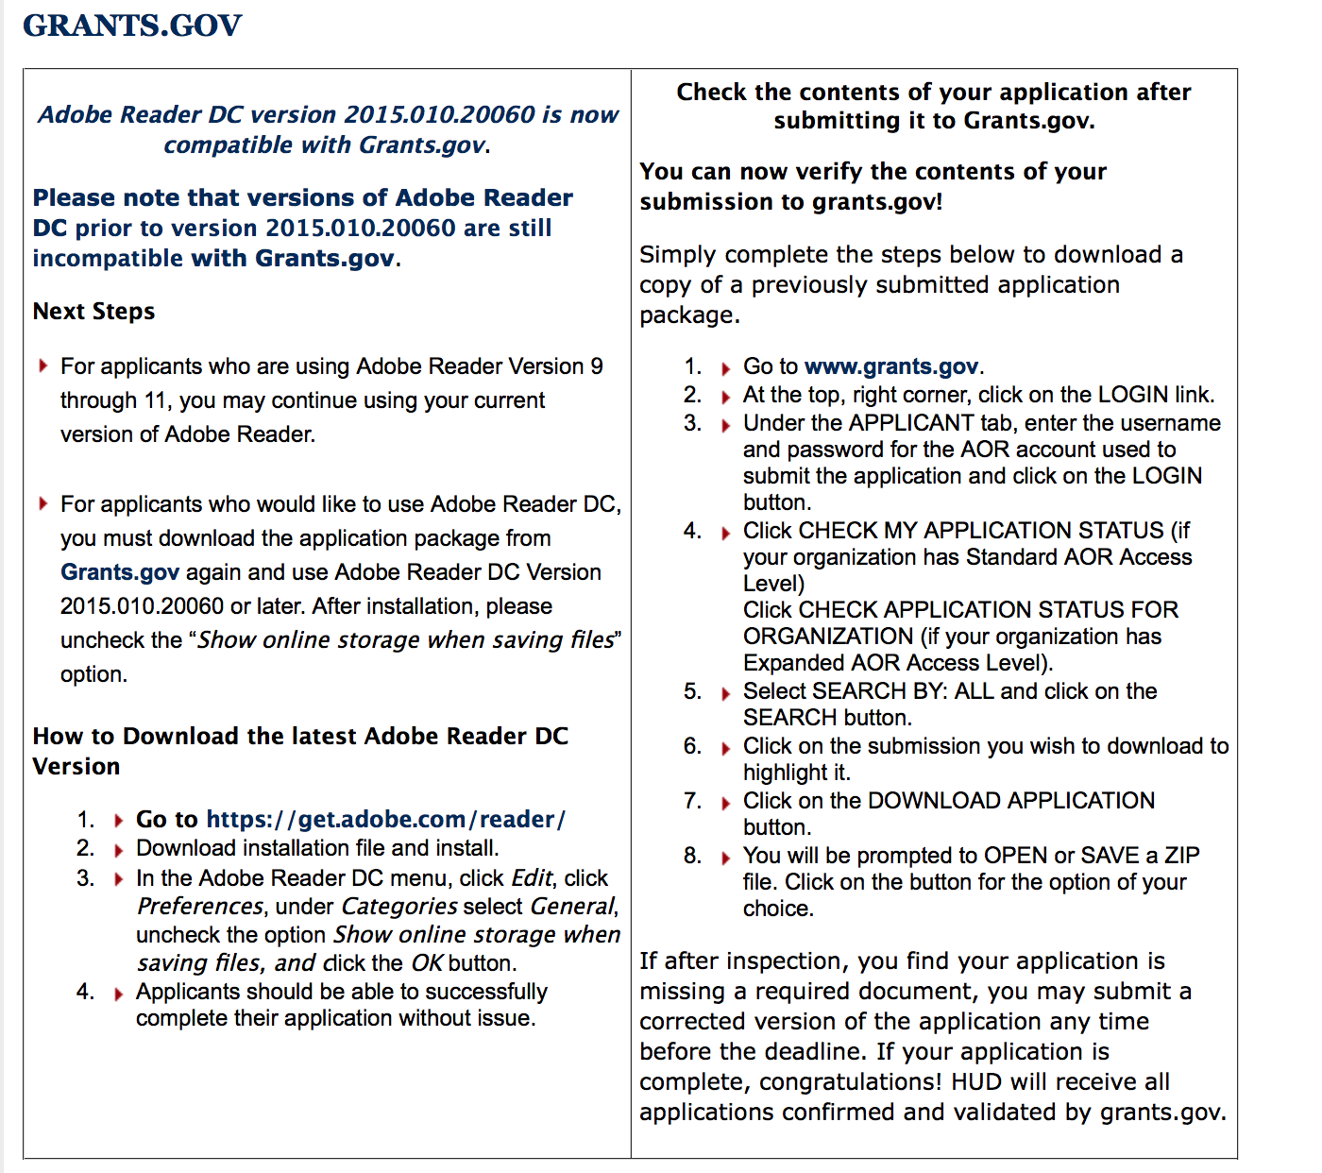

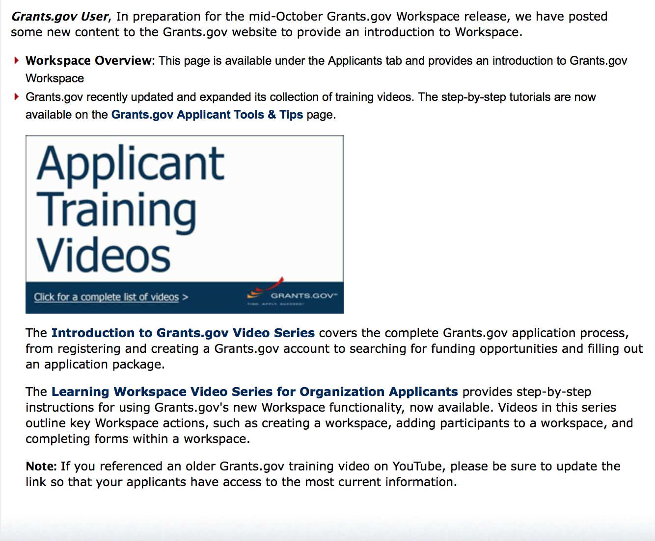
https://portal.hud.gov/hudportal/HUD?src=/program_offices/administration/grants/fundsavail

The Small Business Innovative Research Program - SBIR Program

The Small Business Innovation Research (SBIR) program is a highly competitive program that encourages domestic small businesses to engage in Federal Research/Research and Development (R/R&D) that has the potential for commercialization. Through a competitive awards-based program, SBIR enables small businesses to explore their technological potential and provides the incentive to profit from its commercialization. By including qualified small businesses in the nation's R&D arena, high-tech innovation is stimulated, and the United States gains entrepreneurial spirit as it meets its specific research and development needs.

SBIR Mission and Program Goals
The mission of the SBIR program is to support scientific excellence and technological innovation through the investment of Federal research funds in critical American priorities to build a strong national economy.
The program’s goals are four-fold:
- Stimulate technological innovation
- Meet Federal research and development needs.
- Foster and encourage participation in innovation and entrepreneurship by socially and economically disadvantaged persons.
- Increase private-sector commercialization of innovations derived from Federal research and development funding.

SBIR-Participating Agencies
Each year, Federal agencies with extramural research and development (R&D) budgets that exceed $100 million are required to allocate 2.5 percent of their R&D budget to these programs. Currently, eleven Federal agencies participate in the program:
- Department of Agriculture
- Department of Commerce - National Institute of Standards and Technology
- Department of Commerce - National Oceanic and Atmospheric Administration
- Department of Defense
- Department of Education
- Department of Energy
- Department of Health and Human Services
- Department of Homeland Security
- Department of Transportation
- Environmental Protection Agency
- National Aeronautics and Space Administration
- National Science Foundation
Each agency administers its own individual program within guidelines established by Congress. These agencies designate R&D topics in their solicitations and accept proposals from small businesses. Awards are made on a competitive basis after proposal evaluation.

Three-Phase Program
The SBIR Program is structured in three phases:
Phase I. The objective of Phase I is to establish the technical merit, feasibility, and commercial potential of the proposed R/R&D efforts and to determine the quality of performance of the small business awardee organization prior to providing further Federal support in Phase II. SBIR Phase I awards normally do not exceed $150,000 total costs for 6 months.
Phase II. The objective of Phase II is to continue the R/R&D efforts initiated in Phase I. Funding is based on the results achieved in Phase I and the scientific and technical merit and commercial potential of the project proposed in Phase II. Only Phase I awardees are eligible for a Phase II award. SBIR Phase II awards normally do not exceed $1,000,000 total costs for 2 years.
Phase III. The objective of Phase III, where appropriate, is for the small business to pursue commercialization objectives resulting from the Phase I/II R/R&D activities. The SBIR program does not fund Phase III. Some Federal agencies, Phase III may involve follow-on non-SBIR funded R&D or production contracts for products, processes or services intended for use by the U.S. Government
SBIR NewsLetter

- SBIR Newsletter
Sign up for e-mail updates

Please review each department’s General Grant and Funding Overview. These overviews are the key web pages on each departmental website dedicated to the agency’s funding opportunities. Check back often to note the department updates and use these sources to assist you in your planning.

Federal Grant and Cooperative Agreement Program Summaries

U.S. Department of Agriculture

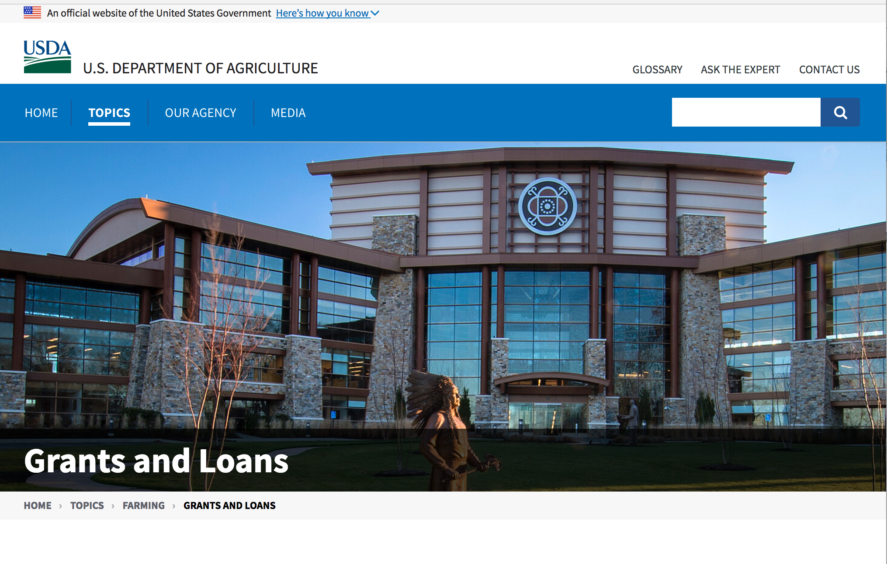

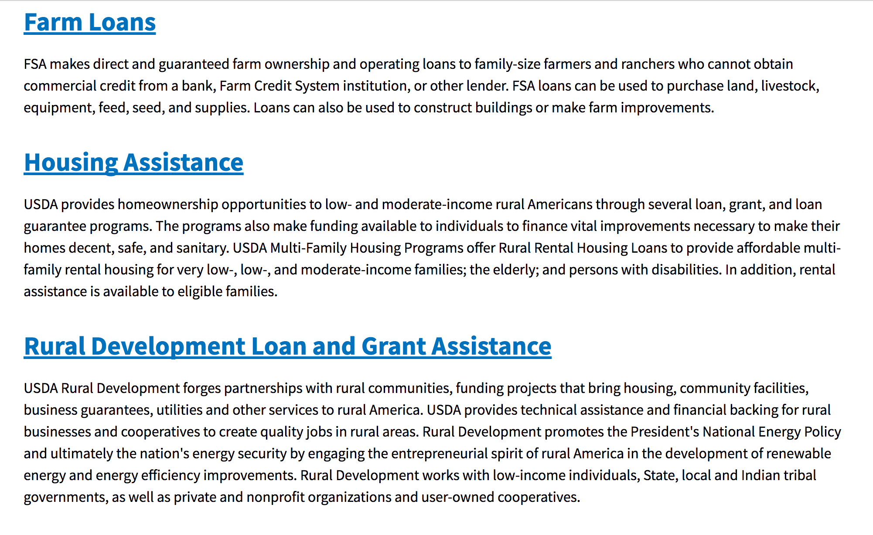

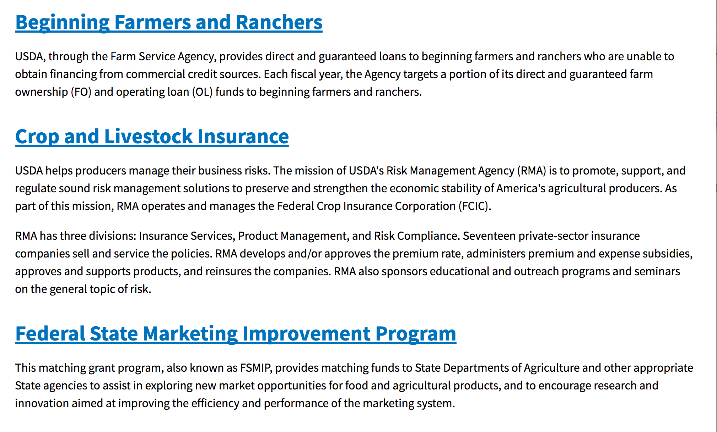
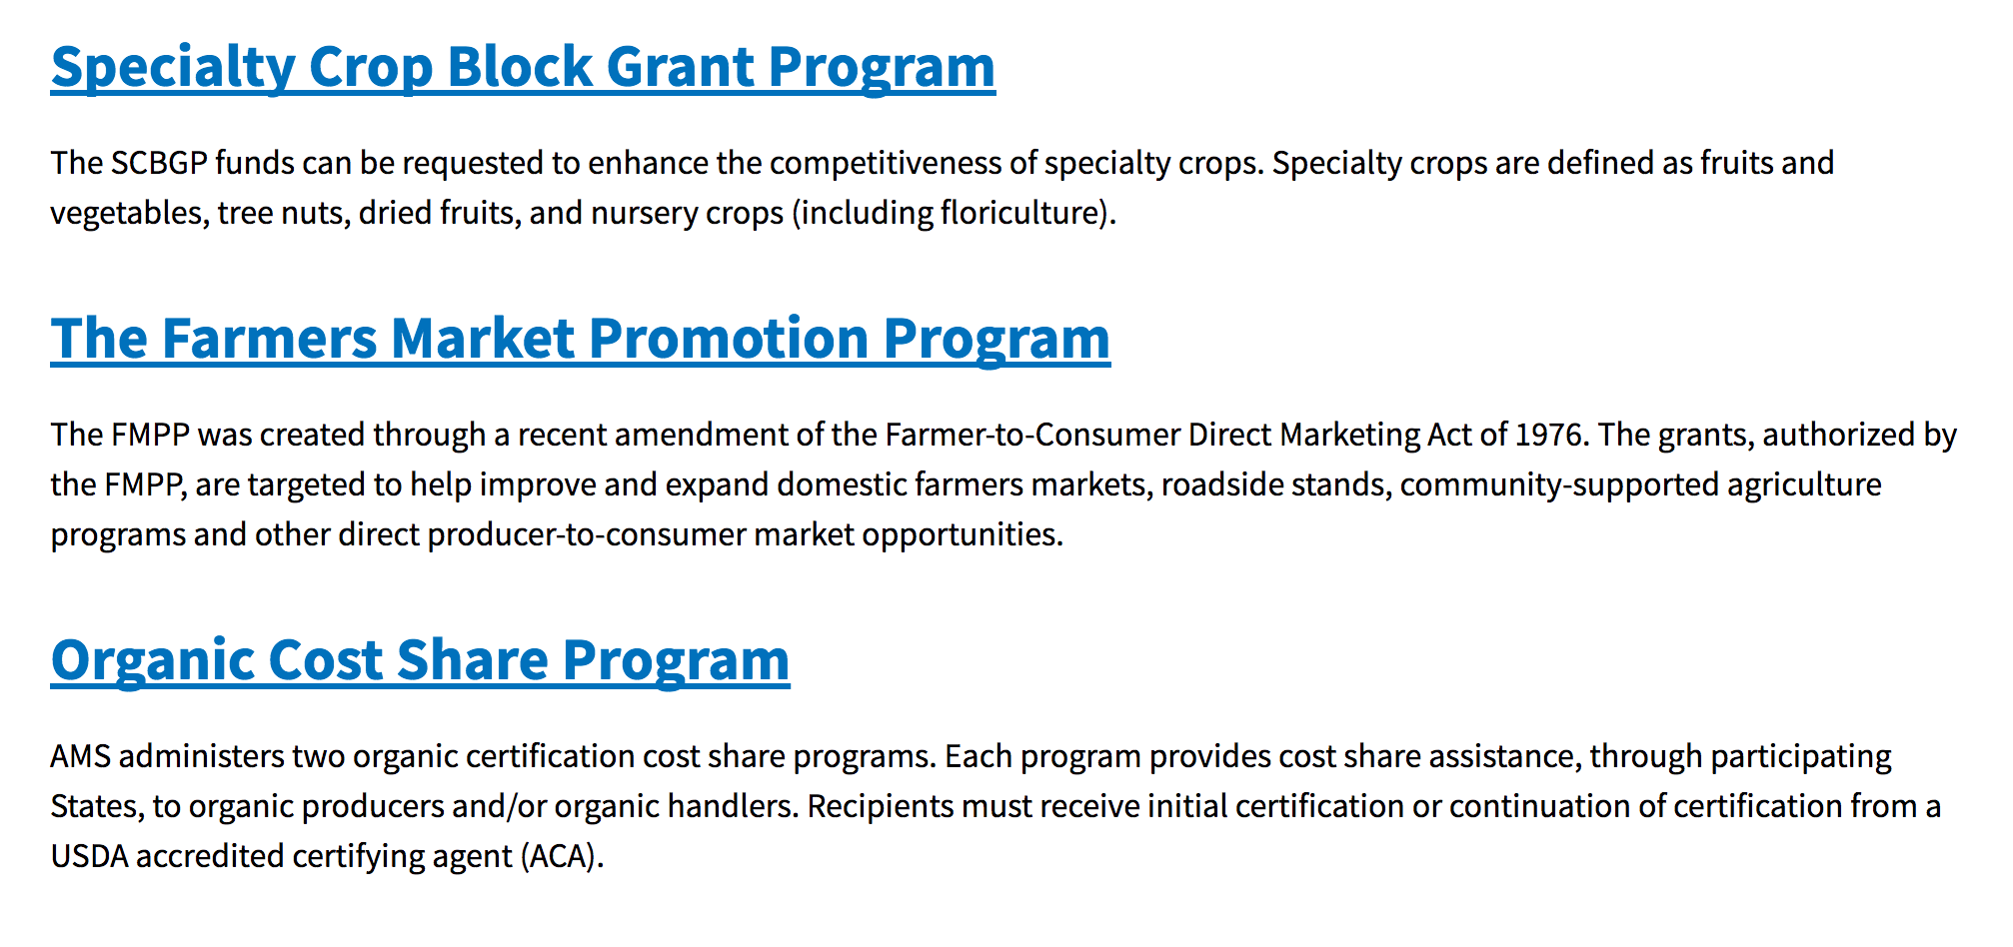
https://www.usda.gov/topics/farming/grants-and-loans

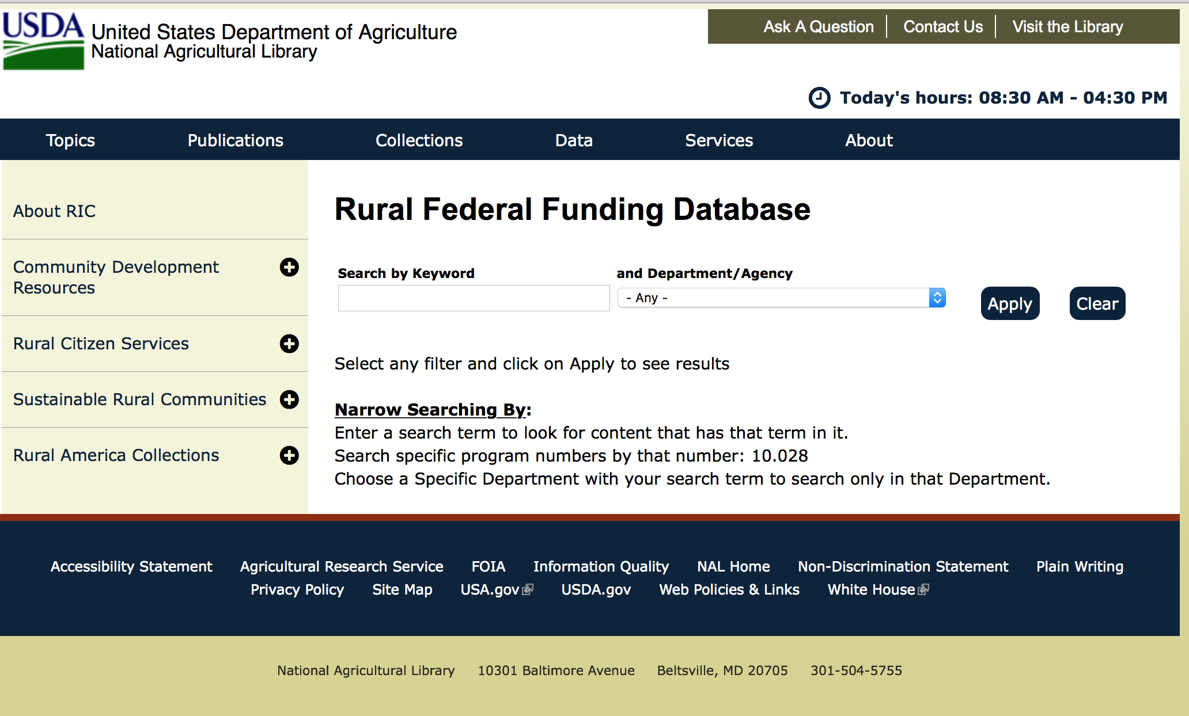

https://www.nal.usda.gov/ric/rural-federal-funding-database

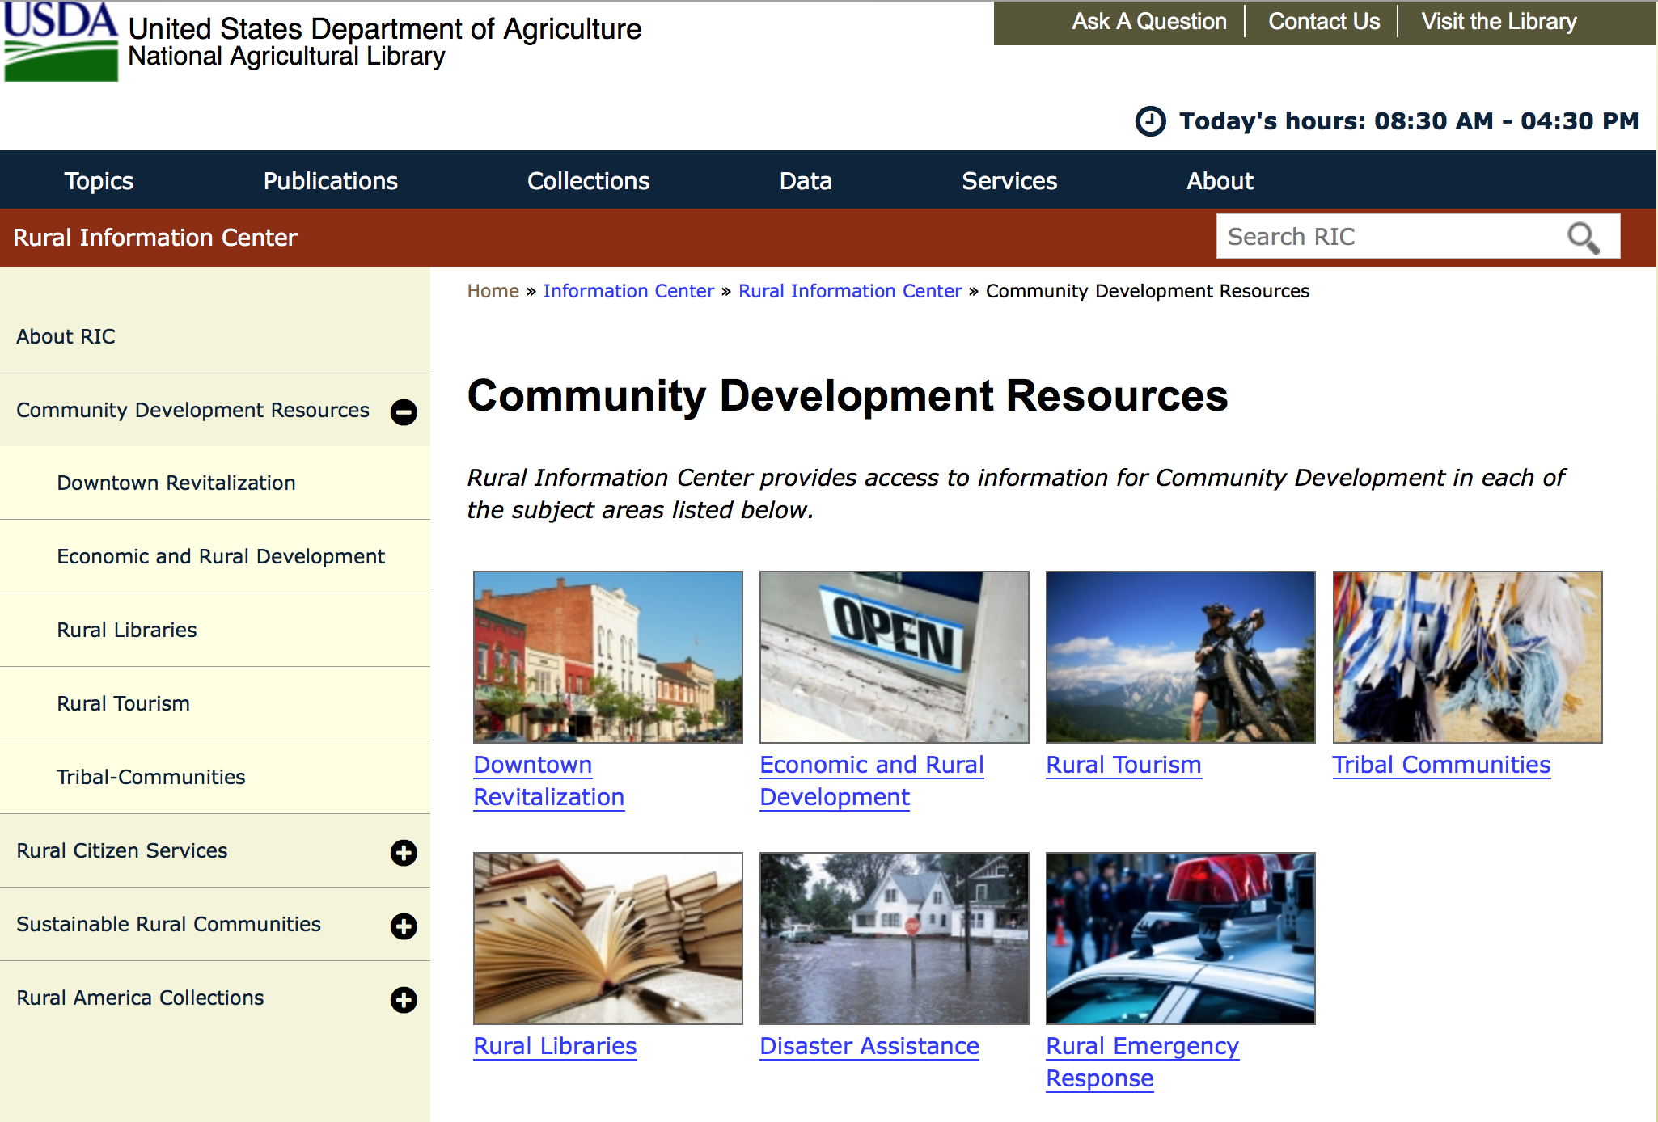

https://www.nal.usda.gov/ric/community-development-resources

Programs:

Business and Cooperative Programs
REAP Energy Audit and Renewable Energy Development Assistance Program
Synopsis 1
Document Type: | Grants Notice
Funding Opportunity Number: | RDBCP-REAP-EA-REDA-2019
Funding Opportunity Title: | REAP Energy Audit and Renewable Energy Development Assistance Program
Opportunity Category: | Mandatory
Opportunity Category Explanation:
Funding Instrument Type: | Grant
Category of Funding Activity: | Education  Energy  Environment  Regional Development
Category Explanation:
Expected Number of Awards: | 23
CFDA Number(s): | 10.868 -- Rural Energy for America Program
Cost Sharing or Matching Requirement: | Yes
Version: | Synopsis 2
Posted Date: | Dec 10, 2018
Last Updated Date: | Dec 12, 2018
Original Closing Date for Applications: | Feb 01, 2019
Current Closing Date for Applications: | Jan 31, 2019
Archive Date:
Estimated Total Program Funding: | $1,864,000
Award Ceiling: | $100,000
Award Floor: | $1
Eligible Applicants: | County governments  State governments  City or township governments  Public and State controlled institutions of higher education  Native American tribal organizations (other than Federally recognized tribal governments)  Others (see text field entitled "Additional Information on Eligibility" for clarification)  Private institutions of higher education  Native American tribal governments (Federally recognized)
Additional Information on Eligibility: | Resource Conservation and Development Districts
Additional Information
Agency Name: | Business and Cooperative Programs
Description: | REAP Energy Audit and Renewable Energy Development Assistance Program. Refer to Application Package AND Application Instruction links to obtain all necessary forms for a complete application. Contact State Energy Coordinator with questions: http://www.rd.usda.gov/files/RBS_StateEnergyCoordinators.pdf
Link to Additional Information: | REAP Energy Audits and Renewable Energy Development Assistance
Grantor Contact Information: | If you have difficulty accessing the full announcement electronically, please contact:  Maureen Hessel Business Loan and Grant Analyst Phone 2024010142  Refer to coordinator list via link posted above.

https://www.grants.gov/web/grants/view-opportunity.html?oppId=310978

Research:

National Institute of Food and Agriculture
FY19 Small Business Innovation Research Program Phase II
Synopsis 1

Document Type: | Grants Notice
Funding Opportunity Number: | USDA-NIFA-SBIR-006692
Funding Opportunity Title: | FY19 Small Business Innovation Research Program Phase II
Opportunity Category: | Discretionary
Opportunity Category Explanation:
Funding Instrument Type: | Grant
Category of Funding Activity: | Agriculture  Business and Commerce
Category Explanation:
Expected Number of Awards:
CFDA Number(s): | 10.212 -- Small Business Innovation Research
Cost Sharing or Matching Requirement: | No
Version: | Synopsis 1
Posted Date: | Dec 21, 2018
Last Updated Date: | Dec 21, 2018
Original Closing Date for Applications: | Mar 14, 2019
Current Closing Date for Applications: | Mar 14, 2019
Archive Date: | Apr 13, 2019
Estimated Total Program Funding: | $12,000,000
Eligible Applicants: | Others (see text field entitled "Additional Information on Eligibility" for clarification)
Additional Information on Eligibility: | Only previous USDA-NIFA SBIR Phase I awardees who have not previously applied for Phase II support are eligible to apply for Phase II support through this FY 2019 RFA. A Phase I project may only apply for a Phase II award once. If a Phase I awardee was unsuccessful in receiving a Phase II award with a previous application, then the awardee is not eligible to resubmit the proposal under this or a future Phase II program solicitation.
Additional Information
Agency Name: | National Institute of Food and Agriculture
Description: | All Phase II projects must have previously completed a successful USDA Phase I project before applying for a Phase II grant. Success rates for applicants have been 50-60% for Phase II. Projects dealing with agriculturally-related manufacturing and alternative and renewable energy technologies are encouraged across all 2018 SBIR topic areas. USDA SBIR's flexible research areas ensure innovative projects consistent with USDA's vision of a healthy and productive nation in harmony with the land, air, and water. USDA SBIR has awarded over 2000 research and development projects since 1983, allowing hundreds of small businesses to explore their technological potential and providing an incentive to profit from the commercialization of innovative ideas.
Link to Additional Information: | Small Business Innovation Research Program - Phase II
Grantor Contact Information: | If you have difficulty accessing the full announcement electronically, please contact:  NIFA Help Desk Phone: 202-401-5048 Business hours are M-F, 7:00 am -5:00 pm ET, excluding Federal holidays  If you have any questions related to preparing application content
https://www.grants.gov/web/grants/view-opportunity.html?oppId=311486

Modifications:

Reminders:

National Institute of Food and Agriculture
Food and Agricultural Sciences National Needs Graduate and Postgraduate Fellowship (NNF) Grants Program
Synopsis 1 & 2

Document Type: | Grants Notice
Funding Opportunity Number: | USDA-NIFA-HEP-006673
Funding Opportunity Title: | Food and Agricultural Sciences National Needs Graduate and Postgraduate Fellowship (NNF) Grants Program
Opportunity Category: | Discretionary
Opportunity Category Explanation:
Funding Instrument Type: | Grant
Category of Funding Activity: | Agriculture
Category Explanation:
Expected Number of Awards:
CFDA Number(s): | 10.210 -- Higher Education � Graduate Fellowships Grant Program
Cost Sharing or Matching Requirement: | No
Version: | Synopsis 2
Posted Date: | Nov 20, 2018
Last Updated Date: | Nov 20, 2018
Original Closing Date for Applications: | Jan 23, 2019
Current Closing Date for Applications: | Jan 23, 2019
Archive Date: | Feb 22, 2019
Estimated Total Program Funding: | $3,100,000
Award Ceiling: | $262,500
Award Floor: | $37,000
Eligible Applicants: | Others (see text field entitled "Additional Information on Eligibility" for clarification)
Additional Information on Eligibility: | Pursuant to section 1417 of the NARETPA of 1977 (7 U.S.C. 3152), and administrative provisions that can be found in 7 CFR 3402 applications may be submitted by:(1) Land-grant institutions (1862, 1890 and 1994 Institutions);(2) Colleges and universities having significant minority enrollments and a demonstrable capacity to carry out the teaching of food and agricultural sciences; and(3) Other colleges and universities having a demonstrable capacity to carry out the teaching of food, and agricultural sciences. Research foundations maintained by an eligible college or university may submit graduate training proposals under this RFA. Applicants should be institutions that confer a graduate degree in at least one of the TESAs in Part I of this RFA. Award recipients may subcontract to organizations not eligible to apply provided such organizations are necessary for the conduct of the project. Failure to meet an eligibility criterion by the application deadline may result in the application being excluded from consideration or, even though an application may be reviewed, will preclude NIFA from making an award. Awards are made to eligible colleges and universities. Individuals are not eligible to apply for these grants to support their graduate education. Successful applications must select and identify Fellows and award Fellowships within eighteen (18) months of the effective date of a grant. Post-doctoral Fellowships will not be awarded under this grant announcement.• Institutions that fail to meet this deadline will be required to refund monies associated with unawarded Fellowships to NIFA.• Graduate fellowship appointments must be awarded only to registered students who are pursuing full-time study in graduate programs in the TESA and at the degree level supported by the grant.• Applicants may not request partial fellowships. A USDA Fellow at the master’s degree level who maintains satisfactory progress is eligible to receive grant support for a maximum of twenty-four (24) months during a thirty (30) month period. A USDA Fellow at the doctoral degree level who maintains satisfactory progress is eligible to receive grant support for a maximum of thirty-six (36) months within a forty-two (42) month period. It is the intent of this program that Graduate Fellows pursue full-time uninterrupted study or thesis/dissertation research, including time spent pursuing USDA-funded special international study or thesis/dissertation research activities. Graduate Fellows in academic institutions are not entitled to regular annual leave but are entitled to the normal student holidays observed by the institution. The time between academic semesters or quarters is to be utilized as an active part of the grant period. During the period of support, USDA Graduate Fellows, at the discretion of their institutions, may accept additional supplemental employment that would positively contribute to their training or research and would make them eligible for tuition waivers (e.g., full or partial tuition waivers with research or teaching assignments).A Graduate Fellow who finds it necessary to interrupt his/her program of study because of health, personal, or other reasonable non-academic and non-disciplinary cause(s) must be allowed to resume funded study at any time within 6 months of the interruption, provided there is adequate time remaining before the award expires (i.e. within the 30-month total funding period for a master’s Fellow, and 42-month total funding period for a Doctoral Fellow). A Graduate Fellow who finds it necessary to interrupt his/her program of study more than one time cannot exceed 6 total months of cumulative leave without forfeiting NNF eligibility. Failure to meet an eligibility criterion by the application deadline may result in the application being excluded from consideration or, even though an application may be reviewed, will preclude NIFA from making an award.
Additional Information
Agency Name: | National Institute of Food and Agriculture
Description: | This grant program supports: (1) training students for master's and doctoral degrees in food, agricultural and natural resource sciences; and (2) Special International Study or Thesis/Dissertation Research Travel Allowances (IRTA) for eligible USDA NNF beneficiaries. Awards are specifically intended to support traineeship programs that engage outstanding students to pursue and complete their degrees in USDA mission areas. Applicants provide clarity about the philosophy of their graduate training, and relevance to USDA mission sciences, NIFA priorities and national science education policies and statistics. Applications are being solicited from institutions that confer a graduate degree in at least one of the following Targeted Expertise Shortage Areas: 1) animal and plant production; 2) forest resources; 3) agricultural educators and communicators; 4) agricultural management and economics; 5) food science and human nutrition; 6) sciences for agricultural biosecurity; and 7) training in integrative biosciences for sustainable food and agricultural systems.
Link to Additional Information: | Food and Agricultural Sciences National Needs Graduate and Postgraduate Fellowship (NNF) Grants Program
Grantor Contact Information: | If you have difficulty accessing the full announcement electronically, please contact:  NIFA Help Desk Phone: 202-401-5048 Business hours are M-F, 7:00 am -5:00 pm ET, excluding Federal holidays  “ If you have any questions related to preparing application content”.
https://www.grants.gov/web/grants/view-opportunity.html?oppId=310500

Food and Nutrition Service
FY_19_TIG_Grant
Synopsis 1
Document Type: | Grants Notice
Funding Opportunity Number: | USDA-FNS-TIG-2019
Funding Opportunity Title: | FY_19_TIG_Grant
Opportunity Category: | Discretionary
Opportunity Category Explanation:
Funding Instrument Type: | Cooperative Agreement
Category of Funding Activity: | Food and Nutrition
Category Explanation:
Expected Number of Awards: | 8
CFDA Number(s): | 10.541 -- Child Nutrition-Technology Innovation Grant
Cost Sharing or Matching Requirement: | No
Version: | Synopsis 2
Posted Date: | Nov 28, 2018
Last Updated Date: | Nov 29, 2018
Original Closing Date for Applications: | Mar 05, 2019
Current Closing Date for Applications: | Mar 05, 2019
Archive Date: | Aug 31, 2019
Estimated Total Program Funding: | $15,000,000
Award Ceiling: | $2,000,000
Award Floor: | $100,000
Eligible Applicants: | County governments
Additional Information on Eligibility: | The Child Nutrition Technology Innovation Grant (CN TIG) funds will be available on a competitive basis to State agencies administering the CNPs (i.e., National School Lunch Program, School Breakfast Program, Child and Adult Care Food Program, and Summer Food Service Program).
Additional Information
Agency Name: | Food and Nutrition Service
Description: | The 2018 Consolidated Appropriations Act, Public Law 115-141 March 23, 2018, authorized funding to be used for grants to States for the purpose of developing or improving current automated information systems used to operate and manage the Child Nutrition Programs (CNPs). The United States Department of Agriculture (USDA) Food and Nutrition Service (FNS) has approximately $15 million available in fiscal year (FY) 2019 to be used for grants under this funding. This Request for Applications (RFA) invites State agencies that administer the CNPs to apply for grant funding to implement innovative technology solutions that will improve program accountability, data accuracy, program performance measurement, and the capacity to identify and target error-prone areas (locations or program functions) within and across the CNPs at the State and Local Educational Agency (LEA) or Sponsor Organization (SO) levels.  The Child Nutrition Technology Innovation Grant (CN TIG) funds will be available on a competitive basis to State agencies administering the CNPs (i.e., National School Lunch Program, School Breakfast Program, Child and Adult Care Food Program, and Summer Food Service Program). FNS is offering two types of CN TIGs: Planning Grants and Implementation Grants. States may apply for either a Planning Grant or an Implementation Grant, as described within this RFA, but not both under this 2019 RFA solicitation.
Link to Additional Information: | USDA CND Website
Grantor Contact Information: | If you have difficulty accessing the full announcement electronically, please contact:  Carla Y Garcia Grant Officer Phone 703-305-2760  Grant Officer
https://www.grants.gov/web/grants/view-opportunity.html?oppId=310642

National Institute of Food and Agriculture
Biotechnology Risk Assessment Grants Program
Synopsis 1
Document Type: | Grants Notice
Funding Opportunity Number: | USDA-NIFA-BRAP-006674
Funding Opportunity Title: | Biotechnology Risk Assessment Grants Program
Opportunity Category: | Discretionary
Opportunity Category Explanation:
Funding Instrument Type: | Grant
Category of Funding Activity: | Agriculture
Category Explanation:
Expected Number of Awards: | 50
CFDA Number(s): | 10.219 -- Biotechnology Risk Assessment Research
Cost Sharing or Matching Requirement: | Yes
Version: | Synopsis 1
Posted Date: | Nov 21, 2018
Last Updated Date: | Nov 21, 2018
Original Closing Date for Applications: | Feb 20, 2019
Current Closing Date for Applications: | Feb 20, 2019
Archive Date: | Mar 22, 2019
Estimated Total Program Funding: | $3,500,000
Award Ceiling: | $500,000
Award Floor: | $1
Eligible Applicants: | Others (see text field entitled "Additional Information on Eligibility" for clarification)
Additional Information on Eligibility: | Applications may only be submitted by United States public or private research or educational institutions or organizations, including federal research laboratories. Failure to meet an eligibility criterion by the application deadline may result in the application being excluded from consideration or, even though an application may be reviewed, will preclude NIFA from making an award.
Additional Information
Agency Name: | National Institute of Food and Agriculture
Description: | The purpose of the BRAG program is to support the generation of new information that will assist Federal regulatory agencies in making science-based decisions about the effects of introducing into the environment genetically engineered organisms (GE), including plants, microorganisms — such as fungi, bacteria, and viruses — arthropods, fish, birds, mammals and other animals excluding humans. Investigations of effects on both managed and natural environments are relevant. The BRAG program accomplishes its purpose by providing federal regulatory agencies with scientific information relevant to regulatory issues
Link to Additional Information: | FY '19 BRAG RFA
Grantor Contact Information: | If you have difficulty accessing the full announcement electronically, please contact:  NIFA Help Desk Phone: 202-401-5048 Business hours are M-F, 7:00 am -5:00 pm ET, excluding Federal holidays  If you have any questions related to preparing application content
https://www.grants.gov/web/grants/view-opportunity.html?oppId=310536

Business and Cooperative Programs
Renewable Energy Systems and Energy Efficiency Improvements Program
Synopsis 1

Document Type: | Grants Notice
Funding Opportunity Number: | RDBCP-REAP-RES-EEI-2019
Funding Opportunity Title: | Renewable Energy Systems and Energy Efficiency Improvements Program
Opportunity Category: | Mandatory
Opportunity Category Explanation:
Funding Instrument Type: | Grant
Category of Funding Activity: | Agriculture  Business and Commerce  Energy
Category Explanation:
Expected Number of Awards: | 1000
CFDA Number(s): | 10.868 -- Rural Energy for America Program
Cost Sharing or Matching Requirement: | Yes
Version: | Synopsis 1
Posted Date: | Oct 30, 2018
Last Updated Date: | Oct 30, 2018
Original Closing Date for Applications: | REAP Applications are accepted year-round. For applicants requesting grants of $20,000 or less, that wish to have their application compete for the "Grants of $20,000 or less set aside", complete applications must be received no later than 4:30pm local time on: October 31, 2018, or April 1, 2019. For applicants requesting grant funds of over $20,000, complete applications must be received no later than 4:30pm local time on April 1, 2019.
Current Closing Date for Applications: | REAP Applications are accepted year-round. For applicants requesting grants of $20,000 or less, that wish to have their application compete for the "Grants of $20,000 or less set aside", complete applications must be received no later than 4:30pm local time on: October 31, 2018, or April 1, 2019. For applicants requesting grant funds of over $20,000, complete applications must be received no later than 4:30pm local time on April 1, 2019.
Archive Date:
Estimated Total Program Funding: | $35,400,000
Award Ceiling: | $500,000
Award Floor: | $1,500
Eligible Applicants: | Others (see text field entitled "Additional Information on Eligibility" for clarification)  Small businesses  Native American tribal organizations (other than Federally recognized tribal governments)
Additional Information on Eligibility: | Agricultural Producers
Additional Information
Agency Name: | Business and Cooperative Programs
Description: | REAP Renewable Energy Systems and Energy Efficiency Improvement Program. Refer to Application Package AND Application Instruction links to obtain all necessary forms for a complete application. Contact State Energy Coordinators with questions: http://www.rd.usda.gov/files/RBS_StateEnergyCoordinators.pdf
Link to Additional Information: | REAP Renewable Energy Systems and Energy Efficiency Improvements Program
Grantor Contact Information: | If you have difficulty accessing the full announcement electronically, please contact:  Maureen Hessel Business Loan and Grant Analyst Phone 2024010142  Refer to energy coordinator list via link posted above.
https://www.grants.gov/web/grants/view-opportunity.html?oppId=310029

Deleted:

Department of Commerce

Grants, Contracting, and Trade Opportunities at Commerce
Learn more information about grants, contracting and trade opportunities at the Department of Commerce using the information below.
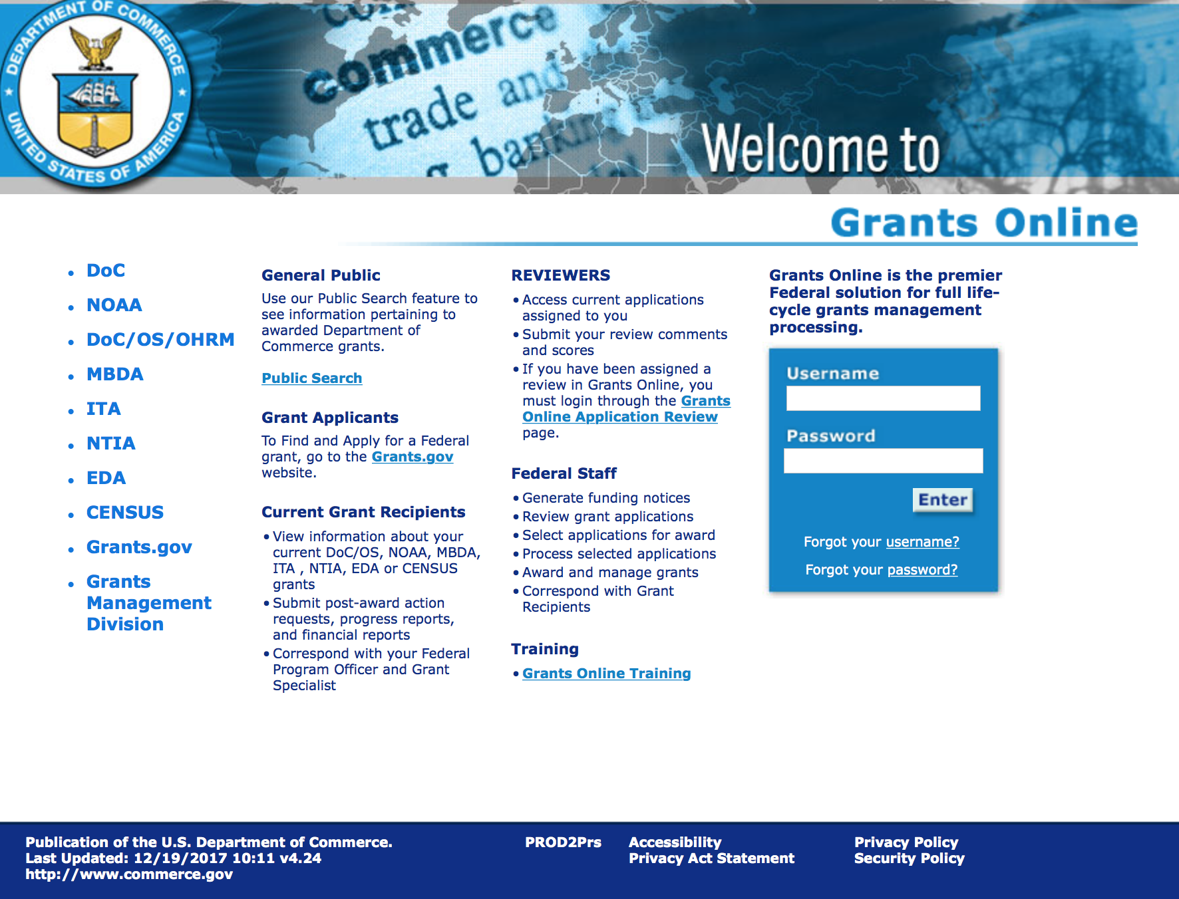
https://grantsonline.rdc.noaa.gov/flows/home/Login/LoginController.jpf

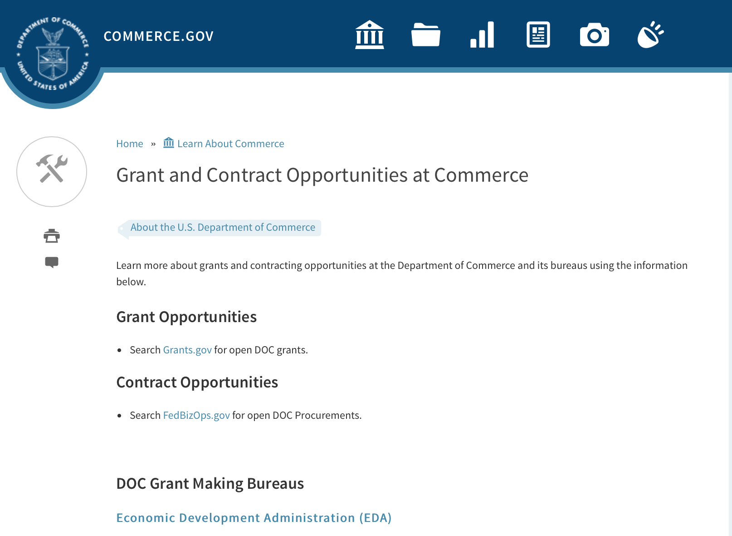
DOC Grant Making Bureaus
Economic Development Administration (EDA)
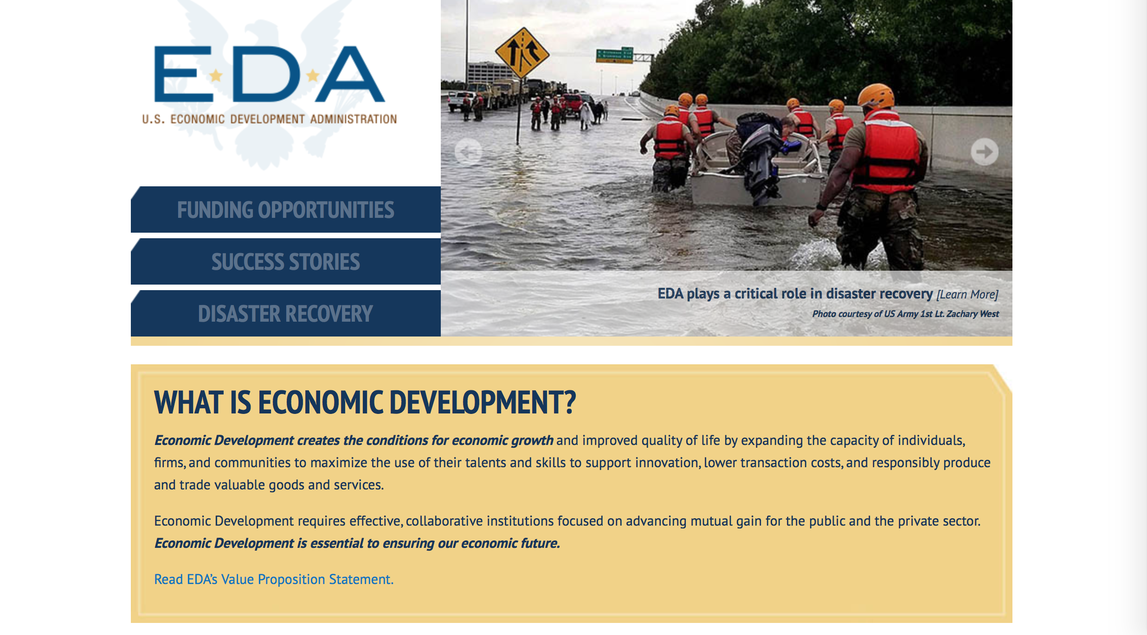
International Trade Administration (ITA)
- Market Development Cooperator Program
- Special American Business Internship Training Program (SABIT). A technical assistance initiative of the International Trade Administration of the U.S. Department of Commerce, SABIT offers organizations competitive grants and an opportunity to host industry-specific delegations. SABIT serves as an initial entry point for U.S. businesses seeking funding to establish long-term relationships with potential customers, distributors, or partners in the former Soviet Union. The program trains Eurasian managers and scientists in commonly accepted business practices as a means of facilitating cross border relationships. In turn, these personal relationships serve as a basis for business development and reduce market access barriers for U.S. businesses
National Institute of Standards & Technology (NIST)
- Funding Opportunities
National Telecommunications & Information Administration (NTIA)
- Telecommunications Grants
National Oceanic & Atmospheric Administration (NOAA)
- Coastal Ocean Program Grant Information
- Fisheries Saltonstall Kennedy Grant Program
- National Undersea Research Program Funding Opportunities
- Grants Management Division
- Fisheries Grants Program
- National Sea Grant
- Office of Global Programs
Contracting Resources for Contractors
- Office of Small and Disadvantaged Business Utilization (OSDBU) - the Office of Small and Disadvantaged Business Utilization (OSDBU) is an advocacy and advisory office responsible for promoting the use of small, small disadvantaged, 8(a), women-owned, veteran-owned, service-disabled veteran-owned, and HUBZone small businesses within the U.S. Department of Commerce's (DOC) acquisition process.
- Business.USA.gov's Find Opportunities Wizard where in a few quick steps, it will guide you towards federal government contracting programs and opportunities for your business!
- Planned Acquisitions: the Department of Commerce's search tool for our planned acquisitions over $100,000. As requirements change, these acquisition plans are updated by department personnel and this search tool is automatically updated.
- Small Business Administration's Contracting section of their web site where you can learn about how to "Get Started" and "Contracting Support for Small Business"
- The General Services Administration (GSA) has implemented a system for vendors doing business with the Federal Government to manage their entity information in one central location. This new database is the System for Award Management (SAM).

DOC Contracting Offices
- Patent and Trademark Office (PTO)
  - Office of Procurement
- National Institute of Standards & Technology (NIST)
NIST Acquisition Management Group
Contracting Opportunities with Commerce
Trade Opportunities through Commerce
http://www.commerce.gov/about-commerce/grants-contracting-trade-opportunities

Programs:

2019 Bycatch Reduction Engineering Program
Synopsis 1

Document Type: | Grants Notice
Funding Opportunity Number: | NOAA-NMFS-FHQ-2019-2005919
Funding Opportunity Title: | 2019 Bycatch Reduction Engineering Program
Opportunity Category: | Discretionary
Opportunity Category Explanation:
Funding Instrument Type: | Cooperative Agreement
Category of Funding Activity: | Environment  Natural Resources  Science and Technology and other Research and Development
Category Explanation:
Expected Number of Awards: | 25
CFDA Number(s): | 11.472 -- Unallied Science Program
Cost Sharing or Matching Requirement: | No
Version: | Synopsis 1
Posted Date: | Dec 16, 2018
Last Updated Date: | Dec 16, 2018
Original Closing Date for Applications: | Mar 29, 2019
Current Closing Date for Applications: | Mar 29, 2019
Archive Date: | Apr 28, 2019
Estimated Total Program Funding: | $2,500,000
Award Ceiling: | $250,000
Award Floor: | $50,000
Eligible Applicants: | Others (see text field entitled "Additional Information on Eligibility" for clarification)
Additional Information on Eligibility: | Eligible applicants are individuals, institutions of higher education, other nonprofits, for-profit organizations, foreign public entities or foreign organizations, and state, local and Indian tribal governments. Federal agencies or instrumentalities are not eligible to receive Federal assistance under this notice. The Department of Commerce/ National Oceanic and Atmospheric Administration (DOC/NOAA) is strongly committed to broadening the participation of historically black colleges and universities, Hispanic serving institutions, tribal colleges and universities, and institutions that work in underserved areas. If the applicant is a university that has a NOAA Cooperative Institute (CI), the institution is encouraged to submit an application that will be associated with the CI. The application must specify the name of the CI, its most recent award number, and the NOAA-approved research theme applicable to the work to be performed in the Project Narrative. The application will use the facilities and administrative rate (F&A or Indirect Cost Rate) associated with the most recent CI award. If the CI-related application is selected for funding, NOAA will notify the university that a separate competitive award will be issued with its own award grant number. However, the BREP competitive award will include a Special Award Condition (SAC) that evidences the link between it and the CI award. The SAC will provide: (1) that the university has submitted the proposal to be associated with the CI; (2) that any existing University/NOAA memorandum of agreement (MOA) will be incorporated by reference into the terms of the BREP competitive award; and (3) that any progress report(s) for the BREP competitive award must follow the timetable of and be submitted by the CI directly to the funding program. Copies of these progress reports will be attached to the CI's performance report as an appendix.
Additional Information
Agency Name: | Department of Commerce
Description: | The mission of the National Bycatch Reduction Engineering Program (BREP) is to support the development of technological solutions and changes in fishing practices designed to minimize bycatch of fish and protected species (including ESA-listed fish, marine mammals, seabirds, and sea turtles) and to reduce impacts to invertebrates (including sponges, deep-sea corals, and shallow (tropical) corals.) In addition, BREP may support projects that quantify post-release mortality and identify ways to minimize mortality and injury of bycaught species (including post-release injury and mortality). Projects should produce outcomes that can directly influence management needs of federally managed living marine resources.  For Fiscal Year 2019, NMFS anticipates that approximately $2,500,000 could be made available for projects that address bycatch research as identified in the Program Priority Section (I.B.1 - I.B.4).
Link to Additional Information:
Grantor Contact Information: | If you have difficulty accessing the full announcement electronically, please contact:  Mr. Derek M. Orner 410-570-2268 1315 EAST WEST HWY Silver Spring, MD 20910-3282  Work
https://www.grants.gov/web/grants/view-opportunity.html?oppId=311253

Research:

Modifications:

Reminders:

FY 2019 Community-based Restoration Program Coastal and Marine Habitat Restoration Grants
Synopsis 1

Document Type: | Grants Notice
Funding Opportunity Number: | NOAA-NMFS-HCPO-2019-2005889
Funding Opportunity Title: | FY 2019 Community-based Restoration Program Coastal and Marine Habitat Restoration Grants
Opportunity Category: | Discretionary
Opportunity Category Explanation:
Funding Instrument Type: | Cooperative Agreement
Category of Funding Activity: | Environment  Natural Resources  Science and Technology and other Research and Development
Category Explanation:
Expected Number of Awards: | 20
CFDA Number(s): | 11.463 -- Habitat Conservation
Cost Sharing or Matching Requirement: | No
Version: | Synopsis 2
Posted Date: | Nov 14, 2018
Last Updated Date: | Nov 15, 2018
Original Closing Date for Applications: | May 15, 2019
Current Closing Date for Applications: | May 15, 2019
Archive Date: | Jun 14, 2019
Estimated Total Program Funding: | $12,000,000
Award Ceiling: | $3,000,000
Award Floor: | $75,000
Eligible Applicants: | Others (see text field entitled "Additional Information on Eligibility" for clarification)
Additional Information on Eligibility: | Eligible applicants are institutions of higher education, non-profits, commercial (for profit) organizations, U.S. territories, and state, local and Native American tribal governments. Applicants must propose work in geographic areas that benefit species with a nexus to NOAA management. Applications from federal agencies or employees of federal agencies will not be considered. Federal agencies are strongly encouraged to work with states, non-governmental organizations, municipal and county governments, and others that are eligible to apply.
Additional Information
Agency Name: | Department of Commerce
Description: | ***There is a mandatory pre-proposal due on January 14, 2019 for this competition***  The principal objective of the NMFS Community-based Restoration Program Coastal and Marine Habitat Restoration solicitation is to support habitat restoration projects that use an ecosystem-based approach to foster species recovery and increase populations under NOAA’s jurisdiction. Proposals submitted under this solicitation will be primarily evaluated based on their ability to demonstrate how the proposed habitat restoration actions will help recover threatened and endangered species listed under the Endangered Species Act (ESA) (hereafter, Listed Species), including species identified by NMFS as “Species in the Spotlight” (https://www.fisheries.noaa.gov/topic/endangered-species-conservation#species-in-the-spotlight), sustain or help rebuild fish stocks managed under the Magnuson-Stevens Fishery Conservation and Management Act (hereafter, Managed Species), and contribute to the sustainability of saltwater recreational fisheries. Successful proposals will: 1) identify a habitat-based issue/concern limiting the recovery or sustainability of one or more species targeted by the proposed restoration action; 2) describe in detail the actions and on-the-ground habitat restoration project(s) to be undertaken to resolve the issue/concern and; 3) describe the project(s)’ expected outcomes and measurable impact on the project’s target species and their ecosystem. Proposals may include: restoration feasibility and/or design; implementation; or a combination.  Proposals selected for funding through this solicitation will be funded through cooperative agreements. One-year or multi-year awards up to three funding years will be considered. Multi-year awards are awards that are funded for up to three years. The funding for the second and/or third year (FY20 and/or FY21) will not be determined in FY19, but will instead be determined in future years, pending future federal appropriations, and progress towards project milestones. Proposals for multi-year funding should outline the costs expected for year two and/or year three in detail in this proposal (see Section IV.B for more details about the budget narrative for multi-year awards). NOAA anticipates typical federal funding for awards will range from $300,000 to $1.5 million over one to three years. NOAA will not accept proposals with a federal funding request of less than $75,000 or more than $3 million total over three years. NOAA anticipates up to $6 million will be available under this FFO in FY19. Funds will be administered by the Community-based Restoration Program within the NOAA Restoration Center. Awards are dependent upon the amount of funds Congress makes available to NOAA in the FY19 - FY21 budgets.
Link to Additional Information:
Grantor Contact Information: | If you have difficulty accessing the full announcement electronically, please contact:  Supplemental Guidance regarding application writing, a checklist to submit a complete application, and FAQs about this FFO can be found at https://www.fisheries.noaa.gov/grant/coastal-and-marine-habitat-restoration-grants. For further information contact Natalie McLenaghan at (301) 427-8687, or by e-mail at natalie.mclenaghan@noaa.gov. Prospective applicants are strongly encouraged to contact NOAA Restoration Center staff before submitting an application to discuss their NOAA project ideas with respect to technical merit and NOAA's objectives. NOAA will make every effort to respond to prospective applicants on a first come, first served basis. These discussions will not include review of draft proposals or site visits during the application period.  Work email address
https://www.grants.gov/web/grants/view-opportunity.html?oppId=310338

Fiscal Year 2020 National Sea Grant College Program Dean John A. Knauss Marine Policy Fellowship
Synopsis 1
Document Type: | Grants Notice
Funding Opportunity Number: | NOAA-OAR-SG-2020-2005911
Funding Opportunity Title: | Fiscal Year 2020 National Sea Grant College Program Dean John A. Knauss Marine Policy Fellowship
Opportunity Category: | Discretionary
Opportunity Category Explanation:
Funding Instrument Type: | Cooperative Agreement
Category of Funding Activity: | Environment  Natural Resources  Science and Technology and other Research and Development
Category Explanation:
Expected Number of Awards: | 70
CFDA Number(s): | 11.417 -- Sea Grant Support
Cost Sharing or Matching Requirement: | No
Version: | Synopsis 1
Posted Date: | Dec 04, 2018
Last Updated Date: | Dec 04, 2018
Original Closing Date for Applications: | Feb 22, 2019
Current Closing Date for Applications: | Feb 22, 2019
Archive Date: | Mar 24, 2019
Estimated Total Program Funding: | $5,005,000
Award Ceiling: | $71,500
Award Floor: | $61,500
Eligible Applicants: | Others (see text field entitled "Additional Information on Eligibility" for clarification)
Additional Information on Eligibility: | Any student, regardless of citizenship, who, on February 22, 2019, is enrolled towards a degree in a graduate program, that has an interest in ocean, coastal, and Great Lakes resources and in the national policy decisions affecting those resources. The graduate degree must be awarded through an accredited institution of higher education in the United States or U.S. Territories. The National Sea Grant College Program champions diversity, equity, and inclusion (DEI) by recruiting, retaining and preparing a diverse workforce, and proactively engaging and serving the diverse populations of coastal communities. Sea Grant is committed to building inclusive research, extension, communication and education programs that serve people with unique backgrounds, circumstances, needs, perspectives and ways of thinking. We encourage applicants of all ages, races, ethnicities, national origins, gender identities, sexual orientations, disabilities, cultures, religions, citizenship types, marital statuses, education levels, job classifications, veteran status types, and income, and socioeconomic status types to apply for this opportunity.
Additional Information
Agency Name: | Department of Commerce
Description: | The National Sea Grant College Program was enacted by U.S. Congress in 1966 (amended in 2008, Public Law 110-394) to support leveraged federal and state partnership that harness the intellectual capacity of the nation’s universities and research institutions to solve problems and generate opportunities in coastal communities.  This notice announces that applications may be submitted for the 2020 National Sea Grant College Program Dean John A. Knauss Marine Policy Fellowship (Sea Grant Knauss Fellowship Program). The National Sea Grant College Program anticipates funding not less than 35 selected applicants, of which those assigned to the Legislative branch will be approximately 14. Each award will be funded up to a total of $71,500 in federal funding, which includes up to $10,000 for office-related travel. In certain circumstances additional office-related travel funding may take the award above $71,500. In such cases any additional funds will be administered through an amendment to the grant.  Applicants are strongly encouraged to reach out to the Sea Grant Program in their state/territory one to two months prior to the state application deadline to receive application support and provide notification of an intent to apply. The applicant should allow sufficient time to schedule an interview with the eligible Sea Grant program at the program’s request.  This document sets out requirements for submitting to NOAA-OAR-SG-2020-2005911. Additional guidance and tips on how best to prepare an application are provided in the Sea Grant General Application Guide available at: https://seagrant.noaa.gov/Portals/1/Guidance/SeaGrantGeneralApplicationGuide.pdf
Link to Additional Information:
Grantor Contact Information: | If you have difficulty accessing the full announcement electronically, please contact:  Jonathan Lilley 301-734-1085 NA, NA, 00 00000  Work
https://www.grants.gov/web/grants/view-opportunity.html?oppId=310836

National Estuarine Research Reserve System (NERRS) Land Acquisition and Construction Program for Fiscal Year 2019
Synopsis 1

Document Type: | Grants Notice
Funding Opportunity Number: | NOAA-NOS-OCM-2019-2005800
Funding Opportunity Title: | National Estuarine Research Reserve System (NERRS) Land Acquisition and Construction Program for Fiscal Year 2019
Opportunity Category: | Discretionary
Opportunity Category Explanation:
Funding Instrument Type: | Grant
Category of Funding Activity: | Environment  Natural Resources  Science and Technology and other Research and Development
Category Explanation:
Expected Number of Awards: | 20
CFDA Number(s): | 11.420 -- Coastal Zone Management Estuarine Research Reserves
Cost Sharing or Matching Requirement: | Yes
Version: | Synopsis 1
Posted Date: | Oct 18, 2018
Last Updated Date: | Oct 18, 2018
Original Closing Date for Applications: | Feb 08, 2019
Current Closing Date for Applications: | Feb 08, 2019
Archive Date: | Mar 10, 2019
Estimated Total Program Funding: | $1,900,000
Award Ceiling: | $800,000
Award Floor: | $20,000
Eligible Applicants: | Others (see text field entitled "Additional Information on Eligibility" for clarification)
Additional Information on Eligibility: | Eligible applicants are NERRS lead state agencies or universities designated to receive NERRS operations funding through a Memorandum of Understanding with NOAA in coastal states including the Pacific, Gulf, Atlantic Coast and Great Lakes. Eligible applicants should meet requirements as stated in the NERRS regulations codified at 15 CFR 921.32 which are available online at http://go.usa.gov/xkGEf. Federal agencies and employees are not allowed to receive funds under this announcement but may serve as collaborative project partners. Federal agencies and employees’ ‘in-kind’ services cannot be considered as part of an applicant’s match on shared costs. If federal agencies are collaborators, applicants are expected to provide detail on the planned level of federal engagement in the application. Examples might include, but are not limited to partnership services; serving in a review capacity; or participating in priority task teams, working groups, or leadership teams.
Additional Information
Agency Name: | Department of Commerce
Description: | The National Estuarine Research Reserve System (NERRS or System) consists of estuarine areas of the United States and its territories designated and managed for research and educational purposes. Each Reserve within the system is chosen to represent a different bio-geographic region and to include a variety of ecosystem types in accordance with the classification scheme of the national program as specified in 15 CFR Part 921. By funding Reserve lead agencies and universities to conduct land acquisition and construction projects that support the NERRS mission, NOAA will strengthen protection of key land and water areas, enhance long-term protection of Reserve areas for research and education, and provide for facility and exhibit construction that meet the highest sustainable design standards possible.  NOAA anticipates approximately $1.9 million in Fiscal Year 2019 will be available to designated lead Reserve agencies or universities in coastal states for approximately 5-10 construction and  acquisition projects, and expected to range from approximately $20,000 to $800,000 per project and with project periods typically covering 12-36 months, depending on the availability of funds.
Link to Additional Information:
Grantor Contact Information: | If you have difficulty accessing the full announcement electronically, please contact:  Mr. Matthew Chasse 301-713-3155 1325 East West Highway, Silver Spring, MD 20910  work
https://www.grants.gov/web/grants/view-opportunity.html?oppId=309682

Economic Development Administration
FY 2017 Economic Development Assistance Programs ­ Application submission and program requirements for EDA’s Public Works and Economic Adjustment Assistance programs.
Synopsis 1
Document Type: | Grants Notice
Funding Opportunity Number: | EDAP-2017
Funding Opportunity Title: | FY 2017 Economic Development Assistance Programs Application submission and program requirements for EDA’s Public Works and Economic Adjustment Assistance programs.
Opportunity Category: | Discretionary
Opportunity Category Explanation:
Funding Instrument Type: | Cooperative Agreement  Grant
Category of Funding Activity: | Other (see text field entitled "Explanation of Other Category of Funding Activity" for clarification)
Category Explanation: | The Economic Development Administration's (EDA's) mission is to lead the Federal economic development agenda by promoting innovation and competitiveness, preparing American regions for economic growth and success in the worldwide economy. EDA fulfills this mission through strategic investments and partnerships that create the regional economic ecosystems required to foster globally competitive regions throughout the United States. EDA supports development in economically distressed areas of the United States by fostering job creation and attracting private investment. Specifically, under the Economic Development Assistance programs (EDAP) Notice of Funding Availability (NOFA), EDA will make construction, non-construction, and revolving loan fund investments under the Public Works and Economic Adjustment Assistance (EAA) Programs. Through this NOFA, EDA will also designate a portion of its EAA funding to support communities and regions that have been negatively impacted by changes in the coal economy (Assistance to Coal Communities, or ACC 2017). Grants made under these programs will leverage regional assets to support the implementation of regional economic development strategies designed to create jobs, leverage private capital, encourage economic development, and strengthen America's ability to compete in the global marketplace. Through the EDAP NOFA, EDA solicits applications from rural and urban communities to develop initiatives that advance new ideas and creative approaches to address rapidly evolving economic conditions.
Expected Number of Awards:
CFDA Number(s): | 11.300 -- Investments for Public Works and Economic Development Facilities  11.307 -- Economic Adjustment Assistance
Cost Sharing or Matching Requirement: | Yes
Version: | Synopsis 1
Posted Date: | Jun 19, 2017
Last Updated Date: | Jun 19, 2017
Original Closing Date for Applications: | There are no submission deadlines under this opportunity. Proposals and applications will be accepted on an ongoing basis until the publication of a new EDAP NOFA.
Current Closing Date for Applications: | There are no submission deadlines under this opportunity. Proposals and applications will be accepted on an ongoing basis until the publication of a new EDAP NOFA.
Archive Date:
Estimated Total Program Funding:
Award Ceiling: | $3,000,000
Award Floor: | $100,000
Eligible Applicants: | Native American tribal organizations (other than Federally recognized tribal governments)  Special district governments  Others (see text field entitled "Additional Information on Eligibility" for clarification)  Private institutions of higher education  County governments  Native American tribal governments (Federally recognized)  City or township governments  Nonprofits that do not have a 501(c)(3) status with the IRS, other than institutions of higher education  State governments  Nonprofits having a 501(c)(3) status with the IRS, other than institutions of higher education  Public and State controlled institutions of higher education
Additional Information on Eligibility: | Eligible applicants for EDA financial assistance under the Public Works and EAA programs (including ACC 2017 funding) include a(n): (i) District Organization of a designated Economic Development District; (ii) Indian Tribe or a consortium of Indian Tribes; (iii) State, county, city, or other political subdivision of a State, including a special purpose unit of a State or local government engaged in economic or infrastructure development activities, or a consortium of political subdivisions; (iv) institution of higher education or a consortium of institutions of higher education; or (v) public or private non-profit organization or association acting in cooperation with officials of a political subdivision of a State. See Section 3 of the Public Works and Economic Development Act of 1965 (PWEDA) (42 U.S.C. § 3122) and 13 C.F.R. § 300.3. EDA is not authorized to provide grants or cooperative agreements to individuals or to for profit entities. Requests from such entities will not be considered for funding. For ACC 2017 funding, projects must be located within and targeted to communities or regions that have been impacted, or can reasonably demonstrate that they will be impacted, by coal mining or coal power plant employment loss, or employment loss in the supply chain industries of either.
Agency Name: | Economic Development Administration
Description: | Under this NOFA, EDA solicits applications from applicants in rural and urban areas to provide investments that support construction, non-construction, technical assistance, and revolving loan fund projects under EDA’s Public Works and EAA programs. Grants and cooperative agreements made under these programs are designed to leverage existing regional assets and support the implementation of economic development strategies that advance new ideas and creative approaches to advance economic prosperity in distressed communities, including communities and regions that have been impacted, or can reasonably demonstrate that they will be impacted, by coal mining or coal power plant employment loss, or employment loss in the supply chain industries of either. EDA provides strategic investments on a competitive- merit-basis to support economic development, foster job creation, and attract private investment in economically distressed areas of the United States. This EDAP NOFA supersedes the EDAP Federal Funding Opportunity dated December 23, 2016.
Link to Additional Information: | Economic Development Administration
Grantor Contact Information: | If you have difficulty accessing the full announcement electronically, please contact:  If you have difficulty accessing the full announcement electronically, please contact: the EDA representative for your state. A complete list of EDA representatives is available on EDA's website at http://www.eda.gov/contact/  http://www.eda.gov/contact/

http://www.grants.gov/web/grants/view-opportunity.html?oppId=294771

FY 2016 – FY 2019 EDA Planning Program and Local Technical Assistance Program Grant

Document Type: | Grants Notice
Funding Opportunity Number: | EDA-HDQ-TA-HDQ-2016-2004759
Funding Opportunity Title: | FY 2016 – FY 2019 EDA Planning Program and Local Technical Assistance Program
Opportunity Category: | Discretionary
Funding Instrument Type: | Cooperative Agreement  Grant
Category of Funding Activity: | Other (see text field entitled "Explanation of Other Category of Funding Activity" for clarification)  Regional Development
Category Explanation: | Regional planning and local technical assistance
Expected Number of Awards:
CFDA Number(s): | 11.302 -- Economic Development Support for Planning Organizations  11.303 -- Economic Development Technical Assistance
Cost Sharing or Matching Requirement: | No
Posted Date: | Dec 10, 2015
Creation Date: | Dec 10, 2015
Original Closing Date for Applications: | Applications are accepted on a continuing basis and processed as received. This Planning and Local Technical Assistance opportunity will remain in effect until superseded by a future announcement.
Current Closing Date for Applications: | Applications are accepted on a continuing basis and processed as received. This Planning and Local Technical Assistance opportunity will remain in effect until superseded by a future announcement.
Archive Date:
Estimated Total Program Funding:
Award Ceiling: | $300,000
Award Floor: | $0
Eligible Applicants: | Nonprofits having a 501(c)(3) status with the IRS, other than institutions of higher education  City or township governments  Nonprofits that do not have a 501(c)(3) status with the IRS, other than institutions of higher education  Others (see text field entitled "Additional Information on Eligibility" for clarification)  Private institutions of higher education  Native American tribal governments (Federally recognized)  Public and State controlled institutions of higher education  State governments  Special district governments  County governments
Additional Information on Eligibility: | Pursuant to section 3 of the Public Works and Economic Development Act of 1965 (42 U.S.C. § 3122) (PWEDA) and EDA’s regulation at 13 C.F.R. § 300.3, the following types of entities are eligible to receive funding assistance from EDA: 1. District Organizations (as defined in 13 C.F.R. § 300.3); 2. Indian Tribes or a consortium of Indian Tribes; 3. States, cities, or other political subdivisions of a State, including a special purpose unit of a State or local government engaged in economic or infrastructure development activities, or a consortium of political subdivisions; 4. Institutions of higher education or a consortium of institutions of higher education; or 5. Public or private non-profit organizations or associations acting in cooperation with officials of a political subdivision of a State.
Agency Name: | Department of Commerce
Description: | Pursuant to PWEDA, EDA announces general policies and application procedures for grant-based investments under the Planning and Local Technical Assistance programs. Under the Planning program EDA assists eligible recipients in creating regional economic development plans designed to build capacity and guide the economic prosperity and resiliency of an area or region. As part of this program, EDA supports Partnership Planning investments to facilitate the development, implementation, revision, or replacement of Comprehensive Economic Development Strategies (CEDS), which articulate and prioritize the strategic economic goals of recipients’ respective regions. In general, EDA provides Partnership Planning grants to the designated planning organization (e.g., District Organization) serving EDA designated Economic Development Districts to enable these organizations to develop and implement relevant CEDS. In addition, EDA provides Partnership Planning grants to Indian Tribes to help develop and implement CEDS and associated economic development activities. The Planning program also helps support organizations, including District Organizations, Indian Tribes, and other eligible recipients, with Short Term and State Planning investments designed to guide the eventual creation and retention of high-quality jobs, particularly for the unemployed and underemployed in the Nation’s most economically distressed regions. The Local Technical Assistance program strengthens the capacity of local or State organizations, institutions of higher education, and other eligible recipients to undertake and promote effective economic development programs through projects such as feasibility analyses and impact studies.
Link to Additional Information: | www.eda.gov
Contact Information: | If you have difficulty accessing the full announcement electronically, please contact:  The EDA representative for your state. A complete list of EDA representatives is available on EDA's website at http://www.eda.gov/contact/

http://www.grants.gov/web/grants/view-opportunity.html?oppId=280447

Economic Development Administration
Planning Program and Local Technical Assistance Program Grant

Document Type: | Grants Notice
Funding Opportunity Number: | EDAPLANNING2012
Opportunity Category: | Discretionary
Posted Date: | Aug 03, 2012
Creation Date: | Aug 03, 2012
Original Closing Date for Applications: | Applications are accepted on a continuing basis and processed as received. This Planning and Local Technical Assistance opportunity will remain in effect until superseded by a future announcement.
Current Closing Date for Applications: | Applications are accepted on a continuing basis and processed as received. This Planning and Local Technical Assistance opportunity will remain in effect until superseded by a future announcement.
Archive Date:
Funding Instrument Type: | Cooperative Agreement  Grant
Category of Funding Activity: | Other (see text field entitled "Explanation of Other Category of Funding Activity" for clarification)  Regional Development
Category Explanation: | Regional planning and local technical assistance
Expected Number of Awards: | 425
Estimated Total Program Funding:
Award Ceiling: | $100,000
Award Floor:
CFDA Number(s): | 11.302 -- Economic Development Support for Planning Organizations
 | 11.303 -- Economic Development Technical Assistance
Cost Sharing or Matching Requirement: | Yes

Eligible Applicants
State governments
County governments
City or township governments
Public and State controlled institutions of higher education
Native American tribal governments (Federally recognized)
Nonprofits having a 501(c)(3) status with the IRS, other than institutions of higher education
Nonprofits that do not have a 501(c)(3) status with the IRS, other than institutions of higher education
Private institutions of higher education
Others (see text field entitled "Additional Information on Eligibility" for clarification)

Additional Information on Eligibility:
Pursuant to section 3 of the Public Works and Economic Development Act of 1965 (42 U.S.C. § 3122) (PWEDA) and EDA’s regulation at 13 C.F.R. § 300.3, the following types of entities are eligible to receive funding assistance from EDA: 1. District Organizations (as defined in 13 C.F.R. § 300.3); 2. Indian Tribes or a consortium of Indian Tribes; 3. States, cities, or other political subdivisions of a State, including a special purpose unit of a State or local government engaged in economic or infrastructure development activities, or a consortium of political subdivisions; 4. Institutions of higher education or a consortium of institutions of higher education; or 5. Public or private non-profit organizations or associations acting in cooperation with officials of a political subdivision of a State.

Agency Name
Economic Development Administration

Description
Pursuant to PWEDA, EDA announces general policies and application procedures for grant-based investments under the Planning and Local Technical Assistance programs. Under the Planning program EDA assists eligible recipients in creating regional economic development plans designed to stimulate and guide the economic development efforts of a community or region. As part of this program, EDA supports Partnership Planning investments to facilitate the development, implementation, revision, or replacement of Comprehensive Economic Development Strategies (CEDS), which articulate and prioritize the strategic economic goals of recipients' respective regions. In general, EDA provides Partnership Planning grants to the designated planning organization (e.g., District Organization) serving EDA-designated Economic Development Districts to enable these organizations to develop and implement relevant CEDS. In addition, EDA provides Partnership Planning grants to Indian Tribes to help develop and implement CEDS and associated economic development activities. The Planning program also helps support planning organizations, including District Organizations, Indian Tribes, and other eligible Recipients, with Short Term and State Planning investments designed to guide the eventual creation and retention of higher-skill, higher-wage jobs, particularly for the unemployed and underemployed in the Nation’s most economically distressed regions. The Local Technical Assistance program strengthens the capacity of local or State organizations, institutions of higher education, and other eligible recipients to undertake and promote effective economic development programs through projects such as feasibility analyses and impact studies.

Link to Additional Information

If you have difficulty accessing the full announcement electronically, please contact:
David Ives Planning and Local TA email

http://www.grants.gov/web/grants/view-opportunity.html?oppId=189193

Deleted:
ITA-INA-OPCM-2017-2004912 - Market Development Cooperator Program 2017
Deletion Comments: Opportunity deleted. Per the Program Officer email dated 3/22/17 this FFO is being deleted.

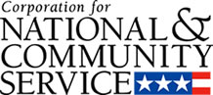

Corporation for National and Community Service

General Program Overview
AmeriCorps provides resources, both human and financial, to organizations that engage Americans in intensive service to meet our country’s critical needs.
Grantees use the funding to support AmeriCorps members for intensive service in their community. AmeriCorps grants partially cover the expense of operating an AmeriCorps program and do not cover general organizational expenses. A cash and in-kind match is required.

The main website can be accessed here: http://www.nationalservice.gov

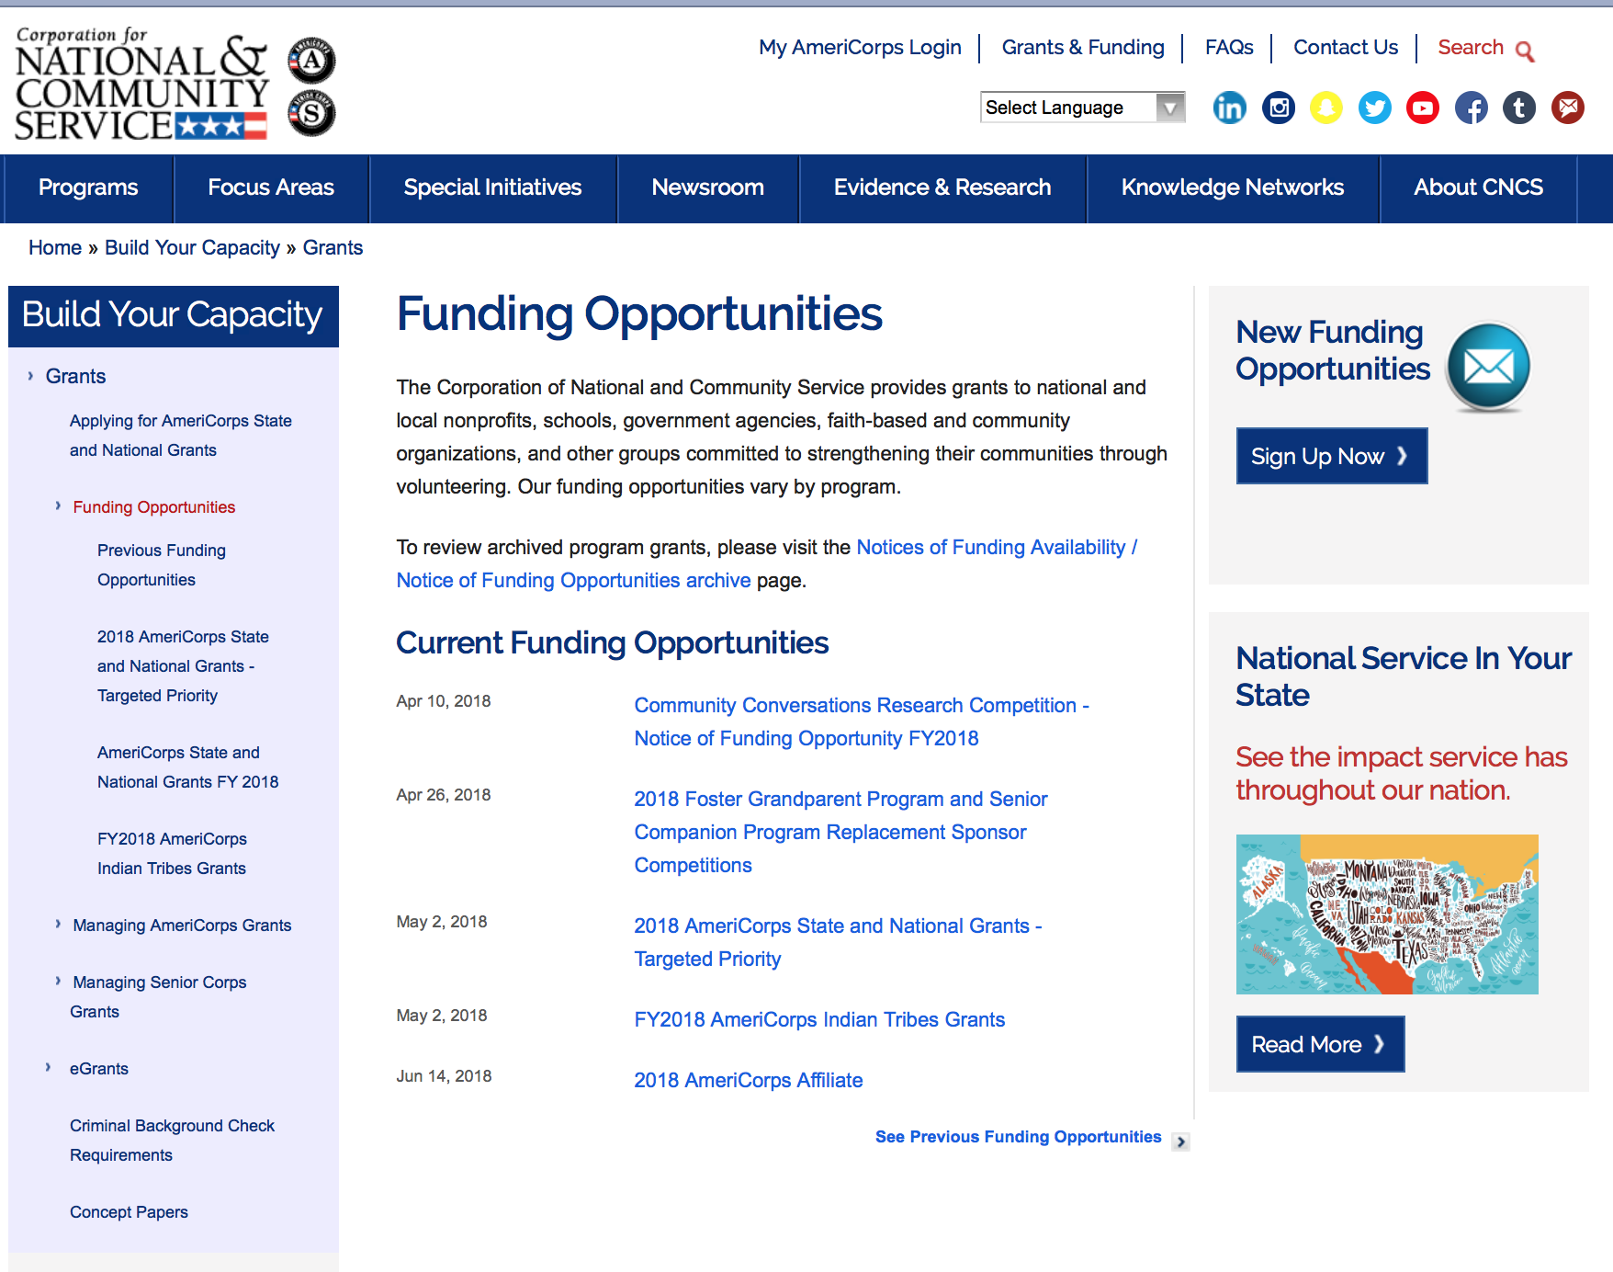

For access to further funding information: click here

http://www.nationalservice.gov/build-your-capacity/grants/funding-opportunities

Programs:

Research:

Reminders:

AmeriCorps State and National Grants FY2019
Synopsis 1

Document Type: | Grants Notice
Funding Opportunity Number: | CNCS-09-25-18
Funding Opportunity Title: | AmeriCorps State and National Grants FY2019
Opportunity Category: | Discretionary
Opportunity Category Explanation:
Funding Instrument Type: | Grant
Category of Funding Activity: | Community Development  Disaster Prevention and Relief  Education  Employment, Labor and Training  Environment  Food and Nutrition  Health  Housing  Natural Resources
Category Explanation:
Expected Number of Awards:
CFDA Number(s): | 94.006 -- AmeriCorps
Cost Sharing or Matching Requirement: | Yes
Version: | Synopsis 1
Posted Date: | Sep 25, 2018
Last Updated Date: | Sep 25, 2018
Original Closing Date for Applications: | Jan 30, 2019
Current Closing Date for Applications: | Jan 30, 2019
Archive Date: | Jan 31, 2019
Eligible Applicants: | Independent school districts  Native American tribal organizations (other than Federally recognized tribal governments)  State governments  Special district governments  City or township governments  Private institutions of higher education  Native American tribal governments (Federally recognized)  Nonprofits that do not have a 501(c)(3) status with the IRS, other than institutions of higher education  Public and State controlled institutions of higher education  County governments  Nonprofits having a 501(c)(3) status with the IRS, other than institutions of higher education  Public housing authorities/Indian housing authorities
Additional Information on Eligibility:
Additional Information
Agency Name: | Corporation for National and Community Service
Description: | AmeriCorps grants are awarded to eligible organizations proposing to engage AmeriCorps members in evidence-based or evidence-informed interventions to strengthen communities. An AmeriCorps member is an individual who engages in community service through an approved national service position. Members may receive a living allowance and other benefits while serving. Upon successful completion of their service, members earn a Segal AmeriCorps Education Award from the National Service Trust that members can use to pay for higher education expenses or apply to qualified student loans.
Link to Additional Information: | Full competition information and resources
Grantor Contact Information: | If you have difficulty accessing the full announcement electronically, please contact:  202-606-6659  Competition inbox
https://www.grants.gov/web/grants/view-opportunity.html?oppId=309257

National Service In Hawaii
2017 Year In Review
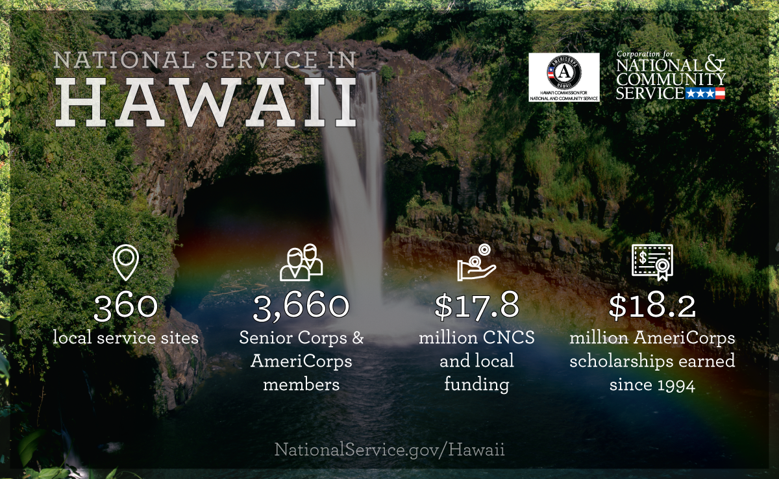
Meeting Community Needs in Hawaii: Last year more than 3,600Americans of all ages and backgrounds met local needs, strengthened communities, and expanded economic opportunity through national service in Hawaii. The Corporation for National and Community Service (CNCS) invested more than $8.1 million to support cost-effective community solutions, working hand in hand with local partners to empower citizens to solve problems. AmeriCorps members and Senior Corps volunteers are preparing today's students for tomorrow's jobs, reducing crime and reviving cities, connecting veterans to services, fighting the opioid epidemic, helping seniors live independently, and rebuilding communities after disasters. Service members served at more than 300 locations across Hawaii, including schools, food banks, homeless shelters, health clinics, youth centers, veterans facilities, and other nonprofit and faith-based organizations. Through a unique public-private partnership, CNCS, its grantees, and project sponsors generated more than $9.6 million in outside resources from businesses, foundations, public agencies, and other sources in FY 2017. This local support strengthened community impact and increased the return on taxpayer dollars.

AmeriCorps
Last year, more than 600 AmeriCorps members met pressing local needs across Hawaii, making a lasting impact in communities while gaining valuable skills and experience to advance their careers. AmeriCorps members serve through one of three programs:
- AmeriCorps State & National engages men and women in intensive service at thousands of locations across the country through nonprofits, schools, public agencies, tribes, and community and faith-based groups. Most AmeriCorps grant funding goes to the Hawaii Commission on National & Community Service, the Governor-appointed State Service Commission, which in turn awards grants to organizations to respond to local needs.
- AmeriCorps VISTA (Volunteers In Service To America) taps the skills, talents, and passion of Americans of all ages to support community efforts to overcome poverty.
- AmeriCorps NCCC (National Civilian Community Corps) is a full-time, team-based residential program for 18-24 year-olds. Members develop leadership skills by serving in public safety, environment, and disaster projects. FEMA Corps, a unit of NCCC, focuses solely on disaster preparedness, response, and recovery.

Senior Corps
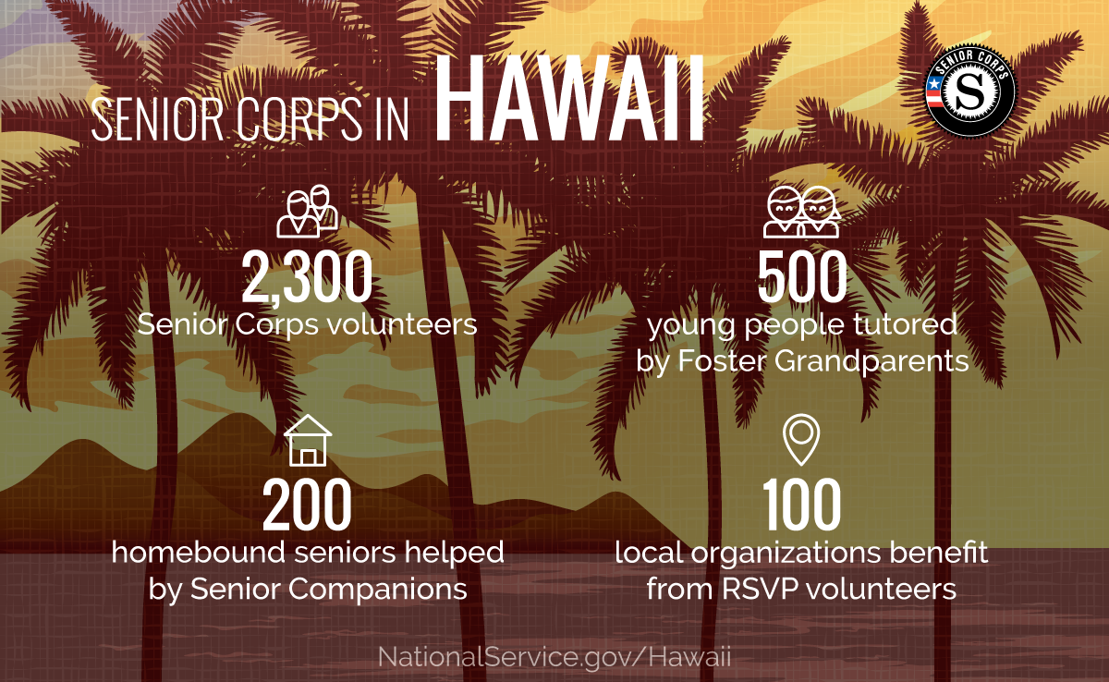
Senior Corps taps the skills, talents, and experience of Americans age 55 and over to meet a wide range of community challenges. Last year, more than 3,000 Hawaii seniors met critical community needs while contributing to longer, healthier lives through one of three Senior Corps programs:
- Foster Grandparents serve one-on-one as tutors and mentors to young people with exceptional needs.
- Senior Companions help homebound seniors and other adults maintain independence primarily in their own homes.
- RSVP volunteers conduct safety patrols, renovate homes, protect the environment, tutor and mentor youth, respond to natural disasters, and provide other services.
Last year in Hawaii, Foster Grandparents tutored and mentored 530young people, Senior Companions helped 290 seniors live independently, and RSVP volunteers strengthened the impact of 150organizations across the state.

Learn More
To see other reports about national service in Hawaii, please contact HI@cns.gov.
The Corporation for National and Community Service is a federal agency that improves lives, strengthens communities, and fosters civic engagement through service and volunteering. To learn more, visit www.NationalService.gov or call 202-606-5000 or TTY 1-800-833-3722.

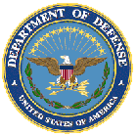

U.S. Department of Defense

Doing Business with the Department of Defense

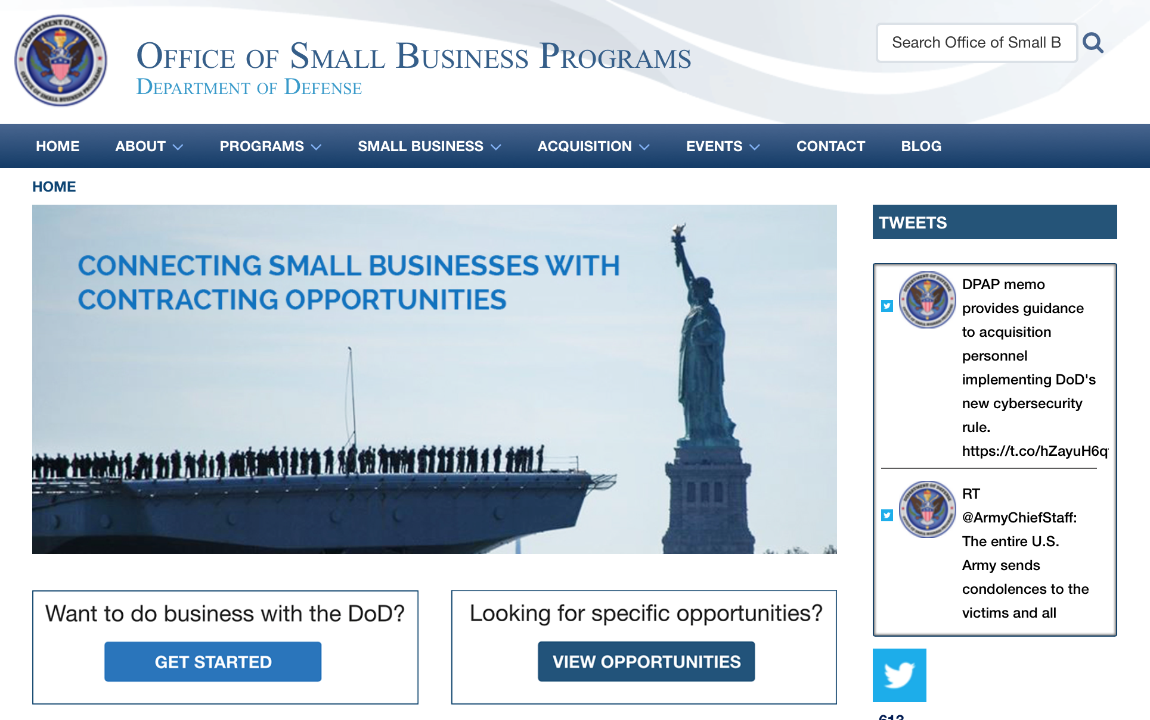

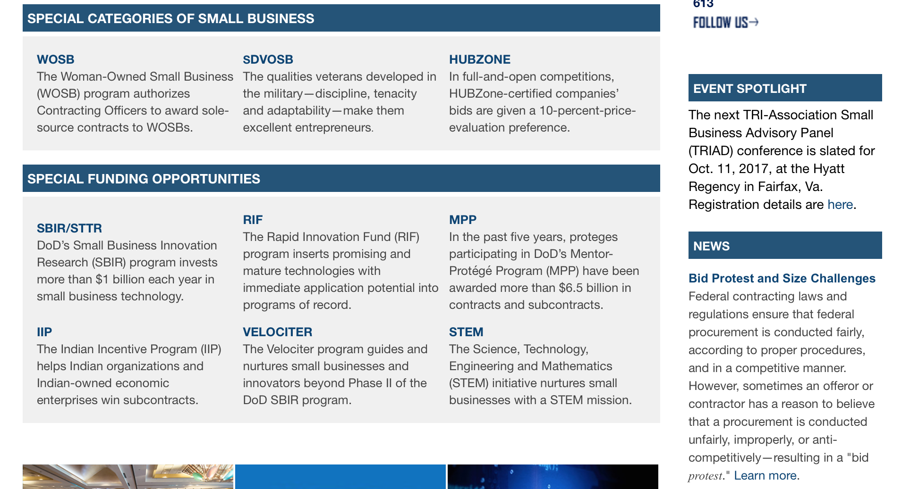

http://business.defense.gov

Research:

DARPA - Biological Technologies Office
Panacea
Synopsis 1
https://www.grants.gov/web/grants/view-opportunity.html?oppId=310972

DARPA - Information Innovation Office
Knowledge-directed Artificial Intelligence Reasoning Over Schemas (KAIROS)
Synopsis 1
https://www.grants.gov/web/grants/view-opportunity.html?oppId=311451

DARPA - Microsystems Technology Office
Guaranteed Architecture for Physical Security (GAPS)
Synopsis 1
https://www.grants.gov/web/grants/view-opportunity.html?oppId=311774

DARPA - Microsystems Technology Office
Technologies for Mixed-mode Ultra Scaled Integrated Circuits (T-MUSIC)
Synopsis 1
https://www.grants.gov/web/grants/view-opportunity.html?oppId=311773

Naval Supply Systems Command
FY19-FY20 Department of Defense HIV/AIDS Prevention Program: Military Specific HIV/AIDS Prevention, Care, and Treatment Program for Non-PEPFAR (President's Emergency Plan for AID Relief) Funded Countries
Synopsis 1
https://www.grants.gov/web/grants/view-opportunity.html?oppId=311127

Office of Naval Research
Long Range BAA
Synopsis 1
https://www.grants.gov/web/grants/view-opportunity.html?oppId=311508

Office of Naval Research
Special Program Announcement for Office of Naval Research Task Force Ocean
Synopsis 1
https://www.grants.gov/web/grants/view-opportunity.html?oppId=311177
Modifications:

AFRL DET 8
AFRL RV-RD Assistance Instruments Announcement
Synopsis 2
https://www.grants.gov/web/grants/view-opportunity.html?oppId=311454
USUHS Medical Research Projects
Wounded Warrior Service Dog Program (WWSDP) FY2019
Synopsis 4
https://www.grants.gov/web/grants/view-opportunity.html?oppId=311379

Deleted:

Reminders:



Department of Education
Grant Programs Overview at the Department of Education

The general information page for Education Grant funding is an excellent resource describing the three types of grants awarded by the Department of Education. See the screen shot of the Department of Education web page below:

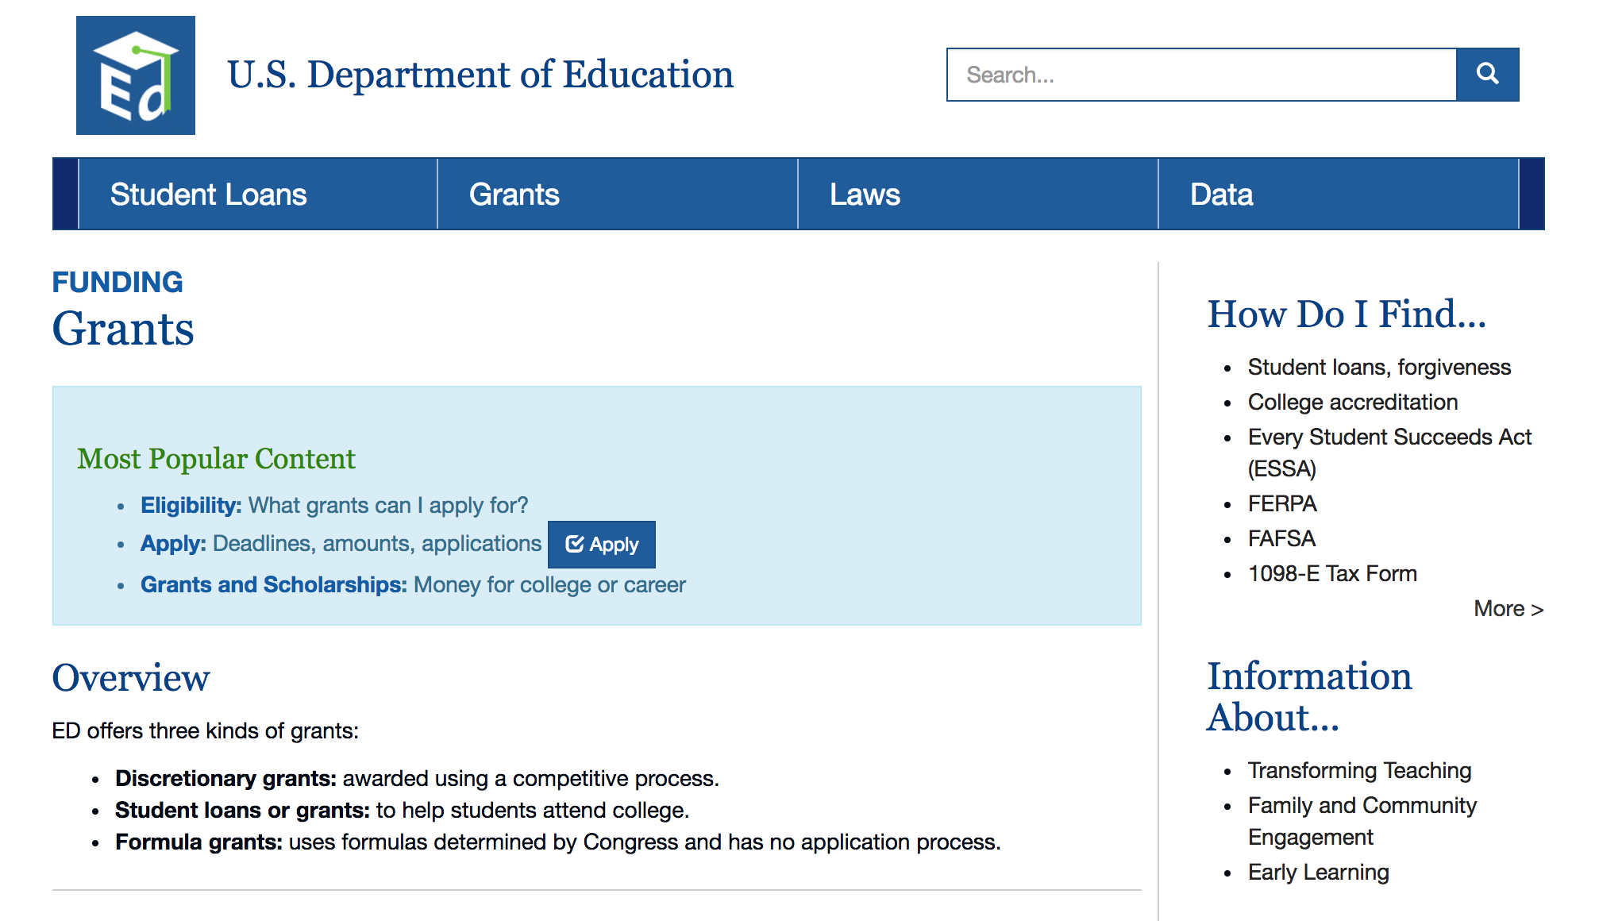
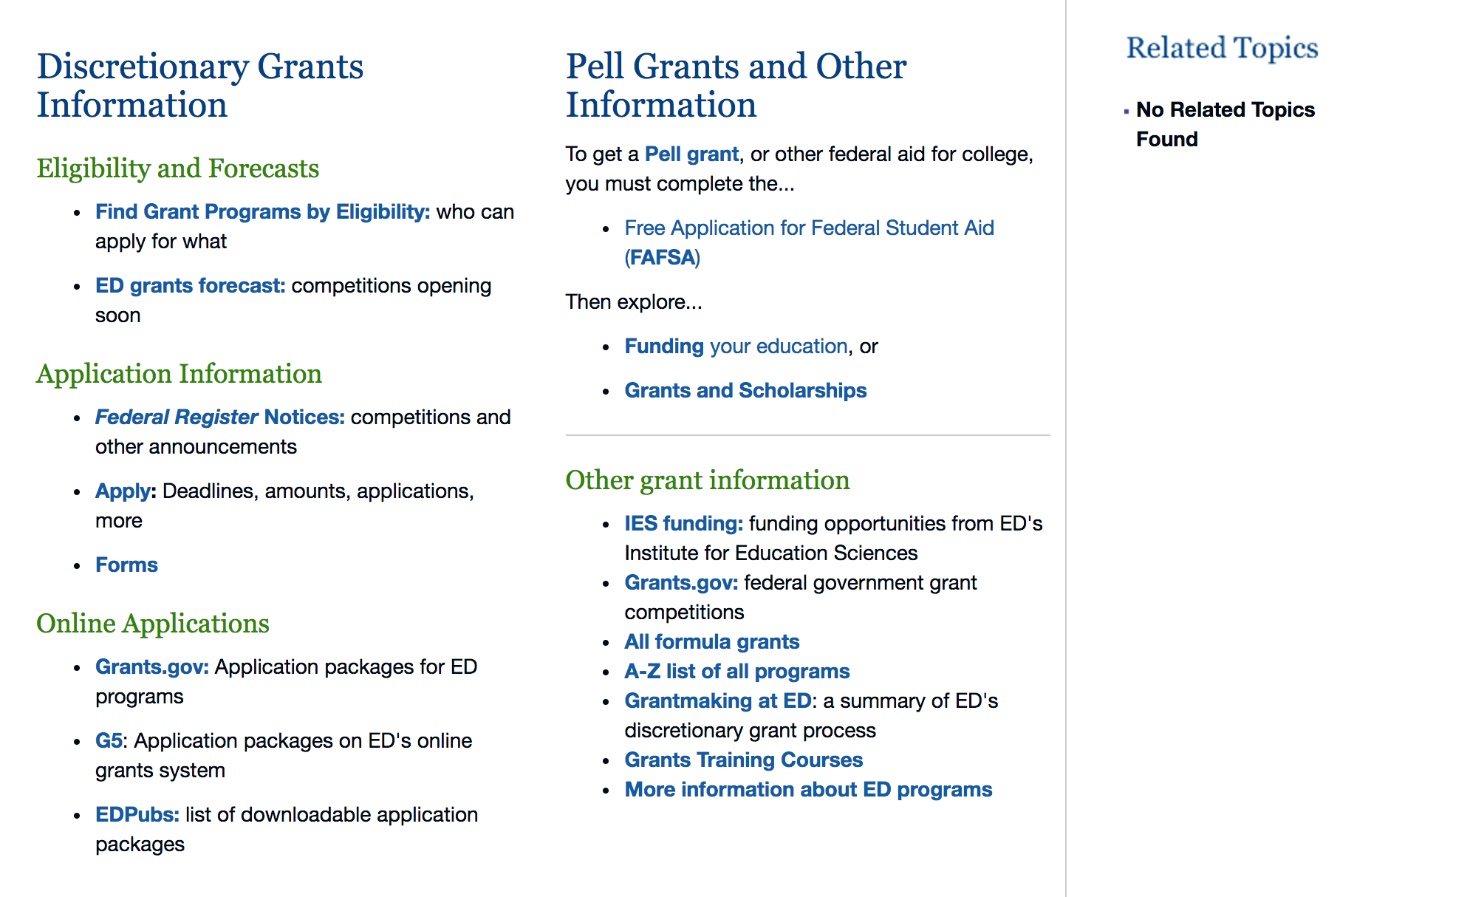

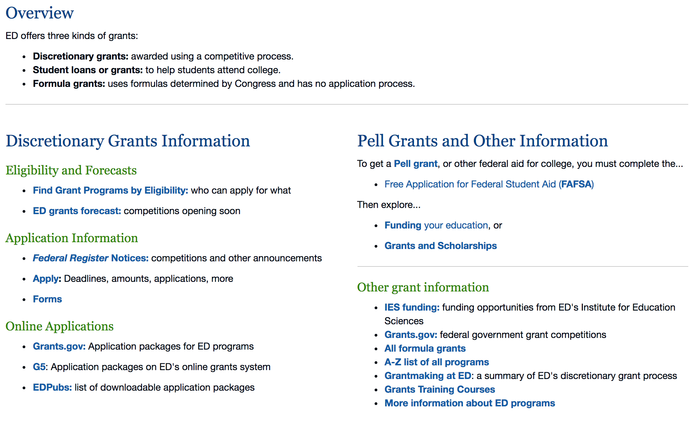

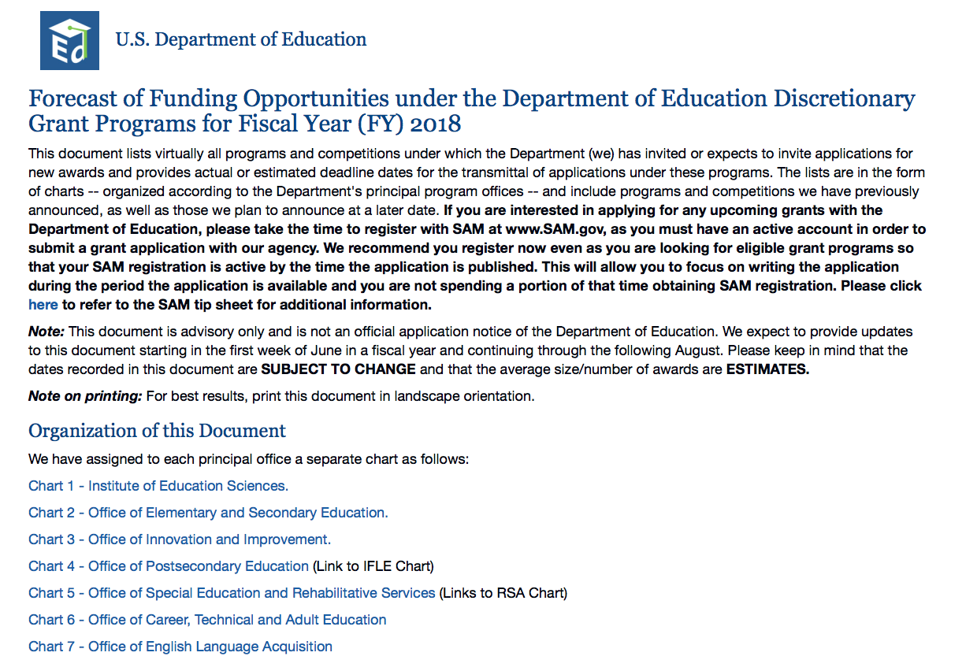

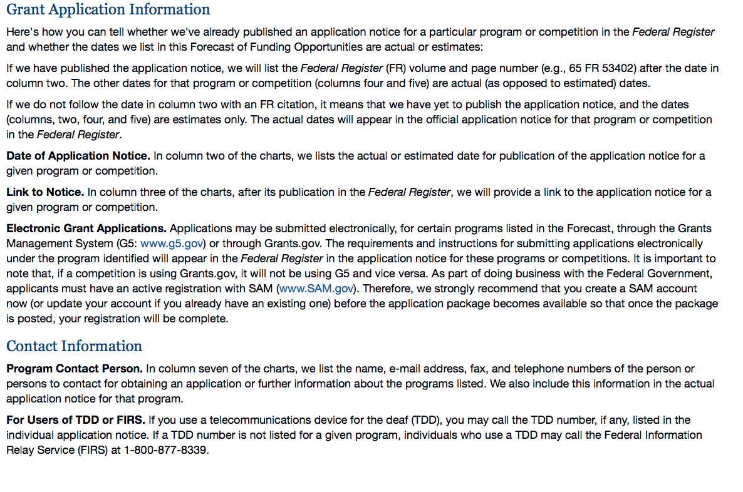

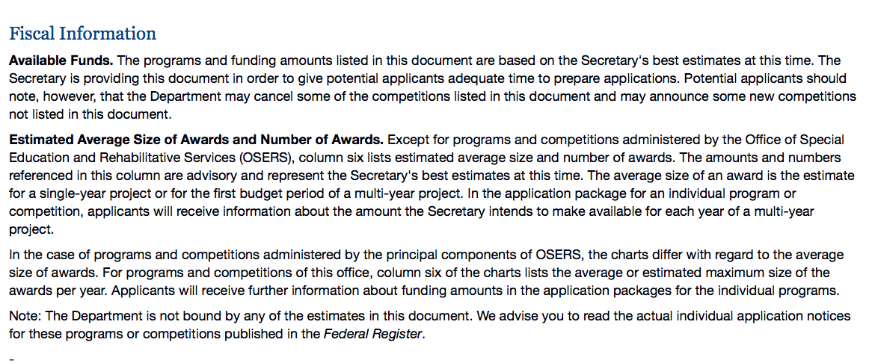

https://www2.ed.gov/fund/grant/find/edlite-forecast.html

Programs:

Research:

Modifications:

Reminders:

Office of Innovation and Improvement (OII): Expanding Opportunity Through Quality Charter Schools Program (CSP): Grants to Charter Management Organizations for the Replication and Expansion of High-Quality Charter Schools CFDA Number 84.282M
Synopsis 1

Document Type: | Grants Notice
Funding Opportunity Number: | ED-GRANTS-113018-001
Funding Opportunity Title: | Office of Innovation and Improvement (OII): Expanding Opportunity Through Quality Charter Schools Program (CSP): Grants to Charter Management Organizations for the Replication and Expansion of High-Quality Charter Schools CFDA Number 84.282M
Opportunity Category: | Discretionary
Opportunity Category Explanation:
Funding Instrument Type: | Grant
Category of Funding Activity: | Education
Category Explanation:
Expected Number of Awards: | 30
CFDA Number(s): | 84.282 -- Charter Schools
Cost Sharing or Matching Requirement: | No
Version: | Synopsis 1
Posted Date: | Nov 30, 2018
Last Updated Date: | Nov 30, 2018
Current Closing Date for Applications: | Jan 10, 2019 Applications Available: November 30, 2018. Date of Pre-Application Webinar: Thursday, December 6, 2018, 12:00 p.m., Washington, DC time. Deadline for Transmittal of Applications: January 10, 2019. Deadline for Intergovernmental Review: February 28, 2019. Pre-Application Webinar Information: The Department will hold a pre-application meeting via webinar for prospective applicants on Thursday, December 6, 12:00 p.m., Washington, DC time. Individuals interested in attending this meeting are encouraged to pre-register by emailing their name, organization, and contact information with the subject heading ``CMO GRANTS PRE-APPLICATION MEETING'' to charterschools@ed.gov. There is no registration fee for attending this meeting.
Archive Date: | Feb 09, 2019
Estimated Total Program Funding: | $90,000,000
Award Ceiling: | $1,500,000
Eligible Applicants: | Others (see text field entitled "Additional Information on Eligibility" for clarification)
Additional Information on Eligibility: | Eligible Applicants: CMOs. Eligible applicants may apply individually or as part of a group or consortium.
Additional Information
Agency Name: | Department of Education
Description: | Note: Each funding opportunity description is a synopsis of information in the Federal Register application notice. For specific information about eligibility, please see the official application notice. The official version of this document is the document published in the Federal Register. Free Internet access to the official edition of the Federal Register and the Code of Federal Regulations is available on GPO Access at: http://www.access.gpo.gov/nara/index.html. Please review the official application notice for pre-application and application requirements, application submission information, performance measures, priorities and program contact information.  For the addresses for obtaining and submitting an application, please refer to our Common Instructions for Applicants to Department of Education Discretionary Grant Programs, published in the Federal Register on February 12, 2018 (83 FR 6003) and available at www.gpo.gov/fdsys/pkg/FR-2018-02-12/pdf/2018-02558.pdf.  Purpose of Program: The major purposes of the CSP are to expand opportunities for all students, particularly traditionally underserved students, to attend charter schools and meet challenging State academic standards; provide financial assistance for the planning, program design, and initial implementation of public charter schools; increase the number of high-quality charter schools \1\ available to students across the United States; evaluate the impact of charter schools on student achievement, families, and communities; share best practices between charter schools and other public schools; encourage States to provide facilities support to charter schools; and support efforts to strengthen the charter school authorizing process. Through CSP Grants to Charter Management Organizations for the Replication and Expansion of High-Quality Charter Schools (CFDA number 84.282M) (also referred to as CMO [i.e., Charter Management Organization] grants or the CMO grant program), the Department provides funds to charter management organizations (CMOs) on a competitive basis to enable them to replicate or expand one or more high-quality charter schools. Grant funds may be used to expand the enrollment of one or more existing high-quality charter schools, or to replicate one or more new charter schools that are based on an existing, high-quality charter school model.  ---------------------------------------------------------------------------  \1\ Italicized terms are defined in the Definitions section of this notice.  ---------------------------------------------------------------------------  Catalog of Federal Domestic Assistance (CFDA) number 84.282M.
Link to Additional Information: | Office of Innovation and Improvement (OII): Expanding Opportunity Through Quality Charter Schools Program (CSP): Grants to Charter Management Organizations for the Replication and Expansion of High-Quality Charter Schools CFDA Number 84.282M; Notice
Grantor Contact Information: | If you have difficulty accessing the full announcement electronically, please contact:  Julius C Cotton ED Grants.gov FIND Systems Admin. Phone 202-245-6288 julius.cotton@ed.gov Program Manager: Eddie Moat, U.S. Department of Education, 400 Maryland Avenue SW, Room 4W259, Washington, DC 20202-5970. Telephone: (202) 401-2266. Email: charterschools@ed.gov.  e-Mail: Program Mailbox

https://www.grants.gov/web/grants/view-opportunity.html?oppId=310666

Institute of Education Sciences (IES): Low-Cost, Short-Duration Evaluation of Education Interventions CFDA Number 84.305L
Synopsis 1
Document Type: Grants Notice  Funding Opportunity Number: ED-GRANTS-052118-005  Funding Opportunity Title: Institute of Education Sciences (IES): Low-Cost, Short-Duration Evaluation of Education Interventions CFDA Number 84.305L  Opportunity Category: Discretionary  Opportunity Category Explanation:  Funding Instrument Type: Cooperative Agreement Grant  Category of Funding Activity: Education  Category Explanation:  Expected Number of Awards:  CFDA Number(s): 84.305 -- Education Research, Development and Dissemination  Cost Sharing or Matching Requirement: No | Version: Synopsis 1  Posted Date: May 21, 2018  Last Updated Date: May 21, 2018  Original Closing Date for Applications: Mar 07, 2019 Applications Available: January 10, 2019. Deadline for Transmittal of Applications: March 7, 2019.  Current Closing Date for Applications: Mar 07, 2019 Applications Available: January 10, 2019. Deadline for Transmittal of Applications: March 7, 2019.  Archive Date: Apr 06, 2019  Estimated Total Program Funding:  Award Ceiling:  Award Floor:
Eligibility
Eligible Applicants: | Others (see text field entitled "Additional Information on Eligibility" for clarification)  Independent school districts  County governments  City or township governments  Special district governments  Public and State controlled institutions of higher education  State governments  Nonprofits that do not have a 501(c)(3) status with the IRS, other than institutions of higher education  For profit organizations other than small businesses  Nonprofits having a 501(c)(3) status with the IRS, other than institutions of higher education  Private institutions of higher education
Additional Information on Eligibility: | Eligible Applicants: Applicants that have the ability and capacity to conduct scientifically valid research are eligible to apply. Eligible applicants include, but are not limited to, nonprofit and for-profit organizations and public and private agencies and institutions of higher education, such as colleges and universities.
Additional Information
Agency Name: | Department of Education
Description: | Note: Each funding opportunity description is a synopsis of information in the Federal Register application notice. For specific information about eligibility, please see the official application notice. The official version of this document is the document published in the Federal Register. Free Internet access to the official edition of the Federal Register and the Code of Federal Regulations is available on GPO Access at: http://www.access.gpo.gov/nara/index.html. Please review the official application notice for pre-application and application requirements, application submission information, performance measures, priorities and program contact information.  For the addresses for obtaining and submitting an application, please refer to our Common Instructions for Applicants to Department of Education Discretionary Grant Programs, published in the Federal Register on February 12, 2018 (83 FR 6003) and available atwww.gpo.gov/fdsys/pkg/FR-2018-02-12/pdf/2018-02558.pdf.  The dates when applications are available and the deadlines for transmittal of applications invited under this notice are indicated in the chart at the end of this notice and in the Requests for Applications (RFAs) that are posted at the following websites: https://ies.ed.gov/funding,https://www.ed.gov/programs/edresearch/index.html,and https://www.ed.gov/programs/specialedresearch/index.html.  FOR FURTHER INFORMATION CONTACT: The contact person associated with a particular research competition is listed in the chart at the end of this notice, as well as in the relevant RFA and application package.  Purpose of Program: In awarding these grants, the Institute of Education Sciences (Institute) intends to provide national leadership in expanding fundamental knowledge and understanding of (1) developmental and school readiness outcomes for infants and toddlers with or at risk for a disability, (2) education outcomes for all students from early childhood education through postsecondary and adult education, and (3) employment and wage outcomes when relevant (such as for students who engaged in career and technical, postsecondary, or adult education). The Institute's research grant programs are designed to provide interested individuals and the general public with reliable and valid information about education practices that support learning and improve academic achievement and access to education opportunities for all students. These interested individuals include parents, educators, students, researchers, and policymakers. In carrying out its grant programs, the Institute provides support for programs of research in areas of demonstrated national need.  Competitions in This Notice: The Institute will conduct nine research competitions in FY 2019 through two of its centers: The Institute's National Center for Education Research (NCER) will hold a total of five competitions--one competition in each of the following areas: Education research; education research and development centers; statistical and research methodology in education; partnerships and collaborations focused on problems of practice or policy; and low-cost, short-duration evaluation of education interventions.  Catalog of Federal Domestic Assistance (CFDA) numbers 84.305A, 84.305C, 84.305D, 84.305H, 84.305L, 84.324A, 84.324B, 84.324L, and 84.324N.
Link to Additional Information: | Institute of Education Sciences (IES): Low-Cost, Short-Duration Evaluation of Education Interventions CFDA Number 84.305L; Notice Inviting Applications for New Awards for Fiscal Year (FY) 2019
Grantor Contact Information: | If you have difficulty accessing the full announcement electronically, please contact:  Julius Cotton ED Grants.gov FIND Systems Admin. Phone 202-245-6288 educationgrantinquiries@ed.gov Program Manager: Phill Gagne e-Mail: Phill Gagne@ed.gov  e-Mail: Program Manager
https://www.grants.gov/web/grants/view-opportunity.html?oppId=305419

Institute of Education Sciences (IES): Low-Cost, Short-Duration Evaluation of Special Education Interventions CFDA Number 84.324L
Synopsis 1
Document Type: Grants Notice  Funding Opportunity Number: ED-GRANTS-052118-008  Funding Opportunity Title: Institute of Education Sciences (IES): Low-Cost, Short-Duration Evaluation of Special Education Interventions CFDA Number 84.324L  Opportunity Category: Discretionary  Opportunity Category Explanation:  Funding Instrument Type: Cooperative Agreement Grant  Category of Funding Activity: Education  Category Explanation:  Expected Number of Awards:  CFDA Number(s): 84.324 -- Research in Special Education  Cost Sharing or Matching Requirement: No | Version: Synopsis 1  Posted Date: May 21, 2018  Last Updated Date: May 21, 2018  Original Closing Date for Applications: Mar 07, 2019 Applications Available: January 10, 2019. Deadline for Transmittal of Applications: March 7, 2019.  Current Closing Date for Applications: Mar 07, 2019 Applications Available: January 10, 2019. Deadline for Transmittal of Applications: March 7, 2019.  Archive Date: Apr 06, 2019  Estimated Total Program Funding:  Award Ceiling:  Award Floor:
Eligibility
Eligible Applicants: | Special district governments  City or township governments  Public and State controlled institutions of higher education  Nonprofits having a 501(c)(3) status with the IRS, other than institutions of higher education  Nonprofits that do not have a 501(c)(3) status with the IRS, other than institutions of higher education  Private institutions of higher education  Independent school districts  State governments  Others (see text field entitled "Additional Information on Eligibility" for clarification)  County governments  For profit organizations other than small businesses
Additional Information on Eligibility: | Eligible Applicants: Applicants that have the ability and capacity to conduct scientifically valid research are eligible to apply. Eligible applicants include, but are not limited to, nonprofit and for-profit organizations and public and private agencies and institutions of higher education, such as colleges and universities.
Additional Information
Agency Name: | Department of Education
Description: | Note: Each funding opportunity description is a synopsis of information in the Federal Register application notice. For specific information about eligibility, please see the official application notice. The official version of this document is the document published in the Federal Register. Free Internet access to the official edition of the Federal Register and the Code of Federal Regulations is available on GPO Access at: http://www.access.gpo.gov/nara/index.html. Please review the official application notice for pre-application and application requirements, application submission information, performance measures, priorities and program contact information.  For the addresses for obtaining and submitting an application, please refer to our Common Instructions for Applicants to Department of Education Discretionary Grant Programs, published in the Federal Register on February 12, 2018 (83 FR 6003) and available atwww.gpo.gov/fdsys/pkg/FR-2018-02-12/pdf/2018-02558.pdf.  The dates when applications are available and the deadlines for transmittal of applications invited under this notice are indicated in the chart at the end of this notice and in the Requests for Applications (RFAs) that are posted at the following websites: https://ies.ed.gov/funding,https://www.ed.gov/programs/edresearch/index.html,and https://www.ed.gov/programs/specialedresearch/index.html.  FOR FURTHER INFORMATION CONTACT: The contact person associated with a particular research competition is listed in the chart at the end of this notice, as well as in the relevant RFA and application package.  Purpose of Program: In awarding these grants, the Institute of Education Sciences (Institute) intends to provide national leadership in expanding fundamental knowledge and understanding of (1) developmental and school readiness outcomes for infants and toddlers with or at risk for a disability, (2) education outcomes for all students from early childhood education through postsecondary and adult education, and (3) employment and wage outcomes when relevant (such as for students who engaged in career and technical, postsecondary, or adult education). The Institute's research grant programs are designed to provide interested individuals and the general public with reliable and valid information about education practices that support learning and improve academic achievement and access to education opportunities for all students. These interested individuals include parents, educators, students, researchers, and policymakers. In carrying out its grant programs, the Institute provides support for programs of research in areas of demonstrated national need.  Competitions in This Notice: The Institute will conduct nine research competitions in FY 2019 through two of its centers: The Institute's National Center for Education Research (NCER) will hold a total of five competitions--one competition in each of the following areas: Education research; education research and development centers; statistical and research methodology in education; partnerships and collaborations focused on problems of practice or policy; and low-cost, short-duration evaluation of education interventions.  Catalog of Federal Domestic Assistance (CFDA) numbers 84.305A, 84.305C, 84.305D, 84.305H, 84.305L, 84.324A, 84.324B, 84.324L, and 84.324N.
Link to Additional Information: | Institute of Education Sciences (IES): Low-Cost, Short-Duration Evaluation of Special Education Interventions CFDA Number 84.324L;
Grantor Contact Information: | If you have difficulty accessing the full announcement electronically, please contact:  Julius Cotton ED Grants.gov FIND Systems Admin. Phone 202-245-6288 educationgrantinquiries@ed.gov Program Manager: Sarah Brasiel e-Mail: Sarah.Brasiel@ed.gov  e-Mail: Program Manager
https://www.grants.gov/web/grants/view-opportunity.html?oppId=305447

Deleted:

U.S. Department of Energy

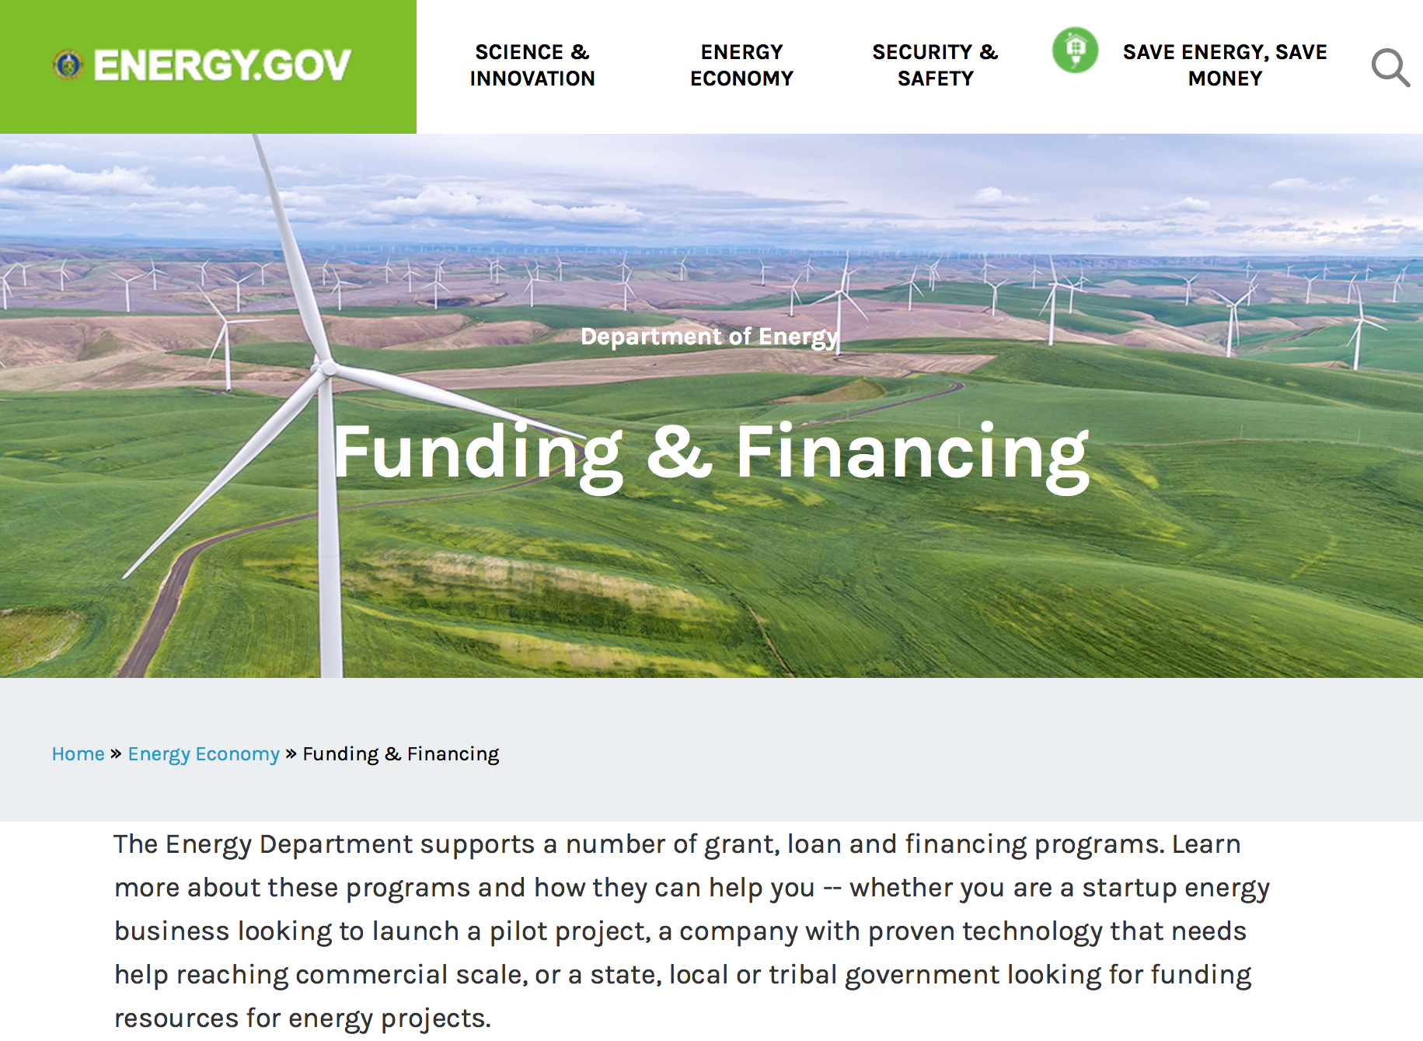

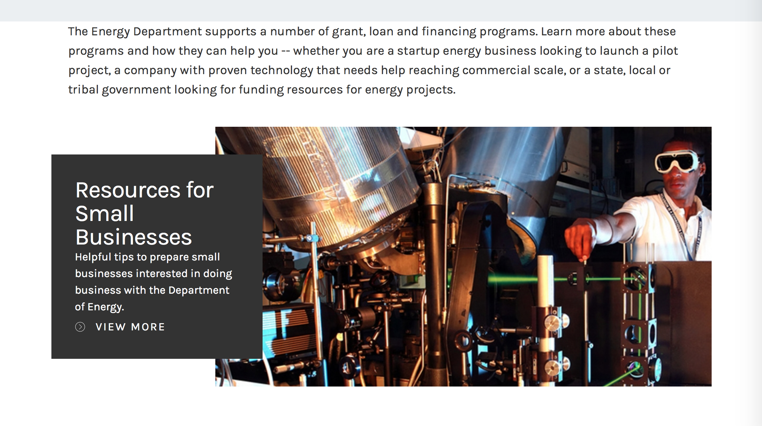

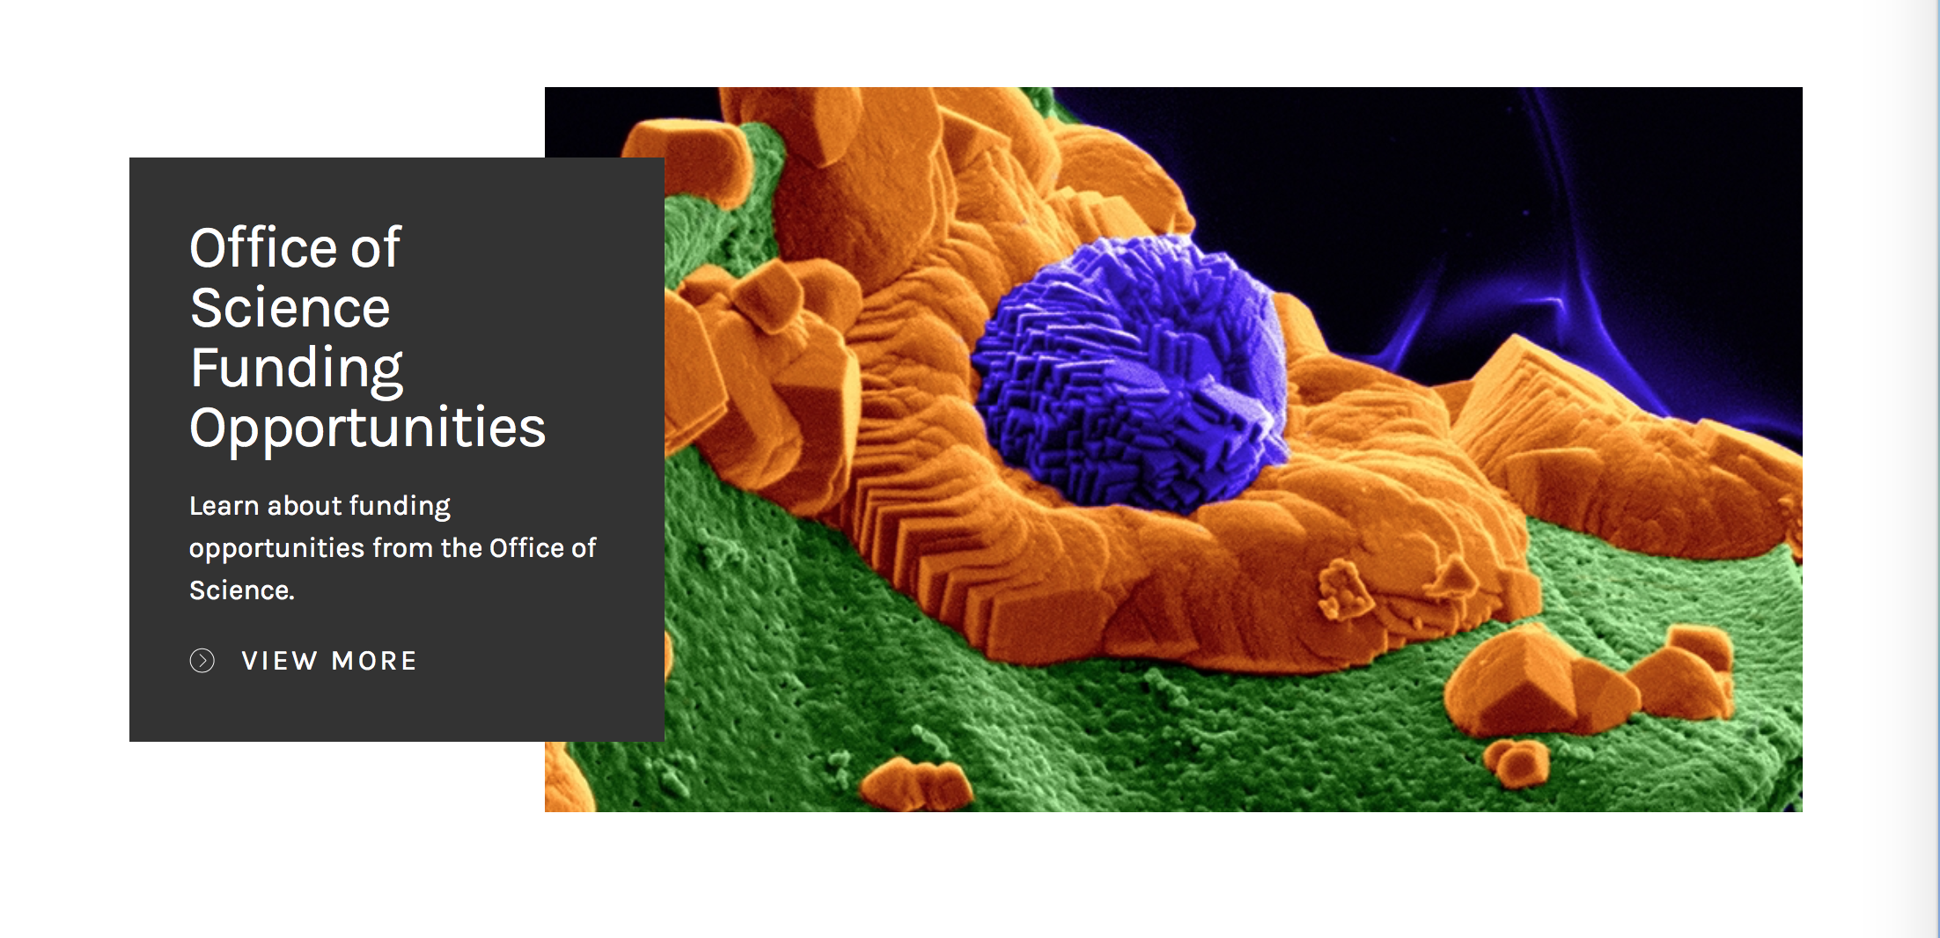

https://www.energy.gov/energy-economy/funding-financing

Office of Science
FY2019 Continuation of Solicitation for the Office of Science Financial Assistance Program
Synopsis 1

Document Type: Grants Notice  Funding Opportunity Number: DE-FOA-0001968  Funding Opportunity Title: FY2019 Continuation of Solicitation for the Office of Science Financial Assistance Program  Opportunity Category: Discretionary  Opportunity Category Explanation:  Funding Instrument Type: Cooperative Agreement Grant  Category of Funding Activity: Science and Technology and other Research and Development  Category Explanation:  Expected Number of Awards: 1000  CFDA Number(s): 81.049 -- Office of Science Financial Assistance Program  Cost Sharing or Matching Requirement: No | Version: Synopsis 1  Posted Date: Dec 31, 2018  Last Updated Date: Dec 31, 2018  Original Closing Date for Applications: Sep 30, 2019  Current Closing Date for Applications: Sep 30, 2019  Archive Date: Dec 31, 2019  Estimated Total Program Funding: $250,000,000  Award Ceiling: $4,000,000  Award Floor: $3,000
Eligibility
Eligible Applicants: | Unrestricted (i.e., open to any type of entity above), subject to any clarification in text field entitled "Additional Information on Eligibility"
Additional Information on Eligibility:
Additional Information
Agency Name: | Office of Science
Description: | The Office of Science (SC) of the Department of Energy hereby announces its continuing interest in receiving grant applications for support of work in the following program areas: Advanced Scientific Computing Research, Basic Energy Sciences, Biological and Environmental Research, Fusion Energy Sciences, High Energy Physics, and Nuclear Physics. On September 3, 1992, DOE published in the Federal Register the Office of Energy Research Financial Assistance Program (now called the Office of Science Financial Assistance Program), 10 CFR 605, as a Final Rule, which contained a solicitation for this program. Information about submission of applications, eligibility, limitations, evaluation and selection processes and other policies and procedures are specified in 10 CFR 605.  This FOA (DE-FOA-0001968) is our annual, broad, open solicitation that covers all of the research areas in the Office of Science and is open throughout the Fiscal Year.  This FOA will remain open until September 30, 2019, 11:59 PM Eastern Time, or until it is succeeded by another issuance, whichever occurs first. This annual FOA (DE-FOA-0001968) succeeds FOA DE-FOA-0001820, which was published May 25, 2018.
Link to Additional Information:
Grantor Contact Information: | If you have difficulty accessing the full announcement electronically, please contact:  Kimberlie Laing Grants Analyst 301-903-3026  Office of Grants and Contracts Support
https://www.grants.gov/web/grants/view-opportunity.html?oppId=311633

Research:

Advanced Research Projects Agency Energy
SOLICITATION ON TOPICS INFORMING NEW PROGRAM AREAS
Synopsis 1
https://www.grants.gov/web/grants/view-opportunity.html?oppId=311427

Advanced Research Projects Agency Energy
SOLICITATION ON TOPICS INFORMING NEW PROGRAM AREAS SBIR/STTR
Synopsis 1
https://www.grants.gov/web/grants/view-opportunity.html?oppId=311429

National Energy Technology Laboratory
Advanced Technologies for Enhanced Oil Recovery
Synopsis 1
https://www.grants.gov/web/grants/view-opportunity.html?oppId=311501

National Energy Technology Laboratory
Advanced Technologies for Recovery of Unconventional Oil and Gas Resources
Synopsis 1
https://www.grants.gov/web/grants/view-opportunity.html?oppId=311536

National Energy Technology Laboratory
Improving Efficiency, Reliability, and Flexibility of Existing Coal-Fueled Power Plants
Synopsis 1
https://www.grants.gov/web/grants/view-opportunity.html?oppId=311485

National Energy Technology Laboratory
Maximizing the Coal Value Chain
Synopsis 1
https://www.grants.gov/web/grants/view-opportunity.html?oppId=311444

National Energy Technology Laboratory
University Training and Research for Fossil Energy Applications
Synopsis 1
https://www.grants.gov/web/grants/view-opportunity.html?oppId=311355

National Energy Technology Laboratory
University Turbine Systems Research
Synopsis 1
https://www.grants.gov/web/grants/view-opportunity.html?oppId=311495

Office of Science
Atmospheric System Research (ASR)
Synopsis 1
https://www.grants.gov/web/grants/view-opportunity.html?oppId=311576

Office of Science
Terrestrial Ecosystem Science
Synopsis 1
https://www.grants.gov/web/grants/view-opportunity.html?oppId=311577

Office of Science
DOE SBIR/STTR FY2019 Phase I Release 2
Synopsis 1
https://www.grants.gov/web/grants/view-opportunity.html?oppId=311320

Office of Science
LOW TEMPERATURE PLASMA SCIENCE CENTERS AND FACILITIES
Synopsis 1
https://www.grants.gov/web/grants/view-opportunity.html?oppId=311494

Modifications:

Office of Science
COLLABORATIVE FUSION ENERGY RESEARCH IN THE DIII-D NATIONAL PROGRAM
Synopsis 2
https://www.grants.gov/web/grants/view-opportunity.html?oppId=311394

Office of Science
FY 2019 SBIR/STTR Phase II Release 1
Synopsis 3
https://www.grants.gov/web/grants/view-opportunity.html?oppId=310984

Reminders:

Environmental Protection Agency

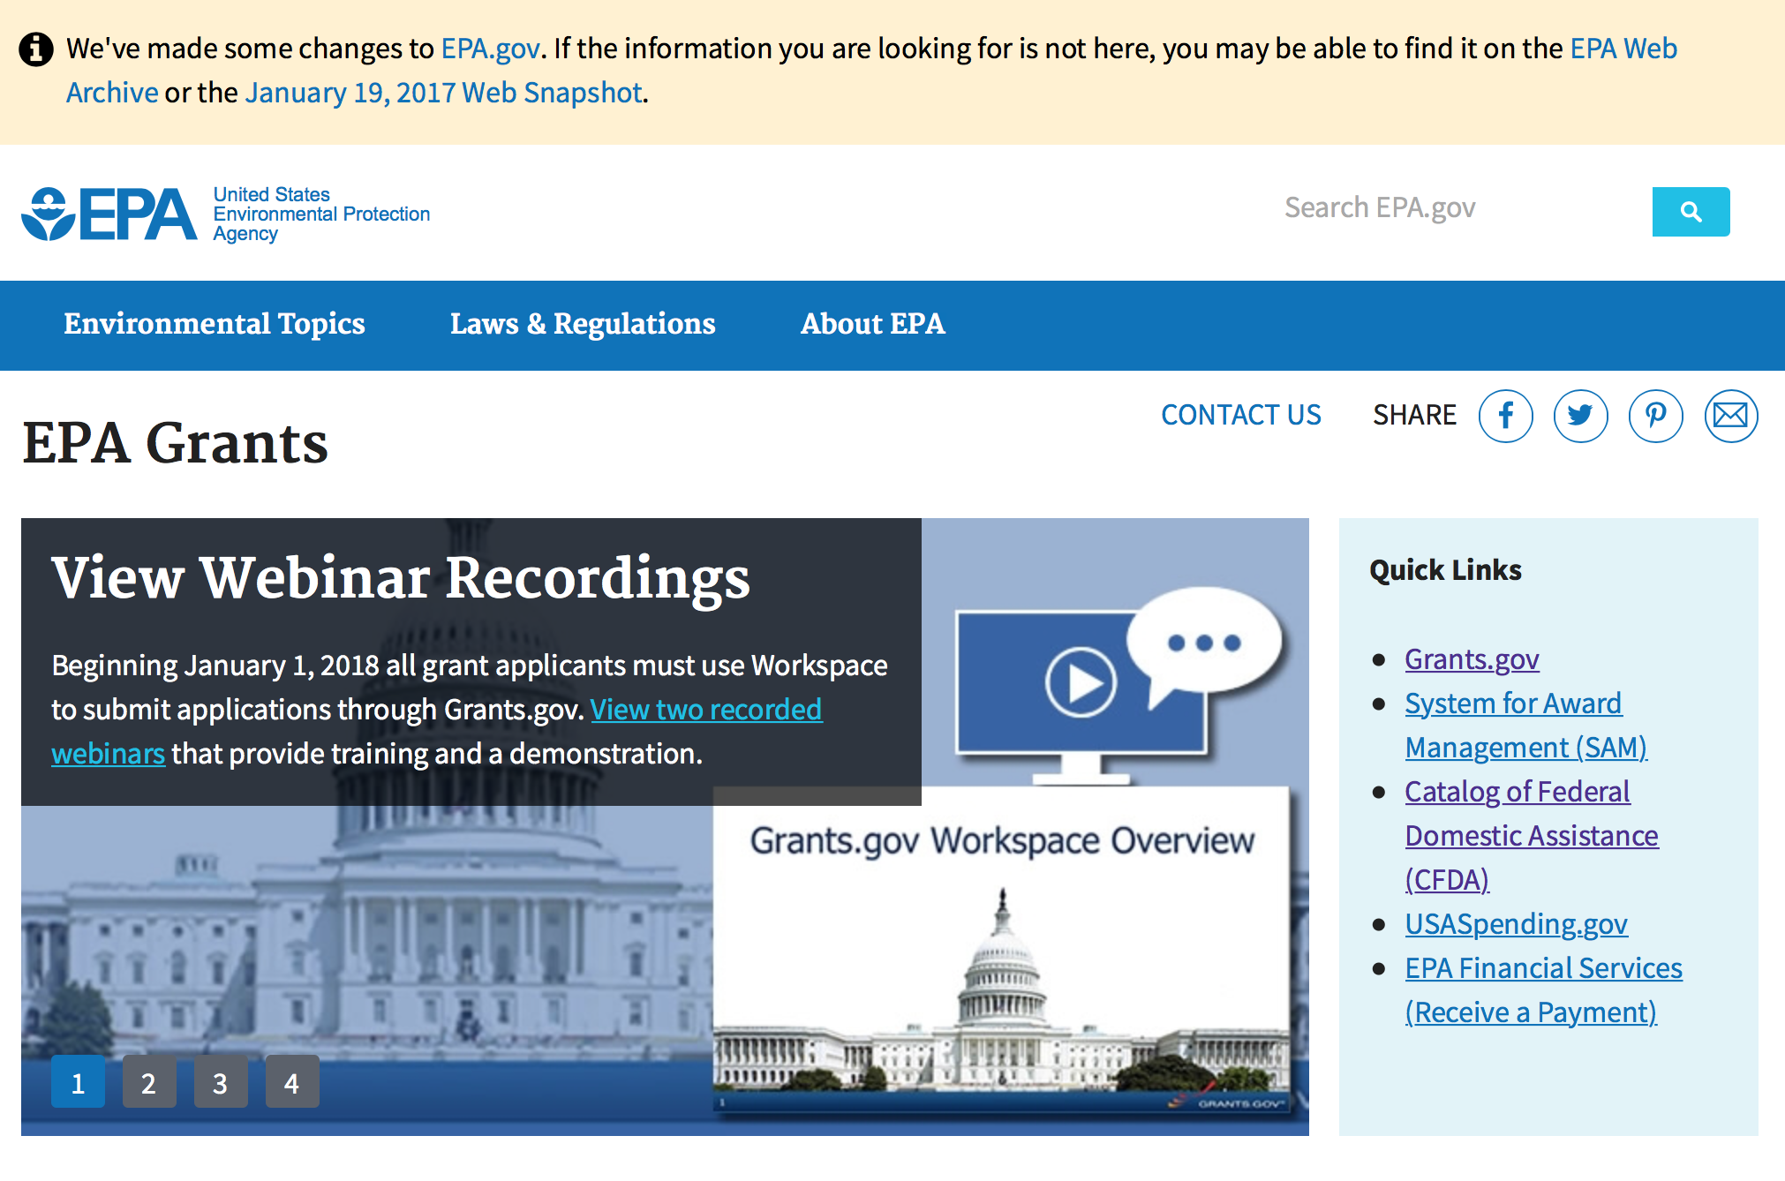
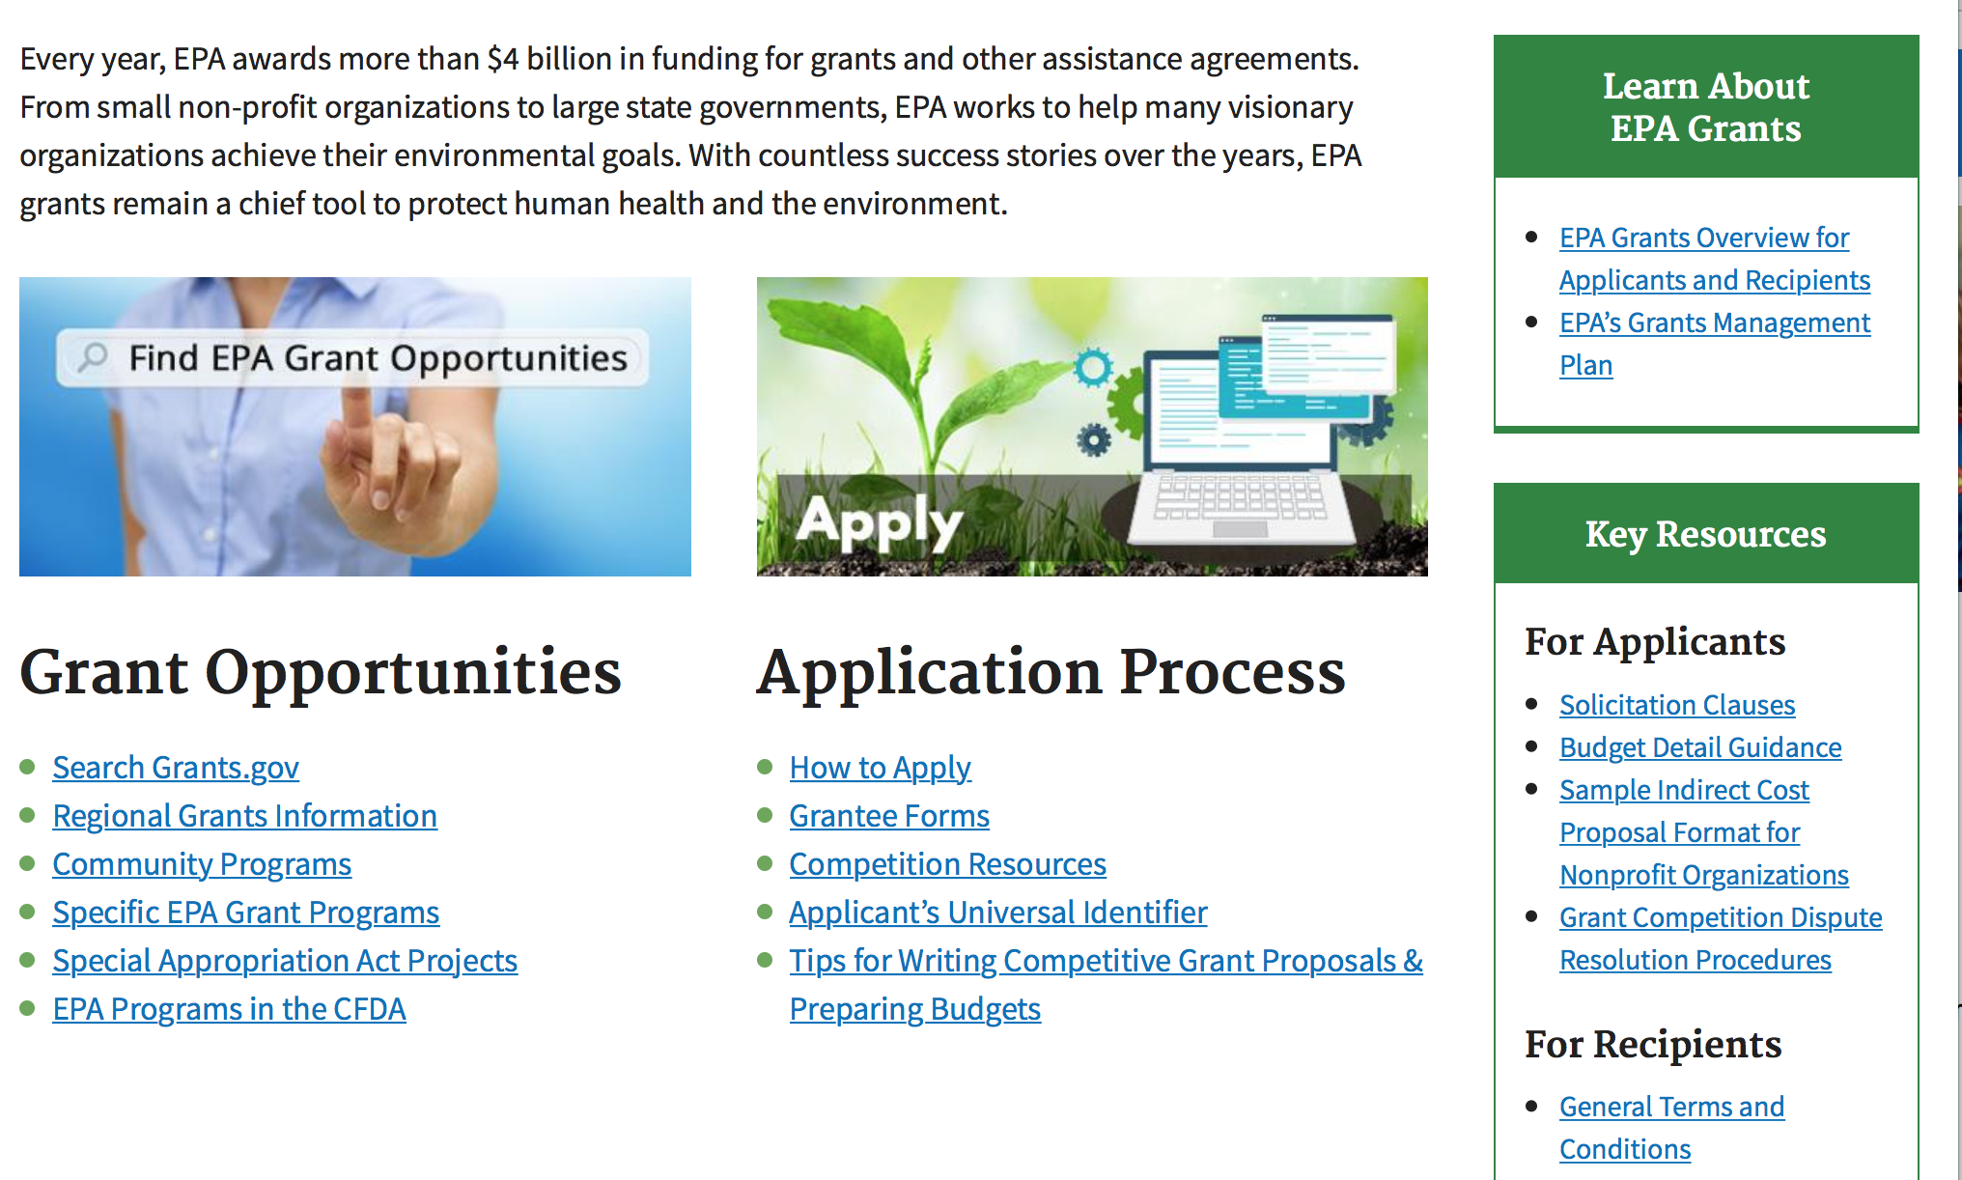

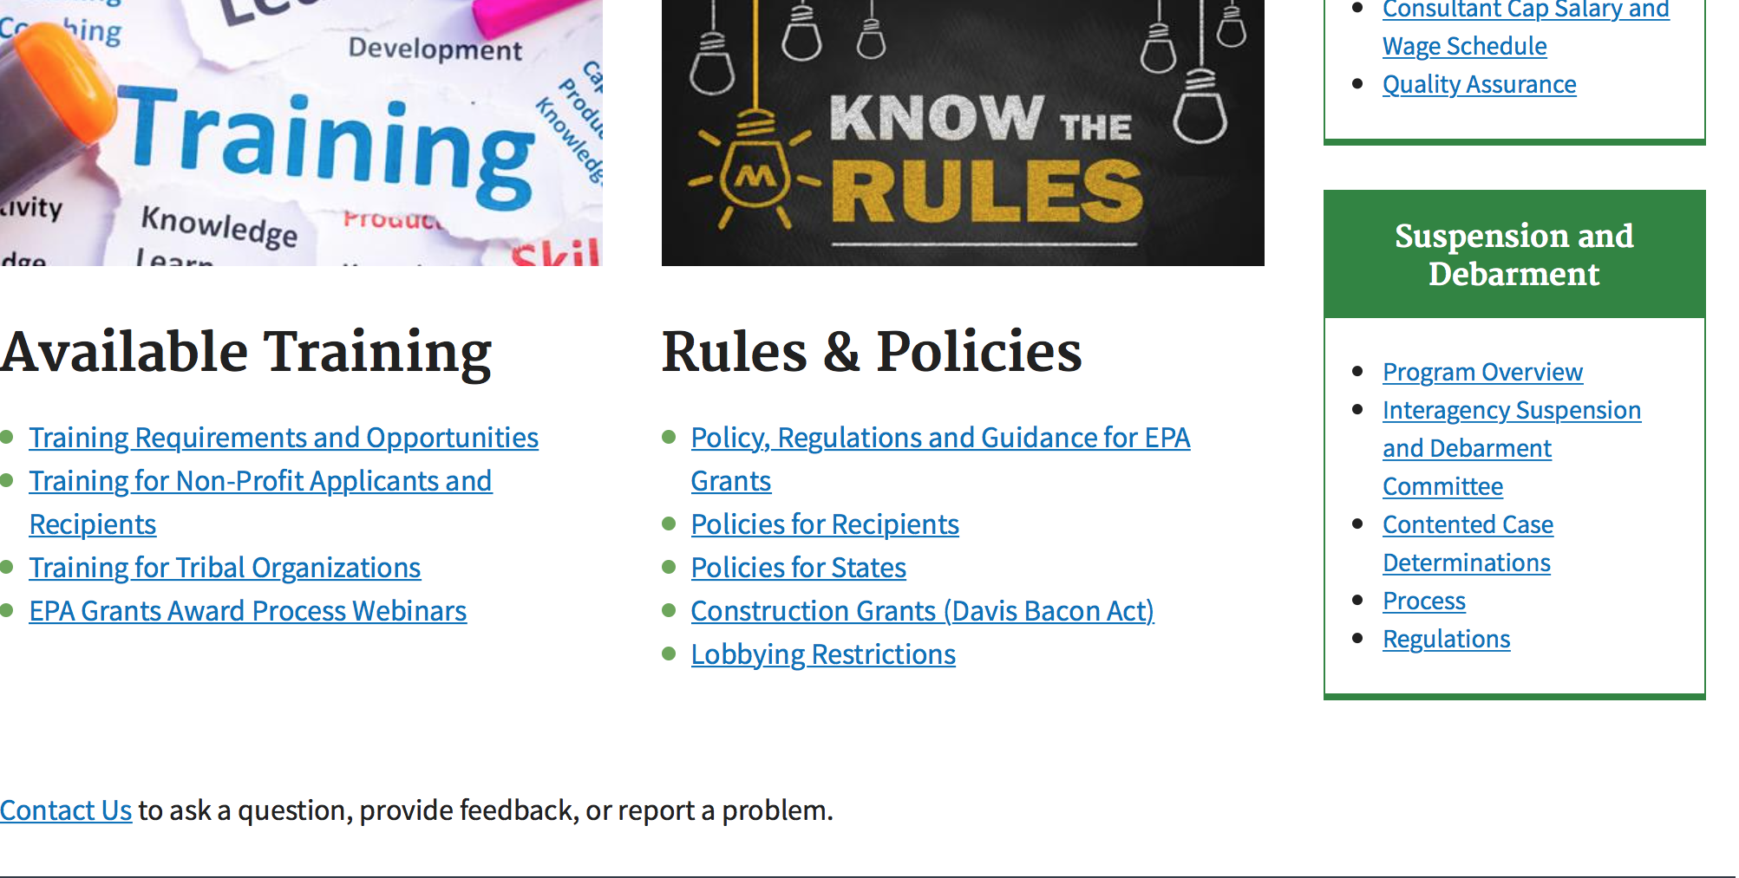

http://www.epa.gov/epahome/grants.htm

Programs:

Clean Diesel Funding Assistance Program FY 2019
Synopsis 1
Document Type: | Grants Notice
Funding Opportunity Number: | EPA-OAR-OTAQ-19-01
Funding Opportunity Title: | Clean Diesel Funding Assistance Program FY 2019
Opportunity Category: | Discretionary
Opportunity Category Explanation:
Funding Instrument Type: | Cooperative Agreement
Category of Funding Activity: | Environment
Category Explanation:
Expected Number of Awards: | 80
CFDA Number(s): | 66.039 -- National Clean Diesel Emissions Reduction Program
Cost Sharing or Matching Requirement: | Yes
Version: | Synopsis 1
Posted Date: | Dec 20, 2018
Last Updated Date: | Dec 20, 2018
Original Closing Date for Applications: | Mar 06, 2019 Please see the announcement including Section IV for additional submission information
Current Closing Date for Applications: | Mar 06, 2019 Please see the announcement including Section IV for additional submission information
Archive Date: | Apr 05, 2019
Estimated Total Program Funding: | $40,000,000
Award Ceiling: | $4,000,000
Award Floor: | $0
Eligible Applicants: | Others (see text field entitled "Additional Information on Eligibility" for clarification)
Additional Information on Eligibility: | Please see Section III of the announcement for eligibility information.
Additional Information
Agency Name: | Environmental Protection Agency
Description: | EPA’s Office of Transportation and Air Quality is soliciting applications nationwide for projects that achieve significant reductions in diesel emissions, particularly from fleets operating at or servicing goods movement facilities located in areas designated as having poor air quality. Further, priority for funding will be given to projects which result in outcomes that benefit affected communities, those that engage affected communities with respect to the design and performance of the project, and those which can demonstrate the ability to promote and continue efforts to reduce emissions after the project has ended.
Link to Additional Information: | Clean Diesel Funding Assistance Program FY 2019
Grantor Contact Information: | If you have difficulty accessing the full announcement electronically, please contact:  Faye Swift, 202-343-9147  Faye Swift
https://www.grants.gov/web/grants/view-opportunity.html?oppId=311411

Research:

Modifications:

Reminders:

Environmental Justice Small Grants Program
Synopsis 1

Document Type: | Grants Notice
Funding Opportunity Number: | EPA-OP-OEJ-19-01
Funding Opportunity Title: | ENVIRONMENTAL JUSTICE SMALL GRANTS PROGRAM
Opportunity Category: | Discretionary
Opportunity Category Explanation:
Funding Instrument Type: | Grant
Category of Funding Activity: | Environment
Category Explanation:
Expected Number of Awards: | 50
CFDA Number(s): | 66.604 -- Environmental Justice Small Grant Program
Cost Sharing or Matching Requirement: | No
Version: | Synopsis 1
Posted Date: | Nov 19, 2018
Last Updated Date: | Nov 19, 2018
Original Closing Date for Applications: | Feb 15, 2019 See Section IV of solicitation for close date information.
Current Closing Date for Applications: | Feb 15, 2019 See Section IV of solicitation for close date information.
Archive Date: | Mar 17, 2019
Estimated Total Program Funding: | $1,500,000
Award Ceiling: | $30,000
Eligible Applicants: | Others (see text field entitled "Additional Information on Eligibility" for clarification)
Additional Information on Eligibility: | See Section III of solicitation for eligibility information.
Additional Information
Agency Name: | Environmental Protection Agency
Description: | The Environmental Justice Small Grants (EJSG) Program provides funding directly to community-based organizations for projects that help residents of underserved communities understand and address local environmental and public health issues. For purposes of this announcement, the term "underserved community" refers to a community with environmental justice concerns and/or vulnerable populations, including minority, low income, rural, tribal, indigenous, and homeless populations that may be disproportionately impacted by environmental harms and risks. In general, the EJSG program awards grants that support community-driven projects designed to engage, educate, and empower communities to better understand local environmental and public health issues and develop strategies for addressing those issues, building consensus in the community, and setting community priorities. Community-driven projects are projects that include activities where community residents and/or representatives are integrally involved in the thinking behind and execution of those activities. Therefore, applying organizations should have a direct connection to the underserved community impacted by environmental harms and risks.
Link to Additional Information: | Environmental Justice Small Grants Program Requests for Applications
Grantor Contact Information: | If you have difficulty accessing the full announcement electronically, please contact:  Jacob Burney; (202) 564-2907  burney.jacob@epa.gov
https://www.grants.gov/web/grants/view-opportunity.html?oppId=310477

FY19 Guidelines For Brownfields Assessment Grants
Synopsis 1
Document Type: | Grants Notice
Funding Opportunity Number: | EPA-OLEM-OBLR-18-06
Funding Opportunity Title: | FY19 GUIDELINES FOR BROWNFIELDS ASSESSMENT GRANTS
Opportunity Category: | Discretionary
Opportunity Category Explanation:
Funding Instrument Type: | Cooperative Agreement
Category of Funding Activity: | Environment
Category Explanation:
Expected Number of Awards: | 114
CFDA Number(s): | 66.818 -- Brownfields Assessment and Cleanup Cooperative Agreements
Cost Sharing or Matching Requirement: | No
Version: | Synopsis 1
Posted Date: | Nov 29, 2018
Last Updated Date: | Nov 29, 2018
Original Closing Date for Applications: | Jan 31, 2019 Please see the announcement including Section IV for additional submission information.
Current Closing Date for Applications: | Jan 31, 2019 Please see the announcement including Section IV for additional submission information.
Archive Date: | Mar 02, 2019
Estimated Total Program Funding: | $37,000,000
Award Ceiling: | $600,000
Award Floor: | $0
Agency Name: | Environmental Protection Agency
Description: | The Comprehensive Environmental Response, Compensation, and Liability Act (CERCLA), as amended by the Brownfields Utilization, Investment, and Local Development (BUILD) Act (P.L. 115-141), requires the U.S. Environmental Protection Agency (EPA) to publish guidance for grants to assess and clean up brownfield sites. EPA’s Brownfields Program provides funds to empower states, communities, tribes, and nonprofit organizations to prevent, inventory, assess, clean up, and reuse brownfield sites.
Link to Additional Information: | FY19 GUIDELINES FOR BROWNFIELDS ASSESSMENT GRANTS
Grantor Contact Information: | If you have difficulty accessing the full announcement electronically, please contact:  See Section VII of announcement  See Section VII of announcement
https://www.grants.gov/web/grants/view-opportunity.html?oppId=310660

FY19 Guidelines For Brownfields Cleanup Grants
Synopsis 1
Document Type: | Grants Notice
Funding Opportunity Number: | EPA-OLEM-OBLR-18-07
Funding Opportunity Title: | FY19 GUIDELINES FOR BROWNFIELDS CLEANUP GRANTS
Opportunity Category: | Discretionary
Opportunity Category Explanation:
Funding Instrument Type: | Cooperative Agreement
Category of Funding Activity: | Environment
Category Explanation:
Expected Number of Awards: | 40
CFDA Number(s): | 66.818 -- Brownfields Assessment and Cleanup Cooperative Agreements
Cost Sharing or Matching Requirement: | Yes
Version: | Synopsis 1
Posted Date: | Nov 29, 2018
Last Updated Date: | Nov 29, 2018
Original Closing Date for Applications: | Jan 31, 2019 Please see the announcement including Section IV for additional submission information.
Current Closing Date for Applications: | Jan 31, 2019 Please see the announcement including Section IV for additional submission information.
Archive Date: | Mar 02, 2019
Estimated Total Program Funding: | $11,000,000
Award Ceiling: | $500,000
Award Floor: | $0
Eligible Applicants: | Others (see text field entitled "Additional Information on Eligibility" for clarification)
Additional Information on Eligibility: | Please see the announcement including Section III for additional eligibility information.
Additional Information
Agency Name: | Environmental Protection Agency
Description: | The Comprehensive Environmental Response, Compensation, and Liability Act (CERCLA), as amended by the Brownfields Utilization, Investment, and Local Development (BUILD) Act (P.L. 115-141), requires the U.S. Environmental Protection Agency (EPA) to publish guidance for grants to assess and clean up brownfield sites. EPA’s Brownfields Program provides funds to empower states, communities, tribes, and nonprofit organizations to prevent, inventory, assess, clean up, and reuse brownfield sites.
Link to Additional Information: | FY19 GUIDELINES FOR BROWNFIELDS CLEANUP GRANTS
Grantor Contact Information: | If you have difficulty accessing the full announcement electronically, please contact:  See Section VII of announcement  See Section VII of announcement
https://www.grants.gov/web/grants/view-opportunity.html?oppId=310661

FY19 Guidelines For Brownfields Multipurpose (MP) Grants
Synopsis 1
Document Type: | Grants Notice
Funding Opportunity Number: | EPA-OLEM-OBLR-18-08
Funding Opportunity Title: | FY19 GUIDELINES FOR BROWNFIELDS MULTIPURPOSE (MP) GRANTS
Opportunity Category: | Discretionary
Opportunity Category Explanation:
Funding Instrument Type: | Cooperative Agreement
Category of Funding Activity: | Environment
Category Explanation:
Expected Number of Awards: | 10
CFDA Number(s): | 66.818 -- Brownfields Assessment and Cleanup Cooperative Agreements
Cost Sharing or Matching Requirement: | Yes

Version: | Synopsis 1
Posted Date: | Nov 29, 2018
Last Updated Date: | Nov 29, 2018
Original Closing Date for Applications: | Jan 31, 2019 Please see the announcement including Section IV for additional submission information.
Current Closing Date for Applications: | Jan 31, 2019 Please see the announcement including Section IV for additional submission information.
Archive Date: | Mar 02, 2019
Estimated Total Program Funding: | $8,000,000
Award Ceiling: | $800,000
Award Floor: | $0
Eligible Applicants: | Others (see text field entitled "Additional Information on Eligibility" for clarification)
Additional Information on Eligibility: | Please see the announcement including Section III for additional eligibility information
Additional Information
Agency Name: | Environmental Protection Agency
Description: | The Comprehensive Environmental Response, Compensation, and Liability Act (CERCLA), as amended by the Brownfields Utilization, Investment, and Local Development (BUILD) Act (P.L. 115-141), requires the U.S. Environmental Protection Agency (EPA) to publish guidance for grants to assess and clean up brownfield sites. EPA’s Brownfields Program provides funds to empower states, communities, tribes, and nonprofit organizations to prevent, inventory, assess, clean up, and reuse brownfield sites.
Link to Additional Information: | FY19 GUIDELINES FOR BROWNFIELDS MULTIPURPOSE (MP) GRANTS
Grantor Contact Information: | If you have difficulty accessing the full announcement electronically, please contact:  See Section VII of the announcement  See Section VII of the announcement
https://www.grants.gov/web/grants/view-opportunity.html?oppId=310676

Federal Mediation and Conciliation Service

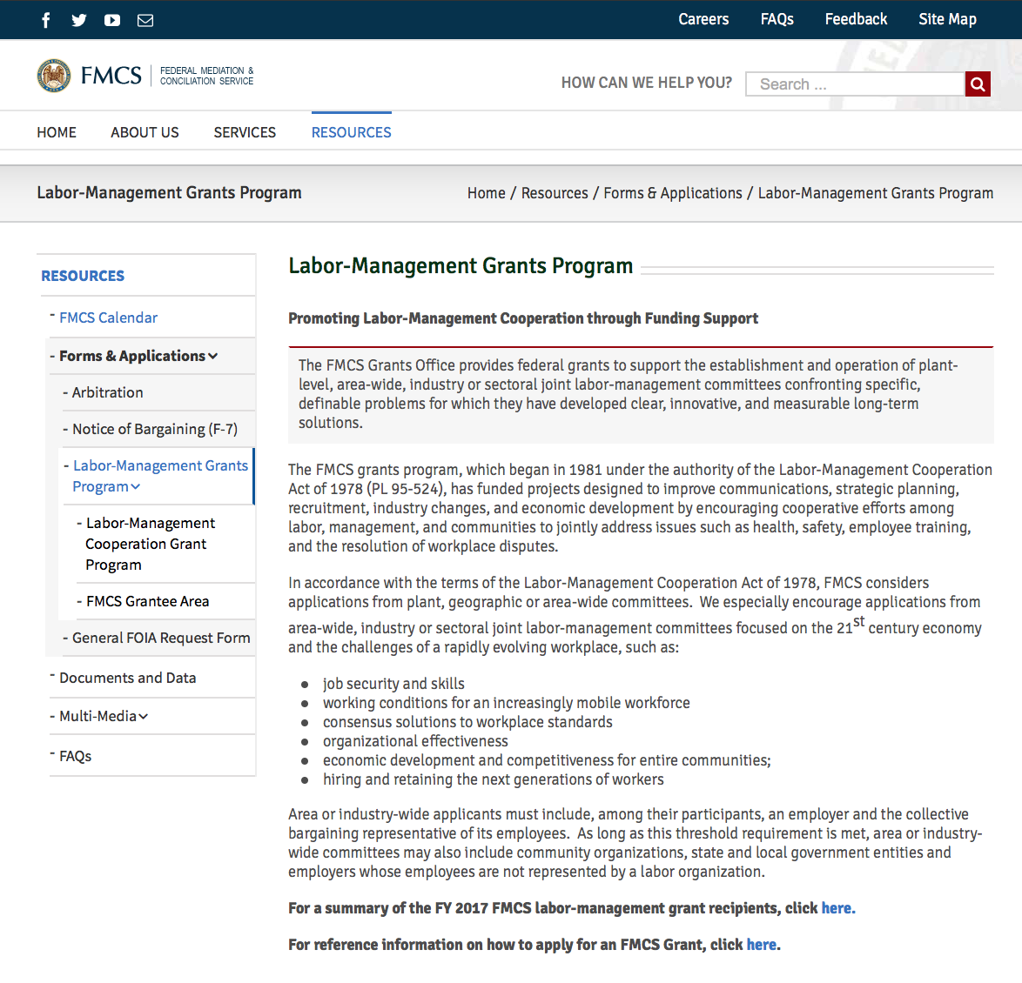

Programs:

Reminders:

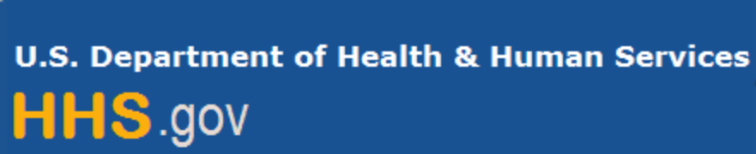

Department of Health and Human Services

Grants Forecast and Overview

The Department of Health and Human Services’ Grants Forecast is a database of planned grant opportunities proposed by its agencies. Each Forecast record contains actual or estimated dates and funding levels for grants that the agency intends to award during the fiscal year. Forecast opportunities are subject to change based on enactment of congressional appropriations.

For more general information about HHS Grants and Funding go to the website below at:

https://www.hhs.gov/grants/grants/index.html

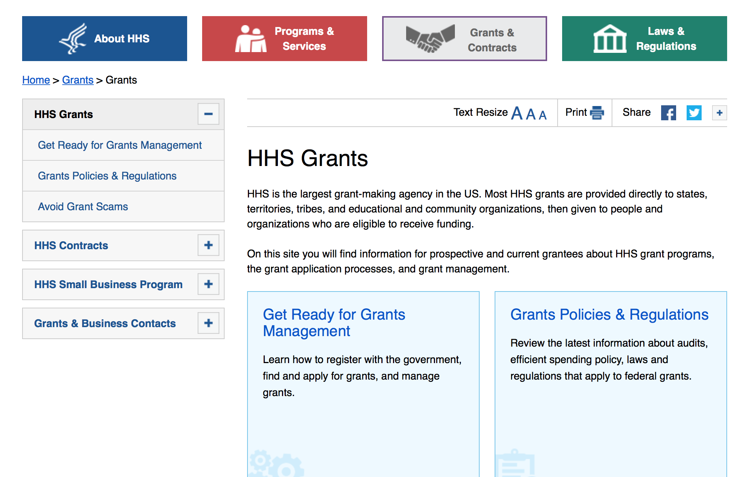

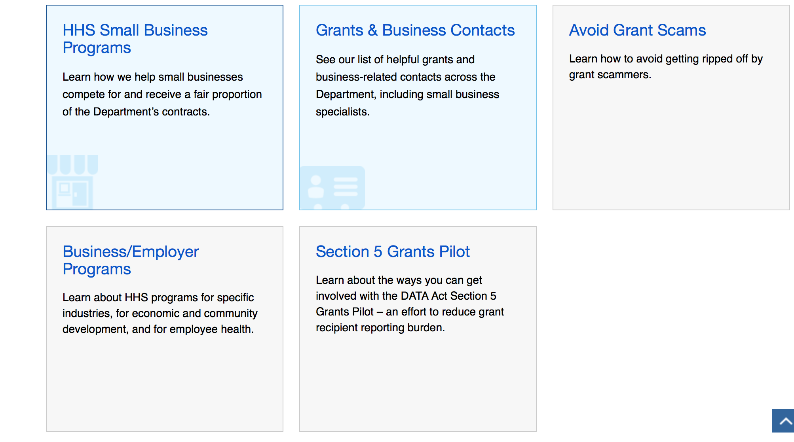

Programs:

Research:

Administration for Children and Families - OCS
Community Economic Development Focus on Social Enterprises
Forecast 1
https://www.grants.gov/web/grants/view-opportunity.html?oppId=311593

Administration for Community Living
FIELD INITIATED PROJECTS PROGRAM (DEVELOPMENT)
Synopsis 1
https://www.grants.gov/web/grants/view-opportunity.html?oppId=310302
Administration for Community Living
FIELD INITIATED PROJECTS PROGRAM (RESEARCH)
Synopsis 1
https://www.grants.gov/web/grants/view-opportunity.html?oppId=310303
Administration for Community Living
Switzer Research Fellowships Program
Synopsis 1
https://www.grants.gov/web/grants/view-opportunity.html?oppId=310255

Centers for Disease Control and Prevention - ERA
Health Promotion and Disease Prevention Research Centers: 2019 Special Interest Project Competitive Supplements (SIPS)
Synopsis 1
https://www.grants.gov/web/grants/view-opportunity.html?oppId=311180
Centers for Disease Control - NCHHSTP
Medical Monitoring Project (MMP)
Forecast 1
https://www.grants.gov/web/grants/view-opportunity.html?oppId=311116
Centers for Disease Control and Prevention - ERA
The Muscular Dystrophy Surveillance, Tracking, and Research Network (MD STARnet)
Synopsis 1
https://www.grants.gov/web/grants/view-opportunity.html?oppId=310904

Centers for Disease Control - NCCDPHP
Preventing Maternal Deaths: Supporting Maternal Mortality Review Committees
Forecast 1
https://www.grants.gov/web/grants/view-opportunity.html?oppId=311065
Centers for Disease Control and Prevention - ERA
Research Approaches to Improve the Care and Outcomes of People Living with Spina Bifida
Synopsis 1
https://www.grants.gov/web/grants/view-opportunity.html?oppId=310905

Centers for Disease Control and Prevention - ERA
Commercial Fishing Occupational Safety Research Cooperative Agreement
Synopsis 1
https://www.grants.gov/web/grants/view-opportunity.html?oppId=309385

Centers for Disease Control and Prevention - ERA
Commercial Fishing Occupational Safety Training Project Grants
Synopsis 1
https://www.grants.gov/web/grants/view-opportunity.html?oppId=309674
Centers for Disease Control and Prevention - ERA
Multi-Site Study of the Health Implications of Exposure to PFAS-Contaminated Drinking Water
Forecast 1
https://www.grants.gov/web/grants/view-opportunity.html?oppId=311616
Centers for Disease Control and Prevention - ERA
Network of Forecasting Centers to Improve Forecast Accuracy and Communication for Seasonal and Pandemic Influenza
Forecast 1
https://www.grants.gov/web/grants/view-opportunity.html?oppId=311615
Centers for Disease Control and Prevention - ERA
Advancing Infectious Disease Detection and Response in Liberia
Synopsis 1
https://www.grants.gov/web/grants/view-opportunity.html?oppId=310244

Health Resources and Services Administration
Innovations in Care Coordination for Children and Youth with Autism Spectrum Disorders and Other Developmental Disabilities Program
Synopsis 1
https://www.grants.gov/web/grants/view-opportunity.html?oppId=307911
Health Resources and Services Administration
Pediatric Emergency Care Applied Research Network (PECARN)
Synopsis 1
https://www.grants.gov/web/grants/view-opportunity.html?oppId=307920

Health Resources and Services Administration
Ryan White HIV/AIDS Program Part F Dental Reimbursement Program
Synopsis 1
https://www.grants.gov/web/grants/view-opportunity.html?oppId=307889Health Resources and Services Administration
Graduate Psychology Education (GPE) Program
Forecast 1
https://www.grants.gov/web/grants/view-opportunity.html?oppId=311375
Health Resources and Services Administration
Ryan White HIV/AIDS Program Part C Capacity Development Program
Synopsis 1
https://www.grants.gov/web/grants/view-opportunity.html?oppId=307901

Health Resources and Services Administration
Advanced Nursing Education Nurse Practitioner Residency (ANE-NPR) Program
Synopsis 1
https://www.grants.gov/web/grants/view-opportunity.html?oppId=311060

National Institutes of Health
Center without Walls for PET Ligand Development for Alzheimer's disease related dementias (ADRDs) (U19 Clinical Trial Optional)
Synopsis 1
https://www.grants.gov/web/grants/view-opportunity.html?oppId=311094

National Institutes of Health
Contraception Research Centers Program (U54 Clinical Trial Optional)
Synopsis 1
https://www.grants.gov/web/grants/view-opportunity.html?oppId=311196

National Institutes of Health
Discovery of the Genetic Basis of Childhood Cancers and of Structural Birth Defects: Gabriella Miller Kids First Pediatric Research Program (X01 Clinical Trial Not Allowed)
Synopsis 1
https://www.grants.gov/web/grants/view-opportunity.html?oppId=311131

National Institutes of Health
Emerging Global Leader Award (K43 Independent Clinical Trial Not Allowed)
Synopsis 1
https://www.grants.gov/web/grants/view-opportunity.html?oppId=311093

National Institutes of Health
Graduate Research Training Initiative for Student Enhancement (G-RISE) (T32)
Synopsis 1
https://www.grants.gov/web/grants/view-opportunity.html?oppId=311114
National Institutes of Health
HEAL Initiative: Americas Startups and Small Businesses Build Technologies to Stop the Opioid Epidemic (R43/R44 - Clinical Trial Optional)
Synopsis 1
https://www.grants.gov/web/grants/view-opportunity.html?oppId=310964
National Institutes of Health
HEAL Initiative: Americas Startups and Small Businesses Build Technologies to Stop the Opioid Epidemic (R41/R42 - Clinical Trial Optional)
Synopsis 1
https://www.grants.gov/web/grants/view-opportunity.html?oppId=310965

National Institutes of Health
HEAL Initiative: Antenatal Opioid Exposure Longitudinal Study Consortium (PL1 Clinical Trials Not Allowed)
Synopsis 1
https://www.grants.gov/web/grants/view-opportunity.html?oppId=310962

National Institutes of Health
HEAL Initiative: Back Pain Consortium (BACPAC) Research Program Data Integration, Algorithm Development and Operations Management Center (U24 Clinical Trial Not Allowed)
Synopsis 1
https://www.grants.gov/web/grants/view-opportunity.html?oppId=310955

National Institutes of Health
HEAL Initiative: Back Pain Consortium (BACPAC) Research Program: Mechanistic Research Centers (U19 Clinical Trial Optional)
Synopsis 1
https://www.grants.gov/web/grants/view-opportunity.html?oppId=310954
National Institutes of Health
HEAL Initiative: Back Pain Consortium (BACPAC) Research Program: Phase 2 Clinical Trials (UG3/UH3 Clinical Trial Required)
Synopsis 1
https://www.grants.gov/web/grants/view-opportunity.html?oppId=310957

National Institutes of Health
HEAL Initiative: Back Pain Consortium (BACPAC) Research Program Technology Research Sites (UH2/UH3 Clinical Trial Optional)
Synopsis 1
https://www.grants.gov/web/grants/view-opportunity.html?oppId=310956

National Institutes of Health
HEAL Initiative: Behavioral Research to Improve MAT: Behavioral and Social Interventions to Improve Adherence to Medication Assisted Treatment for Opioid Use Disorders (R61/R33 Clinical Trial Optional)
Synopsis 1
https://www.grants.gov/web/grants/view-opportunity.html?oppId=310986
National Institutes of Health
HEAL Initiative: Biofabricated 3D Tissue Models of Nociception, Opioid Use Disorder and Overdose for Drug Screening (UH2/UH3 Clinical Trial Not Allowed)
Synopsis 1
https://www.grants.gov/web/grants/view-opportunity.html?oppId=310970

National Institutes of Health
HEAL Initiative: Clinical Devices to Treat Pain (UH3 Clinical Trial Optional)
Synopsis 1
https://www.grants.gov/web/grants/view-opportunity.html?oppId=310961

National Institutes of Health
HEAL Initiative: Early Phase Pain Investigation Clinical Network - Data Coordinating Center (U24 Clinical Trials Not Allowed)
Synopsis 1
https://www.grants.gov/web/grants/view-opportunity.html?oppId=310958

National Institutes of Health
HEAL Initiative: Early Phase Pain Investigation Clinical Network - Specialized Clinical Centers (U24 Clinical Trial Not Allowed)
Synopsis 1
https://www.grants.gov/web/grants/view-opportunity.html?oppId=310960
National Institutes of Health
HEAL Initiative: Effectiveness Trials to Optimize, Implement, Scale, and Sustain the Collaborative Care Model for Individuals with Opioid Use Disorders and Mental Health Conditions (U01 Clinical Trial Required)
Synopsis 1
https://www.grants.gov/web/grants/view-opportunity.html?oppId=310988

National Institutes of Health
HEAL Initiative: Integrated Approach to Pain and Opioid Use in Hemodialysis Patients: The Hemodialysis Opioid Prescription Effort (HOPE) Consortium - Clinical Centers (U01 Clinical Trial Required)
Synopsis 1
https://www.grants.gov/web/grants/view-opportunity.html?oppId=310981

National Institutes of Health
HEAL Initiative: Justice Community Opioid Innovation Network (JCOIN) Clinical Research Centers (UG1 Clinical Trial Optional)
Synopsis 1
https://www.grants.gov/web/grants/view-opportunity.html?oppId=310966

National Institutes of Health
HEAL Initiative: Optimization of Non-addictive Therapies [Small Molecules and Biologics] to Treat Pain - (U44 Clinical Trial Not Allowed)
Synopsis 1
https://www.grants.gov/web/grants/view-opportunity.html?oppId=310969

National Institutes of Health
HEAL Initiative: Pain Management Effectiveness Research Network: Clinical Trial Planning and Implementation Cooperative Agreement (UG3/UH3 Clinical Trial Required)
Synopsis 1
https://www.grants.gov/web/grants/view-opportunity.html?oppId=310971
National Institutes of Health
HEAL Initiative: Pragmatic and Implementation Studies for the Management of Pain to Reduce Opioid Prescribing (PRISM) (UG3/UH3, Clinical Trials Optional)
Synopsis 1
https://www.grants.gov/web/grants/view-opportunity.html?oppId=310979

National Institutes of Health
Heal Initiative: Pragmatic Randomized Controlled Trial of Acupuncture for Management of Chronic Low Back Pain in Older Adults (UG3/UH3 Clinical Trial Required)
Synopsis 1
https://www.grants.gov/web/grants/view-opportunity.html?oppId=310977

National Institutes of Health
HEAL Initiative: Preventing Opioid Use Disorder in Older Adolescents and Young Adults (ages 1630) (UG3/UH3 Clinical Trial Required)
Synopsis 1
https://www.grants.gov/web/grants/view-opportunity.html?oppId=310991

National Institutes of Health
HEAL Initiative: Sleep and Circadian-Dependent Mechanisms Contributing to Opiate Use Disorder (OUD) and Response to Medication Assisted Treatment (MAT) (U01 Clinical Trial Optional)
Synopsis 1
https://www.grants.gov/web/grants/view-opportunity.html?oppId=310980

National Institutes of Health
HEAL Initiative: Sleep and Circadian-Dependent Mechanisms Contributing to Opiate Use Disorder (OUD) and Response to Medication Assisted Treatment (MAT) (R01 - Clinical Trial Not Allowed)
Synopsis 1
https://www.grants.gov/web/grants/view-opportunity.html?oppId=310985

National Institutes of Health
HEAL Initiative: Stimulating Peripheral Activity to Relieve Conditions (SPARC): Anatomical and Functional Mapping of Pain-Related Visceral Organ Neural Circuitry (U01 Clinical Trial Optional)
Synopsis 1
https://www.grants.gov/web/grants/view-opportunity.html?oppId=310990

National Institutes of Health
HEAL Initiative: Tissue Chips to Model Nociception, Addiction, and Overdose (UG3/UH3 Clinical Trial Not Allowed)
Synopsis 1
https://www.grants.gov/web/grants/view-opportunity.html?oppId=310989

National Institutes of Health
HEAL Initiative: Translational Development of Devices to Treat Pain (U18 Clinical Trial Not Allowed)
Synopsis 1
https://www.grants.gov/web/grants/view-opportunity.html?oppId=310973

National Institutes of Health
HEAL Initiative: Translational Devices to Treat Pain (UG3/UH3 Clinical Trial Optional)
Synopsis 1
https://www.grants.gov/web/grants/view-opportunity.html?oppId=310968

National Institutes of Health
HEAL Initiative: Translational Devices to Treat Pain (U44 Clinical Trial Optional)
Synopsis 1
https://www.grants.gov/web/grants/view-opportunity.html?oppId=310976

National Institutes of Health
HEAL Initiative Limited Competition: Behavioral Research to Improve MAT: Ancillary Studies to Enhance Behavioral or Social Interventions to Improve Adherence to Medication Assisted Treatment for Opioid Use Disorders (R01, Clinical Trials Optional)
Synopsis 1
https://www.grants.gov/web/grants/view-opportunity.html?oppId=310963
National Institutes of Health
Limited Competition: Clinical and Translational Science Award (CTSA) Program: Collaborative Innovation Award, (U01 Clinical Trial Optional)
Synopsis 1
https://www.grants.gov/web/grants/view-opportunity.html?oppId=311066

National Institutes of Health
Limited Competition: Clinical and Translational Science Award (CTSA) Program: Exploratory Collaborative Innovation Awards (R21 Clinical Trial Optional)
Synopsis 1
https://www.grants.gov/web/grants/view-opportunity.html?oppId=311067

National Institutes of Health
Physical Sciences-Oncology Network (PS-ON): Physical Sciences-Oncology Projects (PS-OP) (U01 Clinical Trial Optional)
Synopsis 1
https://www.grants.gov/web/grants/view-opportunity.html?oppId=311113

National Institutes of Health
Academic Research Enhancement Award for Undergraduate-Focused Institutions (R15 - Clinical Trial Required)
Synopsis 1
https://www.grants.gov/web/grants/view-opportunity.html?oppId=311488

National Institutes of Health
Biomedical Research Facilities (C06 Clinical Trial Not Allowed)
Synopsis 1
https://www.grants.gov/web/grants/view-opportunity.html?oppId=311414

National Institutes of Health
Cancer Tissue Engineering Collaborative: Enabling Biomimetic Tissue-Engineered Technologies for Cancer Research (R01 Clinical Trial Optional)
Synopsis 1
https://www.grants.gov/web/grants/view-opportunity.html?oppId=311317
National Institutes of Health
End-of-Life and Palliative Needs of Adolescents and Young Adults (AYA) with Serious Illnesses (R01 Clinical Trial Optional)
Synopsis 1
https://www.grants.gov/web/grants/view-opportunity.html?oppId=311490

National Institutes of Health
HEAL Initiative: HEALthy Brain and Child Development Study (HEALthy BCD) (Collaborative R34- Clinical Trial Not Allowed)
Synopsis 1
https://www.grants.gov/web/grants/view-opportunity.html?oppId=311507
National Institutes of Health
HEAL Initiative: HEALthy Brain and Child Development Study (HEALthy BCD) ( R34- Clinical Trial Not Allowed)
Synopsis 1
https://www.grants.gov/web/grants/view-opportunity.html?oppId=311522
National Institutes of Health
Human Islet Research Network - Consortium on Modeling Autoimmune Interactions (HIRN-CMAI) (U01 Clinical Trial Not Allowed)
Synopsis 1
https://www.grants.gov/web/grants/view-opportunity.html?oppId=311315

National Institutes of Health
Improving Outcomes in Cancer Treatment-Related Cardiotoxicity (R21 Clinical Trial Optional)
Synopsis 1
https://www.grants.gov/web/grants/view-opportunity.html?oppId=311318
National Institutes of Health
Improving Outcomes in Cancer Treatment-Related Cardiotoxicity (R01 Clinical Trial Optional)
Synopsis 1
https://www.grants.gov/web/grants/view-opportunity.html?oppId=311319

National Institutes of Health
Independent Scientist Award (Parent K02 - Independent Clinical Trial Required)
Synopsis 1
https://www.grants.gov/web/grants/view-opportunity.html?oppId=311439

National Institutes of Health
Independent Scientist Award (Parent K02 - Independent Clinical Trial Not Allowed)
Synopsis 1
https://www.grants.gov/web/grants/view-opportunity.html?oppId=311440

National Institutes of Health
Laboratories for Early Clinical Evaluation of Pharmacotherapies for Substance Use Disorders (UG1 Clinical Trial Required)
Synopsis 1
https://www.grants.gov/web/grants/view-opportunity.html?oppId=311487
National Institutes of Health
Limited Competition: NeuroImaging Tools and Resources Collaboratory (R24 Clinical Trial Not Allowed)
Synopsis 1
https://www.grants.gov/web/grants/view-opportunity.html?oppId=311329
National Institutes of Health
Mentored Clinical Scientist Research Career Development Award (Parent K08 Independent Clinical Trial Required)
Synopsis 1
https://www.grants.gov/web/grants/view-opportunity.html?oppId=311413

National Institutes of Health
Mentored Clinical Scientist Research Career Development Award (Parent K08 Independent Clinical Trial Not Allowed)
Synopsis 1
https://www.grants.gov/web/grants/view-opportunity.html?oppId=311415

National Institutes of Health
Mentored Patient-Oriented Research Career Development Award (Parent K23 Independent Clinical Trial Not Allowed)
Synopsis 1
https://www.grants.gov/web/grants/view-opportunity.html?oppId=311416
National Institutes of Health
Mentored Patient-Oriented Research Career Development Award (Parent K23 Independent Clinical Trial Required)
Synopsis 1
https://www.grants.gov/web/grants/view-opportunity.html?oppId=311417

National Institutes of Health
Mentored Quantitative Research Development Award (Parent K25 - Independent Clinical Trial Not Allowed)
Synopsis 1
https://www.grants.gov/web/grants/view-opportunity.html?oppId=311419

National Institutes of Health
Mentored Quantitative Research Development Award (Parent K25 - Independent Clinical Trial Required)
Synopsis 1
https://www.grants.gov/web/grants/view-opportunity.html?oppId=311420

National Institutes of Health
Mentored Research Scientist Development Award (Parent K01 - Independent Clinical Trial Required)
Synopsis 1
https://www.grants.gov/web/grants/view-opportunity.html?oppId=311422

National Institutes of Health
Mentored Research Scientist Development Award (Parent K01 - Independent Clinical Trial Not Allowed)
Synopsis 1
https://www.grants.gov/web/grants/view-opportunity.html?oppId=311438

National Institutes of Health
Midcareer Investigator Award in Patient-Oriented Research (Parent K24 Independent Clinical Trial Required)
Synopsis 1
https://www.grants.gov/web/grants/view-opportunity.html?oppId=311436
National Institutes of Health
Midcareer Investigator Award in Patient-Oriented Research (Parent K24 Independent Clinical Trial Not Allowed)
Synopsis 1
https://www.grants.gov/web/grants/view-opportunity.html?oppId=311437

National Institutes of Health
NCI Pathway to Independence Award for Outstanding Early Stage Postdoctoral Researchers (K99/R00 - Independent Clinical Trial Not Allowed)
Synopsis 1
https://www.grants.gov/web/grants/view-opportunity.html?oppId=311434
National Institutes of Health
NCI Pathway to Independence Award for Outstanding Early Stage Postdoctoral Researchers (K99/R00 - Independent Clinical Trial Required)
Synopsis 1
https://www.grants.gov/web/grants/view-opportunity.html?oppId=311435

National Institutes of Health
NEI Audacious Goals Initiative: Preliminary Studies for Translation-Enabling Models of the Visual System (R21 Clinical Trial Not Allowed)
Synopsis 1
https://www.grants.gov/web/grants/view-opportunity.html?oppId=311426

National Institutes of Health
NIH Pathway to Independence Award (Parent K99/R00 - Independent Clinical Trial Not Allowed)
Synopsis 1
https://www.grants.gov/web/grants/view-opportunity.html?oppId=311425
National Institutes of Health
NIH Pathway to Independence Award (Parent K99/R00 - Independent Clinical Trial Required)
Synopsis 1
https://www.grants.gov/web/grants/view-opportunity.html?oppId=311441

National Institutes of Health
Non-human Primates Facilities to Support HIV/AIDS-related Research (C06 Clinical Trial Not Allowed)
Synopsis 1
https://www.grants.gov/web/grants/view-opportunity.html?oppId=311327

National Institutes of Health
Research Enhancement Award Program (REAP) for Health Professional Schools and Graduate Schools (R15 Clinical Trial Required)
Synopsis 1
https://www.grants.gov/web/grants/view-opportunity.html?oppId=311502

National Institutes of Health
Research Enhancement Award Program (REAP) for Health Professional Schools and Graduate Schools (R15 Clinical Trial Not Allowed)
Synopsis 1
https://www.grants.gov/web/grants/view-opportunity.html?oppId=311519

National Institutes of Health
Revision Application for Implementation Research to Inform and Enhance PEPFAR HIV Pre-exposure Prophylaxis (PrEP) Delivery (R01 Clinical Trial Optional)
Synopsis 1
https://www.grants.gov/web/grants/view-opportunity.html?oppId=311341
National Institutes of Health
Stimulating Hematology Investigation: New Endeavors (SHINE) (R01 Clinical Trial Not Allowed)
Synopsis 1
https://www.grants.gov/web/grants/view-opportunity.html?oppId=311316

National Institutes of Health
ImmuneChip: Engineering Microphysiological Immune Tissue Platforms (U01 Clinical Trial Not Allowed)
Synopsis 1
https://www.grants.gov/web/grants/view-opportunity.html?oppId=311578
National Institutes of Health
NIDCD Clinical Research Center Grant (P50 Clinical Trial Optional)
Synopsis 1
https://www.grants.gov/web/grants/view-opportunity.html?oppId=311574

National Institutes of Health
NIDCD Mentored Career Development Award for Postdoctorate Au.D./Ph.D. Audiologists (K01 Independent Basic Experimental Studies with Humans Required)
Synopsis 1
https://www.grants.gov/web/grants/view-opportunity.html?oppId=311614
National Institutes of Health
NIDCD Research Career Enhancement Award for Established Investigators (K18 Basic Experimental Studies with Humans Required)
Synopsis 1
https://www.grants.gov/web/grants/view-opportunity.html?oppId=311604

National Institutes of Health
NIDCR Dual Degree Dentist Scientist Pathway to Independence Award (K99/R00 Independent Clinical Trial Not Allowed)
Synopsis 1
https://www.grants.gov/web/grants/view-opportunity.html?oppId=311603
National Institutes of Health
NIDCR Dual Degree Dentist Scientist Pathway to Independence Award (K99/R00 Independent Basic Experimental Studies with Humans Required)
Synopsis 1
https://www.grants.gov/web/grants/view-opportunity.html?oppId=311613

National Institutes of Health
Resources for Technology Dissemination (U24 Clinical Trial Not Allowed)
Synopsis 1
https://www.grants.gov/web/grants/view-opportunity.html?oppId=311554

National Institutes of Health
Analytical Tools and Approaches for (Multidimensional) Scholarly Research Assessment and Decision Support in the Biomedical Enterprise (R41/R42 - Clinical Trial Not Allowed)
Synopsis 1
https://www.grants.gov/web/grants/view-opportunity.html?oppId=311673
National Institutes of Health
Analytical Tools and Approaches for (Multidimensional) Scholarly Research Assessment and Decision Support in the Biomedical Enterprise (R43/R44 - Clinical Trial Not Allowed)
Synopsis 1
https://www.grants.gov/web/grants/view-opportunity.html?oppId=311674

National Institutes of Health
Exploring the Mechanisms Underlying Analgesic Properties of Minor Cannabinoids and Terpenes (R21 Clinical Trial Optional)
Synopsis 1
https://www.grants.gov/web/grants/view-opportunity.html?oppId=311713
National Institutes of Health
Exploring the Mechanisms Underlying Analgesic Properties of Minor Cannabinoids and Terpenes (R01 Clinical Trial Optional)
Synopsis 1
https://www.grants.gov/web/grants/view-opportunity.html?oppId=311714

National Institutes of Health
Notice of Intent to Publish a Funding Opportunity Announcement for the Maximizing Investigators' Research Award Program
Forecast 1
https://www.grants.gov/web/grants/view-opportunity.html?oppId=311733

National Institutes of Health
Notice of Intent to Publish Funding Opportunity Announcements for Research to Develop, Demonstrate, and Validate Experimental Human Tissue Models that Do Not Rely on Human Fetal Tissue
Forecast 1
https://www.grants.gov/web/grants/view-opportunity.html?oppId=311734

National Institutes of Health
U.S.-China Program for Biomedical Collaborative Research (R01 Clinical Trial Optional)
Synopsis 1
https://www.grants.gov/web/grants/view-opportunity.html?oppId=311675

Modifications:

Reminders:

Department of Homeland Security

The Department of Homeland Security enhances the ability of states, local and tribal jurisdictions, and other regional authorities in the preparation, prevention, and response to terrorist attacks and other disasters, by distributing grant funds. Localities can use grants for planning, equipment, training and exercise needs.

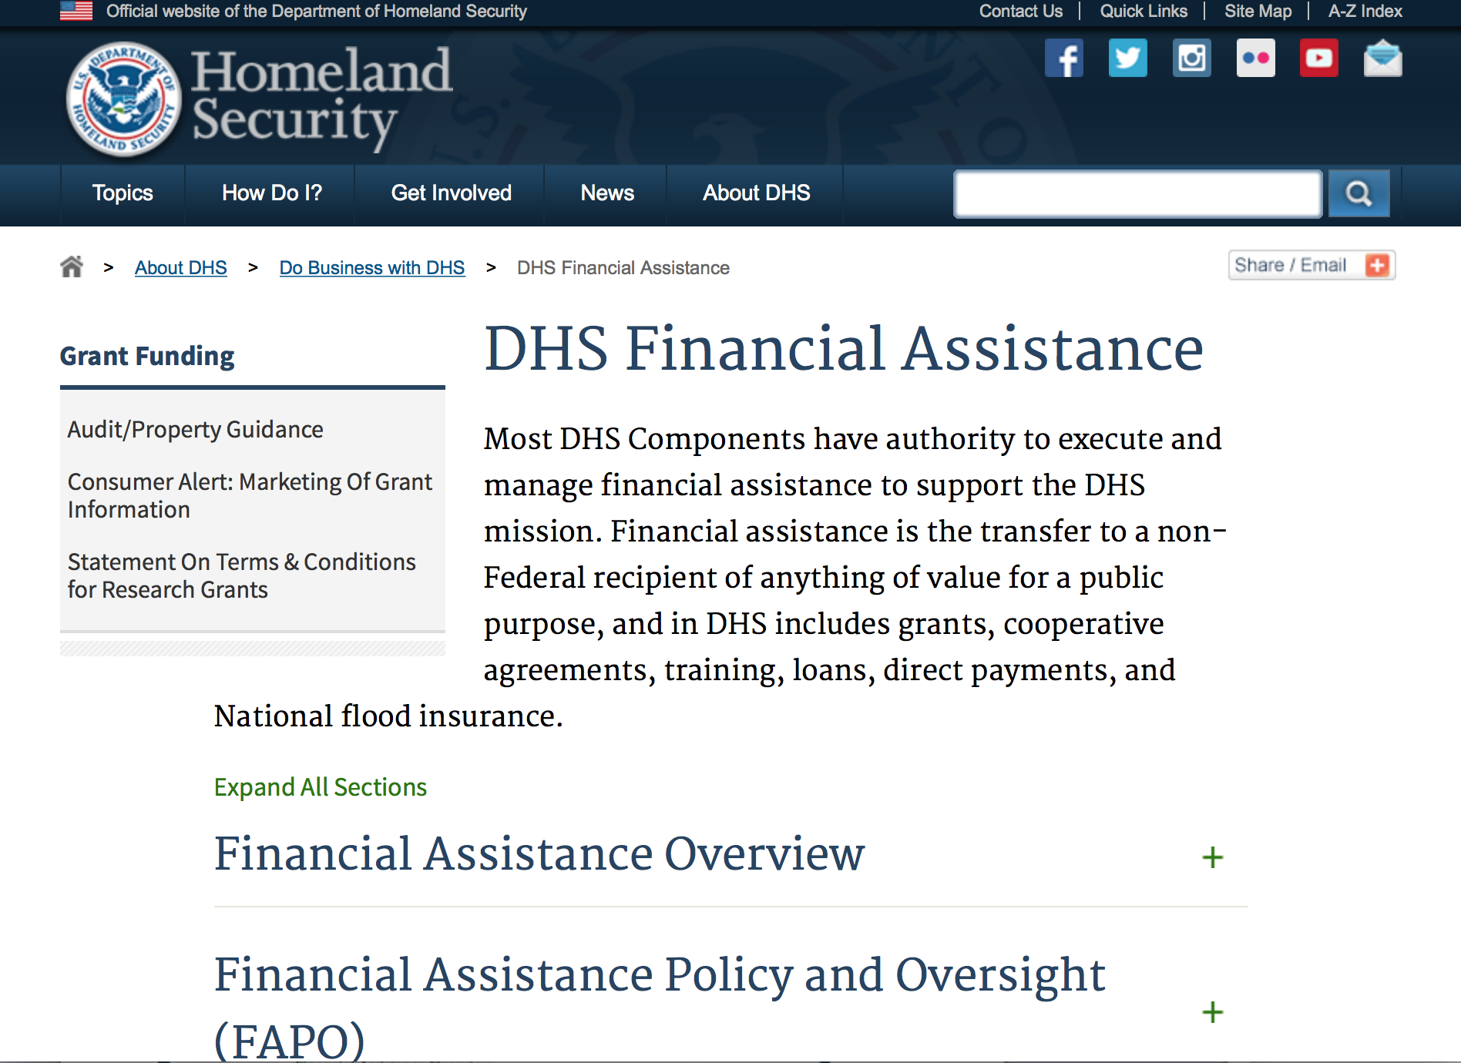
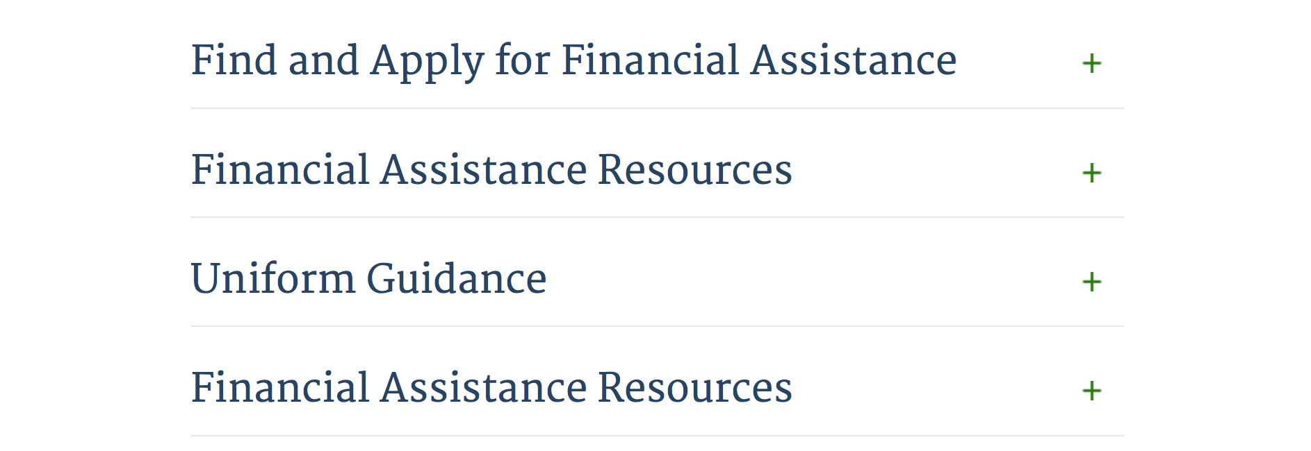

Webpage can be viewed at: http://www.dhs.gov/xopnbiz/grants/index.shtm#2

Information about 2016 for reference only
The FY 2016 Assistance to Firefighters Grants (AFG)

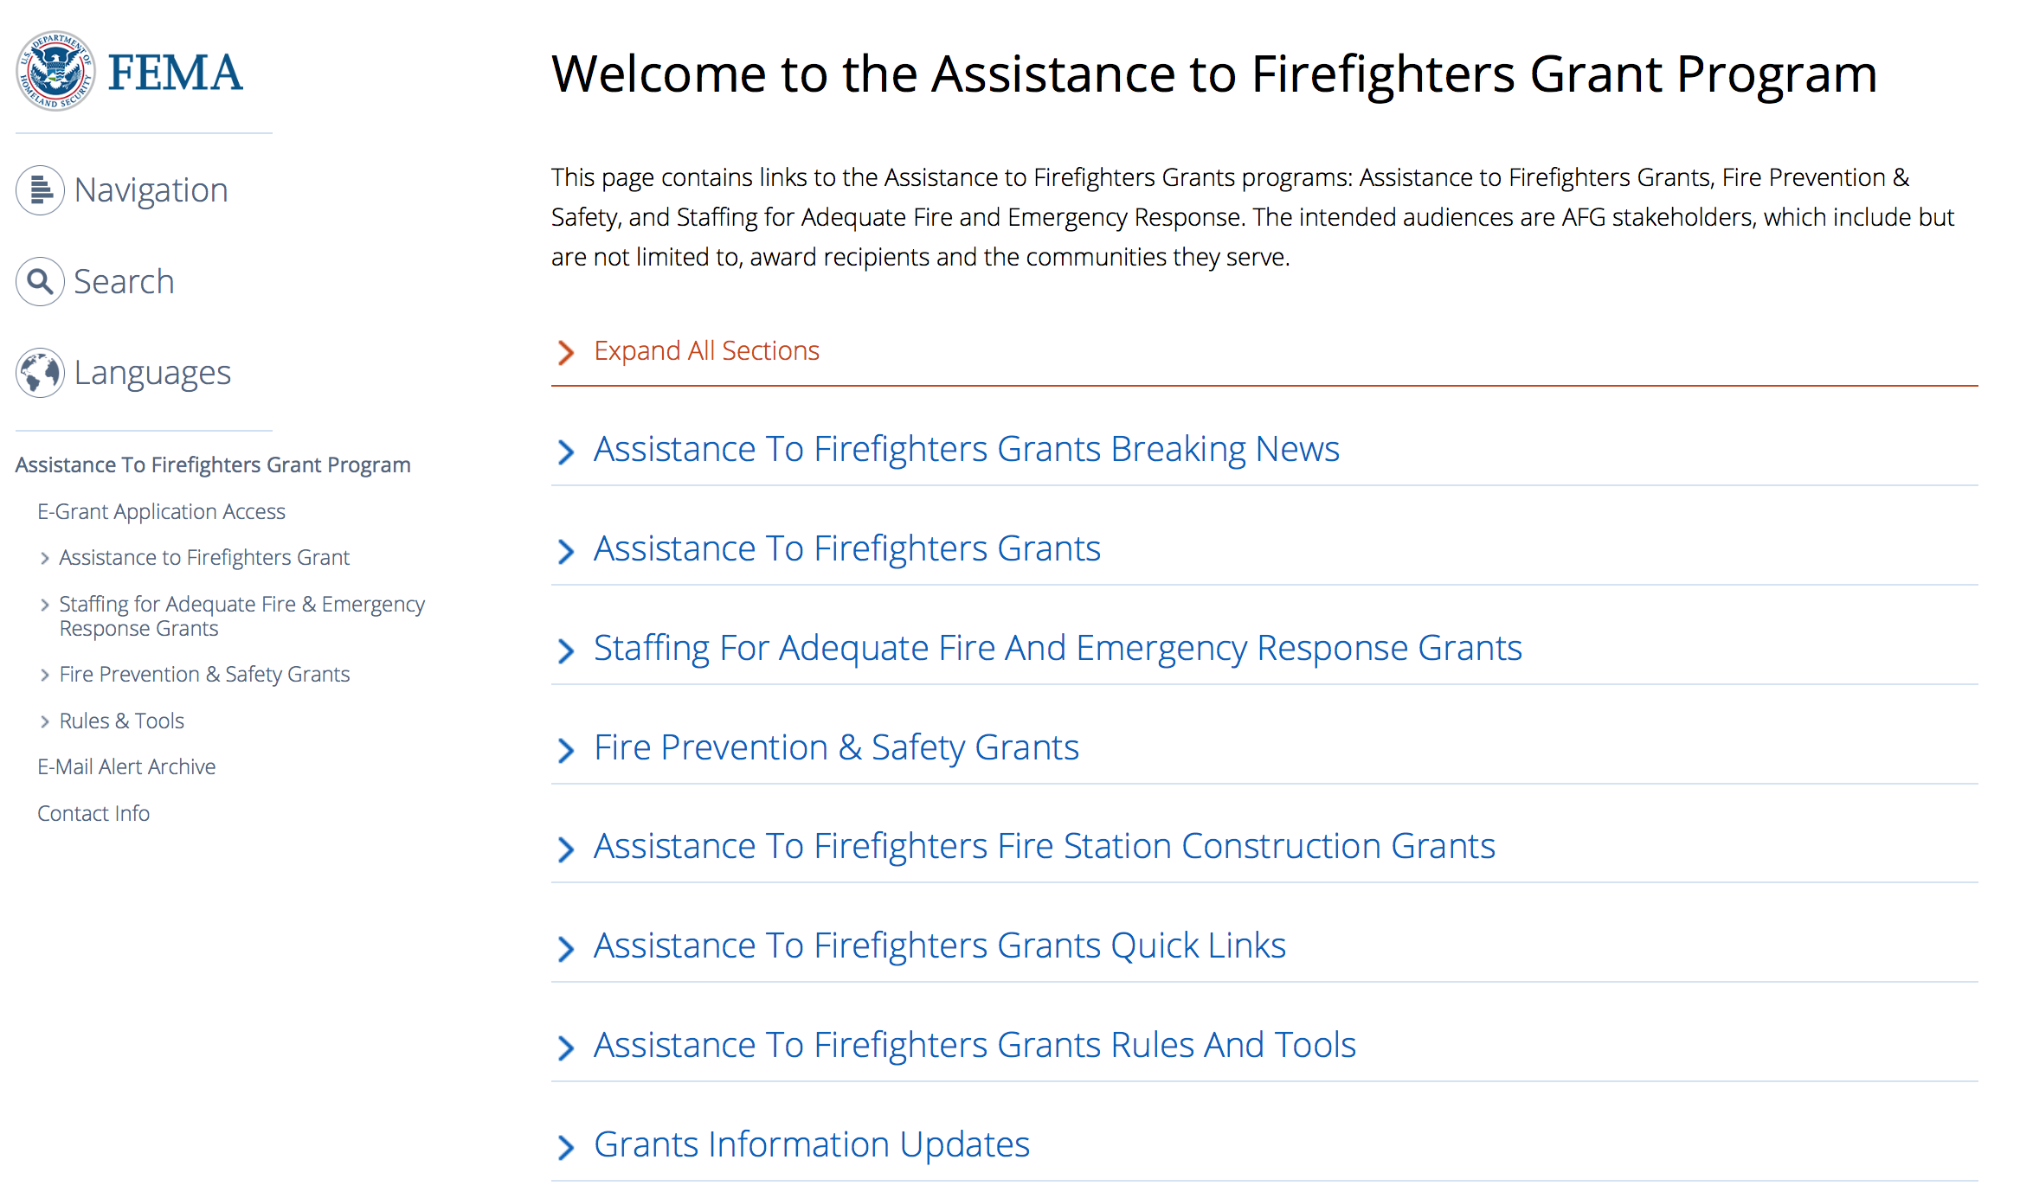

https://www.fema.gov/welcome-assistance-firefighters-grant-program

For AFG program guidance materials, please visit our Documents page.

Resources

AFG Help Desk
Contact the AFG Program Help Desk toll-free at 866-274-0960, or email us at firegrants@dhs.gov.
The AFG Program has Fire Program Specialists in 10 federal regional centers. These Regional Fire Program Specialists respond to questions about the AFG program and carry out grant monitoring activities. View regional contacts

Popular AFG links
- Assistance to Firefighters Grants (AFG)
- AFG Awards List
- AFG Success Stories
- Staffing for Adequate Fire & Emergency Response (SAFER) Grants (SAFER)
- SAFER Awards List
- SAFER Success Stories
- Fire Prevention & Safety (FP&S) Grants
- FP&S Awards List
- FP&S Success Stories
- Grant Closeout Tutorial
- Assistance to Firefighters Grant (AFG) Email Alert Archive
- Frequently Asked Questions
Contact Information For The Assistance to Firefighters Grant (AFG) Program and Help Desk

Federal Funding Alternative To AFG

State Administrative Agencies (SAA) apply for and administer Federal grants on behalf of their States, including FEMA Preparedness Grants. The SAA will work with eligible organizations to comply with the general requirements of grant programs or cooperative agreements. Contact your State’s SAA to find out what current Federal funding opportunities may be available to your organization. A listing of the SAAs and points of contact can be found at http://www.fema.gov/library/viewRecord.do?id=6363.

Programs:

Modifications:

Reminders:

United States Coast Guard
National Nonprofit Organization Grant Program
Synopsis 1
Document Type: | Grants Notice
Funding Opportunity Number: | DHS-USCG-2019-001
Funding Opportunity Title: | National Nonprofit Organization Grant Program
Opportunity Category: | Discretionary
Opportunity Category Explanation:
Funding Instrument Type: | Cooperative Agreement
Category of Funding Activity: | Other (see text field entitled "Explanation of Other Category of Funding Activity" for clarification)
Category Explanation: | Recreational Boating Safety
Expected Number of Awards: | 30
CFDA Number(s): | 97.012 -- Boating Safety Financial Assistance
Cost Sharing or Matching Requirement: | No
Version: | Synopsis 1
Posted Date: | Nov 26, 2018
Last Updated Date: | Nov 26, 2018
Original Closing Date for Applications: | Jan 30, 2019
Current Closing Date for Applications: | Jan 30, 2019
Archive Date: | Jan 31, 2019
Estimated Total Program Funding: | $5,326,094
Eligible Applicants: | Nonprofits having a 501(c)(3) status with the IRS, other than institutions of higher education
Additional Information on Eligibility:
Additional Information
Agency Name: | United States Coast Guard
Description: | See Notice
Link to Additional Information: | Program Website
Grantor Contact Information: | If you have difficulty accessing the full announcement electronically, please contact:  Cynthia Dudzinski Grants Management Specialist Phone 2023721064  Nonprofit Coordinator
https://www.grants.gov/web/grants/view-opportunity.html?oppId=310601

Department of Housing and Urban Development

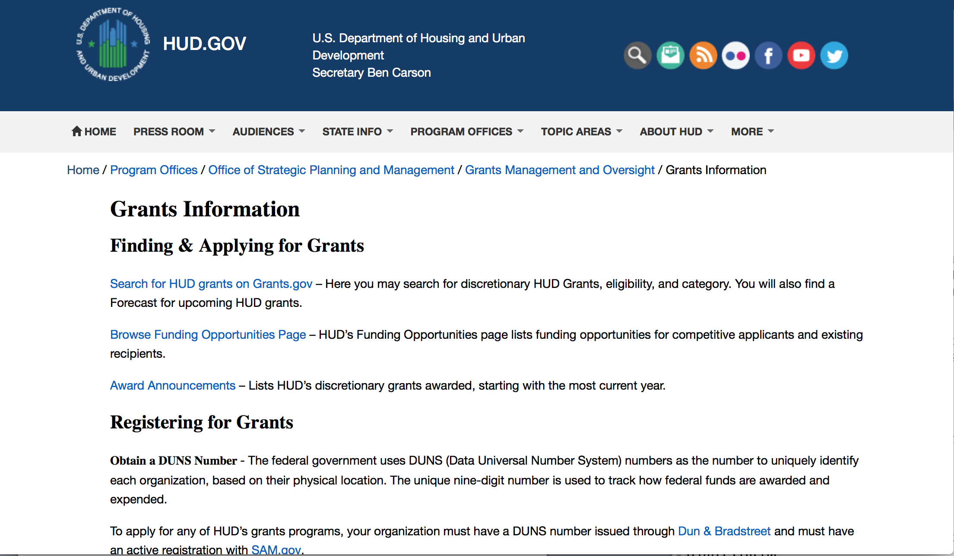
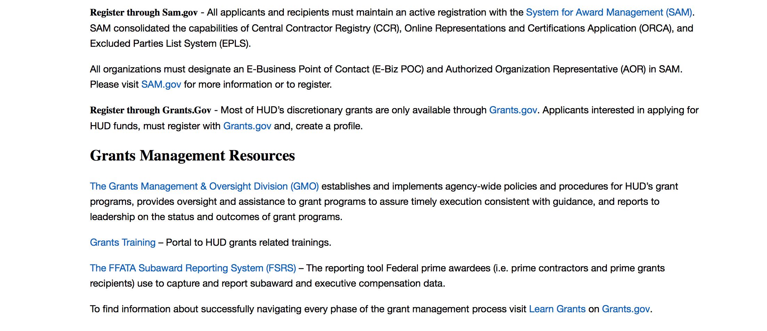
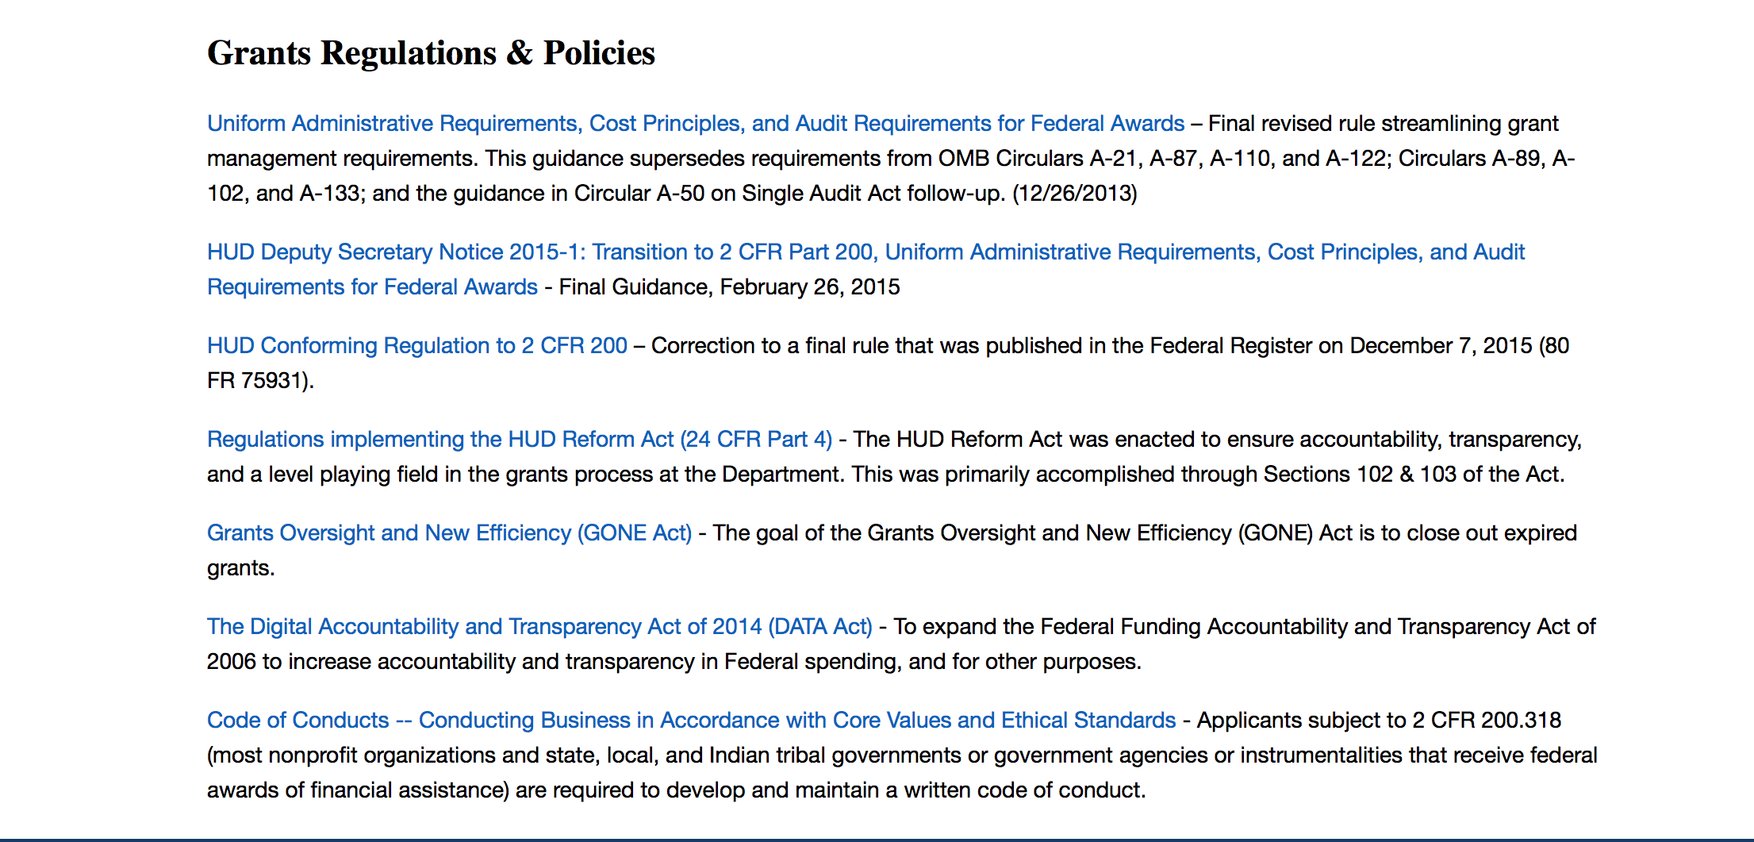

http://portal.hud.gov/hudportal/HUD?src=/topics/grants

HUD - Notice of Funds Available
For detailed information click here

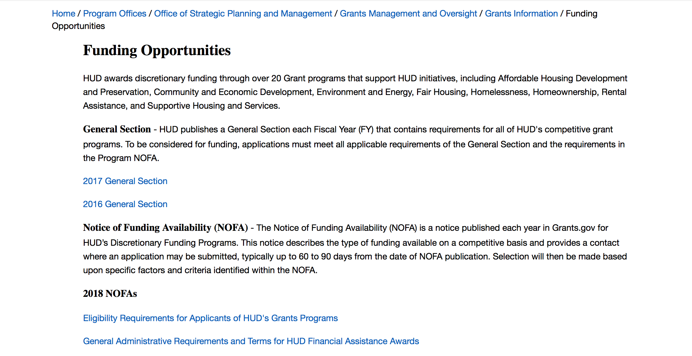

http://portal.hud.gov/hudportal/HUD?src=/program_offices/administration/grants/fundsavail

HUD NOFA FORECAST
The Department of Housing and Urban Development NOFA Forecast lists competitive grant opportunities that may be available for FY2016. The inclusion or exclusion of an opportunity in this list does not constitute a guarantee that a specific opportunity will become available or not be available. Forecast opportunities are subject to change based on enactment of Congressional appropriations and other considerations.
When funding is available, HUD will issue a Notice of Funding Availability (NOFA), which will be available on Grants.gov

Programs:

HUD's FY 2018 and FY 2019 Community Compass Technical Assistance and Capacity Building Program Notice of Funding Availability (NOFA)
Synopsis 1
Document Type: | Grants Notice
Funding Opportunity Number: | FR-6200-N-06
Funding Opportunity Title: | HUD's FY 2018 and FY 2019 Community Compass Technical Assistance and Capacity Building Program Notice of Funding Availability (NOFA)
Opportunity Category: | Discretionary
Opportunity Category Explanation:
Funding Instrument Type: | Cooperative Agreement
Category of Funding Activity: | Housing
Category Explanation:
Expected Number of Awards: | 20
CFDA Number(s): | 14.259 -- Community Compass Technical Assistance and Capacity Building
Cost Sharing or Matching Requirement: | No
Version: | Synopsis 1
Posted Date: | Dec 17, 2018
Last Updated Date: | Dec 17, 2018
Original Closing Date for Applications: | Feb 14, 2019 Electronically submitted applications must be submitted no later than 11:59 p.m., ET, on the listed application due date.
Current Closing Date for Applications: | Feb 14, 2019 Electronically submitted applications must be submitted no later than 11:59 p.m., ET, on the listed application due date.
Archive Date: | Mar 16, 2019
Estimated Total Program Funding: | $73,500,000
Award Ceiling: | $20,000,000
Award Floor: | $250,000
Eligible Applicants: | Nonprofits that do not have a 501(c)(3) status with the IRS, other than institutions of higher education  Public and State controlled institutions of higher education  Private institutions of higher education  Special district governments  Small businesses  City or township governments  State governments  Public housing authorities/Indian housing authorities  Others (see text field entitled "Additional Information on Eligibility" for clarification)  Nonprofits having a 501(c)(3) status with the IRS, other than institutions of higher education  County governments  For profit organizations other than small businesses
Additional Information on Eligibility: | In addition to the list above, eligible applicants include: NAHASDA-eligible Indian tribes as defined at Section 4(13) of NAHASDA TDHEs as defined at Section 4(22) of NAHASDA National or regional organizations representing Native American housing interests Metropolitan Planning Organizations, Councils of Government, or other regional planning entities HUD will not evaluate applications from ineligible applicants. Individuals, foreign entities, and sole proprietorship organizations are not eligible to compete for, or receive, awards made under this announcement.
Additional Information
Agency Name: | Department of Housing and Urban Development
Description: | Through this NOFA, HUD is announcing the availability of approximately $73.5 million in FY 2018 funding for its Community Compass Technical Assistance and Capacity Building Program (Community Compass). Contingent upon the availability of FY 2019 appropriations, we reserve the right to award FY 2019 funds based on this single NOFA competition. Any FY 2019 funds received for the following activities will not be awarded through this NOFA competition: NAHASDA Formula Allocation and Negotiated Rulemaking, Homeless Management Information System (HMIS) Data Lab, and Annual Homeless Assessment Report (AHAR). As HUD’s integrated technical assistance (TA) and capacity building initiative, Community Compass is designed to help HUD’s customers navigate complex housing and community development challenges by equipping them with the knowledge, skills, tools, capacity, and systems to implement HUD programs and policies successfully and sustainably and provide effective administrative and managerial oversight of HUD funding. We recognize that our customers often interact with a variety of HUD programs as they deliver housing or community development services. Community Compass brings together TA investments from across HUD program offices, including the offices of Community Planning and Development, Fair Housing and Equal Opportunity, Housing, and Public and Indian Housing. This cross-funding approach allows TA to address the needs of grantees and subgrantees across multiple HUD programs, often within the same engagement, as well as address cross-agency issues. You are encouraged to procure contractors and consultants that demonstrate experience across a wide variety of HUD programs, as well as in specific skill and policy areas. Community Compass is centrally managed by HUD Headquarters with the involvement of our Regional, Field, and Area Offices.
Link to Additional Information: | https://hud.gov/program_offices/spm/gmomgmt/grantsinfo/fundingopps
Grantor Contact Information: | If you have difficulty accessing the full announcement electronically, please contact:  communitycompass@hud.gov communitycompass@hud.gov  Grants Policy
https://www.grants.gov/web/grants/view-opportunity.html?oppId=311298

Lead-Based Paint Capital Fund Program (LBPCF) - Update and Reissue
Synopsis 1
Document Type: | Grants Notice
Funding Opportunity Number: | FR-6100-N-42A
Funding Opportunity Title: | Lead-Based Paint Capital Fund Program (LBPCF) - Update and Reissue
Opportunity Category: | Discretionary
Opportunity Category Explanation:
Funding Instrument Type: | Grant
Category of Funding Activity: | Housing
Category Explanation:
Expected Number of Awards: | 8
CFDA Number(s): | 14.888 -- Lead-Based Paint Capital Fund Program
Cost Sharing or Matching Requirement: | No
Version: | Synopsis 1
Posted Date: | Dec 20, 2018
Last Updated Date: | Dec 20, 2018
Original Closing Date for Applications: | Feb 19, 2019 Electronically submitted applications must be submitted no later than 11:59 p.m., ET, on the listed application due date.
Current Closing Date for Applications: | Feb 19, 2019 Electronically submitted applications must be submitted no later than 11:59 p.m., ET, on the listed application due date.
Archive Date: | Mar 20, 2019
Estimated Total Program Funding: | $6,631,190
Award Ceiling: | $1,000,000
Award Floor: | $25,000
Eligible Applicants: | Public housing authorities/Indian housing authorities
Additional Information on Eligibility: | Public Housing Authorities with the legal authority to develop, own, modernize and operate a public housing development in accordance with the 1937 Act. Tribes and tribally designated housing entities (TDHEs), nonprofit organizations, and resident associations are not eligible to apply. PHAs that are troubled or under the direction of HUD or a court-appointed receiver are eligible for funding, provided the agency is in compliance with any current Memorandum of Agreement or Recovery Agreements. Individuals, foreign entities, and sole proprietorship organizations are not eligible to compete for, or receive, awards made under this announcement.
Additional Information
Agency Name: | Department of Housing and Urban Development
Description: | As authorized under the Consolidated Appropriations Act, 2017, $25,000,000 shall be available for competitive grants to public housing agencies to evaluate and reduce lead-based paint hazards in public housing by carrying out the activities of risk assessments, abatement, and interim controls (as those terms are defined in section 1004 of the Residential Lead-Based Paint Hazard Reduction Act of 1992 (42 U.S.C. 4851b)) This second round of funding makes available funds not awarded under the first round of competition.
Link to Additional Information: | https://hud.gov/program_offices/spm/gmomgmt/grantsinfo/fundingopps
Grantor Contact Information: | If you have difficulty accessing the full announcement electronically, please contact:  United States Department of Housing and Urban Development PIHOCI@hud.gov  Grants Policy
https://www.grants.gov/web/grants/view-opportunity.html?oppId=311401

Modifications:

Deleted:

Reminders:

Notice of Funding Availability for the Fiscal Year (FY) 2017 Homeless Management Information System Capacity Building Project
Synopsis 2

Document Type: | Grants Notice
Funding Opportunity Number: | FR-6100-N-40
Funding Opportunity Title: | Notice of Funding Availability for the Fiscal Year (FY) 2017 Homeless Management Information System Capacity Building Project
Opportunity Category: | Discretionary
Opportunity Category Explanation:
Funding Instrument Type: | Grant
Category of Funding Activity: | Community Development
Category Explanation:
Expected Number of Awards: | 50
CFDA Number(s): | 14.261 -- Homeless Management Information Systems Technical Assistance
Cost Sharing or Matching Requirement: | No
Version: | Synopsis 2
Posted Date: | Nov 19, 2018
Last Updated Date: | Nov 19, 2018
Original Closing Date for Applications: | Jan 31, 2019 Electronically submitted applications must be submitted no later than 11:59 p.m., ET, on the listed application due date.
Current Closing Date for Applications: | Jan 31, 2019 Electronically submitted applications must be submitted no later than 11:59 p.m., ET, on the listed application due date.
Archive Date: | Mar 02, 2019
Estimated Total Program Funding: | $5,000,000
Award Ceiling: | $400,000
Award Floor: | $20,000
Eligible Applicants: | County governments  State governments  Nonprofits having a 501(c)(3) status with the IRS, other than institutions of higher education  City or township governments
Additional Information on Eligibility: | To be eligible, applicants must be existing CoC program recipients that are UFAs, collaborative applicants, or HMIS Leads and are either:(1) Applying for funds to improve the existing HMIS; or(2) Applying on behalf of two or more CoCs with the intent to execute an HMIS Consolidation to improve the performance of the lower-performing HMIS. If the applicant is representing multiple CoCs in the case of an HMIS Consolidation, HUD recommends that the applicant with the highest-performing HMIS submits the application. If the applicant is selected and awarded, it may subaward funds to CoC program recipients in any of the consolidating CoCs to support the HMIS Consolidation. Recipients may make multiple subawards to conduct the proposed activities. To be considered for funding, an applicant must complete the information required by HUD, in the manner required by HUD. Additionally, if the activity is necessary to complete an HMIS Consolidation, the applicant must provide evidence that each CoC involved in the HMIS Consolidation has approved the HMIS Consolidation. Approvals of the consolidation of the CoC’s HMIS must be submitted for each CoC participating in the HMIS Consolidation. Acceptable forms of documentation are limited to the following: 1) a signed and dated letter indicating approval of the HMIS Consolidation from the CoC Board or other relevant CoC committee, subcommittee or workgroup, or 2) a copy of CoC Board or other relevant CoC committee, subcommittee or workgroup meeting minutes that includes the date, a list of attendees and clear evidence of approval of the HMIS Consolidation. After HUD selects applicants at the end of Phase 2, each selected applicant will enter into a grant agreement with HUD. Individuals, foreign entities, and sole proprietorship organizations are not eligible to compete for, or receive, awards made under this announcement.
Additional Information
Agency Name: | Department of Housing and Urban Development
Description: | This NOFA makes available [$5,000,000] for competitive grants to existing Continuum of Care (CoC) Program recipients to improve their CoCs’ Homeless Management Information Systems. A Homeless Management Information System (HMIS) is the information system designated by the Continuum of Care (CoC) to comply with the requirements of the McKinney-Vento Homeless Assistance Act (42 U.S.C. 11301 et seq.) (the McKinney-Vento Act), and 24 CFR part 578. HMIS is used to record, analyze, and transmit client and activity data for purposes of providing shelter, housing, and services to individuals and families who are homeless or at risk of homelessness. Activities that improve HMIS include any one or more of the following: Consolidating HMIS software or databases with another CoC’s HMIS; Upgrading, customizing, or configuring the functionality of a CoC’s existing HMIS; Improving HMIS data quality; or Increasing staff skills through trainings related to HMIS governance, data collection and data quality improvements, and data analysis to support strategic decision-making. This NOFA also provides funding for HMIS Consolidations and encourages CoC recipients with a strong HMIS to partner with CoCs that have struggled to effectively implement their own HMIS. “HMIS Consolidation” means creating a single HMIS, governed by a shared HMIS governance charter, from two or more HMIS that were independently governed by their own HMIS governance charters. The Appendix provides a list of CoCs with HMIS implementations determined to have highest needs, and likely competitive for the improvement and consolidation funds provided in this NOFA.HUD will use a two-phase process to select applicants and distribute funding. In Phase 1, existing CoC program recipients that are Unified Funding Agencies, collaborative applicants, or HMIS Leads will be able to submit applications to fund either HMIS improvements or an HMIS consolidation. HUD will evaluate each applicant’s proposed activities to ensure eligibility and evaluate responses to several rating factors. Based on Phase 1 results, applicants will be conditionally selected to submit a budget and project proposal to HUD for review and approval. Applicants will have 45 days from the date of the Phase 1 selection announcement to submit a budget and proposal that meets the Phase 2 criteria described in this NOFA. To help assure the budgets and project proposals are cost-effective, feasible, necessary, and maximize the positive impact of this funding, HUD will offer a selection of TA providers to all conditionally selected applicants to assist with developing the applicant’s budget and project proposal in Phase 2. HUD will distribute available funds based on the cost effectiveness, feasibility, necessity and estimated impact of each submitted budget and proposal.
Link to Additional Information: | https://hud.gov/program_offices/spm/gmomgmt/grantsinfo/fundingopps
Grantor Contact Information: | If you have difficulty accessing the full announcement electronically, please contact:  Questions regarding specific program requirements for this NOFA should be directed to the point of contact listed below.  Mailbox
https://www.grants.gov/web/grants/view-opportunity.html?oppId=310498

Institute of Museum and Library Services

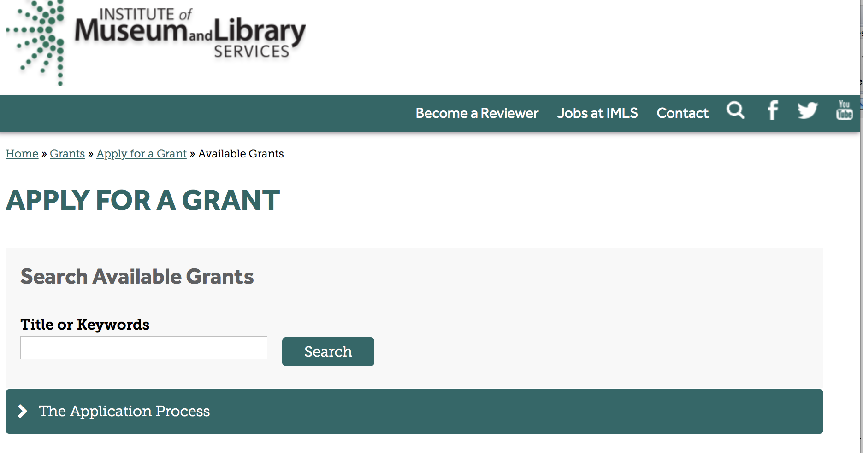

https://www.imls.gov/grants/apply-grant/available-grants

Each grant program has specific eligibility requirements. The links below provide general eligibility criteria for museums, libraries, and tribal organizations, but please note that additional organizations may be eligible for grants under certain programs. Additionally, ineligible organizations may still be able to participate in grant programs through partnerships with eligible organizations. Please click on the links below to see general criteria and review Applications and Guidelines for specific information.
Museums Libraries

Institutions: Archives, Federally Recognized Native American Tribe, Historical Society, Library, Nonprofits that serve Native Hawaiians, Professional Association, Public or Private Non-profit Institutions of Higher Education, Regional Organization, State Library Administrative Agency, State or Local Government

Check out IMLS's Facebook page at:
https://www.facebook.com/USIMLS/

Programs:

Modifications:

Reminders:

Accelerating Promising Practices for Small Libraries
Synopsis 1

Document Type: | Grants Notice
Funding Opportunity Number: | APP-FY19
Funding Opportunity Title: | Accelerating Promising Practices for Small Libraries
Opportunity Category: | Discretionary
Opportunity Category Explanation:
Funding Instrument Type: | Grant
Category of Funding Activity: | Arts (see "Cultural Affairs" in CFDA)  Humanities (see "Cultural Affairs" in CFDA)
Category Explanation:
Expected Number of Awards: | 25
CFDA Number(s): | 45.312 -- National Leadership Grants
Cost Sharing or Matching Requirement: | No
Version: | Synopsis 2
Posted Date: | Nov 27, 2018
Last Updated Date: | Nov 28, 2018
Original Closing Date for Applications: | Feb 25, 2019
Current Closing Date for Applications: | Feb 25, 2019
Archive Date: | Mar 27, 2019
Estimated Total Program Funding: | $1,200,000
Award Ceiling: | $50,000
Award Floor: | $10,000
Eligible Applicants: | Others (see text field entitled "Additional Information on Eligibility" for clarification)
Additional Information on Eligibility: | Please see Notice of Funding Opportunity for eligibility information.
Additional Information
Agency Name: | Institute of Museum and Library Services
Description: | IMLS’ Accelerating Promising Practices for Small Libraries (APP) is a special initiative of the National Leadership Grants for Libraries Program. The goal of this initiative is to support projects that strengthen the ability of small and rural libraries and archives to serve their communities.
Link to Additional Information: | https://www.imls.gov/grants/available/accelerating-promising-practices-small-libraries
Grantor Contact Information: | If you have difficulty accessing the full announcement electronically, please contact:  Transforming School Library Practice Tim Carrigan, Senior Program Officer 202-653-4639 tcarrigan@imls.gov Community Memory Sarah Fuller, Senior Program Officer 202-653-4783 sfuller@imls.gov Digital Inclusion James Neal, Senior Program Officer 202-653-4740 jneal@imls.gov  tcarrigan@imls.gov
https://www.grants.gov/web/grants/view-opportunity.html?oppId=310610

Department of the Interior
Working with Interior

The Interior Department provides assistance to the public, local governments and businesses through a number of programs. For a general overview see: http://www.doi.gov/index.cfm

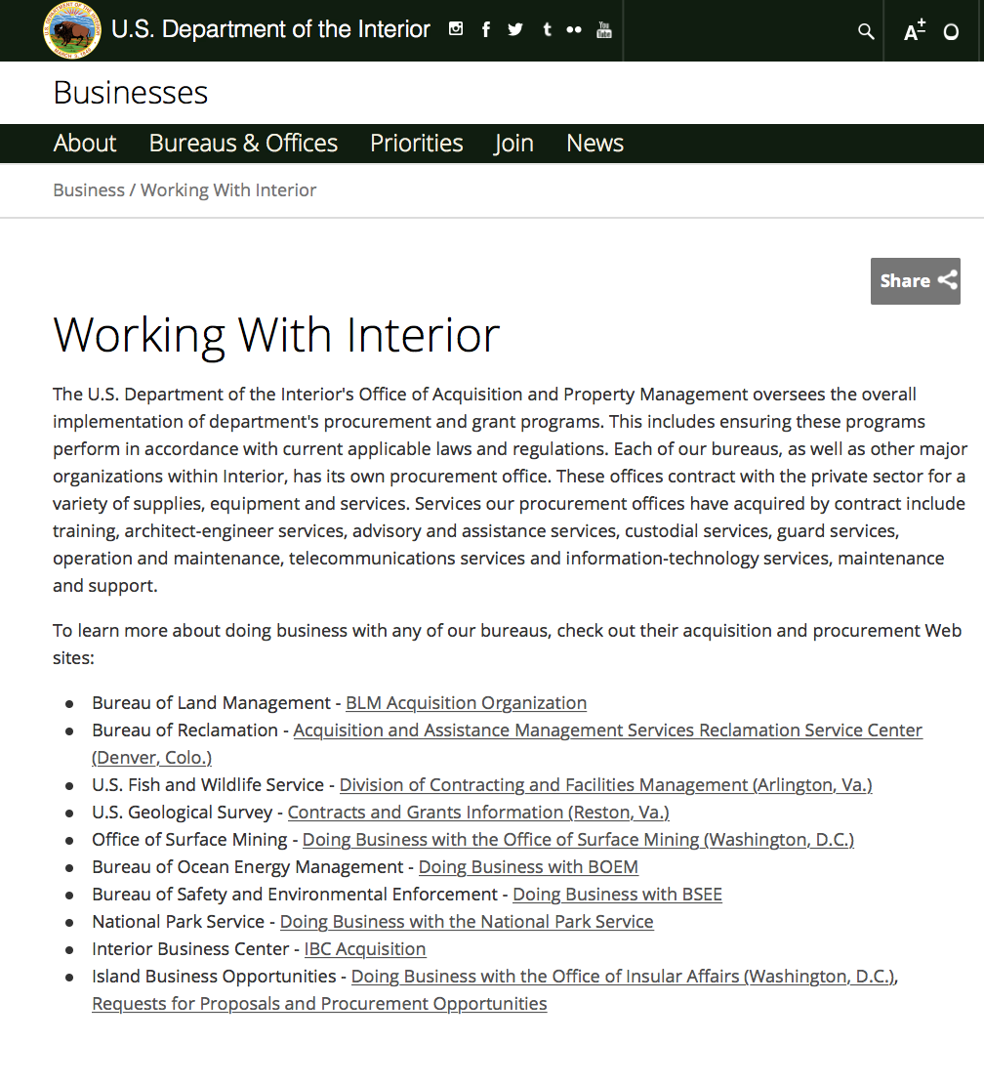

http://www.doi.gov/businesses/working-with-interior.cfm

Programs:

National Park Service
Historic Revitalization Subgrant Program (HRSP)
Synopsis 1

Document Type: | Grants Notice
Funding Opportunity Number: | P19AS00015
Funding Opportunity Title: | Historic Revitalization Subgrant Program (HRSP)
Opportunity Category: | Discretionary
Opportunity Category Explanation:
Funding Instrument Type: | Grant
Category of Funding Activity: | Arts (see "Cultural Affairs" in CFDA)  Community Development  Housing  Humanities (see "Cultural Affairs" in CFDA)  Other (see text field entitled "Explanation of Other Category of Funding Activity" for clarification)  Regional Development
Category Explanation: | cultural heritage; historic preservation
Expected Number of Awards: | 10
CFDA Number(s): | 15.904 -- Historic Preservation Fund Grants-In-Aid
Cost Sharing or Matching Requirement: | No
Version: | Synopsis 1
Posted Date: | Dec 20, 2018
Last Updated Date: | Dec 20, 2018
Original Closing Date for Applications: | Mar 01, 2019 Applications must be submitted through grants.gov and received by 11:59 pm Eastern Standard Time on March 1, 2019.
Current Closing Date for Applications: | Mar 01, 2019 Applications must be submitted through grants.gov and received by 11:59 pm Eastern Standard Time on March 1, 2019.
Archive Date: | Mar 30, 2019
Estimated Total Program Funding: | $5,000,000
Award Ceiling: | $750,000
Award Floor: | $100,000
Eligible Applicants: | Native American tribal governments (Federally recognized)  County governments  Nonprofits that do not have a 501(c)(3) status with the IRS, other than institutions of higher education  State governments  City or township governments  Nonprofits having a 501(c)(3) status with the IRS, other than institutions of higher education  Others (see text field entitled "Additional Information on Eligibility" for clarification)
Additional Information on Eligibility: | Applicants must be a nonprofit, a State Historic Preservation Office, a Tribal Historic Preservation Office, or a Certified Local Government (CLG). A list of CLGs may be found at nps.gov/clg.
Additional Information
Agency Name: | National Park Service
Description: | The goal of this program is to support the rehabilitation of historic properties listed in or eligible for listing in the National Register of Historic Places. Applicants must make subgrants for physical preservation projects. Eligible subgrant recipients must be within the jurisdiction of the applicant. Project must be in communities defined as "rural" by the US Bureau of the Census.
Link to Additional Information: | full announcement available on grants.gov
Grantor Contact Information: | If you have difficulty accessing the full announcement electronically, please contact:  STLPG Staff 202 354-2020 stlpg@nps.gov  Email preferred.
https://www.grants.gov/web/grants/view-opportunity.html?oppId=311450

Fish and Wildlife Service
Marine Turtle Conservation Fund and Combating Wildlife Trafficking Strategy and Partnerships Program
Synopsis 1
Document Type: | Grants Notice
Funding Opportunity Number: | F19AS00072
Funding Opportunity Title: | Marine Turtle Conservation Fund and Combating Wildlife Trafficking Strategy adn Partnerships Program
Opportunity Category: | Discretionary
Opportunity Category Explanation:
Funding Instrument Type: | Grant
Category of Funding Activity: | Environment  Natural Resources
Category Explanation:
Expected Number of Awards: | 5
CFDA Number(s): | 15.679 -- Combating Wildlife Trafficking
Cost Sharing or Matching Requirement: | No
Version: | Synopsis 1
Posted Date: | Dec 18, 2018
Last Updated Date: | Dec 18, 2018
Original Closing Date for Applications: | Feb 19, 2019
Current Closing Date for Applications: | Feb 19, 2019
Archive Date: | Feb 20, 2019
Estimated Total Program Funding: | $500,000
Award Ceiling: | $200,000
Award Floor: | $1
Eligible Applicants: | Individuals  Nonprofits that do not have a 501(c)(3) status with the IRS, other than institutions of higher education  For profit organizations other than small businesses  County governments  Nonprofits having a 501(c)(3) status with the IRS, other than institutions of higher education  Small businesses  Special district governments  Private institutions of higher education  State governments  Public and State controlled institutions of higher education  City or township governments
Additional Information on Eligibility:
Additional Information
Agency Name: | Fish and Wildlife Service
Description: | Combating the Trafficking of Marine Turtles in East and Southeast Asia The mission of the U.S. Fish and Wildlife Service (USFWS) is to work with others to conserve, protect and enhance fish, wildlife and plants and their habitats for the continuing benefit of the American people. The International Affairs Program delivers on this mission through its financial assistance programs by supporting strategic projects that deliver measurable conservation results for priority species and their habitats around the world. Background: Wildlife trafficking is estimated to be a multibillion-dollar business involving the unlawful harvest and trade of animals and plants. It has broad security implications, with corruption and sophisticated transnational crime syndicates at the center of poaching and trafficking. In East and Southeast Asia, hawksbill turtles (Eretmochelys imbricata) are illegally harvested and trafficked to supply the demand for shells, meat, and eggs. The high rate of poaching and trafficking is threatening the survival of the hawksbill turtle, which is listed as critically endangered on the IUCN (International Union for Conservation of Nature) Red List. This Notice of Funding Opportunity (NOFO) aligns with the USFWS mission and the Secretary of the Interior's priority to create a conservation stewardship legacy second only to Teddy Roosevelt. Description: The purpose of this NOFO is to provide financial assistance to projects that address the trafficking of hawksbill turtles in East and Southeast Asia (Vietnam, Cambodia, Thailand, Philippines, Indonesia, Malaysia, Taiwan, and China). Priority will be given to projects that address one or more of the following results: ¿ Reduction in the illegal killing and trafficking of hawksbill turtles in East and Southeast Asia through increased community-based protection activities on key marine turtle nesting beaches; ¿ Improved understanding of marine turtle trafficking routes and main transit points in order to better target law enforcement operations; ¿ Enhanced application and enforcement of existing laws and prohibitions against marine turtle trafficking; ¿ Development and promotion of evidence-based behavior change strategies to reduce demand for marine turtle products in East and Southeast Asia.
Link to Additional Information: | https://www.fws.gov/international/grants-and-reporting/how-to-apply.html
Grantor Contact Information: | If you have difficulty accessing the full announcement electronically, please contact:  Devon Larson 703-358-2134 devon_larson@fws.gov  Grants Specialist
https://www.grants.gov/web/grants/view-opportunity.html?oppId=311357

Modifications:

Reminders:

Fish and Wildlife Service
Partners for Fish and Wildlife
Synopsis 2

Document Type: | Grants Notice
Funding Opportunity Number: | F19AS00024
Funding Opportunity Title: | Partners for Fish and Wildlife
Opportunity Category: | Discretionary
Opportunity Category Explanation:
Funding Instrument Type: | Cooperative Agreement
Category of Funding Activity: | Natural Resources
Category Explanation:
Expected Number of Awards: | 2500
CFDA Number(s): | 15.631 -- Partners for Fish and Wildlife
Cost Sharing or Matching Requirement: | No
Version: | Synopsis 2
Posted Date: | Oct 19, 2018
Last Updated Date: | Oct 19, 2018
Original Closing Date for Applications: | Sep 30, 2019
Current Closing Date for Applications: | Sep 30, 2019
Archive Date: | Oct 01, 2019
Estimated Total Program Funding: | $52,000,000
Award Ceiling: | $750,000
Award Floor: | $1
Eligible Applicants: | Unrestricted (i.e., open to any type of entity above), subject to any clarification in text field entitled "Additional Information on Eligibility"
Additional Information on Eligibility: | To receive funding, PFW projects must be implemented on private lands, with the exception for efforts that support projects on private lands. IN GENERAL, the term private lands is any property not state or federally owned. Private lands include, but are not limited to; tribal, Hawaiian homeland, city, municipality, non-governmental, and private fee-title properties. 501(c)(3) applicants should be prepared to prove status as determined by the Internal Revenue Service and tribal applicants may be required to provide an authorizing tribal resolution.
Additional Information
Agency Name: | Fish and Wildlife Service
Description: | Federal Program: Department of the Interior, United States (U.S.) Fish and Wildlife Service, Division of Natural Resources and Conservation Planning  Catalog of Federal Domestic Assistance (CFDA) Number: 15.631Authorizing Legislation: Partners for Fish and Wildlife Act of 2006, S.260 Public Law 109-294; Fish and Wildlife Act of 1956, 16 U.S.C. 742a-c, 747e-742j; and Fish and Wildlife Coordination Act of 1958, 16 U.S.C. 661 667(e).  The Partners for Fish and Wildlife (PFW) Program is a voluntary, incentive-based program that provides direct technical assistance and financial assistance in the form of cooperative and grant agreements to private landowners to restore and conserve fish and wildlife habitat for the benefit of federal trust resources. The PFW Program is delivered through more than 250 full-time staff, active in all 50 States and territories. Partners for Fish and Wildlife Program staff coordinate with project partners, stakeholders and other Service programs to identify geographic focus areas and develop habitat conservation priorities within these focus areas. Geographic focus areas define where the program directs resources to conserve habitat for federal trust species. Project work plans are developed strategically, in coordination with partners, and with substantial involvement from Service field staff. The program has been in existence since 1987 and has over 30 years of successful delivery. Project selection will seek to align or support the Secretary's priorities. It also advance the Department of the Interior's mission, U.S. Fish and Wildlife Service's mission, and PFW's mission, promote biological diversity, and based upon sound scientific biological principles. Program strategic plans inform the types of projects funded under this opportunity.  ***Applicants seeking technical or financial assistance from the PFW Program are requested to consult with the Regional PFW Program office BEFORE developing or submitting an application (see Section VIII. Agency Contacts at the end of this announcement).  ***Project selection will seek to align or support the Secretary's priorities. Program funding will enhance the missions of DOI, FWS, and PFW.  1. Restoring trust with local communities: The PFW program has local field biologists across all 50 states stationed and living in the communities they serve which enhances trust and allows sustainable relationship building. Projects which support and build trust with local communities will receive high prioritization. 2. Modernizing our infrastructure: The PFW program will assist with modernizing fish passage structures to allow safe travel by aquatic resources and at the same time, allow for structural stability by designing units to avoid flood damage. Additionally, wetland levees, water control structures, and fencing projects are a few examples of modernizing infrastructure to support American conservation.3. Ensuring sovereignty means something: Many PFW projects support tribal operations and PFW staff will continue to recognize opportunities to enhance those relationships.4. Hunt/Fish: The PFW Program will continue to deliver on-the-ground habitat to support robust populations of wildlife for recreational use by the American public. These will support Secretarial Orders 3347, 3356, and 3362.5. National Wildlife Refuge System. PFW Program staff will favor conservation activities and projects that are on private lands near National Wildlife Refuge (Refuges) lands. Activities or projects that complement conservation practices on Refuges or resolve problems on Refuges that are caused by off-refuge land use practices will be given higher priority.6. Expand priority habitats, reduce habitat fragmentation, establish conservation buffers, and provide wildlife movement corridors that result in self-sustaining systems. Our staff will give preference to habitat improvement projects near protected land, including land owned or controlled by the National Wildlife Refuge System, National Forests, National Park Service, U.S. Department of Agriculture, other federal agencies, tribal, state agencies, or nongovernment entities.7. Regional strategic plans and priorities. PFW Program regional and field staff work with conservation partners to identify habitat conservation priorities and delineate geographic focus areas in our Regional strategic plans. The geographic focus areas represent an integration of shared habitat conservation priorities among the Service, conservation partners, and stakeholders. We will concentrate our technical and financial resources in these focus areas to conserve priority habitat. Habitat improvement projects that meet region-specific priorities and are located within geographic focus areas will receive higher priority. However, field staff are not prohibited from implementing high-value habitat improvement projects outside of these geographic focus areas.  ***If you have a potential project that meets the VI. APPLICATION REVIEW criteria, we request that you consult with your Regional PFW Program office below BEFORE developing or submitting an application.  Pacific Region (ID, OR, WA, HI, the Commonwealth of the Northern Mariana Islands, and the territories of American Samoa and Guam,): 503-231-6156  Southwest Region (AZ, NM, OK, TX): 817-277-1100 X2110  Midwest Region (IA, IL, IN, MI, MN, MO, OH, WI): 612-713-5475  Southeast Region (AL, AR, FL, GA, KY, LA, MO, NC, SC, TN, Puerto Rico, U.S. Virgin Islands): 404-679-7138  Northeast Region (CT, DE, MA, MD, ME, NH, NJ, NY, PA, RI, VA, VT, WV): 413-253-8657  Mountain Prairie Region (CO, KS, MT, ND, NE, SD, UT, WY): 303-236-4316  Alaska Region (AK): 907-786-3523  Pacific Southwest Region (CA, NV): 916-335-7054  Or, visit our website to find the nearest Partners for Fish and Wildlife Program office: http://www.fws.gov/partners/contactUs.html
Link to Additional Information: | https://www.grants.gov/
Grantor Contact Information: | If you have difficulty accessing the full announcement electronically, please contact:  Grants Management Specialist Patrick Schulze 703 358 2567 patrick_schulze@fws.gov  Service e-mail
https://www.grants.gov/web/grants/view-opportunity.html?oppId=309699

Fish and Wildlife Service
Coastal
Synopsis 2

Document Type: | Grants Notice
Funding Opportunity Number: | F19AS00027
Funding Opportunity Title: | Coastal
Opportunity Category: | Discretionary
Opportunity Category Explanation:
Funding Instrument Type: | Cooperative Agreement
Category of Funding Activity: | Natural Resources
Category Explanation:
Expected Number of Awards: | 100
CFDA Number(s): | 15.630 -- Coastal
Cost Sharing or Matching Requirement: | No
Version: | Synopsis 2
Posted Date: | Oct 22, 2018
Last Updated Date: | Oct 22, 2018
Original Closing Date for Applications: | Sep 30, 2019
Current Closing Date for Applications: | Sep 30, 2019
Archive Date: | Oct 01, 2019
Estimated Total Program Funding: | $13,000,000
Award Ceiling: | $500,000
Award Floor: | $1
Eligible Applicants: | Unrestricted (i.e., open to any type of entity above), subject to any clarification in text field entitled "Additional Information on Eligibility"
Additional Information on Eligibility:
Additional Information
Agency Name: | Fish and Wildlife Service
Description: | Federal Program: Department of the Interior, Unite States (U.S.) Fish and Wildlife Service, National Wildlife Refuge System, Division of Natural Resources and Conservation Planning,  Coastal Program Catalog of Federal Domestic Assistance (CFDA) Number: 15.630 Authorizing Legislation: Fish and Wildlife Coordination Act (16 U.S.C. 661-667e), Fish and Wildlife Act of 1956 (16 U.S.C. 742a-742j, not including 742 d-I), National Wildlife Refuge System Improvement Act of 1997 (Public Law 105-57)  The Coastal Program is a voluntary, community-based program that provides technical and financial assistance through cooperative agreements to coastal communities, conservation partners, and landowners to restore and protect fish and wildlife habitat on public and private lands. Coastal Program staff coordinates with project partners, stakeholders and other Service programs to identify geographic focus areas and develop habitat conservation priorities within these focus areas. Geographic focus areas are where the Coastal Program directs resources to conserve habitat for Federal trust species. Regional staff develop five-year strategic work plans based on the conservation priorities and the geographic focus areas that guides the work of the program. Projects are developed in collaboration with partners, and with substantial involvement from Service field staff. Projects must advance the missions of the U.S. Department of the Interior (DOI), U.S. Fish and Wildlife Service (Service), and the Coastal Program, and be based on sound scientific biological principles. Projects must also support the financial assistance priorities of Department of the Interior, specifically Priorities 1, 3, 8.  DOI Priority Coastal Program Support  1. Creating a conservation stewardship legacy second only to Teddy Roosevelt The Coastal Program mission is to achieve voluntary habitat conservation by providing technical and financial assistance, in collaboration with partners, for the benefit of Federal trust species. Working with partners, we deliver strategic habitat conservation by conducting landscape-scale planning and design and implementing habitat improvement and protection projects.  3. Restoring trust with local communities The Coastal Program partners with local communities to plan and deliver priority habitat conservation projects that benefit recovery and management of Federal trust species, and address other community priorities;  8. Modernizing our infrastructure Some Coastal Program projects are designed to: (1) improve habitat connectivity (e.g., fish passage structures, culvert retrofits, stream channel improvements, and removal of tidal restrictions and low head dams and levees); (2) attenuate coastal erosion (e.g., wetland restoration, living shorelines, streambank stabilizations, dune restorations, revegetation, and fencing); and (3) maintain habitat for migratory birds and waterfowl (e.g., construction of berms and installation of water control structures).  ***If you have a potential project that meets the VI. APPLICATION REVIEW criteria, we request that you consult with your regional Coastal Program office below BEFORE developing or submitting an application.  Pacific Region (HI, ID, OR minus the Klamath River Basin, WA, the Commonwealth of the Northern Mariana Islands, American Samoa, Guam, Palmyra Atoll, Midway Atoll, the Republic of Palau, the Federated States of Micronesia, and the Republic of the Marshall Islands): 503-213-2198, https://www.fws.gov/pacific/ecoservices/habcon/coastal/index.html  Southwest Region (AZ, NM, OK, TX): 361-225-7320, https://www.fws.gov/southeast/our-services/coastal-conservation/  Midwest Region (IA, IL, IN, MI, MN, MO, OH, WI): 906-226-1240  Southeast Region (AL, AR, FL, GA, KY, LA, MS, NC, SC, TN, Puerto Rico, U.S. Virgin Islands): 404-679-7122  Northeast Region (CT, DE, MA, MD, ME, NH, NJ, NY, PA, RI, VA, VT, WV): 413-253-8657, https://www.fws.gov/northeast/ecologicalservices/coastal.html  Alaska Region (AK): 907-786-3523, https://www.fws.gov/alaska/fisheries/restoration/pdf/coastal%20program_Webversion.pdf  Pacific Southwest Region (CA, NV, Klamath River Basin): 831-460-7553, https://www.fws.gov/cno/conservation/Coastal.html  Headquarters (Washington, DC): 703-358-1829Or, please visit our website to find the nearest Coastal Program office: HTTPs://www.fws.gov/coastal/contact.html
Link to Additional Information: | https://www.grants.gov
Grantor Contact Information: | If you have difficulty accessing the full announcement electronically, please contact:  Grants Management Specialist Patrick Schulze 703 358 2567 patrick_schulze@fws.gov  Service e-mail
https://www.grants.gov/web/grants/view-opportunity.html?oppId=309815

Deleted:

Department of Justice

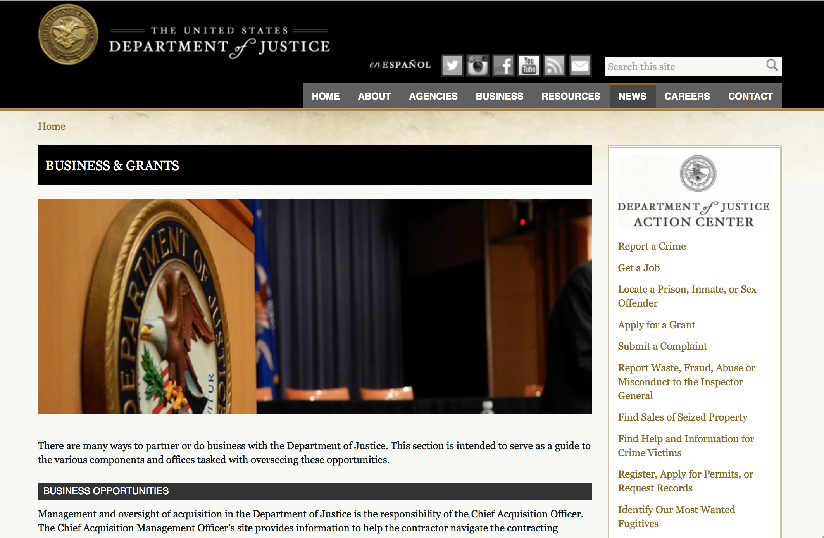

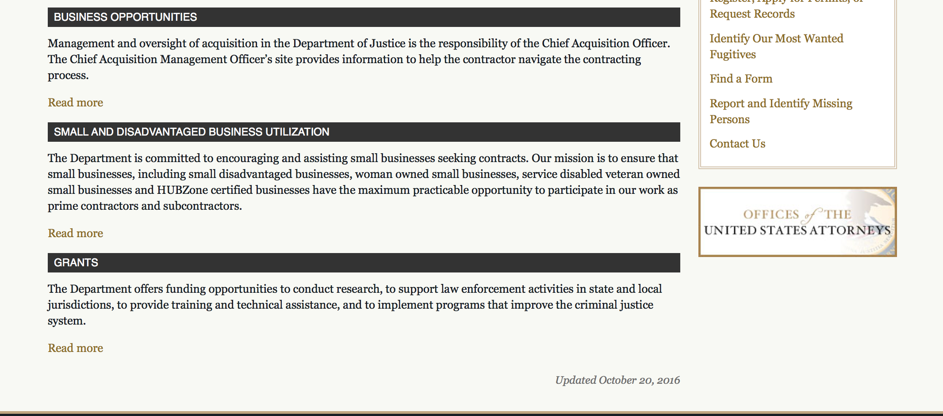

The DOJ agencies listed below also have sites that provide grant information specific to that agency. Examples of what can be found on these sites are programs, funding opportunities, application assistance, and other useful information.

Bureau of Justice Assistance (BJA)

Bureau of Justice Statistics (BJS)

National Criminal Justice Reference Service (NCJRS)

National Institute of Justice (NIJ)

Office of Sex Offender Sentencing, Monitoring, Apprehending, Registering, and Tracking (SMART)

http://www.justice.gov/business/

Programs:

Office on Violence Against Women
OVW FY 2019 Grants for Outreach and Services to Underserved Populations
Synopsis 1

Document Type: | Grants Notice
Funding Opportunity Number: | OVW-2019-15804
Funding Opportunity Title: | OVW FY 2019 Grants for Outreach and Services to Underserved Populations
Opportunity Category: | Discretionary
Opportunity Category Explanation:
Funding Instrument Type: | Grant
Category of Funding Activity: | Other (see text field entitled "Explanation of Other Category of Funding Activity" for clarification)
Category Explanation: | Sexual assault, domestic violence, dating violence, and stalking victim services, training, and community outreach
Expected Number of Awards: | 10
CFDA Number(s): | 16.889 -- Grants for Outreach and Services to Underserved Populations
Cost Sharing or Matching Requirement: | No
Version: | Synopsis 1
Posted Date: | Dec 18, 2018
Last Updated Date: | Dec 18, 2018
Original Closing Date for Applications: | Feb 13, 2019
Current Closing Date for Applications: | Feb 13, 2019
Archive Date:
Estimated Total Program Funding: | $4,700,000
Award Ceiling: | $450,000
Award Floor: | $0
Eligible Applicants: | Nonprofits having a 501(c)(3) status with the IRS, other than institutions of higher education
Additional Information on Eligibility:

Agency Name: | Office on Violence Against Women
Description: | The program was authorized to develop and implement outreach strategies targeted at, and provide victim services to, adult and youth victims of domestic violence, dating violence, sexual assault, or stalking in underserved populations. Grant funds are used to provide enhanced services to underserved populations; build the capacity of both mainstream organizations and organizations serving underserved populations to provide culturally appropriate and inclusive services; and to increase training and outreach activities targeted at organizations providing services to underserved populations.
Link to Additional Information: | Full Announcement
Grantor Contact Information: | If you have difficulty accessing the full announcement electronically, please contact:  Kara Moller Program Specialist 202-616-3464 kara.moller@usdoj.gov  kara.moller@usdoj.gov
https://www.grants.gov/web/grants/view-opportunity.html?oppId=311330

Office on Violence Against Women
OVW FY 2019 Rural Sexual Assault, Domestic Violence, Dating Violence and Stalking Program
Synopsis 1
Document Type: | Grants Notice
Funding Opportunity Number: | OVW-2019-15825
Funding Opportunity Title: | OVW FY 2019 Rural Sexual Assault, Domestic Violence, Dating Violence and Stalking Program
Opportunity Category: | Discretionary
Opportunity Category Explanation:
Funding Instrument Type: | Grant
Category of Funding Activity: | Housing  Humanities (see "Cultural Affairs" in CFDA)  Law, Justice and Legal Services
Category Explanation:
Expected Number of Awards: | 50
CFDA Number(s): | 16.589 -- Rural Domestic Violence, Dating Violence, Sexual Assault, and Stalking Assistance Program
Cost Sharing or Matching Requirement: | No
Version: | Synopsis 1
Posted Date: | Dec 18, 2018
Last Updated Date: | Dec 18, 2018
Original Closing Date for Applications: | Feb 14, 2019
Current Closing Date for Applications: | Feb 14, 2019
Archive Date:
Estimated Total Program Funding: | $35,000,000
Award Ceiling: | $750,000
Award Floor: | $0
Eligible Applicants: | Native American tribal governments (Federally recognized)  Nonprofits having a 501(c)(3) status with the IRS, other than institutions of higher education  State governments  Special district governments  County governments  Public and State controlled institutions of higher education  Native American tribal organizations (other than Federally recognized tribal governments)  City or township governments
Additional Information on Eligibility:
Additional Information
Agency Name: | Office on Violence Against Women
Description: | Victims of sexual assault, domestic violence, dating violence, and stalking in rural communities face unique challenges and barriers to receiving assistance rarely encountered in urban areas. The geographic isolation, transportation barriers, economic structure, particularly strong social and cultural pressures, and lack of available services in rural jurisdictions significantly compound the problems confronted by those seeking support and services to end the violence in their lives. These factors also complicate the ability of the criminal justice system to investigate and prosecute sexual assault, domestic violence, dating violence, and stalking cases. In addition, socio-cultural, economic, and geographic barriers create difficulties for victim services providers to identify and assist victims of these crimes. The United States Department of Justice, Office on Violence Against Women (OVW) (www.ovw.usdoj.gov) is pleased to announce that it is seeking applications for the Fiscal Year 2019 Rural Sexual Assault, Domestic Violence, Dating Violence, and Stalking Assistance Program. This program furthers the Department’s mission by supporting projects designed to address and prevent sexual assault, domestic violence, dating violence, and stalking in rural jurisdictions.
Link to Additional Information: | Full Announcement
Grantor Contact Information: | If you have difficulty accessing the full announcement electronically, please contact:  Sue Pugliese Grant Program Specialist (202) 305-1660 ovw.rural@usdoj.gov  ovw.rural@usdoj.gov
https://www.grants.gov/web/grants/view-opportunity.html?oppId=311346

Office on Violence Against Women
OVW FY 2019 Transitional Housing Assistance Grants for Victims of Sexual Assault, Domestic Violence, Dating Violence and Stalking Program
Synopsis 1

Document Type: | Grants Notice
Funding Opportunity Number: | OVW-2019-15805
Funding Opportunity Title: | OVW FY 2019 Transitional Housing Assistance Grants for Victims of Sexual Assault, Domestic Violence, Dating Violence and Stalking Program
Opportunity Category: | Discretionary
Opportunity Category Explanation:
Funding Instrument Type: | Grant
Category of Funding Activity: | Other (see text field entitled "Explanation of Other Category of Funding Activity" for clarification)
Category Explanation: | transitional housing and voluntary support services including victim services
Expected Number of Awards: | 70
CFDA Number(s): | 16.736 -- Transitional Housing Assistance for Victims of Domestic Violence, Dating Violence, Stalking, or Sexual Assault
Cost Sharing or Matching Requirement: | No
Version: | Synopsis 1
Posted Date: | Dec 17, 2018
Last Updated Date: | Dec 17, 2018
Original Closing Date for Applications: | Feb 13, 2019
Current Closing Date for Applications: | Feb 13, 2019
Archive Date:
Estimated Total Program Funding: | $35,000,000
Award Ceiling: | $450,000
Award Floor: | $0
Eligible Applicants: | State governments  County governments  Others (see text field entitled "Additional Information on Eligibility" for clarification)  Native American tribal governments (Federally recognized)  City or township governments
Additional Information on Eligibility: | Eligible applicants are limited to: states, units of local government, Indian tribes, and other organizations, including sexual assault and domestic violence victim service providers, sexual assault and domestic violence coalitions, other nonprofit, nongovernmental organizations, or community-based and culturally specific organizations, that have a documented history of effective work concerning sexual assault, domestic violence, dating violence, or stalking.
Additional Information
Agency Name: | Office on Violence Against Women
Description: | OVW Fiscal Year 2019 Transitional Housing Assistance Grants for Victims of Sexual Assault, Domestic Violence, Dating Violence, and Stalking
Link to Additional Information: | FY 2019 Transitional Housing Solicitation
Grantor Contact Information: | If you have difficulty accessing the full announcement electronically, please contact:  Sharon Elliott Program Manager (202) 307-6026 ovw.transitionalhousing@usdoj.gov  ovw.transitionalhousing@usdoj.gov

https://www.grants.gov/web/grants/view-opportunity.html?oppId=311322

Office on Violence Against Women
OVW FY 2019 Grants to Enhance Culturally Specific Services for Victims of Sexual Assault, Domestic Violence, Dating Violence and Stalking Program
Synopsis 1

Document Type: | Grants Notice
Funding Opportunity Number: | OVW-2019-15843
Funding Opportunity Title: | OVW FY 2019 Grants to Enhance Culturally Specific Services for Victims of Sexual Assault, Domestic Violence, Dating Violence and Stalking Program
Opportunity Category: | Discretionary
Opportunity Category Explanation:
Funding Instrument Type: | Grant
Category of Funding Activity: | Education  Employment, Labor and Training  Housing  Humanities (see "Cultural Affairs" in CFDA)  Income Security and Social Services  Law, Justice and Legal Services
Category Explanation:
Expected Number of Awards: | 21
CFDA Number(s): | 16.016 -- Culturally and Linguistically Specific Services Program
Cost Sharing or Matching Requirement: | No
Version: | Synopsis 1
Posted Date: | Dec 13, 2018
Last Updated Date: | Dec 13, 2018
Original Closing Date for Applications: | Feb 07, 2019
Current Closing Date for Applications: | Feb 07, 2019
Archive Date:
Estimated Total Program Funding: | $7,000,000
Award Ceiling: | $300,000
Award Floor: | $0
Eligible Applicants: | Nonprofits that do not have a 501(c)(3) status with the IRS, other than institutions of higher education  Nonprofits having a 501(c)(3) status with the IRS, other than institutions of higher education  Native American tribal organizations (other than Federally recognized tribal governments)
Additional Information on Eligibility:

Agency Name: | Office on Violence Against Women
Description: | Grants to Enhance Culturally Specific Services for Victims of Sexual Assault, Domestic Violence, Dating Violence and Stalking Program supports community-based organizations in providing culturally relevant services to victims of sexual assault, domestic violence, dating violence, and stalking
Link to Additional Information: | Full Announcement
Grantor Contact Information: | If you have difficulty accessing the full announcement electronically, please contact:  Paule Tessier Program Specialist 202-353-8408 Paule.Tessier@usdoj.gov  Paule.Tessier@usdoj.gov
https://www.grants.gov/web/grants/view-opportunity.html?oppId=311158

Office on Violence Against Women
OVW FY 2019 Sexual Assault Services Culturally Specific Program
Synopsis 1

Document Type: | Grants Notice
Funding Opportunity Number: | OVW-2019-15703
Funding Opportunity Title: | OVW FY 2019 Sexual Assault Services Culturally Specific Program
Opportunity Category: | Discretionary
Opportunity Category Explanation:
Funding Instrument Type: | Grant
Category of Funding Activity: | Other (see text field entitled "Explanation of Other Category of Funding Activity" for clarification)
Category Explanation: | Sexual assault victim services and advocacy
Expected Number of Awards: | 12
CFDA Number(s): | 16.023 -- Sexual Assault Services Culturally Specific Program
Cost Sharing or Matching Requirement: | No
Version: | Synopsis 1
Posted Date: | Dec 12, 2018
Last Updated Date: | Dec 12, 2018
Original Closing Date for Applications: | Feb 13, 2019
Current Closing Date for Applications: | Feb 13, 2019
Archive Date:
Estimated Total Program Funding: | $3,500,000
Award Ceiling: | $300,000
Award Floor: | $0
Eligible Applicants: | Nonprofits having a 501(c)(3) status with the IRS, other than institutions of higher education
Additional Information on Eligibility:
Additional Information
Agency Name: | Office on Violence Against Women
Description: | The goal of the SAS Culturally Specific Program is create, maintain, and expand sustainable sexual assault services provided by culturally specific organizations, which are uniquely situated to respond to respond to the needs of sexual assault victims within culturally specific populations.
Link to Additional Information: | Full Announcement
Grantor Contact Information: | If you have difficulty accessing the full announcement electronically, please contact:  Tonette Ngassa Grants Specialist 202-305-2379 Tonette.Ngassa@usdoj.gov  Tonette.Ngassa@usdoj.gov
Eligible Applicants: |  | Nonprofits having a 501(c)(3) status with the IRS, other than institutions of higher education
Additional Information on Eligibility:
Additional Information
Agency Name: | Office on Violence Against Women
Description: | The goal of the SAS Culturally Specific Program is create, maintain, and expand sustainable sexual assault services provided by culturally specific organizations, which are uniquely situated to respond to respond to the needs of sexual assault victims within culturally specific populations.
Link to Additional Information: | Full Announcement
Grantor Contact Information: | If you have difficulty accessing the full announcement electronically, please contact:  Tonette Ngassa Grants Specialist 202-305-2379 Tonette.Ngassa@usdoj.gov  Tonette.Ngassa@usdoj.gov
https://www.grants.gov/web/grants/view-opportunity.html?oppId=311118

Research:

Modifications:

National Institute of Corrections
Facilitating Behavior Change with Persons under Community Supervision
Synopsis 2
Document Type: | Grants Notice
Funding Opportunity Number: | 19CS04
Funding Opportunity Title: | Facilitating Behavior Change with Persons under Community Supervision
Opportunity Category: | Discretionary
Opportunity Category Explanation:
Funding Instrument Type: | Cooperative Agreement
Category of Funding Activity: | Other (see text field entitled "Explanation of Other Category of Funding Activity" for clarification)
Category Explanation: | To develop training resources for front-line community supervision staff to help facilitate behavior change.
Expected Number of Awards:
CFDA Number(s): | 16.601 -- Corrections Training and Staff Development
Cost Sharing or Matching Requirement: | No
Version: | Synopsis 3
Posted Date: | Dec 13, 2018
Last Updated Date: | Dec 17, 2018
Original Closing Date for Applications: | Feb 11, 2019
Current Closing Date for Applications: | Feb 11, 2019
Archive Date: | Mar 13, 2019
Estimated Total Program Funding: | $150,000
Award Ceiling: | $150,000
Award Floor: | $0
Eligible Applicants: | Others (see text field entitled "Additional Information on Eligibility" for clarification)
Additional Information on Eligibility: | NIC invites applications from nonprofit organizations (including faith-based, community, and tribal organizations), for-profit organizations (including tribal for-profit organizations), and institutions of higher education (including tribal institutions of higher education). Recipients, including for-profit organizations, must agree to waive any profit or fee for services. NIC welcomes applications that involve two or more entities; however, one eligible entity must be the applicant and the others must be proposed as sub-recipients. The applicant must be the entity with primary responsibility for administering the funding and managing the entire program.
Additional Information
Agency Name: | National Institute of Corrections
Description: | The design and development of specialized training resources that will provide front-line community supervision staff the required knowledge, skills and abilities to incorporate Core Correctional Practices and effectively apply them during one-on-one interactions with offenders.
Link to Additional Information: | NIC Website to Solicitation
Grantor Contact Information: | If you have difficulty accessing the full announcement electronically, please contact:  Cameron D Coblentz Phone 202-514-0053  Form or application information
https://www.grants.gov/web/grants/view-opportunity.html?oppId=311125

Deleted:

Reminders:

Office of Juvenile Justice Delinquency Prevention
OJJDP FY 19 VOCA Regional Children's Advocacy Centers (RCAC)
Synopsis 1

Document Type: | Grants Notice
Funding Opportunity Number: | OJJDP-2019-14993
Funding Opportunity Title: | OJJDP FY 19 VOCA Regional Children's Advocacy Centers (RCAC)
Opportunity Category: | Discretionary
Opportunity Category Explanation:
Funding Instrument Type: | Cooperative Agreement
Category of Funding Activity: | Law, Justice and Legal Services
Category Explanation:
Expected Number of Awards: | 4
CFDA Number(s): | 16.758 -- Improving the Investigation and Prosecution of Child Abuse and the Regional and Local Children's Advocacy Centers
Cost Sharing or Matching Requirement: | No
Version: | Synopsis 2
Posted Date: | Nov 20, 2018
Last Updated Date: | Nov 26, 2018
Original Closing Date for Applications: | Jan 22, 2019
Current Closing Date for Applications: | Jan 22, 2019
Archive Date:
Estimated Total Program Funding: | $5,000,000
Award Ceiling: | $1,250,000
Award Floor: | $0
Eligible Applicants: | Others (see text field entitled "Additional Information on Eligibility" for clarification)  Nonprofits having a 501(c)(3) status with the IRS, other than institutions of higher education
Additional Information on Eligibility: | Eligible applicants are limited to local public and private nonprofit children’s advocacy center agencies and organizations that can demonstrate a minimum of 5 years of experience providing regional or national training and technical assistance to a wide range of multidisciplinary professionals and others (including children’s advocacy center staff) with respect to the judicial handling and investigative response to child abuse and neglect cases.
Additional Information
Agency Name: | Office of Juvenile Justice Delinquency Prevention
Description: | The FY 2019 Victims of Child Abuse (VOCA) Regional Children’s Advocacy Centers (RCAC) Program will support four regional children's advocacy centers, one situated within each of the four U.S. census regions, to: (1) develop multidisciplinary teams, local programs, and state chapter organizations that respond to child abuse and neglect investigation, treatment, intervention, and prosecution; and (2) deliver training and technical assistance that strengthen existing multidisciplinary teams, programs, and state chapter organizations. Funding will enable the RCACs to promote and support widespread, consistent implementation of evidence-based practices and a multidisciplinary approach to child abuse investigations, assessment, intervention, and prosecution, ensuring effective outcomes for child abuse victims and their families.
Link to Additional Information: | Full Announcement
Grantor Contact Information: | If you have difficulty accessing the full announcement electronically, please contact:  For technical assistance with submitting an application, contact the Grants.gov Customer Support Hotline at 800–518–4726 or 606–545–5035, at https://www.grants.gov/web/grants/support.html, or at support@grants.gov. The Grants.gov Support Hotline operates 24 hours a day, 7 days a week, except on federal holidays. An applicant that experiences unforeseen Grants.gov technical issues beyond its control that prevent it from submitting its application by the deadline must email the National Criminal Justice Reference Service Response Center (Response Center) at grants@ncjrs.gov within 24 hours after the application deadline to request approval to submit its application after the deadline. Additional information on reporting technical issues appears under “Experiencing Unforeseen Grants.gov Technical Issues” in the How To Apply section. For assistance with any other requirements of this solicitation, contact the Response Center by telephone at 800–851–3420 or TTY: 301–240–6310 (hearing impaired only) or by email at grants@ncjrs.gov. Response Center hours of operation are 10 a.m. to 6 p.m. ET, Monday through Friday, and 10 a.m. to 8 p.m. ET on the solicitation close date. General information on applying for OJJDP awards can be found at https://www.ojjdp.gov/funding/funding.html. Answers to frequently asked questions that may assist applicants are posted at https://www.ojjdp.gov/grants/solicitations/FY2019/FAQ/VOCARCAC.pdf. grants@ncjrs.gov  Email
https://www.grants.gov/web/grants/view-opportunity.html?oppId=310510

Office on Violence Against Women
OVW FY 2019 Legal Assistance for Victims Grant Program Solicitation
Synopsis 1
Document Type: | Grants Notice
Funding Opportunity Number: | OVW-2019-15785
Funding Opportunity Title: | OVW FY 2019 Legal Assistance for Victims Grant Program Solicitation
Opportunity Category: | Discretionary
Opportunity Category Explanation:
Funding Instrument Type: | Grant
Category of Funding Activity: | Law, Justice and Legal Services
Category Explanation:
Expected Number of Awards: | 58
CFDA Number(s): | 16.524 -- Legal Assistance for Victims
Cost Sharing or Matching Requirement: | No
Version: | Synopsis 1
Posted Date: | Nov 20, 2018
Last Updated Date: | Nov 20, 2018
Original Closing Date for Applications: | Jan 31, 2019
Current Closing Date for Applications: | Jan 31, 2019
Archive Date:
Estimated Total Program Funding: | $34,000,000
Award Ceiling: | $800,000
Award Floor: | $600,000
Eligible Applicants: | Native American tribal governments (Federally recognized)  Native American tribal organizations (other than Federally recognized tribal governments)  Public and State controlled institutions of higher education  Nonprofits that do not have a 501(c)(3) status with the IRS, other than institutions of higher education  Nonprofits having a 501(c)(3) status with the IRS, other than institutions of higher education  Private institutions of higher education
Additional Information on Eligibility:
Additional Information
Agency Name: | Office on Violence Against Women
Description: | The Legal Assistance for Victims (LAV) Grant Program is intended to increase the availability of civil and criminal legal assistance needed to effectively aid adult and youth victims of sexual assault, domestic violence, dating violence, and stalking who are seeking relief in legal matters relating to or arising out of that abuse or violence, at minimum or no cost to the victims. LAV Grant Program funds may not be used provide criminal defense services. Grant funds may be used to provide direct legal services to victims of sexual assault, domestic violence, dating violence, and stalking in matters related to or arising out of that abuse or violence. The objective of the LAV Grant Program is to develop innovative, collaborative projects that provide quality representation to victims of sexual assault, domestic violence, dating violence, and stalking.
Link to Additional Information: | Full Announcement
Grantor Contact Information: | If you have difficulty accessing the full announcement electronically, please contact:  Shannon R. Maultsby Grant Program Specialist 202-307-6026 OVW.LAV@USDOJ.GOV  OVW.LAV@USDOJ.GOV
https://www.grants.gov/web/grants/view-opportunity.html?oppId=310488

Office on Violence Against Women
OVW FY 2019 Training and Services to End Violence Against Women with Disabilities Grant Program
Synopsis 1
Document Type: | Grants Notice
Funding Opportunity Number: | OVW-2019-15806
Funding Opportunity Title: | OVW FY 2019 Training and Services to End Violence Against Women with Disabilities Grant Program
Opportunity Category: | Discretionary
Opportunity Category Explanation:
Funding Instrument Type: | Cooperative Agreement
Category of Funding Activity: | Other (see text field entitled "Explanation of Other Category of Funding Activity" for clarification)
Category Explanation: | Training, Disability, Deaf, Domestic Violence, Sexual Assault, Stalking, and Dating Violence
Expected Number of Awards: | 15
CFDA Number(s): | 16.529 -- Education, Training, and Enhanced Services to End Violence Against and Abuse of Women with Disabilities
Cost Sharing or Matching Requirement: | No
Version: | Synopsis 1
Posted Date: | Dec 04, 2018
Last Updated Date: | Dec 04, 2018
Original Closing Date for Applications: | Feb 07, 2019
Current Closing Date for Applications: | Feb 07, 2019
Archive Date:
Estimated Total Program Funding: | $6,000,000
Award Ceiling: | $500,000
Award Floor: | $325,000
Eligible Applicants: | Native American tribal organizations (other than Federally recognized tribal governments)  City or township governments  State governments  Native American tribal governments (Federally recognized)  Others (see text field entitled "Additional Information on Eligibility" for clarification)  Nonprofits having a 501(c)(3) status with the IRS, other than institutions of higher education  County governments
Additional Information on Eligibility: | Victim service providers, such as state or tribal domestic violence or sexual assault coalitions or nonprofit, nongovernmental organizations serving individuals with disabilities.
Additional Information
Agency Name: | Office on Violence Against Women
Description: | This program is authorized by 34 U.S.C. §20122. The goal of the Disability Grant Program is to create sustainable change within and between organizations that improves the response to individuals with disabilities and Deaf individuals who are victims of domestic violence, dating violence, stalking and sexual assault and to hold perpetrators of such crimes accountable. Disability Grant Program funds are used to establish and strengthen multidisciplinary collaborative relationships; increase organizational capacity to provide accessible, safe, and effective services to individuals with disabilities and Deaf individuals who are victims of violence and abuse; identify needs within the grantee’s organization and/or service area; and develop a plan to address those identified needs that builds a strong foundation for future work.
Link to Additional Information: | Full Announcement
Grantor Contact Information: | If you have difficulty accessing the full announcement electronically, please contact:  Sylvia Pauling Grant Program Specialist 202-514-0748 Sylvia.Pauling@usdoj.gov  Sylvia.Pauling@usdoj.gov
https://www.grants.gov/web/grants/view-opportunity.html?oppId=310833

Office on Violence Against Women
OVW FY 2019 Justice for Families Program Solicitation
Synopsis 1

Document Type: | Grants Notice
Funding Opportunity Number: | OVW-2019-15529
Funding Opportunity Title: | OVW FY 2019 Justice for Families Program Solicitation
Opportunity Category: | Discretionary
Opportunity Category Explanation:
Funding Instrument Type: | Grant
Category of Funding Activity: | Law, Justice and Legal Services  Other (see text field entitled "Explanation of Other Category of Funding Activity" for clarification)
Category Explanation: | The Justice for Families Program supports projects to improve the response of the civil and criminal justice system to families with a history of sexual assault, domestic violence, dating violence, and stalking, or in cases involving allegations of child sexual abuse.
Expected Number of Awards: | 20
CFDA Number(s): | 16.021 -- Justice Systems Response to Families
Cost Sharing or Matching Requirement: | No
Version: | Synopsis 1
Posted Date: | Nov 06, 2018
Last Updated Date: | Nov 06, 2018
Original Closing Date for Applications: | Jan 08, 2019
Current Closing Date for Applications: | Jan 08, 2019
Archive Date:
Estimated Total Program Funding: | $11,000,000
Award Ceiling: | $650,000
Award Floor: | $550,000
Eligible Applicants: | City or township governments  Native American tribal governments (Federally recognized)  County governments  Nonprofits having a 501(c)(3) status with the IRS, other than institutions of higher education  Others (see text field entitled "Additional Information on Eligibility" for clarification)  State governments
Additional Information on Eligibility: | States, units of local government, courts (including juvenile courts), Indian tribal governments, nonprofit organizations, legal services providers, and victim service providers
Agency Name: | Office on Violence Against Women
Description: | The Grants to Support Families in the Justice System program (referred to as the Justice for Families Program) was authorized in the Violence Against Women Reauthorization Act (VAWA) of 2013 to improve the response of the civil and criminal justice system to families with a history of sexual assault, domestic violence, dating violence, and stalking, or in cases involving allegations of child sexual abuse. The program supports the following activities for improving the capacity of courts and communities to respond to families affected by the targeted crimes: court-based and court-related programs; supervised visitation and safe exchange by and between parents; training for people who work with families in the court system; civil legal services; and the provision of resources in juvenile court matters.
Link to Additional Information: | Full Solicitation
Grantor Contact Information: | If you have difficulty accessing the full announcement electronically, please contact:  Carrie Mitchell Grant Program Specialist 202-307-6026 OVW.JFF@usdoj.gov  OVW.JFF@usdoj.gov
https://www.grants.gov/web/grants/view-opportunity.html?oppId=310226



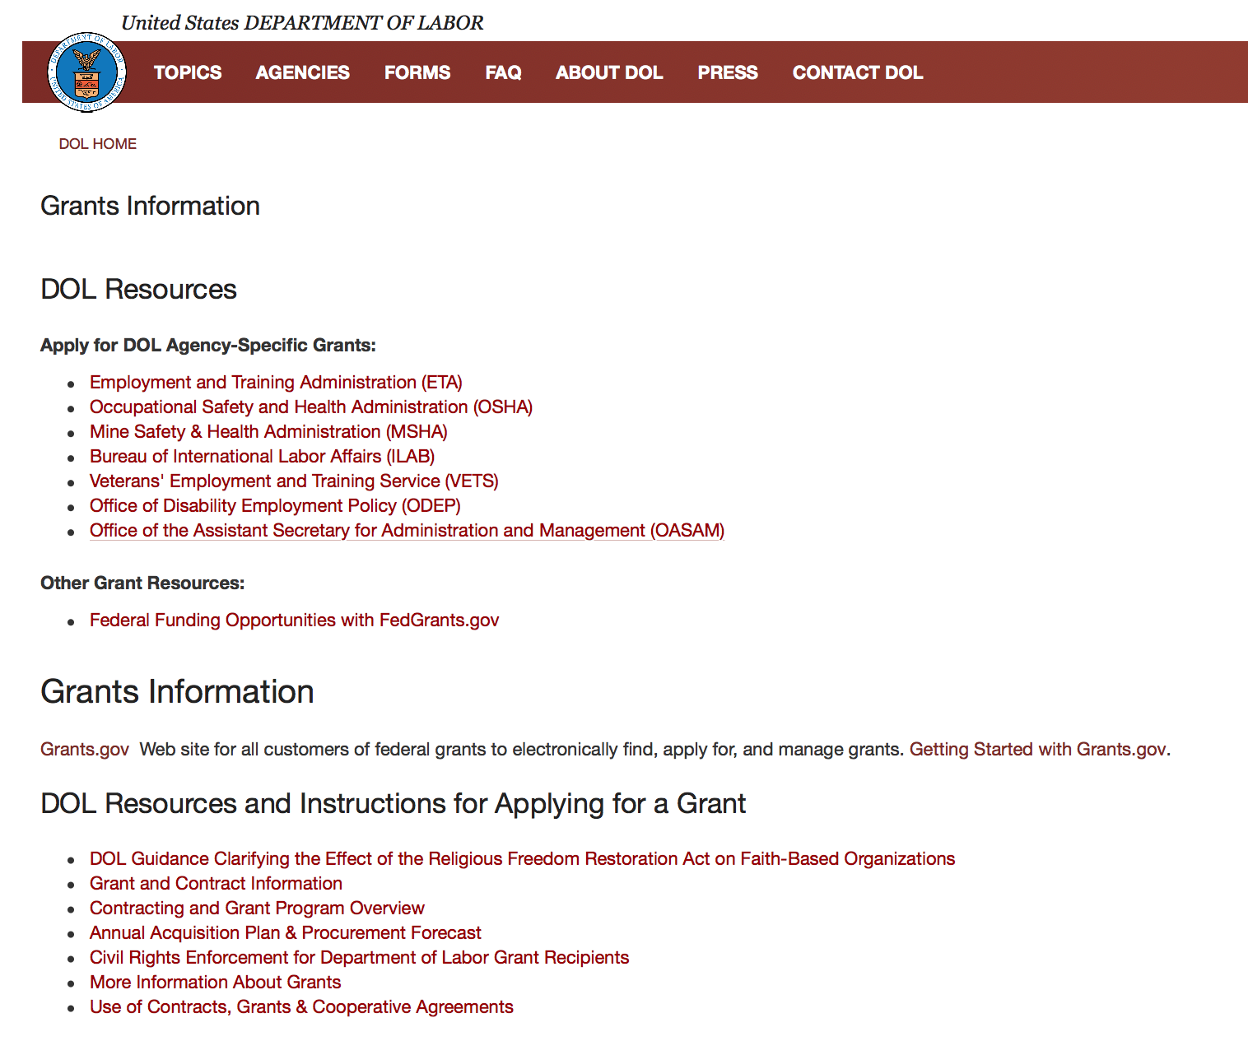

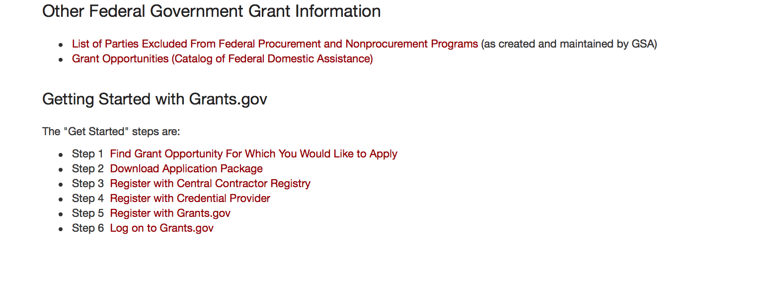
https://www.dol.gov/general/grants2

Agency Grants and Contract General Overview

DOL Resources
Apply for DOL Agency-Specific Grants:
- Employment and Training Administration (ETA)
- Occupational Safety and Health Administration (OSHA)
- Mine Safety & Health Administration (MSHA)
- Bureau of International Labor Affairs (ILAB)
- Veterans' Employment and Training Service (VETS)
- Office of Disability Employment Policy (ODEP)
- Office of the Assistant Secretary for Administration and Management (OASAM)

Other Grant Resources:
- Federal Funding Opportunities with FedGrants.gov
Grants Information
Grants.gov — Web site for all customers of federal grants to electronically find, apply for, and manage grants. Getting Started with Grants.gov.

DOL Resources and Instructions for Applying for a Grant
- DOL Guidance Clarifying the Effect of the Religious Freedom Restoration Act on Faith-Based Organizations
- Grant and Contract Information
- Contracting and Grant Program Overview
- Civil Rights Enforcement for Department of Labor Grant Recipients
- More Information About Grants
- Use of Contracts, Grants & Cooperative Agreements

Other Federal Government Grant Information
- Grant Opportunities (Catalog of Federal Domestic Assistance)

Department of Labor Grant Programs

- Bureau of International Labor Affairs (ILAB): provides grants (cooperative agreements) for the implementation of projects designed to assist developing countries combat the worse forms of child labor, forced labor, and human trafficking; and support worker rights and improve working conditions. http://www.dol.gov/general/business.
- Bureau of Labor Statistics (BLS): provides project grants (cooperative agreements) and the dissemination of technical statistical data and related information on labor force activities; provides data on prices (CPI) and cost of living; data on productivity and technology data; data on compensation and working conditions; data on employment projections.
- Employment and Training (ETA): ETA administers financial assistance programs pursuant to the Workforce Investment Act (WIA), administering State formula grant programs for youth, adults and dislocated workers, national emergency grants for workers affected by mass layoffs, plant closures, and disasters; grant programs for workers with disabilities, Indians and Native Americans, and for migrant and seasonal farmworkers. ETA also administers grant programs for older American workers, apprenticeship programs, Trade Adjustment Assistance (TAA) programs, and assistance for research and development of workforce programs. In addition, ETA is responsible for the operation and maintenance of a national system of public employment service offices and for the national unemployment insurance program.
- Mine Safety and Health (MSHA): provides grants for research, education and training programs to ensure an adequate and competent staff of trained inspectors; and assistance for establishing or improving State mine health and safety programs through technical assistance.
- Occupational Safety and Health (OSHA): provides grants to non-profit organizations to provide training, educational services, and technical assistance; assistance to states to administer and enforce state programs; assistance to states to provide occupational safety and health technical assistance and consultant services.
- Office of Disability Employment Policy (ODEP): The Office of Disability Employment Policy awards competitive grants establishing short-term pilot and technical assistance projects designed to identify, develop, test, evaluate, and disseminate policies to increase employment by expanding access to training, education, employment supports, assistive and systems technology, integrated employment, entrepreneurial development, and small business opportunities for adults and youth with disabilities. Current pilots projects focus on customized employment, Olmstead populations, and innovative demonstration youth grants, among others. Solicitations for grant applications are published in the Federal Register and announced at www.dol.gov/odep. ODEP grants are awarded by the OASAM grant office.
- Veterans' Employment and Training (VETS): provides special employment and training assistance for veterans through the Disabled Veterans' Outreach Program (DVOP) Solicitation for Grant Applications; the Local Veterans' Employment Representative Program (LVER); Veterans' Workforce Investment Program (VWIP); elaws Advisor on veterans' employment and reemployment rights; and the Homeless Veterans Reintegration Project (HVRP). VETS grants are awarded by the OASAM grant office.

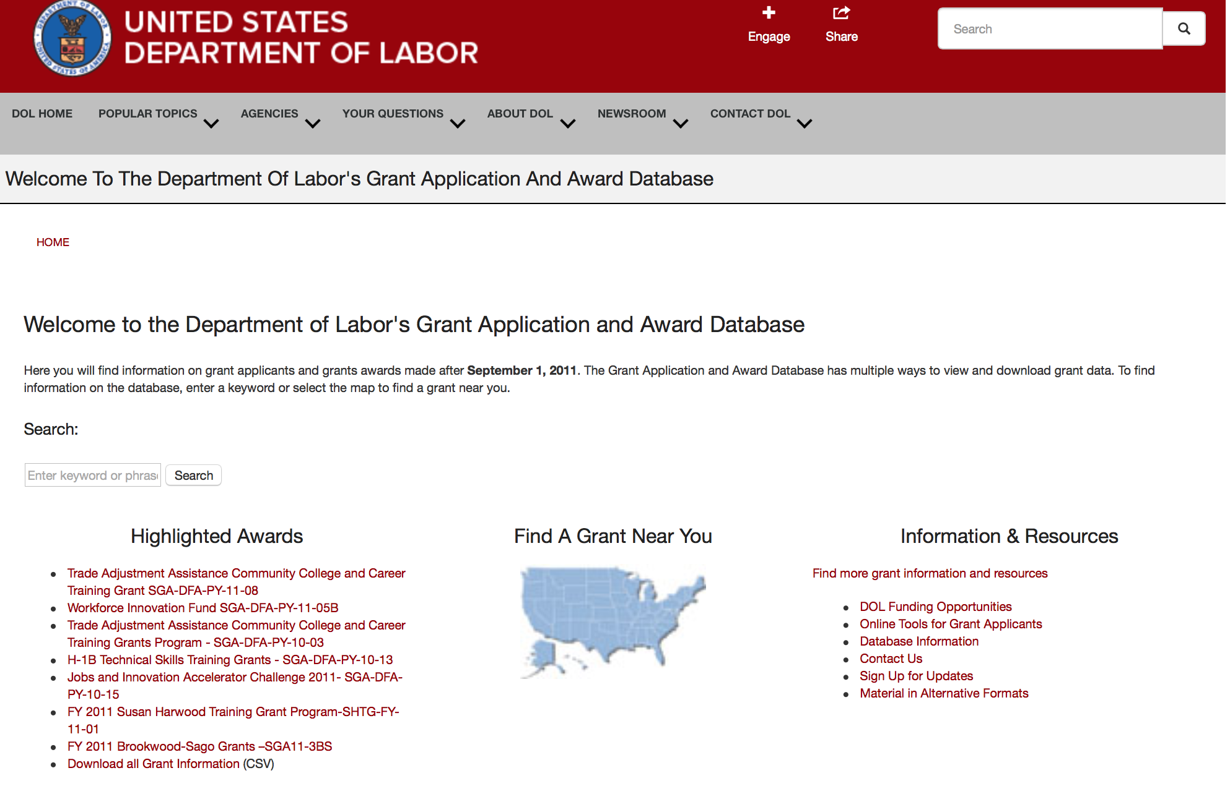

http://www.dol.gov/dol/grants/

Programs

Mine Safety and Health Administration
Mine Health and Safety Grants
Synopsis 1

Document Type: | Grants Notice
Funding Opportunity Number: | MSHA-2019-1
Funding Opportunity Title: | Mine Health and Safety Grants
Opportunity Category: | Discretionary
Opportunity Category Explanation:
Funding Instrument Type: | Grant
Category of Funding Activity: | Education
Category Explanation:
Expected Number of Awards: | 56
CFDA Number(s): | 17.600 -- Mine Health and Safety Grants
Cost Sharing or Matching Requirement: | Yes
Version: | Synopsis 1
Posted Date: | Dec 13, 2018
Last Updated Date: | Dec 13, 2018
Original Closing Date for Applications: | Feb 13, 2019
Current Closing Date for Applications: | Feb 13, 2019
Archive Date: | Mar 15, 2019
Estimated Total Program Funding: | $10,537,000
Award Ceiling: | $0
Award Floor: | $0
Eligible Applicants: | Native American tribal governments (Federally recognized)  Public and State controlled institutions of higher education  State governments
Additional Information on Eligibility:
Additional Information
Agency Name: | Mine Safety and Health Administration
Description: | The Secretary of Labor's vision for the U.S. workforce is helping American workers gain and hold good, safe jobs. One of the Department's strategic goals is to "Promote Safe Jobs and Fair Workplaces for All Americans." MSHA's goal in accomplishing this objective is to "prevent fatalities, disease, and injury from mining and secure safe and healthful working conditions for America's miners." Under Section 503 of the Federal Mine Safety and Health Act of 1977 (Mine Act), Public Law 95-164, as amended, 30 U.S.C. § 953, the Secretary of Labor through the Mine Safety and Health Administration (MSHA) may award grants to States (including the District of Columbia, the Commonwealth of Puerto Rico, the Virgin Islands, American Samoa, Guam, and the Commonwealth of the Northern Mariana Islands) to assist them in developing and enforcing State mining laws and regulations, to improve State workers' compensation and mining occupational disease laws and programs, and to improve safety and health conditions in the Nation's mines through Federal-State coordination and cooperation. The "Department of Labor Appropriations Act, 2019" directed MSHA to award $10,537,000 for State assistance grants.
Link to Additional Information:
Grantor Contact Information: | If you have difficulty accessing the full announcement electronically, please contact:  Janice M Oates Grants Program Manager Phone 202-693-9573  Department of Labor
https://www.grants.gov/web/grants/view-opportunity.html?oppId=311068

Modifications

Reminders

Veterans Employment and Training Service
Announcement of Stand Down Grants
Synopsis 2

Document Type: | Grants Notice
Funding Opportunity Number: | VPL-02-18
Funding Opportunity Title: | Announcement of Stand Down Grants
Opportunity Category: | Discretionary
Opportunity Category Explanation:
Funding Instrument Type: | Grant
Category of Funding Activity: | Other (see text field entitled "Explanation of Other Category of Funding Activity" for clarification)
Category Explanation: | Veterans' Employment and Training Service
Expected Number of Awards:
CFDA Number(s): | 17.805 -- Homeless Veterans Reintegration Program
Cost Sharing or Matching Requirement: | No
Version: | Synopsis 2
Posted Date: | Jan 02, 2018
Last Updated Date: | Jan 02, 2018
Original Closing Date for Applications: | Dec 31, 2020
Current Closing Date for Applications: | Dec 31, 2020
Archive Date: | Jan 30, 2021
Estimated Total Program Funding:
Award Ceiling: | $10,000
Award Floor: | $7,000
Eligible Applicants: | Others (see text field entitled "Additional Information on Eligibility" for clarification)
Additional Information on Eligibility: | The following organizations and entities may apply for grant funds for Stand Down events: State and Local Workforce Development Boards, Veteran Service Organizations, local public agencies, tribal governments, and non-profit organizations including community and faith-based organizations. Organizations registered with the Internal Revenue Service as 501(c)(4) entities are not eligible to apply for this funding opportunity.
Additional Information
Agency Name: | Veterans Employment and Training Service
Description: | DOL VETS supports local Stand Down (SD) events that assist homeless veterans by providing a wide variety of employment, social, and health services. A homeless veteran is a veteran, as defined in 38 U.S.C. 101(2), who is “homeless” as that term is defined at 42 U.S.C. 11302(a)-(b), as amended by the Homeless Emergency Assistance and Rapid Transition to Housing Act of 2009 (Public Law 111-22).Stand Down grant funds must be used to enhance employment and training opportunities or to promote the self-sufficiency of homeless veterans through paid work. Veterans experiencing homelessness do not always have access to basic hygiene supplies necessary to maintain their health and appearance. Lack of shelter limits their ability to prepare for and present themselves at job interviews or be contacted for follow-up. Basic services such as showers, haircuts, attention to health concerns, and other collaborative services provided at SD events can give participants a greater sense of self and an opportunity to improve their chances of securing and maintaining employment. Each year, VETS sets funds aside from the Homeless Veterans’ Reintegration Program (HVRP) budget activity to award SD grants. Stand Down funding is a non-competitive grant awarded on a first-come, first-served basis until available annual funding is exhausted. VETS will continue to accept applications and process when additional funds become available. The maximum amount that can be awarded, per applicant for a geographic area, in a fiscal year (October 1 – September 30) is $7,000 for a one-day event and $10,000 for a multi-day event. Grants may be awarded to multiple organizations that conduct SD events in the same general area so long as there is no commingling of federal funds. In the event of a significant natural or man-made disaster, VETS may elect to accept and award grants for SD events in excess of the $10,000 limit. VETS recognizes the following as circumstances that may justify awarding SD grants in higher amounts: emergencies or major disasters, as defined in the Stafford Act, which have been declared eligible for public assistance by the Federal Emergency Management Agency (FEMA). In addition, emergencies or disaster situations of national significance, natural or man-made, that could result in a potentially large loss of employment, as declared or otherwise recognized in writing by the chief official of the Federal Agency with jurisdiction over the Federal response to the emergency or disaster. If the VETS Assistant Secretary determines it is appropriate to award increased grants for SD events due to a disaster, the VETS Assistant Secretary will announce such a determination in writing, including the maximum amount that can be awarded on account of such an identified disaster, in order to provide notice to entities proposing to conduct SD events in those geographic areas where a disaster has been declared or to which a substantial number of veterans have relocated or been relocated. Acceptable uses of Stand Down grant funds do not change in such circumstances. All applications should be emailed to the appropriate DVET of the state in which the SD event is planned.
Link to Additional Information:
Grantor Contact Information: | If you have difficulty accessing the full announcement electronically, please contact:  Questions regarding a SD grant application should be referred to the DVET in the state in which the event will take place. DVET contact information is available at: https://www.dol.gov/vets/aboutvets/regionaloffices/map.htm.  https://www.dol.gov/vets/aboutvets/regionaloffices/map.htm
https://www.grants.gov/web/grants/view-opportunity.html?oppId=299798

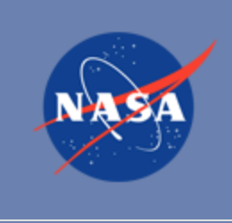

National Aeronautics and Space Administration

Research and Contracting Opportunities

NASA Research Opportunities Online

- Various NASA offices publish their research announcements over the Internet, broadening the opportunity for researchers to apply for funding. This site provides access to current research announcements along with their specific due dates.

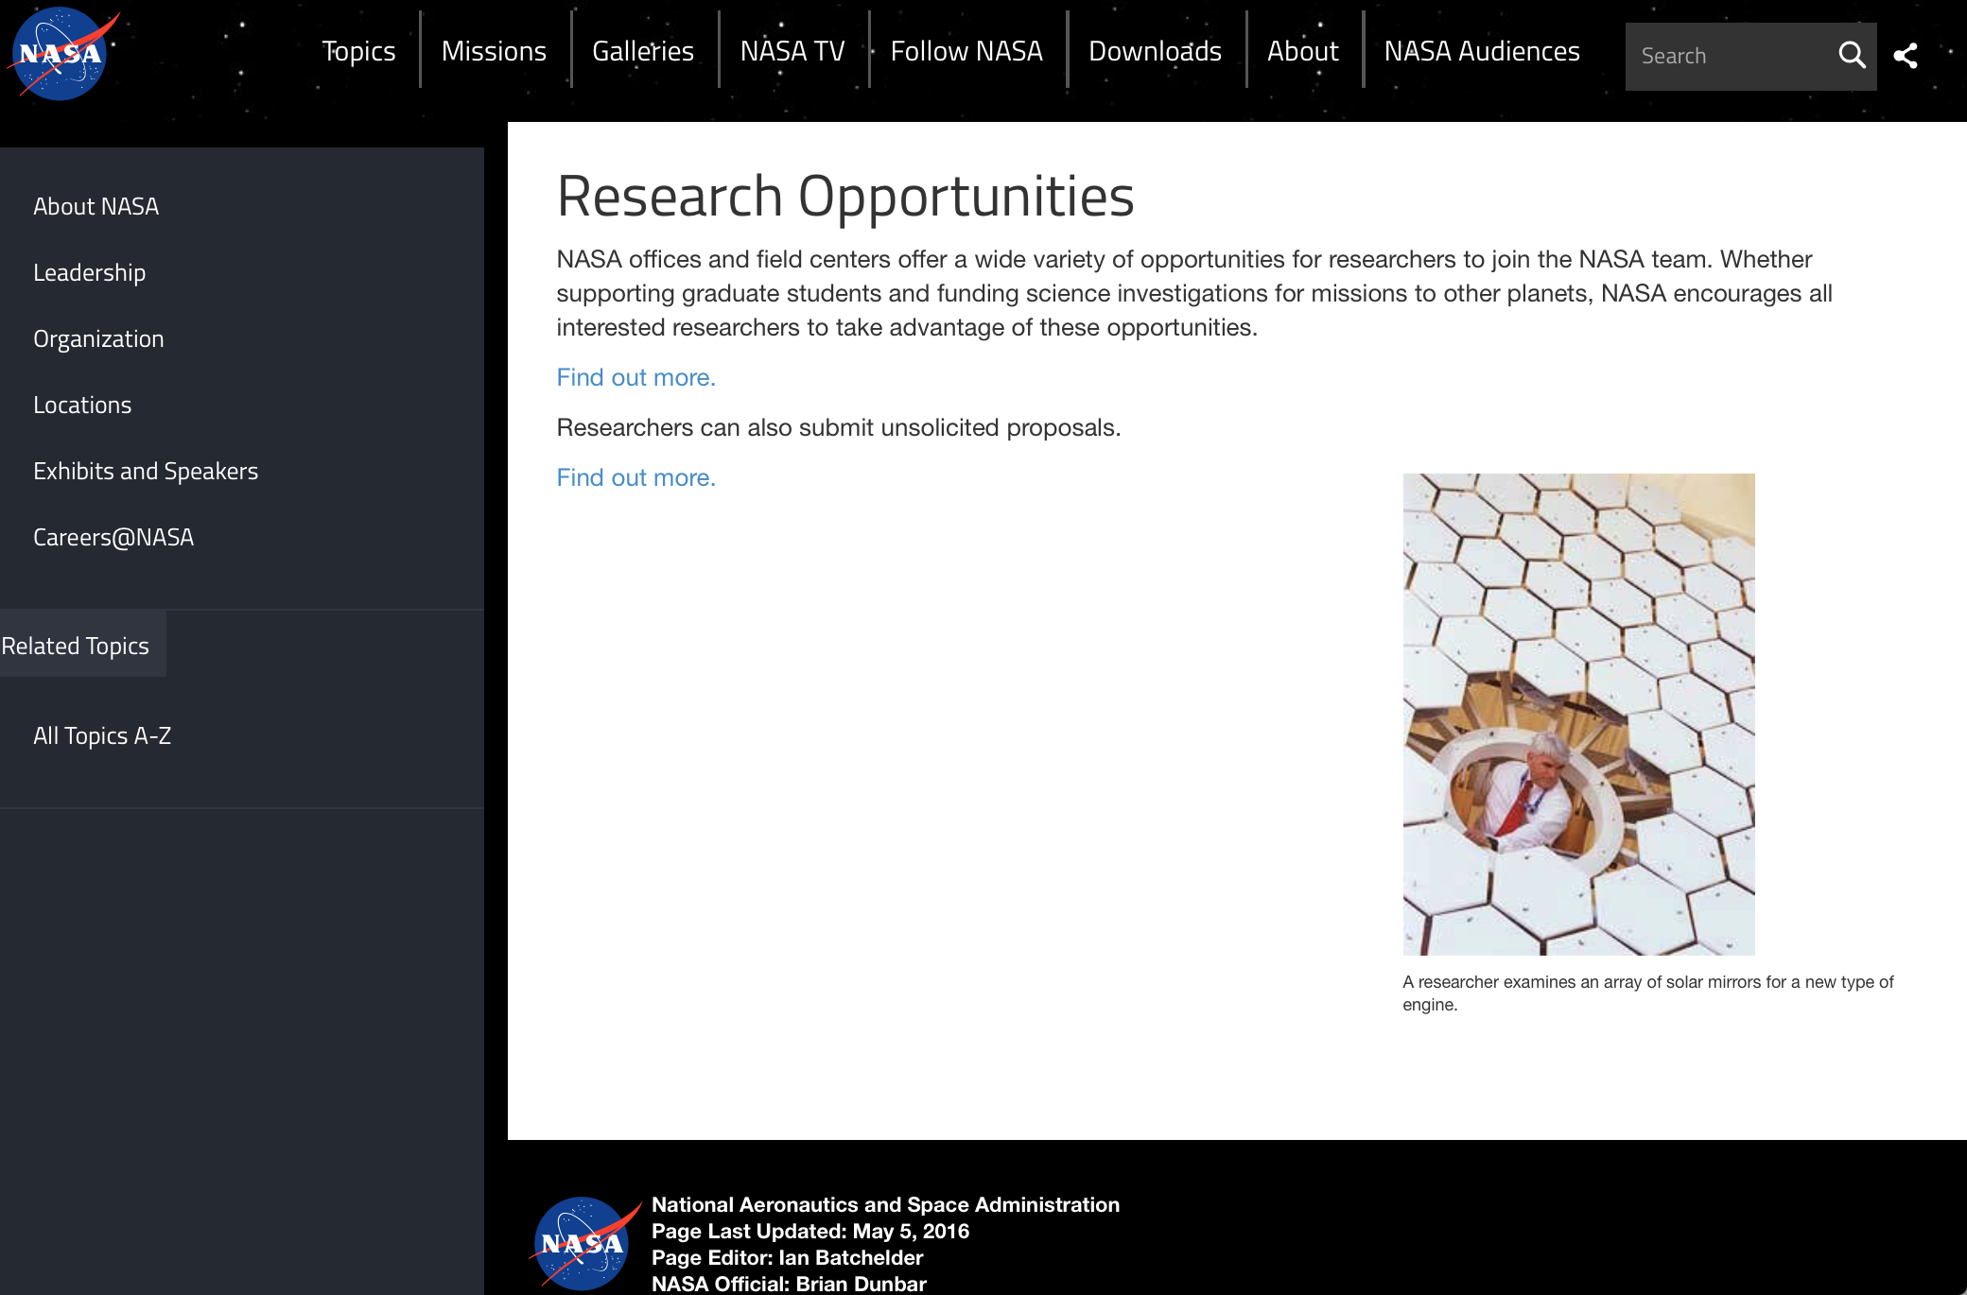

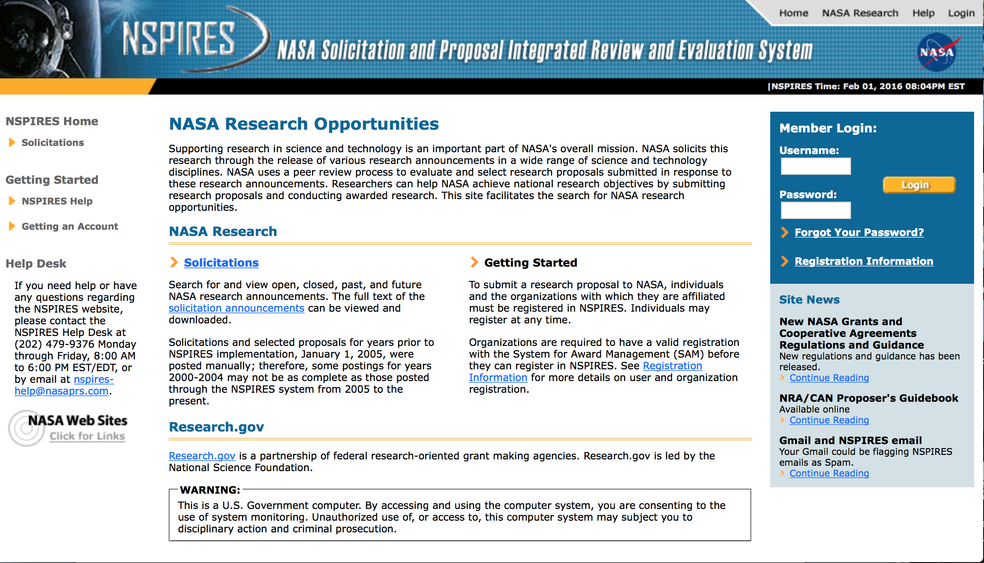
http://nspires.nasaprs.com/external/

Research Programs:

NASA Headquarters
ROSES 2018: Advanced Information Systems Technology
Synopsis 1
https://www.grants.gov/web/grants/view-opportunity.html?oppId=310901

NASA Headquarters
ROSES 2018: Astrodynamics in Support of Icy Worlds Missions
Synopsis 1
https://www.grants.gov/web/grants/view-opportunity.html?oppId=311055

NASA Headquarters
ROSES 2018: Heliophysics Living With a Star
Synopsis 1
https://www.grants.gov/web/grants/view-opportunity.html?oppId=311130

NASA Headquarters
ROSES 2018: ECOSTRESS Science and Applications Team
Synopsis 1
https://www.grants.gov/web/grants/view-opportunity.html?oppId=311334
NASA Headquarters
ROSES 2018: Remote Sensing Theory for Earth Science
Synopsis 1
https://www.grants.gov/web/grants/view-opportunity.html?oppId=311339

NASA Headquarters
Technology Advancement Utilizing Suborbital Flight Opportunities "Tech Flights"
Synopsis 1
https://www.grants.gov/web/grants/view-opportunity.html?oppId=311423

Modifications:

NASA Headquarters
Appendix B: Solicitation of Proposals for Flight and Ground Space Biology Research
Synopsis 2
https://www.grants.gov/web/grants/view-opportunity.html?oppId=310899

National Archives and Records Administration

Grant Opportunities General Overview

To access the information below: click here

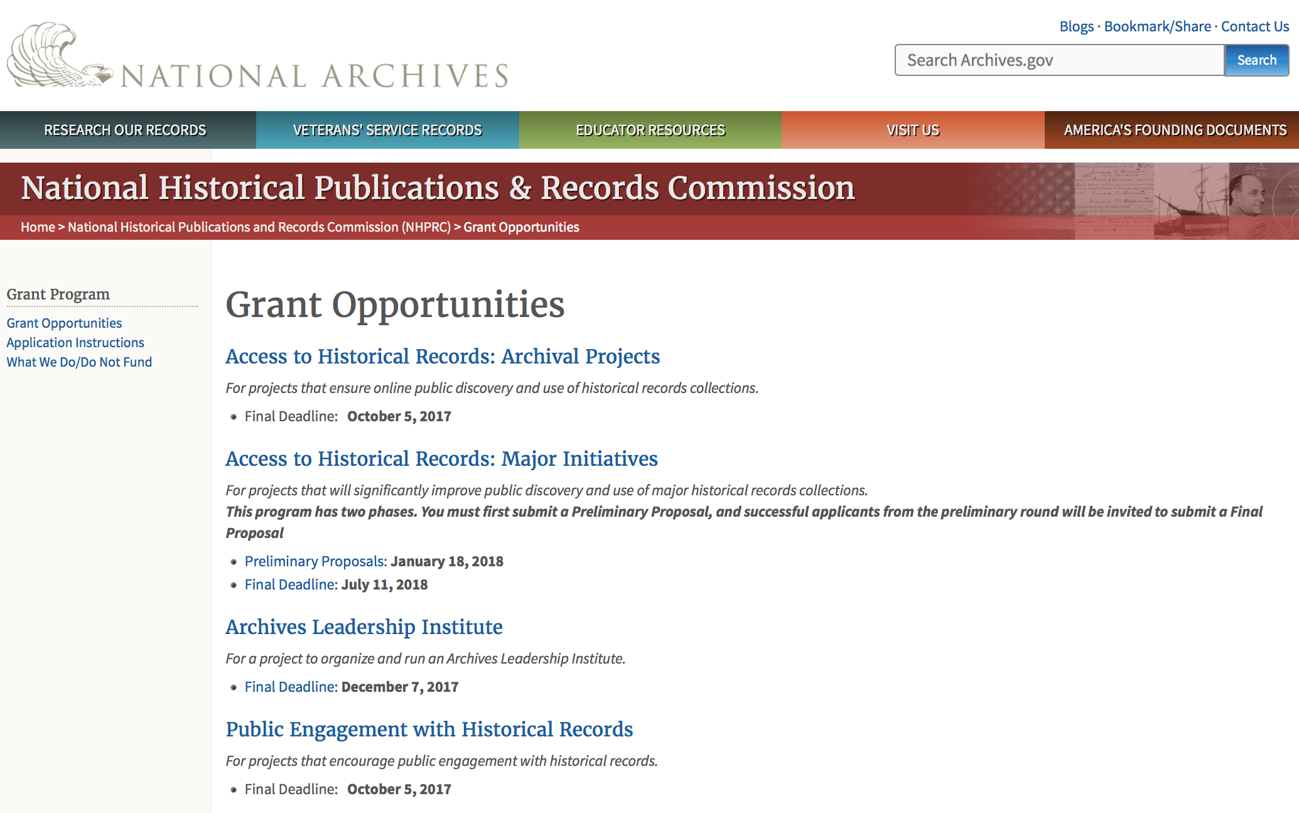

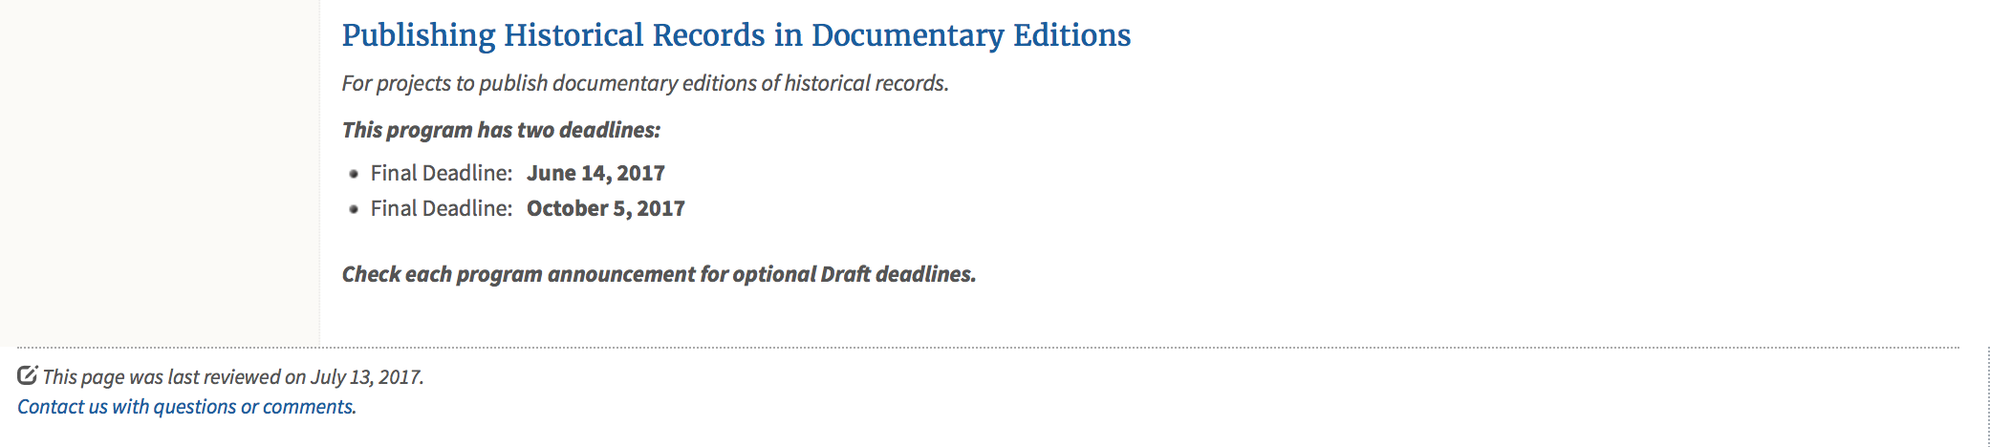
https://www.archives.gov/nhprc/announcement

Programs:

Reminders:

Archives Collaboratives
Synopsis 1
Document Type: | Grants Notice
Funding Opportunity Number: | COLLABORATIVES-201904
Funding Opportunity Title: | Archives Collaboratives
Opportunity Category: | Discretionary
Opportunity Category Explanation:
Funding Instrument Type: | Grant
Category of Funding Activity: | Humanities (see "Cultural Affairs" in CFDA)
Category Explanation:
Expected Number of Awards: | 6
CFDA Number(s): | 89.003 -- National Historical Publications and Records Grants
Cost Sharing or Matching Requirement: | Yes
Version: | Synopsis 1
Posted Date: | Nov 26, 2018
Last Updated Date: | Nov 26, 2018
Original Closing Date for Applications: | Apr 04, 2019
Current Closing Date for Applications: | Apr 04, 2019
Archive Date: | Apr 11, 2019
Estimated Total Program Funding: | $125,000
Award Ceiling: | $25,000
Award Floor: | $1
Eligible Applicants: | City or township governments  Private institutions of higher education  State governments  Native American tribal governments (Federally recognized)  Nonprofits having a 501(c)(3) status with the IRS, other than institutions of higher education  County governments  Public and State controlled institutions of higher education
Additional Information on Eligibility:

Agency Name: | National Archives and Records Administration
Description: | The National Historical Publications and Records Commission seeks projects that will make collections from small and under-represented archives more readily available for public discovery and use. The grant program will fund Archives Collaboratives to share best practices, tools, and techniques among member organizations; assess institutional strengths and opportunities; and develop plans and management structures for long-term sustainability and growth.  Archives Collaboratives must consist of three or more organizations. They may:  be located in the same community, state, or geographic region  - be “virtual” or online collaboratives  - share affinities among the scope and subject matter of their collections  - have similar organizational missions  - serve similar types of user communities  Planning Grants – The first phase of the project would be for the grantee to reach out to potential partners and secure commitments to the Archives Collaborative. Together, the member organizations would develop a mission, workplan, and timeline to carry out a shared project or develop a shared best practice, tool, or technique.  Implementation Grants – Tied to the planning funds would be grants to implement the projects outlined in the Planning Grant. Projects that demonstrate commitment by member organizations, a workplan, and timeline would be eligible to receive grants up to $100,000, shared by the consortia, to carry out the project. Applications would be due in December 2019, with a start date for implementation of July 1, 2020.  A successful Planning Grant does not automatically result in an Implementation Grant, which will undergo additional Commission review and funding recommendations.  For a comprehensive list of the Commission’s limitations on funding, please see “What we do and do not fund” (http://www.archives.gov/nhprc/apply/eligibility.html). Applications that consist entirely of ineligible activities will not be considered.  Award Information  The Commission expects to make up to six Planning grants up to $25,000 each. The total amount allocated for this program is up to $125,000. Grants begin no earlier than July 1, 2019.  Successful Archives Collaboratives which have completed the Planning Phase will be eligible to apply for an Implementation Grant of up to $100,000, shared by the consortia.  The Commission requires that grant recipients acknowledge NHPRC grant assistance in all publications and other products that result from its support.  Eligibility Information  Eligible applicants:  - Nonprofit organizations or institutions  - Colleges, universities, and other academic institutions  - State or local government agencies  - Federally-acknowledged or state-recognized Native American tribes or groups  Cost Sharing  The total costs of a project are shared between the NHPRC and the applicant organization.  No cost sharing is required for the Planning phase.  The Commission provides no more than 75 per cent of total project costs for the Implementation Grants. NHPRC grant recipients are not permitted to use grant funds for indirect costs (as indicated in 2 CFR 2600.101).  The applicant’s financial contribution may include both direct and indirect expenses, in-kind contributions, non-Federal third-party contributions, and any income earned directly by the project. Indirect costs must be listed under the applicant’s cost sharing contribution.  Other Requirements  Applicant organizations must be registered in the System for Award Management (SAM) prior to submitting an application, maintain SAM registration throughout the application and award process, and include a valid DUNS number in their application. Details on SAM registration and requesting a DUNS number can be found at the System for Award Management website at www.sam.gov. Please refer to the User Guides section and the Grants Registrations PDF.  A complete application includes the Application for Federal Assistance (Standard Form 424), Assurances -- Non-Construction Programs (Standard Form 424B), a Project Narrative, Summary, Supplementary Materials, and Budget. Applications lacking these items will not be considered.  Ineligible applications will not be reviewed.
Link to Additional Information: | Link to full grant announcement, including additional requirements
Grantor Contact Information: | If you have difficulty accessing the full announcement electronically, please contact:  Jeff de la Concepcion Grant Program Specialist Phone 202-357-5022  Grant Information Specialist
https://www.grants.gov/web/grants/view-opportunity.html?oppId=310594

Publishing Historical Records in Documentary Editions
Synopsis 1
Document Type: | Grants Notice
Funding Opportunity Number: | EDITIONS-201906
Funding Opportunity Title: | Publishing Historical Records in Documentary Editions
Opportunity Category: | Discretionary
Opportunity Category Explanation:
Funding Instrument Type: | Grant
Category of Funding Activity: | Humanities (see "Cultural Affairs" in CFDA)
Category Explanation:
Expected Number of Awards: | 25
CFDA Number(s): | 89.003 -- National Historical Publications and Records Grants
Cost Sharing or Matching Requirement: | Yes
Version: | Synopsis 1
Posted Date: | Nov 27, 2018
Last Updated Date: | Nov 27, 2018
Original Closing Date for Applications: | Jun 12, 2019
Current Closing Date for Applications: | Jun 12, 2019
Archive Date: | Jun 19, 2019
Estimated Total Program Funding: | $3,000,000
Award Ceiling: | $200,000
Award Floor: | $1
Eligible Applicants: | Public and State controlled institutions of higher education  Native American tribal governments (Federally recognized)  Nonprofits having a 501(c)(3) status with the IRS, other than institutions of higher education  Private institutions of higher education  County governments  State governments  City or township governments
Additional Information on Eligibility:

Agency Name: | National Archives and Records Administration
Description: | The National Historical Publications and Records Commission seeks proposals to publish documentary editions of historical records. Projects may focus on broad historical movements in U.S. history, such as politics, law (including the social and cultural history of the law), social reform, business, military, the arts, and other aspects of the national experience, or may be centered on the papers of major figures from American history. Whether conceived as a thematic or a biographical edition, the historical value of the records and their expected usefulness to broad audiences must justify the costs of the project.  The goal of this program is to provide access to, and editorial context for, the historical documents and records that tell the American story. Applicants should demonstrate familiarity with the best practices recommended by the Association for Documentary Editing or the Modern.  All new projects (those which have never received NHPRC funding) must have definitive plans for publishing and preserving a digital edition which provides online access to a searchable collection of documents. New projects may also prepare print editions (including ebooks and searchable PDFs posted online) as part of their overall publishing plan, but the contents of those volumes must be published in a fully-searchable digital edition within a reasonable period of time following print publication. The NHPRC encourages projects to provide free access to online editions. Projects that do not have definitive plans for digital dissemination and preservation in place at the time of application will not be considered.  Grants are awarded for collecting, describing, preserving, compiling, transcribing, annotating, editing, encoding, and publishing documentary source materials online and in print. Eligible documentary edition projects typically focus on original manuscript or typewritten documents, but may also include other formats, such as analog audio and/or born-digital records. Because of the focus on documentary sources, grants do not support preparation of critical editions of published works unless such works are just a small portion of the larger project.  For a comprehensive list of the Commission's limitations on funding, please see What We Do and Do Not Fund. Applications that consist entirely of ineligible activities will not be considered.  Ongoing projects: Applicants from ongoing projects must demonstrate that they have successfully achieved the performance objectives associated with previous NHPRC awards; provide updated, current information, including a description of the new activities; describe the content and historical significance of the specific materials to be edited during the proposed grant period; show progress towards completing the edition; and justify costs in a new budget.  Award Information  A grant is for one or two years and for up to $200,000 per year. The Commission expects to make up to 25 grants in this category for a total of up to $3,000,000. Grants begin no earlier than January 1, 2020.  The Commission requires that grant recipients acknowledge NHPRC grant assistance in all publications, publicity, and other products that result from its support.  Eligibility  - U.S. nonprofit organizations or institutions  - U.S. colleges, universities, and other academic institutions  - State or local government agencies  - Federally-acknowledged or state-recognized Native American tribes or groups  Cost Sharing  The total costs of a project are shared between the NHPRC and the applicant organization.  The Commission provides no more than 50 per cent of total project costs in the Publishing Historical Records in Documentary Editions category. NHPRC grant recipients are not permitted to use grant funds for indirect costs (as indicated in 2 CFR 2600.101).  Cost sharing is required. The applicant’s financial contribution may include both direct and indirect expenses, in-kind contributions, non-Federal third-party contributions, and any income earned directly by the project. Indirect costs must be listed under the applicant’s cost sharing contribution.  Other Requirements  Applicant organizations must be registered in the System for Award Management (SAM) prior to submitting an application, maintain SAM registration throughout the application and award process, and include a valid DUNS number in their application. Details on SAM registration and requesting a DUNS number can be found at the System for Award Management website at https://sam.gov. Please refer to the User Guides section and the Grants Registrations PDF.  A complete application includes the Application for Federal Assistance (Standard Form 424), Assurances -- Non-Construction Programs (Standard Form 424B), a Project Narrative, Summary, Supplementary Materials, and Budget. Applications lacking these items will not be considered.  Ineligible applications will not be reviewed.
Link to Additional Information: | Link to full grant announcement, including additional requirements
Grantor Contact Information: | If you have difficulty accessing the full announcement electronically, please contact:  Jeff de la Concepcion Grant Information Specialist Phone 202-357-5022  Grant Information Specialist
https://www.grants.gov/web/grants/view-opportunity.html?oppId=310589

Publishing Historical Records in Documentary Editions
Synopsis 1
Document Type: | Grants Notice
Funding Opportunity Number: | EDITIONS-201910
Funding Opportunity Title: | Publishing Historical Records in Documentary Editions
Opportunity Category: | Discretionary
Opportunity Category Explanation:
Funding Instrument Type: | Grant
Category of Funding Activity: | Humanities (see "Cultural Affairs" in CFDA)
Category Explanation:
Expected Number of Awards: | 25
CFDA Number(s): | 89.003 -- National Historical Publications and Records Grants
Cost Sharing or Matching Requirement: | Yes
Version: | Synopsis 1
Posted Date: | Nov 27, 2018
Last Updated Date: | Nov 27, 2018
Original Closing Date for Applications: | Oct 03, 2019
Current Closing Date for Applications: | Oct 03, 2019
Archive Date: | Oct 10, 2019
Estimated Total Program Funding: | $3,000,000
Award Ceiling: | $200,000
Eligible Applicants: | City or township governments  Public and State controlled institutions of higher education  Private institutions of higher education  State governments  County governments  Native American tribal governments (Federally recognized)  Nonprofits having a 501(c)(3) status with the IRS, other than institutions of higher education
Additional Information on Eligibility:
Additional Information
Agency Name: | National Archives and Records Administration
Description: | The National Historical Publications and Records Commission seeks proposals to publish documentary editions of historical records. Projects may focus on broad historical movements in U.S. history, such as politics, law (including the social and cultural history of the law), social reform, business, military, the arts, and other aspects of the national experience, or may be centered on the papers of major figures from American history. Whether conceived as a thematic or a biographical edition, the historical value of the records and their expected usefulness to broad audiences must justify the costs of the project.  The goal of this program is to provide access to, and editorial context for, the historical documents and records that tell the American story. Applicants should demonstrate familiarity with the best practices recommended by the Association for Documentary Editing or the Modern.  All new projects (those which have never received NHPRC funding) must have definitive plans for publishing and preserving a digital edition which provides online access to a searchable collection of documents. New projects may also prepare print editions (including ebooks and searchable PDFs posted online) as part of their overall publishing plan, but the contents of those volumes must be published in a fully-searchable digital edition within a reasonable period of time following print publication. The NHPRC encourages projects to provide free access to online editions. Projects that do not have definitive plans for digital dissemination and preservation in place at the time of application will not be considered.  Grants are awarded for collecting, describing, preserving, compiling, transcribing, annotating, editing, encoding, and publishing documentary source materials online and in print. Eligible documentary edition projects typically focus on original manuscript or typewritten documents, but may also include other formats, such as analog audio and/or born-digital records. Because of the focus on documentary sources, grants do not support preparation of critical editions of published works unless such works are just a small portion of the larger project.  For a comprehensive list of the Commission's limitations on funding, please see What We Do and Do Not Fund. Applications that consist entirely of ineligible activities will not be considered.  Ongoing projects: Applicants from ongoing projects must demonstrate that they have successfully achieved the performance objectives associated with previous NHPRC awards; provide updated, current information, including a description of the new activities; describe the content and historical significance of the specific materials to be edited during the proposed grant period; show progress towards completing the edition; and justify costs in a new budget.  Award Information  A grant is for one or two years and for up to $200,000 per year. The Commission expects to make up to 25 grants in this category for a total of up to $3,000,000. Grants begin no earlier than January 1, 2020.  The Commission requires that grant recipients acknowledge NHPRC grant assistance in all publications, publicity, and other products that result from its support.  Eligibility  - U.S. nonprofit organizations or institutions  - U.S. colleges, universities, and other academic institutions  - State or local government agencies  - Federally-acknowledged or state-recognized Native American tribes or groups  Cost Sharing  The total costs of a project are shared between the NHPRC and the applicant organization.  The Commission provides no more than 50 per cent of total project costs in the Publishing Historical Records in Documentary Editions category. NHPRC grant recipients are not permitted to use grant funds for indirect costs (as indicated in 2 CFR 2600.101).  Cost sharing is required. The applicant’s financial contribution may include both direct and indirect expenses, in-kind contributions, non-Federal third-party contributions, and any income earned directly by the project. Indirect costs must be listed under the applicant’s cost sharing contribution.  Other Requirements  Applicant organizations must be registered in the System for Award Management (SAM) prior to submitting an application, maintain SAM registration throughout the application and award process, and include a valid DUNS number in their application. Details on SAM registration and requesting a DUNS number can be found at the System for Award Management website at https://sam.gov. Please refer to the User Guides section and the Grants Registrations PDF.  A complete application includes the Application for Federal Assistance (Standard Form 424), Assurances -- Non-Construction Programs (Standard Form 424B), a Project Narrative, Summary, Supplementary Materials, and Budget. Applications lacking these items will not be considered.  Ineligible applications will not be reviewed.
Link to Additional Information: | Link to full grant announcement, including additional requirements
Grantor Contact Information: | If you have difficulty accessing the full announcement electronically, please contact:  Jeff de la Concepcion Grant Information Specialist Phone 202-357-5022  Grant Information Specialist
https://www.grants.gov/web/grants/view-opportunity.html?oppId=310607

Access to Historical Records: Major Initiatives (Preliminary)
Synopsis 1
Document Type: | Grants Notice
Funding Opportunity Number: | PRELIM-201901
Funding Opportunity Title: | Access to Historical Records: Major Initiatives (Preliminary)
Opportunity Category: | Discretionary
Opportunity Category Explanation:
Funding Instrument Type: | Grant
Category of Funding Activity: | Humanities (see "Cultural Affairs" in CFDA)
Category Explanation:
Expected Number of Awards: | 5
CFDA Number(s): | 89.003 -- National Historical Publications and Records Grants
Cost Sharing or Matching Requirement: | Yes
Version: | Synopsis 1
Posted Date: | Jun 18, 2018
Last Updated Date: | Jun 18, 2018
Original Closing Date for Applications: | Jan 17, 2019
Current Closing Date for Applications: | Jan 17, 2019
Archive Date:
Estimated Total Program Funding: | $1,000,000
Award Ceiling: | $350,000
Award Floor: | $100,000
Eligible Applicants: | Private institutions of higher education  Nonprofits having a 501(c)(3) status with the IRS, other than institutions of higher education  County governments  Native American tribal governments (Federally recognized)  City or township governments  State governments  Public and State controlled institutions of higher education
Additional Information on Eligibility:

Agency Name: | National Archives and Records Administration
Description: | Grant Program Description The National Historical Publications and Records Commission seeks projects that will significantly improve public discovery and use of major historical records collections. The Commission is especially interested in collections of America’s early legal records, such as the records of colonial, territorial, county, and early statehood and tribal proceedings that document the evolution of the nation’s legal history. All types of historical records are eligible, including documents, photographs, born-digital records, and analog audio and moving images. Projects may: • Digitize historical records collections, or related collections, held by a single institution and make them freely available online • Provide access to born-digital records • Create new freely-available virtual collections drawn from historical records held by multiple institutions • Create new tools and methods for users to access records The NHPRC welcomes collaborative projects, particularly for bringing together related records from multiple institutions. Projects that address significant needs in the field and result in replicable and scalable approaches will be more competitive. We also encourage organizations to actively engage the public in the work of the project. Applicants should also consult Access to Historical Records: Archival Projects program, which has different requirements and award amounts. For a comprehensive list of Commission limitations on funding, please see: "What we do and do not fund" (http://www.archives.gov/nhprc/apply/eligibility.html). Applications that consist entirely of ineligible activities will not be considered. Award Information A grant is for one to three years and for between $100,000 and $350,000. We expect to make up to five grants in this category for a total of up to $1,000,000. Grants begin no earlier than January 1, 2020. The Commission requires that grant recipients acknowledge NHPRC grant assistance in all publications and other products that result from its support. Eligibility Eligible applicants: • Nonprofit organizations or institutions • Colleges, universities, and other academic institutions • State or local government agencies • Federally-acknowledged or state-recognized Native American tribes or groups Cost Sharing The total costs of a project are shared between the NHPRC and the applicant organization. The Commission provides no more than 50 per cent of total project costs in the Access to Historical Records: Major Initiatives category. NHPRC grant recipients are not permitted to use grant funds for indirect costs (as indicated in 2 CFR 2600.101). Cost sharing is required. The applicant's financial contribution may include both direct and indirect expenses, in-kind contributions, non-Federal third-party contributions, and any income earned directly by the project. Indirect costs must be listed under the applicant's cost sharing contribution. Other Requirements Applicant organizations must be registered in the System for Award Management (SAM) prior to submitting an application, maintain SAM registration throughout the application and award process, and include a valid DUNS number in their application. Details on SAM registration and requesting a DUNS number can be found at the System for Award Management website at https://sam.gov. Please refer to the User Guides section and the Grants Registrations PDF. A complete preliminary application includes the Application for Federal Assistance (Standard Form 424), a Project Narrative, and Budget. Applications lacking these items will not be considered. Ineligible applications will not be reviewed.
Link to Additional Information: | Link to full grant announcement, including additional requirements
Grantor Contact Information: | If you have difficulty accessing the full announcement electronically, please contact:  Jeff de la Concepcion Jeff.delaconcepcion@nara.gov  Grant Information Specialist
https://www.grants.gov/web/grants/view-opportunity.html?oppId=306357

National Endowment for the Arts

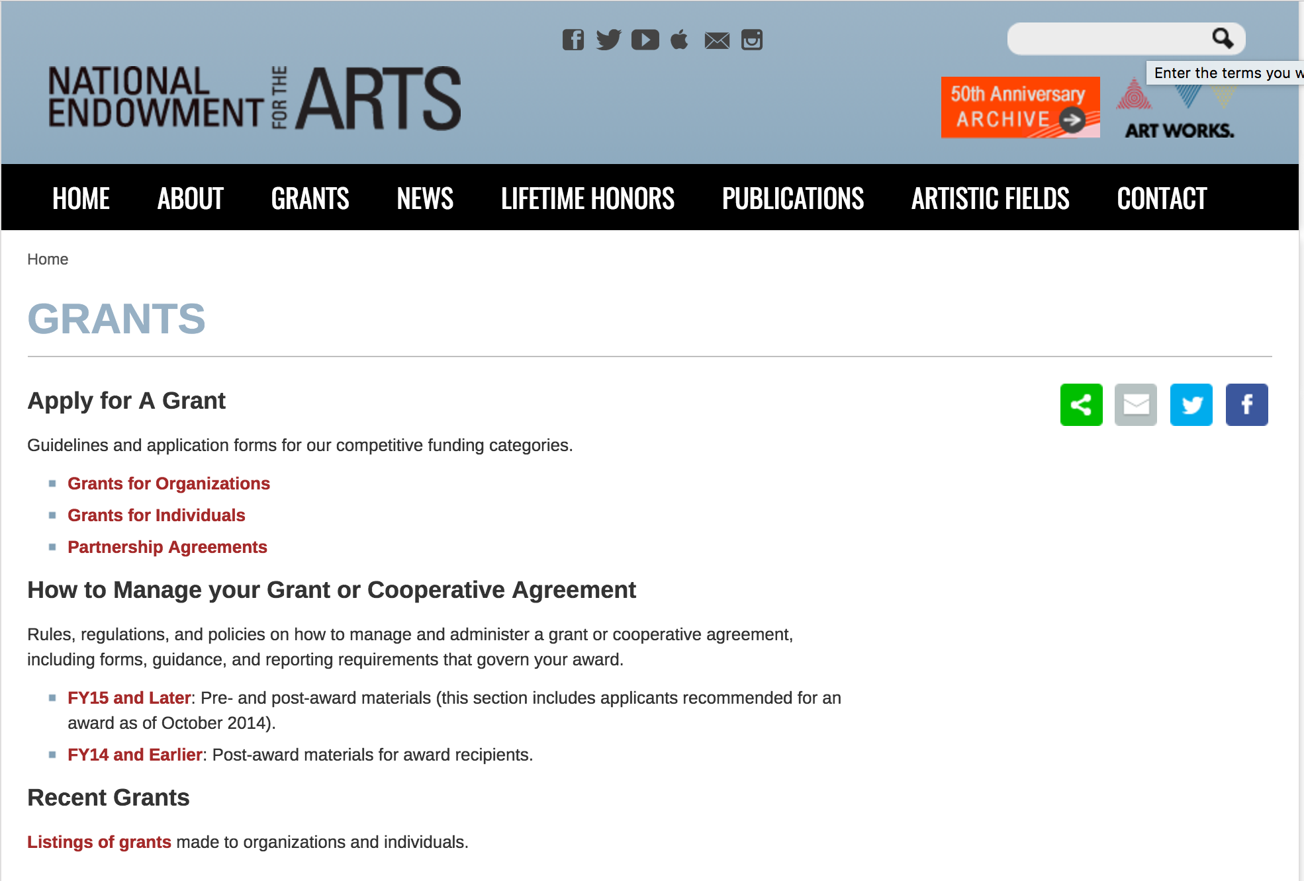

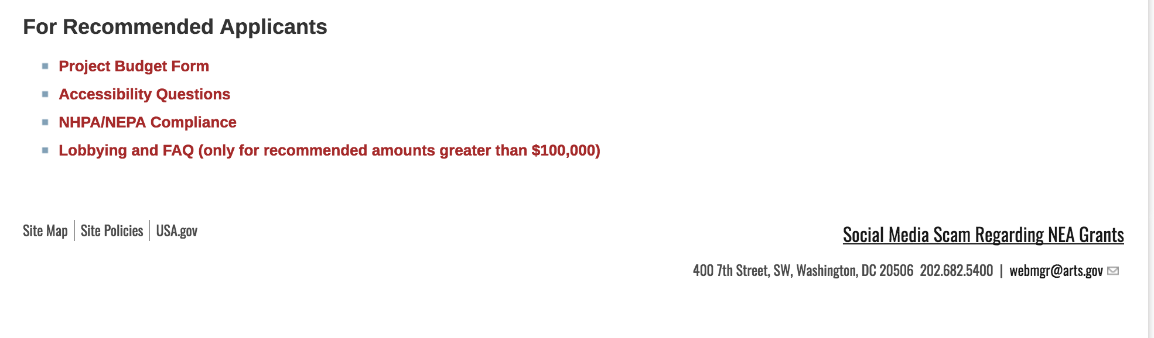
See more at: https://www.arts.gov/grants

Programs:

NEA Art Works 1, FY2020
Synopsis 1
Document Type: | Grants Notice
Funding Opportunity Number: | 2019NEA01AW1
Funding Opportunity Title: | NEA Art Works 1, FY2020
Opportunity Category: | Discretionary
Opportunity Category Explanation:
Funding Instrument Type: | Grant
Category of Funding Activity: | Arts (see "Cultural Affairs" in CFDA)
Category Explanation:
Expected Number of Awards:
CFDA Number(s): | 45.024 -- Promotion of the Arts Grants to Organizations and Individuals
Cost Sharing or Matching Requirement: | Yes
Version: | Synopsis 1
Posted Date: | Dec 11, 2018
Last Updated Date: | Dec 11, 2018
Original Closing Date for Applications: | Feb 14, 2019
Current Closing Date for Applications: | Feb 14, 2019
Archive Date:
Estimated Total Program Funding:
Award Ceiling: | $100,000
Award Floor: | $10,000
Eligible Applicants: | Public and State controlled institutions of higher education  State governments  County governments  Special district governments  Private institutions of higher education  City or township governments  Independent school districts  Nonprofits having a 501(c)(3) status with the IRS, other than institutions of higher education  Native American tribal governments (Federally recognized)
Additional Information on Eligibility:
Additional Information
Agency Name: | National Endowment for the Arts
Description: | Grant Program Description “The Arts . . . belong to all the people of the United States” * Art Works is the National Endowment for the Arts’ principal grants program. Through project-based funding, we support public engagement with, and access to, various forms of excellent art across the nation, the creation of art that meets the highest standards of excellence, learning in the arts at all stages of life, and the integration of the arts into the fabric of community life. Projects may be large or small, existing or new, and may take place in any part of the nation’s 50 states, the District of Columbia, and U.S. territories. We encourage applications for artistically excellent projects that address any of the following activities below: •Honor the 2020 centennial of women’s voting rights in the United States (aka the Women’s Suffrage Centennial). •Engage with Historically Black Colleges and Universities (HBCUs); Hispanic or Latino organizations; or the Native American, Alaskan Native, and Native Hawaiian arts. •Celebrate America’s creativity and cultural heritage. •Invite a dialogue that fosters a mutual respect for the diverse beliefs and values of all persons and groups. •Enrich our humanity by broadening our understanding of ourselves as individuals and as a society.
Link to Additional Information: | NEA Web Site Announcement
Grantor Contact Information: | If you have difficulty accessing the full announcement electronically, please contact:  NEA Web Manager webmgr@arts.gov  NEA Web Manager
https://www.grants.gov/web/grants/view-opportunity.html?oppId=311054

NEA Challenge America, FY2020
Synopsis 1
Document Type: | Grants Notice
Funding Opportunity Number: | 2019NEA01CA
Funding Opportunity Title: | NEA Challenge America, FY2020
Opportunity Category: | Discretionary
Opportunity Category Explanation:
Funding Instrument Type: | Grant
Category of Funding Activity: | Arts (see "Cultural Affairs" in CFDA)
Category Explanation:
Expected Number of Awards:
CFDA Number(s): | 45.024 -- Promotion of the Arts Grants to Organizations and Individuals
Cost Sharing or Matching Requirement: | Yes
Version: | Synopsis 1
Posted Date: | Dec 11, 2018
Last Updated Date: | Dec 11, 2018
Original Closing Date for Applications: | Apr 11, 2019
Current Closing Date for Applications: | Apr 11, 2019
Archive Date:
Estimated Total Program Funding:
Award Ceiling: | $10,000
Award Floor: | $10,000
Eligible Applicants: | State governments  Independent school districts  Public and State controlled institutions of higher education  Native American tribal governments (Federally recognized)  City or township governments  Special district governments  Private institutions of higher education  County governments  Nonprofits having a 501(c)(3) status with the IRS, other than institutions of higher education
Additional Information on Eligibility:
Additional Information
Agency Name: | National Endowment for the Arts
Description: | - An organization that applies to the Challenge America category, may not submit another application to the Art Works category. – You may apply to other National Endowment for the Arts funding opportunities, including Our Town, in addition to Challenge America. In each case, the request must be for a distinctly different project or a distinctly different phase of the same project, with a different period of performance and costs. - The Arts Endowment's support of a project may start on or after January 1, 2020. Grants awarded under these guidelines generally may cover a period of performance of up to two years. An organization that has received Challenge America grants in FY 2017, 2018, and 2019 may not apply for a Challenge America grant under these FY 2020 guidelines. That organization may apply for FY 2020 support under other National Endowment for the Arts funding opportunities including Art Works. Program Description The Challenge America category offers support primarily to small and mid-sized organizations for projects that extend the reach of the arts to underserved populations -- those whose opportunities to experience the arts are limited by geography, ethnicity, economics, or disability. Age alone (e.g., youth, seniors) does not qualify a group as underserved; at least one of the underserved characteristics noted above also must be present. Please provide details about the underserved audience you select in your application using relevant statistics and anecdotal information. Proposals should detail the efforts made to reach the identified underserved population. Grants are available for professional arts programming and for projects that emphasize the potential of the arts in community development.
Link to Additional Information: | NEA Web Site Announcement
Grantor Contact Information: | If you have difficulty accessing the full announcement electronically, please contact:  NEA Web Manager webmgr@arts.gov  NEA Web Manager
https://www.grants.gov/web/grants/view-opportunity.html?oppId=311056

Modifications:

Reminders:

NEA Literature Fellowships: Prose, FY2020
Synopsis 2
Document Type: | Grants Notice
Funding Opportunity Number: | 2019NEA03LFCW
Funding Opportunity Title: | NEA Literature Fellowships: Prose, FY2020
Opportunity Category: | Discretionary
Opportunity Category Explanation:
Funding Instrument Type: | Grant
Category of Funding Activity: | Arts (see "Cultural Affairs" in CFDA)
Category Explanation:
Expected Number of Awards:
CFDA Number(s): | 45.024 -- Promotion of the Arts Grants to Organizations and Individuals
Cost Sharing or Matching Requirement: | No
Version: | Synopsis 2
Posted Date: | Dec 04, 2018
Last Updated Date: | Dec 04, 2018
Original Closing Date for Applications: | Mar 06, 2019
Current Closing Date for Applications: | Mar 06, 2019
Archive Date:
Estimated Total Program Funding:
Award Ceiling: | $25,000
Award Floor: | $25,000
Eligible Applicants: | Individuals
Additional Information on Eligibility:
Additional Information
Agency Name: | National Endowment for the Arts
Description: | •The Arts Endowment’s support of a project may begin any time between January 1, 2020, and January 1, 2021 and extend for up to two years. •You may submit only one application for FY 2020 funding. You may not apply for a Literature Fellowship under this deadline and a Translation Project under the December 5, 2018 deadline Grant Program Description The National Endowment for the Arts Literature Fellowships program offers $25,000 grants in prose (fiction and creative nonfiction) and poetry to published creative writers that enable recipients to set aside time for writing, research, travel, and general career advancement. Applications are reviewed through an anonymous process in which the only criteria for review are artistic excellence and artistic merit. To review the applications, the National Endowment for the Arts assembles a different advisory panel every year, each diverse with regard to geography, race and ethnicity, and artistic points of view. .
Link to Additional Information: | NEA Web Site Announcement
Grantor Contact Information: | If you have difficulty accessing the full announcement electronically, please contact:  NEA Web Manager webmgr@arts.gov  NEA Web Manager
https://www.grants.gov/web/grants/view-opportunity.html?oppId=310834

NEA Performing Arts Discovery, FY2019
Synopsis 1

Document Type: | Grants Notice
Funding Opportunity Number: | NEAPS1807
Funding Opportunity Title: | NEA Performing Arts Discovery, FY2019
Opportunity Category: | Discretionary
Opportunity Category Explanation:
Funding Instrument Type: | Grant
Category of Funding Activity: | Arts (see "Cultural Affairs" in CFDA)
Category Explanation:
Expected Number of Awards:
CFDA Number(s): | 45.024 -- Promotion of the Arts Grants to Organizations and Individuals
Cost Sharing or Matching Requirement: | Yes
Version: | Synopsis 1
Posted Date: | Nov 06, 2018
Last Updated Date: | Nov 06, 2018
Original Closing Date for Applications: | Jan 15, 2019 The Grants.gov system must receive your validated and accepted application no later than 11:59 p.m., Eastern Time, on January 15, 2019. We strongly recommend that you submit your application by January 5, 2019 to give yourself ample time to resolve any problems that you might encounter.
Current Closing Date for Applications: | Jan 15, 2019 The Grants.gov system must receive your validated and accepted application no later than 11:59 p.m., Eastern Time, on January 15, 2019. We strongly recommend that you submit your application by January 5, 2019 to give yourself ample time to resolve any problems that you might encounter.
Archive Date: | Feb 14, 2019
Estimated Total Program Funding:
Award Ceiling: | $100,000
Award Floor: | $100,000
Eligible Applicants: | Nonprofits having a 501(c)(3) status with the IRS, other than institutions of higher education
Additional Information on Eligibility: | U.S. Regional Arts Organizations
Additional Information
Agency Name: | National Endowment for the Arts
Description: | An organization may submit only one proposal under this program solicitation.  The NEA’s support may begin no earlier than June 1, 2019, and may extend for up to 30 months.  Program Description  Through grants with other funders, the National Endowment for the Arts (NEA) has a long history of bringing the benefits of international exchange to audiences, artists, and arts organizations nationwide. For many years, however, there have been limited opportunities for foreign arts presenters to come to the U.S. and see artists at events in geographically diverse areas of our country. Programs such as these are important because they create new markets for working artists, expand mutual understanding, and raise the profile of each participating U.S. region and country.  To address this ongoing gap, the NEA’s Performing Arts Discovery program supports U.S. Regional Arts Organizations (RAOs) to undertake performing arts platforms in their region that will showcase the work of U.S. performing artists for presenters1 based outside of this country.
Link to Additional Information: | https://www.arts.gov/program-solicitation-performing-arts-discovery-2019
Grantor Contact Information: | If you have difficulty accessing the full announcement electronically, please contact:  If you have questions about programmatic requirements, contact: Michael Orlove, NEA Director of Presenting & Multidisciplinary Works, Artist Communities, and International Activities 202-682-5469 or orlovem@arts.gov If you have questions about award administration, contact: Nicki Jacobs NEA Director of Grants Management 202/682-5403 jacobsn@arts.gov  NEA Web Manager
https://www.grants.gov/web/grants/view-opportunity.html?oppId=310221

NEA Performing Arts Global Exchange, FY2019
Synopsis 1
Document Type: | Grants Notice
Funding Opportunity Number: | NEAPS1805
Funding Opportunity Title: | NEA Performing Arts Global Exchange, FY2019
Opportunity Category: | Discretionary
Opportunity Category Explanation:
Funding Instrument Type: | Cooperative Agreement
Category of Funding Activity: | Arts (see "Cultural Affairs" in CFDA)
Category Explanation:
Expected Number of Awards:
CFDA Number(s): | 45.024 -- Promotion of the Arts Grants to Organizations and Individuals
Cost Sharing or Matching Requirement: | Yes
Version: | Synopsis 1
Posted Date: | Nov 06, 2018
Last Updated Date: | Nov 06, 2018
Original Closing Date for Applications: | Jan 15, 2019 The Grants.gov system must receive your validated and accepted application no later than 11:59 p.m., Eastern Time, on January 15, 2019. We strongly recommend that you submit your application by January 5, 2019 to give yourself ample time to resolve any problems that you might encounter.
Current Closing Date for Applications: | Jan 15, 2019 The Grants.gov system must receive your validated and accepted application no later than 11:59 p.m., Eastern Time, on January 15, 2019. We strongly recommend that you submit your application by January 5, 2019 to give yourself ample time to resolve any problems that you might encounter.
Archive Date: | Feb 14, 2019
Estimated Total Program Funding:
Award Ceiling: | $300,000
Award Floor: | $300,000
Eligible Applicants: | Nonprofits having a 501(c)(3) status with the IRS, other than institutions of higher education
Additional Information on Eligibility:
Additional Information
Agency Name: | National Endowment for the Arts
Description: | The National Endowment for the Arts (NEA) aims to increase access to quality international arts programming throughout the U.S and to promote a greater understanding of other cultures through the arts.  Through the Performing Arts Global Exchange (PAGE) program, a Cooperator will award subgrants to nonprofit presenting organizations that book artists from an NEA-approved roster of international performing artists or ensembles for performances in the U.S. An emphasis will be placed on funding engagements in underserved communities that have limited access to this type of artistic work. All funded engagements will be required to include public performances and activities that provide audiences with direct interaction with the visiting artists.  Award support for initiatives and programs such as PAGE are competed by the NEA on a regular basis. Through this Program Solicitation, the NEA is seeking to enter into a Cooperative Agreement with a U.S. Regional Arts Organization (RAO) to administer the 2020-21 cycle of PAGE. Together with the Cooperator, the NEA will identify eligible countries of a chosen region of the world (e.g., North Africa, Southeast Asia, Nordic countries) to highlight biennially.
Link to Additional Information: | https://www.arts.gov/program-solicitation-performing-arts-global-exchange
Grantor Contact Information: | If you have difficulty accessing the full announcement electronically, please contact:  If you have questions about programmatic requirements, contact: Michael Orlove, NEA Director of Presenting & Multidisciplinary Works, Artist Communities, and International Activities 202-682-5469 or orlovem@arts.gov If you have questions about award administration, contact: Nicki Jacobs NEA Director of Grants Management 202/682-5403 jacobsn@arts.gov  NEA Web Manager
https://www.grants.gov/web/grants/view-opportunity.html?oppId=310219

NEA Shakespeare in American Communities, FY2019
Synopsis 1
Document Type: | Grants Notice
Funding Opportunity Number: | NEAPS1808
Funding Opportunity Title: | NEA Shakespeare in American Communities, FY2019
Opportunity Category: | Discretionary
Opportunity Category Explanation:
Funding Instrument Type: | Grant
Category of Funding Activity: | Arts (see "Cultural Affairs" in CFDA)
Category Explanation:
Expected Number of Awards: | 30
CFDA Number(s): | 45.024 -- Promotion of the Arts Grants to Organizations and Individuals
Cost Sharing or Matching Requirement: | Yes
Version: | Synopsis 1
Posted Date: | Nov 06, 2018
Last Updated Date: | Nov 06, 2018
Original Closing Date for Applications: | Jan 15, 2019 The Grants.gov system must receive your validated and accepted application no later than 11:59 p.m., Eastern Time, on January 15, 2019. We strongly recommend that you submit your application by January 5, 2019 to give yourself ample time to resolve any problems that you might encounter.
Current Closing Date for Applications: | Jan 15, 2019 The Grants.gov system must receive your validated and accepted application no later than 11:59 p.m., Eastern Time, on January 15, 2019. We strongly recommend that you submit your application by January 5, 2019 to give yourself ample time to resolve any problems that you might encounter.
Archive Date: | Feb 14, 2019
Estimated Total Program Funding:
Award Ceiling: | $1,482,000
Award Floor: | $1,482,000
Eligible Applicants: | Nonprofits having a 501(c)(3) status with the IRS, other than institutions of higher education
Additional Information on Eligibility: | U.S. Regional Arts Organizations
Additional Information
Agency Name: | National Endowment for the Arts
Description: | An organization may submit only one proposal under this program.  The NEA’s support may begin no earlier than June 1, 2019, and may extend for up to 30 months.  Program Description  A program of the National Endowment for the Arts (NEA), Shakespeare in American Communities (SIAC) brings professional performances of Shakespeare’s plays and related educational activities to middle and high school students in communities across the United States. For many students, these performances may be their first experience with live, professional theater—as well as their first interaction with the works of Shakespeare. Since SIAC’s inception in 2003, approximately 2.5 million students have participated in the program.  The NEA seeks to award a grant to a U.S. Regional Arts Organization (RAO) to administer the SIAC program for the 2020-2021 school year. NEA funds will support program management expenses as well as subgrants to participating theater companies.
Link to Additional Information: | https://www.arts.gov/national-initiatives/shakespeare-american-communities-administration
Grantor Contact Information: | If you have difficulty accessing the full announcement electronically, please contact:  If you have questions about programmatic requirements, contact: Greg Reiner, NEA Director of Theater and Musical Theater 202-682-5482 or reinerg@arts.gov If you have questions about award administration, contact: Nicki Jacobs NEA Director of Grants Management 202/682-5403 jacobsn@arts.gov  NEA Web Manager
https://www.grants.gov/web/grants/view-opportunity.html?oppId=310164

NEA USArtists International, FY2019
Synopsis 1
Document Type: | Grants Notice
Funding Opportunity Number: | NEAPS1806
Funding Opportunity Title: | NEA USArtists International, FY2019
Opportunity Category: | Discretionary
Opportunity Category Explanation:
Funding Instrument Type: | Cooperative Agreement
Category of Funding Activity: | Arts (see "Cultural Affairs" in CFDA)
Category Explanation:
Expected Number of Awards:
CFDA Number(s): | 45.024 -- Promotion of the Arts Grants to Organizations and Individuals
Cost Sharing or Matching Requirement: | Yes
Version: | Synopsis 1
Posted Date: | Nov 06, 2018
Last Updated Date: | Nov 06, 2018
Original Closing Date for Applications: | Jan 15, 2019 The Grants.gov system must receive your validated and accepted application no later than 11:59 p.m., Eastern Time, on January 15, 2019. We strongly recommend that you submit your application by January 5, 2019 to give yourself ample time to resolve any problems that you might encounter.
Current Closing Date for Applications: | Jan 15, 2019 The Grants.gov system must receive your validated and accepted application no later than 11:59 p.m., Eastern Time, on January 15, 2019. We strongly recommend that you submit your application by January 5, 2019 to give yourself ample time to resolve any problems that you might encounter.
Archive Date: | Feb 14, 2019
Estimated Total Program Funding:
Award Ceiling: | $435,000
Award Floor: | $435,000
Eligible Applicants: | Nonprofits having a 501(c)(3) status with the IRS, other than institutions of higher education
Additional Information on Eligibility: | U.S. Regional Arts Organizations
Additional Information
Agency Name: | National Endowment for the Arts
Description: | An organization may submit only one proposal under this program solicitation.  Project activities may begin on or after June 1, 2019, and may extend for up to 24 months.  Program Description  The National Endowment for the Arts (NEA) has a long history of supporting the participation of artists from the U.S. at international festivals abroad. Since 2004, this commitment has been carried out through USArtists International (USAI), a NEA program undertaken in partnership with a U.S. Regional Arts Organization (RAO).  USAI supports performances by U.S. artists at important cultural festivals and arts marketplaces outside of the U.S. and its jurisdictions. The program aims to extend the reach and impact of performing artists and their accomplishments globally. USAI subgrants may support costs such as artist fees, travel, housing, per diem, shipping, and visa preparation.  Award support for initiatives and programs such as USAI are competed by the NEA on a regular basis. Through this Program Solicitation, the NEA is seeking to enter into a Cooperative Agreement with a RAO to administer the 2020-2021 cycle of the USAI program.
Link to Additional Information: | https://www.arts.gov/program-solicitation-usartists-international
Grantor Contact Information: | If you have difficulty accessing the full announcement electronically, please contact:  If you have questions about programmatic requirements, contact: Michael Orlove, NEA Director of Presenting & Multidisciplinary Works, Artist Communities, and International Activities 202-682-5469 or orlovem@arts.gov If you have questions about award administration, contact: Nicki Jacobs NEA Director of Grants Management 202/682-5403 jacobsn@arts.gov  NEA Web Manager
https://www.grants.gov/web/grants/view-opportunity.html?oppId=310220

National Endowment for the Humanities

Grant Overview -

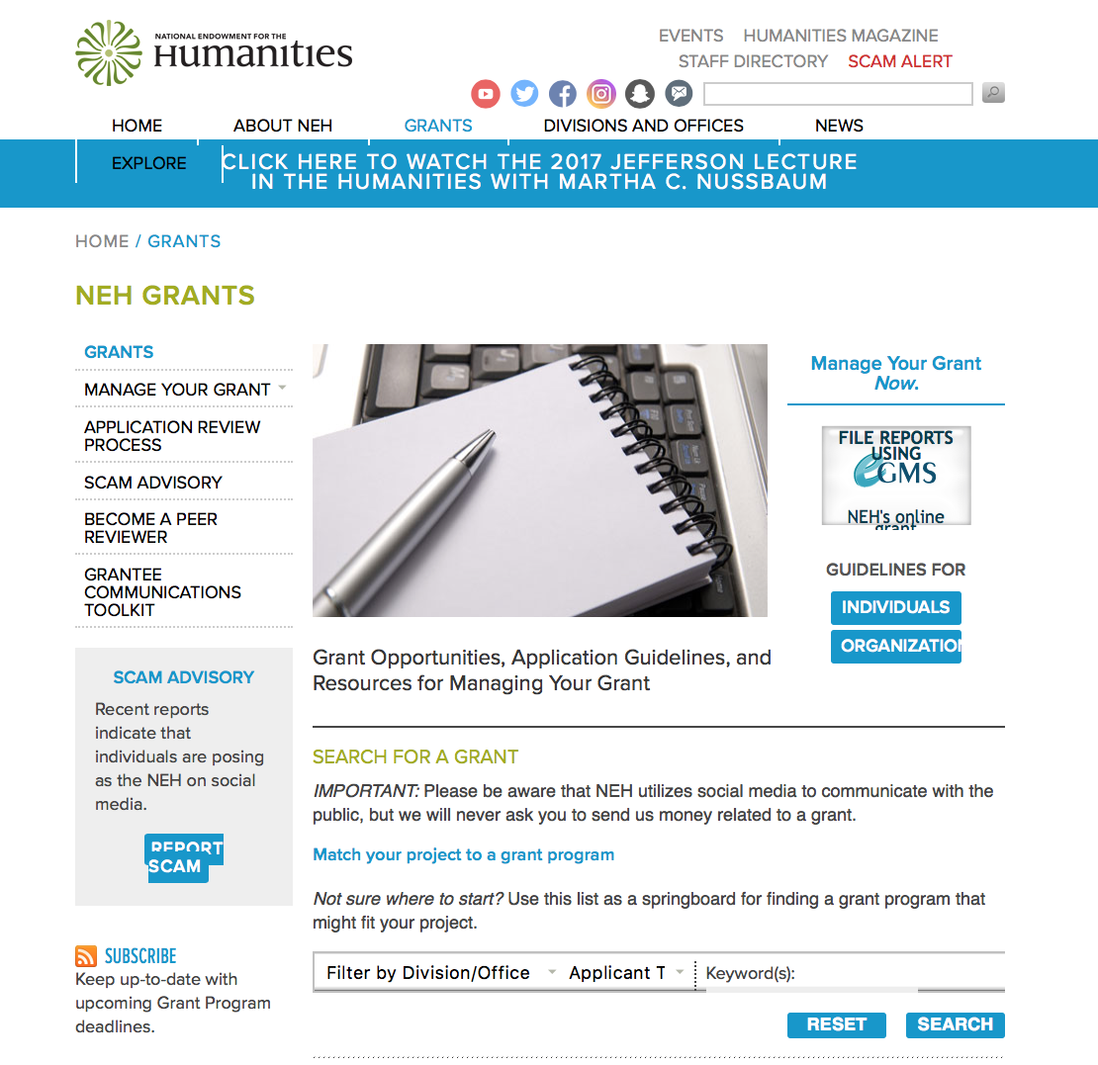

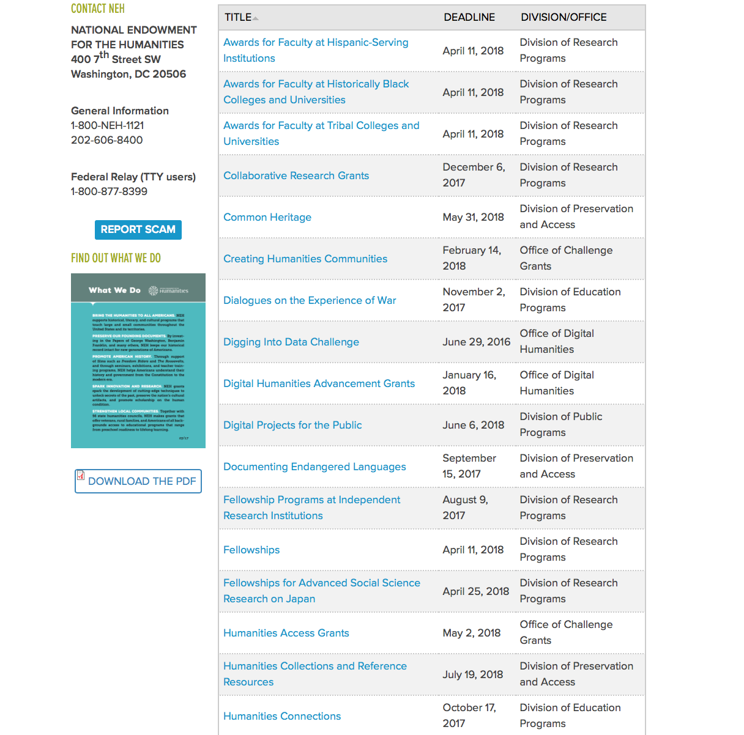

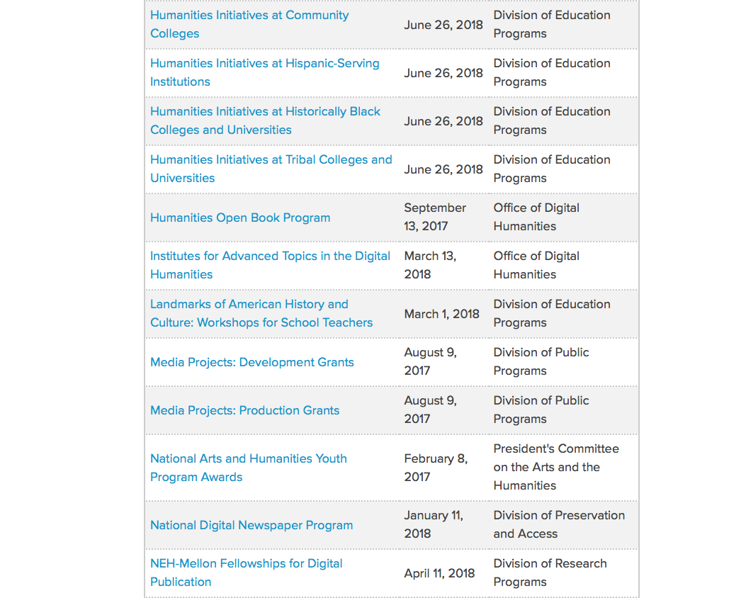

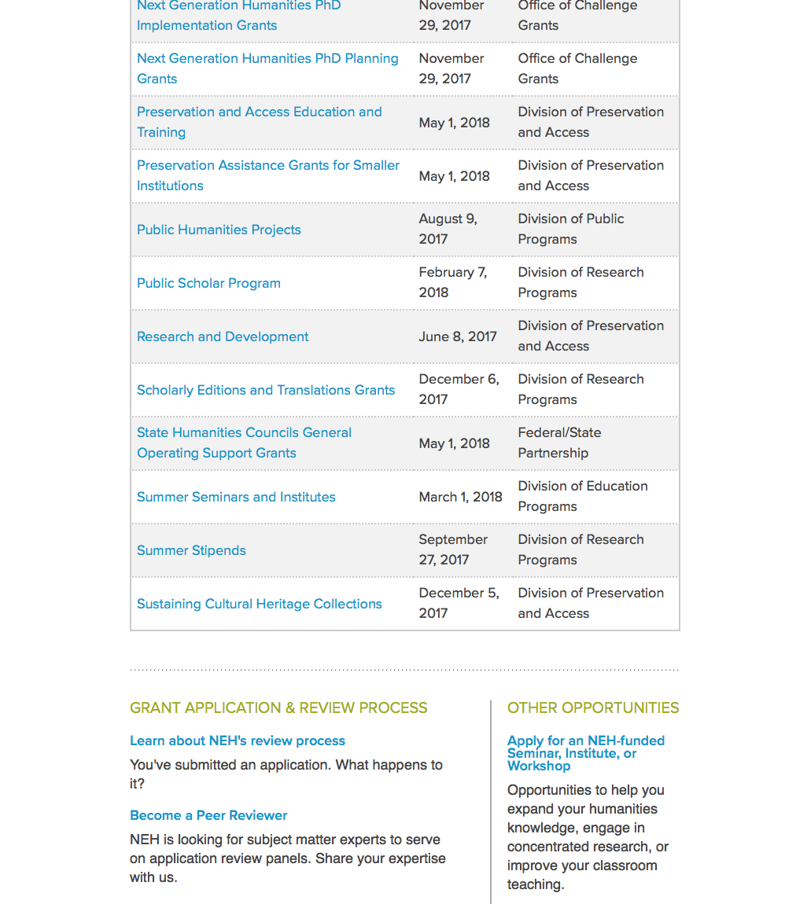

https://www.neh.gov/grants

Programs:

Landmarks of American History and Culture: Workshops for School Teachers
Synopsis 1
Document Type: | Grants Notice
Funding Opportunity Number: | 20190221-BH
Funding Opportunity Title: | Landmarks of American History and Culture: Workshops for School Teachers
Opportunity Category: | Discretionary
Opportunity Category Explanation:
Funding Instrument Type: | Grant
Category of Funding Activity: | Humanities (see "Cultural Affairs" in CFDA)
Category Explanation:
Expected Number of Awards:
CFDA Number(s): | 45.163 -- Promotion of the Humanities Professional Development
Cost Sharing or Matching Requirement: | No
Version: | Synopsis 1
Posted Date: | Dec 21, 2018
Last Updated Date: | Dec 21, 2018
Original Closing Date for Applications: | Feb 21, 2019
Current Closing Date for Applications: | Feb 21, 2019
Archive Date:
Estimated Total Program Funding:
Award Ceiling: | $170,000
Award Floor: | $1
Eligible Applicants: | Native American tribal governments (Federally recognized)  County governments  Special district governments  Nonprofits having a 501(c)(3) status with the IRS, other than institutions of higher education  Private institutions of higher education  Public and State controlled institutions of higher education  City or township governments  State governments
Additional Information on Eligibility:
Additional Information
Agency Name: | National Endowment for the Humanities
Description: | The Landmarks of American History and Culture program supports a series of one-week workshops for K-12 educators across the nation that enhance and strengthen humanities teaching at the K-12 level. The program defines a landmark as a site of historic importance within the United States and its territories that offers educators a unique and compelling opportunity to deepen and expand their knowledge of the diverse histories, cultures, traditions, languages, and perspectives of the American people. Projects employ a place-based approach, teaching historic sites through critical interpretation in order to explore central themes in American history and government, as well as in literature, art, music, and related humanities subjects. Each workshop must accommodate thirty-six participants (NEH Summer Scholars) and must be offered twice during the summer (for a total of seventy-two participants). The content, presenters, site visits, activities, and readings should be substantially the same in each week. Workshops may be hosted by institutions such as community colleges, universities, four-year colleges, learned societies, libraries or other repositories, centers for advanced study, cultural organizations, professional associations, and schools or school systems. Host institutions provide facilities and arrange for accommodations for participants, who receive a stipend. NEH expects host institutions to furnish facilities conducive to scholarly engagement with topics and sites.
Link to Additional Information: | https://www.neh.gov/grants/education/landmarks-american-history-and-culture-workshops-school-teachers
Grantor Contact Information: | If you have difficulty accessing the full announcement electronically, please contact:  Landmarks of American History and Culture: Workshops for School Teachers Division of Education Programs National Endowment for the Humanities 400 Seventh Street, SW Washington, DC 20506 202-606-8500 landmarks@neh.gov landmarks@neh.gov  landmarks@neh.gov
https://www.grants.gov/web/grants/view-opportunity.html?oppId=311517

Preservation Assistance Grants
Synopsis 1
Document Type: | Grants Notice
Funding Opportunity Number: | 20190131-PG
Funding Opportunity Title: | Preservation Assistance Grants
Opportunity Category: | Discretionary
Opportunity Category Explanation:
Funding Instrument Type: | Grant
Category of Funding Activity: | Humanities (see "Cultural Affairs" in CFDA)
Category Explanation:
Expected Number of Awards:
CFDA Number(s): | 45.149 -- Promotion of the Humanities Division of Preservation and Access
Cost Sharing or Matching Requirement: | No
Version: | Synopsis 1
Posted Date: | Dec 07, 2018
Last Updated Date: | Dec 07, 2018
Original Closing Date for Applications: | Jan 31, 2019
Current Closing Date for Applications: | Jan 31, 2019
Archive Date:
Estimated Total Program Funding:
Award Ceiling: | $15,000
Award Floor: | $1
Eligible Applicants: | City or township governments  Special district governments  Native American tribal governments (Federally recognized)  Private institutions of higher education  County governments  Nonprofits having a 501(c)(3) status with the IRS, other than institutions of higher education  State governments  Public and State controlled institutions of higher education
Additional Information on Eligibility:
Additional Information
Agency Name: | National Endowment for the Humanities
Description: | Preservation Assistance Grants help small and mid-sized institutions—such as libraries, museums, historical societies, archival repositories, cultural organizations, town and county records offices, and colleges and universities—improve their ability to preserve and care for their significant humanities collections. These may include special collections of books and journals, archives and manuscripts, prints and photographs, moving images, sound recordings, architectural and cartographic records, decorative and fine art objects, textiles, archaeological and ethnographic artifacts, furniture, historical objects, and digital materials. Applicants must draw on the knowledge of consultants whose preservation skills and experience are related to the types of collections and the nature of the activities on which their projects focus. Within the conservation field, for example, conservators usually specialize in the care of specific types of collections, such as objects, paper, or paintings. Applicants should therefore choose a conservator whose specialty is appropriate for the nature of their collections. Similarly, when assessing the preservation needs of library, museum, or archival holdings, applicants should seek a consultant specifically knowledgeable about the preservation of collections in these types of institutions. The program encourages applications from the following sorts of institutions with significant humanities collections: • small and mid-sized institutions that have never received an NEH grant; • community colleges, Hispanic-serving institutions, Historically Black Colleges and Universities, and Tribal Colleges and Universities; and • Native American tribes and Native Alaskan and Native Hawaiian organizations. The program also encourages applications for the following activities: • consultants working as mentors with advanced students or recent graduates from preservation programs to provide emerging preservation professionals with practical experience. Advanced students and recent graduates may assist in conducting preservation assessments, addressing specific preservation issues, and/or training staff at the applicant institution. • the development of disaster plans and collaborative work with local institutions for training in disaster preparedness and emergency response to address the risk to cultural heritage materials from natural disasters, theft, and other types of damage. • disaster planning, response, recovery, and mitigation; preservation assessments; conservation treatments; temporary relocation and storage of collections; purchase of supplies; education and training related to disaster planning and response; and reformatting of collections as a preservation methodology for institutions in federally declared disaster areas.
Link to Additional Information: | https://www.neh.gov/grants/preservation/preservation-assistance-grants-smaller-institutions
Grantor Contact Information: | If you have difficulty accessing the full announcement electronically, please contact:  Division of Preservation and Access National Endowment for the Humanities 400 Seventh Street, SW Washington, DC 20506 202-606-8570 preservation@neh.gov preservation@neh.gov  preservation@neh.gov

https://www.grants.gov/web/grants/view-opportunity.html?oppId=310934

Public Scholar Program
Synopsis 1
Document Type: | Grants Notice
Funding Opportunity Number: | 20190206-FZ
Funding Opportunity Title: | Public Scholar Program
Opportunity Category: | Discretionary
Opportunity Category Explanation:
Funding Instrument Type: | Grant
Category of Funding Activity: | Humanities (see "Cultural Affairs" in CFDA)
Category Explanation:
Expected Number of Awards:
CFDA Number(s): | 45.160 -- Promotion of the Humanities Fellowships and Stipends
Cost Sharing or Matching Requirement: | No
Version: | Synopsis 1
Posted Date: | Dec 10, 2018
Last Updated Date: | Dec 10, 2018
Original Closing Date for Applications: | Feb 06, 2019
Current Closing Date for Applications: | Feb 06, 2019
Archive Date:
Estimated Total Program Funding:
Award Ceiling: | $60,000
Award Floor: | $30,000
Eligible Applicants: | Individuals
Additional Information on Eligibility:
Additional Information
Agency Name: | National Endowment for the Humanities
Description: | The Public Scholar Program supports the creation of well-researched books in the humanities intended to reach a broad readership. Some humanities scholarship is necessarily specialized, but the humanities can also engage broad audiences in exploring subjects of general interest. Such scholarship might present a narrative history, tell the stories of important individuals, analyze significant texts, provide a synthesis of ideas, revive interest in a neglected subject, or examine the latest thinking on a topic. Books supported by this program must be grounded in humanities research and scholarship, making appropriate use of primary and/or secondary sources. They must also be written in a readily accessible style, addressing significant humanities themes in a way that will appeal to a large audience of general readers. Applications to write books directed primarily to scholars are not appropriate for this program. Applicants may seek support for the creation of digital or Web-based products intended to supplement the book that they propose. By establishing the Public Scholar Program, NEH has entered a long-term commitment to encourage scholarship in the humanities for general audiences. The program is open to both individuals affiliated with scholarly institutions and to independent scholars, researchers, and writers. Projects may be at any stage of development.
Link to Additional Information: | https://www.neh.gov/grants/research/public-scholar-program
Grantor Contact Information: | If you have difficulty accessing the full announcement electronically, please contact:  Division of Research Programs National Endowment for the Humanities Washington, DC 20506 202-606-8200 publicscholar@neh.gov publicscholar@neh.gov  publicscholar@neh.gov
https://www.grants.gov/web/grants/view-opportunity.html?oppId=310953
Summer Seminars and Institutes for Higher Education Faculty
Synopsis 1
Document Type: | Grants Notice
Funding Opportunity Number: | 20190221-FS
Funding Opportunity Title: | Summer Seminars and Institutes for Higher Education Faculty
Opportunity Category: | Discretionary
Opportunity Category Explanation:
Funding Instrument Type: | Grant
Category of Funding Activity: | Humanities (see "Cultural Affairs" in CFDA)
Category Explanation:
Expected Number of Awards:
CFDA Number(s): | 45.163 -- Promotion of the Humanities Professional Development
Cost Sharing or Matching Requirement: | No
Version: | Synopsis 1
Posted Date: | Dec 13, 2018
Last Updated Date: | Dec 13, 2018
Original Closing Date for Applications: | Feb 21, 2019
Current Closing Date for Applications: | Feb 21, 2019
Archive Date:
Estimated Total Program Funding:
Award Ceiling: | $200,000
Award Floor: | $1
Eligible Applicants: | Nonprofits having a 501(c)(3) status with the IRS, other than institutions of higher education  Special district governments  State governments  County governments  City or township governments  Native American tribal governments (Federally recognized)  Public and State controlled institutions of higher education  Private institutions of higher education
Additional Information on Eligibility:
Additional Information
Agency Name: | National Endowment for the Humanities
Description: | NEH Summer Seminars and Institutes for Higher Education Faculty provide higher education faculty across the nation the opportunity to broaden and deepen their engagement with the humanities. The one- to four-week professional development programs allow participants (NEH Summer Scholars) to explore recent developments in scholarship, teaching, and/or curriculum through study of a variety of humanities topics. NEH Summer Seminars and Institutes • focus on the study and teaching of significant texts and other resources; • provide models of excellent scholarship and teaching; • contribute to the intellectual growth of the participants; and • build lasting communities of intellectual and professional collaboration. A program may take place at a college, university, learned society, center for advanced study, library or other repository, cultural or professional organization, or school or school system. The host site must provide facilities for collegial interaction and scholarship. The program must be held only in the United States and its territories. Seminars and Institutes are generally designed for a broad and diverse group of higher education faculty. Individual projects may target a more focused group of participants or extend their reach to include those outside the humanities. Seminars A Seminar provides a focused environment in which sixteen participants study a humanities topic under the guidance of one or two established scholars. Seminars have few, if any, visiting faculty. Seminars emphasize close interaction among the participants and director(s) through discussion of common readings and conversations about scholarship and teaching. Substantial time is made available for reflection, work on independent or collaborative projects, and related advising. Institutes An Institute allows twenty-five to thirty-six participants to study a humanities topic with a team of experienced scholars. Because this larger format emphasizes the range of perspectives that can be brought to a topic, an institute typically has more and longer meetings per week than a seminar. Project leaders and participants mutually explore connections between scholarship and teaching, and some time is provided for work on individual or collaborative projects.
Link to Additional Information: | https://www.neh.gov/program/summer-seminars-and-institutes-higher-education-faculty
Grantor Contact Information: | If you have difficulty accessing the full announcement electronically, please contact:  Division of Education Programs National Endowment for the Humanities 400 Seventh Street, SW Washington, DC 20506 202-606-2324 sem-inst@neh.gov sem-inst@neh.gov  sem-inst@neh.gov
https://www.grants.gov/web/grants/view-opportunity.html?oppId=311154

Summer Seminars and Institutes for K-12 Educators
Synopsis 1
Document Type: | Grants Notice
Funding Opportunity Number: | 20190221-FV
Funding Opportunity Title: | Summer Seminars and Institutes for K-12 Educators
Opportunity Category: | Discretionary
Opportunity Category Explanation:
Funding Instrument Type: | Grant
Category of Funding Activity: | Humanities (see "Cultural Affairs" in CFDA)
Category Explanation:
Expected Number of Awards:
CFDA Number(s): | 45.163 -- Promotion of the Humanities Professional Development
Cost Sharing or Matching Requirement: | No
Version: | Synopsis 1
Posted Date: | Dec 13, 2018
Last Updated Date: | Dec 13, 2018
Original Closing Date for Applications: | Feb 21, 2019
Current Closing Date for Applications: | Feb 21, 2019
Archive Date:
Estimated Total Program Funding:
Award Ceiling: | $200,000
Award Floor: | $1
Eligible Applicants: | City or township governments  State governments  Private institutions of higher education  Public and State controlled institutions of higher education  Native American tribal governments (Federally recognized)  County governments  Nonprofits having a 501(c)(3) status with the IRS, other than institutions of higher education  Special district governments
Additional Information on Eligibility:
Additional Information
Agency Name: | National Endowment for the Humanities
Description: | NEH Summer Seminars and Institutes for K-12 Educators provide school teachers across the nation the opportunity to broaden and deepen their engagement with the humanities. One- to four-week residential programs, led by scholars and K-12 professionals, allow participants (NEH Summer Scholars) to study a variety of humanities topics. Seminars and Institutes focus on the intellectual quality of humanities education and address recent developments in scholarship, teaching, and/or curriculum. NEH Summer Seminars and Institutes • focus on the study and teaching of significant texts and other resources; • provide models of excellent scholarship and teaching; • contribute to the intellectual growth of the participants; and • build lasting communities of inquiry. A program may take place at a college, university, learned society, center for advanced study, library or other repository, cultural or professional organization, or school or school system. The host site must provide facilities for collegial interaction and scholarship. The program may be held only in the United States and its territories. Seminars and Institutes are open to the entire spectrum of K-12 educators. Individual projects target educators of one or more of the following grade ranges: K-5, 6-8, and/or 9-12. Seminars A Seminar provides a focused environment in which sixteen participants study a specific humanities topic under the guidance of one or two established scholars. Seminars have few, if any, visiting faculty. Seminars emphasize sustained interaction among the participants and director(s) through discussion of common readings and conversations about teaching. Substantial time is made available for reflection, work on independent projects, and related advising. Institutes An Institute allows twenty-five to thirty-six participants to study a humanities topic with a team of experienced scholars and K-12 professionals. Because this larger format emphasizes the range of perspectives that can be brought to the topic, an institute typically has more and longer meetings per week than a seminar. The participants and scholarly team mutually explore connections between scholarship and teaching, and some time is provided for work on individual or collaborative projects.
Link to Additional Information: | https://www.neh.gov/program/summer-seminars-and-institutes-k-12-educators
Grantor Contact Information: | If you have difficulty accessing the full announcement electronically, please contact:  Division of Education Programs National Endowment for the Humanities 400 Seventh Street, SW Washington, DC 20506 202-606-2324 sem-inst@neh.gov sem-inst@neh.gov  sem-inst@neh.gov
https://www.grants.gov/web/grants/view-opportunity.html?oppId=311153

Modifications:

Reminders:

National Digital Newspaper Program
Synopsis 1
Document Type: | Grants Notice
Funding Opportunity Number: | 20190115-PJ
Funding Opportunity Title: | National Digital Newspaper Program
Opportunity Category: | Discretionary
Opportunity Category Explanation:
Funding Instrument Type: | Cooperative Agreement
Category of Funding Activity: | Humanities (see "Cultural Affairs" in CFDA)
Category Explanation:
Expected Number of Awards:
CFDA Number(s): | 45.149 -- Promotion of the Humanities Division of Preservation and Access
Cost Sharing or Matching Requirement: | No
Version: | Synopsis 1
Posted Date: | Nov 20, 2018
Last Updated Date: | Nov 20, 2018
Original Closing Date for Applications: | Jan 15, 2019
Current Closing Date for Applications: | Jan 15, 2019
Archive Date:
Estimated Total Program Funding:
Award Ceiling: | $325,000
Award Floor: | $1
Eligible Applicants: | Nonprofits having a 501(c)(3) status with the IRS, other than institutions of higher education  Private institutions of higher education  County governments  State governments  Public and State controlled institutions of higher education  Special district governments  Native American tribal governments (Federally recognized)  City or township governments
Additional Information on Eligibility:
Additional Information
Agency Name: | National Endowment for the Humanities
Description: | The National Digital Newspaper Program (NDNP) is a partnership between NEH and the Library of Congress to create a national digital resource of historically significant newspapers published between 1690 and 1963, from all the states and U.S. territories. This searchable database will be permanently maintained at the Library of Congress (LC) and will be freely accessible via the Internet. (See the Chronicling America: Historic American Newspapers website.) An accompanying national newspaper directory of bibliographic and holdings information on the website directs users to newspaper titles available in all types of formats. During the course of its partnership with NEH, LC will also digitize and contribute to the NDNP database a significant number of newspaper pages drawn from its own collections. Forty-six states and one territory have joined the NDNP so far. Previous award recipients include Alabama, Alaska, Arizona, Arkansas, California, Colorado, Connecticut, Delaware, Florida, Georgia, Hawaii, Idaho, Illinois, Indiana, Iowa, Kansas, Kentucky, Louisiana, Maine, Maryland, Michigan, Minnesota, Mississippi, Missouri, Montana, Nebraska, Nevada, New Jersey, New Mexico, New York, North Carolina, North Dakota, Ohio, Oklahoma, Oregon, Pennsylvania, Puerto Rico, South Carolina, South Dakota, Tennessee, Texas, Utah, Vermont, Virginia, Washington, West Virginia, and Wisconsin. NEH intends to support projects in all states and U.S. territories. Awards are made to an organization within each U.S. state or territory, which typically collaborates with relevant state partners in this effort. After their initial NDNP awards, state partners are encouraged to seek second and third awards, to produce a total of approximately 300,000 pages of digitized newspapers per state. Awardees may receive support for continued work beyond the third award, but the program gives priority to applications from those states and territories that have not received NDNP funding—as well as applications from states and territories that have received fewer than three awards. Applications that involve collaboration between previously funded and new projects are also welcome. Such collaborations might involve, for example, arranging with current awardees to manage the creation and delivery of digital files; offering regular and ongoing consultation on managing aspects of the project; or providing formal training for project staff at an onsite institute or workshop. NDNP has supported such collaborations between the following partners: Arkansas and Mississippi; Florida and Puerto Rico; Louisiana and Mississippi; Minnesota and Iowa; Minnesota and North Dakota; Minnesota and South Dakota; Montana and Idaho; Texas and New Mexico; Texas and Oklahoma; and Virginia and West Virginia. Over a period of two years, successful applicants will select newspapers—published in their state or territory between 1690 and 1963—and convert approximately 100,000 pages into digital files (preferably from microfilm), according to the technical guidelines (PDF) outlined by the Library of Congress. Applicants may select only those titles that are confirmed to be in the public domain. For newspapers published after 1922, only those published without copyright or for which the copyright was not registered or renewed by 1963—in other words, only those considered to be in the public domain—are eligible for selection. Please note that awardees wishing to select titles for digitization that were published after 1922 must adhere to a condition of award according to which the recipient will indemnify the Library of Congress and NEH.
Link to Additional Information: | https://www.neh.gov/grants/preservation/national-digital-newspaper-program
Grantor Contact Information: | If you have difficulty accessing the full announcement electronically, please contact:  preservation@neh.gov 202-606-8570 National Digital Newspaper Program Division of Preservation and Access National Endowment for the Humanities 400 Seventh Street, SW Washington, DC 20506 preservation@neh.gov  preservation@neh.gov
https://www.grants.gov/web/grants/view-opportunity.html?oppId=310504
____________________________________________________________________________

Sustaining Cultural Heritage Collections
Synopsis 1
Document Type: | Grants Notice
Funding Opportunity Number: | 20190131-PF
Funding Opportunity Title: | Sustaining Cultural Heritage Collections
Opportunity Category: | Discretionary
Opportunity Category Explanation:
Funding Instrument Type: | Grant
Category of Funding Activity: | Humanities (see "Cultural Affairs" in CFDA)
Category Explanation:
Expected Number of Awards:
CFDA Number(s): | 45.149 -- Promotion of the Humanities Division of Preservation and Access
Cost Sharing or Matching Requirement: | No
Version: | Synopsis 1
Posted Date: | Nov 20, 2018
Last Updated Date: | Nov 20, 2018
Original Closing Date for Applications: | Jan 31, 2019
Current Closing Date for Applications: | Jan 31, 2019
Archive Date:
Estimated Total Program Funding:
Award Ceiling: | $350,000
Award Floor: | $1
Eligible Applicants: | City or township governments  Special district governments  Public and State controlled institutions of higher education  State governments  Native American tribal governments (Federally recognized)  County governments  Private institutions of higher education  Nonprofits having a 501(c)(3) status with the IRS, other than institutions of higher education
Additional Information on Eligibility:
Additional Information
Agency Name: | National Endowment for the Humanities
Description: | The Sustaining Cultural Heritage Collections (SCHC) program helps cultural institutions meet the complex challenge of preserving large and diverse holdings of humanities materials for future generations by supporting sustainable conservation measures that mitigate deterioration, prolong the useful life of collections, and support institutional resilience: the ability to anticipate and respond to disasters resulting from natural or human activity. Cultural institutions, including libraries, archives, museums, and historical organizations, face an enormous challenge: to preserve humanities collections that facilitate research, strengthen teaching, and provide opportunities for life-long learning. To ensure the preservation of books and manuscripts, photographs, sound recordings and moving images, archaeological and ethnographic artifacts, art, and historical objects, cultural institutions must implement measures that slow deterioration and prevent catastrophic loss from emergencies resulting from natural or human activity. They can accomplish this work most effectively through preventive conservation. Preventive conservation encompasses managing relative humidity, temperature, light, and pollutants in collection spaces; providing protective storage enclosures and systems for collections; and safeguarding collections from theft, fire, floods, and other disasters. As museums, libraries, archives, and other collecting institutions strive to be effective stewards of humanities collections, they must find ways to implement preventive conservation measures that are sustainable. This program therefore helps cultural repositories plan and implement preservation strategies that pragmatically balance effectiveness, cost, and environmental impact. Sustainable approaches to preservation can contribute to an institution’s financial health, reduce its use of fossil fuels, and benefit its green initiatives, while ensuring that collections are well cared for and available for use in humanities programming, education, and research. Sustainable preventive conservation measures may also aim to prepare and plan for, absorb, respond to, recover from, and more successfully protect collections in the event of emergencies resulting from natural or human activity. Effective and sustainable preservation strategies must be informed by the nature of an institution and its collections. Applicants should have completed the process of basic preservation planning and environmental monitoring, which might include a general preservation plan, collection inventory, emergency plan, and/or basic assessments of building and storage environments. Using priorities established through this basic planning process, applicants to SCHC should consider how to address long-term collection care needs. Sustainable preservation strategies can take many forms, depending on collection materials, the building envelope, and the local climate. However, interdisciplinary collaboration during planning and implementation of these strategies is essential. In SCHC projects, such teams typically consist of consultants and members of the institution’s staff and can include architects, building engineers, conservation scientists, conservators, curators, archivists, and facilities managers, among others.
Link to Additional Information: | https://www.neh.gov/grants/preservation/sustaining-cultural-heritage-collections
Grantor Contact Information: | If you have difficulty accessing the full announcement electronically, please contact:  Sustaining Cultural Heritage Collections Division of Preservation and Access National Endowment for the Humanities 400 Seventh Street, SW Washington, DC 20506 202-606-8570 or preservation@neh.gov preservation@neh.gov  preservation@neh.gov
https://www.grants.gov/web/grants/view-opportunity.html?oppId=310485

Digital Humanities Advancement Grants
Synopsis 1

Document Type: | Grants Notice
Funding Opportunity Number: | 20190115-HAA
Funding Opportunity Title: | Digital Humanities Advancement Grants
Opportunity Category: | Discretionary
Opportunity Category Explanation:
Funding Instrument Type: | Grant
Category of Funding Activity: | Humanities (see "Cultural Affairs" in CFDA)
Category Explanation:
Expected Number of Awards:
CFDA Number(s): | 45.169 -- Promotion of the Humanities Office of Digital Humanities
Cost Sharing or Matching Requirement: | No
Version: | Synopsis 1
Posted Date: | Oct 23, 2018
Last Updated Date: | Oct 23, 2018
Original Closing Date for Applications: | Jan 15, 2019
Current Closing Date for Applications: | Jan 15, 2019
Archive Date:
Estimated Total Program Funding:
Award Ceiling: | $375,000
Award Floor: | $10,000
Eligible Applicants: | County governments  Private institutions of higher education  City or township governments  Nonprofits having a 501(c)(3) status with the IRS, other than institutions of higher education  Native American tribal governments (Federally recognized)  Public and State controlled institutions of higher education  State governments  Special district governments
Additional Information on Eligibility:
Additional Information
Agency Name: | National Endowment for the Humanities
Description: | Digital Humanities Advancement Grants (DHAG) support digital projects at different stages throughout their lifecycles, from early start-up phases through implementation and sustainability. Experimentation, reuse, and extensibility are hallmarks of this program, leading to innovative work that can scale to enhance scholarly research, teaching, and public programming in the humanities. This program is offered twice per year. Proposals are welcome for digital initiatives in any area of the humanities. Through a special partnership with NEH and pending the availability of appropriated funds, the Institute of Museum and Library Services (IMLS) anticipates providing additional funding to this program to encourage innovative collaborations between museum or library professionals and humanities professionals to advance preservation of, access to, use of, and engagement with digital collections and services. IMLS and NEH may jointly fund some DHAG projects that involve collaborations with museums and/or libraries. Digital Humanities Advancement Grants may involve • creating or enhancing experimental, computationally-based methods, techniques, or infrastructure that contribute to the humanities; • pursuing scholarship that examines the history, criticism, and philosophy of digital culture and its impact on society; or • conducting evaluative studies that investigate the practices and the impact of digital scholarship on research, pedagogy, scholarly communication, and public engagement.
Link to Additional Information: | https://www.neh.gov/grants/listing
Grantor Contact Information: | If you have difficulty accessing the full announcement electronically, please contact:  If you have questions about the program, contact the ODH staff at odh@neh.gov. Applicants wishing to speak to a staff member by telephone should provide in an e-mail message a telephone number and a preferred time to call. odh@neh.gov  odh@neh.gov
https://www.grants.gov/web/grants/view-opportunity.html?oppId=309839



National Science Foundation

General Funding Overview

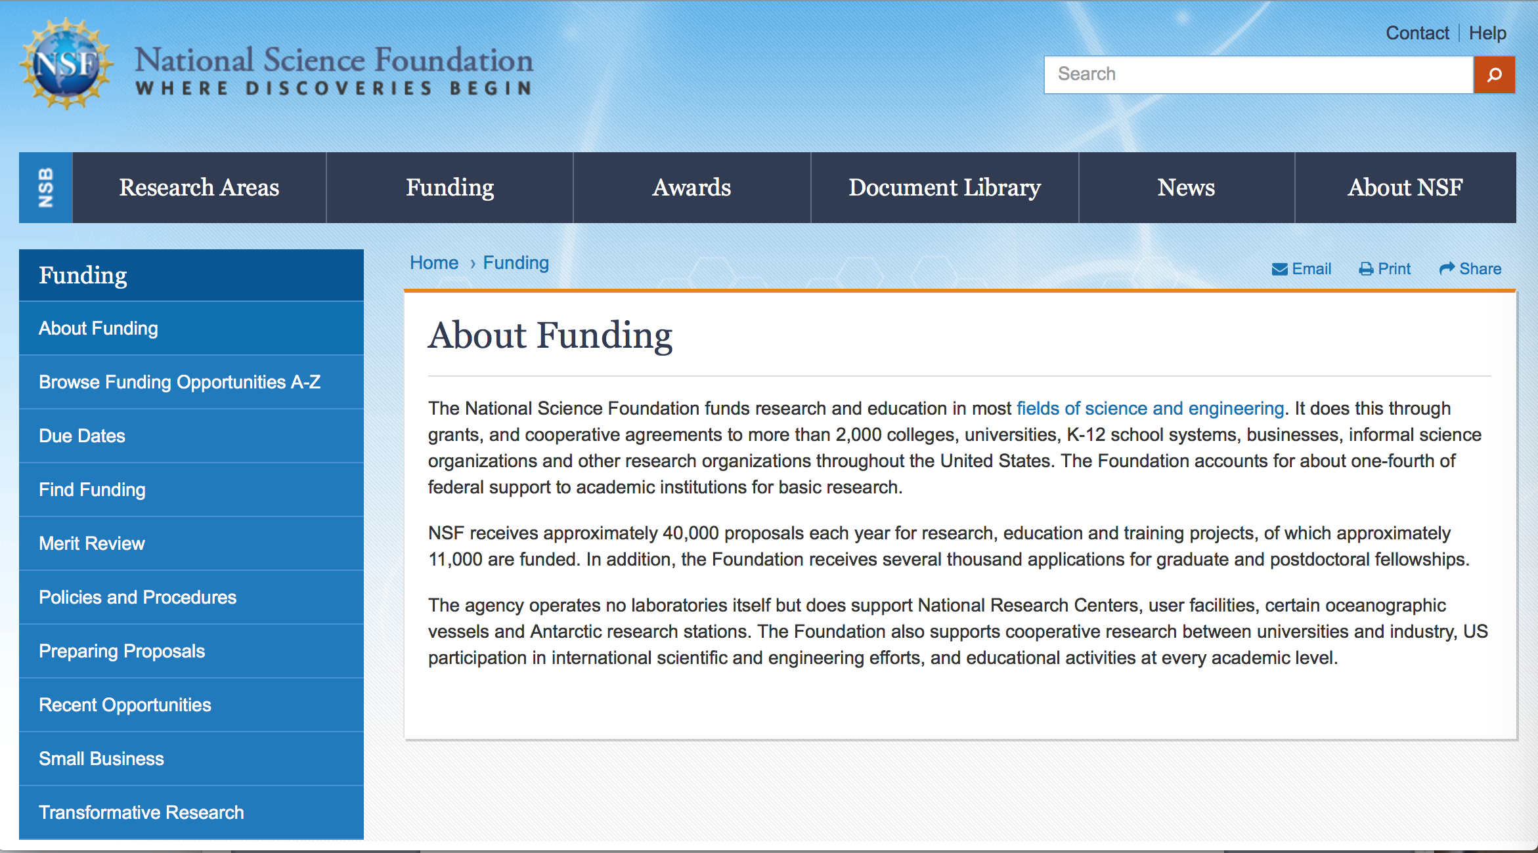

For assistance: https://nsf.gov/funding/aboutfunding.jsp

The National Science Foundation funds research and education in most fields of science and engineering. It does this through grants, and cooperative agreements to more than 2,000 colleges, universities, K-12 school systems, businesses, informal science organizations and other research organizations throughout the United States. The Foundation accounts for about one-fourth of federal support to academic institutions for basic research.
NSF receives approximately 40,000 proposals each year for research, education and training projects, of which approximately 11,000 are funded. In addition, the Foundation receives several thousand applications for graduate and postdoctoral fellowships.
The agency operates no laboratories itself but does support National Research Centers, user facilities, certain oceanographic vessels and Antarctic research stations. The Foundation also supports cooperative research between universities and industry, US participation in international scientific and engineering efforts, and educational activities at every academic level.

For details on active funding deadline dates: http://nsf.gov/funding/pgm_list.jsp?org=NSF&ord=date

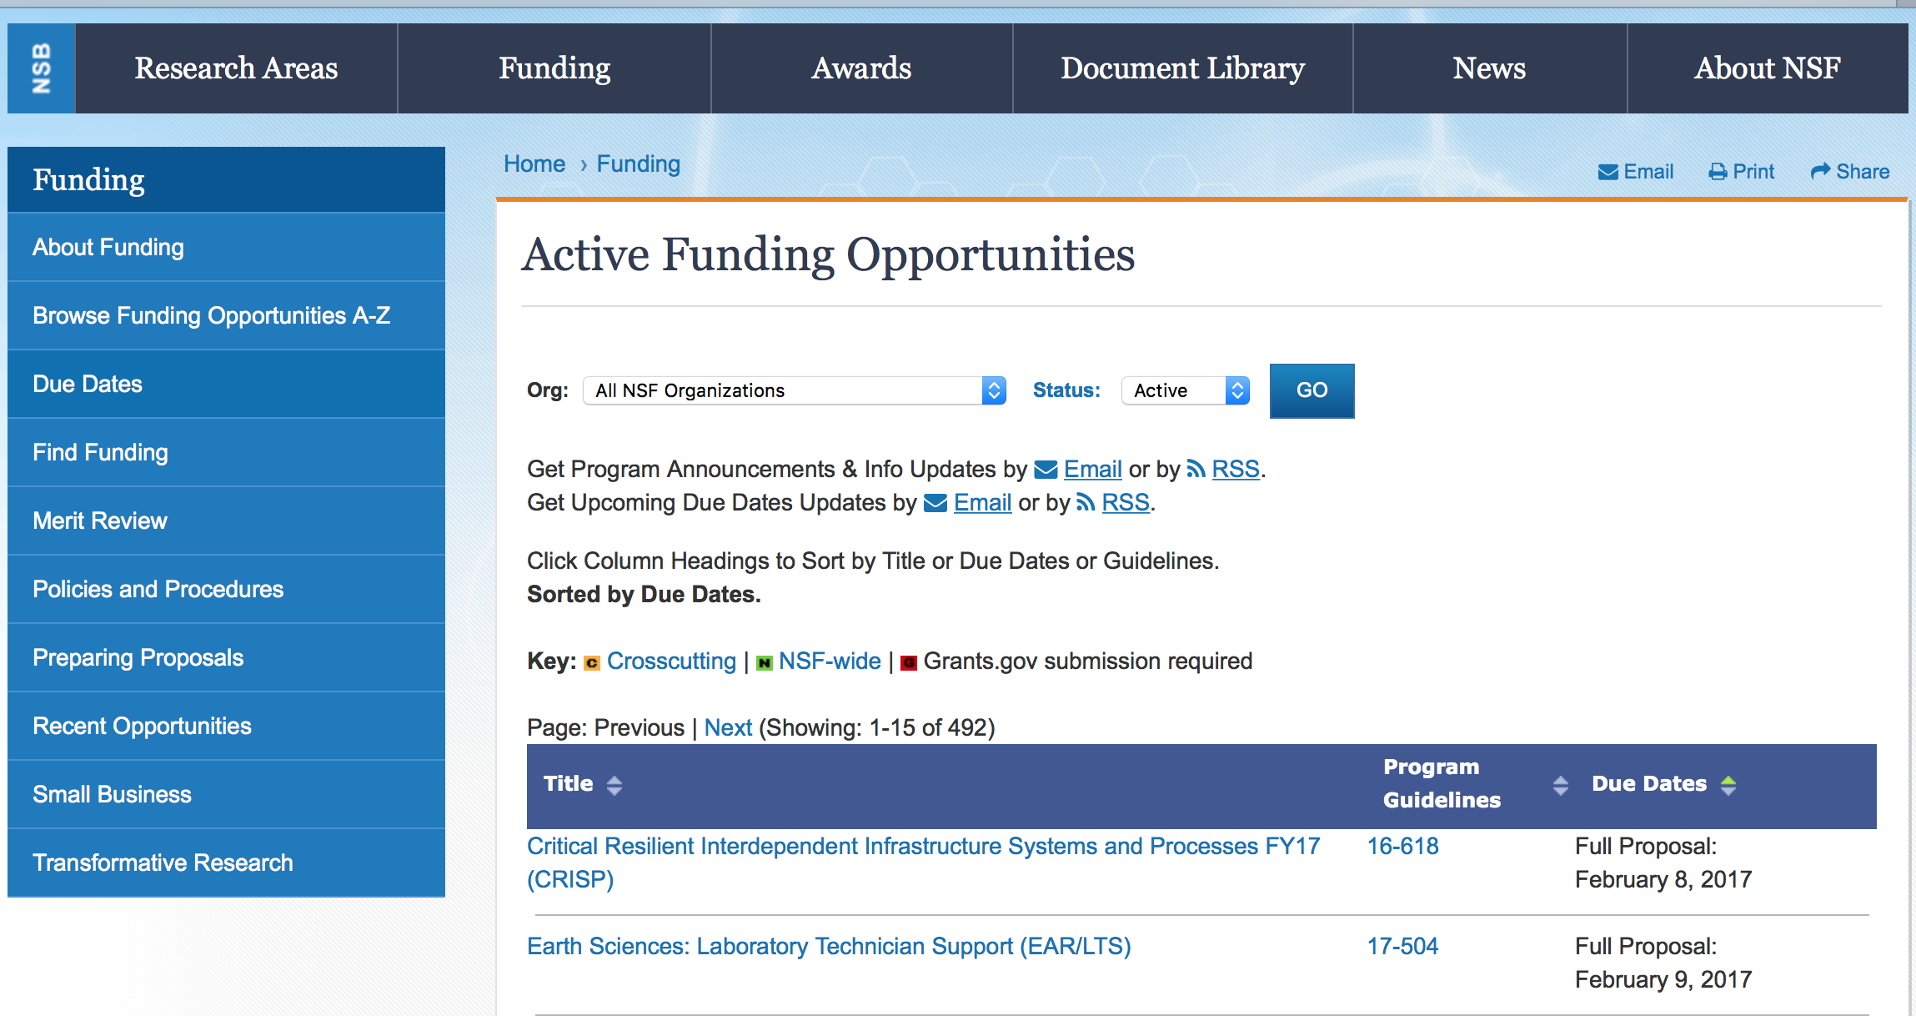

Cyberinfrastructure for Emerging Science and Engineering Research
Synopsis 1
https://www.grants.gov/web/grants/view-opportunity.html?oppId=311402

Future of Work at the Human-Technology Frontier: Core Research
Synopsis 1
https://www.grants.gov/web/grants/view-opportunity.html?oppId=310898
Harnessing the Data Revolution (HDR): Institutes for Data-Intensive Research in Science and Engineering - Ideas Labs
Synopsis 1
https://www.grants.gov/web/grants/view-opportunity.html?oppId=311121

Long Term Ecological Research National Coordination Office
Synopsis 1
https://www.grants.gov/web/grants/view-opportunity.html?oppId=311403

Modifications:

Mid-scale Research Infrastructure-2
Synopsis 1
https://www.grants.gov/web/grants/view-opportunity.html?oppId=311063

Reminders:

Deleted:

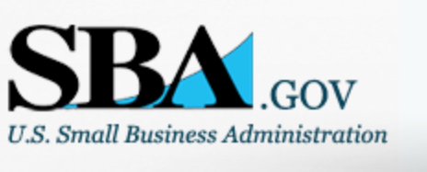

Small Business Administration

General Overview Finding Loans & Grants



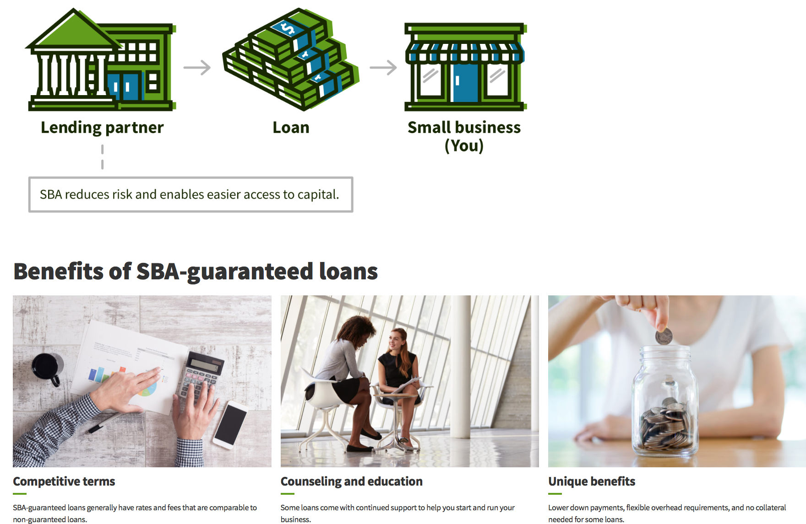

https://www.sba.gov/funding-programs/loans
Federal, state and local governments offer a wide range of financing programs to help small businesses start and grow their operations. These programs include low-interest loans, venture capital, and scientific and economic development grants.
Use SBA.gov's Loans and Grants Search Tool to get a list of financing programs for which you may qualify, or visit the resources below to learn more about small business financing programs.

To get to the main SBA.gov funding page click here
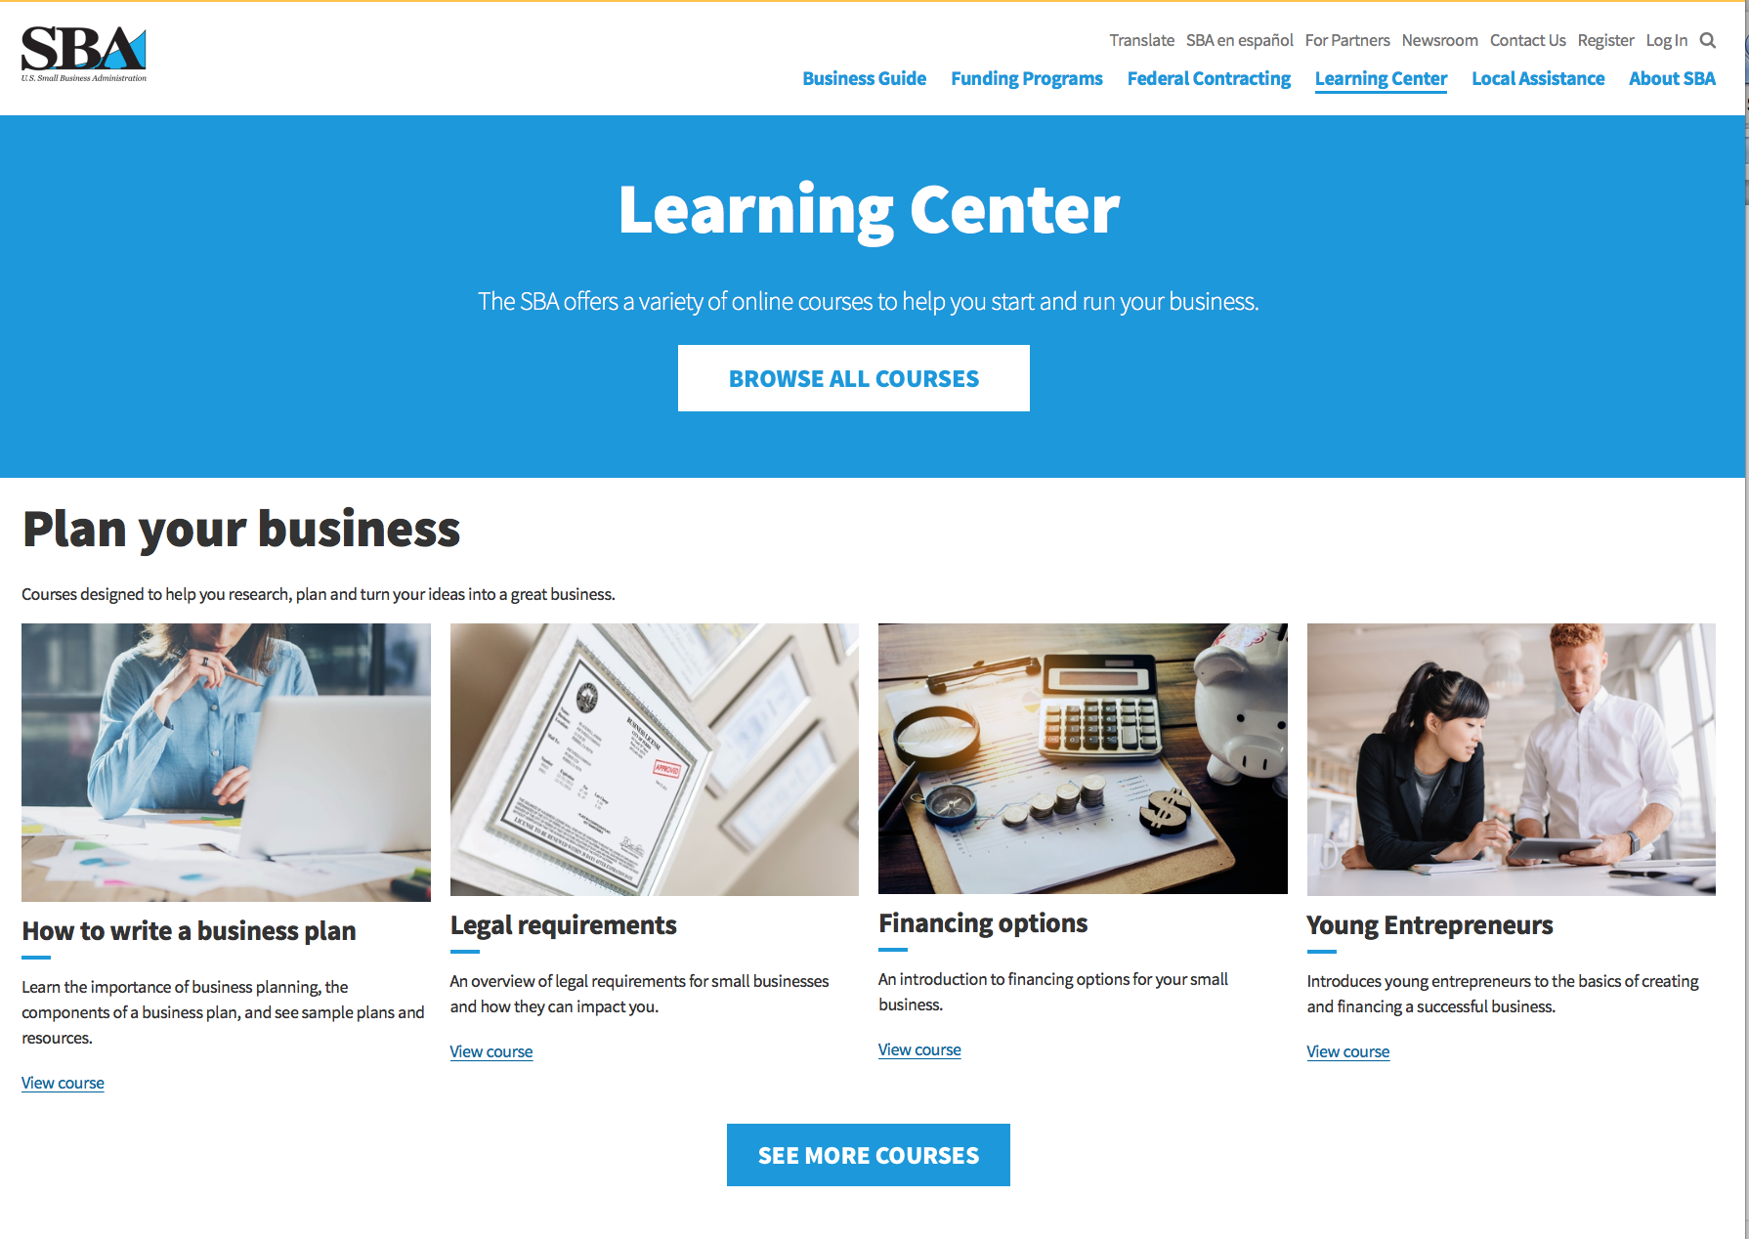
https://www.sba.gov/learning-center

Programs:

Modifications:

Reminders:

Deleted:

SBA Trainings

Contracting Opportunities for Veteran Entrepreneurs
This self-paced training exercise is an introduction to Federal contracting opportunities for Veterans.
Topics include basic information about Veteran-owned businesses and opportunities, services available to small Veteran-owned businesses, small business incentives, and government procurement methods.
Duration: 00:30:00

http://www.sba.gov/tools/sba-learning-center/training/contracting-opportunities-veteran-entrepreneurs

Interested in Exporting? These Four Resources Can Help
Did you know that two-thirds of the world’s purchasing power is in foreign countries? As the numbers show, the international marketplace is a big one. So if you’re interested in exploring the world of exporting – or have gotten started but could use some guidance – check out these resources to help.
- Read more

Upcoming Trainings: Check out SBA's Online Training!
- Financing Options for Small Businesses
How to Prepare Government Contract Proposals
Getting Started With Exporting: Training and Educational Resources
Exporting represents a big opportunity to tap in to new markets, expand your customer base and grow your business. But getting started with exporting can sometimes feel like a maze of regulations, policies, and other barriers. Here are some free training and educational resources to help.
- Read more

For Specific Information in Hawaii see the following links:
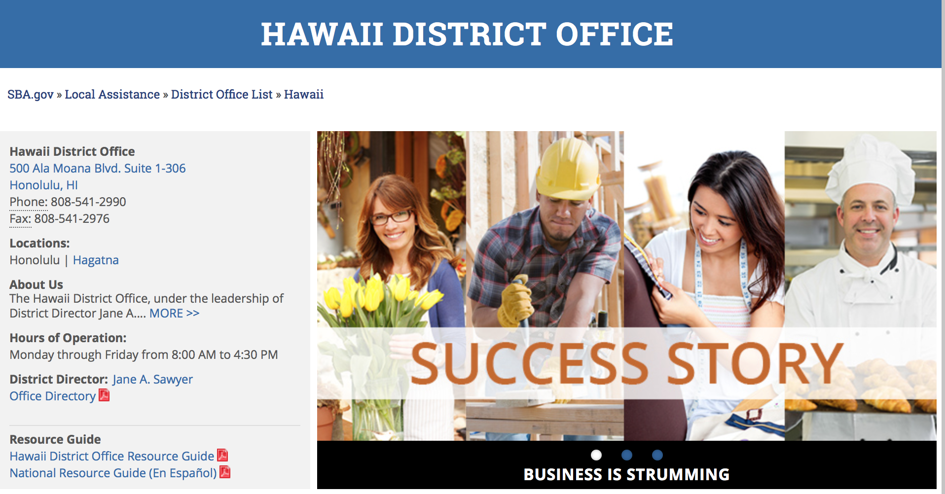

https://www.sba.gov/offices/district/hi/Honolulu

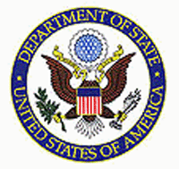

State Department General Overview and Resources for Program Administrators

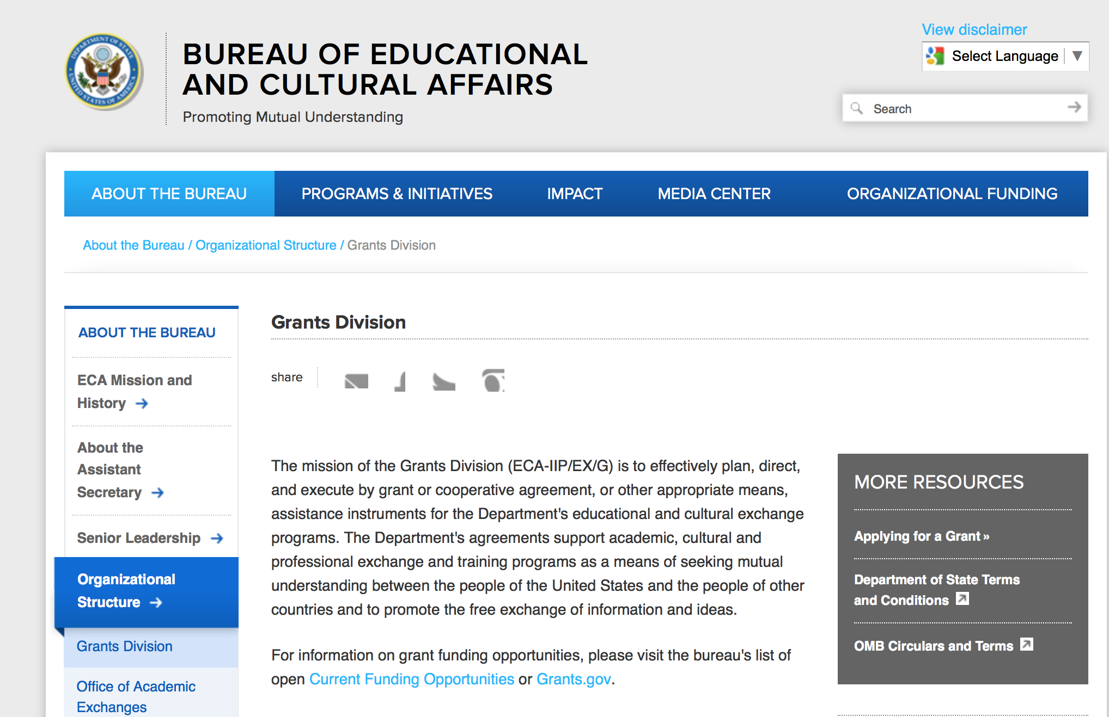

https://eca.state.gov/about-bureau/organizational-structure/grants-division

http://eca.state.gov/search/solr/grants?search_referrer=node/237

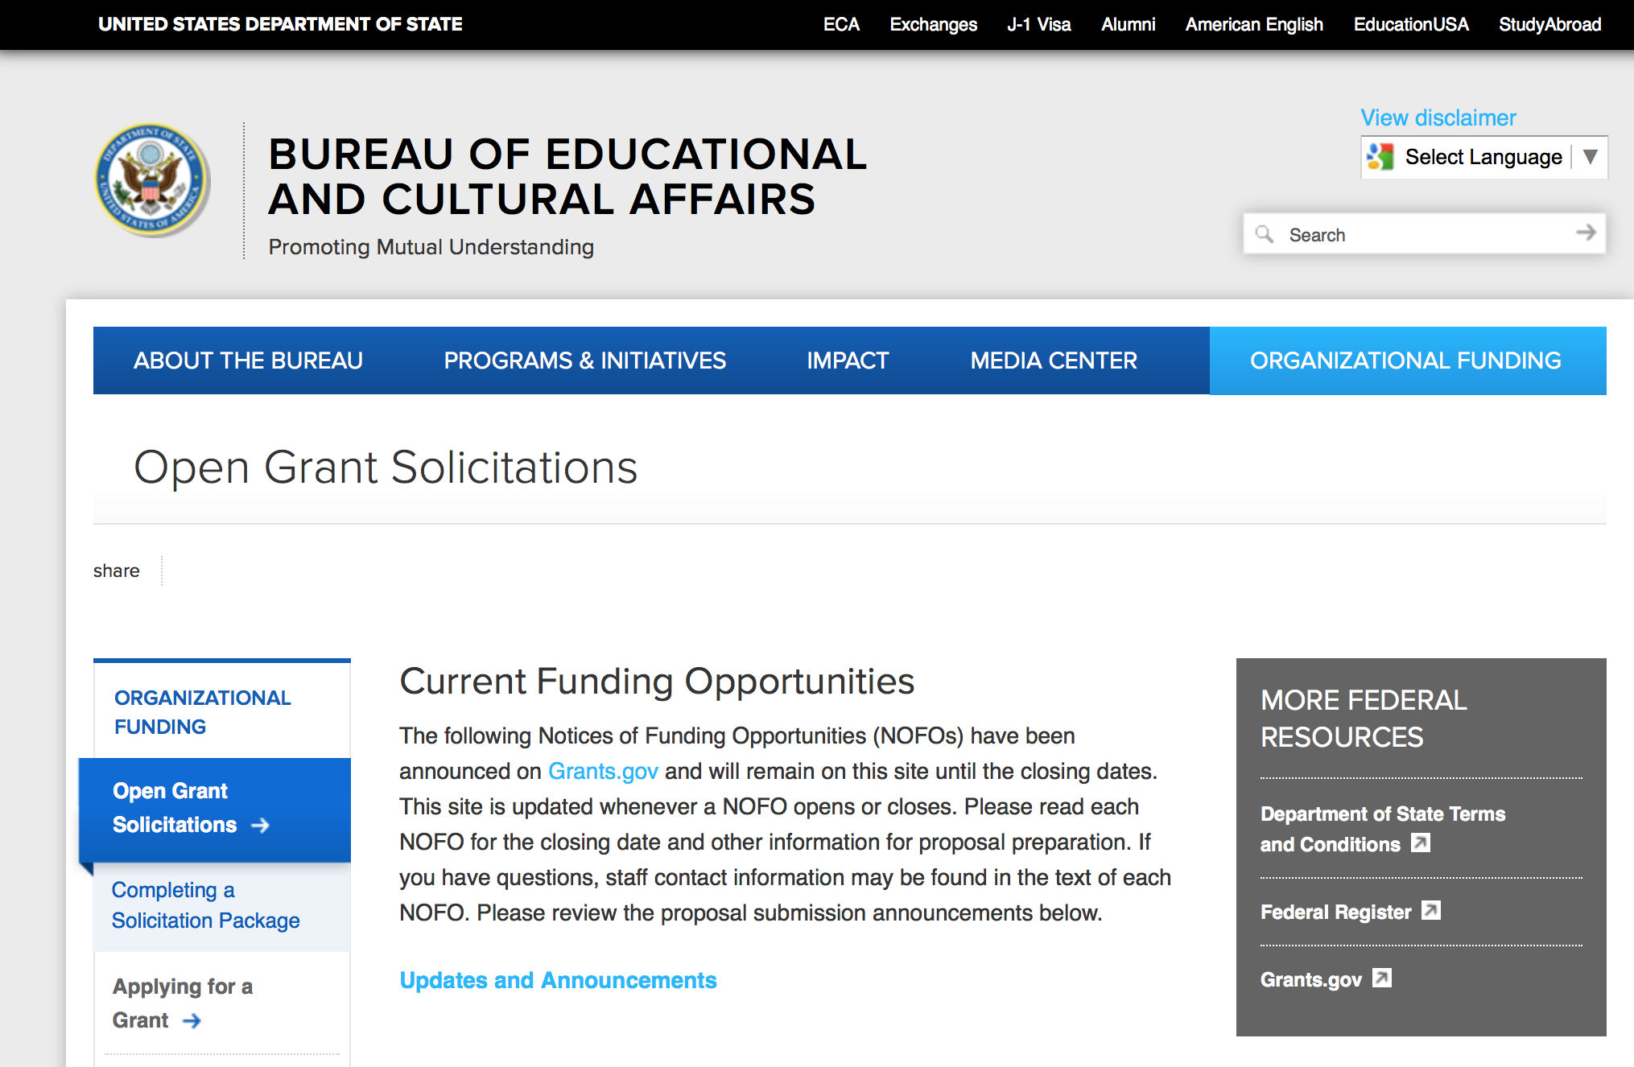
https://eca.state.gov/organizational-funding/open-grant-solicitations

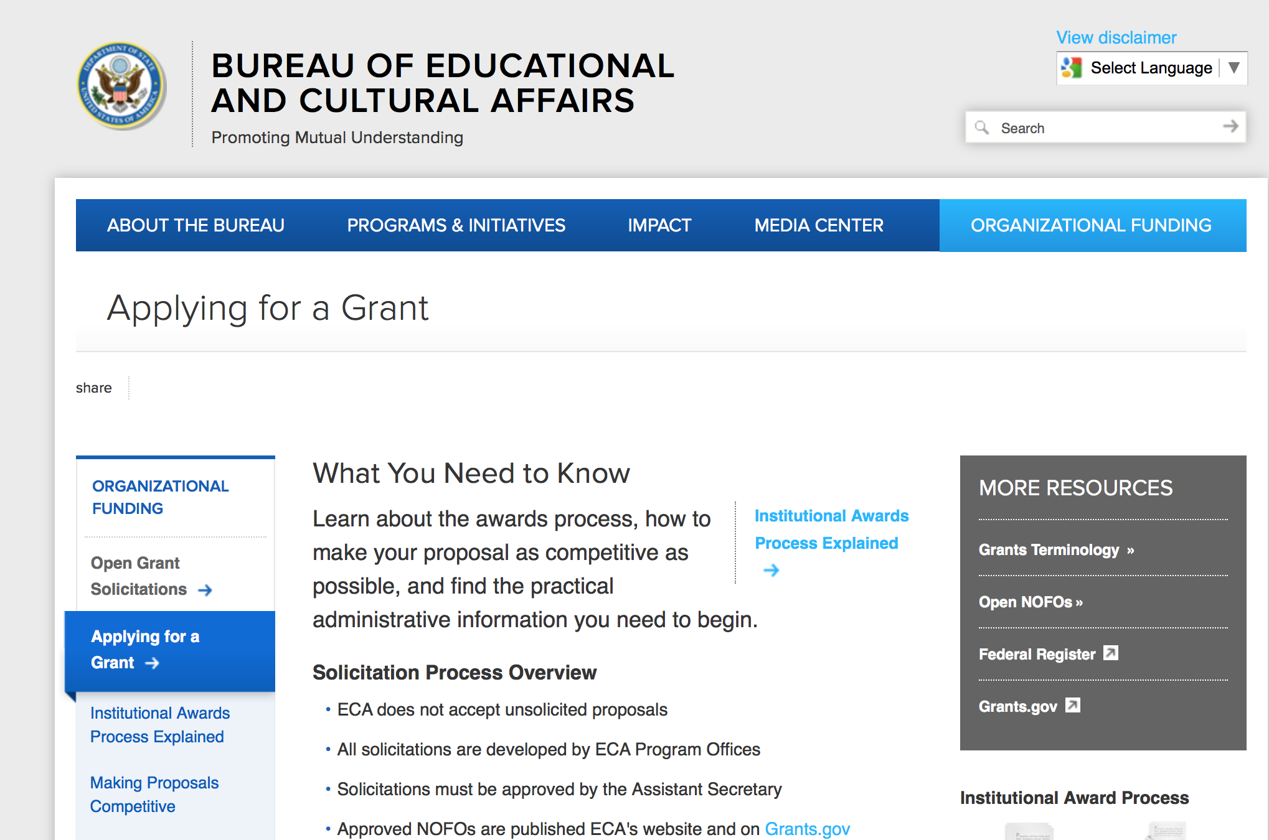
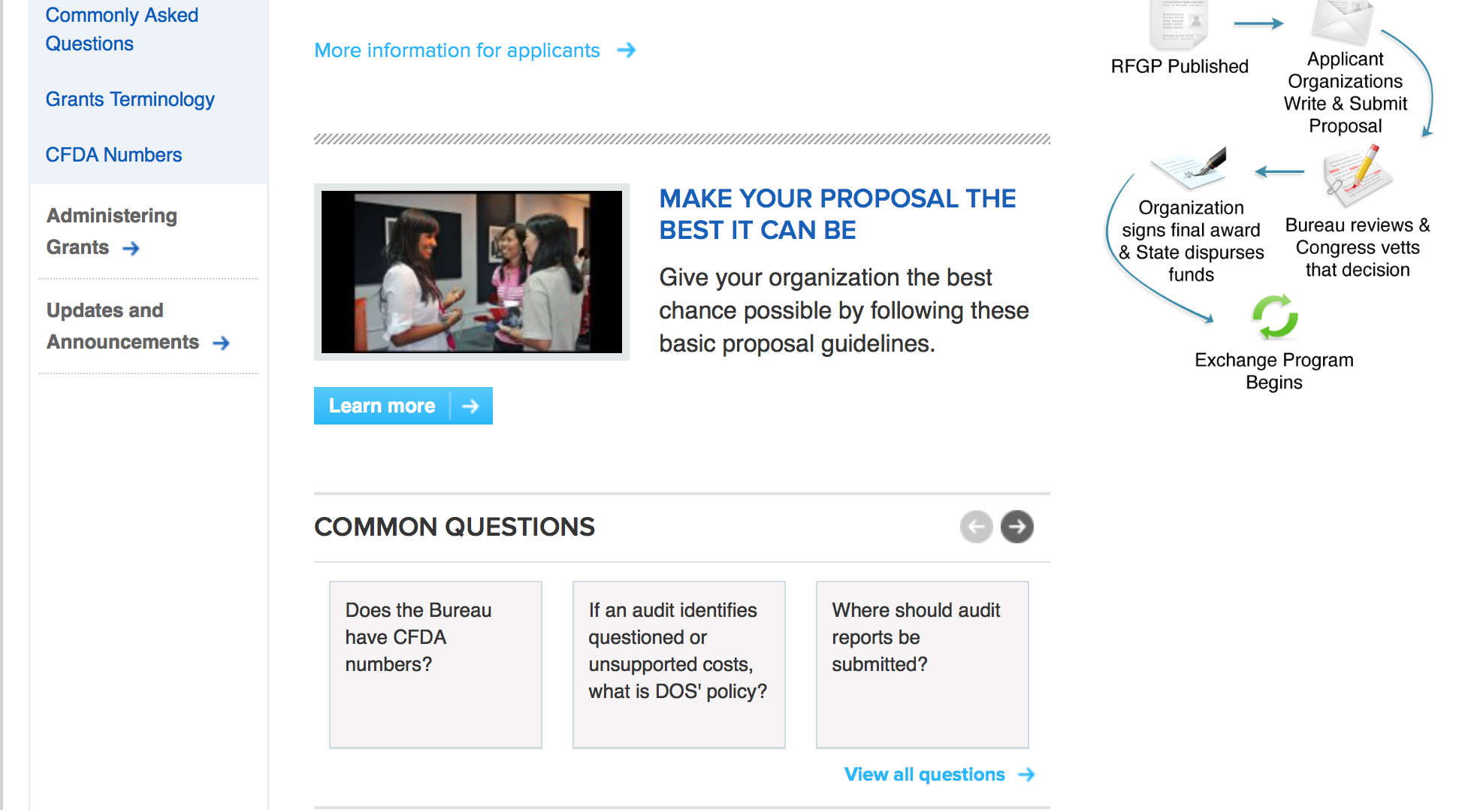
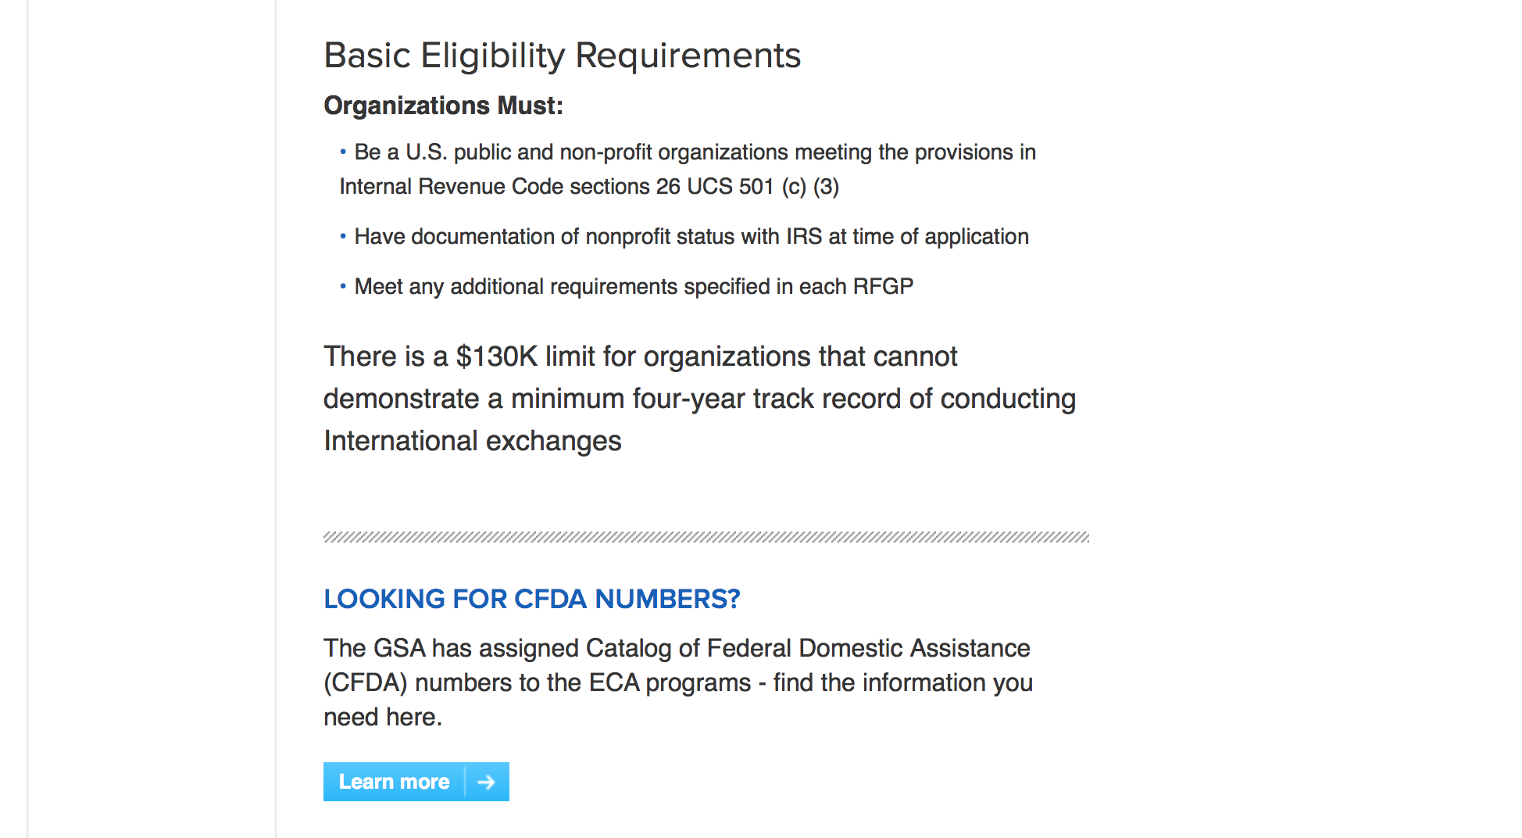
http://eca.state.gov/organizational-funding/applying-grant

General Information:
- Bureau of Educational and Cultural Affairs Grants Division
- Open Grant Opportunities (Requests for Grant Proposals)

For General Information click here

Program Grants:
U.S. Mission to Bosnia and Herzegovina
INTERETHNIC RECONCILIATION AND YOUTH PROGRAM
Synopsis 1
https://www.grants.gov/web/grants/view-opportunity.html?oppId=311073

U.S Mission to Armenia
Democracy Commission Small Grants Program Competition
Synopsis 1
https://www.grants.gov/web/grants/view-opportunity.html?oppId=311481
U.S. Mission to India
Alumni Micro Grants Fund
Synopsis 1
https://www.grants.gov/web/grants/view-opportunity.html?oppId=311389

U.S. Mission to India
Breaking the Glass Ceiling: Women’s Entrepreneurship as an Engine for Growth
Synopsis 1
https://www.grants.gov/web/grants/view-opportunity.html?oppId=311455
U.S. Mission to India
Regional Alumni Conference: Promoting an Open, Stable, and Prosperous Indo-Pacific
Synopsis 1
https://www.grants.gov/web/grants/view-opportunity.html?oppId=311473
U.S. Mission to India
Supporting Her Empowerment via Digital Tools
Synopsis 1
https://www.grants.gov/web/grants/view-opportunity.html?oppId=311384

U.S. Mission to India
U.S. Dance Troupe to Arts Festival in Tier-II City
Synopsis 1
https://www.grants.gov/web/grants/view-opportunity.html?oppId=311498

U.S. Mission to India
Volunteer for India: Creating a Young Citizens’ Volunteer Action Corps
Synopsis 1
https://www.grants.gov/web/grants/view-opportunity.html?oppId=311476
U.S. Mission to Israel
Promoting Cross-Cultural Cooperation
Synopsis 1
https://www.grants.gov/web/grants/view-opportunity.html?oppId=311293

U.S. Mission to Montenegro
2018 Democracy Commission Grants Program
Synopsis 1
https://www.grants.gov/web/grants/view-opportunity.html?oppId=311478

U.S. Mission to Ukraine
Ukraine: USG Exchange Alumni Small Grants Program
Synopsis 1
https://www.grants.gov/web/grants/view-opportunity.html?oppId=311173
Modifications:

Bureau of Population Refugees and Migration
2019 Humanitarian Research
Synopsis 2
https://www.grants.gov/web/grants/view-opportunity.html?oppId=311395
U.S. Mission to Hungary
U.S. Embassy Budapest, Public Affairs Section - FY2019 Annual Program Statement
Synopsis 3
https://www.grants.gov/web/grants/view-opportunity.html?oppId=311340

Reminders:

Deleted:

Department of Transportation

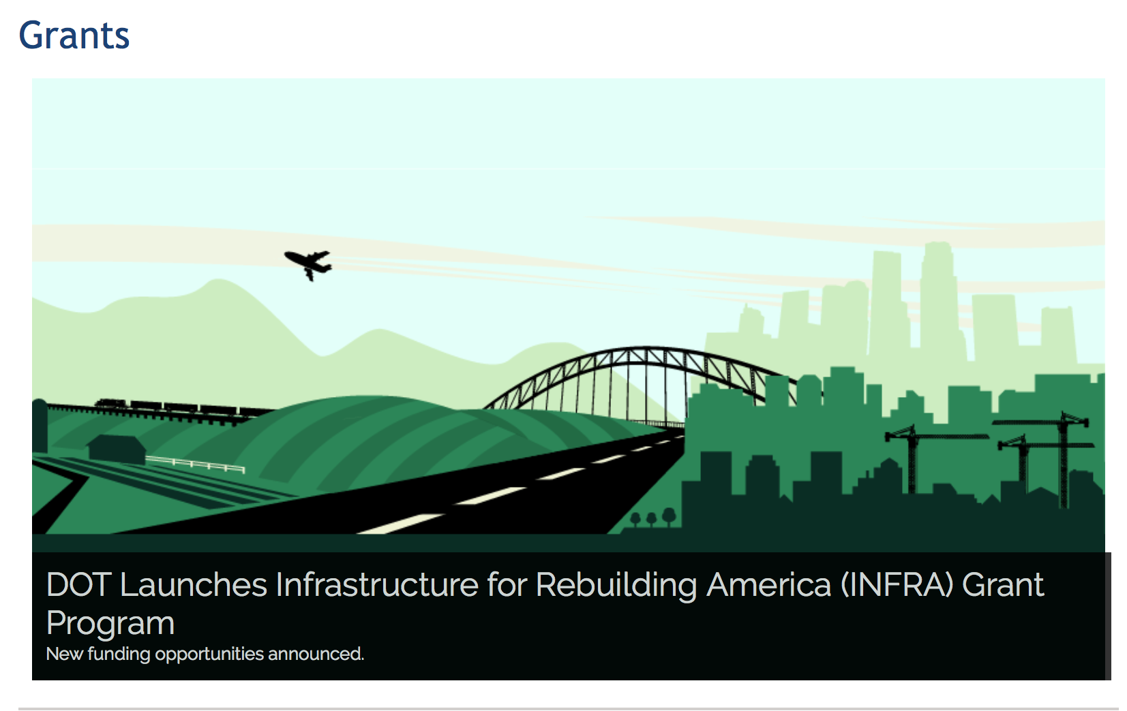

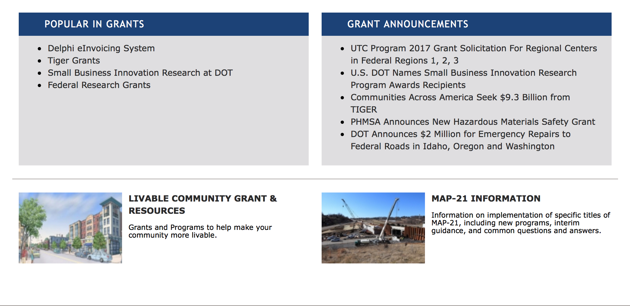

General Grant Program Overview https://www.transportation.gov/grants

Programs:

69A345 Office of the Under Secretary for Policy
INFRA Grants
Synopsis 2

Document Type: Grants Notice  Funding Opportunity Number: NSFHP-19-INFRA19  Funding Opportunity Title: INFRA Grants  Opportunity Category: Discretionary  Opportunity Category Explanation:  Funding Instrument Type: Grant  Category of Funding Activity: Transportation  Category Explanation:  Expected Number of Awards:  CFDA Number(s): 20.934 -- Nationally Significant Freight and Highway Projects  Cost Sharing or Matching Requirement: Yes | Version: Synopsis 2  Posted Date: Jan 02, 2019  Last Updated Date: Dec 31, 2018  Original Closing Date for Applications: Mar 04, 2019  Current Closing Date for Applications: Mar 04, 2019  Archive Date: Apr 05, 2019  Estimated Total Program Funding: $900,000,000  Award Ceiling: $810,000,000  Award Floor: $5,000,000
Eligibility
Eligible Applicants: | Others (see text field entitled "Additional Information on Eligibility" for clarification)
Additional Information on Eligibility: | Eligible applicants for INFRA grants are 1) a State or group of States; 2) a metropolitan planning organization that serves an urbanized area (as defined by the Bureau of the Census) with a population of more than 200,000 individuals; 3) a unit of local government or group of local governments; 4) a political subdivision of a State or local government; 5) a special purpose district or public authority with a transportation function, including a port authority; 6) a Federal land management agency that applies jointly with a State or group of States; 7) a tribal government or a consortium of tribal governments; or 8) a multi-State or multi-jurisdictional group of public entities. Multiple States or jurisdictions that submit a joint application should identify a lead applicant as the primary point of contact. Each applicant in a joint application must be an Eligible Applicant. Joint applications must include a description of the roles and responsibilities of each applicant and must be signed by each applicant.
Additional Information
Agency Name: | 69A345 Office of the Under Secretary for Policy
Description: | The Nationally Significant Freight and Highway Projects (INFRA) program provides Federal financial assistance to highway and freight projects of national or regional significance. This notice solicits applications for awards under the program’s fiscal year (FY) 2019 funding, subject to the availability of appropriated funds.  The Department is focusing the competition on transportation infrastructure projects that support four key objectives, each of which is discussed in greater detail in the Notice of Funding Opportunity:  (1) Supporting economic vitality at the national and regional level;  (2) Leveraging Federal funding to attract non-Federal sources of infrastructure investment;  (3) Deploying innovative technology, encouraging innovative approaches to project delivery, and incentivizing the use of innovative financing; and  (4) Holding grant recipients accountable for their performance.
Link to Additional Information: | INFRA Grants Website
Grantor Contact Information: | If you have difficulty accessing the full announcement electronically, please contact:  Paul Baumer Office of Infrastructure Finance and Innovation Phone 202-366-1092  USDOT Contact

https://www.grants.gov/web/grants/view-opportunity.html?oppId=311381

Modifications:

DOT Federal Highway Administration
Automated Driving System (ADS) Demonstration Grants
Synopsis 2

Document Type: | Grants Notice
Funding Opportunity Number: | 693JJ319NF00001
Funding Opportunity Title: | Automated Driving System (ADS) Demonstration Grants
Opportunity Category: | Discretionary
Opportunity Category Explanation:
Funding Instrument Type: | Grant
Category of Funding Activity: | Transportation
Category Explanation:
Expected Number of Awards:
CFDA Number(s): | 20.200 -- Highway Research and Development Program
Cost Sharing or Matching Requirement: | No
Version: | Synopsis 2
Posted Date: | Dec 21, 2018
Last Updated Date: | Dec 21, 2018
Original Closing Date for Applications: | Mar 21, 2019
Current Closing Date for Applications: | Mar 21, 2019
Archive Date:
Estimated Total Program Funding: | $60,000,000
Award Ceiling: | $10,000,000
Award Floor: | $0
Eligible Applicants: | Public and State controlled institutions of higher education  Native American tribal governments (Federally recognized)  City or township governments  Others (see text field entitled "Additional Information on Eligibility" for clarification)  County governments  State governments
Additional Information on Eligibility: | State and local governments, tribal governments, transit agencies and authorities, metropolitan planning organizations, other subdivisions of State or local governments (including public port authorities/districts), public academic institutions, public research institutions, or a multijurisdictional group* thereof applying through a single lead Applicant. Private companies and private universities are NOT eligible Applicants. However, private companies and private universities may be a sub-recipients or subcontractors.
Additional Information
Agency Name: | DOT Federal Highway Administration
Description: | On behalf of the USDOT, this Notice of Funding Opportunity (NOFO) is issued by Federal Highway Administration (FHWA), Office of Acquisition and Grants Management.  USDOT hereby solicits applications for an Automated Driving System (ADS)Demonstration Program to fund planning, direct research, and demonstration grants. USDOT intends to offer up to $60,000,000 total in Federal funding to fund multiple demonstration projects that test the safe integration of automated driving systems into the Nation's on-road transportation system. See Notice of Funding Opportunity (NOFO) for complete description and instructions to apply.
Link to Additional Information: | www.transportation.gov/av/grants
Grantor Contact Information: | If you have difficulty accessing the full announcement electronically, please contact:  Sarah E Tarpgaard Contracting Officer  ADSDemoGrants@dot.gov
https://www.grants.gov/web/grants/view-opportunity.html?oppId=310839

Research:

Reminders:

DOT - FAA Aviation Research Grants
FAA Aviation Research and Development Grants
Synopsis 3, 4 & 6

Document Type: | Grants Notice
Funding Opportunity Number: | 12-01
Funding Opportunity Title: | FAA Aviation Research and Development Grants
Opportunity Category: | Discretionary
Opportunity Category Explanation:
Funding Instrument Type: | Grant
Category of Funding Activity: | Transportation
Category Explanation:
Expected Number of Awards:
CFDA Number(s): | 20.108 -- Aviation Research Grants
Cost Sharing or Matching Requirement: | No
Version: | Synopsis 6
Posted Date: | Jan 01, 2012
Last Updated Date: | Oct 18, 2017
Original Closing Date for Applications: | Dec 31, 2019
Current Closing Date for Applications: | Dec 31, 2019
Archive Date: | Jan 30, 2020
Estimated Total Program Funding:
Award Ceiling: | $5,000,000
Eligible Applicants: | Private institutions of higher education  Nonprofits having a 501(c)(3) status with the IRS, other than institutions of higher education  Public and State controlled institutions of higher education
Agency Name: | DOT - FAA Aviation Research Grants
Description: | The FAA is soliciting proposals for research grants and cooperative agreements to pursue the long-term growth and short-term technical needs of civil aviation. In order to streamline the application process, it is recommended that all prospective grantees submit a white paper (letter of intent) for agency technical review before complete proposal submission. Please be sure to identify the specific area of interest (Solicitation FAA-12-01 – Chapter I. FAA Research Grants Program, Technical Areas of Research #1-#9). The white paper shall be no longer than three (3) pages and shall detail overall research objectives.
Link to Additional Information:
Grantor Contact Information: | If you have difficulty accessing the full announcement electronically, please contact:  Nicole Saiauskie Grants Officer Phone 609-485-4781  business

http://www.grants.gov/web/grants/view-opportunity.html?oppId=134953

Deleted:

Department of the Treasury

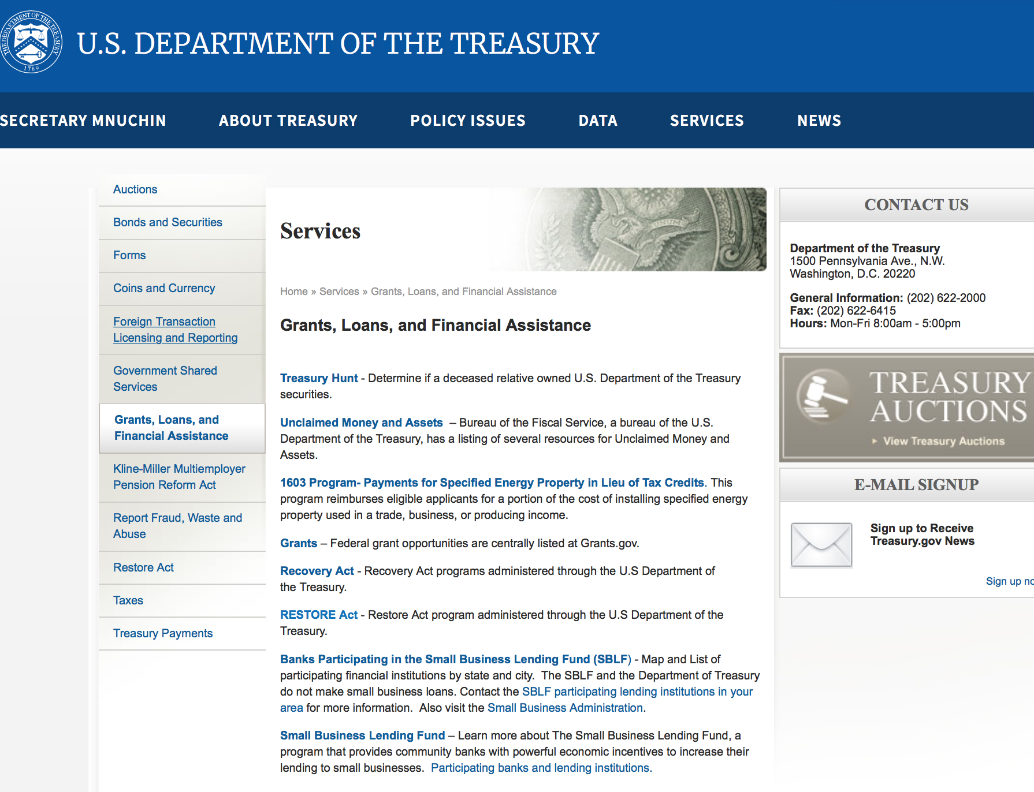

https://www.treasury.gov/services/Pages/Grants-Loans-and-Financial-Assistance.aspx

Programs:

Modifications:

Reminders:

U.S. Agency for International Development

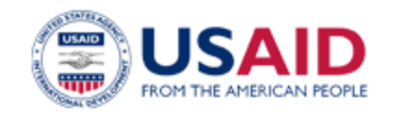

www.usaid.gov

General Overview Funding Opportunities

USAID has working relationships with thousands of American companies and hundreds of U.S.-based private voluntary organizations. For more information on our business and procurement opportunities, please visit our Business section.

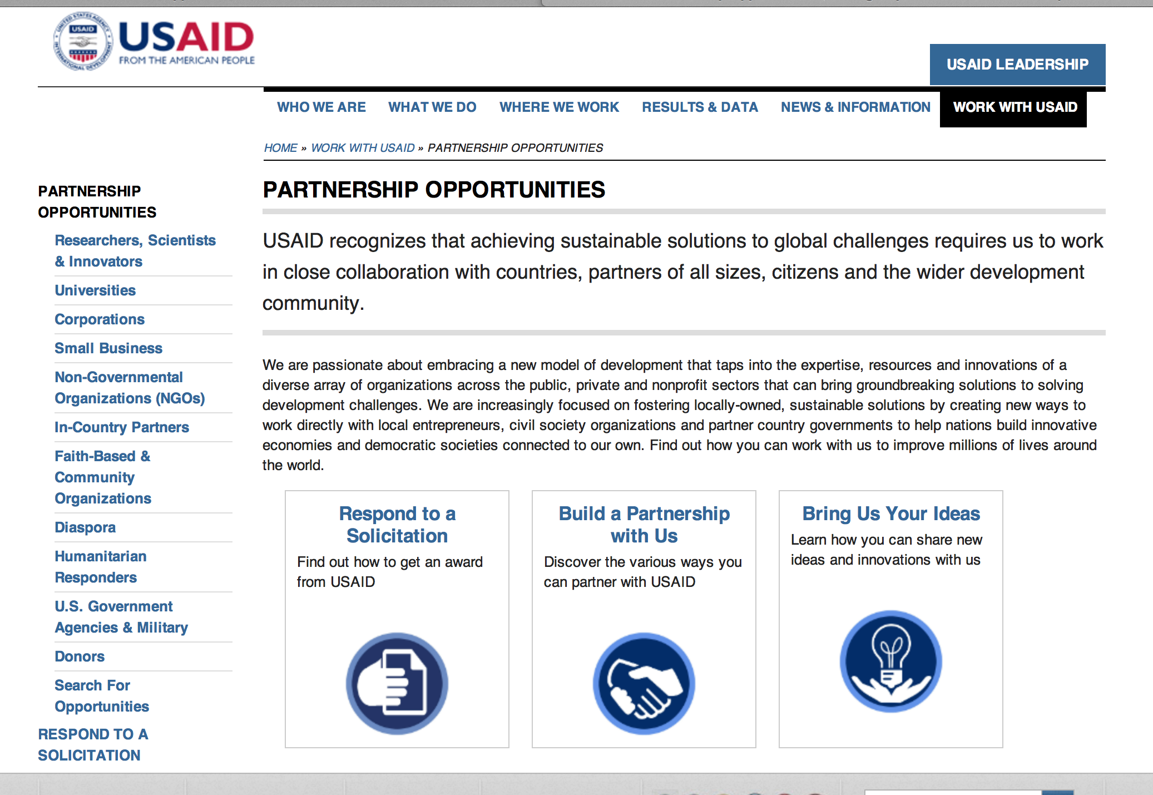
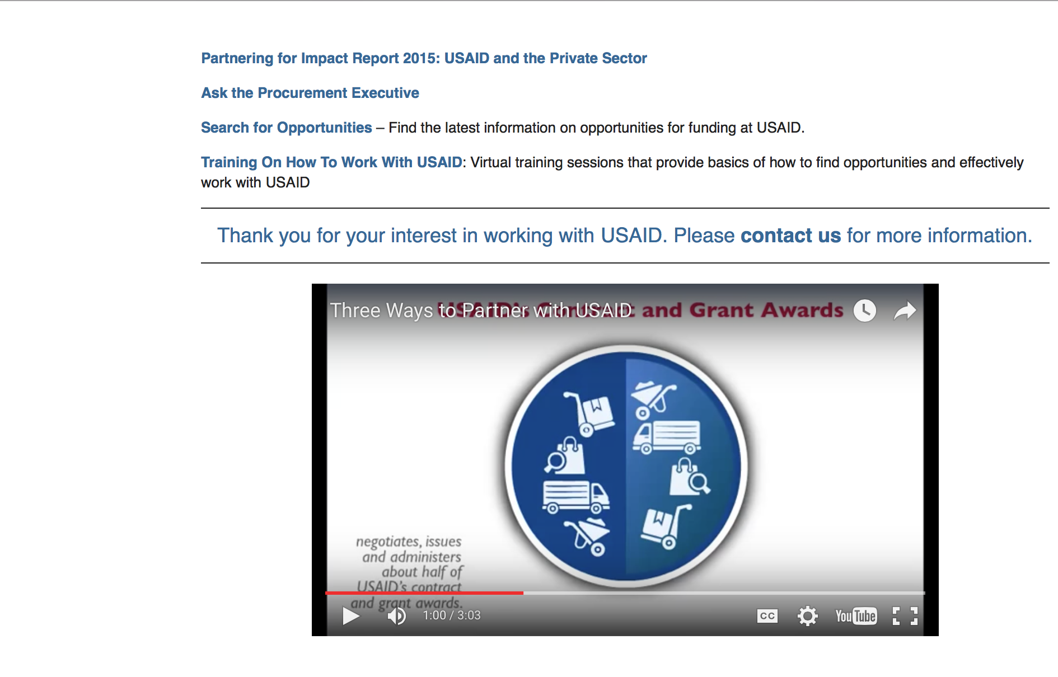

http://www.usaid.gov/partnerships

Programs:

Afghanistan USAID-Kabul
National Health Technical Assistance Program (NHTAP)
Synopsis 1
https://www.grants.gov/web/grants/view-opportunity.html?oppId=311408

Afghanistan USAID-Kabul
USAID/Afghanistan Urban Health Initiative (UHI)
Synopsis 1
https://www.grants.gov/web/grants/view-opportunity.html?oppId=311409
E3ED_Higher Education Partnerships Incentive Fund
Synopsis 1
https://www.grants.gov/web/grants/view-opportunity.html?oppId=310994

Malawi USAID-Lilongwe
Request For Information (RFI) Restoring Fisheries for Sustainable Livelihoods in Lake Malawi (REFRESH)
Synopsis 1
https://www.grants.gov/web/grants/view-opportunity.html?oppId=311176
Peru USAID-Lima
Amazon Environment Programming
Synopsis 1
https://www.grants.gov/web/grants/view-opportunity.html?oppId=311377

Urban Health Research Program
Synopsis 1
https://www.grants.gov/web/grants/view-opportunity.html?oppId=311182

Modifications:

ATscale-a Global Partnership for Assistive Technology (AT)
Synopsis 2
https://www.grants.gov/web/grants/view-opportunity.html?oppId=310900
Monitoring, Evaluation, Accountability, and Learning (MEAL) in Humanitarian Settings
Synopsis 2
https://www.grants.gov/web/grants/view-opportunity.html?oppId=311537

Uganda USAID-Kampala
USAID/Uganda Biodiversity for Resilience Activity
Synopsis 2
https://www.grants.gov/web/grants/view-opportunity.html?oppId=311387
Afghanistan USAID-Kabul
Afghan Civil Society and Media Self Reliance
Synopsis 3
https://www.grants.gov/web/grants/view-opportunity.html?oppId=311573

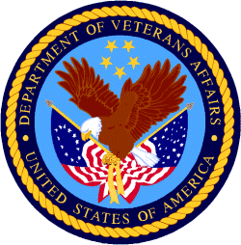

Department of Veterans Affairs

