Senator Mazie Hirono

Grants Assistance Information Newsletter

JANUARY 2023

PART 1 – CURRENT FEDERAL AGENCY DISCRETIONARY GRANT OPPORTUNITIES

PART 2 – GENERAL FEDERAL AGENCY GRANTS INFORMATION

Current Federal Agency Grant and Cooperative Agreement Discretionary Program Summaries

Click on Index Links below to find summaries of the current announcements listed by agency in this document. Once you reach the item, if you cannot open the links for further information, copy the selected URL website address into your browser.

Notices is Teal are items with immediate deadline dates.

Notices in Yellow are of special interest.

Notices is Green are items of special interest with immediate deadline dates.

Several Agencies have research or program opportunities that are not individually listed because they are for very technical or specific audiences. Click on the Agency Index Research or Program designation to review those grant and contract notices.

If an Agency does not have listings, it is due to the lack of competitive open opportunities at that Agency this month. Please review Part 2 for general information not specific to a current deadline date for general funding cycle information.

Special Notice

President Biden’s Bipartisan Infrastructure Law’s Distribution of funding in Hawaii

Build Back Better Infrastructure Guidebook

General Federal Government Coronavirus Responses

Specific Agency Coronavirus Responses

Corona Virus Response for Small Business

Programs specific to Hawaii

Current Notices

Reminders

National Park Service
2023 NAGPRA Consultation/Documentation Grants
National Park Service
FY2023 NAGPRA Repatriation Grants

2023 NOAA Hawaii Bay Watershed Education and Training (B-WET) Program
Employment and Training Administration
Community Projects ETA/Congressionally Directed Spending Grants

U.S. Department of Agriculture

Programs
Rural Business-Cooperative Service
Renewable Energy Systems and Energy Efficiency Improvements Program
Rural Business-Cooperative Service
Rural Business Development Grant (RBDG)
Rural Business-Cooperative Service
Energy Audit and Renewable Energy Development Assistance

Research

National Institute of Food and Agriculture
Small Business Innovation Research and Small Business Technology Transfer Programs Phase II

Modifications

Reminders

Animal and Plant Health Inspection Service
Antimicrobial Resistance Dashboard 2022-2023 Cooperative Agreements
National Institute of Food and Agriculture
Crop Protection and Pest Management Competitive Grants Program
National Institute of Food and Agriculture
Food Safety Outreach Competitive Grants Program
Rural Business-Cooperative Service
Agriculture Innovation Center Grant Program

Animal and Plant Health Inspection Service
USDA APHIS American Rescue Plan: SARS-CoV-2 in Animals
National Institute of Food and Agriculture
Biotechnology Risk Assessment Research Grants Program
Rural Business-Cooperative Service
Rural Microentrepreneur Assistance Program

Rural Business-Cooperative Service
Rural Economic Development Loan and Grant

Department of Commerce

Programs
2023 Bycatch Reduction Engineering Program

Climate Program Office (CPO), Climate and Societal Interactions (CSI) Division — Bipartisan Infrastructure Law (BIL)
Climate Program Office (CPO), Earth System Science and Modeling Research for Coastal Inundation

2023 MBDA Capital Readiness Program

Research
Modifications

Reminders

Fiscal Year 2023 NMFS-Sea Grant Fellowship in Population and Ecosystem Dynamics and Marine Resource Economics

Marine Carbon Dioxide Remove (mCDR): Research and Development for Assessing Large Scale Carbon Removal and Local Scale Ocean Acidification Mitigation

2024 Sea Grant Knauss Marine Policy Fellowship
National Estuarine Research Reserve System (NERRS) Land Acquisition and Construction Program for Fiscal Year 2023
Climate Program Office (CPO) Adaptation Sciences: Interdisciplinary research, engagement and capacity building to advance adaptation and resilience in islands of the Caribbean and the Pacific
Climate Program Office (CPO), Earth System Science and Modeling Research in support of the Disaster
National Competitive Harmful Algal Bloom Programs
Oceanic and Atmospheric Research (OAR), National Oceanic and Atmospheric Administration (NOAA), Department of Commerce
FY2023 National Sea Grant College Program Special Projects
FY2023 Ocean Technology Transition Project
FY 2021 - 2023 Economic Development RNTA
National Institute of Standards and Technology
Measurement Science and Engineering (MSE) Research Grant Programs
National Institute of Standards and Technology
NIST Manufacturing USA National Emergency Assistance Program
Economic Development Administration
FY 2020 EDA Public Works and Economic Adjustment Assistance Programs

Consumer Product Safety Commission

Corporation for National and Community Service

Programs

Reminders

Fiscal Year (FY) 2023 AmeriCorps Seniors Workforce Development

Department of Defense

Programs

Research Grants

Dept of the Army -- Materiel Command
DEVCOM Analysis Center Broad Agency Announcement For Applied Research

ACC-APG-Aberdeen Division A
APEX Accelerator- Option Period for Existing Award Recipients

Modifications

Reminders

Dept of the Army -- Materiel Command
DEVCOM Army Research Laboratory Broad Agency Announcement For Foundational Research

Department of Education

Programs

Research
Modifications

Reminders

Office of Elementary and Secondary Education (OESE): Safe & Supportive Schools: Mental Health Service Professional (MHSP) Demonstration Grant Program, Assistance Listing Number 84.184X
Institute of Education Sciences (IES): National Center for Special Education Research (NCSER): Special Education Research and Development Center, Assistance Listing Number (ALN) 84.324C

Institute of Education Sciences (IES): National Center for Education Research (NCER): Research Networks Focused on Critical Problems of Education Policy and Practice Assistance Listing Number (ALN) 84.305N-1

US Department of Energy

Programs

Research

Office of Science
FY 2023 Phase I Release 2

Modifications

Reminders

Golden Field Office
2022 Funding Opportunity Announcement for Energy Improvements at Public K-12 School Facilities - Bipartisan Infrastructure Law (BIL) - Renew America's Schools

Office of Science
FY2023 Continuation of Solicitation for the Office of Science Financial Assistance Program

Environmental Protection Agency

Programs
FY 2022 Training and Technical Assistance to Improve Water Quality and Enable Small Public Water Systems to Provide Safe Drinking Water

Research
Modifications

Reminders

FY23 Guidelines For Brownfields Training, Research, And Technical Assistance Grant
Technical Assistance To Brownfields Communities

20th Annual P3 Awards: A National Student Design Competition Focusing on People, Prosperity and the Planet

Department of Health and Human Services

Programs
Research Grants

Modifications
Reminders
Health Resources and Services Administration
Ending the HIV Epidemic – Primary Care HIV Prevention (PCHP) Supplement

Department of Homeland Security
Programs
Department of Homeland Security - FEMA
FY 2022 Assistance to Firefighters Grant Program (AFG)

Reminders

Department of Housing and Urban Development

Programs
Modifications

Reminders

FY 2022 Section 202 Supportive Housing for the Elderly Program
Authority to Accept Unsolicited Proposals for Research Partnerships

Institute of Museum and Library Services
Programs

Modifications
Reminders

Department of Interior

Programs
Bureau of Reclamation
WaterSMART: Water Recycling and Desalination Planning

Fish and Wildlife Service
F24AS00003 - NAWCA 2024-1 US Standard Grants
Fish and Wildlife Service
F24AS00004 Fisheries Resource Monitoring Program (2024-2027)
Fish and Wildlife Service
F23AS00124 FY23 Recovery Implementation
Fish and Wildlife Service
F23AS00126 FY23 Candidate Species Conservation Fund
Fish and Wildlife Service
F23AS00130 FY 2023 Prescott Marine Mammal Rescue Assistance Grant Program
National Park Service
FY2023 ABPP - Battlefield Land Acquisition Grant

National Park Service
NPS Cooperative Ecosystems Studies Units (CESU) Master Cooperative Agreements
National Park Service
2023 Preservation Technology and Training Grants

Modifications

Reminders

Fish and Wildlife Service
F23AS00078 National Fish Passage Program Bipartisan Infrastructure Law Fiscal Year 2023
Fish and Wildlife Service
F23AS00100 Refuges Enhancement/Infrastructure

National Park Service
Community Volunteer Ambassador Program

Fish and Wildlife Service
F23AS00069 Youth Engagement, Education, and Employment

Geological Survey
3D Elevation Program (3DEP)

Fish and Wildlife Service
F23AS00032 - 2023 Coastal Program

Fish and Wildlife Service
Research and Development of Biotechnological Tools for White-nose Syndrome
Geological Survey
Cooperative Research Units Program Department of the Interior Geological Survey

Department of Justice

Programs
Bureau of Justice Assistance
BJA FY 23 Local Law Enforcement Crime Gun Intelligence Center Integration Initiative

Office on Violence Against Women
OVW Fiscal Year 2023 Justice for Families Program - Solicitation
Office on Violence Against Women
OVW Fiscal Year 2023 Legal Assistance for Victims Grant Program Expanding Legal Services Initiative - Solicitation

Office on Violence Against Women
OVW Fiscal Year 2023 Legal Assistance for Victims - Solicitation
Office on Violence Against Women
OVW Fiscal Year 2023 Training and Services to End Violence and Abuse Against Individuals with Disabilities and Deaf People Program Solicitation
Office on Violence Against Women
OVW Fiscal Year 2023 Grants for Outreach and Services to Underserved Populations - Solicitation

Modifications

Research

Reminders

Bureau of Justice Assistance
BJA FY 2022 State Criminal Alien Assistance Program

________________________________________________________________________

Department of Labor

Programs

Employment and Training Administration
DOL Building Pathways to Infrastructure Jobs Grant Program
Modifications

Reminders

Employment and Training Administration
YouthBuild
Employment and Training Administration
DOL Building Pathways to Infrastructure Jobs Grant Program
Veterans Employment and Training Service
Homeless Veterans’ Reintegration Program (HVRP), Incarcerated Veterans’ Transition Program (IVTP), and the Homeless Female Veterans’ and Veterans’ with Children Program (HFVVWC) (referred to collectively as HVRP)
Employment and Training Administration
Community Projects ETA/Congressionally Directed Spending Grants

Bureau of International Labor Affairs
Request for Information USDOL/ILAB Safeguarding worker well-being in the wake of climate change
Forecast 1
Employment and Training Administration
National Dislocated Worker Grants Program Guidance

National Aeronautics and Space Administration

Research

Modifications

_______________________________________________________________
National Archives and Records Administration

Programs

Major Collaborative Archival Initiatives

Publishing Historical Records in Collaborative Digital Editions

Publishing Historical Records in Collaborative Digital Editions
State Board Programming Grants

Reminders

NHPRC-Mellon Planning Grants for Collaborative Digital Editions
_______________________________________________________________
National Endowment for the Arts

Programs

Modifications

Reminders

NEA Challenge America, FY2024
NEA Grants for Arts Projects 1, FY2024
NEA Literature Fellowships: Prose, FY2024
___________________________________________________________

National Endowment for the Humanities

Programs
NEH-Mellon Fellowships for Digital Publication
Modifications
Reminders

Fellowships Open Book Program

Institutes for Advanced Topics in the Digital Humanities
Climate Smart Humanities Organizations
Institutes for Higher Education Faculty and K-12 Educators
Landmarks of American History and Culture

Dangers and Opportunities of Technology: Perspectives from the Humanities
_______________________________________________________________
National Science Foundation

Research and Program Grants

Modifications

Reminders

Computer and Information Science and Engineering (CISE): Core Programs

Nuclear Regulatory Commission

Programs

U.S. Nuclear Regulatory Commission Notice of Funding Opportunity Announcement (NOFO), Minority Serving Institutions Grants Program (MSIG), Scholarships and Fellowships, Fiscal Year (FY) 2023

Small Business Administration

Programs
Modifications

Reminders

Veterans Business Outreach Center - Expansion FY23

State Department

Programs

Modifications

Reminders

U.S. Department of Transportation

Programs
DOT Federal Aviation Administration
FY 2022 Competitive Funding Opportunity: Airport Improvement Program Supplemental Discretionary Grants
Maritime Administration
2023 Port Infrastructure Development Program Grants
Research

Modifications
Reminders

69A345 Office of the Under Secretary for Policy
FY 2023 National Infrastructure Investments

DOT Federal Highway Administration
Fiscal Year 2022 National Culvert Removal, Replacement, and Restoration Grant Program (Culvert AOP Program)

Department of the Treasury

Programs

Modifications

Reminders

US Agency for International Development

Programs

Department of Veterans Affairs

Programs

Reminders

Legal Services for Veterans
Legal Services for Homeless Veterans and Veterans At-Risk for Homelessness Grant

Homeless Providers Grant and Per Diem Program
GPD Per Diem Only Grant Program (TIP)

Homeless Providers Grant and Per Diem Program
GPD Per Diem Only Grant Program (PDO)
Supportive Services for Veteran Families
Funding Opportunity Department of Veteran Affairs Supportive Services for Veteran Families

Supportive Services for Veterans Families

Current Federal Agency Grant and Cooperative Agreement Discretionary Program Summaries

Special Programs:

President Biden’s Bipartisan Infrastructure Law’s Distribution of funding in Hawaii

To date, $994 million in Bipartisan Infrastructure Law funding has been announced and is headed to Hawaii with approximately 35 specific projects identified for funding. Since the Bipartisan Infrastructure Law passed, Hawaii is set to receive more than $883 million for transportation to invest in roads, bridges, public transit, ports and airports and over $69 million for clean water. And, as of today, more than 35,000 households across the state are receiving affordable internet due to the Bipartisan Infrastructure Law. Many more projects will be added in the coming months, as funding opportunities become grant awards and as formula funds become specific projects. By reaching communities all across Hawaii – including rural communities and historically underserved populations – the law makes critical investments that will improve lives for Hawaiians and position the state for success. The entire fact sheet is available by clicking this link:

https://www.whitehouse.gov/wp-content/uploads/2022/11/Hawaii-BIL-State-Fact-Sheet-Nov-22.pdf

A Guidebook to the Bipartisan Infrastructure Law
The Biden Administration is committed to maximizing transparency so communities across America know what to apply for, who to contact, and how to get ready to rebuild. That’s why a guidebook was created for state, local, tribal, and territorial leaders. This guidebook is a roadmap to the funding available under the law, as well as an explanatory document that shows, in as much detail as currently available, program-by-program information.
Read the Bipartisan Infrastructure Law Guidebook.

TRANSPORTATION
The Bipartisan Infrastructure Law is a historic opportunity to repair the one-in-five miles of our roadways and more than 45,000 bridges in the United States rated as “in poor condition.” The law also contains funding to rebuild and reinvest in our railways, public transit infrastructure, and the safety of our transportation system. It further reauthorizes federal surface transportation programs for five years and invests billions in transformational projects that will create good-paying union jobs, grow the economy, and make our transportation system safer and more resilient.
Read more about funding for transportation projects.
- Roads, Bridges, and Major Projects
- Passenger and Freight Rail
- Public Transportation
- Airports and Federal Aviation Administration Facilities
- Ports and Waterways
- Safety
- Electric Vehicles, Buses, and Ferries

CLIMATE, ENERGY, AND THE ENVIRONMENT
Each year, millions of Americans feel the effects of climate change when their roads wash out, power goes down, or homes get flooded. The Bipartisan Infrastructure Law is a historic investment in the resiliency of our infrastructure to climate change, cybersecurity risks, and other hazards. This investment will help to protect communities against the impacts of climate changes such as droughts, heat, floods, wildfires, as well as cyber-attacks and other threats. It is also the largest investment in clean energy infrastructure in American history. The funding provided under the law will modernize our power grid; weatherize and upgrade homes, schools, businesses, and communities to make them cleaner and more affordable; and fund new programs to support the development, demonstration, and deployment of cutting-edge clean energy technologies. These investments help build an economy powered by clean energy and resilient to climate change, while creating good paying union jobs and rebuilding our domestic manufacturing base.
Currently up to 10 million American households lack safe drinking water and in too many communities, crumbling and inadequate wastewater infrastructure is a safety threat. The Bipartisan Infrastructure Law makes a historic investment in drinking water and wastewater infrastructure, to deliver clean drinking water to all American families and help to eliminate the nation’s lead service lines.
Read more about funding for climate, energy, and the environment.
- Clean Energy and Power
- Water
- Resilience
- Environmental Remediation

BROADBAND
Quality internet service is necessary for Americans to do their jobs, to participate equally in school learning, health care, and to stay connected. Yet, by one definition, more than 30 million Americans live in areas where there is no broadband infrastructure that provides minimally acceptable speeds – a particular problem in rural communities throughout the country. And, according to the latest OECD data, among 35 countries studied, the United States has the second highest broadband costs.
The Bipartisan Infrastructure Law will help ensure that every American has access to reliable high-speed internet through a historic investment in broadband infrastructure deployment. The legislation will also help lower prices for internet service and help close the digital divide, so that more Americans can make full use of internet access.
Read more about funding for broadband.
Download the guidebook data (CSV).

To learn more about how the Bipartisan Infrastructure Law will rebuild our roads and bridges, replace lead pipes for clean water, and more, click here.

For all Federal Government reports on Coronavirus see:
https://www.coronavirus.gov

For specific agency links on Coronavirus see:

Department of Agriculture
https://www.usda.gov/coronavirus

Department of Commerce:
https://www.commerce.gov/coronavirus

Corporation for National and Community Service:
https://www.nationalservice.gov/about-cncs/coronavirus-disease-2019-covid-19

Department of Education
https://www.ed.gov/coronavirus?%3F=

Department of Energy
https://www.energy.gov/covid-19-hub

Environmental Protection Agency
https://www.epa.gov/grants/epa-frequent-questions-grant-issues-response-novel-coronavirus-covid-19-public-health

Department of Health and Human Services
https://www.hhs.gov/coronavirus/cares-act-provider-relief-fund/index.html

Department of Homeland Security
https://www.dhs.gov/coronavirus

Department of Housing and Urban Development
https://www.hud.gov/coronavirus

Institute of Museum and Library Services
https://www.imls.gov/coronavirus-covid-19-updates

Department of Justice
https://www.justice.gov/coronavirus

Department of Labor
https://www.dol.gov/coronavirus

National Endowment for the Arts
https://www.arts.gov/covid-19-resources-for-artists-and-arts-organizations

National Endowment for the Humanities
https://www.neh.gov/coronavirus

National Science Foundation
https://www.nsf.gov/news/special_reports/coronavirus/

Small Business Administration
https://www.sba.gov/funding-programs/loans/covid-19-relief-options/eidl/covid-19-eidl

Department of Transportation
https://www.transportation.gov/coronavirus

Department of Treasury
https://home.treasury.gov/policy-issues/cares

USAID
https://www.usaid.gov/coronavirus

HAWAII SPECIFIC APPLICANTS ENCOURAGED

Current Notices

Reminders:

National Park Service
2023 NAGPRA Consultation/Documentation Grants
Synopsis 1

Document Type: Grants Notice  Funding Opportunity Number: P23AS00094  Funding Opportunity Title: 2023 NAGPRA Consultation/Documentation Grants  Opportunity Category: Discretionary  Opportunity Category Explanation:  Funding Instrument Type: Grant  Category of Funding Activity: Other (see text field entitled "Explanation of Other Category of Funding Activity" for clarification)  Category Explanation: NAGPRA Consultation/Documentation Grants  Expected Number of Awards:  CFDA Number(s): 15.922 -- Native American Graves Protection and Repatriation Act  Cost Sharing or Matching Requirement: No | Version: Synopsis 1  Posted Date: Nov 18, 2022  Last Updated Date: Nov 18, 2022  Current Closing Date for Applications: Mar 10, 2023 Complete applications must be submitted to the National Park Service by Friday, March 10, 2023, 11:59PM PT. Applicants are encouraged to submit the application well before the deadline. Application preparation time may take several weeks, so please start the application process as soon as possible. Applications submitted after the deadline will not be reviewed or considered for award. If it is determined that a proposal was not considered due its being late or incomplete, the applicant will be notified during the selection process.  Archive Date: Sep 01, 2023  Estimated Total Program Funding: $2,157,000  Award Ceiling: $100,000  Award Floor: $5,000

Eligible Applicants: | Private institutions of higher education  Special district governments  Public and State controlled institutions of higher education  City or township governments  Others (see text field entitled "Additional Information on Eligibility" for clarification)  Native American tribal governments (Federally recognized)  State governments  Native American tribal organizations (other than Federally recognized tribal governments)  County governments  Nonprofits having a 501(c)(3) status with the IRS, other than institutions of higher education
Additional Information on Eligibility: | The following entities are eligible to apply for a NAGPRA Consultation/Documentation grant: An Indian Tribe, Alaska Native village, or Native Hawaiian Organization An Indian Tribe means any tribe, band, nation, or other organized group or community of Indians, including Alaska Native villages, which is recognized as eligible for the special programs and services provided by the United States to Indians because of their status as Indians. The Department of the Interior has interpreted this definition as applying to the 574 Indian tribes and Alaska Native villages that are recognized by the United States Government. The Bureau of Indian Affairs’ list of Federally recognized tribes is available at www.bia.gov. This list does not include Alaska regional or village corporations. Native Hawaiian organization (NHO) includes any organization that: a) serves and represents the interests of Native Hawaiians; b) has as a primary and stated purpose the provision of services to Native Hawaiians; and c) has expertise in Native Hawaiian Affairs. NAGPRA states that this shall include the Office of Hawaiian Affairs. A Museum that has control of Native American human remains, funerary objects, sacred objects, or objects of cultural patrimony and has received Federal funds. The term "Museum" includes state or local government agencies, private institutions, and institutions of higher learning that have received Federal funds. Eligible museums must have completed and provided the following documents to the National NAGPRA Program and to Indian tribes or Native Hawaiian organizations, as appropriate, prior to submission of a grant application: A NAGPRA Summary of the cultural items in their possession or control by November 16, 1993, or after according to timelines in 43 CFR 10.13. A NAGPRA Inventory of human remains and associated funerary objects in their possession or control by November 16, 1995, or after according to timelines in 43 CFR 10.13. A museum that has not yet completed a summary or inventory, but does so prior to submitting a grant proposal, may then be eligible to receive an award. Museums determined to be out of compliance with NAGPRA may be excluded from consideration. Federal agencies and the Smithsonian Institution may not apply for grants. Applicants who previously received a NAGPRA grant but did not meet the conditions of the grant agreement, including reports or deliverables, may be penalized in the review process.

Agency Name: | National Park Service
Description: | Grant funds must be used for CONSULTATION and/or DOCUMENTATION projects under NAGPRA. Consultation projects support efforts related to revising a NAGPRA inventory and making or responding to requests for repatriation of items in a NAGPRA summary. Documentation projects support determining the geographical origin, cultural affiliation, and other basic facts surrounding the acquisition of Native American cultural items. Consultation and documentation projects should lead to determining control, treatment, repatriation, and disposition of NAGPRA cultural items.
Link to Additional Information: | https://www.nps.gov/subjects/nagpra/index.htm
Grantor Contact Information: | If you have difficulty accessing the full announcement electronically, please contact:  Seth Tinkham nagpra_grants@nps.gov  Email preferred.
https://www.grants.gov/web/grants/view-opportunity.html?oppId=344581

National Park Service
FY2023 NAGPRA Repatriation Grants
Synopsis 1
Document Type: Grants Notice  Funding Opportunity Number: P23AS00093  Funding Opportunity Title: FY2023 NAGPRA Repatriation Grants  Opportunity Category: Discretionary  Opportunity Category Explanation:  Funding Instrument Type: Grant  Category of Funding Activity: Other (see text field entitled "Explanation of Other Category of Funding Activity" for clarification)  Category Explanation: NAGPRA Repatriation Grants  Expected Number of Awards:  CFDA Number(s): 15.922 -- Native American Graves Protection and Repatriation Act  Cost Sharing or Matching Requirement: No | Version: Synopsis 1  Posted Date: Nov 18, 2022  Last Updated Date: Nov 18, 2022  Current Closing Date for Applications: May 12, 2023 Complete applications must be submitted to the National Park Service by Friday, May 12, 2023, 11:59PM PT. Applicants are encouraged to submit the application well before the deadline. Application preparation time may take several weeks, so please start the application process as soon as possible. Applications submitted after the deadline will not be reviewed or considered for award. If it is determined that a proposal was not considered due its being late or incomplete, the applicant will be notified during the selection process.  Archive Date: Sep 01, 2023  Estimated Total Program Funding: $2,157,000  Award Ceiling: $15,000  Award Floor: $1,000

Eligible Applicants: | State governments  Public and State controlled institutions of higher education  Native American tribal governments (Federally recognized)  City or township governments  Native American tribal organizations (other than Federally recognized tribal governments)  Special district governments  Others (see text field entitled "Additional Information on Eligibility" for clarification)  Nonprofits having a 501(c)(3) status with the IRS, other than institutions of higher education  Private institutions of higher education  County governments
Additional Information on Eligibility: | The following entities are eligible to apply for a NAGPRA Repatriation Grant: An Indian Tribe, Alaskan Native Village, or Native Hawaiian Organization An Indian Tribe means any tribe, band, nation, or other organized group or community of Indians, including any Alaska Native village (as defined in, or established pursuant to, the Alaska Native Claims Settlement Act), which is recognized as eligible for the special programs and services provided by the United States to Indians because of their status as Indians. The Department of the Interior has interpreted this definition as applying to the 574 Indian tribes and Alaska Native villages that are recognized by the United States Government. The Bureau of Indian Affairs’ list of Federally recognized tribes is available at www.bia.gov. This list does not include Alaska regional or village corporations, though they may be partners on a project. Native Hawaiian organization (NHO) includes any organization that: a) serves and represents the interests of Native Hawaiians; b) has as a primary and stated purpose the provision of services to Native Hawaiians; and c) has expertise in Native Hawaiian Affairs. NAGPRA states that such Native Hawaiian organizations shall include the Office of Hawaiian Affairs. A museum that has control of Native American human remains, funerary objects, sacred objects, or objects of cultural patrimony and has received Federal funds The term “Museum” includes state or local government agencies, private institutions, and institutions of higher learning that have received Federal funds. Museums determined to be out of compliance with NAGPRA may be excluded from consideration. Federal agencies and the Smithsonian Institution may not apply for grants. Applicants who previously received a NAGPRA grant, but whose grant expired without successfully completing major elements of the proposed work or without meeting the conditions of the grant award may be penalized in the review process. If an applicant has questions about their eligibility, they should contact the Awarding Agency using the information provided in Section G of this announcement.

Agency Name: | National Park Service
Description: | Grant funds must be used for REPATRIATION under NAGPRA, which means the transfer of control of Native American human remains and/or cultural items to lineal descendants, Indian tribes, and Native Hawaiian organizations. Repatriation includes disposition of culturally unidentifiable Native American human remains (CUI) according to 43 CFR § 10.11. Repatriation projects defray costs associated with the packaging, transportation, contamination removal, reburial, and/or storage of NAGPRA-related human remains and/or cultural items.
Link to Additional Information: | https://www.nps.gov/subjects/nagpra/index.htm
Grantor Contact Information: | If you have difficulty accessing the full announcement electronically, please contact:  Seth Tinkham nagpra_grants@nps.gov  Email preferred for questions.
https://www.grants.gov/web/grants/view-opportunity.html?oppId=344580

2023 NOAA Hawaii Bay Watershed Education and Training (B-WET) Program
Synopsis 1

Document Type: Grants Notice  Funding Opportunity Number: NOAA-NOS-OCM-2023-2007573  Funding Opportunity Title: 2023 NOAA Hawaii Bay Watershed Education and Training (B-WET) Program  Opportunity Category: Discretionary  Opportunity Category Explanation:  Funding Instrument Type: Grant  Category of Funding Activity: Education Environment  Category Explanation:  Expected Number of Awards: 15  CFDA Number(s): 11.473 -- Office for Coastal Management  Cost Sharing or Matching Requirement: No | Version: Synopsis 1  Posted Date: Oct 07, 2022  Last Updated Date: Oct 07, 2022  Original Closing Date for Applications: Jan 31, 2023  Current Closing Date for Applications: Jan 31, 2023  Archive Date: Mar 02, 2023  Estimated Total Program Funding: $1,000,000  Award Ceiling: $150,000  Award Floor: $50,000

Eligible Applicants: | Others (see text field entitled "Additional Information on Eligibility" for clarification)
Additional Information on Eligibility: | Eligible funding applicants are K-12 public and independent schools and school systems, institutions of higher education, commercial and nonprofit organizations, state or local government agencies, and Indian tribal governments conducting projects in Hawaii (Islands of Hawaii, Maui, Kahoolawe, Lanai, Molokai, Oahu, Kauai, Niihau, and/or the Northwestern Hawaiian Islands). Individual applicants and federal agencies are not eligible. DOC/NOAA supports cultural and gender diversity, and is strongly committed to broadening the participation of organizations that promote inclusion, such as tribal colleges, minority serving institutions, universities, and groups that work in historically underserved communities. The term underserved communities refers to populations sharing a particular characteristic, as well as geographic communities, that have been systematically denied a full opportunity to participate in aspects of economic, social, and civic life. Underserved communities are defined in Executive Order 13985: https://www.federalregister.gov/documents/2021/01/25/2021-01753/advancing-racial-equity-and-support-for-underserved-communities-through-the-federal-government. Federal agencies and employees are not allowed to receive funds under this announcement but may serve as collaborative project partners and may contribute services in-kind; these ‘in-kind services’ cannot be considered as part of an applicant’s match on shared costs. If an applicant proposes a federal agency as a collaborator, applicants should provide detail on the expected level of federal engagement in the application. Examples might include, but are not limited to partnership services; serving in a review capacity; or participating in priority task teams, working groups, or leadership teams. NOAA employees are not permitted to assist in the preparation of applications.

Agency Name: | Department of Commerce
Description: | The NOAA Hawaii Bay Watershed Education and Training (B-WET) program is a federal funding opportunity that meets NOAA’s mission of science, service, and stewardship. The Hawaii B-WET program supports a vision of a future where societies and ecosystems are healthy and resilient in the face of sudden or prolonged change. The purpose for this financial assistance is to support our communities by developing well-informed members of society involved in decision-making that positively impacts our coastal, marine, and watershed ecosystems in the Hawaiian Islands. This is a competitive opportunity for grants to assist in the development of new programs, encourage innovative partnerships among environmental education programs, and support geographically targeted programs to advance environmental education efforts that complement national and state school requirements. The Hawaii B-WET program plays a foundational role as an environmental education program that promotes locally relevant, experiential learning in the K-12 environment on Priority Content Areas such as Earth science, climate science, and indigenous local knowledge models for all sciences. Funded projects provide Meaningful Watershed Educational Experiences for students and professional development for teachers that support regional education and environmental priorities. More information about the B-WET program is online at https://www.noaa.gov/office-education/bwet.
Link to Additional Information: | See Related Documents
Grantor Contact Information: | If you have difficulty accessing the full announcement electronically, please contact:  Mahealani Bambico Hawaii B-WET Coordinator Mokupapapa Discovery Center, 76 Kamehameha Ave, Hilo, HI 96720  Work Email
https://www.grants.gov/web/grants/view-opportunity.html?oppId=343977

Employment and Training Administration
Community Projects ETA/Congressionally Directed Spending Grants
Forecast 1
Document Type: Grants Notice  Opportunity Number: TEGL-03-22  Opportunity Title: Community Projects ETA/Congressionally Directed Spending Grants  Opportunity Category: Earmark  Opportunity Category Explanation:  Funding Instrument Type: Grant  Category of Funding Activity: Employment, Labor and Training  Category Explanation:  Expected Number of Awards: 173  CFDA Number(s): 17.289 -- Community Project Funding/Congressionally Directed Spending  Cost Sharing or Matching Requirement: No | Version: Forecast 1  Forecasted Date: Jul 21, 2022  Last Updated Date: Jul 21, 2022  Estimated Post Date: Aug 22, 2022  Estimated Application Due Date: Feb 28, 2023  Estimated Award Date:  Estimated Project Start Date:  Fiscal Year: 2022  Archive Date:  Estimated Total Program Funding: $137,638,000  Award Ceiling:  Award Floor:

Eligible Applicants: | Unrestricted (i.e., open to any type of entity above), subject to any clarification in text field entitled "Additional Information on Eligibility"
Additional Information on Eligibility: | Only organizations listed as a DOL/ETA recipient in the Explanatory Statement for Division H of the Consolidated Appropriations Act, 2022 (specified in Appendix I) are eligible for grant awards under this Training and Employment Guidance Letter (TEGL).

Agency Name: | Employment and Training Administration
Description: | This Training and Employment Guidance Letter (TEGL) solicits applications from eligible entities for the Department of Labor's (DOL) Employment and Training Administration (ETA) Community Projects demonstration grants and announces application procedures. In order to receive Congressionally Directed funds, eligible applicants specified in Appendix I must submit applications responding to this TEGL, including all required documents detailed in Appendix IV, to https://www.grants.gov no earlier than 12:00 pm Eastern Time, August 22, 2022 and no later than 11:59 pm Eastern Time, February 28, 2023.
Link to Additional Information: | See Related Documents
Grantor Contact Information: | Aiyana Pucci, Grant Officer  Community.Projects.ETA@dol.gov  Please email questions to the contact listed.
https://www.grants.gov/web/grants/view-opportunity.html?oppId=342614

U.S. Department of Agriculture

Programs:

Rural Business-Cooperative Service
Renewable Energy Systems and Energy Efficiency Improvements Program
Synopsis 1
Document Type: Grants Notice  Funding Opportunity Number: RDBCP-REAP-RES-EEI-2023  Funding Opportunity Title: Renewable Energy Systems and Energy Efficiency Improvements Program  Opportunity Category: Mandatory  Opportunity Category Explanation:  Funding Instrument Type: Grant  Category of Funding Activity: Energy  Category Explanation:  Expected Number of Awards: 3000  CFDA Number(s): 10.868 -- Rural Energy for America Program  Cost Sharing or Matching Requirement: Yes | Version: Synopsis 1  Posted Date: Dec 16, 2022  Last Updated Date: Dec 16, 2022  Original Closing Date for Applications: Apr 01, 2023 Applications accepted year round.  Current Closing Date for Applications: Apr 01, 2023 Applications accepted year round.  Archive Date: May 01, 2023  Estimated Total Program Funding:  Award Ceiling: $1,000,000  Award Floor: $1,500

Eligible Applicants: | Small businesses
Additional Information on Eligibility: | Small Businesses must meet SBA size standards. Agricultural Producers are also eligible.

Agency Name: | Rural Business-Cooperative Service
Description: | See review Notice available at: 2022-27359.pdf (govinfo.gov)
Link to Additional Information: | See Related Documents
Grantor Contact Information: | If you have difficulty accessing the full announcement electronically, please contact:  Contact your State Energy Coordinator as listed: https://www.rd.usda.gov/sites/default/files/RBS_StateEnergyCoordinators.pdf  RBCS
https://www.grants.gov/web/grants/view-opportunity.html?oppId=344871
Rural Business-Cooperative Service
Rural Business Development Grant (RBDG)
Synopsis 1
Document Type: Grants Notice  Funding Opportunity Number: RDBCP-RBDG-2023  Funding Opportunity Title: Rural Business Development Grant (RBDG)  Opportunity Category: Discretionary  Opportunity Category Explanation:  Funding Instrument Type: Grant  Category of Funding Activity: Business and Commerce  Category Explanation: This program is designed to provide technical assistance and training for small rural businesses. Small means that the business has fewer than 50 new workers and less than $1 million in gross revenue.  Expected Number of Awards: 450  CFDA Number(s): 10.351 -- Rural Business Development Grant  Cost Sharing or Matching Requirement: No | Version: Synopsis 1  Posted Date: Dec 22, 2022  Last Updated Date: Dec 22, 2022  Current Closing Date for Applications: Feb 28, 2023 Complete applications may be submitted in paper or electronic format and must be received by 4:30 p.m. local time on February 28, 2023, in the USDA Rural Development State Office for the State where the Project is located. Late submissions will not be considered  Archive Date: Apr 10, 2023  Estimated Total Program Funding:  Award Ceiling:  Award Floor:

Eligible Applicants: | State governments  City or township governments  Public and State controlled institutions of higher education  Native American tribal governments (Federally recognized)  Nonprofits having a 501(c)(3) status with the IRS, other than institutions of higher education  Private institutions of higher education  County governments
Additional Information on Eligibility: | Rural public entities including, but not limited to: Towns, Communities, State agencies, Authorities, Nonprofit corporations, Institutions of higher education, Federally-recognized tribes, Rural cooperatives (if organized as a private nonprofit corporation).

Agency Name: | Rural Business-Cooperative Service
Description: | The purpose of the program is to promote economic development and job creation projects through the awarding of grant funds to eligible entities. Applications  will compete in two separate categories, business opportunity grants and business enterprise grants, for use in funding various business and community projects that serve rural areas.
Link to Additional Information: | Link to program Web site
Grantor Contact Information: | If you have difficulty accessing the full announcement electronically, please contact:  Cindy Mason Program Manager  RBDG Program Contact
https://www.grants.gov/web/grants/view-opportunity.html?oppId=345071

Rural Business-Cooperative Service
Energy Audit and Renewable Energy Development Assistance
Synopsis 1
Document Type: Grants Notice  Funding Opportunity Number: RDBCP-REAP-EA-REDA-2023  Funding Opportunity Title: Energy Audit and Renewable Energy Development Assistance  Opportunity Category: Mandatory  Opportunity Category Explanation:  Funding Instrument Type: Grant  Category of Funding Activity: Agriculture Business and Commerce Energy  Category Explanation:  Expected Number of Awards: 30  CFDA Number(s): 10.868 -- Rural Energy for America Program  Cost Sharing or Matching Requirement: No | Version: Synopsis 1  Posted Date: Dec 16, 2022  Last Updated Date: Dec 16, 2022  Original Closing Date for Applications: Feb 01, 2023  Current Closing Date for Applications: Feb 01, 2023  Archive Date: Mar 03, 2023  Estimated Total Program Funding:  Award Ceiling: $100,000  Award Floor: $0

Eligible Applicants: | State governments  Private institutions of higher education  Native American tribal governments (Federally recognized)  City or township governments  Special district governments  County governments
Additional Information on Eligibility: | See Notice

Agency Name: | Rural Business-Cooperative Service
Description: | See notice available at: 2022-27359.pdf (govinfo.gov)
Link to Additional Information: | See Related Documents
Grantor Contact Information: | If you have difficulty accessing the full announcement electronically, please contact:  Contact State Energy Coordinator: https://www.rd.usda.gov/sites/default/files/RBS_StateEnergyCoordinators.pdf  RBCS
https://www.grants.gov/web/grants/view-opportunity.html?oppId=344872

Research:

National Institute of Food and Agriculture
Small Business Innovation Research and Small Business Technology Transfer Programs Phase II
Synopsis 1
Document Type: Grants Notice  Funding Opportunity Number: USDA-NIFA-SBIR-009642  Funding Opportunity Title: Small Business Innovation Research and Small Business Technology Transfer Programs Phase II  Opportunity Category: Mandatory  Opportunity Category Explanation:  Funding Instrument Type: Grant  Category of Funding Activity: Agriculture  Category Explanation:  Expected Number of Awards:  CFDA Number(s): 10.212 -- Small Business Innovation Research  Cost Sharing or Matching Requirement: No | Version: Synopsis 2  Posted Date: Dec 23, 2022  Last Updated Date: Dec 30, 2022  Original Closing Date for Applications: Mar 28, 2023  Current Closing Date for Applications: Mar 28, 2023  Archive Date: Apr 27, 2023  Estimated Total Program Funding: $22,312,000  Award Ceiling: $650,000  Award Floor: $0

Eligible Applicants: | Others (see text field entitled "Additional Information on Eligibility" for clarification)
Additional Information on Eligibility: | Only previous USDA-NIFA SBIR/STTR Phase I awardees who have not previously applied for Phase II support are eligible to apply for Phase II support through this FY 2023 RFA. This includes those awardees identified via a “novated” or “successor-in-interest” revised funding agreement. A Phase I project may only apply for a Phase II award once. If a Phase I awardee was unsuccessful in receiving a Phase II award with a previous application, then the awardee is not eligible to resubmit the proposal under this or a future Phase II program solicitation. Failure to meet an eligibility criterion by the application deadline may result in the application being excluded from consideration or, even though an application may be reviewed, will preclude USDA NIFA from making an award. Each applicant submitting an application must qualify as a Small Business Concern (SBC) through registration with the SBA for R/R&D purposes at the time of award (see Definitions in Appendix II and Appendix III).SBIR/STTR program eligibility requirements are in place to ensure that the funds go only to small, independent businesses within the United States. The regulations include restrictions about (1) the type of firm, (2) its ownership structure, and (3) the firm’s size in terms of the number of employees. The purpose of the requirement regarding type of firm is to target the awards to firms with an economic interest in developing the idea or research into a commercial application. The purpose of the ownership requirement is to limit the program to independent firms controlled by United States citizens or permanent resident aliens as a way of maximizing the likelihood that the funding will stimulate innovative activity within the United States economy. The purpose of the size restriction (number of employees of the firm and its affiliates) is to limit program funding to small business concerns which have a unique capacity for innovation and are more likely to be constrained by lack of access to such funding. TYPE OF FIRM1. An SBIR/STTR small business awardee must be a business concern – it must be organized as a for-profit concern and meet all of the other requirements for a “business concern” in 13 C.F.R. § 121.105.2. Non-profit entities are not eligible.3. If an awardee is a joint venture, each party to the joint venture must be a concern that satisfies all program eligibility requirements. OWNERSHIP & CONTROLA majority (more than 50%) of your firms’ equity (e.g., stock) must be directly owned and controlled by one of the following:1. One or more individuals who are citizens or permanent resident aliens of the United States,2. Other for-profit small business concerns (each of which is directly owned and controlled by individuals who are citizens or permanent resident aliens of the United States).3. A combination of (1) and (2) above.4. Multiple venture capital operating companies, hedge funds, private equity firms, or any combination of these, so long as no one such firm owns or controls more than 50% of the18equity. Note: This option is allowed only for SBIR/STTR awards from agencies that are using the authority provided in § 5107 of the SBIR/STTR Reauthorization Act (majority‐VC‐ owned authority),15 U.S.C. § 638(dd)(1).Note: If an Employee Stock Ownership Plan owns all or part of the concern, each stock trustee and plan member is considered an owner. If a trust owns all or part of the concern, each trustee and trust beneficiary is considered an owner. For more information on SBIR/STTR eligibility go to https://www.sbir.gov/sites/default/files/elig_size_compliance_guide.pdfA potential grantee that is a subsidiary must show that the parent company or parent companies are also a small business entity as described above. The parent companies must be a small business and located within the United States. The parent company or parent companies must provide documentation supporting their small business status (the documentation should be included in, Other Attachments, Field 12, of the Research and Related (R&R) Other Project Information form as directed by Part IV of this RFA). If the parent company or one of the parent companies is a nonprofit organization or an organization outside of the United States, then the subsidiary is not eligible to submit an SBIR/STTR application. Joint ventures, limited partnerships and venture capital are eligible provided the entity created qualifies as a small business concern as defined in this program solicitation. In addition, for SBIR, the primary employment of the Project Director/Principal Investigator (PD/PI) must be with the small business concern at the time of award and during the conduct of the proposed project. Eligible primary employment means that more than one-half (51%) of the PD’s/PI’s time is spent in the employ of the small business during the award period of performance. Primary employment with the small business precludes the applicant as a full-time employee with another organization or academic institution. While the PD/PI must work more than one-half (51%) of his/her time for the small business during the entire grant period, there is no time requirement for the PD’s/PI’s work on the proposed research. Prior Federal Employees must provide documentation that post termination requirements from Federal Service has been completed at time of submission. For STTR, the PD/PI for the proposed project (or, if multiple PD/PIs, at least one PD/PI) must be employed by and perform more than one half (51%) of the PD/PIs time in the employ of either the small business concern or the partnering nonprofit Research Institution. For projects with multiple PD/PIs, at least one PD/PI must meet the primary employment requirement. That PD/PI will serve as the contact PD/PI for the Project Team. To apply to both the SBIR and STTR programs, the PD/PI must be employed more than one-half (51%) by the Small Business Concern. Size. An SBIR/STTR awardee, combined with its affiliates, must not have more than 500 employees. The small business concern must be the primary performer of the proposed research effort. In Phase II, for SBIR, a minimum of one-half (50%) of the research or analytical work, as determined by budget expenditures, must be performed by the proposing small business concern organization. For STTR Phase I, as determined by budget expenditures, a minimum of 30% and19a maximum of 60% of the research or analytical work must be performed by a single nonprofit research institution (e.g., university, federal laboratory, etc.). To apply to both the SBIR and STTR programs, at least 30% but not more than 50% of the research must be conducted by a single nonprofit research institution (e.g., University, Federal Laboratory, etc.).Work in the United States. For Phase II, the R/R&D work must be performed in the United States. On rare and unique circumstances, for example, a supply, material or project requirement may not be available in the United States, agencies may allow that particular portion of the R/R&D work to be performed or obtained outside of the United States. Upon award, the Phase II awardee may request an exception as described in the award terms and conditions and submit to USDA-NIFA for approval. Benchmark. A small business firm that submits a Phase II application and has received more than 15 SBIR/STTR Phase II awards during the preceding 5 fiscal years must document the extent to which it was able to secure Phase III funding/sales to develop concepts resulting from previous Phase II SBIR/STTR awards. In addition, the documentation must include the name of the awarding agency, date of award, funding agreement number, amount, topic or subtopic title, follow-on agreement amount, source and date of commitment, and current commercialization status for each Phase II award. This information will be retained for the report required under section 105 of the Small Business Research and Development Enhancement Act of 1992.

Agency Name: | National Institute of Food and Agriculture
Description: | The Small Business Administration (SBA), through the SBIR/STTR Policy Directive, provides policy guidance for these programs. A main purpose of the legislation is to stimulate technological innovation and increase private sector commercialization among small business concerns and enable them to undertake and to obtain the benefits of research and development in order to maintain and strengthen the competitive free enterprise system and the national economy. The goal of Phase II is to continue research and development while increasing the focus on commercialization. The STTR program aims to foster technology transfer through formal cooperative R&D between small businesses and nonprofit research institutions. The USDA SBIR/STTR programs Assistance Listing 10.212, is therefore in a unique position to meet both the goals of USDA and the purpose of the SBIR/STTR legislation by transforming scientific discovery and innovation both social and economic benefit, and by emphasizing private sector commercialization.
Link to Additional Information: | Small Business Innovation Research and Small Business Technology Transfer Programs Phase II
Grantor Contact Information: | If you have difficulty accessing the full announcement electronically, please contact:  NIFA Support Key Information: Business hours: Monday thru Friday, 7a.m. – 5p.m. ET, except federal holidays  If you have any questions related to preparing application content.
https://www.grants.gov/web/grants/view-opportunity.html?oppId=345108

Modifications:

Reminders:

Animal and Plant Health Inspection Service
Antimicrobial Resistance Dashboard 2022-2023 Cooperative Agreements
Synopsis 1
Document Type: Grants Notice  Funding Opportunity Number: USDA-APHIS-10025-VSSP0000-23-0003  Funding Opportunity Title: Antimicrobial Resistance Dashboard 2022-2023 Cooperative Agreements  Opportunity Category: Discretionary  Opportunity Category Explanation:  Funding Instrument Type: Cooperative Agreement  Category of Funding Activity: Agriculture  Category Explanation:  Expected Number of Awards:  CFDA Number(s): 10.025 -- Plant and Animal Disease, Pest Control, and Animal Care  Cost Sharing or Matching Requirement: No | Version: Synopsis 1  Posted Date: Nov 21, 2022  Last Updated Date: Nov 21, 2022  Original Closing Date for Applications: Feb 20, 2023  Current Closing Date for Applications: Feb 20, 2023  Archive Date: Mar 22, 2023  Estimated Total Program Funding:  Award Ceiling:  Award Floor:

Eligible Applicants: | Others (see text field entitled "Additional Information on Eligibility" for clarification)
Additional Information on Eligibility: | 1. State departments of agriculture2. Offices of the chief animal health official of a State 3. Nonprofits 4. Institutions of higher education5. State or national livestock, poultry, or aquaculture producer organizations with direct and significant economic interest in livestock, poultry, or aquaculture production6. State, national, allied, or regional veterinary organizations or specialty boards recognized by the American Veterinary Medical Association7. Tribal entities

Agency Name: | Animal and Plant Health Inspection Service
Description: | The U.S. Department of Agriculture (USDA), Animal and Plant Health Inspection Service (APHIS), Veterinary Services (VS) is announcing the availability of up to $3 million in funds in the Antimicrobial Resistance Dashboard (AMR Dashboard) to support projects in the topic areas listed below.  Topic 1. Develop antimicrobial resistance dashboard tools that can securely track the emergence and spread of antimicrobial resistant microbes in domesticated animals. The dashboard tool must also include the following elements:  a. Ensure similar confidentiality protections to the Confidential Information Protection and Statistical Efficiency Act.  b. Must be able to track phenotype and/or genotype of microbes.  c. This could include dashboards that help us identify new research questions and perspectives on antimicrobial resistance in domesticated animals.  Topic 2. Identify and/or develop methods for protecting confidentiality of data related to antimicrobial resistance in domesticated animals.  a. This could include developing statistical approaches to improve confidentiality of antimicrobial resistance data in domesticated animals.  Topic 3. Identify data user needs and preferences for antimicrobial resistance dashboard tools.  2  a. This could include necessary elements for using antimicrobial resistance dashboard tools to monitor trends in antimicrobial resistance patterns in domesticated animals.  b. This could include preferences for visualizing antimicrobial resistance data in domesticated animals for different intended audiences, such as domesticated animal owners/producers, veterinarians, diagnostic laboratories, or the general public.  Topic 4. Explore aspects of data management for antimicrobial resistance dashboard tools.  a. This could include data acquisition, data transfer, data flow, data storage, data aggregation, and data analysis.
Link to Additional Information: | See Related Documents
Grantor Contact Information: | If you have difficulty accessing the full announcement electronically, please contact:  Chelsey Shivley, AMR Coordinator chelsey.b.shivley@usda.gov 970-593-8132  For questions about the AMR Dashboard program and applying to this funding opportunity
https://www.grants.gov/web/grants/view-opportunity.html?oppId=344590

National Institute of Food and Agriculture
Crop Protection and Pest Management Competitive Grants Program
Synopsis 1
Document Type: Grants Notice  Funding Opportunity Number: USDA-NIFA-CPPM-009483  Funding Opportunity Title: Crop Protection and Pest Management Competitive Grants Program  Opportunity Category: Discretionary  Opportunity Category Explanation:  Funding Instrument Type: Grant  Category of Funding Activity: Agriculture  Category Explanation:  Expected Number of Awards:  CFDA Number(s): 10.329 -- Crop Protection and Pest Management Competitive Grants Program  Cost Sharing or Matching Requirement: Yes | Version: Synopsis 1  Posted Date: Nov 17, 2022  Last Updated Date: Nov 17, 2022  Original Closing Date for Applications: Feb 13, 2023  Current Closing Date for Applications: Feb 13, 2023  Archive Date: Mar 15, 2023  Estimated Total Program Funding: $4,874,800  Award Ceiling: $325,000  Award Floor: $0

Eligible Applicants: | Others (see text field entitled "Additional Information on Eligibility" for clarification)
Additional Information on Eligibility: | Eligibility Requirements Applications may only be submitted by colleges and universities, as defined in 7 U.S.C. 3103, 1994 Institutions, and Hispanic-serving agricultural colleges and universities. Award recipients may subcontract to organizations not eligible to apply provided such organizations are necessary for the conduct of the project. Failure to meet an eligibility criterion by the application deadline may result in the application being excluded from consideration or, even though an application may be reviewed, will preclude NIFA from making an award. Duplicate or Multiple Submissions – duplicate or multiple submissions are not allowed. NIFA will disqualify both applications if an applicant submits duplicate or multiple submissions. For those new to Federal financial assistance, NIFA’s Grants Overview provides highly recommended information about grants and other resources to help understand the Federal awards process.

Agency Name: | National Institute of Food and Agriculture
Description: | The purpose of the Crop Protection and Pest Management program is to address high priority issues related to pests and their management using IPM approaches at the state, regional and national levels. The CPPM program supports projects that will ensure food security and respond effectively to other major societal pest management challenges with comprehensive IPM approaches that are economically viable, ecologically prudent, and safe for human health. The CPPM program addresses IPM challenges for emerging issues and existing priority pest concerns that can be addressed more effectively with new and emerging technologies. The outcomes of the CPPM program are effective, affordable, and environmentally sound IPM practices and strategies needed to maintain agricultural productivity and healthy communities.
Link to Additional Information: | Crop Protection and Pest Management Competitive Grants Program
Grantor Contact Information: | If you have difficulty accessing the full announcement electronically, please contact:  NIFA Support Key Information: Business hours: Monday thru Friday, 7a.m. – 5p.m. ET, except federal holidays  If you have any questions related to preparing application content.
https://www.grants.gov/web/grants/view-opportunity.html?oppId=344543

National Institute of Food and Agriculture
Food Safety Outreach Competitive Grants Program
Synopsis 1
Document Type: Grants Notice  Funding Opportunity Number: USDA-NIFA-FSMA-009543  Funding Opportunity Title: Food Safety Outreach Competitive Grants Program  Opportunity Category: Discretionary  Opportunity Category Explanation:  Funding Instrument Type: Grant  Category of Funding Activity: Agriculture  Category Explanation:  Expected Number of Awards:  CFDA Number(s): 10.328 -- National Food Safety Training, Education, Extension, Outreach, and Technical Assistance Competitive Grants Program  Cost Sharing or Matching Requirement: No | Version: Synopsis 1  Posted Date: Nov 17, 2022  Last Updated Date: Nov 17, 2022  Original Closing Date for Applications: Feb 16, 2023  Current Closing Date for Applications: Feb 16, 2023  Archive Date: Mar 18, 2023  Estimated Total Program Funding: $9,600,000  Award Ceiling: $550,000  Award Floor: $80,000

Eligible Applicants: | Others (see text field entitled "Additional Information on Eligibility" for clarification)
Additional Information on Eligibility: | Eligibility Requirements Entities are eligible to apply to the National Food Safety and Outreach Program (FSOP) if they meet at least one of the following criteria: 1. The Cooperative Extension Service for a U.S. state or territory; 2. Non-government organizations and/or community-based organizations representing owners and operators of farms, small food processors, or small fruit and vegetable merchant wholesalers that has a commitment to public health and expertise in administering programs that contribute to food safety; 3. Federal, State, local, or tribal agencies; 4. An institution of higher education (as defined in Section 101(a) of the Higher Education Act of 1965 (20 U.S.C1862. 1001(a)) or a foundation maintained by an institution of higher education; 5. A collaboration of two or more eligible entities. Applicants for the FSOP must meet all the requirements discussed in this RFA. Failure to meet the eligibility criteria by the application deadline may result in exclusion from consideration or, preclude NIFA from making an award. For those new to Federal financial assistance, NIFA’s Grants Overview provides highly recommended information about grants and other resources to help understand the Federal awards process. Duplicate or Multiple Submissions – Duplicate or multiple submissions is not allowed. NIFA will disqualify both applications if a Project Director/Principal Investigator (PD/PI) submits multiple submissions. For those new to Federal financial assistance, NIFA’s Grants Overview provides highly recommended information about grants and other resources to help understand the Federal awards process.

Agency Name: | National Institute of Food and Agriculture
Description: | The Food Safety Outreach Program will complement and expand the national infrastructure of the National Food Safety Training, Education, Extension, Outreach, and Technical Assistance Competitive Grants Program. The Food Safety Outreach Program will build upon that national infrastructure, with a sustained focus on delivery of customized training to members of the target audiences. Awardees will develop and implement food safety training, education, extension, outreach and technical assistance projects that address the needs of owners and operators of small to mid-sized farms, beginning farmers, socially-disadvantaged farmers, small processors, or small fresh fruit and vegetable merchant wholesalers. Grant applications will be solicited directly from those in local communities to include those from community-based organizations, non-governmental organizations, food hubs, farm cooperatives, extension, and other local groups.
Link to Additional Information: | Food Safety Outreach Competitive Grants Program
Grantor Contact Information: | If you have difficulty accessing the full announcement electronically, please contact:  NIFA Support Key Information: Business hours: Monday thru Friday, 7a.m. – 5p.m. ET, except federal holidays  If you have any questions related to preparing application content.
https://www.grants.gov/web/grants/view-opportunity.html?oppId=344550

Rural Business-Cooperative Service
Agriculture Innovation Center Grant Program
Synopsis 2
Document Type: Grants Notice  Funding Opportunity Number: RBCS-AIC-2023  Funding Opportunity Title: Agriculture Innovation Center Grant Program  Opportunity Category: Discretionary  Opportunity Category Explanation:  Funding Instrument Type: Grant  Category of Funding Activity: Agriculture Business and Commerce  Category Explanation:  Expected Number of Awards: 10  CFDA Number(s): 10.377 -- Agriculture Innovation Center Demonstration Program  Cost Sharing or Matching Requirement: Yes | Version: Synopsis 2  Posted Date: Dec 05, 2022  Last Updated Date: Dec 05, 2022  Original Closing Date for Applications: Mar 06, 2023  Current Closing Date for Applications: Mar 06, 2023  Archive Date: Apr 04, 2023  Estimated Total Program Funding: $8,005,621  Award Ceiling: $1,000,000  Award Floor: $600,000

Eligible Applicants: | Native American tribal governments (Federally recognized)  Nonprofits having a 501(c)(3) status with the IRS, other than institutions of higher education  County governments  City or township governments  Small businesses  For profit organizations other than small businesses  Private institutions of higher education  State governments  Nonprofits that do not have a 501(c)(3) status with the IRS, other than institutions of higher education  Public and State controlled institutions of higher education
Additional Information on Eligibility:

Agency Name: | Rural Business-Cooperative Service
Description: | The primary objective of the program is to provide grants to Agriculture Innovation Centers that will provide technical assistance to agricultural producers to market value-added agricultural products.
Link to Additional Information: | Agriculture Innovation Center Program
Grantor Contact Information: | If you have difficulty accessing the full announcement electronically, please contact:  Gail Thuner Management and Program Analyst Direct Programs Branch  Program Contact
https://www.grants.gov/web/grants/view-opportunity.html?oppId=344750

National Institute of Food and Agriculture
Biotechnology Risk Assessment Research Grants Program
Synopsis 1

Document Type: Grants Notice  Funding Opportunity Number: USDA-NIFA-BRAP-009504  Funding Opportunity Title: Biotechnology Risk Assessment Research Grants Program  Opportunity Category: Discretionary  Opportunity Category Explanation:  Funding Instrument Type: Grant  Category of Funding Activity: Agriculture  Category Explanation:  Expected Number of Awards:  CFDA Number(s): 10.219 -- Biotechnology Risk Assessment Research  Cost Sharing or Matching Requirement: No | Version: Synopsis 1  Posted Date: Oct 05, 2022  Last Updated Date: Oct 05, 2022  Original Closing Date for Applications: Jan 19, 2023  Current Closing Date for Applications: Jan 19, 2023  Archive Date: Feb 18, 2023  Estimated Total Program Funding: $5,500,000  Award Ceiling: $650,000  Award Floor: $25,000

Eligible Applicants: | Others (see text field entitled "Additional Information on Eligibility" for clarification)
Additional Information on Eligibility: | Eligibility Requirements Applicants for the BRAG program are limited to public or private research or educational institutions or organizations and must meet all the requirements discussed in this RFA. Failure to meet the eligibility criteria by the application deadline may result in exclusion from consideration or preclude NIFA from making an award. For those new to Federal financial assistance, NIFA’s Grants Overview provides highly recommended information about grants and other resources to help understand the Federal awards process.

Agency Name: | National Institute of Food and Agriculture
Description: | The purpose of the BRAG program Assistance Listing 10.219 is to support the generation of new information that will assist Federal regulatory agencies [USDA’s – Animal and Plant Health Inspection Service - Biotechnology Regulatory Services (APHIS-BRS), Environmental Protection Agency (EPA), and Department of Health and Human Services (DHHS) Food and Drug Administration (FDA)] in making science-based decisions about the environmental effects of introducing genetically engineered (GE) organisms by techniques that use recombinant, synthesized, or amplified nucleic acids to modify or create a genome. The organisms include plants, microorganisms (including fungi, bacteria, and viruses), arthropods, fish, birds, livestock, and other animals. These include related wild and agricultural organisms.  The statutory program goals and objectives are to authorize and support environmental assessment research to help identify and analyze environmental effects of biotechnology and to authorize research to help regulators develop long-term policies concerning the introduction of such technology.
Link to Additional Information: | Biotechnology Risk Assessment Research Grants Program
Grantor Contact Information: | If you have difficulty accessing the full announcement electronically, please contact:  NIFA Support Key Information: Business hours: Monday thru Friday, 7a.m. – 5p.m. ET, except federal holidays  If you have any questions related to preparing application content.

https://www.grants.gov/web/grants/view-opportunity.html?oppId=343950

Rural Business-Cooperative Service
Rural Microentrepreneur Assistance Program
Synopsis 1
Document Type: Grants Notice  Funding Opportunity Number: RD-RBCS-23-RMAP  Funding Opportunity Title: Rural Microentrepreneur Assistance Program  Opportunity Category: Discretionary  Opportunity Category Explanation:  Funding Instrument Type: Grant  Category of Funding Activity: Other (see text field entitled "Explanation of Other Category of Funding Activity" for clarification)  Category Explanation: The program provides loans and grants to Microenterprise Development Organizations (MDOs) to: To help microenterprises startup and growth through a Rural Microloan Revolving Fund. Provide training and technical assistance to microloan borrowers and micro entrepreneurs.  Expected Number of Awards: 20  CFDA Number(s): 10.870 -- Rural Microentrepreneur Assistance Program  Cost Sharing or Matching Requirement: Yes | Version: Synopsis 1  Posted Date: Aug 31, 2022  Last Updated Date: Aug 31, 2022  Original Closing Date for Applications: Jun 30, 2023 The deadlines for completed applications to be received in the USDA RD State Office for quarterly funding competitions are no later than 11:59 p.m. Eastern time on: First Quarter, September 30, 2022;Second Quarter, December 31, 2022;Third Quarter, March 31, 2023, and Fourth Quarter, June 30, 2023.  Current Closing Date for Applications: Jun 30, 2023 The deadlines for completed applications to be received in the USDA RD State Office for quarterly funding competitions are no later than 11:59 p.m. Eastern time on: First Quarter, September 30, 2022;Second Quarter, December 31, 2022;Third Quarter, March 31, 2023, and Fourth Quarter, June 30, 2023.  Archive Date: Jul 30, 2023  Estimated Total Program Funding:  Award Ceiling: $500,000  Award Floor:

Eligible Applicants: | Native American tribal governments (Federally recognized)  Nonprofits having a 501(c)(3) status with the IRS, other than institutions of higher education  Public and State controlled institutions of higher education
Additional Information on Eligibility: | The following are eligible to be a Microenterprise Development Organization: Nonprofits. Federally-recognized tribes. Institutions of higher education. The following are eligible to apply for a loan from the MDO as an ultimate recipient: Businesses located in an eligible area with 10 or fewer full-time employees.

Agency Name: | Rural Business-Cooperative Service
Description: | What does this program do?  It provides loans and grants to Microenterprise Development Organizations (MDOs) to:  - To help microenterprises startup and growth through a Rural Microloan Revolving Fund.  - Provide training and technical assistance to microloan borrowers and micro entrepreneurs.  Who may apply for this program?  The following are eligible to be a Microenterprise Development Organization:  - Nonprofits.  - Federally-recognized tribes.  - Institutions of higher education.  The following are eligible to apply for a loan from the MDO as an ultimate recipient:  - Businesses located in an eligible area with 10 or fewer full-time employees.  What is an eligible area?  - Rural areas outside a city or town with a population of fewer than 50,000 residents. Urbanized areas near a city of 50,000 or more may not be eligible.  - The borrower’s headquarters may be based within a larger city so long as the project service area is located in an eligible rural area.  - The lender may be located anywhere.
Link to Additional Information: | Program Information
Grantor Contact Information: | If you have difficulty accessing the full announcement electronically, please contact:  Shamika Johnson Program Manager  Program Manager
https://www.grants.gov/web/grants/view-opportunity.html?oppId=343324

Rural Business-Cooperative Service
Rural Economic Development Loan and Grant
Synopsis 2
Document Type: Grants Notice  Funding Opportunity Number: RD-RBCS-23-REDLG  Funding Opportunity Title: Rural Economic Development Loan and Grant  Opportunity Category: Discretionary  Opportunity Category Explanation:  Funding Instrument Type: Other  Category of Funding Activity: Agriculture Business and Commerce Community Development Education Health Regional Development  Category Explanation:  Expected Number of Awards: 40  CFDA Number(s): 10.854 -- Rural Economic Development Loans and Grants  Cost Sharing or Matching Requirement: Yes | Version: Synopsis 2  Posted Date: Aug 31, 2022  Last Updated Date: Aug 31, 2022  Original Closing Date for Applications: Jun 30, 2023 The deadlines for complete applications to be received in the USDA Rural Development State Office for quarterly funding competitions are no later than 4:30 p.m. (local time) on: First Quarter, September 30, 2022; Second Quarter, December 31, 2022; Third Quarter, March 31, 2023 and Fourth Quarter, June 30, 2023.  Current Closing Date for Applications: Jun 30, 2023 The deadlines for complete applications to be received in the USDA Rural Development State Office for quarterly funding competitions are no later than 4:30 p.m. (local time) on: First Quarter, September 30, 2022; Second Quarter, December 31, 2022; Third Quarter, March 31, 2023 and Fourth Quarter, June 30, 2023.  Archive Date:  Estimated Total Program Funding:  Award Ceiling: $2,000,000  Award Floor: $0

Eligible Applicants: | Others (see text field entitled "Additional Information on Eligibility" for clarification)
Additional Information on Eligibility: | To receive funding (which will be forwarded to selected eligible projects), an entity must be: A former Rural Utilities Service borrower who borrowed, repaid or pre-paid an insured, direct or guaranteed loan. Nonprofit utilities that are eligible to receive assistance from the Rural Development Electric or Telecommunication Programs. Current Rural Development Electric or Telecommunication Programs borrowers.

Agency Name: | Rural Business-Cooperative Service
Description: | The Rural Economic Development Loan and Grant program provides funding for rural projects through local utility organizations. USDA provides zero-interest loans to local utilities which they, in turn, pass through to local businesses (ultimate recipients) for projects that will create and retain employment in rural areas. The ultimate recipients repay the lending utility directly. The utility then is responsible for repayment to USDA.  USDA provides grants to local utility organizations which use the funding to establish Revolving Loan Funds (RLF). Loans are made from the revolving loan funds to projects that will create or retain rural jobs. When the revolving loan fund is terminated, the grant is repaid to USDA.  The Agency anticipates the following maximum amounts per award: Loans - $2,000,000; Grants - $300,000.
Link to Additional Information: | REDLG Program Web Site
Grantor Contact Information: | If you have difficulty accessing the full announcement electronically, please contact:  Cindy Mason Program Manager  Program Manager
https://www.grants.gov/web/grants/view-opportunity.html?oppId=343066

Department of Commerce

Programs:

2023 Bycatch Reduction Engineering Program
Synopsis 1
Document Type: Grants Notice  Funding Opportunity Number: NOAA-NMFS-FHQ-2023-2007749  Funding Opportunity Title: 2023 Bycatch Reduction Engineering Program  Opportunity Category: Discretionary  Opportunity Category Explanation:  Funding Instrument Type: Cooperative Agreement  Category of Funding Activity: Environment Natural Resources Science and Technology and other Research and Development  Category Explanation:  Expected Number of Awards: 15  CFDA Number(s): 11.472 -- Unallied Science Program  Cost Sharing or Matching Requirement: No | Version: Synopsis 1  Posted Date: Dec 15, 2022  Last Updated Date: Dec 15, 2022  Original Closing Date for Applications: Apr 03, 2023  Current Closing Date for Applications: Apr 03, 2023  Archive Date: May 03, 2023  Estimated Total Program Funding: $2,300,000  Award Ceiling: $250,000  Award Floor: $0

Eligible Applicants: | Individuals  City or township governments  Private institutions of higher education  Public and State controlled institutions of higher education  Native American tribal governments (Federally recognized)  Nonprofits having a 501(c)(3) status with the IRS, other than institutions of higher education  Nonprofits that do not have a 501(c)(3) status with the IRS, other than institutions of higher education  County governments  Small businesses  State governments  For profit organizations other than small businesses
Additional Information on Eligibility: | Eligible applicants are individuals, institutions of higher education, other nonprofits, for-profit organizations, foreign public entities or foreign organizations, and state, local, and Indian tribal governments. Federal agencies or instrumentalities are not eligible to receive Federal assistance under this notice. The Department of Commerce/ National Oceanic and Atmospheric Administration (DOC/NOAA) is strongly committed to broadening the participation of historically black colleges and universities, Hispanic serving institutions, tribal colleges and universities, and institutions that work in underserved areas.

Agency Name: | Department of Commerce
Description: | The mission of the National Bycatch Reduction Engineering Program (BREP) is to support the development of technological solutions and changes in fishing practices designed to minimize bycatch of fish and protected species (including Endangered Species Act-listed fish, marine mammals, seabirds, and sea turtles) and to reduce impacts to invertebrates (including sponges, deep-sea corals, and shallow (tropical) corals.) In addition, BREP may support projects that quantify post-release mortality and identify ways to minimize mortality and injury of bycaught species (including post-release injury and mortality). Projects should produce outcomes that can directly influence management needs of federally managed living marine resources.  For Fiscal Year 2023, NMFS anticipates that approximately $2,300,000 could be made available for approximately 10-15 projects that address bycatch research as identified in the Program Priority Section (I.B.1 - I.B.5).
Link to Additional Information: | See Related Documents
Grantor Contact Information: | If you have difficulty accessing the full announcement electronically, please contact:  Justin Pearce Office of Sustainable Fisheries 1315 East-West Highway Silver Spring, MD 20910 Phone: 301-427-8521  Program Email
https://www.grants.gov/web/grants/view-opportunity.html?oppId=344921

Climate Program Office (CPO), Climate and Societal Interactions (CSI) Division — Bipartisan Infrastructure Law (BIL)
Synopsis 1
Document Type: Grants Notice  Funding Opportunity Number: NOAA-OAR-CPO-2023-2007771  Funding Opportunity Title: Climate Program Office (CPO), Climate and Societal Interactions (CSI) Division — Bipartisan Infrastructure Law (BIL)  Opportunity Category: Discretionary  Opportunity Category Explanation:  Funding Instrument Type: Cooperative Agreement  Category of Funding Activity: Business and Commerce Environment Infrastructure Investment and Jobs Act (IIJA) Natural Resources Science and Technology and other Research and Development  Category Explanation:  Expected Number of Awards: 12  CFDA Number(s): 11.431 -- Climate and Atmospheric Research  Cost Sharing or Matching Requirement: No | Version: Synopsis 3  Posted Date: Jan 03, 2023  Last Updated Date: Jan 04, 2023  Original Closing Date for Applications: Mar 29, 2023  Current Closing Date for Applications: Mar 29, 2023  Archive Date: Apr 28, 2023  Estimated Total Program Funding: $4,800,000  Award Ceiling: $500,000  Award Floor: $250,000

Eligible Applicants: | Others (see text field entitled "Additional Information on Eligibility" for clarification)
Additional Information on Eligibility: | Eligible applicants are institutions of higher education, other nonprofits, commercial organizations, international organizations, and state, local and Indian tribal governments. Federal agencies or institutions are not eligible to receive Federal assistance under this notice. In addition to the eligibility guidelines listed above, lead PIs must be team members in current CAP/RISA teams. See https://cpo.noaa.gov/Divisions-Programs/Climate-and-Societal-Interactions/RISA/RISA-Teams#739083-risa-teams for a list of current CAP/RISA teams.

Agency Name: | Department of Commerce
Description: | The goal of this Notice of Federal Funding Opportunity (NOFO) is to support collaborative research and community engagement projects that improve climate adaptation planning and action. Collaborative research and community engagement are defined here as the process of developing trusted and sustained partnerships between scientists, decision-makers, and communities that lead to shared understandings of climate adaptation needs and the co-generation of credible and actionable climate knowledge to support community defined plans, including implementable solutions. Outcomes from this work will support and inform the identification of equitable and inclusive infrastructure investments that mitigate flooding and wildfire risks.  This initiative supports National Oceanic and Atmospheric Administration (NOAA) activities within the 2021 Bipartisan Infrastructure Law (BIL). Through BIL, NOAA aims to improve capabilities to better inform decisions to protect life and property, and mitigate flooding and wildfire impacts to the U.S. population and economy. Specifically, outcomes of grants funded through this opportunity will support national adaptive capacity by 1) generating new, locally relevant knowledge and strategies to reduce risks from flooding and wildfire in frontline communities, 2) testing and evaluating the scalability and transferability of existing methods of engagement and/or approaches for integrating social and interdisciplinary knowledge into climate adaptation planning for flooding and wildfire, and 3) piloting new methods of engagement and/or approaches for integrating social and interdisciplinary knowledge into climate adaptation planning for flooding and wildfire.  Through this NOFO, the Climate Adaptation Partnerships program in the Climate and Societal Interactions (CSI) division of the Climate Program Office is soliciting applications for three competitions.  1. Improving Engagement Methods for Coastal Resilience Planning  2. Assessing Tradeoffs and Co-Benefits for Complex Decision-Making in Communities Facing Coastal Inundation  and/or Inland Flooding  3. Identifying Complex Interactions between Social Infrastructure and Wildfire Risks to Improve Community Adaptive  Capacity  Competitions 1, 2, &amp; 3 support collaborative activities that leverage the Climate Adaptation Partnerships (CAP) program, formerly the Regional Integrated Science and Assessments (RISA) program. Projects will work across existing CAP/RISA teams and expansion activity regions, to test, scale, and transfer knowledge to build national adaptation capacity. The Principal Investigator of the proposal must be a member of a current CAP/RISA team, see section I.B. for additional information on eligibility and team composition requirements. CAP/RISA is a network of regionally focused and applied research and engagement teams with over 25 years of experience building local capacity to adapt to climate impacts. CAP/RISA teams possess extensive knowledge of the key physical, social, cultural, and economic dynamics associated with climate risks and opportunities, and have developed innovative and transformative solutions to build adaptive capacity within their regions, making them credible sources of knowledge and support for partners. As long term, place-based NOAA investments, CAP/RISA teams have had the time to develop sustained and trusted relationships with decision-makers and community members at the frontline of climate  impacts.
Link to Additional Information: | See Related Documents
Grantor Contact Information: | If you have difficulty accessing the full announcement electronically, please contact:  CPO Grants Manager Diane Brown diane.brown@noaa.gov.  Work
https://www.grants.gov/web/grants/view-opportunity.html?oppId=345214
Climate Program Office (CPO), Earth System Science and Modeling Research for Coastal Inundation
Synopsis 2
Document Type: Grants Notice  Funding Opportunity Number: NOAA-OAR-CPO-2023-2007559  Funding Opportunity Title: Climate Program Office (CPO), Earth System Science and Modeling Research for Coastal Inundation  Opportunity Category: Discretionary  Opportunity Category Explanation:  Funding Instrument Type: Grant  Category of Funding Activity: Business and Commerce Environment Natural Resources Science and Technology and other Research and Development  Category Explanation:  Expected Number of Awards: 6  CFDA Number(s): 11.431 -- Climate and Atmospheric Research  Cost Sharing or Matching Requirement: No | Version: Synopsis 2  Posted Date: Jan 04, 2023  Last Updated Date: Jan 04, 2023  Original Closing Date for Applications: Mar 17, 2023  Current Closing Date for Applications: Mar 17, 2023  Archive Date: Apr 16, 2023  Estimated Total Program Funding: $2,400,000  Award Ceiling: $750,000  Award Floor: $250,000

Eligible Applicants: | Others (see text field entitled "Additional Information on Eligibility" for clarification)
Additional Information on Eligibility: | Eligible applicants are institutions of higher education, other nonprofits, commercial organizations, international organizations, and state, local and Indian tribal governments. Federal agencies or institutions are not eligible to receive Federal assistance under this NOFO. If applicants or NOAA cooperative institutes are interested in collaborating with NOAA labs/center employees, then cooperative institutes applicants should submit their applications directly to this NOFO. NOAA lab/center federal employees can participate by emailing the competition managers directly.

Agency Name: | Department of Commerce
Description: | Climate variability and change present society with significant economic, health, safety, and security challenges. As part of the National Oceanic and Atmospheric Administration (NOAA) climate portfolio within the Office of Oceanic and Atmospheric Research (OAR), Climate Program Office (CPO), the Earth System Science and Modeling (ESSM) Division programs address climate challenges by managing competitive research programs that support high-priority science initiatives. CPO/ESSM Programs advance our understanding of the Earth’s climate system and foster the application and use of this knowledge to improve the resilience of our Nation and its partners. The National Ocean Service (NOS) provides data, tools, and services that support coastal economies and their contribution to the national economy, especially in the area of preparedness and risk reduction. The Climate Program Office is working across OAR and NOS, and in collaboration with the National Weather Service, to develop and support research on the topic of coastal inundation. Through this announcement, CPO/ESSM is seeking applications for one individual competition in FY23. Competitions solicit projects in response to H.R.3684 - Infrastructure Investment and Jobs Act, NOAA section, Provision 3:“... coastal and inland flood and inundation mapping and forecasting, …” that align with the goals of “A NOAA Capability for Coastal Flooding and Inundation Information and Services at Climate Timescales to Reduce Risk and Improve Resilience”. (https://cpo.noaa.gov/Portals/0/Docs/Risk-Teams/NOAA-Coastal-Inundation-at-Climate-Timescales-Whitepaper.pdf)  NOAA, OAR, and CPO require applicants and awardees to support the principles of diversity and inclusion when writing their proposals and performing their work; indeed, applicants will be evaluated, in part, on how well principles of diversity and inclusion are addressed. Diversity is defined as a collection of individual attributes that together help organizations achieve objectives. Inclusion is defined as a culture that connects each employee to the organization. Promoting diversity and inclusion improves creativity, productivity, and the vitality of the climate research community in which CPO engages.
Link to Additional Information: | See Related Documents
Grantor Contact Information: | If you have difficulty accessing the full announcement electronically, please contact:  CPO Grants Manager Diane Brown diane.brown@noaa.gov

https://www.grants.gov/web/grants/view-opportunity.html?oppId=345230

2023 MBDA Capital Readiness Program
Synopsis 3

Document Type: | Grants Notice
Funding Opportunity Number: | MBDA-OBD-2023-2007775
Funding Opportunity Title: | 2023 MBDA Capital Readiness Program
Opportunity Category: | Discretionary
Opportunity Category Explanation:
Funding Instrument Type: | Cooperative Agreement
Category of Funding Activity: | Other (see text field entitled "Explanation of Other Category of Funding Activity" for clarification)
Category Explanation: | The MBDA Capital Readiness Program (Program) is designed to help close the entrepreneurship gap between socially and economically disadvantaged individuals (SEDI) and non-SEDI. This notice requests applications from qualified organizations that have the expertise to provide technical assistance for entrepreneurs starting or scaling their businesses who are seeking various forms of capital. Specifically, MBDA expects this Program to serve SEDI-owned businesses that are applying, have previously applied, or plan to apply to an SSBCI capital program or other government program that supports small businesses. The competition seeks applicants that: (1) help SEDI entrepreneurs build capacity; (2) attract and provide access to capital opportunities; and (3) attract and provide access to networks. See Section 1.A of the NOFO. The proposed activities may resemble the service models of incubators (focusing on early-stage technical assistance for new entrepreneurs) or accelerators (providing emerging-stage technical assistance to businesses ready to expand or scale), or provide a combination of both service models. Note: given the widespread need for support for early-stage services for entrepreneurs, MBDA encourages applicants to include services for new entrepreneurs and/or businesses in the early stages of the business lifecycle as part of its offerings. See Section I.A of the NOFO. Applicants must demonstrate a plan to drive SEDI participation in their program and target the needs of one or more subgroups within the definition of SEDI. Applicants who have not historically served SEDI populations must demonstrate a commitment from at least one SEDI-serving organization (such as a community-based organization or a Historically Black College or University (HBCU), Tribal College or University (TCU) or minority-serving institution (MSI)) to work with the applicant to increase the proposed activities’ ability to effectively serve SEDI groups and effectively target SEDI needs. The applicant must explain the role the SEDI-serving organization(s) will play in the proposal. Such roles could include, but are not limited to, ensuring that the applicant’s proposed activities and curricula address the needs of SEDI group(s), identifying potential barriers to SEDI.
Expected Number of Awards: | 46
CFDA Number(s): | 11.802 -- Minority Business Resource Development
Cost Sharing or Matching Requirement:  Version: Synopsis 5  Posted Date: Dec 21, 2022  Last Updated Date: Jan 03, 2023  Current Closing Date for Applications: Feb 28, 2023 Application Deadline: Due February 28, 2023, by 11:59 p.m. Eastern Standard Time. Applications received after this deadline will not be reviewed or considered. Applications will only be accepted electronically through http://www.grants.gov (Grants.gov). Applicants are advised to register for a Grants.gov username and password and apply for a Unique Entity Identifier (UEI) number as soon as possible, as the process can take multiple weeks and both are required to apply.  Archive Date: Mar 30, 2023  Estimated Total Program Funding: $93,500,000  Award Ceiling: $3,000,000  Award Floor: $1 | Yes
Eligible Applicants: | Others (see text field entitled "Additional Information on Eligibility" for clarification)
Additional Information on Eligibility: | Eligible applicants are limited to:• Non-profit organizations,• Private sector entities (defined as entities that are not public sector entities). This includes, for example, for-profit entities of any type, including sole-proprietorships, partnerships, limited liability companies, and corporations, but does not include public sector entities, such as Federal, State, Local, or Tribal Governments, agencies, or any of their instrumentalities,• Institutions of higher education, and• A consortium of two or more of any of the above-mentioned eligible applicants. In a consortium application, there must be a designated lead applicant; the lead applicant would enter into the award agreement with MBDA and assume primary operational and financial responsibility for completing the project should an award be made. MBDA is not authorized to provide cooperative agreements to individuals under this NOFO, and such requests will not be considered for funding.

Agency Name: | Department of Commerce
Description: | The MBDA Capital Readiness Program (Program) is designed to help close the entrepreneurship gap between socially and economically disadvantaged individuals (SEDI) and non-SEDI. This notice requests applications from qualified organizations that have the expertise to provide technical assistance for entrepreneurs starting or scaling their businesses who are seeking various forms of capital. Specifically, MBDA expects this Program to serve SEDI-owned businesses that are applying, have previously applied, or plan to apply to an SSBCI capital program or other government program that supports small businesses.
Link to Additional Information: | See Related Documents
Grantor Contact Information: | If you have difficulty accessing the full announcement electronically, please contact:  Joann Hill  Program Officer
https://www.grants.gov/web/grants/view-opportunity.html?oppId=345054
Research:

Modifications:

Reminders:

Fiscal Year 2023 NMFS-Sea Grant Fellowship in Population and Ecosystem Dynamics and Marine Resource Economics
Synopsis 1
Document Type: Grants Notice  Funding Opportunity Number: NOAA-OAR-SG-2023-2007709  Funding Opportunity Title: Fiscal Year 2023 NMFS-Sea Grant Fellowship in Population and Ecosystem Dynamics and Marine Resource Economics  Opportunity Category: Discretionary  Opportunity Category Explanation:  Funding Instrument Type: Cooperative Agreement  Category of Funding Activity: Business and Commerce Education Natural Resources Science and Technology and other Research and Development  Category Explanation:  Expected Number of Awards: 10  CFDA Number(s): 11.417 -- Sea Grant Support  Cost Sharing or Matching Requirement: No | Version: Synopsis 1  Posted Date: Nov 28, 2022  Last Updated Date: Nov 28, 2022  Original Closing Date for Applications: Feb 24, 2023  Current Closing Date for Applications: Feb 24, 2023  Archive Date: Mar 26, 2023  Estimated Total Program Funding:  Award Ceiling: $175,000  Award Floor: $10,000

Eligible Applicants: | Others (see text field entitled "Additional Information on Eligibility" for clarification)
Additional Information on Eligibility: | The following entities are eligible to submit to this opportunity: Full applications submitted to Grants.gov must come from an eligible Sea Grant program. Prospective fellows enrolled towards a degree in a graduate program in a state or territory served by a Sea Grant program must submit to that program. Applications that are not approved and submitted by the student’s state Sea Grant program will not be considered for review. Those eligible to submit to a Sea Grant Program: 1) Prospective fellows must be United States citizens. 2) At the time of application, prospective fellows must be admitted to a Ph.D. degree program at a U.S. accredited university in the U.S. in population dynamics, ecosystem dynamics, resource or environmental economics, or a related field such as wildlife biology, fishery biology, natural resource management, marine biology, quantitative ecology, applied mathematics, applied statistics, or simulation modeling at an institution of higher education in the United States or its territories. 3) Alternatively, a prospective fellow may submit a signed letter from the institution indicating provisional acceptance to a Ph.D. degree program conditional on obtaining financial support such as this fellowship. Interested students in states or territories without a Sea Grant program must submit their applications to the Sea Grant program to which they were referred to by the NMFS Fellowship Program Manager listed in section VII. The National Sea Grant College Program champions diversity, equity, and inclusion (DEI) by recruiting, retaining and preparing a diverse workforce, and proactively engaging and serving the diverse populations of coastal communities. Sea Grant is committed to building inclusive research, extension, communication and education programs that serve people with unique backgrounds, circumstances, needs, perspectives and ways of thinking. We encourage applicants of all ages, races, ethnicities, national origins, gender identities, sexual orientations, disabilities, cultures, religions, citizenship types, marital statuses, education levels, job classifications, veteran status types, income, and socioeconomic status types to apply for this opportunity.

Agency Name: | Department of Commerce
Description: | The National Sea Grant College Program was enacted by the U.S. Congress in 1966 (amended in 2020, Public Law 116-221) to support leveraged federal and state partnerships that harness the intellectual capacity of the nation’s universities and research institutions to solve problems and generate opportunities in coastal communities.  This notice announces that applications may be submitted for the 2023 NMFS-Sea Grant Fellowship in Population and Ecosystem Dynamics and Marine Resource Economics. When an interested student is applying, be sure to specify your project’s focus area in your title page: either Population and Ecosystem Dynamics (PED), or Marine Resource Economics (MRE). See Section IV.B, Content and Form of Application, for more information.  Population and Ecosystem Dynamics: Sea Grant anticipates funding at least four new Ph.D. fellowships in 2023 to students who are interested in careers related to marine ecosystem and population dynamics, with a focus on modeling and managing systems of living marine resources. The emphasis will be on the development and implementation of quantitative methods for evaluating marine ecosystems for assessing the status of fish, invertebrate, and other targeted species stocks and for assessing the status of marine mammals, seabirds, and other protected species.
Link to Additional Information: | See Related Documents
Grantor Contact Information: | If you have difficulty accessing the full announcement electronically, please contact:  NMFS-SG Sea Grant Fellowship Program Manager National Sea Grant College Program Tel: (240) 507-3712 E-mail: oar.sg.fellows@noaa.gov  Office
https://www.grants.gov/web/grants/view-opportunity.html?oppId=344662

Marine Carbon Dioxide Remove (mCDR): Research and Development for Assessing Large Scale Carbon Removal and Local Scale Ocean Acidification Mitigation
Synopsis 2
Document Type: Grants Notice  Funding Opportunity Number: NOAA-OAR-OAP-2023-2007714  Funding Opportunity Title: Marine Carbon Dioxide Removal (mCDR): Research and Development for Assessing Large Scale Carbon Removal and Local Scale Ocean Acidification Mitigation  Opportunity Category: Discretionary  Opportunity Category Explanation:  Funding Instrument Type: Cooperative Agreement  Category of Funding Activity: Business and Commerce Environment Natural Resources Science and Technology and other Research and Development  Category Explanation:  Expected Number of Awards: 20  CFDA Number(s): 11.017 -- Ocean Acidification Program (OAP)  Cost Sharing or Matching Requirement: No | Version: Synopsis 3  Posted Date: Nov 22, 2022  Last Updated Date: Nov 23, 2022  Original Closing Date for Applications: Feb 28, 2023  Current Closing Date for Applications: Feb 28, 2023  Archive Date: Mar 30, 2023  Estimated Total Program Funding: $30,000,000  Award Ceiling: $2,000,000  Award Floor: $100,000

Eligible Applicants: | Others (see text field entitled "Additional Information on Eligibility" for clarification)
Additional Information on Eligibility: | To be eligible under this NOPP funding opportunity, each proposing team must be comprised of participants from at least two of the following three sectors: academia, private sector (including Non-Governmental Organizations, or NGOs), or government (including federal, tribal, state, and local).Eligible applicants for this competition are institutions of higher education, nonprofit and for-profit organizations, and federal, state, local, and tribal governments. Foreign institutions may not be the primary recipient of awards under this announcement, but they are encouraged to partner for funding with applicants, when appropriate. If an applicant has a partner(s) who would receive funds, the lead grantee will be expected to use subcontracts or other appropriate mechanisms to provide funds to the partner(s). If a partner is a US Government agency, office, or laboratory, the US Government may transfer funds internally. The federal and philanthropic funding entities involved support cultural and gender diversity and encourage women and minority individuals and groups to submit applications. In addition, the funding entities are strongly committed to broadening the participation of Historically Black Colleges and Universities (HBCUs), Hispanic Serving Institutions (HSIs), tribal colleges and universities, and institutions that work in underserved areas and strongly encourages applications involving any of the above institutions to apply.

Agency Name: | Department of Commerce
Description: | The purpose of this document is to advise the public that the NOAA Ocean Acidification Program on behalf of the National Oceanographic Partnership Program (NOPP) is soliciting proposals focused on expanding understanding of various aspects of marine Carbon Dioxide Removal (mCDR) to reduce uncertainty about the extent and durability of carbon removal, associated co-benefits/risks, and contribute to regulatory frameworks needed for both testing and implementation of approaches. This knowledge will assist in the verification or invalidation of hypotheses regarding mCDR, in order to make informed decisions regarding a potential scaled negative carbon ocean industry. The agencies and entities participating in this multi-agency request for proposals include: NOAA (Ocean Acidification Program, Global Ocean Monitoring and Observing Program, US Integrated Ocean Observing System/US IOOS), the Department of Energy (Fossil Energy and Carbon Management, Water Power Technologies Office), Department of Navy (Office of Naval Research), the National Science Foundation (Chemical Oceanography Program) and philanthropies including ClimateWorks. Other agencies, sub-entities and philanthropies may also join after the NOFO release.  This NOFO is focused on various aspects of mCDR implementation, and the research required to successfully execute and understand the impacts of mCDR. A separate and complimentary Funding Opportunity Announcement (FOA) focused on Measurement, Reporting and Verification (MRV) technology development will be issued by ARPA-E in the near future. Applicants are encouraged to consider how responses to this NOFO could dovetail with a more focused program on transformative MRV technology development that may run in parallel with research toward mCDR implementation. More information on the ARPA-E MRV program will be available on the ARPA-E opportunities website, https://arpa-e-foa.energy.gov.  Electronic Access: Proposals should be submitted through Grants.gov. Sign up to receive any potential amendments to this Announcement via www.grants.gov.
Link to Additional Information: | See Related Documents
Grantor Contact Information: | If you have difficulty accessing the full announcement electronically, please contact:  For questions regarding this announcement, contact erica.h.ombres@noaa.gov For questions of a technical nature, contact: jessica.cross@noaa.gov  Work
https://www.grants.gov/web/grants/view-opportunity.html?oppId=344632

2024 Sea Grant Knauss Marine Policy Fellowship
Synopsis 1
Document Type: Grants Notice  Funding Opportunity Number: NOAA-OAR-SG-2024-2007707  Funding Opportunity Title: 2024 Sea Grant Knauss Marine Policy Fellowship  Opportunity Category: Discretionary  Opportunity Category Explanation:  Funding Instrument Type: Cooperative Agreement  Category of Funding Activity: Education Environment Natural Resources Science and Technology and other Research and Development  Category Explanation:  Expected Number of Awards: 17  CFDA Number(s): 11.417 -- Sea Grant Support  Cost Sharing or Matching Requirement: No | Version: Synopsis 2  Posted Date: Nov 09, 2022  Last Updated Date: Nov 10, 2022  Original Closing Date for Applications: Feb 16, 2023  Current Closing Date for Applications: Mar 30, 2023  Archive Date: Apr 29, 2023  Estimated Total Program Funding: $2,000,000  Award Ceiling: $90,500  Award Floor: $78,000

Eligible Applicants: | Others (see text field entitled "Additional Information on Eligibility" for clarification)
Additional Information on Eligibility: | The following entities are eligible to submit to this opportunity: Any student, regardless of citizenship, is eligible to submit to this opportunity if:(1) The student is enrolled towards a degree in a graduate program at any point between the onset of the 2022 Fall Term (quarter, trimester, semester, etc.) and February 16, 2023;(2) The graduate degree will be awarded through an accredited institution of higher education in the United States or U.S. Territories, and; (3) The student has an interest in ocean, coastal, and Great Lakes resources and in the national policy decisions affecting those resources. Application submission is through an application to the Sea Grant program in the state in which the student is earning their degree. If there is no Sea Grant program, a Sea Grant program will be assigned (see Section IV.D.)The National Sea Grant College Program champions diversity, equity, and inclusion (DEI) by working to create a marine science workforce that reflects the communities we serve. We are recruiting, retaining, and preparing a diverse workforce, and proactively engaging and serving the diverse populations of coastal communities. Sea Grant is committed to building inclusive research, extension, communication, and education programs that serve people with unique backgrounds, circumstances, needs, perspectives, and ways of thinking. We encourage student applicants of all ages, races, ethnicities, national origins, gender identities, sexual orientations, disabilities, cultures, religions, citizenship types, marital statuses, education levels, job classifications, veteran status types, income, and socioeconomic status types to apply for this opportunity.

Agency Name: | Department of Commerce
Description: | The National Sea Grant College Program was enacted by U.S. Congress in 1966 (amended in 2020, Public Law 116-221) to support leveraged federal and state partnerships that harness the intellectual capacity of the nation’s universities and research institutions to solve problems and generate opportunities in coastal communities.  This notice announces that applications may be submitted for the 2024 National Sea Grant College Program Dean John A. Knauss Marine Policy Fellowship (Sea Grant Knauss Fellowship Program). The National Sea Grant College Program (Sea Grant) anticipates funding not less than 35 applicants, of which approximately 17 will be assigned to the Legislative branch. Application packages will each propose a total of $90,500 in funding. Detailed breakout of this funding is described in Section II.A and Section III.F of this announcement.  Applicants are strongly encouraged to reach out to the Sea Grant program in their state/territory at least one to two months prior to the state application deadline to receive application support and provide notification of intent to apply. Following student application submission, the student should allow sufficient time to schedule an interview with the eligible Sea Grant program at the program’s request.  This document describes requirements for submitting to NOAA-OAR-SG-2024-2007707.
Link to Additional Information: | See Related Documents
Grantor Contact Information: | If you have difficulty accessing the full announcement electronically, please contact:  Sea Grant Knauss Fellowship Program Manager National Sea Grant College Program oar.sg.fellows@noaa.gov (240) 507-3712  Work
https://www.grants.gov/web/grants/view-opportunity.html?oppId=344434

National Estuarine Research Reserve System (NERRS) Land Acquisition and Construction Program for Fiscal Year 2023
Synopsis 2
Document Type: Grants Notice  Funding Opportunity Number: NOAA-NOS-OCM-2023-2007627  Funding Opportunity Title: National Estuarine Research Reserve System (NERRS) Land Acquisition and Construction Program for Fiscal Year 2023  Opportunity Category: Discretionary  Opportunity Category Explanation:  Funding Instrument Type: Grant  Category of Funding Activity: Environment Natural Resources  Category Explanation:  Expected Number of Awards: 20  CFDA Number(s): 11.420 -- Coastal Zone Management Estuarine Research Reserves  Cost Sharing or Matching Requirement: Yes | Version: Synopsis 2  Posted Date: Nov 02, 2022  Last Updated Date: Nov 02, 2022  Original Closing Date for Applications: Feb 10, 2023  Current Closing Date for Applications: Feb 10, 2023  Archive Date: Mar 12, 2023  Estimated Total Program Funding: $4,500,000  Award Ceiling: $1,500,000  Award Floor: $20,000

Eligible Applicants: | Public and State controlled institutions of higher education  Private institutions of higher education  State governments
Additional Information on Eligibility: | NERRS lead state agencies or universities designated to receive NERRS operations funding through a Memorandum of Understanding with NOAA in coastal states and territories including the Pacific, Gulf of Mexico, Caribbean, Atlantic Coast and Great Lakes. Eligible applicants should meet requirements as stated in the NERRS regulations codified at 15 C.F.R. 921.32 which are available online at http://go.usa.gov/xkGEf.

Agency Name: | Department of Commerce
Description: | The National Estuarine Research Reserve System (NERRS) consists of estuarine areas of the United States and its territories designated and managed for research and educational purposes (Reserve). Each Reserve within the NERRS is chosen to represent a different bio-geographic region and to include a variety of ecosystem types in accordance with the classification scheme of the national program as specified in 15 C.F.R. Part 921. By funding Reserve lead agencies and universities to conduct land acquisition and construction projects that support the NERRS mission, NOAA will strengthen protection of key land and water areas, enhance long-term protection of Reserve areas for research and education, and provide for facility and exhibit construction that meet the highest sustainable design standards possible.  NOAA anticipates approximately $4.5 million in Fiscal Year 2023 will be available to designated lead Reserve agencies or universities in coastal states for approximately 5-20 construction and acquisition projects, and expected to range from approximately $20,000 to $1,500,000 per project and with project periods typically covering 12-36 months, depending on the availability of funds.  The NOAA Office for Coastal Management (OCM) encourages applicants and awardees to support the principles of diversity and inclusion when writing their proposals and performing their work. Diversity is defined as a collection of individual attributes that together help organizations achieve objectives. Inclusion is defined as a culture that connects each employee to the organization. Promoting diversity and inclusion improves creativity, productivity, and the vitality of the climate research community in which OCM engages.
Link to Additional Information: | See Related Documents
Grantor Contact Information: | If you have difficulty accessing the full announcement electronically, please contact:  Matthew Chasse Program Coordinator Phone 240-628-5417  Work E-Mail
https://www.grants.gov/web/grants/view-opportunity.html?oppId=344350

Climate Program Office (CPO) Adaptation Sciences: Interdisciplinary research, engagement and capacity building to advance adaptation and resilience in islands of the Caribbean and the Pacific
Synopsis 1
Document Type: Grants Notice  Funding Opportunity Number: NOAA-OAR-CPO-2023-2007539  Funding Opportunity Title: Climate Program Office (CPO) Adaptation Sciences: Interdisciplinary research, engagement and capacity building to advance adaptation and resilience in islands of the Caribbean and the Pacific  Opportunity Category: Discretionary  Opportunity Category Explanation:  Funding Instrument Type: Cooperative Agreement  Category of Funding Activity: Business and Commerce Environment Natural Resources Science and Technology and other Research and Development  Category Explanation:  Expected Number of Awards: 13  CFDA Number(s): 11.431 -- Climate and Atmospheric Research  Cost Sharing or Matching Requirement: No | Version: Synopsis 2  Posted Date: Oct 03, 2022  Last Updated Date: Oct 04, 2022  Original Closing Date for Applications: Jan 31, 2023  Current Closing Date for Applications: Jan 31, 2023  Archive Date: Mar 02, 2023  Estimated Total Program Funding: $3,900,000  Award Ceiling: $300,000  Award Floor: $150,000

Eligible Applicants: | Others (see text field entitled "Additional Information on Eligibility" for clarification)
Additional Information on Eligibility: | Eligible applicants are institutions of higher education, other nonprofits, commercial organizations, international and regional organizations, and state, local and Indian tribal governments. Federal agencies or institutions are not eligible to receive Federal assistance under this notice, but may be identified as partners in the proposals (with their own resources). Institutions may apply for funding regardless of where they are located (however, partnerships with local and national organizations are encouraged).

Agency Name: | Department of Commerce
Description: | The Adaptation Sciences Program resides in the Climate Program Office’s (CPO’s) Climate and Societal Interactions Division (CSI). CSI has traditionally been a home for high-impact science, catalyzing some of the earliest U.S. government investments in regionally scaled, societally relevant, interdisciplinary climate research and engagement focused on characterizing risk and addressing vulnerability and adaptation through the use of climate knowledge and information in social context. Today, CSI continues to work with partners to enhance community, sectoral and national resilience in the face of climatic changes, through human-centered research, engagement and capacity building activities designed to connect innovative science directly to complex and dynamic preparedness, adaptation, and resilience challenges and opportunities.  Programs managed by CSI are a key component of NOAA’s cutting-edge research enterprise, which has evolved over time to include the private sector, NGOs, and a wide range of practitioners. CSI includes the Adaptation Sciences (AdSci) research program (https://cpo.noaa.gov/Divisions-Programs/Climate-and-Societal-Interactions/The-Adaptation-Sciences-Program), which supports projects and partnerships to help advance the knowledge, methods, and frameworks needed to move society beyond incremental adaptation toward more widespread, connected, adaptive pathways and resilience strategies with clear economic and societal co-benefits, and the Regional Integrated Sciences and Assessments (https://cpo.noaa.gov/Divisions-Programs/Climate-and-Societal-Interactions/RISA/About-RISA) or RISA program, which advances equitable adaptation through sustained regional research and community engagement. CSI seeks to foster collaboration and integration across these program areas in order to optimize the investment of NOAA resources in support of capacity-building to meet societal needs.  The Adaptation Sciences Program  The AdSci program is composed of several lines of effort - each shaped by ongoing engagement and structured partnerships with key stakeholders - and program strategies that reflect the societal needs and opportunities for collaboration that emerge from these partnerships. AdSci’s current lines of effort include partnerships and projects focused on the following: international collaboration to advance adaptation and resilience; climate impacts on fisheries and pathways for adaptation in fishing communities; and water-resources challenges and opportunities in coastal communities. Research focuses on the integration of acute and chronic stressors that occur over multiple timescales, which can lead to cascading impacts that threaten to overwhelm and undermine systems important to daily life and social and economic well-being. The goal of the AdSci Program is to foster adaptation and resilience by supporting research and partnerships focused on:  *Developing an understanding of key drivers and conditions that shape and enable adaptation across multiple temporal and spatial scales (e.g., socioeconomic context, adaptive behaviors, risk perception, public awareness and education); and  *Identifying key aspects of and promoting opportunities for the use of scientific information to best support preparedness and planned adaptation of high value to social and economic goals.  The AdSci International program element works with partners in the public and private sector to enhance the knowledge, engagement and capacity needed to foster adaptation and resilience in the face of a changing climate. Programs work across regions, and the sectors and systems upon which communities depend (e.g., human health, disaster risk reduction, water resources, coastal and marine ecosystem management, food security, infrastructure), and help support the integration of climate information in related risk management and decision making processes.  In FY 23, Adaptation Sciences is seeking proposals for interdisciplinary adaptation research activities to identify and better understand evolving climate -related risks, vulnerabilities, and adaptive capacity and foster the integration of this knowledge into adaptation and resilience planning for islands in the Caribbean and Pacific.  DEIJ  CSI programs encourage applicants and awardees to support the principles of justice, equity, diversity, and inclusion when building their proposals and while performing their work. Ensuring justice and equity means paying particular attention to populations most vulnerable to the impacts of climate change, which are often low-income communities, communities of color, indigenous and tribal communities, those already overburdened by pollution, those who lack economic or social opportunity, and people facing disenfranchisement. Diversity here is defined as a collection of individual attributes that together help organizations achieve objectives. Inclusion is defined as a culture that connects each person to the larger organizing structure. Promoting justice, equity, diversity, and inclusion improves the creativity, productivity, and vitality of the communities in which the program engages.
Link to Additional Information: | See Related Documents
Grantor Contact Information: | If you have difficulty accessing the full announcement electronically, please contact:  CPO Grants Manager Diane Brown diane.brown@noaa.gov For general NOFO questions only. For information specific to the AdSci competition, please contact lisa.vaughan@noaa.gov  Work
https://www.grants.gov/web/grants/view-opportunity.html?oppId=343880

Climate Program Office (CPO), Earth System Science and Modeling Research in support of the Disaster
Synopsis 1

Document Type: Grants Notice  Funding Opportunity Number: NOAA-OAR-CPO-2023-2007562  Funding Opportunity Title: Climate Program Office (CPO), Earth System Science and Modeling Research in support of the Disaster  Opportunity Category: Discretionary  Opportunity Category Explanation:  Funding Instrument Type: Cooperative Agreement Grant  Category of Funding Activity: Business and Commerce Environment Natural Resources Science and Technology and other Research and Development  Category Explanation:  Expected Number of Awards: 5  CFDA Number(s): 11.431 -- Climate and Atmospheric Research  Cost Sharing or Matching Requirement: No | Version: Synopsis 1  Posted Date: Oct 11, 2022  Last Updated Date: Oct 11, 2022  Original Closing Date for Applications: Jan 26, 2023  Current Closing Date for Applications: Jan 26, 2023  Archive Date: Feb 25, 2023  Estimated Total Program Funding: $2,300,000  Award Ceiling: $250,000  Award Floor: $125,000

Eligible Applicants: | Others (see text field entitled "Additional Information on Eligibility" for clarification)
Additional Information on Eligibility: | Eligible applicants are institutions of higher education, other nonprofits, commercial organizations, international organizations, and state, local and Indian tribal governments. Federal agencies or institutions are not eligible to receive Federal assistance under this notice. If applicants or NOAA cooperative institutes are interested in collaborating with NOAA labs/center employees, then applicants should submit their applications directly to this notice. NOAA lab/center federal employees can participate by providing in-kind support.

Agency Name: | Department of Commerce
Description: | Climate variability and change present society with significant economic, health, safety, and security challenges. As part of the National Oceanic and Atmospheric Administration (NOAA) climate portfolio within the Office of Oceanic and Atmospheric Research (OAR), Climate Program Office (CPO), the Earth System Science and Modeling (ESSM) Division programs address climate challenges by managing competitive research programs that support high-priority science initiatives. CPO/ESSM Programs advance our understanding of the Earth’s climate system and foster the application and use of this knowledge to improve the resilience of our Nation and its partners. Through this announcement, CPO/ESSM is seeking applications for two individual competitions in FY23. These competitions solicit projects in response to the DISASTER RELIEF SUPPLEMENTAL APPROPRIATIONS ACT (DRSA), 2022:“Improvements to … precipitation and flood prediction, forecasting, and mitigation capabilities…” (https://www.congress.gov/bill/117th-congress/house-bill/5305/text) that align with the goals of NOAA’s Precipitation Prediction Grand Challenge Strategy 2020-2030 (PPGC). (https://www.noaa.gov/sites/default/files/2022-01/PPGC-Strategy_FINAL_2020-1030.pdf). NOAA’s PPGC initiative is aimed at providing more accurate, reliable, and timely precipitation forecasts across timescales from weather to subseasonal-to-seasonal (S2S) to seasonal-to-decadal (S2D) through the development and application of a fully coupled Earth system prediction model.  NOAA, OAR, and CPO require applicants and awardees to support the principles of diversity and inclusion when writing their proposals and performing their work; indeed, applicants will be evaluated, in part, on how well principles of diversity and inclusion are addressed. Diversity is defined as a collection of individual attributes that together help organizations achieve objectives. Inclusion is defined as a culture that connects each employee to the organization. Promoting diversity and inclusion improves creativity, productivity, and the vitality of the climate research community in which CPO engages.
Link to Additional Information: | See Related Documents
Grantor Contact Information: | If you have difficulty accessing the full announcement electronically, please contact:  CPO Grants Manager Diane Brown diane.brown@noaa.gov General NOFO questions only Climate Observations and Monitoring program competition manager: Virginia Selz virginia.selz@noaa.gov Climate Variability and Predictability program competition managers: Sandy Lucas sandy.lucas@noaa.gov Jin Huang jin.huang@noaa.gov  Work
https://www.grants.gov/web/grants/view-opportunity.html?oppId=343996

National Competitive Harmful Algal Bloom Programs
Synopsis 1
Document Type: Grants Notice  Funding Opportunity Number: NOAA-NOS-NCCOS-2023-2007530  Funding Opportunity Title: National Competitive Harmful Algal Bloom Programs  Opportunity Category: Discretionary  Opportunity Category Explanation:  Funding Instrument Type: Cooperative Agreement Other  Category of Funding Activity: Environment Natural Resources Science and Technology and other Research and Development  Category Explanation:  Expected Number of Awards: 8  CFDA Number(s): 11.478 -- Center for Sponsored Coastal Ocean Research Coastal Ocean Program  Cost Sharing or Matching Requirement: No | Version: Synopsis 1  Posted Date: Sep 30, 2022  Last Updated Date: Sep 30, 2022  Original Closing Date for Applications: Jan 31, 2023  Current Closing Date for Applications: Jan 31, 2023  Archive Date: Mar 02, 2023  Estimated Total Program Funding: $2,800,000  Award Ceiling: $600,000  Award Floor: $0

Eligible Applicants: | Public and State controlled institutions of higher education  Nonprofits having a 501(c)(3) status with the IRS, other than institutions of higher education  Nonprofits that do not have a 501(c)(3) status with the IRS, other than institutions of higher education  Others (see text field entitled "Additional Information on Eligibility" for clarification)  City or township governments  Small businesses  State governments  Private institutions of higher education  For profit organizations other than small businesses  County governments  Native American tribal governments (Federally recognized)
Additional Information on Eligibility: | Eligible applicants for Federal financial assistance in this competition are U.S. institutions of higher education, other non-profits, state, local, Indian Tribal Governments, U.S. Territories, and for-profit organizations. Federal agencies that possess the statutory authority to receive transfers of funds are eligible to submit applications for intra- or inter- agency funds transfers through this competition. Department of Commerce (DOC)/NOAA supports cultural and gender diversity and encourages women and minority individuals and groups to submit applications to its programs. In addition, DOC/NOAA is strongly committed to broadening the participation of historically black colleges and universities, Hispanic serving institutions, tribal colleges and universities, and institutions that work in underserved areas. DOC/NOAA encourages applications involving any of the above institutions to apply. Please note that: (1) PIs must be employees of an eligible entity listed above; and applications must be submitted through that entity. Non-Federal researchers should comply with their institutional requirements for application submission. (2) Non-Federal researchers affiliated with NOAA-University Cooperative/Joint Institutes will be funded through cooperative agreements. (3) Foreign researchers must apply as subawards or contracts through an eligible U.S. entity. (4) Federal applicants are eligible to submit applications for intra- or inter-agency funds transfers through this competition. Non-NOAA Federal applicants will be required to submit certifications or documentation showing that they have specific legal authority to accept funds for this type of research. (5) An eligible U.S. entity may propose Federal agency researchers as funded or unfunded collaborators. If Federal agency researchers are proposed as funded collaborators, the applicant should present the collaborator's funding request in the application in the same way documentation is provided for a subrecipient for purposes of project evaluation, even though intra- or inter-agency funding transfers will generally be used if the project is selected. (6) NCCOS researchers may apply through an eligible U.S. entity as funded or unfunded collaborators, but cannot be the lead PI on the application. NOAA Federal salaries will not be paid.

Agency Name: | Department of Commerce
Description: | The purpose of this document is to advise the public that NOAA/NOS/National Centers for Coastal Ocean Science (NCCOS)/Competitive Research Program (CRP) [formerly Center for Sponsored Coastal Ocean Research (CSCOR)/Coastal Ocean Program (COP)] is soliciting proposals for the Prevention Control and Mitigation of Harmful Algal Bloom (PCMHAB) and Monitoring and Event Response for Harmful Algal Blooms (MERHAB) programs. Funding is contingent upon the availability of Fiscal Year 2023 Federal appropriations. It is anticipated that projects funded under this announcement will have a September 1, 2023 start date. An informational webinar on this solicitation will be offered within approximately two weeks from the publication date of the NOFO. Information regarding this announcement, including webinars and additional background information, is available on the NCCOS funding opportunities website (https://coastalscience.noaa.gov/about/funding-opportunities/).  PCMHAB: It is anticipated that approximately $500,000 may be available in Fiscal Year 2023 for the first year for all PCMHAB projects. If that level of funding becomes available for this program, 2 to 4 targeted projects lasting from 1 to 2 years in duration are expected to be funded. Specific guidelines for approximate budget requests include $125,000-$250,000 per year per proposal. Projects are expected not to exceed 2 years in duration. NCCOS/CRP may reject any PCMHAB proposals submitted with an annual budget that is greater than $250,000 for any year.  MERHAB: It is anticipated that approximately $2,300,000 may be available in Fiscal Year 2023 for the first year for all MERHAB projects. If that level of funding becomes available for this program, 6 to 9 projects lasting from 3 to 5 years in duration are expected to be funded. Specific guidelines for approximate budget requests include $200,000-$300,000 per year for targeted projects and $500,000-$600,000 per year for regional projects. NCCOS/CRP may reject any MERHAB proposals submitted with an annual budget that is greater than $600,000 for any year.  NOAA encourages applicants and awardees to support the principles of diversity, equity, and inclusion when writing their proposals and performing their work. NOAA defines diversity as the mixture of the unique attributes that shape an individual’s identity which they bring into the workplace to help NOAA accomplish its goals (1). Diversity refers to demographic diversity (e.g., race, gender, sexual orientation), experiential diversity (e.g., affinities, hobbies, and abilities), and cognitive diversity (e.g., sensory processing and problem solving). Equity is defined as the consistent and systematic fair, just, and impartial treatment of all individuals, including individuals who belong to underserved communities that have been denied such treatment (2,3). NOAA defines Inclusion as a culture that values the unique attributes of all team members. Inclusion is an environment which is respectful, collaborative, supportive, and one that allows for equal access (1). Inclusion requires active and intentional engagement on the part of everyone and provides a feeling of belonging. By promoting diversity, equity, and inclusion NOAA seeks to improve the creativity, productivity, and the vitality of its research community.  The required LOI should be sent by e-mail to nccos.grant.awards@noaa.gov. Full proposals will not be considered if a LOI was not submitted.
Link to Additional Information: | See Related Documents
Grantor Contact Information: | If you have difficulty accessing the full announcement electronically, please contact:  PCMHAB Program Manager NCCOS/CRP: Felix Martinez, 734-741-2254 felix.martinez@noaa.gov MERHAB Program Manager, NCCOS/CRP: Marc Suddleson, 240-653-9485 marc.suddleson@noaa.gov ECOHAB Program Manager, NCCOS/CRP: Maggie Broadwater, 843-580-6279 maggie.broadwater@noaa.gov NCCOS Grants Administrator: Laura Golden, 240-533-0285 Laurie.Golden@noaa.gov  Program Email
https://www.grants.gov/web/grants/view-opportunity.html?oppId=343841

Oceanic and Atmospheric Research (OAR), National Oceanic and Atmospheric Administration (NOAA), Department of Commerce
Synopsis 1
Document Type: Grants Notice  Funding Opportunity Number: NOAA-OAR-SG-2023-2007535  Funding Opportunity Title: Oceanic and Atmospheric Research (OAR), National Oceanic and Atmospheric Administration (NOAA), Department of Commerce  Opportunity Category: Discretionary  Opportunity Category Explanation:  Funding Instrument Type: Cooperative Agreement Grant  Category of Funding Activity: Business and Commerce Education Environment Natural Resources Science and Technology and other Research and Development  Category Explanation:  Expected Number of Awards: 5  CFDA Number(s): 11.417 -- Sea Grant Support  Cost Sharing or Matching Requirement: No | Version: Synopsis 2  Posted Date: Oct 03, 2022  Last Updated Date: Oct 04, 2022  Original Closing Date for Applications: Feb 15, 2023  Current Closing Date for Applications: Feb 15, 2023  Archive Date: Mar 17, 2023  Estimated Total Program Funding: $2,000,000  Award Ceiling: $400,000  Award Floor: $200,000

Eligible Applicants: | Others (see text field entitled "Additional Information on Eligibility" for clarification)
Additional Information on Eligibility: | To be eligible to receive a grant under this program a recipient shall be a collaborative State, Tribal, local, or regionally based network or partnership of public or private entities, which may include— (A) a Sea Grant Institution; (B) a Federal or State agency or a Tribal organization; (C) a community-based nongovernmental organization; (D) fishermen’s cooperatives or associations; (E) an institution of higher education (including an institution awarding an associate’s degree), or a foundation maintained by an institution of higher education; or (F) any other appropriate entity.. Federal agencies and their personnel are not permitted to receive federal funding under this competition; however, federal scientists and other employees can serve as uncompensated partners or co-Principal Investigators on applications. Federal labs and offices can also make available specialized expertise, facilities or equipment to applicants but cannot be compensated under this competition for their use, nor can the value of such assets be used as match. The National Sea Grant College Program champions diversity, equity, inclusion, justice, and accessibility (DEIJA) by recruiting, retaining, and preparing a diverse workforce, and proactively engaging and serving the diverse populations of coastal communities. Sea Grant is committed to building inclusive research, extension, communication, and education programs that serve people with a diversity of backgrounds, circumstances, needs, perspectives, and ways of thinking. We encourage applicants of all ages, races, ethnicities, national origins, gender identities, sexual orientations, disabilities, cultures, religions, citizenship types, marital statuses, education levels, job classifications, veteran status types, income, and socioeconomic status to apply for this opportunity.

Agency Name: | Department of Commerce
Description: | The National Sea Grant College Program was enacted by the U.S. Congress in 1966 (amended in 2020, Public Law 116-221) to support leveraged federal and state partnerships that harness the intellectual capacity of the nation’s universities and research institutions to solve problems and generate opportunities in coastal communities.  The National Sea Grant Office (NSGO) anticipates between $1,000,000 and $2,000,000 of federal funds will be available to support approximately 2-5 awards in order to develop and execute local, regional, and national programs, workshops, and services to enable fishermen to enter career paths and make a living supplying seafood from our oceans, coasts, and Great Lakes. Awards will be made for no more than $400,000 in federal funds per project, and may be for one or two years, though for no more than $200,000/year.  Applications require 25% non-federal match.  This document sets out requirements for submitting to NOAA-OAR-SG-2023-2007535. Additional guidance and tips on how best to prepare an application are provided in the Sea Grant General Application Guide available at (https://seagrant.noaa.gov/Portals/1/Guidance/SeaGrantGeneralApplicationGuide.pdf)
Link to Additional Information: | See Related Documents
Grantor Contact Information: | If you have difficulty accessing the full announcement electronically, please contact:  NOAA Sea Grant 1315 East-West Highway Silver Spring, MD 20910 sg.grants@noaa.gov  sg.grants@noaa.gov
https://www.grants.gov/web/grants/view-opportunity.html?oppId=343920

FY2023 National Sea Grant College Program Special Projects
Synopsis 1
Document Type: Grants Notice  Funding Opportunity Number: NOAA-OAR-SG-2023-2007550  Funding Opportunity Title: FY2023 National Sea Grant College Program Special Projects  Opportunity Category: Discretionary  Opportunity Category Explanation:  Funding Instrument Type: Cooperative Agreement Grant  Category of Funding Activity: Business and Commerce Education Environment Natural Resources Science and Technology and other Research and Development  Category Explanation:  Expected Number of Awards: 15  CFDA Number(s): 11.417 -- Sea Grant Support  Cost Sharing or Matching Requirement: No | Version: Synopsis 1  Posted Date: Sep 21, 2022  Last Updated Date: Sep 21, 2022  Original Closing Date for Applications: Sep 30, 2023  Current Closing Date for Applications: Sep 30, 2023  Archive Date: Oct 30, 2023  Estimated Total Program Funding: $30,000,000  Award Ceiling: $2,500,000  Award Floor: $100,000

Eligible Applicants: | Others (see text field entitled "Additional Information on Eligibility" for clarification)
Additional Information on Eligibility: | Eligible applicants are: Sea Grant Programs (Sea Grant Colleges, Institutions, or Coherent Area Programs). Individual competition announcements may restrict eligibility to a subset of these applicants. The National Sea Grant College Program champions diversity, equity, and inclusion (DEI) by recruiting, retaining, and preparing a diverse workforce, and proactively engaging and serving the diverse populations of coastal communities. Sea Grant is committed to building inclusive research, extension, communication, and education programs that serve people with unique backgrounds, circumstances, needs, perspectives, and ways of thinking. We encourage Sea Grant program applications to reflect diverse participation with regards to age, race, ethnicities, national origins, gender identities, sexual orientations, disabilities, cultures, religions, citizenship types, marital statuses, education levels, job classifications, veteran status types, income, and socioeconomic status.

Agency Name: | Department of Commerce
Description: | The National Sea Grant College Program was enacted by U.S. Congress in 1966 (amended in 2020, Public Law 116-221) to support leveraged federal and state partnerships that harness the intellectual capacity of the nation’s universities and research institutions to solve problems and generate opportunities in coastal communities. The purpose of this notice is to request proposals for special projects consistent with the focus areas outlined in the National Sea Grant College Program’s (Sea Grant) strategic plan, and to provide the general public with information and guidelines on how Sea Grant will select proposals and administer Federal assistance under this announcement. This announcement is a mechanism to encourage research or other projects that are not normally funded through Sea Grant national competitions. This opportunity is open only to: Sea Grant programs (Sea Grant Colleges, Institutions, or Coherent Area Programs). Section III of this announcement describes eligibility requirements in more detail. Funding has not yet been made available to support applications submitted to this Notice of Funding Opportunity (NOFO), but such funding may become available during the year. Section II.A. below describes individual competition announcements that will be used to announce when funding is available, any restrictions or requirements such as cost share, and other funding details. Awards will be made under this NOFO only to applications that are responsive to individual competition announcements. Unsolicited applications will not be reviewed. This document sets out requirements for submitting to NOAA-OAR-SG-2023-2007550.
Link to Additional Information: | See Related Documents
Grantor Contact Information: | If you have difficulty accessing the full announcement electronically, please contact:  NOAA Sea Grant 1315 East-West Highway Silver Spring, MD 20910  Work
https://www.grants.gov/web/grants/view-opportunity.html?oppId=343695

FY2023 Ocean Technology Transition Project
Synopsis 1
Document Type: Grants Notice  Funding Opportunity Number: NOAA-NOS-IOOS-2023-2007492  Funding Opportunity Title: FY2023 Ocean Technology Transition Project  Opportunity Category: Discretionary  Opportunity Category Explanation:  Funding Instrument Type: Cooperative Agreement  Category of Funding Activity: Business and Commerce Education Environment Natural Resources Science and Technology and other Research and Development  Category Explanation:  Expected Number of Awards: 5  CFDA Number(s): 11.012 -- Integrated Ocean Observing System (IOOS)  Cost Sharing or Matching Requirement: No | Version: Synopsis 3  Posted Date: Jul 26, 2022  Last Updated Date: Jul 29, 2022  Original Closing Date for Applications: Jan 17, 2023  Current Closing Date for Applications: Jan 17, 2023  Archive Date: Feb 16, 2023  Estimated Total Program Funding: $7,500,000  Award Ceiling: $1,200,000  Award Floor: $400,000

Eligible Applicants: | Others (see text field entitled "Additional Information on Eligibility" for clarification)
Additional Information on Eligibility: | Eligible funding applicants for this competition are institutions of higher education, nonprofit and for-profit organizations, and State, local and tribal governments. Federal agencies or institutions and foreign governments may not be the primary recipient of awards under this announcement, but they are encouraged to partner with applicants when appropriate.

Agency Name: | Department of Commerce
Description: | The U.S. Integrated Ocean Observing System (IOOS®) is a national and regional partnership working to provide ocean, coastal and Great Lakes observations, data, tools, and forecasts to improve safety, enhance the economy, and protect our environment. To increase observational and technical capabilities we need smart investments to innovate sensors, data management, decision support products, and other technical capabilities that will improve our ability to monitor and forecast environmental conditions with greater efficiency. The primary objective of IOOS’ Ocean Technology Transition Project (OTT) is to reduce the Research to Operations transition period for ocean observing, product development, and data management technologies for the ocean, coastal and Great Lakes. The term ‘Technologies’ includes: ocean, coastal, and Great Lakes sensors, information technology (data management, data visualization), platform enhancement, and technology modernization efforts. This objective is accomplished by investing in the transition of emerging and promising marine and Great Lakes observing technological capabilities from the mid to latter phases of research into operational status.  The U.S. IOOS Office is seeking to fund projects, subject to the availability of funds, which advance new or existing technology-based solutions that address long standing and emerging coastal observing, product development, and data management challenges. The projects will be focused on those technologies for which there are demonstrated operators who commit to integrated, long term use of those technologies and open data sharing. A Transition Manager for the project should be identified and a Transition Plan will be a Year One deliverable.  Funding will be targeted to technologies that are sufficiently mature for long term operations. This announcement specifically funds activities needed to progress these technologies through the transitional stages between research and full operations such as system integration, testing, validation, and verification. Funding will not be awarded to continue projects previously funded through the Ocean Technology Transition Project.  In FY 2023-2024, it is estimated that up to $7.5 million will be available from the U.S. IOOS Office. Multiple awards are anticipated, subject to availability of funds, in amounts up to $400,000 per year for up to three years, with some exceptions for highly ranked proposals. Proposals not funded in the current fiscal period (Fiscal Year 2023) may be considered for funding in the next fiscal period (Fiscal Year 2024) without NOAA repeating the competitive process outlined in this announcement.  Investigators are highly encouraged to visit the U.S. IOOS Ocean Technology Transition website for more information about the program: https://ioos.noaa.gov/project/ocean-technology-transition/
Link to Additional Information: | See Related Documents
Grantor Contact Information: | If you have difficulty accessing the full announcement electronically, please contact:  Jennifer Hinden jennifer.hinden@noaa.gov Tiffany C. Vance tiffany.c.vance@noaa.gov  Work
https://www.grants.gov/web/grants/view-opportunity.html?oppId=342720

FY 2021 - 2023 Economic Development RNTA
Synopsis 1
Document Type: Grants Notice  Funding Opportunity Number: EDA-HDQ-RNTA-2021-2006892  Funding Opportunity Title: FY 2021 - 2023 Economic Development RNTA  Opportunity Category: Discretionary  Opportunity Category Explanation:  Funding Instrument Type: Cooperative Agreement Grant  Category of Funding Activity: Other (see text field entitled "Explanation of Other Category of Funding Activity" for clarification) Opportunity Zone Benefits  Category Explanation: EDA provides strategic investments on a competitive merit basis to support economic development, foster job creation, and attract private investment in economically distressed areas of the United States. Under this NOFO, EDA solicits applications from applicants in order to provide investments that support research and technical assistance projects under EDA’s R&E and NTA programs. Grants and cooperative agreements made under these programs are designed to leverage existing regional assets and support the implementation of economic development strategies that advance new ideas and creative approaches to advance economic prosperity in distressed communities. EDA reserves the right to determine if an award will be structured as a grant or a cooperative agreement. EDA may make changes or additions to this NOFO. All changes will be communicated on Grants.gov.  Expected Number of Awards: 15  CFDA Number(s): 11.303 -- Economic Development Technical Assistance 11.312 -- Research and Evaluation Program  Cost Sharing or Matching Requirement: No | Version: Synopsis 1  Posted Date: Apr 02, 2021  Last Updated Date: Apr 02, 2021  Original Closing Date for Applications: There are no submission deadlines under this NOFO. Applications will be accepted on an ongoing basis until the termination of this NOFO or publication of a superseding RNTA NOFO.  Current Closing Date for Applications: There are no submission deadlines under this NOFO. Applications will be accepted on an ongoing basis until the termination of this NOFO or publication of a superseding RNTA NOFO.  Archive Date:  Estimated Total Program Funding:  Award Ceiling: $1,500,000  Award Floor: $0

Eligible Applicants: | Others (see text field entitled "Additional Information on Eligibility" for clarification)
Additional Information on Eligibility: | Pursuant to Section 3(4) of PWEDA (42 U.S.C. § 3122(4)) and 13 C.F.R. § 300.3 (Eligible Recipient), eligible applicants for and recipients of EDA RNTA investment assistance include: a District Organization; an Indian Tribe or a consortium of Indian Tribes; a State; a city or other political subdivision of a State, including a special purpose unit of a State or local government engaged in economic or infrastructure development activities, or a consortium of political subdivisions; an institution of higher education or a consortium of institutions of higher education; a public or private non-profit organization or association acting in cooperation with officials of a political subdivision of a State; private individual; or a for-profit organization.

Agency Name: | Department of Commerce
Description: | EDA provides strategic investments on a competitive merit basis to support economic development, foster job creation, and attract private investment in economically distressed areas of the United States. Under this NOFO, EDA solicits applications from applicants in order to provide investments that support research and technical assistance projects under EDA’s R&E and NTA programs. Grants and cooperative agreements made under these programs are designed to leverage existing regional assets and support the implementation of economic development strategies that advance new ideas and creative approaches to advance economic prosperity in distressed communities.
Link to Additional Information: | See Related Documents
Grantor Contact Information: | If you have difficulty accessing the full announcement electronically, please contact:  rnta@eda.gov  rnta@eda.gov
https://www.grants.gov/web/grants/view-opportunity.html?oppId=332576

National Institute of Standards and Technology
Measurement Science and Engineering (MSE) Research Grant Programs
Synopsis 1
Document Type: Grants Notice  Funding Opportunity Number: 2021-NIST-MSE-01  Funding Opportunity Title: Measurement Science and Engineering (MSE) Research Grant Programs  Opportunity Category: Discretionary  Opportunity Category Explanation:  Funding Instrument Type: Cooperative Agreement Grant  Category of Funding Activity: Science and Technology and other Research and Development  Category Explanation:  Expected Number of Awards:  CFDA Number(s): 11.609 -- Measurement and Engineering Research and Standards 11.619 -- Arrangements for Interdisciplinary Research Infrastructure 11.620 -- Science, Technology, Business and/or Education Outreach  Cost Sharing or Matching Requirement: No | Version: Synopsis 1  Posted Date: Jan 26, 2021  Last Updated Date: Jan 26, 2021  Original Closing Date for Applications: Applications will be accepted and considered on a rolling basis as they are received. See Section IV.4. in the Full Announcement Text of this NOFO.  Current Closing Date for Applications: Applications will be accepted and considered on a rolling basis as they are received. See Section IV.4. in the Full Announcement Text of this NOFO.  Archive Date:  Estimated Total Program Funding:  Award Ceiling:  Award Floor:

Eligible Applicants: | Others (see text field entitled "Additional Information on Eligibility" for clarification)
Additional Information on Eligibility: | Eligibility for all programs listed in this NOFO is open to all non-Federal entities. Eligible applicants include institutions of higher education, non-profit organizations, for-profit organizations, state and local governments, Indian tribes, hospitals, foreign public entities, and foreign governments. Please note that individuals and unincorporated sole proprietors are not considered “non-Federal entities” and are not eligible to apply under this NOFO.

Agency Name: | National Institute of Standards and Technology
Description: | NIST is soliciting applications for financial assistance for Fiscal Year 2021 (FY21) within the following NIST grant programs:  - the Associate Director for Innovation and Industry Services (ADIIS);  - the Associate Director for Laboratory Programs (ADLP);  - the Communications Technology Laboratory (CTL);  - the Engineering Laboratory (EL);  - Fire Research (FR);  - the Information Technology Laboratory (ITL);  - the International and Academic Affairs Office (IAAO);  - the Material Measurement Laboratory (MML);  - the NIST Center for Neutron Research (NCNR);  - the Physical Measurement Laboratory (PML);  - the Special Programs Office (SPO); and  - the Standards Coordination Office (SCO).
Link to Additional Information: | See Related Documents
Grantor Contact Information: | If you have difficulty accessing the full announcement electronically, please contact:  Misty L Roosa Management Analyst Phone 301-975-3007  Agency Contact
https://www.grants.gov/web/grants/view-opportunity.html?oppId=331121

National Institute of Standards and Technology
NIST Public Safety Innovation Accelerator Program (PSIAP) – Follow-on Funding for Technical and Business Assistance and Demonstration Projects with Public Safety Agencies
Synopsis 1
Document Type: Grants Notice  Funding Opportunity Number: 2020-NIST-PSIAP-TABA-01  Funding Opportunity Title: NIST Public Safety Innovation Accelerator Program (PSIAP) – Follow-on Funding for Technical and Business Assistance and Demonstration Projects with Public Safety Agencies  Opportunity Category: Discretionary  Opportunity Category Explanation:  Funding Instrument Type: Cooperative Agreement Grant  Category of Funding Activity: Science and Technology and other Research and Development  Category Explanation:  Expected Number of Awards:  CFDA Number(s): 11.620 -- Science, Technology, Business and/or Education Outreach  Cost Sharing or Matching Requirement: No | Version: Synopsis 1  Posted Date: May 14, 2020  Last Updated Date: May 14, 2020  Original Closing Date for Applications: Applications will be accepted and considered on a rolling basis as they are received. This announcement will remain open until the next version is published. See Section IV.4 in the Full Announcement Text of this NOFO.  Current Closing Date for Applications: Applications will be accepted and considered on a rolling basis as they are received. This announcement will remain open until the next version is published. See Section IV.4 in the Full Announcement Text of this NOFO.  Archive Date:  Estimated Total Program Funding:  Award Ceiling:  Award Floor:

Eligible Applicants: | Others (see text field entitled "Additional Information on Eligibility" for clarification)
Additional Information on Eligibility: | This NOFO is open to entities that have been awarded a grant or cooperative agreement (including Small Business Innovation Research and Small Business Technology Transfer awards originally made in the form of a procurement contract), or received an award as part of a prize challenge, from a federal agency (“entities with a previous award”) for a public-safety focused communication technology innovation. NIST will only consider one application per applicant, for a single technology innovation, at a time. Applicants may only request funding for either (1) technical and business assistance or (2) a demonstration project, in a single application. Entities with multiple eligible technology innovation awards may submit multiple applications, but only one application per technology innovation will be considered at a time. After the applicant has completed their proposed technical and business assistance or demonstration project (or been notified that their initial application will not be funded), they may reapply to this NOFO for the other funding opportunity (i.e., the same technology innovation may not receive two technical and business assistance awards or two demonstration project awards, but may receive one of each type).

Agency Name: | National Institute of Standards and Technology
Description: | The NIST PSIAP is seeking applications from eligible organizations - entities that previously were awarded a grant, cooperative agreement, prize challenge, including a Small Business Innovation Research or Small Business Technology Transfer award originally made in the form of a procurement contract, or subaward by a federal entity (‘entities with a previous award”), such as NIST Public Safety Communications Research Division, National Telecommunications and Information Administration, Department of Homeland Security, etc., for a public-safety focused communication technology innovation - to propose activities that will either: (1) more rapidly advance their prototypes through needed technical and business assistance or (2) a demonstration project with a partnering public safety agency, to provide additional testing and research.
Link to Additional Information: | See Related Documents
Grantor Contact Information: | If you have difficulty accessing the full announcement electronically, please contact:  Christopher Hunton NOFO Coordinator Phone 301-975-5718  Agency Contact
https://www.grants.gov/web/grants/view-opportunity.html?oppId=327052

National Institute of Standards and Technology
NIST Manufacturing USA National Emergency Assistance Program
Synopsis 1
Document Type: Grants Notice  Funding Opportunity Number: 2020-NIST-MFGUSA-NEAP-01  Funding Opportunity Title: NIST Manufacturing USA National Emergency Assistance Program  Opportunity Category: Discretionary  Opportunity Category Explanation:  Funding Instrument Type: Cooperative Agreement Grant  Category of Funding Activity: Science and Technology and other Research and Development  Category Explanation:  Expected Number of Awards:  CFDA Number(s): 11.620 -- Science, Technology, Business and/or Education Outreach  Cost Sharing or Matching Requirement: No | Version: Synopsis 1  Posted Date: Mar 30, 2020  Last Updated Date: Mar 27, 2020  Original Closing Date for Applications: Applications for funding pursuant to this NOFO will be reviewed and considered on a rolling basis as they are received. Applications will be accepted until an amendment indicating 90 days to close this NOFO, subject to the publication of a superseding NOFO. Funding is subject to availability.  Current Closing Date for Applications: Applications for funding pursuant to this NOFO will be reviewed and considered on a rolling basis as they are received. Applications will be accepted until an amendment indicating 90 days to close this NOFO, subject to the publication of a superseding NOFO. Funding is subject to availability.  Archive Date:  Estimated Total Program Funding:  Award Ceiling:  Award Floor:

Eligible Applicants: | Others (see text field entitled "Additional Information on Eligibility" for clarification)
Additional Information on Eligibility: | NIST invites applications from current Manufacturing USA institutes not receiving financial assistance under Section 1741(e) of the National Defense Authorization Act for Fiscal Year 2020 ((Pub. L. 116-92, December 20, 2019), to be codified at 15 U.S.C. § 278s(e)) at the time of proposal submission. An institute may work individually or may include proposed subawards to other institutes and/or proposed contracts with other organizations as part of the applicant’s proposal.

Agency Name: | National Institute of Standards and Technology
Description: | NIST invites Manufacturing USA institutes to propose high-impact projects designed to respond to the COVID-19 pandemic.
Link to Additional Information: | See Related Documents
Grantor Contact Information: | If you have difficulty accessing the full announcement electronically, please contact:  Leon Sampson NOFO Coordinator Phone 301-975-3086  Agency Contact
https://www.grants.gov/web/grants/view-opportunity.html?oppId=325811

Economic Development Administration
FY 2020 EDA Public Works and Economic Adjustment Assistance Programs
Synopsis 1
Document Type: Grants Notice  Funding Opportunity Number: PWEAA2020  Funding Opportunity Title: FY 2020 EDA Public Works and Economic Adjustment Assistance Programs  Opportunity Category: Discretionary  Opportunity Category Explanation:  Funding Instrument Type: Cooperative Agreement  Category of Funding Activity: Other (see text field entitled "Explanation of Other Category of Funding Activity" for clarification)  Category Explanation: The Economic Development Administration's (EDA's) mission is to lead the Federal economic development agenda by promoting innovation and competitiveness, preparing American regions for economic growth and success in the worldwide economy. EDA fulfills this mission through strategic investments and partnerships that create the regional economic ecosystems required to foster globally competitive regions throughout the United States. EDA supports development in economically distressed areas of the United States by fostering job creation and attracting private investment. Under this NOFO, EDA solicits applications from applicants in order to provide investments that support construction, non-construction, planning, technical assistance, and revolving loan fund projects under EDA’s Public Works program and EAA program (which includes Assistance to Coal Communities). Grants and cooperative agreements made under these programs are designed to leverage existing regional assets and support the implementation of economic development strategies that advance new ideas and creative approaches to advance economic prosperity in distressed communities, including those negatively impacted by changes to the coal economy.  Expected Number of Awards: 500  CFDA Number(s): 11.300 -- Investments for Public Works and Economic Development Facilities 11.307 -- Economic Adjustment Assistance  Cost Sharing or Matching Requirement: Yes | Version: Synopsis 1  Posted Date: Oct 18, 2019  Last Updated Date: Oct 18, 2019  Original Closing Date for Applications: There are no submission deadlines under this opportunity. Applications will be accepted on an ongoing basis until the publication of a new PWEAA NOFO.  Current Closing Date for Applications: There are no submission deadlines under this opportunity. Applications will be accepted on an ongoing basis until the publication of a new PWEAA NOFO.  Archive Date:  Estimated Total Program Funding:  Award Ceiling: $3,000,000  Award Floor: $100,000

Eligible Applicants: | Nonprofits that do not have a 501(c)(3) status with the IRS, other than institutions of higher education  Native American tribal governments (Federally recognized)  State governments  Special district governments  Others (see text field entitled "Additional Information on Eligibility" for clarification)  County governments  City or township governments  Private institutions of higher education  Public and State controlled institutions of higher education  Nonprofits having a 501(c)(3) status with the IRS, other than institutions of higher education
Additional Information on Eligibility: | Eligible applicants for EDA financial assistance under the Public Works and EAA programs include a(n): (i) District Organization of a designated Economic Development District; (ii) Indian Tribe or a consortium of Indian Tribes; (iii) State, county, city, or other political subdivision of a State, including a special purpose unit of a State or local government engaged in economic or infrastructure development activities, or a consortium of political subdivisions; (iv) institution of higher education or a consortium of institutions of higher education; or (v) public or private non-profit organization or association acting in cooperation with officials of a political subdivision of a State. See Section 3 of the Public Works and Economic Development Act of 1965 (PWEDA) (42 U.S.C. § 3122) and 13 C.F.R. § 300.3. EDA is not authorized to provide grants or cooperative agreements to individuals or to for profit entities. Requests from such entities will not be considered for funding. For ACC funding, projects must be located within and targeted to communities or regions that have been impacted, or can reasonably demonstrate that they will be impacted, by coal mining or coal power plant employment loss, or employment loss in the supply chain industries of either.

Agency Name: | Economic Development Administration
Description: | Under this NOFO, EDA solicits applications from applicants in rural and urban areas to provide investments that support construction, non-construction, technical assistance, and revolving loan fund projects under EDA’s Public Works and EAA programs. Grants and cooperative agreements made under these programs are designed to leverage existing regional assets and support the implementation of economic development strategies that advance new ideas and creative approaches to advance economic prosperity in distressed communities. EDA provides strategic investments on a competitive- merit-basis to support economic development, foster job creation, and attract private investment in economically distressed areas of the United States.
Link to Additional Information: | EDA Website
Grantor Contact Information: | If you have difficulty accessing the full announcement electronically, please contact:  If you have difficulty accessing the full announcement electronically, please contact: the EDA representative for your state. A complete list of EDA representatives is available on EDA's website at http://www.eda.gov/contact/  http://www.eda.gov/contact/
https://www.grants.gov/web/grants/view-opportunity.html?oppId=321695

Consumer Product Safety Commission

Corporation for National and Community Service

Programs:

Research:

Reminders:

Fiscal Year (FY) 2023 AmeriCorps Seniors Workforce Development
Synopsis 1
Document Type: Grants Notice  Funding Opportunity Number: AC-11-04-22  Funding Opportunity Title: Fiscal Year (FY) 2023 AmeriCorps Seniors Workforce Development  Opportunity Category: Discretionary  Opportunity Category Explanation:  Funding Instrument Type: Grant  Category of Funding Activity: Business and Commerce Community Development Disaster Prevention and Relief Education Employment, Labor and Training Environment Food and Nutrition Health Income Security and Social Services  Category Explanation:  Expected Number of Awards:  CFDA Number(s): 94.017 -- AmeriCorps Seniors Senior Demonstration Program (FGP) 94.017  Cost Sharing or Matching Requirement: Yes | Version: Synopsis 1  Posted Date: Nov 04, 2022  Last Updated Date: Nov 04, 2022  Original Closing Date for Applications: Feb 01, 2023  Current Closing Date for Applications: Feb 01, 2023  Archive Date: Feb 02, 2023  Estimated Total Program Funding: $5,000,000  Award Ceiling:  Award Floor:

Eligible Applicants: | Independent school districts  Nonprofits that do not have a 501(c)(3) status with the IRS, other than institutions of higher education  Private institutions of higher education  Public and State controlled institutions of higher education  Public housing authorities/Indian housing authorities  Native American tribal governments (Federally recognized)  State governments  County governments  City or township governments  Nonprofits having a 501(c)(3) status with the IRS, other than institutions of higher education  Special district governments
Additional Information on Eligibility:

Agency Name: | AmeriCorps
Description: | AmeriCorps improves lives, strengthens communities, and fosters civic engagement through service and volunteering. AmeriCorps brings people together to tackle some of the country’s most pressing challenges through national service and volunteerism. AmeriCorps members and AmeriCorps Seniors volunteers serve with organizations dedicated to the improvement of communities and those serving. AmeriCorps helps make service a cornerstone of our national culture.  In addition, while AmeriCorps Seniors volunteers serve, there is the opportunity to build new skills, explore a variety of careers, and build strong networks to support employment goals after their service is complete. This combination of service, training, and follow-up mentoring together serve the basis of this exciting funding opportunity.  Older adult workers, those age 55 and older, may find it challenging to move to a new career of interest, or return to the workforce after being absent for a period of time. There are many reasons for this challenge –ranging from lack of support for older workers, to age discrimination, or the perception that older workers are not considered viable candidates for a position. Whatever the reason, there remain barriers to workers aged 55 and older securing and retaining employment.  AmeriCorps Seniors is publishing this funding notice with the purpose of creating the AmeriCorps Seniors Workforce Development Senior Demonstration Program (herein referred to as WFD) to support projects focused on supporting older adults as they seek to secure employment in professional, skilled labor, or para-professional careers. In addition, AmeriCorps Seniors is partnering with Public Health AmeriCorps, which seeks to support projects that address the public health needs of local communities, advance health equity and create pathways to public health careers for older adults. Applicants that propose public health careers programming would apply via the Public Health Careers Track. All other career programming will apply via the non-public health careers track. Through WFD funding opportunities, applicants must demonstrate how they will engage adults ages 55 and older, using service opportunities, certification, training, and mentoring as the avenue that will lead to employment in skilled, professional, and/or para-professional career employment.
Link to Additional Information: | Full competition information and resources
Grantor Contact Information: | If you have difficulty accessing the full announcement electronically, please contact:  For more information call 1-800-942-2677 or email AmeriCorpsSeniors@cns.gov  competition inbox
https://www.grants.gov/web/grants/view-opportunity.html?oppId=344380

U.S. Department of Defense

Programs:

Research:

Dept of the Army -- Materiel Command
DEVCOM Analysis Center Broad Agency Announcement For Applied Research
Synopsis 1
Document Type: Grants Notice  Funding Opportunity Number: W911NF-23-S-0003  Funding Opportunity Title: DEVCOM ANALYSIS CENTER BROAD AGENCY ANNOUNCEMENT FOR APPLIED RESEARCH  Opportunity Category: Discretionary  Opportunity Category Explanation:  Funding Instrument Type: Cooperative Agreement Grant Other Procurement Contract  Category of Funding Activity: Science and Technology and other Research and Development  Category Explanation:  Expected Number of Awards: 1000  CFDA Number(s): 12.431 -- Basic Scientific Research  Cost Sharing or Matching Requirement: No | Version: Synopsis 1  Posted Date: Jan 05, 2023  Last Updated Date: Jan 05, 2023  Original Closing Date for Applications: Jan 04, 2028  Current Closing Date for Applications: Jan 04, 2028  Archive Date: Feb 03, 2028  Estimated Total Program Funding:  Award Ceiling:  Award Floor:

Eligible Applicants: | Others (see text field entitled "Additional Information on Eligibility" for clarification)
Additional Information on Eligibility: | Unless dictated by the award instrument type, eligible applicants under this BAA include institutions of higher education, nonprofit organizations, state and local governments, foreign organizations, foreign public entities, and for-profit organizations (i.e. large and small businesses). For specific Other Transactions for Prototypes eligibility requirements, please see the “Other Transaction for Prototype or Production” section within the II.B. Federal Award Information section.

Agency Name: | Dept of the Army -- Materiel Command
Description: | The purpose of this Broad Agency Announcement (BAA) under Federal Acquisition Regulation (FAR) Part 35 and Funding Opportunity Announcement (FOA) under 2 Code of Federal Regulations (CFR) 200.204 (henceforth referred to as “BAA”) is to solicit research proposals for submission to the U.S. Army Combat Capabilities Development Command (DEVCOM) Analysis Center (DAC) for funding consideration.  The DAC is the Army's foundation for data-driven analytical decisions across the lifecycle to ensure overmatch for a lethal Army. DAC’s mission is to: Inform Army modernization and readiness decisions with objective Analysis enabled through Tool development and Data curation.  DAC partners across the national security enterprise to deliver fundamentally advantageous change that is rooted in the creation and exploitation of scientific knowledge. DAC accomplishes this mission by funding the areas of applied research (budget activity 6.2), as defined by 32 CFR 22.105, advanced technology development (budget activity 6.3), and advanced component development and prototypes (budget activity 6.4).  Whitepapers for initial concept reviews and full proposals are sought from institutions of higher education, nonprofit organizations, state and local governments, foreign organizations, foreign public entities, and for-profit organizations (i.e. large and small businesses) for scientific research that supports the DAC mission. The DAC BAA generally conforms to the portfolio structured around research area based mission execution. Whitepapers and full proposals are expected to be for cutting-edge innovative research that could produce discoveries with a significant impact to enable new and improved Army technologies and related operational capabilities and related technologies.  In an effort to provide DAC's research topics and related information in an easy to digest format, DAC has published the following public website listing all current DAC research topics: https://www.army.mil/article/261533, hereafter referenced as the DAC BAA topics website. DAC focuses on executing in-house research programs but supplements our efforts with support from the broader technology base and Academia. DAC funds a modest amount of extramural research in certain specific areas, and those areas are described on the DAC BAA topics website. Changes to these topics will be made using this website on an as needed basis. A change to the DAC BAA topics website is not an amendment to this BAA and will not be posted on https://www.grants.gov/ and https://sam.gov/. A change to this document, the BAA itself, is an amendment and will be posted on https://www.grants.gov/ and https://sam.gov/. DAC will maintain a daily static snapshot of the DAC BAA topics website to ensure submissions are aligned with listed research topics on the day of submission.  Interested parties are encouraged to continually browse the DAC BAA topics website for white paper and proposal topics that DAC desires to explore. These specific research topics should be viewed as suggestive, rather than limiting. DAC is always interested in considering other innovative research concepts of relevance to the Army if those concepts align with DAC's mission. Please see Section II, Detailed Information about the Funding Opportunity, for more information on the DAC research topics advertised through this BAA. Interested parties should also review https://www.grants.gov/ and https://sam.gov/ to obtain the latest version of the BAA for whitepaper and proposal submission requirements.
Link to Additional Information: | DAC Listing of Research Topics
Grantor Contact Information: | If you have difficulty accessing the full announcement electronically, please contact:  Kia S McCormick Procurement Analyst Phone 919-549-4281  Point of Contact
https://www.grants.gov/web/grants/view-opportunity.html?oppId=345241

ACC-APG-Aberdeen Division A
APEX Accelerator- Option Period for Existing Award Recipients
Synopsis 3
Document Type: Grants Notice  Funding Opportunity Number: DOD-202301B-APEX-ACCELERATOR  Funding Opportunity Title: APEX Accelerator- Option Period for Existing Award Recipients  Opportunity Category: Discretionary  Opportunity Category Explanation:  Funding Instrument Type: Cooperative Agreement  Category of Funding Activity: Business and Commerce  Category Explanation:  Expected Number of Awards: 96  CFDA Number(s): 12.002 -- Procurement Technical Assistance For Business Firms  Cost Sharing or Matching Requirement: Yes | Version: Synopsis 3  Posted Date: Dec 15, 2022  Last Updated Date: Dec 15, 2022  Original Closing Date for Applications: Aug 15, 2023  Current Closing Date for Applications: Aug 15, 2023  Archive Date: Sep 14, 2023  Estimated Total Program Funding: $50,000,000  Award Ceiling: $1,000,000  Award Floor: $50,000

Eligible Applicants: | State governments  County governments  Native American tribal governments (Federally recognized)  Special district governments  Nonprofits having a 501(c)(3) status with the IRS, other than institutions of higher education  City or township governments
Additional Information on Eligibility: | See Funding Opportunity for details

Agency Name: | ACC-APG-Aberdeen Division A
Description: | This funding opportunity is for option award periods for existing Procurement Technical Assistance Centers/ APEX Accelerators
Link to Additional Information: | https://www.apexaccelerators.us/#/
Grantor Contact Information: | If you have difficulty accessing the full announcement electronically, please contact:  Christopher M Fisher Grantor Phone 4438618374  Email
https://www.grants.gov/web/grants/view-opportunity.html?oppId=344937

Office of Naval Research
FY23 Dept of Navy (DoN) Science Technology Engineering & Mathematics (STEM) Education and Workforce Program
Synopsis 1
https://www.grants.gov/web/grants/view-opportunity.html?oppId=345126

Reminders:

Dept of the Army -- Materiel Command
DEVCOM Army Research Laboratory Broad Agency Announcement For Foundational Research
Synopsis 1

Document Type: Grants Notice  Funding Opportunity Number: W911NF-23-S-0001  Funding Opportunity Title: DEVCOM ARMY RESEARCH LABORATORY BROAD AGENCY ANNOUNCEMENT FOR FOUNDATIONAL RESEARCH  Opportunity Category: Discretionary  Opportunity Category Explanation:  Funding Instrument Type: Cooperative Agreement Grant Other Procurement Contract  Category of Funding Activity: Science and Technology and other Research and Development  Category Explanation:  Expected Number of Awards: 2000  CFDA Number(s): 12.431 -- Basic Scientific Research  Cost Sharing or Matching Requirement: No | Version: Synopsis 1  Posted Date: Nov 21, 2022  Last Updated Date: Nov 21, 2022  Original Closing Date for Applications: Nov 20, 2027  Current Closing Date for Applications: Nov 20, 2027  Archive Date: Dec 20, 2027  Estimated Total Program Funding:  Award Ceiling:  Award Floor:

Eligible Applicants: | Others (see text field entitled "Additional Information on Eligibility" for clarification)
Additional Information on Eligibility: | Eligible applicants under this BAA include institutions of higher education, nonprofit organizations, state and local governments, foreign organizations, foreign public entities, and for-profit organizations (i.e. large and small businesses). For ARO Targeted Opportunities, please see the specific eligibility requirements in the II.A.3 ARO Targeted Opportunities section above. For specific Other Transactions for Prototypes eligibility requirements, please see the “Other Transaction for Prototype or Production” section within the II.B. Federal Award Information section.

Agency Name: | Dept of the Army -- Materiel Command
Description: | The purpose of this combined Broad Agency Announcement (BAA) under Federal Acquisition Regulation (FAR) Part 35 and Funding Opportunity Announcement (FOA) under 2 Code of Federal Regulations (CFR) 200.204 (henceforth referred to as “BAA”) is to solicit research proposals for submission to the U.S. Army Combat Capabilities Development Command (DEVCOM) Army Research Laboratory (ARL) for funding consideration.  Prior to this announcement, ARL announced two separate BAAs to support the mission: 1) W911NF-17-S-0002 titled “Army Research Laboratory Army Research Office Broad Agency Announcement for Fundamental Research”; and 2) W911NF-17-S-0003 titled “Army Research Laboratory Broad Agency Announcement for Basic and Applied Scientific Research”. This announcement succeeds BAA W911NF-17-S-0002 and BAA W911NF-17-S-0003 combining the opportunities into a single announcement.  ARL’s mission as the Army’s foundational research laboratory is to Operationalize Science to ensure overmatch in any future conflict. ARL’s foundational research mission spans basic research (budget activity 6.1) and applied research (budget activity 6.2) as defined by 32 CFR 22.105 but may include advanced technology development (budget activity 6.3) and advanced component development and prototypes (budget activity 6.4) when opportunities arise to help directly or indirectly achieve ARL’s mission. ARL partners across the national security enterprise to deliver fundamentally advantageous change that is rooted in the creation and exploitation of scientific knowledge.  This publication constitutes a BAA for awards as contemplated in FAR 6.102(d)(2) and 35.016 as well as a merit-based, competitive procedure in accordance with the Department of Defense Grant and Agreement Regulations (DoDGARS) at 32 CFR 22.315(a) and the Office of the Under Secretary of Defense for Acquisition and Sustainment Other Transaction Guide version 1.0 dated November, 2018.  This BAA document, and the online list of research topics found on the ARL BAA topics website at https://www.arl.army.mil/opportunities/arl-baa/, sets forth ARL’s research topics of interest for whitepapers and proposals. This BAA is issued under FAR 6.102(d)(2), which provides for the competitive selection of basic and applied research proposals, and 10 U.S.C. 4001, 10 U.S.C. 4021, and 10 U.S.C. 4022, which provide the authorities for issuing awards under this announcement for basic and applied research. The definitions of basic and applied research may be found at 32 CFR 22.105.  Proposals submitted in response to this BAA and selected for award are considered to be the result of full and open competition and in full compliance with the provision of Public Law 98-369, “The Competition in Contracting Act of 1984” and subsequent amendments.
Link to Additional Information: | ARL BAA topics website
Grantor Contact Information: | If you have difficulty accessing the full announcement electronically, please contact:  U.S. Army Contracting Command Aberdeen Proving Ground Research Triangle Park Division P. O. Box 12211 Research Triangle Park, NC 27709-2211  Point of Contact
https://www.grants.gov/web/grants/view-opportunity.html?oppId=344592

Department of Education

Programs:

Research:

Modifications:

Reminders:

Office of Elementary and Secondary Education (OESE): Safe & Supportive Schools: Mental Health Service Professional (MHSP) Demonstration Grant Program, Assistance Listing Number 84.184X
Synopsis 1

Document Type: Grants Notice  Funding Opportunity Number: ED-GRANTS-112822-001  Funding Opportunity Title: Office of Elementary and Secondary Education (OESE): Safe & Supportive Schools: Mental Health Service Professional (MHSP) Demonstration Grant Program, Assistance Listing Number 84.184X  Opportunity Category: Discretionary  Opportunity Category Explanation:  Funding Instrument Type: Grant  Category of Funding Activity: Education  Category Explanation:  Expected Number of Awards: 125  CFDA Number(s): 84.184 -- School Safely National Activities  Cost Sharing or Matching Requirement: No | Version: Synopsis 1  Posted Date: Nov 28, 2022  Last Updated Date: Nov 28, 2022  Current Closing Date for Applications: Jan 27, 2023 Applications Available: November 28, 2022. Deadline for Transmittal of Applications: January 27, 2023. Deadline for Intergovernmental Review: March 28, 2023. Pre-Application Webinar Information: The Department will hold a pre-application meeting via webinar for prospective applicants on December 14, 2022, at 3:00 p.m. and January 11, 2023, at 3:00 p.m. Eastern Time. To register, please visit the program website at: https://oese.ed.gov/offices/office-of-formula-grants/safe-supportive-schools/mental-health-service-professional-demonstration-grant-program/. FOR FURTHER INFORMATION CONTACT: Tawanda Avery, U.S. Department of Education, 400 Maryland Avenue SW, Room 3E244, Washington, DC 20202-6450. Telephone: (202) 987-1782, Email: Mental.Health@ed.gov.  Archive Date: Feb 26, 2023  Estimated Total Program Funding: $99,567,000  Award Ceiling:  Award Floor:

Eligible Applicants: | Others (see text field entitled "Additional Information on Eligibility" for clarification)
Additional Information on Eligibility: | 1. Eligible Applicants: High-need LEAs, SEAs on behalf of one or more high-need LEAs, and IHEs. High-need LEA applicants and SEA applicants on behalf of one or more high-need LEAs must propose to work in partnership with an eligible IHE. Eligible IHE applicants must propose to work in partnership with one or more high-need LEAs or a SEA.

Agency Name: | Department of Education
Description: | Note: Each funding opportunity description is a synopsis of information in the Federal Register application notice. For specific information about eligibility, please see the official application notice. The official version of this document is the document published in the Federal Register. Free Internet access to the official edition of the Federal Register and the Code of Federal Regulations is available on GPO Access at: http://www.access.gpo.gov/nara/index.html. Please review the official application notice for pre-application and application requirements, application submission information, performance measures, priorities and program contact information.  For the addresses for obtaining and submitting an application, please refer to our Revised Common Instructions for Applicants to Department of Education Discretionary Grant Programs, published in the Federal Register on December 27, 2021.  Purpose of Program: The MHSP Program provides competitive grants to support and demonstrate innovative partnerships to train school-based mental health services providers (as defined in section 4102 of the Elementary and Secondary Education Act of 1965, as amended (ESEA)) (services providers) for employment in schools and local educational agencies (LEAs). The goal of this program is to increase the number and diversity of high-quality, trained providers available to address the shortages of mental health service professionals in schools served by high-need LEAs (as defined in this notice). The partnerships must include (1) one or more high-need LEAs or a State educational agency (SEA) on behalf of one or more high-need LEAs and (2) one or more  eligible institutions of higher education (eligible IHE) (as defined in this notice).  Partnerships must provide opportunities to place postsecondary education graduate students in school-based mental health fields into high-need schools (as defined in this notice) served by the participating high-need LEAs to complete required field work, credit hours, internships, or related training, as applicable, for the degree or credential program of each student. In addition to the placement of graduate students, grantees may also develop mental health career  pathways as early as secondary school, through career and technical education opportunities, or through paraprofessional support degree programs at local community or technical colleges.  Assistance Listing Number (ALN) 84.184X.
Link to Additional Information: | Office of Elementary and Secondary Education (OESE): Safe & Supportive Schools: Mental Health Service Professional (MHSP) Demonstration Grant Program, Assistance Listing Number 84.184X; Notice Inviting Applications for New Awards Document
Grantor Contact Information: | If you have difficulty accessing the full announcement electronically, please contact:  Julius C Cotton ED Grants.gov FIND Systems Admin. Phone 202-245-6288 julius.cotton@ed.gov Program Manager: Tawanda Avery, U.S. Department of Education, 400 Maryland Avenue SW, Room 3E244, Washington, DC 20202-6450. Telephone: (202) 987-1782, Email: Mental.Health@ed.gov.  Program Mailbox
https://www.grants.gov/web/grants/view-opportunity.html?oppId=344658

Institute of Education Sciences (IES): National Center for Education Research (NCER): Research Networks Focused on Critical Problems of Education Policy and Practice Assistance Listing Number (ALN) 84.305N-1
Synopsis 4

Document Type: Grants Notice  Funding Opportunity Number: ED-GRANTS-081922-001  Funding Opportunity Title: Institute of Education Sciences (IES): National Center for Education Research (NCER): Research Networks Focused on Critical Problems of Education Policy and Practice Assistance Listing Number (ALN) 84.305N-1  Opportunity Category: Discretionary  Opportunity Category Explanation:  Funding Instrument Type: Grant  Category of Funding Activity: Education  Category Explanation:  Expected Number of Awards:  CFDA Number(s): 84.305 -- Education Research, Development and Dissemination  Cost Sharing or Matching Requirement: No | Version: Synopsis 4  Posted Date: Aug 19, 2022  Last Updated Date: Aug 19, 2022  Original Closing Date for Applications: Feb 23, 2023 Posting Date: August 19, 2022. Applications Available: October 20, 2022. Deadline for Transmittal of Applications: February 23, 2023. FOR FURTHER INFORMATION CONTACT: Erin Higgins, e-Mail: Erin.Higgins@ed.gov, Telephone: (202) 987-1531  Current Closing Date for Applications: Feb 23, 2023 Posting Date: August 19, 2022. Applications Available: October 20, 2022. Deadline for Transmittal of Applications: February 23, 2023. FOR FURTHER INFORMATION CONTACT: Erin Higgins, e-Mail: Erin.Higgins@ed.gov, Telephone: (202) 987-1531  Archive Date: Mar 25, 2023  Estimated Total Program Funding:  Award Ceiling:  Award Floor:

Eligible Applicants: | Special district governments  City or township governments  Others (see text field entitled "Additional Information on Eligibility" for clarification)  Nonprofits having a 501(c)(3) status with the IRS, other than institutions of higher education  County governments  Nonprofits that do not have a 501(c)(3) status with the IRS, other than institutions of higher education  Private institutions of higher education  For profit organizations other than small businesses  Public and State controlled institutions of higher education  State governments
Additional Information on Eligibility: | 1. Eligible Applicants: Applicants that have the ability and capacity to conduct scientifically valid research are eligible to apply. Eligible applicants include, but are not limited to, nonprofit and for-profit organizations and public and private agencies and institutions of higher education, such as colleges and universities.

Agency Name: | Department of Education
Description: | Note: Each funding opportunity description is a synopsis of information in the Federal Register application notice. For specific information about eligibility, please see the official application notice. The official version of this document is the document published in the Federal Register. Free Internet access to the official edition of the Federal Register and the Code of Federal Regulations is available on GPO Access at: http://www.access.gpo.gov/nara/index.html. Please review the official application notice for pre-application and application requirements, application submission information, performance measures, priorities and program contact information.  For the addresses for obtaining and submitting an application, please refer to our Revised Common Instructions for Applicants to Department of Education Discretionary Grant Programs, published in the Federal Register on December 27, 2021.  Through the National Center for Education Research (NCER), the Institute of Education Sciences (IES) provides support for programs of research in areas of demonstrated national need. The IES research grant programs are designed to provide interested individuals and the general public with reliable and valid information about education practices that support learning and improve academic achievement and access to education opportunities for all learners.  Through the Research Networks Focused on Critical Problems of Education Policy and Practice grant program, NCER focuses resources and attention on specific education problems or issues that are a high priority for the Nation. NCER also establishes both a structure and process for researchers who are working on these issues to share ideas, build new knowledge, and strengthen their research and dissemination capacity. Through this program, NCER seeks to establish a new Career and Technical Education Research Network and seeks to expand the Digital Learning Platforms Network, also known as SEERNet (https://www.seernet.org), which was originally established in FY 2021. Additional information about the Career and Technical Education Research Network topic is available in the notice inviting applications under the Lead of a Career and Technical Education (CTE) Network: Research Networks Focused on Critical Problems of Education Policy and Practice published elsewhere in this issue of the Federal Register.  NCER Competition  The Research Networks Focused on Critical Problems of Education Policy and Practice Competition (ALN 84.305N). Under this competition, NCER will consider only applications that address one of the following topics:  · Career and Technical Education Research Network, which includes a single Network Lead in FY23. (The CTE Network will conduct research on CTE through projects funded by other IES grant competitions). For additional information about this topic, please see the notice inviting applications for the Lead of a Career and Technical Education (CTE) Network: Research Networks Focused on Critical Problems of Education Policy and Practice published elsewhere in this issue of the Federal Register.  • Digital Learning Platforms Network, which includes:  o Research Teams  Assistance Listing Number (ALN): 84.305N.
Link to Additional Information: | Institute of Education Sciences (IES): National Center for Education Research (NCER): Research Networks Focused on Critical Problems of Education Policy and Practice Assistance Listing Number (ALN) 84.305N; Notice Inviting Applications for New Awards
Grantor Contact Information: | If you have difficulty accessing the full announcement electronically, please contact:  Julius C Cotton ED Grants.gov FIND Systems Admin. Phone 202-245-6288 julius.cotton@ed.gov Program Manager: Erin Higgins U.S. Department of Education Institute of Education Sciences e-Mail: Erin.Higgins@ed.gov Telephone Number: (202) 987-1531  Program Manager
https://www.grants.gov/web/grants/view-opportunity.html?oppId=343158

U.S. Department of Energy

Programs

Research:

Office of Science
FY 2023 Phase I Release 2
Synopsis 1
Document Type: Grants Notice  Funding Opportunity Number: DE-FOA-0002903  Funding Opportunity Title: FY 2023 Phase I Release 2  Opportunity Category: Discretionary  Opportunity Category Explanation:  Funding Instrument Type: Grant  Category of Funding Activity: Science and Technology and other Research and Development  Category Explanation:  Expected Number of Awards: 196  CFDA Number(s): 81.049 -- Office of Science Financial Assistance Program  Cost Sharing or Matching Requirement: No | Version: Synopsis 1  Posted Date: Dec 12, 2022  Last Updated Date: Dec 01, 2022  Original Closing Date for Applications: Feb 23, 2023  Current Closing Date for Applications: Feb 23, 2023  Archive Date: May 23, 2023  Estimated Total Program Funding: $40,000,000  Award Ceiling: $250,000  Award Floor: $1

Eligible Applicants: | Small businesses
Additional Information on Eligibility:

Agency Name: | Office of Science
Description: | This FOA describes two distinct funding opportunities for DOE: the Small Business Innovation Research (SBIR) and the Small Business Technology Transfer (STTR) programs for Fiscal Year (FY) 2023. Both Phase I and Fast-Track grant opportunities are included in this FY 2023 Phase I Release 2 competition.  A. PHASE I  Phase I grants resulting from this competition will be made during FY 2023 to small businesses with maximum award sizes of $200,000 or $250,000. Refer to the individual topic for its respective maximum award size (a proposal submitted that exceeds the maximum award size for the respective topic will be declined without review). The period of performance will depend on the scope of the effort but will not exceed 12 months. Please note that the Phase II grant application will be due approximately 9.5 months after the grant start date. This will be the only opportunity to submit a Phase II application for a Phase I award made under this FOA. Grantees that select a Phase I period of performance of 9 months or less will be able to complete their Phase I project prior to submission of their Phase II grant application. Grantees that select a Phase I longer than 9 months will be able to continue research and development (R&D) after their Phase II application is submitted but will not be able to utilize these results in the preparation of their Phase II application.  Phase I is to evaluate, insofar as possible, the scientific or technical merit and feasibility of ideas that appear to have commercial potential and/or substantial application in support of DOE mission research. The grant application should concentrate on research that will contribute to proving scientific or technical feasibility of the approach or concept. Success in a DOE Phase I is a prerequisite to further DOE support in Phase II.  Only awardees issued Phase I grants under this FOA are eligible to submit a Phase II application under the corresponding FY 2024 Phase II FOA, i.e., FY 2024 Phase II Release 2.  Approximately 40% of Phase I awardees submitting a Phase II application will receive a Phase II award. Instructions and eligibility requirements for submitting Phase II grant applications will be posted at a later date on the internet at https://www.grants.gov/.  B. FAST-TRACK (COMBINED PHASE I AND PHASE II)  Fast-Track grants are opportunities to expedite the decision and award of SBIR and STTR Phase I and II funding for scientifically meritorious applications that have a high potential for commercialization. Fast-Track incorporates a submission and review process in which both Phase I and Phase II grant applications are combined into one application and submitted and reviewed together. The Project Narrative portion of a Fast-Track application must specify clear, measurable goals and milestones that should be achieved prior to initiating Phase II work. If these milestones are not met in Phase I, authorization to proceed to Phase II may not be provided and the grant will discontinue following Phase I efforts. The work proposed for Fast-Track, assuming that it proceeds, should be suitable in nature for subsequent progress to non-SBIR/STTR funding in Phase III.  For a specific R&D effort, applicants may submit either a Phase I application or a Fast-Track application, but not both. If both Phase I and Fast-Track applications are submitted, the application with the most recent submission date and time to Grants.gov will be evaluated. An individual application may be made only to either the traditional Phase I or to the Fast-Track. A project selected for Fast-Track funding which fails to meet its objectives may not later apply for Phase II funding.  Fast-Track grant awards resulting from this competition will be made during FY 2023 to small businesses with maximum award sizes of $1,300,000 or $1,850,000 depending on the topic. Please refer to the topic descriptions under the FOA found on the DOE SBIR/STTR website at https://science.osti.gov/sbir/Funding-Opportunities to determine the maximum award size for each topic. The period of performance under Fast-Track will depend on the scope of the effort but will not exceed 33 months.  Grant opportunities are announced pursuant to the Small Business Innovation Development Act of 1982 (Public Law 97-219), the Small Business Research and Development Enhancement Act of 1992 (Public Law 102-564), the SBIR/STTR Reauthorization Act of 2011 (Public Law 112-81), and the SBIR/STTR Extension Act of 2022 (public Law 117-183). Small businesses (see definition in Section III – Eligibility Information) with strong research capabilities in science or engineering are encouraged to apply. Some topics may seek manufacturing-related innovations in accordance with Executive Order 13329, “Encouraging Innovation in Manufacturing.”
Link to Additional Information: | https://science.osti.gov/SBIR
Grantor Contact Information: | If you have difficulty accessing the full announcement electronically, please contact:  SBIR-STTR  sbir-sttr@science.doe.gov
https://www.grants.gov/web/grants/view-opportunity.html?oppId=344744

Golden Field Office
Notice of Intent to issue a Funding Opportunity Announcement (FOA) entitled "Onsite Energy Technical Assistance Partnerships"
Synopsis 1
https://www.grants.gov/web/grants/view-opportunity.html?oppId=344897

Golden Field Office
AMMTO-BTO and OE FY22 Multi-Topic FOA
Synopsis 1
https://www.grants.gov/web/grants/view-opportunity.html?oppId=345228
Golden Field Office
DE-FOA-0002813: Bipartisan Infrastructure Law: Resilient and Efficient Codes Implementation
Synopsis 1
https://www.grants.gov/web/grants/view-opportunity.html?oppId=344977

Headquarters
Notice of Intent to Issue Funding Opportunity Announcement No. DE-FOA-0002936 - Industrial Decarbonization and Emissions Reduction Demonstration-to-Deployment
Synopsis 1
https://www.grants.gov/web/grants/view-opportunity.html?oppId=345069
NNSA
MINORITY SERVING INSTITUTIONS PARTNERSHIP PROGRAM (MSIPP) COMMUNITY AND JUNIOR COLLEGE TRADE OCCUPATION PROGRAM (CJCTOP)
Synopsis 1
https://www.grants.gov/web/grants/view-opportunity.html?oppId=344955
NNSA
Nonproliferation & Arms Control Program Studies, Training & Outreach
Synopsis 7
https://www.grants.gov/web/grants/view-opportunity.html?oppId=344741

National Energy Technology Laboratory
Regional Initiative to Accelerate Carbon Capture, Utilization, and Storage Deployment: Technical Assistance for Large-Scale Storage Facilities and Regional Carbon Management Hubs
Synopsis 5
https://www.grants.gov/web/grants/view-opportunity.html?oppId=344854

National Energy Technology Laboratory
BIL Regional Direct Air Capture Hubs
Synopsis 1
https://www.grants.gov/web/grants/view-opportunity.html?oppId=344873

National Energy Technology Laboratory
Regional Initiative to Accelerate Carbon Capture, Utilization, and Storage Deployment: Technical Assistance for Large-Scale Storage Facilities and Regional Carbon Management Hubs
Synopsis 1
https://www.grants.gov/web/grants/view-opportunity.html?oppId=344854

Office of Science
Distributed Resilient Systems
Synopsis 1
https://www.grants.gov/web/grants/view-opportunity.html?oppId=344896
Office of Science
Established Program to Stimulate Competitive (DOE EPSCoR) Implementation Grants
Synopsis 1
https://www.grants.gov/web/grants/view-opportunity.html?oppId=344853
Office of Science
FY 2023 Funding for Accelerated, Inclusive Research (FAIR)
Synopsis 1
https://www.grants.gov/web/grants/view-opportunity.html?oppId=344922
Office of Science
Machine Learning, Artificial Intelligence, and Data Resources for Fusion Energy Sciences
Synopsis 2
https://www.grants.gov/web/grants/view-opportunity.html?oppId=345075

Office of Science
Advanced Scientific Computing Research - Reaching a New Energy Sciences Workforce (ASCR-RENEW)
Synopsis 1
https://www.grants.gov/web/grants/view-opportunity.html?oppId=345283
Office of Science
Basic Energy Sciences - Reaching a New Energy Sciences Workforce (BES-RENEW)
Synopsis 1
https://www.grants.gov/web/grants/view-opportunity.html?oppId=345287
Office of Science
BER - Reaching a New Energy Sciences Workforce (BER-RENEW)
Synopsis 1
https://www.grants.gov/web/grants/view-opportunity.html?oppId=345289

Office of Science
FUSION ENERGY SCIENCE – REACHING A NEW ENERGY SCIENCES WORKFORCE (FES-RENEW)
Synopsis 1
https://www.grants.gov/web/grants/view-opportunity.html?oppId=345290

Office of Science
ISOTOPE R&D AND PRODUCTION– REACHING A NEW ENERGY SCIENCES WORKFORCE (DOE IP-RENEW)
Synopsis 1
https://www.grants.gov/web/grants/view-opportunity.html?oppId=345273

Office of Science
NUCLEAR PHYSICS – REACHING A NEW ENERGY SCIENCES WORKFORCE (NP-RENEW)
Synopsis 1
https://www.grants.gov/web/grants/view-opportunity.html?oppId=345288

Office of Science
Reaching a New Energy Sciences Workforce for High Energy Physics (RENEW-HEP)
Synopsis 1
https://www.grants.gov/web/grants/view-opportunity.html?oppId=345293

Reminders:

Golden Field Office
2022 Funding Opportunity Announcement for Energy Improvements at Public K-12 School Facilities - Bipartisan Infrastructure Law (BIL) - Renew America's Schools
Synopsis 1
Document Type: Grants Notice  Funding Opportunity Number: DE-FOA-0002756  Funding Opportunity Title: 2022 Funding Opportunity Announcement for Energy Improvements at Public K-12 School Facilities - Bipartisan Infrastructure Law (BIL) - Renew America's Schools  Opportunity Category: Discretionary  Opportunity Category Explanation:  Funding Instrument Type: Cooperative Agreement  Category of Funding Activity: Energy Infrastructure Investment and Jobs Act (IIJA)  Category Explanation:  Expected Number of Awards:  CFDA Number(s): 81.086 -- Conservation Research and Development  Cost Sharing or Matching Requirement: Yes | Version: Synopsis 1  Posted Date: Nov 30, 2022  Last Updated Date: Nov 30, 2022  Original Closing Date for Applications: Apr 21, 2023  Current Closing Date for Applications: Apr 21, 2023  Archive Date: May 21, 2023  Estimated Total Program Funding: $80,000,000  Award Ceiling: $15,000,000  Award Floor: $500,000

Eligible Applicants: | Others (see text field entitled "Additional Information on Eligibility" for clarification)
Additional Information on Eligibility: | Please read the FOA document for full eligibility requirements at https://eere-exchange.energy.gov/
Additional Information
Agency Name: | Golden Field Office
Description: | The Office of State and Community Energy Programs is issuing this Funding Opportunity Announcement (FOA) titled Energy Improvements at Public K-12 School Facilities - Bipartisan Infrastructure Law (BIL) - Renew America's Schools.  The activities to be funded under this FOA support BIL section 40541 and the broader government-wide approach to support projects that enable replicable and scalable impacts, create innovative, sustaining partnerships, leverage funding and economies of scale, focus on disadvantaged communities, improve student, teacher, and occupant health, enrich learning and growth, assist schools that serve as community assets (e.g., neighborhood cooling centers or disaster recovery shelters), and are crafted thoughtfully within the context of public school facilities (e.g., procurement restraints, construction windows, etc.).  Topic Area 1 – High-Impact Energy Efficiency and Health Improvements  Proposals contemplated under this topic area will include energy improvements that result in direct reduction to school energy costs, increase energy efficiency, and lead to improvements in teacher and student health, including indoor air quality. Energy cost savings may be realized by reduced loads and/or by demand flexibility and demand response approaches.  Topic Area 2 - Innovative Energy Technology Packages  Proposals contemplated under this topic include innovative energy technology packages. Applicants may include any improvement, repair, or renovation to a school that incorporates two or more of the following energy improvements:  • Energy efficiency measures  • Installation of renewable energy technologies  • Alternative fueled vehicle infrastructure on school grounds  • Purchase or lease of alternative fueled vehicles to be used by a school  DOE expects to make a total of approximately $80,000,000 of federal funding available for new awards under this FOA, subject to the availability of appropriated funds. DOE anticipates making approximately 20-100 awards under this FOA. DOE may issue one, multiple, or no awards. Individual awards may vary between $500,000 and $15,000,000.  Please see full announcement document at https://eere-exchange.energy.gov/
Link to Additional Information: | https://eere-exchange.energy.gov/
Grantor Contact Information: | If you have difficulty accessing the full announcement electronically, please contact:  SchoolsFOA@DOE.gov  SchoolsFOA@DOE.gov
https://www.grants.gov/web/grants/view-opportunity.html?oppId=344711

Office of Science
FY2023 Continuation of Solicitation for the Office of Science Financial Assistance Program
Synopsis 1
Document Type: Grants Notice  Funding Opportunity Number: DE-FOA-0002844  Funding Opportunity Title: FY2023 Continuation of Solicitation for the Office of Science Financial Assistance Program  Opportunity Category: Discretionary  Opportunity Category Explanation:  Funding Instrument Type: Cooperative Agreement Grant Procurement Contract  Category of Funding Activity: Science and Technology and other Research and Development  Category Explanation:  Expected Number of Awards: 1000  CFDA Number(s): 81.049 -- Office of Science Financial Assistance Program  Cost Sharing or Matching Requirement: No | Version: Synopsis 1  Posted Date: Sep 30, 2022  Last Updated Date: Sep 30, 2022  Original Closing Date for Applications: Sep 30, 2023  Current Closing Date for Applications: Sep 30, 2023  Archive Date: Dec 31, 2023  Estimated Total Program Funding: $400,000,000  Award Ceiling: $100,000,000  Award Floor: $5,000

Eligible Applicants: | Unrestricted (i.e., open to any type of entity above), subject to any clarification in text field entitled "Additional Information on Eligibility"
Additional Information on Eligibility:

Agency Name: | Office of Science
Description: | The Office of Science (SC) of the Department of Energy (DOE) hereby announces its continuing interest in receiving grant applications for support of work in the following program areas: Advanced Scientific Computing Research, Basic Energy Sciences, Biological and Environmental Research, Fusion Energy Sciences, High Energy Physics, Nuclear Physics, Isotope R&D and Production, and Accelerator R&D and Production. On September 3, 1992, DOE published in the Federal Register the Office of Energy Research Financial Assistance Program (now called the Office of Science Financial Assistance Program), 10 CFR 605, as a Final Rule, which contained a solicitation for this program. Information about submission of applications, eligibility, limitations, evaluation and selection processes and other policies and procedures are specified in 10 CFR 605.  This FOA is our annual, broad, open solicitation that covers all research areas in SC and is open throughout the Fiscal Year. Any research within SC’s Congressionally-authorized mission may be proposed under this FOA.  This FOA will remain open until September 30, 2023, 11:59 PM Eastern Time, or until it is succeeded by another issuance, whichever occurs first. This FOA succeeds DE-FOA-0002562, which was published September 30, 2021.
Link to Additional Information: | Office of Science
Grantor Contact Information: | If you have difficulty accessing the full announcement electronically, please contact:  sc.grantsandcontracts@science.doe.gov  Office of Grants and Contracts Support
https://www.grants.gov/web/grants/view-opportunity.html?oppId=343866

Environmental Protection Agency

Programs:

FY 2022 Training and Technical Assistance to Improve Water Quality and Enable Small Public Water Systems to Provide Safe Drinking Water
Synopsis 1
Document Type: Grants Notice  Funding Opportunity Number: EPA-OW-OGWDW-22-02  Funding Opportunity Title: FY 2022 Training and Technical Assistance to Improve Water Quality and Enable Small Public Water Systems to Provide Safe Drinking Water  Opportunity Category: Discretionary  Opportunity Category Explanation:  Funding Instrument Type: Cooperative Agreement  Category of Funding Activity: Environment  Category Explanation:  Expected Number of Awards: 9  CFDA Number(s): 66.424 -- Surveys, Studies, Investigations, Demonstrations, and Training Grants - Section 1442 of the Safe Drinking Water Act 66.436 -- Surveys, Studies, Investigations, Demonstrations, and Training Grants and Cooperative Agreements - Section 104(b)(3) of the Clean Water Act  Cost Sharing or Matching Requirement: Yes | Version: Synopsis 2  Posted Date: Dec 12, 2022  Last Updated Date: Dec 16, 2022  Original Closing Date for Applications: Jan 26, 2023 Please refer to the announcement, including Section IV, for additional information on submission methods and due dates.  Current Closing Date for Applications: Jan 31, 2023 Please refer to the announcement, including Section IV, for additional information on submission methods and due dates.  Archive Date: Mar 02, 2023  Estimated Total Program Funding: $25,700,000  Award Ceiling: $22,000,000  Award Floor: $500,000

Eligible Applicants: | Others (see text field entitled "Additional Information on Eligibility" for clarification)

Agency Name: | Environmental Protection Agency
Description: | EPA is seeking applications from organizations with a demonstrable history of providing effective, results-oriented technical assistance to public water systems. The Agency’s priorities include maximizing funds to provide significant benefit to drinking water systems in communities of need; tackling the climate crisis; and advancing environmental justice and equity. EPA believes this funding plays a significant role to ensure continued access to resources to support infrastructure improvements that protect public health, safeguard the environment, and mitigate environmental justice concerns at the public water system.  It is anticipated that approximately one to five cooperative agreements will be awarded in National Priority Area 1, and one to two cooperative agreements will be awarded in each of the National Priority Areas 2 and 3, respectively, as described in Section I.B of the RFA.
Link to Additional Information: | See Related Documents
Grantor Contact Information: | If you have difficulty accessing the full announcement electronically, please contact:  Brianna Knoppow, Phone: (202) 564-4433 E-mail: smallsystemsRFA@epa.gov  smallsystemsRFA@epagov
https://www.grants.gov/web/grants/view-opportunity.html?oppId=344850

Research:

Modifications:

Reminders:

FY23 Guidelines For Brownfields Training, Research, And Technical Assistance Grant
Synopsis 1
Document Type: Grants Notice  Funding Opportunity Number: EPA-I-OLEM-OBLR-22-12  Funding Opportunity Title: FY23 GUIDELINES FOR BROWNFIELDS TRAINING, RESEARCH, AND TECHNICAL ASSISTANCE GRANT  Opportunity Category: Discretionary  Opportunity Category Explanation:  Funding Instrument Type: Cooperative Agreement  Category of Funding Activity: Infrastructure Investment and Jobs Act (IIJA)  Category Explanation:  Expected Number of Awards: 5  CFDA Number(s): 66.814 -- Brownfields Training, Research, and Technical Assistance Grants and Cooperative Agreements  Cost Sharing or Matching Requirement: No | Version: Synopsis 1  Posted Date: Nov 17, 2022  Last Updated Date: Nov 17, 2022  Original Closing Date for Applications: Feb 14, 2023 Please refer to the announcement, including Section IV, for additional information on submission methods and due dates.  Current Closing Date for Applications: Feb 14, 2023 Please refer to the announcement, including Section IV, for additional information on submission methods and due dates.  Archive Date: Mar 16, 2023  Estimated Total Program Funding: $4,000,000  Award Ceiling: $1,000,000  Award Floor: $0

Eligible Applicants: | Others (see text field entitled "Additional Information on Eligibility" for clarification)
Additional Information on Eligibility: | Please see Section III of the announcement for eligibility information.

Agency Name: | Environmental Protection Agency
Description: | The EPA’s Office of Brownfields and Land Revitalization (OBLR) is soliciting applications for funding under Section 104(k)(7) of CERCLA, which authorizes funding to eligible entities to provide training, research, and technical assistance to facilitate the inventory of brownfield sites, site assessments, remediation of brownfield sites, community involvement, or site preparation. Grants awarded under this solicitation will help communities, organizations, government agencies, nonprofits, and individuals tackle the challenge of cleaning up and revitalizing brownfield properties.
Link to Additional Information: | See Related Documents
Grantor Contact Information: | If you have difficulty accessing the full announcement electronically, please contact:  Matthew Wosje, U.S. EPA, Office of Brownfields and Land Revitalization (MC 5105-T), 1200 Pennsylvania Avenue, NW, Washington, DC 20460; Phone (202) 566-1060; wosje.matthew@epa.gov  Matthew Wosje
https://www.grants.gov/web/grants/view-opportunity.html?oppId=344534
Technical Assistance To Brownfields Communities
Synopsis 1
Document Type: Grants Notice  Funding Opportunity Number: EPA-I-OLEM-OBLR-22-11  Funding Opportunity Title: TECHNICAL ASSISTANCE TO BROWNFIELDS COMMUNITIES  Opportunity Category: Discretionary  Opportunity Category Explanation:  Funding Instrument Type: Cooperative Agreement  Category of Funding Activity: Infrastructure Investment and Jobs Act (IIJA)  Category Explanation:  Expected Number of Awards: 11  CFDA Number(s): 66.814 -- Brownfields Training, Research, and Technical Assistance Grants and Cooperative Agreements  Cost Sharing or Matching Requirement: No | Version: Synopsis 2  Posted Date: Nov 17, 2022  Last Updated Date: Nov 30, 2022  Original Closing Date for Applications: Feb 14, 2023 Please refer to the announcement, including Section IV, for additional information on submission methods and due dates.  Current Closing Date for Applications: Feb 14, 2023 Please refer to the announcement, including Section IV, for additional information on submission methods and due dates.  Archive Date: Mar 16, 2023  Estimated Total Program Funding: $53,000,000  Award Ceiling: $5,000,000  Award Floor: $0

Eligible Applicants: | Others (see text field entitled "Additional Information on Eligibility" for clarification)
Additional Information on Eligibility: | Please see Section III of the announcement for eligibility information.

Agency Name: | Environmental Protection Agency
Description: | EPA’s Office of Brownfields and Land Revitalization (OBLR) is soliciting applications from eligible entities to provide technical assistance to assist communities facing brownfields challenges within the geographic areas delineated in Section I.B.6. Cooperative agreements awarded under this announcement will help communities tackle the challenge of assessing, cleaning up and preparing brownfield sites for redevelopment, especially underserved/rural/small and distressed communities. The technical assistance provided through these agreements will cover technical support on various brownfields subject areas. Regardless of the mechanism by which the technical assistance is made available, it should be geared toward results and in helping communities move its brownfield sites forward in the process toward cleanup and reuse. In addition, understanding the underlying technical issues associated with a brownfield site will enable communities to participate substantively in brownfield site decisions. For the purposes of this solicitation, technical assistance is defined as providing advice and support, in the form of specialized knowledge, to a person or organization with the goal of guiding them through the brownfield assessment, cleanup and revitalization process or helping them understand complex brownfields-related subject matters. The recipient will provide technical assistance, consistent with EPA policy and procedures, and serve as an independent source of information to assist communities.
Link to Additional Information: | See Related Documents
Grantor Contact Information: | If you have difficulty accessing the full announcement electronically, please contact:  Sahar Rana, U.S. EPA, Office of Brownfields and Land Revitalization (MC 5105-T), 1200 Pennsylvania Avenue, NW, Washington, DC 20460; Phone (202)566-2916; or email rana.sahar@epa.gov.  Sahar Rana
https://www.grants.gov/web/grants/view-opportunity.html?oppId=344532

20th Annual P3 Awards: A National Student Design Competition Focusing on People, Prosperity and the Planet
Synopsis 1
Document Type: Grants Notice  Funding Opportunity Number: EPA-G2023-P3-Q1 Q2,Q3, Q4  Funding Opportunity Title: 20th Annual P3 Awards: A National Student Design Competition Focusing on People, Prosperity and the Planet  Opportunity Category: Discretionary  Opportunity Category Explanation:  Funding Instrument Type: Grant  Category of Funding Activity: Environment  Category Explanation:  Expected Number of Awards: 16  CFDA Number(s): 66.516 -- P3 Award: National Student Design Competition for Sustainability  Cost Sharing or Matching Requirement: No | Version: Synopsis 1  Posted Date: Oct 04, 2022  Last Updated Date: Oct 04, 2022  Original Closing Date for Applications: Feb 01, 2023  Current Closing Date for Applications: Feb 01, 2023  Archive Date: Mar 03, 2023  Estimated Total Program Funding: $1,200,000  Award Ceiling: $75,000  Award Floor:

Eligible Applicants: | Others (see text field entitled "Additional Information on Eligibility" for clarification)
Additional Information on Eligibility: | See Section III of the funding opportunity announcement for eligibility information.

Agency Name: | Environmental Protection Agency
Description: | This Request for Applications (RFA) represents the 20th anniversary of the National P3 Awards competition. Previously awarded projects funded through this program can be viewed at the People, Prosperity and the Planet (P3) Student Design Competition website. For the 20th annual P3 competition, P3 has transitioned to a single phased competitive program that will fund individual grant awards of up to $75,000 for a two-year project period. Student teams are asked to propose innovative and sustainable ideas and concepts and carry them through the research, design and demonstration stage. During the second year of the award (2025), student teams will showcase their project designs at the P3 National Student Design Expo.  The P3 program is emphasizing the use of innovation in projects submitted to this announcement. The program challenges and empowers interdisciplinary student teams to transform their classroom learning into hands-on experience by designing and demonstrating tangible solutions to real-world environmental issues in their communities.
Link to Additional Information: | See Related Documents
Grantor Contact Information: | If you have difficulty accessing the full announcement electronically, please contact:  Technical Contact: Angela Page; phone: 202-564-7957; email: page.angelad@epa.gov Eligibility Contact: Ron Josephson; phone: 202-564-7823; email: josephson.ron@epa.gov Electronic Submissions Contact: electronic-grant-submissions@epa.gov  page.angelad@epa.gov, josephson.ron@epa.gov, electronic-grant-submissions@epa.gov
https://www.grants.gov/web/grants/view-opportunity.html?oppId=343923
https://www.grants.gov/web/grants/view-opportunity.html?oppId=343924
https://www.grants.gov/web/grants/view-opportunity.html?oppId=343925
https://www.grants.gov/web/grants/view-opportunity.html?oppId=343926

Department of Health and Human Services

Programs:
Research:

Administration for Children and Families - ORR
Residential (Staff Secure) Services for Unaccompanied Children
Forecast 1
https://www.grants.gov/web/grants/view-opportunity.html?oppId=345053
Administration for Children & Families - ACYF/FYSB
Family Violence Prevention and Services Culturally Specific Domestic Violence and Sexual Assault Discretionary Grants
Forecast 1
https://www.grants.gov/web/grants/view-opportunity.html?oppId=345095
Administration for Community Living
Alzheimer's Disease Programs Initiative (ADPI) - State and Community Grant Program (Winter 2023)
Forecast 1
https://www.grants.gov/web/grants/view-opportunity.html?oppId=345294
Administration for Community Living
Alzheimer's Disease Programs Initiative (ADPI) - State and Community Grant Program (Winter 2023)
Synopsis 1
https://www.grants.gov/web/grants/view-opportunity.html?oppId=345029
Administration for Community Living
University Centers for Excellence in Developmental Disabilities, Education and Service
Synopsis 1
https://www.grants.gov/web/grants/view-opportunity.html?oppId=342835
Centers for Disease Control - NCCDPHP
School-Based Interventions to Promote Equity and Improve Health, Academic Achievement, and Well-Being of Students
Synopsis 1
https://www.grants.gov/web/grants/view-opportunity.html?oppId=342776

Centers for Disease Control - NCEH
Strengthen Partnerships to Reduce Lead Poisoning
Forecast 1
https://www.grants.gov/web/grants/view-opportunity.html?oppId=345157

Centers for Disease Control - CGH
Provision of Voluntary Medical Male Circumcision (VMMC) for HIV Prevention in the Republic of South Africa under the President's Emergency Plan for AIDS Relief (PEPFAR)
Synopsis 1
https://www.grants.gov/web/grants/view-opportunity.html?oppId=344332
Centers for Disease Control - NCCDPHP
A Strategic Approach to Advancing Health Equity for Priority Populations with or at Risk for Diabetes
Synopsis 1
https://www.grants.gov/web/grants/view-opportunity.html?oppId=342950
Food and Drug Administration
Biosimilar User Fee Act (BsUFA) Research Grant (U01) Clinical Trials Optional
Forecast 1
https://www.grants.gov/web/grants/view-opportunity.html?oppId=345035

Food and Drug Administration
FDA Support for Conferences and Scientific Meetings (R13 Clinical Trial Not Allowed)
Synopsis 1
https://www.grants.gov/web/grants/view-opportunity.html?oppId=344880
Health Resources and Services Administration
Ryan White HIV/AIDS Program Part C Capacity Development Program
Synopsis 1
https://www.grants.gov/web/grants/view-opportunity.html?oppId=340389
Health Resources and Services Administration
Ryan White HIV/AIDS Program Part F Dental Reimbursement Program
Synopsis 1
https://www.grants.gov/web/grants/view-opportunity.html?oppId=340367

Health Resources and Services Administration
Dental Faculty Loan Repayment Program
Synopsis 1
https://www.grants.gov/web/grants/view-opportunity.html?oppId=341233

National Institutes of Health
Amyotrophic Lateral Sclerosis (ALS) Intermediate Patient Population Expanded Access (U01 Clinical Trial Required)
Synopsis 1
https://www.grants.gov/web/grants/view-opportunity.html?oppId=345304
National Institutes of Health
Animal and Biological Material Resource Centers (P40) (Clinical Trials Not-Allowed)
Synopsis 1
https://www.grants.gov/web/grants/view-opportunity.html?oppId=345295
National Institutes of Health
Archiving and Documenting Child Health and Human Development Data Sets (R03 Clinical Trial Not Allowed)
Synopsis 1
https://www.grants.gov/web/grants/view-opportunity.html?oppId=345306

National Institutes of Health
NIAID Physician-Scientist Pathway to Independence Award (K99/R00 Independent Clinical Trial Not Allowed)
Synopsis 1
https://www.grants.gov/web/grants/view-opportunity.html?oppId=345300
National Institutes of Health
NIAID Physician-Scientist Pathway to Independence Award (K99/R00 Clinical Trial Required)
Synopsis 1
https://www.grants.gov/web/grants/view-opportunity.html?oppId=345301
National Institutes of Health
Bidirectional Influences Between Adolescent Social Media Use and Mental Health (R01 Clinical Trial Optional)
Synopsis 1
https://www.grants.gov/web/grants/view-opportunity.html?oppId=345153

National Institutes of Health
Bidirectional Influences Between Adolescent Social Media Use and Mental Health (R21 Clinical Trial Optional)
Synopsis 1
https://www.grants.gov/web/grants/view-opportunity.html?oppId=345154

National Institutes of Health
Advanced Development of Informatics Technologies for Cancer Research and Management (U24 Clinical Trial Optional)
Synopsis 1
https://www.grants.gov/web/grants/view-opportunity.html?oppId=345073

National Institutes of Health
Ancillary Studies to the NIDDK Inflammatory Bowel Disease Genetics Consortium (R01 Clinical Trial Not Allowed)
Synopsis 1
https://www.grants.gov/web/grants/view-opportunity.html?oppId=345103

National Institutes of Health
Autoimmunity Centers of Excellence, Basic Research Program (U19 Clinical Trial Not Allowed)
Synopsis 1
https://www.grants.gov/web/grants/view-opportunity.html?oppId=345085

National Institutes of Health
Autoimmunity Centers of Excellence, Clinical Research Program (UM1 Clinical Trial Required)
Synopsis 1
https://www.grants.gov/web/grants/view-opportunity.html?oppId=345087
National Institutes of Health
Biomedical Data Repository (U24 - Clinical Trials Not Allowed)
Synopsis 1
https://www.grants.gov/web/grants/view-opportunity.html?oppId=345079

National Institutes of Health
Biomedical Knowledgebase (U24 - Clinical Trials Not Allowed)
Synopsis 1
https://www.grants.gov/web/grants/view-opportunity.html?oppId=345080

National Institutes of Health
Development of Innovative Informatics Methods and Algorithms for Cancer Research and Management (R21 Clinical Trial Optional)
Synopsis 1
https://www.grants.gov/web/grants/view-opportunity.html?oppId=345070

National Institutes of Health
Early and Late Stage Clinical Trials for the Spectrum of Alzheimers Disease/Alzheimers Related Dementias and Age-Related Cognitive Decline (R01 Clinical Trial Optional)
Synopsis 1
https://www.grants.gov/web/grants/view-opportunity.html?oppId=345098

National Institutes of Health
Early-Stage Development of Informatics Technologies for Cancer Research and Management (U01 Clinical Trial Optional)
Synopsis 1
https://www.grants.gov/web/grants/view-opportunity.html?oppId=345072

National Institutes of Health
Enhancing the Use of the All of Us Research Programs Data (R21 Clinical Trial Not Allowed)
Synopsis 1
https://www.grants.gov/web/grants/view-opportunity.html?oppId=345097
National Institutes of Health
Genomic Community Resources (U24 Clinical Trial Not Allowed)
Synopsis 1
https://www.grants.gov/web/grants/view-opportunity.html?oppId=345076

National Institutes of Health
Pilot Studies for the Spectrum of Alzheimers Disease/Alzheimers Disease-Related Dementias and Age-Related Cognitive Decline (R61 Clinical Trial Optional)
Synopsis 1
https://www.grants.gov/web/grants/view-opportunity.html?oppId=345099

National Institutes of Health
Small Grants to Enhance the Use of the All of Us Research Programs Data (R03 Clinical Trial Not Allowed)
Synopsis 1
https://www.grants.gov/web/grants/view-opportunity.html?oppId=345105
National Institutes of Health
Small Research Grants for Analyses of Gabriella Miller Kids First Pediatric Research Data (R03 Clinical Trial Not Allowed)
Synopsis 1
https://www.grants.gov/web/grants/view-opportunity.html?oppId=345102
National Institutes of Health
Sustained Support for Informatics Technologies for Cancer Research and Management (U24 Clinical Trial Optional)
Synopsis 1
https://www.grants.gov/web/grants/view-opportunity.html?oppId=345074
National Institutes of Health
Understanding the Supply of Professional Dementia Care Providers and Their Decisions (U54 Clinical Trial Not Allowed)
Synopsis 1
https://www.grants.gov/web/grants/view-opportunity.html?oppId=345104
National Institutes of Health
Biomedical Research Facilities (C06 Clinical Trial Not Allowed)
Synopsis 1
https://www.grants.gov/web/grants/view-opportunity.html?oppId=345047
National Institutes of Health
Limited Competition: Renewal of Centers of Biomedical Research Excellence (COBRE) (Phase 2) (P20 - Clinical Trial Optional)
Synopsis 1
https://www.grants.gov/web/grants/view-opportunity.html?oppId=345025

National Institutes of Health
Clinical Studies of Mental Illness (Collaborative R01) (Clinical Trial Optional)
Synopsis 1
https://www.grants.gov/web/grants/view-opportunity.html?oppId=344878

National Institutes of Health
Co-infection and Cancer (R01 Clinical Trial Not Allowed)
Synopsis 1
https://www.grants.gov/web/grants/view-opportunity.html?oppId=344903

National Institutes of Health
Co-infection and Cancer (R21 Clinical Trial Not Allowed)
Synopsis 1
https://www.grants.gov/web/grants/view-opportunity.html?oppId=344904
National Institutes of Health
Interorgan Communication in Aging (U01 Clinical Trial Not Allowed)
Synopsis 1
https://www.grants.gov/web/grants/view-opportunity.html?oppId=344856

National Institutes of Health
National Cancer Institute Program Project Applications for the Years 2023, 2024, and 2025 (P01 Clinical Trial Optional)
Synopsis 1
https://www.grants.gov/web/grants/view-opportunity.html?oppId=344891
National Institutes of Health
Rapid Translation of Epidemiological Findings into Interventions to Prevent Substance Use and Addiction (R61/R33 Clinical Trial Optional)
Synopsis 1
https://www.grants.gov/web/grants/view-opportunity.html?oppId=344857

National Institutes of Health
Research on Community Level Interventions for Firearm and Related Violence, Injury and Mortality Prevention (CLIF-VP) (UG3/UH3 Clinical Trial Required)
Synopsis 1
https://www.grants.gov/web/grants/view-opportunity.html?oppId=344884
National Institutes of Health
Short Courses on Innovative Methodologies and Approaches in the Behavioral and Social Sciences (R25 Independent Clinical Trial Not Allowed)
Synopsis 1
https://www.grants.gov/web/grants/view-opportunity.html?oppId=344879
National Institutes of Health
HEAL Initiative Advanced Postdoctoral-to-Independent Career Transition Award in PAIN and SUD Research (K99/R00 Independent Clinical Trial Not Allowed)
Synopsis 1
https://www.grants.gov/web/grants/view-opportunity.html?oppId=344926
National Institutes of Health
HEAL Initiative Advanced Postdoctoral-to-Independent Career Transition Award in PAIN and SUD Research (Independent Basic Experimental Studies with Humans Required)
Synopsis 1
https://www.grants.gov/web/grants/view-opportunity.html?oppId=344927

National Institutes of Health
HEAL Initiative Advanced Postdoctoral-to-Independent Career Transition Award in PAIN and SUD Research to Promote Diversity (K99/R00 Independent Basic Experimental Studies with Humans Required)
Synopsis 1
https://www.grants.gov/web/grants/view-opportunity.html?oppId=344928

National Institutes of Health
HEAL Initiative Advanced Postdoctoral-to-Independent Career Transition Award in PAIN and SUD Research to Promote Diversity (K99/R00 Independent Clinical Trial Not Allowed)
Synopsis 1
https://www.grants.gov/web/grants/view-opportunity.html?oppId=344929

National Institutes of Health
Mechanisms and Targets at the Intersection of HIV and Substance Use (R01 Clinical Trials Not Allowed)
Synopsis 1
https://www.grants.gov/web/grants/view-opportunity.html?oppId=344954
National Institutes of Health
Mechanisms and Targets at the Intersection of HIV and Substance Use (R21 Clinical Trials Not Allowed)
Synopsis 1
https://www.grants.gov/web/grants/view-opportunity.html?oppId=344956

National Institutes of Health
NIH StrokeNet National Coordinating Center for year 2023 (U01 Clinical Trials Not Allowed)
Synopsis 1
https://www.grants.gov/web/grants/view-opportunity.html?oppId=344931

National Institutes of Health
NIH StrokeNet National Data Management Center for year 2023 (U01 Clinical Trials Not Allowed)
Synopsis 1
https://www.grants.gov/web/grants/view-opportunity.html?oppId=344930
National Institutes of Health
NIH StrokeNet- Regional Coordinating Stroke Centers for year 2023 (U24 - Clinical Trials Not Allowed)
Synopsis 1
https://www.grants.gov/web/grants/view-opportunity.html?oppId=344932

National Institutes of Health
Substance Use Prevention Effectiveness Research Among Youth and Families in the Child Welfare System (R61/R33 Clinical Trial Required)
Synopsis 1
https://www.grants.gov/web/grants/view-opportunity.html?oppId=344968
National Institutes of Health
Substance Use Prevention Effectiveness Research Among Youth and Families in the Child Welfare System (R01 Clinical Trial Required)
Synopsis 1
https://www.grants.gov/web/grants/view-opportunity.html?oppId=344970
National Institutes of Health
Limited Competition: Brain Tissue Resource Center for Alcohol Research (R28 Clinical Trial Not Allowed)
Synopsis 1
https://www.grants.gov/web/grants/view-opportunity.html?oppId=345137
National Institutes of Health
NIAMS Resource-based Centers for Bone, Muscle and Orthopaedic Research (P30 - Clinical Trial Not Allowed)
Synopsis 1
https://www.grants.gov/web/grants/view-opportunity.html?oppId=345139
National Institutes of Health
NIAMS Skin Biology and Diseases Resource-based Centers (P30 - Clinical Trial Not Allowed)
Synopsis 1
https://www.grants.gov/web/grants/view-opportunity.html?oppId=345138

National Institutes of Health
NIDA Core "Center of Excellence" Grant Program (P30 Clinical Trial Optional)
Synopsis 1
https://www.grants.gov/web/grants/view-opportunity.html?oppId=345149
National Institutes of Health
Notice of Intent to Publish a Funding Opportunity Announcement for NIH Medical Scientist Partnership Program (FM1 Clinical Trial Not Allowed)
Forecast 1
https://www.grants.gov/web/grants/view-opportunity.html?oppId=345129
National Institutes of Health
Notice of Intent to Publish a Funding Opportunity Announcement for Reporting Back Environmental Health and Non-Genomic Research Results
Forecast 1
https://www.grants.gov/web/grants/view-opportunity.html?oppId=345127

National Institutes of Health
Notice of Intent to Publish a Funding Opportunity Announcement for Suicide Prevention Across the Life Span in Low- and Middle-Income Countries (R34 Clinical Trial Optional)
Forecast 1
https://www.grants.gov/web/grants/view-opportunity.html?oppId=345128
National Institutes of Health
Translational Centers for Microphysiological Systems (TraCe MPS) (U2C Clinical Trials Not Allowed)
Synopsis 1
https://www.grants.gov/web/grants/view-opportunity.html?oppId=345135

Modifications:

Food and Drug Administration
Supporting the use of Real-World Data to Generate Real-World Evidence in Regulatory Decision-Making (U01) Clinical Trials Optional
Synopsis 2
https://www.grants.gov/web/grants/view-opportunity.html?oppId=344521
Health Resources and Services Administration
Nurse Anesthetist Traineeship (NAT) Program
Synopsis 3
https://www.grants.gov/web/grants/view-opportunity.html?oppId=341212

Reminders:

Health Resources and Services Administration
Ending the HIV Epidemic – Primary Care HIV Prevention (PCHP) Supplement
Forecast 1
Document Type: Grants Notice  Opportunity Number: HRSA-23-095  Opportunity Title: Ending the HIV Epidemic – Primary Care HIV Prevention (PCHP) Supplement  Opportunity Category: Discretionary  Opportunity Category Explanation:  Funding Instrument Type: Grant  Category of Funding Activity: Health  Category Explanation:  Expected Number of Awards: 360  CFDA Number(s): 93.527 -- Grants for New and Expanded Services under the Health Center Program  Cost Sharing or Matching Requirement: No | Version: Forecast 1  Forecasted Date: Jul 27, 2022  Last Updated Date: Jul 27, 2022  Estimated Post Date: Feb 23, 2023  Estimated Application Due Date: Apr 28, 2023  Estimated Award Date: Sep 01, 2023  Estimated Project Start Date: Aug 31, 2024  Fiscal Year: 2023  Archive Date:  Estimated Total Program Funding: $36,000,000  Award Ceiling: $100,000  Award Floor:

Eligible Applicants: | Others (see text field entitled "Additional Information on Eligibility" for clarification)
Additional Information on Eligibility: | .

Agency Name: | Health Resources and Services Administration
Description: | The PCHP Supplement will provide additional, non-competitive funding to health centers that received PCHP funding in FY 2020, FY 2021, and FY 2022 (approximately 360 health centers). This non-competitive funding will support health centers in further expanding HIV prevention services that decrease the risk of HIV transmission in underserved communities in support of Ending the HIV Epidemic in the U.S.
Link to Additional Information:
Grantor Contact Information: | PCHP TA Team  (301)594-4300  bphcfunding@hrsa.gov
https://www.grants.gov/web/grants/view-opportunity.html?oppId=342751

Department of Homeland Security

Programs:
Department of Homeland Security - FEMA
FY 2022 Assistance to Firefighters Grant Program (AFG)
Synopsis 1
Document Type: Grants Notice  Funding Opportunity Number: DHS-22-GPD-044-00-98  Funding Opportunity Title: FY 2022 Assistance to Firefighters Grant Program (AFG)  Opportunity Category: Discretionary  Opportunity Category Explanation:  Funding Instrument Type: Grant  Category of Funding Activity: Other (see text field entitled "Explanation of Other Category of Funding Activity" for clarification)  Category Explanation: Firefighting equipment, training, and wellness.  Expected Number of Awards: 2000  CFDA Number(s): 97.044 -- Assistance to Firefighters Grant  Cost Sharing or Matching Requirement: Yes | Version: Synopsis 1  Posted Date: Jan 09, 2023  Last Updated Date: Jan 09, 2023  Original Closing Date for Applications: Feb 10, 2023  Current Closing Date for Applications: Feb 10, 2023  Archive Date: Mar 12, 2023  Estimated Total Program Funding: $324,000,000  Award Ceiling: $9,000,000  Award Floor: $0

Eligible Applicants: | Others (see text field entitled "Additional Information on Eligibility" for clarification)  Native American tribal organizations (other than Federally recognized tribal governments)  Nonprofits having a 501(c)(3) status with the IRS, other than institutions of higher education  City or township governments  County governments  Public and State controlled institutions of higher education
Additional Information on Eligibility: | Fire Departments, State Fire Training Academies, Nonaffiliated Emergency Medical Services

Agency Name: | Department of Homeland Security - FEMA
Description: | The AFG Program provides financial assistance directly to eligible fire departments, nonaffiliated emergency medical service (EMS) organizations, and State Fire Training Academies (SFTAs) to equip and train emergency personnel to recognized standards, enhance operational efficiencies, foster interoperability, support community resilience, and enhance the safety of the public and emergency responders before, during, and after hazardous events.
Link to Additional Information: | Notice of Funding Opportunity
Grantor Contact Information: | If you have difficulty accessing the full announcement electronically, please contact:  Systems and Business Support Branch GMD-Systems-Branch@fema.gov  GMD-Systems-Branch@fema.gov
https://www.grants.gov/web/grants/view-opportunity.html?oppId=345285

Reminders:

Department of Housing and Urban Development

Programs:

Modifications:

Reminders:

FY 2022 Section 202 Supportive Housing for the Elderly Program
Synopsis 1
Document Type: Grants Notice  Funding Opportunity Number: FR-6600-N-52  Funding Opportunity Title: FY 2022 Section 202 Supportive Housing for the Elderly Program  Opportunity Category: Discretionary  Opportunity Category Explanation:  Funding Instrument Type: Grant  Category of Funding Activity: Housing  Category Explanation:  Expected Number of Awards: 35  CFDA Number(s): 14.157 -- Supportive Housing for the Elderly  Cost Sharing or Matching Requirement: Yes | Version: Synopsis 2  Posted Date: Sep 21, 2022  Last Updated Date: Oct 03, 2022  Original Closing Date for Applications: Jan 25, 2023 The application deadline is 11:59:59 PM Eastern Standard time on  Current Closing Date for Applications: Jan 25, 2023 The application deadline is 11:59:59 PM Eastern Standard time on  Archive Date:  Estimated Total Program Funding: $174,600,000  Award Ceiling: $20,000,000  Award Floor: $1

Eligible Applicants: | Others (see text field entitled "Additional Information on Eligibility" for clarification)  Nonprofits having a 501(c)(3) status with the IRS, other than institutions of higher education
Additional Information on Eligibility: | Private non-profit organizations that have tax-exempt status under Section 501(c)(3) or Section 501(c)(4) of the Internal Revenue Code of 1986, and non-profit consumer cooperatives are the only eligible applicants under this Section 202 program. The Owner corporation, when later formed by the Sponsor, must be: A single-purpose and single-asset private non-profit organization that has tax-exempt status under Section 501(c)(3) or Section 501(c)(4) of the Internal Revenue Code of 1986; A non-profit consumer cooperative; or For purposes of developing a mixed-finance project pursuant to the statutory provision under Title VIII of the American Homeownership and Economic Opportunity Act of 2000, as amended, a for-profit limited partnership of which all general partner interests are held by a) one or more private non-profit organization(s) that have tax exempt status under Section 501(c)(3) or Section 501(c)(4) of the Internal Revenue Code of 1986, b) a corporation wholly owned and controlled by one or more private non-profit organization(s) that have tax exempt status under Section 501(c)(3) or Section 501(c)(4) of the Internal Revenue Code of 1986, or c) a limited liability company wholly owned and controlled by one or more private non-profit organization(s) that have tax exempt status under Section 501(c)(3) or Section 501(c)(4) of the Internal Revenue Code of 1986. Non-profit entities associated with public bodies or tribes are eligible applicants. Individuals, foreign entities, and sole proprietorship organizations are not eligible to compete for, or receive, awards made under this announcement.

Agency Name: | Department of Housing and Urban Development
Description: | HUD is providing Capital Advance funding and project rental subsidies for the development and ongoing operation of supportive rental housing for very low-income persons, aged 62 years or older. This funding, leveraged with other financing sources, will expand affordable housing opportunities that are physically designed and that have a robust set of services that will allow seniors to live independently and age in community.
Link to Additional Information: | https://www.hud.gov/program_offices/spm/gmomgmt/grantsinfo/fundingopps
Grantor Contact Information: | If you have difficulty accessing the full announcement electronically, please contact:  202CapitalAdvanceNOFO@hud.gov 202CapitalAdvanceNOFO@hud.gov  202CapitalAdvanceNOFO@hud.gov
https://www.grants.gov/web/grants/view-opportunity.html?oppId=343688

Authority to Accept Unsolicited Proposals for Research Partnerships
Synopsis 1
Document Type: Grants Notice  Funding Opportunity Number: FR-6600-N-USP  Funding Opportunity Title: Authority to Accept Unsolicited Proposals for Research Partnerships  Opportunity Category: Discretionary  Opportunity Category Explanation:  Funding Instrument Type: Cooperative Agreement  Category of Funding Activity: Housing Science and Technology and other Research and Development  Category Explanation:  Expected Number of Awards: 12  CFDA Number(s): 14.506 -- General Research and Technology Activity  Cost Sharing or Matching Requirement: Yes | Version: Synopsis 4  Posted Date: Sep 07, 2022  Last Updated Date: Sep 08, 2022  Original Closing Date for Applications: Dec 30, 2022 Electronically submitted applications must be submitted no later than 11:59 `p.m., ET, on the Notice's expiration date. Daylight time on December 30, 2022.  Current Closing Date for Applications: Jun 30, 2023 Electronically submitted applications must be submitted no later than 11:59 `p.m., ET, on the Notice's expiration date. Daylight time on June 30, 2023.  Archive Date:  Estimated Total Program Funding: $3,000,000  Award Ceiling: $500,000  Award Floor: $10,000

Eligible Applicants: | Others (see text field entitled "Additional Information on Eligibility" for clarification)
Additional Information on Eligibility: | Eligible applicants under this Notice include philanthropic entities, other Federal agencies, State or local governments and their agencies, Indian Tribes, tribally designated housing entities, or colleges or universities located in the United States. Financial proposals may not include a line for profit because successful applicants may not earn profit under their financial arrangements with HUD. Individuals are not eligible. For the purposes of this Notice, HUD defines a philanthropic entity as one among the subset of 501(c)(3) organizations whose articles of incorporation or other organizational documents include the direct funding of research activities and other charitable purposes. These include private foundations, educational institutions that may have a separate foundation, public charities, and operating foundations. Individuals, foreign entities, and sole proprietorship organizations are not eligible to compete for, or receive, awards made under this announcement.

Agency Name: | Department of Housing and Urban Development
Description: | This Notice announces that HUD’s Office of Policy Development and Research (PD&R) has the authority to accept unsolicited research proposals that address current research priorities. In accordance with statutory requirements, the research proposals must be submitted by eligible applicants and provide cost sharing at least 50 percent of total project cost from philanthropic entities or Federal, state, or local government agencies. This Notice announces that HUD is accepting research proposals for such research partnerships and provides a general description of information that should be included in any research proposal.
Link to Additional Information: | https://https://www.hud.gov/program_offices/spm/gmomgmt/grantsinfo/fundingopps
Grantor Contact Information: | If you have difficulty accessing the full announcement electronically, please contact:  Leatha Blanks, Grant Specialist; or Katina Jordan, Grant Specialist Leatha.M.Blanks@hud.gov; or Katina.L.Jordan@hud.gov  Contact staff for this NOFO
https://www.grants.gov/web/grants/view-opportunity.html?oppId=343377

Institute of Museum and Library Services

Programs:

Modifications:

Reminders:

Department of the Interior
Programs:

Bureau of Reclamation
WaterSMART: Water Recycling and Desalination Planning
Synopsis 1
Document Type: Grants Notice  Funding Opportunity Number: R23AS00076  Funding Opportunity Title: WaterSMART: Water Recycling and Desalination Planning  Opportunity Category: Discretionary  Opportunity Category Explanation:  Funding Instrument Type: Cooperative Agreement Grant  Category of Funding Activity: Natural Resources  Category Explanation:  Expected Number of Awards:  CFDA Number(s): 15.504 -- Title XVI Water Reclamation and Reuse  Cost Sharing or Matching Requirement: Yes | Version: Synopsis 1  Posted Date: Dec 23, 2022  Last Updated Date: Dec 23, 2022  Original Closing Date for Applications: Feb 28, 2023 Electronically submitted applications must be submitted no later than 4:00 p.m., MST, on the listed application due date.  Current Closing Date for Applications: Feb 28, 2023 Electronically submitted applications must be submitted no later than 4:00 p.m., MST, on the listed application due date.  Archive Date:  Estimated Total Program Funding: $30,000,000  Award Ceiling: $5,000,000  Award Floor: $100,000

Eligible Applicants: | Native American tribal governments (Federally recognized)  State governments  Special district governments  City or township governments  County governments
Additional Information on Eligibility:

Agency Name: | Bureau of Reclamation
Description: | The U.S. Department of the Interior’s (Department) WaterSMART (Sustain and Manage America’s Resources for Tomorrow) Program provides a framework for Federal leadership and assistance to stretch and secure water supplies for future generations in support of the Department’s priorities. Through WaterSMART, the Bureau of Reclamation (Reclamation) leverages Federal and non-Federal funding to work cooperatively with States, Tribes, and local entities as they plan for and implement actions to increase water supply sustainability through investments in existing infrastructure and attention to local water conflicts. Drought conditions across the Western United States (West) impact a wide range of communities and sectors, including agriculture, cities, Tribes, the environment, recreation, hydropower producers, and others. The West is experiencing its worst drought this century—historic in both duration and severity—threatening to kill crops, spark wildfires, and harm public health. As of July, the U.S. Drought Monitor indicates that more than 93% of the land in nine of the Western states is in drought conditions, and nearly 60% of the area is experiencing extreme or exceptional drought. Through WaterSMART, Reclamation provides financial assistance to water managers for projects that seek to conserve and use water more efficiently and accomplish other benefits that contribute to sustainability in the West. Water recycling and desalination are essential tools for stretching the limited water supplies in the Western United States. Water recycling projects develop and supplement urban and irrigation water supplies through water reuse—thereby improving efficiency, providing flexibility during water shortages, and diversifying the water supply. These projects provide growing communities with new sources of clean water which increases water management flexibility and makes our water supply more reliable. Desalination projects develop and supplement municipal and irrigation water supplies through the treatment of ocean or brackish water, thereby providing a local supply, providing flexibility during water shortages, and diversifying the water supply portfolio. The water recycling and desalination programs also provide support for priorities identified in Presidential Executive Order (E.O.) 14008: Tackling the Climate Crisis at Home and Abroad and align with other priorities, such as those identified in E.O. 13985: Advancing Racial Equity and Support for Underserved Communities Through the Federal Government. Feasibility studies, planning activities, preliminary design and environmental compliance activities funded under this NOFO support the development of water recycling and desalination projects that will supplement existing fresh water supplies in urban and agricultural areas in the Western United States
Link to Additional Information: | See Related Documents
Grantor Contact Information: | If you have difficulty accessing the full announcement electronically, please contact:  Katie Neupane kneupane@usbr.gov  kneupane@usbr.gov
https://www.grants.gov/web/grants/view-opportunity.html?oppId=345107

Fish and Wildlife Service
F24AS00003 - NAWCA 2024-1 US Standard Grants
Synopsis 1
Document Type: Grants Notice  Funding Opportunity Number: F24AS00003  Funding Opportunity Title: F24AS00003 - NAWCA 2024-1 US Standard Grants  Opportunity Category: Discretionary  Opportunity Category Explanation:  Funding Instrument Type: Grant  Category of Funding Activity: Natural Resources  Category Explanation:  Expected Number of Awards:  CFDA Number(s): 15.623 -- North American Wetlands Conservation Fund  Cost Sharing or Matching Requirement: Yes | Version: Synopsis 1  Posted Date: Dec 15, 2022  Last Updated Date: Dec 15, 2022  Original Closing Date for Applications: Feb 24, 2023 Electronically submitted applications must be submitted no later than 11:59 p.m., ET, on the listed application due date.  Current Closing Date for Applications: Feb 24, 2023 Electronically submitted applications must be submitted no later than 11:59 p.m., ET, on the listed application due date.  Archive Date: Feb 25, 2023  Estimated Total Program Funding: $50,000,000  Award Ceiling: $3,000,000  Award Floor: $250,001

Eligible Applicants: | Unrestricted (i.e., open to any type of entity above), subject to any clarification in text field entitled "Additional Information on Eligibility"
Additional Information on Eligibility: | For additional NAWCA information, visit: https://fws.gov/service/north-american-wetlands-conservation-act-nawca-grants-us-standard

Agency Name: | Fish and Wildlife Service
Description: | The U.S. Standard Grants Program is a competitive, matching grant program that supports public-private partnerships carrying out projects in the United States that further the goals of the North American Wetlands Conservation Act. Projects must involve only long-term protection, restoration, enhancement and/or establishment of wetland and associated upland habitats to benefit migratory birds. The program requires a 1:1 non-federal match and research funding is ineligible. This program supports the Department of Interior and U.S. Fish and Wildlife Service mission of protecting and managing the nation's natural resources by collaborating with partners and stakeholders to conserve land and water and to expand outdoor recreation and access.
Link to Additional Information: | See Related Documents
Grantor Contact Information: | If you have difficulty accessing the full announcement electronically, please contact:  Stacy Sanchez Stacy_Sanchez@fws.gov  Work Email
https://www.grants.gov/web/grants/view-opportunity.html?oppId=344943
Fish and Wildlife Service
F24AS00004 Fisheries Resource Monitoring Program (2024-2027)
Synopsis 1
Document Type: Grants Notice  Funding Opportunity Number: F24AS00004  Funding Opportunity Title: F24AS00004 Fisheries Resource Monitoring Program (2024-2027)  Opportunity Category: Discretionary  Opportunity Category Explanation:  Funding Instrument Type: Cooperative Agreement  Category of Funding Activity: Natural Resources  Category Explanation:  Expected Number of Awards:  CFDA Number(s): 15.636 -- Alaska Subsistence Management  Cost Sharing or Matching Requirement: No | Version: Synopsis 1  Posted Date: Dec 16, 2022  Last Updated Date: Dec 16, 2022  Original Closing Date for Applications: Feb 24, 2023 Electronically submitted applications must be submitted no later than 11:59 PM., ET, on the listed application due date.  Current Closing Date for Applications: Feb 24, 2023 Electronically submitted applications must be submitted no later than 11:59 PM., ET, on the listed application due date.  Archive Date: May 01, 2023  Estimated Total Program Funding: $9,000,000  Award Ceiling: $940,000  Award Floor: $40,000

Eligible Applicants: | Unrestricted (i.e., open to any type of entity above), subject to any clarification in text field entitled "Additional Information on Eligibility"
Additional Information on Eligibility: | Applicants should have the necessary technical and administrative abilities and resources to ensure successful completion of studies.

Agency Name: | Fish and Wildlife Service
Description: | Section 812 of ANILCA directs the Departments of the Interior and Agriculture, cooperating with other Federal agencies, the State of Alaska, and Alaska Native and rural organizations, to research and monitor fish and wildlife subsistence uses on Federal public lands and to seek data from, consult with, and make use of the knowledge of local residents engaged in subsistence. When the Federal government assumed responsibility for management of subsistence fisheries on Federal public lands in Alaska in 1999, the Secretary of the Interior made a commitment to increase the quantity and quality of information available to manage subsistence fisheries, to increase quality and quantity of meaningful involvement by Alaska Native and rural organizations, and to increase collaboration among Federal, State, Alaska Native, and rural organizations. The mission of the Fisheries Resource Monitoring Program (Monitoring Program) is to identify and provide information needed to sustain subsistence fisheries on Federal public lands for rural Alaskans through a multidisciplinary, collaborative program. The main focus of the Monitoring Program will continue to be projects whose purpose is the collection, dissemination, and application of information used in the management of Federal subsistence fisheries in Alaska. However, it is also the intent of the Monitoring Program to support partnerships and provide opportunities for capacity building of rural organizations, communities, and individuals. Applicants are encouraged to develop the highest level of community and regional collaboration that is practical. Investigators must demonstrate that capacity building has already reached the communication or partnership development stage during proposal development, and ideally, include a strategy to develop capacity building to higher levels, recognizing, however, that in some situations higher level involvement may not be desired or feasible by local organizations. Letters of support from local communities or organizations that will partner on the proposed project must be included with the proposal package.
Link to Additional Information: | See Related Documents
Grantor Contact Information: | If you have difficulty accessing the full announcement electronically, please contact:  Scott Ayers scott_ayers@fws.gov  scott_ayers@fws.gov
https://www.grants.gov/web/grants/view-opportunity.html?oppId=344957

Fish and Wildlife Service
F23AS00124 FY23 Recovery Implementation
Synopsis 1
Document Type: Grants Notice  Funding Opportunity Number: F23AS00124  Funding Opportunity Title: F23AS00124 FY23 Recovery Implementation  Opportunity Category: Discretionary  Opportunity Category Explanation:  Funding Instrument Type: Cooperative Agreement Grant  Category of Funding Activity: Natural Resources  Category Explanation:  Expected Number of Awards:  CFDA Number(s): 15.657 -- Endangered Species Recovery Implementation  Cost Sharing or Matching Requirement: No | Version: Synopsis 2  Posted Date: Dec 21, 2022  Last Updated Date: Jan 05, 2023  Original Closing Date for Applications: Sep 30, 2023 Electronically submitted applications must be submitted no later than 11:59 p.m., ET, on the listed application due date.  Current Closing Date for Applications: Sep 30, 2023 Electronically submitted applications must be submitted no later than 11:59 p.m., ET, on the listed application due date.  Archive Date: Oct 30, 2023  Estimated Total Program Funding: $14,000,000  Award Ceiling: $2,000,000  Award Floor: $1,000

Eligible Applicants: | Nonprofits having a 501(c)(3) status with the IRS, other than institutions of higher education  Unrestricted (i.e., open to any type of entity above), subject to any clarification in text field entitled "Additional Information on Eligibility"  State governments  Nonprofits that do not have a 501(c)(3) status with the IRS, other than institutions of higher education  Others (see text field entitled "Additional Information on Eligibility" for clarification)  For profit organizations other than small businesses  Public and State controlled institutions of higher education  Native American tribal organizations (other than Federally recognized tribal governments)  Small businesses  City or township governments  Public housing authorities/Indian housing authorities  Individuals  County governments  Independent school districts  Special district governments  Native American tribal governments (Federally recognized)  Private institutions of higher education
Additional Information on Eligibility: | Applicants are expected to have demonstrated knowledge and understanding of the biology of the involved endangered or threatened species and their ecosystem, including preferably having worked with the species and holding a currently valid Endangered Species Act permit, issued by the Service, authorizing them to work with these species (or that have previously held a permit to do so). If funding is awarded, applicants that do not currently hold a valid permit for the proposed activity may need to apply for and obtain a Service permit before beginning the proposed activity. For more information about the permit requirements, please visit our Ecological Services Program’s permit website at https://fws.gov/service/permits

Agency Name: | Fish and Wildlife Service
Description: | The principal objective of this Recovery Implementation funding opportunity is to support the implementation of priority recovery actions for federally endangered and threatened species. The ESA conveys the importance of recovery plans as a central organizing tool for guiding each species’ recovery process by requiring their development for every listed species. Recovery plans establish an overall recovery vision that, among other things: • Defines the point at which protections under the Endangered Species Act (ESA) are no longer needed, • Identifies and prioritizes the most effective and feasible suite of recovery actions that will promote species survival and recovery, • Provides the public and policy makers with an overall estimate of the time and cost to recover species, and the ability to measure success and resources needs, and • Aids the Service in working with others to improve the status for imperiled species.
Link to Additional Information: | See Related Documents
Grantor Contact Information: | If you have difficulty accessing the full announcement electronically, please contact:  Patrick G. McKenney FWS_ES_GRANTS@fws.gov  FWS_ES_GRANTS@fws.gov
https://www.grants.gov/web/grants/view-opportunity.html?oppId=345057

Fish and Wildlife Service
F23AS00126 FY23 Candidate Species Conservation Fund
Synopsis 1
Document Type: Grants Notice  Funding Opportunity Number: F23AS00126  Funding Opportunity Title: F23AS00126 FY23 Candidate Species Conservation Fund  Opportunity Category: Discretionary  Opportunity Category Explanation:  Funding Instrument Type: Cooperative Agreement Grant  Category of Funding Activity: Natural Resources  Category Explanation:  Expected Number of Awards:  CFDA Number(s): 15.660 -- Candidate Species Conservation  Cost Sharing or Matching Requirement: No | Version: Synopsis 1  Posted Date: Dec 21, 2022  Last Updated Date: Dec 21, 2022  Original Closing Date for Applications: Sep 30, 2023 Electronically submitted applications must be submitted no later than 11:59 p.m., ET, on the listed application due date.  Current Closing Date for Applications: Sep 30, 2023 Electronically submitted applications must be submitted no later than 11:59 p.m., ET, on the listed application due date.  Archive Date: Dec 30, 2023  Estimated Total Program Funding: $500,000  Award Ceiling: $500,000  Award Floor: $1,000
Eligibility
Eligible Applicants: | Native American tribal governments (Federally recognized)  Individuals  State governments  Nonprofits having a 501(c)(3) status with the IRS, other than institutions of higher education  City or township governments  Native American tribal organizations (other than Federally recognized tribal governments)  Small businesses  Public and State controlled institutions of higher education  Public housing authorities/Indian housing authorities  Others (see text field entitled "Additional Information on Eligibility" for clarification)  Independent school districts  For profit organizations other than small businesses  Unrestricted (i.e., open to any type of entity above), subject to any clarification in text field entitled "Additional Information on Eligibility"  County governments  Private institutions of higher education  Nonprofits that do not have a 501(c)(3) status with the IRS, other than institutions of higher education  Special district governments
Additional Information on Eligibility: | Applicants are expected to have demonstrated knowledge and understanding of the biology of the involved candidate or at-risk species and its ecosystem, including preferably having worked with the species in the field.

Agency Name: | Fish and Wildlife Service
Description: | The purpose of the Endangered Species Act (ESA) is to provide a means by which the ecosystems upon which endangered and threatened species depend may be conserved, to provide a program for the conservation of such endangered species and threatened species, and to take appropriate steps to achieve the purposes of treaties and conventions set forth in the ESA. Section 2(a)(5) of the ESA authorizes the use of Federal financial assistance to encourage the states and other interested parties to develop and maintain conservation programs to safeguard the Nation’s heritage in fish, wildlife and plants for the benefit of all citizens. The U.S. Fish and Wildlife Service (Service) Ecological Services Program provides Federal financial assistance on a competitive basis to states, landowners, educators, non-profit organizations, researchers and other potential partners to secure information about candidate and other at-risk species to avert listing of species pursuant to the ESA, and to help conserve the ecosystems upon which these species depend. II. Program Objective The principal objective of this Candidate Species Conservation funding opportunity is to accomplish conservation tasks for high priority candidate species (based on our annual Candidate Species Assessments) or other at-risk species in the United States, such that identified threats to the species may be reduced or eliminated. These efforts are based on cooperative relationships with states, non-governmental organizations, private landowners and those interested in habitat restoration or undertaking candidate and at-risk species research, surveys and monitoring, or educational outreach efforts. III. Program Priorities This opportunity will help to support the Administration’s priorities of Build Back Better framework, integrate climate change mitigation, and advance racial justice, equity, diversity and inclusion, as well as supports America the Beautiful initiative. Projects should show a clear conservation benefit that will help prevent listing of a candidate or at-risk species, remove identified threats and improve status, or contribute information on the species’ response to changes in the environment. Priority will be given to proposals that (1) enhance partnerships with states, non-governmental organizations, private landowners, Federal agencies, and others, and (2) leverage our resources and authorities with those of our partners. Priority will be given to projects that aid in improving the conservation status of a species so as to preclude the need to list. These projects could include, but are not limited to, activities that will secure scientific information about candidate or at-risk species and their habitat, implement restoration actions that will lead to removing threats to the species, or help prevent extinction of a species. This opportunity addresses the Presidential priority articulated in Executive Order 14008: Tackling the Climate Crisis at Home and Abroad by supporting biodiversity efforts. Species eligible for this funding opportunity include both candidate and at-risk species. A full list of candidate species is available through the Service’s ECOS website: https://ecos.fws.gov/ecp/report/candidate-species. Candidate species with a Listing Priority Number of 1-6 are especially important to focus on. Projects must include the purpose of conserving species that are candidates for ESA listing status (50 CFR 424.15), included in the Service National Listing work plan, or otherwise identified as priority at-risk species. At-risk species are those that have a reasonable potential to be considered for listing. Listing of at-risk species can be found on the National listing workplan, state endangered species list, and/or have a state heritage rank of G1 or G2, as a few examples. The Service has prioritized at-risk species in their national listing work plan by assigning a priority number. The at-risk species with a priority number of 3 or 4 are especially important to work on – see https://www.fws.gov/endangered/what- we-do/listing-workplan.html for a list of species on the work plan, and see https://www.fws.gov/endangered/what-we-do/listing-workplan-prioritization.html for a description of the prioritization methodology. Funds may be provided via cooperative agreements or project grants. Land acquisition or easement purchase is not allowed under this Notice of Funding Opportunity. Projects for NMFS-managed species are not included in this funding opportunity.
Link to Additional Information: | See Related Documents
Grantor Contact Information: | If you have difficulty accessing the full announcement electronically, please contact:  Patrick McKenney FWS_ES_GRANTS@fws.gov  FWS_ES_GRANTS@fws.gov
https://www.grants.gov/web/grants/view-opportunity.html?oppId=345058

Fish and Wildlife Service
F23AS00130 FY 2023 Prescott Marine Mammal Rescue Assistance Grant Program
Synopsis 2
Document Type: Grants Notice  Funding Opportunity Number: F23AS00130  Funding Opportunity Title: F23AS00130 FY 2023 Prescott Marine Mammal Rescue Assistance Grant Program  Opportunity Category: Discretionary  Opportunity Category Explanation:  Funding Instrument Type: Cooperative Agreement Grant  Category of Funding Activity: Natural Resources  Category Explanation:  Expected Number of Awards:  CFDA Number(s): 15.683 -- Prescott Marine Mammal Rescue Assistance  Cost Sharing or Matching Requirement: Yes | Version: Synopsis 3  Posted Date: Dec 22, 2022  Last Updated Date: Jan 06, 2023  Current Closing Date for Applications: Mar 30, 2023 Electronically submitted applications must be submitted no later than 11:59 PM., ET, on the listed application due date.  Archive Date: Sep 30, 2023  Estimated Total Program Funding: $2,162,000  Award Ceiling: $150,000  Award Floor: $1,000

Eligible Applicants: | Unrestricted (i.e., open to any type of entity above), subject to any clarification in text field entitled "Additional Information on Eligibility"
Additional Information on Eligibility: | Subject to the requirements in Section C3 in the NOFO.

Agency Name: | Fish and Wildlife Service
Description: | The John H. Prescott Marine Mammal Rescue Assistance Grant Program (Prescott Grant Program) provides financial assistance to eligible marine mammal stranding participants to support all aspects of response (i.e., retrieval, care, treatment, rehabilitation, and release, as appropriate) to the stranding of certain marine mammals and for related scientific research. Successful applications will be those aimed at helping support these actions. The U.S. Fish and Wildlife Service’s (Service) Prescott Grant Program will provide support for response to the stranding of wild populations of species under the Department of the Interior’s management authority per section 3(12) of the Marine Mammal Protection Act (MMPA). Under this Funding Opportunity, the Service will select projects for funding based on how well and to what extent they support the species-specific priority activities, which are listed below under Species-Specific Funding Priorities. And, as required under the Prescott Grant Program (section 408(a)((2)(A)), the Service will give preference to those facilities with established records for rescuing or rehabilitating sick and stranded manatees, sea otters, walruses, and polar bears within waters of the United States.
Link to Additional Information: | See Related Documents
Grantor Contact Information: | If you have difficulty accessing the full announcement electronically, please contact:  Patrick McKenney FWS_ES_GRANTS@FWS  FWS_ES_GRANTS@FWS
https://www.grants.gov/web/grants/view-opportunity.html?oppId=345077
National Park Service
FY2023 ABPP - Battlefield Land Acquisition Grant
Synopsis 1
Document Type: Grants Notice  Funding Opportunity Number: P23AS00469  Funding Opportunity Title: FY2023 ABPP - Battlefield Land Acquisition Grant  Opportunity Category: Discretionary  Opportunity Category Explanation:  Funding Instrument Type: Grant  Category of Funding Activity: Other (see text field entitled "Explanation of Other Category of Funding Activity" for clarification)  Category Explanation: Non-Federal acquisition of property or interest in property.  Expected Number of Awards:  CFDA Number(s): 15.928 -- Battlefield Land Acquisition Grants  Cost Sharing or Matching Requirement: Yes | Version: Synopsis 1  Posted Date: Dec 30, 2022  Last Updated Date: Dec 30, 2022  Current Closing Date for Applications: Dec 31, 2023 This Notice of Funding Opportunity will remain open until December 31, 2023, or until it is succeeded by another issuance. Electronically submitted applications and associated required documents will be accepted throughout the calendar year, but must be submitted no later than 11:59 PM, ET, on December 31, 2023.  Archive Date:  Estimated Total Program Funding: $17,400,000  Award Ceiling: $0  Award Floor: $0

Eligible Applicants: | State governments  City or township governments  County governments
Additional Information on Eligibility: | In accordance with 54 U.S.C. § 308103(b), Battlefield Acquisition Grant Program, this funding opportunity is limited to state or local governments. Nonprofit organizations may acquire an interest in an eligible site by partnering in an application from a state or local government which has jurisdiction over the property interest to be acquired. The government agency will be the grant recipient and serve as a pass-through entity for Federal funds to the nonprofit organization (2 C.F.R. § 200.74 and 2 C.F.R. § 200.86).

Agency Name: | National Park Service
Description: | Battlefields and sites of armed conflict are powerful reminders of the shared heritage of all Americans. To learn and heal from the past, the National Park Service’s American Battlefield Protection Program (NPS ABPP) promotes the preservation and interpretation of these important places. NPS ABPP supports community-driven stewardship of historic resources through four grant programs: Preservation Planning, Battlefield Restoration, Battlefield Interpretation, and Battlefield Land Acquisition. NPS ABPP offers Battlefield Land Acquisition Grants (BLAGs) to assist state and local governments and, when applicable, their nonprofit partners acquire and preserve eligible Revolutionary War, War of 1812, and Civil War battlefield lands. Funding for the BLAG program is made available from the Land and Water Conservation Fund (LWCF) and is awarded competitively. Each grant requires a dollar-for-dollar non-Federal match. Grants are available to purchase 1) land in fee simple or 2) permanent, protective interests in land (easements) at Civil War battlefields listed in the Civil War sites Advisory Commission's (CWSAC) Report on the Nation's Civil War Battlefields (1993) and the principal battlefields and associated sites of the Revolutionary War and War of 1812 identified in NPS ABPP’s Report to Congress on the Historic Preservation of Revolutionary War and War of 1812 Sites in the United States (2007) (Survey Reports). Applications are accepted and evaluated on a rolling basis. Applications for acquisition of lands at eligible battlefield and associated sites rated as Preservation Priority I and II properties will be given precedence in processing, evaluation, and award recommendations. Eligible battlefields and associated sites (“eligible sites”) have been assigned a battlefield or “survey” code in the Survey Reports. Boundaries for most eligible battlefields are defined in NPS survey data. Eligible acquisitions should lie within the boundaries of eligible sites. If the land to be acquired overlaps the battlefield boundary, a majority (more than 50%) of the land must be within the boundary for the proposal to be eligible for funding.
Link to Additional Information: | https://www.nps.gov/orgs/2287/index.htm
Grantor Contact Information: | If you have difficulty accessing the full announcement electronically, please contact:  James E. Modrick james_modrick@nps.gov  james_modrick@nps.gov
https://www.grants.gov/web/grants/view-opportunity.html?oppId=345162

National Park Service
NPS Cooperative Ecosystems Studies Units (CESU) Master Cooperative Agreements
Synopsis 1
Document Type: Grants Notice  Funding Opportunity Number: P23AS00132  Funding Opportunity Title: NPS Cooperative Ecosystems Studies Units (CESU) Master Cooperative Agreements  Opportunity Category: Discretionary  Opportunity Category Explanation:  Funding Instrument Type: Cooperative Agreement  Category of Funding Activity: Environment  Category Explanation:  Expected Number of Awards:  CFDA Number(s): 15.945 -- Cooperative Research and Training Programs ��� Resources of the National Park System  Cost Sharing or Matching Requirement: No | Version: Synopsis 1  Posted Date: Dec 22, 2022  Last Updated Date: Dec 22, 2022  Original Closing Date for Applications: Dec 31, 2027 Electronically submitted applications must be submitted no later than 05:00 PM, ET, on the listed application due date.  Current Closing Date for Applications: Dec 31, 2027 Electronically submitted applications must be submitted no later than 05:00 PM, ET, on the listed application due date.  Archive Date: Jan 01, 2028  Estimated Total Program Funding:  Award Ceiling: $0  Award Floor: $0

Eligible Applicants: | Others (see text field entitled "Additional Information on Eligibility" for clarification)
Additional Information on Eligibility: | All applicants must be a partner of the CESU network prior to being considered for an award of a master cooperative agreement under this announcement. Information on how to join the CESU network can be found at: www.cesu.org.

Agency Name: | National Park Service
Description: | The National Park Service (NPS) are seeking applications for Master Cooperative Agreements from CESU network participants in the following CESU network regions: North and West Alaska Californian Chesapeake Watershed Colorado Plateau Desert Southwest Great Basin Great Lakes Northern Forest Great Plains Great Rivers Gulf Coast Hawaii/Pacific Islands North Atlantic Coast Pacific Northwest Piedmont-South Atlantic Coast Rocky Mountains South Florida Caribbean Southern Appalachian Cooperative agreements to CESU network participants residing in CESU network regions other than those listed above will be pursued separate from this notice of funding opportunity; however, those CESU network participants may still apply for a Master Cooperative Agreement under this announcement. Application instructions are found in Section D. Application and Submission Information. Applications will be reviewed and evaluated as they are received and may be submitted at any time up until the closing date of this announcement. The Cooperative Ecosystem Studies Units network is a national consortium of Federal agencies, tribes, academic institutions, state and local governments, nongovernmental conservation organizations, and other partners working together to support informed public trust resource stewardship. The CESU network includes 390 non-Federal partners and 15 Federal Agencies in seventeen (17) CESUs representing biogeographic regions encompassing all 50 states and U.S. territories. The CESU network is well positioned as a platform to support research, technical assistance, education and capacity building that is responsive to long-standing and contemporary science and resource management priorities. The seventeen (17) CESUs bring together scientists, resource managers, students, and other conservation professionals, drawing upon expertise from across the biological, physical, social, cultural, and engineering disciplines (from Anthropology to Zoology) to conduct collaborative and interdisciplinary applied projects that address natural and cultural heritage resource issues at multiple scales and in an ecosystem context. Each CESU is structured as a working collaborative with participation from numerous Federal and non-Federal institutional partners. CESUs are based at host universities and focused on a particular biogeographic region of the country. The NPS is required under “Research Mandate” 54 USC 100702 to ensure the management of NPS units are “enhanced by the availability and utilization of a broad program of the highest quality science and information.” To help answer this mandate, the NPS works cooperatively with approved CESU cooperators. Annually the NPS obligates between $30M and $40M in CESU cooperative agreements agency wide. Individual projects are up to five (5) years in duration with an average of approximately $60,000 per agreement. The NPS plans to create Master Cooperative Agreements with CESU partners to carry out the CFDA program 15.945, Cooperative Research and Training Programs – Resources of the National Park System. The NPS is announcing the intent to solicit proposals from organizations within the CESU network. The objectives of the CESU program are: a. Provide usable knowledge to support informed decision making. b. Ensure the independence and objectivity of research. c. Create and maintain effective partnerships among the Federal agencies and universities to share resources and expertise. d. Take full advantage of university resources while benefiting faculty and students. e. Encourage professional development of current and future Federal scientists, resource managers, and environmental leaders. f. Manage Federal resources effectively.
Link to Additional Information: | See Related Documents
Grantor Contact Information: | If you have difficulty accessing the full announcement electronically, please contact:  Melissa Jacobi melissa_a_jacobi@nps.gov  Email
https://www.grants.gov/web/grants/view-opportunity.html?oppId=345083

National Park Service
2023 Preservation Technology and Training Grants
Synopsis 1
Document Type: Grants Notice  Funding Opportunity Number: P23AS00145  Funding Opportunity Title: 2023 Preservation Technology and Training Grants  Opportunity Category: Discretionary  Opportunity Category Explanation:  Funding Instrument Type: Grant  Category of Funding Activity: Environment  Category Explanation:  Expected Number of Awards:  CFDA Number(s): 15.923 -- National Center for Preservation Technology and Training  Cost Sharing or Matching Requirement: No | Version: Synopsis 1  Posted Date: Jan 09, 2023  Last Updated Date: Jan 09, 2023  Original Closing Date for Applications: Feb 28, 2023 Electronically submitted applications must be submitted no later than 05:00 PM, CT, on the listed application due date.  Current Closing Date for Applications: Feb 28, 2023 Electronically submitted applications must be submitted no later than 05:00 PM, CT, on the listed application due date.  Archive Date: Mar 05, 2023  Estimated Total Program Funding: $200,000  Award Ceiling: $20,000  Award Floor: $5,000

Eligible Applicants: | Others (see text field entitled "Additional Information on Eligibility" for clarification)
Additional Information on Eligibility: | In accordance with 54 U.S.C.§305304(c). Preservation grants, eligible applicants may include— (1) Federal and non-Federal laboratories; (2) accredited museums; (3) universities; (4) nonprofit organizations; (5) System units and offices and Cooperative Park Study Units of the System; (6) State Historic Preservation Offices; (7) tribal preservation offices; and (8) Native Hawaiian organizations.

Agency Name: | National Park Service
Description: | 2023 Preservation Technology and Training Grants (PTT Grants) are intended to create better tools, better materials, and better approaches to conserving buildings, landscapes, sites, and collections. The PTT Grants are administered by the National Center for Preservation Technology and Training (NCPTT), the National Park Service’s innovation center for the preservation community. The competitive grants program will provide funding to federal agencies, states, tribes, local governments, and non-profit organizations. PTT Grants will support the following activities: Innovative research that develops new technologies or adapts existing technologies to preserve cultural resources (typically $20,000) Specialized workshops or symposia that identify and address national preservation needs (typically $15,000 to $20,000) How-to videos, mobile applications, podcasts, best practices publications, or webinars that disseminate practical preservation methods or provide better tools for preservation practice (typically $5,000 to $15,000) The maximum grant award is $20,000. The actual grant award amount is dependent on the scope of the proposed activity. NCPTT does not fund "brick and mortar" grants.
Link to Additional Information: | https://www.nps.gov/subjects/ncptt/index.htm
Grantor Contact Information: | If you have difficulty accessing the full announcement electronically, please contact:  Todd Wilson todd_wilson@nps.gov  todd_wilson@nps.gov
https://www.grants.gov/web/grants/view-opportunity.html?oppId=345296

Modifications:

Reminders:

Fish and Wildlife Service
F23AS00078 National Fish Passage Program Bipartisan Infrastructure Law Fiscal Year 2023
Synopsis 1
Document Type: Grants Notice  Funding Opportunity Number: F23AS00078  Funding Opportunity Title: F23AS00078 National Fish Passage Program Bipartisan Infrastructure Law Fiscal Year 2023  Opportunity Category: Discretionary  Opportunity Category Explanation:  Funding Instrument Type: Cooperative Agreement Grant Other Procurement Contract  Category of Funding Activity: Natural Resources  Category Explanation:  Expected Number of Awards:  CFDA Number(s): 15.685 -- National Fish Passage  Cost Sharing or Matching Requirement: No | Version: Synopsis 2  Posted Date: Nov 17, 2022  Last Updated Date: Nov 22, 2022  Current Closing Date for Applications: Dec 31, 2023 Letters of Intent must be received via email to the appropriate NFPP Regional Coordinator by 11:59 p.m. Eastern Time on December 16, 2022 (see Section G1 for contact information). Full proposals (by invitation only) are due in GrantSolutions by 11:59 p.m. Eastern Time on December 31, 2023. See Section D2 Content and Form of Application Submission for more information.  Archive Date: May 01, 2024  Estimated Total Program Funding: $38,000,000  Award Ceiling: $2,000,000  Award Floor: $100,000

Eligible Applicants: | Others (see text field entitled "Additional Information on Eligibility" for clarification)  Native American tribal governments (Federally recognized)  Public and State controlled institutions of higher education  Private institutions of higher education  Small businesses  Individuals  City or township governments  Special district governments  Public housing authorities/Indian housing authorities  State governments  Nonprofits that do not have a 501(c)(3) status with the IRS, other than institutions of higher education  Independent school districts  County governments  Unrestricted (i.e., open to any type of entity above), subject to any clarification in text field entitled "Additional Information on Eligibility"  Nonprofits having a 501(c)(3) status with the IRS, other than institutions of higher education  For profit organizations other than small businesses  Native American tribal organizations (other than Federally recognized tribal governments)
Additional Information on Eligibility: | For eligible applicants to receive funding, NFPP BIL projects must be developed and implemented in coordination with FAC staff. FAC Program staff work collaboratively with potential applicants to identify common conservation priorities and provide technical assistance to applicants in the generation and development of projects. To be eligible for this funding, potential applicants must work with their local FAC Program staff to ensure the eligibility of their project (see Section D2 for application submission process and Section E2 for project review and selection process). Applicants must ensure that activities occurring outside the United States, or its territories are coordinated as necessary with appropriate U.S. and foreign government authorities and that any necessary licenses, permits, or approvals are obtained prior to undertaking proposed activities. The Service does not assume responsibility for recipient compliance with the laws and regulations of the country in which the work is to be conducted.

Agency Name: | Fish and Wildlife Service
Description: | The Infrastructure Investment and Jobs Act of 2021 (Pub. L. 117-58, November 15, 2021, “Bipartisan Infrastructure Law,” or “BIL”) provided $200 million for Federal Fiscal Years (FY) 2022 to 2026 to the U.S. Fish and Wildlife Service’s (Service) National Fish Passage Program (NFPP). This funding opportunity announcement outlines the criteria and process to select projects for NFPP BIL FY2023 funding. The NFPP is a voluntary program that provides direct technical and financial assistance to partners to remove instream barriers and restore aquatic organism passage and aquatic connectivity for the benefit of Federal trust resources. In doing so, NFPP aims to maintain or increase fish populations to improve ecosystem resiliency and provide quality fishing experiences for the American people. Activities that restore fish passage also support the modernization of the country’s infrastructure such as road culverts, bridges, and water diversions contributing to enhanced community resilience to the impacts from climate change and other public safety hazards. NFPP funds a variety of project types including, but not limited to, dam removals, culvert replacements, floodplain restoration, and the installation of fishways. The NFPP is delivered through the Fish and Aquatic Conservation Program (FAC) across all States and territories. FAC staff coordinate with project partners, stakeholders, and other Service programs to identify and collaboratively implement projects within regional priority areas. Project work plans are developed strategically, in coordination with partners, and with substantial involvement from FAC staff. Projects must be based upon sound scientific principles, advance the Service mission, and promote biological diversity. Applicants seeking funding under this program should contact the regional NFPP Coordinator that corresponds to the location of the project for additional information on regional priorities and coordination with FAC staff prior to applying for funding. Contact are listed at the end of the announcement.
Link to Additional Information: | See Related Documents
Grantor Contact Information: | If you have difficulty accessing the full announcement electronically, please contact:  Sara Nicole Williams sara_n_williams@fws.gov  sara_n_williams@fws.gov
https://www.grants.gov/web/grants/view-opportunity.html?oppId=344533

Fish and Wildlife Service
F23AS00100 Refuges Enhancement/Infrastructure
Synopsis 1
Document Type: Grants Notice  Funding Opportunity Number: F23AS00100  Funding Opportunity Title: F23AS00100 Refuges Enhancement/Infrastructure  Opportunity Category: Discretionary  Opportunity Category Explanation:  Funding Instrument Type: Cooperative Agreement  Category of Funding Activity: Natural Resources  Category Explanation:  Expected Number of Awards:  CFDA Number(s): 15.654 -- National Wildlife Refuge System Enhancements  Cost Sharing or Matching Requirement: Yes | Version: Synopsis 1  Posted Date: Nov 23, 2022  Last Updated Date: Nov 23, 2022  Current Closing Date for Applications: Sep 10, 2023 Electronically submitted applications must be submitted no later than 11:59 PM., ET, on the listed application due date.  Archive Date: Sep 15, 2023  Estimated Total Program Funding: $5,000,000  Award Ceiling: $5,000,000  Award Floor: $5,000

Eligible Applicants: | For profit organizations other than small businesses  City or township governments  Native American tribal organizations (other than Federally recognized tribal governments)  Private institutions of higher education  County governments  Small businesses  Others (see text field entitled "Additional Information on Eligibility" for clarification)  Special district governments  Public and State controlled institutions of higher education  Nonprofits that do not have a 501(c)(3) status with the IRS, other than institutions of higher education  Native American tribal governments (Federally recognized)  Nonprofits having a 501(c)(3) status with the IRS, other than institutions of higher education  Independent school districts  State governments
Additional Information on Eligibility: | Be a state or local government entity, the governing body of any Indian tribe, a nonprofit organization, or an accredited institution of higher education. Have financial policies and procedures that reflect generally accepted accounting principles. Have risk management policies that reflect industry standards and are proactive and thorough in mitigating and managing risk. Have a current Memorandum of Understanding (MOU) with FWS (national, regional office, or field station) that clearly identifies both organization’s roles and responsibilities for implementing the type of project the Partner Organization is proposing (i.e. an organization will not need a new MOU for every individual project if the current MOU includes the type of project being proposed). For example, a national nonprofit organization with a general national MOU with FWS to conduct trail maintenance will not need a new MOU for every refuge where it performs trail maintenance. A copy of the MOU must be included in the application. Please contact your local U.S. Fish and Wildlife Service National Wildlife Refuge or Robert L. Williams for more information on developing an MOU. Contribute a minimum of 50% of the total costs of the project, either as cash or qualified third-party in-kind contributions which can include donations of items considered a reasonable expense of the project such as labor, materials, supplies, or equipment loans. Other Organizations that have an established Memorandum of Understanding (MOU) with FWS such as 501(c) 4 or 501(c) 5 nonprofit organizations that are labor unions, neighborhood associations, or other types of eligible organizations, including those that reach or represent potentially underserved communities.

Agency Name: | Fish and Wildlife Service
Description: | The U.S. Fish and Wildlife Service (FWS) is the premier government agency dedicated to the conservation, protection, and enhancement of fish, wildlife and plants, and their habitats. We are the only agency in the federal government whose primary responsibility is the conservation and management of these important natural resources for the American public. FWS origins date back to 1871 when Congress established the U.S. Fish Commission to study the decrease in the nation’s food fishes and recommend ways to reverse that decline. Today, we are a diverse and largely decentralized organization, employing about 8,000 dedicated professionals working out of facilities across the country, including a headquarters office in Falls Church, Virginia, and eight regional offices representing the 12 Unified Interior Regions. The National Infrastructure Partnerships initiative of the US Fish and Wildlife Service (FWS) encourages National Wildlife Refuge System field stations to partner with local, regional, and national nonprofit organizations, other land management groups, state and tribal partners, and others to accomplish projects that: promote the stewardship of resources of the refuge through habitat maintenance, restoration, and improvement, and support the operation and maintenance of the refuge through constructing, operating, maintaining, or improving the facilities and services of the refuge. The goals of the initiative are to enable local communities to play a more active role in increasing outdoor recreation opportunities on refuge lands and waters, to be more focused and deliberate in using partnerships to help FWS address infrastructure repair and improvement needs such as proactive maintenance and the maintenance backlog, and to enhance wildlife habitat. Additionally, this initiative can help address multiple FWS priorities as a catalyst for: Economic and Conservation Enhancement Career Training and Mentoring Opportunities for Youth and Adults Equity and Inclusion in Conservation and Recreation Climate and Wildlife Resilience Community Health Successful projects will be related to identified FWS priorities or infrastructure projects at national wildlife refuges that enhance the visitor experience, promote wildlife-dependent outdoor recreation, provide sustainable wildlife habitat, provide career training and mentoring opportunities, and engage the community in opportunities to participate in wildlife-dependent outdoor recreation on FWS lands and waters. Fish and Wildlife Act – Community Partnership Enhancement Authority Overview Notwithstanding the Federal Grants and Cooperative Agreements Act, the Fish and Wildlife Act—Community partnership enhancement (16 U.S.C. 742f(d)) authorizes FWS to enter into cooperative agreements with non-Federal partner entities to implement projects or programs for a refuge or complex of geographically related refuges , including carrying out certain construction projects on refuge property. For the purposes of this Act, construction projects include “constructing, operating, maintaining, or improving the facilities”. However, there are several restrictions that apply to the special authority when used for construction, including restrictions on partner administrative and operational costs and property ownership. This authority is only available to the National Wildlife Refuge System. Improvements become the property of the US Fish and Wildlife Service. Federal funds may not exceed non-Federal matching funds. Per the Fish and Wildlife Act – Community Partnership Enhancement Authority, FWS cannot provide funding under this program for non-Federal entity operation or administration costs (i.e. indirect costs): “(ii) Use of Federal funds - Any Federal funds used to fund a project or program under a cooperative agreement may be used only for expenses directly related to the project or program and may not be used for operation or administration of any non-Federal entity.”
Link to Additional Information: | See Related Documents
Grantor Contact Information: | If you have difficulty accessing the full announcement electronically, please contact:  Robert L. Williams robert_l_williams@fws.gov  robert_l_williams@fws.gov
https://www.grants.gov/web/grants/view-opportunity.html?oppId=344640

National Park Service
Community Volunteer Ambassador Program
Synopsis 1
Document Type: Grants Notice  Funding Opportunity Number: P23AS00091  Funding Opportunity Title: Community Volunteer Ambassador Program  Opportunity Category: Discretionary  Opportunity Category Explanation:  Funding Instrument Type: Cooperative Agreement  Category of Funding Activity: Employment, Labor and Training  Category Explanation:  Expected Number of Awards:  CFDA Number(s): 15.931 -- Youth and Veteran Organizations Conservation Activities  Cost Sharing or Matching Requirement: Yes | Version: Synopsis 1  Posted Date: Nov 17, 2022  Last Updated Date: Nov 17, 2022  Original Closing Date for Applications: Feb 17, 2023 Electronically submitted applications must be submitted no later than 5:00 PM, MT, on the listed application due date.  Current Closing Date for Applications: Feb 17, 2023 Electronically submitted applications must be submitted no later than 5:00 PM, MT, on the listed application due date.  Archive Date:  Estimated Total Program Funding: $2,800,000  Award Ceiling: $2,800,000  Award Floor: $0

Eligible Applicants: | Private institutions of higher education  Nonprofits having a 501(c)(3) status with the IRS, other than institutions of higher education  Public and State controlled institutions of higher education
Additional Information on Eligibility:

Agency Name: | National Park Service
Description: | Community Volunteer Ambassador Program
Link to Additional Information: | See Related Documents
Grantor Contact Information: | If you have difficulty accessing the full announcement electronically, please contact:  Steve Livingston steve_livingston@nps.gov  steve_livingston@nps.gov
https://www.grants.gov/web/grants/view-opportunity.html?oppId=344536

Fish and Wildlife Service
F23AS00069 Youth Engagement, Education, and Employment
Synopsis 1
Document Type: Grants Notice  Funding Opportunity Number: F23AS00069  Funding Opportunity Title: F23AS00069 Youth Engagement, Education, and Employment  Opportunity Category: Discretionary  Opportunity Category Explanation:  Funding Instrument Type: Cooperative Agreement  Category of Funding Activity: Natural Resources  Category Explanation:  Expected Number of Awards:  CFDA Number(s): 15.676 -- Youth Engagement, Education, and Employment  Cost Sharing or Matching Requirement: Yes | Version: Synopsis 1  Posted Date: Nov 07, 2022  Last Updated Date: Nov 07, 2022  Original Closing Date for Applications: Sep 10, 2023 Electronically submitted applications must be submitted no later than 11:59 PM., ET, on the listed application due date. Awards are issued on a rolling-basis throughout the year.  Current Closing Date for Applications: Sep 10, 2023 Electronically submitted applications must be submitted no later than 11:59 PM., ET, on the listed application due date. Awards are issued on a rolling-basis throughout the year.  Archive Date: Sep 15, 2023  Estimated Total Program Funding: $18,000,000  Award Ceiling: $2,000,000  Award Floor: $5,000
Eligibility
Eligible Applicants: | County governments  Nonprofits having a 501(c)(3) status with the IRS, other than institutions of higher education  Native American tribal governments (Federally recognized)  Others (see text field entitled "Additional Information on Eligibility" for clarification)  City or township governments  Public and State controlled institutions of higher education  State governments  Special district governments  Native American tribal organizations (other than Federally recognized tribal governments)  Nonprofits that do not have a 501(c)(3) status with the IRS, other than institutions of higher education  Private institutions of higher education
Additional Information on Eligibility: | Other Organizations that have established Public Lands Corps Act eligibility as FWS Youth Corps member organizations such as 501(c) 4 or 501(c) 5 nonprofit organizations that are labor unions, neighborhood associations, or other types of eligible organizations, including those that reach or represent potentially underserved communities. FWS Youth Corps eligibility information is included in the attachments to this NOFO.
Additional Information
Agency Name: | Fish and Wildlife Service
Description: | The U.S. Fish and Wildlife Service (FWS, Service) is committed to building and retaining a diverse and inclusive workforce that reflects the ethic, age, socioeconomic and cultural backgrounds, and language diversity of contemporary America. The Service operates a variety of programs that promote wildlife conservation and public land management under the Public Lands Corps Act (PLC, FWS Youth Corps) through engagement, employment, and education of our nation’s diverse youth and veterans. Service programs operating under the Public Lands Corps Act have been designated as covered programs under Justice40 (Executive Order 14008). The Service strives to meet the Federal Government’s goal that 40 percent of the overall benefits of certain Federal Investments flow to disadvantaged communities that are marginalized, underserved, and overburdened by pollution. The categories of investment are: climate change, clean energy and energy efficiency, clean transit, affordable and sustainable housing, training and workforce development, remediation of reduction of legacy pollution, and the development of critical clean water and wastewater infrastructure. The Service is the premier government agency dedicated to the conservation, protection, and enhancement of fish, wildlife and plants, and their habitats. We are the only agency in the federal government whose primary responsibility is the conservation and management of these important natural resources for the American public. The Service's origins date back to 1871 when Congress established the U.S. Fish Commission to study the decrease in the nation’s food fishes and recommend ways to reverse that decline. ***Applicants seeking technical or financial assistance from a Service PLC Program are requested to consult with a local Service office BEFORE developing or submitting an application (see Agency Contacts at the end of this announcement or visit U.S. Fish and Wildlife Service (fws.gov) The Public Lands Corps (PLC) Program is authorized by Congress under Title 16 USC Sec. 1721-1726; Public Law 109-154, Public Lands Corps Healthy Forests Restoration Act of 2005 (amends the Public Lands Corps Act of 1993)1, and all subsequent amendments. Guidance authorizes U.S. Fish and Wildlife Service (Service) HQ, Regional, and field offices to (1) establish PLC Programs (2) certify participants who meet the PLC eligibility requirements for the PLC non- competitive hiring authority status, and (3) ensure consistent program standards throughout the Service. The purpose of Service PLC Programs is to provide work and education opportunities for youth (defined as ages 16-30 inclusive, and up to age 35 for veterans) participants in the areas of natural and cultural resource conservation, development, and scientific research. Participants perform work on our nation’s public lands by providing additional, unique capacity designed to boost the impact of the Service for the conservation and management of fish, wildlife, plants and their habitats for the American people. The PLC Program allows the Service to establish partnerships with Partner organizations (Partners), generally defined as “qualified youth or conservation corps,” using financial assistance/cooperative agreements or MOUs, to employ the next generation of conservationists in paid PLC projects and internships. Partners must be designated as an official member of the FWS Youth Corps (formerly 21CSC Youth Corps) in order to certify Participants. FWS Youth Corps application information is available in the attachments to this Notice of Funding Opportunity (NOFO). The purpose of this NOFO is not to establish new partnerships. Unsolicited partnership applications or projects that are not collaboratively developed between an existing FWS Youth Corps member and the U.S. Fish and Wildlife Service will be returned as ineligible. ***Applicants seeking technical or financial assistance from a Service PLC Program are requested to consult with a local Service office BEFORE developing or submitting an application (see Agency Contacts at the end of this announcement or visit U.S. Fish and Wildlife Service (fws.gov) The PLC Program’s goals are to: Perform, in a cost-effective manner, appropriate conservation projects on eligible lands where such projects will not be performed by existing government employees. Assist governments and Indian tribes in performing research and public education tasks associated with natural and cultural resources on eligible lands. Expose young people to public service while furthering their understanding and appreciation of the Nation’s natural and cultural resources. Stimulate interest among the Nation’s youth in the Service and conservation careers by exposing them to conservation, scientific research, and other professionals in the Service, and offering them non-competitive hiring eligibility for Federal positions for which they qualify upon meeting program requirements. Allow PLC participants the opportunity to seek forbearance on Stafford loans2. Qualifying PLC participants, who have met program requirements, may become eligible for PLC non-competitive hiring authority status that is valid for up to for two (2) years and can be used to apply for permanent, temporary and term federal positions for which they qualify. The Service operates many PLC programs under the FWS Youth Corps that offer the possibility of non-competitive hiring authority status. Programs such as: Public Lands Transportation Fellows Program (PLTFP) The Public Lands Transportation Fellows program (PLTF) provides fellowships to outstanding graduates in a transportation-related field to work directly with staff of Federal Land Management Agencies on key visitor transportation issues. The PLTF program began in 2012 and was modeled after the very successful Transportation Scholars program managed by the National Park Foundation (NPF) that serves the National Park Service (NPS). The PLTF program gives recent graduates (sometimes current students) in a transportation related engineering, planning, or resource management program a unique opportunity for career development and public service. Successful applicants are placed at a federal land unit facing a transportation issue to facilitate a transportation planning or implementation project. A fellow is assigned to work directly with staff at a unit or headquarters/region/field office. The assigned projects help the land units develop transportation solutions that preserve valuable resources and enhance the visitor experience. The program has three goals, which are to: Encourage emerging transportation professionals to pursue their career serving federal lands. Provide much needed transportation expertise to FMLA units and regions to help them address critical transportation issues. Support the development, implementation, and evaluation of viable alternative transportation for visitors to FLMA’s. Youth Conservation Corps The Youth Conservation Corps (YCC) is summer youth employment program that engages young people in meaningful work experiences on public lands while developing an ethic of environmental stewardship and civic responsibility. YCC programs are generally 8 to 10 weeks long. Participants are paid the minimum wage for a 40-hour work week. Most YCC opportunities are non-residential programs that provide paid daytime work. The Service anticipates entering into cooperative agreements with multiple organizations to accomplish crew-based YCC projects in fiscal year 2022. For Service Regions that operate YCC programs through financial assistance, collaborative projects must be submitted through GrantSolutions prior to the Application Due Date of this Notice of Funding Opportunity. Youth Conservation Corps Career Discovery Internship Program Founded in 2008, the Career Discovery Internship Program (CDIP) was created in partnership with the Student Conservation Association (SCA) to help prepare the next generation of wildlife professionals and managers by: Introducing culturally and ethnically diverse college freshman and sophomores to conservation careers in the U.S. Fish and Wildlife Service (Service); Giving field staff the experience of working with culturally and ethnically diverse employee; and Increasing the diversity of the applicant pool for conservation-based jobs. These internships provide a diverse group of youth with the opportunity to gain hands-on experience in the field. Interns are paid a living wage and, in some cases, are also provided with room and board for the duration of their service. CDIP interns are assigned to Service field stations for a summer of hard work and experiential education. Before beginning their assignment, interns attend a week-long training and orientation program. During this time, interns receive a variety of training units including an introduction to the Service and SCA, cultural and intergenerational awareness training, mentor/mentee training to name a few. The interns also engage in simulations and Service challenges designed and facilitated by Service and SCA staff. Interns also meet their designated mentor for the summer, who is a Service employee. Service challenges are usually management issues common to daily life on a Service field station, with topics considering public relations, invasive species, and resource conservation. The interns close their week with a presentation on their solutions to these challenges. New and emerging Programs The Indian Youth Service Corps Program The IYSC Program is a program established within the Public Lands Corps Act that offers Tribes and other partner organizations the opportunity to enter into agreements with the Secretary of the Interior, Agriculture, or Commerce to do one or more of the following, for the benefit of Tribal members: Establish conservation crews to carry out appropriate conservation projects on eligible service lands; or Place individuals in resource assistant positions; or Place individuals in apprenticeships. The purpose of the IYSC is to: Perform, in a cost-effective manner, appropriate conservation projects on eligible service lands where such projects will not be performed by existing employees; Assist governments and Indian tribes in performing research and public education tasks associated with natural and cultural resources on eligible service lands. Expose Indian young men and women to public service while furthering their understanding and appreciation of our Nation’s natural and cultural resources. Expand educational opportunities by rewarding individuals who participate in national service with an increased ability to pursue higher education or job training; and Stimulate interest among our nation’s Indian young men and women in conservation careers by exposing them to conservation professionals in land-managing agencies. U.S. Fish and Wildlife Service Fire Management Program The U.S. Fish and Wildlife Service Fire Management Program’s goals include: Provide enough fuels work to employ a module of 6 or more for 3 or more months. Provide project leadership to introduce each treatment, present goals, objectives, ensure a safe work environment, quality control monitoring, and ensure FWS policies are being followed. Provide a short project description for each treatment including the scope of the project, objectives, required equipment, required qualifications, etc., to allow the FWS Youth Corps program to develop a cost estimate and bid, and ensure qualification compliance. Provide logistical support when logistical options are limited. Provide educational opportunities to FWS Youth Corps staff about the FWS, our refuges, ecology, wildland fire management, etc. Resource Assistant Programs In addition to PLC non-competitive hiring authority programs, the Service operates Direct Hire programs such as the Directorate Fellows Program (DFP). Under the authorization of the Public Land Corp Act, Resources Assistant Program, the Department of the Interior established policy for bureaus to implement the Direct Hire Authority, Resources Assistant Internship Program (DHA/RAIP) in 2012. The key requirements of the program are: (1) students must be enrolled in undergraduate and graduate degree programs; and (2) mandated targeted recruitment to ensure the full representation of women and participants from historically Black, Hispanic, Asian Pacific Islander and Native American schools or other schools with diverse student populations; and (3) design a rigorous project for a minimum of least 11-weeks for candidates selected to participate in the program. The DFP program is designed with the intent of creating a pipeline of diverse talented individuals who would qualify and be eligible for hiring into permanent entry level science positions. The FWS, DFP was implemented in 2014 with a focus on recruiting diverse students pursuing biological science, natural resources management or related degrees that support FWS conservation mission. The FWS, DFP has provided a cohort of well-qualified, motivated folks who are eligible for direct hiring authority. Since its inception, the DFP has provided 11-week rigorous fellowships for hundreds of students with exemplary talent, approximately 200 of whom have joined our workforce.
Link to Additional Information: | See Related Documents
Grantor Contact Information: | If you have difficulty accessing the full announcement electronically, please contact:  Patrick K. Schulze patrick_schulze@fws.gov  Service e-mail
https://www.grants.gov/web/grants/view-opportunity.html?oppId=344392

Geological Survey
3D Elevation Program (3DEP)
Synopsis 1
Document Type: Grants Notice  Funding Opportunity Number: G23AS00052  Funding Opportunity Title: 3D Elevation Program (3DEP)  Opportunity Category: Discretionary  Opportunity Category Explanation:  Funding Instrument Type: Cooperative Agreement  Category of Funding Activity: Science and Technology and other Research and Development  Category Explanation:  Expected Number of Awards:  CFDA Number(s): 15.817 -- National Geospatial Program: Building The National Map  Cost Sharing or Matching Requirement: No | Version: Synopsis 1  Posted Date: Oct 27, 2022  Last Updated Date: Oct 27, 2022  Original Closing Date for Applications: Jun 01, 2023 Electronically submitted applications must be submitted no later than 5:00 p.m., ET, on the listed application due date.  Current Closing Date for Applications: Jun 01, 2023 Electronically submitted applications must be submitted no later than 5:00 p.m., ET, on the listed application due date.  Archive Date:  Estimated Total Program Funding: $11,000,000  Award Ceiling: $0  Award Floor: $0

Eligible Applicants: | Unrestricted (i.e., open to any type of entity above), subject to any clarification in text field entitled "Additional Information on Eligibility"  State governments  County governments  Independent school districts  For profit organizations other than small businesses  City or township governments  Private institutions of higher education  Nonprofits having a 501(c)(3) status with the IRS, other than institutions of higher education  Special district governments  Small businesses  Public and State controlled institutions of higher education  Native American tribal governments (Federally recognized)  Nonprofits that do not have a 501(c)(3) status with the IRS, other than institutions of higher education  Native American tribal organizations (other than Federally recognized tribal governments)
Additional Information on Eligibility: | Broad Agency Announcement (BAA) for 3D Elevation Program (3DEP)

Agency Name: | Geological Survey
Description: | Authority: Public Law 99-591 (43 U.S.C. § 36(c)), the USGS Organic Act of March 3, 1879, as amended (43 U.S.C. § 31 et seq.), 16 U.S.C. § 1(a)(2)(j), 16 U.S.C. § 1(g), 16 U.S.C. § 5933, and 16 U.S.C. § 753(a) Catalog of Federal Domestic Assistance (CFDA) Number 15.808
Link to Additional Information: | See Related Documents
Grantor Contact Information: | If you have difficulty accessing the full announcement electronically, please contact:  Tania Cerda tcerda@usgs.gov  tcerda@usgs.gov
https://www.grants.gov/web/grants/view-opportunity.html?oppId=344217

Fish and Wildlife Service
F23AS00032 - 2023 Coastal Program
Synopsis 1

Document Type: Grants Notice  Funding Opportunity Number: F23AS00032  Funding Opportunity Title: F23AS00032 - 2023 Coastal Program  Opportunity Category: Discretionary  Opportunity Category Explanation:  Funding Instrument Type: Cooperative Agreement Grant  Category of Funding Activity: Natural Resources  Category Explanation:  Expected Number of Awards:  CFDA Number(s): 15.630 -- Coastal  Cost Sharing or Matching Requirement: No | Version: Synopsis 1  Posted Date: Sep 21, 2022  Last Updated Date: Sep 21, 2022  Current Closing Date for Applications: Sep 30, 2023 Electronically submitted applications must be submitted no later than 11:59 PM, ET, on the listed application due date. Applications are accepted on a rolling basis between October 1, 2022 and September 29, 2023. In order for applications to be considered for funding in FY23, they must be submitted by June 30, 2023. Applications received after June 30, 2023, may not be awarded until the following fiscal year.  Archive Date:  Estimated Total Program Funding: $6,000,000  Award Ceiling: $200,000  Award Floor: $1

Eligible Applicants: | Nonprofits having a 501(c)(3) status with the IRS, other than institutions of higher education  Public and State controlled institutions of higher education  Private institutions of higher education  Special district governments  Native American tribal governments (Federally recognized)  State governments  Small businesses  Public housing authorities/Indian housing authorities  Individuals  Independent school districts  Native American tribal organizations (other than Federally recognized tribal governments)  City or township governments  For profit organizations other than small businesses  County governments  Nonprofits that do not have a 501(c)(3) status with the IRS, other than institutions of higher education
Additional Information on Eligibility:

Agency Name: | Fish and Wildlife Service
Description: | The U.S. Fish and Wildlife Service (Service) Coastal Program is a voluntary, community-based program that provides technical and financial assistance through cooperative agreements to coastal communities, conservation partners, and landowners to restore and protect fish and wildlife habitat on public and private lands. The Coastal Program staff coordinates with partners, stakeholders and other Service programs to identify geographic focus areas and develop habitat conservation goals and priorities within these focus areas. Geographic focus areas are where the Coastal Program directs resources to conserve habitat for Federal trust species. Projects are developed in collaboration with partners, and with substantial involvement from Service field staff. Coastal Program projects must support the missions of the U.S. Department of the Interior (DOI), U.S. Fish and Wildlife Service (Service), and the Coastal Program, and be based on biological principles and the best available science. The Coastal Program takes an adaptive approach to designing and implementing coastal habitat protection and restoration strategies that anticipate and ameliorate the impacts of climate change and other environmental stressors. Coastal Program habitat improvement projects strive to increase coastal resiliency by improving the ability of coastal ecosystems to adapt to environmental changes and supporting natural and nature-based infrastructure projects to protect and enhance coastal habitats. Applicants seeking technical or financial assistance from the Coastal Program are requested to consult with the regional or local Coastal Program office BEFORE developing or submitting an application (Visit https://www.fws.gov/program/coastal/contact-us for regional Coastal Program contacts).
Link to Additional Information: | See Related Documents
Grantor Contact Information: | If you have difficulty accessing the full announcement electronically, please contact:  John Huffman john_huffman@fws.gov  john_huffman@fws.gov

https://www.grants.gov/web/grants/view-opportunity.html?oppId=343706

Fish and Wildlife Service
Research and Development of Biotechnological Tools for White-nose Syndrome
Synopsis 1
Document Type: Grants Notice  Funding Opportunity Number: F23AS00037  Funding Opportunity Title: Research and Development of Biotechnological Tools for White-nose Syndrome  Opportunity Category: Discretionary  Opportunity Category Explanation:  Funding Instrument Type: Cooperative Agreement Grant  Category of Funding Activity: Recovery Act  Category Explanation:  Expected Number of Awards:  CFDA Number(s): 15.684 -- White-nose Syndrome National Response Implementation  Cost Sharing or Matching Requirement: No | Version: Synopsis 1  Posted Date: Oct 04, 2022  Last Updated Date: Oct 04, 2022  Current Closing Date for Applications: Mar 31, 2023 Electronically submitted applications must be submitted no later than 11:59 PM., ET, on the listed application due date. Applications will be reviewed on a monthly basis on the final day of each month throughout the open period of this funding opportunity through 3/31/2023. Processing of awards for selected applications will begin as soon as they are selected, and work may start once the grant is awarded. Activities and expenditures of proposed projects should be planned to begin at least 60 days from the time of submission.  Archive Date:  Estimated Total Program Funding: $1,500,000  Award Ceiling: $300,000  Award Floor: $50,000

Eligible Applicants: | Native American tribal organizations (other than Federally recognized tribal governments)  Nonprofits that do not have a 501(c)(3) status with the IRS, other than institutions of higher education  State governments  Independent school districts  Native American tribal governments (Federally recognized)  For profit organizations other than small businesses  Others (see text field entitled "Additional Information on Eligibility" for clarification)  Public and State controlled institutions of higher education  Nonprofits having a 501(c)(3) status with the IRS, other than institutions of higher education  Small businesses  Private institutions of higher education
Additional Information on Eligibility: | Additional eligible applicants include nonprofits having a 501(c)4 and 501(c)5 status with the IRS. This funding opportunity is open to domestic and foreign applicants. Additional information for foreign entities is included below. To be eligible, the following conditions must be met: 1. Applications must clearly address the stated objective of this funding program, as identified above. 2. Applicants must be in good standing on previously awarded Federal grant agreements, with no outstanding reports or obligations, and a record of successful use of funds from previous WNS grants (if applicable). When an applicant is carrying two or more active WNS awards while applying for another, the Service has an administrative obligation to verify that there are no correctable problems in implementing the existing awards. The Service will review the reasons why those grants are still open before proceeding with further consideration. Previous recipients that demonstrate their effective use of WNS funds will not be affected. Previous recipients that have taken no significant action on any one of their two or more preexisting awards will not be considered eligible to apply for new funds from the WNS program until the issue is resolved.

Agency Name: | Fish and Wildlife Service
Description: | The U.S. Fish and Wildlife Service (Service) is making funding available in 2022 and 2023 for research and development of enduring solutions to manage white-nose syndrome (WNS) in bats. The Service provides financial and technical assistance to nongovernmental, university, and private researchers, as well as state and local governments, Native American tribes, and federal agencies, for the management of WNS and conservation of bats. Projects supported under this funding opportunity will investigate, develop, evaluate, and implement innovative biotechnologies to eliminate the threat of WNS to bats in North America. Since 2007, white-nose syndrome has caused the deaths of millions of bats in North America. The disease is caused by an invasive fungus, Pseudogymnoascus destructans (Pd), in the Phylum Ascomycota, that grows best in cold, damp, dark environments like those preferred by hibernating bats. Twelve species of bats in temperate North America are known to be susceptible to infections by Pd, but the severity of WNS varies considerably among them. Several species suffer high rates of mortality from WNS while others suffer only minor infections. An additional six North American bat species are known to have been exposed to Pd but have not been shown to suffer infection. In Europe and Asia, where Pd likely originated, multiple bat species are known to be susceptible to WNS, but with only minor infections and no evidence of mass mortality from the disease. As of August 2022, WNS is confirmed or suspected in bats in 39 states and eight Canadian provinces, and evidence of the causative fungus, Pd, has been detected in at least four additional states without signs of the disease. For information on WNS and previously funded projects, please see: http://www.whitenosesyndrome.org/ Growth in our scientific understanding of WNS, Pd, and susceptible bats has been rapid since the disease was first identified in 2007. Evidence from multiple lines of investigation, along with recent advances in biotechnology, have laid the groundwork for developing biotechnological tools that may put an end to the threat this invasive species poses to bats in North America. Funding through the Research and Development of Biotechnological Tools for WNS grant opportunity will advance projects that leverage knowledge about WNS, fungal pathogens, invasive species, wildlife diseases and other relevant topics to produce enduring solutions to WNS in North America. We seek management solutions that are pathogen-specific, effective, scalable, and safe for native biota and environments. For this opportunity, we consider biotechnological tools to be those that involve the modification of an organism or genome for the purposes of acting on the function of an organism (in this case, Pd). Projects submitted to this opportunity should clearly achieve progress toward an implementable management tool. Collaborations are encouraged and applicants are invited to contact a member of the Service’s WNS coordination team (below) while developing their projects. Goal: Eliminate the threat of Pd to hibernating bats in North America. Objective 1: Develop biotechnological tools that remove or suppress Pd’s pathogenic properties, making it unable to cause severe disease. Objective 2: Develop biotechnological tools that reduce or eliminate the environmental reservoir of Pd in treated sites.
Link to Additional Information: | See Related Documents
Grantor Contact Information: | If you have difficulty accessing the full announcement electronically, please contact:  Shelley DiBona Shelley_DiBona@fws.gov  Shelley_DiBona@fws.gov
https://www.grants.gov/web/grants/view-opportunity.html?oppId=343941

Geological Survey
Cooperative Research Units Program Department of the Interior Geological Survey
Synopsis 1

Document Type: Grants Notice  Funding Opportunity Number: G23AS00034  Funding Opportunity Title: Cooperative Research Units Program Department of the Interior Geological Survey  Opportunity Category: Discretionary  Opportunity Category Explanation:  Funding Instrument Type: Cooperative Agreement  Category of Funding Activity: Science and Technology and other Research and Development  Category Explanation:  Expected Number of Awards:  CFDA Number(s): 15.812 -- Cooperative Research Units  Cost Sharing or Matching Requirement: No | Version: Synopsis 1  Posted Date: Oct 12, 2022  Last Updated Date: Oct 12, 2022  Current Closing Date for Applications: Jul 28, 2023 Electronically submitted The announcement shall open each year for new Research Work Orders and modifications to be submitted from October 3 through the due date stipulated by the USGS. For FY 2023, due dates are as follows: June 19, 2023, (new or changes in scope of work or total estimated cost) July 24, 2023 (other changes not involving change to scope of work or total estimated cost) applications must be submitted no later than 5:00 p.m., ET, on the listed application due date.  Archive Date:  Estimated Total Program Funding:  Award Ceiling: $100,000  Award Floor: $0

Eligible Applicants: | Others (see text field entitled "Additional Information on Eligibility" for clarification)
Additional Information on Eligibility: | Only CRU Cooperating Universities are eligible to apply to the RWO component of the Cooperative Research Unit Program pursuant to the Cooperative Research Unit Act (Public Law 86-686).

Agency Name: | Geological Survey
Description: | The Cooperative Research Units (CRU) Program is a unique collaborative relationship between States, Universities, the Federal government and a non-profit organization. The program is comprised of 440 states. Since the original nine Units were established in the 1930s, additional Units were established by Congress at specified universities. The 41 units in the program are jointly supported by the US Geological Survey, Host Universities, State Natural Resource Agencies, Wildlife Management Institute, and the US Fish and Wildlife Service.
Link to Additional Information: | See Related Documents
Grantor Contact Information: | If you have difficulty accessing the full announcement electronically, please contact:  FAITH GRAVES fgraves@usgs.gov  fgraves@usgs.gov

https://www.grants.gov/web/grants/view-opportunity.html?oppId=344029

Department of Justice

Programs:
Bureau of Justice Assistance
BJA FY 23 Local Law Enforcement Crime Gun Intelligence Center Integration Initiative
Synopsis 1
Document Type: Grants Notice  Funding Opportunity Number: O-BJA-2023-171486  Funding Opportunity Title: BJA FY 23 Local Law Enforcement Crime Gun Intelligence Center Integration Initiative  Opportunity Category: Discretionary  Opportunity Category Explanation:  Funding Instrument Type: Grant  Category of Funding Activity: Law, Justice and Legal Services  Category Explanation:  Expected Number of Awards: 7  CFDA Number(s): 16.738 -- Edward Byrne Memorial Justice Assistance Grant Program  Cost Sharing or Matching Requirement: No | Version: Synopsis 1  Posted Date: Dec 12, 2022  Last Updated Date: Dec 12, 2022  Original Closing Date for Applications: Feb 06, 2023  Current Closing Date for Applications: Feb 06, 2023  Archive Date:  Estimated Total Program Funding: $5,000,000  Award Ceiling: $700,000  Award Floor: $0

Eligible Applicants: | Others (see text field entitled "Additional Information on Eligibility" for clarification)  Native American tribal governments (Federally recognized)
Additional Information on Eligibility: | State, local, and tribal law enforcement agencies Governmental non-law enforcement agencies

Agency Name: | Bureau of Justice Assistance
Description: | OJP is committed to advancing work that promotes civil rights and racial equity, increases access to justice, supports crime victims and individuals impacted by the justice system, strengthens community safety and protects the public from crime and evolving threats, and builds trust between law enforcement and the community. With this solicitation, BJA seeks to support state, local, and tribal jurisdictions’ capacity to work with their ATF partners to utilize intelligence, technology, and community engagement to swiftly identify unlawfully used firearms and their sources, and effectively prosecute perpetrators engaged in violent crime.
Link to Additional Information: | https://bja.ojp.gov/funding/opportunities/o-bja-2023-171486
Grantor Contact Information: | If you have difficulty accessing the full announcement electronically, please contact:  For assistance with the requirements of this solicitation, contact the OJP Response Center at 800-851-3420, 301-240-6310 (TTY for hearing-impaired callers only), or grants@ncjrs.gov. The OJP Response Center operates from 10:00 a.m. to 6:00 p.m. eastern time (ET) Monday-Friday, and 10:00 a.m. to 8:00 p.m. ET on the solicitation close date. grants@ncjrs.gov  Technical Assistance
https://www.grants.gov/web/grants/view-opportunity.html?oppId=344846

Office on Violence Against Women
OVW Fiscal Year 2023 Justice for Families Program - Solicitation
Synopsis 1
Document Type: Grants Notice  Funding Opportunity Number: O-OVW-2023-171466  Funding Opportunity Title: OVW Fiscal Year 2023 Justice for Families Program - Solicitation  Opportunity Category: Discretionary  Opportunity Category Explanation:  Funding Instrument Type: Grant  Category of Funding Activity: Law, Justice and Legal Services  Category Explanation:  Expected Number of Awards: 20  CFDA Number(s): 16.021 -- Justice Systems Response to Families  Cost Sharing or Matching Requirement: No | Version: Synopsis 1  Posted Date: Dec 13, 2022  Last Updated Date: Dec 13, 2022  Original Closing Date for Applications: Feb 13, 2023  Current Closing Date for Applications: Feb 13, 2023  Archive Date:  Estimated Total Program Funding: $14,000,000  Award Ceiling: $700,000  Award Floor: $600,000

Eligible Applicants: | Nonprofits having a 501(c)(3) status with the IRS, other than institutions of higher education  State governments  Others (see text field entitled "Additional Information on Eligibility" for clarification)  County governments  Native American tribal governments (Federally recognized)  City or township governments
Additional Information on Eligibility: | Eligible applicants are limited to: States, units of local government, courts (including juvenile courts), Indian tribal governments, nonprofit organizations, legal services providers, and victim service providers in the United States or U.S. territories. For more information, see the Eligibility Information section of this solicitation.

Agency Name: | Office on Violence Against Women
Description: | This program is authorized by 34 U.S.C. § 12464. The Grants to Support Families in the Justice System Program (referred to as the Justice for Families Program) (CFDA # 16.021) was authorized in the Violence Against Women Reauthorization Act of 2013 (VAWA 2013) to improve the response of the civil and criminal justice system to families with a history of domestic violence, dating violence, sexual assault, and stalking, or in cases involving allegations of child sexual abuse. The program supports the following activities for improving the capacity of courts and communities to respond to families affected by the targeted crimes: court-based and court-related programs; supervised visitation and safe exchange by and between parents; training for people who work with families in the court system; civil legal services; and the provision of resources in juvenile court matters. For additional information about this program and related performance measures, including how awards contribute to the achievement of program goals and objectives, see: OVW grant program information: OVW Grants and Programs Webpage. Program performance measures under the Measuring Effectiveness Initiative: VAWA Measuring Effectiveness Initiative webpage. Program-specific sections in OVW’s most recent report to Congress on the effectiveness of VAWA grant programs.
Link to Additional Information: | Full Announcement
Grantor Contact Information: | If you have difficulty accessing the full announcement electronically, please contact:  For assistance with the requirements of this solicitation, email OVW at OVW.JFF@usdoj.gov. Alternatively, interested parties may call OVW at 202-307-6026. OVW.JFF@usdoj.gov  OVW.JFF@usdoj.gov
https://www.grants.gov/web/grants/view-opportunity.html?oppId=344885

Office on Violence Against Women
OVW Fiscal Year 2023 Legal Assistance for Victims Grant Program Expanding Legal Services Initiative - Solicitation
Synopsis 1
Document Type: Grants Notice  Funding Opportunity Number: O-OVW-2023-171487  Funding Opportunity Title: OVW Fiscal Year 2023 Legal Assistance for Victims Grant Program Expanding Legal Services Initiative - Solicitation  Opportunity Category: Discretionary  Opportunity Category Explanation:  Funding Instrument Type: Grant  Category of Funding Activity: Law, Justice and Legal Services  Category Explanation:  Expected Number of Awards: 8  CFDA Number(s): 16.524 -- Legal Assistance for Victims  Cost Sharing or Matching Requirement: No | Version: Synopsis 1  Posted Date: Dec 21, 2022  Last Updated Date: Dec 21, 2022  Original Closing Date for Applications: Mar 06, 2023  Current Closing Date for Applications: Mar 06, 2023  Archive Date:  Estimated Total Program Funding: $3,200,000  Award Ceiling: $400,000  Award Floor: $400,000

Eligible Applicants: | Native American tribal governments (Federally recognized)  Nonprofits that do not have a 501(c)(3) status with the IRS, other than institutions of higher education  Nonprofits having a 501(c)(3) status with the IRS, other than institutions of higher education  Native American tribal organizations (other than Federally recognized tribal governments)  Others (see text field entitled "Additional Information on Eligibility" for clarification)
Additional Information on Eligibility: | Eligible applicants are limited to: Private nonprofit entities, territorial organizations, Indian tribal governments, and tribal organizations in the United States or U.S. territories. For more information, see the Eligibility Information section of this solicitation.

Agency Name: | Office on Violence Against Women
Description: | This program is authorized by 34 U.S.C. § 20121. The Legal Assistance for Victims (LAV) Grant Program (CFDA 16.524) is intended to increase the availability of civil and criminal legal assistance needed to effectively aid adult and youth (ages 11 to 24) victims of domestic violence, dating violence, stalking, or sexual assault, by providing funds for comprehensive direct legal services to victims in legal matters relating to or arising out of that abuse or violence. "Legal assistance" is assistance in: a) divorce, parental rights, child support, tribal, territorial, immigration, employment, administrative agency, housing, campus, education, healthcare, privacy, contract, consumer, civil rights, protection or other injunctive proceedings, related enforcement proceedings, and other similar matters; b) criminal justice investigations, prosecutions, and post-conviction matters (including sentencing, parole, and probation) that impact the victim’s safety, privacy, or other interests as a victim; c) alternative dispute resolution, restorative practices, or other processes intended to promote victim safety, privacy, and autonomy, and offender accountability, regardless of court involvement; or d) post-conviction relief proceedings in state, local, Tribal, or territorial court, with respect to a conviction of a victim relating to or arising from domestic violence, dating violence, sexual assault, stalking, or sex trafficking victimization of the victim. 34 U.S.C. § 12291(a)(24)(C). The LAV Grant Program’s Expanding Legal Services Initiative (ELSI) is intended to enable eligible organizations that do not currently offer legal services to establish a program that provides legal representation to victims of domestic violence, dating violence, sexual assault, and stalking. Organizations funded under this solicitation may be eligible for up to five years of funding, two years under this solicitation and an additional three years of noncompetitive funding, provided certain conditions are met. For additional information about the LAV Grant Program and related performance measures, including how awards contribute to the achievement of program goals and objectives, see: OVW grant program information: OVW Grants and Programs Webpage. Program performance measures under the Measuring Effectiveness Initiative: VAWA Measuring Effectiveness Initiative webpage. Program-specific sections in OVW’s most recent report to Congress on the effectiveness of VAWA grant programs.
Link to Additional Information: | Full Announcement
Grantor Contact Information: | If you have difficulty accessing the full announcement electronically, please contact:  For assistance with the requirements of this solicitation, email OVW at OVW.LAV@usdoj.gov. Alternatively, interested parties may call OVW at 202-307-6026. OVW.LAV@usdoj.gov  OVW.LAV@usdoj.gov
https://www.grants.gov/web/grants/view-opportunity.html?oppId=345050

Office on Violence Against Women
OVW Fiscal Year 2023 Legal Assistance for Victims - Solicitation
Synopsis 1
Document Type: Grants Notice  Funding Opportunity Number: O-OVW-2023-171479  Funding Opportunity Title: OVW Fiscal Year 2023 Legal Assistance for Victims - Solicitation  Opportunity Category: Discretionary  Opportunity Category Explanation:  Funding Instrument Type: Grant  Category of Funding Activity: Law, Justice and Legal Services  Category Explanation:  Expected Number of Awards: 45  CFDA Number(s): 16.524 -- Legal Assistance for Victims  Cost Sharing or Matching Requirement: No | Version: Synopsis 1  Posted Date: Dec 21, 2022  Last Updated Date: Dec 21, 2022  Original Closing Date for Applications: Feb 21, 2023  Current Closing Date for Applications: Feb 21, 2023  Archive Date:  Estimated Total Program Funding: $31,799,999  Award Ceiling: $900,000  Award Floor: $400,000

Eligible Applicants: | Private institutions of higher education  Public and State controlled institutions of higher education  Nonprofits that do not have a 501(c)(3) status with the IRS, other than institutions of higher education  Native American tribal governments (Federally recognized)  Others (see text field entitled "Additional Information on Eligibility" for clarification)  Native American tribal organizations (other than Federally recognized tribal governments)  Nonprofits having a 501(c)(3) status with the IRS, other than institutions of higher education
Additional Information on Eligibility: | Eligible applicants are limited to: Private nonprofit entities, publicly funded organizations not acting in a governmental capacity, territorial organizations, Indian tribal governments, and tribal organizations in the United States or U.S. territories. For more information, see the Eligibility Information section of this solicitation.

Agency Name: | Office on Violence Against Women
Description: | This program is authorized by 34 U.S.C. § 20121. The Legal Assistance for Victims (LAV) Grant Program (CFDA 16.524) is intended to increase the availability of civil and criminal legal assistance needed to effectively aid adult and youth (ages 11 to 24) victims of domestic violence, dating violence, stalking, or sexual assault by providing funds for comprehensive direct legal services to victims in legal matters relating to or arising out of that abuse or violence. "Legal assistance" is assistance in: a) divorce, parental rights, child support, Tribal, territorial, immigration, employment, administrative agency, housing, campus, education, healthcare, privacy, contract, consumer, civil rights, protection or other injunctive proceedings, related enforcement proceedings, and other similar matters; b) criminal justice investigations, prosecutions, and post-conviction matters (including sentencing, parole, and probation) that impact the victim’s safety, privacy, or other interests as a victim; c) alternative dispute resolution, restorative practices, or other processes intended to promote victim safety, privacy, and autonomy, and offender accountability, regardless of court involvement; or d) post-conviction relief proceedings in state, local, Tribal, or territorial court with respect to a conviction of a victim relating to or arising from domestic violence, dating violence, sexual assault, stalking, or sex trafficking victimization of the victim. Intake or referral, by itself, does not constitute legal assistance. 34 U.S.C. § 12291(a)(24)(C) and (D). For additional information about this program and related performance measures, including how awards contribute to the achievement of program goals and objectives, see: OVW grant program information: OVW Grants and Programs Webpage. Program performance measures under the Measuring Effectiveness Initiative: VAWA Measuring Effectiveness Initiative webpage. Program-specific sections in OVW’s most recent report to Congress on the effectiveness of VAWA grant programs. What’s New About this OVW Program The Violence Against Women Act Reauthorization Act of 2022 revised statutory provisions addressing the LAV Grant Program. Legal assistance may be provided to victims in post-conviction relief proceedings in State, local, Tribal or territorial court with respect to a conviction of a victim relating to or arising from domestic violence, dating violence, sexual assault, stalking, or sex trafficking victimization of the victim. Legal assistance may be provided in alternative dispute resolution, restorative practices, or other processes intended to promote victim safety, privacy, and autonomy, and offender accountability, regardless of court involvement. Legal assistance may be provided by Board of Immigration Appeals (BIA) accredited representatives in immigration proceedings, in Department of Veteran’s Affairs (VA) claims by VA authorized representatives, or anyone who functions as an attorney or lay advocate in tribal court, in addition by licensed attorneys. The Delivery of Legal Assistance certification requirements have been revised.
Link to Additional Information: | Full Announcement
Grantor Contact Information: | If you have difficulty accessing the full announcement electronically, please contact:  For assistance with the requirements of this solicitation, email OVW at OVW.LAV@jusdoj.gov. Alternatively, interested parties may call OVW at 202-307-6026. OVW.LAV@usdoj.gov  OVW.LAV@usdoj.gov
https://www.grants.gov/web/grants/view-opportunity.html?oppId=345051

Office on Violence Against Women
OVW Fiscal Year 2023 Training and Services to End Violence and Abuse Against Individuals with Disabilities and Deaf People Program Solicitation
Synopsis 1
Document Type: Grants Notice  Funding Opportunity Number: O-OVW-2023-171472  Funding Opportunity Title: OVW Fiscal Year 2023 Training and Services to End Violence and Abuse Against Individuals with Disabilities and Deaf People Program Solicitation  Opportunity Category: Discretionary  Opportunity Category Explanation:  Funding Instrument Type: Cooperative Agreement  Category of Funding Activity: Law, Justice and Legal Services  Category Explanation:  Expected Number of Awards: 12  CFDA Number(s): 16.529 -- Education, Training, and Enhanced Services to End Violence Against and Abuse of Women with Disabilities  Cost Sharing or Matching Requirement: No | Version: Synopsis 1  Posted Date: Jan 06, 2023  Last Updated Date: Jan 06, 2023  Original Closing Date for Applications: Mar 06, 2023  Current Closing Date for Applications: Mar 06, 2023  Archive Date:  Estimated Total Program Funding: $5,359,567  Award Ceiling: $500,000  Award Floor: $0

Eligible Applicants: | State governments  Native American tribal organizations (other than Federally recognized tribal governments)  Others (see text field entitled "Additional Information on Eligibility" for clarification)  Native American tribal governments (Federally recognized)  City or township governments  County governments  Nonprofits having a 501(c)(3) status with the IRS, other than institutions of higher education
Additional Information on Eligibility: | Eligible applicants are limited to: States; units of local government; Indian tribal governments or tribal organizations; or victim service providers, such as state or tribal domestic violence or sexual assault coalitions, or nonprofit, nongovernmental organizations serving individuals with disabilities and Deaf people in the United States or U.S. territories. For more information, see the Eligibility Information section of this solicitation.

Agency Name: | Office on Violence Against Women
Description: | This program is authorized by 34 U.S.C. § 20122. The goal of the Disability Grant Program (CFDA# 16.529) is to create sustainable change within and between organizations that improves the response to individuals with disabilities and Deaf individuals who are victims of domestic violence, dating violence, sexual assault, and stalking, and to hold perpetrators of such crimes accountable. Specifically, the purpose of the program is to provide training, consultation, and information on domestic violence, dating violence, stalking, sexual assault, and abuse by caregivers against individuals with disabilities and Deaf people and to enhance direct services to such individuals. Disability Grant Program funds are used to establish and strengthen multidisciplinary collaborative relationships; increase organizational capacity to provide accessible, safe, and effective services to individuals with disabilities and Deaf individuals who are victims of violence and abuse; identify needs within the grantee’s organization and/or service area; and develop a plan to address those identified needs that builds a strong foundation for future work. For additional information about this program and related performance measures, including how awards contribute to the achievement of program goals and objectives, see: OVW grant program information: OVW Grants and Programs Webpage. Program performance measures under the Measuring Effectiveness Initiative: VAWA Measuring Effectiveness Initiative webpage. Program-specific sections in OVW’s most recent report to Congress on the effectiveness of VAWA grant programs. What’s New About this OVW Program The Violence Against Women Act Reauthorization Act of 2022 revised the definition of victim services to include legal services. Applicants may now request grant funds to provide legal services if appropriate. New grantees may plan for providing accessible legal services if it fits with the collaborative team composition and services they offer. Legal services will be allowed for continuation grantees, but a project cannot focus solely on direct legal services. Additionally, such services must be linked to the activities identified in the strategic plan developed from the initial, or subsequent, Disability Grant Program award(s). VAWA 2022 also expanded the scope of the program to include "caregiver abuse." Applicants may now propose to address this form of abuse.
Link to Additional Information: | Full Announcement
Grantor Contact Information: | If you have difficulty accessing the full announcement electronically, please contact:  For assistance with the requirements of this solicitation, email OVW at OVW.Disabilities@usdoj.gov. Alternatively, interested parties may call OVW at 202-307-6026. kara.moller@usdoj.gov  kara.moller@usdoj.gov
https://www.grants.gov/web/grants/view-opportunity.html?oppId=345277

Office on Violence Against Women
OVW Fiscal Year 2023 Grants for Outreach and Services to Underserved Populations - Solicitation
Synopsis 1
Document Type: Grants Notice  Funding Opportunity Number: O-OVW-2023-171482  Funding Opportunity Title: OVW Fiscal Year 2023 Grants for Outreach and Services to Underserved Populations - Solicitation  Opportunity Category: Discretionary  Opportunity Category Explanation:  Funding Instrument Type: Grant  Category of Funding Activity: Law, Justice and Legal Services  Category Explanation:  Expected Number of Awards: 15  CFDA Number(s): 16.889 -- Grants for Outreach and Services to Underserved Populations  Cost Sharing or Matching Requirement: No | Version: Synopsis 1  Posted Date: Jan 09, 2023  Last Updated Date: Jan 09, 2023  Original Closing Date for Applications: Feb 27, 2023  Current Closing Date for Applications: Feb 27, 2023  Archive Date:  Estimated Total Program Funding: $9,000,000  Award Ceiling: $600,000  Award Floor: $0

Eligible Applicants: | Nonprofits having a 501(c)(3) status with the IRS, other than institutions of higher education  Others (see text field entitled "Additional Information on Eligibility" for clarification)
Additional Information on Eligibility: | Eligible applicants are limited to: population specific organizations or victim service providers in the United States or U.S. territories that are: (1) Deaf programs (2) Lesbian, Gay, Bisexual, and Transgender (LGBT) organizations, (3) Religious minority organizations, and (4) Disability programs, as further defined in the solicitation. For more information, see the Eligibility Information section of this solicitation.

Agency Name: | Office on Violence Against Women
Description: | This program is authorized by 34 U.S.C. § 20123. The Grants for Outreach and Services to Underserved Populations Program (Underserved Program) (CFDA# 16.889) provides funding to develop and implement outreach strategies targeted at, and provide victim services to, adult or youth victims of domestic violence, dating violence, sexual assault, or stalking in underserved populations. Survivors from underserved populations face challenges in accessing comprehensive and effective victim services that are accessible, culturally relevant, and responsive. As a result, survivors from underserved communities often do not receive appropriate services. The Underserved Program supports projects that address these gaps. Funds may be used to: develop or enhance population specific victim services; develop or enhance outreach strategies to reach underserved survivors; build the capacity of population specific organizations to serve survivors of these crimes; build the capacity of victim service providers to provide victim services that are population specific; train and educate community partners and the criminal justice system on the needs of survivors from underserved populations; and develop culturally and linguistically appropriate materials for underserved survivors. For additional information about this program and related performance measures, including how awards contribute to the achievement of program goals and objectives, see: OVW grant program information: OVW Grants and Programs Webpage. Program performance measures under the Measuring Effectiveness Initiative: VAWA Measuring Effectiveness Initiative webpage. Program-specific sections in OVW’s most recent report to Congress on the effectiveness of VAWA grant programs. What’s New About this OVW Program The Violence Against Women Act Reauthorization Act of 2022 revised the definition of victim services to include legal services. Applicants may now request grant funds to provide legal services if appropriate. VAWA 2022 included a new statutory purpose area addressing population-specific training for social and human services providers and culturally specific services regarding responses to, and prevention of female genital mutilation and cutting. OVW is not implementing the female genital mutilation /cutting statutory purpose in this FY 2023 grant cycle and instead will support other efforts to address this issue.
Link to Additional Information: | Full Announcement
Grantor Contact Information: | If you have difficulty accessing the full announcement electronically, please contact:  For assistance with the requirements of this solicitation, email OVW at ovw.underserved@usdoj.gov. Alternatively, interested parties may call OVW at 202-307-6026. ovw.underserved@usdoj.gov  ovw.underserved@usdoj.gov

https://www.grants.gov/web/grants/view-opportunity.html?oppId=345302

Research:

Reminders:

Bureau of Justice Assistance
BJA FY 2022 State Criminal Alien Assistance Program
Synopsis 2
Document Type: Grants Notice  Funding Opportunity Number: O-BJA-2022-171484  Funding Opportunity Title: BJA FY 2022 State Criminal Alien Assistance Program  Opportunity Category: Other  Opportunity Category Explanation: Formula  Funding Instrument Type: Other  Category of Funding Activity: Law, Justice and Legal Services  Category Explanation:  Expected Number of Awards: 550  CFDA Number(s): 16.606 -- State Criminal Alien Assistance Program  Cost Sharing or Matching Requirement: No | Version: Synopsis 2  Posted Date: Dec 09, 2022  Last Updated Date: Dec 09, 2022  Original Closing Date for Applications: Jan 30, 2023  Current Closing Date for Applications: Jan 30, 2023  Archive Date:  Estimated Total Program Funding: $198,998,538  Award Ceiling: $59,000,000  Award Floor: $0

Eligible Applicants: | City or township governments  State governments  County governments
Additional Information on Eligibility:

Agency Name: | Bureau of Justice Assistance
Description: | OJP is committed to advancing work that promotes civil rights and racial equity, increases access to justice, supports crime victims and individuals impacted by the justice system, strengthens community safety and protects the public from crime and evolving threats, and builds trust between law enforcement and the community. OJP’s BJA administers SCAAP. Under SCAAP, OJP is statutorily required to make payments to "states" and "units of local government" that incur certain types of costs due to the "incarceration" of "undocumented criminal aliens" during a specific 12-month reporting period. See below for a detailed discussion of eligibility and definitions including the definitions of "state," "unit of local government," incarceration" "undocumented criminal aliens" for purposes of SCAAP. Under the FY 2022 program, payments will be made in connection with "undocumented criminal aliens" who had been convicted of at least one felony or two misdemeanors (typically for violations of state or local law) and who were "incarcerated" under the legal authority of the applicant government for at least 4 consecutive days during the "reporting period." (Additional details are set out in later sections of this document.)As part of its application, each applicant government provides particular information about individuals it "incarcerated" — under its own legal authority — for at least 4 consecutive days during the "reporting period" and whom the applicant government either (1) knows were "undocumented criminal aliens" or (2) reasonably and in good faith believes were "undocumented criminal aliens." (OJP transmits the data submitted on such individuals to the U.S. Department of Homeland Security (DHS) for a detailed review.) As part of its application, each applicant government also must provide information pertinent to its average costs of incarceration during the "reporting period. “Broadly speaking, SCAAP payments are calculated from information provided by applicant governments in online applications, information provided to OJP by DHS regarding the DHS review of data on "eligible inmates," and the amount of appropriated funds available for the SCAAP application cycle (e.g., for the FY 2022 program). Detailed information on payment calculations can be found in Appendix D: SCAAP Payment Calculations - General Overview. All information submitted as part of an application is subject to appropriate review by OJP.
Link to Additional Information: | https://bja.ojp.gov/funding/opportunities/o-bja-2022-171484
Grantor Contact Information: | If you have difficulty accessing the full announcement electronically, please contact:  For assistance with the requirements of this solicitation, or other aspects of the FY 2022 program, contact the SCAAP Help Desk by phone at 1-202-353-4411 or by email to SCAAP@usdoj.gov. The SCAAP Help Desk operates Monday-Friday from 9 a.m. to 5 p.m. ET. It is closed on federal holidays. SCAAP@usdoj.gov  Technical Assistance
https://www.grants.gov/web/grants/view-opportunity.html?oppId=344827

Department of Labor

Programs:

Employment and Training Administration
DOL Building Pathways to Infrastructure Jobs Grant Program
Synopsis 1
Document Type: Grants Notice  Opportunity Number: FOA-ETA-23-31  Opportunity Title: DOL Building Pathways to Infrastructure Jobs Grant Program  Opportunity Category: Discretionary  Opportunity Category Explanation:  Funding Instrument Type: Grant  Category of Funding Activity: Employment, Labor and Training  Category Explanation:  Expected Number of Awards: 25  CFDA Number(s): 17.268 -- H-1B Job Training Grants  Cost Sharing or Matching Requirement: Yes | Version: Forecast 6  Forecasted Date: Sep 30, 2022  Last Updated Date: Jan 09, 2023  Estimated Post Date: Feb 22, 2023  Estimated Application Due Date: Apr 23, 2023 Applications must be submitted electronically no later than 11:59 pm Eastern Time.  Estimated Award Date:  Estimated Project Start Date:  Fiscal Year: 2023  Archive Date:  Estimated Total Program Funding: $80,000,000  Award Ceiling: $5,000,000  Award Floor: $500,000

Eligible Applicants: | Nonprofits having a 501(c)(3) status with the IRS, other than institutions of higher education  Public and State controlled institutions of higher education  Nonprofits that do not have a 501(c)(3) status with the IRS, other than institutions of higher education  Others (see text field entitled "Additional Information on Eligibility" for clarification)
Additional Information on Eligibility: | .

Agency Name: | Employment and Training Administration
Description: | The purpose of the DOL Building Pathways to Infrastructure Jobs Grant Program is to fund public-private partnerships to develop, strengthen, and scale promising and evidence-based training models in H-1B industries and occupations critical to meeting the goals of the Bipartisan Infrastructure Law (BIL) and to maximize the impact of these investments. The United States (U.S.) will need a proficient workforce to fill the good-paying jobs created by this historic investment, and this grant program will train job seekers in advanced manufacturing; information technology; and professional, scientific, and technical services occupations that support renewable energy, transportation, and broadband infrastructure sectors. The DOL Building Pathways to Infrastructure Jobs Grant Program represents a down payment for the future skilled workforce needs that are being developed through the BIL investments by investing in the development and expansion of the workforce partnerships that will be needed to build equitable pathways to good infrastructure jobs. The Infrastructure Investment and Jobs Grant Program serves dual purposes by implementing and scaling worker-centered sector strategies to support the workforce necessary for successful implementation of the BIL. Applicants must choose one of the following tracks for this grant program: 1) Development Track: Developing and Implementing Local/Regional Worker-Centered Sector Strategy Programs; or 2) Scaling Track: Scaling Effective Worker-Centered Sector Strategy Programs. The goal of the Development Track is to use promising training models to invest in and establish local/regional partnerships that will implement sector-based training programs across one or multiple infrastructure-related sectors. This track will support equitable participation and growth of worker-centered sector-based training programs, particularly those serving rural and smaller communities and historically marginalized, underrepresented, and underserved populations. The goal of the Scaling Track is to scale an existing training model to the statewide or national level, that has shown demonstrated success in one infrastructure-related sector. This track will invest in statewide and national partnerships that will set the stage to enable support and growth in evidence-based worker-centered sector strategies. Both tracks require public-private partnerships to develop workforce training programs which incorporate the following core principles into their grant project design to ensure equitable access to quality jobs: 1) strategies for ensuring diversity, equity, inclusion, and accessibility; 2) career pathways that lead to middle- to high-skilled employment; and 3) worker-centered sector strategies. To embed strong worker voice into these grant projects, applicants should engage workers during the initial grant proposal development phase to ensure that worker needs and priorities and job quality are incorporated into the project design. Questions regarding this Funding Opportunity Announcement (FOA) Forecast may be emailed to IN_FOA-ETA-23-31@dol.gov; however, please note there is limited information that may be shared with the public, as this FOA is currently under development. We encourage prospective applicants and interested parties to use the Grants.gov subscription option to register for future updates provided for this particular FOA.
Link to Additional Information:
Grantor Contact Information: | Ariam Ferro  IN_FOA-ETA-23-31@dol.gov  IN_FOA-ETA-23-31@dol.gov
https://www.grants.gov/web/grants/view-opportunity.html?oppId=343871

Modifications:

Reminders:

Employment and Training Administration
YouthBuild
Synopsis 1
Document Type: Grants Notice  Funding Opportunity Number: FOA-ETA-23-17  Funding Opportunity Title: YouthBuild  Opportunity Category: Discretionary  Opportunity Category Explanation:  Funding Instrument Type: Grant  Category of Funding Activity: Employment, Labor and Training  Category Explanation:  Expected Number of Awards: 75  CFDA Number(s): 17.274 -- YouthBuild  Cost Sharing or Matching Requirement: Yes | Version: Synopsis 1  Posted Date: Nov 29, 2022  Last Updated Date: Nov 29, 2022  Original Closing Date for Applications: Feb 07, 2023 Applications must be submitted electronically no later than 11:59 pm Eastern Time.  Current Closing Date for Applications: Feb 07, 2023 Applications must be submitted electronically no later than 11:59 pm Eastern Time.  Archive Date:  Estimated Total Program Funding: $90,000,000  Award Ceiling: $1,500,000  Award Floor: $700,000

Eligible Applicants: | State governments  Nonprofits having a 501(c)(3) status with the IRS, other than institutions of higher education  Others (see text field entitled "Additional Information on Eligibility" for clarification)  County governments  Special district governments  Native American tribal organizations (other than Federally recognized tribal governments)  Public housing authorities/Indian housing authorities  Nonprofits that do not have a 501(c)(3) status with the IRS, other than institutions of higher education  Independent school districts  Private institutions of higher education  Public and State controlled institutions of higher education  City or township governments  Native American tribal governments (Federally recognized)
Additional Information on Eligibility: | See the Funding Opportunity for more information.

Agency Name: | Employment and Training Administration
Description: | Under the YouthBuild Funding Opportunity Announcement, DOL will award grants through a competitive process to organizations providing pre-apprenticeship services that support education, occupational skills training, and employment services to opportunity youth, ages 16 to 24, while performing meaningful work and service to their communities. The YouthBuild program model prepares participants for quality jobs in a variety of careers, including infrastructure, and contains wrap-around services such as mentoring, trauma-informed care, personal counseling, and employment – all key strategies for addressing community violence. YouthBuild applicants must include construction skills training and may include occupational skills training in other in-demand industries. This expansion into additional in demand industries is the Construction Plus component, a priority in this grant competition. YouthBuild is a community-based alternative education program for youth between the ages of 16 and 24 who left high school prior to graduation that also have other risk factors, including being an adjudicated youth, youth aging out of foster care, youth with disabilities, migrant farmworker youth, youth experiencing housing instability, and other disadvantaged youth populations. The YouthBuild program simultaneously addresses multiple core issues important to youth in low income communities: affordable housing, leadership development, education, and employment opportunities in in-demand industries and apprenticeship pathways. YouthBuild programs serve as the connection point to vital services for participants. Key aspects of the YouthBuild service delivery model include meaningful partnership and collaboration with the public workforce development system, education and human services systems, and labor and industry partners. The YouthBuild model balances project-based academic learning and occupational skills training to prepare opportunity youth for career placement and supports the Administration's goal to build a modern and sustainable infrastructure. YouthBuild programs are well-positioned to connect participants with career opportunities developing as a result of the Bipartisan Infrastructure Law (construction), Inflation Reduction Act (clean energy), and CHIPS and Science Act (manufacturing). For more information on the Bipartisan Infrastructure Law, including a guidebook of other funding opportunities, visit https://www.build.gov. Questions regarding this Funding Opportunity Announcement (FOA) may be emailed to YB_FOA-ETA-23-17@dol.gov. We encourage prospective applicants and interested parties to use the Grants.gov subscription option to register for future updates provided for this particular FOA.
Link to Additional Information: | See Related Documents
Grantor Contact Information: | If you have difficulty accessing the full announcement electronically, please contact:  Andrea Chism YB_FOA-ETA-23-17@dol.gov  YB_FOA-ETA-23-17@dol.gov
https://www.grants.gov/web/grants/view-opportunity.html?oppId=343870

Employment and Training Administration
DOL Building Pathways to Infrastructure Jobs Grant Program
Forecast 1
Document Type: Grants Notice  Opportunity Number: FOA-ETA-23-31  Opportunity Title: DOL Building Pathways to Infrastructure Jobs Grant Program  Opportunity Category: Discretionary  Opportunity Category Explanation:  Funding Instrument Type: Grant  Category of Funding Activity: Employment, Labor and Training  Category Explanation:  Expected Number of Awards: 25  CFDA Number(s): 17.268 -- H-1B Job Training Grants  Cost Sharing or Matching Requirement: Yes | Version: Forecast 3  Forecasted Date: Sep 30, 2022  Last Updated Date: Oct 04, 2022  Estimated Post Date: Nov 25, 2022  Estimated Application Due Date: Jan 24, 2023 Applications must be submitted electronically no later than 11:59 pm Eastern Time.  Estimated Award Date:  Estimated Project Start Date:  Fiscal Year: 2023  Archive Date:  Estimated Total Program Funding: $80,000,000  Award Ceiling: $5,000,000  Award Floor: $500,000

Eligible Applicants: | Nonprofits that do not have a 501(c)(3) status with the IRS, other than institutions of higher education  Public and State controlled institutions of higher education  Nonprofits having a 501(c)(3) status with the IRS, other than institutions of higher education  Others (see text field entitled "Additional Information on Eligibility" for clarification)
Additional Information on Eligibility: | See FOA, Section III, Eligibility Information, for further details.

Agency Name: | Employment and Training Administration
Description: | The purpose of the DOL Building Pathways to Infrastructure Jobs Grant Program is to fund public-private partnerships to develop, strengthen, and scale promising and evidence-based training models in H-1B industries and occupations critical to meeting the goals of the Bipartisan Infrastructure Law (BIL) and to maximize the impact of these investments. The United States (U.S.) will need a proficient workforce to fill the good-paying jobs created by this historic investment, and this grant program will train job seekers in advanced manufacturing; information technology; and professional, scientific, and technical services occupations that support renewable energy, transportation, and broadband infrastructure sectors. The DOL Building Pathways to Infrastructure Jobs Grant Program represents a down payment for the future skilled workforce needs that are being developed through the BIL investments by investing in the development and expansion of the workforce partnerships that will be needed to build equitable pathways to good infrastructure jobs. The Infrastructure Investment and Jobs Grant Program serves dual purposes by implementing and scaling worker-centered sector strategies to support the workforce necessary for successful implementation of the BIL. Applicants must choose one of the following tracks for this grant program: 1) Development Track: Developing and Implementing Local/Regional Worker-Centered Sector Strategy Programs; or 2) Scaling Track: Scaling Effective Worker-Centered Sector Strategy Programs. The goal of the Development Track is to use promising training models to invest in and establish local/regional partnerships that will implement sector-based training programs across one or multiple infrastructure-related sectors. This track will support equitable participation and growth of worker-centered sector-based training programs, particularly those serving rural and smaller communities and historically marginalized, underrepresented, and underserved populations. The goal of the Scaling Track is to scale an existing training model to the statewide or national level, that has shown demonstrated success in one infrastructure-related sector. This track will invest in statewide and national partnerships that will set the stage to enable support and growth in evidence-based worker-centered sector strategies. Both tracks require public-private partnerships to develop workforce training programs which incorporate the following core principles into their grant project design to ensure equitable access to quality jobs: 1) strategies for ensuring diversity, equity, inclusion, and accessibility; 2) career pathways that lead to middle- to high-skilled employment; and 3) worker-centered sector strategies. To embed strong worker voice into these grant projects, applicants should engage workers during the initial grant proposal development phase to ensure that worker needs, and priorities and job quality are incorporated into the project design. Questions regarding this Funding Opportunity Announcement (FOA) Forecast may be emailed to IN_FOA-ETA-23-31@dol.gov; however, please note there is limited information that may be shared with the public, as this FOA is currently under development. We encourage prospective applicants and interested parties to use the Grants.gov subscription option to register for future updates provided for this particular FOA.
Link to Additional Information:
Grantor Contact Information: | Ariam Ferro  IN_FOA-ETA-23-31@dol.gov  IN_FOA-ETA-23-31@dol.gov
https://www.grants.gov/web/grants/view-opportunity.html?oppId=343871

Veterans Employment and Training Service
Homeless Veterans’ Reintegration Program (HVRP), Incarcerated Veterans’ Transition Program (IVTP), and the Homeless Female Veterans’ and Veterans’ with Children Program (HFVVWC) (referred to collectively as HVRP)
Forecast 1
Document Type: Grants Notice  Opportunity Number: FOA-VETS-23-01  Opportunity Title: Homeless Veterans’ Reintegration Program (HVRP), Incarcerated Veterans’ Transition Program (IVTP), and the Homeless Female Veterans’ and Veterans’ with Children Program (HFVVWC) (referred to collectively as HVRP)  Opportunity Category: Discretionary  Opportunity Category Explanation:  Funding Instrument Type: Grant  Category of Funding Activity: Employment, Labor and Training  Category Explanation:  Expected Number of Awards: 28  CFDA Number(s): 17.805 -- Homeless Veterans��� Reintegration Program  Cost Sharing or Matching Requirement: No | Version: Forecast 1  Forecasted Date: Oct 12, 2022  Last Updated Date: Oct 12, 2022  Estimated Post Date: Jan 09, 2023  Estimated Application Due Date: Mar 09, 2023 Applications must be submitted electronically no later than 11:59 pm Eastern Time.  Estimated Award Date:  Estimated Project Start Date: Jul 01, 2023  Fiscal Year: 2023  Archive Date:  Estimated Total Program Funding: $14,000,000  Award Ceiling: $500,000  Award Floor: $0

Eligible Applicants: | City or township governments  Nonprofits having a 501(c)(3) status with the IRS, other than institutions of higher education  Nonprofits that do not have a 501(c)(3) status with the IRS, other than institutions of higher education  Native American tribal governments (Federally recognized)  Others (see text field entitled "Additional Information on Eligibility" for clarification)  Private institutions of higher education  State governments  County governments  Special district governments  Public housing authorities/Indian housing authorities  Small businesses  For profit organizations other than small businesses  Public and State controlled institutions of higher education  Native American tribal organizations (other than Federally recognized tribal governments)
Additional Information on Eligibility: | • U.S. Territory or Possession• State and Local Workforce Development Boards established under the Workforce Innovation and Opportunity Act • Other State and Local Government Agencies• Faith-based organizations

Agency Name: | Veterans Employment and Training Service
Description: | The intent of the HVRP grant program is to obtain high-quality career outcomes for veterans experiencing homelessness. The Department encourages applicants to propose strategies to achieve economic opportunity, address historical inequities, and provide equitable access and outcomes to marginalized groups. To meet the fluctuations in the population and changing needs of veterans experiencing homelessness, VETS requires grant recipients to provide an array of client-centered services utilizing a case management approach that directly assists homeless veterans and provides critical linkages to a variety of support services available in their local communities. The HVRP approach is focused on obtaining high-quality career outcomes for the veteran. Veterans are to receive the job training and employment services required to re-enter and be successful in the labor force. To realize long-term benefits for veterans experiencing homelessness, grant recipients must address the complex employment-related requirements and support services necessary to meet the needs of this population. This can be achieved either through direct services or through a robust referral system establishing tools, resources, and partnerships to identify, recruit, prepare, and support veterans experiencing homelessness for employment success. Through one of these methods, grant recipients will provide job placement, job training, job development, career counseling, and resume preparation services among other services to assist with obtaining high-quality career outcomes. The HVRP grant prioritizes ensuring fair and equitable treatment for all workers, providing opportunities for marginalized communities and ensuring accessibility for underserved communities. Grant recipients will be better able to deliver more outcomes that are equitable for marginalized veterans by understanding the inequities that exist and by embedding equity into decision-making processes. Applicants are encouraged to address systemic and programmatic barriers that have created employment and economic inequities for historically marginalized populations, particularly Black, Indigenous, Latinx/Hispanic, Pacific Islander, other people of color, and women.
Link to Additional Information:
Grantor Contact Information: | Glenwood Williams  HVRPFOA@dol.gov  HVRPFOA@dol.gov
https://www.grants.gov/web/grants/view-opportunity.html?oppId=344019

Employment and Training Administration
Community Projects ETA/Congressionally Directed Spending Grants
Synopsis 1
Document Type: Grants Notice  Funding Opportunity Number: TEGL-03-22  Funding Opportunity Title: Community Projects ETA/Congressionally Directed Spending Grants  Opportunity Category: Earmark  Opportunity Category Explanation:  Funding Instrument Type: Grant  Category of Funding Activity: Employment, Labor and Training  Category Explanation:  Expected Number of Awards: 173  CFDA Number(s): 17.289 -- Community Project Funding/Congressionally Directed Spending  Cost Sharing or Matching Requirement: No | Version: Synopsis 1  Posted Date: Aug 22, 2022  Last Updated Date: Aug 17, 2022  Original Closing Date for Applications: Feb 28, 2023  Current Closing Date for Applications: Feb 28, 2023  Archive Date: Mar 30, 2023  Estimated Total Program Funding: $137,638,000  Award Ceiling: $6,341,000  Award Floor: $0

Eligible Applicants: | Unrestricted (i.e., open to any type of entity above), subject to any clarification in text field entitled "Additional Information on Eligibility"
Additional Information on Eligibility: | Only organizations listed as a DOL/ETA recipient in the Explanatory Statement for Division H of the Consolidated Appropriations Act, 2022 (specified in Appendix I) are eligible for grant awards under this Training and Employment Guidance Letter (TEGL).

Agency Name: | Employment and Training Administration
Description: | This Training and Employment Guidance Letter (TEGL) solicits applications from eligible entities for the Department of Labor's (DOL) Employment and Training Administration (ETA) Community Projects demonstration grants and announces application procedures. In order to receive Congressionally Directed funds, eligible applicants specified in Appendix I must submit applications responding to this TEGL, including all required documents detailed in Appendix IV, to https://www.grants.gov no earlier than 12:00 pm Eastern Time, August 22, 2022 and no later than 11:59 pm Eastern Time, February 28, 2023.
Link to Additional Information: | See Related Documents
Grantor Contact Information: | If you have difficulty accessing the full announcement electronically, please contact:  Aiyana Pucci Grant Officer Community.Projects.ETA@dol.gov  Please email questions to the contact listed.
https://www.grants.gov/web/grants/view-opportunity.html?oppId=342614

Bureau of International Labor Affairs
Request for Information USDOL/ILAB Safeguarding worker well-being in the wake of climate change
Forecast 1
Document Type: Grants Notice  Opportunity Number: RFI-ILAB-22-01  Opportunity Title: Request for Information USDOL/ILAB Safeguarding worker well-being in the wake of climate change  Opportunity Category: Discretionary  Opportunity Category Explanation:  Funding Instrument Type: Other  Category of Funding Activity: Other (see text field entitled "Explanation of Other Category of Funding Activity" for clarification)  Category Explanation: NOTE: This is a Request for Information. There is no announcement related to this RFI. We are not accepting applications.  Expected Number of Awards:  CFDA Number(s): 17.401 -- International Labor Programs  Cost Sharing or Matching Requirement: No | Version: Forecast 1  Forecasted Date: Jun 15, 2022  Last Updated Date: Jun 15, 2022  Estimated Post Date:  Estimated Application Due Date:  Estimated Award Date:  Estimated Project Start Date:  Fiscal Year: 2022  Archive Date:  Estimated Total Program Funding:  Award Ceiling:  Award Floor:

Eligible Applicants: | Unrestricted (i.e., open to any type of entity above), subject to any clarification in text field entitled "Additional Information on Eligibility"
Additional Information on Eligibility:

Agency Name: | Bureau of International Labor Affairs
Description: | The U.S. Department of Labor (USDOL) Bureau of International Labor Affairs (ILAB) seeks input, advice, knowledge, recommendations, and promising practices on worker-centered climate mitigation and adaptation efforts. The associated RFI questions are contained in Attachment 1. This RFI intends to:  1. Identify research gaps, promising approaches, practices, and policies in climate change mitigation and adaptation efforts to protect worker rights and well-being;  2. Explore how ILAB can best support worker-centered climate adaptation and mitigation efforts;  3. Inform ILAB’s future programming on the nexus of climate change and labor rights.
Link to Additional Information: | See Related Documents
Grantor Contact Information: | Holly Christofferson  000-000-0000  Christofferson.Holly.L@dol.gov
https://www.grants.gov/web/grants/view-opportunity.html?oppId=341149

Employment and Training Administration
National Dislocated Worker Grants Program Guidance
Synopsis 1

Document Type: Grants Notice  Funding Opportunity Number: ETA-TEGL-12-19  Funding Opportunity Title: National Dislocated Worker Grants Program Guidance  Opportunity Category: Discretionary  Opportunity Category Explanation:  Funding Instrument Type: Grant  Category of Funding Activity: Employment, Labor and Training  Category Explanation:  Expected Number of Awards: 150  CFDA Number(s): 17.277 -- WIOA National Dislocated Worker Grants / WIA National Emergency Grants  Cost Sharing or Matching Requirement: No | Version: Synopsis 2  Posted Date: Mar 19, 2020  Last Updated Date: Apr 10, 2020  Original Closing Date for Applications: ETA-TEGL-12-19 is a rolling grant solicitation. Currently, there is no closing date for this opportunity.  Current Closing Date for Applications: ETA-TEGL-12-19 is a rolling grant solicitation. Currently, there is no closing date for this opportunity.  Archive Date:  Estimated Total Program Funding: $300,000,000  Award Ceiling: $100,000,000  Award Floor: $150,000

Eligible Applicants: | Others (see text field entitled "Additional Information on Eligibility" for clarification)
Additional Information on Eligibility: | Eligibility varies depending upon the type of National Dislocated Worker Grant requested, as noted below. Please reference the text of TEGL 12-19 for additional requirements. Disaster Recovery DWGs: 1. States, as defined by the Workforce Innovation and Opportunity Act (WIOA) in Section 3(56);2. Outlying areas as defined by WIOA, Section 3(45); and,3. Indian tribal governments as defined by the Stafford Act, 42 U.S.C. 5122(6) Employment Recovery DWGs: 1. a state or outlying area (as defined by WIOA, Section 3), or a consortium of states;2. a local Workforce Development Board (WDB) or a consortium of WDBs;3. an entity eligible for funding through the Indian and Native American program in WIOA Section 166(c);4. entities determined to be appropriate by the governor of the state or outlying area involved; and,5. entities that demonstrate to the Secretary of Labor their capability to effectively respond to circumstances related to particular dislocations.

Agency Name: | Employment and Training Administration
Description: | National Dislocated Worker Grants (DWGs) are discretionary grants awarded by the Secretary of Labor under Section 170 of the Workforce Innovation and Opportunity Act (WIOA) to provide employment-related services for dislocated workers. The Department funds two types of DWGs: Disaster Recovery and Employment Recovery.  Disaster Recovery DWGs provide funding to create temporary employment opportunities to assist with clean-up and recovery efforts when an area impacted by an emergency or major disaster is declared eligible for public assistance by the Federal Emergency Management Agency (FEMA), or is declared, or otherwise recognized, as an emergency or disaster of national significance by a Federal agency with authority or jurisdiction over Federal response to the disaster or emergency.  Employment Recovery DWGs temporarily expand capacity to serve dislocated workers and to meet the increased demand for employment and training services following a qualifying event. Qualifying events include major economic dislocations, such as plant closures, mass layoffs, or higher-than-average demand for employment and training activities for dislocated members of the Armed Forces and their spouses. Under 20 CFR 687.110(a)(5), the Secretary of Labor may determine other major dislocations eligible for Employment Recovery DWGs.
Link to Additional Information: | See Related Documents
Grantor Contact Information: | If you have difficulty accessing the full announcement electronically, please contact:  Jenifer McEnery Grants Management Specialist McEnery.Jenifer@dol.gov  McEnery.Jenifer@dol.gov
https://www.grants.gov/web/grants/view-opportunity.html?oppId=325616

Library of Congress

National Aeronautics and Space Administration

Research Programs:
NASA Headquarters
ROSES 2022: Astrophysics Decadal Survey Precursor Science
Synopsis 1
https://www.grants.gov/web/grants/view-opportunity.html?oppId=344890

NASA Headquarters
ROSES 2022: Earth Venture Suborbital
Synopsis 1
https://www.grants.gov/web/grants/view-opportunity.html?oppId=344874
FY 2023 NASA Established Program To Stimulate Competitive Research (EPSCoR) International Space Station (ISS) Flight Opportunity
Synopsis 1
https://www.grants.gov/web/grants/view-opportunity.html?oppId=345221

NASA Headquarters
ROSES 2022: Ultraviolet Transient Astronomy Satellite Participating Scientists
Synopsis 1
https://www.grants.gov/web/grants/view-opportunity.html?oppId=345094
NASA Headquarters
ROSES 2022: Extreme Precision Radial Velocity Foundation Science
Synopsis 1
https://www.grants.gov/web/grants/view-opportunity.html?oppId=345027
NASA Headquarters
ROSES 2022: Nancy Roman Grace Space Telescope Research and Support Participation Opportunities
Synopsis 1
https://www.grants.gov/web/grants/view-opportunity.html?oppId=344961

NASA Headquarters
ROSES 2022: Space Biology: Research Studies
Synopsis 1
https://www.grants.gov/web/grants/view-opportunity.html?oppId=344951
Modifications:

National Archives and Records Administration

Programs:

Reminders:

Major Collaborative Archival Initiatives
Synopsis 1

Document Type: Grants Notice  Funding Opportunity Number: MAJOR-202305  Funding Opportunity Title: Major Collaborative Archival Initiatives  Opportunity Category: Discretionary  Opportunity Category Explanation:  Funding Instrument Type: Grant  Category of Funding Activity: Humanities (see "Cultural Affairs" in CFDA)  Category Explanation:  Expected Number of Awards: 5  CFDA Number(s): 89.003 -- National Historical Publications and Records Grants  Cost Sharing or Matching Requirement: Yes | Version: Synopsis 1  Posted Date: Nov 29, 2022  Last Updated Date: Nov 29, 2022  Original Closing Date for Applications: May 03, 2023  Current Closing Date for Applications: May 03, 2023  Archive Date:  Estimated Total Program Funding: $1,000,000  Award Ceiling: $350,000  Award Floor: $150,000

Eligible Applicants: | Public and State controlled institutions of higher education  Nonprofits having a 501(c)(3) status with the IRS, other than institutions of higher education  Private institutions of higher education  County governments  City or township governments  State governments  Native American tribal governments (Federally recognized)
Additional Information on Eligibility:

Agency Name: | National Archives and Records Administration
Description: | The National Historical Publications and Records Commission seeks projects that will significantly improve public discovery and use of major historical records collections. All types of historical records are eligible, including documents, photographs, born-digital records, and analog audio and moving images. Projects may focus on broad movements in U.S. history, such as law, politics, social reform, business, military, the arts, and other aspects of the national experience, or on the papers of an individual or figures in American history. Collections that center the voices and document the history of Black, Indigenous, and People of Color are especially welcome. With the 250th anniversary of the Declaration of Independence approaching, the Commission is also interested in projects that promote discovery and access to collections that explore the ideals behind our nation’s founding and the continuous debate over those ideals to the present day. Major Collaborative Archival Initiatives must be collaborations among multiple institutions that undertake either of these two eligible activities: ? digitize and publish online historical records as a “virtual” collection around a common theme, organization, or important historical figure(s); or ? create and test new tools and methods for the archival field to enhance public access, especially for born-digital records Projects that actively engage the public in the work of the project will be more competitive. If you have a project that is designed to process collections or digitize smaller collections, you should consult the Archival Projects program, which has different requirements and considers projects up to $150,000 A successful Major Collaborative Archival Initiative proposal will: ? demonstrate the value of the contents of the collections ? outline a project that addresses best practices for the work ? be appropriately staffed ? propose a budget that accomplishes the project in a cost-effective manner, and ? outline activities that bring researchers to the collections included in the project as well as the rest of the repository’s holdings. Award Information A grant is for one to three years. Awards will be between $150,000 and $350,000. The NHPRC expects to make up to five grants in this category for a total of up to $1,000,000. Grants begin no earlier than January 1, 2024. The Commission requires that grant recipients acknowledge NHPRC grant assistance in all publicity, publications, and other products that result from its support. Eligibility Eligible applicants: ? U.S. nonprofit organizations or institutions ? U.S. colleges, universities, and other academic institutions ? State or local government agencies ? Federally-acknowledged or state-recognized Native American tribes or groups Projects must be collaborations that include at least one of the eligible activities described for this program. Applications must include all required elements (SF424, Project Narrative, NHPRC Budget form, and Supplemental Materials). Applications that do not meet either of these criteria will not be considered. In order to ensure eligibility, applicants should first review the rules and regulations governing NHPRC grants under the Administering an NHPRC Grant section. Cost Sharing The total costs of a project are shared between the NHPRC and the applicant organization. Cost sharing is required. The applicant's financial contribution may include both direct and indirect expenses, in-kind contributions, non-Federal third-party contributions, and any income earned directly by the project. NHPRC grant recipients are not permitted to use grant funds for indirect costs (as indicated in 2 CFR 2600.101). Indirect costs must be listed under the applicant's cost sharing contribution if they are included in the budget. The Commission provides no more than 50 percent of total project costs in the Major Collaborative Archival Initiatives program. Other Requirements Applicant organizations must be registered in the System for Award Management (SAM) prior to submitting an application, maintain SAM registration throughout the application and award process, and include a valid Unique Entity Identifier (UEI) number in their application. Details on SAM registration and requesting a UEI number can be found at the System for Award Management website at https://sam.gov. Please refer to the User Guides section and the Grants Registrations PDF. Ensure your SAM.gov and Grants.gov registrations and passwords are current. It may take up to one month to register or reactivate your registration with SAM.gov and Grants.gov. NHPRC will not grant deadline extensions for lack of registration.
Link to Additional Information: | Link to full grant announcement, including additional requirements
Grantor Contact Information: | If you have difficulty accessing the full announcement electronically, please contact:  Nancy Melley Nancy.Melley@nara.gov  Director of Access Programs
https://www.grants.gov/web/grants/view-opportunity.html?oppId=344689

Publishing Historical Records in Collaborative Digital Editions
Synopsis 1
Document Type: Grants Notice  Funding Opportunity Number: EDITIONS-202305  Funding Opportunity Title: Publishing Historical Records in Collaborative Digital Editions  Opportunity Category: Discretionary  Opportunity Category Explanation:  Funding Instrument Type: Grant  Category of Funding Activity: Humanities (see "Cultural Affairs" in CFDA)  Category Explanation:  Expected Number of Awards: 35  CFDA Number(s): 89.003 -- National Historical Publications and Records Grants  Cost Sharing or Matching Requirement: Yes | Version: Synopsis 1  Posted Date: Nov 29, 2022  Last Updated Date: Nov 29, 2022  Original Closing Date for Applications: May 03, 2023  Current Closing Date for Applications: May 03, 2023  Archive Date:  Estimated Total Program Funding: $4,000,000  Award Ceiling: $125,000  Award Floor: $1

Eligible Applicants: | State governments  Private institutions of higher education  City or township governments  Native American tribal governments (Federally recognized)  Public and State controlled institutions of higher education  County governments  Nonprofits having a 501(c)(3) status with the IRS, other than institutions of higher education
Additional Information on Eligibility:

Agency Name: | National Archives and Records Administration
Description: | The National Historical Publications and Records Commission seeks proposals to publish online editions of historical records. All types of historical records are eligible, including documents, photographs, born-digital records, and analog audio. Projects may focus on broad historical movements in U.S. history, including any aspect of African American, Asian American, Hispanic American, and Native American history, such as law (including the social and cultural history of the law), politics, social reform, business, military, the arts, and other aspects of the national experience. Projects that center the voices and document the history of Black, Indigenous, and People of Color are especially welcome. With the 250th anniversary of the Declaration of Independence approaching, the Commission also invites projects that promote discovery and access to collections that explore the ideals behind our nation’s founding and the continuous debate over those ideals to the present day. The goal of this program is to provide access to, and editorial context for, the historical documents and records that tell the American story. Applicants should demonstrate familiarity with the best practices recommended by the Association for Documentary Editing (ADE) or the Modern Language Association (MLA) Committee on Scholarly Editions. This grant program does not support the production of film or video documentaries. For a comprehensive list of the Commission's limitations on funding, please see What We Do and Do Not Fund. Applications that consist entirely of ineligible activities will not be considered. New Projects All new projects (those which have never received NHPRC funding) must have definitive plans for publishing and preserving a digital edition which provides online access to a searchable, fully-transcribed and annotated collection of documents. New projects may also prepare print editions as part of their overall publishing plan, but the contents of those volumes must be published in a fully-searchable digital edition within a reasonable period of time following print publication. The NHPRC encourages projects to provide free public access to online editions. Projects that do not have suitable plans for digital dissemination and preservation in place at the time of application will not be considered. Collaboration Grants are awarded to collaborative teams (including at least two scholar-editors, in addition to one or more archivists, digital scholars, data curators, and/or other support and technical staff, as necessary) for collecting, describing, preserving, compiling, transcribing, annotating, editing, encoding, and publishing documentary source materials online. We strongly encourage applications from collaborative teams that include diverse faculty and staff in key positions, and that include editorial, archival, and technical staff at Historically Black Colleges and Universities, Hispanic- and Minority-Serving Institutions, Tribal Colleges, and/or other Indigenous and Native American tribal scholars and community members, and institutions serving Asian American communities. We also encourage projects to seek out community members as well as undergraduate and graduate students to contribute to (and benefit from) participation in all phases of the project. **Notice of Funding Renewal Limitation: The NHPRC now limits the number of years it will support projects in this grant category. All projects seeking renewed funding are limited to a maximum of up to 10 years total funding support, beginning with and including any funds awarded for the FY 2022 funding year. (Funding years need not be consecutive.) Applicants seeking renewed funding in this grant category must demonstrate that they have successfully achieved the performance objectives associated with previous NHPRC awards; provide updated, current information, including a description of the new activities; describe the content and historical significance of the specific materials to be edited during the proposed grant period; show progress towards completing the edition; and justify costs in a new budget. Award Information A grant is for one year and for up to $125,000 per year. The Commission expects to make up to 35 grants in this category for a total of up to $4,000,000, contingent on the availability of appropriated funds. Grants begin no earlier than January 1, 2024. The Commission requires that grant recipients acknowledge NHPRC grant assistance in all publications, publicity, and other products that result from its support. Eligibility ? U.S. nonprofit organizations or institutions ? U.S. colleges, universities, and other academic institutions ? State or local government agencies ? Federally-acknowledged or state-recognized Native American tribes or groups In order to ensure eligibility, applicants should first review the rules and regulations governing NHPRC grants under the Administering an NHPRC Grant section. Cost Sharing The total costs of a project are shared between the NHPRC and the applicant organization. Cost sharing is required. The applicant's financial contribution may include both direct and indirect expenses, in-kind contributions, non-Federal third-party contributions, and any income earned directly by the project. NHPRC grant recipients are not permitted to use grant funds for indirect costs (as indicated in 2 CFR 2600.101). Indirect costs must be listed under the applicant's cost sharing contribution if they are included in the budget. The Commission provides no more than 75 percent of total project costs in the Publishing Historical Records in Collaborative Digital Editions category. For example, a request of $75,000 in NHPRC grant funds means the applicant institution must provide at least $25,000 in cost share. Other Requirements Applicant organizations must be registered in the System for Award Management (SAM) prior to submitting an application, maintain SAM registration throughout the application and award process, and include a valid Unique Entity ID in their application. To register or request a Unique Entity ID, go to https://sam.gov. Already manage an entity that does business with the federal government? You may want to consult this article on the transition from DUNS to the Unique Entity ID. Ensure your SAM.gov and Grants.gov registrations and passwords are current. It may take up to one month to register or reactivate your registration with SAM.gov and Grants.gov. NHPRC will not grant deadline extensions for lack of registration.
Link to Additional Information: | Link to full grant announcement, including additional requirements
Grantor Contact Information: | If you have difficulty accessing the full announcement electronically, please contact:  Darrell Meadows Darrell.Meadows@nara.gov  NHPRC Acting Deputy Director
https://www.grants.gov/web/grants/view-opportunity.html?oppId=344691

Publishing Historical Records in Collaborative Digital Editions
Synopsis 1
Document Type: Grants Notice  Funding Opportunity Number: EDITIONS-202311  Funding Opportunity Title: Publishing Historical Records in Collaborative Digital Editions  Opportunity Category: Discretionary  Opportunity Category Explanation:  Funding Instrument Type: Grant  Category of Funding Activity: Humanities (see "Cultural Affairs" in CFDA)  Category Explanation:  Expected Number of Awards: 35  CFDA Number(s): 89.003 -- National Historical Publications and Records Grants  Cost Sharing or Matching Requirement: Yes | Version: Synopsis 1  Posted Date: Nov 29, 2022  Last Updated Date: Nov 29, 2022  Original Closing Date for Applications: Nov 02, 2023  Current Closing Date for Applications: Nov 02, 2023  Archive Date:  Estimated Total Program Funding: $4,000,000  Award Ceiling: $125,000  Award Floor: $1

Eligible Applicants: | Private institutions of higher education  County governments  Nonprofits having a 501(c)(3) status with the IRS, other than institutions of higher education  State governments  Public and State controlled institutions of higher education  City or township governments  Native American tribal governments (Federally recognized)
Additional Information on Eligibility:

Agency Name: | National Archives and Records Administration
Description: | The National Historical Publications and Records Commission seeks proposals to publish online editions of historical records. All types of historical records are eligible, including documents, photographs, born-digital records, and analog audio. Projects may focus on broad historical movements in U.S. history, including any aspect of African American, Asian American, Hispanic American, and Native American history, such as law (including the social and cultural history of the law), politics, social reform, business, military, the arts, and other aspects of the national experience. Projects that center the voices and document the history of Black, Indigenous, and People of Color are especially welcome. With the 250th anniversary of the Declaration of Independence approaching, the Commission also invites projects that promote discovery and access to collections that explore the ideals behind our nation’s founding and the continuous debate over those ideals to the present day. The goal of this program is to provide access to, and editorial context for, the historical documents and records that tell the American story. Applicants should demonstrate familiarity with the best practices recommended by the Association for Documentary Editing (ADE) or the Modern Language Association (MLA) Committee on Scholarly Editions. This grant program does not support the production of film or video documentaries. For a comprehensive list of the Commission's limitations on funding, please see What We Do and Do Not Fund. Applications that consist entirely of ineligible activities will not be considered. New Projects All new projects (those which have never received NHPRC funding) must have definitive plans for publishing and preserving a digital edition which provides online access to a searchable, fully-transcribed and annotated collection of documents. New projects may also prepare print editions as part of their overall publishing plan, but the contents of those volumes must be published in a fully-searchable digital edition within a reasonable period of time following print publication. The NHPRC encourages projects to provide free public access to online editions. Projects that do not have suitable plans for digital dissemination and preservation in place at the time of application will not be considered. Collaboration Grants are awarded to collaborative teams (including at least two scholar-editors, in addition to one or more archivists, digital scholars, data curators, and/or other support and technical staff, as necessary) for collecting, describing, preserving, compiling, transcribing, annotating, editing, encoding, and publishing documentary source materials online. We strongly encourage applications from collaborative teams that include diverse faculty and staff in key positions, and that include editorial, archival, and technical staff at Historically Black Colleges and Universities, Hispanic- and Minority-Serving Institutions, Tribal Colleges, and/or other Indigenous and Native American tribal scholars and community members, and institutions serving Asian American communities. We also encourage projects to seek out community members as well as undergraduate and graduate students to contribute to (and benefit from) participation in all phases of the project. **Notice of Funding Renewal Limitation: The NHPRC now limits the number of years it will support projects in this grant category. All projects seeking renewed funding are limited to a maximum of up to 10 years total funding support, beginning with and including any funds awarded for the FY 2022 funding year. (Funding years need not be consecutive.) Applicants seeking renewed funding in this grant category must demonstrate that they have successfully achieved the performance objectives associated with previous NHPRC awards; provide updated, current information, including a description of the new activities; describe the content and historical significance of the specific materials to be edited during the proposed grant period; show progress towards completing the edition; and justify costs in a new budget. Award Information A grant is for one year and for up to $125,000 per year. The Commission expects to make up to 35 grants in this category for a total of up to $4,000,000, contingent on the availability of appropriated funds. Grants begin no earlier than January 1, 2024. The Commission requires that grant recipients acknowledge NHPRC grant assistance in all publications, publicity, and other products that result from its support. Eligibility ? U.S. nonprofit organizations or institutions ? U.S. colleges, universities, and other academic institutions ? State or local government agencies ? Federally-acknowledged or state-recognized Native American tribes or groups In order to ensure eligibility, applicants should first review the rules and regulations governing NHPRC grants under the Administering an NHPRC Grant section. Cost Sharing The total costs of a project are shared between the NHPRC and the applicant organization. Cost sharing is required. The applicant's financial contribution may include both direct and indirect expenses, in-kind contributions, non-Federal third-party contributions, and any income earned directly by the project. NHPRC grant recipients are not permitted to use grant funds for indirect costs (as indicated in 2 CFR 2600.101). Indirect costs must be listed under the applicant's cost sharing contribution if they are included in the budget. The Commission provides no more than 75 percent of total project costs in the Publishing Historical Records in Collaborative Digital Editions category. For example, a request of $75,000 in NHPRC grant funds means the applicant institution must provide at least $25,000 in cost share. Other Requirements Applicant organizations must be registered in the System for Award Management (SAM) prior to submitting an application, maintain SAM registration throughout the application and award process, and include a valid Unique Entity ID in their application. To register or request a Unique Entity ID, go to https://sam.gov. Already manage an entity that does business with the federal government? You may want to consult this article on the transition from DUNS to the Unique Entity ID. Ensure your SAM.gov and Grants.gov registrations and passwords are current. It may take up to one month to register or reactivate your registration with SAM.gov and Grants.gov. NHPRC will not grant deadline extensions for lack of registration.
Link to Additional Information: | Link to full grant announcement, including additional requirements
Grantor Contact Information: | If you have difficulty accessing the full announcement electronically, please contact:  Darrell Meadows Darrell.Meadows@nara.gov  NHPRC Acting Deputy Director
https://www.grants.gov/web/grants/view-opportunity.html?oppId=344692
State Board Programming Grants
Synopsis 1
Document Type: Grants Notice  Funding Opportunity Number: STATE-202305  Funding Opportunity Title: State Board Programming Grants  Opportunity Category: Discretionary  Opportunity Category Explanation:  Funding Instrument Type: Grant  Category of Funding Activity: Humanities (see "Cultural Affairs" in CFDA)  Category Explanation:  Expected Number of Awards: 30  CFDA Number(s): 89.003 -- National Historical Publications and Records Grants  Cost Sharing or Matching Requirement: Yes | Version: Synopsis 1  Posted Date: Nov 29, 2022  Last Updated Date: Nov 29, 2022  Original Closing Date for Applications: May 03, 2023  Current Closing Date for Applications: May 03, 2023  Archive Date:  Estimated Total Program Funding: $800,000  Award Ceiling: $40,000  Award Floor: $1

Eligible Applicants: | Public and State controlled institutions of higher education  City or township governments  Native American tribal governments (Federally recognized)  Nonprofits having a 501(c)(3) status with the IRS, other than institutions of higher education  State governments  Private institutions of higher education  County governments
Additional Information on Eligibility:

Agency Name: | National Archives and Records Administration
Description: | The National Historical Publications and Records Commission seeks proposals that support the work of state historical records advisory boards through projects that engage the public, expand civic education, and promote understanding of the nation’s history, democracy, and culture. The Commission welcomes projects that commemorate the 250th anniversary of the Declaration of Independence and that use collections to examine the ideals behind the founding of the United States and the continual interpretation and debate over these ideals over the past 250 years. Collections that center the voices and document the history of Black, Indigenous, and People of Color are especially encouraged. The purpose of this grant program is to assist state boards to broaden preservation of, and increased online access to, historical records; develop and promote best practices; support activities that put the American people in touch with primary sources in their communities and online; promote the institutional advancement of organizations in underserved communities; and assist locally based repositories with training and tools to improve their stewardship abilities. The Commission will award grants to state historical records advisory boards to: ? Operate state-based regrant programs that preserve historical records and make them available online ? Carry out traveling archivist programs that provide onsite assistance and follow-up advice to repositories ? Provide educational and outreach programs, workshops, and other activities that enhance citizen and student engagement with historical records ? Offer scholarships, training opportunities, and other programs that support institutional advancement among records repositories, especially those in underserved communities ? Collaborate on projects with other organizations to address common problems or shared opportunities within a state or among a consortium of state archives ? Hold or participate in meetings and public forums on statewide or national archival issues. State boards should review the NHPRC’s strategic plan and consider its goals, objectives, and tactics when evaluating the board’s current programming and considering new programs. Some tactics call on the NHPRC to partner with state boards to undertake particular activities, and other tactics relate to activities that are already common among state boards. Applications that outline programs that address the following tactics, and others that relate to the work of the state boards, will be more competitive: ? Target institutional advancement for small and underserved local archives and repositories, including Historically Black Colleges and Universities, Hispanic-Serving Institutions, Minority-Serving Institutions, and tribal entities. ? Develop outreach strategies to historical records collections that center the voices and perspectives of African Americans, Asian Americans, Hispanic Americans, and Native Americans. ? Support opportunities for Black, Indigenous, and People of Color in professional development as archivists. ? Offer workshops through a variety of sponsors to educate potential applicants about project design and the NHPRC application process. ? Implement local and statewide projects that enhance public participation and engagement in the work of archives. Projects utilizing traditional approaches with a proven record of success, as well as projects testing innovative approaches, are welcome. All applications should outline a process for contacting institutions and individuals who participate in the board’s programs (i.e., regrant and training scholarship recipients, workshop attendees, etc.) to determine how they benefited. Applications should also outline a process for evaluating the board’s programs, determining their effectiveness, and proposing appropriate changes. For a comprehensive list of Commission limitations on funding, please see: "What we do and do not fund" (http://www.archives.gov/nhprc/apply/eligibility.html). Applications that consist entirely of ineligible activities will not be considered. State boards, as well as state archives, are encouraged to consider also applying under the Commission’s Archival Collaboratives: Planning and Implementation Grants program. Funding from this program can be used to build on the current efforts of state archives and state boards to address the needs of small and underrepresented archives; utilize best practices, tools, and techniques; and implement management structures that will promote long-term sustainability and growth. This program can provide the funding necessary to support the staffing, consultants, travel, and other expenses related to the development of archival collaboratives within the state or among several states. The development of collaboratives will provide a mechanism for repositories to work together on a continuing basis to expand on what they have learned through a regrant project, a workshop, or some other program opportunity. These collaboratives can also be used to expand the capabilities of institutions so that they are in a position to apply for a regrant or for funding directly from the NHPRC, either individually or as a collaborative. Award Information The Commission offers two levels of funding. A Level I grant is for one year and for up to $12,000. A Level II grant is for one year and for up to $40,000 or for two years and for up to $80,000. Applicants may request either Level I or Level II funding, but not both. The Commission expects to make up to a total of 30 grants in this category for a total of up to $800,000. Grants begin no earlier than January 1, 2024. The Commission requires that grant recipients acknowledge NHPRC grant assistance in all publicity, publications, and other products that result from its support. Eligibility These grants are awarded only to state historical records advisory boards in each state, or to the state agency responsible for the state board, ordinarily the state archives. Another state agency, or a non-profit organization, such as a foundation or university, acting on behalf of the designated state agency may apply. States also include the District of Columbia, the Commonwealth of Puerto Rico, and United States territories. Projects must include at least one of the eligible activities described for the program. Applicants must include all required elements (SF 424, Narrative, NHPRC Budget Form, and Supplemental Materials). Applications that do not meet either of these criteria will not be considered. In order to ensure eligibility, applicants should first review the rules and regulations governing NHPRC grants under the Administering an NHPRC Grant section. Cost Sharing The total costs of a project are shared between the NHPRC and the applicant organization. Cost sharing is required. The applicant's financial contribution may include both direct and indirect expenses, in-kind contributions, non-Federal third-party contributions, and any income earned directly by the project. NHPRC grant recipients are not permitted to use grant funds for indirect costs (as indicated in 2 CFR 2600.101). Indirect costs must be listed under the applicant's cost sharing contribution if they are included in the budget. The Commission provides no more than 75 per cent of total project costs in the State Board Programming Grants category. For example, a request of $40,000 in NHPRC grant funds means the applicant institution must provide at least $13,334 in cost share. Other Requirements Applicant organizations must be registered in the System for Award Management (SAM) prior to submitting an application, maintain SAM registration throughout the application and award process, and include a valid Unique Entity Identifier (UEI) number in their application. Details on SAM registration and requesting a UEI number can be found at the System for Award Management website at https://sam.gov. Please refer to the User Guides section and the Grants Registrations PDF. Ensure your SAM.gov and Grants.gov registrations and passwords are current. It may take up to one month to register or reactivate your registration with SAM.gov and Grants.gov. NHPRC will not grant deadline extensions for lack of registration.
Link to Additional Information: | Link to full grant announcement, including additional requirements
Grantor Contact Information: | If you have difficulty accessing the full announcement electronically, please contact:  Christopher Eck Christopher.Eck@nara.gov  NHPRC Executive Director
https://www.grants.gov/web/grants/view-opportunity.html?oppId=344690

NHPRC-Mellon Planning Grants for Collaborative Digital Editions
Synopsis 1
Document Type: Grants Notice  Funding Opportunity Number: DIGITALEDITIONS-202306  Funding Opportunity Title: NHPRC-Mellon Planning Grants for Collaborative Digital Editions  Opportunity Category: Discretionary  Opportunity Category Explanation:  Funding Instrument Type: Grant  Category of Funding Activity: Humanities (see "Cultural Affairs" in CFDA)  Category Explanation:  Expected Number of Awards: 10  CFDA Number(s): 89.003 -- National Historical Publications and Records Grants  Cost Sharing or Matching Requirement: Yes | Version: Synopsis 1  Posted Date: Aug 08, 2022  Last Updated Date: Aug 08, 2022  Original Closing Date for Applications: Jun 07, 2023  Current Closing Date for Applications: Jun 07, 2023  Archive Date:  Estimated Total Program Funding: $1,200,000  Award Ceiling: $60,000  Award Floor: $1

Eligible Applicants: | Nonprofits having a 501(c)(3) status with the IRS, other than institutions of higher education  Native American tribal governments (Federally recognized)  State governments  Public and State controlled institutions of higher education  County governments  Private institutions of higher education  City or township governments
Additional Information on Eligibility:

Agency Name: | National Archives and Records Administration
Description: | The National Historical Publications and Records Commission (NHPRC), with funding provided by the Andrew W. Mellon Foundation, seeks proposals for its planning grant program for Collaborative Digital Editions in African American, Asian American, Hispanic American, and Native American History and Ethnic Studies. With an overarching goal to broaden participation in the production and publication of historical and scholarly digital editions, the program is designed: To provide opportunities that augment the preparation and training of Black, Indigenous, and People of Color new to the work of historical documentary editing, especially those currently working in history or related area and ethnic studies departments. To encourage the innovative and collaborative re-thinking of the historical and scholarly digital edition itself—how it is conceived, whose voices it centers, and for what purposes. To support planning activities essential for successful development of significant, innovative, and well-conceived digital edition projects rooted in African American, Asian American, Hispanic American, and Native American history and ethnic studies. To stimulate meaningful, mutually beneficial, and respectful collaborations that help to bridge longstanding institutional inequalities by promoting resource sharing and capacity building at all levels. To sustain projects that build meaningful community and user engagement into their plans. Collaboration Grants are awarded to collaborative teams consisting of at least two scholar-editors, as well as one or more archivists, digital scholars, data curators, and/or other support and technical staff, as appropriate to fulfill the planning goals and prepare the project team for implementation at a later stage. We strongly encourage applications from collaborative teams that include diverse faculty and staff in key positions, and that include editorial, archival, and technical staff at Historically Black Colleges and Universities, Hispanic- and Minority-Serving Institutions, Tribal Colleges, and/or other Indigenous and Native American tribal scholars and community members, and members of the Asian American community. We also encourage projects to seek out community members as well as undergraduate and graduate students to contribute to (and benefit from) participation in all phases of the project planning. What is a digital edition? How can I make the most of this planning opportunity? Frequently based on a corpus of materials intentionally drawn from one or more (often dispersed) archival collections, digital edition projects do more than provide visual access through digitization and online publication. They provide intellectual access to and relevant contextualization for the specific documents and other historical materials that make up the edition’s corpus. In the broadest sense, digital editions are intentional, contextualized research collections created for the purpose of raising new questions and advancing new research and teaching in their respective fields of study. Because of the size, complexity (both human and technical), and duration of such projects, which may require up to 10 years or longer to reach final completion, extensive planning is essential for successful development of a collaborative digital edition project. Eligible projects in this category are encouraged to focus their planning activities on the essentials, beginning with project conception and scope (including plans for understanding and incorporating target user community input); establishing a mutually-beneficial, respectful, and sustainable collaboration; securing long-term institutional support; establishing editorial workflow processes and associated staffing needs (for collecting, describing, preserving, compiling, transcribing, annotating, encoding, and publishing the edition); as well as long-term technical and financial sustainability, among other planning issues (see below). Eligible activities in this category may include: Travel and related costs for planning meetings involving geographically-dispersed collaborations. Relevant training for project directors, staff, and participating community members, including (but not limited to) NHPRC-supported training opportunities. Associated costs for technical planning, wire-framing, and early testing and evaluation with target audience(s) to determine needs and priorities. For projects undertaking an extensive or supplementary document search, funds also may be used for initial surveying of undigitized collections, sample document imaging and collection, canvassing, community outreach, and related travel. For a comprehensive list of Commission limitations on funding, please see: "What we do and do not fund" (http://www.archives.gov/nhprc/apply/eligibility.html). Award Information A grant is for up to two years and for up to $60,000 per year. The Commission expects to make up to 10 grants in this category for a total of up to $1,200,000. Planning Grants begin no earlier than January 1, 2024. The Commission requires that grant recipients acknowledge NHPRC grant assistance in all publications, publicity, and other products that result from its support. Eligibility: U.S. nonprofit organizations or institutions; U.S. colleges, universities, and other academic institutions; State or local government agencies; Federally-acknowledged or state-recognized Native American tribes or groups Applications from and collaborations involving Historically Black Colleges and Universities (HBCUs), Hispanic-Serving Institutions (HSIs), Minority-Serving Institutions (MSIs), and Tribal Colleges are strongly encouraged. In order to ensure eligibility, applicants should first review the rules and regulations governing NHPRC grants under the Administering an NHPRC Grant section. Cost Sharing Cost sharing is not a requirement. However, the applicant's financial contribution may include both direct and indirect expenses, in-kind contributions, non-Federal third-party contributions, and any income earned directly by the project. NHPRC grant recipients are not permitted to use grant funds for indirect costs (as indicated in 2 CFR 2600.101). Indirect costs must be listed under the applicant's cost sharing contribution if they are included in the budget. Other Requirements Applicant organizations must be registered in the System for Award Management (SAM) prior to submitting an application, maintain SAM registration throughout the application and award process, and include a valid Unique Entity ID (UEI) in their application. To register or request a Unique Entity ID, go to https://sam.gov. Already manage an entity that does business with the federal government. You may want to consult this article on the transition from DUNS to the Unique Entity ID. Ineligible applications will not be reviewed.
Link to Additional Information: | Link to full grant announcement, including additional requirements
Grantor Contact Information: | If you have difficulty accessing the full announcement electronically, please contact:  Jeff de la Concepcion Jeff.delaconcepcion@nara.gov
https://www.grants.gov/web/grants/view-opportunity.html?oppId=343029

National Endowment for the Arts

Programs:

Modifications:

Reminders:

NEA Challenge America, FY2024
Synopsis 1
Document Type: Grants Notice  Funding Opportunity Number: 2023NEA01CA  Funding Opportunity Title: NEA Challenge America, FY2024  Opportunity Category: Discretionary  Opportunity Category Explanation:  Funding Instrument Type: Grant  Category of Funding Activity: Arts (see "Cultural Affairs" in CFDA)  Category Explanation:  Expected Number of Awards:  CFDA Number(s): 45.024 -- Promotion of the Arts Grants to Organizations and Individuals  Cost Sharing or Matching Requirement: Yes | Version: Synopsis 1  Posted Date: Dec 07, 2022  Last Updated Date: Dec 07, 2022  Original Closing Date for Applications: Apr 27, 2023  Current Closing Date for Applications: Apr 27, 2023  Archive Date:  Estimated Total Program Funding:  Award Ceiling: $10,000  Award Floor: $10,000

Eligible Applicants: | Private institutions of higher education  Special district governments  Independent school districts  State governments  County governments  City or township governments  Public and State controlled institutions of higher education  Native American tribal governments (Federally recognized)  Nonprofits having a 501(c)(3) status with the IRS, other than institutions of higher education
Additional Information on Eligibility:

Agency Name: | National Endowment for the Arts
Description: | Challenge America offers support primarily to small organizations for projects in all artistic disciplines that extend the reach of the arts to groups/communities with rich and dynamic artistic and cultural contributions to share that are underserved. The program is rooted in principles that include, but are not limited to, our recognition that: • Some groups/communities and some geographic areas with rich cultural identities have limited grant funding opportunities, and/or have been historically underserved by national arts funding; • Some small organizations may face barriers to accessing grant funding; and • Some applicants to the NEA may benefit from enhanced technical assistance resources. Challenge America seeks to address these potential barriers for organizations seeking funding. The program features an abbreviated application, a standardized $10,000 grant amount, and a robust structure of technical assistance to facilitate entry to NEA funding opportunities. This category may be a good entry point for organizations that are new to applying for federal funding. First-time applicants to the NEA, as well as previous NEA applicants who have not been recommended for funding in any of the three most recent Fiscal Years (FYs 2021, 2022, or 2023) in any of the following grant programs, are eligible to apply: • Grants for Arts Projects, • Research Grants in the Arts, or • Our Town. Previous NEA applicants recommended for funding in Grants for Arts Projects, Research Grants in the Arts, or Our Town FY 2021, FY 2022, or FY 2023 are not eligible to apply. Previous Challenge America, American Rescue Plan (ARP), and CARES Act applicants and grantees are eligible to apply, as long as they were not recommended for FY 2021, FY 2022, or FY 2023 funding in Grants for Arts Projects, Research Grants in the Arts, or Our Town.
Link to Additional Information: | Guidelines and Application Instructions
Grantor Contact Information: | If you have difficulty accessing the full announcement electronically, please contact:  NEA Web Manager webmgr@arts.gov  NEA Web Manager
https://www.grants.gov/web/grants/view-opportunity.html?oppId=344793
NEA Grants for Arts Projects 1, FY2024
Synopsis 1
Document Type: Grants Notice  Funding Opportunity Number: 2023NEA01GAP1  Funding Opportunity Title: NEA Grants for Arts Projects 1, FY2024  Opportunity Category: Discretionary  Opportunity Category Explanation:  Funding Instrument Type: Grant  Category of Funding Activity: Arts (see "Cultural Affairs" in CFDA)  Category Explanation:  Expected Number of Awards:  CFDA Number(s): 45.024 -- Promotion of the Arts Grants to Organizations and Individuals  Cost Sharing or Matching Requirement: Yes | Version: Synopsis 1  Posted Date: Dec 07, 2022  Last Updated Date: Dec 07, 2022  Original Closing Date for Applications: Feb 09, 2023  Current Closing Date for Applications: Feb 09, 2023  Archive Date:  Estimated Total Program Funding:  Award Ceiling: $150,000  Award Floor: $10,000

Eligible Applicants: | State governments  Nonprofits having a 501(c)(3) status with the IRS, other than institutions of higher education  Special district governments  Native American tribal governments (Federally recognized)  Public and State controlled institutions of higher education  County governments  Independent school districts  Private institutions of higher education  City or township governments
Additional Information on Eligibility:

Agency Name: | National Endowment for the Arts
Description: | The National Endowment for the Arts (NEA) is proud to support the nation’s arts sector with grant opportunities so that together we can help everyone live more artful lives. The arts contribute to our individual well-being, the well-being of our communities, and to our local economies. The arts are also crucial to helping us make sense of our circumstances from different perspectives as we emerge from the pandemic and plan for the future. Grants for Arts Projects is our largest grants program for organizations, providing comprehensive and expansive funding opportunities for communities. Through project-based funding, the program supports opportunities for public engagement with the arts and arts education, for the integration of the arts with strategies promoting the health and well-being of people and communities, and for the improvement of overall capacity and capabilities within the arts sector. We welcome applications from a variety of eligible organizations, including first-time applicants; from organizations serving communities of all sizes, including rural and urban areas; and from organizations with small, medium, or large operating budgets. An organization may submit only one application under these FY2024 Grants for Arts Projects guidelines. The National Endowment for the Arts’ support of a project may start on or after January 1, 2024. Generally, a period of performance of up to two years is allowed. If an organization applies to the Challenge America category, it may not also apply to the Grants for Arts Projects category.
Link to Additional Information: | Guidelines and Application Instructions
Grantor Contact Information: | If you have difficulty accessing the full announcement electronically, please contact:  NEA Web Manager webmgr@arts.gov  NEA Web Manager
https://www.grants.gov/web/grants/view-opportunity.html?oppId=344794

NEA Literature Fellowships: Prose, FY2024
Synopsis 1
Document Type: Grants Notice  Funding Opportunity Number: 2023NEA03LFCW  Funding Opportunity Title: NEA Literature Fellowships: Prose, FY2024  Opportunity Category: Discretionary  Opportunity Category Explanation:  Funding Instrument Type: Grant  Category of Funding Activity: Arts (see "Cultural Affairs" in CFDA)  Category Explanation:  Expected Number of Awards:  CFDA Number(s): 45.024 -- Promotion of the Arts Grants to Organizations and Individuals  Cost Sharing or Matching Requirement: No | Version: Synopsis 1  Posted Date: Dec 07, 2022  Last Updated Date: Dec 07, 2022  Original Closing Date for Applications: Mar 08, 2023  Current Closing Date for Applications: Mar 08, 2023  Archive Date:  Estimated Total Program Funding:  Award Ceiling: $25,000  Award Floor: $25,000

Eligible Applicants: | Individuals
Additional Information on Eligibility:

Agency Name: | National Endowment for the Arts
Description: | The National Endowment for the Arts (NEA) Literature Fellowships program offers $25,000 grants in prose (fiction and creative nonfiction) and poetry to published creative writers that enable recipients to set aside time for writing, research, travel, and general career advancement. Applications are reviewed through an anonymous process in which the criteria for review are the artistic excellence and artistic merit of the submitted manuscript. Through this program, the NEA seeks to sustain and nurture a diverse range of creative writers at various stages of their careers and to continue to expand the portfolio of American art. The program operates on a two-year cycle with fellowships in prose and poetry available in alternating years. For FY 2024, which is covered by these guidelines, fellowships in prose (fiction and nonfiction) are available. Fellowships in poetry will be offered in FY 2025 and guidelines will be available in January 2024. You may apply only once each year. Competition for fellowships is extremely rigorous. We typically receive more than 1,600 applications each year in this category and award fellowships to fewer than 3% of applicants. The Arts Endowment’s support of a project may begin any time between January 1, 2024, and January 1, 2025 and extend for up to two years.
Link to Additional Information: | Guidelines and Application Instructions
Grantor Contact Information: | If you have difficulty accessing the full announcement electronically, please contact:  NEA Web Manager webmgr@arts.gov  NEA Web Manager
https://www.grants.gov/web/grants/view-opportunity.html?oppId=344795

National Endowment for the Humanities

Programs:

NEH-Mellon Fellowships for Digital Publication
Synopsis 1
Document Type: Grants Notice  Funding Opportunity Number: 20230419-FEL  Funding Opportunity Title: NEH-Mellon Fellowships for Digital Publication  Opportunity Category: Discretionary  Opportunity Category Explanation:  Funding Instrument Type: Grant  Category of Funding Activity: Humanities (see "Cultural Affairs" in CFDA)  Category Explanation:  Expected Number of Awards: 5  CFDA Number(s): 45.160 -- Promotion of the Humanities Fellowships and Stipends  Cost Sharing or Matching Requirement: No | Version: Synopsis 3  Posted Date: Dec 21, 2022  Last Updated Date: Dec 22, 2022  Original Closing Date for Applications: Apr 19, 2023  Current Closing Date for Applications: Apr 19, 2023  Archive Date:  Estimated Total Program Funding: $300,000  Award Ceiling: $60,000  Award Floor: $1

Eligible Applicants: | Individuals
Additional Information on Eligibility: | See C. Eligibility Information in the Notice of Funding Opportunity.

Agency Name: | National Endowment for the Humanities
Description: | The National Endowment for the Humanities (NEH) Division of Research Programs is accepting applications for the NEH-Mellon Fellowships for Digital Publication program. This program supports individual scholars pursuing significant humanities projects that require digital expression and publication. It provides recipients time to conduct research, prepare publications, and develop and incorporate multimedia or interactive components using existing technologies and platforms. Recipients must publish their products in digital form. Outcomes include, but are not limited to, monographs, peer-reviewed articles, websites, virtual exhibitions, translations with annotations or a critical apparatus, and critical editions.
Link to Additional Information: | https://www.neh.gov/grants/research/neh-mellon-fellowships-digital-publication
Grantor Contact Information: | If you have difficulty accessing the full announcement electronically, please contact:  Division of Research Programs National Endowment for the Humanities 400 Seventh Street, SW Washington, DC 20506 202-606-8200 fellowships@neh.gov  fellowships@neh.gov
https://www.grants.gov/web/grants/view-opportunity.html?oppId=345055

Modifications:

Reminders:

Fellowships Open Book Program
Synopsis 1
Document Type: Grants Notice  Funding Opportunity Number: 20230315-DR  Funding Opportunity Title: Fellowships Open Book Program  Opportunity Category: Discretionary  Opportunity Category Explanation:  Funding Instrument Type: Grant  Category of Funding Activity: Humanities (see "Cultural Affairs" in CFDA)  Category Explanation:  Expected Number of Awards: 45  CFDA Number(s): 45.169 -- Promotion of the Humanities Office of Digital Humanities  Cost Sharing or Matching Requirement: No | Version: Synopsis 1  Posted Date: Nov 21, 2022  Last Updated Date: Nov 21, 2022  Original Closing Date for Applications: Nov 15, 2023  Current Closing Date for Applications: Nov 15, 2023  Archive Date:  Estimated Total Program Funding: $450,000  Award Ceiling: $5,500  Award Floor: $5,500

Eligible Applicants: | Public and State controlled institutions of higher education  Private institutions of higher education  Nonprofits having a 501(c)(3) status with the IRS, other than institutions of higher education
Additional Information on Eligibility: | Eligibility is limited to publishers who have published during or after 2016 (or will publish within the period of performance) a book whose research was supported by an NEH fellowship or grant program, including books that were reissued or published in new editions during this period. See A. Program Description in the Notice of Funding Opportunity for additional information.

Agency Name: | National Endowment for the Humanities
Description: | The National Endowment for the Humanities (NEH) Office of Digital Humanities, in partnership with the NEH Division of Research Programs, is accepting applications for the Fellowships Open Book Program. This limited competition awards publishers a $5,500 grant to release open access digital editions of books whose underlying research was funded by an eligible NEH fellowship or grant. (See A. Program Description for a complete list of eligible programs.) Publishers must release e-books under a Creative Commons license, making those books free for anyone to download. The book could be a forthcoming title (to be open access upon first release) or it could be a book that was published, reissued, or printed in a new edition during or after calendar year 2016.
Link to Additional Information: | https://www.neh.gov/grants/odh/FOBP
Grantor Contact Information: | If you have difficulty accessing the full announcement electronically, please contact:  Office of Digital Humanities National Endowment for the Humanities 400 Seventh Street, SW Washington, DC 20506 odh@neh.gov  odh@neh.gov
https://www.grants.gov/web/grants/view-opportunity.html?oppId=344601

Institutes for Advanced Topics in the Digital Humanities
Synopsis 1
Document Type: Grants Notice  Funding Opportunity Number: 20230215-HT  Funding Opportunity Title: Institutes for Advanced Topics in the Digital Humanities  Opportunity Category: Discretionary  Opportunity Category Explanation:  Funding Instrument Type: Grant  Category of Funding Activity: Humanities (see "Cultural Affairs" in CFDA)  Category Explanation:  Expected Number of Awards: 5  CFDA Number(s): 45.169 -- Promotion of the Humanities Office of Digital Humanities  Cost Sharing or Matching Requirement: No | Version: Synopsis 1  Posted Date: Nov 21, 2022  Last Updated Date: Nov 21, 2022  Original Closing Date for Applications: Feb 15, 2023  Current Closing Date for Applications: Feb 15, 2023  Archive Date:  Estimated Total Program Funding: $850,000  Award Ceiling: $250,000  Award Floor: $1

Eligible Applicants: | Native American tribal governments (Federally recognized)  Nonprofits having a 501(c)(3) status with the IRS, other than institutions of higher education  Private institutions of higher education  Special district governments  Public and State controlled institutions of higher education  County governments  City or township governments  State governments
Additional Information on Eligibility: | See C. Eligibility Information in the Notice of Funding Opportunity

Agency Name: | National Endowment for the Humanities
Description: | The National Endowment for the Humanities (NEH) Office of Digital Humanities is accepting applications for the Institutes for Advanced Topics in the Digital Humanities program. The program supports national or regional (multistate) training programs for scholars, humanities professionals, and advanced graduate students to broaden and extend their knowledge of digital humanities. Through this program, NEH seeks to increase the number of humanities scholars and practitioners using digital technology in their research and to broadly disseminate knowledge about advanced technology tools and methodologies relevant to the humanities.
Link to Additional Information: | https://www.neh.gov/grants/odh/institutes-advanced-topics-in-the-digital-humanities
Grantor Contact Information: | If you have difficulty accessing the full announcement electronically, please contact:  Office of Digital Humanities National Endowment for the Humanities 400 Seventh Street, SW Washington, DC 20506 odh@neh.gov  odh@neh.gov
https://www.grants.gov/web/grants/view-opportunity.html?oppId=344597

Institutes for Higher Education Faculty and K-12 Educators
Synopsis 1
Document Type: Grants Notice  Funding Opportunity Number: 20230201-EH-ES  Funding Opportunity Title: Institutes for Higher Education Faculty and Institutes for K-12 Educators  Opportunity Category: Discretionary  Opportunity Category Explanation:  Funding Instrument Type: Grant  Category of Funding Activity: Humanities (see "Cultural Affairs" in CFDA)  Category Explanation:  Expected Number of Awards: 18  CFDA Number(s): 45.163 -- Promotion of the Humanities Professional Development  Cost Sharing or Matching Requirement: No | Version: Synopsis 2  Posted Date: Nov 08, 2022  Last Updated Date: Nov 09, 2022  Original Closing Date for Applications: Feb 01, 2023  Current Closing Date for Applications: Feb 01, 2023  Archive Date:  Estimated Total Program Funding: $3,000,000  Award Ceiling: $220,000  Award Floor: $1

Eligible Applicants: | Public and State controlled institutions of higher education  State governments  City or township governments  Special district governments  Native American tribal governments (Federally recognized)  Nonprofits having a 501(c)(3) status with the IRS, other than institutions of higher education  County governments  Private institutions of higher education
Additional Information on Eligibility:

Agency Name: | National Endowment for the Humanities
Description: | The National Endowment for the Humanities (NEH) Division of Education Programs is accepting applications for the Institutes for Higher Education Faculty and Institutes for K-12 Educators programs. NEH Institutes are professional development programs that convene higher education faculty or K-12 educators from across the nation to deepen and enrich their understanding of significant topics in the humanities and enrich their capacity for effective scholarship and teaching.
Link to Additional Information: | Higher Education Faculty: https://www.neh.gov/grants/education/institutes-higher-education-faculty K-12 Educators: https://www.neh.gov/grants/education/institutes-k-12-educators
Grantor Contact Information: | If you have difficulty accessing the full announcement electronically, please contact:  Division of Education Programs National Endowment for the Humanities 400 Seventh Street, SW Washington, DC 20506 institutes@neh.gov  institutes@neh.gov
https://www.grants.gov/web/grants/view-opportunity.html?oppId=344405
Landmarks of American History and Culture
Synopsis 1
Document Type: Grants Notice  Funding Opportunity Number: 20230201-BH  Funding Opportunity Title: Landmarks of American History and Culture  Opportunity Category: Discretionary  Opportunity Category Explanation:  Funding Instrument Type: Grant  Category of Funding Activity: Humanities (see "Cultural Affairs" in CFDA)  Category Explanation:  Expected Number of Awards: 13  CFDA Number(s): 45.163 -- Promotion of the Humanities Professional Development  Cost Sharing or Matching Requirement: No | Version: Synopsis 2  Posted Date: Nov 04, 2022  Last Updated Date: Nov 08, 2022  Original Closing Date for Applications: Feb 01, 2023  Current Closing Date for Applications: Feb 01, 2023  Archive Date:  Estimated Total Program Funding: $2,500,000  Award Ceiling: $190,000  Award Floor: $1

Eligible Applicants: | County governments  Private institutions of higher education  State governments  Nonprofits having a 501(c)(3) status with the IRS, other than institutions of higher education  City or township governments  Native American tribal governments (Federally recognized)  Special district governments  Public and State controlled institutions of higher education
Additional Information on Eligibility: | See C. Eligibility Information in the Notice of Funding Opportunity

Agency Name: | National Endowment for the Humanities
Description: | The National Endowment for the Humanities (NEH) Division of Education Programs is accepting applications for the Landmarks of American History and Culture program. The program supports a series of one-week residential, virtual, and combined format workshops across the nation to enhance and strengthen how K-12 educators, higher education faculty, and humanities professionals incorporate place-based teaching and learning in the humanities.
Link to Additional Information: | https://www.neh.gov/grants/education/landmarks-american-history-and-culture-workshops-school-teachers
Grantor Contact Information: | If you have difficulty accessing the full announcement electronically, please contact:  Division of Education Programs National Endowment for the Humanities 400 Seventh Street, SW Washington, DC 20506 landmarks@neh.gov  landmarks@neh.gov
https://www.grants.gov/web/grants/view-opportunity.html?oppId=344383

Dangers and Opportunities of Technology: Perspectives from the Humanities
Synopsis 1
Document Type: Grants Notice  Funding Opportunity Number: 20230202-DOI-DOC  Funding Opportunity Title: Dangers and Opportunities of Technology: Perspectives from the Humanities  Opportunity Category: Discretionary  Opportunity Category Explanation:  Funding Instrument Type: Grant  Category of Funding Activity: Humanities (see "Cultural Affairs" in CFDA)  Category Explanation:  Expected Number of Awards: 12  CFDA Number(s): 45.169 -- Promotion of the Humanities Office of Digital Humanities  Cost Sharing or Matching Requirement: No | Version: Synopsis 1  Posted Date: Sep 21, 2022  Last Updated Date: Sep 21, 2022  Original Closing Date for Applications: Feb 02, 2023  Current Closing Date for Applications: Feb 02, 2023  Archive Date:  Estimated Total Program Funding: $700,000  Award Ceiling: $150,000  Award Floor: $1

Eligible Applicants: | Private institutions of higher education  Public and State controlled institutions of higher education  City or township governments  State governments  Special district governments  Native American tribal governments (Federally recognized)  Nonprofits having a 501(c)(3) status with the IRS, other than institutions of higher education  County governments
Additional Information on Eligibility:

Agency Name: | National Endowment for the Humanities
Description: | The National Endowment for the Humanities (NEH) Office of Digital Humanities is accepting applications for the Dangers & Opportunities of Technology: Perspectives from the Humanities program. This program supports research that examines technology and its relationship to society through the lens of the humanities. NEH is particularly interested in projects that examine the role of technology in shaping current social and cultural issues.
Link to Additional Information: | https://www.neh.gov/program/dangers-and-opportunities-technology-perspectives-humanities
Grantor Contact Information: | If you have difficulty accessing the full announcement electronically, please contact:  Office of Digital Humanities National Endowment for the Humanities 400 Seventh Street, SW Washington, DC 20506 Office of Digital Humanities National Endowment for the Humanities 400 Seventh Street, SW Washington, DC 20506 odh@neh.gov  odh@neh.gov
https://www.grants.gov/web/grants/view-opportunity.html?oppId=343684

National Science Foundation

Programs:

Addressing Systems Challenges through Engineering Teams
Synopsis 1
https://www.grants.gov/web/grants/view-opportunity.html?oppId=345158
Archaeology Program - Doctoral Dissertation Research Improvement Grants
Synopsis 1
https://www.grants.gov/web/grants/view-opportunity.html?oppId=344911
Biodiversity on a Changing Planet
Synopsis 1
https://www.grants.gov/web/grants/view-opportunity.html?oppId=345164

Biological Oceanography
Synopsis 1
https://www.grants.gov/web/grants/view-opportunity.html?oppId=344858

Cultural Transformation in the Geoscience Community
Synopsis 1
https://www.grants.gov/web/grants/view-opportunity.html?oppId=345148

Design for Environmental Sustainability in Computing
Synopsis 1
https://www.grants.gov/web/grants/view-opportunity.html?oppId=344914

Designing Materials to Revolutionize and Engineer our Future
Synopsis 1
https://www.grants.gov/web/grants/view-opportunity.html?oppId=344860

Emerging Mathematics in Biology
Synopsis 1
https://www.grants.gov/web/grants/view-opportunity.html?oppId=345092

EPSCoR Research Infrastructure Improvement (RII) Track-4: EPSCoR Research Fellows
Synopsis 1
https://www.grants.gov/web/grants/view-opportunity.html?oppId=344913

Future of Work at the Human-Technology Frontier: Core Research
Synopsis 1
https://www.grants.gov/web/grants/view-opportunity.html?oppId=345165
Geosciences Open Science Ecosystem
Synopsis 1
https://www.grants.gov/web/grants/view-opportunity.html?oppId=344912

Partnerships for Innovation
Synopsis 1
https://www.grants.gov/web/grants/view-opportunity.html?oppId=345147

Pathways into the Earth, Ocean, Polar and Atmospheric & Geospace Sciences
Synopsis 1
https://www.grants.gov/web/grants/view-opportunity.html?oppId=345146

Research Coordination Networks (RCN)
Synopsis 1
https://www.grants.gov/web/grants/view-opportunity.html?oppId=344859

Strengthening American Infrastructure
Synopsis 1
https://www.grants.gov/web/grants/view-opportunity.html?oppId=344915
Scholarships in STEM Network
Synopsis 1
https://www.grants.gov/web/grants/view-opportunity.html?oppId=345091
Modifications:

Reminders:

Nuclear Regulatory Commission

Programs:

U.S. Nuclear Regulatory Commission Notice of Funding Opportunity Announcement (NOFO), Minority Serving Institutions Grants Program (MSIG), Scholarships and Fellowships, Fiscal Year (FY) 2023
Forecast 2
Document Type: Grants Notice  Opportunity Number: 31310022K0006  Opportunity Title: U.S. Nuclear Regulatory Commission Notice of Funding Opportunity Announcement (NOFO), Minority Serving Institutions Grants Program (MSIG), Scholarships and Fellowships, Fiscal Year (FY) 2023  Opportunity Category: Discretionary  Opportunity Category Explanation:  Funding Instrument Type: Grant  Category of Funding Activity: Education  Category Explanation:  Expected Number of Awards: 5  CFDA Number(s): 77.007 -- U.S. Nuclear Regulatory Commission Minority Serving Institutions Program (MSIP)  Cost Sharing or Matching Requirement: No | Version: Forecast 2  Forecasted Date: Aug 12, 2022  Last Updated Date: Aug 12, 2022  Estimated Post Date:  Estimated Application Due Date: Nov 29, 2022  Estimated Award Date:  Estimated Project Start Date: Mar 31, 2023  Fiscal Year: 2023  Archive Date:  Estimated Total Program Funding: $1,000,000  Award Ceiling: $400,000  Award Floor: $100,000

Eligible Applicants: | Others (see text field entitled "Additional Information on Eligibility" for clarification)
Additional Information on Eligibility: | • Hispanic-Serving Institutions (HSIs)• Historically Black Colleges and Universities (HBCUs)• Predominantly Black Institutions. (PBIs)• Tribal Colleges and Universities (TCUs)• Native American Non-Tribal Institutions (NANTI)• Alaskan Native or Native Hawaiian-Serving Institutions (ANNHIs)• Asian American Pacific Islander Institutions (AANAPISIs)

Agency Name: | Nuclear Regulatory Commission
Description: | The Nuclear Regulatory Commission’s Office of Small Business and Civil Rights (SBCR) objective is to fund Minority Serving Institutions’ (MSI) programs and activities relevant to nuclear safety, security, environmental protection, or any other fields the Commission deems critical to its mission.  The goal of the NRC SBCR Minority Serving Institutions Grants Program (MSIGP) is to assist MSIs in their effort to increase the number of students and faculty from groups underrepresented in fields related to the nuclear industry.  The MSIGP objectives are to assist MSIs in their efforts to achieve academic excellence; build capability, capacity and infrastructure; develop human capital (faculty and students); and to create a diverse skilled Science, Technology, Engineering, and Mathematics (STEM) pipeline.  Of particular interest are areas of study aimed at:  · Computer Science (Cybersecurity, Information Technology Management)  · Engineering (Civil, Electrical, General, Mechanical, and Nuclear)  · Mathematics (Financial Management Specialist, Accounting, Budget Analyst)  · Science (General Physical, Health Physics)  Scholarship  The primary objective is to support scholarships for STEM disciplines to develop a workforce capable of supporting the design, construction, operation, and regulation of nuclear facilities and the safe handling of nuclear materials. The STEM discipline supported by this funding is intended to benefit the nuclear safety and security sector broadly.  Fellowship  The primary objective is to support fellowships for STEM disciplines to develop a workforce capable of supporting the design, construction, operation, and regulation of nuclear facilities and the safe handling of nuclear materials. The STEM-related discipline supported by this funding is intended to benefit the nuclear safety and security sector broadly.
Link to Additional Information:
Grantor Contact Information: | M'Lita Carr Grant Specialist  301-415-6869  Office
https://www.grants.gov/web/grants/view-opportunity.html?oppId=343077

Small Business Administration

Programs:

Modifications:

Reminders:

State Department

Program Grants:

Bureau of Democracy Human Rights and Labor
DRL FY 2022 IRF Supporting Dalit Rights in Nepal and Bangladesh
Synopsis 1
https://www.grants.gov/web/grants/view-opportunity.html?oppId=345134

Bureau of Democracy Human Rights and Labor
DRL FY22: Global Equality Fund LGBTQI+ Programs
Synopsis 1
https://www.grants.gov/web/grants/view-opportunity.html?oppId=345152

Bureau of Democracy Human Rights and Labor
FY 2022 IRF Supporting Dalit Rights in Nepal and Bangladesh
Synopsis 1
https://www.grants.gov/web/grants/view-opportunity.html?oppId=345048

Bureau of Democracy Human Rights and Labor
FY22 DRL Syria Programs - Statements of Interest
Synopsis 1
https://www.grants.gov/web/grants/view-opportunity.html?oppId=345213

Bureau Of Educational and Cultural Affairs
FY23 Cultural Property Agreement Implementation Grants
Synopsis 2
https://www.grants.gov/web/grants/view-opportunity.html?oppId=344953

Bureau of International Security-Nonproliferation
Securing Emerging Technologies and Their Supply Chains
Synopsis 1
https://www.grants.gov/web/grants/view-opportunity.html?oppId=345204
Bureau of International Security-Nonproliferation
Securing Emerging Technologies and Their Supply Chains
Synopsis 1
https://www.grants.gov/web/grants/view-opportunity.html?oppId=345303

U.S. Mission to Burkina Faso
U.S. Embassy BURKINA FASO PAS Annual Program
Synopsis 4
https://www.grants.gov/web/grants/view-opportunity.html?oppId=344746

U.S. Mission to Cameroon
U.S. Embassy Yaoundé PDS Annual Program Statement
Synopsis 1
https://www.grants.gov/web/grants/view-opportunity.html?oppId=345002

U.S. Mission to Canada
U.S. Speaker and Specialist Program for the U.S. Embassy and Consulates in Canada
Synopsis 1
https://www.grants.gov/web/grants/view-opportunity.html?oppId=345089

U.S. Mission to Canada
Building Back Better
Synopsis 1
https://www.grants.gov/web/grants/view-opportunity.html?oppId=344969
U.S. Mission to Canada
Building Global Alliances
Synopsis 1
https://www.grants.gov/web/grants/view-opportunity.html?oppId=344972
U.S. Mission to Japan
Modernizing the U.S.-Japan Alliance for Tensions in Taiwan
Synopsis 2
https://www.grants.gov/web/grants/view-opportunity.html?oppId=344987

U.S. Mission to Japan
Promoting Mutual Interests in U.S. Base-Hosting Communities
Synopsis 2
https://www.grants.gov/web/grants/view-opportunity.html?oppId=344993
U.S. Mission to Lesotho
U.S. Ambassador’s Special Self-Help Program 2023
Synopsis 1
https://www.grants.gov/web/grants/view-opportunity.html?oppId=344845

U.S. Mission to Mozambique
U.S. Embassy Mozambique Public Diplomacy Section (PDS) Annual Program Statement
Synopsis 2
https://www.grants.gov/web/grants/view-opportunity.html?oppId=345187

U.S. Mission to Singapore
U.S. Embassy Singapore Annual Program Statement FY23
Synopsis 1
https://www.grants.gov/web/grants/view-opportunity.html?oppId=344997
U.S. Mission to Switzerland
U.S. Embassy to Switzerland and Liechtenstein: Annual Program Statement
Synopsis 5
https://www.grants.gov/web/grants/view-opportunity.html?oppId=345042

Reminders:

Department of Transportation
Programs:

DOT Federal Aviation Administration
FY 2022 Competitive Funding Opportunity: Airport Improvement Program Supplemental Discretionary Grants
Synopsis 3
Document Type: Grants Notice  Funding Opportunity Number: FAA-ARP-AIP-G-23-001  Funding Opportunity Title: FY 2022 Competitive Funding Opportunity: Airport Improvement Program Supplemental Discretionary Grants  Opportunity Category: Discretionary  Opportunity Category Explanation:  Funding Instrument Type: Grant  Category of Funding Activity: Transportation  Category Explanation:  Expected Number of Awards:  CFDA Number(s): 20.106 -- Airport Improvement Program, COVID-19 Airports Programs, and Infrastructure Investment and Jobs Act Programs  Cost Sharing or Matching Requirement: Yes | Version: Synopsis 3  Posted Date: Jan 03, 2023  Last Updated Date: Jan 03, 2023  Current Closing Date for Applications: Jan 31, 2023 Airports that want to be considered for FY 2022 AIP competitive supplemental discretionary funding should submit an application that meets the requirements of the NOFO (cited in the link to additional information in this posting) as soon as possible, but no later than 5:00 pm Eastern time January 31, 2023. All applications must be submitted electronically following instructions to the following mailbox: 9-ARP-AIPSupp@Faa.gov.  Archive Date: Mar 02, 2023  Estimated Total Program Funding: $268,728,965  Award Ceiling: $50,000,000  Award Floor: $25,000

Eligible Applicants: | Others (see text field entitled "Additional Information on Eligibility" for clarification)  State governments  County governments  Special district governments  City or township governments
Additional Information on Eligibility: | Eligible applicants are those airport sponsors normally eligible for AIP discretionary grants as defined in 49 U.S.C. 47115, which includes a public agency, private entity, state agency, Indian Tribe or Pueblo owning a public-use NPIAS airport, the Secretary of the Interior for Midway Island Airport, the Republic of the Marshall Islands, Federated States of Micronesia, and the Republic of Palau. Also see the NOFO (cited in the link to additional information in this posting) for additional applicant eligibility details. Projects should be ready to begin by/on June 30, 2024. Supplemental discretionary funds are awarded in accordance with 49 U.S.C. 47115(j). Eligible projects include, but are not limited to: a. Improvements related to enhancing airport safety, capacity, security, environmental sustainability, planning, or any combination of the above, including terminal development; b. Planning for the feasibility of and options for unleaded aviation fuel infrastructure; c. Airport projects associated with pavement rehabilitation, reconstruction, and extension of the pavement’s useful life; d. Noise planning and noise mitigation; e. Projects to plan for, relocate, and/or construct run-up locations to reduce community exposure to emissions from leaded aviation fuel usage; f. Other emission reduction projects. In further support of FAA’s Climate Challenge, supplemental discretionary funds are available for certain low-emission fuel system or air quality improvement projects such as Voluntary Airport Low Emissions (VALE) projects and Zero-Emissions Vehicles (ZEV) projects, as well as energy efficiency, energy resiliency and sustainability projects. See the NOFO (cited in the link to additional information in this posting) for further details on eligibility of these projects. Applicants should submit an application specifically referencing all requirements in this NOFO to be considered for supplemental discretionary funding, even if the applicant previously applied for funding under FY 2022 AIP. Also, as stipulated in Public Law 117-103 and the accompanying Joint Explanatory Statement (JES), noise planning and noise mitigation projects have priority. More information on noise planning and noise mitigation projects, and their eligibility criteria, can be found at https://www.faa.gov/airports/environmental/airport_noise/ and in Appendix R of the AIP Handbook, which is available at https://www.faa.gov/airports/aip/aip_handbook/media/AIP-Handbook-Order-5100-38D-Chg1.pdf.

Agency Name: | DOT Federal Aviation Administration
Description: | The Federal Aviation Administration (FAA) announces the opportunity to apply for approximately $268,728,965 in fiscal year (FY) 2022 competitive supplemental discretionary grants. The purpose of the supplemental discretionary grant program is to make grants to eligible airports for airport construction projects, associated airport capital planning, noise planning and noise mitigation projects, and energy and environmental sustainability projects. FAA will implement the FY 2022 supplemental discretionary grant program consistent with Airport Improvement Program (AIP) sponsor and project eligibility and will consider project applications that align with the priorities, limitations, and requirements described in the NOFO cited in this grants.gov posting (in the link to additional information).
Link to Additional Information: | NOFO - FY 2022 Competitive Funding Opportunity: Airport Improvement Program Supplemental Discretionary Grants
Grantor Contact Information: | If you have difficulty accessing the full announcement electronically, please contact:  Grant applicant communications are handled by FAA ARP Regional Offices and Airport District Offices. Refer to the link below to locate the grantor contact information for your geographic location. Please contact your regional office or Airports District Office per this link: https://www.faa.gov/airports/regions/ For technical questions regarding specific energy and environmental sustainability programs described in the NOFO cited in this grants.gov posting, please contact: a. VALE and ZEV—Michael Lamprecht, michael.lamprecht@faa.gov or 202-267-6496; b. Airport Sustainability Program—Alan Strasser, alan.strasser@faa.gov or 202-267-7630; c. Energy Efficiency of Airport Power Supply; and Energy Supply, Redundancy and Microgrids—Alan Strasser, alan.strasser@faa.gov or 202-267-7630.  FAA website for contacts by Regional Offices and Airport District Offices
https://www.grants.gov/web/grants/view-opportunity.html?oppId=345212
Maritime Administration
2023 Port Infrastructure Development Program Grants
Synopsis 1
Document Type: Grants Notice  Funding Opportunity Number: MA-PID-23-001  Funding Opportunity Title: 2023 Port Infrastructure Development Program Grants  Opportunity Category: Discretionary  Opportunity Category Explanation:  Funding Instrument Type: Grant  Category of Funding Activity: Transportation  Category Explanation: This Notice announces funding for the FY 2023 Port Infrastructure Development Program (PIDP) grants. Funds for FY 2023 PIDP grants will be awarded on a competitive basis to assist in funding eligible projects for the purpose of improving the safety, efficiency, or reliability of the movement of goods through ports and intermodal connections to ports.  Expected Number of Awards: 50  CFDA Number(s): 20.823 -- Port Infrastructure Development Program  Cost Sharing or Matching Requirement: Yes | Version: Synopsis 1  Posted Date: Dec 30, 2022  Last Updated Date: Dec 30, 2022  Original Closing Date for Applications: Apr 28, 2023 No Explanation  Current Closing Date for Applications: Apr 28, 2023 No Explanation  Archive Date: May 28, 2023  Estimated Total Program Funding: $662,203,512  Award Ceiling: $165,550,878  Award Floor: $1,000,000

Eligible Applicants: | Others (see text field entitled "Additional Information on Eligibility" for clarification)
Additional Information on Eligibility: | An eligible applicant for a FY 2023 PIDP discretionary grant is a port authority, a commission or its subdivision or agent under existing authority, a State or political subdivision of a State or local government, an Indian Tribe, a public agency or publicly chartered authority established by one or more States, a special purpose district with a transportation function, a multistate or multijurisdictional group of entities, or a lead entity described above jointly with a private entity or group of private entities (including the owners or operators of a facility, or collection of facilities, at a port).

Agency Name: | Maritime Administration
Description: | Port Infrastructure Development Program Background: The Infrastructure Investment and Jobs Act authorized and appropriated $450 million for the FY 2023 Port Infrastructure Development Program (PIDP). The Consolidated Appropriations Act, 2023, appropriated an additional $212,203,512 for the FY 2023 PIDP. Therefore a total of $662,203,512 is available for the FY 2023 PIDP.
Link to Additional Information: | 2023 Port Infrastructure Development Program Grants
Grantor Contact Information: | If you have difficulty accessing the full announcement electronically, please contact:  Grants.gov Contact Center Phone Number: 1-800-518-4726 Hours of operation are 24 hours a day, 7 days a week. The contact center is closed on federal holidays. support@grants.gov  Grants.gov Customer Support
https://www.grants.gov/web/grants/view-opportunity.html?oppId=345160

Research:

Reminders:

69A345 Office of the Under Secretary for Policy
FY 2023 National Infrastructure Investments
Synopsis 3
Document Type: Grants Notice  Funding Opportunity Number: DTOS59-23-RA-RAISE  Funding Opportunity Title: FY 2023 National Infrastructure Investments  Opportunity Category: Discretionary  Opportunity Category Explanation:  Funding Instrument Type: Grant  Category of Funding Activity: Transportation  Category Explanation:  Expected Number of Awards:  CFDA Number(s): 20.933 -- National Infrastructure Investments  Cost Sharing or Matching Requirement: Yes | Version: Synopsis 3  Posted Date: Nov 30, 2022  Last Updated Date: Nov 30, 2022  Original Closing Date for Applications: Feb 28, 2023  Current Closing Date for Applications: Feb 28, 2023  Archive Date: Jan 31, 2024  Estimated Total Program Funding: $1,500,000,000  Award Ceiling: $25,000,000  Award Floor: $1,000,000

Eligible Applicants: | Others (see text field entitled "Additional Information on Eligibility" for clarification)
Additional Information on Eligibility: | Eligible Applicants for RAISE Transportation Discretionary Grants are States and the District of Columbia; any territory or possession of the United States; a unit of local government; a public agency or publicly chartered authority established by 1 or more States; a special purpose district or public authority with a transportation function, including a port authority; a Federally recognized Indian Tribe or a consortium of such Indian Tribes; a transit agency; and a multi-State or multijurisdictional group of entities. Multiple States or jurisdictions may submit a joint application and must identify a lead applicant as the primary point of contact. Each project party in a joint application must be an Eligible Applicant. Joint applications must include a description of the roles and responsibilities of each project party and must be supported in writing by each project party.

Agency Name: | 69A345 Office of the Under Secretary for Policy
Description: | The Infrastructure Investment and Jobs Act of 2021 (“Bipartisan Infrastructure Law,” or “BIL”) authorized and appropriated $1.5 billion to be awarded by the Department of Transportation (“DOT”) for Local and Regional Project Assistance Program Grants under National Infrastructure Investments in FY 2023. This Notice of Funding Opportunity (NOFO) solicits applications for projects funded under the Local and Regional Project Assistance Program, known as the RAISE Grants program. If the FY 2023 Appropriations Act provides additional funding for the RAISE grants program and/or significantly different requirements for National Infrastructure Investment funds, the Department will amend this Notice with guidance on additional requirements.  As with previous rounds, funds for the FY 2023 RAISE Transportation program are to be awarded on a competitive basis for projects that will have a significant local or regional impact.
Link to Additional Information: | RAISE Transportation Discretionary Grant Program
Grantor Contact Information: | If you have difficulty accessing the full announcement electronically, please contact:  Andrea Jacobson  Andrea Jacobson, RAISE Program Manager
https://www.grants.gov/web/grants/view-opportunity.html?oppId=344667

DOT Federal Highway Administration
Fiscal Year 2022 National Culvert Removal, Replacement, and Restoration Grant Program (Culvert AOP Program)
Synopsis 1
Document Type: Grants Notice  Funding Opportunity Number: FY2022-CULVERT-AOP-PROGRAM  Funding Opportunity Title: Fiscal Year 2022 National Culvert Removal, Replacement, and Restoration Grant Program (Culvert AOP Program)  Opportunity Category: Discretionary  Opportunity Category Explanation:  Funding Instrument Type: Grant  Category of Funding Activity: Transportation  Category Explanation:  Expected Number of Awards: 200  CFDA Number(s): 20.205 -- Highway Planning and Construction  Cost Sharing or Matching Requirement: Yes | Version: Synopsis 1  Posted Date: Oct 06, 2022  Last Updated Date: Oct 06, 2022  Original Closing Date for Applications: Feb 06, 2023  Current Closing Date for Applications: Feb 06, 2023  Archive Date: Sep 30, 2023  Estimated Total Program Funding: $196,000,000  Award Ceiling: $20,000,000  Award Floor: $10,000

Eligible Applicants: | Others (see text field entitled "Additional Information on Eligibility" for clarification)
Additional Information on Eligibility: | Eligible Applicants are: (1) States; (2) a unit of local government; or an (3) Indian Tribe (49 U.S.C. § 6703(c)). For the purpose of this program and as defined in section 4 of the Indian Self-Determination and Education Assistance Act (25 U.S.C. § 5304), Indian Tribe means any Indian Tribe, band, nation, or other organized group or community, including any Alaska Native village or regional or village corporation as defined in or established pursuant to the Alaska Native Claims Settlement Act (85 Stat. 688) [43 U.S.C. § 1601 et seq.], which is recognized as eligible for the special programs and services provided by the United States to Indians because of their status as Indians (49 U.S.C. § 6703(a)(2)).

Agency Name: | DOT Federal Highway Administration
Description: | The primary goal of the Culvert AOP Program is to improve or restore anadromous fish passage through the replacement, removal, repair, or improvement of culverts or weirs. The grant program prioritizes projects that would improve fish passage for: (A) anadromous fish stocks listed as an endangered species or a threatened species under section 4 of the Endangered Species Act of 1973 (16 U.S.C. § 1533); (B) anadromous fish stocks identified by the National Marine Fisheries Service (NMFS) or the U.S. Fish and Wildlife Service (USFWS) that could reasonably become listed as an endangered species or a threatened species under that section; (C) anadromous fish stocks identified by the NMFS or the USFWS as prey for endangered species, threatened species, or protected species, including Southern resident orcas (Orcinus orca); or (D) anadromous fish stocks identified by the NMFS or the USFWS as climate resilient stocks (49 U.S.C. § 6703(e)(1)). The program also prioritizes projects that would open up more than 200 meters of upstream (anadromous) habitat before the end of the natural habitat (49 U.S.C. § 6703(e)(2)).
Link to Additional Information: | FHWA's Culvert AOP Program Website
Grantor Contact Information: | If you have difficulty accessing the full announcement electronically, please contact:  Rick Murray Agreement Officer Phone 202-366-4250  Culvert AOP email address
https://www.grants.gov/web/grants/view-opportunity.html?oppId=343962

Department of the Treasury

Programs:

Modifications:

Reminders:

U.S. Agency for International Development
Programs:

Addendum to GDA_APS No.: APS-OAA-21-00001
Synopsis 1
https://www.grants.gov/web/grants/view-opportunity.html?oppId=345264

Sudan Local Partner, U.S, and International Partner Outreach- Request for Information
Synopsis 1
https://www.grants.gov/web/grants/view-opportunity.html?oppId=344849

Uzbekistan USAID-Tashkent
All Children Succeeding Activity
Forecast 1
https://www.grants.gov/web/grants/view-opportunity.html?oppId=345063
West Bank, Gaza USAID-West Bank
The Nita M. Lowey Middle East Partnership for Peace Act (MEPPA)
Forecast 1
https://www.grants.gov/web/grants/view-opportunity.html?oppId=345064

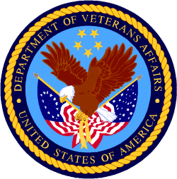

Department of Veterans Affairs

Programs:

Reminders:

Homeless Providers Grant and Per Diem Program
GPD Per Diem Only Grant Program (TIP)
Synopsis 5
Document Type: Grants Notice  Funding Opportunity Number: VA-GPD-TIP-FY2024  Funding Opportunity Title: GPD Per Diem Only Grant Program (TIP)  Opportunity Category: Discretionary  Opportunity Category Explanation:  Funding Instrument Type: Grant  Category of Funding Activity: Housing  Category Explanation:  Expected Number of Awards:  CFDA Number(s): 64.024 -- VA Homeless Providers Grant and Per Diem Program  Cost Sharing or Matching Requirement: No | Version: Synopsis 5  Posted Date: Oct 27, 2022  Last Updated Date: Oct 27, 2022  Original Closing Date for Applications: Jan 30, 2023 Jan 30, 2023. No later than 4:00 p.m. Eastern Time on January 30, 2023  Current Closing Date for Applications: Jan 30, 2023 Jan 30, 2023. No later than 4:00 p.m. Eastern Time on January 30, 2023  Archive Date: Jan 31, 2023  Estimated Total Program Funding:  Award Ceiling:  Award Floor:

Eligible Applicants: | Nonprofits having a 501(c)(3) status with the IRS, other than institutions of higher education  County governments  City or township governments  Native American tribal governments (Federally recognized)  Public housing authorities/Indian housing authorities  State governments  Special district governments
Additional Information on Eligibility:

Agency Name: | Homeless Providers Grant and Per Diem Program
Description: | SUMMARY: The Department of Veterans Affairs (VA) is announcing the availability of funding for new grants under the Transition in Place (TIP) grant component of the VA Homeless Providers Grant and Per Diem (GPD) program in an effort to reduce homelessness among Veterans.  Applications for assistance are being accepted from eligible entities to provide per diem payments for the TIP transitional housing model to facilitate housing stabilization for Veterans experiencing homelessness. The TIP housing model offers Veteran residents housing in which supportive services transition out of the residence over time, rather than the resident. This allows the Veteran to remain in the unit instead of being forced to find other housing while stabilizing.  VA anticipates that the grants will be for a period of 3 years starting in fiscal year (FY) 2024 on October 1, 2023 and ending September 30, 2026. VA anticipates awarding approximately 600 TIP beds nationwide. Applications must include a minimum of 5 TIP beds and up to a maximum of 20 TIP beds, per VA medical facility catchment area, per each applicant’s employer identification number (EIN).  DATES: Applications for grants must be received by the GPD National Program Office no later than 4:00 p.m. Eastern Time on Monday, January 30, 2023. In the interest of fairness to all, this deadline is firm as to date and hour. VA will treat any application received after the deadline as ineligible. Applicants should take this practice into account and submit their materials early to avoid the risk of unanticipated delays, computer service outages or other submission-related problems that might result in ineligibility.  ADDRESSES: Instructions for accessing the application are available at https://www.va.gov/homeless/gpd.asp. The required documentation for applications is outlined under the Content and Form of Application section of the Notice of Funding Opportunity (NOFO). Standard forms, which must be included as part of a complete application package, may be downloaded directly from VA’s GPD National Program Website at https://www.va.gov/homeless/gpd.asp. Questions may be referred to the GPD National Program Office at GPDGrants@va.gov. For detailed GPD program information and requirements, see 38 C.F.R. part 61.  APPLICATION SUBMISSION: Applications must be submitted by following instructions at https://www.va.gov/homeless/gpd.asp. Applications may not be submitted any other way. Applications must be submitted as a complete package. Materials arriving separately will not be included in the application package for consideration and may result in the application being rejected or not funded.  Applicants are advised to refer to the NOFO when completing the online application. NOFO content provides supplementary guidance for completing the online application.  TECHNICAL ASSISTANCE: Information regarding how to obtain technical assistance with the preparation of a grant application is available on the GPD National Program Website at https://www.va.gov/homeless/gpd.asp.  Applicants are encouraged to review the full NOFO in Grants.gov under the Related Documents tab, as well as the technical assistance materials on the GPD National Program Website.
Link to Additional Information: | GPD National Program Website
Grantor Contact Information: | If you have difficulty accessing the full announcement electronically, please contact:  Chelsea Watson Director, GPD National Program  GPDgrants@va.gov
https://www.grants.gov/web/grants/view-opportunity.html?oppId=344210

Homeless Providers Grant and Per Diem Program
GPD Per Diem Only Grant Program (PDO)
Synopsis 9
Document Type: Grants Notice  Funding Opportunity Number: VA-GPD-PDO-FY2024  Funding Opportunity Title: GPD Per Diem Only Grant Program (PDO)  Opportunity Category: Discretionary  Opportunity Category Explanation:  Funding Instrument Type: Grant  Category of Funding Activity: Housing  Category Explanation:  Expected Number of Awards:  CFDA Number(s): 64.024 -- VA Homeless Providers Grant and Per Diem Program  Cost Sharing or Matching Requirement: No | Version: Synopsis 9  Posted Date: Oct 27, 2022  Last Updated Date: Oct 27, 2022  Original Closing Date for Applications: Feb 06, 2023 Feb 06, 2023. No later than 4:00 p.m. Eastern Time on February 6, 2023  Current Closing Date for Applications: Feb 06, 2023 Feb 06, 2023. No later than 4:00 p.m. Eastern Time on February 6, 2023  Archive Date: Feb 07, 2023  Estimated Total Program Funding:  Award Ceiling:  Award Floor:

Eligible Applicants: | Nonprofits having a 501(c)(3) status with the IRS, other than institutions of higher education  County governments  Special district governments  State governments  Native American tribal governments (Federally recognized)  Public housing authorities/Indian housing authorities  City or township governments
Additional Information on Eligibility:

Agency Name: | Homeless Providers Grant and Per Diem Program
Description: | SUMMARY: The Department of Veterans Affairs (VA) is announcing the availability of funding for new grants under the Per Diem Only (PDO) grant component of the VA Homeless Providers Grant and Per Diem (GPD) program in an effort to reduce homelessness among Veterans.  Applications for assistance are being accepted from eligible entities to provide per diem payments for facilitating housing stabilization for Veterans experiencing homelessness. Funding will support PDO transitional supportive housing bed models and service centers. These PDO service models are designed to meet different Veteran populations at various stages as they move to stable housing.  VA anticipates that the grants will be for a period of 3 years starting in fiscal year (FY) 2024 on October 1, 2023 and ending September 30, 2026. VA anticipates awarding approximately 10,500 transitional supportive housing beds and 15 service centers nationwide. Applications will be accepted either for transitional supportive housing beds or for a service center. Applications for transitional supportive housing may include one or a combination of bed models (i.e., Bridge Housing, Clinical Treatment, Hospital to Housing, Low Demand and/or Service Intensive Transitional Housing). Each application for transitional supportive housing beds must include a minimum of one housing model per application and a minimum of five beds per housing model. Applications may not request both transitional supportive housing beds and a service center within the same application.  DATES: Applications for grants must be received by the GPD National Program Office no later than 4:00 p.m. Eastern Time on Monday, February 6, 2023. In the interest of fairness to all, this deadline is firm as to date and hour. VA will treat any application received after the deadline as ineligible. Applicants should take this practice into account and submit their materials early to avoid the risk of unanticipated delays, computer service outages or other submission-related problems that might result in ineligibility.  ADDRESSES: Instructions for accessing the application are available at https://www.va.gov/homeless/gpd.asp. The required documentation for applications is outlined under the Content and Form of Application section of the Notice of Funding Opportunity (NOFO). Standard forms, which must be included as part of a complete application package, may be downloaded directly from VA’s GPD National Program Website at https://www.va.gov/homeless/gpd.asp. Questions may be referred to the GPD National Program Office at GPDGrants@va.gov. For detailed GPD program information and requirements, see 38 C.F.R. part 61.  APPLICATION SUBMISSION: Applications must be submitted by following instructions at https://www.va.gov/homeless/gpd.asp. Applications may not be submitted any other way. Applications must be submitted as a complete package. Materials arriving separately will not be included in the application package for consideration and may result in the application being rejected or not funded.  Applicants are advised to refer to the NOFO when completing the online application. NOFO content provides supplementary guidance for completing the online application.  TECHNICAL ASSISTANCE: Information regarding how to obtain technical assistance with the preparation of a grant application is available on the GPD National Program Website at https://www.va.gov/homeless/gpd.asp.  Applicants are encouraged to review the full NOFO in Grants.gov under the Related Documents tab, as well as the technical assistance materials on the GPD National Program Website.
Link to Additional Information: | GPD National Program Website
Grantor Contact Information: | If you have difficulty accessing the full announcement electronically, please contact:  Chelsea Watson Director, GPD National Program  GPDgrants@va.gov
https://www.grants.gov/web/grants/view-opportunity.html?oppId=344209

Supportive Services for Veteran Families
Funding Opportunity Department of Veteran Affairs Supportive Services for Veteran Families
Synopsis 2

Document Type: Grants Notice  Funding Opportunity Number: VASSVF2024  Funding Opportunity Title: Funding Opportunity Department of Veteran Affairs Supportive Services for Veteran Families  Opportunity Category: Discretionary  Opportunity Category Explanation:  Funding Instrument Type: Grant  Category of Funding Activity: Other (see text field entitled "Explanation of Other Category of Funding Activity" for clarification)  Category Explanation: Housing  Expected Number of Awards:  CFDA Number(s): 64.033 -- VA Supportive Services for Veteran Families Program  Cost Sharing or Matching Requirement: No | Version: Synopsis 2  Posted Date: Nov 01, 2022  Last Updated Date: Nov 01, 2022  Original Closing Date for Applications: Feb 10, 2023  Current Closing Date for Applications: Feb 10, 2023  Archive Date: Feb 11, 2023  Estimated Total Program Funding:  Award Ceiling: $731,000,000  Award Floor: $0

Eligible Applicants: | Nonprofits having a 501(c)(3) status with the IRS, other than institutions of higher education  Others (see text field entitled "Additional Information on Eligibility" for clarification)
Additional Information on Eligibility: | Consumer Cooperatives

Agency Name: | Supportive Services for Veteran Families
Description: | The Department of Veterans Affairs (VA) is announcing the availability of funds for supportive services grants under the Supportive Services for Veteran Families (SSVF) Program. This Notice of Funding Availability (NOFA) contains information concerning the SSVF Program; the renewal and new applicant supportive services grant application processes; and the amount of funding available. Awards made for supportive services grants will fund operations beginning October 1, 2023. Grant  awards may be renewed for up to 3 years pending the availability of funds and grantee performance. Please find additional information on the SSVF website at Supportive Services for Veteran Families (va.gov). Applications can be placed through the VHA Homeless Program Grant Management System UDPaaS - VHA.
Link to Additional Information: | SSVF Website
Grantor Contact Information: | If you have difficulty accessing the full announcement electronically, please contact:  Jennifer Colbert Supervisor  National SSVF Inbox

https://www.grants.gov/web/grants/view-opportunity.html?oppId=344328

VA accesses resources to increase housing assistance for vulnerable Veterans
The Department of Veterans Affairs updated regulations Nov. 10 governing the Supportive Services for Veteran Families grant program to provide a more effective subsidy to Veterans in high-cost rental markets and to increase the cap in general housing assistance available to the most vulnerable Veteran families.
Under the new regulations, in certain communities, the SSVF grant will cover up to 50%, an increase from 35% of eligible Veterans’ reasonable rent for two years without need for recertification.
“We know Veterans are increasingly vulnerable to homelessness and housing insecurity,” said VA Secretary Denis McDonough. “The updated regulations give Supportive Services for Veteran Families grantees more flexibility and tools to keep Veterans housed while also helping them increase their income and access permanent affordable housing solutions.”
The new rule also expands the maximum stay in emergency housing for unsheltered Veterans.
The original rule authorized placement for a Veteran and his or her spouse with dependents in emergency housing for up to 45 days, which proved often not enough time to locate stable and affordable permanent housing in highly competitive rental markets.
A Veteran and his or her spouse with dependents can now stay in emergency housing for a maximum of 60 days. The 15-day increase in length-of-stay is expected to have the most significant benefit to Veteran families in rental markets with few vacancies, as well as unsheltered homeless Veterans families.
Ending Veteran homelessness is a top priority for VA, aligned with the White House’s priority to promote housing stability by supporting vulnerable tenants.
Learn more about VA’s mission to end homelessness among Veterans and how you can help.

PART 2 – GENERAL FEDERAL AGENCY GRANTS INFORMATION
JANUARY 2023

Please review each department’s General Grant and Funding Overview. These overviews are the key web pages on each departmental website dedicated to the agency’s funding opportunities. Check back often to note the department updates.

(See Part 1 for current grant opportunity notices)

Federal Agencies Discretionary Grants and Contract Website Links

Native Hawaiian Programs

U.S. Department of Agriculture

Grants and Loans Overview

Department of Commerce

Grants at Commerce

Economic Development Administration Hawaii Contacts

Corporation for National and Community Service

General Program Overview

National Service in Hawaii

Department of Defense

Doing Business with the Department of Defense

Department of Education

Grant Programs Overview

US Department of Energy

Grants Overview

Environmental Protection Agency

Grants and Contracts Overview

Federal Mediation and Conciliation Service

Grants Overview

Department of Health and Human Services

Grants Overview

Department of Homeland Security
Grants Overview

Department of Housing and Urban Development

HUD - Notice of Funds Available

Institute of Museum and Library Services
Grants Overview

IMLS is on Facebook!

Department of Interior

Grants and Contract Overview

Department of Justice

Grants and Contract Overview

Hawaii State Administrative Agency Contacts
________________________________________________________________________

Department of Labor

Grants and Contract General Overview

National Aeronautics and Space Administration

Research Grant and Contract General Overview
_______________________________________________________________
National Archives and Records Administration

Grant Opportunities General Overview
_______________________________________________________________
National Endowment for the Arts

Grant Opportunities General Overview
_______________________________________________________________

National Endowment for the Humanities

Grant Opportunities General Overview
_______________________________________________________________
National Science Foundation

Grant Opportunities General Overview

Small Business Administration

General Overview Finding Loans & Grants

Links Specific to Hawaii

State Department

General Overview and Resources for Program Administrators

_________________________________________________________________________________

U.S. Department of Transportation

General Grant Program Overview

Department of the Treasury

Overview

US Agency for International Development

General Funding Opportunity Overview

Department of Veterans Affairs

Programs

Grants.Gov Links

Grant Writing Resources

SBIR – Small Business Innovation Research

Federal Agency Discretionary Grant and Contract Websites and Overviews

Federal Offices of Likely Interest to Native Hawaiians
- U.S. Department of Education
Office of Elementary and Secondary Education
Native Hawaiian Education Programs
White House Initiative on Asian Americans and Pacific Islanders
- U.S. Department of Health and Human Services
Health Resources & Services Administration
Native Hawaiian Health Care Systems
Office of Regional Operations Region 9 Office
Administration for Native Americans
ANA Pacific Region Training and Technical Assistance Center
- U.S. Department of Housing and Urban Development
Federal Housing Administration
Insured Mortgages on Hawaiian Home Lands, FHA Section 247
Office of Native American Programs
Native Hawaiian Housing
Hawai‘i State Home Page
- U.S. Department of the Interior
National Park Service
Hawai‘i Parks
National NAGPRA Program
U.S. Fish and Wildlife Service
Pacific Islands Fish and Wildlife Office
Office of the Region One Tribal Liaison
U.S. Geological Survey
Pacific Region - Hawai‘i
- U.S. Department of Agriculture
Cooperative Research and Extension Services
Farm Service Agency - Hawai‘i and Pacific Basin
Natural Resources Conservation Services - Pacific Islands Area
Rural Development - Hawai‘i
- U.S. Department of Defense
Office of the Deputy Under Secretary of Defense (Installations & Environment)
Senior Advisor and Liaison for Native American Affairs
Native Hawaiian Affairs
- Advisory Council on Historic Preservation
Office of Native American Affairs
- U.S. Department of Commerce
U.S. Economic Development Administration
University Center Economic Development Program
Representative covering the State of Hawaii
National Oceanic and Atmospheric Administration
NOAA in Your State - Hawai‘i
- U.S. Small Business Administration
Hawai‘i District Office
8(a) Business Development Program (open to qualified Native Hawaiian businesses)
- U.S. Department of the Treasury
Community Development Financial Institution Fund (CDFI Fund)
- U.S. Department of Veteran Affairs
Center for Minority Veterans
Office of Diversity and Inclusion

https://www.doi.gov/hawaiian

Office of Hawaiian Affairs Community Grants Program
Grants – The purpose of the Office of Hawaiian Affairs Grants Program is to support Hawaiʻi based nonprofit organizations that have projects, programs, and initiatives to serve our Lāhui in alignment with OHA’s Strategic Foundations, Directions & Outcomes.
Reminder, to be eligible for funding consideration, an applicant shall:
- Be registered to do business in the State of Hawaiʻi
- Provide services to Native Hawaiians and/or Native Hawaiian community(ies) in the State of Hawaiʻi
- Have an IRS letter of Determination
- Compliant with Hawaiʻi Compliance Express

https://www.oha.org/resources/

Resources
Providing resources is among the key ways that the Office of Hawaiian Affairs fulfills its purpose.
The best possible Native Hawaiian historical and cultural information has been just a click away since the launch in April 2013 of the Kipuka Database. It is a searchable online geographic information system that makes data that once would have taken long to compile, now available within seconds. The database helps complement our other key research tools, such as the Native Hawaiian Data Book and the Papakilo Database, which is a digital library for Native Hawaiian historical and cultural information.
In addition, we launched Kamakako’i, an issues-based digital media tool that has been years in the making. The cutting-edge website provides a platform to quickly engage key audiences and inspire action on policy matters important to the Native Hawaiian community.

Resources
- Grants – The purpose of the Office of Hawaiian Affairs Community Grants Program is to support projects, programs and initiatives that address OHA’s six Strategic Priorities and accompanying Strategic Results contained in OHA’s 2010-2018 Strategic Plan.
- Kamakakoʻi – A cutting edge tool that leverages technology to engage, inform, activate and rally the Hawaiʻi community around voices on the cutting edge of community issues. It is produced and maintained by the Office of Hawaiian Affairs.
- Ka Wai Ola – Ka Wai Ola is a monthly newspaper published by OHA. The Ka Wai Ola operates under the Communications division of Community Engagement. The Ka Wai Ola has about 60,000 subscribers and strives to create rich content geared toward captivating the Hawaiian community.
- Kīpuka Database – A geographical information system (GIS) that utilizes the latest mapping technologies to provide a window into native Hawaiian land, culture and history.
- Loans – The Office of Hawaiians Affairs is committed to ensuring Native Hawaiians and their ‘ohana have access to resources to assist them in pursuing their financial goals.
- OHA Native Hawaiian Data Book – A compilation of basic demographic data on Hawaiians and data to identify gaps and important issues to ensure OHA’s actions and initiatives are based on the best information available.
- Papakilo Data Base – A comprehensive “Database of Databases” consisting of varied collections of data pertaining to historically and culturally significant places, events, and documents in Hawai’i’s history.
- Reports and Research – A collection of reports and surveys intended to help guide strategic direction and policy decisions.
- Scholarships – Each year OHA provides funding for scholarships through its Higher Education Scholarship Programs.

U.S. Department of Agriculture

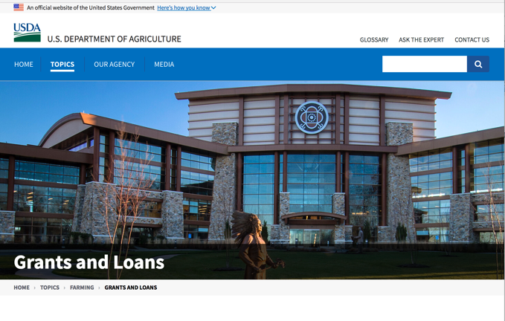

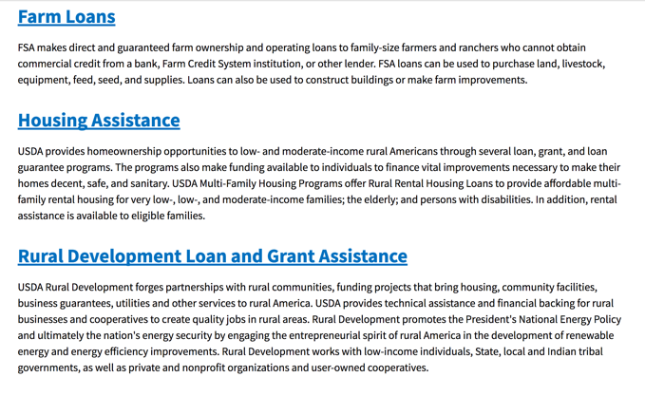

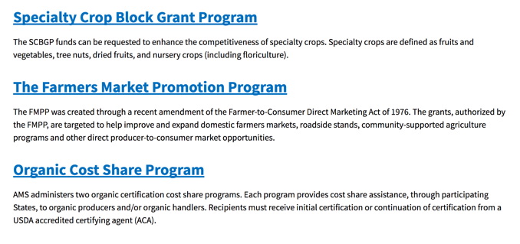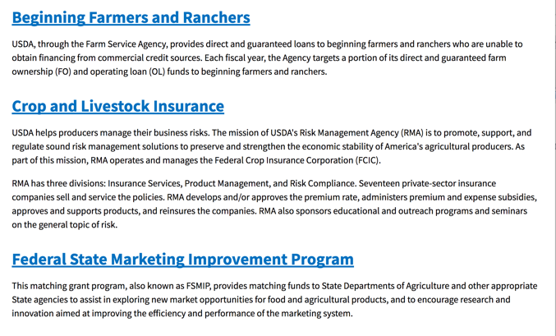
https://www.usda.gov/topics/farming/grants-and-loans
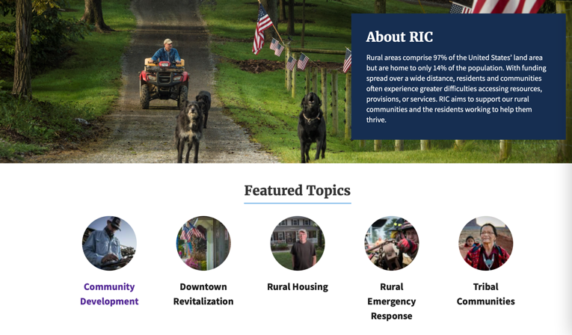https://www.nal.usda.gov/ric/community-development-resources

Department of Commerce

Grants, Contracting, and Trade Opportunities at Commerce
Learn more information about grants, contracting and trade opportunities at the Department of Commerce using the information below
https://www.commerce.gov/work-with-us/grants-and-contract-opportunities
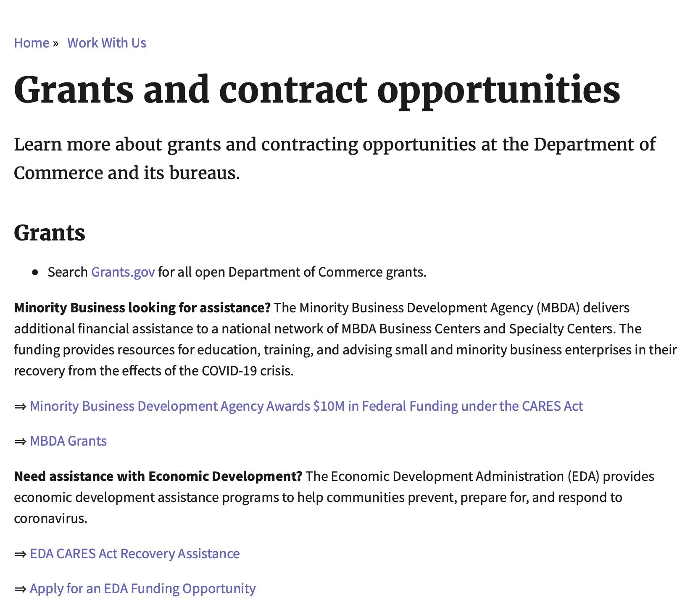

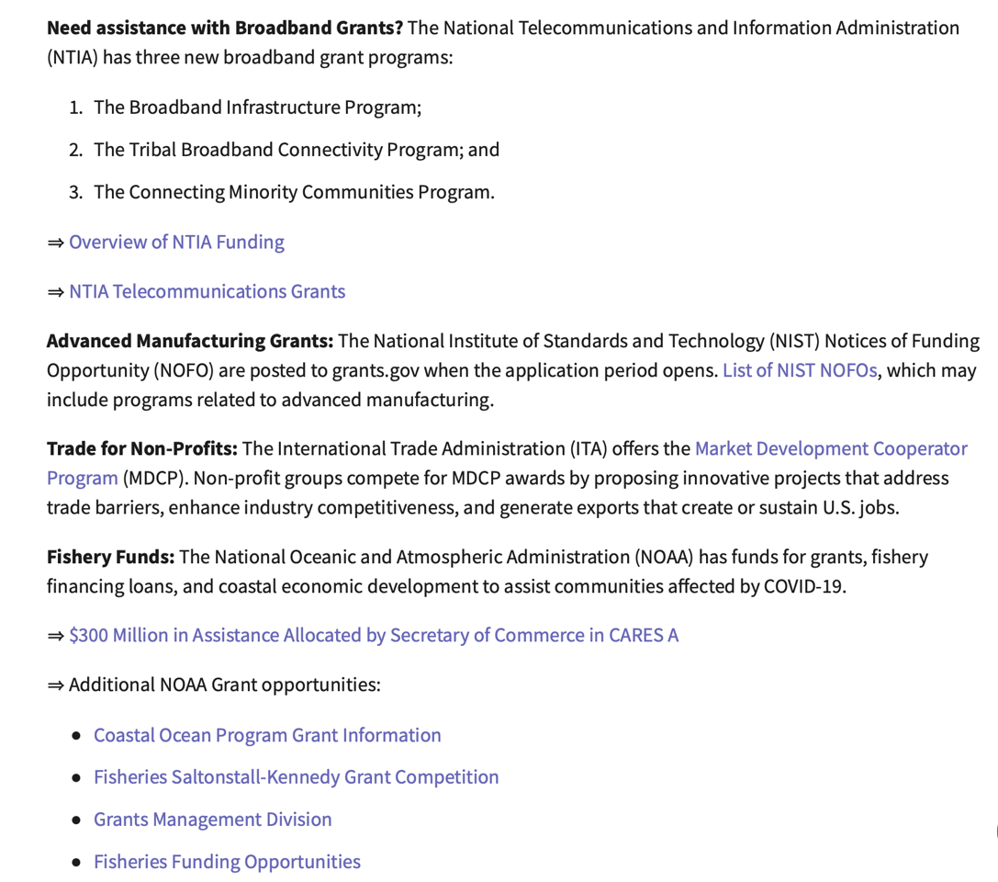
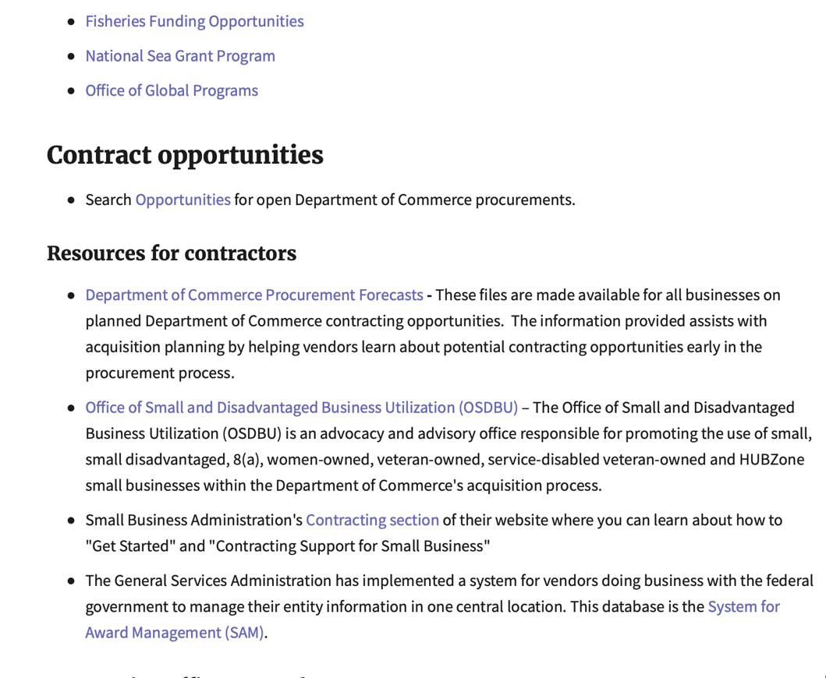
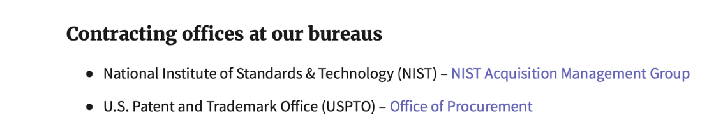
DOC Grant Making Bureaus
Economic Development Administration (EDA)
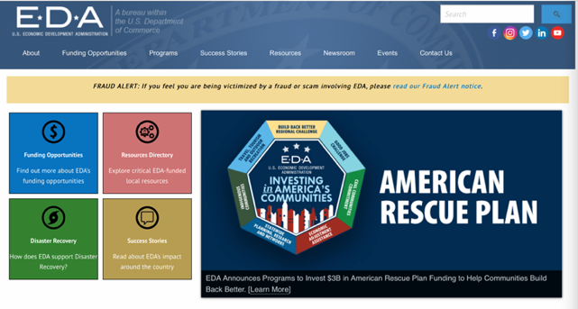
International Trade Administration (ITA)
- Market Development Cooperator Program
- Special American Business Internship Training Program (SABIT). A technical assistance initiative of the International Trade Administration of the U.S. Department of Commerce, SABIT offers organizations competitive grants and an opportunity to host industry-specific delegations. SABIT serves as an initial entry point for U.S. businesses seeking funding to establish long-term relationships with potential customers, distributors, or partners in the former Soviet Union. The program trains Eurasian managers and scientists in commonly accepted business practices as a means of facilitating cross border relationships. In turn, these personal relationships serve as a basis for business development and reduce market access barriers for U.S. businesses
National Institute of Standards & Technology (NIST)
- Funding Opportunities
National Telecommunications & Information Administration (NTIA)
- Telecommunications Grants
National Oceanic & Atmospheric Administration (NOAA)
- Coastal Ocean Program Grant Information
- Fisheries Saltonstall Kennedy Grant Program
- National Undersea Research Program Funding Opportunities
- Grants Management Division
- Fisheries Grants Program
- National Sea Grant
- Office of Global Programs
Contracting Resources for Contractors
- Office of Small and Disadvantaged Business Utilization (OSDBU) - the Office of Small and Disadvantaged Business Utilization (OSDBU) is an advocacy and advisory office responsible for promoting the use of small, small disadvantaged, 8(a), women-owned, veteran-owned, service-disabled veteran-owned, and HUBZone small businesses within the U.S. Department of Commerce's (DOC) acquisition process.
- Business.USA.gov's Find Opportunities Wizard where in a few quick steps, it will guide you towards federal government contracting programs and opportunities for your business!
- Planned Acquisitions: the Department of Commerce's search tool for our planned acquisitions over $100,000. As requirements change, these acquisition plans are updated by department personnel and this search tool is automatically updated.
- Small Business Administration's Contracting section of their web site where you can learn about how to "Get Started" and "Contracting Support for Small Business"
- The General Services Administration (GSA) has implemented a system for vendors doing business with the Federal Government to manage their entity information in one central location. This new database is the System for Award Management (SAM).
DOC Contracting Offices
- Patent and Trademark Office (PTO)
  - Office of Procurement

- National Institute of Standards & Technology (NIST)
NIST Acquisition Management Group
Contracting Opportunities with Commerce
Trade Opportunities through Commerce
http://www.commerce.gov

Economic Development Administration Hawaii Contacts

https://www.eda.gov/resources/economic-development-directory/states/hi.htm

Corporation for National and Community Service

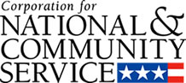

General Program Overview

AmeriCorps provides resources, both human and financial, to organizations that engage Americans in intensive service to meet our country’s critical needs.
Grantees use the funding to support AmeriCorps members for intensive service in their community. AmeriCorps grants partially cover the expense of operating an AmeriCorps program and do not cover general organizational expenses. A cash and in-kind match are required.

The main website can be accessed here: http://www.nationalservice.gov

For access to further funding information: https://americorps.gov/partner/funding-opportunities

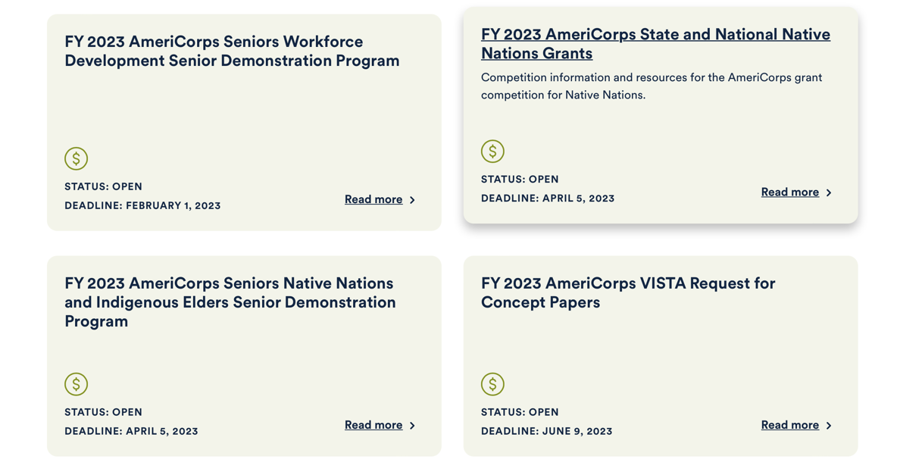

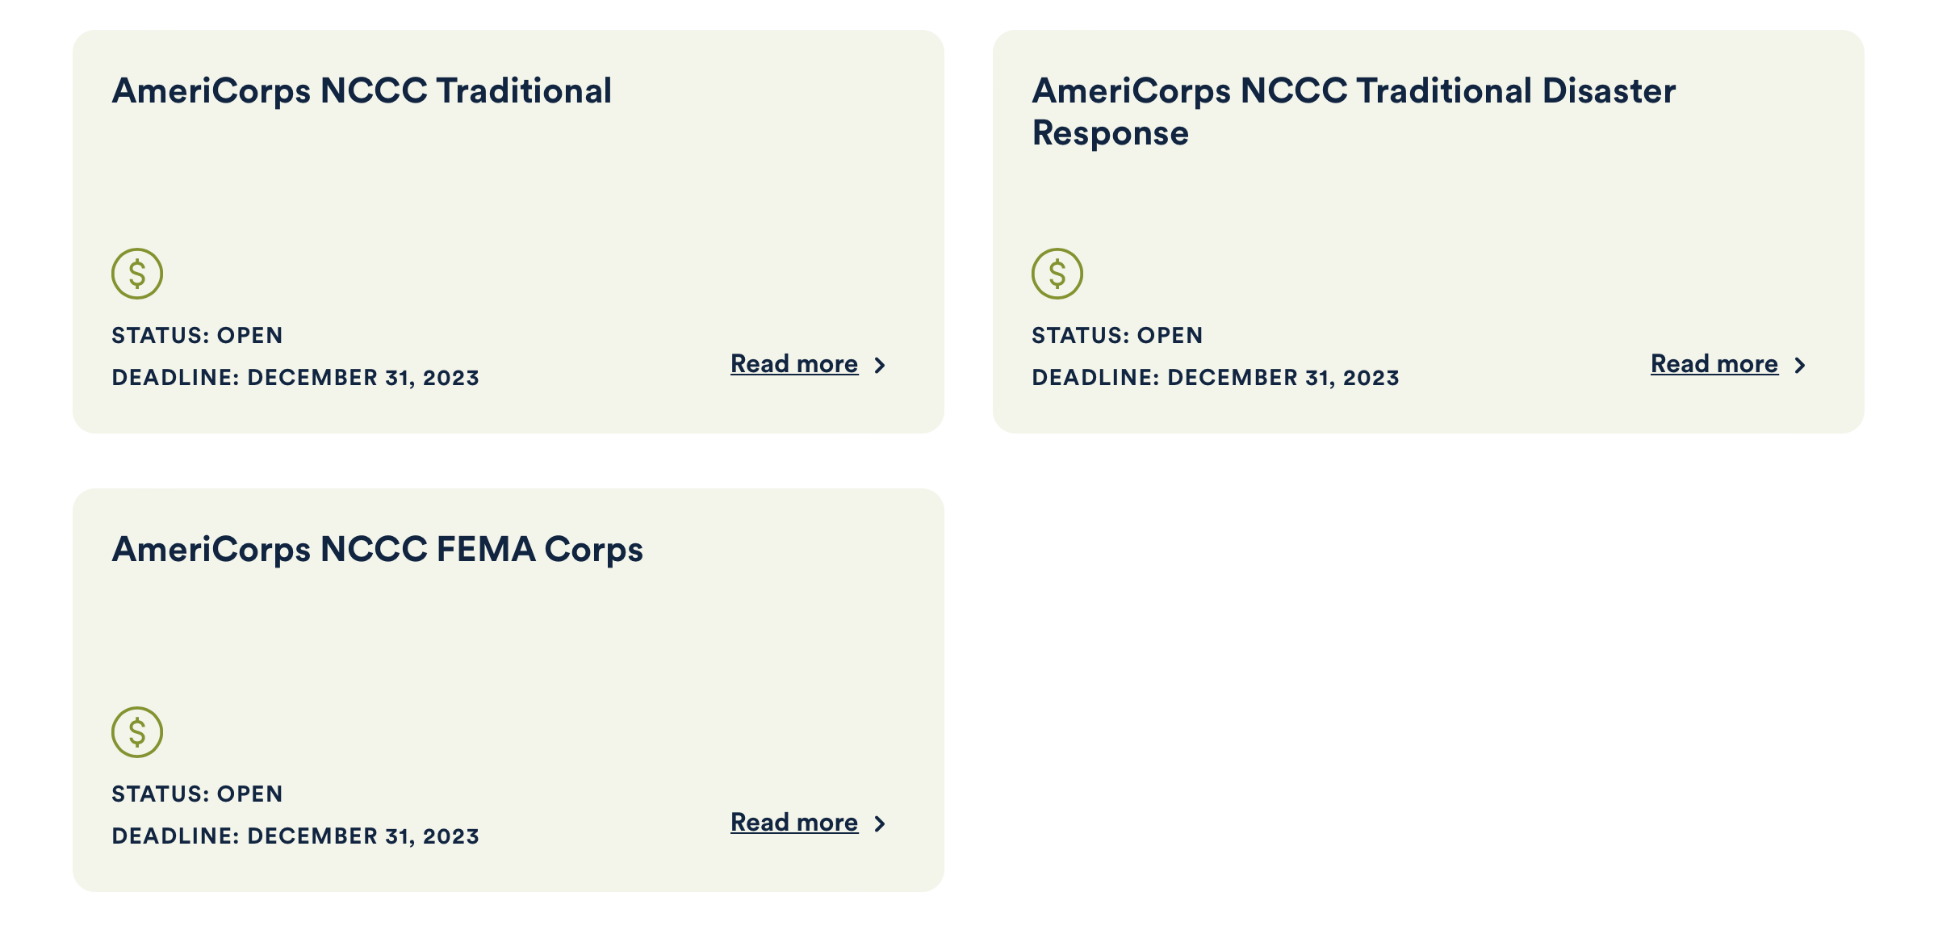
https://www.americorps.gov/partner/funding-opportunities

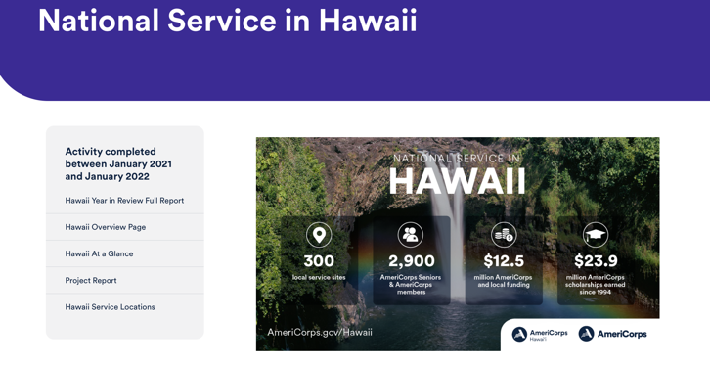

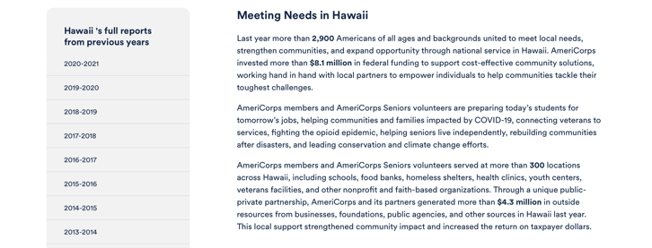
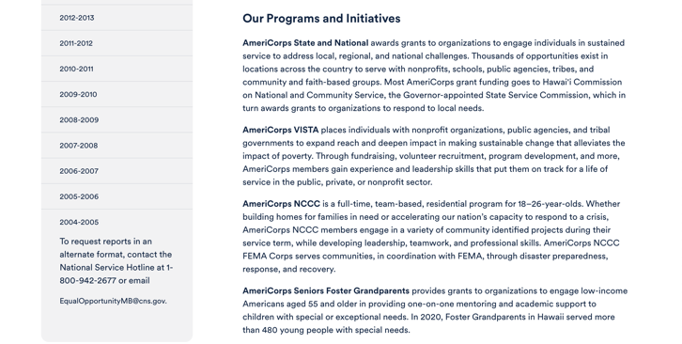
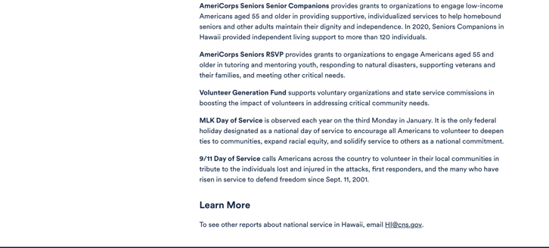

Learn More https://americorps.gov/national-service-report/hi
To see other reports about national service in Hawaii, please contact HI@cns.gov.
The Corporation for National and Community Service is a federal agency that improves lives, strengthens communities, and fosters civic engagement through service and volunteering. To learn more, visit www.NationalService.gov or call 202-606-5000 or TTY 1-800-833-3722.

U.S. Department of Defense

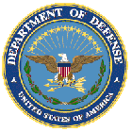

Doing Business with the Department of Defense

http://business.defense.gov

Corona Virus Response -- https://business.defense.gov/COVID-19-SMALL-BUSINESS-RESOURCES/

Department of Education


Grant Programs Overview at the Department of Education

The general information page for Education Grant funding is an excellent resource describing the three types of grants awarded by the Department of Education. See the screen shot of the Department of Education web page below:

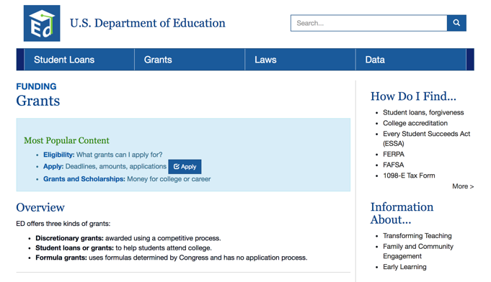
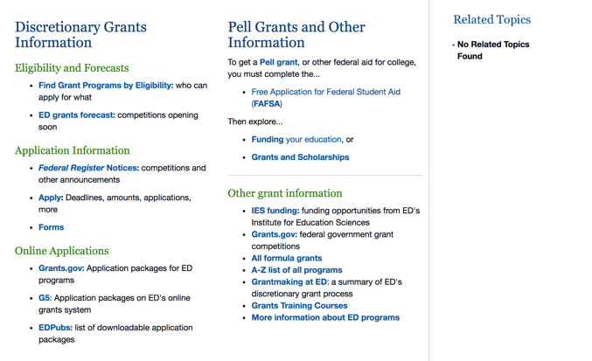

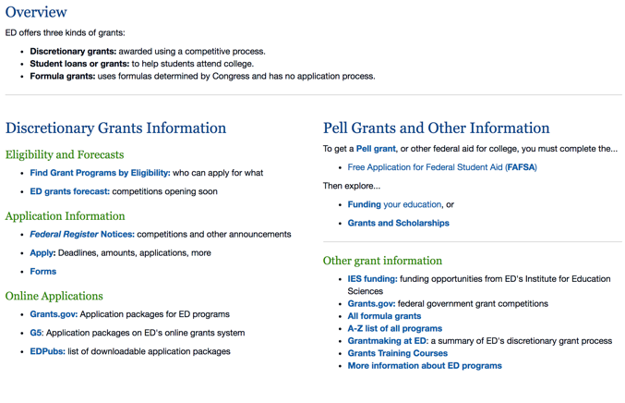

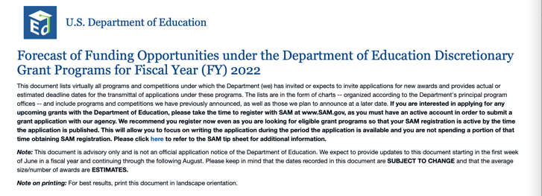

https://www2.ed.gov/fund/grant/find/edlite-forecast.html

U.S. Department of Energy

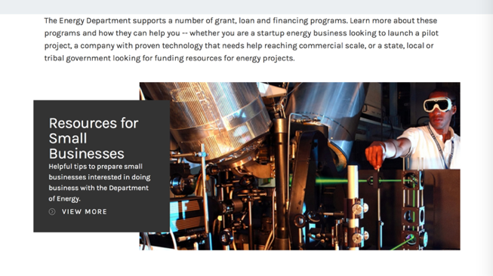
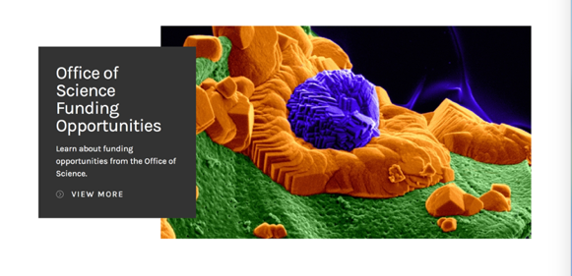

https://www.energy.gov/energy-economy/funding-financing

Environmental Protection Agency

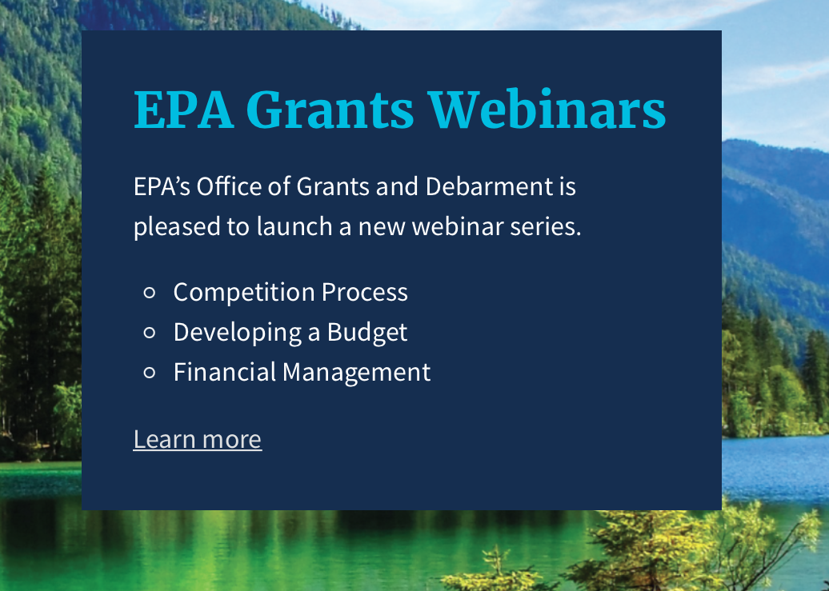

https://www.epa.gov/grants/epa-grants-webinars

https://www.epa.gov/grants

Federal Mediation and Conciliation Service

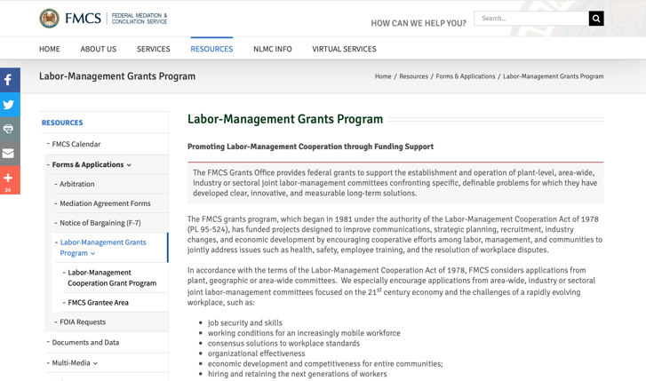
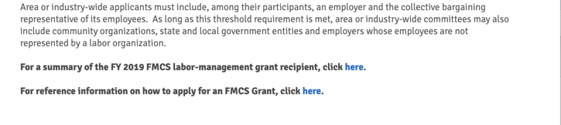

https://www.fmcs.gov/resources/forms-applications/labor-management-grants-program/

Department of Health and Human Services

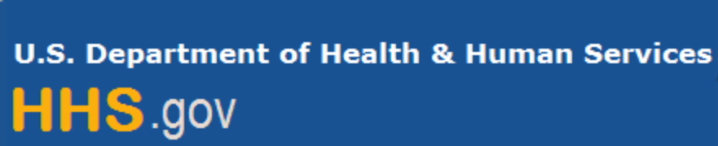

Grants Forecast and Overview

The Department of Health and Human Services’ Grants Forecast is a database of planned grant opportunities proposed by its agencies. Each Forecast record contains actual or estimated dates and funding levels for grants that the agency intends to award during the fiscal year. Forecast opportunities are subject to change based on enactment of congressional appropriations.

For more general information about HHS Grants and Funding go to the website below at:

https://www.hhs.gov/grants/grants/index.html

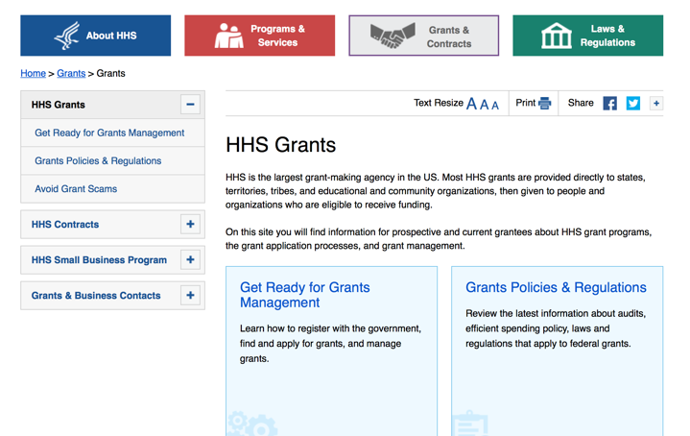

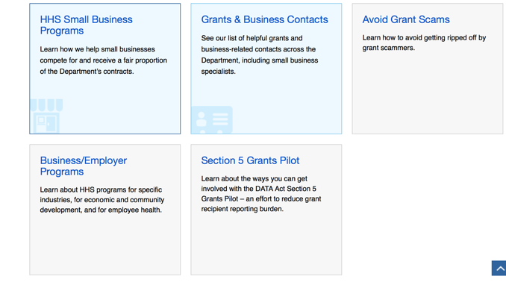

Department of Homeland Security



The Department of Homeland Security enhances the ability of states, local and tribal jurisdictions, and other regional authorities in the preparation, prevention, and response to terrorist attacks and other disasters, by distributing grant funds. Localities can use grants for planning, equipment, training and exercise needs.

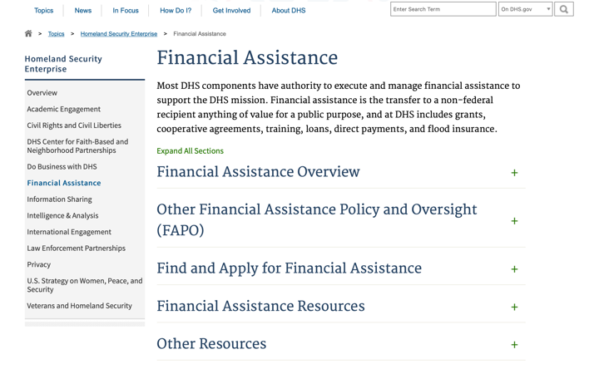

Webpage can be viewed at: https://www.dhs.gov/dhs-financial-assistance#2

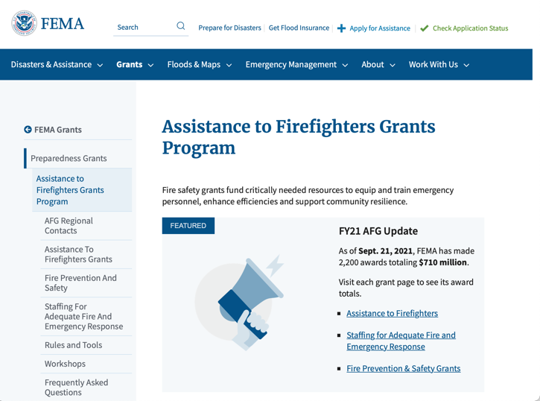
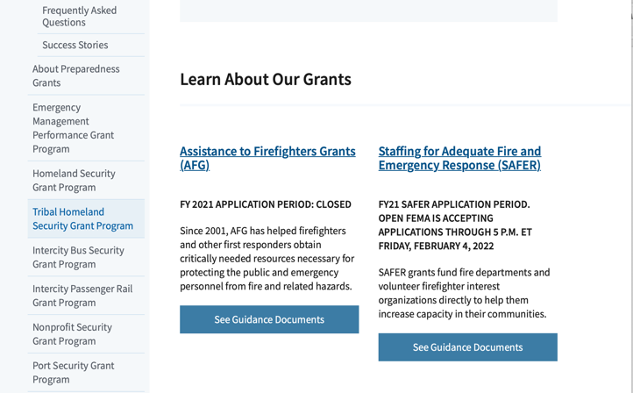

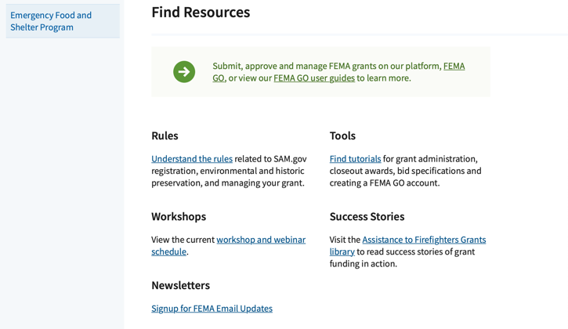
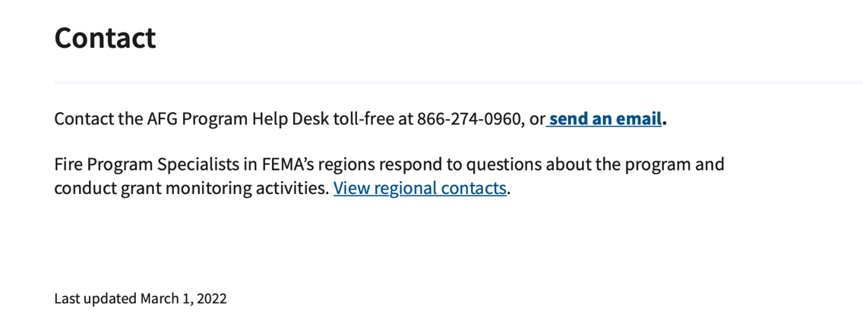

https://www.fema.gov/welcome-assistance-firefighters-grant-program

For AFG program guidance materials, please visit our Documents page.

Resources

AFG Help Desk
Contact the AFG Program Help Desk toll-free at 866-274-0960, or email us at firegrants@dhs.gov.
The AFG Program has Fire Program Specialists in 10 federal regional centers. These Regional Fire Program Specialists respond to questions about the AFG program and carry out grant monitoring activities. View regional contacts

Popular AFG links
- Assistance to Firefighters Grants (AFG)
- AFG Awards List
- Staffing for Adequate Fire & Emergency Response (SAFER) Grants (SAFER)
- SAFER Awards List
- SAFER Success Stories
- Fire Prevention & Safety (FP&S) Grants
- FP&S Awards List
- FP&S Success Stories
- Grant Closeout Tutorial
- Assistance to Firefighters Grant (AFG) Email Alert Archive
- Frequently Asked Questions
Contact Information For The Assistance to Firefighters Grant (AFG) Program and Help Desk

Federal Funding Alternative To AFG

https://www.fema.gov

Department of Housing and Urban Development

https://www.hud.gov/program_offices/spm/gmomgmt/grantsinfo

HUD - Notice of Funds Available
For detailed information click here

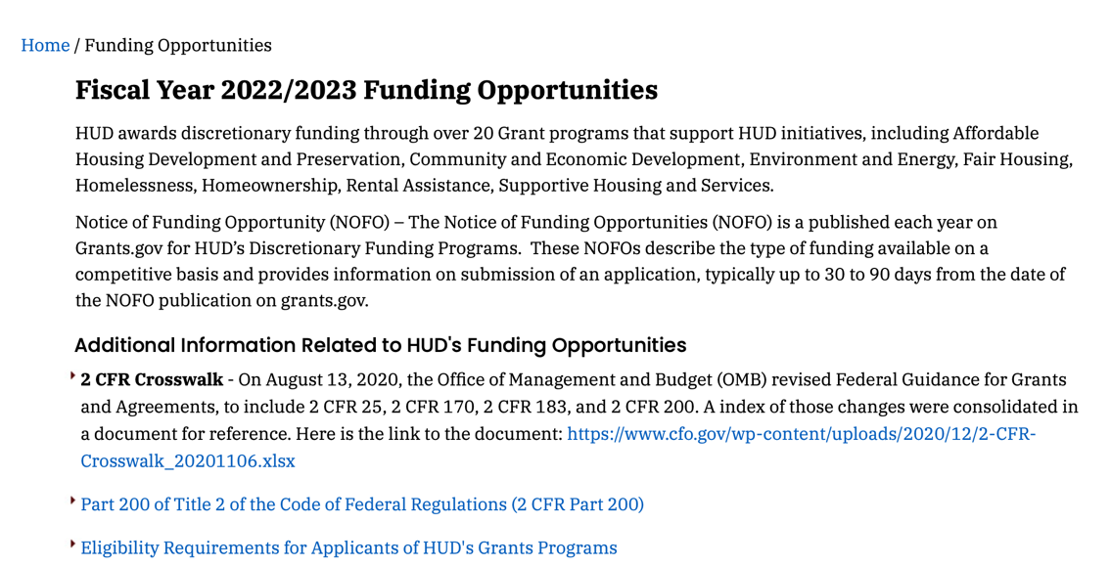
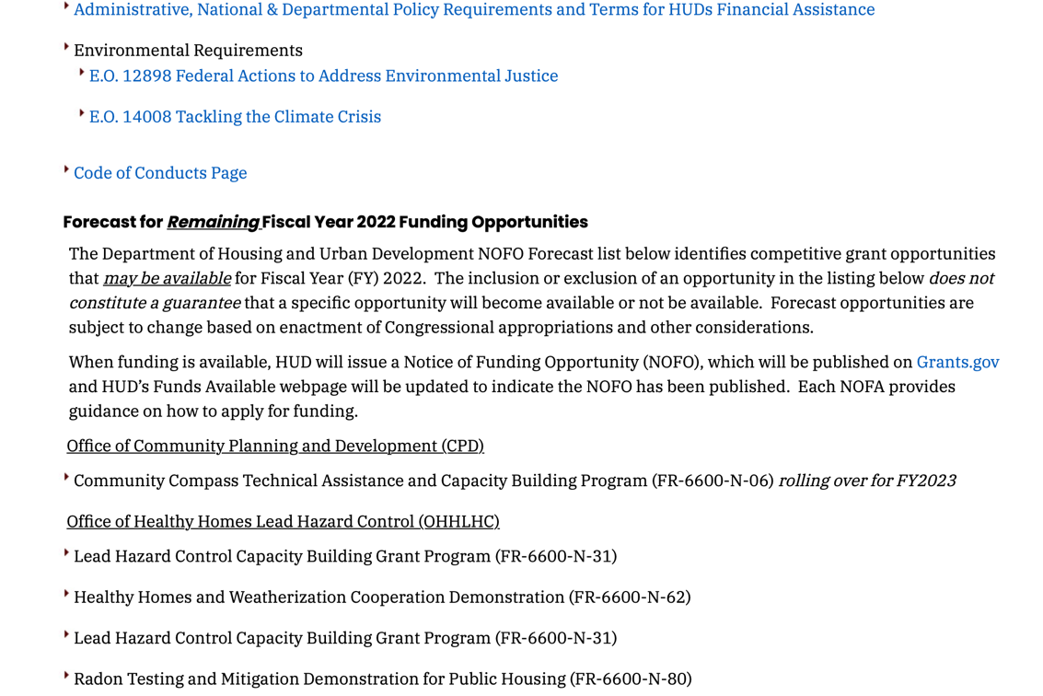
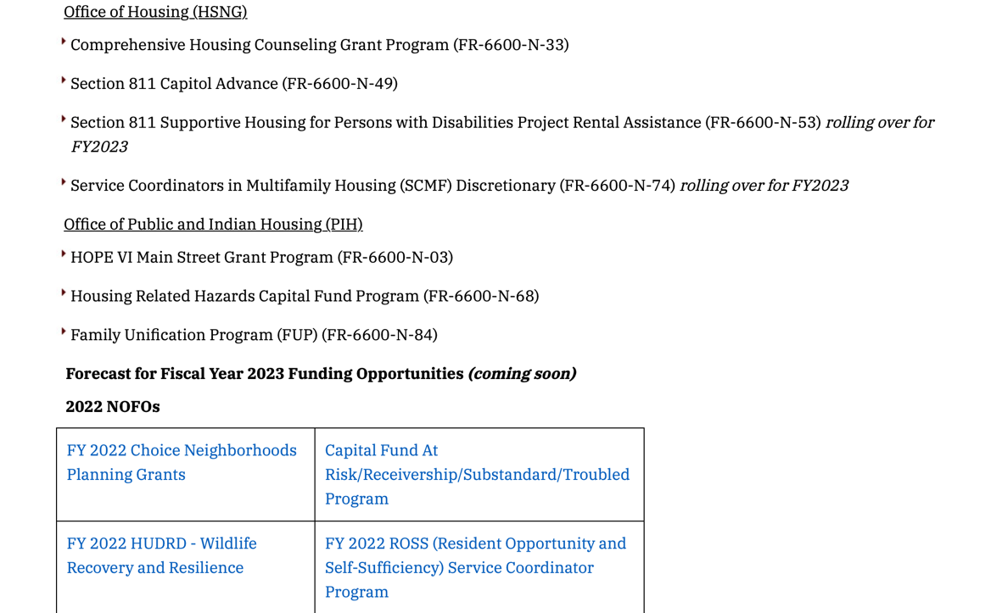
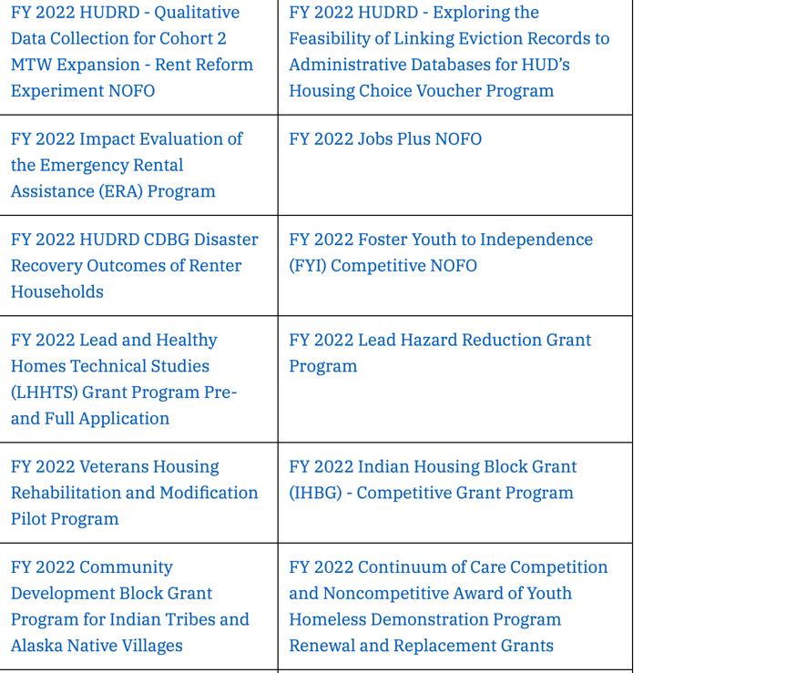

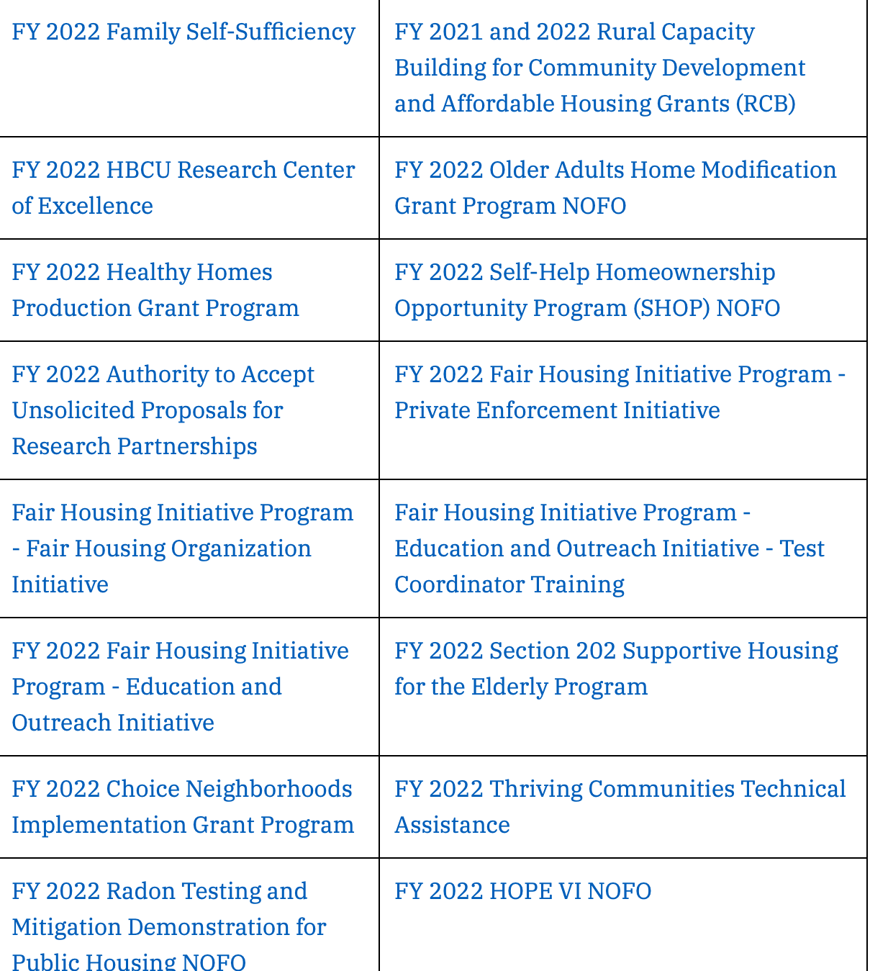

Fiscal 2023 coming soon!
http://portal.hud.gov/hudportal/HUD?src=/program_offices/Administration/grants/fundsavail

Institute of Museum and Library Services

https://www.imls.gov/grants/apply-grant/available-grants

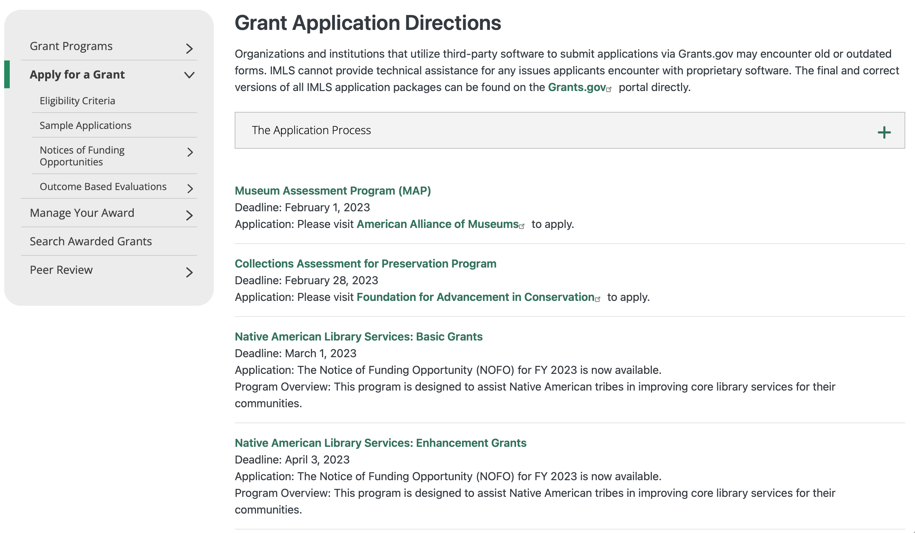

Each grant program has specific eligibility requirements. The links below provide general eligibility criteria for museums, libraries, and tribal organizations, but please note that additional organizations may be eligible for grants under certain programs. Additionally, ineligible organizations may still be able to participate in grant programs through partnerships with eligible organizations. Please click on the links below to see general criteria and review Applications and Guidelines for specific information.
Museums Libraries

Institutions: Archives, Federally Recognized Native American Tribe, Historical Society, Library, Nonprofits that serve Native Hawaiians, Professional Association, Public or Private Non-profit Institutions of Higher Education, Regional Organization, State Library Administrative Agency, State or Local Government

Check out IMLS's Facebook page at:
https://www.facebook.com/USIMLS/

Department of the Interior
The Interior Department provides assistance to the public, local governments and businesses through a number of programs. For a general overview see: http://www.doi.gov/index.cfm

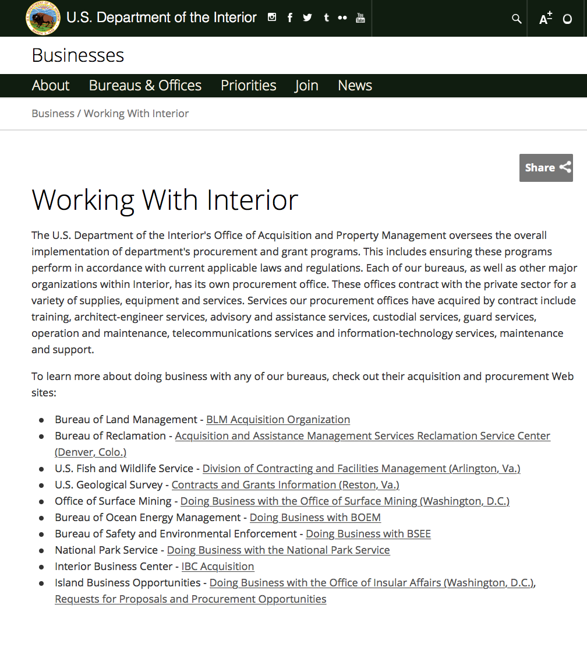

http://www.doi.gov/businesses/working-with-interior.cfm

Department of Justice

http://www.justice.gov/business/

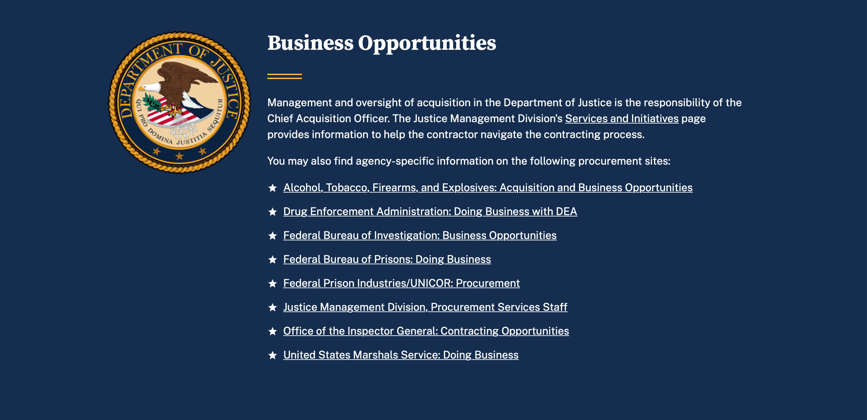

The DOJ agencies listed below also have sites that provide grant information specific to that agency. Examples of what can be found on these sites are programs, funding opportunities, application assistance, and other useful information.

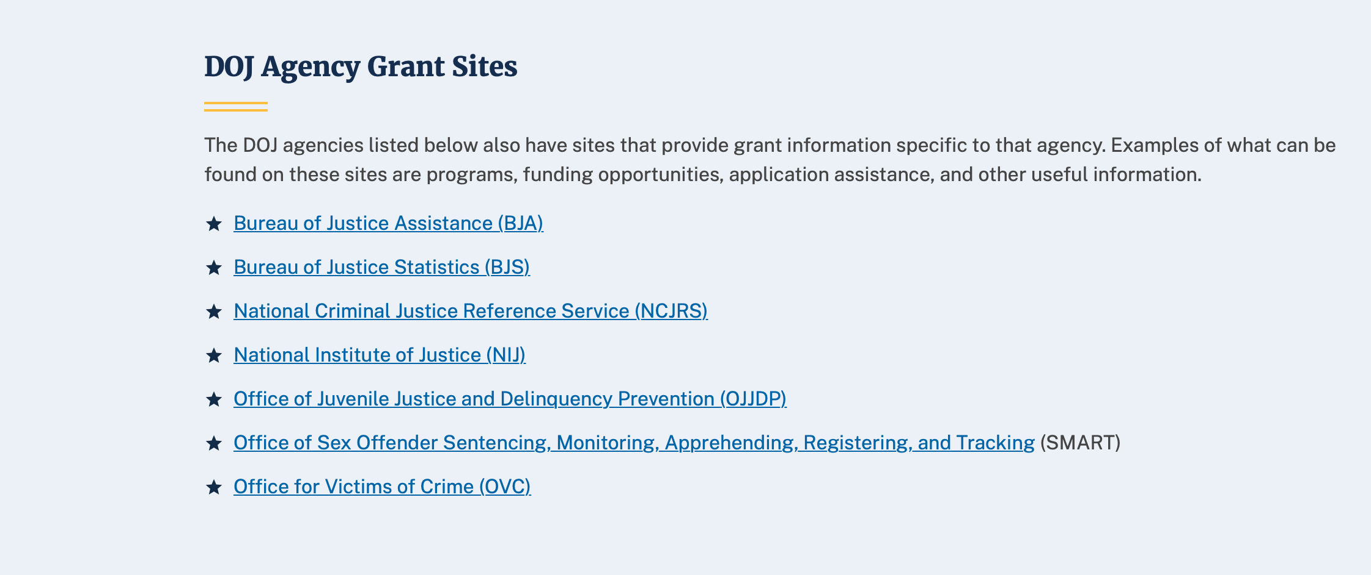

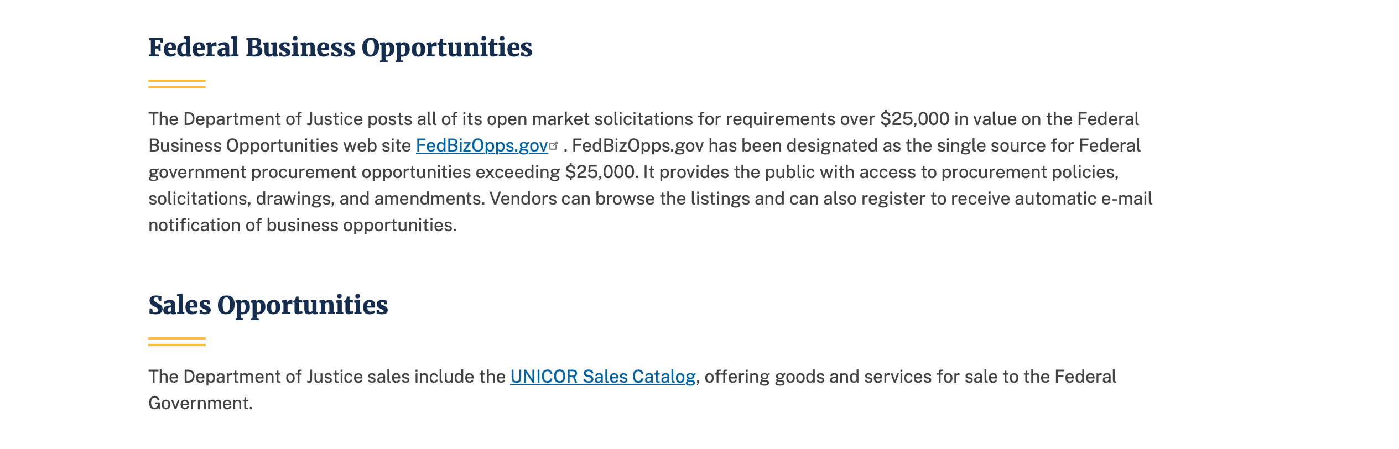

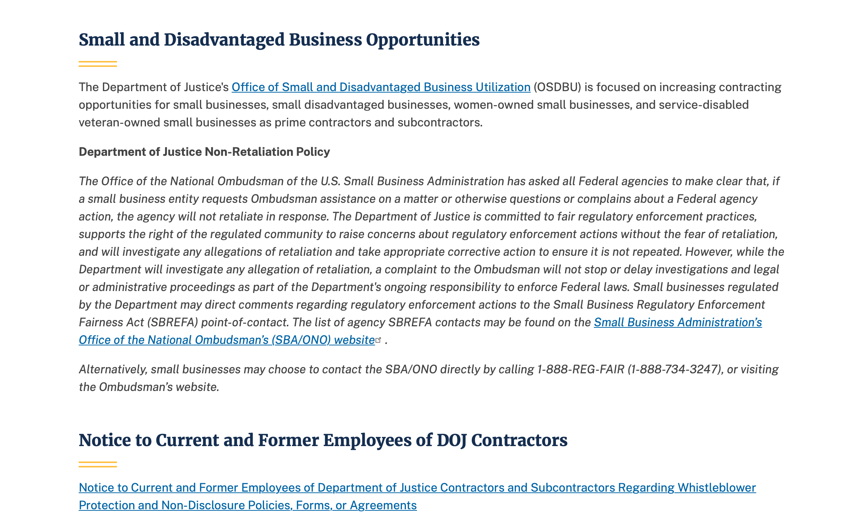

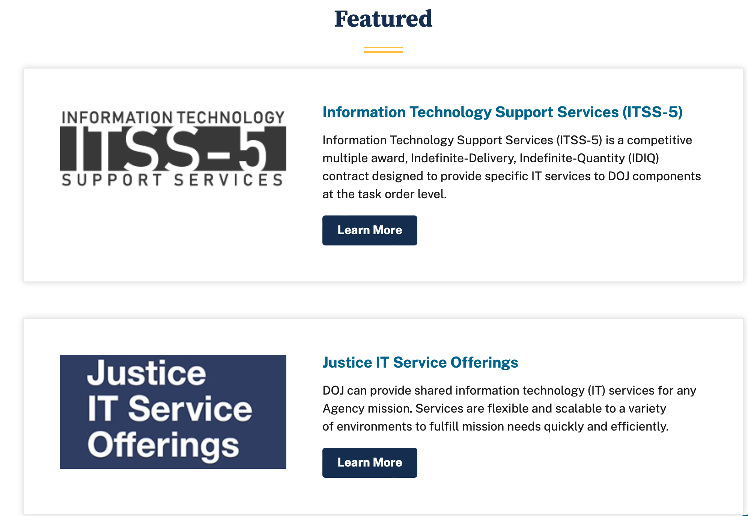

Bureau of Justice Assistance (BJA)

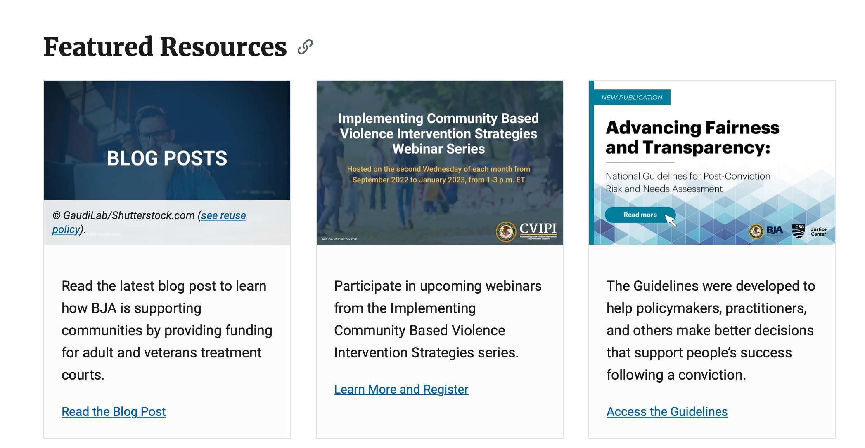

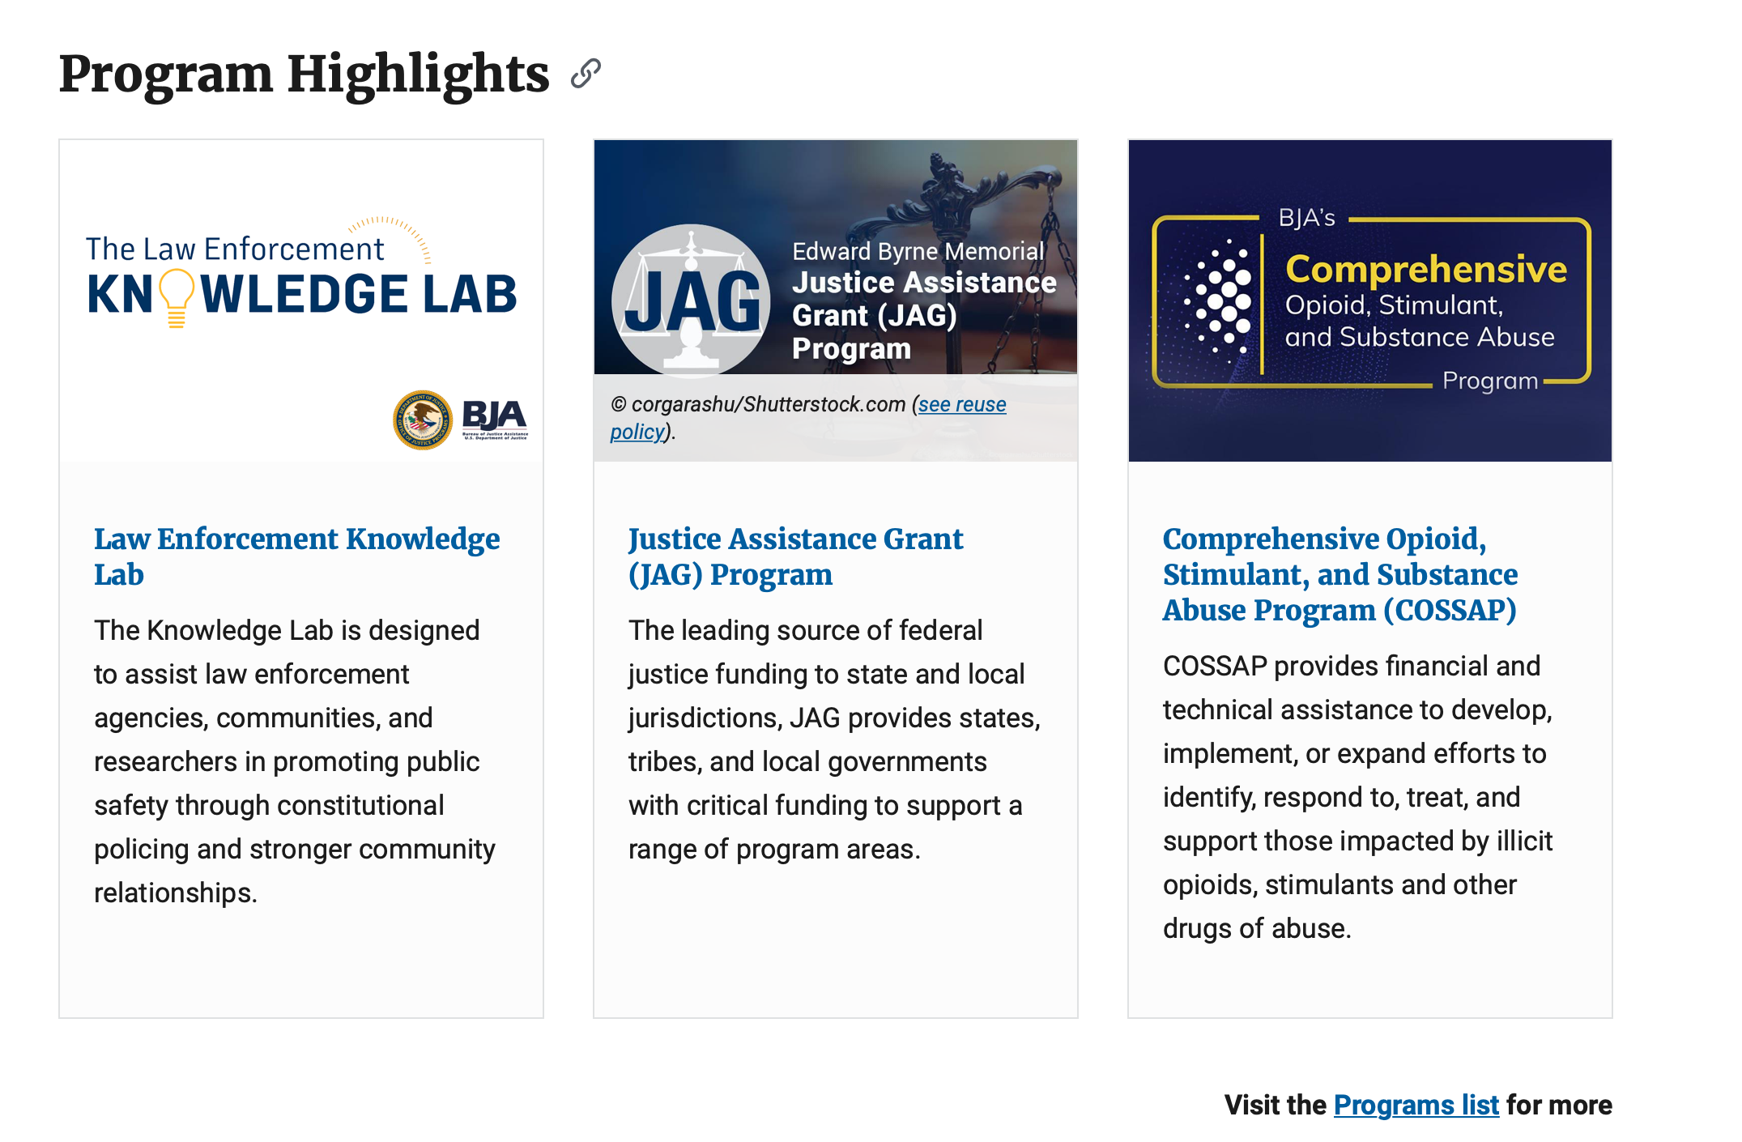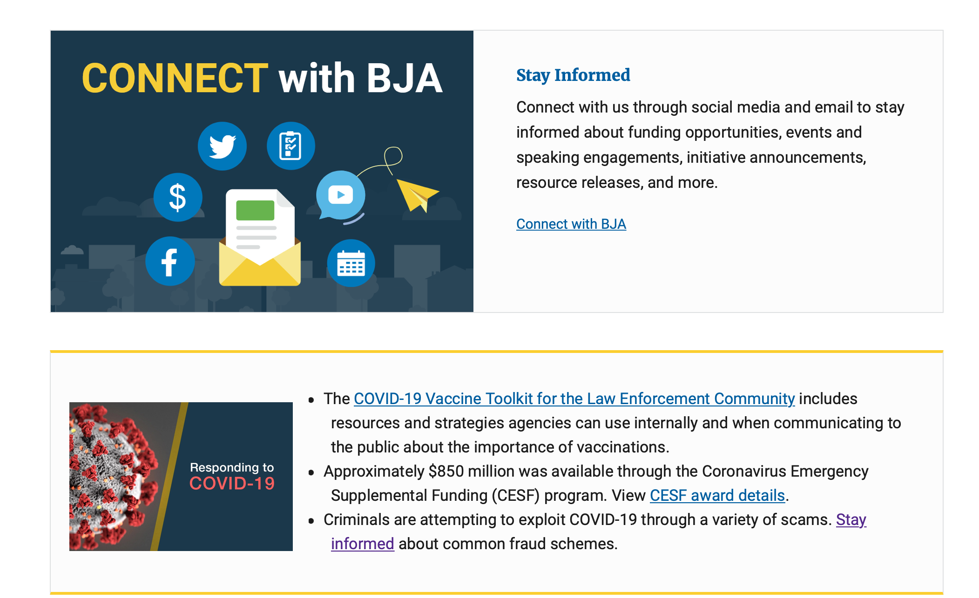

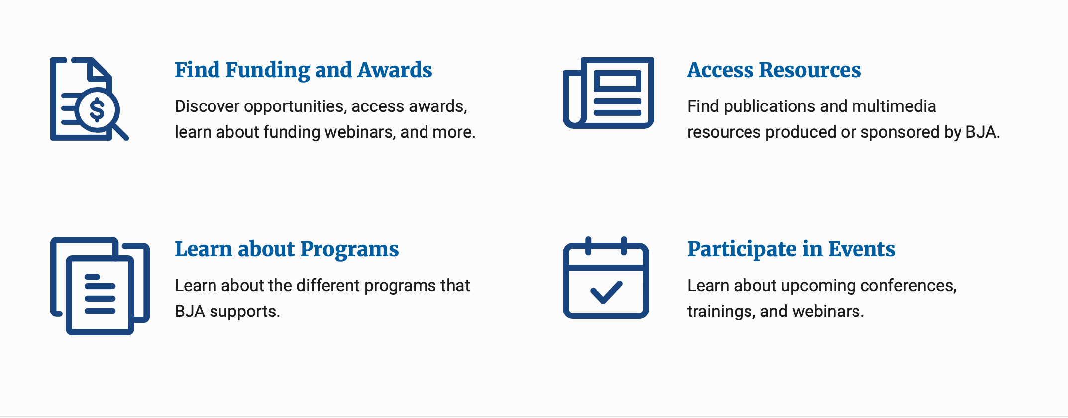

Bureau of Justice Statistics (BJS)

National Criminal Justice Reference Service (NCJRS)

National Institute of Justice (NIJ)

Office of Sex Offender Sentencing, Monitoring, Apprehending, Registering, and Tracking (SMART)

Hawaii State Administrative Agency Contacts

HAWAII DEPARTMENT OF THE ATTORNEY GENERAL, CRIME PREVENTION & JUSTICE ASSISTANCE DIVISION
235 S Beretania Street, Suite 401
Honolulu, HI 96813
(808) 586-1150
Agency Head: Julie Ebato, Administrator
JAG Contact: Shaleigh Tice, Grants & Planning Branch Chief
SAC Director: Paul Perrone, Chief of Research and Statistics

https://ag.hawaii.gov/cpja/gp/

Department of Labor

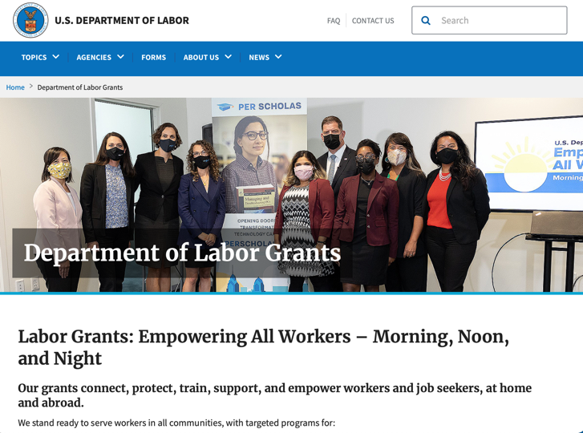
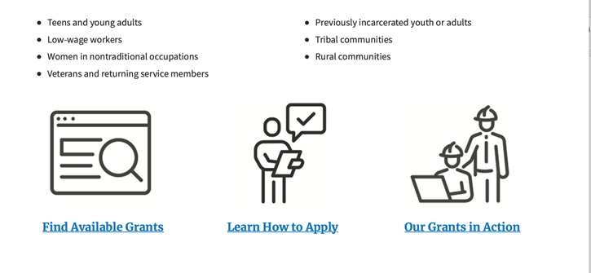

https://www.dol.gov/general/grants/howto

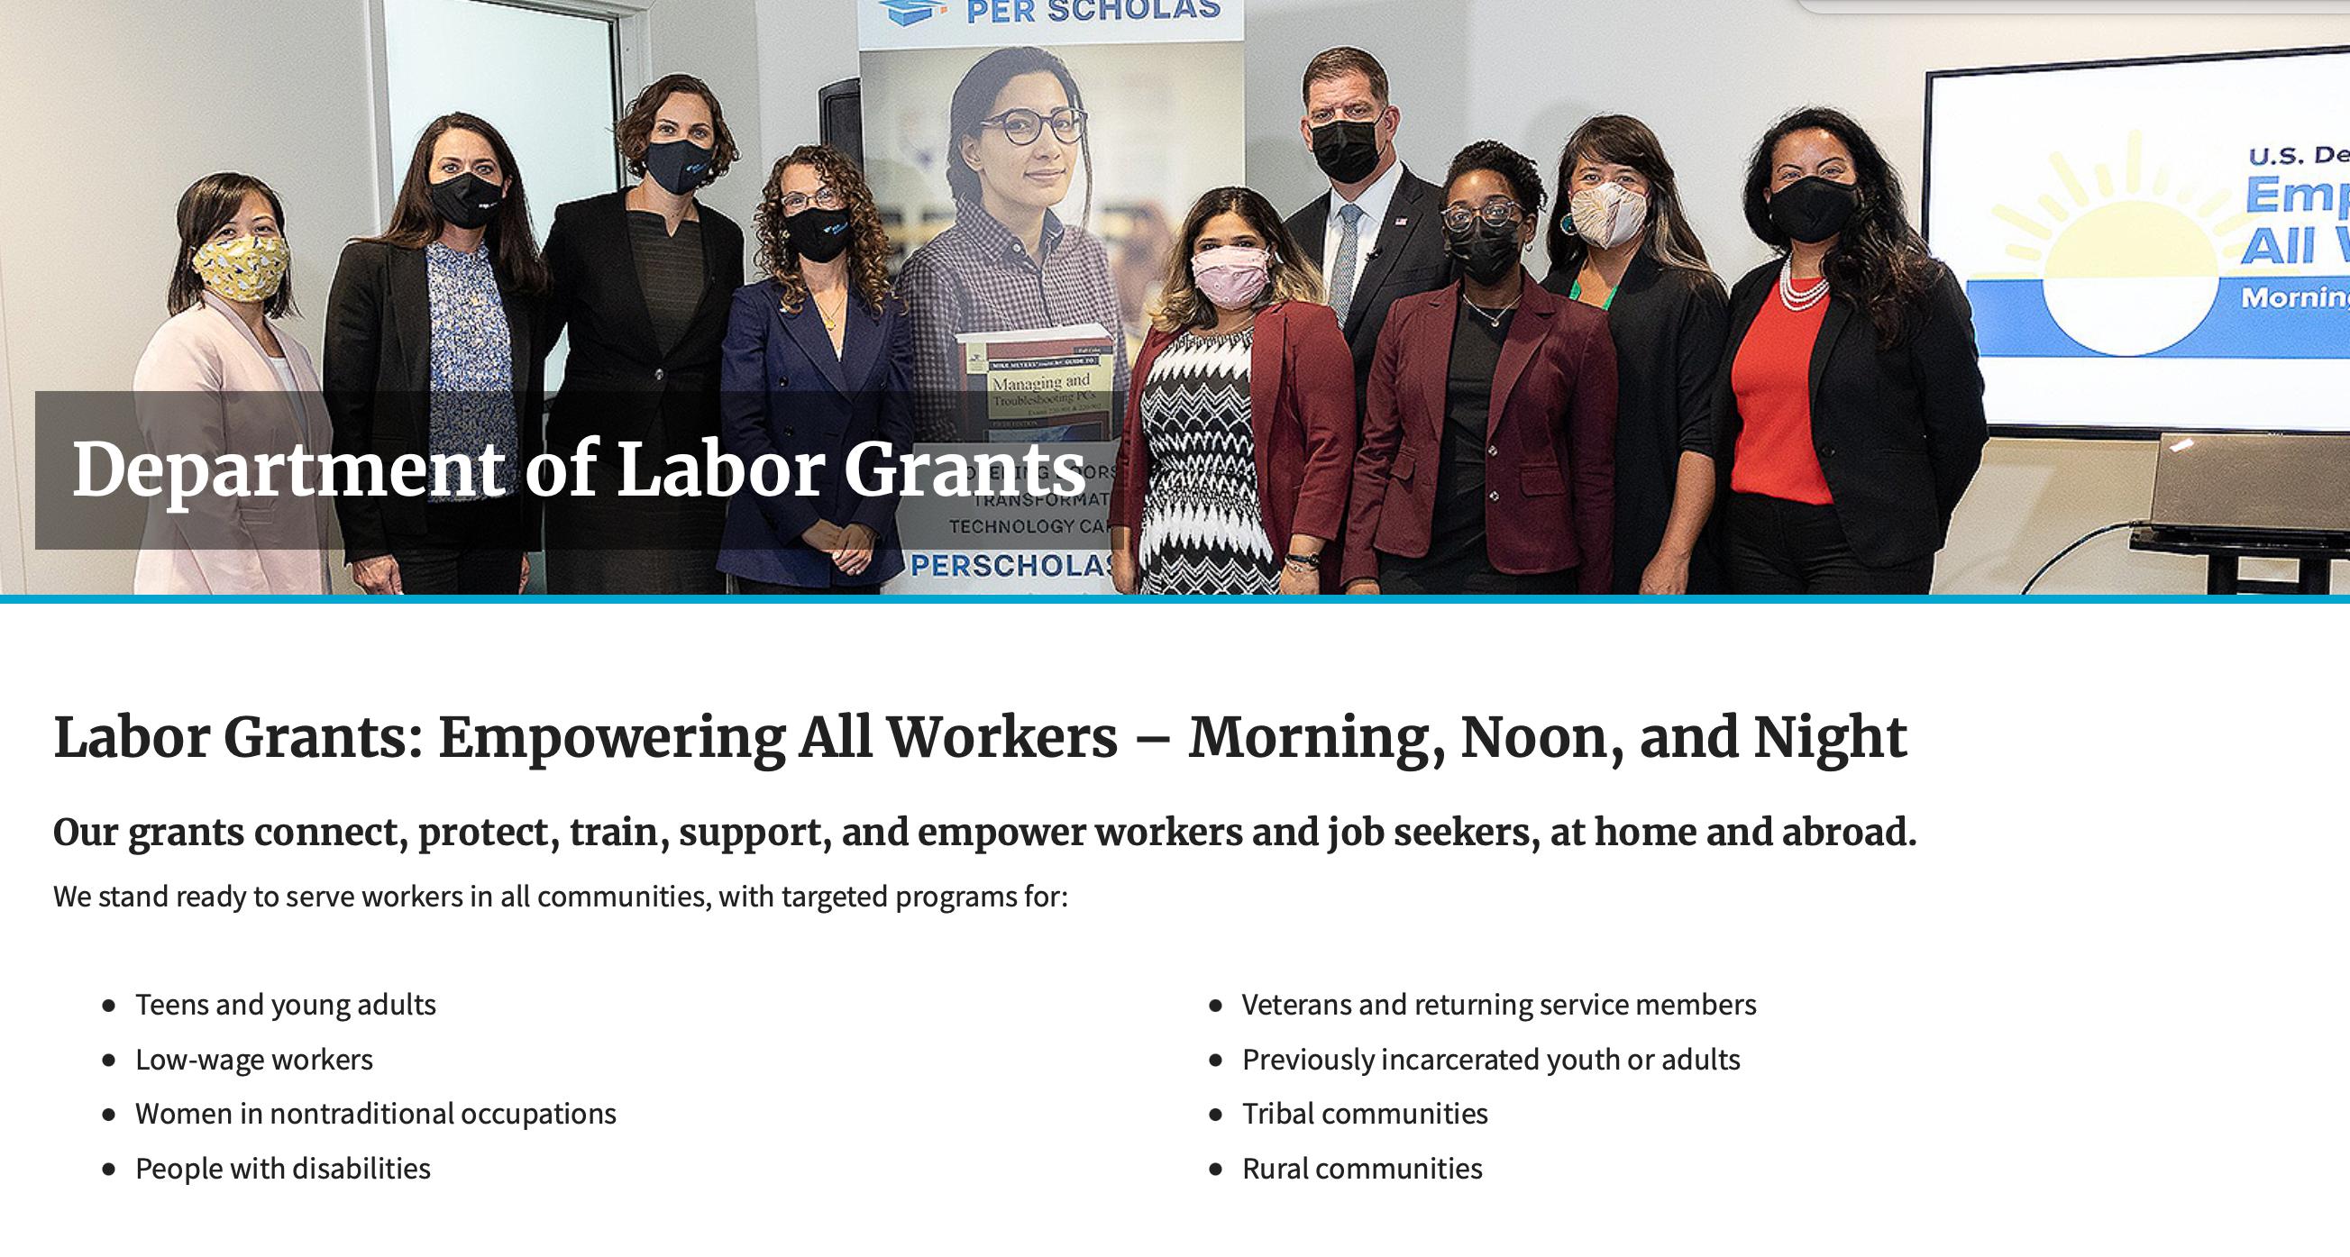

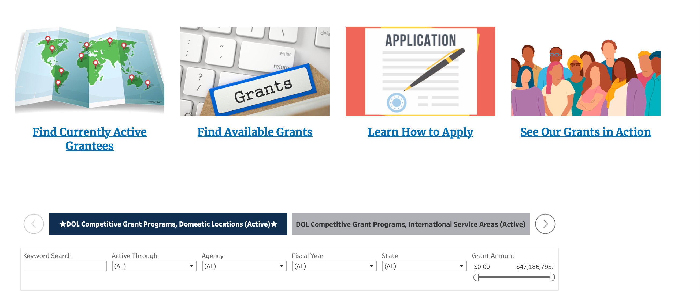

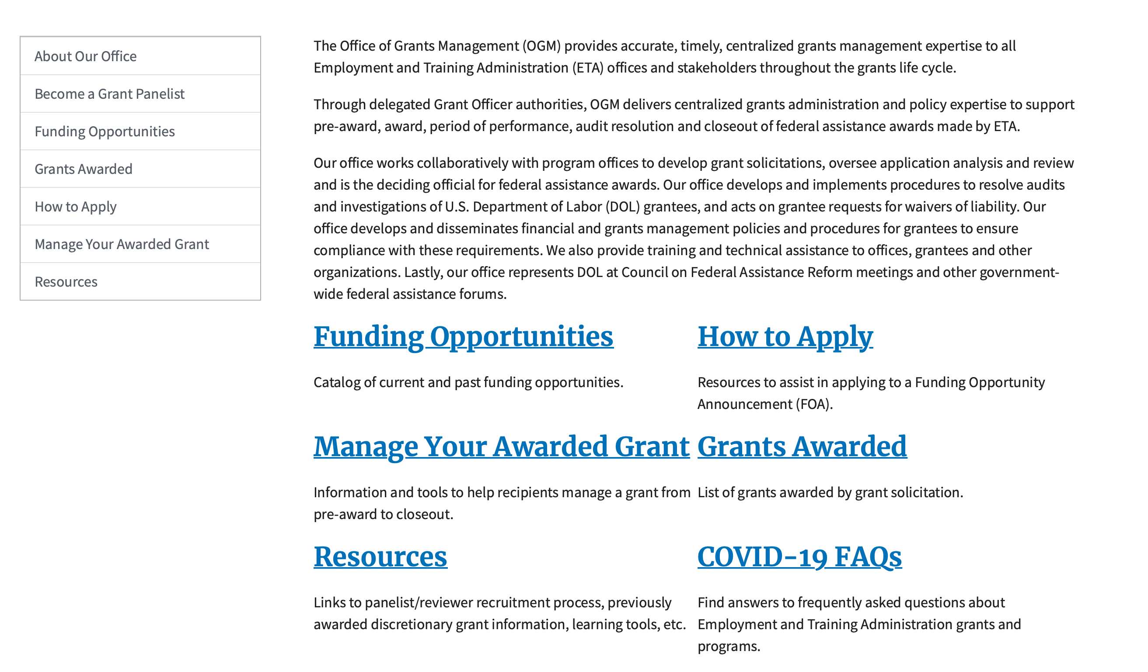

https://www.doleta.gov/grants/

Agency Grants and Contract General Overview

DOL Resources
Apply for DOL Agency-Specific Grants:
- Employment and Training Administration (ETA)
- Occupational Safety and Health Administration (OSHA)
- Bureau of International Labor Affairs (ILAB)
- Veterans' Employment and Training Service (VETS)
- Office of Disability Employment Policy (ODEP)
- Office of the Assistant Secretary for Administration and Management (OASAM)

Other Grant Resources:

DOL Resources and Instructions for Applying for a Grant
- DOL Guidance Clarifying the Effect of the Religious Freedom Restoration Act on Faith-Based Organizations
- Grant and Contract Information
- More Information About Grants

Other Federal Government Grant Information
- Grant Opportunities (Catalog of Federal Domestic Assistance)

Department of Labor Grant Programs

- Bureau of International Labor Affairs (ILAB): provides grants (cooperative agreements) for the implementation of projects designed to assist developing countries combat the worse forms of child labor, forced labor, and human trafficking; and support worker rights and improve working conditions. http://www.dol.gov/general/business.
- Bureau of Labor Statistics (BLS): provides project grants (cooperative agreements) and the dissemination of technical statistical data and related information on labor force activities; provides data on prices (CPI) and cost of living; data on productivity and technology data; data on compensation and working conditions; data on employment projections.
- Employment and Training (ETA): ETA Administers financial assistance programs pursuant to the Workforce Investment Act (WIA), administering State formula grant programs for youth, adults and dislocated workers, national emergency grants for workers affected by mass layoffs, plant closures, and disasters; grant programs for workers with disabilities, Indians and Native Americans, and for migrant and seasonal farmworkers. ETA also administers grant programs for older American workers, apprenticeship programs, Trade Adjustment Assistance (TAA) programs, and assistance for research and development of workforce programs. In addition, ETA is responsible for the operation and maintenance of a national system of public employment service offices and for the national unemployment insurance program.
- Mine Safety and Health (MSHA): provides grants for research, education and training programs to ensure an adequate and competent staff of trained inspectors; and assistance for establishing or improving State mine health and safety programs through technical assistance.
- Occupational Safety and Health (OSHA): provides grants to non-profit organizations to provide training, educational services, and technical assistance; assistance to states to administer and enforce state programs; assistance to states to provide occupational safety and health technical assistance and consultant services.
- Office of Disability Employment Policy (ODEP): The Office of Disability Employment Policy awards competitive grants establishing short-term pilot and technical assistance projects designed to identify, develop, test, evaluate, and disseminate policies to increase employment by expanding access to training, education, employment supports, assistive and systems technology, integrated employment, entrepreneurial development, and small business opportunities for adults and youth with disabilities. Current pilots projects focus on customized employment, Olmstead populations, and innovative demonstration youth grants, among others. Solicitations for grant applications are published in the Federal Register and announced at www.dol.gov/odep. ODEP grants are awarded by the OASAM grant office.
- Veterans' Employment and Training (VETS): provides special employment and training assistance for veterans through the Disabled Veterans' Outreach Program (DVOP) Solicitation for Grant Applications; the Local Veterans' Employment Representative Program (LVER); Veterans' Workforce Investment Program (VWIP); elaws Advisor on veterans' employment and reemployment rights; and the Homeless Veterans Reintegration Project (HVRP). VETS grants are awarded by the OASAM grant office.

https://www.dol.gov/general/grants/howto

National Aeronautics and Space Administration

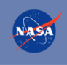 NASA Research Opportunities Online

- Various NASA offices publish their research announcements over the Internet, broadening the opportunity for researchers to apply for funding. This site provides access to current research announcements along with their specific due dates.

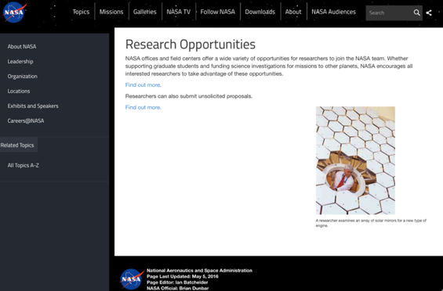
http://nspires.nasaprs.com/external/

National Archives and Records Administration

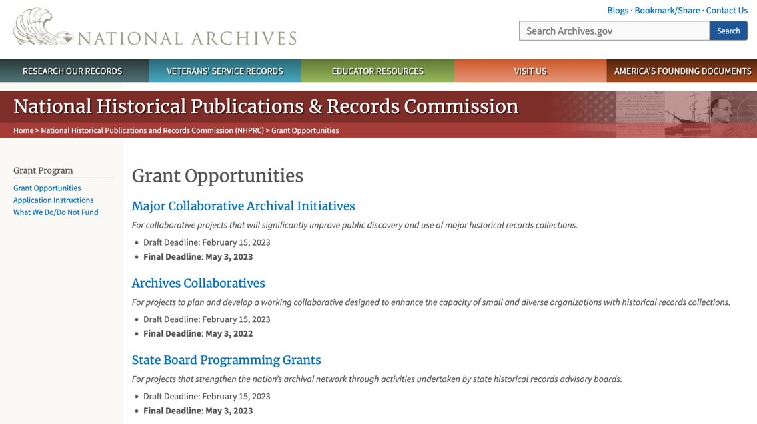
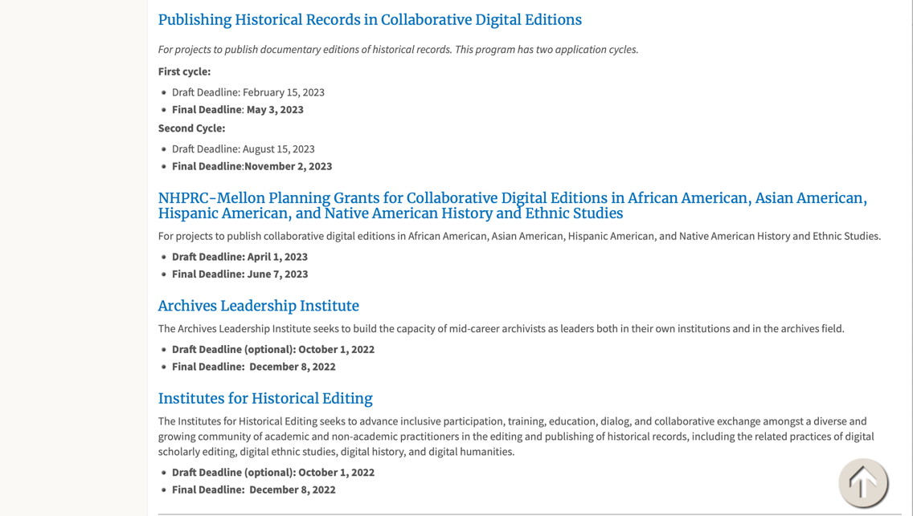
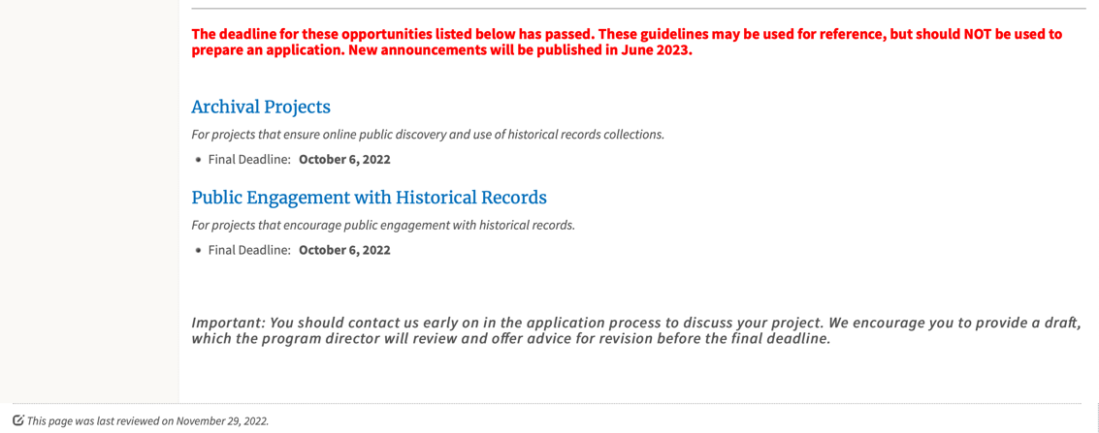

To access the information above: click here

https://www.archives.gov/nhprc/announcement

National Endowment for the Arts

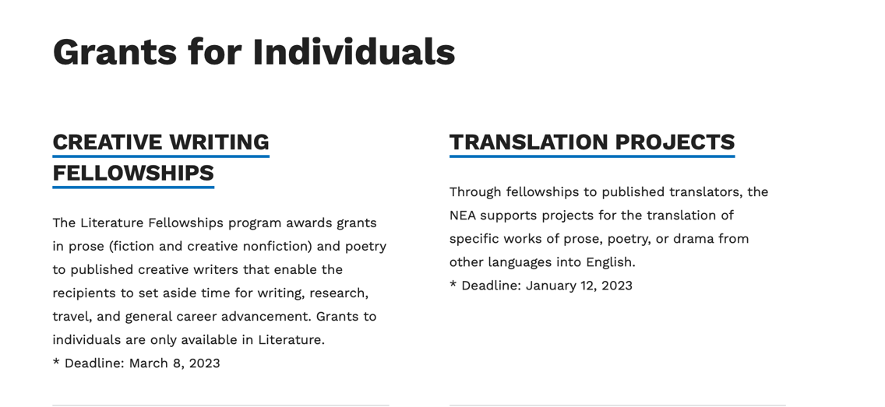
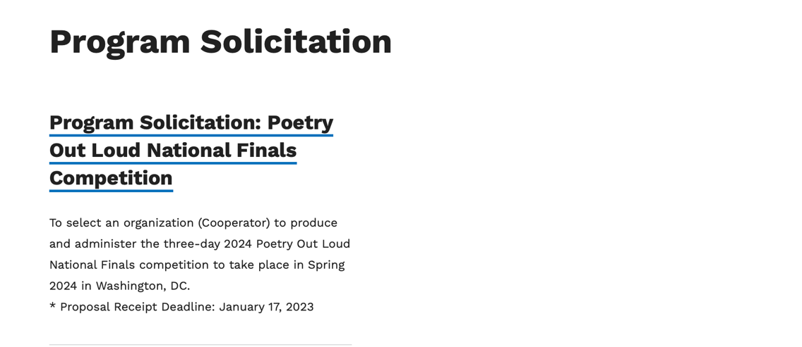
See more at: https://www.arts.gov/grants

National Endowment for the Humanities

https://www.neh.gov/grants

National Science Foundation



For assistance: https://nsf.gov/funding/aboutfunding.jsp

The National Science Foundation funds research and education in most fields of science and engineering. It does this through grants, and cooperative agreements to more than 2,000 colleges, universities, K-12 school systems, businesses, informal science organizations and other research organizations throughout the United States. The Foundation accounts for about one-fourth of federal support to academic institutions for basic research.
NSF receives approximately 40,000 proposals each year for research, education and training projects, of which approximately 11,000 are funded. In addition, the Foundation receives several thousand applications for graduate and postdoctoral fellowships.
The agency operates no laboratories itself but does support National Research Centers, user facilities, certain oceanographic vessels and Antarctic research stations. The Foundation also supports cooperative research between universities and industry, US participation in international scientific and engineering efforts, and educational activities at every academic level.

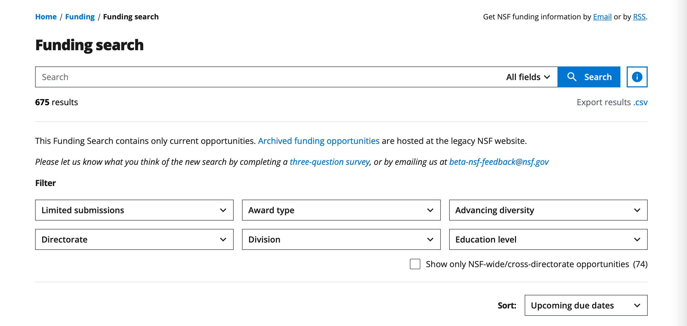

For details on active funding deadline dates: http://nsf.gov/funding/pgm_list.jsp?org=NSF&ord=date

Small Business Administration

https://www.sba.gov/funding-programs/loans
Federal, state and local governments offer a wide range of financing programs to help small businesses start and grow their operations. These programs include low-interest loans, venture capital, and scientific and economic development grants.
Use SBA.gov's Loans and Grants Search Tool to get a list of financing programs for which you may qualify, or visit the resources below to learn more about small business financing programs.

To get to the main SBA.gov funding page click here
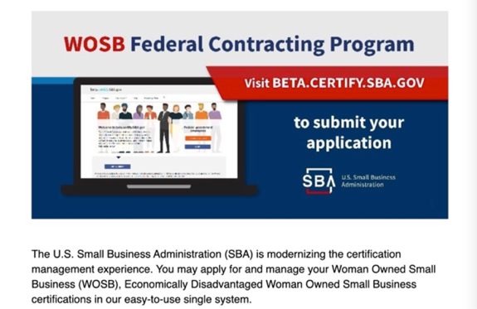
Learn more
https://www.sba.gov/learning-center

SBA Trainings

https://www.sba.gov/learning-center
Upcoming Trainings: Check out SBA's Online Training!
- Financing Options for Small Businesses
For Specific Information in Hawaii see the following links:
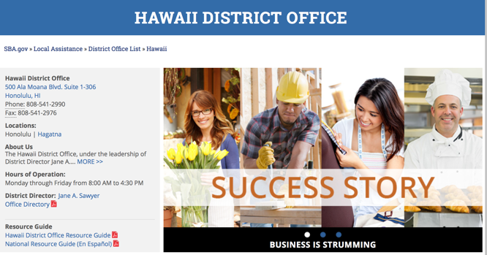

https://www.sba.gov/offices/district/hi/Honolulu

State Department

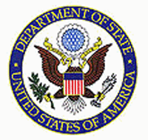

https://eca.state.gov/about-bureau/organizational-structure/grants-division

http://eca.state.gov/search/solr/grants?search_referrer=node/237

https://eca.state.gov/organizational-funding/open-grant-solicitations

http://eca.state.gov/organizational-funding/applying-grant

General Information:
- Bureau of Educational and Cultural Affairs Grants Division
- Open Grant Opportunities (Requests for Grant Proposals)

For General Information click here

Department of Transportation

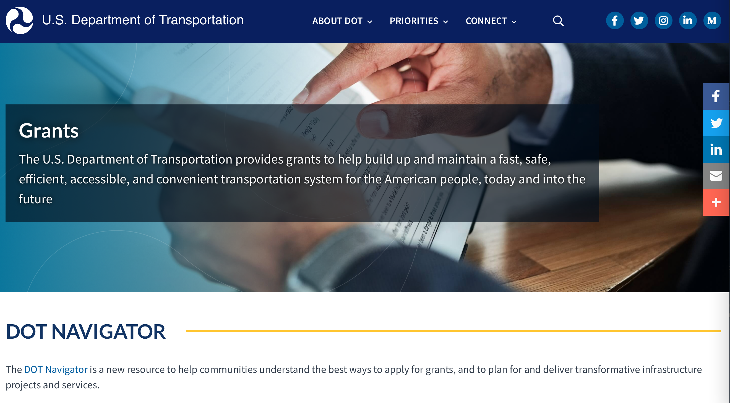

General Grant Program Overview https://www.transportation.gov/grants

Department of the Treasury

https://home.treasury.gov/services/grant-programs

U.S. Agency for International Development
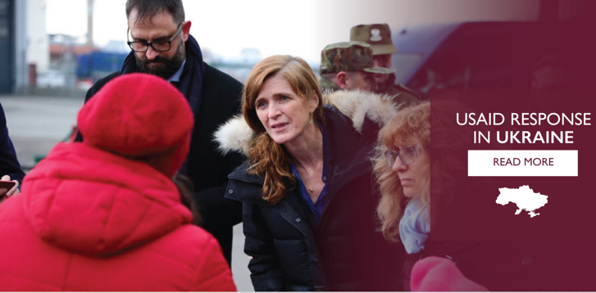

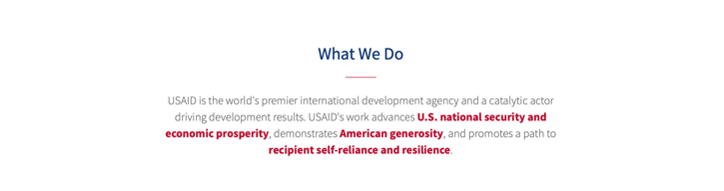

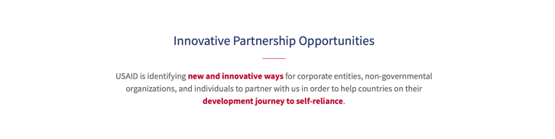

www.usaid.gov

General Overview Funding Opportunities

USAID has working relationships with thousands of American companies and hundreds of U.S.-based private voluntary organizations. For more information on our business and procurement opportunities, \

Department of Veterans Affairs

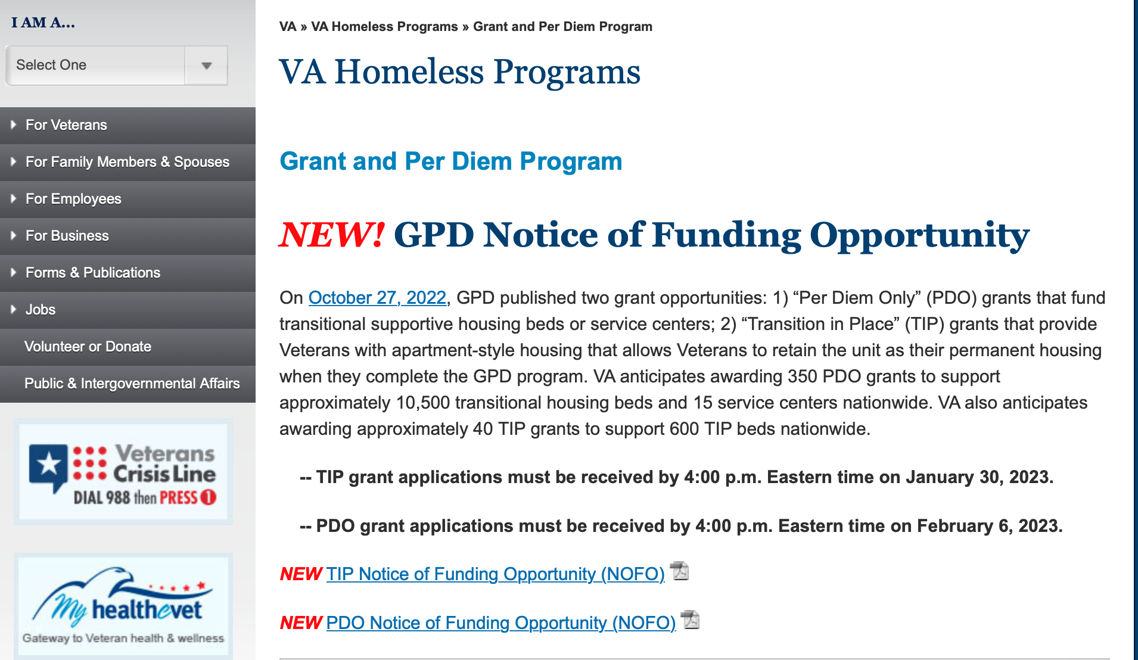

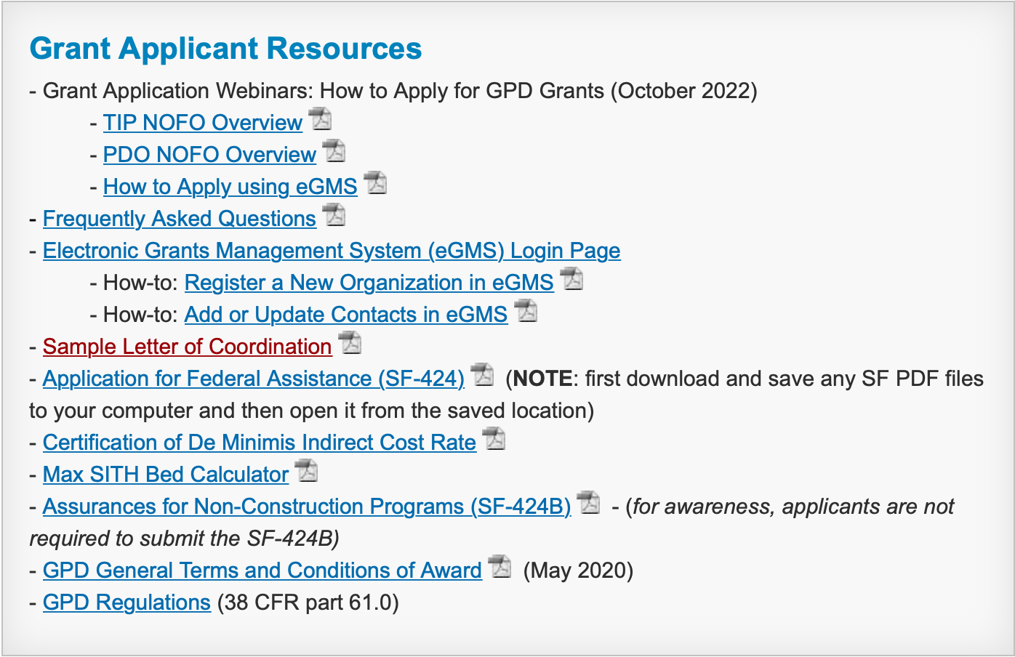

https://www.va.gov/homeless/gpd.asp

https://www.va.gov/pacific-islands-health-care/

GRANTS.GOV

Provides a Grants Learning Center as a gateway to the federal grants world. Bookmark the following link and participate at blog.grants.gov or on twitter @grantsdotgov

Topics include: Grants 101, Grant Policies, Grant Eligibility, Grant Terms, Grant Agencies , Grant Systems, Grant Programs, Grant Careers, Grant Reporting, Grant Fraud and Grant Events

https://www.grants.gov/web/grants/learn-grants.html

Grants.gov maintains a blog. This reprinted article provides some helpful tips:

Grant Writing: 3 Tips for Crafting Need Statements in Federal Grant Proposals
Posted on March 27, 2019 by Grants.gov
In this space, we have previously shared tips about the pre-writing phase of completing a federal grant application – for example, the importance of reading (and re-reading) the grant announcement, and the importance of understanding the criteria by which your application will be evaluated.
In this post, we dip our toes into the grant writing process itself and share some tips about crafting a need statement. These tips are adapted from the U.S. Department of Health and Human Services Health Resources & Services Administration’s grant writing guide, titled “Tips for Writing and Submitting Good Grant Proposals”. Along with each tip, we also include an excerpt from an award-winning federal grant proposal that can be viewed in full on the website of the Institute of Museum and Library Services. (IMLS has an excellent collection of proposals that are worthy of review – especially for new federal grant applicants.)

https://grantsgovprod.wordpress.com/2019/03/27/3-tips-for-crafting-need-statements-in-federal-grant-proposals/?utm_source=newsletter&utm_medium=email&utm_campaign=noprofile&utm_content=june2020

Grant Writing Resources

The following links are a great resource for Faith-Based Non-profits and other community organizations:

U.S. Department of Justice
Task Force for Faith-Based and Community Initiatives

Foundation Center
Proposal Writing Short Course

USDA Rural Information Center
A Guide to Funding Resources

The Small Business Innovative Research Program - SBIR Program

The Small Business Innovation Research (SBIR) program is a highly competitive program that encourages domestic small businesses to engage in Federal Research/Research and Development (R/R&D) that has the potential for commercialization. Through a competitive awards-based program, SBIR enables small businesses to explore their technological potential and provides the incentive to profit from its commercialization. By including qualified small businesses in the nation's R&D arena, high-tech innovation is stimulated, and the United States gains entrepreneurial spirit as it meets its specific research and development needs.

SBIR Mission and Program Goals
The mission of the SBIR program is to support scientific excellence and technological innovation through the investment of Federal research funds in critical American priorities to build a strong national economy.
The program’s goals are four-fold:
- Stimulate technological innovation
- Meet Federal research and development needs.
- Foster and encourage participation in innovation and entrepreneurship by socially and economically disadvantaged persons.
- Increase private-sector commercialization of innovations derived from Federal research and development funding.

SBIR-Participating Agencies
Each year, Federal agencies with extramural research and development (R&D) budgets that exceed $100 million are required to allocate 2.5 percent of their R&D budget to these programs. Currently,
- eDepartment of Commerce - National Institute of Standards and Technology
- Department of Energy
- Department of Health and Human Services
- Department of Transportation
- National Aeronautics and Space Administration
- National Science Foundation
Each agency administers its own individual program within guidelines established by Congress. These agencies designate R&D topics in their solicitations and accept proposals from small businesses. Awards are made on a competitive basis after proposal evaluation.

Three-Phase Program
The SBIR Program is structured in three phases:
Phase I. The objective of Phase I is to establish the technical merit, feasibility, and commercial potential of the proposed R/R&D efforts and to determine the quality of performance of the small business awardee organization prior to providing further Federal support in Phase II. SBIR Phase I awards normally do not exceed $150,000 total costs for 6 months.
Phase II. The objective of Phase II is to continue the R/R&D efforts initiated in Phase I. Funding is based on the results achieved in Phase I and the scientific and technical merit and commercial potential of the project proposed in Phase II. Only Phase I awardees are eligible for a Phase II award. SBIR Phase II awards normally do not exceed $1,000,000 total costs for 2 years.
Phase III. The objective of Phase III, where appropriate, is for the small business to pursue commercialization objectives resulting from the Phase I/II R/R&D activities. The SBIR program does not fund Phase III. Some Federal agencies, Phase III may involve follow-on non-SBIR funded R&D or production contracts for products, processes or services intended for use by the U.S. Government

