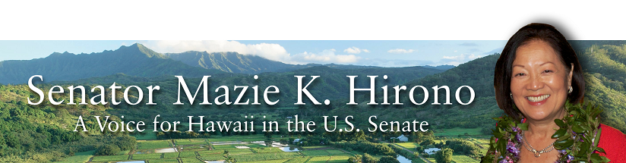
Grants Assistance Information
Newsletter
July 2016

G.A.I.N. INDEX

Click on Index Links below to read summaries of the announcements by agency in this document.
Once you reach the item, if you cannot open the links for further information, copy the selected
URL website address into your browser.

Modified sections from previous listings are shown in a GREY background

Notices is Teal are items with immediate deadline dates.

Notices in Yellow are of special interest.

Notices is Green are items of special interest with immediate deadline dates.

Items in this type color are aimed at Small Businesses

Items in this type color have a Faith-Based Organization component

Special Federal Program Notices

SBIR – Small Business Innovation Research

Programs specific to Hawaii

Current Notices

Reminders

See Individual Departments for information and webpages representing the best and most accessible information on the agency funding opportunities

Federal Grant and Cooperative Agreement Program Summaries

U.S. Department of Agriculture

Grants and Loans Overview

Programs

Outreach and Assistance for Socially Disadvantaged and Veteran Farmers and Ranchers Grant Program

Modifications

Reminders

Utilities Programs
Rural Community Development Initiative Grant

National Institute of Food and Agriculture
Agriculture and Food Research Initiative: Water for Agriculture Challenge Area Grant

National Institute of Food and Agriculture
AFRI Childhood Obesity Prevention Challenge Area Grant

National Institute of Food and Agriculture
Agriculture and Food Research Initiative: Foundational Program Grant

National Institute of Food and Agriculture

AFRI Sustainable Bioenergy and Bioproducts RFA Grant

National Institute of Food and Agriculture
AFRI Food Safety Challenge Area Grant

Farm Service Agency
Outreach and Education, Technical Assistance, and Financial Education for FSA Programs, Functions, and Activities
Modification 2

Department of Commerce

Programs

MBDA Broad Agency Announcement

Research

FY17 Bluefin Tuna Research Program Grant

FY 16 Coastal Ecosystem Resiliency Grants Program
Modifications

Reminders

National Institute of Standards and Technology
Regional Alliances and Multistakeholder Partnerships to Stimulate (RAMPS) Cybersecurity Education and Workforce Development Grant

National Institute of Standards and Technology
Measurement Science and Engineering (MSE) Research Grant Programs

National Sea Grant College Program 2016-17 Special Projects Grant

FY 2016 – FY 2019 EDA Planning Program and Local Technical Assistance Program Grant

FY 2016 Economic Development Assistance Programs ­ Application submission and program requirements for EDA’s Public Works and Economic Adjustment Assistance Programs

Economic Development Administration
Planning Program and Local Technical Assistance Program Grant

Corporation for National and Community Service

General Program Overview

Programs

Reminders

National Service in Hawaii

Department of Defense

Doing Business with the Department of Defense

DoD Small Business Opportunities and Forecasting

Research Grants

Modifications

Reminders

Dept. of the Army -- Materiel Command
Army Research Office Broad Agency Announcement for Basic and Applied Scientific Research
Modification 8

Department of Education

Grant Programs Overview

Programs

Office of Postsecondary Education (OPE): Undergraduate International Studies and Foreign Language (UISFL) Program: CFDA Number 84.016A Grant

Office of Postsecondary Education (OPE): Fulbright-Hays Group Projects Abroad Program CFDA Number 84.021A Grant

Research

Modifications

Reminders

Office of Innovation and Improvement (OII): Teacher Incentive Fund (TIF) CFDA Number 84.374A Grant

Institute of Education Sciences (IES CFDA Number 84.305

US Department of Energy

Grants Overview

Programs

Modifications

Reminders

Environmental Protection Agency

Grants and Contracts Overview

Programs

Modifications

Reminders

Department of Health and Human Services

Grants Overview

Program

Administration for Children and Families
Administration for Children and Families - ORR
Preferred Communities (PC) Program Grant

Health Resources and Services Administration
Service Area Competition Grant

Research Grants

Modifications

Reminders

Department of Homeland Security
Grants Overview

Programs

Fiscal Year (FY) 2016 Homeland Security National Training Program (HSNTP) - National Domestic Preparedness Consortium (NDPC) Grant

Modifications

Reminders

Office of Procurement Operations - Grants Division
Center of Excellence Criminal Investigations and Network Analysis – Partner Grant

Department of Housing and Urban Development

HUD - Notice of Funds Available

Programs

Modifications

FY2016 Continuum of Care
Modification 4

Reminders

HUD Community Compass Technical Assistance and Capacity Building Program Grant

Technical Correction to the General Section to HUD's Fiscal Year 2016 Notice[s] of Funding Availability for Discretionary Programs
Modification 1

General Section to HUD's Fiscal Year 2016 Notice[s] of Funding Availability for Discretionary Programs (General Section)
Modification 1

Institute of Museum and Library Services

Grants Overview

IMLS is on Facebook!

Modifications

Reminders

Department of Interior

Grants and Contract Overview

Programs

Modifications

Reminders

National Park Service
Historic Preservation Fund Grants to Underrepresented Communities
And Modification 1

National Park Service
National Maritime Heritage Grant Program
And Modification 1

Geological Survey
FY 2017 National Climate Change & Wildlife Science Center Program Grant
Fish and Wildlife Service
Fiscal Year 2016 Recovery Implementation Fund Grant

Fish and Wildlife Service
National Fish Passage Program Grant

Fish and Wildlife Service
Fiscal Year 2016 Candidate Conservation Action Funds Grant

Department of Justice

Grants and Contract Overview

Programs

Research

Modifications

Office of Justice Programs
Office for Victims of Crime
OVC FY 16 Building and Enhancing Partnerships to Support Incarcerated Survivors of Sexual Abuse
Modifications 1 & 4

Reminders

Department of Labor

Grants and Contract General Overview

Programs

Senior Community Service Employment Program (SCSEP) National Grants for Program Year (PY) 2016

Disability Employment Initiative Cooperative Agreements

Employment and Training Administration
America’s Promise Job Driven Grant Program

Employment and Training Administration
Bureau of International Labor Affairs
Project to Reduce the Exploitation of Children in the Sava Region of Madagascar Grant

Modifications

National Aeronautics and Space Administration

Research Grant and Contract General Overview

Programs

Modifications

_______________________________________________________________
National Archives and Records Administration

Grant Opportunities General Overview

Public Engagement with Historical Records Grant

Reminders

Access to Historical Records Grant

_______________________________________________________________
National Endowment for the Arts

Grant Opportunities General Overview

Programs

Modifications

Reminders

NEA FY 2017 Art Works II Application Grant

Our Town FY 17 Grant

NEA Research Labs, FY2016 Grant

_______________________________________________________________

National Endowment for the Humanities

Grant Opportunities General Overview

Programs

Public Humanities Projects Grant

Media Projects Grants

Humanities Initiatives at Community Colleges

Modifications

Reminders

Summer Stipends Grant

Humanities Collections and Reference Resources Grant

Fellowship Programs at Independent Research Institutions Grant

Humanities Connections Grant

Common Heritage Grant

Humanities Open Book Program Grant

National Science Foundation

Grant Opportunities General Overview

Research and Program Grants

Modifications

Reminders

Deleted

Nuclear Regulatory Commission

Reminders

Small Business Administration

General Overview Finding Loans & Grants

Programs

Reminders

Upcoming Trainings

Links Specific to Hawaii

State Department

General Overview and Resources for Program Administrators

Programs

Modifications

Reminders

U.S. Department of Transportation

General Grant Program Overview

Programs

Modifications

Reminders

DOT Federal Aviation Administration
DOT - FAA Aviation Research Grants
FAA Aviation Research and Development Grants
Modifications 3 & 4

Department of the Treasury

Programs

Modifications

Reminders

US Agency for International Development

General Funding Opportunity Overview

Programs
Modifications

Deleted

Department of Veterans Affairs

Special Federal Program Notices

The Small Business Innovative Research Program - SBIR Program
The Small Business Innovation Research (SBIR) program is a highly competitive program that encourages domestic small businesses to engage in Federal Research/Research and Development (R/R&D) that has the potential for commercialization. Through a competitive awards-based program, SBIR enables small businesses to explore their technological potential and provides the incentive to profit from its commercialization. By including qualified small businesses in the nation's R&D arena, high-tech innovation is stimulated and the United States gains entrepreneurial spirit as it meets its specific research and development needs.

SBIR Mission and Program Goals
The mission of the SBIR program is to support scientific excellence and technological innovation through the investment of Federal research funds in critical American priorities to build a strong national economy.
The program’s goals are four-fold:
- Stimulate technological innovation
- Meet Federal research and development needs.
- Foster and encourage participation in innovation and entrepreneurship by socially and economically disadvantaged persons.
- Increase private-sector commercialization of innovations derived from Federal research and development funding.

SBIR-Participating Agencies
Each year, Federal agencies with extramural research and development (R&D) budgets that exceed $100 million are required to allocate 2.5 percent of their R&D budget to these programs. Currently, eleven Federal agencies participate in the program:
- Department of Agriculture
- Department of Commerce - National Institute of Standards and Technology
- Department of Commerce - National Oceanic and Atmospheric Administration
- Department of Defense
- Department of Education
- Department of Energy
- Department of Health and Human Services
- Department of Homeland Security
- Department of Transportation
- Environmental Protection Agency
- National Aeronautics and Space Administration
- National Science Foundation
Each agency administers its own individual program within guidelines established by Congress. These agencies designate R&D topics in their solicitations and accept proposals from small businesses. Awards are made on a competitive basis after proposal evaluation.

Three-Phase Program
The SBIR Program is structured in three phases:
Phase I. The objective of Phase I is to establish the technical merit, feasibility, and commercial potential of the proposed R/R&D efforts and to determine the quality of performance of the small business awardee organization prior to providing further Federal support in Phase II. SBIR Phase I awards normally do not exceed $150,000 total costs for 6 months.
Phase II. The objective of Phase II is to continue the R/R&D efforts initiated in Phase I. Funding is based on the results achieved in Phase I and the scientific and technical merit and commercial potential of the project proposed in Phase II. Only Phase I awardees are eligible for a Phase II award. SBIR Phase II awards normally do not exceed $1,000,000 total costs for 2 years.
Phase III. The objective of Phase III, where appropriate, is for the small business to pursue commercialization objectives resulting from the Phase I/II R/R&D activities. The SBIR program does not fund Phase III. Some Federal agencies, Phase III may involve follow-on non-SBIR funded R&D or production contracts for products, processes or services intended for use by the U.S. Government
SBIR NewsLetter

- SBIR Newsletter
Sign up for e-mail updates

HAWAII APPLICANTS ENCOURAGED

Current Notices:

Reminders:

Department of Homeland Security

Reminders:

Please review each department’s General Grant and Funding Overview. These overviews are the key web pages on each departmental website dedicated to the agency’s funding opportunities. Check back often to note the department updates and use these sources to assist you in your planning.

Federal Grant and Cooperative Agreement Program Summaries

U.S. Department of Agriculture



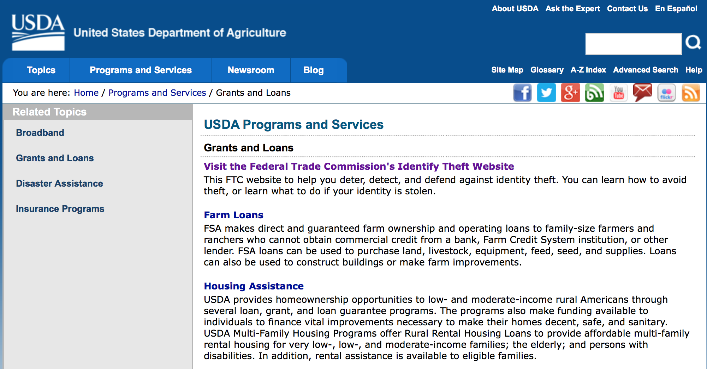
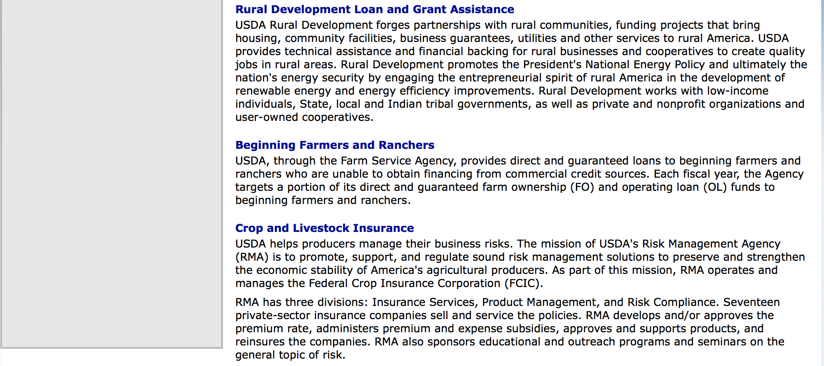

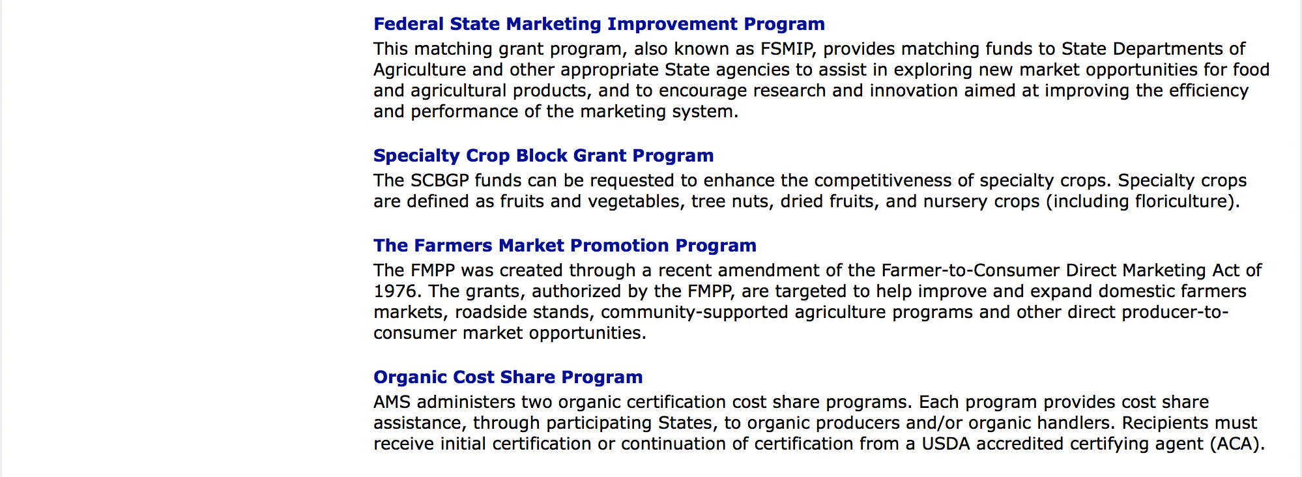

http://usda.gov/wps/portal/usda/usdahome?navid=GRANTS_LOANS

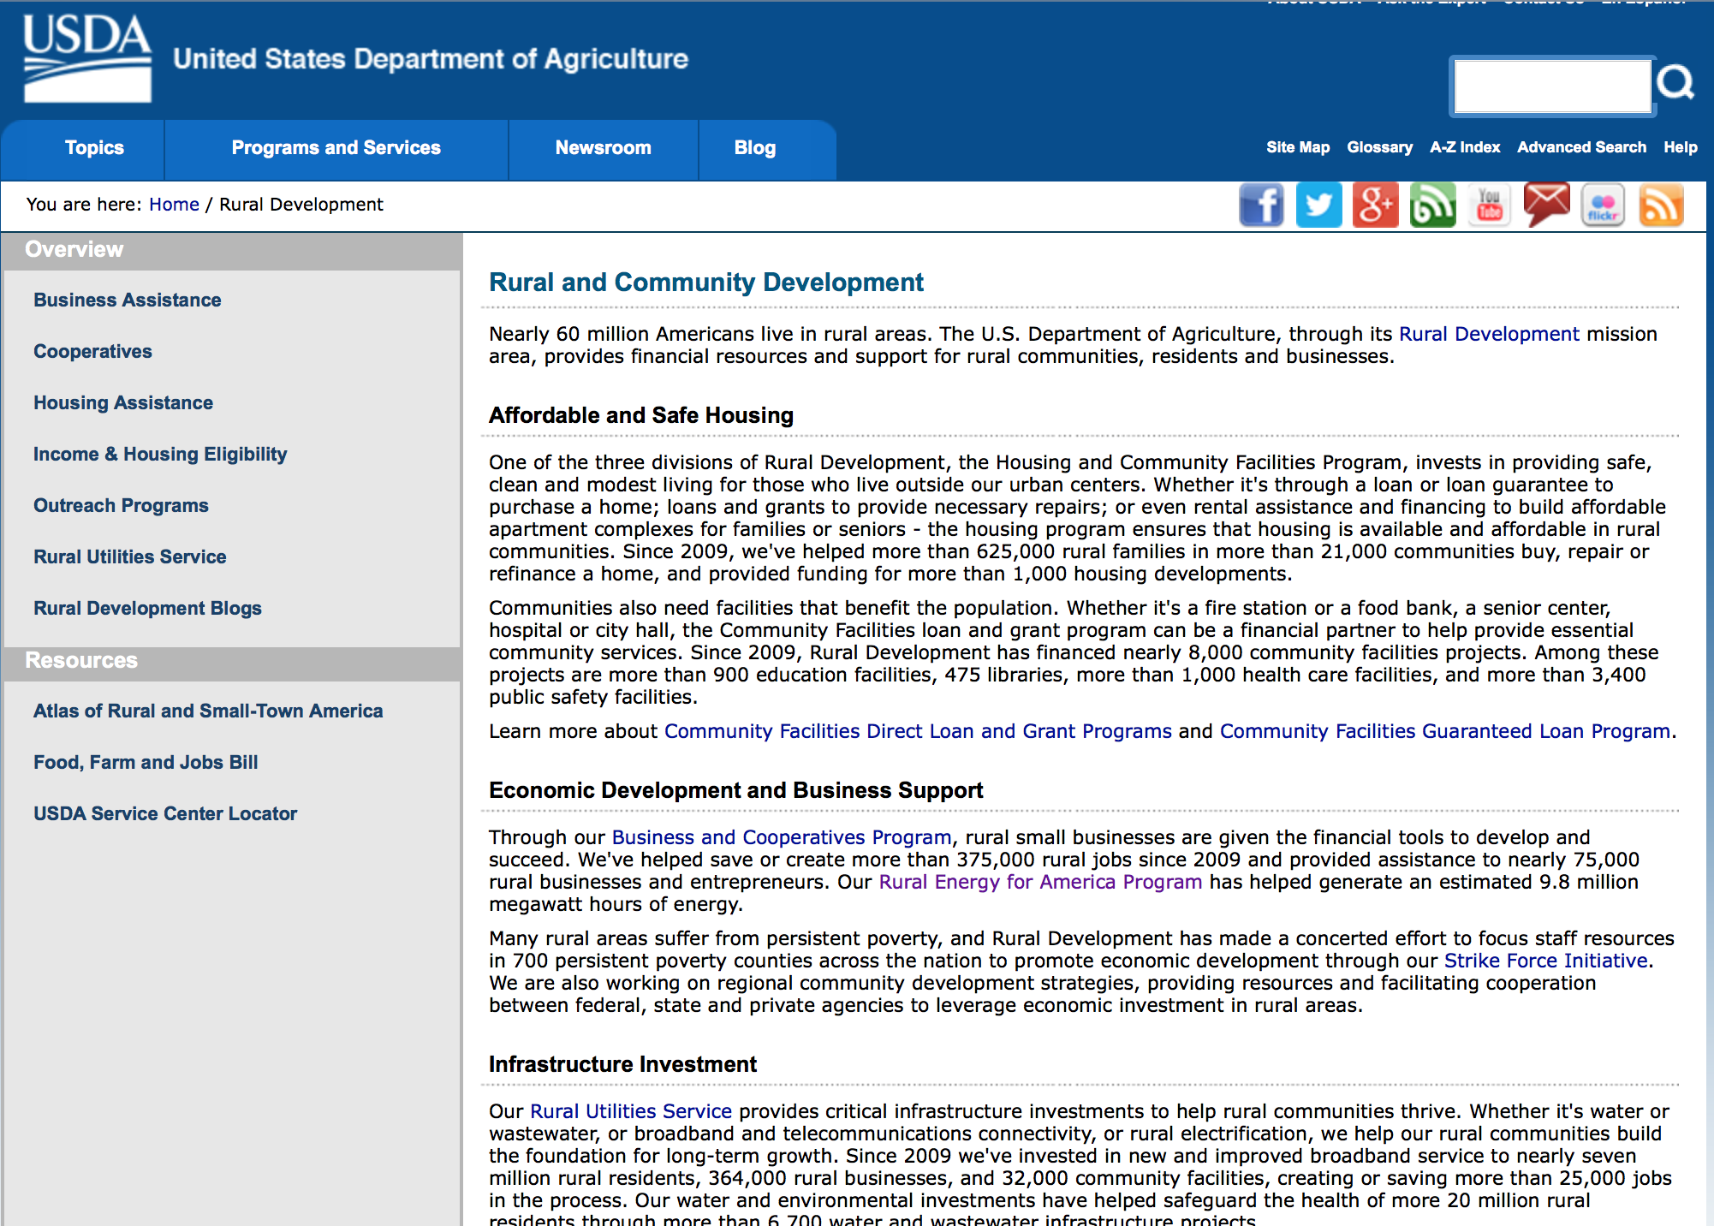

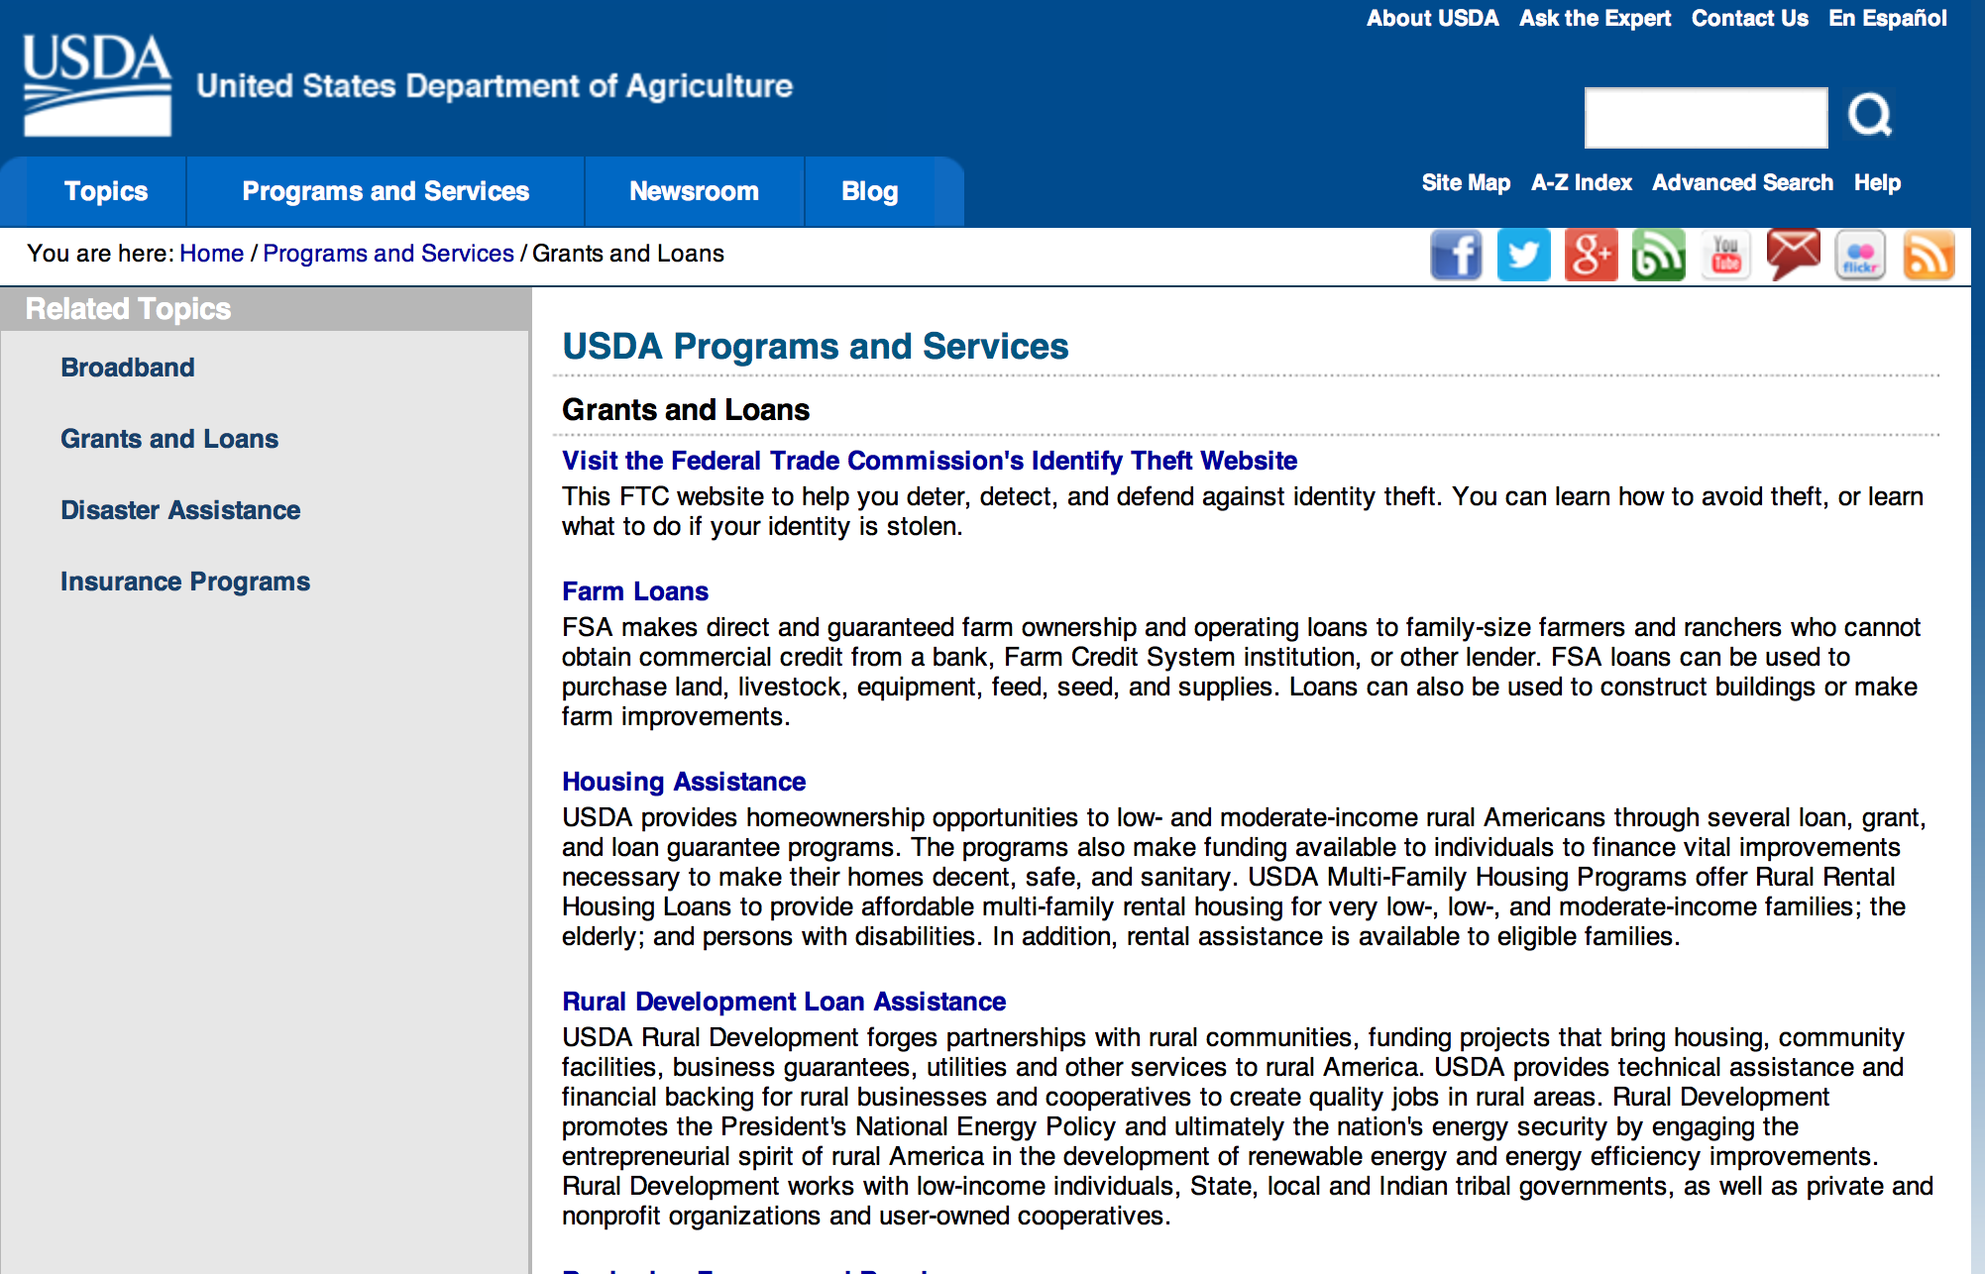

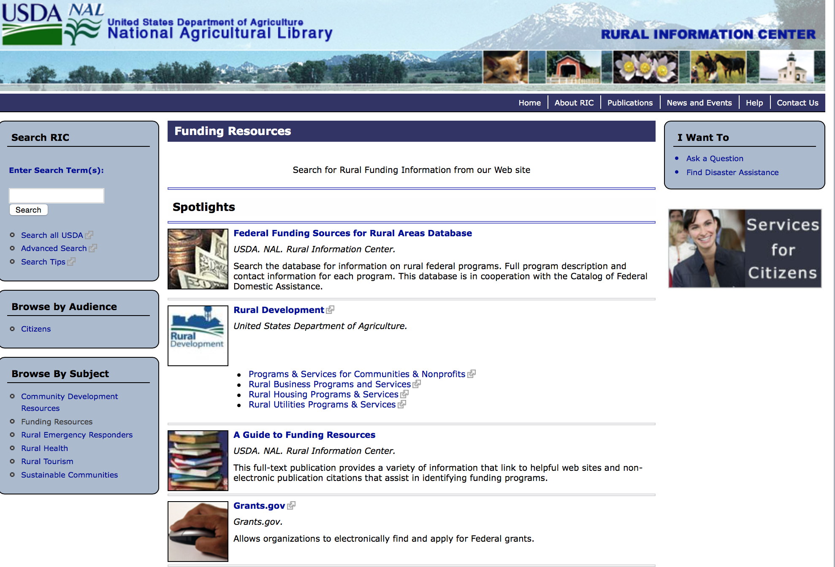

Federal Faith-Based Centers and Community Initiatives
USDA. NAL. Rural Information Center.
- Center for Faith-Based and Community Initiatives (link is external) , U.S. Department of Education
- Center for Faith-Based and Community Initiatives (link is external) , U.S. Department of Health and Human Services
- Center for Faith-Based and Community Initiatives (link is external) , U.S. Department of Labor
- Faith-Based and Community Initiatives (link is external) , U.S. Agency for International Development
- Faith-Based and Community Initiatives (link is external) , U.S. Department of Agriculture
- Faith-Based and Community Initiatives (link is external) , U.S. Department of Housing and Urban Development
- Faith-Based and Other Community Initiatives (link is external) , Corporation for National Community Service
- Task Force for Faith-Based and Community Initiatives (link is external) , U.S. Department of Justice

Grant Writing Resources
- Proposal Writing Short Course (link is external) Foundation Center.
- Data Universal Numbering System Fact sheet (link is external) [PDF | 302.2KB] USDA Rural Development.
- General Tips on Writing a Competitive Grant Proposal (link is external) U.S. Environmental Protection Agency.
- How to Write a Grant Proposal (link is external) Appalachian Regional Commission. <. li>

A Guide to Funding Resources USDA Rural Information Center.

http://ric.nal.usda.gov/funding-resources

http://usda.gov/wps/portal/usda/usdahome?navid=GRANTS_LOANS

Programs:

Funding Opportunity Number: OAO-0010
Outreach and Assistance for Socially Disadvantaged and Veteran Farmers and Ranchers Grant Program
DM-Office of Advocacy and Outreach

Document Type: | Grants Notice
Funding Opportunity Number: | OAO-0010
Funding Opportunity Title: | Outreach and Assistance for Socially Disadvantaged and Veteran Farmers and Ranchers Grant Program
Opportunity Category: | Mandatory
Opportunity Category Explanation:
Funding Instrument Type: | Grant
Category of Funding Activity: | Agriculture
Category Explanation:
Expected Number of Awards: | 200
CFDA Number(s): | 10.443 -- Outreach and Assistance for Socially Disadvantaged and Veteran Farmers and Ranchers
Cost Sharing or Matching Requirement: | No
Posted Date: | Jun 27, 2016
Last Updated Date: | Jun 27, 2016
Original Closing Date for Applications: | Jul 29, 2016
Current Closing Date for Applications: | Jul 29, 2016
Archive Date:
Estimated Total Program Funding:
Award Ceiling: | $200,000
Award Floor: | $1,000
Eligible Applicants: | Private institutions of higher education  Nonprofits that do not have a 501(c)(3) status with the IRS, other than institutions of higher education  Native American tribal governments (Federally recognized)  Public and State controlled institutions of higher education  Native American tribal organizations (other than Federally recognized tribal governments)  Nonprofits having a 501(c)(3) status with the IRS, other than institutions of higher education
Agency Name: | DM-Office of Advocacy and Outreach
Description: | The overall goal of this program is to assist socially disadvantaged and veteran farmers and ranchers in owning and operating farms and ranches while increasing their participation in agricultural programs and services provided by the U. S. Department of Agriculture (USDA). This program will assist eligible community-based and non-profit organizations, higher education institutions, and tribal entities in providing outreach and technical assistance to socially disadvantaged and veteran farmers and ranchers
Link to Additional Information:
Grantor Contact Information: | If you have difficulty accessing the full announcement electronically, please contact:  Kenya Nicholas Program Manager Phone 202-720-6350  Program Manager

Link: http://www.grants.gov/web/grants/view-opportunity.html?oppId=285476

Modifications:

Reminders:

Utilities Programs
Rural Community Development Initiative Grant

Document Type: | Grants Notice
Funding Opportunity Number: | USDA-RD-HCFP-RCDI-2016
Funding Opportunity Title: | Rural Community Development Initiative
Opportunity Category: | Discretionary
Opportunity Category Explanation:
Funding Instrument Type: | Grant
Category of Funding Activity: | Agriculture  Community Development
Category Explanation:
Expected Number of Awards: | 25
CFDA Number(s): | 10.446 -- Rural Community Development Initiative
Cost Sharing or Matching Requirement: | Yes
Posted Date: | May 26, 2016
Last Updated Date: | May 26, 2016
Original Closing Date for Applications: | Jul 22, 2016
Current Closing Date for Applications: | Jul 22, 2016
Archive Date: | Aug 21, 2016
Estimated Total Program Funding: | $4,000,000
Award Ceiling: | $250,000
Award Floor: | $50,000
Eligible Applicants: | Native American tribal governments (Federally recognized)  Private institutions of higher education  Independent school districts  Nonprofits that do not have a 501(c)(3) status with the IRS, other than institutions of higher education  Special district governments  County governments  Public and State controlled institutions of higher education  For profit organizations other than small businesses  Public housing authorities/Indian housing authorities  City or township governments  State governments  Small businesses
Additional Information on Eligibility: | The Intermediary will be required to provide matching funds in an amount at least equal to the RCDI grant. The respective minimum and maximum grant amount per Intermediary is $50,000.00 and $250,000.00. The Recipient and Beneficiary, but not the Intermediary, must be located in a city or town that has a population of 50,000 or less inhabitants.
Agency Name: | Utilities Programs
Description: | Qualified private, nonprofit and public including tribal intermediary organizations proposing to carry out financial and technical assistance programs will be eligible to receive the funding. The Intermediary will be required to provide matching funds in an amount at least equal to the RCDI grant. The respective minimum and maximum grant amount per Intermediary is $50,000 and $250,000. The Intermediary must provide a program of financial and technical assistance to recipients to develop their capacity and ability to undertake projects related to housing, community facilities, or community and economic development that will support the community.
Link to Additional Information: | FY2016 RCDI NOFA
Contact Information: | If you have difficulty accessing the full announcement electronically, please contact:  Shirley Stevenson Community Programs Specialist 202 205-9685  Email contact for Shirley Stevenson

http://www.grants.gov/web/grants/view-opportunity.html?oppId=284154

National Institute of Food and Agriculture
Agriculture and Food Research Initiative: Water for Agriculture Challenge Area Grant

Document Type: | Grants Notice
Funding Opportunity Number: | USDA-NIFA-AFRI-005822
Funding Opportunity Title: | Agriculture and Food Research Initiative: Water for Agriculture Challenge Area
Opportunity Category: | Discretionary
Opportunity Category Explanation:
Funding Instrument Type: | Grant
Category of Funding Activity: | Agriculture  Environment  Natural Resources
Category Explanation:
Expected Number of Awards:
CFDA Number(s): | 10.310 -- Agriculture and Food Research Initiative (AFRI)
Cost Sharing or Matching Requirement: | Yes
Posted Date: | May 05, 2016
Last Updated Date: | May 05, 2016
Original Closing Date for Applications: | Aug 04, 2016
Current Closing Date for Applications: | Aug 04, 2016
Archive Date: | Sep 03, 2016
Estimated Total Program Funding: | $10,700,000
Eligible Applicants: | Others (see text field entitled "Additional Information on Eligibility" for clarification)
Additional Information on Eligibility: | See Part III, Eligibility Information in the RFA. Applications may only be submitted by eligible entities. Eligibility is linked to the project type. All project types are described beginning in Part II, C. in the RFA.
Agency Name: | National Institute of Food and Agriculture
Description: | This AFRI Challenge Area addresses critical water resources issues such as drought, excess soil moisture, flooding, quality and others in an agricultural context. Funding will be used to develop management practices, technologies, and tools for farmers, ranchers, forest owners and managers, public decision makers, public and private managers, and citizens to improve water resource quantity and quality. The long-term goal of the AFRI Water for Agriculture Challenge Area is to tackle critical water issues by developing both regional systems for the sustainable use and reuse, flow and management of water, and at the watershed and farm scales, water issues focused on production and environmental sustainability efforts. Project types supported within this Challenge area are multi-function Integrated Research, Education, and/or Extension Projects and Food and Agricultural Enhancement (FASE) Grants.
Link to Additional Information: | Agriculture and Food Research Initiative - Water for Agriculture Challenge Area
Contact Information: | If you have difficulty accessing the full announcement electronically, please contact:  NIFA Help Desk Phone: 202-401-5048 Business hours are M-F, 7:00 am -5:00 pm ET, excluding Federal holidays  If you have any questions related to preparing application content

http://www.grants.gov/web/grants/view-opportunity.html?oppId=283569

National Institute of Food and Agriculture
AFRI Childhood Obesity Prevention Challenge Area Grant

Document Type: | Grants Notice
Funding Opportunity Number: | USDA-NIFA-AFRI-005845
Funding Opportunity Title: | AFRI Childhood Obesity Prevention Challenge Area
Opportunity Category: | Discretionary
Opportunity Category Explanation:
Funding Instrument Type: | Grant
Category of Funding Activity: | Agriculture  Food and Nutrition  Health
Category Explanation:
Expected Number of Awards:
CFDA Number(s): | 10.310 -- Agriculture and Food Research Initiative (AFRI)
Cost Sharing or Matching Requirement: | Yes
Posted Date: | May 19, 2016
Last Updated Date: | May 19, 2016
Original Closing Date for Applications: | Aug 04, 2016
Current Closing Date for Applications: | Aug 04, 2016
Archive Date: | Sep 03, 2016
Estimated Total Program Funding: | $7,000,000
Eligible Applicants: | Others (see text field entitled "Additional Information on Eligibility" for clarification)
Additional Information on Eligibility: | Applications may only be submitted by eligible entities. Eligibility is linked to the project type. All project types are described beginning in Part II, C. See Part III, A. Eligible Applicants for details.
Agency Name: | National Institute of Food and Agriculture
Description: | This Challenge Area focuses on the societal challenge to end obesity among children, the number one nutrition-related problem in the US. Food is an integral part of the process that leads to obesity and USDA has a unique responsibility for the food system in the United States. This program is designed to achieve the long-term outcome of reducing the prevalence of overweight and obesity among children and adolescents 2-19 years. The AFRI Childhood Obesity Prevention program supports multi-function Integrated Research, Education, and/or Extension Projects and Food and Agricultural Science Enhancement (FASE) Grants.
Link to Additional Information: | Agriculture and Food Research Initiative - Childhood Obesity Prevention Challenge Area
Contact Information: | If you have difficulty accessing the full announcement electronically, please contact:  NIFA Help Desk Phone: 202-401-5048 Business hours are M-F, 7:00 am -5:00 pm ET, excluding Federal holidays  If you have any questions related to preparing application content

http://www.grants.gov/web/grants/view-opportunity.html?oppId=283990

National Institute of Food and Agriculture
Agriculture and Food Research Initiative: Foundational Program Grant
And Modifications 1 & 2

Document Type: | Grants Notice
Funding Opportunity Number: | USDA-NIFA-AFRI-005843
Funding Opportunity Title: | Agriculture and Food Research Initiative: Foundational Program
Opportunity Category: | Discretionary
Opportunity Category Explanation:
Funding Instrument Type: | Grant
Category of Funding Activity: | Agriculture
Category Explanation:
Expected Number of Awards:
CFDA Number(s): | 10.310 -- Agriculture and Food Research Initiative (AFRI)
Cost Sharing or Matching Requirement: | No
Posted Date: | May 13, 2016
Last Updated Date: | May 23, 2016
Original Closing Date for Applications: | Sep 30, 2016 See Program Area Priority for additional information.
Current Closing Date for Applications: | Aug 31, 2016 See Program Area Priority for additional information.
Archive Date: | Sep 30, 2016
Estimated Total Program Funding: | $130,000,000
Eligible Applicants: | Others (see text field entitled "Additional Information on Eligibility" for clarification)
Additional Information on Eligibility: | See Part III, A., Eligible Applicants. Eligibility is linked to the project type. All project types are described beginning in Part II, C.
Agency Name: | National Institute of Food and Agriculture
Description: | The AFRI Foundational Program is offered to support grants in the six AFRI priority areas to continue building a foundation of knowledge critical for solving current and future societal challenges. The six priority areas are: Plant Health and Production and Plant Products; Animal Health and Production and Animal Products; Food Safety, Nutrition, and Health; Bioenergy, Natural Resources, and Environment; Agriculture Systems and Technology; and Agriculture Economics and Rural Communities. Single-function Research Projects, multi-function Integrated Projects, and Food and Agricultural Science Enhancement (FASE) Grants are expected to address one of the Program Area Priorities (see Foundational Program RFA for details).
Link to Additional Information: | AFRI Foundational Program
Contact Information: | If you have difficulty accessing the full announcement electronically, please contact:  NIFA Help Desk Phone: 202-401-5048 Business hours are M-F, 7:00 am - 5:00 pm ET, excluding Federal holidays  If you have any questions related to preparing application content

http://www.grants.gov/web/grants/view-opportunity.html?oppId=283836

National Institute of Food and Agriculture
AFRI Sustainable Bioenergy and Bioproducts RFA Grant

Document Type: | Grants Notice
Funding Opportunity Number: | USDA-NIFA-AFRI-005460
Funding Opportunity Title: | AFRI Sustainable Bioenergy and Bioproducts RFA
Opportunity Category: | Discretionary
Opportunity Category Explanation:
Funding Instrument Type: | Grant
Category of Funding Activity: | Agriculture  Energy  Natural Resources
Category Explanation:
Expected Number of Awards:
CFDA Number(s): | 10.310 -- Agriculture and Food Research Initiative (AFRI)
Cost Sharing or Matching Requirement: | Yes
Posted Date: | May 13, 2016
Last Updated Date: | May 13, 2016
Original Closing Date for Applications: | Sep 22, 2016 1.The Letter of intent must be received at NIFA by 5:00 p.m. Eastern Time on the dates indicated in the Program Area Descriptions beginning in Part I, C and in the format specified in Part IV, A. 2.Applications must be received by Grants.gov by 5:00 p.m. Eastern Time on the dates indicated in the Program Area Descriptions beginning in Part I, C.
Current Closing Date for Applications: | Sep 22, 2016 1.The Letter of intent must be received at NIFA by 5:00 p.m. Eastern Time on the dates indicated in the Program Area Descriptions beginning in Part I, C and in the format specified in Part IV, A. 2.Applications must be received by Grants.gov by 5:00 p.m. Eastern Time on the dates indicated in the Program Area Descriptions beginning in Part I, C.
Archive Date: | Oct 22, 2016
Estimated Total Program Funding: | $21,000,000
Eligible Applicants: | Others (see text field entitled "Additional Information on Eligibility" for clarification)
Additional Information on Eligibility: | Applications may only be submitted by eligible entities. Eligibility is linked to the project type. All project types are described beginning in Part II, C. See Part III, A. Eligibility Information for details.
Agency Name: | National Institute of Food and Agriculture
Description: | In the Agriculture and Food Research Initiative Sustainable Bioenergy and Bioproducts (SBEBP) Challenge Area specific program areas are designed to achieve the long term outcome of reducing the national dependence on foreign oil through the development and production of regionally-appropriate sustainable bioenergy systems that materially deliver advanced liquid transportation biofuels, biopower, and bioproducts.
Link to Additional Information: | Agriculture and Food Research Initiative Sustainable Bioenergy and Bioproducts (SBEBP) Challenge Area
Contact Information: | If you have difficulty accessing the full announcement electronically, please contact:  NIFA Help Desk Phone: 202-401-5048 Business hours are M-F, 7:00 am -5:00 pm ET, excluding Federal holidays  If you have any questions related to preparing application content

http://www.grants.gov/web/grants/view-opportunity.html?oppId=283812

National Institute of Food and Agriculture
AFRI Food Safety Challenge Area Grant

Document Type: | Grants Notice
Funding Opportunity Number: | USDA-NIFA-AFRI-005802
Funding Opportunity Title: | AFRI Food Safety Challenge Area
Opportunity Category: | Discretionary
Opportunity Category Explanation:
Funding Instrument Type: | Grant
Category of Funding Activity: | Agriculture
Category Explanation:
Expected Number of Awards:
CFDA Number(s): | 10.310 -- Agriculture and Food Research Initiative (AFRI)
Cost Sharing or Matching Requirement: | No
Posted Date: | Apr 28, 2016
Last Updated Date: | Apr 28, 2016
Original Closing Date for Applications: | Aug 03, 2016
Current Closing Date for Applications: | Aug 03, 2016
Archive Date: | Sep 02, 2016
Estimated Total Program Funding: | $6,000,000
Eligible Applicants: | Others (see text field entitled "Additional Information on Eligibility" for clarification)
Additional Information on Eligibility: | See Part III, A., Eligible Applicants. Eligibility is linked to the project type. All project types are described beginning in Part II, C.
Agency Name: | National Institute of Food and Agriculture
Description: | This AFRI Challenge Area promotes and enhances the scientific discipline of food safety, with an overall aim of protecting consumers from microbial and chemical contaminants that may occur during all stages of the food chain, from production to consumption. This requires an understanding of the interdependencies of human, animal, and ecosystem health as it pertains to foodborne pathogens. The long-term outcome for this program is to reduce foodborne illnesses and deaths by improving the safety of the food supply, which will result in reduced impacts on public health and on our economy. In order to achieve this outcome, this program will support single-function Research Projects and multi-function Integrated Research, Education, and/or Extension Projects, and Food and Agricultural Science Enhancement (FASE) Grants that address one of the Program Area Priorities (see Food Safety RFA for details).
Link to Additional Information: | AFRI Food Safety Challenge Area
Contact Information: | If you have difficulty accessing the full announcement electronically, please contact:  NIFA Help Desk Phone: 202-401-5048 Business hours are M-F, 7:00 am -5:00 pm ET, excluding Federal holidays  If you have any questions related to preparing application content

http://www.grants.gov/web/grants/view-opportunity.html?oppId=283339

Farm Service Agency
Outreach and Education, Technical Assistance, and Financial Education for FSA Programs, Functions, and Activities
Modification 2

Document Type: | Grants Notice
Funding Opportunity Number: | USDA-FSA-CA-2016-001
Funding Opportunity Title: | Outreach and Education, Technical Assistance, and Financial Education for FSA Programs, Functions, and Activities
Opportunity Category: | Discretionary
Opportunity Category Explanation:
Funding Instrument Type: | Cooperative Agreement
Category of Funding Activity: | Agriculture
Category Explanation:
Expected Number of Awards: | 125
CFDA Number(s):
Cost Sharing or Matching Requirement: | No
Posted Date: | Oct 20, 2015
Last Updated Date: | Feb 26, 2016
Original Closing Date for Applications: | May 27, 2016
Current Closing Date for Applications: | Jul 11, 2016
Archive Date: | Aug 10, 2016
Estimated Total Program Funding: | $2,500,000
Award Ceiling: | $99,999
Award Floor: | $20,000
Eligible Applicants: | Public and State controlled institutions of higher education  Nonprofits having a 501(c)(3) status with the IRS, other than institutions of higher education
Agency Name: | Farm Service Agency
Description: | As part of our mission supporting farmers and ranchers, the Farm Service Agency (FSA) provides extensive education and outreach for producers. This typically involves public meetings, mailings, news releases, and interactions with individual producers seeking additional information or to enroll in a program. However, there remains a need for additional outreach and education that could benefit potential participants in FSA’s portfolio of programs. This RFA seeks proposals to further support and expand FSA’s existing outreach and education efforts. The additional outreach and education could, for example, be public meetings, training sessions, and/or workshops for producers including new and beginning farmers, veterans, underserved communities, and/or established producers. Emphasis will be afforded to proposals that propose to address producers who are ethnic minorities, women, new and beginning, veterans, urban, or who grow non-commodity crops (e.g., fruits and vegetables or specialty crops). Proposals may include innovative outreach approaches that ease the learning curve for farmers and ranchers through training on best practices, common challenges and solutions, and local networking opportunities. The subject matter should include an introduction to FSA, its programs, and common provisions that generally apply. FSA’s common provisions include maintenance of producer-level records regarding payment eligibility and limitations, conservation compliance, and name and address, payments, and farm and tract information. Additional information regarding FSA is available at www.fsa.usda.gov.
Link to Additional Information: | FSA Outreach Staff
Contact Information: | If you have difficulty accessing the full announcement electronically, please contact:  Robert Stephenson Director, Office of Business and Program Integration Phone: 202-720-4019  Help Desk

http://www.grants.gov/web/grants/view-opportunity.html?oppId=279761

Department of Commerce

Grants, Contracting, and Trade Opportunities at Commerce
Learn more information about grants, contracting and trade opportunities at the Department of Commerce using the information below.

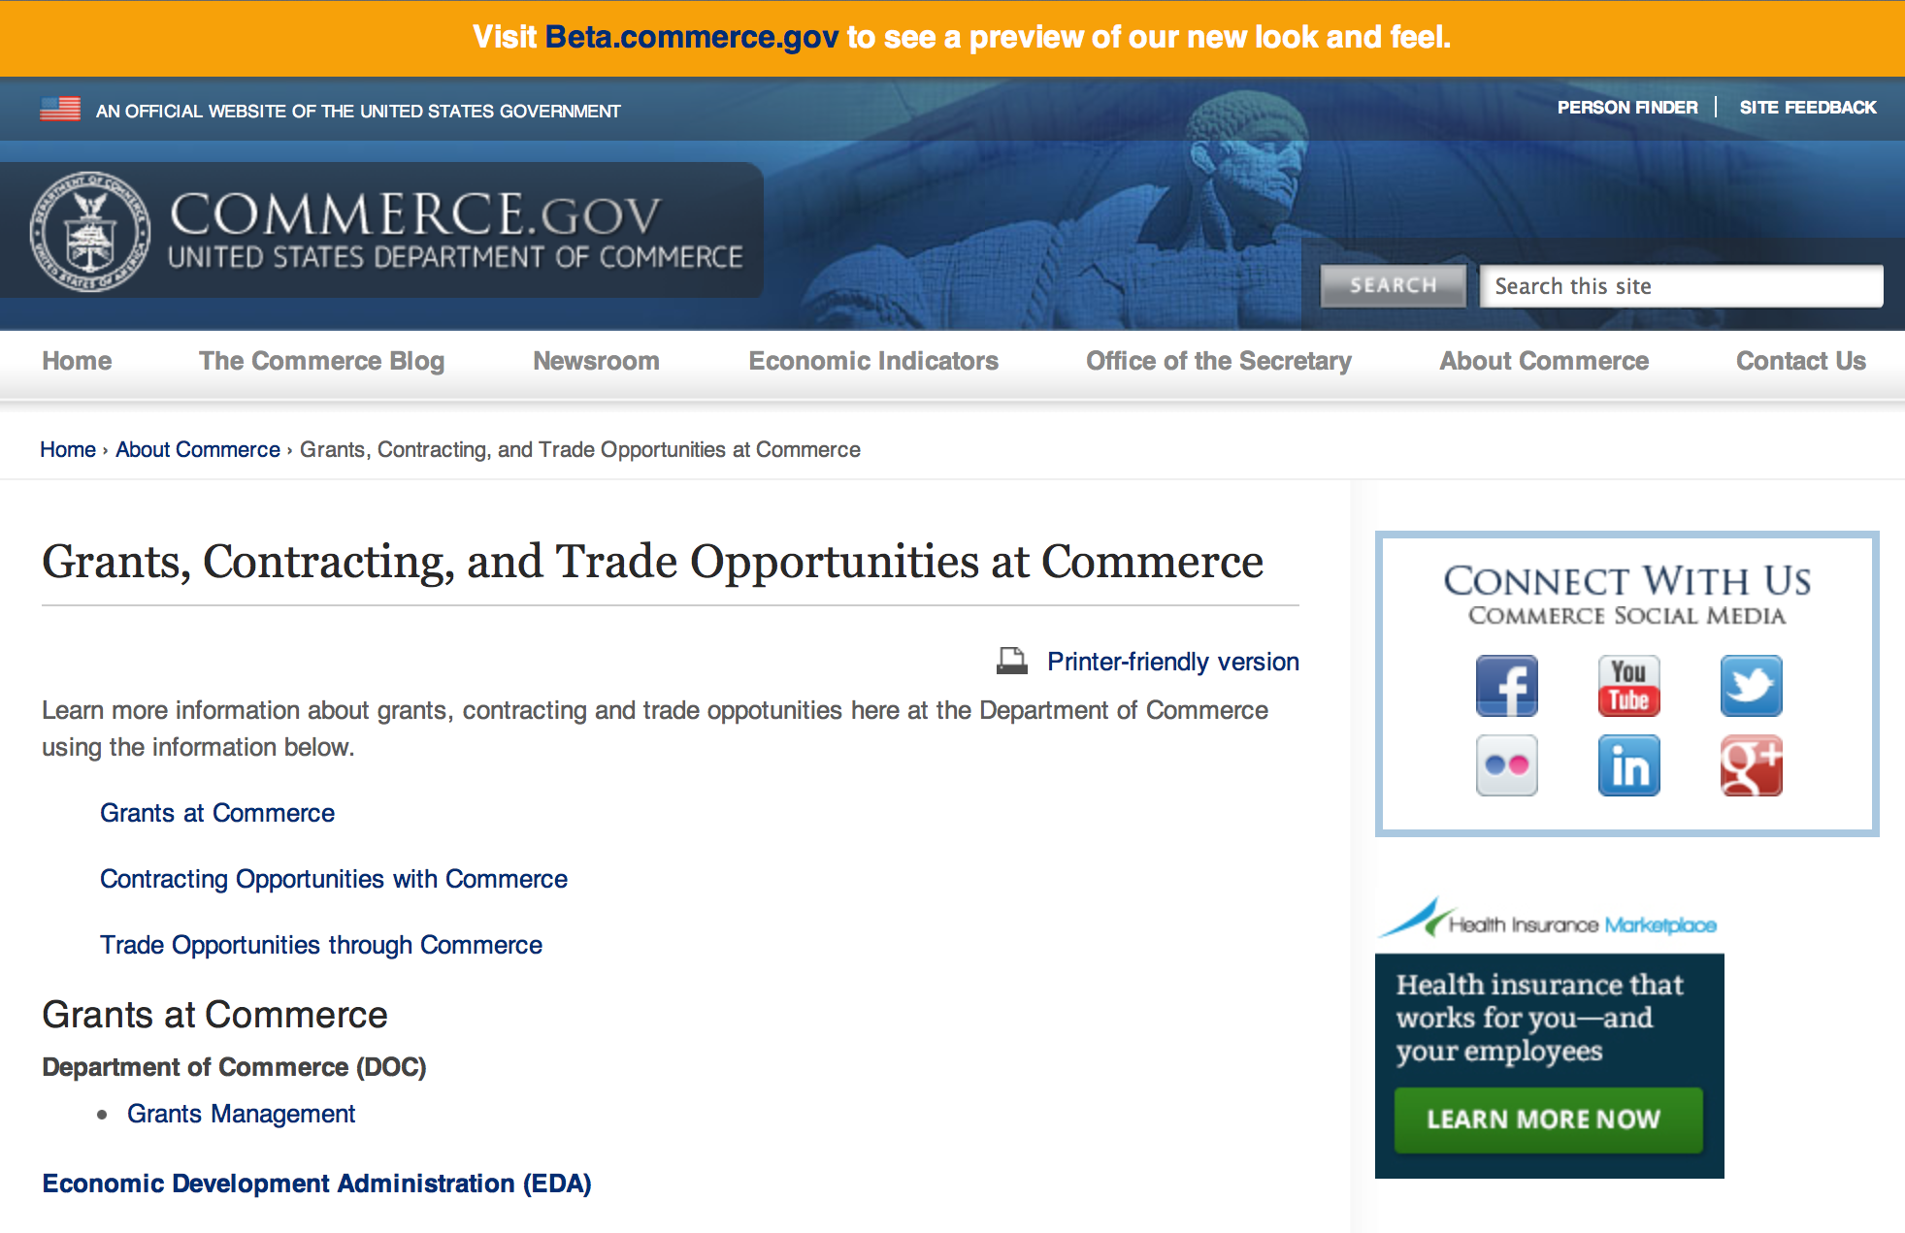
Grants at Commerce
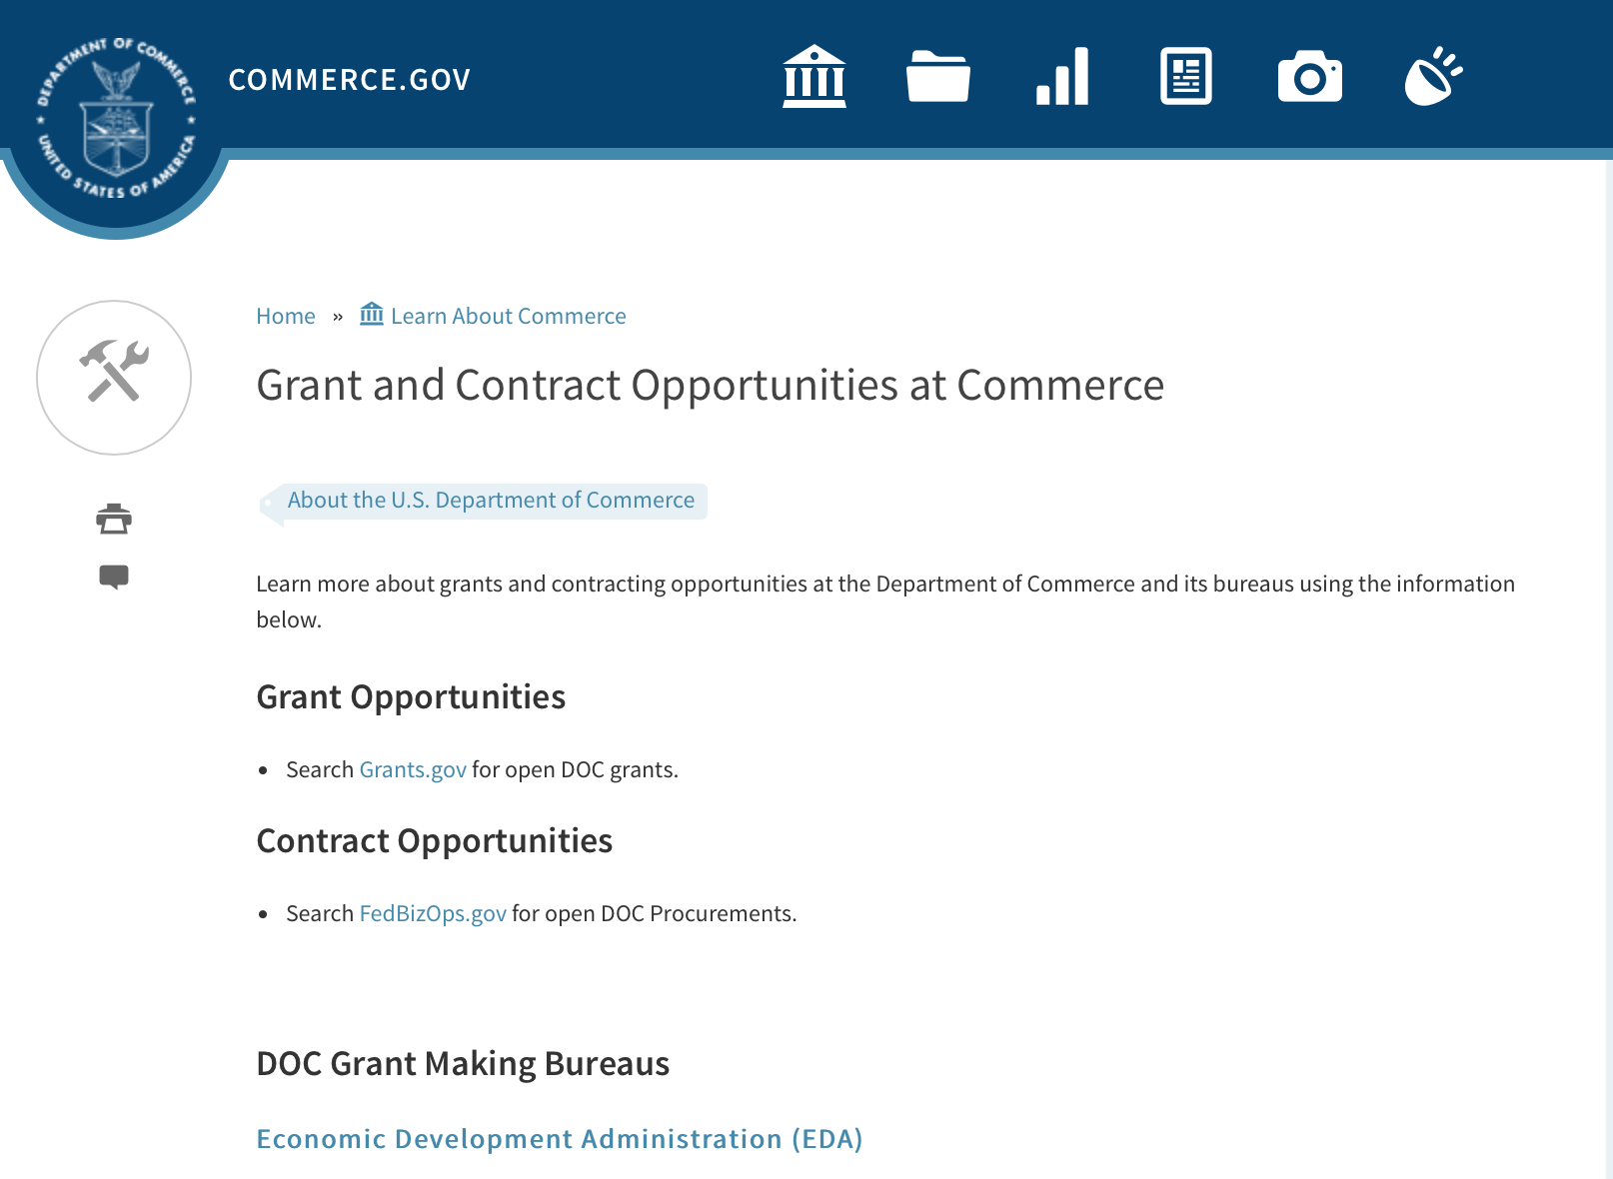

DOC Grant Making Bureaus
Economic Development Administration (EDA)
International Trade Administration (ITA)
- Market Development Cooperator Program
- Special American Business Internship Training Program (SABIT). A technical assistance initiative of the International Trade Administration of the U.S. Department of Commerce, SABIT offers organizations competitive grants and an opportunity to host industry-specific delegations. SABIT serves as an initial entry point for U.S. businesses seeking funding to establish long-term relationships with potential customers, distributors, or partners in the former Soviet Union. The program trains Eurasian managers and scientists in commonly accepted business practices as a means of facilitating cross border relationships. In turn, these personal relationships serve as a basis for business development and reduce market access barriers for U.S. businesses
National Institute of Standards & Technology (NIST)
- Funding Opportunities
National Telecommunications & Information Administration (NTIA)
- Telecommunications Grants
National Oceanic & Atmospheric Administration (NOAA)
- Coastal Ocean Program Grant Information
- Fisheries Saltonstall Kennedy Grant Program
- National Undersea Research Program Funding Opportunities
- Grants Management Division
- Fisheries Grants Program
- National Sea Grant
- Office of Global Programs
Contracting Resources for Contractors
- Office of Small and Disadvantaged Business Utilization (OSDBU) - he Office of Small and Disadvantaged Business Utilization (OSDBU) is an advocacy and advisory office responsible for promoting the use of small, small disadvantaged, 8(a), women-owned, veteran-owned, service-disabled veteran-owned, and HUBZone small businesses within the U.S. Department of Commerce's (DOC) acquisition process.
- Business.USA.gov's Find Opportunities Wizard where in a few quick steps, it will guide you towards federal government contracting programs and opportunities for your business!
- Planned Acquisitions: the Department of Commerce's search tool for our planned acquisitions over $100,000. As requirements change, these acquisition plans are updated by department personnel and this search tool is automatically updated.
- Small Business Administration's Contracting section of their web site where you can learn about how to "Get Started" and "Contracting Support for Small Business"
- The General Services Administration (GSA) has implemented a system for vendors doing business with the Federal Government to manage their entity information in one central location. This new database is the System for Award Management (SAM).

DOC Contracting Offices
- Patent and Trademark Office (PTO)
  - Office of Procurement
- National Institute of Standards & Technology (NIST)
NIST Acquisition Management Group
Contracting Opportunities with Commerce
Trade Opportunities through Commerce
http://www.commerce.gov/about-commerce/grants-contracting-trade-opportunities

Programs:

Funding Opportunity Number: MBDA-OBD-2016-2004926
MBDA Broad Agency Announcement

Document Type: | Grants Notice
Funding Opportunity Number: | MBDA-OBD-2016-2004926
Funding Opportunity Title: | MBDA Broad Agency Announcement
Opportunity Category: | Discretionary
Opportunity Category Explanation:
Funding Instrument Type: | Cooperative Agreement  Grant
Category of Funding Activity: | Environment  Natural Resources  Science and Technology and other Research and Development
Category Explanation:
Expected Number of Awards:
CFDA Number(s): | 11.802 -- Minority Business Resource Development
Cost Sharing or Matching Requirement: | No
Posted Date: | Jun 22, 2016
Last Updated Date: | Jun 22, 2016
Original Closing Date for Applications: | Jun 21, 2017
Current Closing Date for Applications: | Jun 21, 2017
Archive Date: | Jul 21, 2017
Estimated Total Program Funding: | $2,000,000
Award Ceiling: | $2,000,000
Award Floor: | $1
Eligible Applicants: | Others (see text field entitled "Additional Information on Eligibility" for clarification)
Additional Information on Eligibility: | Eligible applicants may be for-profit entities (including but not limited to sole-proprietorships, partnerships, limited liability companies and corporations), non-profit organizations, institutions of higher education, commercial organizations, individuals, state and local government entities, Indian Tribal governments.
Agency Name: | Department of Commerce
Description: | The purpose of this notice is to request applications for special projects and programs associated with the Minority Business Development Agency’s (MBDA) strategic plans and mission goals, as well as to provide the general public with information and guidelines on how MBDA will select proposals and administer discretionary Federal assistance under this Broad Agency Announcement (BAA).
Link to Additional Information:
Grantor Contact Information: | If you have difficulty accessing the full announcement electronically, please contact:  Ms. Joann J. Hill, Chief MBDA Office of Business Development U.S. Department of Commerce 1401 Constitution Ave., N.W. Room 5079 Washington, DC 20230 Tel: 202-482-1940 jhill@mbda.gov Nakita Chambers MBDA Program Manager U.S. Department of Commerce 1401 Constitution Ave., N.W., Room 5079 Washington, DC 20230 Tel: 202-482-0065 nchambers@mbda.gov  Work

Link: http://www.grants.gov/web/grants/view-opportunity.html?oppId=285308

Research:

FY17 Bluefin Tuna Research Program Grant

Document Type: | Grants Notice
Funding Opportunity Number: | NOAA-NMFS-SE-2017-2004938
Funding Opportunity Title: | FY17 Bluefin Tuna Research Program
Opportunity Category: | Discretionary
Opportunity Category Explanation:
Funding Instrument Type: | Cooperative Agreement
Category of Funding Activity: | Environment  Natural Resources  Science and Technology and other Research and Development
Category Explanation:
Expected Number of Awards: | 5
CFDA Number(s): | 11.472 -- Unallied Science Program
Cost Sharing or Matching Requirement: | No
Posted Date: | Jun 14, 2016
Last Updated Date: | Jun 14, 2016
Original Closing Date for Applications: | Sep 01, 2016
Current Closing Date for Applications: | Sep 01, 2016
Archive Date: | Oct 01, 2016
Estimated Total Program Funding: | $600,000
Award Ceiling: | $300,000
Award Floor: | $25,000
Eligible Applicants: | Others (see text field entitled "Additional Information on Eligibility" for clarification)
Additional Information on Eligibility: | Eligible applicants may be institutions of higher education, nonprofits, commercial organizations, individuals, and state, local, and Indian tribal governments.
Agency Name: | Department of Commerce
Description: | The BTRP program provides opportunity to compete for financial assistance for projects which seek to increase and improve the working relationship between fisheries researchers from the NMFS, state fishery agencies, universities, other research institutions and U.S. fishery interests (recreational and commercial) focusing on northern bluefin tuna in the Atlantic Ocean. The program is a means of advancing research objectives to address the information needs to improve the science-based fisheries management for Atlantic bluefin tuna. This program addresses NOAA's mission goal to "Protect, Restore, and Manage the Use of Coastal and Ocean Resources through an Ecosystem Approach to Management."
Link to Additional Information:
Grantor Contact Information: | If you have difficulty accessing the full announcement electronically, please contact:  Dax Ruiz, (727) 824-5324, Dax.Ruiz@noaa.gov  Work

http://www.grants.gov/web/grants/view-opportunity.html?oppId=284667

FY 16 Coastal Ecosystem Resiliency Grants Program

Document Type: | Grants Notice
Funding Opportunity Number: | NOAA-NMFS-HCPO-2016-2004840
Funding Opportunity Title: | FY 16 Coastal Ecosystem Resiliency Grants Program
Opportunity Category: | Discretionary
Opportunity Category Explanation:
Funding Instrument Type: | Cooperative Agreement
Category of Funding Activity: | Environment  Natural Resources  Science and Technology and other Research and Development
Category Explanation:
Expected Number of Awards: | 10
CFDA Number(s): | 11.463 -- Habitat Conservation
Cost Sharing or Matching Requirement: | Yes
Posted Date: | Jun 14, 2016
Last Updated Date: | Jun 14, 2016
Original Closing Date for Applications: | Aug 16, 2016
Current Closing Date for Applications: | Aug 16, 2016
Archive Date: | Sep 15, 2016
Estimated Total Program Funding: | $8,500,000
Award Ceiling: | $2,000,000
Award Floor: | $100,000
Eligible Applicants: | Others (see text field entitled "Additional Information on Eligibility" for clarification)
Additional Information on Eligibility: | Eligible applicants are institutions of higher education, non-profit or for-profit organizations, U.S. territories, and state, local and Native American tribal governments. Applications from individuals, federal agencies, or employees of federal agencies will not be considered. Individuals and federal agencies are strongly encouraged to work with states, non-governmental organizations, municipal and county governments, and others that are eligible to apply.
Agency Name: | Department of Commerce
Description: | The principal objective of the National Marine Fisheries Service's (NMFS) Coastal Ecosystem Resiliency Grants solicitation is to implement projects that use a proactive approach to improve or restore coastal habitat to: 1) strengthen the resilience of U.S. marine and coastal ecosystems and decrease the vulnerability of communities to extreme weather and 2) support sustainable fisheries and contribute to the recovery of protected resources. Applications submitted under this solicitation will be selected based on their ability to demonstrate how the proposed project will enhance the resiliency of U.S. marine and coastal ecosystems to the impacts of extreme weather and changing environmental conditions thereby increasing community resilience and improving habitat for species under NOAA jurisdiction. Proposed projects should benefit threatened and endangered species listed under the Endangered Species Act (hereafter, Listed Species), including species identified by NMFS as “Species in the Spotlight” (http://www.nmfs.noaa.gov/stories/2015/05/05_14_15species_in_the_spotlight.html), species managed under the Magnuson-Stevens Fishery Conservation and Management Act (hereafter, Managed Species), or benefit Listed or Managed Species through ecosystem improvements such as restoring habitat for forage fish. Proposed projects should also demonstrate collaboration among stakeholders, as evidenced by recommendations and strategies outlined in multi-stakeholder studies, coastal vulnerability assessments, or comprehensive planning efforts designed to address ecosystem resiliency. Successful applications will: 1) identify an issue limiting the resiliency of U.S. marine and coastal ecosystems to extreme weather events or changing environmental conditions at the proposed project site; 2) identify the proposed project’s outcome goal(s) and describe in detail the actions and on-the-ground restoration to be undertaken to enhance resiliency and reduce risk and; 3) describe the measurable impact on the ecosystem, the species (e.g. Listed or Managed Species) to benefit from the project, and surrounding coastal communities to benefit from the proposed coastal habitat restoration project.
Link to Additional Information:
Grantor Contact Information: | If you have difficulty accessing the full announcement electronically, please contact:  Melanie Gange at (301) 427-8664  work

http://www.grants.gov/web/grants/view-opportunity.html?oppId=284647

Modifications:

Reminders:

National Institute of Standards and Technology
Regional Alliances and Multistakeholder Partnerships to Stimulate (RAMPS) Cybersecurity Education and Workforce Development Grant

Document Type: | Grants Notice
Funding Opportunity Number: | 2016-NIST-NICE-01
Funding Opportunity Title: | Regional Alliances and Multistakeholder Partnerships to Stimulate (RAMPS) Cybersecurity Education and Workforce Development
Opportunity Category: | Discretionary
Opportunity Category Explanation: | Category Explanation
Funding Instrument Type: | Cooperative Agreement
Category of Funding Activity: | Science and Technology and other Research and Development
Category Explanation:
Expected Number of Awards:
CFDA Number(s): | 11.620 -- Science, Technology, Business and/or Education Outreach
Cost Sharing or Matching Requirement: | No
Posted Date: | May 11, 2016
Last Updated Date: | May 11, 2016
Original Closing Date for Applications: | Jul 12, 2016 Applications must be received at Grants.gov no later than 11:59 p.m. Eastern Time, Tuesday, July 12, 2016. Applications received after this deadline will not be reviewed or considered. Applicants should be aware, and factor in their application submission planning, that the Grants.gov system is expected to be closed for routine maintenance from 12:01 a.m. Eastern Time, Saturday, June 18, 2016 until Monday, June 20, 2016 at 6:00 a.m. Eastern Time. Applications cannot be submitted when Grants.gov is closed.
Current Closing Date for Applications: | Jul 12, 2016 Applications must be received at Grants.gov no later than 11:59 p.m. Eastern Time, Tuesday, July 12, 2016. Applications received after this deadline will not be reviewed or considered. Applicants should be aware, and factor in their application submission planning, that the Grants.gov system is expected to be closed for routine maintenance from 12:01 a.m. Eastern Time, Saturday, June 18, 2016 until Monday, June 20, 2016 at 6:00 a.m. Eastern Time. Applications cannot be submitted when Grants.gov is closed.
Archive Date: | Aug 11, 2016
Eligible Applicants: | Others (see text field entitled "Additional Information on Eligibility" for clarification)
Additional Information on Eligibility: | Applicants must meet all of the following requirements. Applicants must be non-profit organizations including institutions of higher education located in the U.S. or its territories. The applicant will be the lead organization for the project. Applicants must demonstrate through commitment letters that at least one of each of the following types of organizations is committed to being part of the proposed multistakeholder workforce partnership: a K-12 school or Local Education Agency (LEA); an institution of higher education or college/university system; and a local employer.
Agency Name: | National Institute of Standards and Technology
Description: | The National Initiative for Cybersecurity Education (NICE), led by NIST, is soliciting applications from eligible applicants for the establishment of state or regional consortia to identify cybersecurity workforce development pathways that address local workforce needs.
Link to Additional Information: | 2016-NIST-NICE-01 Full Announcement/FFO document
Contact Information: | If you have difficulty accessing the full announcement electronically, please contact:  Christopher Hunton Management and Program Analyst Phone 301-975-5718  Agency Contact

http://www.grants.gov/web/grants/view-opportunity.html?oppId=283764

National Institute of Standards and Technology
Measurement Science and Engineering (MSE) Research Grant Programs

Document Type: | Grants Notice
Funding Opportunity Number: | 2016-NIST-MSE-01
Funding Opportunity Title: | Measurement Science and Engineering (MSE) Research Grant Programs
Opportunity Category: | Discretionary
Opportunity Category Explanation:
Funding Instrument Type: | Cooperative Agreement  Grant
Category of Funding Activity: | Science and Technology and other Research and Development
Category Explanation:
Expected Number of Awards:
CFDA Number(s):
Cost Sharing or Matching Requirement: | No
Posted Date: | Feb 19, 2016
Last Updated Date: | Feb 19, 2016
Original Closing Date for Applications: | Applications will be accepted and considered on a rolling basis as they are received. See Section IV.4. in the text of the Full Announcement/FFO document. Applications may be submitted by paper or electronically through Grants.gov. Carefully read Section IV. of the Full Announcement/FFO document for details applying to electronic submissions and to paper submissions.
Current Closing Date for Applications: | Applications will be accepted and considered on a rolling basis as they are received. See Section IV.4. in the text of the Full Announcement/FFO document. Applications may be submitted by paper or electronically through Grants.gov. Carefully read Section IV. of the Full Announcement/FFO document for details applying to electronic submissions and to paper submissions.
Eligible Applicants: | Others (see text field entitled "Additional Information on Eligibility" for clarification)
Additional Information on Eligibility: | Eligibility for all programs listed in this FFO is open to all non-Federal entities. Eligible applicants include institutions of higher education, non-profit organizations, for-profit organizations, state and local governments, Indian tribes, hospitals, foreign public entities, and foreign governments. Applicants selected for awards under 15 U.S.C. § 278g-1 are encouraged, but not required, to select underrepresented minorities for participation. In addition, NIST is not able to accept an application from an individual unaffiliated with a sponsoring applicant organization.
Agency Name: | National Institute of Standards and Technology
Description: | NIST is soliciting applications for financial assistance for Fiscal Year 2016 (FY16) within the following NIST Laboratory grant programs: (1) the Material Measurement Laboratory (MML) Grant Program; (2) the Physical Measurement Laboratory (PML) Grant Program; (3) the Engineering Laboratory (EL) Grant Program; (4) the Fire Research (FR) Grant Program; (5) the Information Technology Laboratory (ITL) Grant Program; (6) the Communications Technology Laboratory (CTL) Grant Program; (7) the NIST Center for Neutron Research (NCNR) Grant Program; (8) the Center for Nanoscale Science and Technology (CNST) Grant Program; (9) the Special Programs Office (SPO) Grant Program; (10) the Standards Coordination Office (SCO) Grant Program; (11) the International and Academic Affairs Office (IAAO) Grant Program; and (12) the Associate Director for Laboratory Programs (ADLP) Grant Program.
Link to Additional Information: | 2016-NIST-MSE-01 Full Announcement/FFO document
Contact Information: | If you have difficulty accessing the full announcement electronically, please contact:  Christopher Hunton Management and Program Analyst Phone 301-975-5718  Agency Contact

http://www.grants.gov/web/grants/view-opportunity.html?oppId=281689

National Sea Grant College Program 2016-17 Special Projects Grant

Document Type: | Grants Notice
Funding Opportunity Number: | NOAA-OAR-SG-2016-2004772
Funding Opportunity Title: | National Sea Grant College Program 2016-17 Special Projects
Opportunity Category: | Discretionary
Funding Instrument Type: | Cooperative Agreement  Grant
Category of Funding Activity: | Environment  Natural Resources  Science and Technology and other Research and Development
Category Explanation:
Expected Number of Awards: | 30
CFDA Number(s): | 11.417 -- Sea Grant Support
Cost Sharing or Matching Requirement: | Yes
Posted Date: | Jan 7, 2016
Creation Date: | Jan 7, 2016
Original Closing Date for Applications: | Sep 30, 2017
Current Closing Date for Applications: | Sep 30, 2017
Archive Date: | Oct 30, 2017
Estimated Total Program Funding: | $4,000,000
Award Ceiling: | $1,000,000
Award Floor: | $1
Eligible Applicants: | Others (see text field entitled "Additional Information on Eligibility" for clarification)
Additional Information on Eligibility: | Sea Grant Programs (Sea Grant Colleges, Institutions, or Coherent Area Programs), the National Sea Grant Law Center, and the National Sea Grant Library.
Agency Name: | Department of Commerce
Description: | The purpose of this notice is to request proposals for special projects associated with the National Sea Grant College Program’s (Sea Grant) strategic focus areas, and to provide the general public with information and guidelines on how Sea Grant will select proposals and administer Federal assistance under this announcement. This announcement is a mechanism to encourage research or other projects that are not normally funded through Sea Grant national competitions. This opportunity is open only to Sea Grant Programs. Section III of this announcement describes eligibility requirements in more detail. Funding has not yet been made available to support applications submitted to this Federal Funding Opportunity (FFO), but such funding may become available during the year. Section II.A. below describes individual competition announcements that will be used to announce when funding is available; any restrictions or requirements on such funding, such as matching funds; and other funding details. Awards will be made under this FFO only if funds have been announced as provided in this FFO.
Link to Additional Information:
Contact Information: | If you have difficulty accessing the full announcement electronically, please contact:  Special Projects Competition Manager, NOAA R/SG National Sea Grant Office 1315 East-West Highway, Rm 11839 Silver Spring, MD 20910 301-734-1066  work

http://www.grants.gov/web/grants/view-opportunity.html?oppId=280846

FY 2016 – FY 2019 EDA Planning Program and Local Technical Assistance Program Grant

Document Type: | Grants Notice
Funding Opportunity Number: | EDA-HDQ-TA-HDQ-2016-2004759
Funding Opportunity Title: | FY 2016 – FY 2019 EDA Planning Program and Local Technical Assistance Program
Opportunity Category: | Discretionary
Funding Instrument Type: | Cooperative Agreement  Grant
Category of Funding Activity: | Other (see text field entitled "Explanation of Other Category of Funding Activity" for clarification)  Regional Development
Category Explanation: | Regional planning and local technical assistance
Expected Number of Awards:
CFDA Number(s): | 11.302 -- Economic Development Support for Planning Organizations  11.303 -- Economic Development Technical Assistance
Cost Sharing or Matching Requirement: | No
Posted Date: | Dec 10, 2015
Creation Date: | Dec 10, 2015
Original Closing Date for Applications: | Applications are accepted on a continuing basis and processed as received. This Planning and Local Technical Assistance opportunity will remain in effect until superseded by a future announcement.
Current Closing Date for Applications: | Applications are accepted on a continuing basis and processed as received. This Planning and Local Technical Assistance opportunity will remain in effect until superseded by a future announcement.
Archive Date:
Estimated Total Program Funding:
Award Ceiling: | $300,000
Award Floor: | $0
Eligible Applicants: | Nonprofits having a 501(c)(3) status with the IRS, other than institutions of higher education  City or township governments  Nonprofits that do not have a 501(c)(3) status with the IRS, other than institutions of higher education  Others (see text field entitled "Additional Information on Eligibility" for clarification)  Private institutions of higher education  Native American tribal governments (Federally recognized)  Public and State controlled institutions of higher education  State governments  Special district governments  County governments
Additional Information on Eligibility: | Pursuant to section 3 of the Public Works and Economic Development Act of 1965 (42 U.S.C. § 3122) (PWEDA) and EDA’s regulation at 13 C.F.R. § 300.3, the following types of entities are eligible to receive funding assistance from EDA: 1. District Organizations (as defined in 13 C.F.R. § 300.3); 2. Indian Tribes or a consortium of Indian Tribes; 3. States, cities, or other political subdivisions of a State, including a special purpose unit of a State or local government engaged in economic or infrastructure development activities, or a consortium of political subdivisions; 4. Institutions of higher education or a consortium of institutions of higher education; or 5. Public or private non-profit organizations or associations acting in cooperation with officials of a political subdivision of a State.
Agency Name: | Department of Commerce
Description: | Pursuant to PWEDA, EDA announces general policies and application procedures for grant-based investments under the Planning and Local Technical Assistance programs. Under the Planning program EDA assists eligible recipients in creating regional economic development plans designed to build capacity and guide the economic prosperity and resiliency of an area or region. As part of this program, EDA supports Partnership Planning investments to facilitate the development, implementation, revision, or replacement of Comprehensive Economic Development Strategies (CEDS), which articulate and prioritize the strategic economic goals of recipients’ respective regions. In general, EDA provides Partnership Planning grants to the designated planning organization (e.g., District Organization) serving EDA designated Economic Development Districts to enable these organizations to develop and implement relevant CEDS. In addition, EDA provides Partnership Planning grants to Indian Tribes to help develop and implement CEDS and associated economic development activities. The Planning program also helps support organizations, including District Organizations, Indian Tribes, and other eligible recipients, with Short Term and State Planning investments designed to guide the eventual creation and retention of high-quality jobs, particularly for the unemployed and underemployed in the Nation’s most economically distressed regions. The Local Technical Assistance program strengthens the capacity of local or State organizations, institutions of higher education, and other eligible recipients to undertake and promote effective economic development programs through projects such as feasibility analyses and impact studies.
Link to Additional Information: | www.eda.gov
Contact Information: | If you have difficulty accessing the full announcement electronically, please contact:  The EDA representative for your state. A complete list of EDA representatives is available on EDA's website at http://www.eda.gov/contact/

http://www.grants.gov/web/grants/view-opportunity.html?oppId=280447

FY 2016 Economic Development Assistance Programs ­ Application submission and program requirements for EDA’s Public Works and Economic Adjustment Assistance Programs Grant

Document Type: | Grants Notice
Funding Opportunity Number: | EDAP2016
Funding Opportunity Title: | FY 2016 Economic Development Assistance Programs ­ Application submission and program requirements for EDA’s Public Works and Economic Adjustment Assistance programs.
Opportunity Category: | Discretionary
Funding Instrument Type: | Cooperative Agreement  Grant
Category of Funding Activity: | Other (see text field entitled "Explanation of Other Category of Funding Activity" for clarification)
Category Explanation: | The Economic Development Administration's (EDA's) mission is to lead the Federal economic development agenda by promoting innovation and competitiveness, preparing American regions for economic growth and success in the worldwide economy. EDA fulfills this mission through strategic investments and partnerships that create the regional economic ecosystems required to foster globally competitive regions throughout the United States. EDA supports development in economically distressed areas of the United States by fostering job creation and attracting private investment. Specifically, under the Economic Development Assistance programs (EDAP) Federal Funding Opportunity (FFO) announcement, EDA will make construction, non-construction, and revolving loan fund investments under the Public Works and Economic Adjustment Assistance (EAA) Programs. Grants made under these programs will leverage regional assets to support the implementation of regional economic development strategies designed to create jobs, leverage private capital, encourage economic development, and strengthen America's ability to compete in the global marketplace. Through the EDAP FFO, EDA solicits applications from rural and urban communities to develop initiatives that advance new ideas and creative approaches to address rapidly evolving economic conditions.
Expected Number of Awards:
CFDA Number(s): | 11.300 -- Investments for Public Works and Economic Development Facilities  11.307 -- Economic Adjustment Assistance
Cost Sharing or Matching Requirement: | Yes
Posted Date: | Oct 26, 2015
Creation Date: | Oct 26, 2015
Original Closing Date for Applications: | There are no submission deadlines under this opportunity. Proposals and applications will be accepted on an ongoing basis until the publication of a new EDAP FFO.
Current Closing Date for Applications: | There are no submission deadlines under this opportunity. Proposals and applications will be accepted on an ongoing basis until the publication of a new EDAP FFO.
Archive Date:
Estimated Total Program Funding:
Award Ceiling: | $3,000,000
Award Floor: | $100,000
Eligible Applicants: | Others (see text field entitled "Additional Information on Eligibility" for clarification)  State governments  City or township governments  Native American tribal organizations (other than Federally recognized tribal governments)  Native American tribal governments (Federally recognized)  Private institutions of higher education  Special district governments  Nonprofits having a 501(c)(3) status with the IRS, other than institutions of higher education  County governments  Nonprofits that do not have a 501(c)(3) status with the IRS, other than institutions of higher education  Public and State controlled institutions of higher education
Additional Information on Eligibility: | Eligible applicants for EDA financial assistance under the Public Works and EAA programs include a(n): (i) District Organization of a designated Economic Development District; (ii) Indian Tribe or a consortium of Indian Tribes; (iii) State, county, city, or other political subdivision of a State, including a special purpose unit of a State or local government engaged in economic or infrastructure development activities, or a consortium of political subdivisions; (iv) institution of higher education or a consortium of institutions of higher education; or (v) public or private non-profit organization or association acting in cooperation with officials of a political subdivision of a State. See Section 3 of the Public Works and Economic Development Act of 1965 (PWEDA) (42 U.S.C. § 3122) and 13 C.F.R. § 300.3. EDA is not authorized to provide grants or cooperative agreements to individuals or to for profit entities. Requests from such entities will not be considered for funding.
Agency Name: | Economic Development Administration
Description: | Under this FFO, EDA solicits applications from applicants in rural and urban areas to provide investments that support construction, non-construction, technical assistance, and revolving loan fund projects under EDA’s Public Works and EAA programs. Grants and cooperative agreements made under these programs are designed to leverage existing regional assets and support the implementation of economic development strategies that advance new ideas and creative approaches to advance economic prosperity in distressed communities. EDA provides strategic investments on a competitive- merit-basis to support economic development, foster job creation, and attract private investment in economically distressed areas of the United States.
Link to Additional Information: | www.eda.gov
Contact Information: | If you have difficulty accessing the full announcement electronically, please contact:  the EDA representative for your state. A complete list of EDA representatives is available on EDA's website at http://www.eda.gov/contact/

http://www.grants.gov/web/grants/view-opportunity.html?oppId=279842

Economic Development Administration
Planning Program and Local Technical Assistance Program Grant

Document Type: | Grants Notice
Funding Opportunity Number: | EDAPLANNING2012
Opportunity Category: | Discretionary
Posted Date: | Aug 03, 2012
Creation Date: | Aug 03, 2012
Original Closing Date for Applications: | Applications are accepted on a continuing basis and processed as received. This Planning and Local Technical Assistance opportunity will remain in effect until superseded by a future announcement.
Current Closing Date for Applications: | Applications are accepted on a continuing basis and processed as received. This Planning and Local Technical Assistance opportunity will remain in effect until superseded by a future announcement.
Archive Date:
Funding Instrument Type: | Cooperative Agreement  Grant
Category of Funding Activity: | Other (see text field entitled "Explanation of Other Category of Funding Activity" for clarification)  Regional Development
Category Explanation: | Regional planning and local technical assistance
Expected Number of Awards: | 425
Estimated Total Program Funding:
Award Ceiling: | $100,000
Award Floor:
CFDA Number(s): | 11.302 -- Economic Development Support for Planning Organizations
 | 11.303 -- Economic Development Technical Assistance
Cost Sharing or Matching Requirement: | Yes

Eligible Applicants
State governments
County governments
City or township governments
Public and State controlled institutions of higher education
Native American tribal governments (Federally recognized)
Nonprofits having a 501(c)(3) status with the IRS, other than institutions of higher education
Nonprofits that do not have a 501(c)(3) status with the IRS, other than institutions of higher education
Private institutions of higher education
Others (see text field entitled "Additional Information on Eligibility" for clarification)

Additional Information on Eligibility:
Pursuant to section 3 of the Public Works and Economic Development Act of 1965 (42 U.S.C. § 3122) (PWEDA) and EDA’s regulation at 13 C.F.R. § 300.3, the following types of entities are eligible to receive funding assistance from EDA: 1. District Organizations (as defined in 13 C.F.R. § 300.3); 2. Indian Tribes or a consortium of Indian Tribes; 3. States, cities, or other political subdivisions of a State, including a special purpose unit of a State or local government engaged in economic or infrastructure development activities, or a consortium of political subdivisions; 4. Institutions of higher education or a consortium of institutions of higher education; or 5. Public or private non-profit organizations or associations acting in cooperation with officials of a political subdivision of a State.

Agency Name
Economic Development Administration

Description
Pursuant to PWEDA, EDA announces general policies and application procedures for grant-based investments under the Planning and Local Technical Assistance programs. Under the Planning program EDA assists eligible recipients in creating regional economic development plans designed to stimulate and guide the economic development efforts of a community or region. As part of this program, EDA supports Partnership Planning investments to facilitate the development, implementation, revision, or replacement of Comprehensive Economic Development Strategies (CEDS), which articulate and prioritize the strategic economic goals of recipients' respective regions. In general, EDA provides Partnership Planning grants to the designated planning organization (e.g., District Organization) serving EDA-designated Economic Development Districts to enable these organizations to develop and implement relevant CEDS. In addition, EDA provides Partnership Planning grants to Indian Tribes to help develop and implement CEDS and associated economic development activities. The Planning program also helps support planning organizations, including District Organizations, Indian Tribes, and other eligible Recipients, with Short Term and State Planning investments designed to guide the eventual creation and retention of higher-skill, higher-wage jobs, particularly for the unemployed and underemployed in the Nation’s most economically distressed regions. The Local Technical Assistance program strengthens the capacity of local or State organizations, institutions of higher education, and other eligible recipients to undertake and promote effective economic development programs through projects such as feasibility analyses and impact studies.

Link to Additional Information

If you have difficulty accessing the full announcement electronically, please contact:
David Ives Planning and Local TA email

http://www.grants.gov/web/grants/view-opportunity.html?oppId=189193

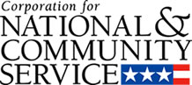

Corporation for National and Community Service

General Program Overview
AmeriCorps provides resources, both human and financial, to organizations that engage Americans in intensive service to meet our country’s critical needs.
Grantees use the funding to support AmeriCorps members for intensive service in their community. AmeriCorps grants partially cover the expense of operating an AmeriCorps program and do not cover general organizational expenses. A cash and in-kind match is required.

The main website can be accessed here: http://www.nationalservice.gov

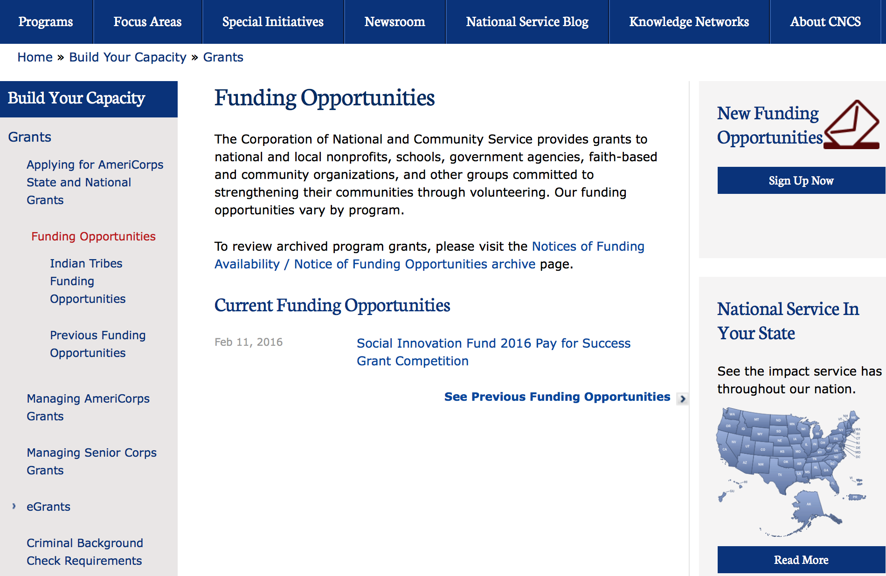

For access to further funding information: click here

http://www.nationalservice.gov/build-your-capacity/grants/funding-opportunities

Programs:

Reminders:

National Service In Hawaii
National Service in Your State - Hawaii
2014-2015
Meeting Community Needs in Hawaii: More than 3,800 people of all ages and backgrounds are helping to meet local needs, strengthen communities, and increase civic engagement through national service in Hawaii. Serving at more than 350 locations throughout the state, these citizens tutor and mentor children, support veterans and military families, provide health services, restore the environment, respond to disasters, increase economic opportunity, and recruit and manage volunteers. This year, the Corporation for National and Community Service (CNCS) will commit more than $6,260,000 to support Hawaii communities through national service initiatives. Through a unique public-private partnership, this federal investment will leverage an additional $3,640,000 in other resources to strengthen community impact, build local support, and increase return on taxpayer dollars.

AmeriCorps
This year, AmeriCorps will provide more than 540 individuals the opportunity to provide intensive, results-driven service to meet education, environmental, health, economic, and other pressing needs in communities across Hawaii. Most AmeriCorps grant funding goes to the Hawaii Commission on National & Community Service, which in turn awards grants to nonprofit groups to respond to local needs. Most of the remainder of the grant funding is distributed by CNCS directly to multi-state and national organizations through a competitive grants process. Other individuals serve through AmeriCorps VISTA, whose members help bring individuals and communities out of poverty by serving full-time to fight illiteracy, improve health services, create businesses, and increase housing opportunities, and AmeriCorps NCCC (National Civilian Community Corps), a 10-month, full time residential program for men and women between the ages of 18 and 24. In exchange for their service, AmeriCorps members earn an education award that can be used to pay for college or to pay back qualified student loans. Since 1994, more than 5,600 Hawaii residents have served more than 5.8 million hours and have qualified for Segal AmeriCorps Education Awards totaling more than $13,510,000.

Senior Corps
More than 3,200 seniors in Hawaii contribute their time and talents in one of three Senior Corps programs. Foster Grandparents serve one-on-one as tutors and mentors to more than 340 young people who have special needs. Senior Companions help more than 200 homebound seniors and other adults maintain independence in their own homes. RSVP volunteers conduct safety patrols, renovate homes, protect the environment, tutor and mentor youth, respond to natural disasters, and provide other services through more than 170 groups across Hawaii.

The Corporation for National and Community Service is a federal agency that improves lives, strengthens communities, and fosters civic engagement through service and volunteering. CNCS annually engages more than five million Americans in service to meet local needs through Senior Corps, AmeriCorps, and national days of service; improves communities through the Social Innovation Fund, and leads President Obama's national call to service initiative, United We Serve. To learn more visit NationalService.gov or Serve.gov or call 202-606-5000 or TTY 1-800-833-3722.

http://www.nationalservice.gov/impact-our-nation/state-profiles/hi

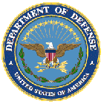

U.S. Department of Defense

Doing Business with the Department of Defense

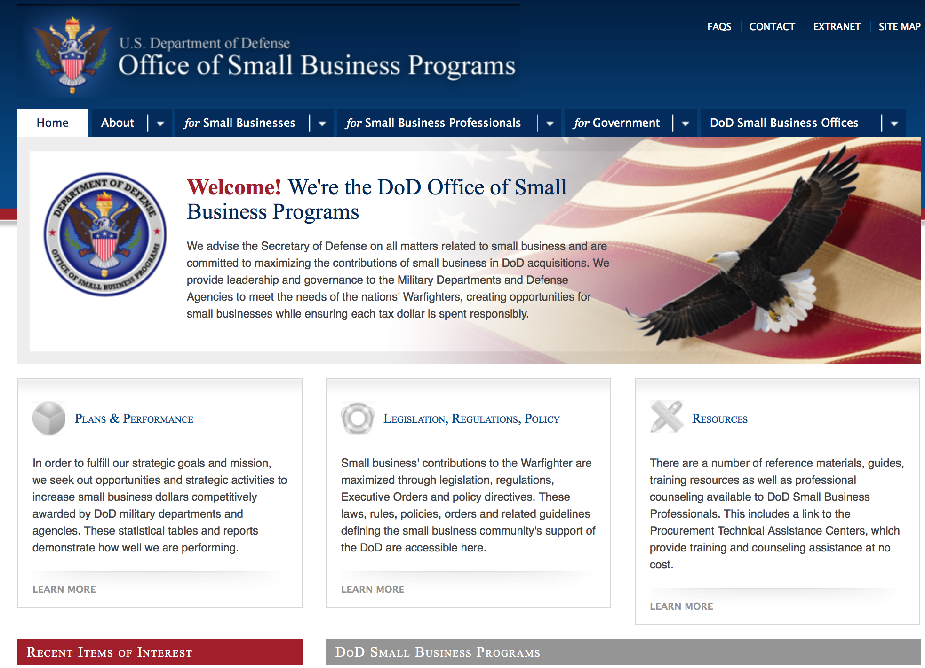

http://www.acq.osd.mil/osbp/

Doing Business with the DoD

Resources

Procurement Technical Assistance Centers (PTACs)

Procurement Technical Assistance Centers (PTACs) are charged with assisting businesses in learning how to do business with federal, state, and local governments. PTACs are a local resource available at no or nominal cost that can provide assistance to business firms in marketing their products and services. They offer training to businesses on how to research and bid on contracts, assist with registration requirements, provide bid-matching services, and assist with pre and post contracting issues.

Prime Contractors with Subcontracting Plans [xlsx]

Directory updated 4/19/11

This FY 2014 directory is intended for small business concerns seeking opportunities with DoD prime contractors. The directory is a listing of large business prime contractors who are required to establish subcontracting plans with goals. The report is generated from data contained in the Individual Subcontract Reports (ISRs) submitted in the Electronic Subcontracting Reporting System (eSRS) by contractors and from data contained in the Federal Procurement Data System (FPDS). The directory includes the name of the prime contractor; the major product/service code (PSC) provided to DoD; the major NAICS of the company; name, telephone number and email address of the company’s point of contact; contract number with the effective date and completion date, ultimate contract value and obligated dollars. In addition, many companies have websites with additional information which may be useful in your search for subcontracting opportunities or teaming arrangements.

Locate a Small Business Professional

Small Business Professionals serve as the primary liaison between private-sector small businesses seeking to do business with government agencies. Specialists advise small businesses regarding current acquisitions contracts available from the federal government.

Procurement Forecasts & the Department of Defense

The Department of Defense, due to its size and scope, does not have a single, comprehensive source for future procurements. Procurements are made locally and within the various services and agencies.

Business Intelligence, relative to future procurement planning, would be gathered at the local level.

For the purposes of forecasting, knowledge of past behavior is useful. Click here for a table of DoD acquisitions in FY10 summarized by NAICS code. The FY10 data has been validated but FPDS data is dynamic and changes continuously.

Non-Appropriated Fund Customers

Non-appropriated fund customers operate similar to non-profit organizations and include commissaries, exchanges, recreation and fitness centers, dining at officer/enlisted/civilian clubs, and barber/beauty services, just to name a few. For more information click here.

Research:

Funding Opportunity Number: W81XWH-16-PCRP-CCRSA
FunDoD Prostate Cancer Clinical Consortium Research Site Award
Dept. of the Army -- USAMRAA
Posted Date: Jun 22, 2016
Link: http://www.grants.gov/web/grants/view-opportunity.html?oppId=285303

Funding Opportunity Number: DARPA-BAA-16-41
Dispersed Computing
DARPA - Information Innovation Office
Posted Date: Jun 24, 2016
Link: http://www.grants.gov/web/grants/view-opportunity.html?oppId=285415

Defense Advanced Research Projects Agency
DARPA - Information Innovation Office
Data-Driven Discovery of Models (D3M) Grant
http://www.grants.gov/web/grants/view-opportunity.html?oppId=284657

Defense Advanced Research Projects Agency
DARPA - Biological Technologies Office
Prometheus Grant
http://www.grants.gov/web/grants/view-opportunity.html?oppId=284679

Defense Advanced Research Projects Agency
DARPA - MTO - BAA0718
Magnetic Miniaturized and Monolithically-Integrated Components (M3IC) Grant
http://www.grants.gov/web/grants/view-opportunity.html?oppId=284693

Defense Advanced Research Projects Agency
DARPA - Defense Sciences Office
Defense Sciences Office Office-wide Grant
http://www.grants.gov/web/grants/view-opportunity.html?oppId=284355Funding Opportunity Number: W911NF-16-R-0018
Modification Quibits in Silicon - BAA
Dept of the Army -- Materiel Command
Posted Date: Jun 20, 2016
Link: http://www.grants.gov/web/grants/view-opportunity.html?oppId=285229

Dept of the Army -- Materiel Command
Advanced Tissue Biofabrication Manufacturing Innovation Institute (ATB-MII) Grant
http://www.grants.gov/web/grants/view-opportunity.html?oppId=284612

Funding Opportunity Number: W81XWH-16-PRCRP-HA
DoD Peer Reviewed Cancer Horizon Award
Dept. of the Army -- USAMRAA
Posted Date: Jun 27, 2016
Link: http://www.grants.gov/web/grants/view-opportunity.html?oppId=285478

Funding Opportunity Number: N00014-16-R-FO13

Funding Opportunity Announcement from the Office of Naval Research (ONR) Navy and Marine
Corps FY2016 for the HEL-JTO High Energy Laser Multidisciplinary Research Initiative
(HEL-MRI) Program
Office of Naval Research
Posted Date: Jun 29, 2016
Link: http://www.grants.gov/web/grants/view-opportunity.html?oppId=285571

Modifications:

Air Force Office of Scientific Research
Research Interests of the Air Force Office of Scientific Research
Modification 4
http://www.grants.gov/web/grants/view-opportunity.html?oppId=276388

Dept. of the Army -- USAMRAA
USAMRMC FY16 Broad Agency Announcement for Extramural Medical Research
Modification 1
http://www.grants.gov/web/grants/view-opportunity.html?oppId=279338

Defense Advanced Research Projects Agency
DARPA - Defense Sciences Office
DSO Office-wide BAA
Modification 2
http://www.grants.gov/web/grants/view-opportunity.html?oppId=277630

Office of Naval Research
Naval Supply Systems Command
FY15 - FY16 HIV/AIDS Prevention Program: Military Specific HIV/AIDS Prevention, Care, and Treatment Program for non-PEPFAR (President's Emergency Plan for AIDS Relief
Modification 6
http://www.grants.gov/web/grants/view-opportunity.html?oppId=270443

FY15 - FY16 Department of Defense HIV/AIDS Prevention Program: Military Specific HIV/AIDS Prevention, Care, and Treatment Program for PEPFAR (President's Emergency Plan for AIDS Relief) Funded Countries
Naval Supply Systems Command
Posted Date: Dec 12, 2014
Modification 23

Modification Comments: The purpose of this Amendment 0018 is to cancel Amendment 0017 (Concept Papers for Rwanda) in its entirety.

Link: http://www.grants.gov/web/grants/view-opportunity.html?oppId=270446

Funding Opportunity Number: NPS-FOA-16-002
Modification Multi-Intelligence (Multi-INT) Research Initiatives at The Naval Postgraduate School
Naval Supply Systems Command
Posted Date: May 05, 2016
Modification 3
Modification Comments: The purpose of Amendment 0001 is to modify the Response Date as follows:
Response Date: This announcement will remain open until 4:00 p.m., Pacific Daylight Time (PDT), 29 July 2016 or until replaced by a successor FOA.

Link: http://www.grants.gov/web/grants/view-opportunity.html?oppId=283589

Funding Opportunity Number: DHAPP-BAA-15-002
Modification FY15 - FY16 Department of Defense HIV/AIDS Prevention Program: Military Specific HIV/AIDS Prevention, Care, and Treatment Program for PEPFAR (President's Emergency Plan for AIDS Relief) Funded Countries
Agency Code: DOD-ONR-SUP
Agency: Department of Defense
Naval Supply Systems Command
Posted Date: Dec 12, 2014
Modification 22
Modification Comments: The purpose of this Amendment 0017 is to incorporate the following:

NHRC/DHAPP is accepting “Concept Papers” for Rwanda through 25 July 2016.

NOTE: Each narrative is a standalone effort and should not be combined with another narrative and all the program elements (tasks) in each specific narrative must be addressed in that concept paper submission.
Link: http://www.grants.gov/web/grants/view-opportunity.html?oppId=270446

Funding Opportunity Number: FOA-RVKV-2013-0001
Space Vehicles (RV) University Grants Program
Agency Code: DOD-AFRL

Air Force -- Research Lab
Posted Date: Dec 10, 2013
Modification 2
Modification Comments: 1. The following changes are hereby made to the announcement:

Section V – Application and Submission Information, (b) Full Proposals, (2) Submitting the Application, (g) R&R Other Project Information Form, Abstract:

Replace the following paragraph with:

The proposal shall include an abstract (not to exceed one page) that is publicly releasable and describes – in terms the public may understand – the project or program supported by the grant. Attach the Abstract to the R&R Other Project Information form in field 7.

Section V – Application and Submission Information, (b) Full Proposals, (2) Submitting the Application, (h) R&R Other Project Information Form , Project Narrative – Principle Investigator (PI) Time:

Replace the following paragraph with:

PI time is required. List the estimate of time the principal investigator and other senior professional personnel will devote to the research. This shall include information pertaining to other commitments of time, such as sabbatical or extended leave; and proportion of time to be devoted to this research and to other research. Awards may be terminated when the principal investigator severs connections with the organization or is unable to continue active participation in the research. State the number of graduate students for whom each senior staff member is responsible. If the principal investigator or other key personnel are currently engaged in research under other auspices, or expect to receive support from other agencies for research during the time proposed for AFRL support, state the title of the other research, the proportion of time to be devoted to it, the amount of support, name of agency, dates, etc. Send any changes in this information as soon as they are known. Submit an abstracts as specified in Section V.b(2)(g) and a copy of the budget for both present and pending research projects.

2. All other content remains unchanged.

Link: http://www.grants.gov/web/grants/view-opportunity.html?oppId=249084

Reminders:

Dept. of the Army -- Materiel Command
Army Research Office Broad Agency Announcement for Basic and Applied Scientific Research
Modification 8

Document Type: | Grants Notice
Funding Opportunity Number: | W911NF-12-R-0012
Funding Opportunity Title: | Army Research Office Broad Agency Announcement for Basic and Applied Scientific Research
Opportunity Category: | Discretionary
Funding Instrument Type: | Cooperative Agreement  Grant  Other  Procurement Contract
Category of Funding Activity: | Science and Technology and other Research and Development
Category Explanation:
Expected Number of Awards: | 1000
CFDA Number(s): | 12.431 -- Basic Scientific Research
Cost Sharing or Matching Requirement: | No
Posted Date: | Mar 27, 2015
Creation Date: | Mar 27, 2015
Original Closing Date for Applications: | Mar 31, 2017
Current Closing Date for Applications: | Mar 31, 2017
Archive Date: | Apr 30, 2017
Eligible Applicants: | Unrestricted (i.e., open to any type of entity above), subject to any clarification in text field entitled "Additional Information on Eligibility"
Agency Name: | Dept. of the Army -- Materiel Command
Description: | The purpose of this Broad Agency Announcement (BAA) is to solicit research proposals in the engineering, physical, life, and information sciences for submission to the Army Research Office (ARO) for consideration for possible funding. For ease of reference, this BAA is an extraction of the ARO sections of the Army Research Laboratory BAA. (www.arl.army.mil/www/default.cfm?page=8).
Link to Additional Information: | ARO CORE BAA-W911NF-12-R-0012-Mod 03
Contact Information: | If you have difficulty accessing the full announcement electronically, please contact:  ANDREW L. FISKE Procurement Analyst Army Contracting Command Aberdeen Proving Ground Research Triangle Park Division Phone: (919) 549-4338 FAX: (919) 549-4388 andrew.l.fiske.civ@mail.mil  Administrative POC

http://www.grants.gov/web/grants/view-opportunity.html?oppId=173593



Department of Education

Grant Programs Overview at the Department of Education

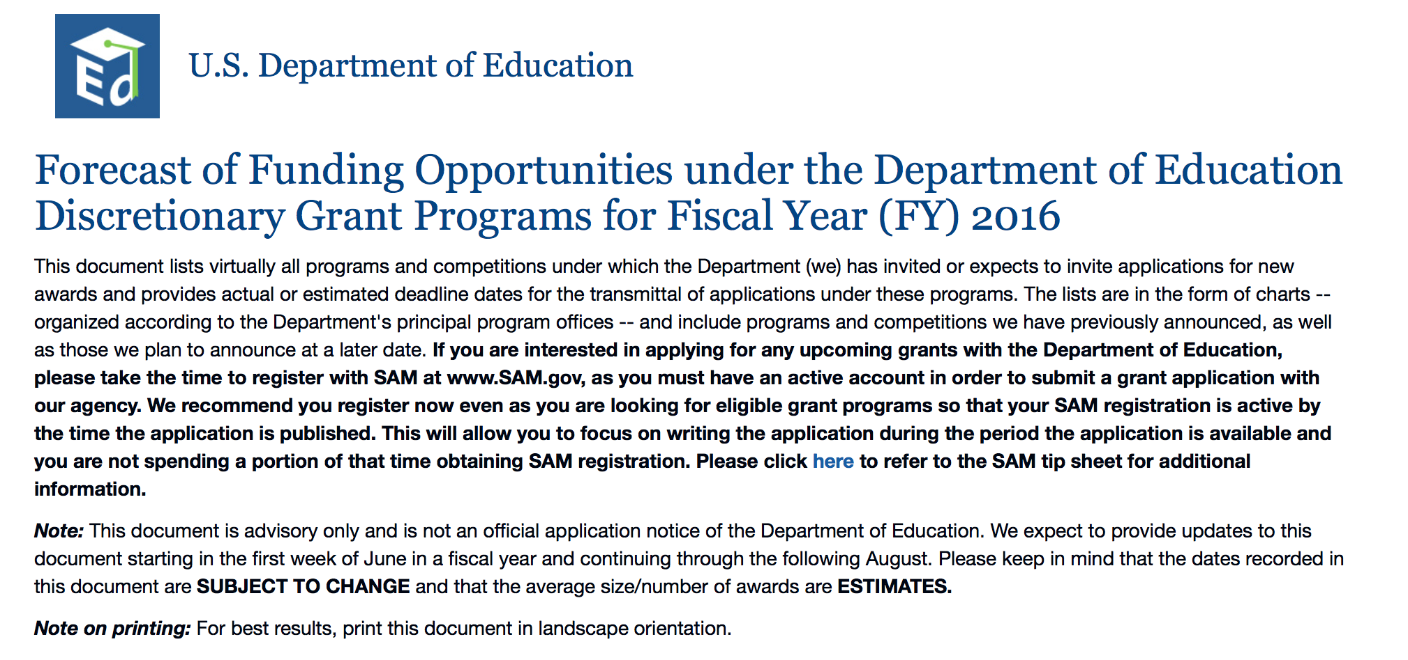To see the complete document click here: http://www2.ed.gov/fund/grant/find/edlite-forecast.html

The general information page for Education Grant funding is an excellent resource describing the three types of grants awarded by the Department of Education. See the screen shot of the Department of Education web page below:

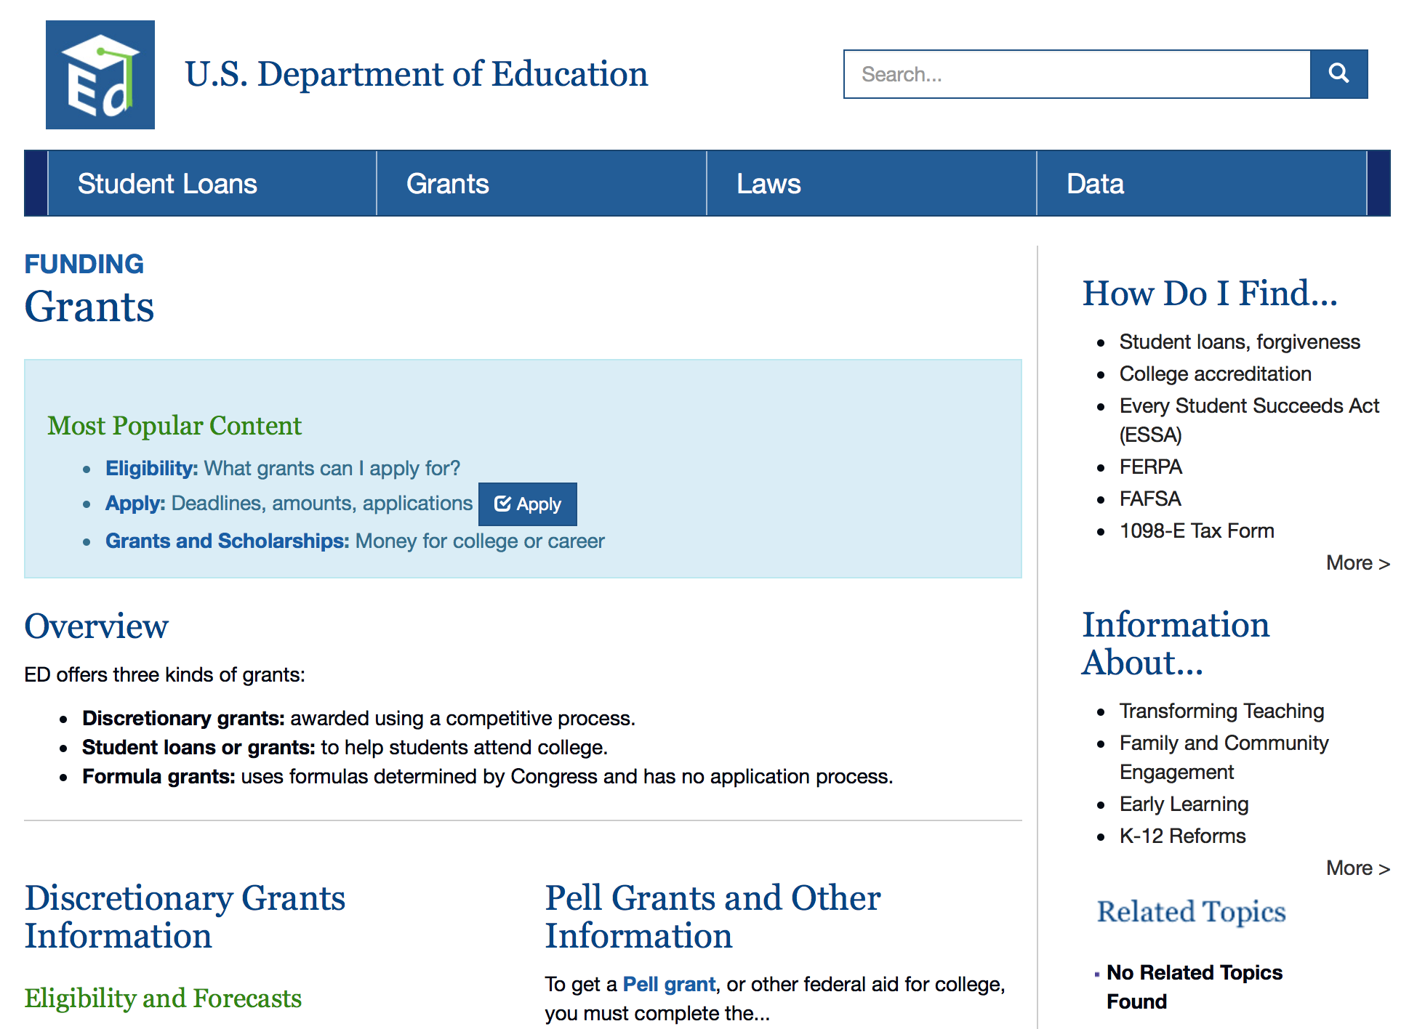

http://www.ed.gov/fund/grants-apply.html

Programs:

Office of Postsecondary Education (OPE): Undergraduate International Studies and Foreign Language (UISFL) Program: CFDA Number 84.016A Grant

Document Type: | Grants Notice
Funding Opportunity Number: | ED-GRANTS-061316-001
Funding Opportunity Title: | Office of Postsecondary Education (OPE): Undergraduate International Studies and Foreign Language (UISFL) Program: CFDA Number 84.016A
Opportunity Category: | Discretionary
Opportunity Category Explanation:
Funding Instrument Type: | Grant
Category of Funding Activity: | Education
Category Explanation:
Expected Number of Awards: | 24
CFDA Number(s): | 84.016 -- Undergraduate International Studies and Foreign Language Programs
Cost Sharing or Matching Requirement: | Yes
Posted Date: | Jun 13, 2016
Last Updated Date: | Jun 13, 2016
Original Closing Date for Applications: | Jul 22, 2016 Applications Available: June 13, 2016. Deadline for Transmittal of Applications: July 22, 2016.
Current Closing Date for Applications: | Jul 22, 2016 Applications Available: June 13, 2016. Deadline for Transmittal of Applications: July 22, 2016.
Archive Date: | Aug 21, 2016
Estimated Total Program Funding: | $2,257,434
Award Ceiling: | $150,000
Eligible Applicants: | Public and State controlled institutions of higher education  Private institutions of higher education  Others (see text field entitled "Additional Information on Eligibility" for clarification)
Additional Information on Eligibility: | Eligible Applicants: (1) IHEs; (2) consortia of IHEs; (3) partnerships between nonprofit educational organizations and IHEs; and (4) public and private nonprofit agencies and organizations, including professional and scholarly associations.
Agency Name: | Department of Education
Description: | Note: Each funding opportunity description is a synopsis of information in the Federal Register application notice. For specific information about eligibility, please see the official application notice. The official version of this document is the document published in the Federal Register. Free Internet access to the official edition of the Federal Register and the Code of Federal Regulations is available on GPO Access at: http://www.access.gpo.gov/nara/index.html. Please review the official application notice for pre-application and application requirements, application submission information, performance measures, priorities and program contact information. Purpose of Program: The UISFL Program provides grants for planning, developing, and carrying out programs to strengthen and improve undergraduate instruction in international studies and foreign languages in the United States. Catalog of Federal Domestic Assistance (CFDA) Number: 84.016A. Applications for grants under the UISFL Program, CFDA number 84.016A, must be submitted electronically using the Governmentwide Grants.gov Apply site at www.Grants.gov. Through this site, you will be able to download a copy of the application package, complete it offline, and then upload and submit your application. You may not email an electronic copy of a grant application to us. You may access the electronic grant application for the UISFL Program at www.Grants.gov. You must search for the downloadable application package for this program by the CFDA number. Do not include the CFDA number's alpha suffix in your search (e.g., search for 84.016, not 84.016A).
Link to Additional Information: | Office of Postsecondary Education (OPE): Undergraduate International Studies and Foreign Language (UISFL) Program: CFDA Number 84.016A; Notice inviting applications for new awards for fiscal year (FY) 2016
Grantor Contact Information: | If you have difficulty accessing the full announcement electronically, please contact:  Julius Cotton ED Grants.gov FIND Systems Admin. Phone 202-245-6288 EducationGrantInquiries@ed.gov Program Manager: Tanyelle Richardson, U.S. Department of Education, 400 Maryland Ave, SW., room 3E211, Washington, DC 20202-4260. Telephone: (202) 453-6391 or by email: tanyelle.richardson@ed.gov.  e-Mail: Program Manager

http://www.grants.gov/web/grants/view-opportunity.html?oppId=284605

Office of Postsecondary Education (OPE): Fulbright-Hays Group Projects Abroad Program CFDA Number 84.021A Grant

Document Type: | Grants Notice
Funding Opportunity Number: | ED-GRANTS-061616-001
Funding Opportunity Title: | Office of Postsecondary Education (OPE): Fulbright-Hays Group Projects Abroad Program CFDA Number 84.021A
Opportunity Category: | Discretionary
Opportunity Category Explanation: | Category Explanation
Funding Instrument Type: | Grant
Category of Funding Activity: | Education
Category Explanation:
Expected Number of Awards: | 20
CFDA Number(s): | 84.021 -- Overseas Programs - Group Projects Abroad
Cost Sharing or Matching Requirement: | No
Posted Date: | Jun 16, 2016
Last Updated Date: | Jun 16, 2016
Original Closing Date for Applications: | Aug 01, 2016 Applications Available: June 16, 2016. Deadline for Transmittal of Applications: August 1, 2016.
Current Closing Date for Applications: | Aug 01, 2016 Applications Available: June 16, 2016. Deadline for Transmittal of Applications: August 1, 2016.
Archive Date: | Aug 31, 2016
Estimated Total Program Funding: | $2,792,440
Award Ceiling: | $250,000
Eligible Applicants: | Nonprofits that do not have a 501(c)(3) status with the IRS, other than institutions of higher education  Public and State controlled institutions of higher education  Others (see text field entitled "Additional Information on Eligibility" for clarification)  State governments  Private institutions of higher education  Nonprofits having a 501(c)(3) status with the IRS, other than institutions of higher education
Additional Information on Eligibility: | Eligible Applicants: (1) IHEs, (2) State departments of education, (3) Private nonprofit educational organizations, and (4) Consortia of these entities.
Agency Name: | Department of Education
Description: | Note: Each funding opportunity description is a synopsis of information in the Federal Register application notice. For specific information about eligibility, please see the official application notice. The official version of this document is the document published in the Federal Register. Free Internet access to the official edition of the Federal Register and the Code of Federal Regulations is available on GPO Access at: http://www.access.gpo.gov/nara/index.html. Please review the official application notice for pre-application and application requirements, application submission information, performance measures, priorities and program contact information. Purpose of Program: The purpose of the Fulbright-Hays Group Projects Abroad (GPA) Program is to promote, improve, and develop modern foreign languages and area studies at varying levels of education. The program provides opportunities for faculty, teachers, and undergraduate and graduate students to conduct individual and group projects overseas to carry out research and study in the fields of modern foreign languages and area studies. This competition will support both Fulbright-Hays GPA short-term projects (GPA short-term projects) and Fulbright-Hays GPA long-term projects (GPA long-term projects). There are three types of GPA short-term projects: (1) Short-term seminar projects of four to six weeks in length designed to increase the linguistic or cultural competency of U.S. students and educators by focusing on a particular aspect of area study, such as the culture of an area or country of study (34 CFR 664.11); (2) curriculum development projects of four to eight weeks in length that provide participants an opportunity to acquire resource materials for curriculum development in modern foreign language and area studies for use and dissemination in the United States (34 CFR 664.12); and (3) group research or study projects of three to twelve months in duration designed to give participants the opportunity to undertake research or study in a foreign country (34 CFR 664.13). GPA long-term projects are advanced overseas intensive language projects that may be carried out during a full year, an academic year, a semester, a trimester, a quarter, or a summer. GPA long-term projects are designed to take advantage of the opportunities in the foreign country that are not present in the United States when providing intensive advanced foreign language training. Only participants who have successfully completed at least two academic years of training in the language to be studied are eligible for language training under this program. In addition, the language to be studied must be indigenous to the host country and maximum use must be made of local institutions and personnel (34 CFR 664.14). Applicants may submit only one application under this notice and must identify whether they are applying for a short-term project or a long-term project. Catalog of Federal Domestic Assistance (CFDA) Number: 84.021A. Applications for grants under the Fulbright-Hays GPA Program, CFDA number 84.021A, must be submitted electronically using the Governmentwide Grants.gov Apply site at Grants.gov. Through this site, you will be able to download a copy of the application package, complete it offline, and then upload and submit your application. You may not email an electronic copy of a grant application to us. You may access the electronic grant application for the Fulbright-Hays GPA Program at www.Grants.gov. You must search for the downloadable application package for this program by the CFDA number. Do not include the CFDA number's alpha suffix in your search (e.g., search for 84.021, not 84.021A).
Link to Additional Information: | Office of Postsecondary Education (OPE): Fulbright-Hays Group Projects Abroad Program CFDA Number 84.021A; Notice inviting applications for new awards for fiscal year (FY) 2016
Grantor Contact Information: | If you have difficulty accessing the full announcement electronically, please contact:  Julius Cotton ED Grants.gov FIND Systems Admin. Phone 202-245-6288 EducationGrantInquiries@ed.gov Program Manager: Reha Mallory, Fulbright-Hays Group Projects Abroad Program, U.S. Department of Education, 400 Maryland Avenue SW., Room 3E213, Washington, DC 20202. FAX: (202) 453-7502 or by email: reha.mallory@ed.gov.  e-Mail: Program Manager

http://www.grants.gov/web/grants/view-opportunity.html?oppId=284714

Research:

Modifications:

Reminders:

Office of Innovation and Improvement (OII): Teacher Incentive Fund (TIF) CFDA Number 84.374A Grant

Document Type: | Grants Notice
Funding Opportunity Number: | ED-GRANTS-053116-002
Funding Opportunity Title: | Office of Innovation and Improvement (OII): Teacher Incentive Fund (TIF) CFDA Number 84.374A
Opportunity Category: | Discretionary
Opportunity Category Explanation: | Category Explanation
Funding Instrument Type: | Grant
Category of Funding Activity: | Education
Category Explanation:
Expected Number of Awards: | 5
CFDA Number(s): | 84.374 -- Teacher Incentive Fund
Cost Sharing or Matching Requirement: | No
Posted Date: | May 31, 2016
Last Updated Date: | May 31, 2016
Current Closing Date for Applications: | Jul 15, 2016 Applications Available: May 31, 2016. Deadline for Notice of Intent To Apply: June 30, 2016. Notice of Intent to Apply: We will be able to develop a more efficient process for reviewing grant applications if we can anticipate the number of applicants that intend to apply for funding under this competition. Therefore, we strongly encourage each potential applicant to notify us of the applicant's intent to submit an application for funding by sending a short email message. This short email should provide (1) the applicant organization's name and address; and (2) all priorities the applicant intends to address. Please send this email notification to TIF5@ed.gov with ``Intent to Apply'' in the email subject line. Applicants that do not provide this email notification may still apply for funding and are not required to, or prohibited from, addressing priorities they do not mention in their notice of intent to apply. Dates of Pre-Application Workshops: For information about pre-application workshops, visit the TIF Web site at: http://innovation.ed.gov/what-we-do/teacher-quality/teacher-incentive-fund/. Pre-application workshops will be held for this competition in the spring of 2016. The workshops are intended to provide technical assistance to all interested grant applicants. Detailed information regarding the pre-application workshops times, and online registration form, can be found on the Teacher Incentive Fund's Web site at http://innovation.ed.gov/what-we-do/teacher-quality/teacher-incentive-fund/. Deadline for Transmittal of Applications: July 15, 2016.
Archive Date: | Aug 14, 2016
Estimated Total Program Funding: | $50,000,000
Eligible Applicants: | Others (see text field entitled "Additional Information on Eligibility" for clarification)
Additional Information on Eligibility: | 1. Eligible Applicants: (a) LEAs, including charter schools that are LEAs. (b) States that apply with one or more LEAs. (c) Nonprofit organizations that apply in partnership with one or more LEAs or an LEA and State.
Agency Name: | Department of Education
Description: | Note: Each funding opportunity description is a synopsis of information in the Federal Register application notice. For specific information about eligibility, please see the official application notice. The official version of this document is the document published in the Federal Register. Free Internet access to the official edition of the Federal Register and the Code of Federal Regulations is available on GPO Access at: http://www.access.gpo.gov/nara/index.html. Please review the official application notice for pre-application and application requirements, application submission information, performance measures, priorities and program contact information. Purpose of Program: The purpose of the TIF program is to support, develop, and implement sustainable Performance-based Compensation Systems for teachers, principals, and other personnel in High-Need Schools,\1\ within the context of a local educational agency's (LEA's) overall Human Capital Management System, in order to increase Educator effectiveness and student achievement in those schools. --------------------------------------------------------------------------- \1\ Throughout this notice, all defined terms are denoted with initial capitals. --------------------------------------------------------------------------- Catalog of Federal Domestic Assistance (CFDA) Number: 84.374A. Applications for grants under the Teacher Incentive Fund, CFDA number 84.374A, must be submitted electronically using the Governmentwide Grants.gov Apply site at www.Grants.gov. Through this site, you will be able to download a copy of the application package, complete it offline, and then upload and submit your application. You may not email an electronic copy of a grant application to us. You may access the electronic grant application for the Teacher Incentive Fund competition at www.Grants.gov. You must search for the downloadable application package for this program by the CFDA number. Do not include the CFDA number's alpha suffix in your search (e.g., search for 84.374, not 84.374A).
Link to Additional Information: | Office of Innovation and Improvement (OII): Teacher Incentive Fund (TIF) CFDA Number 84.374A; Notice inviting applications for new awards for fiscal year (FY) 2016
Contact Information: | If you have difficulty accessing the full announcement electronically, please contact:  Julius Cotton ED Grants.gov FIND Systems Admin. Phone 202-245-6288 EducationGrantInquiries@ed.gov Program Manager: Vicki Robinson, U.S. Department of Education, 400 Maryland Avenue SW., Room 4W103, Washington, DC 20202-6200. Telephone: (202) 205-5471 or by email: TIF5@ed.gov.  e-Mail: Program Mailbox

http://www.grants.gov/web/grants/view-opportunity.html?oppId=284265

Institute of Education Sciences (IES CFDA Number 84.305

Original Closing Date for Applications: | Aug 04, 2016 Application Package Available: May 5, 2016 Deadline for Transmittal of Applications: August 4, 2016.
Current Closing Date for Applications: | Aug 04, 2016 Application Package Available: May 5, 2016 Deadline for Transmittal of Applications: August 4, 2016.
Eligible Applicants: | Others (see text field entitled "Additional Information on Eligibility" for clarification)  County governments  Nonprofits having a 501(c)(3) status with the IRS, other than institutions of higher education  City or township governments  State governments  Special district governments  Nonprofits that do not have a 501(c)(3) status with the IRS, other than institutions of higher education  Public and State controlled institutions of higher education  Independent school districts  For profit organizations other than small businesses  Private institutions of higher education
Additional Information on Eligibility: | Eligible Applicants: Applicants that have the ability and capacity to conduct scientifically valid research are eligible to apply. Eligible applicants include, but are not limited to, nonprofit and for-profit organizations and public and private agencies and institutions of higher education, such as colleges and universities.
Agency Name: | Department of Education
Description: | Note: Each funding opportunity description is a synopsis of information in the Federal Register application notice. For specific information about eligibility, please see the official application notice. The official version of this document is the document published in the Federal Register. Free Internet access to the official edition of the Federal Register and the Code of Federal Regulations is available on GPO Access at: http://www.access.gpo.gov/nara/index.html. Please review the official application notice for pre-application and application requirements, application submission information, performance measures, priorities and program contact information. Purpose of Program: The central purpose of the Institute's research grant programs is to provide interested individuals and the general public with reliable and valid information about education practices that support learning and improve academic achievement and access to education opportunities for all students. These interested individuals include parents, educators, students, researchers, and policymakers. In carrying out its grant programs, the Institute provides support for programs of research in areas of demonstrated national need. Competitions in This Notice: The Institute will conduct nine research competitions in FY 2017 through two of its centers: Catalog of Federal Domestic Assistance (CFDA) Numbers: 84.305A, 84.305B, 84.305D, 84.305H, 84.305L, 84.305N, 84.324A, 84.324B, and 84.324L. The Deputy Director for Policy and Research, Delegated the Duties of the Director, of the Institute of Education Sciences (Institute) announces the Institute's FY 2017 competitions for grants to support education research and special education research. The Delegated Director takes this action under the Education Sciences Reform Act of 2002. The Institute's purpose in awarding these grants is to provide national leadership in expanding fundamental knowledge and understanding of (1) developmental and school readiness outcomes for infants and toddlers with or at risk for disability, and (2) education outcomes for all students from early childhood education through postsecondary and adult education. Applications for grants under the Education Research, Research Training Programs in the Education Sciences, Statistical and Research Methodology in Education, Partnerships and Collaborations Focused on Problems of Practice or Policy, Low-Cost, Short-Duration Evaluation of Education Interventions, Research Networks Focused on Critical Problems of Education Policy and Practice, Special Education Research, Research Training Programs in Special Education, and Low-Cost, Short-Duration Evaluation of Special Education Interventions competitions, CFDA numbers 84.305A, 84.305B, 84.305D, 84.305H, 84.305L, 84.305N, 84.324A, 84.324B, and 84.324L must be submitted electronically using the Governmentwide Grants.gov Apply site at www.Grants.gov. Through this site, you will be able to download a copy of the application package, complete it offline, and then upload and submit your application. You may not email an electronic copy of a grant application to us. You may access the electronic grant applications for the Education Research, Research Training Programs in the Education Sciences, Statistical and Research Methodology in Education, Partnerships and Collaborations Focused on Problems of Practice or Policy, Low-Cost, Short-Duration Evaluation of Education Interventions, Research Networks Focused on Critical Problems of Education Policy and Practice, Special Education Research, Research Training Programs in Special Education, and Low-Cost, Short-Duration Evaluation of Special Education Interventions competitions at www.Grants.gov. You must search for the downloadable application package for each competition by the CFDA number. Do not include the CFDA number's alpha suffix in your search (e.g., search for 84.305, not 84.305A).
Link to Additional Information: | Institute of Education Sciences (IES): Statistical and Research Methodology in Education CFDA Number 84.305D; Notice inviting applications for new awards for fiscal year (FY) 2017
Contact Information: | If you have difficulty accessing the full announcement electronically, please contact:  Julius Cotton ED Grants.gov FIND Systems Admin. Phone 202-245-6288 EducationGrantInquiries@ed.gov Program Manager: Phill Gagne, Phill.Gagne@ed.gov.  e-Mail: Program Manager



U.S. Department of Energy
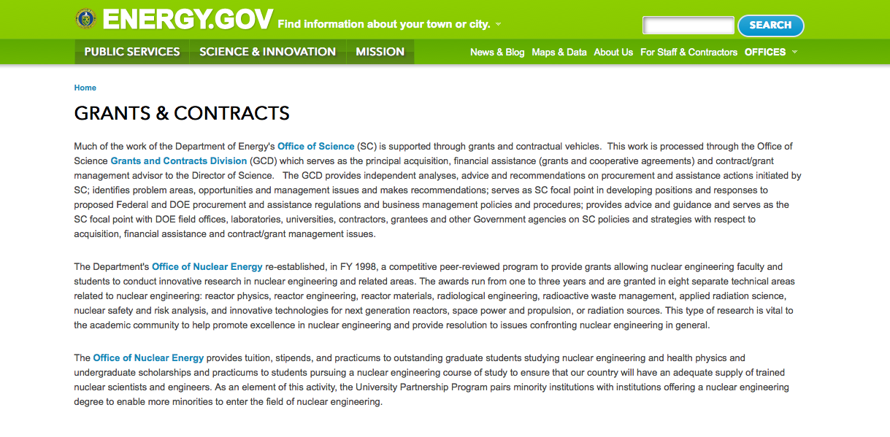
http://www.doe.gov/grants-contracts

Programs:

National Energy Technology Laboratory
Fiscal Year (FY) 2016 Vehicle Technologies Multi-Topic Funding Opportunity Announcement
Grant
http://www.grants.gov/web/grants/view-opportunity.html?oppId=284402

National Energy Technology Laboratory
Next-Generation Transformers – Flexible Designs Grant
http://www.grants.gov/web/grants/view-opportunity.html?oppId=284451

Funding Opportunity Number: DE-FOA-0001590
Modification Request for Information: Advanced HVAC&R Research and Development (R&D)
Golden Field Office
Posted Date: Jun 20, 2016
Link: http://www.grants.gov/web/grants/view-opportunity.html?oppId=285159

Funding Opportunity Number: DE-FOA-0001450
Modification Carbon Storage Assurance Facility Enterprise (CarbonSAFE): Storage Complex Facility
National Energy Technology Laboratory
Posted Date: Jun 23, 2016
Link: http://www.grants.gov/web/grants/view-opportunity.html?oppId=285360

Funding Opportunity Number: DE-FOA-0001584
Modification Carbon Storage Assurance Facility Enterprise (CarbonSAFE) Integrated CCS Pre-Feasibility
National Energy Technology Laboratory
Posted Date: Jun 23, 2016
Link: http://www.grants.gov/web/grants/view-opportunity.html?oppId=285361

Funding Opportunity Number: DE-FOA-0001555
Modification Request for Information (RFI) DE-FOA-0001555: Hydrogen Technology Showcase and Training (HyTeST) Facility
Golden Field Office
Posted Date: Jun 22, 2016
Link: http://www.grants.gov/web/grants/view-opportunity.html?oppId=285315

Funding Opportunity Number: DE-FOA-0001554
Modification Eagle Impact Minimization Technologies and Field Testing Opportunities
Golden Field Office
Posted Date: Jun 22, 2016
Link: http://www.grants.gov/web/grants/view-opportunity.html?oppId=285318

Modifications:

Funding Opportunity Number: DE-FOA-0001495
Modification Enabling Extreme Real-time Grid Integration of Solar Energy (ENERGISE)
Golden Field Office
Posted Date: May 02, 2016
Modification 2
Modification Comments: The purpose of modification 000001 is to:

1) Change the link in section VI.B.12 to http://www1.eere.energy.gov/financing/resources.html.

All other parts of the Funding Opportunity Announcement remain unchanged.
Link: http://www.grants.gov/web/grants/view-opportunity.html?oppId=283450

National Energy Technology Laboratory
Enabling Technologies for Advanced Combustion Systems
Modification 1
http://www.grants.gov/web/grants/view-opportunity.html?oppId=283954

Golden Field Office
Funding Opportunity Announcement (FOA) Number DE-FOA-0001232, Modification 000002: Project Development for Pilot and Demonstration Scale Manufacturing of Biofuels, Bioproducts and Biopower (PD2B3)
Modification 2
http://www.grants.gov/web/grants/view-opportunity.html?oppId=283616

Funding Opportunity Number: DE-FOA-0001535
Fiscal Year (FY) 2016 Vehicle Technologies Multi-Topic Funding Opportunity Announcement
National Energy Technology Laboratory
Posted Date: Jun 06, 2016
Modifications 2 & 3
Modification Comments: Amendment 000001 to DE-FOA-0001535. To view the changes associated with this amendment, please refer to the EERE Exchange website.
Link: http://www.grants.gov/web/grants/view-opportunity.html?oppId=284402

Reminders:

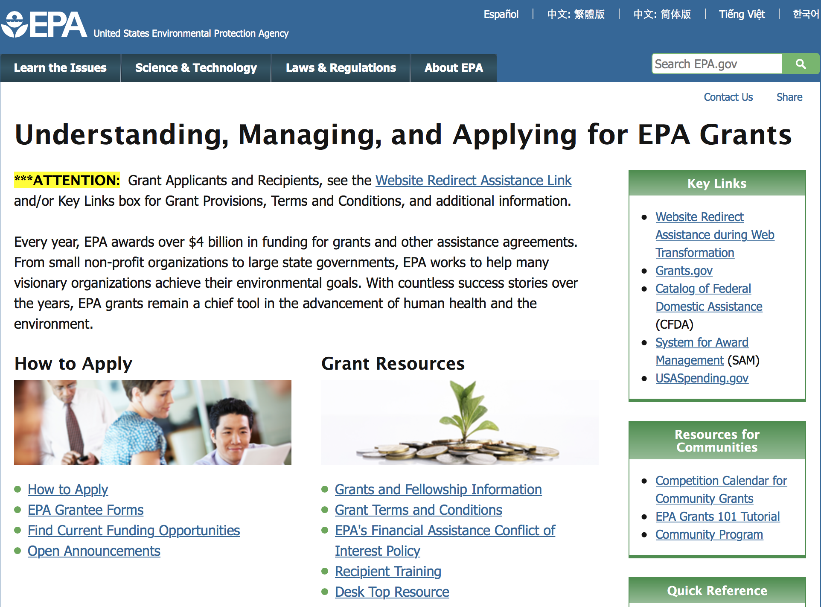

http://www.epa.gov/epahome/grants.htm

Programs:

Modifications:

Reminders:



Department of Health and Human Services

Grants Forecast and Overview

The Department of Health and Human Services’ Grants Forecast is a database of planned grant opportunities proposed by its agencies. Each Forecast record contains actual or estimated dates and funding levels for grants that the agency intends to award during the fiscal year. Forecast opportunities are subject to change based on enactment of congressional appropriations. Go to the webpage below for more information.

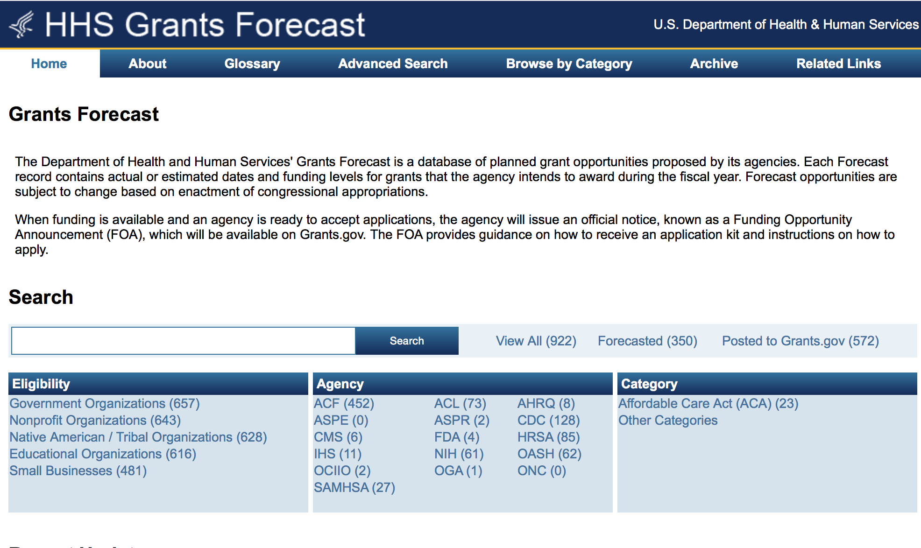
For more general information about HHS Grants and Funding go to the website below at: http://www.hhs.gov/grants/ .

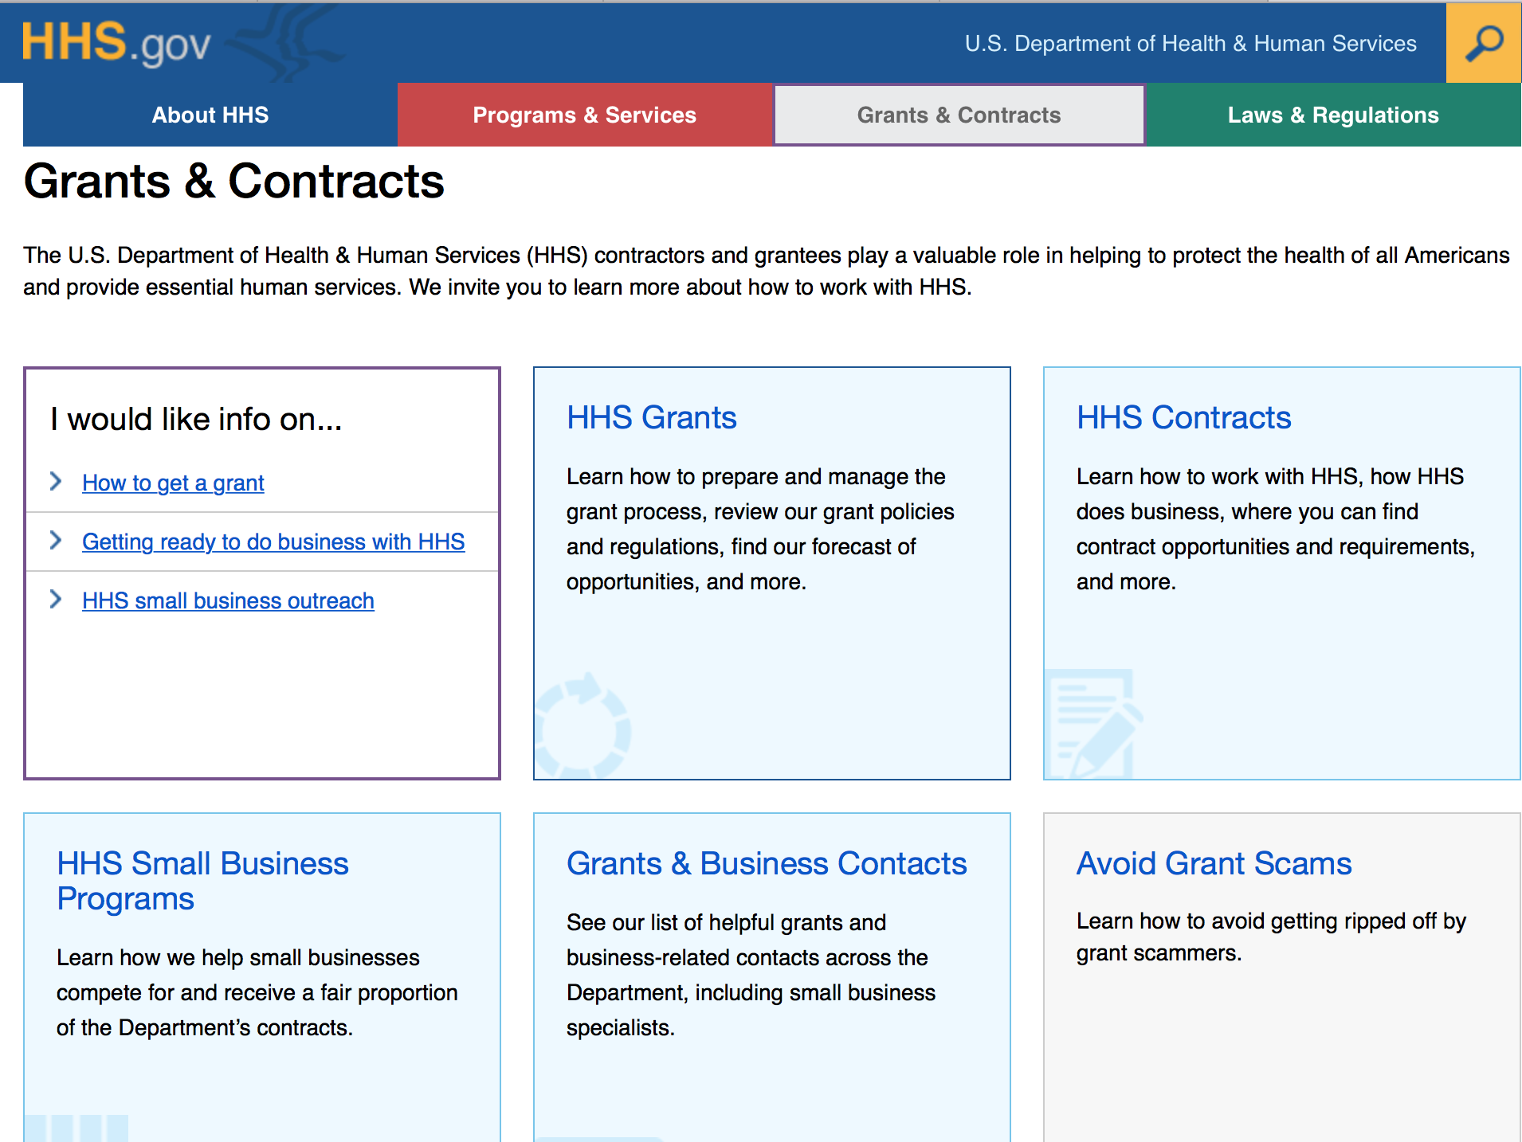

Programs:

Administration for Children and Families
Administration for Children and Families - ORR
Preferred Communities (PC) Program Grant

Document Type: | Grants Notice
Funding Opportunity Number: | HHS-2016-ACF-ORR-RP-1116
Funding Opportunity Title: | Preferred Communities (PC) Program
Opportunity Category: | Discretionary
Opportunity Category Explanation:
Funding Instrument Type: | Cooperative Agreement
Category of Funding Activity: | Income Security and Social Services
Category Explanation:
Expected Number of Awards: | 9
CFDA Number(s): | 93.576 -- Refugee and Entrant Assistance Discretionary Grants
Cost Sharing or Matching Requirement: | No
Version: | Synopsis 2
Posted Date: | Jun 01, 2016
Last Updated Date: | Jun 23, 2016
Original Closing Date for Applications: | Aug 01, 2016 Electronically submitted applications must be submitted no later than 11:59 p.m., ET, on the listed application due date.
Current Closing Date for Applications: | Aug 01, 2016 Electronically submitted applications must be submitted no later than 11:59 p.m., ET, on the listed application due date.
Archive Date: | Aug 31, 2016
Estimated Total Program Funding: | $15,510,907
Award Ceiling: | $3,500,000
Award Floor: | $900,000
Eligible Applicants: | Independent school districts  Private institutions of higher education  Public housing authorities/Indian housing authorities  Public and State controlled institutions of higher education  Nonprofits that do not have a 501(c)(3) status with the IRS, other than institutions of higher education  Nonprofits having a 501(c)(3) status with the IRS, other than institutions of higher education  Native American tribal organizations (other than Federally recognized tribal governments)  County governments  Special district governments  City or township governments  Native American tribal governments (Federally recognized)  State governments  Others (see text field entitled "Additional Information on Eligibility" for clarification)
Additional Information on Eligibility: | This Funding Opportunity Announcement is open to public and private non-profit organizations. Faith-based and community organizations that meet the eligibility requirements are eligible to receive awards under this funding opportunity announcement. Faith-based organizations are encouraged to review the ACF Policy on Grants to Faith-Based Organizations at: http: //www.acf.hhs.gov/acf-policy-on-grants-to-faith-based-organizations. Applications from individuals (including sole proprietorships) and foreign entities are not eligible and will be disqualified from competitive review and from funding under this announcement
Agency Name: | Administration for Children and Families - ORR
Description: | The Office of Refugee Resettlement (ORR) within the Administration for Children and Families (ACF) announces the availability of funds and award procedures for fiscal year 2017 under the Preferred Communities (PC) Program. The twin goals of the PC Program are: The successful resettlement and integration of especially vulnerable refugees (and other ORR client populations); and The enhancement of refugee service providers; capacity to serve such populations at new or established PC locations. ORR aims to achieve these goals by awarding grants, under cooperative agreements, to well-qualified refugee service providers that operate under cooperative agreements with the Department of State and/or the Department of Homeland Security, to offer a range of reception and placement (R&P) services to refugees and other ORR client populations through a national network of resettlement locations across the United States. While R&P services effectively support many newly arriving refugees in their initial resettlement phase, an increasing number of especially vulnerable individuals still have difficulty navigating systems and attaining self-sufficiency after the completion of R&P services. With limited material and human resources, agencies in turn find it challenging to deliver the specialized supporting services necessary for such individuals. By providing PC funds, ORR intends to facilitate the enhancement of PC Programs; ability to place vulnerable refugees in areas where they are most likely to achieve self-sufficiency, and to offer specialized services. The enhanced capacity of PC Programs to afford especially vulnerable refugees access to specialized services such as intensive case management is intended to result in these refugees; attainment of self-sufficiency in their vulnerable life areas, which may include medical disabilities, trauma, and lack of access to supporting services.
Link to Additional Information: | https://ami.grantsolutions.gov/HHS-2016-ACF-ORR-RP-1116
Grantor Contact Information: | If you have difficulty accessing the full announcement electronically, please contact:  ACF Applications Help Desk app_support@acf.hhs.gov  ACF Applications Help Desk

http://www.grants.gov/web/grants/view-opportunity.html?oppId=284290

Health Resources and Services Administration
Service Area Competition Grant

Document Type: | Grants Notice
Funding Opportunity Number: | HRSA-17-050
Funding Opportunity Title: | Service Area Competition
Opportunity Category: | Discretionary
Opportunity Category Explanation:
Funding Instrument Type: | Grant
Category of Funding Activity: | Health
Category Explanation: | https://grants.hrsa.gov/2010/Web2External/Interface/FundingCycle/ExternalView.aspx?fCycleID=bd9c2f13-d136-444e-bdd2-6a9645fe38a5
Expected Number of Awards: | 85
CFDA Number(s): | 93.224 -- Consolidated Health Centers  (Community Health Centers, Migrant Health Centers,  Health Care for the Homeless, and Public
Cost Sharing or Matching Requirement: | No
Posted Date: | Jun 15, 2016
Last Updated Date: | Jun 15, 2016
Original Closing Date for Applications: | Aug 16, 2016
Current Closing Date for Applications: | Aug 16, 2016
Archive Date: | Sep 30, 2016
Estimated Total Program Funding: | $132,000,000
Eligible Applicants: | Others (see text field entitled "Additional Information on  Eligibility" for clarification)
Additional Information on Eligibility: | You must be a public or nonprofit private entity, as  demonstrated through the submission of the Evidence of  Non-profit/Public Center Status outlined in Section IV.2.vii.  Faith-based and community-based organizations,  Tribes, and tribal organizations are eligible to apply.
Agency Name: | Health Resources and Services Administration
Description: | This announcement solicits applications for the Health Center  Program’s Service Area Competition (SAC). The Health  Center Program supports patient-directed public and private  nonprofit organizations that provide primary and preventive  health care services to the Nation’s medically underserved.  The purpose of the SAC funding opportunity is to ensure  continued access to comprehensive, culturally competent,  quality primary health care services for communities and  vulnerable populations currently served by the Health Center  Program. This FOA details the SAC eligibility requirements,  review criteria, and awarding factors for organizations seeking  funding for operational support to provide primary and  preventive health care services to an announced service area  under the Health Center Program, including Community Health  Center (CHC – section 330(e)), Migrant Health Center  (MHC – section 330(g)), Health Care for the Homeless  (HCH – section 330(h)), and/or Public Housing Primary  Care (PHPC – section 330(i)). For the purposes of this  document, the term “health center” encompasses these  types of funding (i.e., CHC, MHC, HCH, and PHPC).
Link to Additional Information:
Grantor Contact Information: | If you have difficulty accessing the full announcement  electronically, please contact:  Department of Health and Human Services, Health Resources  and Services Administration bphcsac@hrsa.gov  Contact Beth Hartmayer at (301)594-4300 or email bphcsac@hrsa.gov

http://www.grants.gov/web/grants/view-opportunity.html?oppId=284683

Research:

Centers for Disease Control and Prevention
Centers for Disease Control - NCTP
Improving Hepatitis B and C Care Cascades; Focus on Increased Testing and Diagnosis
Grant
http://www.grants.gov/web/grants/view-opportunity.html?oppId=284316

Health Resources and Services Administration
Resilient and Responsive Health Systems (RRHS) Initiative Grant
http://www.grants.gov/web/grants/view-opportunity.html?oppId=284400

National Institutes of Health
Administrative Supplements for Research on Dietary Supplements (Admin Supp) Grant
http://www.grants.gov/web/grants/view-opportunity.html?oppId=284487

National Institutes of Health
NIDCR Mentored Career Development Award to Promote Diversity in the Dental, Oral and Craniofacial Research Workforce (K01) Grant
http://www.grants.gov/web/grants/view-opportunity.html?oppId=284505

National Institutes of Health
NIDCD Mentored Career Development Award for Postdoctorate Au.D./Ph.D. Audiologists (K01)
Grant
http://www.grants.gov/web/grants/view-opportunity.html?oppId=284458

National Institutes of Health
Intervening with Cancer Caregivers to Improve Patient Health Outcomes and Optimize Health Care Utilization (R21) Grant
http://www.grants.gov/web/grants/view-opportunity.html?oppId=284459

National Institutes of Health
Biosensors in the Oral Cavity (R21) Grant
http://www.grants.gov/web/grants/view-opportunity.html?oppId=284460

National Institutes of Health
Biosensors in the Oral Cavity (R01) Grant
http://www.grants.gov/web/grants/view-opportunity.html?oppId=284461

National Institutes of Health
Intervening with Cancer Caregivers to Improve Patient Health Outcomes and Optimize Health Care Utilization (R01) Grant
http://www.grants.gov/web/grants/view-opportunity.html?oppId=284474

National Institutes of Health
Safety and Outcome Measures of Pain Medications Used in Children and Pregnant Women (R03)
Grant
http://www.grants.gov/web/grants/view-opportunity.html?oppId=284417

National Institutes of Health
Understanding STI Co-Infection In At Risk and HIV Infected Adolescents and Young Adults (R21)
Grant
http://www.grants.gov/web/grants/view-opportunity.html?oppId=284419

National Institutes of Health
Characterization of the Adolescent Reproductive Transition (R21) Grant
http://www.grants.gov/web/grants/view-opportunity.html?oppId=284421

National Institutes of Health
Characterization of the Adolescent Reproductive Transition (R03) Grant
http://www.grants.gov/web/grants/view-opportunity.html?oppId=284423

National Institutes of Health
Safety and Outcome Measures of Pain Medications Used in Children and Pregnant Women (R01) Grant
http://www.grants.gov/web/grants/view-opportunity.html?oppId=284425

National Institutes of Health
Safety and Outcome Measures of Pain Medications Used in Children and Pregnant Women (R21) Grant
http://www.grants.gov/web/grants/view-opportunity.html?oppId=284428

National Institutes of Health
Understanding STI Co-Infection In At Risk and HIV Infected Adolescents and Young Adults (R01)
Grant
http://www.grants.gov/web/grants/view-opportunity.html?oppId=284434

National Institutes of Health
Characterization of the Adolescent Reproductive Transition (R01) Grant
http://www.grants.gov/web/grants/view-opportunity.html?oppId=284437

National Institutes of Health
PHS 2016-02 Omnibus Solicitation of the NIH, CDC, FDA and ACF for Small Business Innovation Research Grant Applications (Parent SBIR [R43/R44]) Grant
http://www.grants.gov/web/grants/view-opportunity.html?oppId=284323

National Institutes of Health
PHS 2016-02 Omnibus Solicitation of the NIH for Small Business Technology Transfer Grant Applications (Parent STTR [R41/R42]) Grant
http://www.grants.gov/web/grants/view-opportunity.html?oppId=284356

National Institutes of Health
Ruth L. Kirschstein National Research Service Award (NRSA) Individual Senior Fellowship (Parent F33) Grant
http://www.grants.gov/web/grants/view-opportunity.html?oppId=284360

National Institutes of Health
Ruth L. Kirschstein National Research Service Award Individual Predoctoral Fellowship to Promote Diversity in Health-Related Research (Parent F31 - Diversity) Grant
http://www.grants.gov/web/grants/view-opportunity.html?oppId=284362

National Institutes of Health
Ruth L. Kirschstein National Research Service Award (NRSA) Individual Postdoctoral Fellowship (Parent F32) Grant
http://www.grants.gov/web/grants/view-opportunity.html?oppId=284363

National Institutes of Health
Ruth L. Kirschstein National Research Service Award (NRSA) Fellowship for Students at Institutions With NIH-Funded Institutional Predoctoral Dual-Degree Training Programs (Parent F30) Grant
http://www.grants.gov/web/grants/view-opportunity.html?oppId=284364

National Institutes of Health
Ruth L. Kirschstein National Research Service Award (NRSA) Fellowship for Students at Institutions Without NIH-Funded Institutional Predoctoral Dual-Degree Training Programs (Parent F30) Grant
http://www.grants.gov/web/grants/view-opportunity.html?oppId=284387

National Institutes of Health
Ruth L. Kirschstein National Research Service Award (NRSA) Individual Predoctoral Fellowship (Parent F31) Grant
http://www.grants.gov/web/grants/view-opportunity.html?oppId=284388

National Institutes of Health
Ancillary Studies to Identify Behavioral and/or Psychological Phenotypes Contributing to Obesity (R01) Grant
http://www.grants.gov/web/grants/view-opportunity.html?oppId=284283

National Institutes of Health
Limited Competition: Administrative Supplements to Enhance Network Capacity: Collaborative Opportunities for the CTSA Program (Admin Supp) Grant
http://www.grants.gov/web/grants/view-opportunity.html?oppId=284621

National Institutes of Health
Nutrigenetics and Nutrigenomics Approaches for Nutrition Research (R01) Grant
http://www.grants.gov/web/grants/view-opportunity.html?oppId=284704

National Institutes of Health
Limited Competition: NIDCR Supplements to NCATS CTSA Programs for Scholars Pursing Dental, Oral and Craniofacial Clinical and Translational Research Career Development (Admin Supp) Grant
http://www.grants.gov/web/grants/view-opportunity.html?oppId=284637

National Institutes of Health
Science of Behavior Change: Use-inspired Basic Research to Optimize Behavior Change Interventions and Outcomes (Admin Supp) Grant
http://www.grants.gov/web/grants/view-opportunity.html?oppId=284705

National Institutes of Health
NHLBI Pilot Program to Provide Regulatory Support to SBIR/STTR Awardees Developing Medical Devices (Diagnostics and Therapeutics) (Admin Supp) Grant
http://www.grants.gov/web/grants/view-opportunity.html?oppId=284706

National Institutes of Health
Metabolic Contributions to the Neurocognitive Complications of Diabetes: Ancillary Studies (R01)
Grant
http://www.grants.gov/web/grants/view-opportunity.html?oppId=284685

National Institutes of Health
Advancing Basic Behavioral and Social Research on Resilience: An Integrative Science Approach (UG3/UH3) Grant
http://www.grants.gov/web/grants/view-opportunity.html?oppId=284587

National Institutes of Health
Improvement of Animal Models for Stem Cell-Based Regenerative Medicine (R24) Grant
http://www.grants.gov/web/grants/view-opportunity.html?oppId=284606

National Institutes of Health
Collaborative Activities to Expedite Environmental Health Science Research, Translation, and Community Engagement Across EHS Core Centers (Admin Supp) Grant
http://www.grants.gov/web/grants/view-opportunity.html?oppId=284615

National Institutes of Health
Bold New Bioengineering Methods and Approaches for Heart, Lung, Blood and Sleep Disorders and Diseases (R21) Grant
http://www.grants.gov/web/grants/view-opportunity.html?oppId=284588

National Institutes of Health
Countermeasures Against Chemical Threats (CounterACT) Research Centers of Excellence (U54)
Grant
http://www.grants.gov/web/grants/view-opportunity.html?oppId=284668

National Institutes of Health
Neurocognitive Effects of Glycemic Dysregulation in Type 1 Diabetes (DP3) Grant
http://www.grants.gov/web/grants/view-opportunity.html?oppId=284686

National Institutes of Health
Linking the Provider Recommendation to Adolescent HPV Vaccine Uptake (R01) Grant
http://www.grants.gov/web/grants/view-opportunity.html?oppId=284692

National Institutes of Health
Linking the Provider Recommendation to Adolescent HPV Vaccine Uptake (R21) Grant
http://www.grants.gov/web/grants/view-opportunity.html?oppId=284716

National Institutes of Health
Countermeasures Against Chemical Threats (CounterACT): Identification of Therapeutic Lead Compounds (U01) Grant
http://www.grants.gov/web/grants/view-opportunity.html?oppId=284677

National Institutes of Health
Countermeasures Against Chemical Threats (CounterACT): Optimization of Therapeutic Lead Compounds (U01) Grant
http://www.grants.gov/web/grants/view-opportunity.html?oppId=284678

National Institutes of Health
Linking the Provider Recommendation to Adolescent HPV Vaccine Uptake (R03)
Grant
http://www.grants.gov/web/grants/view-opportunity.html?oppId=284717

Funding Opportunity Number: PAR-16-345
Initiative to Maximize Research Education in Genomics: Diversity Action Plan (R25)
National Institutes of Health
Posted Date: Jun 27, 2016
Link: http://www.grants.gov/web/grants/view-opportunity.html?oppId=285475

Funding Opportunity Number: PAR-16-344
Biological Comparisons in Patient-Derived Models of Cancer (U01)
National Institutes of Health
Posted Date: Jun 24, 2016
Link: http://www.grants.gov/web/grants/view-opportunity.html?oppId=285396

Funding Opportunity Number: PAR-16-344
Biological Comparisons in Patient-Derived Models of Cancer (U01)
National Institutes of Health
Posted Date: Jun 24, 2016
Link: http://www.grants.gov/web/grants/view-opportunity.html?oppId=285396

Funding Opportunity Number: PAR-16-348
Small Research Grants for Analyses of Data for the Gabriella Miller Kids First Data Resource (R03)
National Institutes of Health
Posted Date: Jun 29, 2016
Link: http://www.grants.gov/web/grants/view-opportunity.html?oppId=285569

Funding Opportunity Number: PAR-16-345
Initiative to Maximize Research Education in Genomics: Diversity Action Plan (R25)
National Institutes of Health
Posted Date: Jun 27, 2016
Link: http://www.grants.gov/web/grants/view-opportunity.html?oppId=285475

Funding Opportunity Number: PAR-16-349
New Informatics Tools and Methods to Enhance US Cancer Surveillance and Research (UG3/UH3)
National Institutes of Health
Posted Date: Jun 29, 2016
Link: http://www.grants.gov/web/grants/view-opportunity.html?oppId=285551

Funding Opportunity Number: RFA-HL-17-016
NHLBI Research Career Development Programs in T4 Implementation Research (K12)
National Institutes of Health
Posted Date: Jun 29, 2016
Link: http://www.grants.gov/web/grants/view-opportunity.html?oppId=285544

Funding Opportunity Number: PAR-16-339
NIDCD Clinical Research Center Grant (P50)
National Institutes of Health
Posted Date: Jun 23, 2016
Link: http://www.grants.gov/web/grants/view-opportunity.html?oppId=285335

Funding Opportunity Number: PAR-16-340
Career Transition Award for NINDS Intramural Clinician-Scientists (K22)
National Institutes of Health
Posted Date: Jun 23, 2016
Link: http://www.grants.gov/web/grants/view-opportunity.html?oppId=285336

Funding Opportunity Number: PA-16-341
Methods Development in Natural Products Chemistry (R43/R44)
HHS-NIH11
National Institutes of Health
Posted Date: Jun 23, 2016
Link: http://www.grants.gov/web/grants/view-opportunity.html?oppId=285338

Funding Opportunity Number: PAR-14-282
Funding Opportunity Number: PA-16-342
Methods Development in Natural Products Chemistry (R41/R42)
National Institutes of Health
Posted Date: Jun 23, 2016
Link: http://www.grants.gov/web/grants/view-opportunity.html?oppId=285339

Funding Opportunity Number: PAR-16-343
Limited Competition: Exploratory CTSA Collaborative Innovation Awards (R21)
National Institutes of Health
Posted Date: Jun 23, 2016
Link: http://www.grants.gov/web/grants/view-opportunity.html?oppId=285350

Funding Opportunity Number: RFA-AA-17-006
U.S.-Russia Bilateral Collaborative Research Partnerships (CRP) on the Prevention and Treatment of HIV/AIDS and HIV-Associated Comorbidities (R01)
National Institutes of Health
Posted Date: Jun 21, 2016
Link: http://www.grants.gov/web/grants/view-opportunity.html?oppId=285251

Funding Opportunity Number: PAR-16-353
Target Assessment, Engagement and Data Replicability to Improve Substance Use Disorders Treatment Outcomes (R21/R33)
National Institutes of Health
Posted Date: Jul 01, 2016
Link: http://www.grants.gov/web/grants/view-opportunity.html?oppId=285634

Funding Opportunity Number: PAR-16-352
Target Assessment, Engagement and Data Replicability to Improve Substance Use Disorders Treatment Outcomes (R33)
National Institutes of Health
Posted Date: Jul 01, 2016
Link: http://www.grants.gov/web/grants/view-opportunity.html?oppId=285651

Funding Opportunity Number: PAR-16-351
Conference for Early Stage HIV/AIDS Vaccine Researchers (R13)
National Institutes of Health
Posted Date: Jun 30, 2016
Link: http://www.grants.gov/web/grants/view-opportunity.html?oppId=285611

Funding Opportunity Number: PAR-16-350
Clinical Research Education and Career Development (CRECD) Program (R25)
National Institutes of Health
Posted Date: Jun 30, 2016
Link: http://www.grants.gov/web/grants/view-opportunity.html?oppId=285614

Funding Opportunity Number: RFA-ES-16-007
The Preconception Exposure Window and Health of the Offspring (R01)
National Institutes of Health
Posted Date: Jul 01, 2016
Link: http://www.grants.gov/web/grants/view-opportunity.html?oppId=285629

Modifications:

Career Transition Award for NINDS Intramural Clinician-Scientists (K22)
National Institutes of Health
Posted Date: Jul 15, 2014
Modification 2
Modification Comments: Expired and Reissued as PAR-16-340

Link: http://www.grants.gov/web/grants/view-opportunity.html?oppId=259538
Reminders:

Department of Homeland Security

The Department of Homeland Security enhances the ability of states, local and tribal jurisdictions, and other regional authorities in the preparation, prevention, and response to terrorist attacks and other disasters, by distributing grant funds. Localities can use grants for planning, equipment, training and exercise needs.

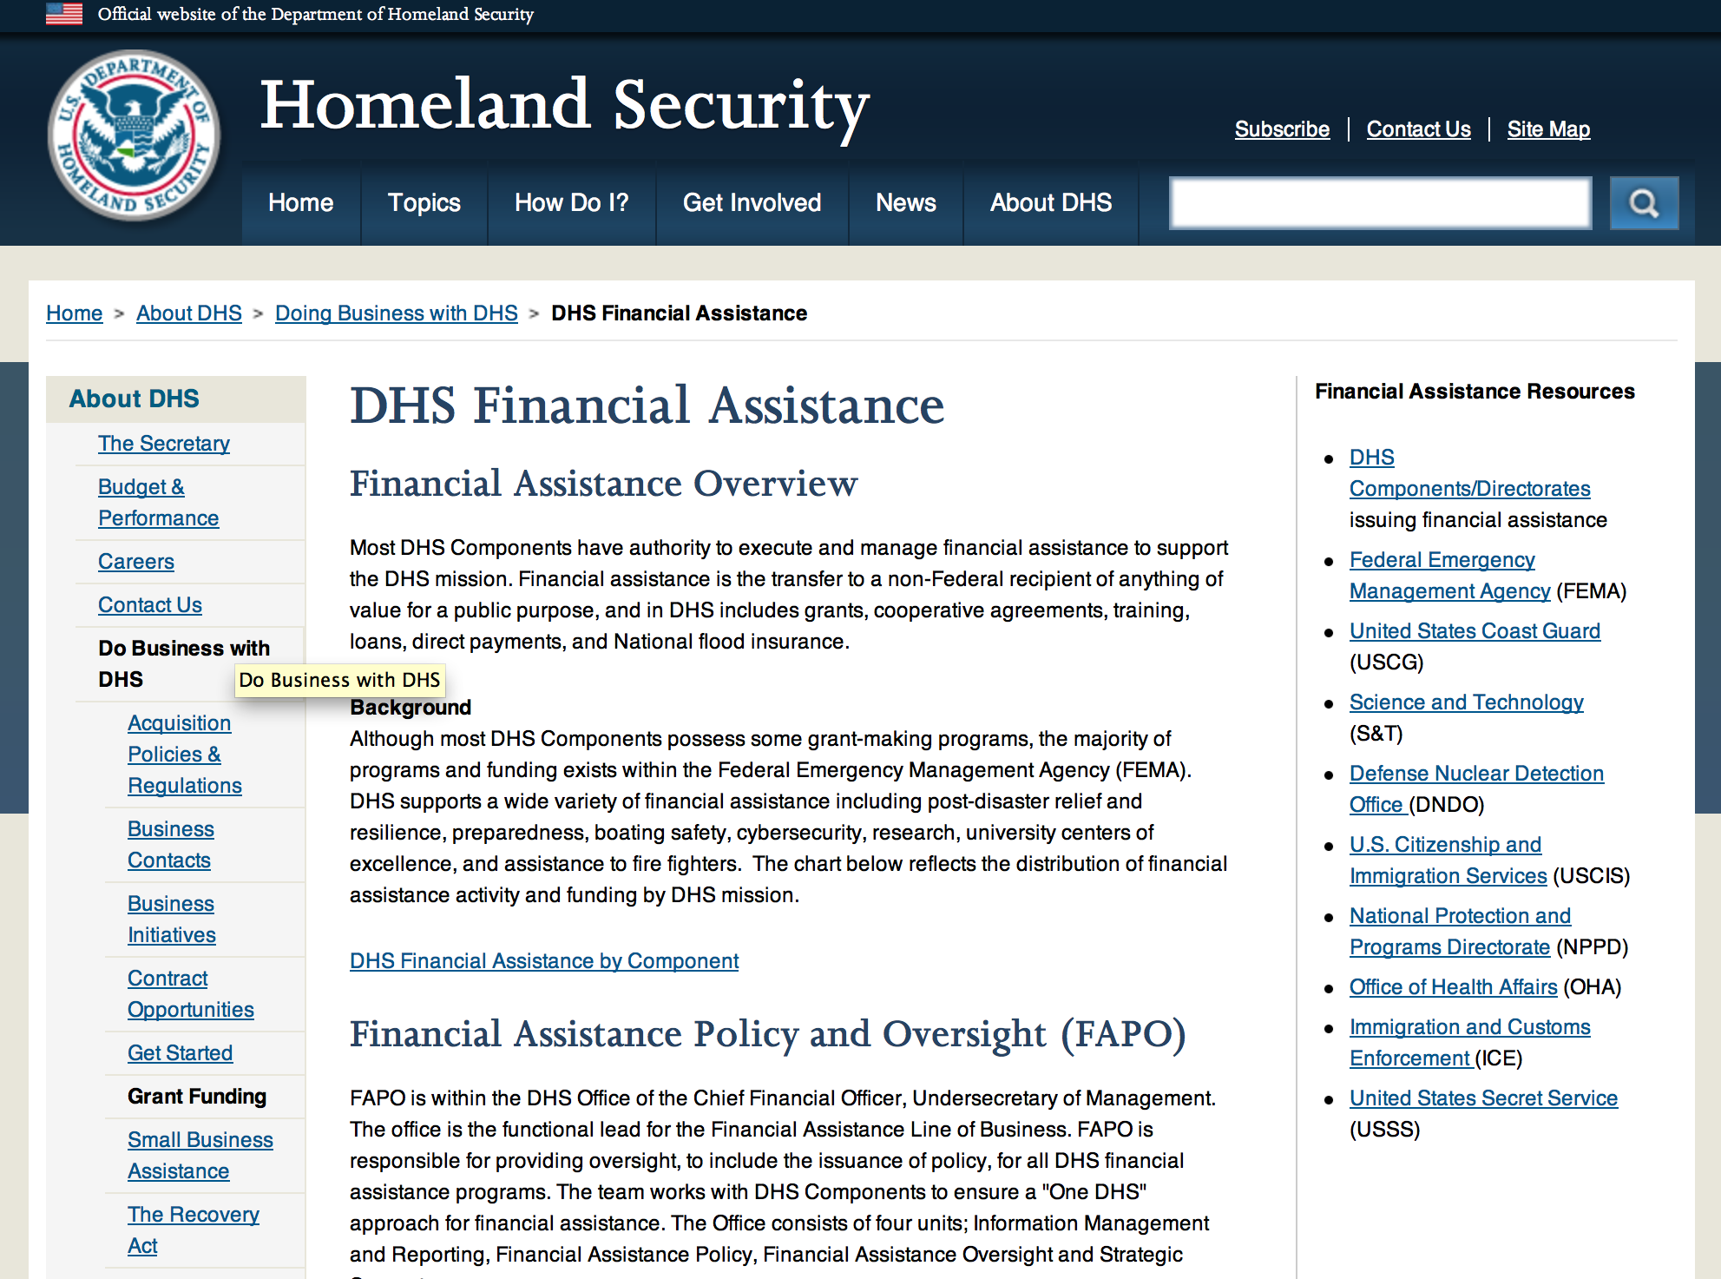

Webpage can be viewed at: http://www.dhs.gov/xopnbiz/grants/index.shtm#2

The FY 2015 Assistance to Firefighters Grants (AFG) Application Period Has Closed.
For AFG program guidance materials, please visit our Documents page.
FY 2015 FIRE PREVENTION & SAFETY (FP&S) Grants
- FY 2015 Application Information Coming Soon
- FP&S Success Stories
FY 2014 FIRE PREVENTION & SAFETY (FP&S) Grants
- FY 2014 FP&S Award Announcements - View Awards List
FY 2015 STAFFING FOR ADEQUATE FIRE and EMERGENCY RESPONSE (SAFER) Grants
- FY 2015 Application Information Coming Soon
- SAFER Success Stories
FY 2014 STAFFING FOR ADEQUATE FIRE and EMERGENCY RESPONSE (SAFER) Grants
- FY 2014 FP&S Award Announcements - View Awards List
FP&S Success Stories

Resources

AFG Help Desk
Contact the AFG Program Help Desk toll-free at 866-274-0960, or email us at firegrants@dhs.gov.
The AFG Program has Fire Program Specialists in 10 federal regional centers. These Regional Fire Program Specialists respond to questions about the AFG program and carry out grant monitoring activities. View regional contacts

Popular AFG links
- AFG Workshop Schedule
- Assistance to Firefighters Grants (AFG)
- AFG Awards List
- AFG Success Stories
- Staffing for Adequate Fire & Emergency Response (SAFER) Grants (SAFER)
- SAFER Awards List
- SAFER Success Stories
- Fire Prevention & Safety (FP&S) Grants
- FP&S Awards List
- FP&S Success Stories
- Grant Closeout Tutorial
- Assistance to Firefighters Grant (AFG) Email Alert Archive
- Frequently Asked Questions
Contact Information For The Assistance to Firefighters Grant (AFG) Program and Help Desk

Federal Funding Alternative To AFG

State Administrative Agencies (SAA) apply for and administer Federal grants on behalf of their States, including FEMA Preparedness Grants. The SAA will work with eligible organizations to comply with the general requirements of grant programs or cooperative agreements. Contact your State’s SAA to find out what current Federal funding opportunities may be available to your organization. A listing of the SAAs and points of contact can be found at http://www.fema.gov/library/viewRecord.do?id=6363.

Programs:

Fiscal Year (FY) 2016 Homeland Security National Training Program (HSNTP) - National Domestic Preparedness Consortium (NDPC) Grant

Document Type: | Grants Notice
Funding Opportunity Number: | DHS-16-NPD-005-00-02
Funding Opportunity Title: | Fiscal Year (FY) 2016 Homeland Security National Training Program (HSNTP) - National Domestic Preparedness Consortium (NDPC)
Opportunity Category: | Discretionary
Opportunity Category Explanation:
Funding Instrument Type: | Cooperative Agreement
Category of Funding Activity: | Education  Other (see text field entitled "Explanation of Other Category of Funding Activity" for clarification)
Category Explanation: | Training
Expected Number of Awards: | 5
CFDA Number(s): | 97.005 -- State and Local Homeland Security National Training Program
Cost Sharing or Matching Requirement: | Yes
Posted Date: | Jun 06, 2016
Last Updated Date: | Jun 06, 2016
Original Closing Date for Applications: | Jul 22, 2016
Current Closing Date for Applications: | Jul 22, 2016
Archive Date: | Aug 22, 2016
Estimated Total Program Funding: | $76,000,000
Eligible Applicants: | Nonprofits having a 501(c)(3) status with the IRS, other than institutions of higher education  Public and State controlled institutions of higher education
Agency Name: | Department of Homeland Security - FEMA
Description: | The Department of Homeland Security Fiscal Year (FY) 2016 Homeland Security National Training Program (HSNTP), National Domestic Preparedness Consortium (NDPC) plays an important role in the implementation of the National Preparedness System by supporting the building, sustainment, and delivery of core capabilities essential to achieving the National Preparedness Goal (the Goal) of a secure and resilient Nation. Delivering core capabilities requires the combined effort of the whole community, rather than the exclusive effort of any single organization or level of government. The FY 2016 HSNTP/NDPC supports efforts to build and sustain core capabilities across Prevention, Protection, Mitigation, Response, and Recovery mission areas, with specific focus on addressing the training needs of our nation. Objectives: FY 2016 HSNTP/NDPC training programs will provide training solutions to address national preparedness gaps, correlate training needs with exercise activities and outcomes, incorporate the core capabilities identified in the National Preparedness Goal, and ensure training is available and accessible to a nationwide audience.
Link to Additional Information: | http://www.grants.gov
Grantor Contact Information: | If you have difficulty accessing the full announcement electronically, please contact:  Systems, GPD GMD-Systems-Branch@fema.gov  GMD-Systems-Branch@fema.gov

http://www.grants.gov/web/grants/view-opportunity.html?oppId=284411

Modifications:

Reminders:

Office of Procurement Operations - Grants Division
Center of Excellence Criminal Investigations and Network Analysis – Partner Grant

Document Type: |  | Grants Notice
Funding Opportunity Number: |  | DHS-16-ST-061-CINA-PARTNER
Funding Opportunity Title: |  | Center of Excellence Criminal Investigations and Network Analysis - Partner
Opportunity Category: |  | Discretionary
Opportunity Category Explanation:
Funding Instrument Type: |  | Cooperative Agreement
Category of Funding Activity: |  | Science and Technology and other Research and Development
Category Explanation:
Expected Number of Awards: |  | 3
CFDA Number(s): |  | 97.061 -- Centers for Homeland Security
Cost Sharing or Matching Requirement: |  | No
Posted Date: |  | May 27, 2016
Last Updated Date: |  | May 27, 2016
Original Closing Date for Applications: |  | Sep 01, 2016
Current Closing Date for Applications: |  | Sep 01, 2016
Archive Date: |  | Oct 01, 2016
Estimated Total Program Funding: |  | $5,000,000
Award Ceiling: |  | $500,000
Award Floor: |  | $100,000
Eligible Applicants: |  | Public and State controlled institutions of higher education  Private institutions of higher education
Agency Name: | Office of Procurement Operations - Grants Division
Description: | Informational Webinar June 21, 2016 3:00pm EDT. The Department of Homeland Security (DHS) Science and Technology Directorate (S&T) Office of University Programs (OUP) is requesting applications from U.S. colleges and universities to serve as a partner institution for a Center for Criminal Investigations and Network Analysis (CINA). OUP is also posting a separate NOFO for eligible applicants to submit lead proposals for consideration. Please see NOFO Number DHS-16-ST-061-CINA-Partner or 97.061 on http://www.grants.gov for directions on how to submit single project proposals. DHS will select qualified individual projects from applications received for either the Center Lead NOFO or the Center Partner NOFO, regardless of the institution that is awarded as lead institution. Principal Investigators that are already Partners under a Center Lead application may not submit the same application under this Partner NOFO.
Link to Additional Information: | Webinar link 6-21-2016 3:00pm EDT
Contact Information: | If you have difficulty accessing the full announcement electronically, please contact:  Melanie Bales Lead Grants Officer  DHS

http://www.grants.gov/web/grants/view-opportunity.html?oppId=284177

Department of Housing and Urban Development

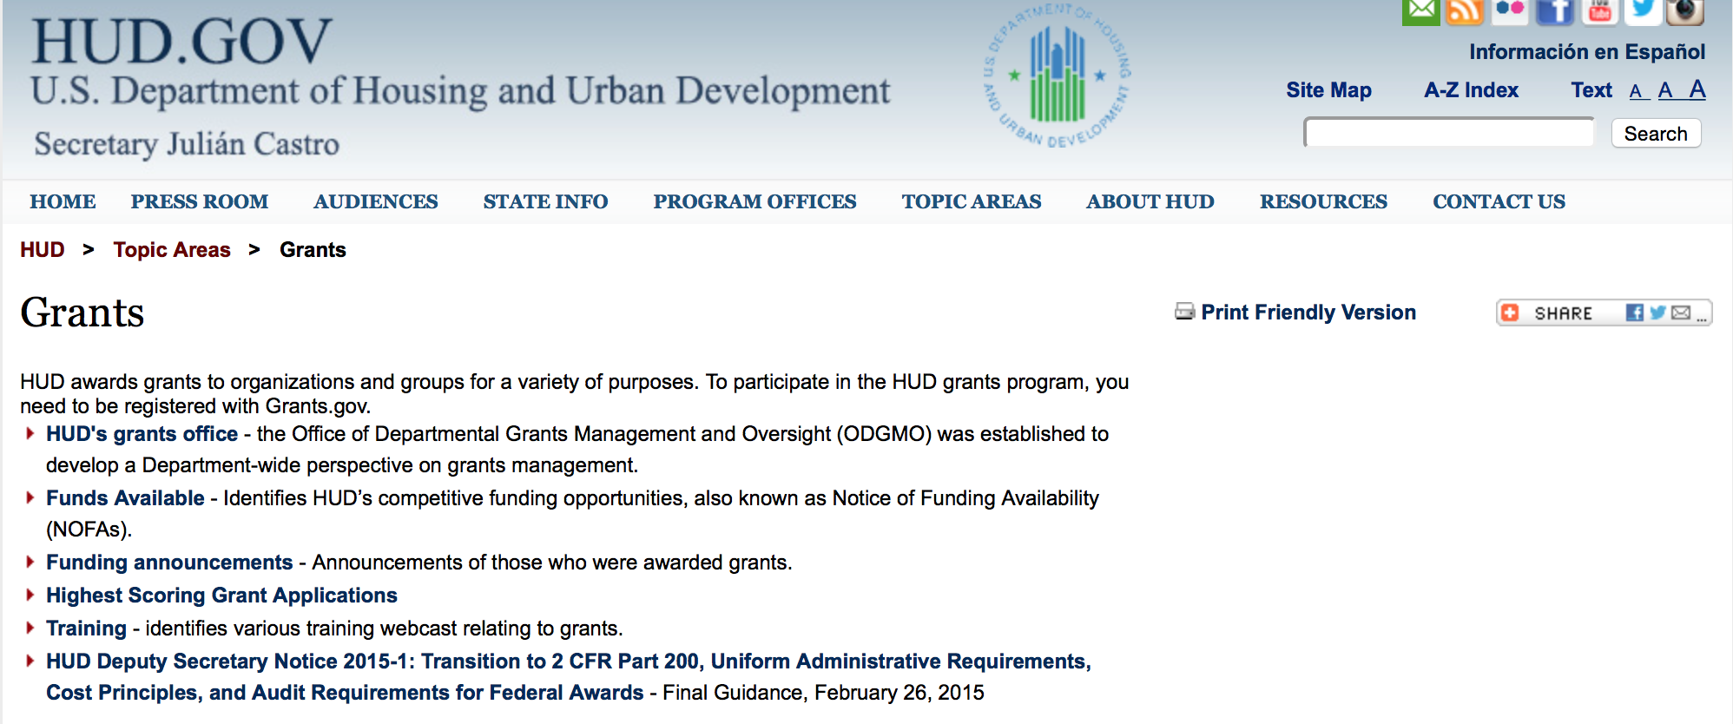

http://portal.hud.gov/hudportal/HUD?src=/topics/grants

HUD - Notice of Funds Available

For detailed information click here

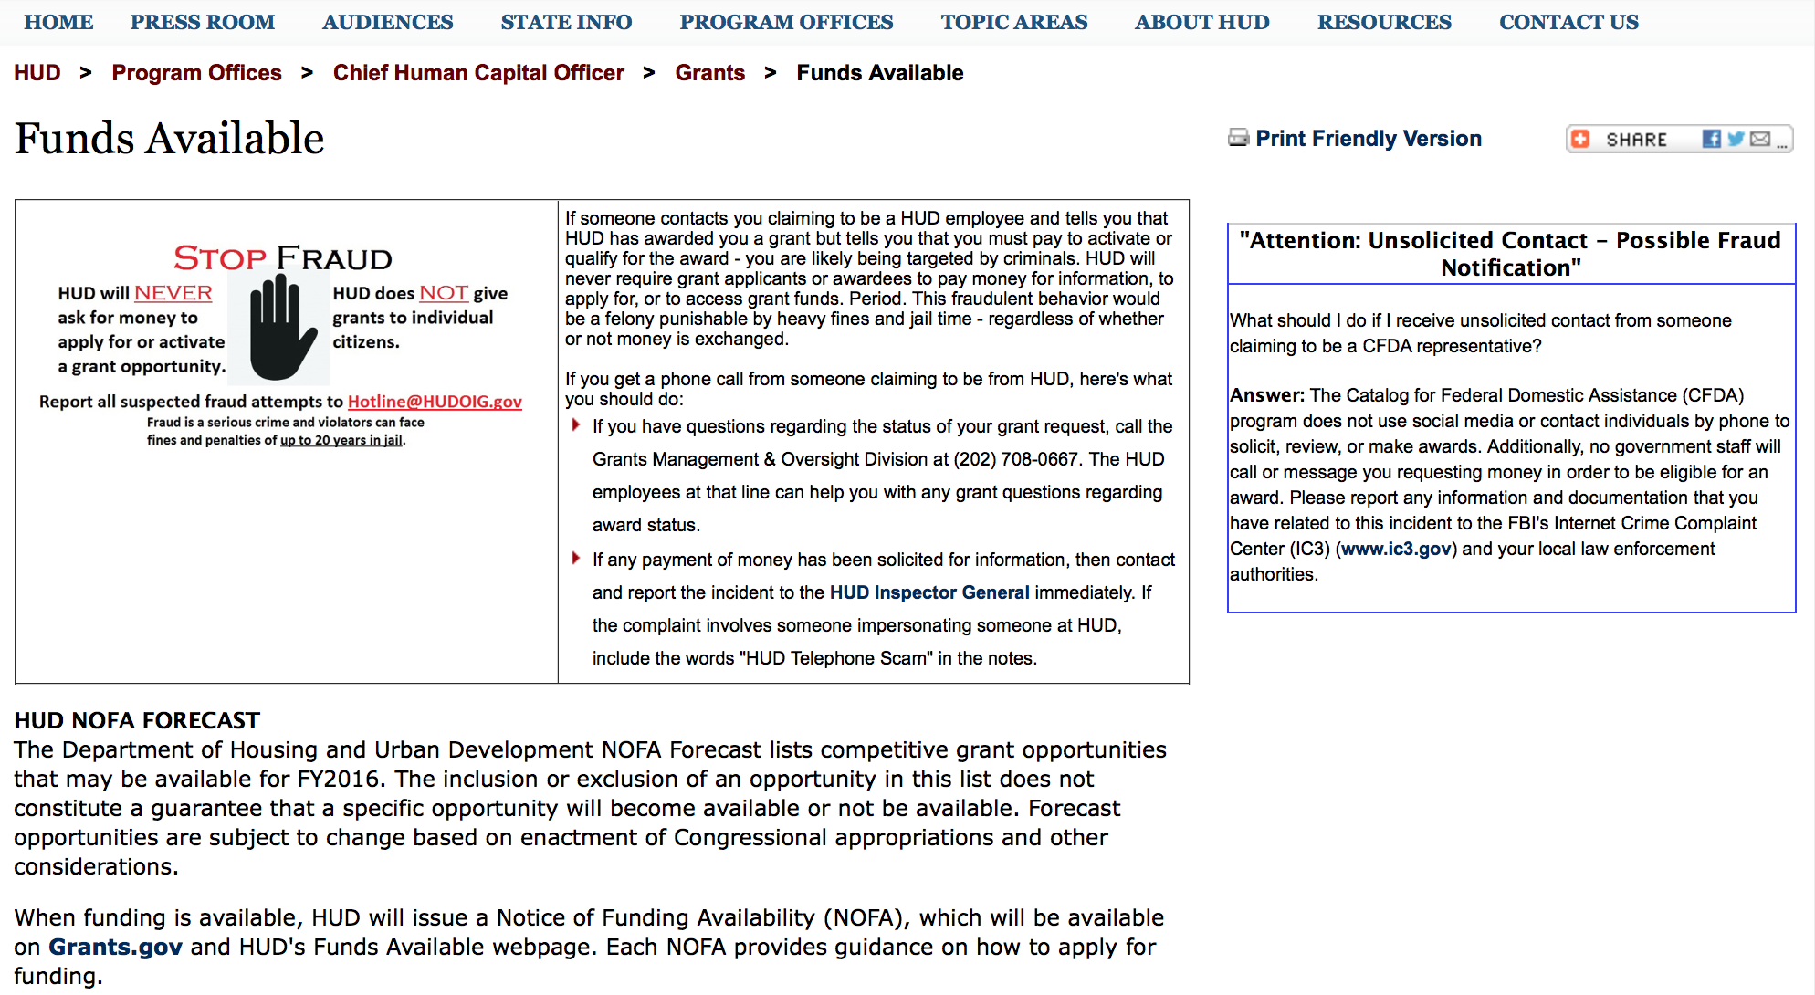

http://portal.hud.gov/hudportal/HUD?src=/program_offices/administration/grants/fundsavail

HUD NOFA FORECAST
The Department of Housing and Urban Development NOFA Forecast lists competitive grant opportunities that may be available for FY2016. The inclusion or exclusion of an opportunity in this list does not constitute a guarantee that a specific opportunity will become available or not be available. Forecast opportunities are subject to change based on enactment of Congressional appropriations and other considerations.
When funding is available, HUD will issue a Notice of Funding Availability (NOFA), which will be available on Grants.gov and HUD's Funds Available webpage. Each NOFA provides guidance on how to apply for funding.
Program Office | Funding Opportunity Title | Funding Opportunity Number | CFDA | Estimated Publication Date | Estimated Application Due Date
GMO | General Section to HUD's Fiscal Year 2016 Notice[s] of Funding Availability for Discretionary Programs (General Section) | FR-6000-N-01 | 14.506 | PUBLISHED | N/A
HSNG | Notice of Funding Availability (NOFA) for the Department's Fiscal Years 2016 and 2017 Comprehensive Housing Counseling Grant Program | FR-6000-N-33 | 14.169 | PUBLISHED | 4/4/2016
HSNG | NOFA for HUD's FY16-17 Housing Counseling Training Grant Program | FR-6000-N-30 | 14.316 | PUBLISHED | 4/4/2016
HSNG | Multifamily Energy and Water Conservation Pay For Success Pilot | FR-6000-N-36 | 14.157 | 9/14/2016 | 11/14/2016
OLHCHH | Lead Hazard Reduction Demonstration (LHRD) Grant Program | FR-6000-N-13 | 14.905 | PUBLISHED | 4/28/2016
OLHCHH | Lead-Based Paint Hazard Control (LBPHC) Grant Program | FR-6000-N-12 | 14.900 | PUBLISHED | 4/28/2016
OLHCHH | Healthy Homes Technical Studies Grant Program Pre and Full Application | FR-6000-N-15 | 14.906 | PUBLISHED | 6/1/2016
PIH | Resident Opportunity & Self-Sufficiency Program | FR-6000-N-05 | 14.870 | PUBLISHED | 5/16/2016
PIH | HOPE VI Main Street Grant Program | FR-6000-N-03 | 14.878 | PUBLISHED | 4/12/2016
PIH | Jobs Plus Initiative | FR-6000-N-14 | 14.895 | PUBLISHED | 6/13/2016
PIH | Family Self-Sufficiency Program | FR-6000-N-04 | 14.896 | PUBLISHED | 4/20/2016
PIH | Community Development Block Grant Program for Indian Tribes and Alaska Native Villages | FR-6000-N-23 | 14.862 | PUBLISHED | 6/14/2016
PIH | Choice Neighborhoods Implementation Grant Program | FR-6000-N-34 | 14.889 | PUBLISHED | 6/28/2016
PIH | Project SOAR | FR-6000-N-27 | 14.889 | 7/20/2016 | 9/19/2016
FHEO | Fair Housing Initiative Program - Private Enforcement Initiative | FR-6000-N-21C | 14.418 | PUBLISHED | 6/23/2016
FHEO | Fair Housing Initiative Program - Fair Housing Organization Initiative | FR-6000-N-21B | 14.417 | PUBLISHED | 6/23/2016
FHEO | Fair Housing Initiative Program - Education and Outreach Initiative | FR-6000-N-21A | 14.416 | PUBLISHED | 6/23/2016
PDR | Research and Evaluation, Demonstration, and Data Analysis and Utilization | FR-5900-N-29 | 14.536 | PUBLISHED | 6/6/2016
PDR | Research and Evaluation, Demonstration, and Data Analysis and Utilization | FR-6000-N-29 | 14.536 | 7/7/2016 | 8/23/2016
CPD | HUD Community Compass Technical Assistance and Capacity Building Program | FR-6000-N-06 | 14.259 | PUBLISHED | 7/19/2016
CPD | Capacity Building for Community Development and Affordable Housing Grants (Section 4) | FR-6000-N-07 | 14.252 | PUBLISHED | 8/9/2016
CPD | Building Capacity to End Youth Homelessness | FR-6000-N-37 | 14.270 | CANCELLED | CANCELLED
CPD | Youth Homelessness Demonstration Project | FR-6000-N-35 | 14.267 | 7/7/2016 | 9/1/2016
CPD | Continuum of Care Program Competition | FR-6000-N-25 | 14.276 | 6/30/2016 | 9/30/2016
CPD | Rural Capacity Building for Community Development and Affordable Housing Grants | FR-6000-N-08 | 14.265 | 7/8/2016 | 9/6/2016
CPD | Self-Help Homeownership Opportunity Program (SHOP) | FR-6000-N-19 | 14.247 | 10/12/2016 | 12/11/2016
- Updated 6/21/2016 General Section
- FONSI
- New Application Attachment Filename Requirement

Programs

Modifications:

Funding Opportunity Number: FR-6000-N-25
FY2016 Continuum of Care
Modification 4
Modification Comments: This modification updates the Agency Contact URL.

Document Type: | Grants Notice
Funding Opportunity Number: | FR-6000-N-25
Funding Opportunity Title: | FY2016 Continuum of Care
Opportunity Category: | Discretionary
Opportunity Category Explanation:
Funding Instrument Type: | Grant
Category of Funding Activity: | Housing
Category Explanation:
Expected Number of Awards: | 8000
CFDA Number(s): | 14.267 -- Continuum of Care Program
Cost Sharing or Matching Requirement: | Yes
Version: | Synopsis 4
Posted Date: | Jun 28, 2016
Last Updated Date: | Jun 29, 2016
Original Closing Date for Applications: | Sep 14, 2016
Current Closing Date for Applications: | Sep 14, 2016
Archive Date: | Oct 14, 2016
Estimated Total Program Funding: | $1,900,000,000
Award Ceiling: | $1,500,000
Award Floor: | $2,500
Eligible Applicants: | City or township governments  State governments  County governments  Others (see text field entitled "Additional Information on Eligibility" for clarification)  Nonprofits having a 501(c)(3) status with the IRS, other than institutions of higher education
Additional Information on Eligibility: | 24 CFR 578.15, eligible project applicants for the CoC Program Competition are nonprofit organizations, States, local governments, and instrumentalities of State and local governments. Public housing agencies, as such term is defined in 24 CFR 5.100, are eligible without limitation or exclusion. For-profit entities are not eligible to apply for grants or to be subrecipients of grant funds. Individuals, foreign entities, and sole proprietorship organizations are not eligible to compete for, or receive, awards made under this announcement.
Agency Name: | Department of Housing and Urban Development
Description: | The CoC Program (24 CFR part 578) is designed to promote a community-wide commitment to the goal of ending homelessness; to provide funding for efforts by nonprofit providers, States, and local governments to quickly re-house homeless individuals, families, persons fleeing domestic violence, and youth while minimizing the trauma and dislocation caused by homelessness; to promote access to and effective utilization of mainstream programs by homeless; and to optimize self-sufficiency among those experiencing homelessness.
Link to Additional Information: | HUD Funds Available Page
Grantor Contact Information: | If you have difficulty accessing the full announcement electronically, please contact:  HUD Staff  HUD Exchange AAQ help desk

Link: http://www.grants.gov/web/grants/view-opportunity.html?oppId=285539

Reminders

HUD Community Compass Technical Assistance and Capacity Building Program Grant
Document Type: | Grants Notice
Funding Opportunity Number: | FR-6000-N-06
Funding Opportunity Title: | HUD Community Compass Technical Assistance and Capacity Building Program
Opportunity Category: | Discretionary
Opportunity Category Explanation:
Funding Instrument Type: | Cooperative Agreement
Category of Funding Activity: | Housing
Category Explanation:
Expected Number of Awards: | 20
CFDA Number(s): | 14.259 -- Community Compass Technical Assistance and Capacity Building
Cost Sharing or Matching Requirement: | No
Posted Date: | May 19, 2016
Last Updated Date: | May 19, 2016
Original Closing Date for Applications: | Jul 19, 2016 Electronically submitted applications must be submitted no later than 11:59:59 p.m., ET, on the listed application due date.
Current Closing Date for Applications: | Jul 19, 2016 Electronically submitted applications must be submitted no later than 11:59:59 p.m., ET, on the listed application due date.
Archive Date: | Aug 18, 2016
Estimated Total Program Funding: | $58,000,000
Award Ceiling: | $20,000,000
Award Floor: | $250,000
Eligible Applicants: | Public and State controlled institutions of higher education  Native American tribal organizations (other than Federally recognized tribal governments)  Nonprofits that do not have a 501(c)(3) status with the IRS, other than institutions of higher education  Special district governments  Nonprofits having a 501(c)(3) status with the IRS, other than institutions of higher education  Private institutions of higher education  Others (see text field entitled "Additional Information on Eligibility" for clarification)  State governments  For profit organizations other than small businesses  County governments  Native American tribal governments (Federally recognized)  Public housing authorities/Indian housing authorities  Small businesses  City or township governments
Additional Information on Eligibility: | In addition to the list above, eligible applicants include: NAHASDA-eligible Indian tribes as defined at Section 4(13) of NAHASDA; tribally designated housing entities (TDHEs) as defined at Section 4(22) of the NAHASDA; and national or regional organizations representing Native American housing interests Metropolitan Planning Organizations (MPOs), Councils of Government (COGs), or other regional planning entities For MAHRA TA, tenant groups as defined at Section 514 of the MAHRA See section V.B. "Rules that affect applicants' eligibility to receive an award" of the FY2016 General Section for more information on eligibility. Individuals, foreign entities, and sole proprietorship organizations are not eligible to compete for, or receive, awards made under this announcement.
Agency Name: | Department of Housing and Urban Development
Description: | Community Compass is designed to help HUD's customers navigate complex housing and community development challenges by equipping them with the knowledge, skills, tools, capacity, and systems to implement HUD programs and policies successfully. The goal of Community Compass is to empower communities by providing effective technical assistance and capacity building so that successful program implementation is sustained over the long term.
Link to Additional Information: | http://portal.hud.gov/hudportal/HUD?src=/program_offices/administration/grants/fundsavail
Contact Information: | If you have difficulty accessing the full announcement electronically, please contact:  Lauren Deigh Lauren.S.Deigh@hud.gov  Grants Policy

http://www.grants.gov/web/grants/view-opportunity.html?oppId=283996

Technical Correction to the General Section to HUD's Fiscal Year 2016 Notice[s] of Funding Availability for Discretionary Programs
Modification 1

Document Type: | Grants Notice
Funding Opportunity Number: | FR-6000-N-01-C
Funding Opportunity Title: | Technical Correction to the General Section to HUD's Fiscal Year 2016 Notice[s] of Funding Availability for Discretionary Programs
Opportunity Category: | Discretionary
Opportunity Category Explanation:
Funding Instrument Type: | Grant
Category of Funding Activity: | Community Development
Category Explanation:
Expected Number of Awards: | 0
CFDA Number(s):
Cost Sharing or Matching Requirement: | No
Posted Date: | May 16, 2016
Last Updated Date: | May 16, 2016
Original Closing Date for Applications: | Dec 31, 2016 Electronically submitted applications to program NOFAs must be submitted no later than 11:59:59 p.m., ET, on the listed application due date. No applications are accepted in response to this Notice, which publishes policies and guidance only.
Current Closing Date for Applications: | Dec 31, 2016 Electronically submitted applications to program NOFAs must be submitted no later than 11:59:59 p.m., ET, on the listed application due date. No applications are accepted in response to this Notice, which publishes policies and guidance only.
Archive Date: | Jan 30, 2017
Estimated Total Program Funding: | $0
Award Ceiling: | $0
Award Floor: | $0
Eligible Applicants: | Public and State controlled institutions of higher education  Unrestricted (i.e., open to any type of entity above), subject to any clarification in text field entitled "Additional Information on Eligibility"  Nonprofits that do not have a 501(c)(3) status with the IRS, other than institutions of higher education  State governments  Private institutions of higher education  Public housing authorities/Indian housing authorities  County governments  Special district governments  City or township governments  Small businesses  Native American tribal governments (Federally recognized)  Independent school districts  Native American tribal organizations (other than Federally recognized tribal governments)  Individuals  Nonprofits having a 501(c)(3) status with the IRS, other than institutions of higher education  For profit organizations other than small businesses
Additional Information on Eligibility: | No applications will be accepted in response to this document. This Document is a policy document only. The individual program Notices of Funds Available (NOFA) will identify eligible applicants for each competition. Each Program NOFA will describe additional eligibility requirements for applicants. HUD does not provide direct services or products to individuals through its formula-based programs or its competitive Program NOFA process. Individuals seeking financial assistance should refer to www.GovBenefits.gov. Individuals, foreign entities, and sole proprietorship organizations are not eligible to compete for, or receive, awards made under this announcement.
Agency Name: | Department of Housing and Urban Development
Description: | HUD publishes a General Section each Fiscal Year (FY) that contains requirements for all of HUD’s competitive grant programs. Applications to HUD programs must meet all applicable requirements of the General Section and the requirements in the Program NOFA to be considered for funding. This updates paragraph V.C.8. Eminent Domain to reflect the 2016 Appropriations authority, and updates paragraph VI.A.1. Obtaining an Electronic Application.
Link to Additional Information: | http://portal.hud.gov/hudportal/HUD?src=/program_offices/administration/grants/fundsavail
Contact Information: | If you have difficulty accessing the full announcement electronically, please contact:  Loyd LaMois loyd.lamois@hud.gov  Grants Policy

http://www.grants.gov/web/grants/view-opportunity.html?oppId=283900

General Section to HUD's Fiscal Year 2016 Notice[s] of Funding Availability for Discretionary Programs (General Section)
Modification 1

Document Type: | Grants Notice
Funding Opportunity Number: | FR-6000-N-01
Funding Opportunity Title: | General Section to HUD's Fiscal Year 2016 Notice[s] of Funding Availability for Discretionary Programs (General Section)
Opportunity Category: | Discretionary
Funding Instrument Type: | Grant
Category of Funding Activity: | Community Development
Category Explanation:
Expected Number of Awards: | 0
CFDA Number(s):
Cost Sharing or Matching Requirement: | No
Posted Date: | Sep 24, 2015
Creation Date: | Sep 24, 2015
Original Closing Date for Applications: | Dec 30, 2016 Electronically submitted applications must be submitted no later than 11:59:59 p.m., ET, on the listed application due date published in the individual program NOFA.
Current Closing Date for Applications: | Dec 30, 2016 Electronically submitted applications must be submitted no later than 11:59:59 p.m., ET, on the listed application due date published in the individual program NOFA.
Archive Date: | Jan 29, 2017
Eligible Applicants: | Others (see text field entitled "Additional Information on Eligibility" for clarification)
Additional Information on Eligibility: | This Document is a policy document only. The individual program Notices of Funds Available (NOFA) will identify eligible applicants for each competition. Each Program NOFA will describe additional eligibility requirements for applicants. All applicants must have valid, active Registration in the System for Award Management (SAM) prior to submission of applications for financial assistance. HUD does not provide direct services or products to individuals through its formula-based programs or its competitive Program NOFA process. Individuals seeking financial assistance should refer to www.GovBenefits.gov. Individuals, foreign entities, and sole proprietorship organizations are not eligible to compete for, or receive, awards made under this announcement.
Agency Name: | Department of Housing and Urban Development
Description: | The General Section describes the requirements that are applicable to all HUD FY 2015 Program NOFAs. The General Section also provides information on HUD’s priorities and strategic goals. Each Program NOFA will describe additional applicable procedures and requirements, including a description of the eligible applicants, eligible activities, threshold requirements, cross-program requirements such as nondiscrimination, environmental protection, and any additional program requirements or limitations. To adequately address all of the application requirements for any program, please carefully read and respond to both this General Section and any applicable Program NOFA.
Link to Additional Information: | http://portal.hud.gov/hudportal/HUD?src=/program_offices/administration/grants/fundsavail
Contact Information: | If you have difficulty accessing the full announcement electronically, please contact:  Loyd LaMois loyd.lamois@hud.gov  Grants Policy

http://www.grants.gov/web/grants/view-opportunity.html?oppId=279206



Institute of Museum and Library Services

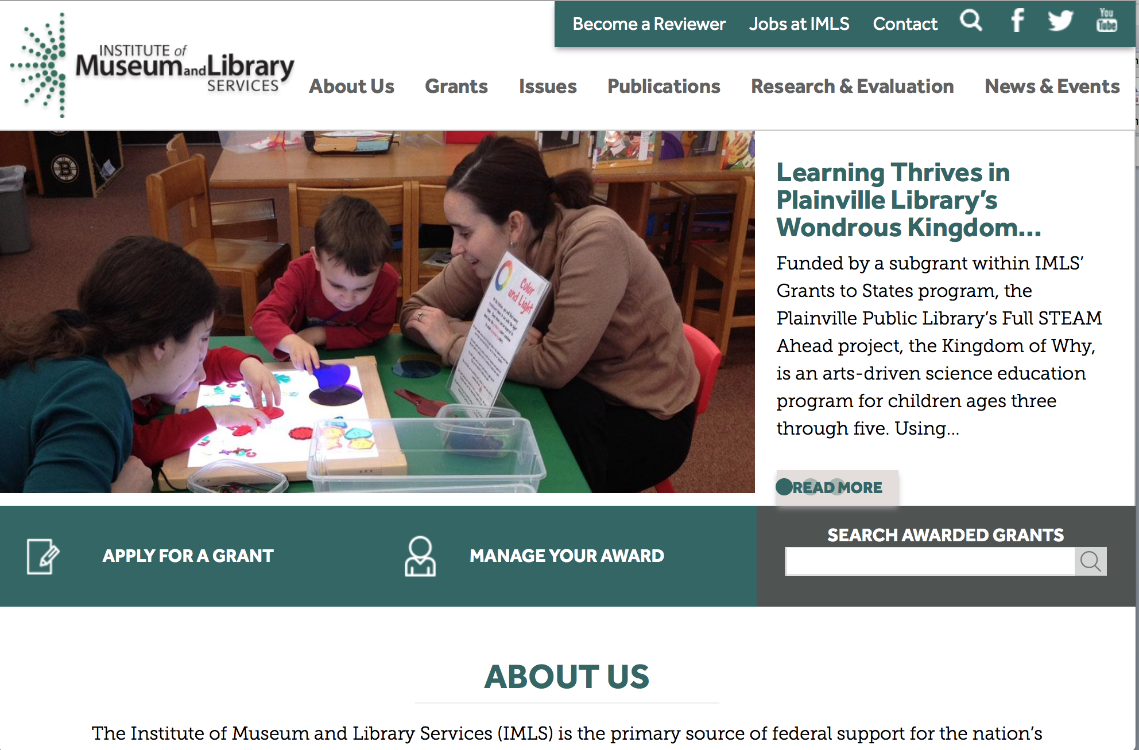

www.imls.gov

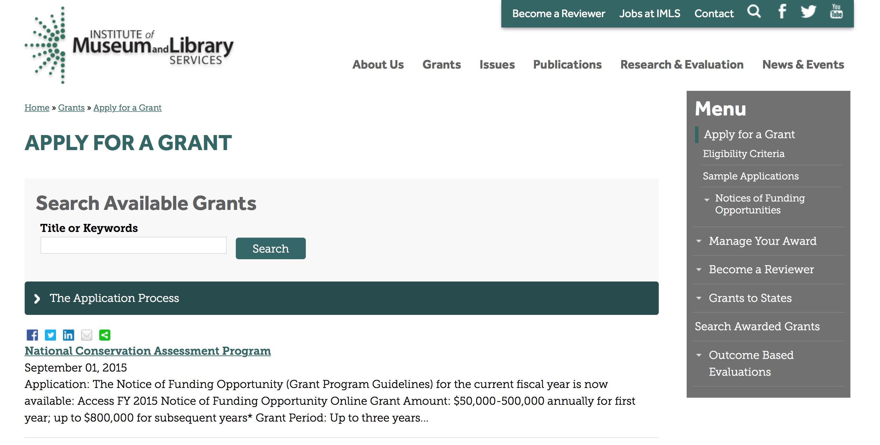
http://www.imls.gov/applicants/available_grants.aspx

Each grant program has specific eligibility requirements. The links below provide general eligibility criteria for museums, libraries, and tribal organizations, but please note that additional organizations may be eligible for grants under certain programs. Additionally, ineligible organizations may still be able to participate in grant programs through partnerships with eligible organizations. Please click on the links below to see general criteria and review Applications and Guidelines for specific information.
Museums Libraries

Institutions: Archives, Federally Recognized Native American Tribe, Historical Society, Library, Nonprofits that serve Native Hawaiians, Professional Association, Public or Private Non-profit Institutions of Higher Education, Regional Organization, State Library Administrative Agency, State or Local Government

Check out IMLS's Facebook page at:
https://www.facebook.com/USIMLS/

Modifications:

Reminders:

Department of the Interior
Working with Interior

The Interior Department provides assistance to the public, local governments and businesses through a number of programs. For a general overview see: http://www.doi.gov/index.cfm

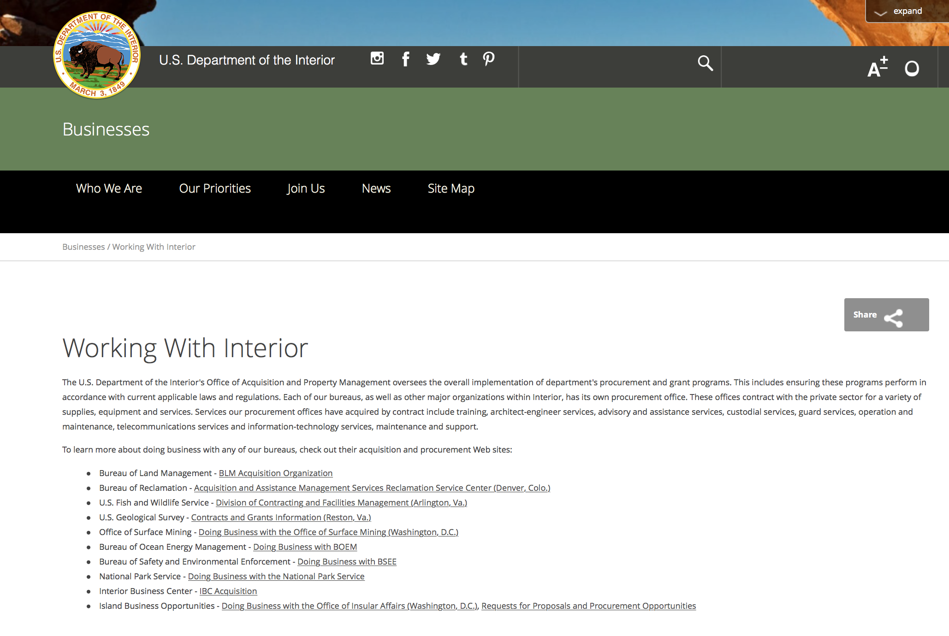

http://www.doi.gov/businesses/working-with-interior.cfm

Programs:

Modifications:

Reminders:

Historic Preservation Fund Grants to Underrepresented Communities
And Modification 1

Document Type: | Grants Notice
Funding Opportunity Number: | P16AS00184
Funding Opportunity Title: | Historic Preservation Fund Grants to Underrepresented Communities
Opportunity Category: | Discretionary
Opportunity Category Explanation:
Funding Instrument Type: | Grant
Category of Funding Activity: | Arts (see "Cultural Affairs" in CFDA)  Community Development  Humanities (see "Cultural Affairs" in CFDA)  Other (see text field entitled "Explanation of Other Category of Funding Activity" for clarification)
Category Explanation: | Historic Preservation, Cultural Resource Management
Expected Number of Awards: | 20
CFDA Number(s): | 15.904 -- Historic Preservation Fund Grants-In-Aid
Cost Sharing or Matching Requirement: | No
Posted Date: | May 20, 2016
Last Updated Date: | May 21, 2016
Original Closing Date for Applications: | Jul 15, 2016 Applications must be submitted in grants.gov and received by 11:59 pm EST on July 15, 2016.
Current Closing Date for Applications: | Jul 15, 2016 Applications must be submitted in grants.gov and received by 11:59 pm EST on July 15, 2016.
Archive Date: | Aug 31, 2016
Estimated Total Program Funding: | $500,000
Award Ceiling: | $50,000
Award Floor: | $15,000
Eligible Applicants: | Native American tribal governments (Federally recognized)  State governments  City or township governments  Others (see text field entitled "Additional Information on Eligibility" for clarification)  Nonprofits that do not have a 501(c)(3) status with the IRS, other than institutions of higher education  County governments
Additional Information on Eligibility: | Eligible applicants are limited to: federally recognized Tribes, Alaska Native Groups, Native Hawaiian Organizations (as defined by 54 USC 300300 et seq.); State Historic Preservation Offices (in some states and territories, these are nonprofits); and Certified Local Governments (which may be county, city, or township governments). A listing of Certified Local Governments may be found at nps.gov/clg.
Agency Name: | National Park Service
Description: | Grants support the survey, inventory, and designation of historic properties that are associated with communities currently underrepresented in the National Register of Historic Places and among National Historic Landmarks. Within one year of the completion of the grant, all projects must result in: the submission of a new nomination to the National Register of Historic Places or National Historic Landmark program OR an amendment to an existing National Register or National Historic Landmark nomination to include underrepresented communities.
Link to Additional Information: | Underrepresented Community Grant Program Homepage
Contact Information: | If you have difficulty accessing the full announcement electronically, please contact:  Division Chief Megan Brown 202 354 2020 preservation_grants_info@nps.gov  Email preferred for questions.

http://www.grants.gov/web/grants/view-opportunity.html?oppId=284031

National Park Service
National Park Service
National Maritime Heritage Grant Program
And Modification 1

Document Type: | Grants Notice
Funding Opportunity Number: | P16AS00170
Funding Opportunity Title: | National Maritime Heritage Grant Program
Opportunity Category: | Discretionary
Opportunity Category Explanation:
Funding Instrument Type: | Grant
Category of Funding Activity: | Other (see text field entitled "Explanation of Other Category of Funding Activity" for clarification)
Category Explanation: | Historic Preservation
Expected Number of Awards: | 35
CFDA Number(s): | 15.925 -- National Maritime Heritage Grants Program
Cost Sharing or Matching Requirement: | Yes
Posted Date: | May 23, 2016
Last Updated Date: | May 24, 2016
Original Closing Date for Applications: | Aug 05, 2016
Current Closing Date for Applications: | Aug 05, 2016
Archive Date: | Aug 06, 2016
Estimated Total Program Funding: | $1,700,000
Award Ceiling: | $200,000
Award Floor: | $15,000
Eligible Applicants: | Public and State controlled institutions of higher education  City or township governments  Nonprofits having a 501(c)(3) status with the IRS, other than institutions of higher education  Private institutions of higher education  Nonprofits that do not have a 501(c)(3) status with the IRS, other than institutions of higher education  Native American tribal governments (Federally recognized)  State governments  County governments
Agency Name: | National Park Service
Description: | Approximately $1.7 million in National Maritime Heritage Grants for education or preservation projects are available for 2016. Proposals for grants will be accepted from May 23 until August 5, 2016. Education projects can request $15,000-50,000 and preservation projects can request $50,000-200,000. Funding for Maritime Heritage Grants is competitive. Project grants are administered through the Maritime Heritage Program and State Historic Preservation Offices (SHPOs).
Link to Additional Information: | https://www.nps.gov/maritime/grants/intro.htm
Contact Information: | If you have difficulty accessing the full announcement electronically, please contact:  Megan Brown 202 354 2062 Megan_Brown@nps.gov  megan_brown@nps.gov

http://www.grants.gov/web/grants/view-opportunity.html?oppId=283892

Geological Survey
FY 2017 National Climate Change & Wildlife Science Center Program Grant

Document Type: | Grants Notice
Funding Opportunity Number: | G16AS00049
Funding Opportunity Title: | FY 2017 National Climate Change & Wildlife Science Center Program
Opportunity Category: | Discretionary
Opportunity Category Explanation:
Funding Instrument Type: | Cooperative Agreement
Category of Funding Activity: | Natural Resources
Category Explanation:
Expected Number of Awards: | 4
CFDA Number(s): | 15.820 -- National Climate Change and Wildlife Science Center
Cost Sharing or Matching Requirement: | No
Posted Date: | May 03, 2016
Last Updated Date: | May 03, 2016
Original Closing Date for Applications: | Jul 19, 2016
Current Closing Date for Applications: | Jul 19, 2016
Archive Date: | Aug 19, 2016
Estimated Total Program Funding: | $52,000,000
Award Ceiling: | $800,000
Award Floor: | $0
Eligible Applicants: | Unrestricted (i.e., open to any type of entity above), subject to any clarification in text field entitled "Additional Information on Eligibility"
Additional Information on Eligibility: | Organizations eligible to submit proposals under this Announcement include state, not-for-profit, local government, and tribal entities, including academic institutions. USGS entities may not submit proposals and may not be formal partners on proposals. Federal agencies may participate in the execution of projects; they will receive money through other methods as appropriate and not through federal financial assistance (i.e. the host cooperative agreement).
Agency Name: | Geological Survey
Description: | This program was created to ensure that the National Climate Change and Wildlife Science Center is responsive to the research and management needs of Federal and State agencies to provide science and technical support regarding the impacts of climate change in fish, wildlife, plants and ecological processes. National coordination of research and modeling at regional centers will ensure uniformity of downscaling and forecasting models and standardized information to support management of fish and wildlife resources and regional partnership collaborations. The Climate Science Centers will provide access to the expertise at cooperating universities and supports the mission of the Climate Science Center Program.
Link to Additional Information: | http://www.grants.gov
Contact Information: | If you have difficulty accessing the full announcement electronically, please contact:  Tammy Szydloski 703-648-7371 tszydloski@usgs.gov  Grant Specialist

http://www.grants.gov/web/grants/view-opportunity.html?oppId=283476

Fish and Wildlife Service
Fiscal Year 2016 Recovery Implementation Fund Grant

Document Type: | Grants Notice
Funding Opportunity Number: | F16AS00099
Funding Opportunity Title: | Fiscal Year 2016 Recovery Implementation Fund
Opportunity Category: | Discretionary
Opportunity Category Explanation:
Funding Instrument Type: | Cooperative Agreement  Grant  Procurement Contract
Category of Funding Activity: | Environment  Natural Resources
Category Explanation:
Expected Number of Awards: | 0
CFDA Number(s): | 15.657 -- Endangered Species Conservation - Recovery Implementation Funds
Cost Sharing or Matching Requirement: | No
Posted Date: | Feb 04, 2016
Last Updated Date: | Feb 04, 2016
Original Closing Date for Applications: | Jul 31, 2016 Applications are due by July 31, 2016. However, you may submit applications throughout the year. Consideration of applications ultimately will be based on the FWS budget cycle.
Current Closing Date for Applications: | Jul 31, 2016 Applications are due by July 31, 2016. However, you may submit applications throughout the year. Consideration of applications ultimately will be based on the FWS budget cycle.
Archive Date: | Aug 31, 2016
Estimated Total Program Funding: | $0
Award Ceiling: | $1,000,000
Award Floor: | $1
Eligible Applicants: | Unrestricted (i.e., open to any type of entity above), subject to any clarification in text field entitled "Additional Information on Eligibility"
Additional Information on Eligibility: | Applicants must have a demonstrated knowledge and understanding of the biology of the involved endangered or threatened species in the United States and their ecosystem, including preferably having worked with the species in the field and holding a currently valid Endangered Species Act permit, issued by the FWS, authorizing them to work with these species (or that have previously held a permit to do so). If funding is awarded, applicants that do not currently hold a valid permit for the proposed activity may need to apply for and obtain a permit (http://www.fws.gov/endangered/permits/index.html) before beginning the proposed activity. FWS Regional (or Field Office) contacts will discuss potential proposals with interested parties if needed, and review eligible applications. The FWS Regional Office will refer interested parties to the appropriate FWS Field Office for further consideration as appropriate. For potential proposals submitted directly to the Field Office, the Field Office will conduct the proposal review and selection process. A list of FWS Regional Office contacts is available in the Full Announcement under section VII. Agency Contacts.
Agency Name: | Fish and Wildlife Service
Description: | The FWS Ecological Services Program provides Federal financial assistance on a competitive basis to States, other Federal agencies, landowners, educators, non-profit organizations, researchers, and other partners to secure information about endangered, threatened or candidate species, to aid in the recovery of these species, to avert listing of species pursuant to the Endangered Species Act, and to help conserve the ecosystems upon which these species depend. The FWS and National Marine Fisheries Service (NMFS), which is part of the Department of Commerce’s NOAA Fisheries office, share Endangered Species Act responsibilities for several species such as sea turtles. We have responsibility for sea turtles when they are on land, and NMFS has responsibility for sea turtles when they are in the water. Projects for NMFS-managed species are not included in this funding opportunity. This Recovery Implementation funding opportunity is intended for projects that will contribute to the recovery of FWS-managed endangered and threatened species in the United States, and is limited to projects carrying out actions described in a species approved recovery plan, in the implementation schedule of a species approved recovery plan, actions recommended in a completed 5-year status review of the species or in a spotlight species action plan, or projects documenting species response to climate change. For example: securing scientific information about endangered or threatened species, implementing restoration actions that will lead to delisting of a species, help prevent extinction of a species, or aid in the recovery of a species. Projects that address species response to climate change will receive additional consideration.
Link to Additional Information: | http://www.grants.gov
Contact Information: | If you have difficulty accessing the full announcement electronically, please contact:  Kelly Niland 703-358-2492 Kelly_Niland@fws.gov  Grant Specialist

http://www.grants.gov/web/grants/view-opportunity.html?oppId=281338

Fish and Wildlife Service
National Fish Passage Program Grant

Document Type: | Grants Notice
Funding Opportunity Number: | F16AS00041
Funding Opportunity Title: | National Fish Passage Program
Opportunity Category: | Discretionary
Funding Instrument Type: | Cooperative Agreement
Category of Funding Activity: | Natural Resources
Category Explanation:
Expected Number of Awards:
CFDA Number(s): | 15.608 -- Fish and Wildlife Management Assistance
Cost Sharing or Matching Requirement: | Yes
Posted Date: | Dec 1, 2015
Creation Date: | Nov 30, 2015
Original Closing Date for Applications: | Sep 1, 2016
Current Closing Date for Applications: | Sep 1, 2016
Archive Date: | Sep 20, 2016
Eligible Applicants: | Unrestricted (i.e., open to any type of entity above), subject to any clarification in text field entitled "Additional Information on Eligibility"
Additional Information on Eligibility: | To receive funding, NFPP projects must be implemented in coordination with FAC staff. Applicants can be, but not limited to: state and federal agencies, private lands, tribes, local municipalities, and non-governmental organizations.
Agency Name: | Fish and Wildlife Service
Description: | The National Fish Passage Program (NFPP) is a voluntary program that provides direct technical assistance and financial assistance in the form of cooperative agreements to partners to provide fish (and other aquatic organisms) passage and restore aquatic connectivity for the benefit of federal trust resources. The NFPP is delivered through more than 65 Fisheries and Aquatic Conservation (FAC) Field Offices across all States and territories. FAC staff coordinates with project partners, stakeholders and other Service programs to identify and collaboratively implement projects within Regional priority areas. Project work plans are developed strategically, in coordination with partners, and with substantial involvement from FAC staff. Projects must advance our mission, promote biological diversity, and be based upon sound scientific biological principles. FAC and Fish and Wildlife Service (FWS) strategic plans inform the types of projects funded under this opportunity. Applicants seeking funding under this program should review the program strategic plan and also contact the regional NFPP Coordinator for local FAC contacts prior to submitting an application for funding.
Link to Additional Information: | http://www.grants.gov
Contact Information: | If you have difficulty accessing the full announcement electronically, please contact:  Stephanie Long, 703-358-1749 Stephanie_A_Long@fws.gov  Stephanie_A_Long@fws.gov

http://www.grants.gov/web/grants/view-opportunity.html?oppId=280260

Fish and Wildlife Service
Fiscal Year 2016 Candidate Conservation Action Funds Grant

Document Type: | Grants Notice
Funding Opportunity Number: | F16AS00100
Funding Opportunity Title: | Fiscal Year 2016 Candidate Conservation Action Funds
Opportunity Category: | Discretionary
Funding Instrument Type: | Cooperative Agreement  Grant  Procurement Contract
Category of Funding Activity: | Environment  Natural Resources
Category Explanation:
Expected Number of Awards: | 0
CFDA Number(s): | 15.660 -- Endangered Species - Candidate Conservation Action Funds
Cost Sharing or Matching Requirement: | No
Posted Date: | Feb 4, 2016
Creation Date: | Feb 4, 2016
Original Closing Date for Applications: | Jul 31, 2016 Applications are due by July 31, 2016. However, you may submit applications throughout the year. Consideration of applications ultimately will be based on the FWS budget cycle.
Current Closing Date for Applications: | Jul 31, 2016 Applications are due by July 31, 2016. However, you may submit applications throughout the year. Consideration of applications ultimately will be based on the FWS budget cycle.
Archive Date: | Aug 31, 2016
Estimated Total Program Funding: | $0
Award Ceiling: | $1,000,000
Award Floor: | $1
Eligible Applicants: | Unrestricted (i.e., open to any type of entity above), subject to any clarification in text field entitled "Additional Information on Eligibility"
Additional Information on Eligibility: | Applicants must have a demonstrated knowledge and understanding of the biology of the involved candidate or at-risk species in the United States and their ecosystem, including preferably having worked with the species in the field. FWS Regional (or Field Office) contacts will discuss potential proposals with interested parties if needed, and review eligible applications. The FWS Regional Office will refer interested parties to the appropriate FWS Field Office for further consideration as appropriate. For potential proposals submitted directly to the Field Office, the Field Office will conduct the proposal review and selection process. A list of FWS Regional and Field Office contacts is available in the Full Announcement under section VII. Agency Contacts.
Agency Name: | Fish and Wildlife Service
Description: | Financial assistance is available to secure candidate and other at-risk species information or undertake restoration actions that will help avert federal listing of species. The purpose is to provide a means by which the ecosystems upon which candidate and at-risk species depend may be conserved, to provide a program for the conservation of these species.
Link to Additional Information: | http://www.grants.gov
Contact Information: | If you have difficulty accessing the full announcement electronically, please contact:  Grant Specialist Kelly Niland 703-358-2492 Kelly_Niland@fws.gov  Grant Specialist

http://www.grants.gov/web/grants/view-opportunity.html?oppId=281344

Department of Justice

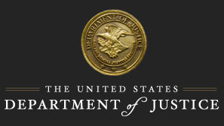

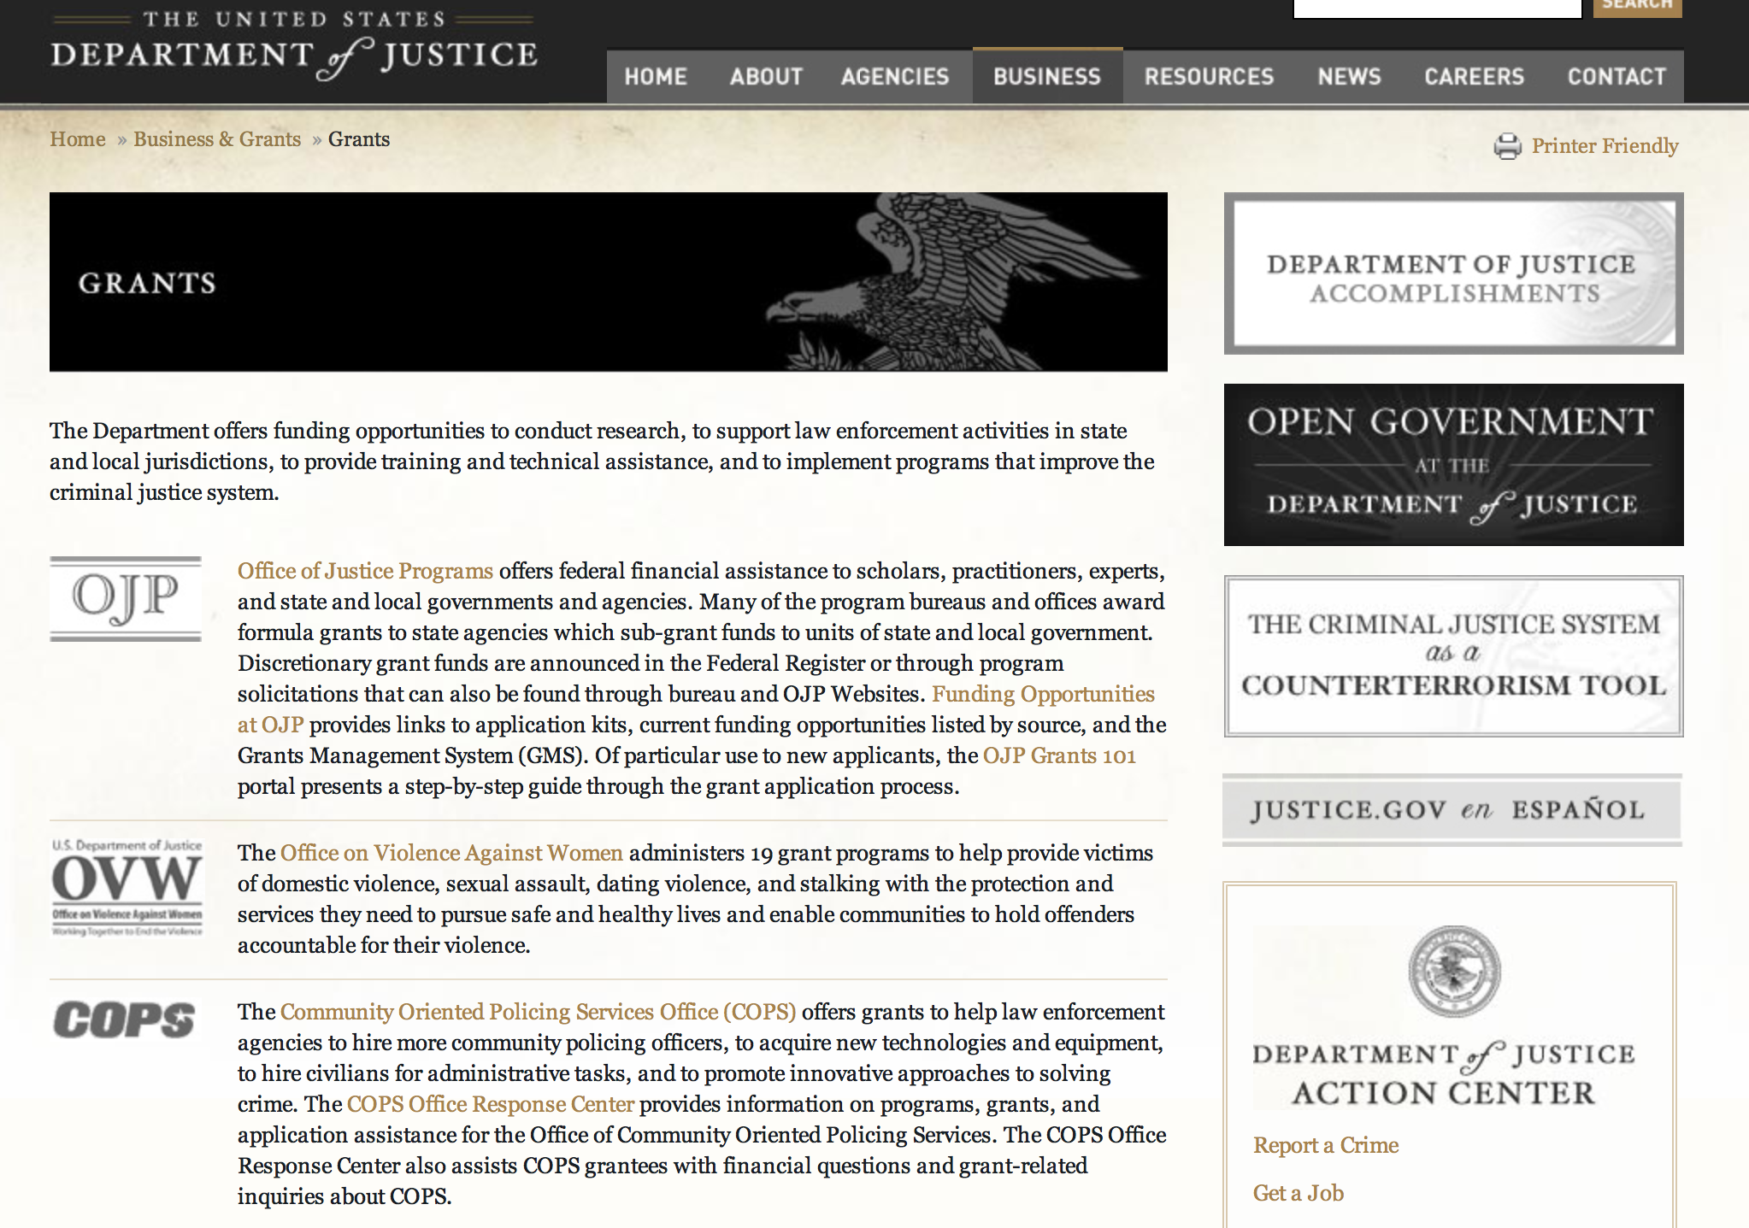

The DOJ agencies listed below also have sites that provide grant information specific to that agency. Examples of what can be found on these sites are programs, funding opportunities, application assistance, and other useful information.

Bureau of Justice Assistance (BJA)

Bureau of Justice Statistics (BJS)

National Criminal Justice Reference Service (NCJRS)

National Institute of Justice (NIJ)

Office of Juvenile Justice and Delinquency Prevention (OJJDP)

Office of Sex Offender Sentencing, Monitoring, Apprehending, Registering, and Tracking (SMART)

Office for Victims of Crime (OVC)

http://www.justice.gov/business/

Programs:

Research:

Modifications:

Office of Justice Programs
Office for Victims of Crime
OVC FY 16 Building and Enhancing Partnerships to Support Incarcerated Survivors of Sexual Abuse
Modifications 1 & 4
Document Type: | Grants Notice
Funding Opportunity Number: | OVC-2016-10240
Funding Opportunity Title: | OVC FY 16 Building and Enhancing Partnerships to Support Incarcerated Survivors of Sexual Abuse
Opportunity Category: | Discretionary
Opportunity Category Explanation:
Funding Instrument Type: | Cooperative Agreement
Category of Funding Activity: | Income Security and Social Services  Law, Justice and Legal Services
Category Explanation:
Expected Number of Awards: | 4
CFDA Number(s): | 16.582 -- Crime Victim Assistance/Discretionary Grants
Cost Sharing or Matching Requirement: | No
Version: | Synopsis 4
Posted Date: | Jun 10, 2016
Last Updated Date: | Jun 27, 2016
Original Closing Date for Applications: | Jul 25, 2016
Current Closing Date for Applications: | Jul 25, 2016
Archive Date:
Estimated Total Program Funding: | $1,200,000
Award Ceiling: | $300,000
Eligible Applicants: | Others (see text field entitled "Additional Information on Eligibility" for clarification)
Additional Information on Eligibility: | For additional information, see Section C. Eligibility Information.
Agency Name: | Office for Victims of Crime
Description: | This solicitation is intended to support the development and enhancement of partnerships between correction agencies and community based victim service providers with the goal of increasing access to outside support services for incarcerated survivors of sexual abuse. Eligible applicants shall be nonprofit organizations (including tribal nonprofit organizations) with a demonstrated knowledge of and experience with providing support services to victims of sexual abuse and/or rape crisis coalitions, and a strong desire to provide victim support services to incarcerated survivor.
Link to Additional Information: | Funding Opportunity
Grantor Contact Information: | If you have difficulty accessing the full announcement electronically, please contact:  Stacy.Phillips@ojp.usdoj.gov or 202-616-3627 Stacy.Phillips@ojp.usdoj.gov  For Programmatic Questions

Modification 4
Modification Comments: The Deadline to submit an application is MONDAY, JULY 25, 2016 by 11:59 p.m.

http://www.grants.gov/web/grants/view-opportunity.html?oppId=284571



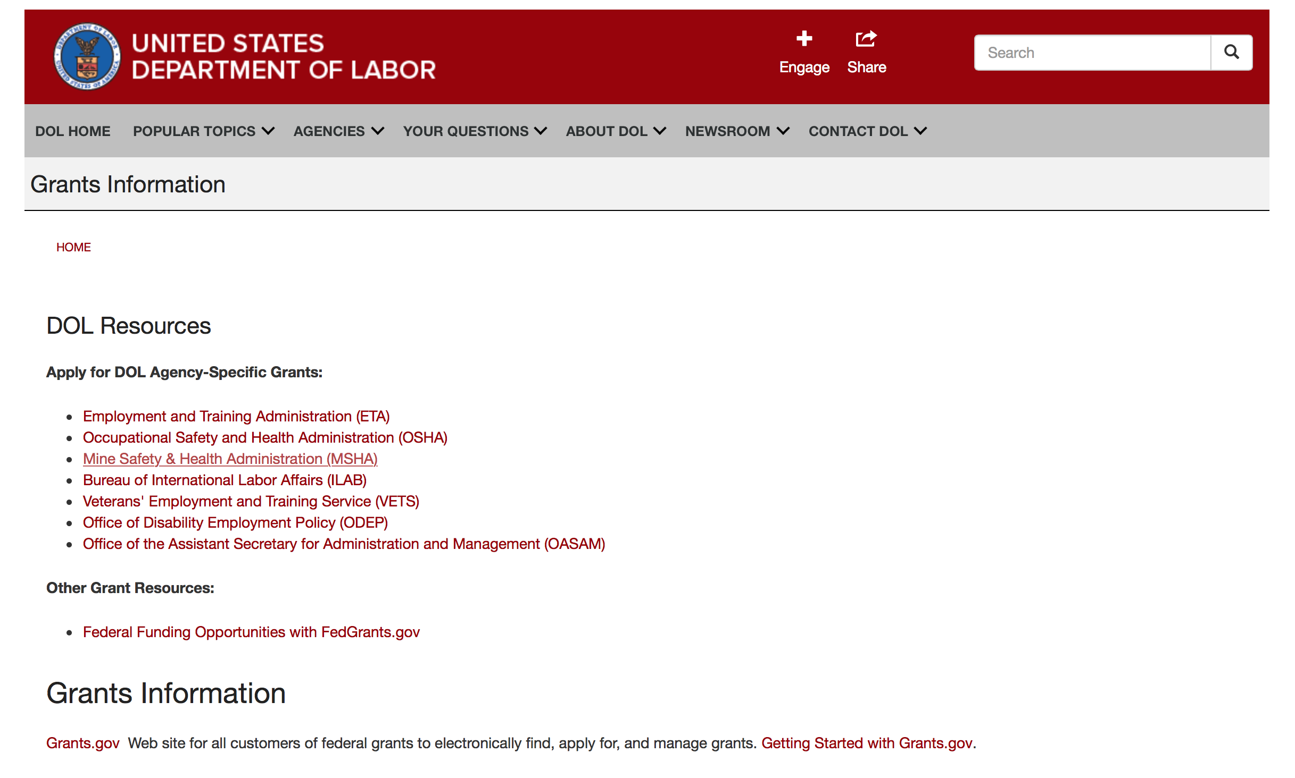

Agency Grants and Contract General Overview

DOL Resources
Apply for DOL Agency-Specific Grants:
- Employment and Training Administration (ETA)
- Occupational Safety and Health Administration (OSHA)
- Mine Safety & Health Administration (MSHA)
- Bureau of International Labor Affairs (ILAB)
- Veterans' Employment and Training Service (VETS)
- Office of Disability Employment Policy (ODEP)
- Office of the Assistant Secretary for Administration and Management (OASAM)

Other Grant Resources:
- Federal Funding Opportunities with FedGrants.gov
Grants Information
Grants.gov — Web site for all customers of federal grants to electronically find, apply for, and manage grants. Getting Started with Grants.gov.

DOL Resources and Instructions for Applying for a Grant
- DOL Guidance Clarifying the Effect of the Religious Freedom Restoration Act on Faith-Based Organizations
- Grant and Contract Information
- Contracting and Grant Program Overview
- Annual Acquisition Plan & Procurement Forecast
- Civil Rights Enforcement for Department of Labor Grant Recipients
- More Information About Grants
- Use of Contracts, Grants & Cooperative Agreements

Other Federal Government Grant Information
- List of Parties Excluded From Federal Procurement and Nonprocurement Programs (as created and maintained by GSA)
- Grant Opportunities (Catalog of Federal Domestic Assistance)

Department of Labor Grant Programs

- Bureau of International Labor Affairs (ILAB): provides grants (cooperative agreements) for the implementation of projects designed to assist developing countries combat the worse forms of child labor, forced labor, and human trafficking; and support worker rights and improve working conditions. http://www.dol.gov/general/business.
- Bureau of Labor Statistics (BLS): provides project grants (cooperative agreements) and the dissemination of technical statistical data and related information on labor force activities; provides data on prices (CPI) and cost of living; data on productivity and technology data; data on compensation and working conditions; data on employment projections.
- Employment and Training (ETA): ETA administers financial assistance programs pursuant to the Workforce Investment Act (WIA), administering State formula grant programs for youth, adults and dislocated workers, national emergency grants for workers affected by mass layoffs, plant closures, and disasters; grant programs for workers with disabilities, Indians and Native Americans, and for migrant and seasonal farmworkers. ETA also administers grant programs for older American workers, apprenticeship programs, Trade Adjustment Assistance (TAA) programs, and assistance for research and development of workforce programs. In addition, ETA is responsible for the operation and maintenance of a national system of public employment service offices and for the national unemployment insurance program.
- Mine Safety and Health (MSHA): provides grants for research, education and training programs to ensure an adequate and competent staff of trained inspectors; and assistance for establishing or improving State mine health and safety programs through technical assistance.
- Occupational Safety and Health (OSHA): provides grants to non-profit organizations to provide training, educational services, and technical assistance; assistance to states to administer and enforce state programs; assistance to states to provide occupational safety and health technical assistance and consultant services.
- Office of Disability Employment Policy (ODEP): The Office of Disability Employment Policy awards competitive grants establishing short-term pilot and technical assistance projects designed to identify, develop, test, evaluate, and disseminate policies to increase employment by expanding access to training, education, employment supports, assistive and systems technology, integrated employment, entrepreneurial development, and small business opportunities for adults and youth with disabilities. Current pilots projects focus on customized employment, Olmstead populations, and innovative demonstration youth grants, among others. Solicitations for grant applications are published in the Federal Register and announced at www.dol.gov/odep. ODEP grants are awarded by the OASAM grant office.
- Veterans' Employment and Training (VETS): provides special employment and training assistance for veterans through the Disabled Veterans' Outreach Program (DVOP) Solicitation for Grant Applications; the Local Veterans' Employment Representative Program (LVER); Veterans' Workforce Investment Program (VWIP); elaws Advisor on veterans' employment and reemployment rights; and the Homeless Veterans Reintegration Project (HVRP). VETS grants are awarded by the OASAM grant office.

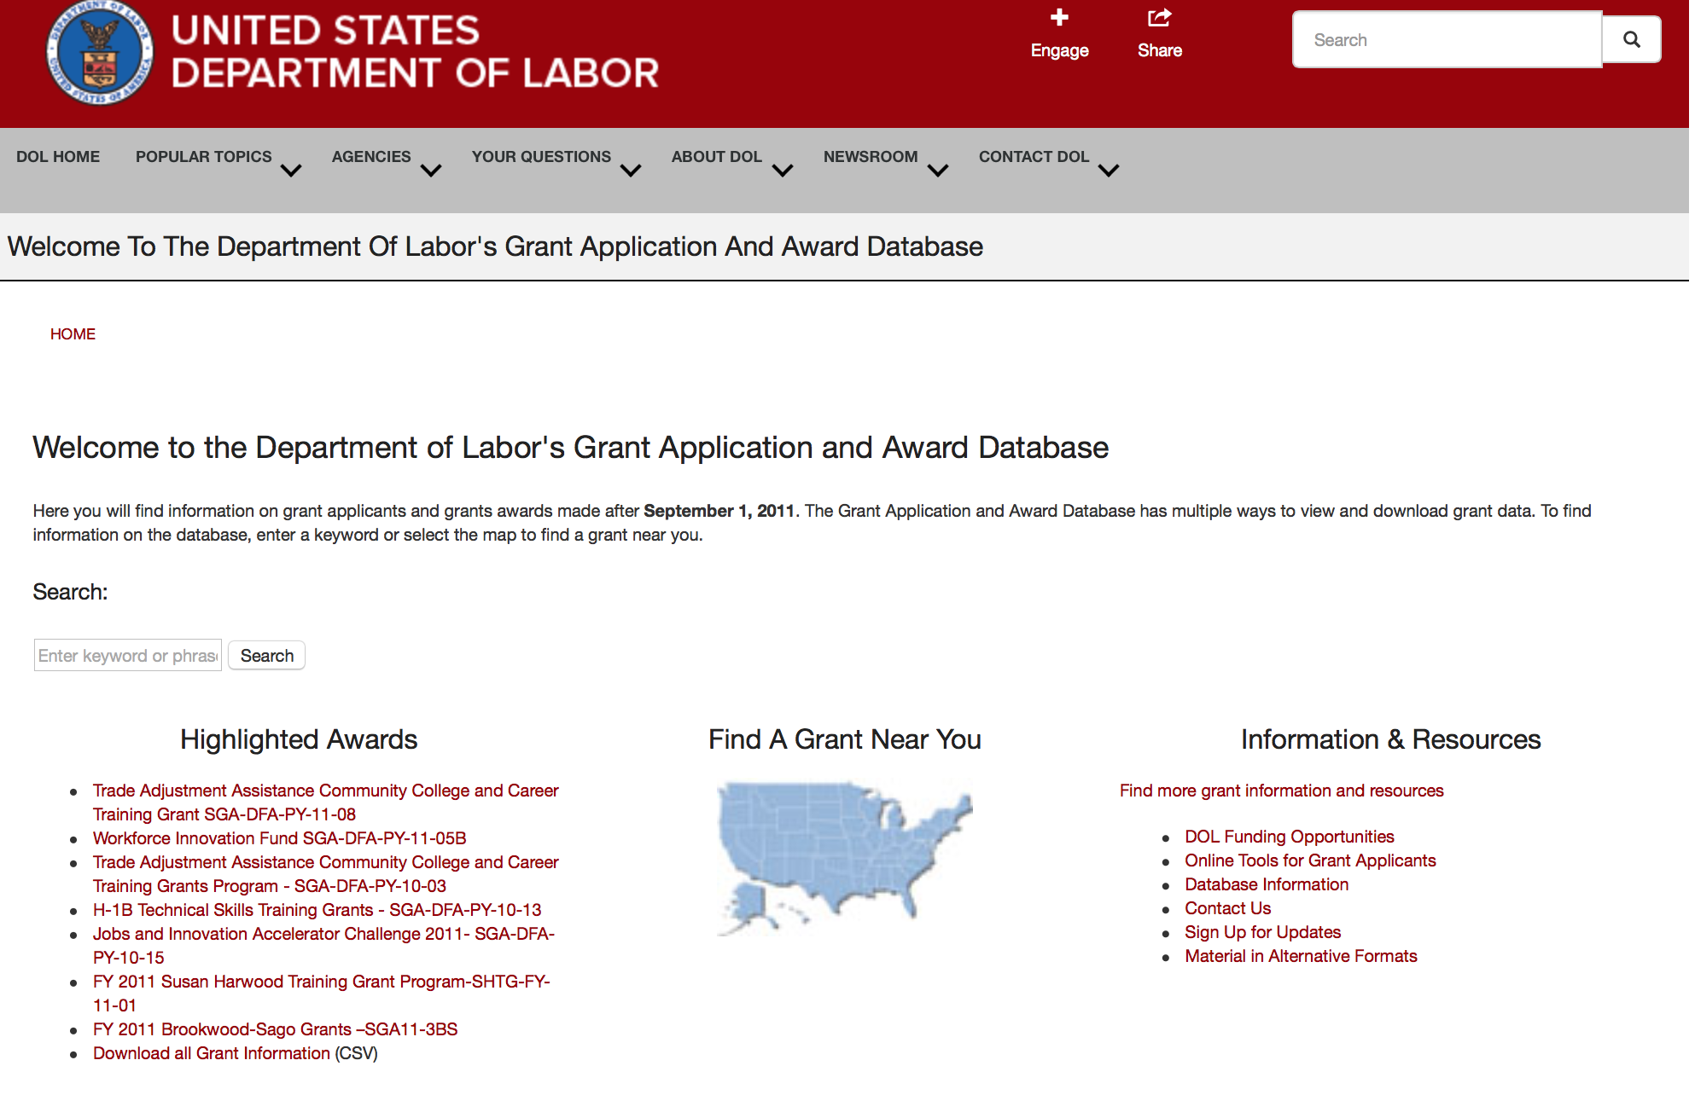

http://www.dol.gov/dol/grants/

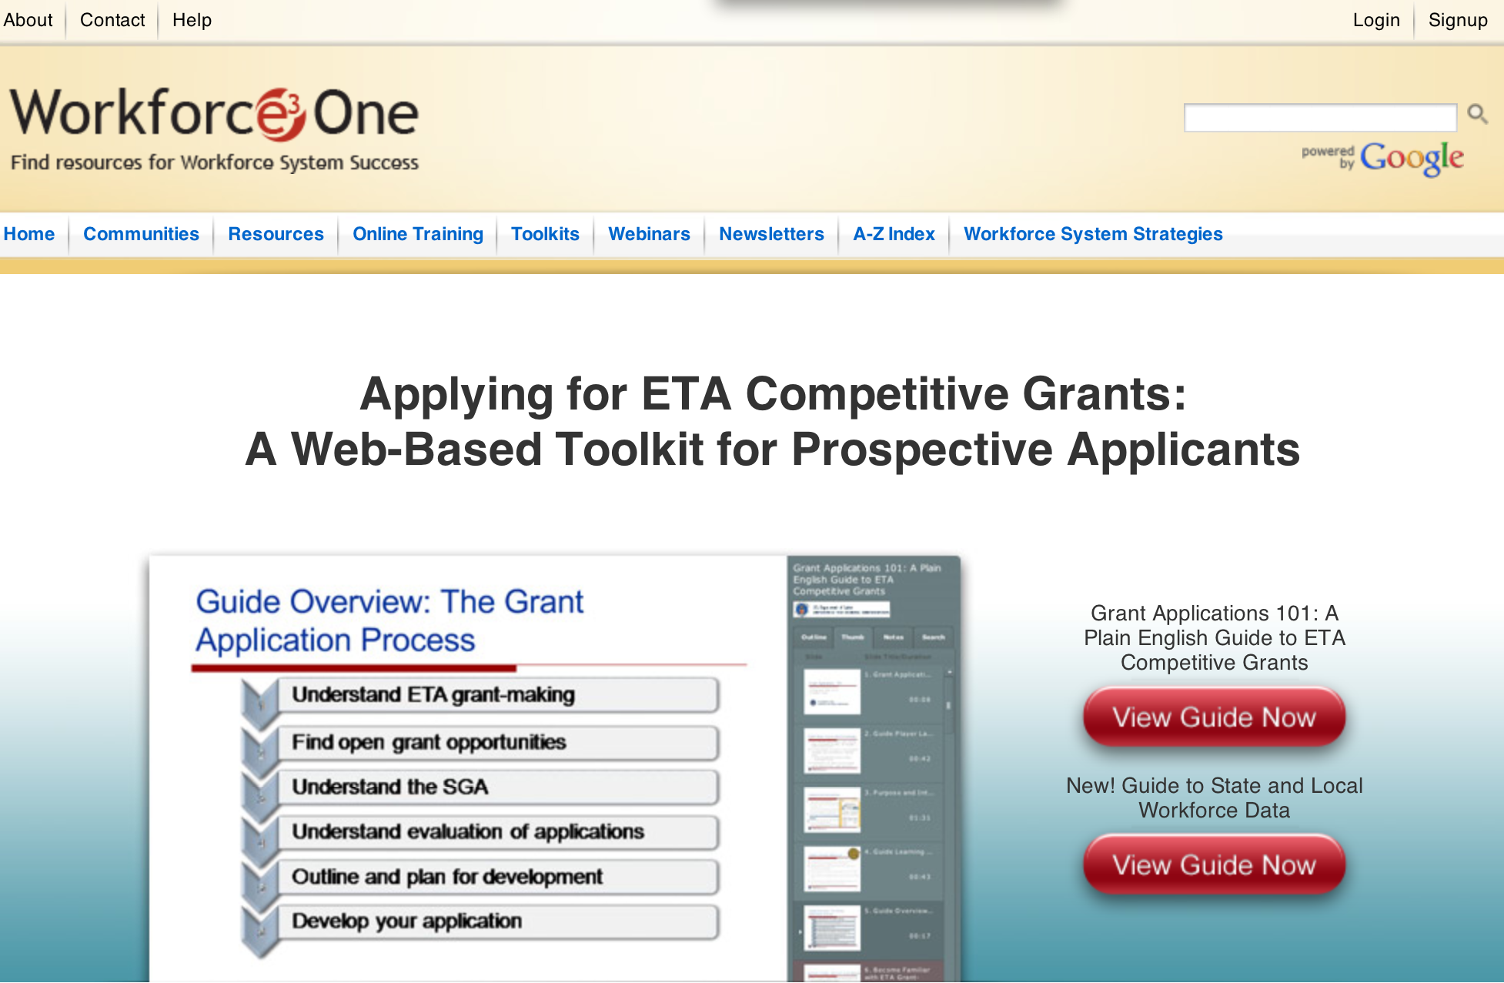

https://www.workforce3one.org/ws/www/pages/grants_toolkit.aspx?pparams=/

Programs

Funding Opportunity Number: FOA-ETA-16-04-A
Senior Community Service Employment Program (SCSEP) National Grants for Program Year (PY) 2016
Employment and Training Administration
Posted Date: Jun 23, 2016

Document Type: | Grants Notice
Funding Opportunity Number: | FOA-ETA-16-04-A
Funding Opportunity Title: | Senior Community Service Employment Program (SCSEP) National Grants for Program Year (PY) 2016
Opportunity Category: | Discretionary
Opportunity Category Explanation:
Funding Instrument Type: | Grant
Category of Funding Activity: | Employment, Labor and Training
Category Explanation:
Expected Number of Awards: | 22
CFDA Number(s): | 17.235 -- Senior Community Service Employment Program
Cost Sharing or Matching Requirement: | No
Posted Date: | Jun 23, 2016
Last Updated Date: | Jun 23, 2016
Original Closing Date for Applications: | Jul 25, 2016 Applications must be received no later than 4:00:00 p.m. Eastern Time.
Current Closing Date for Applications: | Jul 25, 2016 Applications must be received no later than 4:00:00 p.m. Eastern Time.
Archive Date: | Aug 24, 2016
Estimated Total Program Funding: | $338,520,000
Award Ceiling: | $50,000,000
Award Floor: | $2,000,000
Eligible Applicants: | Others (see text field entitled "Additional Information on Eligibility" for clarification)
Additional Information on Eligibility: | The following organizations are eligible to apply: • Nonprofit Organizations • Federal public agencies • Tribal organizations Applicants must demonstrate their ability to administer a multi-State program that meets the eligibility and responsibility requirements outlined in 20 CFR part 641 subpart D, which are based on the statutory criteria listed in section 514(c) of the OAA. Requirements include providing evidence of legal authority to operate a multi-State program and applying to provide services in more than one State based on the award information requirements in Section II.A.2. After selection, grantees’ Statement of Work will consist of the Project Narrative submitted in response to this FOA, the number of positions assigned by county, and the signed programmatic assurances in Appendix A. We reserve the right to award a grant to only one applicant per State, and to award an applicant funds to serve only one State. This reservation does not, however, permit an applicant to apply to provide services in only one State.
Agency Name: | Employment and Training Administration
Description: | Employment and Training Administration (ETA) is reopening the SCSEP FOA open period through the closing date noted above to help ensure adequate coverage of the necessary geographic areas and associated participant slots. The Employment and Training Administration (ETA), U.S. Department of Labor (DOL, or the Department, or we), announces the availability of approximately $338,520,000 in grant funds authorized by Title V of the Older Americans Act (OAA) as amended in 2006, Pub. L. No. 109-365 for the Community Service Employment for Older Americans program commonly referred to as the Senior Community Service Employment Program (SCSEP), for National Grants for Program Year (PY) 2016. We anticipate awarding approximately 10-22 grants ranging from $2 million to $50 million each under this FOA. Awards made under this announcement are subject to the availability of Federal funds. Selection of grantees will be determined based on the strength of the proposal and on other pertinent factors, outlined in this announcement. This is a four-year grant, renewable annually for each of those four years based on annual Departmental application requirements and subject to the availability of funds. The grant may be extended for a fifth year at the Department’s discretion, contingent upon the grantee meeting or exceeding the minimum negotiated performance measures as required by section 514(a) of the OAA Amendments and 20 CFR 641.700.
Link to Additional Information:
Grantor Contact Information: | If you have difficulty accessing the full announcement electronically, please contact:  Jeannette Flowers Grants Management Specialist  Flowers.Jeannette@dol.gov

Link: http://www.grants.gov/web/grants/view-opportunity.html?oppId=285373

Funding Opportunity Number: FOA-ETA-16-07
Disability Employment Initiative Cooperative Agreements
Employment and Training Administration

Document Type: | Grants Notice
Funding Opportunity Number: | FOA-ETA-16-07
Funding Opportunity Title: | Disability Employment Initiative Cooperative Agreements
Opportunity Category: | Discretionary
Opportunity Category Explanation:
Funding Instrument Type: | Cooperative Agreement
Category of Funding Activity: | Employment, Labor and Training
Category Explanation:
Expected Number of Awards: | 8
CFDA Number(s): | 17.283 -- Workforce Innovation Fund
Cost Sharing or Matching Requirement: | No
Posted Date: | Jun 27, 2016
Last Updated Date: | Jun 27, 2016
Original Closing Date for Applications: | Aug 01, 2016 Applications must be received no later than 4:00:00 p.m. Eastern Time.
Current Closing Date for Applications: | Aug 01, 2016 Applications must be received no later than 4:00:00 p.m. Eastern Time.
Archive Date: | Aug 31, 2016
Estimated Total Program Funding: | $15,600,000
Award Ceiling: | $2,500,000
Award Floor: | $1,500,000
Eligible Applicants: | Others (see text field entitled "Additional Information on Eligibility" for clarification)
Additional Information on Eligibility: | The following organizations are eligible to apply: Cooperative agreements will be awarded to a lead applicant, which will serve as the grantee and have overall fiscal and administrative responsibility for the cooperative agreement. This responsibility may not be delegated. The lead applicant must be the state workforce agency (SWA) that is eligible for funding under Title I of WIOA or for funding under the W-P Act. The SWA, as well as the Local Workforce Development Board(s) (LWDB) identified as a required partner for this grant, must be involved in existing career pathways systems, programs, and partnerships. (The reference to LWDBs throughout this FOA is not meant to eliminate states with single state workforce areas from the DEI.) Applicants may also include entities receiving funds under WIOA Section 166 grants. An eligible applicant is a tribe, tribal consortium, or tribal non-profit organization that receives funds under WIOA Section 166 Indian and Native American Program. These applicants are not required to partner with LWDBs. States that received DEI Round VI funds are not eligible for funding under this FOA.
Agency Name: | Employment and Training Administration
Description: | This announcement solicits applications for Round VII of the Disability Employment Initiative (DEI). The purpose of this program is to provide funding to expand the capacity of American Job Centers (AJCs), also known as One-Stop Centers, to improve the employment outcomes of three population focus areas: 1) adults (ages 18 and older) with visible and non-visible disabilities, including those who have acquired disabilities in adulthood; 2) youth (ages 14-24) with visible and non-visible disabilities, including those who have chronic health conditions; and 3) individuals (ages 14 and older) with significant disabilities. The DEI plans to accomplish this by increasing their participation in career pathways systems and successful existing programs in the public workforce system in partnership with vocational rehabilitation, community colleges and other education, human service, and business partners. Capitalizing on the flexibility that the career pathways model provides to use innovative service delivery strategies, grantees will use their award to support job-driven approaches in their pre-existing career pathway systems and programs. This will further equip individuals with disabilities with the skills, competencies, and credentials necessary to help them obtain in-demand jobs, increase earnings, and advance their careers. The Department intends to award at least one cooperative agreement in each of three population focus areas: 1) adults (ages 18 and older) with visible and non-visible disabilities, including those who have acquired disabilities in adulthood; 2) youth (ages 14-24) with visible and non-visible disabilities, including those who have chronic health conditions; and 3) individuals (ages 14 and older) with significant disabilities. The period of performance is 42 months with an anticipated start date of October 1, 2016. This performance period includes all necessary implementation and start-up activities.
Link to Additional Information:
Grantor Contact Information: | If you have difficulty accessing the full announcement electronically, please contact:  Erika Beasley Grants Management Specialist  beasley.erika@dol.gov

Link: http://www.grants.gov/web/grants/view-opportunity.html?oppId=285479

Employment and Training Administration
America’s Promise Job Driven Grant Program

Document Type: | Grants Notice
Funding Opportunity Number: | FOA-ETA-16-12
Funding Opportunity Title: | America’s Promise Job Driven Grant Program
Opportunity Category: | Discretionary
Opportunity Category Explanation:
Funding Instrument Type: | Grant
Category of Funding Activity: | Employment, Labor and Training
Category Explanation:
Expected Number of Awards: | 40
CFDA Number(s): | 17.268 -- H-1B Job Training Grants
Cost Sharing or Matching Requirement: | No
Posted Date: | Jun 06, 2016
Last Updated Date: | Jun 06, 2016
Original Closing Date for Applications: | Aug 25, 2016 Applications must be received no later than 4:00:00 p.m. Eastern Time.
Current Closing Date for Applications: | Aug 25, 2016 Applications must be received no later than 4:00:00 p.m. Eastern Time.
Archive Date: | Sep 24, 2016
Estimated Total Program Funding: | $100,000,000
Award Ceiling: | $6,000,000
Award Floor: | $1,000,000
Eligible Applicants: | Others (see text field entitled "Additional Information on Eligibility" for clarification)
Additional Information on Eligibility: | To be eligible for consideration, the lead applicant in the regional workforce partnership must represent one of the following types of entities: a) the workforce investment system; b) education and training providers, including community and technical colleges and systems; and c) business-related nonprofit organizations, an organization functioning as a workforce intermediary for the express purpose of serving the needs of an industry, or a regional or industry association. Applications that do not include a lead applicant that meets the eligibility requirements of one of the three types of entities mentioned above will be considered non-responsive and will not be reviewed.
Agency Name: | Employment and Training Administration
Description: | The purpose of America’s Promise grant program is to strengthen the pipeline of skilled workers to expand an economic region’s middle- to high-skilled workforce within one or more prioritized industry sector(s), thereby creating economic opportunities for America’s workforce to gain the necessary skills to fill in-demand jobs and increasing the long-term competitiveness of an economic region. To help achieve this goal, the grant will provide individuals the opportunity to get high-quality, tuition free education and training that leads to in-demand and industry-recognized credentials and degrees. A fundamental goal of America’s Promise is to accelerate the development of new and the expansion of existing 21st century regional workforce partnerships with business and industry leaders committed to providing a pipeline of skilled workers in a specific industry sector(s). These partnerships will bring together industry leaders with senior level leadership from workforce and economic development, secondary and post-secondary education, elected officials, and other important community stakeholders. To keep pace with the rapid shifts we are seeing in today’s economy, we encourage these partnerships to leverage data and technology to increase communication between employers, workforce and training providers, and job seekers.
Link to Additional Information:
Grantor Contact Information: | If you have difficulty accessing the full announcement electronically, please contact:  Ariam Ferro Grants Management Specialists  ferro.ariam@dol.gov

http://www.grants.gov/web/grants/view-opportunity.html?oppId=284371

Employment and Training Administration
Bureau of International Labor Affairs
Project to Reduce the Exploitation of Children in the Sava Region of Madagascar Grant

Document Type: | Grants Notice
Funding Opportunity Number: | FOA-ILAB-16-08
Funding Opportunity Title: | Project to Reduce the Exploitation of Children in the Sava Region of Madagascar
Opportunity Category: | Discretionary
Opportunity Category Explanation: | Category Explanation
Funding Instrument Type: | Cooperative Agreement
Category of Funding Activity: | Employment, Labor and Training
Category Explanation:
Expected Number of Awards:
CFDA Number(s): | 17.401 -- International Labor Programs
Cost Sharing or Matching Requirement: | No
Posted Date: | Jun 09, 2016
Last Updated Date: | Jun 09, 2016
Original Closing Date for Applications: | Aug 18, 2016
Current Closing Date for Applications: | Aug 18, 2016
Archive Date: | Aug 31, 2016
Estimated Total Program Funding: | $4,000,000
Award Ceiling: | $4,000,000
Award Floor: | $4,000,000
Eligible Applicants: | Others (see text field entitled "Additional Information on Eligibility" for clarification)
Additional Information on Eligibility: | Eligible applicants may include any commercial, international, educational, or non-profit organizations, including any faith-based organizations, community-based organizations, or public international organizations (PIOs), capable of successfully fulfilling the objectives identified in the Funding Opportunity Description.
Agency Name: | Bureau of International Labor Affairs
Description: | The Bureau of International Labor Affairs (ILAB), U.S. Department of Labor (DOL, or the Department, or we), announces the availability of approximately $4,000,000 total costs for one or more cooperative agreements to fund a technical assistance project(s) in Madagascar to reduce child labor in the vanilla-producing areas of the Sava region of Madagascar. The project outcomes include: 1) Vanilla exporters have significantly reduced child labor in the production of vanilla at the farm and collection levels in Sava. 2) Law enforcement entities are effectively enforcing child labor laws and policies in the vanilla-producing areas of Sava, including imposing and collecting penalties and referring child labor victims to appropriate services. 3) Community members are monitoring for child labor and are referring victims of child labor to the appropriate authorities and services. 4) Beneficiary households are no longer using child labor to supplement household income. The duration of the project will be a maximum of 4 years (48 months) from the effective date of the award.
Link to Additional Information:
Grantor Contact Information: | If you have difficulty accessing the full announcement electronically, please contact:  Sue Levenstein, Grants Management Specialist  Levenstein.Susan.L@dol.gov

http://www.grants.gov/web/grants/view-opportunity.html?oppId=284502

Modifications

Reminders



National Aeronautics and Space Administration

Research and Contracting Opportunities

NASA Research Opportunities Online

- Various NASA offices publish their research announcements over the Internet, broadening the opportunity for researchers to apply for funding. This site provides access to current research announcements along with their specific due dates.

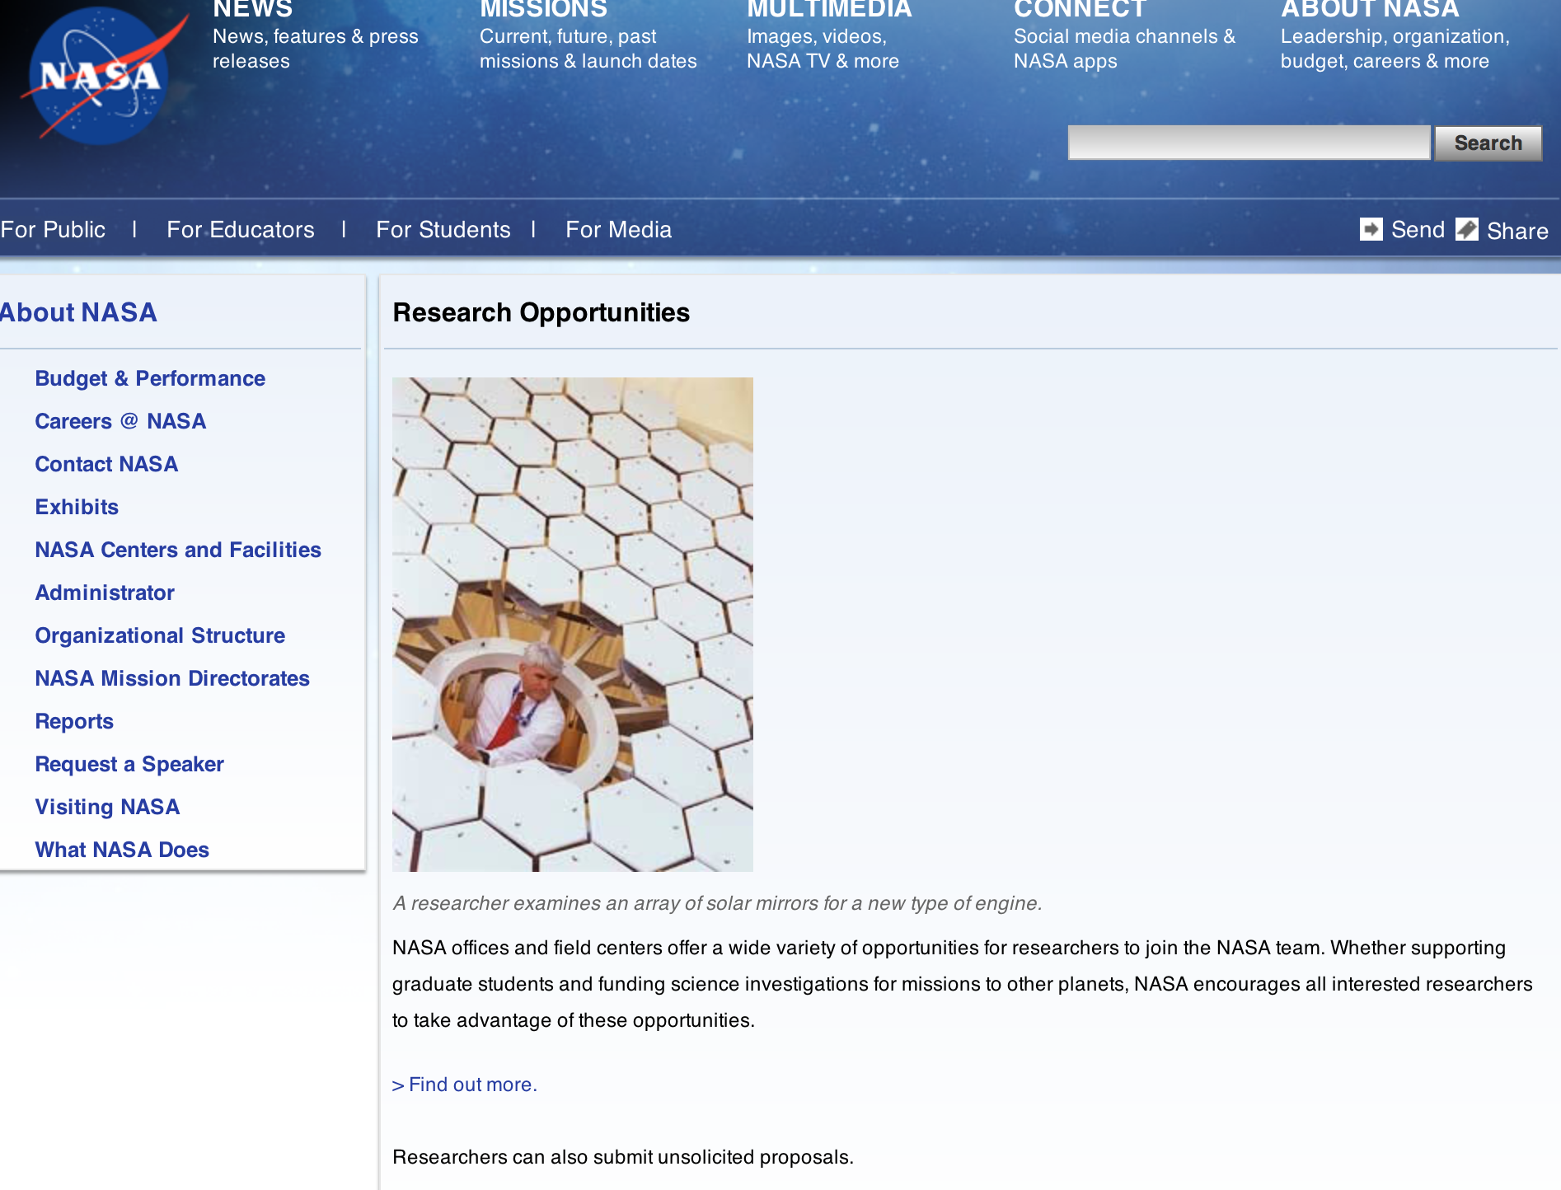

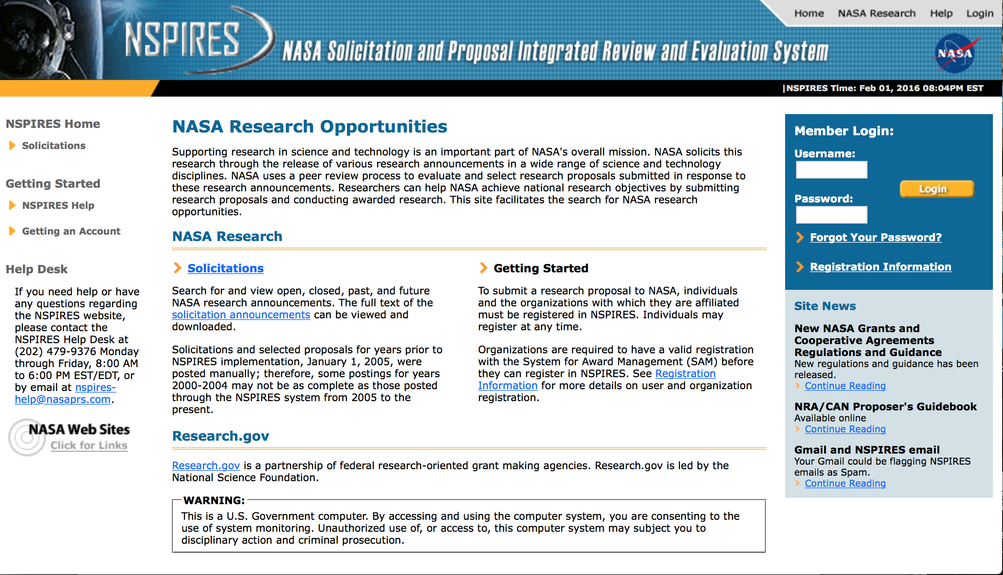

http://nspires.nasaprs.com/external/

Research Programs:

NASA Headquarters
ROSES 2016: Heliophysics Supporting Research Grant
http://www.grants.gov/web/grants/view-opportunity.html?oppId=284403

NASA Headquarters
ROSES 2016: Planetary Science and Technology Through Analog Research Grant
http://www.grants.gov/web/grants/view-opportunity.html?oppId=284424

Funding Opportunity Number: NNH16ZOA001N-16STMD-001
UTILIZING PUBLIC - PRIVATE PARTNERSHIPS TO ADVANCE TIPPING POINT TECHNOLOGIES
NASA Headquarters
Posted Date: Jun 29, 2016
Link: http://www.grants.gov/web/grants/view-opportunity.html?oppId=285570

Funding Opportunity Number: NNH16ZDA001N-ICEBST
ROSES 2016: IceBridge Science Team
NASA Headquarters
Posted Date: Jun 24, 2016
Link: http://www.grants.gov/web/grants/view-opportunity.html?oppId=285365

Funding Opportunity Number: NNH16ZDA001N-MDAP
ROSES 2016: Mars Data Analysis Program
Agency: National Aeronautics and Space Administration
NASA Headquarters
Posted Date: Jun 24, 2016
Link: http://www.grants.gov/web/grants/view-opportunity.html?oppId=285393

Funding Opportunity Number: NNH16ZDA001N-MDAP
ROSES 2016: Mars Data Analysis Program
Agency Code: NASA-HQ
Agency: National Aeronautics and Space Administration
NASA Headquarters
Posted Date: Jun 24, 2016
Link: http://www.grants.gov/web/grants/view-opportunity.html?oppId=285393

Modifications:

Funding Opportunity Number: NNH16ZDA001N-HTIDS
Funding Opportunity Title: ROSES 2016: Heliophysics Technology and Instrument Development for Science
NASA Headquarters
Posted Date: Apr 14, 2016
Modification: 2
Modification Comments: Close date changed to 7/22/16 to permit submission of Step-2 proposals
Link: http://www.grants.gov/web/grants/view-opportunity.html?oppId=283001

Number: NNH16ZDA001N-ICESAT2
ROSES 2016: Studies with IceSat and CryoSat -2
NASA Headquarters
Posted Date: Jun 24, 2016
Modification 2
Modification Comments: Description was duplicate of "other" explanation due to a copy/paste error. Inserted corrected Description
Link: http://www.grants.gov/web/grants/view-opportunity.html?oppId=285364

NASA Johnson Space Center
EXPLORATION TECHNOLOGY DEMONSTRATION AND NATIONAL LAB UTILIZATION ENHANCEMENTS
Modification 5
http://www.grants.gov/web/grants/view-opportunity.html?oppId=207073

NASA Headquarters
ROSES 2016: Maturation of Instruments for Solar System Exploration
Modification 2

http://www.grants.gov/web/grants/view-opportunity.html?oppId=282380

NASA Headquarters
ROSES 2016: Exobiology
Modification 1
http://www.grants.gov/web/grants/view-opportunity.html?oppId=283000

NASA Headquarters
ROSES 2016: Heliophysics Data Environment Enhancements
Modification 1
http://www.grants.gov/web/grants/view-opportunity.html?oppId=283002

Funding Opportunity Number: NNH16ZDA001N-ICESAT2
Funding Opportunity Title: ROSES 2016: Studies with IceSat and CryoSat -2
Agency Code: NASA-HQ
Agency: National Aeronautics and Space Administration
NASA Headquarters
Posted Date: Jun 24, 2016
Modification 2
Modification Comments: Description was duplicate of "other" explanation due to a copy/paste error. Inserted corrected Description
Link: http://www.grants.gov/web/grants/view-opportunity.html?oppId=285364

National Archives and Records Administration

Grant Opportunities General Overview

To access the information below: click here

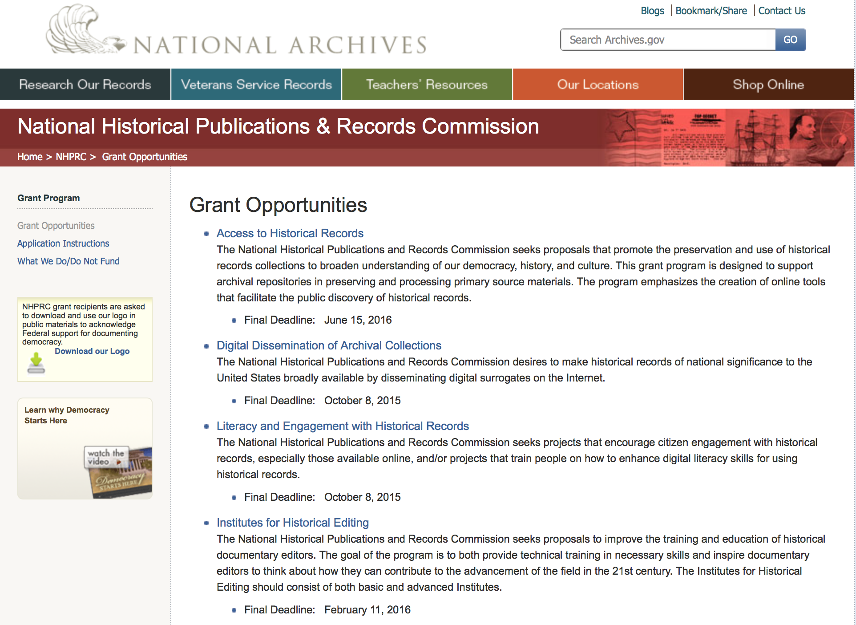

Public Engagement with Historical Records Grant

Document Type: | Grants Notice
Funding Opportunity Number: | ENGAGEMENT-201610
Funding Opportunity Title: | Public Engagement with Historical Records
Opportunity Category: | Discretionary
Opportunity Category Explanation:
Funding Instrument Type: | Grant
Category of Funding Activity: | Humanities (see "Cultural Affairs" in CFDA)
Category Explanation:
Expected Number of Awards: | 3
CFDA Number(s): | 89.003 -- National Historical Publications and Records Grants
Cost Sharing or Matching Requirement: | Yes
Posted Date: | Jun 06, 2016
Last Updated Date: | Jun 06, 2016
Original Closing Date for Applications: | Oct 06, 2016
Current Closing Date for Applications: | Oct 06, 2016
Archive Date:
Estimated Total Program Funding: | $275,000
Award Ceiling: | $150,000
Award Floor: | $50,000
Eligible Applicants: | State governments  Public and State controlled institutions of higher education  City or township governments  Nonprofits having a 501(c)(3) status with the IRS, other than institutions of higher education  Private institutions of higher education  County governments  Native American tribal governments (Federally recognized)
Agency Name: | National Archives and Records Administration
Description: | The National Historical Publications and Records Commission seeks projects that encourage public engagement with historical records, including the development of new tools that enable people to engage online. The NHPRC is looking for projects that create models and technologies that other institutions can freely adopt. In general, collaborations between archivists, documentary editors, historians, educators, and/or community-based individuals are more likely to create a competitive proposal. Projects might create and develop programs to engage people in the study and use of historical records for institutional, educational or personal reasons. For example, an applicant can: • Enlist volunteer “citizen archivists” in projects to accelerate access to historical records, especially those online. This may include, but is not limited to, efforts to identify, tag, transcribe, annotate, or otherwise enhance digitized historical records. • Develop educational programs for K-16 students or community members that encourage them to engage with historical records already in repositories or that are collected as part of the project. For a comprehensive list of the Commission’s limitations on funding, please see “What we do and do not fund” (http://www.archives.gov/nhprc/apply/eligibility.html). Applications that consist entirely of ineligible activities will not be considered. Award Information A grant normally is for one to three years. The Commission expects to make up to three grants of between $50,000 and $150,000. The total amount allocated for this program is up to $275,000. Grants begin no earlier than July 1, 2017. The Commission requires that grant recipients acknowledge NHPRC grant assistance in all publications and other products that result from its support. Eligibility Information Eligible applicants: • Nonprofit organizations or institutions • Colleges, universities, and other academic institutions • State or local government agencies • Federally-acknowledged or state-recognized Native American tribes or groups Cost Sharing The total costs of a project are shared between the NHPRC and the applicant organization. The Commission provides no more than 50 per cent of total direct project costs in the Public Engagement with Historical Records category. NHPRC grant recipients are not permitted to use grant funds for indirect costs (as indicated in 2 CFR 2600.101). The applicant’s financial contribution may include both direct and indirect expenses, in-kind contributions, non-Federal third-party contributions, and any income earned directly by the project. Indirect costs must be listed under the applicant’s cost sharing contribution. Other Requirements Applicant organizations must be registered in the System for Award Management (SAM) prior to submitting an application, maintain SAM registration throughout the application and award process, and include a valid DUNS number in their application. Details on SAM registration and requesting a DUNS number can be found at the System for Award Management website at www.sam.gov. Please refer to the User Guides section and the Grants Registrations PDF. A complete application includes the Application for Federal Assistance (Standard Form 424), Assurances -- Non-Construction Programs (Standard Form 424B), a Project Narrative, Summary, Supplementary Materials, and Budget. Applications lacking these items will not be considered. Ineligible applications will not be reviewed.
Link to Additional Information: | Link to full grant announcement, including additional requirements
Grantor Contact Information: | If you have difficulty accessing the full announcement electronically, please contact:  Jeff de la Concepcion Jeff.delaconcepcion@nara.gov  Grant Information Specialist

http://www.grants.gov/web/grants/view-opportunity.html?oppId=284376

Reminders:

Publishing Historical Records in Documentary Editions Grant

Document Type: | Grants Notice
Funding Opportunity Number: | EDITIONS-201610
Funding Opportunity Title: | Publishing Historical Records in Documentary Editions
Opportunity Category: | Discretionary
Funding Instrument Type: | Grant
Category of Funding Activity: | Humanities (see "Cultural Affairs" in CFDA)
Category Explanation:
Expected Number of Awards: | 25
CFDA Number(s): | 89.003 -- National Historical Publications and Records Grants
Cost Sharing or Matching Requirement: | Yes
Posted Date: | Nov 24, 2015
Creation Date: | Nov 23, 2015
Original Closing Date for Applications: | Oct 6, 2016
Current Closing Date for Applications: | Oct 6, 2016
Archive Date: | Nov 4, 2016
Estimated Total Program Funding: | $2,500,000
Award Ceiling: | $200,000
Award Floor: | $0
Eligible Applicants: | Private institutions of higher education  County governments  City or township governments  Public and State controlled institutions of higher education  Native American tribal governments (Federally recognized)  Nonprofits having a 501(c)(3) status with the IRS, other than institutions of higher education  State governments
Agency Name: | National Archives and Records Administration
Description: | The National Historical Publications and Records Commission seeks proposals to publish documentary editions of historical records. Projects may focus on the papers of major figures from American history or cover broad historical movements in politics, military, business, social reform, the arts, and other aspects of the national experience. The historical value of the records and their expected usefulness to broad audiences must justify the costs of the project. The goal of this program is to provide access to, and editorial context for, the historical documents and records that tell the American story. The NHPRC encourages projects, whenever possible and appropriate, to provide access to these materials in a free and open online environment, without precluding other forms of publication. Applicants should demonstrate familiarity with the best practices recommended by the Association for Documentary Editing or the Modern Language Association Committee on Scholarly Editions. Projects may also prepare print editions as part of their overall publishing plan. However, projects that do not have definitive plans for digital dissemination and preservation in place at the time of application will not be considered. It is also expected that the contents of any print volumes produced will be made available online within a reasonable period of time following print publication. Grants are awarded for collecting, describing, preserving, compiling, transcribing, annotating, editing, encoding, and publishing documentary source materials in print and online. Because of the focus on documentary sources, grants do not support preparation of critical editions of published works unless such works are just a small portion of the larger project. All applicants should be aware that the application process is highly competitive. Ongoing projects: Applicants from ongoing projects must demonstrate that they have successfully achieved the performance objectives associated with previous NHPRC awards; provide updated, current information, including a description of the new activities as well as description and significance of the specific materials to be edited during the proposed grant period; show progress towards completing the edition; and justify costs in a new budget. For a comprehensive list of Commission's limitations on funding, please see What We Do and Do Not Fund. Applications that consist entirely of ineligible activities will not be considered. Award Information A grant is for one year and for up to $200,000. The Commission expects to make up to 25 grants in this category for a total of up to $2,500,000. Grants begin no earlier than January 1, 2017. The Commission requires that grant recipients acknowledge NHPRC grant assistance in all publications and other products that result from its support. Eligibility U.S. nonprofit organizations or institutions U.S. colleges, universities, and other academic institutions State or local government agencies Federally-acknowledged or state-recognized Native American tribes or groups Cost Sharing The total costs of a project are shared between the NHPRC and the applicant organization. The Commission provides no more than 50 per cent of total direct project costs in the Publishing Historical Records in Documentary Editions category. NHPRC grant recipients are not permitted to use grant funds for indirect costs (as indicated in 2 CFR 2600.101). Cost sharing is required. The applicant’s financial contribution may include both direct and indirect expenses, in-kind contributions, non-Federal third-party contributions, and any income earned directly by the project. Indirect costs must be listed under the applicant’s cost sharing contribution. Other Requirements Applicant organizations must be registered in the System for Award Management (SAM) prior to submitting an application, maintain SAM registration throughout the application and award process, and include a valid DUNS number in their application. Details on SAM registration and requesting a DUNS number can be found at the System for Award Management website at https://sam.gov. Please refer to the User Guides section and the Grants Registrations PDF. A complete application includes the Application for Federal Assistance (Standard Form 424), Assurances -- Non-Construction Programs (Standard Form 424B), a Project Narrative, Summary, Supplementary Materials, and Budget. Applications lacking these items will not be considered. Ineligible applications will not be reviewed.
Link to Additional Information: | Link to full grant announcement, including additional requirements
Contact Information: | If you have difficulty accessing the full announcement electronically, please contact:  Jeff de la Concepcion Grant Program Specialist Phone 202-357-5022  Grant Program Specialist

http://www.grants.gov/web/grants/view-opportunity.html?oppId=280202

Access to Historical Records Grant

Document Type: | Grants Notice
Funding Opportunity Number: | ACCESS-201606
Funding Opportunity Title: | Access to Historical Records
Opportunity Category: | Discretionary
Funding Instrument Type: | Grant
Category of Funding Activity: | Humanities (see "Cultural Affairs" in CFDA)
Category Explanation:
Expected Number of Awards: | 14
CFDA Number(s): | 89.003 -- National Historical Publications and Records Grants
Cost Sharing or Matching Requirement: | Yes
Posted Date: | Nov 24, 2015
Creation Date: | Nov 23, 2015
Original Closing Date for Applications: | Jun 15, 2016
Current Closing Date for Applications: | Jun 15, 2016
Archive Date: | Jul 15, 2016
Estimated Total Program Funding: | $1,000,000
Award Ceiling: | $200,000
Eligible Applicants: | Public and State controlled institutions of higher education  State governments  City or township governments  Nonprofits having a 501(c)(3) status with the IRS, other than institutions of higher education  Private institutions of higher education  Native American tribal governments (Federally recognized)  County governments
Agency Name: | National Archives and Records Administration
Description: | The National Historical Publications and Records Commission seeks proposals that promote the preservation and use of historical records collections to broaden understanding of our democracy, history, and culture. This grant program is designed to support archival repositories in preserving and processing primary source materials. The program emphasizes the creation of online tools that facilitate the public discovery of historical records. The Commission looks to fund projects that undertake one or more of the following activities: • Preservation, arrangement, and online description of historical records in all formats • Digital preservation of electronic records and unstable audio or moving image formats After completing arrangement and description activities, applicants may also propose to digitize materials to provide online access to collections. For a comprehensive list of Commission limitations on funding, please see “What we do and do not fund” (http://www.archives.gov/nhprc/apply/eligibility.html). Applications that consist entirely of ineligible activities will not be considered. Award Information A grant is for one to two years and for up to $200,000. The Commission expects to make up to 14 grants in this category for a total of up to $1,000,000. Grants begin no earlier than January 1, 2017. The Commission requires that grant recipients acknowledge NHPRC grant assistance in all publicity, publications, and other products that result from its support. Eligibility Information Eligible applicants: • Nonprofit organizations or institutions • Colleges, universities, and other academic institutions • State or local government agencies • Federally-acknowledged or state-recognized Native American tribes or groups Cost Sharing - The total costs of a project are shared between the NHPRC and the applicant organization. The Commission provides no more than 50 per cent of total direct project costs in the Access to Historical Records category. NHPRC grant recipients are not permitted to use grant funds for indirect costs (as indicated in 2 CFR 2600.101). Cost sharing is required. The applicant’s financial contribution may include both direct and indirect expenses, in-kind contributions, non-Federal third-party contributions, and any income earned directly by the project. Indirect costs must be listed under the applicant’s cost sharing contribution. Other Requirements - Applicant organizations must be registered in the System for Award Management (SAM) prior to submitting an application, maintain SAM registration throughout the application and award process, and include a valid DUNS number in their application. Details on SAM registration and requesting a DUNS number can be found at the System for Award Management website at http://sam.gov. Please refer to the User Guides section and the Grants Registrations PDF. A complete application includes the Application for Federal Assistance (Standard Form 424), Assurances -- Non-Construction Programs (Standard Form 424B), a Project Narrative, Summary, Supplementary Materials, and Budget. Applications lacking these items will not be considered. Ineligible applications will not be reviewed.
Link to Additional Information: | Link to full grant announcement, including additional requirements
Contact Information: | If you have difficulty accessing the full announcement electronically, please contact:  Jeff de la Concepcion Grant Program Specialist Phone 202-357-5022  Grant Program Specialist

http://www.grants.gov/web/grants/view-opportunity.html?oppId=280217

National Endowment for the Arts

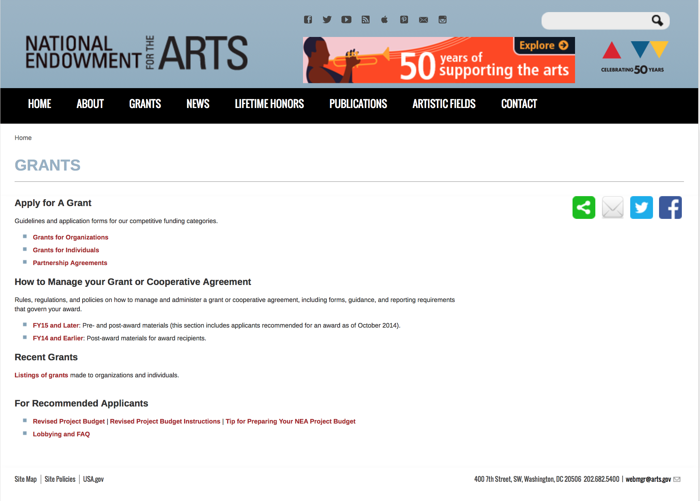

http://arts.gov/grants

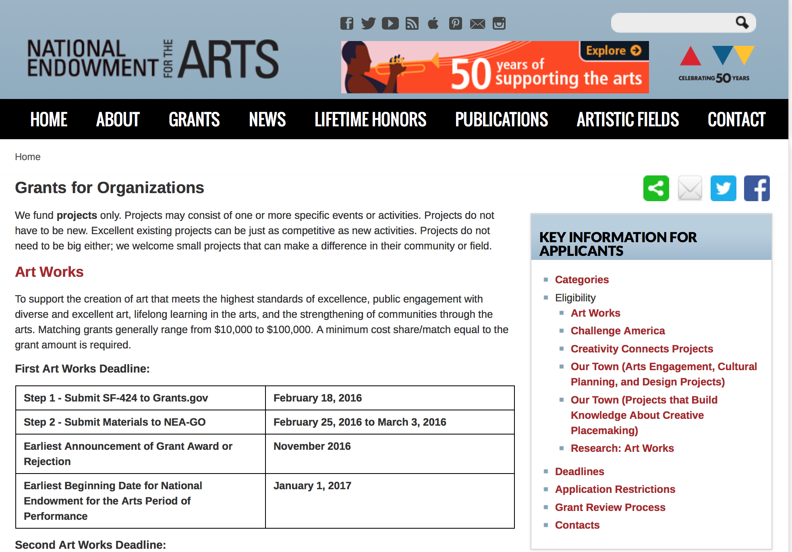
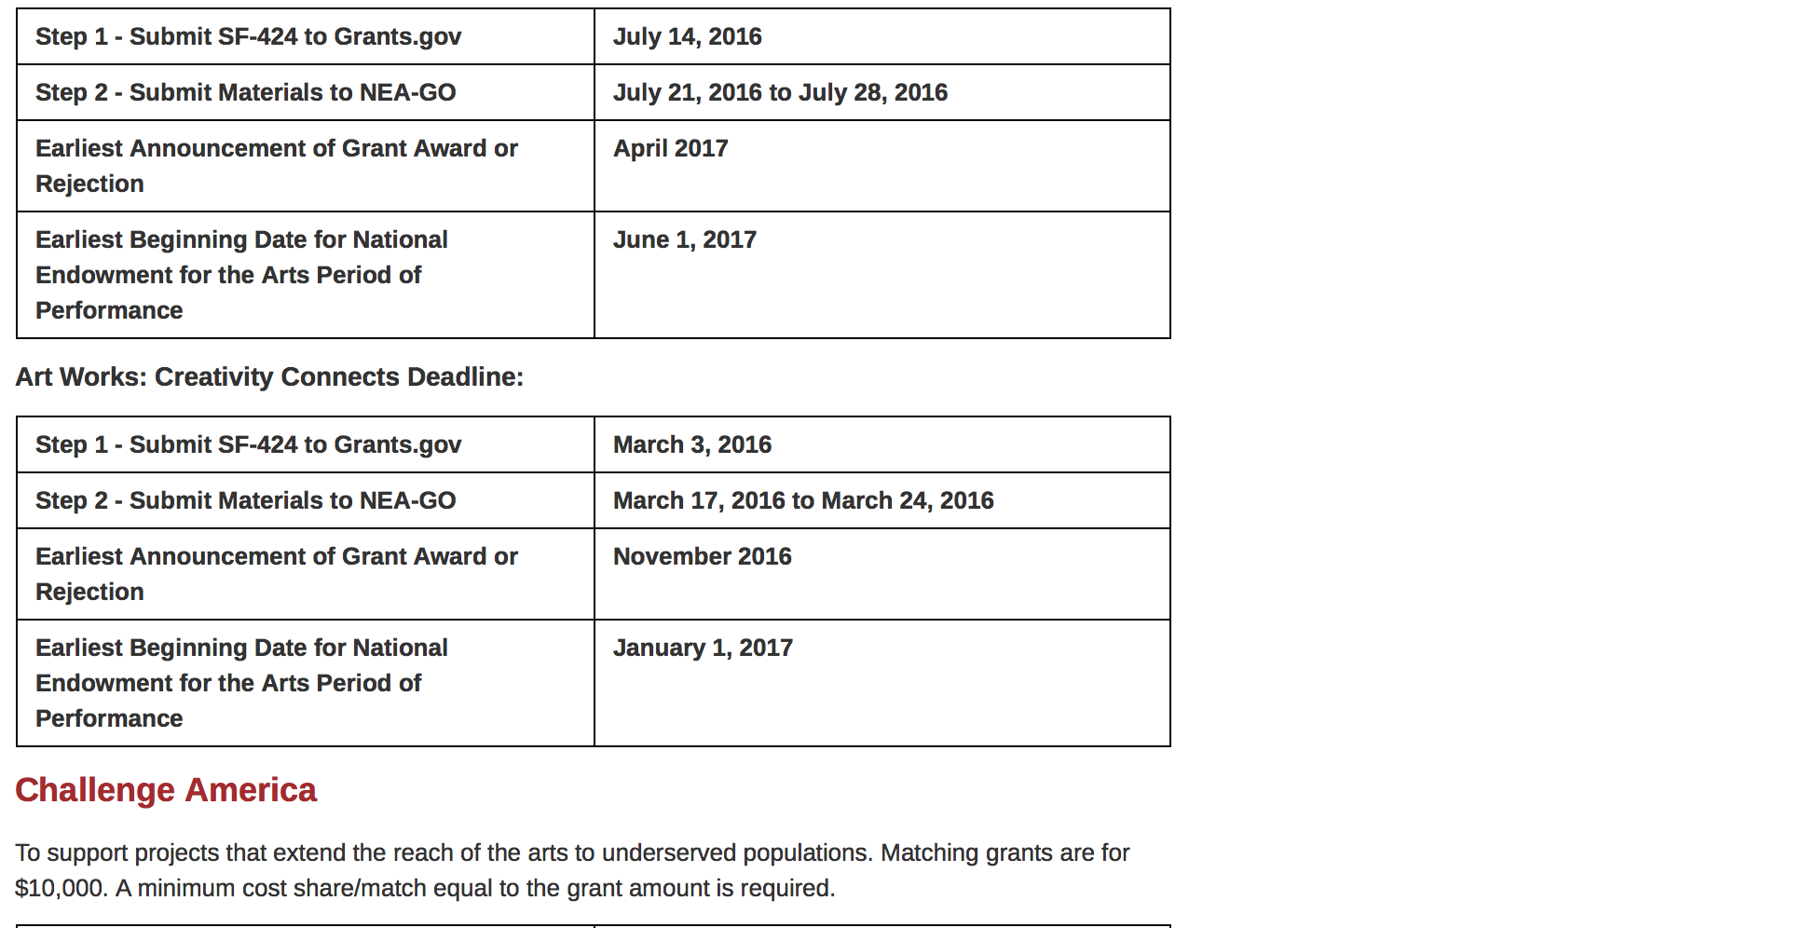
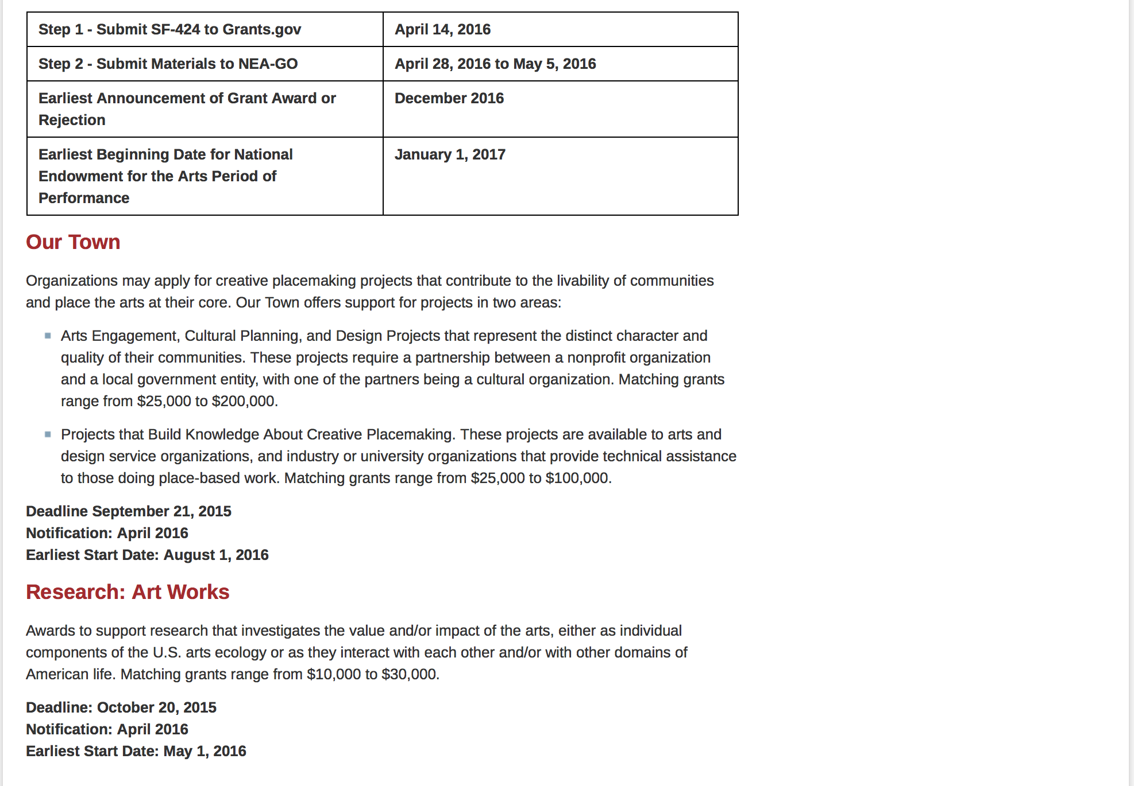
See more at: https://www.arts.gov/grants/apply-grant/grants-organizations

Programs:

Modifications:

Reminders:

NEA FY 2017 Art Works II Application Grant

Document Type: | Grants Notice
Funding Opportunity Number: | 2016NEA01AW2
Funding Opportunity Title: | NEA FY 2017 Art Works II Application
Opportunity Category: | Discretionary
Opportunity Category Explanation:
Funding Instrument Type: | Grant
Category of Funding Activity: | Arts (see "Cultural Affairs" in CFDA)
Category Explanation:
Expected Number of Awards:
CFDA Number(s): | 45.024 -- Promotion of the Arts Grants to Organizations and Individuals
Cost Sharing or Matching Requirement: | Yes
Posted Date: | May 03, 2016
Last Updated Date: | May 03, 2016
Original Closing Date for Applications: | Jul 14, 2016 “The Grants.gov system must receive your validated and accepted application no later than 11:59 p.m., Eastern Time, on July 14, 2016.”
Current Closing Date for Applications: | Jul 14, 2016 “The Grants.gov system must receive your validated and accepted application no later than 11:59 p.m., Eastern Time, on July 14, 2016.”
Archive Date: | Aug 13, 2016
Estimated Total Program Funding:
Award Ceiling: | $100,000
Award Floor: | $10,000
Eligible Applicants: | County governments  Native American tribal governments (Federally recognized)  Public and State controlled institutions of higher education  Special district governments  City or township governments  Independent school districts  State governments  Nonprofits having a 501(c)(3) status with the IRS, other than institutions of higher education  Private institutions of higher education
Additional Information on Eligibility: | An organization may submit only one application through one of the following FY 2017 categories: Art Works or Challenge America. -An organization may submit one additional application under the Art Works category for a Creativity Connects project. -If an organization applies to the Challenge America category, it may not submit another application to the Art Works category except for a Creativity Connects project. –The Arts Endowment's support of a project may start on or after June 1, 2017. Generally, a period of performance of up to two years is allowed. Applicant Eligibility Nonprofit, tax-exempt 501(c)(3), U.S. organizations; units of state or local government; or federally recognized tribal communities or tribes may apply. Applicants may be arts organizations, local arts agencies, arts service organizations, local education agencies (school districts), and other organizations that can help advance the goals of the National Endowment for the Arts. To be eligible, the applicant organization must: •Meet the National Endowment for the Arts’ "Legal Requirements" including nonprofit, tax-exempt status at the time of application. (All organizations must apply directly on their own behalf. Applications through a fiscal sponsor are not allowed. See more information on fiscal sponsors.) •Have a three-year history of programming prior to the application deadline. •Have submitted acceptable Final Report packages by the due date(s) for all National Endowment for the Arts grant(s) previously received. - See more at: https://www.arts.gov/grants-organizations/art-works/applicant-eligibility#sthash.KlcPcEkx.dpuf
Agency Name: | National Endowment for the Arts
Description: | An organization may submit only one application through one of the following FY 2017 categories: Art Works or Challenge America. -An organization may submit one additional application under the Art Works category for a Creativity Connects project. -If an organization applies to the Challenge America category, it may not submit another application to the Art Works category except for a Creativity Connects project. –The Arts Endowment's support of a project may start on or after June 1, 2017. Generally, a period of performance of up to two years is allowed. Grant Program Description The guiding principle of "Art Works" is at the center of everything we do at the NEA. "Art Works" refers to three things: the works of art themselves, the ways art works on audiences, and the fact that art is work for the artists and arts professionals who make up the field. Art works by enhancing the value of individuals and communities, by connecting us to each other and to something greater than ourselves, and by empowering creativity and innovation in our society and economy. The arts exist for beauty itself, but they also are an inexhaustible source of meaning and inspiration. The NEA recognizes these catalytic effects of excellent art, and the key role that arts and design organizations play in revitalizing them. To deepen and extend the arts' value, including their ability to foster new connections and to exemplify creativity and innovation, we welcome projects that: Are likely to prove transformative with the potential for meaningful change, whether in the development or enhancement of new or existing art forms, new approaches to the creation or presentation of art, or new ways of engaging the public with art; Are distinctive, offering fresh insights and new value for their fields and/or the public through unconventional solutions; and Have the potential to be shared and/or emulated, or are likely to lead to other advances in the field. Beyond encouraging projects that demonstrate these characteristics, we want to achieve the following four objectives through the Art Works category: Creation: The creation of art that meets the highest standards of excellence, Engagement: Public engagement with diverse and excellent art, Learning: Lifelong learning in the arts, and Livability: The strengthening of communities through the arts. - See more at: https://www.arts.gov/grants-organizations/art-works/grant-program-description#sthash.wmzUQwur.dpuf
Link to Additional Information: | Complete NEA Website Posting
Contact Information: | If you have difficulty accessing the full announcement electronically, please contact:  NEA Web Manager  NEA Web Manager

http://www.grants.gov/web/grants/view-opportunity.html?oppId=283461

Our Town FY 17 Grant

Document Type: | Grants Notice
Funding Opportunity Number: | 2016NEA01OT
Funding Opportunity Title: | Our Town FY 17
Opportunity Category: | Discretionary
Opportunity Category Explanation: | Category Explanation
Funding Instrument Type: | Grant
Category of Funding Activity: | Arts (see "Cultural Affairs" in CFDA)
Category Explanation:
Expected Number of Awards:
CFDA Number(s): | 45.024 -- Promotion of the Arts Grants to Organizations and Individuals
Cost Sharing or Matching Requirement: | Yes
Posted Date: | May 09, 2016
Last Updated Date: | May 09, 2016
Original Closing Date for Applications: | Sep 12, 2016 Applications must be received by September 12, 2016, 11:59 p.m., Eastern Time
Current Closing Date for Applications: | Sep 12, 2016 Applications must be received by September 12, 2016, 11:59 p.m., Eastern Time
Archive Date: | Oct 12, 2016
Estimated Total Program Funding:
Award Ceiling: | $200,000
Award Floor: | $25,000
Eligible Applicants: | State governments  Special district governments  Private institutions of higher education  Public and State controlled institutions of higher education  County governments  Nonprofits having a 501(c)(3) status with the IRS, other than institutions of higher education  Independent school districts  City or township governments  Native American tribal governments (Federally recognized)
Agency Name: | National Endowment for the Arts
Description: | Organizations may apply for creative placemaking projects that contribute to the livability of communities and place the arts at their core. Our Town offers support for projects in two areas: • Arts Engagement, Cultural Planning, and Design Projects that represent the distinct character and quality of their communities. These projects require a partnership between a nonprofit organization and a local government entity, with one of the partners being a cultural organization. Matching grants range from $25,000 to $200,000. • Projects that Build Knowledge About Creative Placemaking. These projects are available to arts and design service organizations, and industry, policy, or university organizations that provide technical assistance to those doing place-based work. Matching grants range from $25,000 to $100,000.
Link to Additional Information: | Our Town Guidelines
Contact Information: | If you have difficulty accessing the full announcement electronically, please contact:  Web Manager  Web manager's email address

http://www.grants.gov/web/grants/view-opportunity.html?oppId=283652

NEA Research Labs, FY2016 Grant

Document Type: | Grants Notice
Funding Opportunity Number: | NEAPS1602
Funding Opportunity Title: | NEA Research Labs, FY2016
Opportunity Category: | Discretionary
Opportunity Category Explanation:
Funding Instrument Type: | Cooperative Agreement
Category of Funding Activity: | Arts (see "Cultural Affairs" in CFDA)
Category Explanation:
Expected Number of Awards:
CFDA Number(s): | 45.024 -- Promotion of the Arts Grants to Organizations and Individuals
Cost Sharing or Matching Requirement: | Yes
Posted Date: | May 17, 2016
Last Updated Date: | May 17, 2016
Original Closing Date for Applications: | Jul 12, 2016 The Grants.gov system must receive your proposal no later than 11:59 p.m., Eastern Time, on July 12, 2016. We strongly recommend that you submit your application by July 2, 2016 to give yourself ample time to resolve any problems that you might encounter.
Current Closing Date for Applications: | Jul 12, 2016 The Grants.gov system must receive your proposal no later than 11:59 p.m., Eastern Time, on July 12, 2016. We strongly recommend that you submit your application by July 2, 2016 to give yourself ample time to resolve any problems that you might encounter.
Archive Date: | Aug 11, 2016
Estimated Total Program Funding:
Award Ceiling: | $150,000
Award Floor: | $150,000
Eligible Applicants: | Nonprofits having a 501(c)(3) status with the IRS, other than institutions of higher education  State governments  City or township governments  County governments  Native American tribal governments (Federally recognized)  Private institutions of higher education  Public and State controlled institutions of higher education  Independent school districts  Special district governments
Additional Information on Eligibility: | “An organization may submit only one proposal under this program solicitation.” “This Cooperative Agreement will begin no earlier than March 1, 2017, and extend for up to 24 months.” Applicant Eligibility The official applicant must be 1) a U.S. institution of higher education, or 2) a nonprofit, tax-exempt 501(c)(3), U.S. organization with their core components having research and policy as a principal focus, either as the primary work or as part of a transdisciplinary mission. This nonprofit organization also must have a three-year history of commissioning and conducting research in the behavioral or social sciences, and communicating research findings and policy implications through reports and/or convenings, at the time of application. The official applicant must meet the eligibility requirements, submit the application, and assume full responsibility for the grant.
Agency Name: | National Endowment for the Arts
Description: | “An organization may submit only one proposal under this program solicitation.” “This Cooperative Agreement will begin no earlier than March 1, 2017, and extend for up to 24 months.” Program Description In recent years, the National Endowment for the Arts’ research portfolio has focused on yielding new knowledge about the value and impact of the arts. Through a new program, the National Endowment for the Arts Research Labs (NEA Research Labs), we seek to support a series of transdisciplinary research partnerships, grounded in the social and behavioral sciences, to produce and report empirical insights about the arts for the benefit of arts and non-arts sectors alike. Each NEA Research Lab will define a research agenda, conduct a research program to implement that agenda, and prepare reports that will contribute substantively to a wider understanding of one of three areas of special interest to the National Endowment for the Arts: 1. The Arts, Health, and Social/Emotional Well-Being 2. The Arts, Creativity, Cognition, and Learning 3. The Arts, Entrepreneurship, and Innovation
Link to Additional Information: | NEA Web Site Announcement
Contact Information: | If you have difficulty accessing the full announcement electronically, please contact:  NEA Web Manager  NEA Web Manager

http://www.grants.gov/web/grants/view-opportunity.html?oppId=283878

National Endowment for the Humanities

Grant Overview -

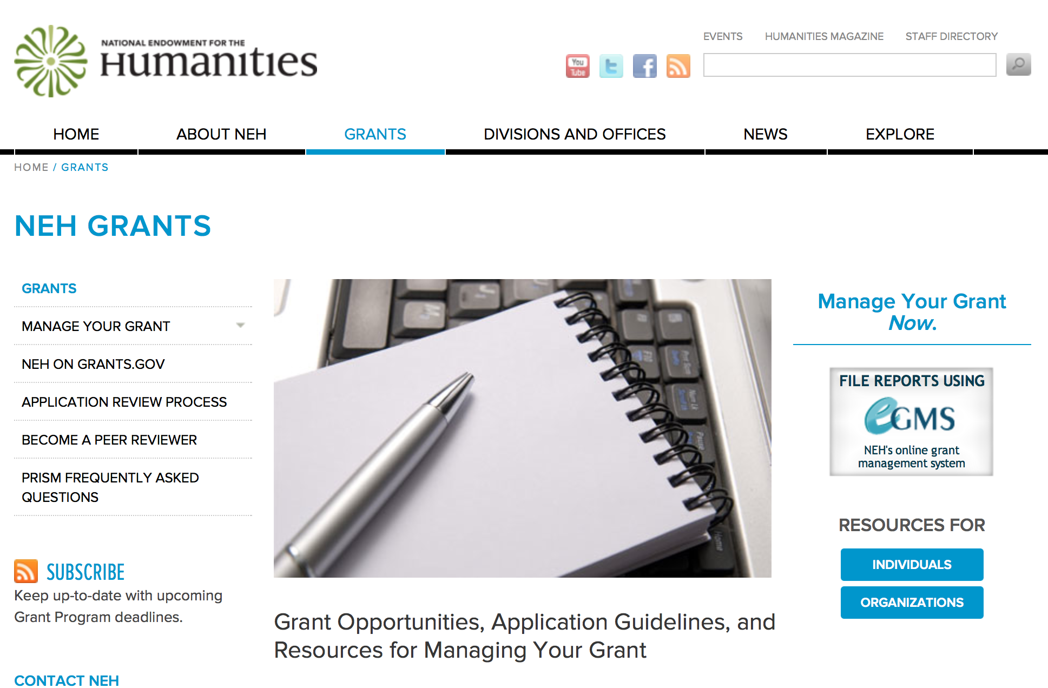

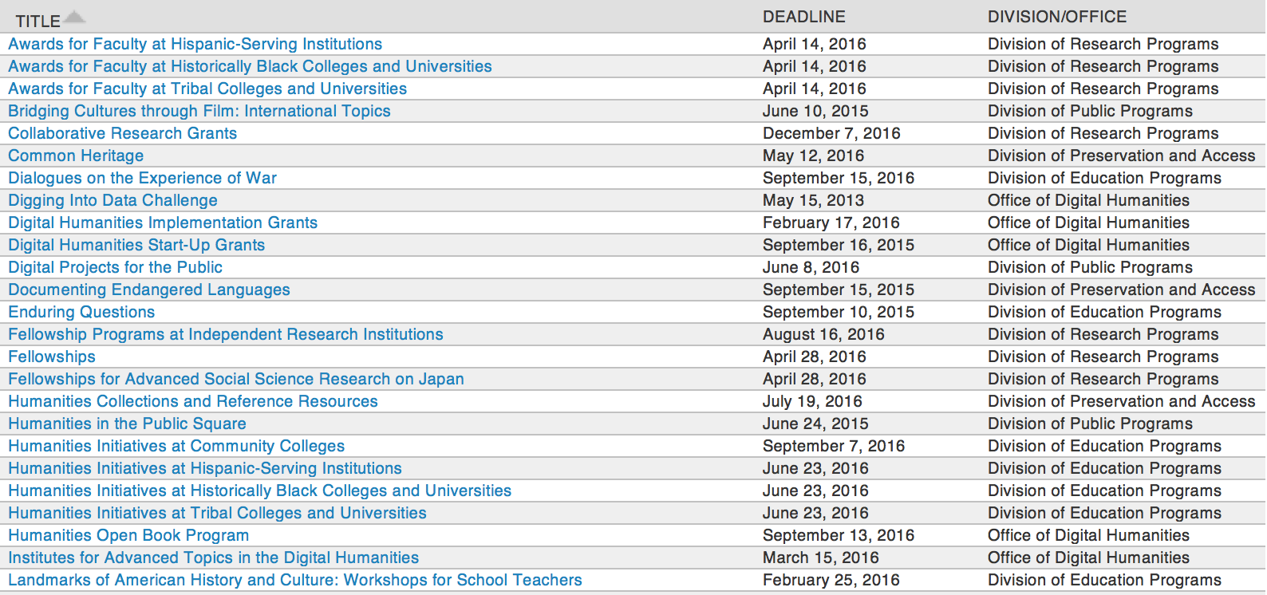

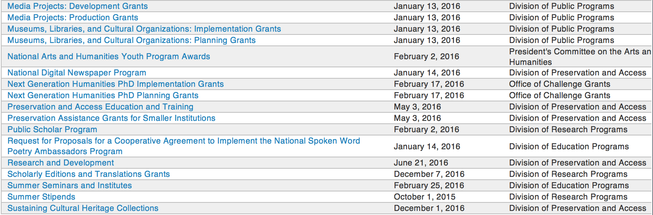

http://www.neh.gov/grants/grantsbydivision.html

Programs:

Public Humanities Projects Grant

Document Type: | Grants Notice
Funding Opportunity Number: | 20160810-GW
Funding Opportunity Title: | Public Humanities Projects
Opportunity Category: | Discretionary
Opportunity Category Explanation:
Funding Instrument Type: | Grant
Category of Funding Activity: | Humanities (see "Cultural Affairs" in CFDA)
Category Explanation:
Expected Number of Awards:
CFDA Number(s): | 45.164 -- Promotion of the Humanities Public Programs
Cost Sharing or Matching Requirement: | No
Posted Date: | Jun 09, 2016
Last Updated Date: | Jun 09, 2016
Original Closing Date for Applications: | Aug 10, 2016
Current Closing Date for Applications: | Aug 10, 2016
Archive Date:
Estimated Total Program Funding:
Award Ceiling: | $1,000,000
Award Floor: | $1
Eligible Applicants: | County governments  Special district governments  City or township governments  Native American tribal governments (Federally recognized)  Private institutions of higher education  Public and State controlled institutions of higher education  Nonprofits that do not have a 501(c)(3) status with the IRS, other than institutions of higher education  State governments  Nonprofits having a 501(c)(3) status with the IRS, other than institutions of higher education
Agency Name: | National Endowment for the Humanities
Description: | Public Humanities Projects grants support projects that bring the ideas and insights of the humanities to life for general audiences. Projects must engage humanities scholarship to illuminate significant themes in disciplines such as history, literature, ethics, and art, or to address challenging issues in contemporary life. NEH encourages projects that involve members of the public in collaboration with humanities scholars or that invite contributions from the community in the development and delivery of humanities programming. This grant program supports a variety of forms of audience engagement. Applications should follow the parameters set out below for one of the following three formats: • Community Conversations: This format supports one- to three-year-long series of community-wide public discussions in which diverse residents creatively address community challenges, guided by the perspectives of the humanities. • Exhibitions: This format supports permanent exhibitions that will be on view for at least three years, or travelling exhibitions that will be available to public audiences in at least two venues in the United States (including the originating location). • Historic Places: This format supports the interpretation of historic sites, houses, neighborhoods, and regions, which might include living history presentations, guided tours, exhibitions, and public programs. NEH encourages projects that explore humanities ideas through multiple formats. Proposed projects may include complementary components that deepen an audience’s understanding of a subject: for example, a museum exhibition might be accompanied by a website, mobile app, or discussion programs. Your application must identify one primary format for your project and follow the application instructions for that format.
Link to Additional Information: | http://www.neh.gov/grants/public/public-humanities-projects
Grantor Contact Information: | If you have difficulty accessing the full announcement electronically, please contact:  Division of Public Programs National Endowment for the Humanities 400 Seventh Street, SW Washington, DC 20506 202-606-8269 publicpgms@neh.gov publicpgms@neh.gov  publicpgms@neh.gov

http://www.grants.gov/web/grants/view-opportunity.html?oppId=284506

Media Projects Grants

Document Type: | Grants Notice
Funding Opportunity Number: | 20160810-TD
Funding Opportunity Title: | Media Projects Grants
Opportunity Category: | Discretionary
Opportunity Category Explanation:
Funding Instrument Type: | Grant
Category of Funding Activity: | Humanities (see "Cultural Affairs" in CFDA)
Category Explanation:
Expected Number of Awards:
CFDA Number(s): | 45.164 -- Promotion of the Humanities Public Programs
Cost Sharing or Matching Requirement: | No
Posted Date: | Jun 09, 2016
Last Updated Date: | Jun 09, 2016
Original Closing Date for Applications: | Aug 10, 2016
Current Closing Date for Applications: | Aug 10, 2016
Archive Date:
Estimated Total Program Funding:
Award Ceiling: | $1,000,000
Award Floor: | $1
Eligible Applicants: | State governments  Public and State controlled institutions of higher education  Nonprofits having a 501(c)(3) status with the IRS, other than institutions of higher education  City or township governments  County governments  Nonprofits that do not have a 501(c)(3) status with the IRS, other than institutions of higher education  Private institutions of higher education  Special district governments  Native American tribal governments (Federally recognized)
Agency Name: | National Endowment for the Humanities
Description: | The Media Projects program supports film, television, and radio projects that engage general audiences with humanities ideas in creative and appealing ways. All projects must be grounded in humanities scholarship in disciplines such as history, art history, film studies, literature, drama, religious studies, philosophy, or anthropology. Projects must also demonstrate an approach that is thoughtful, balanced, and analytical (rather than celebratory). The approach to the subject matter must go beyond the mere presentation of factual information to explore its larger significance and stimulate critical thinking. NEH is a national funding agency, so the projects that we support must demonstrate the potential to attract a broad general audience. Film and television projects may be single programs or a series addressing significant figures, events, or ideas. Programs must be intended for national distribution, via traditional carriage or online distribution. The Division of Public Programs welcomes projects that range in length from short-form to broadcast-length video. The Division of Public Programs also encourages film and television projects that examine international themes and subjects in the humanities, in order to spark Americans’ engagement with the broader world beyond the United States. These projects should demonstrate international collaboration by enlisting scholars based both in the United States and abroad, and/or by working with an international media team. The collaborations should bring broad cross-cultural perspectives to the proposed topics and should be intended primarily for U.S. public audiences. Radio projects, including podcasts, may involve single programs, limited series, or segments within an ongoing series. They may also develop new humanities content to augment existing radio programming or add greater historical background or humanities analysis to the subjects of existing programs. Programs receiving production grants may be either broadcast or disseminated online. They may be intended for national or regional distribution. NEH encourages projects that engage public audiences through multiple formats in the exploration of humanities ideas. Proposed projects might include complementary components to a film, television, or radio project. These components should deepen the audience’s understanding of the subject in a supplementary manner: for example, book/film discussion programs, supplemental educational websites, or museum exhibitions. Development Grants enable media producers to collaborate with scholars to develop humanities content and to prepare programs for production. Grants should result in a script and may also yield a detailed plan for outreach and public engagement in collaboration with a partner organization or organizations. Production Grants support the production and distribution of films, television programs, and radio programs that promise to engage a broad public audience.
Link to Additional Information: | http://www.neh.gov/grants/mp
Grantor Contact Information: | If you have difficulty accessing the full announcement electronically, please contact:  Division of Public Programs National Endowment for the Humanities 400 Seventh Street, SW Washington, DC 20506 202-606-8269 publicpgms@neh.gov publicpgms@neh.gov  publicpgms@neh.gov

http://www.grants.gov/web/grants/view-opportunity.html?oppId=284507

Funding Opportunity Number: 20170112-AE
Humanities Initiatives at Community Colleges

Posted Date: Jul 05, 2016
Document Type: | Grants Notice
Funding Opportunity Number: | 20170112-AE
Funding Opportunity Title: | Humanities Initiatives at Community Colleges
Opportunity Category: | Discretionary
Opportunity Category Explanation:
Funding Instrument Type: | Grant
Category of Funding Activity: | Humanities (see "Cultural Affairs" in CFDA)
Category Explanation:
Expected Number of Awards:
CFDA Number(s): | 45.162 -- Promotion of the Humanities Teaching and Learning Resources and Curriculum Development
Cost Sharing or Matching Requirement: | No
Posted Date: | Jul 05, 2016
Last Updated Date: | Jul 05, 2016
Original Closing Date for Applications: | Jan 12, 2017
Current Closing Date for Applications: | Jan 12, 2017
Archive Date:
Estimated Total Program Funding:
Award Ceiling: | $100,000
Award Floor: | $1
Eligible Applicants: | Others (see text field entitled "Additional Information on Eligibility" for clarification)
Additional Information on Eligibility: | The only eligible applicants are U.S. nonprofit tax-exempt two-year colleges.
Agency Name: | National Endowment for the Humanities
Description: | The humanities can play a vital role at community colleges by expanding students’ intellectual horizons and by increasing their capacity to read, write, and think analytically. By effecting these changes, the humanities can help prepare students for careers and for lives as engaged citizens. Humanities Initiatives at Community Colleges support community colleges’ commitment to educating students on a variety of educational and career paths. The program funds curricular and faculty development projects that help strengthen humanities programs and/or incorporate humanistic approaches in fields outside the humanities. Each project must be organized around a core topic or set of themes, drawn from subjects such as history, philosophy, and literature. Each project must also incorporate a broader institutional vision for the humanities at a community college. NEH Humanities Initiatives may • develop bridge programs for at-risk and nontraditional students; • integrate substantial humanities content or texts in required or developmental courses that focus on close reading, analytical writing, and/or effective speaking; • support new humanities programs (which may include but are not limited to new humanities minors, first-year seminars, and capstone courses) and enhance existing ones; • infuse humanistic learning into professional training (in such fields as business, law, engineering, technology, hospitality, and nursing and medicine); • create or improve curricular pathways towards graduation and/or transfer to four-year institutions; • create opportunities for faculty members to study together, in order to improve their capacity to teach the humanities; and • support collaborative projects in the humanities between the applicant institution and another institution, such as a college or university, a school or school system, a museum or library, or a historical or cultural society. Applicants are encouraged to draw on the knowledge of outside scholars who would contribute expertise and fresh insights to the project.
Link to Additional Information: | http://www.neh.gov/grants/education/humanities-initiatives-community-colleges
Grantor Contact Information: | If you have difficulty accessing the full announcement electronically, please contact:  Division of Education Programs National Endowment for the Humanities 400 Seventh Street, SW Washington, DC 20506 202-606-8471 hi@neh.gov hi@neh.gov  hi@neh.gov

Link: http://www.grants.gov/web/grants/view-opportunity.html?oppId=285749

Modifications:

Reminders:

Summer Stipends Grant

Document Type: | Grants Notice
Funding Opportunity Number: | 20160929-FT
Funding Opportunity Title: | Summer Stipends
Opportunity Category: | Discretionary
Opportunity Category Explanation:
Funding Instrument Type: | Grant
Category of Funding Activity: | Humanities (see "Cultural Affairs" in CFDA)
Category Explanation:
Expected Number of Awards:
CFDA Number(s): | 45.160 -- Promotion of the Humanities Fellowships and Stipends
Cost Sharing or Matching Requirement: | No
Posted Date: | May 05, 2016
Last Updated Date: | May 05, 2016
Original Closing Date for Applications: | Sep 29, 2016
Current Closing Date for Applications: | Sep 29, 2016
Archive Date:
Estimated Total Program Funding:
Award Ceiling: | $6,000
Award Floor: | $6,000
Eligible Applicants: | Others (see text field entitled "Additional Information on Eligibility" for clarification)
Additional Information on Eligibility: | The only eligible applicants are individuals. Individuals who teach full-time at colleges or universities must be nominated by their institutions to be eligible.
Agency Name: | National Endowment for the Humanities
Description: | Summer Stipends support individuals pursuing advanced research that is of value to humanities scholars, general audiences, or both. Eligible projects usually result in articles, monographs, books, digital materials and publications, archaeological site reports, translations, editions, or other scholarly resources. Summer Stipends support continuous full-time work on a humanities project for a period of two consecutive months. Summer Stipends support projects at any stage of development.
Link to Additional Information: | http://www.neh.gov/grants/research/summer-stipends
Contact Information: | If you have difficulty accessing the full announcement electronically, please contact:  Division of Research Programs National Endowment for the Humanities 400 Seventh Street, SW Washington, D.C. 20506 202-606-8200 stipends@neh.gov stipends@neh.gov  stipends@neh.gov

http://www.grants.gov/web/grants/view-opportunity.html?oppId=283530

Humanities Collections and Reference Resources Grant

Document Type: | Grants Notice
Funding Opportunity Number: | 20160719-PW
Funding Opportunity Title: | Humanities Collections and Reference Resources
Opportunity Category: | Discretionary
Opportunity Category Explanation:
Funding Instrument Type: | Grant
Category of Funding Activity: | Humanities (see "Cultural Affairs" in CFDA)
Category Explanation:
Expected Number of Awards:
CFDA Number(s): | 45.149 -- Promotion of the Humanities Division of Preservation and Access
Cost Sharing or Matching Requirement: | No
Posted Date: | May 05, 2016
Last Updated Date: | May 05, 2016
Original Closing Date for Applications: | Jul 19, 2016
Current Closing Date for Applications: | Jul 19, 2016
Archive Date:
Estimated Total Program Funding:
Award Ceiling: | $350,000
Award Floor: | $1
Eligible Applicants: | Nonprofits that do not have a 501(c)(3) status with the IRS, other than institutions of higher education  Private institutions of higher education  City or township governments  Native American tribal governments (Federally recognized)  Nonprofits having a 501(c)(3) status with the IRS, other than institutions of higher education  State governments  Special district governments  County governments  Public and State controlled institutions of higher education
Agency Name: | National Endowment for the Humanities
Description: | The Humanities Collections and Reference Resources (HCRR) program supports projects that provide an essential underpinning for scholarship, education, and public programming in the humanities. Thousands of libraries, archives, museums, and historical organizations across the country maintain important collections of books and manuscripts, photographs, sound recordings and moving images, archaeological and ethnographic artifacts, art and material culture, and digital objects. Funding from this program strengthens efforts to extend the life of such materials and make their intellectual content widely accessible, often through the use of digital technology. Awards are also made to create various reference resources that facilitate use of cultural materials, from works that provide basic information quickly to tools that synthesize and codify knowledge of a subject for in-depth investigation. HCRR offers two kinds of awards: 1) for implementation and 2) for planning, assessment, and pilot efforts (HCRR Foundations grants).
Link to Additional Information: | http://www.neh.gov/grants/preservation/humanities-collections-and-reference-resources
Contact Information: | If you have difficulty accessing the full announcement electronically, please contact:  Humanities Collections and Reference Resources Division of Preservation and Access National Endowment for the Humanities 400 Seventh Street, SW Washington, DC 20506 preservation@neh.gov preservation@neh.gov  preservation@neh.gov

http://www.grants.gov/web/grants/view-opportunity.html?oppId=283531

Fellowship Programs at Independent Research Institutions Grant
Document Type: | Grants Notice
Funding Opportunity Number: | 20160816-RA
Funding Opportunity Title: | Fellowship Programs at Independent Research Institutions
Opportunity Category: | Discretionary
Opportunity Category Explanation:
Funding Instrument Type: | Grant
Category of Funding Activity: | Humanities (see "Cultural Affairs" in CFDA)
Category Explanation:
Expected Number of Awards:
CFDA Number(s): | 45.161 -- Promotion of the Humanities Research
Cost Sharing or Matching Requirement: | No
Posted Date: | May 27, 2016
Last Updated Date: | May 27, 2016
Original Closing Date for Applications: | Aug 16, 2016
Current Closing Date for Applications: | Aug 16, 2016
Archive Date:
Estimated Total Program Funding:
Award Ceiling: | $300,000
Award Floor: | $100,000
Eligible Applicants: | Nonprofits having a 501(c)(3) status with the IRS, other than institutions of higher education  City or township governments  County governments  Special district governments  Nonprofits that do not have a 501(c)(3) status with the IRS, other than institutions of higher education  State governments  Native American tribal governments (Federally recognized)
Agency Name: | National Endowment for the Humanities
Description: | Grants for Fellowship Programs at Independent Research Institutions (FPIRI) support fellowships at institutions devoted to advanced study and research in the humanities. Recognizing that at times scholars need to work away from their homes and institutions, the FPIRI program sponsors fellowships that provide scholars with research time, a stimulating intellectual environment, and access to resources that might otherwise not be available to them. Fellowship programs may be administered by independent centers for advanced study, libraries, and museums in the United States; American overseas research centers; and American organizations that have expertise in promoting research in foreign countries. Individual scholars apply directly to the institutions for fellowships. A list of currently funded institutions is available. In evaluating applications consideration is given to the library holdings, archives, special collections, and other resources—either on site or nearby—that institutions make available to fellows. FPIRI grants provide funding for humanities fellowships of four to twelve months. The fellowships are held at the U.S. grantee institutions or—in the case of overseas research centers and organizations—abroad.
Link to Additional Information: | http://www.neh.gov/grants/research/fellowship-programs-independent-research-institutions
Contact Information: | If you have difficulty accessing the full announcement electronically, please contact:  Division of Research Programs National Endowment for the Humanities 400 Seventh Street, SW Washington, DC 20506 202-606-8200 fpiri@neh.gov fpiri@neh.gov  fpiri@neh.gov

http://www.grants.gov/web/grants/view-opportunity.html?oppId=284182

Humanities Connections Grant

Document Type: | Grants Notice
Funding Opportunity Number: | 20161005-AK
Funding Opportunity Title: | Humanities Connections
Opportunity Category: | Discretionary
Opportunity Category Explanation:
Funding Instrument Type: | Grant
Category of Funding Activity: | Humanities (see "Cultural Affairs" in CFDA)
Category Explanation:
Expected Number of Awards:
CFDA Number(s): | 45.162 -- Promotion of the Humanities Teaching and Learning Resources and Curriculum Development
Cost Sharing or Matching Requirement: | No
Posted Date: | Apr 19, 2016
Last Updated Date: | Apr 19, 2016
Original Closing Date for Applications: | Oct 05, 2016
Current Closing Date for Applications: | Oct 05, 2016
Archive Date:
Estimated Total Program Funding:
Award Ceiling: | $100,000
Award Floor: | $1
Eligible Applicants: | Public and State controlled institutions of higher education  Private institutions of higher education
Agency Name: | National Endowment for the Humanities
Description: | Humanities Connections grants seek to expand the role of the humanities in the undergraduate curriculum at two- and four-year institutions, offering students in all academic fields new opportunities to develop the intellectual skills and habits of mind that the humanities cultivate. Grant projects focus on connecting the resources and perspectives of the humanities to students’ broader educational and professional goals, regardless of their path of study. Through this new grant program, NEH invites proposals that reflect innovative and imaginative approaches to preparing students for their roles as engaged citizens and productive professionals in a rapidly changing and interdependent world. Grants support the development and implementation of an integrated set of courses and student engagement activities focusing on significant humanities content. A common topic, theme, or compelling issue or question must link the courses and activities. The linked courses (a minimum of three) may fulfill general education or core curriculum requirements but could also be designed primarily for students in a particular major or course of study. The Humanities Connections program gives special encouragement to projects that foster collaboration between humanities faculty and their counterparts in the social and natural sciences and pre-service or professional programs in business, engineering, health sciences, law, computer science, and other non-humanities fields. Humanities Connections projects have two core features: 1. faculty from at least two separate departments or schools at a single institution must collaborate to devise new curricular arrangements; and 2. projects must include provisions for high-impact student engagement activities that relate directly to the topic(s) of the linked courses. These activities could include individual or collaborative undergraduate research projects; opportunities for civic engagement; or a structured experience with community-based, project-based, or site-based learning. Community organizations and cultural institutions can play key roles in this regard.
Link to Additional Information: | http://www.neh.gov/grants/education/humanities-connections
Contact Information: | If you have difficulty accessing the full announcement electronically, please contact:  Humanities Connections Division of Education Programs National Endowment for the Humanities 400 Seventh Street, SW Washington, DC 20506 202-606-8500  humanitiesconnections@neh.gov

http://www.grants.gov/web/grants/view-opportunity.html?oppId=283098

Humanities Open Book Program Grant

Document Type: | Grants Notice
Funding Opportunity Number: | 20160913-HZ
Funding Opportunity Title: | Humanities Open Book Program
Opportunity Category: | Discretionary
Opportunity Category Explanation:
Funding Instrument Type: | Grant
Category of Funding Activity: | Humanities (see "Cultural Affairs" in CFDA)
Category Explanation:
Expected Number of Awards:
CFDA Number(s): | 45.169 -- Promotion of the Humanities Office of Digital Humanities
Cost Sharing or Matching Requirement: | No
Posted Date: | Mar 22, 2016
Last Updated Date: | Mar 22, 2016
Original Closing Date for Applications: | Sep 13, 2016
Current Closing Date for Applications: | Sep 13, 2016
Archive Date:
Estimated Total Program Funding:
Award Ceiling: | $100,000
Award Floor: | $50,000
Eligible Applicants: | Native American tribal governments (Federally recognized)  Special district governments  Public and State controlled institutions of higher education  City or township governments  Private institutions of higher education  County governments  Nonprofits having a 501(c)(3) status with the IRS, other than institutions of higher education  Nonprofits that do not have a 501(c)(3) status with the IRS, other than institutions of higher education  State governments
Agency Name: | National Endowment for the Humanities
Description: | The Humanities Open Book Program is designed to make outstanding out-of-print humanities books available to a wide audience. By taking advantage of low-cost “ebook” technology, the program will allow teachers, students, scholars, and the public to read humanities books that have long been out of print. Humanities Open Book is jointly sponsored by NEH and the Andrew W. Mellon Foundation. Traditionally, printed books have been the primary medium for expressing, communicating, and debating humanistic ideas. However, the vast majority of humanities books sell a small number of copies and then quickly go out of print. Most scholarly books printed since 1923 are not in the public domain and are not easily available to the general public. As a result, there is a huge, mostly untapped resource of remarkable scholarship going back decades that is largely unused by today’s scholars, teachers, students, and members of the public, many of whom turn first to the Internet when looking for information. Modern ebook technology can make these books far more accessible than they are today. NEH and Mellon are soliciting proposals from academic presses, scholarly societies, museums, and other institutions that publish books in the humanities to participate in the Humanities Open Book Program. Applicants will provide a list of previously published humanities books along with brief descriptions of the books and their intellectual significance. Depending on the length and topics of the books, the number to be digitized may vary. However, NEH and Mellon anticipate that applicants may propose to digitize a total that ranges from less than fifty to more than one hundred books. Awards will be given to digitize these books and make them available as Creative Commons-licensed “ebooks” that can be read by the public at no charge on computers, mobile devices, and ebook readers. The final ebook files must be in EPUB version 3.0.1 (or later) format, to ensure that the text is fully searchable and reflowable and that fonts are resizable on any e-reading device.
Link to Additional Information: | http://www.neh.gov/grants/odh/humanities-open-book-program
Contact Information: | If you have difficulty accessing the full announcement electronically, please contact:  If you have questions about the program, contact the ODH staff at odh@neh.gov. Applicants wishing to speak to a staff member by telephone should provide in an e-mail message a telephone number and a preferred time to call. odh@neh.gov  odh@neh.gov

http://www.grants.gov/web/grants/view-opportunity.html?oppId=282404



National Science Foundation

General Funding Overview

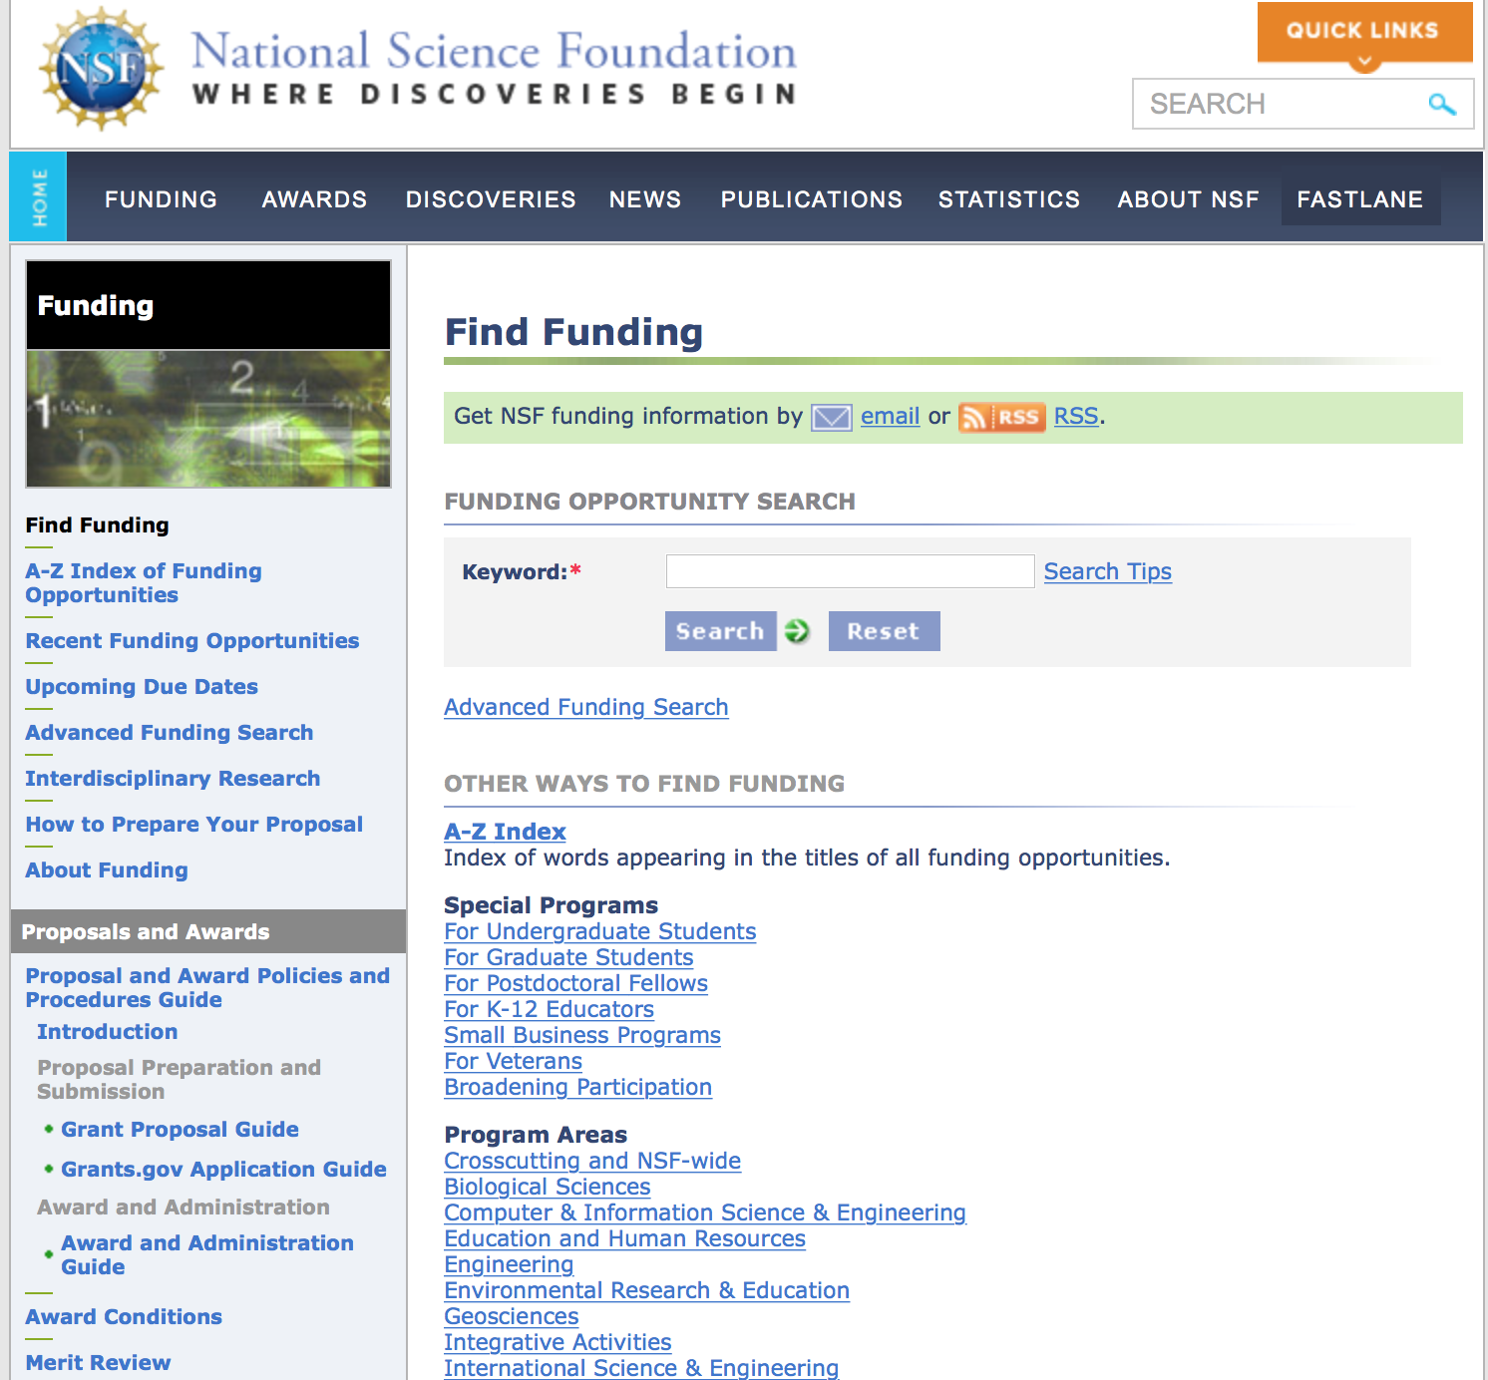
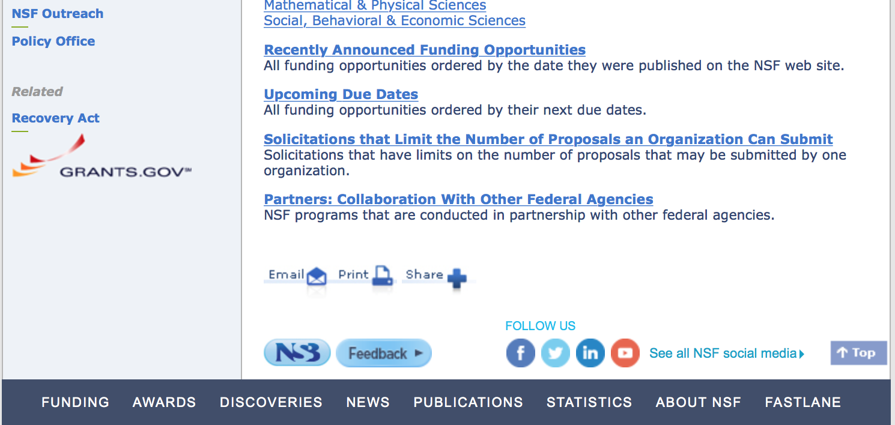

For assistance in finding funding: http://nsf.gov/funding/index.jsp - areas

The National Science Foundation funds research and education in most fields of science and engineering. It does this through grants, and cooperative agreements to more than 2,000 colleges, universities, K-12 school systems, businesses, informal science organizations and other research organizations throughout the United States. The Foundation accounts for about one-fourth of federal support to academic institutions for basic research.
NSF receives approximately 40,000 proposals each year for research, education and training projects, of which approximately 11,000 are funded. In addition, the Foundation receives several thousand applications for graduate and postdoctoral fellowships.
The agency operates no laboratories itself but does support National Research Centers, user facilities, certain oceanographic vessels and Antarctic research stations. The Foundation also supports cooperative research between universities and industry, US participation in international scientific and engineering efforts, and educational activities at every academic level.

For details on active funding deadline dates: http://nsf.gov/funding/pgm_list.jsp?org=NSF&ord=date

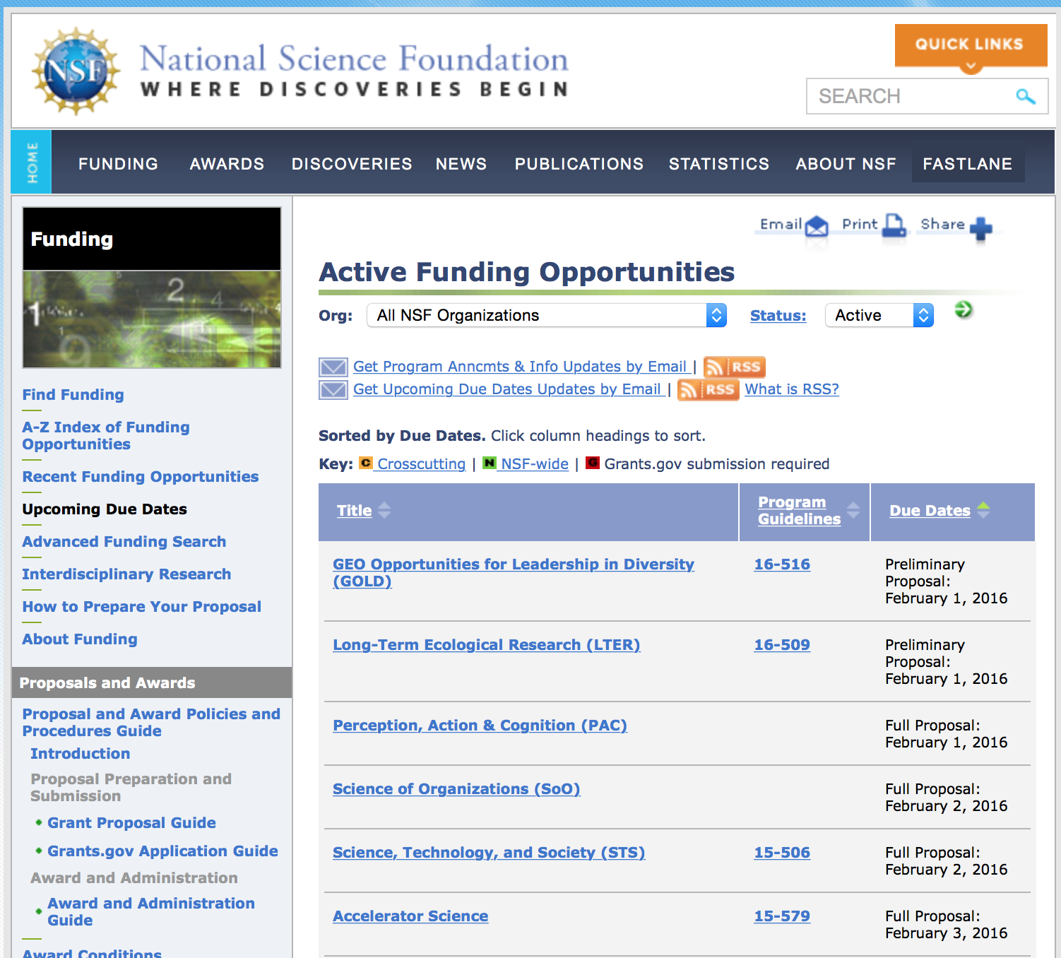

Research and Program Grants:

Funding Opportunity Number: 16-574
Astronomy and Astrophysics Research Grants
Posted Date: Jun 25, 2016
Link: http://www.grants.gov/web/grants/view-opportunity.html?oppId=285403

Funding Opportunity Number: 16-575
NSF Astronomy and Astrophysics Postdoctoral Fellowships
Posted Date: Jun 29, 2016
Link: http://www.grants.gov/web/grants/view-opportunity.html?oppId=285541

Funding Opportunity Number: PD-16-7244
Computational Physics
Posted Date: Jul 02, 2016
Link: http://www.grants.gov/web/grants/view-opportunity.html?oppId=285669

Funding Opportunity Number: 16-572
Cooperative Studies Of The Earth's Deep Interior
Posted Date: Jun 19, 2016
Link: http://www.grants.gov/web/grants/view-opportunity.html?oppId=285010

Funding Opportunity Number: 16-576
Documenting Endangered Languages
Posted Date: Jun 29, 2016
Link: http://www.grants.gov/web/grants/view-opportunity.html?oppId=285540

EAR Postdoctoral Fellowships Grant
http://www.grants.gov/web/grants/view-opportunity.html?oppId=284572

Funding Opportunity Number: 16-577
Focused Research Groups in the Mathematical Sciences
Posted Date: Jun 30, 2016
Link: http://www.grants.gov/web/grants/view-opportunity.html?oppId=285586

Funding Opportunity Number: 16-573
Joint NSF/NIH Initiative on Quantitative Approaches to Biomedical Big Data
Posted Date: Jun 21, 2016
Link: http://www.grants.gov/web/grants/view-opportunity.html?oppId=285237

Origin of Life Grant
http://www.grants.gov/web/grants/view-opportunity.html?oppId=284415
Funding Opportunity Number: 16-571
Partnerships for International Research and Education
Posted Date: Jun 19, 2016
Link: http://www.grants.gov/web/grants/view-opportunity.html?oppId=285009

Modifications:

Reminders:

Deleted:

Opportunity Number: 16-528
Opportunity Title: Science of Learning: Collaborative Networks
Deleted Date: Jul 04, 2016

Opportunity Number: PD-15-7244
Opportunity Title: Computational Physics
Deleted Date: Jul 02, 2016

Opportunity Number: 15-611
Opportunity Title: Dimensions of Biodiversity
Deleted Date: Jun 19, 2016

Opportunity Number: 15-567
Opportunity Title: Documenting Endangered Languages
Deleted Date: Jun 29, 2016

Opportunity Number: 16-524
Opportunity Title: Innovations at the Nexus of Food, Energy and Water Systems
Deleted Date: Jun 21, 2016

Opportunity Number: 16-523
Opportunity Title: International Research Network Connections
Deleted Date: Jun 19, 2016

Opportunity Number: 16-526
Opportunity Title: Energy-Efficient Computing: from Devices to Architectures
Deleted Date: Jun 28, 2016

Opportunity Number: 12-566
Opportunity Title: Focused Research Groups in the Mathematical Sciences
Deleted Date: Jun 30, 2016

Opportunity Number: 16-528
Opportunity Title: Science of Learning: Collaborative Networks
Deleted Date: Jul 04, 2016

Opportunity Number: 16-530
Opportunity Title: Data Infrastructure Building Blocks
Deleted Date: Jul 04, 2016

Nuclear Regulatory Commission

Reminders:



Small Business Administration

General Overview Finding Loans & Grants

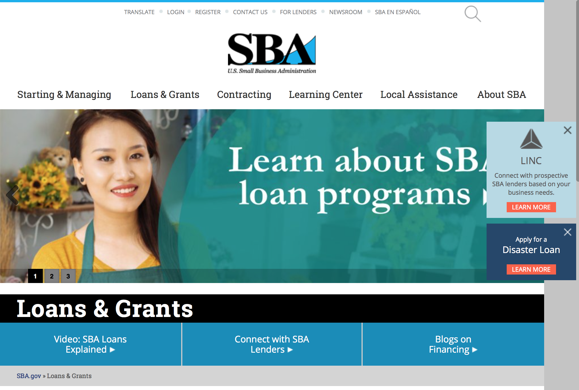
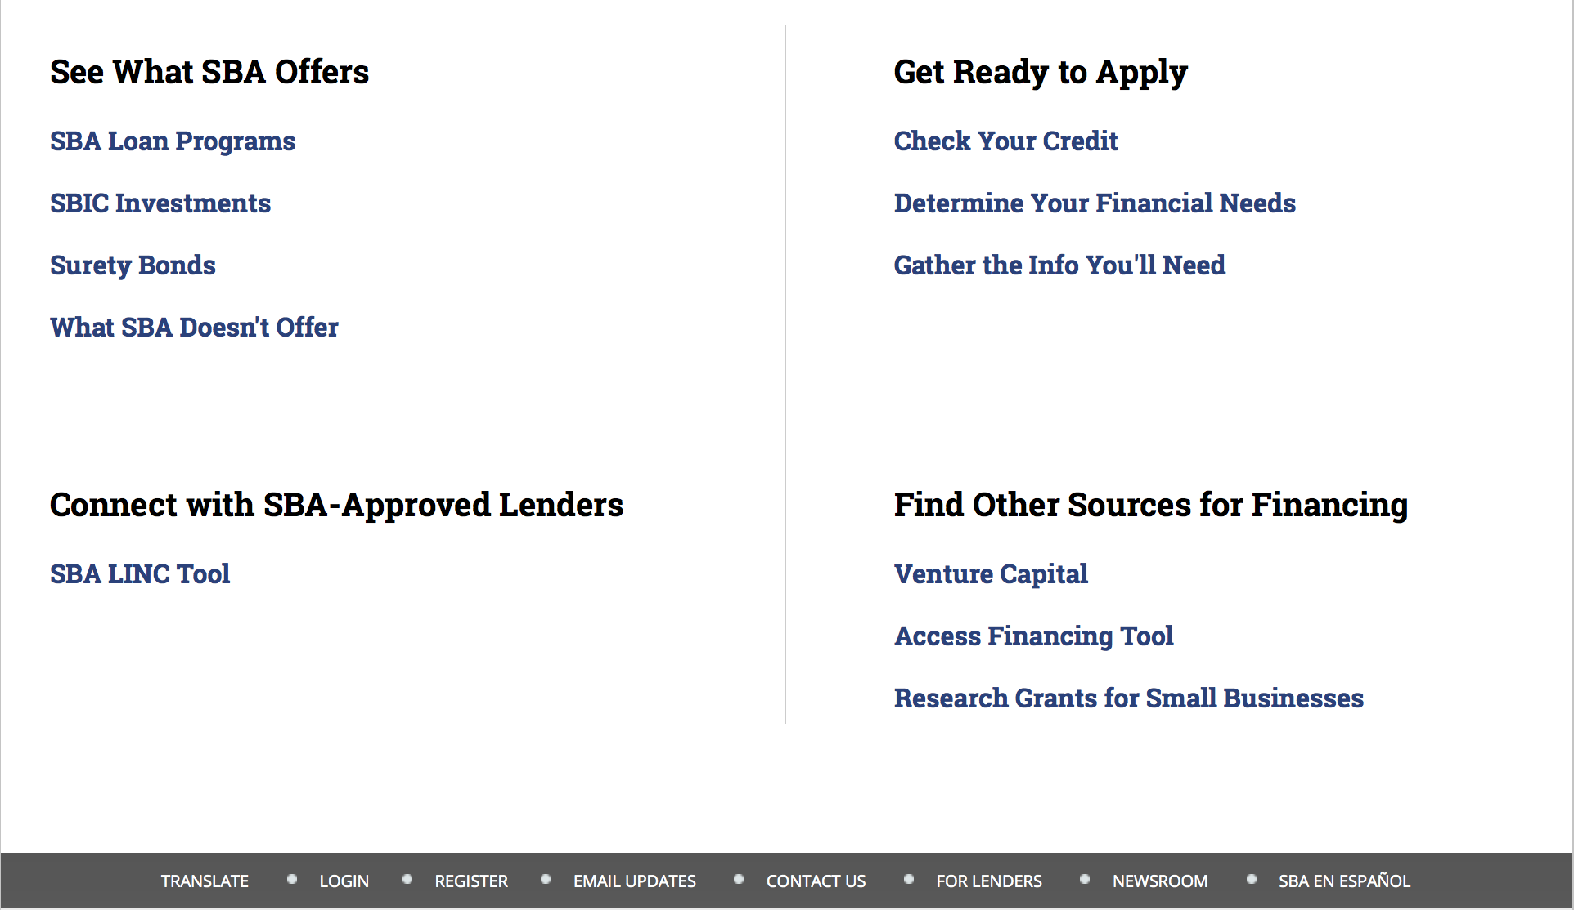

https://www.sba.gov/category/navigation-structure/loans-grants
Federal, state and local governments offer a wide range of financing programs to help small businesses start and grow their operations. These programs include low-interest loans, venture capital, and scientific and economic development grants.

Use SBA.gov's Loans and Grants Search Tool to get a list of financing programs for which you may qualify, or visit the resources below to learn more about small business financing programs. 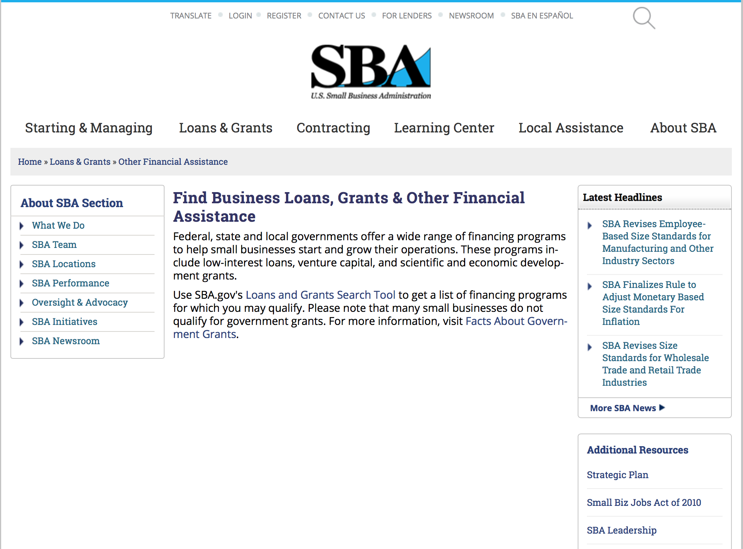
To get to the main SBA.gov funding page click here
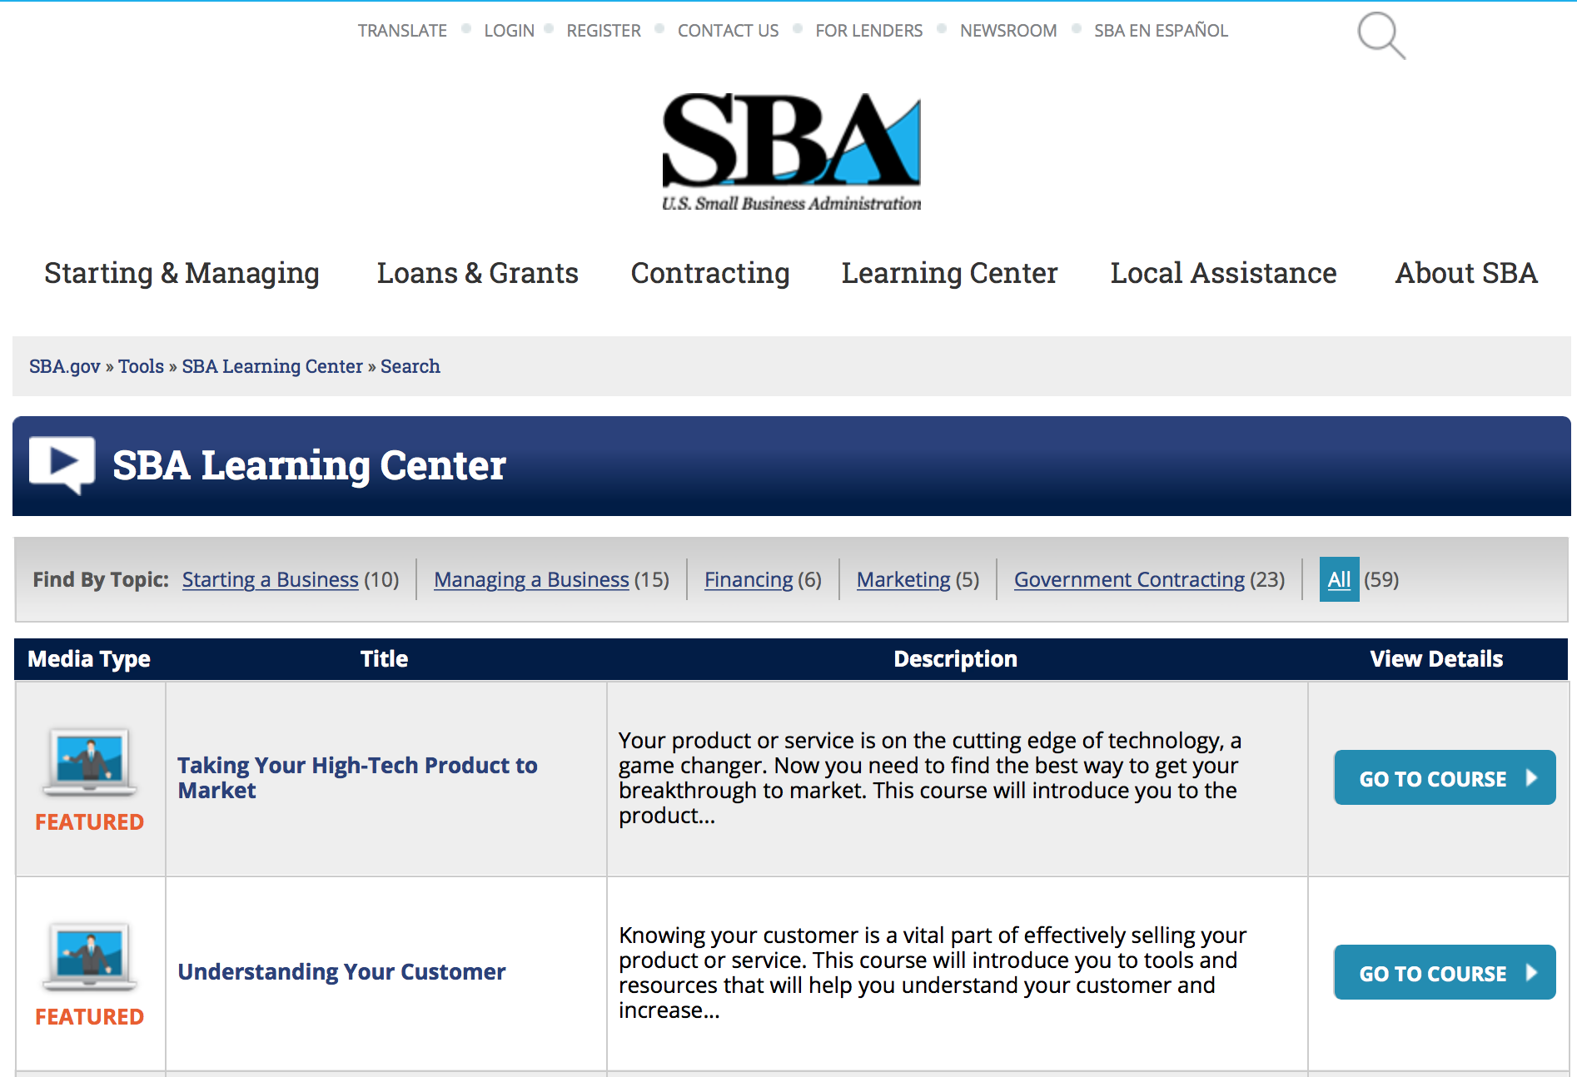
https://www.sba.gov/tools/sba-learning-center/search/training
Programs:

Reminders:

SBA Trainings

Contracting Opportunities for Veteran Entrepreneurs
This self-paced training exercise is an introduction to Federal contracting opportunities for Veterans.
Topics include basic information about Veteran-owned businesses and opportunities, services available to small Veteran-owned businesses, small business incentives, and government procurement methods.
Duration: 00:30:00

http://www.sba.gov/tools/sba-learning-center/training/contracting-opportunities-veteran-entrepreneurs

Interested in Exporting? These Four Resources Can Help
Did you know that two-thirds of the world’s purchasing power is in foreign countries? As the numbers show, the international marketplace is a big one. So if you’re interested in exploring the world of exporting – or have gotten started but could use some guidance – check out these resources to help.
- Read more

Upcoming Trainings: Check out SBA's Online Training!
- Financing Options for Small Businesses
How to Prepare Government Contract Proposals
Getting Started With Exporting: Training and Educational Resources
Exporting represents a big opportunity to tap in to new markets, expand your customer base and grow your business. But getting started with exporting can sometimes feel like a maze of regulations, policies, and other barriers. Here are some free training and educational resources to help.
- Read more

For Specific Information in Hawaii see the following links:
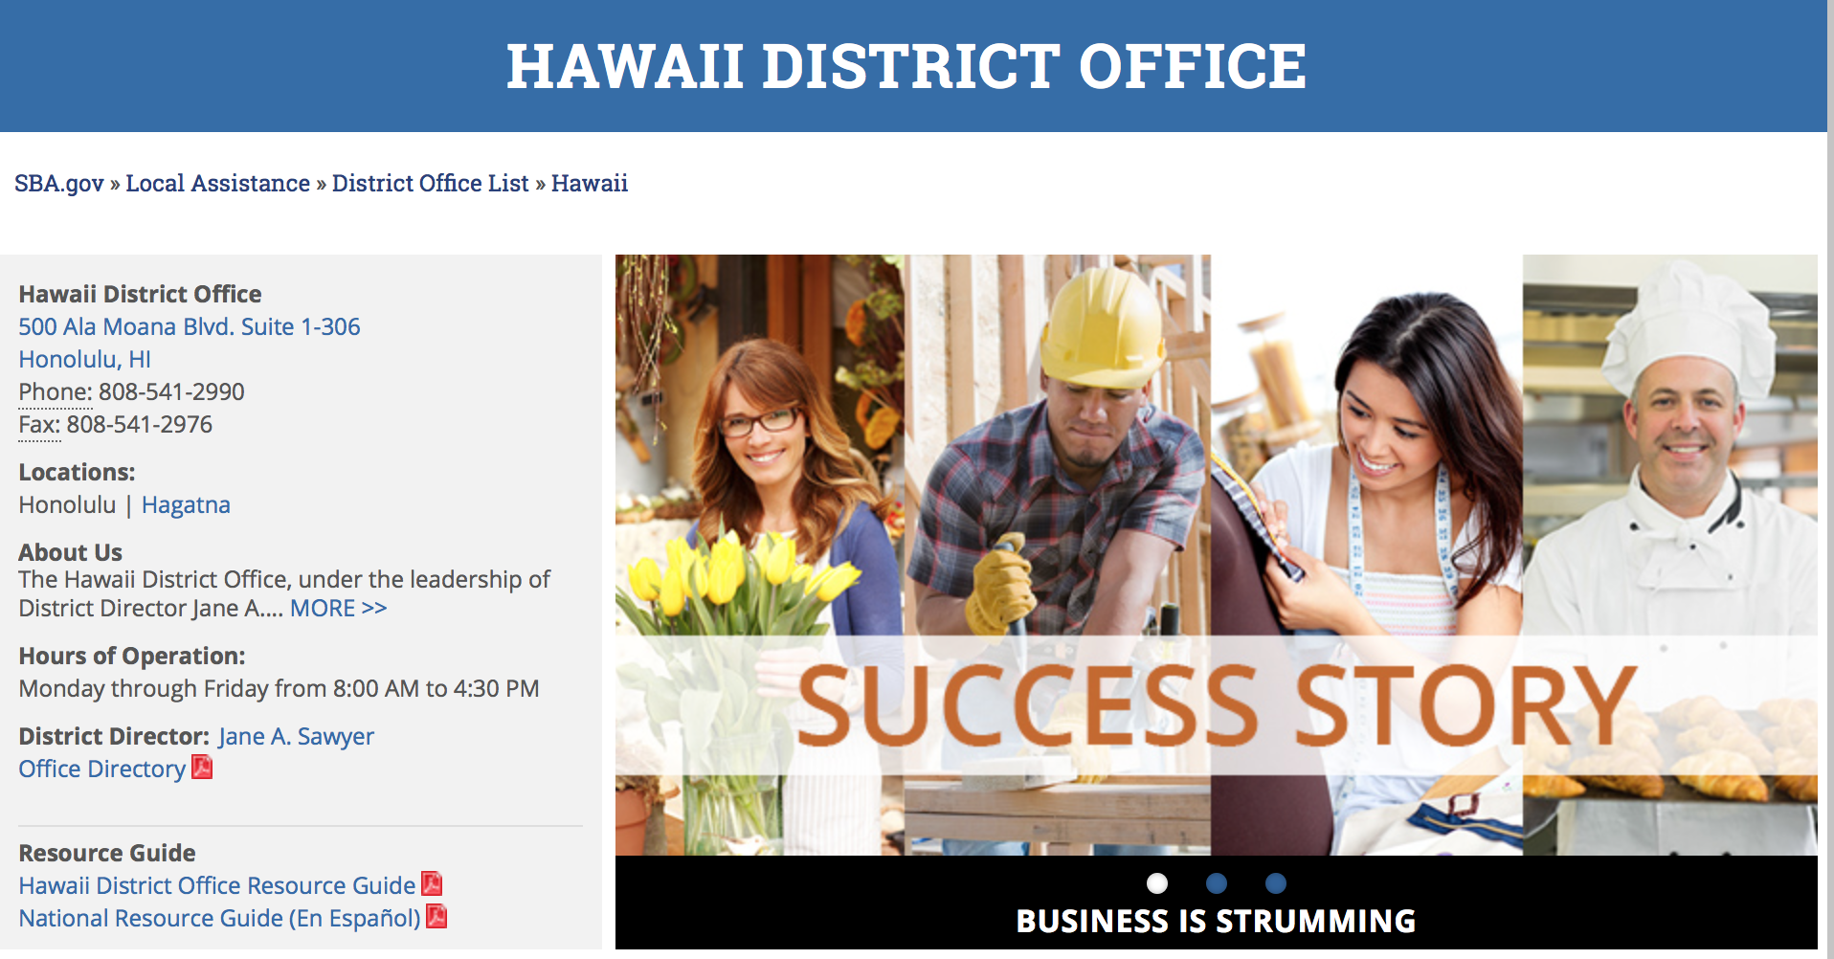

https://www.sba.gov/offices/district/hi/Honolulu

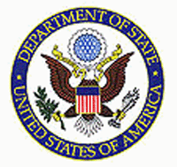

State Department General Overview and Resources for Program Administrators

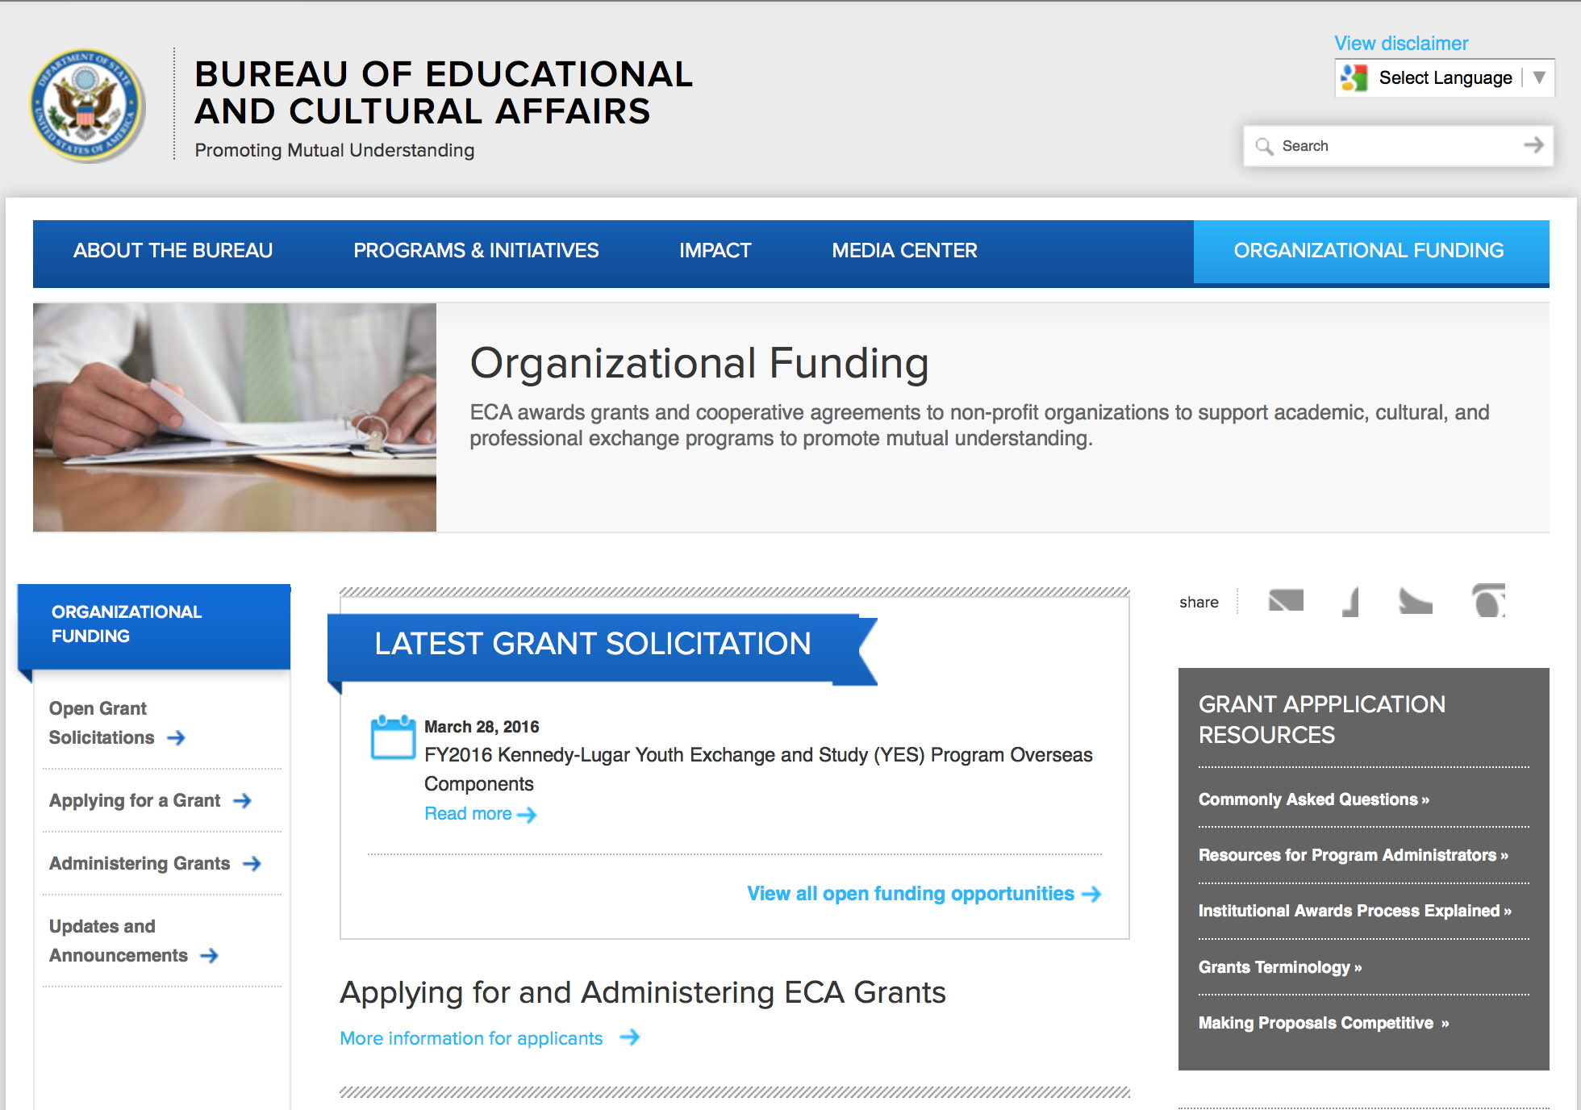
http://eca.state.gov/search/solr/grants?search_referrer=node/237
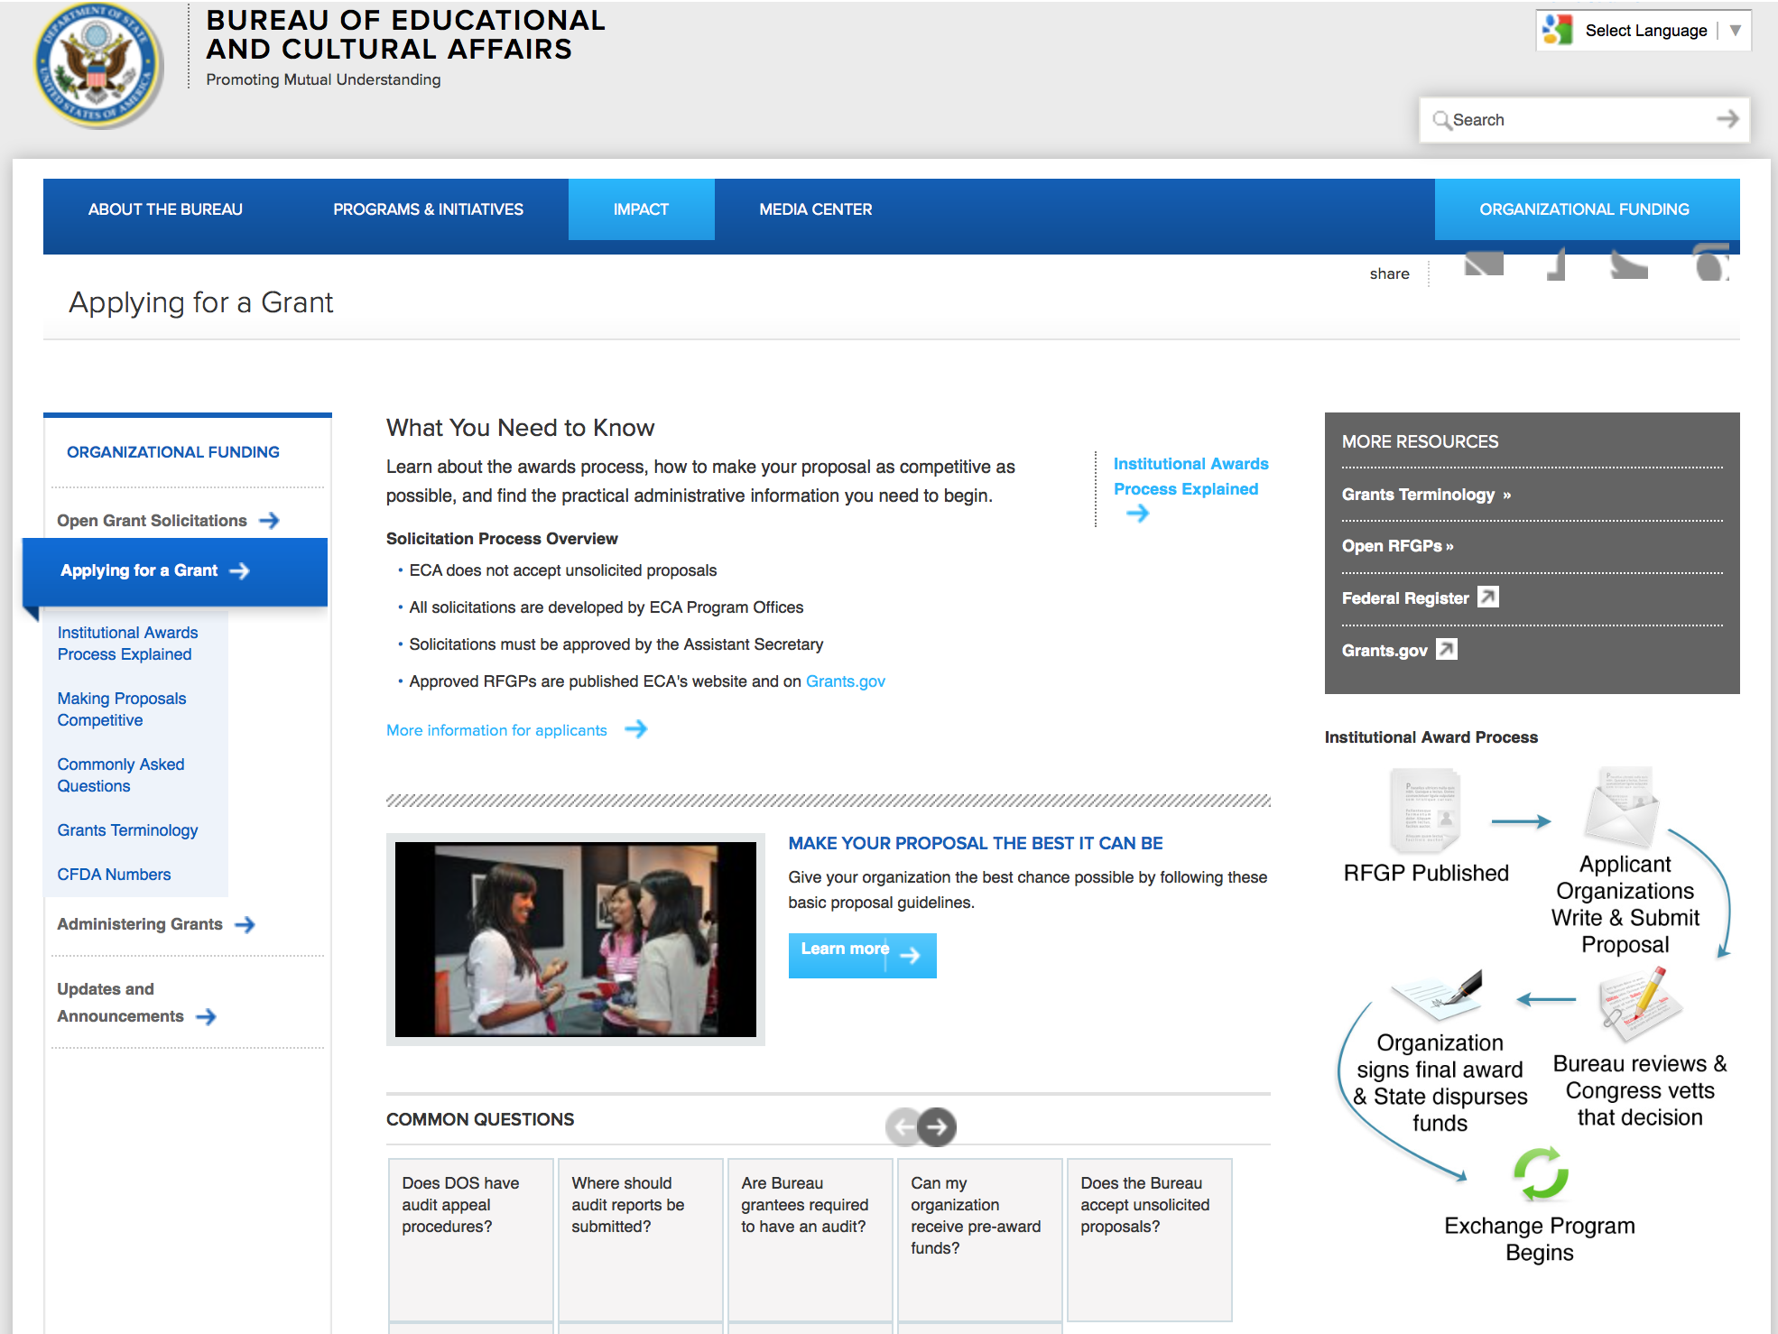

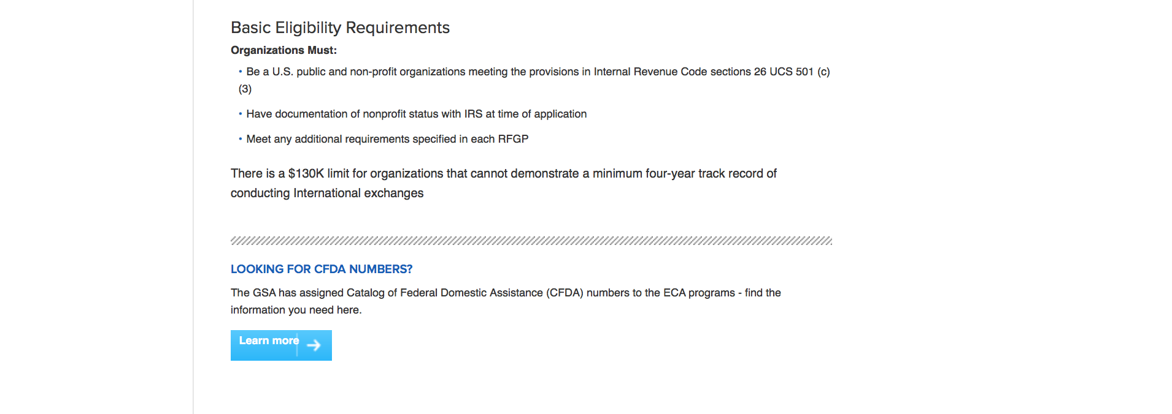
http://eca.state.gov/organizational-funding/applying-grant

General Information:
- Bureau of Educational and Cultural Affairs Grants Division
- Open Grant Opportunities (Requests for Grant Proposals)

For General Information click here

Program Grants:

Bureau of Near Eastern Affairs
Near East Affairs - Assistance Coordination
Access to Justice and Community Security Grant
http://www.grants.gov/web/grants/view-opportunity.html?oppId=284500

Bureau of African Affairs
Africa - Women, Peace, and Security (AF-WPS) Initiative FY 2016 Grant
http://www.grants.gov/web/grants/view-opportunity.html?oppId=284465

Number: ISN-ISNECC-16-013Internal Compliance Program for Serbia
Bureau of International Security and Nonproliferat
Posted Date: Jun 23, 2016
Link: http://www.grants.gov/web/grants/view-opportunity.html?oppId=285354

PM Weapons Removal and Abatement
16.PMWRA.Colombia.VA.NOFO Grant
http://www.grants.gov/web/grants/view-opportunity.html?oppId=284472

International Narcotics and Law Enforcement Affair
Facilitating Access to Justice in South Sudan Grant
http://www.grants.gov/web/grants/view-opportunity.html?oppId=284351

Ocean and International Environmental Scientific
Results-Focused Monitoring and Evaluation of U.S. Trade-Related Environmental Cooperation Grant
http://www.grants.gov/web/grants/view-opportunity.html?oppId=284392

Number: CSOG-CSOOPS2-16-004
Using Conflict Prevention Analysis and Tools to Prevent Violent Extremism in Tanzania
Bureau of Conflict Stabilization Operations
Posted Date: Jun 20, 2016
Link: http://www.grants.gov/web/grants/view-opportunity.html?oppId=285234

Number: ISN-ISNECC-16-014
EXBS Program Logistics Support
Bureau of International Security and Nonproliferat
Posted Date: Jun 23, 2016
Link: http://www.grants.gov/web/grants/view-opportunity.html?oppId=285342

Number: S-ND-POL-16-001
Gender-Based Violence Prevention and Awareness Caravan
Posted Date: Jun 23, 2016
Link: http://www.grants.gov/web/grants/view-opportunity.html?oppId=285331

Number: SBUR-SGWIPF-16-006
Comprehensive Gender-Based Violence Programming in Malawi and Tanzania Initiative
Agency Code: DOS-SBUR
S Bureau Grants Offices
Posted Date: Jul 01, 2016
Link: http://www.grants.gov/web/grants/view-opportunity.html?oppId=285650

Number: S-MY300-16-GR-TMP
Tun Mustapha Park Enforcement Assessment and Follow-on Activities
Agency Code: DOS-MLA
Mission To Malaysia
Posted Date: Jun 29, 2016
Link: http://www.grants.gov/web/grants/view-opportunity.html?oppId=285500

Modifications:

Bureau of African Affairs
Africa - Women, Peace, and Security (AF-WPS) Initiative FY 2016
Modification 3
http://www.grants.gov/web/grants/view-opportunity.html?oppId=284465

Bureau of Counterterrorism
Countering Violent Extremism in Kenya and Tanzania
Modification 1
http://www.grants.gov/web/grants/view-opportunity.html?oppId=284341

Bureau of Democracy, Human Rights and Labor
DRL Internet Freedom Annual Program Statement
Modification 1
http://www.grants.gov/web/grants/view-opportunity.html?oppId=284595

International Narcotics and Law Enforcement Affair
Facilitating Access to Justice in South Sudan
Modification 1
http://www.grants.gov/web/grants/view-opportunity.html?oppId=284351

U.S. Mission to Bosnia and Herzegovina
EDUCATIONUSA STUDENT ADVISING – BANJA LUKA
Modification 3
http://www.grants.gov/web/grants/view-opportunity.html?oppId=284179

U.S. Mission to Bosnia and Herzegovina
EDUCATIONUSA STUDENT ADVISING – TUZLA
Modification 3
http://www.grants.gov/web/grants/view-opportunity.html?oppId=284180

Number: DRLA-DRLAQM-17-001
DRL Internet Freedom Annual Program Statement
Bureau of Democracy, Human Rights and Labor
Posted Date: Jun 13, 2016
Modification 4
Modification Comments: Correct submission date
Link: http://www.grants.gov/web/grants/view-opportunity.html?oppId=284595

Number: NEAAC-ACBURGR-16-010
Economic, Governance, and Political TransitionSupport in Yemen
Near East Affairs - Assistance Coordination
Posted Date: Jun 21, 2016
Modification 2 Modification Comments: Spelling error
Link: http://www.grants.gov/web/grants/view-opportunity.html?oppId=285275

Number: OES-OTI-16-005
Ocean Conservation Projects in Developing States: Advancing Marine Protected Areas and Reducing Nutrient Pollution
Agency Code: DOS-OES
Ocean and International Environmental Scientific
Posted Date: Jun 29, 2016
Version: Synopsis 2
Modification Comments:

Link: http://www.grants.gov/web/grants/view-opportunity.html?oppId=285575

Reminders:

Department of Transportation

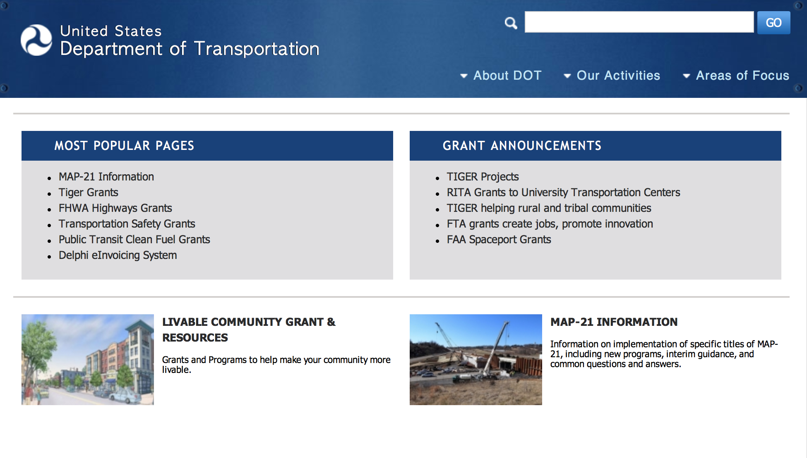
General Grant Program Overview https://www.transportation.gov/grants

Programs:

Modifications:

Reminders:

DOT Federal Aviation Administration
DOT - FAA Aviation Research Grants
FAA Aviation Research and Development Grants
Modifications 3 & 4

Document Type: | Grants Notice
Funding Opportunity Number: | 12-01
Funding Opportunity Title: | FAA Aviation Research and Development Grants
Opportunity Category: | Discretionary
Opportunity Category Explanation:
Funding Instrument Type: | Grant
Category of Funding Activity: | Transportation
Category Explanation:
Expected Number of Awards:
CFDA Number(s): | 20.108 -- Aviation Research Grants
Cost Sharing or Matching Requirement: | No
Version: | Synopsis 5
Posted Date: | Jan 01, 2012
Last Updated Date: | Jun 09, 2016
Original Closing Date for Applications: | Dec 31, 2019
Current Closing Date for Applications: | Dec 31, 2019
Archive Date: | Jan 30, 2020
Estimated Total Program Funding:
Award Ceiling: | $5,000,000
Eligible Applicants: | Nonprofits having a 501(c)(3) status with the IRS, other than institutions of higher education  Private institutions of higher education  Public and State controlled institutions of higher education
Agency Name: | DOT - FAA Aviation Research Grants
Description: | The FAA is soliciting proposals for research grants and cooperative agreements to pursue the long-term growth and short-term technical needs of civil aviation. In order to streamline the application process, it is recommended that all prospective grantees submit a white paper (letter of intent) for agency technical review before complete proposal submission. Please be sure to identify the specific area of interest (Solicitation FAA-12-01 – Chapter I. FAA Research Grants Program, Technical Areas of Research #1-#9). The white paper shall be no longer than three (3) pages and shall detail overall research objectives.
Link to Additional Information:
Grantor Contact Information: | If you have difficulty accessing the full announcement electronically, please contact:  Debra Monzo Grants Officer Phone 609-485-4962  business

http://www.grants.gov/web/grants/view-opportunity.html?oppId=134953

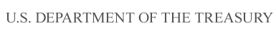

Department of the Treasury

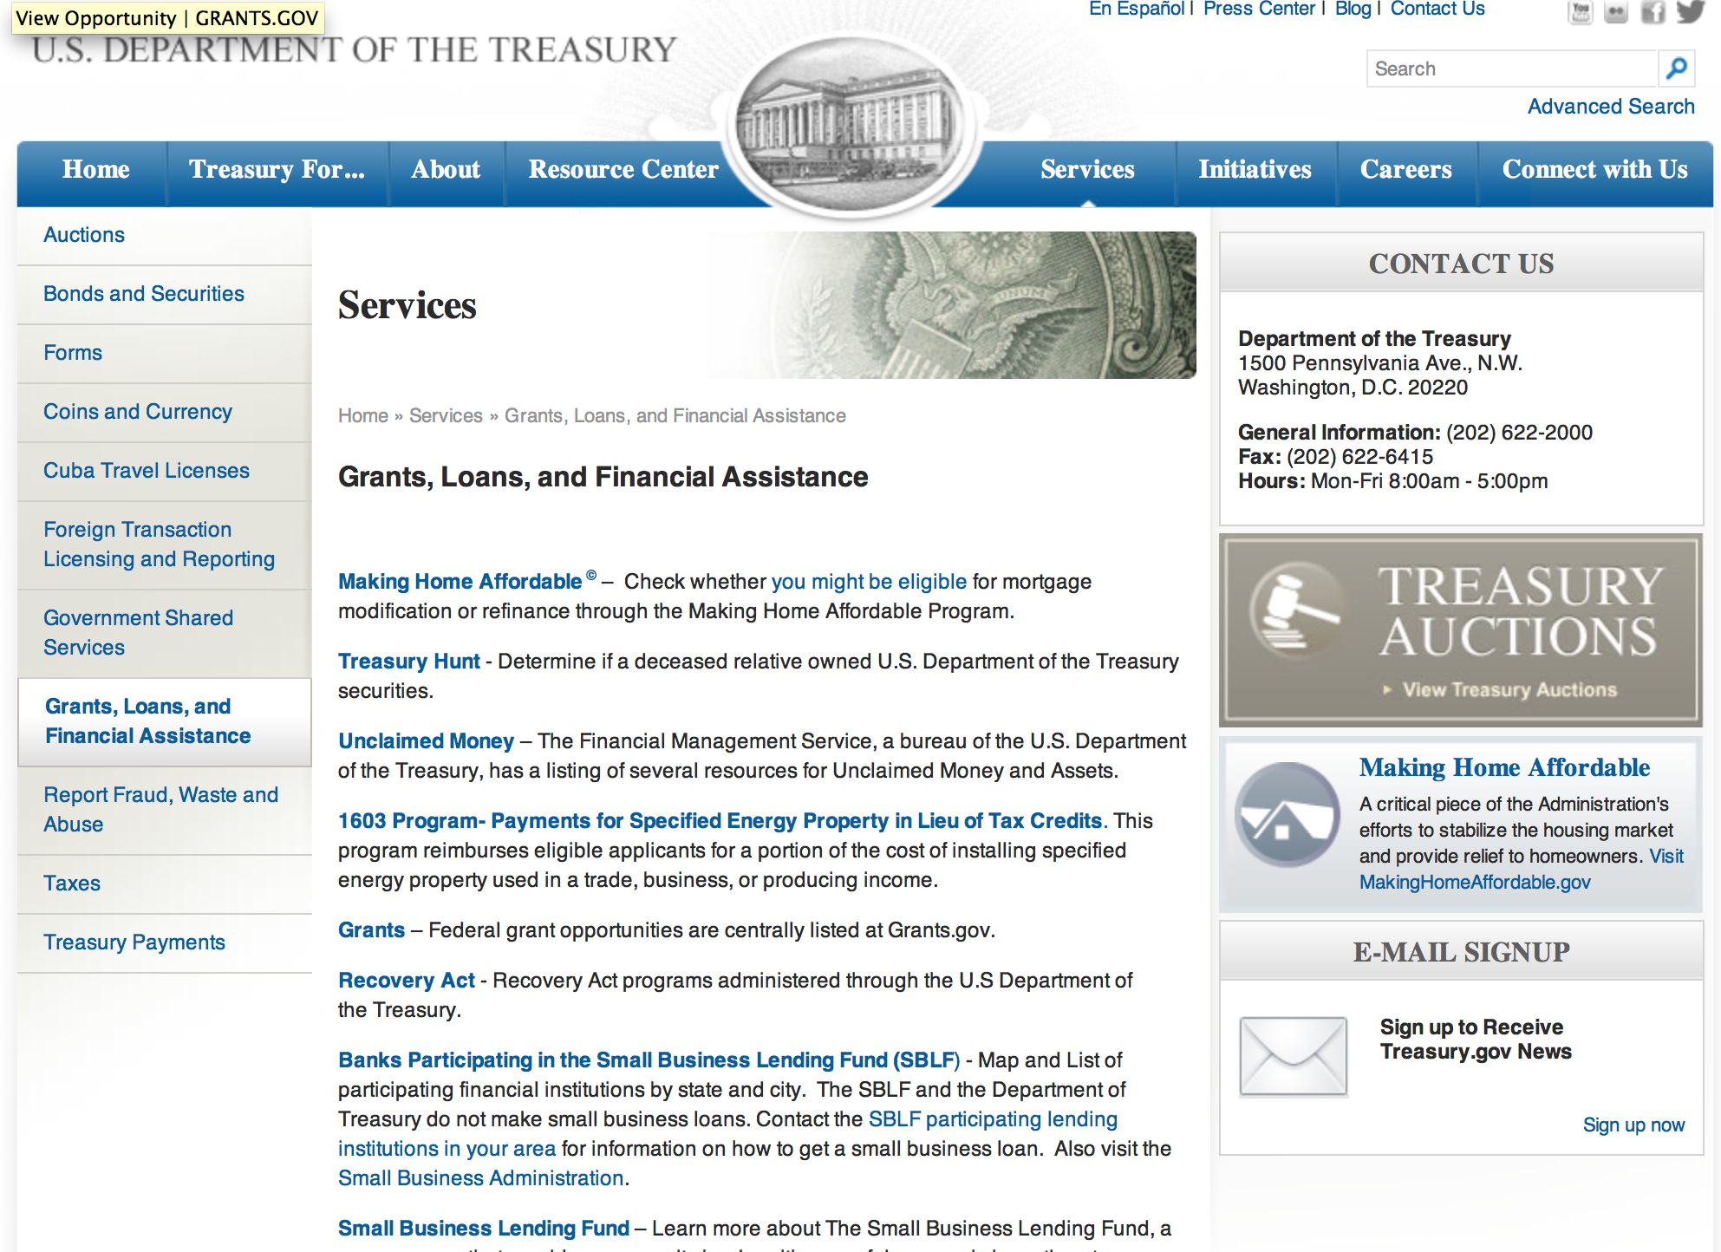

http://www.treasury.gov/services/Pages/Grants-Loans-and-Financial-Assistance.aspx

Programs:

Modifications:

Reminders:

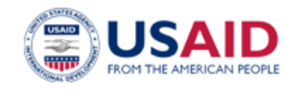

U.S. Agency for International Development

www.usaid.gov

General Overview Funding Opportunities

USAID has working relationships with thousands of American companies and hundreds of U.S.-based private voluntary organizations. For more information on our business and procurement opportunities, please visit our Business section.

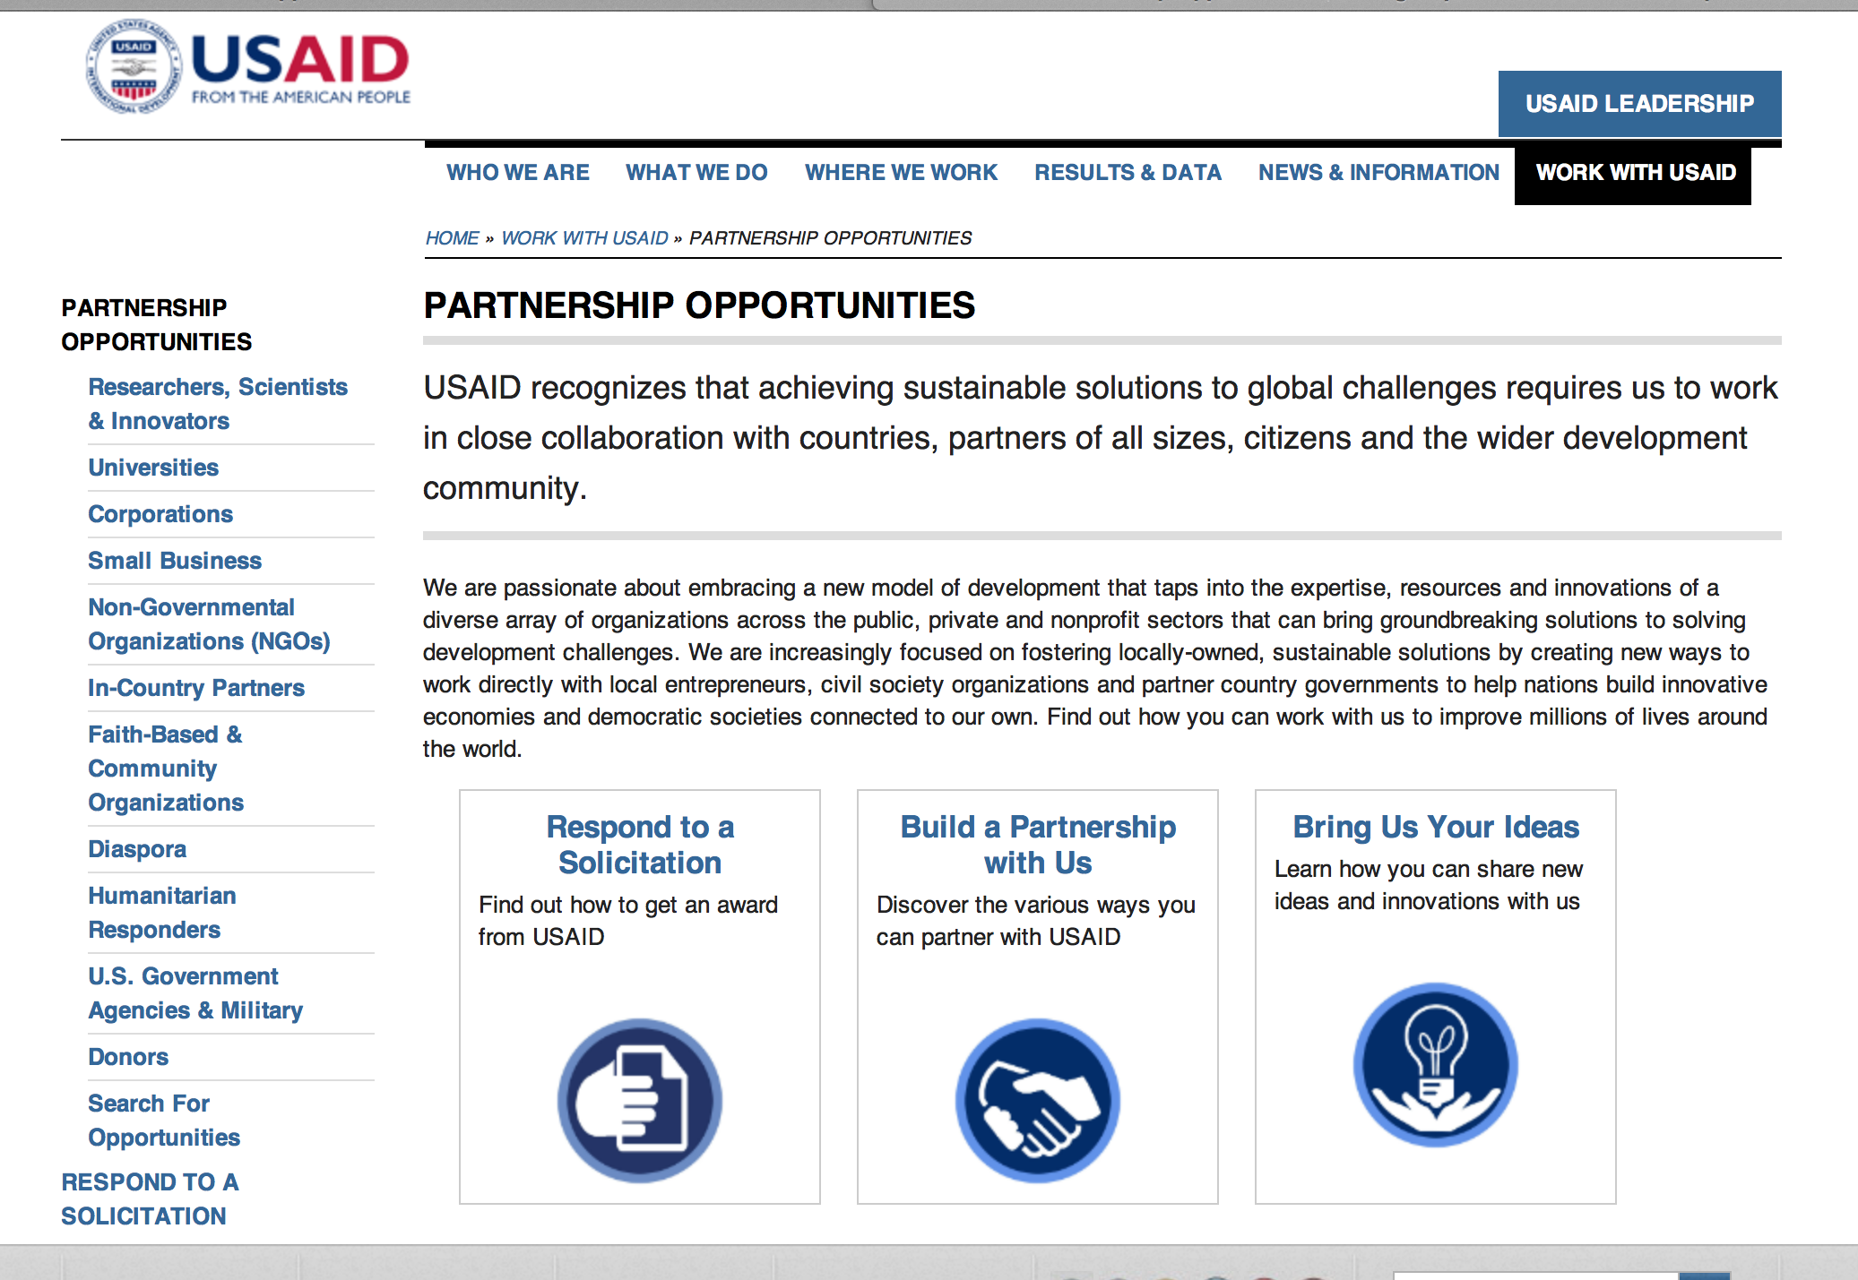
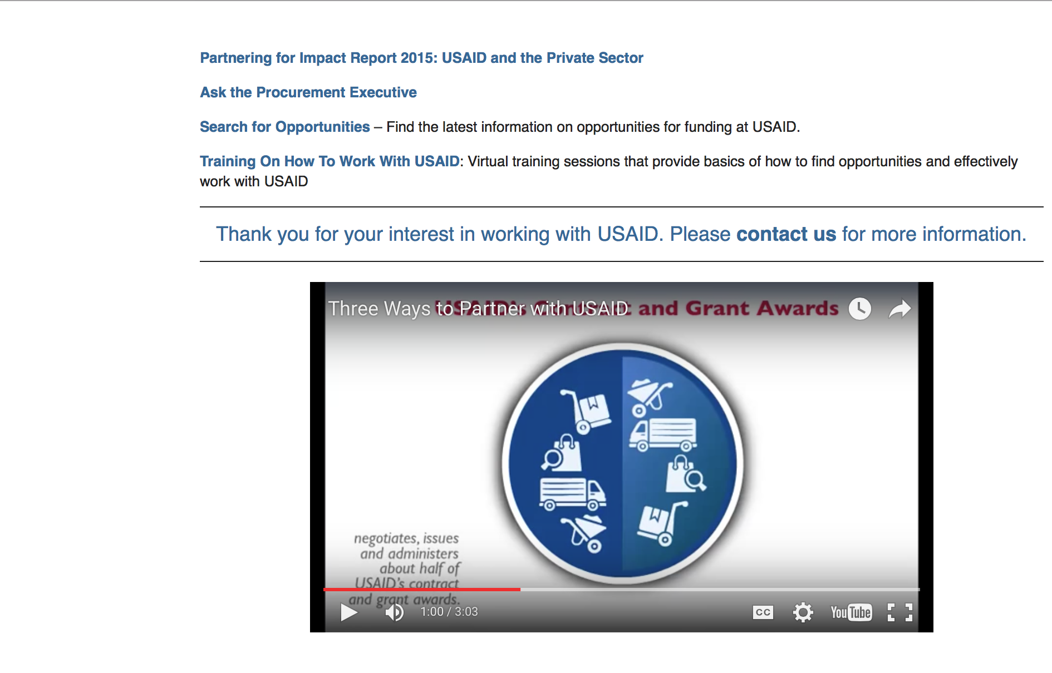

http://www.usaid.gov/partnerships

Programs:

Number: RFA-388-16-000006
Social and Behavior Change Communication (SBCC) Activity
Bangladesh USAID-Dhaka
Posted Date: Jun 19, 2016
Link: http://www.grants.gov/web/grants/view-opportunity.html?oppId=284989

Number: BAA-669-LGL-2016
Let Girls Learn Challenge for Liberia
Agency Code: USAID-LIB
Agency: Agency for International Development
Liberia USAID-Monrovia
Posted Date: Jun 27, 2016
Link: http://www.grants.gov/web/grants/view-opportunity.html?oppId=285469

Modifications:

Deleted:

Opportunity Number: RFA-696-16-000003
Opportunity Title: Youth Employment Project
Agency Code: USAID
Agency: Agency for International Development
Deleted Date: Jun 20, 2016

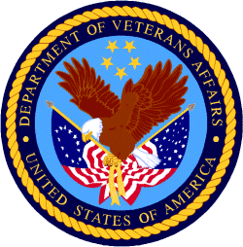

Department of Veterans Affairs

