Senator Mazie Hirono

Grants Assistance Information Newsletter

JULY 2017

G.A.I.N. INDEX

Click on Index Links below to read summaries of the announcements by agency in this document. Once you reach the item, if you cannot open the links for further information, copy the selected URL website address into your browser.

Modified sections from previous listings are shown in a GREY background

Notices is Teal are items with immediate deadline dates.

Notices in Yellow are of special interest.

Notices is Green are items of special interest with immediate deadline dates.

Items in this type color are aimed at Small Businesses

Items in this type color have a Faith-Based Organization component

Special Federal Program Notices

Grant Writing Resources

SAM and Grants.Gov Information

SBIR – Small Business Innovation Research

Programs specific to Hawaii

Current Notices

Native Youth Initiative for Leadership, Empowerment, and Development (I-LEAD)

Reminders

See Individual Departments for information and webpages representing the best and most accessible information on the agency funding opportunities

Federal Grant and Cooperative Agreement Program Summaries

U.S. Department of Agriculture

Grants and Loans Overview

Programs

Business and Cooperative Programs
Socially Disadvantaged Groups Grant

DM-Office of Advocacy and Outreach
Outreach and Assistance for Socially Disadvantaged Farmers and Ranchers and Veteran Farmers and Ranchers Program

Research

Modifications

Agricultural Marketing Service
USDA-AMS-TM-SCMP-G-17-0005

Reminders

Utilities Programs
Community Facilities Technical Assistance and Training Grant

Utilities Programs
Distance Learning & Telemedicine Grant

Utilities Programs
Rural Community Development Initiative (RCDI)

Utilities Programs
Rural Housing Preservation Grant

Fish and Wildlife Service
2017 National Fish Habitat Action Plan

Risk Management Education
Risk Management Education Partnership Program

Risk Management Education
Crop Insurance Education in Targeted States

Deleted:

Department of Commerce

Grants at Commerce

Programs

Economic Development Administration
FY 2017 Economic Development Assistance Programs ­ Application submission and program requirements for EDA’s Public Works and Economic Adjustment Assistance programs.

National Institute of Standards and Technology
Professional Research Experience Program

Modifications

Research

Reminders

Climate Program Office 2018

National Institute of Standards and Technology
Embedding MEP in Manufacturing USA Institutes Pilot Projects – Round 3

National Institute of Standards and Technology
Measurement Science and Engineering (MSE) Research Grant Programs

National Sea Grant College Program 2016-17 Special Projects Grant

FY 2016 – FY 2019 EDA Planning Program and Local Technical Assistance Program Grant

Economic Development Administration
Planning Program and Local Technical Assistance Program Grant

Deleted

Corporation for National and Community Service

General Program Overview

Programs

Reminders

National Service and Civic Engagement Research Competition

National Service in Hawaii

Department of Defense

Doing Business with the Department of Defense

DoD Small Business Opportunities and Forecasting

Research Grants

Modifications

Reminders

Department of Defense
Dept of the Army -- Materiel Command
Fiscal Year 2018 Defense University Research Instrumentation Program (DURIP) - ARMY SUBMISSION

Air Force Office of Scientific Research
Fiscal Year 2018 Defense University Research Instrumentation Program (DURIP)

Department of Education

Grant Programs Overview

Programs

Office of Career, Technical, and Adult Education (OCTAE): High School Career and Technical Education Teacher Pathway Initiative CFDA Number 84.051D

Research

Office of Postsecondary Education (OPE): International Research and Studies Program: Research, Studies, and Surveys CFDA Number 84.017A

Modifications

The Office of Innovation and Improvement (OII): American History and Civics Education: Presidential and Congressional Academies for American History and Civics (Academies) Program CFDA Number 84.422A

Reminders

Deleted

US Department of Energy

Grants Overview

Research

Modifications

Reminders

PAMS
Department of Energy - Office of Science
Office of Science
FY 2017 Continuation of Solicitation for the Office of Science Financial Assistance Program
Synopsis 2

Environmental Protection Agency

Grants and Contracts Overview

Programs

Modifications

Research

Reminders

Department of Health and Human Services

Grants Overview

Program

Research Grants

Modifications

Deleted

Reminders

Department of Homeland Security
Grants Overview

Programs

Department of Homeland Security - FEMA
Fiscal Year (FY) 2017 Homeland Security National Training Program (HSNTP) - National Domestic Preparedness Consortium (NDPC)

Fiscal Year (FY) 2017 Homeland Security National Training Program (HSNTP) - Continuing Training Grants (CTG)

Office of Procurement Operations - Grants Division
Genetic Engineering Machine Competition

Modifications

Reminders

Office of Procurement Operations - Grants Division
DHS S&T Center of Excellence for Cross-Border Threat Screening and Supply Chain Defense - Partner
Synopsis 2

Department of Housing and Urban Development

HUD - Notice of Funds Available

Programs

Modifications

Choice Neighborhoods Planning Grants Program

Deleted

Reminders

Institute of Museum and Library Services

Grants Overview

IMLS is on Facebook!

Programs

Modifications

Reminders

Deleted

Department of Interior

Grants and Contract Overview

Programs

National Park Service
Historic Preservation Fund Grants to Underrepresented Communities

Modifications

Reminders

National Fish Passage Program

Fish and Wildlife Service
Fiscal Year 2017 Recovery Implementation Grants

Fish and Wildlife Service
Partners for Fish and Wildlife

Fish and Wildlife Service
Coastal Program

Deleted

Department of Justice

Grants and Contract Overview

Programs

Office for Victims of Crime
OVC FY 17 Increasing Legal Access to Victims of Crime: Innovations in Access to Justice Programs

Office for Victims of Crime
OVC FY 17 Vision 21: Integrated Services for Victims Program: Increasing Access to Mental Health Services for Victims of Crime

Research

Modifications

Deleted

Reminders

________________________________________________________________________

Department of Labor

Grants and Contract General Overview

Programs

Modifications

Reminders

National Aeronautics and Space Administration

Research Grant and Contract General Overview

Programs

Modifications

_______________________________________________________________
National Archives and Records Administration

Grant Opportunities General Overview

Access to Historical Records: Archival Projects

Reminders

EDITIONS-201710 for Publishing Historical Records in Documentary Editions

Access to Historical Records - Major Initiatives

_______________________________________________________________
National Endowment for the Arts

Grant Opportunities General Overview

Programs

NEA Art Works II Application, FY2018

Modifications

Reminders

NEA Our Town Application, FY2018

NEA Arts Research Labs PS Application, FY2018

_______________________________________________________________

National Endowment for the Humanities

Grant Opportunities General Overview

Programs

Fellowship Programs at Independent Research Institutions

Media Projects

Public Humanities Projects

Humanities Open Book Program

Reminders

Humanities Collections and Reference Resources

Summer Stipends

_______________________________________________________________
National Science Foundation

Grant Opportunities General Overview

Research and Program Grants

Modifications

Reminders

Deleted

Nuclear Regulatory Commission

Reminders

Small Business Administration

General Overview Finding Loans & Grants

Programs

Women's Business Center Renewal Grant

Option Year Workplan and Budget

Modifications

OSBDC

Program Announcement

Reminders

Program Announcement

Deleted

Upcoming Trainings

Links Specific to Hawaii

State Department

General Overview and Resources for Program Administrators

Programs

Modifications

Reminders

U.S. Department of Transportation

General Grant Program Overview

Programs

Research

Modifications:

Reminders

DOT Federal Aviation Administration
DOT - FAA Aviation Research Grants
FAA Aviation Research and Development Grants
Modifications 3 & 4

Deleted

Department of the Treasury

Programs

Community Development Financial Institutions
Fiscal Year 2017 Capital Magnet Fund Program

Modifications

Reminders

US Agency for International Development

General Funding Opportunity Overview

Programs
Modifications

Deleted

Department of Veterans Affairs

Special Federal Program Notices

Grant Writing Resources

The following links are a great resource for faith-based non-profits and other community organizations :

- Center for Faith-Based and Community Initiatives (link is external) , U.S. Department of Labor

- http://www.usaid.gov/partnership-opportunities/fbci. U.S. Agency for International Development

- Faith-Based and Other Community Initiatives (link is external) , Corporation for National Community Service

- Task Force for Faith-Based and Community Initiatives (link is external) , U.S. Department of Justice

- Proposal Writing Short Course (link is external) Foundation Center.
- General Tips on Writing a Competitive Grant Proposal (link is external) U.S. Environmental Protection Agency.
- How to Write a Grant Proposal (link is external) Appalachian Regional Commission.
- A Guide to Funding Resources USDA Rural Information Center.

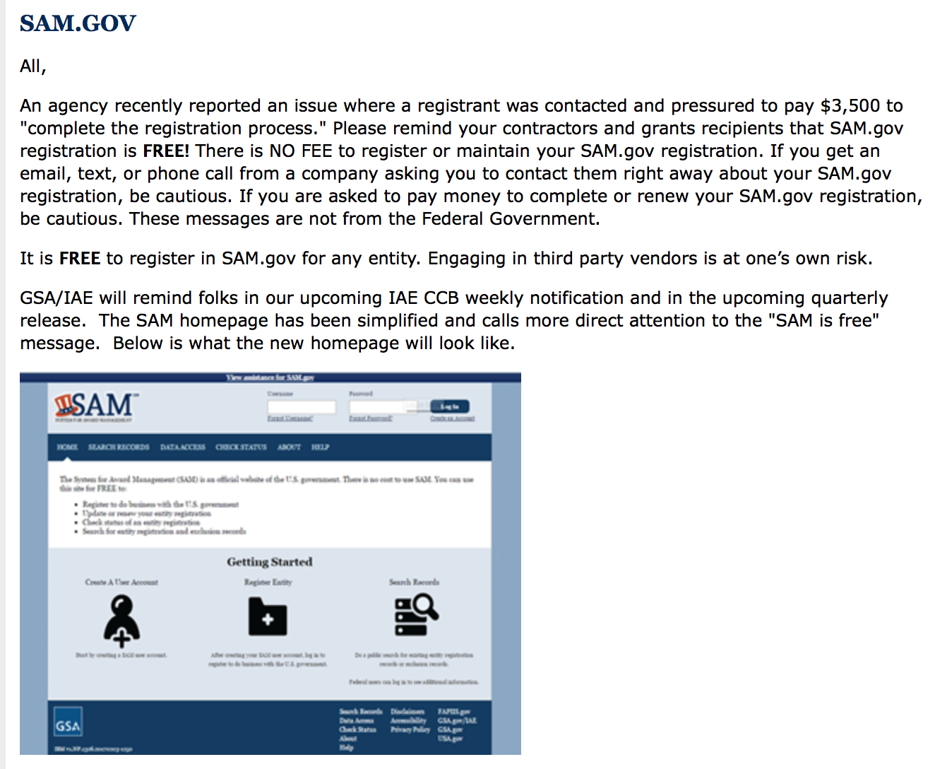

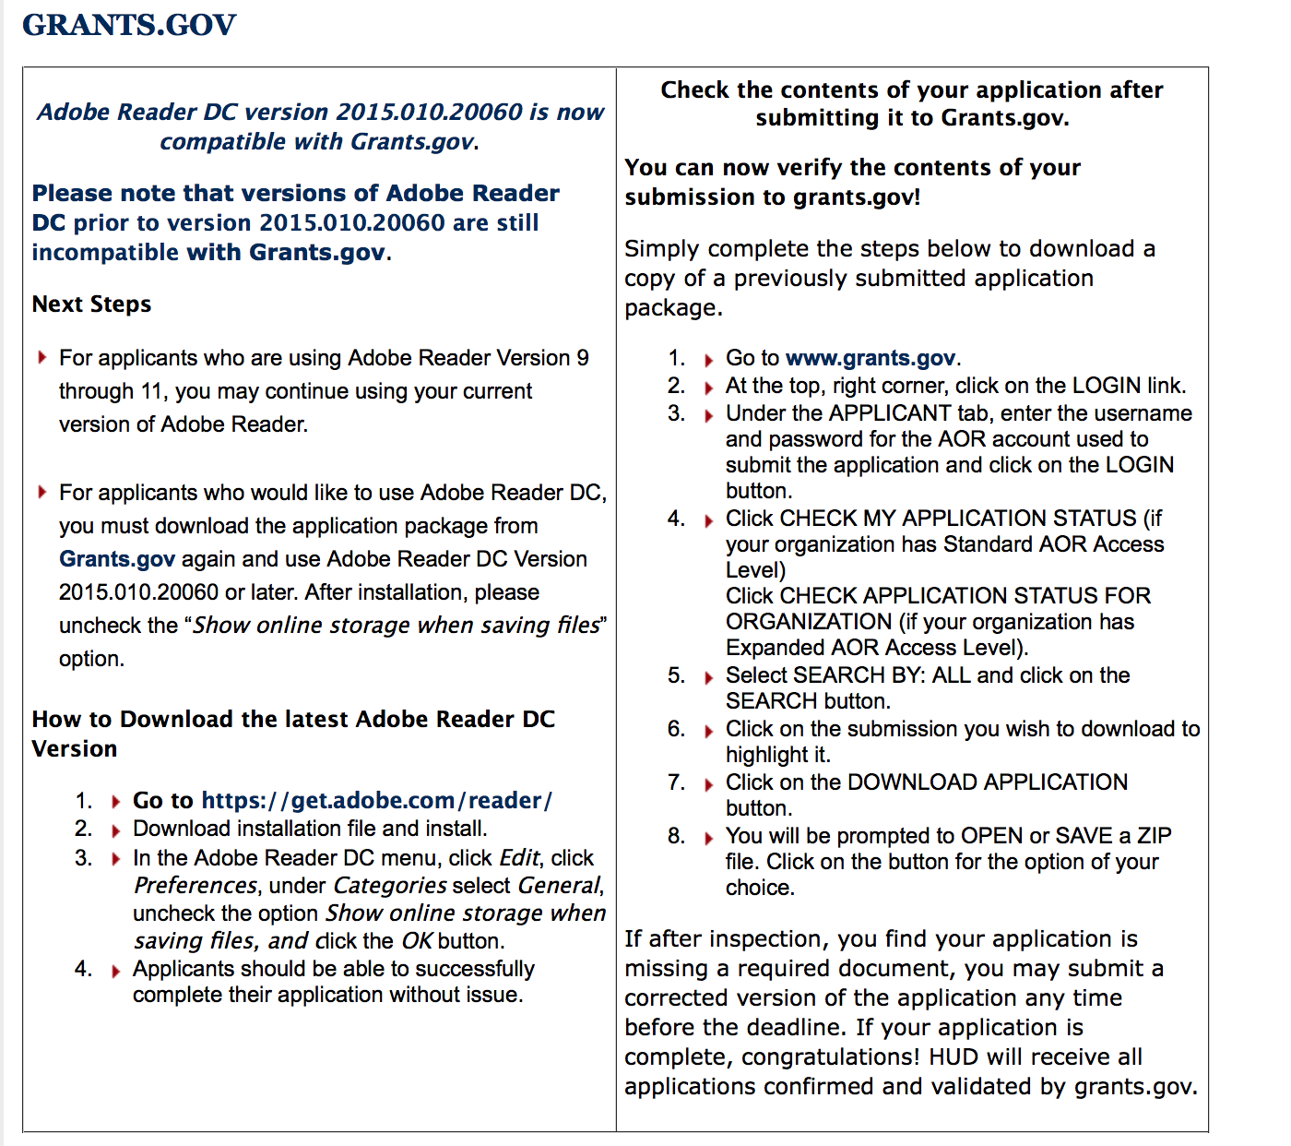

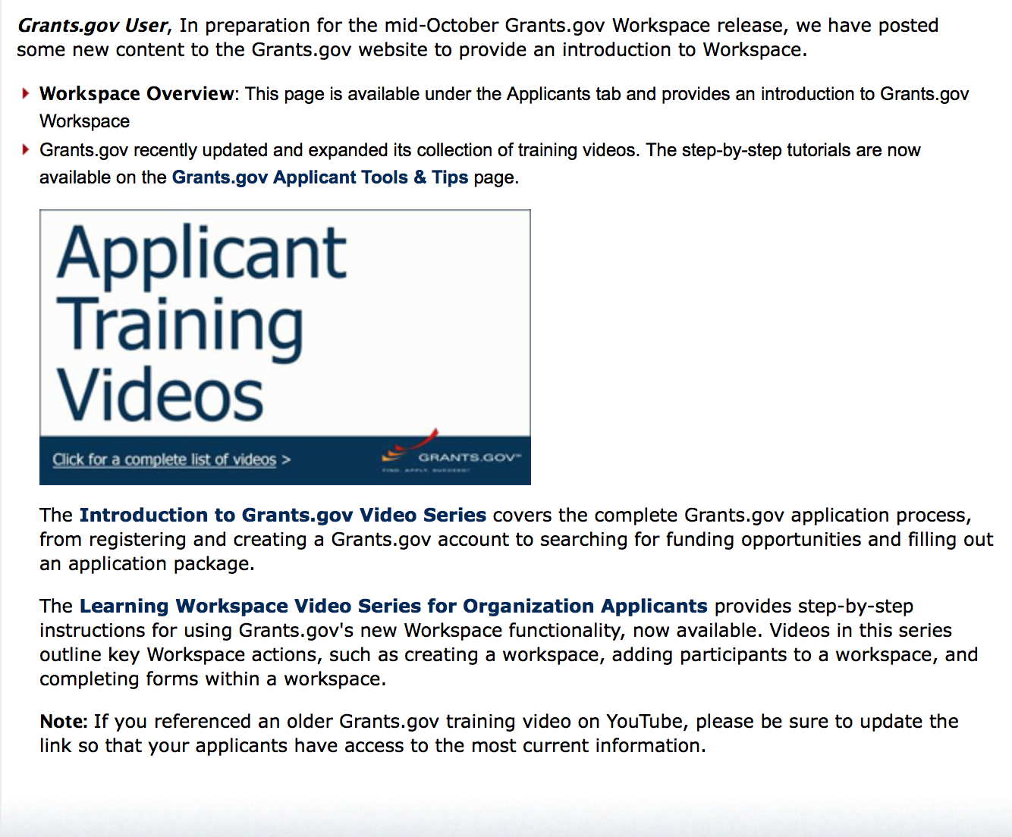
https://portal.hud.gov/hudportal/HUD?src=/program_offices/administration/grants/fundsavail

The Small Business Innovative Research Program - SBIR Program

The Small Business Innovation Research (SBIR) program is a highly competitive program that encourages domestic small businesses to engage in Federal Research/Research and Development (R/R&D) that has the potential for commercialization. Through a competitive awards-based program, SBIR enables small businesses to explore their technological potential and provides the incentive to profit from its commercialization. By including qualified small businesses in the nation's R&D arena, high-tech innovation is stimulated and the United States gains entrepreneurial spirit as it meets its specific research and development needs.

SBIR Mission and Program Goals
The mission of the SBIR program is to support scientific excellence and technological innovation through the investment of Federal research funds in critical American priorities to build a strong national economy.
The program’s goals are four-fold:
- Stimulate technological innovation
- Meet Federal research and development needs.
- Foster and encourage participation in innovation and entrepreneurship by socially and economically disadvantaged persons.
- Increase private-sector commercialization of innovations derived from Federal research and development funding.

SBIR-Participating Agencies
Each year, Federal agencies with extramural research and development (R&D) budgets that exceed $100 million are required to allocate 2.5 percent of their R&D budget to these programs. Currently, eleven Federal agencies participate in the program:
- Department of Agriculture
- Department of Commerce - National Institute of Standards and Technology
- Department of Commerce - National Oceanic and Atmospheric Administration
- Department of Defense
- Department of Education
- Department of Energy
- Department of Health and Human Services
- Department of Homeland Security
- Department of Transportation
- Environmental Protection Agency
- National Aeronautics and Space Administration
- National Science Foundation
Each agency administers its own individual program within guidelines established by Congress. These agencies designate R&D topics in their solicitations and accept proposals from small businesses. Awards are made on a competitive basis after proposal evaluation.

Three-Phase Program
The SBIR Program is structured in three phases:
Phase I. The objective of Phase I is to establish the technical merit, feasibility, and commercial potential of the proposed R/R&D efforts and to determine the quality of performance of the small business awardee organization prior to providing further Federal support in Phase II. SBIR Phase I awards normally do not exceed $150,000 total costs for 6 months.
Phase II. The objective of Phase II is to continue the R/R&D efforts initiated in Phase I. Funding is based on the results achieved in Phase I and the scientific and technical merit and commercial potential of the project proposed in Phase II. Only Phase I awardees are eligible for a Phase II award. SBIR Phase II awards normally do not exceed $1,000,000 total costs for 2 years.
Phase III. The objective of Phase III, where appropriate, is for the small business to pursue commercialization objectives resulting from the Phase I/II R/R&D activities. The SBIR program does not fund Phase III. Some Federal agencies, Phase III may involve follow-on non-SBIR funded R&D or production contracts for products, processes or services intended for use by the U.S. Government
SBIR NewsLetter

- SBIR Newsletter
Sign up for e-mail updates

HAWAII APPLICANTS ENCOURAGED

Current Notices:

Native Youth Initiative for Leadership, Empowerment, and Development (I-LEAD)
Synopsis 1
Document Type: | Grants Notice
Funding Opportunity Number: | HHS-2017-ACF-ANA-NC-1263
Funding Opportunity Title: | Native Youth Initiative for Leadership, Empowerment, and Development (I-LEAD)
Opportunity Category: | Discretionary
Opportunity Category Explanation:
Funding Instrument Type: | Grant
Category of Funding Activity: | Income Security and Social Services
Category Explanation:
Expected Number of Awards: | 7
CFDA Number(s): | 93.612 -- Native American Programs
Cost Sharing or Matching Requirement: | Yes
Version: | Synopsis 1
Posted Date: | Jun 09, 2017
Last Updated Date: | Jun 09, 2017
Original Closing Date for Applications: | Jul 19, 2017 Electronically submitted applications must be submitted no later than 11:59 p.m., ET, on the listed application due date.
Current Closing Date for Applications: | Jul 19, 2017 Electronically submitted applications must be submitted no later than 11:59 p.m., ET, on the listed application due date.
Archive Date: | Aug 18, 2017
Estimated Total Program Funding: | $2,000,000
Award Ceiling: | $300,000
Award Floor: | $100,000
Eligible Applicants: | Others (see text field entitled "Additional Information on Eligibility" for clarification)  Native American tribal governments (Federally recognized)  Nonprofits having a 501(c)(3) status with the IRS, other than institutions of higher education  Native American tribal organizations (other than Federally recognized tribal governments)
Additional Information on Eligibility: | Non-profit organizations representing American Indians, Alaska Natives, Native Hawaiians, and other Native American Pacific Islanders, including American Samoa, Guam, and the Commonwealth of the Northern Mariana Islands are eligible applicants under this announcement. A full listing of eligible entities under this announcement are: Federally recognized Indian tribes, as recognized by the Bureau of Indian Affairs; Incorporated non-federally recognized tribes; Incorporated state-recognized Indian tribes, Consortia of Indian tribes; Incorporated non-profit multi-purpose community-based Indian organizations; Urban Indian Centers; Alaska Native villages as defined in the Alaska Native Claims Settlement Act (ANSCA) and/or non-profit village; Non-profit native organizations in Alaska with village-specific projects; Incorporated non-profit Alaska Native multipurpose, community-based organizations; Non-profit Alaska Native Regional Corporations/Associations in Alaska with village-specific projects; Non-profit Alaska Native community entities or tribal governing bodies (Indian Reorganization Act or Traditional Councils) as recognized by the Bureau of Indian Affairs; Public and non-profit private agencies serving Native Hawaiians; National or regional incorporated non-profit Native American organizations with Native American community-specific objectives; Public and non-profit private agencies serving native peoples from Guam, American Samoa, or the Commonwealth of the Northern Mariana Islands;Tribal Colleges and Universities, and colleges and universities located in Hawaii, Guam, American Samoa, or the Commonwealth of the Northern Mariana Islands that serve Native American Pacific Islanders. Faith-based and community organizations that meet the eligibility requirements are eligible to receive awards under this funding opportunity announcement. Applications from individuals (including sole proprietorships) and foreign entities are not eligible and will be disqualified from competitive review and from funding under this announcement.
Agency Name: | Administration for Children and Families - ANA
Description: | The Administration for Native Americans (ANA), within the Administration for Children and Families (ACF), announces the availability of Fiscal Year (FY) 2017 funds for the Native Youth I-LEAD. This program will emphasize a comprehensive, culturally-appropriate approach to ensure that all young Native people can thrive and reach their full potential by fostering Native youth resilience, capacity building, and leadership. Native Youth I-LEAD will specifically focus on implementation of community programs that promote Native youth resiliency and foster protective factors such as connections with Native languages and Elders, positive peer groups, culturally-responsive parenting resources, models of safe sanctuary, and reconnection with traditional healing. Projects will also promote Native youth leadership development through the establishment of local models to instill confidence in Native youth of their value and potential, preparation of older youth to be role models for younger peers, and activities that foster leadership and skills-building. In addition, it is intended that Native youth must be actively involved during the planning and implementation phases of the projects to ensure that they are responsive to the needs of Native youth in the communities to be served and to ensure that youth remain engaged throughout the project period.
Link to Additional Information: | https://ami.grantsolutions.gov/HHS-2017-ACF-ANA-NC-1263
Grantor Contact Information: | If you have difficulty accessing the full announcement electronically, please contact:  ACF Applications Help Desk app_support@acf.hhs.gov

http://www.grants.gov/web/grants/view-opportunity.html?oppId=290439

Reminders:

Please review each department’s General Grant and Funding Overview. These overviews are the key web pages on each departmental website dedicated to the agency’s funding opportunities. Check back often to note the department updates and use these sources to assist you in your planning.

Federal Grant and Cooperative Agreement Program Summaries

U.S. Department of Agriculture

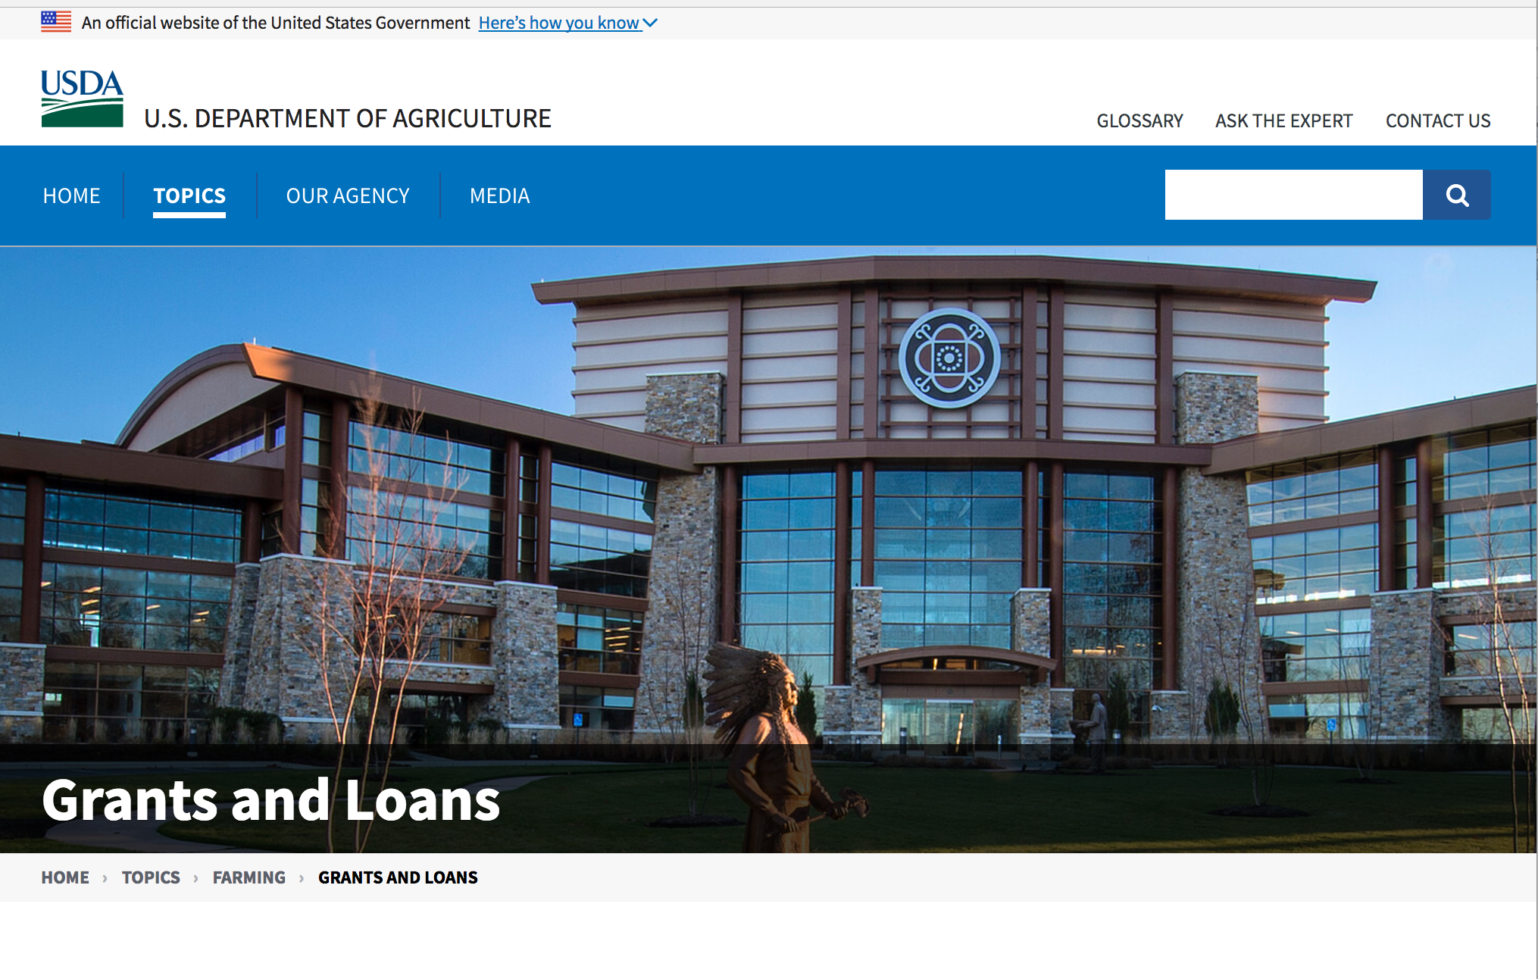

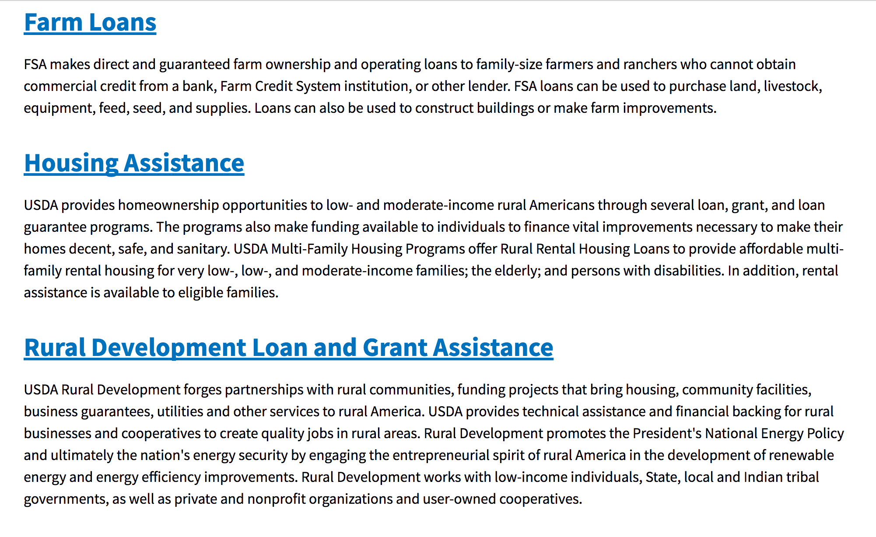

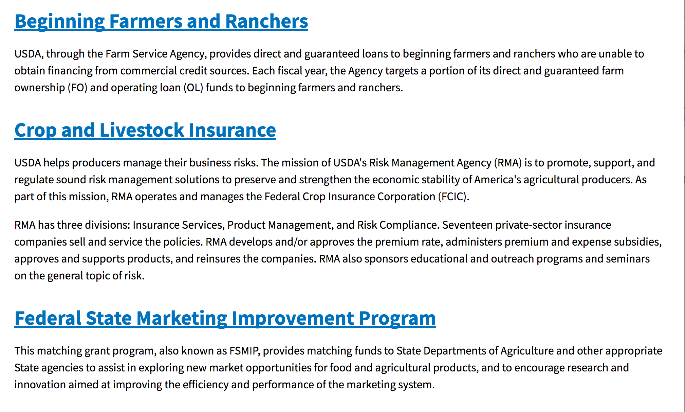
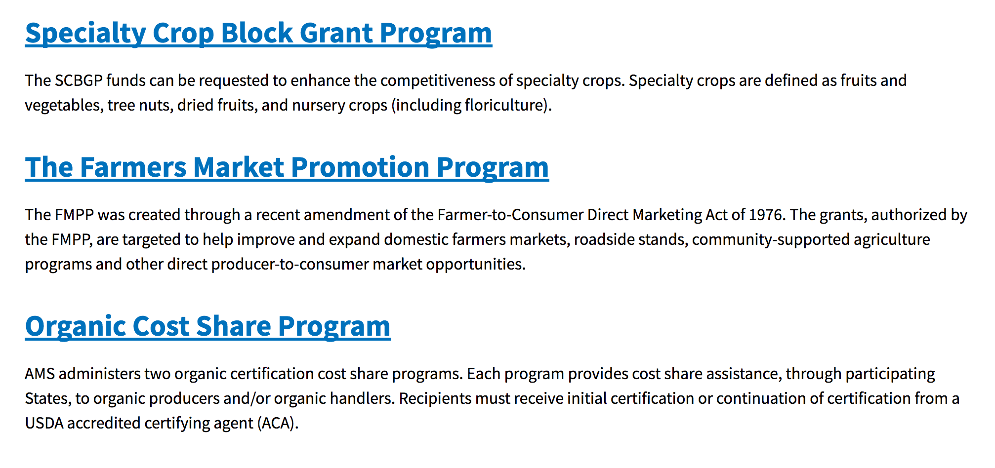
https://www.usda.gov/topics/farming/grants-and-loans

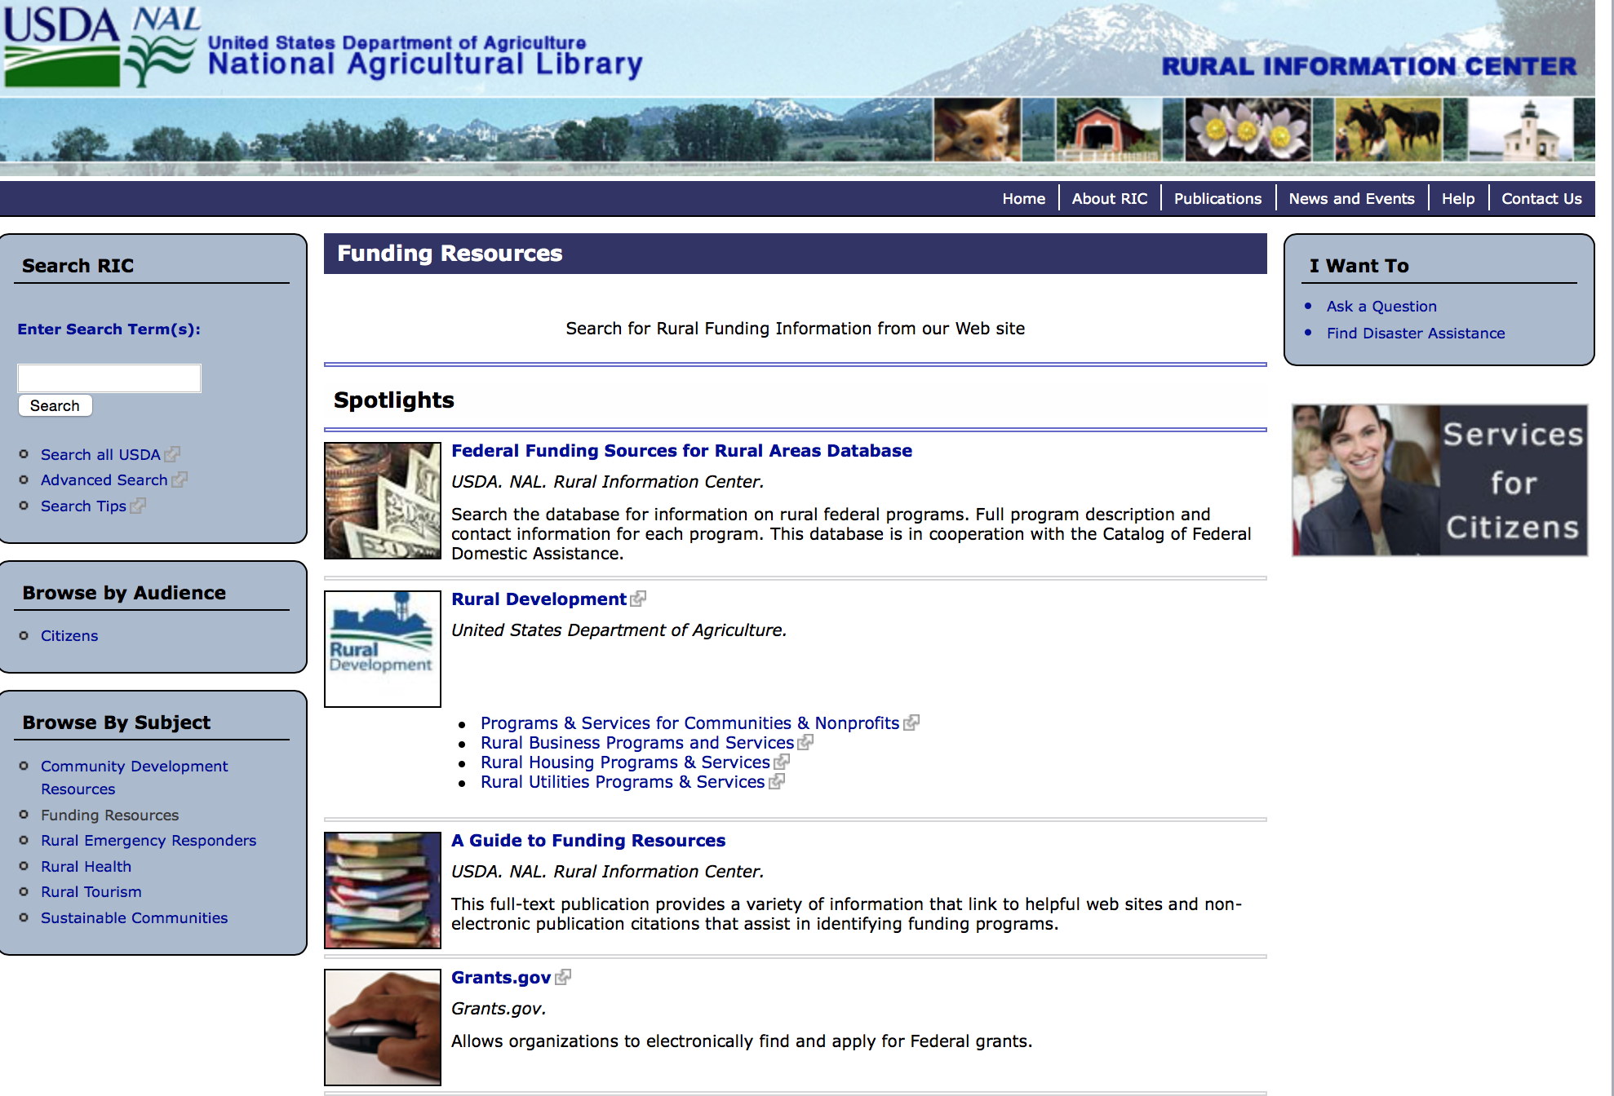

http://ric.nal.usda.gov/funding-resources

Programs:

Business and Cooperative Programs
Socially Disadvantaged Groups Grant
Synopsis 1
Document Type: | Grants Notice
Funding Opportunity Number: | RDBCP-SDGG-2017
Funding Opportunity Title: | Socially Disadvantaged Groups Grant
Opportunity Category: | Discretionary
Opportunity Category Explanation:
Funding Instrument Type: | Grant
Category of Funding Activity: | Business and Commerce
Category Explanation:
Expected Number of Awards: | 30
CFDA Number(s): | 10.871 -- Socially-Disadvantaged Groups Grant
Cost Sharing or Matching Requirement:
Version: | Synopsis 1
Posted Date: | Jun 07, 2017
Last Updated Date: | Jun 07, 2017
Original Closing Date for Applications: | Jul 25, 2017
Current Closing Date for Applications: | Jul 25, 2017
Archive Date: | Aug 24, 2017
Estimated Total Program Funding: | $3,000,000
Award Ceiling: | $175,000
Award Floor: | $0
Eligible Applicants: | Others (see text field entitled "Additional Information on Eligibility" for clarification)  Native American tribal governments (Federally recognized)
Additional Information on Eligibility: | Cooperatives, Groups of Cooperatives, Cooperative Development Centers that serve socially disadvantaged groups
Agency Name: | Business and Cooperative Programs
Description: | The Rural Business-Cooperative Service announces the availability of $3,000,000 in competitive grant funds for the FY 2017 Socially-Disadvantaged Groups Grant (SDGG) program, formerly known as the Small Socially-Disadvantaged Producer Grant program, as authorized by section 310B (e)(11) of the Consolidated Farm and Rural Development Act (7 U.S.C. 1932 (e)(11)). We are requesting proposals from applicants who will provide technical assistance to socially-disadvantaged groups in rural areas. The Agency is encouraging applications that direct grants to projects based in or serving census tracts with poverty rates greater than or equal to 20 percent. This emphasis will support Rural Development’s (RD) mission of improving the quality of life for rural Americans and commitment to directing resources to those who most need them. Eligible applicants include Cooperatives, Groups of Cooperatives, and Cooperative Development Centers.
Link to Additional Information: | SDGG FY 2017 NOFA
Grantor Contact Information: | If you have difficulty accessing the full announcement electronically, please contact:  Rural Development - Cooperative Programs (202)690-1374  CP Grants

http://www.grants.gov/web/grants/view-opportunity.html?oppId=294476

DM-Office of Advocacy and Outreach
Outreach and Assistance for Socially Disadvantaged Farmers and Ranchers and Veteran Farmers and Ranchers Program
Synopsis 1
Funding Opportunity Number: | OAO-011
Funding Opportunity Title: | Outreach and Assistance for Socially Disadvantaged Farmers and Ranchers and Veteran Farmers and Ranchers Program
Opportunity Category: | Mandatory
Opportunity Category Explanation:
Funding Instrument Type: | Grant
Category of Funding Activity: | Agriculture
Category Explanation:
Expected Number of Awards:
CFDA Number(s): | 10.443 -- Outreach and Assistance for Socially Disadvantaged and Veteran Farmers and Ranchers
Cost Sharing or Matching Requirement: | No
Version: | Synopsis 1
Posted Date: | Jun 26, 2017
Last Updated Date: | Jun 26, 2017
Original Closing Date for Applications: | Aug 07, 2017
Current Closing Date for Applications: | Aug 07, 2017
Archive Date: | Sep 06, 2017
Estimated Total Program Funding: | $8,400,000
Award Ceiling: | $200,000
Award Floor: | $0
Eligible Applicants: | Private institutions of higher education  Nonprofits that do not have a 501(c)(3) status with the IRS, other than institutions of higher education  Nonprofits having a 501(c)(3) status with the IRS, other than institutions of higher education  Public and State controlled institutions of higher education
Agency Name: | DM-Office of Advocacy and Outreach
Description: | Please refer to application instructions and package.
Link to Additional Information:
Grantor Contact Information: | If you have difficulty accessing the full announcement electronically, please contact:  Kenya Nicholas Program Manager Phone 202-720-6350  Office Email

http://www.grants.gov/web/grants/view-opportunity.html?oppId=294868

Research:

Modifications:

Agricultural Marketing Service
USDA-AMS-TM-SCMP-G-17-0005
Synopsis 2
Document Type: | Grants Notice
Funding Opportunity Number: | USDA-AMS-TM-SCMP-G-17-0005
Funding Opportunity Title: | USDA-AMS-TM-SCMP-G-17-0005
Opportunity Category: | Discretionary
Opportunity Category Explanation:
Funding Instrument Type: | Grant
Category of Funding Activity: | Agriculture
Category Explanation:
Expected Number of Awards: | 10
CFDA Number(s): | 10.170 -- Specialty Crop Block Grant Program - Farm Bill
Cost Sharing or Matching Requirement: | No
Version: | Synopsis 2
Posted Date: | Jun 26, 2017
Last Updated Date: | Jun 26, 2017
Original Closing Date for Applications: | Oct 24, 2017
Current Closing Date for Applications: | Oct 24, 2017
Archive Date: | Nov 23, 2017
Estimated Total Program Funding: | $7,000,000
Award Ceiling: | $1,000,000
Award Floor: | $250,000
Eligible Applicants: | Public and State controlled institutions of higher education
Agency Name: | Agricultural Marketing Service
Description: | The Agricultural Marketing Service (AMS) announces the availability of approximately $7 million in competitive grant funds to solely enhance the competitiveness of specialty crops through collaborative, multi-state projects that address the following regional or national level specialty crop issues: food safety; plant pests and disease; research; crop-specific common issues; and marketing and promotion. Specialty crops are defined as fruits and vegetables, dried fruit, tree nuts, horticulture and nursery crops, including floriculture. States are encouraged to submit projects that bring together multi-state teams of partners to research and develop solutions to practical problems that cross state boundaries and address the needs of specialty crop growers. Applications are due October 24, 2017.
Link to Additional Information: | SCMP website
Grantor Contact Information: | If you have difficulty accessing the full announcement electronically, please contact:  Martin Rosier Grants Manager Phone 2022608449  SCMP Office

http://www.grants.gov/web/grants/view-opportunity.html?oppId=295033

Reminders:

Utilities Programs
Community Facilities Technical Assistance and Training Grant
Synopsis 2
Document Type: | Grants Notice
Funding Opportunity Number: | USDA-RD-CFTAT-2017
Funding Opportunity Title: | Community Facilities Technical Assistance and Training Grant
Opportunity Category: | Discretionary
Opportunity Category Explanation:
Funding Instrument Type: | Grant
Category of Funding Activity: | Agriculture  Community Development
Category Explanation:
Expected Number of Awards: | 15
CFDA Number(s): | 10.766 -- Community Facilities Loans and Grants
Cost Sharing or Matching Requirement: | No
Version: | Synopsis 2
Posted Date: | May 26, 2017
Last Updated Date: | May 26, 2017
Original Closing Date for Applications: | Jul 24, 2017
Current Closing Date for Applications: | Jul 24, 2017
Archive Date: | Aug 23, 2017
Estimated Total Program Funding: | $1,500,000
Award Ceiling: | $150,000
Award Floor: | $0
Eligible Applicants: | Nonprofits having a 501(c)(3) status with the IRS, other than institutions of higher education  County governments  Public and State controlled institutions of higher education  Public housing authorities/Indian housing authorities  City or township governments  Independent school districts  State governments  Native American tribal governments (Federally recognized)  Private institutions of higher education  Nonprofits that do not have a 501(c)(3) status with the IRS, other than institutions of higher education  Native American tribal organizations (other than Federally recognized tribal governments)  Special district governments
Additional Information on Eligibility: | There are two types of applicants. They are Technical Assistance Providers and Ultimate Recipients. Generally speaking, both types of applicants must be a public body, nonprofit corporation, Federally Recognized Indian Tribe or Indian Tribe located on Federal and State reservations.
Agency Name: | Utilities Programs
Description: | The Agency will make grants to public bodies and private nonprofit corporations, (such as States, counties, cities, townships, and incorporated towns and villages, boroughs, authorities, districts, and Indian tribes on Federal and State reservations) to provide associations Technical Assistance and/or training with respect to essential community facilities programs. The Technical Assistance and/or training will assist communities, Indian Tribes, and Nonprofit Corporations to identify and plan for community facility needs that exist in their area. Once those needs have been identified, the Grantee can assist in identifying public and private resources to finance those identified community facility needs.
Link to Additional Information: | Notice of Solicitation of Applications for the CF TAT Grant
Grantor Contact Information: | If you have difficulty accessing the full announcement electronically, please contact:  Nathan Chitwood Regional Coordinator, RHS Phone 573 876-0965  Email contact for Nathan Chitwood

http://www.grants.gov/web/grants/view-opportunity.html?oppId=294154

Utilities Programs
Distance Learning & Telemedicine Grant
Synopsis 1
Document Type: | Grants Notice
Funding Opportunity Number: | RUS-17-01-DLT
Funding Opportunity Title: | Distance Learning & Telemedicine Grant
Opportunity Category: | Discretionary
Opportunity Category Explanation:
Funding Instrument Type: | Grant
Category of Funding Activity: | Agriculture  Health
Category Explanation:
Expected Number of Awards: | 250
CFDA Number(s): | 10.855 -- Distance Learning and Telemedicine Loans and Grants
Cost Sharing or Matching Requirement: | No
Version: | Synopsis 1
Posted Date: | May 19, 2017
Last Updated Date: | May 19, 2017
Original Closing Date for Applications: | Jul 17, 2017
Current Closing Date for Applications: | Jul 17, 2017
Archive Date: | Aug 16, 2017
Estimated Total Program Funding:
Award Ceiling: | $500,000
Award Floor: | $50,000
Eligible Applicants: | Native American tribal governments (Federally recognized)  Public and State controlled institutions of higher education  For profit organizations other than small businesses  County governments  City or township governments  Nonprofits having a 501(c)(3) status with the IRS, other than institutions of higher education
Agency Name: | Utilities Programs
Description: | DLT grants are designed to provide access to education, training, and health care resources for rural Americans. The DLT Program is authorized by 7 U.S.C. 950aaa and provides financial assistance to encourage and improve telemedicine and distance learning services in rural areas through the use of telecommunications, computer networks, and related advanced technologies that students, teachers, medical professionals, and rural residents can use. The regulation for the DLT Program can be found at 7 CFR part 1703 (Subparts D through E). The grants, which are awarded through a competitive process, may be used to fund telecommunications-enabled information, audio and video equipment, and related advanced technologies which extend educational and medical applications into rural areas. Grants are intended to benefit end users in rural areas, who are often not in the same location as the source of the educational or health care service. Of the funds made available, $1,600,000.00 will be prioritized to provide for communication upgrades between ambulances, emergency transportation vehicles and medical facilities.
Link to Additional Information: | DLT Website
Grantor Contact Information: | If you have difficulty accessing the full announcement electronically, please contact:  Shawn Arner Deputy Assistant Administrator, Telecommunications Programs Phone 202-720-0800  eMail address

http://www.grants.gov/web/grants/view-opportunity.html?oppId=293962

Utilities Programs
Rural Community Development Initiative (RCDI)
Synopsis 1
Document Type: | Grants Notice
Funding Opportunity Number: | USDA-RD-HCFP-RCDI-2017
Funding Opportunity Title: | Rural Community Development Initiative (RCDI)
Opportunity Category: | Discretionary
Opportunity Category Explanation:
Funding Instrument Type: | Grant
Category of Funding Activity: | Agriculture  Community Development
Category Explanation:
Expected Number of Awards: | 25
CFDA Number(s): | 10.446 -- Rural Community Development Initiative
Cost Sharing or Matching Requirement: | Yes
Version: | Synopsis 1
Posted Date: | May 26, 2017
Last Updated Date: | May 26, 2017
Original Closing Date for Applications: | Jul 25, 2017
Current Closing Date for Applications: | Jul 25, 2017
Archive Date: | Aug 24, 2017
Estimated Total Program Funding: | $4,000,000
Award Ceiling: | $250,000
Award Floor: | $50,000
Eligible Applicants: | Small businesses  For profit organizations other than small businesses  Public and State controlled institutions of higher education  Nonprofits having a 501(c)(3) status with the IRS, other than institutions of higher education  Native American tribal governments (Federally recognized)  County governments  State governments  Independent school districts  Special district governments  City or township governments  Public housing authorities/Indian housing authorities  Private institutions of higher education
Additional Information on Eligibility: | The Intermediary will be required to provide matching funds in an amount at least equal to the RCDI grant. The respective minimum and maximum grant amount per Intermediary is $50,000.00 and $250,000.00. The Recipient and Beneficiary, but not the Intermediary, must be located in a city or town that has a population of 50,000 or less inhabitants.
Agency Name: | Utilities Programs
Description: | Qualified private, nonprofit and public including tribal intermediary organizations proposing to carry out financial and technical assistance programs will be eligible to receive the funding. The Intermediary will be required to provide matching funds in an amount at least equal to the RCDI grant. The respective minimum and maximum grant amount per Intermediary is $50,000 and $250,000. The Intermediary must provide a program of financial and technical assistance to recipients to develop their capacity and ability to undertake projects related to housing, community facilities, or community and economic development that will support the community.
Link to Additional Information: | FY2017 RCDI Notice of Solicitation of Applications
Grantor Contact Information: | If you have difficulty accessing the full announcement electronically, please contact:  Shirley Stevenson Community Programs Specialist Phone 2022059685  Email contact for Shirley Stevenson

http://www.grants.gov/web/grants/view-opportunity.html?oppId=294134

Utilities Programs
Rural Housing Preservation Grant
Synopsis 1
Document Type: | Grants Notice
Funding Opportunity Number: | USDA-RD-HCFP-HPG-2017
Funding Opportunity Title: | Rural Housing Preservation Grant
Opportunity Category: | Discretionary
Opportunity Category Explanation:
Funding Instrument Type: | Grant
Category of Funding Activity: | Community Development
Category Explanation:
Expected Number of Awards: | 100
CFDA Number(s): | 10.433 -- Rural Housing Preservation Grants
Cost Sharing or Matching Requirement: | No
Version: | Synopsis 1
Posted Date: | Jun 01, 2017
Last Updated Date: | Jun 01, 2017
Original Closing Date for Applications: | Jul 17, 2017
Current Closing Date for Applications: | Jul 17, 2017
Archive Date: | Aug 16, 2017
Estimated Total Program Funding: | $3,871,198
Award Ceiling: | $50,000
Award Floor: | $0
Eligible Applicants: | State governments  Others (see text field entitled "Additional Information on Eligibility" for clarification)  Native American tribal governments (Federally recognized)  City or township governments  Nonprofits that do not have a 501(c)(3) status with the IRS, other than institutions of higher education  Nonprofits having a 501(c)(3) status with the IRS, other than institutions of higher education  Native American tribal organizations (other than Federally recognized tribal governments)  County governments  Public housing authorities/Indian housing authorities
Additional Information on Eligibility: | Faith-Based and Community Organizations
Agency Name: | Utilities Programs
Description: | The Rural Housing Service (RHS) announces that it is soliciting applications under its Housing Preservation Grant (HPG) program. The HPG program is a grant program which provides qualified public agencies, private nonprofit organizations, which may include but not be limited to Faith-Based and Community Organizations, and other eligible entities grant funds to assist very low- and low-income homeowners in repairing and rehabilitating their homes in rural areas. In addition, the HPG program assists rental property owners and cooperative housing complexes in repairing and rehabilitating their units if they agree to make such units available to low- and very low-income persons. This action is taken to comply with Agency regulations found in 7 CFR part 1944, subpart N, which require the Agency to announce the opening and closing dates for receipt of preapplications for HPG funds from eligible applicants. The intended effect of this Notice is to provide eligible organizations notice of these dates.
Link to Additional Information: | Link to 2017 HPG NOSA
Grantor Contact Information: | If you have difficulty accessing the full announcement electronically, please contact:  Bonnie Edwards-Jackson Finance and Loan Analyst Phone 202-690-0759  For additional questions

http://www.grants.gov/web/grants/view-opportunity.html?oppId=294257

Fish and Wildlife Service
2017 National Fish Habitat Action Plan
Synopsis 1

Document Type: | Grants Notice
Funding Opportunity Number: | F17AS00016
Funding Opportunity Title: | 2017 National Fish Habitat Action Plan
Opportunity Category: | Discretionary
Opportunity Category Explanation:
Funding Instrument Type: | Cooperative Agreement  Grant
Category of Funding Activity: | Natural Resources
Category Explanation:
Expected Number of Awards: | 70
CFDA Number(s): | 15.608 -- Fish and Wildlife Management Assistance
Cost Sharing or Matching Requirement: | No
Posted Date: | Nov 08, 2016
Last Updated Date: | Nov 08, 2016
Original Closing Date for Applications: | Applications are accepted on a rolling basis.
Current Closing Date for Applications: | Applications are accepted on a rolling basis.
Archive Date: | May 31, 2017
Estimated Total Program Funding: | $0
Award Ceiling: | $300,000
Award Floor: | $5,000
Eligible Applicants: | Unrestricted (i.e., open to any type of entity above), subject to any clarification in text field entitled "Additional Information on Eligibility"
Additional Information on Eligibility: | Applications are accepted on a rolling basis.
Agency Name: | Fish and Wildlife Service
Description: | The National Fish Habitat Action Plan is a national investment strategy to leverage federal and privately raised funds to protect, restore, and enhance the nation's fish and aquatic habitats through partnerships that foster fish habitat conservation. Funds appropriated to the U.S. Fish and Wildlife Service's (Service) Fish and Aquatic Conservation (FAC) Program specifically to implement the Action Plan will be utilized in collaboration with the National Fish Habitat Board and Fish Habitat Partnerships. Fish Habitat Partnerships are the primary work units of the Action Plan, formed around distinct geographic areas, "keystone" fish species, or system types (e.g. large lakes, impoundments, estuaries). Funds will support national and regional science and coordination activities to protect, restore, or enhance fish habitats. All or a portion or project funds may be transferred to partner organizations if the Service lacks the capability to implement a project. Projects must protect, restore, or enhance fish and aquatic habitats or otherwise directly support habitat-related priorities of Fish Habitat Partnerships or the National Fish Habitat Board. Every project must be identified in the Fisheries Operational Needs System (FONS), a database that identifies the operational needs of FAC field stations, including fish habitat project needs. FAC field offices will work with Fish Habitat Partnerships to identify fish habitat projects, and enter them into the FONS. Entities that seek to propose a fish habitat conservation project for consideration should contact a local or regional office of the Service FAC Program.
Link to Additional Information: | http://www.grants.gov
Grantor Contact Information: | If you have difficulty accessing the full announcement electronically, please contact:  Cecilia Lewis 703-358-2102 Cecilia_Lewis@fws.gov  Fish Biologist

http://www.grants.gov/web/grants/view-opportunity.html?oppId=289987

Risk Management Education
Risk Management Education Partnership Program
Synopsis 4
Document Type: | Grants Notice
Funding Opportunity Number: | USDA-PP-RMED-2017
Funding Opportunity Title: | Risk Management Education Partnership Program
Opportunity Category: | Discretionary
Opportunity Category Explanation:
Funding Instrument Type: | Cooperative Agreement
Category of Funding Activity: | Education
Category Explanation:
Expected Number of Awards: | 200
CFDA Number(s): | 10.460 -- Risk Management Education Partnerships
Cost Sharing or Matching Requirement: | No
Version: | Synopsis 4
Posted Date: | May 11, 2017
Last Updated Date: | May 10, 2017
Original Closing Date for Applications: | Jul 10, 2017
Current Closing Date for Applications: | Jul 10, 2017
Archive Date: | Aug 10, 2017
Estimated Total Program Funding: | $4,000,000
Award Ceiling: | $4,000,000
Award Floor: | $0
Eligible Applicants: | Unrestricted (i.e., open to any type of entity above), subject to any clarification in text field entitled "Additional Information on Eligibility"
Additional Information on Eligibility: | ALL APPLICANTS MUST SUBMIT THEIR APPLICATION THROUGH THE RESULTS VERIFICATION SYSTEM (rvs). WE RECOMMEND ALL APPLICANTS TO USE THE MOST CURRENT VERSION OF THE REQUIRED DOCUMENTS THAT CAN ALSO BE FOUND ON THE RVS. ANY APPLICATION SUBMITTED THROUGH GRANTS.GOV WILL NOT BE ACCEPTED. The link to the Results Verification System is https://rvs.umn.edu/HOME.aspx
Agency Name: | Risk Management Education
Description: | The purpose of this cooperative agreement program is to deliver crop insurance education and risk management training to U.S. agricultural producers to assist them in identifying and managing production, marketing, legal, financial, and human risk.
Link to Additional Information: | Results Verification System
Grantor Contact Information: | If you have difficulty accessing the full announcement electronically, please contact:  Risk Management Education Division Phone 202-720-0779  Risk Management Education Division

http://www.grants.gov/web/grants/view-opportunity.html?oppId=293739

Risk Management Education
Crop Insurance Education in Targeted States
Synopsis 3 & 4
Document Type: | Grants Notice
Funding Opportunity Number: | USDA-TS-RMED-2017
Funding Opportunity Title: | Crop Insurance Education in Targeted States
Opportunity Category: | Discretionary
Opportunity Category Explanation:
Funding Instrument Type: | Cooperative Agreement
Category of Funding Activity: | Education
Category Explanation:
Expected Number of Awards: | 50
CFDA Number(s): | 10.458 -- Crop Insurance Education in Targeted States
Cost Sharing or Matching Requirement: | No
Version: | Synopsis 4
Posted Date: | May 11, 2017
Last Updated Date: | May 11, 2017
Original Closing Date for Applications: | Jul 10, 2017
Current Closing Date for Applications: | Jul 10, 2017
Archive Date: | Aug 10, 2017
Estimated Total Program Funding: | $4,850,000
Award Ceiling: | $613,000
Award Floor: | $0
Eligible Applicants: | Unrestricted (i.e., open to any type of entity above), subject to any clarification in text field entitled "Additional Information on Eligibility"
Additional Information on Eligibility: | ALL APPLICANTS MUST SUBMIT THEIR APPLICATION THROUGH THE RESULTS VERIFICATION SYSTEM (rvs). WE RECOMMEND ALL APPLICANTS TO USE THE MOST CURRENT VERSION OF THE REQUIRED DOCUMENTS THAT CAN ALSO BE FOUND ON THE RVS. ANY APPLICATION SUBMITTED THROUGH GRANTS.GOV WILL NOT BE ACCEPTED. The link to the Results Verification System is https://rvs.umn.edu/HOME.aspx
Agency Name: | Risk Management Education
Description: | The purpose of the Targeted States program is to deliver crop insurance education and information to U.S. agricultural producers in States where there is traditionally, and continues to be a low level of Federal crop insurance participation and availability, and producers are underserved by the Federal crop insurance program. These states, defined as Targeted States for the purpose of this RFA are Alaska, Connecticut, Delaware, Hawaii, Maine, Maryland, Massachusetts, Nevada, New Hampshire, New Jersey, New York, Pennsylvania, Rhode Island, Utah, Vermont, West Virginia, and Wyoming.
Link to Additional Information: | Results Verification System
Grantor Contact Information: | If you have difficulty accessing the full announcement electronically, please contact:  Risk Management Education Division Phone 202-720-0779  Risk Management Education Division

http://www.grants.gov/web/grants/view-opportunity.html?oppId=293741

Deleted:

Department of Commerce

Grants, Contracting, and Trade Opportunities at Commerce
Learn more information about grants, contracting and trade opportunities at the Department of Commerce using the information below.

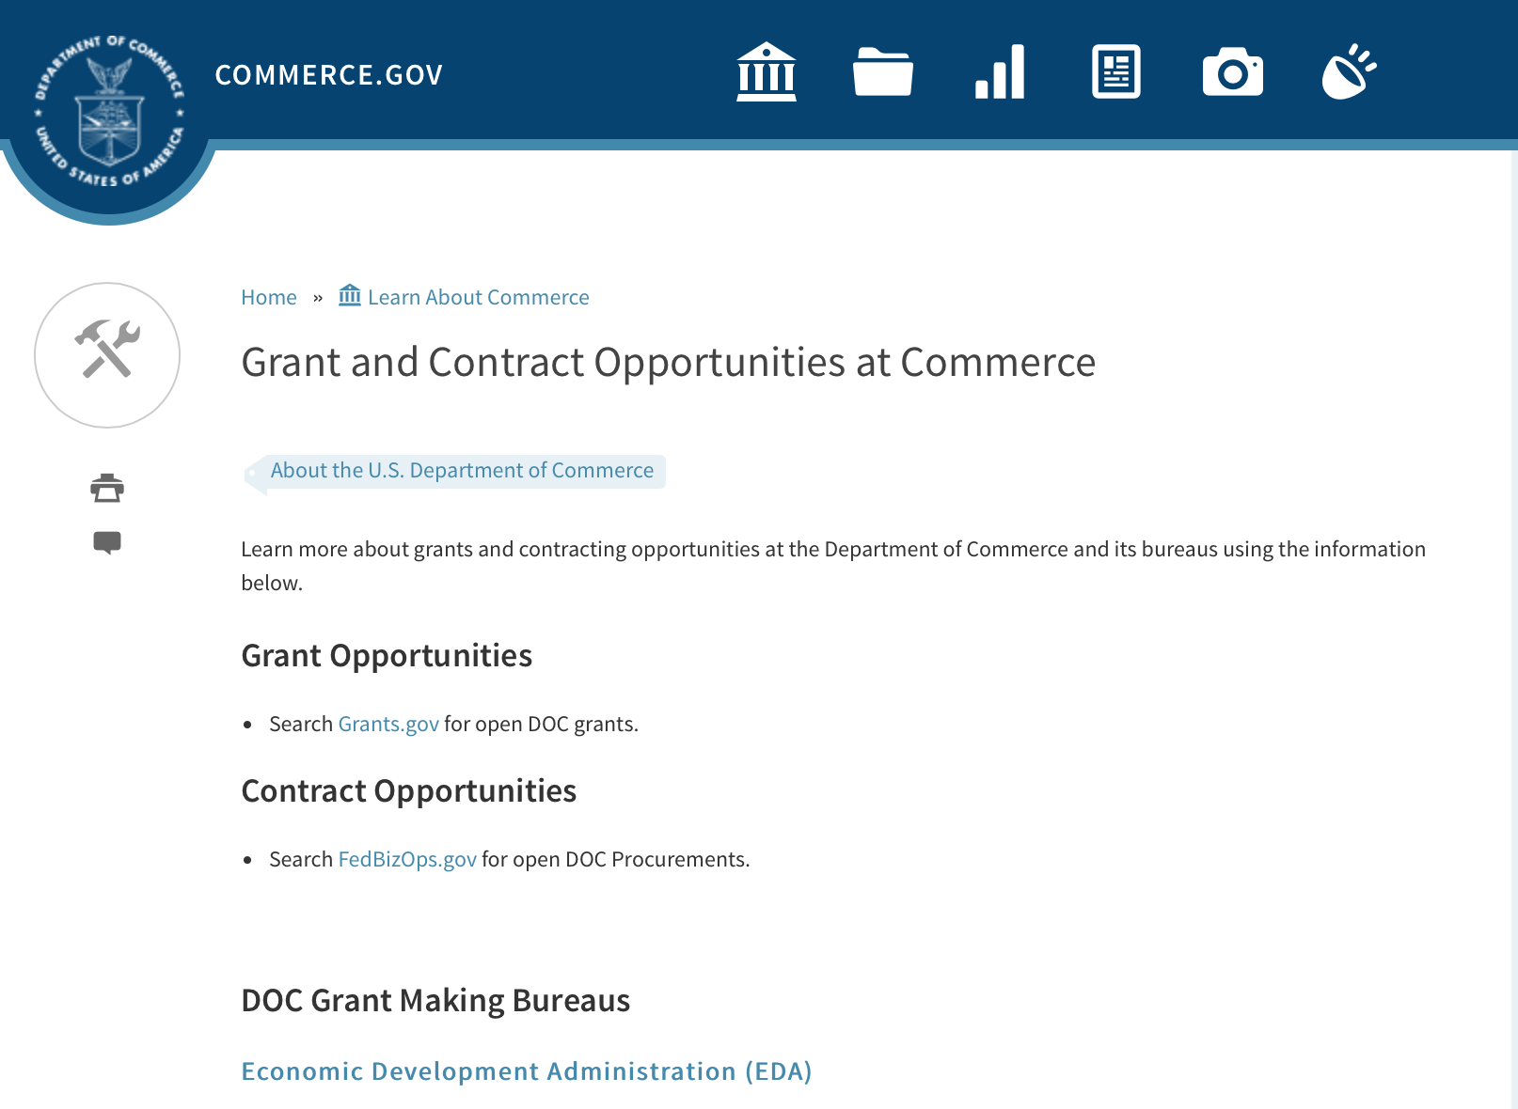
Grants at Commerce
DOC Grant Making Bureaus
Economic Development Administration (EDA)
International Trade Administration (ITA)
- Market Development Cooperator Program
- Special American Business Internship Training Program (SABIT). A technical assistance initiative of the International Trade Administration of the U.S. Department of Commerce, SABIT offers organizations competitive grants and an opportunity to host industry-specific delegations. SABIT serves as an initial entry point for U.S. businesses seeking funding to establish long-term relationships with potential customers, distributors, or partners in the former Soviet Union. The program trains Eurasian managers and scientists in commonly accepted business practices as a means of facilitating cross border relationships. In turn, these personal relationships serve as a basis for business development and reduce market access barriers for U.S. businesses
National Institute of Standards & Technology (NIST)
- Funding Opportunities
National Telecommunications & Information Administration (NTIA)
- Telecommunications Grants
National Oceanic & Atmospheric Administration (NOAA)
- Coastal Ocean Program Grant Information
- Fisheries Saltonstall Kennedy Grant Program
- National Undersea Research Program Funding Opportunities
- Grants Management Division
- Fisheries Grants Program
- National Sea Grant
- Office of Global Programs
Contracting Resources for Contractors
- Office of Small and Disadvantaged Business Utilization (OSDBU) - he Office of Small and Disadvantaged Business Utilization (OSDBU) is an advocacy and advisory office responsible for promoting the use of small, small disadvantaged, 8(a), women-owned, veteran-owned, service-disabled veteran-owned, and HUBZone small businesses within the U.S. Department of Commerce's (DOC) acquisition process.
- Business.USA.gov's Find Opportunities Wizard where in a few quick steps, it will guide you towards federal government contracting programs and opportunities for your business!
- Planned Acquisitions: the Department of Commerce's search tool for our planned acquisitions over $100,000. As requirements change, these acquisition plans are updated by department personnel and this search tool is automatically updated.
- Small Business Administration's Contracting section of their web site where you can learn about how to "Get Started" and "Contracting Support for Small Business"
- The General Services Administration (GSA) has implemented a system for vendors doing business with the Federal Government to manage their entity information in one central location. This new database is the System for Award Management (SAM).

DOC Contracting Offices
- Patent and Trademark Office (PTO)
  - Office of Procurement
- National Institute of Standards & Technology (NIST)
NIST Acquisition Management Group
Contracting Opportunities with Commerce
Trade Opportunities through Commerce
http://www.commerce.gov/about-commerce/grants-contracting-trade-opportunities

Programs:

Economic Development Administration
FY 2017 Economic Development Assistance Programs ­ Application submission and program requirements for EDA’s Public Works and Economic Adjustment Assistance programs.
Synopsis 1
Document Type: | Grants Notice
Funding Opportunity Number: | EDAP-2017
Funding Opportunity Title: | FY 2017 Economic Development Assistance Programs Application submission and program requirements for EDA’s Public Works and Economic Adjustment Assistance programs.
Opportunity Category: | Discretionary
Opportunity Category Explanation:
Funding Instrument Type: | Cooperative Agreement  Grant
Category of Funding Activity: | Other (see text field entitled "Explanation of Other Category of Funding Activity" for clarification)
Category Explanation: | The Economic Development Administration's (EDA's) mission is to lead the Federal economic development agenda by promoting innovation and competitiveness, preparing American regions for economic growth and success in the worldwide economy. EDA fulfills this mission through strategic investments and partnerships that create the regional economic ecosystems required to foster globally competitive regions throughout the United States. EDA supports development in economically distressed areas of the United States by fostering job creation and attracting private investment. Specifically, under the Economic Development Assistance programs (EDAP) Notice of Funding Availability (NOFA), EDA will make construction, non-construction, and revolving loan fund investments under the Public Works and Economic Adjustment Assistance (EAA) Programs. Through this NOFA, EDA will also designate a portion of its EAA funding to support communities and regions that have been negatively impacted by changes in the coal economy (Assistance to Coal Communities, or ACC 2017). Grants made under these programs will leverage regional assets to support the implementation of regional economic development strategies designed to create jobs, leverage private capital, encourage economic development, and strengthen America's ability to compete in the global marketplace. Through the EDAP NOFA, EDA solicits applications from rural and urban communities to develop initiatives that advance new ideas and creative approaches to address rapidly evolving economic conditions.
Expected Number of Awards:
CFDA Number(s): | 11.300 -- Investments for Public Works and Economic Development Facilities  11.307 -- Economic Adjustment Assistance
Cost Sharing or Matching Requirement: | Yes
Version: | Synopsis 1
Posted Date: | Jun 19, 2017
Last Updated Date: | Jun 19, 2017
Original Closing Date for Applications: | There are no submission deadlines under this opportunity. Proposals and applications will be accepted on an ongoing basis until the publication of a new EDAP NOFA.
Current Closing Date for Applications: | There are no submission deadlines under this opportunity. Proposals and applications will be accepted on an ongoing basis until the publication of a new EDAP NOFA.
Archive Date:
Estimated Total Program Funding:
Award Ceiling: | $3,000,000
Award Floor: | $100,000
Eligible Applicants: | Native American tribal organizations (other than Federally recognized tribal governments)  Special district governments  Others (see text field entitled "Additional Information on Eligibility" for clarification)  Private institutions of higher education  County governments  Native American tribal governments (Federally recognized)  City or township governments  Nonprofits that do not have a 501(c)(3) status with the IRS, other than institutions of higher education  State governments  Nonprofits having a 501(c)(3) status with the IRS, other than institutions of higher education  Public and State controlled institutions of higher education
Additional Information on Eligibility: | Eligible applicants for EDA financial assistance under the Public Works and EAA programs (including ACC 2017 funding) include a(n): (i) District Organization of a designated Economic Development District; (ii) Indian Tribe or a consortium of Indian Tribes; (iii) State, county, city, or other political subdivision of a State, including a special purpose unit of a State or local government engaged in economic or infrastructure development activities, or a consortium of political subdivisions; (iv) institution of higher education or a consortium of institutions of higher education; or (v) public or private non-profit organization or association acting in cooperation with officials of a political subdivision of a State. See Section 3 of the Public Works and Economic Development Act of 1965 (PWEDA) (42 U.S.C. § 3122) and 13 C.F.R. § 300.3. EDA is not authorized to provide grants or cooperative agreements to individuals or to for profit entities. Requests from such entities will not be considered for funding. For ACC 2017 funding, projects must be located within and targeted to communities or regions that have been impacted, or can reasonably demonstrate that they will be impacted, by coal mining or coal power plant employment loss, or employment loss in the supply chain industries of either.
Agency Name: | Economic Development Administration
Description: | Under this NOFA, EDA solicits applications from applicants in rural and urban areas to provide investments that support construction, non-construction, technical assistance, and revolving loan fund projects under EDA’s Public Works and EAA programs. Grants and cooperative agreements made under these programs are designed to leverage existing regional assets and support the implementation of economic development strategies that advance new ideas and creative approaches to advance economic prosperity in distressed communities, including communities and regions that have been impacted, or can reasonably demonstrate that they will be impacted, by coal mining or coal power plant employment loss, or employment loss in the supply chain industries of either. EDA provides strategic investments on a competitive- merit-basis to support economic development, foster job creation, and attract private investment in economically distressed areas of the United States. This EDAP NOFA supersedes the EDAP Federal Funding Opportunity dated December 23, 2016.
Link to Additional Information: | Economic Development Administration
Grantor Contact Information: | If you have difficulty accessing the full announcement electronically, please contact:  If you have difficulty accessing the full announcement electronically, please contact: the EDA representative for your state. A complete list of EDA representatives is available on EDA's website at http://www.eda.gov/contact/  http://www.eda.gov/contact/

http://www.grants.gov/web/grants/view-opportunity.html?oppId=294771

National Institute of Standards and Technology
Professional Research Experience Program
Synopsis 1
Document Type: | Grants Notice
Funding Opportunity Number: | 2017-NIST-PREP-01
Funding Opportunity Title: | Professional Research Experience Program
Opportunity Category: | Discretionary
Opportunity Category Explanation:
Funding Instrument Type: | Cooperative Agreement
Category of Funding Activity: | Other (see text field entitled "Explanation of Other Category of Funding Activity" for clarification)
Category Explanation: | Science, Technology, Business and/or Education Outreach
Expected Number of Awards:
CFDA Number(s): | 11.620 -- Science, Technology, Business and/or Education Outreach
Cost Sharing or Matching Requirement: | No
Version: | Synopsis 1
Posted Date: | Jun 06, 2017
Last Updated Date: | Jun 06, 2017
Original Closing Date for Applications: | Aug 04, 2017
Current Closing Date for Applications: | Aug 04, 2017
Archive Date: | Sep 03, 2017
Eligible Applicants: | Others (see text field entitled "Additional Information on Eligibility" for clarification)
Additional Information on Eligibility: | Eligibility for PREP Boulder and PREP Gaithersburg is limited to accredited institutions of higher education that offer two- or four-year degrees in the U.S. and its territories in academic disciplines relevant to the technical programs of the NIST laboratories and major programs (http://www.nist.gov/laboratories.cfm). For the purposes of this NOFO, these disciplines include (but may not be limited to) biochemistry, biological sciences, chemistry, computer science, engineering, electronics, materials science, mathematics, nanoscale science, neutron science, physical sciences, physics, and statistics. See Section III.1. of this NOFO for more information on eligibility requirements.
Agency Name: | National Institute of Standards and Technology
Description: | NIST is soliciting applications from eligible institutions of higher education in the U.S. and its territories that offer two- or four- year degrees in academic science, technology, engineering and mathematics (STEM) disciplines, which include but are not limited to biochemistry, biological sciences, chemistry, computer science, engineering, electronics, materials science, mathematics, nanoscale science, neutron science, physical sciences, physics, and statistics, to establish and manage a program to support collaborative research relationships among NIST staff, undergraduate and graduate students, individuals with bachelor’s or master’s degrees, post-doctoral fellows, and academic affiliates, and the PREP researchers’ academic institutions. These collaborative relationships will include research opportunities at the relevant NIST campuses in Boulder, Colorado (CO) (PREP Boulder), or Gaithersburg, Maryland (MD), and/or Charleston, South Carolina (SC) (PREP Gaithersburg). Eligible applicants may apply to establish and manage a PREP Boulder program or a PREP Gaithersburg program or may apply to establish and manage programs for both.
Link to Additional Information: | 2017-NIST-PREP-01
Grantor Contact Information: | If you have difficulty accessing the full announcement electronically, please contact:  Christopher Hunton Management and Program Analyst Phone 301-975-5718  Agency Contact

http://www.grants.gov/web/grants/view-opportunity.html?oppId=294410

Modifications:

Research:

Reminders:

Climate Program Office 2018
Synopsis 2

Document Type: | Grants Notice
Funding Opportunity Number: | NOAA-OAR-CPO-2018-2005133
Funding Opportunity Title: | Climate Program Office 2018
Opportunity Category: | Discretionary
Opportunity Category Explanation:
Funding Instrument Type: | Grant
Category of Funding Activity: | Environment  Natural Resources  Science and Technology and other Research and Development
Category Explanation:
Expected Number of Awards: | 90
CFDA Number(s): | 11.431 -- Climate and Atmospheric Research
Cost Sharing or Matching Requirement: | No
Version: | Synopsis 2
Posted Date: | May 15, 2017
Last Updated Date: | May 15, 2017
Original Closing Date for Applications: | Sep 11, 2017
Current Closing Date for Applications: | Sep 11, 2017
Archive Date: | Oct 11, 2017
Estimated Total Program Funding: | $8,000,000
Award Ceiling: | $300,000
Award Floor: | $50,000
Eligible Applicants: | Others (see text field entitled "Additional Information on Eligibility" for clarification)
Additional Information on Eligibility: | Eligible applicants are institutions of higher education, other nonprofits, commercial organizations, international organizations, and state, local and Indian tribal governments. Federal agencies interested in receiving financial support for projects should contact the appropriate competition manager.
Agency Name: | Department of Commerce
Description: | The National Oceanic and Atmospheric Administration (NOAA) is focused on providing the essential and highest quality environmental information vital to our Nation’s safety, prosperity and resilience. Toward this goal, the agency conducts and supports weather and climate research, oceanic and atmospheric observations, modeling, information management, assessments, interdisciplinary decision-support research, outreach, education, and partnership development. Climate variability and change present society with significant economic, health, safety, and security challenges and opportunities. In meeting these challenges, and as part of NOAA’s climate portfolio within the Office of Oceanic and Atmospheric Research (OAR), the Climate Program Office (CPO) advances scientific understanding, monitoring, and prediction of climate and its impacts, to enable effective decisions. These investments are key to NOAA’s mission of "Science, Service, and Stewardship" and are guided by the agency’s vision to create and sustain enhanced resilience in ecosystems, communities, and economies. Within this context, CPO manages competitive research programs through which NOAA funds high-priority climate science, assessments, decision support research, outreach, education, and capacity-building activities designed to advance our understanding of the Earth’s climate system, and to foster the application and use of this knowledge to improve the resilience of our Nation and its partners. CPO supports research that is conducted across the United States and internationally. CPO also provides strategic guidance for the agency’s climate science and services programs and supports NOAA’s contributions to the U.S. Global Change Research Program (USGCRP) and its National Climate Assessment, and similar international endeavors such as the Global Framework for Climate Services. CPO’s climate research portfolio is designed to achieve a fully integrated research and applications program. We meet this objective through a focus on climate intelligence and climate resilience, in support of NOAA’s goals. Climate intelligence defines CPO’s technical strength through its foundational capabilities, which include (1) Observations and monitoring, (2) Research to advance scientific understanding, (3) Modeling and prediction, (4) Communication, education, and engagement, and, (5) Climate and societal interactions. A focus on climate resilience leverages CPO’s climate intelligence to advance capabilities for responding to the urgent and growing demand for reliable, trusted, transparent, and timely climate information needed to sustain all sectors of our economy and environment. CPO’s strategy addresses challenges in the areas of, (1) Weather and climate extremes, (2) Climate impacts on water resources, (3) Coasts and climate resilience, (4) Sustainability of marine ecosystems, and (5) Changing atmospheric composition and its impacts. Making progress in addressing climate-related societal challenges and realizing benefits for NOAA’s public and private partners, requires that these mission-focused capabilities be integrated across CPO to align research, applications, transitions, and operations, and to meet the information needs of a resilient society. NOAA envisions a Nation that is prepared for, thriving, and resilient to climate variability and change. CPO’s activities support a unique and highly flexible climate research enterprise to improve scientific understanding of climate variability and change and to enable businesses and communities to derive the benefits of this investment in the present and into the future. Effectively coordinating across these components through the development and deployment of end-to-end research-based integrated information systems that address needs of high societal relevance, have been hallmarks of CPO’s success in linking environmental intelligence to resilience. Key components in this enterprise are annual Federal Funding Opportunities, competitive grants programs and other types of support that advance and extend NOAA’s foundational capabilities and applications research. Proficiency in these core areas ensures that CPO’s infrastructure is always in place to meet the intelligence and resilience challenges of our changing climate. NOAA, OAR, and the Climate Program Office encourage applicants and awardees to support the principles of diversity and inclusion when writing their proposals and performing their work. Diversity is defined as a collection of individual attributes that together help organizations achieve objectives. Inclusion is defined as a culture that connects each employee to the organization. By promoting diversity and inclusion you can improve creativity, productivity, and the vitality of the research community.
Link to Additional Information:
Grantor Contact Information: | If you have difficulty accessing the full announcement electronically, please contact:  Diane Brown CPO Grants Manager  work

http://www.grants.gov/web/grants/view-opportunity.html?oppId=293866

National Institute of Standards and Technology
Measurement Science and Engineering (MSE) Research Grant Programs

Document Type: | Grants Notice
Funding Opportunity Number: | 2016-NIST-MSE-01
Funding Opportunity Title: | Measurement Science and Engineering (MSE) Research Grant Programs
Opportunity Category: | Discretionary
Opportunity Category Explanation:
Funding Instrument Type: | Cooperative Agreement  Grant
Category of Funding Activity: | Science and Technology and other Research and Development
Category Explanation:
Expected Number of Awards:
CFDA Number(s):
Cost Sharing or Matching Requirement: | No
Posted Date: | Feb 19, 2016
Last Updated Date: | Feb 19, 2016
Original Closing Date for Applications: | Applications will be accepted and considered on a rolling basis as they are received. See Section IV.4. in the text of the Full Announcement/FFO document. Applications may be submitted by paper or electronically through Grants.gov. Carefully read Section IV. of the Full Announcement/FFO document for details applying to electronic submissions and to paper submissions.
Current Closing Date for Applications: | Applications will be accepted and considered on a rolling basis as they are received. See Section IV.4. in the text of the Full Announcement/FFO document. Applications may be submitted by paper or electronically through Grants.gov. Carefully read Section IV. of the Full Announcement/FFO document for details applying to electronic submissions and to paper submissions.
Eligible Applicants: | Others (see text field entitled "Additional Information on Eligibility" for clarification)
Additional Information on Eligibility: | Eligibility for all programs listed in this FFO is open to all non-Federal entities. Eligible applicants include institutions of higher education, non-profit organizations, for-profit organizations, state and local governments, Indian tribes, hospitals, foreign public entities, and foreign governments. Applicants selected for awards under 15 U.S.C. § 278g-1 are encouraged, but not required, to select underrepresented minorities for participation. In addition, NIST is not able to accept an application from an individual unaffiliated with a sponsoring applicant organization.
Agency Name: | National Institute of Standards and Technology
Description: | NIST is soliciting applications for financial assistance for Fiscal Year 2016 (FY16) within the following NIST Laboratory grant programs: (1) the Material Measurement Laboratory (MML) Grant Program; (2) the Physical Measurement Laboratory (PML) Grant Program; (3) the Engineering Laboratory (EL) Grant Program; (4) the Fire Research (FR) Grant Program; (5) the Information Technology Laboratory (ITL) Grant Program; (6) the Communications Technology Laboratory (CTL) Grant Program; (7) the NIST Center for Neutron Research (NCNR) Grant Program; (8) the Center for Nanoscale Science and Technology (CNST) Grant Program; (9) the Special Programs Office (SPO) Grant Program; (10) the Standards Coordination Office (SCO) Grant Program; (11) the International and Academic Affairs Office (IAAO) Grant Program; and (12) the Associate Director for Laboratory Programs (ADLP) Grant Program.
Link to Additional Information: | 2016-NIST-MSE-01 Full Announcement/FFO document
Contact Information: | If you have difficulty accessing the full announcement electronically, please contact:  Christopher Hunton Management and Program Analyst Phone 301-975-5718  Agency Contact

http://www.grants.gov/web/grants/view-opportunity.html?oppId=281689

National Sea Grant College Program 2016-17 Special Projects Grant

Document Type: | Grants Notice
Funding Opportunity Number: | NOAA-OAR-SG-2016-2004772
Funding Opportunity Title: | National Sea Grant College Program 2016-17 Special Projects
Opportunity Category: | Discretionary
Funding Instrument Type: | Cooperative Agreement  Grant
Category of Funding Activity: | Environment  Natural Resources  Science and Technology and other Research and Development
Category Explanation:
Expected Number of Awards: | 30
CFDA Number(s): | 11.417 -- Sea Grant Support
Cost Sharing or Matching Requirement: | Yes
Posted Date: | Jan 7, 2016
Creation Date: | Jan 7, 2016
Original Closing Date for Applications: | Sep 30, 2017
Current Closing Date for Applications: | Sep 30, 2017
Archive Date: | Oct 30, 2017
Estimated Total Program Funding: | $4,000,000
Award Ceiling: | $1,000,000
Award Floor: | $1
Eligible Applicants: | Others (see text field entitled "Additional Information on Eligibility" for clarification)
Additional Information on Eligibility: | Sea Grant Programs (Sea Grant Colleges, Institutions, or Coherent Area Programs), the National Sea Grant Law Center, and the National Sea Grant Library.
Agency Name: | Department of Commerce
Description: | The purpose of this notice is to request proposals for special projects associated with the National Sea Grant College Program’s (Sea Grant) strategic focus areas, and to provide the general public with information and guidelines on how Sea Grant will select proposals and administer Federal assistance under this announcement. This announcement is a mechanism to encourage research or other projects that are not normally funded through Sea Grant national competitions. This opportunity is open only to Sea Grant Programs. Section III of this announcement describes eligibility requirements in more detail. Funding has not yet been made available to support applications submitted to this Federal Funding Opportunity (FFO), but such funding may become available during the year. Section II.A. below describes individual competition announcements that will be used to announce when funding is available; any restrictions or requirements on such funding, such as matching funds; and other funding details. Awards will be made under this FFO only if funds have been announced as provided in this FFO.
Link to Additional Information:
Contact Information: | If you have difficulty accessing the full announcement electronically, please contact:  Special Projects Competition Manager, NOAA R/SG National Sea Grant Office 1315 East-West Highway, Rm 11839 Silver Spring, MD 20910 301-734-1066  work

http://www.grants.gov/web/grants/view-opportunity.html?oppId=280846

FY 2016 – FY 2019 EDA Planning Program and Local Technical Assistance Program Grant

Document Type: | Grants Notice
Funding Opportunity Number: | EDA-HDQ-TA-HDQ-2016-2004759
Funding Opportunity Title: | FY 2016 – FY 2019 EDA Planning Program and Local Technical Assistance Program
Opportunity Category: | Discretionary
Funding Instrument Type: | Cooperative Agreement  Grant
Category of Funding Activity: | Other (see text field entitled "Explanation of Other Category of Funding Activity" for clarification)  Regional Development
Category Explanation: | Regional planning and local technical assistance
Expected Number of Awards:
CFDA Number(s): | 11.302 -- Economic Development Support for Planning Organizations  11.303 -- Economic Development Technical Assistance
Cost Sharing or Matching Requirement: | No
Posted Date: | Dec 10, 2015
Creation Date: | Dec 10, 2015
Original Closing Date for Applications: | Applications are accepted on a continuing basis and processed as received. This Planning and Local Technical Assistance opportunity will remain in effect until superseded by a future announcement.
Current Closing Date for Applications: | Applications are accepted on a continuing basis and processed as received. This Planning and Local Technical Assistance opportunity will remain in effect until superseded by a future announcement.
Archive Date:
Estimated Total Program Funding:
Award Ceiling: | $300,000
Award Floor: | $0
Eligible Applicants: | Nonprofits having a 501(c)(3) status with the IRS, other than institutions of higher education  City or township governments  Nonprofits that do not have a 501(c)(3) status with the IRS, other than institutions of higher education  Others (see text field entitled "Additional Information on Eligibility" for clarification)  Private institutions of higher education  Native American tribal governments (Federally recognized)  Public and State controlled institutions of higher education  State governments  Special district governments  County governments
Additional Information on Eligibility: | Pursuant to section 3 of the Public Works and Economic Development Act of 1965 (42 U.S.C. § 3122) (PWEDA) and EDA’s regulation at 13 C.F.R. § 300.3, the following types of entities are eligible to receive funding assistance from EDA: 1. District Organizations (as defined in 13 C.F.R. § 300.3); 2. Indian Tribes or a consortium of Indian Tribes; 3. States, cities, or other political subdivisions of a State, including a special purpose unit of a State or local government engaged in economic or infrastructure development activities, or a consortium of political subdivisions; 4. Institutions of higher education or a consortium of institutions of higher education; or 5. Public or private non-profit organizations or associations acting in cooperation with officials of a political subdivision of a State.
Agency Name: | Department of Commerce
Description: | Pursuant to PWEDA, EDA announces general policies and application procedures for grant-based investments under the Planning and Local Technical Assistance programs. Under the Planning program EDA assists eligible recipients in creating regional economic development plans designed to build capacity and guide the economic prosperity and resiliency of an area or region. As part of this program, EDA supports Partnership Planning investments to facilitate the development, implementation, revision, or replacement of Comprehensive Economic Development Strategies (CEDS), which articulate and prioritize the strategic economic goals of recipients’ respective regions. In general, EDA provides Partnership Planning grants to the designated planning organization (e.g., District Organization) serving EDA designated Economic Development Districts to enable these organizations to develop and implement relevant CEDS. In addition, EDA provides Partnership Planning grants to Indian Tribes to help develop and implement CEDS and associated economic development activities. The Planning program also helps support organizations, including District Organizations, Indian Tribes, and other eligible recipients, with Short Term and State Planning investments designed to guide the eventual creation and retention of high-quality jobs, particularly for the unemployed and underemployed in the Nation’s most economically distressed regions. The Local Technical Assistance program strengthens the capacity of local or State organizations, institutions of higher education, and other eligible recipients to undertake and promote effective economic development programs through projects such as feasibility analyses and impact studies.
Link to Additional Information: | www.eda.gov
Contact Information: | If you have difficulty accessing the full announcement electronically, please contact:  The EDA representative for your state. A complete list of EDA representatives is available on EDA's website at http://www.eda.gov/contact/

http://www.grants.gov/web/grants/view-opportunity.html?oppId=280447

Economic Development Administration
Planning Program and Local Technical Assistance Program Grant

Document Type: | Grants Notice
Funding Opportunity Number: | EDAPLANNING2012
Opportunity Category: | Discretionary
Posted Date: | Aug 03, 2012
Creation Date: | Aug 03, 2012
Original Closing Date for Applications: | Applications are accepted on a continuing basis and processed as received. This Planning and Local Technical Assistance opportunity will remain in effect until superseded by a future announcement.
Current Closing Date for Applications: | Applications are accepted on a continuing basis and processed as received. This Planning and Local Technical Assistance opportunity will remain in effect until superseded by a future announcement.
Archive Date:
Funding Instrument Type: | Cooperative Agreement  Grant
Category of Funding Activity: | Other (see text field entitled "Explanation of Other Category of Funding Activity" for clarification)  Regional Development
Category Explanation: | Regional planning and local technical assistance
Expected Number of Awards: | 425
Estimated Total Program Funding:
Award Ceiling: | $100,000
Award Floor:
CFDA Number(s): | 11.302 -- Economic Development Support for Planning Organizations
 | 11.303 -- Economic Development Technical Assistance
Cost Sharing or Matching Requirement: | Yes

Eligible Applicants
State governments
County governments
City or township governments
Public and State controlled institutions of higher education
Native American tribal governments (Federally recognized)
Nonprofits having a 501(c)(3) status with the IRS, other than institutions of higher education
Nonprofits that do not have a 501(c)(3) status with the IRS, other than institutions of higher education
Private institutions of higher education
Others (see text field entitled "Additional Information on Eligibility" for clarification)

Additional Information on Eligibility:
Pursuant to section 3 of the Public Works and Economic Development Act of 1965 (42 U.S.C. § 3122) (PWEDA) and EDA’s regulation at 13 C.F.R. § 300.3, the following types of entities are eligible to receive funding assistance from EDA: 1. District Organizations (as defined in 13 C.F.R. § 300.3); 2. Indian Tribes or a consortium of Indian Tribes; 3. States, cities, or other political subdivisions of a State, including a special purpose unit of a State or local government engaged in economic or infrastructure development activities, or a consortium of political subdivisions; 4. Institutions of higher education or a consortium of institutions of higher education; or 5. Public or private non-profit organizations or associations acting in cooperation with officials of a political subdivision of a State.

Agency Name
Economic Development Administration

Description
Pursuant to PWEDA, EDA announces general policies and application procedures for grant-based investments under the Planning and Local Technical Assistance programs. Under the Planning program EDA assists eligible recipients in creating regional economic development plans designed to stimulate and guide the economic development efforts of a community or region. As part of this program, EDA supports Partnership Planning investments to facilitate the development, implementation, revision, or replacement of Comprehensive Economic Development Strategies (CEDS), which articulate and prioritize the strategic economic goals of recipients' respective regions. In general, EDA provides Partnership Planning grants to the designated planning organization (e.g., District Organization) serving EDA-designated Economic Development Districts to enable these organizations to develop and implement relevant CEDS. In addition, EDA provides Partnership Planning grants to Indian Tribes to help develop and implement CEDS and associated economic development activities. The Planning program also helps support planning organizations, including District Organizations, Indian Tribes, and other eligible Recipients, with Short Term and State Planning investments designed to guide the eventual creation and retention of higher-skill, higher-wage jobs, particularly for the unemployed and underemployed in the Nation’s most economically distressed regions. The Local Technical Assistance program strengthens the capacity of local or State organizations, institutions of higher education, and other eligible recipients to undertake and promote effective economic development programs through projects such as feasibility analyses and impact studies.

Link to Additional Information

If you have difficulty accessing the full announcement electronically, please contact:
David Ives Planning and Local TA email

http://www.grants.gov/web/grants/view-opportunity.html?oppId=189193

Deleted:

ITA-INA-OPCM-2017-2004912 - Market Development Cooperator Program 2017
Deletion Comments: Opportunity deleted. Per the Program Officer email dated 3/22/17 this FFO is being deleted.

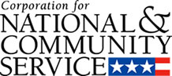

Corporation for National and Community Service

General Program Overview
AmeriCorps provides resources, both human and financial, to organizations that engage Americans in intensive service to meet our country’s critical needs.
Grantees use the funding to support AmeriCorps members for intensive service in their community. AmeriCorps grants partially cover the expense of operating an AmeriCorps program and do not cover general organizational expenses. A cash and in-kind match is required.

The main website can be accessed here: http://www.nationalservice.gov

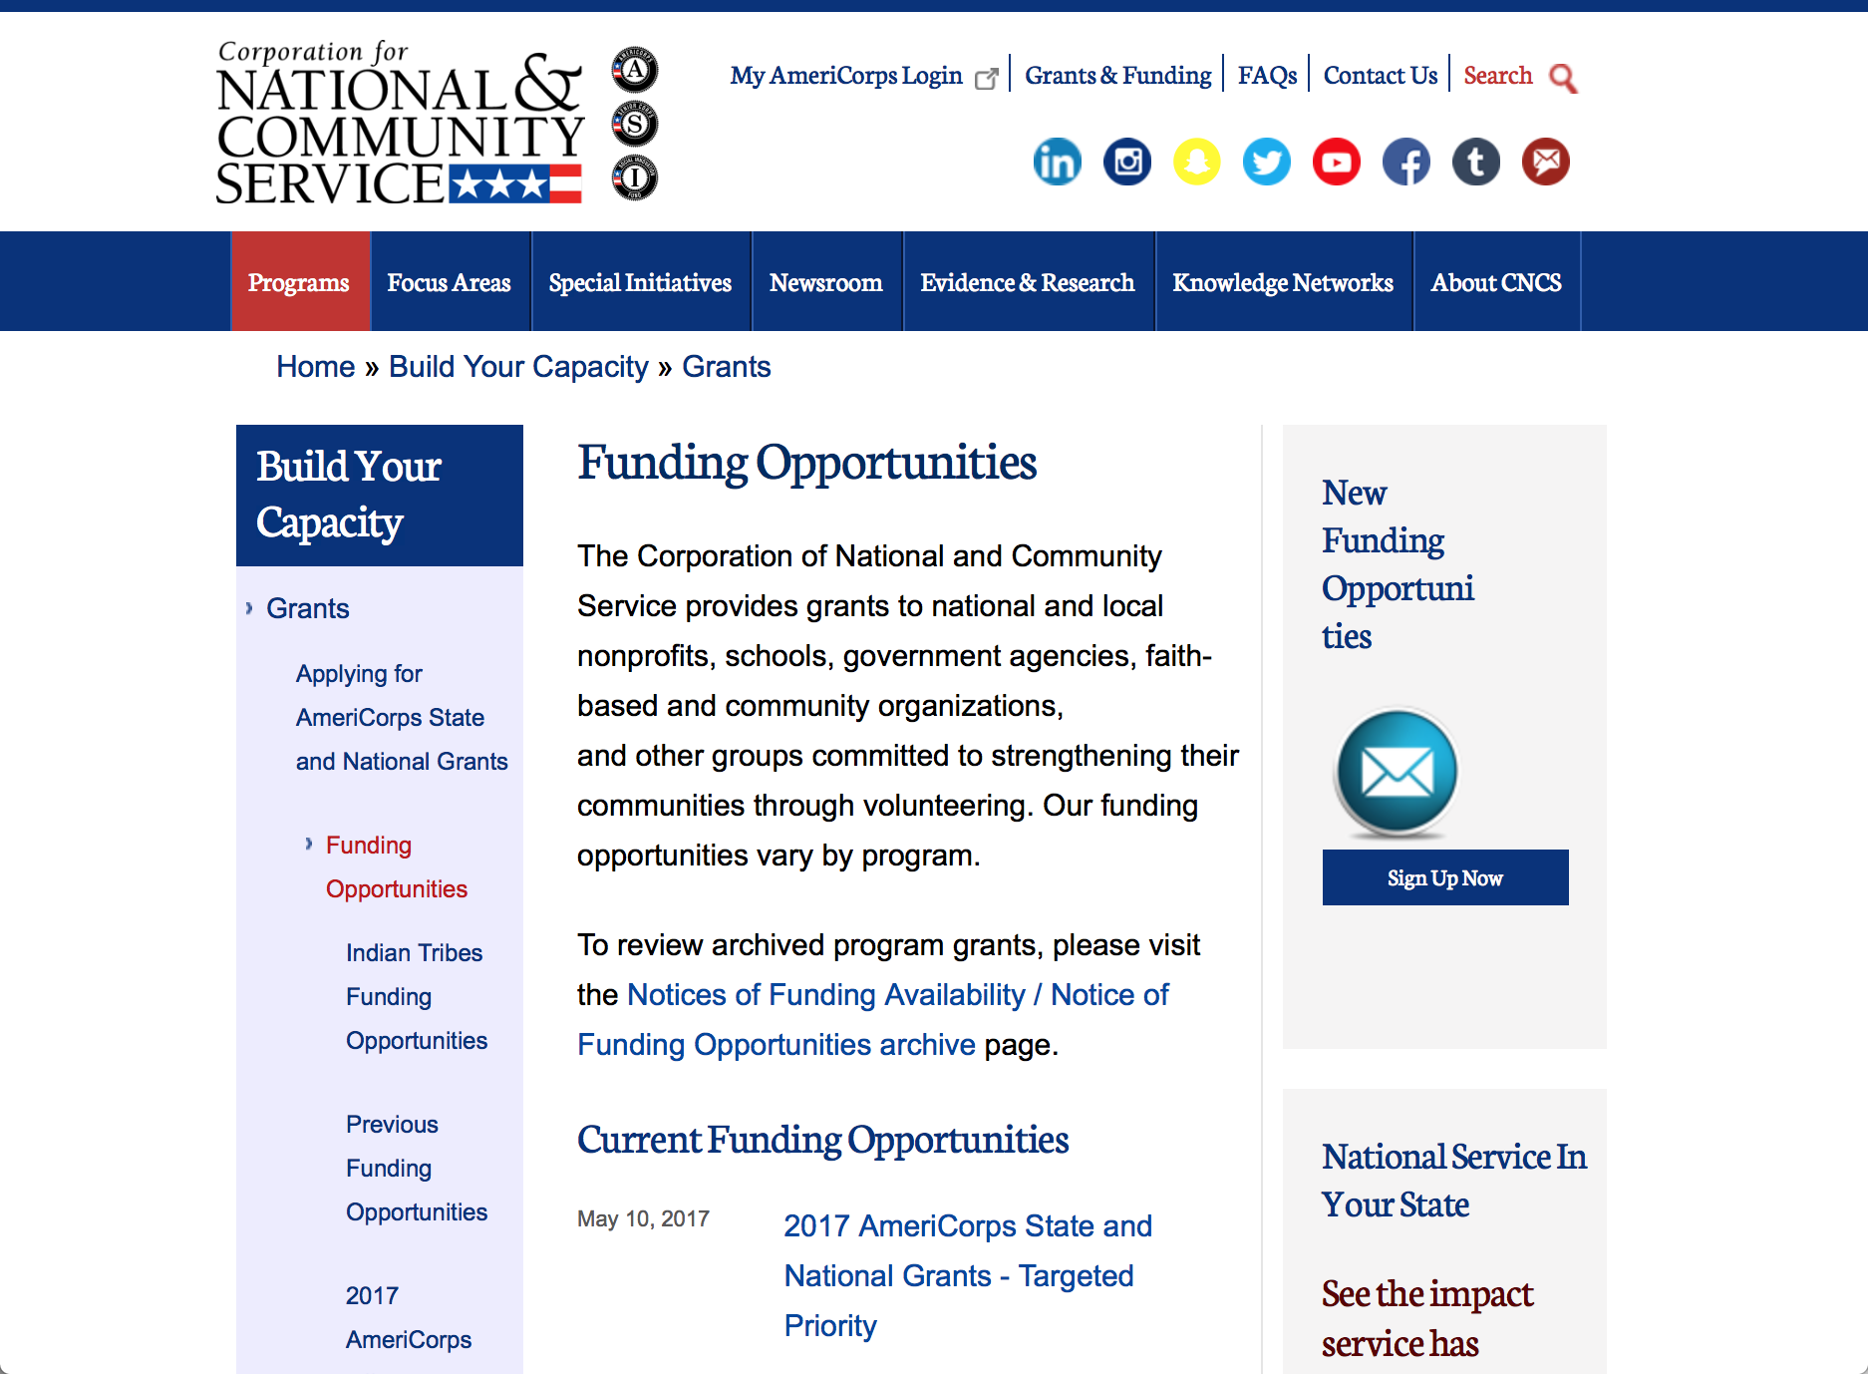

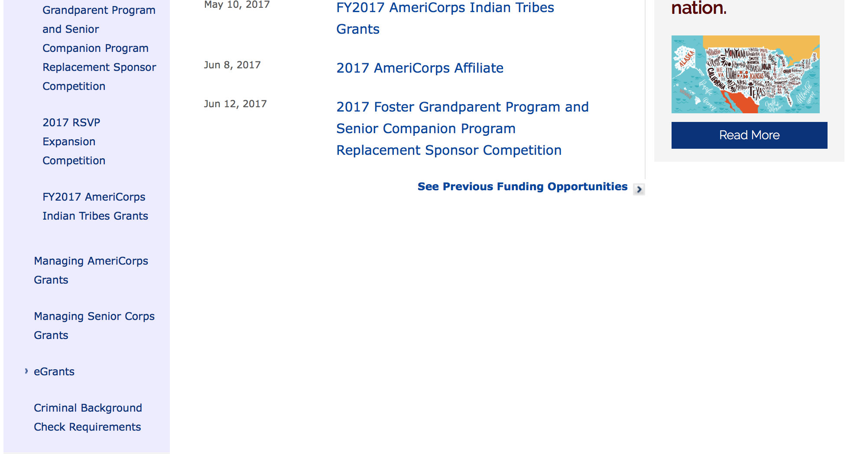
For access to further funding information: click here

http://www.nationalservice.gov/build-your-capacity/grants/funding-opportunities

Programs:

Research:

Reminders:

National Service and Civic Engagement Research Competition
Synopsis 1

Document Type: | Grants Notice
Funding Opportunity Number: | CNCS-05-16-2017
Funding Opportunity Title: | National Service and Civic Engagement Research Competition
Opportunity Category: | Discretionary
Opportunity Category Explanation:
Funding Instrument Type: | Cooperative Agreement
Category of Funding Activity: | Other (see text field entitled "Explanation of Other Category of Funding Activity" for clarification)
Category Explanation: | Civic Engagement and INfrastructure
Expected Number of Awards:
CFDA Number(s): | 94.026 -- National Service and Civic Engagement Research Competition
Cost Sharing or Matching Requirement: | No
Version: | Synopsis 1
Posted Date: | May 16, 2017
Last Updated Date: | May 16, 2017
Original Closing Date for Applications: | Jul 11, 2017
Current Closing Date for Applications: | Jul 11, 2017
Archive Date: | Aug 10, 2017
Estimated Total Program Funding:
Award Ceiling: | $150,000
Award Floor: | $20,000
Eligible Applicants: | Public and State controlled institutions of higher education  Private institutions of higher education
Agency Name: | Corporation for National and Community Service
Description: | This grant funds research on civic infrastructure and civic engagement and related concepts. For 2017 the three broad priority areas include how civic infrastructure and civic engagement are defined measured developed and hindered, how individuals civic engagement changes over the course of a lifetime, impacts associated with civic engagement, volunteering or national service. This competition is only open to institutions of higher education and funds projects in two categories -dissertation and scholars. Award amounts are expected to be in the range of $20,000 to $150,000 up to 2 years
Link to Additional Information: | full competition details
Grantor Contact Information: | If you have difficulty accessing the full announcement electronically, please contact:  NationalServiceResearch@cns.gov  competition mailbox

http://www.grants.gov/web/grants/view-opportunity.html?oppId=293872

National Service In Hawaii
National Service in Your State - Hawaii
2015-2016

Meeting Community Needs in Hawaii: More than 3,100 people of all ages and backgrounds are helping to meet local needs, strengthen communities, and increase civic engagement through national service in Hawaii. Serving at more than 450 locations throughout the state, these citizens tutor and mentor children, support veterans and military families, provide health services, restore the environment, respond to disasters, increase economic opportunity, and recruit and manage volunteers. This year, the Corporation for National and Community Service (CNCS) will commit more than $6,260,000 to support Hawaii communities through national service initiatives. Through a unique public-private partnership, this federal investment will leverage an additional $9,060,000 in other resources to strengthen community impact, build local support, and increase return on taxpayer dollars. Nationwide, CNCS, its grantees, and project sponsors generated more than $1.25 billion in outside resources from businesses, foundations, public agencies, and other sources in FY 2015.

AmeriCorps
This year, AmeriCorps will provide more than 560 individuals the opportunity to provide intensive, results-driven service to meet education, environmental, health, economic, and other pressing needs in communities across Hawaii. Most AmeriCorps grant funding goes to the Hawaii Commission on National & Community Service, which in turn awards grants to nonprofit groups to respond to local needs. Most of the remainder of the grant funding is distributed by CNCS directly to multi-state and national organizations through a competitive grants process. Other individuals serve through AmeriCorps VISTA, whose members help bring individuals and communities out of poverty by serving full-time to fight illiteracy, improve health services, create businesses, and increase housing opportunities, and AmeriCorps NCCC (National Civilian Community Corps), a 10-month, full time residential program for men and women between the ages of 18 and 24. In exchange for their service, AmeriCorps members earn an education award that can be used to pay for college or to pay back qualified student loans. Since 1994, more than 5,900 Hawaii residents have served more than 6.4 million hours and have qualified for Segal AmeriCorps Education Awards totaling more than $14,980,000.
Download: AmeriCorps in Hawaii (PDF)
Senior Corps
More than 2,500 seniors in Hawaii contribute their time and talents in one of three Senior Corps programs. Foster Grandparents serve one-on-one as tutors and mentors to more than 310 young people who have special needs. Senior Companions help more than 220 homebound seniors and other adults maintain independence in their own homes. RSVP volunteers conduct safety patrols, renovate homes, protect the environment, tutor and mentor youth, respond to natural disasters, and provide other services through more than 250 groups across Hawaii.
Download: Senior Corps in Hawaii (PDF)

The Corporation for National and Community Service is a federal agency that improves lives, strengthens communities, and fosters civic engagement through service and volunteering. CNCS annually engages more than five million Americans in service to meet local needs through Senior Corps, AmeriCorps, and national days of service; improves communities through the Social Innovation Fund, and leads President Obama's national call to service initiative, United We Serve. To learn more visit NationalService.gov or Serve.gov or call 202-606-5000 or TTY 1-800-833-3722.

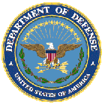

U.S. Department of Defense

Doing Business with the Department of Defense

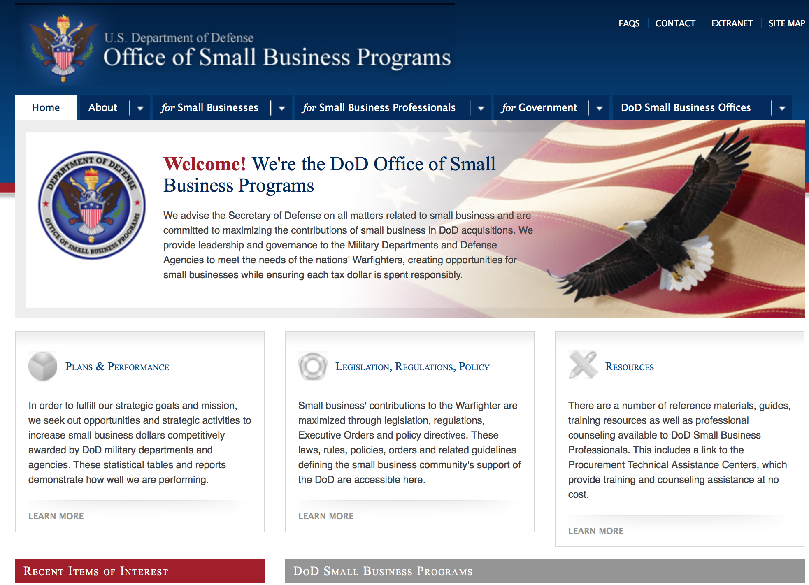
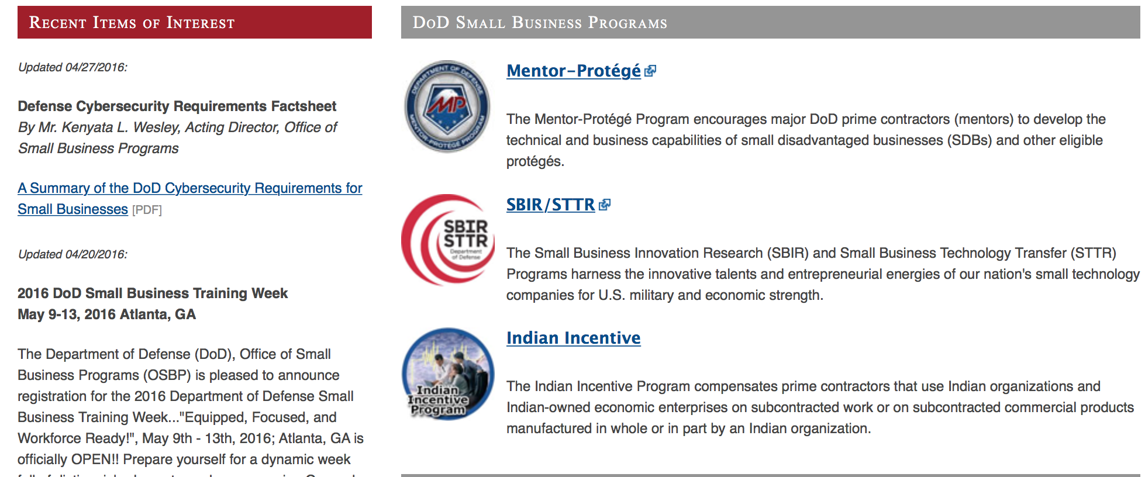

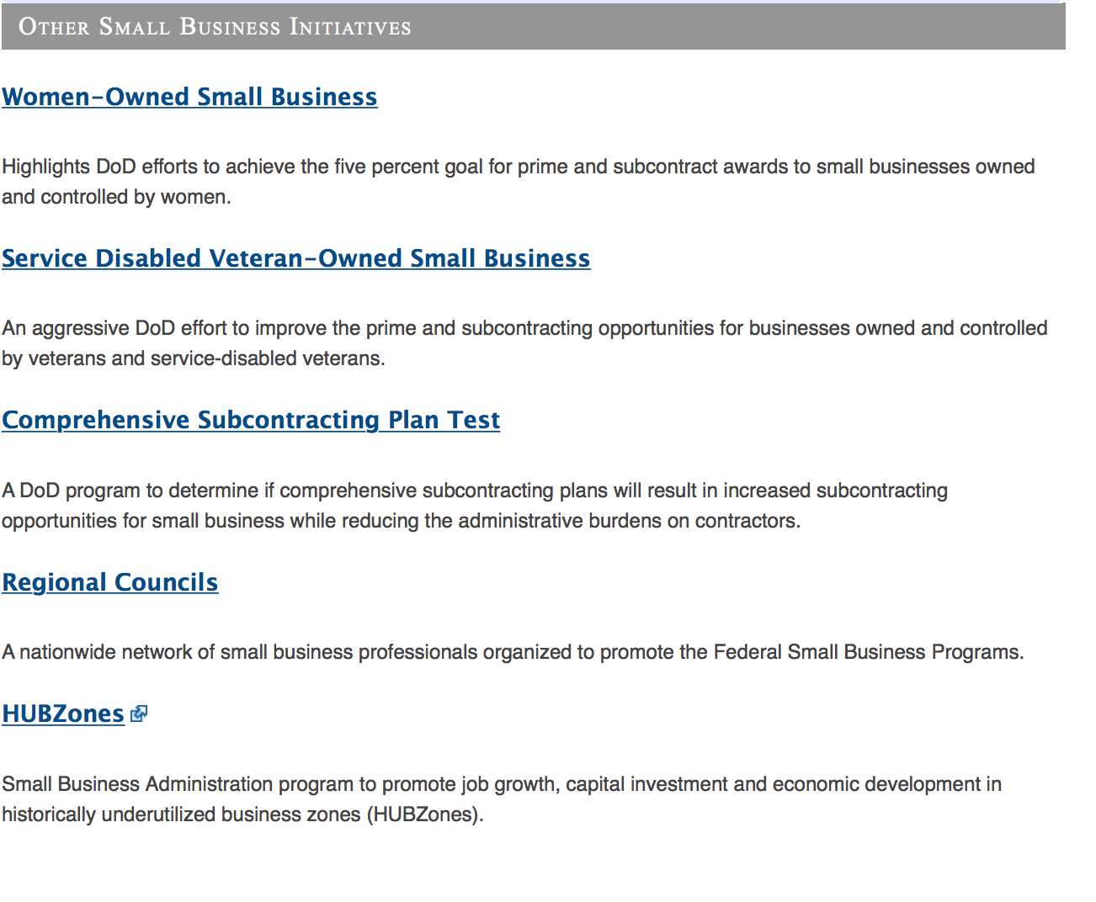
http://www.acq.osd.mil/osbp/

Doing Business with the DoD

Resources

Procurement Technical Assistance Centers (PTACs)

Procurement Technical Assistance Centers (PTACs) are charged with assisting businesses in learning how to do business with federal, state, and local governments. PTACs are a local resource available at no or nominal cost that can provide assistance to business firms in marketing their products and services. They offer training to businesses on how to research and bid on contracts, assist with registration requirements, provide bid-matching services, and assist with pre and post contracting issues.

Prime Contractors with Subcontracting Plans [xlsx]

Directory last updated 6/2017

This FY 2014 directory is intended for small business concerns seeking opportunities with DoD prime contractors. The directory is a listing of large business prime contractors who are required to establish subcontracting plans with goals. The report is generated from data contained in the Individual Subcontract Reports (ISRs) submitted in the Electronic Subcontracting Reporting System (eSRS) by contractors and from data contained in the Federal Procurement Data System (FPDS). The directory includes the name of the prime contractor; the major product/service code (PSC) provided to DoD; the major NAICS of the company; name, telephone number and email address of the company’s point of contact; contract number with the effective date and completion date, ultimate contract value and obligated dollars. In addition, many companies have websites with additional information which may be useful in your search for subcontracting opportunities or teaming arrangements.

Locate a Small Business Professional

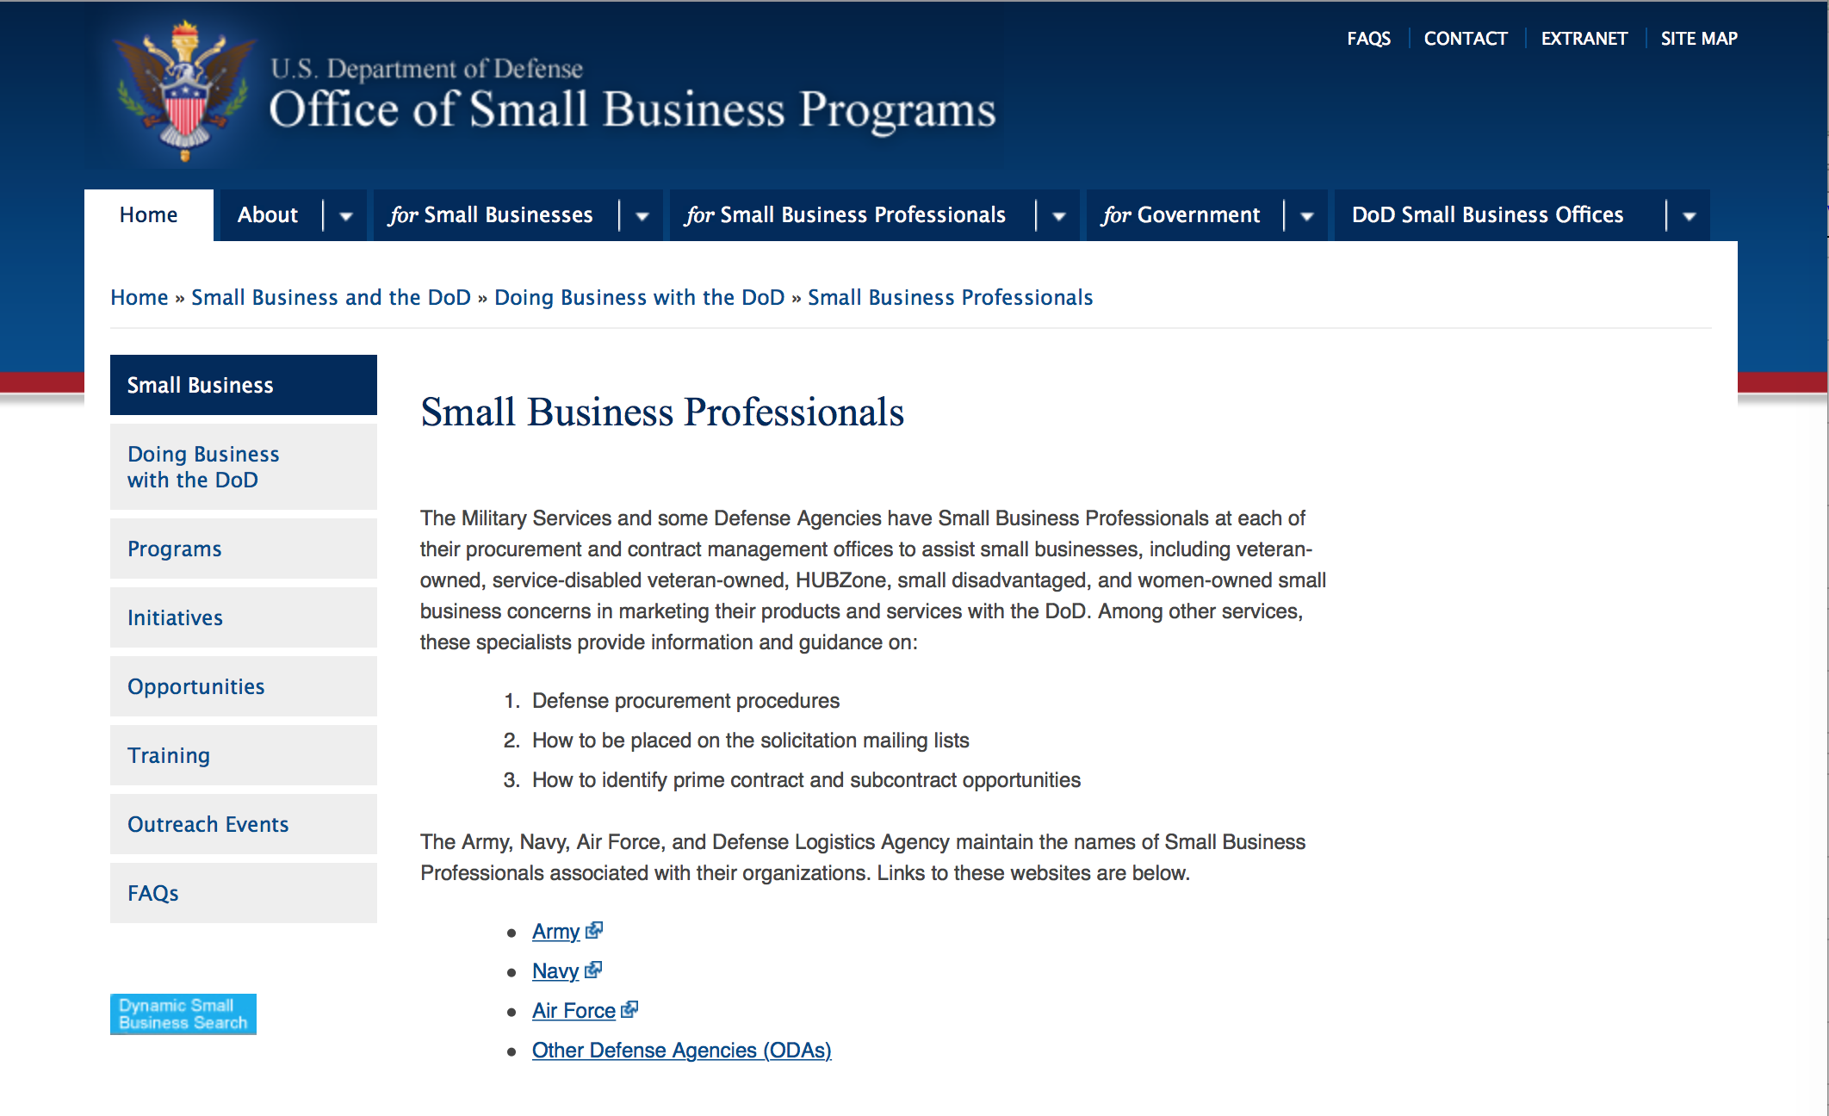

Non-Appropriated Fund Customers

Non-appropriated fund customers operate similar to non-profit organizations and include commissaries, exchanges, recreation and fitness centers, dining at officer/enlisted/civilian clubs, and barber/beauty services, just to name a few.

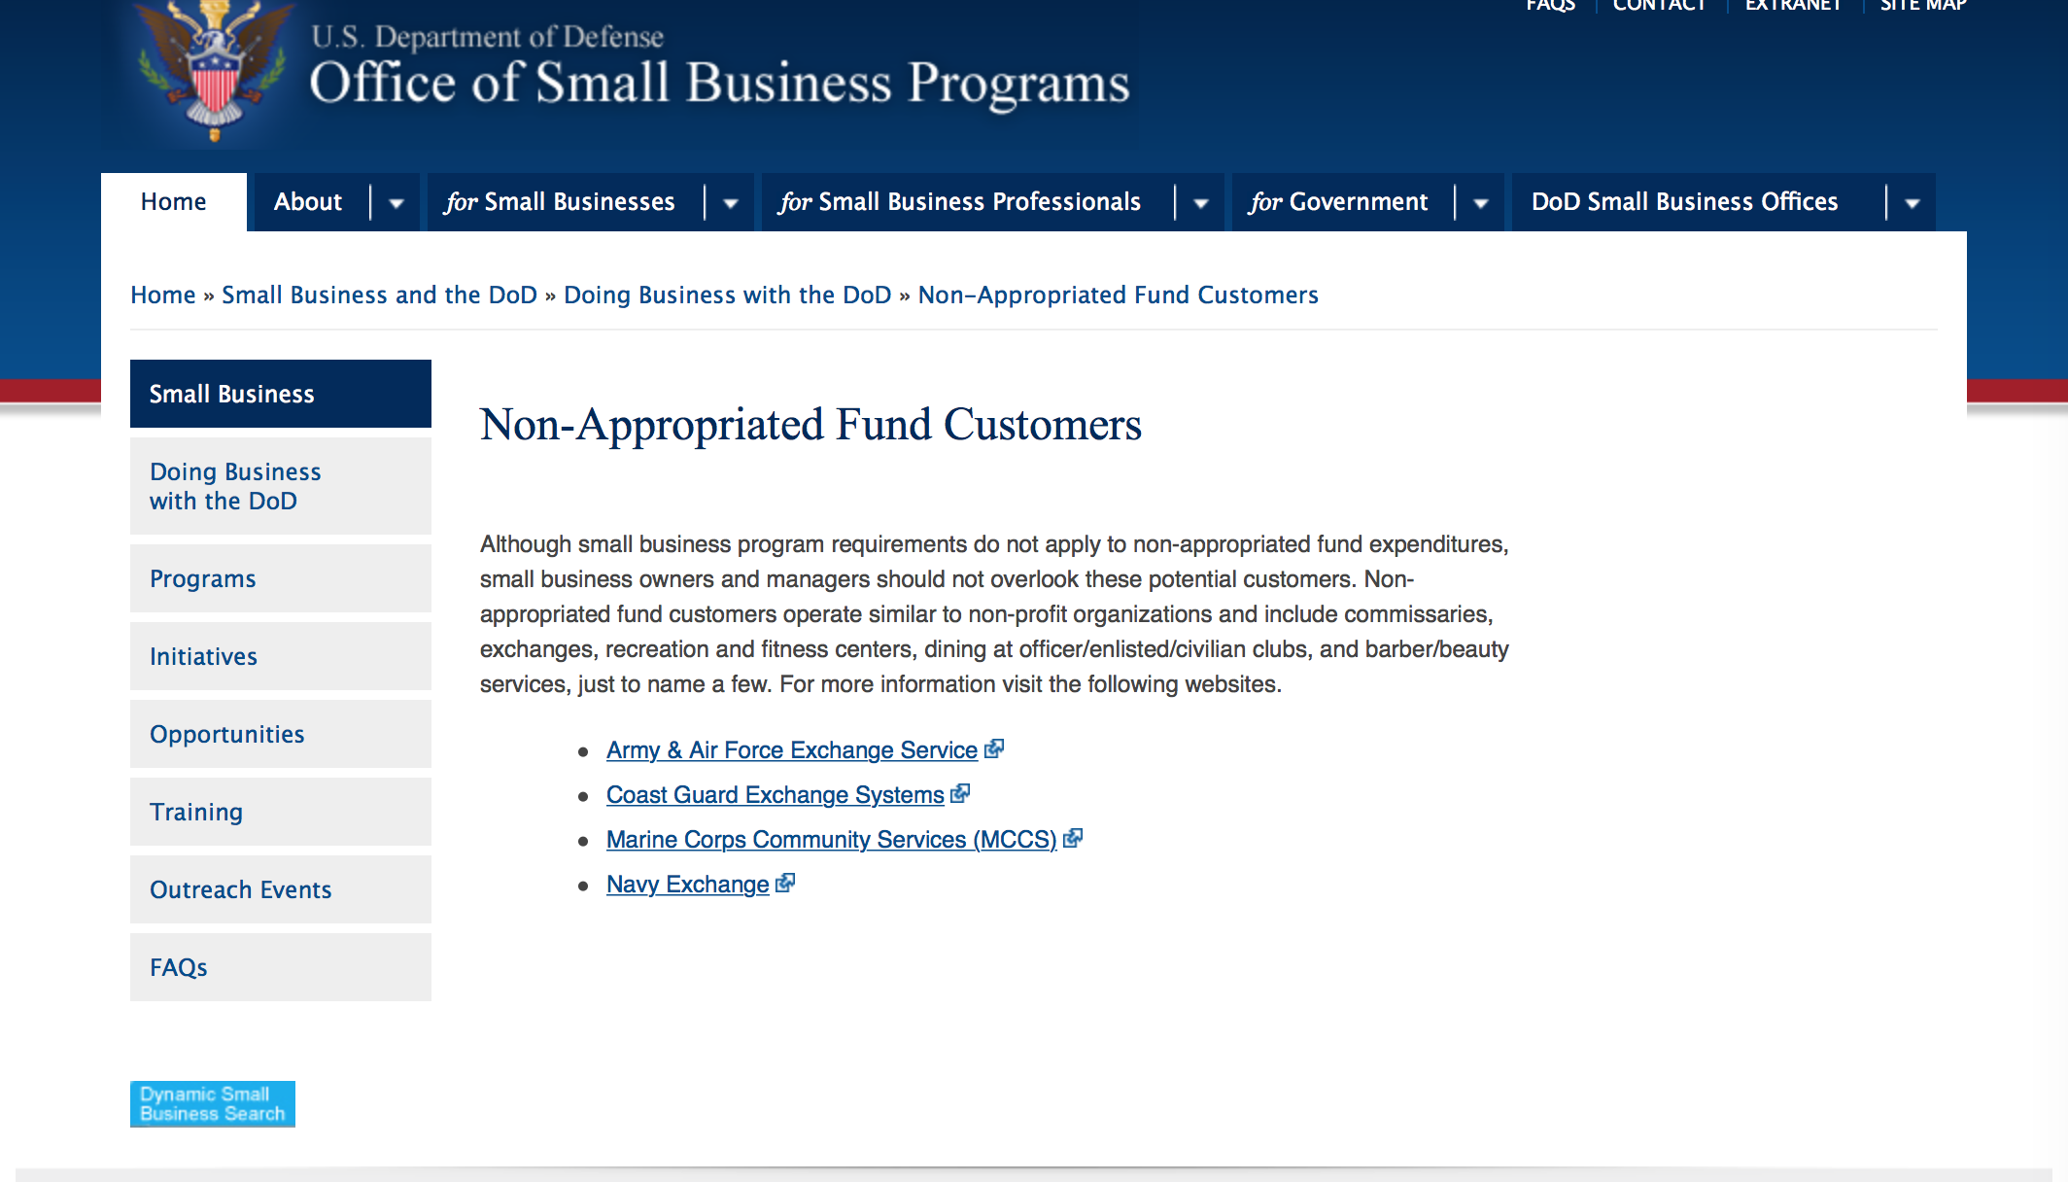

For more information click here.

Research:

Air Force Academy
Research of Technologies Advancing Corrosion Prevention and Control
Synopsis 1
http://www.grants.gov/web/grants/view-opportunity.html?oppId=294495

DARPA - Defense Sciences Office
Topological Excitations in Electronics
Synopsis 1
http://www.grants.gov/web/grants/view-opportunity.html?oppId=294551

DARPA - Defense Sciences Office
Lagrange
Synopsis 1
http://www.grants.gov/web/grants/view-opportunity.html?oppId=294477

DARPA - Tactical Technology Office
Innovative Systems for Military Missions
Synopsis 1
http://www.grants.gov/web/grants/view-opportunity.html?oppId=294585

DARPA - Defense Sciences Office
Defense Sciences Office (DSO) Office-wide
Synopsis 1
http://www.grants.gov/web/grants/view-opportunity.html?oppId=294598

DARPA - Tactical Technology Office
Innovative Systems for Military Missions
Synopsis 1
http://www.grants.gov/web/grants/view-opportunity.html?oppId=294585

DARPA - Defense Sciences Office
Defense Sciences Office (DSO) Office-wide
Synopsis 1
http://www.grants.gov/web/grants/view-opportunity.html?oppId=294598

Dept of the Army -- Materiel Command
DEPARTMENT OF DEFENSE Research and Education Program for Historically Black Colleges and Universities/Minority-Serving Institutions (HBCU/MI)
Synopsis 1
http://www.grants.gov/web/grants/view-opportunity.html?oppId=294603

Dept. of the Army -- USAMRAA
DoD Neurofibromatosis Research Program, New Investigator Award
Synopsis 1
http://www.grants.gov/web/grants/view-opportunity.html?oppId=294423

Dept. of the Army -- USAMRAA
DoD Neurofibromatosis Research Program, Investigator-Initiated Research Award
Synopsis 1
http://www.grants.gov/web/grants/view-opportunity.html?oppId=294441

Dept. of the Army -- USAMRAA
DoD Parkinson’s Research Program, Early Investigator Research Award
Synopsis 1
http://www.grants.gov/web/grants/view-opportunity.html?oppId=294660

Dept. of the Army -- USAMRAA
DoD Parkinson’s Research Program, Investigator- Initiated Research Award
Synopsis 1
http://www.grants.gov/web/grants/view-opportunity.html?oppId=294661

Dept of the Army -- Materiel Command
High Performance Superconducting Qubit Systems (HiPS)
Synopsis 1
http://www.grants.gov/web/grants/view-opportunity.html?oppId=294436

Dept of the Army -- Materiel Command
Proof of Concept Commercialization Pilot Program Innovation Corps @ Department of Defense (I Corps @ DoD)
Synopsis 1
http://www.grants.gov/web/grants/view-opportunity.html?oppId=295175

Office of Naval Research
FY2018 Basic Research Challenge (BRC) Program
Synopsis 1
http://www.grants.gov/web/grants/view-opportunity.html?oppId=294926

Office of Naval Research
FY2018 Office of Naval Research (ONR) Young Investigator Program (YIP)
Synopsis 1
http://www.grants.gov/web/grants/view-opportunity.html?oppId=294449

Office of Naval Research
FY2018 VANNEVAR BUSH FACULTY FELLOWSHIP
Synopsis 1
http://www.grants.gov/web/grants/view-opportunity.html?oppId=294637

Modifications:

Air Force Office of Scientific Research
Boundary Layer Transition Experiment II (BOLT II)
Synopsis 4
http://www.grants.gov/web/grants/view-opportunity.html?oppId=293606

Dept. of the Army -- USAMRAA
DoD Peer Reviewed Cancer, Career Development Award
Synopsis 2
http://www.grants.gov/web/grants/view-opportunity.html?oppId=294555

Dept. of the Army -- USAMRAA
DoD Spinal Cord Injury Research Prorgam, Investigator-Initiated Research Award
Synopsis 2
http://www.grants.gov/web/grants/view-opportunity.html?oppId=294421

Defense Threat Reduction Agency
Fundamental Research to Counter Weapons of Mass Destruction
Synopsis 9
http://www.grants.gov/web/grants/view-opportunity.html?oppId=275322

NAVAL FACILITIES ENGINEERING COMMAND
Stream Restoration NRL Cheasapeake Bay Detachment
Synopsis 3
http://www.grants.gov/web/grants/view-opportunity.html?oppId=294141

Office of Naval Research
N00014-16-R-FO08 - Funding Opportunity Announcement for the Office of Naval Research (ONR) Navy and Marine Corps FY2017 Historically Black Colleges and Universities/Minority Institutions (HBCU/MI) Program
Deletion Comments: The HBCU Funding Opportunity has been deleted from Grants.gov

Reminders:

Department of Defense
Dept. of the Army -- Materiel Command
Fiscal Year 2018 Defense University Research Instrumentation Program (DURIP) - ARMY SUBMISSION
Synopsis 1

Document Type: |  | Grants Notice
Funding Opportunity Number: |  | PA-AFRL-AFOSR-2017-0001
Funding Opportunity Title: |  | Fiscal Year 2018 Defense University Research Instrumentation Program (DURIP) - ARMY SUBMISSION
Opportunity Category: |  | Discretionary
Opportunity Category Explanation:
Funding Instrument Type: |  | Grant
Category of Funding Activity: |  | Science and Technology and other Research and Development
Category Explanation:
Expected Number of Awards: |  | 100
CFDA Number(s): |  | 12.431 -- Basic Scientific Research
Cost Sharing or Matching Requirement: |  | No
Version: |  | Synopsis 1
Posted Date: |  | Mar 02, 2017
Last Updated Date: |  | Mar 02, 2017
Original Closing Date for Applications: |  | Jul 07, 2017 Pre-Proposal inquires and questions must be submitted not later than Friday, 16 Jun 2017.
Current Closing Date for Applications: |  | Jul 07, 2017 Pre-Proposal inquires and questions must be submitted not later than Friday, 16 Jun 2017.
Archive Date: |  | Jul 08, 2017
Estimated Total Program Funding: |  | $47,000,000
Award Ceiling: |  | $1,500,000
Award Floor: |  | $50,000
Eligible Applicants: |  | Others (see text field entitled "Additional Information on Eligibility" for clarification)  Private institutions of higher education  Public and State controlled institutions of higher education
Additional Information on Eligibility: |  | ELIGIBLE APPLICANTS: Accredited U.S. Institutions of Higher Education This competition is open to accredited U.S. institutions of higher education with degree granting programs in science, mathematics, and/or engineering except for-profit educational institutions.
Agency Name: | Dept. of the Army -- Materiel Command
Description: | The Department of Defense (DoD) announces the Fiscal Year 2018 Defense University Research Instrumentation Program (DURIP). DURIP is designed to improve the capabilities of accredited United States (U.S.) institutions of higher education to conduct research and to educate scientists and engineers in areas important to national defense, by providing funds for the acquisition of research equipment or instrumentation. For-profit organizations are not eligible for DURIP funding. We refer to eligible institutions of higher education as universities in the rest of this announcement. DURIP is part of the University Research Initiative (URI).
Link to Additional Information: | Funding Opportunity
Grantor Contact Information: | If you have difficulty accessing the full announcement electronically, please contact:  ANDREW FISKE PROCUREMENT ANALYST Phone (919) 549-4338  Army Point of Contact

http://www.grants.gov/web/grants/view-opportunity.html?oppId=292130

Air Force Office of Scientific Research
Fiscal Year 2018 Defense University Research Instrumentation Program (DURIP)
Synopsis 1

Document Type: |  | Grants Notice
Funding Opportunity Number: |  | PA-AFRL-AFOSR-2017-0001
Funding Opportunity Title: |  | Fiscal Year 2018 Defense University Research Instrumentation Program (DURIP)
Opportunity Category: |  | Discretionary
Opportunity Category Explanation:
Funding Instrument Type: |  | Grant
Category of Funding Activity: |  | Science and Technology and other Research and Development
Category Explanation:
Expected Number of Awards: |  | 100
CFDA Number(s): |  | 12.800 -- Air Force Defense Research Sciences Program
Cost Sharing or Matching Requirement: |  | No
Version: |  | Synopsis 1
Posted Date: |  | Mar 01, 2017
Last Updated Date: |  | Mar 01, 2017
Original Closing Date for Applications: |  | Jul 07, 2017 Pre-Proposal inquires and questions must be submitted not later than Friday, 16 Jun 2017.
Current Closing Date for Applications: |  | Jul 07, 2017 Pre-Proposal inquires and questions must be submitted not later than Friday, 16 Jun 2017.
Archive Date: |  | Jul 08, 2017
Estimated Total Program Funding: |  | $47,000,000
Award Ceiling: |  | $1,500,000
Award Floor: |  | $50,000
Eligible Applicants: |  | Public and State controlled institutions of higher education  Private institutions of higher education  Others (see text field entitled "Additional Information on Eligibility" for clarification)
Additional Information on Eligibility: |  | ELIGIBLE APPLICANTS: Accredited U.S. Institutions of Higher Education This competition is open to accredited U.S. institutions of higher education with degree granting programs in science, mathematics, and/or engineering except for-profit educational institutions.
Agency Name: | Air Force Office of Scientific Research
Description: | The Department of Defense (DoD) announces the Fiscal Year 2018 Defense University Research Instrumentation Program (DURIP). DURIP is designed to improve the capabilities of accredited United States (U.S.) institutions of higher education to conduct research and to educate scientists and engineers in areas important to national defense, by providing funds for the acquisition of research equipment or instrumentation. For-profit organizations are not eligible for DURIP funding. We refer to eligible institutions of higher education as universities in the rest of this announcement. DURIP is part of the University Research Initiative (URI).
Link to Additional Information: | AFOSR - Funding Opportunities
Grantor Contact Information: | If you have difficulty accessing the full announcement electronically, please contact:  MS. KATIE WISECARVER Phone: (703) 696-9544  Announcement Email

http://www.grants.gov/web/grants/view-opportunity.html?oppId=292128



Department of Education
Grant Programs Overview at the Department of Education

The general information page for Education Grant funding is an excellent resource describing the three types of grants awarded by the Department of Education. See the screen shot of the Department of Education web page below:

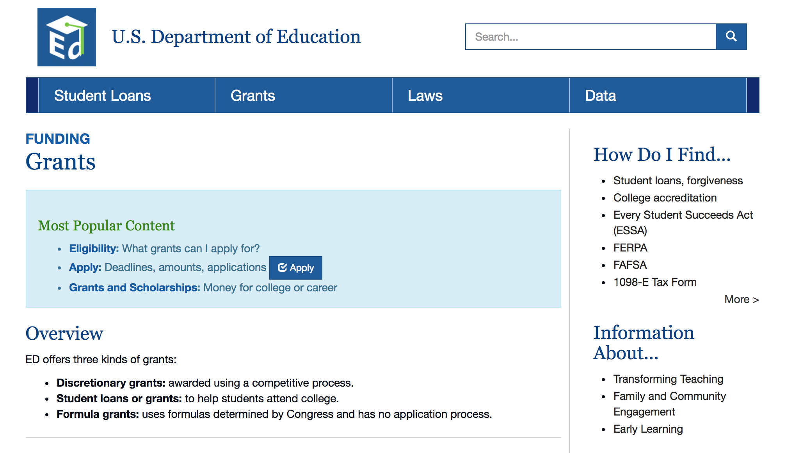
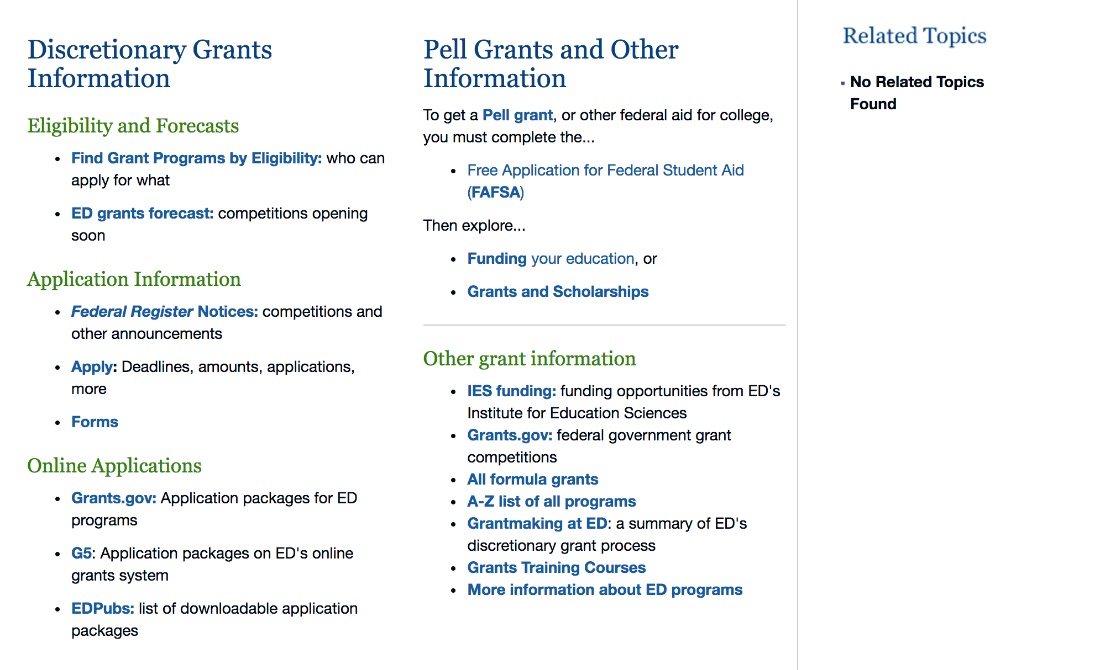

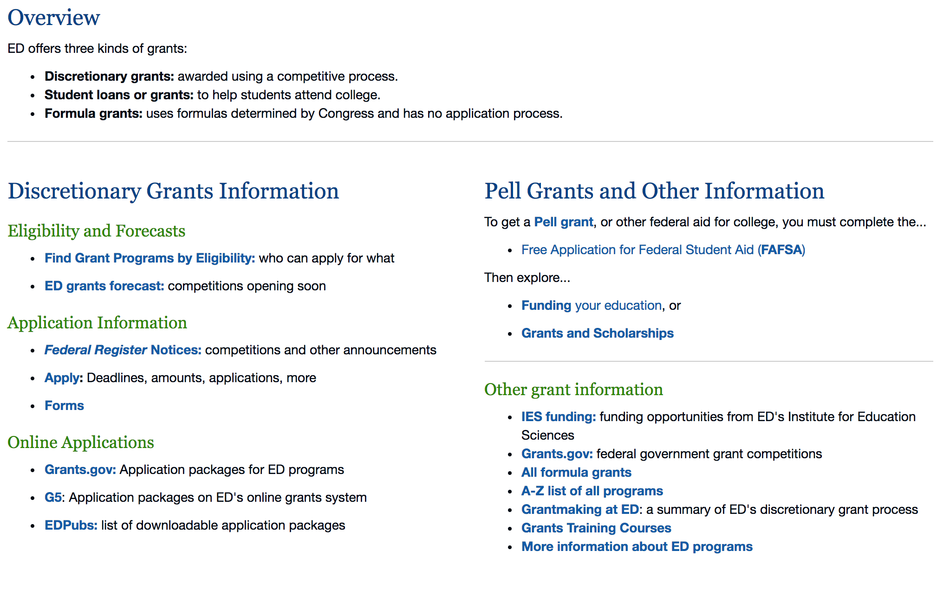

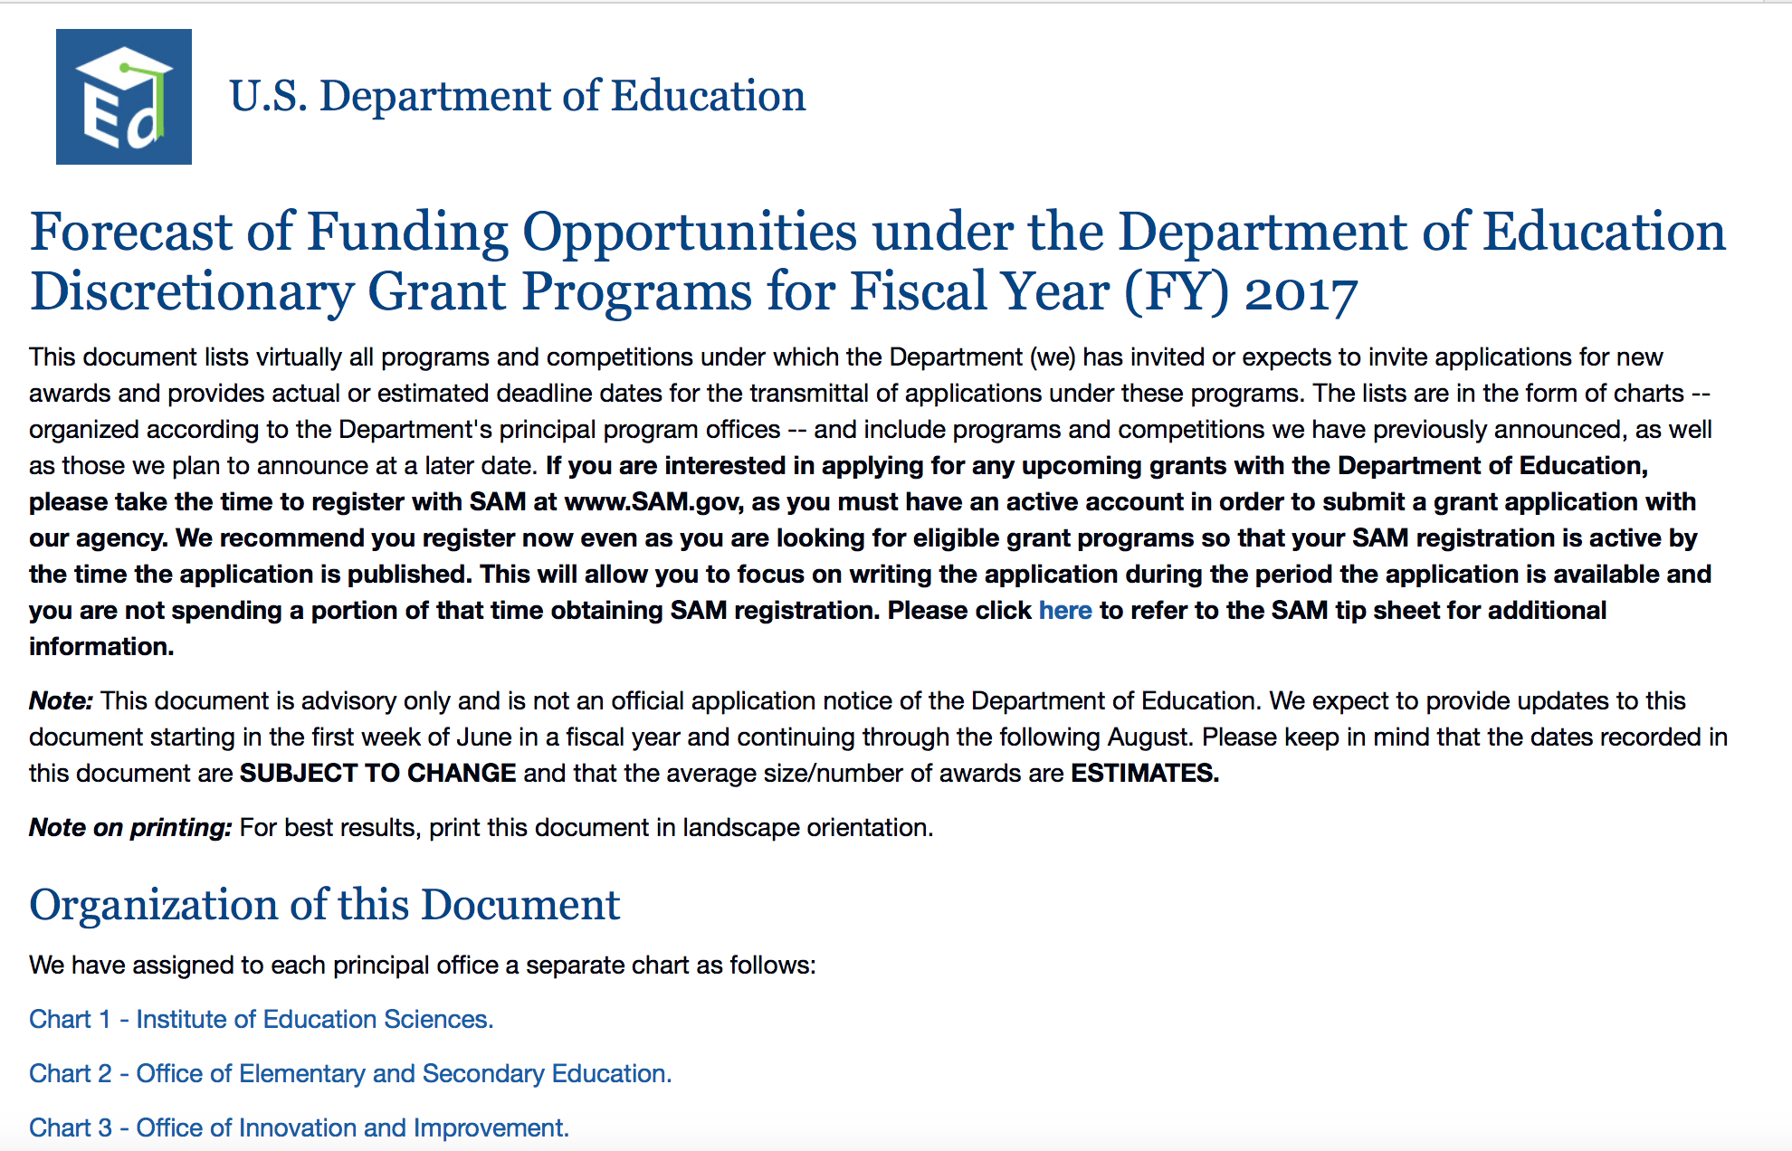
https://www2.ed.gov/fund/grants-apply.html

Programs:

Office of Career, Technical, and Adult Education (OCTAE): High School Career and Technical Education Teacher Pathway Initiative CFDA Number 84.051D
Synopsis 1 & 2
Document Type: | Grants Notice
Funding Opportunity Number: | ED-GRANTS-061317-001
Funding Opportunity Title: | Office of Career, Technical, and Adult Education (OCTAE): High School Career and Technical Education Teacher Pathway Initiative CFDA Number 84.051D
Opportunity Category: | Discretionary
Opportunity Category Explanation:
Funding Instrument Type: | Grant
Category of Funding Activity: | Education
Category Explanation:
Expected Number of Awards: | 5
CFDA Number(s): | 84.051 -- Career and Technical Education -- National Programs
Cost Sharing or Matching Requirement: | Yes
Version: | Synopsis 2
Posted Date: | Jun 13, 2017
Last Updated Date: | Jun 22, 2017
Current Closing Date for Applications: | Jul 28, 2017 Applications Available: June 13, 2017. Deadline for Notice of Intent to Apply: July 13, 2017. Notice of Intent to Apply: We will be able to develop a more efficient process for reviewing grant applications if we can anticipate the number of applicants that intend to apply for funding under this competition. Therefore, we strongly encourage each potential applicant to notify us of the applicant's intent to submit an application for funding by sending a short email message. This short email should provide the applicant organization's name and address. Please send this email notification to CTEteachergrant@ed.gov with ``Intent to Apply'' in the email subject line. Applicants that do not provide this email notification may still apply for funding. Date of Pre-Application Webinar: For information about a pre-application webinar, visit the Perkins Collaborative Resource Network (PCRN) at http://cte.ed.gov/. A pre-application webinar will be held for this competition shortly after the date that this notice will publish. The webinar is intended to provide technical assistance to all interested grant applicants. Information regarding the pre-application webinar can be found on the Perkins Collaborative Resource Network at http://cte.ed.gov/. Deadline for Transmittal of Applications: July 28, 2017.
Archive Date: | Aug 27, 2017
Estimated Total Program Funding: | $3,600,102
Eligible Applicants: | Others (see text field entitled "Additional Information on Eligibility" for clarification)
Additional Information on Eligibility: | 1. Eligible Applicants: The following entities are eligible to apply under this competition: (a) A State board designated or created consistent with State law as the sole State agency responsible for the administration of CTE in the State or for the supervision of the administration of CTE in the State; (b) An LEA (including a public charter school that operates as an LEA), an area CTE school, an educational service agency, or a consortium of such entities, in each case, that receives assistance under section 131 of the Act; (c) An Eligible Institution that receives assistance under section 132 of the Act. Note: Eligible applicants proposing to apply for funds as a consortium must comply with the regulations in 34 CFR 75.127 through 75.129, which address group applications.
Agency Name: | Department of Education
Description: | Note: Each funding opportunity description is a synopsis of information in the Federal Register application notice. For specific information about eligibility, please see the official application notice. The official version of this document is the document published in the Federal Register. Free Internet access to the official edition of the Federal Register and the Code of Federal Regulations is available on GPO Access at: http://www.access.gpo.gov/nara/index.html. Please review the official application notice for pre-application and application requirements, application submission information, performance measures, priorities and program contact information. The purpose of the High School Career and Technical Education (CTE) Teacher Pathway Initiative is to improve CTE programs assisted under the Carl D. Perkins Career and Technical Education Act of 2006 (the Perkins Act) by increasing the supply of high school CTE teachers available to teach students in CTE programs that align to In-Demand Industry Sectors or Occupations \1\ in States and communities where shortages of such teachers exist.--------------------------------------------------------------------------- \1\ Throughout this notice, all defined terms are denoted with initial capitals.---------------------------------------------------------------------------Catalog of Federal Domestic Assistance (CFDA) number 84.051D. Applications for grants under the High School CTE Teacher Pathway Initiative, CFDA number 84.051D, must be submitted electronically using the Governmentwide Grants.gov Apply site at www.Grants.gov. Through this site, you will be able to download a copy of the application package, complete it offline, and then upload and submit your application. You may not email an electronic copy of a grant application to us. You may access the electronic grant application for the High School CTE Teacher Pathway Initiative competition at www.Grants.gov. You must search for the downloadable application package for this program by the CFDA number. Do not include the CFDA number's alpha suffix in your search (e.g., search for 84.051, not 84.051D).
Link to Additional Information: | Office of Career, Technical, and Adult Education (OCTAE): High School Career and Technical Education Teacher Pathway Initiative CFDA Number 84.051D; Notice Inviting Applications for New Awards for Fiscal Year (FY) 2017
Grantor Contact Information: | If you have difficulty accessing the full announcement electronically, please contact:  Julius Cotton ED Grants.gov FIND Systems Admin. Phone 202-245-6288 EducationGrantInquiries@ed.gov Program Manager: Laura Messenger, U.S. Department of Education, 400 Maryland Avenue SW., Potomac Center Plaza (PCP), Room 11028, Washington, DC 20202-7241. Telephone: (202) 245-7840 or by fax at (202) 245-7170 or e-Mail: Laura.Messenger@ed.gov.  e-Mail: Program Manager

http://www.grants.gov/web/grants/view-opportunity.html?oppId=294612

Research:

Office of Postsecondary Education (OPE): International Research and Studies Program: Research, Studies, and Surveys CFDA Number 84.017A
Synopsis 1
http://www.grants.gov/web/grants/view-opportunity.html?oppId=295172

Modifications:

The Office of Innovation and Improvement (OII): American History and Civics Education: Presidential and Congressional Academies for American History and Civics (Academies) Program CFDA Number 84.422A
Synopsis 2 & 3
Document Type: | Grants Notice
Funding Opportunity Number: | ED-GRANTS-060917-001
Funding Opportunity Title: | The Office of Innovation and Improvement (OII): American History and Civics Education: Presidential and Congressional Academies for American History and Civics (Academies) Program CFDA Number 84.422A
Opportunity Category: | Discretionary
Opportunity Category Explanation:
Funding Instrument Type: | Grant
Category of Funding Activity: | Education
Category Explanation:
Expected Number of Awards: | 6
CFDA Number(s): | 84.422 -- Presidential and Congressional Academies for American History and Civics
Cost Sharing or Matching Requirement: | Yes
Version: | Synopsis 3
Posted Date: | Jun 09, 2017
Last Updated Date: | Jun 12, 2017
Current Closing Date for Applications: | Jul 24, 2017 Applications Available: June 9, 2017. Deadline for Notice of Intent To Apply: July 10, 2017. The Department will be able to develop a more efficient process for reviewing grant applications if it has a better understanding of the number of entities that intend to apply for funding under this competition. Therefore, the Secretary strongly encourages each potential applicant to notify the Department by sending a short email message indicating the applicant's intent to submit an application for funding. The email need not include information regarding the content of the proposed application, only the applicant's intent to submit it. You should send this email notification to: Academies@ed.gov. Applicants that do not provide this email notification may still apply for funding. Date of Pre-Application Webinars: Information about pre-application webinars will be posted at https://innovation.ed.gov/what-we-do/american-history-and-civics-academies/ academies/. Deadline for Transmittal of Applications: July 24, 2017.
Archive Date: | Aug 23, 2017
Estimated Total Program Funding: | $1,815,000
Eligible Applicants: | Others (see text field entitled "Additional Information on Eligibility" for clarification)
Additional Information on Eligibility: | Eligible Applicants: An institution of higher education, or nonprofit educational organization, museum, library, or research center with demonstrated expertise in historical methodology or the teaching of American history and civics; or a consortium of these entities. In its application, an applicant is required to submit documentation of its organization's expertise in historical methodology or the teaching of American history or civics. Note: Consortium applicants must follow the procedures for group applications described in 34 CFR 75.127 through 34 CFR 75.129.
Agency Name: | Department of Education
Description: | Note: Each funding opportunity description is a synopsis of information in the Federal Register application notice. For specific information about eligibility, please see the official application notice. The official version of this document is the document published in the Federal Register. Free Internet access to the official edition of the Federal Register and the Code of Federal Regulations is available on GPO Access at: http://www.access.gpo.gov/nara/index.html. Please review the official application notice for pre-application and application requirements, application submission information, performance measures, priorities and program contact information. Purpose of Program: The Academies Program supports the establishment of: (1) Presidential Academies for the Teaching of American History and Civics that offer workshops for both veteran and new teachers to strengthen their knowledge of American history, civics, and government education (Presidential Academies); and (2) Congressional Academies for Students of American History and Civics that provide high school students opportunities to enrich their understanding of these subjects (Congressional Academies). Applications for grants under the Academies Program, CFDA number 84.422A, must be submitted electronically using the Governmentwide Grants.gov Apply site at www.Grants.gov. You may access the electronic grant application for the Academies Program at www.Grants.gov. You must search for the downloadable application package for this competition by the CFDA number. Do not include the CFDA number's alpha suffix in your search (e.g., search for 84.422, not 84.422A).
Link to Additional Information: | The Office of Innovation and Improvement (OII): American History and Civics Education: Presidential and Congressional Academies for American History and Civics (Academies) Program CFDA Number 84.422A
Grantor Contact Information: | If you have difficulty accessing the full announcement electronically, please contact:  Joyce Mays Management Analyst Phone 202-245-6122 joyce.mays@ed.gov Program Manager: Christine Miller U.S. Department of Education 400 Maryland Avenue SW, Rm 4W205 Washington, DC 20202 Or by email: Academies@ed.gov.  e-Mail: Program Mailbox

http://www.grants.gov/web/grants/view-opportunity.html?oppId=294516

Reminders:

Deleted:

U.S. Department of Energy

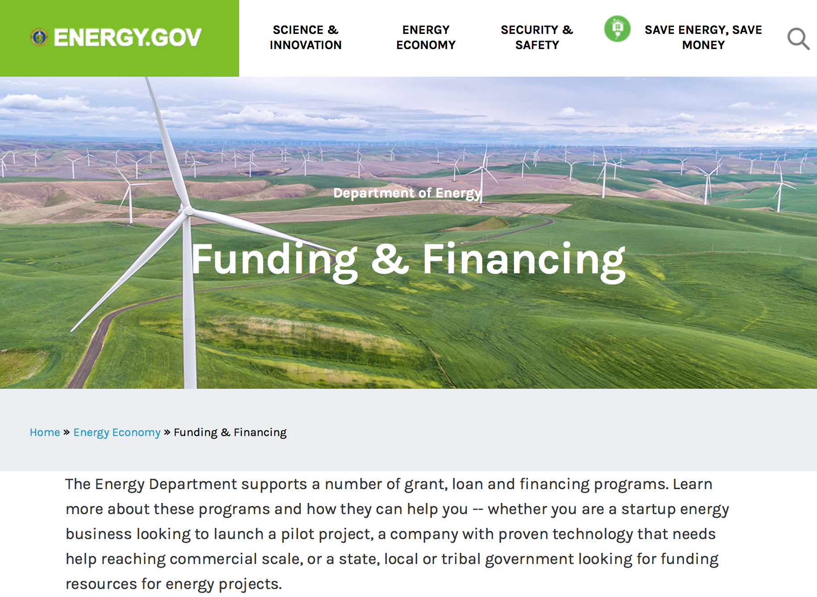
https://www.energy.gov/energy-economy/funding-financing

Research:

Golden Field Office
DE-FOA-0001637: Fiscal Year 2017 BIOMASS RESEARCH AND DEVELOPMENT INITIATIVE (BRDI)
Synopsis 1
http://www.grants.gov/web/grants/view-opportunity.html?oppId=294380

National Energy Technology Laboratory
Innovative Technology Development to Enhance Fossil Power System Efficiency
Synopsis 1
http://www.grants.gov/web/grants/view-opportunity.html?oppId=294556

National Energy Technology Laboratory
Advanced Combustion Technologies
Synopsis 1
http://www.grants.gov/web/grants/view-opportunity.html?oppId=294487

National Energy Technology Laboratory
Advanced Technology Solutions for Unconventional Oil and Gas Development
Synopsis 1
http://www.grants.gov/web/grants/view-opportunity.html?oppId=294863

National Energy Technology Laboratory
Development of Transformational Separation and Extraction Processes for Production of Rare Earth Element Materials from Domestic U.S. Coal and Coal By-Products
Synopsis 1
http://www.grants.gov/web/grants/view-opportunity.html?oppId=294381

National Energy Technology Laboratory
University Turbine Systems Research
Synopsis 1, 2 & 4
http://www.grants.gov/web/grants/view-opportunity.html?oppId=294486

National Energy Technology Laboratory
Small Scale Modularization of Gasification Technology Components for Radically Engineered Modular Systems
Synopsis 1
http://www.grants.gov/web/grants/view-opportunity.html?oppId=294430

PAMS
Department of Energy - Office of Science
Office of Science
Collaborative Fusion Energy Research in the DIII-D National Program
Synopsis 1
http://www.grants.gov/web/grants/view-opportunity.html?oppId=294475

PAMS
Department of Energy - Office of Science
Office of Science
Theoretical Research in Magnetic Fusion Energy Science
Synopsis 1
http://www.grants.gov/web/grants/view-opportunity.html?oppId=294721

PAMS
Department of Energy - Office of Science
Office of Science
FY 2018 Research Opportunities in High Energy Physics
Synopsis 1
http://www.grants.gov/web/grants/view-opportunity.html?oppId=295093

National Energy Technology Laboratory
Solid Oxide Fuel Cell Prototype System Testing and Core Technology Development
Synopsis 1 & 2
http://www.grants.gov/web/grants/view-opportunity.html?oppId=294419

Modifications:

Reminders:

PAMS
Department of Energy - Office of Science
Office of Science
FY 2017 Continuation of Solicitation for the Office of Science Financial Assistance Program
Synopsis 2

Document Type: | Grants Notice
Funding Opportunity Number: | DE-FOA-0001664
Funding Opportunity Title: | FY 2017 Continuation of Solicitation for the Office of Science Financial Assistance Program
Opportunity Category: | Discretionary
Opportunity Category Explanation:
Funding Instrument Type: | Cooperative Agreement  Grant
Category of Funding Activity: | Science and Technology and other Research and Development
Category Explanation:
Expected Number of Awards: | 200
CFDA Number(s): | 81.049 -- Office of Science Financial Assistance Program
Cost Sharing or Matching Requirement: | No
Version: | Synopsis 2
Posted Date: | Sep 30, 2016
Last Updated Date: | Oct 04, 2016
Original Closing Date for Applications: | Sep 30, 2017
Current Closing Date for Applications: | Sep 30, 2017
Archive Date: | Oct 30, 2017
Estimated Total Program Funding:
Award Ceiling: | $4,000,000
Award Floor: | $2,000
Eligible Applicants: | Unrestricted (i.e., open to any type of entity above), subject to any clarification in text field entitled "Additional Information on Eligibility"
Agency Name: | Office of Science
Description: | The Office of Science (SC) of the Department of Energy hereby announces its continuing interest in receiving grant applications for support of work in the following program areas: Advanced Scientific Computing Research, Basic Energy Sciences, Biological and Environmental Research, Fusion Energy Sciences, High Energy Physics, and Nuclear Physics. On September 3, 1992, DOE published in the Federal Register the Office of Energy Research Financial Assistance Program (now called the Office of Science Financial Assistance Program), 10 CFR 605, as a Final Rule, which contained a solicitation for this program. Information about submission of applications, eligibility, limitations, evaluation and selection processes and other policies and procedures are specified in 10 CFR 605.
Link to Additional Information: | http://science.energy.gov/~/media/grants/pdf/foas/2017/SC_FOA_0001664.pdf
Grantor Contact Information: | If you have difficulty accessing the full announcement electronically, please contact:  Kimberlie Laing Grant Analyst Phone 301-903-3026  kim.laing@science.doe.gov

http://www.grants.gov/web/grants/view-opportunity.html?oppId=289281

Environmental Protection Agency

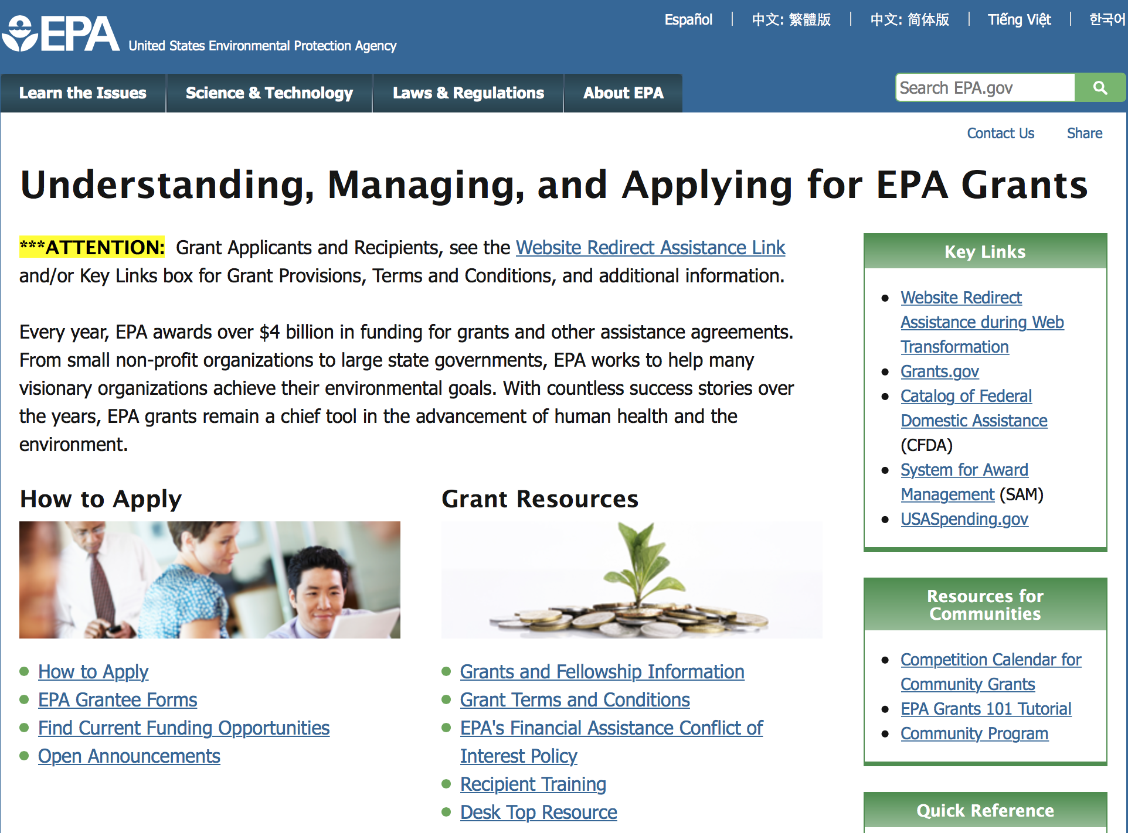

http://www.epa.gov/epahome/grants.htm

Programs:

Research:

Modifications:

Reminders:

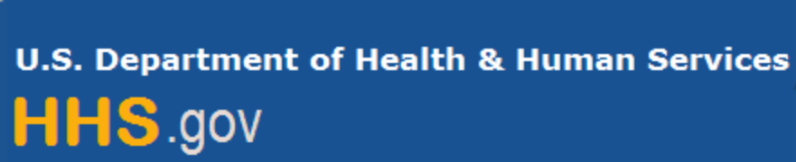

Department of Health and Human Services

Grants Forecast and Overview

The Department of Health and Human Services’ Grants Forecast is a database of planned grant opportunities proposed by its agencies. Each Forecast record contains actual or estimated dates and funding levels for grants that the agency intends to award during the fiscal year. Forecast opportunities are subject to change based on enactment of congressional appropriations.

For more general information about HHS Grants and Funding go to the website below at:
https://www.hhs.gov/grants/grants/index.html

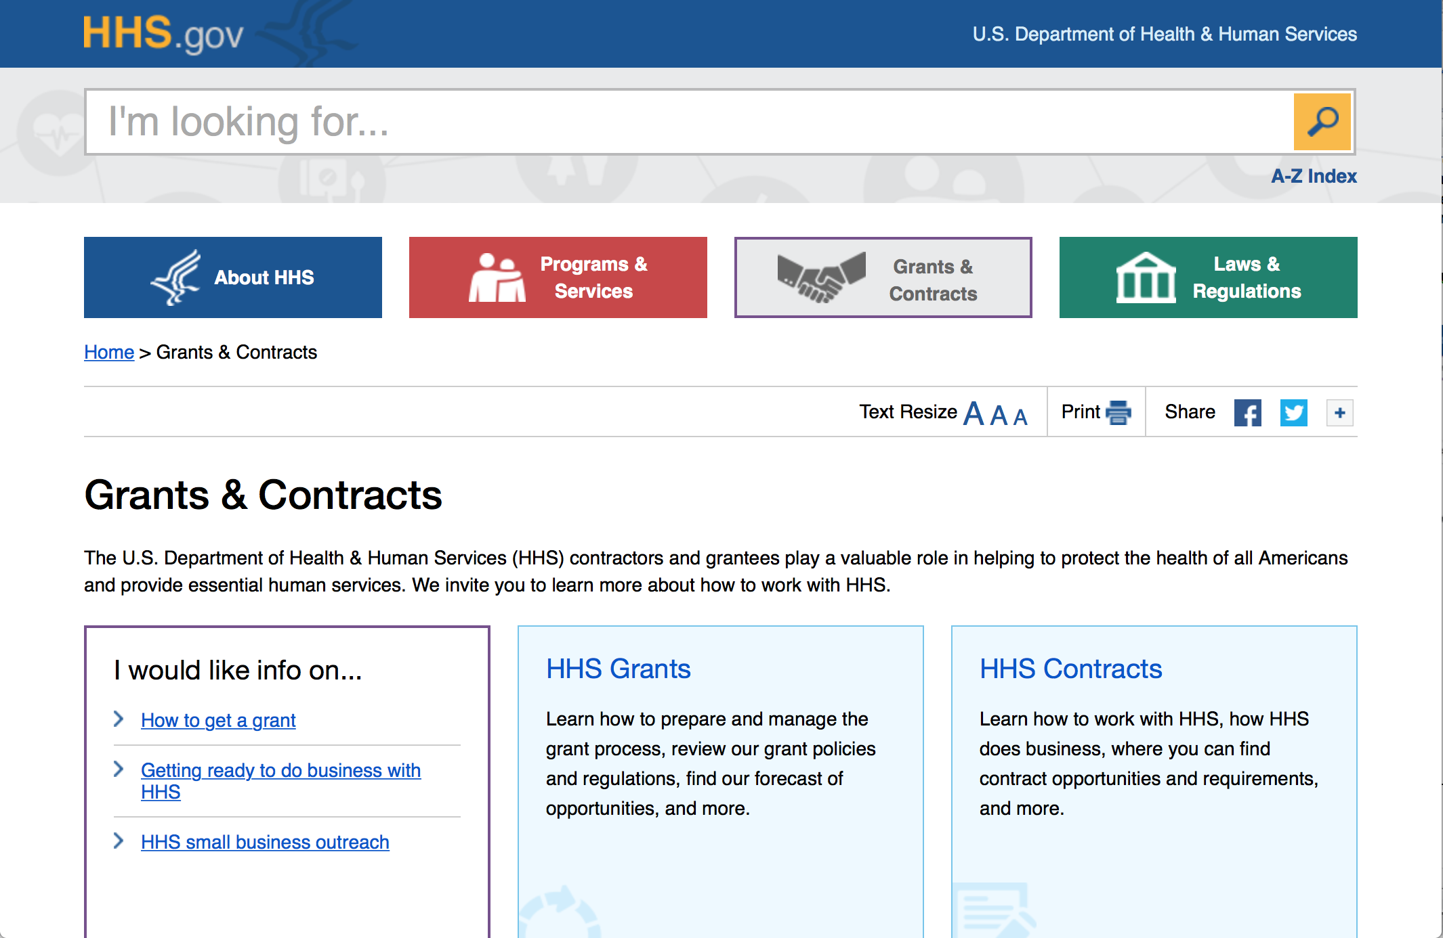

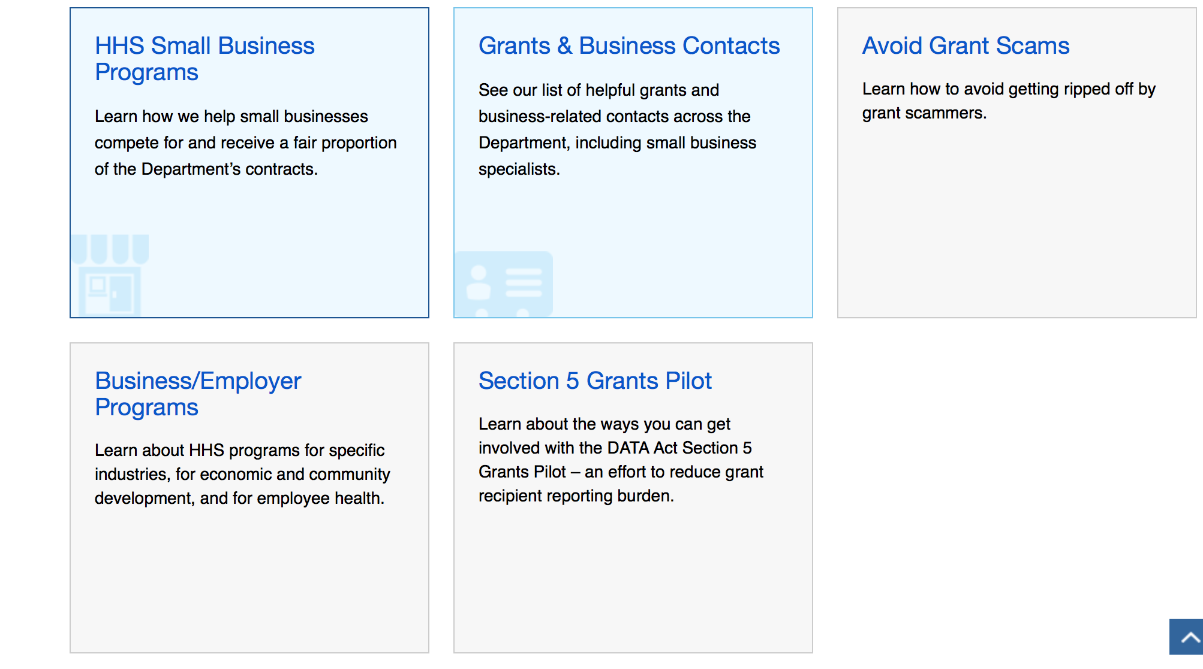

Programs:

Research:

Administration for Children and Families-IOAS-OTIP
Look Beneath the Surface Regional Anti-Trafficking Program
Synopsis 1
http://www.grants.gov/web/grants/view-opportunity.html?oppId=289166

Administration for Children and Families - OCS
Community Economic Development Projects
Synopsis 1
http://www.grants.gov/web/grants/view-opportunity.html?oppId=288729

Administration for Children and Families - ORR
Ethnic Community Self Help Program
Synopsis 1
http://www.grants.gov/web/grants/view-opportunity.html?oppId=289035

Administration for Community Living
Elder Justice Innovation Grants
Synopsis 1
http://www.grants.gov/web/grants/view-opportunity.html?oppId=294104

Centers for Disease Control - NCIPC
DELTA (Domestic Violence Prevention Enhancement and Leadership Through Alliances) Impact
Forecast 1
http://www.grants.gov/web/grants/view-opportunity.html?oppId=295041

Centers for Disease Control - NCHHSTP
Integrated HIV Surveillance and Prevention Programs for Health Departments
Synopsis 1
http://www.grants.gov/web/grants/view-opportunity.html?oppId=291220

Centers for Medicare & Medicaid Services
Grants to Support the Hispanic Health Services Research Grant Program
Synopsis 1
http://www.grants.gov/web/grants/view-opportunity.html?oppId=294538

Health Resources and Services Administration
Rural Health Opioid Program
Synopsis 1
http://www.grants.gov/web/grants/view-opportunity.html?oppId=284888

Health Resources and Services Administration
Children’s Hospitals Graduate Medical Education (CHGME) Payment Program
Synopsis 1
http://www.grants.gov/web/grants/view-opportunity.html?oppId=294630

Health Resources and Services Administration
Ryan White HIV/AIDS Program Part C HIV Early Intervention Services Program: Existing Geographic Service Areas
Synopsis 1
http://www.grants.gov/web/grants/view-opportunity.html?oppId=295094

Health Resources and Services Administration
Ryan White HIV/AIDS Program Part C HIV Early Intervention Services Program: Existing Geographic Service Areas
Synopsis 1
http://www.grants.gov/web/grants/view-opportunity.html?oppId=295111

Health Resources and Services Administration
Ryan White HIV/AIDS Program Part C HIV Early Intervention Services Program: Existing Geographic Service Areas
Synopsis 1
http://www.grants.gov/web/grants/view-opportunity.html?oppId=295114

National Institutes of Health
Clinical Research Sites for the Network of Excellence in Neuroscience Clinical Trials (NeuroNEXT sites) (U24)
Synopsis 1
http://www.grants.gov/web/grants/view-opportunity.html?oppId=295133

National Institutes of Health
Expanding Genome Integrity Assays to Population Studies (U01)
Synopsis 1
http://www.grants.gov/web/grants/view-opportunity.html?oppId=295155

National Institutes of Health
Mobile Monitoring of Cognitive Change (U2C)
Synopsis 1
http://www.grants.gov/web/grants/view-opportunity.html?oppId=295157

National Institutes of Health
Pre-application for a Biomedical Technology Research Resource (X02)
Synopsis 1

http://www.grants.gov/web/grants/view-opportunity.html?oppId=294641

National Institutes of Health
Global Brain and Nervous System Disorders Research Across the Lifespan (R21)
Synopsis 1
http://www.grants.gov/web/grants/view-opportunity.html?oppId=294617

National Institutes of Health
Global Brain and Nervous System Disorders Research Across the Lifespan (R01)
Synopsis 1
http://www.grants.gov/web/grants/view-opportunity.html?oppId=294618

National Institutes of Health
Collaborative Activities to Expedite Environmental Health Science Research, Translation, and Community Engagement Across EHS Core Centers (Admin Supp)
Synopsis 1
http://www.grants.gov/web/grants/view-opportunity.html?oppId=294731

National Institutes of Health
Biomedical Technology Research Resource (P41)
Synopsis 1
http://www.grants.gov/web/grants/view-opportunity.html?oppId=294656

National Institutes of Health
PHS 2017-02 Omnibus Solicitation of the NIH for Small Business Technology Transfer Grant Applications (Parent STTR [R41/R42])
Synopsis 1
http://www.grants.gov/web/grants/view-opportunity.html?oppId=294378

National Institutes of Health
PHS 2017-02 Omnibus Solicitation of the NIH, CDC, and FDA for Small Business Innovation Research Grant Applications (Parent SBIR [R43/R44])
Synopsis 1
http://www.grants.gov/web/grants/view-opportunity.html?oppId=294393

National Institutes of Health
Exposure Analysis Services for the Environmental Influences on Child Health Outcomes (ECHO) Program (Admin Supp)
Synopsis 1
http://www.grants.gov/web/grants/view-opportunity.html?oppId=294532

National Institutes of Health
Limited Competition: Small Grant Program for ORIP Special Emphasis Research Career Award (SERCA) K01 Recipients (R03)
Synopsis 1
http://www.grants.gov/web/grants/view-opportunity.html?oppId=294373

National Institutes of Health
NeuroNEXT Small Business Innovation in Clinical Trials (U44)
Synopsis 1
http://www.grants.gov/web/grants/view-opportunity.html?oppId=294374

National Institutes of Health
Notice of Intent to Publish a Funding Opportunity Announcement for NCCIH Natural Product Early Phase Clinical Trials (R33)
Forecast 1
http://www.grants.gov/web/grants/view-opportunity.html?oppId=294278

National Institutes of Health
Notice of Intent to Publish a Funding Opportunity Announcement for NCCIH Natural Product Phase I-IIa Clinical Trials Phased Innovation Award (R61/R33)
Forecast 1
http://www.grants.gov/web/grants/view-opportunity.html?oppId=294279

National Institutes of Health
Notice of Intent to Publish a Funding Opportunity Announcement for Precompetitive Collaboration on Liquid Biopsy for Early Cancer Assessment (U01)
Forecast 1
http://www.grants.gov/web/grants/view-opportunity.html?oppId=294280

National Institutes of Health
Notice of Intent to Publish a Funding Opportunity Announcement for the Coordinating Center for the Consortium of Translational Research in Early Detection of Liver Cancer (U24)
Forecast 1
http://www.grants.gov/web/grants/view-opportunity.html?oppId=294281

National Institutes of Health
Notice of Intent to Publish a Funding Opportunity Announcement for Consortium on Translational Research in Early Detection of Liver Cancer (Clinical and Research Centers (U01)
Forecast 1
http://www.grants.gov/web/grants/view-opportunity.html?oppId=294282

National Institutes of Health
Global Brain and Nervous System Disorders Research Across the Lifespan (R21)
Synopsis 1
http://www.grants.gov/web/grants/view-opportunity.html?oppId=294617

National Institutes of Health
Global Brain and Nervous System Disorders Research Across the Lifespan (R01)
Synopsis 1
http://www.grants.gov/web/grants/view-opportunity.html?oppId=294618

National Institutes of Health
NINDS Neuroscience Development for Advancing the Careers of a Diverse Research Workforce (R25)
Synopsis 1
http://www.grants.gov/web/grants/view-opportunity.html?oppId=294575

National Institutes of Health
Cellular and Molecular Biology of Complex Brain Disorders (R21)
Synopsis 1
http://www.grants.gov/web/grants/view-opportunity.html?oppId=294576

National Institutes of Health
Cellular and Molecular Biology of Complex Brain Disorders (R01)
Synopsis 1
http://www.grants.gov/web/grants/view-opportunity.html?oppId=294569

National Institutes of Health
HIV/HCV Co-Infections in Substance Abusers (R01)
Synopsis 1
http://www.grants.gov/web/grants/view-opportunity.html?oppId=294580

National Institutes of Health
Notice of Intent to Publish a Funding Opportunity Announcement for Compound Identification Development Cores (CIDC) (U2C)
Forecast 1
http://www.grants.gov/web/grants/view-opportunity.html?oppId=294285

National Institutes of Health
Notice of Intent to Publish a Funding Opportunity Announcement for NINR Exploratory Centers (P20)
Forecast 1
http://www.grants.gov/web/grants/view-opportunity.html?oppId=294287

National Institutes of Health
Notice of Intent to Publish a Funding Opportunity Announcement for NINR Centers of Excellence (P30)
Forecast 1
http://www.grants.gov/web/grants/view-opportunity.html?oppId=294288

National Institutes of Health
Imaging the Persistent HIV Reservoir (R01)
Synopsis 1
http://www.grants.gov/web/grants/view-opportunity.html?oppId=294418

National Institutes of Health
Institutional Development Award (IDeA) Program Infrastructure for Clinical and Translational Research (IDeA-CTR)(U54)
Synopsis 1
http://www.grants.gov/web/grants/view-opportunity.html?oppId=294451

National Institutes of Health
Optimizing HIV Phylodynamics to Target and Interrogate Clusters (OPTICs) (R21)
Synopsis 1
http://www.grants.gov/web/grants/view-opportunity.html?oppId=294452

National Institutes of Health
Integration of Individual Residential Histories into Cancer Research (R01)
Synopsis 1
http://www.grants.gov/web/grants/view-opportunity.html?oppId=294929

National Institutes of Health
Integration of Individual Residential Histories into Cancer Research (R21)
Synopsis 1
http://www.grants.gov/web/grants/view-opportunity.html?oppId=294906

National Institutes of Health
NCCIH Natural Product Phase I-IIa Clinical Trial Award (R33)
Synopsis 1
http://www.grants.gov/web/grants/view-opportunity.html?oppId=294923

National Institutes of Health
NCCIH Natural Product Phase I-IIa Clinical Trial Phased Innovation Award (R61/R33)
Synopsis 1
http://www.grants.gov/web/grants/view-opportunity.html?oppId=294924

National Institutes of Health
Multidisciplinary Studies of HIV/AIDS and Aging (R21)
Synopsis 1
http://www.grants.gov/web/grants/view-opportunity.html?oppId=294956

National Institutes of Health
Multidisciplinary Studies of HIV/AIDS and Aging (R01)
Synopsis 1
http://www.grants.gov/web/grants/view-opportunity.html?oppId=294957

National Institutes of Health
Novel Assays for Screening the Effects of Chemical Toxicants on Cell Differentiation (SBIR R44)
Synopsis 1
http://www.grants.gov/web/grants/view-opportunity.html?oppId=294941

National Institutes of Health
NEI Center Core Grant for Vision Research (P30)
Synopsis 1
http://www.grants.gov/web/grants/view-opportunity.html?oppId=294942

Office of the National Coordinator
Market Transparency Project for Health IT Interoperability Services
Synopsis 1
http://www.grants.gov/web/grants/view-opportunity.html?oppId=295132

Modifications:

Administration for Children and Families - OCS
Community Economic Development Projects
Synopsis 2
http://www.grants.gov/web/grants/view-opportunity.html?oppId=288729

Administration for Children and Families - ACYF/CB
Regional Partnership Grants to Increase the Well-Being of, and to Improve the Permanency Outcomes for, Children Affected by Substance Abuse
Synopsis 3
http://www.grants.gov/web/grants/view-opportunity.html?oppId=288213

Administration for Children and Families-IOAS-OTIP
Look Beneath the Surface Regional Anti-Trafficking Program
Synopsis 2
http://www.grants.gov/web/grants/view-opportunity.html?oppId=289166

National Institutes of Health
Discovering Novel Targets: The Molecular Genetics of Drug Addiction and Related Co-Morbidities (R01)
Synopsis 2
http://www.grants.gov/web/grants/view-opportunity.html?oppId=291143

National Institutes of Health
HIV Drug Resistance: Genotype-Phenotype-Outcome Correlations (R21)
Synopsis 2
http://www.grants.gov/web/grants/view-opportunity.html?oppId=293907

National Institutes of Health
Exploratory/Developmental Investigations on Primary Immunodeficiency Diseases (R21)
Synopsis 3
http://www.grants.gov/web/grants/view-opportunity.html?oppId=286310

National Institutes of Health
Uncovering the Causes, Contexts, and Consequences of Elder Mistreatment (R01)
Synopsis 2
http://www.grants.gov/web/grants/view-opportunity.html?oppId=293770

National Institutes of Health
Administrative Supplements for Research on Dietary Supplements (Admin Supp)
Synopsis 2
http://www.grants.gov/web/grants/view-opportunity.html?oppId=294471

National Institutes of Health
Small Grants on Primary Immunodeficiency Diseases (R03)
Synopsis 3
http://www.grants.gov/web/grants/view-opportunity.html?oppId=286311

National Institutes of Health
NeuroNEXT Clinical Trials (U01)
Synopsis 2
http://www.grants.gov/web/grants/view-opportunity.html?oppId=282540

National Institutes of Health
HIV Drug Resistance: Genotype-Phenotype-Outcome Correlations (R01)
Synopsis 2
http://www.grants.gov/web/grants/view-opportunity.html?oppId=293906

National Institutes of Health
Exploratory/Developmental Investigations on Primary Immunodeficiency Diseases (R21)
Synopsis 3
http://www.grants.gov/web/grants/view-opportunity.html?oppId=286310

Office of the Assistant Secretary for Health
Empowered Communities for a Healthier Nation Initiative
Synopsis 4
http://www.grants.gov/web/grants/view-opportunity.html?oppId=294314

Office of the Assistant Secretary for Health
Empowered Communities for a Healthier Nation
Forecast 3
http://www.grants.gov/web/grants/view-opportunity.html?oppId=294060

Office of the Assistant Secretary for Health
FY17 Empowered Communities for a Healthier Nation Initiative
Synopsis 2
http://www.grants.gov/web/grants/view-opportunity.html?oppId=294314

Deleted:

Administration for Children and Families - ANA
HHS-2017-ACF-ANA-NE-1225 - Sustainable Employment and Economic Development Strategies (SEEDS)
Deletion

Administration for Children and Families - ORR
-2017-ACF-ORR-ZM-1224 - Refugee Career Pathways Program
Deletion Comments: The forecast under this funding opportunity number (FON) has been cancelled. Please see FON -2018-ACF-ORR-ZM-1224 to apply for funding

Centers for Disease Control - CGH
CDC-RFA-GH17-1780 - Protecting and Improving Public Health Globally: Cooperative Agreement between Ministry of Agriculture of Georgia and US Centers for Disease Control and Prevention
Deletion Comments: Synopsis deleted

Centers for Disease Control - CGH
CDC-RFA-GH17-1779 - Cooperative Agreement with the Chinese Center for Disease Control and Prevention
Deletion Comments: Synopsis deleted

Centers for Disease Control - NCIPC
CDC-RFA-CE18-1801 - DELTA (Domestic Violence Prevention Enhancement and Leadership Through Alliances) Impact
Deletion Comments: Opportunity deleted

Food and Drug Administration
RDA-FD-18-002 - Creation and Implementation of the National Evaluation System for Health Technology (NEST) Coordinating Center (CC)
Deletion Comments: Opportunity deleted

Reminders:

Department of Homeland Security

The Department of Homeland Security enhances the ability of states, local and tribal jurisdictions, and other regional authorities in the preparation, prevention, and response to terrorist attacks and other disasters, by distributing grant funds. Localities can use grants for planning, equipment, training and exercise needs.

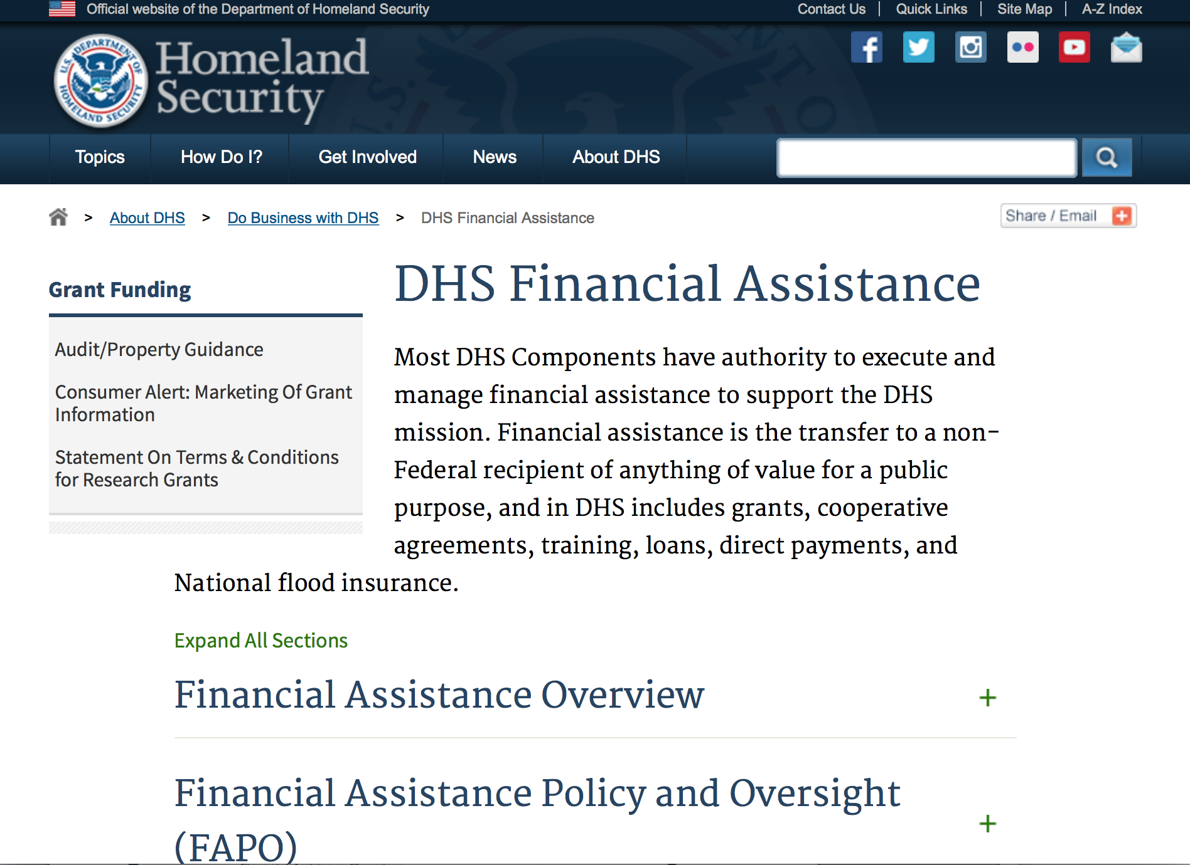
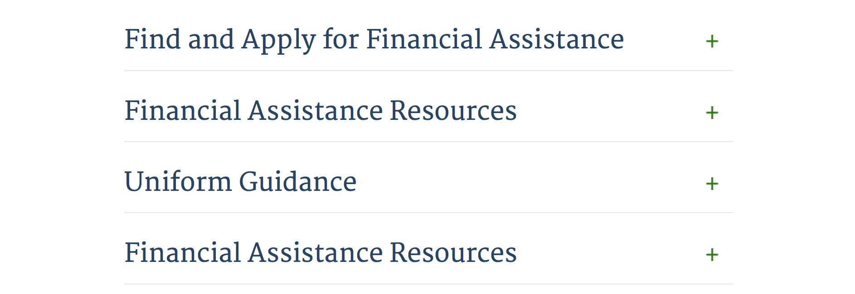

Webpage can be viewed at: http://www.dhs.gov/xopnbiz/grants/index.shtm#2

Information about 2016 for reference only
The FY 2016 Assistance to Firefighters Grants (AFG)
FY 2016 ASSISTANCE TO FIREFIGHTERS (AFG) GRANTS IS CLOSED AT THIS TIME
- FY 2016 Application Workshop Schedule
- FY 2016 AFG Application Guidance Materials The following documents are now available:
  - FY 2016 Notice of Funding Opportunity (NOFO) – Available Now
  - FY 2016 AFG Grant Application Get Ready Guide
  - FY 2016 AFG Narrative Get Ready Guide
  - FY 2016 AFG Self-Evaluation - Operations and Safety
  - FY 2016 AFG Self-Evaluation - Vehicle Acquisition
  - FY 2016 AFG Application Checklist
  - FY 2016 AFG Cost Share Calculator
FY 2016 AFG FAQs
For AFG program guidance materials, please visit our Documents page.

Resources

AFG Help Desk
Contact the AFG Program Help Desk toll-free at 866-274-0960, or email us at firegrants@dhs.gov.
The AFG Program has Fire Program Specialists in 10 federal regional centers. These Regional Fire Program Specialists respond to questions about the AFG program and carry out grant monitoring activities. View regional contacts

Popular AFG links
- AFG Workshop Schedule
- Assistance to Firefighters Grants (AFG)
- AFG Awards List
- AFG Success Stories
- Staffing for Adequate Fire & Emergency Response (SAFER) Grants (SAFER)
- SAFER Awards List
- SAFER Success Stories
- Fire Prevention & Safety (FP&S) Grants
- FP&S Awards List
- FP&S Success Stories
- Grant Closeout Tutorial
- Assistance to Firefighters Grant (AFG) Email Alert Archive
- Frequently Asked Questions
Contact Information For The Assistance to Firefighters Grant (AFG) Program and Help Desk

Federal Funding Alternative To AFG

State Administrative Agencies (SAA) apply for and administer Federal grants on behalf of their States, including FEMA Preparedness Grants. The SAA will work with eligible organizations to comply with the general requirements of grant programs or cooperative agreements. Contact your State’s SAA to find out what current Federal funding opportunities may be available to your organization. A listing of the SAAs and points of contact can be found at http://www.fema.gov/library/viewRecord.do?id=6363.

Programs:

Department of Homeland Security - FEMA
Fiscal Year (FY) 2017 Homeland Security National Training Program (HSNTP) - National Domestic Preparedness Consortium (NDPC)
Synopsis 1
Document Type: | Grants Notice
Funding Opportunity Number: | DHS-17-NPD-005-00-02
Funding Opportunity Title: | Fiscal Year (FY) 2017 Homeland Security National Training Program (HSNTP) - National Domestic Preparedness Consortium (NDPC)
Opportunity Category: | Discretionary
Opportunity Category Explanation:
Funding Instrument Type: | Cooperative Agreement
Category of Funding Activity: | Education  Other (see text field entitled "Explanation of Other Category of Funding Activity" for clarification)
Category Explanation: | Training
Expected Number of Awards: | 5
CFDA Number(s): | 97.005 -- State and Local Homeland Security National Training Program
Cost Sharing or Matching Requirement: | Yes
Version: | Synopsis 1
Posted Date: | Jun 26, 2017
Last Updated Date: | Jun 26, 2017
Original Closing Date for Applications: | Jul 26, 2017
Current Closing Date for Applications: | Jul 26, 2017
Archive Date: | Aug 25, 2017
Estimated Total Program Funding: | $79,000,000
Eligible Applicants: | Public and State controlled institutions of higher education  Nonprofits having a 501(c)(3) status with the IRS, other than institutions of higher education
Agency Name: | Department of Homeland Security - FEMA
Description: | The Department of Homeland Security National Training Program (HSNTP), National Domestic Preparedness Consortium (NDPC) plays an important role in the implementation of the National Preparedness System by supporting the building, sustainment, and delivery of core capabilities essential to achieving the National Preparedness Goal (the Goal) of a secure and resilient Nation. Delivering core capabilities requires the combined effort of the whole community, rather than the exclusive effort of any single organization or level of government. The FY 2017 HSNTP/NDPC supports efforts to build and sustain core capabilities across Prevention, Protection, Mitigation, Response, and Recovery mission areas, with specific focus on addressing the training needs of our nation. Objectives: FY 2017 HSNTP/NDPC training programs will provide training solutions to address national preparedness gaps, correlate training needs with exercise activities and outcomes, incorporate the core capabilities identified in the National Preparedness Goal, and ensure training is available and accessible to a nationwide audience.
Link to Additional Information: | http://www.grants.gov
Grantor Contact Information: | If you have difficulty accessing the full announcement electronically, please contact:  Systems, GPD GMD-Systems-Branch@fema.gov  GMD-Systems-Branch@fema.gov

http://www.grants.gov/web/grants/view-opportunity.html?oppId=295039

Department of Homeland Security - FEMA
Fiscal Year (FY) 2017 Homeland Security National Training Program (HSNTP) - Continuing Training Grants (CTG)
Synopsis 1
Document Type: | Grants Notice
Funding Opportunity Number: | DHS-17-NPD-005-00-01
Funding Opportunity Title: | Fiscal Year (FY) 2017 Homeland Security National Training Program (HSNTP) - Continuing Training Grants (CTG)
Opportunity Category: | Discretionary
Opportunity Category Explanation:
Funding Instrument Type: | Cooperative Agreement
Category of Funding Activity: | Education  Other (see text field entitled "Explanation of Other Category of Funding Activity" for clarification)
Category Explanation: | Training
Expected Number of Awards: | 4
CFDA Number(s): | 97.005 -- State and Local Homeland Security National Training Program
Cost Sharing or Matching Requirement: | No
Version: | Synopsis 1
Posted Date: | Jun 26, 2017
Last Updated Date: | Jun 26, 2017
Original Closing Date for Applications: | Jul 26, 2017
Current Closing Date for Applications: | Jul 26, 2017
Archive Date: | Aug 25, 2017
Estimated Total Program Funding: | $8,000,000
Eligible Applicants: | Native American tribal governments (Federally recognized)  Public and State controlled institutions of higher education  State governments  Private institutions of higher education  Nonprofits having a 501(c)(3) status with the IRS, other than institutions of higher education  County governments  City or township governments
Agency Name: | Department of Homeland Security - FEMA
Description: | The Department of Homeland Security National Training Program (HSNTP), Continuing Training Grants (CTG) program plays an important role in the implementation of the National Preparedness System by supporting the building, sustainment, and delivery of core capabilities essential to achieving the National Preparedness Goal (the Goal) of a secure and resilient Nation. Delivering core capabilities requires the combined effort of the whole community, rather than the exclusive effort of any single organization or level of government. The FY 2017 HSNTP/CTG supports efforts to build and sustain core capabilities across Prevention, Protection, Mitigation, Response, and Recovery mission areas, with specific focus on addressing the training needs of our Nation. Objectives: FY 2017 HSNTP/CTG training programs will provide training solutions to address specific national preparedness gaps, correlate training needs with exercise activities and outcomes, incorporate the core capabilities identified in the National Preparedness Goal, and ensure training is available and accessible to a nationwide audience.
Link to Additional Information: | http://www.grants.gov
Grantor Contact Information: | If you have difficulty accessing the full announcement electronically, please contact:  User, System ndgrants@fema.dhs.gov  ndgrants@fema.dhs.gov

http://www.grants.gov/web/grants/view-opportunity.html?oppId=295022

Office of Procurement Operations - Grants Division
Genetic Engineering Machine Competition
Synopsis 1
Document Type: | Grants Notice
Funding Opportunity Number: | DHS-ST-17-104-CBD-0001
Funding Opportunity Title: | Genetic Engineering Machine Competition
Opportunity Category: | Discretionary
Opportunity Category Explanation:
Funding Instrument Type: | Grant
Category of Funding Activity: | Education
Category Explanation:
Expected Number of Awards: | 10
CFDA Number(s): | 97.104 -- Homeland Security-related Science, Technology, Engineering and Mathematics (HS STEM) Career Development Program
Cost Sharing or Matching Requirement: | No
Version: | Synopsis 1
Posted Date: | Jun 30, 2017
Last Updated Date: | Jun 30, 2017
Original Closing Date for Applications: | Jul 31, 2017
Current Closing Date for Applications: | Jul 31, 2017
Archive Date: | Aug 30, 2017
Estimated Total Program Funding: | $35,000
Award Ceiling: | $0
Award Floor: | $0
Eligible Applicants: | Nonprofits having a 501(c)(3) status with the IRS, other than institutions of higher education
Agency Name: | Office of Procurement Operations - Grants Division
Description: | See Full Announcement
Link to Additional Information:
Grantor Contact Information: | If you have difficulty accessing the full announcement electronically, please contact:  Janet Bailey Grants Specialist Phone 202-447-0362  janet.bailey@hq.dhs.gov

http://www.grants.gov/web/grants/view-opportunity.html?oppId=295138

Modifications:

Reminders:

Office of Procurement Operations - Grants Division
DHS S&T Center of Excellence for Cross-Border Threat Screening and Supply Chain Defense - Partner
Synopsis 2

Document Type: | Grants Notice
Funding Opportunity Number: | DHS-ST-061-CBTS-PARTNER
Funding Opportunity Title: | DHS S&T Center of Excellence for Cross-Border Threat Screening and Supply Chain Defense - Partner
Opportunity Category: | Discretionary
Opportunity Category Explanation:
Funding Instrument Type: | Cooperative Agreement
Category of Funding Activity: | Science and Technology and other Research and Development
Category Explanation:
Expected Number of Awards: | 3
CFDA Number(s): | 97.061 -- Centers for Homeland Security
Cost Sharing or Matching Requirement: | No
Version: | Synopsis 2
Posted Date: | Mar 16, 2017
Last Updated Date: | Mar 24, 2017
Original Closing Date for Applications: | Aug 04, 2017
Current Closing Date for Applications: | Aug 04, 2017
Archive Date: | Sep 03, 2017
Estimated Total Program Funding: | $1,500,000
Award Ceiling: | $500,000
Award Floor: | $400,000
Eligible Applicants: | Public and State controlled institutions of higher education  Private institutions of higher education
Agency Name: | Office of Procurement Operations - Grants Division
Description: | Informational Webinar: March 29, 2017 3:00PM EDT The Department of Homeland Security (DHS) Science and Technology Directorate (S&T) Office of University Programs (OUP) is requesting applications from U.S. colleges and universities to serve as a partner institution for the Center for Cross-Border Threat Screening and Supply Chain Defense (CBTS). OUP is also posting a separate NOFO for eligible applicants to submit lead proposals for consideration. Please see NOFO Number DHS-16-ST-061-CBTS-Lead or 97.061 on http://www.grants.gov for directions on how to submit Lead proposal. DHS will select qualified individual projects from applications received for either the Center Lead NOFO or the Center Partner NOFO, regardless of the institution that is awarded as lead institution. Principal Investigators that are already Partners under a Center Lead application may not submit the same application under this Partner NOFO.
Link to Additional Information:
Grantor Contact Information: | If you have difficulty accessing the full announcement electronically, please contact:  Melanie Bales Lead Grants Officer Phone 202-447-5522  Grants Officer

http://www.grants.gov/web/grants/view-opportunity.html?oppId=292507

Department of Housing and Urban Development

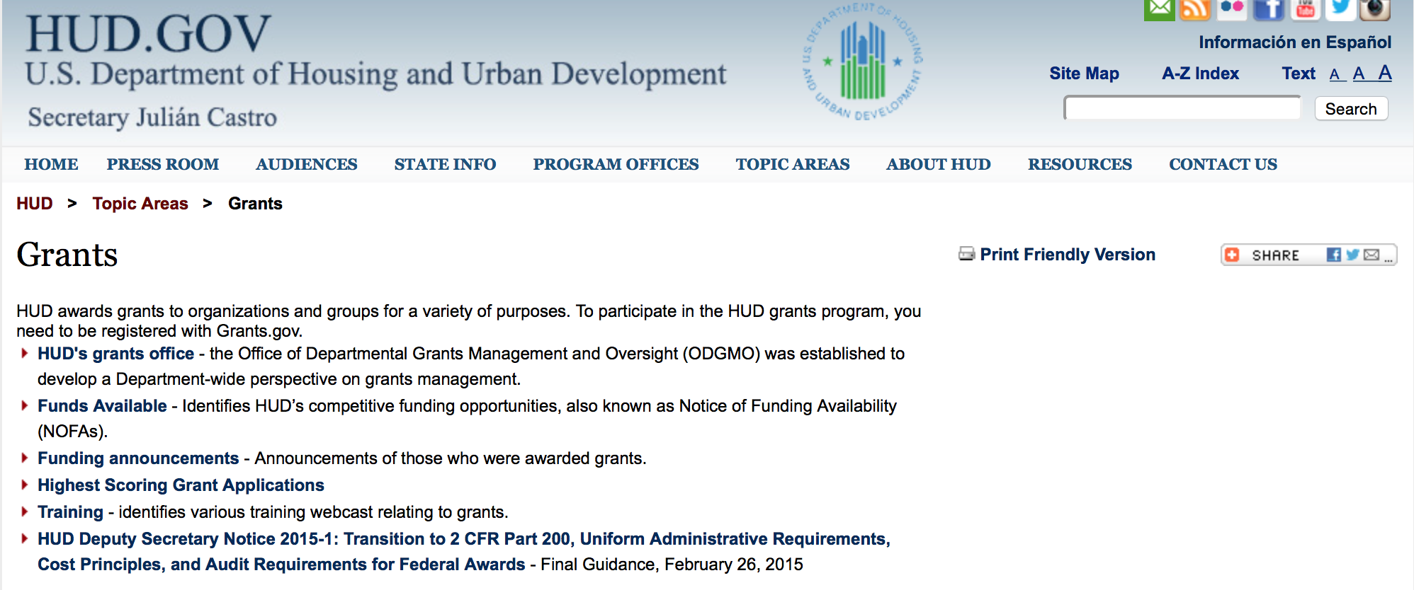

http://portal.hud.gov/hudportal/HUD?src=/topics/grants

HUD - Notice of Funds Available

For detailed information click here

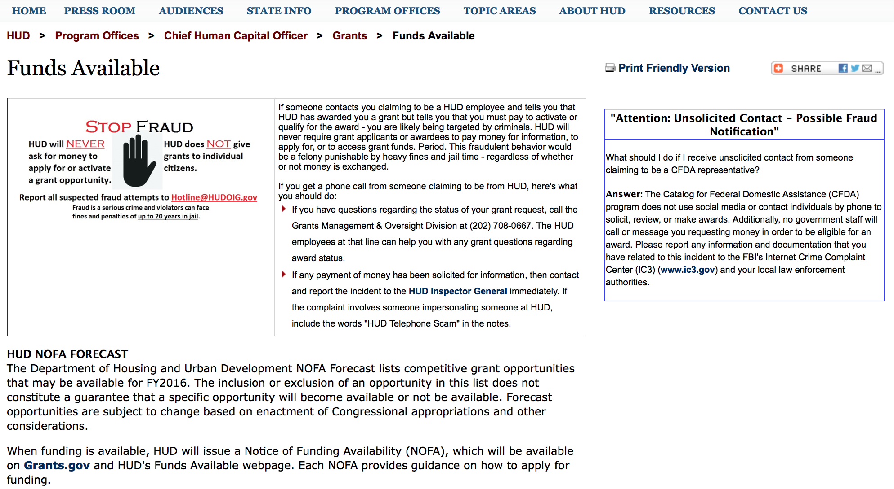

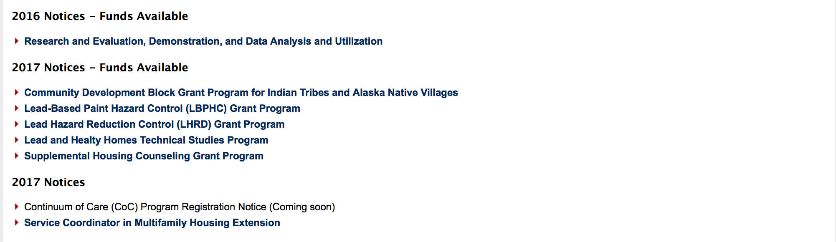
http://portal.hud.gov/hudportal/HUD?src=/program_offices/administration/grants/fundsavail

HUD NOFA FORECAST
The Department of Housing and Urban Development NOFA Forecast lists competitive grant opportunities that may be available for FY2016. The inclusion or exclusion of an opportunity in this list does not constitute a guarantee that a specific opportunity will become available or not be available. Forecast opportunities are subject to change based on enactment of Congressional appropriations and other considerations.
When funding is available, HUD will issue a Notice of Funding Availability (NOFA), which will be available on Grants.gov

Programs:

Modifications:

Choice Neighborhoods Planning Grants Program
Synopsis 2
Document Type: | Grants Notice
Funding Opportunity Number: | FR-6100-N-38
Funding Opportunity Title: | Choice Neighborhoods Planning Grants Program
Opportunity Category: | Discretionary
Opportunity Category Explanation:
Funding Instrument Type: | Grant
Category of Funding Activity: | Housing
Category Explanation:
Expected Number of Awards: | 6
CFDA Number(s): | 14.892 -- Choice Neighborhoods Planning Grants
Cost Sharing or Matching Requirement: | Yes
Version: | Synopsis 2
Posted Date: | Jun 28, 2017
Last Updated Date: | Jun 28, 2017
Original Closing Date for Applications: | Aug 28, 2017 Electronically submitted applications must be submitted no later than 11:59 p.m., ET, on the listed application due date.
Current Closing Date for Applications: | Aug 28, 2017 Electronically submitted applications must be submitted no later than 11:59 p.m., ET, on the listed application due date.
Archive Date: | Sep 27, 2017
Estimated Total Program Funding: | $5,000,000
Award Ceiling: | $1,300,000
Award Floor: | $1
Eligible Applicants: | Others (see text field entitled "Additional Information on Eligibility" for clarification)
Additional Information on Eligibility: | Eligible applicants under this NOFA are Public Housing Authorities (PHAs), local governments, tribal entities, and nonprofits. Refer to the definitions in section I.A.3.b for definitions of these terms. Individuals, foreign entities, and sole proprietorship organizations are not eligible to compete for, or receive, awards made under this announcement.
Agency Name: | Department of Housing and Urban Development
Description: | With this publication, HUD is making available up to $5,000,000 for Planning Grants, including Planning and Action Grants.1. Planning Grants are two-year grants that assist communities with severely distressed public or HUD-assisted housing in developing a successful neighborhood transformation plan and building the support necessary for that plan to be successfully implemented.2. Planning and Action Grants are three and a half year planning grants that pair planning with action. Experience shows that tangible actions taken early on help communities build momentum for further planning and the eventual transition from planning to implementation of that plan. These actions improve neighborhood confidence, which in turn sustains the community's energy, attracts more engagement and resources, and helps convince skeptical stakeholders that positive change is possible. Under these grants, the planning process activities would take place during the first 24 months of the grant period. The planning process will identify Action Activities that will be carried out during the latter portion of the grant period. Action Activities must build upon the planning for the target housing and neighborhood.
Link to Additional Information: | http://portal.hud.gov/hudportal/HUD?src=/program_offices/administration/grants/fundsavail
Grantor Contact Information: | If you have difficulty accessing the full announcement electronically, please contact:  ChoiceNeighborhoods@hud.gov  Email inquiries

http://www.grants.gov/web/grants/view-opportunity.html?oppId=295096

Deleted:

Reminders:

Institute of Museum and Library Services

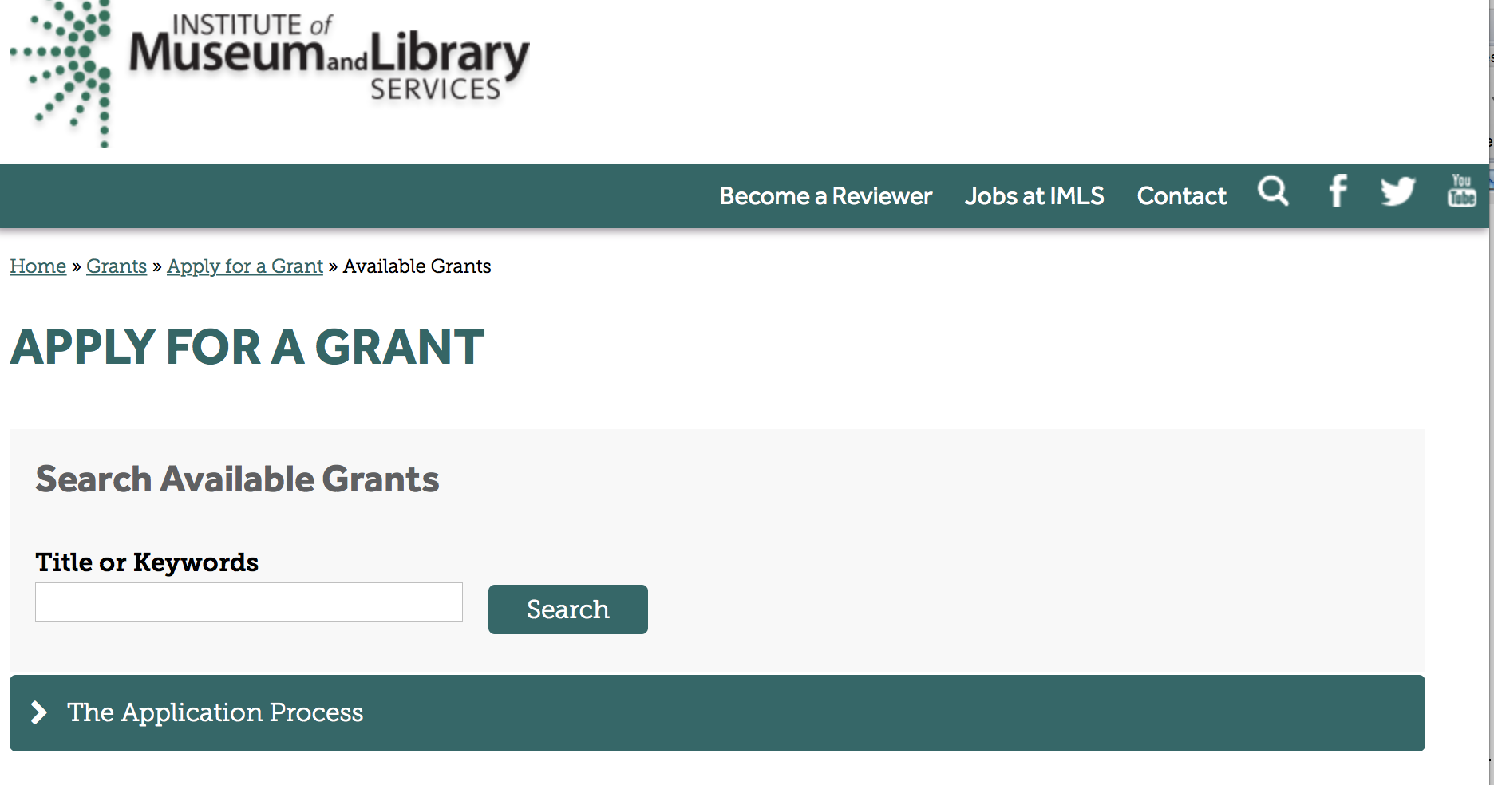

https://www.imls.gov/grants/apply-grant/available-grants

Each grant program has specific eligibility requirements. The links below provide general eligibility criteria for museums, libraries, and tribal organizations, but please note that additional organizations may be eligible for grants under certain programs. Additionally, ineligible organizations may still be able to participate in grant programs through partnerships with eligible organizations. Please click on the links below to see general criteria and review Applications and Guidelines for specific information.
Museums Libraries

Institutions: Archives, Federally Recognized Native American Tribe, Historical Society, Library, Nonprofits that serve Native Hawaiians, Professional Association, Public or Private Non-profit Institutions of Higher Education, Regional Organization, State Library Administrative Agency, State or Local Government

Check out IMLS's Facebook page at:
https://www.facebook.com/USIMLS/

Programs:

Modifications:

Reminders:

Deleted:

Department of the Interior
Working with Interior

The Interior Department provides assistance to the public, local governments and businesses through a number of programs. For a general overview see: http://www.doi.gov/index.cfm

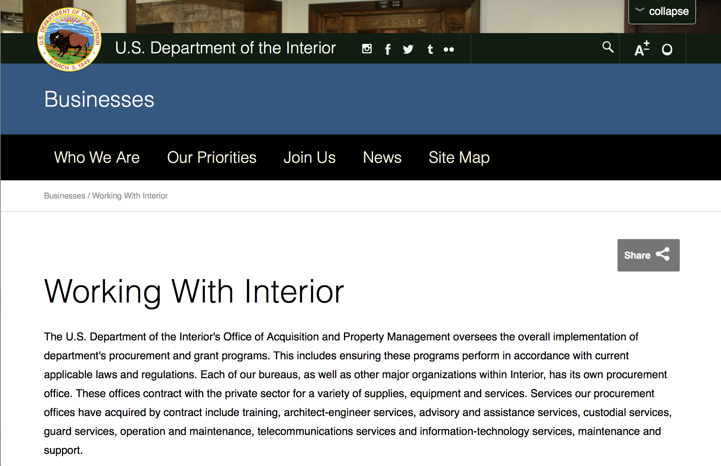

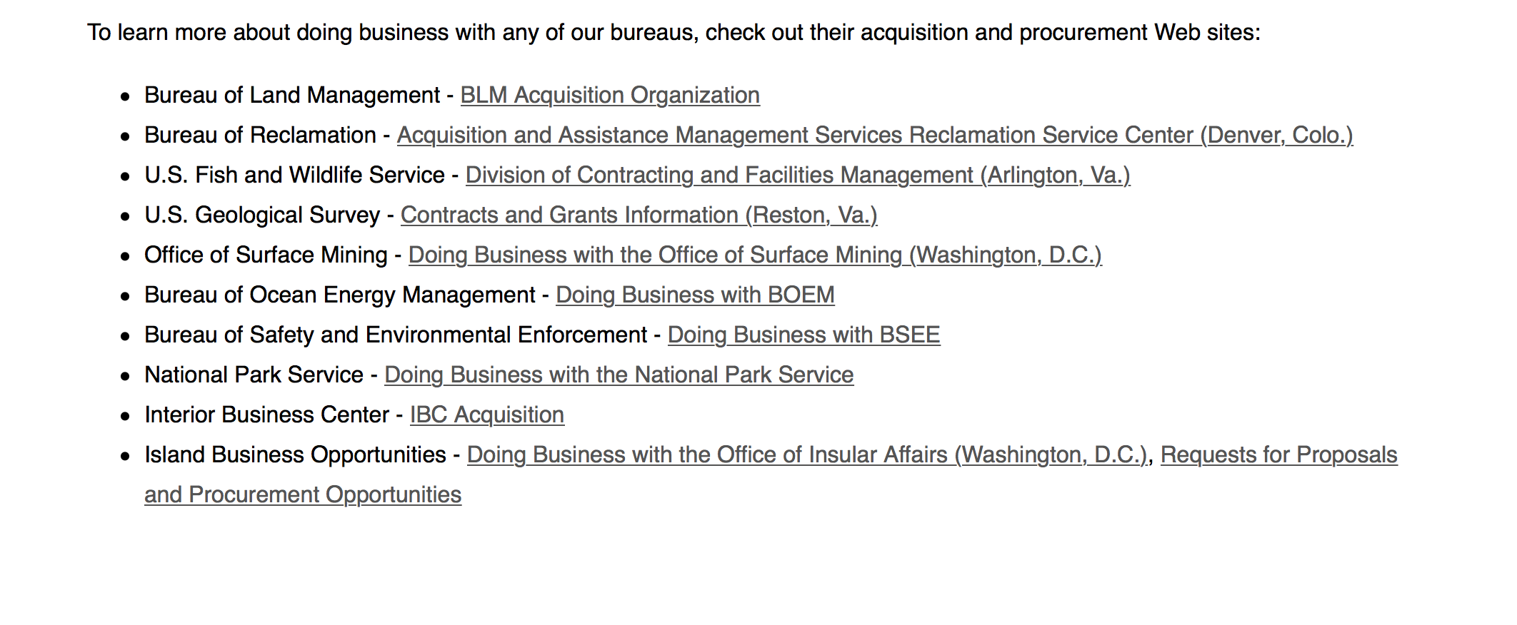
http://www.doi.gov/businesses/working-with-interior.cfm

Programs:

National Park Service
Historic Preservation Fund Grants to Underrepresented Communities
Synopsis 1 & 2
Document Type: | Grants Notice
Funding Opportunity Number: | P17AS00399
Funding Opportunity Title: | Historic Preservation Fund Grants to Underrepresented Communities
Opportunity Category: | Discretionary
Opportunity Category Explanation:
Funding Instrument Type: | Grant
Category of Funding Activity: | Arts (see "Cultural Affairs" in CFDA)  Community Development  Humanities (see "Cultural Affairs" in CFDA)  Other (see text field entitled "Explanation of Other Category of Funding Activity" for clarification)
Category Explanation: | Historic Preservation, Cultural Resource Management
Expected Number of Awards: | 15
CFDA Number(s): | 15.904 -- Historic Preservation Fund Grants-In-Aid
Cost Sharing or Matching Requirement: | No
Version: | Synopsis 1
Posted Date: | Jun 19, 2017
Last Updated Date: | July 3, 2017
Original Closing Date for Applications: | Jul 31, 2017 Applications must be submitted in grants.gov and received by 11:59 pm Pacific Daylight Time on July 31, 2017.
Current Closing Date for Applications: | Jul 31, 2017 Applications must be submitted in grants.gov and received by 11:59 pm Pacific Daylight Time on July 31, 2017.
Archive Date: | Sep 29, 2017
Estimated Total Program Funding: | $500,000
Award Ceiling: | $50,000
Eligible Applicants: | City or township governments  County governments  Others (see text field entitled "Additional Information on Eligibility" for clarification)  State governments  Native American tribal governments (Federally recognized)
Additional Information on Eligibility: | Eligible applicants are limited to: federally recognized Tribes, Alaska Native Groups, Native Hawaiian Organizations (as defined by 54 USC 300300 et seq.); State Historic Preservation Offices (in some states and territories, these are nonprofits); and Certified Local Governments (which may be county, city, or township governments). A listing of Certified Local Governments may be found at nps.gov/clg.
Agency Name: | National Park Service
Description: | Grants support the survey, inventory, and designation of historic properties that are associated with communities currently underrepresented in the National Register of Historic Places and among National Historic Landmarks. Within one year of the completion of the grant, all projects must result in: the submission of a new nomination to the National Register of Historic Places or National Historic Landmark program OR an amendment to an existing National Register or National Historic Landmark nomination to include underrepresented communities.
Link to Additional Information: | http://www.grants.gov
Grantor Contact Information: | If you have difficulty accessing the full announcement electronically, please contact:  Grants Management Specialist Seth Tinkham 202-354-2020 preservation_grants_info@nps.gov  Please contact us if you have questions. Email preferred.

http://www.grants.gov/web/grants/view-opportunity.html?oppId=294781

Modifications:

National Park Service
National Maritime Heritage Grants 2017
Synopsis 3

http://www.grants.gov/web/grants/view-opportunity.html?oppId=293713

Reminders:

National Fish Passage Program
Synopsis 1

Document Type: | Grants Notice
Funding Opportunity Number: | F17AS00030
Funding Opportunity Title: | National Fish Passage Program
Opportunity Category: | Discretionary
Opportunity Category Explanation:
Funding Instrument Type: | Cooperative Agreement  Grant
Category of Funding Activity: | Natural Resources
Category Explanation:
Expected Number of Awards: | 0
CFDA Number(s): | 15.608 -- Fish and Wildlife Management Assistance
Cost Sharing or Matching Requirement: | Yes
Posted Date: | Nov 23, 2016
Last Updated Date: | Nov 23, 2016
Original Closing Date for Applications: | Sep 30, 2017
Current Closing Date for Applications: | Sep 30, 2017
Archive Date: | Oct 02, 2017
Estimated Total Program Funding: | $0
Award Ceiling: | $2,000,000
Award Floor: | $500
Eligible Applicants: | Unrestricted (i.e., open to any type of entity above), subject to any clarification in text field entitled "Additional Information on Eligibility"
Additional Information on Eligibility: | To receive funding, NFPP projects must be implemented in coordination with FAC staff. Applicants can be, but not limited to: state and federal agencies, private lands, tribes, local municipalities, and non-governmental organizations.
Agency Name: | Fish and Wildlife Service
Description: | The National Fish Passage Program (NFPP) is a voluntary program that provides direct technical assistance and financial assistance in the form of cooperative agreements and grants to partners to provide fish (and other aquatic organisms) passage and restore aquatic connectivity for the benefit of federal trust resources. The NFPP is delivered through more than 65 Fisheries and Aquatic Conservation (FAC) Field Offices across all States and territories. FAC staff coordinates with project partners, stakeholders and other Service programs to identify and collaboratively implement projects within Regional priority areas. Project work plans are developed strategically, in coordination with partners, and with substantial involvement from FAC staff. Projects must advance our mission, promote biological diversity, and be based upon sound scientific biological principles. FAC and Fish and Wildlife Service (FWS) strategic plans inform the types of projects funded under this opportunity. Applicants seeking funding under this program should review the program strategic plan and also contact the regional NFPP Coordinator for local FAC contacts prior to submitting an application for funding.
Link to Additional Information: | http://www.grants.gov
Grantor Contact Information: | If you have difficulty accessing the full announcement electronically, please contact:  Susan Wells 703-358-2523 Susan_Wells@fws.gov  Fish Passage Coordinator

http://www.grants.gov/web/grants/view-opportunity.html?oppId=290297

Fish and Wildlife Service
Fiscal Year

Document Type: | Grants Notice
Funding Opportunity Number: | F17AS00005
Funding Opportunity Title: | Fiscal Year 2017 Recovery Implementation Grants
Opportunity Category: | Discretionary
Opportunity Category Explanation:
Funding Instrument Type: | Cooperative Agreement  Grant  Procurement Contract
Category of Funding Activity: | Environment  Natural Resources
Category Explanation:
Expected Number of Awards: | 0
CFDA Number(s): | 15.657 -- Endangered Species Conservation - Recovery Implementation Funds
Cost Sharing or Matching Requirement: | No
Posted Date: | Oct 18, 2016
Last Updated Date: | Oct 18, 2016
Original Closing Date for Applications: | Applications are due by July 31, 2017. However, you may submit applications throughout the year. Consideration of applications ultimately will be based on the FWS budget cycle.
Current Closing Date for Applications: | Applications are due by July 31, 2017. However, you may submit applications throughout the year. Consideration of applications ultimately will be based on the FWS budget cycle.
Archive Date: | Aug 31, 2017
Estimated Total Program Funding: | $100,000
Award Ceiling: | $100,000
Award Floor: | $1
Eligible Applicants: | Unrestricted (i.e., open to any type of entity above), subject to any clarification in text field entitled "Additional Information on Eligibility"
Additional Information on Eligibility: | Applicants must have a demonstrated knowledge and understanding of the biology of the involved endangered or threatened species in the United States and their ecosystem, including preferably having worked with the species in the field and holding a currently valid Endangered Species Act permit, issued by the FWS, authorizing them to work with these species (or that have previously held a permit to do so). If funding is awarded, applicants that do not currently hold a valid permit for the proposed activity may need to apply for and obtain a permit (http://www.fws.gov/endangered/permits/index.html) before beginning the proposed activity. FWS Regional (or Field Office) contacts will discuss potential proposals with interested parties if needed, and review eligible applications. The FWS Regional Office will refer interested parties to the appropriate FWS Field Office for further consideration as appropriate. For potential proposals submitted directly to the Field Office, the Field Office will conduct the proposal review and selection process. A list of FWS Regional Office contacts is available in the Full Announcement under section VII. Agency Contacts.
Agency Name: | Fish and Wildlife Service
Description: | The FWS Ecological Services Program provides Federal financial assistance on a competitive basis to States, other Federal agencies, landowners, educators, non-profit organizations, researchers, and other partners to secure information about endangered, threatened or candidate species, to aid in the recovery of these species, to avert listing of species pursuant to the Endangered Species Act, and to help conserve the ecosystems upon which these species depend. The FWS and National Marine Fisheries Service (NMFS), which is part of the Department of Commerceï¿½s NOAA Fisheries office, share Endangered Species Act responsibilities for several species such as sea turtles. We have responsibility for sea turtles when they are on land, and NMFS has responsibility for sea turtles when they are in the water. Projects for NMFS-managed species are not included in this funding opportunity. This Recovery Implementation funding opportunity is intended for projects that will contribute to the recovery of FWS-managed endangered and threatened species in the United States, and is limited to projects carrying out actions described in a speciesï¿½ approved recovery plan, in the implementation schedule of a speciesï¿½ approved recovery plan, actions recommended in a completed 5-year status review of the species or in a spotlight species action plan, or projects documenting speciesï¿½ response to climate change. For example: securing scientific information about endangered or threatened species, implementing restoration actions that will lead to delisting of a species, help prevent extinction of a species, or aid in the recovery of a species. Projects that address species response to climate change will receive additional consideration.
Link to Additional Information: | http://www.grants.gov
Grantor Contact Information: | If you have difficulty accessing the full announcement electronically, please contact:  Kelly Niland 703-358-2492 Kelly_Niland@fws.gov  Kelly_Niland@fws.gov

http://www.grants.gov/web/grants/view-opportunity.html?oppId=289600

Fish and Wildlife Service
Partners for Fish and Wildlife
Synopsis 1

Document Type: | Grants Notice
Funding Opportunity Number: | F17AS00015
Funding Opportunity Title: | Partners for Fish and Wildlife
Opportunity Category: | Discretionary
Opportunity Category Explanation:
Funding Instrument Type: | Cooperative Agreement
Category of Funding Activity: | Community Development  Education  Environment  Natural Resources
Category Explanation:
Expected Number of Awards: | 5000
CFDA Number(s): | 15.631 -- Partners for Fish and Wildlife
Cost Sharing or Matching Requirement: | No
Posted Date: | Nov 03, 2016
Last Updated Date: | Nov 03, 2016
Original Closing Date for Applications: | Sep 30, 2017
Current Closing Date for Applications: | Sep 30, 2017
Archive Date: | Oct 07, 2017
Estimated Total Program Funding: | $52,000,000
Award Ceiling: | $500,000
Award Floor: | $1
Eligible Applicants: | For profit organizations other than small businesses  Nonprofits having a 501(c)(3) status with the IRS, other than institutions of higher education  City or township governments  Native American tribal organizations (other than Federally recognized tribal governments)  State governments  Individuals  Small businesses  Public and State controlled institutions of higher education  Nonprofits that do not have a 501(c)(3) status with the IRS, other than institutions of higher education  Native American tribal governments (Federally recognized)  County governments  Private institutions of higher education
Agency Name: | Fish and Wildlife Service
Description: | The Partners for Fish and Wildlife (PFW) Program is a voluntary, incentive-based program that provides direct technical assistance and financial assistance in the form of cooperative agreements to private landowners to restore and conserve fish and wildlife habitat for the benefit of federal trust resources. The PFW Program is delivered through more than 250 full-time staff, active in all 50 States and territories. Partners for Fish and Wildlife Program staff coordinate with project partners, stakeholders and other Service programs to identify geographic focus areas and develop habitat conservation priorities within these focus areas. Geographic focus areas are where the PFW Program directs resources to conserve habitat for federal trust species. Project work plans are developed strategically, in coordination with partners, and with substantial involvement from Service field staff. Projects must advance our mission, promote biological diversity, and be based upon sound scientific biological principles. Program strategic plans inform the types of projects funded under this opportunity. Applicants seeking funding under this program should review the program strategic plan and also contact the regional PFW Program office prior to submitting an application for funding. Authorizing statues include Partners for Fish and Wildlife Act of 2006, 16 U.S.C. 3771-3774; Fish and Wildlife Act of 1956; 16 U.S.C. 742a-c, 742e-j; Fish and Wildlife Coordination Act of 1958, 16 U.S.C. 661-667(e).
Link to Additional Information: | http://www.grants.gov
Grantor Contact Information: | If you have difficulty accessing the full announcement electronically, please contact:  Matthew Filsinger 703-358-2011 matthew_filsinger@fws.gov  Project Officer

http://www.grants.gov/web/grants/view-opportunity.html?oppId=289882

Fish and Wildlife Service
Coastal Program
Synopsis 1

Document Type: | Grants Notice
Funding Opportunity Number: | F17AS00014
Funding Opportunity Title: | Coastal Program
Opportunity Category: | Discretionary
Opportunity Category Explanation:
Funding Instrument Type: | Cooperative Agreement
Category of Funding Activity: | Community Development  Education  Environment  Natural Resources
Category Explanation:
Expected Number of Awards: | 500
CFDA Number(s): | 15.630 -- Coastal
Cost Sharing or Matching Requirement: | No
Posted Date: | Nov 03, 2016
Last Updated Date: | Nov 03, 2016
Original Closing Date for Applications: | Sep 30, 2017
Current Closing Date for Applications: | Sep 30, 2017
Archive Date: | Oct 07, 2017
Estimated Total Program Funding: | $14,000,000
Award Ceiling: | $500,000
Award Floor: | $1
Eligible Applicants: | County governments  Nonprofits having a 501(c)(3) status with the IRS, other than institutions of higher education  City or township governments  Special district governments  Native American tribal governments (Federally recognized)  Private institutions of higher education  Native American tribal organizations (other than Federally recognized tribal governments)  For profit organizations other than small businesses  State governments  Small businesses  Public and State controlled institutions of higher education  Individuals  Nonprofits that do not have a 501(c)(3) status with the IRS, other than institutions of higher education
Agency Name: | Fish and Wildlife Service
Description: | The Coastal Program is a voluntary, incentive-based program that provides direct technical assistance and financial assistance in the form of cooperative agreements to coastal communities and landowners to restore and protect fish and wildlife habitat on public and private lands. Coastal Program staff coordinate with project partners, stakeholders and other Service programs to identify geographic focus areas and develop habitat conservation priorities within these focus areas. Geographic focus areas are where the Coastal Program directs resources to conserve habitat for federal trust species. Project work plans are developed strategically, in coordination with partners, and with substantial involvement from Service field staff. Projects must advance our mission, promote biological diversity, and be based upon sound scientific biological principles. Program strategic plans inform the types of projects funded under this opportunity. Applicants seeking funding under this program should review the program strategic plan and also contact the regional Coastal Program office prior to submitting an application for funding. Authorizing statues include Fish and Wildlife Act of 1956, 16 U.S.C. 742a-c, 747e-742j; and Fish and Wildlife Coordination Act of 1958, 16 U.S.C. 661 667(e).
Link to Additional Information: | http://www.grants.gov
Grantor Contact Information: | If you have difficulty accessing the full announcement electronically, please contact:  Chris Darnell 703-358-2236 chris_darnell@fws.gov  Project Officer

http://www.grants.gov/web/grants/view-opportunity.html?oppId=289863

Deleted:

Department of Justice

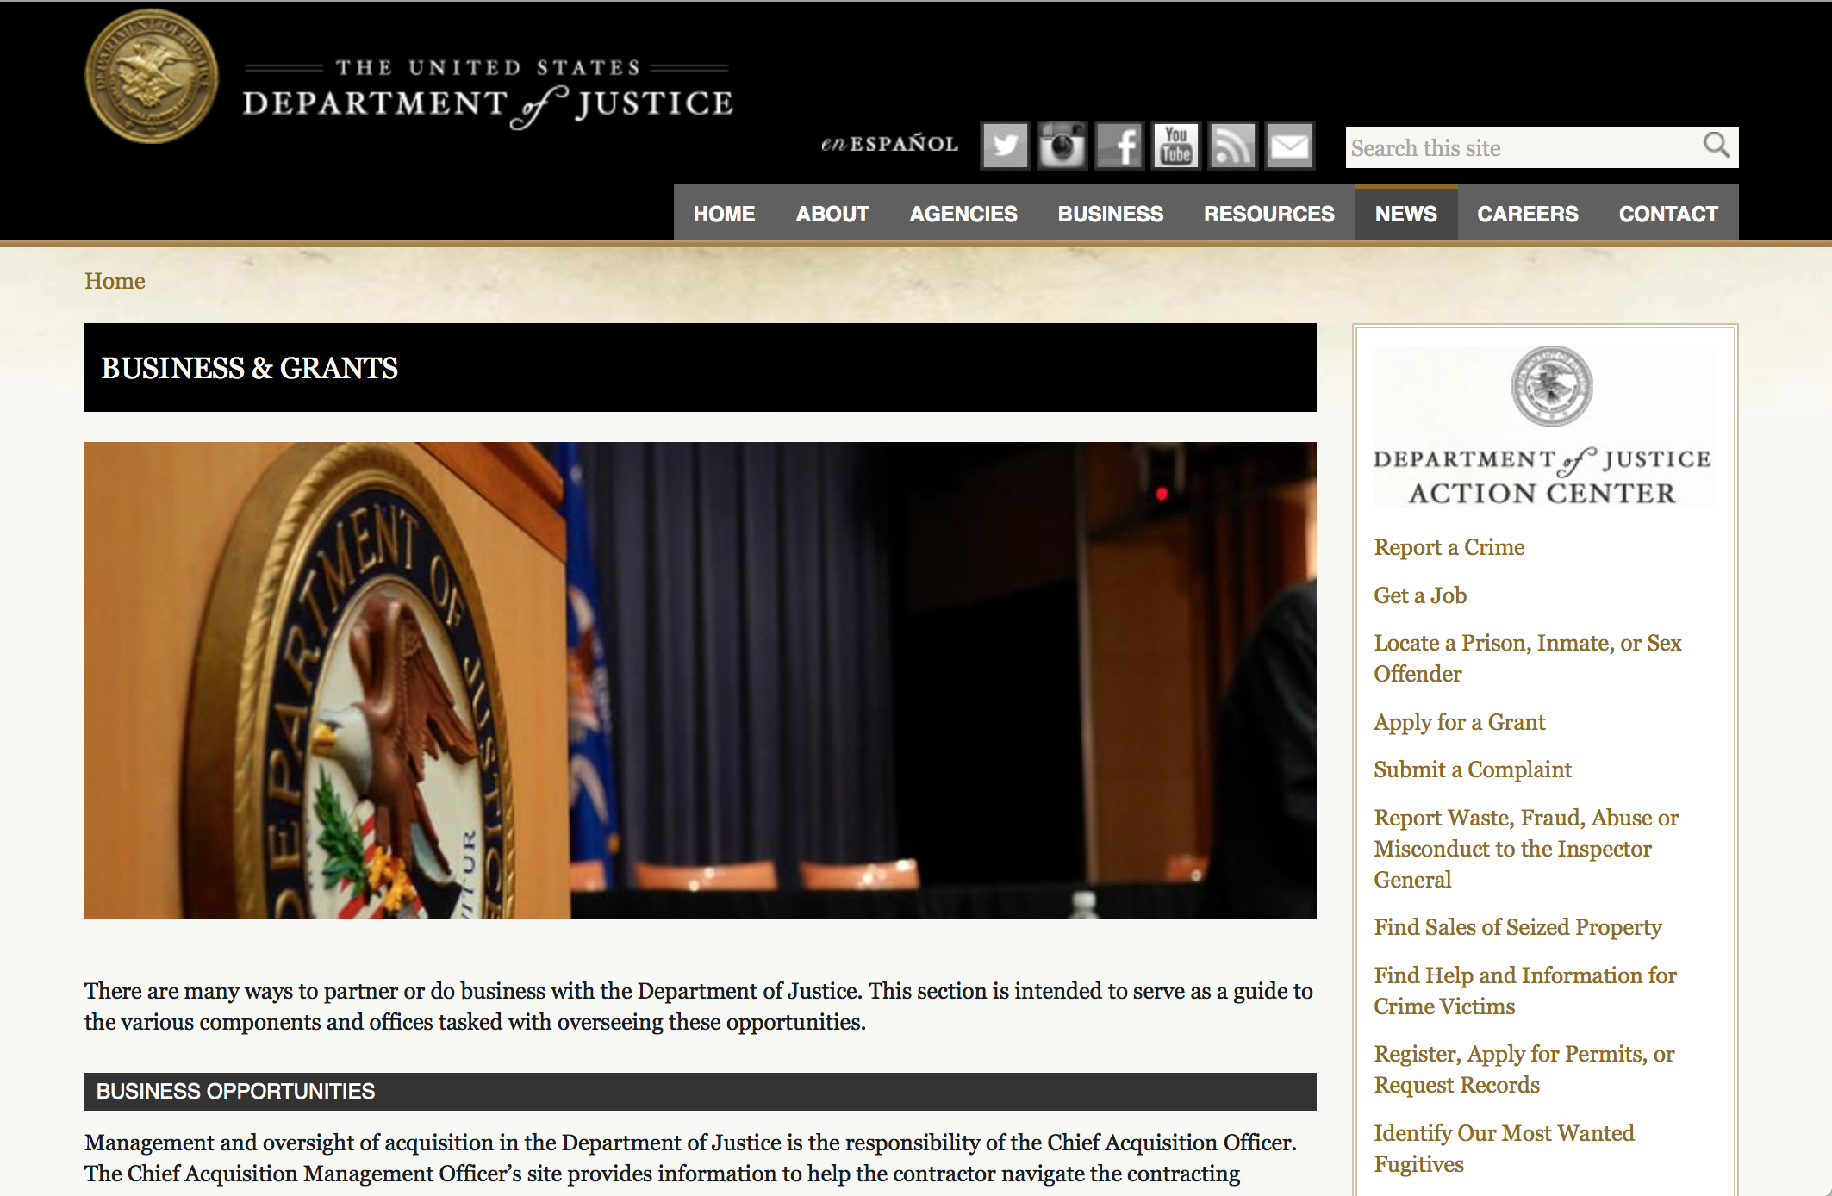

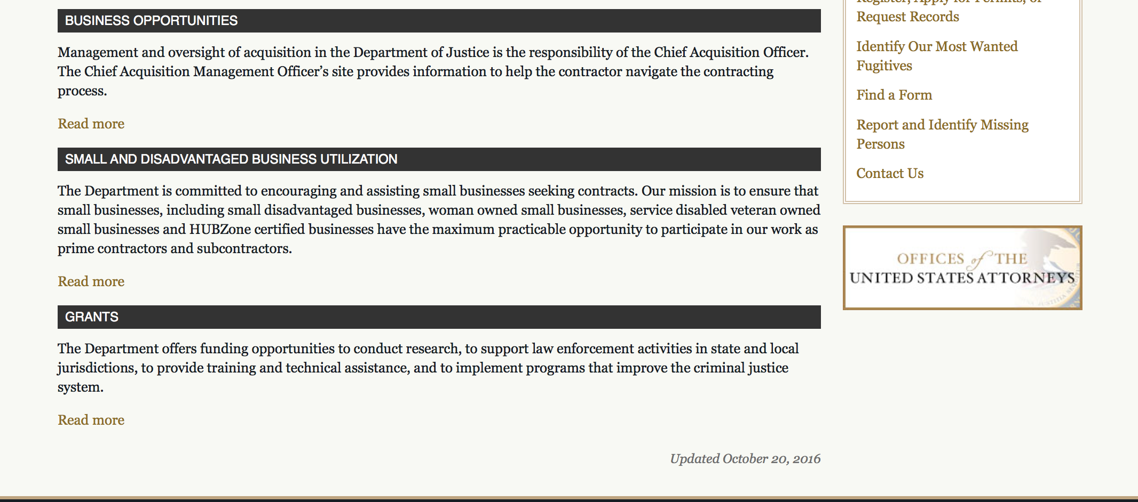

The DOJ agencies listed below also have sites that provide grant information specific to that agency. Examples of what can be found on these sites are programs, funding opportunities, application assistance, and other useful information.

Bureau of Justice Assistance (BJA)

Bureau of Justice Statistics (BJS)

National Criminal Justice Reference Service (NCJRS)

National Institute of Justice (NIJ)

Office of Sex Offender Sentencing, Monitoring, Apprehending, Registering, and Tracking (SMART)

http://www.justice.gov/business/

Programs:

Office for Victims of Crime
OVC FY 17 Increasing Legal Access to Victims of Crime: Innovations in Access to Justice Programs
Synopsis 1
Document Type: | Grants Notice
Funding Opportunity Number: | OVC-2017-12180
Funding Opportunity Title: | OVC FY 17 Increasing Legal Access to Victims of Crime: Innovations in Access to Justice Programs
Opportunity Category: | Discretionary
Opportunity Category Explanation:
Funding Instrument Type: | Cooperative Agreement
Category of Funding Activity: | Income Security and Social Services  Law, Justice and Legal Services
Category Explanation:
Expected Number of Awards: | 3
CFDA Number(s): | 16.582 -- Crime Victim Assistance/Discretionary Grants
Cost Sharing or Matching Requirement: | Yes
Version: | Synopsis 1
Posted Date: | Jun 16, 2017
Last Updated Date: | Jun 16, 2017
Original Closing Date for Applications: | Jul 18, 2017
Current Closing Date for Applications: | Jul 18, 2017
Archive Date:
Estimated Total Program Funding: | $8,150,000
Award Ceiling: | $4,000,000
Award Floor: | $1,000,000
Eligible Applicants: | Others (see text field entitled "Additional Information on Eligibility" for clarification)
Additional Information on Eligibility: | This solicitation seeks eligible applicants under three distinct purpose areas. Applicants may apply for more than one purpose area under this solicitation, so long as they meet the eligibility requirements for each purpose area. Under Purpose Area 1, by statute, eligible applicants are limited to states, units of local government, federally recognized Indian tribal governments (as determined by the Secretary of the Interior), and nonprofit (defined as an organization that is described in section 501(c)(3) of Title 26 and is exempt from taxation under 501(a) of such title), nongovernmental organizations (including tribal nonprofits). An applicant must demonstrate a history of providing services, (e.g., victim assistance, social services, legal services, shelter, or mental health services), to human trafficking survivors. Additionally, an applicant must demonstrate that “subaward” organizations that host legal fellows providing legal services for human trafficking survivors have a demonstrated history of providing services to human trafficking survivors. Nonprofit organizations that hold money in offshore accounts for the purpose of avoiding paying the tax described in 26 U.S.C. § 511(a) are not eligible to apply. Under Purpose Areas 2 and 3, eligible applicants are limited to private nonprofit organizations (including tribal nonprofit organizations); faith and community-based organizations; colleges and universities (including tribal institutions of higher education); and public agencies, federally recognized Indian tribal governments (as determined by the Secretary of the Interior), or tribal organizations that can demonstrate knowledge and understanding of civil legal representation for crime victims and the range of services needed; knowledge, and ability to successfully execute the development of training, technical assistance, public awareness, and other informational resources to meet the needs of victim service providers and allied practitioners who serve them; and the capacity to partner with other organizations and key stakeholders to deliver comprehensive, seamless legal services to victims. For these purpose areas, a private nonprofit organization does not have to have 501(c)(3) status to apply for grant funding under this solicitation. Purpose Area 2 applicants must have the staff, resources, and capability to develop or enhance a model for delivery of these services. An applicant must demonstrate that it proposes to serve a rural area or rural community, and that there is a demonstrated need for legal services in this area. The applicant must provide their definition of a “rural area” or “rural community,” and explain why the targeted area meets the applicant’s definition of “rural area” or “rural community.” OVC may elect to fund applications submitted under this FY 2017 solicitation in future fiscal years, dependent on, among other considerations, the merit of the applications and on the availability of appropriations.
Agency Name: | Office for Victims of Crime
Description: | OVC will provide, in total, approximately $8.15 million in funding for legal services for three distinct projects that will enhance legal access for crime victims, foster technological innovation, and provide training and technical assistance to those involved in the initiatives. OVC anticipates that it will make awards under three distinct purpose areas. •Purpose Area 1 – Increase Capacity and Access to Civil Legal Help for Crime Victims Through Legal Fellows Program (Legal Fellows Program) - one award, up to $4,000,000, for a 2-year performance period. •Purpose Area 2 – Using Technology/Other Innovations to Increase Legal Access in Rural Areas - one award, up to $3,150,000, for a 3-year performance period. •Purpose Area 3 – Training and Technical Assistance – Legal Partnerships Increasing Medical Care Advocacy to Crime Victims - one award, up to $1,000,000, for a 2-year performance period.
Link to Additional Information:
Grantor Contact Information: | If you have difficulty accessing the full announcement electronically, please contact:  For assistance with the requirements of this solicitation, contact Silvia P. Torres, Program Management Specialist, by telephone at 202-616-1796. silvia.torres@usdoj.gov  For Programmatic Questions

http://www.grants.gov/web/grants/view-opportunity.html?oppId=294737

Office for Victims of Crime
OVC FY 17 Vision 21: Integrated Services for Victims Program: Increasing Access to Mental Health Services for Victims of Crime
Synopsis 1
Document Type: | Grants Notice
Funding Opportunity Number: | OVC-2017-12280
Funding Opportunity Title: | OVC FY 17 Vision 21: Integrated Services for Victims Program: Increasing Access to Mental Health Services for Victims of Crime
Opportunity Category: | Discretionary
Opportunity Category Explanation:
Funding Instrument Type: | Cooperative Agreement
Category of Funding Activity: | Income Security and Social Services  Law, Justice and Legal Services
Category Explanation:
Expected Number of Awards: | 9
CFDA Number(s): | 16.582 -- Crime Victim Assistance/Discretionary Grants
Cost Sharing or Matching Requirement: | No
Version: | Synopsis 1
Posted Date: | Jun 27, 2017
Last Updated Date: | Jun 27, 2017
Original Closing Date for Applications: | Aug 10, 2017
Current Closing Date for Applications: | Aug 10, 2017
Archive Date:
Estimated Total Program Funding: | $4,750,000
Award Ceiling: | $500,000
Award Floor: | $350,000
Eligible Applicants: | Others (see text field entitled "Additional Information on Eligibility" for clarification)
Additional Information on Eligibility: | For information on eligibility, see Section C of the funding opportunity under Eligibility Information.
Agency Name: | Office for Victims of Crime
Description: | Vision 21 Integrated Services for Victims Program: Increasing Access to Mental Health Services for Victims of Crime (Vision 21 ISV Program), consists of three purpose areas: (1) developing a suicide prevention gatekeeper training curriculum to increase the capacity of crime victim advocates to help prevent suicide; (2) increasing access to services for victims of domestic violence and sexual assault who have a serious mental illness; and (3) increasing access to mental health services for traditionally underserved victims of crime. The Vision 21 ISV Program will promote a collaborative approach to the delivery of direct services by requiring crime victim services providers and clinical mental health service providers to form strategic partnerships to develop and implement project developed under purpose areas 2 and 3 of this program.
Link to Additional Information: | Funding Opportunity
Grantor Contact Information: | If you have difficulty accessing the full announcement electronically, please contact:  For assistance with any other requirements of this solicitation, contact Kimberly Woodard, Senior Tribal Affairs Specialist, by telephone at 202–307–2952. kimberly.woodard@usdoj.gov  For Programmatic Questions

http://www.grants.gov/web/grants/view-opportunity.html?oppId=295072

Research:

Modifications:

Deleted:

Reminders:



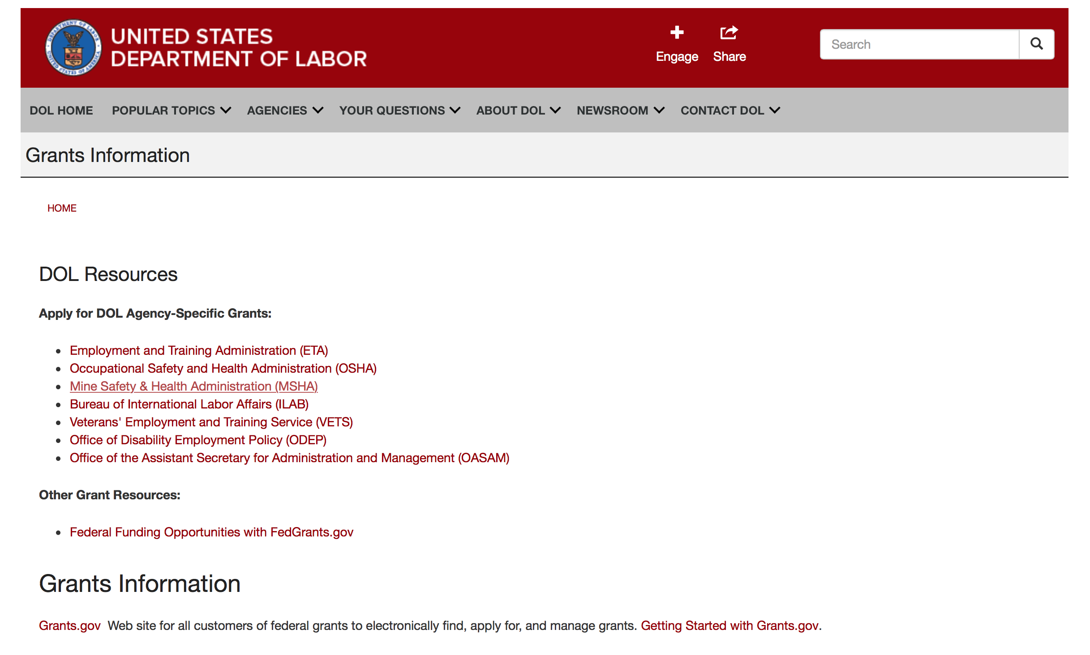

Agency Grants and Contract General Overview

DOL Resources
Apply for DOL Agency-Specific Grants:
- Employment and Training Administration (ETA)
- Occupational Safety and Health Administration (OSHA)
- Mine Safety & Health Administration (MSHA)
- Bureau of International Labor Affairs (ILAB)
- Veterans' Employment and Training Service (VETS)
- Office of Disability Employment Policy (ODEP)
- Office of the Assistant Secretary for Administration and Management (OASAM)

Other Grant Resources:
- Federal Funding Opportunities with FedGrants.gov
Grants Information
Grants.gov — Web site for all customers of federal grants to electronically find, apply for, and manage grants. Getting Started with Grants.gov.

DOL Resources and Instructions for Applying for a Grant
- DOL Guidance Clarifying the Effect of the Religious Freedom Restoration Act on Faith-Based Organizations
- Grant and Contract Information
- Contracting and Grant Program Overview
- Civil Rights Enforcement for Department of Labor Grant Recipients
- More Information About Grants
- Use of Contracts, Grants & Cooperative Agreements

Other Federal Government Grant Information
- Grant Opportunities (Catalog of Federal Domestic Assistance)

Department of Labor Grant Programs

- Bureau of International Labor Affairs (ILAB): provides grants (cooperative agreements) for the implementation of projects designed to assist developing countries combat the worse forms of child labor, forced labor, and human trafficking; and support worker rights and improve working conditions. http://www.dol.gov/general/business.
- Bureau of Labor Statistics (BLS): provides project grants (cooperative agreements) and the dissemination of technical statistical data and related information on labor force activities; provides data on prices (CPI) and cost of living; data on productivity and technology data; data on compensation and working conditions; data on employment projections.
- Employment and Training (ETA): ETA administers financial assistance programs pursuant to the Workforce Investment Act (WIA), administering State formula grant programs for youth, adults and dislocated workers, national emergency grants for workers affected by mass layoffs, plant closures, and disasters; grant programs for workers with disabilities, Indians and Native Americans, and for migrant and seasonal farmworkers. ETA also administers grant programs for older American workers, apprenticeship programs, Trade Adjustment Assistance (TAA) programs, and assistance for research and development of workforce programs. In addition, ETA is responsible for the operation and maintenance of a national system of public employment service offices and for the national unemployment insurance program.
- Mine Safety and Health (MSHA): provides grants for research, education and training programs to ensure an adequate and competent staff of trained inspectors; and assistance for establishing or improving State mine health and safety programs through technical assistance.
- Occupational Safety and Health (OSHA): provides grants to non-profit organizations to provide training, educational services, and technical assistance; assistance to states to administer and enforce state programs; assistance to states to provide occupational safety and health technical assistance and consultant services.
- Office of Disability Employment Policy (ODEP): The Office of Disability Employment Policy awards competitive grants establishing short-term pilot and technical assistance projects designed to identify, develop, test, evaluate, and disseminate policies to increase employment by expanding access to training, education, employment supports, assistive and systems technology, integrated employment, entrepreneurial development, and small business opportunities for adults and youth with disabilities. Current pilots projects focus on customized employment, Olmstead populations, and innovative demonstration youth grants, among others. Solicitations for grant applications are published in the Federal Register and announced at www.dol.gov/odep. ODEP grants are awarded by the OASAM grant office.
- Veterans' Employment and Training (VETS): provides special employment and training assistance for veterans through the Disabled Veterans' Outreach Program (DVOP) Solicitation for Grant Applications; the Local Veterans' Employment Representative Program (LVER); Veterans' Workforce Investment Program (VWIP); elaws Advisor on veterans' employment and reemployment rights; and the Homeless Veterans Reintegration Project (HVRP). VETS grants are awarded by the OASAM grant office.

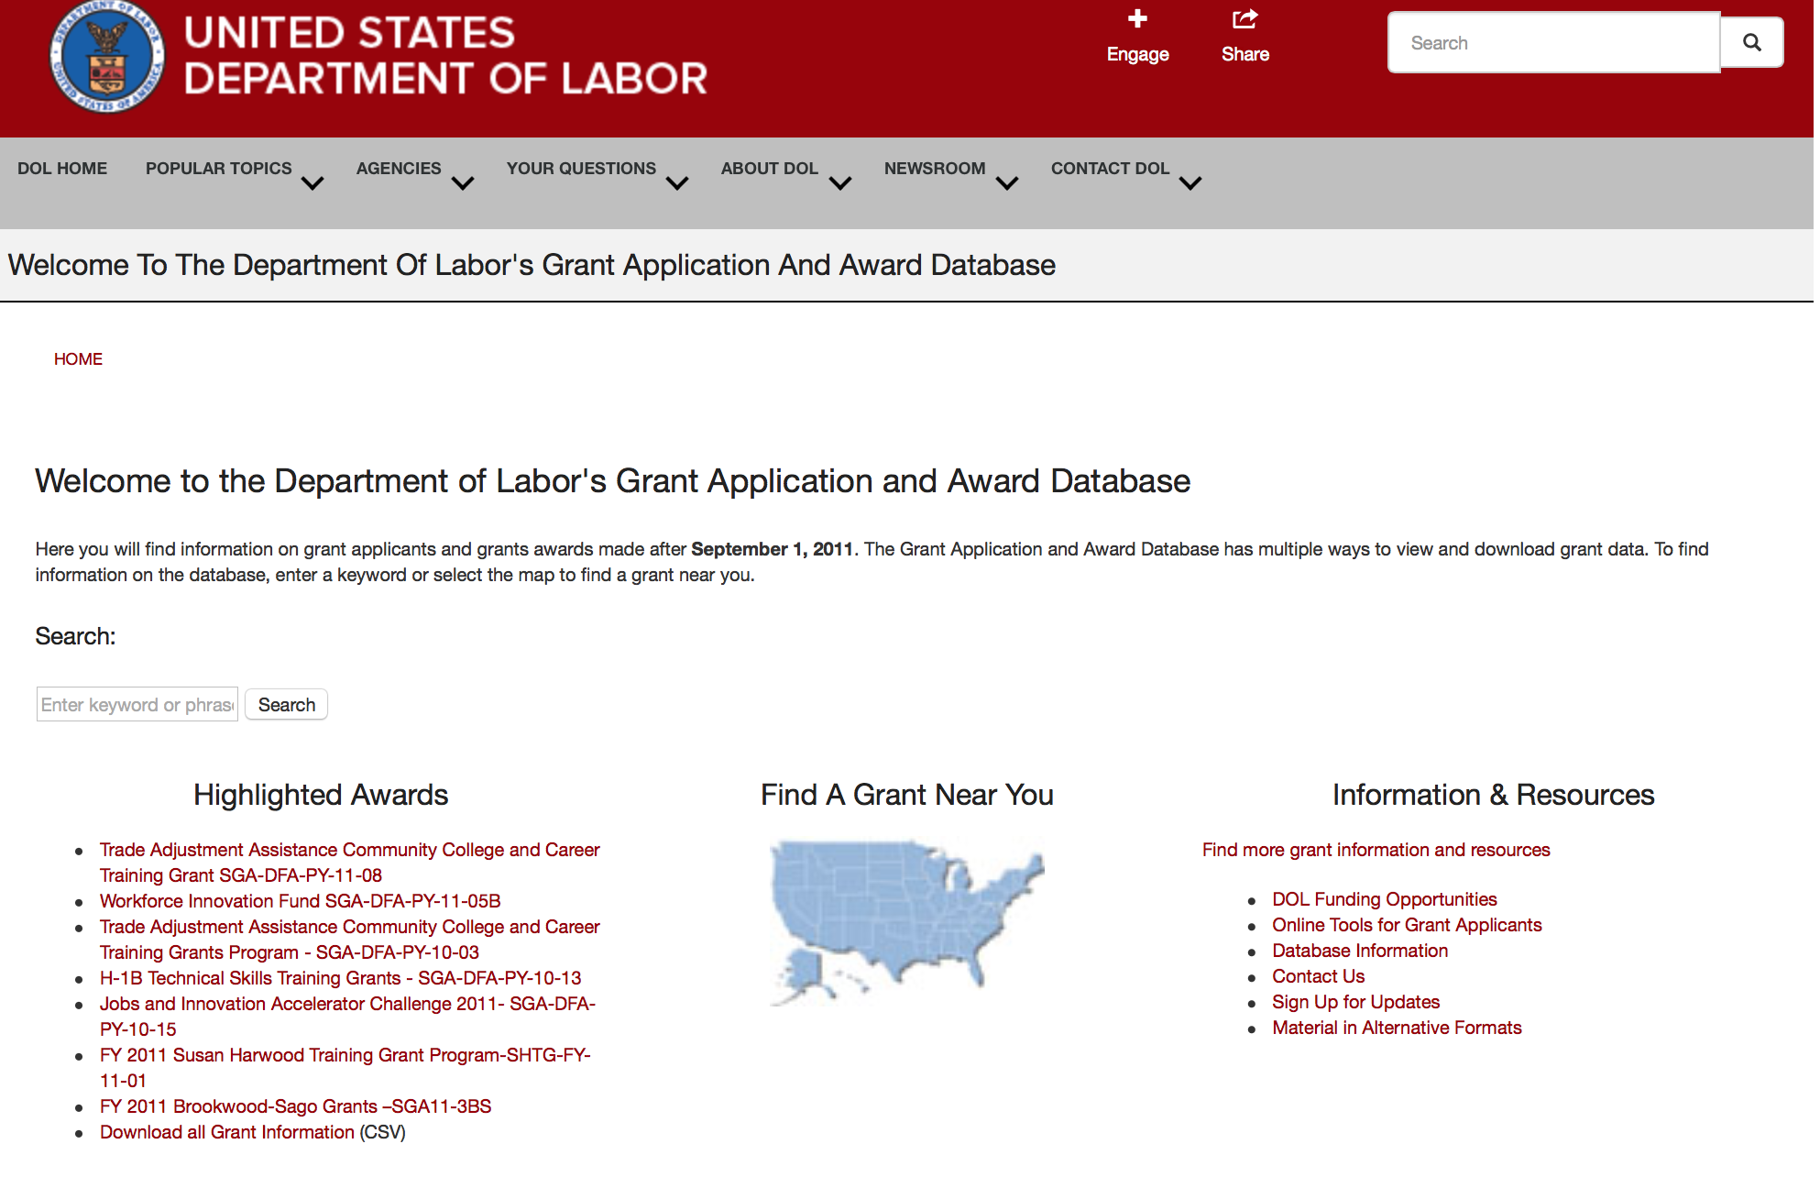

http://www.dol.gov/dol/grants/

Programs

Modifications

Reminders



National Aeronautics and Space Administration

Research and Contracting Opportunities

NASA Research Opportunities Online

- Various NASA offices publish their research announcements over the Internet, broadening the opportunity for researchers to apply for funding. This site provides access to current research announcements along with their specific due dates.

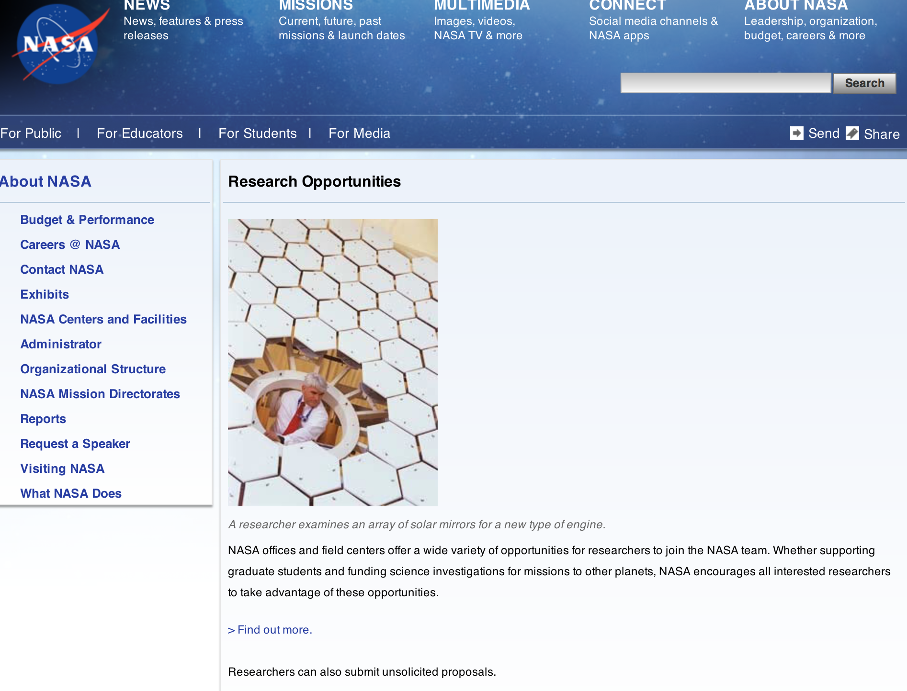

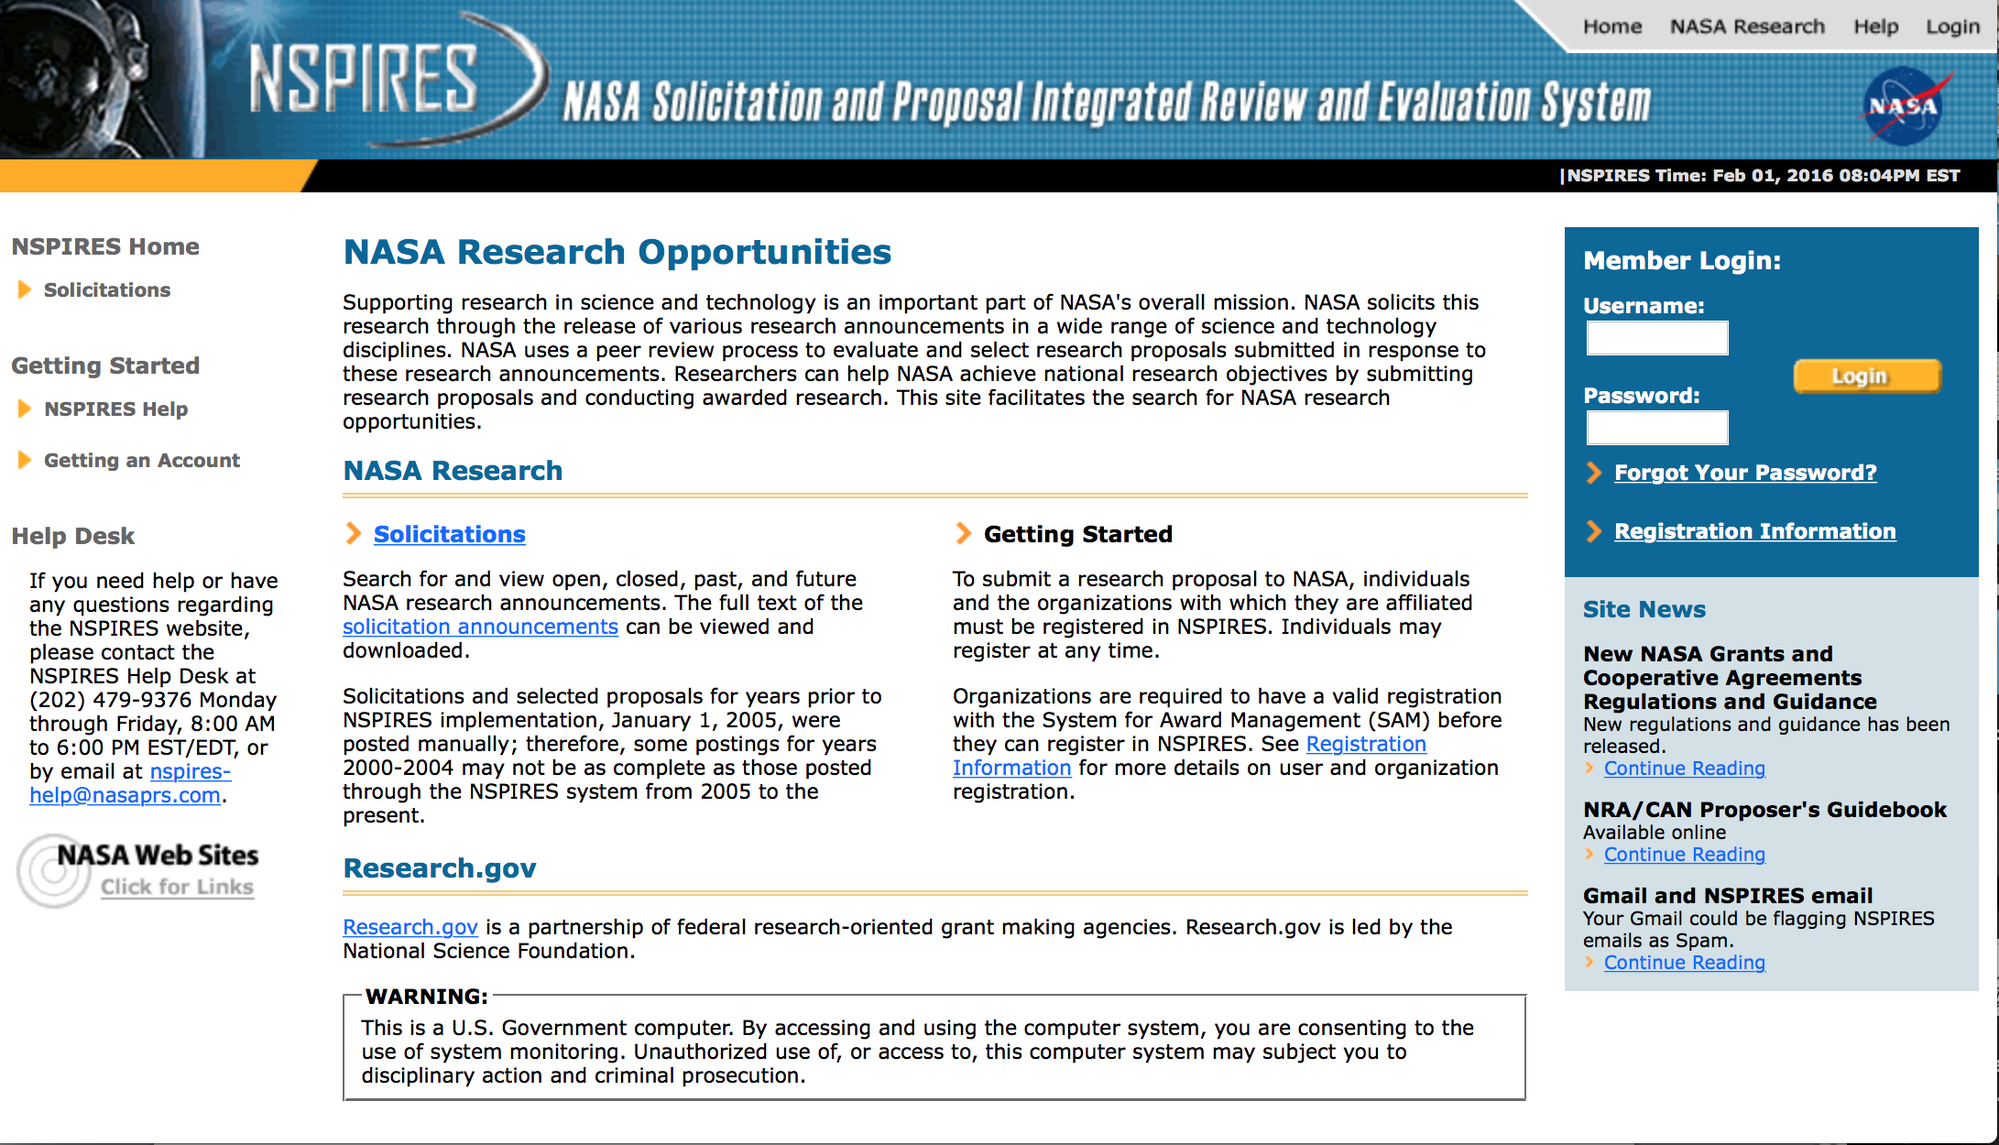
http://nspires.nasaprs.com/external/

Research Programs:

NASA Headquarters
ROSES 2017: Planetary Science and Technology Through Analog Research
Synopsis 1
http://www.grants.gov/web/grants/view-opportunity.html?oppId=294955

NASA Headquarters
ROSES 2017: The Science of Terra, Aqua, and Suomi NPP
Synopsis 1
http://www.grants.gov/web/grants/view-opportunity.html?oppId=294406

NASA Headquarters
ROSES 2017: Heliophysics Data Environment Enhancements
Synopsis 2
http://www.grants.gov/web/grants/view-opportunity.html?oppId=292688

Modifications:

NASA Headquarters
ROSES 2017: Heliophysics Technology and Instrument Development for Science
Synopsis 2
http://www.grants.gov/web/grants/view-opportunity.html?oppId=293148

National Archives and Records Administration

Grant Opportunities General Overview

To access the information below: click here

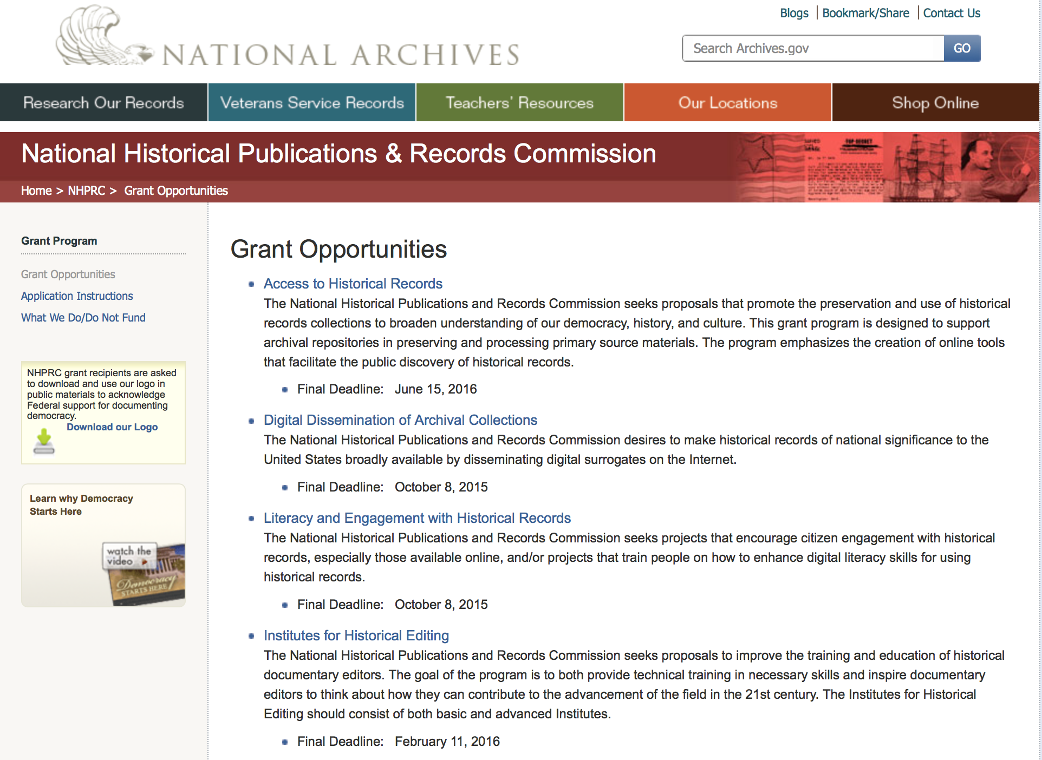

https://www.archives.gov/nhprc/announcement

Programs:

Access to Historical Records: Archival Projects
Synopsis 1
Document Type: | Grants Notice
Funding Opportunity Number: | ARCHIVAL-201710
Funding Opportunity Title: | Access to Historical Records: Archival Projects
Opportunity Category: | Discretionary
Opportunity Category Explanation:
Funding Instrument Type: | Grant
Category of Funding Activity: | Humanities (see "Cultural Affairs" in CFDA)
Category Explanation:
Expected Number of Awards: | 10
CFDA Number(s): | 89.003 -- National Historical Publications and Records Grants
Cost Sharing or Matching Requirement: | Yes
Version: | Synopsis 1
Posted Date: | Jun 09, 2017
Last Updated Date: | Jun 09, 2017
Original Closing Date for Applications: | Oct 05, 2017
Current Closing Date for Applications: | Oct 05, 2017
Archive Date:
Estimated Total Program Funding: | $700,000
Award Ceiling: | $100,000
Award Floor: | $1
Eligible Applicants: | Private institutions of higher education  Public and State controlled institutions of higher education  City or township governments  County governments  Nonprofits having a 501(c)(3) status with the IRS, other than institutions of higher education  Native American tribal governments (Federally recognized)  State governments
Agency Name: | National Archives and Records Administration
Description: | The National Historical Publications and Records Commission seeks projects that ensure online public discovery and use of historical records collections. All types of historical records are eligible, including documents, photographs, born-digital records, and analog audio and moving images. Projects may preserve and process historical records to: • Create new online Finding Aids to collections • Digitize historical records collections and make them freely available online The NHPRC encourages organizations to actively engage the public in the work of the project. For a comprehensive list of Commission limitations on funding, please see: "What we do and do not fund" (http://www.archives.gov/nhprc/apply/eligibility.html). Applications that consist entirely of ineligible activities will not be considered. Award Information A grant is for one or two years and for up to $100,000. The Commission expects to make up to 10 grants in this category for a total of up to $700,000. Grants begin no earlier than July 1, 2018. The Commission requires that grant recipients acknowledge NHPRC grant assistance in all publicity, publications, and other products that result from its support. Eligibility Eligible applicants: • Nonprofit organizations or institutions • Colleges, universities, and other academic institutions • State or local government agencies • Federally-acknowledged or state-recognized Native American tribes or groups Cost Sharing The total costs of a project are shared between the NHPRC and the applicant organization. The Commission provides no more than 75 per cent of total project costs in the Access to Historical Records: Archival Projects category. NHPRC grant recipients are not permitted to use grant funds for indirect costs (as indicated in 2 CFR 2600.101). Cost sharing is required. The applicant's financial contribution may include both direct and indirect expenses, in-kind contributions, non-Federal third-party contributions, and any income earned directly by the project. Indirect costs must be listed under the applicant's cost sharing contribution. Other Requirements Applicant organizations must be registered in the System for Award Management (SAM) prior to submitting an application, maintain SAM registration throughout the application and award process, and include a valid DUNS number in their application. Details on SAM registration and requesting a DUNS number can be found at the System for Award Management website at https://sam.gov. Please refer to the User Guides section and the Grants Registrations PDF. Ineligible applications will not be reviewed.
Link to Additional Information: | Link to full grant announcement, including additional requirements
Grantor Contact Information: | If you have difficulty accessing the full announcement electronically, please contact:  Jeff de la Concepcion Jeff.delaconcepcion@nara.gov  Grant Information Specialist

http://www.grants.gov/web/grants/view-opportunity.html?oppId=294522

Reminders:

EDITIONS-201710 for Publishing Historical Records in Documentary Editions
Synopsis 1

Document Type: | Grants Notice
Funding Opportunity Number: | EDITIONS-201710
Funding Opportunity Title: | For Publishing Historical Records in Documentary Editions
Opportunity Category: | Discretionary
Opportunity Category Explanation:
Funding Instrument Type: | Grant
Category of Funding Activity: | Humanities (see "Cultural Affairs" in CFDA)
Category Explanation:
Expected Number of Awards: | 25
CFDA Number(s): | 89.003 -- National Historical Publications and Records Grants
Cost Sharing or Matching Requirement: | Yes
Version: | Synopsis 1
Posted Date: | Dec 09, 2016
Last Updated Date: | Dec 09, 2016
Original Closing Date for Applications: | Oct 05, 2017
Current Closing Date for Applications: | Oct 05, 2017
Archive Date:
Estimated Total Program Funding: | $2,500,000
Award Ceiling: | $200,000
Award Floor: | $1
Eligible Applicants: | County governments  Nonprofits having a 501(c)(3) status with the IRS, other than institutions of higher education  Native American tribal governments (Federally recognized)  City or township governments  Public and State controlled institutions of higher education  State governments  Private institutions of higher education
Agency Name: | National Archives and Records Administration
Description: | The National Historical Publications and Records Commission seeks proposals to publish documentary editions of historical records. Projects may focus on the papers of major figures from American history or cover broad historical movements in politics, military, business, social reform, the arts, and other aspects of the national experience. The historical value of the records and their expected usefulness to broad audiences must justify the costs of the project. The goal of this program is to provide access to, and editorial context for, the historical documents and records that tell the American story. The NHPRC encourages projects, whenever possible and appropriate, to provide free access to these materials in an open online environment, without precluding other forms of publication. Applicants should demonstrate familiarity with the best practices recommended by the Association for Documentary Editing or the Modern Language Association Committee on Scholarly Editions. Projects may also prepare print editions as part of their overall publishing plan. However, projects that do not have definitive plans for digital dissemination and preservation in place at the time of application will not be considered. It is also expected that the contents of any print volumes produced will be made available online within a reasonable period of time following print publication. Grants are awarded for collecting, describing, preserving, compiling, transcribing, annotating, editing, encoding, and publishing documentary source materials online and in print. Because of the focus on documentary sources, grants do not support preparation of critical editions of published works unless such works are just a small portion of the larger project. All applicants should be aware that the application process is highly competitive. For a comprehensive list of Commission's limitations on funding, please see What We Do and Do Not Fund. Applications that consist entirely of ineligible activities will not be considered. Ongoing projects: Applicants from ongoing projects must demonstrate that they have successfully achieved the performance objectives associated with previous NHPRC awards; provide updated, current information, including a description of the new activities; describe the content and historical significance of the specific materials to be edited during the proposed grant period; show progress towards completing the edition; and justify costs in a new budget. Award Information A grant is for one year and for up to $200,000. The Commission expects to make up to 25 grants in this category for a total of up to $2,500,000. Grants begin no earlier than January 1, 2018. The Commission requires that grant recipients acknowledge NHPRC grant assistance in all publications, publicity, and other products that result from its support. Eligibility • U.S. nonprofit organizations or institutions • U.S. colleges, universities, and other academic institutions • State or local government agencies • Federally-acknowledged or state-recognized Native American tribes or groups Cost Sharing The total costs of a project are shared between the NHPRC and the applicant organization. The Commission provides no more than 50 per cent of total direct project costs in the Publishing Historical Records in Documentary Editions category. NHPRC grant recipients are not permitted to use grant funds for indirect costs (as indicated in 2 CFR 2600.101). Cost sharing is required. The applicant’s financial contribution may include both direct and indirect expenses, in-kind contributions, non-Federal third-party contributions, and any income earned directly by the project. Indirect costs must be listed under the applicant’s cost sharing contribution. Other Requirements Applicant organizations must be registered in the System for Award Management (SAM) prior to submitting an application, maintain SAM registration throughout the application and award process, and include a valid DUNS number in their application. Details on SAM registration and requesting a DUNS number can be found at the System for Award Management website at https://sam.gov. Please refer to the User Guides section and the Grants Registrations PDF. A complete application includes the Application for Federal Assistance (Standard Form 424), Assurances -- Non-Construction Programs (Standard Form 424B), a Project Narrative, Summary, Supplementary Materials, and Budget. Applications lacking these items will not be considered. Ineligible applications will not be reviewed.
Link to Additional Information: | Link to full grant announcement, including additional requirements
Grantor Contact Information: | If you have difficulty accessing the full announcement electronically, please contact:  Jeff de la Concepcion Jeff.delaConcepcion@nara.gov  Grant Information Specialist

http://www.grants.gov/web/grants/view-opportunity.html?oppId=290564

Access to Historical Records - Major Initiatives

Document Type: | Grants Notice
Funding Opportunity Number: | MAJOR-201707
Funding Opportunity Title: | Access to Historical Records - Major Initiatives
Opportunity Category: | Discretionary
Opportunity Category Explanation:
Funding Instrument Type: | Grant
Category of Funding Activity: | Humanities (see "Cultural Affairs" in CFDA)
Category Explanation:
Expected Number of Awards: | 5
CFDA Number(s): | 89.003 -- National Historical Publications and Records Grants
Cost Sharing or Matching Requirement: | Yes
Posted Date: | Jul 25, 2016
Last Updated Date: | Jul 25, 2016
Current Closing Date for Applications: | Jul 12, 2017
Archive Date: | Aug 11, 2017
Estimated Total Program Funding: | $1,000,000
Award Ceiling: | $350,000
Award Floor: | $1
Eligible Applicants: | Private institutions of higher education  County governments  Native American tribal governments (Federally recognized)  Public and State controlled institutions of higher education  City or township governments  Nonprofits having a 501(c)(3) status with the IRS, other than institutions of higher education  State governments
Agency Name: | National Archives and Records Administration
Description: | The National Historical Publications and Records Commission seeks projects that will significantly improve public discovery and use of major historical records collections. All types of historical records are eligible, including documents, photographs, born-digital records, and analog audio and moving images. Projects may: • Digitize historical records collections, or related collections, held by a single institution and make them freely available online • Provide access to born-digital records • Create new freely-available virtual collections drawn from historical records held by multiple institutions • Create new tools and methods for users to access records The NHPRC welcomes collaborative projects, particularly for bringing together related records from multiple institutions. Projects that address significant needs in the field and result in replicable and scalable approaches will be more competitive. We also encourage organizations to actively engage the public in the work of the project. For a comprehensive list of Commission limitations on funding, please see “What we do and do not fund” (http://www.archives.gov/nhprc/apply/eligibility.html). Applications that consist entirely of ineligible activities will not be considered. Award Information A grant is for one to three years and for up to $350,000. We expect to make up to five grants in this category for a total of up to $1,000,000. Grants begin no earlier than January 1, 2018. Eligible applicants: • Nonprofit organizations or institutions • Colleges, universities, and other academic institutions • State or local government agencies • Federally-acknowledged or state-recognized Native American tribes or groups Cost Sharing The total costs of a project are shared between the NHPRC and the applicant organization. The Commission provides no more than 50 per cent of total project costs in the Access to Historical Records: Major Initiatives category. NHPRC grant recipients are not permitted to use grant funds for indirect costs (as indicated in 2 CFR 2600.101). Cost sharing is required. The applicant’s financial contribution may include both direct and indirect expenses, in-kind contributions, non-Federal third-party contributions, and any income earned directly by the project. Indirect costs must be listed under the applicant’s cost sharing contribution. Other Requirements Applicant organizations must be registered in the System for Award Management (SAM) prior to submitting an application, maintain SAM registration throughout the application and award process, and include a valid DUNS number in their application. Details on SAM registration and requesting a DUNS number can be found at the System for Award Management website at http://sam.gov. Please refer to the User Guides section and the Grants Registrations PDF. APPLICATION AND SUBMISSION INFORMATION You must use Grants.gov to submit a Full Proposal. All information necessary to apply is included in this announcement, the Application Instructions, and the forms on Grants.gov. If you need the information supplied in an alternative format, please call the NHPRC at 202-357-5010. Applying for the Access to Historical Records: Major Initiatives program is a two-phase process. Phase One All applicants must have submitted a five-page preliminary proposal and Application for Federal Domestic Assistance – Short Organizational form SF424 and the Budget Information for Non-Construction Projects form SF424A by January 19, 2017 using the preliminary proposal Major Initiatives grant announcement (insert link). Only those applicants who have successfully completed Phase One and who have been invited by the Commission to submit a full proposal to the Access to Historical Records: Major Initiatives program are eligible to participate in the second phase of the process. Phase Two Using this announcement, invited applicants will prepare and submit a complete application via Grants.gov by July 12, 2017. A complete application includes the Application for Federal Assistance (Standard Form 424), Assurances -- Non-Construction Programs (Standard Form 424B), a Project Narrative, Supplementary Materials, and Budget. Applications lacking any of these items will not be considered. Applicants may consult with the Director of the Access Program, Alex Lorch (alexander.lorch@nara.gov) during both the preliminary and full proposal project phases. In order to ensure eligibility, applicants should first review the rules and regulations governing NHPRC grants under the Administering an NHPRC Grant section.
Link to Additional Information: | Link to full grant announcement, including additional requirements
Grantor Contact Information: | If you have difficulty accessing the full announcement electronically, please contact:  Jeff de la Concepcion Grant Program Specialist Phone 202-357-5022  Grant Information Specialist

http://www.grants.gov/web/grants/view-opportunity.html?oppId=286436

National Endowment for the Arts

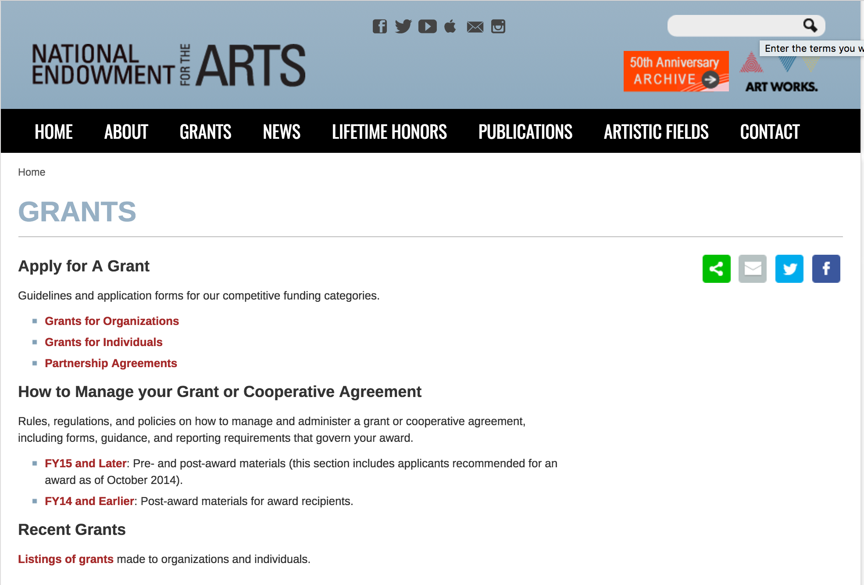

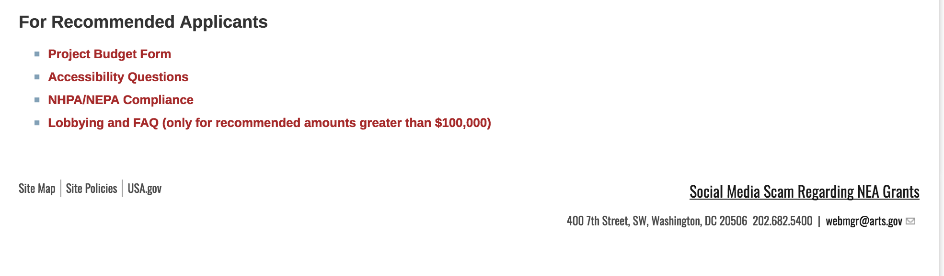
See more at: https://www.arts.gov/grants

Programs:

NEA Art Works II Application, FY2018
Synopsis 1
Document Type: | Grants Notice
Funding Opportunity Number: | 2017NEA01AW2
Funding Opportunity Title: | NEA Art Works II Application, FY2018
Opportunity Category: | Discretionary
Opportunity Category Explanation:
Funding Instrument Type: | Grant
Category of Funding Activity: | Arts (see "Cultural Affairs" in CFDA)
Category Explanation:
Expected Number of Awards:
CFDA Number(s): | 45.024 -- Promotion of the Arts Grants to Organizations and Individuals
Cost Sharing or Matching Requirement: | Yes
Version: | Synopsis 1
Posted Date: | Jun 20, 2017
Last Updated Date: | Jun 20, 2017
Original Closing Date for Applications: | Jul 13, 2017
Current Closing Date for Applications: | Jul 13, 2017
Archive Date:
Estimated Total Program Funding:
Award Ceiling: | $100,000
Award Floor: | $10,000
Eligible Applicants: | Independent school districts  Native American tribal governments (Federally recognized)  City or township governments  Private institutions of higher education  Nonprofits having a 501(c)(3) status with the IRS, other than institutions of higher education  State governments  Public and State controlled institutions of higher education  Special district governments  County governments
Agency Name: | National Endowment for the Arts
Description: | The Arts Endowment's support of a project may start on or after June 1, 2018. Generally, a period of performance of up to two years is allowed. Program Description The guiding principle of "Art Works" is at the center of everything we do at the NEA. "Art Works" refers to three things: the works of art themselves, the ways art works on audiences, and the fact that art is work for the artists and arts professionals who make up the field. Art works by enhancing the value of individuals and communities, by connecting us to each other and to something greater than ourselves, and by empowering creativity and innovation in our society and economy. The arts exist for beauty itself, but they also are an inexhaustible source of meaning and inspiration. The NEA recognizes these catalytic effects of excellent art, and the key role that arts and design organizations play in revitalizing them. To deepen and extend the arts' value, including their ability to foster new connections and to exemplify creativity and innovation, we welcome projects that: • Are likely to prove transformative with the potential for meaningful change, whether in the development or enhancement of new or existing art forms, new approaches to the creation or presentation of art, or new ways of engaging the public with art; • Are distinctive, offering fresh insights and new value for their fields and/or the public through unconventional solutions; and • Have the potential to be shared and/or emulated, or are likely to lead to other advances in the field. Beyond encouraging projects that demonstrate these characteristics, we want to achieve the following four objectives through the Art Works category: • Creation: The creation of art that meets the highest standards of excellence, • Engagement: Public engagement with diverse and excellent art, • Learning: Lifelong learning in the arts, and • Livability: The strengthening of communities through the arts.
Link to Additional Information: | NEA Website Announcement
Grantor Contact Information: | If you have difficulty accessing the full announcement electronically, please contact:  NEA Web Manager webmgr@arts.gov  NEA Web Manager

http://www.grants.gov/web/grants/view-opportunity.html?oppId=294790

Modifications:

Reminders:

NEA Our Town Application, FY2018
Synopsis 1
Document Type: | Grants Notice
Funding Opportunity Number: | 2017NEA01OT
Funding Opportunity Title: | NEA Our Town Application, FY2018
Opportunity Category: | Discretionary
Opportunity Category Explanation:
Funding Instrument Type: | Grant
Category of Funding Activity: | Arts (see "Cultural Affairs" in CFDA)
Category Explanation:
Expected Number of Awards: | 500
CFDA Number(s): | 45.024 -- Promotion of the Arts Grants to Organizations and Individuals
Cost Sharing or Matching Requirement: | Yes
Version: | Synopsis 1
Posted Date: | May 18, 2017
Last Updated Date: | May 18, 2017
Original Closing Date for Applications: | Sep 11, 2017
Current Closing Date for Applications: | Sep 11, 2017
Archive Date:
Estimated Total Program Funding:
Award Ceiling: | $200,000
Award Floor: | $25,000
Eligible Applicants: | State governments  County governments  Private institutions of higher education  Independent school districts  Public and State controlled institutions of higher education  City or township governments  Special district governments  Nonprofits having a 501(c)(3) status with the IRS, other than institutions of higher education  Native American tribal governments (Federally recognized)
Agency Name: | National Endowment for the Arts
Description: | The Our Town grant program supports creative placemaking projects that help to transform communities into lively, beautiful, and resilient places – achieving these community goals through strategies that incorporate arts, culture, and/or design. Creative placemaking is when artists, arts organizations, and community development practitioners deliberately integrate arts and culture into community revitalization work - placing arts at the table with land-use, transportation, economic development, education, housing, infrastructure, and public safety strategies. This funding supports local efforts to enhance quality of life and opportunity for existing residents, increase creative activity, and create or preserve a distinct sense of place. Through Our Town, subject to the availability of funding, the National Endowment for the Arts will provide a limited number of grants for creative placemaking. Our Town requires partnerships between arts organizations and government, other nonprofit organizations, and private entities to achieve livability goals for communities. Our Town offers support for projects in two areas: • Arts Engagement, Cultural Planning, and Design Projects. These projects represent the distinct character and quality of their communities. These projects require a partnership between a nonprofit organization and a local government entity, with one of the partners being a cultural organization. Matching grants range from $25,000 to $200,000. • Projects that Build Knowledge About Creative Placemaking. These projects are available to arts and design service organizations, and industry, policy, or university organizations that provide technical assistance to those doing place-based work. Matching grants range from $25,000 to $100,000. • Through Our Town projects, the National Endowment for the Arts intends to achieve the following objective: Livability: American communities are strengthened through the arts.
Link to Additional Information: | NEA Website Announcement
Grantor Contact Information: | If you have difficulty accessing the full announcement electronically, please contact:  NEA Web Manager webmgr@arts.gov  NEA Web Manager

http://www.grants.gov/web/grants/view-opportunity.html?oppId=293915

NEA Arts Research Labs PS Application, FY2018
Synopsis 1

Document Type: | Grants Notice
Funding Opportunity Number: | NEAPS1704
Funding Opportunity Title: | NEA Arts Research Labs PS Application, FY2018
Opportunity Category: | Discretionary
Opportunity Category Explanation:
Funding Instrument Type: | Cooperative Agreement
Category of Funding Activity: | Arts (see "Cultural Affairs" in CFDA)
Category Explanation:
Expected Number of Awards:
CFDA Number(s): | 45.024 -- Promotion of the Arts Grants to Organizations and Individuals
Cost Sharing or Matching Requirement: | Yes
Version: | Synopsis 1
Posted Date: | May 23, 2017
Last Updated Date: | May 23, 2017
Original Closing Date for Applications: | Jul 18, 2017 The Grants.gov system must receive your validated and accepted application no later than 11:59 p.m., Eastern Time, on July 18, 2017. We strongly recommend that you submit your application by July 8, 2017 to give yourself ample time to resolve any problems that you might encounter.
Current Closing Date for Applications: | Jul 18, 2017 The Grants.gov system must receive your validated and accepted application no later than 11:59 p.m., Eastern Time, on July 18, 2017. We strongly recommend that you submit your application by July 8, 2017 to give yourself ample time to resolve any problems that you might encounter.
Archive Date: | Aug 17, 2017
Estimated Total Program Funding:
Award Ceiling: | $150,000
Award Floor: | $150,000
Eligible Applicants: | Native American tribal governments (Federally recognized)  Nonprofits having a 501(c)(3) status with the IRS, other than institutions of higher education  Independent school districts  Private institutions of higher education  State governments  Public and State controlled institutions of higher education  City or township governments  County governments  Special district governments
Agency Name: | National Endowment for the Arts
Description: | The National Endowment for the Arts’ support may begin no earlier than March 1, 2018 and extend for up to 24 months. An organization may submit only one proposal under this program solicitation. Program Description: In recent years, the National Endowment for the Arts’ research agenda has focused on yielding new knowledge about the value and impact of the arts. Through the National Endowment for the Arts Research Labs (NEA Research Labs), we seek to extend this agenda and its impact by cultivating a series of transdisciplinary research partnerships, grounded in the social and behavioral sciences, to produce and report empirical insights about the arts for the benefit of arts and non-arts sectors alike. Each NEA Research Lab will define its own research agenda, conduct a research program to implement that agenda, and prepare reports that will contribute substantively to a wider understanding of one of three areas of special interest to the National Endowment for the Arts: 1. The Arts, Health, and Social/Emotional Well-Being a. Therapeutic Approaches and Benefits b. Non-Therapeutic Approaches and Benefits 2. The Arts, Creativity, Cognition, and Learning 3. The Arts, Entrepreneurship, and Innovation We anticipate that a sustained engagement with these topic areas, and with the corresponding research questions we frame below, will have distinctive benefits not only for the arts community, but also for sectors such as healthcare, education, and business or management. We intend for the NEA Research Labs to serve as “hubs” or centers of excellence in the domain of interest. Each NEA Research Lab will develop a pipeline of projects or products, even while conducting at least one major study. In addition, NEA Research Labs will be positioned to fulfill ad hoc analyses or information requests concerning the research agenda being pursued, as may be required by the National Endowment for the Arts during the project period of performance. Such requests will not involve new data collection.
Link to Additional Information: | NEA Website Announcement
Grantor Contact Information: | If you have difficulty accessing the full announcement electronically, please contact:  NEA Web Manager  NEA Web Manager

http://www.grants.gov/web/grants/view-opportunity.html?oppId=294024

National Endowment for the Humanities

Grant Overview -

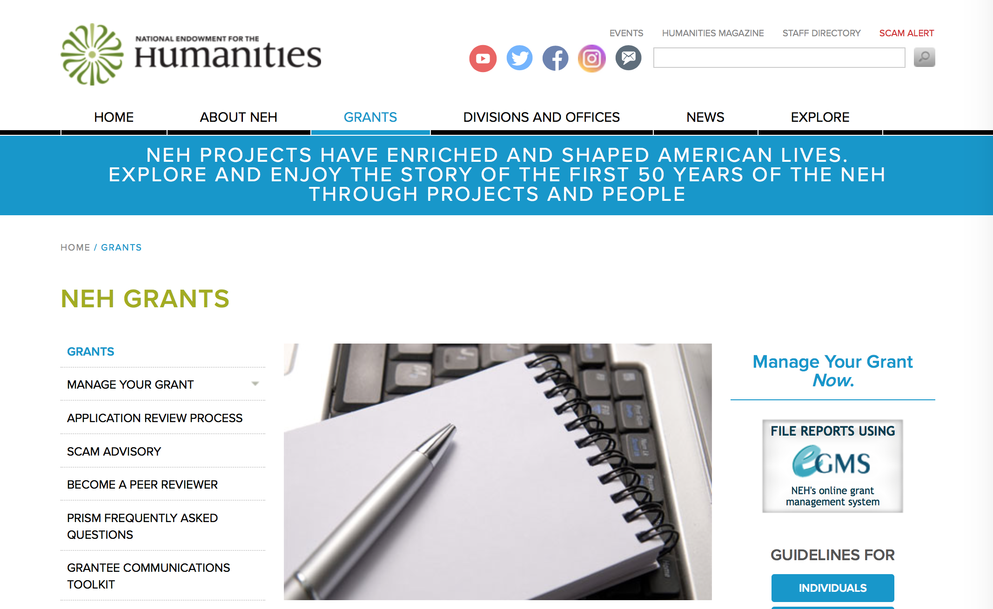

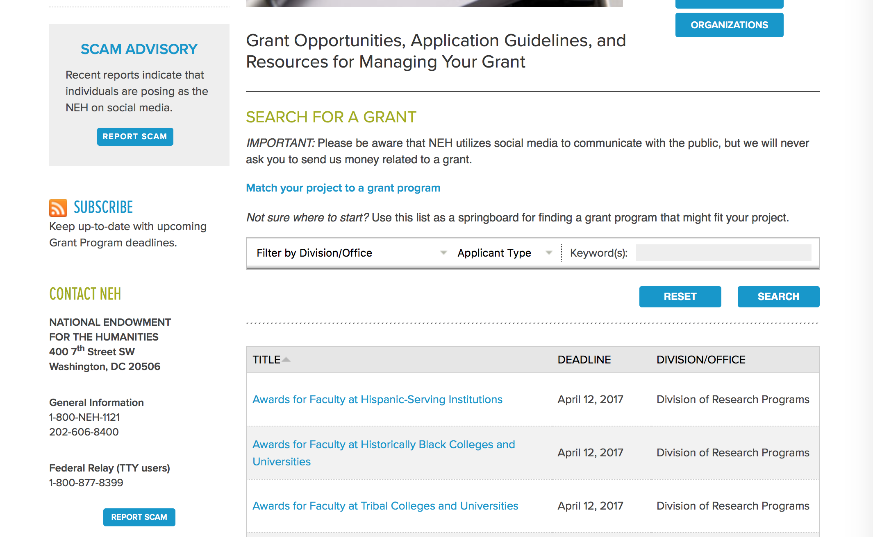

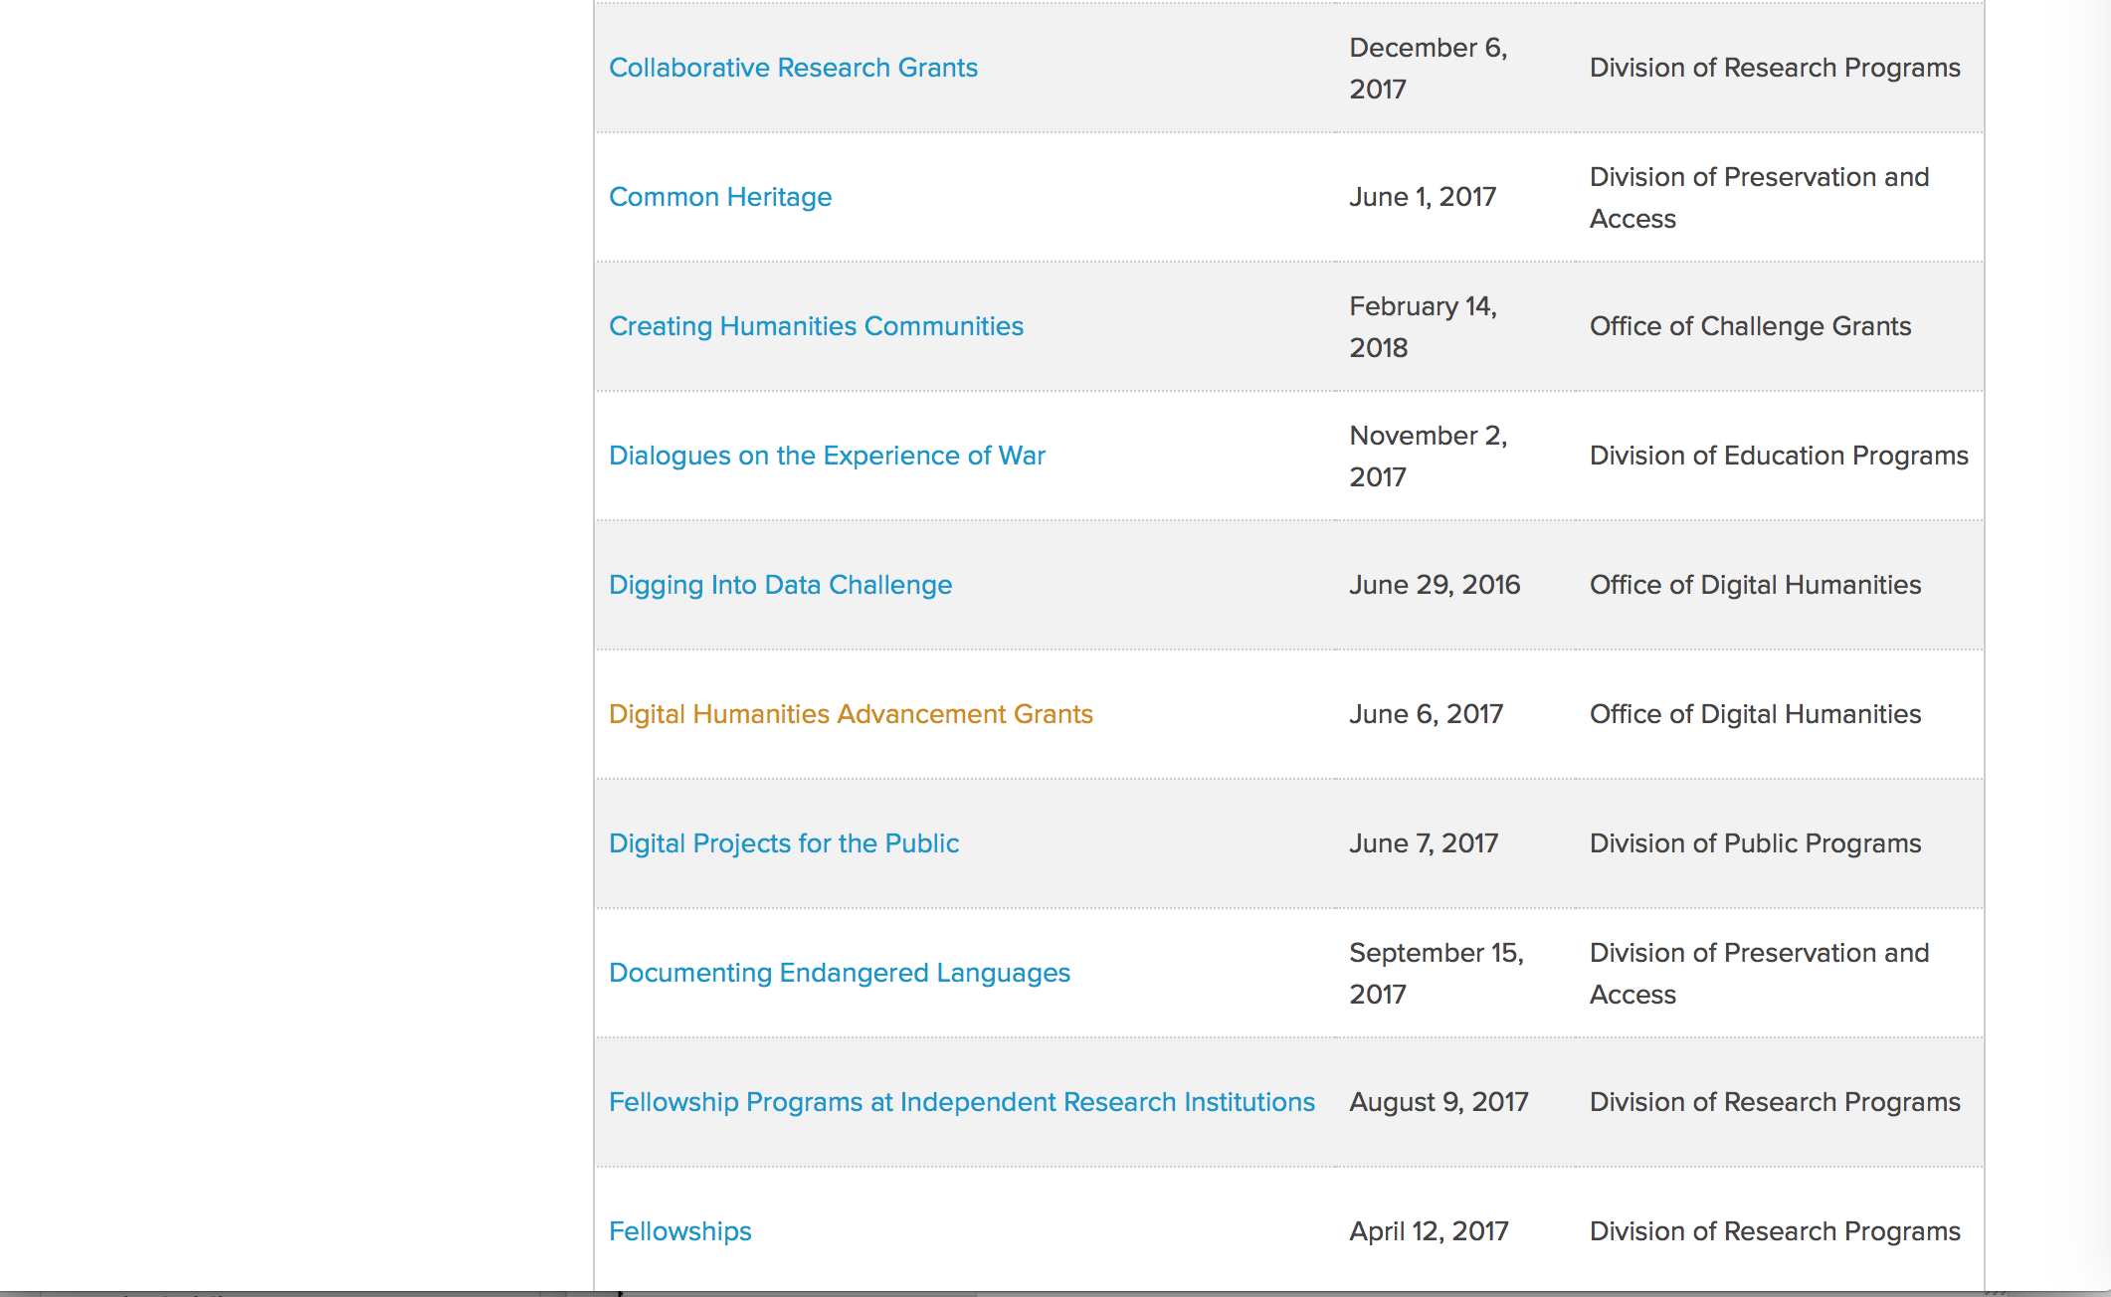

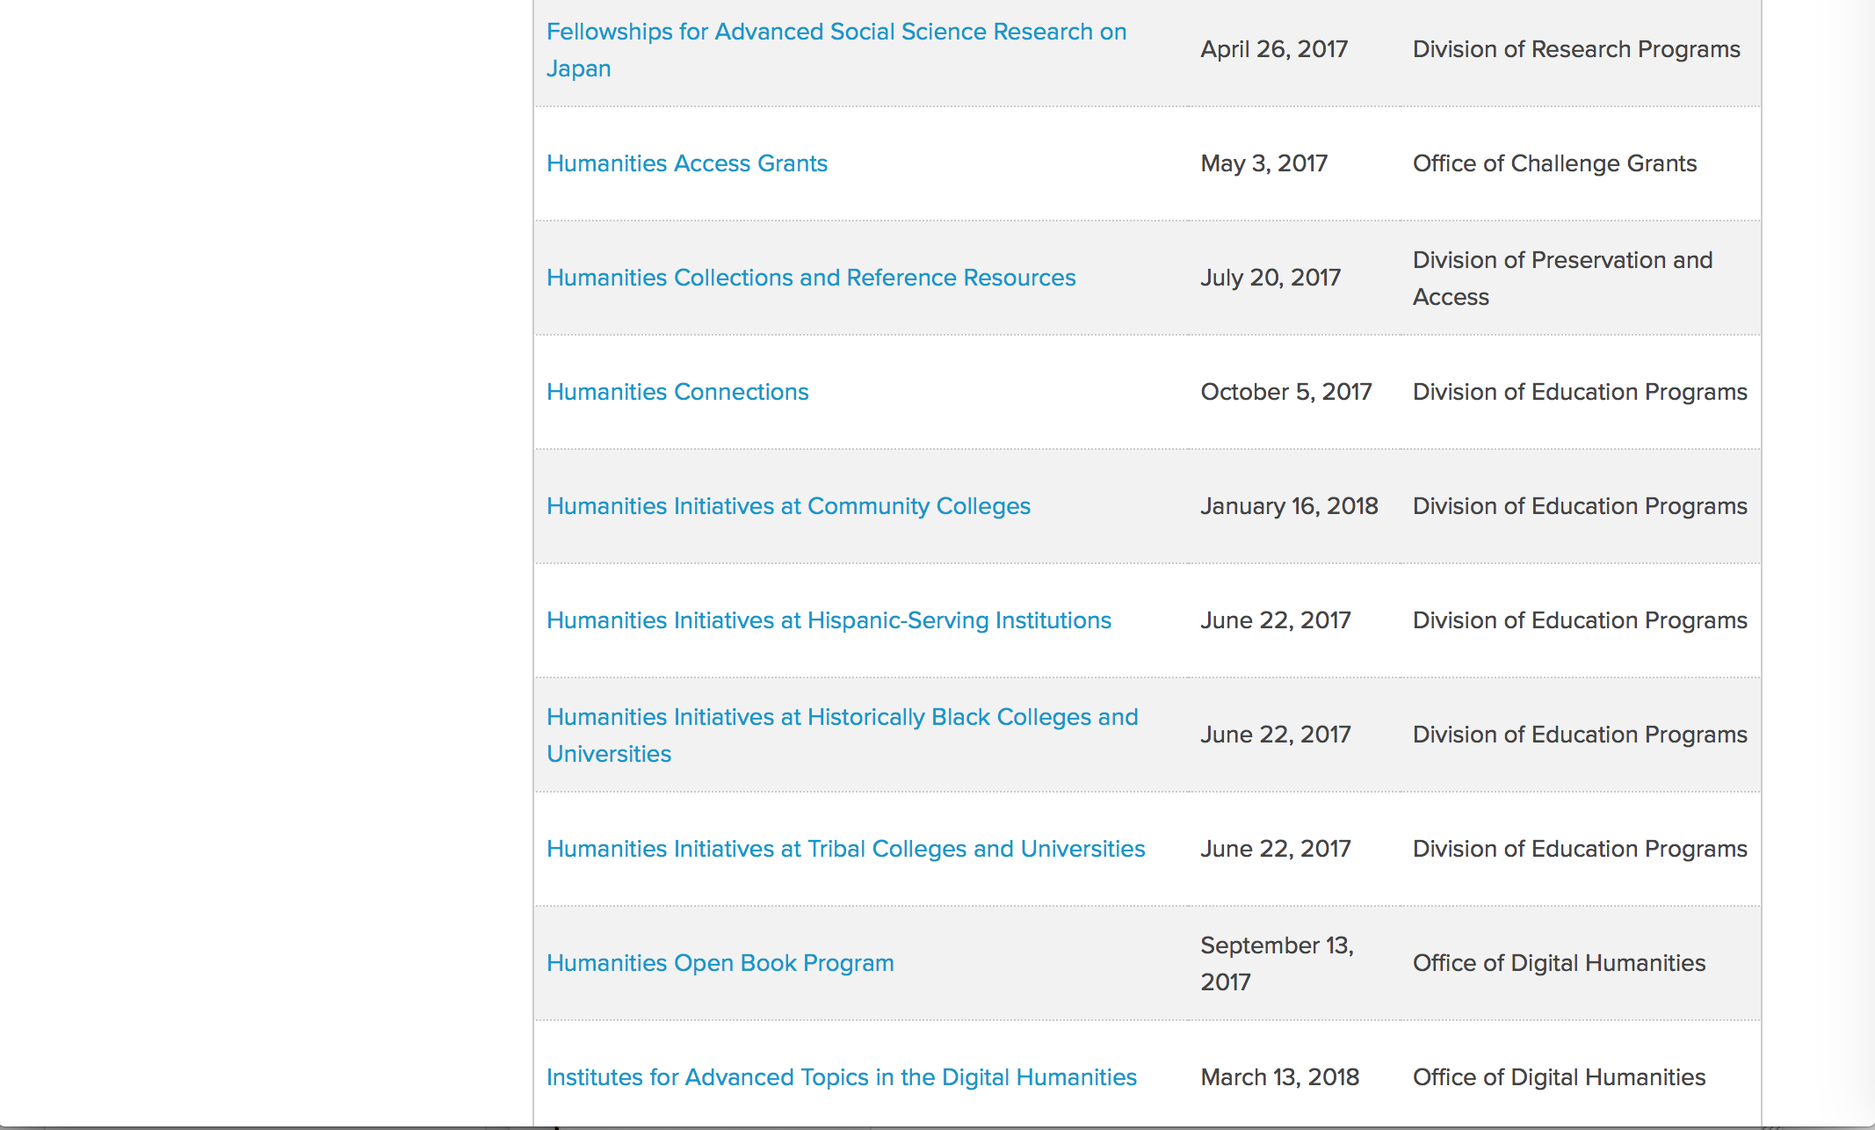

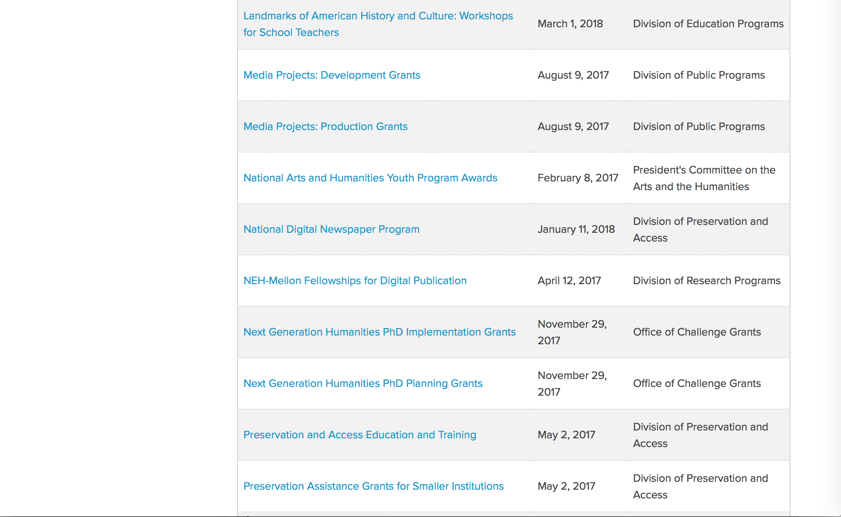
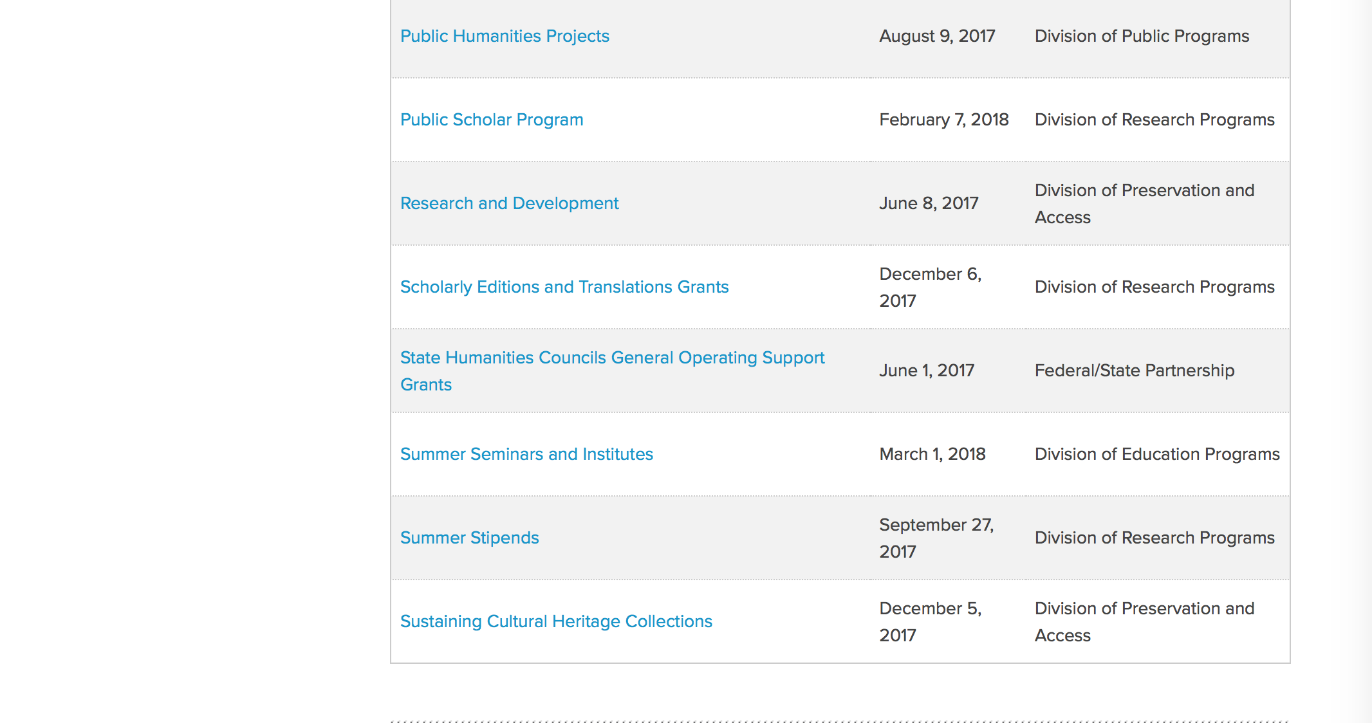
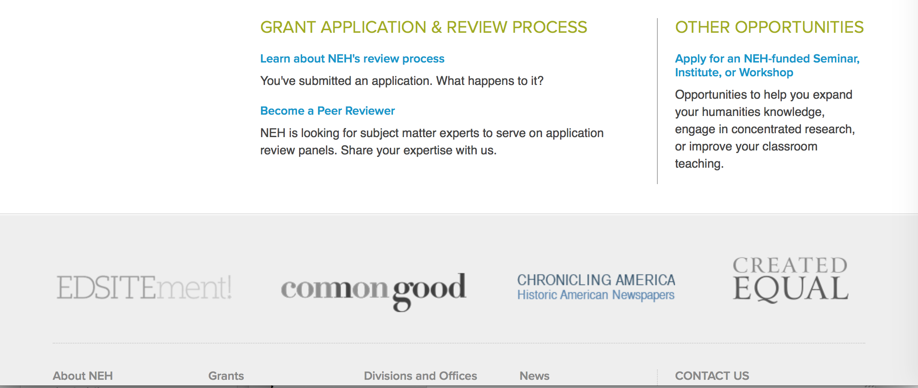

https://www.neh.gov/grants

Programs:

Fellowship Programs at Independent Research Institutions
Synopsis 1
Document Type: | Grants Notice
Funding Opportunity Number: | 20170809-RA
Funding Opportunity Title: | Fellowship Programs at Independent Research Institutions
Opportunity Category: | Discretionary
Opportunity Category Explanation:
Funding Instrument Type: | Grant
Category of Funding Activity: | Humanities (see "Cultural Affairs" in CFDA)
Category Explanation:
Expected Number of Awards:
CFDA Number(s): | 45.161 -- Promotion of the Humanities_Research
Cost Sharing or Matching Requirement: | No
Version: | Synopsis 1
Posted Date: | Jun 05, 2017
Last Updated Date: | Jun 05, 2017
Original Closing Date for Applications: | Aug 09, 2017
Current Closing Date for Applications: | Aug 09, 2017
Archive Date:
Estimated Total Program Funding:
Award Ceiling: | $400,000
Award Floor: | $100,000
Eligible Applicants: | Nonprofits having a 501(c)(3) status with the IRS, other than institutions of higher education  City or township governments  Native American tribal governments (Federally recognized)  State governments  County governments  Special district governments
Agency Name: | National Endowment for the Humanities
Description: | Grants for Fellowship Programs at Independent Research Institutions (FPIRI) support fellowships at institutions devoted to advanced study and research in the humanities. Recognizing that at times scholars need to work away from their homes and institutions, the FPIRI program sponsors fellowships that provide scholars with research time, a stimulating intellectual environment, and access to resources that might otherwise not be available to them. Fellowship programs may be administered by independent centers for advanced study, libraries, and museums in the United States; American overseas research centers; and American organizations that have expertise in promoting research in foreign countries. Individual scholars apply directly to the institutions for fellowships. In evaluating applications consideration is given to the library holdings, archives, special collections, and other resources—either on site or nearby—that institutions make available to fellows. FPIRI grants provide funding for humanities fellowships of four to twelve months. The fellowships are held at the U.S. grantee institutions or—in the case of overseas research centers and organizations—abroad. FPIRI grants support fellowship stipends at a rate of $4,200 per month and a portion of the costs of selecting the fellows, up to $5,000 per year.
Link to Additional Information: | https://www.neh.gov/grants/research/fellowship-programs-independent-research-institutions
Grantor Contact Information: | If you have difficulty accessing the full announcement electronically, please contact:  Division of Research Programs National Endowment for the Humanities 400 Seventh Street, SW Washington, DC 20506 202-606-8200 fpiri@neh.gov fpiri@neh.gov  fpiri@neh.gov

http://www.grants.gov/web/grants/view-opportunity.html?oppId=294391

Media Projects
Synopsis 1
Document Type: | Grants Notice
Funding Opportunity Number: | 20170809-TD
Funding Opportunity Title: | Media Projects
Opportunity Category: | Discretionary
Opportunity Category Explanation:
Funding Instrument Type: | Grant
Category of Funding Activity: | Humanities (see "Cultural Affairs" in CFDA)
Category Explanation:
Expected Number of Awards:
CFDA Number(s): | 45.164 -- Promotion of the Humanities Public Programs
Cost Sharing or Matching Requirement: | No
Version: | Synopsis 1
Posted Date: | Jun 02, 2017
Last Updated Date: | Jun 02, 2017
Original Closing Date for Applications: | Aug 09, 2017
Current Closing Date for Applications: | Aug 09, 2017
Archive Date:
Estimated Total Program Funding:
Award Ceiling: | $1,000,000
Award Floor: | $1
Eligible Applicants: | Private institutions of higher education  Nonprofits having a 501(c)(3) status with the IRS, other than institutions of higher education  Native American tribal governments (Federally recognized)  City or township governments  State governments  Special district governments  County governments  Public and State controlled institutions of higher education
Agency Name: | National Endowment for the Humanities
Description: | The Media Projects program supports film, television, and radio projects that engage general audiences with humanities ideas in creative and appealing ways. All projects must be grounded in humanities scholarship in disciplines such as history, art history, film studies, literature, drama, religious studies, philosophy, or anthropology. Projects must also demonstrate an approach that is thoughtful, balanced, and analytical (rather than celebratory). The approach to the subject matter must go beyond the mere presentation of factual information to explore its larger significance and stimulate critical thinking. NEH is a national funding agency, so the projects that we support must demonstrate the potential to attract a broad general audience. Film and television projects may be single programs or a series addressing significant figures, events, or ideas. Programs must be intended for national distribution, via traditional carriage or online distribution. The Division of Public Programs welcomes projects that range in length from short-form to broadcast-length video. The Division of Public Programs also encourages film and television projects that examine international themes and subjects in the humanities, in order to spark Americans’ engagement with the broader world beyond the United States. These projects should demonstrate international collaboration by enlisting scholars based both in the United States and abroad, and/or by working with an international media team. The collaborations should bring broad cross-cultural perspectives to the proposed topics and should be intended primarily for U.S. public audiences. Radio projects, including podcasts, may involve single programs, limited series, or segments within an ongoing series. They may also develop new humanities content to augment existing radio programming or add greater historical background or humanities analysis to the subjects of existing programs. Programs receiving production grants may be either broadcast or disseminated online. They may be intended for national or regional distribution. NEH encourages projects that engage public audiences through multiple formats in the exploration of humanities ideas. Proposed projects might include complementary components to a film, television, or radio project. These components should deepen the audience’s understanding of the subject in a supplementary manner: for example, book/film discussion programs, supplemental educational websites, or museum exhibitions. Development grants enable media producers to collaborate with scholars to develop humanities content and to prepare programs for production. Grants should result in a script and may also yield a detailed plan for outreach and public engagement in collaboration with a partner organization or organizations. See application guidelines for Development Grants. Production grants support the production and distribution of films, television programs, and radio programs or podcasts that promise to engage a broad public audience. Development grants enable media producers to collaborate with scholars to develop humanities content and to prepare programs for production. Grants should result in a script and may also yield a detailed plan for outreach and public engagement in collaboration with a partner organization or organizations. See application guidelines for Development Grants. Production grants support the production and distribution of films, television programs, and radio programs or podcasts that promise to engage a broad public audience. Development grants enable media producers to collaborate with scholars to develop humanities content and to prepare programs for production. Grants should result in a script and may also yield a detailed plan for outreach and public engagement in collaboration with a partner organization or organizations. Production grants support the production and distribution of films, television programs, and radio programs or podcasts that promise to engage a broad public audience.
Link to Additional Information: | https://www.neh.gov/grants/mp
Grantor Contact Information: | If you have difficulty accessing the full announcement electronically, please contact:  Division of Public Programs National Endowment for the Humanities 400 Seventh Street, SW Washington, DC 20506 202-606-8269 publicpgms@neh.gov publicpgms@neh.gov  publicpgms@neh.gov

http://www.grants.gov/web/grants/view-opportunity.html?oppId=294262

Public Humanities Projects
Synopsis 1
Document Type: | Grants Notice
Funding Opportunity Number: | 20170809-GW
Funding Opportunity Title: | Public Humanities Projects
Opportunity Category: | Discretionary
Opportunity Category Explanation:
Funding Instrument Type: | Grant
Category of Funding Activity: | Humanities (see "Cultural Affairs" in CFDA)
Category Explanation:
Expected Number of Awards:
CFDA Number(s): | 45.164 -- Promotion of the Humanities Public Programs
Cost Sharing or Matching Requirement: | No
Version: | Synopsis 1
Posted Date: | Jun 08, 2017
Last Updated Date: | Jun 08, 2017
Original Closing Date for Applications: | Aug 09, 2017
Current Closing Date for Applications: | Aug 09, 2017
Archive Date:
Estimated Total Program Funding:
Award Ceiling: | $1,000,000
Award Floor: | $1
Eligible Applicants: | Public and State controlled institutions of higher education  Private institutions of higher education  Nonprofits having a 501(c)(3) status with the IRS, other than institutions of higher education  State governments  Native American tribal governments (Federally recognized)  City or township governments  Special district governments  County governments
Agency Name: | National Endowment for the Humanities
Description: | Public Humanities Projects grants support projects that bring the ideas and insights of the humanities to life for general audiences. Projects must engage humanities scholarship to analyze significant themes in disciplines such as history, literature, ethics, and art history, or to address challenging issues in contemporary life. NEH encourages projects that involve members of the public in collaboration with humanities scholars or that invite contributions from the community in the development and delivery of humanities programming. This grant program supports a variety of forms of audience engagement. Applications should follow the parameters set out below for one of the following three formats: • Community Conversations: This format supports one- to two-year-long series of community-wide public discussions that bring together a diverse group of residents to address important topics relevant to their town or city, guided by the perspectives of the humanities. Applicants must demonstrate prior experience conducting public and nonpartisan dialogues about important topics. • Exhibitions: This format supports permanent exhibitions that will be on view for at least three years, or travelling exhibitions that will be available to public audiences in at least two venues in the United States (including the originating location). • Historic Places: This format supports the interpretation of historic sites, houses, neighborhoods, and regions, which might include living history presentations, guided tours, exhibitions, and public programs. NEH encourages projects that explore humanities ideas through multiple formats. Proposed projects may include complementary components: for example, a museum exhibition might be accompanied by a website, mobile app, or discussion programs. Your application must identify one primary format for your project and follow the application instructions for that format.
Link to Additional Information: | https://www.neh.gov/grants/public/public-humanities-projects
Grantor Contact Information: | If you have difficulty accessing the full announcement electronically, please contact:  Division of Public Programs National Endowment for the Humanities 400 Seventh Street, SW Washington, DC 20506 202-606-8269 publicpgms@neh.gov publicpgms@neh.gov  publicpgms@neh.gov

http://www.grants.gov/web/grants/view-opportunity.html?oppId=294484

Humanities Open Book Program
Synopsis 1
Document Type: | Grants Notice
Funding Opportunity Number: | 20170913-HZ
Funding Opportunity Title: | Humanities Open Book Program
Opportunity Category: | Discretionary
Opportunity Category Explanation:
Funding Instrument Type: | Grant
Category of Funding Activity: | Humanities (see "Cultural Affairs" in CFDA)
Category Explanation:
Expected Number of Awards:
CFDA Number(s): | 45.169 -- Promotion of the Humanities Office of Digital Humanities
Cost Sharing or Matching Requirement: | No
Version: | Synopsis 1
Posted Date: | Jun 22, 2017
Last Updated Date: | Jun 22, 2017
Original Closing Date for Applications: | Sep 13, 2017
Current Closing Date for Applications: | Sep 13, 2017
Archive Date:
Estimated Total Program Funding:
Award Ceiling: | $200,000
Award Floor: | $1
Eligible Applicants: | State governments  Native American tribal governments (Federally recognized)  Special district governments  Private institutions of higher education  Nonprofits having a 501(c)(3) status with the IRS, other than institutions of higher education  City or township governments  Public and State controlled institutions of higher education  County governments
Agency Name: | National Endowment for the Humanities
Description: | The Humanities Open Book Program is designed to make outstanding out-of-print humanities books available to a wide audience. By taking advantage of low-cost “ebook” technology, the program will allow teachers, students, scholars, and the public to read humanities books that have long been out of print. The Humanities Open Book Program is jointly sponsored by NEH and the Andrew W. Mellon Foundation. Traditionally, printed books have been the primary medium for expressing, communicating, and debating humanistic ideas. However, the vast majority of humanities books sell a small number of copies and then quickly go out of print. Most scholarly books printed since 1923 are not in the public domain and are not easily available to the general public. As a result, there is a huge, mostly untapped resource of remarkable scholarship going back decades that is largely unused by today’s scholars, teachers, students, and members of the public, many of whom turn first to the Internet when looking for information. Modern ebook technology can make these books far more accessible than they are today. NEH and Mellon are soliciting proposals from academic presses, scholarly societies, museums, and other institutions that publish books in the humanities to participate in the Humanities Open Book Program. Applicants will provide a list of previously published humanities books along with brief descriptions of the books and their intellectual significance. Depending on the length and topics of the books, the number to be digitized may vary. However, NEH and Mellon anticipate that applicants may propose to digitize a total that ranges from less than fifty to more than one hundred books. Awards will be given to digitize these books and make them available as Creative Commons-licensed “ebooks” that can be read by the public at no charge on computers, mobile devices, and ebook readers. The final ebook files must be in EPUB version 3.0.1 (or later) format, to ensure that the text is fully searchable and reflowable and that fonts are resizable on any e-reading device.
Link to Additional Information: | https://www.neh.gov/grants/odh/humanities-open-book-program
Grantor Contact Information: | If you have difficulty accessing the full announcement electronically, please contact:  If you have questions about the program, contact the Office of Digital Humanities staff at odh@neh.gov. Applicants wishing to speak to a staff member by telephone should provide in an e-mail message a telephone number and a preferred time to call. odh@neh.gov  odh@neh.gov

http://www.grants.gov/web/grants/view-opportunity.html?oppId=294921

Modifications:

Reminders:

Humanities Collections and Reference Resources
Synopsis 1

Document Type: | Grants Notice
Funding Opportunity Number: | 20170720-PW
Funding Opportunity Title: | Humanities Collections and Reference Resources
Opportunity Category: | Discretionary
Opportunity Category Explanation:
Funding Instrument Type: | Grant
Category of Funding Activity: | Humanities (see "Cultural Affairs" in CFDA)
Category Explanation:
Expected Number of Awards:
CFDA Number(s): | 45.149 -- Promotion of the Humanities Division of Preservation and Access
Cost Sharing or Matching Requirement: | No
Version: | Synopsis 1
Posted Date: | May 16, 2017
Last Updated Date: | May 16, 2017
Original Closing Date for Applications: | Jul 20, 2017
Current Closing Date for Applications: | Jul 20, 2017
Archive Date:
Estimated Total Program Funding:
Award Ceiling: | $350,000
Award Floor: | $1
Eligible Applicants: | Native American tribal governments (Federally recognized)  Nonprofits having a 501(c)(3) status with the IRS, other than institutions of higher education  Special district governments  Private institutions of higher education  State governments  City or township governments  County governments  Public and State controlled institutions of higher education
Agency Name: | National Endowment for the Humanities
Description: | The Humanities Collections and Reference Resources (HCRR) program supports projects that provide an essential underpinning for scholarship, education, and public programming in the humanities. Thousands of libraries, archives, museums, and historical organizations across the country maintain important collections of books and manuscripts, photographs, sound recordings and moving images, archaeological and ethnographic artifacts, art and material culture, and digital objects. Funding from this program strengthens efforts to extend the life of such materials and make their intellectual content widely accessible, often through the use of digital technology. Awards are also made to create various reference resources that facilitate use of cultural materials, from works that provide basic information quickly to tools that synthesize and codify knowledge of a subject for in-depth investigation. HCRR offers two kinds of awards: 1) for implementation and 2) for planning, assessment, and pilot efforts (HCRR Foundations grants).
Link to Additional Information: | https://www.neh.gov/grants/preservation/humanities-collections-and-reference-resources
Grantor Contact Information: | If you have difficulty accessing the full announcement electronically, please contact:  Humanities Collections and Reference Resources Division of Preservation and Access National Endowment for the Humanities 400 Seventh Street, SW Washington, DC 20506 preservation@neh.gov preservation@neh.gov  preservation@neh.gov

http://www.grants.gov/web/grants/view-opportunity.html?oppId=293869

Summer Stipends
Synopsis 1

Document Type: | Grants Notice
Funding Opportunity Number: | 20170927-FT
Funding Opportunity Title: | Summer Stipends
Opportunity Category: | Discretionary
Opportunity Category Explanation:
Funding Instrument Type: | Grant
Category of Funding Activity: | Humanities (see "Cultural Affairs" in CFDA)
Category Explanation:
Expected Number of Awards:
CFDA Number(s): | 45.160 -- Promotion of the Humanities Fellowships and Stipends
Cost Sharing or Matching Requirement: | No
Version: | Synopsis 1
Posted Date: | May 19, 2017
Last Updated Date: | May 19, 2017
Original Closing Date for Applications: | Sep 27, 2017
Current Closing Date for Applications: | Sep 27, 2017
Archive Date:
Estimated Total Program Funding:
Award Ceiling: | $6,000
Award Floor: | $6,000
Eligible Applicants: | Others (see text field entitled "Additional Information on Eligibility" for clarification)
Additional Information on Eligibility: | The only eligible applicants are individuals. Individuals who teach full-time at colleges or universities must be nominated by their institutions to be eligible.
Agency Name: | National Endowment for the Humanities
Description: | Summer Stipends support individuals pursuing advanced research that is of value to humanities scholars, general audiences, or both. Eligible projects usually result in articles, monographs, books, digital materials and publications, archaeological site reports, translations, or editions. Projects must not result solely in the collection of data; instead they must also incorporate analysis and interpretation. Summer Stipends support continuous full-time work on a humanities project for a period of two consecutive months. Summer Stipends support projects at any stage of development.
Link to Additional Information: | https://www.neh.gov/grants/research/summer-stipends
Grantor Contact Information: | If you have difficulty accessing the full announcement electronically, please contact:  Division of Research Programs National Endowment for the Humanities 400 Seventh Street, SW Washington, D.C. 20506 202-606-8200 stipends@neh.gov stipends@neh.gov  stipends@neh.gov

http://www.grants.gov/web/grants/view-opportunity.html?oppId=293973



National Science Foundation

General Funding Overview

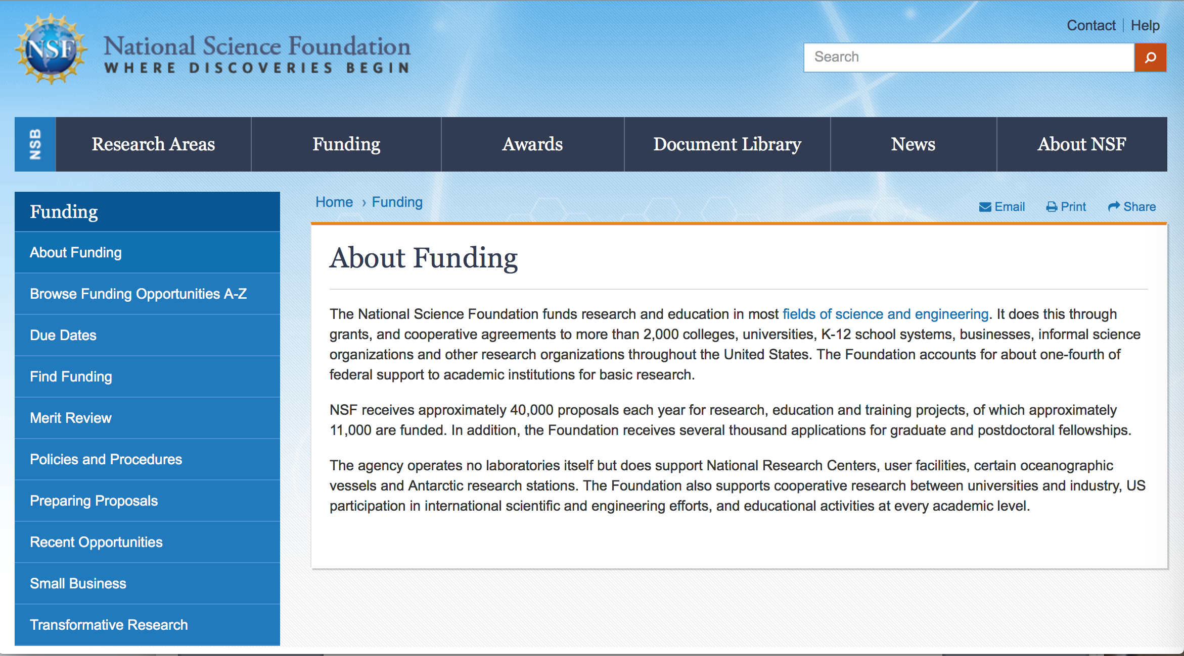

For assistance: https://nsf.gov/funding/aboutfunding.jsp

The National Science Foundation funds research and education in most fields of science and engineering. It does this through grants, and cooperative agreements to more than 2,000 colleges, universities, K-12 school systems, businesses, informal science organizations and other research organizations throughout the United States. The Foundation accounts for about one-fourth of federal support to academic institutions for basic research.
NSF receives approximately 40,000 proposals each year for research, education and training projects, of which approximately 11,000 are funded. In addition, the Foundation receives several thousand applications for graduate and postdoctoral fellowships.
The agency operates no laboratories itself but does support National Research Centers, user facilities, certain oceanographic vessels and Antarctic research stations. The Foundation also supports cooperative research between universities and industry, US participation in international scientific and engineering efforts, and educational activities at every academic level.

For details on active funding deadline dates: http://nsf.gov/funding/pgm_list.jsp?org=NSF&ord=date

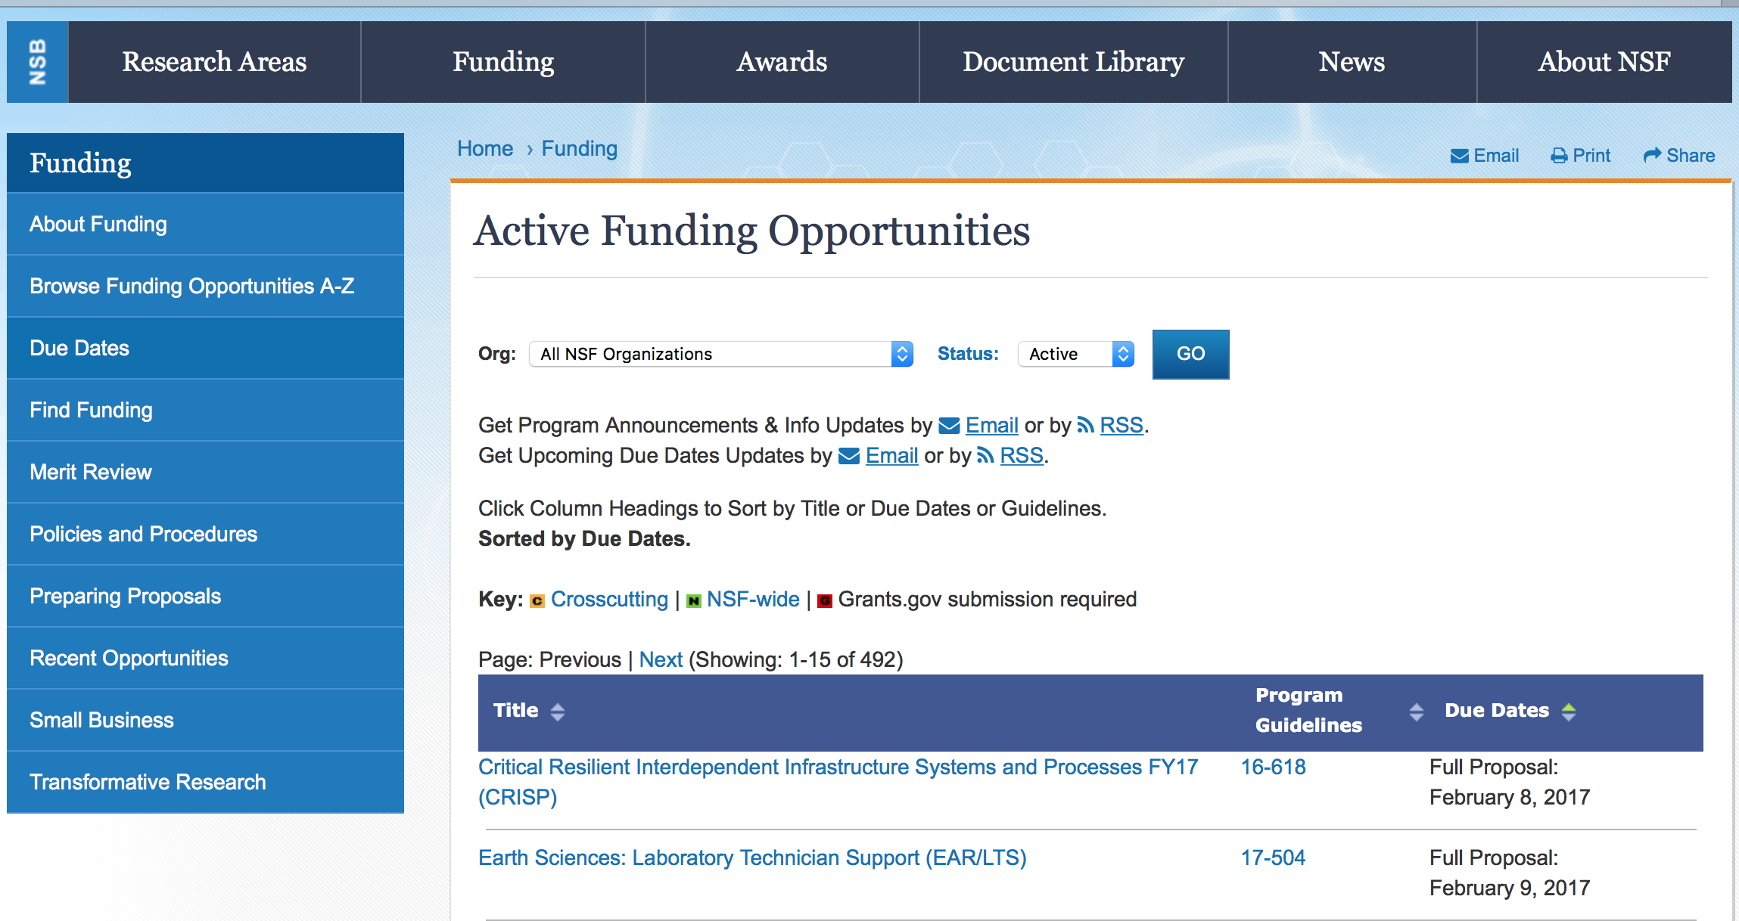

Advanced Technological Education
Synopsis 1
http://www.grants.gov/web/grants/view-opportunity.html?oppId=294625

Computer and Network Systems (CNS): Core Programs
Synopsis 1
http://www.grants.gov/web/grants/view-opportunity.html?oppId=295161

Computing and Communication Foundations (CCF): Core Programs
Synopsis 1
http://www.grants.gov/web/grants/view-opportunity.html?oppId=295162

EAR Postdoctoral Fellowships
Synopsis 1
http://www.grants.gov/web/grants/view-opportunity.html?oppId=294699

Geography and Spatial Sciences Program
Synopsis 1
http://www.grants.gov/web/grants/view-opportunity.html?oppId=294460

Geography and Spatial Sciences Program - Doctoral Dissertation Research Improvement Awards
Synopsis 1
http://www.grants.gov/web/grants/view-opportunity.html?oppId=294461

Information and Intelligent Systems (IIS): Core Programs
Synopsis 1
http://www.grants.gov/web/grants/view-opportunity.html?oppId=295163

Innovative Technology Experiences for Students and Teachers
Synopsis 1
http://www.grants.gov/web/grants/view-opportunity.html?oppId=294427

Joint DMS/NIGMS Initiative to Support Research at the Interface of the Biological and Mathematical Sciences
Synopsis 1
http://www.grants.gov/web/grants/view-opportunity.html?oppId=294827

Joint DMS/NIGMS Initiative to Support Research at the Interface of the Biological and Mathematical Sciences
Synopsis 1

http://www.grants.gov/web/grants/view-opportunity.html?oppId=294827

Modifications:

Reminders:

Deleted:

12-602 - Innovation Corps Teams Program
Deletion Comments: Opportunity deleted

13-568 - Doctoral Dissertation Improvement Grants in the Directorate for Biological Sciences
Deletion Comments: Opportunity deleted

14-537 - Geography and Spatial Sciences Program
Deletion Comments: Opportunity deleted

14-538 - Geography and Spatial Sciences Program - Doctoral Dissertation Research Improvement Awards
Deletion Comments: Opportunity deleted

15-599 - Innovative Technology Experiences for Students and Teachers
Deletion Comments: Opportunity deleted

15-606 - Solar, Heliospheric, and INterplanetary Environment
Deletion Comments: Opportunity deleted

16-514 - EarthCube:
Deletion Comments: Opportunity deleted

16-612 - EMERGING FRONTIERS IN RESEARCH AND INNOVATION (EFRI)<BR>
Deletion Comments: Opportunity deleted

16-615 - Transdisciplinary Research in Principles of Data Science
Deletion Comments: Opportunity deleted

16-578 - Computing and Communication Foundations (CCF): Core Programs
Deletion Comments: Opportunity deleted

16-579 - Computer and Network Systems (CNS): Core Programs
Deletion Comments: Opportunity deleted

16-581 - Information and Intelligent Systems (IIS): Core Programs
Deletion Comments: Opportunity deleted
Computer and Network Systems (CNS): Core Programs

17-517 - Combustion and Thermal Transport Processes Research at the International Space Station to Benefit Life on Earth (NSF-ISS)

17-529 - Cyber-Physical Systems
Deletion Comments: Opportunity deleted

17-530 - Innovations at the Nexus of Food, Energy and Water Systems
Deletion Comments: Opportunity deleted

17-531 - Energy-Efficient Computing: from Devices to Architectures
Deletion Comments: Opportunity deleted

17-532 - Building Community and Capacity in Data Intensive Research in Education
Deletion Comments: Opportunity deleted

17-535 - STEM + Computing Partnerships
Deletion Comments: Opportunity deleted

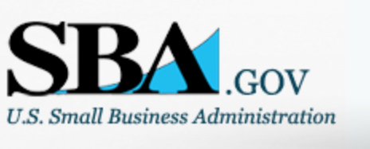

Small Business Administration

General Overview Finding Loans & Grants

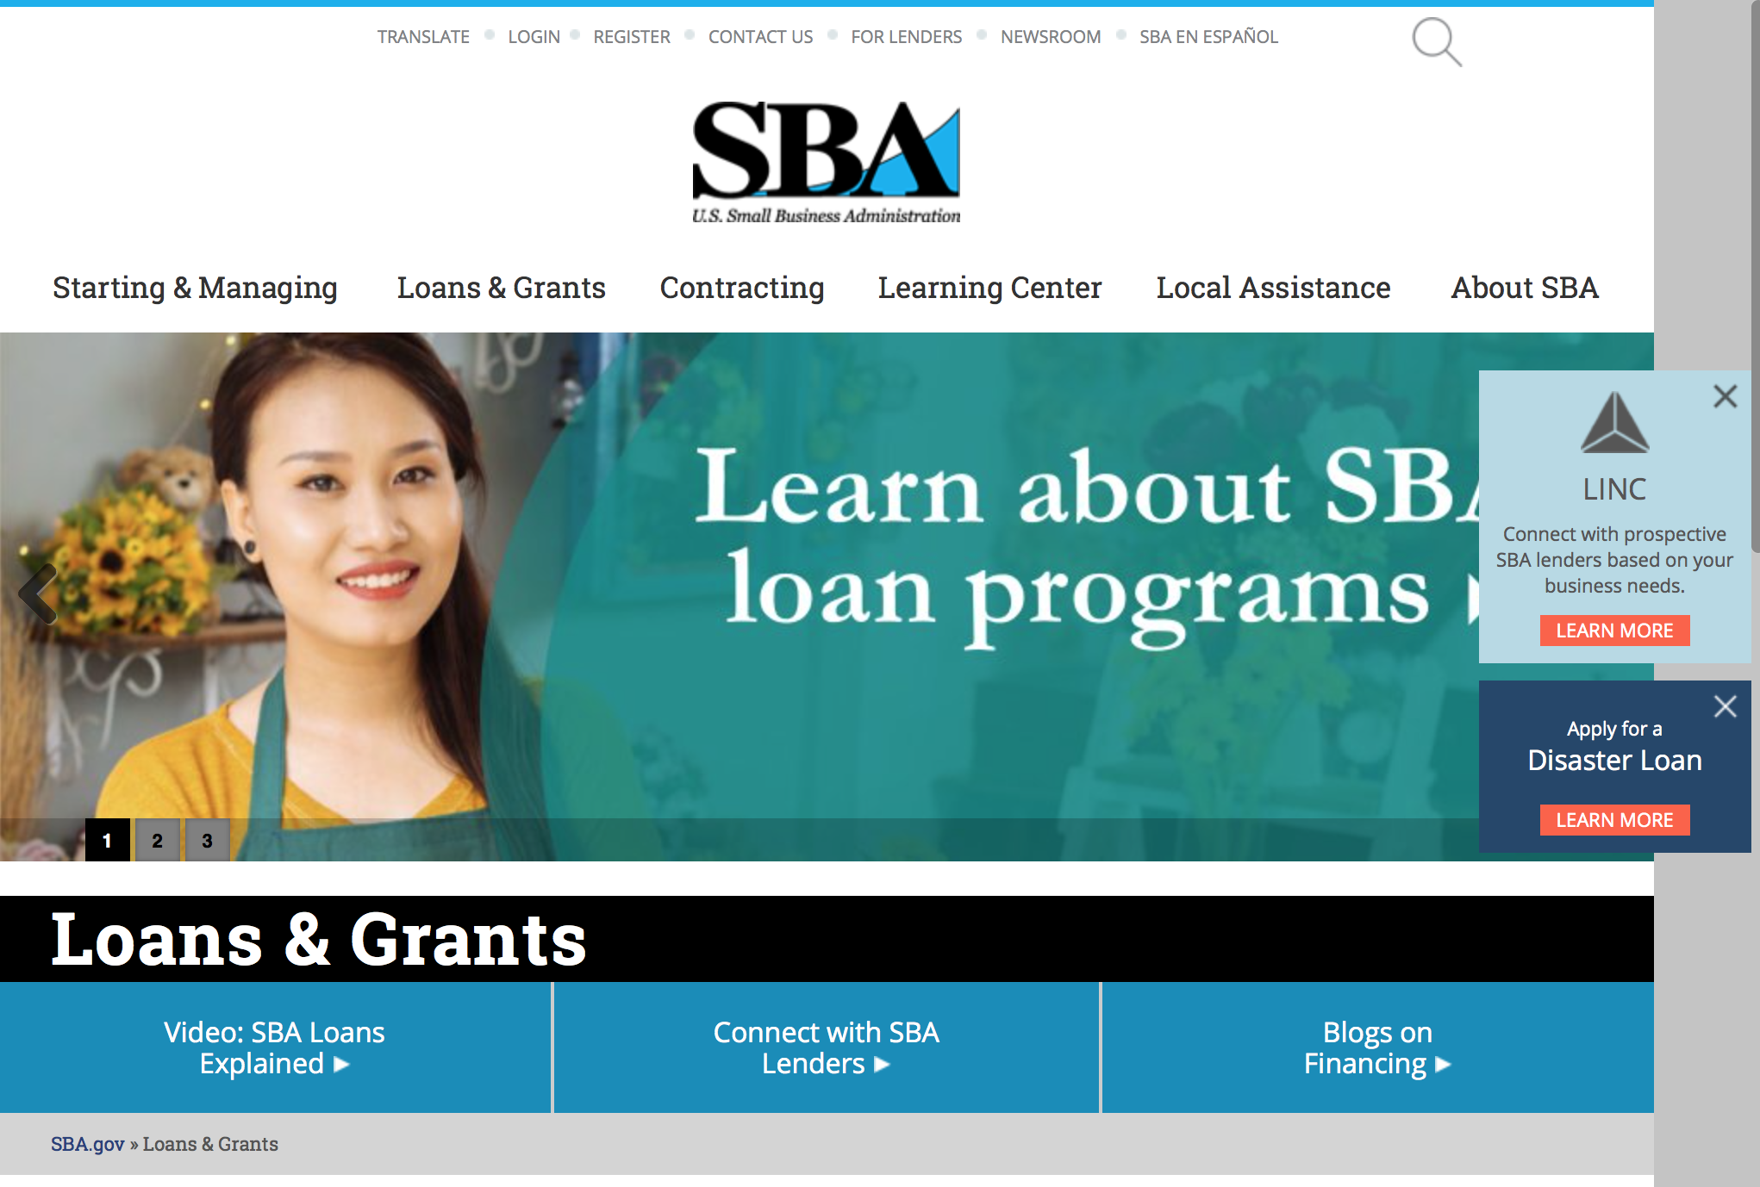
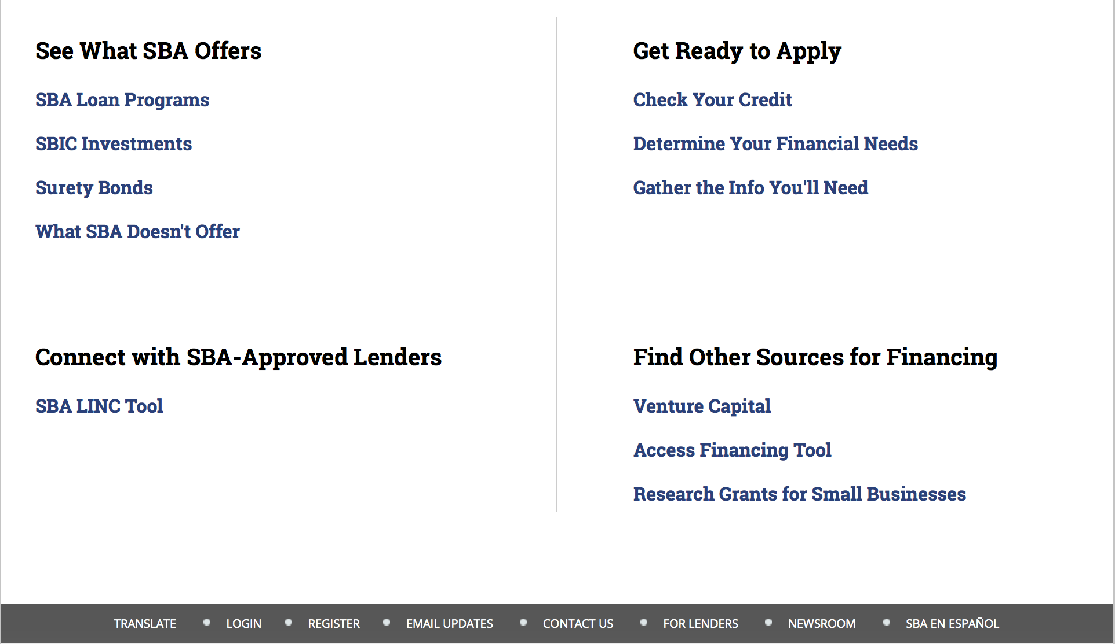

https://www.sba.gov/category/navigation-structure/loans-grants
Federal, state and local governments offer a wide range of financing programs to help small businesses start and grow their operations. These programs include low-interest loans, venture capital, and scientific and economic development grants.
Use SBA.gov's Loans and Grants Search Tool to get a list of financing programs for which you may qualify, or visit the resources below to learn more about small business financing programs.
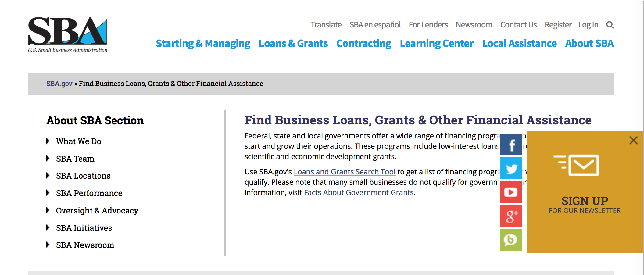
To get to the main SBA.gov funding page click here
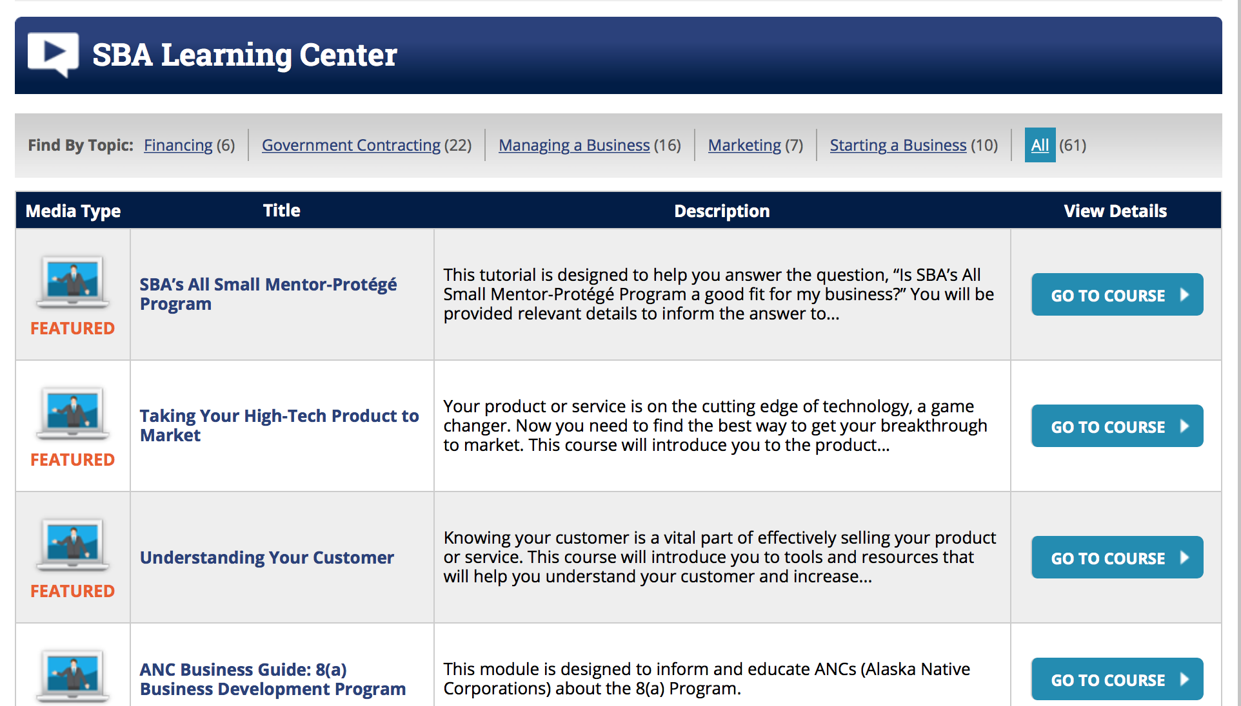
https://www.sba.gov/tools/sba-learning-center/search/training

Programs:

Women's Business Center Renewal Grant
Synopsis 1 & 3
Document Type: | Grants Notice
Funding Opportunity Number: | OWBO-2017-02
Funding Opportunity Title: | Women's Business Center Renewal Grant
Opportunity Category: | Discretionary
Opportunity Category Explanation:
Funding Instrument Type: | Cooperative Agreement
Category of Funding Activity: | Business and Commerce
Category Explanation:
Expected Number of Awards: | 36
CFDA Number(s): | 59.043 -- Women's Business Ownership Assistance
Cost Sharing or Matching Requirement: | Yes
Version: | Synopsis 3
Posted Date: | Jun 09, 2017
Last Updated Date: | Jun 13, 2017
Original Closing Date for Applications: | Jul 11, 2017
Current Closing Date for Applications: | Jul 11, 2017
Archive Date: | Aug 10, 2017
Estimated Total Program Funding: | $5,400,000
Award Ceiling: | $150,000
Award Floor: | $0
Eligible Applicants: | Nonprofits having a 501(c)(3) status with the IRS, other than institutions of higher education
Agency Name: | Small Business Administration
Description: | See synopsis
Link to Additional Information:
Grantor Contact Information: | If you have difficulty accessing the full announcement electronically, please contact:  OWBO@sba.gov  OWBO@sba.gov

http://www.grants.gov/web/grants/view-opportunity.html?oppId=294524

Option Year Workplan and Budget
Synopsis 1
Document Type: | Grants Notice
Funding Opportunity Number: | OWBO-WKPLN-2017-18
Funding Opportunity Title: | Option Year Workplan and Budget
Opportunity Category: | Discretionary
Opportunity Category Explanation:
Funding Instrument Type: | Cooperative Agreement
Category of Funding Activity: | Business and Commerce
Category Explanation:
Expected Number of Awards: | 74
CFDA Number(s): | 59.043 -- Women's Business Ownership Assistance
Cost Sharing or Matching Requirement: | Yes
Version: | Synopsis 1
Posted Date: | Jun 14, 2017
Last Updated Date: | Jun 14, 2017
Original Closing Date for Applications: | Jul 14, 2017
Current Closing Date for Applications: | Jul 14, 2017
Archive Date: | Aug 13, 2017
Estimated Total Program Funding: | $0
Award Ceiling: | $0
Award Floor: | $0
Eligible Applicants: | Others (see text field entitled "Additional Information on Eligibility" for clarification)
Additional Information on Eligibility: | Provided to eligible applicants via e-mail
Agency Name: | Small Business Administration
Description: | See Work Plan and Budget Request
Link to Additional Information:
Grantor Contact Information: | If you have difficulty accessing the full announcement electronically, please contact:  OWBO@sb.gov Phone 202-205-6673  OWBO@sba.gov

http://www.grants.gov/web/grants/view-opportunity.html?oppId=294607

Modifications

OSBDC
Synopsis 5
Document Type: | Grants Notice
Funding Opportunity Number: | OSBDC-2018-01
Funding Opportunity Title: | OSBDC
Opportunity Category: | Mandatory
Opportunity Category Explanation:
Funding Instrument Type: | Cooperative Agreement
Category of Funding Activity: | Business and Commerce
Category Explanation:
Expected Number of Awards: | 63
CFDA Number(s): | 59.037 -- Small Business Development Centers
Cost Sharing or Matching Requirement: | Yes
Version: | Synopsis 5
Posted Date: | Jun 09, 2017
Last Updated Date: | Jun 09, 2017
Original Closing Date for Applications: | Jul 21, 2017
Current Closing Date for Applications: | Jul 21, 2017
Archive Date: | Aug 20, 2017
Estimated Total Program Funding:
Award Ceiling: | $6,186,911
Award Floor: | $199,999
Eligible Applicants: | Others (see text field entitled "Additional Information on Eligibility" for clarification)
Additional Information on Eligibility: | An eligible candidate is an existing SBDC recipient organization currently funded under the Small Business Development (SBDC) Program which is in good standing regarding accreditation. An application submitted by an entity that is not a current Lead SBDC will not be considered.
Agency Name: | Small Business Administration
Description: | The SBDC program is the SBA’s largest matching grant, funding a service delivery network to provide high quality business and economic development assistance to small businesses and nascent entrepreneurs in order to promote growth, expansion, innovation, increased productivity and management improvement. The SBDCs, in partnership with SBA’s Office of Small Business Development Centers (OSBDC) and SBA District Offices, develop programs and provide business management and other services that enhance the economic development goals and objectives of SBA and their other respective state and local funding partners. The SBDC program is a broad-based system of assistance for the small business community that links the resources of Federal, state, and local governments with those of the educational community and the private sector. Although SBA is responsible for the general management and oversight of the SBDC program, a partnership exists between SBA and the recipient organization to effectuate the delivery of assistance to the small business community.
Link to Additional Information:
Grantor Contact Information: | If you have difficulty accessing the full announcement electronically, please contact:  Victoria.Mundt@sba.gov Dep. Dir./SBDC Phone 202-205-7176  victoria.mundt@sba.gov

http://www.grants.gov/web/grants/view-opportunity.html?oppId=294035

Program Announcement
Synopsis 3
Document Type: | Grants Notice
Funding Opportunity Number: | OSBDC-2018-02
Funding Opportunity Title: | Program Announcement
Opportunity Category: | Mandatory
Opportunity Category Explanation:
Funding Instrument Type: | Cooperative Agreement
Category of Funding Activity: | Business and Commerce
Category Explanation:
Expected Number of Awards: | 63
CFDA Number(s): | 59.037 -- Small Business Development Centers
Cost Sharing or Matching Requirement: | Yes
Version: | Synopsis 3
Posted Date: | May 22, 2017
Last Updated Date: | Jun 09, 2017
Original Closing Date for Applications: | Aug 25, 2017
Current Closing Date for Applications: | Aug 25, 2017
Archive Date:
Estimated Total Program Funding: | $110,000,000
Award Ceiling: | $6,186,911
Award Floor: | $199,999
Eligible Applicants: | Others (see text field entitled "Additional Information on Eligibility" for clarification)
Additional Information on Eligibility: | An eligible candidate is an existing SBDC recipient organization currently funded under the Small Business Development (SBDC) Program which is in good standing regarding accreditation. An application submitted by an entity that is not a current Lead SBDC will not be considered.
Agency Name: | Small Business Administration
Description: | The SBDC program is the SBA’s largest matching grant, funding a service delivery network to provide high quality business and economic development assistance to small businesses and nascent entrepreneurs in order to promote growth, expansion, innovation, increased productivity and management improvement. The SBDCs, in partnership with SBA’s Office of Small Business Development Centers (OSBDC) and SBA District Offices, develop programs and provide business management and other services that enhance the economic development goals and objectives of SBA and their other respective state and local funding partners. The SBDC program is a broad-based system of assistance for the small business community that links the resources of Federal, state, and local governments with those of the educational community and the private sector. Although SBA is responsible for the general management and oversight of the SBDC program, a partnership exists between SBA and the recipient organization to effectuate the delivery of assistance to the small business community.
Link to Additional Information:
Grantor Contact Information: | If you have difficulty accessing the full announcement electronically, please contact:  Victoria Mundt Deputy Director/SBDC Phone 202-205-7176  victoria.mundt@sba.gov

http://www.grants.gov/web/grants/view-opportunity.html?oppId=294041

Reminders:

OSBDC

Program Announcement

Program Announcement
Synopsis 2
Document Type: | Grants Notice
Funding Opportunity Number: | OSBDC-2018-02
Funding Opportunity Title: | Program Announcement
Opportunity Category: | Mandatory
Opportunity Category Explanation:
Funding Instrument Type: | Cooperative Agreement
Category of Funding Activity: | Business and Commerce
Category Explanation:
Expected Number of Awards: | 63
CFDA Number(s): | 59.037 -- Small Business Development Centers
Cost Sharing or Matching Requirement: | Yes
Version: | Synopsis 2
Posted Date: | May 22, 2017
Last Updated Date: | May 24, 2017
Original Closing Date for Applications: | Aug 25, 2017
Current Closing Date for Applications: | Aug 25, 2017
Archive Date:
Estimated Total Program Funding:
Award Ceiling: | $7,300,000
Award Floor: | $199,999
Eligible Applicants: | Unrestricted (i.e., open to any type of entity above), subject to any clarification in text field entitled "Additional Information on Eligibility"
Agency Name: | Small Business Administration
Description: | Higher Institutions are eligible
Link to Additional Information:
Grantor Contact Information: | If you have difficulty accessing the full announcement electronically, please contact:  Victoria Mundt Deputy Director/SBDC Phone 202-205-7176  victoria.mundt@sba.gov

http://www.grants.gov/web/grants/view-opportunity.html?oppId=294041

Deleted:

SBA Trainings

Contracting Opportunities for Veteran Entrepreneurs
This self-paced training exercise is an introduction to Federal contracting opportunities for Veterans.
Topics include basic information about Veteran-owned businesses and opportunities, services available to small Veteran-owned businesses, small business incentives, and government procurement methods.
Duration: 00:30:00

http://www.sba.gov/tools/sba-learning-center/training/contracting-opportunities-veteran-entrepreneurs

Interested in Exporting? These Four Resources Can Help
Did you know that two-thirds of the world’s purchasing power is in foreign countries? As the numbers show, the international marketplace is a big one. So if you’re interested in exploring the world of exporting – or have gotten started but could use some guidance – check out these resources to help.
- Read more

Upcoming Trainings: Check out SBA's Online Training!
- Financing Options for Small Businesses
How to Prepare Government Contract Proposals
Getting Started With Exporting: Training and Educational Resources
Exporting represents a big opportunity to tap in to new markets, expand your customer base and grow your business. But getting started with exporting can sometimes feel like a maze of regulations, policies, and other barriers. Here are some free training and educational resources to help.
- Read more

For Specific Information in Hawaii see the following links:
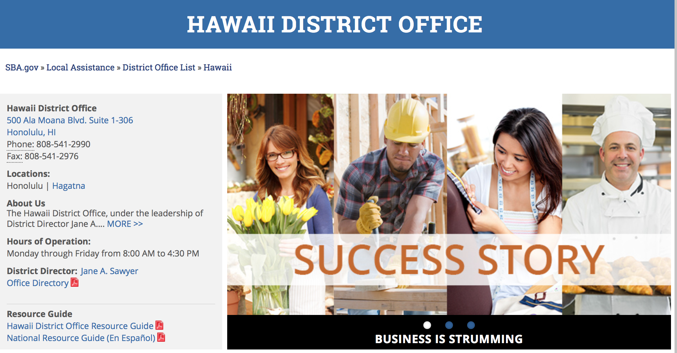

https://www.sba.gov/offices/district/hi/Honolulu

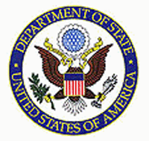

State Department General Overview and Resources for Program Administrators

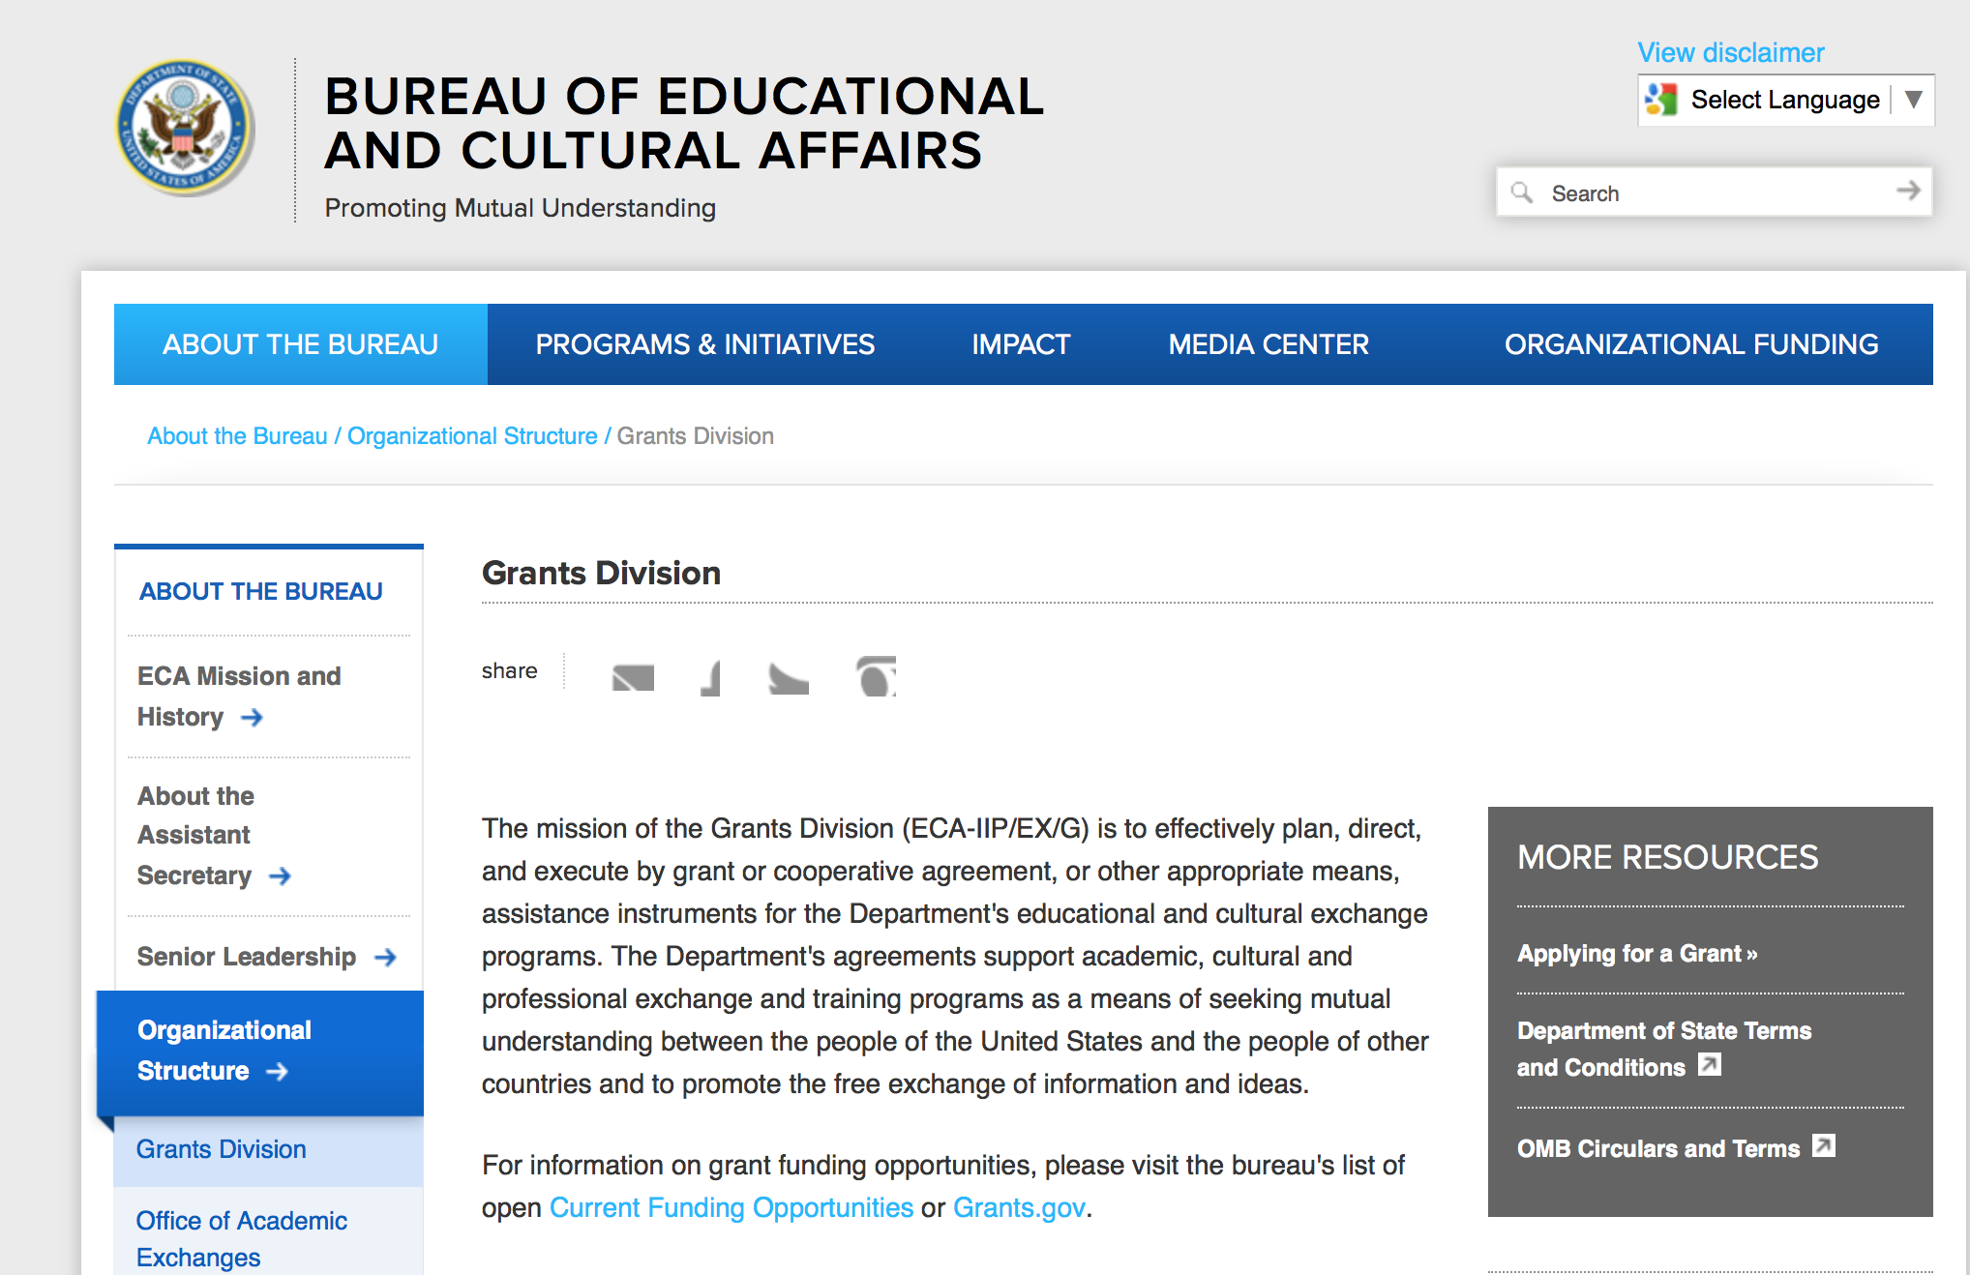

https://eca.state.gov/about-bureau/organizational-structure/grants-division

http://eca.state.gov/search/solr/grants?search_referrer=node/237

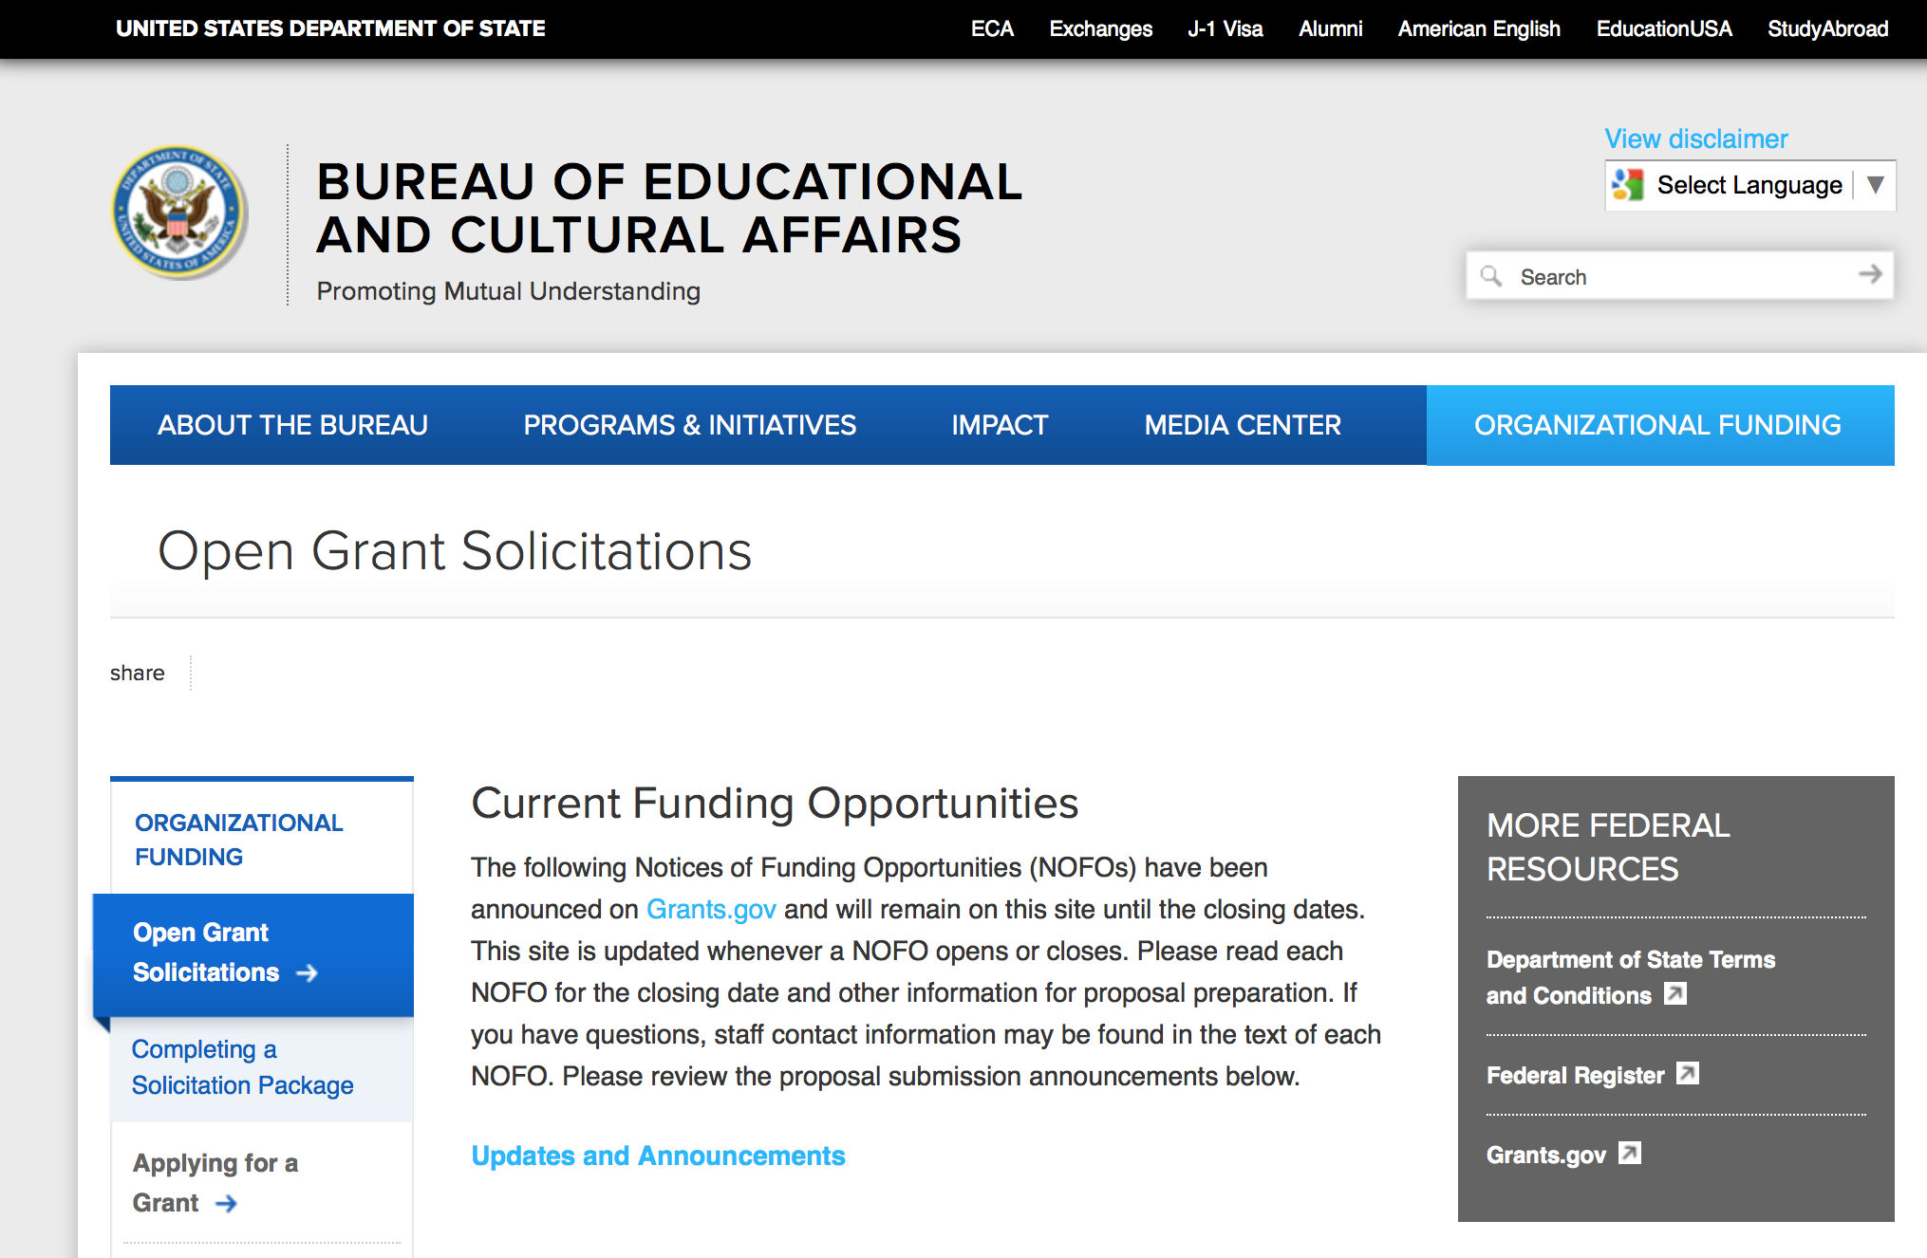
https://eca.state.gov/organizational-funding/open-grant-solicitations

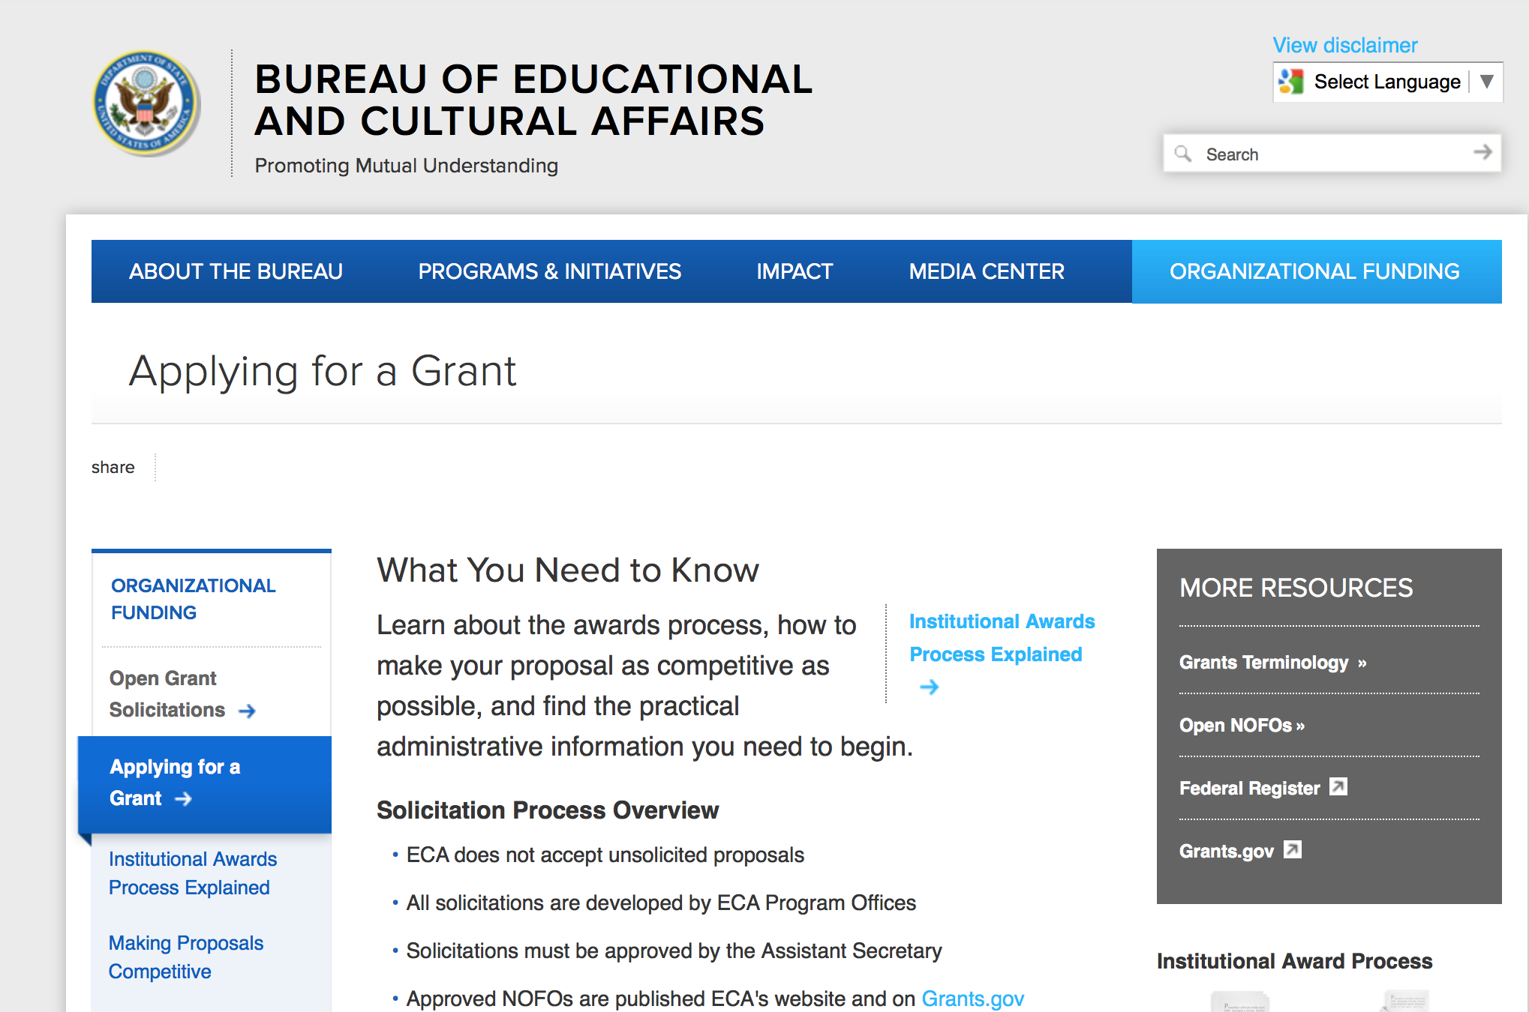
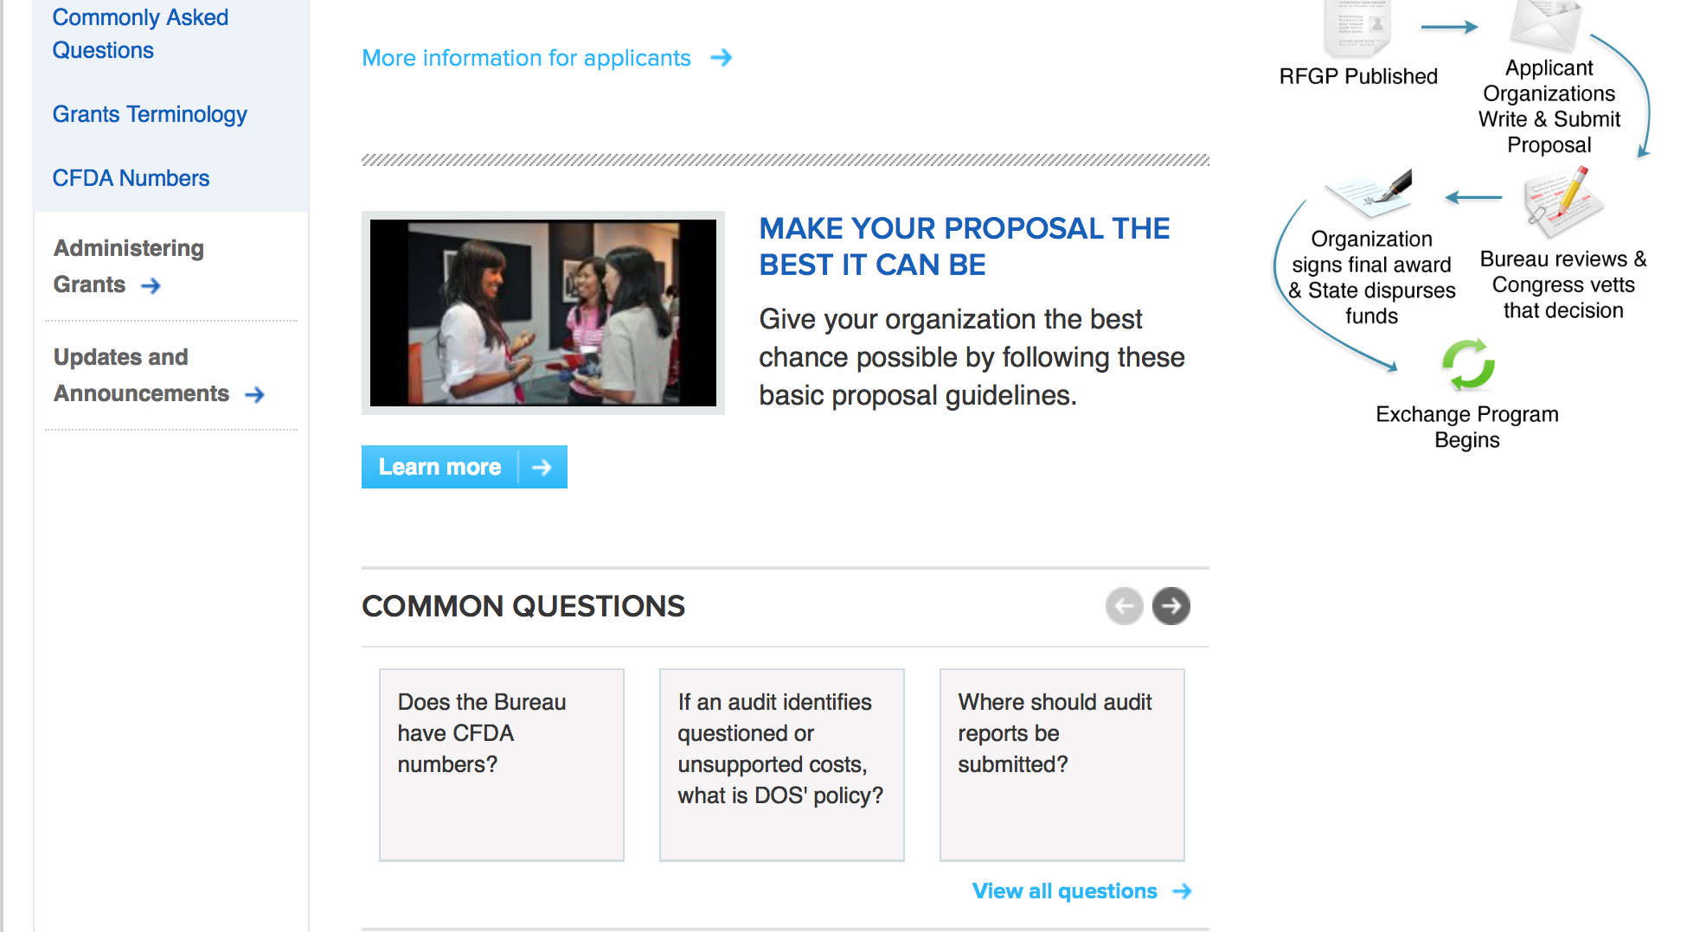
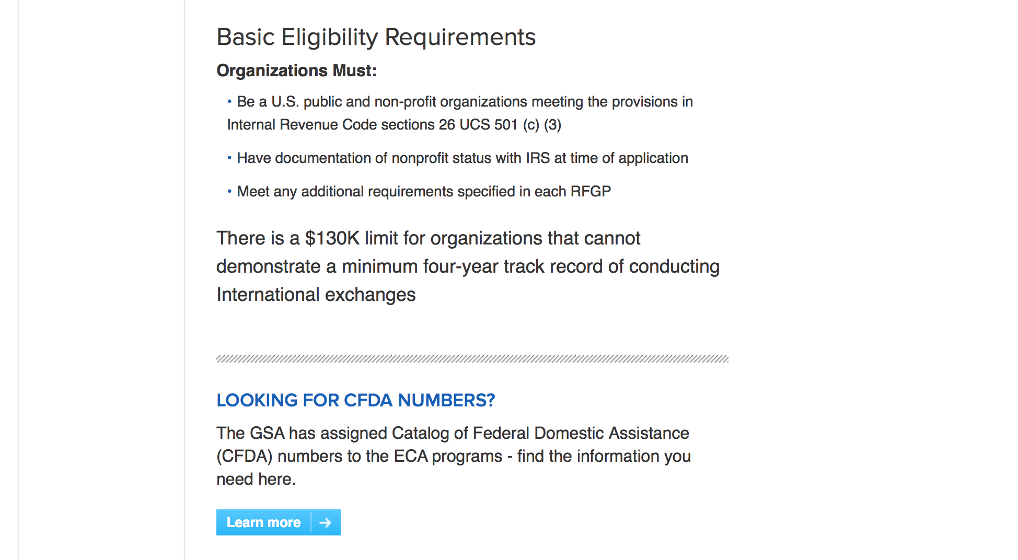
http://eca.state.gov/organizational-funding/applying-grant

General Information:
- Bureau of Educational and Cultural Affairs Grants Division
- Open Grant Opportunities (Requests for Grant Proposals)

For General Information click here

Program Grants:

Bureau of Democracy Human Rights and Labor
Business and Human Rights in the ICT Sector to Advance Internet Freedom
Synopsis 1
http://www.grants.gov/web/grants/view-opportunity.html?oppId=294643

Bureau of International Narcotics-Law Enforcement
Combating Wildlife Trafficking in Sub-Saharan Africa
Synopsis 1 & 2
http://www.grants.gov/web/grants/view-opportunity.html?oppId=294437

Office to Monitor-Combat Trafficking in Persons
Fiscal Year (FY) 2017 International Programs to Combat Child Trafficking in Peru
Synopsis 1
http://www.grants.gov/web/grants/view-opportunity.html?oppId=294794

PM Weapons Removal and Abatement
17.PMWRA.Afghanistan.CM Clearance Project.NOFO
Synopsis 1 & 2
http://www.grants.gov/web/grants/view-opportunity.html?oppId=295089

PM Weapons Removal and Abatement
17.PMWRA.CWD.AF.RFI
Synopsis 1
http://www.grants.gov/web/grants/view-opportunity.html?oppId=294626

PM Weapons Removal and Abatement
17.PMWRA.Guatemala.PSSM.NOFO
Synopsis 1
http://www.grants.gov/web/grants/view-opportunity.html?oppId=294399

U.S. Mission to Afghanistan
U.S. University-American University of Afghanistan Partnership
Synopsis 1
http://www.grants.gov/web/grants/view-opportunity.html?oppId=294273

U.S. Mission to Cuba
U.S. Embassy Havana PAS Annual Program Statement
Synopsis 1
http://www.grants.gov/web/grants/view-opportunity.html?oppId=295101

Assistance Coordination
Increasing Accountability in Tunisia and Empowering the Judicial Financial Pole
Synopsis 1
http://www.grants.gov/web/grants/view-opportunity.html?oppId=295143

U.S. Mission to Slovenia
FY 2017 Notice of Funding Opportunity: Cultural Grants Program - Open Competition
Synopsis 1
http://www.grants.gov/web/grants/view-opportunity.html?oppId=295115

Modifications:

U.S. Mission to Saudi Arabia
Saudi Young Leaders Exchange Program
Synopsis 4
http://www.grants.gov/web/grants/view-opportunity.html?oppId=294832

Bureau of International Security-Nonproliferation
Proliferation Financing Course Development and Delivery
Synopsis 2
http://www.grants.gov/web/grants/view-opportunity.html?oppId=294842

Office of Acquisitions Management
Proliferation Financing Course Development and Delivery
Synopsis 2
http://www.grants.gov/web/grants/view-opportunity.html?oppId=294710

U.S. Mission to Malawi
U.S. Ambassador’s PEPFAR Small Grants Program 2017-2018
Synopsis 5
http://www.grants.gov/web/grants/view-opportunity.html?oppId=295167

PM Weapons Removal and Abatement
17.PMWRA.Peru.PSSM.NOFO
Synopsis 2
http://www.grants.gov/web/grants/view-opportunity.html?oppId=295121

Reminders:

Deleted:

Office of Acquisitions Management
SFOP0002100 - Proliferation Financing Course Development and Delivery
Deletion Comments: Updating Agency in Grants.gov

Bureau of International Security-Nonproliferation
SFOP0002096 - Mapping Illicit Proliferation Networks
Deletion Comments: Incorrect Post

Department of Transportation

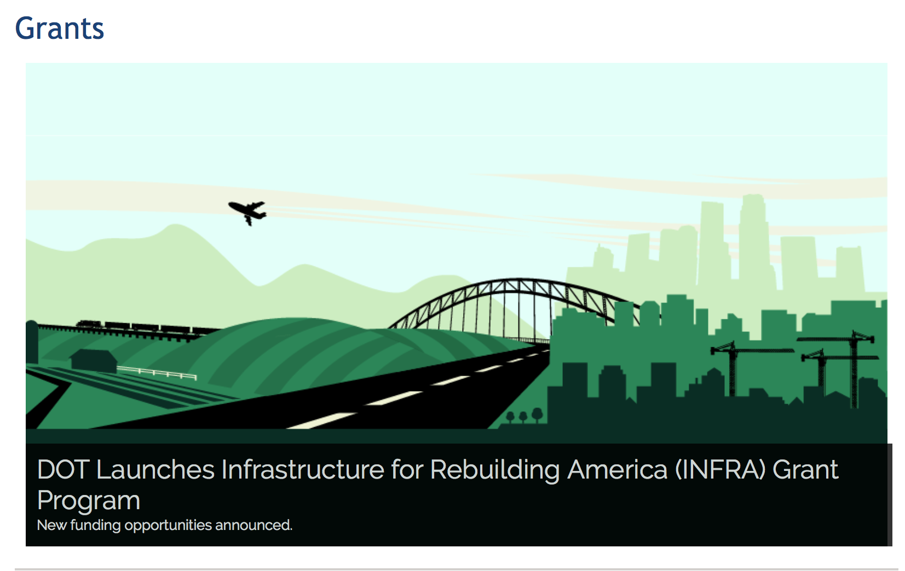

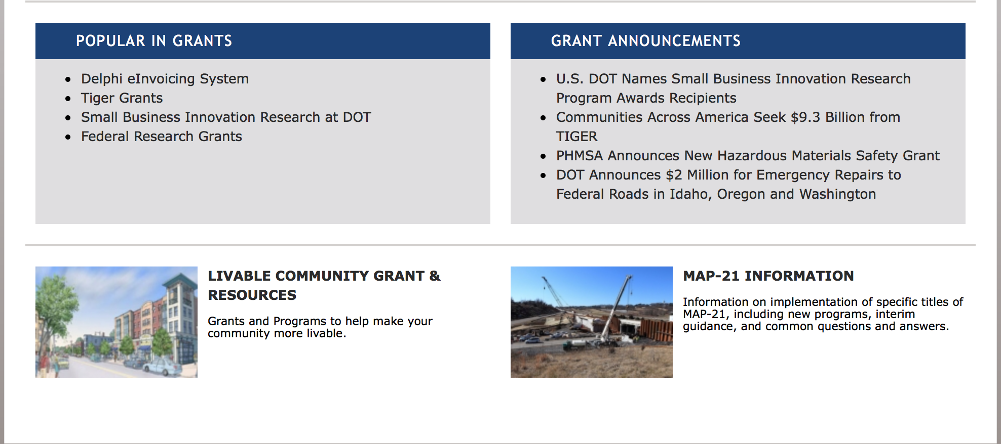
General Grant Program Overview https://www.transportation.gov/grants

Programs:

Modifications:

Research:

Reminders:

DOT Federal Aviation Administration
DOT - FAA Aviation Research Grants
FAA Aviation Research and Development Grants
Modifications 3 & 4

Document Type: | Grants Notice
Funding Opportunity Number: | 12-01
Funding Opportunity Title: | FAA Aviation Research and Development Grants
Opportunity Category: | Discretionary
Opportunity Category Explanation:
Funding Instrument Type: | Grant
Category of Funding Activity: | Transportation
Category Explanation:
Expected Number of Awards:
CFDA Number(s): | 20.108 -- Aviation Research Grants
Cost Sharing or Matching Requirement: | No
Version: | Synopsis 5
Posted Date: | Jan 01, 2012
Last Updated Date: | Jun 09, 2016
Original Closing Date for Applications: | Dec 31, 2019
Current Closing Date for Applications: | Dec 31, 2019
Archive Date: | Jan 30, 2020
Estimated Total Program Funding:
Award Ceiling: | $5,000,000
Eligible Applicants: | Nonprofits having a 501(c)(3) status with the IRS, other than institutions of higher education  Private institutions of higher education  Public and State controlled institutions of higher education
Agency Name: | DOT - FAA Aviation Research Grants
Description: | The FAA is soliciting proposals for research grants and cooperative agreements to pursue the long-term growth and short-term technical needs of civil aviation. In order to streamline the application process, it is recommended that all prospective grantees submit a white paper (letter of intent) for agency technical review before complete proposal submission. Please be sure to identify the specific area of interest (Solicitation FAA-12-01 – Chapter I. FAA Research Grants Program, Technical Areas of Research #1-#9). The white paper shall be no longer than three (3) pages and shall detail overall research objectives.
Link to Additional Information:
Grantor Contact Information: | If you have difficulty accessing the full announcement electronically, please contact:  Debra Monzo Grants Officer Phone 609-485-4962  business

http://www.grants.gov/web/grants/view-opportunity.html?oppId=134953

Deleted:

Department of the Treasury

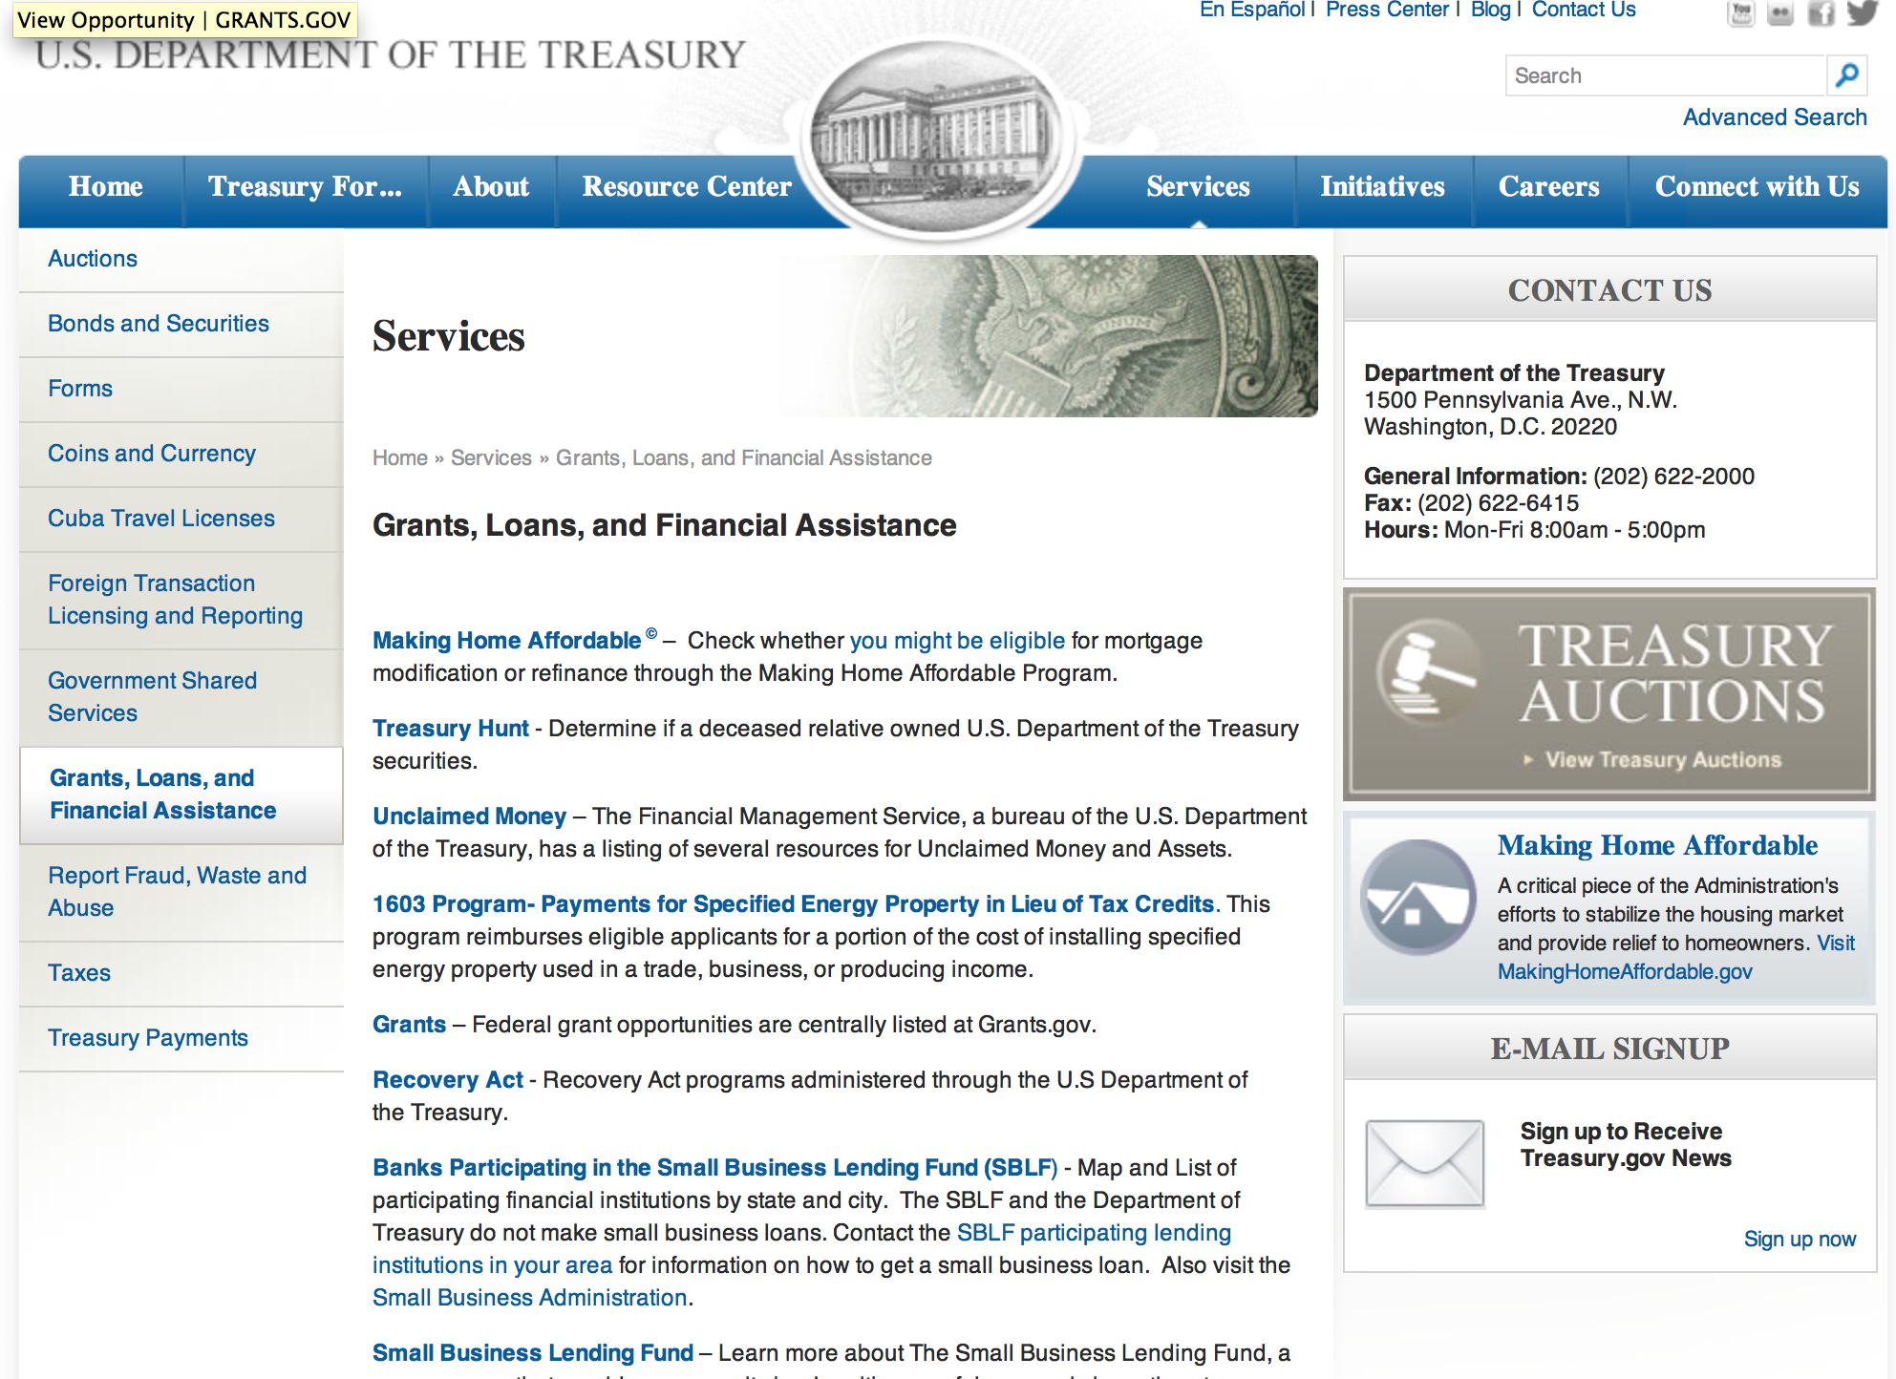

http://www.treasury.gov/services/Pages/Grants-Loans-and-Financial-Assistance.aspx

Programs:

Community Development Financial Institutions
Fiscal Year 2017 Capital Magnet Fund Program
Synopsis 1

Document Type: | Grants Notice
Funding Opportunity Number: | CDFI-2017-CMF
Funding Opportunity Title: | Fiscal Year 2017 Capital Magnet Fund Program
Opportunity Category: | Mandatory
Opportunity Category Explanation:
Funding Instrument Type: | Grant
Category of Funding Activity: | Community Development
Category Explanation:
Expected Number of Awards: | 32
CFDA Number(s): | 21.011 -- Capital Magnet Fund
Cost Sharing or Matching Requirement: | No
Version: | Synopsis 1
Posted Date: | Jun 29, 2017
Last Updated Date: | Jun 29, 2017
Original Closing Date for Applications: | Jul 28, 2017
Current Closing Date for Applications: | Jul 28, 2017
Archive Date: | Aug 27, 2017
Estimated Total Program Funding: | $119,500,000
Award Ceiling: | $17,900,000
Award Floor: | $500,000
Eligible Applicants: | Others (see text field entitled "Additional Information on Eligibility" for clarification)
Additional Information on Eligibility: | Applicants must be (1) a Treasury certified CDFI; or (2) a nonprofit organization having as one of its principal purposes the development or management of affordable housing. An applicant must provide information necessary to establish that it is an eligible organization in order to apply for assistance. This information is included as part of the application materials.
Agency Name: | Community Development Financial Institutions
Description: | The CDFI Fund awards Capital Magnet Fund grants to certified Community Development Financial Institutions (CDFIs) and certain nonprofit organizations to finance: (1) the development, preservation, rehabilitation, or purchase of affordable housing for primarily extremely low-, very low-, and low-income families; and (2) economic development activities or community service facilities, such as day care centers, workforce development centers, and health care clinics, which in conjunction with affordable housing activities implement a concerted strategy to stabilize or revitalize a low-income area or underserved rural area. CMF's award ceiling is 15% of Total Program Funding. Additional details on Application requirements are available on the CDFI Fund’s website.
Link to Additional Information: | A webpage on the CDFI Fund's website with all the relevant details regarding the Capital Magnet Fund Program.
Grantor Contact Information: | If you have difficulty accessing the full announcement electronically, please contact:  CDFI Fund Help Desk 202-653-0421  CDFI Fund Help Desk

http://www.grants.gov/web/grants/view-opportunity.html?oppId=295103

Modifications:

Reminders:

U.S. Agency for International Development

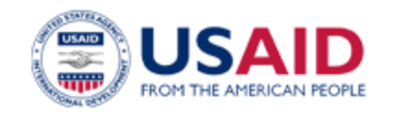

www.usaid.gov

General Overview Funding Opportunities

USAID has working relationships with thousands of American companies and hundreds of U.S.-based private voluntary organizations. For more information on our business and procurement opportunities, please visit our Business section.

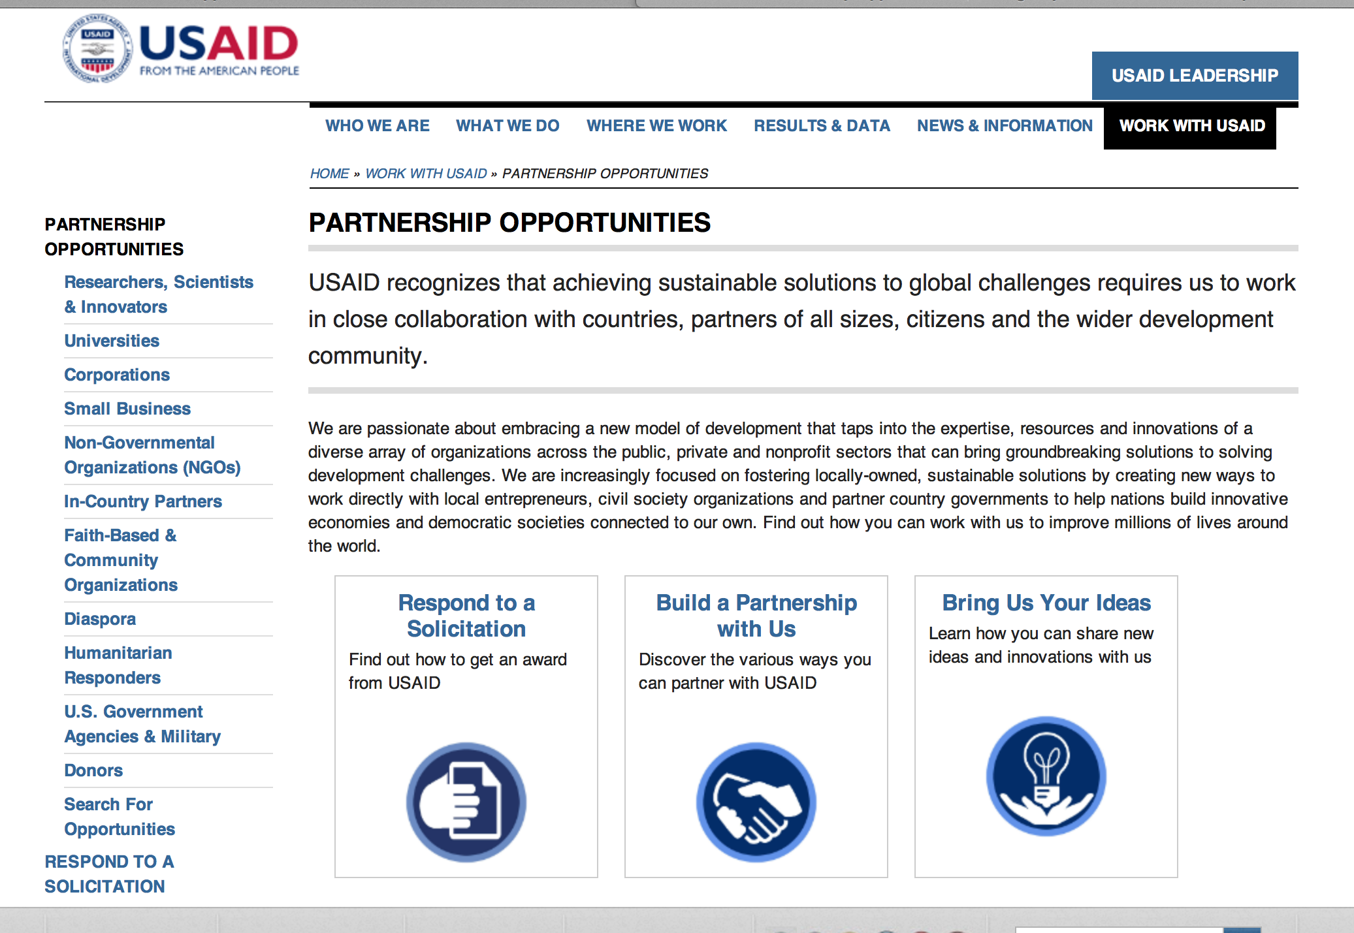
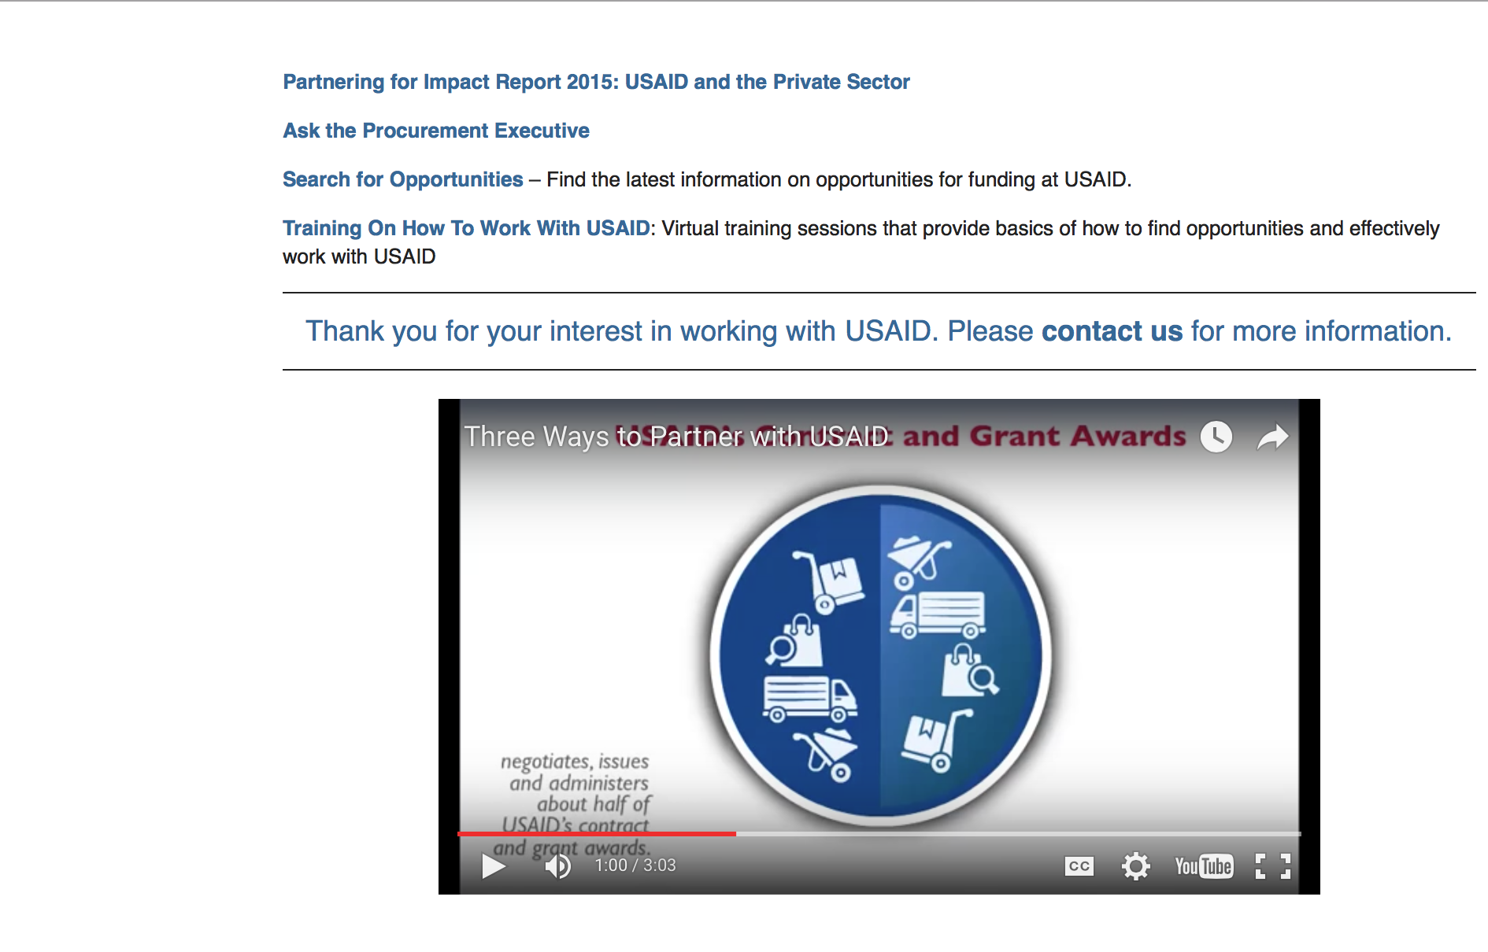

http://www.usaid.gov/partnerships

Programs:

Afghanistan USAID-Kabul
Afghanistan Jobs Creation Program (AJCP)
Synopsis 1
http://www.grants.gov/web/grants/view-opportunity.html?oppId=294649

Haiti USAID-Port Au Prince
Improving Governance in Haiti Program (IGHI)
Synopsis 1
http://www.grants.gov/web/grants/view-opportunity.html?oppId=295067

Kenya USAID-Nairobi
Kenya Feed the Future Livestock Market Systems Leader with Associates
Synopsis 1 & 2
http://www.grants.gov/web/grants/view-opportunity.html?oppId=294628

Kenya USAID-Nairobi
Crops and Dairy Market Systems Development Activity
Synopsis 1
http://www.grants.gov/web/grants/view-opportunity.html?oppId=294900

Leveraging Academic Partnerships in Operational Humanitarian Environments
Synopsis 1 & 2
http://www.grants.gov/web/grants/view-opportunity.html?oppId=294425

Partnering for Impact in Guinea
Synopsis 1
http://www.grants.gov/web/grants/view-opportunity.html?oppId=295147

Modifications:

Afghanistan USAID-Kabul
Afghanistan Jobs Creation Program (AJCP)
Synopsis 2
http://www.grants.gov/web/grants/view-opportunity.html?oppId=294649

The USAID Global Health Challenge BAA
Synopsis 2
http://www.grants.gov/web/grants/view-opportunity.html?oppId=294194

Deleted:
Agency for International Development
Haiti USAID-Port Au Prince
SOL-521-17-000015 - Improving Governance in Haiti Initiative (IGHI)
Deletion Comments: Opportunity deleted

South Africa USAID-Pretoria
RFA-674-17-000005 - Ready, Resourceful, Risk Aware (Triple R): OVC, Adolescent Girls and Young Women
Deletion Comments: Opportunity will be re-posted at a later date.

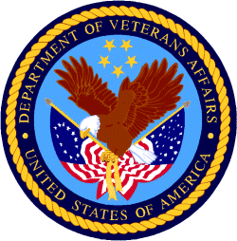

Department of Veterans Affairs

