Senator Mazie Hirono

Grants Assistance Information Newsletter

JULY 2018

G.A.I.N. INDEX

Click on Index Links below to read summaries of the announcements by agency in this document. Once you reach the item, if you cannot open the links for further information, copy the selected URL website address into your browser.

Modified sections from previous listings are shown in a GREY background

Notices is Teal are items with immediate deadline dates.

Notices in Yellow are of special interest.

Notices is Green are items of special interest with immediate deadline dates.

Items in this type color are aimed at Small Businesses

Items in this type color have a Faith-Based Organization component

Special Federal Program Notices

Highlighted

Reminders

Programs specific to Hawaii

Current Notices

Reminders

Grant Writing Resources

SAM and Grants.Gov Information

SBIR – Small Business Innovation Research

See Individual Departments for information and webpages representing the best and most accessible information on the agency funding opportunities

Federal Grant and Cooperative Agreement Program Summaries

U.S. Department of Agriculture

Grants and Loans Overview

Programs

Research
Modifications
Reminders

Business and Cooperative Programs
Rural Cooperative Development Grant
National Institute of Food and Agriculture
Agriculture and Food Research Initiative - Foundational and Applied Science
Risk Management Education
Crop Insurance Education in Targeted States
Risk Management Education
Risk Management Education Partnership Program

Deleted:

Department of Commerce

Grants at Commerce

Programs

Ocean Exploration Fiscal Year 2019 Funding Opportunity
Research and National Technical Assistance FY18-FY20

Modifications

2018 MBDA Broad Agency Announcement

NOAA RESTORE Science Program
FY 2018 Regional Innovation Strategies Program

Research

Reminders

FY19 Saltonstall-Kennedy Competition
National Institute of Standards and Technology
NIST Public Safety Innovation Accelerator Program – Mission Critical Voice Quality of Experience

National Sea Grant College Program 2018-19 Special Projects

Economic Development Administration
FY 2017 Economic Development Assistance Programs ­ Application submission and program requirements for EDA’s Public Works and Economic Adjustment Assistance programs.

FY 2016 – FY 2019 EDA Planning Program and Local Technical Assistance Program Grant

Economic Development Administration
Planning Program and Local Technical Assistance Program Grant

Deleted

Corporation for National and Community Service

General Program Overview

Programs

Reminders

National Service in Hawaii

Department of Defense

Doing Business with the Department of Defense

DoD Small Business Opportunities and Forecasting

Research Grants

Modifications

Deleted

Reminders

Department of Education

Grant Programs Overview

Programs

Office of Postsecondary Education (OPE): Gaining Early Awareness and Readiness for Undergraduate Programs (GEAR UP) Partnership Grants CFDA Number 84.334A
Office of Postsecondary Education (OPE): Undergraduate International Studies and Foreign Language (UISFL) Program CFDA Number 84.016A

Office of Postsecondary Education (OPE): Child Care Access Means Parents in School (CCAMPIS) Program CFDA Number 84.335A

OSERS-OSEP: Interdisciplinary Preparation in Special Education, Early Intervention, and Related Services for Personnel Serving Children with Disabilities who have High-Intensity Needs CFDA Number 84.325K Focus Area A
OSERS-OSEP: Interdisciplinary Preparation in Special Education, Early Intervention, and Related Services for Personnel Serving Children with Disabilities who have High-Intensity Needs CFDA Number 84.325K Focus Area B
OSERS-OSEP: Preparation of Special Education, Early Intervention, and Related Services Leadership Personnel CFDA Number 84.325D
Research

Modifications

Reminders

Institutes of Education Sciences (IES): Education Research and Development Centers CFDA Number 84.305C
Institute of Education Sciences (IES): Education Research CFDA Number 84.305A
Institute of Education Sciences (IES): Low-Cost, Short-Duration Evaluation of Education Interventions CFDA Number 84.305L
Institute of Education Sciences (IES): Low-Cost, Short-Duration Evaluation of Special Education Interventions CFDA Number 84.324L
Institute of Education Sciences (IES): Partnerships and Collaborations Focused on Problems of Practice or Policy CFDA Number 84.305H

Institute of Education Sciences (IES): Research Networks Focused on Critical Problems of Policy and Practice in Special Education CFDA Number 84.324N
Institute of Education Sciences (IES): Research Training Programs in Special Education CFDA Number 84.324B

Institute of Education Sciences (IES): Special Education Research CFDA Number 84.324A

Institute of Education Sciences (IES): Statistical and Research Methodology in Education CFDA Number 84.305D

Deleted

US Department of Energy

Grants Overview

Research

Modifications

Reminders

Environmental Protection Agency

Grants and Contracts Overview

Programs

Modifications
Research

Reminders

Federal Mediation and Conciliation Service

Programs

Reminders

Department of Health and Human Services

Grants Overview

Program

Research Grants

Modifications

Deleted

Reminders

Department of Homeland Security
Grants Overview

Programs

Department of Homeland Security - FEMA
Fiscal Year (FY) 2018 National Urban Search & Rescue (US&R) Response System Readiness Cooperative Agreement
Modifications

Reminders

Department of Housing and Urban Development

HUD - Notice of Funds Available

Programs

Lead-Based Paint Hazard Reduction Program

Notice of Funding Availability (NOFA) for the Fiscal Year (FY) 2018 Continuum of Care Program Competition

Modifications

Lead and Healthy Homes Technical Studies Grant Program Pre- and Full Application

Deleted

Reminders
Family Unification Program Notice of Funding Availability for Fiscal Years 2017 and 2018

Institute of Museum and Library Services

Grants Overview

IMLS is on Facebook!

Programs

Modifications

Reminders

Deleted

Department of Interior

Grants and Contract Overview

Programs

Modifications

Reminders

Bureau of Reclamation
WaterSMART: Title XVI Water Reclamation and Reuse Projects
Fish and Wildlife Service
2019 Multistate Conservation Grant Program
National Park Service
Cultural Resources Management Services

Fish and Wildlife Service
White-Nose Syndrome Research Grants FY18
Office of Surface Mining
Not-for Profit Acid Mine Drainage Watershed Cooperative Agreement Programs (WCAP)

Deleted

Department of Justice

Grants and Contract Overview

Programs
Bureau of Justice Assistance
BJA FY 18 STOP School Violence Prevention and Mental Health Training Program
Bureau of Justice Assistance
BJA FY 18 STOP School Violence Threat Assessment and Technology Reporting Program
Research

Modifications

Deleted

Reminders

Drug Court Training and Technical Assistance Grant
Office for Victims of Crime
OVC FY 2018 Enhancing Access to Services Program

Office for Victims of Crime
OVC FY 2018 Enhancing Community Responses to the Opioid Crisis: Serving Our Youngest Crime Victims

________________________________________________________________________

Department of Labor

Grants and Contract General Overview

Programs

Mine Safety and Health Administration
Mine Health and Safety Grants

Modifications

Reminders

Veterans Employment and Training Service
Announcement of Stand Down Grants

National Aeronautics and Space Administration

Research Grant and Contract General Overview

Programs

Modifications

_______________________________________________________________
National Archives and Records Administration

Grant Opportunities General Overview

Programs

Public Engagement with Historical Records
Access to Historical Records: Archival Projects
Access to Historical Records: Major Initiatives (Preliminary)
Reminders

Publishing Historical Records in Documentary Editions

Access to Historical Records: Major Initiatives

_______________________________________________________________
National Endowment for the Arts

Grant Opportunities General Overview

Programs

NEA Jazz Masters Tribute Concert and Ancillary Events, FY2020

Modifications

Reminders

NEA Art Works 2, FY2019
NEA Research Labs, FY2019
NEA Our Town, FY2019

_______________________________________________________________

National Endowment for the Humanities

Grant Opportunities General Overview

Programs

Infrastructure and Capacity Building Challenge Grants

Summer Stipends

Reminders

Humanities Collections and Reference Resources
Humanities Initiatives

_______________________________________________________________
National Science Foundation

Grant Opportunities General Overview

Research and Program Grants

Modifications

Reminders

Deleted

Nuclear Regulatory Commission

Reminders

Small Business Administration

General Overview Finding Loans & Grants

Programs
Modifications

Reminders

Federal and State Technology (Fast) Partnership Program
Federal and State Technology (FAST) Partnership Program – SBTDC

Deleted

Upcoming Trainings

Links Specific to Hawaii

State Department

General Overview and Resources for Program Administrators

Programs

Modifications

Reminders

U.S. Department of Transportation

General Grant Program Overview

Programs

DOT Federal Highway Administration
Administration of the Dwight David Eisenhower Transportation Fellowship Program (DDETFP) Local Competition at Designated Institutions of Higher Education

DOT/Federal Transit Administration
5339(b) Grants for Buses and Bus Facilities Infrastructure Investment Program
Research

Modifications

Reminders

DOT/Federal Transit Administration
Pilot Program for Transit-Oriented Development (TOD) Planning

FY 2018 National Infrastructure Investments

DOT Federal Aviation Administration
DOT - FAA Aviation Research Grants
FAA Aviation Research and Development Grants
Modifications 3,4& 6

Deleted

Department of the Treasury

Programs

Modifications

Reminders

US Agency for International Development

General Funding Opportunity Overview

Programs
Modifications

Deleted

Department of Veterans Affairs

VHA Member Services
Grants for Transportation of Veterans in Highly Rural Areas

Special Federal Program Notices

Highlighted Programs

Reminders:

HAWAII APPLICANTS ENCOURAGED

Current Notices:

Reminders:

Grant Writing Resources

The following links are a great resource for faith-based non-profits and other community organizations :

- Center for Faith-Based and Community Initiatives (link is external) , U.S. Department of Labor

- http://www.usaid.gov/partnership-opportunities/fbci. U.S. Agency for International Development

- Faith-Based and Other Community Initiatives (link is external) , Corporation for National Community Service

- Task Force for Faith-Based and Community Initiatives (link is external) , U.S. Department of Justice

- Proposal Writing Short Course (link is external) Foundation Center.
- General Tips on Writing a Competitive Grant Proposal (link is external) U.S. Environmental Protection Agency.
- How to Write a Grant Proposal (link is external) Appalachian Regional Commission.
- A Guide to Funding Resources USDA Rural Information Center.

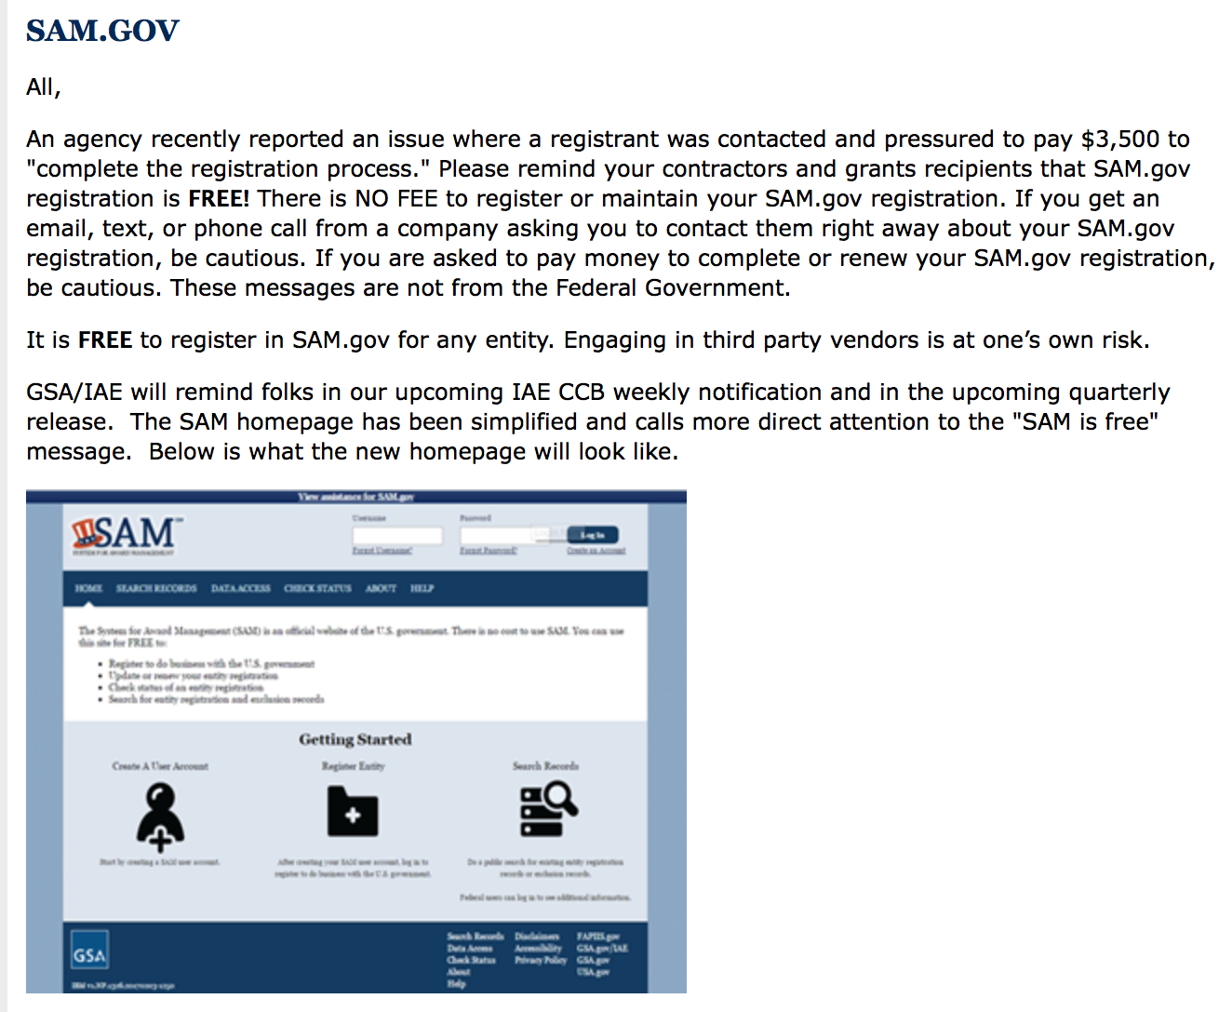

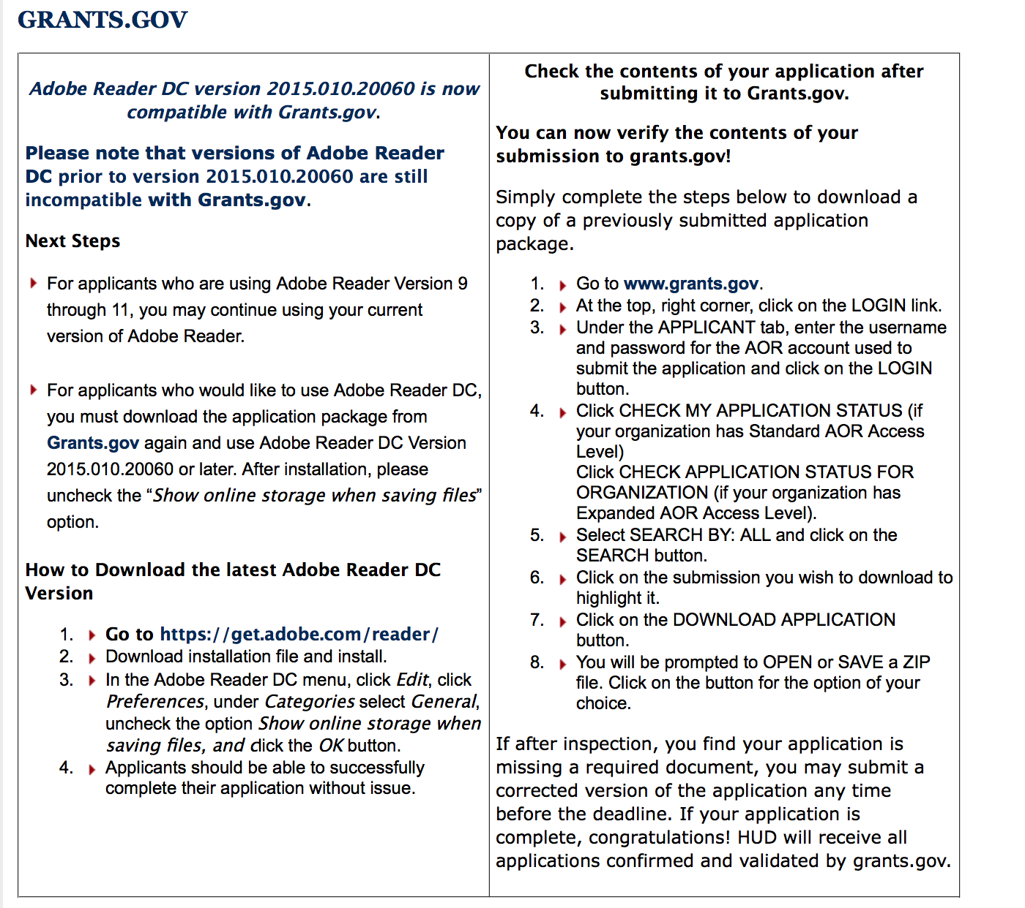

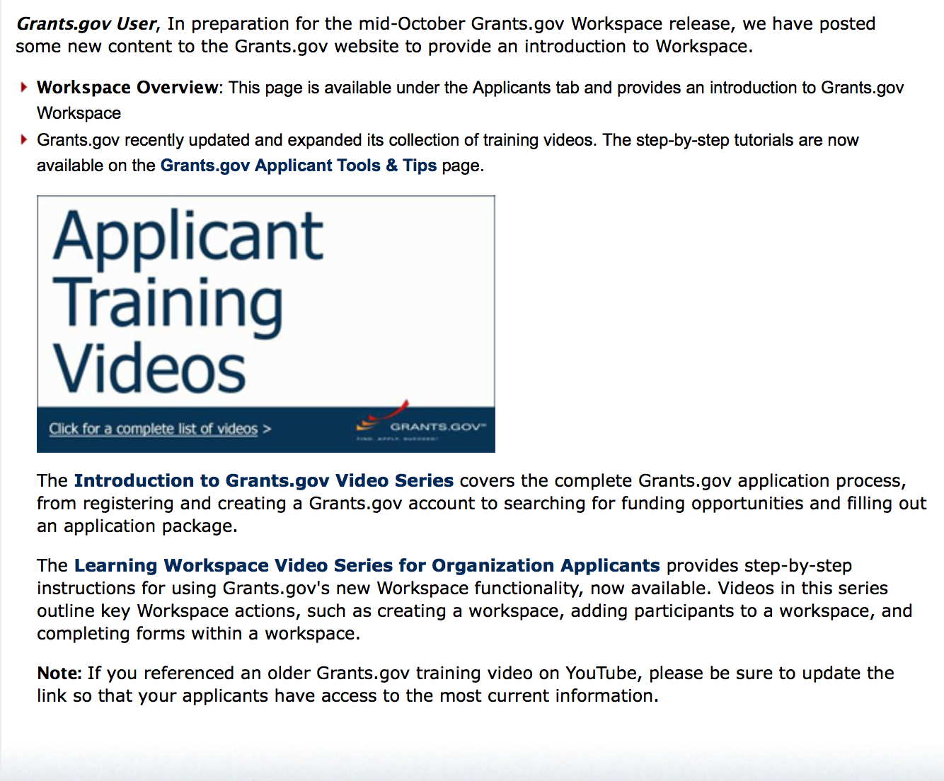
https://portal.hud.gov/hudportal/HUD?src=/program_offices/administration/grants/fundsavail

The Small Business Innovative Research Program - SBIR Program

The Small Business Innovation Research (SBIR) program is a highly competitive program that encourages domestic small businesses to engage in Federal Research/Research and Development (R/R&D) that has the potential for commercialization. Through a competitive awards-based program, SBIR enables small businesses to explore their technological potential and provides the incentive to profit from its commercialization. By including qualified small businesses in the nation's R&D arena, high-tech innovation is stimulated, and the United States gains entrepreneurial spirit as it meets its specific research and development needs.

SBIR Mission and Program Goals
The mission of the SBIR program is to support scientific excellence and technological innovation through the investment of Federal research funds in critical American priorities to build a strong national economy.
The program’s goals are four-fold:
- Stimulate technological innovation
- Meet Federal research and development needs.
- Foster and encourage participation in innovation and entrepreneurship by socially and economically disadvantaged persons.
- Increase private-sector commercialization of innovations derived from Federal research and development funding.

SBIR-Participating Agencies
Each year, Federal agencies with extramural research and development (R&D) budgets that exceed $100 million are required to allocate 2.5 percent of their R&D budget to these programs. Currently, eleven Federal agencies participate in the program:
- Department of Agriculture
- Department of Commerce - National Institute of Standards and Technology
- Department of Commerce - National Oceanic and Atmospheric Administration
- Department of Defense
- Department of Education
- Department of Energy
- Department of Health and Human Services
- Department of Homeland Security
- Department of Transportation
- Environmental Protection Agency
- National Aeronautics and Space Administration
- National Science Foundation
Each agency administers its own individual program within guidelines established by Congress. These agencies designate R&D topics in their solicitations and accept proposals from small businesses. Awards are made on a competitive basis after proposal evaluation.

Three-Phase Program
The SBIR Program is structured in three phases:
Phase I. The objective of Phase I is to establish the technical merit, feasibility, and commercial potential of the proposed R/R&D efforts and to determine the quality of performance of the small business awardee organization prior to providing further Federal support in Phase II. SBIR Phase I awards normally do not exceed $150,000 total costs for 6 months.
Phase II. The objective of Phase II is to continue the R/R&D efforts initiated in Phase I. Funding is based on the results achieved in Phase I and the scientific and technical merit and commercial potential of the project proposed in Phase II. Only Phase I awardees are eligible for a Phase II award. SBIR Phase II awards normally do not exceed $1,000,000 total costs for 2 years.
Phase III. The objective of Phase III, where appropriate, is for the small business to pursue commercialization objectives resulting from the Phase I/II R/R&D activities. The SBIR program does not fund Phase III. Some Federal agencies, Phase III may involve follow-on non-SBIR funded R&D or production contracts for products, processes or services intended for use by the U.S. Government
SBIR NewsLetter

- SBIR Newsletter
Sign up for e-mail updates

Please review each department’s General Grant and Funding Overview. These overviews are the key web pages on each departmental website dedicated to the agency’s funding opportunities. Check back often to note the department updates and use these sources to assist you in your planning.

Federal Grant and Cooperative Agreement Program Summaries

U.S. Department of Agriculture

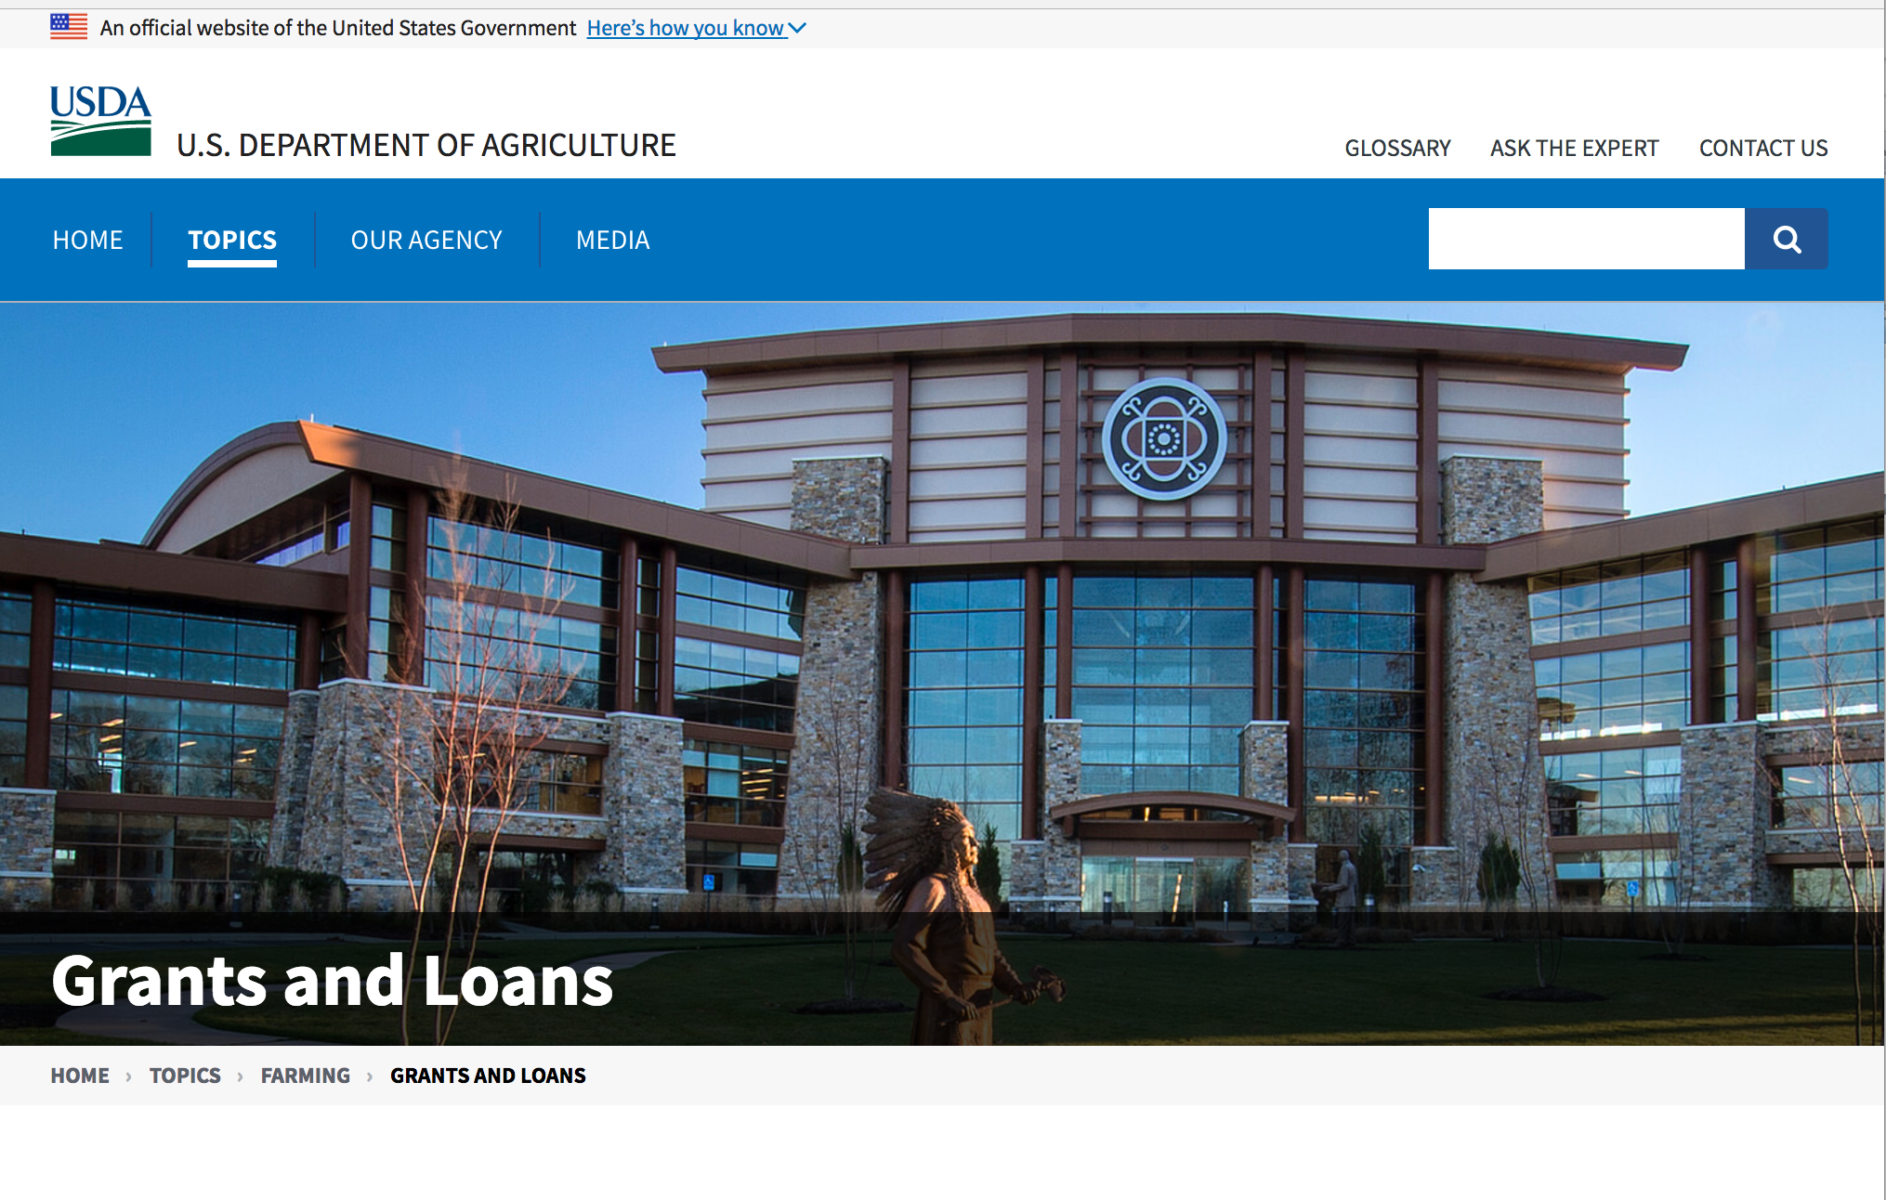

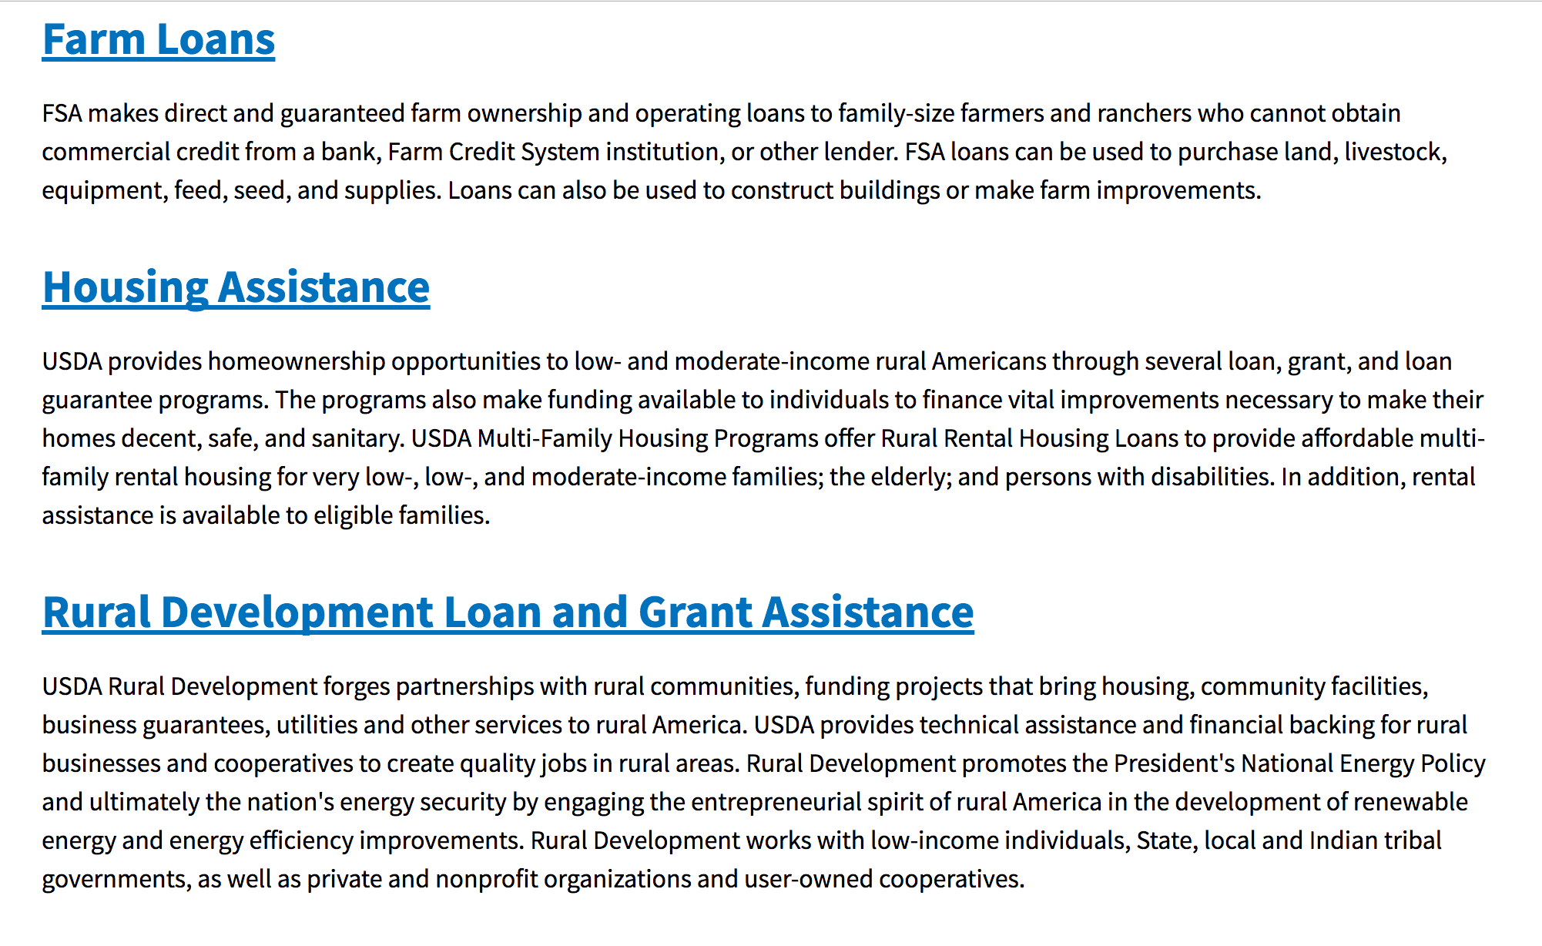

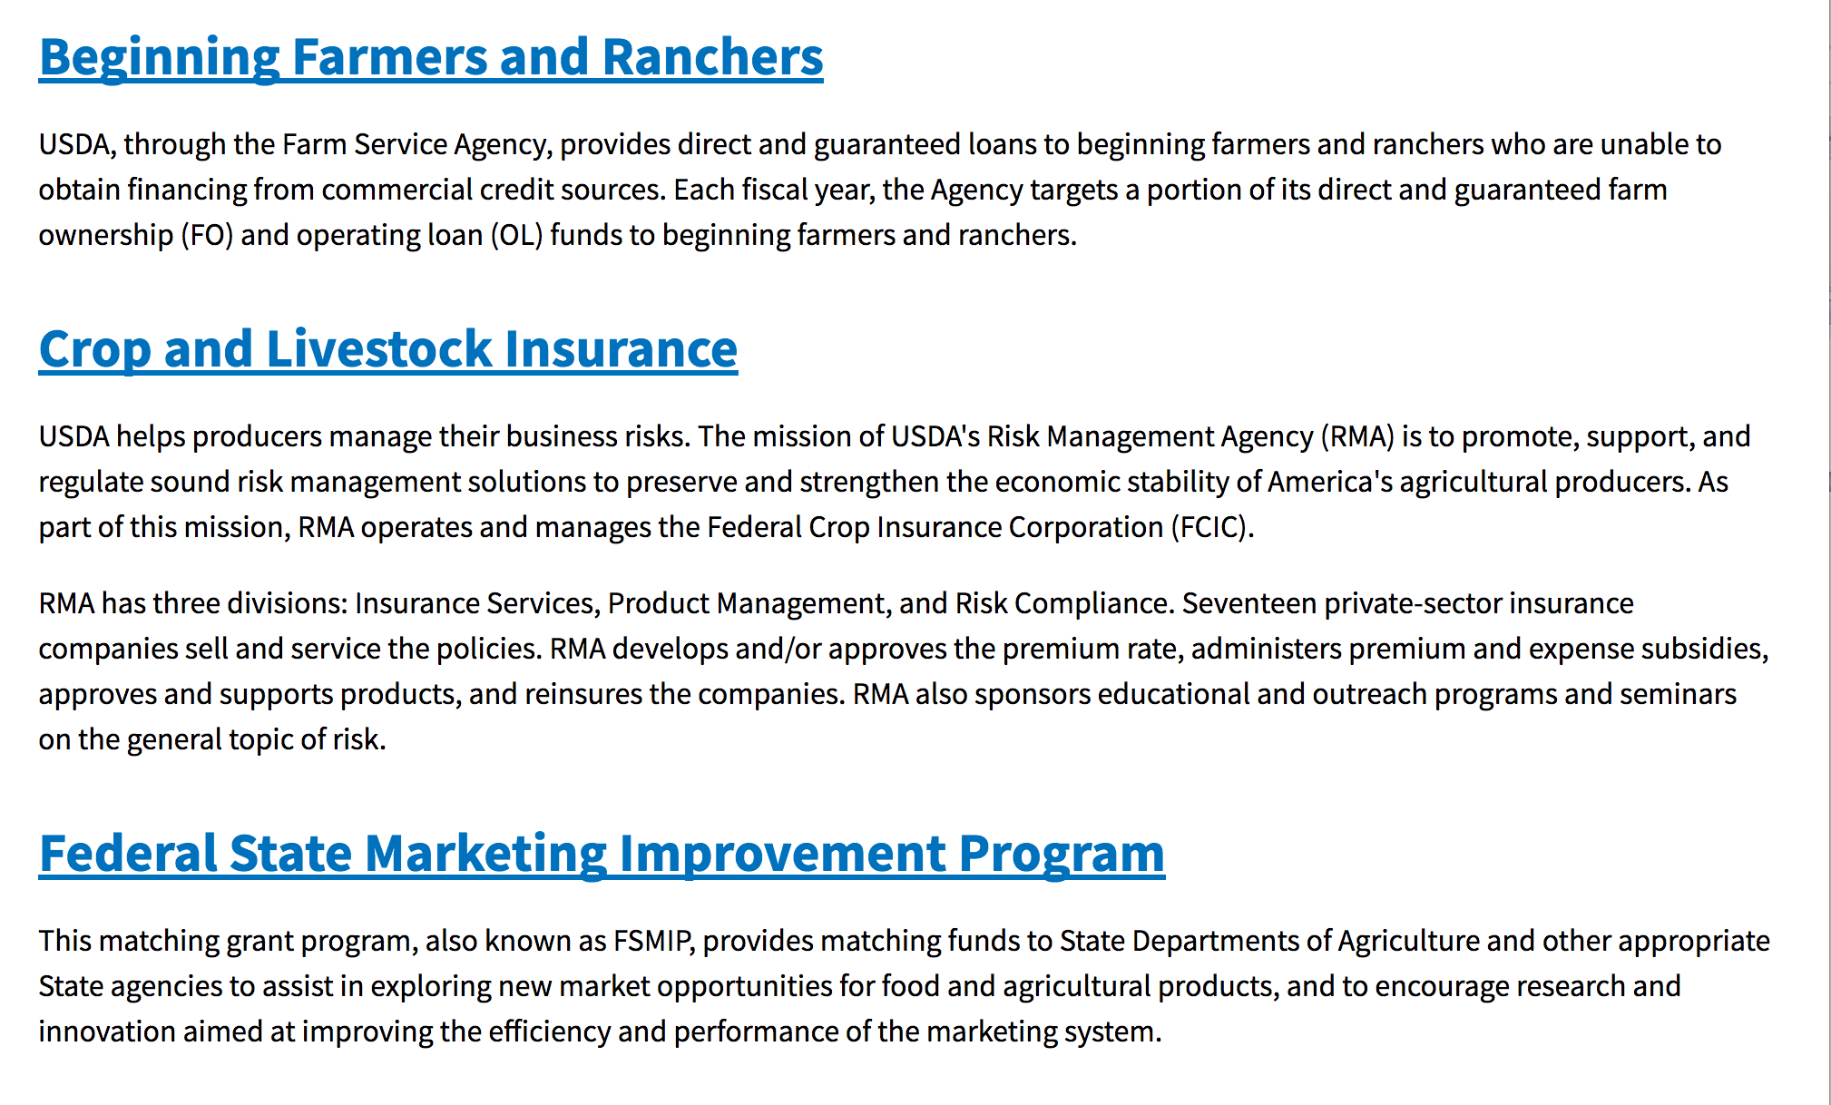
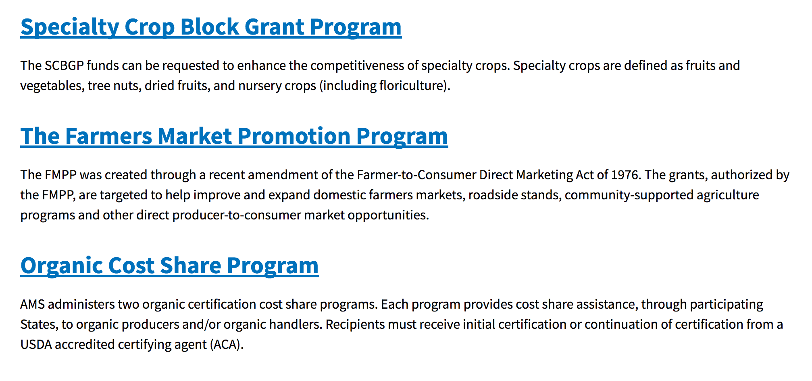
https://www.usda.gov/topics/farming/grants-and-loans

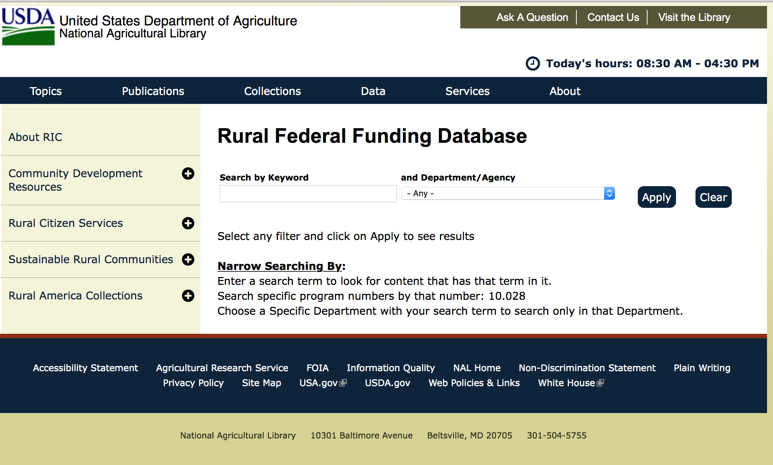

https://www.nal.usda.gov/ric/rural-federal-funding-database

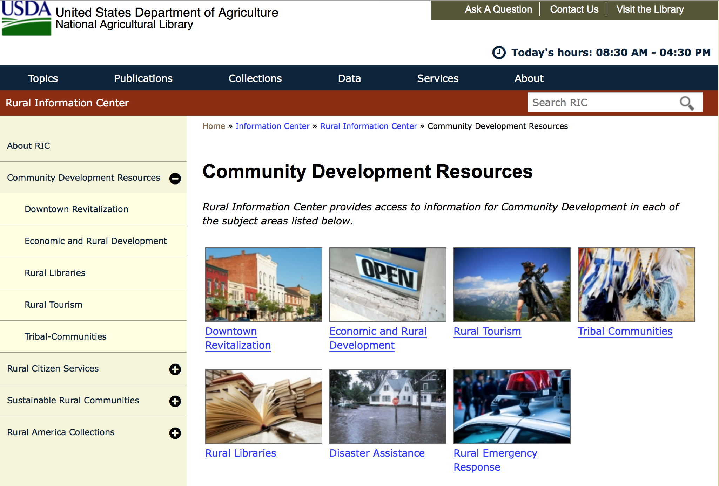

https://www.nal.usda.gov/ric/community-development-resources

Programs:

Research:

Modifications:

Reminders:

Business and Cooperative Programs
Rural Cooperative Development Grant
Synopsis 1
Document Type: Grants Notice  Funding Opportunity Number: RDBCP-RCDG-2018  Funding Opportunity Title: Rural Cooperative Development Grant  Opportunity Category: Discretionary  Opportunity Category Explanation:  Funding Instrument Type: Grant  Category of Funding Activity: Business and Commerce  Category Explanation:  Expected Number of Awards: 29  CFDA Number(s): 10.771 -- Rural Cooperative Development Grants  Cost Sharing or Matching Requirement: Yes | Version: Synopsis 1  Posted Date: May 30, 2018  Last Updated Date: May 30, 2018  Original Closing Date for Applications: Jul 24, 2018  Current Closing Date for Applications: Jul 24, 2018  Archive Date: Aug 23, 2018  Estimated Total Program Funding: $5,800,000  Award Ceiling: $200,000  Award Floor: $0
Eligibility
Eligible Applicants: | Nonprofits having a 501(c)(3) status with the IRS, other than institutions of higher education  Public and State controlled institutions of higher education  Private institutions of higher education
Additional Information on Eligibility:
Additional Information
Agency Name: | Business and Cooperative Programs
Description: | The primary objective of the RCDG program is to improve the economic condition of rural areas by assisting individuals or entities in the startup, expansion or operational improvement of rural cooperatives and other business entities. Grants are awarded competitively on an annual basis to Rural Cooperative Development Centers who in turn provide technical assistance to individuals and entities.
Link to Additional Information: | RCDG Program Website
Grantor Contact Information: | If you have difficulty accessing the full announcement electronically, please contact:  For further information, please contact your State Office.  CP Grants Division
https://www.grants.gov/web/grants/view-opportunity.html?oppId=305739

National Institute of Food and Agriculture
Agriculture and Food Research Initiative - Foundational and Applied Science
Synopsis 1
Document Type: | Grants Notice
Funding Opportunity Number: | USDA-NIFA-AFRI-006609
Funding Opportunity Title: | Agriculture and Food Research Initiative - Foundational and Applied Science
Opportunity Category: | Discretionary
Opportunity Category Explanation:
Funding Instrument Type: | Grant
Category of Funding Activity: | Agriculture
Category Explanation:
Expected Number of Awards:
CFDA Number(s): | 10.310 -- Agriculture and Food Research Initiative (AFRI)
Cost Sharing or Matching Requirement: | Yes
Current Closing Date for Applications: | Sep 30, 2019 DATES FOR LETTERS OF INTENT AND APPLICATIONS: The Program Area Descriptions section in Part I, C., identifies the applicability of a Letter of Intent (LOI) and, if applicable, the deadline date for its submission (a LOI is not required for conference grants). In these instances, it must be received by 5:00 p.m. Eastern Time on the deadline date. Applications must be received by 5:00 p.m. Eastern Time on the deadline date indicated in the Program Area Descriptions section in Part I, C. Applications received after this deadline will normally not be considered for funding (see Part IV, C).
Archive Date: | Oct 30, 2019
Estimated Total Program Funding: | $182,000,000
Award Ceiling: | $1,000,000
Award Floor:
Eligible Applicants: | Others (see text field entitled "Additional Information on Eligibility" for clarification)
Additional Information on Eligibility: | 1862 Land-Grant Institutions, 1890 Land-Grant Institutions, 1994 Land-Grant Institutions, For-profit Organizations Other Than Small Businesses, Hispanic-Serving Institutions, Individuals, Native American Tribal Orgs, not Federally recognized Tribal Governments, Nonprofits with 501(c)(3) IRS status, other than Institutions of Higher Ed, Nonprofits without 501(c)(3) IRS status, other than Institutions of Higher Ed, Other or Additional Information (See below), Private Institutions of Higher Ed, Small Business, State Agricultural Experiment Stations, State Controlled Institutions of Higher Ed The list above is abbreviated. Others may be eligible to apply. Eligibility may differ based on project types. See Program Area Priorities in the current Foundational and Applied Science RFA for the requested project types. Please refer to Part III, A of the current Foundational and Applied Science Program RFA for eligibility requirements. Note that restrictions apply to integrated projects applicants. Applications from ineligible institutions will not be reviewed.
Additional Information
Agency Name: | National Institute of Food and Agriculture
Description: | The AFRI Foundational and Applied Science Program supports grants in the six AFRI priority areas to advance knowledge in both fundamental and applied sciences important to agriculture. The six priority areas are: Plant Health and Production and Plant Products; Animal Health and Production and Animal Products; Food Safety, Nutrition, and Health; Bioenergy, Natural Resources, and Environment; Agriculture Systems and Technology; and Agriculture Economics and Rural Communities. Research-only, extension-only, and integrated research, education and/or extension projects are solicited in this Request for Applications (RFA). See Foundational and Applied Science RFA for specific details.
Link to Additional Information: | Agriculture and Food Research Initiative - Foundational Program
Grantor Contact Information: | If you have difficulty accessing the full announcement electronically, please contact:  NIFA Help Desk Phone: 202-401-5048 Business hours are M-F, 7:00 am -5:00 pm ET, excluding Federal holidays  If you have any questions related to preparing application content
https://www.grants.gov/web/grants/view-opportunity.html?oppId=305681

Risk Management Education
Crop Insurance Education in Targeted States
Synopsis 1
Document Type: Grants Notice  Funding Opportunity Number: USDA-TS-RMED-2018  Funding Opportunity Title: Crop Insurance Education in Targeted States  Opportunity Category: Discretionary  Opportunity Category Explanation:  Funding Instrument Type: Cooperative Agreement  Category of Funding Activity: Education  Category Explanation:  Expected Number of Awards: 50  CFDA Number(s): 10.458 -- Crop Insurance Education in Targeted States  Cost Sharing or Matching Requirement: No | Version: Synopsis 1  Posted Date: May 29, 2018  Last Updated Date: May 27, 2018  Original Closing Date for Applications: Jul 30, 2018  Current Closing Date for Applications: Jul 30, 2018  Archive Date: Aug 29, 2018  Estimated Total Program Funding: $4,730,000  Award Ceiling: $580,000  Award Floor: $0
Eligibility
Eligible Applicants: | Unrestricted (i.e., open to any type of entity above), subject to any clarification in text field entitled "Additional Information on Eligibility"
Additional Information on Eligibility: | ALL APPLICANTS MUST SUBMIT THEIR APPLICATION THROUGH THE RESULTS VERIFICATION SYSTEM (RVS). WE RECOMMEND ALL APPLICANTS USE THE MOST CURRENT VERSION OF THE REQUIRED DOCUMENTS THAT CAN ALSO BE FOUND ON THE RVS. ANY APPLICATION SUBMITTED THROUGH GRANTS.GOV WILL NOT BE ACCEPTED. The link to the Results Verification System is https://rvs.umn.edu/HOME.aspx
Additional Information
Agency Name: | Risk Management Education
Description: | The purpose of the Targeted States program is to deliver crop insurance education and information to U.S. agricultural producers in States where there is traditionally, and continues to be a low level of Federal crop insurance participation and availability, and producers are underserved by the Federal crop insurance program. These states, defined as Targeted States for the purpose of this RFA are Alaska, Connecticut, Delaware, Hawaii, Maine, Maryland, Massachusetts, Nevada, New Hampshire, New Jersey, New York, Pennsylvania, Rhode Island, Utah, Vermont, West Virginia, and Wyoming.
Link to Additional Information: | Results Verification System
Grantor Contact Information: | If you have difficulty accessing the full announcement electronically, please contact:  Risk Management Education Division  Risk Management Education Division
https://www.grants.gov/web/grants/view-opportunity.html?oppId=305633

Risk Management Education
Risk Management Education Partnership Program
Synopsis 1

Document Type: Grants Notice  Funding Opportunity Number: USDA-PP-RMED-2018  Funding Opportunity Title: Risk Management Education Partnership Program  Opportunity Category: Discretionary  Opportunity Category Explanation:  Funding Instrument Type: Cooperative Agreement  Category of Funding Activity: Education  Category Explanation:  Expected Number of Awards: 200  CFDA Number(s): 10.460 -- Risk Management Education Partnerships  Cost Sharing or Matching Requirement: No | Version: Synopsis 1  Posted Date: May 29, 2018  Last Updated Date: May 27, 2018  Original Closing Date for Applications: Jul 30, 2018  Current Closing Date for Applications: Jul 30, 2018  Archive Date: Aug 29, 2018  Estimated Total Program Funding: $4,160,000  Award Ceiling: $4,160,000  Award Floor: $0
Eligibility
Eligible Applicants: | Unrestricted (i.e., open to any type of entity above), subject to any clarification in text field entitled "Additional Information on Eligibility"
Additional Information on Eligibility: | ALL APPLICANTS MUST SUBMIT THEIR APPLICATION THROUGH THE RESULTS VERIFICATION SYSTEM (RVS). WE RECOMMEND ALL APPLICANTS USE THE MOST CURRENT VERSION OF THE REQUIRED DOCUMENTS THAT CAN ALSO BE FOUND ON THE RVS. ANY APPLICATION SUBMITTED THROUGH GRANTS.GOV WILL NOT BE ACCEPTED. The link to the Results Verification System is https://rvs.umn.edu/HOME.aspx
Additional Information
Agency Name: | Risk Management Education
Description: | The purpose of this cooperative agreement program is to deliver crop insurance education and risk management training to U.S. agricultural producers to assist them in identifying and managing production, marketing, legal, financial, and human risk.
Link to Additional Information: | Results Verification System
Grantor Contact Information: | If you have difficulty accessing the full announcement electronically, please contact:  Risk Management Education Division  Risk Management Education Division
https://www.grants.gov/web/grants/view-opportunity.html?oppId=305653

Deleted:

Department of Commerce

Grants, Contracting, and Trade Opportunities at Commerce
Learn more information about grants, contracting and trade opportunities at the Department of Commerce using the information below.
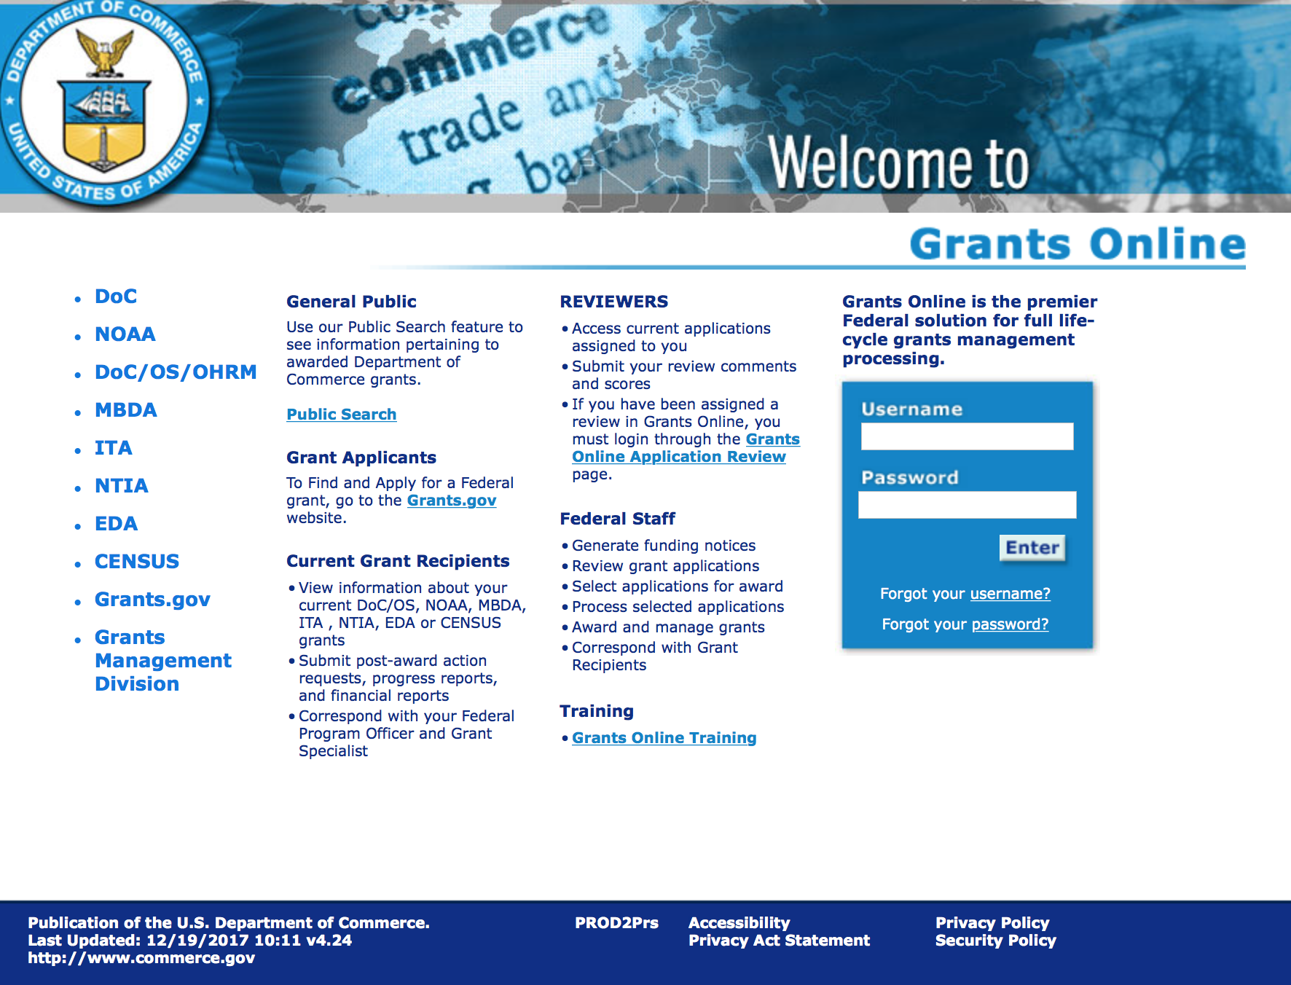
https://grantsonline.rdc.noaa.gov/flows/home/Login/LoginController.jpf

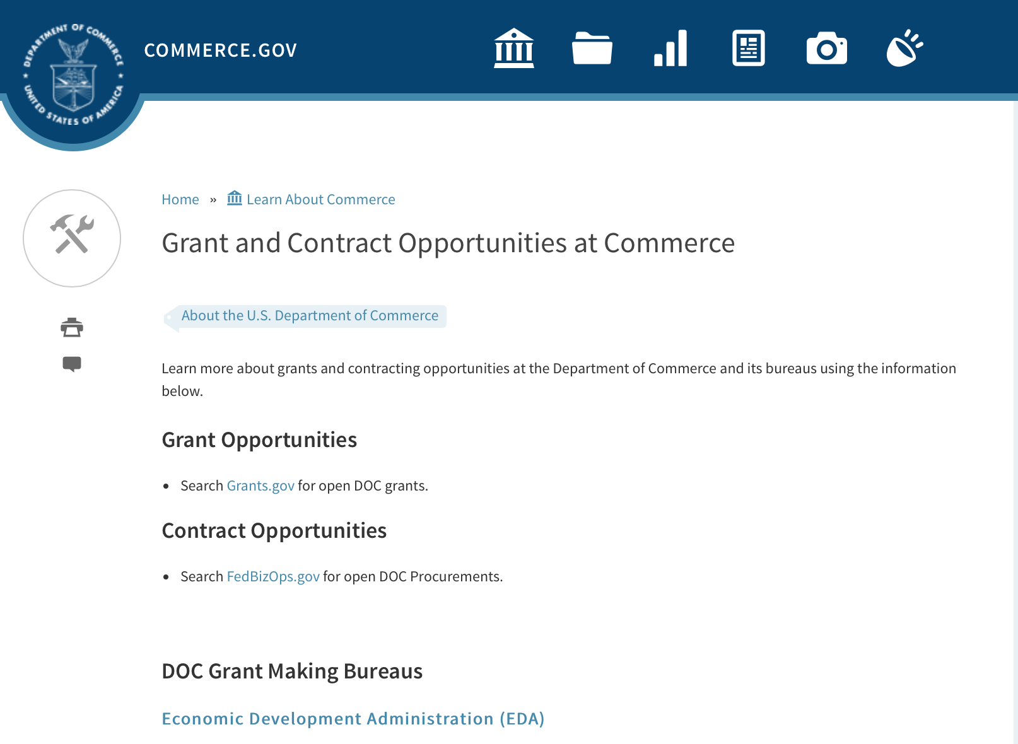
Grant and Contract Opportunities Department of Commerce

DOC Grant Making Bureaus
Economic Development Administration (EDA)
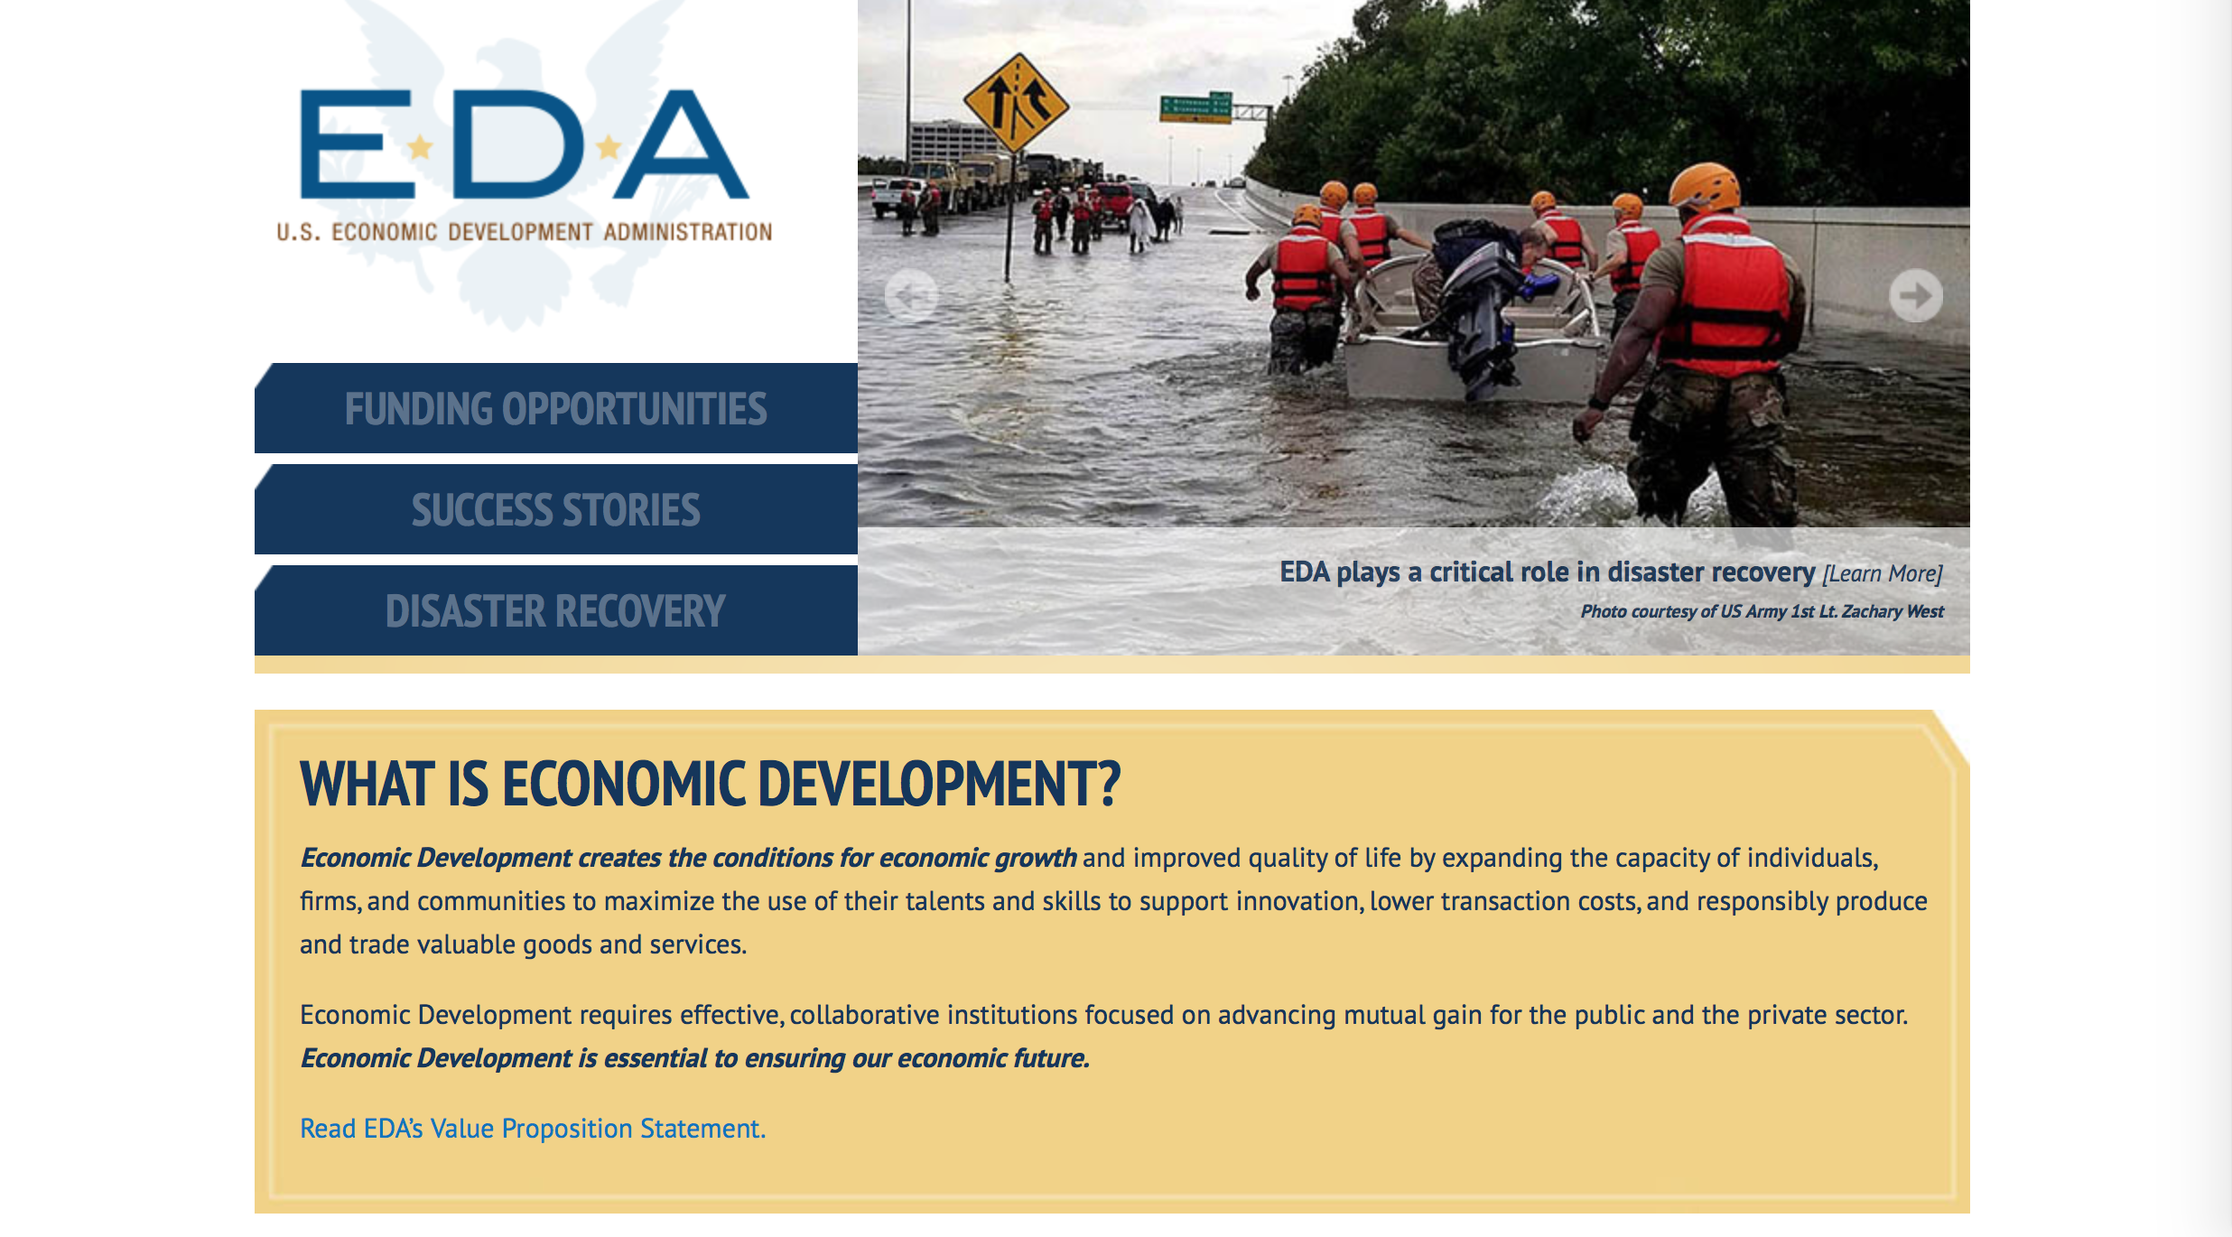
International Trade Administration (ITA)
- Market Development Cooperator Program
- Special American Business Internship Training Program (SABIT). A technical assistance initiative of the International Trade Administration of the U.S. Department of Commerce, SABIT offers organizations competitive grants and an opportunity to host industry-specific delegations. SABIT serves as an initial entry point for U.S. businesses seeking funding to establish long-term relationships with potential customers, distributors, or partners in the former Soviet Union. The program trains Eurasian managers and scientists in commonly accepted business practices as a means of facilitating cross border relationships. In turn, these personal relationships serve as a basis for business development and reduce market access barriers for U.S. businesses
National Institute of Standards & Technology (NIST)
- Funding Opportunities
National Telecommunications & Information Administration (NTIA)
- Telecommunications Grants
National Oceanic & Atmospheric Administration (NOAA)
- Coastal Ocean Program Grant Information
- Fisheries Saltonstall Kennedy Grant Program
- National Undersea Research Program Funding Opportunities
- Grants Management Division
- Fisheries Grants Program
- National Sea Grant
- Office of Global Programs
Contracting Resources for Contractors
- Office of Small and Disadvantaged Business Utilization (OSDBU) - he Office of Small and Disadvantaged Business Utilization (OSDBU) is an advocacy and advisory office responsible for promoting the use of small, small disadvantaged, 8(a), women-owned, veteran-owned, service-disabled veteran-owned, and HUBZone small businesses within the U.S. Department of Commerce's (DOC) acquisition process.
- Business.USA.gov's Find Opportunities Wizard where in a few quick steps, it will guide you towards federal government contracting programs and opportunities for your business!
- Planned Acquisitions: the Department of Commerce's search tool for our planned acquisitions over $100,000. As requirements change, these acquisition plans are updated by department personnel and this search tool is automatically updated.
- Small Business Administration's Contracting section of their web site where you can learn about how to "Get Started" and "Contracting Support for Small Business"
- The General Services Administration (GSA) has implemented a system for vendors doing business with the Federal Government to manage their entity information in one central location. This new database is the System for Award Management (SAM).

DOC Contracting Offices
- Patent and Trademark Office (PTO)
  - Office of Procurement
- National Institute of Standards & Technology (NIST)
NIST Acquisition Management Group
Contracting Opportunities with Commerce
Trade Opportunities through Commerce
http://www.commerce.gov/about-commerce/grants-contracting-trade-opportunities

Programs:

Ocean Exploration Fiscal Year 2019 Funding Opportunity
Synopsis 1
Document Type: Grants Notice  Funding Opportunity Number: NOAA-OAR-OER-2019-2005679  Funding Opportunity Title: Ocean Exploration Fiscal Year 2019 Funding Opportunity  Opportunity Category: Discretionary  Opportunity Category Explanation:  Funding Instrument Type: Cooperative Agreement Grant  Category of Funding Activity: Environment Natural Resources Science and Technology and other Research and Development  Category Explanation:  Expected Number of Awards: 6  CFDA Number(s): 11.011 -- Ocean Exploration  Cost Sharing or Matching Requirement: No | Version: Synopsis 1  Posted Date: Jun 19, 2018  Last Updated Date: Jun 19, 2018  Original Closing Date for Applications: Nov 15, 2018  Current Closing Date for Applications: Nov 15, 2018  Archive Date: Dec 15, 2018  Estimated Total Program Funding: $3,000,000  Award Ceiling: $750,000  Award Floor: $10,000
Eligibility
Eligible Applicants: | Others (see text field entitled "Additional Information on Eligibility" for clarification)
Additional Information on Eligibility: | Eligible applicants are U.S.-based institutions of higher education; non-profit institutions; state, local, and tribal governments; Federal agencies; for-profit organizations; and U.S. territories that possess the statutory authority to accept funding for this type of work. PLEASE NOTE: Before non-NOAA federal applicants may be funded, they must demonstrate that they have legal authority to receive funds from another federal agency in excess of their appropriation. NOAA and other Federal agencies that possess the statutory authority to accept funding for this type of work must agree to take FY 2019 funding for proposed projects and allocate them in FY2019. Federal and state agencies are strongly encouraged to collaborate with partners from a non- federal eligible entity. Foreign researchers may participate by submitting a sub-award through collaboration with an eligible U.S. entity. The DOC and NOAA support cultural and gender diversity and encourage women and minority individuals and groups to submit applications to this Announcement of Notice of Funding Opportunity (NOFO). In addition, DOC/NOAA is strongly committed to broadening the participation of historically black colleges and universities, Hispanic serving institutions, tribal colleges and universities, and institutions that work in underserved areas. DOC/NOAA encourages applications involving any of the above institutions to apply.
Additional Information
Agency Name: | Department of Commerce
Description: | NOAA’s Office of Ocean Exploration & Research (OER) is soliciting proposals for ocean exploration in waters under U.S. jurisdiction, including the U.S. Exclusive Economic Zone (EEZ), and areas mapped by, or of interest to, the U.S. Extended Continental Shelf (ECS) Project. Presently, important marine habitats and living and non-living resources are neither fully explored nor characterized. OER's intent is to address these knowledge gaps and support growth in the Nation's Blue Economy by soliciting ocean exploration proposals that focus on:  1. Discovering microorganisms, sponges, corals, and other organisms with biopharmaceutical or biotechnical potential;  2. Acquiring baseline ocean environmental information to better inform decision-making where future ocean energy development or critical mineral extraction may occur;  3. Finding and characterizing shipwrecks and submerged cultural resources that played a role in America’s past ocean-based economy (e.g., transport, trade, warfare, etc.) and could inform decisions on future seabed activities and potential environmental impacts.  OER seeks to enhance ocean exploration and scientific knowledge of unknown or poorly known areas of the ocean through interdisciplinary exploration, and to advance and disseminate knowledge of the ocean’s physical, geological, chemical, biological, and archaeological environments. This entails identifying, describing and creating baseline characterizations of new ocean habitats, marine resources and/or processes. OER’s mission is compliant with NOAA’s Next Generation Strategic Plan (http://www.performance.noaa.gov/ngsp/) which outlines NOAA goals of Science, Service and Stewardship.  Applicants are required to submit pre-proposals and, ultimately, full proposals that support OER’s exploration mission.  Note: Ship time on the NOAA Ship Okeanos Explorer will not be funded through this announcement.  Informational documents on this funding opportunity are accessible through the OER Website: https://oceanexplorer.noaa.gov/about/funding-opps/welcome.html.  For the purpose of this opportunity, ship time costs and/or other ocean data collection platform support (remotely operated vehicles, autonomous underwater vehicles, etc.) are considered rental costs and therefore are not included in Modified Total Direct Cost (MTDC).
Link to Additional Information:
Grantor Contact Information: | If you have difficulty accessing the full announcement electronically, please contact:  For further information, contact the NOAA Office of Ocean Exploration and Research at (301)734-1014 or oer.ffo2019@noaa.gov. Email inquiries should include the Principal Investigator's name in the subject heading. Inquiries can also be mailed to: NOAA Office of Ocean Exploration and Research, ATTN: OER NOFO 2019, SSMC3, Rm 10316, 1315 East West Highway, Silver Spring, Maryland 20910.  OER Work email
https://www.grants.gov/web/grants/view-opportunity.html?oppId=306381

Research and National Technical Assistance FY18-FY20
Synopsis 1
Document Type: Grants Notice  Funding Opportunity Number: EDA-HDQ-RNTA-2018-2005669  Funding Opportunity Title: Economic Development Research and National Technical Assistance FY18-FY20  Opportunity Category: Discretionary  Opportunity Category Explanation:  Funding Instrument Type: Cooperative Agreement Grant  Category of Funding Activity: Other (see text field entitled "Explanation of Other Category of Funding Activity" for clarification)  Category Explanation: EDA provides strategic investments on a competitive merit basis to support economic development, foster job creation, and attract private investment in economically distressed areas of the United States. Under this NOFO, EDA solicits applications from applicants in order to provide investments that support research and technical assistance projects under EDA’s R&E and NTA programs. Grants and cooperative agreements made under these programs are designed to leverage existing regional assets and support the implementation of economic development strategies that advance new ideas and creative approaches to advance economic prosperity in distressed communities. EDA reserves the right to determine if an award will be structured as a grant or a cooperative agreement. EDA may make changes or additions to this NOFO. All changes will be communicated on Grants.gov.  Expected Number of Awards: 15  CFDA Number(s): 11.303 -- Economic Development Technical Assistance 11.312 -- Research and Evaluation Program  Cost Sharing or Matching Requirement: No | Version: Synopsis 2  Posted Date: May 31, 2018  Last Updated Date: Jun 06, 2018  Original Closing Date for Applications: Sep 30, 2020  Current Closing Date for Applications: Sep 30, 2020  Archive Date: Oct 30, 2020  Estimated Total Program Funding: $3,000,000  Award Ceiling: $1,500,000  Award Floor: $1
Eligibility
Eligible Applicants: | Others (see text field entitled "Additional Information on Eligibility" for clarification)
Additional Information on Eligibility: | Pursuant to Section 3(4) of PWEDA (42 U.S.C. § 3122(4)) and 13 C.F.R. § 300.3 (Eligible Recipient), eligible applicants for and recipients of EDA RNTA investment assistance include: a District Organization; an Indian Tribe or a consortium of Indian Tribes; a State; a city or other political subdivision of a State, including a special purpose unit of a State or local government engaged in economic or infrastructure development activities, or a consortium of political subdivisions; an institution of higher education or a consortium of institutions of higher education; a public or private non-profit organization or association acting in cooperation with officials of a political subdivision of a State; private individual; or a for-profit organization.
Additional Information
Agency Name: | Department of Commerce
Description: | Federal Agency Name: Economic Development Administration (EDA or the Agency), U.S. Department of Commerce (DOC).  Federal Funding Opportunity Title: FY 2018-2020 Research and Evaluation (R&E) and National Technical Assistance (NTA) programs, jointly known as RNTA.  Announcement Type and Date: FY 2018-2020 Notice of Funding Opportunity (NOFO) announcement publishing EDA’s application submission requirements and review procedures for applications received under EDA’s R&E and NTA programs, authorized under the Public Works and Economic Development Act of 1965, as amended (42 U.S.C. § 3121 et seq.) (PWEDA). Effective date: 5/31/2018.
Link to Additional Information: | Program Description
Grantor Contact Information: | If you have difficulty accessing the full announcement electronically, please contact:  RNTA Program rnta@eda.gov  RNTA Program Email
https://www.grants.gov/web/grants/view-opportunity.html?oppId=305782

FY19 Saltonstall-Kennedy Competition
Synopsis 1

Document Type: Grants Notice  Funding Opportunity Number: NOAA-NMFS-FHQ-2019-2005591  Funding Opportunity Title: FY19 Saltonstall-Kennedy Competition  Opportunity Category: Discretionary  Opportunity Category Explanation:  Funding Instrument Type: Cooperative Agreement Grant  Category of Funding Activity: Environment Natural Resources Science and Technology and other Research and Development  Category Explanation:  Expected Number of Awards: 50  CFDA Number(s): 11.427 -- Fisheries Development and Utilization Research and Development Grants and Cooperative Agreements Program  Cost Sharing or Matching Requirement: No | Version: Synopsis 2  Posted Date: May 24, 2018  Last Updated Date: May 30, 2018  Original Closing Date for Applications: Jul 23, 2018  Current Closing Date for Applications: Jul 23, 2018  Archive Date: Aug 22, 2018  Estimated Total Program Funding: $10,000,000  Award Ceiling: $300,000  Award Floor: $25,000
Eligibility
Eligible Applicants: | Others (see text field entitled "Additional Information on Eligibility" for clarification)
Additional Information on Eligibility: | You are eligible to apply for a grant or a cooperative agreement under the Saltonstall-Kennedy Grant Program if:1. You are a citizen or national of the United States;2. You represent an entity that is a corporation, partnership, association, or other non-Federal entity, non-profit or otherwise (including Indian tribes), if such entity is a citizen of the United States within the meaning of section 2 of the Shipping Act, 1916, as amended (46 U.S.C. app. 802); or3. You are a citizen of the Republic of the Marshall Islands, Republic of Palau, or the Federated States of Micronesia. We recognize the interest of the Secretaries of Commerce and Interior in defining appropriate fisheries policies and programs that meet the needs of the U.S. insular areas, so we encourage applications from individuals, government entities, and businesses in U.S. insular areas. We support cultural and gender diversity in our programs and encourage women and minority individuals and groups to submit applications. We are also committed to broadening the participation of Minority Serving Institutions (MSIs), which include Historically Black Colleges and Universities, Hispanic Serving Institutions, and Tribal Colleges and Universities, in our grant programs. To find out more about MSIs go to http://www2.ed.gov/about/offices/list/ocr/edlite-minorityinst.html. We encourage applications from members of the fishing community and applications that involve fishing community cooperation and participation. We will consider the extent of fishing community involvement when evaluating the potential benefit of funding a proposal. Eligible Applicants must submit a pre-proposal that meets the submission requirements listed in this NOFO by the established due date. Full proposals will not be reviewed or evaluated if a pre-proposal was not received on time and ranked. Non Eligible Applicants You are not eligible to submit an application under this program if you are an employee of any Federal agency; a Regional Fishery Management Council (Council); or an employee of a Council. However, Council members who are not Federal employees can submit an application to the S-K Program.
Additional Information
Agency Name: | Department of Commerce
Description: | The Saltonstall-Kennedy Act established a fund (known as the S-K fund) used by the Secretary of Commerce to provide grants or cooperative agreements for fisheries research and development projects addressing aspects of U.S. fisheries, including, but not limited to, harvesting, processing, marketing, and associated business infrastructures. Under this authority, grants and cooperative agreements are made on a competitive basis (subject to availability of funding) to assist in carrying out projects related to U.S. commercial and recreational fisheries. The term “fisheries” encompasses wild capture, marine aquaculture and recreational fishing. The objective of the S-K Grant Program is to address the needs of the fisheries and fishing communities in optimizing economic benefits by building and maintaining sustainable fisheries and practices, dealing with the impacts of conservation and management measures, and increasing other opportunities to use existing infrastructure to support keeping working waterfronts viable. U.S. fisheries include any fishery, commercial or recreational, that is, or may be, engaged in by citizens or nationals of the United States. Proposals submitted to this competition must address at least one of the following priorities: Promotion, Development and Marketing; Marine Aquaculture; Support of Science that Ensures the Long-Term Sustainability of Marine Resources While Maximizing Fishing Opportunities, Revenue and Jobs in U.S. Fisheries. This Notice of Funding Opportunity (NOFO) includes information on application and criteria for research proposals requesting a maximum of $300,000 in Federal funding for up to a two-year period. Matching funds are not required, nor will they be considered during the evaluation process. Awards are anticipated to start no earlier than September 1, 2019.  Grant awards are dependent on the availability of Federal funding as provided in enacted Appropriations Acts. This NOFO is being released prior to final appropriations due to award process time frames. While the FY 2019 President's budget proposed $0 for this program, final Congressional direction has not been determined.
Link to Additional Information:
Grantor Contact Information: | If you have difficulty accessing the full announcement electronically, please contact:  Clifford T Cosgrove 301-427-8736 1315 East West Highway SSMC3 14321, Silver Spring, MD 20910  Work
https://www.grants.gov/web/grants/view-opportunity.html?oppId=305595

National Institute of Standards and Technology
NIST Public Safety Innovation Accelerator Program – Mission Critical Voice Quality of Experience
Synopsis 1

Document Type: Grants Notice  Funding Opportunity Number: 2018-NIST-PSIAP-MCVQOE  Funding Opportunity Title: NIST Public Safety Innovation Accelerator Program – Mission Critical Voice Quality of Experience  Opportunity Category: Discretionary  Opportunity Category Explanation:  Funding Instrument Type: Cooperative Agreement Grant  Category of Funding Activity: Science and Technology and other Research and Development  Category Explanation:  Expected Number of Awards:  CFDA Number(s): 11.609 -- Measurement and Engineering Research and Standards  Cost Sharing or Matching Requirement: No | Version: Synopsis 2  Posted Date: May 23, 2018  Last Updated Date: May 29, 2018  Original Closing Date for Applications: Aug 03, 2018  Current Closing Date for Applications: Aug 03, 2018  Archive Date: Sep 02, 2018  Estimated Total Program Funding:  Award Ceiling:  Award Floor:
Eligibility
Eligible Applicants: | Others (see text field entitled "Additional Information on Eligibility" for clarification)
Additional Information on Eligibility: | This NOFO is open to all non-Federal entities. Eligible applicants include institutions of higher education, non-profit organizations, for-profit organizations, state and local governments, Indian tribes, hospitals, foreign public entities, and foreign governments. Please note that individuals and unincorporated sole proprietors are not considered “non-Federal entities” and are not eligible to apply under this NOFO. Although Federal entities are not eligible to receive funding under this NOFO, they may participate as unfunded collaborators. NIST will only consider one application per applicant; however, an applicant entity may be proposed as a sub-recipient, contractor, or unfunded collaborator within applications submitted by other entities.
Additional Information
Agency Name: | National Institute of Standards and Technology
Description: | The NIST Public Safety Innovation Accelerator Program (PSIAP) is seeking applications from eligible applicants for activities to measure the impact of impairments to mission critical voice (MCV) systems and quantify the quality of experience (QoE) for first responders.
Link to Additional Information: | 2018-NIST-PSIAP-MCVQOE NOFO
Grantor Contact Information: | If you have difficulty accessing the full announcement electronically, please contact:  Christopher Hunton Management and Program Analyst Phone 301-975-5718  Agency Contact
https://www.grants.gov/web/grants/view-opportunity.html?oppId=305552

Modifications:

2018 MBDA Broad Agency Announcement
Synopsis 2
Document Type: | Grants Notice
Funding Opportunity Number: | MBDA-OBD-2018-2005687
Funding Opportunity Title: | 2018 MBDA Broad Agency Announcement
Opportunity Category: | Discretionary
Opportunity Category Explanation:
Funding Instrument Type: | Cooperative Agreement  Grant
Category of Funding Activity: | Environment  Natural Resources  Science and Technology and other Research and Development
Category Explanation:
Expected Number of Awards: | 27
CFDA Number(s): | 11.802 -- Minority Business Resource Development
Cost Sharing or Matching Requirement: | No
Version: | Synopsis 2
Posted Date: | Jun 11, 2018
Last Updated Date: | Jun 11, 2018
Original Closing Date for Applications: | Jul 11, 2018
Current Closing Date for Applications: | Jul 11, 2018
Archive Date: | Aug 10, 2018
Estimated Total Program Funding: | $11,650,000
Award Ceiling: | $850,000
Award Floor: | $200,000

Eligibility
Eligible Applicants: | Others (see text field entitled "Additional Information on Eligibility" for clarification)
Additional Information on Eligibility: | Eligible applicants may be for-profit entities (including but not limited to sole-proprietorships, partnerships, limited liability companies, and corporations), non-profit organizations, institutions of higher education, commercial organizations, state and local government entities, quasi-government entities, Indian Tribal governments, Tribal entities, and Native Hawaiian entities.
Additional Information
Agency Name: | Department of Commerce
Description: | The purpose of this notice is to request applications for special projects and programs associated with the Minority Business Development Agency’s (MBDA) strategic plans and mission goals, as well as to provide the general public with information and guidelines on how MBDA will select proposals and administer discretionary Federal assistance under this Broad Agency Announcement (BAA).
Link to Additional Information:
Grantor Contact Information: | If you have difficulty accessing the full announcement electronically, please contact:  Nakita Chambers MBDA Program Manager U.S. Department of Commerce 1401 Constitution Ave., N.W., Room 5079 Washington, DC 20230 Email: nchambers@mbda.gov Tel: 202-482-0065  Work

https://www.grants.gov/web/grants/view-opportunity.html?oppId=306152

NOAA RESTORE Science Program
Synopsis 2
Document Type: | Grants Notice
Funding Opportunity Number: | NOAA-NOS-NCCOS-2019-2005608
Funding Opportunity Title: | NOAA RESTORE Science Program
Opportunity Category: | Discretionary
Opportunity Category Explanation:
Funding Instrument Type: | Cooperative Agreement
Category of Funding Activity: | Environment  Natural Resources  Science and Technology and other Research and Development
Category Explanation:
Expected Number of Awards: | 6
CFDA Number(s): | 11.451 -- Gulf Coast Ecosystem Restoration Science, Observation, Monitoring, and Technology
Cost Sharing or Matching Requirement: | No
Version: | Synopsis 2
Posted Date: | Jun 05, 2018
Last Updated Date: | Jun 05, 2018
Original Closing Date for Applications: | Oct 29, 2018
Current Closing Date for Applications: | Oct 29, 2018
Archive Date: | Nov 28, 2018
Estimated Total Program Funding: | $15,000,000
Award Ceiling: | $7,500,000
Award Floor: | $500,000
Eligible Applicants: | Others (see text field entitled "Additional Information on Eligibility" for clarification)
Additional Information on Eligibility: | Eligible applicants are institutions of higher education; not-for-profit institutions; local, state, and tribal governments; for-profit organizations; and U.S. territories and federal agencies that possess the statutory authority to accept funding for this type of work. The lead applicant must be from a U.S. based entity. Applicants from federal agencies are required to have a co-investigator from at least one non-NOAA entity and it is strongly encouraged that the co-investigator(s) be from a non-federal eligible entity. Science Program funding opportunities may not be used to hire and fund the salaries of any permanent federal employees. Federal award recipients may use their funding to cover travel, equipment, supplies, and contractual personnel costs associated with the proposed work. Investigators are not required to be employed by an eligible entity that is based in one of the five Gulf of Mexico States (Florida, Alabama, Mississippi, Louisiana, and Texas). However, investigators that are not employed by or associated with Gulf of Mexico-based eligible entities are strongly encouraged to collaborate with partners from Gulf of Mexico-based eligible entities. Applicants may be investigators on no more than two (2) pre-proposals and subsequent full applications, and may only be the lead investigator on one (1) of them. Investigators, including the lead investigator, may change from a pre-proposal to the full application. Foreign researchers may participate by submitting a subaward or contract through an eligible U.S. entity. Science Program funding may not be spent in Cuba. The DOC and NOAA support cultural and gender diversity and encourage applications involving women and minority investigators, participants, and groups. In addition, the DOC and NOAA are strongly committed to broadening the participation of historically black colleges and universities, Hispanic serving institutions, tribal colleges and universities, and institutions that work in underserved areas. The DOC and NOAA encourage any of the above institutions to apply.
Additional Information
Agency Name: | Department of Commerce
Description: | The purpose of this document is to advise the public that NOAA/NOS/NCCOS is soliciting applications for the NOAA RESTORE Science Program for projects of five years in duration with the option for a five year, non-competitive renewal award for high performing projects. This funding opportunity invites applications that propose to identify, track, understand, and/or predict trends and variability in the Gulf of Mexico’s living coastal and marine resources and the processes driving them. Funding is contingent upon the availability of funds in the Gulf Coast Restoration Trust Fund. It is anticipated that final recommendations for funding under this Announcement will be made in June 2019, and that projects funded under this Announcement will have a September 1, 2019 start date. Total funding for this competition will be approximately $15 million over five years and approximately six projects may be funded. The minimum individual award amount is approximately $500,000 over five years (an average of $100,000 per year) and the maximum individual award amount is approximately $7.5 million over five years (an average of $1.5 million per year). An additional $15 million may be available for five year, non-competitive renewals for high performing projects.  Electronic Access: The NOAA RESTORE Science Program website (http://restoreactscienceprogram.noaa.gov/) furnishes supplementary information. Full applications should be submitted through Grants.gov (http://www.grants.gov).
Link to Additional Information:
Grantor Contact Information: | If you have difficulty accessing the full announcement electronically, please contact:  Technical Program Information: Frank Parker, Associate Director and federal program officer, 303-497-5698, frank.parker@noaa.gov. Grants Administration Information: Laura Golden, NCCOS Grants Administrator, 240-533-0285, laurie.golden@noaa.gov; 1305 East West Hwy, SSMC 4, Station 8219, Silver Spring, MD 20910. Data Management Information: Jessica Morgan, NCCOS Scientific Data Coordinator, 240-533-0297, nccos.data@noaa.gov. Indirect or Facilities and Administrative Costs Information: Lamar Revis, Grants Officer, NOAA Grants Management Division, 301-628-1308, lamar.revis@noaa.gov; 1325 East West Highway, 9th Floor, Silver Spring, Maryland 20910.  Work email address
https://www.grants.gov/web/grants/view-opportunity.html?oppId=305915

FY 2018 Regional Innovation Strategies Program
Synopsis 3
Document Type: | Grants Notice
Funding Opportunity Number: | EDA-HDQ-OIE-2018-2005523
Funding Opportunity Title: | FY 2018 Regional Innovation Strategies Program
Opportunity Category: | Discretionary
Opportunity Category Explanation:
Funding Instrument Type: | Grant
Category of Funding Activity: | Other (see text field entitled "Explanation of Other Category of Funding Activity" for clarification)
Category Explanation: | Economic Development, Innovation and Entrepreneurship
Expected Number of Awards:
CFDA Number(s): | 11.020 -- Cluster Grants
Cost Sharing or Matching Requirement: | Yes
Version: | Synopsis 3
Posted Date: | May 31, 2018
Last Updated Date: | May 31, 2018
Original Closing Date for Applications: | Aug 29, 2018
Current Closing Date for Applications: | Aug 29, 2018
Archive Date: | Sep 28, 2018
Estimated Total Program Funding:
Award Ceiling: | $750,000
Award Floor: | $0
Eligible Applicants: | City or township governments  Public and State controlled institutions of higher education  Special district governments  Native American tribal governments (Federally recognized)  Private institutions of higher education  State governments  County governments  Others (see text field entitled "Additional Information on Eligibility" for clarification)  Nonprofits that do not have a 501(c)(3) status with the IRS, other than institutions of higher education  Nonprofits having a 501(c)(3) status with the IRS, other than institutions of higher education
Additional Information on Eligibility: | A State; An Indian tribe; A city or other political subdivision of a State; An entity that— (a) is a nonprofit organization, an institution of higher education, a public-private partnership, a science or research park, a Federal laboratory, or an economic development organization or similar entity, and (b) has an application that is supported by a State or a political subdivision of a State; or A consortium of any of the entities described above.
Additional Information
Agency Name: | Department of Commerce
Description: | EDA is committed to fostering connected, innovation-centric economic sectors that support the conversion of research into products and services, businesses, and ultimately jobs through entrepreneurship. See Section 27. Funding is available for capacity-building programs that provide proof-of-concept and commercialization assistance to innovators and entrepreneurs and for operational support for organizations that provide essential early-stage funding to startups. Under the RIS Program, EDA is soliciting applications for two separate competitions:  - the 2018 i6 Challenge; and  - the 2018 Seed Fund Support (SFS) Grant Competition.  Applicants must provide a matching share from non-Federal sources of at least 50 percent of the total project cost; i.e., applicants must match each Federal dollar requested with at least one dollar of local match. See Section C.2 (p. 9) of this NOFO.
Link to Additional Information:
Grantor Contact Information: | If you have difficulty accessing the full announcement electronically, please contact:  If you have difficulty accessing the full announcement electronically, please contact:  oie@eda.gov
https://www.grants.gov/web/grants/view-opportunity.html?oppId=305799

Research:

Reminders:

National Sea Grant College Program 2018-19 Special Projects
Synopsis 1
Document Type: | Grants Notice
Funding Opportunity Number: | NOAA-OAR-SG-2018-2005457
Funding Opportunity Title: | National Sea Grant College Program 2018-19 Special Projects
Opportunity Category: | Discretionary
Opportunity Category Explanation:
Funding Instrument Type: | Cooperative Agreement  Grant
Category of Funding Activity: | Environment  Natural Resources  Science and Technology and other Research and Development
Category Explanation:
Expected Number of Awards:
CFDA Number(s): | 11.417 -- Sea Grant Support
Cost Sharing or Matching Requirement:

Version: | Synopsis 1
Posted Date: | Nov 15, 2017
Last Updated Date: | Nov 15, 2017
Original Closing Date for Applications: | Sep 30, 2019
Current Closing Date for Applications: | Sep 30, 2019
Archive Date: | Oct 30, 2019
Estimated Total Program Funding:
Award Ceiling: | $1
Award Floor: | $1
Eligible Applicants: | Others (see text field entitled "Additional Information on Eligibility" for clarification)
Additional Information on Eligibility: | Eligible applicants are: Sea Grant Programs (Sea Grant Colleges, Institutions, or Coherent Area Programs), the National Sea Grant Law Center, and the National Sea Grant Library. Individual competition announcements may restrict eligibility to a subset of these applicants.
Agency Name: | Department of Commerce
Description: | The purpose of this notice is to request proposals for special projects consistent with the focus areas outlined in the National Sea Grant College Program’s (Sea Grant) strategic plan, and to provide the general public with information and guidelines on how Sea Grant will select proposals and administer Federal assistance under this announcement. This announcement is a mechanism to encourage research or other projects that are not normally funded through Sea Grant national competitions. This opportunity is open only to Sea Grant Programs. Section III of this announcement describes eligibility requirements in more detail. Funding has not yet been made available to support applications submitted to this Federal Funding Opportunity (FFO), but such funding may become available during the year. Section II.A. below describes individual competition announcements that will be used to announce when funding is available, any restrictions or requirements such as cost share, and other funding details. Awards will be made under this FFO only to applications that are responsive to individual competition announcements; unsolicited applications will not be reviewed.
Link to Additional Information:
Grantor Contact Information: | If you have difficulty accessing the full announcement electronically, please contact:  Special Projects Competition Manager NOAA R/SG, National Sea Grant Office 1315 East-West Highway, Rm 11839 Silver Spring, MD 20910 Telephone: 301-734-1066 oar.hq.sg.competitions@noaa.gov  Work
http://www.grants.gov/web/grants/view-opportunity.html?oppId=298706

Economic Development Administration
FY 2017 Economic Development Assistance Programs ­ Application submission and program requirements for EDA’s Public Works and Economic Adjustment Assistance programs.
Synopsis 1
Document Type: | Grants Notice
Funding Opportunity Number: | EDAP-2017
Funding Opportunity Title: | FY 2017 Economic Development Assistance Programs Application submission and program requirements for EDA’s Public Works and Economic Adjustment Assistance programs.
Opportunity Category: | Discretionary
Opportunity Category Explanation:
Funding Instrument Type: | Cooperative Agreement  Grant
Category of Funding Activity: | Other (see text field entitled "Explanation of Other Category of Funding Activity" for clarification)
Category Explanation: | The Economic Development Administration's (EDA's) mission is to lead the Federal economic development agenda by promoting innovation and competitiveness, preparing American regions for economic growth and success in the worldwide economy. EDA fulfills this mission through strategic investments and partnerships that create the regional economic ecosystems required to foster globally competitive regions throughout the United States. EDA supports development in economically distressed areas of the United States by fostering job creation and attracting private investment. Specifically, under the Economic Development Assistance programs (EDAP) Notice of Funding Availability (NOFA), EDA will make construction, non-construction, and revolving loan fund investments under the Public Works and Economic Adjustment Assistance (EAA) Programs. Through this NOFA, EDA will also designate a portion of its EAA funding to support communities and regions that have been negatively impacted by changes in the coal economy (Assistance to Coal Communities, or ACC 2017). Grants made under these programs will leverage regional assets to support the implementation of regional economic development strategies designed to create jobs, leverage private capital, encourage economic development, and strengthen America's ability to compete in the global marketplace. Through the EDAP NOFA, EDA solicits applications from rural and urban communities to develop initiatives that advance new ideas and creative approaches to address rapidly evolving economic conditions.
Expected Number of Awards:
CFDA Number(s): | 11.300 -- Investments for Public Works and Economic Development Facilities  11.307 -- Economic Adjustment Assistance
Cost Sharing or Matching Requirement: | Yes
Version: | Synopsis 1
Posted Date: | Jun 19, 2017
Last Updated Date: | Jun 19, 2017
Original Closing Date for Applications: | There are no submission deadlines under this opportunity. Proposals and applications will be accepted on an ongoing basis until the publication of a new EDAP NOFA.
Current Closing Date for Applications: | There are no submission deadlines under this opportunity. Proposals and applications will be accepted on an ongoing basis until the publication of a new EDAP NOFA.
Archive Date:
Estimated Total Program Funding:
Award Ceiling: | $3,000,000
Award Floor: | $100,000
Eligible Applicants: | Native American tribal organizations (other than Federally recognized tribal governments)  Special district governments  Others (see text field entitled "Additional Information on Eligibility" for clarification)  Private institutions of higher education  County governments  Native American tribal governments (Federally recognized)  City or township governments  Nonprofits that do not have a 501(c)(3) status with the IRS, other than institutions of higher education  State governments  Nonprofits having a 501(c)(3) status with the IRS, other than institutions of higher education  Public and State controlled institutions of higher education
Additional Information on Eligibility: | Eligible applicants for EDA financial assistance under the Public Works and EAA programs (including ACC 2017 funding) include a(n): (i) District Organization of a designated Economic Development District; (ii) Indian Tribe or a consortium of Indian Tribes; (iii) State, county, city, or other political subdivision of a State, including a special purpose unit of a State or local government engaged in economic or infrastructure development activities, or a consortium of political subdivisions; (iv) institution of higher education or a consortium of institutions of higher education; or (v) public or private non-profit organization or association acting in cooperation with officials of a political subdivision of a State. See Section 3 of the Public Works and Economic Development Act of 1965 (PWEDA) (42 U.S.C. § 3122) and 13 C.F.R. § 300.3. EDA is not authorized to provide grants or cooperative agreements to individuals or to for profit entities. Requests from such entities will not be considered for funding. For ACC 2017 funding, projects must be located within and targeted to communities or regions that have been impacted, or can reasonably demonstrate that they will be impacted, by coal mining or coal power plant employment loss, or employment loss in the supply chain industries of either.
Agency Name: | Economic Development Administration
Description: | Under this NOFA, EDA solicits applications from applicants in rural and urban areas to provide investments that support construction, non-construction, technical assistance, and revolving loan fund projects under EDA’s Public Works and EAA programs. Grants and cooperative agreements made under these programs are designed to leverage existing regional assets and support the implementation of economic development strategies that advance new ideas and creative approaches to advance economic prosperity in distressed communities, including communities and regions that have been impacted, or can reasonably demonstrate that they will be impacted, by coal mining or coal power plant employment loss, or employment loss in the supply chain industries of either. EDA provides strategic investments on a competitive- merit-basis to support economic development, foster job creation, and attract private investment in economically distressed areas of the United States. This EDAP NOFA supersedes the EDAP Federal Funding Opportunity dated December 23, 2016.
Link to Additional Information: | Economic Development Administration
Grantor Contact Information: | If you have difficulty accessing the full announcement electronically, please contact:  If you have difficulty accessing the full announcement electronically, please contact: the EDA representative for your state. A complete list of EDA representatives is available on EDA's website at http://www.eda.gov/contact/  http://www.eda.gov/contact/

http://www.grants.gov/web/grants/view-opportunity.html?oppId=294771

FY 2016 – FY 2019 EDA Planning Program and Local Technical Assistance Program Grant

Document Type: | Grants Notice
Funding Opportunity Number: | EDA-HDQ-TA-HDQ-2016-2004759
Funding Opportunity Title: | FY 2016 – FY 2019 EDA Planning Program and Local Technical Assistance Program
Opportunity Category: | Discretionary
Funding Instrument Type: | Cooperative Agreement  Grant
Category of Funding Activity: | Other (see text field entitled "Explanation of Other Category of Funding Activity" for clarification)  Regional Development
Category Explanation: | Regional planning and local technical assistance
Expected Number of Awards:
CFDA Number(s): | 11.302 -- Economic Development Support for Planning Organizations  11.303 -- Economic Development Technical Assistance
Cost Sharing or Matching Requirement: | No
Posted Date: | Dec 10, 2015
Creation Date: | Dec 10, 2015
Original Closing Date for Applications: | Applications are accepted on a continuing basis and processed as received. This Planning and Local Technical Assistance opportunity will remain in effect until superseded by a future announcement.
Current Closing Date for Applications: | Applications are accepted on a continuing basis and processed as received. This Planning and Local Technical Assistance opportunity will remain in effect until superseded by a future announcement.
Archive Date:
Estimated Total Program Funding:
Award Ceiling: | $300,000
Award Floor: | $0
Eligible Applicants: | Nonprofits having a 501(c)(3) status with the IRS, other than institutions of higher education  City or township governments  Nonprofits that do not have a 501(c)(3) status with the IRS, other than institutions of higher education  Others (see text field entitled "Additional Information on Eligibility" for clarification)  Private institutions of higher education  Native American tribal governments (Federally recognized)  Public and State controlled institutions of higher education  State governments  Special district governments  County governments
Additional Information on Eligibility: | Pursuant to section 3 of the Public Works and Economic Development Act of 1965 (42 U.S.C. § 3122) (PWEDA) and EDA’s regulation at 13 C.F.R. § 300.3, the following types of entities are eligible to receive funding assistance from EDA: 1. District Organizations (as defined in 13 C.F.R. § 300.3); 2. Indian Tribes or a consortium of Indian Tribes; 3. States, cities, or other political subdivisions of a State, including a special purpose unit of a State or local government engaged in economic or infrastructure development activities, or a consortium of political subdivisions; 4. Institutions of higher education or a consortium of institutions of higher education; or 5. Public or private non-profit organizations or associations acting in cooperation with officials of a political subdivision of a State.
Agency Name: | Department of Commerce
Description: | Pursuant to PWEDA, EDA announces general policies and application procedures for grant-based investments under the Planning and Local Technical Assistance programs. Under the Planning program EDA assists eligible recipients in creating regional economic development plans designed to build capacity and guide the economic prosperity and resiliency of an area or region. As part of this program, EDA supports Partnership Planning investments to facilitate the development, implementation, revision, or replacement of Comprehensive Economic Development Strategies (CEDS), which articulate and prioritize the strategic economic goals of recipients’ respective regions. In general, EDA provides Partnership Planning grants to the designated planning organization (e.g., District Organization) serving EDA designated Economic Development Districts to enable these organizations to develop and implement relevant CEDS. In addition, EDA provides Partnership Planning grants to Indian Tribes to help develop and implement CEDS and associated economic development activities. The Planning program also helps support organizations, including District Organizations, Indian Tribes, and other eligible recipients, with Short Term and State Planning investments designed to guide the eventual creation and retention of high-quality jobs, particularly for the unemployed and underemployed in the Nation’s most economically distressed regions. The Local Technical Assistance program strengthens the capacity of local or State organizations, institutions of higher education, and other eligible recipients to undertake and promote effective economic development programs through projects such as feasibility analyses and impact studies.
Link to Additional Information: | www.eda.gov
Contact Information: | If you have difficulty accessing the full announcement electronically, please contact:  The EDA representative for your state. A complete list of EDA representatives is available on EDA's website at http://www.eda.gov/contact/

http://www.grants.gov/web/grants/view-opportunity.html?oppId=280447

Economic Development Administration
Planning Program and Local Technical Assistance Program Grant

Document Type: | Grants Notice
Funding Opportunity Number: | EDAPLANNING2012
Opportunity Category: | Discretionary
Posted Date: | Aug 03, 2012
Creation Date: | Aug 03, 2012
Original Closing Date for Applications: | Applications are accepted on a continuing basis and processed as received. This Planning and Local Technical Assistance opportunity will remain in effect until superseded by a future announcement.
Current Closing Date for Applications: | Applications are accepted on a continuing basis and processed as received. This Planning and Local Technical Assistance opportunity will remain in effect until superseded by a future announcement.
Archive Date:
Funding Instrument Type: | Cooperative Agreement  Grant
Category of Funding Activity: | Other (see text field entitled "Explanation of Other Category of Funding Activity" for clarification)  Regional Development
Category Explanation: | Regional planning and local technical assistance
Expected Number of Awards: | 425
Estimated Total Program Funding:
Award Ceiling: | $100,000
Award Floor:
CFDA Number(s): | 11.302 -- Economic Development Support for Planning Organizations
 | 11.303 -- Economic Development Technical Assistance
Cost Sharing or Matching Requirement: | Yes

Eligible Applicants
State governments
County governments
City or township governments
Public and State controlled institutions of higher education
Native American tribal governments (Federally recognized)
Nonprofits having a 501(c)(3) status with the IRS, other than institutions of higher education
Nonprofits that do not have a 501(c)(3) status with the IRS, other than institutions of higher education
Private institutions of higher education
Others (see text field entitled "Additional Information on Eligibility" for clarification)

Additional Information on Eligibility:
Pursuant to section 3 of the Public Works and Economic Development Act of 1965 (42 U.S.C. § 3122) (PWEDA) and EDA’s regulation at 13 C.F.R. § 300.3, the following types of entities are eligible to receive funding assistance from EDA: 1. District Organizations (as defined in 13 C.F.R. § 300.3); 2. Indian Tribes or a consortium of Indian Tribes; 3. States, cities, or other political subdivisions of a State, including a special purpose unit of a State or local government engaged in economic or infrastructure development activities, or a consortium of political subdivisions; 4. Institutions of higher education or a consortium of institutions of higher education; or 5. Public or private non-profit organizations or associations acting in cooperation with officials of a political subdivision of a State.

Agency Name
Economic Development Administration

Description
Pursuant to PWEDA, EDA announces general policies and application procedures for grant-based investments under the Planning and Local Technical Assistance programs. Under the Planning program EDA assists eligible recipients in creating regional economic development plans designed to stimulate and guide the economic development efforts of a community or region. As part of this program, EDA supports Partnership Planning investments to facilitate the development, implementation, revision, or replacement of Comprehensive Economic Development Strategies (CEDS), which articulate and prioritize the strategic economic goals of recipients' respective regions. In general, EDA provides Partnership Planning grants to the designated planning organization (e.g., District Organization) serving EDA-designated Economic Development Districts to enable these organizations to develop and implement relevant CEDS. In addition, EDA provides Partnership Planning grants to Indian Tribes to help develop and implement CEDS and associated economic development activities. The Planning program also helps support planning organizations, including District Organizations, Indian Tribes, and other eligible Recipients, with Short Term and State Planning investments designed to guide the eventual creation and retention of higher-skill, higher-wage jobs, particularly for the unemployed and underemployed in the Nation’s most economically distressed regions. The Local Technical Assistance program strengthens the capacity of local or State organizations, institutions of higher education, and other eligible recipients to undertake and promote effective economic development programs through projects such as feasibility analyses and impact studies.

Link to Additional Information

If you have difficulty accessing the full announcement electronically, please contact:
David Ives Planning and Local TA email

http://www.grants.gov/web/grants/view-opportunity.html?oppId=189193

Deleted:
ITA-INA-OPCM-2017-2004912 - Market Development Cooperator Program 2017
Deletion Comments: Opportunity deleted. Per the Program Officer email dated 3/22/17 this FFO is being deleted.

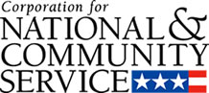

Corporation for National and Community Service

General Program Overview
AmeriCorps provides resources, both human and financial, to organizations that engage Americans in intensive service to meet our country’s critical needs.
Grantees use the funding to support AmeriCorps members for intensive service in their community. AmeriCorps grants partially cover the expense of operating an AmeriCorps program and do not cover general organizational expenses. A cash and in-kind match is required.

The main website can be accessed here: http://www.nationalservice.gov

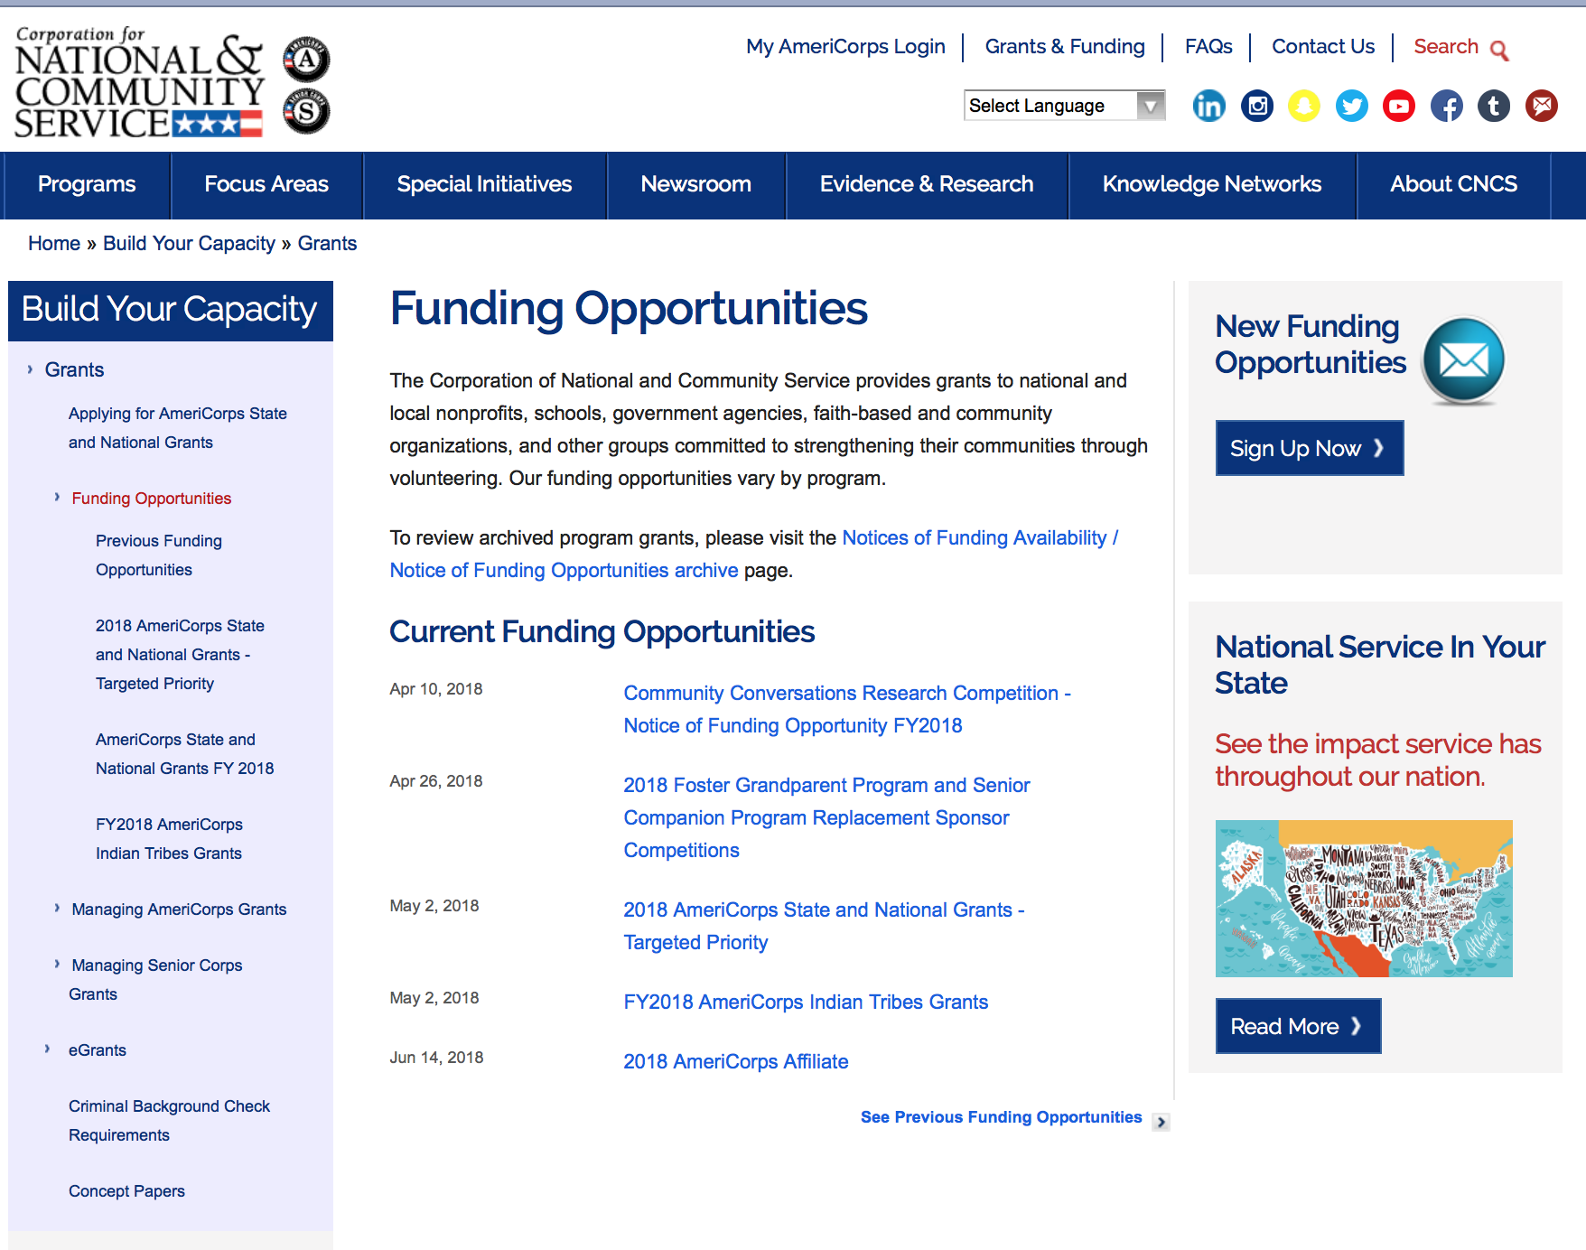

For access to further funding information: click here

http://www.nationalservice.gov/build-your-capacity/grants/funding-opportunities

Programs:

Research:

Reminders:

National Service In Hawaii
National Service in Your State - Hawaii
2015-2016

Meeting Community Needs in Hawaii: More than 3,100 people of all ages and backgrounds are helping to meet local needs, strengthen communities, and increase civic engagement through national service in Hawaii. Serving at more than 450 locations throughout the state, these citizens tutor and mentor children, support veterans and military families, provide health services, restore the environment, respond to disasters, increase economic opportunity, and recruit and manage volunteers. This year, the Corporation for National and Community Service (CNCS) will commit more than $6,260,000 to support Hawaii communities through national service initiatives. Through a unique public-private partnership, this federal investment will leverage an additional $9,060,000 in other resources to strengthen community impact, build local support, and increase return on taxpayer dollars. Nationwide, CNCS, its grantees, and project sponsors generated more than $1.25 billion in outside resources from businesses, foundations, public agencies, and other sources in FY 2015.

AmeriCorps
This year, AmeriCorps will provide more than 560 individuals the opportunity to provide intensive, results-driven service to meet education, environmental, health, economic, and other pressing needs in communities across Hawaii. Most AmeriCorps grant funding goes to the Hawaii Commission on National & Community Service, which in turn awards grants to nonprofit groups to respond to local needs. Most of the remainder of the grant funding is distributed by CNCS directly to multi-state and national organizations through a competitive grants process. Other individuals serve through AmeriCorps VISTA, whose members help bring individuals and communities out of poverty by serving full-time to fight illiteracy, improve health services, create businesses, and increase housing opportunities, and AmeriCorps NCCC (National Civilian Community Corps), a 10-month, full time residential program for men and women between the ages of 18 and 24. In exchange for their service, AmeriCorps members earn an education award that can be used to pay for college or to pay back qualified student loans. Since 1994, more than 5,900 Hawaii residents have served more than 6.4 million hours and have qualified for Segal AmeriCorps Education Awards totaling more than $14,980,000.
Download: AmeriCorps in Hawaii (PDF)
Senior Corps
More than 2,500 seniors in Hawaii contribute their time and talents in one of three Senior Corps programs. Foster Grandparents serve one-on-one as tutors and mentors to more than 310 young people who have special needs. Senior Companions help more than 220 homebound seniors and other adults maintain independence in their own homes. RSVP volunteers conduct safety patrols, renovate homes, protect the environment, tutor and mentor youth, respond to natural disasters, and provide other services through more than 250 groups across Hawaii.
Download: Senior Corps in Hawaii (PDF)

The Corporation for National and Community Service is a federal agency that improves lives, strengthens communities, and fosters civic engagement through service and volunteering. CNCS annually engages more than five million Americans in service to meet local needs through Senior Corps, AmeriCorps, and national days of service; improves communities through the Social Innovation Fund, and leads President Obama's national call to service initiative, United We Serve. To learn more visit NationalService.gov or Serve.gov or call 202-606-5000 or TTY 1-800-833-3722.

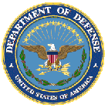

U.S. Department of Defense

Doing Business with the Department of Defense

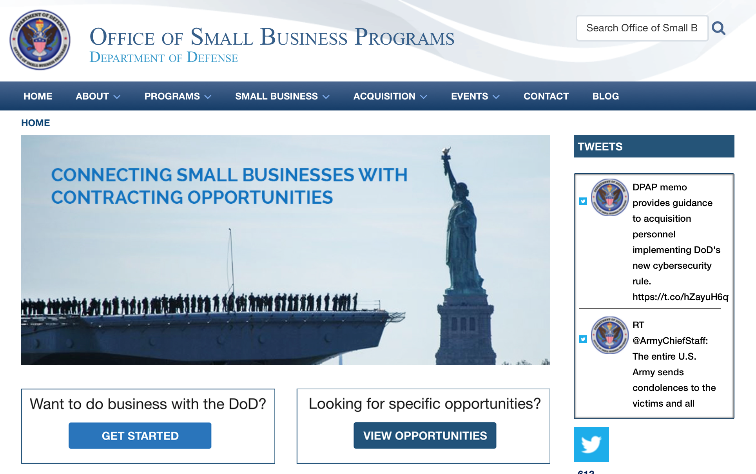

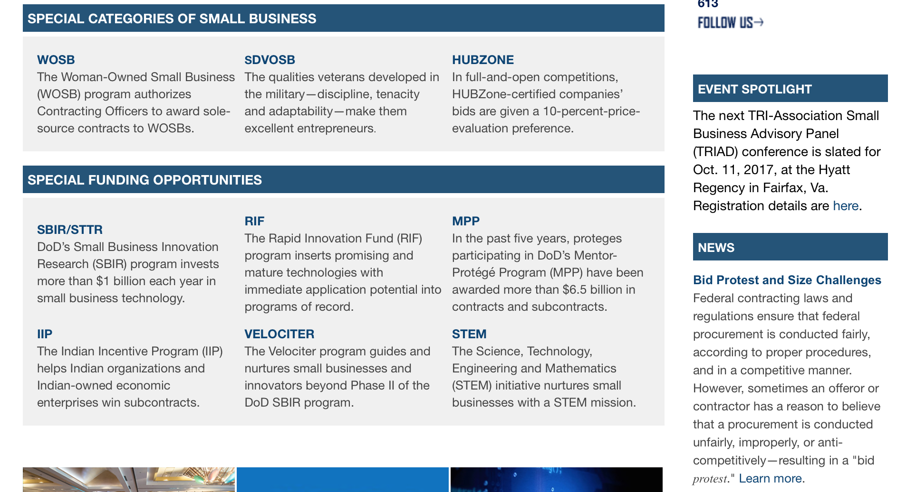

http://business.defense.gov

http://www.acq.osd.mil/osbp/

Doing Business with the DoD

Resources

Procurement Technical Assistance Centers (PTACs)

Procurement Technical Assistance Centers (PTACs) are charged with assisting businesses in learning how to do business with federal, state, and local governments. PTACs are a local resource available at no or nominal cost that can provide assistance to business firms in marketing their products and services. They offer training to businesses on how to research and bid on contracts, assist with registration requirements, provide bid-matching services, and assist with pre and post contracting issues.

Prime Contractors with Subcontracting Plans [xlsx]

Directory last updated 6/2017

This FY 2014 directory is intended for small business concerns seeking opportunities with DoD prime contractors. The directory is a listing of large business prime contractors who are required to establish subcontracting plans with goals. The report is generated from data contained in the Individual Subcontract Reports (ISRs) submitted in the Electronic Subcontracting Reporting System (eSRS) by contractors and from data contained in the Federal Procurement Data System (FPDS). The directory includes the name of the prime contractor; the major product/service code (PSC) provided to DoD; the major NAICS of the company; name, telephone number and email address of the company’s point of contact; contract number with the effective date and completion date, ultimate contract value and obligated dollars. In addition, many companies have websites with additional information which may be useful in your search for subcontracting opportunities or teaming arrangements.

Locate a Small Business Professional

Non-Appropriated Fund Customers

Non-appropriated fund customers operate similar to non-profit organizations and include commissaries, exchanges, recreation and fitness centers, dining at officer/enlisted/civilian clubs, and barber/beauty services, just to name a few.

For more information click here.

Research:

Air Force Office of Scientific Research
Research Interests of the Air Force Office of Scientific Research
Synopsis 1
https://www.grants.gov/web/grants/view-opportunity.html?oppId=305574

Air Force Office of Scientific Research
Research Interests of the Air Force Office of Scientific Research
Synopsis 1
https://www.grants.gov/web/grants/view-opportunity.html?oppId=305996
Dept. of the Army -- USAMRAA
DoD Epilepsy, Idea Development Award
Synopsis 1
https://www.grants.gov/web/grants/view-opportunity.html?oppId=306154

Dept. of the Army -- USAMRAA
DoD Peer Reviewed Alzheimer's Convergence Science Research Award
Synopsis 1
https://www.grants.gov/web/grants/view-opportunity.html?oppId=306218

Dept. of the Army -- USAMRAA
DoD Peer Reviewed Alzheimer's New Investigator Research Award
Synopsis 1
https://www.grants.gov/web/grants/view-opportunity.html?oppId=306234
Dept. of the Army -- USAMRAA
DoD Peer Reviewed Alzheimer's Quality of Life Research Award
Synopsis 1
https://www.grants.gov/web/grants/view-opportunity.html?oppId=306236

Dept. of the Army -- USAMRAA
DoD Parkinson's, Investigator-Initiated Research Award
Synopsis 1
https://www.grants.gov/web/grants/view-opportunity.html?oppId=306404

Dept. of the Army -- USAMRAA
DoD Peer Reviewed Orthopaedic, Clinical Translational Research Award
Synopsis 1
https://www.grants.gov/web/grants/view-opportunity.html?oppId=306362

Dept. of the Army -- USAMRAA
DoD Peer Reviewed Orthopaedic Research, Applied Research Award
Synopsis 1
https://www.grants.gov/web/grants/view-opportunity.html?oppId=306360

Dept. of the Army -- USAMRAA
DoD Prostate Cancer, Health Disparity Research Award
Synopsis 1
https://www.grants.gov/web/grants/view-opportunity.html?oppId=306378
Dept. of the Army -- USAMRAA
Prostate Cancer, Health Disparity Fellowship Award
Synopsis 1
https://www.grants.gov/web/grants/view-opportunity.html?oppId=306398

Dept. of the Army -- USAMRAA
DoD Kidney Cancer, Concept Award
Synopsis 1
https://www.grants.gov/web/grants/view-opportunity.html?oppId=306084

Dept. of the Army -- USAMRAA
DoD Kidney Cancer, Idea Development Award
Synopsis 1
https://www.grants.gov/web/grants/view-opportunity.html?oppId=306086

Dept. of the Army -- USAMRAA
DoD Lupus, Concept Award
Synopsis 1
https://www.grants.gov/web/grants/view-opportunity.html?oppId=306114

Dept. of the Army -- USAMRAA
DoD Lupus, Impact Award
Synopsis 1
https://www.grants.gov/web/grants/view-opportunity.html?oppId=306113

Army Contracting Command - Benet Laboratories
Defense Production Act (DPA) Title III - High Strength, Inherently Fire and Ballistic Resistant Co-polymer Aramid Fibers Industrial Capability Project
Synopsis 1
https://www.grants.gov/web/grants/view-opportunity.html?oppId=306616

DARPA - Defense Sciences Office
Defense Sciences Office (DSO) Office-Wide
Synopsis 1
https://www.grants.gov/web/grants/view-opportunity.html?oppId=306198

DARPA - Defense Sciences Office
Systematizing Confidence in Open Research and Evidence (SCORE)
Synopsis 1
https://www.grants.gov/web/grants/view-opportunity.html?oppId=306186

DARPA - Tactical Technology Office
Disruptive Capabilities for Future Warfare
Synopsis 1
https://www.grants.gov/web/grants/view-opportunity.html?oppId=306178

Dept of the Army -- Materiel Command
SuperCables
Synopsis 1
https://www.grants.gov/web/grants/view-opportunity.html?oppId=305910

DARPA - Biological Technologies Office
PReemptive Expression of Protective Alleles and Response Elements (PREPARE)
Synopsis 1
https://www.grants.gov/web/grants/view-opportunity.html?oppId=305984
Defense Intelligence Agency
Critical language & Cultural Immersion Studies Program
Synopsis 1
https://www.grants.gov/web/grants/view-opportunity.html?oppId=305933

NAVAIR
Naval Air Warfare Center Aircraft Division (NAWCAD) Office-Wide
Synopsis 1
https://www.grants.gov/web/grants/view-opportunity.html?oppId=306292

Office of Naval Research
FY2019 VANNEVAR BUSH FACULTY FELLOWSHIP (VBFF)
Synopsis 1
https://www.grants.gov/web/grants/view-opportunity.html?oppId=306562

Uniformed Services Univ. of the Health Sciences
Global Health Engagement Research Initiative | Call for White Papers
Synopsis 1
https://www.grants.gov/web/grants/view-opportunity.html?oppId=306606

Modifications:

Deleted:

Reminders:



Department of Education
Grant Programs Overview at the Department of Education

The general information page for Education Grant funding is an excellent resource describing the three types of grants awarded by the Department of Education. See the screen shot of the Department of Education web page below:

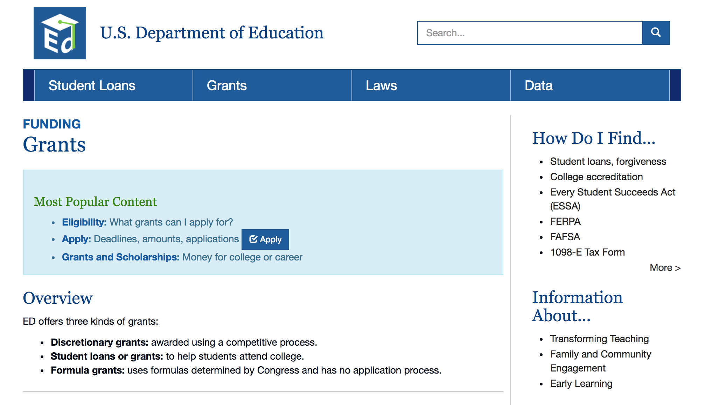
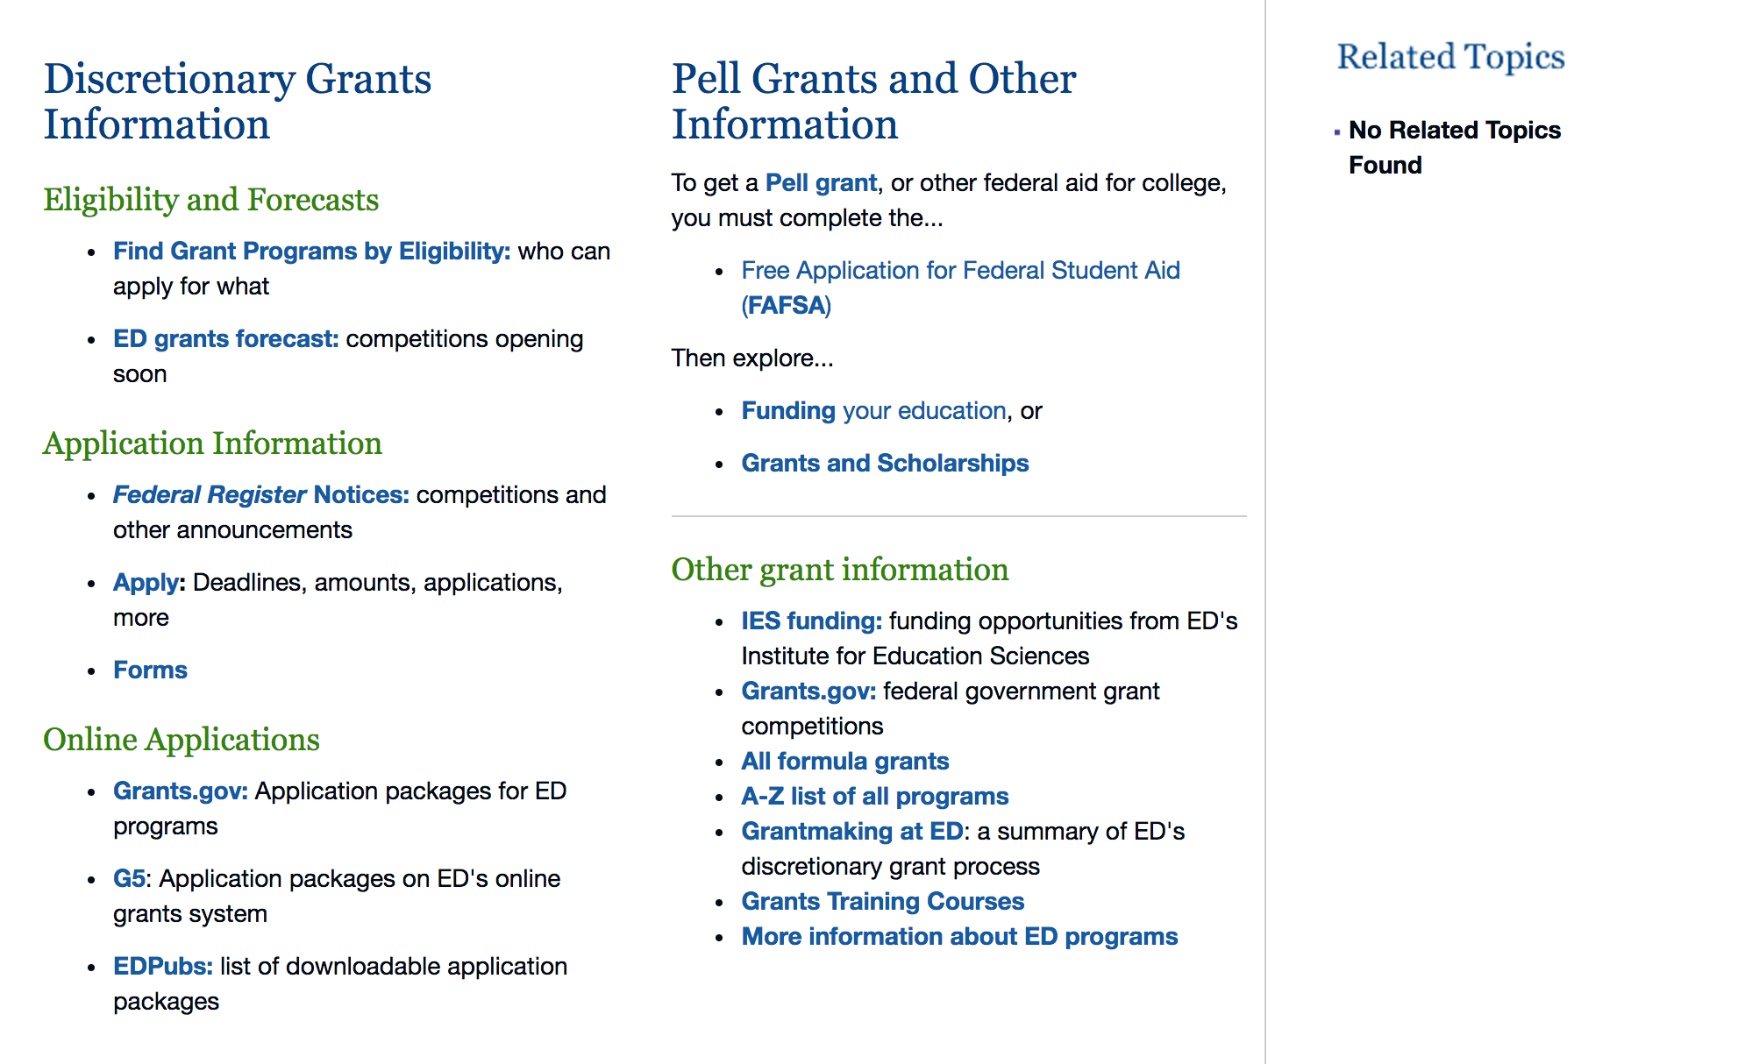

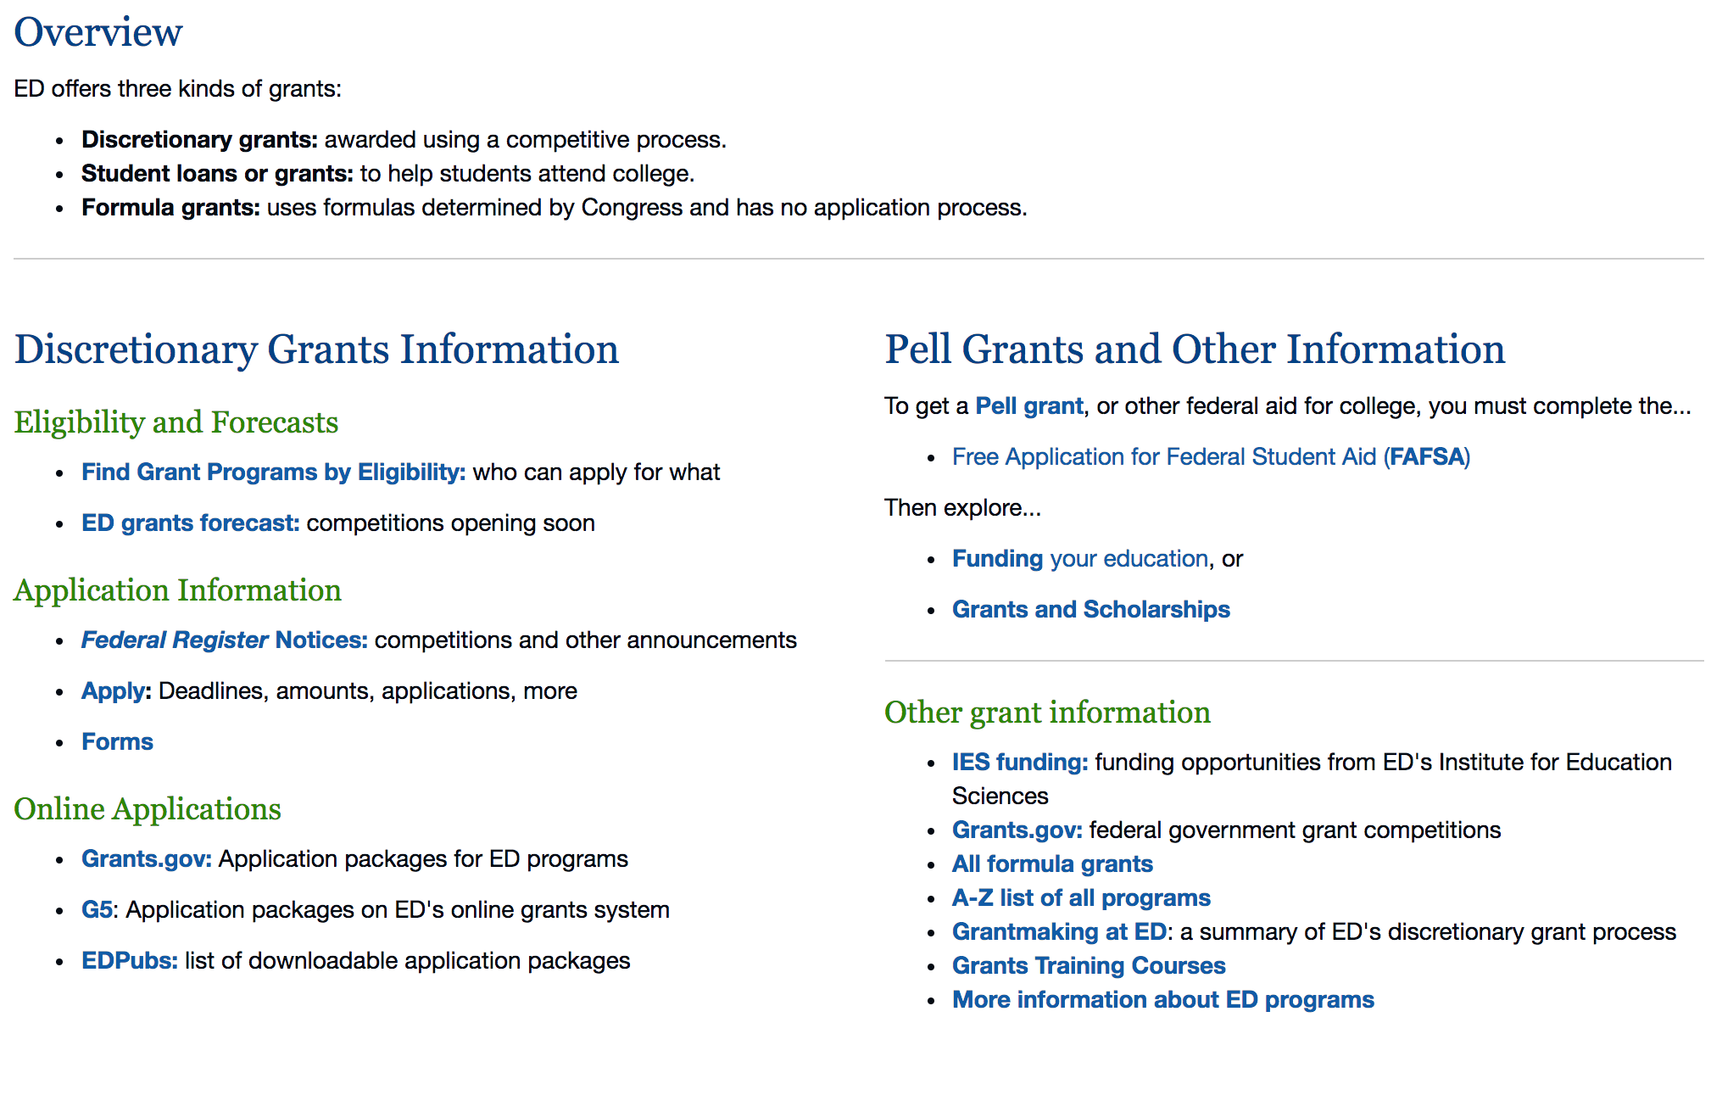

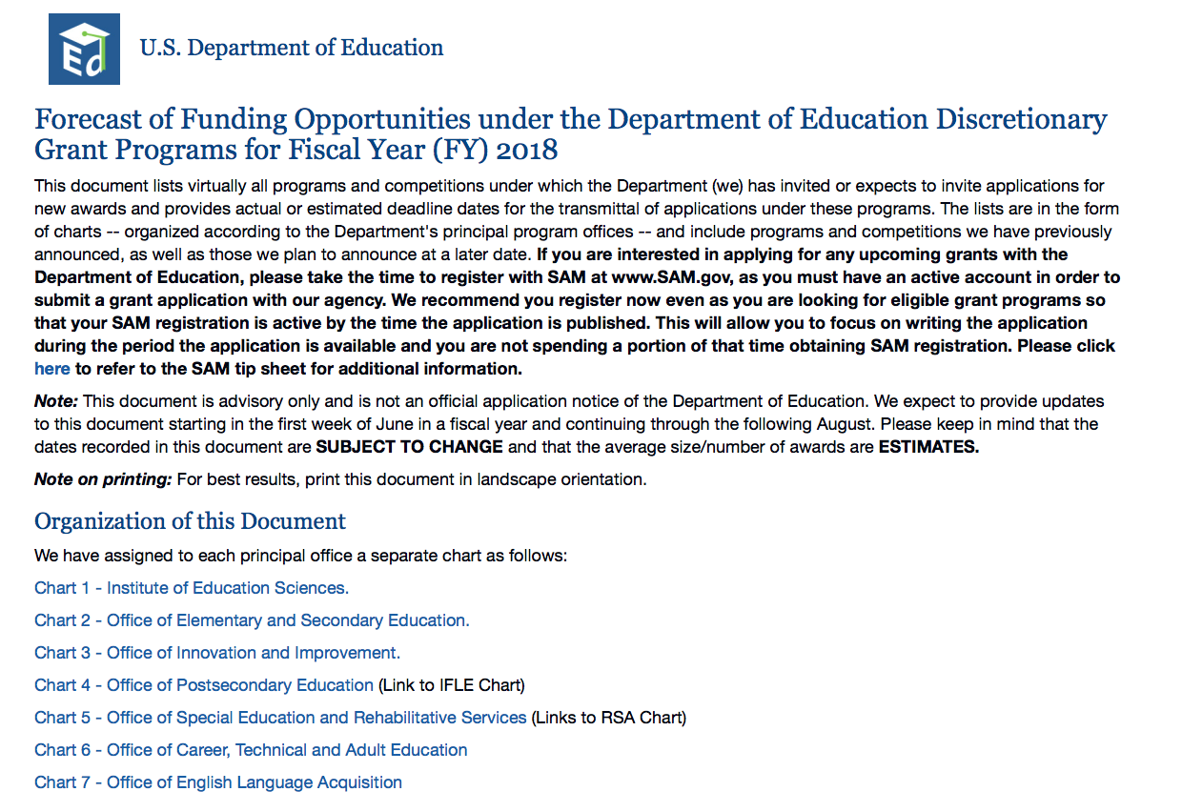

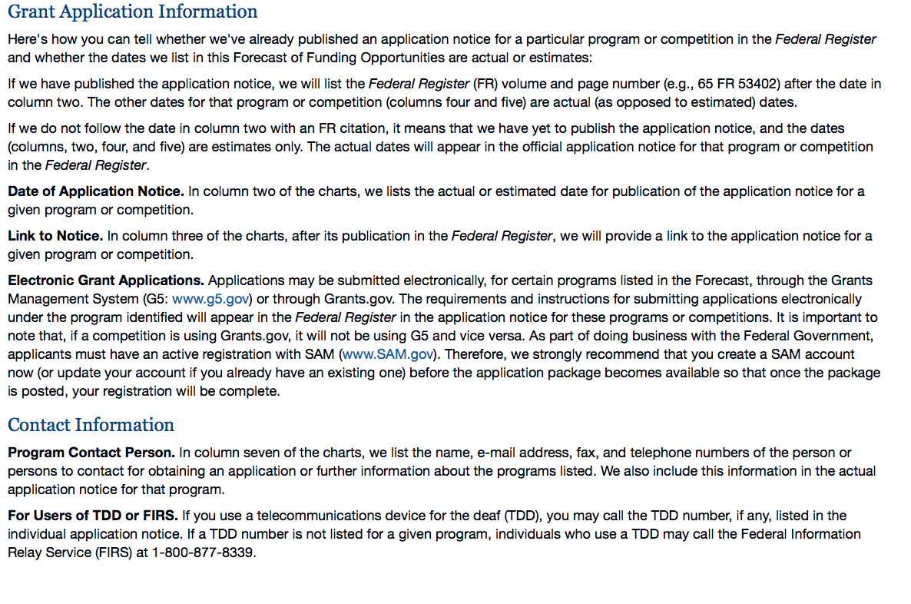

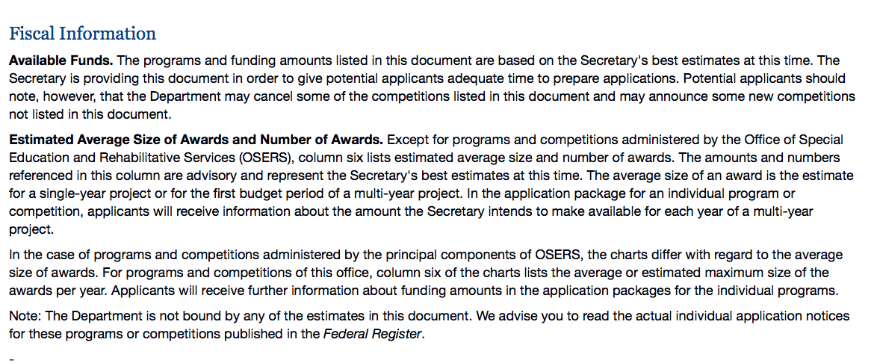

https://www2.ed.gov/fund/grant/find/edlite-forecast.html

Programs:

Office of Postsecondary Education (OPE): Gaining Early Awareness and Readiness for Undergraduate Programs (GEAR UP) Partnership Grants CFDA Number 84.334A
Synopsis 1
Document Type: | Grants Notice
Funding Opportunity Number: | ED-GRANTS-060718-002
Funding Opportunity Title: | Office of Postsecondary Education (OPE): Gaining Early Awareness and Readiness for Undergraduate Programs (GEAR UP) Partnership Grants CFDA Number 84.334A
Opportunity Category: | Discretionary
Opportunity Category Explanation:
Funding Instrument Type: | Grant
Category of Funding Activity: | Education
Category Explanation:
Expected Number of Awards: | 54
CFDA Number(s): | 84.334 -- Gaining Early Awareness and Readiness for Undergraduate Programs
Cost Sharing or Matching Requirement: | Yes
Version: | Synopsis 1
Posted Date: | Jun 07, 2018
Last Updated Date: | Jun 07, 2018
Original Closing Date for Applications: | Jul 13, 2018 Applications Available: June 7, 2018. Deadline for Transmittal of Applications: July 13, 2018.
Current Closing Date for Applications: | Jul 13, 2018 Applications Available: June 7, 2018. Deadline for Transmittal of Applications: July 13, 2018.
Archive Date: | Aug 12, 2018
Estimated Total Program Funding: | $64,833,000
Award Ceiling: | $7,000,000

Eligibility
Eligible Applicants: | Public and State controlled institutions of higher education  State governments  Others (see text field entitled "Additional Information on Eligibility" for clarification)  Private institutions of higher education
Additional Information on Eligibility: | Eligible Applicants: Partnerships consisting of (a) at least one LEA and (b) at least one degree-granting IHE. Partnerships may include not less than two other community organizations or entities, such as businesses, professional organizations, State agencies, institutions or agencies sponsoring programs authorized under the Leveraging Educational Assistance Partnership Program authorized in part A, subpart 4, of title IV of the HEA (20 U.S.C. 1070c et seq.), or other public or private agencies or organizations (20 U.S.C. 1070a-21(c)(2)).
Additional Information
Agency Name: | Department of Education
Description: | Note: Each funding opportunity description is a synopsis of information in the Federal Register application notice. For specific information about eligibility, please see the official application notice. The official version of this document is the document published in the Federal Register. Free Internet access to the official edition of the Federal Register and the Code of Federal Regulations is available on GPO Access at: http://www.access.gpo.gov/nara/index.html. Please review the official application notice for pre-application and application requirements, application submission information, performance measures, priorities and program contact information.  For the addresses for obtaining and submitting an application, please refer to our Common Instructions for Applicants to Department of Education Discretionary Grant Programs, published in the Federal Register on February 12, 2018 (83 FR 6003) and available at www.gpo.gov/fdsys/pkg/FR-2018-02-12/pdf/2018-02558.pdf.  Purpose of Program: The GEAR UP program is a discretionary grant program that encourages eligible entities to provide support, and maintain a commitment, to eligible low-income students, including students with disabilities, to assist the students in obtaining a secondary school diploma (or its recognized equivalent) and to prepare for and succeed in postsecondary education. Under the GEAR UP program, the Department awards grants to two types of entities: (1) States and (2) partnerships consisting of at least one institution of higher education (IHE) and at least one local educational agency (LEA).  In this notice, the Department invites applications for partnership grants only. We will invite applications for State grants in another notice published in the Federal Register. Required services under the GEAR UP program are specified in sections 404D(a) of the Higher  Education Act of 1965, as amended (HEA) (20 U.S.C. 1070a-24(a)), and permissible services under the GEAR UP program are specified in section 404D(b) of the HEA (20 U.S.C. 1070a-24(b)). For partnership grantees, activities must include providing financial aid information for postsecondary education, encouraging enrollment in rigorous and challenging coursework in order to reduce the need for remediation at the postsecondary level, implementing activities to improve the number of participating students who obtain a secondary school diploma and who complete applications for and enroll in a program of postsecondary education. Activities may also include mentoring, tutoring, supporting dual or concurrent enrollment programs that support participating students in science, technology, engineering, or mathematics (STEM), academic and career counseling, financial and economic literacy education, and exposure to college campuses.  Catalog of Federal Domestic Assistance (CFDA) number 84.334A.
Link to Additional Information: | Office of Postsecondary Education (OPE): Gaining Early Awareness and Readiness for Undergraduate Programs (GEAR UP) Partnership Grants CFDA Number 84.334A; Notice Inviting Applications for New Awards for Fiscal Year (FY) 2018
Grantor Contact Information: | If you have difficulty accessing the full announcement electronically, please contact:  Julius Cotton ED Grants.gov FIND Systems Admin. Phone 202-245-6288 educationgrantinquiries@ed.gov Program Manager: Karmon Simms-Coates, U.S. Department of Education, 400 Maryland Avenue SW, room 278-54, Washington, DC 20202-6450. Telephone: (202) 453-7917. Email: Karmon.Simms-Coates@ed.gov.  e-Mail: Program Manager
https://www.grants.gov/web/grants/view-opportunity.html?oppId=305992

Office of Postsecondary Education (OPE): Undergraduate International Studies and Foreign Language (UISFL) Program CFDA Number 84.016A
Synopsis 1
Document Type: | Grants Notice
Funding Opportunity Number: | ED-GRANTS-060618-001
Funding Opportunity Title: | Office of Postsecondary Education (OPE): Undergraduate International Studies and Foreign Language (UISFL) Program CFDA Number 84.016A
Opportunity Category: | Discretionary
Opportunity Category Explanation:
Funding Instrument Type: | Grant
Category of Funding Activity: | Education
Category Explanation:
Expected Number of Awards: | 24
CFDA Number(s): | 84.016 -- Undergraduate International Studies and Foreign Language Programs
Cost Sharing or Matching Requirement: | Yes
Version: | Synopsis 1
Posted Date: | Jun 06, 2018
Last Updated Date: | Jun 06, 2018
Original Closing Date for Applications: | Jul 26, 2018 Applications Available: June 6, 2018. Deadline for Transmittal of Applications: July 26, 2018
Current Closing Date for Applications: | Jul 26, 2018 Applications Available: June 6, 2018. Deadline for Transmittal of Applications: July 26, 2018
Archive Date: | Aug 25, 2018
Estimated Total Program Funding: | $2,257,434
Award Ceiling: | $150,000
Eligible Applicants: | Private institutions of higher education  Nonprofits that do not have a 501(c)(3) status with the IRS, other than institutions of higher education  Public and State controlled institutions of higher education  Others (see text field entitled "Additional Information on Eligibility" for clarification)  Nonprofits having a 501(c)(3) status with the IRS, other than institutions of higher education
Additional Information on Eligibility: | Eligible Applicants: (1) IHEs; (2) consortia of IHEs; (3) partnerships between nonprofit educational organizations and IHEs; and (4) public and private nonprofit agencies and organizations, including professional and scholarly associations.
Additional Information
Agency Name: | Department of Education
Description: | For the addresses for obtaining and submitting an application, please refer to our Common Instructions for Applicants to Department of Education Discretionary Grant Programs, published in the Federal Register on February 12, 2018 (83 FR 6003) and available at www.gpo.gov/fdsys/pkg/FR-2018-02-12/pdf/2018-02558.pdf.  Purpose of Program: The UISFL program provides grants for planning, developing, and carrying out programs to strengthen and improve undergraduate instruction in international studies and foreign languages in the United States.  Catalog of Federal Domestic Assistance (CFDA) number 84.016A.
Link to Additional Information: | Office of Postsecondary Education (OPE): Undergraduate International Studies and Foreign Language (UISFL) Program CFDA Number 84.016A; Notice Inviting Applications for Fiscal Year (FY) 2018
Grantor Contact Information: | If you have difficulty accessing the full announcement electronically, please contact:  Julius Cotton ED Grants.gov FIND Systems Admin. Phone 202-245-6288 educationgrantinquiries@ed.gov Program Manager: Tanyelle H. Richardson, U.S. Department of Education, 400 Maryland Avenue SW, Room 258-14, Washington, DC 20202. Telephone: (202) 453-6391. Email: tanyelle.richardson@ed.gov.  e-Mail: Program Manager
https://www.grants.gov/web/grants/view-opportunity.html?oppId=305973

DED84325KOffice of Postsecondary Education (OPE): Child Care Access Means Parents in School (CCAMPIS) Program CFDA Number 84.335A
Synopsis 1

Document Type: | Grants Notice
Funding Opportunity Number: | ED-GRANTS-061918-001
Funding Opportunity Title: | Office of Postsecondary Education (OPE): Child Care Access Means Parents in School (CCAMPIS) Program CFDA Number 84.335A
Opportunity Category: | Discretionary
Opportunity Category Explanation:
Funding Instrument Type: | Grant
Category of Funding Activity: | Education
Category Explanation:
Expected Number of Awards: | 212
CFDA Number(s): | 84.335 -- Child Care Access Means Parents in School
Cost Sharing or Matching Requirement: | No
Version: | Synopsis 1
Posted Date: | Jun 19, 2018
Last Updated Date: | Jun 19, 2018
Original Closing Date for Applications: | Jul 24, 2018 Applications Available: June 19, 2018. Deadline for Transmittal of Applications: July 24, 2018.
Current Closing Date for Applications: | Jul 24, 2018 Applications Available: June 19, 2018. Deadline for Transmittal of Applications: July 24, 2018.
Archive Date: | Aug 23, 2018
Estimated Total Program Funding: | $32,027,299
Award Ceiling: | $375,000
Award Floor: | $30,000
Eligible Applicants: | Others (see text field entitled "Additional Information on Eligibility" for clarification)  Private institutions of higher education  Public and State controlled institutions of higher education
Additional Information on Eligibility: | Eligible Applicants: Any institution of higher education that awarded a total of $250,000 or more of Federal Pell Grant funds during FY 2017 to students enrolled at the institution.

Agency Name: | Department of Education
Description: | Note: Each funding opportunity description is a synopsis of information in the Federal Register application notice. For specific information about eligibility, please see the official application notice. The official version of this document is the document published in the Federal Register. Free Internet access to the official edition of the Federal Register and the Code of Federal Regulations is available on GPO Access at: http://www.access.gpo.gov/nara/index.html. Please review the official application notice for pre-application and application requirements, application submission information, performance measures, priorities and program contact information.  For the addresses for obtaining and submitting an application, please refer to our Common Instructions for Applicants to Department of Education Discretionary Grant Programs, published in the Federal Register on February 12, 2018 (83 FR 6003) and available at www.gpo.gov/fdsys/pkg/FR-2018-02-12/pdf/2018-02558.pdf.  Purpose of Program: The CCAMPIS Program supports the participation of low-income parents in postsecondary education through the provision of campus-based child care services.  Catalog of Federal Domestic Assistance (CFDA) number 84.335A.
Link to Additional Information: | Office of Postsecondary Education (OPE): Child Care Access Means Parents in School (CCAMPIS) Program CFDA Number 84.335A; Notice Inviting Applications for New Awards for Fiscal Year (FY) 2018
Grantor Contact Information: | If you have difficulty accessing the full announcement electronically, please contact:  Julius Cotton ED Grants.gov FIND Systems Admin. Phone 202-245-6288 educationgrantinquiries@ed.gov Program Manager: Antoinette Clark Edwards, U.S. Department of Education, 400 Maryland Avenue SW, Room 278-50, Washington, DC 20202-4260. Telephone: (202) 453-7121. Email: antoinette.clark@ed.gov.  e-Mail: Program Manager
https://www.grants.gov/web/grants/view-opportunity.html?oppId=306351

OSERS-OSEP: Interdisciplinary Preparation in Special Education, Early Intervention, and Related Services for Personnel Serving Children with Disabilities who have High-Intensity Needs CFDA Number 84.325K Focus Area A
Synopsis 1
Document Type: | Grants Notice
Funding Opportunity Number: | ED-GRANTS-061318-002
Funding Opportunity Title: | OSERS-OSEP: Interdisciplinary Preparation in Special Education, Early Intervention, and Related Services for Personnel Serving Children with Disabilities who have High-Intensity Needs CFDA Number 84.325K Focus Area A
Opportunity Category: | Discretionary
Opportunity Category Explanation:
Funding Instrument Type: | Grant
Category of Funding Activity: | Education
Category Explanation:
Expected Number of Awards: | 10
CFDA Number(s): | 84.325 -- Special Education - Personnel Development to Improve Services and Results for Children with Disabilities
Cost Sharing or Matching Requirement: | No
Version: | Synopsis 1
Posted Date: | Jun 13, 2018
Last Updated Date: | Jun 13, 2018
Original Closing Date for Applications: | Jul 30, 2018 Applications Available: June 13, 2018. Deadline for Transmittal of Applications: July 30, 2018.
Current Closing Date for Applications: | Jul 30, 2018 Applications Available: June 13, 2018. Deadline for Transmittal of Applications: July 30, 2018.
Archive Date: | Aug 29, 2018
Estimated Total Program Funding: | $2,500,000
Award Ceiling: | $250,000
Eligible Applicants: | Private institutions of higher education  Public and State controlled institutions of higher education  Nonprofits that do not have a 501(c)(3) status with the IRS, other than institutions of higher education  Nonprofits having a 501(c)(3) status with the IRS, other than institutions of higher education  Others (see text field entitled "Additional Information on Eligibility" for clarification)
Additional Information on Eligibility: | Eligible Applicants: IHEs and private nonprofit organizations.
Additional Information
Agency Name: | Department of Education
Description: | Note: Each funding opportunity description is a synopsis of information in the Federal Register application notice. For specific information about eligibility, please see the official application notice. The official version of this document is the document published in the Federal Register. Free Internet access to the official edition of the Federal Register and the Code of Federal Regulations is available on GPO Access at: http://www.access.gpo.gov/nara/index.html. Please review the official application notice for pre-application and application requirements, application submission information, performance measures, priorities and program contact information.  For the addresses for obtaining and submitting an application, please refer to our Common Instructions for Applicants to Department of Education Discretionary Grant Programs, published in the Federal Register on February 12, 2018 (83 FR 6003) and available at www.gpo.gov/fdsys/pkg/FR-2018-02-12/pdf/2018-02558.pdf  Purpose of Program: The purposes of this program are to (1) help address State-identified needs for personnel preparation in special education, early intervention, related services, and regular education to work with children, including infants and toddlers, and youth with disabilities; and (2) ensure that those personnel have the necessary skills and knowledge, derived from practices that have been determined through scientifically based research and experience, to be successful in serving those children.  Catalog of Federal Domestic Assistance (CFDA) number 84.325K.
Link to Additional Information:
Grantor Contact Information: | If you have difficulty accessing the full announcement electronically, please contact:  JuliMaryaus Cotton ED Grants.gov FIND Systems Admin. Phone 202-245-6288 educationgrantinquiries@ed.gov Program Manager: Maryann McDermott, U.S. Department of Education, 400 Maryland Avenue SW, Room 5144, Potomac Center Plaza, Washington, DC 20202-5108. Telephone: (202) 245-7439 or e-Mail: Maryann.McDermott@ed.gov.  e-Mail: Program Manager
https://www.grants.gov/web/grants/view-opportunity.html?oppId=306235

OSERS-OSEP: Interdisciplinary Preparation in Special Education, Early Intervention, and Related Services for Personnel Serving Children with Disabilities who have High-Intensity Needs CFDA Number 84.325K Focus Area B
Synopsis 1

Document Type: | Grants Notice
Funding Opportunity Number: | ED-GRANTS-061318-003
Funding Opportunity Title: | OSERS-OSEP: Interdisciplinary Preparation in Special Education, Early Intervention, and Related Services for Personnel Serving Children with Disabilities who have High-Intensity Needs CFDA Number 84.325K Focus Area B
Opportunity Category: | Discretionary
Opportunity Category Explanation:
Funding Instrument Type: | Grant
Category of Funding Activity: | Education
Category Explanation:
Expected Number of Awards: | 30
CFDA Number(s): | 84.325 -- Special Education - Personnel Development to Improve Services and Results for Children with Disabilities
Cost Sharing or Matching Requirement: | No

Version: | Synopsis 1
Posted Date: | Jun 13, 2018
Last Updated Date: | Jun 13, 2018
Original Closing Date for Applications: | Jul 30, 2018 Applications Available: June 13, 2018. Deadline for Transmittal of Applications: July 30, 2018.
Current Closing Date for Applications: | Jul 30, 2018 Applications Available: June 13, 2018. Deadline for Transmittal of Applications: July 30, 2018.
Archive Date: | Aug 29, 2018
Estimated Total Program Funding: | $7,500,000
Award Ceiling: | $250,000
Eligible Applicants: | Others (see text field entitled "Additional Information on Eligibility" for clarification)  Private institutions of higher education  Public and State controlled institutions of higher education  Nonprofits that do not have a 501(c)(3) status with the IRS, other than institutions of higher education  Nonprofits having a 501(c)(3) status with the IRS, other than institutions of higher education
Additional Information on Eligibility: | Eligible Applicants: IHEs and private nonprofit organizations.
Additional Information
Agency Name: | Department of Education
Description: | Note: Each funding opportunity description is a synopsis of information in the Federal Register application notice. For specific information about eligibility, please see the official application notice. The official version of this document is the document published in the Federal Register. Free Internet access to the official edition of the Federal Register and the Code of Federal Regulations is available on GPO Access at: http://www.access.gpo.gov/nara/index.html. Please review the official application notice for pre-application and application requirements, application submission information, performance measures, priorities and program contact information.  For the addresses for obtaining and submitting an application, please refer to our Common Instructions for Applicants to Department of Education Discretionary Grant Programs, published in the Federal Register on February 12, 2018 (83 FR 6003) and available at www.gpo.gov/fdsys/pkg/FR-2018-02-12/pdf/2018-02558.pdf  Purpose of Program: The purposes of this program are to (1) help address State-identified needs for personnel preparation in special education, early intervention, related services, and regular education to work with children, including infants and toddlers, and youth with disabilities; and (2) ensure that those personnel have the necessary skills and knowledge, derived from practices that have been determined through scientifically based research and experience, to be successful in serving those children.  Catalog of Federal Domestic Assistance (CFDA) number 84.325K.
Link to Additional Information: | OSERS-OSEP: Interdisciplinary Preparation in Special Education, Early Intervention, and Related Services for Personnel Serving Children with Disabilities who have High-Intensity Needs CFDA Number 84.325K Focus Area B; Notice Inviting Applications
Grantor Contact Information: | If you have difficulty accessing the full announcement electronically, please contact:  Julius Cotton ED Grants.gov FIND Systems Admin. Phone 202-245-6288 educationgrantinquiries@ed.gov Program Manager: Maryann McDermott, U.S. Department of Education, 400 Maryland Avenue SW, Room 5144, Potomac Center Plaza, Washington, DC 20202-5108. Telephone: (202) 245-7439 or e-Mail: Maryann.McDermott@ed.gov.  e-Mail: Program Manager
https://www.grants.gov/web/grants/view-opportunity.html?oppId=306237

OSERS-OSEP: Preparation of Special Education, Early Intervention, and Related Services Leadership Personnel CFDA Number 84.325D
Synopsis 1
Document Type: | Grants Notice
Funding Opportunity Number: | ED-GRANTS-061318-004
Funding Opportunity Title: | OSERS-OSEP: Preparation of Special Education, Early Intervention, and Related Services Leadership Personnel CFDA Number 84.325D
Opportunity Category: | Discretionary
Opportunity Category Explanation:
Funding Instrument Type: | Grant
Category of Funding Activity: | Education
Category Explanation:
Expected Number of Awards: | 17
CFDA Number(s): | 84.325 -- Special Education - Personnel Development to Improve Services and Results for Children with Disabilities
Cost Sharing or Matching Requirement: | Yes
Version: | Synopsis 1
Posted Date: | Jun 13, 2018
Last Updated Date: | Jun 13, 2018
Original Closing Date for Applications: | Jul 30, 2018 Applications Available: June 13, 2018. Deadline for Transmittal of Applications: July 30, 2018
Current Closing Date for Applications: | Jul 30, 2018 Applications Available: June 13, 2018. Deadline for Transmittal of Applications: July 30, 2018
Archive Date: | Aug 29, 2018
Estimated Total Program Funding: | $4,250,000
Award Ceiling: | $250,000
Eligible Applicants: | Nonprofits that do not have a 501(c)(3) status with the IRS, other than institutions of higher education  Public and State controlled institutions of higher education  Others (see text field entitled "Additional Information on Eligibility" for clarification)  Private institutions of higher education  Nonprofits having a 501(c)(3) status with the IRS, other than institutions of higher education
Additional Information on Eligibility: | Eligible Applicants: IHEs, private nonprofit organizations.
Additional Information
Agency Name: | Department of Education
Description: | Note: Each funding opportunity description is a synopsis of information in the Federal Register application notice. For specific information about eligibility, please see the official application notice. The official version of this document is the document published in the Federal Register. Free Internet access to the official edition of the Federal Register and the Code of Federal Regulations is available on GPO Access at: http://www.access.gpo.gov/nara/index.html. Please review the official application notice for pre-application and application requirements, application submission information, performance measures, priorities and program contact information.  For the addresses for obtaining and submitting an application, please refer to our Common Instructions for Applicants to Department of Education Discretionary Grant Programs, published in the Federal Register on February 12, 2018 (83 FR 6003) and available at www.gpo.gov/fdsys/pkg/FR-2018-02-12/pdf/2018-02558.pdf  Purpose of Program: The purposes of this program are to (1) help address State-identified needs for personnel preparation in special education, early intervention, related services, and regular education to work with children, including infants and toddlers, with disabilities; and (2) ensure that those personnel have the necessary skills and knowledge, derived from practices that have been determined through scientifically based research and experience, to be successful in serving those children.  Catalog of Federal Domestic Assistance (CFDA) number 84.325D.
Link to Additional Information: | OSERS-OSEP: Preparation of Special Education, Early Intervention, and Related Services Leadership Personnel CFDA Number 84.325D; Notice Inviting Applications for New Awards for Fiscal Year (FY) 2018
Grantor Contact Information: | If you have difficulty accessing the full announcement electronically, please contact:  Julius Cotton ED Grants.gov FIND Systems Admin. Phone 202-245-6288 educationgrantinquiries@ed.gov Program Manager: Celia Rosenquist, U.S. Department of Education, 400 Maryland Avenue SW, Room 5146, Potomac Center Plaza, Washington, DC 20202-5076. Telephone: (202) 245-7373 or e-Mail: Celia.Rosenquist@ed.gov  e-Mail: Program Manager
https://www.grants.gov/web/grants/view-opportunity.html?oppId=306219

Research:

Modifications:

Reminders:

Institutes of Education Sciences (IES): Education Research and Development Centers CFDA Number 84.305C
Synopsis 1
Document Type: Grants Notice  Funding Opportunity Number: ED-GRANTS-052118-002  Funding Opportunity Title: Institutes of Education Sciences (IES): Education Research and Development Centers CFDA Number 84.305C  Opportunity Category: Discretionary  Opportunity Category Explanation:  Funding Instrument Type: Cooperative Agreement Grant  Category of Funding Activity: Education  Category Explanation:  Expected Number of Awards:  CFDA Number(s): 84.305 -- Education Research, Development and Dissemination  Cost Sharing or Matching Requirement: No | Version: Synopsis 1  Posted Date: May 21, 2018  Last Updated Date: May 21, 2018  Original Closing Date for Applications: Aug 09, 2018 Applications Available: June 21, 2018. Deadline for Transmittal of Applications: August 9, 2018.  Current Closing Date for Applications: Aug 09, 2018 Applications Available: June 21, 2018. Deadline for Transmittal of Applications: August 9, 2018.  Archive Date: Sep 08, 2018  Estimated Total Program Funding:  Award Ceiling:  Award Floor:
Eligibility
Eligible Applicants: | Independent school districts  State governments  For profit organizations other than small businesses  County governments  Special district governments  City or township governments  Nonprofits that do not have a 501(c)(3) status with the IRS, other than institutions of higher education  Others (see text field entitled "Additional Information on Eligibility" for clarification)  Public and State controlled institutions of higher education  Nonprofits having a 501(c)(3) status with the IRS, other than institutions of higher education  Private institutions of higher education
Additional Information on Eligibility: | Eligible Applicants: Applicants that have the ability and capacity to conduct scientifically valid research are eligible to apply. Eligible applicants include, but are not limited to, nonprofit and for-profit organizations and public and private agencies and institutions of higher education, such as colleges and universities.
Additional Information
Agency Name: | Department of Education
Description: | Note: Each funding opportunity description is a synopsis of information in the Federal Register application notice. For specific information about eligibility, please see the official application notice. The official version of this document is the document published in the Federal Register. Free Internet access to the official edition of the Federal Register and the Code of Federal Regulations is available on GPO Access at: http://www.access.gpo.gov/nara/index.html. Please review the official application notice for pre-application and application requirements, application submission information, performance measures, priorities and program contact information.  For the addresses for obtaining and submitting an application, please refer to our Common Instructions for Applicants to Department of Education Discretionary Grant Programs, published in the Federal Register on February 12, 2018 (83 FR 6003) and available atwww.gpo.gov/fdsys/pkg/FR-2018-02-12/pdf/2018-02558.pdf.  The dates when applications are available and the deadlines for transmittal of applications invited under this notice are indicated in the chart at the end of this notice and in the Requests for Applications (RFAs) that are posted at the following websites: https://ies.ed.gov/funding,https://www.ed.gov/programs/edresearch/index.html,and https://www.ed.gov/programs/specialedresearch/index.html.  FOR FURTHER INFORMATION CONTACT: The contact person associated with a particular research competition is listed in the chart at the end of this notice, as well as in the relevant RFA and application package.  Purpose of Program: In awarding these grants, the Institute of Education Sciences (Institute) intends to provide national leadership in expanding fundamental knowledge and understanding of (1) developmental and school readiness outcomes for infants and toddlers with or at risk for a disability, (2) education outcomes for all students from early childhood education through postsecondary and adult education, and (3) employment and wage outcomes when relevant (such as for students who engaged in career and technical, postsecondary, or adult education). The Institute's research grant programs are designed to provide interested individuals and the general public with reliable and valid information about education practices that support learning and improve academic achievement and access to education opportunities for all students. These interested individuals include parents, educators, students, researchers, and policymakers. In carrying out its grant programs, the Institute provides support for programs of research in areas of demonstrated national need.  Competitions in This Notice: The Institute will conduct nine research competitions in FY 2019 through two of its centers: The Institute's National Center for Education Research (NCER) will hold a total of five competitions--one competition in each of the following areas: Education research; education research and development centers; statistical and research methodology in education; partnerships and collaborations focused on problems of practice or policy; and low-cost, short-duration evaluation of education interventions.  Catalog of Federal Domestic Assistance (CFDA) numbers 84.305A, 84.305C, 84.305D, 84.305H, 84.305L, 84.324A, 84.324B, 84.324L, and 84.324N.
Link to Additional Information: | Institutes of Education Sciences (IES): Education Research and Development Centers CFDA Number 84.305C;
Grantor Contact Information: | If you have difficulty accessing the full announcement electronically, please contact:  Julius Cotton ED Grants.gov FIND Systems Admin. Phone 202-245-6288 educationgrantinquiries@ed.gov Program Manager: Corinne Alfed e-Mail: Corinne.Alfed@ed.gov.  e-Mail: Program Manager
https://www.grants.gov/web/grants/view-opportunity.html?oppId=305416

Institute of Education Sciences (IES): Education Research CFDA Number 84.305A
Synopsis 1
Document Type: Grants Notice  Funding Opportunity Number: ED-GRANTS-052118-001  Funding Opportunity Title: Institute of Education Sciences (IES): Education Research CFDA Number 84.305A  Opportunity Category: Discretionary  Opportunity Category Explanation:  Funding Instrument Type: Cooperative Agreement Grant  Category of Funding Activity: Education  Category Explanation:  Expected Number of Awards:  CFDA Number(s): 84.305 -- Education Research, Development and Dissemination  Cost Sharing or Matching Requirement: No | Version: Synopsis 1  Posted Date: May 21, 2018  Last Updated Date: May 21, 2018  Original Closing Date for Applications: Aug 23, 2018 Application Package Available: June 21, 2018. Deadline for Transmittal of Applications: August 23, 2018.  Current Closing Date for Applications: Aug 23, 2018 Application Package Available: June 21, 2018. Deadline for Transmittal of Applications: August 23, 2018.  Archive Date: Sep 22, 2018  Estimated Total Program Funding:  Award Ceiling:  Award Floor:
Eligibility
Eligible Applicants: | Special district governments  County governments  For profit organizations other than small businesses  Independent school districts  Others (see text field entitled "Additional Information on Eligibility" for clarification)  Private institutions of higher education  Public and State controlled institutions of higher education  State governments  City or township governments  Nonprofits that do not have a 501(c)(3) status with the IRS, other than institutions of higher education  Nonprofits having a 501(c)(3) status with the IRS, other than institutions of higher education
Additional Information on Eligibility: | Eligible Applicants: Applicants that have the ability and capacity to conduct scientifically valid research are eligible to apply. Eligible applicants include, but are not limited to, nonprofit and for-profit organizations and public and private agencies and institutions of higher education, such as colleges and universities.
Additional Information
Agency Name: | Department of Education
Description: | Note: Each funding opportunity description is a synopsis of information in the Federal Register application notice. For specific information about eligibility, please see the official application notice. The official version of this document is the document published in the Federal Register. Free Internet access to the official edition of the Federal Register and the Code of Federal Regulations is available on GPO Access at: http://www.access.gpo.gov/nara/index.html. Please review the official application notice for pre-application and application requirements, application submission information, performance measures, priorities and program contact information.  For the addresses for obtaining and submitting an application, please refer to our Common Instructions for Applicants to Department of Education Discretionary Grant Programs, published in the Federal Register on February 12, 2018 (83 FR 6003) and available atwww.gpo.gov/fdsys/pkg/FR-2018-02-12/pdf/2018-02558.pdf.  The dates when applications are available and the deadlines for transmittal of applications invited under this notice are indicated in the chart at the end of this notice and in the Requests for Applications (RFAs) that are posted at the following websites: https://ies.ed.gov/funding,https://www.ed.gov/programs/edresearch/index.html,and https://www.ed.gov/programs/specialedresearch/index.html.  FOR FURTHER INFORMATION CONTACT: The contact person associated with a particular research competition is listed in the chart at the end of this notice, as well as in the relevant RFA and application package.  Purpose of Program: In awarding these grants, the Institute of Education Sciences (Institute) intends to provide national leadership in expanding fundamental knowledge and understanding of (1) developmental and school readiness outcomes for infants and toddlers with or at risk for a disability, (2) education outcomes for all students from early childhood education through postsecondary and adult education, and (3) employment and wage outcomes when relevant (such as for students who engaged in career and technical, postsecondary, or adult education). The Institute's research grant programs are designed to provide interested individuals and the general public with reliable and valid information about education practices that support learning and improve academic achievement and access to education opportunities for all students. These interested individuals include parents, educators, students, researchers, and policymakers. In carrying out its grant programs, the Institute provides support for programs of research in areas of demonstrated national need.  Competitions in This Notice: The Institute will conduct nine research competitions in FY 2019 through two of its centers: The Institute's National Center for Education Research (NCER) will hold a total of five competitions--one competition in each of the following areas: Education research; education research and development centers; statistical and research methodology in education; partnerships and collaborations focused on problems of practice or policy; and low-cost, short-duration evaluation of education interventions.  Catalog of Federal Domestic Assistance (CFDA) numbers 84.305A, 84.305C, 84.305D, 84.305H, 84.305L, 84.324A, 84.324B, 84.324L, and 84.324N.
Link to Additional Information: | Institute of Education Sciences (IES): Education Research CFDA Number 84.305A; Notice Inviting Applications for New Awards for Fiscal Year (FY) 2019
Grantor Contact Information: | If you have difficulty accessing the full announcement electronically, please contact:  Julius Cotton ED Grants.gov FIND Systems Admin. Phone 202-245-6288 EducationGrantInquiries@ed.gov Program Manager: Molly Faulkner-Bond e-Mail: Molly.Faulkner-Bond@ed.gov.  e-Mail: Program Manager
https://www.grants.gov/web/grants/view-opportunity.html?oppId=305415

Institute of Education Sciences (IES): Low-Cost, Short-Duration Evaluation of Education Interventions CFDA Number 84.305L
Synopsis 1
Document Type: Grants Notice  Funding Opportunity Number: ED-GRANTS-052118-005  Funding Opportunity Title: Institute of Education Sciences (IES): Low-Cost, Short-Duration Evaluation of Education Interventions CFDA Number 84.305L  Opportunity Category: Discretionary  Opportunity Category Explanation:  Funding Instrument Type: Cooperative Agreement Grant  Category of Funding Activity: Education  Category Explanation:  Expected Number of Awards:  CFDA Number(s): 84.305 -- Education Research, Development and Dissemination  Cost Sharing or Matching Requirement: No | Version: Synopsis 1  Posted Date: May 21, 2018  Last Updated Date: May 21, 2018  Original Closing Date for Applications: Mar 07, 2019 Applications Available: January 10, 2019. Deadline for Transmittal of Applications: March 7, 2019.  Current Closing Date for Applications: Mar 07, 2019 Applications Available: January 10, 2019. Deadline for Transmittal of Applications: March 7, 2019.  Archive Date: Apr 06, 2019  Estimated Total Program Funding:  Award Ceiling:  Award Floor:
Eligibility
Eligible Applicants: | Others (see text field entitled "Additional Information on Eligibility" for clarification)  Independent school districts  County governments  City or township governments  Special district governments  Public and State controlled institutions of higher education  State governments  Nonprofits that do not have a 501(c)(3) status with the IRS, other than institutions of higher education  For profit organizations other than small businesses  Nonprofits having a 501(c)(3) status with the IRS, other than institutions of higher education  Private institutions of higher education
Additional Information on Eligibility: | Eligible Applicants: Applicants that have the ability and capacity to conduct scientifically valid research are eligible to apply. Eligible applicants include, but are not limited to, nonprofit and for-profit organizations and public and private agencies and institutions of higher education, such as colleges and universities.
Additional Information
Agency Name: | Department of Education
Description: | Note: Each funding opportunity description is a synopsis of information in the Federal Register application notice. For specific information about eligibility, please see the official application notice. The official version of this document is the document published in the Federal Register. Free Internet access to the official edition of the Federal Register and the Code of Federal Regulations is available on GPO Access at: http://www.access.gpo.gov/nara/index.html. Please review the official application notice for pre-application and application requirements, application submission information, performance measures, priorities and program contact information.  For the addresses for obtaining and submitting an application, please refer to our Common Instructions for Applicants to Department of Education Discretionary Grant Programs, published in the Federal Register on February 12, 2018 (83 FR 6003) and available atwww.gpo.gov/fdsys/pkg/FR-2018-02-12/pdf/2018-02558.pdf.  The dates when applications are available and the deadlines for transmittal of applications invited under this notice are indicated in the chart at the end of this notice and in the Requests for Applications (RFAs) that are posted at the following websites: https://ies.ed.gov/funding,https://www.ed.gov/programs/edresearch/index.html,and https://www.ed.gov/programs/specialedresearch/index.html.  FOR FURTHER INFORMATION CONTACT: The contact person associated with a particular research competition is listed in the chart at the end of this notice, as well as in the relevant RFA and application package.  Purpose of Program: In awarding these grants, the Institute of Education Sciences (Institute) intends to provide national leadership in expanding fundamental knowledge and understanding of (1) developmental and school readiness outcomes for infants and toddlers with or at risk for a disability, (2) education outcomes for all students from early childhood education through postsecondary and adult education, and (3) employment and wage outcomes when relevant (such as for students who engaged in career and technical, postsecondary, or adult education). The Institute's research grant programs are designed to provide interested individuals and the general public with reliable and valid information about education practices that support learning and improve academic achievement and access to education opportunities for all students. These interested individuals include parents, educators, students, researchers, and policymakers. In carrying out its grant programs, the Institute provides support for programs of research in areas of demonstrated national need.  Competitions in This Notice: The Institute will conduct nine research competitions in FY 2019 through two of its centers: The Institute's National Center for Education Research (NCER) will hold a total of five competitions--one competition in each of the following areas: Education research; education research and development centers; statistical and research methodology in education; partnerships and collaborations focused on problems of practice or policy; and low-cost, short-duration evaluation of education interventions.  Catalog of Federal Domestic Assistance (CFDA) numbers 84.305A, 84.305C, 84.305D, 84.305H, 84.305L, 84.324A, 84.324B, 84.324L, and 84.324N.
Link to Additional Information: | Institute of Education Sciences (IES): Low-Cost, Short-Duration Evaluation of Education Interventions CFDA Number 84.305L; Notice Inviting Applications for New Awards for Fiscal Year (FY) 2019
Grantor Contact Information: | If you have difficulty accessing the full announcement electronically, please contact:  Julius Cotton ED Grants.gov FIND Systems Admin. Phone 202-245-6288 educationgrantinquiries@ed.gov Program Manager: Phill Gagne e-Mail: Phill Gagne@ed.gov  e-Mail: Program Manager
https://www.grants.gov/web/grants/view-opportunity.html?oppId=305419

Institute of Education Sciences (IES): Low-Cost, Short-Duration Evaluation of Special Education Interventions CFDA Number 84.324L
Synopsis 1
Document Type: Grants Notice  Funding Opportunity Number: ED-GRANTS-052118-008  Funding Opportunity Title: Institute of Education Sciences (IES): Low-Cost, Short-Duration Evaluation of Special Education Interventions CFDA Number 84.324L  Opportunity Category: Discretionary  Opportunity Category Explanation:  Funding Instrument Type: Cooperative Agreement Grant  Category of Funding Activity: Education  Category Explanation:  Expected Number of Awards:  CFDA Number(s): 84.324 -- Research in Special Education  Cost Sharing or Matching Requirement: No | Version: Synopsis 1  Posted Date: May 21, 2018  Last Updated Date: May 21, 2018  Original Closing Date for Applications: Mar 07, 2019 Applications Available: January 10, 2019. Deadline for Transmittal of Applications: March 7, 2019.  Current Closing Date for Applications: Mar 07, 2019 Applications Available: January 10, 2019. Deadline for Transmittal of Applications: March 7, 2019.  Archive Date: Apr 06, 2019  Estimated Total Program Funding:  Award Ceiling:  Award Floor:
Eligibility
Eligible Applicants: | Special district governments  City or township governments  Public and State controlled institutions of higher education  Nonprofits having a 501(c)(3) status with the IRS, other than institutions of higher education  Nonprofits that do not have a 501(c)(3) status with the IRS, other than institutions of higher education  Private institutions of higher education  Independent school districts  State governments  Others (see text field entitled "Additional Information on Eligibility" for clarification)  County governments  For profit organizations other than small businesses
Additional Information on Eligibility: | Eligible Applicants: Applicants that have the ability and capacity to conduct scientifically valid research are eligible to apply. Eligible applicants include, but are not limited to, nonprofit and for-profit organizations and public and private agencies and institutions of higher education, such as colleges and universities.
Additional Information
Agency Name: | Department of Education
Description: | Note: Each funding opportunity description is a synopsis of information in the Federal Register application notice. For specific information about eligibility, please see the official application notice. The official version of this document is the document published in the Federal Register. Free Internet access to the official edition of the Federal Register and the Code of Federal Regulations is available on GPO Access at: http://www.access.gpo.gov/nara/index.html. Please review the official application notice for pre-application and application requirements, application submission information, performance measures, priorities and program contact information.  For the addresses for obtaining and submitting an application, please refer to our Common Instructions for Applicants to Department of Education Discretionary Grant Programs, published in the Federal Register on February 12, 2018 (83 FR 6003) and available atwww.gpo.gov/fdsys/pkg/FR-2018-02-12/pdf/2018-02558.pdf.  The dates when applications are available and the deadlines for transmittal of applications invited under this notice are indicated in the chart at the end of this notice and in the Requests for Applications (RFAs) that are posted at the following websites: https://ies.ed.gov/funding,https://www.ed.gov/programs/edresearch/index.html,and https://www.ed.gov/programs/specialedresearch/index.html.  FOR FURTHER INFORMATION CONTACT: The contact person associated with a particular research competition is listed in the chart at the end of this notice, as well as in the relevant RFA and application package.  Purpose of Program: In awarding these grants, the Institute of Education Sciences (Institute) intends to provide national leadership in expanding fundamental knowledge and understanding of (1) developmental and school readiness outcomes for infants and toddlers with or at risk for a disability, (2) education outcomes for all students from early childhood education through postsecondary and adult education, and (3) employment and wage outcomes when relevant (such as for students who engaged in career and technical, postsecondary, or adult education). The Institute's research grant programs are designed to provide interested individuals and the general public with reliable and valid information about education practices that support learning and improve academic achievement and access to education opportunities for all students. These interested individuals include parents, educators, students, researchers, and policymakers. In carrying out its grant programs, the Institute provides support for programs of research in areas of demonstrated national need.  Competitions in This Notice: The Institute will conduct nine research competitions in FY 2019 through two of its centers: The Institute's National Center for Education Research (NCER) will hold a total of five competitions--one competition in each of the following areas: Education research; education research and development centers; statistical and research methodology in education; partnerships and collaborations focused on problems of practice or policy; and low-cost, short-duration evaluation of education interventions.  Catalog of Federal Domestic Assistance (CFDA) numbers 84.305A, 84.305C, 84.305D, 84.305H, 84.305L, 84.324A, 84.324B, 84.324L, and 84.324N.
Link to Additional Information: | Institute of Education Sciences (IES): Low-Cost, Short-Duration Evaluation of Special Education Interventions CFDA Number 84.324L;
Grantor Contact Information: | If you have difficulty accessing the full announcement electronically, please contact:  Julius Cotton ED Grants.gov FIND Systems Admin. Phone 202-245-6288 educationgrantinquiries@ed.gov Program Manager: Sarah Brasiel e-Mail: Sarah.Brasiel@ed.gov  e-Mail: Program Manager
https://www.grants.gov/web/grants/view-opportunity.html?oppId=305447

Institute of Education Sciences (IES): Partnerships and Collaborations Focused on Problems of Practice or Policy CFDA Number 84.305H
Synopsis 1
Document Type: Grants Notice  Funding Opportunity Number: ED-GRANTS-052118-004  Funding Opportunity Title: Institute of Education Sciences (IES): Partnerships and Collaborations Focused on Problems of Practice or Policy CFDA Number 84.305H  Opportunity Category: Discretionary  Opportunity Category Explanation:  Funding Instrument Type: Cooperative Agreement Grant  Category of Funding Activity: Education  Category Explanation:  Expected Number of Awards:  CFDA Number(s): 84.305 -- Education Research, Development and Dissemination  Cost Sharing or Matching Requirement: No | Version: Synopsis 1  Posted Date: May 21, 2018  Last Updated Date: May 21, 2018  Original Closing Date for Applications: Aug 23, 2018 Applications Available: June 21, 2018. Deadline for Transmittal of Applications: August 23, 2018.  Current Closing Date for Applications: Aug 23, 2018 Applications Available: June 21, 2018. Deadline for Transmittal of Applications: August 23, 2018.  Archive Date: Sep 22, 2018  Estimated Total Program Funding:  Award Ceiling:  Award Floor:
Eligibility
Eligible Applicants: | County governments  State governments  City or township governments  Private institutions of higher education  Public and State controlled institutions of higher education  Others (see text field entitled "Additional Information on Eligibility" for clarification)  Nonprofits that do not have a 501(c)(3) status with the IRS, other than institutions of higher education  Nonprofits having a 501(c)(3) status with the IRS, other than institutions of higher education  For profit organizations other than small businesses  Independent school districts  Special district governments
Additional Information on Eligibility: | Eligible Applicants: Applicants that have the ability and capacity to conduct scientifically valid research are eligible to apply. Eligible applicants include, but are not limited to, nonprofit and for-profit organizations and public and private agencies and institutions of higher education, such as colleges and universities.
Additional Information
Agency Name: | Department of Education
Description: | Note: Each funding opportunity description is a synopsis of information in the Federal Register application notice. For specific information about eligibility, please see the official application notice. The official version of this document is the document published in the Federal Register. Free Internet access to the official edition of the Federal Register and the Code of Federal Regulations is available on GPO Access at: http://www.access.gpo.gov/nara/index.html. Please review the official application notice for pre-application and application requirements, application submission information, performance measures, priorities and program contact information.  For the addresses for obtaining and submitting an application, please refer to our Common Instructions for Applicants to Department of Education Discretionary Grant Programs, published in the Federal Register on February 12, 2018 (83 FR 6003) and available atwww.gpo.gov/fdsys/pkg/FR-2018-02-12/pdf/2018-02558.pdf.  The dates when applications are available and the deadlines for transmittal of applications invited under this notice are indicated in the chart at the end of this notice and in the Requests for Applications (RFAs) that are posted at the following websites: https://ies.ed.gov/funding,https://www.ed.gov/programs/edresearch/index.html,and https://www.ed.gov/programs/specialedresearch/index.html.  FOR FURTHER INFORMATION CONTACT: The contact person associated with a particular research competition is listed in the chart at the end of this notice, as well as in the relevant RFA and application package.  Purpose of Program: In awarding these grants, the Institute of Education Sciences (Institute) intends to provide national leadership in expanding fundamental knowledge and understanding of (1) developmental and school readiness outcomes for infants and toddlers with or at risk for a disability, (2) education outcomes for all students from early childhood education through postsecondary and adult education, and (3) employment and wage outcomes when relevant (such as for students who engaged in career and technical, postsecondary, or adult education). The Institute's research grant programs are designed to provide interested individuals and the general public with reliable and valid information about education practices that support learning and improve academic achievement and access to education opportunities for all students. These interested individuals include parents, educators, students, researchers, and policymakers. In carrying out its grant programs, the Institute provides support for programs of research in areas of demonstrated national need.  Competitions in This Notice: The Institute will conduct nine research competitions in FY 2019 through two of its centers: The Institute's National Center for Education Research (NCER) will hold a total of five competitions--one competition in each of the following areas: Education research; education research and development centers; statistical and research methodology in education; partnerships and collaborations focused on problems of practice or policy; and low-cost, short-duration evaluation of education interventions.  Catalog of Federal Domestic Assistance (CFDA) numbers 84.305A, 84.305C, 84.305D, 84.305H, 84.305L, 84.324A, 84.324B, 84.324L, and 84.324N.
Link to Additional Information: | Institute of Education Sciences (IES): Partnerships and Collaborations Focused on Problems of Practice or Policy CFDA Number 84.305H; Notice Inviting Applications for New Awards for Fiscal Year (FY) 2019
Grantor Contact Information: | If you have difficulty accessing the full announcement electronically, please contact:  Julius Cotton ED Grants.gov FIND Systems Admin. Phone 202-245-6288 educationgrantinquiries@ed.gov Program Manager: Allen Ruby e-Mail: Allen.Ruby@ed.gov  e-Mail: Program Manager
https://www.grants.gov/web/grants/view-opportunity.html?oppId=305439

Institute of Education Sciences (IES): Research Networks Focused on Critical Problems of Policy and Practice in Special Education CFDA Number 84.324N
Synopsis 1
Document Type: Grants Notice  Funding Opportunity Number: ED-GRANTS-052118-009  Funding Opportunity Title: Institute of Education Sciences (IES): Research Networks Focused on Critical Problems of Policy and Practice in Special Education CFDA Number 84.324N  Opportunity Category: Discretionary  Opportunity Category Explanation:  Funding Instrument Type: Cooperative Agreement Grant  Category of Funding Activity: Education  Category Explanation:  Expected Number of Awards:  CFDA Number(s): 84.324 -- Research in Special Education  Cost Sharing or Matching Requirement: No | Version: Synopsis 1  Posted Date: May 21, 2018  Last Updated Date: May 21, 2018  Original Closing Date for Applications: Aug 09, 2018 Applications Available: June 21, 2018. Deadline for Transmittal of Applications: August 9, 2018.  Current Closing Date for Applications: Aug 09, 2018 Applications Available: June 21, 2018. Deadline for Transmittal of Applications: August 9, 2018.  Archive Date: Sep 08, 2018  Estimated Total Program Funding:  Award Ceiling:  Award Floor:
Eligibility
Eligible Applicants: | City or township governments  Nonprofits that do not have a 501(c)(3) status with the IRS, other than institutions of higher education  For profit organizations other than small businesses  State governments  Others (see text field entitled "Additional Information on Eligibility" for clarification)  Independent school districts  Private institutions of higher education  Public and State controlled institutions of higher education  Nonprofits having a 501(c)(3) status with the IRS, other than institutions of higher education  Special district governments  County governments
Additional Information on Eligibility: | Eligible Applicants: Applicants that have the ability and capacity to conduct scientifically valid research are eligible to apply. Eligible applicants include, but are not limited to, nonprofit and for-profit organizations and public and private agencies and institutions of higher education, such as colleges and universities.
Additional Information
Agency Name: | Department of Education
Description: | Note: Each funding opportunity description is a synopsis of information in the Federal Register application notice. For specific information about eligibility, please see the official application notice. The official version of this document is the document published in the Federal Register. Free Internet access to the official edition of the Federal Register and the Code of Federal Regulations is available on GPO Access at: http://www.access.gpo.gov/nara/index.html. Please review the official application notice for pre-application and application requirements, application submission information, performance measures, priorities and program contact information.  For the addresses for obtaining and submitting an application, please refer to our Common Instructions for Applicants to Department of Education Discretionary Grant Programs, published in the Federal Register on February 12, 2018 (83 FR 6003) and available atwww.gpo.gov/fdsys/pkg/FR-2018-02-12/pdf/2018-02558.pdf.  The dates when applications are available and the deadlines for transmittal of applications invited under this notice are indicated in the chart at the end of this notice and in the Requests for Applications (RFAs) that are posted at the following websites: https://ies.ed.gov/funding,https://www.ed.gov/programs/edresearch/index.html,and https://www.ed.gov/programs/specialedresearch/index.html.  FOR FURTHER INFORMATION CONTACT: The contact person associated with a particular research competition is listed in the chart at the end of this notice, as well as in the relevant RFA and application package.  Purpose of Program: In awarding these grants, the Institute of Education Sciences (Institute) intends to provide national leadership in expanding fundamental knowledge and understanding of (1) developmental and school readiness outcomes for infants and toddlers with or at risk for a disability, (2) education outcomes for all students from early childhood education through postsecondary and adult education, and (3) employment and wage outcomes when relevant (such as for students who engaged in career and technical, postsecondary, or adult education). The Institute's research grant programs are designed to provide interested individuals and the general public with reliable and valid information about education practices that support learning and improve academic achievement and access to education opportunities for all students. These interested individuals include parents, educators, students, researchers, and policymakers. In carrying out its grant programs, the Institute provides support for programs of research in areas of demonstrated national need.  Competitions in This Notice: The Institute will conduct nine research competitions in FY 2019 through two of its centers: The Institute's National Center for Education Research (NCER) will hold a total of five competitions--one competition in each of the following areas: Education research; education research and development centers; statistical and research methodology in education; partnerships and collaborations focused on problems of practice or policy; and low-cost, short-duration evaluation of education interventions.  Catalog of Federal Domestic Assistance (CFDA) numbers 84.305A, 84.305C, 84.305D, 84.305H, 84.305L, 84.324A, 84.324B, 84.324L, and 84.324N.
Link to Additional Information: | Institute of Education Sciences (IES): Research Networks Focused on Critical Problems of Policy and Practice in Special Education CFDA Number 84.324N; Notice Inviting Applications for New Awards for Fiscal Year (FY) 2019
Grantor Contact Information: | If you have difficulty accessing the full announcement electronically, please contact:  Julius Cotton ED Grants.gov FIND Systems Admin. Phone 202-245-6288 educationgrantinquiries@ed.gov Program Manager: Amy Sussman e-Mail: Amy.Sussman@ed.gov.  e-Mail: Program Manager
https://www.grants.gov/web/grants/view-opportunity.html?oppId=305424

Institute of Education Sciences (IES): Research Training Programs in Special Education CFDA Number 84.324B
Synopsis 1
Document Type: Grants Notice  Funding Opportunity Number: ED-GRANTS-052118-007  Funding Opportunity Title: Institute of Education Sciences (IES): Research Training Programs in Special Education CFDA Number 84.324B  Opportunity Category: Discretionary  Opportunity Category Explanation:  Funding Instrument Type: Cooperative Agreement Grant  Category of Funding Activity: Education  Category Explanation:  Expected Number of Awards:  CFDA Number(s): 84.324 -- Research in Special Education  Cost Sharing or Matching Requirement: No | Version: Synopsis 1  Posted Date: May 21, 2018  Last Updated Date: May 21, 2018  Original Closing Date for Applications: Aug 23, 2018 Applications Available: June 21, 2018. Deadline for Transmittal of Applications: August 23, 2018.  Current Closing Date for Applications: Aug 23, 2018 Applications Available: June 21, 2018. Deadline for Transmittal of Applications: August 23, 2018.  Archive Date: Sep 22, 2018  Estimated Total Program Funding:  Award Ceiling:  Award Floor:
Eligibility
Eligible Applicants: | City or township governments  Independent school districts  State governments  Nonprofits having a 501(c)(3) status with the IRS, other than institutions of higher education  Private institutions of higher education  Others (see text field entitled "Additional Information on Eligibility" for clarification)  Special district governments  Nonprofits that do not have a 501(c)(3) status with the IRS, other than institutions of higher education  County governments  Public and State controlled institutions of higher education  For profit organizations other than small businesses
Additional Information on Eligibility: | Eligible Applicants: Applicants that have the ability and capacity to conduct scientifically valid research are eligible to apply. Eligible applicants include, but are not limited to, nonprofit and for-profit organizations and public and private agencies and institutions of higher education, such as colleges and universities.
Additional Information
Agency Name: | Department of Education
Description: | Note: Each funding opportunity description is a synopsis of information in the Federal Register application notice. For specific information about eligibility, please see the official application notice. The official version of this document is the document published in the Federal Register. Free Internet access to the official edition of the Federal Register and the Code of Federal Regulations is available on GPO Access at: http://www.access.gpo.gov/nara/index.html. Please review the official application notice for pre-application and application requirements, application submission information, performance measures, priorities and program contact information.  For the addresses for obtaining and submitting an application, please refer to our Common Instructions for Applicants to Department of Education Discretionary Grant Programs, published in the Federal Register on February 12, 2018 (83 FR 6003) and available atwww.gpo.gov/fdsys/pkg/FR-2018-02-12/pdf/2018-02558.pdf.  The dates when applications are available and the deadlines for transmittal of applications invited under this notice are indicated in the chart at the end of this notice and in the Requests for Applications (RFAs) that are posted at the following websites: https://ies.ed.gov/funding,https://www.ed.gov/programs/edresearch/index.html,and https://www.ed.gov/programs/specialedresearch/index.html.  FOR FURTHER INFORMATION CONTACT: The contact person associated with a particular research competition is listed in the chart at the end of this notice, as well as in the relevant RFA and application package.  Purpose of Program: In awarding these grants, the Institute of Education Sciences (Institute) intends to provide national leadership in expanding fundamental knowledge and understanding of (1) developmental and school readiness outcomes for infants and toddlers with or at risk for a disability, (2) education outcomes for all students from early childhood education through postsecondary and adult education, and (3) employment and wage outcomes when relevant (such as for students who engaged in career and technical, postsecondary, or adult education). The Institute's research grant programs are designed to provide interested individuals and the general public with reliable and valid information about education practices that support learning and improve academic achievement and access to education opportunities for all students. These interested individuals include parents, educators, students, researchers, and policymakers. In carrying out its grant programs, the Institute provides support for programs of research in areas of demonstrated national need.  Competitions in This Notice: The Institute will conduct nine research competitions in FY 2019 through two of its centers: The Institute's National Center for Education Research (NCER) will hold a total of five competitions--one competition in each of the following areas: Education research; education research and development centers; statistical and research methodology in education; partnerships and collaborations focused on problems of practice or policy; and low-cost, short-duration evaluation of education interventions.  Catalog of Federal Domestic Assistance (CFDA) numbers 84.305A, 84.305C, 84.305D, 84.305H, 84.305L, 84.324A, 84.324B, 84.324L, and 84.324N.
Link to Additional Information: | Institute of Education Sciences (IES): Research Training Programs in Special Education CFDA Number 84.324B; Notice Inviting Applications for New Awards for Fiscal Year (FY) 2019
Grantor Contact Information: | If you have difficulty accessing the full announcement electronically, please contact:  Julius Cotton ED Grants.gov FIND Systems Admin. Phone 202-245-6288 educationgrantinquiries@ed.gov Program Manager: Katherine Taylor e-Mail: Katherine.Taylor@ed.gov.  e-Mail: Program Manager
https://www.grants.gov/web/grants/view-opportunity.html?oppId=305446

Institute of Education Sciences (IES): Special Education Research CFDA Number 84.324A
Synopsis 1
Document Type: Grants Notice  Funding Opportunity Number: ED-GRANTS-052118-006  Funding Opportunity Title: Institute of Education Sciences (IES): Special Education Research CFDA Number 84.324A  Opportunity Category: Discretionary  Opportunity Category Explanation:  Funding Instrument Type: Cooperative Agreement Grant  Category of Funding Activity: Education  Category Explanation:  Expected Number of Awards:  CFDA Number(s): 84.324 -- Research in Special Education  Cost Sharing or Matching Requirement: No | Version: Synopsis 1  Posted Date: May 21, 2018  Last Updated Date: May 21, 2018  Original Closing Date for Applications: Aug 23, 2018 Applications Available: June 21, 2018. Deadline for Transmittal of Applications: August 23, 2018.  Current Closing Date for Applications: Aug 23, 2018 Applications Available: June 21, 2018. Deadline for Transmittal of Applications: August 23, 2018.  Archive Date: Sep 22, 2018  Estimated Total Program Funding:  Award Ceiling:  Award Floor:
Eligibility
Eligible Applicants: | City or township governments  Nonprofits that do not have a 501(c)(3) status with the IRS, other than institutions of higher education  Nonprofits having a 501(c)(3) status with the IRS, other than institutions of higher education  Others (see text field entitled "Additional Information on Eligibility" for clarification)  State governments  Public and State controlled institutions of higher education  Private institutions of higher education  For profit organizations other than small businesses  Special district governments  Independent school districts  County governments
Additional Information on Eligibility: | Eligible Applicants: Applicants that have the ability and capacity to conduct scientifically valid research are eligible to apply. Eligible applicants include, but are not limited to, nonprofit and for-profit organizations and public and private agencies and institutions of higher education, such as colleges and universities.
Additional Information
Agency Name: | Department of Education
Description: | Note: Each funding opportunity description is a synopsis of information in the Federal Register application notice. For specific information about eligibility, please see the official application notice. The official version of this document is the document published in the Federal Register. Free Internet access to the official edition of the Federal Register and the Code of Federal Regulations is available on GPO Access at: http://www.access.gpo.gov/nara/index.html. Please review the official application notice for pre-application and application requirements, application submission information, performance measures, priorities and program contact information.  For the addresses for obtaining and submitting an application, please refer to our Common Instructions for Applicants to Department of Education Discretionary Grant Programs, published in the Federal Register on February 12, 2018 (83 FR 6003) and available atwww.gpo.gov/fdsys/pkg/FR-2018-02-12/pdf/2018-02558.pdf.  The dates when applications are available and the deadlines for transmittal of applications invited under this notice are indicated in the chart at the end of this notice and in the Requests for Applications (RFAs) that are posted at the following websites: https://ies.ed.gov/funding,https://www.ed.gov/programs/edresearch/index.html,and https://www.ed.gov/programs/specialedresearch/index.html.  FOR FURTHER INFORMATION CONTACT: The contact person associated with a particular research competition is listed in the chart at the end of this notice, as well as in the relevant RFA and application package.  Purpose of Program: In awarding these grants, the Institute of Education Sciences (Institute) intends to provide national leadership in expanding fundamental knowledge and understanding of (1) developmental and school readiness outcomes for infants and toddlers with or at risk for a disability, (2) education outcomes for all students from early childhood education through postsecondary and adult education, and (3) employment and wage outcomes when relevant (such as for students who engaged in career and technical, postsecondary, or adult education). The Institute's research grant programs are designed to provide interested individuals and the general public with reliable and valid information about education practices that support learning and improve academic achievement and access to education opportunities for all students. These interested individuals include parents, educators, students, researchers, and policymakers. In carrying out its grant programs, the Institute provides support for programs of research in areas of demonstrated national need.  Competitions in This Notice: The Institute will conduct nine research competitions in FY 2019 through two of its centers: The Institute's National Center for Education Research (NCER) will hold a total of five competitions--one competition in each of the following areas: Education research; education research and development centers; statistical and research methodology in education; partnerships and collaborations focused on problems of practice or policy; and low-cost, short-duration evaluation of education interventions.  Catalog of Federal Domestic Assistance (CFDA) numbers 84.305A, 84.305C, 84.305D, 84.305H, 84.305L, 84.324A, 84.324B, 84.324L, and 84.324N.
Link to Additional Information: | Institute of Education Sciences (IES): Special Education Research CFDA Number 84.324A; Notice Inviting Applications for New Awards for Fiscal Year (FY) 2019
Grantor Contact Information: | If you have difficulty accessing the full announcement electronically, please contact:  Julius Cotton ED Grants.gov FIND Systems Admin. Phone 202-245-6288 educationgrantinquiries@ed.gov Program Manager: Amy Sussman e-Mail: Amy.Sussman@ed.gov.  e-Mai: Program Manager
https://www.grants.gov/web/grants/view-opportunity.html?oppId=305444

Institute of Education Sciences (IES): Statistical and Research Methodology in Education CFDA Number 84.305D
Synopsis 1
Document Type: Grants Notice  Funding Opportunity Number: ED-GRANTS-052118-003  Funding Opportunity Title: Institute of Education Sciences (IES): Statistical and Research Methodology in Education CFDA Number 84.305D  Opportunity Category: Discretionary  Opportunity Category Explanation:  Funding Instrument Type: Cooperative Agreement Grant  Category of Funding Activity: Education  Category Explanation:  Expected Number of Awards:  CFDA Number(s): 84.305 -- Education Research, Development and Dissemination  Cost Sharing or Matching Requirement: No | Version: Synopsis 1  Posted Date: May 21, 2018  Last Updated Date: May 21, 2018  Original Closing Date for Applications: Aug 23, 2018 Applications Available: June 21, 2018. Deadline for Transmittal of Applications: August 23, 2018.  Current Closing Date for Applications: Aug 23, 2018 Applications Available: June 21, 2018. Deadline for Transmittal of Applications: August 23, 2018.  Archive Date: Sep 22, 2018  Estimated Total Program Funding:  Award Ceiling:  Award Floor:
Eligibility
Eligible Applicants: | City or township governments  County governments  State governments  For profit organizations other than small businesses  Independent school districts  Private institutions of higher education  Others (see text field entitled "Additional Information on Eligibility" for clarification)  Special district governments  Nonprofits having a 501(c)(3) status with the IRS, other than institutions of higher education  Public and State controlled institutions of higher education  Nonprofits that do not have a 501(c)(3) status with the IRS, other than institutions of higher education
Additional Information on Eligibility: | Eligible Applicants: Applicants that have the ability and capacity to conduct scientifically valid research are eligible to apply. Eligible applicants include, but are not limited to, nonprofit and for-profit organizations and public and private agencies and institutions of higher education, such as colleges and universities
Additional Information
Agency Name: | Department of Education
Description: | Note: Each funding opportunity description is a synopsis of information in the Federal Register application notice. For specific information about eligibility, please see the official application notice. The official version of this document is the document published in the Federal Register. Free Internet access to the official edition of the Federal Register and the Code of Federal Regulations is available on GPO Access at: http://www.access.gpo.gov/nara/index.html. Please review the official application notice for pre-application and application requirements, application submission information, performance measures, priorities and program contact information.  For the addresses for obtaining and submitting an application, please refer to our Common Instructions for Applicants to Department of Education Discretionary Grant Programs, published in the Federal Register on February 12, 2018 (83 FR 6003) and available atwww.gpo.gov/fdsys/pkg/FR-2018-02-12/pdf/2018-02558.pdf.  The dates when applications are available and the deadlines for transmittal of applications invited under this notice are indicated in the chart at the end of this notice and in the Requests for Applications (RFAs) that are posted at the following websites: https://ies.ed.gov/funding,https://www.ed.gov/programs/edresearch/index.html,and https://www.ed.gov/programs/specialedresearch/index.html.  FOR FURTHER INFORMATION CONTACT: The contact person associated with a particular research competition is listed in the chart at the end of this notice, as well as in the relevant RFA and application package.  Purpose of Program: In awarding these grants, the Institute of Education Sciences (Institute) intends to provide national leadership in expanding fundamental knowledge and understanding of (1) developmental and school readiness outcomes for infants and toddlers with or at risk for a disability, (2) education outcomes for all students from early childhood education through postsecondary and adult education, and (3) employment and wage outcomes when relevant (such as for students who engaged in career and technical, postsecondary, or adult education). The Institute's research grant programs are designed to provide interested individuals and the general public with reliable and valid information about education practices that support learning and improve academic achievement and access to education opportunities for all students. These interested individuals include parents, educators, students, researchers, and policymakers. In carrying out its grant programs, the Institute provides support for programs of research in areas of demonstrated national need.  Competitions in This Notice: The Institute will conduct nine research competitions in FY 2019 through two of its centers: The Institute's National Center for Education Research (NCER) will hold a total of five competitions--one competition in each of the following areas: Education research; education research and development centers; statistical and research methodology in education; partnerships and collaborations focused on problems of practice or policy; and low-cost, short-duration evaluation of education interventions.  Catalog of Federal Domestic Assistance (CFDA) numbers 84.305A, 84.305C, 84.305D, 84.305H, 84.305L, 84.324A, 84.324B, 84.324L, and 84.324N.
Link to Additional Information: | Institute of Education Sciences (IES): Statistical and Research Methodology in Education CFDA Number 84.305D; Notice Inviting Applications for New Awards for Fiscal Year (FY) 2019
Grantor Contact Information: | If you have difficulty accessing the full announcement electronically, please contact:  Julius Cotton ED Grants.gov FIND Systems Admin. Phone 202-245-6288 educationgrantinquiries@ed.gov Program Manager: Phill Gagne e-Mail: Phill.Gagne@ed.gov.  e-Mail: Program Manager
https://www.grants.gov/web/grants/view-opportunity.html?oppId=305418

Deleted:

U.S. Department of Energy

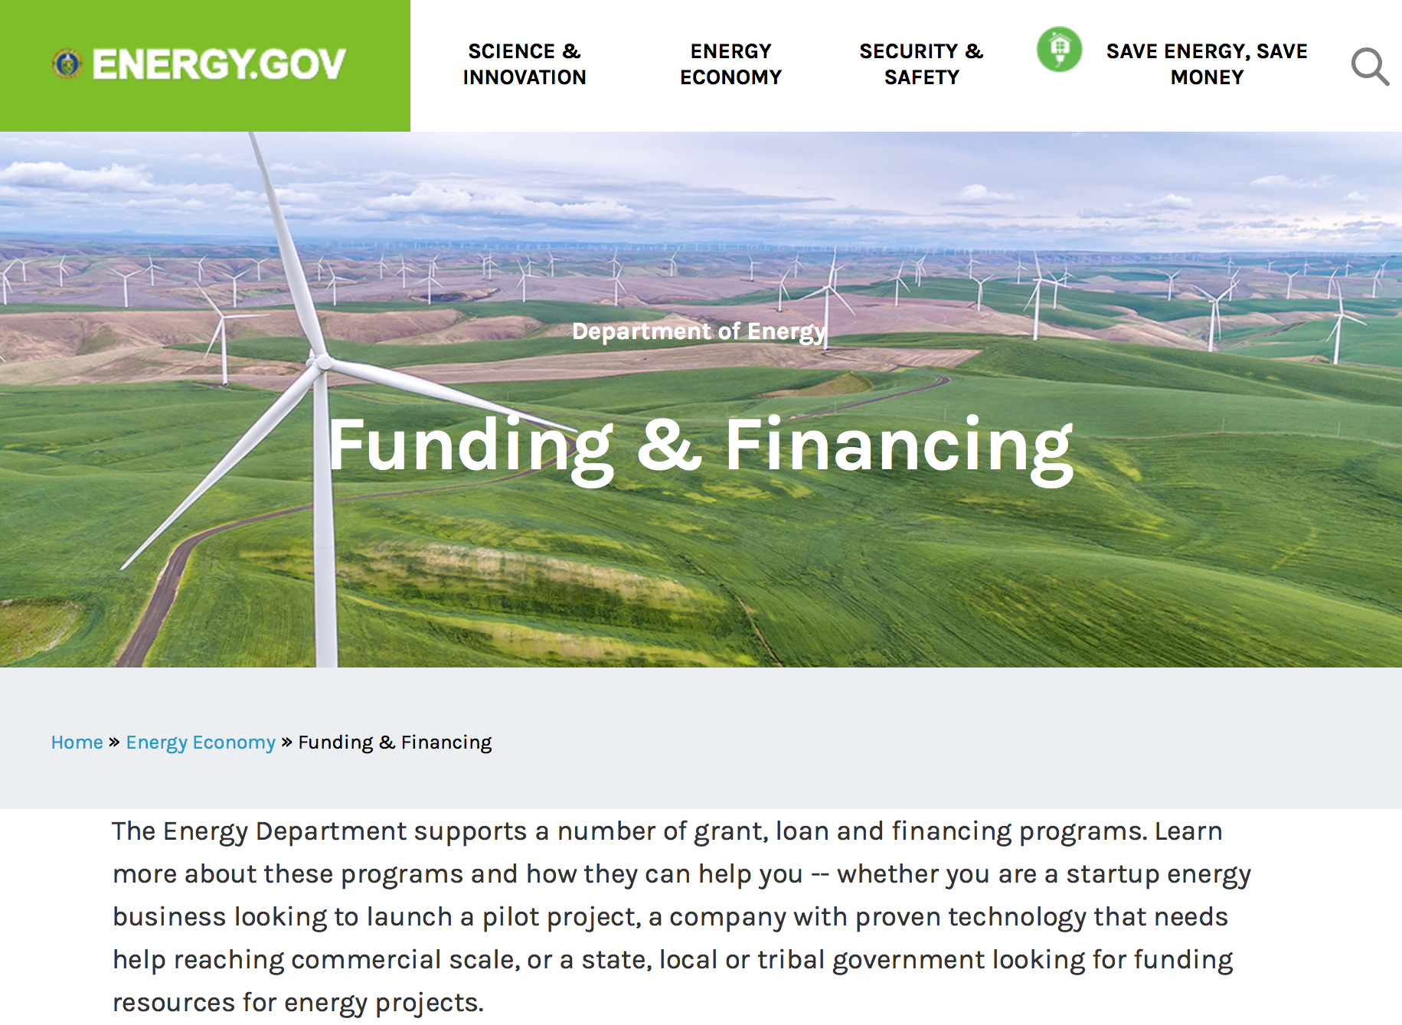

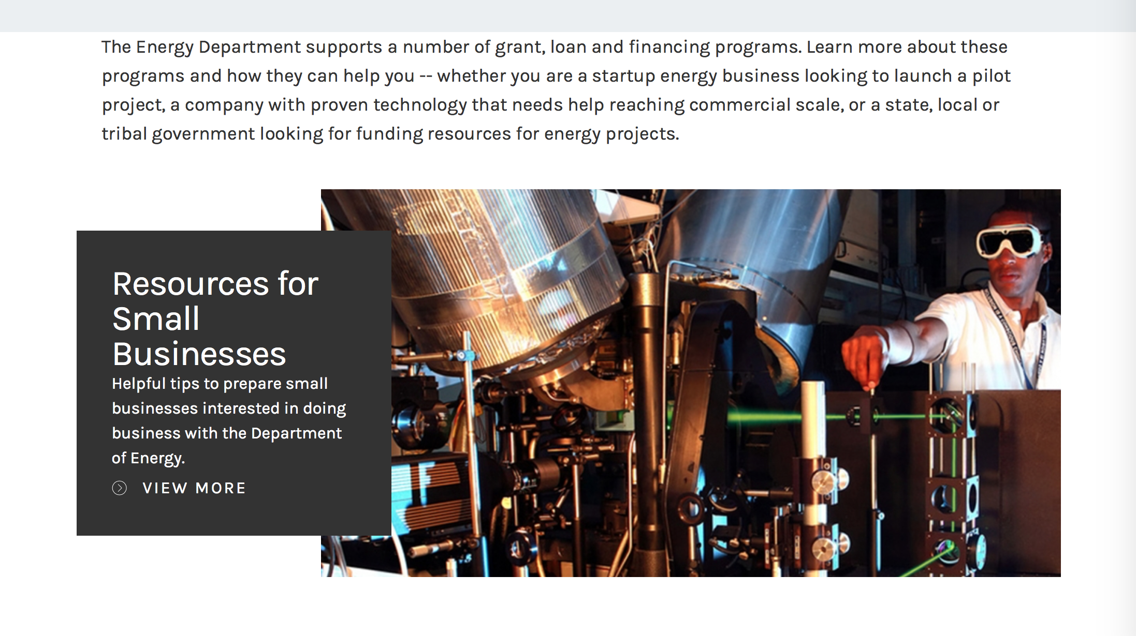

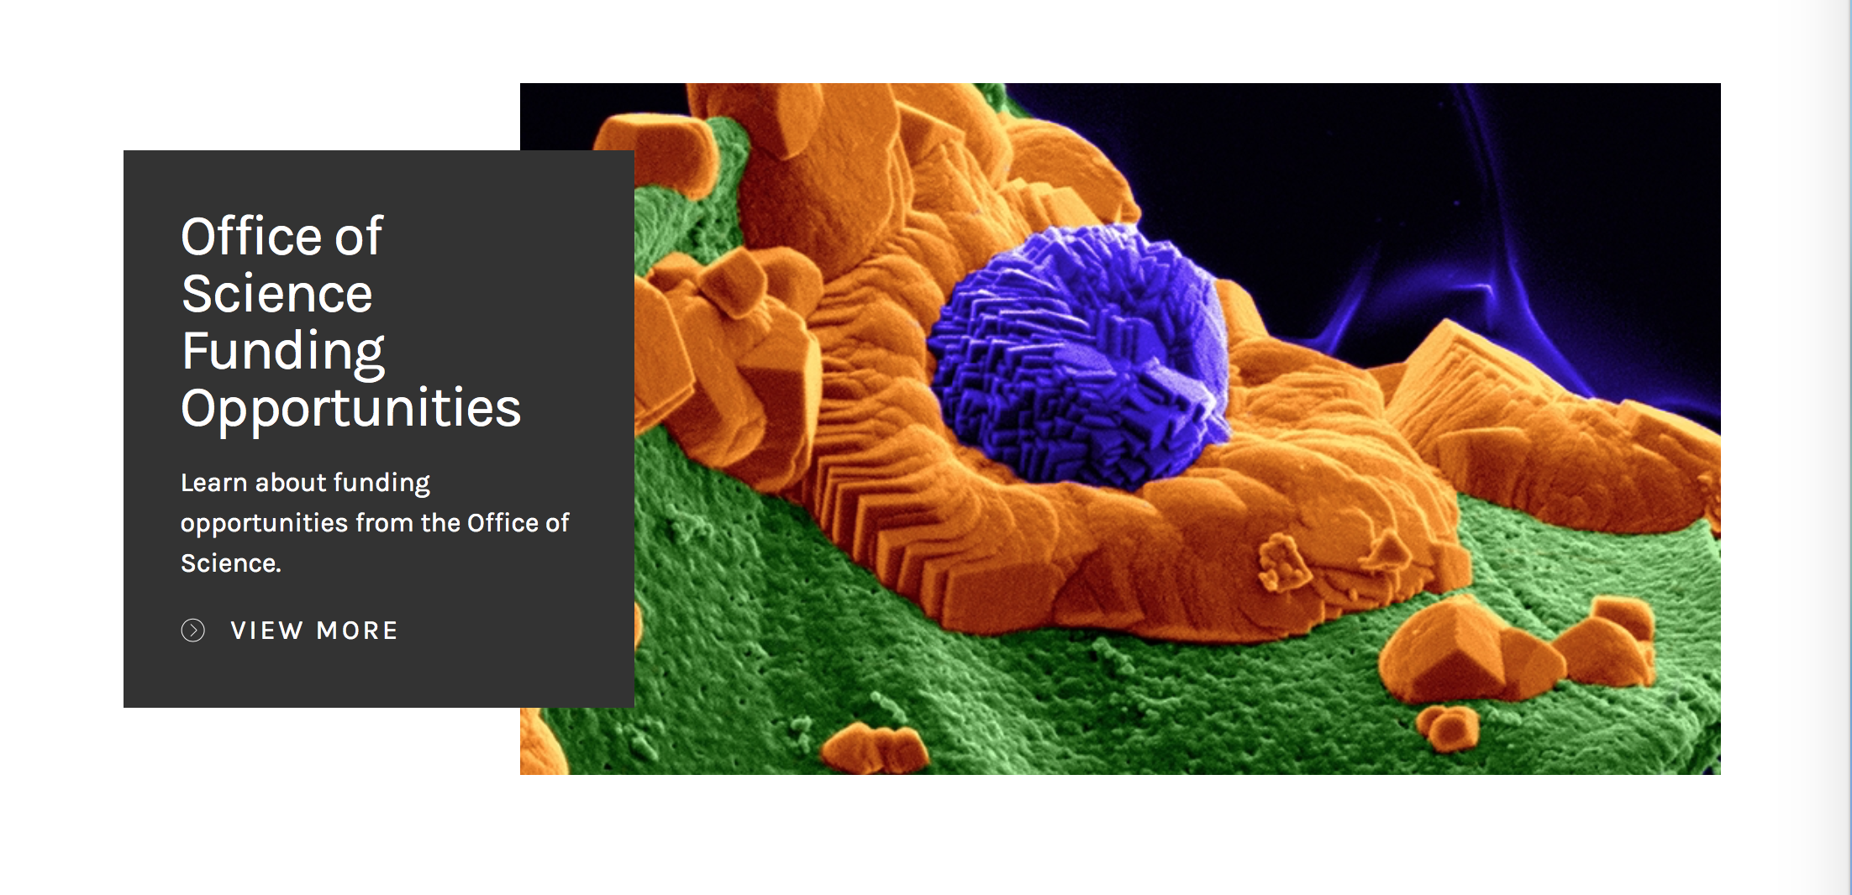

https://www.energy.gov/energy-economy/funding-financing

Research:

Golden Field Office
Building America Industry Partnerships and Research Priorities for High Performance Housing Innovation – 2018
Synopsis 1
https://www.grants.gov/web/grants/view-opportunity.html?oppId=304922
Golden Field Office
Zonal Isolation for Manmade Geothermal Reservoirs
Synopsis 1
https://www.grants.gov/web/grants/view-opportunity.html?oppId=306555

National Energy Technology Laboratory
NOVEL METHODS FOR MAKING PRODUCTS FROM CARBON DIOXIDE OR COAL
Synopsis 1
https://www.grants.gov/web/grants/view-opportunity.html?oppId=305422

Office of Science
FY 2018 Continuation of Solicitation for the Office of Science Financial Assistance Program
Synopsis 1
https://www.grants.gov/web/grants/view-opportunity.html?oppId=305601

Modifications:

National Energy Technology Laboratory
Next Generation Transformers – Flexible and Adaptable Designs
Synopsis 2
https://www.grants.gov/web/grants/view-opportunity.html?oppId=306028

Reminders:

Environmental Protection Agency

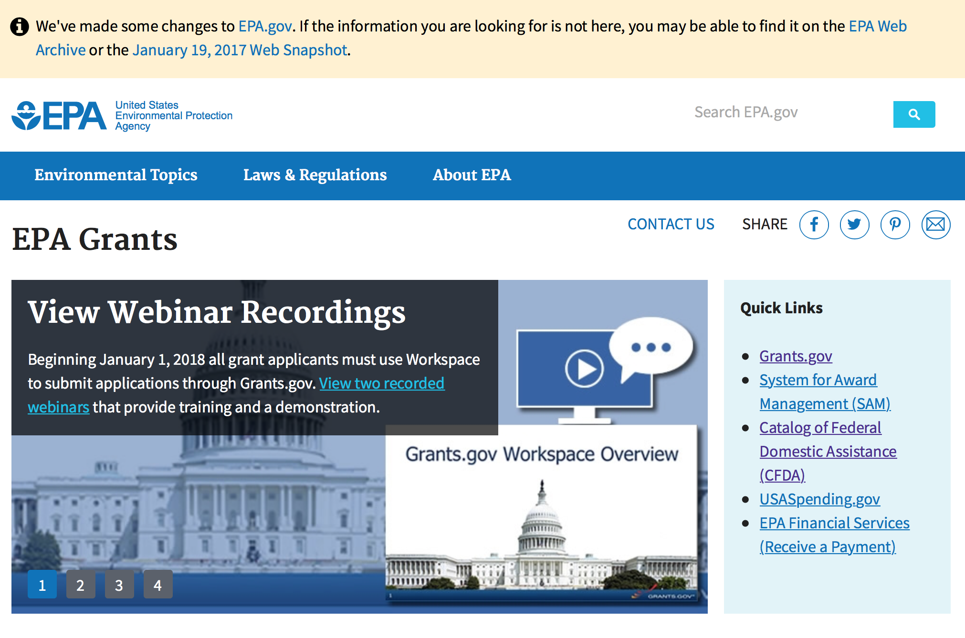
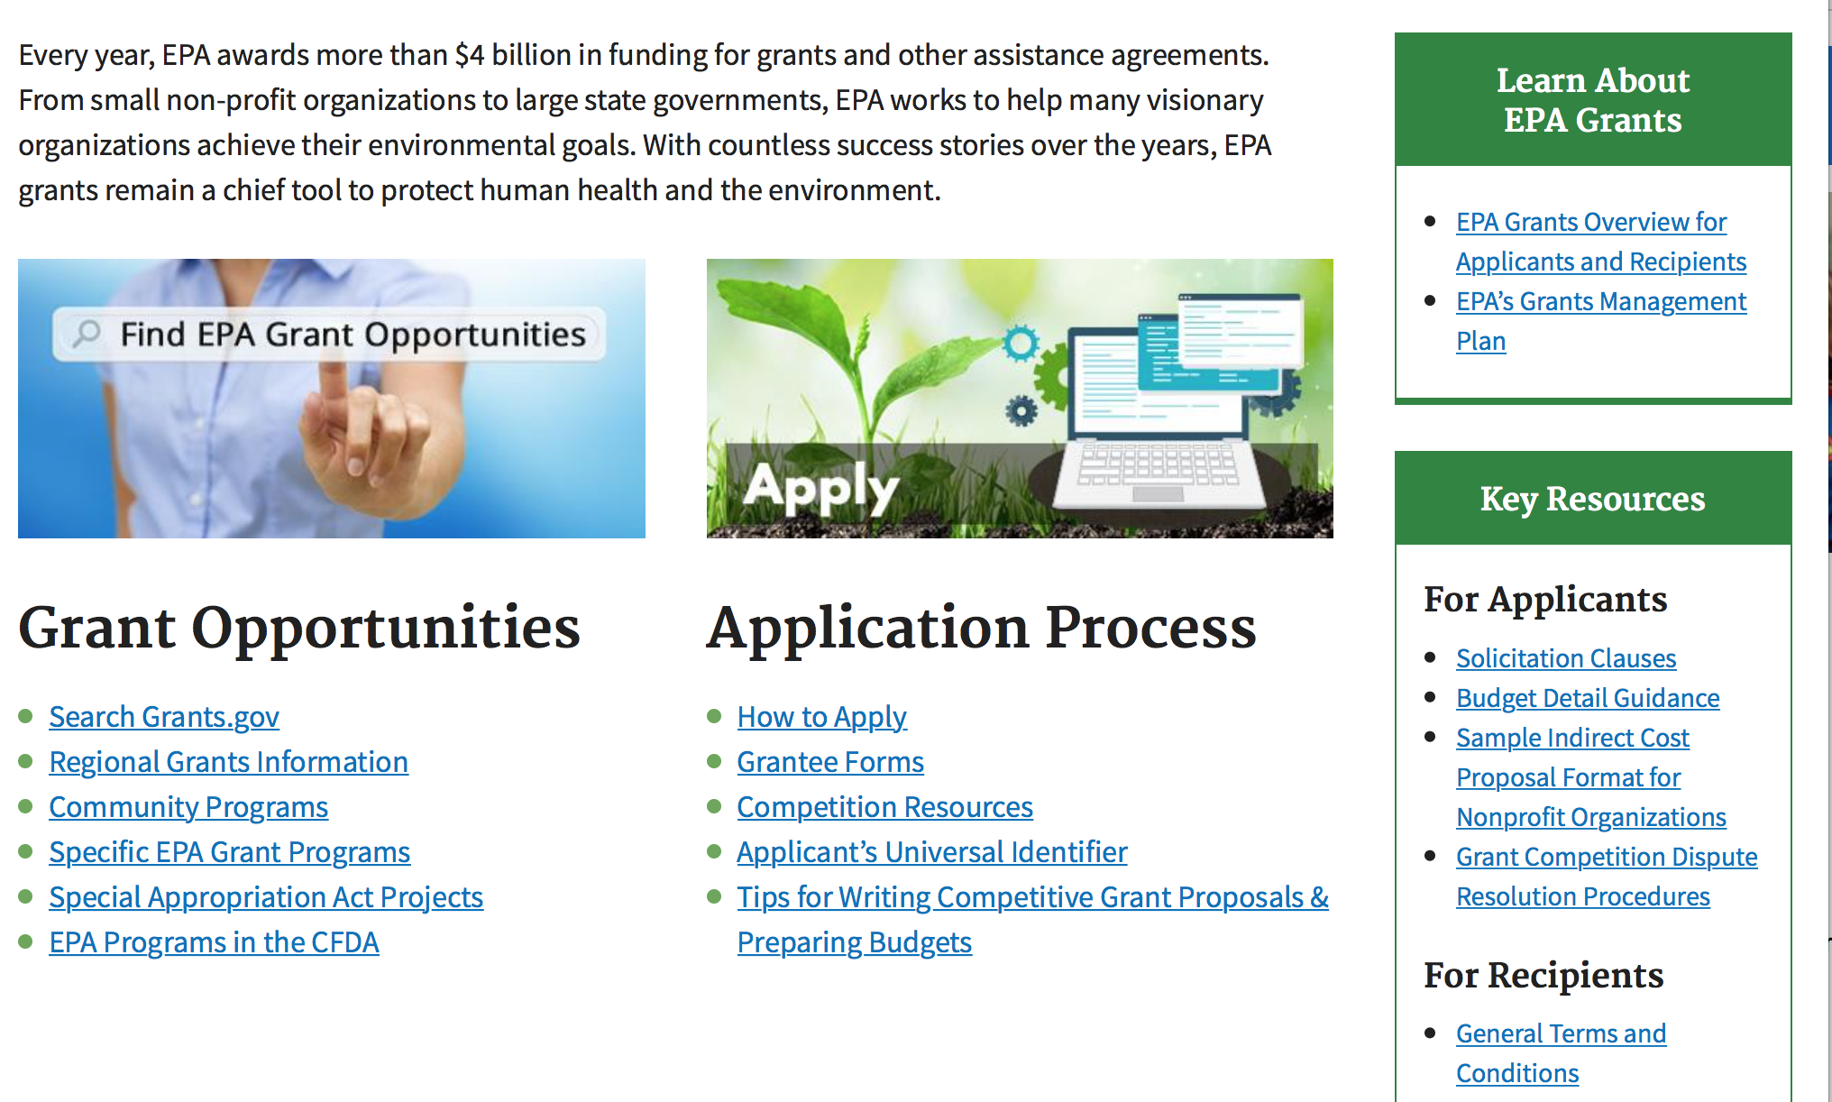

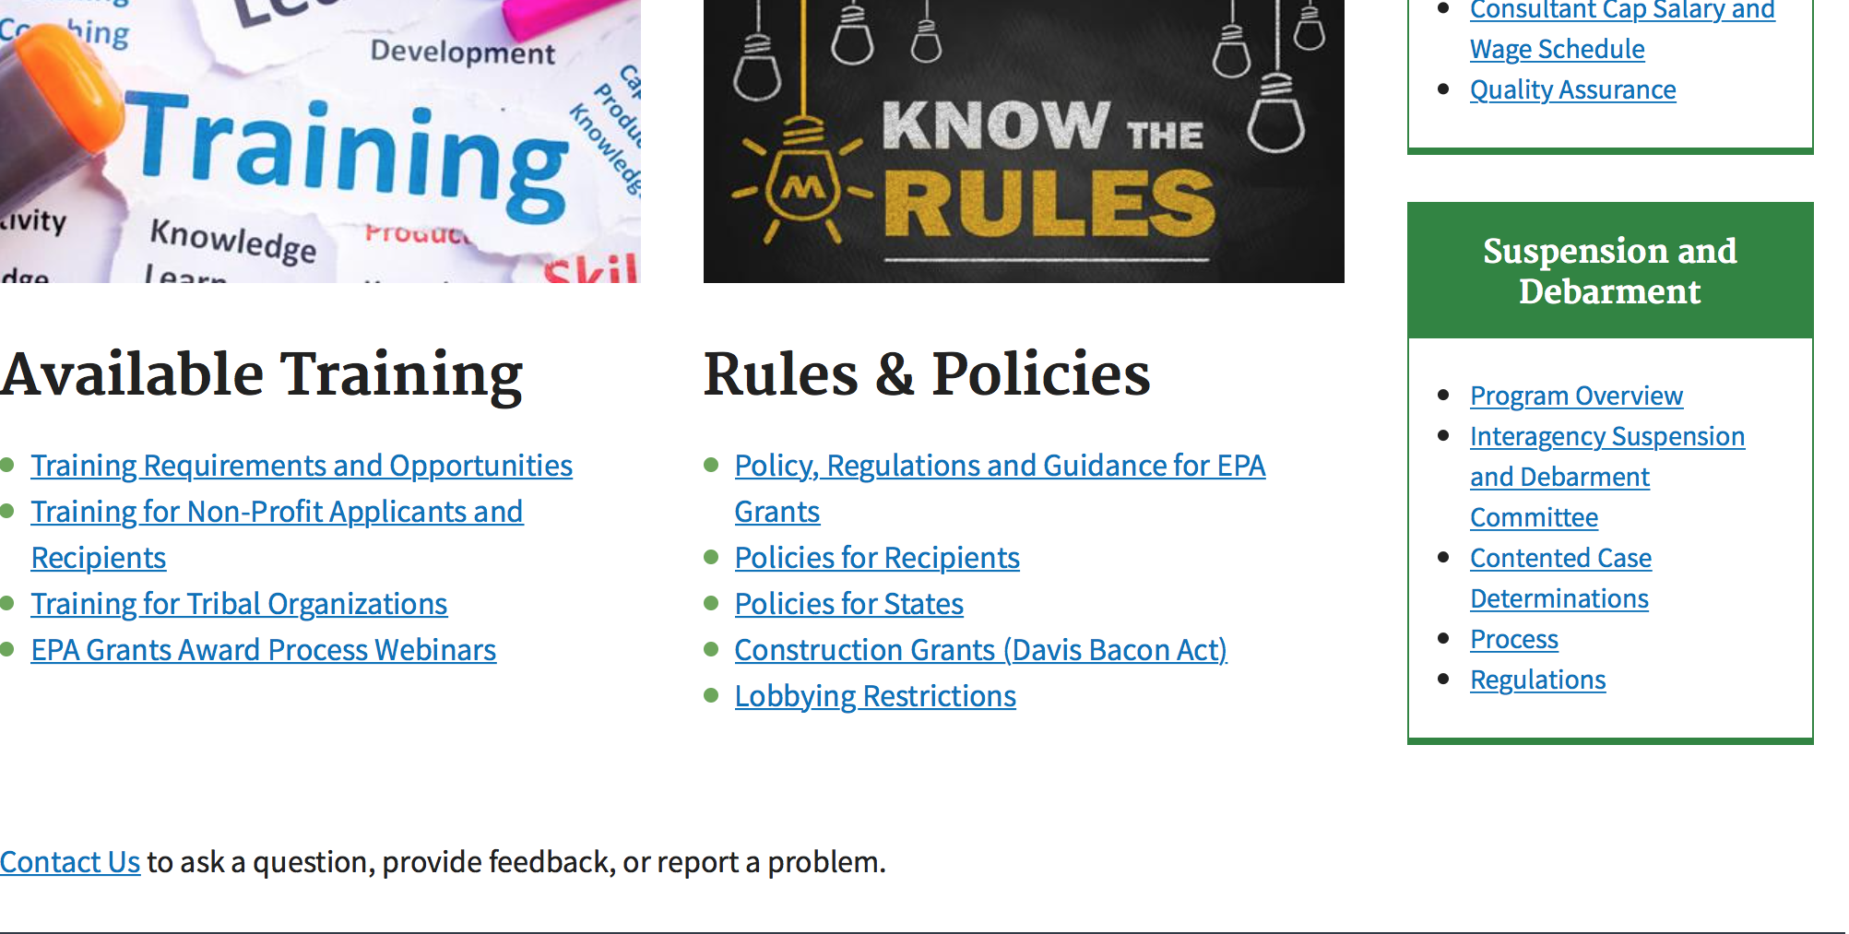

http://www.epa.gov/epahome/grants.htm

Programs:

Research:

Modifications:

Reminders:

Federal Mediation and Conciliation Service

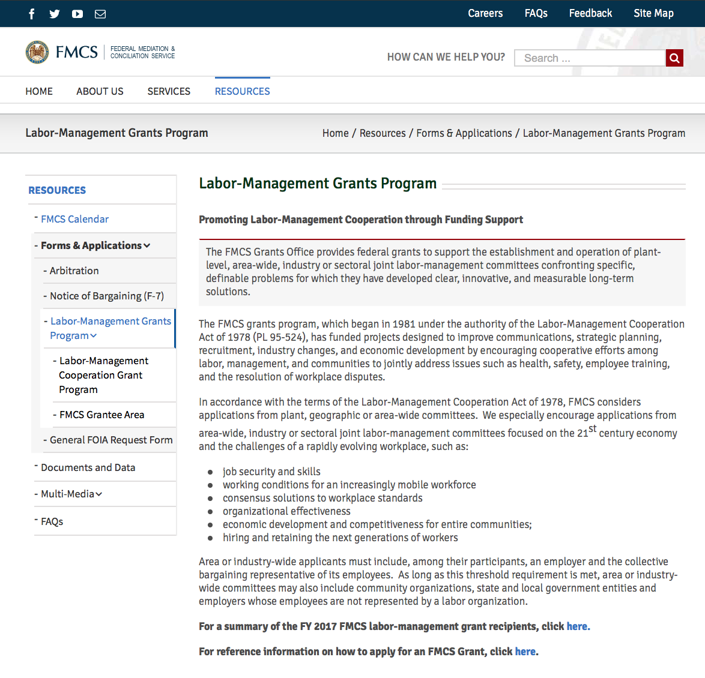

Programs:

Reminders:

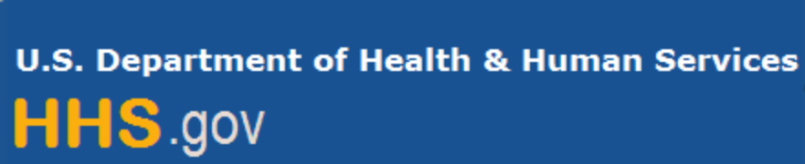

Department of Health and Human Services

Grants Forecast and Overview

The Department of Health and Human Services’ Grants Forecast is a database of planned grant opportunities proposed by its agencies. Each Forecast record contains actual or estimated dates and funding levels for grants that the agency intends to award during the fiscal year. Forecast opportunities are subject to change based on enactment of congressional appropriations.

For more general information about HHS Grants and Funding go to the website below at:

https://www.hhs.gov/grants/grants/index.html

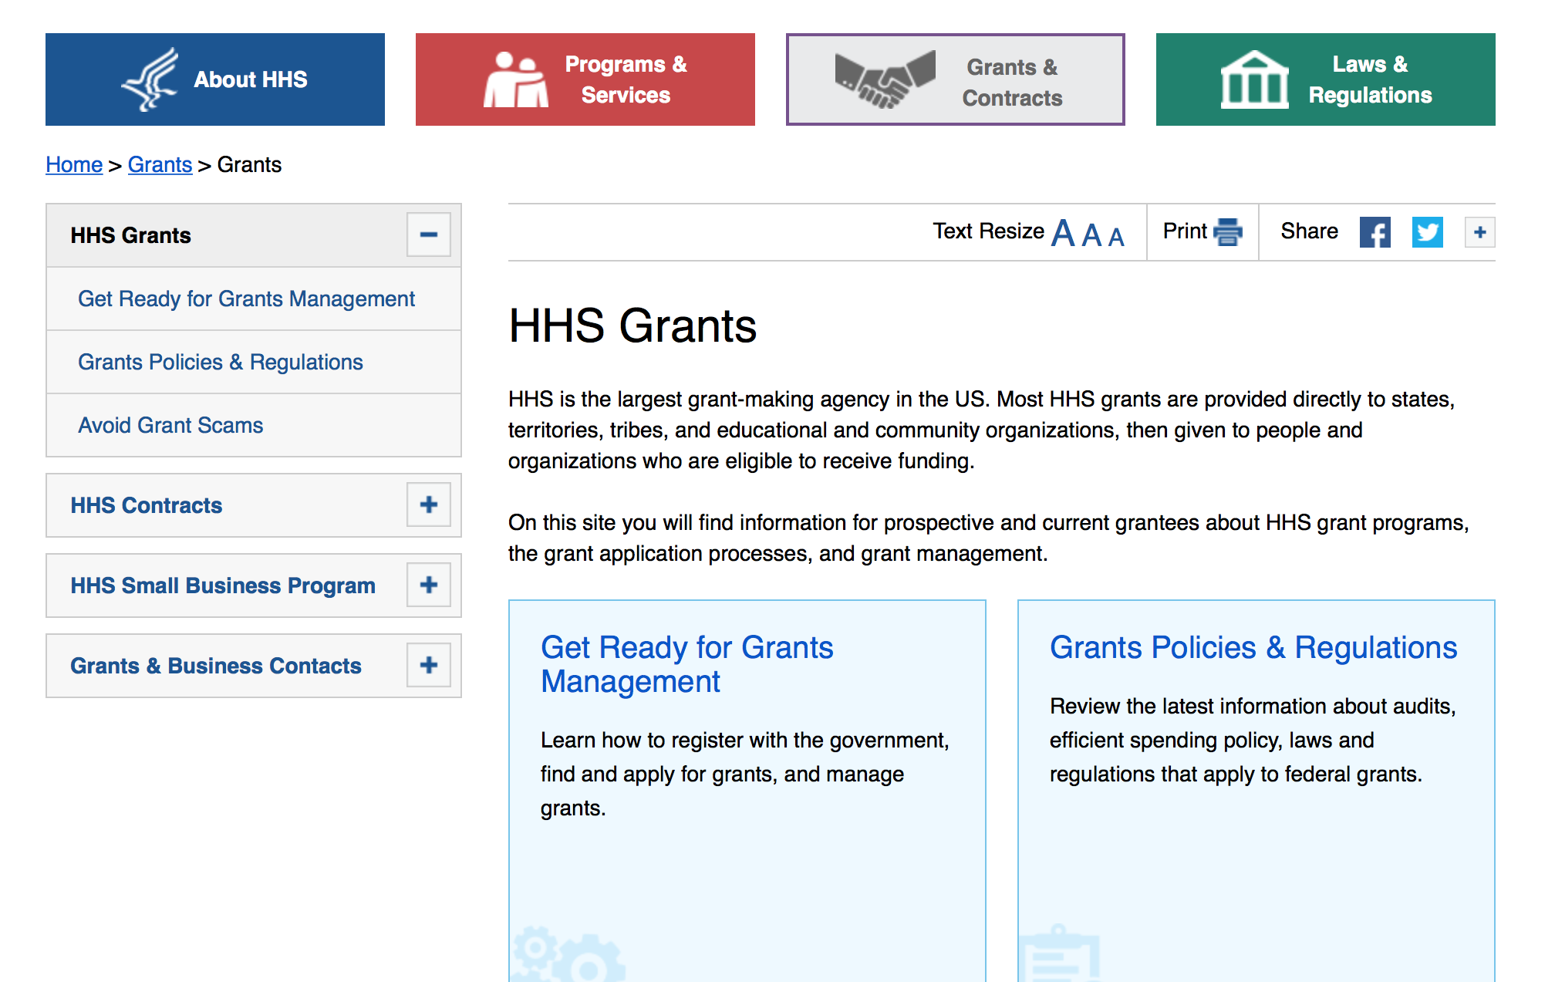

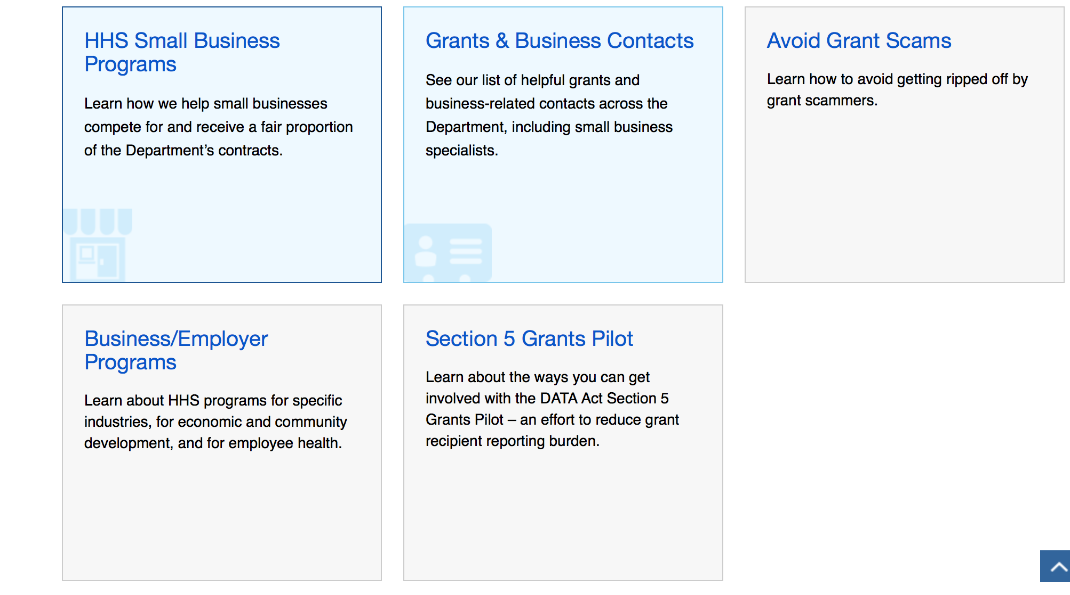

Programs:

Research:

Administration for Community Living
University Centers of Excellence in Developmental Disabilities Diversity Fellowships
Synopsis 1
https://www.grants.gov/web/grants/view-opportunity.html?oppId=304473
Centers for Disease Control - NCIPC
Collecting Violent Death Information Using the National Violent Death Reporting System (NVDRS)
Synopsis 1
https://www.grants.gov/web/grants/view-opportunity.html?oppId=303024

Centers for Disease Control - OSTLTS
Strengthening Public Health Systems and Services through National Partnerships to Improve and Protect the Nation's Health
Forecast 1
https://www.grants.gov/web/grants/view-opportunity.html?oppId=305885

Food and Drug Administration
Minor Use Minor Species Development of Drugs (R01)
Synopsis 1
https://www.grants.gov/web/grants/view-opportunity.html?oppId=306175

Health Resources and Services Administration
Advanced Nursing Education - Sexual Assault Nurse Examiners (ANE-SANE) Program
Synopsis 1
https://www.grants.gov/web/grants/view-opportunity.html?oppId=305139

Health Resources and Services Administration
Rural Communities Opioid Response Program - Planning
Synopsis 1
https://www.grants.gov/web/grants/view-opportunity.html?oppId=305116
Health Resources and Services Administration
Service Area Competition
Synopsis 1
https://www.grants.gov/web/grants/view-opportunity.html?oppId=306271
Health Resources and Services Administration
Service Area Competition
Synopsis 1
https://www.grants.gov/web/grants/view-opportunity.html?oppId=306436

Health Resources and Services Administration
AIDS Drug Assistance Program (ADAP) Emergency Relief Funds (ERF)
Synopsis 1
https://www.grants.gov/web/grants/view-opportunity.html?oppId=306565

Health Resources and Services Administration
Service Area Competition (SAC): Round 1
Synopsis 1
https://www.grants.gov/web/grants/view-opportunity.html?oppId=306037

National Institutes of Health
Administrative Supplements for Research on Dietary Supplements (Admin. Supp.- Clinical Trial Not Allowed)
Synopsis 1
https://www.grants.gov/web/grants/view-opportunity.html?oppId=305888
National Institutes of Health
Administrative Supplements for Validation Studies of Analytical Methods for Dietary Supplement Constituents (Admin Supp - Clinical Trial Not Allowed)
Synopsis 1
https://www.grants.gov/web/grants/view-opportunity.html?oppId=305914
National Institutes of Health
Alzheimer's Drug-Development Program (U01 Clinical Trial Optional)
Synopsis 1
https://www.grants.gov/web/grants/view-opportunity.html?oppId=305991

National Institutes of Health
Analyses of Adherence Strategies and Data Sets from CALERIE to Explore Behavioral and Psychosocial Aspects of Sustained Caloric Restriction in Humans (R01 - Clinical Trial Not Allowed)
Synopsis 1
https://www.grants.gov/web/grants/view-opportunity.html?oppId=306064

National Institutes of Health
Analyses of CALERIE Data and Biospecimens to Elucidate Mechanisms of Caloric Restriction (CR)-Induced Effects in Humans (R01 - Clinical Trial Not Allowed)
Synopsis 1
https://www.grants.gov/web/grants/view-opportunity.html?oppId=306082

National Institutes of Health
Approaches for Understanding Disease Mechanisms and Improving Outcomes in TB Meningitis (TBM) (R01 Clinical Trial Not Allowed)
Synopsis 1
https://www.grants.gov/web/grants/view-opportunity.html?oppId=306016

National Institutes of Health
Better Defining Growth Medium to Improve Reproducibility of Cell Culture (SBIR) (R43/R44 - Clinical Trial Not Allowed)
Synopsis 1
https://www.grants.gov/web/grants/view-opportunity.html?oppId=305886

National Institutes of Health
Better Defining Growth Medium to Improve Reproducibility of Cell Culture (STTR) (R41/R42 - Clinical Trial Not Allowed)
Synopsis 1
https://www.grants.gov/web/grants/view-opportunity.html?oppId=305887

National Institutes of Health
BRAIN Initiative Advanced Postdoctoral Career Transition Award to Promote Diversity (K99/R00 Independent Clinical Trial Not Allowed)
Synopsis 1
https://www.grants.gov/web/grants/view-opportunity.html?oppId=305839

National Institutes of Health
BRAIN Initiative Advanced Postdoctoral Career Transition Award to Promote Diversity (K99/R00 Clinical Trial Required)
Synopsis 1
https://www.grants.gov/web/grants/view-opportunity.html?oppId=305864

National Institutes of Health
Collaborative Activities to Promote Cancer Cachexia Research (Admin Supp - Clinical Trial Not Allowed)
Synopsis 1
https://www.grants.gov/web/grants/view-opportunity.html?oppId=306014

National Institutes of Health
Data Management and Coordinating Center (DMCC) for Rare Diseases Clinical Research Network (RDCRN) (U2C Clinical Trial Not Allowed)
Synopsis 1
https://www.grants.gov/web/grants/view-opportunity.html?oppId=306098

National Institutes of Health
Exploratory Analyses of Adherence Strategies and Data Sets from CALERIE to Investigate Behavioral and Psychosocial Aspects of Sustained Caloric Restriction in Humans (R21 - Clinical Trial Not Allowed)
Synopsis 1
https://www.grants.gov/web/grants/view-opportunity.html?oppId=306066

National Institutes of Health
Exploratory Analyses of CALERIE Data and Biospecimens to Elucidate Mechanisms of Caloric Restriction (CR)-Induced Effects in Humans (R21 - Clinical Trial Not Allowed)
Synopsis 1
https://www.grants.gov/web/grants/view-opportunity.html?oppId=306061

National Institutes of Health
Lab to Marketplace: Tools for Brain and Behavioral Research (R43/R44 - Clinical Trial Optional)
Synopsis 1
https://www.grants.gov/web/grants/view-opportunity.html?oppId=305944

National Institutes of Health
Notice of Intent to Publish a Funding Opportunity Announcement for Alzheimer Centers for Discovery of New Medicines (U54 - Clinical Trial Not Allowed)
Forecast 1
https://www.grants.gov/web/grants/view-opportunity.html?oppId=305921

National Institutes of Health
Notice of Intent to Publish a Funding Opportunity Announcement for Predoctoral Training in Advanced Data Analytics for Behavioral and Social Sciences Research (BSSR) - Institutional Research Training Program [T32]
Forecast 1
https://www.grants.gov/web/grants/view-opportunity.html?oppId=305925

National Institutes of Health
Notice of Intent to Publish a Funding Opportunity Announcement for Rare Disease Cohorts in Heart, Lung, Blood and Sleep Disorders (UG3/UH3)
Forecast 1
https://www.grants.gov/web/grants/view-opportunity.html?oppId=305922

National Institutes of Health
Notice of Intent to Publish a Funding Opportunity Announcement for the Graduate Research Initiative for Student Enhancement (G-RISE) (T32) Program
Forecast 1
https://www.grants.gov/web/grants/view-opportunity.html?oppId=305929

National Institutes of Health
Notice of Intent to Publish a Funding Opportunity Announcement for the Initiative for Maximizing Student Development (IMSD) (T32) Program
Forecast 1
https://www.grants.gov/web/grants/view-opportunity.html?oppId=305924
National Institutes of Health
Notice of Intent to Publish a Funding Opportunity Announcement for the Maximizing Access to Research Careers (MARC) (T34) Program
Forecast 1
https://www.grants.gov/web/grants/view-opportunity.html?oppId=305928

National Institutes of Health
Notice of Intent to Publish a Funding Opportunity Announcement for the Reissue of PA-18-426 NIBIB Supplements to NCATS CTSA Programs for Translational Research Teams of Quantitative Researchers and Clinician-Scientists (Admin Supp)
Forecast 1
https://www.grants.gov/web/grants/view-opportunity.html?oppId=305923
National Institutes of Health
Notice of Intent to Publish a Funding Opportunity Announcement for the Undergraduate Research Initiative for Student Enhancement (U-RISE) (T34) Program
Forecast 1
https://www.grants.gov/web/grants/view-opportunity.html?oppId=305927
National Institutes of Health
Paul B. Beeson Emerging Leaders Career Development Award in Aging (K76 Independent Clinical Trial Not Allowed)
Synopsis 1
https://www.grants.gov/web/grants/view-opportunity.html?oppId=306070

National Institutes of Health
Paul B. Beeson Emerging Leaders Career Development Award in Aging (K76 Independent Clinical Trial Required)
Synopsis 1
https://www.grants.gov/web/grants/view-opportunity.html?oppId=306072
National Institutes of Health
Rare Diseases Clinical Research Consortia (RDCRC) for Rare Diseases Clinical Research Network (U54 Clinical Trials Optional)
Synopsis 1
https://www.grants.gov/web/grants/view-opportunity.html?oppId=306099
National Institutes of Health
Rare Genetic Syndromes as a Window into the Genetic Architecture of Mental Disorders (Collaborative U01 Clinical Trial Not Allowed)
Synopsis 1
https://www.grants.gov/web/grants/view-opportunity.html?oppId=306001
National Institutes of Health
Rare Genetic Syndromes as a Window into the Genetic Architecture of Mental Disorders (U01 Clinical Trial Not Allowed)
Synopsis 1
https://www.grants.gov/web/grants/view-opportunity.html?oppId=306002

National Institutes of Health
Roybal Centers for Translational Research on Aging (P30 - Clinical Trial Required)
Synopsis 1
https://www.grants.gov/web/grants/view-opportunity.html?oppId=305997

National Institutes of Health
Roybal Centers for Translational Research on Dementia Care Provider Support (P30 - Clinical Trial Required)
Synopsis 1
https://www.grants.gov/web/grants/view-opportunity.html?oppId=305995

National Institutes of Health
Administrative Supplements to Support Cancer Disparity Collaborative Research (Clinical Trial Optional)
Synopsis 1
https://www.grants.gov/web/grants/view-opportunity.html?oppId=306652

National Institutes of Health
Advancing mAbs to Achieve a Drug-free Sustained HIV Virologic Remission (U01 Clinical Trial Required)
Synopsis 1
https://www.grants.gov/web/grants/view-opportunity.html?oppId=306655

National Institutes of Health
Elucidating the Functional Roles of Non-Coding RNAs in Viral Infectious Diseases (R21 Clinical Trial Not Allowed)
Synopsis 1
https://www.grants.gov/web/grants/view-opportunity.html?oppId=306656

National Institutes of Health
Global Infectious Disease Research Training Program (D43 Clinical Trial Optional)
Synopsis 1
https://www.grants.gov/web/grants/view-opportunity.html?oppId=306584
National Institutes of Health
Investigator Initiated Research in Computational Genomics and Data Science (R01 Clinical Trial Not Allowed)
Synopsis 1
https://www.grants.gov/web/grants/view-opportunity.html?oppId=306674
National Institutes of Health
Investigator Initiated Research in Computational Genomics and Data Science (R21 Clinical Trial Not Allowed)
Synopsis 1
https://www.grants.gov/web/grants/view-opportunity.html?oppId=306675

National Institutes of Health
Oncology Co-Clinical Imaging Research Resources to Encourage Consensus on Quantitative Imaging Methods and Precision Medicine (U24 - Clinical Trial Optional)
Synopsis 1
https://www.grants.gov/web/grants/view-opportunity.html?oppId=306651

National Institutes of Health
Role of Gut Microbiome in Regulating Reproduction and Its Impact on Fertility Status in Women Living with and Without HIV (R01 - Clinical Trial Optional)
Synopsis 1
https://www.grants.gov/web/grants/view-opportunity.html?oppId=306551

National Institutes of Health
Role of Gut Microbiome in Regulating Reproduction and Its Impact on Fertility Status in Women Living with and Without HIV (R21 Clinical Trial Optional)
Synopsis 1
https://www.grants.gov/web/grants/view-opportunity.html?oppId=306576

National Institutes of Health
Administrative Supplements to Promote Diversity in Small Businesses-SBIR/STTR (Admin Supp Clinical Trial Not Allowed)
Synopsis 1
https://www.grants.gov/web/grants/view-opportunity.html?oppId=306413
National Institutes of Health
Collaborative Human Tissue Network (CHTN) (UM1 Clinical Trials Not Allowed)
Synopsis 1
https://www.grants.gov/web/grants/view-opportunity.html?oppId=306465
National Institutes of Health
Enhancing Developmental Biology Research at Academic Research Enhancement Award Eligible Institutions (R15 - Clinical Trial Not Allowed)
Synopsis 1
https://www.grants.gov/web/grants/view-opportunity.html?oppId=306356

National Institutes of Health
Global Brain and Nervous System Disorders Research Across the Lifespan (R01 Clinical Trials Optional)
Synopsis 1
https://www.grants.gov/web/grants/view-opportunity.html?oppId=306352
National Institutes of Health
Global Brain and Nervous System Disorders Research Across the Lifespan (R21 Clinical Trial Optional)
Synopsis 1
https://www.grants.gov/web/grants/view-opportunity.html?oppId=306374

National Institutes of Health
High-Priority Behavioral and Social Research Networks (R24 Clinical Trial Not Allowed)
Synopsis 1
https://www.grants.gov/web/grants/view-opportunity.html?oppId=306443

National Institutes of Health
High-Priority Behavioral and Social Research Networks in Alzheimer's Disease and Alzheimer's Disease Related Dementias (R24 Clinical Trial Not Allowed)
Synopsis 1
https://www.grants.gov/web/grants/view-opportunity.html?oppId=306442
National Institutes of Health
Modeling and Simulation to Optimize HIV Prevention Research (MS OPR) (R01 Clinical Trial not allowed)
Synopsis 1
https://www.grants.gov/web/grants/view-opportunity.html?oppId=306376

National Institutes of Health
AIDS Research Center on Mental Health and HIV/AIDS (P30 Clinical Trial Optional)
Synopsis 1
https://www.grants.gov/web/grants/view-opportunity.html?oppId=306315

National Institutes of Health
Development of Novel Nonsteroidal Contraceptive Methods (R61/R33 - Clinical Trial Not Allowed)
Synopsis 1
https://www.grants.gov/web/grants/view-opportunity.html?oppId=306301

National Institutes of Health
Developmental AIDS Research Center on Mental Health and HIV/AIDS (P30 Clinical Trial Optional)
Synopsis 1
https://www.grants.gov/web/grants/view-opportunity.html?oppId=306302

National Institutes of Health
Gastrointestinal Mechanisms Contributing to HIV Pathogenesis (R01 Clinical Trial Not Allowed)
Synopsis 1
https://www.grants.gov/web/grants/view-opportunity.html?oppId=306142

National Institutes of Health
Immune Mechanisms at the Maternal-Fetal Interface (R01 Clinical Trial Optional)
Synopsis 1
https://www.grants.gov/web/grants/view-opportunity.html?oppId=306262

National Institutes of Health
Large Animal Testing Centers for Evaluation of Somatic Cell Genome Editing Tools (U42 - Clinical Trial Not Allowed)
Synopsis 1
https://www.grants.gov/web/grants/view-opportunity.html?oppId=306176

National Institutes of Health
NCCIH Natural Product Early Phase Clinical Trial Award (R33 Clinical Trial Required)
Synopsis 1
https://www.grants.gov/web/grants/view-opportunity.html?oppId=306228

National Institutes of Health
NCCIH Natural Product Early Phase Clinical Trial Phased Innovation Award (R61/R33 Clinical Trial Required)
Synopsis 1
https://www.grants.gov/web/grants/view-opportunity.html?oppId=306226
National Institutes of Health
NCI Community Oncology Research Program (NCORP) Community Sites (UG1 Clinical Trial Required)
Synopsis 1
https://www.grants.gov/web/grants/view-opportunity.html?oppId=306221
National Institutes of Health
NCI Community Oncology Research Program (NCORP) Minority/Underserved Community Sites (UG1 Clinical Trial Required)
Synopsis 1
https://www.grants.gov/web/grants/view-opportunity.html?oppId=306242

National Institutes of Health
NCI Community Oncology Research Program (NCORP) Research Bases (UG1 Clinical Trial Required)
Synopsis 1
https://www.grants.gov/web/grants/view-opportunity.html?oppId=306222
National Institutes of Health
Sustained Release Innovation for HIV (SRI) (R61/R33 Clinical Trial Optional)
Synopsis 1
https://www.grants.gov/web/grants/view-opportunity.html?oppId=306153

National Institutes of Health
The Role of Epitranscriptomics in Development and Disease (R21 - Clinical Trial Not Allowed)
Synopsis 1
https://www.grants.gov/web/grants/view-opportunity.html?oppId=306279

National Institutes of Health
The Role of Epitranscriptomics in Development and Disease (R01 - Clinical Trial Not Allowed)
Synopsis 1
https://www.grants.gov/web/grants/view-opportunity.html?oppId=306280

Office of the Assistant Secretary for Health
Border Health Global Health Security Agenda and Antimicrobial Resistance Projects
Forecast 1
https://www.grants.gov/web/grants/view-opportunity.html?oppId=306347

Substance Abuse and Mental Health Services Administration
State Opioid Response Grants
Synopsis 1
https://www.grants.gov/web/grants/view-opportunity.html?oppId=306293

Modifications:

Assistant Secretary for Preparedness and Response
Partnership for Disaster Health Response
Synopsis 8
https://www.grants.gov/web/grants/view-opportunity.html?oppId=306288

Centers for Disease Control - CGH
Emergency Response and Recovery Branch Supplemental Emergency Component
Forecast 3
https://www.grants.gov/web/grants/view-opportunity.html?oppId=306402

Centers for Disease Control - OSTLTS
Preventive Health and Health Services Block Grant– 2018
Synopsis 2
https://www.grants.gov/web/grants/view-opportunity.html?oppId=306586

Reminders:

Department of Homeland Security

The Department of Homeland Security enhances the ability of states, local and tribal jurisdictions, and other regional authorities in the preparation, prevention, and response to terrorist attacks and other disasters, by distributing grant funds. Localities can use grants for planning, equipment, training and exercise needs.

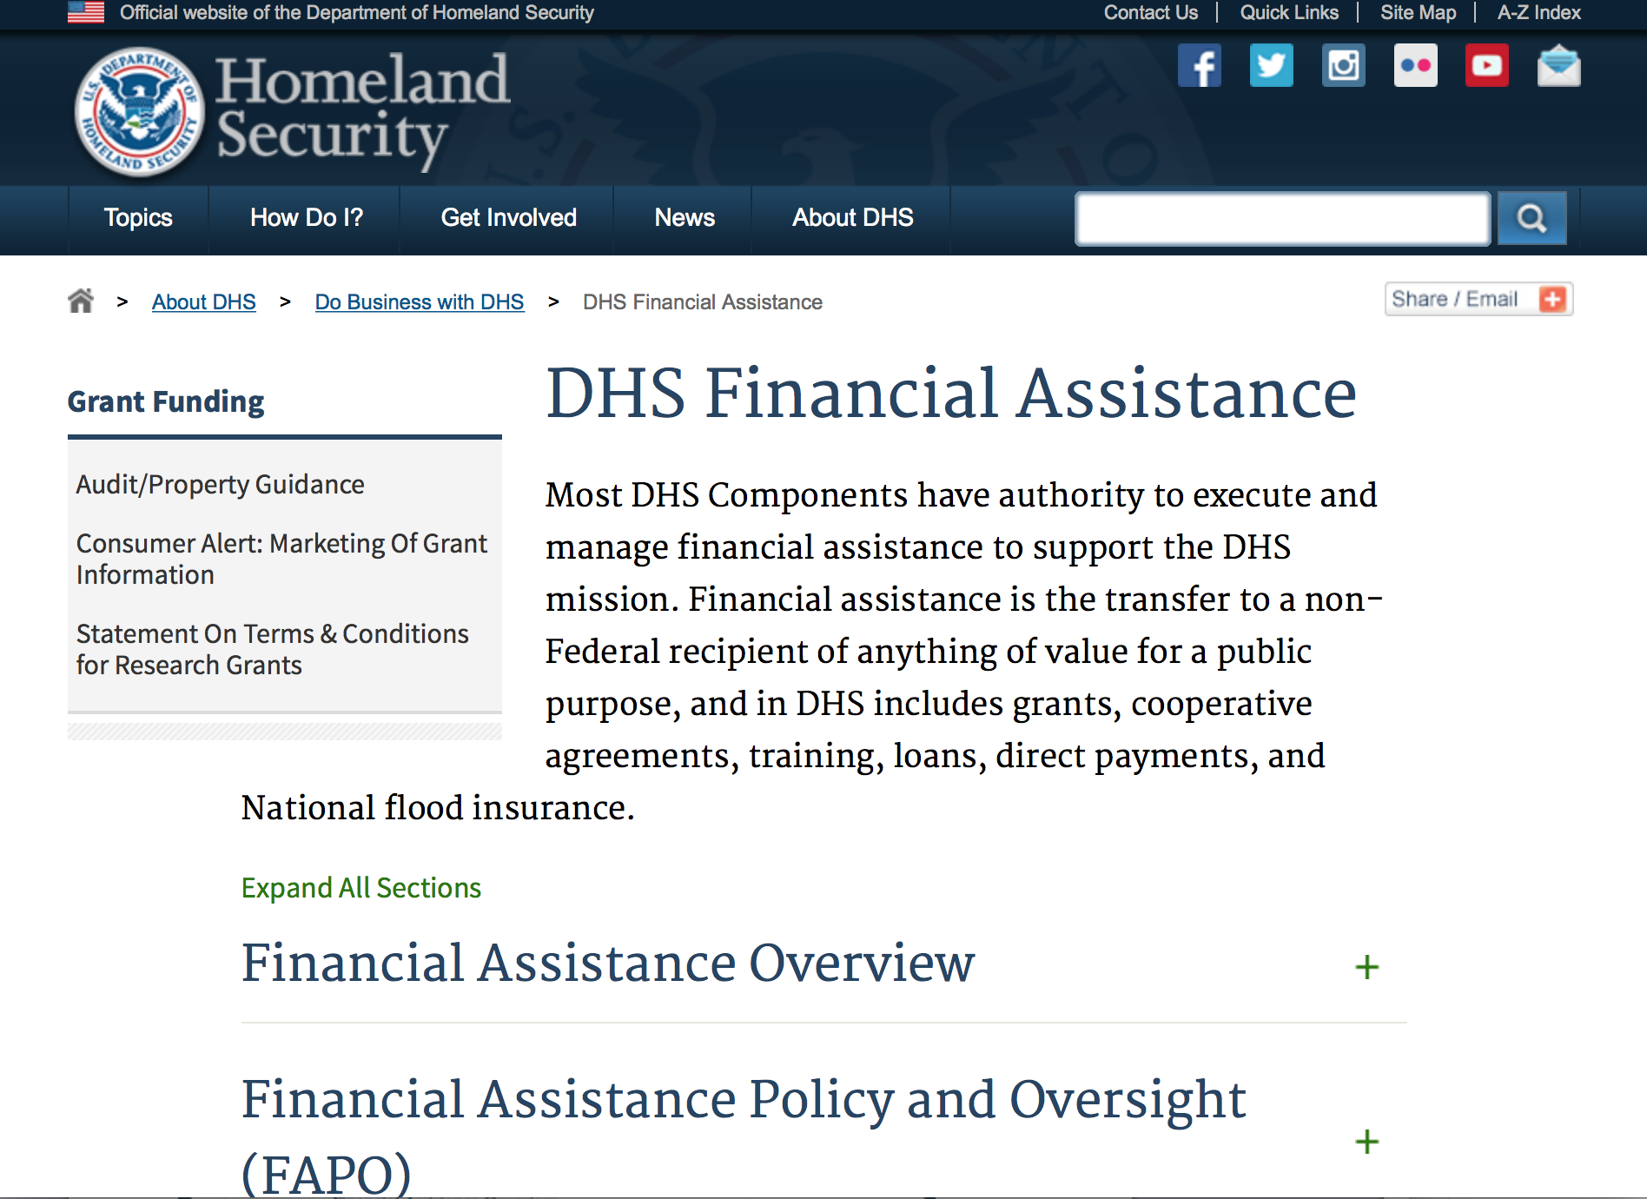
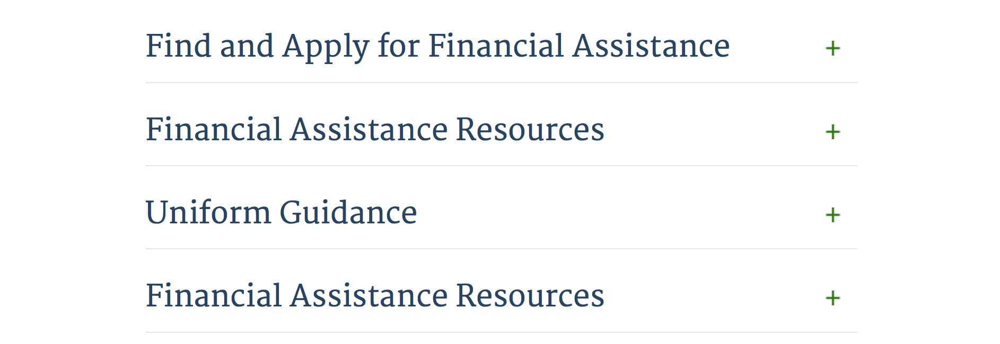

Webpage can be viewed at: http://www.dhs.gov/xopnbiz/grants/index.shtm#2

Information about 2016 for reference only
The FY 2016 Assistance to Firefighters Grants (AFG)

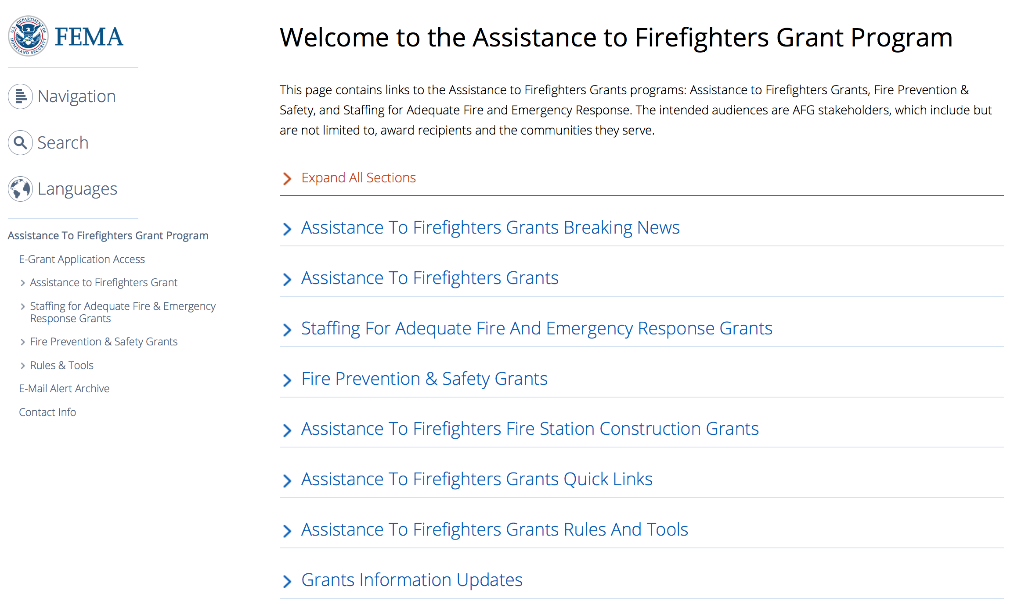

https://www.fema.gov/welcome-assistance-firefighters-grant-program

For AFG program guidance materials, please visit our Documents page.

Resources

AFG Help Desk
Contact the AFG Program Help Desk toll-free at 866-274-0960, or email us at firegrants@dhs.gov.
The AFG Program has Fire Program Specialists in 10 federal regional centers. These Regional Fire Program Specialists respond to questions about the AFG program and carry out grant monitoring activities. View regional contacts

Popular AFG links
- Assistance to Firefighters Grants (AFG)
- AFG Awards List
- AFG Success Stories
- Staffing for Adequate Fire & Emergency Response (SAFER) Grants (SAFER)
- SAFER Awards List
- SAFER Success Stories
- Fire Prevention & Safety (FP&S) Grants
- FP&S Awards List
- FP&S Success Stories
- Grant Closeout Tutorial
- Assistance to Firefighters Grant (AFG) Email Alert Archive
- Frequently Asked Questions
Contact Information For The Assistance to Firefighters Grant (AFG) Program and Help Desk

Federal Funding Alternative To AFG

State Administrative Agencies (SAA) apply for and administer Federal grants on behalf of their States, including FEMA Preparedness Grants. The SAA will work with eligible organizations to comply with the general requirements of grant programs or cooperative agreements. Contact your State’s SAA to find out what current Federal funding opportunities may be available to your organization. A listing of the SAAs and points of contact can be found at http://www.fema.gov/library/viewRecord.do?id=6363.

Programs:

Department of Homeland Security - FEMA
Fiscal Year (FY) 2018 National Urban Search & Rescue (US&R) Response System Readiness Cooperative Agreement
Synopsis 1

Document Type: | Grants Notice
Funding Opportunity Number: | DHS-18-DOD-025-00-01
Funding Opportunity Title: | Fiscal Year (FY) 2018 National Urban Search & Rescue (US&R) Response System Readiness Cooperative Agreement
Opportunity Category: | Discretionary
Opportunity Category Explanation:
Funding Instrument Type: | Cooperative Agreement
Category of Funding Activity: | Other (see text field entitled "Explanation of Other Category of Funding Activity" for clarification)
Category Explanation: | Disaster Readiness/Response
Expected Number of Awards: | 28
CFDA Number(s): | 97.025 -- National Urban Search and Rescue (US&R) Response System
Cost Sharing or Matching Requirement: | No
Version: | Synopsis 2
Posted Date: | Jun 22, 2018
Last Updated Date: | Jun 22, 2018
Original Closing Date for Applications: | Aug 02, 2018
Current Closing Date for Applications: | Aug 08, 2018
Archive Date: | Sep 07, 2018
Estimated Total Program Funding: | $34,234,232
Award Ceiling: | $1,404,490
Award Floor: | $1,147,990
Eligible Applicants: | County governments  City or township governments  Others (see text field entitled "Additional Information on Eligibility" for clarification)  State governments
Additional Information on Eligibility: | One of the 28 Sponsoring Agencies of the National US&R Response System Task Forces
Additional Information
Agency Name: | Department of Homeland Security - FEMA
Description: | The National Urban Search and Rescue (US&R) Response System (the System) provides funding for 28 national task forces staffed and equipped to conduct around-the-clock search-and-rescue operations following earthquakes, tornadoes, floods, hurricanes, aircraft accidents, hazardous materials spills and catastrophic structure collapses. When deployed, these task forces support state and local emergency responders' efforts to locate survivors and manage recovery operations. This program supports Mission 5, Goal 5.1: "Enhance National Readiness", as provided in the Quadrennial Homeland Security Review. To provide for the sustainment and readiness of the System and their local jurisdictions, through the funding of: administration and management, training, equipment and storage and maintenance.
Link to Additional Information:
Grantor Contact Information: | If you have difficulty accessing the full announcement electronically, please contact:  User, System ndgrants@fema.dhs.gov  ndgrants@fema.dhs.gov
https://www.grants.gov/web/grants/view-opportunity.html?oppId=306431

Modifications:

Reminders:

Department of Housing and Urban Development

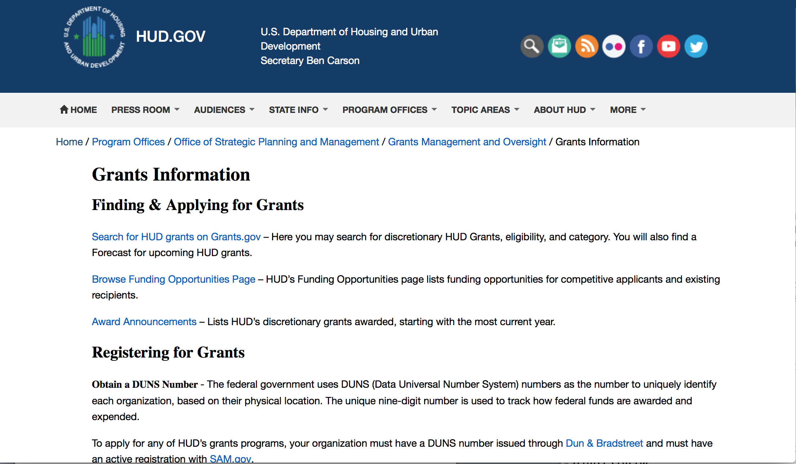
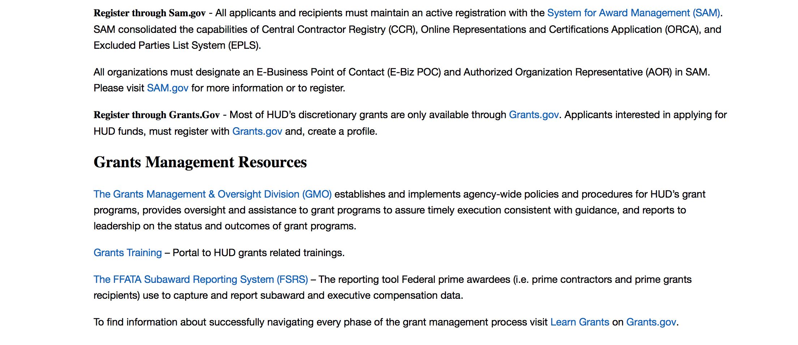
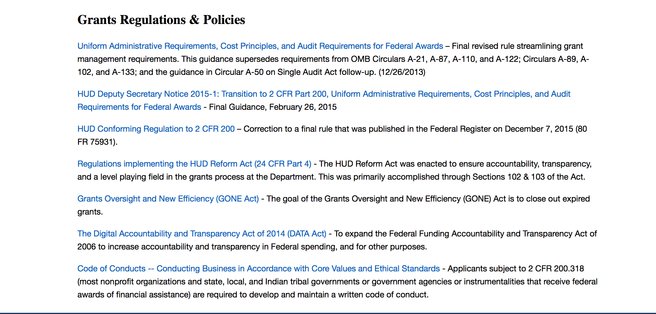

http://portal.hud.gov/hudportal/HUD?src=/topics/grants

HUD - Notice of Funds Available
For detailed information click here

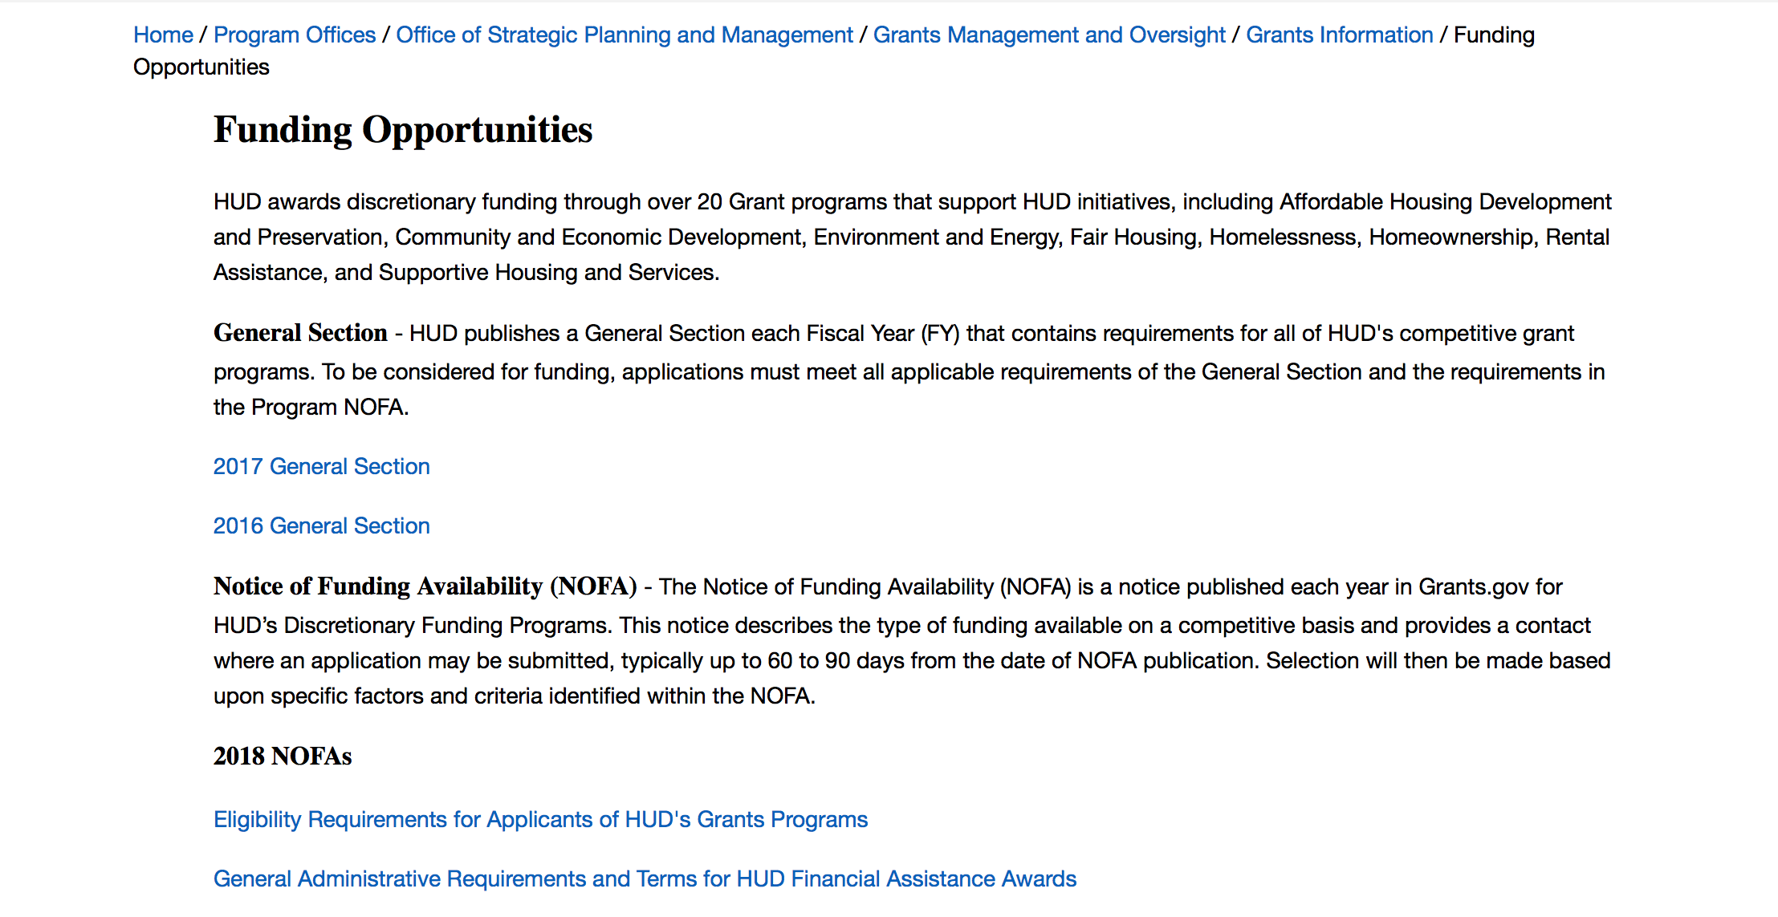

http://portal.hud.gov/hudportal/HUD?src=/program_offices/administration/grants/fundsavail

HUD NOFA FORECAST
The Department of Housing and Urban Development NOFA Forecast lists competitive grant opportunities that may be available for FY2016. The inclusion or exclusion of an opportunity in this list does not constitute a guarantee that a specific opportunity will become available or not be available. Forecast opportunities are subject to change based on enactment of Congressional appropriations and other considerations.
When funding is available, HUD will issue a Notice of Funding Availability (NOFA), which will be available on Grants.gov

Programs:

Lead-Based Paint Hazard Reduction Program
Synopsis 1

Document Type: | Grants Notice
Funding Opportunity Number: | FR-6200-N-12
Funding Opportunity Title: | Lead-Based Paint Hazard Reduction Program
Opportunity Category: | Discretionary
Opportunity Category Explanation:
Funding Instrument Type: | Grant
Category of Funding Activity: | Housing
Category Explanation:
Expected Number of Awards: | 50
CFDA Number(s): | 14.900 -- Lead-Based Paint Hazard Control in Privately-Owned Housing
Cost Sharing or Matching Requirement: | Yes
Version: | Synopsis 1
Posted Date: | Jun 19, 2018
Last Updated Date: | Jun 19, 2018
Original Closing Date for Applications: | Aug 02, 2018 Electronically submitted applications must be submitted no later than 11:59 p.m., ET, on the listed application due date.
Current Closing Date for Applications: | Aug 02, 2018 Electronically submitted applications must be submitted no later than 11:59 p.m., ET, on the listed application due date.
Archive Date: | Sep 01, 2018
Estimated Total Program Funding: | $212,000,000
Award Ceiling: | $4,100,000
Award Floor: | $1,000,000
Eligible Applicants: | County governments  Native American tribal governments (Federally recognized)  State governments  Special district governments  City or township governments
Additional Information on Eligibility: | If your organization is established under section 501(c) (including any subsidiary sections) of the Internal Revenue Code, you are not eligible to apply for funding under this NOFA. Under the authorizing statute for this grant program, only cities, counties/parishes, and other units of local government, and certain States and Native American Tribes (see below) are eligible to receive funding under this NOFA. State government and Native American tribal applicants (whether they are the principal applicant or partner applicants in a consortium) are eligible to apply for funding under this NOFA only if they have an Environmental Protection Agency (EPA) authorized lead-based paint training and certification program as of the submission deadline date. Multiple agencies within a local government, or multiple units of local government, or a state and one or more units of local government may apply as a consortium; however, an eligible principal (lead) applicant that will be responsible for ensuring compliance with all requirements in this NOFA must be identified. Where an application involves multiple entities, each entity must meet the civil rights threshold requirement of Resolution of Civil Rights Matters. If you, the applicant, are not a component of the executive branch of your jurisdiction’s government, that is, if your department or agency does not report directly or through a direct chain of command to the chief executive officer of your jurisdiction (e.g., the governor, the county executive (by whatever title), or the mayor (by whatever title), you must identify the law that provides the authority establishing you as a part of the State government or the unit of local government. To do so, you must provide the specific statutory citation(s) (e.g., 1 Mystate Revised Code 2345), and either the relevant wording as an attachment, or the specific web address(es) of the relevant wording in the body of your application. Be sure to verify that each web address cited is active and available without cost. Applicants with a large, urban jurisdictions with at least 3,500 pre-1940 occupied rental housing units (either alone or through a consortium), as listed at the Census website click here or as listed in this program link (Click here.) will be able to apply for the maximum award of $3,500,000 as a high need jurisdiction applying for Lead Hazard Reduction Program funding. The following are not eligible entities for this competition and applications will not be reviewed: Individuals. Non-Profit Organizations. Applications from organizations established under section 501(c) (including any subsidiary sections) of the Internal Revenue Code will not be reviewed. FY 2017 Awardees. Applicants that received an award under the 2017 NOFA cycle for either the Lead-Based Paint Hazard Control Program (LBPHC) or Lead Hazard Reduction Demonstration (this NOFA) program will not be reviewed. Individuals, foreign entities, and sole proprietorship organizations are not eligible to compete for, or receive, awards made under this announcement.
Additional Information
Agency Name: | Department of Housing and Urban Development
Description: | Program Description The purpose of the Lead Based Paint Hazard Reduction (LHR) grant program is to assist states, cities, counties/parishes, Native American Tribes or other units of local government in undertaking comprehensive programs to identify and control lead-based paint hazards in eligible privately-owned rental or owner-occupied housing populations. 2. Program Objectives Funds will be awarded to applicants to accomplish the following objectives: a. Maximize the number of children under the age of six years protected from lead poisoning and the number of housing units where lead hazards are controlled; b. Target lead hazard control efforts in housing in which children less than 6 years of age are at greatest risk of lead poisoning (pre-1960), which both currently and historically has included children residing in low-income and minority neighborhoods, to reduce the risk of elevated blood lead levels in these children less; c. Utilize cost-effective lead hazard control methods and approaches that ensures the long-term safety of the building occupants; d. Build local capacity to safely and effectively address lead hazards during lead hazard control, and renovation, remodeling, and maintenance activities by appropriate trained and certified individuals; e. Develop comprehensive, community-based approaches to integrating this grant program within other local initiatives through public and private partnerships that address housing related health and safety hazards and or serve low income families with children under the age of 6; f. Affirmatively further fair housing and further environmental justice. Note that besides being an “objective” of this NOFA, the obligation to affirmatively further fair housing is also a civil rights related program requirement; g. Establish data sharing, and targeting between health and housing departments; Specifically, for the following required reporting data pieces: (ER Visits, Asthma Incidence, ect of enrolled applicants and general pop of target area) h. Establish and implement a detailed process of monitoring and ensuring that units made lead-safe units are affirmatively marketed, and priority given, to families with young children under the age of 6 years of age for up to three years; i. Direct Job training, employment, contracting, and other economic opportunities generated by this grant will be directed to low- and very-low income persons, particularly those who are recipients of government assistance for housing, and to businesses that provide economic opportunities to low- and very low-income persons in the area in which the project is located. For more information, see 24 CFR 135; j. Gather pre and post treatment data that supports and validates lead hazard control investments; and k. Comply with Section 504 of the Rehabilitation Act of 1973 (“Section 504”) and its implementing regulations at 24 CFR 8, and Titles II and III of the Americans with Disabilities Act. Each of these prohibits discrimination based on disability.
Link to Additional Information: | https://hud.gov/program_offices/spm/gmomgmt/grantsinfo/fundingopps
Grantor Contact Information: | If you have difficulty accessing the full announcement electronically, please contact:  Shannon Steinbauer Shannon.E.Steinbauer@hud.gov  Grants Policy
https://www.grants.gov/web/grants/view-opportunity.html?oppId=306382

Notice of Funding Availability (NOFA) for the Fiscal Year (FY) 2018 Continuum of Care Program Competition
Synopsis 1
Document Type: | Grants Notice
Funding Opportunity Number: | FR-6200-N-25
Funding Opportunity Title: | Notice of Funding Availability (NOFA) for the Fiscal Year (FY) 2018 Continuum of Care Program Competition
Opportunity Category: | Discretionary
Opportunity Category Explanation:
Funding Instrument Type: | Grant
Category of Funding Activity: | Housing
Category Explanation:
Expected Number of Awards: | 8000
CFDA Number(s): | 14.267 -- Continuum of Care Program
Cost Sharing or Matching Requirement: | Yes
Posted Date: | Jun 20, 2018
Last Updated Date: | Jun 20, 2018
Original Closing Date for Applications: | Sep 18, 2018 Electronically submitted applications must be submitted no later than 11:59 p.m., ET, on the listed application due date.
Current Closing Date for Applications: | Sep 18, 2018 Electronically submitted applications must be submitted no later than 11:59 p.m., ET, on the listed application due date.
Archive Date: | Oct 18, 2018
Estimated Total Program Funding: | $2,100,000,000
Award Ceiling: | $5,000,000
Award Floor: | $2,500
Eligible Applicants: | City or township governments  County governments  Nonprofits having a 501(c)(3) status with the IRS, other than institutions of higher education  State governments
Additional Information on Eligibility: | 24 CFR 578.15, eligible project applicants for the CoC Program Competition are nonprofit organizations, States, local governments, and instrumentalities of State and local governments, and public housing agencies, as such term is defined in 24 CFR 5.100, without limitation or exclusion. For-profit entities are not eligible to apply for grants or to be subrecipients of grant funds. Individuals, foreign entities, and sole proprietorship organizations are not eligible to compete for, or receive, awards made under this announcement.
Additional Information
Agency Name: | Department of Housing and Urban Development
Description: | The CoC Program (24 CFR part 578) is designed to promote a community-wide commitment to the goal of ending homelessness; to provide funding for efforts by nonprofit providers, States, and local governments to quickly re-house homeless individuals, families, persons fleeing domestic violence, and youth while minimizing the trauma and dislocation caused by homelessness; to promote access to and effective utilization of mainstream programs by homeless; and to optimize self-sufficiency among those experiencing homelessness.
Link to Additional Information: | https://hud.gov/program_offices/spm/gmomgmt/grantsinfo/fundingopps
Grantor Contact Information: | If you have difficulty accessing the full announcement electronically, please contact:  Sherri Boyd Sherri.L.Boyd@hud.gov  Grants Policy
https://www.grants.gov/web/grants/view-opportunity.html?oppId=306391

Modifications:

Resident Opportunity & Self-Sufficiency Program
Synopsis 2
https://www.grants.gov/web/grants/view-opportunity.html?oppId=305771

Jobs Plus Initiative
Synopsis 3
https://www.grants.gov/web/grants/view-opportunity.html?oppId=306244

Deleted:

Reminders:

Family Unification Program Notice of Funding Availability for Fiscal Years 2017 and 2018
Synopsis 1
Document Type: Grants Notice  Funding Opportunity Number: FR-6100-N-41  Funding Opportunity Title: Family Unification Program Notice of Funding Availability for Fiscal Years 2017 and 2018  Opportunity Category: Discretionary  Opportunity Category Explanation:  Funding Instrument Type: Grant  Category of Funding Activity: Housing  Category Explanation:  Expected Number of Awards: 60  CFDA Number(s): 14.880 -- Family Unification Program (FUP)  Cost Sharing or Matching Requirement: No | Version: Synopsis 2  Posted Date: Apr 25, 2018  Last Updated Date: Apr 26, 2018  Original Closing Date for Applications: Jul 24, 2018 Electronically submitted applications must be submitted no later than 11:59 p.m., ET, on the listed application due date.  Current Closing Date for Applications: Jul 24, 2018 Electronically submitted applications must be submitted no later than 11:59 p.m., ET, on the listed application due date.  Archive Date: Aug 23, 2018  Estimated Total Program Funding: $30,000,000  Award Ceiling: $1,071,000  Award Floor: $44,000
Eligibility
Eligible Applicants: | Others (see text field entitled "Additional Information on Eligibility" for clarification)
Additional Information on Eligibility: | a. Only PHAs that have an existing ACC with HUD for HCVs are eligible to apply for funding under this announcement. b. Eligible PHAs must have demonstrated a commitment to administer FUP, which shall be verified by an executed MOU between the PHA, PCWA, and CoC, and in accordance with this NOFA. c. HUD will only consider funding one application per PHA. This one application limit applies regardless of whether the PHA is a State or regional PHA, except in those instances where such a PHA has more than one PHA code number due to its operating under the jurisdiction of more than one HUD Field Office. In such instance, a separate application under each code shall be considered for funding with the cumulative total of vouchers applied for under the applications not to exceed the maximum number of vouchers the PHA is eligible to apply for under this NOFA (i.e., no more than the number of vouchers the same PHA would be eligible to apply for if it had only one PHA code number). d. A contract administrator that does not have an ACC with HUD for HCVs, but constitutes a PHA under 24 CFR 982.4 by reason of its administering HCVs on behalf of another PHA, is not eligible to submit an application under this NOFA. Individuals, foreign entities, and sole proprietorship organizations are not eligible to compete for, or receive, awards made under this announcement.
Additional Information
Agency Name: | Department of Housing and Urban Development
Description: | FUP is a program under which HCVs are provided to two groups: 1. Families for whom the lack of adequate housing is a primary factor in the imminent placement of the family's child, or children, in out-of-home care; or the delay in the discharge of the child, or children, to the family from out-of-home care; and 2. Youths at least 18 years and not more than 24 years of age (have not reached their 25th birthday) who left foster care at age 16, or will leave foster care within 90 days, in accordance with a transition plan described in section 475(5)(H) of the Social Security Act, and is homeless or is at risk of becoming homeless at age 16 or older. As required by statute, a FUP voucher issued to such a youth may only be used to provide housing assistance for the youth for a maximum of 36 months.
Link to Additional Information: | https://hud.gov/program_offices/spm/gmomgmt/grantsinfo/fundingopps
Grantor Contact Information: | If you have difficulty accessing the full announcement electronically, please contact:  Ryan Jones FUPvouchers@hud.gov  Grants Policy
https://www.grants.gov/web/grants/view-opportunity.html?oppId=304293

Institute of Museum and Library Services

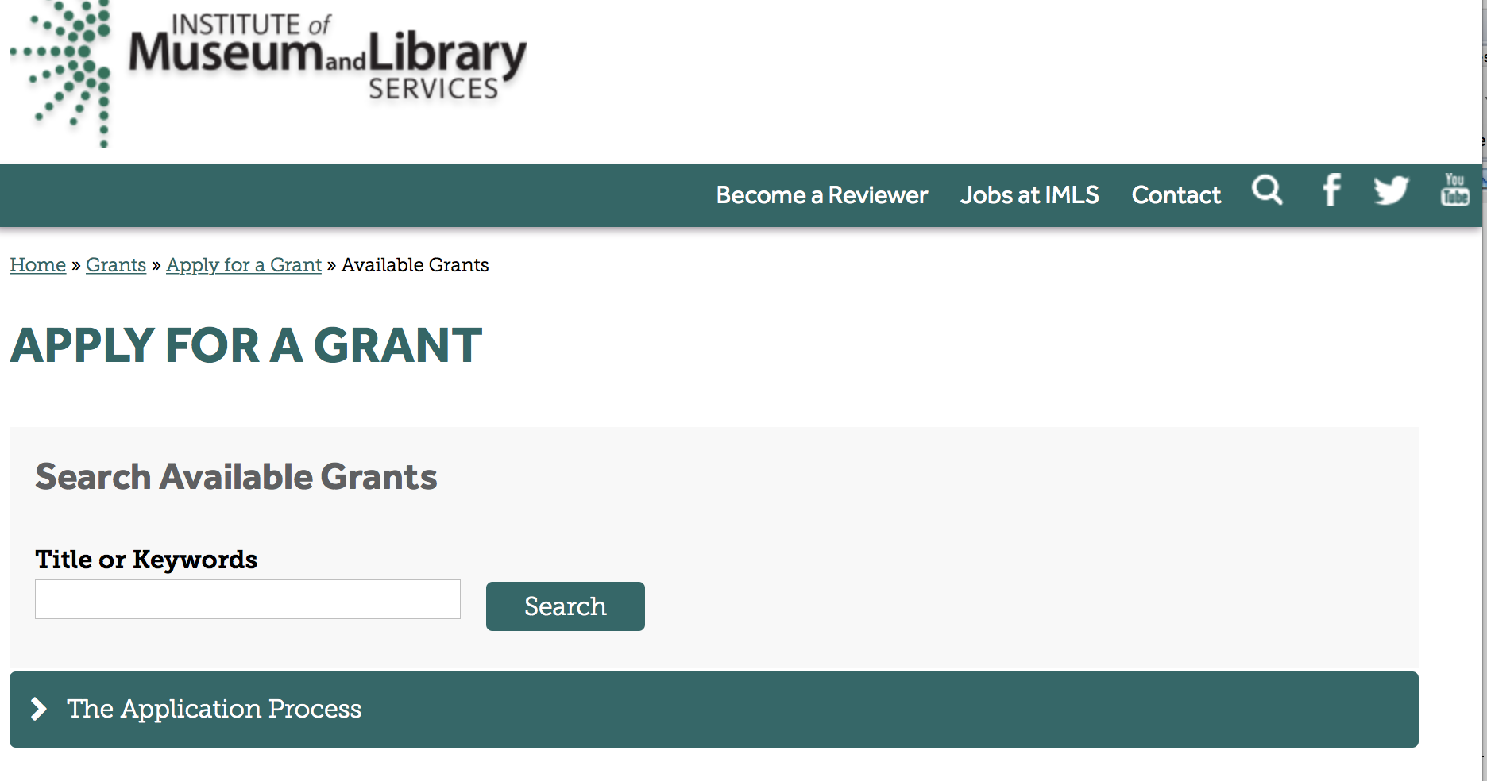

https://www.imls.gov/grants/apply-grant/available-grants

Each grant program has specific eligibility requirements. The links below provide general eligibility criteria for museums, libraries, and tribal organizations, but please note that additional organizations may be eligible for grants under certain programs. Additionally, ineligible organizations may still be able to participate in grant programs through partnerships with eligible organizations. Please click on the links below to see general criteria and review Applications and Guidelines for specific information.
Museums Libraries

Institutions: Archives, Federally Recognized Native American Tribe, Historical Society, Library, Nonprofits that serve Native Hawaiians, Professional Association, Public or Private Non-profit Institutions of Higher Education, Regional Organization, State Library Administrative Agency, State or Local Government

Check out IMLS's Facebook page at:
https://www.facebook.com/USIMLS/

Programs:

Modifications:

Reminders:

Deleted:

Department of the Interior
Working with Interior

The Interior Department provides assistance to the public, local governments and businesses through a number of programs. For a general overview see: http://www.doi.gov/index.cfm

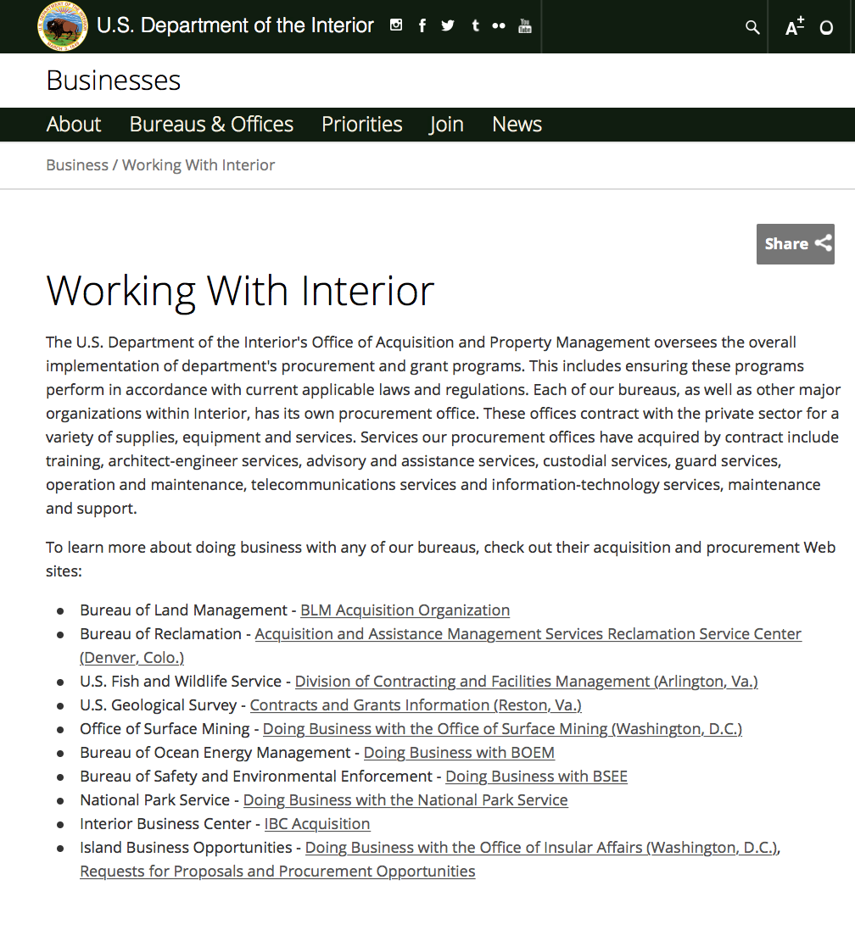

http://www.doi.gov/businesses/working-with-interior.cfm

Programs:

Modifications:

Reminders:

Bureau of Reclamation
WaterSMART: Title XVI Water Reclamation and Reuse Projects
Synopsis 2
Document Type: Grants Notice  Funding Opportunity Number: BOR-DO-18-F011  Funding Opportunity Title: WaterSMART: Title XVI Water Reclamation and Reuse Projects  Opportunity Category: Discretionary  Opportunity Category Explanation:  Funding Instrument Type: Grant  Category of Funding Activity: Natural Resources  Category Explanation:  Expected Number of Awards: 14  CFDA Number(s): 15.504 -- Title XVI Water Reclamation and Reuse  Cost Sharing or Matching Requirement: Yes | Version: Synopsis 2  Posted Date: May 30, 2018  Last Updated Date: May 30, 2018  Original Closing Date for Applications: Jul 27, 2018  Current Closing Date for Applications: Jul 27, 2018  Archive Date: Aug 01, 2018  Estimated Total Program Funding: $54,000,000  Award Ceiling: $20,000,000  Award Floor: $0
Eligibility
Eligible Applicants: | Others (see text field entitled "Additional Information on Eligibility" for clarification)
Additional Information on Eligibility: | Sponsors of any one of the 53 Title XVI Projects specifically authorized by the Title XVI Act; provided that the Title XVI Project has not reached its Federal funding ceiling as specified in the Title XVI Act. For a list of authorized projects please visit the Title XVI website, www.usbr.gov/watersmart/title/authorized.html.Sponsors of projects eligible for funding under section 4009(c) of the WIIN Act, Public Law 114-322. Eligible entities under section 4009(c) include sponsors of Projects that have submitted a Title XVI Feasibility Study to Reclamation for review by the date that this FOA is posted, and for which the study is found to meet all of the requirements of Reclamation Manual WTR 11-01: Title XVI Water Reclamation and Reuse Program Feasibility Study Review Process by July 27, 2018 (the application deadline for this FOA). If a feasibility study has been reviewed by Reclamation and found to meet the requirements of WTR 11-01, but the review findings have not yet been transmitted to Congress, Reclamation will transmit those findings to Congress either before project selections are made or concurrently with project selections.
Additional Information
Agency Name: | Bureau of Reclamation
Description: | The objective of this Funding Opportunity Announcement (FOA) is to invite sponsors of congressionally authorized water reclamation and reuse projects and projects eligible under section 4009(c) of the WIIN Act (Projects) to request cost-shared funding for the planning, design, and/or construction of those Projects.  Eligible applicants are invited to request funding for planning, design, and/or construction of Projects. Although the evaluation criteria listed in this FOA will be applied to the Project as a whole, funding requests submitted under this FOA must be based on the expenditures already incurred or planned to be incurred by September 30, 2020.  This may include work either:  - Planned through September 30, 2020, or  - Completed work that was conducted after the date of the project’s congressional authorization for authorized projects, or the date that Reclamation’s feasibility study review findings for the Project were transmitted to Congress for WIIN projects.  Under section 4009(c) of the WIIN Act, Projects can only receive funding once enacted appropriations legislation designates funding to them by name. Therefore, financial assistance agreements for projects eligible under section 4009(c) will not be entered into until the project appears in enacted appropriations legislation.
Link to Additional Information: | Program Website
Grantor Contact Information: | If you have difficulty accessing the full announcement electronically, please contact:  Irene Hoiby Grants Management Specialist Phone 303-445-2025  Grants Officer

https://www.grants.gov/web/grants/view-opportunity.html?oppId=305731

Fish and Wildlife Service
2019 Multistate Conservation Grant Program
Synopsis 1
Document Type: Grants Notice  Funding Opportunity Number: F18AS00142  Funding Opportunity Title: 2019 Multistate Conservation Grant Program  Opportunity Category: Discretionary  Opportunity Category Explanation:  Funding Instrument Type: Grant  Category of Funding Activity: Environment Natural Resources  Category Explanation:  Expected Number of Awards: 17  CFDA Number(s): 15.628 -- Multistate Conservation Grant  Cost Sharing or Matching Requirement: No | Version: Synopsis 1  Posted Date: May 21, 2018  Last Updated Date: May 21, 2018  Original Closing Date for Applications: Aug 03, 2018  Current Closing Date for Applications: Aug 03, 2018  Archive Date: Oct 05, 2018  Estimated Total Program Funding: $6,000,000  Award Ceiling: $600,000  Award Floor: $25,000
Eligibility
Eligible Applicants: | Private institutions of higher education  Nonprofits having a 501(c)(3) status with the IRS, other than institutions of higher education  State governments  Public and State controlled institutions of higher education  Nonprofits that do not have a 501(c)(3) status with the IRS, other than institutions of higher education
Additional Information on Eligibility:
Additional Information
Agency Name: | Fish and Wildlife Service
Description: | The Sport Fish Restoration Act and the Wildlife Restoration Act, as amended by the Wildlife and Sport Fish Restoration Programs Improvement Act of 2000 (Pub. L. 106-408) authorize the Secretary of the Interior to make up to $6,000,000 available annually under the Wildlife and Sport Fish Restoration Program (WSFR) for the purpose of funding multistate conservation project grants. The primary goal of the MSCGP is to provide grant funds to address regional or national priority needs (National Conservation Needs or NCNs) of the State fish and wildlife agencies (States) and their partners that are beyond the scope and capabilities of a single State. Projects awarded funding are published annually in the Federal Register.
Link to Additional Information: | Grants.gov
Grantor Contact Information: | If you have difficulty accessing the full announcement electronically, please contact:  Multistate Conservation Grant Coordinator John Stremple 703-358-2066 John_Stremple@fws.gov  email address
https://www.grants.gov/web/grants/view-opportunity.html?oppId=305417

National Park Service
Cultural Resources Management Services
Synopsis 1

Document Type: Grants Notice  Funding Opportunity Number: P18AS00217  Funding Opportunity Title: Cultural Resources Management Services  Opportunity Category: Discretionary  Opportunity Category Explanation:  Funding Instrument Type: Cooperative Agreement  Category of Funding Activity: Other (see text field entitled "Explanation of Other Category of Funding Activity" for clarification)  Category Explanation: Cultural Resources  Expected Number of Awards: 25  CFDA Number(s): 15.946 -- Cultural Resources Management  Cost Sharing or Matching Requirement: No | Version: Synopsis 1  Posted Date: May 14, 2018  Last Updated Date: May 14, 2018  Original Closing Date for Applications: Jul 13, 2018  Current Closing Date for Applications: Jul 13, 2018  Archive Date: Aug 12, 2018  Estimated Total Program Funding: $250,000  Award Ceiling: $250,000  Award Floor: $2,500
Eligibility
Eligible Applicants: | Public and State controlled institutions of higher education  Nonprofits having a 501(c)(3) status with the IRS, other than institutions of higher education  Private institutions of higher education
Additional Information on Eligibility:
Additional Information
Agency Name: | National Park Service
Description: | Questions must be submitted in writing via email only to steve_livingston@nps.gov. The subject line of the email must reference “P18AS00217.” All questions and answers will be consolidated into one document and disseminated through an amendment to the NOFO through the grants.gov website.  The deadline for questions is June 14th 5:00 PM MT.
Link to Additional Information:
Grantor Contact Information: | If you have difficulty accessing the full announcement electronically, please contact:  Steve Livingston Contract Specialist Phone 303-969-2690  E-mail Only
https://www.grants.gov/web/grants/view-opportunity.html?oppId=305055

Fish and Wildlife Service
White-Nose Syndrome Research Grants FY18
Synopsis 1
Document Type: Grants Notice  Funding Opportunity Number: F18AS00119  Funding Opportunity Title: White-Nose Syndrome Research Grants FY18  Opportunity Category: Discretionary  Opportunity Category Explanation:  Funding Instrument Type: Grant  Category of Funding Activity: Natural Resources  Category Explanation:  Expected Number of Awards: 30  CFDA Number(s): 15.657 -- Endangered Species Conservation � Recovery Implementation Funds  Cost Sharing or Matching Requirement: Yes | Version: Synopsis 1  Posted Date: Apr 20, 2018  Last Updated Date: Apr 20, 2018  Original Closing Date for Applications: Sep 30, 2018 Proposals will be evaluated as frequently as monthly - see application review information for additional details  Current Closing Date for Applications: Sep 30, 2018 Proposals will be evaluated as frequently as monthly - see application review information for additional details  Archive Date: Dec 31, 2018  Estimated Total Program Funding: $1,500,000  Award Ceiling: $300,000  Award Floor: $35,000

Eligible Applicants: | City or township governments  County governments  Native American tribal organizations (other than Federally recognized tribal governments)  Special district governments  Private institutions of higher education  For profit organizations other than small businesses  Nonprofits that do not have a 501(c)(3) status with the IRS, other than institutions of higher education  Native American tribal governments (Federally recognized)  Public and State controlled institutions of higher education  Nonprofits having a 501(c)(3) status with the IRS, other than institutions of higher education  State governments  Individuals  Small businesses
Additional Information on Eligibility:
Additional Information
Agency Name: | Fish and Wildlife Service
Description: | The U.S. Fish and Wildlife Service (Service) is pleased to announce the availability of research funding in 2018 to investigate issues related directly to the management of white-nose syndrome (WNS). The WNS Program provides financial and technical assistance to non-governmental, university, and private researchers, as well as state and local governments, Native American tribes, and federal agencies, for the management of WNS and conservation of bats. Funded projects will investigate priority questions about WNS to improve our ability to manage the disease and implement management actions that will help to conserve affected bat species.
Link to Additional Information: | http://www.grants.gov
Grantor Contact Information: | If you have difficulty accessing the full announcement electronically, please contact:  Fish & Wildlife Biologist Sadie Stevens 413-253-8677 Sadie_Stevens@fws.gov  Sadie_Stevens@fws.gov
https://www.grants.gov/web/grants/view-opportunity.html?oppId=303939

Office of Surface Mining
Not-for Profit Acid Mine Drainage Watershed Cooperative Agreement Programs (WCAP)
Synopsis
Document Type: | Grants Notice
Funding Opportunity Number: | S18AS00003
Funding Opportunity Title: | Not-for Profit Acid Mine Drainage Watershed Cooperative Agreement Programs (WCAP)
Opportunity Category: | Discretionary
Opportunity Category Explanation:
Funding Instrument Type: | Cooperative Agreement
Category of Funding Activity: | Science and Technology and other Research and Development
Category Explanation:
Expected Number of Awards: | 20
CFDA Number(s): | 15.253 -- Not-for-Profit AMD Reclamation
Cost Sharing or Matching Requirement: | No
Version: | Synopsis 1
Posted Date: | Jan 19, 2018
Last Updated Date: | Jan 19, 2018
Original Closing Date for Applications: | Aug 31, 2018
Current Closing Date for Applications: | Aug 31, 2018
Archive Date: | Sep 30, 2018
Estimated Total Program Funding: | $1,500,000
Award Ceiling: | $100,000
Award Floor: | $100,000
Eligible Applicants: | Nonprofits having a 501(c)(3) status with the IRS, other than institutions of higher education
Agency Name: | Office of Surface Mining
Description: | The funding priorities and technical focus for this announcement are to restore streams affected by AMD to a level that will support a diverse biological community and provide recreational opportunities for the public, water quality improvement, pollutants removed, stream segments improved or restored, aquatic habitat improved or restored, public water supply improved, fisheries improved, recreation opportunities enhanced, educational opportunities created, aesthetic enhancement, community benefits/pride generated, associated land restoration, and health & safety hazards eliminated.
Link to Additional Information:
Grantor Contact Information: | If you have difficulty accessing the full announcement electronically, please contact:  Prouda Adams Grants Specialist Phone 202-208-2230  Work
https://www.grants.gov/web/grants/view-opportunity.html?oppId=300194

Deleted:

Department of Justice

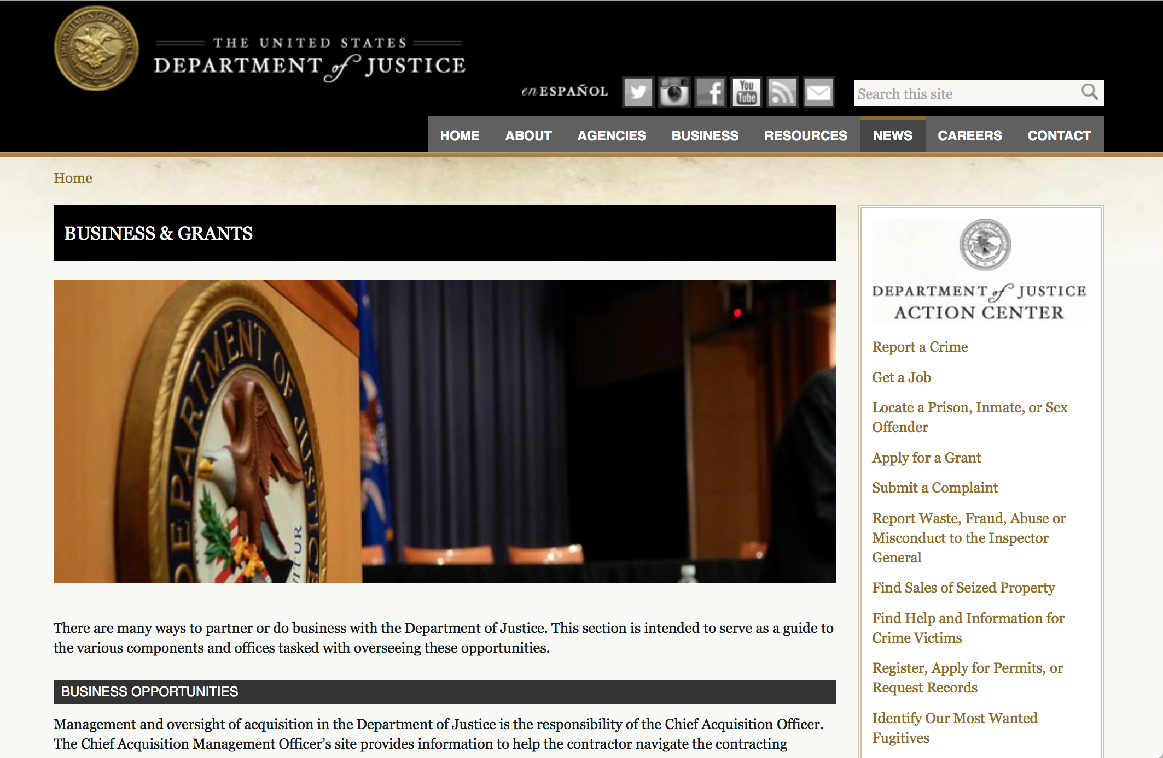

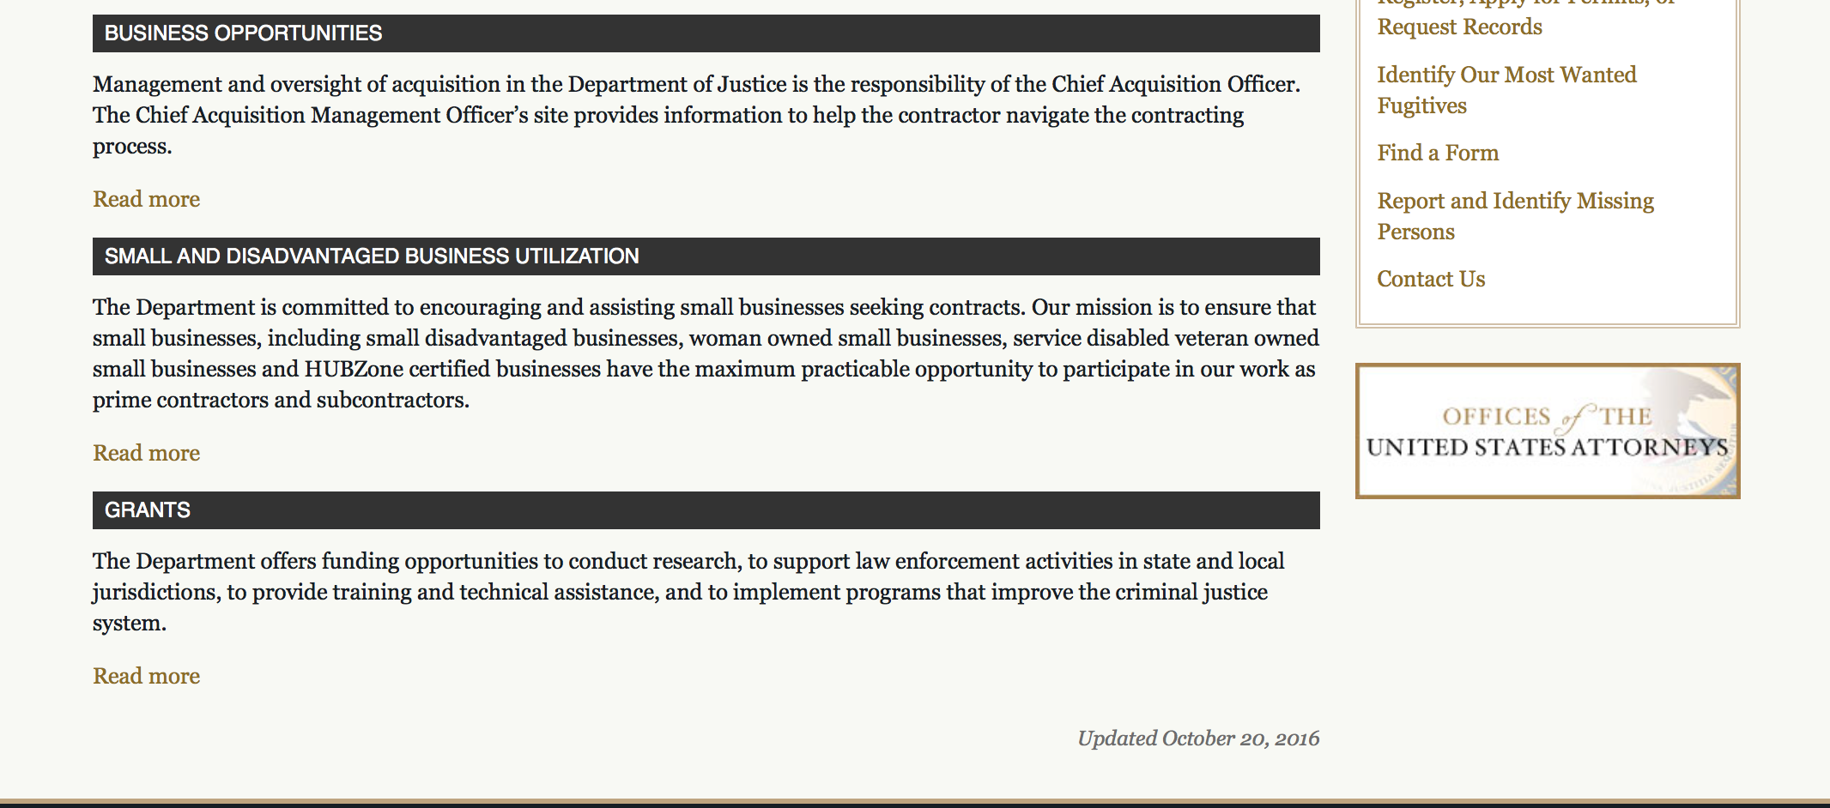

The DOJ agencies listed below also have sites that provide grant information specific to that agency. Examples of what can be found on these sites are programs, funding opportunities, application assistance, and other useful information.

Bureau of Justice Assistance (BJA)

Bureau of Justice Statistics (BJS)

National Criminal Justice Reference Service (NCJRS)

National Institute of Justice (NIJ)

Office of Sex Offender Sentencing, Monitoring, Apprehending, Registering, and Tracking (SMART)

http://www.justice.gov/business/

Programs:

Bureau of Justice Assistance
BJA FY 18 STOP School Violence Prevention and Mental Health Training Program
Synopsis 1

Document Type: | Grants Notice
Funding Opportunity Number: | BJA-2018-14480
Funding Opportunity Title: | BJA FY 18 STOP School Violence Prevention and Mental Health Training Program
Opportunity Category: | Discretionary
Opportunity Category Explanation:
Funding Instrument Type: | Grant
Category of Funding Activity: | Education  Employment, Labor and Training  Humanities (see "Cultural Affairs" in CFDA)  Information and Statistics  Law, Justice and Legal Services
Category Explanation:
Expected Number of Awards: | 70
CFDA Number(s): | 16.839 -- STOP School Violence
Cost Sharing or Matching Requirement: | No
Eligible Applicants: | City or township governments  Native American tribal governments (Federally recognized)  State governments  Special district governments  County governments
Additional Information on Eligibility:
Additional Information
Agency Name: | Bureau of Justice Assistance
Description: | Among its provisions, the STOP School Violence Act of 2018 authorized BJA to manage a grant program that would support efforts by state, local, and federally-recognized Indian tribes to prevent and reduce school violence. Specifically, the BJA program will address: (1) training school personnel and educating students to prevent student violence; (2) development and operation of anonymous reporting systems against threats of school violence, including mobile telephone applications, hotlines, and websites; and (3) development and operation of school threat assessment and crisis intervention teams that may include coordination with law enforcement agencies and school personnel. In addition, the program may fund specialized training for school officials in intervening and responding to individuals with mental health issues that may impact school safety.
Link to Additional Information: | https://www.bja.gov/SSVtraining18
Grantor Contact Information: | If you have difficulty accessing the full announcement electronically, please contact:  For technical assistance with submitting an application, contact the Grants.gov Customer Support Hotline at 800-518-4726 or 606-545-5035, or via email to support@grants.gov. The Grants.gov Support Hotline operates 24 hours a day, 7 days a week, except on federal holidays. An applicant that experiences unforeseen Grants.gov technical issues beyond its control that prevent it from submitting its application by the deadline must email the contact identified below within 24 hours after the application deadline in order to request approval to submit its application after the deadline. Additional information on reporting technical issues appears under “Experiencing Unforeseen Grants.gov Technical Issues” in the How to Apply section. For assistance with any unforeseen Grants.gov technical issues beyond an applicant’s control that prevent it from submitting its application by the deadline, or any other requirement of this solicitation, contact the National Criminal Justice Reference Service (NCJRS) Response Center: toll-free at 800-851-3420; via TTY at 301-240-6310 (hearing impaired only); email grants@ncjrs.gov; fax to 301-240-5830; or web chat at https://webcontact.ncjrs.gov/ncjchat/chat.jsp. The NCJRS Response Center hours of operation are 10:00 a.m. to 6:00 p.m. eastern time, Monday through Friday, and 10:00 a.m. to 8:00 p.m. eastern time on the solicitation close date. support@grants.gov  Technical Application Assistance
https://www.grants.gov/web/grants/view-opportunity.html?oppId=306024

Bureau of Justice Assistance
BJA FY 18 STOP School Violence Threat Assessment and Technology Reporting Program
Synopsis 1
Document Type: | Grants Notice
Funding Opportunity Number: | BJA-2018-14489
Funding Opportunity Title: | BJA FY 18 STOP School Violence Threat Assessment and Technology Reporting Program
Opportunity Category: | Discretionary
Opportunity Category Explanation:
Funding Instrument Type: | Grant
Category of Funding Activity: | Education  Employment, Labor and Training  Humanities (see "Cultural Affairs" in CFDA)  Information and Statistics  Law, Justice and Legal Services  Science and Technology and other Research and Development
Category Explanation:
Expected Number of Awards: | 62
CFDA Number(s): | 16.839 -- STOP School Violence
Cost Sharing or Matching Requirement: | No
Version: | Synopsis 1
Posted Date: | Jun 07, 2018
Last Updated Date: | Jun 07, 2018
Original Closing Date for Applications: | Jul 23, 2018
Current Closing Date for Applications: | Jul 23, 2018
Archive Date:
Estimated Total Program Funding: | $21,150,000
Award Ceiling: | $1,000,000
Eligible Applicants: | Native American tribal governments (Federally recognized)  City or township governments  Special district governments  State governments  County governments
Additional Information on Eligibility:
Additional Information
Agency Name: | Bureau of Justice Assistance
Description: | Among its provisions, the STOP School Violence Act of 2018 authorized BJA to manage a grant program that would support efforts by state, local, and federally-recognized Indian tribes to prevent and reduce school violence. Specifically, the BJA program will address: (1) training school personnel and students to prevent student violence; (2) development and operation of anonymous reporting systems against threats of school violence, including mobile telephone applications, hotlines, and websites; and (3) development and operation of school threat assessment and crisis intervention teams that may include coordination with law enforcement agencies and school personnel. In addition, the program may fund specialized training for school officials in intervening and responding to individuals with mental health issues that may impact school safety. This solicitation specifically seeks applications that address the development and operation of school threat assessment and crisis intervention teams and the development of technology for local or regional anonymous reporting systems. This technology may be in the form of an app, hotline, or website. The proposed technology solutions may be those that could be used during an incident to assist in securing the safety of those involved, to include sharing information with first responders.
Link to Additional Information: | https://www.bja.gov/SSVthreat18
Grantor Contact Information: | If you have difficulty accessing the full announcement electronically, please contact:  For technical assistance with submitting an application, contact the Grants.gov Customer Support Hotline at 800-518-4726 or 606-545-5035, or via email to support@grants.gov. The Grants.gov Support Hotline operates 24 hours a day, 7 days a week, except on federal holidays. An applicant that experiences unforeseen Grants.gov technical issues beyond its control that prevent it from submitting its application by the deadline must email the contact identified below within 24 hours after the application deadline in order to request approval to submit its application after the deadline. Additional information on reporting technical issues appears under “Experiencing Unforeseen Grants.gov Technical Issues” in the How to Apply section. For assistance with any unforeseen Grants.gov technical issues beyond an applicant’s control that prevent it from submitting its application by the deadline, or any other requirement of this solicitation, contact the National Criminal Justice Reference Service (NCJRS) Response Center: toll-free at 800-851-3420; via TTY at 301-240-6310 (hearing impaired only); email grants@ncjrs.gov; fax to 301-240-5830; or web chat at https://webcontact.ncjrs.gov/ncjchat/chat.jsp. The NCJRS Response Center hours of operation are 10:00 a.m. to 6:00 p.m. eastern time, Monday through Friday, and 10:00 a.m. to 8:00 p.m. eastern time on the solicitation close date. support@grants.gov  Technical Application Assistance
https://www.grants.gov/web/grants/view-opportunity.html?oppId=306023

Research:

Modifications:

Deleted:

Reminders:

Drug Court Training and Technical Assistance Grant
Synopsis 1

Document Type: Grants Notice  Funding Opportunity Number: ONDCP-DRUGCOURTTTA-2018  Funding Opportunity Title: Drug Court Training and Technical Assistance Grant  Opportunity Category: Discretionary  Opportunity Category Explanation:  Funding Instrument Type: Grant  Category of Funding Activity: Law, Justice and Legal Services  Category Explanation:  Expected Number of Awards:  CFDA Number(s): 95.005 -- Drug Court Training and Technical Assistance  Cost Sharing or Matching Requirement: No | Version: Synopsis 1  Posted Date: May 11, 2018  Last Updated Date: May 11, 2018  Original Closing Date for Applications: Jul 13, 2018  Current Closing Date for Applications: Jul 13, 2018  Archive Date: Aug 12, 2018  Estimated Total Program Funding:  Award Ceiling: $4,000,000  Award Floor: $4,000,000
Eligibility
Eligible Applicants: | Native American tribal organizations (other than Federally recognized tribal governments)  Native American tribal governments (Federally recognized)  Nonprofits having a 501(c)(3) status with the IRS, other than institutions of higher education  Public and State controlled institutions of higher education  Private institutions of higher education  Nonprofits that do not have a 501(c)(3) status with the IRS, other than institutions of higher education
Additional Information on Eligibility: | ONDCP invites applications from non-profit organizations (including faith-based, community, and tribal organizations), and institutions of higher learning (including tribal institutions of higher education) with demonstrated expertise in leading state and local governments in criminal justice systems reform. Applicants must be able to secure the participation of expert practitioners. ONDCP welcomes joint applications from two or more eligible applicants; however, one applicant must be clearly indicated as the primary applicant (for correspondence, award, and management purposes) and the others indicated as co-applicants. The applicant should provide information that demonstrates the strength of the commitment of their partnering organizations, as set forth in Memorandums of Understanding, letters of support, statements of work, etc. All co-applicants must have demonstrated expertise in the provision of training and technical assistance on criminal justice systems reform and substance use disorders.
Additional Information
Agency Name: | Office of National Drug Control Policy
Description: | The Office of National Drug Control Policy (ONDCP), Executive Office of the President, is seeking applications from a non-profit entity as described in Section 501(c)(3) of the Internal Revenue Code with expert knowledge and extensive experience in training drug court and other criminal justice practitioners on the application of evidence-based practices to address addiction among people involved in the criminal justice system.  ONDCP’s Drug Court Training and Technical Assistance Grant support training and technical assistance (TTA) that helps states, state courts, local courts, units of local government with drug courts or considering drug courts develop, maintain, and enhance alternatives to incarceration for individuals with addiction. The President’s priority is to enhance public safety by providing those who have engaged in criminal activity with greater opportunities to lead productive lives by addressing a range of issues, including mental health, vocational training, job creation, after-school programming, substance abuse, and mentoring through evidence-based rehabilitation programs. ONDCP seeks to reduce drug use and its consequences through evidence-based practices, and this grant will apply these principles to the criminal justice system.  The purpose of this grant is to: (1) educate, train, and produce materials to improve adherence to best practices, (2) decrease justice costs and recidivism, (3) improve access to services and service delivery, and (4) reduce disproportionality of punishment in the criminal justice system. The grant recipient shall:  · Use expert practitioners in the fields engaged in the science of addiction, criminal justice, healthcare, and drug courts.  · Provide in-person training, online training, and jurisdiction-specific technical assistance to a variety of demographically-composed areas at the state, local, and tribal levels.  · Include ONDCP policy priorities in the development and execution of training and technical assistance programs and educational materials:  o Applying a comprehensive approach to addressing opioid use disorders, including overdose prevention and naloxone administration training, and programs that provide access to medication-assisted treatment.  o Diversion programming with evidenced-based and comprehensive case management, treatment for substance use disorders, recovery and other necessary services.  o Consistency of practice among drug courts  · Collect and analyze data from jurisdictions engaged in grantee programming on alternatives to incarceration to determine the effectiveness of the trainings and on-site assistance.  All portions of the application must reflect these objectives and subject matter areas.  Goal. The program’s goals are: (1) to provide TTA to criminal justice practitioners to develop, maintain, and enhance evidence-based interventions from arrest to reentry; (2) to educate criminal justice professionals on substance use disorders; and (3) to develop TTA on medication-assisted treatment and overdose reversal medications to expand use in drug courts, to support recovery, and to prevent overdose deaths.  Program Objectives. The objectives of the program are as follows:  · To provide tools that educate and train at statewide, regionally, and nationally of no-cost, on-request curricula on evidence-based interventions at all points of engagement with the criminal justice system to ensure systematic implementation.  · To provide statewide, regionally, and nationally of no-cost evidence-based training for treatment providers working with drug court.  · To provide statewide and regional training for drug courts on census expansion with a focus on probation violators.  · To develop tools that educate drug court practitioners on the implementation of the evidence-based drug court standards for adult drug courts.  • To provide TTA to drug court practitioners on the evidence-based drug court standards for adult drug courts.  • To develop educational materials to address substance use disorders and opioid strategies for people in the criminal justice system.  • To develop and conduct no-cost training events for drug court professionals on medication-assisted treatment and overdose prevention.  • To conduct evaluations of trainings provided under this grant.
Link to Additional Information:
Grantor Contact Information: | If you have difficulty accessing the full announcement electronically, please contact:  Jayme Delano Policy Analyst  email POC
https://www.grants.gov/web/grants/view-opportunity.html?oppId=304999

Office for Victims of Crime
OVC FY 2018 Enhancing Access to Services Program
Synopsis 1
Document Type: Grants Notice  Funding Opportunity Number: OVC-2018-14302  Funding Opportunity Title: OVC FY 2018 Enhancing Access to Services Program  Opportunity Category: Discretionary  Opportunity Category Explanation:  Funding Instrument Type: Cooperative Agreement  Category of Funding Activity: Income Security and Social Services Law, Justice and Legal Services  Category Explanation:  Expected Number of Awards: 11  CFDA Number(s): 16.582 -- Crime Victim Assistance/Discretionary Grants  Cost Sharing or Matching Requirement: No | Version: Synopsis 1  Posted Date: May 30, 2018  Last Updated Date: May 30, 2018  Original Closing Date for Applications: Jul 16, 2018  Current Closing Date for Applications: Jul 16, 2018  Archive Date:  Estimated Total Program Funding: $2,600,000  Award Ceiling: $600,000  Award Floor: $0
Eligibility
Eligible Applicants: | Others (see text field entitled "Additional Information on Eligibility" for clarification)
Additional Information on Eligibility: | Purpose Area 1 – Direct Service Sites: Eligible direct service sites applicants are limited to: public agencies; federally recognized Indian tribal governments (as determined by the Secretary of the Interior); nonprofit organizations (including tribal nonprofit organizations); faith- and community-based organizations; and colleges or universities (including tribal institutions of higher education). All applicants must demonstrate a history of providing direct services to victims of crime in linguistically specific communities. Purpose Area 2 – Training & Technical Assistance: Eligible training and technical assistance (TTA) applicants are limited to: public agencies; federally recognized Indian tribal governments (as determined by the Secretary of the Interior); nonprofit organizations (including tribal nonprofit organizations); faith- and community-based organizations; and colleges and universities (including tribal institutions of higher education). Applicants must demonstrate (1) experience providing training and technical assistance on crime victim service and language access issues for community-based organizations, and (2) experience developing online publications and technical assistance resources for broad dissemination to the victim services field. All recipients and subrecipients must forgo any profit or management fee. Under both purpose areas, OVC welcomes applications under which two or more entities would carry out the federal award; however, only one entity may be the applicant. Any others must be proposed as subrecipients (subgrantees). The applicant must be the entity that would have primary responsibility for carrying out the award, including administering the funding and managing the entire project. Eligible applicants may apply for funding as a direct service site or as a technical assistance provider, but not both. Under this solicitation, only one application by any particular applicant entity will be considered. An entity may, however, be proposed as a subrecipient (subgrantee) in more than one application. OVC may elect to fund applications submitted under this FY 2018 solicitation in future fiscal years, dependent on, among other considerations, the merit of the applications and on the availability of appropriations.
Additional Information
Agency Name: | Office for Victims of Crime
Description: | Many victims of crime, particularly those from limited English proficient, Deaf, and hard-of-hearing communities, may experience barriers that prevent them from accessing critical services. This program will enhance language access and direct services in affected communities and enhance the work of community-based organizations and programs working to help victims report crimes and access services they need to heal in the aftermath of crime victimization. Purpose Area (PA) 1: OVC will make up to 10 awards of up to $200,000 each to organizations for the provision of direct services to victims of crime in affected communities. PA 2: OVC will make one award of up to $600,000 to a technical assistance provider who will identify and address a broad range of TTA and resource development needs to support grantees funded under PA 1 of this solicitation. OVC will conduct a pre-application webinar on June 12, at 3:00 p.m. e.t. Register at www.ovc.gov/grants/webinars.html. Apply by July 16, 2018.
Link to Additional Information: | Funding Opportunity
Grantor Contact Information: | If you have difficulty accessing the full announcement electronically, please contact:  For assistance with any other requirements of this solicitation, contact OVC’s National Criminal Justice Reference Service (NCJRS) Response Center: toll free at 800–851–3420; via TTY at 301–240–6310 (hearing impaired only); email to grants@ncjrs.gov; fax to 301–240–5830; or web chat at https://webcontact.ncjrs.gov/ncjchat/chat.jsp. The NCJRS Response Center operates from 10:00 a.m.–6:00 p.m., eastern time, Monday through Friday, and from 10:00 a.m.–8:00 p.m., eastern time on the solicitation closing date. grants@ncjrs.gov  OVC’s National Criminal Justice Reference Service (NCJRS) Response Center
https://www.grants.gov/web/grants/view-opportunity.html?oppId=305762

Office for Victims of Crime
OVC FY 2018 Enhancing Community Responses to the Opioid Crisis: Serving Our Youngest Crime Victims
Synopsis 1
Document Type: Grants Notice  Funding Opportunity Number: OVC-2018-14323  Funding Opportunity Title: OVC FY 2018 Enhancing Community Responses to the Opioid Crisis: Serving Our Youngest Crime Victims  Opportunity Category: Discretionary  Opportunity Category Explanation:  Funding Instrument Type: Grant  Category of Funding Activity: Income Security and Social Services Law, Justice and Legal Services  Category Explanation:  Expected Number of Awards: 33  CFDA Number(s): 16.582 -- Crime Victim Assistance/Discretionary Grants  Cost Sharing or Matching Requirement: No | Version: Synopsis 1  Posted Date: May 30, 2018  Last Updated Date: May 30, 2018  Original Closing Date for Applications: Jul 10, 2018  Current Closing Date for Applications: Jul 10, 2018  Archive Date:  Estimated Total Program Funding: $26,000,000  Award Ceiling: $2,500,000  Award Floor: $300,000
Eligibility
Eligible Applicants: | Others (see text field entitled "Additional Information on Eligibility" for clarification)
Additional Information on Eligibility: | For both Purpose Area 1 and Purpose Area 2: Applications in either purpose area that involve two or more entities are welcome; however, one eligible entity must be the lead applicant and the others proposed as subrecipients (subgrantees). The lead applicant must be the entity with the primary responsibility for administering the funding and managing the project, including subrecipient monitoring. Under this solicitation, only one application by any particular entity will be considered. An entity may, however, be proposed as a subrecipient (subgrantee) in more than one application. All recipients and subrecipients, of both purpose areas (including any for-profit organization), must forgo any profit or management fee. OVC may elect to fund applications submitted under this FY 2018 solicitation in future fiscal years, dependent on, among other considerations, the merit of the applications and on the availability of appropriations.
Additional Information
Agency Name: | Office for Victims of Crime
Description: | OVC is seeking applications to support crime victims and to enhance community-driven responses to the current opioid crisis. Under Purpose Area 1, applicants will develop and execute plans to support children and youth directly at the community or jurisdictional level. Applicants are expected to work with an OVC-designated national training and technical assistance provider to further enhance these efforts and contribute to the growing body of knowledge about these issues and underscore successful practices. Under Purpose Area 2, applicants will develop and activate plans to support the Purpose Area 1 applicants on a national scale, to equip and support the community-based programs as they develop new initiatives or enhance existing efforts. OVC will conduct a pre-application webinar on June 6, 2018, at 1:00 p.m. e.t. Register at www.ovc.gov/grants/webinars.html. Apply by July 10, 2018.
Link to Additional Information: | Funding Opportunity
Grantor Contact Information: | If you have difficulty accessing the full announcement electronically, please contact:  For assistance with any other requirements of this solicitation, contact OVC’s National Criminal Justice Reference Service (NCJRS) Response Center: toll free at 800–851–3420; via TTY at 301–240–6310 (hearing impaired only); email to grants@ncjrs.gov; fax to 301–240–5830; or web chat at https://webcontact.ncjrs.gov/ncjchat/chat.jsp. The NCJRS Response Center operates from 10:00 a.m.–6:00 p.m., eastern time, Monday through Friday, and from 10:00 a.m.–8:00 p.m., eastern time on the solicitation closing date. grants@ncjrs.gov  OVC’s National Criminal Justice Reference Service (NCJRS) Response Center
https://www.grants.gov/web/grants/view-opportunity.html?oppId=305777



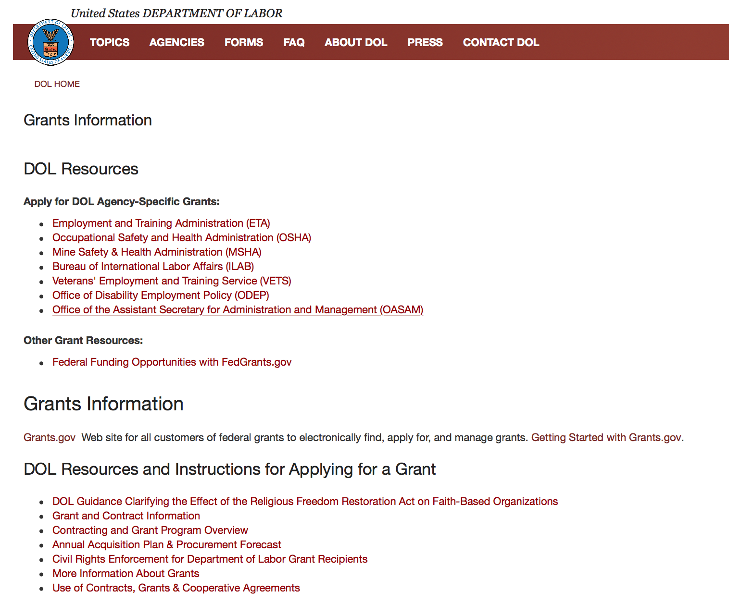

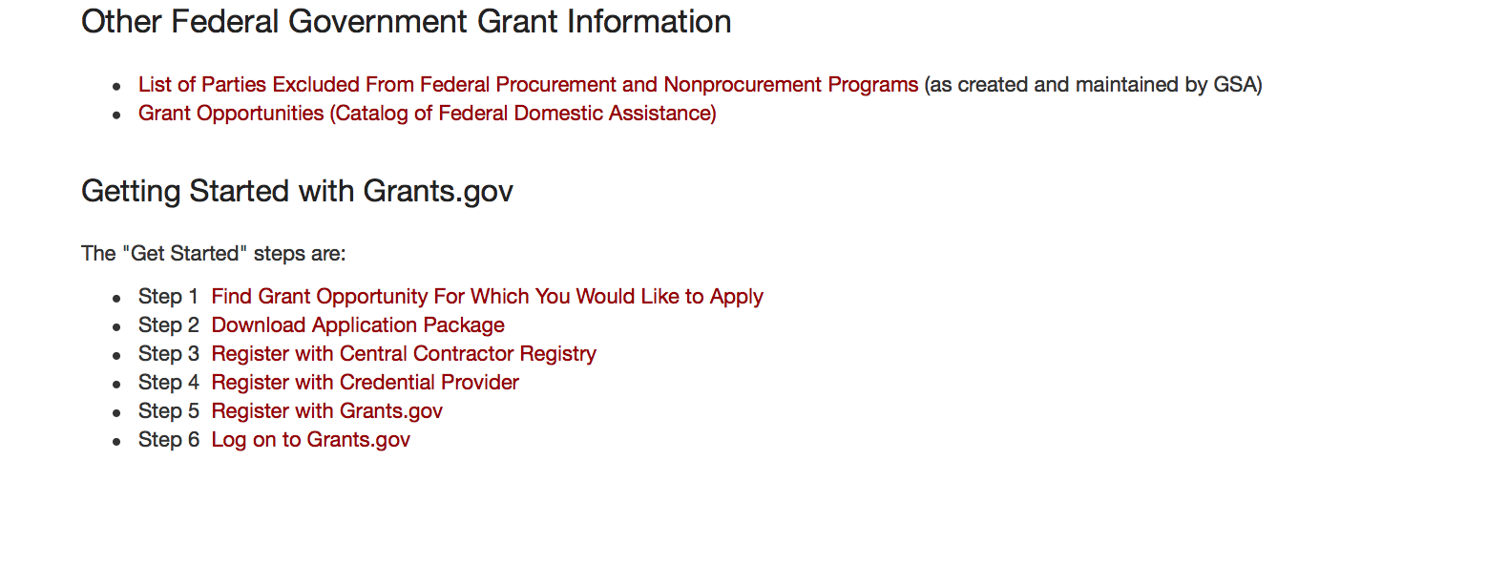
https://www.dol.gov/general/grants2

Agency Grants and Contract General Overview

DOL Resources
Apply for DOL Agency-Specific Grants:
- Employment and Training Administration (ETA)
- Occupational Safety and Health Administration (OSHA)
- Mine Safety & Health Administration (MSHA)
- Bureau of International Labor Affairs (ILAB)
- Veterans' Employment and Training Service (VETS)
- Office of Disability Employment Policy (ODEP)
- Office of the Assistant Secretary for Administration and Management (OASAM)

Other Grant Resources:
- Federal Funding Opportunities with FedGrants.gov
Grants Information
Grants.gov — Web site for all customers of federal grants to electronically find, apply for, and manage grants. Getting Started with Grants.gov.

DOL Resources and Instructions for Applying for a Grant
- DOL Guidance Clarifying the Effect of the Religious Freedom Restoration Act on Faith-Based Organizations
- Grant and Contract Information
- Contracting and Grant Program Overview
- Civil Rights Enforcement for Department of Labor Grant Recipients
- More Information About Grants
- Use of Contracts, Grants & Cooperative Agreements

Other Federal Government Grant Information
- Grant Opportunities (Catalog of Federal Domestic Assistance)

Department of Labor Grant Programs

- Bureau of International Labor Affairs (ILAB): provides grants (cooperative agreements) for the implementation of projects designed to assist developing countries combat the worse forms of child labor, forced labor, and human trafficking; and support worker rights and improve working conditions. http://www.dol.gov/general/business.
- Bureau of Labor Statistics (BLS): provides project grants (cooperative agreements) and the dissemination of technical statistical data and related information on labor force activities; provides data on prices (CPI) and cost of living; data on productivity and technology data; data on compensation and working conditions; data on employment projections.
- Employment and Training (ETA): ETA administers financial assistance programs pursuant to the Workforce Investment Act (WIA), administering State formula grant programs for youth, adults and dislocated workers, national emergency grants for workers affected by mass layoffs, plant closures, and disasters; grant programs for workers with disabilities, Indians and Native Americans, and for migrant and seasonal farmworkers. ETA also administers grant programs for older American workers, apprenticeship programs, Trade Adjustment Assistance (TAA) programs, and assistance for research and development of workforce programs. In addition, ETA is responsible for the operation and maintenance of a national system of public employment service offices and for the national unemployment insurance program.
- Mine Safety and Health (MSHA): provides grants for research, education and training programs to ensure an adequate and competent staff of trained inspectors; and assistance for establishing or improving State mine health and safety programs through technical assistance.
- Occupational Safety and Health (OSHA): provides grants to non-profit organizations to provide training, educational services, and technical assistance; assistance to states to administer and enforce state programs; assistance to states to provide occupational safety and health technical assistance and consultant services.
- Office of Disability Employment Policy (ODEP): The Office of Disability Employment Policy awards competitive grants establishing short-term pilot and technical assistance projects designed to identify, develop, test, evaluate, and disseminate policies to increase employment by expanding access to training, education, employment supports, assistive and systems technology, integrated employment, entrepreneurial development, and small business opportunities for adults and youth with disabilities. Current pilots projects focus on customized employment, Olmstead populations, and innovative demonstration youth grants, among others. Solicitations for grant applications are published in the Federal Register and announced at www.dol.gov/odep. ODEP grants are awarded by the OASAM grant office.
- Veterans' Employment and Training (VETS): provides special employment and training assistance for veterans through the Disabled Veterans' Outreach Program (DVOP) Solicitation for Grant Applications; the Local Veterans' Employment Representative Program (LVER); Veterans' Workforce Investment Program (VWIP); elaws Advisor on veterans' employment and reemployment rights; and the Homeless Veterans Reintegration Project (HVRP). VETS grants are awarded by the OASAM grant office.

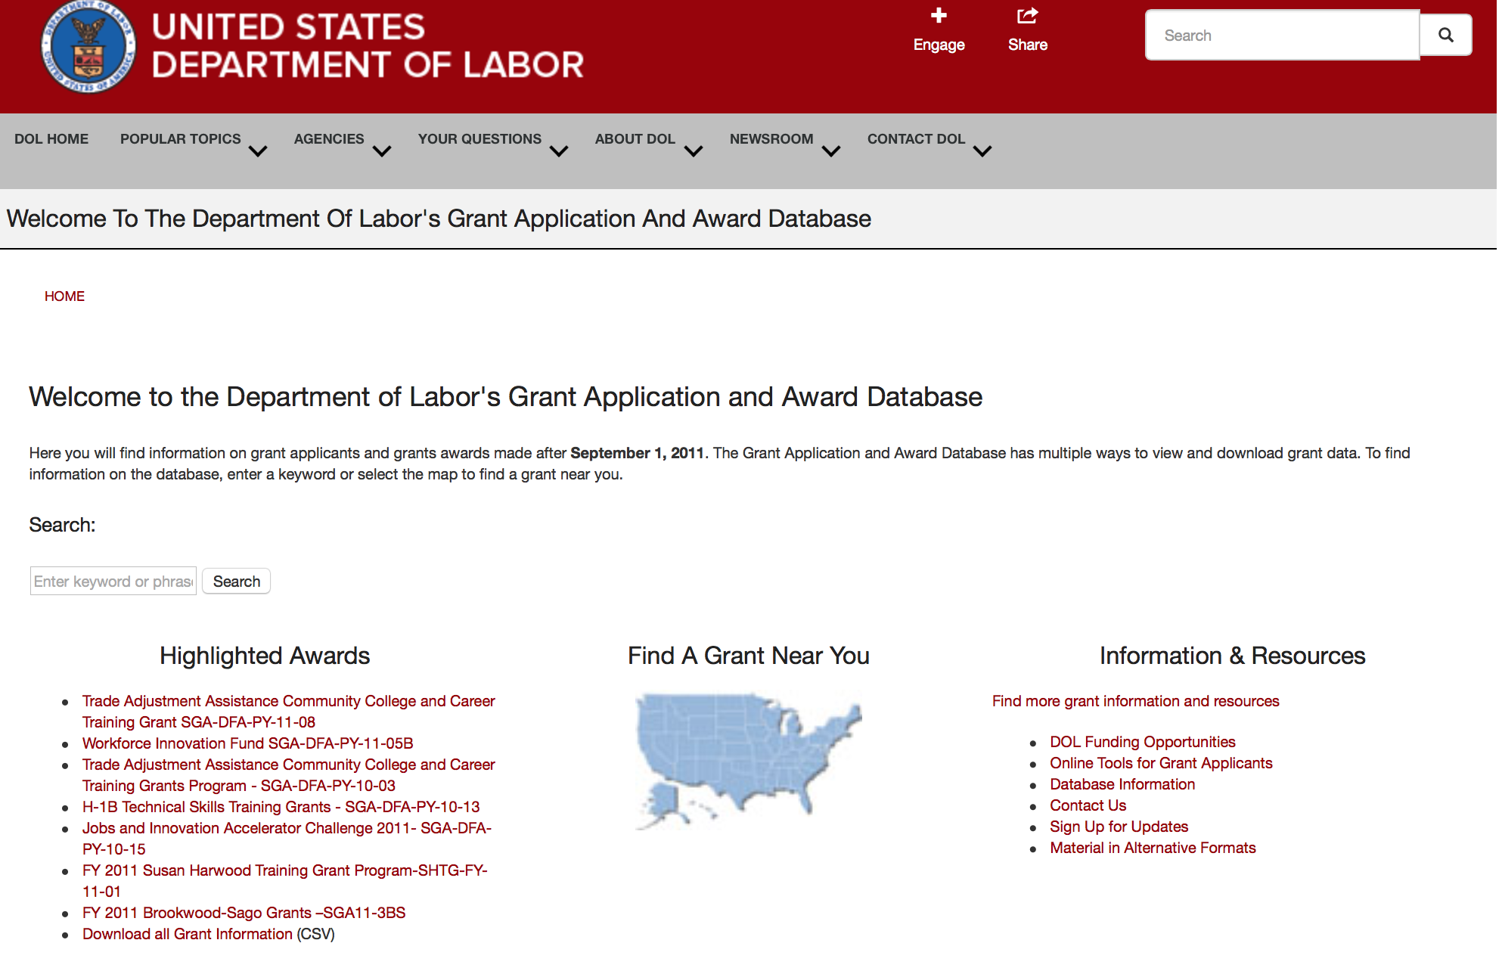

http://www.dol.gov/dol/grants/

Programs

Mine Safety and Health Administration
Mine Health and Safety Grants
Synopsis 1
Document Type: | Grants Notice
Funding Opportunity Number: | MSHA-2018-1
Funding Opportunity Title: | Mine Health and Safety Grants
Opportunity Category: | Discretionary
Opportunity Category Explanation:
Funding Instrument Type: | Grant
Category of Funding Activity: | Education
Category Explanation:
Expected Number of Awards: | 56
CFDA Number(s): | 17.600 -- Mine Health and Safety Grants
Cost Sharing or Matching Requirement: | Yes
Version: | Synopsis 1
Posted Date: | Jun 05, 2018
Last Updated Date: | Jun 05, 2018
Original Closing Date for Applications: | Jul 16, 2018
Current Closing Date for Applications: | Jul 16, 2018
Archive Date: | Aug 15, 2018
Estimated Total Program Funding: | $10,537,000
Eligible Applicants: | Native American tribal governments (Federally recognized)  Public and State controlled institutions of higher education  State governments
Additional Information on Eligibility:

Agency Name: | Mine Safety and Health Administration
Description: | The Secretary of Labor's vision for the U.S. workforce is helping American workers gain and hold good, safe jobs. One of the Department’s strategic goals is to “Promote Safe Jobs and Fair Workplaces for All Americans” through the strategic objective “secure safe and healthy workplaces, particularly in high-risk industries.” MSHA’s goal in accomplishing this objective is to prevent fatalities, disease, and injury from mining and secure safe and healthful working conditions for America’s miners. Under Section 503 of the Federal Mine Safety and Health Act of 1977 (Mine Act), Public Law 95-164, as amended, the Secretary of Labor through the Mine Safety and Health Administration (MSHA) may award grants to States (including the District of Columbia, the Commonwealth of Puerto Rico, the Virgin Islands, American Samoa, Guam, and the Commonwealth of the Northern Mariana Islands) to assist them in developing and enforcing State mining laws and regulations, to improve State workers’ compensation and mining occupational disease laws and programs, and to improve safety and health conditions in the Nation’s mines through Federal-State coordination and cooperation.
Link to Additional Information:
Grantor Contact Information: | If you have difficulty accessing the full announcement electronically, please contact:  Janice Oates Management and Program Analyst Phone 202-693-9573  Department of Labor
https://www.grants.gov/web/grants/view-opportunity.html?oppId=305905

Modifications

Reminders

Veterans Employment and Training Service
Announcement of Stand Down Grants
Synopsis 2

Document Type: | Grants Notice
Funding Opportunity Number: | VPL-02-18
Funding Opportunity Title: | Announcement of Stand Down Grants
Opportunity Category: | Discretionary
Opportunity Category Explanation:
Funding Instrument Type: | Grant
Category of Funding Activity: | Other (see text field entitled "Explanation of Other Category of Funding Activity" for clarification)
Category Explanation: | Veterans' Employment and Training Service
Expected Number of Awards:
CFDA Number(s): | 17.805 -- Homeless Veterans Reintegration Program
Cost Sharing or Matching Requirement: | No
Version: | Synopsis 2
Posted Date: | Jan 02, 2018
Last Updated Date: | Jan 02, 2018
Original Closing Date for Applications: | Dec 31, 2020
Current Closing Date for Applications: | Dec 31, 2020
Archive Date: | Jan 30, 2021
Estimated Total Program Funding:
Award Ceiling: | $10,000
Award Floor: | $7,000
Eligible Applicants: | Others (see text field entitled "Additional Information on Eligibility" for clarification)
Additional Information on Eligibility: | The following organizations and entities may apply for grant funds for Stand Down events: State and Local Workforce Development Boards, Veteran Service Organizations, local public agencies, tribal governments, and non-profit organizations including community and faith-based organizations. Organizations registered with the Internal Revenue Service as 501(c)(4) entities are not eligible to apply for this funding opportunity.
Additional Information
Agency Name: | Veterans Employment and Training Service
Description: | DOL VETS supports local Stand Down (SD) events that assist homeless veterans by providing a wide variety of employment, social, and health services. A homeless veteran is a veteran, as defined in 38 U.S.C. 101(2), who is “homeless” as that term is defined at 42 U.S.C. 11302(a)-(b), as amended by the Homeless Emergency Assistance and Rapid Transition to Housing Act of 2009 (Public Law 111-22).Stand Down grant funds must be used to enhance employment and training opportunities or to promote the self-sufficiency of homeless veterans through paid work. Veterans experiencing homelessness do not always have access to basic hygiene supplies necessary to maintain their health and appearance. Lack of shelter limits their ability to prepare for and present themselves at job interviews or be contacted for follow-up. Basic services such as showers, haircuts, attention to health concerns, and other collaborative services provided at SD events can give participants a greater sense of self and an opportunity to improve their chances of securing and maintaining employment. Each year, VETS sets funds aside from the Homeless Veterans’ Reintegration Program (HVRP) budget activity to award SD grants. Stand Down funding is a non-competitive grant awarded on a first-come, first-served basis until available annual funding is exhausted. VETS will continue to accept applications and process when additional funds become available. The maximum amount that can be awarded, per applicant for a geographic area, in a fiscal year (October 1 – September 30) is $7,000 for a one-day event and $10,000 for a multi-day event. Grants may be awarded to multiple organizations that conduct SD events in the same general area so long as there is no commingling of federal funds. In the event of a significant natural or man-made disaster, VETS may elect to accept and award grants for SD events in excess of the $10,000 limit. VETS recognizes the following as circumstances that may justify awarding SD grants in higher amounts: emergencies or major disasters, as defined in the Stafford Act, which have been declared eligible for public assistance by the Federal Emergency Management Agency (FEMA). In addition, emergencies or disaster situations of national significance, natural or man-made, that could result in a potentially large loss of employment, as declared or otherwise recognized in writing by the chief official of the Federal Agency with jurisdiction over the Federal response to the emergency or disaster. If the VETS Assistant Secretary determines it is appropriate to award increased grants for SD events due to a disaster, the VETS Assistant Secretary will announce such a determination in writing, including the maximum amount that can be awarded on account of such an identified disaster, in order to provide notice to entities proposing to conduct SD events in those geographic areas where a disaster has been declared or to which a substantial number of veterans have relocated or been relocated. Acceptable uses of Stand Down grant funds do not change in such circumstances. All applications should be emailed to the appropriate DVET of the state in which the SD event is planned.
Link to Additional Information:
Grantor Contact Information: | If you have difficulty accessing the full announcement electronically, please contact:  Questions regarding a SD grant application should be referred to the DVET in the state in which the event will take place. DVET contact information is available at: https://www.dol.gov/vets/aboutvets/regionaloffices/map.htm.  https://www.dol.gov/vets/aboutvets/regionaloffices/map.htm
https://www.grants.gov/web/grants/view-opportunity.html?oppId=299798



National Aeronautics and Space Administration

Research and Contracting Opportunities

NASA Research Opportunities Online

- Various NASA offices publish their research announcements over the Internet, broadening the opportunity for researchers to apply for funding. This site provides access to current research announcements along with their specific due dates.

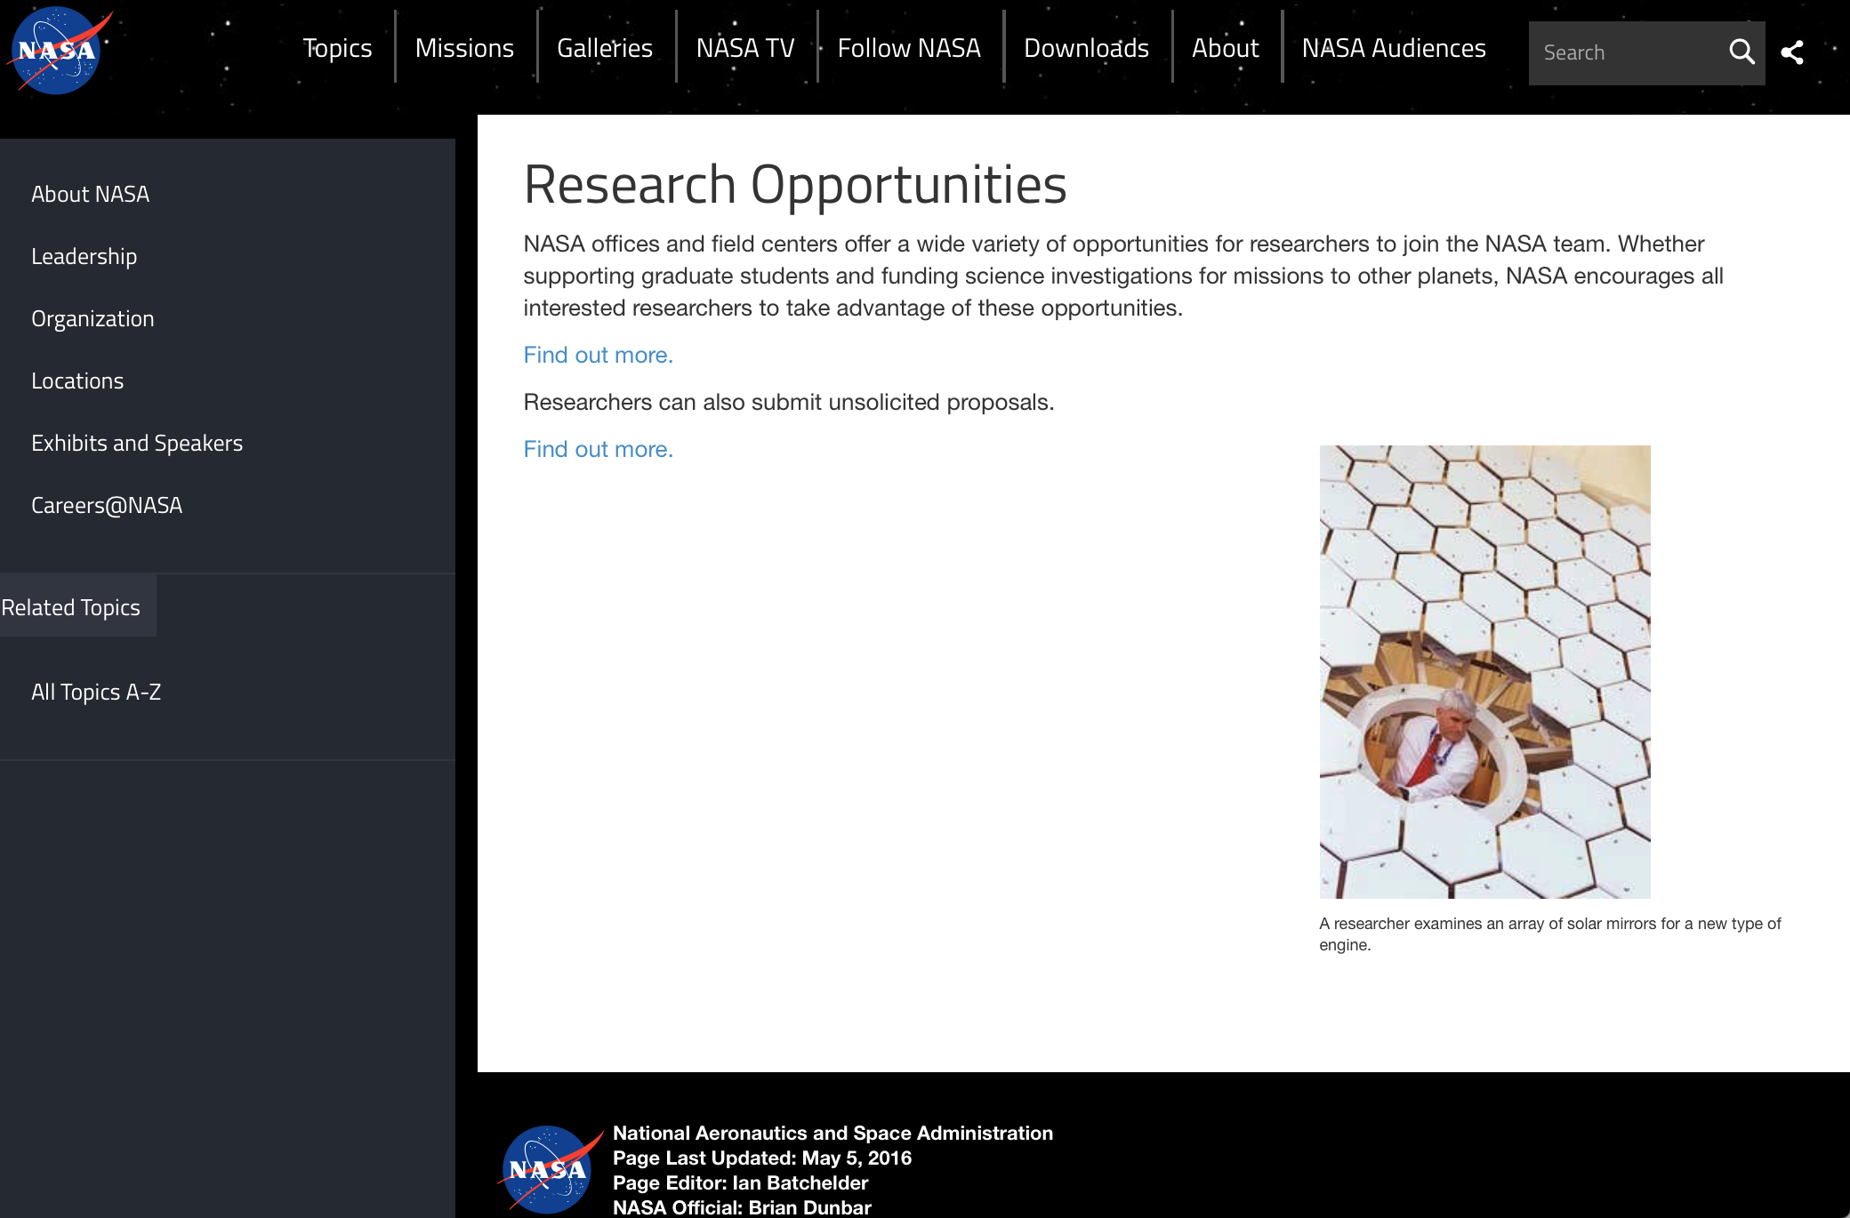

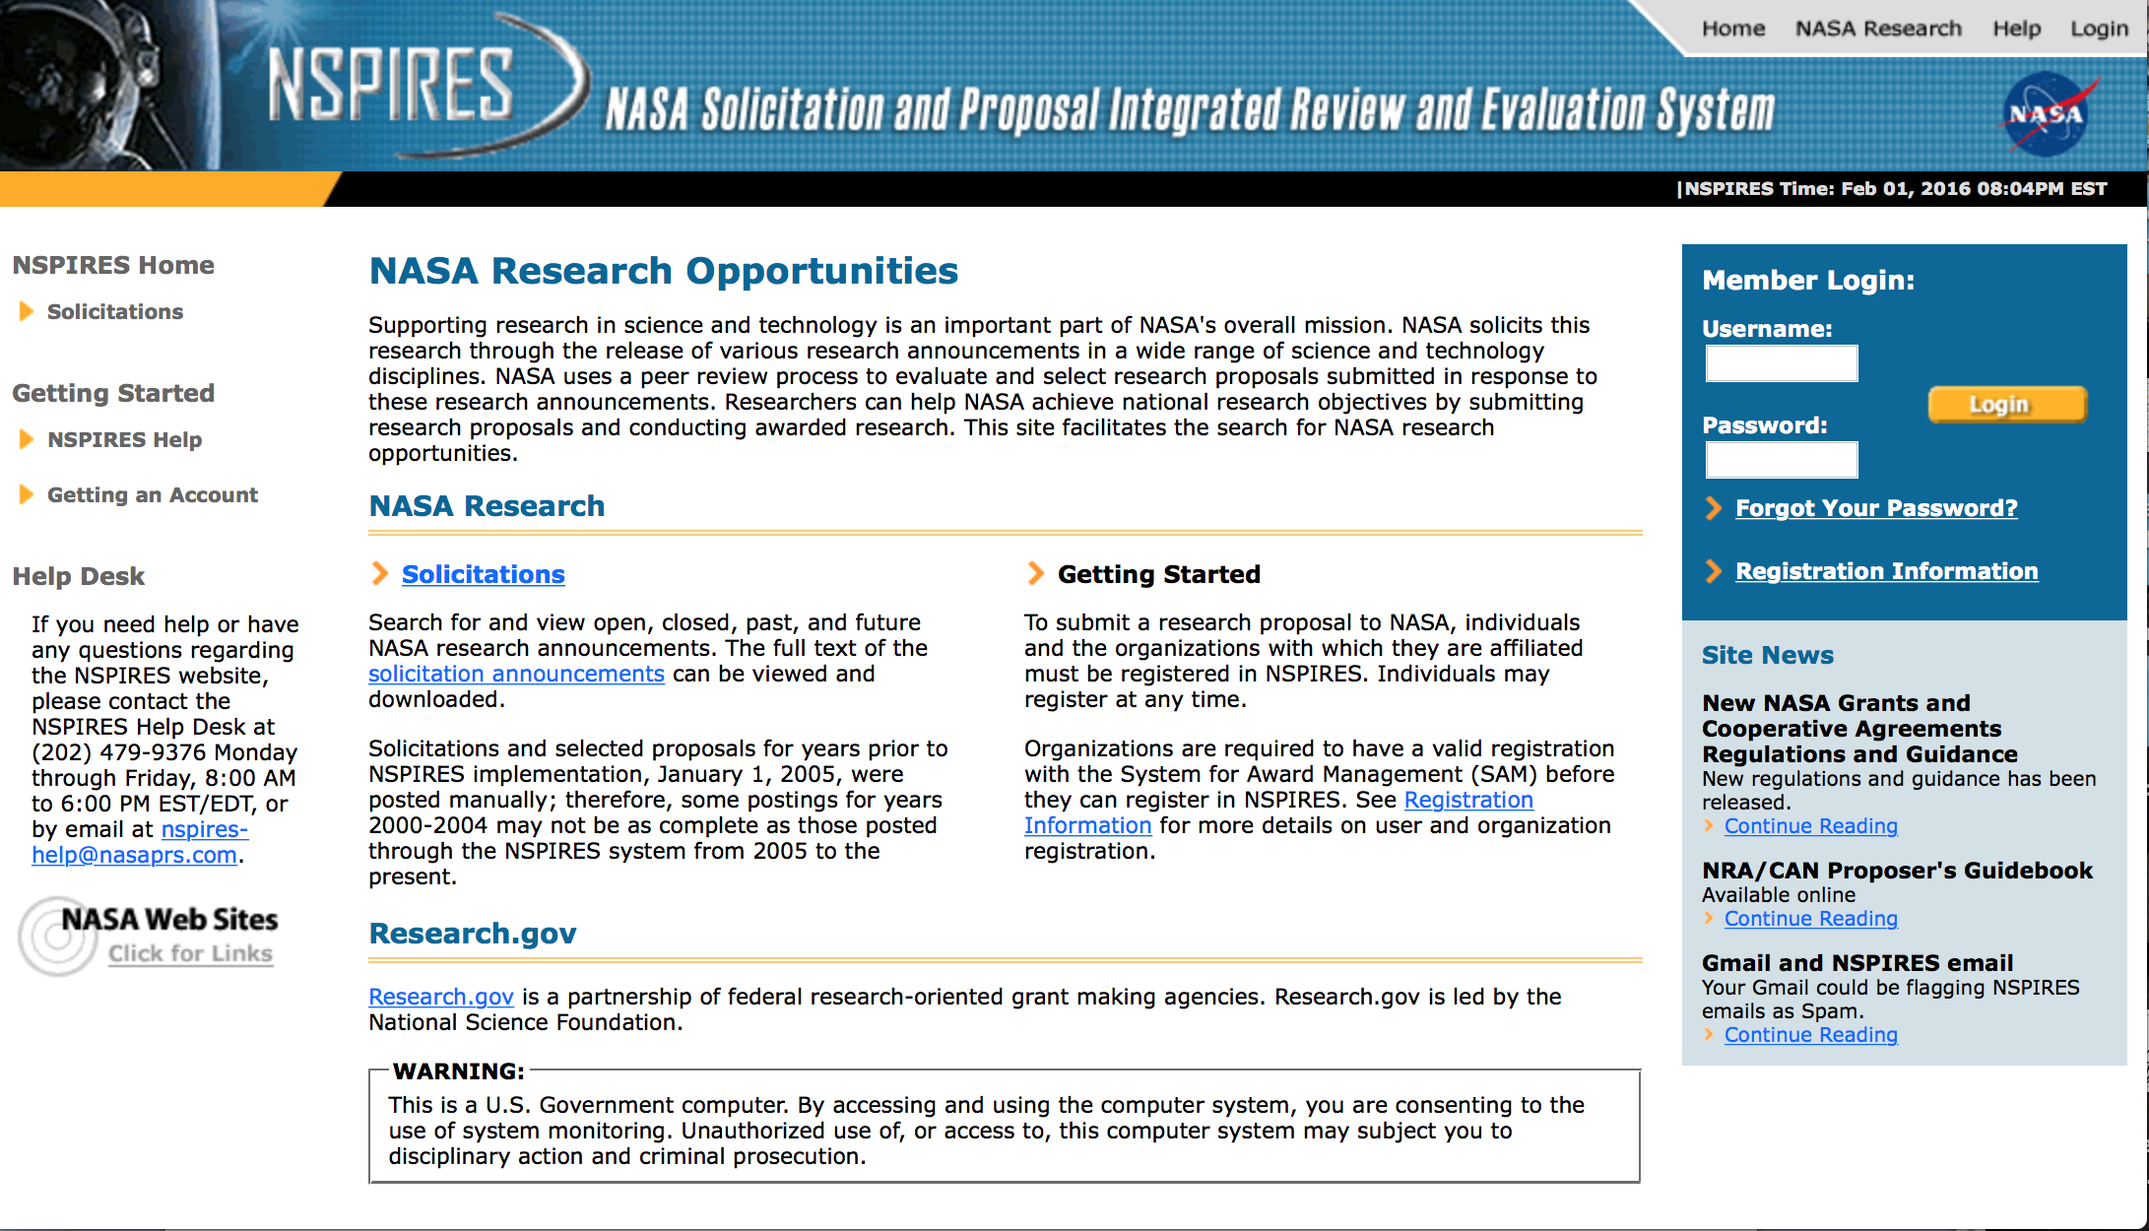
http://nspires.nasaprs.com/external/

Research Programs:

NASA Headquarters
ROSES 2018: DSCOVR Science Team
Synopsis 1
https://www.grants.gov/web/grants/view-opportunity.html?oppId=305902
NASA Headquarters
ROSES 2018: K2 Guest Observer (GO) Cycle 7
Synopsis 1
https://www.grants.gov/web/grants/view-opportunity.html?oppId=305768

Modifications:

National Archives and Records Administration

Grant Opportunities General Overview

To access the information below: click here

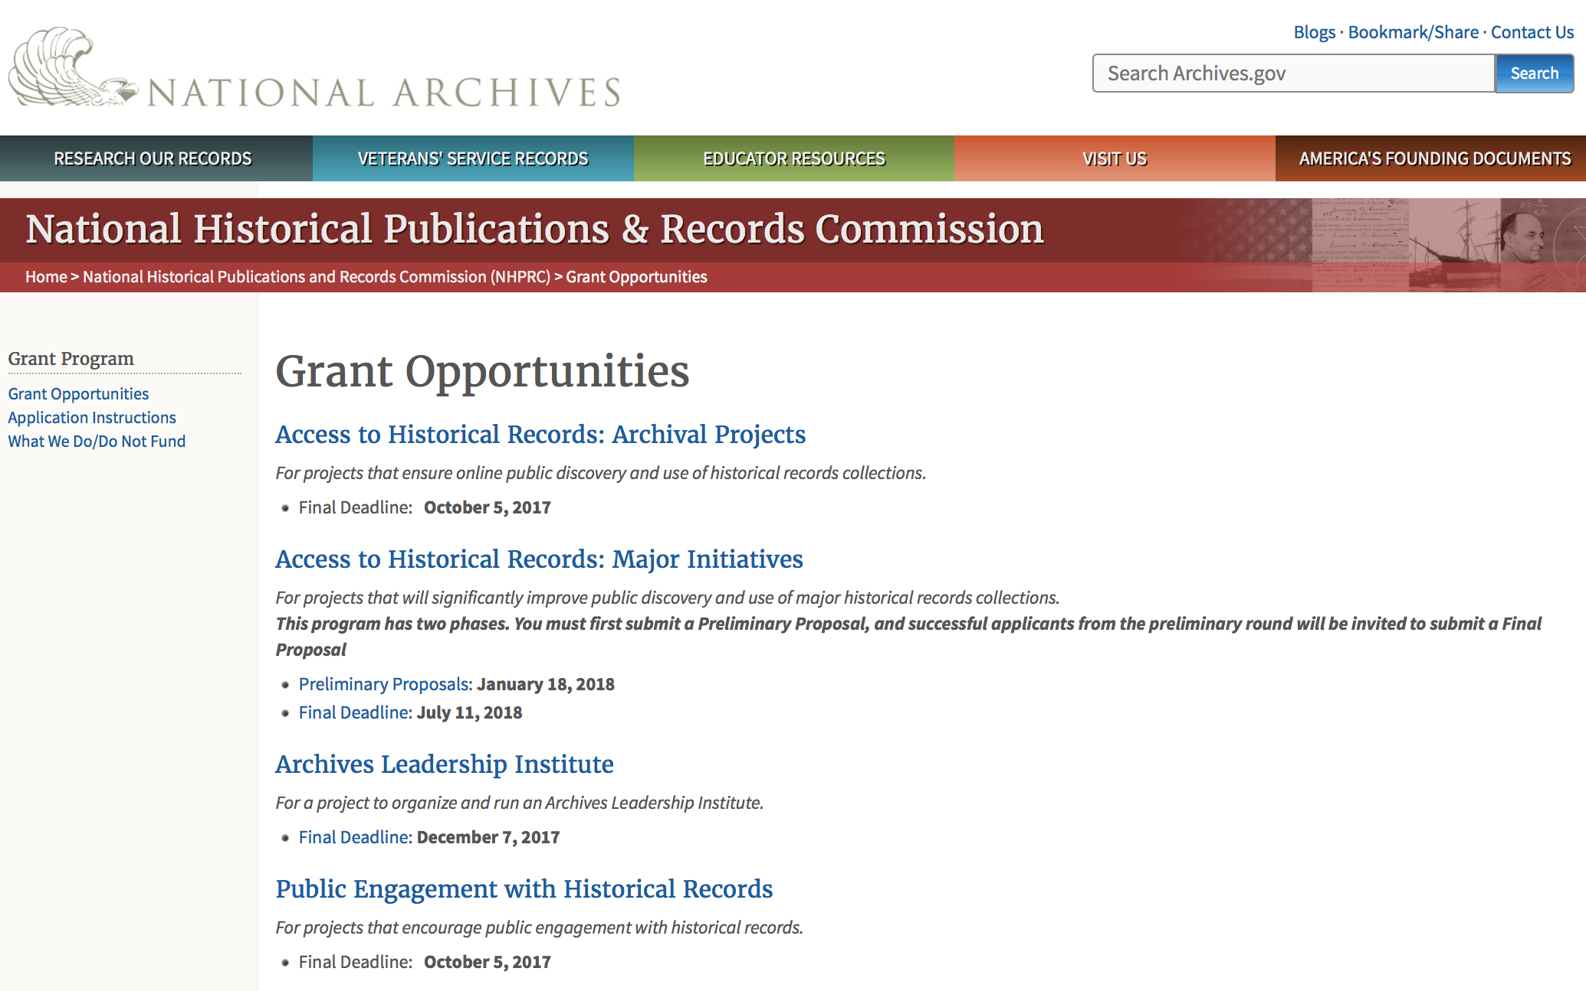

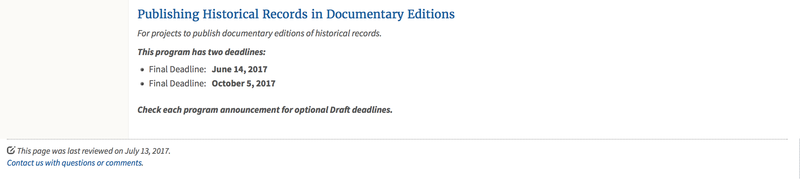
https://www.archives.gov/nhprc/announcement

Programs:

Public Engagement with Historical Records
Synopsis 1

Document Type: | Grants Notice
Funding Opportunity Number: | ENGAGEMENT-201810
Funding Opportunity Title: | Public Engagement with Historical Records
Opportunity Category: | Discretionary
Opportunity Category Explanation:
Funding Instrument Type: | Grant
Category of Funding Activity: | Humanities (see "Cultural Affairs" in CFDA)
Category Explanation:
Expected Number of Awards: | 5
CFDA Number(s): | 89.003 -- National Historical Publications and Records Grants
Cost Sharing or Matching Requirement: | Yes
Version: | Synopsis 1
Posted Date: | Jun 12, 2018
Last Updated Date: | Jun 12, 2018
Original Closing Date for Applications: | Oct 04, 2018
Current Closing Date for Applications: | Oct 04, 2018
Archive Date:
Estimated Total Program Funding: | $275,000
Award Ceiling: | $150,000
Award Floor: | $50,000

Eligible Applicants: | Private institutions of higher education  Native American tribal governments (Federally recognized)  County governments  Nonprofits having a 501(c)(3) status with the IRS, other than institutions of higher education  State governments  City or township governments  Public and State controlled institutions of higher education
Additional Information on Eligibility:

Agency Name: | National Archives and Records Administration
Description: | The National Historical Publications and Records Commission seeks projects that encourage public engagement with historical records, including the development of new tools that enable people to engage online. The NHPRC is looking for projects that create models and technologies that other institutions can freely adopt. In general, collaborations between archivists, documentary editors, historians, educators, and/or community-based individuals are more likely to create a competitive proposal. Projects that focus on innovative methods to introduce primary source materials and how to use them in multiple locations also are more likely to create a competitive proposal. Projects might create and develop programs to engage people in the study and use of historical records for institutional, educational or personal reasons. For example, an applicant can: • Enlist volunteer “citizen archivists” in projects to accelerate access to historical records, especially those online. This may include, but is not limited to, efforts to identify, tag, transcribe, annotate, or otherwise enhance digitized historical records. • Develop educational programs for K-12 students, undergraduate classes, or community members that encourage them to engage with historical records already in repositories or that are collected as part of the project. • Collect primary source material from people through public gatherings and sponsor discussions or websites about the results. • Use historical records in artistic endeavors. This could include K-12 students, undergraduate classes, or community members. Examples include projects that encourage researching and writing life stories for performance; using record facsimiles in painting, sculpture, or audiovisual collages; or using text as lyrics for music or as music. • Develop technologies that encourage the sharing of information about historical records. For a comprehensive list of the Commission’s limitations on funding, please see “What we do and do not fund” (http://www.archives.gov/nhprc/apply/eligibility.html). Applications that consist entirely of ineligible activities will not be considered. Award Information A grant normally is for one to three years. The Commission expects to make up to three grants of between $50,000 and $150,000. The total amount allocated for this program is up to $275,000. Grants begin no earlier than July 1, 2019. The Commission requires that grant recipients acknowledge NHPRC grant assistance in all publications and other products that result from its support. Eligibility Information Eligible applicants: • Nonprofit organizations or institutions • Colleges, universities, and other academic institutions • State or local government agencies • Federally-acknowledged or state-recognized Native American tribes or groups Cost Sharing The total costs of a project are shared between the NHPRC and the applicant organization. The Commission provides no more than 50 per cent of total project costs in the Public Engagement with Historical Records category. NHPRC grant recipients are not permitted to use grant funds for indirect costs (as indicated in 2 CFR 2600.101). The applicant’s financial contribution may include both direct and indirect expenses, in-kind contributions, non-Federal third-party contributions, and any income earned directly by the project. Indirect costs must be listed under the applicant’s cost sharing contribution. Other Requirements Applicant organizations must be registered in the System for Award Management (SAM) prior to submitting an application, maintain SAM registration throughout the application and award process, and include a valid DUNS number in their application. Details on SAM registration and requesting a DUNS number can be found at the System for Award Management website at www.sam.gov. Please refer to the User Guides section and the Grants Registrations PDF. A complete application includes the Application for Federal Assistance (Standard Form 424), Assurances -- Non-Construction Programs (Standard Form 424B), a Project Narrative, Summary, Supplementary Materials, and Budget. Applications lacking these items will not be considered. Ineligible applications will not be reviewed.
Link to Additional Information: | Link to full grant announcement, including additional requirements
Grantor Contact Information: | If you have difficulty accessing the full announcement electronically, please contact:  Jeff de la Concepcion Jeff.delaConcepcion@nara.gov  Grant Information Specialist
https://www.grants.gov/web/grants/view-opportunity.html?oppId=306189

Access to Historical Records: Archival Projects
Synopsis 1
Document Type: | Grants Notice
Funding Opportunity Number: | ARCHIVAL-201810
Funding Opportunity Title: | Access to Historical Records: Archival Projects
Opportunity Category: | Discretionary
Opportunity Category Explanation:
Funding Instrument Type: | Grant
Category of Funding Activity: | Humanities (see "Cultural Affairs" in CFDA)
Category Explanation:
Expected Number of Awards: | 10
CFDA Number(s): | 89.003 -- National Historical Publications and Records Grants
Cost Sharing or Matching Requirement: | Yes
Version: | Synopsis 1
Posted Date: | Jun 18, 2018
Last Updated Date: | Jun 18, 2018
Original Closing Date for Applications: | Oct 04, 2018
Current Closing Date for Applications: | Oct 04, 2018
Archive Date:
Estimated Total Program Funding: | $700,000
Award Ceiling: | $100,000
Award Floor: | $1
Eligible Applicants: | Private institutions of higher education  Native American tribal governments (Federally recognized)  County governments  State governments  City or township governments  Public and State controlled institutions of higher education  Nonprofits having a 501(c)(3) status with the IRS, other than institutions of higher education
Additional Information on Eligibility:
Additional Information
Agency Name: | National Archives and Records Administration
Description: | The National Historical Publications and Records Commission seeks projects that ensure online public discovery and use of historical records collections. The Commission is especially interested in collections of America’s early legal records, such as the records of colonial, territorial, county, and early statehood and tribal proceedings that document the evolution of the nation’s legal history. All types of historical records are eligible, including documents, photographs, born-digital records, and analog audio and moving images. Projects may preserve and process historical records to: • Create new online Finding Aids to collections • Digitize historical records collections and make them freely available online The NHPRC encourages organizations to actively engage the public in the work of the project. For a comprehensive list of Commission limitations on funding, please see: "What we do and do not fund" (http://www.archives.gov/nhprc/apply/eligibility.html). Applications that consist entirely of ineligible activities will not be considered. Award Information A grant is for one or two years and for up to $100,000. The Commission expects to make up to 10 grants in this category for a total of up to $700,000. Grants begin no earlier than July 1, 2019. The Commission requires that grant recipients acknowledge NHPRC grant assistance in all publicity, publications, and other products that result from its support. Eligibility Eligible applicants: • Nonprofit organizations or institutions • Colleges, universities, and other academic institutions • State or local government agencies • Federally-acknowledged or state-recognized Native American tribes or groups Cost Sharing The total costs of a project are shared between the NHPRC and the applicant organization. The Commission provides no more than 75 per cent of total project costs in the Access to Historical Records: Archival Projects category. NHPRC grant recipients are not permitted to use grant funds for indirect costs (as indicated in 2 CFR 2600.101). Cost sharing is required. The applicant's financial contribution may include both direct and indirect expenses, in-kind contributions, non-Federal third-party contributions, and any income earned directly by the project. Indirect costs must be listed under the applicant's cost sharing contribution. Other Requirements Applicant organizations must be registered in the System for Award Management (SAM) prior to submitting an application, maintain SAM registration throughout the application and award process, and include a valid DUNS number in their application. Details on SAM registration and requesting a DUNS number can be found at the System for Award Management website at https://sam.gov. Please refer to the User Guides section and the Grants Registrations PDF. A complete application includes the Application for Federal Assistance (Standard Form 424), Assurances -- Non-Construction Programs (Standard Form 424B), a Project Narrative, Summary, Supplementary Materials, and Budget. Applications lacking these items will not be considered. Ineligible applications will not be reviewed.
Link to Additional Information: | Link to full grant announcement, including additional requirements
Grantor Contact Information: | If you have difficulty accessing the full announcement electronically, please contact:  Jeff de la Concepcion Jeff.delaConcepcion@nara.gov  Grant Information Specialist
https://www.grants.gov/web/grants/view-opportunity.html?oppId=306343

Access to Historical Records: Major Initiatives (Preliminary)
Synopsis 1
Document Type: | Grants Notice
Funding Opportunity Number: | PRELIM-201901
Funding Opportunity Title: | Access to Historical Records: Major Initiatives (Preliminary)
Opportunity Category: | Discretionary
Opportunity Category Explanation:
Funding Instrument Type: | Grant
Category of Funding Activity: | Humanities (see "Cultural Affairs" in CFDA)
Category Explanation:
Expected Number of Awards: | 5
CFDA Number(s): | 89.003 -- National Historical Publications and Records Grants
Cost Sharing or Matching Requirement: | Yes
Version: | Synopsis 1
Posted Date: | Jun 18, 2018
Last Updated Date: | Jun 18, 2018
Original Closing Date for Applications: | Jan 17, 2019
Current Closing Date for Applications: | Jan 17, 2019
Archive Date:
Estimated Total Program Funding: | $1,000,000
Award Ceiling: | $350,000
Award Floor: | $100,000
Eligible Applicants: | Private institutions of higher education  Nonprofits having a 501(c)(3) status with the IRS, other than institutions of higher education  County governments  Native American tribal governments (Federally recognized)  City or township governments  State governments  Public and State controlled institutions of higher education
Additional Information on Eligibility:

Agency Name: | National Archives and Records Administration
Description: | Grant Program Description The National Historical Publications and Records Commission seeks projects that will significantly improve public discovery and use of major historical records collections. The Commission is especially interested in collections of America’s early legal records, such as the records of colonial, territorial, county, and early statehood and tribal proceedings that document the evolution of the nation’s legal history. All types of historical records are eligible, including documents, photographs, born-digital records, and analog audio and moving images. Projects may: • Digitize historical records collections, or related collections, held by a single institution and make them freely available online • Provide access to born-digital records • Create new freely-available virtual collections drawn from historical records held by multiple institutions • Create new tools and methods for users to access records The NHPRC welcomes collaborative projects, particularly for bringing together related records from multiple institutions. Projects that address significant needs in the field and result in replicable and scalable approaches will be more competitive. We also encourage organizations to actively engage the public in the work of the project. Applicants should also consult Access to Historical Records: Archival Projects program, which has different requirements and award amounts. For a comprehensive list of Commission limitations on funding, please see: "What we do and do not fund" (http://www.archives.gov/nhprc/apply/eligibility.html). Applications that consist entirely of ineligible activities will not be considered. Award Information A grant is for one to three years and for between $100,000 and $350,000. We expect to make up to five grants in this category for a total of up to $1,000,000. Grants begin no earlier than January 1, 2020. The Commission requires that grant recipients acknowledge NHPRC grant assistance in all publications and other products that result from its support. Eligibility Eligible applicants: • Nonprofit organizations or institutions • Colleges, universities, and other academic institutions • State or local government agencies • Federally-acknowledged or state-recognized Native American tribes or groups Cost Sharing The total costs of a project are shared between the NHPRC and the applicant organization. The Commission provides no more than 50 per cent of total project costs in the Access to Historical Records: Major Initiatives category. NHPRC grant recipients are not permitted to use grant funds for indirect costs (as indicated in 2 CFR 2600.101). Cost sharing is required. The applicant's financial contribution may include both direct and indirect expenses, in-kind contributions, non-Federal third-party contributions, and any income earned directly by the project. Indirect costs must be listed under the applicant's cost sharing contribution. Other Requirements Applicant organizations must be registered in the System for Award Management (SAM) prior to submitting an application, maintain SAM registration throughout the application and award process, and include a valid DUNS number in their application. Details on SAM registration and requesting a DUNS number can be found at the System for Award Management website at https://sam.gov. Please refer to the User Guides section and the Grants Registrations PDF. A complete preliminary application includes the Application for Federal Assistance (Standard Form 424), a Project Narrative, and Budget. Applications lacking these items will not be considered. Ineligible applications will not be reviewed.
Link to Additional Information: | Link to full grant announcement, including additional requirements
Grantor Contact Information: | If you have difficulty accessing the full announcement electronically, please contact:  Jeff de la Concepcion Jeff.delaconcepcion@nara.gov  Grant Information Specialist
https://www.grants.gov/web/grants/view-opportunity.html?oppId=306357

Reminders:

Publishing Historical Records in Documentary Editions
Synopsis 1
Document Type: | Grants Notice
Funding Opportunity Number: | EDITIONS-201810
Funding Opportunity Title: | Publishing Historical Records in Documentary Editions
Opportunity Category: | Discretionary
Opportunity Category Explanation:
Funding Instrument Type: | Grant
Category of Funding Activity: | Humanities (see "Cultural Affairs" in CFDA)
Category Explanation:
Expected Number of Awards: | 25
CFDA Number(s): | 89.003 -- National Historical Publications and Records Grants
Cost Sharing or Matching Requirement: | Yes
Version: | Synopsis 1
Posted Date: | Nov 29, 2017
Last Updated Date: | Nov 29, 2017
Original Closing Date for Applications: | Oct 04, 2018
Current Closing Date for Applications: | Oct 04, 2018
Archive Date:
Estimated Total Program Funding: | $2,500,000
Award Ceiling: | $200,000
Award Floor: | $1
Eligible Applicants: | Public and State controlled institutions of higher education  State governments  City or township governments  Nonprofits having a 501(c)(3) status with the IRS, other than institutions of higher education  Native American tribal governments (Federally recognized)  County governments  Private institutions of higher education
Agency Name: | National Archives and Records Administration
Description: | The National Historical Publications and Records Commission seeks proposals to publish documentary editions of historical records. Projects may focus on the papers of major figures from American history or cover broad historical movements in politics, social reform, business, military, the arts, and other aspects of the national experience. The historical value of the records and their expected usefulness to broad audiences must justify the costs of the project. The goal of this program is to provide access to, and editorial context for, the historical documents and records that tell the American story. Applicants should demonstrate familiarity with the best practices recommended by the Association for Documentary Editing or the Modern Language Association Committee on Scholarly Editions. All new projects (those which have never received NHPRC funding) must publish a digital edition, which provides online access to a searchable collection of all documents. (Ebooks or volumes in PDF do not qualify for the purposes of this grant program.) New projects may also prepare print editions as part of their overall publishing plan, but the contents of those volumes must be published online within a reasonable period of time following print publication. The NHPRC encourages projects to provide free access to online editions. Projects that do not have definitive plans for digital dissemination and preservation in place at the time of application will not be considered. Grants are awarded for collecting, describing, preserving, compiling, transcribing, annotating, editing, encoding, and publishing documentary source materials online and in print. Because of the focus on documentary sources, grants do not support preparation of critical editions of published works unless such works are just a small portion of the larger project. All applicants should be aware that the application process is highly competitive. For a comprehensive list of Commission's limitations on funding, please see What We Do and Do Not Fund. Applications that consist entirely of ineligible activities will not be considered. Ongoing projects: Applicants from ongoing projects must demonstrate that they have successfully achieved the performance objectives associated with previous NHPRC awards; provide updated, current information, including a description of the new activities; describe the content and historical significance of the specific materials to be edited during the proposed grant period; show progress towards completing the edition; and justify costs in a new budget. Award Information A grant is for one year and for up to $200,000. The Commission expects to make up to 25 grants in this category for a total of up to $2,500,000. Grants begin no earlier than January 1, 2019. The Commission requires that grant recipients acknowledge NHPRC grant assistance in all publications, publicity, and other products that result from its support. Eligibility • U.S. nonprofit organizations or institutions • U.S. colleges, universities, and other academic institutions • State or local government agencies • Federally-acknowledged or state-recognized Native American tribes or groups Cost Sharing The total costs of a project are shared between the NHPRC and the applicant organization. The Commission provides no more than 50 per cent of total direct project costs in the Publishing Historical Records in Documentary Editions category. NHPRC grant recipients are not permitted to use grant funds for indirect costs (as indicated in 2 CFR 2600.101). Cost sharing is required. The applicant’s financial contribution may include both direct and indirect expenses, in-kind contributions, non-Federal third-party contributions, and any income earned directly by the project. Indirect costs must be listed under the applicant’s cost sharing contribution. Other Requirements Applicant organizations must be registered in the System for Award Management (SAM) prior to submitting an application, maintain SAM registration throughout the application and award process, and include a valid DUNS number in their application. Details on SAM registration and requesting a DUNS number can be found at the System for Award Management website at https://sam.gov. Please refer to the User Guides section and the Grants Registrations PDF. A complete application includes the Application for Federal Assistance (Standard Form 424), Assurances -- Non-Construction Programs (Standard Form 424B), a Project Narrative, Summary, Supplementary Materials, and Budget. Applications lacking these items will not be considered. Ineligible applications will not be reviewed.
Link to Additional Information: | Link to full grant announcement, including additional requirements
Grantor Contact Information: | If you have difficulty accessing the full announcement electronically, please contact:  Jeff de la Concepcion Jeff.delaconcepcion@nara.gov  Grant Information Specialist
https://www.grants.gov/web/grants/view-opportunity.html?oppId=299091

Access to Historical Records: Major Initiatives
Synopsis 1

Document Type: | Grants Notice
Funding Opportunity Number: | MAJOR-201807
Funding Opportunity Title: | Access to Historical Records: Major Initiatives
Opportunity Category: | Discretionary
Opportunity Category Explanation:
Funding Instrument Type: | Grant
Category of Funding Activity: | Humanities (see "Cultural Affairs" in CFDA)
Category Explanation:
Expected Number of Awards: | 5
CFDA Number(s): | 89.003 -- National Historical Publications and Records Grants
Cost Sharing or Matching Requirement: | Yes
Version: | Synopsis 1
Posted Date: | Jul 14, 2017
Last Updated Date: | Jul 14, 2017
Original Closing Date for Applications: | Jul 11, 2018
Current Closing Date for Applications: | Jul 11, 2018
Archive Date:
Estimated Total Program Funding: | $1,000,000
Award Ceiling: | $350,000
Award Floor: | $100,000
Eligible Applicants: | Public and State controlled institutions of higher education  County governments  Nonprofits having a 501(c)(3) status with the IRS, other than institutions of higher education  State governments  City or township governments  Private institutions of higher education  Native American tribal governments (Federally recognized)
Agency Name: | National Archives and Records Administration
Description: | The National Historical Publications and Records Commission seeks projects that will significantly improve public discovery and use of major historical records collections. All types of historical records are eligible, including documents, photographs, born-digital records, and analog audio and moving images. Projects may: • Digitize historical records collections, or related collections, held by a single institution and make them freely available online • Provide access to born-digital records • Create new freely-available virtual collections drawn from historical records held by multiple institutions • Create new tools and methods for users to access records The NHPRC welcomes collaborative projects, particularly for bringing together related records from multiple institutions. Projects that address significant needs in the field and result in replicable and scalable approaches will be more competitive. We also encourage organizations to actively engage the public in the work of the project. Applicants should also consult Access to Historical Records: Archival Projects program, which has different requirements and award amounts. For a comprehensive list of Commission limitations on funding, please see: "What we do and do not fund" (http://www.archives.gov/nhprc/apply/eligibility.html). Applications that consist entirely of ineligible activities will not be considered. Award Information A grant is for one to three years and between $100,000 and $350,000. We expect to make up to five grants in this category for a total of up to $1,000,000. Grants begin no earlier than January 1, 2019. The Commission requires that grant recipients acknowledge NHPRC grant assistance in all publicity, publications, and other products that result from its support. Eligibility Eligible applicants: • U.S. nonprofit organizations or institutions • U.S. colleges, universities, and other academic institutions • State or local government agencies • Federally-acknowledged or state-recognized Native American tribes or groups Cost Sharing The total costs of a project are shared between the NHPRC and the applicant organization. The Commission provides no more than 50 per cent of total project costs in the Access to Historical Records: Major Initiatives category. NHPRC grant recipients are not permitted to use grant funds for indirect costs (as indicated in 2 CFR 2600.101). Cost sharing is required. The applicant's financial contribution may include both direct and indirect expenses, in-kind contributions, non-Federal third-party contributions, and any income earned directly by the project. Indirect costs must be listed under the applicant's cost sharing contribution. Other Requirements Applicant organizations must be registered in the System for Award Management (SAM) prior to submitting an application, maintain SAM registration throughout the application and award process, and include a valid DUNS number in their application. Details on SAM registration and requesting a DUNS number can be found at the System for Award Management website at https://sam.gov. Please refer to the User Guides section and the Grants Registrations PDF. Application Information You must use Grants.gov to submit your Full Proposal. All information necessary to apply is included in this announcement, the Application Instructions, and the forms on Grants.gov. If you need the information supplied in an alternative format, please call the NHPRC at 202-357-5010. In order to ensure eligibility, applicants should first review the rules and regulations governing NHPRC grants under the Administering an NHPRC Grant section. Applying to the Access to Historical Records: Major Initiatives program is a two-phase process. Phase One • All applicants must have submitted a Preliminary Proposal by January 18, 2018. • Only those applicants who have successfully completed Phase One and who have been invited by the Commission to submit a full proposal to the Access to Historical Records: Major Initiatives program are eligible to participate in the second phase of the process. Phase Two • If you have been invited, prepare and submit a complete application to the full Major Initiatives grant announcement via Grants.gov by July 11, 2018. • Applicants may consult with the Director of the Access Program, Alex Lorch (alexander.lorch@nara.gov), or with the Director for Technology Initiatives, Nancy Melley (nancy.melley@nara.gov), during both the preliminary and full proposal project phases.
Link to Additional Information: | Link to full grant announcement, including additional requirements
Grantor Contact Information: | If you have difficulty accessing the full announcement electronically, please contact:  Jeff de la Concepcion Jeff.delaconcepcion@nara.gov  Grant Information Specialist

http://www.grants.gov/web/grants/view-opportunity.html?oppId=295496

National Endowment for the Arts

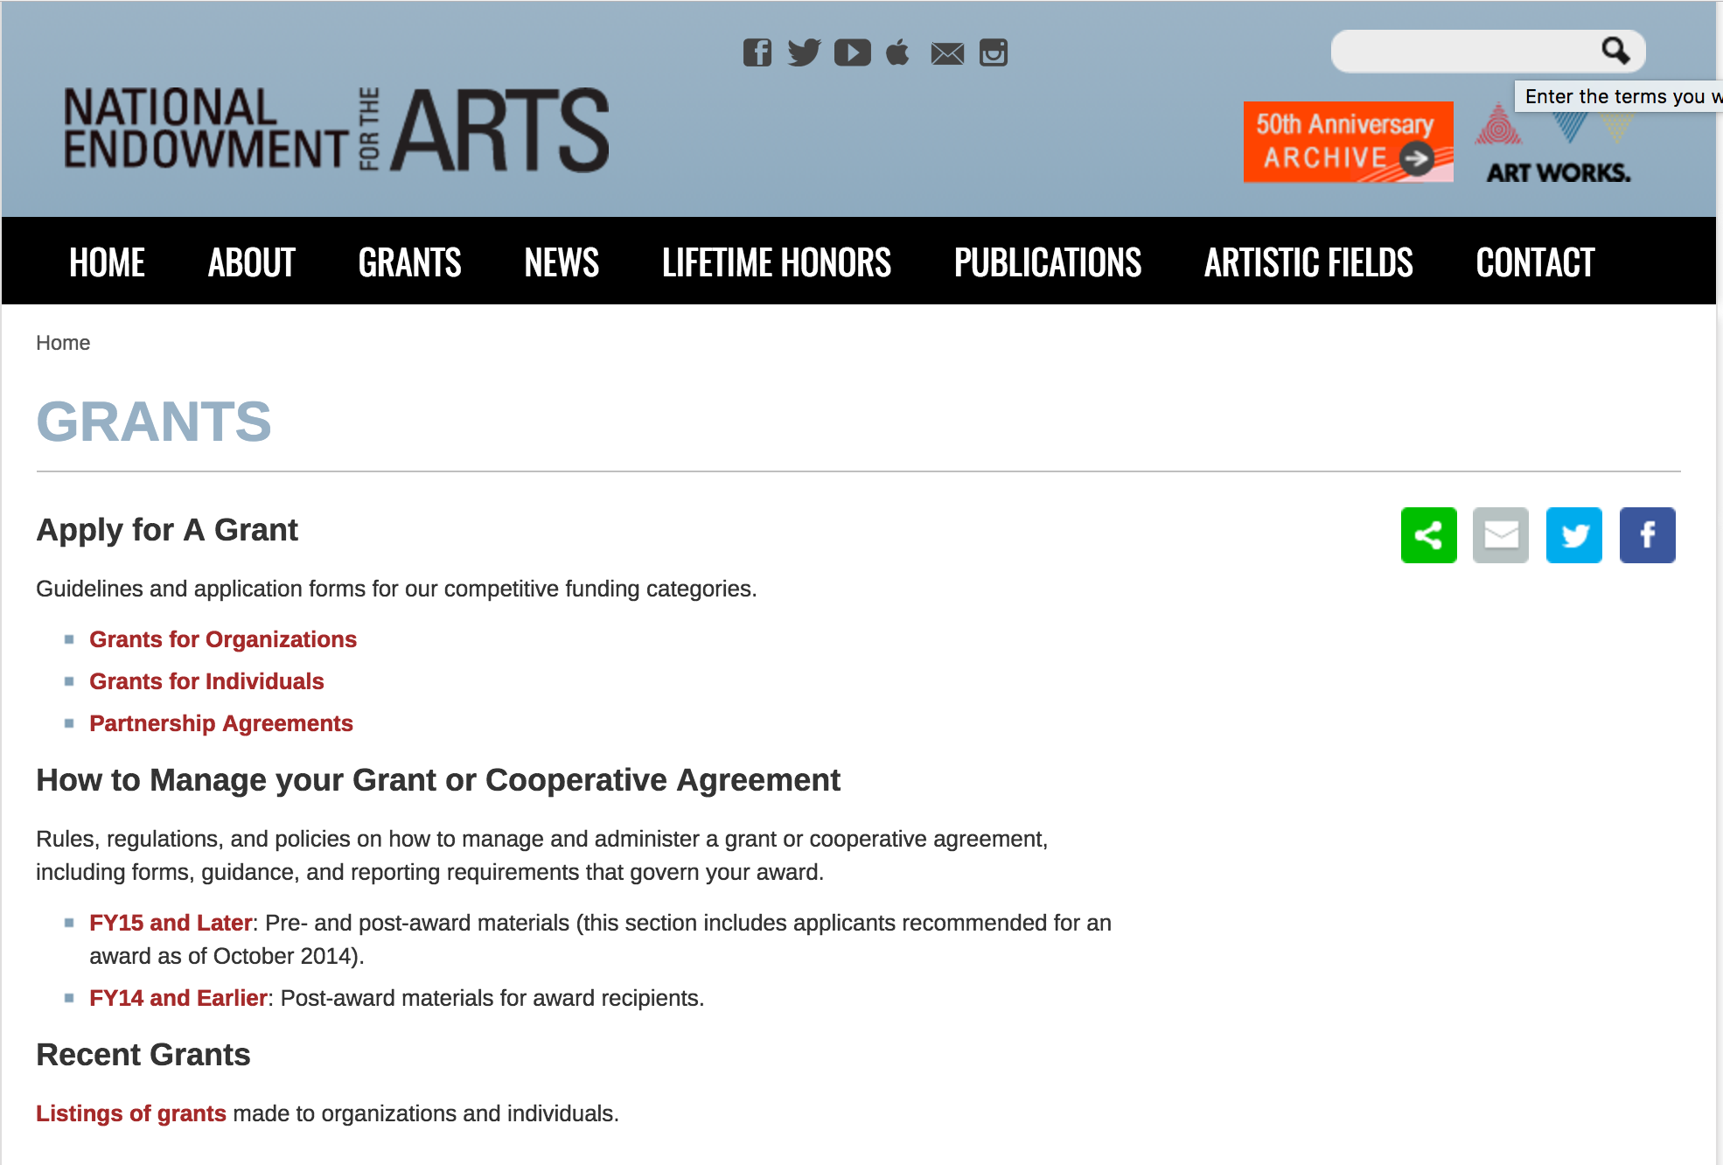

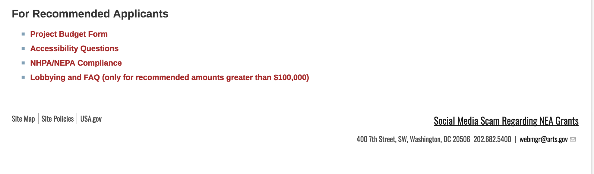
See more at: https://www.arts.gov/grants

Programs:

NEA Jazz Masters Tribute Concert and Ancillary Events, FY2020
Synopsis 1

Document Type: | Grants Notice
Funding Opportunity Number: | NEAPS1802
Funding Opportunity Title: | NEA Jazz Masters Tribute Concert and Ancillary Events, FY2020
Opportunity Category: | Discretionary
Opportunity Category Explanation:
Funding Instrument Type: | Cooperative Agreement
Category of Funding Activity: | Arts (see "Cultural Affairs" in CFDA)
Category Explanation:
Expected Number of Awards:
CFDA Number(s): | 45.024 -- Promotion of the Arts Grants to Organizations and Individuals
Cost Sharing or Matching Requirement: | No
Version: | Synopsis 1
Posted Date: | Jun 14, 2018
Last Updated Date: | Jun 14, 2018
Original Closing Date for Applications: | Aug 15, 2018
Current Closing Date for Applications: | Aug 15, 2018
Archive Date:
Estimated Total Program Funding:
Award Ceiling: | $425,000
Award Floor: | $425,000
Eligible Applicants: | City or township governments  Native American tribal governments (Federally recognized)  Special district governments  Nonprofits having a 501(c)(3) status with the IRS, other than institutions of higher education  Private institutions of higher education  State governments  Independent school districts  Public and State controlled institutions of higher education  County governments
Additional Information on Eligibility:
Additional Information
Agency Name: | National Endowment for the Arts
Description: | The NEA is seeking an organization (“Cooperator”) to produce and coordinate a free, public Tribute Concert (the “Concert”) and ancillary events honoring the 2020 NEA Jazz Masters Fellowship awardees. The NEA Jazz Masters Fellowship is the highest honor that our nation bestows upon a jazz musician or advocate. Since 1982, the NEA has awarded 149 fellowships to great figures in jazz. In 2020, we anticipate honoring four individuals (generally three jazz musicians and one individual who is designated as a jazz advocate). The Concert may take place in any U.S. city with a thriving jazz community or other characteristics that are likely to draw a robust audience for the Concert. We are interested in receiving proposals for concerts in venues located in a wide range of U.S. cities, states, and territories, especially those in the middle region of the country. We are also interested in rotating the Concert to other U.S. cities in future years contingent upon what we hope will be subsequent Cooperative Agreements with the organization selected as a result of this Program Solicitation. The Concert must take place during the winter or spring of 2020, and possibly coincide with Jazz Appreciation Month in April 2020 as appropriate. Project activities may also take place in conjunction with other related events undertaken by the Cooperator during this timeframe, such as an established jazz festival. The Concert should highlight the honorees' individual, collective, or advocacy accomplishments, as appropriate. Applicants are encouraged to present innovative approaches to showcase the honorees and the NEA Jazz Masters brand through the events’ design and event-related marketing and public relations efforts. The Concert may include, but is not limited to, performances by leading jazz artists that celebrate the 2020 honorees’ bodies of work, history, or style.
Link to Additional Information: | NEA Web Site Announcement
Grantor Contact Information: | If you have difficulty accessing the full announcement electronically, please contact:  NEA Web Manager webmgr@arts.gov  NEA Web Manager
https://www.grants.gov/web/grants/view-opportunity.html?oppId=306274

Modifications:

Reminders:

NEA Art Works 2, FY2019
Synopsis 1
Document Type: Grants Notice  Funding Opportunity Number: 2018NEA01AW2  Funding Opportunity Title: NEA Art Works 2, FY2019  Opportunity Category: Discretionary  Opportunity Category Explanation:  Funding Instrument Type: Grant  Category of Funding Activity: Arts (see "Cultural Affairs" in CFDA)  Category Explanation:  Expected Number of Awards:  CFDA Number(s): 45.024 -- Promotion of the Arts Grants to Organizations and Individuals  Cost Sharing or Matching Requirement: Yes | Version: Synopsis 1  Posted Date: May 09, 2018  Last Updated Date: May 09, 2018  Original Closing Date for Applications: Jul 12, 2018  Current Closing Date for Applications: Jul 12, 2018  Archive Date:  Estimated Total Program Funding:  Award Ceiling: $100,000  Award Floor: $10,000
Eligibility
Eligible Applicants: | Native American tribal governments (Federally recognized)  Nonprofits having a 501(c)(3) status with the IRS, other than institutions of higher education  County governments  Public and State controlled institutions of higher education  Independent school districts  Private institutions of higher education  State governments  City or township governments  Special district governments
Additional Information on Eligibility:
Additional Information
Agency Name: | National Endowment for the Arts
Description: | An organization may submit only one application through one of the following FY 2019 categories: Art Works or Challenge America. If an organization applies to the Challenge America category, it may not submit another application to the Art Works category. The Arts Endowment's support of a project may start on or after June 1, 2019. Generally, a period of performance of up to two years is allowed. Program Description Art Works is the National Endowment for the Arts’ principal grants program. Through project-based funding, we support public engagement with, and access to, various forms of excellent art across the nation, the creation of art that meets the highest standards of excellence, learning in the arts at all stages of life, and the integration of the arts into the fabric of community life. Projects may be large or small, existing or new, and may take place in any part of the nation’s 50 states, the District of Columbia, and U.S. territories.
Link to Additional Information: | NEA Website Announcement
Grantor Contact Information: | If you have difficulty accessing the full announcement electronically, please contact:  NEA Web Manager webmgr@arts.gov  NEA Web Manager
https://www.grants.gov/web/grants/view-opportunity.html?oppId=304858

NEA Research Labs, FY2019
Synopsis 1

Document Type: Grants Notice  Funding Opportunity Number: NEAPS1801  Funding Opportunity Title: NEA Research Labs, FY2019  Opportunity Category: Discretionary  Opportunity Category Explanation:  Funding Instrument Type: Cooperative Agreement  Category of Funding Activity: Arts (see "Cultural Affairs" in CFDA)  Category Explanation:  Expected Number of Awards:  CFDA Number(s): 45.024 -- Promotion of the Arts Grants to Organizations and Individuals  Cost Sharing or Matching Requirement: Yes | Version: Synopsis 1  Posted Date: May 23, 2018  Last Updated Date: May 23, 2018  Original Closing Date for Applications: Jul 19, 2018  Current Closing Date for Applications: Jul 19, 2018  Archive Date:  Estimated Total Program Funding:  Award Ceiling: $150,000  Award Floor: $150,000
Eligibility
Eligible Applicants: | State governments  Special district governments  County governments  Independent school districts  Native American tribal governments (Federally recognized)  City or township governments  Private institutions of higher education  Public and State controlled institutions of higher education  Nonprofits having a 501(c)(3) status with the IRS, other than institutions of higher education
Additional Information on Eligibility:
Additional Information
Agency Name: | National Endowment for the Arts
Description: | “An organization may submit only one proposal under this program solicitation.” “This Cooperative Agreement will begin no earlier than March 1, 2019, and extend for up to 24 months.” Program Description Our five-year research agenda aims to build public knowledge about the arts’ contributions to individuals and society. Through the NEA Research Labs (“Research Labs”), we seek to extend this agenda and its impact by cultivating a series of transdisciplinary research partnerships, grounded in the social and behavioral sciences, to produce and report empirical insights about the arts for the benefit of arts and non-arts sectors alike. Each Research Lab will define its own agenda, conduct a research program to implement that agenda, and prepare reports that will contribute substantively to a wider understanding of one of three areas of special interest to the NEA: 1. The Arts, Health, and Social/Emotional Well-Being a. Therapeutic Approaches and Benefits b. Non-Therapeutic Approaches and Benefits 2. The Arts, Creativity, Cognition, and Learning 3. The Arts, Entrepreneurship, and Innovation We anticipate that a sustained engagement with these topic areas, and with the corresponding research questions we frame below, will have distinctive benefits not only for the arts community, but also for sectors such as healthcare, education, and business or management.
Link to Additional Information: | NEA Web Site Announcement
Grantor Contact Information: | If you have difficulty accessing the full announcement electronically, please contact:  NEA Web Manager webmgr@arts.gov  NEA Web Manager
https://www.grants.gov/web/grants/view-opportunity.html?oppId=305533

NEA Our Town, FY2019
Synopsis 1

Document Type: Grants Notice  Funding Opportunity Number: 2018NEA01OT  Funding Opportunity Title: NEA Our Town, FY2019  Opportunity Category: Discretionary  Opportunity Category Explanation:  Funding Instrument Type: Grant  Category of Funding Activity: Arts (see "Cultural Affairs" in CFDA)  Category Explanation:  Expected Number of Awards:  CFDA Number(s): 45.024 -- Promotion of the Arts Grants to Organizations and Individuals  Cost Sharing or Matching Requirement: Yes | Version: Synopsis 1  Posted Date: Apr 20, 2018  Last Updated Date: Apr 20, 2018  Original Closing Date for Applications: Aug 09, 2018  Current Closing Date for Applications: Aug 09, 2018  Archive Date:  Estimated Total Program Funding:  Award Ceiling: $200,000  Award Floor: $25,000
Eligibility
Eligible Applicants: | State governments  Native American tribal governments (Federally recognized)  County governments  Special district governments  Public and State controlled institutions of higher education  City or township governments  Independent school districts  Nonprofits having a 501(c)(3) status with the IRS, other than institutions of higher education  Private institutions of higher education
Additional Information on Eligibility:
Additional Information
Agency Name: | National Endowment for the Arts
Description: | The Arts Endowment’s support of a project may start on July 1, 2019, or any time thereafter. A grant period of up to two years is allowed. An organization may submit as a lead applicant two applications to Our Town. A partnering organization may serve as a partner on as many applications as they like. You may apply to other National Endowment for the Arts funding opportunities, including Art Works and Challenge America, in addition to Our Town. In each case, the request must be for a distinctly different project, or a distinctly different phase of a project. If you have applied to the NEA in the past and were not recommended for funding, you may apply again to any funding opportunity, including Our Town. Description Our Town is the National Endowment for the Arts’ creative placemaking grants program. These grants support projects that integrate arts, culture, and design activities into efforts that strengthen communities by advancing local economic, physical, and/or social outcomes. Successful Our Town projects ultimately lay the groundwork for systemic changes that sustain the integration of arts, culture, and design into strategies for strengthening communities. Our Town offers support for projects in two areas: • Place-Based Projects. Through arts engagement, cultural planning, design, and/or artist/creative industry support, these projects contribute to improved quality of life in local communities. These projects require a partnership between a nonprofit organization and a local government entity, with one of the partners being a cultural organization. Matching grants range from $25,000 to $200,000, with a minimum cost share/match equal to the grant amount. • Knowledge Building Projects. These projects build and disseminate knowledge about how to leverage arts, culture, and design as mechanisms for strengthening communities. These grants are available to arts service or design service organizations, and/or other national or regional membership, policy, or university-based organizations. These projects require a partnership that will facilitate the knowledge sharing and/or exchange. Matching grants range from $25,000 to $100,000, with a minimum cost share/match equal to the grant amount.
Link to Additional Information: | NEA Web Site Announcement
Grantor Contact Information: | If you have difficulty accessing the full announcement electronically, please contact:  Contact the staff at OT@arts.gov OT@arts.gov  NEA Our Town Staff
https://www.grants.gov/web/grants/view-opportunity.html?oppId=303916

National Endowment for the Humanities

Grant Overview -

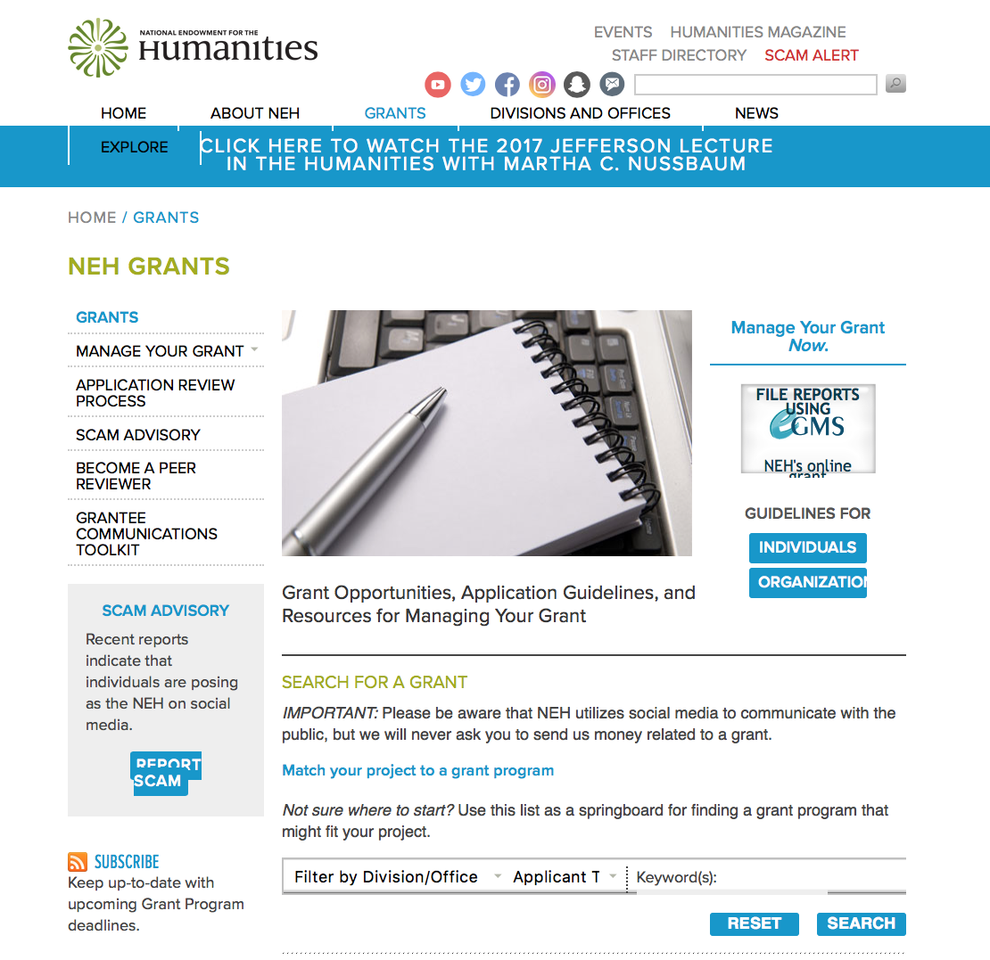

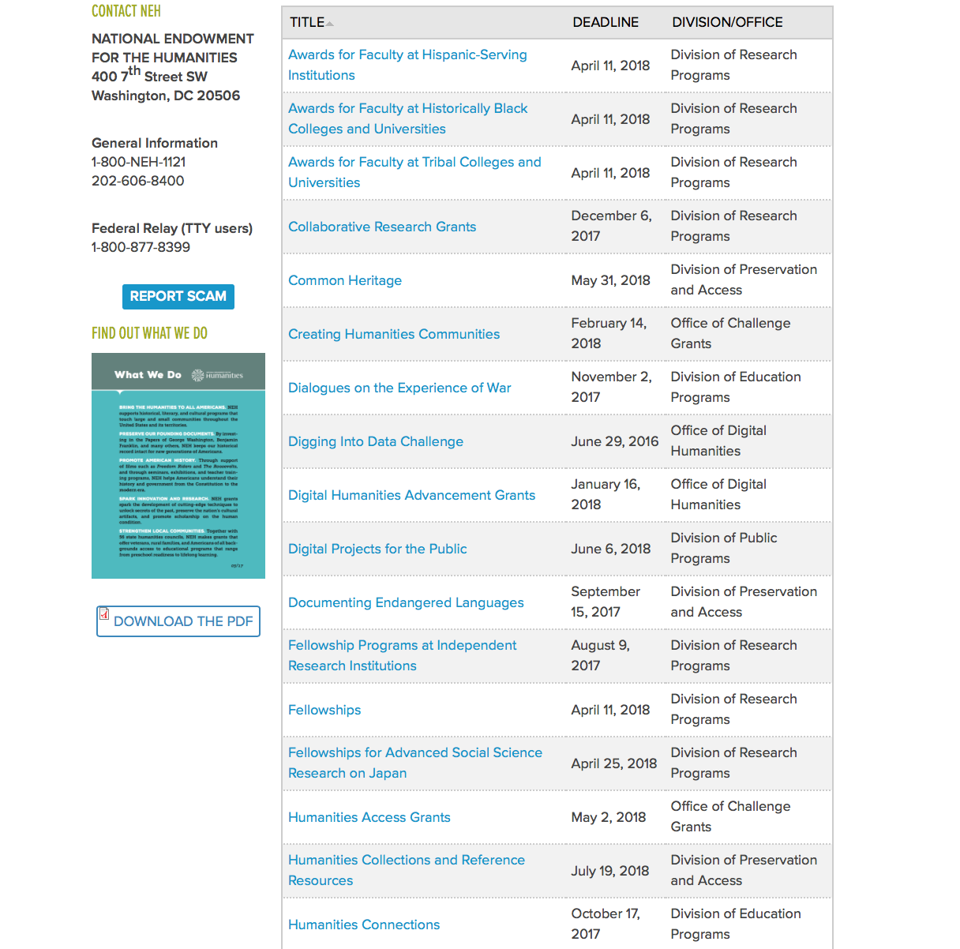

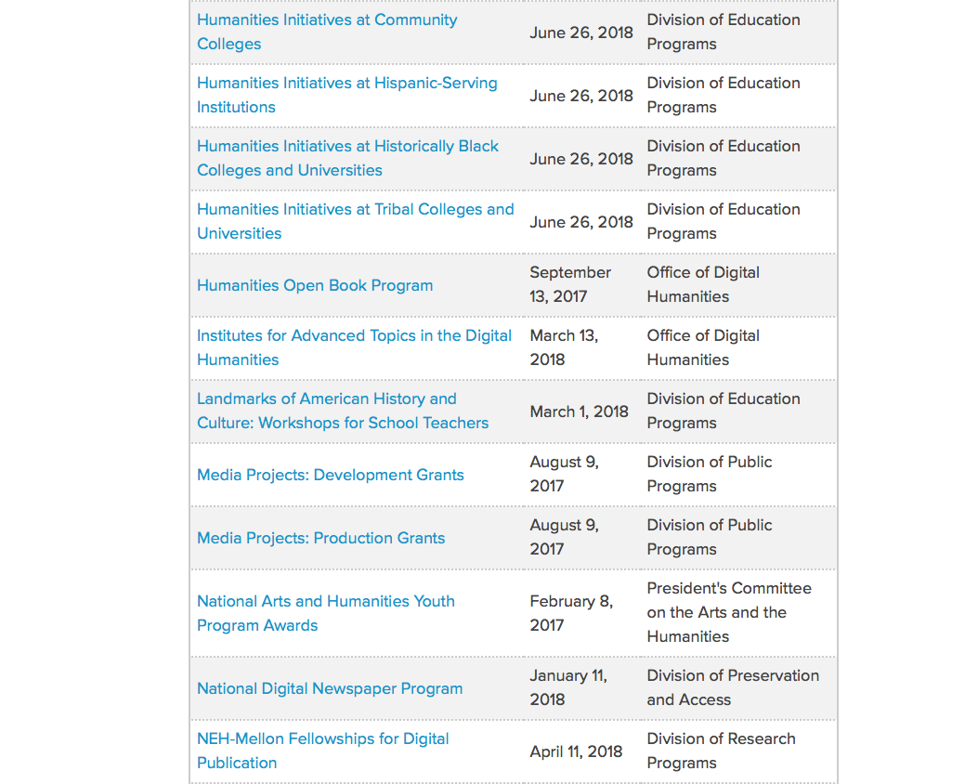

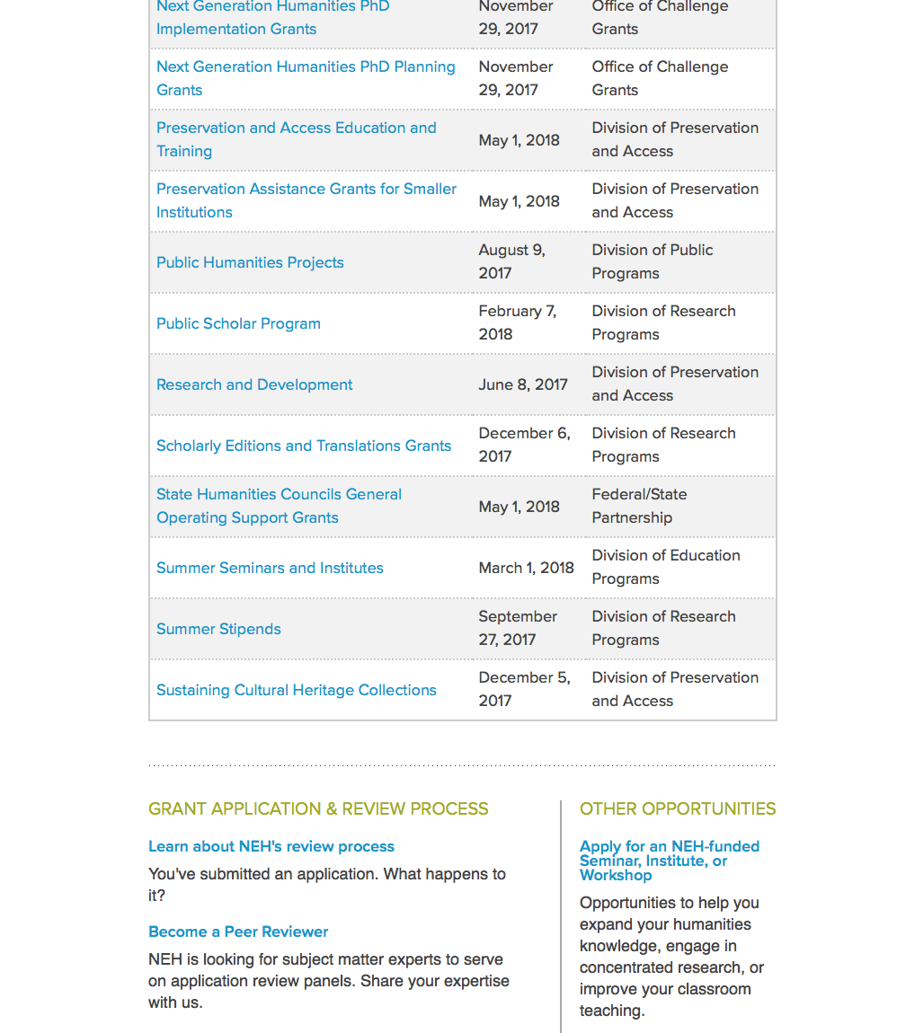

https://www.neh.gov/grants

Programs:

Infrastructure and Capacity Building Challenge Grants
Synopsis 1
Document Type: | Grants Notice
Funding Opportunity Number: | 20180809-CHA
Funding Opportunity Title: | Infrastructure and Capacity Building Challenge Grants
Opportunity Category: | Discretionary
Opportunity Category Explanation:
Funding Instrument Type: | Grant
Category of Funding Activity: | Humanities (see "Cultural Affairs" in CFDA)
Category Explanation:
Expected Number of Awards:
CFDA Number(s): | 45.130 -- Promotion of the Humanities Challenge Grants
Cost Sharing or Matching Requirement: | Yes
Version: | Synopsis 1
Posted Date: | Jun 08, 2018
Last Updated Date: | Jun 08, 2018
Original Closing Date for Applications: | Aug 09, 2018
Current Closing Date for Applications: | Aug 09, 2018
Archive Date:
Estimated Total Program Funding:
Award Ceiling: | $750,000
Award Floor: | $2
Eligible Applicants: | County governments  Nonprofits having a 501(c)(3) status with the IRS, other than institutions of higher education  Special district governments  Private institutions of higher education  City or township governments  Native American tribal governments (Federally recognized)  State governments  Public and State controlled institutions of higher education
Additional Information on Eligibility:
Additional Information
Agency Name: | National Endowment for the Humanities
Description: | The mission of this Challenge Grants program is to strengthen the institutional base of the humanities by enabling infrastructure development and capacity building. Awards aim to help institutions secure long-term support for their core activities and expand efforts to preserve and create access to outstanding humanities materials. Applications are welcome from colleges and universities, museums, public libraries, research institutions, historical societies and historic sites, scholarly associations, state humanities councils, and other public and nonprofit humanities entities. Programs that involve collaboration among multiple institutions are eligible as well, but one institution must serve as the lead agent and formal applicant of record. Through these awards organizations can increase their humanities capacity with funds invested in a restricted, short-term endowment or other investment fund (or spend-down funds) that generate expendable earnings to support and enhance ongoing program activities. Eligible activities include the documentation of cultural heritage materials that are lost or imperiled; the preservation and conservation of humanities materials; and the sustaining of digital scholarly infrastructure. Challenge grants may also support the purchase of equipment and software; the design, purchase, construction, restoration, or renovation of facilities needed for humanities activities; and collections sharing. Such expenditures bring long-term benefits to the institution and to the humanities more broadly. Up to 10 percent of total grant funds (federal matching funds plus certified gifts) may be used for fundraising costs during the period of performance. Challenge funds (both federal matching funds and required nonfederal gifts) must enhance the humanities in the long term. Challenge grants should not merely replace funds already being expended, but instead should reflect careful strategic planning to strengthen and enrich an institution’s humanities activities. Institutions may use challenge funds to meet both ongoing and one-time humanities-related costs, provided that the long-term benefit of the expenditure can be demonstrated.
Link to Additional Information: | https://www.neh.gov/grants/preservation/infrastructure-and-capacity-building-challenge-grants
Grantor Contact Information: | If you have difficulty accessing the full announcement electronically, please contact:  Division of Preservation and Access National Endowment for the Humanities 400 Seventh Street, SW Washington, DC 20506 202-606-8309 challenge@neh.gov challenge@neh.gov  challenge@neh.gov
https://www.grants.gov/web/grants/view-opportunity.html?oppId=306069

Summer Stipends
Synopsis 1
Grants Notice
Funding Opportunity Number: | 20180926-FT
Funding Opportunity Title: | Summer Stipends
Opportunity Category: | Discretionary
Opportunity Category Explanation:
Funding Instrument Type: | Grant
Category of Funding Activity: | Humanities (see "Cultural Affairs" in CFDA)
Category Explanation:
Expected Number of Awards:
CFDA Number(s): | 45.160 -- Promotion of the Humanities Fellowships and Stipends
Cost Sharing or Matching Requirement: | No
Version: | Synopsis 1
Posted Date: | Jun 04, 2018
Last Updated Date: | Jun 04, 2018
Original Closing Date for Applications: | Sep 26, 2018
Current Closing Date for Applications: | Sep 26, 2018
Archive Date:
Estimated Total Program Funding:
Award Ceiling: | $6,000
Award Floor: | $6,000
Eligible Applicants: | Others (see text field entitled "Additional Information on Eligibility" for clarification)
Additional Information on Eligibility: | The only eligible applicants are individuals. Individuals with tenured or tenure-track appointments at four-year institutions of higher education must be nominated by their institutions to be eligible.
Additional Information
Agency Name: | National Endowment for the Humanities
Description: | Summer Stipends support individuals pursuing advanced research that is of value to humanities scholars, general audiences, or both. Eligible projects usually result in articles, monographs, books, digital materials and publications, archaeological site reports, translations, or editions. Projects must incorporate analysis and not result solely in the collection of data. Summer Stipends support continuous full-time work on a humanities project for a period of two consecutive months. Summer Stipends support projects at any stage of development. NEH funds may support recipients’ compensation, travel, and other costs related to the proposed scholarly research. Summer Stipends are awarded to individual scholars. Organizations are not eligible to apply.
Link to Additional Information: | https://www.neh.gov/grants/research/summer-stipends
Grantor Contact Information: | If you have difficulty accessing the full announcement electronically, please contact:  Division of Research Programs National Endowment for the Humanities 400 Seventh Street, SW Washington, D.C. 20506 202-606-8200 stipends@neh.gov stipends@neh.gov  stipends@neh.gov

https://www.grants.gov/web/grants/view-opportunity.html?oppId=305875

Modifications:

Reminders:

Humanities Collections and Reference Resources
Synopsis 1

Document Type: Grants Notice  Funding Opportunity Number: 20180719-PW  Funding Opportunity Title: Humanities Collections and Reference Resources  Opportunity Category: Discretionary  Opportunity Category Explanation:  Funding Instrument Type: Grant  Category of Funding Activity: Humanities (see "Cultural Affairs" in CFDA)  Category Explanation:  Expected Number of Awards:  CFDA Number(s): 45.149 -- Promotion of the Humanities Division of Preservation and Access  Cost Sharing or Matching Requirement: No | Version: Synopsis 1  Posted Date: May 23, 2018  Last Updated Date: May 23, 2018  Original Closing Date for Applications: Jul 19, 2018  Current Closing Date for Applications: Jul 19, 2018  Archive Date:  Estimated Total Program Funding:  Award Ceiling: $350,000  Award Floor: $1
Eligibility
Eligible Applicants: | County governments  Native American tribal governments (Federally recognized)  Special district governments  Public and State controlled institutions of higher education  State governments  City or township governments  Nonprofits having a 501(c)(3) status with the IRS, other than institutions of higher education  Private institutions of higher education
Additional Information on Eligibility:
Additional Information
Agency Name: | National Endowment for the Humanities
Description: | The Humanities Collections and Reference Resources (HCRR) program supports projects that provide an essential underpinning for scholarship, education, and public programming in the humanities. Thousands of libraries, archives, museums, and historical organizations across the country maintain important collections of books and manuscripts, photographs, sound recordings and moving images, archaeological and ethnographic artifacts, art and material culture, and digital objects. Funding from this program strengthens efforts to extend the life of such materials and make their intellectual content widely accessible, often through the use of digital technology. Awards are also made to create various reference resources that facilitate use of cultural materials, from works that provide basic information quickly to tools that synthesize and codify knowledge of a subject for in-depth investigation. HCRR offers two kinds of awards: 1) for implementation and 2) for planning, assessment, and pilot efforts (HCRR Foundations awards).
Link to Additional Information: | https://www.neh.gov/grants/preservation/humanities-collections-and-reference-resources
Grantor Contact Information: | If you have difficulty accessing the full announcement electronically, please contact:  Humanities Collections and Reference Resources Division of Preservation and Access National Endowment for the Humanities 400 Seventh Street, SW Washington, DC 20506 preservation@neh.gov preservation@neh.gov  preservation@neh.gov
https://www.grants.gov/web/grants/view-opportunity.html?oppId=305536

Humanities Initiatives
Synopsis 1

Document Type: Grants Notice  Funding Opportunity Number: 20180719-AB  Funding Opportunity Title: Humanities Initiatives  Opportunity Category: Discretionary  Opportunity Category Explanation:  Funding Instrument Type: Grant  Category of Funding Activity: Humanities (see "Cultural Affairs" in CFDA)  Category Explanation:  Expected Number of Awards:  CFDA Number(s): 45.162 -- Promotion of the Humanities Teaching and Learning Resources and Curriculum Development  Cost Sharing or Matching Requirement: No | Version: Synopsis 1  Posted Date: May 23, 2018  Last Updated Date: May 23, 2018  Original Closing Date for Applications: Jul 19, 2018  Current Closing Date for Applications: Jul 19, 2018  Archive Date:  Estimated Total Program Funding:  Award Ceiling: $100,000  Award Floor: $1
Eligibility
Eligible Applicants: | Others (see text field entitled "Additional Information on Eligibility" for clarification)
Additional Information on Eligibility: | The only eligible applicants are community colleges and those institutions of higher education designated by the U.S. Department of Education as Hispanic-Serving Institutions, Historically Black Colleges and Universities, and Tribal Colleges and Universities.
Additional Information
Agency Name: | National Endowment for the Humanities
Description: | NEH Humanities Initiatives at Historically Black Colleges and Universities, Hispanic-Serving Institutions, Tribal Colleges and Universities, and Community Colleges help strengthen the teaching and study of the humanities by developing new humanities programs, resources, or courses, or by enhancing existing ones. Applicants are encouraged to draw on the knowledge of outside scholars who would contribute expertise and fresh insights to the project. Each project must be organized around a core topic or set of themes drawn from areas of study in the humanities such as history, philosophy, religion, literature, and composition and writing skills.
Link to Additional Information: | https://www.neh.gov/grants/humanities-initiatives
Grantor Contact Information: | If you have difficulty accessing the full announcement electronically, please contact:  Division of Education Programs National Endowment for the Humanities 400 Seventh Street, SW Washington, DC 20506 202-606-8471 hi@neh.gov hi@neh.gov  hi@neh.gov
https://www.grants.gov/web/grants/view-opportunity.html?oppId=305534



National Science Foundation

General Funding Overview

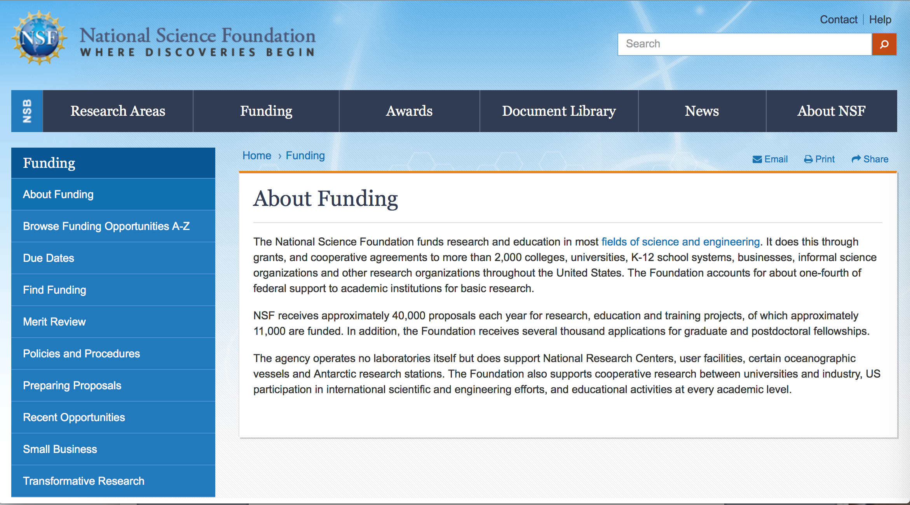

For assistance: https://nsf.gov/funding/aboutfunding.jsp

The National Science Foundation funds research and education in most fields of science and engineering. It does this through grants, and cooperative agreements to more than 2,000 colleges, universities, K-12 school systems, businesses, informal science organizations and other research organizations throughout the United States. The Foundation accounts for about one-fourth of federal support to academic institutions for basic research.
NSF receives approximately 40,000 proposals each year for research, education and training projects, of which approximately 11,000 are funded. In addition, the Foundation receives several thousand applications for graduate and postdoctoral fellowships.
The agency operates no laboratories itself but does support National Research Centers, user facilities, certain oceanographic vessels and Antarctic research stations. The Foundation also supports cooperative research between universities and industry, US participation in international scientific and engineering efforts, and educational activities at every academic level.

For details on active funding deadline dates: http://nsf.gov/funding/pgm_list.jsp?org=NSF&ord=date

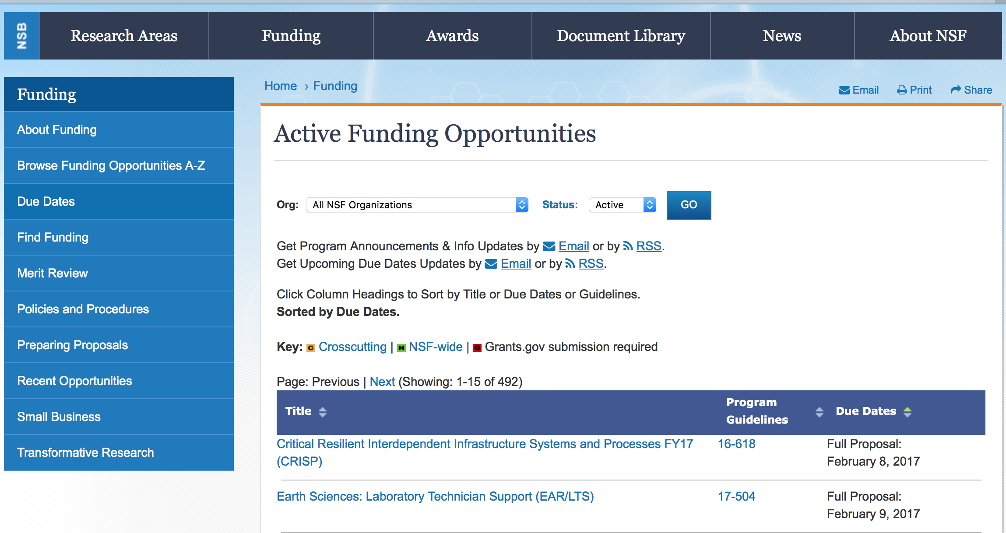

Advanced Manufacturing.
Synopsis 1
https://www.grants.gov/web/grants/view-opportunity.html?oppId=305951

Biomechanics and Mechanobiology
Synopsis 1
https://www.grants.gov/web/grants/view-opportunity.html?oppId=306171

Civil Infrastructure Systems
Synopsis 1
https://www.grants.gov/web/grants/view-opportunity.html?oppId=306193

Communications, Circuits, and Sensing-Systems
Synopsis 1
https://www.grants.gov/web/grants/view-opportunity.html?oppId=306480

Division of Physics: Investigator-Initiated Research Projects
Synopsis 1
https://www.grants.gov/web/grants/view-opportunity.html?oppId=306256

Division of Chemistry: Disciplinary Research Programs
Synopsis 1
https://www.grants.gov/web/grants/view-opportunity.html?oppId=305950

Dynamics, Control and Systems Diagnostics
Synopsis 1
https://www.grants.gov/web/grants/view-opportunity.html?oppId=306166

EAR Postdoctoral Fellowships
Synopsis 1
https://www.grants.gov/web/grants/view-opportunity.html?oppId=306420

Electronics, Photonics and Magnetic Devices
Synopsis 1
https://www.grants.gov/web/grants/view-opportunity.html?oppId=306482

Energy, Power, Control, and Networks
Synopsis 1
https://www.grants.gov/web/grants/view-opportunity.html?oppId=306481

Engineering Design and System Engineering
Synopsis 1
https://www.grants.gov/web/grants/view-opportunity.html?oppId=306170

Engineering for Civil Infrastructure
Synopsis 1
https://www.grants.gov/web/grants/view-opportunity.html?oppId=306169

Humans, Disasters, and the Built Environment
Synopsis 1
https://www.grants.gov/web/grants/view-opportunity.html?oppId=306194

Innovation Corps - National Innovation Network Teams Program (I-CorpsTM Teams)
Synopsis 1
https://www.grants.gov/web/grants/view-opportunity.html?oppId=306421
Innovation Corps - National Innovation Network Teams Program (I-CorpsTM Teams)
Synopsis 1
https://www.grants.gov/web/grants/view-opportunity.html?oppId=306255
Mechanics of Materials and Structures
Synopsis 1
https://www.grants.gov/web/grants/view-opportunity.html?oppId=306172

Mind, Machine and Motor Nexus
Synopsis 1
https://www.grants.gov/web/grants/view-opportunity.html?oppId=306168

Operations Engineering
Synopsis 1
https://www.grants.gov/web/grants/view-opportunity.html?oppId=306167

Research Experiences for Undergraduates
Synopsis 1
https://www.grants.gov/web/grants/view-opportunity.html?oppId=306257
Secondary Satellite Network for the U. S. Academic Research Vessel Fleet
Synopsis 1
https://www.grants.gov/web/grants/view-opportunity.html?oppId=306254

Modifications:

Reminders:

Deleted:

Nuclear Regulatory Commission

Reminders:

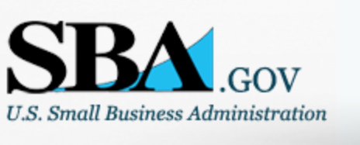

Small Business Administration

General Overview Finding Loans & Grants



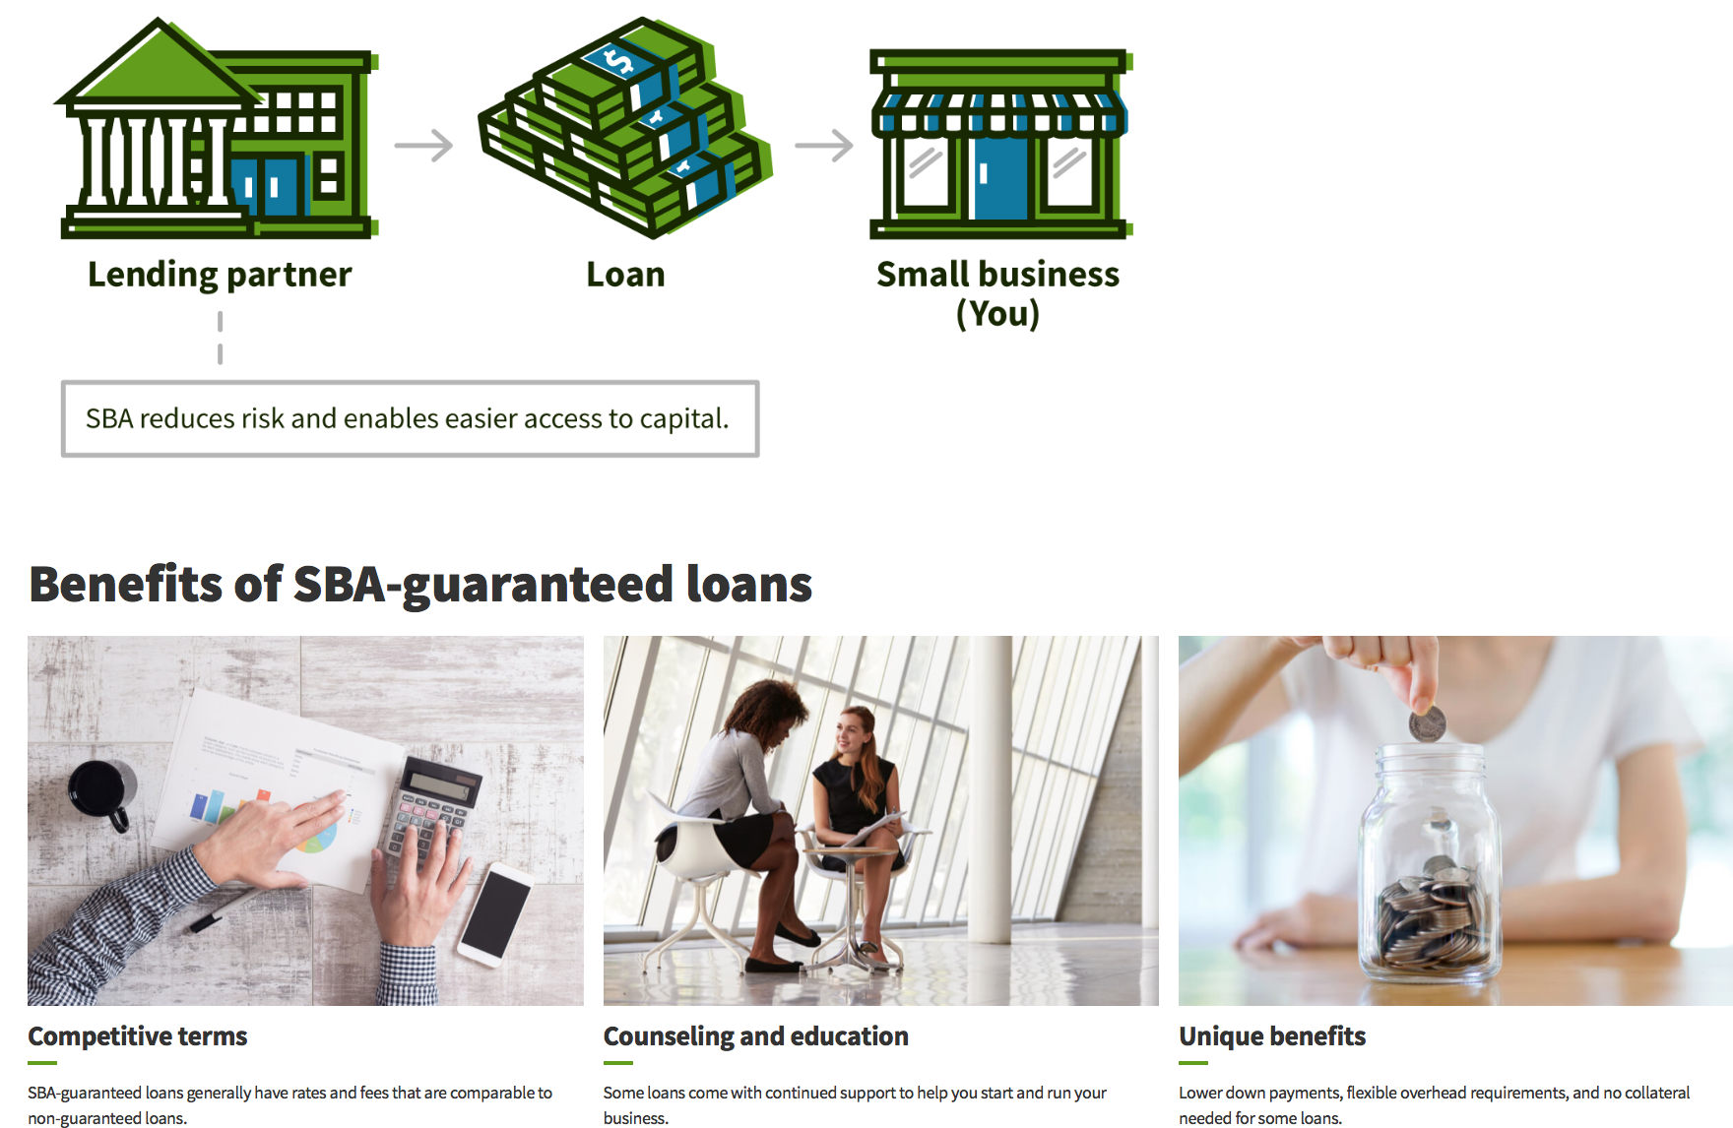

https://www.sba.gov/funding-programs/loans
Federal, state and local governments offer a wide range of financing programs to help small businesses start and grow their operations. These programs include low-interest loans, venture capital, and scientific and economic development grants.
Use SBA.gov's Loans and Grants Search Tool to get a list of financing programs for which you may qualify, or visit the resources below to learn more about small business financing programs.

To get to the main SBA.gov funding page click here
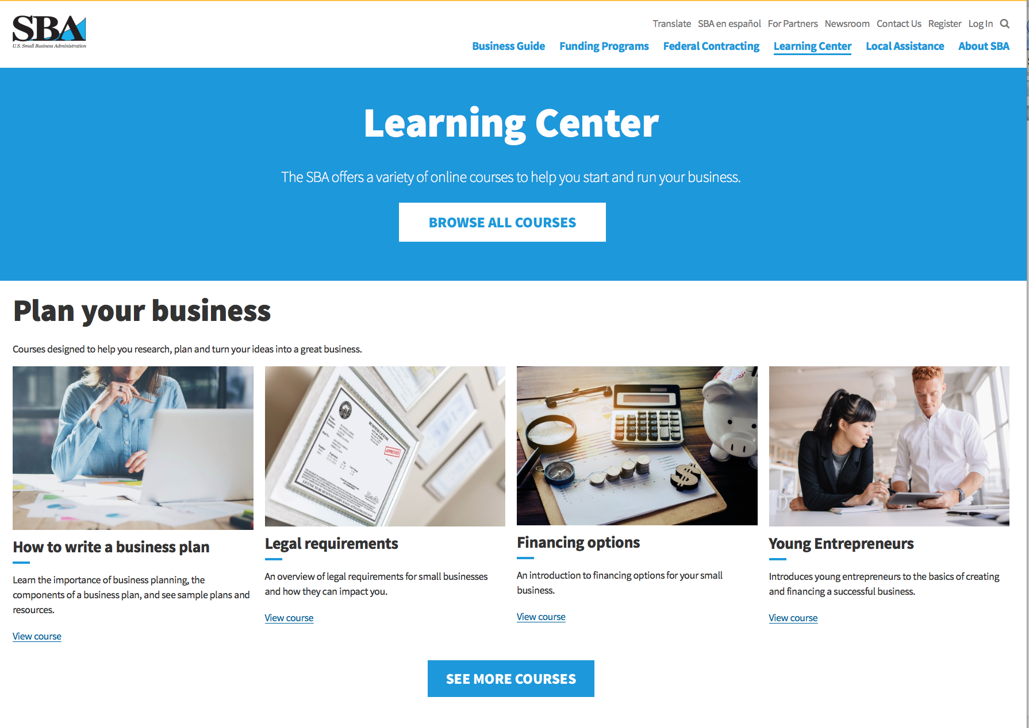
https://www.sba.gov/learning-center

Programs:

Modifications:

Reminders:

Deleted:

SBA Trainings

Contracting Opportunities for Veteran Entrepreneurs
This self-paced training exercise is an introduction to Federal contracting opportunities for Veterans.
Topics include basic information about Veteran-owned businesses and opportunities, services available to small Veteran-owned businesses, small business incentives, and government procurement methods.
Duration: 00:30:00

http://www.sba.gov/tools/sba-learning-center/training/contracting-opportunities-veteran-entrepreneurs

Interested in Exporting? These Four Resources Can Help
Did you know that two-thirds of the world’s purchasing power is in foreign countries? As the numbers show, the international marketplace is a big one. So if you’re interested in exploring the world of exporting – or have gotten started but could use some guidance – check out these resources to help.
- Read more

Upcoming Trainings: Check out SBA's Online Training!
- Financing Options for Small Businesses
How to Prepare Government Contract Proposals
Getting Started With Exporting: Training and Educational Resources
Exporting represents a big opportunity to tap in to new markets, expand your customer base and grow your business. But getting started with exporting can sometimes feel like a maze of regulations, policies, and other barriers. Here are some free training and educational resources to help.
- Read more

For Specific Information in Hawaii see the following links:
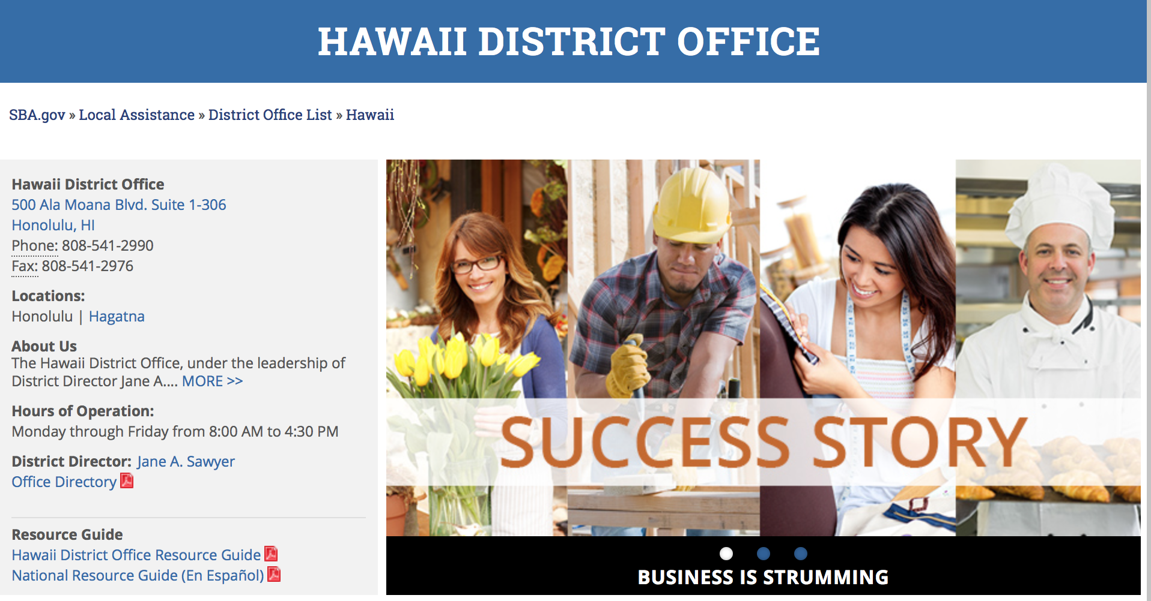

https://www.sba.gov/offices/district/hi/Honolulu

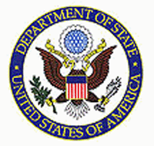

State Department General Overview and Resources for Program Administrators

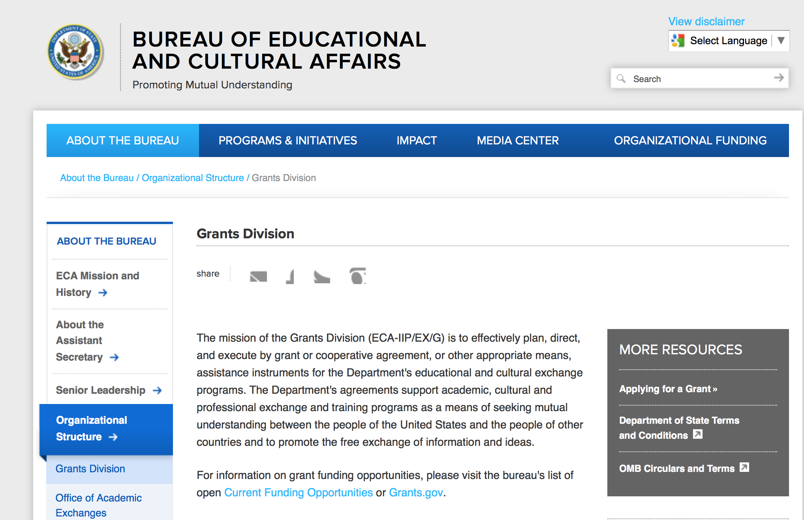

https://eca.state.gov/about-bureau/organizational-structure/grants-division

http://eca.state.gov/search/solr/grants?search_referrer=node/237

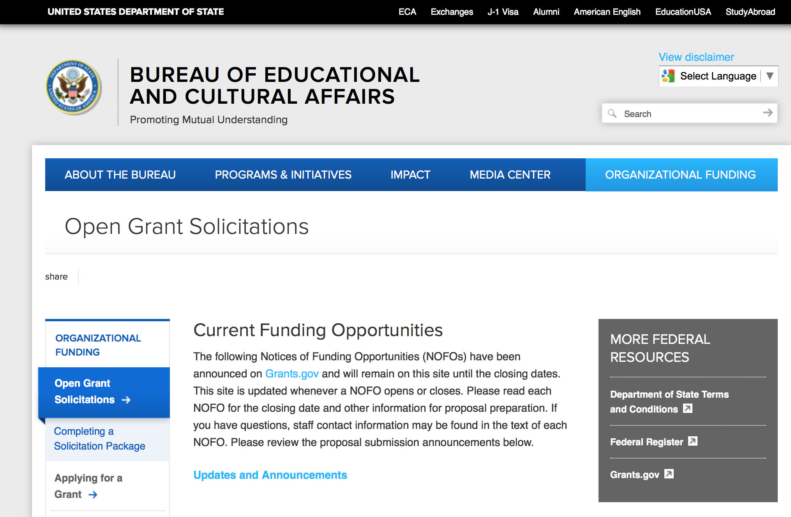
https://eca.state.gov/organizational-funding/open-grant-solicitations

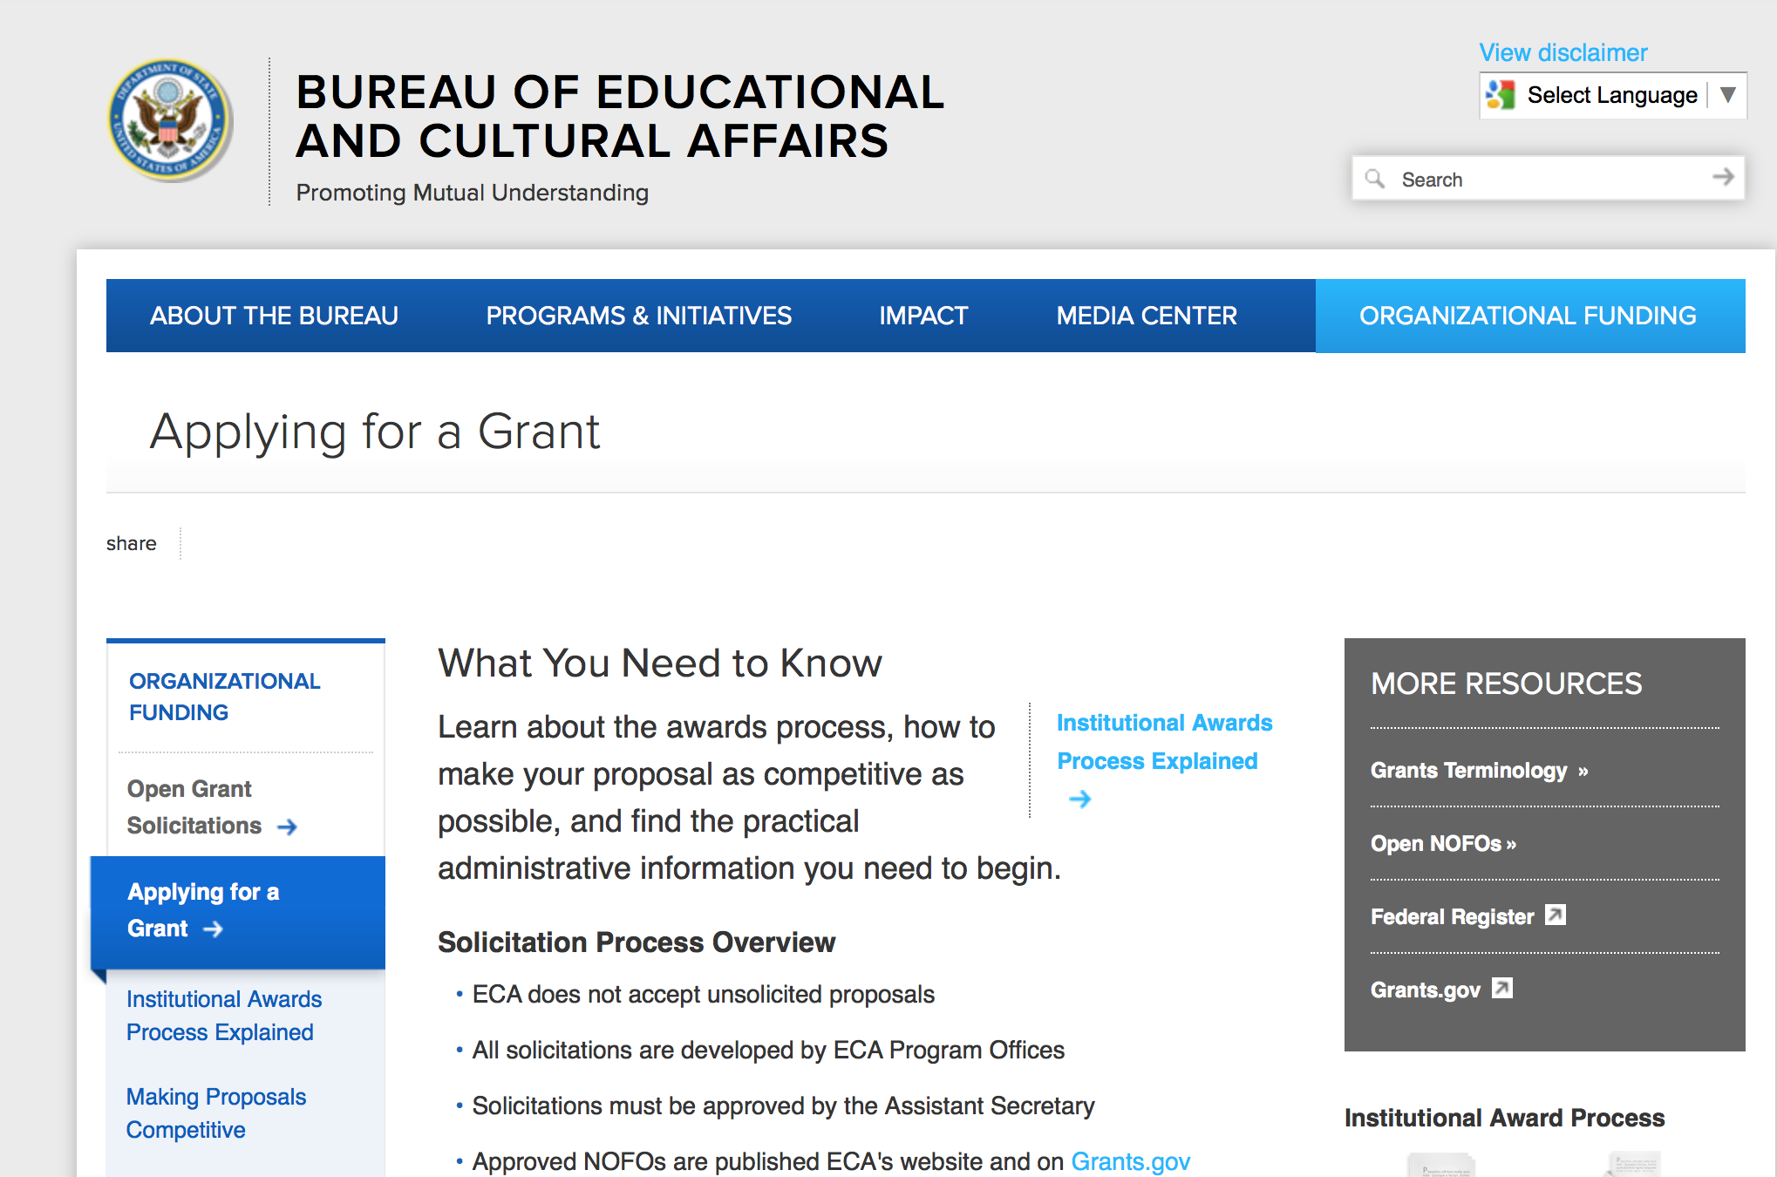
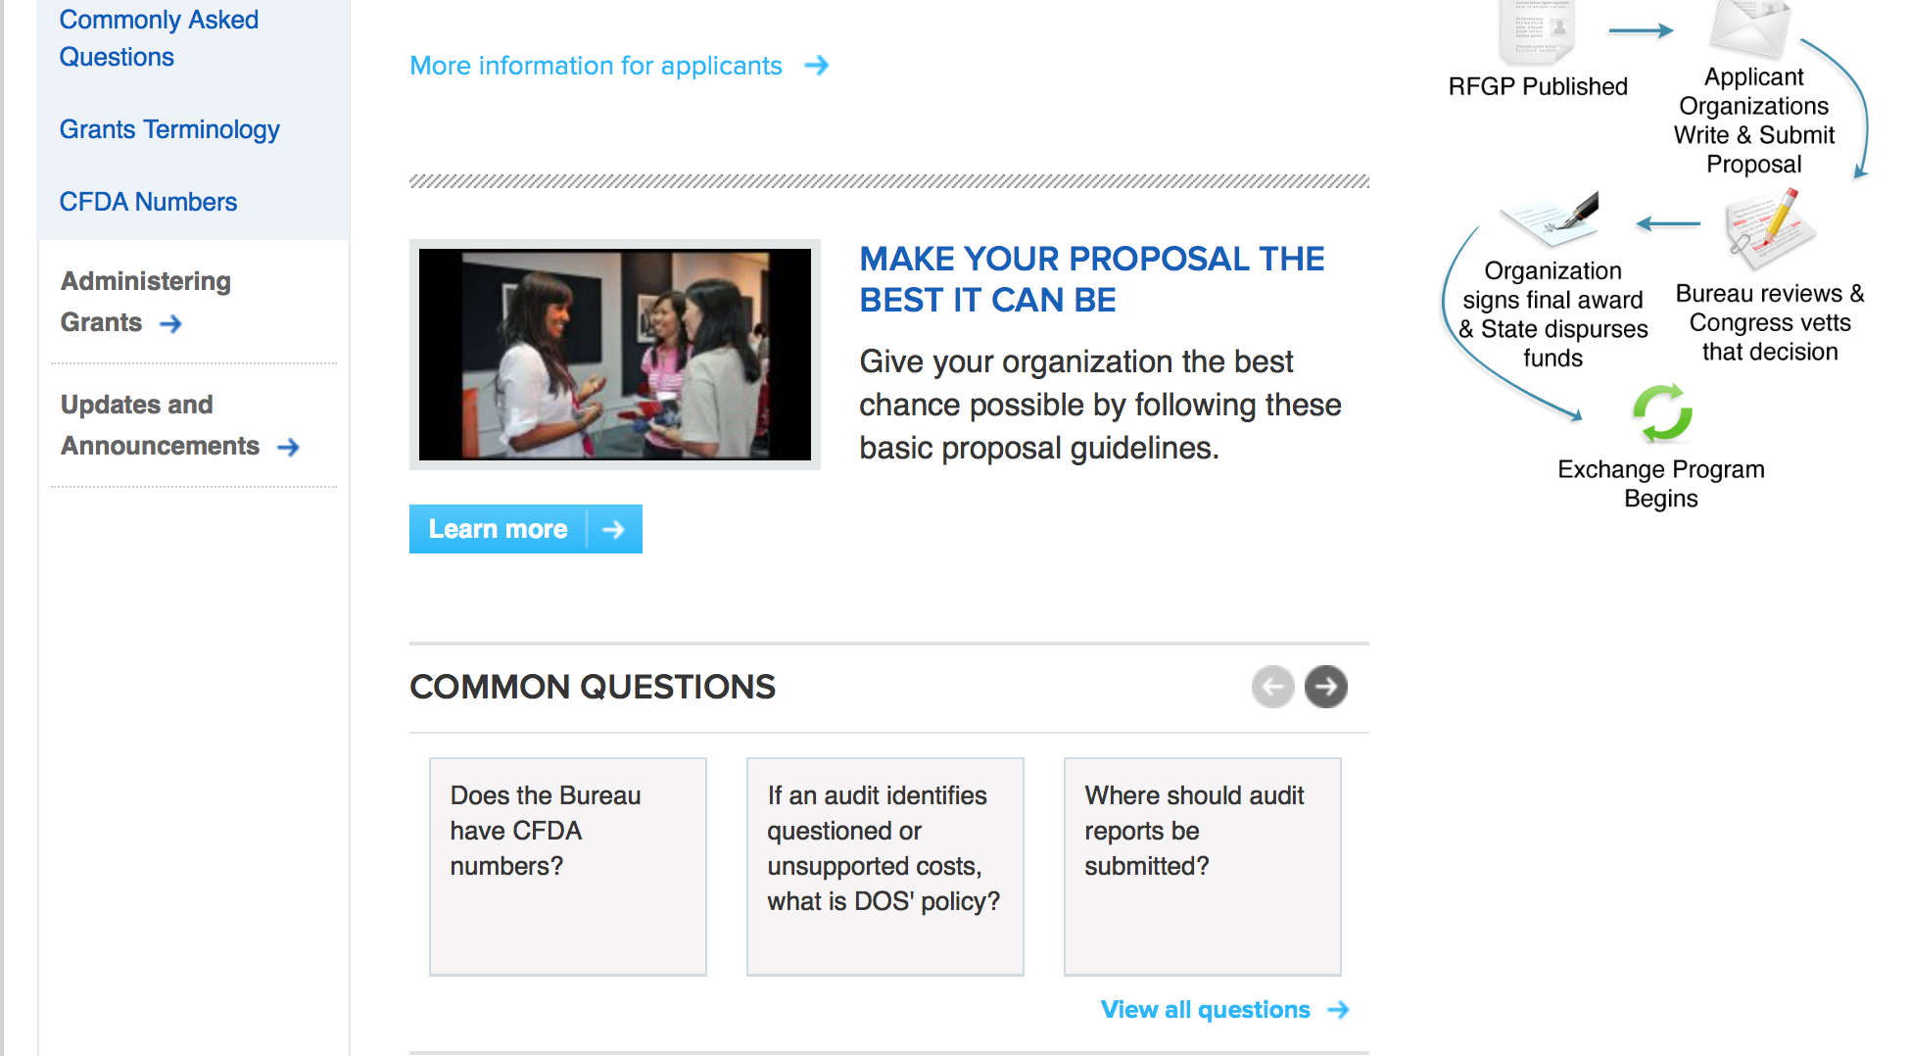
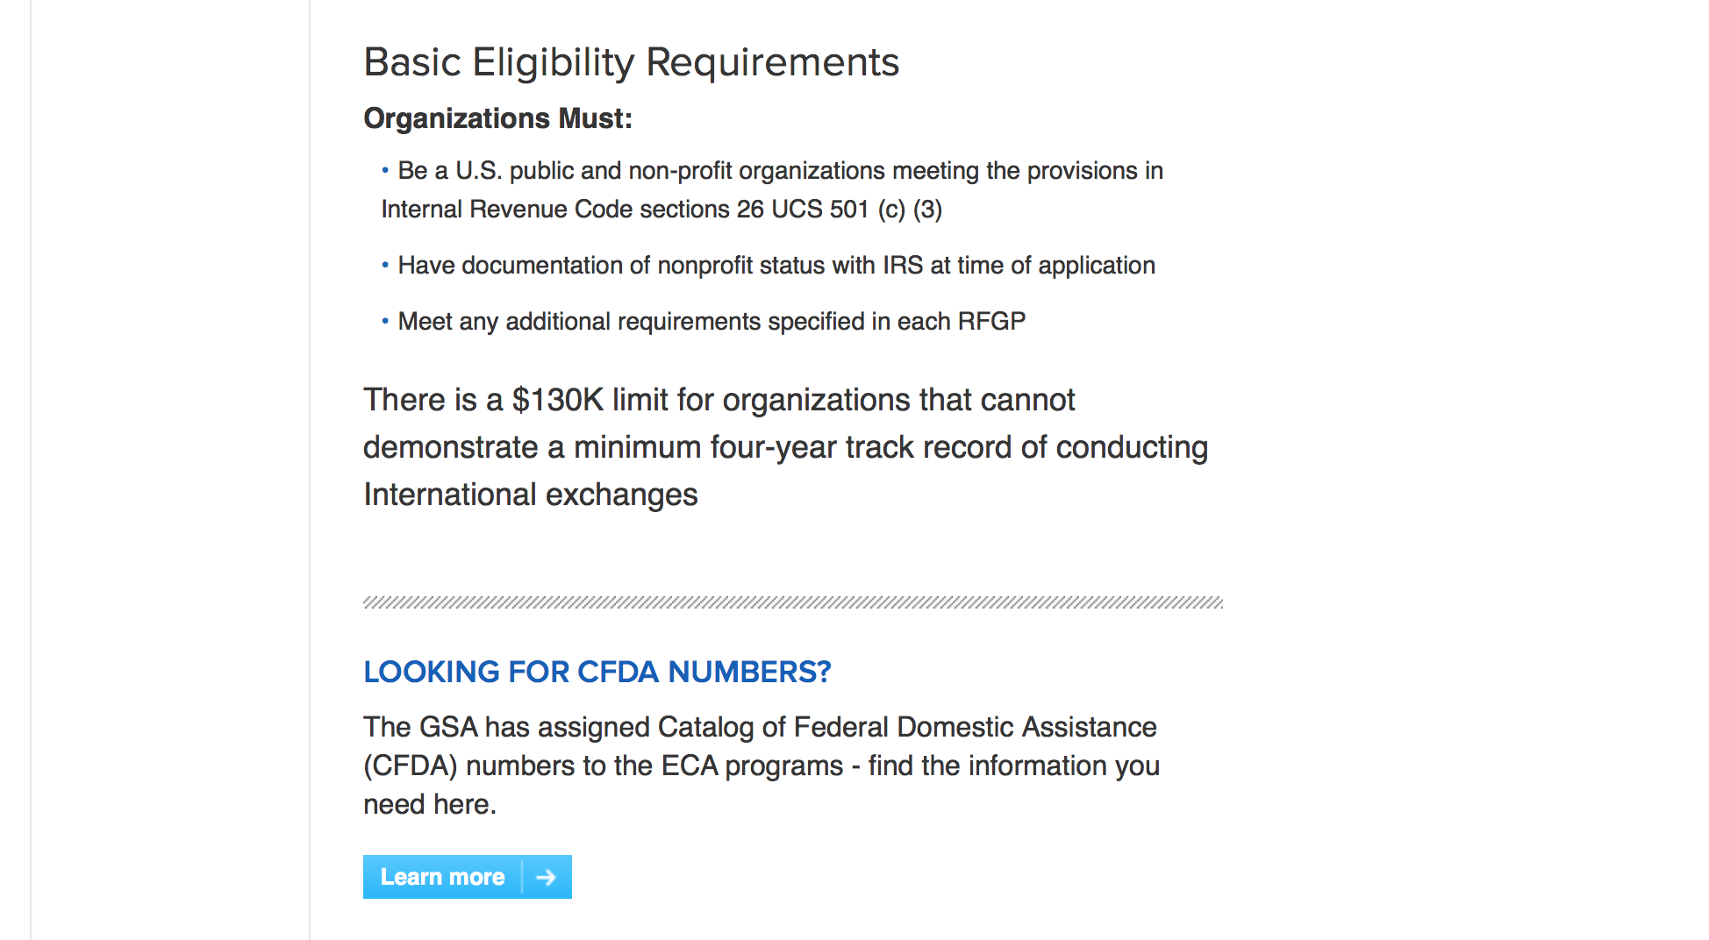
http://eca.state.gov/organizational-funding/applying-grant

General Information:
- Bureau of Educational and Cultural Affairs Grants Division
- Open Grant Opportunities (Requests for Grant Proposals)

For General Information click here

Program Grants:
Bureau of International Narcotics-Law Enforcement
Colombia Counternarcotics and Rule of Law Capacity Building Program
Synopsis 1
https://www.grants.gov/web/grants/view-opportunity.html?oppId=306190

U.S. Mission to Mali
U.S. Embassy Bamako PAS Annual Program Statement
Synopsis 1
https://www.grants.gov/web/grants/view-opportunity.html?oppId=306573

U.S. Mission to Moldova
Moldova: American Resource Center Program
Synopsis 1
https://www.grants.gov/web/grants/view-opportunity.html?oppId=306354

U.S. Mission to Cameroon
ARDF-Democracy, Human Rights and Governance Program, POL/ECON, U.S. Embassy Yaounde
Synopsis 1
https://www.grants.gov/web/grants/view-opportunity.html?oppId=305894

U.S. Mission to Georgia
Media Educational Program "Strengthening Journalism Education in Georgia"
Synopsis 1
https://www.grants.gov/web/grants/view-opportunity.html?oppId=305836

U.S. Mission to Slovenia
FY 2018 Notice of Funding Opportunity: Cultural Grants Program
Synopsis 1
https://www.grants.gov/web/grants/view-opportunity.html?oppId=305952

U.S. Mission to Slovenia
FY 2018 Notice of Funding Opportunity: NGO Small Grants Program
Synopsis 1
https://www.grants.gov/web/grants/view-opportunity.html?oppId=305993

U.S. Mission to Vietnam
2018 YSEALI Micro-Grant Program
Synopsis 1
https://www.grants.gov/web/grants/view-opportunity.html?oppId=305901

Modifications:

Bureau of Democracy Human Rights and Labor
The Bureau of Democracy, Human Rights, and Labor announces its "Annual Workshop for Potential Grant Applicants"
Synopsis 3
https://www.grants.gov/web/grants/view-opportunity.html?oppId=306654

Bureau of International Security-Nonproliferation
Open Source Research to Support Sanctions Enforcement
Synopsis 5
https://www.grants.gov/web/grants/view-opportunity.html?oppId=306253

Bureau of Intelligence and Research
2018 (Title VIII) - Research and Training on Eastern Europe and Eurasia
Synopsis 6
https://www.grants.gov/web/grants/view-opportunity.html?oppId=306298

U.S. Mission to India
North India Small Grants Program
Synopsis 2
https://www.grants.gov/web/grants/view-opportunity.html?oppId=306461

U.S. Mission to Thailand
Lower Mekong Initiative (LMI) Embassy Regional Grants
Synopsis 2
https://www.grants.gov/web/grants/view-opportunity.html?oppId=306184

Reminders:

Deleted:

Department of Transportation

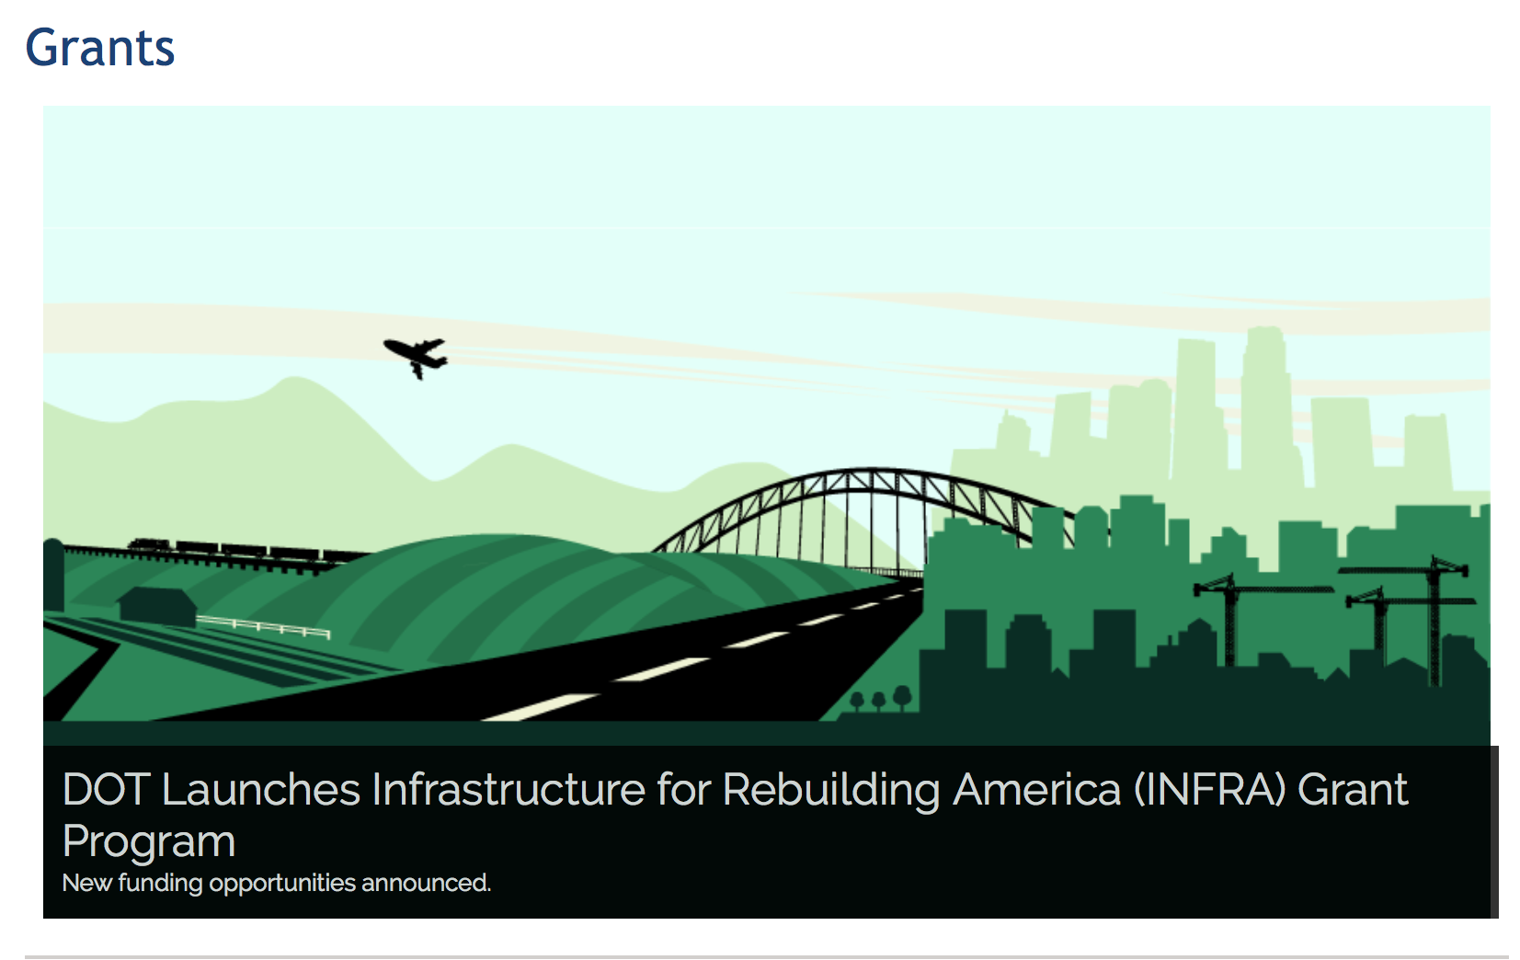

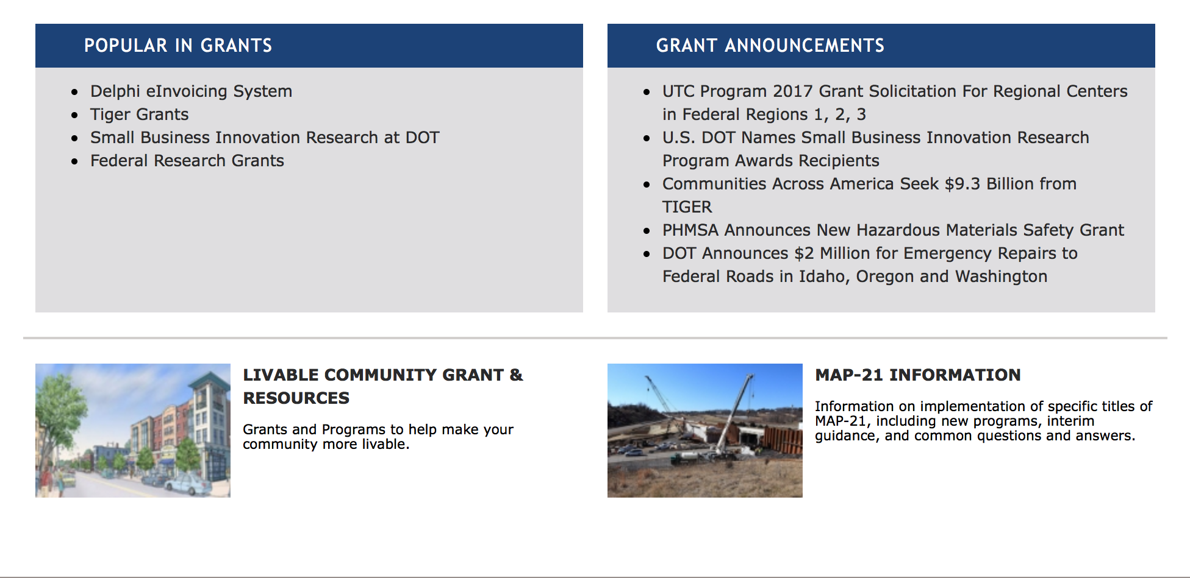

General Grant Program Overview https://www.transportation.gov/grants

Programs:

DOT Federal Highway Administration
Administration of the Dwight David Eisenhower Transportation Fellowship Program (DDETFP) Local Competition at Designated Institutions of Higher Education
Synopsis 1

Document Type: | Grants Notice
Funding Opportunity Number: | 693JJ318NF5228
Funding Opportunity Title: | Administration of the Dwight David Eisenhower Transportation Fellowship Program (DDETFP) Local Competition at Designated Institutions of Higher Education
Opportunity Category: | Discretionary
Opportunity Category Explanation:
Funding Instrument Type: | Grant
Category of Funding Activity: | Education
Category Explanation:
Expected Number of Awards: | 50
CFDA Number(s): | 20.215 -- Highway Training and Education
Cost Sharing or Matching Requirement: | No
Version: | Synopsis 2
Posted Date: | Jun 01, 2018
Last Updated Date: | Jun 25, 2018
Original Closing Date for Applications: | Jul 16, 2018
Current Closing Date for Applications: | Jul 16, 2018
Archive Date: | Aug 15, 2018
Estimated Total Program Funding: | $1,000,000
Award Ceiling: | $50,000
Award Floor: | $1,500
Eligible Applicants: | Others (see text field entitled "Additional Information on Eligibility" for clarification)
Additional Information on Eligibility: | Institutions of Higher Education (IHE) designated as Historically Black Colleges and Universities (HBCU), Hispanic Serving Institutions (HSI), Tribal Colleges and Universities (TCU), Asian and Pacific Islander-Serving Institutions (API), and Community Colleges (CC). The IHE must be accredited by a federally-recognized accrediting agency and must be located within the United States or its Territories.
Additional Information
Agency Name: | DOT Federal Highway Administration
Description: | The purpose of the Dwight David Eisenhower Transportation Fellowship Program (DDETFP) Local Competition is to stimulate interest among students attending an Institution of Higher Education (IHE) of Minority Serving Institutions (MSI) and community colleges to conduct transportation-related research, pursue transportation-related degrees, to enter the transportation workforce, and to enhance the breadth, scope and diversity of knowledge of the entire transportation community in the United States. The DDETFP Local Competition provides funding for students to pursue Associate, Bachelor, Master, and Doctoral Degrees in transportation-related disciplines in all modes of transportation. The MSI and community colleges are encouraged to apply to administer the DDETFP Local Competition at their IHE. The IHE must be accredited by a federally-recognized accrediting agency and must be located within the United States or its territories.
Link to Additional Information: | Recording of informational webinar presented on 6/20/18
Grantor Contact Information: | If you have difficulty accessing the full announcement electronically, please contact:  Ewa Flom Program Manager Phone 703-235-0532  ewa.flom@dot.gov
https://www.grants.gov/web/grants/view-opportunity.html?oppId=305866

DOT/Federal Transit Administration
5339(b) Grants for Buses and Bus Facilities Infrastructure Investment Program
Synopsis 1

Document Type: | Grants Notice
Funding Opportunity Number: | FTA-2018-005-TPM-BUS
Funding Opportunity Title: | 5339(b) Grants for Buses and Bus Facilities Infrastructure Investment Program
Opportunity Category: | Discretionary
Opportunity Category Explanation:
Funding Instrument Type: | Grant
Category of Funding Activity: | Transportation
Category Explanation:
Expected Number of Awards: | 150
CFDA Number(s): | 20.526 -- Bus and Bus Facilities Formula Program
Cost Sharing or Matching Requirement: | Yes
Version: | Synopsis 1
Posted Date: | Jun 21, 2018
Last Updated Date: | Jun 21, 2018
Original Closing Date for Applications: | Aug 06, 2018
Current Closing Date for Applications: | Aug 06, 2018
Archive Date: | Sep 05, 2018
Estimated Total Program Funding: | $366,300,000
Award Ceiling: | $36,630,000
Eligible Applicants: | Native American tribal governments (Federally recognized)  City or township governments  State governments  County governments  Others (see text field entitled "Additional Information on Eligibility" for clarification)
Additional Information on Eligibility: | An Eligible Applicant is a designated recipient of FTA grants, States, local governmental authorities and Indian Tribes. The Bus and Bus Infrastructure Program provides funds to designated recipients that allocate funds to fixed route bus operators, and to states, and local governmental authorities that operate fixed route bus service.
Additional Information
Agency Name: | DOT/Federal Transit Administration
Description: | Notice of Funding Opportunity (NOFO): Solicitation of Project Proposals for the 5339(b) Grants for Buses and Bus Facilities Infrastructure Investment Program (Bus and Bus Infrastructure Program). The Federal Transit Administration (FTA) announces the availability of approximately $366.3 million of Fiscal Year 2018 funds for buses, bus facilities, and bus equipment. Synopses and full announcement will be posted on Grants.gov as opportunity FTA-2018-005-TPM-BUS. Proposals must be submitted electronically through Grants.gov website by 11:59 PM Eastern Time on August 6, 2018.  Summary: The purpose of the Bus and Bus Infrastructure Program is to assist in the financing of buses and bus facilities capital projects, including replacing, rehabilitating, purchasing or leasing buses or related equipment, and rehabilitating, purchasing, constructing or leasing bus-related facilities.
Link to Additional Information: | FTA Notices of Funding Opportunity
Grantor Contact Information: | If you have difficulty accessing the full announcement electronically, please contact:  Mark G. Bathrick Office of Program Management 202-366-9955  Mark Bathrick
https://www.grants.gov/web/grants/view-opportunity.html?oppId=306423

Modifications:

Research:

Reminders:

DOT/Federal Transit Administration
Pilot Program for Transit-Oriented Development (TOD) Planning
Synopsis 2
Document Type: Grants Notice  Funding Opportunity Number: FTA-2018-004-TPE  Funding Opportunity Title: Pilot Program for Transit-Oriented Development (TOD) Planning  Opportunity Category: Discretionary  Opportunity Category Explanation:  Funding Instrument Type: Grant  Category of Funding Activity: Transportation  Category Explanation:  Expected Number of Awards: 35  CFDA Number(s): 20.500 -- Federal Transit Capital Investment Grants  Cost Sharing or Matching Requirement: Yes | Version: Synopsis 2  Posted Date: May 24, 2018  Last Updated Date: May 23, 2018  Original Closing Date for Applications: Jul 23, 2018  Current Closing Date for Applications: Jul 23, 2018  Archive Date: Aug 22, 2018  Estimated Total Program Funding: $25,788,487  Award Ceiling: $2,000,000  Award Floor: $250,000

Eligible Applicants: | Others (see text field entitled "Additional Information on Eligibility" for clarification)
Additional Information on Eligibility: | Any comprehensive planning work proposed for funding under this program must be associated with an eligible transit capital project, namely a new fixed guideway project or a core capacity improvement project as defined in Section 5309(a) of title 49, United States Code. These statutory definitions are also provided in section (C)(3)(i) of the notice of funding opportunity (NOFO).Applicants and eventual grant recipients under this program must be existing FTA grantees as of the publication date of the NOFO. A proposer must either be the project sponsor of an eligible transit capital project as defined above or an entity with land use planning authority in an eligible transit capital project corridor. Evidence of a partnership between these two types of entity will be required unless the applicant has both responsibilities. Please refer to the NOFO for further information. Only one application per transit capital project corridor may be submitted to FTA. Multiple applications submitted for a single transit capital project corridor indicate to FTA that partnerships are not in place and FTA will reject all of the applications.

Agency Name: | DOT/Federal Transit Administration
Description: | Federal Transit Administration (FTA) announces the opportunity to apply for approximately $25.79 million of funding under the Pilot Program for TOD Planning (Catalog of Federal Domestic Assistance #20.500). As required by federal transit law and subject to funding availability, funds will be awarded competitively to support comprehensive planning associated with new fixed guideway and core capacity improvement projects. FTA anticipates minimum grant awards of $250,000 and maximum grant awards of $2,000,000. Synopses and full announcement are posted on Grants.gov and FTA Website as opportunity FTA-2018-004-TPE.  Proposals must be submitted electronically through the Grants.gov website by 11:59 p.m. Eastern Time on 7/23/2018.  As outlined in statute, the Pilot Program for TOD Planning is intended to fund comprehensive planning that supports economic development, ridership, multimodal connectivity and accessibility, increased transit access for pedestrian and bicycle traffic, and mixed-use development near transit stations. The program also encourages identification of infrastructure needs and engagement with the private sector.  Consistent with statutory direction, FTA is seeking comprehensive planning projects covering an entire transit capital project corridor, rather than proposals that involve planning for individual station areas or only a small section of the corridor. To ensure any proposed planning work reflects the needs and aspirations of the local community and results in concrete, specific deliverables and outcomes, transit project sponsors must partner with entities with land use planning authority in the transit project corridor to conduct the planning work.  The Pilot Program for TOD Planning helps support FTA’s mission of improving public transportation for America’s communities by providing funding to local communities to integrate land use and transportation planning around a new fixed guideway or core capacity improvement project. Per statute, any comprehensive planning funded through the program must examine ways to improve economic development and ridership, foster multimodal connectivity and accessibility, improve transit access for pedestrian and bicycle traffic, engage the private sector, identify infrastructure needs, and enable mixed-use development near transit stations.  Webinar: FTA will host a webinar on this funding opportunity at 2 p.m. ET Thursday, June 14 at https://connectdot.connectsolutions.com/fta-tod-pilot. The webinar will provide an overview of the program, describe eligible applicants and projects, and provide an opportunity for attendees to obtain answers to other questions. (Note: audio and video will be provided through the link above; there is no separate call-in number. Advance registration is not offered. The webinar will be recorded and posted afterward on the FTA website at https://www.transit.dot.gov/TODPilot.)
Link to Additional Information: | FTA NOFO Website
Grantor Contact Information: | If you have difficulty accessing the full announcement electronically, please contact:  Benjamin Owen Office of Planning and Environment phone: 202-366-5602  Benjamin Owen
https://www.grants.gov/web/grants/view-opportunity.html?oppId=305503

FY 2018 National Infrastructure Investments
Synopsis 1
Document Type: | Grants Notice
Funding Opportunity Number: | DTOS59-18-RA-BUILD1
Funding Opportunity Title: | FY 2018 National Infrastructure Investments
Opportunity Category: | Discretionary
Opportunity Category Explanation:
Funding Instrument Type: | Grant
Category of Funding Activity: | Transportation
Category Explanation:
Expected Number of Awards:
CFDA Number(s): | 20.933 -- National Infrastructure Investments
Cost Sharing or Matching Requirement: | Yes
Version: | Synopsis 1
Posted Date: | Apr 20, 2018
Current Closing Date for Applications: | Jul 19, 2018 NOTE: Detailed Instructions on "How to Apply" for BUILD Transportation Discretionary Grants can be found on the BUILD Website (www.transportation.gov/BUILDgrants). Application Instructions: Applications must be submitted through Grants.gov. The Grants.gov “Apply” function will open by June 4, 2018. Please be aware that you must complete the Grants.gov registration process before submitting the Application, and that this process usually takes 2-4 weeks to complete. Applications must be submitted by 8:00 PM E.D.T. on July 19, 2018. Applicants are strongly encouraged to make submissions in advance of the deadline date. *Late Applications: Applications received after the deadline will not be considered except in the case of unforeseen technical difficulties outlined below. Late applications that are the result of failure to register or comply with Grants.gov applicant requirements in a timely manner will not be considered. Applicants experiencing technical issues with Grants.gov that are beyond the applicant’s control must contact BUILDgrants@dot.gov or Howard Hill at 202-366-0301 prior to the deadline with the user name of the registrant and details of the technical issue experienced. The applicant must provide 1: Details of the technical issue experienced 2: Screen capture(s) of the technical issue experienced along corresponding “Grant tracking number” (Grants.gov) 3: The "Legal Business Name" for the applicant that was provided in the SF-424. 4: The AOR name submitted in the SF-424 (Grants.gov). 5: The DUNS number associated with the Application. 6: The Grants.gov Help Desk Tracking Number. To ensure a fair competition for limited discretionary funds, the following conditions are not valid reasons to permit late submissions: (1) failure to complete the registration process before the deadline date; (2) failure to follow Grants.gov instructions on how to register and apply as posted on its website; (3) failure to follow all of the instructions in this notice of funding availability; and (4) technical issues experienced with the applicant’s computer or information technology (IT) environment. After DOT staff review all of the information submitted and contact the Grants.gov Help Desk to validate the technical issues you reported, DOT staff will contact you to either approve or deny your request to submit a late application through Grants.gov. If the technical issues you reported cannot be validated, your application will be rejected as untimely.
Archive Date: | Dec 31, 2018
Estimated Total Program Funding: | $1,500,000,000
Award Ceiling: | $25,000,000
Award Floor: | $0
Agency Name: | Department of Transportation
Description: | The FY 2018 Appropriations Act appropriated $1.5 billion for National Infrastructure Investments previously known as TIGER grants, and now renamed BUILD Transportation grants. As with previous rounds of TIGER, funds for the FY 2018 BUILD Transportation program are to be awarded on a competitive basis for projects that will have a significant local or regional impact. The Act also allows DOT to use a small portion of the $1.5 billion for oversight and administration of grants. If this solicitation does not result in the award and obligation of all available funds, DOT may publish additional solicitations. The Consolidated Appropriations Act, 2018 specifies that BUILD Transportation Discretionary Grants may not be less than $5 million and not greater than $25 million, except that for projects located in rural areas the minimum BUILD Transportation Discretionary Grant size is $1 million. There is no statutory minimum grant size, regardless of location, for BUILD Transportation Planning grants. Pursuant to the FY Consolidated Appropriations Act, 2018, no more than 10 percent of the funds made available for BUILD Transportation Discretionary Grants (or $150 million) may be awarded to projects in a single State. The Consolidated Appropriations Act, 2018 directs that not less than 30 percent of the funds provided for TIGER Discretionary Grants (or $450 million) shall be used for projects located in rural areas. Further, pursuant to the Consolidated Appropriations Act, 2087, DOT must take measures to ensure an equitable geographic distribution of grant funds, an appropriate balance in addressing the needs of urban and rural areas, and investment in a variety of transportation modes. The Consolidated Appropriations Act, 2018 requires that FY 2018 BUILD funds are only available for obligation through September 30, 2020. No FY 2018 BUILD funds may be expended after September 30, 2025. As part of the review and selection process described in the Notice of Funding Opportunity, DOT will consider whether a project is ready to proceed with an obligation of grant funds from DOT within the statutory time provided. Under the FY 2018 Appropriations Act, no waiver is possible for these deadlines. The FY 2018 Appropriations Act allows for up to 20 percent of available funds (or $300 million) to be used by the Department to pay the subsidy and administrative costs for a project receiving credit assistance under the Transportation Infrastructure Finance and Innovation Act of 1998 (“TIFIA”) program, if it would further the purposes of the BUILD Transportation Discretionary Grant program. Recipients of prior TIGER Discretionary Grants may apply for funding to support additional phases of a project awarded funds in earlier rounds of this program. However, to be competitive, the applicant should demonstrate the extent to which the previously funded project phase has been able to meet estimated project schedules and budget, as well as the ability to realize the benefits expected for the project. DOT expects that each BUILD Transportation Discretionary Grant will be administered by one of the relevant modal administrations, pursuant to a grant agreement between the BUILD Transportation Discretionary Grant recipient and the relevant modal administration.
Link to Additional Information: | BUILD Transportation Discretionary Grant Program
Grantor Contact Information: | If you have difficulty accessing the full announcement electronically, please contact:  Robert Mariner Program Manager Phone 202-366-8914  BUILD Program Manager
https://www.grants.gov/web/grants/view-opportunity.html?oppId=303923

DOT - FAA Aviation Research Grants
FAA Aviation Research and Development Grants
Synopsis 3, 4 & 6

Document Type: | Grants Notice
Funding Opportunity Number: | 12-01
Funding Opportunity Title: | FAA Aviation Research and Development Grants
Opportunity Category: | Discretionary
Opportunity Category Explanation:
Funding Instrument Type: | Grant
Category of Funding Activity: | Transportation
Category Explanation:
Expected Number of Awards:
CFDA Number(s): | 20.108 -- Aviation Research Grants
Cost Sharing or Matching Requirement: | No
Version: | Synopsis 6
Posted Date: | Jan 01, 2012
Last Updated Date: | Oct 18, 2017
Original Closing Date for Applications: | Dec 31, 2019
Current Closing Date for Applications: | Dec 31, 2019
Archive Date: | Jan 30, 2020
Estimated Total Program Funding:
Award Ceiling: | $5,000,000
Eligible Applicants: | Private institutions of higher education  Nonprofits having a 501(c)(3) status with the IRS, other than institutions of higher education  Public and State controlled institutions of higher education
Agency Name: | DOT - FAA Aviation Research Grants
Description: | The FAA is soliciting proposals for research grants and cooperative agreements to pursue the long-term growth and short-term technical needs of civil aviation. In order to streamline the application process, it is recommended that all prospective grantees submit a white paper (letter of intent) for agency technical review before complete proposal submission. Please be sure to identify the specific area of interest (Solicitation FAA-12-01 – Chapter I. FAA Research Grants Program, Technical Areas of Research #1-#9). The white paper shall be no longer than three (3) pages and shall detail overall research objectives.
Link to Additional Information:
Grantor Contact Information: | If you have difficulty accessing the full announcement electronically, please contact:  Nicole Saiauskie Grants Officer Phone 609-485-4781  business

http://www.grants.gov/web/grants/view-opportunity.html?oppId=134953

Deleted:

Department of the Treasury

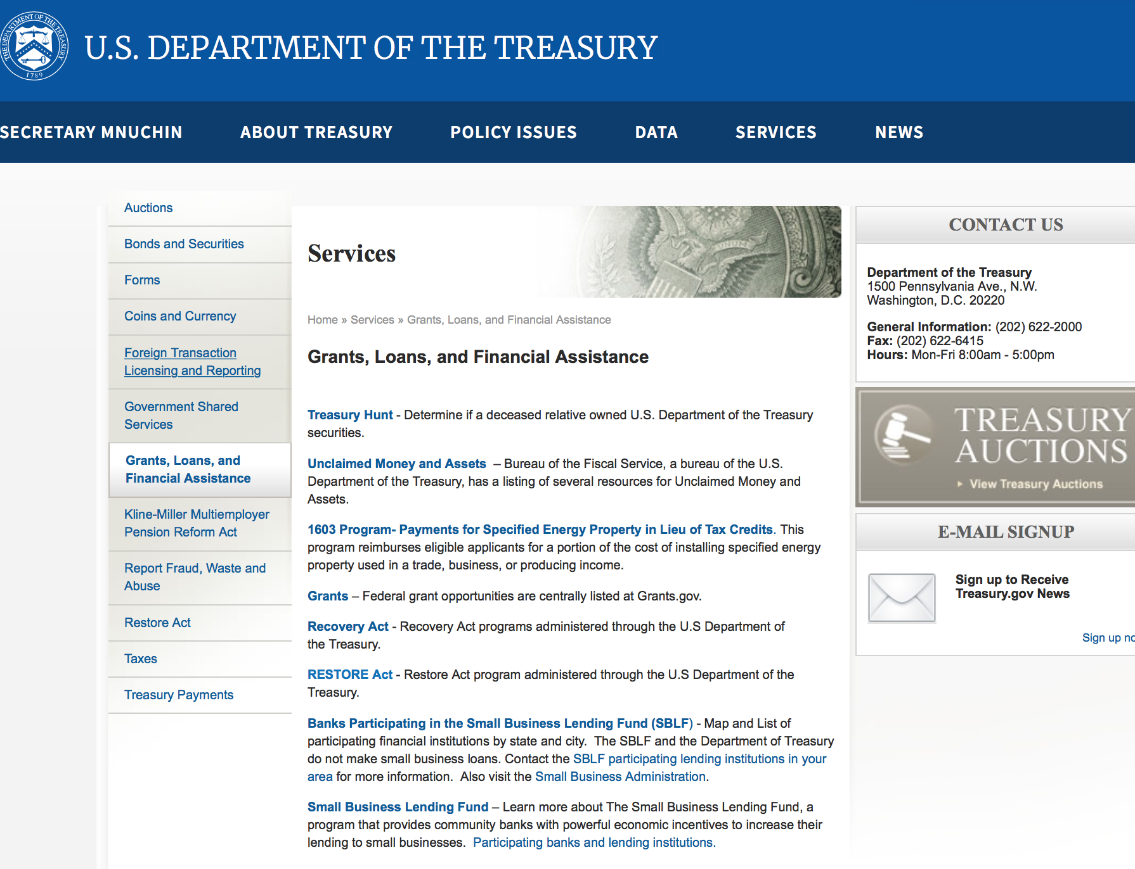

https://www.treasury.gov/services/Pages/Grants-Loans-and-Financial-Assistance.aspx

Programs:

Modifications:

Reminders:

U.S. Agency for International Development

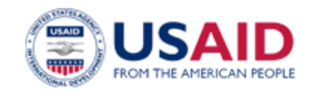

www.usaid.gov

General Overview Funding Opportunities

USAID has working relationships with thousands of American companies and hundreds of U.S.-based private voluntary organizations. For more information on our business and procurement opportunities, please visit our Business section.

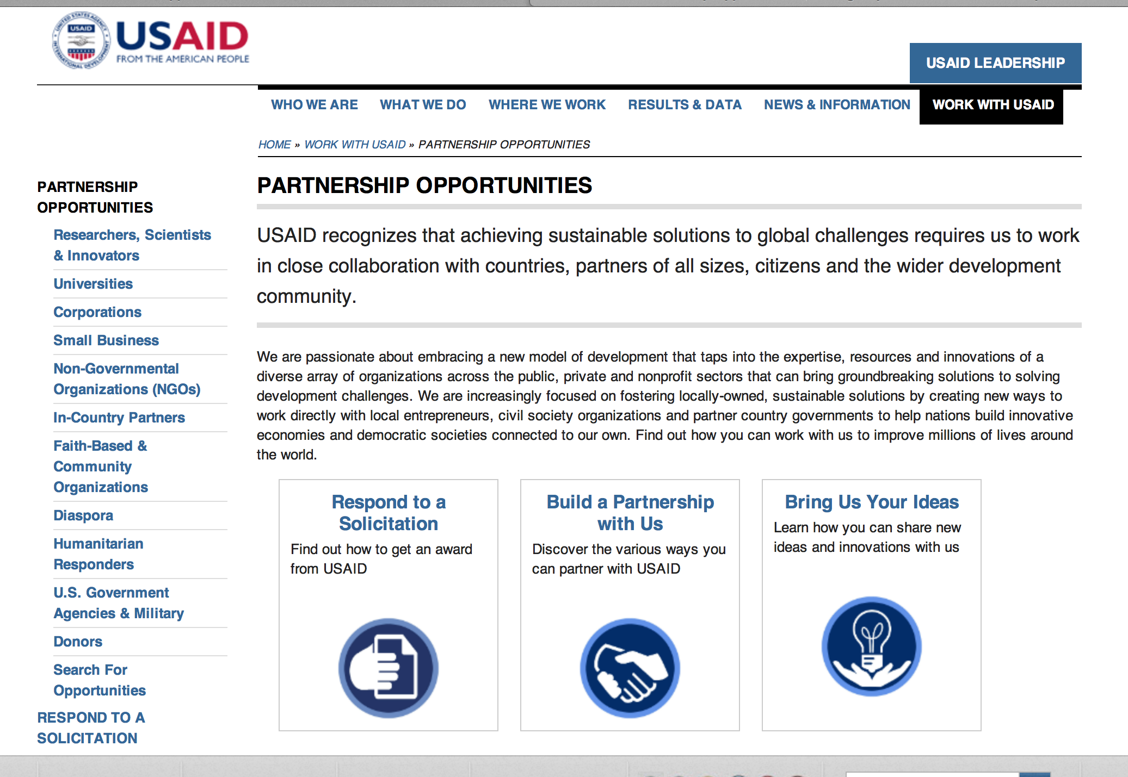
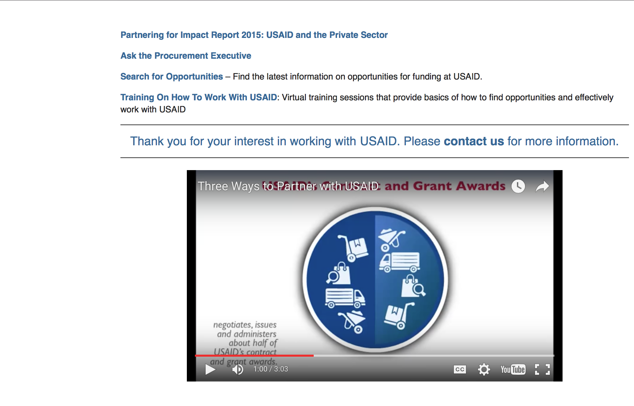

http://www.usaid.gov/partnerships

Programs:

Advancing Human Rights and Democratic Values
Synopsis 1
https://www.grants.gov/web/grants/view-opportunity.html?oppId=306322

Catalyzing Private Investment
Synopsis 1
https://www.grants.gov/web/grants/view-opportunity.html?oppId=306469

El Salvador USAID-San Salvador
REQUEST FOR INFORMATION- El Salvador Power Efficiency and Reliability Improvement
Synopsis 1
https://www.grants.gov/web/grants/view-opportunity.html?oppId=306477

Haiti USAID-Port Au Prince
Orphans and Vulnerable Children II (OVC II) Activity
Synopsis 1
https://www.grants.gov/web/grants/view-opportunity.html?oppId=306278

Pakistan USAID-Islamabad
PAKISTAN MULTI-SECTOR ANNUAL PROGRAM STATEMENT
Synopsis 1
https://www.grants.gov/web/grants/view-opportunity.html?oppId=306483

Democratic Republic of the Congo USAID-Kinshasa
USAID/DRC funded Environment Partnerships Program (DRC EPP)
Synopsis 1
https://www.grants.gov/web/grants/view-opportunity.html?oppId=306539

The USAID Global Health Broad Agency Announcement for Research and Development (2018)
Synopsis 1
https://www.grants.gov/web/grants/view-opportunity.html?oppId=305999

Modifications:

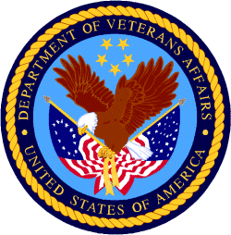

Department of Veterans Affairs

VHA Member Services
Grants for Transportation of Veterans in Highly Rural Areas
Synopsis 2

Document Type: | Grants Notice
Funding Opportunity Number: | VA-HRTG-NEW-2018
Funding Opportunity Title: | Grants for Transportation of Veterans in Highly Rural Areas
Opportunity Category: | Discretionary
Opportunity Category Explanation:
Funding Instrument Type: | Grant
Category of Funding Activity: | Transportation
Category Explanation: | ***Note*** This Notice of Funding only applies to VA recognized Veterans Service Organizations and State Veteran Entities only. If you are a current HRTG Grantee do not apply.
Expected Number of Awards: | 10
CFDA Number(s): | 64.035 -- Veterans Transportation Program
Cost Sharing or Matching Requirement: | No
Version: | Synopsis 3
Posted Date: | Jun 06, 2018
Last Updated Date: | Jun 26, 2018
Original Closing Date for Applications: | Aug 05, 2018
Current Closing Date for Applications: | Aug 05, 2018
Archive Date: | Sep 04, 2018
Estimated Total Program Funding: | $1,000,000
Award Ceiling: | $50,000
Eligible Applicants: | Others (see text field entitled "Additional Information on Eligibility" for clarification)
Additional Information on Eligibility: | This notice applies to VA recognized Veteran Service Organizations and State Veteran Entities only. If you're a current HRTG Grantee do not apply.

Agency Name: | VHA Member Services
Description: | In accordance with 38 CFR 17.710, VA is issuing this Notice of Funding Availability (Notice) for new grants under the Grants for Transportation of Veterans in Highly Rural Areas Program for fiscal year 2018. Approximately $1 million is authorized to be appropriated for this fiscal year. ***This Notice applies to new grantees only****
Link to Additional Information: | HRTG Website
Grantor Contact Information: | If you have difficulty accessing the full announcement electronically, please contact:  Mindy LaCrone Management Analyst  HRTG Point of Contact
https://www.grants.gov/web/grants/view-opportunity.html?oppId=305911

