Senator Mazie Hirono

Grants Assistance Information Newsletter

JULY 2021

PART 1 – CURRENT FEDERAL AGENCY DISCRETIONARY GRANT OPPORTUNITIES

PART 2 – GENERAL FEDERAL AGENCY GRANTS INFORMATION

Current Federal Agency Grant and Cooperative Agreement Discretionary Program Summaries

Click on Index Links below to find summaries of the current announcements listed by agency in this document. Once you reach the item, if you cannot open the links for further information, copy the selected URL website address into your browser.

Notices is Teal are items with immediate deadline dates.

Notices in Yellow are of special interest.

Notices is Green are items of special interest with immediate deadline dates.

Several Agencies have research or program opportunities that are not individually listed because they are for very technical or specific audiences. Click on the Agency Index Research or Program designation to review those grant and contract notices.

If an Agency does not have listings, it is due to the lack of competitive open opportunities at that Agency this month. Please review Part 2 for general information not specific to a current deadline date for general funding cycle information.

Special Notice

General Federal Government Coronavirus Responses

Specific Agency Coronavirus Responses

Corona Virus Response for Small Business

Programs specific to Hawaii

Current Notices

Dept of the Army -- Materiel Command
Department of Defense (DoD) FY 2022 Research and Education Program for Historically Black Colleges and Universities and Minority-Serving Institutions (HBCU/MI) Equipment/Instrumentation

Reminders
National Institutes of Health
Intervention Research to Improve Native American Health (R01 Clinical Trial Optional)

National Institutes of Health
Research to Improve Native American Health (R21 Clinical Trials Optional)

U.S. Department of Agriculture

Programs

Animal and Plant Health Inspection Service
Joint National Animal Health Laboratory Network and National Animal Disease Preparedness and Response Programs 2021
Animal and Plant Health Inspection Service
National Animal Disease Preparedness and Response Program 2021 Cooperative/Interagency Agreements

Research

Modifications
Agriculture Innovation Center Grant Program

Department of Homeland Security - FEMA
Fiscal Year (FY) 2021 Homeland Security National Training Program (HSNTP) - National Domestic Preparedness Consortium (NDPC)

Reminders

Utilities Programs
RPIC Cooperative Agreement
Utilities Programs
Rural Innovation Stronger Economy Grant Program
Utilities Programs
Rural Decentralized Water System Grant Program

Utilities Programs
Rural Housing Preservation Grant
Agricultural Marketing Service
Meat and Poultry Inspection Readiness Grant (MPIRG)
Socially Disadvantaged Groups Grant

Business and Cooperative Programs
Rural Cooperative Development Grant

Natural Resources Conservation Service
Urban Agriculture and Innovative Production (UAIP) Competitive Grants Program
Food for Progress 10.606
FY 2021 FFPr Standing NOFO

McGovern-Dole Food for Education 10.608
FY 2021 McGovern-Dole Standing Supplemental NOFO
National Institute of Food and Agriculture
Agriculture and Food Research Initiative - Foundational and Applied Science

Department of Commerce

Programs

Fiscal Year 2022 - FY2023 Margaret A. Davidson Graduate Fellowships for the National Estuarine Research Reserve System
FY22 Bluefin Tuna Research Program
FY22 Saltonstall-Kennedy Competition
Climate Program Office FY2022

Research

Modifications

Reminders

Oceanic and Atmospheric Research (OAR), National Oceanic and Atmospheric Administration (NOAA), Department of Commerce
National Telecommunications and Information Administration
Broadband Infrastructure Program

National Institute of Standards and Technology
NIST Public Safety Innovation Accelerator Program – Artificial Intelligence for IoT Information Prize Competition

FY 2021 - 2023 Economic Development RNTA
National Institute of Standards and Technology
Measurement Science and Engineering (MSE) Research Grant Programs
National Institute of Standards and Technology
NIST Public Safety Innovation Accelerator Program (PSIAP) – Follow-on Funding for Technical and Business Assistance and Demonstration Projects with Public Safety Agencies
National Institute of Standards and Technology
NIST Manufacturing USA National Emergency Assistance Program
Economic Development Administration
FY 2020 EDA Public Works and Economic Adjustment Assistance Programs

Consumer Product Safety Commission

Pool Safely Grant Program (PSGP)

Corporation for National and Community Service

Programs

Reminders

FY 2021 AmeriCorps State and National Tribal Grants

Department of Defense

Programs

Research Grants

Modifications

Reminders

Air Force Office of Scientific Research
Multidisciplinary Research Program of the University Research Initiative (FY22 Air Force Submission)

Department of Education

Programs
Office of Postsecondary Education (OPE): International Foreign Language Education (IFLE): Business and International Education (BIE) Program Assistance Listing Number 84.153A

Research
Institute of Education Sciences (IES): Education Research Assistance Listing Number (ALN) 84.305A
Institute of Education Sciences (IES): Research to Accelerate Pandemic Recovery in Special Education Assistance Listing Number (ALN) 84.324X-2
Institute of Education Sciences (IES): Using Longitudinal Data to Support State Education Recovery Policy Making Assistance Listing Number (ALN) 84.305S
Institute of Education Sciences (IES): Research Grants Focused on Systemic Replication Assistance Listing Number (ALN) 84.305R
Institute of Education Sciences (IES): Research to Accelerate Pandemic Recovery in Special Education Assistance Listing Number (ALN) 84.324X-1
Institute of Education Sciences (IES): Statistical and Research Methodology in Education Assistance Listing Number (ALN) 84.305D
Institute of Education Sciences (IES): Research Training Programs in the Education Sciences Assistance Listing Number (ALN) 84.305B

Modifications

Reminders

OSERS: OSEP: Technical Assistance and Dissemination to Improve Services and Results for Children with Disabilities--Model Demonstration Projects to Improve Services and Results for Infants, Toddlers, and Children with Disabilities ALN 84.326M
Office of Postsecondary Education (OPE): Higher Education Under the Higher Education Emergency Relief Fund (HEERF), Section 2003 of the American Rescue Plan Act, 2021 (ARP) Assistance Listing Number 84.425E
Office of Postsecondary Education (OPE): Higher Education Under the Higher Education Emergency Relief Fund (HEERF), Section 2003 of the American Rescue Plan Act, 2021 (ARP) Assistance Listing Number 84.425F
Office of Postsecondary Education (OPE): Under the Higher Education Emergency Relief Fund (HEERF), Section 2003 of the American Rescue Plan Act, 2021 (ARP) Assistance Listing Number 84.425Q

US Department of Energy

Research

Modifications

Reminders

Environmental Protection Agency

Programs

Fiscal Year (FY) 2021 Building Partner Capacity and Promoting Resiliency and Equity under Clean Water Act Wetlands, Nonpoint Source, Monitoring, Assessment and Listing Programs
Supporting Anaerobic Digestion In Communities
Research

Modifications

Reminders

Federal Mediation and Conciliation Service

Programs

Reminders

Department of Health and Human Services

Programs

Office of the Assistant Secretary for Health
Promoting Vaccine Confidence in Local Communities through Partnership with Regional Health Offices

Research Grants

Modifications

Office of the Assistant Secretary for Health
State, Local, Territorial, and Tribal (SLTT) Partnership Programs to Reduce Maternal Deaths due to Violence
Reminders

Department of Homeland Security
Programs

Modifications

Department of Homeland Security - FEMA
Fiscal Year (FY) 2021 Homeland Security National Training Program (HSNTP) - National Domestic Preparedness Consortium (NDPC)

Reminders

Department of Housing and Urban Development

Programs

HUD FY2021 Healthy Homes and Weatherization Cooperation Demonstration
HUD's FY2020 and FY2021 Distressed Cities and Persistent Poverty Technical Assistance Notice of Funding Opportunity (NOFO)
Modifications

Reminders

FY21 Choice Neighborhoods Planning Grants NOFO
Veterans Housing Rehabilitation and Modification Pilot Program

Continuum of Care Notice

Institute of Museum and Library Services
Programs
Laura Bush 21st Century Librarian Program (2022)
National Leadership Grants for Libraries (2022)

Modifications

Reminders

Department of Interior

Programs

Bureau of Land Management
USDA/USDOI Joint Fire Science Program (JFSP)
Office of Surface Mining
OSMRE Mine Drainage Technology Initiative (MDTI
Modifications

Bureau of Reclamation
Desalination and Water Purification Research Program for Fiscal Year (FY) 22

Reminders

Fish and Wildlife Service
2021 National Fish Habitat Action Plan
Fish and Wildlife Service
2021 National Fish Passage Program

National Park Service
National Parks Business Plan Internship Program

Fish and Wildlife Service
Coastal Program

Fish and Wildlife Service
Candidate Species Conservation Fund

Fish and Wildlife Service
Endangered Species Recovery Implementation

Department of Justice

Programs
Bureau of Justice Assistance
BJA FY 21 Edward Byrne Memorial Justice Assistance Grant (JAG) Program - Local Solicitation
Community Oriented Policing Services
Community Policing Development (CPD) Accreditation Solicitation
Community Oriented Policing Services
Community Policing Development (CPD) De-Escalation Training Solicitation
Bureau of Justice Assistance
FY 21 BJA Visiting Fellows Program

Office on Violence Against Women
OVW Fiscal Year 2021 National Service Line for Incarcerated Survivors of Sexual Abuse Solicitation

Modifications

Research

Reminders

Bureau of Justice Assistance
BJA FY 21 Edward Byrne Memorial Justice Assistance Grant (JAG) Program - Local Solicitation
________________________________________________________________________

Department of Labor

Programs

Occupational Safety and Health Administration
Capacity Building Developmental & Capacity Building Pilot
Occupational Safety and Health Administration
Training and Educational Materials Development
Occupational Safety and Health Administration
Workplace Safety and Health Training on Infectious Diseases, Including COVID-19
Modifications

Occupational Safety and Health Administration
Targeted Topic Training

Reminders

Employment and Training Administration
National Dislocated Worker Grants Program Guidance

National Aeronautics and Space Administration

Research

Modifications

_______________________________________________________________
National Archives and Records Administration

Programs

Reminders
Access to Historical Records: Archival Projects

Public Engagement with Historical Records

Publishing Historical Records in Documentary Editions

_______________________________________________________________
National Endowment for the Arts

Programs
Modifications

NEA American Rescue Plan Grants to Organizations #1, FY2021
NEA American Rescue Plan Grants to Organizations #2, FY2021
NEA American Rescue Plan Local Arts Agencies for Subgranting, FY2021

Reminders

NEA Our Town, FY2022

_______________________________________________________________
National Endowment for the Humanities

Programs
Dynamic Language Infrastructure – Documenting Endangered Languages Fellowships
Humanities Connections
Dialogues on the Experience of War

Modifications
Reminders

Fellowship Programs at Independent Research Institutions

Public Humanities Projects

Archaeological and Ethnographic Field Research
Media Projects
Short Documentaries

Fellowships Open Book Program

_______________________________________________________________
National Science Foundation

Research and Program Grants

Modifications

Reminders

Nuclear Regulatory Commission

Programs

Small Business Administration

Programs

Modifications

Reminders

Restaurant Revitalization Fund

The Shuttered Venue Operators Grant (SVOG)

State Department

Programs

Modifications

Reminders

U.S. Department of Transportation

Programs

Research

Modifications
DOT Federal Highway Administration
Advanced Transportation and Congestion Management Technologies Deployment Initiative
Reminders
Maritime Administration
2021 Port Infrastructure Development Grants

Department of the Treasury

Programs

Modifications

Reminders

US Agency for International Development
Programs

Department of Veterans Affairs

Programs

Reminders

Current Federal Agency Grant and Cooperative Agreement Discretionary Program Summaries

Special Programs:
For all Federal Government reports on Coronavirus see:
https://www.coronavirus.gov

For specific agency links on Coronavirus see:

Department of Agriculture
https://www.usda.gov/coronavirus

Department of Commerce:
https://www.commerce.gov/coronavirus

Corporation for National and Community Service:
https://www.nationalservice.gov/about-cncs/coronavirus-disease-2019-covid-19

Department of Defense
-- https://business.defense.gov/COVID-19-SMALL-BUSINESS-RESOURCES/

Department of Education
https://www.ed.gov/coronavirus?%3F=

Department of Energy
https://www.energy.gov/covid-19-hub

Environmental Protection Agency
https://www.epa.gov/grants/epa-frequent-questions-grant-issues-response-novel-coronavirus-covid-19-public-health

Department of Health and Human Services
https://www.hhs.gov/coronavirus/cares-act-provider-relief-fund/index.html

Department of Homeland Security
https://www.dhs.gov/coronavirus

Department of Housing and Urban Development
https://www.hud.gov/coronavirus

Institute of Museum and Library Services
https://www.imls.gov/coronavirus-covid-19-updates

Department of Justice
https://www.justice.gov/coronavirus

Department of Labor
https://www.dol.gov/coronavirus

National Endowment for the Arts
https://www.arts.gov/covid-19-resources-for-artists-and-arts-organizations

National Endowment for the Humanities
https://www.neh.gov/coronavirus

National Science Foundation
https://www.nsf.gov/news/special_reports/coronavirus/

Small Business Administration
https://www.sba.gov/page/coronavirus-covid-19-small-business-guidance-loan-resources

Department of State
https://covid19.state.gov

Department of Transportation
https://www.transportation.gov/coronavirus

Department of Treasury
https://home.treasury.gov/policy-issues/cares

USAID
https://www.usaid.gov/coronavirus

HAWAII SPECIFIC APPLICANTS ENCOURAGED

Current Notices

Dept of the Army -- Materiel Command
Department Of Defense (DoD) FY 2022 Research and Education Program for Historically Black Colleges and Universities and Minority-Serving Institutions (HBCU/MI) Equipment/Instrumentation
Synopsis 4
Document Type: Grants Notice  Funding Opportunity Number: W911NF-21-S-0011  Funding Opportunity Title: DEPARTMENT OF DEFENSE (DoD) FY 2022 Research and Education Program for Historically Black Colleges and Universities and Minority-Serving Institutions (HBCU/MI) Equipment/Instrumentation  Opportunity Category: Discretionary  Opportunity Category Explanation:  Funding Instrument Type: Grant  Category of Funding Activity: Science and Technology and other Research and Development  Category Explanation:  Expected Number of Awards: 1000  CFDA Number(s): 12.630 -- Basic, Applied, and Advanced Research in Science and Engineering  Cost Sharing or Matching Requirement: No | Version: Synopsis 4  Posted Date: May 13, 2021  Last Updated Date: May 13, 2021  Original Closing Date for Applications: Aug 16, 2021  Current Closing Date for Applications: Aug 16, 2021  Archive Date: Sep 15, 2021  Estimated Total Program Funding: $30,000,000  Award Ceiling: $600,000  Award Floor: $100,000

Eligible Applicants: | Others (see text field entitled "Additional Information on Eligibility" for clarification)
Additional Information on Eligibility: | As provided in 10 U.S.C. § 2362, eligibility for this competition is open only to “covered educational institutions,” which are defined as: a. institutions of higher education eligible for assistance under Title III or V of the Higher Education Act of 1965 (20 U.S.C. 1051 et seq.); orb. accredited post-secondary minority institutions. Eligible applicants include community colleges or other 2-year degree granting institutions meeting the definition of a “covered educational institution.”

Agency Name: | Dept of the Army -- Materiel Command
Description: | The Department of Defense (DoD) is soliciting applications for the acquisition of equipment/instrumentation under the Fiscal Year 2022 Research and Education Program for HBCU/MI. The Research and Education Program is designed to enhance the research capabilities of HBCUs and MIs and to strengthen their STEM education programs. The purpose of funding under this Funding Opportunity Announcement (FOA) is to (1) support the acquisition of equipment/instrumentation to augment existing capabilities or to develop new capabilities in research areas of interest to DoD, and (2) attract students to pursue studies leading to STEM careers. Although funding provided under this FOA cannot be used for student support, to further DoD’s objective of attracting students to pursue studies leading to STEM careers, applicants must address the impact of the requested equipment/instrumentation on student participation in research.
Grantor Contact Information: | If you have difficulty accessing the full announcement electronically, please contact:  Kevin Bassler Grants Officer  Point of Contact
https://www.grants.gov/web/grants/view-opportunity.html?oppId=333481

Department of Education

Office of Elementary and Secondary Education (OESE): Rural, Insular, and Native Achievement Programs (RINAP): Native Hawaiian Education (NHE) Program Assistance Listing Number 84.362A
Synopsis 5
Document Type: Grants Notice  Funding Opportunity Number: ED-GRANTS-052821-001  Funding Opportunity Title: Office of Elementary and Secondary Education (OESE): Rural, Insular, and Native Achievement Programs (RINAP): Native Hawaiian Education (NHE) Program Assistance Listing Number 84.362A  Opportunity Category: Discretionary  Opportunity Category Explanation:  Funding Instrument Type: Grant  Category of Funding Activity: Education  Category Explanation:  Expected Number of Awards: 36  CFDA Number(s): 84.362 -- Native Hawaiian Education  Cost Sharing or Matching Requirement: No | Version: Synopsis 5  Posted Date: May 28, 2021  Last Updated Date: May 28, 2021  Original Closing Date for Applications: Jul 02, 2021 Applications Available: May 28, 2021. Deadline for Transmittal of Applications: July 2, 2021 FOR FURTHER INFORMATION CONTACT: Joanne Osborne, U.S. Department of Education, 400 Maryland Avenue, SW., room 3E306, Washington, DC 20202. Telephone: (202) 401-1265. Email: Hawaiian@ed.gov.  Current Closing Date for Applications: Jul 02, 2021 Applications Available: May 28, 2021. Deadline for Transmittal of Applications: July 2, 2021 FOR FURTHER INFORMATION CONTACT: Joanne Osborne, U.S. Department of Education, 400 Maryland Avenue, SW., room 3E306, Washington, DC 20202. Telephone: (202) 401-1265. Email: Hawaiian@ed.gov.  Archive Date: Aug 01, 2021  Estimated Total Program Funding: $85,000,000  Award Ceiling:  Award Floor:

Eligible Applicants: | Others (see text field entitled "Additional Information on Eligibility" for clarification)
Additional Information on Eligibility: | 1. Eligible Applicants: The following entities are eligible to apply under this competition: (a) Native Hawaiian educational organizations. (b) Native Hawaiian community-based organizations. (c) Public and private nonprofit organizations, agencies, and institutions with experience in developing or operating Native Hawaiian programs or programs of instruction in the Native Hawaiian language. (d) Charter schools. (e) Consortia of the organizations, agencies, and institutions described in paragraphs (a) through (c). Note: Although State educational agencies (SEAs) and LEAs are not eligible entities, applicants are encouraged to partner and coordinate with an SEA or LEA in proposing and implementing a project. In addition, all applicants must meet the application requirement to solicit comments on the proposed project from the LEA and submit those comments, if any, with the application.

Agency Name: | Department of Education
Description: | Note: Each funding opportunity description is a synopsis of information in the Federal Register application notice. For specific information about eligibility, please see the official application notice. The official version of this document is the document published in the Federal Register. Free Internet access to the official edition of the Federal Register and the Code of Federal Regulations is available on GPO Access at: http://www.access.gpo.gov/nara/index.html. Please review the official application notice for pre-application and application requirements, application submission information, performance measures, priorities and program contact information.  For the addresses for obtaining and submitting an application, please refer to our Common Instructions for Applicants to Department of Education Discretionary Grant Programs, published in the Federal Register on February 13, 2019 (84 FR 3768),or at www.govinfo.gov/​content/​pkg/​FR-2019-02-13/​pdf/​2019-02206.pdf.  Purpose of Program: The purpose of the NHE program is to support innovative projects that recognize and address the unique educational needs of Native Hawaiians. The ARP Act provides an additional $85 million to support Native Hawaiians and Native Hawaiian communities that have been significantly impacted by the novel coronavirus disease (COVID-19) pandemic by funding innovative projects that are distinct from the projects previously funded under the NHE program. These projects must include one or more of the activities authorized under section 6205(a)(3) of the Elementary and Secondary Education Act of 1965, as amended (ESEA). New grantees may propose projects that address current needs in the Native Hawaiian community in connection with the COVID-19 pandemic. Existing grantees may propose either new projects to address newly identified needs in response to COVID-19 or projects that build on and leverage current NHE-funded activities to address the additional impacts of COVID-19.  Although there are many types of activities authorized under section 6205(a)(3) of the ESEA, NHE ARP program funding may not be used for the acquisition of real property or construction under 34 CFR 75.533. However, this general prohibition on construction and acquisition of real property does not extend to activities that meet the definition of “minor remodeling” under 34 CFR 77.1. For more information, see the Funding Restrictions section of this notice.  Assistance Listing Number (ALN): 84.362A
Link to Additional Information: | Office of Elementary and Secondary Education (OESE): Rural, Insular, and Native Achievement Program: Native Hawaiian Education (NHE) Program Assistance Listing Number 84.362A; Notice Inviting Applications for New Awards for Fiscal Year (FY) 2021
Grantor Contact Information: | If you have difficulty accessing the full announcement electronically, please contact:  Julius C Cotton ED Grants.gov FIND Systems Admin. Phone 202-245-6288 julius.cotton@ed.gov Program Manager: Joanne Osborne, U.S. Department of Education, 400 Maryland Avenue, SW., room 3E306, Washington, DC 20202. Telephone: (202) 401-1265. Email: Hawaiian@ed.gov.  Program Mailbox
https://www.grants.gov/web/grants/view-opportunity.html?oppId=333828

Reminders:

National Institutes of Health
Intervention Research to Improve Native American Health (R01 Clinical Trial Optional)
Synopsis 1
Document Type: Grants Notice  Funding Opportunity Number: PAR-20-238  Funding Opportunity Title: Intervention Research to Improve Native American Health (R01 Clinical Trial Optional)  Opportunity Category: Discretionary  Opportunity Category Explanation:  Funding Instrument Type: Grant  Category of Funding Activity: Education Environment Health  Category Explanation:  Expected Number of Awards:  CFDA Number(s): 93.113 -- Environmental Health 93.121 -- Oral Diseases and Disorders Research 93.242 -- Mental Health Research Grants 93.273 -- Alcohol Research Programs 93.279 -- Drug Abuse and Addiction Research Programs 93.286 -- Discovery and Applied Research for Technological Innovations to Improve Human Health 93.307 -- Minority Health and Health Disparities Research 93.361 -- Nursing Research 93.399 -- Cancer Control 93.846 -- Arthritis, Musculoskeletal and Skin Diseases Research 93.855 -- Allergy and Infectious Diseases Research 93.879 -- Medical Library Assistance  Cost Sharing or Matching Requirement: No | Version: Synopsis 1  Posted Date: Aug 17, 2020  Last Updated Date: Aug 17, 2020  Original Closing Date for Applications: Sep 07, 2023  Current Closing Date for Applications: Sep 07, 2023  Archive Date: Oct 13, 2023  Estimated Total Program Funding:  Award Ceiling:  Award Floor:

Eligible Applicants: | Nonprofits that do not have a 501(c)(3) status with the IRS, other than institutions of higher education  Small businesses  Others (see text field entitled "Additional Information on Eligibility" for clarification)  County governments  City or township governments  State governments  Public and State controlled institutions of higher education  Native American tribal governments (Federally recognized)  Independent school districts  Native American tribal organizations (other than Federally recognized tribal governments)  Special district governments  Nonprofits having a 501(c)(3) status with the IRS, other than institutions of higher education  Private institutions of higher education  Public housing authorities/Indian housing authorities  For profit organizations other than small businesses
Additional Information on Eligibility: | Other Eligible Applicants include the following: Alaska Native and Native Hawaiian Serving Institutions; Asian American Native American Pacific Islander Serving Institutions (AANAPISISs); Eligible Agencies of the Federal Government; Faith-based or Community-based Organizations; Hispanic-serving Institutions; Historically Black Colleges and Universities (HBCUs); Indian/Native American Tribal Governments (Other than Federally Recognized); Regional Organizations; Tribally Controlled Colleges and Universities (TCCUs) ; U.S. Territory or Possession; Non-domestic (non-U.S.) Entities (Foreign Institutions) are not eligible to apply. Non-domestic (non-U.S.) components of U.S. Organizations are not eligible to apply. Foreign components, as defined in the NIH Grants Policy Statement, are allowed.

Agency Name: | National Institutes of Health
Description: | The purpose of this funding opportunity announcement (FOA) is to support research on interventions to improve health in Native American (NA) populations. This includes 1) etiologic research, where there is a significant gap in knowledge, that will directly inform intervention development or adaptations, 2) research that develops, adapts, or tests the efficacy or effectiveness of health promotion and disease prevention interventions, 3) research that tests culturally informed treatment or recovery interventions and 4) where a sufficient body of knowledge on intervention efficacy exists, research on dissemination and implementation that develops and tests strategies to overcome barriers to the adoption, integration, scale-up, and sustainability of effective interventions. Existing data suggest that significant acute and chronic disease inequities exist for NA populations. Concurrently, NA populations experience unique sociopolitical, historical, and environmental stressors and risks that may exacerbate health conditions and/or impact the effectiveness of existing solutions to address the conditions. They also possess unique strengths and resiliencies that can mitigate stressors or inform intervention strategies. Through this initiative, intervention and related research is sought to build upon community knowledge, resources, and resilience to test science-based, culturally appropriate solutions to reduce morbidity and mortality through identification and remediation of precursors to diseases and disorders and through culturally informed treatment. Interventions should be designed with a consideration for sustainability within the communities where they are tested, and have the flexibility to be readily adapted, disseminated, and scaled up to other communities where culturally appropriate. For the purposes of this FOA, Native Americans include the following populations: Alaska Natives, American Indians (whose ancestral lands fall at least partially within the U.S. ma
Link to Additional Information: | http://grants.nih.gov/grants/guide/pa-files/PAR-20-238.html
Grantor Contact Information: | If you have difficulty accessing the full announcement electronically, please contact:  NIH OER Webmaster FBOWebmaster@OD.NIH.GOV  If you have any problems linking to this funding announcement, please contact the NIH OER Webmaster
https://www.grants.gov/web/grants/view-opportunity.html?oppId=328725

National Institutes of Health
Research to Improve Native American Health (R21 Clinical Trials Optional)
Synopsis 1
Document Type: Grants Notice  Funding Opportunity Number: PAR-20-214  Funding Opportunity Title: Research to Improve Native American Health (R21 Clinical Trials Optional)  Opportunity Category: Discretionary  Opportunity Category Explanation:  Funding Instrument Type: Grant  Category of Funding Activity: Education Environment Health  Category Explanation:  Expected Number of Awards:  CFDA Number(s): 93.113 -- Environmental Health 93.121 -- Oral Diseases and Disorders Research 93.213 -- Research and Training in Complementary and Integrative Health 93.242 -- Mental Health Research Grants 93.273 -- Alcohol Research Programs 93.279 -- Drug Abuse and Addiction Research Programs 93.307 -- Minority Health and Health Disparities Research 93.350 -- National Center for Advancing Translational Sciences 93.361 -- Nursing Research 93.399 -- Cancer Control 93.846 -- Arthritis, Musculoskeletal and Skin Diseases Research 93.879 -- Medical Library Assistance  Cost Sharing or Matching Requirement: No | Version: Synopsis 1  Posted Date: Aug 17, 2020  Last Updated Date: Aug 17, 2020  Original Closing Date for Applications: Sep 07, 2023  Current Closing Date for Applications: Sep 07, 2023  Archive Date: Oct 13, 2023  Estimated Total Program Funding:  Award Ceiling: $200,000  Award Floor:

Eligible Applicants: | Public and State controlled institutions of higher education  Nonprofits that do not have a 501(c)(3) status with the IRS, other than institutions of higher education  For profit organizations other than small businesses  Private institutions of higher education  Small businesses  Others (see text field entitled "Additional Information on Eligibility" for clarification)  Native American tribal organizations (other than Federally recognized tribal governments)  State governments  Nonprofits having a 501(c)(3) status with the IRS, other than institutions of higher education  Independent school districts  Public housing authorities/Indian housing authorities  County governments  City or township governments  Special district governments  Native American tribal governments (Federally recognized)
Additional Information on Eligibility: | Other Eligible Applicants include the following: Alaska Native and Native Hawaiian Serving Institutions; Asian American Native American Pacific Islander Serving Institutions (AANAPISISs); Eligible Agencies of the Federal Government; Faith-based or Community-based Organizations; Hispanic-serving Institutions; Historically Black Colleges and Universities (HBCUs); Indian/Native American Tribal Governments (Other than Federally Recognized); Regional Organizations; Tribally Controlled Colleges and Universities (TCCUs) ; U.S. Territory or Possession; Non-domestic (non-U.S.) Entities (Foreign Institutions) are not eligible to apply. Non-domestic (non-U.S.) components of U.S. Organizations are not eligible to apply. Foreign components, as defined in the NIH Grants Policy Statement, are allowed.

Agency Name: | National Institutes of Health
Description: | The purpose of this funding opportunity announcement (FOA) is to support developmental/exploratory studies in preparation for health promotion, disease prevention, treatment, or treatment services research to improve health in Native American (NA) populations. Applications may include 1) etiologic research, where there is a significant gap in knowledge, that will directly inform intervention development or adaptations, 2) research to develop and pilot test new or adapted interventions for feasibility, acceptability, and scalability, 3) research to test the short-term efficacy of interventions, 4) where a sufficient body of knowledge on intervention efficacy exists, research on strategies to overcome barriers to the adoption, integration, scale-up, and sustainability of effective interventions. Existing data suggest that significant acute and chronic disease inequities exist for NA populations. Concurrently, NA populations experience unique sociopolitical, historical, and environmental stressors and risks that may exacerbate health conditions and/or impact the effectiveness of existing solutions to address the conditions. They also possess unique strengths and resiliencies that can mitigate stressors or inform intervention strategies. Through this announcement, culturally informed exploratory/developmental research is sought that builds upon community knowledge, resources, and resilience to provide foundational knowledge for future science-based, culturally appropriate solutions to reduce morbidity and mortality through identification and remediation of precursors to diseases and disorders and through culturally informed treatment. For the purposes of this FOA, Native Americans include the following populations: Alaska Natives, American Indians (whose ancestral lands fall at least partially within the U.S. mainland border), and Native Hawaiians. The term Native Hawaiian means any individual any of whose ancestors were natives, prior to 1778, of the area which
Link to Additional Information: | http://grants.nih.gov/grants/guide/pa-files/PAR-20-214.html
Grantor Contact Information: | If you have difficulty accessing the full announcement electronically, please contact:  NIH OER Webmaster FBOWebmaster@OD.NIH.GOV  If you have any problems linking to this funding announcement, please contact the NIH OER Webmaster
https://www.grants.gov/web/grants/view-opportunity.html?oppId=328702

U.S. Department of Agriculture

Programs:

Animal and Plant Health Inspection Service
Joint National Animal Health Laboratory Network and National Animal Disease Preparedness and Response Programs 2021
Synopsis 1
Document Type: Grants Notice  Funding Opportunity Number: USDA-APHIS-10025-VSDB000-22-0001  Funding Opportunity Title: Joint National Animal Health Laboratory Network and National Animal Disease Preparedness and Response Programs 2021  Opportunity Category: Discretionary  Opportunity Category Explanation:  Funding Instrument Type: Cooperative Agreement Other  Category of Funding Activity: Agriculture  Category Explanation:  Expected Number of Awards:  CFDA Number(s): 10.025 -- Plant and Animal Disease, Pest Control, and Animal Care  Cost Sharing or Matching Requirement: No | Version: Synopsis 1  Posted Date: Jun 08, 2021  Last Updated Date: Jun 08, 2021  Original Closing Date for Applications: Aug 06, 2021  Current Closing Date for Applications: Aug 06, 2021  Archive Date: Sep 05, 2021  Estimated Total Program Funding: $5,000,000  Award Ceiling:  Award Floor:

Eligible Applicants: | Others (see text field entitled "Additional Information on Eligibility" for clarification)
Additional Information on Eligibility: | Eligible applicants are: Any persons directly associated with a laboratory approved by and part of the National Animal Health Laboratory Network (NAHLN) and all eligible entities for NADPRP. NADPRP eligible entities include State departments of agriculture; offices of State chief animal health officials; land-grant universities and other entities eligible to receive funds under a capacity and infrastructure program (as defined in section 251(f)(1)(C) of the Department of Agriculture Reorganization Act of 1994 (7 U.S.C. 6971); colleges of veterinary medicine, including veterinary emergency teams at such colleges; State, regional, or national livestock producer organizations with direct and significant economic interest in livestock production; State emergency agencies; State, national, allied, or regional veterinary organizations or specialty boards recognized by the American Veterinary Medical Association; Indian Tribes; or Federal agencies.

Agency Name: | Animal and Plant Health Inspection Service
Description: | The U.S. Department of Agriculture (USDA), Animal and Plant Health Inspection Service (APHIS), Veterinary Services (VS) is announcing the availability of up to $5 million in funds to be provided to support successful projects that will develop and/ or evaluate point-of-care diagnostic tests that will enhance the nation’s ability to quickly detect high-consequence foreign animal diseases (FADs) and accelerate our response and containment efforts.
Link to Additional Information: | See Related Documents
Grantor Contact Information: | If you have difficulty accessing the full announcement electronically, please contact:  Connie Osmundson, Supervisory Financial Analyst Phone: (515) 337-7571  For Cooperative Agreement proposal and administrative questions
https://www.grants.gov/web/grants/view-opportunity.html?oppId=334064

Animal and Plant Health Inspection Service
National Animal Disease Preparedness and Response Program 2021 Cooperative/Interagency Agreements
Synopsis 1
Document Type: Grants Notice  Funding Opportunity Number: USDA-APHIS-10025-VSSP0000-22-0001  Funding Opportunity Title: National Animal Disease Preparedness and Response Program 2021 Cooperative/Interagency Agreements  Opportunity Category: Discretionary  Opportunity Category Explanation:  Funding Instrument Type: Cooperative Agreement Other  Category of Funding Activity: Agriculture  Category Explanation:  Expected Number of Awards:  CFDA Number(s): 10.025 -- Plant and Animal Disease, Pest Control, and Animal Care  Cost Sharing or Matching Requirement: No | Version: Synopsis 1  Posted Date: Jun 07, 2021  Last Updated Date: Jun 07, 2021  Original Closing Date for Applications: Aug 06, 2021  Current Closing Date for Applications: Aug 06, 2021  Archive Date: Sep 05, 2021  Estimated Total Program Funding: $10,000,000  Award Ceiling:  Award Floor:

Eligible Applicants: | Others (see text field entitled "Additional Information on Eligibility" for clarification)
Additional Information on Eligibility: | NADPRP eligible applicants are:1. State departments of agriculture.2. Offices of the chief animal health official of a State.3. Land-Grant Universities and other entities eligible to receive funds under a capacity and infrastructure program (as defined in section 251(f)(1)(C) of the Department of Agriculture9Reorganization Act of 1994 (7 U.S.C. 6971(f)(1)(C))). This includes entities eligible for the National Institute of Food and Agriculture Federal Assistance Programs. 4. Colleges of veterinary medicine, including a veterinary emergency team at such college.5. State or national livestock, poultry, or aquaculture producer organizations with direct and significant economic interest in livestock, poultry, or aquaculture production.6. State emergency agencies.7. State, national, allied, or regional veterinary organizations or specialty boards recognized by the American Veterinary Medical Association.8. Indian Tribes.9. Federal agencies.

Agency Name: | Animal and Plant Health Inspection Service
Description: | This funding opportunity is provided to carry out the NADPRP as described in Section 12101 of the Agriculture Improvement Act of 2018 (aka "2018 Farm Bill"). Through the NADPRP program, APHIS provides funds to support high-value projects that will help prevent the introduction and spread of foreign and emerging animal diseases that threaten U.S. agriculture. Each year, APHIS makes funding available to support projects in priority areas of animal disease preparedness and response that are identified through consultation with eligible entities and stakeholders. Additional details about the program are available on the USDA APHIS NADPRP website.  APHIS will make available up to $10 million in funds to support NADPRP projects in 2021. In this funding opportunity, the NADPRP is seeking proposals for projects that will (1) develop and/or enhance State and Tribal foreign animal disease (FAD) vaccination plans to improve animal disease outbreak response capabilities, (2) support animal movement decisions in an FAD outbreak, or (3) strengthen outreach and education on animal disease prevention, preparedness, and response to specific audiences. Additional information is available on the USDA APHIS NADPRP website.
Link to Additional Information: | ezFedGrants system to apply
Grantor Contact Information: | If you have difficulty accessing the full announcement electronically, please contact:  Laura Wilson Laura.s.wilson@usda.gov 970-494-7208  For questions about this funding opportunity and the NADPRP program
https://www.grants.gov/web/grants/view-opportunity.html?oppId=334034

Modifications:

Agriculture Innovation Center Grant Program
Synopsis 2
Document Type: Grants Notice  Funding Opportunity Number: RBCS-AIC-2021  Funding Opportunity Title: Agriculture Innovation Center Grant Program  Opportunity Category: Discretionary  Opportunity Category Explanation:  Funding Instrument Type: Grant  Category of Funding Activity: Agriculture Business and Commerce  Category Explanation:  Expected Number of Awards: 10  CFDA Number(s): 10.377 -- Agriculture Innovation Center Demonstration Program  Cost Sharing or Matching Requirement: Yes | Version: Synopsis 2  Posted Date: Jun 28, 2021  Last Updated Date: Jun 28, 2021  Original Closing Date for Applications: Sep 26, 2021  Current Closing Date for Applications: Sep 27, 2021  Archive Date: Oct 26, 2021  Estimated Total Program Funding: $7,392,479  Award Ceiling: $1,000,000  Award Floor: $400,000

Eligible Applicants: | Private institutions of higher education  For profit organizations other than small businesses  Small businesses  County governments  Nonprofits that do not have a 501(c)(3) status with the IRS, other than institutions of higher education  Public and State controlled institutions of higher education  Native American tribal governments (Federally recognized)  Nonprofits having a 501(c)(3) status with the IRS, other than institutions of higher education  State governments  City or township governments
Additional Information on Eligibility:
Additional Information
Agency Name: | Rural Business-Cooperative Service
Description: | The primary objective of the program is to provide grants to Agriculture Innovation Centers that will provide technical assistance to agricultural producers to market value-added agricultural products.
Link to Additional Information: | Agriculture Innovation Center Program
Grantor Contact Information: | If you have difficulty accessing the full announcement electronically, please contact:  Gail Thuner Management and Program Analyst Direct Programs Branch  Program Contact
https://www.grants.gov/web/grants/view-opportunity.html?oppId=334366

Department of Homeland Security - FEMA
Fiscal Year (FY) 2021 Homeland Security National Training Program (HSNTP) - National Domestic Preparedness Consortium (NDPC)
Synopsis 2
Document Type: Grants Notice  Funding Opportunity Number: DHS-21-NPD-005-00-01  Funding Opportunity Title: Fiscal Year (FY) 2021 Homeland Security National Training Program (HSNTP) - National Domestic Preparedness Consortium (NDPC)  Opportunity Category: Discretionary  Opportunity Category Explanation:  Funding Instrument Type: Cooperative Agreement  Category of Funding Activity: Other (see text field entitled "Explanation of Other Category of Funding Activity" for clarification)  Category Explanation: Training for State, local, tribal and territorial responders  Expected Number of Awards: 5  CFDA Number(s): 97.005 -- State and Local Homeland Security National Training Program  Cost Sharing or Matching Requirement: No | Version: Synopsis 3  Posted Date: Jun 24, 2021  Last Updated Date: Jun 25, 2021  Original Closing Date for Applications: Jul 26, 2021  Current Closing Date for Applications: Jul 26, 2021  Archive Date: Aug 26, 2021  Estimated Total Program Funding: $79,000,000  Award Ceiling: $79,000,000  Award Floor: $0

Eligible Applicants: | Others (see text field entitled "Additional Information on Eligibility" for clarification)
Additional Information on Eligibility: | The National Center for Biomedical Research and Training, Louisiana State University; The National Energetic Materials Research and Testing Center, New Mexico Institute of Mining and Technology; The National Emergency Response and Recovery Training Center, Texas A&M University; The Security and Emergency Response Training Center, Transportation Technology Center, Incorporated, in Pueblo, Colorado; and The National Disaster Preparedness Training Center, University of Hawaii

Agency Name: | Department of Homeland Security - FEMA
Description: | The Department of Homeland Security Fiscal Year (FY) 2021 Homeland Security National Training Program (HSNTP), National Domestic Preparedness Consortium (NDPC) provides funding to eligible applicants to develop and deliver training solutions to address national preparedness gaps, map training to the core capabilities, and ensure training is available and accessible to a nationwide audience. The NDPC addresses the below Presidential Policy Directives through training of State, Local, Tribal and Territorial (SLTT) first responders.
Link to Additional Information: | askcsid@fema.dhs.gov
Grantor Contact Information: | If you have difficulty accessing the full announcement electronically, please contact:  Centralized Scheduling and Information Desk (CSID) Phone: (800) 368-6498 E-mail: askcsid@fema.dhs.gov  askcsid@fema.dhs.gov
https://www.grants.gov/web/grants/view-opportunity.html?oppId=334330

Research:

Reminders:

Utilities Programs
RPIC Cooperative Agreement
Synopsis 1
Document Type: Grants Notice  Funding Opportunity Number: RPIC2021  Funding Opportunity Title: RPIC COOPERATIVE AGREEMENT  Opportunity Category: Discretionary  Opportunity Category Explanation:  Funding Instrument Type: Cooperative Agreement  Category of Funding Activity: Regional Development  Category Explanation:  Expected Number of Awards:  CFDA Number(s): 10.890 -- Rural Development Cooperative Agreement Program  Cost Sharing or Matching Requirement: Yes | Version: Synopsis 1  Posted Date: May 27, 2021  Last Updated Date: May 27, 2021  Original Closing Date for Applications: Jul 26, 2021  Current Closing Date for Applications: Jul 26, 2021  Archive Date: Aug 25, 2021  Estimated Total Program Funding: $3,000,000  Award Ceiling: $250,000  Award Floor: $0

Eligible Applicants: | Private institutions of higher education  Native American tribal organizations (other than Federally recognized tribal governments)  City or township governments  Native American tribal governments (Federally recognized)  Small businesses  Special district governments  Public and State controlled institutions of higher education  Nonprofits having a 501(c)(3) status with the IRS, other than institutions of higher education  State governments  County governments
Additional Information on Eligibility:

Agency Name: | Utilities Programs
Description: | The Rural Placemaking Innovation Challenge is a technical assistance and planning process for qualified entities to support rural community leaders to create places where people want to live, work, and play. This initiative is to provide planning support, technical assistance, and training to communities to foster placemaking activities in rural communities. Funds can help enhance capacity for broadband access, preserve cultural and historic structures, and support the development of transportation, housing, and recreational spaces. Applicants must demonstrate existing and proposed partnerships with public, private, philanthropic, and community partners to provide assistance. This funding announcement supports the delivery of technical assistance and training in visioning, planning, and assisting communities to implement placemaking efforts in rural communities under the Rural Placemaking Innovation Challenge (RPIC).
Link to Additional Information: | government website
Grantor Contact Information: | If you have difficulty accessing the full announcement electronically, please contact:  ANGELA CALLIE RD Innovation Center Phone 202-568-9738  government email address
https://www.grants.gov/web/grants/view-opportunity.html?oppId=333852

Utilities Programs
Rural Innovation Stronger Economy Grant Program
Synopsis 4
Document Type: Grants Notice  Funding Opportunity Number: RD-RBS-21-01-RISE  Funding Opportunity Title: Rural Innovation Stronger Economy Grant Program  Opportunity Category: Discretionary  Opportunity Category Explanation:  Funding Instrument Type: Grant  Category of Funding Activity: Agriculture Business and Commerce Community Development Education Employment, Labor and Training Energy Environment Food and Nutrition Health Natural Resources Opportunity Zone Benefits Regional Development Science and Technology and other Research and Development Transportation  Category Explanation:  Expected Number of Awards: 7  CFDA Number(s): 10.755 -- Rural Innovation Stronger Economy  Cost Sharing or Matching Requirement: Yes | Version: Synopsis 4  Posted Date: Jun 17, 2021  Last Updated Date: Jun 17, 2021  Original Closing Date for Applications: Aug 02, 2021  Current Closing Date for Applications: Aug 02, 2021  Archive Date: Oct 01, 2021  Estimated Total Program Funding: $10,000,000  Award Ceiling: $10,000,000  Award Floor: $0
Eligibility
Eligible Applicants: | Public and State controlled institutions of higher education  Special district governments  Nonprofits that do not have a 501(c)(3) status with the IRS, other than institutions of higher education  Native American tribal organizations (other than Federally recognized tribal governments)  Small businesses  County governments  Independent school districts  Nonprofits having a 501(c)(3) status with the IRS, other than institutions of higher education  For profit organizations other than small businesses  Private institutions of higher education  Public housing authorities/Indian housing authorities  City or township governments  Native American tribal governments (Federally recognized)
Additional Information on Eligibility:
Additional Information
Agency Name: | Utilities Programs
Description: | The primary objective of the RISE program is to support jobs accelerator partnerships to improve the ability of distressed rural and energy communities to create high wage jobs, accelerate the formation of new businesses, and help rural communities identify and maximize local assets. Grants are awarded on a competitive basis. The minimum award per grant is $500,000 and the maximum award amount per grant is $2,000,000. Grant funds may be used to pay for up to 80 percent of eligible project costs. Grant funds may be used to pay for costs directly related to the purchase or construction of an innovation center located in a rural area; costs directly related to operations of an innovation center including purchase of equipment, office supplies, and administrative costs including salaries directly related to the project; costs directly associated with support programs to be carried out at or in direct partnership with job accelerators; reasonable and customary travel expenses directly related to job accelerators and at rates in compliance with 2 CFR 200.474; utilities, operating expenses of the innovation center and job accelerator programs and associated programs; and administrative costs of the grantee not exceeding 10% of the grant amount for the duration of the project.
Link to Additional Information: | Program Website
Grantor Contact Information: | If you have difficulty accessing the full announcement electronically, please contact:  Will Dodson Rural Business-Cooperative Service Phone 202-720-1400  Work email
https://www.grants.gov/web/grants/view-opportunity.html?oppId=334201

Utilities Programs
Rural Decentralized Water System Grant Program
Synopsis 3
Document Type: Grants Notice  Funding Opportunity Number: RDRUS-21-01-DWS  Funding Opportunity Title: Rural Decentralized Water System Grant Program  Opportunity Category: Discretionary  Opportunity Category Explanation:  Funding Instrument Type: Grant  Category of Funding Activity: Agriculture Community Development Environment Health  Category Explanation:  Expected Number of Awards: 10  CFDA Number(s): 10.862 -- Household Water Well System Grant Program  Cost Sharing or Matching Requirement: Yes | Version: Synopsis 3  Posted Date: Jun 04, 2021  Last Updated Date: Jun 04, 2021  Original Closing Date for Applications: Jul 19, 2021  Current Closing Date for Applications: Jul 19, 2021  Archive Date: Aug 18, 2021  Estimated Total Program Funding: $10,044,020  Award Ceiling: $0  Award Floor: $0

Eligible Applicants: | Others (see text field entitled "Additional Information on Eligibility" for clarification)
Additional Information on Eligibility: | 1. An organization is eligible to receive a DWS grant if it: i. has an active registration with current information in the System for Award Management (SAM) and has a Dun and Bradstreet (D&B) Data Universal Numbering System (DUNS) number; ii. is a private, non-profit organization; iii. is legally established and located within one of the following: (1) a state within the United States; (2) the District of Columbia; (3) the Commonwealth of Puerto Rico, or (4) a United States territory; has the legal capacity and authority to carry out the grant purpose; has sufficient expertise and experience in lending activities; has sufficient expertise and experience in promoting the safe and productive use of individually-owned household water wells or decentralized wastewater systems; has no delinquent debt to the Federal government or no outstanding judgments to repay a Federal debt; demonstrates that it possesses the financial, technical, and managerial capability to comply with Federal and State laws and requirements, and is not a corporation that has been convicted of a felony (or had an officer or agent acting on behalf of the corporation convicted of a felony) within the past 24 months. Any Corporation that has any unpaid Federal tax liability that has been assessed, for which all judicial and administrative remedies have been exhausted or have lapsed, and that is not being paid in a timely manner pursuant to an agreement with the authority responsible for collecting the tax liability is not eligible. 2. An individual is ineligible to receive a DWS grant. however, an individual may receive a loan or sub-grant from an organization receiving a grant award.

Agency Name: | Utilities Programs
Description: | The DWS Grant Program has been established to help individuals with low to moderate incomes finance the costs of household water wells and individually owned decentralized wastewater systems that they own or will own. Grant funds must be used to establish and maintain a revolving fund to provide loans and sub-grants to eligible individuals for individually owned water well systems and/or individually owned wastewater systems. Individual households may use the loan and/or sub-grant funds to construct, refurbish, rehabilitate, or replace decentralized water systems up to the point of entry to a home. Point of entry for the well system is the junction where water enters into a home water delivery system after being pumped from a well. For septic systems, in lieu of the point of entry, the point of exit is substituted. The point of exit is the junction where wastewater exits out of the home wastewater collection system into the septic tank and drain field. Grant funds may be used to pay administrative expenses associated with providing DWS loans and/or sub-grants.
Link to Additional Information: | website
Grantor Contact Information: | If you have difficulty accessing the full announcement electronically, please contact:  Taylor Marable Community Programs Specialist 615.772.8726  email address
https://www.grants.gov/web/grants/view-opportunity.html?oppId=334025

Utilities Programs
Rural Housing Preservation Grant
Synopsis 9
Document Type: Grants Notice  Funding Opportunity Number: USDA-RD-HCFP-HPG-2021  Funding Opportunity Title: Rural Housing Preservation Grant  Opportunity Category: Discretionary  Opportunity Category Explanation:  Funding Instrument Type: Grant  Category of Funding Activity: Community Development Housing  Category Explanation:  Expected Number of Awards: 160  CFDA Number(s): 10.433 -- Rural Housing Preservation Grants  Cost Sharing or Matching Requirement: No | Version: Synopsis 9  Posted Date: Jun 03, 2021  Last Updated Date: Jun 03, 2021  Original Closing Date for Applications: Jul 19, 2021 FY2021 HPG NOSA - The FY 2021 Housing Preservation Grant application period is Wednesday, June 2, 2021 - Monday, July 19, 2021. Please refer to the FY2021 HPG NOSA for additional information concerning the application requirements.  Current Closing Date for Applications: Jul 19, 2021 FY2021 HPG NOSA - The FY 2021 Housing Preservation Grant application period is Wednesday, June 2, 2021 - Monday, July 19, 2021. Please refer to the FY2021 HPG NOSA for additional information concerning the application requirements.  Archive Date: Sep 07, 2021  Estimated Total Program Funding: $15,150,000  Award Ceiling: $50,000  Award Floor: $0

Eligible Applicants: | Native American tribal organizations (other than Federally recognized tribal governments)  City or township governments  Nonprofits that do not have a 501(c)(3) status with the IRS, other than institutions of higher education  Others (see text field entitled "Additional Information on Eligibility" for clarification)  County governments  Nonprofits having a 501(c)(3) status with the IRS, other than institutions of higher education  State governments  Native American tribal governments (Federally recognized)
Additional Information on Eligibility: | Faith-Based and Community Organizations

Agency Name: | Utilities Programs
Description: | The Rural Housing Service (RHS) announces that it is soliciting applications under its Housing Preservation Grant (HPG) program. The HPG program is a grant program which provides qualified public agencies, private nonprofit organizations, which may include but not be limited to, Faith-Based and Community Organizations, and other eligible entities grant funds to assist very low- and low-income homeowners in repairing and rehabilitating their homes in rural areas. In addition, the HPG program assists rental property owners and cooperative housing complexes in repairing and rehabilitating their units if they agree to make such units available to low- and very low-income persons. This action is taken to comply with Agency regulations found in 7 CFR part 1944, subpart N, which require the Agency to announce the opening and closing dates for receipt of preapplications for HPG funds from eligible applicants. The intended effect of this Notice is to provide eligible organizations notice of these dates.
Link to Additional Information: | NOSA for Housing Preservation Grant Program
Grantor Contact Information: | If you have difficulty accessing the full announcement electronically, please contact:  Bonnie Edwards-Jackson Finance and Loan Analyst Phone 202 690-0759  For additional questions
https://www.grants.gov/web/grants/view-opportunity.html?oppId=333826

Agricultural Marketing Service
Meat and Poultry Inspection Readiness Grant (MPIRG)
Synopsis 1
Document Type: Grants Notice  Funding Opportunity Number: USDA-AMS-TM-MPIRG-G-21-0001  Funding Opportunity Title: Meat and Poultry Inspection Readiness Grant (MPIRG)  Opportunity Category: Discretionary  Opportunity Category Explanation:  Funding Instrument Type: Grant  Category of Funding Activity: Agriculture  Category Explanation:  Expected Number of Awards: 276  CFDA Number(s): 10.180 -- Meat and Poultry Interstate Shipment and Inspection Readiness Program (ISIRP)  Cost Sharing or Matching Requirement: No | Version: Synopsis 1  Posted Date: Jun 21, 2021  Last Updated Date: Jun 21, 2021  Original Closing Date for Applications: Aug 02, 2021 No Explanation  Current Closing Date for Applications: Aug 02, 2021 No Explanation  Archive Date: Sep 01, 2021  Estimated Total Program Funding:  Award Ceiling: $200,000  Award Floor: $0

Eligible Applicants: | Others (see text field entitled "Additional Information on Eligibility" for clarification)
Additional Information on Eligibility: | Consistent with 21 U.S.C. § 473, meat or poultry slaughter or processing facilities must be operational at the time they submit the grant application to be eligible for the program. In addition, such facilities must be: 1. Seeking to obtain a Federal Grant of Inspection under the FMIA or PPIA in the 50 States, American Samoa, the District of Columbia, Guam, the Federated States of Micronesia, the Commonwealth of the Northern Mariana Islands, the Commonwealth of Puerto Rico, and the U.S. Virgin Islands, including those managed or owned by Tribal entities; or 2. Seeking to operate as a State-inspected facility compliant with either the FMIA under the CIS Program or the PPIA under the CIS Program by this RFA’s deadline. Facilities that are exempt from Federal inspection under the FMIA and PPIA are also eligible. Exemptions may include, but are not limited to Custom, Retail, etc.

Agency Name: | Agricultural Marketing Service
Description: | The MPIRG supports a range of eligible meat and poultry slaughter and processing facilities, including facilities operating under State inspection or those exempt from Federal inspection, in making facility improvements and carrying out other planning activities necessary to obtain a Federal Grant of Inspection or to operate as a State-inspected facility that is compliant with the cooperative interstate shipment program under the Federal Meat Inspection Act or Poultry Products Inspection Act. Such entities may include, but are not limited to, commercial businesses, cooperatives, tribal enterprises, etc. The program focuses on: • Improving meat and poultry slaughter and processing capacity and efficiency; • Developing new markets and expanding existing markets; • Increasing capacity and better meeting consumer and producer demand; • Maintaining strong inspection and food safety standards; • Obtaining a larger commercial presence; • Increasing access to slaughter/processing facilities for smaller farms and ranches, new and beginning farmers and ranchers, socially disadvantaged producers, veteran producers, and underserved communities.
Link to Additional Information: | Meat and Poultry Inspection Readiness Grant (MPIRG)
Grantor Contact Information: | If you have difficulty accessing the full announcement electronically, please contact:  Grants.gov Contact Center Phone Number: 1-800-518-4726 Hours of operation are 24 hours a day, 7 days a week. The contact center is closed on federal holidays. support@grants.gov  Grants.gov Customer Support
https://www.grants.gov/web/grants/view-opportunity.html?oppId=334269

Socially Disadvantaged Groups Grant
Synopsis 1
Document Type: Grants Notice  Funding Opportunity Number: RBCS-SDGG-2021  Funding Opportunity Title: Socially Disadvantaged Groups Grant  Opportunity Category: Discretionary  Opportunity Category Explanation:  Funding Instrument Type: Grant  Category of Funding Activity: Business and Commerce  Category Explanation:  Expected Number of Awards: 30  CFDA Number(s): 10.871 -- Socially-Disadvantaged Groups Grant  Cost Sharing or Matching Requirement: No | Version: Synopsis 2  Posted Date: Jun 23, 2021  Last Updated Date: Jun 24, 2021  Original Closing Date for Applications: Aug 09, 2021  Current Closing Date for Applications: Aug 09, 2021  Archive Date: Sep 08, 2021  Estimated Total Program Funding: $3,000,000  Award Ceiling: $175,000  Award Floor: $0

Eligible Applicants: | Native American tribal governments (Federally recognized)  Others (see text field entitled "Additional Information on Eligibility" for clarification)
Additional Information on Eligibility: | Cooperatives, Groups of Cooperatives, Cooperative Development Centers that serve socially disadvantaged groups

Agency Name: | Business and Cooperative Programs
Description: | The Rural Business-Cooperative Service announces the availability of $3,000,000 in competitive grant funds for the FY 2021 Socially-Disadvantaged Groups Grant (SDGG) program. The purpose of this program is to provide technical assistance to Socially-Disadvantaged Groups in rural areas. Eligible applicants include Cooperatives, Groups of Cooperatives, and Cooperative Development Centers. This program supports Rural Development’s (RD) mission of improving the quality of life for rural Americans and commitment to directing resources to those who most need them.
Link to Additional Information: | SDGG Program Website
Grantor Contact Information: | If you have difficulty accessing the full announcement electronically, please contact:  Program Management Division Phone 202-720-1400  Arti Kshirsagar
https://www.grants.gov/web/grants/view-opportunity.html?oppId=334293

Business and Cooperative Programs
Rural Cooperative Development Grant
Synopsis 1
Document Type: Grants Notice  Funding Opportunity Number: RBCS-RDCG-2021  Funding Opportunity Title: Rural Cooperative Development Grant  Opportunity Category: Discretionary  Opportunity Category Explanation:  Funding Instrument Type: Grant  Category of Funding Activity: Business and Commerce  Category Explanation:  Expected Number of Awards: 29  CFDA Number(s): 10.771 -- Rural Cooperative Development Grants  Cost Sharing or Matching Requirement: Yes | Version: Synopsis 1  Posted Date: Jun 16, 2021  Last Updated Date: Jun 16, 2021  Original Closing Date for Applications: Aug 10, 2021  Current Closing Date for Applications: Aug 10, 2021  Archive Date: Sep 09, 2021  Estimated Total Program Funding: $5,800,000  Award Ceiling: $200,000  Award Floor: $0

Eligible Applicants: | Public and State controlled institutions of higher education  Private institutions of higher education  Nonprofits having a 501(c)(3) status with the IRS, other than institutions of higher education
Additional Information on Eligibility:

Agency Name: | Business and Cooperative Programs
Description: | The primary objective of the RCDG program is to improve the economic condition of rural areas by assisting individuals or entities in the startup, expansion or operational improvement of rural cooperatives and other business entities. Grants are awarded competitively on an annual basis to Rural Cooperative Development Centers who in turn provide technical assistance to individuals and entities.
Link to Additional Information: | RCDG Program Website
Grantor Contact Information: | If you have difficulty accessing the full announcement electronically, please contact:  Program Management Division (202)720-1400  Program Management Division
https://www.grants.gov/web/grants/view-opportunity.html?oppId=334209

Natural Resources Conservation Service
Urban Agriculture and Innovative Production (UAIP) Competitive Grants Program
Synopsis 1
Document Type: Grants Notice  Funding Opportunity Number: USDA-NRCS-NHQ-UAIP-21-NOFO0001110  Funding Opportunity Title: Urban Agriculture and Innovative Production (UAIP) Competitive Grants Program  Opportunity Category: Discretionary  Opportunity Category Explanation:  Funding Instrument Type: Grant  Category of Funding Activity: Agriculture Environment Natural Resources  Category Explanation:  Expected Number of Awards:  CFDA Number(s): 10.935 -- Urban Agriculture and Innovative Production  Cost Sharing or Matching Requirement: No | Version: Synopsis 1  Posted Date: May 27, 2021  Last Updated Date: May 27, 2021  Original Closing Date for Applications: Jul 30, 2021 Applicants must submit their applications via Grants.gov by 11:59 p.m. Eastern Time on July 30, 2021.  Current Closing Date for Applications: Jul 30, 2021 Applicants must submit their applications via Grants.gov by 11:59 p.m. Eastern Time on July 30, 2021.  Archive Date: Aug 29, 2021  Estimated Total Program Funding: $4,000,000  Award Ceiling: $300,000  Award Floor: $50,000

Eligible Applicants: | Nonprofits having a 501(c)(3) status with the IRS, other than institutions of higher education  Others (see text field entitled "Additional Information on Eligibility" for clarification)  Native American tribal organizations (other than Federally recognized tribal governments)  Nonprofits that do not have a 501(c)(3) status with the IRS, other than institutions of higher education  Native American tribal governments (Federally recognized)
Additional Information on Eligibility: | • A unit of local government; and • Any school that serves any of the grades kindergarten through grade 12. See the Notice of Funding Opportunity under the Related Documents tab for further details.
Additional Information
Agency Name: | Natural Resources Conservation Service
Description: | The U.S. Department of Agriculture (USDA), Natural Resources Conservation Service (NRCS) requests applications for the Urban Agriculture and Innovative Production (UAIP) Competitive Grants Program for fiscal year (FY) 2021. There are two types of UAIP Grants types which are entitled (1) Planning Projects and (2) Implementation Projects.  (1) Planning Projects (PP): The estimated funding floor for PP is $50,000 and the funding ceiling is $200,000.  (2) Implementation Projects (IP): The estimated funding floor for IP is $50,000 and the funding ceiling is $300,000.  The funding floor means the minimum agreement funding amount for the Federal share per agreement awarded. The ceiling is the maximum agreement funding amount for the Federal share per agreement awarded. These numbers refer to the total agreement amount, not any specific budget period.  The primary goal of UAIP is to assist eligible entities with projects that support the development of urban agriculture and innovative production. NRCS anticipates that the amount available for support of this program in FY 2021 will be approximately $4 million.  See the Notice of Funding Opportunity under the Related Documents tab for further information regarding eligibility, how to prepare an application and apply, evaluation criteria, etc.
Link to Additional Information: | See Related Documents
Grantor Contact Information: | If you have difficulty accessing the full announcement electronically, please contact:  Melanie Krizmanich Grantor Phone 202-572-5805  If you have any questions related to preparing application content.
https://www.grants.gov/web/grants/view-opportunity.html?oppId=333854

Food for Progress 10.606
FY 2021 FFPr Standing NOFO
Synopsis 1
Document Type: Grants Notice  Funding Opportunity Number: USDA-FAS-0700-10606-21-S  Funding Opportunity Title: FY 2021 FFPr Standing NOFO  Opportunity Category: Discretionary  Opportunity Category Explanation:  Funding Instrument Type: Cooperative Agreement  Category of Funding Activity: Agriculture  Category Explanation:  Expected Number of Awards: 10  CFDA Number(s): 10.606 -- Food for Progress  Cost Sharing or Matching Requirement: No | Version: Synopsis 1  Posted Date: Feb 02, 2021  Last Updated Date: Feb 02, 2021  Original Closing Date for Applications: Aug 02, 2021  Current Closing Date for Applications: Aug 02, 2021  Archive Date: Sep 01, 2021  Estimated Total Program Funding: $15,000,000  Award Ceiling: $7,000,000  Award Floor: $100,000

Eligible Applicants: | Others (see text field entitled "Additional Information on Eligibility" for clarification)
Additional Information on Eligibility: | FFPr award recipients with active cooperative agreements and an invitation from FAS to apply to this NOFO. Pursuant to 2 CFR Part 415.1(d)(3), this NOFO supports continuing work already started under the base FFPr agreement. All applicants must have an active registration in the SAM database at www.sam.gov – pending or expired registrants are not eligible. This requirement must be met before an amendment awarding supplemental funding can be signed. This requirement will not be waived. An invitation from the International Food Assistance Division (IFAD) is required before an eligible applicant may apply to this NOFO. If funding is available, eligible applicants will be contacted directly by IFAD. Applicants that respond to this solicitation without an invitation from IFAD will not be considered. Please contact FFPrAmendments@usda.gov if you have questions about this requirement.

Agency Name: | Food for Progress 10.606
Description: | Program Overview  The FFPr program provides for the donation of U.S. agricultural commodities to developing countries and emerging democracies committed to introducing and expanding free enterprise in the agricultural sector. The commodities are generally sold on the local market and the proceeds are used to support agricultural development activities.  Program Objectives  The FFPr program has two principal objectives:  • To improve agricultural productivity; and  • To expand trade of agricultural products.  Program Priorities  The program funding priorities of this NOFO are to support active FFPr agreements experiencing monetization shortfalls by providing additional current year commodity and or freight funds.
Link to Additional Information: | See Related Documents
Grantor Contact Information: | If you have difficulty accessing the full announcement electronically, please contact:  Ingrid Ardjosoediro Director, Food for Progress Branch International Food Assistance Division Global Programs, Foreign Agricultural Service U.S. Department of Agriculture 1400 Independence Avenue, SW Washington, DC 20250 Phone: (202) 720-2637 Fax: (202) 690-0251 Email: FFPrAmendments@usda.gov  USDA E-mail
https://www.grants.gov/web/grants/view-opportunity.html?oppId=331266

McGovern-Dole Food for Education 10.608
FY 2021 McGovern-Dole Standing Supplemental NOFO
Synopsis 4
Document Type: Grants Notice  Funding Opportunity Number: USDA-FAS-0700-10608-21-S  Funding Opportunity Title: FY 2021 McGovern-Dole Standing Supplemental NOFO  Opportunity Category: Discretionary  Opportunity Category Explanation:  Funding Instrument Type: Cooperative Agreement  Category of Funding Activity: Agriculture  Category Explanation:  Expected Number of Awards: 20  CFDA Number(s): 10.608 -- Food for Education  Cost Sharing or Matching Requirement: No | Version: Synopsis 4  Posted Date: Dec 01, 2020  Last Updated Date: Dec 01, 2020  Original Closing Date for Applications: Aug 01, 2021  Current Closing Date for Applications: Aug 01, 2021  Archive Date:  Estimated Total Program Funding: $35,000,000  Award Ceiling: $5,000,000  Award Floor: $50,000

Eligible Applicants: | Others (see text field entitled "Additional Information on Eligibility" for clarification)
Additional Information on Eligibility: | Current McGovern-Dole award recipients with active cooperative agreements and an invitation from FAS/IFAD. Pursuant to 2 CFR Part 415.1(d)(3), this NOFO supports continuing work already started under the base McGovern-Dole agreement. Organizations without an active McGovern-Dole agreement are ineligible. All applicants must have an active registration in the SAM database at SAM.gov; pending or expired registrants are not eligible. This requirement must be met before the supplement amendment will be signed and will not be waived. Please contact MGDAmendments@usda.gov if you have questions about this requirement.

Agency Name: | McGovern-Dole Food for Education 10.608
Description: | Program Overview  The McGovern-Dole program feeds school children and improves literacy (especially for girls) in low-income, food-deficit countries around the world. The program provides for the donation of U.S. agricultural commodities, as well as financial and technical assistance, to support school feeding, literacy, maternal and child health and nutrition projects worldwide pursuant to an agreement with USDA-FAS. The program requires the inclusion of graduation as stipulated in the legislation.  Program Objectives  The McGovern-Dole program key objectives are to carry out:  - Preschool and primary school food for education programs in foreign countries to improve food security, reduce the incidence of hunger, and improve literacy and primary education, particularly with respect to girls; and  - Maternal, infant, and child nutrition programs for pregnant women, nursing mothers, infants, and children who are five years of age or younger.  Program Priorities  The program funding priorities of this NOFO are to provide additional freight, commodity, and/or administrative funds to active McGovern-Dole cooperative agreements. Generally, additional funding is needed due to natural disasters, complications related to COVID-19, higher than anticipated commodity and/or freight rates, continuation of program activities/school feeding, political instability delaying key project dates, pipeline breaks in school feeding, or commodity loss.
Link to Additional Information: | See Related Documents
Grantor Contact Information: | If you have difficulty accessing the full announcement electronically, please contact:  Lindsay Carter Director, McGovern-Dole Branch International Food Assistance Division Global Programs, Foreign Agricultural Service U.S. Department of Agriculture 1400 Independence Avenue, SW Room 6970 Washington, DC 20250 Phone: (202) 720-1008 Fax: (202) 690-0251 Email at:MGDAmendments@usda.gov  USDA email address
https://www.grants.gov/web/grants/view-opportunity.html?oppId=330109

National Institute of Food and Agriculture
Agriculture and Food Research Initiative - Foundational and Applied Science
Synopsis 2

Document Type: Grants Notice  Funding Opportunity Number: USDA-NIFA-AFRI-007692  Funding Opportunity Title: Agriculture and Food Research Initiative - Foundational and Applied Science  Opportunity Category: Discretionary  Opportunity Category Explanation:  Funding Instrument Type: Grant  Category of Funding Activity: Agriculture  Category Explanation:  Expected Number of Awards: 500  CFDA Number(s): 10.310 -- Agriculture and Food Research Initiative (AFRI)  Cost Sharing or Matching Requirement: Yes | Version: Synopsis 2  Posted Date: Jul 17, 2020  Last Updated Date: Jul 17, 2020  Original Closing Date for Applications: Jul 29, 2021  Current Closing Date for Applications: Jul 29, 2021 Conference Grants - Letter of Intent required, Letter of Intent Deadline - Minimum of 195 days before the conference begins; Application Deadline Dates - Dates vary by program area priority, see Program Area Descriptions for additional information (See Part I, C.).  Archive Date: Aug 28, 2021  Estimated Total Program Funding: $290,000,000  Award Ceiling:  Award Floor:

Eligible Applicants: | Others (see text field entitled "Additional Information on Eligibility" for clarification)
Additional Information on Eligibility: | Additional Information on Eligibility: Applications may only be submitted by eligible entities. Failure to meet an eligibility criterion by the application deadline may result in the application being excluded from consideration or, even though an application may be reviewed, will preclude NIFA from making an award. Eligibility is linked to the project type as specified in the RFA.

Agency Name: | National Institute of Food and Agriculture
Description: | The AFRI Foundational and Applied Science Program supports grants in six AFRI priority areas to advance knowledge in both fundamental and applied sciences important to agriculture. The six priority areas are: Plant Health and Production and Plant Products; Animal Health and Production and Animal Products; Food Safety, Nutrition, and Health; Bioenergy, Natural Resources, and Environment; Agriculture Systems and Technology; and Agriculture Economics and Rural Communities. Research-only, extension-only, and integrated research, education and/or extension projects are solicited in this Request for Applications (RFA). See Foundational and Applied Science RFA for specific details.
Link to Additional Information: | Agriculture and Food Research Initiative - Foundational and Applied Science Program
Grantor Contact Information: | If you have difficulty accessing the full announcement electronically, please contact:  NIFA Help Desk Business hours are M-F, 7:00 am -5:00 pm ET, excluding Federal holidays  If you have any questions related to preparing application content.
https://www.grants.gov/web/grants/view-opportunity.html?oppId=328182

Department of Commerce

Programs:

Fiscal Year 2022 - FY2023 Margaret A. Davidson Graduate Fellowships for the National Estuarine Research Reserve System
Synopsis 1
Document Type: Grants Notice  Funding Opportunity Number: NOAA-NOS-OCM-2021-2006941  Funding Opportunity Title: Fiscal Year 2022 - FY2023 Margaret A. Davidson Graduate Fellowships for the National Estuarine Research Reserve System  Opportunity Category: Discretionary  Opportunity Category Explanation:  Funding Instrument Type: Cooperative Agreement  Category of Funding Activity: Environment Natural Resources Science and Technology and other Research and Development  Category Explanation:  Expected Number of Awards: 29  CFDA Number(s): 11.420 -- Coastal Zone Management Estuarine Research Reserves  Cost Sharing or Matching Requirement: No | Version: Synopsis 1  Posted Date: Jun 08, 2021  Last Updated Date: Jun 08, 2021  Original Closing Date for Applications: Dec 10, 2021  Current Closing Date for Applications: Dec 10, 2021  Archive Date: Jan 09, 2022  Estimated Total Program Funding: $1,740,000  Award Ceiling: $60,000  Award Floor: $45,000

Eligible Applicants: | Others (see text field entitled "Additional Information on Eligibility" for clarification)
Additional Information on Eligibility: | Eligible applicants are institutions of higher education or other research-related organizations. Students interested in this fellowship opportunity should work with their advisor and the university’s Office of Sponsored Programs, or equivalent. An authorized representative of the sponsoring organization will submit the application to Grants.gov. Typically awards will be made to the fellow's graduate institution through the use of a cooperative agreement. Funds are expected to be available on a competitive basis to qualified graduate students for research within a reserve(s) leading to a graduate degree. To be eligible to participate in an application, prospective fellows must be citizens or permanent residents of U.S. states or territories, and admitted to or enrolled full-time in a master's or doctoral program at a U.S. accredited university. The intent is for a two-year fellowship, thus successful prospective fellows must plan to be enrolled for all of the first year and the majority of the second year of funding. Students in the final year of their graduate program are not advised to participate in this fellowship. Federal agencies and employees are not allowed to receive funds under this announcement but may serve as project partners. If federal agencies are collaborators, applicants are expected to provide details on the planned level of federal engagement in the application. Examples might include, but are not limited to participating in an advisory capacity or providing facilities for research. National Estuarine Research Reserve staff are ineligible to submit an application for a fellowship under this announcement.

Agency Name: | Department of Commerce
Description: | The purpose of this notice is to solicit grant proposals for the National Estuarine Research Reserve System’s Margaret A. Davidson Graduate Fellowship (Davidson Fellowship) from master’s and doctoral students admitted to or enrolled full-time in a graduate program at an accredited university. The National Estuarine Research Reserve System is a program of the Office for Coastal Management and authorized by the Coastal Zone Management Act. The program aims to balance the needs of the natural environment and coastal communities. The goals of the Davidson Fellowship are to build the next generation of leaders in estuarine science and coastal management by affording qualified graduate students the opportunity to conduct collaborative science within the National Estuarine Research Reserve System; partake in professional development opportunities; and receive mentoring to support professional growth.  All Davidson Fellowship projects must be conducted in coordination with a research reserve, specified in the application, and designed to address one of the reserve’s priority management questions. Approaches to these questions may be from a variety of disciplines spanning the range of natural and social sciences; cross-discipline approaches are encouraged. Mentoring and professional development activities will be provided to build the knowledge and skills needed to successfully contribute to the workforce responsible for the coast. These opportunities are also designed to create a strong network among the fellows during their tenure and into the early portion of their careers.  One fellow will be selected for each of the 29 reserves for a two-year duration. Total anticipated funding for all awards is approximately $1,740,000 per year and is subject to the availability of fiscal year (FY) 2022 and FY 2023 appropriations. The federal funding award should not exceed $60,000 per year (direct and indirect) with a 24-month project period (multi-year awards). Direct costs should not exceed $45,000 per year. Direct costs may include stipend, supplies, travel, or tuition to support the student. Awards will be made to the fellow's graduate institution through the use of a cooperative agreement. Funds are expected to be available on a competitive basis. To be eligible, applicants must be citizens or permanent residents of U.S. states or territories, and admitted to or enrolled full-time in a master's or doctoral program at a U.S. accredited university. Minority students are encouraged to apply. Office for Coastal Management Fellowships are committed to being accessible to all interested and eligible candidates, allowing all fellows to be comfortable in their identities and participate fully in their fellowships, and removing barriers to becoming part of the next generation of coastal leaders. Additional information about the fellowship may be found at https://coast.noaa.gov/nerrs/research/davidson-fellowship.html.
Link to Additional Information: | See Related Documents
Grantor Contact Information: | If you have difficulty accessing the full announcement electronically, please contact:  Christopher Katalinas NOAA Office for Coastal Management 2234 South Hobson Ave., Charleston, SC 29405.  WORK
https://www.grants.gov/web/grants/view-opportunity.html?oppId=334046

FY22 Bluefin Tuna Research Program
Synopsis 1
Document Type: Grants Notice  Funding Opportunity Number: NOAA-NMFS-SE-2022-2006951  Funding Opportunity Title: FY22 Bluefin Tuna Research Program  Opportunity Category: Discretionary  Opportunity Category Explanation:  Funding Instrument Type: Cooperative Agreement  Category of Funding Activity: Science and Technology and other Research and Development  Category Explanation:  Expected Number of Awards: 5  CFDA Number(s): 11.472 -- Unallied Science Program  Cost Sharing or Matching Requirement: No | Version: Synopsis 1  Posted Date: Jun 07, 2021  Last Updated Date: Jun 07, 2021  Original Closing Date for Applications: Sep 24, 2021  Current Closing Date for Applications: Sep 24, 2021  Archive Date: Oct 24, 2021  Estimated Total Program Funding: $600,000  Award Ceiling: $300,000  Award Floor: $25,000

Eligible Applicants: | Others (see text field entitled "Additional Information on Eligibility" for clarification)
Additional Information on Eligibility: | Eligible applicants may be institutions of higher education, nonprofits, commercial organizations, individuals, and state, local, and Indian tribal governments. Federal agencies or institutions are not eligible. Foreign governments, organizations under the jurisdiction of foreign governments, and international organizations are excluded for purposes of this solicitation since the objective of the BTRP is to optimize research and development benefits from U.S. marine fishery resources.

Agency Name: | Department of Commerce
Description: | The objective of the program is to provide a basis for advancing science-based fisheries management for Atlantic bluefin tuna. Such advancement will depend upon improvements in understanding of the fisheries and biology of bluefin tuna, especially regarding the effects of mixing and movement between the eastern and western Atlantic populations. Contracting Parties to the International Convention for the Conservation of Atlantic Tunas (ICCAT), of which the US is one, and other partners have embarked upon a multi-year research program on bluefin tuna as a step toward improving ICCAT's science-based management of Bluefin fisheries. Research sponsored under this funding opportunity represents a contribution to this partnership. Proposals that demonstrate collaborations with the ICCAT Atlantic Bluefin Tuna Research Program and other ICCAT partners are strongly encouraged.
Link to Additional Information: | See Related Documents
Grantor Contact Information: | If you have difficulty accessing the full announcement electronically, please contact:  Dax Ruiz, Federal Grants Program Manager, NOAA/NMFS/SERO; 263 13th Avenue, South, St. Petersburg, FL, 33701, Phone: (727) 824-5324  work
https://www.grants.gov/web/grants/view-opportunity.html?oppId=334031

FY22 Saltonstall-Kennedy Competition
Synopsis 1
Document Type: Grants Notice  Funding Opportunity Number: NOAA-NMFS-FHQ-2022-2006956  Funding Opportunity Title: FY22 Saltonstall-Kennedy Competition  Opportunity Category: Discretionary  Opportunity Category Explanation:  Funding Instrument Type: Cooperative Agreement Grant  Category of Funding Activity: Environment Natural Resources Science and Technology and other Research and Development  Category Explanation:  Expected Number of Awards: 50  CFDA Number(s): 11.427 -- Fisheries Development and Utilization Research and Development Grants and Cooperative Agreements Program  Cost Sharing or Matching Requirement: No | Version: Synopsis 2  Posted Date: Jun 18, 2021  Last Updated Date: Jun 21, 2021  Original Closing Date for Applications: Nov 29, 2021  Current Closing Date for Applications: Nov 29, 2021  Archive Date: Dec 29, 2021  Estimated Total Program Funding: $10,000,000  Award Ceiling: $300,000  Award Floor: $25,000
Eligibility
Eligible Applicants: | Others (see text field entitled "Additional Information on Eligibility" for clarification)
Additional Information on Eligibility: | You are eligible to apply for a grant or a cooperative agreement under the Saltonstall- Kennedy Grant Competition if:1. You are a citizen or national of the United States;2. You represent an entity that is a corporation, partnership, association, or other non-Federal entity, non-profit or otherwise (including Indian tribes), if such entity is a citizen of the United States within the meaning of section 2 of the Shipping Act, 1916, as amended (46 U.S.C. app. 802); or3. You are a citizen of the Republic of the Marshall Islands, Republic of Palau, or the States of Micronesia. We recognize the interest of the Secretaries of Commerce and Interior in defining appropriate fisheries policies and programs that meet the needs of the U.S. insular areas, so we encourage applications from individuals, government entities, and businesses in U.S. insular areas. We support cultural and gender diversity in our programs and encourage women and minority individuals and groups to submit applications. We are also committed to broadening the participation of Minority Serving Institutions (MSIs), which include Historically Black Colleges and Universities, Hispanic Serving Institutions, and Tribal Colleges and Universities, in our grant programs. To find out more about MSIs go to https://www.doi.gov/pmb/eeo/doi-minority-serving-institutions-programWe encourage applications from members of the fishing community and applications that involve fishing community cooperation and participation. We will consider the extent of fishing community involvement when evaluating the potential benefit of funding a proposal. Eligible Applicants must submit a pre-proposal that meets the submission requirements listed in this NOFO by the established due date. Full proposals will not be reviewed or evaluated if a pre-proposal was not received on time and ranked.
Additional Information
Agency Name: | Department of Commerce
Description: | The Saltonstall-Kennedy Act established a fund (known as the S-K fund) used by the Secretary of Commerce to provide grants or cooperative agreements for fisheries research and development projects addressing aspects of U.S. fisheries, including, but not limited to, harvesting, processing, marketing, and associated business infrastructures (see section IV, F; Funding Restrictions). Under this authority, grants and cooperative agreements are made on a competitive basis (subject to availability of funding) to assist in carrying out projects to expand domestic and foreign markets related to U.S. commercial and recreational fisheries.  The term “fisheries” encompasses wild capture, marine aquaculture and recreational fishing. The objective of the S-K Research and Development Program, referred to throughout this document as the S-K Program, is to address the needs of the fisheries and fishing communities in optimizing economic benefits by building and maintaining sustainable fisheries and practices, dealing with the impacts of conservation and management measures, and increasing other opportunities to use existing infrastructure to support keeping working waterfronts viable. U.S. fisheries include any fishery, commercial or recreational, that is, or may be, engaged in by citizens or nationals of the United States or other eligible applicants.  Proposals submitted to this competition must address at least one of the following priorities: Promotion, Development, and Marketing; Science or Technology that Promotes Sustainable U.S. Seafood Production and Harvesting. This Notice of Funding Opportunity (NOFO) includes information on application and criteria for research proposals requesting a maximum of $300,000 in Federal funding for up to a two-year period. Matching funds are not required, nor will they be considered during the evaluation process. Awards are anticipated to start no earlier than September 1, 2022.
Link to Additional Information: | See Related Documents
Grantor Contact Information: | If you have difficulty accessing the full announcement electronically, please contact:  Headquarters - Program Manager – Clifford Cosgrove, telephone (301) 427-8736  Work
https://www.grants.gov/web/grants/view-opportunity.html?oppId=334248

Climate Program Office FY2022
Synopsis 1
Document Type: Grants Notice  Funding Opportunity Number: NOAA-OAR-CPO-2022-2006799  Funding Opportunity Title: Climate Program Office FY2022  Opportunity Category: Discretionary  Opportunity Category Explanation:  Funding Instrument Type: Cooperative Agreement Grant  Category of Funding Activity: Environment Natural Resources Science and Technology and other Research and Development  Category Explanation:  Expected Number of Awards: 90  CFDA Number(s): 11.431 -- Climate and Atmospheric Research  Cost Sharing or Matching Requirement: No | Version: Synopsis 1  Posted Date: Jul 08, 2021  Last Updated Date: Jul 08, 2021  Original Closing Date for Applications: Oct 18, 2021  Current Closing Date for Applications: Oct 18, 2021  Archive Date: Nov 17, 2021  Estimated Total Program Funding: $15,000,000  Award Ceiling: $1,500,000  Award Floor: $50,000

Eligible Applicants: | Others (see text field entitled "Additional Information on Eligibility" for clarification)
Additional Information on Eligibility: | Eligible applicants are institutions of higher education, other nonprofits, commercial organizations, international organizations, and state, local and Indian tribal governments. For “CVP/OSTI Joint Competition - Focus Area B” and for the “CEE/Climate-Smart Communities Initiative (CSCI)” competition, applicants are limited to U.S.-based eligible applicants. The CEE/CSCI competition is limited to institutions of higher learning, other non-profits, and commercial organizations. Federal agencies or institutions are not eligible to receive Federal assistance under this notice. Please see Section IV, “Application and Submission Information”, Subsection G. “Other Submission Requirements”, for additional information regarding Federal investigators/co-investigators.

Agency Name: | Department of Commerce
Description: | Climate variability and change present society with significant economic, health, safety, and security challenges. As part of the National Oceanic and Atmospheric Administration (NOAA) climate portfolio within the Office of Oceanic and Atmospheric Research (OAR), the Climate Program Office (CPO) addresses these climate challenges by managing competitive research programs through which high-priority climate science, assessments, decision-support research, outreach, education, and capacity-building activities are funded to advance our understanding of the Earth’s climate system, and to foster the application and use of this knowledge to improve the resilience of our Nation and its partners. Through this announcement, CPO is seeking applications for eight individual competitions in FY22. Several of these competitions are relevant to four high-priority climate risk areas CPO is focusing on to improve science understanding and/or capabilities that result in user-driven outcomes: Coastal Inundation, Marine Ecosystems, Water Resources, and Extreme Heat. More information about CPO’s Climate Risk Areas Initiative can be found https://cpo.noaa.gov/News/ArtMID/7875/ArticleID/1945/NOAA%E2%80%99s-Climate-Program-Office-launches-Climate-Risk-Areas-Initiative.  NOAA, OAR, and CPO encourage applicants and awardees to support the principles of diversity and inclusion when writing their proposals and performing their work. Diversity is defined as a collection of individual attributes that together help organizations achieve objectives. Inclusion is defined as a culture that connects each employee to the organization. Promoting diversity and inclusion improves creativity, productivity, and the vitality of the climate research community in which CPO engages.
Link to Additional Information: | See Related Documents
Grantor Contact Information: | If you have difficulty accessing the full announcement electronically, please contact:  Mrs. Diane Salena Brown 301-734-1206 1315 East West Highway Suite 12112, Silver Spring, MD 20910-5644  Work
https://www.grants.gov/web/grants/view-opportunity.html?oppId=334633

Research:

Modifications:

Reminders:

Oceanic and Atmospheric Research (OAR), National Oceanic and Atmospheric Administration (NOAA), Department of Commerce
Synopsis 1
Document Type: Grants Notice  Funding Opportunity Number: NOAA-OAR-OER-2022-2006910  Funding Opportunity Title: Oceanic and Atmospheric Research (OAR), National Oceanic and Atmospheric Administration (NOAA), Department of Commerce  Opportunity Category: Discretionary  Opportunity Category Explanation:  Funding Instrument Type: Cooperative Agreement Grant  Category of Funding Activity: Environment Natural Resources Science and Technology and other Research and Development  Category Explanation:  Expected Number of Awards: 10  CFDA Number(s): 11.011 -- Ocean Exploration  Cost Sharing or Matching Requirement: No | Version: Synopsis 1  Posted Date: May 17, 2021  Last Updated Date: May 17, 2021  Original Closing Date for Applications: Oct 08, 2021  Current Closing Date for Applications: Oct 08, 2021  Archive Date: Nov 07, 2021  Estimated Total Program Funding: $3,000,000  Award Ceiling: $750,000  Award Floor: $75,000

Eligible Applicants: | Others (see text field entitled "Additional Information on Eligibility" for clarification)
Additional Information on Eligibility: | Eligible applicants are U.S.-based institutions of higher education; non-profit institutions; state, local, and tribal governments; federal agencies; for-profit organizations; and U.S. territories. PLEASE NOTE: Before non-NOAA federal applicants may be funded, they must affirm that they have legal authority to receive funds from another federal agency in excess of their appropriation. Because this announcement is not proposing to procure goods or services from the applicants, the Economy Act (31 U.S.C. section 1535) is not an appropriate basis. NOAA and other federal agencies that possess the statutory authority to accept funding for this type of work must agree to take FY 2022 funding for proposed projects (both one and two year projects) and allocate them in FY 2022. The DOC and NOAA support cultural and gender diversity and encourage women and minority individuals and groups to submit applications to this NOFO. In addition, DOC/NOAA is strongly committed to broadening the participation of historically black colleges and universities, Hispanic serving institutions, tribal colleges and universities, and institutions that work in underserved areas. DOC/NOAA encourages applications involving any of the above institutions

Agency Name: | Department of Commerce
Description: | The NOAA Office of Ocean Exploration and Research (OER), also known as NOAA Ocean Exploration, is soliciting proposals to conduct or support ocean exploration resulting in outcomes that provide or enable initial assessments about unknown or poorly understood regions of U.S. waters. This funding opportunity will focus on the outcomes of the Workshop to Identify National Ocean Exploration Priorities in the Pacific hosted by the Consortium for Ocean Leadership (COL) in 2020 in partnership with OER. Proposals should support the ocean exploration topical priorities or spatial priorities in the U.S. Exclusive Economic Zone (EEZ) identified in the “Report on the Workshop to Identify National Ocean Exploration Priorities in the Pacific” (https://oceanleadership.org/wp-content/uploads/2020/11/OceanExploration_PacificPriorities_WorkshopReport_NOV2020.pdf).  Proposals should also support the National Strategy for Mapping, Exploring, and Characterizing the United States Exclusive Economic Zone (national strategy, https://oeab.noaa.gov/wp-content/uploads/2021/01/2020-national-strategy.pdf). Proposals for the ocean exploration and marine archaeology themes must be for projects in unknown or poorly understood areas as referenced in the national strategy’s implementation plan (https://oeab.noaa.gov/wp-content/uploads/2021/01/2021-national-strategy-implementation.pdf) and within the U.S. EEZ in the Pacific Ocean.  The Pacific priorities workshop report stresses the active awareness of the cultural context in which ocean exploration is often conducted. Recognizing the unique and numerous Pacific communities as partners and stakeholders enhances the overall impact of the ocean exploration enterprise through wider public support, a more diverse workforce and community of practitioners, and incorporation of traditional knowledge systems throughout the process. Applicants should consider including the interests of tribal nations and Indigenous peoples within targeted exploration areas and engaging these communities in a meaningful way.
Link to Additional Information: | See Related Documents
Grantor Contact Information: | If you have difficulty accessing the full announcement electronically, please contact:  Adrienne Copeland 301-734-1172 1315 East West Highway, SSMC-3, 10 Floor, Silver Spring, MD 20910  Work
https://www.grants.gov/web/grants/view-opportunity.html?oppId=333585

National Telecommunications and Information Administration
Broadband Infrastructure Program
Synopsis 1
Document Type: Grants Notice  Funding Opportunity Number: NTIA-BROADBAND-INFRASTRUCTURE-PROGRAM-21  Funding Opportunity Title: BROADBAND INFRASTRUCTURE PROGRAM  Opportunity Category: Discretionary  Opportunity Category Explanation:  Funding Instrument Type: Grant  Category of Funding Activity: Other (see text field entitled "Explanation of Other Category of Funding Activity" for clarification)  Category Explanation: Broadband Infrastructure Program  Expected Number of Awards: 200  CFDA Number(s): 11.031 -- Broadband Infrastructure Program  Cost Sharing or Matching Requirement: No | Version: Synopsis 1  Posted Date: May 19, 2021  Last Updated Date: May 19, 2021  Original Closing Date for Applications: Aug 17, 2021  Current Closing Date for Applications: Aug 17, 2021  Archive Date: Sep 16, 2021  Estimated Total Program Funding:  Award Ceiling:  Award Floor:

Eligible Applicants: | Others (see text field entitled "Additional Information on Eligibility" for clarification)
Additional Information on Eligibility: | A covered partnership is eligible for a grant under the Broadband Infrastructure Program. The Act defines a covered partnership as a partnership between: (A) a State, or one or more political subdivisions of a State; and (B) a provider of fixed broadband service. A covered partnership may include more than one provider of fixed broadband service as part of its application. Additionally, a provider of fixed broadband service may participate in more than one covered partnership. See Section III of this NOFO for additional information concerning the eligibility requirements for this program.
Additional Information
Agency Name: | National Telecommunications and Information Administration
Description: | NTIA issues this NOFO to describe the requirements under which it will award grants for the Broadband Infrastructure Program, authorized by the Consolidated Appropriations Act, 2021, Division N, Title IX, Section 905, Public Law 116-260, 134 Stat. 1182 (Dec. 27, 2020) (Act). The Broadband Infrastructure Program provides new federal funding for the Assistant Secretary to make grants on a competitive basis for the deployment of broadband infrastructure. The Act authorizes grants to covered partnerships for covered broadband projects, defined as competitively and technologically neutral projects for the deployment of fixed broadband service that provides qualifying broadband service in an eligible service area. See Section I of this NOFO for the full Program Description.
Link to Additional Information: | See Related Documents
Grantor Contact Information: | If you have difficulty accessing the full announcement electronically, please contact:  Jennifer Duane Senior Broadband Program Specialist Phone 202-482-2048  Agency Contact
https://www.grants.gov/web/grants/view-opportunity.html?oppId=333684

National Institute of Standards and Technology
NIST Public Safety Innovation Accelerator Program – Artificial Intelligence for IoT Information Prize Competition
Synopsis 1
Document Type: Grants Notice  Funding Opportunity Number: 2021-NIST-AI3-01  Funding Opportunity Title: NIST Public Safety Innovation Accelerator Program – Artificial Intelligence for IoT Information Prize Competition  Opportunity Category: Discretionary  Opportunity Category Explanation:  Funding Instrument Type: Cooperative Agreement  Category of Funding Activity: Science and Technology and other Research and Development  Category Explanation:  Expected Number of Awards:  CFDA Number(s): 11.609 -- Measurement and Engineering Research and Standards  Cost Sharing or Matching Requirement: No | Version: Synopsis 1  Posted Date: May 27, 2021  Last Updated Date: May 27, 2021  Original Closing Date for Applications: Jul 26, 2021  Current Closing Date for Applications: Jul 26, 2021  Archive Date: Aug 25, 2021  Estimated Total Program Funding:  Award Ceiling:  Award Floor:

Eligible Applicants: | Others (see text field entitled "Additional Information on Eligibility" for clarification)
Additional Information on Eligibility: | Eligibility for all programs listed in this NOFO is open to U.S. non-Federal entities. Eligible applicants include: Institutions of higher education, non-profit organizations, and for-profit organizations organized in the United States. NIST will not be accepting proposals from foreign entities. Please note that individuals and unincorporated sole proprietors are not considered “non-Federal entities” and are not eligible to apply under this NOFO. Although Federal entities are not eligible to receive funding under this NOFO, they may participate as unfunded collaborators.

Agency Name: | National Institute of Standards and Technology
Description: | The NIST’s Public Safety Innovation Accelerator Program (PSIAP) is seeking applications from eligible applicants for activities to collaborate with technical experts from NIST, industry/academia, and public safety in developing and implementing the Artificial Intelligence for IoT Information (AI3) Prize Competition. The AI3 Prize Competition aims to utilize artificial intelligence learning techniques to make disparate situational awareness data sources actionable for first responders. The AI3 Prize Competition seeks to attract experts and innovators from industry and academia to focus on this difficult challenge by offering a monetary prize purse and an opportunity to help public safety solve this overarching problem. The AI3 Prize Competition award will include all aspects of prize development, implementation, and post-competition publicity and evaluation of the project impact.
Link to Additional Information: | See Related Documents
Grantor Contact Information: | If you have difficulty accessing the full announcement electronically, please contact:  Misty L Roosa Management Analyst 301-975-3007  Agency Contact
https://www.grants.gov/web/grants/view-opportunity.html?oppId=333855

FY 2021 - 2023 Economic Development RNTA
Synopsis 1
Document Type: Grants Notice  Funding Opportunity Number: EDA-HDQ-RNTA-2021-2006892  Funding Opportunity Title: FY 2021 - 2023 Economic Development RNTA  Opportunity Category: Discretionary  Opportunity Category Explanation:  Funding Instrument Type: Cooperative Agreement Grant  Category of Funding Activity: Other (see text field entitled "Explanation of Other Category of Funding Activity" for clarification) Opportunity Zone Benefits  Category Explanation: EDA provides strategic investments on a competitive merit basis to support economic development, foster job creation, and attract private investment in economically distressed areas of the United States. Under this NOFO, EDA solicits applications from applicants in order to provide investments that support research and technical assistance projects under EDA’s R&E and NTA programs. Grants and cooperative agreements made under these programs are designed to leverage existing regional assets and support the implementation of economic development strategies that advance new ideas and creative approaches to advance economic prosperity in distressed communities. EDA reserves the right to determine if an award will be structured as a grant or a cooperative agreement. EDA may make changes or additions to this NOFO. All changes will be communicated on Grants.gov.  Expected Number of Awards: 15  CFDA Number(s): 11.303 -- Economic Development Technical Assistance 11.312 -- Research and Evaluation Program  Cost Sharing or Matching Requirement: No | Version: Synopsis 1  Posted Date: Apr 02, 2021  Last Updated Date: Apr 02, 2021  Original Closing Date for Applications: There are no submission deadlines under this NOFO. Applications will be accepted on an ongoing basis until the termination of this NOFO or publication of a superseding RNTA NOFO.  Current Closing Date for Applications: There are no submission deadlines under this NOFO. Applications will be accepted on an ongoing basis until the termination of this NOFO or publication of a superseding RNTA NOFO.  Archive Date:  Estimated Total Program Funding:  Award Ceiling: $1,500,000  Award Floor: $0

Eligible Applicants: | Others (see text field entitled "Additional Information on Eligibility" for clarification)
Additional Information on Eligibility: | Pursuant to Section 3(4) of PWEDA (42 U.S.C. § 3122(4)) and 13 C.F.R. § 300.3 (Eligible Recipient), eligible applicants for and recipients of EDA RNTA investment assistance include: a District Organization; an Indian Tribe or a consortium of Indian Tribes; a State; a city or other political subdivision of a State, including a special purpose unit of a State or local government engaged in economic or infrastructure development activities, or a consortium of political subdivisions; an institution of higher education or a consortium of institutions of higher education; a public or private non-profit organization or association acting in cooperation with officials of a political subdivision of a State; private individual; or a for-profit organization.

Agency Name: | Department of Commerce
Description: | EDA provides strategic investments on a competitive merit basis to support economic development, foster job creation, and attract private investment in economically distressed areas of the United States. Under this NOFO, EDA solicits applications from applicants in order to provide investments that support research and technical assistance projects under EDA’s R&E and NTA programs. Grants and cooperative agreements made under these programs are designed to leverage existing regional assets and support the implementation of economic development strategies that advance new ideas and creative approaches to advance economic prosperity in distressed communities.
Link to Additional Information: | See Related Documents
Grantor Contact Information: | If you have difficulty accessing the full announcement electronically, please contact:  rnta@eda.gov  rnta@eda.gov
https://www.grants.gov/web/grants/view-opportunity.html?oppId=332576

National Institute of Standards and Technology
Measurement Science and Engineering (MSE) Research Grant Programs
Synopsis 1
Document Type: Grants Notice  Funding Opportunity Number: 2021-NIST-MSE-01  Funding Opportunity Title: Measurement Science and Engineering (MSE) Research Grant Programs  Opportunity Category: Discretionary  Opportunity Category Explanation:  Funding Instrument Type: Cooperative Agreement Grant  Category of Funding Activity: Science and Technology and other Research and Development  Category Explanation:  Expected Number of Awards:  CFDA Number(s): 11.609 -- Measurement and Engineering Research and Standards 11.619 -- Arrangements for Interdisciplinary Research Infrastructure 11.620 -- Science, Technology, Business and/or Education Outreach  Cost Sharing or Matching Requirement: No | Version: Synopsis 1  Posted Date: Jan 26, 2021  Last Updated Date: Jan 26, 2021  Original Closing Date for Applications: Applications will be accepted and considered on a rolling basis as they are received. See Section IV.4. in the Full Announcement Text of this NOFO.  Current Closing Date for Applications: Applications will be accepted and considered on a rolling basis as they are received. See Section IV.4. in the Full Announcement Text of this NOFO.  Archive Date:  Estimated Total Program Funding:  Award Ceiling:  Award Floor:

Eligible Applicants: | Others (see text field entitled "Additional Information on Eligibility" for clarification)
Additional Information on Eligibility: | Eligibility for all programs listed in this NOFO is open to all non-Federal entities. Eligible applicants include institutions of higher education, non-profit organizations, for-profit organizations, state and local governments, Indian tribes, hospitals, foreign public entities, and foreign governments. Please note that individuals and unincorporated sole proprietors are not considered “non-Federal entities” and are not eligible to apply under this NOFO.

Agency Name: | National Institute of Standards and Technology
Description: | NIST is soliciting applications for financial assistance for Fiscal Year 2021 (FY21) within the following NIST grant programs:  - the Associate Director for Innovation and Industry Services (ADIIS);  - the Associate Director for Laboratory Programs (ADLP);  - the Communications Technology Laboratory (CTL);  - the Engineering Laboratory (EL);  - Fire Research (FR);  - the Information Technology Laboratory (ITL);  - the International and Academic Affairs Office (IAAO);  - the Material Measurement Laboratory (MML);  - the NIST Center for Neutron Research (NCNR);  - the Physical Measurement Laboratory (PML);  - the Special Programs Office (SPO); and  - the Standards Coordination Office (SCO).
Link to Additional Information: | See Related Documents
Grantor Contact Information: | If you have difficulty accessing the full announcement electronically, please contact:  Misty L Roosa Management Analyst Phone 301-975-3007  Agency Contact
https://www.grants.gov/web/grants/view-opportunity.html?oppId=331121

National Institute of Standards and Technology
NIST Public Safety Innovation Accelerator Program (PSIAP) – Follow-on Funding for Technical and Business Assistance and Demonstration Projects with Public Safety Agencies
Synopsis 1
Document Type: Grants Notice  Funding Opportunity Number: 2020-NIST-PSIAP-TABA-01  Funding Opportunity Title: NIST Public Safety Innovation Accelerator Program (PSIAP) – Follow-on Funding for Technical and Business Assistance and Demonstration Projects with Public Safety Agencies  Opportunity Category: Discretionary  Opportunity Category Explanation:  Funding Instrument Type: Cooperative Agreement Grant  Category of Funding Activity: Science and Technology and other Research and Development  Category Explanation:  Expected Number of Awards:  CFDA Number(s): 11.620 -- Science, Technology, Business and/or Education Outreach  Cost Sharing or Matching Requirement: No | Version: Synopsis 1  Posted Date: May 14, 2020  Last Updated Date: May 14, 2020  Original Closing Date for Applications: Applications will be accepted and considered on a rolling basis as they are received. This announcement will remain open until the next version is published. See Section IV.4 in the Full Announcement Text of this NOFO.  Current Closing Date for Applications: Applications will be accepted and considered on a rolling basis as they are received. This announcement will remain open until the next version is published. See Section IV.4 in the Full Announcement Text of this NOFO.  Archive Date:  Estimated Total Program Funding:  Award Ceiling:  Award Floor:

Eligible Applicants: | Others (see text field entitled "Additional Information on Eligibility" for clarification)
Additional Information on Eligibility: | This NOFO is open to entities that have been awarded a grant or cooperative agreement (including Small Business Innovation Research and Small Business Technology Transfer awards originally made in the form of a procurement contract), or received an award as part of a prize challenge, from a federal agency (“entities with a previous award”) for a public-safety focused communication technology innovation. NIST will only consider one application per applicant, for a single technology innovation, at a time. Applicants may only request funding for either (1) technical and business assistance or (2) a demonstration project, in a single application. Entities with multiple eligible technology innovation awards may submit multiple applications, but only one application per technology innovation will be considered at a time. After the applicant has completed their proposed technical and business assistance or demonstration project (or been notified that their initial application will not be funded), they may reapply to this NOFO for the other funding opportunity (i.e., the same technology innovation may not receive two technical and business assistance awards or two demonstration project awards, but may receive one of each type).

Agency Name: | National Institute of Standards and Technology
Description: | The NIST PSIAP is seeking applications from eligible organizations - entities that previously were awarded a grant, cooperative agreement, prize challenge, including a Small Business Innovation Research or Small Business Technology Transfer award originally made in the form of a procurement contract, or subaward by a federal entity (‘entities with a previous award”), such as NIST Public Safety Communications Research Division, National Telecommunications and Information Administration, Department of Homeland Security, etc., for a public-safety focused communication technology innovation - to propose activities that will either: (1) more rapidly advance their prototypes through needed technical and business assistance or (2) a demonstration project with a partnering public safety agency, to provide additional testing and research.
Link to Additional Information: | See Related Documents
Grantor Contact Information: | If you have difficulty accessing the full announcement electronically, please contact:  Christopher Hunton NOFO Coordinator Phone 301-975-5718  Agency Contact
https://www.grants.gov/web/grants/view-opportunity.html?oppId=327052

National Institute of Standards and Technology
NIST Manufacturing USA National Emergency Assistance Program
Synopsis 1
Document Type: Grants Notice  Funding Opportunity Number: 2020-NIST-MFGUSA-NEAP-01  Funding Opportunity Title: NIST Manufacturing USA National Emergency Assistance Program  Opportunity Category: Discretionary  Opportunity Category Explanation:  Funding Instrument Type: Cooperative Agreement Grant  Category of Funding Activity: Science and Technology and other Research and Development  Category Explanation:  Expected Number of Awards:  CFDA Number(s): 11.620 -- Science, Technology, Business and/or Education Outreach  Cost Sharing or Matching Requirement: No | Version: Synopsis 1  Posted Date: Mar 30, 2020  Last Updated Date: Mar 27, 2020  Original Closing Date for Applications: Applications for funding pursuant to this NOFO will be reviewed and considered on a rolling basis as they are received. Applications will be accepted until an amendment indicating 90 days to close this NOFO, subject to the publication of a superseding NOFO. Funding is subject to availability.  Current Closing Date for Applications: Applications for funding pursuant to this NOFO will be reviewed and considered on a rolling basis as they are received. Applications will be accepted until an amendment indicating 90 days to close this NOFO, subject to the publication of a superseding NOFO. Funding is subject to availability.  Archive Date:  Estimated Total Program Funding:  Award Ceiling:  Award Floor:

Eligible Applicants: | Others (see text field entitled "Additional Information on Eligibility" for clarification)
Additional Information on Eligibility: | NIST invites applications from current Manufacturing USA institutes not receiving financial assistance under Section 1741(e) of the National Defense Authorization Act for Fiscal Year 2020 ((Pub. L. 116-92, December 20, 2019), to be codified at 15 U.S.C. § 278s(e)) at the time of proposal submission. An institute may work individually or may include proposed subawards to other institutes and/or proposed contracts with other organizations as part of the applicant’s proposal.

Agency Name: | National Institute of Standards and Technology
Description: | NIST invites Manufacturing USA institutes to propose high-impact projects designed to respond to the COVID-19 pandemic.
Link to Additional Information: | See Related Documents
Grantor Contact Information: | If you have difficulty accessing the full announcement electronically, please contact:  Leon Sampson NOFO Coordinator Phone 301-975-3086  Agency Contact
https://www.grants.gov/web/grants/view-opportunity.html?oppId=325811

Economic Development Administration
FY 2020 EDA Public Works and Economic Adjustment Assistance Programs
Synopsis 1
Document Type: Grants Notice  Funding Opportunity Number: PWEAA2020  Funding Opportunity Title: FY 2020 EDA Public Works and Economic Adjustment Assistance Programs  Opportunity Category: Discretionary  Opportunity Category Explanation:  Funding Instrument Type: Cooperative Agreement  Category of Funding Activity: Other (see text field entitled "Explanation of Other Category of Funding Activity" for clarification)  Category Explanation: The Economic Development Administration's (EDA's) mission is to lead the Federal economic development agenda by promoting innovation and competitiveness, preparing American regions for economic growth and success in the worldwide economy. EDA fulfills this mission through strategic investments and partnerships that create the regional economic ecosystems required to foster globally competitive regions throughout the United States. EDA supports development in economically distressed areas of the United States by fostering job creation and attracting private investment. Under this NOFO, EDA solicits applications from applicants in order to provide investments that support construction, non-construction, planning, technical assistance, and revolving loan fund projects under EDA’s Public Works program and EAA program (which includes Assistance to Coal Communities). Grants and cooperative agreements made under these programs are designed to leverage existing regional assets and support the implementation of economic development strategies that advance new ideas and creative approaches to advance economic prosperity in distressed communities, including those negatively impacted by changes to the coal economy.  Expected Number of Awards: 500  CFDA Number(s): 11.300 -- Investments for Public Works and Economic Development Facilities 11.307 -- Economic Adjustment Assistance  Cost Sharing or Matching Requirement: Yes | Version: Synopsis 1  Posted Date: Oct 18, 2019  Last Updated Date: Oct 18, 2019  Original Closing Date for Applications: There are no submission deadlines under this opportunity. Applications will be accepted on an ongoing basis until the publication of a new PWEAA NOFO.  Current Closing Date for Applications: There are no submission deadlines under this opportunity. Applications will be accepted on an ongoing basis until the publication of a new PWEAA NOFO.  Archive Date:  Estimated Total Program Funding:  Award Ceiling: $3,000,000  Award Floor: $100,000

Eligible Applicants: | Nonprofits that do not have a 501(c)(3) status with the IRS, other than institutions of higher education  Native American tribal governments (Federally recognized)  State governments  Special district governments  Others (see text field entitled "Additional Information on Eligibility" for clarification)  County governments  City or township governments  Private institutions of higher education  Public and State controlled institutions of higher education  Nonprofits having a 501(c)(3) status with the IRS, other than institutions of higher education
Additional Information on Eligibility: | Eligible applicants for EDA financial assistance under the Public Works and EAA programs include a(n): (i) District Organization of a designated Economic Development District; (ii) Indian Tribe or a consortium of Indian Tribes; (iii) State, county, city, or other political subdivision of a State, including a special purpose unit of a State or local government engaged in economic or infrastructure development activities, or a consortium of political subdivisions; (iv) institution of higher education or a consortium of institutions of higher education; or (v) public or private non-profit organization or association acting in cooperation with officials of a political subdivision of a State. See Section 3 of the Public Works and Economic Development Act of 1965 (PWEDA) (42 U.S.C. § 3122) and 13 C.F.R. § 300.3. EDA is not authorized to provide grants or cooperative agreements to individuals or to for profit entities. Requests from such entities will not be considered for funding. For ACC funding, projects must be located within and targeted to communities or regions that have been impacted, or can reasonably demonstrate that they will be impacted, by coal mining or coal power plant employment loss, or employment loss in the supply chain industries of either.

Agency Name: | Economic Development Administration
Description: | Under this NOFO, EDA solicits applications from applicants in rural and urban areas to provide investments that support construction, non-construction, technical assistance, and revolving loan fund projects under EDA’s Public Works and EAA programs. Grants and cooperative agreements made under these programs are designed to leverage existing regional assets and support the implementation of economic development strategies that advance new ideas and creative approaches to advance economic prosperity in distressed communities. EDA provides strategic investments on a competitive- merit-basis to support economic development, foster job creation, and attract private investment in economically distressed areas of the United States.
Link to Additional Information: | EDA Website
Grantor Contact Information: | If you have difficulty accessing the full announcement electronically, please contact:  If you have difficulty accessing the full announcement electronically, please contact: the EDA representative for your state. A complete list of EDA representatives is available on EDA's website at http://www.eda.gov/contact/  http://www.eda.gov/contact/
https://www.grants.gov/web/grants/view-opportunity.html?oppId=321695

Consumer Product Safety Commission

Pool Safely Grant Program (PSGP)
Synopsis 2
Document Type: Grants Notice  Funding Opportunity Number: CPSC-21-001  Funding Opportunity Title: Pool Safely Grant Program (PSGP)  Opportunity Category: Discretionary  Opportunity Category Explanation:  Funding Instrument Type: Grant  Category of Funding Activity: Consumer Protection  Category Explanation:  Expected Number of Awards: 8  CFDA Number(s): 87.002 -- Virginia Graeme Baker Pool and Spa Safety  Cost Sharing or Matching Requirement: No | Version: Synopsis 2  Posted Date: May 27, 2021  Last Updated Date: May 27, 2021  Original Closing Date for Applications: Jul 19, 2021  Current Closing Date for Applications: Jul 19, 2021  Archive Date: Aug 18, 2021  Estimated Total Program Funding: $2,000,000  Award Ceiling: $400,000  Award Floor: $50,000

Eligible Applicants: | County governments  City or township governments  State governments
Additional Information on Eligibility:

Agency Name: | Consumer Product Safety Commission
Description: | This announcement solicits applications for the Pool Safely Grant Program, as authorized by PUB. L. No. 110-140. Virginia Graeme Baker Pool and Spa Safely Act (VGB Act), section 1405. The CPSC anticipates awarding up to, but no more than $2 million in FY2021 through competitive project grant awards to eligible state and local governments that meet the requirements under the VGB Act, for a 2-year project period. This announcement provides potential applicants with the details of requirements for applying, processing, and evaluating applications for financial assistance under the FY2021 PSGP.
Link to Additional Information: | Related Documents
Grantor Contact Information: | If you have difficulty accessing the full announcement electronically, please contact:  U.S. Consumer Product Safety Commission 4330 East West Highway Bethesda, MD 20814  Grants Management
https://www.grants.gov/web/grants/view-opportunity.html?oppId=333860

Corporation for National and Community Service

Programs:

Research:

Reminders:

FY 2021 AmeriCorps State and National Tribal Grants
Synopsis 1
Document Type: Grants Notice  Funding Opportunity Number: AC-05-24-21  Funding Opportunity Title: FY 2021 AmeriCorps State and National Tribal Grants  Opportunity Category: Discretionary  Opportunity Category Explanation:  Funding Instrument Type: Grant  Category of Funding Activity: Community Development Disaster Prevention and Relief Education Employment, Labor and Training Environment Food and Nutrition Health Housing Natural Resources  Category Explanation:  Expected Number of Awards:  CFDA Number(s): 94.006 -- AmeriCorps  Cost Sharing or Matching Requirement: Yes | Version: Synopsis 1  Posted Date: May 24, 2021  Last Updated Date: May 24, 2021  Original Closing Date for Applications: Jul 23, 2021  Current Closing Date for Applications: Jul 23, 2021  Archive Date: Aug 22, 2021  Estimated Total Program Funding:  Award Ceiling:  Award Floor:

Eligible Applicants: | Native American tribal governments (Federally recognized)  County governments  City or township governments  Independent school districts  Public housing authorities/Indian housing authorities  Nonprofits that do not have a 501(c)(3) status with the IRS, other than institutions of higher education  Special district governments  Native American tribal organizations (other than Federally recognized tribal governments)  Public and State controlled institutions of higher education  State governments  Nonprofits having a 501(c)(3) status with the IRS, other than institutions of higher education  Private institutions of higher education
Additional Information on Eligibility:

Agency Name: | AmeriCorps
Description: | AmeriCorps grants are awarded to eligible organizations proposing to engage AmeriCorps members in evidence-based or evidence-informed interventions to strengthen communities. An AmeriCorps member is an individual who engages in community service through an approved national service position. Members may receive a living allowance and other benefits while serving. Upon successful completion of their service, members earn a Segal AmeriCorps Education Award from the National Service Trust that members can use to pay for higher education expenses or apply to qualified student loans.
Link to Additional Information: | https://americorps.gov/funding-opportunity/fy-2021-americorps-indian-tribes-grants
Grantor Contact Information: | If you have difficulty accessing the full announcement electronically, please contact:  Rafeeq Warfield Grantor AmeriCorpsGrants@cns.gov  AmeriCorpsGrants@cns.gov
https://www.grants.gov/web/grants/view-opportunity.html?oppId=333777

U.S. Department of Defense

Programs:

Research:

Air Force Office of Scientific Research
Research Interests of the Air Force Office of Scientific Research
Synopsis 1
https://www.grants.gov/web/grants/view-opportunity.html?oppId=334084

Dept. of the Army -- USAMRAA
DOD Chronic Pain Management, Investigator-Initiated Research Award
Synopsis 1
https://www.grants.gov/web/grants/view-opportunity.html?oppId=334179

DARPA - Microsystems Technology Office
Compact Front-end Filters at the Element-level (COFFEE)
Synopsis 1
https://www.grants.gov/web/grants/view-opportunity.html?oppId=334140

DARPA - Defense Sciences Office
Knowledge Management at Scale and Speed (KMASS)
Synopsis 1
https://www.grants.gov/web/grants/view-opportunity.html?oppId=334322

DARPA - Defense Sciences Office
Defense Sciences Office Office-wide
Synopsis 1
https://www.grants.gov/web/grants/view-opportunity.html?oppId=334133
DARPA - Tactical Technology Office
Redefining Possible
Synopsis 1
https://www.grants.gov/web/grants/view-opportunity.html?oppId=334117

DARPA - Defense Sciences Office
Morphogenic Interfaces (MINT)
Synopsis 1
https://www.grants.gov/web/grants/view-opportunity.html?oppId=334503

Defense Logistics Agency
Procurement Technical Assistance Program
Synopsis 1
https://www.grants.gov/web/grants/view-opportunity.html?oppId=334568

Missile Defense Agency
Missile Defense Agency (MDA) Science, Technology, Engineering & Mathematics (STEM), Boosting Engineering Science & Technology (BEST) Robotics Grant: Hub's Teacher Professional Development (HTPD) 2021
Synopsis 1
https://www.grants.gov/web/grants/view-opportunity.html?oppId=334255

NAVAIR
FY21 Naval Air Warfare Center Aircraft Division (NAWCAD) Office-Wide Broad Agency Announcement
Synopsis 1
https://www.grants.gov/web/grants/view-opportunity.html?oppId=333999

Naval Information Warfare Center Pacific
C4ISR, Information Operations, Cyberspace Operations and Information Technology System Research, Cryogenics & Quantum
Synopsis 1
https://www.grants.gov/web/grants/view-opportunity.html?oppId=334026

Modifications:

Reminders:

Air Force Office of Scientific Research
Multidisciplinary Research Program of the University Research Initiative (FY22 Air Force Submission)
Synopsis 14
Document Type: Grants Notice  Funding Opportunity Number: FOA-AFRL-AFOSR-2021-0003  Funding Opportunity Title: Multidisciplinary Research Program of the University Research Initiative (FY22 Air Force Submission)  Opportunity Category: Discretionary  Opportunity Category Explanation:  Funding Instrument Type: Grant  Category of Funding Activity: Science and Technology and other Research and Development  Category Explanation:  Expected Number of Awards: 500  CFDA Number(s): 12.800 -- Air Force Defense Research Sciences Program  Cost Sharing or Matching Requirement: No | Version: Synopsis 14  Posted Date: Mar 23, 2021  Last Updated Date: Mar 23, 2021  Original Closing Date for Applications: Sep 27, 2021  Current Closing Date for Applications: Sep 27, 2021  Archive Date: Oct 27, 2021  Estimated Total Program Funding:  Award Ceiling: $1,500,000  Award Floor: $1,000,000

Eligible Applicants: | Others (see text field entitled "Additional Information on Eligibility" for clarification)
Additional Information on Eligibility: | This MURI competition is open only to, and proposals are to be submitted only by, U.S. institutions of higher education (universities) with degree-granting programs in science and/or engineering, including DoD institutions of higher education. To the extent that it is a part of a U.S. institution of higher education and is not designated as a Federally Funded Research and Development Center (FFRDC), a University Affiliated Research Center (UARC) or other University Affiliated Laboratory (UAL) is eligible to submit a proposal to this MURI competition and/or receive MURI funds. Ineligible organizations (e.g., industry, DoD laboratories, FFRDCs, and foreign entities) may collaborate on the research but may not receive MURI funds directly or via sub award. When additional funding for an ineligible organization is necessary to make the proposed collaboration possible, such funds may be identified via a separate proposal from that organization. This supplemental proposal shall be attached to the primary MURI proposal and will be evaluated in accordance with the MURI review criteria by the responsible Research Topic Chief. If approved, the supplemental proposal may be funded using non-MURI or non-Government funds.

Agency Name: | Air Force Office of Scientific Research
Description: | Agency Name:  Air Force Office of Scientific Research  Description:  See full announcement in Related Documents folder for detailed descriptions of the SPECIFIC MURI TOPICS.  Grantor Contact Information:  If you have difficulty accessing the full announcement electronically, please contact  Katie Wisecarver  Program Coordinator  Phone 703-696-9544  Business Point of Contact
Link to Additional Information: | See Related Documents
Grantor Contact Information: | If you have difficulty accessing the full announcement electronically, please contact:  Katie Wisecarver Program Coordinator Katie.wisecarver@us.af.mil Phone 703-696-9544  Katie.wisecarver@us.af.mil
https://www.grants.gov/web/grants/view-opportunity.html?oppId=332285

Department of Education

Programs:

Office of Postsecondary Education (OPE): International Foreign Language Education (IFLE): Business and International Education (BIE) Program Assistance Listing Number 84.153A
Synopsis 1
Document Type: Grants Notice  Funding Opportunity Number: ED-GRANTS-062421-001  Funding Opportunity Title: Office of Postsecondary Education (OPE): International Foreign Language Education (IFLE): Business and International Education (BIE) Program Assistance Listing Number 84.153A  Opportunity Category: Discretionary  Opportunity Category Explanation:  Funding Instrument Type: Grant  Category of Funding Activity: Education  Category Explanation:  Expected Number of Awards: 20  CFDA Number(s): 84.153 -- Business and International Education Projects  Cost Sharing or Matching Requirement: Yes | Version: Synopsis 1  Posted Date: Jun 24, 2021  Last Updated Date: Jun 24, 2021  Current Closing Date for Applications: Aug 13, 2021 Applications Available: June 24, 2021. Deadline for Transmittal of Applications: August 13, 2021. Deadline for Intergovernmental Review: September 13, 2021. Pre-Application Webinar information: The Department will hold a pre-application meeting via webinar for prospective applicants. Detailed information regarding this webinar will be provided on the International and Foreign Language Education website at www2.ed.gov/about/offices/list/ope/iegps/index.html. Additionally, for new potential grantees unfamiliar with grantmaking at the Department, please consult our funding basics resources at www2.ed.gov/documents/funding-101/funding-101-basics.pdf. FOR FURTHER INFORMATION CONTACT: Tanyelle Richardson, U.S. Department of Education, 400 Maryland Avenue, SW, room 258-14, Washington, DC 20202. Telephone: (202) 453-6391. Email: tanyelle.richardson@ed.gov.  Archive Date: Sep 12, 2021  Estimated Total Program Funding: $1,663,532  Award Ceiling:  Award Floor:

Eligible Applicants: | Others (see text field entitled "Additional Information on Eligibility" for clarification)  Public and State controlled institutions of higher education  Private institutions of higher education
Additional Information on Eligibility: | 1. Eligible Applicants: Institutions of higher education (IHEs) that have entered into agreements with business enterprises, trade organizations, or associations that are engaged in international economic activity--or a consortium of these enterprises, organizations, or associations--for the purposes of pursuing the activities authorized under this program.
Additional Information
Agency Name: | Department of Education
Description: | Note: Each funding opportunity description is a synopsis of information in the Federal Register application notice. For specific information about eligibility, please see the official application notice. The official version of this document is the document published in the Federal Register. Free Internet access to the official edition of the Federal Register and the Code of Federal Regulations is available on GPO Access at: http://www.access.gpo.gov/nara/index.html. Please review the official application notice for pre-application and application requirements, application submission information, performance measures, priorities and program contact information.  For the addresses for obtaining and submitting an application, please refer to our Common Instructions for Applicants to Department of Education Discretionary Grant Programs, published in the Federal Register on February 13, 2019 (84 FR 3768),or at www.govinfo.gov/​content/​pkg/​FR-2019-02-13/​pdf/​2019-02206.pdf.  Purpose of Program: The BIE Program provides grants to enhance international business education programs and to expand the capacity of the business community to engage in international economic activities.  Assistance Listing Number (ALN): 84.153A
Link to Additional Information: | Office of Postsecondary Education (OPE): International Foreign Language Education (IFLE): Business and International Education (BIE) Program Assistance Listing Number 84.153A; Notice Inviting Applications for New Awards for Fiscal Year (FY) 2021
Grantor Contact Information: | If you have difficulty accessing the full announcement electronically, please contact:  Julius C Cotton ED Grants.gov FIND Systems Admin. Phone 202-245-6288 julius.cotton@ed.gov Program Manager: Tanyelle Richardson, U.S. Department of Education, 400 Maryland Avenue, SW, room 258-14, Washington, DC 20202. Telephone: (202) 453-6391. Email: tanyelle.richardson@ed.gov.  Program Manager
https://www.grants.gov/web/grants/view-opportunity.html?oppId=334263

OSERS: OSEP: Technical Assistance and Dissemination to Improve Services and Results for Children with Disabilities--Model Demonstration Projects to Improve Services and Results for Infants, Toddlers, and Children with Disabilities ALN 84.326M
Synopsis 1
Document Type: Grants Notice  Funding Opportunity Number: ED-GRANTS-052121-002  Funding Opportunity Title: OSERS: OSEP: Technical Assistance and Dissemination to Improve Services and Results for Children with Disabilities--Model Demonstration Projects to Improve Services and Results for Infants, Toddlers, and Children with Disabilities ALN 84.326M  Opportunity Category: Discretionary  Opportunity Category Explanation:  Funding Instrument Type: Cooperative Agreement  Category of Funding Activity: Education  Category Explanation:  Expected Number of Awards: 6  CFDA Number(s): 84.326 -- Special Education Technical Assistance and Dissemination to Improve Services and Results for Children with Disabilities  Cost Sharing or Matching Requirement: No | Version: Synopsis 1  Posted Date: May 21, 2021  Last Updated Date: May 21, 2021  Current Closing Date for Applications: Jul 20, 2021 Applications Available: May 21, 2021. Deadline for Transmittal of Applications: July 20, 2021. Deadline for Intergovernmental Review: September 20, 2021. FOR FURTHER INFORMATION CONTACT: For Absolute Priority 1: Yolanda Lusane, U.S. Department of Education, 400 Maryland Avenue, SW, room 5031A, Potomac Center Plaza, Washington, DC 20202-5076. Telephone: (202) 245-6545. Email: Yolanda.Lusane@ed.gov. For Absolute Priority 2: Tina Diamond, U.S. Department of Education, 400 Maryland Avenue, SW, room 5142, Potomac Center Plaza, Washington, DC 20202-5076. Telephone: (202) 245-6723. Email: Christina.Diamond@ed.gov.  Archive Date: Aug 19, 2021  Estimated Total Program Funding: $2,400,000  Award Ceiling: $1,600,000  Award Floor:

Eligible Applicants: | Native American tribal governments (Federally recognized)  County governments  Nonprofits having a 501(c)(3) status with the IRS, other than institutions of higher education  Special district governments  Nonprofits that do not have a 501(c)(3) status with the IRS, other than institutions of higher education  Native American tribal organizations (other than Federally recognized tribal governments)  Independent school districts  Private institutions of higher education  State governments  Public and State controlled institutions of higher education  City or township governments  For profit organizations other than small businesses  Others (see text field entitled "Additional Information on Eligibility" for clarification)
Additional Information on Eligibility: | 1. Eligible Applicants: SEAs; State lead agencies under Part C of the IDEA; LEAs, including charter schools that are considered LEAs under State law; IHEs; other public agencies; private nonprofit organizations; outlying areas; freely associated States; Indian Tribes or Tribal organizations; and for-profit organizations.

Agency Name: | Department of Education
Description: | Note: Each funding opportunity description is a synopsis of information in the Federal Register application notice. For specific information about eligibility, please see the official application notice. The official version of this document is the document published in the Federal Register. Free Internet access to the official edition of the Federal Register and the Code of Federal Regulations is available on GPO Access at: http://www.access.gpo.gov/nara/index.html. Please review the official application notice for pre-application and application requirements, application submission information, performance measures, priorities, and program contact information.  For the addresses for obtaining and submitting an application, please refer to our Common Instructions for Applicants to Department of Education Discretionary Grant Programs, published in the Federal Register on February 13, 2019 (84 FR 3768),or at www.govinfo.gov/​content/​pkg/​FR-2019-02-13/​pdf/​2019-02206.pdf.  Purpose of Program: The purpose of the Technical Assistance and Dissemination to Improve Services and Results for Children with Disabilities program is to promote academic achievement and to improve results for children with disabilities by providing technical assistance (TA), supporting model demonstration projects, disseminating useful information, and implementing activities that are supported by scientifically based research.  Assistance Listing Number (ALN): 84.326M
Link to Additional Information: | OSERS: OSEP: Technical Assistance and Dissemination to Improve Services and Results for Children with Disabilities--Model Demonstration Projects to Improve Services and Results for Infants, Toddlers, and Children with Disabilities ALN 84.326M
Grantor Contact Information: | If you have difficulty accessing the full announcement electronically, please contact:  Julius C Cotton ED Grants.gov FIND Systems Admin. Phone 202-245-6288 julius.cotton@ed.gov Program Managers: FOR FURTHER INFORMATION CONTACT: For Absolute Priority 1: Yolanda Lusane, U.S. Department of Education, 400 Maryland Avenue, SW, room 5031A, Potomac Center Plaza, Washington, DC 20202-5076. Telephone: (202) 245-6545. Email: Yolanda.Lusane@ed.gov. For Absolute Priority 2: Tina Diamond, U.S. Department of Education, 400 Maryland Avenue, SW, room 5142, Potomac Center Plaza, Washington, DC 20202-5076. Telephone: (202) 245-6723. Email: Christina.Diamond@ed.gov.  Program Manager Absolute Priority 1
https://www.grants.gov/web/grants/view-opportunity.html?oppId=333640

Office of Postsecondary Education (OPE): Higher Education Under the Higher Education Emergency Relief Fund (HEERF), Section 2003 of the American Rescue Plan Act, 2021 (ARP) Assistance Listing Number 84.425E
Synopsis 1
Document Type: Grants Notice  Funding Opportunity Number: ED-GRANTS-051321-001  Funding Opportunity Title: Office of Postsecondary Education (OPE): Higher Education Under the Higher Education Emergency Relief Fund (HEERF), Section 2003 of the American Rescue Plan Act, 2021 (ARP) Assistance Listing Number 84.425E  Opportunity Category: Mandatory  Opportunity Category Explanation:  Funding Instrument Type: Grant  Category of Funding Activity: Education  Category Explanation:  Expected Number of Awards:  CFDA Number(s): 84.425 -- Education Stabilization Fund  Cost Sharing or Matching Requirement: No | Version: Synopsis 1  Posted Date: May 13, 2021  Last Updated Date: May 13, 2021  Current Closing Date for Applications: Aug 11, 2021 Applications Available: May 13, 2021. Deadline for Transmittal of Applications: Applications will be accepted on a rolling basis until August 11, 2021. Deadline for Submission of Required Proprietary Institution Certification Form: August 11, 2021. FOR FURTHER INFORMATION CONTACT: Karen Epps, U.S. Department of Education, 400 Maryland Avenue, SW, room 250-64, Washington, DC 20202. Telephone: The Department of Education HEERF Call Center at (202) 377-3711. Email: HEERF@ed.gov. Please also visit our HEERF website at: www2.ed.gov/about/offices/list/ope/arp.html.  Archive Date: Sep 10, 2021  Estimated Total Program Funding: $39,600,000,000  Award Ceiling:  Award Floor:

Eligible Applicants: | Private institutions of higher education  Public and State controlled institutions of higher education  Others (see text field entitled "Additional Information on Eligibility" for clarification)
Additional Information on Eligibility: | Eligible Applicants: Public and Private Nonprofit IHEs, as defined in section 101 and section 102(c) of the HEA.
Additional Information
Agency Name: | Department of Education
Description: | Note: Each funding opportunity description is a synopsis of information in the Federal Register application notice. For specific information about eligibility, please see the official application notice. The official version of this document is the document published in the Federal Register. Free Internet access to the official edition of the Federal Register and the Code of Federal Regulations is available on GPO Access at: http://www.access.gpo.gov/nara/index.html. Please review the official application notice for pre-application and application requirements, application submission information, performance measures, priorities, and program contact information.  For the addresses for obtaining and submitting an application, please refer to our Common Instructions for Applicants to Department of Education Discretionary Grant Programs, published in the Federal Register on February 13, 2019 (84 FR 3768),or at www.govinfo.gov/​content/​pkg/​FR-2019-02-13/​pdf/​2019-02206.pdf.  On March 11, 2021, the President signed into law the ARP (Pub. L. 117-2). This new law makes available approximately $39.6 billion for institutions of higher education under HEERF, with funding appropriated through existing programs previously authorized under the CRRSAA (Pub. L. 116-260).  With this notice, the Secretary is announcing the availability of HEERF grant funds under the ARP (a)(1) programs under ALNs 84.425E and 84.425F. These programs, with some changes, are a continuation of the CRRSAA section 314(a)(1) program, which the Department implemented as two funding streams: (1) the Student Aid Portion (ALN 84.425E) for financial grants to students, and (2) the Institutional Portion (ALN 84.425F) for institutional uses of funds related to the coronavirus.  Eligible institutions are institutions of higher education, as defined in sections 101 and 102(c) of the Higher Education Act of 1965, as amended (HEA), 20 U.S.C. 1001, 1002(c). Allocations for these programs will be calculated according to the formulas in ARP section 2003(1) and section 314(a)(1) of the CRRSAA. Under ARP section 2003, grant awards under these programs may be used to (1) defray expenses associated with coronavirus (including lost revenue, reimbursement for expenses already incurred, technology costs associated with a transition to distance education, faculty and staff trainings, and payroll) or (2) provide financial aid grants to students (including students exclusively enrolled in distance education), which may be used for any component of the student’s cost of attendance or for emergency costs that arise due to coronavirus, such as tuition, food, housing, health care (including mental health care), or child care. In making financial aid grants to students, an institution of higher education must prioritize grants to students with exceptional need, such as students who receive Pell Grants. The amount each institution must use for financial aid grants to students is determined by calculating the sum of 50 percent of the amount each institution receives under the formula factors in CRRSAA section 314(a)(1)(A)-(D); and 100 percent of the amount received under the formula factors in CRRSAA section 314(a)(1)(E)-(F). This amount is identified for each institution in the allocation table.  Assistance Listing Number (ALN) 84.425E.
Link to Additional Information: | Office of Postsecondary Education (OPE): Higher Education Under the Higher Education Emergency Relief Fund (HEERF), Section 2003 of the American Rescue Plan Act, 2021 (ARP) Assistance Listing Number 84.425E; Notice Inviting Applications
Grantor Contact Information: | If you have difficulty accessing the full announcement electronically, please contact:  Julius C Cotton ED Grants.gov FIND Systems Admin. Phone 202-245-6288 julius.cotton@ed.gov Program Manager: Karen Epps, U.S. Department of Education, 400 Maryland Avenue, SW, room 250-64, Washington, DC 20202. Telephone: The Department of Education HEERF Call Center at (202) 377-3711. Email: HEERF@ed.gov.  Program Mailbox
https://www.grants.gov/web/grants/view-opportunity.html?oppId=333492

Office of Postsecondary Education (OPE): Higher Education Under the Higher Education Emergency Relief Fund (HEERF), Section 2003 of the American Rescue Plan Act, 2021 (ARP) Assistance Listing Number 84.425F
Synopsis 1
Document Type: Grants Notice  Funding Opportunity Number: ED-GRANTS-051321-002  Funding Opportunity Title: Office of Postsecondary Education (OPE): Higher Education Under the Higher Education Emergency Relief Fund (HEERF), Section 2003 of the American Rescue Plan Act, 2021 (ARP) Assistance Listing Number 84.425F  Opportunity Category: Mandatory  Opportunity Category Explanation:  Funding Instrument Type: Grant  Category of Funding Activity: Education  Category Explanation:  Expected Number of Awards:  CFDA Number(s): 84.425 -- Education Stabilization Fund  Cost Sharing or Matching Requirement: No | Version: Synopsis 1  Posted Date: May 13, 2021  Last Updated Date: May 13, 2021  Current Closing Date for Applications: Aug 11, 2021 Applications Available: May 13, 2021. Deadline for Transmittal of Applications: Applications will be accepted on a rolling basis until August 11, 2021. Deadline for Submission of Required Proprietary Institution Certification Form: August 11, 2021. FOR FURTHER INFORMATION CONTACT: Karen Epps, U.S. Department of Education, 400 Maryland Avenue, SW, room 250-64, Washington, DC 20202. Telephone: The Department of Education HEERF Call Center at (202) 377-3711. Email: HEERF@ed.gov. Please also visit our HEERF website at: www2.ed.gov/about/offices/list/ope/arp.html.  Archive Date: Sep 10, 2021  Estimated Total Program Funding: $39,600,000,000  Award Ceiling:  Award Floor:

Eligible Applicants: | Private institutions of higher education  Public and State controlled institutions of higher education  Others (see text field entitled "Additional Information on Eligibility" for clarification)
Additional Information on Eligibility: | Eligible Applicants: Public and Private Nonprofit IHEs, as defined in section 101 and section 102(c) of the HEA.

Agency Name: | Department of Education
Description: | Note: Each funding opportunity description is a synopsis of information in the Federal Register application notice. For specific information about eligibility, please see the official application notice. The official version of this document is the document published in the Federal Register. Free Internet access to the official edition of the Federal Register and the Code of Federal Regulations is available on GPO Access at: http://www.access.gpo.gov/nara/index.html. Please review the official application notice for pre-application and application requirements, application submission information, performance measures, priorities, and program contact information.  For the addresses for obtaining and submitting an application, please refer to our Common Instructions for Applicants to Department of Education Discretionary Grant Programs, published in the Federal Register on February 13, 2019 (84 FR 3768),or at www.govinfo.gov/​content/​pkg/​FR-2019-02-13/​pdf/​2019-02206.pdf.  On March 11, 2021, the President signed into law the ARP (Pub. L. 117-2). This new law makes available approximately $39.6 billion for institutions of higher education under HEERF, with funding appropriated through existing programs previously authorized under the CRRSAA (Pub. L. 116-260).  With this notice, the Secretary is announcing the availability of HEERF grant funds under the ARP (a)(1) programs under ALNs 84.425E and 84.425F. These programs, with some changes, are a continuation of the CRRSAA section 314(a)(1) program, which the Department implemented as two funding streams: (1) the Student Aid Portion (ALN 84.425E) for financial grants to students, and (2) the Institutional Portion (ALN 84.425F) for institutional uses of funds related to the coronavirus.  Eligible institutions are institutions of higher education, as defined in sections 101 and 102(c) of the Higher Education Act of 1965, as amended (HEA), 20 U.S.C. 1001, 1002(c). Allocations for these programs will be calculated according to the formulas in ARP section 2003(1) and section 314(a)(1) of the CRRSAA. Under ARP section 2003, grant awards under these programs may be used to (1) defray expenses associated with coronavirus (including lost revenue, reimbursement for expenses already incurred, technology costs associated with a transition to distance education, faculty and staff trainings, and payroll) or (2) provide financial aid grants to students (including students exclusively enrolled in distance education), which may be used for any component of the student’s cost of attendance or for emergency costs that arise due to coronavirus, such as tuition, food, housing, health care (including mental health care), or child care. In making financial aid grants to students, an institution of higher education must prioritize grants to students with exceptional need, such as students who receive Pell Grants. The amount each institution must use for financial aid grants to students is determined by calculating the sum of 50 percent of the amount each institution receives under the formula factors in CRRSAA section 314(a)(1)(A)-(D); and 100 percent of the amount received under the formula factors in CRRSAA section 314(a)(1)(E)-(F). This amount is identified for each institution in the allocation table.  Assistance Listing Number (ALN) 84.425F.
Link to Additional Information: | Office of Postsecondary Education (OPE): Higher Education Under the Higher Education Emergency Relief Fund (HEERF), Section 2003 of the American Rescue Plan Act, 2021 (ARP) Assistance Listing Number 84.425F; Notice Inviting Appliications
Grantor Contact Information: | If you have difficulty accessing the full announcement electronically, please contact:  Julius C Cotton ED Grants.gov FIND Systems Admin. Phone 202-245-6288 julius.cotton@ed.gov Program Manager: Karen Epps, U.S. Department of Education, 400 Maryland Avenue, SW, room 250-64, Washington, DC 20202. Telephone: The Department of Education HEERF Call Center at (202) 377-3711. Email: HEERF@ed.gov.  Program Mailbox
https://www.grants.gov/web/grants/view-opportunity.html?oppId=333493

Office of Postsecondary Education (OPE): Under the Higher Education Emergency Relief Fund (HEERF), Section 2003 of the American Rescue Plan Act, 2021 (ARP) Assistance Listing Number 84.425Q
Synopsis 1
Document Type: Grants Notice  Funding Opportunity Number: ED-GRANTS-051321-003  Funding Opportunity Title: Office of Postsecondary Education (OPE): Under the Higher Education Emergency Relief Fund (HEERF), Section 2003 of the American Rescue Plan Act, 2021 (ARP) Assistance Listing Number 84.425Q  Opportunity Category: Mandatory  Opportunity Category Explanation:  Funding Instrument Type: Grant  Category of Funding Activity: Education  Category Explanation:  Expected Number of Awards:  CFDA Number(s): 84.425 -- Education Stabilization Fund  Cost Sharing or Matching Requirement: No | Version: Synopsis 1  Posted Date: May 13, 2021  Last Updated Date: May 13, 2021  Current Closing Date for Applications: Aug 11, 2021 Applications Available: May 13, 2021. Deadline for Transmittal of Applications: Applications will be accepted on a rolling basis until August 11, 2021. Deadline for Submission of Required Proprietary Institution Certification Form: August 11, 2021. FOR FURTHER INFORMATION CONTACT: Karen Epps, U.S. Department of Education, 400 Maryland Avenue, SW, room 250-64, Washington, DC 20202. Telephone: The Department of Education HEERF Call Center at (202) 377-3711. Email: HEERF@ed.gov. Please also visit our HEERF website at: www2.ed.gov/about/offices/list/ope/arp.html.  Archive Date: Sep 10, 2021  Estimated Total Program Funding: $396,000,000  Award Ceiling:  Award Floor:

Eligible Applicants: | Private institutions of higher education  Public and State controlled institutions of higher education  Others (see text field entitled "Additional Information on Eligibility" for clarification)
Additional Information on Eligibility: | Eligible Applicants: Proprietary institutions of higher education, as defined in section 102(b) of the HEA.
Additional Information
Agency Name: | Department of Education
Description: | Note: Each funding opportunity description is a synopsis of information in the Federal Register application notice. For specific information about eligibility, please see the official application notice. The official version of this document is the document published in the Federal Register. Free Internet access to the official edition of the Federal Register and the Code of Federal Regulations is available on GPO Access at: http://www.access.gpo.gov/nara/index.html. Please review the official application notice for pre-application and application requirements, application submission information, performance measures, priorities, and program contact information.  For the addresses for obtaining and submitting an application, please refer to our Common Instructions for Applicants to Department of Education Discretionary Grant Programs, published in the Federal Register on February 13, 2019 (84 FR 3768),or at www.govinfo.gov/​content/​pkg/​FR-2019-02-13/​pdf/​2019-02206.pdf.  On March 11, 2021, the President signed into law the ARP (Pub. L. 117-2). This new law makes available approximately $39.6 billion for institutions of higher education under the HEERF grant program, with funding appropriated through existing programs previously authorized under the CRRSAA (Pub. L. 116-260).  With this notice, the Secretary is announcing that proprietary institutions of higher education, as defined in section 102(b) of the Higher Education Act of 1965, as amended, 20 U.S.C. 1002(b) (HEA), that did not previously receive funding under section 314(a)(4) of CRRSAA may apply for HEERF III grant funds under the ARP (a)(4) program, Proprietary Institution Grant Funds for Students ALN 84.425Q. The estimated available funds for this program is approximately $396 million. Allocations for eligible proprietary institutions of higher education will be calculated on the basis of the formula specified under section 314(a)(1)(A)-(F) of CRRSAA, with the total amount of funding allocated to the (a)(4) funding stream determined under ARP section 2003(4).  Under CRRSAA section 314(d)(7), which continues to apply to ARP (a)(4) funds, awards from the Proprietary Institution Grant Funds for Students program may only be used to provide emergency financial aid grants to students (including students exclusively enrolled in distance education), which may be used for any component of the student’s cost of attendance or for emergency costs that arise due to coronavirus, such as tuition, food, housing, health care (including mental health care), or childcare. In making such emergency financial aid grants to students, grantees must prioritize grants to students with exceptional need, such as students who receive Pell Grants. Please note that drawing down any amount of these supplemental funds constitutes an institution’s acceptance of the terms and conditions under the ARP and Supplemental Agreement, which are included as appendices to this notice for reference.  Assistance Listing Number (ALN): 84.425Q.
Link to Additional Information: | Office of Postsecondary Education (OPE): Under the Higher Education Emergency Relief Fund (HEERF), Section 2003 of the American Rescue Plan Act, 2021 (ARP) Assistance Listing Number 84.425Q; Notice Inviting Applications
Grantor Contact Information: | If you have difficulty accessing the full announcement electronically, please contact:  Julius C Cotton ED Grants.gov FIND Systems Admin. Phone 202-245-6288 julius.cotton@ed.gov Program Manager: Karen Epps, U.S. Department of Education, 400 Maryland Avenue, SW, room 250-64, Washington, DC 20202. Telephone: The Department of Education HEERF Call Center at (202) 377-3711. Email: HEERF@ed.gov.  Program Mailbox
https://www.grants.gov/web/grants/view-opportunity.html?oppId=333506

Research:

Institute of Education Sciences (IES): Education Research Assistance Listing Number (ALN) 84.305A
Synopsis 2
Document Type: Grants Notice  Funding Opportunity Number: ED-GRANTS-061021-001  Funding Opportunity Title: Institute of Education Sciences (IES): Education Research Assistance Listing Number (ALN) 84.305A  Opportunity Category: Discretionary  Opportunity Category Explanation:  Funding Instrument Type: Cooperative Agreement Grant  Category of Funding Activity: Education  Category Explanation:  Expected Number of Awards:  CFDA Number(s): 84.305 -- Education Research, Development and Dissemination  Cost Sharing or Matching Requirement: No | Version: Synopsis 2  Posted Date: Jun 10, 2021  Last Updated Date: Jun 10, 2021  Original Closing Date for Applications: Sep 09, 2021 Grant Synopsis Posting Date: 06/10/2021. Application Package Available: 06/30/2021. Deadline for Transmittal of Applications: 09/09/2021. For Further Information Contact: Helyn Kim, e-mail: Helyn.Kim@ed.gov  Current Closing Date for Applications: Sep 09, 2021 Grant Synopsis Posting Date: 06/10/2021. Application Package Available: 06/30/2021. Deadline for Transmittal of Applications: 09/09/2021. For Further Information Contact: Helyn Kim, e-mail: Helyn.Kim@ed.gov  Archive Date: Oct 09, 2021  Estimated Total Program Funding:  Award Ceiling:  Award Floor:

Eligible Applicants: | State governments  Nonprofits having a 501(c)(3) status with the IRS, other than institutions of higher education  Nonprofits that do not have a 501(c)(3) status with the IRS, other than institutions of higher education  Private institutions of higher education  Public and State controlled institutions of higher education  County governments  Independent school districts  Others (see text field entitled "Additional Information on Eligibility" for clarification)  City or township governments  Special district governments  For profit organizations other than small businesses
Additional Information on Eligibility: | 1. Eligible Applicants: Applicants that have the ability and capacity to conduct scientifically valid research are eligible to apply. Eligible applicants include, but are not limited to, nonprofit and for-profit organizations and public and private agencies and institutions of higher education, such as colleges and universities. For the Research Training in the Education Sciences grant program, eligible applicants vary by program topic. For the Early Career Mentoring Program, applicants must be a minority-serving institution. For the Postdoctoral Research Training Program in the Education Sciences, applicants must be academic institutions located in the United States and its territories that confer doctoral degrees in fields relevant to education. For the Methods Training for Education Researchers program, applicants must be located in the territorial United States and have the ability and capacity to conduct training in scientific research methods. For the Using Longitudinal Data to Support State Education Recovery Policymaking grant program, eligible applicants must be the State agency responsible for the education issue, program, or policy to be examined. Eligible State agencies include the State education agency (SEA) responsible for the State’s K-12 sector as well as State agencies responsible for other specific education sectors such as prekindergarten, career and technical education, postsecondary education, and adult education. State agencies may apply alone, or in conjunction with research organizations such as universities and research firms, and/or with other appropriate organizations (such as other State agencies or local education agencies). The State agency must be the grantee and must provide the Principal Investigator.

Agency Name: | Department of Education
Description: | Note: Each funding opportunity description is a synopsis of information in the Federal Register application notice. For specific information about eligibility, please see the official application notice. The official version of this document is the document published in the Federal Register. Free Internet access to the official edition of the Federal Register and the Code of Federal Regulations is available on GPO Access at: http://www.access.gpo.gov/nara/index.html. Please review the official application notice for pre-application and application requirements, application submission information, performance measures, priorities and program contact information.  For the addresses for obtaining and submitting an application, please refer to our Common Instructions for Applicants to Department of Education Discretionary Grant Programs, published in the Federal Register on February 13, 2019 (84 FR 3768),or at www.govinfo.gov/​content/​pkg/​FR-2019-02-13/​pdf/​2019-02206.pdf.  Purpose of Program: In awarding these grants, the Institute of Education Sciences (IES) intends to provide national leadership in expanding knowledge and understanding of (1) developmental and school readiness outcomes for infants and toddlers with or at risk for a disability, (2) education outcomes for all learners from early childhood education through postsecondary and adult education, and (3) employment and wage outcomes when relevant (such as for those engaged in career and technical, postsecondary, or adult education). The IES research grant programs are designed to provide interested individuals and the general public with reliable and valid information about education practices that support learning and improve academic achievement and access to education opportunities for all learners. These interested individuals include parents, educators, learners, researchers, and policymakers. In carrying out its grant programs, IES provides support for programs of research in areas of demonstrated national need.  Competitions in This Notice: IES is announcing seven research competitions through two of its centers:  The IES National Center for Education Research (NCER) is announcing five competitions--one competition in each of the following areas: education research; education research training; systematic replication in education; statistical and research methodology in education; and using longitudinal data to support State education recovery policymaking.  The IES National Center for Special Education Research (NCSER) is announcing two competitions for research to accelerate pandemic recovery in special education.  NCER Competitions  The Education Research Competition. Under this competition, NCER will consider only applications that address one of the following topics:  • Career and Technical Education.  • Civics Education and Social Studies.  • Cognition and Student Learning.  • Early Learning Programs and Policies.  • Effective Instruction.  • English Learners.  • Improving Education Systems.  • Postsecondary and Adult Education.  • Literacy.  • Science, Technology, Engineering, and Mathematics (STEM) Education.  • Social and Behavioral Context for Academic Learning.  Note: While NCER is not now establishing a separate, stand-alone topic area within the Education Research Grants competition inviting research related to COVID-19 as authorized under the American Rescue Plan Act of 2021 (ARP), we invite applications to the standing topics listed above designed to accomplish this purpose. If you intend to submit a project in one of the topic areas identified above that is specifically intended to address COVID-19 learning loss, we ask that you express or state this intention clearly in your proposal and on item 4(b) of the SF424 Federal Application Assistance Form.  The Research Training Programs in the Education Sciences Competition. Under this competition, NCER will consider only applications that address one of the following topics:  • Early Career Mentoring Program for Faculty at Minority-Serving Institutions (MSIs).[1]  • Postdoctoral Research Training Program in the Education Sciences.  • Methods Training for Education Researchers.  Research Grants Focused on Systematic Replication. Under this competition, NCER will consider only applications that address identifying what works for whom and under what conditions in education through systematic replication.  Statistical and Research Methodology in Education. Under this competition, NCER will consider only applications that address one of the following topics:  • Regular Grants to support the development of new and improved methods, toolkits, guidelines, and syntheses.  • Early Career Grants to support the development of new and improved methods by early career researchers with the support of a mentor or advisory panel.  Using Longitudinal Data to Support State Education Recovery Policymaking. Under this competition, NCER will only consider applications that address State agencies’ use of their State’s education longitudinal data systems as they and local education agencies reengage their students after the disruptions caused by COVID-19.  NCSER Competitions  Research to Accelerate Pandemic Recovery in Special Education. Under these competitions, NCSER will consider only applications that directly address a pandemic-related problem, issue, program, policy, or practice that is important to a State or local education agency, has the potential to improve outcomes significantly and rapidly for students with or at risk for disabilities, and will provide actionable and timely results to districts and schools. NCSER will hold two competitions.  NCSER will not hold any additional competitions in FY22. If funding is available in FY 2022, the Director intends to use the grant slate developed in FY 2021 for the Special Education Research Grants program to make new awards to high-quality applications that remain on this slate.  Exemption from Proposed Rulemaking: Under section 191 of the Education Sciences Reform Act, 20 U.S.C. 9581, IES is not subject to section 437(d) of the General Education Provisions Act, 20 U.S.C. 1232(d), and is therefore not required to offer interested parties the opportunity to comment on priorities, selection criteria, definitions, and requirements.  Assistance Listing Number (ALN): 84.305A.  [1] To qualify as an MSI for the purpose of the Early Career Mentoring Program, the institution must already have been certified as an MSI and must be on one or more of the following lists:  · Institutions on the Office of Postsecondary Education’s FY21 or FY20 lists of Title III and Title V eligible institutions will be considered MSIs.  · HBCUs listed on the Department’s FY21 or FY20 lists of Title III and Title V eligible institutions as meeting the criteria of 34 CFR 608.2 will be considered MSIs.
Link to Additional Information: | Institute of Education Sciences (IES): Education Research Assistance Listing Number (ALN) 84.305A; Notice Inviting Applications for New Awards for Fiscal Year (FY) 2022
Grantor Contact Information: | If you have difficulty accessing the full announcement electronically, please contact:  Julius C Cotton ED Grants.gov FIND Systems Admin. Phone 202-245-6288 julius.cotton@ed.gov Program Manager: Helyn Kim e-Mail: Helyn.Kim@ed.gov  Program Manager

https://www.grants.gov/web/grants/view-opportunity.html?oppId=334085

Institute of Education Sciences (IES): Research to Accelerate Pandemic Recovery in Special Education Assistance Listing Number (ALN) 84.324X-2
Synopsis 3
Document Type: Grants Notice  Funding Opportunity Number: ED-GRANTS-061021-007  Funding Opportunity Title: Institute of Education Sciences (IES): Research to Accelerate Pandemic Recovery in Special Education Assistance Listing Number (ALN) 84.324X-2  Opportunity Category: Discretionary  Opportunity Category Explanation:  Funding Instrument Type: Cooperative Agreement Grant  Category of Funding Activity: Education  Category Explanation:  Expected Number of Awards:  CFDA Number(s): 84.324 -- Research in Special Education  Cost Sharing or Matching Requirement: No | Version: Synopsis 4  Posted Date: Jun 10, 2021  Last Updated Date: Jun 14, 2021  Original Closing Date for Applications: Aug 02, 2021 Grant Synopsis Posting Date: 06/10/2021. Application Package Available: 06/15/2021. Deadline for Transmittal of Applications: 09/09/2021. For Further Information Contact: Katherine Taylor e-Mail: Katherine.Taylor@ed.gov  Current Closing Date for Applications: Sep 09, 2021 Grant Synopsis Posting Date: 06/10/2021. Application Package Available: 06/15/2021. Deadline for Transmittal of Applications: 09/09/2021. For Further Information Contact: Katherine Taylor e-Mail: Katherine.Taylor@ed.gov  Archive Date: Oct 09, 2021  Estimated Total Program Funding:  Award Ceiling:  Award Floor:

Eligible Applicants: | For profit organizations other than small businesses  County governments  Nonprofits having a 501(c)(3) status with the IRS, other than institutions of higher education  Public and State controlled institutions of higher education  City or township governments  Nonprofits that do not have a 501(c)(3) status with the IRS, other than institutions of higher education  Private institutions of higher education  Special district governments  Others (see text field entitled "Additional Information on Eligibility" for clarification)  State governments  Independent school districts
Additional Information on Eligibility: | 1. Eligible Applicants: Applicants that have the ability and capacity to conduct scientifically valid research are eligible to apply. Eligible applicants include, but are not limited to, nonprofit and for-profit organizations and public and private agencies and institutions of higher education, such as colleges and universities. For the Research Training in the Education Sciences grant program, eligible applicants vary by program topic. For the Early Career Mentoring Program, applicants must be a minority-serving institution. For the Postdoctoral Research Training Program in the Education Sciences, applicants must be academic institutions located in the United States and its territories that confer doctoral degrees in fields relevant to education. For the Methods Training for Education Researchers program, applicants must be located in the territorial United States and have the ability and capacity to conduct training in scientific research methods. For the Using Longitudinal Data to Support State Education Recovery Policymaking grant program, eligible applicants must be the State agency responsible for the education issue, program, or policy to be examined. Eligible State agencies include the State education agency (SEA) responsible for the State’s K-12 sector as well as State agencies responsible for other specific education sectors such as prekindergarten, career and technical education, postsecondary education, and adult education. State agencies may apply alone, or in conjunction with research organizations such as universities and research firms, and/or with other appropriate organizations (such as other State agencies or local education agencies). The State agency must be the grantee and must provide the Principal Investigator.

Agency Name: | Department of Education
Description: | Note: Each funding opportunity description is a synopsis of information in the Federal Register application notice. For specific information about eligibility, please see the official application notice. The official version of this document is the document published in the Federal Register. Free Internet access to the official edition of the Federal Register and the Code of Federal Regulations is available on GPO Access at: http://www.access.gpo.gov/nara/index.html. Please review the official application notice for pre-application and application requirements, application submission information, performance measures, priorities and program contact information.  For the addresses for obtaining and submitting an application, please refer to our Common Instructions for Applicants to Department of Education Discretionary Grant Programs, published in the Federal Register on February 13, 2019 (84 FR 3768),or at www.govinfo.gov/​content/​pkg/​FR-2019-02-13/​pdf/​2019-02206.pdf.  Purpose of Program: In awarding these grants, the Institute of Education Sciences (IES) intends to provide national leadership in expanding knowledge and understanding of (1) developmental and school readiness outcomes for infants and toddlers with or at risk for a disability, (2) education outcomes for all learners from early childhood education through postsecondary and adult education, and (3) employment and wage outcomes when relevant (such as for those engaged in career and technical, postsecondary, or adult education). The IES research grant programs are designed to provide interested individuals and the general public with reliable and valid information about education practices that support learning and improve academic achievement and access to education opportunities for all learners. These interested individuals include parents, educators, learners, researchers, and policymakers. In carrying out its grant programs, IES provides support for programs of research in areas of demonstrated national need.  Competitions in This Notice: IES is announcing seven research competitions through two of its centers:  The IES National Center for Education Research (NCER) is announcing five competitions--one competition in each of the following areas: education research; education research training; systematic replication in education; statistical and research methodology in education; and using longitudinal data to support State education recovery policymaking.  The IES National Center for Special Education Research (NCSER) is announcing two competitions for research to accelerate pandemic recovery in special education.  NCER Competitions  The Education Research Competition. Under this competition, NCER will consider only applications that address one of the following topics:  • Career and Technical Education.  • Civics Education and Social Studies.  • Cognition and Student Learning.  • Early Learning Programs and Policies.  • Effective Instruction.  • English Learners.  • Improving Education Systems.  • Postsecondary and Adult Education.  • Literacy.  • Science, Technology, Engineering, and Mathematics (STEM) Education.  • Social and Behavioral Context for Academic Learning.  •  Note: While NCER is not now establishing a separate, stand-alone topic area within the Education Research Grants competition inviting research related to COVID-19 as authorized under the American Rescue Plan Act of 2021 (ARP), we invite applications to the standing topics listed above designed to accomplish this purpose. If you intend to submit a project in one of the topic areas identified above that is specifically intended to address COVID-19 learning loss, we ask that you express or state this intention clearly in your proposal and on item 4(b) of the SF424 Federal Application Assistance Form.  The Research Training Programs in the Education Sciences Competition. Under this competition, NCER will consider only applications that address one of the following topics:  • Early Career Mentoring Program for Faculty at Minority-Serving Institutions (MSIs).[1]  • Postdoctoral Research Training Program in the Education Sciences.  • Methods Training for Education Researchers.  Research Grants Focused on Systematic Replication. Under this competition, NCER will consider only applications that address identifying what works for whom and under what conditions in education through systematic replication.  Statistical and Research Methodology in Education. Under this competition, NCER will consider only applications that address one of the following topics:  • Regular Grants to support the development of new and improved methods, toolkits, guidelines, and syntheses.  • Early Career Grants to support the development of new and improved methods by early career researchers with the support of a mentor or advisory panel.  Using Longitudinal Data to Support State Education Recovery Policymaking. Under this competition, NCER will only consider applications that address State agencies’ use of their State’s education longitudinal data systems as they and local education agencies reengage their students after the disruptions caused by COVID-19.  NCSER Competitions  Research to Accelerate Pandemic Recovery in Special Education. Under these competitions, NCSER will consider only applications that directly address a pandemic-related problem, issue, program, policy, or practice that is important to a State or local education agency, has the potential to improve outcomes significantly and rapidly for students with or at risk for disabilities, and will provide actionable and timely results to districts and schools. NCSER will hold two competitions.  NCSER will not hold any additional competitions in FY22. If funding is available in FY 2022, the Director intends to use the grant slate developed in FY 2021 for the Special Education Research Grants program to make new awards to high-quality applications that remain on this slate.  Exemption from Proposed Rulemaking: Under section 191 of the Education Sciences Reform Act, 20 U.S.C. 9581, IES is not subject to section 437(d) of the General Education Provisions Act, 20 U.S.C. 1232(d), and is therefore not required to offer interested parties the opportunity to comment on priorities, selection criteria, definitions, and requirements.  Assistance Listing Number (ALN): 84.305A.  [1] To qualify as an MSI for the purpose of the Early Career Mentoring Program, the institution must already have been certified as an MSI and must be on one or more of the following lists:  · Institutions on the Office of Postsecondary Education’s FY21 or FY20 lists of Title III and Title V eligible institutions will be considered MSIs.  · HBCUs listed on the Department’s FY21 or FY20 lists of Title III and Title V eligible institutions as meeting the criteria of 34 CFR 608.2 will be considered MSIs.
Link to Additional Information: | Institute of Education Sciences (IES): Research to Accelerate Pandemic Recovery in Special Education Assistance Listing Number (ALN) 84.324X-2 Notice Inviting Applications for New Awards for Fiscal Year (FY) 2022
Grantor Contact Information: | If you have difficulty accessing the full announcement electronically, please contact:  Julius C Cotton ED Grants.gov FIND Systems Admin. Phone 202-245-6288 julius.cotton@ed.gov Program Manager: Katherine Taylor e-Mail: Katherine.Taylor@ed.gov  Program Manager
https://www.grants.gov/web/grants/view-opportunity.html?oppId=334082

Institute of Education Sciences (IES): Using Longitudinal Data to Support State Education Recovery Policy Making Assistance Listing Number (ALN) 84.305S
Synopsis 3
Document Type: Grants Notice  Funding Opportunity Number: ED-GRANTS-061021-005  Funding Opportunity Title: Institute of Education Sciences (IES): Institute of Education Sciences (IES): Using Longitudinal Data to Support State Education Recovery Policy Making Assistance Listing Number (ALN) 84.305S  Opportunity Category: Discretionary  Opportunity Category Explanation:  Funding Instrument Type: Cooperative Agreement Grant  Category of Funding Activity: Education  Category Explanation:  Expected Number of Awards:  CFDA Number(s): 84.305 -- Education Research, Development and Dissemination  Cost Sharing or Matching Requirement: No | Version: Synopsis 3  Posted Date: Jun 10, 2021  Last Updated Date: Jun 10, 2021  Original Closing Date for Applications: Aug 12, 2021 Grant Synopsis Posting Date: 06/10/2021. Application Package Available: 06/15/2021. Deadline for Transmittal of Applications: 08/12/2021. For Further Information Contact: Allen Ruby e-Mail: Allen.Ruby@ed.gov  Current Closing Date for Applications: Aug 12, 2021 Grant Synopsis Posting Date: 06/10/2021. Application Package Available: 06/15/2021. Deadline for Transmittal of Applications: 08/12/2021. For Further Information Contact: Allen Ruby e-Mail: Allen.Ruby@ed.gov  Archive Date: Sep 11, 2021  Estimated Total Program Funding:  Award Ceiling:  Award Floor:
Eligibility
Eligible Applicants: | Special district governments  Public and State controlled institutions of higher education  City or township governments  State governments  Independent school districts  For profit organizations other than small businesses  Nonprofits that do not have a 501(c)(3) status with the IRS, other than institutions of higher education  Others (see text field entitled "Additional Information on Eligibility" for clarification)  County governments  Private institutions of higher education  Nonprofits having a 501(c)(3) status with the IRS, other than institutions of higher education
Additional Information on Eligibility: | 1. Eligible Applicants: Applicants that have the ability and capacity to conduct scientifically valid research are eligible to apply. Eligible applicants include, but are not limited to, nonprofit and for-profit organizations and public and private agencies and institutions of higher education, such as colleges and universities. For the Research Training in the Education Sciences grant program, eligible applicants vary by program topic. For the Early Career Mentoring Program, applicants must be a minority-serving institution. For the Postdoctoral Research Training Program in the Education Sciences, applicants must be academic institutions located in the United States and its territories that confer doctoral degrees in fields relevant to education. For the Methods Training for Education Researchers program, applicants must be located in the territorial United States and have the ability and capacity to conduct training in scientific research methods. For the Using Longitudinal Data to Support State Education Recovery Policymaking grant program, eligible applicants must be the State agency responsible for the education issue, program, or policy to be examined. Eligible State agencies include the State education agency (SEA) responsible for the State’s K-12 sector as well as State agencies responsible for other specific education sectors such as prekindergarten, career and technical education, postsecondary education, and adult education. State agencies may apply alone, or in conjunction with research organizations such as universities and research firms, and/or with other appropriate organizations (such as other State agencies or local education agencies). The State agency must be the grantee and must provide the Principal Investigator.
Additional Information
Agency Name: | Department of Education
Description: | Note: Each funding opportunity description is a synopsis of information in the Federal Register application notice. For specific information about eligibility, please see the official application notice. The official version of this document is the document published in the Federal Register. Free Internet access to the official edition of the Federal Register and the Code of Federal Regulations is available on GPO Access at: http://www.access.gpo.gov/nara/index.html. Please review the official application notice for pre-application and application requirements, application submission information, performance measures, priorities and program contact information.  For the addresses for obtaining and submitting an application, please refer to our Common Instructions for Applicants to Department of Education Discretionary Grant Programs, published in the Federal Register on February 13, 2019 (84 FR 3768),or at www.govinfo.gov/​content/​pkg/​FR-2019-02-13/​pdf/​2019-02206.pdf.  Purpose of Program: In awarding these grants, the Institute of Education Sciences (IES) intends to provide national leadership in expanding knowledge and understanding of (1) developmental and school readiness outcomes for infants and toddlers with or at risk for a disability, (2) education outcomes for all learners from early childhood education through postsecondary and adult education, and (3) employment and wage outcomes when relevant (such as for those engaged in career and technical, postsecondary, or adult education). The IES research grant programs are designed to provide interested individuals and the general public with reliable and valid information about education practices that support learning and improve academic achievement and access to education opportunities for all learners. These interested individuals include parents, educators, learners, researchers, and policymakers. In carrying out its grant programs, IES provides support for programs of research in areas of demonstrated national need.  Competitions in This Notice: IES is announcing seven research competitions through two of its centers:  The IES National Center for Education Research (NCER) is announcing five competitions--one competition in each of the following areas: education research; education research training; systematic replication in education; statistical and research methodology in education; and using longitudinal data to support State education recovery policymaking.  The IES National Center for Special Education Research (NCSER) is announcing two competitions for research to accelerate pandemic recovery in special education.  NCER Competitions  The Education Research Competition. Under this competition, NCER will consider only applications that address one of the following topics:  • Career and Technical Education.  • Civics Education and Social Studies.  • Cognition and Student Learning.  • Early Learning Programs and Policies.  • Effective Instruction.  • English Learners.  • Improving Education Systems.  • Postsecondary and Adult Education.  • Literacy.  • Science, Technology, Engineering, and Mathematics (STEM) Education.  • Social and Behavioral Context for Academic Learning.  •  Note: While NCER is not now establishing a separate, stand-alone topic area within the Education Research Grants competition inviting research related to COVID-19 as authorized under the American Rescue Plan Act of 2021 (ARP), we invite applications to the standing topics listed above designed to accomplish this purpose. If you intend to submit a project in one of the topic areas identified above that is specifically intended to address COVID-19 learning loss, we ask that you express or state this intention clearly in your proposal and on item 4(b) of the SF424 Federal Application Assistance Form.  The Research Training Programs in the Education Sciences Competition. Under this competition, NCER will consider only applications that address one of the following topics:  • Early Career Mentoring Program for Faculty at Minority-Serving Institutions (MSIs).[1]  • Postdoctoral Research Training Program in the Education Sciences.  • Methods Training for Education Researchers.  Research Grants Focused on Systematic Replication. Under this competition, NCER will consider only applications that address identifying what works for whom and under what conditions in education through systematic replication.  Statistical and Research Methodology in Education. Under this competition, NCER will consider only applications that address one of the following topics:  • Regular Grants to support the development of new and improved methods, toolkits, guidelines, and syntheses.  • Early Career Grants to support the development of new and improved methods by early career researchers with the support of a mentor or advisory panel.  Using Longitudinal Data to Support State Education Recovery Policymaking. Under this competition, NCER will only consider applications that address State agencies’ use of their State’s education longitudinal data systems as they and local education agencies reengage their students after the disruptions caused by COVID-19.  NCSER Competitions  Research to Accelerate Pandemic Recovery in Special Education. Under these competitions, NCSER will consider only applications that directly address a pandemic-related problem, issue, program, policy, or practice that is important to a State or local education agency, has the potential to improve outcomes significantly and rapidly for students with or at risk for disabilities, and will provide actionable and timely results to districts and schools. NCSER will hold two competitions.  NCSER will not hold any additional competitions in FY22. If funding is available in FY 2022, the Director intends to use the grant slate developed in FY 2021 for the Special Education Research Grants program to make new awards to high-quality applications that remain on this slate.  Exemption from Proposed Rulemaking: Under section 191 of the Education Sciences Reform Act, 20 U.S.C. 9581, IES is not subject to section 437(d) of the General Education Provisions Act, 20 U.S.C. 1232(d), and is therefore not required to offer interested parties the opportunity to comment on priorities, selection criteria, definitions, and requirements.  Assistance Listing Number (ALN): 84.305B.  [1] To qualify as an MSI for the purpose of the Early Career Mentoring Program, the institution must already have been certified as an MSI and must be on one or more of the following lists:  · Institutions on the Office of Postsecondary Education’s FY21 or FY20 lists of Title III and Title V eligible institutions will be considered MSIs.  · HBCUs listed on the Department’s FY21 or FY20 lists of Title III and Title V eligible institutions as meeting the criteria of 34 CFR 608.2 will be considered MSIs.
Link to Additional Information: | Institute of Education Sciences (IES): Institute of Education Sciences (IES): Using Longitudinal Data to Support State Education Recovery Policy Making Assistance Listing Number (; Notice Inviting Applications for New Awards for Fiscal Year (FY) 2022
Grantor Contact Information: | If you have difficulty accessing the full announcement electronically, please contact:  Julius C Cotton ED Grants.gov FIND Systems Admin. Phone 202-245-6288 julius.cotton@ed.gov Program Manager: Allen Ruby e-Mail: Allen.Ruby@ed.gov  Program Manager
https://www.grants.gov/web/grants/view-opportunity.html?oppId=334081
Institute of Education Sciences (IES): Research Grants Focused on Systemic Replication Assistance Listing Number (ALN) 84.305R
Synopsis 4
Document Type: Grants Notice  Funding Opportunity Number: ED-GRANTS-061021-004  Funding Opportunity Title: Institute of Education Sciences (IES): Research Grants Focused on Systemic Replication Assistance Listing Number (ALN) 84.305R  Opportunity Category: Discretionary  Opportunity Category Explanation:  Funding Instrument Type: Cooperative Agreement Grant  Category of Funding Activity: Education  Category Explanation:  Expected Number of Awards:  CFDA Number(s): 84.305 -- Education Research, Development and Dissemination  Cost Sharing or Matching Requirement: No | Version: Synopsis 4  Posted Date: Jun 10, 2021  Last Updated Date: Jun 10, 2021  Original Closing Date for Applications: Sep 09, 2021 Grant Synopsis Posting Date: 06/10/2021. Application Package Available: 06/30/2021. Deadline for Transmittal of Applications: 09/09/2021. For Further Information Contact: Christina Chhin e-Mail: Christina.Chhin@ed.gov  Current Closing Date for Applications: Sep 09, 2021 Grant Synopsis Posting Date: 06/10/2021. Application Package Available: 06/30/2021. Deadline for Transmittal of Applications: 09/09/2021. For Further Information Contact: Christina Chhin e-Mail: Christina.Chhin@ed.gov  Archive Date: Oct 09, 2021  Estimated Total Program Funding:  Award Ceiling:  Award Floor:
Eligibility
Eligible Applicants: | Others (see text field entitled "Additional Information on Eligibility" for clarification)  Independent school districts  County governments  State governments  City or township governments  Nonprofits having a 501(c)(3) status with the IRS, other than institutions of higher education  Public and State controlled institutions of higher education  For profit organizations other than small businesses  Private institutions of higher education  Nonprofits that do not have a 501(c)(3) status with the IRS, other than institutions of higher education  Special district governments
Additional Information on Eligibility: | 1. Eligible Applicants: Applicants that have the ability and capacity to conduct scientifically valid research are eligible to apply. Eligible applicants include, but are not limited to, nonprofit and for-profit organizations and public and private agencies and institutions of higher education, such as colleges and universities. For the Research Training in the Education Sciences grant program, eligible applicants vary by program topic. For the Early Career Mentoring Program, applicants must be a minority-serving institution. For the Postdoctoral Research Training Program in the Education Sciences, applicants must be academic institutions located in the United States and its territories that confer doctoral degrees in fields relevant to education. For the Methods Training for Education Researchers program, applicants must be located in the territorial United States and have the ability and capacity to conduct training in scientific research methods. For the Using Longitudinal Data to Support State Education Recovery Policymaking grant program, eligible applicants must be the State agency responsible for the education issue, program, or policy to be examined. Eligible State agencies include the State education agency (SEA) responsible for the State’s K-12 sector as well as State agencies responsible for other specific education sectors such as prekindergarten, career and technical education, postsecondary education, and adult education. State agencies may apply alone, or in conjunction with research organizations such as universities and research firms, and/or with other appropriate organizations (such as other State agencies or local education agencies). The State agency must be the grantee and must provide the Principal Investigator.
Additional Information
Agency Name: | Department of Education
Description: | Note: Each funding opportunity description is a synopsis of information in the Federal Register application notice. For specific information about eligibility, please see the official application notice. The official version of this document is the document published in the Federal Register. Free Internet access to the official edition of the Federal Register and the Code of Federal Regulations is available on GPO Access at: http://www.access.gpo.gov/nara/index.html. Please review the official application notice for pre-application and application requirements, application submission information, performance measures, priorities and program contact information.  For the addresses for obtaining and submitting an application, please refer to our Common Instructions for Applicants to Department of Education Discretionary Grant Programs, published in the Federal Register on February 13, 2019 (84 FR 3768),or at www.govinfo.gov/​content/​pkg/​FR-2019-02-13/​pdf/​2019-02206.pdf.  Purpose of Program: In awarding these grants, the Institute of Education Sciences (IES) intends to provide national leadership in expanding knowledge and understanding of (1) developmental and school readiness outcomes for infants and toddlers with or at risk for a disability, (2) education outcomes for all learners from early childhood education through postsecondary and adult education, and (3) employment and wage outcomes when relevant (such as for those engaged in career and technical, postsecondary, or adult education). The IES research grant programs are designed to provide interested individuals and the general public with reliable and valid information about education practices that support learning and improve academic achievement and access to education opportunities for all learners. These interested individuals include parents, educators, learners, researchers, and policymakers. In carrying out its grant programs, IES provides support for programs of research in areas of demonstrated national need.  Competitions in This Notice: IES is announcing seven research competitions through two of its centers:  The IES National Center for Education Research (NCER) is announcing five competitions--one competition in each of the following areas: education research; education research training; systematic replication in education; statistical and research methodology in education; and using longitudinal data to support State education recovery policymaking.  The IES National Center for Special Education Research (NCSER) is announcing two competitions for research to accelerate pandemic recovery in special education.  NCER Competitions  The Education Research Competition. Under this competition, NCER will consider only applications that address one of the following topics:  • Career and Technical Education.  • Civics Education and Social Studies.  • Cognition and Student Learning.  • Early Learning Programs and Policies.  • Effective Instruction.  • English Learners.  • Improving Education Systems.  • Postsecondary and Adult Education.  • Literacy.  • Science, Technology, Engineering, and Mathematics (STEM) Education.  • Social and Behavioral Context for Academic Learning.  •  Note: While NCER is not now establishing a separate, stand-alone topic area within the Education Research Grants competition inviting research related to COVID-19 as authorized under the American Rescue Plan Act of 2021 (ARP), we invite applications to the standing topics listed above designed to accomplish this purpose. If you intend to submit a project in one of the topic areas identified above that is specifically intended to address COVID-19 learning loss, we ask that you express or state this intention clearly in your proposal and on item 4(b) of the SF424 Federal Application Assistance Form.  The Research Training Programs in the Education Sciences Competition. Under this competition, NCER will consider only applications that address one of the following topics:  • Early Career Mentoring Program for Faculty at Minority-Serving Institutions (MSIs).[1]  • Postdoctoral Research Training Program in the Education Sciences.  • Methods Training for Education Researchers.  Research Grants Focused on Systematic Replication. Under this competition, NCER will consider only applications that address identifying what works for whom and under what conditions in education through systematic replication.  Statistical and Research Methodology in Education. Under this competition, NCER will consider only applications that address one of the following topics:  • Regular Grants to support the development of new and improved methods, toolkits, guidelines, and syntheses.  • Early Career Grants to support the development of new and improved methods by early career researchers with the support of a mentor or advisory panel.  Using Longitudinal Data to Support State Education Recovery Policymaking. Under this competition, NCER will only consider applications that address State agencies’ use of their State’s education longitudinal data systems as they and local education agencies reengage their students after the disruptions caused by COVID-19.  NCSER Competitions  Research to Accelerate Pandemic Recovery in Special Education. Under these competitions, NCSER will consider only applications that directly address a pandemic-related problem, issue, program, policy, or practice that is important to a State or local education agency, has the potential to improve outcomes significantly and rapidly for students with or at risk for disabilities, and will provide actionable and timely results to districts and schools. NCSER will hold two competitions.  NCSER will not hold any additional competitions in FY22. If funding is available in FY 2022, the Director intends to use the grant slate developed in FY 2021 for the Special Education Research Grants program to make new awards to high-quality applications that remain on this slate.  Exemption from Proposed Rulemaking: Under section 191 of the Education Sciences Reform Act, 20 U.S.C. 9581, IES is not subject to section 437(d) of the General Education Provisions Act, 20 U.S.C. 1232(d), and is therefore not required to offer interested parties the opportunity to comment on priorities, selection criteria, definitions, and requirements.  Assistance Listing Number (ALN): 84.305A.  [1] To qualify as an MSI for the purpose of the Early Career Mentoring Program, the institution must already have been certified as an MSI and must be on one or more of the following lists:  · Institutions on the Office of Postsecondary Education’s FY21 or FY20 lists of Title III and Title V eligible institutions will be considered MSIs.  · HBCUs listed on the Department’s FY21 or FY20 lists of Title III and Title V eligible institutions as meeting the criteria of 34 CFR 608.2 will be considered MSIs.
Link to Additional Information: | Institute of Education Sciences (IES): Research Grants Focused on Systemic Replication Assistance Listing Number (ALN) 84.305R; Notice Inviting Applications for New Awards for Fiscal Year (FY) 2022
Grantor Contact Information: | If you have difficulty accessing the full announcement electronically, please contact:  Julius C Cotton ED Grants.gov FIND Systems Admin. Phone 202-245-6288 julius.cotton@ed.gov Program Manager: Christina Chhin e-Mail: Christina.Chhin@ed.gov  Program Manager
https://www.grants.gov/web/grants/view-opportunity.html?oppId=334087

Institute of Education Sciences (IES): Research to Accelerate Pandemic Recovery in Special Education Assistance Listing Number (ALN) 84.324X-1
Synopsis 4
Document Type: Grants Notice  Funding Opportunity Number: ED-GRANTS-061021-006  Funding Opportunity Title: Institute of Education Sciences (IES): Research to Accelerate Pandemic Recovery in Special Education Assistance Listing Number (ALN) 84.324X-1  Opportunity Category: Discretionary  Opportunity Category Explanation:  Funding Instrument Type: Cooperative Agreement Grant  Category of Funding Activity: Education  Category Explanation:  Expected Number of Awards:  CFDA Number(s): 84.324 -- Research in Special Education  Cost Sharing or Matching Requirement: No | Version: Synopsis 4  Posted Date: Jun 10, 2021  Last Updated Date: Jun 10, 2021  Original Closing Date for Applications: Aug 02, 2021 Grant Synopsis Posting Date: 06/10/2021. Application Package Available: 06/15/2021. Deadline for Transmittal of Applications: 08/02/2021. For Further Information Contact: Katherine Taylor e-Mail: Katherine.Taylor@ed.gov  Current Closing Date for Applications: Aug 02, 2021 Grant Synopsis Posting Date: 06/10/2021. Application Package Available: 06/15/2021. Deadline for Transmittal of Applications: 08/02/2021. For Further Information Contact: Katherine Taylor e-Mail: Katherine.Taylor@ed.gov  Archive Date: Sep 01, 2021  Estimated Total Program Funding:  Award Ceiling:  Award Floor:

Eligible Applicants: | Public and State controlled institutions of higher education  Private institutions of higher education  Special district governments  For profit organizations other than small businesses  Independent school districts  State governments  Nonprofits having a 501(c)(3) status with the IRS, other than institutions of higher education  Others (see text field entitled "Additional Information on Eligibility" for clarification)  County governments  City or township governments  Nonprofits that do not have a 501(c)(3) status with the IRS, other than institutions of higher education
Additional Information on Eligibility: | 1. Eligible Applicants: Applicants that have the ability and capacity to conduct scientifically valid research are eligible to apply. Eligible applicants include, but are not limited to, nonprofit and for-profit organizations and public and private agencies and institutions of higher education, such as colleges and universities. For the Research Training in the Education Sciences grant program, eligible applicants vary by program topic. For the Early Career Mentoring Program, applicants must be a minority-serving institution. For the Postdoctoral Research Training Program in the Education Sciences, applicants must be academic institutions located in the United States and its territories that confer doctoral degrees in fields relevant to education. For the Methods Training for Education Researchers program, applicants must be located in the territorial United States and have the ability and capacity to conduct training in scientific research methods. For the Using Longitudinal Data to Support State Education Recovery Policymaking grant program, eligible applicants must be the State agency responsible for the education issue, program, or policy to be examined. Eligible State agencies include the State education agency (SEA) responsible for the State’s K-12 sector as well as State agencies responsible for other specific education sectors such as prekindergarten, career and technical education, postsecondary education, and adult education. State agencies may apply alone, or in conjunction with research organizations such as universities and research firms, and/or with other appropriate organizations (such as other State agencies or local education agencies). The State agency must be the grantee and must provide the Principal Investigator.

Agency Name: | Department of Education
Description: | Note: Each funding opportunity description is a synopsis of information in the Federal Register application notice. For specific information about eligibility, please see the official application notice. The official version of this document is the document published in the Federal Register. Free Internet access to the official edition of the Federal Register and the Code of Federal Regulations is available on GPO Access at: http://www.access.gpo.gov/nara/index.html. Please review the official application notice for pre-application and application requirements, application submission information, performance measures, priorities and program contact information.  For the addresses for obtaining and submitting an application, please refer to our Common Instructions for Applicants to Department of Education Discretionary Grant Programs, published in the Federal Register on February 13, 2019 (84 FR 3768),or at www.govinfo.gov/​content/​pkg/​FR-2019-02-13/​pdf/​2019-02206.pdf.  Purpose of Program: In awarding these grants, the Institute of Education Sciences (IES) intends to provide national leadership in expanding knowledge and understanding of (1) developmental and school readiness outcomes for infants and toddlers with or at risk for a disability, (2) education outcomes for all learners from early childhood education through postsecondary and adult education, and (3) employment and wage outcomes when relevant (such as for those engaged in career and technical, postsecondary, or adult education). The IES research grant programs are designed to provide interested individuals and the general public with reliable and valid information about education practices that support learning and improve academic achievement and access to education opportunities for all learners. These interested individuals include parents, educators, learners, researchers, and policymakers. In carrying out its grant programs, IES provides support for programs of research in areas of demonstrated national need.  Competitions in This Notice: IES is announcing seven research competitions through two of its centers:  The IES National Center for Education Research (NCER) is announcing five competitions--one competition in each of the following areas: education research; education research training; systematic replication in education; statistical and research methodology in education; and using longitudinal data to support State education recovery policymaking.  The IES National Center for Special Education Research (NCSER) is announcing two competitions for research to accelerate pandemic recovery in special education.  NCER Competitions  The Education Research Competition. Under this competition, NCER will consider only applications that address one of the following topics:  • Career and Technical Education.  • Civics Education and Social Studies.  • Cognition and Student Learning.  • Early Learning Programs and Policies.  • Effective Instruction.  • English Learners.  • Improving Education Systems.  • Postsecondary and Adult Education.  • Literacy.  • Science, Technology, Engineering, and Mathematics (STEM) Education.  • Social and Behavioral Context for Academic Learning.  •  Note: While NCER is not now establishing a separate, stand-alone topic area within the Education Research Grants competition inviting research related to COVID-19 as authorized under the American Rescue Plan Act of 2021 (ARP), we invite applications to the standing topics listed above designed to accomplish this purpose. If you intend to submit a project in one of the topic areas identified above that is specifically intended to address COVID-19 learning loss, we ask that you express or state this intention clearly in your proposal and on item 4(b) of the SF424 Federal Application Assistance Form.  The Research Training Programs in the Education Sciences Competition. Under this competition, NCER will consider only applications that address one of the following topics:  • Early Career Mentoring Program for Faculty at Minority-Serving Institutions (MSIs).[1]  • Postdoctoral Research Training Program in the Education Sciences.  • Methods Training for Education Researchers.  Research Grants Focused on Systematic Replication. Under this competition, NCER will consider only applications that address identifying what works for whom and under what conditions in education through systematic replication.  Statistical and Research Methodology in Education. Under this competition, NCER will consider only applications that address one of the following topics:  • Regular Grants to support the development of new and improved methods, toolkits, guidelines, and syntheses.  • Early Career Grants to support the development of new and improved methods by early career researchers with the support of a mentor or advisory panel.  Using Longitudinal Data to Support State Education Recovery Policymaking. Under this competition, NCER will only consider applications that address State agencies’ use of their State’s education longitudinal data systems as they and local education agencies reengage their students after the disruptions caused by COVID-19.  NCSER Competitions  Research to Accelerate Pandemic Recovery in Special Education. Under these competitions, NCSER will consider only applications that directly address a pandemic-related problem, issue, program, policy, or practice that is important to a State or local education agency, has the potential to improve outcomes significantly and rapidly for students with or at risk for disabilities, and will provide actionable and timely results to districts and schools. NCSER will hold two competitions.  NCSER will not hold any additional competitions in FY22. If funding is available in FY 2022, the Director intends to use the grant slate developed in FY 2021 for the Special Education Research Grants program to make new awards to high-quality applications that remain on this slate.  Exemption from Proposed Rulemaking: Under section 191 of the Education Sciences Reform Act, 20 U.S.C. 9581, IES is not subject to section 437(d) of the General Education Provisions Act, 20 U.S.C. 1232(d), and is therefore not required to offer interested parties the opportunity to comment on priorities, selection criteria, definitions, and requirements.  Assistance Listing Number (ALN): 84.305A.  [1] To qualify as an MSI for the purpose of the Early Career Mentoring Program, the institution must already have been certified as an MSI and must be on one or more of the following lists:  · Institutions on the Office of Postsecondary Education’s FY21 or FY20 lists of Title III and Title V eligible institutions will be considered MSIs.  · HBCUs listed on the Department’s FY21 or FY20 lists of Title III and Title V eligible institutions as meeting the criteria of 34 CFR 608.2 will be considered MSIs.
Link to Additional Information: | Institute of Education Sciences (IES): Research to Accelerate Pandemic Recovery in Special Education Assistance Listing Number (ALN) 84.324X-1; Notice Inviting Applications for New Awards for Fiscal Year (FY) 2022
Grantor Contact Information: | If you have difficulty accessing the full announcement electronically, please contact:  Julius C Cotton ED Grants.gov FIND Systems Admin. Phone 202-245-6288 julius.cotton@ed.gov Program Manager: Katherine Taylor e-Mail: Katherine.Taylor@ed.gov  Program Manager
https://www.grants.gov/web/grants/view-opportunity.html?oppId=334088

Institute of Education Sciences (IES): Statistical and Research Methodology in Education Assistance Listing Number (ALN) 84.305D
Synopsis 4
Document Type: Grants Notice  Funding Opportunity Number: ED-GRANTS-061021-003  Funding Opportunity Title: Institute of Education Sciences (IES): Statistical and Research Methodology in Education Assistance Listing Number (ALN) 84.305D  Opportunity Category: Discretionary  Opportunity Category Explanation:  Funding Instrument Type: Cooperative Agreement Grant  Category of Funding Activity: Education  Category Explanation:  Expected Number of Awards:  CFDA Number(s): 84.305 -- Education Research, Development and Dissemination  Cost Sharing or Matching Requirement: No | Version: Synopsis 4  Posted Date: Jun 10, 2021  Last Updated Date: Jun 10, 2021  Original Closing Date for Applications: Aug 12, 2021 Grant Synopsis Posting Date: 06/10/2021. Application Package Available: 06/15/2021. Deadline for Transmittal of Applications: 08/12/2021. For Further Information Contact: Phill Gagne e-Mail: Phill.Gagne@ed.gov  Current Closing Date for Applications: Aug 12, 2021 Grant Synopsis Posting Date: 06/10/2021. Application Package Available: 06/15/2021. Deadline for Transmittal of Applications: 08/12/2021. For Further Information Contact: Phill Gagne e-Mail: Phill.Gagne@ed.gov  Archive Date: Sep 11, 2021  Estimated Total Program Funding:  Award Ceiling:  Award Floor:

Eligible Applicants: | State governments  Nonprofits having a 501(c)(3) status with the IRS, other than institutions of higher education  Independent school districts  Private institutions of higher education  Nonprofits that do not have a 501(c)(3) status with the IRS, other than institutions of higher education  Public and State controlled institutions of higher education  Others (see text field entitled "Additional Information on Eligibility" for clarification)  City or township governments  Special district governments  For profit organizations other than small businesses  County governments
Additional Information on Eligibility: | 1. Eligible Applicants: Applicants that have the ability and capacity to conduct scientifically valid research are eligible to apply. Eligible applicants include, but are not limited to, nonprofit and for-profit organizations and public and private agencies and institutions of higher education, such as colleges and universities. For the Research Training in the Education Sciences grant program, eligible applicants vary by program topic. For the Early Career Mentoring Program, applicants must be a minority-serving institution. For the Postdoctoral Research Training Program in the Education Sciences, applicants must be academic institutions located in the United States and its territories that confer doctoral degrees in fields relevant to education. For the Methods Training for Education Researchers program, applicants must be located in the territorial United States and have the ability and capacity to conduct training in scientific research methods. For the Using Longitudinal Data to Support State Education Recovery Policymaking grant program, eligible applicants must be the State agency responsible for the education issue, program, or policy to be examined. Eligible State agencies include the State education agency (SEA) responsible for the State’s K-12 sector as well as State agencies responsible for other specific education sectors such as prekindergarten, career and technical education, postsecondary education, and adult education. State agencies may apply alone, or in conjunction with research organizations such as universities and research firms, and/or with other appropriate organizations (such as other State agencies or local education agencies). The State agency must be the grantee and must provide the Principal Investigator.

Agency Name: | Department of Education
Description: | Note: Each funding opportunity description is a synopsis of information in the Federal Register application notice. For specific information about eligibility, please see the official application notice. The official version of this document is the document published in the Federal Register. Free Internet access to the official edition of the Federal Register and the Code of Federal Regulations is available on GPO Access at: http://www.access.gpo.gov/nara/index.html. Please review the official application notice for pre-application and application requirements, application submission information, performance measures, priorities and program contact information.  For the addresses for obtaining and submitting an application, please refer to our Common Instructions for Applicants to Department of Education Discretionary Grant Programs, published in the Federal Register on February 13, 2019 (84 FR 3768),or at www.govinfo.gov/​content/​pkg/​FR-2019-02-13/​pdf/​2019-02206.pdf.  Purpose of Program: In awarding these grants, the Institute of Education Sciences (IES) intends to provide national leadership in expanding knowledge and understanding of (1) developmental and school readiness outcomes for infants and toddlers with or at risk for a disability, (2) education outcomes for all learners from early childhood education through postsecondary and adult education, and (3) employment and wage outcomes when relevant (such as for those engaged in career and technical, postsecondary, or adult education). The IES research grant programs are designed to provide interested individuals and the general public with reliable and valid information about education practices that support learning and improve academic achievement and access to education opportunities for all learners. These interested individuals include parents, educators, learners, researchers, and policymakers. In carrying out its grant programs, IES provides support for programs of research in areas of demonstrated national need.  Competitions in This Notice: IES is announcing seven research competitions through two of its centers:  The IES National Center for Education Research (NCER) is announcing five competitions--one competition in each of the following areas: education research; education research training; systematic replication in education; statistical and research methodology in education; and using longitudinal data to support State education recovery policymaking.  The IES National Center for Special Education Research (NCSER) is announcing two competitions for research to accelerate pandemic recovery in special education.  NCER Competitions  The Education Research Competition. Under this competition, NCER will consider only applications that address one of the following topics:  • Career and Technical Education.  • Civics Education and Social Studies.  • Cognition and Student Learning.  • Early Learning Programs and Policies.  • Effective Instruction.  • English Learners.  • Improving Education Systems.  • Postsecondary and Adult Education.  • Literacy.  • Science, Technology, Engineering, and Mathematics (STEM) Education.  • Social and Behavioral Context for Academic Learning.  •  Note: While NCER is not now establishing a separate, stand-alone topic area within the Education Research Grants competition inviting research related to COVID-19 as authorized under the American Rescue Plan Act of 2021 (ARP), we invite applications to the standing topics listed above designed to accomplish this purpose. If you intend to submit a project in one of the topic areas identified above that is specifically intended to address COVID-19 learning loss, we ask that you express or state this intention clearly in your proposal and on item 4(b) of the SF424 Federal Application Assistance Form.  The Research Training Programs in the Education Sciences Competition. Under this competition, NCER will consider only applications that address one of the following topics:  • Early Career Mentoring Program for Faculty at Minority-Serving Institutions (MSIs).[1]  • Postdoctoral Research Training Program in the Education Sciences.  • Methods Training for Education Researchers.  Research Grants Focused on Systematic Replication. Under this competition, NCER will consider only applications that address identifying what works for whom and under what conditions in education through systematic replication.  Statistical and Research Methodology in Education. Under this competition, NCER will consider only applications that address one of the following topics:  • Regular Grants to support the development of new and improved methods, toolkits, guidelines, and syntheses.  • Early Career Grants to support the development of new and improved methods by early career researchers with the support of a mentor or advisory panel.  Using Longitudinal Data to Support State Education Recovery Policymaking. Under this competition, NCER will only consider applications that address State agencies’ use of their State’s education longitudinal data systems as they and local education agencies reengage their students after the disruptions caused by COVID-19.  NCSER Competitions  Research to Accelerate Pandemic Recovery in Special Education. Under these competitions, NCSER will consider only applications that directly address a pandemic-related problem, issue, program, policy, or practice that is important to a State or local education agency, has the potential to improve outcomes significantly and rapidly for students with or at risk for disabilities, and will provide actionable and timely results to districts and schools. NCSER will hold two competitions.  NCSER will not hold any additional competitions in FY22. If funding is available in FY 2022, the Director intends to use the grant slate developed in FY 2021 for the Special Education Research Grants program to make new awards to high-quality applications that remain on this slate.  Exemption from Proposed Rulemaking: Under section 191 of the Education Sciences Reform Act, 20 U.S.C. 9581, IES is not subject to section 437(d) of the General Education Provisions Act, 20 U.S.C. 1232(d), and is therefore not required to offer interested parties the opportunity to comment on priorities, selection criteria, definitions, and requirements.  Assistance Listing Number (ALN): 84.305B.  [1] To qualify as an MSI for the purpose of the Early Career Mentoring Program, the institution must already have been certified as an MSI and must be on one or more of the following lists:  · Institutions on the Office of Postsecondary Education’s FY21 or FY20 lists of Title III and Title V eligible institutions will be considered MSIs.  · HBCUs listed on the Department’s FY21 or FY20 lists of Title III and Title V eligible institutions as meeting the criteria of 34 CFR 608.2 will be considered MSIs.
Link to Additional Information: | Institute of Education Sciences (IES): Statistical and Research Methodology in Education Assistance Listing Number (ALN) 84.305D; Notice Inviting Applications for New Awards for Fiscal Year (FY) 2022
Grantor Contact Information: | If you have difficulty accessing the full announcement electronically, please contact:  Julius C Cotton ED Grants.gov FIND Systems Admin. Phone 202-245-6288 julius.cotton@ed.gov Program Manager: Phill Gagne e-Mail: Phill.Gagne@ed.gov  Program Manager
https://www.grants.gov/web/grants/view-opportunity.html?oppId=334080

Institute of Education Sciences (IES): Research Training Programs in the Education Sciences Assistance Listing Number (ALN) 84.305B
Synopsis 5
Document Type: Grants Notice  Funding Opportunity Number: ED-GRANTS-061021-002  Funding Opportunity Title: Institute of Education Sciences (IES): Research Training Programs in the Education Sciences Assistance Listing Number (ALN) 84.305B  Opportunity Category: Discretionary  Opportunity Category Explanation:  Funding Instrument Type: Cooperative Agreement Grant  Category of Funding Activity: Education  Category Explanation:  Expected Number of Awards:  CFDA Number(s): 84.305 -- Education Research, Development and Dissemination  Cost Sharing or Matching Requirement: No | Version: Synopsis 5  Posted Date: Jun 10, 2021  Last Updated Date: Jun 10, 2021  Original Closing Date for Applications: Sep 09, 2021 Grant Synopsis Posting Date: 06/10/2021. Application Package Available: 06/30/2021. Deadline for Transmittal of Applications: 09/09/2021. For Further Information Contact: Katina Stapleton e-Mail: Katina.Stapleton@ed.gov  Current Closing Date for Applications: Sep 09, 2021 Grant Synopsis Posting Date: 06/10/2021. Application Package Available: 06/30/2021. Deadline for Transmittal of Applications: 09/09/2021. For Further Information Contact: Katina Stapleton e-Mail: Katina.Stapleton@ed.gov  Archive Date: Oct 09, 2021  Estimated Total Program Funding:  Award Ceiling:  Award Floor:

Eligible Applicants: | Nonprofits that do not have a 501(c)(3) status with the IRS, other than institutions of higher education  Private institutions of higher education  State governments  Public and State controlled institutions of higher education  Others (see text field entitled "Additional Information on Eligibility" for clarification)  Independent school districts  For profit organizations other than small businesses  County governments  Nonprofits having a 501(c)(3) status with the IRS, other than institutions of higher education  City or township governments  Special district governments
Additional Information on Eligibility: | 1. Eligible Applicants: Applicants that have the ability and capacity to conduct scientifically valid research are eligible to apply. Eligible applicants include, but are not limited to, nonprofit and for-profit organizations and public and private agencies and institutions of higher education, such as colleges and universities. For the Research Training in the Education Sciences grant program, eligible applicants vary by program topic. For the Early Career Mentoring Program, applicants must be a minority-serving institution. For the Postdoctoral Research Training Program in the Education Sciences, applicants must be academic institutions located in the United States and its territories that confer doctoral degrees in fields relevant to education. For the Methods Training for Education Researchers program, applicants must be located in the territorial United States and have the ability and capacity to conduct training in scientific research methods. For the Using Longitudinal Data to Support State Education Recovery Policymaking grant program, eligible applicants must be the State agency responsible for the education issue, program, or policy to be examined. Eligible State agencies include the State education agency (SEA) responsible for the State’s K-12 sector as well as State agencies responsible for other specific education sectors such as prekindergarten, career and technical education, postsecondary education, and adult education. State agencies may apply alone, or in conjunction with research organizations such as universities and research firms, and/or with other appropriate organizations (such as other State agencies or local education agencies). The State agency must be the grantee and must provide the Principal Investigator.

Agency Name: | Department of Education
Description: | Note: Each funding opportunity description is a synopsis of information in the Federal Register application notice. For specific information about eligibility, please see the official application notice. The official version of this document is the document published in the Federal Register. Free Internet access to the official edition of the Federal Register and the Code of Federal Regulations is available on GPO Access at: http://www.access.gpo.gov/nara/index.html. Please review the official application notice for pre-application and application requirements, application submission information, performance measures, priorities and program contact information.  For the addresses for obtaining and submitting an application, please refer to our Common Instructions for Applicants to Department of Education Discretionary Grant Programs, published in the Federal Register on February 13, 2019 (84 FR 3768),or at www.govinfo.gov/​content/​pkg/​FR-2019-02-13/​pdf/​2019-02206.pdf.  Purpose of Program: In awarding these grants, the Institute of Education Sciences (IES) intends to provide national leadership in expanding knowledge and understanding of (1) developmental and school readiness outcomes for infants and toddlers with or at risk for a disability, (2) education outcomes for all learners from early childhood education through postsecondary and adult education, and (3) employment and wage outcomes when relevant (such as for those engaged in career and technical, postsecondary, or adult education). The IES research grant programs are designed to provide interested individuals and the general public with reliable and valid information about education practices that support learning and improve academic achievement and access to education opportunities for all learners. These interested individuals include parents, educators, learners, researchers, and policymakers. In carrying out its grant programs, IES provides support for programs of research in areas of demonstrated national need.  Competitions in This Notice: IES is announcing seven research competitions through two of its centers:  The IES National Center for Education Research (NCER) is announcing five competitions--one competition in each of the following areas: education research; education research training; systematic replication in education; statistical and research methodology in education; and using longitudinal data to support State education recovery policymaking.  The IES National Center for Special Education Research (NCSER) is announcing two competitions for research to accelerate pandemic recovery in special education.  NCER Competitions  The Education Research Competition. Under this competition, NCER will consider only applications that address one of the following topics:  • Career and Technical Education.  • Civics Education and Social Studies.  • Cognition and Student Learning.  • Early Learning Programs and Policies.  • Effective Instruction.  • English Learners.  • Improving Education Systems.  • Postsecondary and Adult Education.  • Literacy.  • Science, Technology, Engineering, and Mathematics (STEM) Education.  • Social and Behavioral Context for Academic Learning.  •  Note: While NCER is not now establishing a separate, stand-alone topic area within the Education Research Grants competition inviting research related to COVID-19 as authorized under the American Rescue Plan Act of 2021 (ARP), we invite applications to the standing topics listed above designed to accomplish this purpose. If you intend to submit a project in one of the topic areas identified above that is specifically intended to address COVID-19 learning loss, we ask that you express or state this intention clearly in your proposal and on item 4(b) of the SF424 Federal Application Assistance Form.  The Research Training Programs in the Education Sciences Competition. Under this competition, NCER will consider only applications that address one of the following topics:  • Early Career Mentoring Program for Faculty at Minority-Serving Institutions (MSIs).[1]  • Postdoctoral Research Training Program in the Education Sciences.  • Methods Training for Education Researchers.  Research Grants Focused on Systematic Replication. Under this competition, NCER will consider only applications that address identifying what works for whom and under what conditions in education through systematic replication.  Statistical and Research Methodology in Education. Under this competition, NCER will consider only applications that address one of the following topics:  • Regular Grants to support the development of new and improved methods, toolkits, guidelines, and syntheses.  • Early Career Grants to support the development of new and improved methods by early career researchers with the support of a mentor or advisory panel.  Using Longitudinal Data to Support State Education Recovery Policymaking. Under this competition, NCER will only consider applications that address State agencies’ use of their State’s education longitudinal data systems as they and local education agencies reengage their students after the disruptions caused by COVID-19.  NCSER Competitions  Research to Accelerate Pandemic Recovery in Special Education. Under these competitions, NCSER will consider only applications that directly address a pandemic-related problem, issue, program, policy, or practice that is important to a State or local education agency, has the potential to improve outcomes significantly and rapidly for students with or at risk for disabilities, and will provide actionable and timely results to districts and schools. NCSER will hold two competitions.  NCSER will not hold any additional competitions in FY22. If funding is available in FY 2022, the Director intends to use the grant slate developed in FY 2021 for the Special Education Research Grants program to make new awards to high-quality applications that remain on this slate.  Exemption from Proposed Rulemaking: Under section 191 of the Education Sciences Reform Act, 20 U.S.C. 9581, IES is not subject to section 437(d) of the General Education Provisions Act, 20 U.S.C. 1232(d), and is therefore not required to offer interested parties the opportunity to comment on priorities, selection criteria, definitions, and requirements.  Assistance Listing Number (ALN): 84.305B.  [1] To qualify as an MSI for the purpose of the Early Career Mentoring Program, the institution must already have been certified as an MSI and must be on one or more of the following lists:  · Institutions on the Office of Postsecondary Education’s FY21 or FY20 lists of Title III and Title V eligible institutions will be considered MSIs.  · HBCUs listed on the Department’s FY21 or FY20 lists of Title III and Title V eligible institutions as meeting the criteria of 34 CFR 608.2 will be considered MSIs.
Link to Additional Information: | Institute of Education Sciences (IES): Research Training Programs in the Education Sciences Assistance Listing Number (ALN) 84.305B; Notice Inviting Applications for New Awards for Fiscal Year (FY) 2022
Grantor Contact Information: | If you have difficulty accessing the full announcement electronically, please contact:  Julius C Cotton ED Grants.gov FIND Systems Admin. Phone 202-245-6288 julius.cotton@ed.gov Program Manager: Katina Stapleton Katina.Stapleton@ed.gov  Program Manager
https://www.grants.gov/web/grants/view-opportunity.html?oppId=334086

Modifications:

Reminders:

U.S. Department of Energy

Research:

Golden Field Office
Notice of Intent to Issue: DE-FOA-0002415 Advancing Wave Energy Technologies through Open Water Testing at PacWave
Synopsis 1
https://www.grants.gov/web/grants/view-opportunity.html?oppId=334095
Golden Field Office
Wells of Opportunity (WOO): Amplify II & Reamplify
Synopsis 1
https://www.grants.gov/web/grants/view-opportunity.html?oppId=334109

Golden Field Office
Advancing Wave Energy Technologies through Open Water Testing at PacWave
Synopsis 1
https://www.grants.gov/web/grants/view-opportunity.html?oppId=334649

National Energy Technology Laboratory
Request for Information on Integrating Electric Vehicles onto the Electric Grid
Synopsis 1
https://www.grants.gov/web/grants/view-opportunity.html?oppId=334175

Reminders:

Environmental Protection Agency

Programs:

Fiscal Year (FY) 2021 Building Partner Capacity and Promoting Resiliency and Equity under Clean Water Act Wetlands, Nonpoint Source, Monitoring, Assessment and Listing Programs
Synopsis 1
Document Type: Grants Notice  Funding Opportunity Number: EPA-OW-OWOW-21-02  Funding Opportunity Title: Fiscal Year (FY) 2021 Building Partner Capacity and Promoting Resiliency and Equity under Clean Water Act Wetlands, Nonpoint Source, Monitoring, Assessment and Listing Programs  Opportunity Category: Discretionary  Opportunity Category Explanation:  Funding Instrument Type: Cooperative Agreement  Category of Funding Activity: Environment  Category Explanation:  Expected Number of Awards: 17  CFDA Number(s): 66.436 -- Surveys, Studies, Investigations, Demonstrations, and Training Grants and Cooperative Agreements - Section 104(b)(3) of the Clean Water Act  Cost Sharing or Matching Requirement: No | Version: Synopsis 1  Posted Date: Jun 24, 2021  Last Updated Date: Jun 24, 2021  Original Closing Date for Applications: Aug 10, 2021 See Section IV of the funding opportunity announcement for close date information.  Current Closing Date for Applications: Aug 10, 2021 See Section IV of the funding opportunity announcement for close date information.  Archive Date: Sep 09, 2021  Estimated Total Program Funding: $7,300,000  Award Ceiling: $990,000  Award Floor:

Eligible Applicants: | Others (see text field entitled "Additional Information on Eligibility" for clarification)
Additional Information on Eligibility: | See Section III of the funding opportunity announcement for eligibility information.

Agency Name: | Environmental Protection Agency
Description: | The U.S. Environmental Protection Agency (EPA) is soliciting applications from eligible applicants to provide support for training and related activities to build the capacity of agricultural partners, state, territorial and tribal officials and nongovernmental stakeholders in activities to be carried out to support the goals of the Clean Water Act (CWA) Section 303(d) Program, the Nonpoint Source (CWA Section 319) Program, the Wetlands Program, the CWA 401 Program, and the Water Quality Monitoring Program. Awardees will assess and assist state, territorial and tribal officials, nongovernmental stakeholders, and other stakeholders through knowledge exchange and capacity building.
Link to Additional Information: | See Related Documents
Grantor Contact Information: | If you have difficulty accessing the full announcement electronically, please contact:  Concepcion Cahanap  OWOW-RFP@epa.gov
https://www.grants.gov/web/grants/view-opportunity.html?oppId=334333

Supporting Anaerobic Digestion In Communities
Synopsis 1
Document Type: Grants Notice  Funding Opportunity Number: EPA-OLEM-ORCR-21-02  Funding Opportunity Title: SUPPORTING ANAEROBIC DIGESTION IN COMMUNITIES  Opportunity Category: Discretionary  Opportunity Category Explanation:  Funding Instrument Type: Cooperative Agreement  Category of Funding Activity: Environment  Category Explanation:  Expected Number of Awards: 20  CFDA Number(s): 66.808 -- Solid Waste Management Assistance Grants  Cost Sharing or Matching Requirement: No | Version: Synopsis 1  Posted Date: Jul 09, 2021  Last Updated Date: Jul 09, 2021  Original Closing Date for Applications: Oct 07, 2021 See Section IV of the funding opportunity announcement for close date information.  Current Closing Date for Applications: Oct 07, 2021 See Section IV of the funding opportunity announcement for close date information.  Archive Date: Nov 06, 2021  Estimated Total Program Funding: $2,000,000  Award Ceiling: $200,000  Award Floor:

Eligible Applicants: | Others (see text field entitled "Additional Information on Eligibility" for clarification)
Additional Information on Eligibility: | See Section III of the funding opportunity announcement for eligibility information.

Agency Name: | Environmental Protection Agency
Description: | This notice announces the availability of funds and solicits applications that will demonstrate means of accelerating the development of new or enhance/increase existing anaerobic digestion capacity and infrastructure in the United States from food waste. This funding announcement supports the priorities detailed in President Biden’s Executive Order 13985 titled Advancing Racial Equity and Support for Underserved Communities Through the Federal Government and Executive Order 14008 titled Tackling the Climate Crisis at Home and Abroad. Anaerobic digestion (AD) is the natural process in which microorganisms break down organic (plant and animal) materials. Food waste diverted from landfills and incinerators can be managed at AD facilities. The AD process generates renewable energy (biogas) and a product that can improve soil health (digestate). Food waste AD reduces landfill methane emissions. Methane is a potent greenhouse gas 28 to 36 times more effective than CO2 at trapping heat in the atmosphere over a 100-year period.
Link to Additional Information: | See Related Documents
Grantor Contact Information: | If you have difficulty accessing the full announcement electronically, please contact:  Chris Carusiello U.S. EPA, Office of Resource Conservation and Recovery (MC 5306P) 1200 Pennsylvania Avenue, NW, Washington, DC 20460 Phone: 703-308-8757  ADGrant@epa.gov
https://www.grants.gov/web/grants/view-opportunity.html?oppId=334660

Research:

Modifications:

Reminders:

Federal Mediation and Conciliation Service

Programs:

Reminders:

Department of Health and Human Services

Programs:

Office of the Assistant Secretary for Health
Promoting Vaccine Confidence in Local Communities through Partnership with Regional Health Offices
Synopsis 1
Document Type: Grants Notice  Funding Opportunity Number: NV-VSR-21-001  Funding Opportunity Title: Promoting Vaccine Confidence in Local Communities through Partnership with Regional Health Offices  Opportunity Category: Discretionary  Opportunity Category Explanation:  Funding Instrument Type: Cooperative Agreement  Category of Funding Activity: Health  Category Explanation:  Expected Number of Awards: 8  CFDA Number(s): 93.344 -- Research, Monitoring and Outcomes Definitions for Vaccine Safety  Cost Sharing or Matching Requirement: No | Version: Synopsis 1  Posted Date: Jul 09, 2021  Last Updated Date: Jul 09, 2021  Original Closing Date for Applications: Aug 17, 2021 No Explanation  Current Closing Date for Applications: Aug 17, 2021 No Explanation  Archive Date: Sep 16, 2021  Estimated Total Program Funding: $750,000  Award Ceiling: $125,000  Award Floor: $0

Eligible Applicants: | Others (see text field entitled "Additional Information on Eligibility" for clarification)
Additional Information on Eligibility: | Any public or private entity located in a state or territory (which includes one of the 50 states in the United States, District of Columbia, Commonwealth of Puerto Rico, U.S. Virgin Islands, Commonwealth of the Northern Mariana Islands, American Samoa, Guam, Republic of Palau, Federated States of Micronesia, and the Republic of the Marshall Islands) is eligible to apply for an award under this announcement. State and local governments, faith-based organizations and American Indian/Alaska Native/Native American (AI/AN/NA) organizations are eligible to apply.

Agency Name: | Office of the Assistant Secretary for Health
Description: | The Office of the Assistant Secretary for Health, Office of Infectious Disease and HIV/AIDS Policy (OIDP) announces the availability of funds for Fiscal Year (FY) 2021 under the authority of sections 1702 and 1703 of the Public Health Service Act, (42 U.S.C. 300u-1 and 300u-2). OIDP oversees the National Vaccine Program that provides strategic leadership and coordination of vaccine and immunization activities among federal agencies and other stakeholders with the goal to help reduce the burden of preventable infectious disease. OIDP has maintained that vaccine confidence is critical to improving vaccination coverage rates and has prioritized its work on strengthening public trust in vaccines. This project aligns with the priority of the OASH to respond to and prevent the coronavirus disease (COVID-19) and other vaccine-preventable diseases, and strategic goals of the HHS including “Goal 2: Protect the health of Americans Where they Live, Learn, Work, and Play” and “Goal 3: Strengthen the Economic and Social Well-being of Americans Across the Lifespan”. Vaccines are among the most effective public health interventions to promote health and prevent diseases. According to the World Health Organization, vaccines prevent between two and three million deaths per year globally. An essential pillar of success for a national vaccine program is maintaining high rates of immunity in communities. To reach the necessary number of vaccinated individuals to achieve community immunity, a high level of public trust in the immunization systems, i.e., vaccine confidence, is needed. In the United States, vaccination coverage for adolescents and adults have generally remained persistently low. Even among children, where coverage rates are high at 90% or higher for most vaccines, nearly 12% of parents refuse at least one recommended vaccine for their children and approximately 30% delay one or more vaccines from being administered to their children. Additionally, non-medical exemptions from school immunization requirements have hindered higher vaccination coverage in children. These data suggest a deficiency in public trust in vaccines. If the national trend of reduced vaccine confidence continues, gains made over the past decades in preventing serious and potentially deadly diseases are threatened. Such erosion may result in more frequent and larger outbreaks of preventable diseases that strain the healthcare system and public health infrastructure and pose an increased threat to national security. Vaccine confidence is defined as having confidence in 1) the safety and efficacy of a vaccine (confidence in the product), 2) the competence of the healthcare professional administering the vaccine (confidence in the provider), and 3) trusting the motivations of the policymakers deciding which vaccines are recommended and when (confidence in the policy). Given the direct relationship between vaccine confidence and vaccine decision making, there is a critical need to understand the determinants of and steps that can be taken to improve vaccine confidence. Efforts to better understand vaccine confidence so that effective interventions can be implemented are ongoing. For example, the National Vaccine Advisory Committee (NVAC), a federal advisory committee of external experts that advises the Assistant Secretary for Health, HHS, is continuing its work to update the report on recommendations regarding determinants of vaccination confidence (Assessing the State of Vaccine Confidence in the United States: Recommendations from the National Vaccine Advisory Committee. Public Health Rep. 2015 Nov–Dec; 130(6):573–595). NVAC recommended strategies to improve the public’s confidence in vaccines and provided guidance on the use of effective vaccination policies to promote evidence-informed best practices. However, practical solutions to engage healthcare providers, academicians, immunization program managers, vaccine advocates, vaccine manufacturers, and other partners in local communities are needed. This initiative seeks to expand traditional immunization partnerships to plan, implement, and evaluate evidence-based practices and develop novel approaches to increase confidence in vaccines in local communities, particularly partnerships with minority-serving or other advocacy organizations that work with populations with low vaccination rates (e.g., African Americans, Hispanics, and Native Americans; residents in rural communities, medical assistants [when compared to other medical professions]; some immigrant and refugee communities; and young adults [when compared to older adults] and teens and adolescents [when compared to younger children]).
Link to Additional Information: | Promoting Vaccine Confidence in Local Communities through Partnership with Regional Health Offices
Grantor Contact Information: | If you have difficulty accessing the full announcement electronically, please contact:  Grants.gov Contact Center Phone Number: 1-800-518-4726 Hours of operation are 24 hours a day, 7 days a week. The contact center is closed on federal holidays. support@grants.gov  Grants.gov Customer Support
https://www.grants.gov/web/grants/view-opportunity.html?oppId=332874
Research:

Administration for Children and Families - OPRE
Coordinated Evaluations of Child Care and Development Fund (CCDF) Policies and Initiatives
Synopsis 1
https://www.grants.gov/web/grants/view-opportunity.html?oppId=328865
Administration for Children and Families - OCS
Community Services Block Grant (CSBG) CARES Act Rapid-Cycle Impact Projects
Synopsis 1
https://www.grants.gov/web/grants/view-opportunity.html?oppId=329386
Administration for Children & Families - ACYF/FYSB
Personal Responsibility Education Program Innovative Strategies (PREIS)
Synopsis 1
https://www.grants.gov/web/grants/view-opportunity.html?oppId=328908
Administration for Community Living
Projects of National Significance: Community Collaborations for Employment Program
Synopsis 1
https://www.grants.gov/web/grants/view-opportunity.html?oppId=332427
Agency for Health Care Research and Quality
Large Health Services Research Demonstration and Dissemination Projects for Prevention of Healthcare-Associated Infections (R18)
Forecast 1
https://www.grants.gov/web/grants/view-opportunity.html?oppId=334048

Agency for Health Care Research and Quality
Large Research Projects for Prevention of Healthcare-Associated Infections (R01)
Forecast 1
https://www.grants.gov/web/grants/view-opportunity.html?oppId=334065

Agency for Health Care Research and Quality
Patient Safety Learning Laboratories: Advancing Patient Safety through Design, Systems Engineering, and Health Services Research (R18 Clinical Trial Optional)
Forecast 1
https://www.grants.gov/web/grants/view-opportunity.html?oppId=334219

Agency for Health Care Research and Quality
Large Research Projects for Prevention of Healthcare-Associated Infections (R01)
Synopsis 1
https://www.grants.gov/web/grants/view-opportunity.html?oppId=334065
Centers for Disease Control and Prevention - ERA
Vector-Borne Disease Regional Centers of Excellence
Forecast 1
https://www.grants.gov/web/grants/view-opportunity.html?oppId=334610

Centers for Disease Control - CGH
Enhancing Global Health Security: Strengthening Public Health Surveillance Systems and Preparedness Globally
Synopsis 1
https://www.grants.gov/web/grants/view-opportunity.html?oppId=329410
Centers for Disease Control and Prevention - ERA
World Trade Center Health Research related to WTC Survivors (U01-No Applications with Responders Accepted)
Forecast 1
https://www.grants.gov/web/grants/view-opportunity.html?oppId=334050

Centers for Disease Control - OSTLTS
Strengthening Public Health Systems and Services through National Partnerships to Improve and Protect the Nation's Health
Forecast 1
https://www.grants.gov/web/grants/view-opportunity.html?oppId=334146
Centers for Disease Control and Prevention - ERA
Epidemiology of Lupus: Longitudinal Studies in Population-Based Cohorts
Forecast 1
https://www.grants.gov/web/grants/view-opportunity.html?oppId=334360
Centers for Disease Control and Prevention - ERA
Real-world effectiveness of structured lifestyle interventions in preventing type 2 diabetes
Forecast 1
https://www.grants.gov/web/grants/view-opportunity.html?oppId=334359

Food and Drug Administration
Innovation Grant: COVID-19 and Health Equity (R01) Clinical Trials Optional
Forecast 1
https://www.grants.gov/web/grants/view-opportunity.html?oppId=334126
Health Resources and Services Administration
Ryan White HIV/AIDS Program Part A HIV Emergency Relief Grant Program
Synopsis 1
https://www.grants.gov/web/grants/view-opportunity.html?oppId=333255
Health Resources and Services Administration
Service Area Competition
Synopsis 1
https://www.grants.gov/web/grants/view-opportunity.html?oppId=334144
Health Resources and Services Administration
Catalysts for Infant Health Equity
Forecast 1
https://www.grants.gov/web/grants/view-opportunity.html?oppId=334421
Health Resources and Services Administration
Clinical and Psychosocial Models of Care for People Aging with HIV: Demonstration sites
Forecast 1
https://www.grants.gov/web/grants/view-opportunity.html?oppId=334407

Health Resources and Services Administration
Cross-Sector Approaches to Advance Health Equity through Maternal and Child Health Leadership Development Program
Forecast 1
https://www.grants.gov/web/grants/view-opportunity.html?oppId=334393

Health Resources and Services Administration
Enhancing Systems of Care for Children with Medical Complexity
Forecast 1
https://www.grants.gov/web/grants/view-opportunity.html?oppId=334401

Health Resources and Services Administration
Family-to-Family Health Information Centers
Forecast 1
https://www.grants.gov/web/grants/view-opportunity.html?oppId=334424
Health Resources and Services Administration
FY 2022 Health Center Controlled Network
Forecast 1
https://www.grants.gov/web/grants/view-opportunity.html?oppId=334318
Health Resources and Services Administration
FY 2022 Service Area Competition
Forecast 1
https://www.grants.gov/web/grants/view-opportunity.html?oppId=334313
Health Resources and Services Administration
FY 2022 Service Area Competition
Forecast 1
https://www.grants.gov/web/grants/view-opportunity.html?oppId=334314

Health Resources and Services Administration
FY 2022 Service Area Competition
Forecast 1
https://www.grants.gov/web/grants/view-opportunity.html?oppId=334334
Health Resources and Services Administration
FY 2022 Service Area Competition
Forecast 1
https://www.grants.gov/web/grants/view-opportunity.html?oppId=334335

Health Resources and Services Administration
Infant-Toddler Court Program- State Awards
Forecast 1
https://www.grants.gov/web/grants/view-opportunity.html?oppId=334426

Health Resources and Services Administration
Leadership Education in Adolescent Health (LEAH)
Forecast 1
https://www.grants.gov/web/grants/view-opportunity.html?oppId=334425
Health Resources and Services Administration
MCH Secondary Data Analysis Research Studies (MCH SDAR)
Forecast 1
https://www.grants.gov/web/grants/view-opportunity.html?oppId=334400

Health Resources and Services Administration
Medicare Rural Hospital Flexibility Program – Emergency Medical Services Supplement
Forecast 1
https://www.grants.gov/web/grants/view-opportunity.html?oppId=334419
Health Resources and Services Administration
Regional Hemophilia Treatment Centers
Forecast 1
https://www.grants.gov/web/grants/view-opportunity.html?oppId=334422
Health Resources and Services Administration
Rural Communities Opioid Response Program-Implementation
Forecast 1
https://www.grants.gov/web/grants/view-opportunity.html?oppId=334413

Health Resources and Services Administration
Rural Communities Opioid Response Program – Mental and Behavioral Health
Forecast 1
https://www.grants.gov/web/grants/view-opportunity.html?oppId=334417

Health Resources and Services Administration
Rural Communities Opioid Response Program-Psychostimulant Support
Forecast 1
https://www.grants.gov/web/grants/view-opportunity.html?oppId=334416
Health Resources and Services Administration
Rural Health Network Development Planning
Forecast 1
https://www.grants.gov/web/grants/view-opportunity.html?oppId=334415
Health Resources and Services Administration
Rural Residency Planning and Development Program
Forecast 1
https://www.grants.gov/web/grants/view-opportunity.html?oppId=334398

Health Resources and Services Administration
Ryan White HIV/AIDS Program Part F Dental Reimbursement Program
Forecast 1
https://www.grants.gov/web/grants/view-opportunity.html?oppId=334403
Health Resources and Services Administration
Small Health Care Provider Quality Improvement Program
Forecast 1
https://www.grants.gov/web/grants/view-opportunity.html?oppId=334397
Health Resources and Services Administration
Teaching Health Center Graduate Medical Education Program
Forecast 1
https://www.grants.gov/web/grants/view-opportunity.html?oppId=334336

Health Resources and Services Administration
Area Health Education Centers
Forecast 1
https://www.grants.gov/web/grants/view-opportunity.html?oppId=334468

Health Resources and Services Administration
Centers of Excellence
Forecast 1
https://www.grants.gov/web/grants/view-opportunity.html?oppId=334361
Health Resources and Services Administration
Dental Faculty Loan Repayment Program
Forecast 1
https://www.grants.gov/web/grants/view-opportunity.html?oppId=334450
Health Resources and Services Administration
Graduate Psychology Education Program
Forecast 1
https://www.grants.gov/web/grants/view-opportunity.html?oppId=334363

Health Resources and Services Administration
Health Workforce Research Centers
Forecast 1
https://www.grants.gov/web/grants/view-opportunity.html?oppId=334451
Health Resources and Services Administration
Nurse Education, Practice, Quality and Retention: Mobile Health Training Program
Forecast 1
https://www.grants.gov/web/grants/view-opportunity.html?oppId=334453
Health Resources and Services Administration
Nurse Faculty Loan Program
Forecast 1
https://www.grants.gov/web/grants/view-opportunity.html?oppId=334464

Health Resources and Services Administration
Predoctoral Training in General, Pediatric, and Public Health Dentistry and Dental Hygiene
Forecast 1
https://www.grants.gov/web/grants/view-opportunity.html?oppId=334449
Health Resources and Services Administration
Primary Care Dental Faculty Development Program
Forecast 1
https://www.grants.gov/web/grants/view-opportunity.html?oppId=334466

Health Resources and Services Administration
Primary Care Training and Enhancement: Physician Assistant
Forecast 1
https://www.grants.gov/web/grants/view-opportunity.html?oppId=334448
Health Resources and Services Administration
Regional Public Health Training Center
Forecast 1
https://www.grants.gov/web/grants/view-opportunity.html?oppId=334452

Health Resources and Services Administration
Service Area Competition
Synopsis 1
https://www.grants.gov/web/grants/view-opportunity.html?oppId=334313

National Institutes of Health
Antiviral Drug Discovery (AViDD) Centers for Pathogens of Pandemic Concern (U19 Clinical Trial Not Allowed)
Synopsis 1
https://www.grants.gov/web/grants/view-opportunity.html?oppId=334659

National Institutes of Health
Dyadic Interpersonal Processes and Biopsychosocial Outcomes (R01 Clinical Trials Not Allowed)
Synopsis 1
https://www.grants.gov/web/grants/view-opportunity.html?oppId=334641
National Institutes of Health
Dyadic Interpersonal Processes and Biopsychosocial Outcomes (R01 - Basic Experimental Studies with Humans)
Synopsis 1
https://www.grants.gov/web/grants/view-opportunity.html?oppId=334657
National Institutes of Health
NIMH Career Transition Award for Tenure-Track Intramural Investigators (K22 No Independent Clinical Trials)
Synopsis 1
https://www.grants.gov/web/grants/view-opportunity.html?oppId=334648

National Institutes of Health
Pediatric Immune System Ontogeny and Development (INTEND) (R01 Clinical Trial Not Allowed)
Synopsis 1
https://www.grants.gov/web/grants/view-opportunity.html?oppId=334658
National Institutes of Health
PHS 2021-2 Omnibus Solicitation of the NIH and CDC for Small Business Innovation Research Grant Applications (Parent SBIR [R43/R44] Clinical Trial Required)
Synopsis 1
https://www.grants.gov/web/grants/view-opportunity.html?oppId=334631
National Institutes of Health
PHS 2021-2 Omnibus Solicitation of the NIH, CDC and FDA for Small Business Innovation Research Grant Applications (Parent SBIR [R43/R44] Clinical Trial Not Allowed)
Synopsis 1
https://www.grants.gov/web/grants/view-opportunity.html?oppId=334628

National Institutes of Health
PHS 2021-2 Omnibus Solicitation of the NIH for Small Business Technology Transfer Grant Applications (Parent STTR [R41/R42] Clinical Trial Not Allowed)
Synopsis 1
https://www.grants.gov/web/grants/view-opportunity.html?oppId=334629
National Institutes of Health
PHS 2021-2 Omnibus Solicitation of the NIH for Small Business Technology Transfer Grant Applications (Parent STTR [R41/R42] Clinical Trial Required)
Synopsis 1
https://www.grants.gov/web/grants/view-opportunity.html?oppId=334630

National Institutes of Health
Technology Development for Single-Molecule Protein Sequencing (R01 Clinical Trial not allowed)
Synopsis 1
https://www.grants.gov/web/grants/view-opportunity.html?oppId=334639

National Institutes of Health
Technology Development for Single-Molecule Protein Sequencing (R21 Clinical Trial not allowed)
Synopsis 1
https://www.grants.gov/web/grants/view-opportunity.html?oppId=334640National Institutes of Health
Computational Approaches for Validating Dimensional Constructs of Relevance to Psychopathology (R01 Clinical Trial Optional)
Synopsis 1
https://www.grants.gov/web/grants/view-opportunity.html?oppId=334599
National Institutes of Health
Computationally-Defined Behaviors in Psychiatry (R21 Clinical Trial Optional)
Synopsis 1
https://www.grants.gov/web/grants/view-opportunity.html?oppId=334598

National Institutes of Health
Coordinating Center for the Metabolic Dysregulation and Cancer Risk Program: A Transdisciplinary Approach to Obesity-Associated Cancer Research (U24 Clinical Trial Not Allowed)
Synopsis 1
https://www.grants.gov/web/grants/view-opportunity.html?oppId=334578
National Institutes of Health
Grants for Early Medical/Surgical Specialists' Transition to Aging Research (GEMSSTAR) (R03 Clinical Trial Optional)
Synopsis 1
https://www.grants.gov/web/grants/view-opportunity.html?oppId=334573
National Institutes of Health
Growing Great Ideas: Research Education Course in Product Development and Entrepreneurship for Life Science Researchers (UE5 Clinical Trial Not Allowed)
Synopsis 1
https://www.grants.gov/web/grants/view-opportunity.html?oppId=334579

National Institutes of Health
HEAL Initiative: Novel Targets for Opioid Use Disorders and Opioid Overdose (R01 Clinical Trial Not Allowed)
Synopsis 1
https://www.grants.gov/web/grants/view-opportunity.html?oppId=334569
National Institutes of Health
HEAL Initiative: Novel Targets for Opioid Use Disorders and Opioid Overdose (R21 Clinical Trial Not Allowed)
Synopsis 1
https://www.grants.gov/web/grants/view-opportunity.html?oppId=334570

National Institutes of Health
HIV-associated Non-Communicable Diseases Research at Low- and Middle-Income Country Institutions (R21 Clinical Trial Optional)
Synopsis 1
https://www.grants.gov/web/grants/view-opportunity.html?oppId=334589

National Institutes of Health
Identification and Characterization of Bioactive Microbial Metabolites for Advancing Research on Microbe-Diet-Host Interactions (R01 Clinical Trial Not Allowed)
Synopsis 1
https://www.grants.gov/web/grants/view-opportunity.html?oppId=334591
National Institutes of Health
Identification and Characterization of Bioactive Microbial Metabolites for Advancing Research on Microbe-Diet-Host Interactions Knowledgebase Management Center (U24 Clinical Trial Not Allowed)
Synopsis 1
https://www.grants.gov/web/grants/view-opportunity.html?oppId=334580

National Institutes of Health
Innate Immune Memory Impacting HIV Acquisition and/or Control (R21 Clinical Trial Not Allowed)
Synopsis 1
https://www.grants.gov/web/grants/view-opportunity.html?oppId=334613
National Institutes of Health
Metabolic Dysregulation and Cancer Risk Program, Research Grants: a Transdisciplinary Approach to Obesity-Associated Research (U01 Clinical Trial Optional)
Synopsis 1
https://www.grants.gov/web/grants/view-opportunity.html?oppId=334577
National Institutes of Health
Transformative Artificial Intelligence and Machine Learning Based Strategies to Identify Determinants of Exceptional Health and Life Span (R21/R33 Clinical Trial Not Allowed)
Synopsis 1
https://www.grants.gov/web/grants/view-opportunity.html?oppId=334571National Institutes of Health
Change of Recipient Organization (Type 7 Parent Clinical Trial Optional)
Synopsis 1
https://www.grants.gov/web/grants/view-opportunity.html?oppId=334515
National Institutes of Health
Exploratory Studies to Investigate the Mechanisms of Interrelationship between Sleep and Substance Use Disorders (R61/R33 Basic Experimental Studies with Humans Required)
Synopsis 1
https://www.grants.gov/web/grants/view-opportunity.html?oppId=334445
National Institutes of Health
NEI Vision Research Epidemiology Grant (UG1 Clinical Trial Not Allowed)
Synopsis 1
https://www.grants.gov/web/grants/view-opportunity.html?oppId=334469

National Institutes of Health
New Investigators to Promote Workforce Diversity in Genomics and other Health-Related Research (R01 Clinical Trial Optional)
Synopsis 1
https://www.grants.gov/web/grants/view-opportunity.html?oppId=334493
National Institutes of Health
Research on Interventions that Promote the Careers of Individuals in the Biomedical Research Enterprise (R01 Clinical Trial Not Allowed)
Synopsis 1
https://www.grants.gov/web/grants/view-opportunity.html?oppId=334362
National Institutes of Health
Understanding Oral Human Papillomavirus (HPV) Infection, Acquisition, and Persistence in People Living with HIV (R21 Clinical Trial Not Allowed)
Synopsis 1
https://www.grants.gov/web/grants/view-opportunity.html?oppId=334358

National Institutes of Health
Understanding Oral Human Papillomavirus (HPV) Infection, Acquisition, and Persistence in People Living with HIV (R01 Clinical Trial Not Allowed)
Synopsis 1
https://www.grants.gov/web/grants/view-opportunity.html?oppId=334504
National Institutes of Health
CCRP Initiative: Chemical Threat Agent-induced Pulmonary and Ocular Pathophysiological Mechanisms (R01 Clinical Trial Not Allowed)
Synopsis 1
https://www.grants.gov/web/grants/view-opportunity.html?oppId=334367
National Institutes of Health
Coordinating Center for the Program on the Origins of Gastroesophageal Cancers (U24 Clinical Trial Not Allowed)
Synopsis 1
https://www.grants.gov/web/grants/view-opportunity.html?oppId=334354
National Institutes of Health
India Collaborative Vision Research Program (R01 Clinical Trial Not Allowed)
Synopsis 1
https://www.grants.gov/web/grants/view-opportunity.html?oppId=334348
National Institutes of Health
NIDCD Research Grants for Translating Basic Research into Clinical Tools (R01 Clinical Trial Optional)
Synopsis 1
https://www.grants.gov/web/grants/view-opportunity.html?oppId=334364
National Institutes of Health
Notice of Intent to Publish a Funding Opportunity Announcement for Antiviral Drug Discovery (AViDD) Centers for Pathogens of Pandemic Concern (U19 Clinical Trial Not Allowed)
Forecast 1
https://www.grants.gov/web/grants/view-opportunity.html?oppId=334372

National Institutes of Health
Notice of Intent to Publish a Funding Opportunity Announcement for Implementation Science for Cancer Control in People Living with HIV in Low- and Middle-Income Countries (U01 Clinical Trial Optional)
Forecast 1
https://www.grants.gov/web/grants/view-opportunity.html?oppId=334371

National Institutes of Health
Notice of Intent to Publish a Funding Opportunity Announcement for Innovative Therapies and Tools for Screenable Disorders in Newborns
Forecast 1
https://www.grants.gov/web/grants/view-opportunity.html?oppId=334377
National Institutes of Health
Notice of Intent to Publish a Funding Opportunity Announcement for Materials to Enhance Training in Experimental Rigor (METER) (UE5 Clinical Trial Not Allowed)
Forecast 1
https://www.grants.gov/web/grants/view-opportunity.html?oppId=334374

National Institutes of Health
Notice of Intent to Publish a Funding Opportunity Announcement for Research to Address Vaccine Hesitancy, Uptake, and Implementation among Populations that Experience Health Disparities
Forecast 1
https://www.grants.gov/web/grants/view-opportunity.html?oppId=334370

National Institutes of Health
Notice of Intent to Publish a Funding Opportunity Announcement for SPARC Human Open Research Neural Engineering Technology (HORNET) Initiative (U41 Clinical Trial Optional)
Forecast 1
https://www.grants.gov/web/grants/view-opportunity.html?oppId=334375
National Institutes of Health
Prevention of Perinatal Depression: Improving Intervention Delivery for At-Risk Individuals (R34 Clinical Trial Required)
Synopsis 1
https://www.grants.gov/web/grants/view-opportunity.html?oppId=334351

National Institutes of Health
Prevention of Perinatal Depression: Improving Intervention Delivery for At-Risk Individuals (R01 Clinical Trial Required)
Synopsis 1
https://www.grants.gov/web/grants/view-opportunity.html?oppId=334368
National Institutes of Health
Program on the Origins of Gastroesophageal Cancers (R01 Clinical Trial Optional)
Synopsis 1
https://www.grants.gov/web/grants/view-opportunity.html?oppId=334353
National Institutes of Health
Radiation Oncology-Biology Integration Network (ROBIN) Centers (U54 Clinical Trial Required)
Synopsis 1
https://www.grants.gov/web/grants/view-opportunity.html?oppId=334315

National Institutes of Health
The Role of Work in Health Disparities in the U.S. (R01 Clinical Trials Optional)
Synopsis 1
https://www.grants.gov/web/grants/view-opportunity.html?oppId=334380
National Institutes of Health
Support for Small Business Innovation Research (SBIR) to Develop New Methods and Technologies for Assessment of Risk and for Early Diagnosis and Prognosis of Type 1 Diabetes (R43/R44 Clinical Trial Not Allowed)
Synopsis 1
https://www.grants.gov/web/grants/view-opportunity.html?oppId=334347

National Institutes of Health
Clinical Coordinating Center for NCCIH Multi-Site Investigator-Initiated Clinical Trials of Mind and Body Interventions (Collaborative UG3/UH3 Clinical Trial Required)
Synopsis 1
https://www.grants.gov/web/grants/view-opportunity.html?oppId=334149
National Institutes of Health
Data Coordinating Center for NCCIH Multi-Site Investigator-Initiated Clinical Trials of Mind and Body Interventions (Collaborative U24 Clinical Trial Required)
Synopsis 1
https://www.grants.gov/web/grants/view-opportunity.html?oppId=334148
National Institutes of Health
Feasibility Clinical Trials of Mind and Body Interventions for NCCIH High Priority Research Topics (R34 Clinical Trial Required)
Synopsis 1
https://www.grants.gov/web/grants/view-opportunity.html?oppId=334141

National Institutes of Health
Innovative Models for Delivering PrEP and STI Services to Stop HIV in the United States (R61/R33 Clinical Trial Optional)
Synopsis 1
https://www.grants.gov/web/grants/view-opportunity.html?oppId=334154
National Institutes of Health
Limited Competition: Promoting a Basic Understanding of Chemical Threats to Skin (R34 Clinical Trial Not Allowed)
Synopsis 1
https://www.grants.gov/web/grants/view-opportunity.html?oppId=334150

National Institutes of Health
NCCIH Multi-Site Feasibility Clinical Trials of Mind and Body Interventions (R01 Clinical Trial Required)
Synopsis 1
https://www.grants.gov/web/grants/view-opportunity.html?oppId=334147

National Institutes of Health
PrEP for HIV Prevention among Substance Using Populations (R01 - Clinical Trial Optional)
Synopsis 1
https://www.grants.gov/web/grants/view-opportunity.html?oppId=334208

National Institutes of Health
Role of Adaptive Immunity in Etiology of Alzheimer’s Disease and Alzheimer’s Disease-Related Dementias (R01 Clinical Trial Optional)
Synopsis 1
https://www.grants.gov/web/grants/view-opportunity.html?oppId=334197
National Institutes of Health
High Resolution Mapping of Biomolecules in Brain Cells in Aging and Alzheimer’s Disease (R01 Clinical Trial Not Allowed)
Synopsis 1
https://www.grants.gov/web/grants/view-opportunity.html?oppId=334101

National Institutes of Health
NIA Research and Entrepreneurial Development Immersion (REDI): Entrepreneurial Small Business Transition Award (R41/R42 Clinical Trial Optional)
Synopsis 1
https://www.grants.gov/web/grants/view-opportunity.html?oppId=334097

National Institutes of Health
NIA Research and Entrepreneurial Development Immersion (REDI): Entrepreneurial Small Business Transition Award (R43/R44 Clinical Trial Optional)
Synopsis 1
https://www.grants.gov/web/grants/view-opportunity.html?oppId=334098

National Institutes of Health
NIA Research and Entrepreneurial Development Immersion (REDI): Entrepreneurship Enhancement Award (R25 Clinical Trial Not Allowed)
Synopsis 1
https://www.grants.gov/web/grants/view-opportunity.html?oppId=334110

National Institutes of Health
NIA Research and Entrepreneurial Development Immersion (REDI): Mentored Entrepreneurial Career Development Award (K01 Clinical Trial Not Allowed)
Synopsis 1
https://www.grants.gov/web/grants/view-opportunity.html?oppId=334099
National Institutes of Health
NIDA Animal Genomics Program (U01 Clinical Trial Not Allowed)
Synopsis 1
https://www.grants.gov/web/grants/view-opportunity.html?oppId=334096
National Institutes of Health
Promoting Bunyavirales Basic Science Research (R01 Clinical Trial Not Allowed)
Synopsis 1
https://www.grants.gov/web/grants/view-opportunity.html?oppId=334102
National Institutes of Health
BRAIN Initiative: New Technologies and Novel Approaches for Recording and Modulation in the Nervous System (R01 Clinical Trial Not Allowed)
Synopsis 1
https://www.grants.gov/web/grants/view-opportunity.html?oppId=334067
National Institutes of Health
BRAIN Initiative: Optimization of Transformative Technologies for Recording and Modulation in the Nervous System (U01 Clinical Trials Not Allowed)
Synopsis 1
https://www.grants.gov/web/grants/view-opportunity.html?oppId=334068
National Institutes of Health
HEAL Initiative: Planning Studies for Initial Analgesic Development [Small Molecules and Biologics] (R61 Clinical Trial Not Allowed)
Synopsis 1
https://www.grants.gov/web/grants/view-opportunity.html?oppId=334053
National Institutes of Health
Integration, Dissemination, and Evaluation (BRIDGE) Center for the NIH Bridge to Artificial Intelligence (Bridge2AI) Program (U54 Clinical Trial Not Allowed)
Synopsis 1
https://www.grants.gov/web/grants/view-opportunity.html?oppId=334055
National Institutes of Health
Characterization of Islet-derived Extracellular Vesicles for Improved Detection, Monitoring, Classification, and Treatment of Type 1 Diabetes (R01 Clinical Trial Not Allowed)
Synopsis 1
https://www.grants.gov/web/grants/view-opportunity.html?oppId=333977

National Institutes of Health
Exploratory Studies to Investigate the Mechanisms of Interrelationship Between Sleep and Substance Use Disorders (R61/R33 Clinical Trials Not Allowed)
Synopsis 1
https://www.grants.gov/web/grants/view-opportunity.html?oppId=334007
National Institutes of Health
Limited Competition for the Continuation of the National Consortium on Alcohol and Neurodevelopment in Adolescence (NCANDA) Administrative Resource (U24 Clinical Trials Optional)
Synopsis 1
https://www.grants.gov/web/grants/view-opportunity.html?oppId=334030

National Institutes of Health
Limited Competition for the Continuation of the National Consortium on Alcohol and Neurodevelopment in Adolescence (NCANDA) Data Analysis Resource (U24 Clinical Trials Optional)
Synopsis 1
https://www.grants.gov/web/grants/view-opportunity.html?oppId=334009
National Institutes of Health
Limited Competition for the Continuation of the National Consortium on Alcohol and Neurodevelopment in Adolescence (NCANDA) Research Project Sites (U01 Clinical Trials Optional)
Synopsis 1
https://www.grants.gov/web/grants/view-opportunity.html?oppId=334008
National Institutes of Health
NIH Directors Transformative Research Awards (R01 Clinical Trial Optional)
Synopsis 1
https://www.grants.gov/web/grants/view-opportunity.html?oppId=334029
National Institutes of Health
Non-Human Primate Developmental Genotype-Tissue Expression (NHP dGTEx) Project (U24 Clinical Trials Not Allowed)
Synopsis 1
https://www.grants.gov/web/grants/view-opportunity.html?oppId=333995
National Institutes of Health
Leveraging Existing Large Databases and Cohorts to Better Understand the Risks and Benefits of Long-Term Osteoporosis Therapy and Drug Holiday (R01 Clinical Trial Not Allowed)
Synopsis 1
https://www.grants.gov/web/grants/view-opportunity.html?oppId=334230
National Institutes of Health
Organoid Modeling of Neural Stimulants and HIV Comorbidity of Human Brain (R01- Clinical Trial Optional)
Synopsis 1
https://www.grants.gov/web/grants/view-opportunity.html?oppId=334223
National Institutes of Health
Short-Term Research Education Program to Enhance Diversity in Health-Related Research (R25 Clinical Trial Not Allowed)
Synopsis 1
https://www.grants.gov/web/grants/view-opportunity.html?oppId=334228
National Institutes of Health
Elucidating the Effects of ART on Neuronal Function in the Context of SUD and HIV (R01 - Clinical Trials Not Allowed)
Synopsis 1
https://www.grants.gov/web/grants/view-opportunity.html?oppId=334305

National Institutes of Health
Large Scale Mapping and/or Molecular Profiling of Ensembles and/or Cell-Types Mediating Opioid Action in the Rodent Brain (R01 - Clinical Trial Not Allowed)
Synopsis 1
https://www.grants.gov/web/grants/view-opportunity.html?oppId=334257

National Institutes of Health
Mechanisms of Alcohol Tolerance (R21/R33 Clinical Trial Optional)
Synopsis 1
https://www.grants.gov/web/grants/view-opportunity.html?oppId=334284
Office of the National Coordinator
Public Health Informatics & Technology Workforce Development Program (The PHIT Workforce Development Program)
Synopsis 1
https://www.grants.gov/web/grants/view-opportunity.html?oppId=334213
Modifications:

Office of the Assistant Secretary for Health
State, Local, Territorial, and Tribal (SLTT) Partnership Programs to Reduce Maternal Deaths due to Violence
Synopsis 1 & 3

Document Type: Grants Notice  Funding Opportunity Number: WH-AST-21-003  Funding Opportunity Title: State, Local, Territorial, and Tribal (SLTT) Partnership Programs to Reduce Maternal Deaths due to Violence  Opportunity Category: Discretionary  Opportunity Category Explanation:  Funding Instrument Type: Cooperative Agreement  Category of Funding Activity: Health  Category Explanation:  Expected Number of Awards: 15  CFDA Number(s): 93.088 -- Advancing System Improvements for Key Issues in Women's Health  Cost Sharing or Matching Requirement: No | Version: Synopsis 3  Posted Date: Jul 07, 2021  Last Updated Date: Jul 07, 2021  Original Closing Date for Applications: Aug 12, 2021 No Explanation  Current Closing Date for Applications: Aug 12, 2021 No Explanation  Archive Date: Dec 31, 2021  Estimated Total Program Funding: $4,300,000  Award Ceiling: $300,000  Award Floor: $0

Eligible Applicants: | Others (see text field entitled "Additional Information on Eligibility" for clarification)
Additional Information on Eligibility: | Applicants may be a public or private (profit or non-profit) entity, including faith-based, community-based, and Indian Tribes or Tribal organizations are eligible to apply. Examples include:• State Governments • U.S. territories• County Governments • City or township governments • Special district governments • Independent school districts • Public and State controlled institutions of higher education • Native American tribal governments (Federally recognized) • Public Housing authorities/Indian housing authorities • Native American tribal organizations (other than federally recognized tribal governments) • Nonprofits having 501(c)(3) status with the IRS, other than institutions of higher education • Nonprofits without 501(c)(3) status with the IRS, other than institutions of higher education • Private institutions of higher education • For profit organizations, including small businesses.

Agency Name: | Office of the Assistant Secretary for Health
Description: | The Office on Women's Health announces the availability of funds for Fiscal Year (FY) 2021 cooperative agreements under the authority of section 1703(a) of the PHS Act (42 U.S.C. § 300u-2(a)), and section 229 of the PHS Act (42 U.S.C. § 237a). This notice solicits applications for state, local, territorial, and tribal (SLTT) partnership projects designed to identify and reduce deaths among pregnant and postpartum women due to violence. For the purposes of this Notice of Funding Opportunity (NOFO), violent maternal deaths are defined as maternal deaths due to homicide and suicide. Applicants receiving funding will be expected to: (1) Establish or expand programs that review, identify, and track maternal deaths due to violence; (2) Implement evidence-based interventions to improve outcomes and reduce deaths among pregnant and postpartum women due to violence; (3) Develop a sustainability plan for maintaining the program when the cooperative agreement award ends.
Link to Additional Information: | State, Local, Territorial, and Tribal (SLTT) Partnership Programs to Reduce Maternal Deaths due to Violence
Grantor Contact Information: | If you have difficulty accessing the full announcement electronically, please contact:  Grants.gov Contact Center Phone Number: 1-800-518-4726 Hours of operation are 24 hours a day, 7 days a week. The contact center is closed on federal holidays. support@grants.gov  Grants.gov Customer Support
https://www.grants.gov/web/grants/view-opportunity.html?oppId=332893

Centers for Disease Control - NCEH
Strengthening environmental health capacity (EHC) to detect, prevent, and control environmental health hazards through data-driven, evidence-based approaches; pilot Environmental Health Records EHR/COVID-19 community mitigation
Synopsis 2
https://www.grants.gov/web/grants/view-opportunity.html?oppId=334198

Reminders:

Department of Homeland Security

Programs:

Modifications:

Reminders:

Department of Housing and Urban Development

Programs:

HUD FY2021 Healthy Homes and Weatherization Cooperation Demonstration
Synopsis 1
Document Type: Grants Notice  Funding Opportunity Number: FR-6500-N-62  Funding Opportunity Title: HUD FY2021 Healthy Homes and Weatherization Cooperation Demonstration  Opportunity Category: Discretionary  Opportunity Category Explanation:  Funding Instrument Type: Cooperative Agreement  Category of Funding Activity: Housing  Category Explanation:  Expected Number of Awards: 5  CFDA Number(s): 14.901 -- Healthy Homes Demonstration Grants  Cost Sharing or Matching Requirement: No | Version: Synopsis 2  Posted Date: Jun 14, 2021  Last Updated Date: Jun 15, 2021  Original Closing Date for Applications: Aug 17, 2021 The application deadline is 11:59:59 PM Eastern Standard time on  Current Closing Date for Applications: Aug 17, 2021 The application deadline is 11:59:59 PM Eastern Standard time on  Archive Date:  Estimated Total Program Funding: $5,000,000  Award Ceiling: $1,000,000  Award Floor: $1,000,000

Eligible Applicants: | County governments  Nonprofits that do not have a 501(c)(3) status with the IRS, other than institutions of higher education  City or township governments  Private institutions of higher education  State governments  Public and State controlled institutions of higher education  Nonprofits having a 501(c)(3) status with the IRS, other than institutions of higher education  Special district governments
Additional Information on Eligibility: | If the applicant has a current HUD Lead Hazard Control grant and/or DOE Weatherization Assistance Program funding (i.e., a grant or subgrant) it must demonstrate the commitment from the other organization to collaborate in the execution of this grant. (see section III.F.1 for additional details). Similarly, if the applicant is not currently administering either of these programs, commitments from both programs to work in each of the target communities must be demonstrated (see section III.F.1 for additional details). Individuals, foreign entities, and sole proprietorship organizations are not eligible to compete for, or receive, awards made under this announcement.

Agency Name: | Department of Housing and Urban Development
Description: | To fund Healthy Homes and Weatherization Program Cooperation Demonstration grants in localities that are served by both Healthy Homes and Weatherization Assistance Programs to determine whether coordination between the programs with respect to the implementation of healthy homes remediation activities and energy conservation measures achieves cost effectiveness and better outcomes in improving the safety and quality of homes. The following are the major goals and objectives of this NOFO: Identify effective strategies for coordination between Lead/Healthy Homes (LHH) and Weatherization programs that maximize program efficiencies and benefits to occupants. Reduce Weatherization Assistance Program (WAP) deferrals through coordination with LHH programs. Establish sustainable models of inter-program cooperation, including data sharing, reporting, and targeting/recruiting clients. Identify effective models for the sustainable financing of coordinated healthy homes/weatherization interventions. Identify effective strategies for coordination between Lead/Healthy Homes (LHH) and Weatherization programs that maximize program efficiencies and benefits to occupants.
Grantor Contact Information: | If you have difficulty accessing the full announcement electronically, please contact:  Brenda M. Reyes, MD, MPH Brenda.m.reyes@hud.gov  For Programmatic questions on the Healthy Homes Weatherization Cooperation Demonstration grant program
https://www.grants.gov/web/grants/view-opportunity.html?oppId=334122

HUD's FY2020 and FY2021 Distressed Cities and Persistent Poverty Technical Assistance Notice of Funding Opportunity (NOFO)
Synopsis 1
Document Type: Grants Notice  Funding Opportunity Number: FR-6500-N-54  Funding Opportunity Title: HUD's FY2020 and FY2021 Distressed Cities and Persistent Poverty Technical Assistance Notice of Funding Opportunity (NOFO)  Opportunity Category: Discretionary  Opportunity Category Explanation:  Funding Instrument Type: Cooperative Agreement  Category of Funding Activity: Community Development Disaster Prevention and Relief Employment, Labor and Training Health Housing  Category Explanation:  Expected Number of Awards: 6  CFDA Number(s): 14.259 -- Community Compass Technical Assistance and Capacity Building  Cost Sharing or Matching Requirement: Yes | Version: Synopsis 1  Posted Date: Jun 17, 2021  Last Updated Date: Jun 17, 2021  Original Closing Date for Applications: Jul 29, 2021 The application deadline is 11:59:59 PM Eastern Standard time on  Current Closing Date for Applications: Jul 29, 2021 The application deadline is 11:59:59 PM Eastern Standard time on  Archive Date:  Estimated Total Program Funding: $9,300,000  Award Ceiling: $6,800,000  Award Floor: $750,000

Eligible Applicants: | Nonprofits having a 501(c)(3) status with the IRS, other than institutions of higher education  Small businesses  Nonprofits that do not have a 501(c)(3) status with the IRS, other than institutions of higher education  Private institutions of higher education  For profit organizations other than small businesses
Additional Information on Eligibility: | For profit organizations cannot realize any profit from activities supported by the funds provided through this NOFO. Individuals, foreign entities, and sole proprietorship organizations are not eligible to compete for, or receive, awards made under this announcement.

Agency Name: | Department of Housing and Urban Development
Description: | Through this NOFO, HUD is announcing the availability of at least two awards: up to $2.5 million in FY 2020 funding and up to $6.8 million in FY 2021 funding. We anticipate around three awards from each of these funding sources to provide technical assistance (TA) to units of general local government (UGLGs) and their non-profit partners serving communities experiencing long-term economic hardship. This includes distressed UGLGs and UGLGs experiencing persistent poverty, as defined under this NOFO. No less than $5 million from the FY 2021 funding will be available to assist UGLGs and their nonprofit partners serving communities experiencing persistent poverty.
Link to Additional Information: | See Related Documents
Grantor Contact Information: | If you have difficulty accessing the full announcement electronically, please contact:  Madlyn Wohlman-Rodriguez Madlyn.WohlmanRodriguez@hud.gov  Grants Manager
https://www.grants.gov/web/grants/view-opportunity.html?oppId=334221

Modifications:

Reminders:

Youth Homelessness Demonstration Program
Synopsis 2
Document Type: Grants Notice  Funding Opportunity Number: FR-6400-N-35  Funding Opportunity Title: Youth Homelessness Demonstration Program  Opportunity Category: Discretionary  Opportunity Category Explanation:  Funding Instrument Type: Grant  Category of Funding Activity: Community Development  Category Explanation:  Expected Number of Awards: 50  CFDA Number(s): 14.276 -- Youth Homelessness Demonstration Program  Cost Sharing or Matching Requirement: Yes | Version: Synopsis 2  Posted Date: May 24, 2021  Last Updated Date: May 24, 2021  Original Closing Date for Applications: Jul 27, 2021 The application deadline is 11:59:59 PM Eastern Standard time on  Current Closing Date for Applications: Jul 27, 2021 The application deadline is 11:59:59 PM Eastern Standard time on  Archive Date:  Estimated Total Program Funding: $145,000,000  Award Ceiling: $15,000,000  Award Floor: $1,000,000

Eligible Applicants: | State governments  Special district governments  Others (see text field entitled "Additional Information on Eligibility" for clarification)  City or township governments  County governments
Additional Information on Eligibility: | (25) Other - Nonprofits, as demonstrated by criteria at 24 CFR 5.109(l)(1) through 24 CFR 5.109(l)(5). Community Selection application: Available to Collaborative Applicants designated by CoCs registered through the FY 2020 CoC Program Registration process. The Collaborative Applicant can apply for any community located within its CoC&#8217;s geographic area. The Collaborative Applicant can also apply for multiple communities located within its CoC&#8217;s geographic area; however, HUD will not select more than one community within a CoC's geographic area. Project application: Project Applicants that are designated during the application process by the Collaborative Applicant or its designee are eligible to apply for grant funds. The Collaborative Applicant may apply for projects under this Demonstration as well. The Collaborative Applicants that are not Unified Funding Agencies (UFAs) may also designate an eligible applicant to be the recipient of the planning grant. UFAs must apply for and be recipient of all grants for their Community. For-profit entities are not eligible to apply for grants or to be subrecipients of grant funds. For a dedicated HMIS grant, the application must either be from the UFA (when there is a UFA for the community) or the HMIS Lead (when there is no UFA for the community) that will be the grant recipient. To be considered for funding, Project Applicants must complete the information required by HUD, receive the approval of the YAB for their project(s) through a letter of support, and receive the approval of the CoC to apply for funding, as signed off on by the Collaborative Applicant or its designee. This NOFO application is for community selection only. Applications for funding individual projects will occur after communities have been selected. Requirements for applying for projects are detailed in Appendix A. As required in the Code of Federal Regulations (CFR) at 2 CFR 25.200 and 24 CFR Part 5 Subpart K, all applicants for financial assistance must have an active Data Universal Numbering System (DUNS) number (http://fedgov.dnb.com/webform) and have an active registration in the System for Award Management (SAM) (www.sam.gov) before submitting an application. Getting a DUNS number and completing SAM registration can take up to four weeks. Therefore, applicants should start this process or check their status early. See Section IV.C for information on SAM and the DUNS number requirement. See also Section IV.B for necessary form and content information. Individuals, foreign entities, and sole proprietorship organizations are not eligible to compete for, or receive, awards made under this announcement.
Additional Information
Agency Name: | Department of Housing and Urban Development
Description: | NOFO Highlights HUD will select up to 50 communities to participate in the Youth Homelessness Demonstration Program (YHDP) to develop and execute a coordinated community approach to preventing and ending youth homelessness. 8 of the 50 selected communities must be rural communities. [Section I.A.1] Only CoC Collaborative Applicants may apply to this NOFO [Section III.A] Applications are submitted through grants.gov, and are due by July 27, 2021 Communities represented by the CoC Collaborative Applicant must include a youth action board, the local or state public child welfare agency, and a broad array of other partners [V.A] The rating and ranking criteria included in this NOFO will be used to competitively select the communities [Section V.A] The selection of the selected communities will be announced in September 2021 Selected Communities will: Develop and implement a CCP to prevent and end youth homelessness [Section III.F.b] Apply for project funding up to an amount between $1 million and $15 million per community, based on each community’s youth population size and poverty rate, for a total demonstration amount of approximately $145 million [Section II.C] Requests for funding for all project types allowed under the CoC Program to support homeless and at risk youth, as well as innovative project types that may require a waiver or exception of CoC Program or McKinney-Vento Act requirements [Appendix A ] Request funding for a 2-year grant term that will be eligible for renewal under the CoC Program, as long as the project meets statutory CoC Program requirements [Section II.D] Receive technical assistance to advise the development and implementation of the CCP [Section 1.A.1] Participate in an evaluation that will inform the federal strategy for preventing and ending youth homelessness [Section I.A and VI.C.] NOFO Priority The purpose of the YHDP is to implement projects that demonstrate how a comprehensive approach to serving homeless youth age 24 and under can dramatically reduce youth homelessness. The population to be served by this demonstration program is youth experiencing homelessness, including unaccompanied and pregnant or parenting youth. In order to effectively implement a system that addresses the needs of youth experiencing homelessness, Continuums of Care (CoCs) must understand the subgroups of unaccompanied youth and incorporate those understandings into the YHDP CCP and awarded projects. This will require CoCs to use innovative practices to design better projects and strong comprehensive plans to prevent and end youth homelessness.
Link to Additional Information: | https://
Grantor Contact Information: | If you have difficulty accessing the full announcement electronically, please contact:  Sidhartha Nilakanta YouthDemo@hud.gov  Government email
https://www.grants.gov/web/grants/view-opportunity.html?oppId=333749

Veterans Housing Rehabilitation and Modification Pilot Program
Synopsis 1
Document Type: Grants Notice  Funding Opportunity Number: FR-6500-N-39  Funding Opportunity Title: Veterans Housing Rehabilitation and Modification Pilot Program  Opportunity Category: Discretionary  Opportunity Category Explanation:  Funding Instrument Type: Grant  Category of Funding Activity: Housing Opportunity Zone Benefits  Category Explanation:  Expected Number of Awards: 10  CFDA Number(s): 14.278 -- Veterans Housing Rehabilitation and Modification Program  Cost Sharing or Matching Requirement: Yes | Version: Synopsis 1  Posted Date: Apr 27, 2021  Last Updated Date: Apr 27, 2021  Original Closing Date for Applications: Jul 30, 2021 The application deadline is 11:59:59 PM Eastern Standard time on  Current Closing Date for Applications: Jul 30, 2021 The application deadline is 11:59:59 PM Eastern Standard time on  Archive Date:  Estimated Total Program Funding: $9,445,988  Award Ceiling: $1,000,000  Award Floor: $700,000

Eligible Applicants: | Others (see text field entitled "Additional Information on Eligibility" for clarification)
Additional Information on Eligibility: | To be eligible for a VHRMP grant, each applicant must meet both of the following criteria: (1) The organization must be described in section 501(c)(3) or 501(c)(19) of the Internal Revenue Code of 1986 (26 U.S.C. 501(c)(3) or 501(c)(19)) and be exempt from tax under section 501(a) of such Code (26 U.S.C. 501(a)); and (2) The organization must provide nationwide or statewide programs that primarily serve veterans or low-income individuals. Individuals, foreign entities, and sole proprietorship organizations are not eligible to compete for, or receive, awards made under this announcement.

Agency Name: | Department of Housing and Urban Development
Description: | A number of America’s low-income veterans with disabilities are in need of adaptive housing to help them regain or maintain their independence. In partnership with the U.S. Department of Veterans Affairs, the U.S. Department of Housing and Urban Development intends to address these challenges in accordance with section 1079 of the Carl Levin and Howard P. “Buck” McKeon National Defense Authorization Act for Fiscal Year 2015 (Public Law 113-291, §1079, enacted December 19, 2014, as amended by Public Law 114-92, §1081(b)(4), November 25, 2015) by awarding competitive grants of up to $1 million each to nonprofit organizations that provide nationwide or statewide programs that primarily serve veterans and/or low-income individuals. The grants may be used to modify or rehabilitate eligible veterans’ primary residences or to provide grantees’ affiliates with technical, administrative, and training support in connection with those services. For FY 2021, HUD will award up to $9,445,988 in grants of up to $1 million each through the competition described in the NOFO.
Link to Additional Information: | https://www.hud.gov/program_offices/spm/gmomgmt/grantsinfo/fundingopps
Grantor Contact Information: | If you have difficulty accessing the full announcement electronically, please contact:  Jovette Gadson Jovette.G.Gadson@hud.gov  Jovette.G.Gadson@hud.gov
https://www.grants.gov/web/grants/view-opportunity.html?oppId=333118

Continuum of Care Notice
Synopsis 1
Document Type: Grants Notice  Funding Opportunity Number: CPD-2021-01  Funding Opportunity Title: Continuum of Care Notice  Opportunity Category: Other  Opportunity Category Explanation: Notice  Funding Instrument Type: Other  Category of Funding Activity: Housing  Category Explanation:  Expected Number of Awards:  CFDA Number(s): 14.267 -- Continuum of Care Program  Cost Sharing or Matching Requirement: No | Version: Synopsis 1  Posted Date: Jan 29, 2021  Last Updated Date: Jan 29, 2021  Original Closing Date for Applications: Dec 31, 2021 This Notice is affective until amended, superseded or rescinded.  Current Closing Date for Applications: Dec 31, 2021 This Notice is affective until amended, superseded or rescinded.  Archive Date: Jan 30, 2022  Estimated Total Program Funding:  Award Ceiling: $0  Award Floor: $0

Eligible Applicants: | Others (see text field entitled "Additional Information on Eligibility" for clarification)
Additional Information on Eligibility: | Eligibility and Funding Process1. FY 2020 Awards. The Consolidated Appropriations Act, 2021 requires HUD to publish a Notice that identifies and lists all projects and award amounts eligible fornon-competitive renewal funding, makes adjustments to the renewal amount based on changes to the Fair Market Rent, and establishes a maximum amount for the renewal of planning and Unified Funding Agency awards. To meet this requirement, HUD is publishing a Notice to the HUD website that includes:• Organization Name;• Project or Award Name; and• FY 2020 Eligibility Amount. CoC Program funded organizations must notify HUD via email if a project eligible for FY 2020 renewal funding is missing from the published list. If your project is eligible for FY 2020 renewal funding and is missing from the published listed, send an email to 2020cocnotice@hud.gov with the following information that is located on your grant agreement, or grant agreement as amended: Organization Name; Project or Award Name; Grant Number; and Current grant amount under grant agreement.

Agency Name: | Department of Housing and Urban Development
Description: | The U.S. Department of Housing and Urban Development (HUD) is issuing this Notice to non-competitively renew for one 12-month period existing CoC renewal projects (including Shelter Plus Care and Youth Homeless Demonstration Program (YHDP) projects), CoC planning awards, and Unified Funding Agency (UFA) Costs awards expiring during Calendar Year (CY) 2021 (between January 1, 2021 and December 31, 2021). Renewal amounts will be adjusted to account for changes in Fair Market Rent (FMR) as applicable. This process includes any current CoC Program-funded project and award that has an expiration date in CY 2021.  The CoC Program is designed to promote a community-wide commitment to the goal of ending homelessness; to provide funding for efforts by nonprofit providers, states, and local governments to quickly rehouse homeless individuals, families, persons fleeing domestic violence, sexual assault, dating violence, and stalking; and youth while minimizing the trauma and dislocation caused by homelessness; to promote access to and effective utilization of mainstream programs by homeless individuals and families; and to optimize self-sufficiency among those experiencing homelessness.
Link to Additional Information: | https://www.hud.gov/program_offices/spm/gmomgmt/grantsinfo/fundingopps
Grantor Contact Information: | If you have difficulty accessing the full announcement electronically, please contact:  202cocnotice@hud.gov  2020cocnotice@hud.gov
https://www.grants.gov/web/grants/view-opportunity.html?oppId=331220

Institute of Museum and Library Services

Programs:

Laura Bush 21st Century Librarian Program (2022)
Synopsis 1
Document Type: Grants Notice  Funding Opportunity Number: LB21-FY22  Funding Opportunity Title: Laura Bush 21st Century Librarian Program (2022)  Opportunity Category: Discretionary  Opportunity Category Explanation:  Funding Instrument Type: Grant  Category of Funding Activity: Arts (see "Cultural Affairs" in CFDA) Humanities (see "Cultural Affairs" in CFDA)  Category Explanation:  Expected Number of Awards: 31  CFDA Number(s): 45.313 -- Laura Bush 21st Century Librarian Program  Cost Sharing or Matching Requirement: Yes | Version: Synopsis 1  Posted Date: Jul 01, 2021  Last Updated Date: Jul 01, 2021  Original Closing Date for Applications: Sep 24, 2021  Current Closing Date for Applications: Sep 24, 2021  Archive Date:  Estimated Total Program Funding: $8,000,000  Award Ceiling: $1,000,000  Award Floor: $50,000

Eligible Applicants: | Others (see text field entitled "Additional Information on Eligibility" for clarification)
Additional Information on Eligibility: | See the Notice of Funding Opportunity for program eligibility criteria.

Agency Name: | Institute of Museum and Library Services
Description: | The Laura Bush 21st Century Librarian Program (LB21) supports the development of a diverse workforce of librarians and archivists in order to meet the information needs of their communities by enhancing the training and professional development of library and archives professionals; developing faculty and information leaders; and recruiting, educating, and retaining the next generation of library and archives professionals. The application process for the LB21 program has two phases. For Phase I, all applicants must submit preliminary proposals by the deadline listed for this Notice of Funding Opportunity. For Phase II, selected applicants will be invited to submit full proposals. Only Invited Full Proposals will be considered for funding. Invited Full Proposals will be due March 25, 2022.
Link to Additional Information: | https://www.imls.gov/grants/available/laura-bush-21st-century-librarian-program
Grantor Contact Information: | If you have difficulty accessing the full announcement electronically, please contact:  Jill Connors-Joyner, Senior Program Officer, jconnors-joyner@imls.gov Sarah Fuller, Senior Program Officer, sfuller@imls.gov James Neal, Senior Program Officer, jneal@imls.gov Ashley Sands, PhD, Senior Program Officer, asands@imls.gov imls-librarygrants@imls.gov  imls-librarygrants@imls.gov
https://www.grants.gov/web/grants/view-opportunity.html?oppId=334499

National Leadership Grants for Libraries (2022)
Synopsis 1
Document Type: Grants Notice  Funding Opportunity Number: NLG-LIBRARIES-FY22  Funding Opportunity Title: National Leadership Grants for Libraries (2022)  Opportunity Category: Discretionary  Opportunity Category Explanation:  Funding Instrument Type: Grant  Category of Funding Activity: Arts (see "Cultural Affairs" in CFDA) Humanities (see "Cultural Affairs" in CFDA)  Category Explanation:  Expected Number of Awards: 40  CFDA Number(s): 45.312 -- National Leadership Grants  Cost Sharing or Matching Requirement: Yes | Version: Synopsis 1  Posted Date: Jul 01, 2021  Last Updated Date: Jul 01, 2021  Original Closing Date for Applications: Sep 24, 2021  Current Closing Date for Applications: Sep 24, 2021  Archive Date:  Estimated Total Program Funding: $9,000,000  Award Ceiling: $1,000,000  Award Floor: $50,000

Eligible Applicants: | Others (see text field entitled "Additional Information on Eligibility" for clarification)
Additional Information on Eligibility: | See the Notice of Funding Opportunity for program eligibility criteria.

Agency Name: | Institute of Museum and Library Services
Description: | The National Leadership Grants for Libraries Program (NLG-L) supports projects that address critical needs of the library and archives fields and have the potential to advance practice in these professions to strengthen library and archival services for the American public. Successful proposals will generate results such as new models, new tools, research findings, services, practices, and/or alliances that can be widely used, adapted, scaled, or replicated to extend and leverage the benefits of federal investment. The application process for the NLG-L program consists of two phases. For Phase I, all applicants must submit preliminary proposals by the deadline listed for this Notice of Funding Opportunity. For Phase II, selected applicants will be invited to submit full proposals. Only Invited Full Proposals will be considered for funding. Invited Full Proposals will be due March 25, 2022.
Link to Additional Information: | https://www.imls.gov/grants/available/national-leadership-grants-libraries
Grantor Contact Information: | If you have difficulty accessing the full announcement electronically, please contact:  Jill Connors-Joyner, Senior Program Officer, jconnors-joyner@imls.gov Sarah Fuller, Senior Program Officer, sfuller@imls.gov James Neal, Senior Program Officer, jneal@imls.gov Ashley Sands, PhD, Senior Program Officer, asands@imls.gov imls-librarygrants@imls.gov  imls-librarygrants@imls.gov
https://www.grants.gov/web/grants/view-opportunity.html?oppId=334500

Modifications:

Reminders:

Department of the Interior
Programs:

Bureau of Land Management
USDA/USDOI Joint Fire Science Program (JFSP)
Forecast 1
Document Type: Grants Notice  Opportunity Number: JFSP-FY22-FORECAST  Opportunity Title: USDA/USDOI Joint Fire Science Program (JFSP)  Opportunity Category: Discretionary  Opportunity Category Explanation:  Funding Instrument Type: Cooperative Agreement  Category of Funding Activity: Science and Technology and other Research and Development  Category Explanation:  Expected Number of Awards:  CFDA Number(s): 15.232 -- Joint Fire Science Program  Cost Sharing or Matching Requirement: No | Version: Forecast 1  Forecasted Date: Jun 22, 2021  Last Updated Date: Jun 22, 2021  Estimated Post Date:  Estimated Application Due Date:  Estimated Award Date:  Estimated Project Start Date:  Fiscal Year: 2021  Archive Date:  Estimated Total Program Funding:  Award Ceiling:  Award Floor:
Eligibility
Eligible Applicants: | Unrestricted (i.e., open to any type of entity above), subject to any clarification in text field entitled "Additional Information on Eligibility"
Additional Information on Eligibility: | The following types of entities are eligible to apply for award under this announcement. Failure to meet eligibility requirements will result in precluding the BLM from making an award. Types are: - State, local government, Indian Tribe; - Institution of Higher Education (IHE); - Nonprofit Organizations
Additional Information
Agency Name: | Bureau of Land Management
Description: | GRANT OPPORTUNITY FORECAST  USDA/USDOI Joint Fire Science Program (JFSP)  Funding Opportunity Announcement (FOA): July – September 2021  Potential Topics  June 2021  Background  The interagency Joint Fire Science Program (JFSP) intends to request proposals through one or more formal Funding Opportunity Announcements (FOA) beginning approximately July 2021 and remaining open 60 days. The intent of this announcement is to provide an early alert to investigators interested in the topics below so they can begin considering responsive ideas with potential partners and collaborators.  Investigators should recognize that final decisions regarding topic selection will not be made until Summer of 2021 and that final topic selection may differ from that posted here. One or more topics could be dropped or added, and the specific focus of individual topics may be altered. Investigators should recognize this uncertainty and not invest substantial time or resources working on proposals until the FOAs and their associated topics are formally posted.  Investigators should not contact the JFSP Office or Governing Board members seeking further information on these topics. No further information will be released until the FOAs are formally posted.  Primary FOA  A. Social and ecological recovery of communities impacted by wildfire  Societal losses from wildfire have increased in recent decades. In addition to structure damages and losses, communities directly impacted by wildfire face significant challenges in recovery, including, rebuilding community infrastructure, remediation of contaminants, and recovery of local economies. Altered post-fire ecological processes or states (e.g., hydrologic cycles, invasive species incursions) can also have profound impacts on communities far outside the wildfire boundary reliant on the ecosystem services provided by those processes and states. Thus, community recovery from wildfire must be considered in the context of coupled social-ecological systems. In addition, recent and ongoing changes in both the fire and community environments, such as lengthening fire seasons and increased density of residential structures, will likely necessitate forward looking recovery strategies that anticipate changing conditions. JFSP is interested in new science that will inform the development or improvement of strategies, tools, and resources used for post-fire community recovery, such that they facilitate recovery efforts that increase the resilience of social-ecological systems to future wildfires.  B. Collaborative development of ecosystem mapping products for fire and fuels management  Access to dynamic maps of ecosystem condition, desired condition, and departure from desired condition is critical for developing and communicating strategic fire and fuels management strategies at landscape to regional scales. Several mapping products have been developed at national scales that characterize current and/or desired ecosystem condition and have been used by resource managers to prioritize fuels management and restoration activities (e.g., LANDFIRE). However, national-level mapping products are not always applicable to landscape- or regional-level prioritization processes. Managers have for example expressed the need of products with finer resolution, greater accuracy in some fuel or vegetation characteristics, greater dynamism to capture the rapidly changing nature of vegetation and fuels, or that incorporate some measure of variability in fuel and vegetation characteristics. Advances in citizen science; satellite, airborne, and terrestrial remote sensing have greatly increased the ability to address these identified needs, but many of the newest technologies have been applied primarily in research settings. As a result, JFSP may look for proposals to develop, using a collaborative framework, prototype mapping protocols and products that capture current ecosystem condition, desired condition, and departure from desired condition at spatial and temporal resolutions relevant to fire and fuels management decisions.  GRIN FOA - Graduate Research Innovation (GRIN) Award  In partnership with the Association for Fire Ecology, the Joint Fire Science Program (JFSP) will likely continue the Graduate Research Innovation (GRIN) program for current master and doctoral students in the field of wildland fire and related physical, biological, and social sciences. The purpose of these awards is to enhance student exposure to the management and policy relevance of their research. As a result, these awards will enable graduate students to conduct research that will supplement and enhance the quality, scope, or applicability of their thesis or dissertation to develop information and products useful to managers and decision-makers.  Proposals must describe new, unfunded work that extends ongoing or planned research that is the subject of a thesis or dissertation that has been approved by the graduate student’s advisory committee. Proposals must be directly related to the mission and goals of JFSP to be considered, and they must address management- or policy-related questions related to one or more of the following general topic areas: fuels management and fire behavior, emissions and air quality, fire effects and post-fire recovery, relative impacts of prescribed fire versus wildfire, or human dimensions of fire.  Note: the specific topics eligible for GRIN proposals identified in the FOA may differ from those listed above.  Regional Fire Science Exchange FOA  The JFSP is looking to solicit proposals to lead and execute a particular regional fire science exchange for a period of one to three years. The JFSP funds and provides oversight to a national collaborative of 15 regional wildland fire science exchanges of the Fire Science Exchange Network (FSEN). The FSEN provides the most relevant, current wildland fire science information to federal, state, local, tribal, and private stakeholders within ecologically similar regions. The FSEN brings fire, fuel, natural resource, and land managers, practitioners, and scientists together to address regional wildland fire management needs and challenges. Please see the JFSP website (https://www.firescience.gov) for additional information about the FSEN.  This solicitation may seek individual proposals (i.e., each proposal must be specific to one region) for the following six regions of the FSEN: Southern, Southern Rockies, Southwest, Appalachians, Great Plains and North Atlantic (see map below).
Link to Additional Information:
Grantor Contact Information: | Kyle Bowers Grants Management Officer  208-373-3912  kbowers@blm.gov
https://www.grants.gov/web/grants/view-opportunity.html?oppId=334273

Office of Surface Mining
OSMRE Mine Drainage Technology Initiative (MDTI
Synopsis 1
Document Type: Grants Notice  Funding Opportunity Number: S21AS00545  Funding Opportunity Title: OSMRE Mine Drainage Technology Initiative (MDTI  Opportunity Category: Discretionary  Opportunity Category Explanation:  Funding Instrument Type: Cooperative Agreement  Category of Funding Activity: Science and Technology and other Research and Development  Category Explanation:  Expected Number of Awards:  CFDA Number(s): 15.255 -- Science and Technology Projects Related to Coal Mining and Reclamation  Cost Sharing or Matching Requirement: No | Version: Synopsis 1  Posted Date: Jun 29, 2021  Last Updated Date: Jun 29, 2021  Original Closing Date for Applications: Aug 10, 2021 Electronically submitted applications must be submitted no later than 5:00 p.m., ET, on the listed application due date.  Current Closing Date for Applications: Aug 10, 2021 Electronically submitted applications must be submitted no later than 5:00 p.m., ET, on the listed application due date.  Archive Date:  Estimated Total Program Funding: $200,000  Award Ceiling: $200,000  Award Floor: $150,000

Eligible Applicants: | Native American tribal organizations (other than Federally recognized tribal governments)  Nonprofits having a 501(c)(3) status with the IRS, other than institutions of higher education  Public and State controlled institutions of higher education  Private institutions of higher education
Additional Information on Eligibility:
Additional Information
Agency Name: | Office of Surface Mining
Description: | Grants Officer
Link to Additional Information: | See Related Documents
Grantor Contact Information: | If you have difficulty accessing the full announcement electronically, please contact:  Paul Fritsch pfritsch@osmre.gov  pfritsch@osmre.gov
https://www.grants.gov/web/grants/view-opportunity.html?oppId=334485

Modifications:

Bureau of Reclamation
Desalination and Water Purification Research Program for Fiscal Year (FY) 22
Synopsis 3
Document Type: Grants Notice  Funding Opportunity Number: R22AS00010  Funding Opportunity Title: Desalination and Water Purification Research Program for Fiscal Year(FY) 22  Opportunity Category: Discretionary  Opportunity Category Explanation:  Funding Instrument Type: Cooperative Agreement  Category of Funding Activity: Science and Technology and other Research and Development  Category Explanation:  Expected Number of Awards:  CFDA Number(s): 15.506 -- Water Desalination Research and Development  Cost Sharing or Matching Requirement: Yes | Version: Synopsis 3  Posted Date: Jul 07, 2021  Last Updated Date: Jul 07, 2021  Original Closing Date for Applications: Sep 09, 2021 Electronically submitted applications must be submitted no later than 6:00 p.m., ET, on the listed application due date.  Current Closing Date for Applications: Sep 09, 2021 Electronically submitted applications must be submitted no later than 6:00 p.m., ET, on the listed application due date.  Archive Date:  Estimated Total Program Funding: $7,850,000  Award Ceiling: $800,000  Award Floor: $0

Eligible Applicants: | Others (see text field entitled "Additional Information on Eligibility" for clarification)
Additional Information on Eligibility: | Any responsible research entity is eligible to receive an award under this NOFO, including: Individuals, Institutions of higher education, Profit organizations, Private entities, State and local governmental entities, Entities that are an administrator of a federally funded research and development center, Tribal governments and organizations, Non-profit organizations Those not eligible include: Federal governmental entities, Foreign entities; Foreign entities are not eligible to apply to the program and receive funding directly. Applicants are encouraged to leverage the experience of international partners with considerable expertise in desalination, for example, the State of Israel, the Middle East Desalination Research Center, European Desalination Society, Centro de Investigaciones Energeticas, Medioambientales y Tecnologicas in Spain, and academic and public global institutions.

Agency Name: | Bureau of Reclamation
Description: | N/A
Link to Additional Information: | https://www.usbr.gov/research/dwpr
Grantor Contact Information: | If you have difficulty accessing the full announcement electronically, please contact:  Matthew Reichert bor-sha-fafoa@usbr.gov  bor-sha-fafoa@usbr.gov
https://www.grants.gov/web/grants/view-opportunity.html?oppId=334596

Reminders:

Fish and Wildlife Service
2021 National Fish Habitat Action Plan
Synopsis 1
Document Type: Grants Notice  Funding Opportunity Number: F21AS00513  Funding Opportunity Title: 2021 National Fish Habitat Action Plan  Opportunity Category: Discretionary  Opportunity Category Explanation:  Funding Instrument Type: Cooperative Agreement Grant  Category of Funding Activity: Natural Resources  Category Explanation:  Expected Number of Awards:  CFDA Number(s): 15.608 -- Fish and Wildlife Management Assistance  Cost Sharing or Matching Requirement: No | Version: Synopsis 1  Posted Date: May 11, 2021  Last Updated Date: May 11, 2021  Original Closing Date for Applications: Dec 31, 2021 Electronically submitted applications must be submitted no later than 5:00 p.m., ET, on the listed application due date.  Current Closing Date for Applications: Dec 31, 2021 Electronically submitted applications must be submitted no later than 5:00 p.m., ET, on the listed application due date.  Archive Date: Jan 03, 2022  Estimated Total Program Funding: $4,300,000  Award Ceiling: $900,000  Award Floor: $1,000

Eligible Applicants: | Small businesses  Public housing authorities/Indian housing authorities  Others (see text field entitled "Additional Information on Eligibility" for clarification)  Private institutions of higher education  For profit organizations other than small businesses  Native American tribal governments (Federally recognized)  State governments  Native American tribal organizations (other than Federally recognized tribal governments)  Nonprofits having a 501(c)(3) status with the IRS, other than institutions of higher education  Special district governments  Individuals  Public and State controlled institutions of higher education  Independent school districts  Nonprofits that do not have a 501(c)(3) status with the IRS, other than institutions of higher education
Additional Information on Eligibility: | Entities seeking funding must be associated with an FHP recognized by the Board. Specifically, proposed projects must be submitted to the Service through an FHP listed below. Fish Habitat Partnerships Atlantic Coastal Fish Habitat Partnership California Fish Passage Forum Driftless Area Restoration Effort Desert Fish Habitat Partnership Eastern Brook Trout Joint Venture Fishers and Farmers Partnership for the Upper Mississippi River Basin Great Lakes Basin Fish Habitat Partnership Great Plains Fish Habitat Partnership Hawaii Fish Habitat Partnership Kenai Peninsula Fish Habitat Partnership Mat-Su Basin Salmon Habitat Partnership Midwest Glacial Lakes Partnership Pacific Lamprey Fish Habitat Partnership Pacific Marine and Estuarine Partnership Reservoir Fish Habitat Partnership Ohio River Basin Fish Habitat Partnership Southeast Alaska Fish Habitat Partnership Southeast Aquatic Resources Partnership Southwest Alaska Salmon Habitat Partnership Western Native Trout Initiative Board recognized FHPs may have their own eligibility requirements within the bounds of the Action Plan and Policy 717 FW 1. More information about FHPs and their respective eligibility requirements can be found at http://fishhabitat.org/partnerships.

Agency Name: | Fish and Wildlife Service
Description: | Aquatic habitat conservation projects under the National Fish Habitat Partnership (NFHP) program must protect, restore, and enhance fish and aquatic habitats, as outlined in the National Fish Habitat Action Plan (Action Plan). Projects under this program, directly or indirectly, support and promote public access to recreational fishing opportunities. Funded projects may be carried out by Fish Habitat Partnerships (FHPs) recognized by the National Fish Habitat Board (Board), in cooperation with their partners. More information about the FHPs and their partners can be found online at www.fishhabitat.org.
Link to Additional Information: | See Related Documents
Grantor Contact Information: | If you have difficulty accessing the full announcement electronically, please contact:  Tracey Vriens tracey_vriens@fws.gov  tracey_vriens@fws.gov
https://www.grants.gov/web/grants/view-opportunity.html?oppId=333451

Fish and Wildlife Service
2021 National Fish Passage Program
Synopsis 1
Document Type: Grants Notice  Funding Opportunity Number: F21AS00413  Funding Opportunity Title: 2021 National Fish Passage Program  Opportunity Category: Discretionary  Opportunity Category Explanation:  Funding Instrument Type: Cooperative Agreement  Category of Funding Activity: Natural Resources  Category Explanation:  Expected Number of Awards:  CFDA Number(s): 15.608 -- Fish and Wildlife Management Assistance  Cost Sharing or Matching Requirement: Yes | Version: Synopsis 1  Posted Date: Mar 26, 2021  Last Updated Date: Mar 26, 2021  Original Closing Date for Applications: Dec 31, 2021 Electronically submitted applications must be submitted no later than 5:00 p.m., ET, on the listed application due date. Due Date for Applications: Continuous from March 1, 2021 to December 31, 2021.  Current Closing Date for Applications: Dec 31, 2021 Electronically submitted applications must be submitted no later than 5:00 p.m., ET, on the listed application due date. Due Date for Applications: Continuous from March 1, 2021 to December 31, 2021.  Archive Date: Mar 29, 2023  Estimated Total Program Funding:  Award Ceiling: $2,000,000  Award Floor: $500

Eligible Applicants: | Native American tribal organizations (other than Federally recognized tribal governments)  Small businesses  For profit organizations other than small businesses  Private institutions of higher education  Nonprofits that do not have a 501(c)(3) status with the IRS, other than institutions of higher education  Public and State controlled institutions of higher education  Others (see text field entitled "Additional Information on Eligibility" for clarification)  Individuals  Independent school districts  Native American tribal governments (Federally recognized)  Public housing authorities/Indian housing authorities  Nonprofits having a 501(c)(3) status with the IRS, other than institutions of higher education  State governments  Special district governments
Additional Information on Eligibility: | Applicants must ensure that activities occurring outside the United States are coordinated as necessary with appropriate U.S. and foreign government authorities and that any necessary licenses, permits, or approvals are obtained prior to undertaking proposed activities. The Service does not assume responsibility for recipient compliance with the laws and regulations of the country in which the work is to be conducted.

Agency Name: | Fish and Wildlife Service
Description: | Contact local FAC field Program or Service Regional staff prior to applying. To be considered for funding under this funding opportunity, an application must be submitted to the Service region where the project is located. If you have a proposed project that meets the Application Review Information criteria (Section E), we strongly encourage you to contact your regional and local FAC office below before submitting an application. Please refer to section G for list of regional contacts or, visit our website to find the nearest Fish and Wildlife Conservation Office: https://www.fws.gov/fisheries/fwco/index.html and more information on the National Fish Passage Program https://www.fws.gov/fisheries/fish-passage.html.
Grantor Contact Information: | If you have difficulty accessing the full announcement electronically, please contact:  Tracey Vriens tracey_virens@fws.gov  tracey_virens@fws.gov
https://www.grants.gov/web/grants/view-opportunity.html?oppId=332399

Fish and Wildlife Service
Coastal Program
Synopsis 1
Document Type: Grants Notice  Funding Opportunity Number: F21AS00197  Funding Opportunity Title: Coastal Program  Opportunity Category: Discretionary  Opportunity Category Explanation:  Funding Instrument Type: Cooperative Agreement Grant  Category of Funding Activity: Natural Resources  Category Explanation:  Expected Number of Awards:  CFDA Number(s): 15.630 -- Coastal  Cost Sharing or Matching Requirement: No | Version: Synopsis 1  Posted Date: Nov 09, 2020  Last Updated Date: Nov 09, 2020  Original Closing Date for Applications: Sep 30, 2021 Applications are accepted on a rolling basis between October 1, 2020 and September 30, 2021  Current Closing Date for Applications: Sep 30, 2021 Applications are accepted on a rolling basis between October 1, 2020 and September 30, 2021  Archive Date:  Estimated Total Program Funding: $13,000,000  Award Ceiling: $500,000  Award Floor: $1

Eligible Applicants: | Public and State controlled institutions of higher education  Private institutions of higher education  City or township governments  Native American tribal organizations (other than Federally recognized tribal governments)  Individuals  Nonprofits having a 501(c)(3) status with the IRS, other than institutions of higher education  For profit organizations other than small businesses  Public housing authorities/Indian housing authorities  Unrestricted (i.e., open to any type of entity above), subject to any clarification in text field entitled "Additional Information on Eligibility"  Native American tribal governments (Federally recognized)  Special district governments  State governments  Nonprofits that do not have a 501(c)(3) status with the IRS, other than institutions of higher education  Small businesses  Independent school districts  Others (see text field entitled "Additional Information on Eligibility" for clarification)  County governments
Additional Information on Eligibility: | U.S. non-profit, non-governmental organization with 501(c)(3) status with the Internal Revenue Status (IRS) must provide a copy of their Section 501(c)(3) status determination letter received from the Internal Revenue Service. Federal law mandates that all entities applying for Federal financial assistance must have a valid Dun &#38; Bradstreet Data Universal Number System (DUNS) number and have a current registration in the System for Award Management (SAM). Request a DUNS number at http://fedgov.dnb.com/webform. Exemptions: The SAM registration requirement does not apply to individuals submitting an application on their own behalf and not on behalf of a company or other for-profit entity, state, local or Tribal government, academia or other type of organization.

Agency Name: | Fish and Wildlife Service
Description: | From Grants.gov
Link to Additional Information: | See Related Documents
Grantor Contact Information: | If you have difficulty accessing the full announcement electronically, please contact:  Chris Darnell chris_darnell@fws.gov  chris_darnell@fws.gov
https://www.grants.gov/web/grants/view-opportunity.html?oppId=329764

Fish and Wildlife Service
Candidate Species Conservation Fund
Synopsis 1
Document Type: Grants Notice  Funding Opportunity Number: F21AS00156  Funding Opportunity Title: Candidate Species Conservation Fund  Opportunity Category: Discretionary  Opportunity Category Explanation:  Funding Instrument Type: Cooperative Agreement Grant  Category of Funding Activity: Natural Resources  Category Explanation: The principle objective of this Candidate Species Conservation funding opportunity is to accomplish conservation tasks for high priority candidate species (based on our annual Candidate Species Assessments) or other at-risk species in the United States, such that identified threats to the species may be reduced or eliminated. These efforts are based on cooperative relationships with states, non-governmental organizations, private landowners and those interested in habitat restoration or undertaking candidate and at-risk species research, surveys and monitoring, or educational outreach efforts.  Expected Number of Awards:  CFDA Number(s): 15.660 -- Candidate Species Conservation  Cost Sharing or Matching Requirement: No | Version: Synopsis 1  Posted Date: Oct 28, 2020  Last Updated Date: Oct 28, 2020  Original Closing Date for Applications: Sep 30, 2021 Electronically submitted applications must be submitted no later than 11:59 p.m., ET, on the listed application due date.  Current Closing Date for Applications: Sep 30, 2021 Electronically submitted applications must be submitted no later than 11:59 p.m., ET, on the listed application due date.  Archive Date:  Estimated Total Program Funding: $500,000  Award Ceiling: $500,000  Award Floor: $1,000

Eligible Applicants: | City or township governments  Private institutions of higher education  Nonprofits that do not have a 501(c)(3) status with the IRS, other than institutions of higher education  Special district governments  For profit organizations other than small businesses  Public and State controlled institutions of higher education  Nonprofits having a 501(c)(3) status with the IRS, other than institutions of higher education  Individuals  State governments  Small businesses  Independent school districts  County governments  Native American tribal governments (Federally recognized)  Native American tribal organizations (other than Federally recognized tribal governments)
Additional Information on Eligibility: | Applicants are expected to have demonstrated knowledge and understanding of the biology of the involved candidate or at-risk species and its ecosystem, including preferably having worked with the species in the field.

Agency Name: | Fish and Wildlife Service
Description: | The principle objective of this Candidate Species Conservation funding opportunity is to accomplish conservation tasks for high priority candidate species (based on our annual Candidate Species Assessments) or other at-risk species in the United States, such that identified threats to the species may be reduced or eliminated. These efforts are based on cooperative relationships with states, non-governmental organizations, private landowners and those interested in habitat restoration or undertaking candidate and at-risk species research, surveys and monitoring, or educational outreach efforts.
Link to Additional Information: | See Related Documents
Grantor Contact Information: | If you have difficulty accessing the full announcement electronically, please contact:  Amanda Murnane amanda_murnane@fws.gov  amanda_murnane@fws.gov
https://www.grants.gov/web/grants/view-opportunity.html?oppId=329585
Fish and Wildlife Service
Endangered Species Recovery Implementation
Synopsis 1
Document Type: Grants Notice  Funding Opportunity Number: F21AS00155  Funding Opportunity Title: Endangered Species Recovery Implementation  Opportunity Category: Discretionary  Opportunity Category Explanation:  Funding Instrument Type: Cooperative Agreement Grant  Category of Funding Activity: Natural Resources  Category Explanation: The principal objective of this Recovery Implementation funding opportunity is to support the implementation of priority recovery actions for federally endangered and threatened species. The ESA conveys the importance of recovery plans as a central organizing tool for guiding each species#8227; recovery process by requiring their development for every listed species. Recovery plans establish an overall recovery vision that, among other things: &#8226; Defines the point at which protections under the Endangered Species Act (ESA) are no longer needed, &#8226; Identifies and prioritizes the most effective and feasible suite of recovery actions that will promote species survival and recovery, &#8226; Provides the public and policy makers with an overall estimate of the time and cost to recover species, and the ability to measure success and resources needs, and &#8226; Aids the Service in working with others to improve the status for imperiled species.  Expected Number of Awards:  CFDA Number(s): 15.657 -- Endangered Species Recovery Implementation  Cost Sharing or Matching Requirement: No | Version: Synopsis 1  Posted Date: Oct 28, 2020  Last Updated Date: Oct 28, 2020  Original Closing Date for Applications: Sep 30, 2021 Electronically submitted applications must be submitted no later than 11:59 p.m., ET, on the listed application due date.  Current Closing Date for Applications: Sep 30, 2021 Electronically submitted applications must be submitted no later than 11:59 p.m., ET, on the listed application due date.  Archive Date:  Estimated Total Program Funding: $14,000,000  Award Ceiling: $2,000,000  Award Floor: $1,000

Eligible Applicants: | Small businesses  Native American tribal governments (Federally recognized)  Independent school districts  Nonprofits that do not have a 501(c)(3) status with the IRS, other than institutions of higher education  Public and State controlled institutions of higher education  Nonprofits having a 501(c)(3) status with the IRS, other than institutions of higher education  State governments  County governments  City or township governments  For profit organizations other than small businesses  Native American tribal organizations (other than Federally recognized tribal governments)  Private institutions of higher education  Individuals  Special district governments
Additional Information on Eligibility: | Applicants are expected to have demonstrated knowledge and understanding of the biology of the involved endangered or threatened species and their ecosystem, including preferably having worked with the species in the field and holding a currently valid Endangered Species Act permit, issued by the Service, authorizing them to work with these species (or that have previously held a permit to do so). If funding is awarded, applicants that do not currently hold a valid permit for the proposed activity may need to apply for and obtain a Service permit before beginning the proposed activity. For more information about the permit requirements, please visit our Ecological Services Program&#8217;s permit website at http: //www.fws.gov/endangered/permits/index.html.

Agency Name: | Fish and Wildlife Service
Description: | The principal objective of this Recovery Implementation funding opportunity is to support the implementation of priority recovery actions for federally endangered and threatened species. The ESA conveys the importance of recovery plans as a central organizing tool for guiding each species’ recovery process by requiring their development for every listed species. Recovery plans establish an overall recovery vision that, among other things: • Defines the point at which protections under the Endangered Species Act (ESA) are no longer needed, • Identifies and prioritizes the most effective and feasible suite of recovery actions that will promote species survival and recovery, • Provides the public and policy makers with an overall estimate of the time and cost to recover species, and the ability to measure success and resources needs, and • Aids the Service in working with others to improve the status for imperiled species.
Link to Additional Information: | See Related Documents
Grantor Contact Information: | If you have difficulty accessing the full announcement electronically, please contact:  Amanda Murnane amanda_murnane@fws.gov  amanda_murnane@fws.gov
https://www.grants.gov/web/grants/view-opportunity.html?oppId=329584

Department of Justice

Programs:

Bureau of Justice Assistance
BJA FY 21 Edward Byrne Memorial Justice Assistance Grant (JAG) Program - Local Solicitation
Synopsis 1
Document Type: Grants Notice  Funding Opportunity Number: O-BJA-2021-35004  Funding Opportunity Title: BJA FY 21 Edward Byrne Memorial Justice Assistance Grant (JAG) Program - Local Solicitation  Opportunity Category: Other  Opportunity Category Explanation: Formula  Funding Instrument Type: Grant  Category of Funding Activity: Affordable Care Act  Category Explanation:  Expected Number of Awards: 1185  CFDA Number(s): 16.738 -- Edward Byrne Memorial Justice Assistance Grant Program  Cost Sharing or Matching Requirement: No | Version: Synopsis 1  Posted Date: Jun 08, 2021  Last Updated Date: Jun 08, 2021  Original Closing Date for Applications: Jul 26, 2021  Current Closing Date for Applications: Jul 26, 2021  Archive Date:  Estimated Total Program Funding: $89,878,997  Award Ceiling: $4,095,916  Award Floor: $0

Eligible Applicants: | City or township governments  Native American tribal governments (Federally recognized)  County governments  Others (see text field entitled "Additional Information on Eligibility" for clarification)
Additional Information on Eligibility: | By law, for purposes of the JAG Program, the term "units of local government" includes a town, township, village, parish, city, county, borough, or other general-purpose political subdivision of a state; or it may be a federally recognized Indian tribal government that performs law enforcement functions (as determined by the Secretary of the Interior). A unit of local government also may be any law enforcement district or judicial enforcement district established under applicable state law with authority to independently establish a budget and impose taxes; for example, in Louisiana, a unit of local government means a district attorney or parish sheriff. The expected eligible allocations by state for the fiscal year (FY) 2021 JAG Program can be found at: https://bja.ojp.gov/program/jag/fy-2021-allocations. Eligible allocations under JAG are posted annually on the JAG web page. See the allocation determination and Units of Local Government requirements section for more information. Applicants with eligible allocation amounts of less than $25,000 will apply to Category 1, and applicants with eligible allocation amounts of $25,000 or more will apply to Category 2. All recipients and subrecipients (including any for-profit organization) must forgo any profit or management fee.
Additional Information
Agency Name: | Bureau of Justice Assistance
Description: | The Department of Justice is committed to advancing work that promotes civil rights, increases access to justice, supports crime victims, protects the public from crime and evolving threats, and builds trust between law enforcement and the community. The Edward Byrne Memorial Justice Assistance Grant (JAG) Program is the primary provider of federal criminal justice funding to states and units of local government. BJA will award JAG Program funds to eligible units of local government as described in this FY 2021 JAG Program Local Solicitation. (BJA will issue a separate solicitation for states.) Statutory Authority The JAG Program is authorized by Title I of Pub. L. No. 90-351 (generally codified at 34 U.S.C. 10151-10726), including subpart 1 of part E (codified at 34 U.S.C. 10151-10158); see also 28 U.S.C. 530C(a).
Link to Additional Information: | https://bja.ojp.gov/funding/opportunities/o-bja-2021-135004
Grantor Contact Information: | If you have difficulty accessing the full announcement electronically, please contact:  For technical assistance with submitting the SF-424 and SF-LLL in Grants.gov, contact the Grants.gov Customer Support Hotline at 800-518-4726, 606-545-5035, Grants.gov customer support web page, or email at support@grants.gov. The Grants.gov Support Hotline operates 24 hours a day, 7 days a week, except on federal holidays. For technical assistance with submitting the full application in DOJ&rsquo;s Justice Grants System (JustGrants), contact the JustGrants Service Desk at JustGrants.Support@usdoj.gov or 833-872-5175. The JustGrants Service Desk operates 5 a.m. to 9.p.m. eastern time, Monday-Friday, and 9 a.m. to 5 p.m. Saturday, Sunday, and federal holidays. An applicant that experiences unforeseen Grants.gov or JustGrants technical issues beyond its control that prevent it from submitting its application by the deadline must email the National Criminal Justice Reference Service Response Center (Response Center) at grants@ncjrs.gov within 24 hours after the application deadline to request approval to submit its application after the deadline. For assistance with any other requirements of this solicitation, contact the Response Center by telephone at 800-851-3420 or TTY: 301-240-6310 (hearing impaired only) or by email at grants@ncjrs.gov. Response Center hours of operation are 10 a.m. to 6 p.m. eastern time Monday through Friday, and 10 a.m. to 8 p.m. eastern time on the solicitation close date. Applicants also may contact the appropriate BJA grant manager. grants@ncjrs.gov  Technical Assistance
https://www.grants.gov/web/grants/view-opportunity.html?oppId=334043

Community Oriented Policing Services
Community Policing Development (CPD) Accreditation Solicitation
Synopsis 1
Document Type: Grants Notice  Funding Opportunity Number: O-COPS-2021-75010  Funding Opportunity Title: Community Policing Development (CPD) Accreditation Solicitation  Opportunity Category: Discretionary  Opportunity Category Explanation:  Funding Instrument Type: Cooperative Agreement  Category of Funding Activity: Law, Justice and Legal Services  Category Explanation:  Expected Number of Awards: 46  CFDA Number(s): 16.710 -- Public Safety Partnership and Community Policing Grants  Cost Sharing or Matching Requirement: No | Version: Synopsis 1  Posted Date: Jun 03, 2021  Last Updated Date: Jun 03, 2021  Original Closing Date for Applications: Jul 21, 2021  Current Closing Date for Applications: Jul 21, 2021  Archive Date:  Estimated Total Program Funding: $5,000,000  Award Ceiling: $150,000  Award Floor: $0

Eligible Applicants: | Others (see text field entitled "Additional Information on Eligibility" for clarification)
Additional Information on Eligibility: | The Addressing Gaps in State Accreditation subcategory is open to all public governmental agencies, federally recognized Indian tribes, for-profit (commercial) organizations, nonprofit organizations, institutions of higher education, community groups, and faith-based organizations. The Supporting Tribal Agency Accreditation and Enhancing Existing Law Enforcement Accreditation Entities subcategories are limited to any existing accreditation entity. The Supporting Law Enforcement Agencies in Seeking Accreditation is limited to local, state, tribal, and territorial law enforcement agencies. For-profit organizations (as well as other recipients) must forgo any profit or management fee. To advance Executive Order 13929 Safe Policing for Safe Communities, as of October 28, 2020, the Attorney General determined that all state, local, and university or college law enforcement agencies must be certified by an approved independent credentialing body or have started the certification process to be allocated FY 2021 DOJ discretionary grant funding, as either a recipient or a subrecipient. For detailed information on this new certification requirement, please visit https://cops.usdoj.gov/SafePolicingEO.

Agency Name: | Community Oriented Policing Services
Description: | Community policing is a philosophy that promotes organizational strategies that support the systematic use of partnerships and problem-solving techniques to proactively address the immediate conditions that give rise to public safety issues such as violent crime, nonviolent crime, and fear of crime. Community Policing Development (CPD) funds are used to develop the capacity of law enforcement to implement community policing strategies by providing guidance on promising practices through the development and testing of innovative strategies; building knowledge about effective practices and outcomes; and supporting new, creative approaches to preventing crime and promoting safe communities. With this funding, the COPS Office supports projects that allow for the identification and expansion of promising practices and produces knowledge products that follow the principles of good guidance: Quality-driven, with an emphasis on action statements to drive promising practices and reduce variations in performance Evidence-based, with recommendations that are consistent with the weight of the best available evidence identified through systematic review Accessible, with clear language and manageable lengths that are appropriate and relevant for the law enforcement field Memorable, to encourage immediate actions or aid for the complex situations law enforcement professionals face To read an overview of the principles of community policing, please see the COPS Office publication Community Policing Defined. The Department of Justice is committed to advancing work that promotes civil rights, increases access to justice, supports crime victims, protects the public from crime and evolving threats, and builds trust between law enforcement and the community. Law enforcement plays a vital role in each of these areas, through developing and maintaining meaningful relationships with all segments of their communities, and working in partnership with those communities to provide effective crime prevention, intervention, and response services and resources. For all Fiscal Year 2021 COPS Office grant solicitations, applicants should consider these priorities when applying for COPS Office funding to advance community policing, and address these strategic planning priorities within their applications as applicable. Statutory authority This program is authorized under the Omnibus Crime Control and Safe Streets Act of 1968, as amended, and the Violent Crime Control and Law Enforcement Act of 1994, Title I, Part Q, Public Law 103-322, 34 U.S.C. § 10381 et seq. All awards are subject to the availability of appropriated funds and any modifications or additional requirements that may be imposed by law. Program-specific information The 2021 CPD program has been established to fund specific projects related to the following subcategory areas: Addressing Gaps in State Accreditation Enhancing Existing Law Enforcement Accreditation Entities Supporting Tribal Agency Accreditation Supporting Law Enforcement Agencies in Seeking Accreditation This solicitation is being announced as an open competition. When applying, please be sure to select the most appropriate subcategory under which to apply. Please note that applicants may submit multiple applications, but you must submit a separate application for each project. Any application that does not clearly state the solicitation, and where applicable, the subcategory on the cover page of the project narrative or selects the incorrect subcategory may not pass the basic minimum requirement phase of the review process. The following sections will provide further details on each subcategory as well as any further specific requirements for your application. In addition, all applicants should keep the following general requirements in mind: All award recipients will be expected to begin work immediately upon selection and notification of award. For all identified deliverables, the applicant must adhere to the requirements set forth in the COPS Office Curriculum Standards and Review Process Guides, which can be found at https://cops.usdoj.gov/training. For all identified deliverables, the applicant must adhere to the requirements set forth in the COPS Office conference request approval process. For all identified deliverables, the applicant should adhere to the COPS Office Editorial and Style Manual. For projects that propose site-specific work, letters of support from the targeted agencies are strongly encouraged. With any programmatic questions, please contact the COPS Office Response Center at 800-421-6770 or send questions via email to AskCopsRC@usdoj.gov. The COPS Office Response Center operates Monday through Friday, 9:00 a.m. to 5:00 p.m. ET, except on federal holidays.
Link to Additional Information: | COPS Grants
Grantor Contact Information: | If you have difficulty accessing the full announcement electronically, please contact:  For technical assistance with submitting the SF-424, please call the Grants.gov customer service hotline at 800-518-4726, send questions via email to support@Grants.gov, or consult the Grants.gov Organization Applicant User Guide. The Grants.gov Support Hotline operates 24 hours a day, 7 days a week, except on federal holidays. For technical support with the Justice Grants System (JustGrants) application, please contact JustGrants Support at JustGrants.Support@usdoj.gov or 833-872-5175. JustGrants Support operates Monday through Friday between the hours of 5:00 a.m. and 9:00 p.m. Eastern Time (ET) and Saturday, Sunday, and federal holidays from 9:00 a.m. to 5:00 p.m. ET. Training on JustGrants can also be found at https://justicegrants.usdoj.gov/training-resources. For programmatic assistance with the requirements of this program, please call the COPS Office Response Center at 800-421-6770 or send questions via email to AskCopsRC@usdoj.gov. The COPS Office Response Center operates Monday through Friday, 9:00 a.m. to 5:00 p.m. ET, except on federal holidays. askCopsRC@usdoj.gov  COPS Office Response Center
https://www.grants.gov/web/grants/view-opportunity.html?oppId=333990

Community Oriented Policing Services
Community Policing Development (CPD) De-Escalation Training Solicitation
Synopsis 1
Document Type: Grants Notice  Funding Opportunity Number: O-COPS-2021-75008  Funding Opportunity Title: Community Policing Development (CPD) De-Escalation Training Solicitation  Opportunity Category: Discretionary  Opportunity Category Explanation:  Funding Instrument Type: Cooperative Agreement  Category of Funding Activity: Law, Justice and Legal Services  Category Explanation:  Expected Number of Awards: 48  CFDA Number(s): 16.710 -- Public Safety Partnership and Community Policing Grants  Cost Sharing or Matching Requirement: No | Version: Synopsis 1  Posted Date: Jun 03, 2021  Last Updated Date: Jun 03, 2021  Original Closing Date for Applications: Jul 21, 2021  Current Closing Date for Applications: Jul 21, 2021  Archive Date:  Estimated Total Program Funding: $15,000,000  Award Ceiling: $1,750,000  Award Floor: $0

Eligible Applicants: | Others (see text field entitled "Additional Information on Eligibility" for clarification)
Additional Information on Eligibility: | The Regional De-Escalation Training Centers subcategory is limited to accredited institutions of higher education. The De-escalation State, Local, and Tribal Law Enforcement Agency Grants subcategory is limited to local, state, tribal, and territorial law enforcement agencies. To advance Executive Order 13929 Safe Policing for Safe Communities, as of October 28, 2020, the Attorney General determined that all state, local, and university or college law enforcement agencies must be certified by an approved independent credentialing body or have started the certification process to be allocated FY 2021 DOJ discretionary grant funding, as either a recipient or a subrecipient. For detailed information on this new certification requirement, please visit https://cops.usdoj.gov/SafePolicingEO.

Agency Name: | Community Oriented Policing Services
Description: | Community policing is a philosophy that promotes organizational strategies that support the systematic use of partnerships and problem-solving techniques to proactively address the immediate conditions that give rise to public safety issues such as violent crime, nonviolent crime, and fear of crime. Community Policing Development (CPD) funds are used to develop the capacity of law enforcement to implement community policing strategies by providing guidance on promising practices through the development and testing of innovative strategies; building knowledge about effective practices and outcomes; and supporting new, creative approaches to preventing crime and promoting safe communities. With this funding, the COPS Office supports projects that allow for the identification and expansion of promising practices and produces knowledge products that follow the principles of good guidance: Quality-driven, with an emphasis on action statements to drive promising practices and reduce variations in performance Evidence-based, with recommendations that are consistent with the weight of the best available evidence identified through systematic review Accessible, with clear language and manageable lengths that are appropriate and relevant for the law enforcement field Memorable, to encourage immediate actions or aid for the complex situations law enforcement professionals face To read an overview of the principles of community policing, please see the COPS Office publication Community Policing Defined. The Department of Justice is committed to advancing work that promotes civil rights, increases access to justice, supports crime victims, protects the public from crime and evolving threats, and builds trust between law enforcement and the community. Law enforcement plays a vital role in each of these areas, through developing and maintaining meaningful relationships with all segments of their communities, and working in partnership with those communities to provide effective crime prevention, intervention, and response services and resources. For all Fiscal Year 2021 COPS Office grant solicitations, applicants should consider these priorities when applying for COPS Office funding to advance community policing, and address these strategic planning priorities within their applications as applicable. Statutory authority This program is authorized under the Omnibus Crime Control and Safe Streets Act of 1968, as amended, and the Violent Crime Control and Law Enforcement Act of 1994, Title I, Part Q, Public Law 103-322, 34 U.S.C. § 10381 et seq. All awards are subject to the availability of appropriated funds and any modifications or additional requirements that may be imposed by law. Program-specific information This solicitation is being announced as an open competition. The following sections will provide further details on each subcategory as well as any further specific requirements for your application. In addition, all applicants should keep the following general requirements in mind: All award recipients will be expected to begin work immediately upon selection and notification of award. For all identified deliverables, the applicant must adhere to the requirements set forth in the COPS Office Curriculum Standards and Review Process Guides, which can be found at https://cops.usdoj.gov/training. For all identified deliverables, the applicant must adhere to the requirements set forth in the COPS Office conference request approval process. For all identified deliverables, the applicant should adhere to the COPS Office Editorial and Style Manual. For projects that propose site-specific work, letters of support from the targeted agencies are strongly encouraged. With any programmatic questions, please contact the COPS Office Response Center at 800-421-6770 or send questions via email to AskCopsRC@usdoj.gov. The COPS Office Response Center operates Monday through Friday, 9:00 a.m. to 5:00 p.m. ET, except on federal holidays.
Link to Additional Information: | COPS Grants
Grantor Contact Information: | If you have difficulty accessing the full announcement electronically, please contact:  For technical assistance with submitting the SF-424, please call the Grants.gov customer service hotline at 800-518-4726, send questions via email to support@Grants.gov, or consult the Grants.gov Organization Applicant User Guide. The Grants.gov Support Hotline operates 24 hours a day, 7 days a week, except on federal holidays. For technical support with the Justice Grants System (JustGrants) application, please contact JustGrants Support at JustGrants.Support@usdoj.gov or 833-872-5175. JustGrants Support operates Monday through Friday between the hours of 5:00 a.m. and 9:00 p.m. Eastern Time (ET) and Saturday, Sunday, and federal holidays from 9:00 a.m. to 5:00 p.m. ET. Training on JustGrants can also be found at https://justicegrants.usdoj.gov/training-resources. For programmatic assistance with the requirements of this program, please call the COPS Office Response Center at 800-421-6770 or send questions via email to AskCopsRC@usdoj.gov. The COPS Office Response Center operates Monday through Friday, 9:00 a.m. to 5:00 p.m. ET, except on federal holidays. askCopsRC@usdoj.gov  COPS Office Response Center
https://www.grants.gov/web/grants/view-opportunity.html?oppId=333989

Bureau of Justice Assistance
FY 21 BJA Visiting Fellows Program
Synopsis 1
Document Type: Grants Notice  Funding Opportunity Number: O-BJA-2021-52002  Funding Opportunity Title: FY 21 BJA Visiting Fellows Program  Opportunity Category: Discretionary  Opportunity Category Explanation:  Funding Instrument Type: Cooperative Agreement  Category of Funding Activity: Law, Justice and Legal Services  Category Explanation:  Expected Number of Awards: 12  CFDA Number(s): 16.585 -- Drug Court Discretionary Grant Program 16.735 -- PREA Program: Strategic Support for PREA Implementation 16.738 -- Edward Byrne Memorial Justice Assistance Grant Program 16.745 -- Criminal and Juvenile Justice and Mental Health Collaboration Program 16.812 -- Second Chance Act Reentry Initiative 16.817 -- Byrne Criminal Justice Innovation Program  Cost Sharing or Matching Requirement: No | Version: Synopsis 1  Posted Date: Jul 02, 2021  Last Updated Date: Jul 02, 2021  Original Closing Date for Applications: Aug 02, 2021  Current Closing Date for Applications: Aug 02, 2021  Archive Date:  Estimated Total Program Funding: $4,200,000  Award Ceiling: $350,000  Award Floor: $0

Eligible Applicants: | Individuals  State governments  For profit organizations other than small businesses  Private institutions of higher education  County governments  Nonprofits having a 501(c)(3) status with the IRS, other than institutions of higher education  City or township governments  Public and State controlled institutions of higher education  Others (see text field entitled "Additional Information on Eligibility" for clarification)  Native American tribal governments (Federally recognized)
Additional Information on Eligibility: | Eligible applicants are limited to individuals, as well as state, tribal, or local government, organizations, or academic institutions seeking to provide federal-level experience for one of their staff members. Organizations seeking to place an employee as a fellow under this program will not have programmatic oversight of that staff person for those activities conducted as part of the fellowship. For-profit organizations must agree to forgo any profit or management fee. For purposes of this solicitation, "state" means any state of the United States, the District of Columbia, the Commonwealth of Puerto Rico, the Virgin Islands, Guam, American Samoa, and the Commonwealth of the Northern Mariana Islands. See eligibility section for additional information.
Additional Information
Agency Name: | Bureau of Justice Assistance
Description: | The Department of Justice is committed to advancing work that promotes civil rights, increases access to justice, supports crime victims, protects the public from crime and evolving threats, and builds trust between law enforcement and the community. Through the BJA Visiting Fellows Program, BJA invests in future and current leaders in the field to advance priority national policy issues and offer cross developmental opportunities for DOJ staff and criminal justice practitioners and researchers. Awards made under the BJA Visiting Fellows Program will fund fellowships for a period of 24 months, including a residency period of at least 9 to 12 months onsite at BJA in Washington, D.C. The purpose of each fellowship is to make important policy and programmatic contributions in a priority area of criminal justice practice. Fellows will collaborate with BJA and DOJ staff to provide critical outreach, data, research, and subject-matter expertise to inform the development of new BJA strategies and programs to benefit the field.
Link to Additional Information: | Full Announcement
Grantor Contact Information: | If you have difficulty accessing the full announcement electronically, please contact:  For technical assistance with submitting the SF-424 and SF- LLL in Grants.gov, contact the Grants.gov Customer Support Hotline at 800-518-4726, 606-545-5035, at Grants.gov customer support webpage, or email at support@grants.gov. The Grants.gov Support Hotline operates 24 hours a day, 7 days a week, except on federal holidays. For technical assistance with submitting the full application in DOJ's Justice Grants System (JustGrants), contact the JustGrants Service Desk at 833-872-5175 or JustGrants.Support@usdoj.gov. The JustGrants Service Desk operates 5 a.m. to 9 p.m. eastern time, Monday-Friday, and 9 a.m. to 5 p.m. Saturday, Sunday, and federal holidays. An applicant that experiences unforeseen Grants.gov or JustGrants technical issues beyond its control that prevent it from submitting its application by the deadline must email the National Criminal Justice Reference Service Response Center (Response Center) at grants@ncjrs.gov within 24 hours after the application deadline to request approval to submit its application after the deadline. For assistance with any other requirements of this solicitation, contact the Response Center by telephone at 800-851-3420 or TTY: 301-240-6310 (hearing impaired only) or by email at grants@ncjrs.gov. Response Center hours of operation are 10 a.m. to 6 p.m. eastern time, Monday through Friday, and 10 a.m. to 8 p.m. eastern time on the solicitation close date. grants@ncjrs.gov  Technical Assistance
https://www.grants.gov/web/grants/view-opportunity.html?oppId=334557

Office on Violence Against Women
OVW Fiscal Year 2021 National Service Line for Incarcerated Survivors of Sexual Abuse Solicitation
Synopsis 1
Document Type: Grants Notice  Funding Opportunity Number: O-OVW-2021-36002  Funding Opportunity Title: OVW Fiscal Year 2021 National Service Line for Incarcerated Survivors of Sexual Abuse Solicitation  Opportunity Category: Discretionary  Opportunity Category Explanation:  Funding Instrument Type: Cooperative Agreement  Category of Funding Activity: Law, Justice and Legal Services  Category Explanation:  Expected Number of Awards:  CFDA Number(s): 16.029 -- Office on Violence Against Women Special Projects  Cost Sharing or Matching Requirement: No | Version: Synopsis 1  Posted Date: Jun 30, 2021  Last Updated Date: Jun 30, 2021  Original Closing Date for Applications: Aug 25, 2021  Current Closing Date for Applications: Aug 25, 2021  Archive Date:  Estimated Total Program Funding: $600,000  Award Ceiling: $600,000  Award Floor: $600,000

Eligible Applicants: | Nonprofits that do not have a 501(c)(3) status with the IRS, other than institutions of higher education  Public and State controlled institutions of higher education  Others (see text field entitled "Additional Information on Eligibility" for clarification)  Nonprofits having a 501(c)(3) status with the IRS, other than institutions of higher education
Additional Information on Eligibility: | Eligible entities for this initiative are nonprofit organizations, victim service providers, and universities/institutions of higher education. Eligible applicants, including partners, must have expertise and experience working at the national level on projects related to corrections, the provision of services for survivors of sexual abuse, and implementation of the PREA Standards. For more information, see the Eligibility Information section of this solicitation.

Agency Name: | Office on Violence Against Women
Description: | DOJ estimates that hundreds of thousands of incidents of sexual abuse and sexual harassment occur every year in prisons and jails across the country. Certain historically marginalized groups are statistically more likely to experience abuse in prison, though this violence occurs regardless of gender identity, race, age, sexual orientation, religion, and socioeconomic status. While the prevalence of sexual abuse and sexual harassment in prisons and jails is widespread, the vast majority of incidents go unreported, with estimates of incarcerated victims’ willingness to report their victimization below that of victims not behind bars. Sexual abuse is already one of the most underreported violent crimes in the U.S., and confinement settings create additional barriers for victims to report the sexual abuse or sexual harassment experience and/or seek services. For instance, while victims often fear retaliation from their abusers if they decide to report, the balance of power between inmates and corrections staff, as well as factors like proximity to other inmates, are additional concerns for victims in confinement facilities. The Prison Rape Elimination Act (PREA) Standards, released in 2012, include requirements that are designed to help confinement agencies prevent, detect, and respond to sexual abuse and sexual harassment. PREA Standard 115.51 requires every confinement agency to provide at least one way for inmates to report sexual abuse or harassment to a public or private entity or office that is not part of the agency, and that is able to receive and immediately forward inmate reports of sexual abuse and sexual harassment to agency officials, allowing the inmate to remain anonymous upon request. PREA Standard 115.53 requires confinement facilities to provide inmates with access to outside victim advocates for emotional support services related to sexual abuse. The full text of the PREA Standards can be found on the PREA Resource Center website. While these Standards apply to all federal, state, and local confinement facilities (including jails, prisons, police lockups, juvenile facilities, and community confinement facilities), many confinement agencies and facilities across the country, especially those in remote and rural areas, have struggled to maintain compliance with Standards 115.51 and 115.53. Such agencies and facilities report that needed victim support services are often scarce or non-existent, and typically under-resourced. In addition, it can also be challenging for confinement agencies and facilities to identify a separate entity or office that has the capacity to receive and immediately forward inmate reports of sexual abuse and harassment to confinement agency officials while allowing inmates to remain anonymous upon request. As a result, the goal of the National Service Line for Incarcerated Survivors of Sexual Abuse Initiative (Initiative) is to determine if and how a National Sexual Abuse Service Line (Service Line) could assist correctional agencies and facilities across the nation to achieve and maintain compliance with PREA Standards 115.51 and 115.53. This Initiative is being supported through a partnership between OVW and the Office for Justice Programs, Bureau of Justice Assistance (BJA), which provided the funding for this Initiative. The partnership is designed to combine BJA’s PREA implementation expertise with OVW’s broad knowledge of sexual assault services. The Initiative demonstrates both offices’ shared commitment of ensuring that sexual abuse and sexual harassment victims in detention have access to quality support services as well as a mechanism for reporting abuse and harassment. The Service Line Initiative is being administered as a two-phase project including a planning phase followed by an implementation phase. This solicitation is seeking applications for Phase One - the planning phase - which will include a national scan of practices related to efforts to comply with PREA Standards 115.51 and 115.53, identification of common service gaps and needs, and guidance from subject matter experts on what a national service line would require to be responsive to both the PREA Standards and the unique needs of incarcerated victims. The goal of Phase One is two-fold: 1) to determine if and how a Service Line could ensure compliance with the complementary yet distinct requirements of PREA Standards 115.51 and 115.53; and 2) to develop a comprehensive plan for the design and implementation of a Service Line for incarcerated victims of sexual abuse. Phase Two - the implementation phase - will occur after Phase One is completed and will focus on using the comprehensive plan developed in the first phase to guide the Service Line’s implementation. It is anticipated that Phase Two will be directed and administered by OVW and BJA, and that it will be funded competitively. Phase Two is dependent upon the availability of sufficient PREA appropriations in future fiscal years. Note: the organization funded to develop the comprehensive plan in Phase One of the Initiative will not be eligible to receive funding to implement the plan under Phase Two. This restriction may apply to formal partners as well, depending on their involvement in the project. For more information on this restriction, see the Letters of Support section.
Link to Additional Information: | Full Announcement
Grantor Contact Information: | If you have difficulty accessing the full announcement electronically, please contact:  For assistance with the requirements of this solicitation, email OVW at Lucille.Moran@usdoj.gov. Alternatively, interested parties may call OVW at 202-307-6026. Lucille.Moran@usdoj.gov  Lucille.Moran@usdoj.gov
https://www.grants.gov/web/grants/view-opportunity.html?oppId=334512

Research:

Modifications:

Reminders:

Bureau of Justice Assistance
BJA FY 21 Edward Byrne Memorial Justice Assistance Grant (JAG) Program - Local Solicitation
Synopsis 1
Document Type: Grants Notice  Funding Opportunity Number: O-BJA-2021-35004  Funding Opportunity Title: BJA FY 21 Edward Byrne Memorial Justice Assistance Grant (JAG) Program - Local Solicitation  Opportunity Category: Other  Opportunity Category Explanation: Formula  Funding Instrument Type: Grant  Category of Funding Activity: Affordable Care Act  Category Explanation:  Expected Number of Awards: 1185  CFDA Number(s): 16.738 -- Edward Byrne Memorial Justice Assistance Grant Program  Cost Sharing or Matching Requirement: No | Version: Synopsis 1  Posted Date: Jun 08, 2021  Last Updated Date: Jun 08, 2021  Original Closing Date for Applications: Jul 26, 2021  Current Closing Date for Applications: Jul 26, 2021  Archive Date:  Estimated Total Program Funding: $89,878,997  Award Ceiling: $4,095,916  Award Floor: $0

Eligible Applicants: | County governments  Native American tribal governments (Federally recognized)  City or township governments  Others (see text field entitled "Additional Information on Eligibility" for clarification)
Additional Information on Eligibility: | By law, for purposes of the JAG Program, the term "units of local government" includes a town, township, village, parish, city, county, borough, or other general-purpose political subdivision of a state; or it may be a federally recognized Indian tribal government that performs law enforcement functions (as determined by the Secretary of the Interior). A unit of local government also may be any law enforcement district or judicial enforcement district established under applicable state law with authority to independently establish a budget and impose taxes; for example, in Louisiana, a unit of local government means a district attorney or parish sheriff. The expected eligible allocations by state for the fiscal year (FY) 2021 JAG Program can be found at: https://bja.ojp.gov/program/jag/fy-2021-allocations. Eligible allocations under JAG are posted annually on the JAG web page. See the allocation determination and Units of Local Government requirements section for more information. Applicants with eligible allocation amounts of less than $25,000 will apply to Category 1, and applicants with eligible allocation amounts of $25,000 or more will apply to Category 2. All recipients and subrecipients (including any for-profit organization) must forgo any profit or management fee.

Agency Name: | Bureau of Justice Assistance
Description: | The Department of Justice is committed to advancing work that promotes civil rights, increases access to justice, supports crime victims, protects the public from crime and evolving threats, and builds trust between law enforcement and the community. The Edward Byrne Memorial Justice Assistance Grant (JAG) Program is the primary provider of federal criminal justice funding to states and units of local government. BJA will award JAG Program funds to eligible units of local government as described in this FY 2021 JAG Program Local Solicitation. (BJA will issue a separate solicitation for states.) Statutory Authority The JAG Program is authorized by Title I of Pub. L. No. 90-351 (generally codified at 34 U.S.C. 10151-10726), including subpart 1 of part E (codified at 34 U.S.C. 10151-10158); see also 28 U.S.C. 530C(a).
Link to Additional Information: | https://bja.ojp.gov/funding/opportunities/o-bja-2021-135004
Grantor Contact Information: | If you have difficulty accessing the full announcement electronically, please contact:  For technical assistance with submitting the SF-424 and SF-LLL in Grants.gov, contact the Grants.gov Customer Support Hotline at 800-518-4726, 606-545-5035, Grants.gov customer support web page, or email at support@grants.gov. The Grants.gov Support Hotline operates 24 hours a day, 7 days a week, except on federal holidays. For technical assistance with submitting the full application in DOJ’s Justice Grants System (JustGrants), contact the JustGrants Service Desk at JustGrants.Support@usdoj.gov or 833-872-5175. The JustGrants Service Desk operates 5 a.m. to 9.p.m. eastern time, Monday-Friday, and 9 a.m. to 5 p.m. Saturday, Sunday, and federal holidays. An applicant that experiences unforeseen Grants.gov or JustGrants technical issues beyond its control that prevent it from submitting its application by the deadline must email the National Criminal Justice Reference Service Response Center (Response Center) at grants@ncjrs.gov within 24 hours after the application deadline to request approval to submit its application after the deadline. For assistance with any other requirements of this solicitation, contact the Response Center by telephone at 800-851-3420 or TTY: 301-240-6310 (hearing impaired only) or by email at grants@ncjrs.gov. Response Center hours of operation are 10 a.m. to 6 p.m. eastern time Monday through Friday, and 10 a.m. to 8 p.m. eastern time on the solicitation close date. Applicants also may contact the appropriate BJA grant manager. grants@ncjrs.gov  Technical Assistance

https://www.grants.gov/web/grants/view-opportunity.html?oppId=334043

Department of Labor

Programs:

Occupational Safety and Health Administration
Capacity Building Developmental & Capacity Building Pilot
Synopsis 1
Document Type: Grants Notice  Funding Opportunity Number: SHTG-FY-21-03  Funding Opportunity Title: Capacity Building Developmental & Capacity Building Pilot  Opportunity Category: Discretionary  Opportunity Category Explanation:  Funding Instrument Type: Grant  Category of Funding Activity: Employment, Labor and Training  Category Explanation:  Expected Number of Awards: 80  CFDA Number(s): 17.502 -- Occupational Safety and Health Susan Harwood Training Grants  Cost Sharing or Matching Requirement: No | Version: Synopsis 1  Posted Date: Jun 24, 2021  Last Updated Date: Jun 23, 2021  Original Closing Date for Applications: Aug 23, 2021 This FOA closes on August 23, 2021, at 11:59 p.m. eastern time. Applications not validated by Grants.gov, or submitted after this deadline, are ineligible for consideration.  Current Closing Date for Applications: Aug 23, 2021 This FOA closes on August 23, 2021, at 11:59 p.m. eastern time. Applications not validated by Grants.gov, or submitted after this deadline, are ineligible for consideration.  Archive Date:  Estimated Total Program Funding: $4,500,000  Award Ceiling: $180,000  Award Floor: $0

Eligible Applicants: | Others (see text field entitled "Additional Information on Eligibility" for clarification)
Additional Information on Eligibility: | Non-profit organizations including qualifying labor unions, community-based and faith-based organizations, employer associations that are not an agency of a state or local government, institutions of higher education supported by a state or local government, Indian tribes, tribal organizations, Alaska Native entities, Indian-controlled organizations serving Indians, and Native Hawaiian organizations may apply.

Agency Name: | Occupational Safety and Health Administration
Description: | Under the authority of Section 21 of the Occupational Safety and Health Act of 1970 (OSH Act), the U.S. Department of Labor (DOL) Occupational Safety and Health Administration (OSHA) established its discretionary grant program in 1978. In 1997, OSHA renamed the program in honor of the late Susan Harwood, former director of the OSHA Office of Risk Assessment. The grant program offers opportunities for nonprofit organizations to compete annually for funding so they may develop and conduct training and educational programs for small business employers and workers on the recognition, avoidance, and prevention of occupational safety and health hazards in their workplaces, and to inform workers of their rights and employers of their responsibilities under the OSH Act.  The Susan Harwood Grant Program awards funds to qualifying organizations who have demonstrated capabilities to achieve the program’s performance expectations outlined in this FOA. This includes experience in employing subject matter experts, delivering and administering adult training programs, recruiting students, and managing grants. Following the grant awards, OSHA monitors each organization’s progress in achieving their performance goals and training targets. OSHA accomplishes this by conducting orientation meetings, training material reviews, training observations, program and financial monitoring visits, and quarterly and year-end report reviews.  For FY 2021, OSHA announces the availability of approximately $4.5 million to fund Susan Harwood Training Program Capacity Building grants. Susan Harwood Training Program grants are subject to the availability of federal funding and appropriations. OSHA expects to award multiple grants to eligible nonprofit organizations under this competitive Funding Opportunity Announcement (FOA). This FOA does not itself obligate any federal funds. The obligation of funds occurs when grant recipients acknowledge receipt and acceptance of award documents.  Program funding is for a 12-month period beginning no later than September 30, 2021, and ending on September 30, 2022. Two types of capacity building grant opportunities are available. The maximum award for a Capacity Building Developmental grant is $180,000 and for a Capacity Building Pilot grant is $80,000.  Organizations are restricted to one Susan Harwood Targeted Topic Training grant, Training and Educational Materials Development grant, or Capacity Building grant award in a fiscal year. If an organization submits multiple applications, OSHA will review the last complete and viable application package submitted. Organizations may apply for and receive a Susan Harwood Workplace Safety and Health Training on Infectious Diseases, Including COVID-19 grant award in addition to one of the grants awards listed above.  Once submitted, applications are not available for additions, corrections, or revisions. To make changes to a submitted application, the organization must submit a new application package. This FOA closes on August 23, 2021, at 11:59 p.m. eastern time. Applications not validated by Grants.gov, or submitted after this deadline, are ineligible for consideration.
Link to Additional Information: | OSHA website
Grantor Contact Information: | If you have difficulty accessing the full announcement electronically, please contact:  Send an email to HarwoodGrants@dol.gov, or call the Susan Harwood Grants Coordinator at 847-725-7805, weekdays between 9:00 a.m. and 5:00 p.m. eastern time excluding federal holidays.  Susan Harwood Grants Coordinator
https://www.grants.gov/web/grants/view-opportunity.html?oppId=334308

Occupational Safety and Health Administration
Training and Educational Materials Development
Synopsis 1
Document Type: Grants Notice  Funding Opportunity Number: SHTG-FY-21-02  Funding Opportunity Title: Training and Educational Materials Development  Opportunity Category: Discretionary  Opportunity Category Explanation:  Funding Instrument Type: Grant  Category of Funding Activity: Employment, Labor and Training  Category Explanation:  Expected Number of Awards: 80  CFDA Number(s): 17.502 -- Occupational Safety and Health Susan Harwood Training Grants  Cost Sharing or Matching Requirement: No | Version: Synopsis 1  Posted Date: Jun 24, 2021  Last Updated Date: Jun 23, 2021  Original Closing Date for Applications: Aug 23, 2021 This FOA closes on August 23, 2021, at 11:59 p.m. eastern time. Applications not validated by Grants.gov, or submitted after this deadline, are ineligible for consideration.  Current Closing Date for Applications: Aug 23, 2021 This FOA closes on August 23, 2021, at 11:59 p.m. eastern time. Applications not validated by Grants.gov, or submitted after this deadline, are ineligible for consideration.  Archive Date:  Estimated Total Program Funding: $11,787,000  Award Ceiling: $75,000  Award Floor: $0

Eligible Applicants: | Others (see text field entitled "Additional Information on Eligibility" for clarification)
Additional Information on Eligibility: | Non-profit organizations including qualifying labor unions, community-based and faith-based organizations, employer associations that are not an agency of a state or local government, institutions of higher education supported by a State or local government, Indian tribes, tribal organizations, Alaska Native entities, Indian-controlled organizations serving Indians, and Native Hawaiian organizations may apply.

Agency Name: | Occupational Safety and Health Administration
Description: | Under the authority of Section 21 of the Occupational Safety and Health Act of 1970 (OSH Act), the U.S. Department of Labor (DOL) Occupational Safety and Health Administration (OSHA) established its discretionary grant program in 1978. In 1997, OSHA renamed the program in honor of the late Susan Harwood, former director of the OSHA Office of Risk Assessment. The grant program offers opportunities for nonprofit organizations to compete annually for funding so they may develop and conduct training and educational programs for small business employers and workers on the recognition, avoidance, and prevention of occupational safety and health hazards in their workplaces, and to inform workers of their rights and employers of their responsibilities under the OSH Act.  The Susan Harwood Grant Program awards funds to qualifying organizations who have demonstrated capabilities to achieve the program’s performance expectations outlined in this FOA. This includes experience in employing subject matter experts, delivering and administering adult training programs, recruiting students, and managing grants. Following the grant awards, OSHA monitors each organization’s progress in achieving their performance goals and training targets. OSHA accomplishes this by conducting orientation meetings, training material reviews, training observations, program and financial monitoring visits, and quarterly and year-end report reviews.  For FY 2021, OSHA announces the availability of $11,787,000 to fund new Susan Harwood Training Program grants. Susan Harwood Training Program grants are subject to the availability of federal funding and appropriations. OSHA expects to award multiple grants to eligible nonprofit organizations under this competitive Funding Opportunity Announcement (FOA). Program funding is for a 12-month period beginning no later than September 30, 2021, and ending on September 30, 2022. The maximum award for a Training and Educational Materials Development grant is $75,000.  Applications submitted under this FOA are competing for a Training and Educational Materials Development grant. This FOA does not itself obligate any federal funds. The obligation of funds occurs when grant recipients acknowledge receipt and acceptance of award documents.  Applicants must propose to develop new training materials addressing one of the OSHA-specified training topics. The materials must include learning objectives, course matrices, presentation/training materials including videos, instructor and participant guides, student handouts, training evaluations, and learning assessments. Grantees must validate the training materials in a live classroom training session.  Organizations are restricted to one Susan Harwood Targeted Topic Training grant, Training and Educational Materials Development grant, or Capacity Building grant award in a fiscal year. If an organization submits multiple applications for any of these Susan Harwood funding opportunities, OSHA will review the last complete and viable application package submitted. Organizations may apply for and receive a Susan Harwood Workplace Safety and Health Training on Infectious Diseases, Including COVID-19 grant award in addition to one of the grants awards listed above.  Once submitted, applications are not available for additions, corrections, or revisions. To make changes to a submitted application, the organization must submit a new application package. This FOA closes on August 23, 2021, at 11:59 p.m. eastern time. Applications not validated by Grants.gov, or submitted after this deadline, are ineligible for consideration.
Link to Additional Information: | OSHA website
Grantor Contact Information: | If you have difficulty accessing the full announcement electronically, please contact:  Email your FOA questions to HarwoodGrants@dol.gov, or call 847-725-7805, weekdays between 9:00 a.m. and 5:00 p.m. eastern time.  Susan Harwood Training Grant Program
https://www.grants.gov/web/grants/view-opportunity.html?oppId=334302

Occupational Safety and Health Administration
Workplace Safety and Health Training on Infectious Diseases, Including COVID-19
Synopsis 1
Document Type: Grants Notice  Funding Opportunity Number: SHTG-FY-21-05  Funding Opportunity Title: Workplace Safety and Health Training on Infectious Diseases, Including COVID-19  Opportunity Category: Discretionary  Opportunity Category Explanation:  Funding Instrument Type: Grant  Category of Funding Activity: Employment, Labor and Training  Category Explanation:  Expected Number of Awards: 80  CFDA Number(s): 17.502 -- Occupational Safety and Health Susan Harwood Training Grants  Cost Sharing or Matching Requirement: No | Version: Synopsis 1  Posted Date: Jun 24, 2021  Last Updated Date: Jun 23, 2021  Original Closing Date for Applications: Jul 26, 2021 This FOA closes on July 26, 2021, at 11:59 p.m. eastern time. Applications not validated by Grants.gov, or submitted after this deadline, are ineligible for consideration.  Current Closing Date for Applications: Jul 26, 2021 This FOA closes on July 26, 2021, at 11:59 p.m. eastern time. Applications not validated by Grants.gov, or submitted after this deadline, are ineligible for consideration.  Archive Date:  Estimated Total Program Funding: $10,000,000  Award Ceiling: $200,000  Award Floor: $0

Eligible Applicants: | Others (see text field entitled "Additional Information on Eligibility" for clarification)
Additional Information on Eligibility: | Non-profit organizations including qualifying labor unions, community-based and faith-based organizations, employer associations that are not an agency of a state or local government, institutions of higher education supported by a state or local government, Indian tribes, tribal organizations, Alaska Native entities, Indian-controlled organizations serving Indians, and Native Hawaiian organizations may apply.

Agency Name: | Occupational Safety and Health Administration
Description: | Under the authority of Section 21 of the Occupational Safety and Health Act of 1970 (OSH Act), the U.S. Department of Labor (DOL) Occupational Safety and Health Administration (OSHA) established its discretionary grant program in 1978. In 1997, OSHA renamed the program in honor of the late Susan Harwood, former director of the OSHA Office of Risk Assessment. The grant program offers opportunities for nonprofit organizations to compete annually for funding so they may develop and conduct training and educational programs for small business employers and workers on the recognition, avoidance, and prevention of occupational safety and health hazards in their workplaces, and to inform workers of their rights and employers of their responsibilities under the OSH Act.  The American Rescue Plan Act (ARPA) of 2021 appropriated $200,000,000 to the Secretary of Labor for specified agencies to carry out COVID-19-related worker protection activities and allocated not less than $100,000,000 of those funds for OSHA. ARPA also specified that  $10,000,000 of OSHA’s funds be for Susan Harwood training grants.  The Susan Harwood Training Grant Program awards funds to qualifying organizations who have demonstrated capabilities to achieve the program’s performance expectations outlined in this FOA. This includes experience in the subject matter, administering and delivering adult training programs, recruiting students, and managing grants. Following the grant awards, OSHA monitors each organization’s progress in achieving their performance goals and training targets. OSHA accomplishes this by conducting orientation meetings, training material reviews, training observations, program and financial monitoring visits, and quarterly and year-end report reviews.  For FY 2021, OSHA announces the availability of $10,000,000 to train employees and employers on infectious disease, including COVID-19 exposure in the workplace through the Susan Harwood Training Grant Program. OSHA expects to award multiple grants to eligible nonprofit organizations under this competitive FOA. Program funding is for a grant performance period ending on March 31, 2023. The maximum award for a Workplace Safety and Health Training on Infectious Diseases, Including COVID-19 grant is $200,000. This FOA does not itself obligate any federal funds. The obligation of funds occurs when grant recipients acknowledge receipt and acceptance of award documents.  Applications submitted under this FOA are competing for a Workplace Safety and Health Training on Infectious Diseases, Including COVID-19 grant. Organizations may receive a FY 2021 Susan Harwood Training Grant (i.e., a Targeted Topic Training, Training and Educational Materials Development, or one of the Capacity Building grants) and a Workplace Safety and Health Training on Infectious Diseases, Including COVID-19 grant in the same year. If an organization submits multiple applications for a Workplace Safety and Health Training on Infectious Diseases, Including COVID-19 grant, OSHA will review the last viable application. An application is not available for additions, corrections, or revisions once it is submitted at Grants.gov. To make changes to a submitted application, the applicant must submit a new application package. This FOA closes on July 26, 2021, at 11:59 p.m. Eastern Time. Applications not validated by Grants.gov, or submitted after this deadline, are ineligible for consideration.
Link to Additional Information: | OSHA website
Grantor Contact Information: | If you have difficulty accessing the full announcement electronically, please contact:  Email your questions about this FOA to HarwoodGrants@dol.gov, or call 847-725-7805, weekdays between 9:00 a.m. – 5:00 p.m., Eastern Time.  Susan Harwood Grants Coordinator
https://www.grants.gov/web/grants/view-opportunity.html?oppId=334324

Modifications

Occupational Safety and Health Administration
Targeted Topic Training
Synopsis 2
Document Type: Grants Notice  Funding Opportunity Number: SHTG-FY-21-01  Funding Opportunity Title: Targeted Topic Training  Opportunity Category: Discretionary  Opportunity Category Explanation:  Funding Instrument Type: Grant  Category of Funding Activity: Employment, Labor and Training  Category Explanation:  Expected Number of Awards: 80  CFDA Number(s): 17.502 -- Occupational Safety and Health Susan Harwood Training Grants  Cost Sharing or Matching Requirement: No | Version: Synopsis 2  Posted Date: Jun 24, 2021  Last Updated Date: Jun 23, 2021  Original Closing Date for Applications: Aug 23, 2021 This FOA closes on Monday, August 23, 2021, at 11:59 p.m. eastern time. Applications not validated by Grants.gov, or submitted after this deadline, are ineligible for consideration.  Current Closing Date for Applications: Aug 23, 2021 This FOA closes on Monday, August 23, 2021, at 11:59 p.m. eastern time. Applications not validated by Grants.gov, or submitted after this deadline, are ineligible for consideration.  Archive Date:  Estimated Total Program Funding: $11,787,000  Award Ceiling: $160,000  Award Floor: $0

Eligible Applicants: | Others (see text field entitled "Additional Information on Eligibility" for clarification)
Additional Information on Eligibility: | Eligible nonprofit applicants include qualifying labor unions, community-based and faith-based organizations, and employer associations that are not an agency of a state or local government. An institution of higher education supported by a state or local government is eligible to apply in accordance with OMB 2 CFR 200 and DOL exceptions in 2 CFR 2900. Indian tribes, tribal organizations, Alaska Native entities, Indian-controlled organizations serving Indians, and Native Hawaiian organizations are eligible to apply in accordance with Executive Order 13175.

Agency Name: | Occupational Safety and Health Administration
Description: | Under the authority of Section 21 of the Occupational Safety and Health Act of 1970 (OSH Act), the U.S. Department of Labor (DOL) Occupational Safety and Health Administration (OSHA) established its discretionary grant program in 1978. In 1997, OSHA renamed the program in honor of the late Susan Harwood, former director of the OSHA Office of Risk Assessment. The grant program offers opportunities for nonprofit organizations to compete annually for funding so they may develop and conduct training and educational programs for small business employers and workers on the recognition, avoidance, and prevention of occupational safety and health hazards in their workplaces, and to inform workers of their rights and employers of their responsibilities under the OSH Act.  The Susan Harwood Grant Program awards funds to qualifying organizations who have demonstrated capabilities to achieve the program’s performance expectations outlined in this FOA. This includes experience in employing subject matter experts, delivering and administering adult training programs, recruiting students, and managing grants. Following the grant awards, OSHA monitors each organization’s progress in achieving their performance goals and training targets. OSHA accomplishes this by conducting orientation meetings, training material reviews, training observations, program and financial monitoring visits, and quarterly and year-end report reviews.  For FY 2021, OSHA announces the availability of $11,787,000 to fund new Susan Harwood Training Program grants. Susan Harwood Training grants are subject to the availability of federal funding and appropriations. OSHA expects to award multiple grants to eligible nonprofit organizations under this competitive Funding Opportunity Announcement (FOA). Program funding is for a 12-month period beginning no later than September 30, 2021, and ending on September 30, 2022. The maximum award for a Targeted Topic Training grant is $160,000.  Applications submitted under this FOA are competing for a Targeted Topic Training grant. Targeted Topic Training grant applicants must propose to develop and conduct training addressing one of the OSHA-specified training topics for an audience identified in this funding opportunity. This FOA does not itself obligate any federal funds. The obligation of funds occurs when grant recipients acknowledge receipt and acceptance of award documents.  Organizations are restricted to one Susan Harwood Targeted Topic Training grant, Training and Educational Materials Development grant, or Capacity Building grant award in a fiscal year. If an organization submits multiple applications for any of these Susan Harwood funding opportunities, OSHA will review the last complete and viable application package submitted. Organizations may apply for and receive a Susan Harwood Workplace Safety and Health Training on Infectious Diseases, Including COVID-19 grant award in addition to one of the grants awards listed above.  Once submitted, applications are not available for additions, corrections, or revisions. To make changes to a submitted application, the organization must submit a new application package. This FOA closes on August 23, 2021, at 11:59 p.m. eastern time. Applications not validated by Grants.gov, or submitted after this deadline, are ineligible for consideration.
Link to Additional Information: | OSHA website
Grantor Contact Information: | If you have difficulty accessing the full announcement electronically, please contact:  Email your questions about this FOA to HarwoodGrants@dol.gov, or call 847-725-7805  Susan Harwood Training Grant Program
https://www.grants.gov/web/grants/view-opportunity.html?oppId=334203

Reminders

Employment and Training Administration
National Dislocated Worker Grants Program Guidance
Synopsis 1

Document Type: Grants Notice  Funding Opportunity Number: ETA-TEGL-12-19  Funding Opportunity Title: National Dislocated Worker Grants Program Guidance  Opportunity Category: Discretionary  Opportunity Category Explanation:  Funding Instrument Type: Grant  Category of Funding Activity: Employment, Labor and Training  Category Explanation:  Expected Number of Awards: 150  CFDA Number(s): 17.277 -- WIOA National Dislocated Worker Grants / WIA National Emergency Grants  Cost Sharing or Matching Requirement: No | Version: Synopsis 2  Posted Date: Mar 19, 2020  Last Updated Date: Apr 10, 2020  Original Closing Date for Applications: ETA-TEGL-12-19 is a rolling grant solicitation. Currently, there is no closing date for this opportunity.  Current Closing Date for Applications: ETA-TEGL-12-19 is a rolling grant solicitation. Currently, there is no closing date for this opportunity.  Archive Date:  Estimated Total Program Funding: $300,000,000  Award Ceiling: $100,000,000  Award Floor: $150,000

Eligible Applicants: | Others (see text field entitled "Additional Information on Eligibility" for clarification)
Additional Information on Eligibility: | Eligibility varies depending upon the type of National Dislocated Worker Grant requested, as noted below. Please reference the text of TEGL 12-19 for additional requirements. Disaster Recovery DWGs: 1. States, as defined by the Workforce Innovation and Opportunity Act (WIOA) in Section 3(56);2. Outlying areas as defined by WIOA, Section 3(45); and,3. Indian tribal governments as defined by the Stafford Act, 42 U.S.C. 5122(6) Employment Recovery DWGs: 1. a state or outlying area (as defined by WIOA, Section 3), or a consortium of states;2. a local Workforce Development Board (WDB) or a consortium of WDBs;3. an entity eligible for funding through the Indian and Native American program in WIOA Section 166(c);4. entities determined to be appropriate by the governor of the state or outlying area involved; and,5. entities that demonstrate to the Secretary of Labor their capability to effectively respond to circumstances related to particular dislocations.

Agency Name: | Employment and Training Administration
Description: | National Dislocated Worker Grants (DWGs) are discretionary grants awarded by the Secretary of Labor under Section 170 of the Workforce Innovation and Opportunity Act (WIOA) to provide employment-related services for dislocated workers. The Department funds two types of DWGs: Disaster Recovery and Employment Recovery.  Disaster Recovery DWGs provide funding to create temporary employment opportunities to assist with clean-up and recovery efforts when an area impacted by an emergency or major disaster is declared eligible for public assistance by the Federal Emergency Management Agency (FEMA), or is declared, or otherwise recognized, as an emergency or disaster of national significance by a Federal agency with authority or jurisdiction over Federal response to the disaster or emergency.  Employment Recovery DWGs temporarily expand capacity to serve dislocated workers and to meet the increased demand for employment and training services following a qualifying event. Qualifying events include major economic dislocations, such as plant closures, mass layoffs, or higher-than-average demand for employment and training activities for dislocated members of the Armed Forces and their spouses. Under 20 CFR 687.110(a)(5), the Secretary of Labor may determine other major dislocations eligible for Employment Recovery DWGs.
Link to Additional Information: | See Related Documents
Grantor Contact Information: | If you have difficulty accessing the full announcement electronically, please contact:  Jenifer McEnery Grants Management Specialist McEnery.Jenifer@dol.gov  McEnery.Jenifer@dol.gov
https://www.grants.gov/web/grants/view-opportunity.html?oppId=325616

National Aeronautics and Space Administration

Research Programs:
NASA Headquarters
ROSES 2021: Living With a Star Strategic Capability
Synopsis 1
https://www.grants.gov/web/grants/view-opportunity.html?oppId=334447

NASA Headquarters
ROSES 2021: Advanced Information Systems Technology
Synopsis 1
https://www.grants.gov/web/grants/view-opportunity.html?oppId=334552

NASA Headquarters
Technology Advancement Utilizing Suborbital Flight Opportunities "Tech Flights"
Synopsis 1
https://www.grants.gov/web/grants/view-opportunity.html?oppId=334544

Modifications:

National Archives and Records Administration

Programs:

Reminders:

Access to Historical Records: Archival Projects
Synopsis 1
Document Type: Grants Notice  Funding Opportunity Number: ARCHIVAL-202110  Funding Opportunity Title: Access to Historical Records: Archival Projects  Opportunity Category: Discretionary  Opportunity Category Explanation:  Funding Instrument Type: Grant  Category of Funding Activity: Humanities (see "Cultural Affairs" in CFDA)  Category Explanation:  Expected Number of Awards: 10  CFDA Number(s): 89.003 -- National Historical Publications and Records Grants  Cost Sharing or Matching Requirement: Yes | Version: Synopsis 1  Posted Date: May 20, 2021  Last Updated Date: May 20, 2021  Original Closing Date for Applications: Oct 06, 2021  Current Closing Date for Applications: Oct 06, 2021  Archive Date:  Estimated Total Program Funding: $1,000,000  Award Ceiling: $150,000  Award Floor: $1

Eligible Applicants: | Nonprofits having a 501(c)(3) status with the IRS, other than institutions of higher education  Private institutions of higher education  State governments  Public and State controlled institutions of higher education  County governments  Native American tribal governments (Federally recognized)  City or township governments
Additional Information on Eligibility:

Agency Name: | National Archives and Records Administration
Description: | The NHPRC seeks projects that will significantly improve online public discovery and use of historical records collections. The Commission encourages projects centered on collections of America’s early legal records, such as the records of colonial, territorial, county, and early statehood and tribal proceedings that document the evolution of the nation’s legal history. Additionally, the Commission is especially interested in projects to commemorate the 250th anniversary of the Declaration of Independence. We encourage applications that use collections to examine the ideals behind the founding of the United States and the continual interpretation and debate over those ideals over the past 250 years. We welcome projects that engage the public, expand civic education, and promote understanding of the nation’s history, democracy, and culture from the founding era to the present day. Projects, to preserve and process historical records, may: • Convert existing description for online access • Create new online finding aids to collections • Digitize historical records collections and make them freely available online All types of historical records are eligible, including documents, photographs, born-digital records, and analog audio and moving images. The successful application will demonstrate the value of the contents of the collections; will outline a project that addresses best practices for the work, and that is appropriately staffed; will propose a budget that accomplishes the project in a cost-effective manner; and will outline activities that bring researchers to the collections included in the project as well as the rest of the repository’s holdings. For a comprehensive list of Commission limitations on funding, please see: "What we do and do not fund". Award Information A grant is for one to two years and for up to $150,000. The Commission expects to make up to 10 grants in this category for a total of up to $1,000,000. The Commission requires that grant recipients acknowledge NHPRC grant assistance in all publicity, publications, and other products that result from its support. Eligibility Eligible applicants: • Nonprofit organizations or institutions • Colleges, universities, and other academic institutions • State or local government agencies • Federally recognized or -acknowledged or state-recognized Native American tribes or groups Projects must include at least one of the eligible activities described for this program. Applications must include all required elements (SF424, Narrative, NHPRC Budget form, and Supplemental Materials). Applications that do not meet either of these criteria will not be considered. In order to ensure eligibility, applicants should first review the rules and regulations governing NHPRC grants under the Administering an NHPRC Grant section. Cost Sharing The total costs of a project are shared between the NHPRC and the applicant organization. Cost sharing is required. The applicant's financial contribution may include both direct and indirect expenses, in-kind contributions, non-Federal third-party contributions, and any income earned directly by the project. NHPRC grant recipients are not permitted to use grant funds for indirect costs (as indicated in 2 CFR 2600.101). Indirect costs must be listed under the applicant's cost sharing contribution if they are included in the budget. The Commission provides no more than 75 per cent of total project costs in the Access to Historical Records: Archival Projects category. For example, a request of $75,000 in NHPRC grant funds means the applicant institution must provide at least $25,000 in cost share. Other Requirements Applicant organizations must be registered in the System for Award Management (SAM) prior to submitting an application, maintain SAM registration throughout the application and award process, and include a valid DUNS number in their application. Details on SAM registration and requesting a DUNS number can be found at the System for Award Management website at https://sam.gov. Please refer to the User Guides section and the Grants Registrations PDF.
Link to Additional Information: | Link to full grant announcement, including additional requirements
Grantor Contact Information: | If you have difficulty accessing the full announcement electronically, please contact:  Jeff de la Concepcion Jeff.delaconcepcion@nara.gov  Grant Information Specialist
https://www.grants.gov/web/grants/view-opportunity.html?oppId=333700

Public Engagement with Historical Records
Synopsis 1
Document Type: Grants Notice  Funding Opportunity Number: ENGAGEMENT-202110  Funding Opportunity Title: Public Engagement with Historical Records  Opportunity Category: Discretionary  Opportunity Category Explanation:  Funding Instrument Type: Grant  Category of Funding Activity: Humanities (see "Cultural Affairs" in CFDA)  Category Explanation:  Expected Number of Awards: 5  CFDA Number(s): 89.003 -- National Historical Publications and Records Grants  Cost Sharing or Matching Requirement: Yes | Version: Synopsis 1  Posted Date: May 20, 2021  Last Updated Date: May 20, 2021  Original Closing Date for Applications: Oct 06, 2021  Current Closing Date for Applications: Oct 06, 2021  Archive Date:  Estimated Total Program Funding: $400,000  Award Ceiling: $150,000  Award Floor: $50,000

Eligible Applicants: | City or township governments  State governments  Native American tribal governments (Federally recognized)  Public and State controlled institutions of higher education  Nonprofits having a 501(c)(3) status with the IRS, other than institutions of higher education  County governments  Private institutions of higher education
Additional Information on Eligibility:

Agency Name: | National Archives and Records Administration
Description: | The National Historical Publications and Records Commission seeks projects that encourage public engagement with historical records, including the development of new tools that enable people to engage online. The NHPRC is looking for projects that create models and technologies that other institutions can freely adopt. In general, collaborations between archivists, documentary editors, historians, educators, and/or community-based individuals are more likely to create a competitive proposal. Projects that focus on innovative methods to introduce primary source materials and how to use them in multiple locations also are more likely to create a competitive proposal. Projects might create and develop programs to engage people in the study and use of historical records for institutional, educational or personal reasons. For example, an applicant can: • Enlist volunteer “citizen archivists” in projects to accelerate access to historical records, especially those online. This may include, but is not limited to, efforts to identify, tag, transcribe, annotate, or otherwise enhance digitized historical records. • Develop educational programs for K-12 students, undergraduate classes, or community members that encourage them to engage with historical records already in repositories or that are collected as part of the project. • Collect primary source material from people through public gatherings and sponsor discussions or websites about the results. • Use historical records in workshops for artistic endeavors. This could include K-12 students, undergraduate classes, or community members. Examples include projects that encourage researching and writing life stories for performance; using record facsimiles in painting, sculpture, or audiovisual collages; or using text as lyrics for music or as music. • Develop technologies that encourage the sharing of information about historical records. For a comprehensive list of the Commission’s limitations on funding, please see “What we do and do not fund”. Applications that consist entirely of ineligible activities will not be considered. Award Information A grant normally is for one to three years. The Commission expects to make up to five grants of between $50,000 and $150,000. The total amount allocated for this program is up to $400,000. Grants begin no earlier than July 1, 2022. The Commission requires that grant recipients acknowledge NHPRC grant assistance in all publications and other products that result from its support. Eligibility Eligible applicants: • Nonprofit organizations or institutions • Colleges, universities, and other academic institutions • State or local government agencies • Federally recognized or -acknowledged or state-recognized Native American tribes or groups Projects must include at least one of the eligible activities described for this program. Applications must include all required elements (SF424, Narrative, NHPRC Budget form, and Supplemental Materials). Applications that do not meet either of these criteria will not be considered. In order to ensure eligibility, applicants should first review the rules and regulations governing NHPRC grants under the Administering an NHPRC Grant section. Cost Sharing The total costs of a project are shared between the NHPRC and the applicant organization. Cost sharing is required. The applicant's financial contribution may include both direct and indirect expenses, in-kind contributions, non-Federal third-party contributions, and any income earned directly by the project. NHPRC grant recipients are not permitted to use grant funds for indirect costs (as indicated in 2 CFR 2600.101). Indirect costs must be listed under the applicant's cost sharing contribution if they are included in the budget. The Commission provides no more than 75 per cent of total project costs in the Public Engagement with Historical Records category. For example, a request of $75,000 in NHPRC grant funds means the applicant institution must provide at least $25,000 in cost share. Other Requirements Applicant organizations must be registered in the System for Award Management (SAM) prior to submitting an application, maintain SAM registration throughout the application and award process, and include a valid DUNS number in their application. Details on SAM registration and requesting a DUNS number can be found at the System for Award Management website at www.sam.gov. Please refer to the User Guides section and the Grants Registrations PDF.
Link to Additional Information: | Link to full grant announcement, including additional requirements
Grantor Contact Information: | If you have difficulty accessing the full announcement electronically, please contact:  Jeff de la Concepcion Jeff.delaConcepcion@nara.gov  Grant Information Specialist
https://www.grants.gov/web/grants/view-opportunity.html?oppId=333706

Publishing Historical Records in Documentary Editions
Synopsis 1
Document Type: Grants Notice  Funding Opportunity Number: EDITIONS-202110  Funding Opportunity Title: Publishing Historical Records in Documentary Editions  Opportunity Category: Discretionary  Opportunity Category Explanation:  Funding Instrument Type: Grant  Category of Funding Activity: Humanities (see "Cultural Affairs" in CFDA)  Category Explanation:  Expected Number of Awards: 25  CFDA Number(s): 89.003 -- National Historical Publications and Records Grants  Cost Sharing or Matching Requirement: Yes | Version: Synopsis 1  Posted Date: Dec 01, 2020  Last Updated Date: Dec 01, 2020  Original Closing Date for Applications: Oct 07, 2021  Current Closing Date for Applications: Oct 07, 2021  Archive Date:  Estimated Total Program Funding: $3,000,000  Award Ceiling: $175,000  Award Floor: $1

Eligible Applicants: | Nonprofits having a 501(c)(3) status with the IRS, other than institutions of higher education  Private institutions of higher education  State governments  City or township governments  County governments  Public and State controlled institutions of higher education  Native American tribal governments (Federally recognized)
Additional Information on Eligibility:

Agency Name: | National Archives and Records Administration
Description: | The National Historical Publications and Records Commission seeks proposals to publish documentary editions of historical records. We especially welcome projects that focus on broad historical movements in U.S. history, such as law (including the social and cultural history of the law), politics, social reform, business, military, the arts, and other aspects of the national experience, including any aspect of African American, Asian American, Hispanic American, and Native American history. Projects may also center on the papers of major figures from American history. The Commission is especially interested in projects to commemorate the 250th anniversary of the Declaration of Independence. We encourage applications that use collections to examine the ideals behind the founding of the United States and the continual interpretation and debate over those ideals over the past 250 years. We welcome projects that engage the public, expand civic education, and promote understanding of the nation’s history, democracy, and culture from the founding era to the present day. The goal of this program is to provide access to, and editorial context for, the historical documents and records that tell the American story. Applicants should demonstrate familiarity with the best practices recommended by the Association for Documentary Editing (ADE) or the Modern Language Association (MLA) Committee on Scholarly Editions . All new projects (those which have never received NHPRC funding) must have definitive plans for publishing and preserving a digital edition which provides online access to a searchable, fully-transcribed and annotated collection of documents. New projects may also prepare print editions (including ebooks and searchable PDFs posted online) as part of their overall publishing plan, but the contents of those volumes must be published in a fully-searchable digital edition within a reasonable period of time following print publication. The NHPRC encourages projects to provide free public access to online editions. Projects that do not have suitable plans for digital dissemination and preservation in place at the time of application will not be considered. Grants are awarded to collaborative teams (including at least two scholar-editors, in addition to one or more archivists, digital scholars, data curators, and/or other support and technical staff, as necessary) for collecting, describing, preserving, compiling, transcribing, annotating, editing, encoding, and publishing documentary source materials online and in print. Eligible documentary edition projects typically focus on original manuscript or typewritten documents, but may also include other formats, such as analog audio and/or born-digital records. Because of the focus on historical documentary sources, grants do not support preparation of critical editions of published works unless such works are just a small portion of the larger project. This grant program does not support the production of film or video documentaries. For a comprehensive list of the Commission's limitations on funding, please see What We Do and Do Not Fund. Applications that consist entirely of ineligible activities will not be considered. Ongoing projects: Applicants from ongoing projects must demonstrate that they have successfully achieved the performance objectives associated with previous NHPRC awards; provide updated, current information, including a description of the new activities; describe the content and historical significance of the specific materials to be edited during the proposed grant period; show progress towards completing the edition; and justify costs in a new budget. The successful application will demonstrate the historical value of the records to be included in the edition for its intended audiences, will outline a project that addresses best practices for the work and that is appropriately staffed, will propose a budget that accomplishes the project in a cost-effective manner, and will outline activities that bring researchers to the published edition. For a comprehensive list of Commission limitations on funding, please see: "What we do and do not fund" (http://www.archives.gov/nhprc/apply/eligibility.html). Award Information A grant is for one year and for up to $175,000 per year. The Commission expects to make up to 25 grants in this category for a total of up to $3,000,000. Grants begin no earlier than January 1, 2022. The Commission requires that grant recipients acknowledge NHPRC grant assistance in all publications, publicity, and other products that result from its support. Eligibility ? U.S. nonprofit organizations or institutions ? U.S. colleges, universities, and other academic institutions ? State or local government agencies ? Federally-acknowledged or state-recognized Native American tribes or groups In order to ensure eligibility, applicants should first review the rules and regulations governing NHPRC grants under the Administering an NHPRC Grant section. Cost Sharing The total costs of a project are shared between the NHPRC and the applicant organization. Cost sharing is required. The applicant's financial contribution may include both direct and indirect expenses, in-kind contributions, non-Federal third-party contributions, and any income earned directly by the project. NHPRC grant recipients are not permitted to use grant funds for indirect costs (as indicated in 2 CFR 2600.101). Indirect costs must be listed under the applicant's cost sharing contribution if they are included in the budget. The Commission provides no more than 50 per cent of total project costs in the Publishing Historical Records in Documentary Editions category. For example, a request of $75,000 in NHPRC grant funds means the applicant institution must provide at least $75,000 in cost share. Other Requirements Applicant organizations must be registered in the System for Award Management (SAM) prior to submitting an application, maintain SAM registration throughout the application and award process, and include a valid DUNS number in their application. Details on SAM registration and requesting a DUNS number can be found at the System for Award Management website at https://sam.gov. Please refer to the User Guides section and the Grants Registrations PDF. Ineligible applications will not be reviewed.
Link to Additional Information: | Link to full grant announcement, including additional requirements
Grantor Contact Information: | If you have difficulty accessing the full announcement electronically, please contact:  Jeff de la Concepcion Jeff.delaconcepcion@nara.gov  Grant Information Specialist
https://www.grants.gov/web/grants/view-opportunity.html?oppId=330114

National Endowment for the Arts

Programs:

Modifications:

NEA American Rescue Plan Grants to Organizations #1, FY2021
Synopsis 2
Document Type: Grants Notice  Funding Opportunity Number: 2021NEA01ARP60AL  Funding Opportunity Title: NEA American Rescue Plan Grants to Organizations #1, FY2021  Opportunity Category: Discretionary  Opportunity Category Explanation:  Funding Instrument Type: Grant  Category of Funding Activity: Arts (see "Cultural Affairs" in CFDA)  Category Explanation:  Expected Number of Awards:  CFDA Number(s): 45.024 -- Promotion of the Arts Grants to Organizations and Individuals  Cost Sharing or Matching Requirement: No | Version: Synopsis 2  Posted Date: Jun 23, 2021  Last Updated Date: Jun 23, 2021  Original Closing Date for Applications: Aug 12, 2021  Current Closing Date for Applications: Aug 12, 2021  Archive Date:  Estimated Total Program Funding:  Award Ceiling: $150,000  Award Floor: $50,000

Eligible Applicants: | Private institutions of higher education  Special district governments  State governments  County governments  City or township governments  Independent school districts  Nonprofits having a 501(c)(3) status with the IRS, other than institutions of higher education  Native American tribal governments (Federally recognized)  Public and State controlled institutions of higher education
Additional Information on Eligibility:
Additional Information
Agency Name: | National Endowment for the Arts
Description: | American Rescue Plan Grants to Organizations Group A-L The Rescue Plan’s Grants to Organizations program will be carried out through one-time grants to eligible organizations including, but not limited to, nonprofit arts organizations, local arts agencies, arts service organizations, units of state or local government, federally recognized tribal communities or tribes, and a wide range of other organizations that can help advance the goals of this program. Grants will be made to eligible organizations to support their own operations. Unlike other Arts Endowment funding programs that offer project-based support, Rescue Plan funds are intended to support day-to-day business expenses/operating costs, and not specific programmatic activities. Cost share/matching funds are not required. The Arts Endowment does not fund direct grants to individuals. Applicants may request a fixed grant amount for: $50,000, $100,000 or $150,000. Cost share/matching funds are not required. An organization is limited to one application under the Rescue Plan’s Grants to Organizations guidelines. The Arts Endowment’s support of a project may start on or after January 1, 2022. Generally, a grant period of up to two years is allowed.
Link to Additional Information: | NEA Website Announcement
Grantor Contact Information: | If you have difficulty accessing the full announcement electronically, please contact:  NEA Web Manager webmgr@arts.gov  NEA Web Manager
https://www.grants.gov/web/grants/view-opportunity.html?oppId=334283

NEA American Rescue Plan Grants to Organizations #2, FY2021
Synopsis 2
Document Type: Grants Notice  Funding Opportunity Number: 2021NEA01ARP60MZ  Funding Opportunity Title: NEA American Rescue Plan Grants to Organizations #2, FY2021  Opportunity Category: Discretionary  Opportunity Category Explanation:  Funding Instrument Type: Grant  Category of Funding Activity: Arts (see "Cultural Affairs" in CFDA)  Category Explanation:  Expected Number of Awards:  CFDA Number(s): 45.024 -- Promotion of the Arts Grants to Organizations and Individuals  Cost Sharing or Matching Requirement: No | Version: Synopsis 2  Posted Date: Jun 23, 2021  Last Updated Date: Jun 23, 2021  Original Closing Date for Applications: Aug 12, 2021  Current Closing Date for Applications: Aug 12, 2021  Archive Date:  Estimated Total Program Funding:  Award Ceiling: $150,000  Award Floor: $50,000

Eligible Applicants: | County governments  Nonprofits having a 501(c)(3) status with the IRS, other than institutions of higher education  Special district governments  Native American tribal governments (Federally recognized)  Independent school districts  State governments  Public and State controlled institutions of higher education  City or township governments  Private institutions of higher education
Additional Information on Eligibility:

Agency Name: | National Endowment for the Arts
Description: | American Rescue Plan Grants to Organizations Group M-Z The Rescue Plan’s Grants to Organizations program will be carried out through one-time grants to eligible organizations including, but not limited to, nonprofit arts organizations, local arts agencies, arts service organizations, units of state or local government, federally recognized tribal communities or tribes, and a wide range of other organizations that can help advance the goals of this program. Grants will be made to eligible organizations to support their own operations. Unlike other Arts Endowment funding programs that offer project-based support, Rescue Plan funds are intended to support day-to-day business expenses/operating costs, and not specific programmatic activities. Cost share/matching funds are not required. The Arts Endowment does not fund direct grants to individuals. Applicants may request a fixed grant amount for: $50,000, $100,000 or $150,000. Cost share/matching funds are not required. An organization is limited to one application under the Rescue Plan’s Grants to Organizations guidelines. The Arts Endowment’s support of a project may start on or after January 1, 2022. Generally, a grant period of up to two years is allowed.
Link to Additional Information: | NEA Website Announcement
Grantor Contact Information: | If you have difficulty accessing the full announcement electronically, please contact:  NEA Web Manager webmgr@arts.gov  NEA Web Manager
https://www.grants.gov/web/grants/view-opportunity.html?oppId=334295

NEA American Rescue Plan Local Arts Agencies for Subgranting, FY2021
Synopsis 2
Document Type: Grants Notice  Funding Opportunity Number: 2021NEA01ARP60  Funding Opportunity Title: NEA American Rescue Plan Local Arts Agencies for Subgranting, FY2021  Opportunity Category: Discretionary  Opportunity Category Explanation:  Funding Instrument Type: Grant  Category of Funding Activity: Arts (see "Cultural Affairs" in CFDA)  Category Explanation:  Expected Number of Awards:  CFDA Number(s): 45.024 -- Promotion of the Arts Grants to Organizations and Individuals  Cost Sharing or Matching Requirement: No | Version: Synopsis 2  Posted Date: Jun 23, 2021  Last Updated Date: Jun 23, 2021  Original Closing Date for Applications: Jul 22, 2021  Current Closing Date for Applications: Jul 22, 2021  Archive Date:  Estimated Total Program Funding:  Award Ceiling: $500,000  Award Floor: $150,000

Eligible Applicants: | County governments  Native American tribal governments (Federally recognized)  Nonprofits having a 501(c)(3) status with the IRS, other than institutions of higher education  Special district governments  Public and State controlled institutions of higher education  State governments  Independent school districts  City or township governments  Private institutions of higher education
Additional Information on Eligibility:

Agency Name: | National Endowment for the Arts
Description: | American Rescue Plan Grants to Local Arts Agencies for Subgranting The Rescue Plan’s Grants to Local Arts Agencies for Subgranting program recognizes the central role that local arts agencies play in supporting artists, enhancing the quality of life in their communities, and increasing public access to the arts. Local arts agencies are valued partners of the Arts Endowment, greatly extending our reach and impact to assist communities respond to the economic and health effects of the COVID-19 pandemic. The Arts Endowment will competitively award funds to designated local arts agencies for subgranting programs. To be eligible to subgrant, a designated local arts agency must have a history of grantmaking that occurred anytime within the ten-year period immediately preceding this program’s application deadline. The grantmaking program is not required to have been supported by the Arts Endowment. We recognize that the financial needs of the field far outweigh the available funds that will be awarded through this program. We anticipate making approximately 80 awards in this category and encourage applicants to select a grant amount that is reflective of their own internal capacity and the impact the funds will have in their local community. There is no pre-determined number of awards per grant amount. Eligible designated local arts agencies may request a fixed-amount grant of $150,000, $250,000, or $500,000 for subgranting programs. When choosing a grant amount, local arts agencies should consider factors such as their organizational capacity and mission, potential applicant pool, and any unique characteristics of their communities. Cost share/matching funds are not required. Similarly, subgrants awarded as a result of this program do not require a cost share/match. Rescue Plan funds may be used to support existing jobs, new jobs, or to restore jobs that were furloughed or eliminated due the pandemic. An organization is limited to one application under the Rescue Plan’s Grants to Local Arts Agencies for Subgranting guidelines. The Arts Endowment’s support of a project may start on or after December 1, 2021. Generally, a grant period of up to two years is allowed.
Link to Additional Information: | NEA Website Announcement
Grantor Contact Information: | If you have difficulty accessing the full announcement electronically, please contact:  NEA Web Manager webmgr@arts.gov  NEA Web Manager
https://www.grants.gov/web/grants/view-opportunity.html?oppId=334296

Reminders:

NEA Our Town, FY2022
Synopsis 1
Document Type: Grants Notice  Funding Opportunity Number: 2021NEA01OT  Funding Opportunity Title: NEA Our Town, FY2022  Opportunity Category: Discretionary  Opportunity Category Explanation:  Funding Instrument Type: Grant  Category of Funding Activity: Arts (see "Cultural Affairs" in CFDA)  Category Explanation:  Expected Number of Awards:  CFDA Number(s): 45.024 -- Promotion of the Arts Grants to Organizations and Individuals  Cost Sharing or Matching Requirement: Yes | Version: Synopsis 1  Posted Date: May 21, 2021  Last Updated Date: May 21, 2021  Original Closing Date for Applications: Aug 05, 2021  Current Closing Date for Applications: Aug 05, 2021  Archive Date:  Estimated Total Program Funding:  Award Ceiling: $150,000  Award Floor: $25,000

Eligible Applicants: | Nonprofits having a 501(c)(3) status with the IRS, other than institutions of higher education  Independent school districts  State governments  Special district governments  Native American tribal governments (Federally recognized)  Private institutions of higher education  Public and State controlled institutions of higher education  County governments  City or township governments
Additional Information on Eligibility:

Agency Name: | National Endowment for the Arts
Description: | Grant Program Description Our Town is the National Endowment for the Arts’ creative placemaking grants program. Through project-based funding, we support projects that integrate arts, culture, and design activities into efforts that strengthen communities by advancing local economic, physical, and/or social outcomes. Successful Our Town projects ultimately lay the groundwork for systemic changes that sustain the integration of arts, culture, and design into local strategies for strengthening communities. These projects require a partnership between a local government entity and nonprofit organization, one of which must be a cultural organization; and should engage in partnership with other sectors (such as agriculture and food, economic development, education and youth, environment and energy, health, housing, public safety, transportation, and workforce development). Cost share/matching grants range from $25,000 to $150,000, with a minimum cost share/match equal to the grant amount. The Arts Endowment’s support of a project may start on July 1, 2022, or any time thereafter. A grant period of up to two years is allowed. An organization may submit as a lead applicant two applications to Our Town. A partnering organization may serve as a partner on as many applications as they like. You may apply to other National Endowment for the Arts funding opportunities, including Grants for Arts Projects, in addition to Our Town. In each case, the request must be for a distinctly different project, or a distinctly different phase of a project. If you have applied to the Arts Endowment in the past and were not recommended for funding, you may apply again to any funding opportunity, including Our Town.
Link to Additional Information: | NEA Website Announcement
Grantor Contact Information: | If you have difficulty accessing the full announcement electronically, please contact:  NEA Web Manager webmgr@arts.gov  NEA Web Manager
https://www.grants.gov/web/grants/view-opportunity.html?oppId=333703

National Endowment for the Humanities

Programs:

Dynamic Language Infrastructure – Documenting Endangered Languages Fellowships
Synopsis 1
Document Type: Grants Notice  Funding Opportunity Number: 20210915-FN  Funding Opportunity Title: Dynamic Language Infrastructure – Documenting Endangered Languages Fellowships  Opportunity Category: Discretionary  Opportunity Category Explanation:  Funding Instrument Type: Grant  Category of Funding Activity: Humanities (see "Cultural Affairs" in CFDA)  Category Explanation:  Expected Number of Awards: 5  CFDA Number(s): 45.160 -- Promotion of the Humanities Fellowships and Stipends  Cost Sharing or Matching Requirement: No | Version: Synopsis 1  Posted Date: Jun 14, 2021  Last Updated Date: Jun 14, 2021  Original Closing Date for Applications: Sep 15, 2021  Current Closing Date for Applications: Sep 15, 2021  Archive Date:  Estimated Total Program Funding: $300,000  Award Ceiling: $60,000  Award Floor: $30,000
Eligibility
Eligible Applicants: | Individuals
Additional Information on Eligibility: | See C. Eligibility Information in the Notice of Funding Opportunity for details.

Agency Name: | National Endowment for the Humanities
Description: | The National Endowment for the Humanities (NEH) Division of Research Programs is accepting applications for Dynamic Language Infrastructure – Documenting Endangered Languages (DLI-DEL) Fellowships program, offered in partnership with the National Science Foundation (NSF). This program supports individual scholars for six to twelve months to pursue research on documentation and analysis of one or more endangered languages. DLI-DEL Fellowships provide recipients with time for fieldwork to record languages; digital archiving; transcription and annotation; linguistic and ethnographic analysis of findings; and preparation of print or digital research publications. Anticipated products include, but are not limited to, lexicons, grammars, databases, peer-reviewed articles, and monographs.
Link to Additional Information: | https://www.neh.gov/grants/preservation/documenting-endangered-languages
Grantor Contact Information: | If you have difficulty accessing the full announcement electronically, please contact:  Division of Research Programs National Endowment for the Humanities 400 Seventh Street, SW Washington, DC 20506 202-606-8200 delfel@neh.gov  delfel@neh.gov
https://www.grants.gov/web/grants/view-opportunity.html?oppId=334135

Humanities Connections
Synopsis 1
Document Type: Grants Notice  Funding Opportunity Number: 20210914-AKA-AKB  Funding Opportunity Title: Humanities Connections  Opportunity Category: Discretionary  Opportunity Category Explanation:  Funding Instrument Type: Grant  Category of Funding Activity: Humanities (see "Cultural Affairs" in CFDA)  Category Explanation:  Expected Number of Awards: 21  CFDA Number(s): 45.162 -- Promotion of the Humanities Teaching and Learning Resources and Curriculum Development  Cost Sharing or Matching Requirement: No | Version: Synopsis 1  Posted Date: Jun 23, 2021  Last Updated Date: Jun 23, 2021  Original Closing Date for Applications: Sep 14, 2021  Current Closing Date for Applications: Sep 14, 2021  Archive Date:  Estimated Total Program Funding: $1,500,000  Award Ceiling: $150,000  Award Floor: $1

Eligible Applicants: | Public and State controlled institutions of higher education  Private institutions of higher education
Additional Information on Eligibility: | See C. Eligibility Information in the Notice of Funding Opportunity for details.

Agency Name: | National Endowment for the Humanities
Description: | The National Endowment for the Humanities (NEH) Division of Education Programs is accepting applications for the Humanities Connections program. The purpose of this program is to expand the role of the humanities in undergraduate education at two- and four-year institutions. Awards support innovative curricular approaches that foster partnerships among humanities faculty and their counterparts in the social and natural sciences and in pre-service or professional programs (such as business, engineering, health sciences, law, computer science, and other technology-driven fields), in order to encourage and develop new integrative learning opportunities for students.
Link to Additional Information: | https://www.neh.gov/grants/education/humanities-connections
Grantor Contact Information: | If you have difficulty accessing the full announcement electronically, please contact:  Division of Education Programs National Endowment for the Humanities 400 Seventh Street, SW Washington, DC 20506 202-606-8337 humanitiesconnections@neh.gov  humanitiesconnections@neh.gov
https://www.grants.gov/web/grants/view-opportunity.html?oppId=334307

Dialogues on the Experience of War
Synopsis 1
Document Type: Grants Notice  Funding Opportunity Number: 20211014-AV  Funding Opportunity Title: Dialogues on the Experience of War  Opportunity Category: Discretionary  Opportunity Category Explanation:  Funding Instrument Type: Grant  Category of Funding Activity: Humanities (see "Cultural Affairs" in CFDA)  Category Explanation:  Expected Number of Awards: 10  CFDA Number(s): 45.163 -- Promotion of the Humanities Professional Development  Cost Sharing or Matching Requirement: No | Version: Synopsis 1  Posted Date: Jul 08, 2021  Last Updated Date: Jul 08, 2021  Original Closing Date for Applications: Oct 14, 2021  Current Closing Date for Applications: Oct 14, 2021  Archive Date:  Estimated Total Program Funding: $1,000,000  Award Ceiling: $100,000  Award Floor: $1

Eligible Applicants: | State governments  County governments  Native American tribal governments (Federally recognized)  Special district governments  City or township governments  Public and State controlled institutions of higher education  Private institutions of higher education  Nonprofits having a 501(c)(3) status with the IRS, other than institutions of higher education
Additional Information on Eligibility: | See C. Eligibility Information in the Notice of Funding Opportunity.

Agency Name: | National Endowment for the Humanities
Description: | The National Endowment for the Humanities (NEH) Division of Education Programs is accepting applications for the Dialogues on the Experience of War program, as part of its Standing Together: The Humanities and the Experience of War initiative. The purpose of the program is to support the study and discussion of important humanities sources about war, in the belief that these sources can help U.S. military veterans and others think more deeply about the issues raised by war and military service. Dialogues is designed to reach military veterans; however, men and women in active service, military families, and interested members of the public may also participate.
Link to Additional Information: | https://www.neh.gov/grants/education/dialogues-the-experience-war
Grantor Contact Information: | If you have difficulty accessing the full announcement electronically, please contact:  Division of Education Programs National Endowment for the Humanities 400 Seventh Street, SW Washington, DC 20506 dew@neh.gov  dew@neh.gov
https://www.grants.gov/web/grants/view-opportunity.html?oppId=334621

Modifications:

Reminders:

Fellowship Programs at Independent Research Institutions
Synopsis 1
Document Type: Grants Notice  Funding Opportunity Number: 20210811-RA  Funding Opportunity Title: Fellowship Programs at Independent Research Institutions  Opportunity Category: Discretionary  Opportunity Category Explanation:  Funding Instrument Type: Grant  Category of Funding Activity: Humanities (see "Cultural Affairs" in CFDA)  Category Explanation:  Expected Number of Awards: 10  CFDA Number(s): 45.161 -- Promotion of the Humanities Research  Cost Sharing or Matching Requirement: No | Version: Synopsis 1  Posted Date: May 06, 2021  Last Updated Date: May 05, 2021  Original Closing Date for Applications: Aug 11, 2021  Current Closing Date for Applications: Aug 11, 2021  Archive Date:  Estimated Total Program Funding: $1,900,000  Award Ceiling: $565,000  Award Floor: $1

Eligible Applicants: | State governments  City or township governments  County governments  Special district governments  Nonprofits having a 501(c)(3) status with the IRS, other than institutions of higher education  Native American tribal governments (Federally recognized)
Additional Information on Eligibility: | See C. Eligibility Information in the Notice of Funding Opportunity.
Additional Information
Agency Name: | National Endowment for the Humanities
Description: | The National Endowment for the Humanities (NEH) Division of Research Programs is accepting applications for the Fellowship Programs at Independent Research Institutions program. The purpose of this program is to support institutions that provide fellowships devoted to advanced study and research in the humanities in the United States and abroad, foster communities of intellectual exchange among participating scholars, and provide access to resources that might otherwise not be available to the participating scholars.
Link to Additional Information: | https://www.neh.gov/grants/research/fellowship-programs-independent-research-institutions
Grantor Contact Information: | If you have difficulty accessing the full announcement electronically, please contact:  Division of Research Programs National Endowment for the Humanities 400 Seventh Street, SW Washington, DC 20506 202-606-8200 fpiri@neh.gov  fpiri@neh.gov
https://www.grants.gov/web/grants/view-opportunity.html?oppId=333361

Public Humanities Projects
Synopsis 1
Document Type: Grants Notice  Funding Opportunity Number: 20210811-BP-BR-GE-GG-GI  Funding Opportunity Title: Public Humanities Projects  Opportunity Category: Discretionary  Opportunity Category Explanation:  Funding Instrument Type: Grant  Category of Funding Activity: Humanities (see "Cultural Affairs" in CFDA)  Category Explanation:  Expected Number of Awards: 17  CFDA Number(s): 45.164 -- Promotion of the Humanities Public Programs  Cost Sharing or Matching Requirement: No | Version: Synopsis 1  Posted Date: May 04, 2021  Last Updated Date: May 04, 2021  Original Closing Date for Applications: Aug 11, 2021  Current Closing Date for Applications: Aug 11, 2021  Archive Date:  Estimated Total Program Funding: $2,735,000  Award Ceiling: $1,000,000  Award Floor: $1

Eligible Applicants: | Special district governments  Public and State controlled institutions of higher education  City or township governments  State governments  Private institutions of higher education  County governments  Native American tribal governments (Federally recognized)  Nonprofits having a 501(c)(3) status with the IRS, other than institutions of higher education
Additional Information on Eligibility:

Agency Name: | National Endowment for the Humanities
Description: | The National Endowment for the Humanities (NEH) Division of Public Programs is accepting applications for the Public Humanities Projects program. The purpose of this program is to support projects that bring the ideas and insights of the humanities to life for general audiences through in-person programming. Projects must engage humanities scholarship to analyze significant themes in disciplines such as history, literature, ethics, and art history.
Link to Additional Information: | https://www.neh.gov/grants/public/public-humanities-projects
Grantor Contact Information: | If you have difficulty accessing the full announcement electronically, please contact:  Division of Public Programs National Endowment for the Humanities 400 Seventh Street, SW Washington, DC 20506 202-606-8269 publicpgms@neh.gov  publicpgms@neh.gov
https://www.grants.gov/web/grants/view-opportunity.html?oppId=333280

Archaeological and Ethnographic Field Research
Synopsis 1
Document Type: Grants Notice  Funding Opportunity Number: 20210929-RFW  Funding Opportunity Title: Archaeological and Ethnographic Field Research  Opportunity Category: Discretionary  Opportunity Category Explanation:  Funding Instrument Type: Grant  Category of Funding Activity: Humanities (see "Cultural Affairs" in CFDA)  Category Explanation:  Expected Number of Awards: 6  CFDA Number(s): 45.161 -- Promotion of the Humanities Research  Cost Sharing or Matching Requirement: No | Version: Synopsis 1  Posted Date: Jun 02, 2021  Last Updated Date: Jun 02, 2021  Original Closing Date for Applications: Sep 29, 2021  Current Closing Date for Applications: Sep 29, 2021  Archive Date:  Estimated Total Program Funding: $800,000  Award Ceiling: $150,000  Award Floor: $1

Eligible Applicants: | Public and State controlled institutions of higher education  Native American tribal governments (Federally recognized)  County governments  Special district governments  Nonprofits having a 501(c)(3) status with the IRS, other than institutions of higher education  State governments  City or township governments  Private institutions of higher education
Additional Information on Eligibility: | See C. Eligibility Information in the Notice of Funding Opportunity.

Agency Name: | National Endowment for the Humanities
Description: | The National Endowment for the Humanities (NEH) Division of Research Programs is accepting applications for the Archaeological and Ethnographic Field Research program. 41T41TThe purpose of this program is to provide funding to conduct empirical research in the United States or abroad in order to answer questions of importance to the humanities. While the ultimate expectation of such awards is the dissemination of results through publications and other media, the program supports field costs such as travel, accommodation, field staff, field equipment, and salary replacement for the project director and collaborating scholars.
Link to Additional Information: | https://www.neh.gov/grants/preservation/infrastructure-and-capacity-building-challenge-grants
Grantor Contact Information: | If you have difficulty accessing the full announcement electronically, please contact:  Division of Research Programs National Endowment for the Humanities 400 Seventh Street, SW Washington, DC 20506 202-606-8200 fieldwork@neh.gov  fieldwork@neh.gov
https://www.grants.gov/web/grants/view-opportunity.html?oppId=333933

Media Projects
Synopsis 1
Document Type: Grants Notice  Funding Opportunity Number: 20210811-TD-TR  Funding Opportunity Title: Media Projects  Opportunity Category: Discretionary  Opportunity Category Explanation:  Funding Instrument Type: Grant  Category of Funding Activity: Humanities (see "Cultural Affairs" in CFDA)  Category Explanation:  Expected Number of Awards: 12  CFDA Number(s): 45.164 -- Promotion of the Humanities Public Programs  Cost Sharing or Matching Requirement: No | Version: Synopsis 1  Posted Date: Apr 26, 2021  Last Updated Date: Apr 26, 2021  Original Closing Date for Applications: Aug 11, 2021  Current Closing Date for Applications: Aug 11, 2021  Archive Date:  Estimated Total Program Funding: $3,500,000  Award Ceiling: $1,000,000  Award Floor: $1

Eligible Applicants: | Nonprofits having a 501(c)(3) status with the IRS, other than institutions of higher education  Public and State controlled institutions of higher education  Private institutions of higher education  Special district governments  County governments  City or township governments  Native American tribal governments (Federally recognized)  State governments
Additional Information on Eligibility:

Agency Name: | National Endowment for the Humanities
Description: | The National Endowment for the Humanities (NEH) Division of Public Programs is accepting applications for the Media Projects program. The purpose of this program is to support collaboration between media producers and scholars to develop humanities content and to prepare documentary films, radio, and podcasts that engage public audiences with humanities ideas in creative and appealing ways. All projects must be grounded in humanities scholarship. Media Projects awards are made at two levels: Development and Production.
Link to Additional Information: | https://www.neh.gov/program/media-projects
Grantor Contact Information: | If you have difficulty accessing the full announcement electronically, please contact:  Division of Public Programs National Endowment for the Humanities 400 Seventh Street, SW Washington, DC 20506 202-606-8269 publicpgms@neh.gov  publicpgms@neh.gov
https://www.grants.gov/web/grants/view-opportunity.html?oppId=333090

Short Documentaries
Synopsis 1
Document Type: Grants Notice  Funding Opportunity Number: 20210811-TT  Funding Opportunity Title: Short Documentaries  Opportunity Category: Discretionary  Opportunity Category Explanation:  Funding Instrument Type: Grant  Category of Funding Activity: Humanities (see "Cultural Affairs" in CFDA)  Category Explanation:  Expected Number of Awards: 5  CFDA Number(s): 45.164 -- Promotion of the Humanities Public Programs  Cost Sharing or Matching Requirement: No | Version: Synopsis 1  Posted Date: Apr 26, 2021  Last Updated Date: Apr 26, 2021  Original Closing Date for Applications: Aug 11, 2021  Current Closing Date for Applications: Aug 11, 2021  Archive Date:  Estimated Total Program Funding: $1,500,000  Award Ceiling: $300,000  Award Floor: $1

Eligible Applicants: | City or township governments  Public and State controlled institutions of higher education  Nonprofits having a 501(c)(3) status with the IRS, other than institutions of higher education  Special district governments  Private institutions of higher education  State governments  County governments  Native American tribal governments (Federally recognized)
Additional Information on Eligibility:

Agency Name: | National Endowment for the Humanities
Description: | The National Endowment for the Humanities (NEH) Division of Public Programs is currently accepting proposals for the Short Documentaries program. The purpose of the program is to support documentary films up to 30 minutes that engage audiences with humanities ideas in appealing ways. The program can support single films or a series of thematically-related short films addressing significant figures, events, or ideas. The subject of the film(s) must be related to A More Perfect Union: Exploring America's Story and Commemorating its 250th Anniversary.
Link to Additional Information: | https://www.neh.gov/grants/listing/short-documentaries
Grantor Contact Information: | If you have difficulty accessing the full announcement electronically, please contact:  Division of Public Programs National Endowment for the Humanities 400 Seventh Street, SW Washington, DC 20506 202-606-8269 publicpgms@neh.gov  publicpgms@neh.gov
https://www.grants.gov/web/grants/view-opportunity.html?oppId=333074

Fellowships Open Book Program
Synopsis 1
Document Type: Grants Notice  Funding Opportunity Number: 20210315-DR  Funding Opportunity Title: Fellowships Open Book Program  Opportunity Category: Discretionary  Opportunity Category Explanation:  Funding Instrument Type: Grant  Category of Funding Activity: Humanities (see "Cultural Affairs" in CFDA)  Category Explanation:  Expected Number of Awards: 15  CFDA Number(s): 45.169 -- Promotion of the Humanities Office of Digital Humanities  Cost Sharing or Matching Requirement: No | Version: Synopsis 1  Posted Date: Dec 22, 2020  Last Updated Date: Dec 22, 2020  Original Closing Date for Applications: Nov 15, 2021  Current Closing Date for Applications: Nov 15, 2021  Archive Date:  Estimated Total Program Funding: $75,000  Award Ceiling: $5,500  Award Floor: $5,500

Eligible Applicants: | Public and State controlled institutions of higher education  Private institutions of higher education  Nonprofits having a 501(c)(3) status with the IRS, other than institutions of higher education
Additional Information on Eligibility: | Eligibility is limited to publishers who have published during or after 2018 (or will publish within the period of performance) a book whose research was supported by an NEH fellowship. Publishers must be U.S. nonprofit organizations with 501(c)(3) tax-exempt status, or accredited public or 501(c)(3) institutions of higher education. See C. Eligibility Information in the Notice of Funding Opportunity for details.

Agency Name: | National Endowment for the Humanities
Description: | The National Endowment for the Humanities (NEH) Office of Digital Humanities, in partnership with the NEH Division of Research Programs, is accepting applications for the Fellowships Open Book Program. This limited competition aims to award publishers a $5,500 grant to release open access digital editions of books whose underlying research was funded by one of the following six NEH programs: Fellowships; Awards for Faculty at Hispanic-Serving Institutions; Awards for Faculty at Historically Black Colleges and Universities; Awards for Faculty at Tribal Colleges and University; Fellowships for Advanced Social Science Research on Japan; or Public Scholars. Each ebook shall be released under a Creative Commons license, making those books free for anyone to download. The book could be a forthcoming title (to be open access upon first release) or it could be a book that was first released at any time during or after calendar year 2018. This program utilizes a greatly streamlined application process; there are three deadlines per year.
Link to Additional Information: | https://www.neh.gov/grants/odh/FOBP
Grantor Contact Information: | If you have difficulty accessing the full announcement electronically, please contact:  Office of Digital Humanities National Endowment for the Humanities 400 Seventh Street, SW Washington, DC 20506 odh@neh.gov  odh@neh.gov
https://www.grants.gov/web/grants/view-opportunity.html?oppId=330556

National Science Foundation

Programs:

Advanced Technological Education
Synopsis 1
https://www.grants.gov/web/grants/view-opportunity.html?oppId=334650

Biophotonics
Synopsis 1
https://www.grants.gov/web/grants/view-opportunity.html?oppId=334104

Community Facility Support: Synchrotron-based analytical capabilities advancing Earth and Environmental Sciences research and training
Synopsis 1
https://www.grants.gov/web/grants/view-opportunity.html?oppId=334327
Division of Physics: Investigator-Initiated Research Projects
Synopsis 1
https://www.grants.gov/web/grants/view-opportunity.html?oppId=334309

Environmental Convergence Opportunities in Chemical, Bioengineering, Environmental, and Transport Systems
Synopsis 1
https://www.grants.gov/web/grants/view-opportunity.html?oppId=334536

Environmental Sustainability
Synopsis 1
https://www.grants.gov/web/grants/view-opportunity.html?oppId=334106
Fluid Dynamics
Synopsis 1
https://www.grants.gov/web/grants/view-opportunity.html?oppId=334107
GERMINATION: Germination of Research Questions for Addressing Critical Societal Challenges
Synopsis 1
https://www.grants.gov/web/grants/view-opportunity.html?oppId=334325

Leading Engineering for America's Prosperity, Health, and Infrastructure
Synopsis 1
https://www.grants.gov/web/grants/view-opportunity.html?oppId=334278

Nanoscale Interactions
Synopsis 1
https://www.grants.gov/web/grants/view-opportunity.html?oppId=334105
Secure and Trustworthy Cyberspace Frontiers
Synopsis 1
https://www.grants.gov/web/grants/view-opportunity.html?oppId=334537

Modifications:

Reminders:

Nuclear Regulatory Commission

Programs:

Small Business Administration

Programs:

Modifications:

Reminders:

Restaurant Revitalization Fund
Registration for the Restaurant Revitalization Fund (RRF) is now open at restaurants.sba.gov. If you are working with Square or Toast, you do not need to register.
SBA will begin accepting applications via the application portal on Monday, May 3 at 12 p.m. EDT. The application portal will remain open to any eligible establishment until all funds are exhausted.
In preparation, qualifying applicants should familiarize themselves with the application process in advance to ensure a smooth and efficient application. In addition to registering at the portal, follow the steps below. If you are working with Square or Toast, you do not need to register.
- Review the sample application, program guide and cross-program eligibility chart on SBA COVID-19 relief options. SBA also added screenshots of the application portal that are available here.
- Applications must be submitted in English or Spanish. SBA has documents in additional languages to help you understand eligibility requirements, fill out applications, and answer frequently asked questions. See the additional languages and materials here.
- If you were unable to attend one of the webinars held earlier this week which covered program details and a demonstration of the application portal, you can watch the recording here.
For more information, visit sba.gov/restaurants.

The Shuttered Venue Operators Grant (SVOG)
The Shuttered Venue Operators Grant (SVOG)program was established by the Economic Aid to Hard-Hit Small Businesses, Nonprofits, and Venues Act, and amended by the American Rescue Plan Act. The program includes over $16 billion in grants to shuttered venues, to be administered by SBA’s Office of Disaster Assistance.
Eligible applicants may qualify for grants equal to 45% of their gross earned revenue, with the maximum amount available for a single grant award of $10 million. $2 billion is reserved for eligible applications with up to 50 full-time employees.

The SBA is currently accepting applications for the Shuttered Venue Operators Grant. To submit an application, visit sba.gov/svogrant.

State Department

Program Grants:

Bureau of International Narcotics-Law Enforcement
Montenegro Civic Education Project
Synopsis 1
https://www.grants.gov/web/grants/view-opportunity.html?oppId=334042
U.S. Mission to Djibouti
U.S. Embassy Djibouti - PAS Annual Program Statement
Synopsis 1
https://www.grants.gov/web/grants/view-opportunity.html?oppId=334012

U.S. Mission to Niger
American Corner-Journalism, Media Literacy, and Countering Disinformation
Synopsis 1
https://www.grants.gov/web/grants/view-opportunity.html?oppId=334078

U.S. Mission to New Zealand
Blue and Green Technology Conference 2022
Synopsis 1
https://www.grants.gov/web/grants/view-opportunity.html?oppId=334635

U.S. Mission to Slovenia
FY 2021 Notice of Funding Opportunity: Cultural Grants Program - Open Competition
Synopsis 1
https://www.grants.gov/web/grants/view-opportunity.html?oppId=334169
U.S. Mission to Cameroon
Leadership Academy for Disability Empowerment
Synopsis 2
https://www.grants.gov/web/grants/view-opportunity.html?oppId=334323

U.S. Mission to the Democratic Republic of Congo
Promoting Human Rights For Vulnerable Children in Haut-Katanga
Forecast 2
https://www.grants.gov/web/grants/view-opportunity.html?oppId=334551

U.S. Mission to Kazakhstan
Cultural Program Projects to Preventing Gender Based Violence
Synopsis 4
https://www.grants.gov/web/grants/view-opportunity.html?oppId=334037

U.S. Mission to Saudi Arabia
Entrepreneurship/Career/Job Training & Development
Synopsis 4
https://www.grants.gov/web/grants/view-opportunity.html?oppId=334190

U.S. Mission to South Korea
American Instructors for English Lounge Series Program at the American Spaces Korea (seven American Spaces)
Synopsis 3
https://www.grants.gov/web/grants/view-opportunity.html?oppId=334636

Reminders:

Department of Transportation
Programs:

Modifications:

DOT Federal Highway Administration
Advanced Transportation and Congestion Management Technologies Deployment Initiative
Synopsis 2
Document Type: Grants Notice  Funding Opportunity Number: 693JJ321NF00005  Funding Opportunity Title: Advanced Transportation and Congestion Management Technologies Deployment Initiative  Opportunity Category: Discretionary  Opportunity Category Explanation:  Funding Instrument Type: Cooperative Agreement  Category of Funding Activity: Transportation  Category Explanation:  Expected Number of Awards:  CFDA Number(s): 20.200 -- Highway Research and Development Program  Cost Sharing or Matching Requirement: Yes | Version: Synopsis 4  Posted Date: Jun 22, 2021  Last Updated Date: Jun 29, 2021  Original Closing Date for Applications: Aug 23, 2021  Current Closing Date for Applications: Aug 23, 2021  Archive Date: Sep 22, 2021  Estimated Total Program Funding: $60,000,000  Award Ceiling: $12,000,000  Award Floor: $0

Eligible Applicants: | Others (see text field entitled "Additional Information on Eligibility" for clarification)
Additional Information on Eligibility: | To be selected for an ATCMTD award, an applicant must be an eligible applicant. Eligible applicants are State or local governments, transit agencies, metropolitan planning organizations (MPO) representing a population of over 200,000, or other political subdivisions of a State or local government (such as publicly owned toll or port authorities), or a multijurisdictional group or consortia of research institutions or academic institutions.(23 U.S.C. 503(c)(4)(N)). Partnership with the private sector or public agencies, including multimodal and multijurisdictional entities, research institutions, organizations representing transportation and technology leaders, or other transportation stakeholders, is encouraged. Typically, a consortium is a meaningful arrangement with all members involved in planning the overall direction of the group’s activities and participating in most aspects of the group; the consortium is a long-term relationship intended to last the full life of the grant. Any application submitted by a sole research or academic institution and that is not part of a consortium will not be considered for selection.

Agency Name: | DOT Federal Highway Administration
Description: | ATCMTD 2021 NOFO Amendment 1 (6/29/2021): This amendment to NOFO 693JJ321NF00005 incorporates the following changes to the version originally posted to Grants.gov on 06/22/2021:  The weblink and date for the NOFO's informational webinar is now available. The webinar will occur on Tuesday, July 13, 2021 at 1:00PM (Eastern). The registration link is below:  https://connectdot.connectsolutions.com/e0g2xc792a4l/event/registration.html  [END OF AMENDMENT 1]  _________________________________________________________________________________________________________________  Up to $60 million in Federal Funding to provide grants to eligible entities to develop model deployment sites for large scale installation and operation of advanced transportation technologies to improve safety, efficiency, system performance, and infrastructure return on investment. (23 U.S.C. 503(c)(4)(A)).
Link to Additional Information: | ATCMTD Program
Grantor Contact Information: | If you have difficulty accessing the full announcement electronically, please contact:  Ryan J Buck Agreement Officer Phone 202-366-4229  ATCMTD Program Inbox
https://www.grants.gov/web/grants/view-opportunity.html?oppId=334272

Research:

Reminders:

Maritime Administration
2021 Port Infrastructure Development Grants
Synopsis 1
Document Type: Grants Notice  Funding Opportunity Number: MA-PID-21-001  Funding Opportunity Title: 2021 Port Infrastructure Development Grants  Opportunity Category: Discretionary  Opportunity Category Explanation:  Funding Instrument Type: Grant  Category of Funding Activity: Transportation  Category Explanation: An eligible applicant is a port authority, a commission or its subdivision or agent under existing authority, a State or political subdivision of a State or local government, a Tribal government, a public agency or publicly-chartered authority established by one or more States, a special purpose district with a transportation function, a multistate or multijurisdictional group of entities, or a lead entity described above jointly with a private entity or group of private entities.  Expected Number of Awards: 20  CFDA Number(s): 20.823 -- Port Infrastructure Development Program  Cost Sharing or Matching Requirement: Yes | Version: Synopsis 2  Posted Date: Mar 29, 2021  Last Updated Date: Mar 30, 2021  Original Closing Date for Applications: Jul 30, 2021 Applications must be submitted by 5:00 p.m. E.D.T. on July 30, 2021. Applications must be submitted through Grants.gov.  Current Closing Date for Applications: Jul 30, 2021 Applications must be submitted by 5:00 p.m. E.D.T. on July 30, 2021. Applications must be submitted through Grants.gov.  Archive Date: Aug 29, 2021  Estimated Total Program Funding: $230,000,000  Award Ceiling: $57,500,000  Award Floor: $1,000,000

Eligible Applicants: | Others (see text field entitled "Additional Information on Eligibility" for clarification)
Additional Information on Eligibility: | An eligible applicant is a port authority, a commission or its subdivision or agent under existing authority, a State or political subdivision of a State or local government, a Tribal government, a public agency or publicly-chartered authority established by one or more States, a special purpose district with a transportation function, a multistate or multijurisdictional group of entities, or a lead entity described above jointly with a private entity or group of private entities.

Agency Name: | Maritime Administration
Description: | Port Infrastructure Development Program Background: The National Defense Authorization Act for Fiscal Year 2021 (Pub. L. 116-283, January 1, 2021) (“NDAA”) and the Consolidated Appropriations Act, 2021 (Pub. L. 116-260, December 27, 2020) (“FY21 Appropriations Act” or the “Act”), authorized and appropriated $230 million for the Port Infrastructure Development Program (PIDP) to make grants to improve facilities within, or outside of and directly related to operations of or an intermodal connection to, coastal seaports, inland river ports, and Great Lakes ports. This notice announces the availability of funding for grants under this program and establishes selection criteria and application requirements. The Act directed that at least $205 million of the appropriated funds shall be for grants to coastal seaports or Great Lakes ports. Additionally, the NDAA directed that not less than $41.4 million shall be for projects at small ports and terminals meeting certain requirements described in this NOFO. Funds for the PIDP are to be awarded as discretionary grants on a competitive basis for projects that will improve the safety, efficiency, or reliability of the movement of goods into, out of, around, or within a port. All PIDP grant recipients must meet all applicable Federal requirements, including the Buy American Act. The purpose of this notice is to solicit grant applications for the PIDP.Supplemental Information. Each section of the Notice of Funding Opportunity contains information and instructions relevant to the application process for the PIDP discretionary grants and all applicants should read the notice in its entirety so that they have the information they need to submit eligible and competitive applications. The Notice of Funding Opportunity will be posted in the Federal Register. The Department of Transportation will regularly post answers to questions and requests for clarifications as well as information about webinars at:https://www.maritime.dot.gov/PIDP%20Grants/FAQs
Link to Additional Information: | See Related Documents
Grantor Contact Information: | If you have difficulty accessing the full announcement electronically, please contact:  Grants.gov Contact Center Phone Number: 1-800-518-4726 Hours of operation are M-F 7:00am - 9:00pm ET. The contact center is closed on federal holidays. support@grants.gov  Grants.gov Customer Support
https://www.grants.gov/web/grants/view-opportunity.html?oppId=332457

Department of the Treasury

Programs:

Modifications:

Reminders:

U.S. Agency for International Development
Programs:

Haiti USAID-Port Au Prince
USAID/Haiti Water Security and Sustainable Services Activity
Forecast 1
https://www.grants.gov/web/grants/view-opportunity.html?oppId=334474

Kazakhstan USAID-Almaty
Uzbekistan Youth Workforce Development and Entrepreneurship Activity
Synopsis 2
https://www.grants.gov/web/grants/view-opportunity.html?oppId=334618
Thailand USAID-Bangkok
Request for Information gathering information to support anticipated activity design for the Regional Inclusive Digital Economy Activity
Forecast 1
https://www.grants.gov/web/grants/view-opportunity.html?oppId=334192
Soybean Value Chain Research
Synopsis 1
https://www.grants.gov/web/grants/view-opportunity.html?oppId=334586
Ethiopia USAID-Addis Ababa
Disaster Risk Management
Synopsis 5
https://www.grants.gov/web/grants/view-opportunity.html?oppId=334260

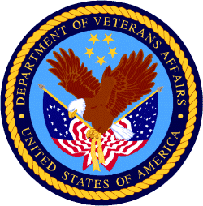

Department of Veterans Affairs

Programs:

Reminders:

PART 2 – GENERAL FEDERAL AGENCY GRANTS INFORMATION
JULY 2021

Please review each department’s General Grant and Funding Overview. These overviews are the key web pages on each departmental website dedicated to the agency’s funding opportunities. Check back often to note the department updates.

(See Part 1 for current grant opportunity notices)

Federal Agencies Discretionary Grants and Contract Website Links

Native Hawaiian Programs

U.S. Department of Agriculture

Grants and Loans Overview

Department of Commerce

Grants at Commerce

Economic Development Administration Hawaii Contacts

Corporation for National and Community Service

General Program Overview

National Service in Hawaii

Department of Defense

Doing Business with the Department of Defense

Department of Education

Grant Programs Overview

US Department of Energy

Grants Overview

Environmental Protection Agency

Grants and Contracts Overview

Federal Mediation and Conciliation Service

Grants Overview

Department of Health and Human Services

Grants Overview

Department of Homeland Security
Grants Overview

Department of Housing and Urban Development

HUD - Notice of Funds Available

Institute of Museum and Library Services
Grants Overview

IMLS is on Facebook!

Department of Interior

Grants and Contract Overview

Department of Justice

Grants and Contract Overview

Hawaii State Administrative Agency Contacts
________________________________________________________________________

Department of Labor

Grants and Contract General Overview

National Aeronautics and Space Administration

Research Grant and Contract General Overview
_______________________________________________________________
National Archives and Records Administration

Grant Opportunities General Overview
_______________________________________________________________
National Endowment for the Arts

Grant Opportunities General Overview
_______________________________________________________________
National Endowment for the Humanities

Grant Opportunities General Overview
_______________________________________________________________
National Science Foundation

Grant Opportunities General Overview

Small Business Administration

General Overview Finding Loans & Grants

Links Specific to Hawaii

State Department

General Overview and Resources for Program Administrators

_________________________________________________________________________________

U.S. Department of Transportation

General Grant Program Overview

Department of the Treasury

Overview

US Agency for International Development
General Funding Opportunity Overview

Department of Veterans Affairs

Programs

Grants.Gov Links

Grant Writing Resources

SBIR – Small Business Innovation Research

Federal Agency Discretionary Grant and Contract Websites and Overviews

Native Hawaiian Programs

The Office of Native Hawaiian Relations was authorized by Congress in Public Law 108-199 on January 23, 2004, and in Public Law 104-42 on November 2, 1995. The Office discharges the Secretary's responsibilities for matters related to Native Hawaiians and serves as a conduit for the Department’s field activities in Hawaii

To access the resources in the 2016 guide (the most recent) click on this link:
https://www.doi.gov/sites/doi.gov/files/uploads/NHC%20Guide%20to%20Fed%20Prog%20and%20Services%2002052016%20ONHR.pdf

The listing below can be reviewed online at the following site:
https://www.doi.gov/hawaiian/programs

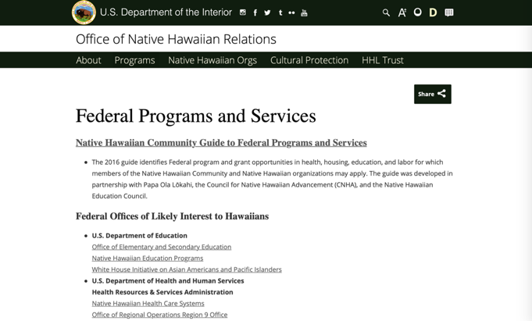

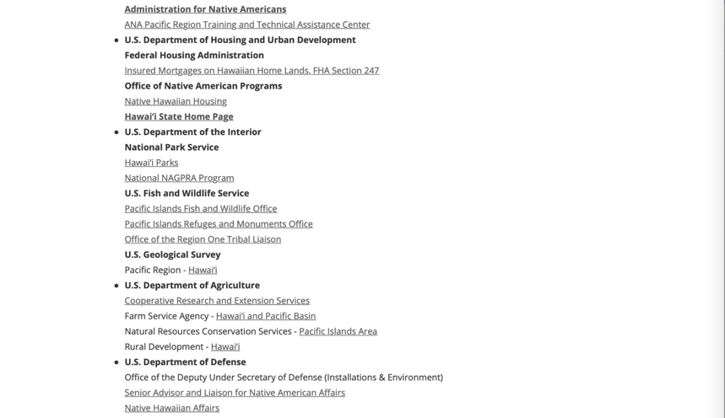

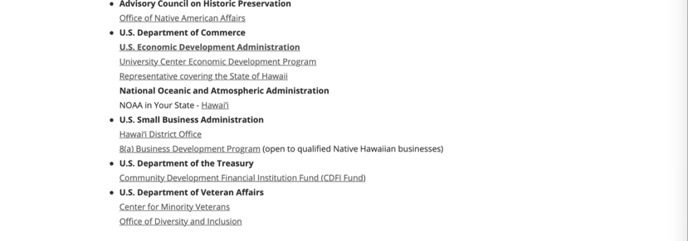

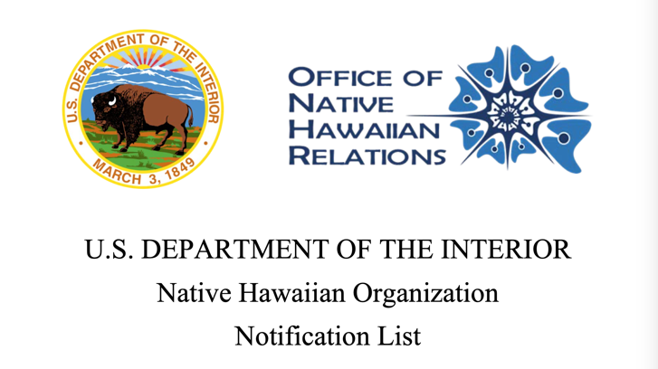

Last Updated: September 23, 2020
https://www.doi.gov/sites/doi.gov/files/nhol-complete-list.pdf

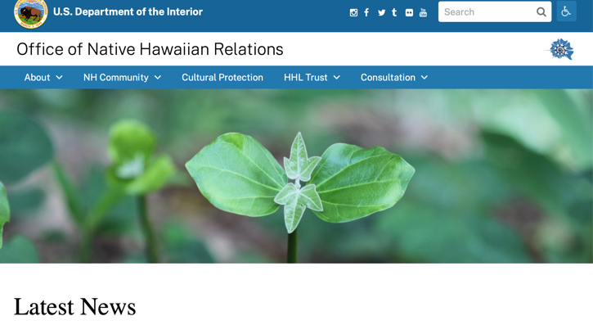
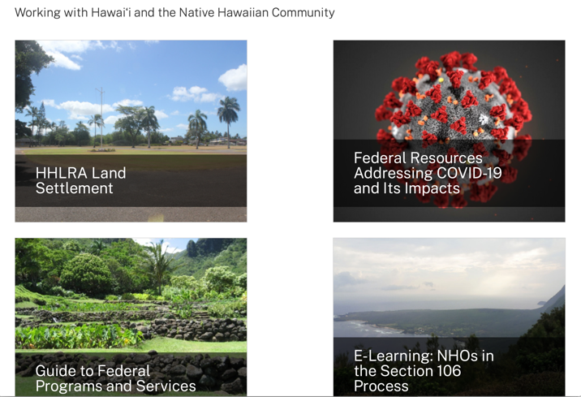
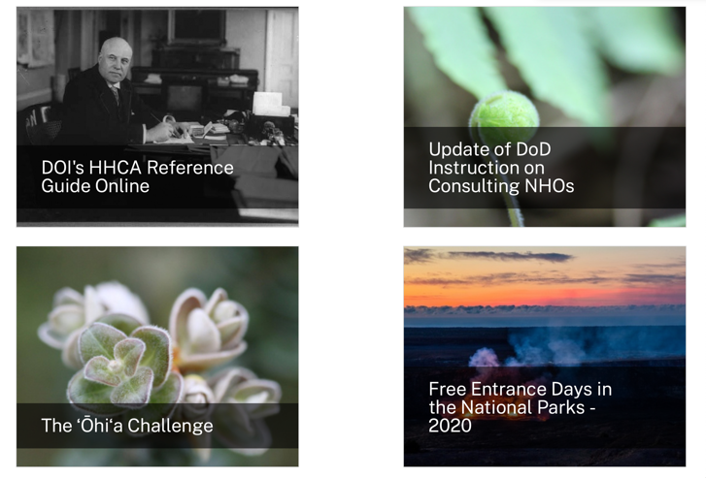
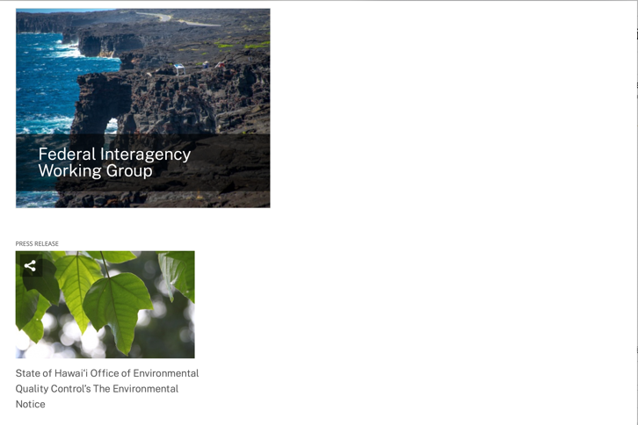
https://www.doi.gov/hawaiian

Office of Hawaiian Affairs Community Grants Program
Grants – The purpose of the Office of Hawaiian Affairs Grants Program is to support Hawaiʻi based nonprofit organizations that have projects, programs, and initiatives to serve our Lāhui in alignment with OHA’s Strategic Foundations, Directions & Outcomes.
Reminder, to be eligible for funding consideration, an applicant shall:
- Be registered to do business in the State of Hawaiʻi
- Provide services to Native Hawaiians and/or Native Hawaiian community(ies) in the State of Hawaiʻi
- Have an IRS letter of Determination
- Compliant with Hawaiʻi Compliance Express

https://www.oha.org/resources/

Resources
Providing resources is among the key ways that the Office of Hawaiian Affairs fulfills its purpose.
The best possible Native Hawaiian historical and cultural information has been just a click away since the launch in April 2013 of the Kipuka Database. It is a searchable online geographic information system that makes data that once would have taken long to compile, now available within seconds. The database helps complement our other key research tools, such as the Native Hawaiian Data Book and the Papakilo Database, which is a digital library for Native Hawaiian historical and cultural information.
In addition, we launched Kamakako’i, an issues-based digital media tool that has been years in the making. The cutting-edge website provides a platform to quickly engage key audiences and inspire action on policy matters important to the Native Hawaiian community.

Resources
- Grants – The purpose of the Office of Hawaiian Affairs Community Grants Program is to support projects, programs and initiatives that address OHA’s six Strategic Priorities and accompanying Strategic Results contained in OHA’s 2010-2018 Strategic Plan.
- Kamakakoʻi – A cutting edge tool that leverages technology to engage, inform, activate and rally the Hawaiʻi community around voices on the cutting edge of community issues. It is produced and maintained by the Office of Hawaiian Affairs.
- Ka Wai Ola – Ka Wai Ola is a monthly newspaper published by OHA. The Ka Wai Ola operates under the Communications division of Community Engagement. The Ka Wai Ola has about 60,000 subscribers and strives to create rich content geared toward captivating the Hawaiian community.
- Kīpuka Database – A geographical information system (GIS) that utilizes the latest mapping technologies to provide a window into native Hawaiian land, culture and history.
- Loans – The Office of Hawaiians Affairs is committed to ensuring Native Hawaiians and their ‘ohana have access to resources to assist them in pursuing their financial goals.
- OHA Native Hawaiian Data Book – A compilation of basic demographic data on Hawaiians and data to identify gaps and important issues to ensure OHA’s actions and initiatives are based on the best information available.
- Papakilo Data Base – A comprehensive “Database of Databases” consisting of varied collections of data pertaining to historically and culturally significant places, events, and documents in Hawai’i’s history.
- Reports and Research – A collection of reports and surveys intended to help guide strategic direction and policy decisions.
- Scholarships – Each year OHA provides funding for scholarships through its Higher Education Scholarship Programs.

U.S. Department of Agriculture

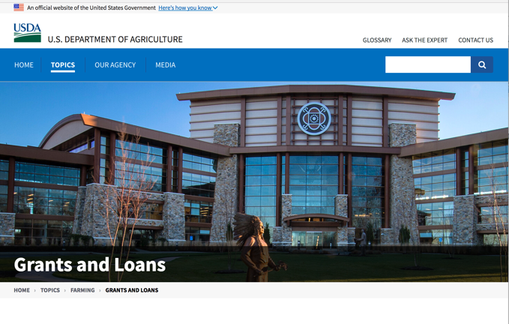

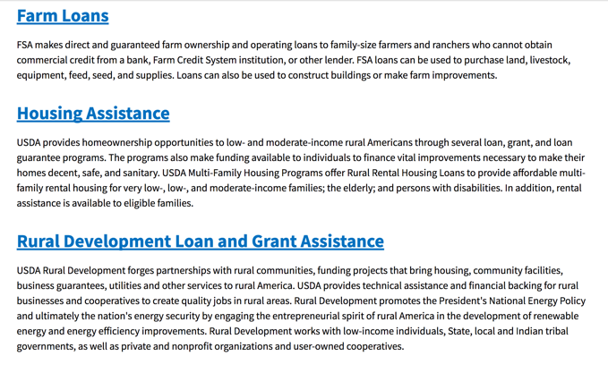
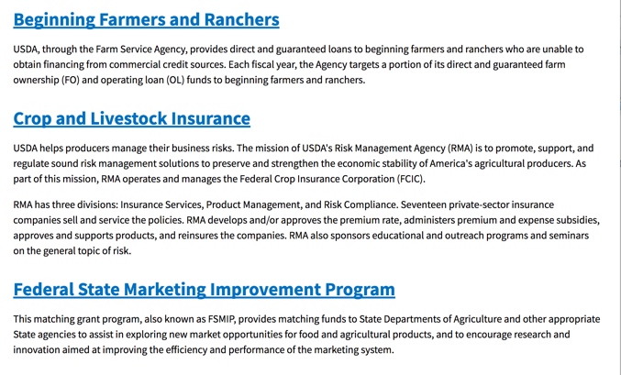
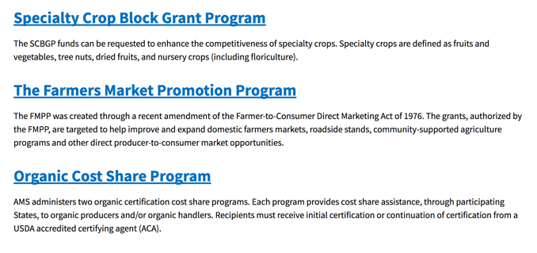
https://www.usda.gov/topics/farming/grants-and-loans

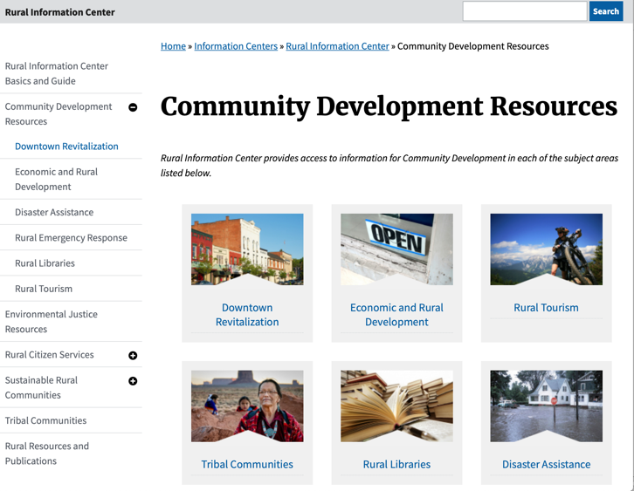

https://www.nal.usda.gov/ric/community-development-resources

Department of Commerce

Grants, Contracting, and Trade Opportunities at Commerce
Learn more information about grants, contracting and trade opportunities at the Department of Commerce using the information below.
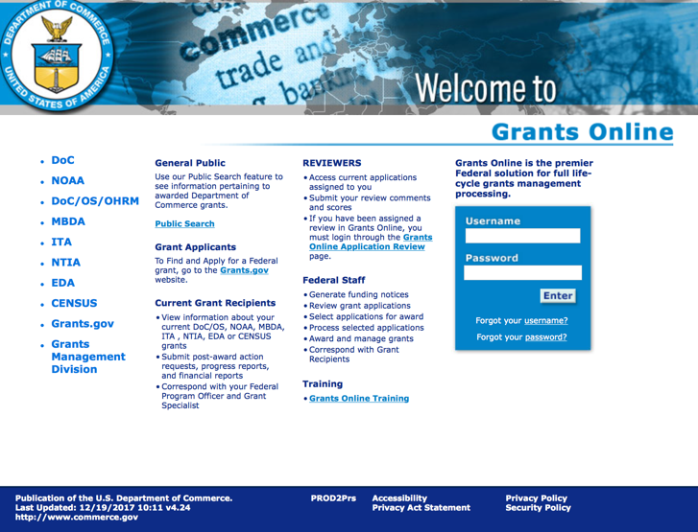
https://grantsonline.rdc.noaa.gov/flows/home/Login/LoginController.jpf

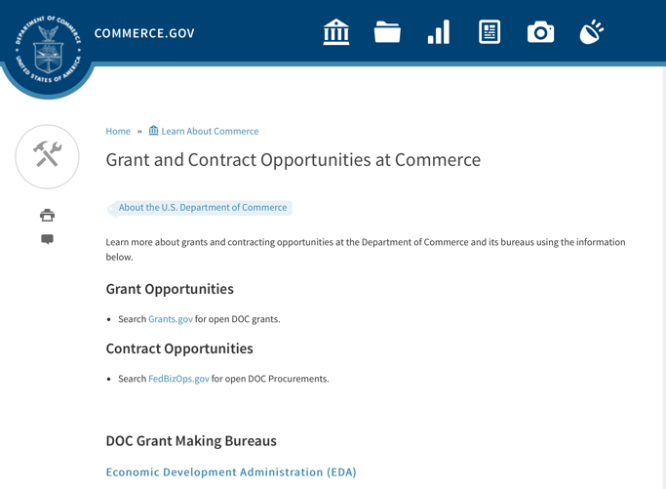
DOC Grant Making Bureaus
Economic Development Administration (EDA)
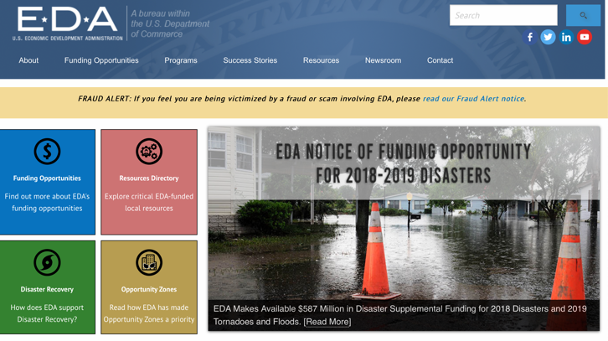
International Trade Administration (ITA)
- Market Development Cooperator Program
- Special American Business Internship Training Program (SABIT). A technical assistance initiative of the International Trade Administration of the U.S. Department of Commerce, SABIT offers organizations competitive grants and an opportunity to host industry-specific delegations. SABIT serves as an initial entry point for U.S. businesses seeking funding to establish long-term relationships with potential customers, distributors, or partners in the former Soviet Union. The program trains Eurasian managers and scientists in commonly accepted business practices as a means of facilitating cross border relationships. In turn, these personal relationships serve as a basis for business development and reduce market access barriers for U.S. businesses
National Institute of Standards & Technology (NIST)
- Funding Opportunities
National Telecommunications & Information Administration (NTIA)
- Telecommunications Grants
National Oceanic & Atmospheric Administration (NOAA)
- Coastal Ocean Program Grant Information
- Fisheries Saltonstall Kennedy Grant Program
- National Undersea Research Program Funding Opportunities
- Grants Management Division
- Fisheries Grants Program
- National Sea Grant
- Office of Global Programs
Contracting Resources for Contractors
- Office of Small and Disadvantaged Business Utilization (OSDBU) - the Office of Small and Disadvantaged Business Utilization (OSDBU) is an advocacy and advisory office responsible for promoting the use of small, small disadvantaged, 8(a), women-owned, veteran-owned, service-disabled veteran-owned, and HUBZone small businesses within the U.S. Department of Commerce's (DOC) acquisition process.
- Business.USA.gov's Find Opportunities Wizard where in a few quick steps, it will guide you towards federal government contracting programs and opportunities for your business!
- Planned Acquisitions: the Department of Commerce's search tool for our planned acquisitions over $100,000. As requirements change, these acquisition plans are updated by department personnel and this search tool is automatically updated.
- Small Business Administration's Contracting section of their web site where you can learn about how to "Get Started" and "Contracting Support for Small Business"
- The General Services Administration (GSA) has implemented a system for vendors doing business with the Federal Government to manage their entity information in one central location. This new database is the System for Award Management (SAM).

DOC Contracting Offices
- Patent and Trademark Office (PTO)
  - Office of Procurement

- National Institute of Standards & Technology (NIST)
NIST Acquisition Management Group
Contracting Opportunities with Commerce
Trade Opportunities through Commerce
http://www.commerce.gov

Economic Development Administration Hawaii Contacts

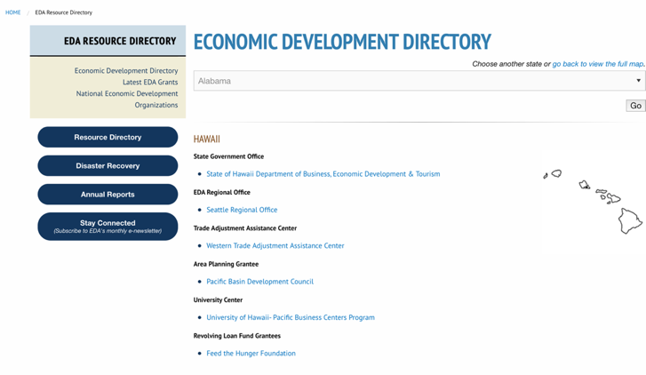

https://www.eda.gov/resources/economic-development-directory/states/hi.htm

Corporation for National and Community Service

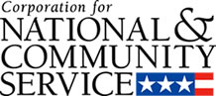

General Program Overview

AmeriCorps provides resources, both human and financial, to organizations that engage Americans in intensive service to meet our country’s critical needs.
Grantees use the funding to support AmeriCorps members for intensive service in their community. AmeriCorps grants partially cover the expense of operating an AmeriCorps program and do not cover general organizational expenses. A cash and in-kind match is required.

The main website can be accessed here: http://www.nationalservice.gov

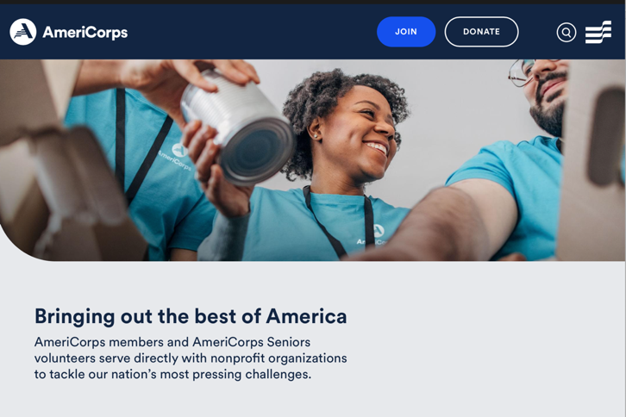

For access to further funding information: https://americorps.gov/partner/funding-opportunities

http://www.nationalservice.gov/build-your-capacity/grants/funding-opportunities

National Service in Hawaii
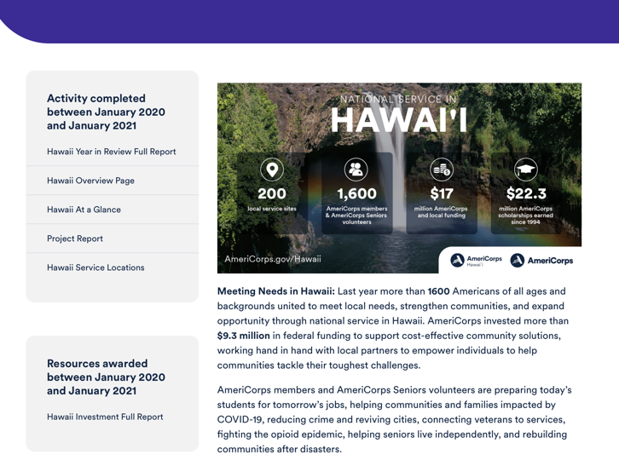
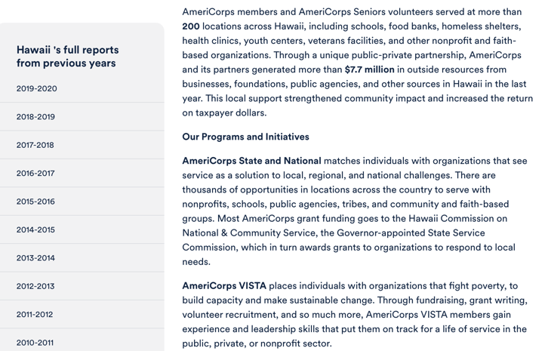
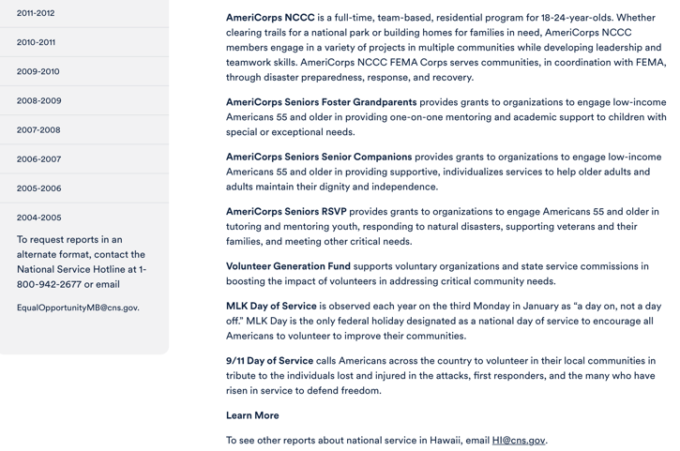

Learn More https://americorps.gov/national-service-report/hi
To see other reports about national service in Hawaii, please contact HI@cns.gov.
The Corporation for National and Community Service is a federal agency that improves lives, strengthens communities, and fosters civic engagement through service and volunteering. To learn more, visit www.NationalService.gov or call 202-606-5000 or TTY 1-800-833-3722.

U.S. Department of Defense

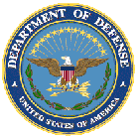

Doing Business with the Department of Defense

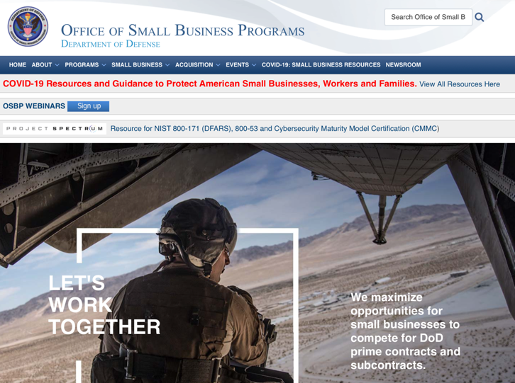

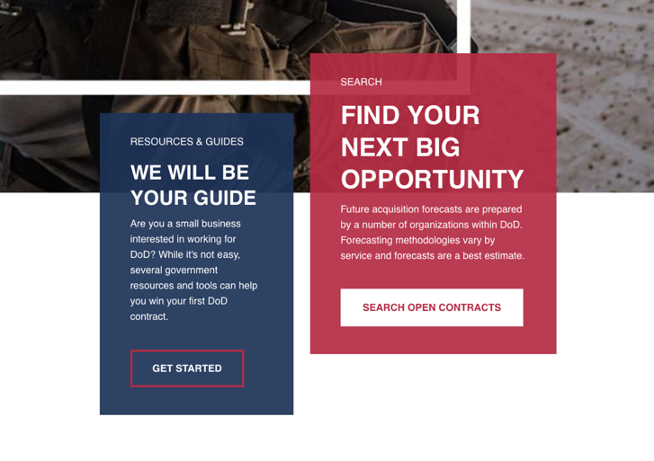
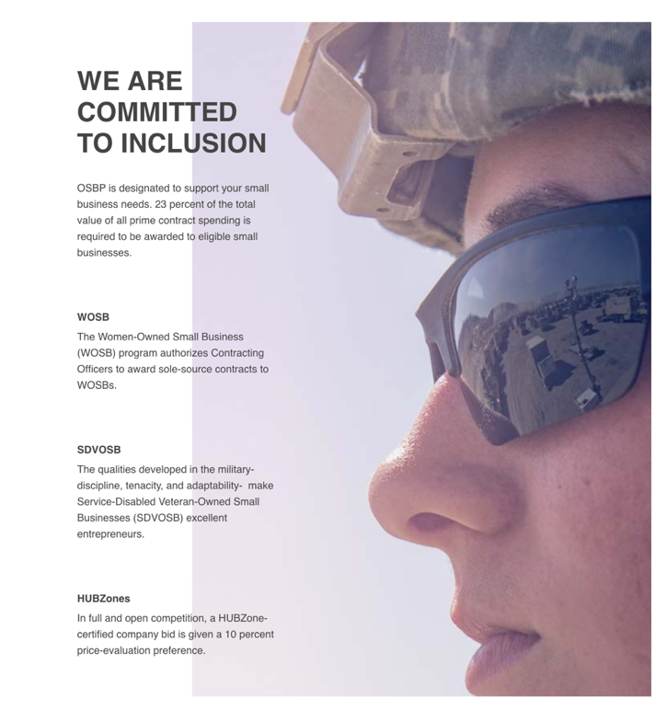
http://business.defense.gov

Corona Virus Response -- https://business.defense.gov/COVID-19-SMALL-BUSINESS-RESOURCES/

Department of Education


Grant Programs Overview at the Department of Education

The general information page for Education Grant funding is an excellent resource describing the three types of grants awarded by the Department of Education. See the screen shot of the Department of Education web page below:

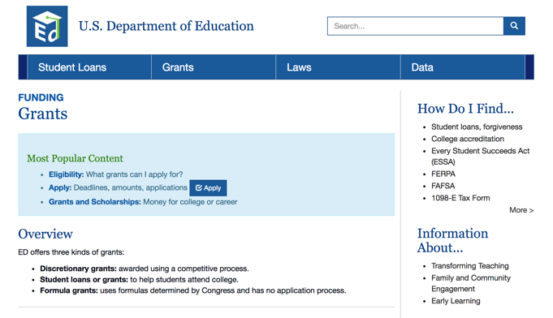
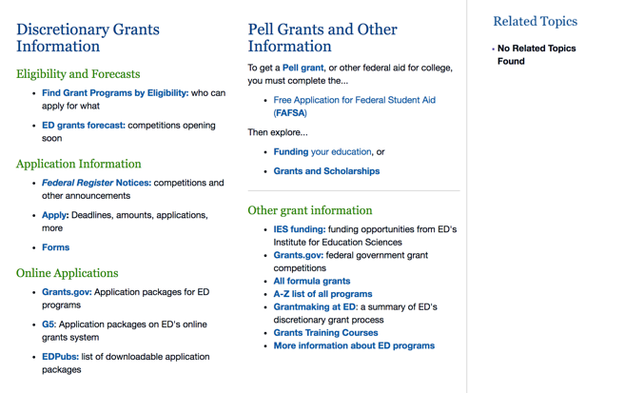

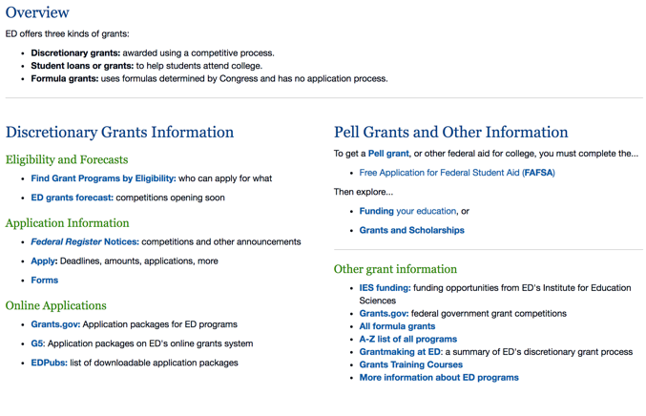

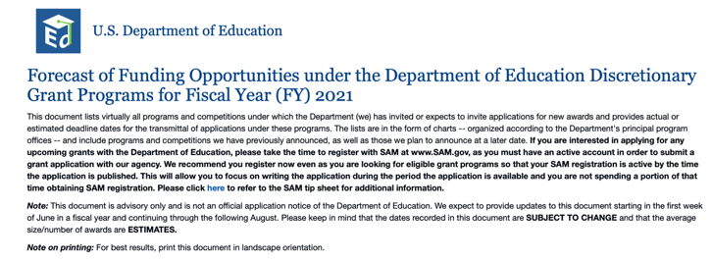

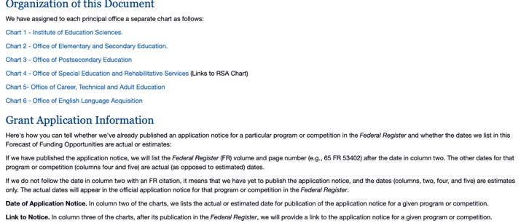

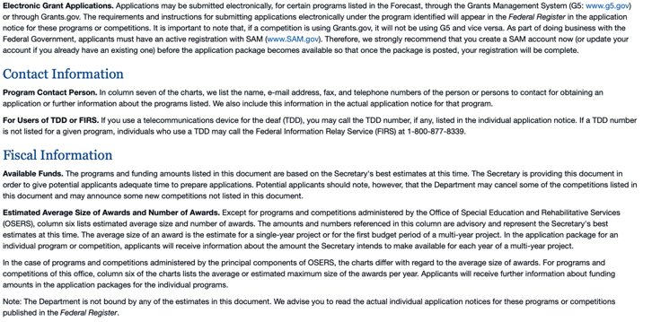

https://www2.ed.gov/fund/grant/find/edlite-forecast.html

U.S. Department of Energy

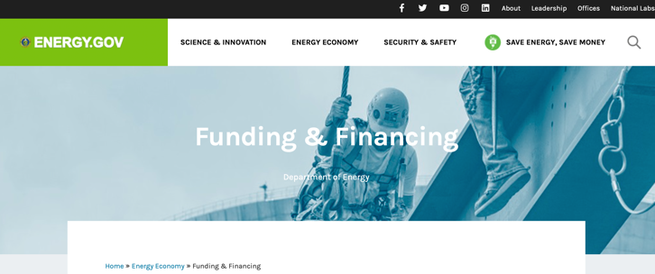
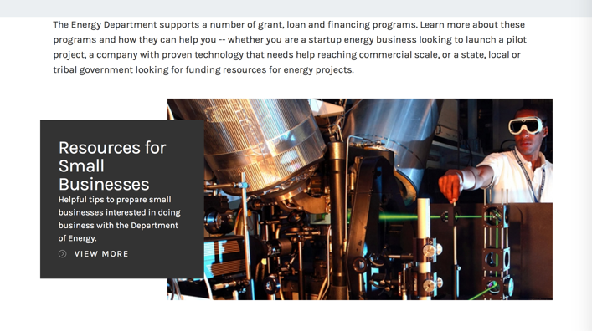

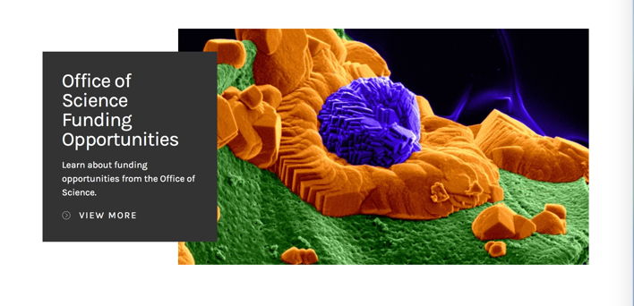

https://www.energy.gov/energy-economy/funding-financing

Environmental Protection Agency

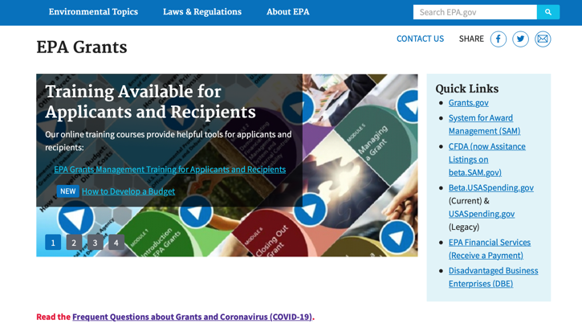

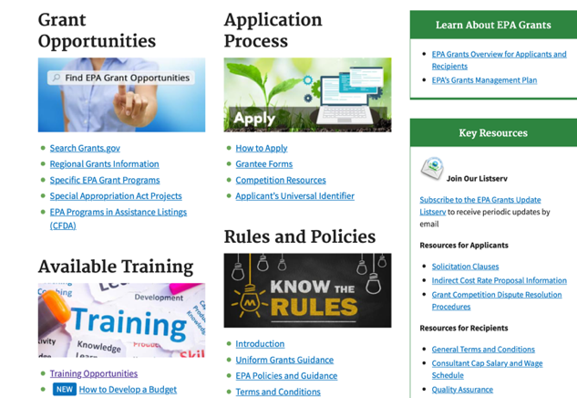

https://www.epa.gov/grants

Federal Mediation and Conciliation Service

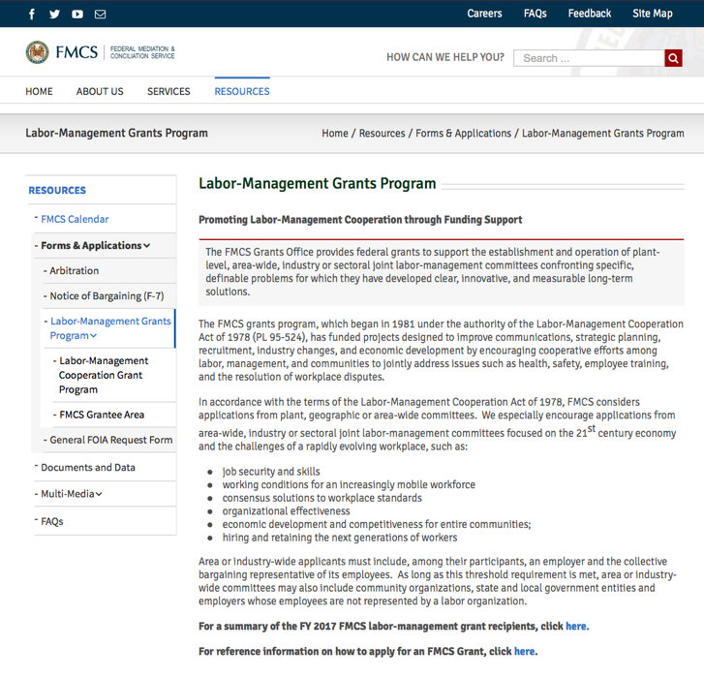
https://www.fmcs.gov/resources/forms-applications/labor-management-grants-program/

Department of Health and Human Services

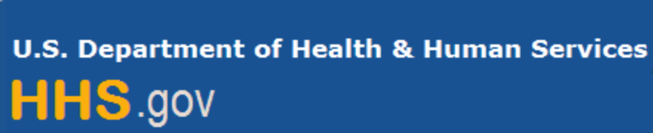

Grants Forecast and Overview

The Department of Health and Human Services’ Grants Forecast is a database of planned grant opportunities proposed by its agencies. Each Forecast record contains actual or estimated dates and funding levels for grants that the agency intends to award during the fiscal year. Forecast opportunities are subject to change based on enactment of congressional appropriations.

For more general information about HHS Grants and Funding go to the website below at:

https://www.hhs.gov/grants/grants/index.html

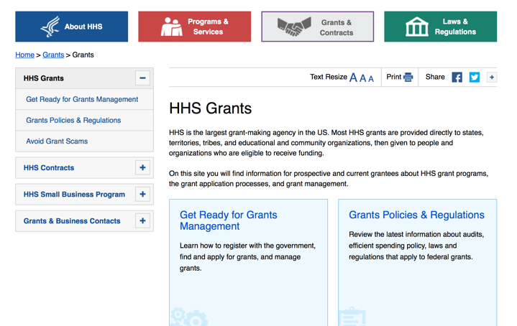

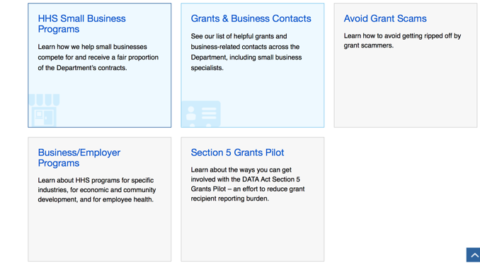

Department of Homeland Security



The Department of Homeland Security enhances the ability of states, local and tribal jurisdictions, and other regional authorities in the preparation, prevention, and response to terrorist attacks and other disasters, by distributing grant funds. Localities can use grants for planning, equipment, training and exercise needs.

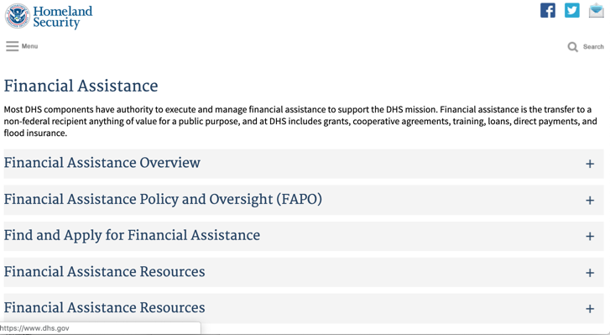

Webpage can be viewed at: https://www.dhs.gov/dhs-financial-assistance#2

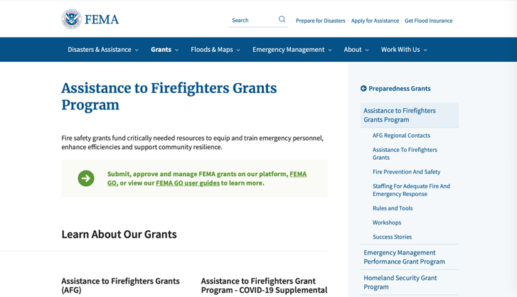

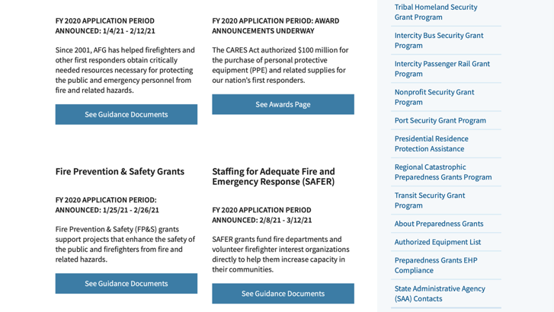

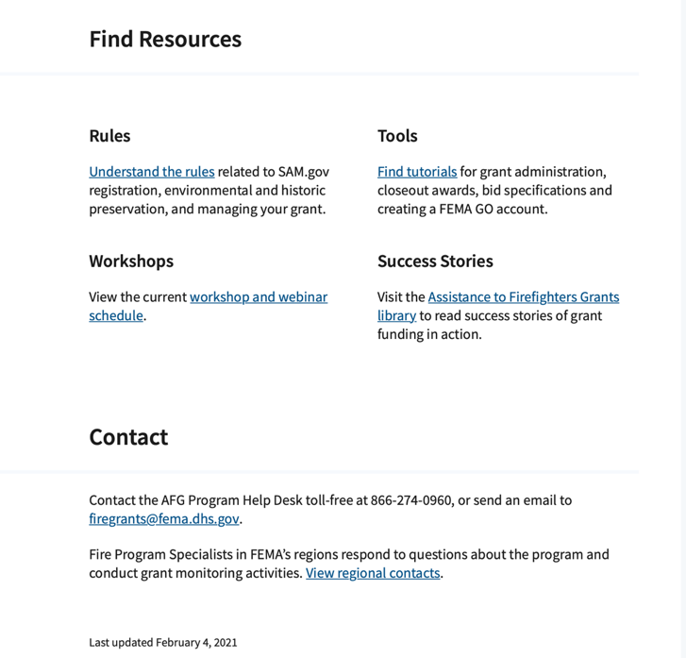

https://www.fema.gov/welcome-assistance-firefighters-grant-program

For AFG program guidance materials, please visit our Documents page.

Resources

AFG Help Desk
Contact the AFG Program Help Desk toll-free at 866-274-0960, or email us at firegrants@dhs.gov.
The AFG Program has Fire Program Specialists in 10 federal regional centers. These Regional Fire Program Specialists respond to questions about the AFG program and carry out grant monitoring activities. View regional contacts

Popular AFG links
- Assistance to Firefighters Grants (AFG)
- AFG Awards List
- Staffing for Adequate Fire & Emergency Response (SAFER) Grants (SAFER)
- SAFER Awards List
- SAFER Success Stories
- Fire Prevention & Safety (FP&S) Grants
- FP&S Awards List
- FP&S Success Stories
- Grant Closeout Tutorial
- Assistance to Firefighters Grant (AFG) Email Alert Archive
- Frequently Asked Questions
Contact Information For The Assistance to Firefighters Grant (AFG) Program and Help Desk

Federal Funding Alternative To AFG

State Administrative Agencies (SAA) apply for and administer Federal grants on behalf of their States, including FEMA Preparedness Grants. The SAA will work with eligible organizations to comply with the general requirements of grant programs or cooperative agreements. Contact your State’s SAA to find out what current Federal funding opportunities may be available to your organization. A listing of the SAAs and points of contact can be found at http://www.fema.gov/library/viewRecord.do?id=6363.

Department of Housing and Urban Development

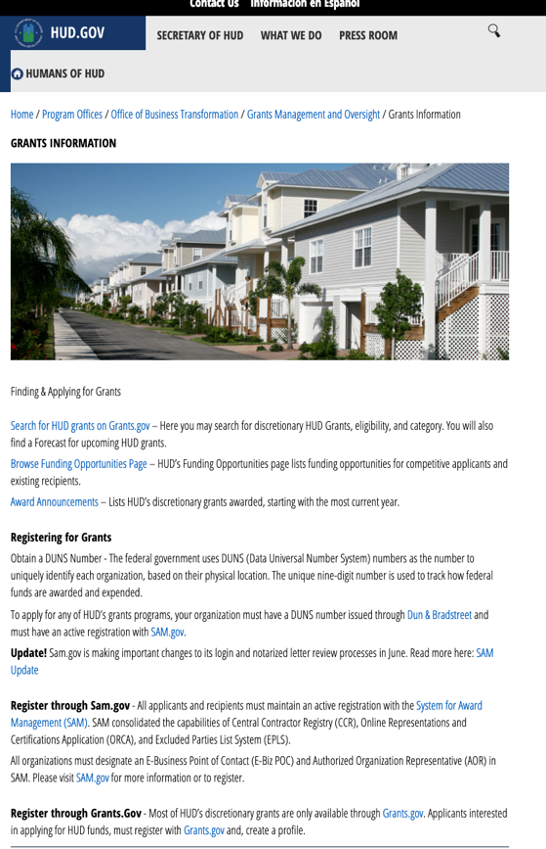
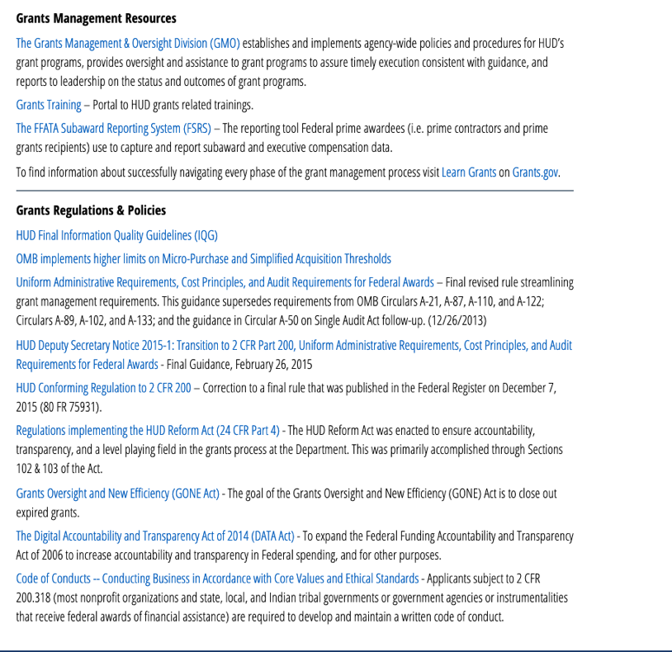

https://www.hud.gov/program_offices/spm/gmomgmt/grantsinfo

HUD - Notice of Funds Available
For detailed information click here

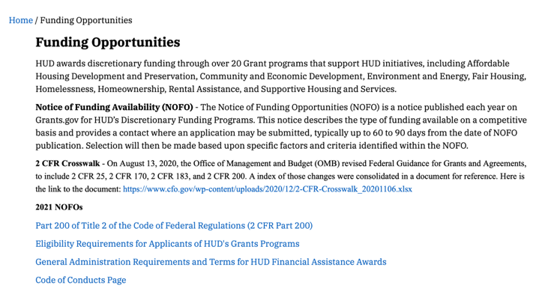

http://portal.hud.gov/hudportal/HUD?src=/program_offices/Administration/grants/fundsavail

Institute of Museum and Library Services

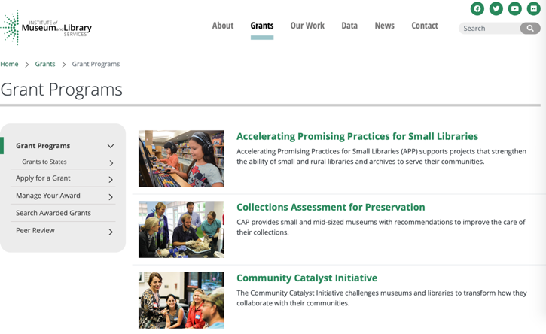
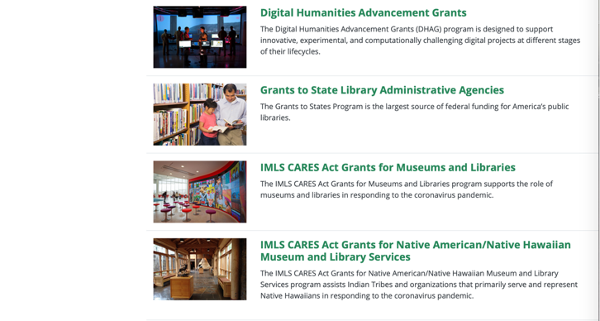

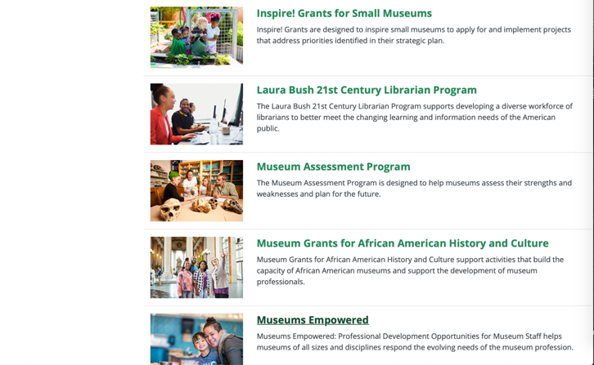

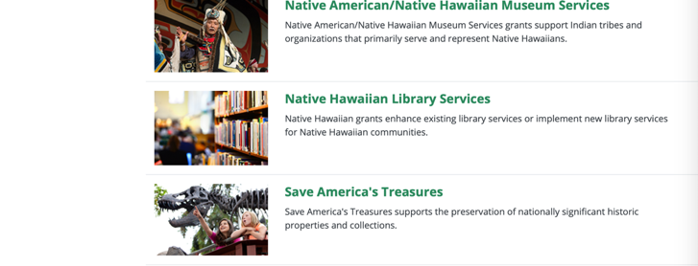
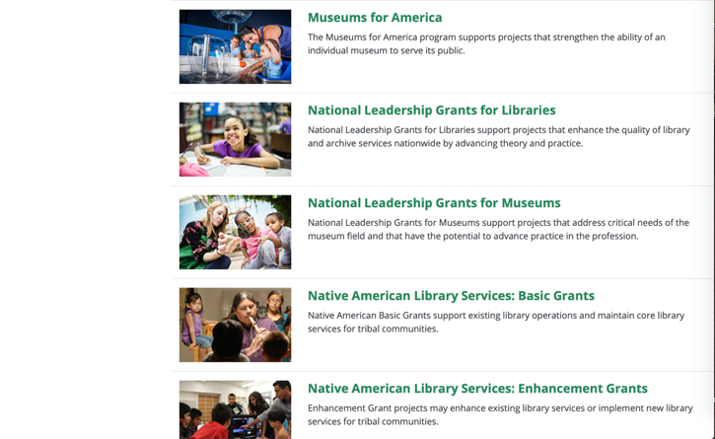
https://www.imls.gov/grants/apply-grant/available-grants

Each grant program has specific eligibility requirements. The links below provide general eligibility criteria for museums, libraries, and tribal organizations, but please note that additional organizations may be eligible for grants under certain programs. Additionally, ineligible organizations may still be able to participate in grant programs through partnerships with eligible organizations. Please click on the links below to see general criteria and review Applications and Guidelines for specific information.
Museums Libraries

Institutions: Archives, Federally Recognized Native American Tribe, Historical Society, Library, Nonprofits that serve Native Hawaiians, Professional Association, Public or Private Non-profit Institutions of Higher Education, Regional Organization, State Library Administrative Agency, State or Local Government

Check out IMLS's Facebook page at:
https://www.facebook.com/USIMLS/

Department of the Interior

Working with Interior

The Interior Department provides assistance to the public, local governments and businesses through a number of programs. For a general overview see: http://www.doi.gov/index.cfm

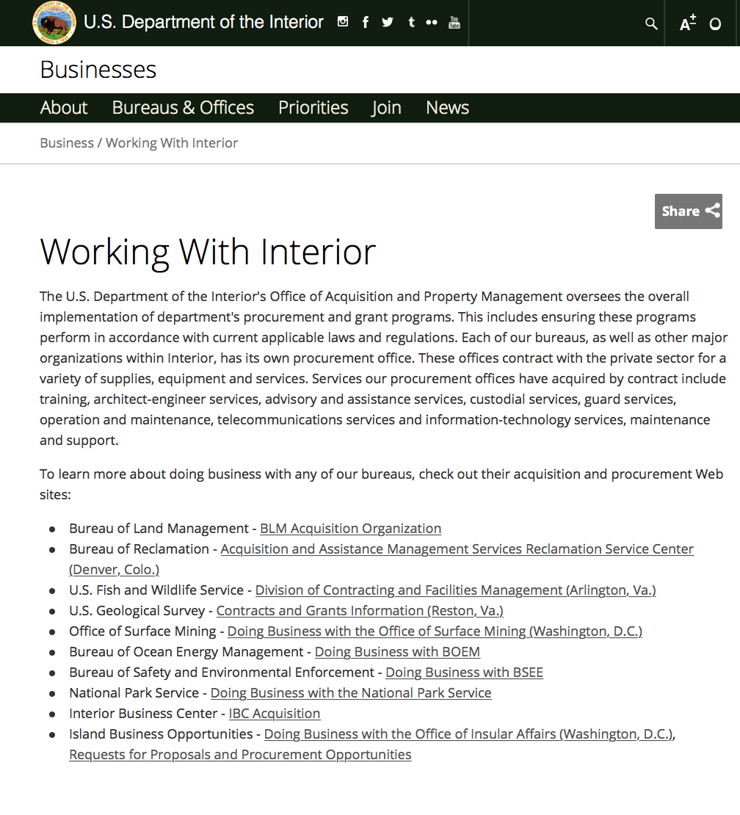

http://www.doi.gov/businesses/working-with-interior.cfm

Department of Justice

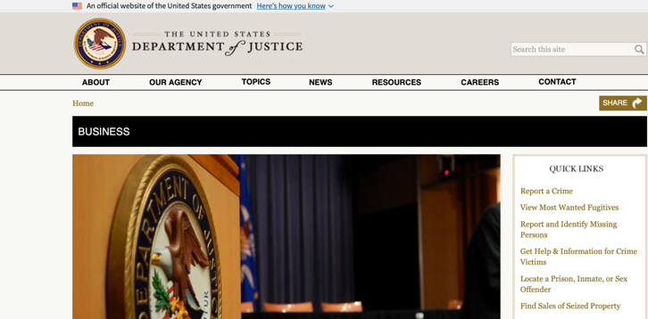

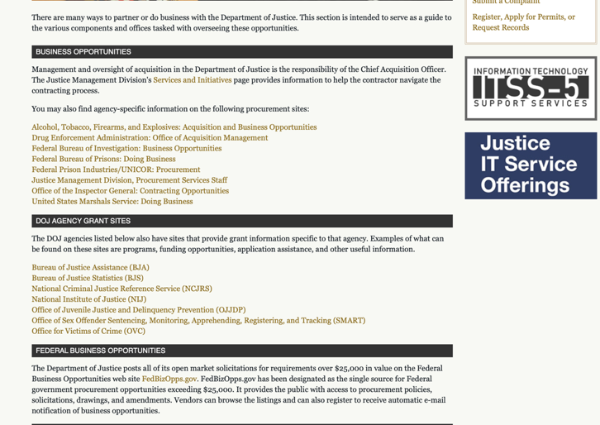
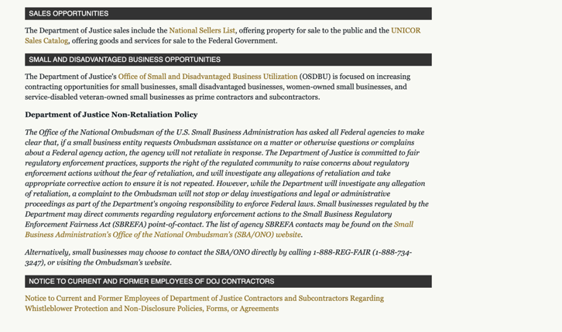
http://www.justice.gov/business/

The DOJ agencies listed below also have sites that provide grant information specific to that agency. Examples of what can be found on these sites are programs, funding opportunities, application assistance, and other useful information.

Bureau of Justice Assistance (BJA)
Bureau of Justice Statistics (BJS)
National Criminal Justice Reference Service (NCJRS)
National Institute of Justice (NIJ)
Office of Sex Offender Sentencing, Monitoring, Apprehending, Registering, and Tracking (SMART)

Hawaii State Administrative Agency Contacts

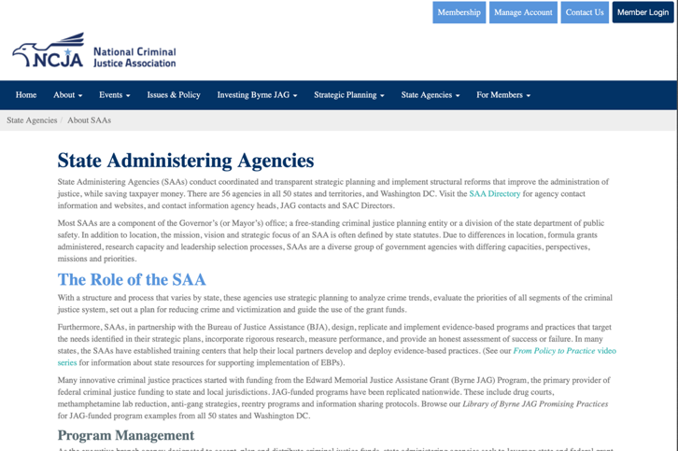

https://www.ncja.org/state-agencies/about-state-agencies

HAWAII DEPARTMENT OF THE ATTORNEY GENERAL, CRIME PREVENTION & JUSTICE ASSISTANCE DIVISION
235 S Beretania Street, Suite 401
Honolulu, HI 96813
(808) 586-1150
Agency Head: Julie Ebato, Administrator
JAG Contact: Shaleigh Tice, Grants & Planning Branch Chief
SAC Director: Paul Perrone, Chief of Research and Statistics

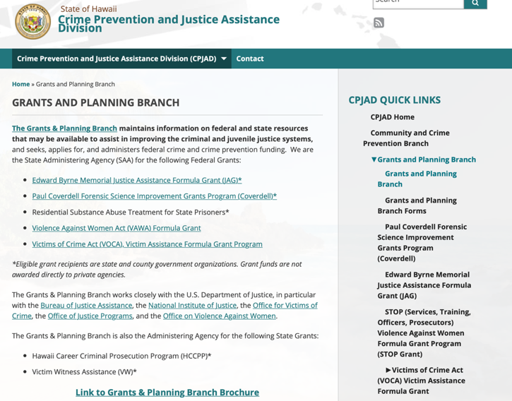
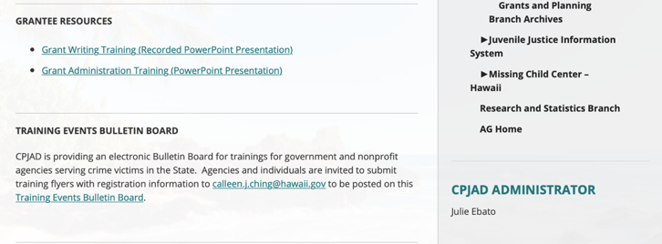
https://ag.hawaii.gov/cpja/gp/

Department of Labor

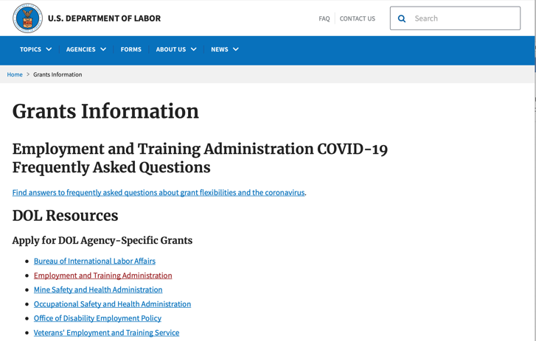

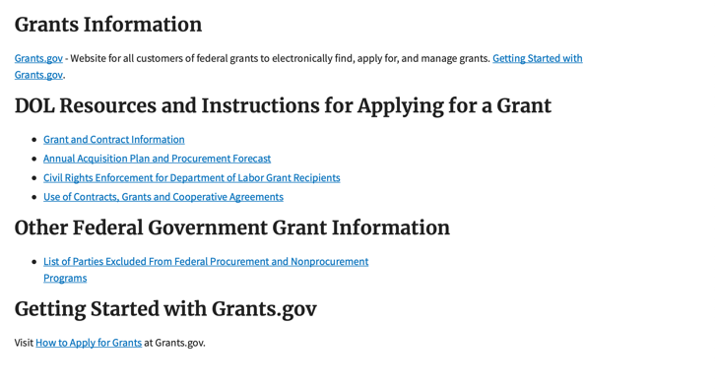
https://www.dol.gov/general/grants/howto

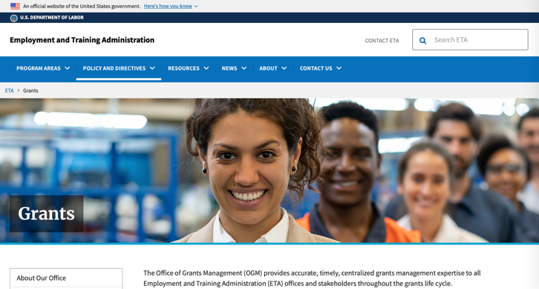

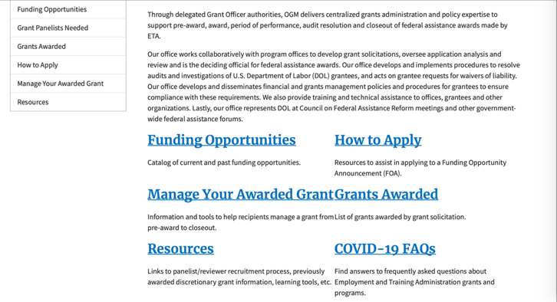
https://www.doleta.gov/grants/

Agency Grants and Contract General Overview

DOL Resources
Apply for DOL Agency-Specific Grants:
- Employment and Training Administration (ETA)
- Occupational Safety and Health Administration (OSHA)
- Bureau of International Labor Affairs (ILAB)
- Veterans' Employment and Training Service (VETS)
- Office of Disability Employment Policy (ODEP)
- Office of the Assistant Secretary for Administration and Management (OASAM)

Other Grant Resources:

DOL Resources and Instructions for Applying for a Grant
- DOL Guidance Clarifying the Effect of the Religious Freedom Restoration Act on Faith-Based Organizations
- Grant and Contract Information
- More Information About Grants

Other Federal Government Grant Information
- Grant Opportunities (Catalog of Federal Domestic Assistance)

Department of Labor Grant Programs

- Bureau of International Labor Affairs (ILAB): provides grants (cooperative agreements) for the implementation of projects designed to assist developing countries combat the worse forms of child labor, forced labor, and human trafficking; and support worker rights and improve working conditions. http://www.dol.gov/general/business.
- Bureau of Labor Statistics (BLS): provides project grants (cooperative agreements) and the dissemination of technical statistical data and related information on labor force activities; provides data on prices (CPI) and cost of living; data on productivity and technology data; data on compensation and working conditions; data on employment projections.
- Employment and Training (ETA): ETA Administers financial assistance programs pursuant to the Workforce Investment Act (WIA), administering State formula grant programs for youth, adults and dislocated workers, national emergency grants for workers affected by mass layoffs, plant closures, and disasters; grant programs for workers with disabilities, Indians and Native Americans, and for migrant and seasonal farmworkers. ETA also administers grant programs for older American workers, apprenticeship programs, Trade Adjustment Assistance (TAA) programs, and assistance for research and development of workforce programs. In addition, ETA is responsible for the operation and maintenance of a national system of public employment service offices and for the national unemployment insurance program.
- Mine Safety and Health (MSHA): provides grants for research, education and training programs to ensure an adequate and competent staff of trained inspectors; and assistance for establishing or improving State mine health and safety programs through technical assistance.
- Occupational Safety and Health (OSHA): provides grants to non-profit organizations to provide training, educational services, and technical assistance; assistance to states to administer and enforce state programs; assistance to states to provide occupational safety and health technical assistance and consultant services.
- Office of Disability Employment Policy (ODEP): The Office of Disability Employment Policy awards competitive grants establishing short-term pilot and technical assistance projects designed to identify, develop, test, evaluate, and disseminate policies to increase employment by expanding access to training, education, employment supports, assistive and systems technology, integrated employment, entrepreneurial development, and small business opportunities for adults and youth with disabilities. Current pilots projects focus on customized employment, Olmstead populations, and innovative demonstration youth grants, among others. Solicitations for grant applications are published in the Federal Register and announced at www.dol.gov/odep. ODEP grants are awarded by the OASAM grant office.
- Veterans' Employment and Training (VETS): provides special employment and training assistance for veterans through the Disabled Veterans' Outreach Program (DVOP) Solicitation for Grant Applications; the Local Veterans' Employment Representative Program (LVER); Veterans' Workforce Investment Program (VWIP); elaws Advisor on veterans' employment and reemployment rights; and the Homeless Veterans Reintegration Project (HVRP). VETS grants are awarded by the OASAM grant office.

https://www.dol.gov/general/grants/howto

National Aeronautics and Space Administration



NASA Research Opportunities Online

- Various NASA offices publish their research announcements over the Internet, broadening the opportunity for researchers to apply for funding. This site provides access to current research announcements along with their specific due dates.

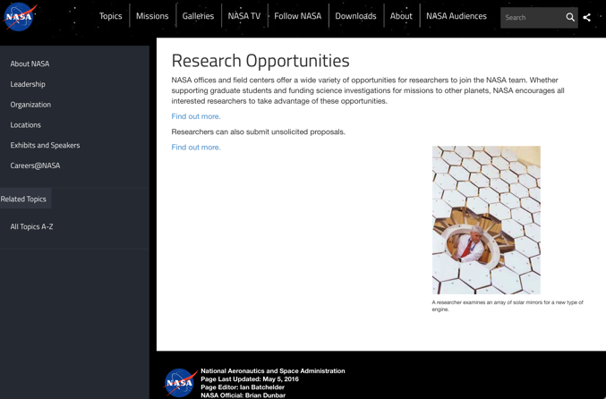

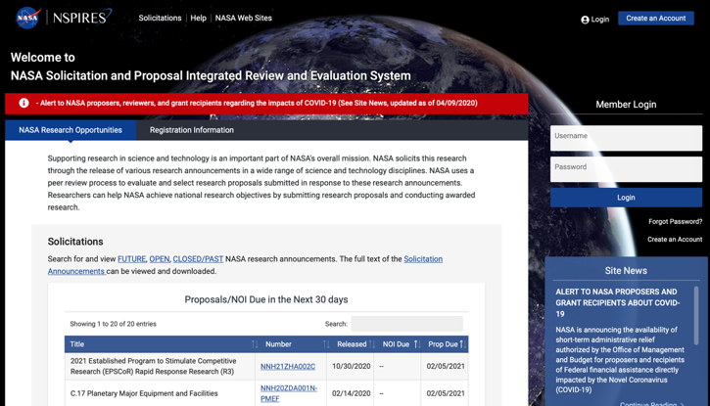
http://nspires.nasaprs.com/external/

National Archives and Records Administration

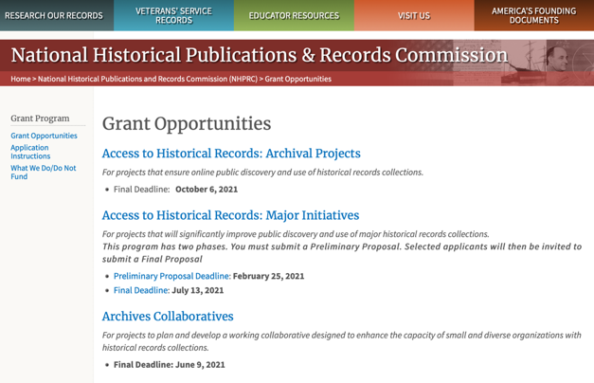
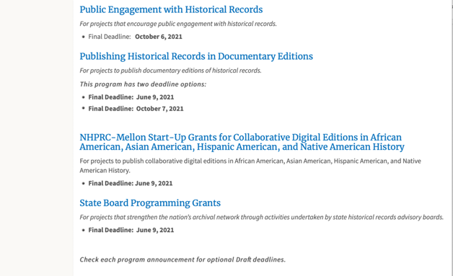

To access the information above: click here

https://www.archives.gov/nhprc/announcement

National Endowment for the Arts

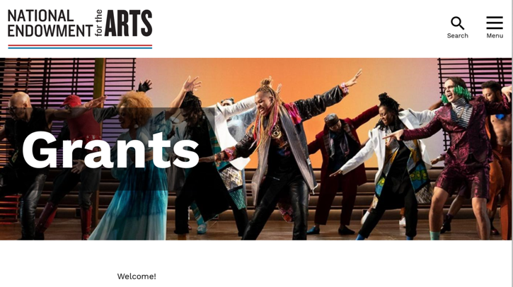
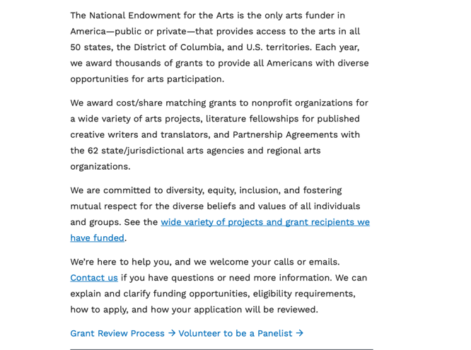
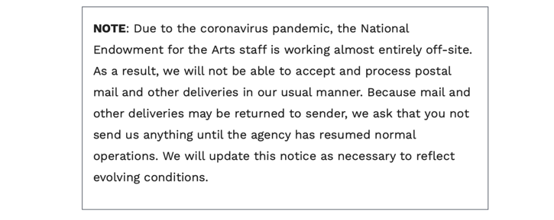

See more at: https://www.arts.gov/grants

National Endowment for the Humanities

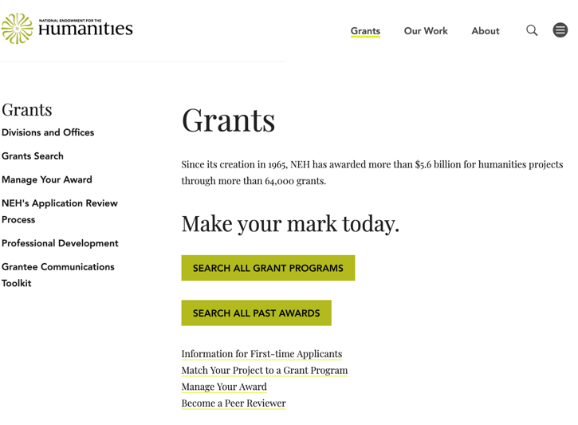
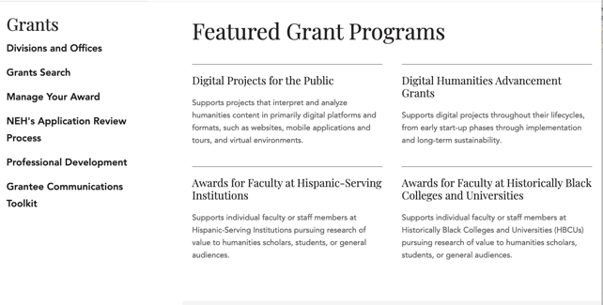
https://www.neh.gov/grants

National Science Foundation



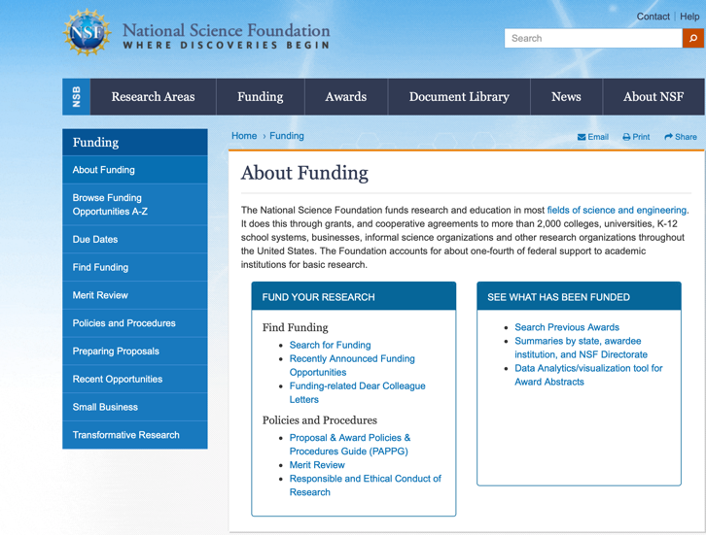

For assistance: https://nsf.gov/funding/aboutfunding.jsp

The National Science Foundation funds research and education in most fields of science and engineering. It does this through grants, and cooperative agreements to more than 2,000 colleges, universities, K-12 school systems, businesses, informal science organizations and other research organizations throughout the United States. The Foundation accounts for about one-fourth of federal support to academic institutions for basic research.
NSF receives approximately 40,000 proposals each year for research, education and training projects, of which approximately 11,000 are funded. In addition, the Foundation receives several thousand applications for graduate and postdoctoral fellowships.
The agency operates no laboratories itself but does support National Research Centers, user facilities, certain oceanographic vessels and Antarctic research stations. The Foundation also supports cooperative research between universities and industry, US participation in international scientific and engineering efforts, and educational activities at every academic level.

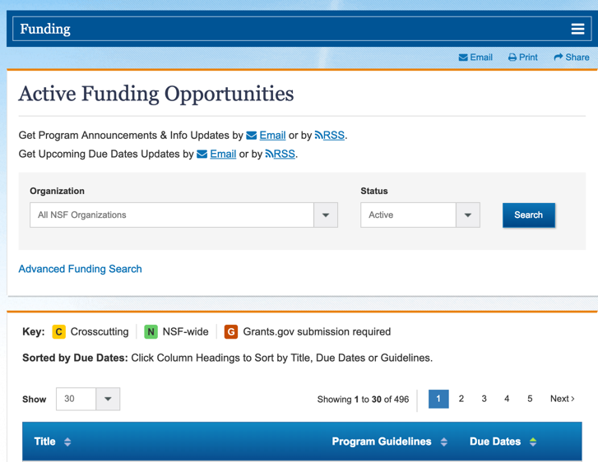

For details on active funding deadline dates: http://nsf.gov/funding/pgm_list.jsp?org=NSF&ord=date

Small Business Administration

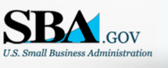


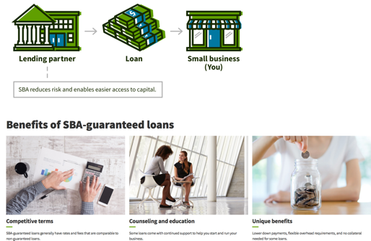

https://www.sba.gov/funding-programs/loans
Federal, state and local governments offer a wide range of financing programs to help small businesses start and grow their operations. These programs include low-interest loans, venture capital, and scientific and economic development grants.
Use SBA.gov's Loans and Grants Search Tool to get a list of financing programs for which you may qualify, or visit the resources below to learn more about small business financing programs.

To get to the main SBA.gov funding page click here
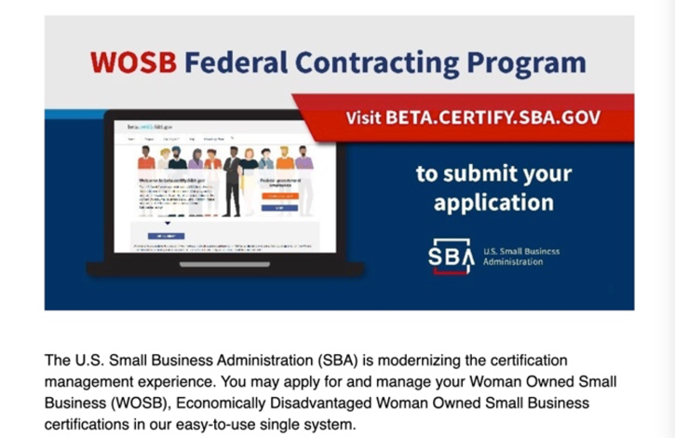
Learn more


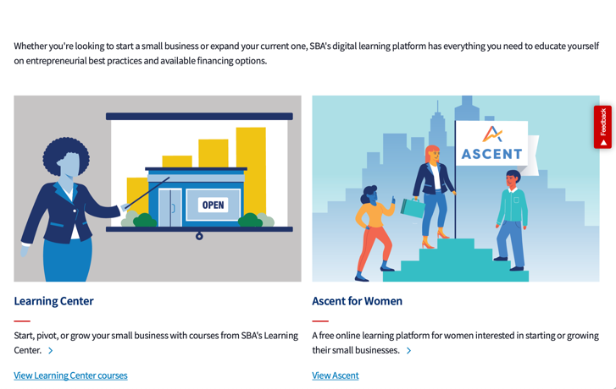
https://www.sba.gov/learning-center

SBA Trainings

https://www.sba.gov/learning-center
Upcoming Trainings: Check out SBA's Online Training!
- Financing Options for Small Businesses

For Specific Information in Hawaii see the following links:
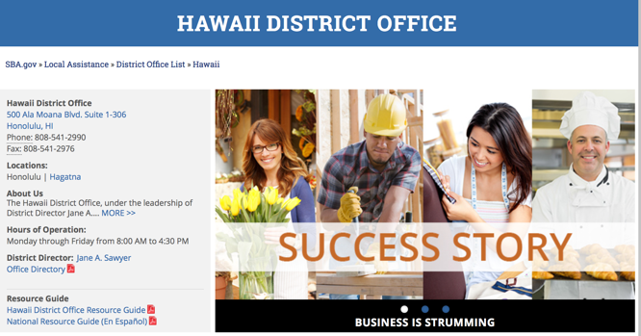

https://www.sba.gov/offices/district/hi/Honolulu

State Department

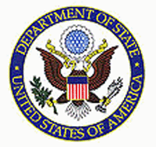

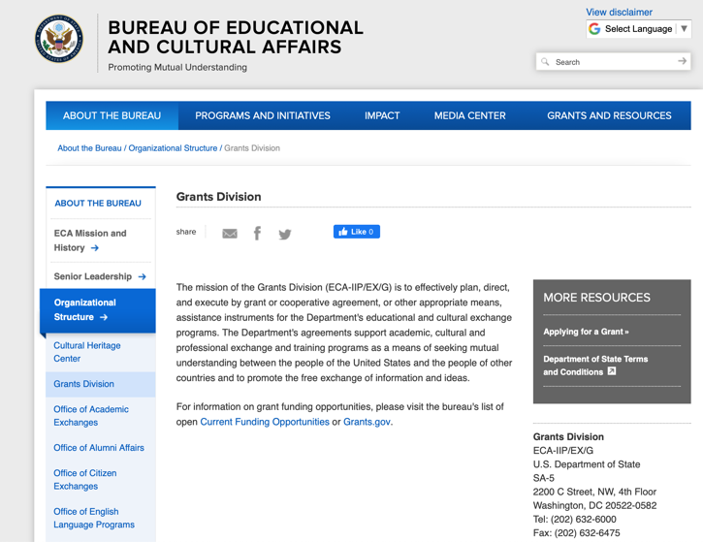

https://eca.state.gov/about-bureau/organizational-structure/grants-division

http://eca.state.gov/search/solr/grants?search_referrer=node/237

https://eca.state.gov/organizational-funding/open-grant-solicitations

http://eca.state.gov/organizational-funding/applying-grant

General Information:
- Bureau of Educational and Cultural Affairs Grants Division
- Open Grant Opportunities (Requests for Grant Proposals)

For General Information click here

Department of Transportation
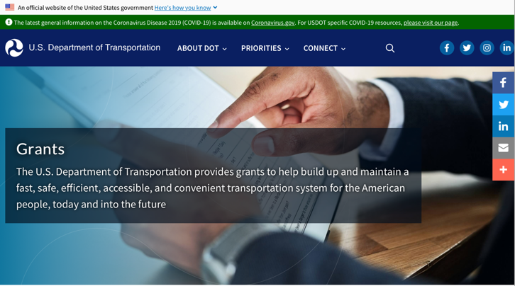
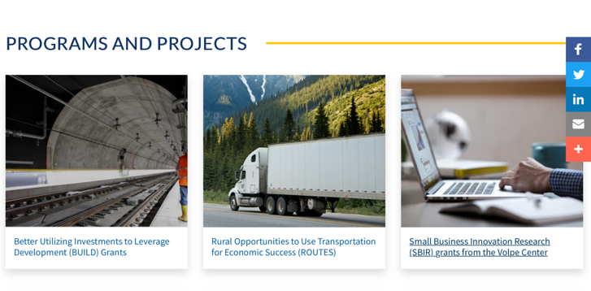
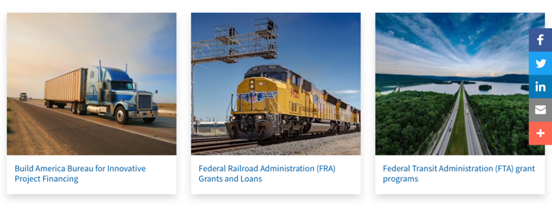
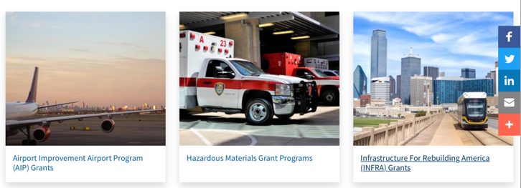


General Grant Program Overview https://www.transportation.gov/grants

Department of the Treasury

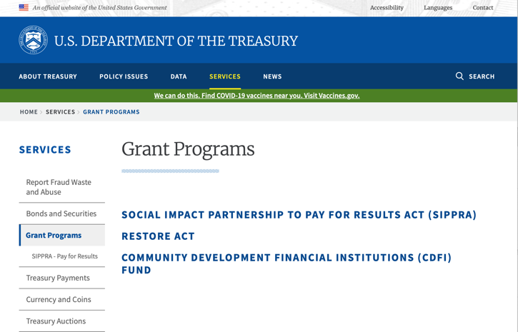

https://home.treasury.gov/services/grant-programs

U.S. Agency for International Development
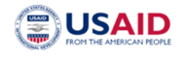
www.usaid.gov

General Overview Funding Opportunities

USAID has working relationships with thousands of American companies and hundreds of U.S.-based private voluntary organizations. For more information on our business and procurement opportunities, please visit our Business section.

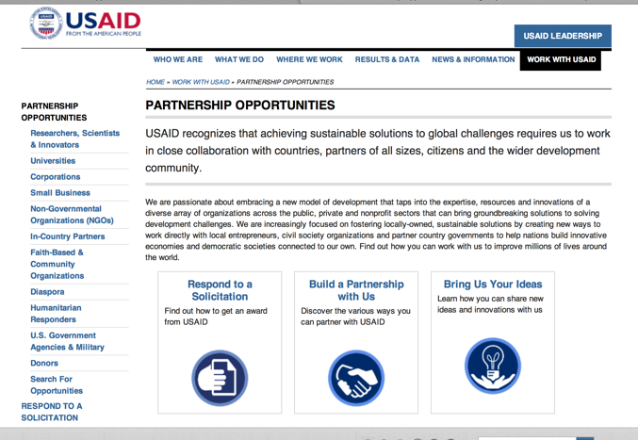

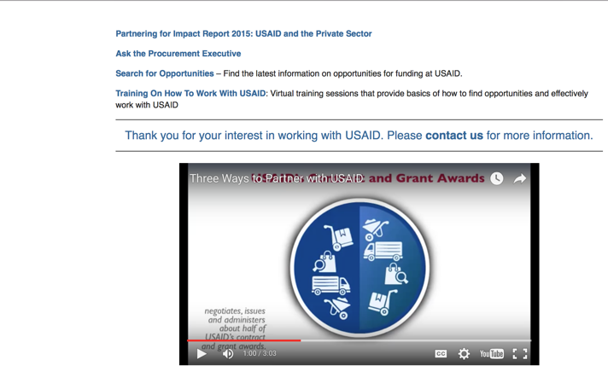

http://www.usaid.gov/partnerships

Department of Veterans Affairs

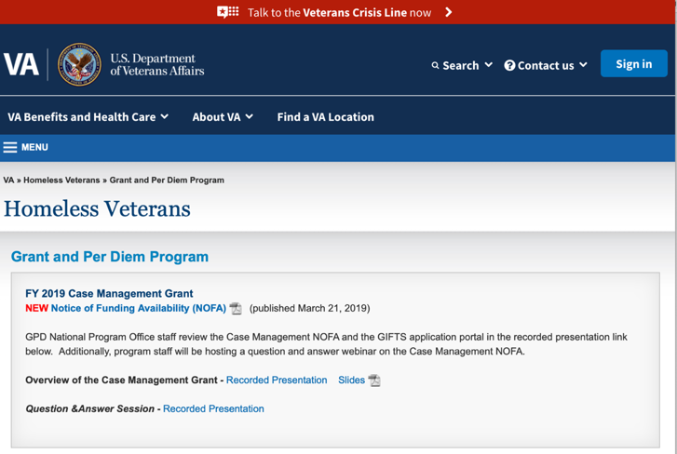

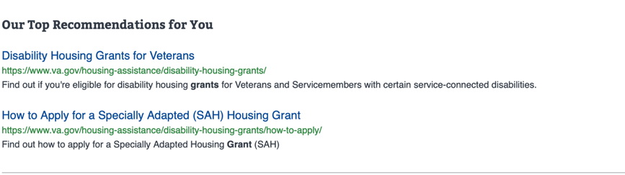

https://www.va.gov/homeless/gpd.asp
GRANTS.GOV

Provides a Grants Learning Center as a gateway to the federal grants world. Bookmark the following link and participate at blog.grants.gov or on twitter @grantsdotgov

Topics include: Grants 101, Grant Policies, Grant Eligibility, Grant Terms, Grant Agencies , Grant Systems, Grant Programs, Grant Careers, Grant Reporting, Grant Fraud and Grant Events

https://www.grants.gov/web/grants/learn-grants.html

Grants.gov maintains a blog. This reprinted article provides some helpful tips:

Grant Writing: 3 Tips for Crafting Need Statements in Federal Grant Proposals
Posted on March 27, 2019 by Grants.gov
In this space, we have previously shared tips about the pre-writing phase of completing a federal grant application – for example, the importance of reading (and re-reading) the grant announcement, and the importance of understanding the criteria by which your application will be evaluated.
In this post, we dip our toes into the grant writing process itself and share some tips about crafting a need statement. These tips are adapted from the U.S. Department of Health and Human Services Health Resources & Services Administration’s grant writing guide, titled “Tips for Writing and Submitting Good Grant Proposals”. Along with each tip, we also include an excerpt from an award-winning federal grant proposal that can be viewed in full on the website of the Institute of Museum and Library Services. (IMLS has an excellent collection of proposals that are worthy of review – especially for new federal grant applicants.)

https://grantsgovprod.wordpress.com/2019/03/27/3-tips-for-crafting-need-statements-in-federal-grant-proposals/?utm_source=newsletter&utm_medium=email&utm_campaign=noprofile&utm_content=june2020

Grant Writing Resources

The following links are a great resource for Faith-Based Non-profits and other community organizations:

U.S. Agency for International Development
Faith Based and Community Organization Work with USAID

Corporation for National Community Service
Faith-Based and Other Community Initiatives

U.S. Department of Justice
Task Force for Faith-Based and Community Initiatives

Foundation Center
Proposal Writing Short Course

U.S. Environmental Protection Agency
General Tips on Writing a Competitive Grant Proposal

Appalachian Regional Commission
How To Write A Grant Proposal

USDA Rural Information Center
A Guide to Funding Resources

The Small Business Innovative Research Program - SBIR Program

The Small Business Innovation Research (SBIR) program is a highly competitive program that encourages domestic small businesses to engage in Federal Research/Research and Development (R/R&D) that has the potential for commercialization. Through a competitive awards-based program, SBIR enables small businesses to explore their technological potential and provides the incentive to profit from its commercialization. By including qualified small businesses in the nation's R&D arena, high-tech innovation is stimulated, and the United States gains entrepreneurial spirit as it meets its specific research and development needs.

SBIR Mission and Program Goals
The mission of the SBIR program is to support scientific excellence and technological innovation through the investment of Federal research funds in critical American priorities to build a strong national economy.
The program’s goals are four-fold:
- Stimulate technological innovation
- Meet Federal research and development needs.
- Foster and encourage participation in innovation and entrepreneurship by socially and economically disadvantaged persons.
- Increase private-sector commercialization of innovations derived from Federal research and development funding.

SBIR-Participating Agencies
Each year, Federal agencies with extramural research and development (R&D) budgets that exceed $100 million are required to allocate 2.5 percent of their R&D budget to these programs. Currently, eleven Federal agencies participate in the program:
- Department of Agriculture
- Department of Commerce - National Institute of Standards and Technology
- Department of Defense
- Department of Energy
- Department of Health and Human Services
- Department of Homeland Security
- Department of Transportation
- Environmental Protection Agency
- National Aeronautics and Space Administration
- National Science Foundation
Each agency administers its own individual program within guidelines established by Congress. These agencies designate R&D topics in their solicitations and accept proposals from small businesses. Awards are made on a competitive basis after proposal evaluation.

Three-Phase Program
The SBIR Program is structured in three phases:
Phase I. The objective of Phase I is to establish the technical merit, feasibility, and commercial potential of the proposed R/R&D efforts and to determine the quality of performance of the small business awardee organization prior to providing further Federal support in Phase II. SBIR Phase I awards normally do not exceed $150,000 total costs for 6 months.
Phase II. The objective of Phase II is to continue the R/R&D efforts initiated in Phase I. Funding is based on the results achieved in Phase I and the scientific and technical merit and commercial potential of the project proposed in Phase II. Only Phase I awardees are eligible for a Phase II award. SBIR Phase II awards normally do not exceed $1,000,000 total costs for 2 years.
Phase III. The objective of Phase III, where appropriate, is for the small business to pursue commercialization objectives resulting from the Phase I/II R/R&D activities. The SBIR program does not fund Phase III. Some Federal agencies, Phase III may involve follow-on non-SBIR funded R&D or production contracts for products, processes or services intended for use by the U.S. Government

