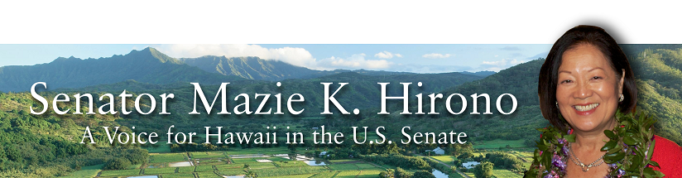
Grants Assistance Information
Newsletter
June 2016

G.A.I.N. INDEX

Click on Index Links below to read summaries of the announcements by agency in this document.
Once you reach the item, if you cannot open the links for further information, copy the selected
URL website address into your browser.

Modified sections from previous listings are shown in a GREY background

Notices is Teal are items with immediate deadline dates.

Notices in Yellow are of special interest.

Notices is Green are items of special interest with immediate deadline dates.

Items in this type color are aimed at Small Businesses

Items in this type color have a Faith-Based Organization component

Special Federal Program Notices

SBIR – Small Business Innovation Research

Programs specific to Hawaii

Current Notices

Reminders

Department of Homeland Security

Department of Homeland Security - FEMA
Fiscal Year (FY) 2016 Cooperating Technical Partners (CTP) Program - Region 9
Modifications 2 & 4

See Individual Departments for information and webpages representing the best and most accessible information on the agency funding opportunities

Federal Grant and Cooperative Agreement Program Summaries

U.S. Department of Agriculture

Grants and Loans Overview

Programs

Utilities Programs
Rural Community Development Initiative Grant

National Institute of Food and Agriculture
AFRI Food Security Challenge Area Grant

National Institute of Food and Agriculture
Agriculture and Food Research Initiative: Water for Agriculture Challenge Area Grant

National Institute of Food and Agriculture
AFRI Childhood Obesity Prevention Challenge Area Grant

National Institute of Food and Agriculture
Agriculture and Food Research Initiative: Foundational Program Grant

National Institute of Food and Agriculture
AFRI Sustainable Bioenergy and Bioproducts RFA Grant

Modifications

Risk Management Agency
Risk Management Education
Crop Insurance Education in Targeted States
Modification 2

Business and Cooperative Programs
Value Added Producer Grant
Modification 1

Risk Management Agency
Risk Management Education
Risk Management Education Partnership Program
Modifications 2 & 3

Reminders

Utilities Programs
Community Connect Grant Program Grant

National Institute of Food and Agriculture
AFRI Food Safety Challenge Area Grant

Business and Cooperative Programs
Rural Cooperative Development Grant

Forest Service
2017 National Urban and Community Forestry Grant Program

Farm Service Agency
Outreach and Education, Technical Assistance, and Financial Education for FSA Programs, Functions, and Activities
Modification 2

Department of Commerce

Programs

National Institute of Standards and Technology
Regional Alliances and Multistakeholder Partnerships to Stimulate (RAMPS) Cybersecurity Education and Workforce Development Grant

Advanced Manufacturing Project Grant

Exporting Project Grant

Research

Modifications

Reminders

FY2016 Regional Innovation Strategies Program Grant

Capital Project Grant

National Institute of Standards and Technology
Embedding MEP in NNMI Institutes Pilot Projects
Modification 1

National Institute of Standards and Technology
Measurement Science and Engineering (MSE) Research Grant Programs

National Sea Grant College Program 2016-17 Special Projects Grant

FY 2016 – FY 2019 EDA Planning Program and Local Technical Assistance Program Grant

FY 2016 Economic Development Assistance Programs ­ Application submission and program requirements for EDA’s Public Works and Economic Adjustment Assistance Programs

Economic Development Administration
Planning Program and Local Technical Assistance Program Grant

Corporation for National and Community Service

General Program Overview

Programs

FY 2016 Training and Technical Assistance – Regional Training Conferences
And Modification 1

Reminders

National Service in Hawaii

Department of Defense

Doing Business with the Department of Defense

DoD Small Business Opportunities and Forecasting

Research Grants

Modifications

Reminders

Dept. of the Army -- Materiel Command
Army Research Office Broad Agency Announcement for Basic and Applied Scientific Research
Modification 8

Department of Education

Grant Programs Overview

Programs

Office of Innovation and Improvement (OII): Charter Schools Program (CSP): Grants for Replication and Expansion of High-Quality Charter Schools CFDA Number 84.282M Grant
And Modification 1

Office of Innovation and Improvement (OII): Teacher Incentive Fund (TIF) CFDA Number 84.374A Grant

Research

Modifications

Reminders

Office of Career, Technical, and Adult Education (OCTAE): Performance Partnership Pilots (P3) CFDA Number 84.420A
Modification 1

Institute of Education Sciences (IES CFDA Number 84.305

US Department of Energy

Grants Overview

Programs

Modifications

Reminders

Cities Leading through Energy Analysis and Planning (Cities-LEAP) Grant

Environmental Protection Agency

Grants and Contracts Overview

Programs

FY 2016 and FY 2017 National Wetland Program Development Grants

Modifications

Reminders

Department of Health and Human Services

Grants Overview

Program

Research Grants

Modifications

Reminders

Department of Homeland Security
Grants Overview

Programs

Office of Procurement Operations - Grants Division
Center of Excellence Criminal Investigations and Network Analysis – Partner Grant

Modifications

Reminders

Department of Homeland Security - FEMA
Fiscal Year (FY) 2016 Cooperating Technical Partners (CTP) Program
Modification 3

Department of Homeland Security - FEMA
FY16 Pre-Disaster Mitigation Grant

Department of Homeland Security - FEMA
FY16 Flood Mitigation Assistance Grant

Department of Housing and Urban Development

HUD - Notice of Funds Available

Programs

HUD Community Compass Technical Assistance and Capacity Building Program Grant

Modifications

Choice Neighborhoods Implementation Grant Program
Modification 2

Technical Correction to the General Section to HUD's Fiscal Year 2016 Notice[s] of Funding Availability for Discretionary Programs
Modification 1

Reminders

Fair Housing Initiative Program - Education and Outreach Initiative Grant

Jobs Plus Initiative Grant

Fair Housing Initiatives Program - Private Enforcement Initiative Grant

Resident Opportunity & Self-Sufficiency Program Grant

General Section to HUD's Fiscal Year 2016 Notice[s] of Funding Availability for Discretionary Programs (General Section)
Modification 1

Institute of Museum and Library Services

Grants Overview

IMLS is on Facebook!

Modifications

Reminders

Department of Interior

Grants and Contract Overview

Programs

National Park Service
Historic Preservation Fund Grants to Underrepresented Communities
And Modification 1

National Park Service
National Maritime Heritage Grant Program
And Modification 1

Geological Survey
FY 2017 National Climate Change & Wildlife Science Center Program Grant

Modifications

Reminders

Fish and Wildlife Service
Fiscal Year 2016 Recovery Implementation Fund Grant

Fish and Wildlife Service
National Fish Passage Program Grant

Fish and Wildlife Service
Fiscal Year 2016 Candidate Conservation Action Funds Grant

Department of Justice

Grants and Contract Overview

Programs

Office of Justice Programs
Office for Victims of Crime
OVC FY 16 A Pathway to Justice, Healing and Hope: Addressing Polyvictimization in a Family Justice Center Setting Demonstration Initiative Grant

Research

Office of Justice Programs
Office of Juvenile Justice Delinquency Prevention
OJJDP FY 2016 Studies Program on Trauma and Justice-Involved Youth
And Modification 3

Modifications

Office of Justice Programs
Office for Victims of Crime
OVC FY 16 Vision 21: Multidisciplinary Responses to Families and Communities in Complex Homicide Cases
Modification 1

Reminders

Office of Justice Programs
Office of Juvenile Justice Delinquency Prevention
OJJDP FY 16 Safe and Thriving Communities: Uniting Community Based Violence Prevention, Defending Childhood and National Forum Approaches to Prevent and Heal Violence Grant

Office of Justice Programs
Bureau of Justice Assistance
Smart Reentry: Focus on Evidence-Based Strategies for Successful Reentry from Incarceration to Community Grant

Department of Labor

Grants and Contract General Overview

Programs

Employment and Training Administration
YouthBuild Grant

Modifications

Occupational Safety and Health Administration
Susan Harwood Training Grant, FY 2016, (Targeted Topics)
Modification 1

Occupational Safety and Health Administration
Susan Harwood Training Grant Program, FY 2016 (Capacity Building)
Modification 1

National Aeronautics and Space Administration

Research Grant and Contract General Overview

Programs

Modifications

_______________________________________________________________
National Archives and Records Administration

Grant Opportunities General Overview

Reminders

State Board Programming Grants

Publishing Historical Records in Documentary Editions Grant

Access to Historical Records Grant

_______________________________________________________________
National Endowment for the Arts

Grant Opportunities General Overview

Programs

NEA FY 2017 Art Works II Application Grant

Our Town FY 17 Grant

NEA Research Labs, FY2016 Grant

Modifications

Reminders

_______________________________________________________________

National Endowment for the Humanities

Grant Opportunities General Overview

Programs

Summer Stipends Grant

Humanities Collections and Reference Resources Grant

Fellowship Programs at Independent Research Institutions Grant

Modifications

Reminders

Humanities Connections Grant

Research and Development Grant

Common Heritage Grant

Humanities Open Book Program Grant

Digital Projects for the Public Grant

National Science Foundation

Grant Opportunities General Overview

Research and Program Grants

Modifications

Reminders

Nuclear Regulatory Commission

Reminders

Small Business Administration

General Overview Finding Loans & Grants

Programs

Service-Disabled Veteran Entrepreneurship Training Program Grant

Reminders

Upcoming Trainings

Links Specific to Hawaii

State Department

General Overview and Resources for Program Administrators

Programs

Modifications

Reminders

U.S. Department of Transportation

General Grant Program Overview

Programs

DOT/Federal Transit Administration
Mobility on Demand (MOD) Sandbox Program Grant

DOT Federal Highway Administration
2016 Work Zone and Guardrail Safety Training Grants

Modifications

Reminders

Pipeline &Hazardous Material Safety Administration
Pipeline Safety Research Competitive Academic Agreement Program (CAAP) 2016 Grant

DOT Federal Aviation Administration
DOT - FAA Aviation Research Grants
FAA Aviation Research and Development Grants
Modification 3

Department of the Treasury

Programs

Modifications

Reminders

Low Income Taxpayer Clinic (LITC)
Modification 2

US Agency for International Development

General Funding Opportunity Overview

Programs
Modifications

Department of Veterans Affairs

Homeless Providers Grant and Per Diem Program
VA Grant and Per Diem Program Special Need Renewal Grant

Special Federal Program Notices

The Small Business Innovative Research Program - SBIR Program
The Small Business Innovation Research (SBIR) program is a highly competitive program that encourages domestic small businesses to engage in Federal Research/Research and Development (R/R&D) that has the potential for commercialization. Through a competitive awards-based program, SBIR enables small businesses to explore their technological potential and provides the incentive to profit from its commercialization. By including qualified small businesses in the nation's R&D arena, high-tech innovation is stimulated and the United States gains entrepreneurial spirit as it meets its specific research and development needs.

SBIR Mission and Program Goals
The mission of the SBIR program is to support scientific excellence and technological innovation through the investment of Federal research funds in critical American priorities to build a strong national economy.
The program’s goals are four-fold:
- Stimulate technological innovation
- Meet Federal research and development needs.
- Foster and encourage participation in innovation and entrepreneurship by socially and economically disadvantaged persons.
- Increase private-sector commercialization of innovations derived from Federal research and development funding.

SBIR-Participating Agencies
Each year, Federal agencies with extramural research and development (R&D) budgets that exceed $100 million are required to allocate 2.5 percent of their R&D budget to these programs. Currently, eleven Federal agencies participate in the program:
- Department of Agriculture
- Department of Commerce - National Institute of Standards and Technology
- Department of Commerce - National Oceanic and Atmospheric Administration
- Department of Defense
- Department of Education
- Department of Energy
- Department of Health and Human Services
- Department of Homeland Security
- Department of Transportation
- Environmental Protection Agency
- National Aeronautics and Space Administration
- National Science Foundation
Each agency administers its own individual program within guidelines established by Congress. These agencies designate R&D topics in their solicitations and accept proposals from small businesses. Awards are made on a competitive basis after proposal evaluation.

Three-Phase Program
The SBIR Program is structured in three phases:
Phase I. The objective of Phase I is to establish the technical merit, feasibility, and commercial potential of the proposed R/R&D efforts and to determine the quality of performance of the small business awardee organization prior to providing further Federal support in Phase II. SBIR Phase I awards normally do not exceed $150,000 total costs for 6 months.
Phase II. The objective of Phase II is to continue the R/R&D efforts initiated in Phase I. Funding is based on the results achieved in Phase I and the scientific and technical merit and commercial potential of the project proposed in Phase II. Only Phase I awardees are eligible for a Phase II award. SBIR Phase II awards normally do not exceed $1,000,000 total costs for 2 years.
Phase III. The objective of Phase III, where appropriate, is for the small business to pursue commercialization objectives resulting from the Phase I/II R/R&D activities. The SBIR program does not fund Phase III. Some Federal agencies, Phase III may involve follow-on non-SBIR funded R&D or production contracts for products, processes or services intended for use by the U.S. Government
SBIR NewsLetter

- SBIR Newsletter
Sign up for e-mail updates

HAWAII APPLICANTS ENCOURAGED

Current Notices:

Reminders:

Department of Homeland Security

Department of Homeland Security - FEMA
Fiscal Year (FY) 2016 Cooperating Technical Partners (CTP) Program - Region 9
Modifications 2 & 4

Document Type: | Grants Notice
Funding Opportunity Number: | DHS-16-MT-045-09-01
Funding Opportunity Title: | Fiscal Year (FY) 2016 Cooperating Technical Partners (CTP) Program - Region 9
Opportunity Category: | Discretionary
Opportunity Category Explanation:
Funding Instrument Type: | Cooperative Agreement
Category of Funding Activity: | Science and Technology and other Research and Development
Category Explanation:
Expected Number of Awards: | 14
CFDA Number(s): | 97.045 -- Cooperating Technical Partners
Cost Sharing or Matching Requirement: | No
Posted Date: | Mar 25, 2016
Last Updated Date: | Mar 31, 2016
Original Closing Date for Applications: | Jun 10, 2016
Current Closing Date for Applications: | Jun 10, 2016
Archive Date: | Jul 10, 2016
Estimated Total Program Funding: | $5,100,000
Eligible Applicants: | Special district governments  Nonprofits having a 501(c)(3) status with the IRS, other than institutions of higher education  County governments  Native American tribal governments (Federally recognized)  City or township governments  Public and State controlled institutions of higher education  State governments  Others (see text field entitled "Additional Information on Eligibility" for clarification)
Additional Information on Eligibility: | As approved by FEMA HQ
Agency Name: | Department of Homeland Security - FEMA
Description: | "The Cooperating Technical Partners Program (CTP Program) exists to strengthen and increase the effectiveness of the National Flood Insurance Program (NFIP) through fostering strong Federal, State, Tribal, regional and local partnerships for the purposes of reducing flood losses and promoting community resiliency. The CTP Program may provide federal assistance, through a grant or cooperative agreement, to an eligible Cooperating Technical Partner (herein referred to as CTP, partner, or grantee) to perform various projects and activities that stimulate and support the ability of NFIP State Coordinating Agencies and NFIP-participating communities (as defined in 44 CFR Part 59.1) to continue their ongoing regulatory NFIP responsibilities as well as support the ability of States, communities and the public and private sector to mitigate flood risk. The CTP Program seeks to enhance the existing capabilities of CTPs to increase local involvement in, and ownership of, the development and maintenance of flood risk data and products, such as the Flood Insurance Rate Maps (FIRMs) and other risk related products, as well as other support to advance the goals and objectives of the Risk Mapping Assessment and Planning (Risk MAP) program. Partnerships developed through FEMA¿s CTP Program are in the best interest of State and local communities, the NFIP and the public. CTPs may be able to perform activities related to program management, technical risk analysis and mapping, and communication of flood risk hazard data and information. Only qualified partners of the CTP Program are eligible for federal assistance awards through the CTP Program. Recipients must: be a CTP (i.e., have a signed Partnership Agreement with FEMA HQ or a FEMA Regional Office); ¿ either be or represent a National Flood Insurance Program (NFIP) community in good-standing, or a FEMA-approved non-profit agency whose primary mission supports the goals and objectives of the NFIP; ¿ have existing non-Federally funded processes and/or systems in place to support the collection, development, evaluation, dissemination and communication of flood hazard and risk assessment data and mapping;¿ have the capability to perform funded activities; demonstrate the ability to achieve the CTP Program performance metrics and provide timely and accurate reports to FEMA documenting performance and achievements; and¿ when applicable, agree to perform work in the Mapping Information Platform (MIP) and update the activities within the MIP every 30 days in the Studies Workflow (and more frequently within the Revisions Workflow).CTPs need to work with FEMA in advance of the application to understand FEMA program priorities, objectives and measures, and to identify specific tasks to undertake. In support of program objectives, FEMA may provide technical assistance, training, and/or data to a CTP to enhance the activities within the project categories. Any funds FEMA provides through a grant or cooperative agreement to complete project activities are in addition to the leveraged resources and data which may be provided by the CTP to complete the tasks agreed upon. When awarded a grant or cooperative agreement through the CTP Program in support of program objectives and to advance program measures, the CTP must comply with the requirements outlined in the announcement, the terms and conditions of the award, as well as the Partnership Agreement and the associated Statement of Work or Mapping Activity Statement approved by FEMA. These templates may be obtained from your granting organization, either the FEMA Region or FEMA Headquarters."
Link to Additional Information:
Contact Information: | If you have difficulty accessing the full announcement electronically, please contact:  System Branch  GMD-Systems-Branch@fema.gov

http://www.grants.gov/web/grants/view-opportunity.html?oppId=282551

Reminders:

Please review each department’s General Grant and Funding Overview. These overviews are the key web pages on each departmental website dedicated to the agency’s funding opportunities. Check back often to note the department updates and use these sources to assist you in your planning.

Federal Grant and Cooperative Agreement Program Summaries

U.S. Department of Agriculture



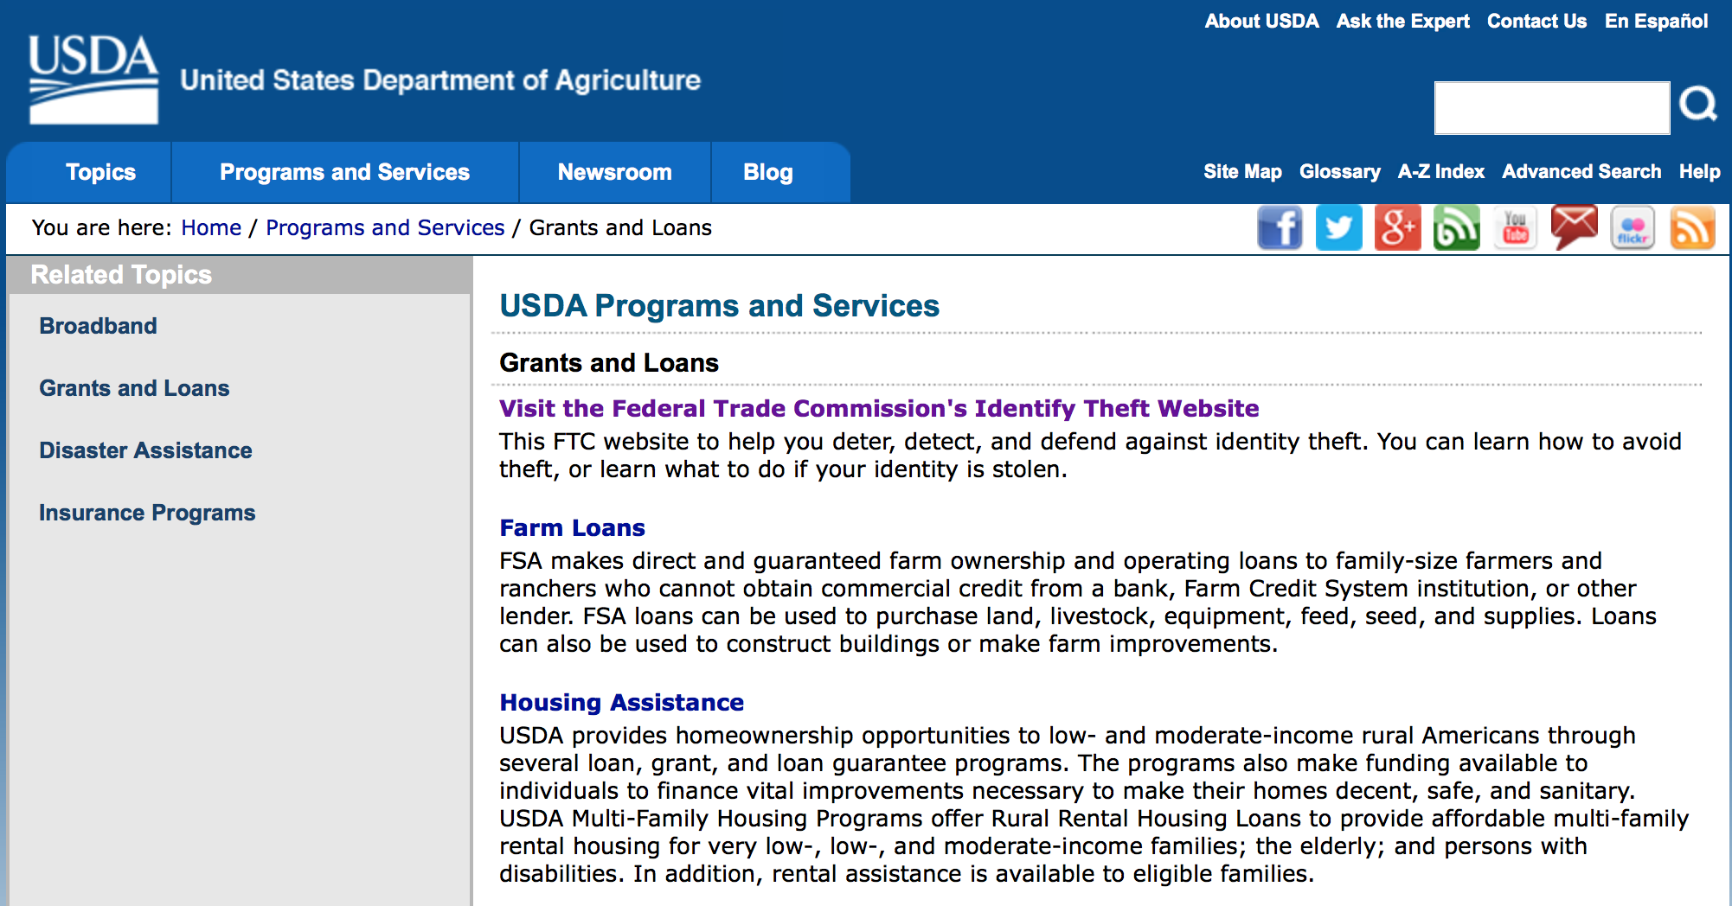
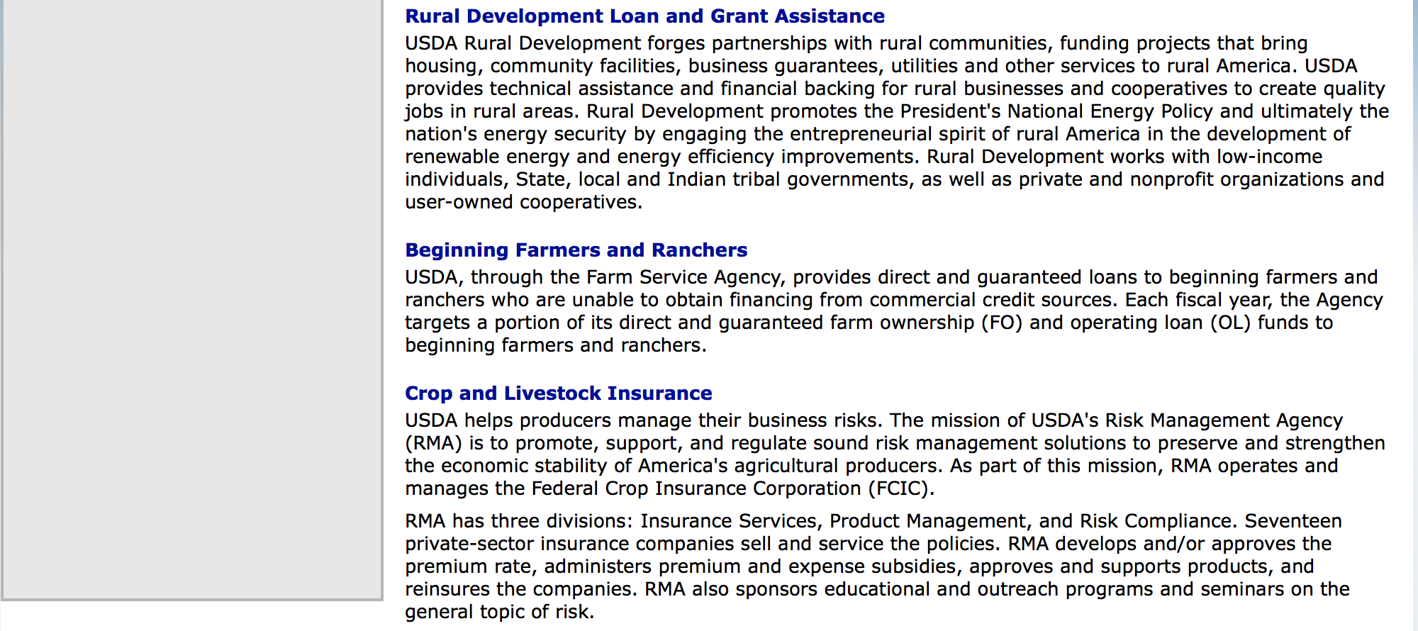

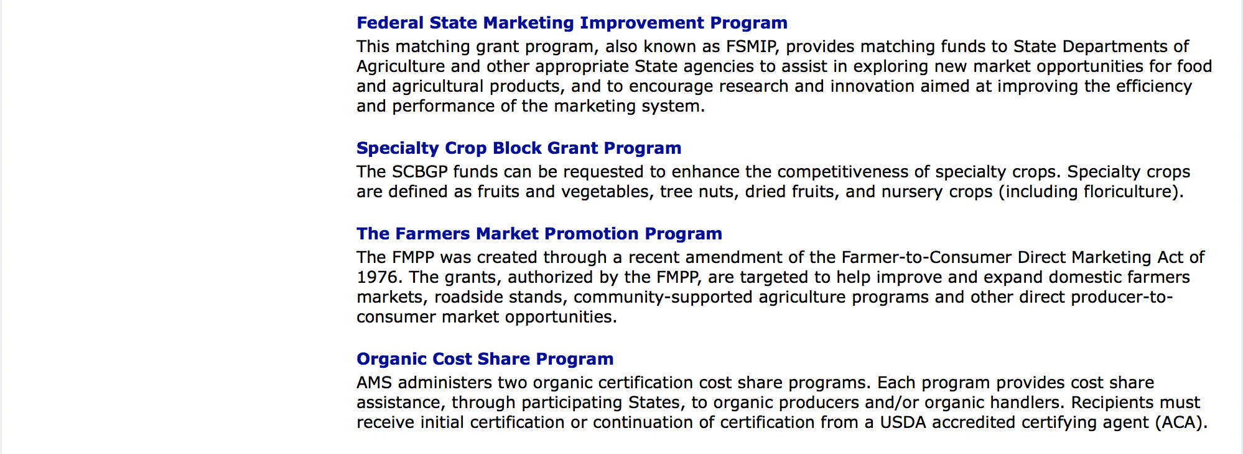

http://usda.gov/wps/portal/usda/usdahome?navid=GRANTS_LOANS

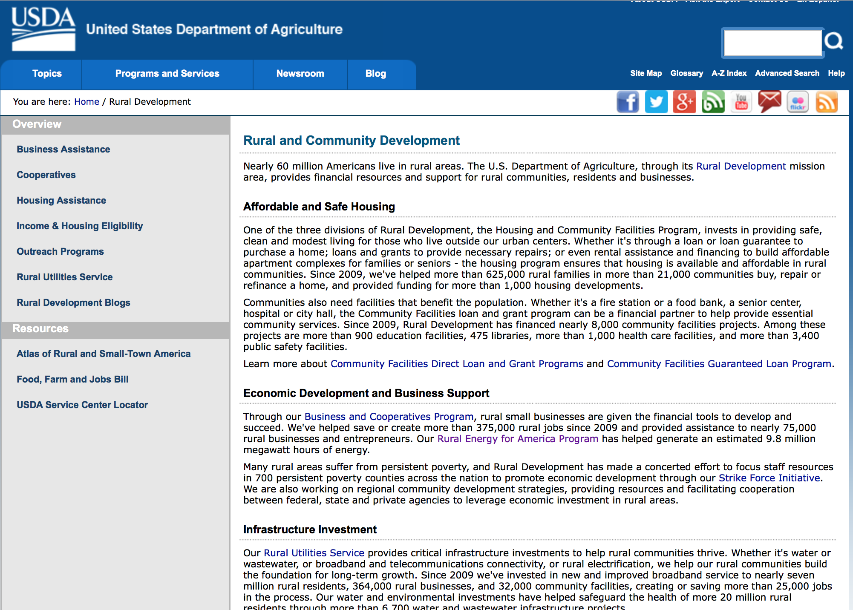

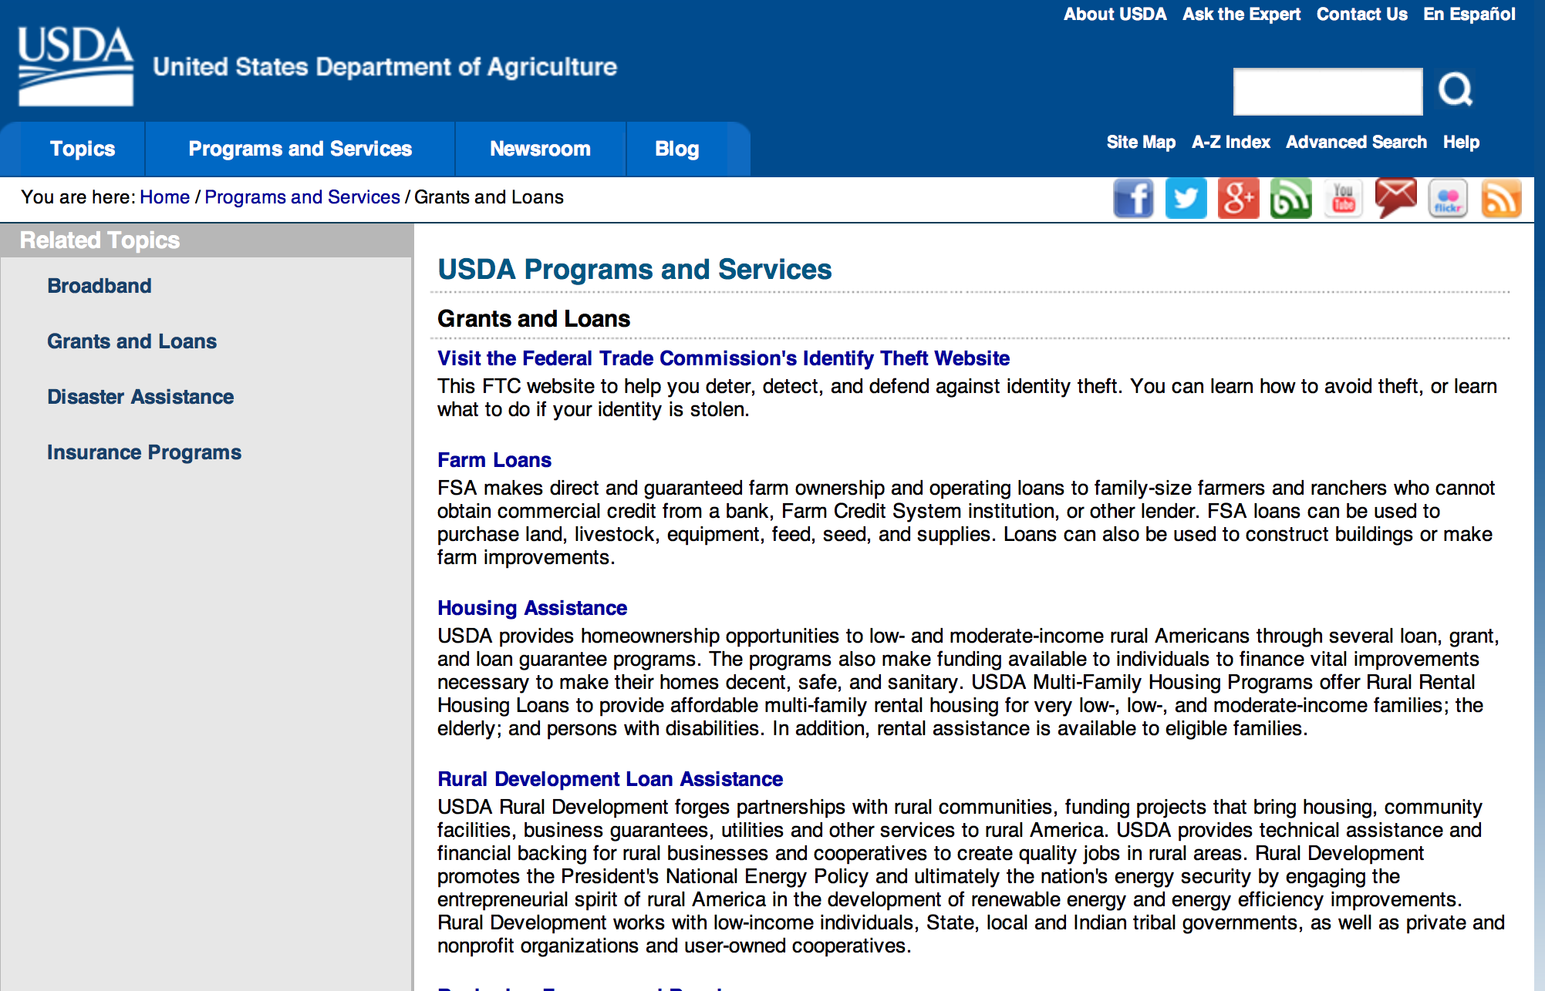

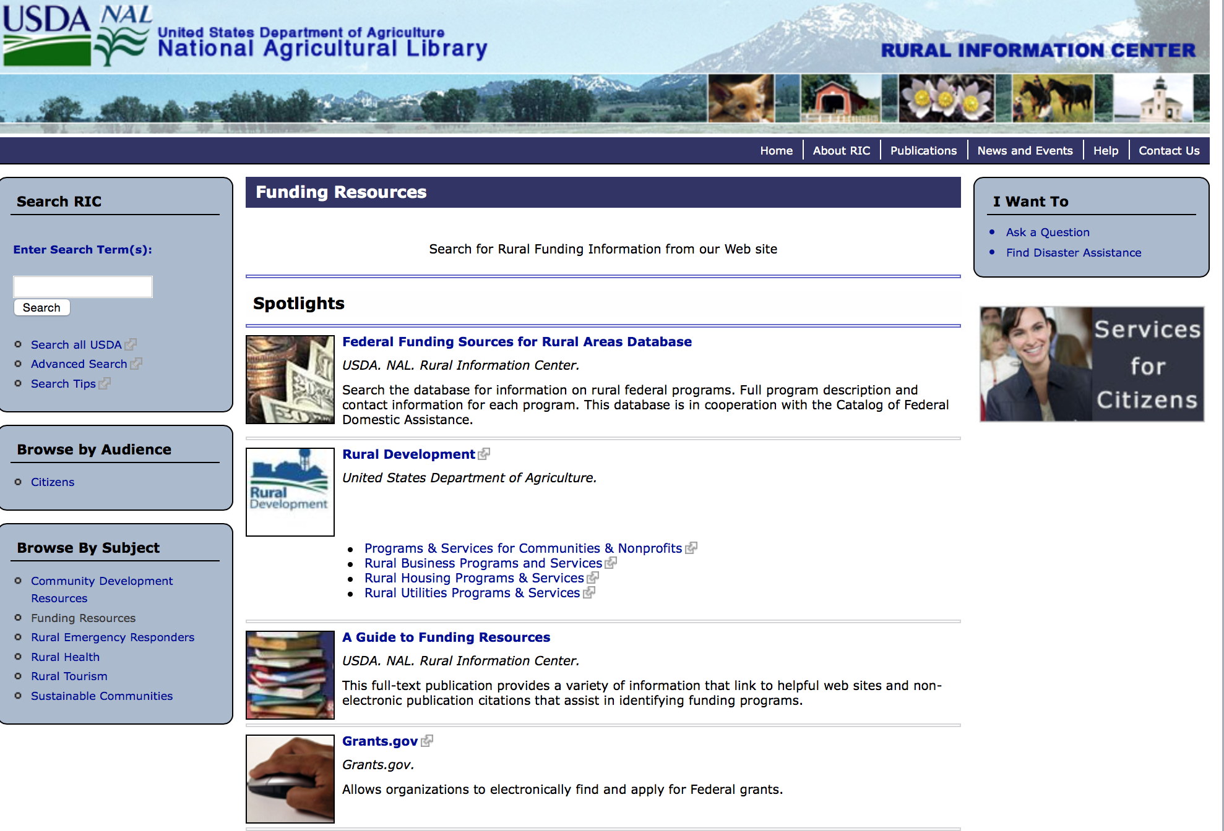

Federal Faith-Based Centers and Community Initiatives
USDA. NAL. Rural Information Center.
- Center for Faith-Based and Community Initiatives (link is external) , U.S. Department of Education
- Center for Faith-Based and Community Initiatives (link is external) , U.S. Department of Health and Human Services
- Center for Faith-Based and Community Initiatives (link is external) , U.S. Department of Labor
- Faith-Based and Community Initiatives (link is external) , U.S. Agency for International Development
- Faith-Based and Community Initiatives (link is external) , U.S. Department of Agriculture
- Faith-Based and Community Initiatives (link is external) , U.S. Department of Housing and Urban Development
- Faith-Based and Other Community Initiatives (link is external) , Corporation for National Community Service
- Task Force for Faith-Based and Community Initiatives (link is external) , U.S. Department of Justice

Grant Writing Resources
- Proposal Writing Short Course (link is external) Foundation Center.
- Data Universal Numbering System Fact sheet (link is external) [PDF | 302.2KB] USDA Rural Development.
- General Tips on Writing a Competitive Grant Proposal (link is external) U.S. Environmental Protection Agency.
- How to Write a Grant Proposal (link is external) Appalachian Regional Commission. <. li>

A Guide to Funding Resources USDA Rural Information Center.

http://ric.nal.usda.gov/funding-resources

http://usda.gov/wps/portal/usda/usdahome?navid=GRANTS_LOANS

Programs:

Utilities Programs
Rural Community Development Initiative Grant

Document Type: | Grants Notice
Funding Opportunity Number: | USDA-RD-HCFP-RCDI-2016
Funding Opportunity Title: | Rural Community Development Initiative
Opportunity Category: | Discretionary
Opportunity Category Explanation:
Funding Instrument Type: | Grant
Category of Funding Activity: | Agriculture  Community Development
Category Explanation:
Expected Number of Awards: | 25
CFDA Number(s): | 10.446 -- Rural Community Development Initiative
Cost Sharing or Matching Requirement: | Yes
Posted Date: | May 26, 2016
Last Updated Date: | May 26, 2016
Original Closing Date for Applications: | Jul 22, 2016
Current Closing Date for Applications: | Jul 22, 2016
Archive Date: | Aug 21, 2016
Estimated Total Program Funding: | $4,000,000
Award Ceiling: | $250,000
Award Floor: | $50,000
Eligible Applicants: | Native American tribal governments (Federally recognized)  Private institutions of higher education  Independent school districts  Nonprofits that do not have a 501(c)(3) status with the IRS, other than institutions of higher education  Special district governments  County governments  Public and State controlled institutions of higher education  For profit organizations other than small businesses  Public housing authorities/Indian housing authorities  City or township governments  State governments  Small businesses
Additional Information on Eligibility: | The Intermediary will be required to provide matching funds in an amount at least equal to the RCDI grant. The respective minimum and maximum grant amount per Intermediary is $50,000.00 and $250,000.00. The Recipient and Beneficiary, but not the Intermediary, must be located in a city or town that has a population of 50,000 or less inhabitants.
Agency Name: | Utilities Programs
Description: | Qualified private, nonprofit and public including tribal intermediary organizations proposing to carry out financial and technical assistance programs will be eligible to receive the funding. The Intermediary will be required to provide matching funds in an amount at least equal to the RCDI grant. The respective minimum and maximum grant amount per Intermediary is $50,000 and $250,000. The Intermediary must provide a program of financial and technical assistance to recipients to develop their capacity and ability to undertake projects related to housing, community facilities, or community and economic development that will support the community.
Link to Additional Information: | FY2016 RCDI NOFA
Contact Information: | If you have difficulty accessing the full announcement electronically, please contact:  Shirley Stevenson Community Programs Specialist 202 205-9685  Email contact for Shirley Stevenson

http://www.grants.gov/web/grants/view-opportunity.html?oppId=284154

National Institute of Food and Agriculture
AFRI Food Security Challenge Area Grant

Document Type: | Grants Notice
Funding Opportunity Number: | USDA-NIFA-AFRI-005823
Funding Opportunity Title: | AFRI Food Security Challenge Area
Opportunity Category: | Discretionary
Opportunity Category Explanation:
Funding Instrument Type: | Grant
Category of Funding Activity: | Agriculture
Category Explanation:
Expected Number of Awards:
CFDA Number(s): | 10.310 -- Agriculture and Food Research Initiative (AFRI)
Cost Sharing or Matching Requirement: | No
Posted Date: | May 03, 2016
Last Updated Date: | May 03, 2016
Original Closing Date for Applications: | Jul 07, 2016
Current Closing Date for Applications: | Jul 07, 2016
Archive Date: | Aug 06, 2016
Estimated Total Program Funding: | $16,800,000
Eligible Applicants: | Others (see text field entitled "Additional Information on Eligibility" for clarification)
Additional Information on Eligibility: | See Part III, A., Eligible Applicants. Eligibility is linked to the project type. All project types are described beginning in Part II, C.
Agency Name: | National Institute of Food and Agriculture
Description: | The AFRI Food Security Challenge Area focuses on the societal challenge to keep American agriculture competitive and end world hunger by ensuring the availability and accessibility of safe and nutritious food. The long-term goal of the AFRI Food Security Challenge Area is to sustainably increase agricultural productivity and the availability and accessibility of safe and nutritious food. Project types supported within this Challenge Area will propose multi-function Integrated Research, Education, and/or Extension Projects, Food and Agricultural Science Enhancement (FASE) Grants, and conferences and/or workshops.
Link to Additional Information: | AFRI Food Security Challenge Area
Contact Information: | If you have difficulty accessing the full announcement electronically, please contact:  NIFA Help Desk Phone: 202-401-5048 Business hours are M-F, 7:00 am -5:00 pm ET, excluding Federal holidays  If you have any questions related to preparing application content

http://www.grants.gov/web/grants/view-opportunity.html?oppId=283456

National Institute of Food and Agriculture
Agriculture and Food Research Initiative: Water for Agriculture Challenge Area Grant

Document Type: | Grants Notice
Funding Opportunity Number: | USDA-NIFA-AFRI-005822
Funding Opportunity Title: | Agriculture and Food Research Initiative: Water for Agriculture Challenge Area
Opportunity Category: | Discretionary
Opportunity Category Explanation:
Funding Instrument Type: | Grant
Category of Funding Activity: | Agriculture  Environment  Natural Resources
Category Explanation:
Expected Number of Awards:
CFDA Number(s): | 10.310 -- Agriculture and Food Research Initiative (AFRI)
Cost Sharing or Matching Requirement: | Yes
Posted Date: | May 05, 2016
Last Updated Date: | May 05, 2016
Original Closing Date for Applications: | Aug 04, 2016
Current Closing Date for Applications: | Aug 04, 2016
Archive Date: | Sep 03, 2016
Estimated Total Program Funding: | $10,700,000
Eligible Applicants: | Others (see text field entitled "Additional Information on Eligibility" for clarification)
Additional Information on Eligibility: | See Part III, Eligibility Information in the RFA. Applications may only be submitted by eligible entities. Eligibility is linked to the project type. All project types are described beginning in Part II, C. in the RFA.
Agency Name: | National Institute of Food and Agriculture
Description: | This AFRI Challenge Area addresses critical water resources issues such as drought, excess soil moisture, flooding, quality and others in an agricultural context. Funding will be used to develop management practices, technologies, and tools for farmers, ranchers, forest owners and managers, public decision makers, public and private managers, and citizens to improve water resource quantity and quality. The long-term goal of the AFRI Water for Agriculture Challenge Area is to tackle critical water issues by developing both regional systems for the sustainable use and reuse, flow and management of water, and at the watershed and farm scales, water issues focused on production and environmental sustainability efforts. Project types supported within this Challenge area are multi-function Integrated Research, Education, and/or Extension Projects and Food and Agricultural Enhancement (FASE) Grants.
Link to Additional Information: | Agriculture and Food Research Initiative - Water for Agriculture Challenge Area
Contact Information: | If you have difficulty accessing the full announcement electronically, please contact:  NIFA Help Desk Phone: 202-401-5048 Business hours are M-F, 7:00 am -5:00 pm ET, excluding Federal holidays  If you have any questions related to preparing application content

http://www.grants.gov/web/grants/view-opportunity.html?oppId=283569

National Institute of Food and Agriculture
AFRI Childhood Obesity Prevention Challenge Area Grant

Document Type: | Grants Notice
Funding Opportunity Number: | USDA-NIFA-AFRI-005845
Funding Opportunity Title: | AFRI Childhood Obesity Prevention Challenge Area
Opportunity Category: | Discretionary
Opportunity Category Explanation:
Funding Instrument Type: | Grant
Category of Funding Activity: | Agriculture  Food and Nutrition  Health
Category Explanation:
Expected Number of Awards:
CFDA Number(s): | 10.310 -- Agriculture and Food Research Initiative (AFRI)
Cost Sharing or Matching Requirement: | Yes
Posted Date: | May 19, 2016
Last Updated Date: | May 19, 2016
Original Closing Date for Applications: | Aug 04, 2016
Current Closing Date for Applications: | Aug 04, 2016
Archive Date: | Sep 03, 2016
Estimated Total Program Funding: | $7,000,000
Eligible Applicants: | Others (see text field entitled "Additional Information on Eligibility" for clarification)
Additional Information on Eligibility: | Applications may only be submitted by eligible entities. Eligibility is linked to the project type. All project types are described beginning in Part II, C. See Part III, A. Eligible Applicants for details.
Agency Name: | National Institute of Food and Agriculture
Description: | This Challenge Area focuses on the societal challenge to end obesity among children, the number one nutrition-related problem in the US. Food is an integral part of the process that leads to obesity and USDA has a unique responsibility for the food system in the United States. This program is designed to achieve the long-term outcome of reducing the prevalence of overweight and obesity among children and adolescents 2-19 years. The AFRI Childhood Obesity Prevention program supports multi-function Integrated Research, Education, and/or Extension Projects and Food and Agricultural Science Enhancement (FASE) Grants.
Link to Additional Information: | Agriculture and Food Research Initiative - Childhood Obesity Prevention Challenge Area
Contact Information: | If you have difficulty accessing the full announcement electronically, please contact:  NIFA Help Desk Phone: 202-401-5048 Business hours are M-F, 7:00 am -5:00 pm ET, excluding Federal holidays  If you have any questions related to preparing application content

http://www.grants.gov/web/grants/view-opportunity.html?oppId=283990

National Institute of Food and Agriculture
Agriculture and Food Research Initiative: Foundational Program Grant
And Modifications 1 & 2

Document Type: | Grants Notice
Funding Opportunity Number: | USDA-NIFA-AFRI-005843
Funding Opportunity Title: | Agriculture and Food Research Initiative: Foundational Program
Opportunity Category: | Discretionary
Opportunity Category Explanation:
Funding Instrument Type: | Grant
Category of Funding Activity: | Agriculture
Category Explanation:
Expected Number of Awards:
CFDA Number(s): | 10.310 -- Agriculture and Food Research Initiative (AFRI)
Cost Sharing or Matching Requirement: | No
Posted Date: | May 13, 2016
Last Updated Date: | May 23, 2016
Original Closing Date for Applications: | Sep 30, 2016 See Program Area Priority for additional information.
Current Closing Date for Applications: | Aug 31, 2016 See Program Area Priority for additional information.
Archive Date: | Sep 30, 2016
Estimated Total Program Funding: | $130,000,000
Eligible Applicants: | Others (see text field entitled "Additional Information on Eligibility" for clarification)
Additional Information on Eligibility: | See Part III, A., Eligible Applicants. Eligibility is linked to the project type. All project types are described beginning in Part II, C.
Agency Name: | National Institute of Food and Agriculture
Description: | The AFRI Foundational Program is offered to support grants in the six AFRI priority areas to continue building a foundation of knowledge critical for solving current and future societal challenges. The six priority areas are: Plant Health and Production and Plant Products; Animal Health and Production and Animal Products; Food Safety, Nutrition, and Health; Bioenergy, Natural Resources, and Environment; Agriculture Systems and Technology; and Agriculture Economics and Rural Communities. Single-function Research Projects, multi-function Integrated Projects, and Food and Agricultural Science Enhancement (FASE) Grants are expected to address one of the Program Area Priorities (see Foundational Program RFA for details).
Link to Additional Information: | AFRI Foundational Program
Contact Information: | If you have difficulty accessing the full announcement electronically, please contact:  NIFA Help Desk Phone: 202-401-5048 Business hours are M-F, 7:00 am - 5:00 pm ET, excluding Federal holidays  If you have any questions related to preparing application content

http://www.grants.gov/web/grants/view-opportunity.html?oppId=283836

National Institute of Food and Agriculture
AFRI Sustainable Bioenergy and Bioproducts RFA Grant

Document Type: | Grants Notice
Funding Opportunity Number: | USDA-NIFA-AFRI-005460
Funding Opportunity Title: | AFRI Sustainable Bioenergy and Bioproducts RFA
Opportunity Category: | Discretionary
Opportunity Category Explanation:
Funding Instrument Type: | Grant
Category of Funding Activity: | Agriculture  Energy  Natural Resources
Category Explanation:
Expected Number of Awards:
CFDA Number(s): | 10.310 -- Agriculture and Food Research Initiative (AFRI)
Cost Sharing or Matching Requirement: | Yes
Posted Date: | May 13, 2016
Last Updated Date: | May 13, 2016
Original Closing Date for Applications: | Sep 22, 2016 1.The Letter of intent must be received at NIFA by 5:00 p.m. Eastern Time on the dates indicated in the Program Area Descriptions beginning in Part I, C and in the format specified in Part IV, A. 2.Applications must be received by Grants.gov by 5:00 p.m. Eastern Time on the dates indicated in the Program Area Descriptions beginning in Part I, C.
Current Closing Date for Applications: | Sep 22, 2016 1.The Letter of intent must be received at NIFA by 5:00 p.m. Eastern Time on the dates indicated in the Program Area Descriptions beginning in Part I, C and in the format specified in Part IV, A. 2.Applications must be received by Grants.gov by 5:00 p.m. Eastern Time on the dates indicated in the Program Area Descriptions beginning in Part I, C.
Archive Date: | Oct 22, 2016
Estimated Total Program Funding: | $21,000,000
Eligible Applicants: | Others (see text field entitled "Additional Information on Eligibility" for clarification)
Additional Information on Eligibility: | Applications may only be submitted by eligible entities. Eligibility is linked to the project type. All project types are described beginning in Part II, C. See Part III, A. Eligibility Information for details.
Agency Name: | National Institute of Food and Agriculture
Description: | In the Agriculture and Food Research Initiative Sustainable Bioenergy and Bioproducts (SBEBP) Challenge Area specific program areas are designed to achieve the long term outcome of reducing the national dependence on foreign oil through the development and production of regionally-appropriate sustainable bioenergy systems that materially deliver advanced liquid transportation biofuels, biopower, and bioproducts.
Link to Additional Information: | Agriculture and Food Research Initiative Sustainable Bioenergy and Bioproducts (SBEBP) Challenge Area
Contact Information: | If you have difficulty accessing the full announcement electronically, please contact:  NIFA Help Desk Phone: 202-401-5048 Business hours are M-F, 7:00 am -5:00 pm ET, excluding Federal holidays  If you have any questions related to preparing application content

http://www.grants.gov/web/grants/view-opportunity.html?oppId=283812

Modifications:

Risk Management Agency
Risk Management Education
Crop Insurance Education in Targeted States
Modification 2

Document Type: |  | Grants Notice
Funding Opportunity Number: |  | USDA-TS-RMED-2016
Funding Opportunity Title: |  | Crop Insurance Education in Targeted States
Opportunity Category: |  | Discretionary
Opportunity Category Explanation:
Funding Instrument Type: |  | Cooperative Agreement
Category of Funding Activity: |  | Education
Category Explanation:
Expected Number of Awards: |  | 50
CFDA Number(s): |  | 10.458 -- Crop Insurance Education in Targeted States
Cost Sharing or Matching Requirement: |  | No
Posted Date: |  | May 05, 2016
Last Updated Date: |  | May 17, 2016
Original Closing Date for Applications: |  | Jul 03, 2016
Current Closing Date for Applications: |  | Jul 05, 2016
Archive Date: |  | Aug 02, 2016
Estimated Total Program Funding: |  | $4,400,000
Award Ceiling: |  | $700,000
Award Floor: |  | $0
Eligible Applicants: |  | Unrestricted (i.e., open to any type of entity above), subject to any clarification in text field entitled "Additional Information on Eligibility"
Additional Information on Eligibility: |  | ALL APPLICANTS MUST SUBMIT THEIR APPLICATION THROUGH THE RESULTS VERIFICATION SYSTEM. APPLICATION SUBMITTED THROUGH GRANTS.GOV WILL NOT BE ACCEPTED. The link to the Results Verification System is https://rvs.umn.edu/Home.aspx
Agency Name: | Risk Management Education
Description: | The purpose of the Targeted States program is to deliver crop insurance education and information to U.S agricultural producers in States where there is traditionally, and continues to be a low level of Federal crop insurance participation and availability, and producers are underserved by the Federal crop insurance program. These states, defined as Targeted States for the purpose of this RFA are Alaska, Connecticut, Delaware, Hawaii, Maine, Maryland, Massachusetts, Nevada, New Hampshire, New Jersey, New York, Pennsylvania, Rhode Island, Utah, Vermont, West Virginia, and Wyoming.
Link to Additional Information: | Results Verification System
Contact Information: | If you have difficulty accessing the full announcement electronically, please contact:  Risk Management Education Division Phone 202-720-0779  Risk Management Education Division

http://www.grants.gov/web/grants/view-opportunity.html?oppId=283503

Business and Cooperative Programs
Value Added Producer Grant
Modification 1

Document Type: | Grants Notice
Funding Opportunity Number: | RDBCP-VAPG-2016
Funding Opportunity Title: | Value Added Producer Grant
Opportunity Category: | Mandatory
Opportunity Category Explanation: | Category Explanation
Funding Instrument Type: | Grant
Category of Funding Activity: | Business and Commerce
Category Explanation:
Expected Number of Awards: | 400
CFDA Number(s): | 10.352 -- Value-Added Producer Grants
Cost Sharing or Matching Requirement: | Yes
Posted Date: | Apr 08, 2016
Last Updated Date: | May 19, 2016
Original Closing Date for Applications: | Jun 24, 2016 Electronic Submissions must be submitted by midnight on 6/24/2016.
Current Closing Date for Applications: | Jun 24, 2016 Electronic Submissions must be submitted by midnight on 6/24/2016.
Archive Date: | Sep 30, 2016
Estimated Total Program Funding: | $44,000,000
Award Ceiling: | $250,000
Award Floor: | $0
Eligible Applicants: | Others (see text field entitled "Additional Information on Eligibility" for clarification)
Additional Information on Eligibility: | Independent Producers, Agriculture Producer Groups, Majority Controlled Business Ventures, and Farmer or Rancher Cooperatives.
Agency Name: | Business and Cooperative Programs
Description: | This Notice announces that the Rural Business-Cooperative Service (Agency) is accepting fiscal year (FY) 2016 applications for the Value-Added Producer Grant (VAPG) program. Approximately $44 Million in funding is available to help agricultural producers enter into value-added activities for FY 2016.
Link to Additional Information: | VAPG 2016 Federal Notice
Contact Information: | If you have difficulty accessing the full announcement electronically, please contact:  Shantelle Gordon or Tracey Kennedy Phone 202-690-1374  Contact email

http://www.grants.gov/web/grants/view-opportunity.html?oppId=282855

Risk Management Agency
Risk Management Education
Risk Management Education Partnership Program
Modifications 2 & 3

Document Type: |  | Grants Notice
Funding Opportunity Number: |  | USDA-PP-RMED-2016
Funding Opportunity Title: |  | Risk Management Education Partnership Program
Opportunity Category: |  | Discretionary
Opportunity Category Explanation: |  | Category Explanation
Funding Instrument Type: |  | Cooperative Agreement
Category of Funding Activity: |  | Education
Category Explanation:
Expected Number of Awards: |  | 250
CFDA Number(s): |  | 10.460 -- Risk Management Education Partnerships
Cost Sharing or Matching Requirement: |  | No
Posted Date: |  | May 17, 2016
Last Updated Date: |  | May 17, 2016
Original Closing Date for Applications: |  | Jul 03, 2016
Current Closing Date for Applications: |  | Jul 05, 2016
Archive Date: |  | Aug 02, 2016
Estimated Total Program Funding: |  | $4,300,000
Award Ceiling: |  | $99,999
Eligible Applicants: |  | Unrestricted (i.e., open to any type of entity above), subject to any clarification in text field entitled "Additional Information on Eligibility"
Additional Information on Eligibility: |  | ALL APPLICANTS MUST SUBMIT THEIR APPLICATION THROUGH THE RESULTS VERIFICATION SYSTEM. ANY APPLICATION SUBMITTED THROUGH GRANTS.GOV WILL NOT BE ACCEPTED. The link to the Results Verification System is https://rvs.umn.edu/Home.aspx
Agency Name: | Risk Management Education
Description: | The purpose of this cooperative agreement program is to deliver crop insurance education and risk management training to U.S. agricultural producers to assist them in identifying and managing production, marketing, legal, financial, and human risk.
Link to Additional Information: | Results Verification System
Contact Information: | If you have difficulty accessing the full announcement electronically, please contact:  Risk Management Agency Risk Management Education Division Phone 202-720-0779  Risk Management Education Division

http://www.grants.gov/web/grants/view-opportunity.html?oppId=283509

Reminders:

Utilities Programs
Community Connect Grant Program Grant

Document Type: | Grants Notice
Funding Opportunity Number: | RDRUS-CC-2016
Funding Opportunity Title: | Community Connect Grant Program
Opportunity Category: | Discretionary
Opportunity Category Explanation:
Funding Instrument Type: | Grant
Category of Funding Activity: | Community Development  Regional Development
Category Explanation:
Expected Number of Awards: | 10
CFDA Number(s): | 10.863 -- Community Connect Grant Program
Cost Sharing or Matching Requirement: | Yes
Posted Date: | Apr 19, 2016
Last Updated Date: | Apr 19, 2016
Original Closing Date for Applications: | Jun 17, 2016
Current Closing Date for Applications: | Jun 17, 2016
Archive Date: | Jul 17, 2016
Estimated Total Program Funding: | $11,740,000
Award Ceiling: | $3,000,000
Award Floor: | $100,000
Eligible Applicants: | For profit organizations other than small businesses  Public housing authorities/Indian housing authorities  Native American tribal organizations (other than Federally recognized tribal governments)  Nonprofits that do not have a 501(c)(3) status with the IRS, other than institutions of higher education  City or township governments  State governments  Native American tribal governments (Federally recognized)  Small businesses  Special district governments  Public and State controlled institutions of higher education  Independent school districts  County governments  Private institutions of higher education  Nonprofits having a 501(c)(3) status with the IRS, other than institutions of higher education
Agency Name: | Utilities Programs
Description: | The Community-Oriented Connectivity Broadband Grant Program (Community Connect Grant Program) is designed to provide financial assistance to provide service at the Broadband Grant Speed in rural, economically-challenged communities where broadband service does not currently exist. Grant funds may be used to: (1) deploy service at the Broadband Grant Speed to critical community facilities, rural residents, and rural businesses, (2) construct, acquire, or expand a community center, and (3) equip a community center that provides free access to service at the Broadband Grant Speed to community residents for at least two years. Grants will be awarded on a competitive basis for entities to serve all premises in eligible rural areas at the Broadband Grant Speed to ensure rural consumers enjoy the same quality and range of broadband services as are available in urban and suburban communities.
Link to Additional Information: | Community Connect Program Website
Contact Information: | If you have difficulty accessing the full announcement electronically, please contact:  Scott Steiner Engineering Branch Chief Phone 2027200800  Agency Contact

http://www.grants.gov/web/grants/view-opportunity.html?oppId=283149

National Institute of Food and Agriculture
AFRI Food Safety Challenge Area Grant

Document Type: | Grants Notice
Funding Opportunity Number: | USDA-NIFA-AFRI-005802
Funding Opportunity Title: | AFRI Food Safety Challenge Area
Opportunity Category: | Discretionary
Opportunity Category Explanation:
Funding Instrument Type: | Grant
Category of Funding Activity: | Agriculture
Category Explanation:
Expected Number of Awards:
CFDA Number(s): | 10.310 -- Agriculture and Food Research Initiative (AFRI)
Cost Sharing or Matching Requirement: | No
Posted Date: | Apr 28, 2016
Last Updated Date: | Apr 28, 2016
Original Closing Date for Applications: | Aug 03, 2016
Current Closing Date for Applications: | Aug 03, 2016
Archive Date: | Sep 02, 2016
Estimated Total Program Funding: | $6,000,000
Eligible Applicants: | Others (see text field entitled "Additional Information on Eligibility" for clarification)
Additional Information on Eligibility: | See Part III, A., Eligible Applicants. Eligibility is linked to the project type. All project types are described beginning in Part II, C.
Agency Name: | National Institute of Food and Agriculture
Description: | This AFRI Challenge Area promotes and enhances the scientific discipline of food safety, with an overall aim of protecting consumers from microbial and chemical contaminants that may occur during all stages of the food chain, from production to consumption. This requires an understanding of the interdependencies of human, animal, and ecosystem health as it pertains to foodborne pathogens. The long-term outcome for this program is to reduce foodborne illnesses and deaths by improving the safety of the food supply, which will result in reduced impacts on public health and on our economy. In order to achieve this outcome, this program will support single-function Research Projects and multi-function Integrated Research, Education, and/or Extension Projects, and Food and Agricultural Science Enhancement (FASE) Grants that address one of the Program Area Priorities (see Food Safety RFA for details).
Link to Additional Information: | AFRI Food Safety Challenge Area
Contact Information: | If you have difficulty accessing the full announcement electronically, please contact:  NIFA Help Desk Phone: 202-401-5048 Business hours are M-F, 7:00 am -5:00 pm ET, excluding Federal holidays  If you have any questions related to preparing application content

http://www.grants.gov/web/grants/view-opportunity.html?oppId=283339

Business and Cooperative Programs
Rural Cooperative Development Grant

Document Type: | Grants Notice
Funding Opportunity Number: | RDBCP-RCDG-2016
Funding Opportunity Title: | Rural Cooperative Development Grant
Opportunity Category: | Discretionary
Opportunity Category Explanation:
Funding Instrument Type: | Grant
Category of Funding Activity: | Agriculture  Business and Commerce
Category Explanation:
Expected Number of Awards: | 39
CFDA Number(s): | 10.771 -- Rural Cooperative Development Grants
Cost Sharing or Matching Requirement: | Yes
Posted Date: | Mar 29, 2016
Last Updated Date: | Mar 29, 2016
Original Closing Date for Applications: | Jun 20, 2016
Current Closing Date for Applications: | Jun 20, 2016
Archive Date: | Jul 20, 2016
Estimated Total Program Funding: | $5,800,000
Award Ceiling: | $200,000
Award Floor: | $0
Eligible Applicants: | Public and State controlled institutions of higher education  Private institutions of higher education  Nonprofits having a 501(c)(3) status with the IRS, other than institutions of higher education
Agency Name: | Business and Cooperative Programs
Description: | The primary objective of the RCDG program is to improve the economic condition of rural areas by assisting individuals or entities in the startup, expansion or operational improvement of rural cooperatives and other business entities. Grants are awarded competitively on an annual basis to Rural Cooperative Development Centers who in turn provide technical assistance to individuals and entities.
Link to Additional Information: | RCDG Program Website
Contact Information: | If you have difficulty accessing the full announcement electronically, please contact:  Grants Division Phone 2026901374  Grants Division

http://www.grants.gov/web/grants/view-opportunity.html?oppId=282595

Forest Service
2017 National Urban and Community Forestry Grant Program

Document Type: |  | Grants Notice
Funding Opportunity Number: |  | USDA-FS-UCF-01-2017
Funding Opportunity Title: |  | 2017 National Urban and Community Forestry Grant Program
Opportunity Category: |  | Discretionary
Opportunity Category Explanation:
Funding Instrument Type: |  | Grant
Category of Funding Activity: |  | Community Development  Disaster Prevention and Relief  Education  Environment  Health  Natural Resources  Science and Technology and other Research and Development
Category Explanation: |  | The National Urban and Community Forestry Advisory Council seeks innovative (new, cutting-edge or builds upon existing studies) grant proposals for program development, study, and collaboration that will address strategies in the National Ten Year Urban Forestry Action Plan (2016-2026). This Request for Proposals is to address the following priority issues: • Developing a National Urban Forestry Funding Assessment and Methodology • Understand Urban Forest Ecosystem/Ecological Services Detailed information about each category follows this section. Proposals are to meet the request and intent of each applicable category. Organizations, local governments, tribal agencies, and partnerships are encouraged to submit proposals that will demonstrate the reach, resources, and expertise needed to address the three priority issues in ways that will lead to meaningful, replicable results across the country. Potential Innovation grantees are should work collaboratively with other organizations and entities not traditionally involved in urban and community forestry. Applicants should consider multi-year projects and other sources of funds, which may include other Federal cooperative conservation sources. While other Federal dollars or technical support may contribute to the project, they may not be used to match these Federal grant program dollars. The grant review process takes about a year to review pre and full proposals once they are received. Applicants should state their start and end date accordingly on their SF424. Each category is separate. Please do not merge more than one category content or intent into one proposal, which can result in disqualification of the proposal. Applicants may submit separate pre-proposals for more than one category.
Expected Number of Awards: |  | 5
CFDA Number(s): |  | 10.675 -- Urban and Community Forestry Program
Cost Sharing or Matching Requirement: |  | Yes
Posted Date: |  | Feb 29, 2016
Last Updated Date: |  | Mar 01, 2016
Original Closing Date for Applications: |  | Jun 17, 2016
Current Closing Date for Applications: |  | Jun 17, 2016
Archive Date: |  | Jul 17, 2016
Estimated Total Program Funding: |  | $900,000
Award Ceiling: |  | $300,000
Award Floor: |  | $75,000
Eligible Applicants: |  | State governments  Public and State controlled institutions of higher education  Special district governments  Public housing authorities/Indian housing authorities  Independent school districts  City or township governments  Private institutions of higher education  County governments  Nonprofits that do not have a 501(c)(3) status with the IRS, other than institutions of higher education  Nonprofits having a 501(c)(3) status with the IRS, other than institutions of higher education  Native American tribal governments (Federally recognized)
Agency Name: | Forest Service
Description: | Available Funding: The U.S. Forest Service anticipates that the statutory authority (Sub Title 9 of the Cooperative Forestry Assistance Act) for the Fiscal Year 2017 Urban and Community Forestry (U&CF) Program may provide, approximately $900,000 in grant funds to be awarded through the 2017 National Urban and Community Forestry Challenge Cost-Share Grant Program. Funds are to support national urban and community forestry projects on nonfederal public land that have a national or multi-state impact and application. All awards are based on the availability of funding, which may be subject to change. Eligible Applicants: Any U.S. non-Federal organization and Tribal agencies, operating within the United States or its territories, may apply for the Challenge Cost-Share grant. While collaboration with Federal agencies is encouraged, a Federal agency may not receive funding or be used as match to the Federal funds being requested. Individuals and private land are not eligible. Proposals are required to address National or multi-state, multi-tribal land urban forestry issues. The Forest Service will address any conflicts of interest. Not Eligible: If an entity has a local/State tree-planting projects, capital improvements to property of any ownership, and/or projects that have only a local impact and applicability are not eligible and they should contact their State Urban and Community Forestry Coordinator for assistance in identifying funding alternatives at the local level. The list of State Coordinators may be found at the following website: State Urban Foresters' Contact List
Link to Additional Information: | National Urban and Community Forestry Advisory Council Website
Contact Information: | If you have difficulty accessing the full announcement electronically, please contact:  Nancy Stremple Urban Forestry Program Specialist Phone 202-309-9873  Forest Service Email address

http://www.grants.gov/web/grants/view-opportunity.html?oppId=281798

Farm Service Agency
Outreach and Education, Technical Assistance, and Financial Education for FSA Programs, Functions, and Activities
Modification 2

Document Type: | Grants Notice
Funding Opportunity Number: | USDA-FSA-CA-2016-001
Funding Opportunity Title: | Outreach and Education, Technical Assistance, and Financial Education for FSA Programs, Functions, and Activities
Opportunity Category: | Discretionary
Opportunity Category Explanation:
Funding Instrument Type: | Cooperative Agreement
Category of Funding Activity: | Agriculture
Category Explanation:
Expected Number of Awards: | 125
CFDA Number(s):
Cost Sharing or Matching Requirement: | No
Posted Date: | Oct 20, 2015
Last Updated Date: | Feb 26, 2016
Original Closing Date for Applications: | May 27, 2016
Current Closing Date for Applications: | Jul 11, 2016
Archive Date: | Aug 10, 2016
Estimated Total Program Funding: | $2,500,000
Award Ceiling: | $99,999
Award Floor: | $20,000
Eligible Applicants: | Public and State controlled institutions of higher education  Nonprofits having a 501(c)(3) status with the IRS, other than institutions of higher education
Agency Name: | Farm Service Agency
Description: | As part of our mission supporting farmers and ranchers, the Farm Service Agency (FSA) provides extensive education and outreach for producers. This typically involves public meetings, mailings, news releases, and interactions with individual producers seeking additional information or to enroll in a program. However, there remains a need for additional outreach and education that could benefit potential participants in FSA’s portfolio of programs. This RFA seeks proposals to further support and expand FSA’s existing outreach and education efforts. The additional outreach and education could, for example, be public meetings, training sessions, and/or workshops for producers including new and beginning farmers, veterans, underserved communities, and/or established producers. Emphasis will be afforded to proposals that propose to address producers who are ethnic minorities, women, new and beginning, veterans, urban, or who grow non-commodity crops (e.g., fruits and vegetables or specialty crops). Proposals may include innovative outreach approaches that ease the learning curve for farmers and ranchers through training on best practices, common challenges and solutions, and local networking opportunities. The subject matter should include an introduction to FSA, its programs, and common provisions that generally apply. FSA’s common provisions include maintenance of producer-level records regarding payment eligibility and limitations, conservation compliance, and name and address, payments, and farm and tract information. Additional information regarding FSA is available at www.fsa.usda.gov.
Link to Additional Information: | FSA Outreach Staff
Contact Information: | If you have difficulty accessing the full announcement electronically, please contact:  Robert Stephenson Director, Office of Business and Program Integration Phone: 202-720-4019  Help Desk

http://www.grants.gov/web/grants/view-opportunity.html?oppId=279761

Department of Commerce

Grants, Contracting, and Trade Opportunities at Commerce
Learn more information about grants, contracting and trade opportunities at the Department of Commerce using the information below.

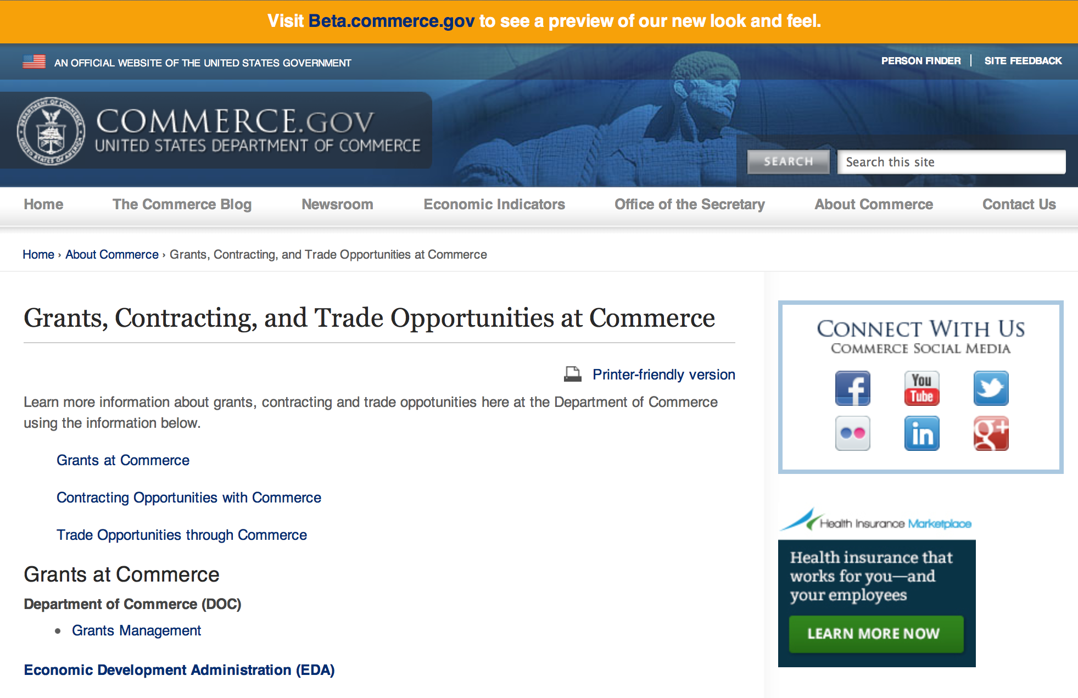
Grants at Commerce
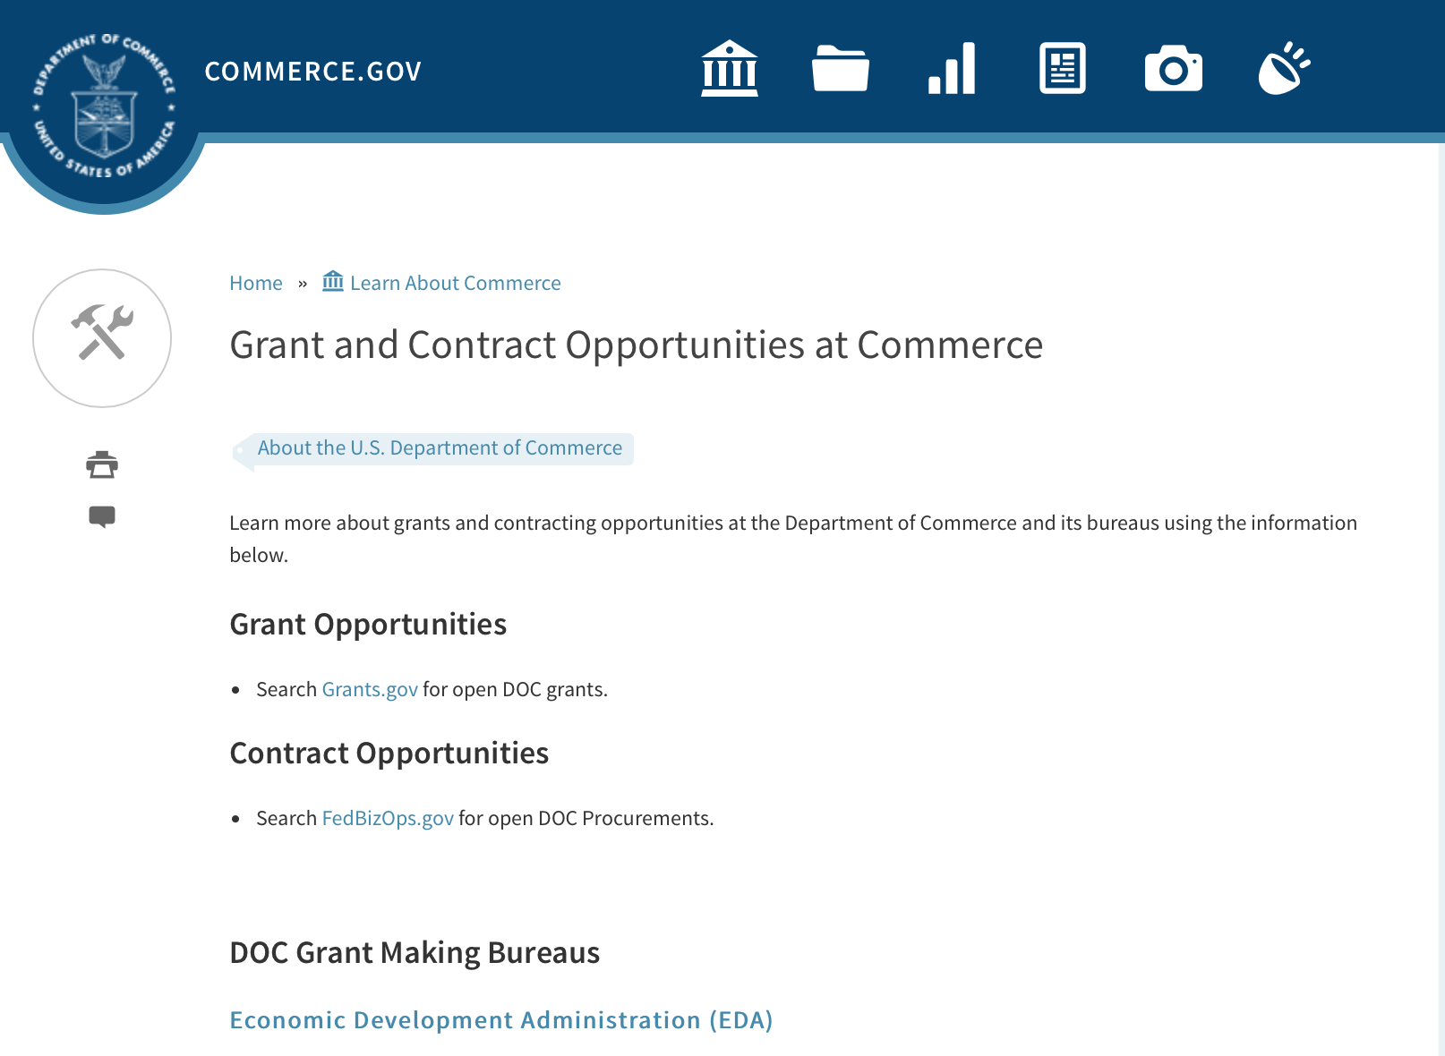

DOC Grant Making Bureaus
Economic Development Administration (EDA)
International Trade Administration (ITA)
- Market Development Cooperator Program
- Special American Business Internship Training Program (SABIT). A technical assistance initiative of the International Trade Administration of the U.S. Department of Commerce, SABIT offers organizations competitive grants and an opportunity to host industry-specific delegations. SABIT serves as an initial entry point for U.S. businesses seeking funding to establish long-term relationships with potential customers, distributors, or partners in the former Soviet Union. The program trains Eurasian managers and scientists in commonly accepted business practices as a means of facilitating cross border relationships. In turn, these personal relationships serve as a basis for business development and reduce market access barriers for U.S. businesses
National Institute of Standards & Technology (NIST)
- Funding Opportunities
National Telecommunications & Information Administration (NTIA)
- Telecommunications Grants
National Oceanic & Atmospheric Administration (NOAA)
- Coastal Ocean Program Grant Information
- Fisheries Saltonstall Kennedy Grant Program
- National Undersea Research Program Funding Opportunities
- Grants Management Division
- Fisheries Grants Program
- National Sea Grant
- Office of Global Programs
Contracting Resources for Contractors
- Office of Small and Disadvantaged Business Utilization (OSDBU) - he Office of Small and Disadvantaged Business Utilization (OSDBU) is an advocacy and advisory office responsible for promoting the use of small, small disadvantaged, 8(a), women-owned, veteran-owned, service-disabled veteran-owned, and HUBZone small businesses within the U.S. Department of Commerce's (DOC) acquisition process.
- Business.USA.gov's Find Opportunities Wizard where in a few quick steps, it will guide you towards federal government contracting programs and opportunities for your business!
- Planned Acquisitions: the Department of Commerce's search tool for our planned acquisitions over $100,000. As requirements change, these acquisition plans are updated by department personnel and this search tool is automatically updated.
- Small Business Administration's Contracting section of their web site where you can learn about how to "Get Started" and "Contracting Support for Small Business"
- The General Services Administration (GSA) has implemented a system for vendors doing business with the Federal Government to manage their entity information in one central location. This new database is the System for Award Management (SAM).

DOC Contracting Offices
- Patent and Trademark Office (PTO)
  - Office of Procurement
- National Institute of Standards & Technology (NIST)
NIST Acquisition Management Group
Contracting Opportunities with Commerce
Trade Opportunities through Commerce
http://www.commerce.gov/about-commerce/grants-contracting-trade-opportunities

Programs:

National Institute of Standards and Technology
Regional Alliances and Multistakeholder Partnerships to Stimulate (RAMPS) Cybersecurity Education and Workforce Development Grant

Document Type: | Grants Notice
Funding Opportunity Number: | 2016-NIST-NICE-01
Funding Opportunity Title: | Regional Alliances and Multistakeholder Partnerships to Stimulate (RAMPS) Cybersecurity Education and Workforce Development
Opportunity Category: | Discretionary
Opportunity Category Explanation: | Category Explanation
Funding Instrument Type: | Cooperative Agreement
Category of Funding Activity: | Science and Technology and other Research and Development
Category Explanation:
Expected Number of Awards:
CFDA Number(s): | 11.620 -- Science, Technology, Business and/or Education Outreach
Cost Sharing or Matching Requirement: | No
Posted Date: | May 11, 2016
Last Updated Date: | May 11, 2016
Original Closing Date for Applications: | Jul 12, 2016 Applications must be received at Grants.gov no later than 11:59 p.m. Eastern Time, Tuesday, July 12, 2016. Applications received after this deadline will not be reviewed or considered. Applicants should be aware, and factor in their application submission planning, that the Grants.gov system is expected to be closed for routine maintenance from 12:01 a.m. Eastern Time, Saturday, June 18, 2016 until Monday, June 20, 2016 at 6:00 a.m. Eastern Time. Applications cannot be submitted when Grants.gov is closed.
Current Closing Date for Applications: | Jul 12, 2016 Applications must be received at Grants.gov no later than 11:59 p.m. Eastern Time, Tuesday, July 12, 2016. Applications received after this deadline will not be reviewed or considered. Applicants should be aware, and factor in their application submission planning, that the Grants.gov system is expected to be closed for routine maintenance from 12:01 a.m. Eastern Time, Saturday, June 18, 2016 until Monday, June 20, 2016 at 6:00 a.m. Eastern Time. Applications cannot be submitted when Grants.gov is closed.
Archive Date: | Aug 11, 2016
Eligible Applicants: | Others (see text field entitled "Additional Information on Eligibility" for clarification)
Additional Information on Eligibility: | Applicants must meet all of the following requirements. Applicants must be non-profit organizations including institutions of higher education located in the U.S. or its territories. The applicant will be the lead organization for the project. Applicants must demonstrate through commitment letters that at least one of each of the following types of organizations is committed to being part of the proposed multistakeholder workforce partnership: a K-12 school or Local Education Agency (LEA); an institution of higher education or college/university system; and a local employer.
Agency Name: | National Institute of Standards and Technology
Description: | The National Initiative for Cybersecurity Education (NICE), led by NIST, is soliciting applications from eligible applicants for the establishment of state or regional consortia to identify cybersecurity workforce development pathways that address local workforce needs.
Link to Additional Information: | 2016-NIST-NICE-01 Full Announcement/FFO document
Contact Information: | If you have difficulty accessing the full announcement electronically, please contact:  Christopher Hunton Management and Program Analyst Phone 301-975-5718  Agency Contact

http://www.grants.gov/web/grants/view-opportunity.html?oppId=283764

Advanced Manufacturing Project Grant

Document Type: | Grants Notice
Funding Opportunity Number: | MBDA-OBD-2016-2004580
Funding Opportunity Title: | Advanced Manufacturing Project
Opportunity Category: | Discretionary
Opportunity Category Explanation:
Funding Instrument Type: | Cooperative Agreement
Category of Funding Activity: | Business and Commerce  Environment  Natural Resources  Science and Technology and other Research and Development
Category Explanation:
Expected Number of Awards: | 4
CFDA Number(s): | 11.802 -- Minority Business Resource Development
Cost Sharing or Matching Requirement: | No
Posted Date: | May 04, 2016
Last Updated Date: | May 04, 2016
Original Closing Date for Applications: | Jun 17, 2016
Current Closing Date for Applications: | Jun 17, 2016
Archive Date: | Jul 17, 2016
Estimated Total Program Funding: | $5,000,000
Award Ceiling: | $1,250,000
Award Floor: | $1
Eligible Applicants: | Others (see text field entitled "Additional Information on Eligibility" for clarification)
Additional Information on Eligibility: | For-profit entities (including but not limited to sole-proprietorships, partnerships, limited liability companies and corporations), non-profit organizations, state and local government entities, Native American Tribes and educational institutions are eligible to apply to operate an AMP. Successful applicants will possess experience in assisting advanced manufacturing minority firms in obtaining large scale contracts/procurements and financing awards; accessing established supply chains; educating and assisting minority firms in joint ventures, teaming arrangements, mergers and acquisitions; minority business advocacy; policy analysis; and facilitating entry and large scale transactions in global markets. It is also anticipated that the mission of successful applicant organizations will align with both the mission of MBDA and the AMP objectives.
Agency Name: | Department of Commerce
Description: | This Federal Funding Opportunity (FFO or Announcement) announces the anticipated availability of funding for the MBDA Advanced Manufacturing Project (“AMP”), and solicits competitive applications for four (4) AMP awards that must be located within any of the 50 U.S. States or Puerto Rico. The AMP awards will be used to identify, screen, promote, refer minority business enterprises (MBEs) to specialized advanced manufacturing programs (e.g., the NIST Manufacturing Extension Program (MEP), and to provide technical and business development services. The technical assistance and business development services will generate increased financing and contract opportunities for MBEs and will assist MBEs in creating and retaining jobs. The AMP will also assess regulatory changes pertaining to manufacturing in domestic and global markets, economic impact and need for minority manufacturers. AMP will educate federal, state, local government and private sector entities on ways to expand resources and to use minority manufacturers.
Link to Additional Information:
Contact Information: | If you have difficulty accessing the full announcement electronically, please contact:  Ms. Joann J. Hill, Chief MBDA Office of Business Development U.S. Department of Commerce 1401 Constitution Ave., N.W. Room 5079 Washington, DC 20230 Tel: 202-482-1940 Nakita Chambers MBDA Program Manager U.S. Department of Commerce 1401 Constitution Ave., N.W., Room 5079 Washington, DC 20230 Tel: 202-482-0065  Work

http://www.grants.gov/web/grants/view-opportunity.html?oppId=283548

Exporting Project Grant

Document Type: | Grants Notice
Funding Opportunity Number: | MBDA-OBD-2016-2004601
Funding Opportunity Title: | Exporting Project
Opportunity Category: | Discretionary
Opportunity Category Explanation:
Funding Instrument Type: | Cooperative Agreement
Category of Funding Activity: | Business and Commerce  Community Development  Environment  Natural Resources  Regional Development  Science and Technology and other Research and Development
Category Explanation:
Expected Number of Awards: | 4
CFDA Number(s): | 11.802 -- Minority Business Resource Development
Cost Sharing or Matching Requirement: | No
Posted Date: | May 23, 2016
Last Updated Date: | May 23, 2016
Original Closing Date for Applications: | Jul 05, 2016
Current Closing Date for Applications: | Jul 05, 2016
Archive Date: | Aug 04, 2016
Estimated Total Program Funding: | $20,000,000
Award Ceiling: | $5,000,000
Award Floor: | $3,000,000
Eligible Applicants: | Others (see text field entitled "Additional Information on Eligibility" for clarification)
Additional Information on Eligibility: | For-profit entities (including but not limited to sole-proprietorships, partnerships, limited liability companies and corporations), non-profit organizations, state and local government entities, Native American Tribes and educational institutions are eligible to apply to operate the MBDA Exporting Project. Successful applicants will possess experience in assisting exporting minority firms in obtaining large scale contracts/procurements and financing awards; accessing established on developing new supply chains; educating and assisting minority firms in joint ventures, teaming arrangements, mergers and acquisitions; minority business advocacy; policy analysis; and, facilitating entry and large scale transactions in global markets. It is also anticipated that the mission of successful applicant organizations will align with both the mission of MBDA and the MBDA Exporting Project objectives.
Agency Name: | Department of Commerce
Description: | This Federal Funding Opportunity Announcement (FFO or Announcement) notifies the anticipated availability of funding for the MBDA Exporting Project (Project), and solicits competitive applications for operators of four (4) Project awards. The Project is a subset of the MBDA Business Center program and is established to identify, screen, promote, refer minority business enterprises (MBEs) to exporting resources, and to engage in and/or expand exporting. The Project also provides technical assistance and business development services. The technical assistance and business development services are provided through federal financial assistance awards to generate increased financing, contract opportunities, and greater access to new and global markets for minority business enterprises (MBEs). In addition, the services provided will assist MBEs in creating and retaining jobs. Pre-Application Teleconference: MBDA will conduct a pre-application teleconference on June 6, 2016. The time of the pre-application teleconference has yet to be determined. Participants must register at least 24 hours in advance of the teleconference. Please visit the MBDA Internet Portal at www.mbda.gov for more information.
Link to Additional Information:
Contact Information: | If you have difficulty accessing the full announcement electronically, please contact:  Prospective applicants may contact: Ms. Joann J. Hill, Chief MBDA Office of Business Development U.S. Department of Commerce 1401 Constitution Ave., N.W. Room 5079 Washington, DC 20230 Tel: 202-482-1940 Nakita Chambers MBDA Program Manager U.S. Department of Commerce 1401 Constitution Ave., N.W., Room 5079  Work
http://www.grants.gov/web/grants/view-opportunity.html?oppId=284097

Research:

Modifications:

Reminders:

FY2016 Regional Innovation Strategies Program Grant

Document Type: | Grants Notice
Funding Opportunity Number: | EDA-HDQ-OIE-2016-2004868
Funding Opportunity Title: | FY2016 Regional Innovation Strategies Program
Opportunity Category: | Discretionary
Opportunity Category Explanation:
Funding Instrument Type: | Grant
Category of Funding Activity: | Other (see text field entitled "Explanation of Other Category of Funding Activity" for clarification)  Regional Development
Category Explanation: | Economic Development Innovation and Entrepreneurship
Expected Number of Awards: | 40
CFDA Number(s): | 11.020 -- Cluster Grants
Cost Sharing or Matching Requirement: | Yes
Posted Date: | Apr 25, 2016
Last Updated Date: | Apr 11, 2016
Original Closing Date for Applications: | Jun 24, 2016
Current Closing Date for Applications: | Jun 24, 2016
Archive Date: | Jul 24, 2016
Estimated Total Program Funding: | $15,000,000
Award Ceiling: | $500,000
Award Floor: | $1
Eligible Applicants: | State governments  Private institutions of higher education  City or township governments  County governments  Others (see text field entitled "Additional Information on Eligibility" for clarification)  Nonprofits that do not have a 501(c)(3) status with the IRS, other than institutions of higher education  Native American tribal governments (Federally recognized)  Nonprofits having a 501(c)(3) status with the IRS, other than institutions of higher education  Public and State controlled institutions of higher education  Special district governments
Additional Information on Eligibility: | A State; An Indian tribe; A city or other political subdivision of a State; An entity that— (a) is a nonprofit organization, an institution of higher education, a public-private partnership, a science or research park, a Federal laboratory, or an economic development organization or similar entity, and (b) has an application that is supported by a State or a political subdivision of a State; or A consortium of any of the entities described above.
Agency Name: | Department of Commerce
Description: | EDA is committed to fostering connected, innovation-centric economic sectors which support the conversion of research into products and services, businesses, and ultimately jobs through entrepreneurship. See SWTIA § 27. The DOC FY 2014-2018 Strategic Plan sets forth the strategic goal of working within and across ecosystems throughout the country to develop regional innovation strategies, including regional innovation clusters. Regional innovation strategies are a keystone of the Secretary of Commerce’s commitment to building globally competitive regions. As part of this strategy, funding is available for capacity-building programs that provide proof-of-concept and commercialization assistance to innovators and entrepreneurs and for operational support for organizations that provide essential early-stage funding to startups. Under the RIS Program, EDA is soliciting applications for two separate competitions: the 2016 i6 Challenge, and the Seed Fund Support (SFS) Grant competition. Applicants may, but are not required to, submit proposals for more than one competition under the RIS Program. Note that the 2016 RIS Program is authorized under SWTIA § 27, which does not restrict the focus of grantees’ projects to economically distressed communities.
Link to Additional Information: | http://www.eda.gov/oie/ris/
Contact Information: | If you have difficulty accessing the full announcement electronically, please contact:  EDA Office of Innovation and Entrepreneurship  oie@eda.gov

http://www.grants.gov/web/grants/view-opportunity.html?oppId=282919

Capital Project Grant

Document Type: | Grants Notice
Funding Opportunity Number: | MBDA-OBD-2016-2004600
Funding Opportunity Title: | Capital Project
Opportunity Category: | Discretionary
Opportunity Category Explanation:
Funding Instrument Type: | Cooperative Agreement
Category of Funding Activity: | Environment  Natural Resources  Science and Technology and other Research and Development
Category Explanation:
Expected Number of Awards: | 10
CFDA Number(s): | 11.802 -- Minority Business Resource Development
Cost Sharing or Matching Requirement: | No
Posted Date: | Apr 30, 2016
Last Updated Date: | Apr 30, 2016
Original Closing Date for Applications: | Jun 15, 2016
Current Closing Date for Applications: | Jun 15, 2016
Archive Date: | Jul 15, 2016
Estimated Total Program Funding: | $2,500,000
Award Ceiling: | $500,000
Award Floor: | $100
Eligible Applicants: | Others (see text field entitled "Additional Information on Eligibility" for clarification)
Additional Information on Eligibility: | For-profit entities (including but not limited to sole-proprietorships, partnerships, limited liability companies and corporations), non-profit organizations, state and local government entities, Native American Tribes and educational institutions are eligible to apply to operate the Project.
Agency Name: | Department of Commerce
Description: | This Federal Funding Opportunity (FFO or Announcement) announces the anticipated availability of funding for the MBDA Capital Project (Project or CAP), and solicits competitive applications for an operator of this Project in one (1) area. The Project is established to provide technical assistance and business development services that result in awarded financial transactions to Minority Business Enterprises (MBEs). The technical assistance and business development services for this Project are provided through a federal financial assistance award to generate increased financing opportunities for MBEs. In addition, the services provided will assist these firms in creating and retaining jobs.
Link to Additional Information:
Contact Information: | If you have difficulty accessing the full announcement electronically, please contact:  Ms. Joann J. Hill, Chief MBDA Office of Business Development U.S. Department of Commerce 1401 Constitution Ave., N.W. Room 5079 Washington, DC 20230 Tel: 202-482-1940  work

http://www.grants.gov/web/grants/view-opportunity.html?oppId=283411

National Institute of Standards and Technology
Embedding MEP in NNMI Institutes Pilot Projects
Modification 1

Document Type: | Grants Notice
Funding Opportunity Number: | 2016-NIST-MEP-ENNMI-01
Funding Opportunity Title: | Embedding MEP in NNMI Institutes Pilot Projects
Opportunity Category: | Discretionary
Opportunity Category Explanation: | Category Explanation
Funding Instrument Type: | Cooperative Agreement
Category of Funding Activity: | Other (see text field entitled "Explanation of Other Category of Funding Activity" for clarification)
Category Explanation: | Manufacturing Extension Partnership
Expected Number of Awards: | 7
CFDA Number(s): | 11.611 -- Manufacturing Extension Partnership
Cost Sharing or Matching Requirement: | No
Posted Date: | Apr 19, 2016
Last Updated Date: | Apr 19, 2016
Original Closing Date for Applications: | Jun 17, 2016 Electronic applications in response to this FFO must be received no later than 11:59 p.m. Eastern Time on Friday, June 17, 2016. Applications received after the deadline will not be reviewed or considered.
Current Closing Date for Applications: | Jun 17, 2016 Electronic applications in response to this FFO must be received no later than 11:59 p.m. Eastern Time on Friday, June 17, 2016. Applications received after the deadline will not be reviewed or considered.
Archive Date: | Jul 17, 2016
Eligible Applicants: | Others (see text field entitled "Additional Information on Eligibility" for clarification)
Additional Information on Eligibility: | Eligible applicants for this program are MEP Centers receiving current cooperative agreement funding from NIST. An applicant MEP Center must form a collaboration, teaming arrangement, or other appropriate relationship with one or more of the current NNMI Institutes. NIST encourages project proposals involving participation from multiple MEP Centers and multiple NNMI Institutes, as well as other collaborating entities such as local economic development organizations, universities, community colleges, technology incubator programs, and other organizations.
Agency Name: | National Institute of Standards and Technology
Description: | NIST invites proposals from current MEP Centers to pilot test approaches to provide needed technology acceleration assistance to small and mid-sized U.S. manufacturers (referred to hereinafter as small U.S. manufacturers) through the establishment of meaningful and results oriented collaborations between the nationwide system of Centers operating as part of the NIST Hollings Manufacturing Extension Partnership (MEP) Program (hereinafter referred to as NIST MEP), and the Institutes participating in the National Network for Manufacturing Innovation (NNMI). The emphasis of these Pilot Projects will be to demonstrate ways to more fully leverage the assets and resources of the national MEP Program to provide assistance to small U.S. manufacturers in technology areas that are the focus of the NNMI Institutes. These Pilots will embed personnel from MEP Centers in residence at NNMI Institutes, targeting the cultivation of enduring collaborations among small U.S. manufacturers, NNMI Institutes, and MEP Centers for the benefit of all these entities. The Pilots will accelerate the processes by which small U.S. manufacturers transition the latest and most compelling technological innovations into the manufactured goods needed by our Nation.
Link to Additional Information: | 2016-NIST-MEP-ENNMI-01 Full Announcement/FFO document
Contact Information: | If you have difficulty accessing the full announcement electronically, please contact:  Christopher Hunton Management and Program Analyst Phone 301-975-5718  Agency Contact

http://www.grants.gov/web/grants/view-opportunity.html?oppId=283127

National Institute of Standards and Technology
Measurement Science and Engineering (MSE) Research Grant Programs

Document Type: | Grants Notice
Funding Opportunity Number: | 2016-NIST-MSE-01
Funding Opportunity Title: | Measurement Science and Engineering (MSE) Research Grant Programs
Opportunity Category: | Discretionary
Opportunity Category Explanation:
Funding Instrument Type: | Cooperative Agreement  Grant
Category of Funding Activity: | Science and Technology and other Research and Development
Category Explanation:
Expected Number of Awards:
CFDA Number(s):
Cost Sharing or Matching Requirement: | No
Posted Date: | Feb 19, 2016
Last Updated Date: | Feb 19, 2016
Original Closing Date for Applications: | Applications will be accepted and considered on a rolling basis as they are received. See Section IV.4. in the text of the Full Announcement/FFO document. Applications may be submitted by paper or electronically through Grants.gov. Carefully read Section IV. of the Full Announcement/FFO document for details applying to electronic submissions and to paper submissions.
Current Closing Date for Applications: | Applications will be accepted and considered on a rolling basis as they are received. See Section IV.4. in the text of the Full Announcement/FFO document. Applications may be submitted by paper or electronically through Grants.gov. Carefully read Section IV. of the Full Announcement/FFO document for details applying to electronic submissions and to paper submissions.
Eligible Applicants: | Others (see text field entitled "Additional Information on Eligibility" for clarification)
Additional Information on Eligibility: | Eligibility for all programs listed in this FFO is open to all non-Federal entities. Eligible applicants include institutions of higher education, non-profit organizations, for-profit organizations, state and local governments, Indian tribes, hospitals, foreign public entities, and foreign governments. Applicants selected for awards under 15 U.S.C. § 278g-1 are encouraged, but not required, to select underrepresented minorities for participation. In addition, NIST is not able to accept an application from an individual unaffiliated with a sponsoring applicant organization.
Agency Name: | National Institute of Standards and Technology
Description: | NIST is soliciting applications for financial assistance for Fiscal Year 2016 (FY16) within the following NIST Laboratory grant programs: (1) the Material Measurement Laboratory (MML) Grant Program; (2) the Physical Measurement Laboratory (PML) Grant Program; (3) the Engineering Laboratory (EL) Grant Program; (4) the Fire Research (FR) Grant Program; (5) the Information Technology Laboratory (ITL) Grant Program; (6) the Communications Technology Laboratory (CTL) Grant Program; (7) the NIST Center for Neutron Research (NCNR) Grant Program; (8) the Center for Nanoscale Science and Technology (CNST) Grant Program; (9) the Special Programs Office (SPO) Grant Program; (10) the Standards Coordination Office (SCO) Grant Program; (11) the International and Academic Affairs Office (IAAO) Grant Program; and (12) the Associate Director for Laboratory Programs (ADLP) Grant Program.
Link to Additional Information: | 2016-NIST-MSE-01 Full Announcement/FFO document
Contact Information: | If you have difficulty accessing the full announcement electronically, please contact:  Christopher Hunton Management and Program Analyst Phone 301-975-5718  Agency Contact

http://www.grants.gov/web/grants/view-opportunity.html?oppId=281689

National Sea Grant College Program 2016-17 Special Projects Grant

Document Type: | Grants Notice
Funding Opportunity Number: | NOAA-OAR-SG-2016-2004772
Funding Opportunity Title: | National Sea Grant College Program 2016-17 Special Projects
Opportunity Category: | Discretionary
Funding Instrument Type: | Cooperative Agreement  Grant
Category of Funding Activity: | Environment  Natural Resources  Science and Technology and other Research and Development
Category Explanation:
Expected Number of Awards: | 30
CFDA Number(s): | 11.417 -- Sea Grant Support
Cost Sharing or Matching Requirement: | Yes
Posted Date: | Jan 7, 2016
Creation Date: | Jan 7, 2016
Original Closing Date for Applications: | Sep 30, 2017
Current Closing Date for Applications: | Sep 30, 2017
Archive Date: | Oct 30, 2017
Estimated Total Program Funding: | $4,000,000
Award Ceiling: | $1,000,000
Award Floor: | $1
Eligible Applicants: | Others (see text field entitled "Additional Information on Eligibility" for clarification)
Additional Information on Eligibility: | Sea Grant Programs (Sea Grant Colleges, Institutions, or Coherent Area Programs), the National Sea Grant Law Center, and the National Sea Grant Library.
Agency Name: | Department of Commerce
Description: | The purpose of this notice is to request proposals for special projects associated with the National Sea Grant College Program’s (Sea Grant) strategic focus areas, and to provide the general public with information and guidelines on how Sea Grant will select proposals and administer Federal assistance under this announcement. This announcement is a mechanism to encourage research or other projects that are not normally funded through Sea Grant national competitions. This opportunity is open only to Sea Grant Programs. Section III of this announcement describes eligibility requirements in more detail. Funding has not yet been made available to support applications submitted to this Federal Funding Opportunity (FFO), but such funding may become available during the year. Section II.A. below describes individual competition announcements that will be used to announce when funding is available; any restrictions or requirements on such funding, such as matching funds; and other funding details. Awards will be made under this FFO only if funds have been announced as provided in this FFO.
Link to Additional Information:
Contact Information: | If you have difficulty accessing the full announcement electronically, please contact:  Special Projects Competition Manager, NOAA R/SG National Sea Grant Office 1315 East-West Highway, Rm 11839 Silver Spring, MD 20910 301-734-1066  work

http://www.grants.gov/web/grants/view-opportunity.html?oppId=280846

FY 2016 – FY 2019 EDA Planning Program and Local Technical Assistance Program Grant

Document Type: | Grants Notice
Funding Opportunity Number: | EDA-HDQ-TA-HDQ-2016-2004759
Funding Opportunity Title: | FY 2016 – FY 2019 EDA Planning Program and Local Technical Assistance Program
Opportunity Category: | Discretionary
Funding Instrument Type: | Cooperative Agreement  Grant
Category of Funding Activity: | Other (see text field entitled "Explanation of Other Category of Funding Activity" for clarification)  Regional Development
Category Explanation: | Regional planning and local technical assistance
Expected Number of Awards:
CFDA Number(s): | 11.302 -- Economic Development Support for Planning Organizations  11.303 -- Economic Development Technical Assistance
Cost Sharing or Matching Requirement: | No
Posted Date: | Dec 10, 2015
Creation Date: | Dec 10, 2015
Original Closing Date for Applications: | Applications are accepted on a continuing basis and processed as received. This Planning and Local Technical Assistance opportunity will remain in effect until superseded by a future announcement.
Current Closing Date for Applications: | Applications are accepted on a continuing basis and processed as received. This Planning and Local Technical Assistance opportunity will remain in effect until superseded by a future announcement.
Archive Date:
Estimated Total Program Funding:
Award Ceiling: | $300,000
Award Floor: | $0
Eligible Applicants: | Nonprofits having a 501(c)(3) status with the IRS, other than institutions of higher education  City or township governments  Nonprofits that do not have a 501(c)(3) status with the IRS, other than institutions of higher education  Others (see text field entitled "Additional Information on Eligibility" for clarification)  Private institutions of higher education  Native American tribal governments (Federally recognized)  Public and State controlled institutions of higher education  State governments  Special district governments  County governments
Additional Information on Eligibility: | Pursuant to section 3 of the Public Works and Economic Development Act of 1965 (42 U.S.C. § 3122) (PWEDA) and EDA’s regulation at 13 C.F.R. § 300.3, the following types of entities are eligible to receive funding assistance from EDA: 1. District Organizations (as defined in 13 C.F.R. § 300.3); 2. Indian Tribes or a consortium of Indian Tribes; 3. States, cities, or other political subdivisions of a State, including a special purpose unit of a State or local government engaged in economic or infrastructure development activities, or a consortium of political subdivisions; 4. Institutions of higher education or a consortium of institutions of higher education; or 5. Public or private non-profit organizations or associations acting in cooperation with officials of a political subdivision of a State.
Agency Name: | Department of Commerce
Description: | Pursuant to PWEDA, EDA announces general policies and application procedures for grant-based investments under the Planning and Local Technical Assistance programs. Under the Planning program EDA assists eligible recipients in creating regional economic development plans designed to build capacity and guide the economic prosperity and resiliency of an area or region. As part of this program, EDA supports Partnership Planning investments to facilitate the development, implementation, revision, or replacement of Comprehensive Economic Development Strategies (CEDS), which articulate and prioritize the strategic economic goals of recipients’ respective regions. In general, EDA provides Partnership Planning grants to the designated planning organization (e.g., District Organization) serving EDA designated Economic Development Districts to enable these organizations to develop and implement relevant CEDS. In addition, EDA provides Partnership Planning grants to Indian Tribes to help develop and implement CEDS and associated economic development activities. The Planning program also helps support organizations, including District Organizations, Indian Tribes, and other eligible recipients, with Short Term and State Planning investments designed to guide the eventual creation and retention of high-quality jobs, particularly for the unemployed and underemployed in the Nation’s most economically distressed regions. The Local Technical Assistance program strengthens the capacity of local or State organizations, institutions of higher education, and other eligible recipients to undertake and promote effective economic development programs through projects such as feasibility analyses and impact studies.
Link to Additional Information: | www.eda.gov
Contact Information: | If you have difficulty accessing the full announcement electronically, please contact:  The EDA representative for your state. A complete list of EDA representatives is available on EDA's website at http://www.eda.gov/contact/

http://www.grants.gov/web/grants/view-opportunity.html?oppId=280447

FY 2016 Economic Development Assistance Programs ­ Application submission and program requirements for EDA’s Public Works and Economic Adjustment Assistance Programs Grant

Document Type: | Grants Notice
Funding Opportunity Number: | EDAP2016
Funding Opportunity Title: | FY 2016 Economic Development Assistance Programs ­ Application submission and program requirements for EDA’s Public Works and Economic Adjustment Assistance programs.
Opportunity Category: | Discretionary
Funding Instrument Type: | Cooperative Agreement  Grant
Category of Funding Activity: | Other (see text field entitled "Explanation of Other Category of Funding Activity" for clarification)
Category Explanation: | The Economic Development Administration's (EDA's) mission is to lead the Federal economic development agenda by promoting innovation and competitiveness, preparing American regions for economic growth and success in the worldwide economy. EDA fulfills this mission through strategic investments and partnerships that create the regional economic ecosystems required to foster globally competitive regions throughout the United States. EDA supports development in economically distressed areas of the United States by fostering job creation and attracting private investment. Specifically, under the Economic Development Assistance programs (EDAP) Federal Funding Opportunity (FFO) announcement, EDA will make construction, non-construction, and revolving loan fund investments under the Public Works and Economic Adjustment Assistance (EAA) Programs. Grants made under these programs will leverage regional assets to support the implementation of regional economic development strategies designed to create jobs, leverage private capital, encourage economic development, and strengthen America's ability to compete in the global marketplace. Through the EDAP FFO, EDA solicits applications from rural and urban communities to develop initiatives that advance new ideas and creative approaches to address rapidly evolving economic conditions.
Expected Number of Awards:
CFDA Number(s): | 11.300 -- Investments for Public Works and Economic Development Facilities  11.307 -- Economic Adjustment Assistance
Cost Sharing or Matching Requirement: | Yes
Posted Date: | Oct 26, 2015
Creation Date: | Oct 26, 2015
Original Closing Date for Applications: | There are no submission deadlines under this opportunity. Proposals and applications will be accepted on an ongoing basis until the publication of a new EDAP FFO.
Current Closing Date for Applications: | There are no submission deadlines under this opportunity. Proposals and applications will be accepted on an ongoing basis until the publication of a new EDAP FFO.
Archive Date:
Estimated Total Program Funding:
Award Ceiling: | $3,000,000
Award Floor: | $100,000
Eligible Applicants: | Others (see text field entitled "Additional Information on Eligibility" for clarification)  State governments  City or township governments  Native American tribal organizations (other than Federally recognized tribal governments)  Native American tribal governments (Federally recognized)  Private institutions of higher education  Special district governments  Nonprofits having a 501(c)(3) status with the IRS, other than institutions of higher education  County governments  Nonprofits that do not have a 501(c)(3) status with the IRS, other than institutions of higher education  Public and State controlled institutions of higher education
Additional Information on Eligibility: | Eligible applicants for EDA financial assistance under the Public Works and EAA programs include a(n): (i) District Organization of a designated Economic Development District; (ii) Indian Tribe or a consortium of Indian Tribes; (iii) State, county, city, or other political subdivision of a State, including a special purpose unit of a State or local government engaged in economic or infrastructure development activities, or a consortium of political subdivisions; (iv) institution of higher education or a consortium of institutions of higher education; or (v) public or private non-profit organization or association acting in cooperation with officials of a political subdivision of a State. See Section 3 of the Public Works and Economic Development Act of 1965 (PWEDA) (42 U.S.C. § 3122) and 13 C.F.R. § 300.3. EDA is not authorized to provide grants or cooperative agreements to individuals or to for profit entities. Requests from such entities will not be considered for funding.
Agency Name: | Economic Development Administration
Description: | Under this FFO, EDA solicits applications from applicants in rural and urban areas to provide investments that support construction, non-construction, technical assistance, and revolving loan fund projects under EDA’s Public Works and EAA programs. Grants and cooperative agreements made under these programs are designed to leverage existing regional assets and support the implementation of economic development strategies that advance new ideas and creative approaches to advance economic prosperity in distressed communities. EDA provides strategic investments on a competitive- merit-basis to support economic development, foster job creation, and attract private investment in economically distressed areas of the United States.
Link to Additional Information: | www.eda.gov
Contact Information: | If you have difficulty accessing the full announcement electronically, please contact:  the EDA representative for your state. A complete list of EDA representatives is available on EDA's website at http://www.eda.gov/contact/

http://www.grants.gov/web/grants/view-opportunity.html?oppId=279842

Economic Development Administration
Planning Program and Local Technical Assistance Program Grant

Document Type: | Grants Notice
Funding Opportunity Number: | EDAPLANNING2012
Opportunity Category: | Discretionary
Posted Date: | Aug 03, 2012
Creation Date: | Aug 03, 2012
Original Closing Date for Applications: | Applications are accepted on a continuing basis and processed as received. This Planning and Local Technical Assistance opportunity will remain in effect until superseded by a future announcement.
Current Closing Date for Applications: | Applications are accepted on a continuing basis and processed as received. This Planning and Local Technical Assistance opportunity will remain in effect until superseded by a future announcement.
Archive Date:
Funding Instrument Type: | Cooperative Agreement  Grant
Category of Funding Activity: | Other (see text field entitled "Explanation of Other Category of Funding Activity" for clarification)  Regional Development
Category Explanation: | Regional planning and local technical assistance
Expected Number of Awards: | 425
Estimated Total Program Funding:
Award Ceiling: | $100,000
Award Floor:
CFDA Number(s): | 11.302 -- Economic Development Support for Planning Organizations
 | 11.303 -- Economic Development Technical Assistance
Cost Sharing or Matching Requirement: | Yes

Eligible Applicants
State governments
County governments
City or township governments
Public and State controlled institutions of higher education
Native American tribal governments (Federally recognized)
Nonprofits having a 501(c)(3) status with the IRS, other than institutions of higher education
Nonprofits that do not have a 501(c)(3) status with the IRS, other than institutions of higher education
Private institutions of higher education
Others (see text field entitled "Additional Information on Eligibility" for clarification)

Additional Information on Eligibility:
Pursuant to section 3 of the Public Works and Economic Development Act of 1965 (42 U.S.C. § 3122) (PWEDA) and EDA’s regulation at 13 C.F.R. § 300.3, the following types of entities are eligible to receive funding assistance from EDA: 1. District Organizations (as defined in 13 C.F.R. § 300.3); 2. Indian Tribes or a consortium of Indian Tribes; 3. States, cities, or other political subdivisions of a State, including a special purpose unit of a State or local government engaged in economic or infrastructure development activities, or a consortium of political subdivisions; 4. Institutions of higher education or a consortium of institutions of higher education; or 5. Public or private non-profit organizations or associations acting in cooperation with officials of a political subdivision of a State.

Agency Name
Economic Development Administration

Description
Pursuant to PWEDA, EDA announces general policies and application procedures for grant-based investments under the Planning and Local Technical Assistance programs. Under the Planning program EDA assists eligible recipients in creating regional economic development plans designed to stimulate and guide the economic development efforts of a community or region. As part of this program, EDA supports Partnership Planning investments to facilitate the development, implementation, revision, or replacement of Comprehensive Economic Development Strategies (CEDS), which articulate and prioritize the strategic economic goals of recipients' respective regions. In general, EDA provides Partnership Planning grants to the designated planning organization (e.g., District Organization) serving EDA-designated Economic Development Districts to enable these organizations to develop and implement relevant CEDS. In addition, EDA provides Partnership Planning grants to Indian Tribes to help develop and implement CEDS and associated economic development activities. The Planning program also helps support planning organizations, including District Organizations, Indian Tribes, and other eligible Recipients, with Short Term and State Planning investments designed to guide the eventual creation and retention of higher-skill, higher-wage jobs, particularly for the unemployed and underemployed in the Nation’s most economically distressed regions. The Local Technical Assistance program strengthens the capacity of local or State organizations, institutions of higher education, and other eligible recipients to undertake and promote effective economic development programs through projects such as feasibility analyses and impact studies.

Link to Additional Information

If you have difficulty accessing the full announcement electronically, please contact:
David Ives Planning and Local TA email

http://www.grants.gov/web/grants/view-opportunity.html?oppId=189193

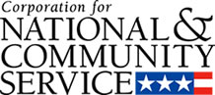

Corporation for National and Community Service

General Program Overview
AmeriCorps provides resources, both human and financial, to organizations that engage Americans in intensive service to meet our country’s critical needs.
Grantees use the funding to support AmeriCorps members for intensive service in their community. AmeriCorps grants partially cover the expense of operating an AmeriCorps program and do not cover general organizational expenses. A cash and in-kind match is required.

The main website can be accessed here: http://www.nationalservice.gov

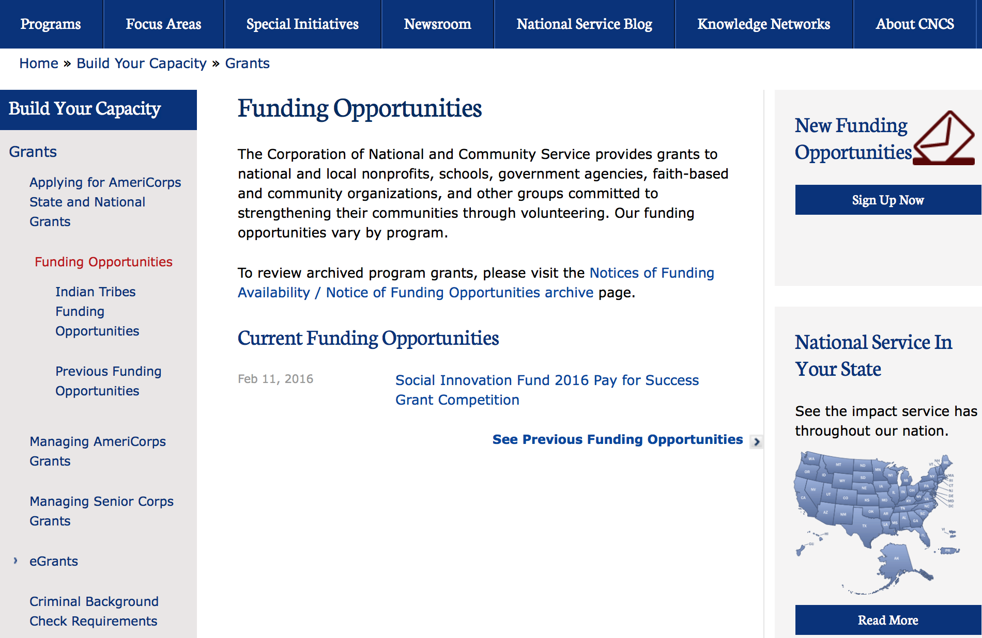

For access to further funding information: click here

http://www.nationalservice.gov/build-your-capacity/grants/funding-opportunities

Programs:

FY 2016 Training and Technical Assistance – Regional Training Conferences
And Modification 1

Document Type: | Grants Notice
Funding Opportunity Number: | CNCS-5-17-2016
Funding Opportunity Title: | FY 2016 Training and Technical Assistance – Regional Training Conferences
Opportunity Category: | Discretionary
Opportunity Category Explanation:
Funding Instrument Type: | Cooperative Agreement
Category of Funding Activity: | Other (see text field entitled "Explanation of Other Category of Funding Activity" for clarification)
Category Explanation: | Planning and delivering regional training conferences for AmeriCorps programs and Senior Corps projects.
Expected Number of Awards: | 4
CFDA Number(s): | 94.009 -- Training and Technical Assistance
Cost Sharing or Matching Requirement: | No
Posted Date: | May 17, 2016
Last Updated Date: | May 18, 2016
Original Closing Date for Applications: | Jun 16, 2016
Current Closing Date for Applications: | Jun 16, 2016
Archive Date: | Jun 17, 2016
Estimated Total Program Funding: | $578,000
Eligible Applicants: | Others (see text field entitled "Additional Information on Eligibility" for clarification)
Additional Information on Eligibility: | This competition is open to State Service Commissions on National and Community Service, and alternative administrative entities, as defined by Section 178(a) of the National and Community Service Act, only. An applicant may apply as a single organization or consortia of organizations, however, one partner must be designated as the lead applicant. Applicants must have a successful track record of providing training and technical assistance to national service programs and projects. A further discussion of the evaluation criteria can be found in the Notice. Organizations that have been convicted of a Federal crime are disqualified from receiving the assistance described in this Notice. Pursuant to the Lobbying Disclosure Action of 1995, an organization described in Section 501(c)(4) of the Internal Revenue code of 1986, 26 U.S.C. 501(c)(4) that engages in lobbying activities is not eligible to apply.
Agency Name: | Corporation for National and Community Service
Description: | This Notice announces the availability of funding for planning and delivering regional training conferences that focus on strengthening and building the capacity of AmeriCorps programs and Senior Corps projects across the country. CNCS acknowledges the need for flexibility in determining the regions where the conferences will be delivered. Regions may align with each of CNCS’s five regional clusters as defined in section II. Award Information, or applicants may choose to propose, with justification, one or more geographic region(s) different from the existing CNCS regional clusters. The primary target audiences for training at these regional training conferences are AmeriCorps State and National programs and Senior Corps projects. These regional training conferences are a critical component of CNCS’s training and technical assistance (TTA) strategy for 2016-2017, and CNCS intends for these conferences to build on and leverage previous investments to increase the capacity for national service resources to impact communities. While AmeriCorps State and National programs and Senior Corps projects are the primary audiences, it is expected that other national service programs will be invited to participate such as AmeriCorps Indian Tribes programs, AmeriCorps VISTA programs (especially multi-site projects), Social Innovation Fund grantees, and AmeriCorps National Civilian Community Corps (NCCC) staff. Although the entire agenda of these conferences may not be specific to these programs, having broad representation from CNCS programs increases the potential for strong and integrated community impact. The National and Community Service Act of 1990 (NCSA) authorizes CNCS to provide TTA to improve the programmatic quality and accountability of current and potential national service programs and projects. The current TTA strategy focuses on the implementation of CNCS’s performance measures, grantee compliance with statutory and regulatory requirements, as well as the fiscal and administrative requirements for managing CNCS grants - a unique set of knowledge and skills specific to CNCS programs and projects. The Corporation will host technical assistance calls to answer questions from potential applicants about this funding opportunity on: May 20, 2016, 2:30-3:30 pm Eastern Call number: (888) 906-7802Passcode: 1362783
Link to Additional Information: | Funding Opportunity Competition Webpage
Contact Information: | If you have difficulty accessing the full announcement electronically, please contact:  Barbara Reynolds AmeriCorps  Competition Email Address

http://www.grants.gov/web/grants/view-opportunity.html?oppId=283910

Reminders:

National Service In Hawaii
National Service in Your State - Hawaii
2014-2015
Meeting Community Needs in Hawaii: More than 3,800 people of all ages and backgrounds are helping to meet local needs, strengthen communities, and increase civic engagement through national service in Hawaii. Serving at more than 350 locations throughout the state, these citizens tutor and mentor children, support veterans and military families, provide health services, restore the environment, respond to disasters, increase economic opportunity, and recruit and manage volunteers. This year, the Corporation for National and Community Service (CNCS) will commit more than $6,260,000 to support Hawaii communities through national service initiatives. Through a unique public-private partnership, this federal investment will leverage an additional $3,640,000 in other resources to strengthen community impact, build local support, and increase return on taxpayer dollars.

AmeriCorps
This year, AmeriCorps will provide more than 540 individuals the opportunity to provide intensive, results-driven service to meet education, environmental, health, economic, and other pressing needs in communities across Hawaii. Most AmeriCorps grant funding goes to the Hawaii Commission on National & Community Service, which in turn awards grants to nonprofit groups to respond to local needs. Most of the remainder of the grant funding is distributed by CNCS directly to multi-state and national organizations through a competitive grants process. Other individuals serve through AmeriCorps VISTA, whose members help bring individuals and communities out of poverty by serving full-time to fight illiteracy, improve health services, create businesses, and increase housing opportunities, and AmeriCorps NCCC (National Civilian Community Corps), a 10-month, full time residential program for men and women between the ages of 18 and 24. In exchange for their service, AmeriCorps members earn an education award that can be used to pay for college or to pay back qualified student loans. Since 1994, more than 5,600 Hawaii residents have served more than 5.8 million hours and have qualified for Segal AmeriCorps Education Awards totaling more than $13,510,000.

Senior Corps
More than 3,200 seniors in Hawaii contribute their time and talents in one of three Senior Corps programs. Foster Grandparents serve one-on-one as tutors and mentors to more than 340 young people who have special needs. Senior Companions help more than 200 homebound seniors and other adults maintain independence in their own homes. RSVP volunteers conduct safety patrols, renovate homes, protect the environment, tutor and mentor youth, respond to natural disasters, and provide other services through more than 170 groups across Hawaii.

The Corporation for National and Community Service is a federal agency that improves lives, strengthens communities, and fosters civic engagement through service and volunteering. CNCS annually engages more than five million Americans in service to meet local needs through Senior Corps, AmeriCorps, and national days of service; improves communities through the Social Innovation Fund, and leads President Obama's national call to service initiative, United We Serve. To learn more visit NationalService.gov or Serve.gov or call 202-606-5000 or TTY 1-800-833-3722.

http://www.nationalservice.gov/impact-our-nation/state-profiles/hi

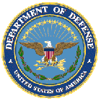

U.S. Department of Defense

Doing Business with the Department of Defense

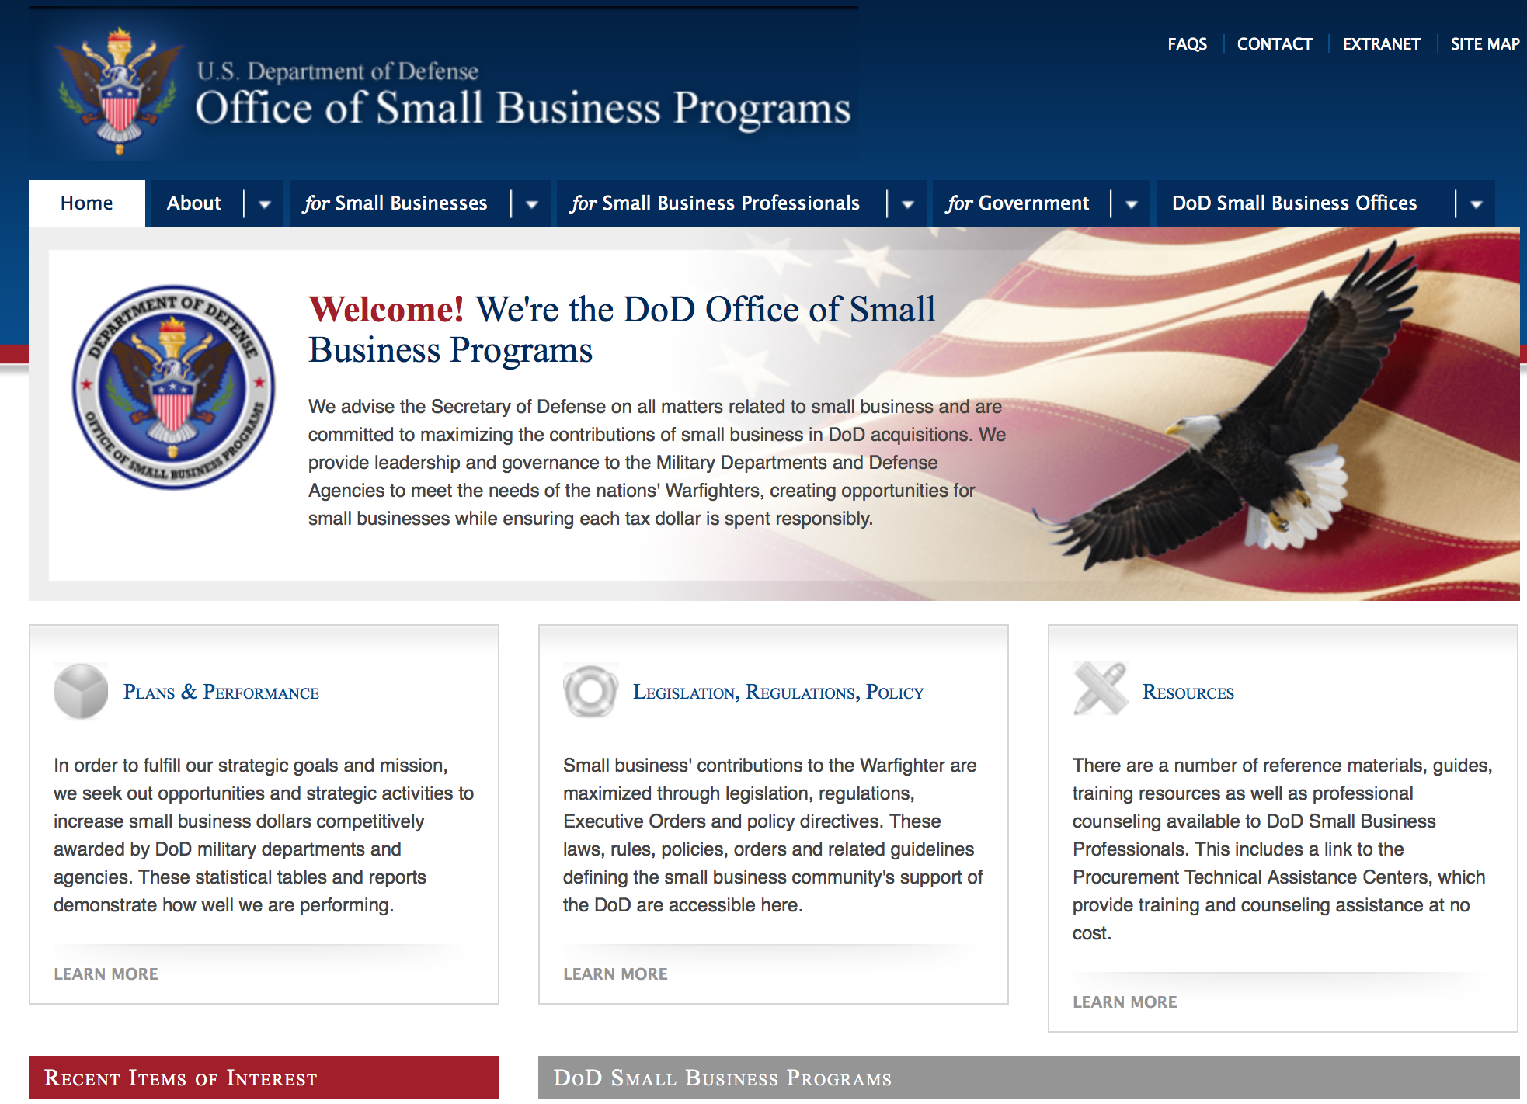

http://www.acq.osd.mil/osbp/

Doing Business with the DoD

Resources

Procurement Technical Assistance Centers (PTACs)

Procurement Technical Assistance Centers (PTACs) are charged with assisting businesses in learning how to do business with federal, state, and local governments. PTACs are a local resource available at no or nominal cost that can provide assistance to business firms in marketing their products and services. They offer training to businesses on how to research and bid on contracts, assist with registration requirements, provide bid-matching services, and assist with pre and post contracting issues.

Prime Contractors with Subcontracting Plans [xlsx]

Directory updated 4/19/11

This FY 2014 directory is intended for small business concerns seeking opportunities with DoD prime contractors. The directory is a listing of large business prime contractors who are required to establish subcontracting plans with goals. The report is generated from data contained in the Individual Subcontract Reports (ISRs) submitted in the Electronic Subcontracting Reporting System (eSRS) by contractors and from data contained in the Federal Procurement Data System (FPDS). The directory includes the name of the prime contractor; the major product/service code (PSC) provided to DoD; the major NAICS of the company; name, telephone number and email address of the company’s point of contact; contract number with the effective date and completion date, ultimate contract value and obligated dollars. In addition, many companies have websites with additional information which may be useful in your search for subcontracting opportunities or teaming arrangements.

Locate a Small Business Professional

Small Business Professionals serve as the primary liaison between private-sector small businesses seeking to do business with government agencies. Specialists advise small businesses regarding current acquisitions contracts available from the federal government.

Procurement Forecasts & the Department of Defense

The Department of Defense, due to its size and scope, does not have a single, comprehensive source for future procurements. Procurements are made locally and within the various services and agencies.

Business Intelligence, relative to future procurement planning, would be gathered at the local level.

For the purposes of forecasting, knowledge of past behavior is useful. Click here for a table of DoD acquisitions in FY10 summarized by NAICS code. The FY10 data has been validated but FPDS data is dynamic and changes continuously.

Non-Appropriated Fund Customers

Non-appropriated fund customers operate similar to non-profit organizations and include commissaries, exchanges, recreation and fitness centers, dining at officer/enlisted/civilian clubs, and barber/beauty services, just to name a few. For more information click here.

Research:

Dept. of the Army -- USAMRAA
Peer Reviewed Medical Discovery Award Grant
http://www.grants.gov/web/grants/view-opportunity.html?oppId=283528

Dept. of the Army -- USAMRAA
Peer Reviewed Medical Focused Program Award Grant
http://www.grants.gov/web/grants/view-opportunity.html?oppId=283529

Dept. of the Army -- USAMRAA
Peer Reviewed Medical Technology/Therapeutic Development Award Grant
http://www.grants.gov/web/grants/view-opportunity.html?oppId=283566

Dept. of the Army -- USAMRAA
Prostate Cancer Impact Award Grant
http://www.grants.gov/web/grants/view-opportunity.html?oppId=283542

Dept. of the Army -- USAMRAA
Peer Reviewed Medical Clinical Trial Award Grant
http://www.grants.gov/web/grants/view-opportunity.html?oppId=283564

Dept. of the Army -- USAMRAA
Peer Reviewed Medical Investigator-Initiated Research Award Grant
http://www.grants.gov/web/grants/view-opportunity.html?oppId=283565

Dept. of the Army -- USAMRAA
Prostate Cancer Early Investigator Research Award Grant
http://www.grants.gov/web/grants/view-opportunity.html?oppId=283574

Dept. of the Army -- USAMRAA
Prostate Cancer Health Disparity Research Award Grant
http://www.grants.gov/web/grants/view-opportunity.html?oppId=283576

Dept. of the Army -- USAMRAA
Prostate Cancer Idea Development Award Grant
http://www.grants.gov/web/grants/view-opportunity.html?oppId=283578

Dept. of the Army -- USAMRAA
Prostate Cancer Physician Research Award Grant
http://www.grants.gov/web/grants/view-opportunity.html?oppId=283580

Dept. of the Army -- USAMRAA
Spinal Cord Injury Investigator-Initiated Grant
http://www.grants.gov/web/grants/view-opportunity.html?oppId=283821

Dept. of the Army -- USAMRAA
Gulf War Illness Treatment Evaluation Award Grant
http://www.grants.gov/web/grants/view-opportunity.html?oppId=283826

Dept. of the Army -- USAMRAA
Gulf War Illness New Investigator Award Grant
http://www.grants.gov/web/grants/view-opportunity.html?oppId=283829

Dept. of the Army -- USAMRAA
Gulf War Illness Investigator-Initiated Focused Research Award Grant
http://www.grants.gov/web/grants/view-opportunity.html?oppId=283827

Dept. of the Army -- USAMRAA
Spinal Cord Injury Qualitative Award Grant
http://www.grants.gov/web/grants/view-opportunity.html?oppId=283838

Dept. of the Army -- USAMRAA
Tuberous Sclerosis Complex Exploration-Hypothesis Development Award Grant
http://www.grants.gov/web/grants/view-opportunity.html?oppId=283645

Dept. of the Army -- USAMRAA
Tuberous Sclerosis Complex Postdoctoral Development Award Grant
http://www.grants.gov/web/grants/view-opportunity.html?oppId=283653

Dept. of the Army -- USAMRAA
Neurofibromatosis New Investigator Award Grant
http://www.grants.gov/web/grants/view-opportunity.html?oppId=283687

Dept. of the Army -- USAMRAA
Spinal Cord Injury Translational Award Grant
http://www.grants.gov/web/grants/view-opportunity.html?oppId=283839

Dept. of the Army -- USAMRAA
Lung Cancer Concept Award Grant
http://www.grants.gov/web/grants/view-opportunity.html?oppId=284071

Dept. of the Army -- Materiel Command
Proof of Concept Commercialization Pilot Program Grant
http://www.grants.gov/web/grants/view-opportunity.html?oppId=283581

Defense Logistics Agency
Procurement Technical Assistance Program Grant
http://www.grants.gov/web/grants/view-opportunity.html?oppId=283583

Dept. of the Army -- Materiel Command
Proof of Concept Commercialization Pilot Program Grant
http://www.grants.gov/web/grants/view-opportunity.html?oppId=283584

Defense Advanced Research Projects Agency
DARPA - Defense Sciences Office
Accelerated Computation for Efficient Scientific Simulation (ACCESS) Grant
http://www.grants.gov/web/grants/view-opportunity.html?oppId=283611

Defense Advanced Research Projects Agency
DARPA - Tactical Technology Office
Innovative Systems for Military Missions Grant
http://www.grants.gov/web/grants/view-opportunity.html?oppId=284170

Defense Advanced Research Projects Agency
DARPA - Defense Sciences Office
TRADES Grant
http://www.grants.gov/web/grants/view-opportunity.html?oppId=283730

Office of Naval Research
Naval Supply Systems Command
Multi-Int Research Initiatives At The Grant
http://www.grants.gov/web/grants/view-opportunity.html?oppId=283589

Office of Naval Research
FY 17 Communications and Networking Discovery and Invention Grant
http://www.grants.gov/web/grants/view-opportunity.html?oppId=283597

Office of Naval Research
SPAWAR SYSTEMS CENTER
BAA-C4ISR, Information Operations and Information Technology Grant
http://www.grants.gov/web/grants/view-opportunity.html?oppId=284139

Modifications:

Air Force Office of Scientific Research
FISCAL YEAR 2017 DEFENSE UNIVERSITY RESEARCH INSTRUMENTATION PROGRAM
Modification 6
http://www.grants.gov/web/grants/view-opportunity.html?oppId=282081

Dept of the Army -- Materiel Command
DEFENSE UNIVERSITY RESEARCH INSTRUMENTATION PROGRAM (DURIP) FISCAL YEAR 2017 - ARMY SUBMISSION
Modification 2
http://www.grants.gov/web/grants/view-opportunity.html?oppId=282256

Dept. of the Army -- USAMRAA
Peer Reviewed Cancer Idea Award with Special Focus
Modification 2
http://www.grants.gov/web/grants/view-opportunity.html?oppId=283060

Dept. of the Army -- Materiel Command
Proof of Concept Commercialization Pilot Program
Modification 1
http://www.grants.gov/web/grants/view-opportunity.html?oppId=283584

Dept. of the Army -- USAMRAA
Spinal Cord Injury Clinical Trial Award
Modification 1
http://www.grants.gov/web/grants/view-opportunity.html?oppId=283820

Dept. of the Army -- USAMRAA
Neurofibromatosis Exploration-Hypothesis Development Award
Modification 1
http://www.grants.gov/web/grants/view-opportunity.html?oppId=283669

Defense Advanced Research Projects Agency
DARPA - Defense Sciences Office
TRAnsformative DESign (TRADES)
Modification 1
http://www.grants.gov/web/grants/view-opportunity.html?oppId=283730

Dept. of the Army -- Materiel Command
Army Research Laboratory Broad Agency Announcement for Basic and Applied Scientific Research
Modification 6
http://www.grants.gov/web/grants/view-opportunity.html?oppId=173578

Dept. of the Army -- Materiel Command
Army Research Office Broad Agency Announcement for Basic and Applied Scientific Research
Modification 9
http://www.grants.gov/web/grants/view-opportunity.html?oppId=173593

Office of Naval Research
Naval Supply Systems Command
Multi-Intelligence (Multi-INT) Research Initiatives at The Naval Postgraduate School
Modification 1

http://www.grants.gov/web/grants/view-opportunity.html?oppId=283589

Office of Naval Research
Naval Research Laboratory
NRL WIDE BROAD AGENCY ANNOUNCEMENT
Modification 1
http://www.grants.gov/web/grants/view-opportunity.html?oppId=281554

Office of Naval Research
Naval Supply Systems Command
FY15 - FY16 Department of Defense HIV/AIDS Prevention Program: Military Specific HIV/AIDS Prevention, Care, and Treatment Program for PEPFAR (President's Emergency Plan for AIDS Relief) Funded Countries
Modification 19
http://www.grants.gov/web/grants/view-opportunity.html?oppId=270446

Reminders:

Dept. of the Army -- Materiel Command
Army Research Office Broad Agency Announcement for Basic and Applied Scientific Research
Modification 8

Document Type: | Grants Notice
Funding Opportunity Number: | W911NF-12-R-0012
Funding Opportunity Title: | Army Research Office Broad Agency Announcement for Basic and Applied Scientific Research
Opportunity Category: | Discretionary
Funding Instrument Type: | Cooperative Agreement  Grant  Other  Procurement Contract
Category of Funding Activity: | Science and Technology and other Research and Development
Category Explanation:
Expected Number of Awards: | 1000
CFDA Number(s): | 12.431 -- Basic Scientific Research
Cost Sharing or Matching Requirement: | No
Posted Date: | Mar 27, 2015
Creation Date: | Mar 27, 2015
Original Closing Date for Applications: | Mar 31, 2017
Current Closing Date for Applications: | Mar 31, 2017
Archive Date: | Apr 30, 2017
Eligible Applicants: | Unrestricted (i.e., open to any type of entity above), subject to any clarification in text field entitled "Additional Information on Eligibility"
Agency Name: | Dept. of the Army -- Materiel Command
Description: | The purpose of this Broad Agency Announcement (BAA) is to solicit research proposals in the engineering, physical, life, and information sciences for submission to the Army Research Office (ARO) for consideration for possible funding. For ease of reference, this BAA is an extraction of the ARO sections of the Army Research Laboratory BAA. (www.arl.army.mil/www/default.cfm?page=8).
Link to Additional Information: | ARO CORE BAA-W911NF-12-R-0012-Mod 03
Contact Information: | If you have difficulty accessing the full announcement electronically, please contact:  ANDREW L. FISKE Procurement Analyst Army Contracting Command Aberdeen Proving Ground Research Triangle Park Division Phone: (919) 549-4338 FAX: (919) 549-4388 andrew.l.fiske.civ@mail.mil  Administrative POC

http://www.grants.gov/web/grants/view-opportunity.html?oppId=173593



Department of Education

Grant Programs Overview at the Department of Education

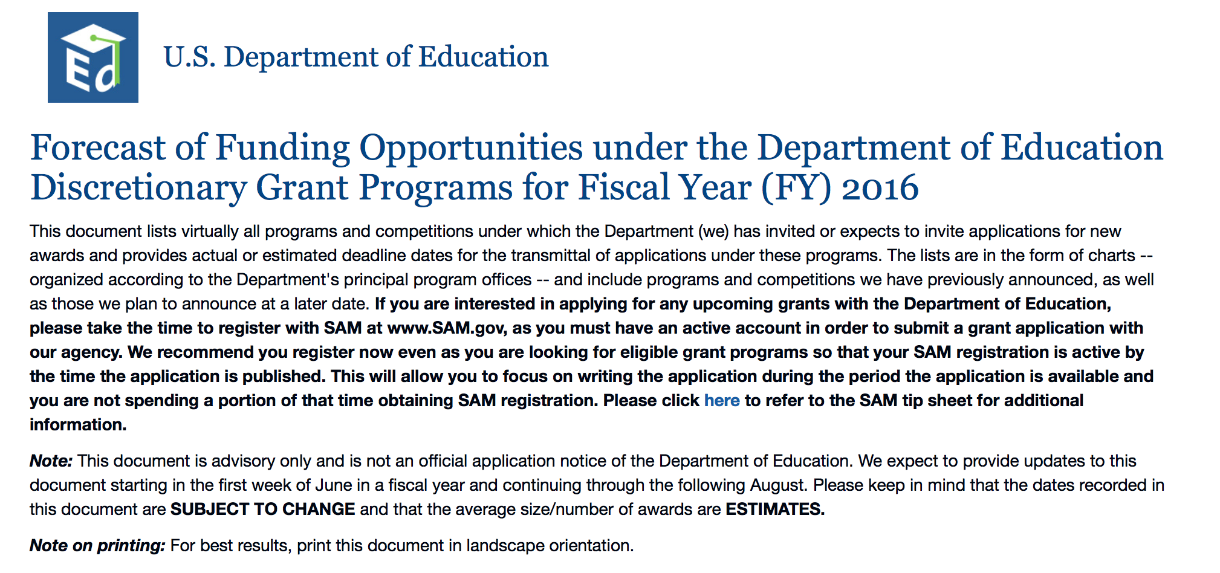To see the complete document click here: http://www2.ed.gov/fund/grant/find/edlite-forecast.html

The general information page for Education Grant funding is an excellent resource describing the three types of grants awarded by the Department of Education. See the screen shot of the Department of Education web page below:

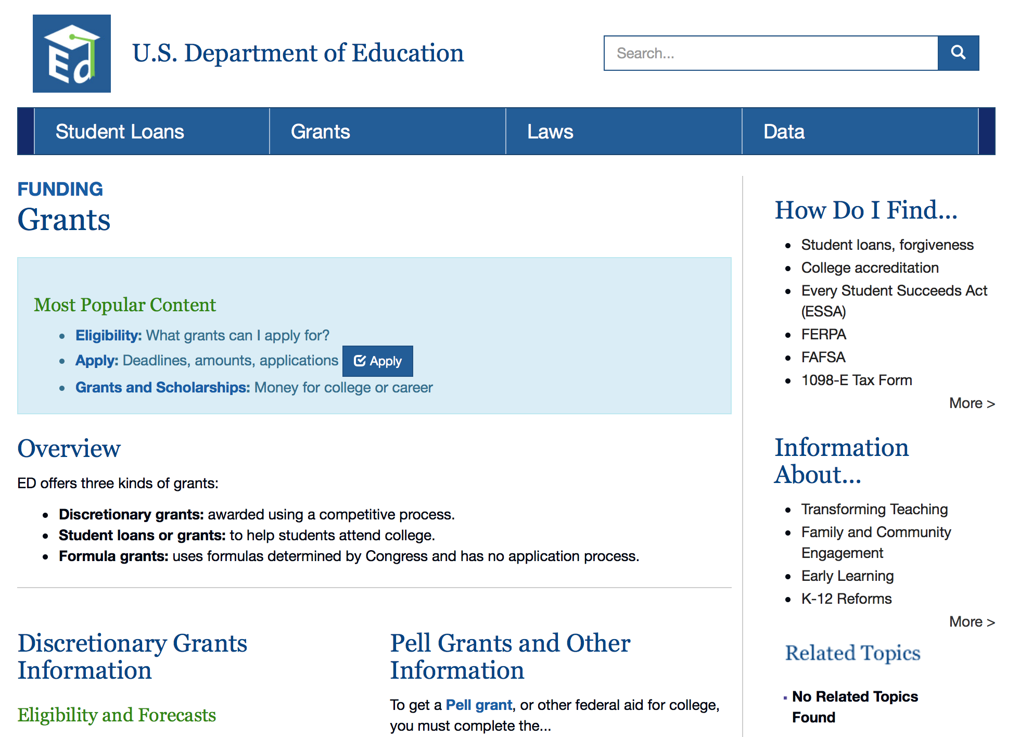

http://www.ed.gov/fund/grants-apply.html

Programs:

Office of Innovation and Improvement (OII): Charter Schools Program (CSP): Grants for Replication and Expansion of High-Quality Charter Schools CFDA Number 84.282M Grant

Document Type: | Grants Notice
Funding Opportunity Number: | ED-GRANTS-051016-001
Funding Opportunity Title: | Office of Innovation and Improvement (OII): Charter Schools Program (CSP): Grants for Replication and Expansion of High-Quality Charter Schools CFDA Number 84.282M
Opportunity Category: | Discretionary
Opportunity Category Explanation: | Category Explanation
Funding Instrument Type: | Grant
Category of Funding Activity: | Education
Category Explanation:
Expected Number of Awards: | 10
CFDA Number(s): | 84.282 -- Charter Schools
Cost Sharing or Matching Requirement: | No
Last Updated Date: | May 17, 2016
Original Closing Date for Applications: | Jun 20, 2016 Applications Available: May 10, 2016. Date of Pre-Application Webinar: June 16, 2016, 2:00 p.m. to 3:30 p.m., Washington, DC, time. Date of Pre-Application Webinar: The Department will hold a pre-application meeting via Webinar for prospective applicants on June 16, 2016, 2:00 p.m. to 3:30 p.m., Washington, DC, time. Individuals interested in attending this meeting are encouraged to pre-register by emailing their name, organization, and contact information with the subject heading ``PRE-APPLICATION MEETING'' to CharterSchools@ed.gov. There is no registration fee for attending this meeting. For further information about the pre-application meeting, contact Brian Martin, U.S. Department of Education, 400 Maryland Avenue SW., Room 4W224, Washington, DC 20202-5970. Telephone: (202) 205-9085 or by email: brian.martin@ed.gov. Deadline for Transmittal of Applications: June 20, 2016.
Current Closing Date for Applications: | Jun 24, 2016 On May 10, 2016, we published in the Federal Register (81 FR 28837) a notice inviting applications for new awards for fiscal year (FY) 2016 for the CSP Grants for Replication and Expansion of High-Quality Charter Schools program. This correction notice amends (1) the date of the pre-application webinar from June 16, 2016, to May 24, 2016; and (2) the deadline for transmittal of applications from June 20, 2016, to June 24, 2016. All other requirements and conditions stated in the notice inviting applications, including the deadline for intergovernmental review, remain the same. DATES: Date of Pre-Application Webinar: May 24, 2016, 2:00 p.m. to 3:30 p.m., Washington, DC, time. Deadline for Transmittal of Applications: June 24, 2016.
Archive Date: | Jul 24, 2016
Estimated Total Program Funding: | $65,000,000
Award Ceiling: | $3,000,000
Eligible Applicants: | Others (see text field entitled "Additional Information on Eligibility" for clarification)
Additional Information on Eligibility: | Eligible Applicants: Non-profit charter management organizations (as defined in this notice) and other entities that are not for-profit entities. Eligible applicants also may apply as a group or consortium.
Agency Name: | Department of Education
Description: | Note: Each funding opportunity description is a synopsis of information in the Federal Register application notice. For specific information about eligibility, please see the official application notice. The official version of this document is the document published in the Federal Register. Free Internet access to the official edition of the Federal Register and the Code of Federal Regulations is available on GPO Access at: http://www.access.gpo.gov/nara/index.html. Please review the official application notice for pre-application and application requirements, application submission information, performance measures, priorities and program contact information. Purpose of Program: The purpose of the CSP is to increase national understanding of the charter school model by expanding the number of high-quality charter schools (as defined in this notice) available to students across the Nation; providing financial assistance for the planning, program design, and initial implementation of charter schools; and evaluating the effects of charter schools, including their effects on students, student academic achievement, staff, and parents. The purpose of the CSP Grants for Replication and Expansion of High-Quality Charter Schools (Replication and Expansion) competition (CFDA 84.282M) is to award grants to eligible applicants to enable them to replicate (as defined in this notice) or expand high-quality charter schools (as defined in this notice) with demonstrated records of success, including success in increasing student academic achievement. Eligible applicants may use their grant funds to expand the enrollment of one or more existing charter schools by substantially increasing the number of available seats per school, or to open one or more new charter schools that are based on the charter school model for which the eligible applicant has presented evidence of success. Catalog of Federal Domestic Assistance (CFDA) Number: 84.282M.Applications for grants under the CSP Grants for Replication and Expansion of High-Quality Charter Schools, CFDA number 84.282M, must be submitted electronically using the Governmentwide Grants.gov Apply site at www.Grants.gov. Through this site, you will be able to download a copy of the application package, complete it offline, and then upload and submit your application. You may not email an electronic copy of a grant application to us. You may access the electronic grant application for CSP Grants for Replication and Expansion of High-Quality Charter Schools at www.Grants.gov. You must search for the downloadable application package for this competition by the CFDA number. Do not include the CFDA number's alpha suffix in your search (e.g., search for 84.282, not 84.282M).
Link to Additional Information: | Office of Innovation and Improvement (OII): Charter Schools Program (CSP): Grants for Replication and Expansion of High-Quality Charter Schools CFDA Number 84.282M: Notice inviting applications for new awards for fiscal year (FY) 2016
Contact Information: | If you have difficulty accessing the full announcement electronically, please contact:  Julius Cotton ED Grants.gov FIND Systems Admin. Phone 202-245-6288 EducationGrantInquiries@ed.gov Program Manager: Brian Martin, U.S. Department of Education, 400 Maryland Avenue SW., Room 4W224, Washington, DC 20202-5970. Telephone: (202) 205-9085 or by email: brian.martin@ed.gov.  e-Mail: Program Manager

http://www.grants.gov/web/grants/view-opportunity.html?oppId=283700

Office of Innovation and Improvement (OII): Teacher Incentive Fund (TIF) CFDA Number 84.374A Grant
Document Type: | Grants Notice
Funding Opportunity Number: | ED-GRANTS-053116-002
Funding Opportunity Title: | Office of Innovation and Improvement (OII): Teacher Incentive Fund (TIF) CFDA Number 84.374A
Opportunity Category: | Discretionary
Opportunity Category Explanation: | Category Explanation
Funding Instrument Type: | Grant
Category of Funding Activity: | Education
Category Explanation:
Expected Number of Awards: | 5
CFDA Number(s): | 84.374 -- Teacher Incentive Fund
Cost Sharing or Matching Requirement: | No
Posted Date: | May 31, 2016
Last Updated Date: | May 31, 2016
Current Closing Date for Applications: | Jul 15, 2016 Applications Available: May 31, 2016. Deadline for Notice of Intent To Apply: June 30, 2016. Notice of Intent to Apply: We will be able to develop a more efficient process for reviewing grant applications if we can anticipate the number of applicants that intend to apply for funding under this competition. Therefore, we strongly encourage each potential applicant to notify us of the applicant's intent to submit an application for funding by sending a short email message. This short email should provide (1) the applicant organization's name and address; and (2) all priorities the applicant intends to address. Please send this email notification to TIF5@ed.gov with ``Intent to Apply'' in the email subject line. Applicants that do not provide this email notification may still apply for funding and are not required to, or prohibited from, addressing priorities they do not mention in their notice of intent to apply. Dates of Pre-Application Workshops: For information about pre-application workshops, visit the TIF Web site at: http://innovation.ed.gov/what-we-do/teacher-quality/teacher-incentive-fund/. Pre-application workshops will be held for this competition in the spring of 2016. The workshops are intended to provide technical assistance to all interested grant applicants. Detailed information regarding the pre-application workshops times, and online registration form, can be found on the Teacher Incentive Fund's Web site at http://innovation.ed.gov/what-we-do/teacher-quality/teacher-incentive-fund/. Deadline for Transmittal of Applications: July 15, 2016.
Archive Date: | Aug 14, 2016
Estimated Total Program Funding: | $50,000,000
Eligible Applicants: | Others (see text field entitled "Additional Information on Eligibility" for clarification)
Additional Information on Eligibility: | 1. Eligible Applicants: (a) LEAs, including charter schools that are LEAs. (b) States that apply with one or more LEAs. (c) Nonprofit organizations that apply in partnership with one or more LEAs or an LEA and State.
Agency Name: | Department of Education
Description: | Note: Each funding opportunity description is a synopsis of information in the Federal Register application notice. For specific information about eligibility, please see the official application notice. The official version of this document is the document published in the Federal Register. Free Internet access to the official edition of the Federal Register and the Code of Federal Regulations is available on GPO Access at: http://www.access.gpo.gov/nara/index.html. Please review the official application notice for pre-application and application requirements, application submission information, performance measures, priorities and program contact information. Purpose of Program: The purpose of the TIF program is to support, develop, and implement sustainable Performance-based Compensation Systems for teachers, principals, and other personnel in High-Need Schools,\1\ within the context of a local educational agency's (LEA's) overall Human Capital Management System, in order to increase Educator effectiveness and student achievement in those schools. --------------------------------------------------------------------------- \1\ Throughout this notice, all defined terms are denoted with initial capitals. --------------------------------------------------------------------------- Catalog of Federal Domestic Assistance (CFDA) Number: 84.374A. Applications for grants under the Teacher Incentive Fund, CFDA number 84.374A, must be submitted electronically using the Governmentwide Grants.gov Apply site at www.Grants.gov. Through this site, you will be able to download a copy of the application package, complete it offline, and then upload and submit your application. You may not email an electronic copy of a grant application to us. You may access the electronic grant application for the Teacher Incentive Fund competition at www.Grants.gov. You must search for the downloadable application package for this program by the CFDA number. Do not include the CFDA number's alpha suffix in your search (e.g., search for 84.374, not 84.374A).
Link to Additional Information: | Office of Innovation and Improvement (OII): Teacher Incentive Fund (TIF) CFDA Number 84.374A; Notice inviting applications for new awards for fiscal year (FY) 2016
Contact Information: | If you have difficulty accessing the full announcement electronically, please contact:  Julius Cotton ED Grants.gov FIND Systems Admin. Phone 202-245-6288 EducationGrantInquiries@ed.gov Program Manager: Vicki Robinson, U.S. Department of Education, 400 Maryland Avenue SW., Room 4W103, Washington, DC 20202-6200. Telephone: (202) 205-5471 or by email: TIF5@ed.gov.  e-Mail: Program Mailbox

http://www.grants.gov/web/grants/view-opportunity.html?oppId=284265

Research:

Modifications:

Office of Innovation and Improvement (OII): Investing in Innovation (I3) Fund: Scale-up Grants CFDA Number 84.411A
Modification 1
http://www.grants.gov/web/grants/view-opportunity.html?oppId=283866

Office of Innovation and Improvement (OII): Charter Schools Program (CSP): Grants for Replication and Expansion of High-Quality Charter Schools CFDA Number 84.282M
Modification 1
http://www.grants.gov/web/grants/view-opportunity.html?oppId=283700

Reminders:

Office of Career, Technical, and Adult Education (OCTAE): Performance Partnership Pilots (P3) CFDA Number 84.420A
Modification 1
Document Type: | Grants Notice
Funding Opportunity Number: | ED-GRANTS-042616-001
Funding Opportunity Title: | Office of Career, Technical, and Adult Education (OCTAE): Performance Partnership Pilots (P3) CFDA Number 84.420A
Opportunity Category: | Discretionary
Opportunity Category Explanation:
Funding Instrument Type: | Cooperative Agreement
Category of Funding Activity: | Education
Category Explanation:
Expected Number of Awards: | 10
CFDA Number(s): | 84.420 -- Performance Partnership Pilots for Disconnected Youth
Cost Sharing or Matching Requirement: | No
Posted Date: | Apr 26, 2016
Last Updated Date: | Apr 26, 2016
Current Closing Date for Applications: | Jun 27, 2016 Applications Available: April 26, 2016. Deadline for Notice of Intent to Apply: May 26, 2016. Note: Submission of a notice of intent to apply is optional. We will be able to develop a more efficient process for reviewing applications if we know the approximate number of applicants that intend to apply under this competition. Therefore, we strongly encourage each potential applicant to notify us of the applicant's intent to apply by emailing to disconnectedyouth@ed.gov the following information: (1) The applicant organization's name and address and (2) the absolute priority the applicant intends to address. Applicants that do not submit a notice of intent to apply may still submit an application. Note: Submission of a notice of intent to apply is optional. Deadline for Transmittal of Applications: June 27, 2016.
Archive Date: | Jul 27, 2016
Estimated Total Program Funding: | $3,050,000
Eligible Applicants: | State governments  Others (see text field entitled "Additional Information on Eligibility" for clarification)  County governments  Special district governments  Native American tribal governments (Federally recognized)  City or township governments
Additional Information on Eligibility: | Eligible Applicants: The lead applicant must be a State, local, or tribal government entity, represented by a Chief Executive, such as a governor, mayor, or other elected leader, or the head of a State, local, or tribal agency.
Agency Name: | Department of Education
Description: | Note: Each funding opportunity description is a synopsis of information in the Federal Register application notice. For specific information about eligibility, please see the official application notice. The official version of this document is the document published in the Federal Register. Free Internet access to the official edition of the Federal Register and the Code of Federal Regulations is available on GPO Access at: http://www.access.gpo.gov/nara/index.html. Please review the official application notice for pre-application and application requirements, application submission information, performance measures, priorities and program contact information. Purpose of Program: Performance Partnership Pilots (P3), first authorized by Congress for FY 2014 by the Consolidated Appropriations Act, 2014 (2014 Appropriations Act) and reauthorized for FY 2015 by the Consolidated and Further Continuing Appropriations Act, 2015 (2015 Appropriations Act) and for FY 2016 by the Consolidated Appropriations Act, 2016 (2016 Appropriations Act) (together, the Acts), enable pilot sites to test innovative, outcome-focused strategies to achieve significant improvements in educational, employment, and other key outcomes for disconnected youth using new flexibility to blend existing Federal funds and to seek waivers of associated program requirements. Background: The Acts authorize the Departments of Education (ED), Labor (DOL), Health and Human Services (HHS), Housing and Urban Development (HUD),\1\ and Justice (DOJ),\2\ the Corporation for National and Community Service (CNCS), and the Institute of Museum and Library Services (IMLS) (collectively, the Agencies), to enter into Performance Partnership Agreements (performance agreements) with State, local, or tribal governments to provide additional flexibility in using certain of the Agencies' discretionary funds,\3\ including competitive and formula grant funds, across multiple Federal programs. Entities that seek to participate in these pilots will be required to commit to achieving significant improvements in outcomes for disconnected youth in exchange for this new flexibility. The authorizing statute states that `` `[t]o improve outcomes for disconnected youth' means to increase the rate at which individuals between the ages of 14 and 24 (who are low-income and either homeless, in foster care, involved in the juvenile justice system, unemployed, or not enrolled in or at risk of dropping out of an educational institution) achieve success in meeting educational, employment, or other key goals.'' Catalog of Federal Domestic Assistance (CFDA) Number: 84.420A. Applications for grants under the P3 program, CFDA number 84.420A, must be submitted electronically using the Governmentwide Grants.gov Apply site at www.Grants.gov. Through this site, you will be able to download a copy of the application package, complete it offline, and then upload and submit your application. You may not email and you may access the electronic grant application for P3 at www.Grants.gov. You must search for the downloadable application package for this competition by the CFDA number. Do not include the CFDA number's alpha suffix in your search (e.g., search for 84.420, not 84.420A).
Link to Additional Information: | Office of Career, Technical, and Adult Education (OCTAE): Performance Partnership Pilots (P3) CFDA NUmber 84.420A; Notice inviting applications for new awards for fiscal year (FY) 2015
Contact Information: | If you have difficulty accessing the full announcement electronically, please contact:  Julius Cotton ED Grants.gov FIND Systems Admin. Phone 202-245-6288 EducationGrantInquiries@ed.gov Program Managers: Marilyn Fountain, U.S. Department of Education, 400 Maryland Avenue SW., Room 11026, Potomac Center Plaza (PCP), Washington, DC 20202. Telephone: (202)245-7346 or by email: disconnectedyouth@ed.gov or Rosanne Andre, U.S. Department of Education, 400 Maryland Avenue SW., Room 11070, Potomac Center Plaza (PCP), Washington, DC 20202. Telephone: (202) 245-7789. Email address: Disconnectedyouth@ed.gov.  e-Mail: Program Mailbox

http://www.grants.gov/web/grants/view-opportunity.html?oppId=283281

Institute of Education Sciences (IES CFDA Number 84.305

Original Closing Date for Applications: | Aug 04, 2016 Application Package Available: May 5, 2016 Deadline for Transmittal of Applications: August 4, 2016.
Current Closing Date for Applications: | Aug 04, 2016 Application Package Available: May 5, 2016 Deadline for Transmittal of Applications: August 4, 2016.
Eligible Applicants: | Others (see text field entitled "Additional Information on Eligibility" for clarification)  County governments  Nonprofits having a 501(c)(3) status with the IRS, other than institutions of higher education  City or township governments  State governments  Special district governments  Nonprofits that do not have a 501(c)(3) status with the IRS, other than institutions of higher education  Public and State controlled institutions of higher education  Independent school districts  For profit organizations other than small businesses  Private institutions of higher education
Additional Information on Eligibility: | Eligible Applicants: Applicants that have the ability and capacity to conduct scientifically valid research are eligible to apply. Eligible applicants include, but are not limited to, nonprofit and for-profit organizations and public and private agencies and institutions of higher education, such as colleges and universities.
Agency Name: | Department of Education
Description: | Note: Each funding opportunity description is a synopsis of information in the Federal Register application notice. For specific information about eligibility, please see the official application notice. The official version of this document is the document published in the Federal Register. Free Internet access to the official edition of the Federal Register and the Code of Federal Regulations is available on GPO Access at: http://www.access.gpo.gov/nara/index.html. Please review the official application notice for pre-application and application requirements, application submission information, performance measures, priorities and program contact information. Purpose of Program: The central purpose of the Institute's research grant programs is to provide interested individuals and the general public with reliable and valid information about education practices that support learning and improve academic achievement and access to education opportunities for all students. These interested individuals include parents, educators, students, researchers, and policymakers. In carrying out its grant programs, the Institute provides support for programs of research in areas of demonstrated national need. Competitions in This Notice: The Institute will conduct nine research competitions in FY 2017 through two of its centers: Catalog of Federal Domestic Assistance (CFDA) Numbers: 84.305A, 84.305B, 84.305D, 84.305H, 84.305L, 84.305N, 84.324A, 84.324B, and 84.324L. The Deputy Director for Policy and Research, Delegated the Duties of the Director, of the Institute of Education Sciences (Institute) announces the Institute's FY 2017 competitions for grants to support education research and special education research. The Delegated Director takes this action under the Education Sciences Reform Act of 2002. The Institute's purpose in awarding these grants is to provide national leadership in expanding fundamental knowledge and understanding of (1) developmental and school readiness outcomes for infants and toddlers with or at risk for disability, and (2) education outcomes for all students from early childhood education through postsecondary and adult education. Applications for grants under the Education Research, Research Training Programs in the Education Sciences, Statistical and Research Methodology in Education, Partnerships and Collaborations Focused on Problems of Practice or Policy, Low-Cost, Short-Duration Evaluation of Education Interventions, Research Networks Focused on Critical Problems of Education Policy and Practice, Special Education Research, Research Training Programs in Special Education, and Low-Cost, Short-Duration Evaluation of Special Education Interventions competitions, CFDA numbers 84.305A, 84.305B, 84.305D, 84.305H, 84.305L, 84.305N, 84.324A, 84.324B, and 84.324L must be submitted electronically using the Governmentwide Grants.gov Apply site at www.Grants.gov. Through this site, you will be able to download a copy of the application package, complete it offline, and then upload and submit your application. You may not email an electronic copy of a grant application to us. You may access the electronic grant applications for the Education Research, Research Training Programs in the Education Sciences, Statistical and Research Methodology in Education, Partnerships and Collaborations Focused on Problems of Practice or Policy, Low-Cost, Short-Duration Evaluation of Education Interventions, Research Networks Focused on Critical Problems of Education Policy and Practice, Special Education Research, Research Training Programs in Special Education, and Low-Cost, Short-Duration Evaluation of Special Education Interventions competitions at www.Grants.gov. You must search for the downloadable application package for each competition by the CFDA number. Do not include the CFDA number's alpha suffix in your search (e.g., search for 84.305, not 84.305A).
Link to Additional Information: | Institute of Education Sciences (IES): Statistical and Research Methodology in Education CFDA Number 84.305D; Notice inviting applications for new awards for fiscal year (FY) 2017
Contact Information: | If you have difficulty accessing the full announcement electronically, please contact:  Julius Cotton ED Grants.gov FIND Systems Admin. Phone 202-245-6288 EducationGrantInquiries@ed.gov Program Manager: Phill Gagne, Phill.Gagne@ed.gov.  e-Mail: Program Manager



U.S. Department of Energy
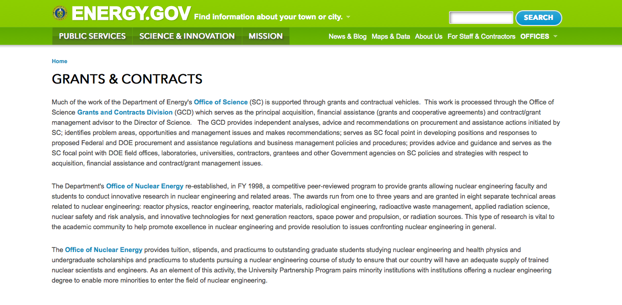
http://www.doe.gov/grants-contracts

Programs:

National Energy Technology Laboratory
Enabling Technologies for Advanced Combustion Systems Grant
http://www.grants.gov/web/grants/view-opportunity.html?oppId=283954

Golden Field Office
Funding Opportunity Announcement (FOA) Number DE-FOA-0001232: Project Development for Pilot and Demonstration Scale Manufacturing of Biofuels, Bioproducts and Biopower (PD2B3) Grant
http://www.grants.gov/web/grants/view-opportunity.html?oppId=283616

NNSA
National Laser Users' Facility (NLUF) Grant
http://www.grants.gov/web/grants/view-opportunity.html?oppId=284277

Modifications:

Advanced Research Projects Agency Energy
Integration and Optimization of Novel Ion Conducting Solids (IONICS)
Modifications 1 & 2
http://www.grants.gov/web/grants/view-opportunity.html?oppId=281814

National Energy Technology Laboratory
Methane Emissions Mitigation and Quantification from Natural Gas Infrastructure
Modification 4
http://www.grants.gov/web/grants/view-opportunity.html?oppId=283010

National Energy Technology Laboratory
Methane Emissions Mitigation and Quantification from Natural Gas Infrastructure
Modification 3
http://www.grants.gov/web/grants/view-opportunity.html?oppId=283010

Reminders:

Cities Leading through Energy Analysis and Planning (Cities-LEAP) Grant
And Modification 2

Document Type: | Grants Notice
Funding Opportunity Number: | DE-FOA-0001403
Funding Opportunity Title: | Cities Leading through Energy Analysis and Planning (Cities-LEAP)
Opportunity Category: | Discretionary
Opportunity Category Explanation:
Funding Instrument Type: | Cooperative Agreement
Category of Funding Activity: | Energy
Category Explanation:
Expected Number of Awards: | 0
CFDA Number(s): | 81.117 -- Energy Efficiency and Renewable Energy Information Dissemination, Outreach, Training and Technical Analysis/Assistance
Cost Sharing or Matching Requirement: | Yes
Posted Date: | Mar 23, 2016
Last Updated Date: | Mar 23, 2016
Original Closing Date for Applications: | Jun 17, 2016
Current Closing Date for Applications: | Jun 23, 2016
Archive Date: | Sep 30, 2016
Estimated Total Program Funding: | $0
Award Ceiling: | $500,000
Award Floor: | $100,000
Eligible Applicants: | County governments  City or township governments  Native American tribal governments (Federally recognized)  Native American tribal organizations (other than Federally recognized tribal governments)  Independent school districts  Special district governments
Agency Name: | Golden Field Office
Description: | The intent of this Funding Opportunity Announcement (FOA) is to support the development and piloting of data-driven decision frameworks by local and tribal governments. These frameworks should advance model practices and processes that improve the ability of local and tribal governments to integrate, analyze, and understand varied datasets, in order to pursue opportunities across all clean energy sectors such as sustainable transportation, energy efficiency, and renewable power. To develop and pilot such data-driven efforts, this FOA strongly encourages partnerships between local or tribal governments and entities such as academic institutions, technology companies, utilities, regional planning bodies, and non-governmental organizations.  Modification 0002: The purpose of this modification is to correct the page limit for the Technical Volume from 20 pages to 10 pages, as stated in Section IV.D.ii of the FOA. Modification 0001: The purpose of this modification is to revise the following dates: Full Application submission deadline, expected submission deadline for replies to reviewer comments, expected date for EERE selection notifications, and expected timeframe for award negotiations. The intent of this Funding Opportunity Announcement (FOA) is to support the development and piloting of data-driven decision frameworks by local and tribal governments. These frameworks should advance model practices and processes that improve the ability of local and tribal governments to integrate, analyze, and understand varied datasets, in order to pursue opportunities across all clean energy sectors such as sustainable transportation, energy efficiency, and renewable power. To develop and pilot such data-driven efforts, this FOA strongly encourages partnerships between local or tribal governments and entities such as academic institutions, technology companies, utilities, regional planning bodies, and non-governmental organizations
Link to Additional Information: | https://eere-exchange.energy.gov
Contact Information: | If you have difficulty accessing the full announcement electronically, please contact:  Grants Management Specialist Brenda L. Dias Cities.LEAP@ee.doe.gov  Submit all questions to Cities.LEAP@ee.doe.gov

http://www.grants.gov/web/grants/view-opportunity.html?oppId=282452

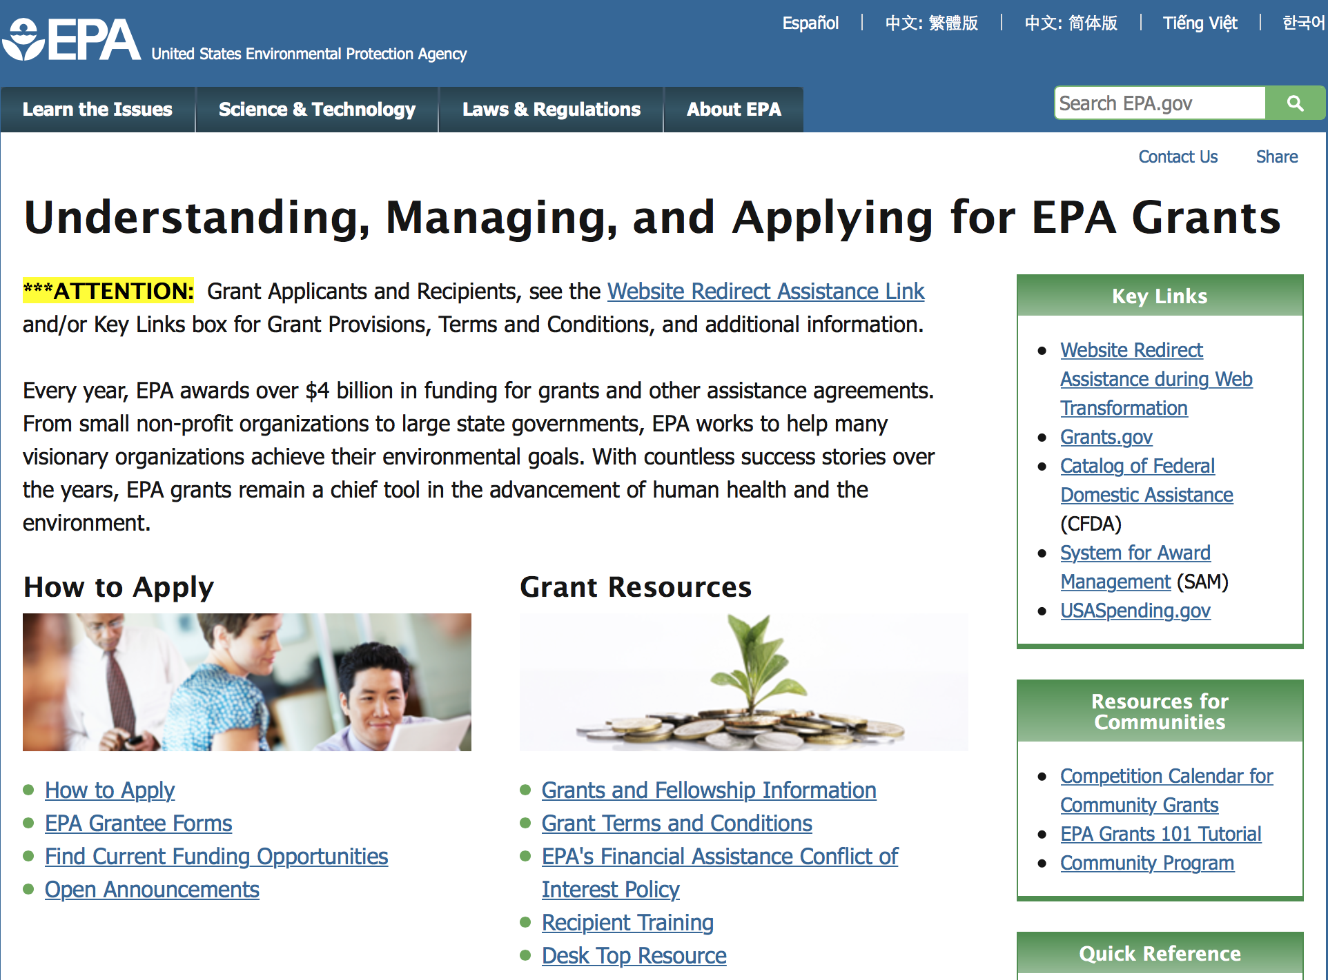

http://www.epa.gov/epahome/grants.htm

Programs:

FY 2016 and FY 2017 National Wetland Program Development Grants

Document Type: | Grants Notice
Funding Opportunity Number: | EPA-OW-OWOW-16-02
Funding Opportunity Title: | FY 2016 and FY 2017 National Wetland Program Development Grants
Opportunity Category: | Discretionary
Opportunity Category Explanation:
Funding Instrument Type: | Cooperative Agreement  Grant
Category of Funding Activity: | Environment
Category Explanation:
Expected Number of Awards: | 8
CFDA Number(s): | 66.462 -- National Wetland Program Development Grants and Five-Star Restoration Training Grant
Cost Sharing or Matching Requirement: | Yes
Posted Date: | May 18, 2016
Last Updated Date: | May 18, 2016
Original Closing Date for Applications: | Jun 23, 2016 Please see the announcement including Section IV for additional submission information.
Current Closing Date for Applications: | Jun 23, 2016 Please see the announcement including Section IV for additional submission information.
Archive Date: | Jul 23, 2016
Estimated Total Program Funding: | $800,000
Award Ceiling: | $200,000
Award Floor: | $75,000
Eligible Applicants: | Others (see text field entitled "Additional Information on Eligibility" for clarification)
Additional Information on Eligibility: | Individual states, tribes, local governments, and for-profit organizations are not eligible to apply under this announcement. Non-profit organizations described in Section 501(c)(4) of the Internal Revenue Code that engage in lobbying activities as defined in Section 3 of the Lobbying Disclosure Act of 1995 are not eligible to apply.
Agency Name: | Environmental Protection Agency
Description: | The U.S. Environmental Protection Agency (EPA) is soliciting proposals from eligible applicants for projects that develop or refine state/tribal/local government wetland programs as a whole, or individual components of those programs. Proposals for projects submitted under this announcement for Wetland Program Development Grants (WPDGs) must address the National Priority Area identified in Section I.B of the solicitation.
Link to Additional Information: | FY 2016 and FY 2017 National Wetland Program Development Grants
Contact Information: | If you have difficulty accessing the full announcement electronically, please contact:  Myra Price, 202-566-1225  Myra Price

http://www.grants.gov/web/grants/view-opportunity.html?oppId=283965

Modifications:

Reminders:

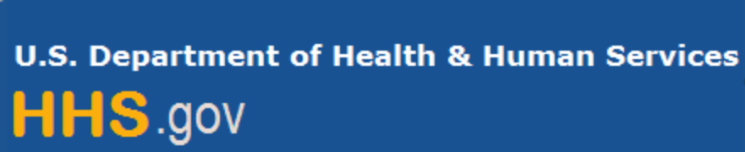

Department of Health and Human Services

Grants Forecast and Overview

The Department of Health and Human Services’ Grants Forecast is a database of planned grant opportunities proposed by its agencies. Each Forecast record contains actual or estimated dates and funding levels for grants that the agency intends to award during the fiscal year. Forecast opportunities are subject to change based on enactment of congressional appropriations. Go to the webpage below for more information.

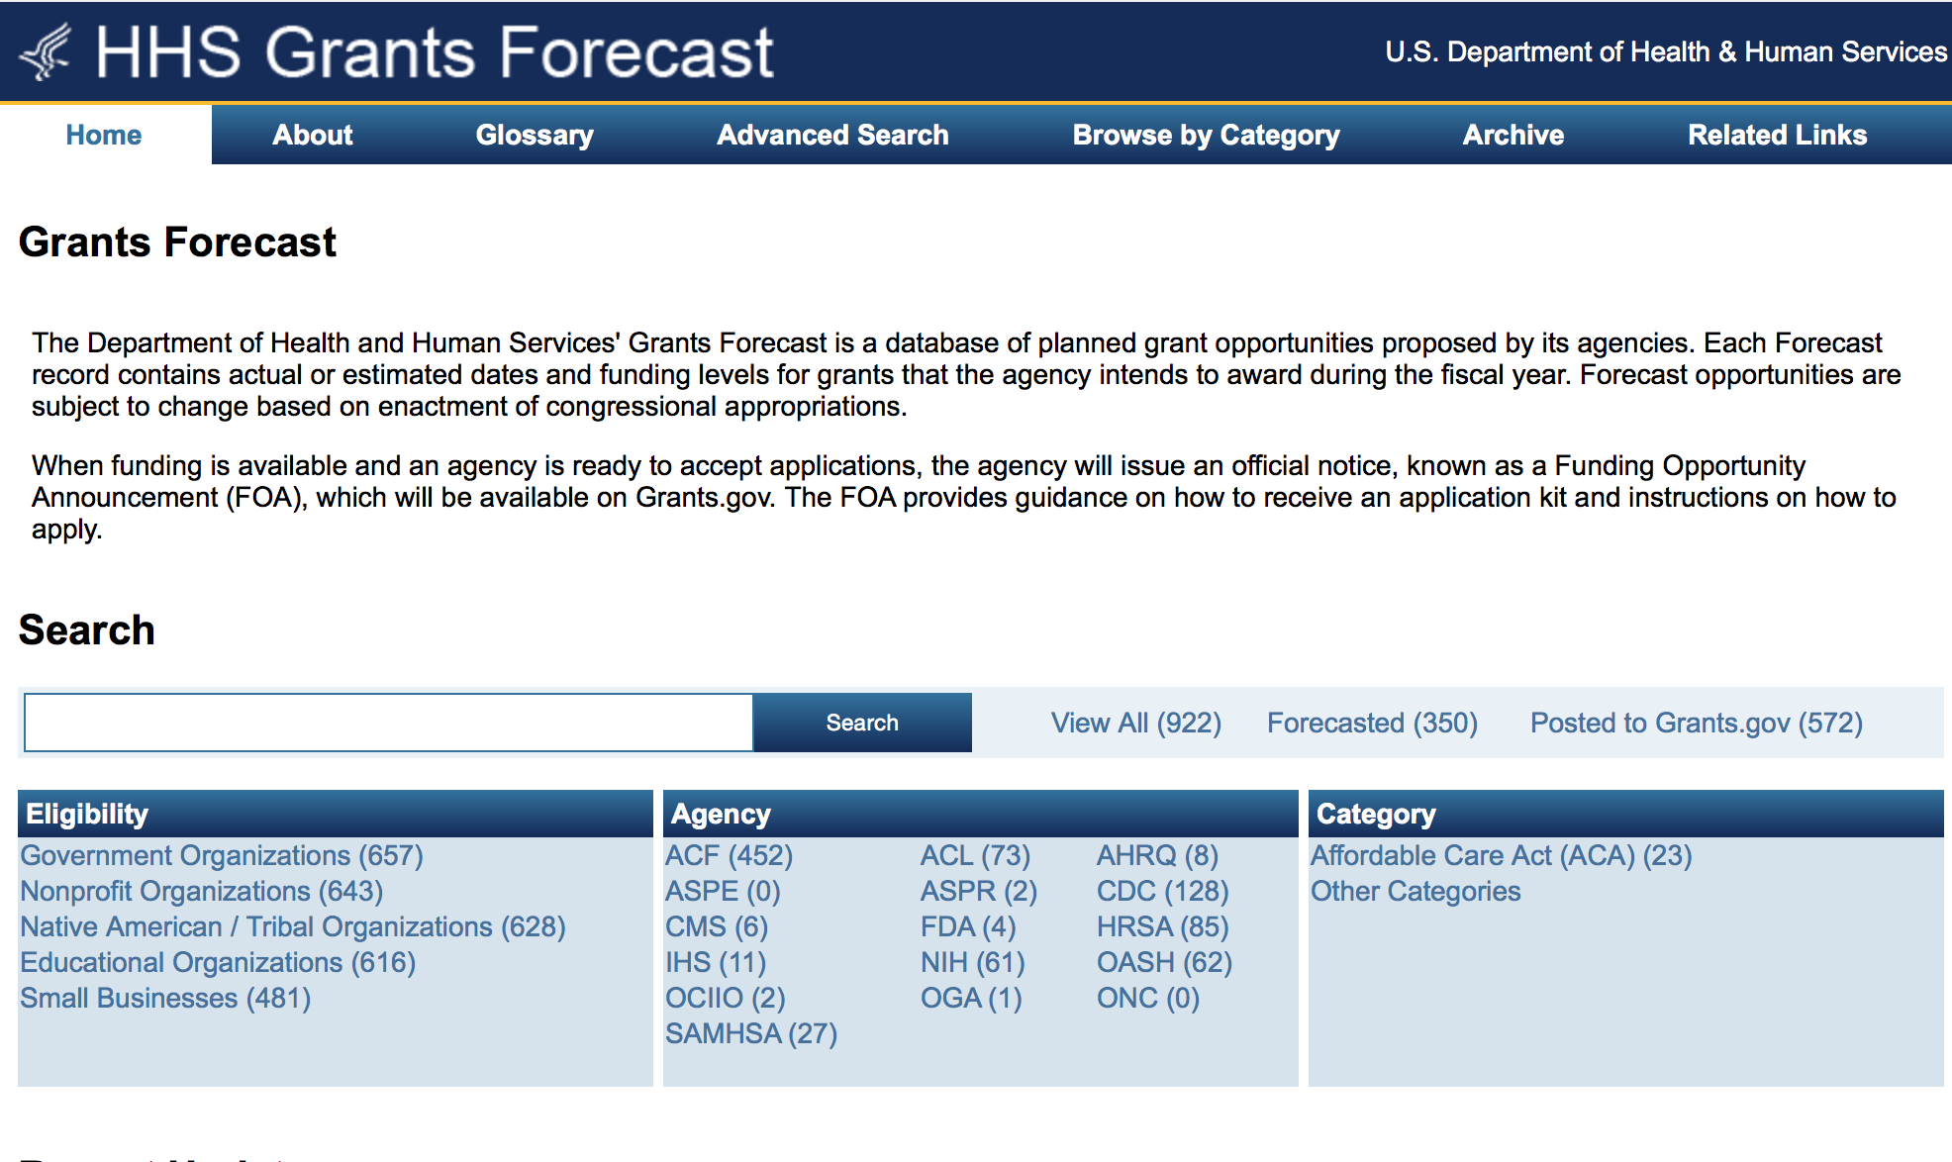
For more general information about HHS Grants and Funding go to the website below at: http://www.hhs.gov/grants/ .

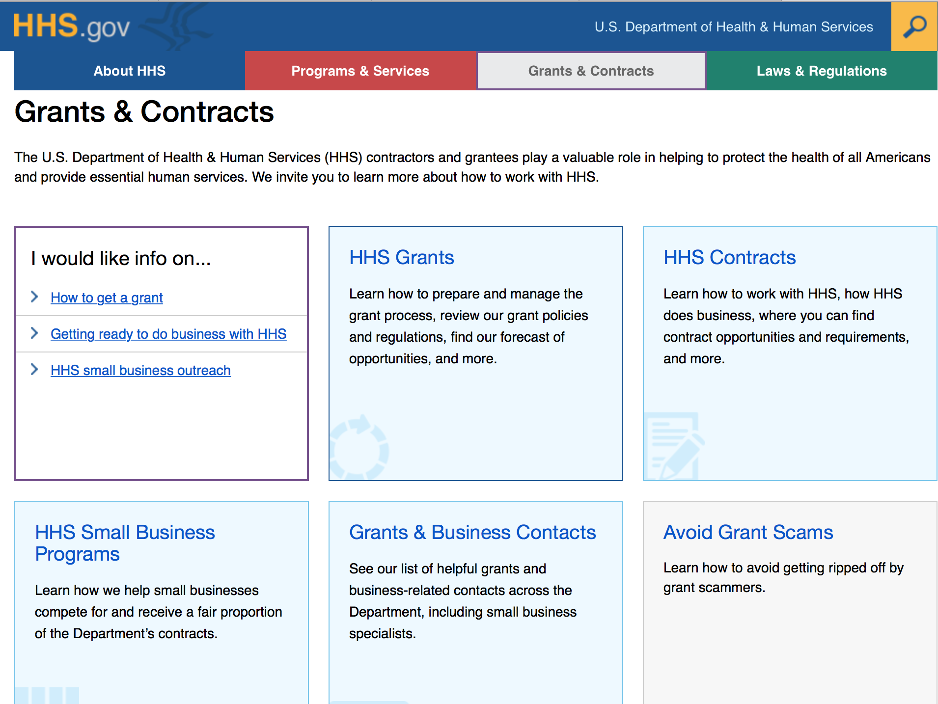

Programs:

Centers for Disease Control and Prevention
Centers for Disease Control - OPHPR
Public Health Preparedness and Response (PHPR) Cooperative Agreement for All-Hazards Public Health Emergencies: Zika 2016 Grant
http://www.grants.gov/web/grants/view-opportunity.html?oppId=283750

Health Resources and Services Administration
Healthy Tomorrows Partnership for Children Program (HTPCP) Grant
http://www.grants.gov/web/grants/view-opportunity.html?oppId=284005

Health Resources and Services Administration
Behavioral Health Workforce Education and Training (BHWET) for Paraprofessionals and Professionals Grant
http://www.grants.gov/web/grants/view-opportunity.html?oppId=283671

Administration for Children and Families - ORR
Standing Announcement for Residential (Staff Secure) Services for Unaccompanied Alien Children
Grant
http://www.grants.gov/web/grants/view-opportunity.html?oppId=284253

Administration for Children and Families - ORR
Standing Announcement for Residential (Secure) Services for Unaccompanied Alien Children
Grant
http://www.grants.gov/web/grants/view-opportunity.html?oppId=284254

Administration for Children and Families - ORR
Standing Announcement for Residential (Long Term Foster Care) Services for Unaccompanied Children Grant
http://www.grants.gov/web/grants/view-opportunity.html?oppId=284261

Administration for Children and Families - ORR
Standing Announcement for Residential (Therapeutic) Services for Unaccompanied Alien Children Grant
http://www.grants.gov/web/grants/view-opportunity.html?oppId=284262

Administration for Children and Families - ORR
Standing Announcement for Residential (Shelter) Services for Unaccompanied Children Grant
http://www.grants.gov/web/grants/view-opportunity.html?oppId=284278

Research:

Administration for Children and Families
Basic Center Program Grant
http://www.grants.gov/web/grants/view-opportunity.html?oppId=283567

Administration for Children and Families
Street Outreach Program Grant
http://www.grants.gov/web/grants/view-opportunity.html?oppId=283514

Administration for Children and Families
Administration for Children and Families - ORR
Refugee Agricultural Partnership Program Grant
http://www.grants.gov/web/grants/view-opportunity.html?oppId=283460

Administration for Children and Families
Grants to Address Trafficking within the Child Welfare Population Grant
http://www.grants.gov/web/grants/view-opportunity.html?oppId=283726

Administration for Children & Families - ACYF/FYSB
Sexual Risk Avoidance Education Program Grant
http://www.grants.gov/web/grants/view-opportunity.html?oppId=284164

Administration for Children and Families - ORR
Home Study and Post Release Services for Unaccompanied Children Grant
http://www.grants.gov/web/grants/view-opportunity.html?oppId=284192

Administration for Community Living
Partnerships in Employment Systems Change Grant
http://www.grants.gov/web/grants/view-opportunity.html?oppId=284181

Administration for Community Living
University Centers for Excellence in Developmental Disabilities Education, Research and Service National Training Initiatives, Diversity Fellowships and Partnership Planning Grants
http://www.grants.gov/web/grants/view-opportunity.html?oppId=283785

Administration for Children and Families
Administration for Children and Families - ACYF/CB
Quality Improvement Center on Child Welfare Involved Children and Families Experiencing Domestic Violence Grant
http://www.grants.gov/web/grants/view-opportunity.html?oppId=284098

Agency for Health Care Research and Quality
Developing New Clinical Decision Support to Disseminate and Implement Patient-Centered Outcomes Research Findings (R18) Grant
http://www.grants.gov/web/grants/view-opportunity.html?oppId=284106

Agency for Health Care Research and Quality
Scaling Established Clinical Decision Support to Facilitate the Dissemination and Implementation of Patient-Centered Outcomes Research Findings (R18) Grant
http://www.grants.gov/web/grants/view-opportunity.html?oppId=284107

Agency for Health Care Research and Quality
AHRQ Mentored Research Scientist Research Career Development Award (K01) Grant
http://www.grants.gov/web/grants/view-opportunity.html?oppId=283570

Centers for Disease Control and Prevention
Centers for Disease Control - ATSDR
Community Health Projects Related to Contamination at Brownfield/Land Reuse Sites Grant
http://www.grants.gov/web/grants/view-opportunity.html?oppId=283485

Food and Drug Administration
National Curriculum Standard Development for Integrated Food Safety System Regulators (U18)
Grant
http://www.grants.gov/web/grants/view-opportunity.html?oppId=283458

Health Resources and Services Administration
Children’s Hospitals Graduate Medical Education (CHGME) Payment Program Grant

http://www.grants.gov/web/grants/view-opportunity.html?oppId=283902

National Institutes of Health
NIDA Research Education Program for Clinical Researchers and Clinicians (R25) Grant
http://www.grants.gov/web/grants/view-opportunity.html?oppId=283536

National Institutes of Health
The Role of Mobile Genetic Elements in Cancer (R01) Grant
http://www.grants.gov/web/grants/view-opportunity.html?oppId=283582

National Institutes of Health
The Role of Mobile Genetic Elements in Cancer (R21) Grant
http://www.grants.gov/web/grants/view-opportunity.html?oppId=283543

National Institutes of Health
Improving Physical Infrastructure to Enhance Animal Model Research: Revisions of Research Project Grants (R01)
http://www.grants.gov/web/grants/view-opportunity.html?oppId=283568

National Institutes of Health
Factors Underlying Differences in Female and Male Presentation for Dental, Oral, and Craniofacial Diseases and Conditions (R01) Grant
http://www.grants.gov/web/grants/view-opportunity.html?oppId=284201

National Institutes of Health
Factors Underlying Differences in Female and Male Presentation for Dental, Oral, and Craniofacial Diseases and Conditions (R21) Grant
http://www.grants.gov/web/grants/view-opportunity.html?oppId=284202

Department of Health and Human Services
National Institutes of Health
Detecting and Preventing Suicide Behavior, Ideation and Self-Harm in Youth in Contact with the Juvenile Justice System (R01) Grant
http://www.grants.gov/web/grants/view-opportunity.html?oppId=284224

National Institutes of Health
Pilot Studies to Detect and Prevent Suicide Behavior, Ideation and Self-Harm in Youth in Contact with the Juvenile Justice System (R34) Grant
http://www.grants.gov/web/grants/view-opportunity.html?oppId=284225

National Institutes of Health
Aging Research to Address Health Disparities (Admin Supplement) Grant
http://www.grants.gov/web/grants/view-opportunity.html?oppId=283577

National Institutes of Health
BD2K Mentored Career Development Award in Biomedical Big Data Science for Intramural Investigators (K22) Grant
http://www.grants.gov/web/grants/view-opportunity.html?oppId=283496

National Institutes of Health
Health Services Research on Minority Health and Health Disparities (R21) Grant
http://www.grants.gov/web/grants/view-opportunity.html?oppId=283497

National Institutes of Health
Health Services Research on Minority Health and Health Disparities (R01) Grant
http://www.grants.gov/web/grants/view-opportunity.html?oppId=283498

National Institutes of Health
BD2K Mentored Career Development Award in Biomedical Big Data Science for Clinicians and Doctorally Prepared Scientists (K01) Grant
http://www.grants.gov/web/grants/view-opportunity.html?oppId=283500

National Institutes of Health
Mechanism for Time-Sensitive Opportunity in Environmental Health Sciences (R21) Grant
http://www.grants.gov/web/grants/view-opportunity.html?oppId=283439

National Institutes of Health
Non-healing Ulcerative Wounds in Aging (R01) Grant
http://www.grants.gov/web/grants/view-opportunity.html?oppId=283623

National Institutes of Health
Metabolic Reprogramming to Improve Immunotherapy (R01) Grant
http://www.grants.gov/web/grants/view-opportunity.html?oppId=283620

National Institutes of Health
Non-healing Ulcerative Wounds in Aging (R21) Grant
http://www.grants.gov/web/grants/view-opportunity.html?oppId=283598

National Institutes of Health
Metabolic Reprogramming to Improve Immunotherapy (R21) Grant
http://www.grants.gov/web/grants/view-opportunity.html?oppId=283596

National Institutes of Health
Clinical Sequencing Evidence-Generating Research (CSER2) - Clinical Sites with Enhanced Diversity (U01) Grant
http://www.grants.gov/web/grants/view-opportunity.html?oppId=283594

National Institutes of Health
Clinical Sequencing Evidence-Generating Research (CSER2) - Clinical Sites (U01)
Grant
http://www.grants.gov/web/grants/view-opportunity.html?oppId=283612

National Institutes of Health
Limited Competition: Small Grant Program for NIAMS K08 and K23 Recipients (R03) Grant
http://www.grants.gov/web/grants/view-opportunity.html?oppId=283937

National Institutes of Health
BD2K Predoctoral Training in Biomedical Big Data Science (T32) Grant
http://www.grants.gov/web/grants/view-opportunity.html?oppId=283688

National Institutes of Health
NIAID Clinical Trial Implementation Grant (R01) Grant
http://www.grants.gov/web/grants/view-opportunity.html?oppId=283939

National Institutes of Health
Gene Fusions in Pediatric Sarcomas (R21) Grant
http://www.grants.gov/web/grants/view-opportunity.html?oppId=283683

National Institutes of Health
Prescription Drug Abuse (R01) Grant
http://www.grants.gov/web/grants/view-opportunity.html?oppId=283694

National Institutes of Health
Accelerating the Pace of Drug Abuse Research Using Existing Data (R01) Grant
http://www.grants.gov/web/grants/view-opportunity.html?oppId=283695

National Institutes of Health
Dissemination and Implementation Research in Health (R01) Grant
http://www.grants.gov/web/grants/view-opportunity.html?oppId=283696

National Institutes of Health
Dissemination and Implementation Research in Health (R21) Grant
http://www.grants.gov/web/grants/view-opportunity.html?oppId=283697

National Institutes of Health
Mechanisms Mediating Osteoarthritis in Aging (R21) Grant
http://www.grants.gov/web/grants/view-opportunity.html?oppId=283636

National Institutes of Health
Limited Competition: NIGMS Mature Synchrotron Resources for Structural Biology (P30)
Grant
http://www.grants.gov/web/grants/view-opportunity.html?oppId=283637

National Institutes of Health
Impact of Aging in Human Cell Models of Alzheimer's Disease (R01) Grant
http://www.grants.gov/web/grants/view-opportunity.html?oppId=283647

National Institutes of Health
Dissemination and Implementation Research in Health (R03) Grant
http://www.grants.gov/web/grants/view-opportunity.html?oppId=283698

National Institutes of Health
Gene Fusions in Pediatric Sarcomas (R01) Grant
http://www.grants.gov/web/grants/view-opportunity.html?oppId=283704

National Institutes of Health
Innovative Approaches to Studying Cancer Communication in the New Media Environment (R01)
Grant
http://www.grants.gov/web/grants/view-opportunity.html?oppId=283705

National Institutes of Health
Informatics Methodology and Secondary Analyses to Explore Shared Immunology Study Data in ImmPort (UH2) Grant
http://www.grants.gov/web/grants/view-opportunity.html?oppId=283724

National Institutes of Health
Building Evidence: Effective Palliative/End of Life Care Interventions (R01) Grant
http://www.grants.gov/web/grants/view-opportunity.html?oppId=283725

National Institutes of Health
Innovative Approaches to Studying Cancer Communication in the New Media Environment (R21)
Grant
http://www.grants.gov/web/grants/view-opportunity.html?oppId=283706

National Institutes of Health
Bioengineering Research Grants (BRG) (R01) Grant
http://www.grants.gov/web/grants/view-opportunity.html?oppId=283699

National Institutes of Health
NIAID Clinical Trial Implementation Cooperative Agreement (U01) Grant
http://www.grants.gov/web/grants/view-opportunity.html?oppId=283940

National Institutes of Health
NIAID SBIR Phase II Clinical Trial Implementation Cooperative Agreement (U44) Grant
http://www.grants.gov/web/grants/view-opportunity.html?oppId=283941

National Institutes of Health
NIAID Clinical Trial Planning Grant (R34) Grant
http://www.grants.gov/web/grants/view-opportunity.html?oppId=283950

National Institutes of Health
Mechanisms Mediating Osteoarthritis in Aging (R01) Grant
http://www.grants.gov/web/grants/view-opportunity.html?oppId=283650

National Institutes of Health
Neural Regulation of Cancer (R21) Grant
http://www.grants.gov/web/grants/view-opportunity.html?oppId=283654

National Institutes of Health
Neural Regulation of Cancer (R01) Grant
http://www.grants.gov/web/grants/view-opportunity.html?oppId=283655

National Institutes of Health
Partnerships for Structure-Based Design of Novel Immunogens for Vaccine Development (R01)
Grant
http://www.grants.gov/web/grants/view-opportunity.html?oppId=283964

National Institutes of Health
BD2K Open Educational Resources for Skills Development in Biomedical Big Data Science (R25)
Grant
http://www.grants.gov/web/grants/view-opportunity.html?oppId=283968

National Institutes of Health
Sustained Release of Antivirals for Treatment or Prevention of HIV (SRATP) (R01) Grant
http://www.grants.gov/web/grants/view-opportunity.html?oppId=283880

National Institutes of Health
Reducing the Duration of Untreated Psychosis in the United States (R01) Grant
http://www.grants.gov/web/grants/view-opportunity.html?oppId=283883

National Institutes of Health
Reducing the Duration of Untreated Psychosis in the United States (R34) Grant
http://www.grants.gov/web/grants/view-opportunity.html?oppId=283909

National Institutes of Health
NHLBI Career Transition Award for Intramural Fellows (K22) Grant
http://www.grants.gov/web/grants/view-opportunity.html?oppId=283913

National Institutes of Health
Development and Application of PET and SPECT Imaging Ligands as Biomarkers for Drug Discovery and for Pathophysiological Studies of CNS Disorders (R01) Grant
http://www.grants.gov/web/grants/view-opportunity.html?oppId=283930

National Institutes of Health
Serious Adverse Drug Reaction Research (R21) Grant
http://www.grants.gov/web/grants/view-opportunity.html?oppId=283991

National Institutes of Health
Serious Adverse Drug Reaction Research (R01) Grant
http://www.grants.gov/web/grants/view-opportunity.html?oppId=283992

National Institutes of Health
Environmental Exposures and Health: Exploration of Non-Traditional Settings (R01) Grant
http://www.grants.gov/web/grants/view-opportunity.html?oppId=283988

National Institutes of Health
Environmental Exposures and Health: Exploration of Non-Traditional Settings (R21) Grant
http://www.grants.gov/web/grants/view-opportunity.html?oppId=283989

National Institutes of Health
Novel Approaches to Understanding, Preventing and Treating Lyme Disease and Tick-borne Coinfections (R21) Grant
http://www.grants.gov/web/grants/view-opportunity.html?oppId=283660

National Institutes of Health
Limited Competition: Renewal of Centers of Biomedical Research Excellence (COBRE)(P20)
Grant
http://www.grants.gov/web/grants/view-opportunity.html?oppId=283661

National Institutes of Health
Comprehensive Alcohol Research Centers (P60) Grant
http://www.grants.gov/web/grants/view-opportunity.html?oppId=283662

National Institutes of Health
Novel Approaches to Understanding, Preventing and Treating Lyme Disease and Tick-borne Coinfections (R01) Grant
http://www.grants.gov/web/grants/view-opportunity.html?oppId=283667

National Institutes of Health
Specialized Alcohol Research Centers (P50) Grant
http://www.grants.gov/web/grants/view-opportunity.html?oppId=283668

National Institutes of Health
Methodology and Measurement in the Behavioral and Social Sciences (R21) Grant
http://www.grants.gov/web/grants/view-opportunity.html?oppId=283874

National Institutes of Health
Centers of Research Translation (CORT) (P50) Grant
http://www.grants.gov/web/grants/view-opportunity.html?oppId=283741

National Institutes of Health
Methodology and Measurement in the Behavioral and Social Sciences (R01) Grant
http://www.grants.gov/web/grants/view-opportunity.html?oppId=283875

National Institutes of Health
Mechanisms of Cancer and Treatment-related Symptoms and Toxicities (R21) Grant
http://www.grants.gov/web/grants/view-opportunity.html?oppId=283890

National Institutes of Health
Grants for Early Medical/Surgical Subspecialists' Transition to Aging Research (GEMSSTAR) (R03) Grant
http://www.grants.gov/web/grants/view-opportunity.html?oppId=283720

National Institutes of Health
Revision Applications for U.S-South Africa Program for Collaborative Biomedical Research (U01)
Grant
http://www.grants.gov/web/grants/view-opportunity.html?oppId=283721

National Institutes of Health
From Association to Function in the Alzheimers Disease Post Genomics Era (R01) Grant
http://www.grants.gov/web/grants/view-opportunity.html?oppId=283731

National Institutes of Health
From Association to Function in the Alzheimers Disease Post Genomics Era (R21) Grant
http://www.grants.gov/web/grants/view-opportunity.html?oppId=283732

National Institutes of Health
Cancer-related Behavioral Research through Integrating Existing Data (R21) Grant
http://www.grants.gov/web/grants/view-opportunity.html?oppId=283733

National Institutes of Health
Cancer-related Behavioral Research through Integrating Existing Data (R01) Grant
http://www.grants.gov/web/grants/view-opportunity.html?oppId=283734

National Institutes of Health
Revision Applications for U.S-South Africa Program for Collaborative Biomedical Research (R01)
Grant
http://www.grants.gov/web/grants/view-opportunity.html?oppId=283736

National Institutes of Health
Predicting Behavioral Responses to Population-Level Cancer Control Strategies (R21) Grant
http://www.grants.gov/web/grants/view-opportunity.html?oppId=283737

National Institutes of Health
Improving Physical Infrastructure to Enhance Animal Model Research: Revisions of Resource Cooperative Agreement (U42) Grant
http://www.grants.gov/web/grants/view-opportunity.html?oppId=284083

National Institutes of Health
Improving Physical Infrastructure to Enhance Animal Model Research: Revisions of Specialized Center Cooperative Agreements (U54) Grant
http://www.grants.gov/web/grants/view-opportunity.html?oppId=284109

National Institutes of Health
Change of Grantee Organization (Type 7 Parent) Grant
http://www.grants.gov/web/grants/view-opportunity.html?oppId=284110

National Institutes of Health
Program to Assess the Rigor and Reproducibility of Exosome-Derived Analytes for Cancer Detection (R01) Grant
http://www.grants.gov/web/grants/view-opportunity.html?oppId=284052

National Institutes of Health
Program to Assess the Rigor and Reproducibility of Exosome-Derived Analytes for Cancer Detection (R21) Grant
http://www.grants.gov/web/grants/view-opportunity.html?oppId=284054

National Institutes of Health
Fogarty HIV Research Training Program for Low-and Middle-Income Country Institutions (D43)
Grant
http://www.grants.gov/web/grants/view-opportunity.html?oppId=284057

National Institutes of Health
Stimulating Innovations in Behavioral Intervention Research for Cancer Prevention and Control (R21) Grant
http://www.grants.gov/web/grants/view-opportunity.html?oppId=284060

National Institutes of Health
Planning Grant for Fogarty HIV Research Training Program for Low-and Middle-Income Country Institutions (D71) Grant
http://www.grants.gov/web/grants/view-opportunity.html?oppId=284061

National Institutes of Health
Infrastructure Development Training Programs for Critical HIV Research at Low-and Middle-Income Country Institutions (G11) Grant
http://www.grants.gov/web/grants/view-opportunity.html?oppId=284063

National Institutes of Health
Fogarty Global Health Training Program (D43) Grant
http://www.grants.gov/web/grants/view-opportunity.html?oppId=284065

National Institutes of Health
Prescription Drug Abuse (R21) Grant
http://www.grants.gov/web/grants/view-opportunity.html?oppId=284092

National Institutes of Health
Mechanisms of Mycobacterial-Induced Immunity in HIV-Infected and Uninfected Individuals to Inform Tuberculosis Vaccine Design (R01) Grant
http://www.grants.gov/web/grants/view-opportunity.html?oppId=283738

National Institutes of Health
Research Supplements to Promote Re-Entry into Biomedical and Behavioral Research Careers (Admin Supp) Grant
http://www.grants.gov/web/grants/view-opportunity.html?oppId=284134

National Institutes of Health
Research Supplements to Promote Diversity in Health-Related Research (Admin Supp) Grant
http://www.grants.gov/web/grants/view-opportunity.html?oppId=284135

National Institutes of Health
Successor-in-Interest (Type 6 Parent) Grant
http://www.grants.gov/web/grants/view-opportunity.html?oppId=284120

National Institutes of Health
Cancer Prevention, Control, Behavioral Sciences, and Population Sciences Career Development Award (K07) Grant
http://www.grants.gov/web/grants/view-opportunity.html?oppId=284131

National Institutes of Health
Mobile Health: Technology and Outcomes in Low and Middle Income Countries (R21) Grant
http://www.grants.gov/web/grants/view-opportunity.html?oppId=284166

National Institutes of Health
Integrative Research on Polysubstance Abuse and Addiction (R21/R33) Grant
http://www.grants.gov/web/grants/view-opportunity.html?oppId=284159

National Institutes of Health
Diabetes Research Centers (P30) Grant
http://www.grants.gov/web/grants/view-opportunity.html?oppId=284160

National Institutes of Health
Limited Interaction Targeted Epidemiology (LITE) to Advance HIV Prevention (UG3/UH3)
Grant
http://www.grants.gov/web/grants/view-opportunity.html?oppId=284167

National Institutes of Health
NIH Support for Conferences and Scientific Meetings (Parent R13) Grant
http://www.grants.gov/web/grants/view-opportunity.html?oppId=284187

National Institutes of Health
The NCI Transition Career Development Award (K22) Grant
http://www.grants.gov/web/grants/view-opportunity.html?oppId=284188

National Institutes of Health
Silencing of HIV-1 Proviruses (R61/R33) Grant
http://www.grants.gov/web/grants/view-opportunity.html?oppId=284174

National Institutes of Health
Clinical Coordinating Center for Multi-Site Investigator-Initiated Clinical Trials (Collaborative UG3/UH3) Grant
http://www.grants.gov/web/grants/view-opportunity.html?oppId=284257

National Institutes of Health
Data Coordinating Center for Multi-Site Investigator-Initiated Clinical Trials (Collaborative U24)
Grant
http://www.grants.gov/web/grants/view-opportunity.html?oppId=284258

National Institutes of Health
Systems Approach to Immunity and Inflammation (U19) Grant
http://www.grants.gov/web/grants/view-opportunity.html?oppId=284184

Modifications:

Administration for Children and Families
Family Violence Prevention and Services Discretionary Grants: Specialized Services for Abused Parents and Their Children (Demonstration Projects)
Modification 1
http://www.grants.gov/web/grants/view-opportunity.html?oppId=283286

Administration for Children and Families
Administration for Children and Families - OCSE
Procedural Justice Informed Alternatives to Contempt (PJAC)
Modification 1
http://www.grants.gov/web/grants/view-opportunity.html?oppId=283283

Centers for Disease Control and Prevention
Centers for Disease Control and Prevention
PPHF 2016: PPHF Epidemiology and Laboratory Capacity Program – US Platform to Measure Influenza Vaccine Effectiveness against Laboratory-confirmed Influenza-associated Hospitalizations – financed in part by 2016 Prevention and Public Health Funds
Modification 4
http://www.grants.gov/web/grants/view-opportunity.html?oppId=284108

Centers for Disease Control and Prevention
NIOSH Exploratory/Developmental Grant Program (R21)
Modification 15
http://www.grants.gov/web/grants/view-opportunity.html?oppId=188173

Centers for Disease Control and Prevention
Occupational Safety and Health Research (R01)
Modification 8
http://www.grants.gov/web/grants/view-opportunity.html?oppId=229513

Centers for Disease Control and Prevention
Mentored Research Scientist Development Award (K01)
Modification 21
http://www.grants.gov/web/grants/view-opportunity.html?oppId=237453

Centers for Disease Control and Prevention
Workers Compensation Surveillance
Modification 8
http://www.grants.gov/web/grants/view-opportunity.html?oppId=256009

Centers for Disease Control and Prevention
NIOSH Support for Conferences and Scientific Meetings (R13)
Modification 5
http://www.grants.gov/web/grants/view-opportunity.html?oppId=257213

Centers for Disease Control and Prevention
Occupational Safety and Health Training Project Grants (T03)
Modification 9
http://www.grants.gov/web/grants/view-opportunity.html?oppId=279237

Centers for Disease Control and Prevention
Centers for Disease Control - NCIRD

PPHF 2016: Immunization Grants - Immunization and Vaccines for Children Program – Financed in Part by 2016 Prevention and Public Health Funds
Modification 2
http://www.grants.gov/web/grants/view-opportunity.html?oppId=284126

Centers for Disease Control and Prevention
Centers for Disease Control - ATSDR
Community Health Projects Related to Contamination at Brownfield/Land Reuse Sites
Modification 2
http://www.grants.gov/web/grants/view-opportunity.html?oppId=283485

Centers for Disease Control and Prevention
Centers for Disease Control and Prevention
Operations Research (Implementation Science) for Strengthening Global Health Protection Implementation: Amendment 1
Modification 5
http://www.grants.gov/web/grants/view-opportunity.html?oppId=283023

Centers for Disease Control and Prevention
Mentored Research Scientist Development Award (K01)
Modification 19
http://www.grants.gov/web/grants/view-opportunity.html?oppId=237453

Centers for Disease Control and Prevention
NIOSH Exploratory/Developmental Grant Program (R21)
Modification 13
http://www.grants.gov/web/grants/view-opportunity.html?oppId=188173

Centers for Disease Control and Prevention
NIOSH Small Research Program (R03)
Modification 15
http://www.grants.gov/web/grants/view-opportunity.html?oppId=188233

Centers for Disease Control and Prevention
Occupational Safety and Health Research (R01)
Modification 6
http://www.grants.gov/web/grants/view-opportunity.html?oppId=229513

Centers for Disease Control and Prevention
Centers for Disease Control and Prevention
PPHF-2016-US Platform to Measure Influenza Vaccine Effectiveness against Laboratory-confirmed
Modification 2
http://www.grants.gov/web/grants/view-opportunity.html?oppId=284108

Centers for Disease Control and Prevention
Centers for Disease Control - OPHPR
Public Health Preparedness and Response (PHPR) Cooperative Agreement for All-Hazards Public Health Emergencies: Zika 2016
Modification 1
http://www.grants.gov/web/grants/view-opportunity.html?oppId=283750

National Institutes of Health
Administrative Supplements to Existing NIH Grants and Cooperative Agreements (Parent Admin Supp)
Modification 1
http://www.grants.gov/web/grants/view-opportunity.html?oppId=284117

National Institutes of Health
Research Supplements to Promote Re-Entry into Biomedical and Behavioral Research Careers (Admin Supp)
Modification 1
http://www.grants.gov/web/grants/view-opportunity.html?oppId=278316

National Institutes of Health
Research Supplements to Promote Diversity in Health-Related Research (Admin Supp)
Modification 1
http://www.grants.gov/web/grants/view-opportunity.html?oppId=278357

National Institutes of Health
NINDS Exploratory Clinical Trials (R01)
Modification 2
http://www.grants.gov/web/grants/view-opportunity.html?oppId=238162

National Institutes of Health
Limited Competition - Stimulating Peripheral Activity to Relieve Conditions (SPARC): Foundational Functional Mapping of Neuroanatomy and Neurobiology of Organs (OT2)
Modification 1
http://www.grants.gov/web/grants/view-opportunity.html?oppId=280117

National Institutes of Health
NINDS Phase III Investigator-Initiated Efficacy Clinical Trials (U01)
Modification 2
http://www.grants.gov/web/grants/view-opportunity.html?oppId=238034

National Institutes of Health
Mechanisms of Mycobacterial-Induced Immunity in HIV-Infected and Uninfected Individuals to Inform Tuberculosis Vaccine Design (R01)
Modification 1
http://www.grants.gov/web/grants/view-opportunity.html?oppId=283738

HHS- Office of the Secretary
Office of the National Coordinator
Standards Exploration Awards
Modification 4
http://www.grants.gov/web/grants/view-opportunity.html?oppId=283656

HHS- Office of the Secretary
Office of the National Coordinator
High Impact Pilots Awards
Modification 8
http://www.grants.gov/web/grants/view-opportunity.html?oppId=283657

Reminders:

Department of Homeland Security

The Department of Homeland Security enhances the ability of states, local and tribal jurisdictions, and other regional authorities in the preparation, prevention, and response to terrorist attacks and other disasters, by distributing grant funds. Localities can use grants for planning, equipment, training and exercise needs.

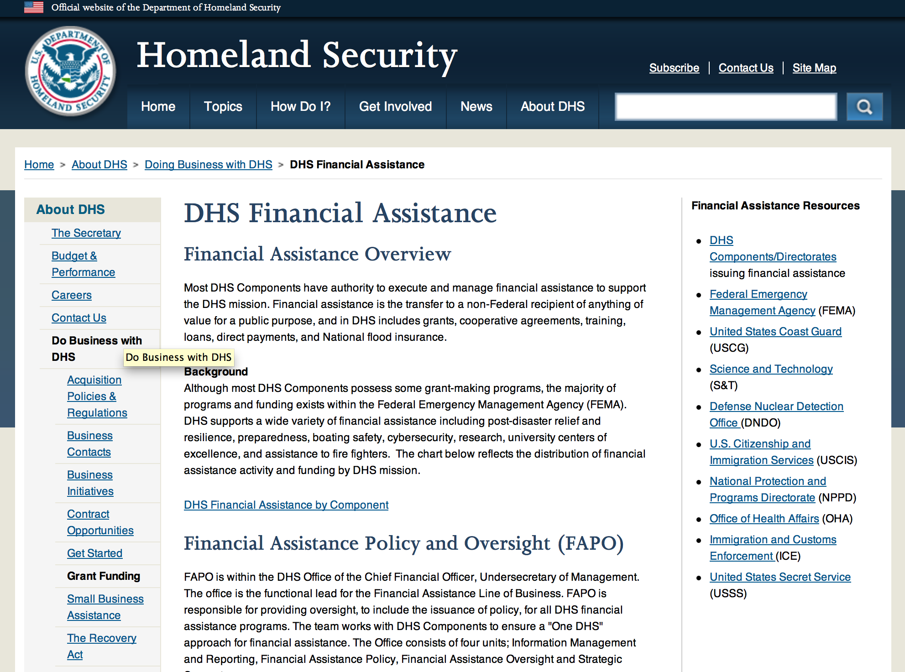

Webpage can be viewed at: http://www.dhs.gov/xopnbiz/grants/index.shtm#2

The FY 2015 Assistance to Firefighters Grants (AFG) Application Period Has Closed.
For AFG program guidance materials, please visit our Documents page.
FY 2015 FIRE PREVENTION & SAFETY (FP&S) Grants
- FY 2015 Application Information Coming Soon
- FP&S Success Stories
FY 2014 FIRE PREVENTION & SAFETY (FP&S) Grants
- FY 2014 FP&S Award Announcements - View Awards List
FY 2015 STAFFING FOR ADEQUATE FIRE and EMERGENCY RESPONSE (SAFER) Grants
- FY 2015 Application Information Coming Soon
- SAFER Success Stories
FY 2014 STAFFING FOR ADEQUATE FIRE and EMERGENCY RESPONSE (SAFER) Grants
- FY 2014 FP&S Award Announcements - View Awards List
FP&S Success Stories

Resources

AFG Help Desk
Contact the AFG Program Help Desk toll-free at 866-274-0960, or email us at firegrants@dhs.gov.
The AFG Program has Fire Program Specialists in 10 federal regional centers. These Regional Fire Program Specialists respond to questions about the AFG program and carry out grant monitoring activities. View regional contacts

Popular AFG links
- AFG Workshop Schedule
- Assistance to Firefighters Grants (AFG)
- AFG Awards List
- AFG Success Stories
- Staffing for Adequate Fire & Emergency Response (SAFER) Grants (SAFER)
- SAFER Awards List
- SAFER Success Stories
- Fire Prevention & Safety (FP&S) Grants
- FP&S Awards List
- FP&S Success Stories
- Grant Closeout Tutorial
- Assistance to Firefighters Grant (AFG) Email Alert Archive
- Frequently Asked Questions
Contact Information For The Assistance to Firefighters Grant (AFG) Program and Help Desk

Federal Funding Alternative To AFG

State Administrative Agencies (SAA) apply for and administer Federal grants on behalf of their States, including FEMA Preparedness Grants. The SAA will work with eligible organizations to comply with the general requirements of grant programs or cooperative agreements. Contact your State’s SAA to find out what current Federal funding opportunities may be available to your organization. A listing of the SAAs and points of contact can be found at http://www.fema.gov/library/viewRecord.do?id=6363.

Programs:

Office of Procurement Operations - Grants Division
Center of Excellence Criminal Investigations and Network Analysis – Partner Grant

Document Type: |  | Grants Notice
Funding Opportunity Number: |  | DHS-16-ST-061-CINA-PARTNER
Funding Opportunity Title: |  | Center of Excellence Criminal Investigations and Network Analysis - Partner
Opportunity Category: |  | Discretionary
Opportunity Category Explanation:
Funding Instrument Type: |  | Cooperative Agreement
Category of Funding Activity: |  | Science and Technology and other Research and Development
Category Explanation:
Expected Number of Awards: |  | 3
CFDA Number(s): |  | 97.061 -- Centers for Homeland Security
Cost Sharing or Matching Requirement: |  | No
Posted Date: |  | May 27, 2016
Last Updated Date: |  | May 27, 2016
Original Closing Date for Applications: |  | Sep 01, 2016
Current Closing Date for Applications: |  | Sep 01, 2016
Archive Date: |  | Oct 01, 2016
Estimated Total Program Funding: |  | $5,000,000
Award Ceiling: |  | $500,000
Award Floor: |  | $100,000
Eligible Applicants: |  | Public and State controlled institutions of higher education  Private institutions of higher education
Agency Name: | Office of Procurement Operations - Grants Division
Description: | Informational Webinar June 21, 2016 3:00pm EDT. The Department of Homeland Security (DHS) Science and Technology Directorate (S&T) Office of University Programs (OUP) is requesting applications from U.S. colleges and universities to serve as a partner institution for a Center for Criminal Investigations and Network Analysis (CINA). OUP is also posting a separate NOFO for eligible applicants to submit lead proposals for consideration. Please see NOFO Number DHS-16-ST-061-CINA-Partner or 97.061 on http://www.grants.gov for directions on how to submit single project proposals. DHS will select qualified individual projects from applications received for either the Center Lead NOFO or the Center Partner NOFO, regardless of the institution that is awarded as lead institution. Principal Investigators that are already Partners under a Center Lead application may not submit the same application under this Partner NOFO.
Link to Additional Information: | Webinar link 6-21-2016 3:00pm EDT
Contact Information: | If you have difficulty accessing the full announcement electronically, please contact:  Melanie Bales Lead Grants Officer  DHS

http://www.grants.gov/web/grants/view-opportunity.html?oppId=284177

Modifications:

Reminders:

Department of Homeland Security - FEMA
Fiscal Year (FY) 2016 Cooperating Technical Partners (CTP) Program
Modifications 3 & 5

Document Type: | Grants Notice
Funding Opportunity Number: | DHS-16-MT-045-00-01
Funding Opportunity Title: | Fiscal Year (FY) 2016 Cooperating Technical Partners (CTP) Program
Opportunity Category: | Discretionary
Opportunity Category Explanation:
Funding Instrument Type: | Cooperative Agreement
Category of Funding Activity: | Science and Technology and other Research and Development
Category Explanation:
Expected Number of Awards: | 11
CFDA Number(s): | 97.045 -- Cooperating Technical Partners
Cost Sharing or Matching Requirement: | No
Posted Date: | Mar 25, 2016
Last Updated Date: | Mar 31, 2016
Original Closing Date for Applications: | Jun 10, 2016
Current Closing Date for Applications: | Jun 10, 2016
Archive Date: | Jul 10, 2016
Estimated Total Program Funding: | $2,450,000
Eligible Applicants: | Native American tribal governments (Federally recognized)  Others (see text field entitled "Additional Information on Eligibility" for clarification)  Special district governments  State governments  City or township governments  Nonprofits having a 501(c)(3) status with the IRS, other than institutions of higher education  Public and State controlled institutions of higher education  County governments
Additional Information on Eligibility: | As approved by FEMA HQ
Agency Name: | Department of Homeland Security - FEMA
Description: | "The Cooperating Technical Partners Program (CTP Program) exists to strengthen and increase the effectiveness of the National Flood Insurance Program (NFIP) through fostering strong Federal, State, Tribal, regional and local partnerships for the purposes of reducing flood losses and promoting community resiliency. The CTP Program may provide federal assistance, through a grant or cooperative agreement, to an eligible Cooperating Technical Partner (herein referred to as ¿CTP¿, ¿partner¿ or ¿grantee¿) to perform various projects and activities that stimulate and support the ability of NFIP State Coordinating Agencies and NFIP-participating communities (as defined in 44 CFR Part 59.1) to continue their ongoing regulatory NFIP responsibilities as well as support the ability of States, communities and the public and private sector to mitigate flood risk. The CTP Program seeks to enhance the existing capabilities of CTPs to increase local involvement in, and ownership of, the development and maintenance of flood risk data and products, such as the Flood Insurance Rate Maps (FIRMs) and other risk related products, as well as other support to advance the goals and objectives of the Risk Mapping Assessment and Planning (Risk MAP) program. Partnerships developed through FEMA¿s CTP Program are in the best interest of State and local communities, the NFIP and the public. CTPs may be able to perform activities related to program management, technical risk analysis and mapping, and communication of flood risk hazard data and information. Only qualified partners of the CTP Program are eligible for federal assistance awards through the CTP Program. Recipients must:¿ be a CTP (i.e., have a signed Partnership Agreement with FEMA HQ or a FEMA Regional Office);¿ either be or represent a National Flood Insurance Program (NFIP) community in good-standing, or a FEMA-approved non-profit agency whose primary mission supports the goals and objectives of the NFIP;¿ have existing non-Federally funded processes and/or systems in place to support the collection, development, evaluation, dissemination and communication of flood hazard and risk assessment data and mapping;¿ have the capability to perform funded activities; demonstrate the ability to achieve the CTP Program performance metrics and provide timely and accurate reports to FEMA documenting performance and achievements; and¿ when applicable, agree to perform work in the Mapping Information Platform (MIP) and update the activities within the MIP every 30 days in the Studies Workflow (and more frequently within the Revisions Workflow).CTPs need to work with FEMA in advance of the application to understand FEMA program priorities, objectives and measures, and to identify specific tasks to undertake. In support of program objectives, FEMA may provide technical assistance, training, and/or data to a CTP to enhance the activities within the project categories. Any funds FEMA provides through a grant or cooperative agreement to complete project activities are in addition to the leveraged resources and data which may be provided by the CTP to complete the tasks agreed upon. When awarded a grant or cooperative agreement through the CTP Program in support of program objectives and to advance program measures, the CTP must comply with the requirements outlined in the announcement, the terms and conditions of the award, as well as the Partnership Agreement and the associated Statement of Work or Mapping Activity Statement approved by FEMA. These templates may be obtained from your granting organization, either the FEMA Region or FEMA Headquarters."
Link to Additional Information:
Contact Information: | If you have difficulty accessing the full announcement electronically, please contact:  System Branch  GMD-Systems-Branch@fema.gov

http://www.grants.gov/web/grants/view-opportunity.html?oppId=282549

Department of Homeland Security - FEMA
FY16 Pre-Disaster Mitigation Grant

Document Type: | Grants Notice
Funding Opportunity Number: | DHS-16-MT-047-000-99
Funding Opportunity Title: | FY16 Pre-Disaster Mitigation
Opportunity Category: | Discretionary
Opportunity Category Explanation:
Funding Instrument Type: | Grant
Category of Funding Activity: | Other (see text field entitled "Explanation of Other Category of Funding Activity" for clarification)
Category Explanation: | The Robert T. Stafford Disaster Relief and Emergency Assistance Act, Public Law 93-288, as amended, (42 U.S.C. 5133), Section 203 authorizes FEMA to make grants for the purpose of implementing a sustained pre-disaster natural hazard mitigation program to reduce overall risk to the population and structures from future hazard events, while also reducing reliance on Federal funding from future disasters.
Expected Number of Awards: | 200
CFDA Number(s): | 97.047 -- Pre-Disaster Mitigation
Cost Sharing or Matching Requirement: | Yes
Posted Date: | Feb 10, 2016
Last Updated Date: | Feb 10, 2016
Original Closing Date for Applications: | Jun 15, 2016
Current Closing Date for Applications: | Jun 15, 2016
Archive Date: | Jul 15, 2016
Estimated Total Program Funding: | $90,000,000
Award Ceiling: | $15,000,000
Eligible Applicants: | State governments  Others (see text field entitled "Additional Information on Eligibility" for clarification)  Native American tribal governments (Federally recognized)
Additional Information on Eligibility: | District of Columbia; U.S. Territories. Local governments must apply through their state.
Agency Name: | Department of Homeland Security - FEMA
Description: | The Pre-Disaster Mitigation (PDM) program makes available Federal funds to State, Local and Tribal Governments to implement and sustain cost-effective measures designed to reduce the risk to individuals and property from natural hazards, while also reducing reliance on Federal funding from future disasters. FEMA will provide allocations of $575,000 as required by the Stafford Act to states and territories; and a tribal set aside of $10 million for allocations up to $575,000 for Native American Indian tribal governments to support overall mitigation planning and projects. The remaining PDM funds will be awarded on a competitive basis with a focus on Climate Resilient Mitigation Activities. Applicants must submit applications via the Mitigation eGrants system on the FEMA Grants Portal: https://portal.fema.gov. Applicants may submit a maximum of 19 sub-applications, including 1 management cost sub-application for Applicant management costs. Of the 18 sub-applications for mitigation activities, a maximum of 8 projects may be included.
Link to Additional Information: | Program Guidance
Contact Information: | If you have difficulty accessing the full announcement electronically, please contact:  Mitigation eGrants System Helpdesk Phone: 1-855-228-3362  MTeGrants@fema.dhs.gov

http://www.grants.gov/web/grants/view-opportunity.html?oppId=281453

Department of Homeland Security - FEMA
FY16 Flood Mitigation Assistance Grant

Document Type: | Grants Notice
Funding Opportunity Number: | DHS-16-MT-029-000-99
Funding Opportunity Title: | FY16 Flood Mitigation Assistance
Opportunity Category: | Discretionary
Opportunity Category Explanation:
Funding Instrument Type: | Grant
Category of Funding Activity: | Other (see text field entitled "Explanation of Other Category of Funding Activity" for clarification)
Category Explanation: | The Flood Mitigation Assistance (FMA) program is authorized by the National Flood Insurance Reform Act (NFIRA) of 1994 with the goal of reducing or eliminating claims under the NFIP.
Expected Number of Awards: | 200
CFDA Number(s): | 97.029 -- Flood Mitigation Assistance
Cost Sharing or Matching Requirement: | Yes
Posted Date: | Feb 10, 2016
Last Updated Date: | Feb 10, 2016
Original Closing Date for Applications: | Jun 15, 2016
Current Closing Date for Applications: | Jun 15, 2016
Archive Date: | Jul 15, 2016
Estimated Total Program Funding: | $199,000,000
Award Ceiling: | $0
Award Floor: | $0
Eligible Applicants: | Native American tribal governments (Federally recognized)  Others (see text field entitled "Additional Information on Eligibility" for clarification)  State governments
Additional Information on Eligibility: | District of Columbia; U.S. Territories. Local governments must apply through their state.
Agency Name: | Department of Homeland Security - FEMA
Description: | The Flood Mitigation Assistance (FMA) Program makes available federal funds to State, Local and Tribal Governments to implement and sustain cost-effective measures that reduce or eliminate risk of flood damage to buildings insured under the National Flood Insurance Program (NFIP). FEMA will fund planning up to $100,000 per applicant with a maximum of $50,000 for state plans and $25,000 for local plans. FEMA will fund technical assistance up to $50,000 for states who were awarded FMA Grant Program funds totaling at least $1 million in FY 2015. The remaining FMA funds will be awarded on a competitive basis for projects that will reduce or eliminate claims under the NFIP with a focus on mitigation of severe repetitive loss and repetitive loss properties as well as projects that will reduce the risk profile in communities through mitigation of the largest number of NFIP-insured properties on a neighborhood level. Applicants must apply for FMA funding through the Mitigation eGrants system on the FEMA Grants Portal accessible on the Internet at https:/portal.fema.gov
Link to Additional Information: | Program Guidance
Contact Information: | If you have difficulty accessing the full announcement electronically, please contact:  Mitigation eGrants System Helpdesk Phone: 1-855-228-3362  MTeGrants@fema.dhs.gov

http://www.grants.gov/web/grants/view-opportunity.html?oppId=281474

Department of Housing and Urban Development

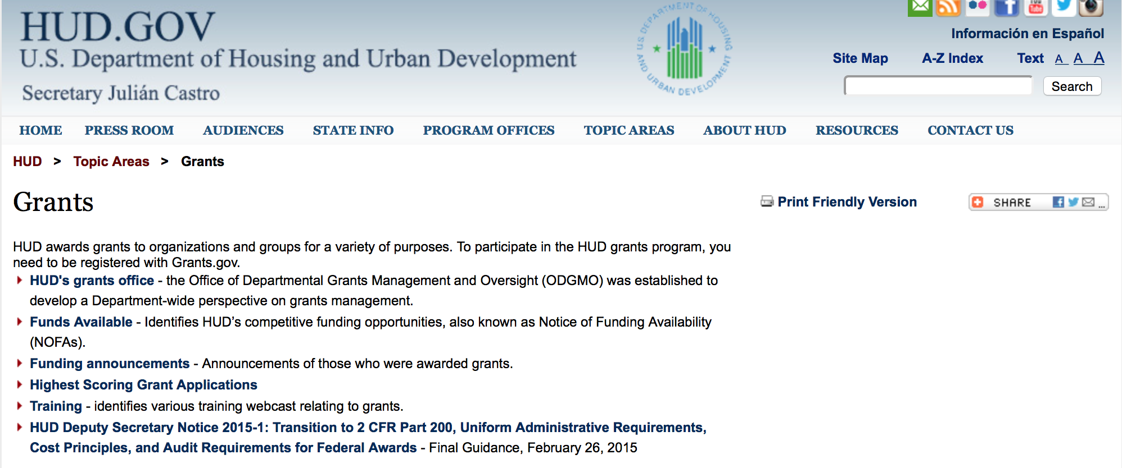

http://portal.hud.gov/hudportal/HUD?src=/topics/grants

HUD - Notice of Funds Available

For detailed information click here

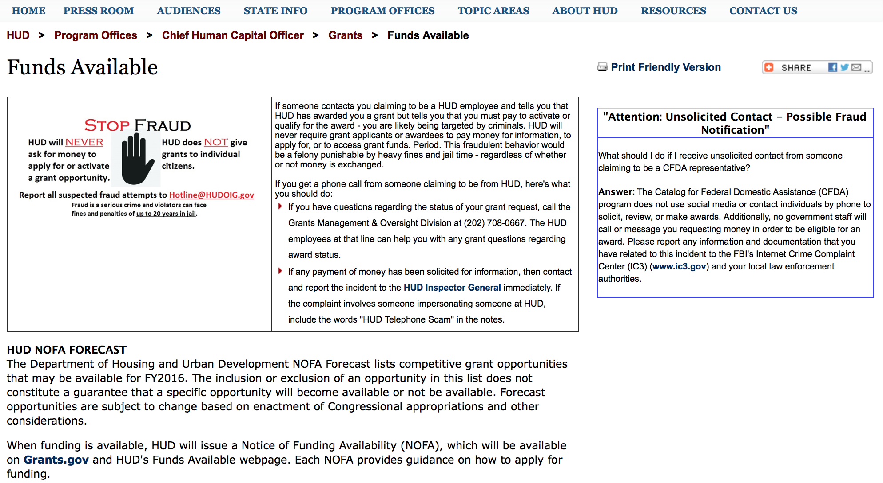

http://portal.hud.gov/hudportal/HUD?src=/program_offices/administration/grants/fundsavail

FY 2013 Notice of Funding Availability (NOFA) Policy Requirements and General Section to HUD’s FY2013 NOFAs for Discretionary Programs
This Notice provides prospective applicants for HUD's competitive funding with the opportunity to become familiar with the General Section to HUD's FY2013 Notices of Funding Availability (NOFAs) for Discretionary Funding (program NOFA), in advance of publication of any individual FY2013 program NOFAs. This General Section and the individual FY2013 program NOFA Sections comprise the entirety of the FY2013 NOFA instructions.
- General Section
- FONSI
- New Application Attachment Filename Requirement

Programs

HUD Community Compass Technical Assistance and Capacity Building Program Grant
Document Type: | Grants Notice
Funding Opportunity Number: | FR-6000-N-06
Funding Opportunity Title: | HUD Community Compass Technical Assistance and Capacity Building Program
Opportunity Category: | Discretionary
Opportunity Category Explanation:
Funding Instrument Type: | Cooperative Agreement
Category of Funding Activity: | Housing
Category Explanation:
Expected Number of Awards: | 20
CFDA Number(s): | 14.259 -- Community Compass Technical Assistance and Capacity Building
Cost Sharing or Matching Requirement: | No
Posted Date: | May 19, 2016
Last Updated Date: | May 19, 2016
Original Closing Date for Applications: | Jul 19, 2016 Electronically submitted applications must be submitted no later than 11:59:59 p.m., ET, on the listed application due date.
Current Closing Date for Applications: | Jul 19, 2016 Electronically submitted applications must be submitted no later than 11:59:59 p.m., ET, on the listed application due date.
Archive Date: | Aug 18, 2016
Estimated Total Program Funding: | $58,000,000
Award Ceiling: | $20,000,000
Award Floor: | $250,000
Eligible Applicants: | Public and State controlled institutions of higher education  Native American tribal organizations (other than Federally recognized tribal governments)  Nonprofits that do not have a 501(c)(3) status with the IRS, other than institutions of higher education  Special district governments  Nonprofits having a 501(c)(3) status with the IRS, other than institutions of higher education  Private institutions of higher education  Others (see text field entitled "Additional Information on Eligibility" for clarification)  State governments  For profit organizations other than small businesses  County governments  Native American tribal governments (Federally recognized)  Public housing authorities/Indian housing authorities  Small businesses  City or township governments
Additional Information on Eligibility: | In addition to the list above, eligible applicants include: NAHASDA-eligible Indian tribes as defined at Section 4(13) of NAHASDA; tribally designated housing entities (TDHEs) as defined at Section 4(22) of the NAHASDA; and national or regional organizations representing Native American housing interests Metropolitan Planning Organizations (MPOs), Councils of Government (COGs), or other regional planning entities For MAHRA TA, tenant groups as defined at Section 514 of the MAHRA See section V.B. "Rules that affect applicants' eligibility to receive an award" of the FY2016 General Section for more information on eligibility. Individuals, foreign entities, and sole proprietorship organizations are not eligible to compete for, or receive, awards made under this announcement.
Agency Name: | Department of Housing and Urban Development
Description: | Community Compass is designed to help HUD's customers navigate complex housing and community development challenges by equipping them with the knowledge, skills, tools, capacity, and systems to implement HUD programs and policies successfully. The goal of Community Compass is to empower communities by providing effective technical assistance and capacity building so that successful program implementation is sustained over the long term.
Link to Additional Information: | http://portal.hud.gov/hudportal/HUD?src=/program_offices/administration/grants/fundsavail
Contact Information: | If you have difficulty accessing the full announcement electronically, please contact:  Lauren Deigh Lauren.S.Deigh@hud.gov  Grants Policy

http://www.grants.gov/web/grants/view-opportunity.html?oppId=283996

Modifications:

Choice Neighborhoods Implementation Grant Program
Modification 2

Document Type: | Grants Notice
Funding Opportunity Number: | FR-6000-N-34
Funding Opportunity Title: | Choice Neighborhoods Implementation Grant Program
Opportunity Category: | Discretionary
Opportunity Category Explanation:
Funding Instrument Type: | Grant
Category of Funding Activity: | Housing
Category Explanation:
Expected Number of Awards: | 4
CFDA Number(s): | 14.889 -- Choice Neighborhoods Implementation Grants
Cost Sharing or Matching Requirement: | Yes
Posted Date: | Mar 31, 2016
Last Updated Date: | Mar 31, 2016
Original Closing Date for Applications: | Jun 28, 2016 Electronically submitted applications must be submitted no later than 11:59:59 p.m., ET, on the listed application due date.
Current Closing Date for Applications: | Jun 28, 2016 Electronically submitted applications must be submitted no later than 11:59:59 p.m., ET, on the listed application due date.
Archive Date: | Jul 28, 2016
Estimated Total Program Funding: | $120,000,000
Award Ceiling: | $30,000,000
Award Floor: | $0
Eligible Applicants: | Others (see text field entitled "Additional Information on Eligibility" for clarification)
Additional Information on Eligibility: | Eligible applicants are Public Housing Authorities (PHAs), local governments, tribal entities, nonprofits, and for-profit developers that apply jointly with a public entity. Refer to section I.A.4 for definitions of these terms as applicable to this program. Individuals, foreign entities, and sole proprietorship organizations are not eligible to compete for, or receive, awards made under this announcement.
Agency Name: | Department of Housing and Urban Development
Description: | Choice Neighborhoods Implementation Grants support the implementation of comprehensive neighborhood revitalization plans that are expected to achieve the following three core goals: 1. Housing: Replace distressed public and assisted housing with high-quality mixed-income housing that is well-managed and responsive to the needs of the surrounding neighborhood; 2. People: Improve educational outcomes and intergenerational mobility for youth with services and supports delivered directly to youth and their families; and 3. Neighborhood: Create the conditions necessary for public and private reinvestment in distressed neighborhoods to offer the kinds of amenities and assets, including safety, good schools, and commercial activity, that are important to families; choices about their community.
Link to Additional Information: | http://portal.hud.gov/hudportal/HUD?src=/program_offices/administration/grants/fundsavail
Contact Information: | If you have difficulty accessing the full announcement electronically, please contact:  Please send inquiries to email below  Grants Policy

http://www.grants.gov/web/grants/view-opportunity.html?oppId=282659

Technical Correction to the General Section to HUD's Fiscal Year 2016 Notice[s] of Funding Availability for Discretionary Programs
Modification 1

Document Type: | Grants Notice
Funding Opportunity Number: | FR-6000-N-01-C
Funding Opportunity Title: | Technical Correction to the General Section to HUD's Fiscal Year 2016 Notice[s] of Funding Availability for Discretionary Programs
Opportunity Category: | Discretionary
Opportunity Category Explanation:
Funding Instrument Type: | Grant
Category of Funding Activity: | Community Development
Category Explanation:
Expected Number of Awards: | 0
CFDA Number(s):
Cost Sharing or Matching Requirement: | No
Posted Date: | May 16, 2016
Last Updated Date: | May 16, 2016
Original Closing Date for Applications: | Dec 31, 2016 Electronically submitted applications to program NOFAs must be submitted no later than 11:59:59 p.m., ET, on the listed application due date. No applications are accepted in response to this Notice, which publishes policies and guidance only.
Current Closing Date for Applications: | Dec 31, 2016 Electronically submitted applications to program NOFAs must be submitted no later than 11:59:59 p.m., ET, on the listed application due date. No applications are accepted in response to this Notice, which publishes policies and guidance only.
Archive Date: | Jan 30, 2017
Estimated Total Program Funding: | $0
Award Ceiling: | $0
Award Floor: | $0
Eligible Applicants: | Public and State controlled institutions of higher education  Unrestricted (i.e., open to any type of entity above), subject to any clarification in text field entitled "Additional Information on Eligibility"  Nonprofits that do not have a 501(c)(3) status with the IRS, other than institutions of higher education  State governments  Private institutions of higher education  Public housing authorities/Indian housing authorities  County governments  Special district governments  City or township governments  Small businesses  Native American tribal governments (Federally recognized)  Independent school districts  Native American tribal organizations (other than Federally recognized tribal governments)  Individuals  Nonprofits having a 501(c)(3) status with the IRS, other than institutions of higher education  For profit organizations other than small businesses
Additional Information on Eligibility: | No applications will be accepted in response to this document. This Document is a policy document only. The individual program Notices of Funds Available (NOFA) will identify eligible applicants for each competition. Each Program NOFA will describe additional eligibility requirements for applicants. HUD does not provide direct services or products to individuals through its formula-based programs or its competitive Program NOFA process. Individuals seeking financial assistance should refer to www.GovBenefits.gov. Individuals, foreign entities, and sole proprietorship organizations are not eligible to compete for, or receive, awards made under this announcement.
Agency Name: | Department of Housing and Urban Development
Description: | HUD publishes a General Section each Fiscal Year (FY) that contains requirements for all of HUD’s competitive grant programs. Applications to HUD programs must meet all applicable requirements of the General Section and the requirements in the Program NOFA to be considered for funding. This updates paragraph V.C.8. Eminent Domain to reflect the 2016 Appropriations authority, and updates paragraph VI.A.1. Obtaining an Electronic Application.
Link to Additional Information: | http://portal.hud.gov/hudportal/HUD?src=/program_offices/administration/grants/fundsavail
Contact Information: | If you have difficulty accessing the full announcement electronically, please contact:  Loyd LaMois loyd.lamois@hud.gov  Grants Policy

http://www.grants.gov/web/grants/view-opportunity.html?oppId=283900

Reminders

Fair Housing Initiative Program - Education and Outreach Initiative Grant

Document Type: | Grants Notice
Funding Opportunity Number: | FR-6000-N-21A
Funding Opportunity Title: | Fair Housing Initiative Program - Education and Outreach Initiative
Opportunity Category: | Discretionary
Opportunity Category Explanation:
Funding Instrument Type: | Grant
Category of Funding Activity: | Housing
Category Explanation:
Expected Number of Awards: | 49
CFDA Number(s): | 14.416 -- Education and Outreach Initiatives
Cost Sharing or Matching Requirement: | No
Posted Date: | Apr 26, 2016
Last Updated Date: | Apr 26, 2016
Original Closing Date for Applications: | Jun 23, 2016 Electronically submitted applications must be submitted no later than 11:59:59 p.m., ET, on the listed application due date.
Current Closing Date for Applications: | Jun 23, 2016 Electronically submitted applications must be submitted no later than 11:59:59 p.m., ET, on the listed application due date.
Archive Date: | Jul 23, 2016
Estimated Total Program Funding: | $7,450,000
Award Ceiling: | $1,250,000
Award Floor: | $125,000
Eligible Applicants: | Others (see text field entitled "Additional Information on Eligibility" for clarification)
Additional Information on Eligibility: | Eligible Applicants. Depending on the specific component as outlined in the eligibility chart, eligible applicants may be Qualified Fair Housing Enforcement Organizations (QFHOs) and Fair Housing Enforcement Organizations (FHOs), public or private not-for-profit organizations or institutions, and other public or private entities that are formulating or carrying out programs to prevent or eliminate discriminatory housing practices; agencies of State or local governments; and agencies that participate in the Fair Housing Assistance Program (FHAP). Individuals, foreign entities, and sole proprietorship organizations are not eligible to compete for, or receive, awards made under this announcement.
Agency Name: | Department of Housing and Urban Development
Description: | HUD is making available through this Education and Outreach Initiative (EOI) NOFA $7,450,000 for The Fair Housing Initiatives Program. Additional funds may become available for award under this NOFA as a result of HUD's efforts to recapture unused funds, use carryover funds, or because of the availability of additional appropriated funds. Use of these funds will be subject to statutory constraints. All awards are subject to the applicable funding restrictions described in the General Section and to those contained in this NOFA. FHIP funds are used to increase compliance with the Fair Housing Act. This year, funding is available under three Initiatives: Private Enforcement (PEI), Fair Housing Organization (FHOI) and Education and Outreach (EOI) Initiatives. Multi-year awards beyond FY2016 funding are subject to appropriations and the availability of funds. For FY2016, funding for each initiative is listed under a separate NOFA. Applicants must apply under the correct NOFA to be considered for funding. Additionally, if an applicant is eligible and applying for funding under separate initiatives and/or components, the applicant must submit a separate application under the correct NOFA for each component the applicant applies. This NOFA will consider applicants applying under EOI only. The following is a general description of the Education and Outreach Initiative (see chart in section III. A. for all eligibility requirements and a listing of related components): Education and Outreach Initiative (EOI). This Initiative provides funding for the purpose of developing, implementing, carrying out, or coordinating education and outreach programs designed to inform members of the public concerning their rights and obligations under the provisions of the Fair Housing Act. EOI applicants may be funded under the following components based on eligibility: Education and Outreach Initiative (EOI) - $7,450,000 (1) National-Based Programs (a) National Media Campaign Component (EOI-NMCC) - $1,250,000 (2) Regional/Local/Community Based Program (a) General Component (EOI-G) - $5,950,000 (b) Tester Coordinator Training (EOI-TC) - $250,000 Applicants may apply for funding under multiple EOI Components as long as the applicant meets the specific eligibility requirements for each Component (see eligibility chart in Section III.A.1, and applies under the correct NOFA. Applicants will be funded in accordance with the funding restrictions listed under Section IV.F.5.
Link to Additional Information: | http://portal.hud.gov/hudportal/HUD?src=/program_offices/administration/grants/fundsavail
Contact Information: | If you have difficulty accessing the full announcement electronically, please contact:  Myron Newry Myron.P.Newry@hud.gov  Grants Policy

http://www.grants.gov/web/grants/view-opportunity.html?oppId=283306

Jobs Plus Initiative Grant

Document Type: | Grants Notice
Funding Opportunity Number: | FR-6000-N-14
Funding Opportunity Title: | Jobs Plus Initiative
Opportunity Category: | Discretionary
Opportunity Category Explanation:
Funding Instrument Type: | Grant
Category of Funding Activity: | Housing
Category Explanation:
Expected Number of Awards: | 5
CFDA Number(s): | 14.895 -- Jobs-Plus Pilot Initiative
Cost Sharing or Matching Requirement: | Yes
Posted Date: | Apr 11, 2016
Last Updated Date: | Apr 11, 2016
Original Closing Date for Applications: | Jun 13, 2016 Electronically submitted applications must be submitted no later than 11:59:59 p.m., ET, on the listed application due date.
Current Closing Date for Applications: | Jun 13, 2016 Electronically submitted applications must be submitted no later than 11:59:59 p.m., ET, on the listed application due date.
Archive Date: | Jul 13, 2016
Estimated Total Program Funding: | $15,000,000
Award Ceiling: | $3,000,000
Award Floor: | $1,000,000
Eligible Applicants: | Others (see text field entitled "Additional Information on Eligibility" for clarification)
Additional Information on Eligibility: | Conditions for Eligibility of Public Housing Authorities Eligible applicants are PHAs that operate one or more public housing developments (as designated for asset management purposes) that meet the criteria outlined in this NOFA. A list of developments that meet the criteria is provided in Appendix B however, the mere appearance of a development on this list does not necessarily mean that the development is appropriate for a Jobs Plus program. Federally designated tribes and tribally designated housing entities (TDHEs) are not eligible entities under this award. PHAs that received a Jobs Plus program grant in 2014 or 2015 are not eligible for 2016 grant funds. If a PHA is a successful applicant for Jobs Plus funds, the PHA will be required to implement the full 48 month term of the grant at the public housing site(s) for which funds were awarded and commit to not engaging in any significant redevelopment that would result in resident relocation during the 48-month Jobs Plus implementation timeframe. Notwithstanding the above, conversion of public housing assistance to a project-based section 8 contract under the Rental Assistance Demonstration (RAD) will not itself cause the termination of Jobs Plus funds. Grantees that convert the Jobs Plus target projects(s) under RAD will be able to finish out their Jobs Plus period of performance at the subject site as long as the conversion does not entail significant relocation or result in a substantial change in building occupancy. Criteria for Eligible Developments Size: Minimum development size of 200 non-elderly-only households. Non-elderly-only means households where at least one resident is under age 62. Unemployment: At least 50 percent of the households (excluding elderly-only households) contain no member showing earned income in PIC. Place: Because Jobs Plus is a place-based program, units to be served must be contiguous unless good cause can be shown that the program will be successful in non-contiguous developments. A detailed description as to how the program will be run from one central location and remain accessible to all residents of non-contiguous developments will be required in the rating factors. This requirement may disqualify developments on the Eligible Development list if the Asset Management Project (AMP) is for scattered sites. Only public housing development PHA residents are eligible to be served by the funding. Performance: Developments that belong to a non-performing PHA may be eligible to participate provided HUD has determined the PHA has the capacity to implement and oversee the grant successfully. A non-performing PHA is defined as a PHA that is designated as a troubled performer under the Public Housing Assessment System (PHAS) as listed on HUD’s most recent official Troubled List or is designated a substandard performer based on its most recent published PHAS score. See Threshold requirements in Section III.C.3 for more information. PHAs that have more than one development already listed as eligible in Appendix B may apply to serve more than one of the eligible developments as long as they are contiguous or show in the application that they meet the required criteria for place (see above). No Request for Review of Eligibility is required prior to submitting the application. PHAs that have developments not listed on Appendix B that they believe, when combined, meet the criteria, may submit a request for review of eligibility. Individuals, foreign entities, and sole proprietorship organizations are not eligible to compete for, or receive, awards made under this announcement.
Agency Name: | Department of Housing and Urban Development
Description: | This Notice of Funding Availability (NOFA) announces the availability of funding of approximately $15 million for the Jobs Plus program for Public Housing Agencies (PHAs) to develop locally-based approaches to increase earnings and advance employment outcomes for Public Housing residents. The NOFA will fund initiatives to improve employment and earnings outcomes for Public Housing residents through supports such as work readiness, employer linkages, job placement and financial literacy. To help applicants with the electronic application registration and submission process, the Department advises applicants to use the checklists, user guides, and other help features located at SAM.gov and Grants.gov websites. Both websites provide access to instructions and answers to frequently asked questions which are updated periodically.
Link to Additional Information: | http://portal.hud.gov/hudportal/HUD?src=/program_offices/administration/grants/fundsavail
Contact Information: | If you have difficulty accessing the full announcement electronically, please contact:  Jayme Brown Jayme.A.Brown@hud.gov  Grants Policy

http://www.grants.gov/web/grants/view-opportunity.html?oppId=282902

Fair Housing Initiatives Program - Private Enforcement Initiative Grant

Document Type: | Grants Notice
Funding Opportunity Number: | FR-6000-N-21C
Funding Opportunity Title: | Fair Housing Initiatives Program - Private Enforcement Initiative
Opportunity Category: | Discretionary
Opportunity Category Explanation:
Funding Instrument Type: | Grant
Category of Funding Activity: | Housing
Category Explanation:
Expected Number of Awards: | 24
CFDA Number(s): | 14.418 -- Private Enforcement Initiatives
Cost Sharing or Matching Requirement: | No
Posted Date: | Apr 26, 2016
Last Updated Date: | Apr 26, 2016
Original Closing Date for Applications: | Jun 23, 2016 Electronically submitted applications must be submitted no later than 11:59:59 p.m., ET, on the listed application due date.
Current Closing Date for Applications: | Jun 23, 2016 Electronically submitted applications must be submitted no later than 11:59:59 p.m., ET, on the listed application due date.
Archive Date: | Jul 23, 2016
Estimated Total Program Funding: | $7,897,458
Award Ceiling: | $325,000
Award Floor: | $325,000
Eligible Applicants: | Others (see text field entitled "Additional Information on Eligibility" for clarification)
Additional Information on Eligibility: | Under the PEI NOFA, eligible applicants must be Qualified Fair Housing Enforcement Organizations (QFHOs) or Fair Housing Enforcement Organizations (FHOs). If an organization does not meet the eligibility requirements for the PEI (current QFHO or FHO), the organization may be an eligible to apply under the Education and Outreach Initiative (FR-6000-N-21A) or Fair Housing Organizations Initiative (FR-6000-N-21B) NOFAs. Please see those NOFAs for specific eligibility requirements. Individuals, foreign entities, and sole proprietorship organizations are not eligible to compete for, or receive, awards made under this announcement.
Agency Name: | Department of Housing and Urban Development
Description: | HUD is making available through this Private Enforcement Initiative (PEI) NOFA $7,897,458 for Fair Housing Initiative Programs. Additional funds may become available for award under this NOFA as a result of HUD's efforts to recapture unused funds, use carryover funds, or because of the availability of additional appropriated funds. Use of these funds will be subject to statutory constraints. All awards are subject to the applicable funding restrictions described in the General Section and to those contained in this NOFA. Funding for additional years beyond FY2016 is subject to the availability of appropriations. FHIP funds are used to increase compliance with the Fair Housing Act. This year, funding is available under three Initiatives: Private Enforcement (PEI), Fair Housing Organization (FHOI) and Education and Outreach (EOI) Initiatives. However, for FY2016, funding for each initiative is listed under a separate NOFA. Applicants must apply under the correct NOFA to be considered for funding. Additionally, if an applicant is eligible and applying for funding under separate initiatives and/or components, the applicant must submit a separate application under the correct NOFA for each component the applicant applies. This NOFA will consider applicants applying under PEI only. The following is a general description of the Private Enforcement Initiative (PEI) and each PEI component (see chart in section III. A. for all PEI eligibility requirements): Private Enforcement Initiative (PEI). This Initiative provides funding to private, non-profit fair housing enforcement organizations that meet statutory requirements to investigate violations and obtain enforcement of the rights granted under the Fair Housing Act or State or local laws that provide rights and remedies for discriminatory housing practices that are substantially equivalent to the rights and remedies provided in the Fair Housing Act. PEI applicants may be funded under the following component based on eligibility: Private Enforcement Initiative (PEI) - $7,897,458 (1) Multi-Year Funding Component (PEI-MYFC) Total PEI Multi-Year Funding (PEI-MYFC) is $29,375,000 minus $22,452,542 already reserved for FY 2014 and FY 2015 Multi-year grantees), therefore making $6,922,458 available for FY2016 new awardees. (2) Lending Component (PEI-L) - $975,000 Applicants may apply for funding under each FHIP NOFA as long as the applicant meets the specific eligibility requirements for each Initiative/Component, and in accordance with the funding restrictions listed in each NOFA.
Link to Additional Information: | http://portal.hud.gov/hudportal/HUD?src=/program_offices/administration/grants/fundsavail
Contact Information: | If you have difficulty accessing the full announcement electronically, please contact:  Myron Newry Myron.P.Newry@hud.gov  Grants Policy

http://www.grants.gov/web/grants/view-opportunity.html?oppId=283288

Resident Opportunity & Self-Sufficiency Program Grant

Document Type: | Grants Notice
Funding Opportunity Number: | FR-6000-N-05
Funding Opportunity Title: | Resident Opportunity & Self-Sufficiency Program
Opportunity Category: | Discretionary
Opportunity Category Explanation:
Funding Instrument Type: | Grant
Category of Funding Activity: | Housing
Category Explanation:
Expected Number of Awards: | 110
CFDA Number(s): | 14.870 -- Resident Opportunity and Supportive Services - Service Coordinators
Cost Sharing or Matching Requirement: | Yes
Posted Date: | Mar 31, 2016
Last Updated Date: | Mar 31, 2016
Original Closing Date for Applications: | May 16, 2016 Electronically submitted applications must be submitted no later than 11:59:59 p.m., ET, on the listed application due date.
Current Closing Date for Applications: | May 16, 2016 Electronically submitted applications must be submitted no later than 11:59:59 p.m., ET, on the listed application due date.
Archive Date: | Jun 15, 2016
Estimated Total Program Funding: | $35,000,000
Award Ceiling: | $738,000
Award Floor: | $0
Eligible Applicants: | Public housing authorities/Indian housing authorities  Nonprofits having a 501(c)(3) status with the IRS, other than institutions of higher education  Nonprofits that do not have a 501(c)(3) status with the IRS, other than institutions of higher education
Additional Information on Eligibility: | Native American tribes as defined at 4(13) of NAHASDA, Tribally Designated Housing Entities (TDHEs) as defined at 4(22) of NAHASDA. Resident associations of all kinds must have either locally-incorporated nonprofit status (usually designated by the state or tribal government) or 501(c)(3) nonprofit status designated by the IRS. Applicants must provide documentation with their application attesting to their designation as a locally-incorporated non-profit organization or a federally designated 501(c)(3) nonprofit. Such documentation must include a copy of the 2015 federal annual information return submitted to the IRS (for 501(c)(3) applicants) or the state or tribal equivalent for locally-incorporated nonprofits. If this information is not submitted as part of the application, it will be requested during the deficiency period. Please see Section IV.B. "Content and Form of Application Submission" for more information. EDSC Provision. PHA applicants that are currently eligible to receive annual renewal funding under the Elderly/Disabled Service Coordinator (EDSC) program from the Public Housing Operating Fund that apply to serve elderly/disabled residents through this NOFA will forgo all future eligibility for EDSC funding through the Operating Fund. These applicants may apply and receive funding to serve families only without risking their EDSC funding. To confirm if your PHA is affected by this EDSC provision. When completing your ROSS-SC application, please pay special attention to the EDSC section on the HUD form 52768;ROSS Service Coordinators Funding Request; For-profit entities are not eligible to apply. Individuals, foreign entities, and sole proprietorship organizations are not eligible to compete for, or receive, awards made under this announcement.
Agency Name: | Department of Housing and Urban Development
Description: | The purpose of the Resident Opportunity & Self Sufficiency (ROSS) Service Coordinator (SC) program is to assist residents of public and Indian housing in making progress towards economic and housing self-sufficiency. To accomplish this goal, ROSS provides grant funding to eligible applicants to hire Service Coordinators to assess the needs of public and Indian housing residents and link them to supportive services that enable participants to increase earned income, reduce or eliminate the need for welfare assistance, and make progress toward achieving economic independence and housing self-sufficiency. In the case of elderly/disabled residents, the Service Coordinator links participants to supportive services which enable them to age/remain in place thereby avoiding more costly forms of care.
Link to Additional Information: | http://portal.hud.gov/hudportal/HUD?src=/program_offices/administration/grants/fundsavail
Contact Information: | If you have difficulty accessing the full announcement electronically, please contact:  Dina Lehmann-Kim Dina.Lehmann-Kim@hud.gov  Grants Policy

http://www.grants.gov/web/grants/view-opportunity.html?oppId=282668

General Section to HUD's Fiscal Year 2016 Notice[s] of Funding Availability for Discretionary Programs (General Section)
Modification 1

Document Type: | Grants Notice
Funding Opportunity Number: | FR-6000-N-01
Funding Opportunity Title: | General Section to HUD's Fiscal Year 2016 Notice[s] of Funding Availability for Discretionary Programs (General Section)
Opportunity Category: | Discretionary
Funding Instrument Type: | Grant
Category of Funding Activity: | Community Development
Category Explanation:
Expected Number of Awards: | 0
CFDA Number(s):
Cost Sharing or Matching Requirement: | No
Posted Date: | Sep 24, 2015
Creation Date: | Sep 24, 2015
Original Closing Date for Applications: | Dec 30, 2016 Electronically submitted applications must be submitted no later than 11:59:59 p.m., ET, on the listed application due date published in the individual program NOFA.
Current Closing Date for Applications: | Dec 30, 2016 Electronically submitted applications must be submitted no later than 11:59:59 p.m., ET, on the listed application due date published in the individual program NOFA.
Archive Date: | Jan 29, 2017
Eligible Applicants: | Others (see text field entitled "Additional Information on Eligibility" for clarification)
Additional Information on Eligibility: | This Document is a policy document only. The individual program Notices of Funds Available (NOFA) will identify eligible applicants for each competition. Each Program NOFA will describe additional eligibility requirements for applicants. All applicants must have valid, active Registration in the System for Award Management (SAM) prior to submission of applications for financial assistance. HUD does not provide direct services or products to individuals through its formula-based programs or its competitive Program NOFA process. Individuals seeking financial assistance should refer to www.GovBenefits.gov. Individuals, foreign entities, and sole proprietorship organizations are not eligible to compete for, or receive, awards made under this announcement.
Agency Name: | Department of Housing and Urban Development
Description: | The General Section describes the requirements that are applicable to all HUD FY 2015 Program NOFAs. The General Section also provides information on HUD’s priorities and strategic goals. Each Program NOFA will describe additional applicable procedures and requirements, including a description of the eligible applicants, eligible activities, threshold requirements, cross-program requirements such as nondiscrimination, environmental protection, and any additional program requirements or limitations. To adequately address all of the application requirements for any program, please carefully read and respond to both this General Section and any applicable Program NOFA.
Link to Additional Information: | http://portal.hud.gov/hudportal/HUD?src=/program_offices/administration/grants/fundsavail
Contact Information: | If you have difficulty accessing the full announcement electronically, please contact:  Loyd LaMois loyd.lamois@hud.gov  Grants Policy

http://www.grants.gov/web/grants/view-opportunity.html?oppId=279206



Institute of Museum and Library Services

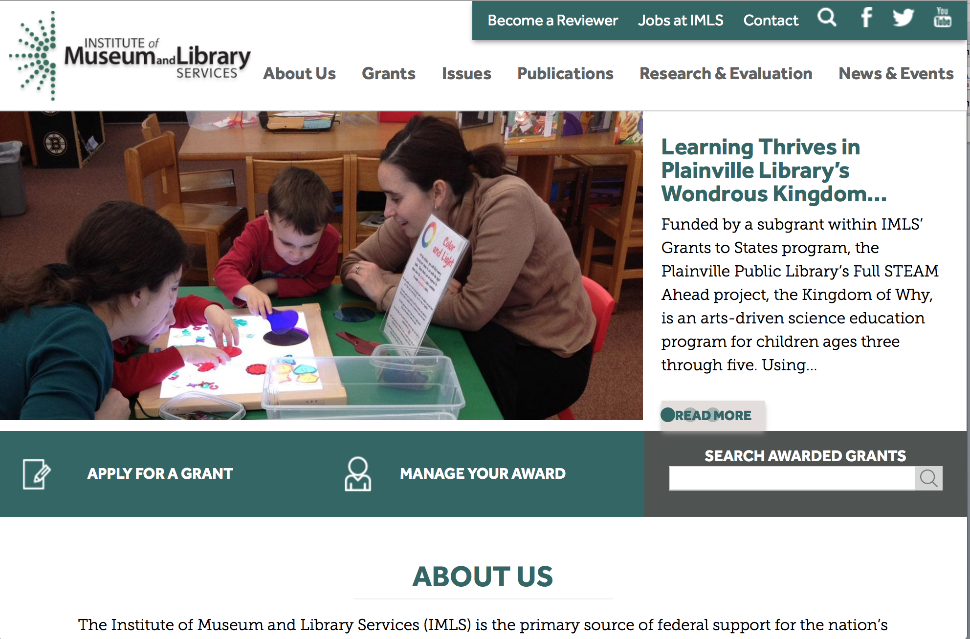

www.imls.gov

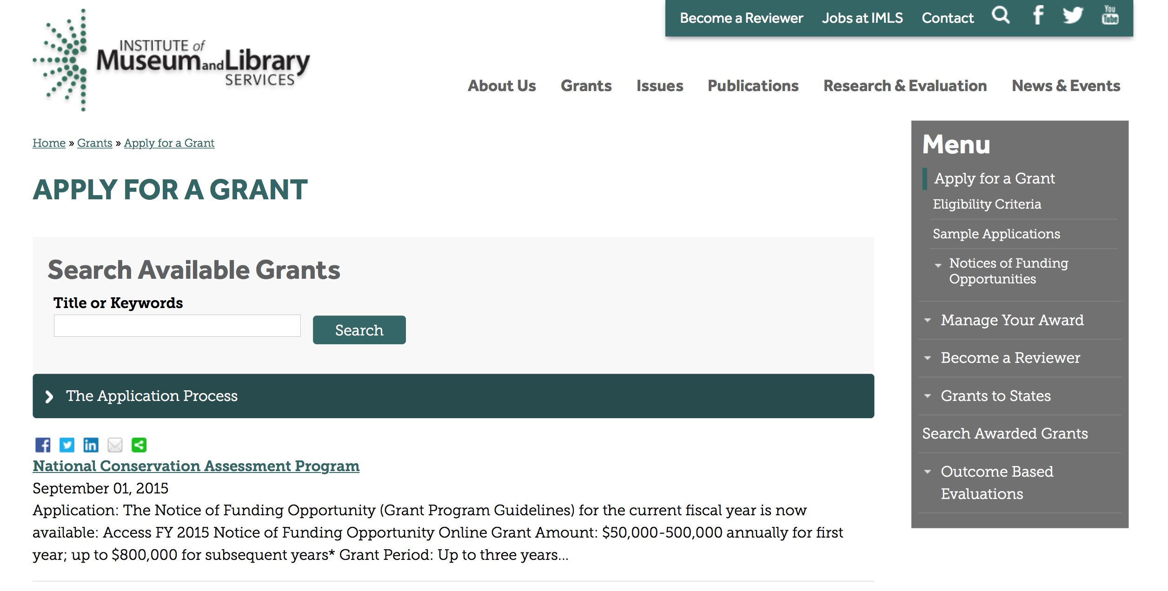
http://www.imls.gov/applicants/available_grants.aspx

Each grant program has specific eligibility requirements. The links below provide general eligibility criteria for museums, libraries, and tribal organizations, but please note that additional organizations may be eligible for grants under certain programs. Additionally, ineligible organizations may still be able to participate in grant programs through partnerships with eligible organizations. Please click on the links below to see general criteria and review Applications and Guidelines for specific information.
Museums Libraries

Institutions: Archives, Federally Recognized Native American Tribe, Historical Society, Library, Nonprofits that serve Native Hawaiians, Professional Association, Public or Private Non-profit Institutions of Higher Education, Regional Organization, State Library Administrative Agency, State or Local Government

Check out IMLS's Facebook page at:
https://www.facebook.com/USIMLS/

Modifications:

Reminders:

Department of the Interior
Working with Interior

The Interior Department provides assistance to the public, local governments and businesses through a number of programs. For a general overview see: http://www.doi.gov/index.cfm

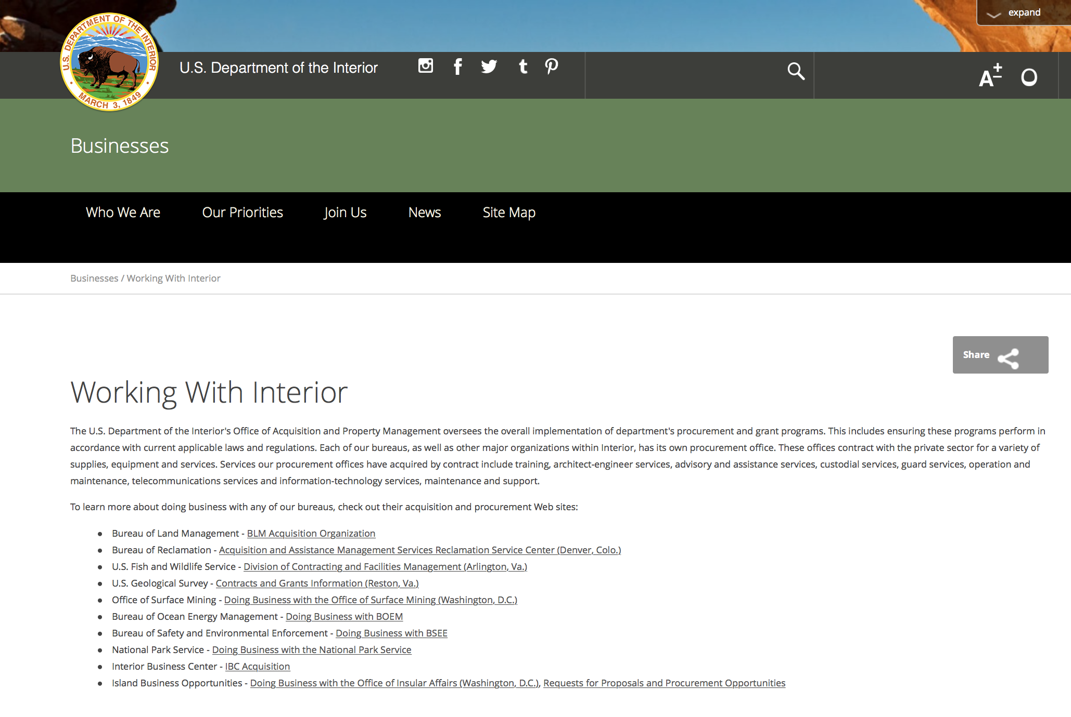

http://www.doi.gov/businesses/working-with-interior.cfm

Programs:

National Park Service
Historic Preservation Fund Grants to Underrepresented Communities
And Modification 1

Document Type: | Grants Notice
Funding Opportunity Number: | P16AS00184
Funding Opportunity Title: | Historic Preservation Fund Grants to Underrepresented Communities
Opportunity Category: | Discretionary
Opportunity Category Explanation:
Funding Instrument Type: | Grant
Category of Funding Activity: | Arts (see "Cultural Affairs" in CFDA)  Community Development  Humanities (see "Cultural Affairs" in CFDA)  Other (see text field entitled "Explanation of Other Category of Funding Activity" for clarification)
Category Explanation: | Historic Preservation, Cultural Resource Management
Expected Number of Awards: | 20
CFDA Number(s): | 15.904 -- Historic Preservation Fund Grants-In-Aid
Cost Sharing or Matching Requirement: | No
Posted Date: | May 20, 2016
Last Updated Date: | May 21, 2016
Original Closing Date for Applications: | Jul 15, 2016 Applications must be submitted in grants.gov and received by 11:59 pm EST on July 15, 2016.
Current Closing Date for Applications: | Jul 15, 2016 Applications must be submitted in grants.gov and received by 11:59 pm EST on July 15, 2016.
Archive Date: | Aug 31, 2016
Estimated Total Program Funding: | $500,000
Award Ceiling: | $50,000
Award Floor: | $15,000
Eligible Applicants: | Native American tribal governments (Federally recognized)  State governments  City or township governments  Others (see text field entitled "Additional Information on Eligibility" for clarification)  Nonprofits that do not have a 501(c)(3) status with the IRS, other than institutions of higher education  County governments
Additional Information on Eligibility: | Eligible applicants are limited to: federally recognized Tribes, Alaska Native Groups, Native Hawaiian Organizations (as defined by 54 USC 300300 et seq.); State Historic Preservation Offices (in some states and territories, these are nonprofits); and Certified Local Governments (which may be county, city, or township governments). A listing of Certified Local Governments may be found at nps.gov/clg.
Agency Name: | National Park Service
Description: | Grants support the survey, inventory, and designation of historic properties that are associated with communities currently underrepresented in the National Register of Historic Places and among National Historic Landmarks. Within one year of the completion of the grant, all projects must result in: the submission of a new nomination to the National Register of Historic Places or National Historic Landmark program OR an amendment to an existing National Register or National Historic Landmark nomination to include underrepresented communities.
Link to Additional Information: | Underrepresented Community Grant Program Homepage
Contact Information: | If you have difficulty accessing the full announcement electronically, please contact:  Division Chief Megan Brown 202 354 2020 preservation_grants_info@nps.gov  Email preferred for questions.

http://www.grants.gov/web/grants/view-opportunity.html?oppId=284031

National Park Service
National Maritime Heritage Grant Program
And Modification 1

Document Type: | Grants Notice
Funding Opportunity Number: | P16AS00170
Funding Opportunity Title: | National Maritime Heritage Grant Program
Opportunity Category: | Discretionary
Opportunity Category Explanation:
Funding Instrument Type: | Grant
Category of Funding Activity: | Other (see text field entitled "Explanation of Other Category of Funding Activity" for clarification)
Category Explanation: | Historic Preservation
Expected Number of Awards: | 35
CFDA Number(s): | 15.925 -- National Maritime Heritage Grants Program
Cost Sharing or Matching Requirement: | Yes
Posted Date: | May 23, 2016
Last Updated Date: | May 24, 2016
Original Closing Date for Applications: | Aug 05, 2016
Current Closing Date for Applications: | Aug 05, 2016
Archive Date: | Aug 06, 2016
Estimated Total Program Funding: | $1,700,000
Award Ceiling: | $200,000
Award Floor: | $15,000
Eligible Applicants: | Public and State controlled institutions of higher education  City or township governments  Nonprofits having a 501(c)(3) status with the IRS, other than institutions of higher education  Private institutions of higher education  Nonprofits that do not have a 501(c)(3) status with the IRS, other than institutions of higher education  Native American tribal governments (Federally recognized)  State governments  County governments
Agency Name: | National Park Service
Description: | Approximately $1.7 million in National Maritime Heritage Grants for education or preservation projects are available for 2016. Proposals for grants will be accepted from May 23 until August 5, 2016. Education projects can request $15,000-50,000 and preservation projects can request $50,000-200,000. Funding for Maritime Heritage Grants is competitive. Project grants are administered through the Maritime Heritage Program and State Historic Preservation Offices (SHPOs).
Link to Additional Information: | https://www.nps.gov/maritime/grants/intro.htm
Contact Information: | If you have difficulty accessing the full announcement electronically, please contact:  Megan Brown 202 354 2062 Megan_Brown@nps.gov  megan_brown@nps.gov

http://www.grants.gov/web/grants/view-opportunity.html?oppId=283892

Geological Survey
FY 2017 National Climate Change & Wildlife Science Center Program Grant

Document Type: | Grants Notice
Funding Opportunity Number: | G16AS00049
Funding Opportunity Title: | FY 2017 National Climate Change & Wildlife Science Center Program
Opportunity Category: | Discretionary
Opportunity Category Explanation:
Funding Instrument Type: | Cooperative Agreement
Category of Funding Activity: | Natural Resources
Category Explanation:
Expected Number of Awards: | 4
CFDA Number(s): | 15.820 -- National Climate Change and Wildlife Science Center
Cost Sharing or Matching Requirement: | No
Posted Date: | May 03, 2016
Last Updated Date: | May 03, 2016
Original Closing Date for Applications: | Jul 19, 2016
Current Closing Date for Applications: | Jul 19, 2016
Archive Date: | Aug 19, 2016
Estimated Total Program Funding: | $52,000,000
Award Ceiling: | $800,000
Award Floor: | $0
Eligible Applicants: | Unrestricted (i.e., open to any type of entity above), subject to any clarification in text field entitled "Additional Information on Eligibility"
Additional Information on Eligibility: | Organizations eligible to submit proposals under this Announcement include state, not-for-profit, local government, and tribal entities, including academic institutions. USGS entities may not submit proposals and may not be formal partners on proposals. Federal agencies may participate in the execution of projects; they will receive money through other methods as appropriate and not through federal financial assistance (i.e. the host cooperative agreement).
Agency Name: | Geological Survey
Description: | This program was created to ensure that the National Climate Change and Wildlife Science Center is responsive to the research and management needs of Federal and State agencies to provide science and technical support regarding the impacts of climate change in fish, wildlife, plants and ecological processes. National coordination of research and modeling at regional centers will ensure uniformity of downscaling and forecasting models and standardized information to support management of fish and wildlife resources and regional partnership collaborations. The Climate Science Centers will provide access to the expertise at cooperating universities and supports the mission of the Climate Science Center Program.
Link to Additional Information: | http://www.grants.gov
Contact Information: | If you have difficulty accessing the full announcement electronically, please contact:  Tammy Szydloski 703-648-7371 tszydloski@usgs.gov  Grant Specialist

http://www.grants.gov/web/grants/view-opportunity.html?oppId=283476

Modifications:

Reminders:

Fish and Wildlife Service
Fiscal Year 2016 Recovery Implementation Fund Grant

Document Type: | Grants Notice
Funding Opportunity Number: | F16AS00099
Funding Opportunity Title: | Fiscal Year 2016 Recovery Implementation Fund
Opportunity Category: | Discretionary
Opportunity Category Explanation:
Funding Instrument Type: | Cooperative Agreement  Grant  Procurement Contract
Category of Funding Activity: | Environment  Natural Resources
Category Explanation:
Expected Number of Awards: | 0
CFDA Number(s): | 15.657 -- Endangered Species Conservation - Recovery Implementation Funds
Cost Sharing or Matching Requirement: | No
Posted Date: | Feb 04, 2016
Last Updated Date: | Feb 04, 2016
Original Closing Date for Applications: | Jul 31, 2016 Applications are due by July 31, 2016. However, you may submit applications throughout the year. Consideration of applications ultimately will be based on the FWS budget cycle.
Current Closing Date for Applications: | Jul 31, 2016 Applications are due by July 31, 2016. However, you may submit applications throughout the year. Consideration of applications ultimately will be based on the FWS budget cycle.
Archive Date: | Aug 31, 2016
Estimated Total Program Funding: | $0
Award Ceiling: | $1,000,000
Award Floor: | $1
Eligible Applicants: | Unrestricted (i.e., open to any type of entity above), subject to any clarification in text field entitled "Additional Information on Eligibility"
Additional Information on Eligibility: | Applicants must have a demonstrated knowledge and understanding of the biology of the involved endangered or threatened species in the United States and their ecosystem, including preferably having worked with the species in the field and holding a currently valid Endangered Species Act permit, issued by the FWS, authorizing them to work with these species (or that have previously held a permit to do so). If funding is awarded, applicants that do not currently hold a valid permit for the proposed activity may need to apply for and obtain a permit (http://www.fws.gov/endangered/permits/index.html) before beginning the proposed activity. FWS Regional (or Field Office) contacts will discuss potential proposals with interested parties if needed, and review eligible applications. The FWS Regional Office will refer interested parties to the appropriate FWS Field Office for further consideration as appropriate. For potential proposals submitted directly to the Field Office, the Field Office will conduct the proposal review and selection process. A list of FWS Regional Office contacts is available in the Full Announcement under section VII. Agency Contacts.
Agency Name: | Fish and Wildlife Service
Description: | The FWS Ecological Services Program provides Federal financial assistance on a competitive basis to States, other Federal agencies, landowners, educators, non-profit organizations, researchers, and other partners to secure information about endangered, threatened or candidate species, to aid in the recovery of these species, to avert listing of species pursuant to the Endangered Species Act, and to help conserve the ecosystems upon which these species depend. The FWS and National Marine Fisheries Service (NMFS), which is part of the Department of Commerce’s NOAA Fisheries office, share Endangered Species Act responsibilities for several species such as sea turtles. We have responsibility for sea turtles when they are on land, and NMFS has responsibility for sea turtles when they are in the water. Projects for NMFS-managed species are not included in this funding opportunity. This Recovery Implementation funding opportunity is intended for projects that will contribute to the recovery of FWS-managed endangered and threatened species in the United States, and is limited to projects carrying out actions described in a species approved recovery plan, in the implementation schedule of a species approved recovery plan, actions recommended in a completed 5-year status review of the species or in a spotlight species action plan, or projects documenting species response to climate change. For example: securing scientific information about endangered or threatened species, implementing restoration actions that will lead to delisting of a species, help prevent extinction of a species, or aid in the recovery of a species. Projects that address species response to climate change will receive additional consideration.
Link to Additional Information: | http://www.grants.gov
Contact Information: | If you have difficulty accessing the full announcement electronically, please contact:  Kelly Niland 703-358-2492 Kelly_Niland@fws.gov  Grant Specialist

http://www.grants.gov/web/grants/view-opportunity.html?oppId=281338

Fish and Wildlife Service
National Fish Passage Program Grant

Document Type: | Grants Notice
Funding Opportunity Number: | F16AS00041
Funding Opportunity Title: | National Fish Passage Program
Opportunity Category: | Discretionary
Funding Instrument Type: | Cooperative Agreement
Category of Funding Activity: | Natural Resources
Category Explanation:
Expected Number of Awards:
CFDA Number(s): | 15.608 -- Fish and Wildlife Management Assistance
Cost Sharing or Matching Requirement: | Yes
Posted Date: | Dec 1, 2015
Creation Date: | Nov 30, 2015
Original Closing Date for Applications: | Sep 1, 2016
Current Closing Date for Applications: | Sep 1, 2016
Archive Date: | Sep 20, 2016
Eligible Applicants: | Unrestricted (i.e., open to any type of entity above), subject to any clarification in text field entitled "Additional Information on Eligibility"
Additional Information on Eligibility: | To receive funding, NFPP projects must be implemented in coordination with FAC staff. Applicants can be, but not limited to: state and federal agencies, private lands, tribes, local municipalities, and non-governmental organizations.
Agency Name: | Fish and Wildlife Service
Description: | The National Fish Passage Program (NFPP) is a voluntary program that provides direct technical assistance and financial assistance in the form of cooperative agreements to partners to provide fish (and other aquatic organisms) passage and restore aquatic connectivity for the benefit of federal trust resources. The NFPP is delivered through more than 65 Fisheries and Aquatic Conservation (FAC) Field Offices across all States and territories. FAC staff coordinates with project partners, stakeholders and other Service programs to identify and collaboratively implement projects within Regional priority areas. Project work plans are developed strategically, in coordination with partners, and with substantial involvement from FAC staff. Projects must advance our mission, promote biological diversity, and be based upon sound scientific biological principles. FAC and Fish and Wildlife Service (FWS) strategic plans inform the types of projects funded under this opportunity. Applicants seeking funding under this program should review the program strategic plan and also contact the regional NFPP Coordinator for local FAC contacts prior to submitting an application for funding.
Link to Additional Information: | http://www.grants.gov
Contact Information: | If you have difficulty accessing the full announcement electronically, please contact:  Stephanie Long, 703-358-1749 Stephanie_A_Long@fws.gov  Stephanie_A_Long@fws.gov

http://www.grants.gov/web/grants/view-opportunity.html?oppId=280260

Fish and Wildlife Service
Fiscal Year 2016 Candidate Conservation Action Funds Grant

Document Type: | Grants Notice
Funding Opportunity Number: | F16AS00100
Funding Opportunity Title: | Fiscal Year 2016 Candidate Conservation Action Funds
Opportunity Category: | Discretionary
Funding Instrument Type: | Cooperative Agreement  Grant  Procurement Contract
Category of Funding Activity: | Environment  Natural Resources
Category Explanation:
Expected Number of Awards: | 0
CFDA Number(s): | 15.660 -- Endangered Species - Candidate Conservation Action Funds
Cost Sharing or Matching Requirement: | No
Posted Date: | Feb 4, 2016
Creation Date: | Feb 4, 2016
Original Closing Date for Applications: | Jul 31, 2016 Applications are due by July 31, 2016. However, you may submit applications throughout the year. Consideration of applications ultimately will be based on the FWS budget cycle.
Current Closing Date for Applications: | Jul 31, 2016 Applications are due by July 31, 2016. However, you may submit applications throughout the year. Consideration of applications ultimately will be based on the FWS budget cycle.
Archive Date: | Aug 31, 2016
Estimated Total Program Funding: | $0
Award Ceiling: | $1,000,000
Award Floor: | $1
Eligible Applicants: | Unrestricted (i.e., open to any type of entity above), subject to any clarification in text field entitled "Additional Information on Eligibility"
Additional Information on Eligibility: | Applicants must have a demonstrated knowledge and understanding of the biology of the involved candidate or at-risk species in the United States and their ecosystem, including preferably having worked with the species in the field. FWS Regional (or Field Office) contacts will discuss potential proposals with interested parties if needed, and review eligible applications. The FWS Regional Office will refer interested parties to the appropriate FWS Field Office for further consideration as appropriate. For potential proposals submitted directly to the Field Office, the Field Office will conduct the proposal review and selection process. A list of FWS Regional and Field Office contacts is available in the Full Announcement under section VII. Agency Contacts.
Agency Name: | Fish and Wildlife Service
Description: | Financial assistance is available to secure candidate and other at-risk species information or undertake restoration actions that will help avert federal listing of species. The purpose is to provide a means by which the ecosystems upon which candidate and at-risk species depend may be conserved, to provide a program for the conservation of these species.
Link to Additional Information: | http://www.grants.gov
Contact Information: | If you have difficulty accessing the full announcement electronically, please contact:  Grant Specialist Kelly Niland 703-358-2492 Kelly_Niland@fws.gov  Grant Specialist

http://www.grants.gov/web/grants/view-opportunity.html?oppId=281344

Department of Justice

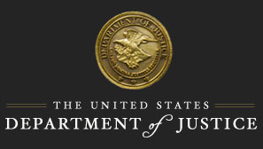

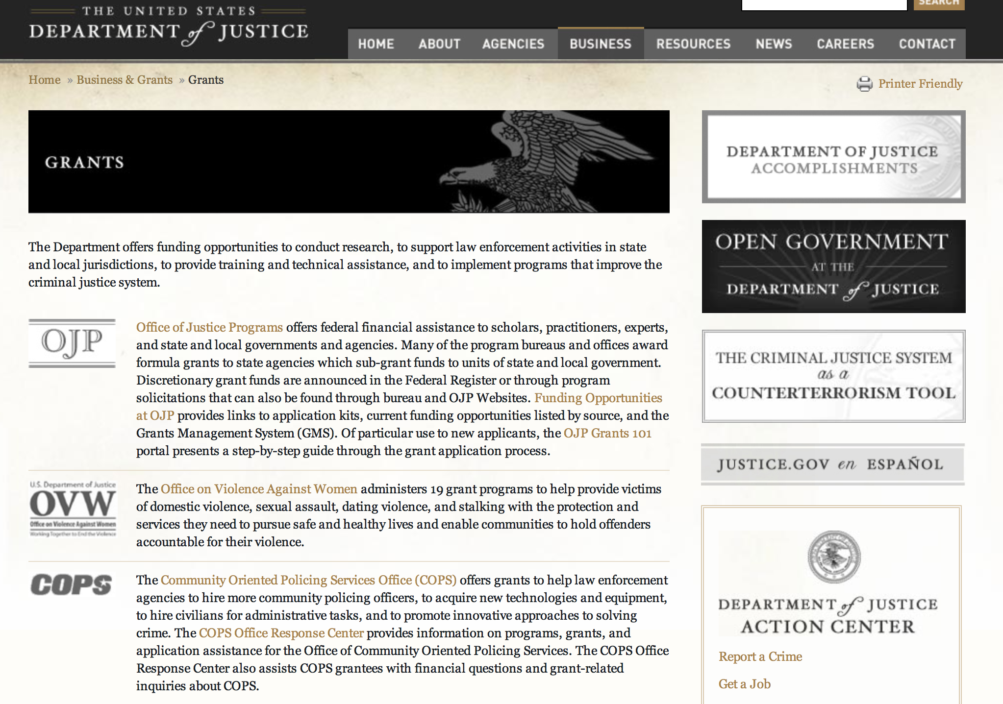

The DOJ agencies listed below also have sites that provide grant information specific to that agency. Examples of what can be found on these sites are programs, funding opportunities, application assistance, and other useful information.

Bureau of Justice Assistance (BJA)

Bureau of Justice Statistics (BJS)

National Criminal Justice Reference Service (NCJRS)

National Institute of Justice (NIJ)

Office of Juvenile Justice and Delinquency Prevention (OJJDP)

Office of Sex Offender Sentencing, Monitoring, Apprehending, Registering, and Tracking (SMART)

Office for Victims of Crime (OVC)

http://www.justice.gov/business/

Programs:

Office of Justice Programs
Office for Victims of Crime
OVC FY 16 A Pathway to Justice, Healing and Hope: Addressing Polyvictimization in a Family Justice Center Setting Demonstration Initiative Grant

Document Type: | Grants Notice
Funding Opportunity Number: | OVC-2016-9376
Funding Opportunity Title: | OVC FY 16 A Pathway to Justice, Healing and Hope: Addressing Polyvictimization in a Family Justice Center Setting Demonstration Initiative
Opportunity Category: | Discretionary
Opportunity Category Explanation:
Funding Instrument Type: | Cooperative Agreement
Category of Funding Activity: | Income Security and Social Services  Law, Justice and Legal Services
Category Explanation:
Expected Number of Awards: | 6
CFDA Number(s): | 16.582 -- Crime Victim Assistance/Discretionary Grants
Cost Sharing or Matching Requirement: | No
Posted Date: | May 12, 2016
Last Updated Date: | May 12, 2016
Original Closing Date for Applications: | Jun 27, 2016
Current Closing Date for Applications: | Jun 27, 2016
Archive Date:
Estimated Total Program Funding: | $5,000,000
Award Ceiling: | $1,000,000
Award Floor: | $666,666
Eligible Applicants: | Others (see text field entitled "Additional Information on Eligibility" for clarification)
Additional Information on Eligibility: | The intended focus of this demonstration initiative is on Family Justice Centers and other comprehensive co-located services for victims of domestic violence and sexual assault. The initiative will support the selection of up to six demonstration sites and one comprehensive national technical assistance provider. Purpose Area 1: Demonstration site applicants: OVC recognizes that there are several different governance structures that support the operation of Family Justice Centers (FJC) and/or co-located service centers. Therefore, the following entities are eligible to apply: • Governmental agencies that serve as the lead agency of an FJC. • Governmental agencies with an FJC established as a separate department or program within a city or county agency. • Nonprofit, nongovernmental, community-based domestic violence or sexual assault agencies that serve as the lead agency of an FJC. • 501(c)(3) nonprofit organizations created expressly for the leadership and management of an FJC. • Governmental and nonprofit organizations that serve as the lead of a comprehensive co-located service center for victims of domestic violence and sexual assault, involving victim services, civil legal services, law enforcement, and prosecution. Purpose Area 2: Technical assistance applicants: Eligible applicants for funding to provide technical assistance to the demonstration projects are nonprofit organizations with a demonstrated history of providing national scope training and technical assistance (TTA) and an expertise in working with FJCs, other local co-located service collaboratives, and multidisciplinary audiences.
Agency Name: | Office for Victims of Crime
Description: | The establishment of a demonstration initiative to develop a special polyvictimization program within Family Justice Centers (FJC). Through this initiative, a specialized polyvictimization screening tool will be developed and offered for both adults and children receiving services at the FJC followed by the provision of the wide-range of services needed to address a survivor's full history of current and past traumas. The initiative may require the identification of new on-site and/or off-site partners to deliver the full-range of services needed. The demonstration initiative will include a technical assistance and an evaluation component.
Link to Additional Information: | Funding Opportunity
Contact Information: | If you have difficulty accessing the full announcement electronically, please contact:  For assistance with any other requirements of this solicitation, contact Stacy Phillips, Grant Management Specialist, by telephone at 202-616-3627. stacy.phillips@usdoj.gov  For Programmatic Questions

http://www.grants.gov/web/grants/view-opportunity.html?oppId=283804

Research:

Office of Justice Programs
Office of Juvenile Justice Delinquency Prevention
OJJDP FY 2016 Studies Program on Trauma and Justice-Involved Youth
And Modification 3
http://www.grants.gov/web/grants/view-opportunity.html?oppId=283663

Modifications:

Office of Justice Programs
Office for Victims of Crime
OVC FY 16 Vision 21: Multidisciplinary Responses to Families and Communities in Complex Homicide Cases
Modification 1

Document Type: | Grants Notice
Funding Opportunity Number: | OVC-2016-9440
Funding Opportunity Title: | OVC FY 16 Vision 21: Multidisciplinary Responses to Families and Communities in Complex Homicide Cases
Opportunity Category: | Discretionary
Opportunity Category Explanation:
Funding Instrument Type: | Cooperative Agreement
Category of Funding Activity: | Income Security and Social Services  Law, Justice and Legal Services
Category Explanation:
Expected Number of Awards: | 7
CFDA Number(s): | 16.582 -- Crime Victim Assistance/Discretionary Grants
Cost Sharing or Matching Requirement: | No
Posted Date: | May 03, 2016
Last Updated Date: | May 03, 2016
Original Closing Date for Applications: | Jun 20, 2016
Current Closing Date for Applications: | Jun 20, 2016
Archive Date:
Estimated Total Program Funding: | $5,100,000
Award Ceiling: | $1,500,000
Award Floor: | $300,000
Eligible Applicants: | Others (see text field entitled "Additional Information on Eligibility" for clarification)
Additional Information on Eligibility: | Purpose Area #1: Eligible applicants for the demonstration project sites are limited to: public agencies; federally recognized tribal governments (as determined by the Secretary of the Interior); private nonprofit organizations (including tribal nonprofit organizations); faith- and community-based organizations; and colleges or universities (including tribal institutions of higher education) that demonstrate: 1) experience in providing direct services to families after a homicide or violent death and 2) experience in implementing a program or intervention that requires significant coordination between service providers, law enforcement, and other entities that engage with families and communities after a homicide or violent crime. Purpose Area #2: Eligible applicants to provide technical assistance to the demonstration projects are limited to: public agencies; federally recognized tribal governments (as determined by the Secretary of the Interior); private nonprofit organizations (including tribal nonprofit organizations); faith- and community-based organizations; and colleges and universities (including tribal institutions of higher education). Applicants must have: 1) demonstrated experience providing technical assistance in the areas of victimization and support services described in this solicitation and 2) experience developing online publications and resources for broad dissemination to the victim services field. Eligible applicants may apply for funding as a demonstration site or as a technical assistance provider, but not both. Applicants that apply for both purpose areas will not be considered.
Agency Name: | Office for Victims of Crime
Description: | This program will identify promising practices in addressing the needs of families and communities on extremely complex homicide cases. For the purpose of this solicitation, OVC is using the term complex homicide to describe cases that require specialized and coordinated responses on the part of victim service providers and law enforcement. These cases may include, but are not limited to, cases involving intra-familial homicide, murder/suicide, child witnesses, mass violence/multiple victim cases, vehicular homicides, gang involved shootings, and police involved shootings where either a police officer or a suspect are killed. Under Purpose Area #1 of this solicitation, OVC will make up to six awards up to $600,000 each to organizations that demonstrate experience in responding to complex homicide cases and have capacity to implement multi-disciplinary responses to families and communities impacted by these types of crimes. Funding under Purpose Area #1 will also support researcher/practitioner partnerships at each site to conduct program evaluation and identify evidence- based practices that can be used at the local level. Under Purpose Area #2 of this solicitation, OVC will make one award up to $1.5 million to one technical assistance provider who will identify TA needs of direct service sites, convene grantee meetings and compile a compendium of promising practices suitable for publication and dissemination to the field.
Link to Additional Information: | Funding Opportunity
Contact Information: | If you have difficulty accessing the full announcement electronically, please contact:  For assistance with any other requirements of this solicitation, contact Mary Atlas-Terry, Victim Justice Program Specialist, by telephone at 202–353–8473. Mary.Atlas-Terry@usdoj.gov  For Programmatic Questions

http://www.grants.gov/web/grants/view-opportunity.html?oppId=283463

Reminders:

Office of Justice Programs
Office of Juvenile Justice Delinquency Prevention
OJJDP FY 16 Safe and Thriving Communities: Uniting Community Based Violence Prevention, Defending Childhood and National Forum Approaches to Prevent and Heal Violence Grant

Document Type: | Grants Notice
Funding Opportunity Number: | OJJDP-2016-9157
Funding Opportunity Title: | OJJDP FY 16 Safe and Thriving Communities: Uniting Community Based Violence Prevention, Defending Childhood and National Forum Approaches to Prevent and Heal Violence
Opportunity Category: | Discretionary
Opportunity Category Explanation:
Funding Instrument Type: | Cooperative Agreement
Category of Funding Activity: | Law, Justice and Legal Services
Category Explanation:
Expected Number of Awards: | 14
CFDA Number(s): | 16.818 -- Children Exposed to Violence
Cost Sharing or Matching Requirement: | No
Posted Date: | Apr 22, 2016
Last Updated Date: | Apr 22, 2016
Original Closing Date for Applications: | Jun 21, 2016
Current Closing Date for Applications: | Jun 21, 2016
Archive Date:
Estimated Total Program Funding: | $3,000,000
Award Ceiling: | $1,000,000
Award Floor: | $500,000
Eligible Applicants: | County governments  Native American tribal governments (Federally recognized)  Others (see text field entitled "Additional Information on Eligibility" for clarification)  City or township governments  State governments
Additional Information on Eligibility: | Category 1: New Applicants. Eligible applicants are limited to units of local government, state agencies proposing local initiatives in collaboration with community-based organizations, and federally recognized tribal governments (as determined by the Secretary of the Interior). Existing grantees funded under OJJDP’s National Forum on Youth Violence Prevention, Defending Childhood, and Community-Based Violence Prevention initiatives are eligible only under Category 2. Category 2: Existing Grantees. Eligible applicants are existing grantee sites of OJJDP’s National Forum on Youth Violence Prevention, Defending Childhood, and Community-Based Violence Prevention initiatives that did not receive funding under the FY 2015 Youth Violence Prevention Enhancement solicitation. (Refer to the matrix, Appendix B, page 52.) All Applicants: To be eligible for consideration for funding under this solicitation, applicants must provide letters of commitment/memoranda of understanding that the chief executive officer (e.g., mayor, county executive, tribal chair), chief of police, superintendent of schools within the locality, and directors of public health, housing, workforce development, economic development, and child welfare (or the equivalent positions) have signed. Letters of commitment/memoranda must indicate an understanding of the goals of the proposal, describe the roles and responsibilities of the signer and/or represented agency, and specify the fiscal and staffing resource commitments made to the collaboration. OJJDP welcomes applications that involve two or more entities that will carry out the funded federal award activities; however, one eligible entity must be the applicant and the other(s) must be proposed as subrecipient(s). The applicant must be the entity with primary responsibility for administering the funding and managing the entire project. Only one application per lead applicant will be considered; however, a subrecipient may be part of multiple proposals. OJJDP may elect to make awards for applications submitted under this solicitation in future fiscal years, dependent on, among other considerations, the merit of the applications and on the availability of appropriations.
Agency Name: | Office of Juvenile Justice Delinquency Prevention
Description: | This solicitation seeks to help catalyze and further advance the prevention and intervention of youth victimization and violence, especially youth gun and gang violence, by focusing efforts in partnership with a limited number of localities and Tribes. The funds are intended to help initiate or strengthen work to end youth violence and improve the wellbeing of children, youth, families and communities through comprehensive approaches that unify the central tenets of OJJDP’s existing youth violence initiatives through a single, shared framework for collective action.
Link to Additional Information: | Full Announcement
Contact Information: | If you have difficulty accessing the full announcement electronically, please contact:  For technical assistance with submitting an application, contact the Grants.gov Customer Support Hotline at 800-518-4726or 606-545-5035, or via e-mail to support@grants.gov. Hotline hours of operation are 24 hours a day, 7 days a week, except federal holidays. Applicants who experience unforeseen Grants.gov technical issues beyond their control that prevent them from submitting their application by the deadline must e-mail the OJJDP contact identified below within 24 hours after the application deadline and request approval to submit their application. Additional information on reporting technical issues is found under “Experiencing Unforeseen Grants.gov Technical Issues” in the How To Apply section. For assistance with any other requirements of this solicitation, contact the Response Center by telephone at 800-851-3420 or TTY: 301-240-6310 (Hearing impaired only), by e-mail at grants@ncjrs.gov, or by web chat. Response Center hours of operation are 10 a.m. to 6 p.m. ET, Monday through Friday, and 10 a.m. to 8 p.m. ET on the solicitation close date. Answers to frequently asked questions that may assist applicants are posted at www.ojjdp.gov/grants/solicitations/FY2016/FAQ/Safe&ThrivingFAQ.pdf. grants@ncjrs.gov  Email

http://www.grants.gov/web/grants/view-opportunity.html?oppId=283239

Office of Justice Programs
Bureau of Justice Assistance
Smart Reentry: Focus on Evidence-Based Strategies for Successful Reentry from Incarceration to Community Grant

Document Type: | Grants Notice
Funding Opportunity Number: | BJA-2016-9207
Funding Opportunity Title: | Smart Reentry: Focus on Evidence-Based Strategies for Successful Reentry from Incarceration to Community
Opportunity Category: | Discretionary
Opportunity Category Explanation:
Funding Instrument Type: | Grant
Category of Funding Activity: | Law, Justice and Legal Services
Category Explanation:
Expected Number of Awards: | 6
CFDA Number(s): | 16.812 -- Second Chance Act Reentry Initiative
Cost Sharing or Matching Requirement: | N
Posted Date: | Apr 10, 2016
Last Updated Date: | Apr 11, 2016
Original Closing Date for Applications: | Jun 09, 2016
Current Closing Date for Applications: | Jun 09, 2016
Archive Date:
Estimated Total Program Funding: | $6,000,000
Award Ceiling: | $1,000,000
Eligible Applicants: | Native American tribal governments (Federally recognized)  State governments  County governments  City or township governments
Agency Name: | Bureau of Justice Assistance
Description: | The goal of this program is to support jurisdictions to develop and implement comprehensive and collaborative strategies that address the challenges posed by reentry to increase public safety and reduce recidivism for individuals reentering communities from incarceration who are at medium to risk for recidivating. Within the context of this initiative, reentry is not envisioned to be a specific program, but rather a process that begins when the individual is first incarcerated (pre-release) and ends with his or her successful reduction in risk of recidivism and community reintegration (post-release). This process should provide the individual with appropriate evidence-based services including reentry planning that addresses individual criminogenic needs identified through information obtained from an empirically validated risk/needs assessment that also reflects the risk of recidivism for each individual. The reentry plan should reflect both specific and ongoing pre-release and post-release needs, and a strategy for ensuring that these needs are met throughout the duration of the reentry process.
Link to Additional Information: | Full Announcement
Contact Information: | If you have difficulty accessing the full announcement electronically, please contact:  For technical assistance with submitting an application, contact the Grants.gov Customer Support Hotline at 800-518-4726 or 606-545-5035, or via e-mail to support@grants.gov. The Grants.gov Support Hotline hours of operation are 24 hours a day, 7 days a week, except federal holidays. support@grants.gov  Technical Application Support

http://www.grants.gov/web/grants/view-opportunity.html?oppId=282907



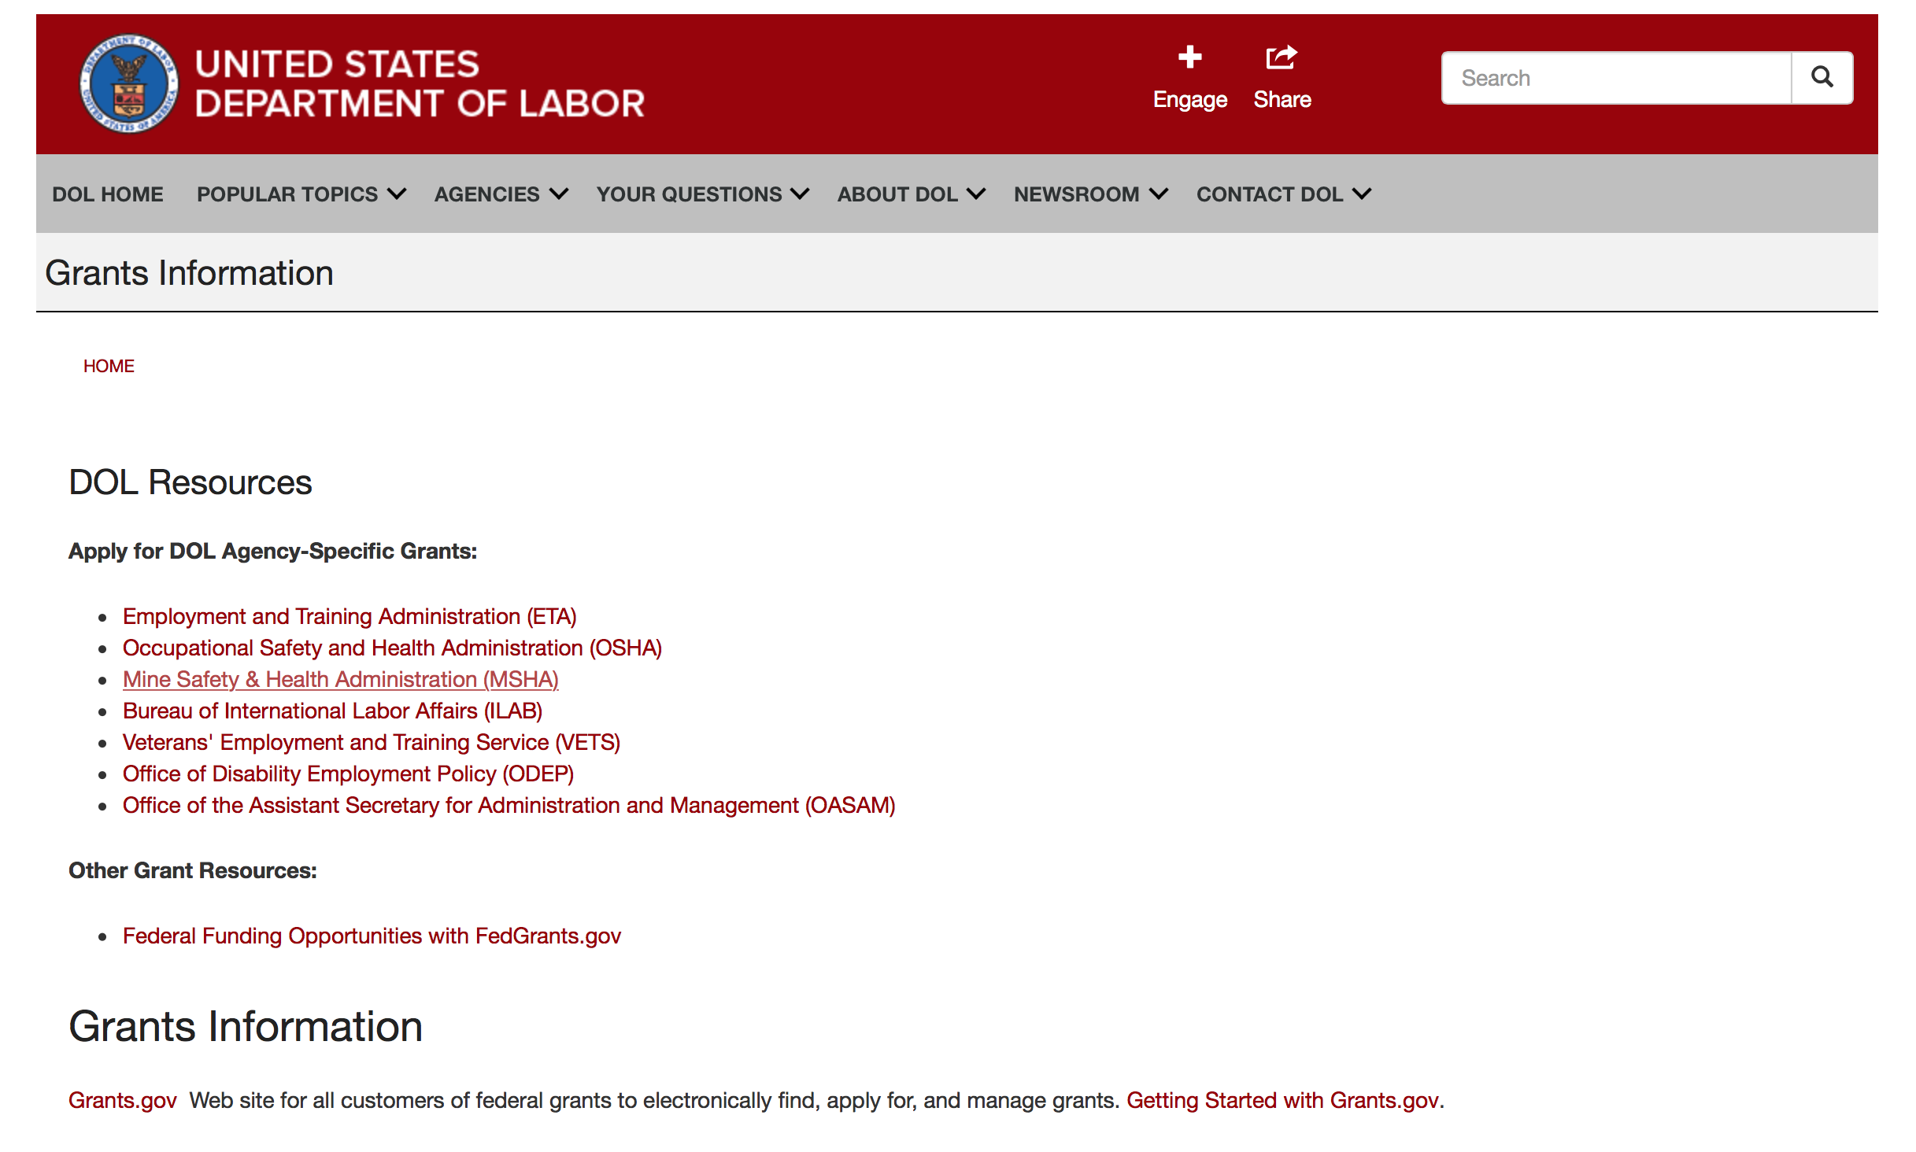

Agency Grants and Contract General Overview

DOL Resources
Apply for DOL Agency-Specific Grants:
- Employment and Training Administration (ETA)
- Occupational Safety and Health Administration (OSHA)
- Mine Safety & Health Administration (MSHA)
- Bureau of International Labor Affairs (ILAB)
- Veterans' Employment and Training Service (VETS)
- Office of Disability Employment Policy (ODEP)
- Office of the Assistant Secretary for Administration and Management (OASAM)

Other Grant Resources:
- Federal Funding Opportunities with FedGrants.gov
Grants Information
Grants.gov — Web site for all customers of federal grants to electronically find, apply for, and manage grants. Getting Started with Grants.gov.

DOL Resources and Instructions for Applying for a Grant
- DOL Guidance Clarifying the Effect of the Religious Freedom Restoration Act on Faith-Based Organizations
- Grant and Contract Information
- Contracting and Grant Program Overview
- Annual Acquisition Plan & Procurement Forecast
- Civil Rights Enforcement for Department of Labor Grant Recipients
- More Information About Grants
- Use of Contracts, Grants & Cooperative Agreements

Other Federal Government Grant Information
- List of Parties Excluded From Federal Procurement and Nonprocurement Programs (as created and maintained by GSA)
- Grant Opportunities (Catalog of Federal Domestic Assistance)

Department of Labor Grant Programs

- Bureau of International Labor Affairs (ILAB): provides grants (cooperative agreements) for the implementation of projects designed to assist developing countries combat the worse forms of child labor, forced labor, and human trafficking; and support worker rights and improve working conditions. http://www.dol.gov/general/business.
- Bureau of Labor Statistics (BLS): provides project grants (cooperative agreements) and the dissemination of technical statistical data and related information on labor force activities; provides data on prices (CPI) and cost of living; data on productivity and technology data; data on compensation and working conditions; data on employment projections.
- Employment and Training (ETA): ETA administers financial assistance programs pursuant to the Workforce Investment Act (WIA), administering State formula grant programs for youth, adults and dislocated workers, national emergency grants for workers affected by mass layoffs, plant closures, and disasters; grant programs for workers with disabilities, Indians and Native Americans, and for migrant and seasonal farmworkers. ETA also administers grant programs for older American workers, apprenticeship programs, Trade Adjustment Assistance (TAA) programs, and assistance for research and development of workforce programs. In addition, ETA is responsible for the operation and maintenance of a national system of public employment service offices and for the national unemployment insurance program.
- Mine Safety and Health (MSHA): provides grants for research, education and training programs to ensure an adequate and competent staff of trained inspectors; and assistance for establishing or improving State mine health and safety programs through technical assistance.
- Occupational Safety and Health (OSHA): provides grants to non-profit organizations to provide training, educational services, and technical assistance; assistance to states to administer and enforce state programs; assistance to states to provide occupational safety and health technical assistance and consultant services.
- Office of Disability Employment Policy (ODEP): The Office of Disability Employment Policy awards competitive grants establishing short-term pilot and technical assistance projects designed to identify, develop, test, evaluate, and disseminate policies to increase employment by expanding access to training, education, employment supports, assistive and systems technology, integrated employment, entrepreneurial development, and small business opportunities for adults and youth with disabilities. Current pilots projects focus on customized employment, Olmstead populations, and innovative demonstration youth grants, among others. Solicitations for grant applications are published in the Federal Register and announced at www.dol.gov/odep. ODEP grants are awarded by the OASAM grant office.
- Veterans' Employment and Training (VETS): provides special employment and training assistance for veterans through the Disabled Veterans' Outreach Program (DVOP) Solicitation for Grant Applications; the Local Veterans' Employment Representative Program (LVER); Veterans' Workforce Investment Program (VWIP); elaws Advisor on veterans' employment and reemployment rights; and the Homeless Veterans Reintegration Project (HVRP). VETS grants are awarded by the OASAM grant office.

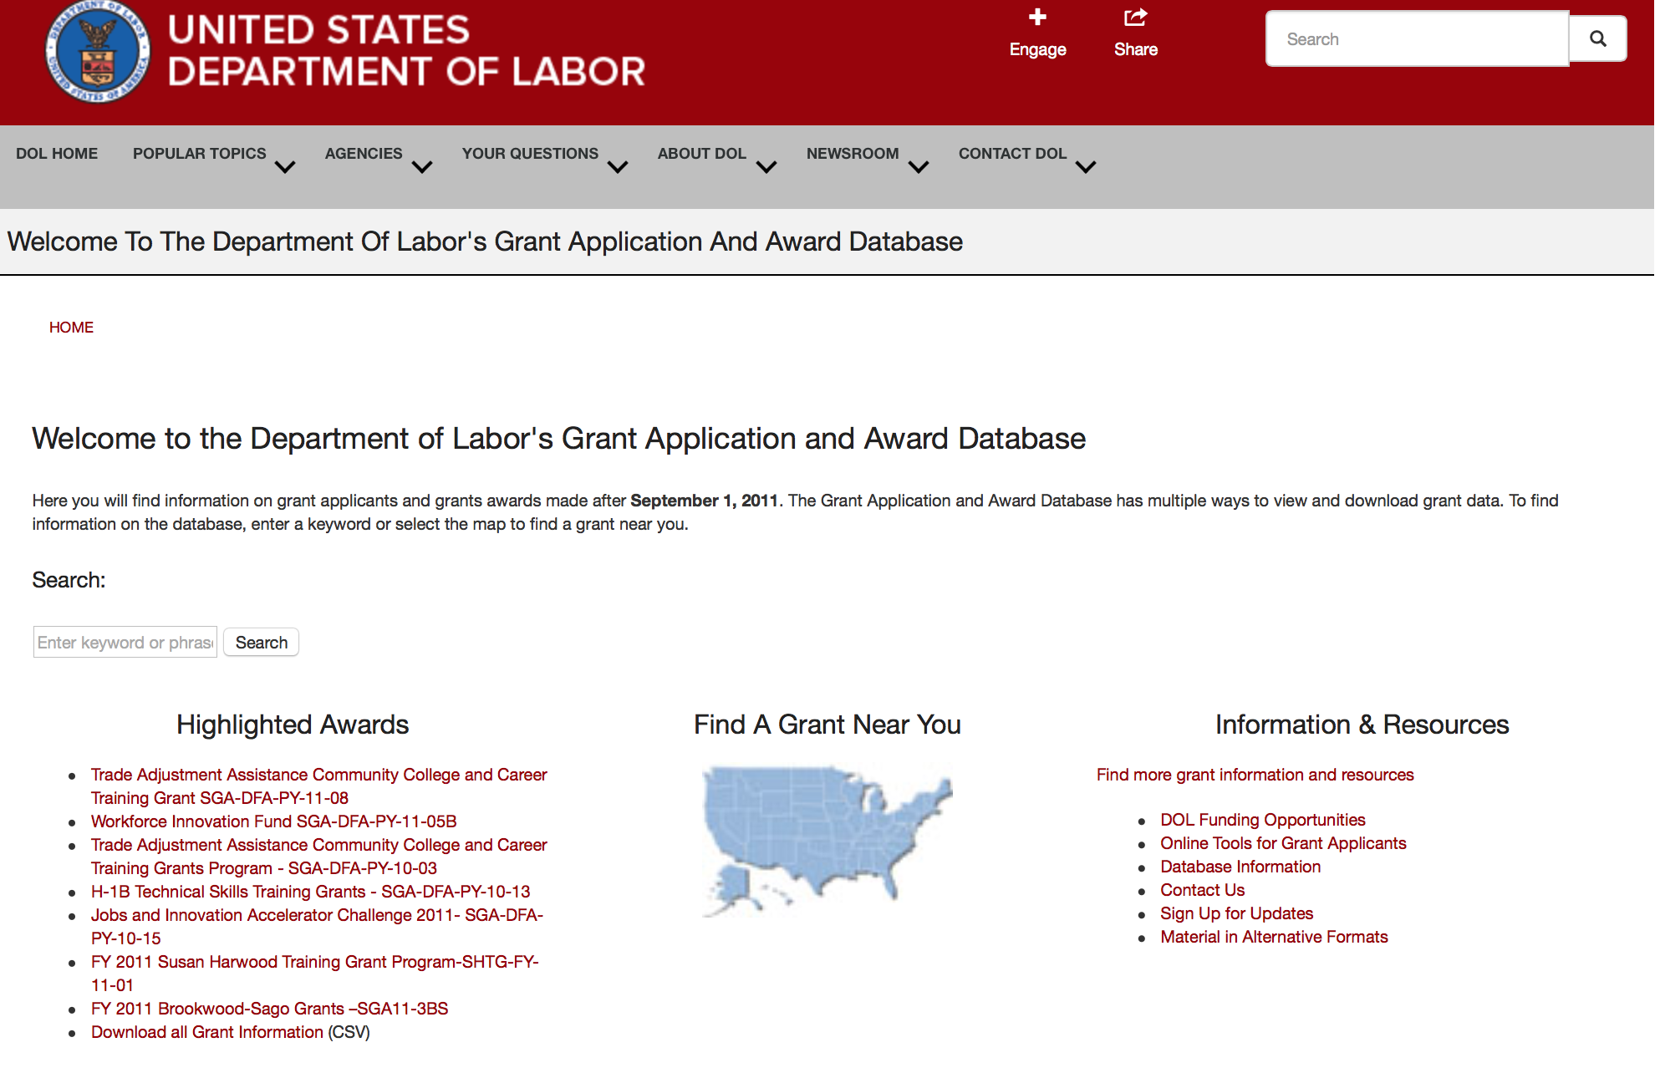

http://www.dol.gov/dol/grants/

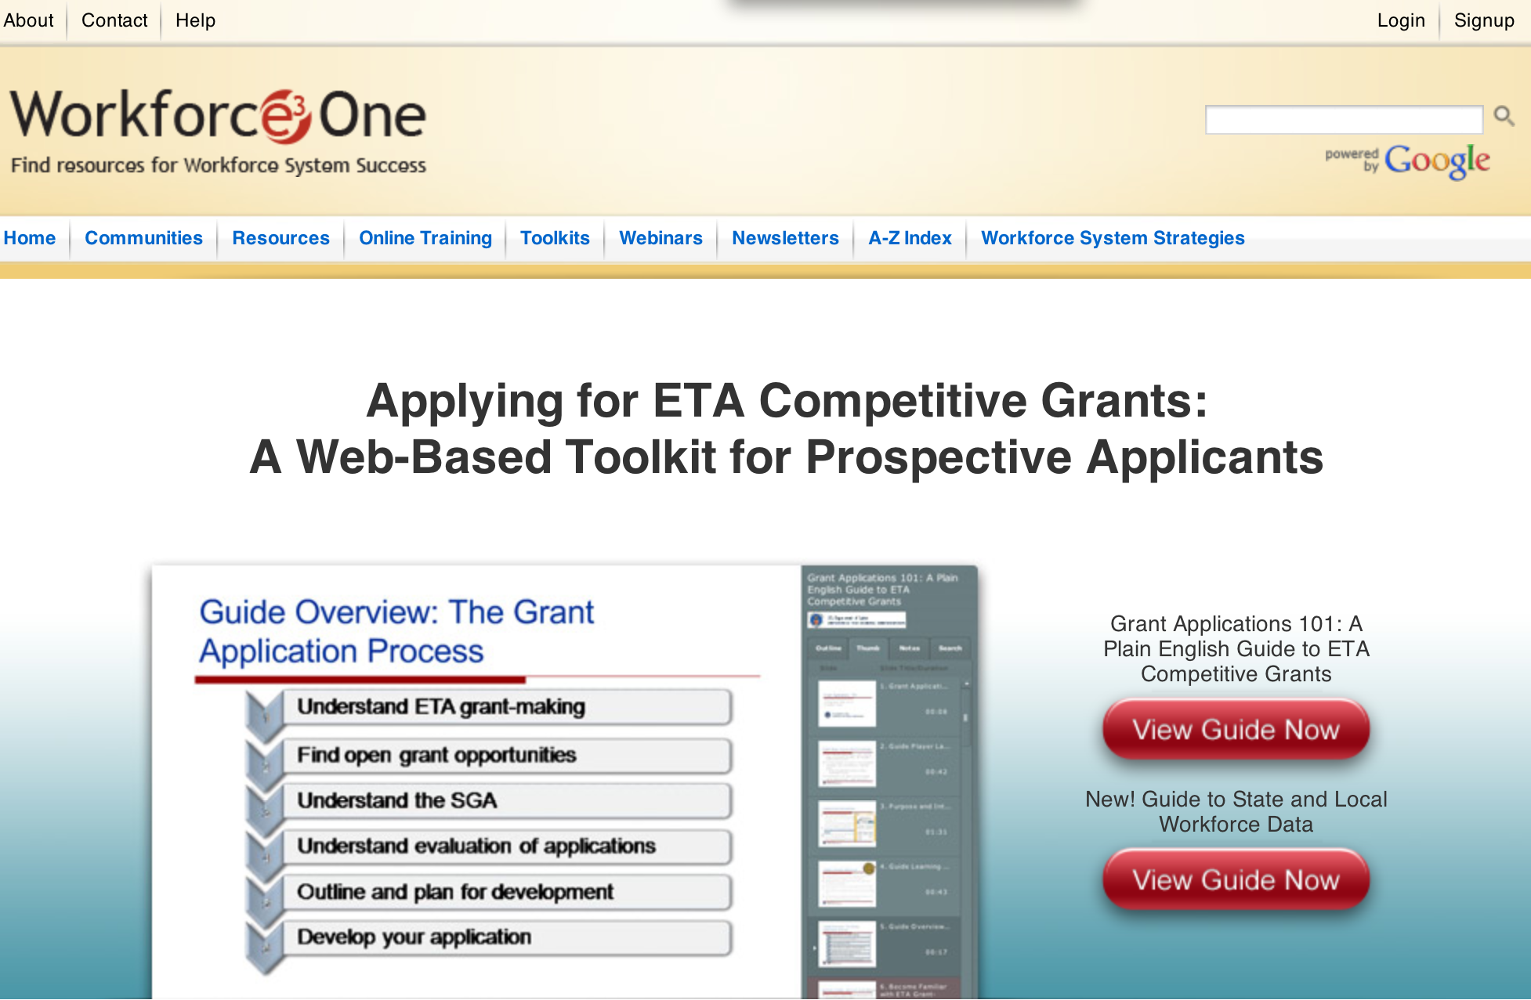

https://www.workforce3one.org/ws/www/pages/grants_toolkit.aspx?pparams=/

Programs

Employment and Training Administration
YouthBuild Grant

Document Type: | Grants Notice
Funding Opportunity Number: | FOA-ETA-16-10
Funding Opportunity Title: | YouthBuild
Opportunity Category: | Discretionary
Opportunity Category Explanation:
Funding Instrument Type: | Grant
Category of Funding Activity: | Employment, Labor and Training
Category Explanation:
Expected Number of Awards: | 80
CFDA Number(s): | 17.274 -- YouthBuild
Cost Sharing or Matching Requirement: | Yes
Posted Date: | May 17, 2016
Last Updated Date: | May 17, 2016
Original Closing Date for Applications: | Jul 06, 2016 We must receive applications no later than 4:00:00 p.m. Eastern Time.
Current Closing Date for Applications: | Jul 06, 2016 We must receive applications no later than 4:00:00 p.m. Eastern Time.
Archive Date: | Aug 05, 2016
Estimated Total Program Funding: | $80,000,000
Award Ceiling: | $1,100,000
Award Floor: | $700,000
Eligible Applicants: | Others (see text field entitled "Additional Information on Eligibility" for clarification)
Additional Information on Eligibility: | Eligible applicants for these grants are public or private non-profit agencies or organizations including rural, urban, or Native American agencies that have previously served disadvantaged youth in a YouthBuild or other similar program. These agencies or organizations include, but are not limited to: • a community-based organization; • a faith-based organization; • an entity carrying out activities under the WIOA, such as a local workforce development board; • a community action agency; • a state or local housing development agency; • an Indian tribe or other agency primarily serving Native Americans (including those living on reservations), Native Hawaiians, or Alaska Natives; • a community development corporation; • a state or local youth service or conservation corps; • any other entity eligible to provide education or employment training under a federal program; or • an entity in an area designated as a Promise Zone or member of a Promise Zone collaboration, if applicable. For more information on about Promise Zones go to http://portal.hud.gov/hudportal/HUD?src=/program_offices/comm_planning/economicdevelopment/programs/pz Grantees who received funding from the FY 2015 YouthBuild competition are funded through January 2019, and these grantees (based on their unique Employer Identification Numbers) are not eligible to participate in this competition.
Agency Name: | Employment and Training Administration
Description: | YouthBuild is a community-based alternative education program for youth between the ages of 16 and 24 who are high school dropouts, adjudicated youth, youth aging out of foster care, youth with disabilities, homeless youth, and other disconnected youth populations. The YouthBuild program simultaneously addresses several core issues important to low-income communities: affordable housing, education, employment, leadership development, and energy efficiency. The YouthBuild model balances project-based academic learning and occupational skills training to prepare disadvantaged youth for career placement. The academic component assists youth who are often significantly behind in basic skill development to obtain a high school diploma or state high school equivalency credential. The occupational skills training component prepares at-risk youth to gain placement into career pathways and/or further education or training, and also supports the goal of increasing affordable housing within communities by teaching youth construction skills learned by building or significantly renovating homes for sale or rent to low-income families or transitional housing for homeless families or individuals. Additionally, grantees that have been previously funded by the Department may include occupational skills training in other in-demand industries in addition to construction skills training. This expansion into additional in-demand industries is the “Construction Plus” component. Additionally, through WIOA, YouthBuild programs are now required partners of the One-Stop Career Centers. All YouthBuild programs must adhere to the requirements of being a One-Stop partner. Partnering with One-Stop Career Centers provides an opportunity for YouthBuild grantees to increase the number of eligible applicants, have greater access to local employers, and develop the ability to directly access information regarding changes to local workforce needs and respond with program changes accordingly.
Link to Additional Information:
Contact Information: | If you have difficulty accessing the full announcement electronically, please contact:  Kia Mason Grants Management Specialists  mason.kia@dol.gov

http://www.grants.gov/web/grants/view-opportunity.html?oppId=283907

Modifications

Occupational Safety and Health Administration
Susan Harwood Training Grant, FY 2016, (Targeted Topics)
Modification 1

Document Type: | Grants Notice
Funding Opportunity Number: | SHTG-FY-16-01
Funding Opportunity Title: | Susan Harwood Training Grant, FY 2016, (Targeted Topics)
Opportunity Category: | Discretionary
Opportunity Category Explanation: | Category Explanation
Funding Instrument Type: | Grant
Category of Funding Activity: | Employment, Labor and Training
Category Explanation: | Safety and Health Training and Education
Expected Number of Awards:
CFDA Number(s): | 17.502 -- Occupational Safety and Health Susan Harwood Training Grants
Cost Sharing or Matching Requirement: | No
Posted Date: | May 09, 2016
Last Updated Date: | May 09, 2016
Original Closing Date for Applications: | Jun 28, 2016 Grant applications must be received electronically by the Grants.gov Web site no later than 11:59 p.m., ET, on Tuesday, June 28, 2016, the application deadline date. See full announcement in Grants.gov for details
Current Closing Date for Applications: | Jun 28, 2016 Grant applications must be received electronically by the Grants.gov Web site no later than 11:59 p.m., ET, on Tuesday, June 28, 2016, the application deadline date. See full announcement in Grants.gov for details
Archive Date: | Jul 28, 2016
Estimated Total Program Funding: | $4,500,000
Eligible Applicants: | Others (see text field entitled "Additional Information on Eligibility" for clarification)
Additional Information on Eligibility: | Nonprofit organizations, including qualifying labor unions, community-based and faith-based organizations, and employer associations, that are not an agency of a state or local government are eligible to apply. Indian tribes, tribal organizations, Alaska Native entities, Indian-controlled organizations serving Indians, and Native Hawaiian organizations are eligible to apply in accordance with Executive Order 13175. State or local government supported institutions of higher education are eligible to apply in accordance with OMB 2 CFR 200 and DOL exceptions in 2 CFR 2900. Eligible organizations may apply independently for funding. For partnerships, each separate organization will be considered a prime grantee, but one organization must be designated as the lead organization for purposes of liaison with DOL and for receiving and disbursing funds. Sub-awards are not authorized. Subcontracts, if any, must be awarded in accordance with OMB 2 CFR 200, which require full and open competition for procurement transactions to the maximum extent practicable. A 501(c)(4) nonprofit organization, as described in 26 U.S.C. 501(c)(4), that engages in lobbying activities will not be eligible for the receipt of federal funds constituting an award, grant or loan. See 2 U.S.C. 1611.Applicants other than state or local government supported institutions of higher education will be required to submit evidence of nonprofit status, as outlined in Section VI.I.5.
Agency Name: | Occupational Safety and Health Administration
Description: | The U.S. Department of Labor (DOL), Occupational Safety and Health Administration (OSHA) is soliciting applications from nonprofit organizations for grants to provide training and educational programs for workers and/or employers. Nonprofit organizations, including qualifying labor unions, community-based and faith-based organizations, and employer associations, that are not an agency of a state or local government, are eligible to apply. Indian tribes, tribal organizations, Alaska Native entities, Indian-controlled organizations serving Indians, and Native Hawaiian organizations are eligible to apply in accordance with Executive Order 13175. Additionally, state or local government-supported institutions of higher education are eligible to apply in accordance with OMB 2 CFR 200 and DOL exceptions in 2 CFR 2900. Grants are awarded under Section 21 of the Occupational Safety and Health Act (OSH Act) to provide training and education programs for workers and employers on the recognition, abatement, and prevention of safety and health hazards in the workplace, and to inform workers of their rights and employers of their responsibilities under the OSH Act. OSHA announces the availability of approximately $4.5 million for Susan Harwood Training Grant Program grants in FY 2016 and expects to award multiple grants. Two funding Opportunity Announcement (FOA) offers not-for-profit organizations the opportunity apply for funding. This announcement offers two types for training grants:▪ Targeted Topic Training ▪ Targeted Topic Training and Educational Materials Development grants For a full description of each of these grant categories and their respective application components see Section II.B. Applications for Capacity Building Developmental grants must be submitted under FOA SHTG-FY-16-02.
Link to Additional Information:
Contact Information: | If you have difficulty accessing the full announcement electronically, please contact:  Donna Robertson, Program Analyst, Phone: 847-759-7700 E-Mail: HarwoodGrants@dol.gov  E-Mail questions to

http://www.grants.gov/web/grants/view-opportunity.html?oppId=283659

Occupational Safety and Health Administration
Susan Harwood Training Grant Program, FY 2016 (Capacity Building)
Modification 1
Document Type: | Grants Notice
Funding Opportunity Number: | SHTG-FY-16-02
Funding Opportunity Title: | Susan Harwood Training Grant Program, FY 2016 (Capacity Building)
Opportunity Category: | Discretionary
Opportunity Category Explanation:
Funding Instrument Type: | Grant
Category of Funding Activity: | Employment, Labor and Training
Category Explanation: | Safety and Health Training Education
Expected Number of Awards:
CFDA Number(s): | 17.502 -- Occupational Safety and Health Susan Harwood Training Grants
Cost Sharing or Matching Requirement: | No
Posted Date: | May 09, 2016
Last Updated Date: | May 09, 2016
Original Closing Date for Applications: | Jun 28, 2016 Grant applications must be received electronically by the Grants.gov Web site no later than 11:59 p.m., ET, on Tuesday, June 28, 2016, the application deadline date. See full announcement in Grants.gov for details.
Current Closing Date for Applications: | Jun 28, 2016 Grant applications must be received electronically by the Grants.gov Web site no later than 11:59 p.m., ET, on Tuesday, June 28, 2016, the application deadline date. See full announcement in Grants.gov for details.
Archive Date: | Jul 28, 2016
Estimated Total Program Funding: | $4,500,000
Eligible Applicants: | Others (see text field entitled "Additional Information on Eligibility" for clarification)
Additional Information on Eligibility: | Nonprofit organizations, including qualifying labor unions, community- based and faith-based organizations, and employer associations, that are not an agency of a state or local government are eligible to apply. Indian tribes, tribal organizations, Alaska Native entities, Indian-controlled organizations serving Indians, and Native Hawaiian organizations are eligible to apply in accordance with Executive Order 13175. Additionally, state or local government supported institutions of higher education are eligible to apply in accordance with OMB 2 CFR 200 and DOL exceptions in 2 CFR 2900. Eligible organizations can apply independently for funding. For partnerships, each separate organization will be considered a prime grantee, but one organization must be designated as the lead organization for purposes of liaison with DOL and for receiving and disbursing funds. Sub-grants are not authorized. Subcontracts, if any, must be awarded in accordance with OMB 2 CFR 200 and DOL 2 CFR 2900 that require full and open competition for procurement transactions to the maximum extent practicable. Applicants other than state or local government supported institutions of higher education will be required to submit evidence of nonprofit status as outlined in Section VI.I.5.A 501(c)(4) nonprofit organization, as described in 26 U.S.C. 501(c)(4), that engages in lobbying activities will not be eligible for the receipt of federal funds constituting an award, grant or loan. See 2 U.S.C. 1611.
Agency Name: | Occupational Safety and Health Administration
Description: | The U.S. Department of Labor (DOL), Occupational Safety and Health Administration (OSHA) is soliciting applications from nonprofit organizations for grants to provide training and educational programs for workers and/or employers. Nonprofit organizations, including qualifying labor unions, community-based and faith-based organizations, and employer associations, that are not an agency of a state or local government, are eligible to apply. Indian tribes, tribal organizations, Alaska Native entities, Indian-controlled organizations serving Indians, and Native Hawaiian organizations are eligible to apply in accordance with Executive Order 13175. Additionally, state or local government-supported institutions of higher education are eligible to apply in accordance with OMB 2 CFR 200 and DOL exceptions in 2 CFR 2900. Grants are awarded under Section 21 of the Occupational Safety and Health Act (OSH Act) to provide training and education programs for workers and employers on the recognition, abatement, and prevention of safety and health hazards in the workplace, and to inform workers of their rights and employers of their responsibilities under the OSH Act. OSHA announces the availability of approximately $4.5 million for Susan Harwood Training Grant Program grants in FY 2016 and expects to award multiple grants. Two funding Opportunity Announcement (FOA) offers not-for-profit organizations the opportunity apply for funding. This announcement offers two types for Capacity Building grant opportunities:▪ Capacity Building Developmental ▪ Capacity Building Pilot For a full description of each of these grant categories and their respective application components see Section II.B. Applications for Targeted Topic Training or Targeted Topic Training and Educational Materials Development grants must be submitted under FOA SHTG-FY-16-01.
Link to Additional Information:
Contact Information: | If you have difficulty accessing the full announcement electronically, please contact:  Donna Robertson, Program Analyst, Phone: 847-759-7700 E-Mail: HarwoodGrants@dol.gov  E-Mail questions to

http://www.grants.gov/web/grants/view-opportunity.html?oppId=283665

Reminders



National Aeronautics and Space Administration

Research and Contracting Opportunities

NASA Research Opportunities Online

- Various NASA offices publish their research announcements over the Internet, broadening the opportunity for researchers to apply for funding. This site provides access to current research announcements along with their specific due dates.

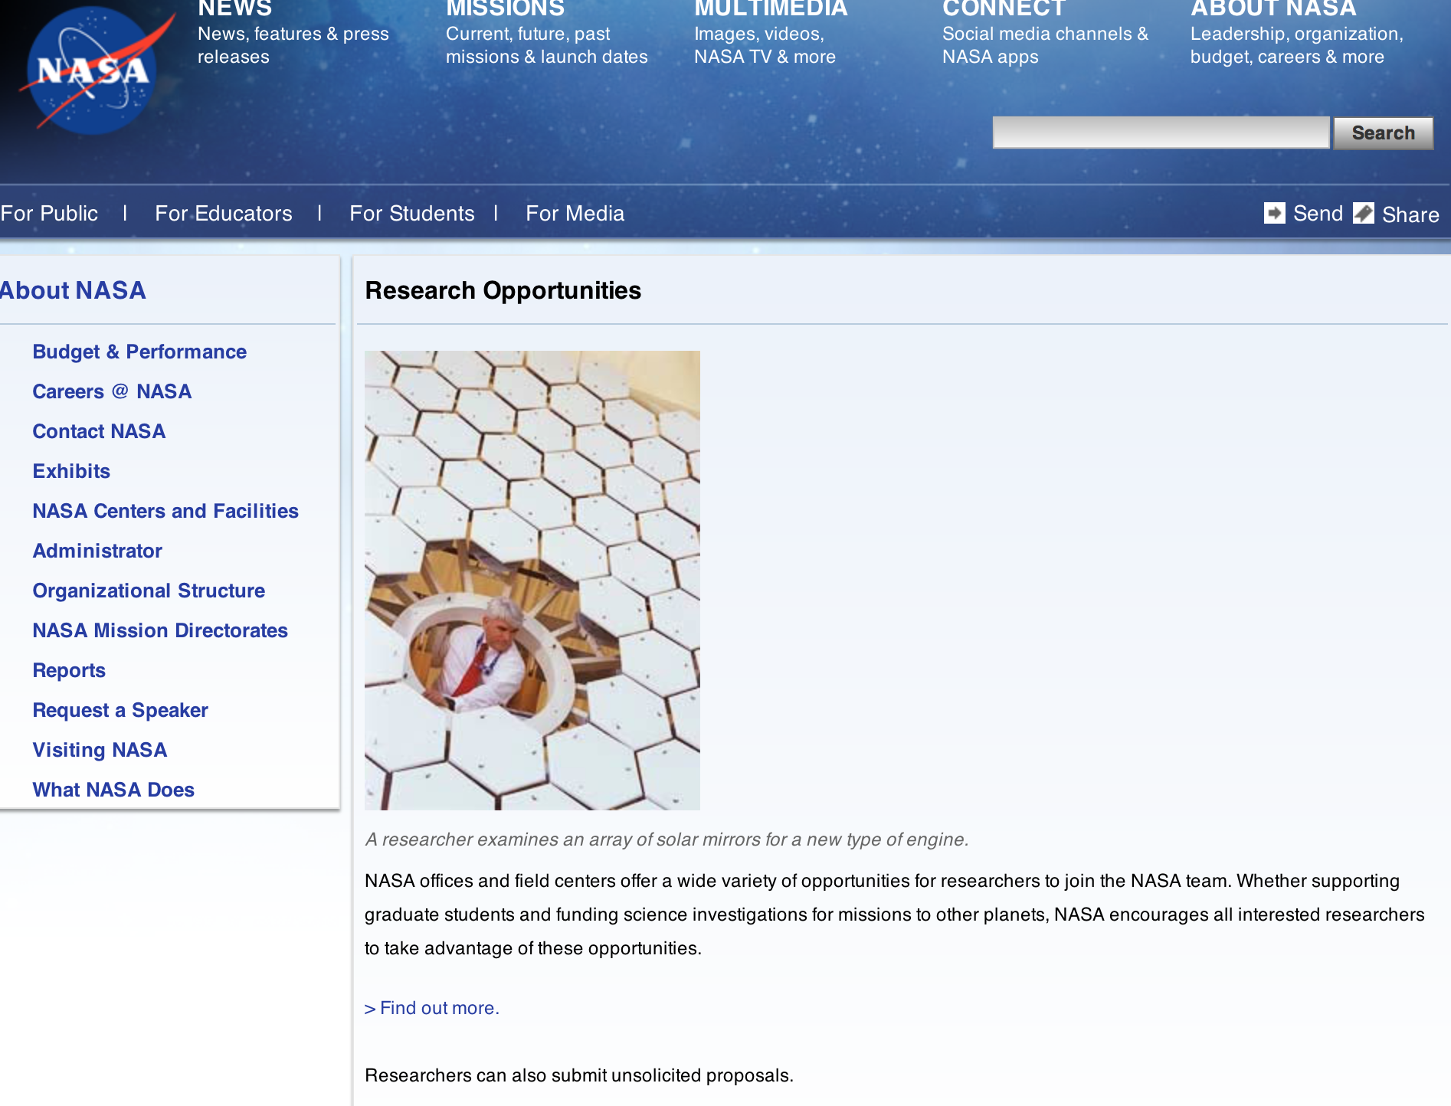

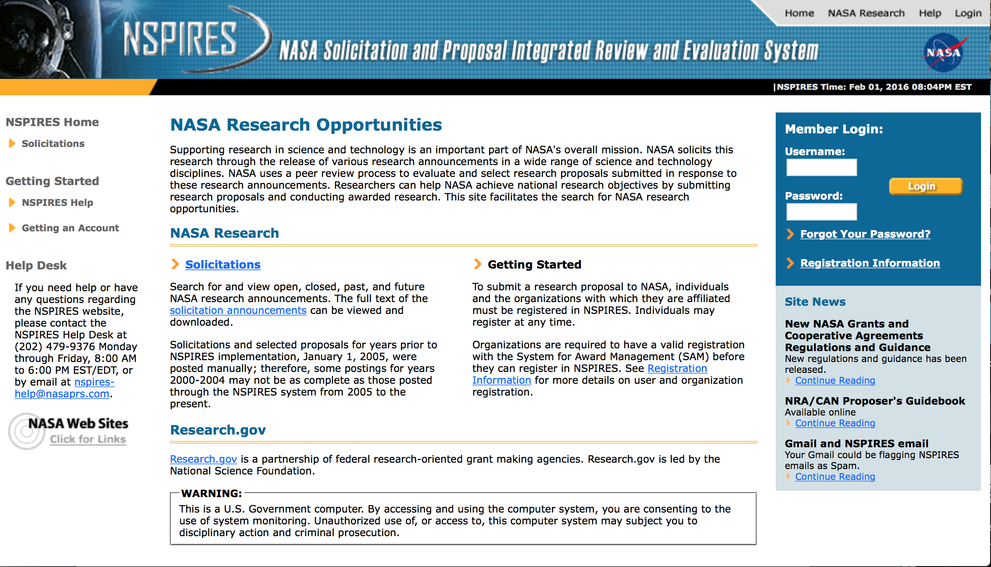

http://nspires.nasaprs.com/external/

Research Programs:

Research Opportunities In Fundamental Physics - NASA/NSF Partnership On Science Of Dusty Plasmas: Utilizing The Pk-4 Facility On Board The International Space Station Grant
http://www.grants.gov/web/grants/view-opportunity.html?oppId=283984

NASA Headquarters
ROSES 2016: Space Geodesy Research Program Grant
http://www.grants.gov/web/grants/view-opportunity.html?oppId=284075

NASA Headquarters
ROSES 2016: Concepts for Ocean worlds Life Detection Technology Grant
http://www.grants.gov/web/grants/view-opportunity.html?oppId=283925

NASA Headquarters
ROSES 2016: Modeling, Analysis, and Prediction Grant
http://www.grants.gov/web/grants/view-opportunity.html?oppId=283835

NASA Headquarters
Early Stage Innovations (ESI) Grant
http://www.grants.gov/web/grants/view-opportunity.html?oppId=283747

NASA Headquarters
ROSES 2016: Citizen Science for Earth Systems Program Grant
http://www.grants.gov/web/grants/view-opportunity.html?oppId=283438

NASA Headquarters
ROSES 2016: Atmospheric Composition: Upper Atmospheric Composition Observatio Grant
http://www.grants.gov/web/grants/view-opportunity.html?oppId=284275

Modifications:

NASA Headquarters
ROSES 2016: Laboratory Analysis of Returned Samples
Modification 2
http://www.grants.gov/web/grants/view-opportunity.html?oppId=282175

NASA Headquarters
ROSES 2016: Earth Science Applications: Ecological Forecasting
Modification 2
http://www.grants.gov/web/grants/view-opportunity.html?oppId=281938

NASA Headquarters
ROSES 2016: Utilization of Airborne Visible/Infrared Imaging Spectrometer – Next Generation Data from an Airborne Campaign in India
Modification 2
http://www.grants.gov/web/grants/view-opportunity.html?oppId=281947

NASA Johnson Space Center
Exploration Technology Demonstration And National Lab Utilization Enhancements
Modification 4
http://www.grants.gov/web/grants/view-opportunity.html?oppId=207073

National Archives and Records Administration

Grant Opportunities General Overview

To access the information below: click here

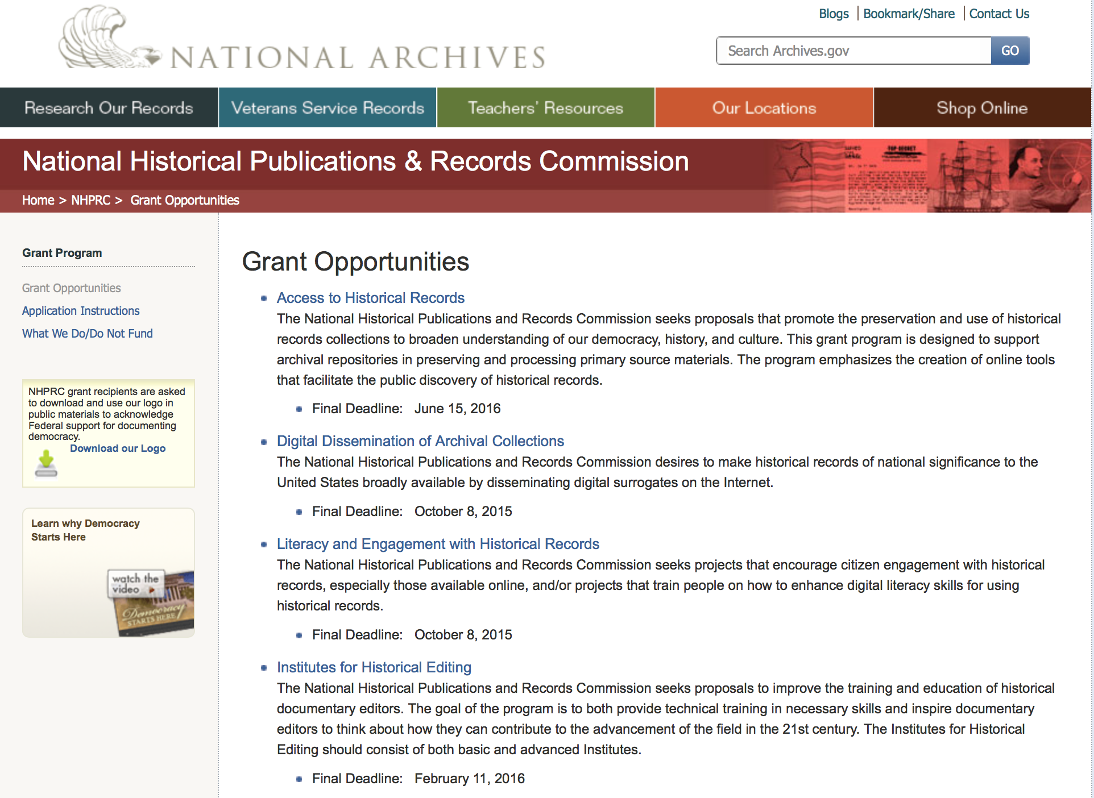

Reminders:

State Board Programming Grants

Document Type: | Grants Notice
Funding Opportunity Number: | STATE-201606
Funding Opportunity Title: | State Board Programming Grants
Opportunity Category: | Discretionary
Funding Instrument Type: | Grant
Category of Funding Activity: | Humanities (see "Cultural Affairs" in CFDA)
Category Explanation:
Expected Number of Awards: | 25
CFDA Number(s): | 89.003 -- National Historical Publications and Records Grants
Cost Sharing or Matching Requirement: | Yes
Posted Date: | Nov 24, 2015
Creation Date: | Nov 23, 2015
Original Closing Date for Applications: | Jun 15, 2016
Current Closing Date for Applications: | Jun 15, 2016
Archive Date: | Jul 15, 2016
Estimated Total Program Funding: | $650,000
Award Ceiling: | $80,000
Award Floor: | $0
Eligible Applicants: | State governments  Public and State controlled institutions of higher education  Others (see text field entitled "Additional Information on Eligibility" for clarification)  Nonprofits having a 501(c)(3) status with the IRS, other than institutions of higher education
Additional Information on Eligibility: | These grants are awarded only to SHRABs in each state, or to the state agency responsible for the SHRAB, ordinarily the state archives. Another state agency, or a non-profit organization, such as a foundation or university, acting on behalf of the designated state agency may apply. States also include the District of Columbia, the Commonwealth of Puerto Rico, and United States territories.
Agency Name: | National Archives and Records Administration
Description: | The National Historical Publications and Records Commission seeks proposals that strengthen the nation’s archival network through activities undertaken by state historical records advisory boards (SHRABs). The purpose of this grant program is to assist state boards to enhance access to historical records, increase citizen engagement with records, and provide learning and development opportunities for students, citizens and professional archivists. The Commission will award grants to State Historical Records Advisory Boards to: • Provide educational and outreach programs, workshops, and other activities that enhance citizen and student engagement with historical records • Operate state-based regrant and scholarship programs that advance access to historical records • Collaborate on projects with other organizations to address common problems or shared opportunities within a state or among a consortium of state archives • Hold or participate in meetings and public forums on statewide or national archival issues. For a comprehensive list of Commission limitations on funding, please see What We Do and Do Not Fund. Applications that consist entirely of ineligible activities will not be considered. Award Information A grant is for one year and for up to $40,000 or for two years and for up to $80,000. The NHPRC expects to award approximately 25 grants in this program. The total amount allocated for this program is up to $650,000. Grants begin no earlier than January 1, 2017. The Commission requires that grant recipients acknowledge NHPRC grant assistance in all publicity, publications, and other products that result from its support. Eligibility These grants are awarded only to SHRABs in each state, or to the state agency responsible for the SHRAB, ordinarily the state archives. Another state agency, or a non-profit organization, such as a foundation or university, acting on behalf of the designated state agency may apply. States also include the District of Columbia, the Commonwealth of Puerto Rico, and United States territories. Cost Sharing The total costs of a project are shared between the NHPRC and the applicant organization. The Commission provides no more than 75 per cent of total direct project costs in the State Board Programming Grants category. NHPRC grant recipients are not permitted to use grant funds for indirect costs (as indicated in 2 CFR 2600.101). Cost sharing is required. The applicant’s financial contribution may include both direct and indirect expenses, in-kind contributions, non-Federal third-party contributions, and any income earned directly by the project. Indirect costs must be listed under the applicant’s cost sharing contribution. Other Requirements Applicant organizations must be registered in System for Award Management (SAM) prior to submitting an application, maintain SAM registration throughout the application and award process, and include a valid DUNS number in their application. Details on SAM registration and requesting a DUNS number can be found at the System for Award Management website at https://sam.gov. Please refer to the User Guides section and the Grants Registrations PDF. A complete application includes the Application for Federal Assistance (Standard Form 424), Assurances - Non-Construction Programs (Standard Form 424B), a Project Narrative, Summary, Supplementary Materials, and Budget. Applications lacking these items will not be considered. Ineligible applications will not be reviewed.
Link to Additional Information: | Link to full grant announcement, including additional requirements
Contact Information: | If you have difficulty accessing the full announcement electronically, please contact:  Jeff de la Concepcion Grant Program Specialist Phone 202-357-5022  Grant Program Specialist

http://www.grants.gov/web/grants/view-opportunity.html?oppId=280200

Publishing Historical Records in Documentary Editions Grant

Document Type: | Grants Notice
Funding Opportunity Number: | EDITIONS-201606
Funding Opportunity Title: | Publishing Historical Records in Documentary Editions
Opportunity Category: | Discretionary
Funding Instrument Type: | Grant
Category of Funding Activity: | Humanities (see "Cultural Affairs" in CFDA)
Category Explanation:
Expected Number of Awards: | 25
CFDA Number(s): | 89.003 -- National Historical Publications and Records Grants
Cost Sharing or Matching Requirement: | Yes
Posted Date: | Nov 24, 2015
Creation Date: | Nov 23, 2015
Original Closing Date for Applications: | Jun 15, 2016
Current Closing Date for Applications: | Jun 15, 2016
Archive Date: | Jul 15, 2016
Estimated Total Program Funding: | $2,500,000
Award Ceiling: | $200,000
Award Floor: | $0
Eligible Applicants: | County governments  Native American tribal governments (Federally recognized)  City or township governments  Private institutions of higher education  Nonprofits having a 501(c)(3) status with the IRS, other than institutions of higher education  State governments  Public and State controlled institutions of higher education
Agency Name: | National Archives and Records Administration
Description: | The National Historical Publications and Records Commission seeks proposals to publish documentary editions of historical records. Projects may focus on the papers of major figures from American history or cover broad historical movements in politics, military, business, social reform, the arts, and other aspects of the national experience. The historical value of the records and their expected usefulness to broad audiences must justify the costs of the project. The goal of this program is to provide access to, and editorial context for, the historical documents and records that tell the American story. The NHPRC encourages projects, whenever possible and appropriate, to provide access to these materials in a free and open online environment, without precluding other forms of publication. Applicants should demonstrate familiarity with the best practices recommended by the Association for Documentary Editing or the Modern Language Association Committee on Scholarly Editions. Projects may also prepare print editions as part of their overall publishing plan. However, projects that do not have definitive plans for digital dissemination and preservation in place at the time of application will not be considered. It is also expected that the contents of any print volumes produced will be made available online within a reasonable period of time following print publication. Grants are awarded for collecting, describing, preserving, compiling, transcribing, annotating, editing, encoding, and publishing documentary source materials in print and online. Because of the focus on documentary sources, grants do not support preparation of critical editions of published works unless such works are just a small portion of the larger project. All applicants should be aware that the application process is highly competitive. Ongoing projects: Applicants from ongoing projects must demonstrate that they have successfully achieved the performance objectives associated with previous NHPRC awards; provide updated, current information, including a description of the new activities as well as description and significance of the specific materials to be edited during the proposed grant period; show progress towards completing the edition; and justify costs in a new budget. For a comprehensive list of Commission's limitations on funding, please see What We Do and Do Not Fund. Applications that consist entirely of ineligible activities will not be considered. Award Information A grant is for one year and for up to $200,000. The Commission expects to make up to 25 grants in this category for a total of up to $2,500,000. Grants begin no earlier than January 1, 2017. The Commission requires that grant recipients acknowledge NHPRC grant assistance in all publications and other products that result from its support. Eligibility U.S. nonprofit organizations or institutions U.S. colleges, universities, and other academic institutions State or local government agencies Federally-acknowledged or state-recognized Native American tribes or groups Cost Sharing The total costs of a project are shared between the NHPRC and the applicant organization. The Commission provides no more than 50 per cent of total direct project costs in the Publishing Historical Records in Documentary Editions category. NHPRC grant recipients are not permitted to use grant funds for indirect costs (as indicated in 2 CFR 2600.101). Cost sharing is required. The applicant’s financial contribution may include both direct and indirect expenses, in-kind contributions, non-Federal third-party contributions, and any income earned directly by the project. Indirect costs must be listed under the applicant’s cost sharing contribution. Other Requirements Applicant organizations must be registered in the System for Award Management (SAM) prior to submitting an application, maintain SAM registration throughout the application and award process, and include a valid DUNS number in their application. Details on SAM registration and requesting a DUNS number can be found at the System for Award Management website at https://sam.gov. Please refer to the User Guides section and the Grants Registrations PDF. A complete application includes the Application for Federal Assistance (Standard Form 424), Assurances -- Non-Construction Programs (Standard Form 424B), a Project Narrative, Summary, Supplementary Materials, and Budget. Applications lacking these items will not be considered. Ineligible applications will not be reviewed.
Link to Additional Information: | Link to full grant announcement, including additional requirements
Contact Information: | If you have difficulty accessing the full announcement electronically, please contact:  Jeff de la Concepcion Grant Program Specialist Phone 202-357-5022  Grant Program Specialist

http://www.grants.gov/web/grants/view-opportunity.html?oppId=280201

Publishing Historical Records in Documentary Editions Grant

Document Type: | Grants Notice
Funding Opportunity Number: | EDITIONS-201610
Funding Opportunity Title: | Publishing Historical Records in Documentary Editions
Opportunity Category: | Discretionary
Funding Instrument Type: | Grant
Category of Funding Activity: | Humanities (see "Cultural Affairs" in CFDA)
Category Explanation:
Expected Number of Awards: | 25
CFDA Number(s): | 89.003 -- National Historical Publications and Records Grants
Cost Sharing or Matching Requirement: | Yes
Posted Date: | Nov 24, 2015
Creation Date: | Nov 23, 2015
Original Closing Date for Applications: | Oct 6, 2016
Current Closing Date for Applications: | Oct 6, 2016
Archive Date: | Nov 4, 2016
Estimated Total Program Funding: | $2,500,000
Award Ceiling: | $200,000
Award Floor: | $0
Eligible Applicants: | Private institutions of higher education  County governments  City or township governments  Public and State controlled institutions of higher education  Native American tribal governments (Federally recognized)  Nonprofits having a 501(c)(3) status with the IRS, other than institutions of higher education  State governments
Agency Name: | National Archives and Records Administration
Description: | The National Historical Publications and Records Commission seeks proposals to publish documentary editions of historical records. Projects may focus on the papers of major figures from American history or cover broad historical movements in politics, military, business, social reform, the arts, and other aspects of the national experience. The historical value of the records and their expected usefulness to broad audiences must justify the costs of the project. The goal of this program is to provide access to, and editorial context for, the historical documents and records that tell the American story. The NHPRC encourages projects, whenever possible and appropriate, to provide access to these materials in a free and open online environment, without precluding other forms of publication. Applicants should demonstrate familiarity with the best practices recommended by the Association for Documentary Editing or the Modern Language Association Committee on Scholarly Editions. Projects may also prepare print editions as part of their overall publishing plan. However, projects that do not have definitive plans for digital dissemination and preservation in place at the time of application will not be considered. It is also expected that the contents of any print volumes produced will be made available online within a reasonable period of time following print publication. Grants are awarded for collecting, describing, preserving, compiling, transcribing, annotating, editing, encoding, and publishing documentary source materials in print and online. Because of the focus on documentary sources, grants do not support preparation of critical editions of published works unless such works are just a small portion of the larger project. All applicants should be aware that the application process is highly competitive. Ongoing projects: Applicants from ongoing projects must demonstrate that they have successfully achieved the performance objectives associated with previous NHPRC awards; provide updated, current information, including a description of the new activities as well as description and significance of the specific materials to be edited during the proposed grant period; show progress towards completing the edition; and justify costs in a new budget. For a comprehensive list of Commission's limitations on funding, please see What We Do and Do Not Fund. Applications that consist entirely of ineligible activities will not be considered. Award Information A grant is for one year and for up to $200,000. The Commission expects to make up to 25 grants in this category for a total of up to $2,500,000. Grants begin no earlier than January 1, 2017. The Commission requires that grant recipients acknowledge NHPRC grant assistance in all publications and other products that result from its support. Eligibility U.S. nonprofit organizations or institutions U.S. colleges, universities, and other academic institutions State or local government agencies Federally-acknowledged or state-recognized Native American tribes or groups Cost Sharing The total costs of a project are shared between the NHPRC and the applicant organization. The Commission provides no more than 50 per cent of total direct project costs in the Publishing Historical Records in Documentary Editions category. NHPRC grant recipients are not permitted to use grant funds for indirect costs (as indicated in 2 CFR 2600.101). Cost sharing is required. The applicant’s financial contribution may include both direct and indirect expenses, in-kind contributions, non-Federal third-party contributions, and any income earned directly by the project. Indirect costs must be listed under the applicant’s cost sharing contribution. Other Requirements Applicant organizations must be registered in the System for Award Management (SAM) prior to submitting an application, maintain SAM registration throughout the application and award process, and include a valid DUNS number in their application. Details on SAM registration and requesting a DUNS number can be found at the System for Award Management website at https://sam.gov. Please refer to the User Guides section and the Grants Registrations PDF. A complete application includes the Application for Federal Assistance (Standard Form 424), Assurances -- Non-Construction Programs (Standard Form 424B), a Project Narrative, Summary, Supplementary Materials, and Budget. Applications lacking these items will not be considered. Ineligible applications will not be reviewed.
Link to Additional Information: | Link to full grant announcement, including additional requirements
Contact Information: | If you have difficulty accessing the full announcement electronically, please contact:  Jeff de la Concepcion Grant Program Specialist Phone 202-357-5022  Grant Program Specialist

http://www.grants.gov/web/grants/view-opportunity.html?oppId=280202

Access to Historical Records Grant

Document Type: | Grants Notice
Funding Opportunity Number: | ACCESS-201606
Funding Opportunity Title: | Access to Historical Records
Opportunity Category: | Discretionary
Funding Instrument Type: | Grant
Category of Funding Activity: | Humanities (see "Cultural Affairs" in CFDA)
Category Explanation:
Expected Number of Awards: | 14
CFDA Number(s): | 89.003 -- National Historical Publications and Records Grants
Cost Sharing or Matching Requirement: | Yes
Posted Date: | Nov 24, 2015
Creation Date: | Nov 23, 2015
Original Closing Date for Applications: | Jun 15, 2016
Current Closing Date for Applications: | Jun 15, 2016
Archive Date: | Jul 15, 2016
Estimated Total Program Funding: | $1,000,000
Award Ceiling: | $200,000
Eligible Applicants: | Public and State controlled institutions of higher education  State governments  City or township governments  Nonprofits having a 501(c)(3) status with the IRS, other than institutions of higher education  Private institutions of higher education  Native American tribal governments (Federally recognized)  County governments
Agency Name: | National Archives and Records Administration
Description: | The National Historical Publications and Records Commission seeks proposals that promote the preservation and use of historical records collections to broaden understanding of our democracy, history, and culture. This grant program is designed to support archival repositories in preserving and processing primary source materials. The program emphasizes the creation of online tools that facilitate the public discovery of historical records. The Commission looks to fund projects that undertake one or more of the following activities: • Preservation, arrangement, and online description of historical records in all formats • Digital preservation of electronic records and unstable audio or moving image formats After completing arrangement and description activities, applicants may also propose to digitize materials to provide online access to collections. For a comprehensive list of Commission limitations on funding, please see “What we do and do not fund” (http://www.archives.gov/nhprc/apply/eligibility.html). Applications that consist entirely of ineligible activities will not be considered. Award Information A grant is for one to two years and for up to $200,000. The Commission expects to make up to 14 grants in this category for a total of up to $1,000,000. Grants begin no earlier than January 1, 2017. The Commission requires that grant recipients acknowledge NHPRC grant assistance in all publicity, publications, and other products that result from its support. Eligibility Information Eligible applicants: • Nonprofit organizations or institutions • Colleges, universities, and other academic institutions • State or local government agencies • Federally-acknowledged or state-recognized Native American tribes or groups Cost Sharing - The total costs of a project are shared between the NHPRC and the applicant organization. The Commission provides no more than 50 per cent of total direct project costs in the Access to Historical Records category. NHPRC grant recipients are not permitted to use grant funds for indirect costs (as indicated in 2 CFR 2600.101). Cost sharing is required. The applicant’s financial contribution may include both direct and indirect expenses, in-kind contributions, non-Federal third-party contributions, and any income earned directly by the project. Indirect costs must be listed under the applicant’s cost sharing contribution. Other Requirements - Applicant organizations must be registered in the System for Award Management (SAM) prior to submitting an application, maintain SAM registration throughout the application and award process, and include a valid DUNS number in their application. Details on SAM registration and requesting a DUNS number can be found at the System for Award Management website at http://sam.gov. Please refer to the User Guides section and the Grants Registrations PDF. A complete application includes the Application for Federal Assistance (Standard Form 424), Assurances -- Non-Construction Programs (Standard Form 424B), a Project Narrative, Summary, Supplementary Materials, and Budget. Applications lacking these items will not be considered. Ineligible applications will not be reviewed.
Link to Additional Information: | Link to full grant announcement, including additional requirements
Contact Information: | If you have difficulty accessing the full announcement electronically, please contact:  Jeff de la Concepcion Grant Program Specialist Phone 202-357-5022  Grant Program Specialist

http://www.grants.gov/web/grants/view-opportunity.html?oppId=280217

National Endowment for the Arts

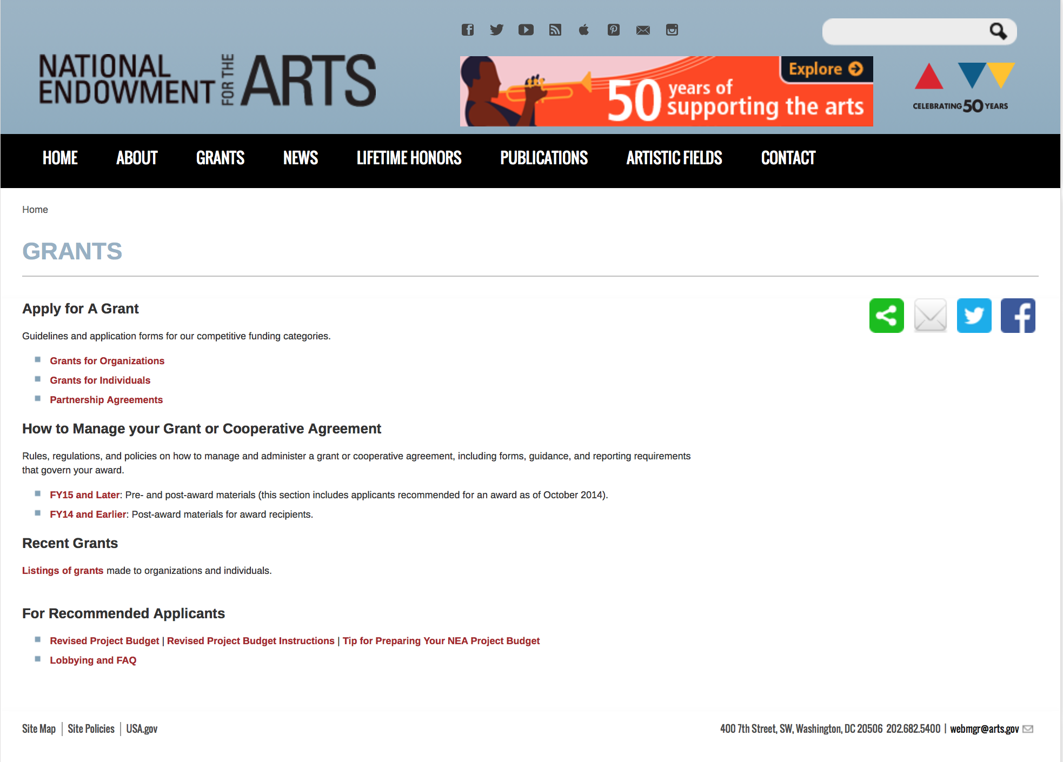

http://arts.gov/grants

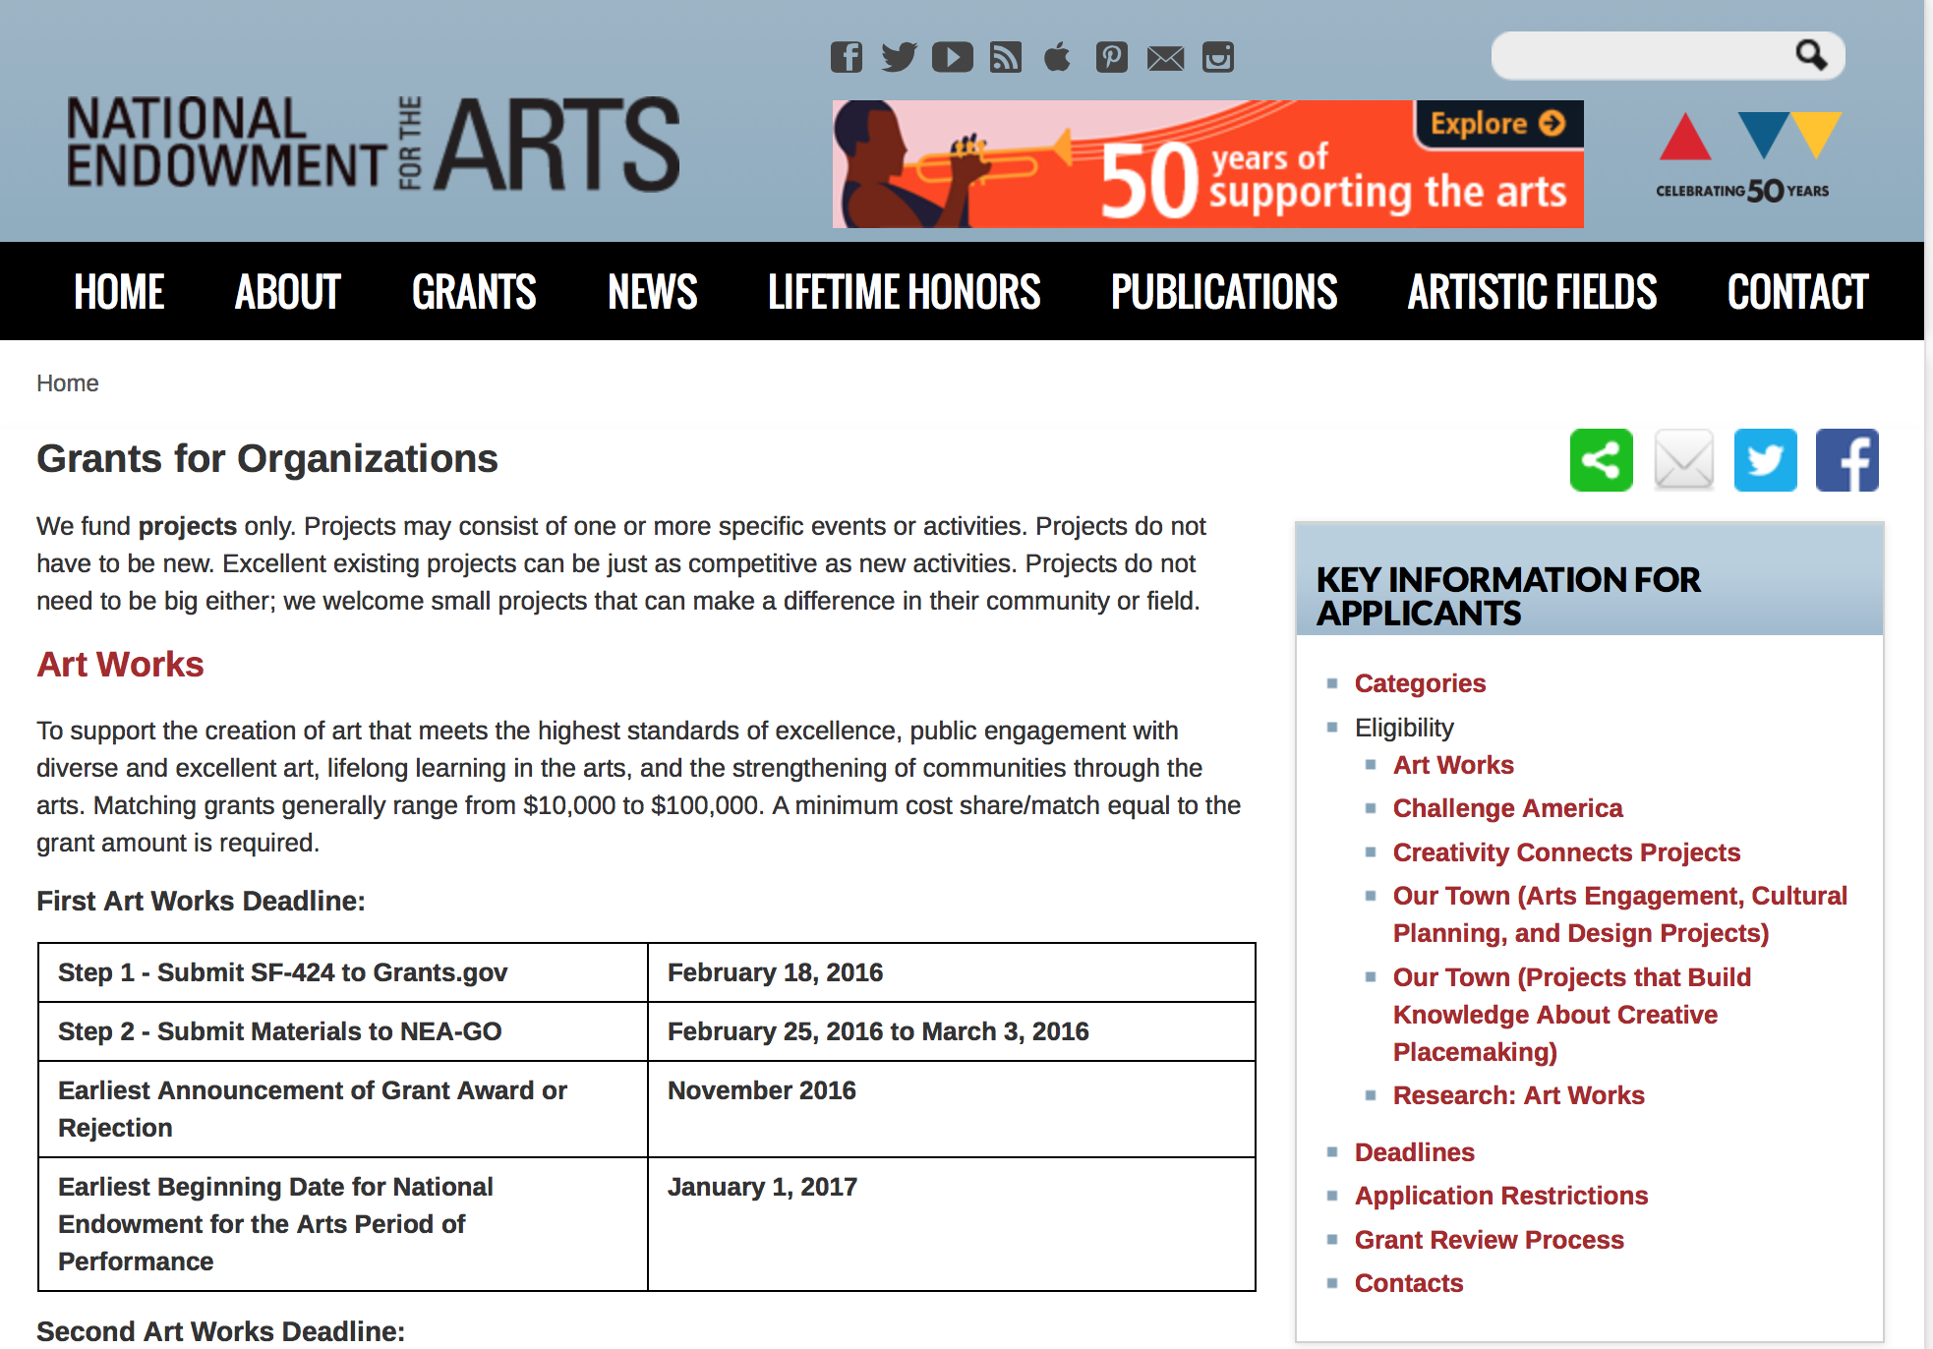
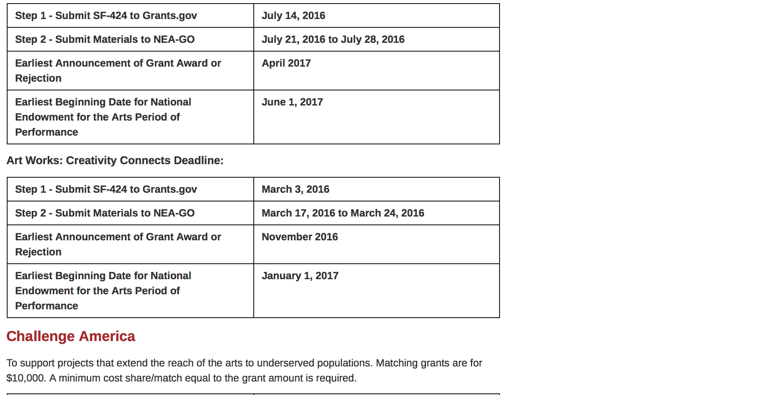
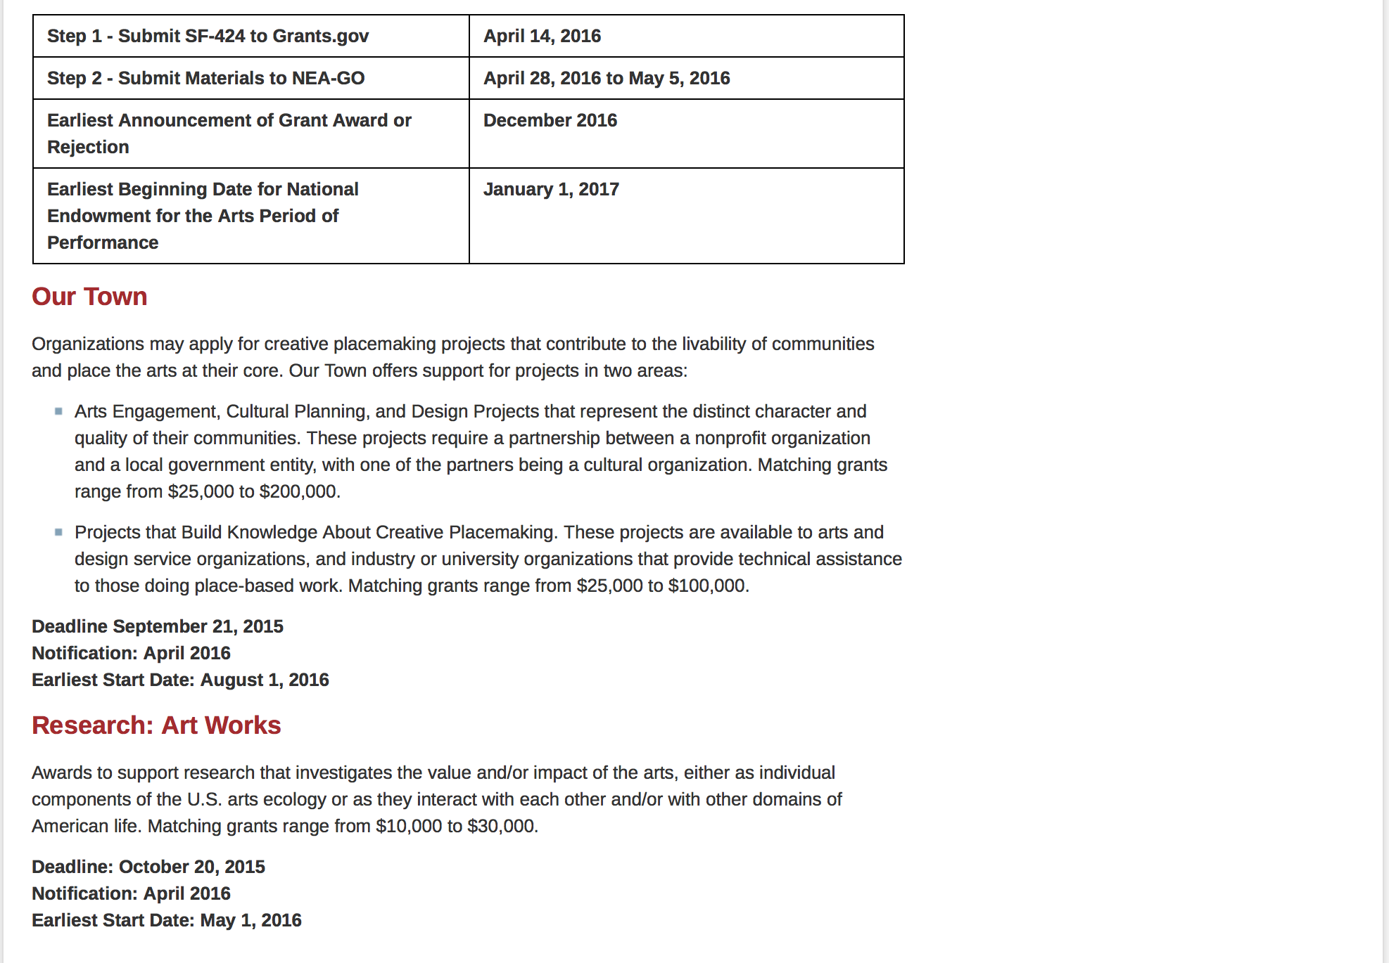
See more at: https://www.arts.gov/grants/apply-grant/grants-organizations

Programs:

NEA FY 2017 Art Works II Application Grant

Document Type: | Grants Notice
Funding Opportunity Number: | 2016NEA01AW2
Funding Opportunity Title: | NEA FY 2017 Art Works II Application
Opportunity Category: | Discretionary
Opportunity Category Explanation:
Funding Instrument Type: | Grant
Category of Funding Activity: | Arts (see "Cultural Affairs" in CFDA)
Category Explanation:
Expected Number of Awards:
CFDA Number(s): | 45.024 -- Promotion of the Arts Grants to Organizations and Individuals
Cost Sharing or Matching Requirement: | Yes
Posted Date: | May 03, 2016
Last Updated Date: | May 03, 2016
Original Closing Date for Applications: | Jul 14, 2016 “The Grants.gov system must receive your validated and accepted application no later than 11:59 p.m., Eastern Time, on July 14, 2016.”
Current Closing Date for Applications: | Jul 14, 2016 “The Grants.gov system must receive your validated and accepted application no later than 11:59 p.m., Eastern Time, on July 14, 2016.”
Archive Date: | Aug 13, 2016
Estimated Total Program Funding:
Award Ceiling: | $100,000
Award Floor: | $10,000
Eligible Applicants: | County governments  Native American tribal governments (Federally recognized)  Public and State controlled institutions of higher education  Special district governments  City or township governments  Independent school districts  State governments  Nonprofits having a 501(c)(3) status with the IRS, other than institutions of higher education  Private institutions of higher education
Additional Information on Eligibility: | An organization may submit only one application through one of the following FY 2017 categories: Art Works or Challenge America. -An organization may submit one additional application under the Art Works category for a Creativity Connects project. -If an organization applies to the Challenge America category, it may not submit another application to the Art Works category except for a Creativity Connects project. –The Arts Endowment's support of a project may start on or after June 1, 2017. Generally, a period of performance of up to two years is allowed. Applicant Eligibility Nonprofit, tax-exempt 501(c)(3), U.S. organizations; units of state or local government; or federally recognized tribal communities or tribes may apply. Applicants may be arts organizations, local arts agencies, arts service organizations, local education agencies (school districts), and other organizations that can help advance the goals of the National Endowment for the Arts. To be eligible, the applicant organization must: •Meet the National Endowment for the Arts’ "Legal Requirements" including nonprofit, tax-exempt status at the time of application. (All organizations must apply directly on their own behalf. Applications through a fiscal sponsor are not allowed. See more information on fiscal sponsors.) •Have a three-year history of programming prior to the application deadline. •Have submitted acceptable Final Report packages by the due date(s) for all National Endowment for the Arts grant(s) previously received. - See more at: https://www.arts.gov/grants-organizations/art-works/applicant-eligibility#sthash.KlcPcEkx.dpuf
Agency Name: | National Endowment for the Arts
Description: | An organization may submit only one application through one of the following FY 2017 categories: Art Works or Challenge America. -An organization may submit one additional application under the Art Works category for a Creativity Connects project. -If an organization applies to the Challenge America category, it may not submit another application to the Art Works category except for a Creativity Connects project. –The Arts Endowment's support of a project may start on or after June 1, 2017. Generally, a period of performance of up to two years is allowed. Grant Program Description The guiding principle of "Art Works" is at the center of everything we do at the NEA. "Art Works" refers to three things: the works of art themselves, the ways art works on audiences, and the fact that art is work for the artists and arts professionals who make up the field. Art works by enhancing the value of individuals and communities, by connecting us to each other and to something greater than ourselves, and by empowering creativity and innovation in our society and economy. The arts exist for beauty itself, but they also are an inexhaustible source of meaning and inspiration. The NEA recognizes these catalytic effects of excellent art, and the key role that arts and design organizations play in revitalizing them. To deepen and extend the arts' value, including their ability to foster new connections and to exemplify creativity and innovation, we welcome projects that: Are likely to prove transformative with the potential for meaningful change, whether in the development or enhancement of new or existing art forms, new approaches to the creation or presentation of art, or new ways of engaging the public with art; Are distinctive, offering fresh insights and new value for their fields and/or the public through unconventional solutions; and Have the potential to be shared and/or emulated, or are likely to lead to other advances in the field. Beyond encouraging projects that demonstrate these characteristics, we want to achieve the following four objectives through the Art Works category: Creation: The creation of art that meets the highest standards of excellence, Engagement: Public engagement with diverse and excellent art, Learning: Lifelong learning in the arts, and Livability: The strengthening of communities through the arts. - See more at: https://www.arts.gov/grants-organizations/art-works/grant-program-description#sthash.wmzUQwur.dpuf
Link to Additional Information: | Complete NEA Website Posting
Contact Information: | If you have difficulty accessing the full announcement electronically, please contact:  NEA Web Manager  NEA Web Manager

http://www.grants.gov/web/grants/view-opportunity.html?oppId=283461

Our Town FY 17 Grant

Document Type: | Grants Notice
Funding Opportunity Number: | 2016NEA01OT
Funding Opportunity Title: | Our Town FY 17
Opportunity Category: | Discretionary
Opportunity Category Explanation: | Category Explanation
Funding Instrument Type: | Grant
Category of Funding Activity: | Arts (see "Cultural Affairs" in CFDA)
Category Explanation:
Expected Number of Awards:
CFDA Number(s): | 45.024 -- Promotion of the Arts Grants to Organizations and Individuals
Cost Sharing or Matching Requirement: | Yes
Posted Date: | May 09, 2016
Last Updated Date: | May 09, 2016
Original Closing Date for Applications: | Sep 12, 2016 Applications must be received by September 12, 2016, 11:59 p.m., Eastern Time
Current Closing Date for Applications: | Sep 12, 2016 Applications must be received by September 12, 2016, 11:59 p.m., Eastern Time
Archive Date: | Oct 12, 2016
Estimated Total Program Funding:
Award Ceiling: | $200,000
Award Floor: | $25,000
Eligible Applicants: | State governments  Special district governments  Private institutions of higher education  Public and State controlled institutions of higher education  County governments  Nonprofits having a 501(c)(3) status with the IRS, other than institutions of higher education  Independent school districts  City or township governments  Native American tribal governments (Federally recognized)
Agency Name: | National Endowment for the Arts
Description: | Organizations may apply for creative placemaking projects that contribute to the livability of communities and place the arts at their core. Our Town offers support for projects in two areas: • Arts Engagement, Cultural Planning, and Design Projects that represent the distinct character and quality of their communities. These projects require a partnership between a nonprofit organization and a local government entity, with one of the partners being a cultural organization. Matching grants range from $25,000 to $200,000. • Projects that Build Knowledge About Creative Placemaking. These projects are available to arts and design service organizations, and industry, policy, or university organizations that provide technical assistance to those doing place-based work. Matching grants range from $25,000 to $100,000.
Link to Additional Information: | Our Town Guidelines
Contact Information: | If you have difficulty accessing the full announcement electronically, please contact:  Web Manager  Web manager's email address

http://www.grants.gov/web/grants/view-opportunity.html?oppId=283652

NEA Research Labs, FY2016 Grant

Document Type: | Grants Notice
Funding Opportunity Number: | NEAPS1602
Funding Opportunity Title: | NEA Research Labs, FY2016
Opportunity Category: | Discretionary
Opportunity Category Explanation:
Funding Instrument Type: | Cooperative Agreement
Category of Funding Activity: | Arts (see "Cultural Affairs" in CFDA)
Category Explanation:
Expected Number of Awards:
CFDA Number(s): | 45.024 -- Promotion of the Arts Grants to Organizations and Individuals
Cost Sharing or Matching Requirement: | Yes
Posted Date: | May 17, 2016
Last Updated Date: | May 17, 2016
Original Closing Date for Applications: | Jul 12, 2016 The Grants.gov system must receive your proposal no later than 11:59 p.m., Eastern Time, on July 12, 2016. We strongly recommend that you submit your application by July 2, 2016 to give yourself ample time to resolve any problems that you might encounter.
Current Closing Date for Applications: | Jul 12, 2016 The Grants.gov system must receive your proposal no later than 11:59 p.m., Eastern Time, on July 12, 2016. We strongly recommend that you submit your application by July 2, 2016 to give yourself ample time to resolve any problems that you might encounter.
Archive Date: | Aug 11, 2016
Estimated Total Program Funding:
Award Ceiling: | $150,000
Award Floor: | $150,000
Eligible Applicants: | Nonprofits having a 501(c)(3) status with the IRS, other than institutions of higher education  State governments  City or township governments  County governments  Native American tribal governments (Federally recognized)  Private institutions of higher education  Public and State controlled institutions of higher education  Independent school districts  Special district governments
Additional Information on Eligibility: | “An organization may submit only one proposal under this program solicitation.” “This Cooperative Agreement will begin no earlier than March 1, 2017, and extend for up to 24 months.” Applicant Eligibility The official applicant must be 1) a U.S. institution of higher education, or 2) a nonprofit, tax-exempt 501(c)(3), U.S. organization with their core components having research and policy as a principal focus, either as the primary work or as part of a transdisciplinary mission. This nonprofit organization also must have a three-year history of commissioning and conducting research in the behavioral or social sciences, and communicating research findings and policy implications through reports and/or convenings, at the time of application. The official applicant must meet the eligibility requirements, submit the application, and assume full responsibility for the grant.
Agency Name: | National Endowment for the Arts
Description: | “An organization may submit only one proposal under this program solicitation.” “This Cooperative Agreement will begin no earlier than March 1, 2017, and extend for up to 24 months.” Program Description In recent years, the National Endowment for the Arts’ research portfolio has focused on yielding new knowledge about the value and impact of the arts. Through a new program, the National Endowment for the Arts Research Labs (NEA Research Labs), we seek to support a series of transdisciplinary research partnerships, grounded in the social and behavioral sciences, to produce and report empirical insights about the arts for the benefit of arts and non-arts sectors alike. Each NEA Research Lab will define a research agenda, conduct a research program to implement that agenda, and prepare reports that will contribute substantively to a wider understanding of one of three areas of special interest to the National Endowment for the Arts: 1. The Arts, Health, and Social/Emotional Well-Being 2. The Arts, Creativity, Cognition, and Learning 3. The Arts, Entrepreneurship, and Innovation
Link to Additional Information: | NEA Web Site Announcement
Contact Information: | If you have difficulty accessing the full announcement electronically, please contact:  NEA Web Manager  NEA Web Manager

http://www.grants.gov/web/grants/view-opportunity.html?oppId=283878

Modifications:

Reminders:

National Endowment for the Humanities

Grant Overview -

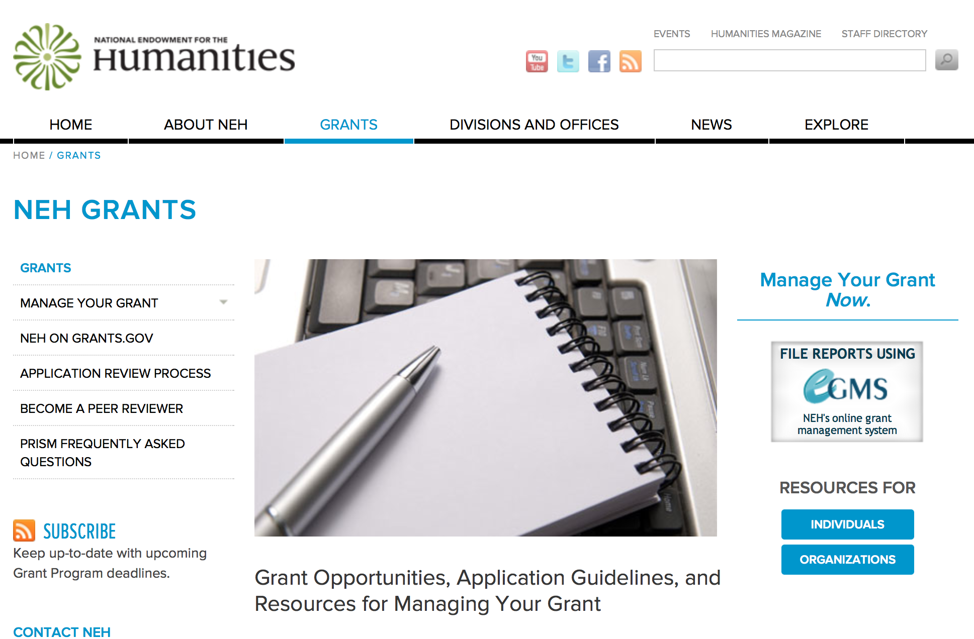

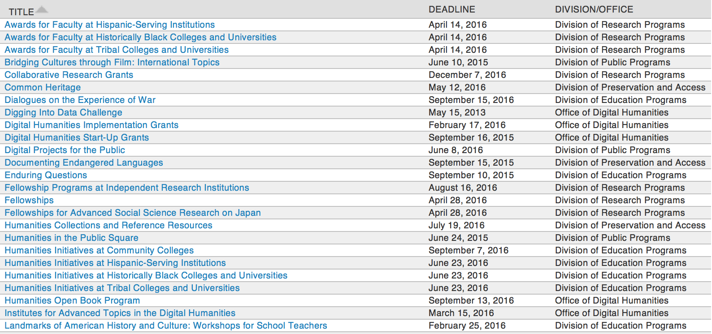

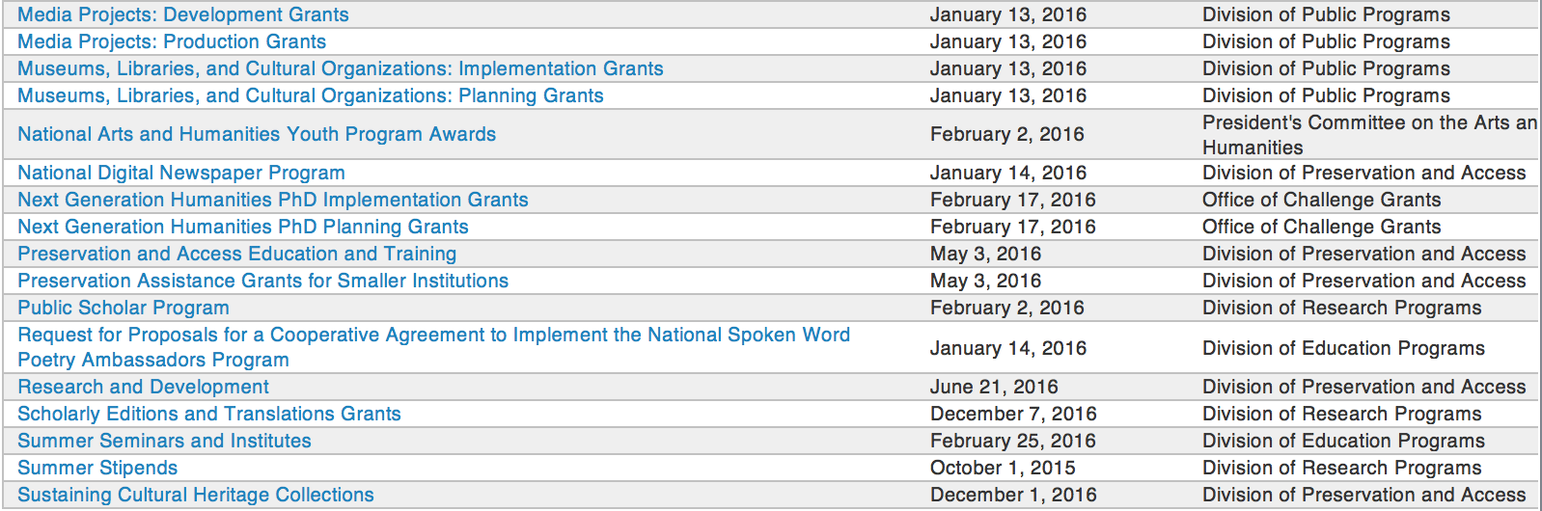

http://www.neh.gov/grants/grantsbydivision.html

Programs:

Summer Stipends Grant

Document Type: | Grants Notice
Funding Opportunity Number: | 20160929-FT
Funding Opportunity Title: | Summer Stipends
Opportunity Category: | Discretionary
Opportunity Category Explanation:
Funding Instrument Type: | Grant
Category of Funding Activity: | Humanities (see "Cultural Affairs" in CFDA)
Category Explanation:
Expected Number of Awards:
CFDA Number(s): | 45.160 -- Promotion of the Humanities Fellowships and Stipends
Cost Sharing or Matching Requirement: | No
Posted Date: | May 05, 2016
Last Updated Date: | May 05, 2016
Original Closing Date for Applications: | Sep 29, 2016
Current Closing Date for Applications: | Sep 29, 2016
Archive Date:
Estimated Total Program Funding:
Award Ceiling: | $6,000
Award Floor: | $6,000
Eligible Applicants: | Others (see text field entitled "Additional Information on Eligibility" for clarification)
Additional Information on Eligibility: | The only eligible applicants are individuals. Individuals who teach full-time at colleges or universities must be nominated by their institutions to be eligible.
Agency Name: | National Endowment for the Humanities
Description: | Summer Stipends support individuals pursuing advanced research that is of value to humanities scholars, general audiences, or both. Eligible projects usually result in articles, monographs, books, digital materials and publications, archaeological site reports, translations, editions, or other scholarly resources. Summer Stipends support continuous full-time work on a humanities project for a period of two consecutive months. Summer Stipends support projects at any stage of development.
Link to Additional Information: | http://www.neh.gov/grants/research/summer-stipends
Contact Information: | If you have difficulty accessing the full announcement electronically, please contact:  Division of Research Programs National Endowment for the Humanities 400 Seventh Street, SW Washington, D.C. 20506 202-606-8200 stipends@neh.gov stipends@neh.gov  stipends@neh.gov

http://www.grants.gov/web/grants/view-opportunity.html?oppId=283530

Humanities Collections and Reference Resources Grant

Document Type: | Grants Notice
Funding Opportunity Number: | 20160719-PW
Funding Opportunity Title: | Humanities Collections and Reference Resources
Opportunity Category: | Discretionary
Opportunity Category Explanation:
Funding Instrument Type: | Grant
Category of Funding Activity: | Humanities (see "Cultural Affairs" in CFDA)
Category Explanation:
Expected Number of Awards:
CFDA Number(s): | 45.149 -- Promotion of the Humanities Division of Preservation and Access
Cost Sharing or Matching Requirement: | No
Posted Date: | May 05, 2016
Last Updated Date: | May 05, 2016
Original Closing Date for Applications: | Jul 19, 2016
Current Closing Date for Applications: | Jul 19, 2016
Archive Date:
Estimated Total Program Funding:
Award Ceiling: | $350,000
Award Floor: | $1
Eligible Applicants: | Nonprofits that do not have a 501(c)(3) status with the IRS, other than institutions of higher education  Private institutions of higher education  City or township governments  Native American tribal governments (Federally recognized)  Nonprofits having a 501(c)(3) status with the IRS, other than institutions of higher education  State governments  Special district governments  County governments  Public and State controlled institutions of higher education
Agency Name: | National Endowment for the Humanities
Description: | The Humanities Collections and Reference Resources (HCRR) program supports projects that provide an essential underpinning for scholarship, education, and public programming in the humanities. Thousands of libraries, archives, museums, and historical organizations across the country maintain important collections of books and manuscripts, photographs, sound recordings and moving images, archaeological and ethnographic artifacts, art and material culture, and digital objects. Funding from this program strengthens efforts to extend the life of such materials and make their intellectual content widely accessible, often through the use of digital technology. Awards are also made to create various reference resources that facilitate use of cultural materials, from works that provide basic information quickly to tools that synthesize and codify knowledge of a subject for in-depth investigation. HCRR offers two kinds of awards: 1) for implementation and 2) for planning, assessment, and pilot efforts (HCRR Foundations grants).
Link to Additional Information: | http://www.neh.gov/grants/preservation/humanities-collections-and-reference-resources
Contact Information: | If you have difficulty accessing the full announcement electronically, please contact:  Humanities Collections and Reference Resources Division of Preservation and Access National Endowment for the Humanities 400 Seventh Street, SW Washington, DC 20506 preservation@neh.gov preservation@neh.gov  preservation@neh.gov

http://www.grants.gov/web/grants/view-opportunity.html?oppId=283531

Fellowship Programs at Independent Research Institutions Grant
Document Type: | Grants Notice
Funding Opportunity Number: | 20160816-RA
Funding Opportunity Title: | Fellowship Programs at Independent Research Institutions
Opportunity Category: | Discretionary
Opportunity Category Explanation:
Funding Instrument Type: | Grant
Category of Funding Activity: | Humanities (see "Cultural Affairs" in CFDA)
Category Explanation:
Expected Number of Awards:
CFDA Number(s): | 45.161 -- Promotion of the Humanities_Research
Cost Sharing or Matching Requirement: | No
Posted Date: | May 27, 2016
Last Updated Date: | May 27, 2016
Original Closing Date for Applications: | Aug 16, 2016
Current Closing Date for Applications: | Aug 16, 2016
Archive Date:
Estimated Total Program Funding:
Award Ceiling: | $300,000
Award Floor: | $100,000
Eligible Applicants: | Nonprofits having a 501(c)(3) status with the IRS, other than institutions of higher education  City or township governments  County governments  Special district governments  Nonprofits that do not have a 501(c)(3) status with the IRS, other than institutions of higher education  State governments  Native American tribal governments (Federally recognized)
Agency Name: | National Endowment for the Humanities
Description: | Grants for Fellowship Programs at Independent Research Institutions (FPIRI) support fellowships at institutions devoted to advanced study and research in the humanities. Recognizing that at times scholars need to work away from their homes and institutions, the FPIRI program sponsors fellowships that provide scholars with research time, a stimulating intellectual environment, and access to resources that might otherwise not be available to them. Fellowship programs may be administered by independent centers for advanced study, libraries, and museums in the United States; American overseas research centers; and American organizations that have expertise in promoting research in foreign countries. Individual scholars apply directly to the institutions for fellowships. A list of currently funded institutions is available. In evaluating applications consideration is given to the library holdings, archives, special collections, and other resources—either on site or nearby—that institutions make available to fellows. FPIRI grants provide funding for humanities fellowships of four to twelve months. The fellowships are held at the U.S. grantee institutions or—in the case of overseas research centers and organizations—abroad.
Link to Additional Information: | http://www.neh.gov/grants/research/fellowship-programs-independent-research-institutions
Contact Information: | If you have difficulty accessing the full announcement electronically, please contact:  Division of Research Programs National Endowment for the Humanities 400 Seventh Street, SW Washington, DC 20506 202-606-8200 fpiri@neh.gov fpiri@neh.gov  fpiri@neh.gov

http://www.grants.gov/web/grants/view-opportunity.html?oppId=284182

Modifications:

Reminders:

Humanities Connections Grant

Document Type: | Grants Notice
Funding Opportunity Number: | 20161005-AK
Funding Opportunity Title: | Humanities Connections
Opportunity Category: | Discretionary
Opportunity Category Explanation:
Funding Instrument Type: | Grant
Category of Funding Activity: | Humanities (see "Cultural Affairs" in CFDA)
Category Explanation:
Expected Number of Awards:
CFDA Number(s): | 45.162 -- Promotion of the Humanities Teaching and Learning Resources and Curriculum Development
Cost Sharing or Matching Requirement: | No
Posted Date: | Apr 19, 2016
Last Updated Date: | Apr 19, 2016
Original Closing Date for Applications: | Oct 05, 2016
Current Closing Date for Applications: | Oct 05, 2016
Archive Date:
Estimated Total Program Funding:
Award Ceiling: | $100,000
Award Floor: | $1
Eligible Applicants: | Public and State controlled institutions of higher education  Private institutions of higher education
Agency Name: | National Endowment for the Humanities
Description: | Humanities Connections grants seek to expand the role of the humanities in the undergraduate curriculum at two- and four-year institutions, offering students in all academic fields new opportunities to develop the intellectual skills and habits of mind that the humanities cultivate. Grant projects focus on connecting the resources and perspectives of the humanities to students’ broader educational and professional goals, regardless of their path of study. Through this new grant program, NEH invites proposals that reflect innovative and imaginative approaches to preparing students for their roles as engaged citizens and productive professionals in a rapidly changing and interdependent world. Grants support the development and implementation of an integrated set of courses and student engagement activities focusing on significant humanities content. A common topic, theme, or compelling issue or question must link the courses and activities. The linked courses (a minimum of three) may fulfill general education or core curriculum requirements but could also be designed primarily for students in a particular major or course of study. The Humanities Connections program gives special encouragement to projects that foster collaboration between humanities faculty and their counterparts in the social and natural sciences and pre-service or professional programs in business, engineering, health sciences, law, computer science, and other non-humanities fields. Humanities Connections projects have two core features: 1. faculty from at least two separate departments or schools at a single institution must collaborate to devise new curricular arrangements; and 2. projects must include provisions for high-impact student engagement activities that relate directly to the topic(s) of the linked courses. These activities could include individual or collaborative undergraduate research projects; opportunities for civic engagement; or a structured experience with community-based, project-based, or site-based learning. Community organizations and cultural institutions can play key roles in this regard.
Link to Additional Information: | http://www.neh.gov/grants/education/humanities-connections
Contact Information: | If you have difficulty accessing the full announcement electronically, please contact:  Humanities Connections Division of Education Programs National Endowment for the Humanities 400 Seventh Street, SW Washington, DC 20506 202-606-8500  humanitiesconnections@neh.gov

http://www.grants.gov/web/grants/view-opportunity.html?oppId=283098

Research and Development Grant

Document Type: | Grants Notice
Funding Opportunity Number: | 20160621-PR
Funding Opportunity Title: | Research and Development
Opportunity Category: | Discretionary
Opportunity Category Explanation:
Funding Instrument Type: | Grant
Category of Funding Activity: | Humanities (see "Cultural Affairs" in CFDA)
Category Explanation:
Expected Number of Awards:
CFDA Number(s): | 45.149 -- Promotion of the Humanities Division of Preservation and Access
Cost Sharing or Matching Requirement: | No
Posted Date: | Apr 18, 2016
Last Updated Date: | Apr 18, 2016
Original Closing Date for Applications: | Jun 21, 2016
Current Closing Date for Applications: | Jun 21, 2016
Archive Date:
Estimated Total Program Funding:
Award Ceiling: | $350,000
Award Floor: | $1
Eligible Applicants: | Private institutions of higher education  Nonprofits that do not have a 501(c)(3) status with the IRS, other than institutions of higher education  Public and State controlled institutions of higher education  Native American tribal governments (Federally recognized)  Nonprofits having a 501(c)(3) status with the IRS, other than institutions of higher education  City or township governments  State governments  County governments  Special district governments
Agency Name: | National Endowment for the Humanities
Description: | The Research and Development program supports projects that address major challenges in preserving or providing access to humanities collections and resources. These challenges include the need to find better ways to preserve materials of critical importance to the nation’s cultural heritage—from fragile artifacts and manuscripts to analog recordings and digital assets subject to technological obsolescence—and to develop advanced modes of organizing, searching, discovering, and using such materials. This program recognizes that finding solutions to complex problems often requires forming interdisciplinary project teams, bringing together participants with expertise in the humanities; in preservation; and in information, computer, and natural science. All projects must demonstrate how advances in preservation and access would benefit the cultural heritage community in supporting humanities research, teaching, or public programming.
Link to Additional Information: | http://www.neh.gov/grants/preservation/research-and-development
Contact Information: | If you have difficulty accessing the full announcement electronically, please contact:  Research and Development National Endowment for the Humanities 400 Seventh Street, SW Washington, DC 20506 202-606-8570 preservation@neh.gov preservation@neh.gov  preservation@neh.gov

http://www.grants.gov/web/grants/view-opportunity.html?oppId=283061

Humanities Open Book Program Grant

Document Type: | Grants Notice
Funding Opportunity Number: | 20160913-HZ
Funding Opportunity Title: | Humanities Open Book Program
Opportunity Category: | Discretionary
Opportunity Category Explanation:
Funding Instrument Type: | Grant
Category of Funding Activity: | Humanities (see "Cultural Affairs" in CFDA)
Category Explanation:
Expected Number of Awards:
CFDA Number(s): | 45.169 -- Promotion of the Humanities Office of Digital Humanities
Cost Sharing or Matching Requirement: | No
Posted Date: | Mar 22, 2016
Last Updated Date: | Mar 22, 2016
Original Closing Date for Applications: | Sep 13, 2016
Current Closing Date for Applications: | Sep 13, 2016
Archive Date:
Estimated Total Program Funding:
Award Ceiling: | $100,000
Award Floor: | $50,000
Eligible Applicants: | Native American tribal governments (Federally recognized)  Special district governments  Public and State controlled institutions of higher education  City or township governments  Private institutions of higher education  County governments  Nonprofits having a 501(c)(3) status with the IRS, other than institutions of higher education  Nonprofits that do not have a 501(c)(3) status with the IRS, other than institutions of higher education  State governments
Agency Name: | National Endowment for the Humanities
Description: | The Humanities Open Book Program is designed to make outstanding out-of-print humanities books available to a wide audience. By taking advantage of low-cost “ebook” technology, the program will allow teachers, students, scholars, and the public to read humanities books that have long been out of print. Humanities Open Book is jointly sponsored by NEH and the Andrew W. Mellon Foundation. Traditionally, printed books have been the primary medium for expressing, communicating, and debating humanistic ideas. However, the vast majority of humanities books sell a small number of copies and then quickly go out of print. Most scholarly books printed since 1923 are not in the public domain and are not easily available to the general public. As a result, there is a huge, mostly untapped resource of remarkable scholarship going back decades that is largely unused by today’s scholars, teachers, students, and members of the public, many of whom turn first to the Internet when looking for information. Modern ebook technology can make these books far more accessible than they are today. NEH and Mellon are soliciting proposals from academic presses, scholarly societies, museums, and other institutions that publish books in the humanities to participate in the Humanities Open Book Program. Applicants will provide a list of previously published humanities books along with brief descriptions of the books and their intellectual significance. Depending on the length and topics of the books, the number to be digitized may vary. However, NEH and Mellon anticipate that applicants may propose to digitize a total that ranges from less than fifty to more than one hundred books. Awards will be given to digitize these books and make them available as Creative Commons-licensed “ebooks” that can be read by the public at no charge on computers, mobile devices, and ebook readers. The final ebook files must be in EPUB version 3.0.1 (or later) format, to ensure that the text is fully searchable and reflowable and that fonts are resizable on any e-reading device.
Link to Additional Information: | http://www.neh.gov/grants/odh/humanities-open-book-program
Contact Information: | If you have difficulty accessing the full announcement electronically, please contact:  If you have questions about the program, contact the ODH staff at odh@neh.gov. Applicants wishing to speak to a staff member by telephone should provide in an e-mail message a telephone number and a preferred time to call. odh@neh.gov  odh@neh.gov

http://www.grants.gov/web/grants/view-opportunity.html?oppId=282404

Digital Projects for the Public Grant

Document Type: | Grants Notice
Funding Opportunity Number: | 20160608-MD
Funding Opportunity Title: | Digital Projects for the Public
Opportunity Category: | Discretionary
Opportunity Category Explanation:
Funding Instrument Type: | Grant
Category of Funding Activity: | Humanities (see "Cultural Affairs" in CFDA)
Category Explanation:
Expected Number of Awards:
CFDA Number(s): | 45.164 -- Promotion of the Humanities Public Programs
Cost Sharing or Matching Requirement: | No
Posted Date: | Apr 05, 2016
Last Updated Date: | Apr 05, 2016
Original Closing Date for Applications: | Jun 08, 2016
Current Closing Date for Applications: | Jun 08, 2016
Archive Date:
Estimated Total Program Funding:
Award Ceiling: | $400,000
Award Floor: | $1
Eligible Applicants: | Private institutions of higher education  Nonprofits that do not have a 501(c)(3) status with the IRS, other than institutions of higher education  State governments  City or township governments  County governments  Special district governments  Nonprofits having a 501(c)(3) status with the IRS, other than institutions of higher education  Native American tribal governments (Federally recognized)  Public and State controlled institutions of higher education
Agency Name: | National Endowment for the Humanities
Description: | Digital Projects for the Public grants support projects that significantly contribute to the public’s engagement with the humanities. Digital platforms—such as websites, mobile applications and tours, interactive touch screens and kiosks, games, and virtual environments—can reach diverse audiences and bring the humanities to life for the American people. The program offers three levels of support for digital projects: grants for Discovery projects (early-stage planning work), Prototyping projects (proof-of-concept development work), and Production projects (end-stage production and distribution work). While projects can take many forms, shapes, and sizes, your request should be for an exclusively digital project or for a digital component of a larger project. All Digital Projects for the Public projects should • deepen public understanding of significant humanities stories and ideas; • incorporate sound humanities scholarship; • involve humanities scholars in all phases of development and production; • include appropriate digital media professionals; • reach a broad public through a realistic plan for development, marketing, and distribution; • create appealing digital formats for the general public; and • demonstrate the capacity to sustain themselves. All projects should demonstrate the potential to attract a broad, general, nonspecialist audience, either online or in person at venues such as museums, libraries or other cultural institutions. Applicants may also choose to identify particular communities and groups, including students, to whom a project may have particular appeal.
Link to Additional Information: | http://www.neh.gov/grants/public/digital-projects-the-public
Contact Information: | If you have difficulty accessing the full announcement electronically, please contact:  Division of Public Programs National Endowment for the Humanities 400 Seventh Street, S.W. Washington, DC 20506 202-606-8269 publicpgms@neh.gov publicpgms@neh.gov  publicpgms@neh.gov

http://www.grants.gov/web/grants/view-opportunity.html?oppId=282754



National Science Foundation

General Funding Overview

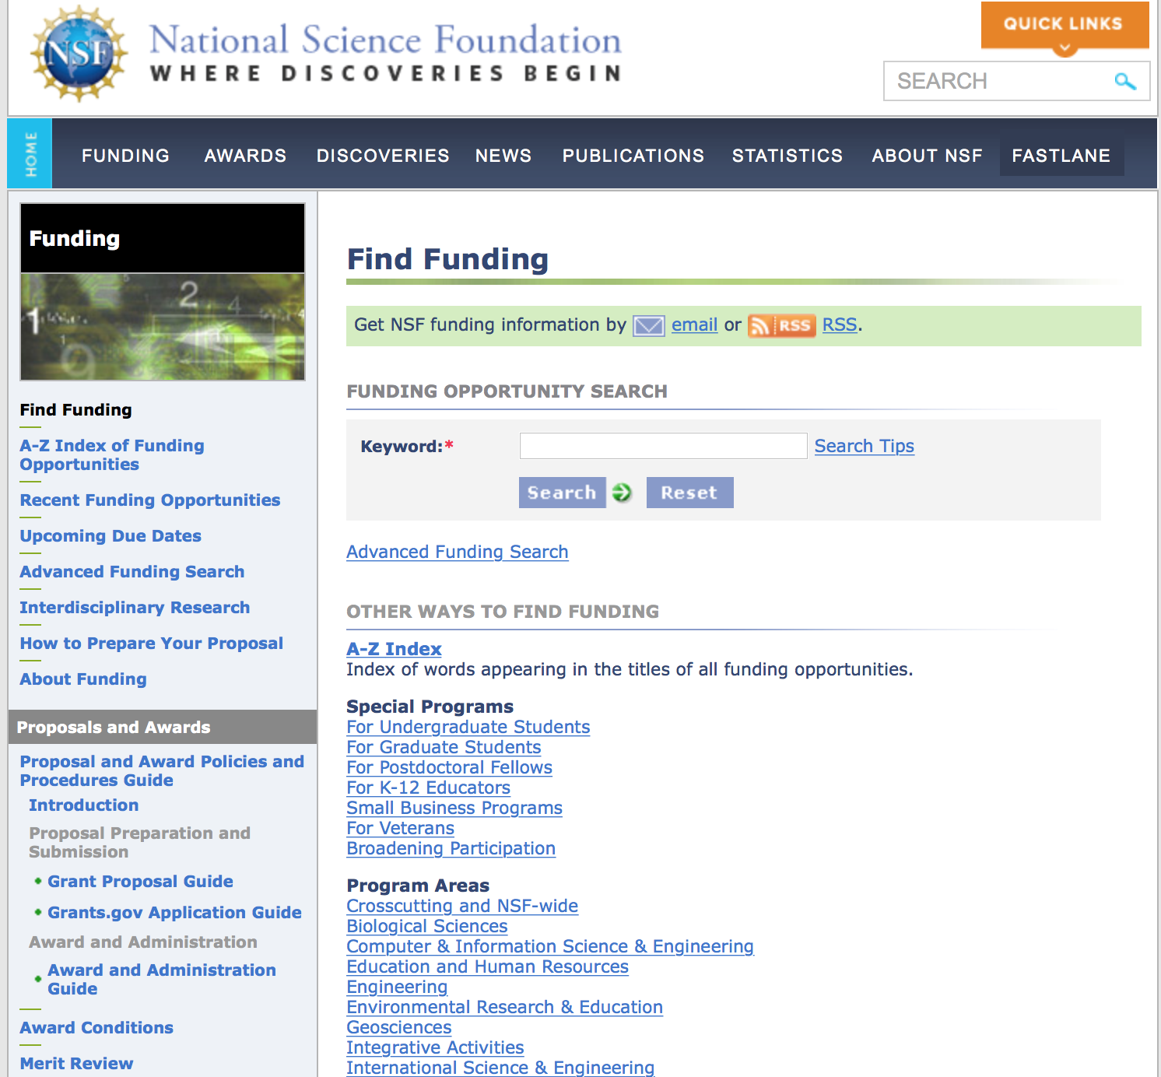
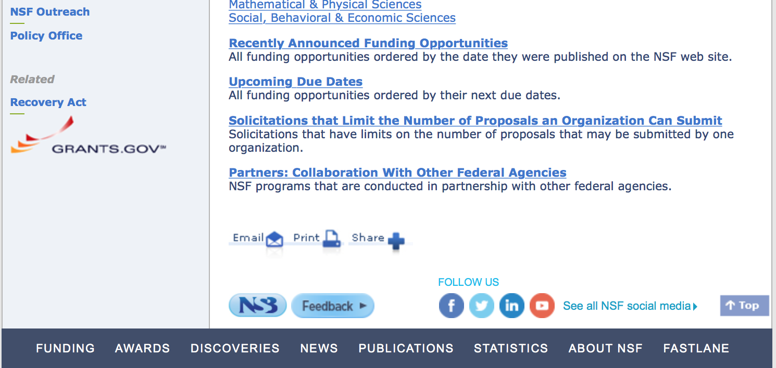

For assistance in finding funding: http://nsf.gov/funding/index.jsp - areas

The National Science Foundation funds research and education in most fields of science and engineering. It does this through grants, and cooperative agreements to more than 2,000 colleges, universities, K-12 school systems, businesses, informal science organizations and other research organizations throughout the United States. The Foundation accounts for about one-fourth of federal support to academic institutions for basic research.
NSF receives approximately 40,000 proposals each year for research, education and training projects, of which approximately 11,000 are funded. In addition, the Foundation receives several thousand applications for graduate and postdoctoral fellowships.
The agency operates no laboratories itself but does support National Research Centers, user facilities, certain oceanographic vessels and Antarctic research stations. The Foundation also supports cooperative research between universities and industry, US participation in international scientific and engineering efforts, and educational activities at every academic level.

For details on active funding deadline dates: http://nsf.gov/funding/pgm_list.jsp?org=NSF&ord=date

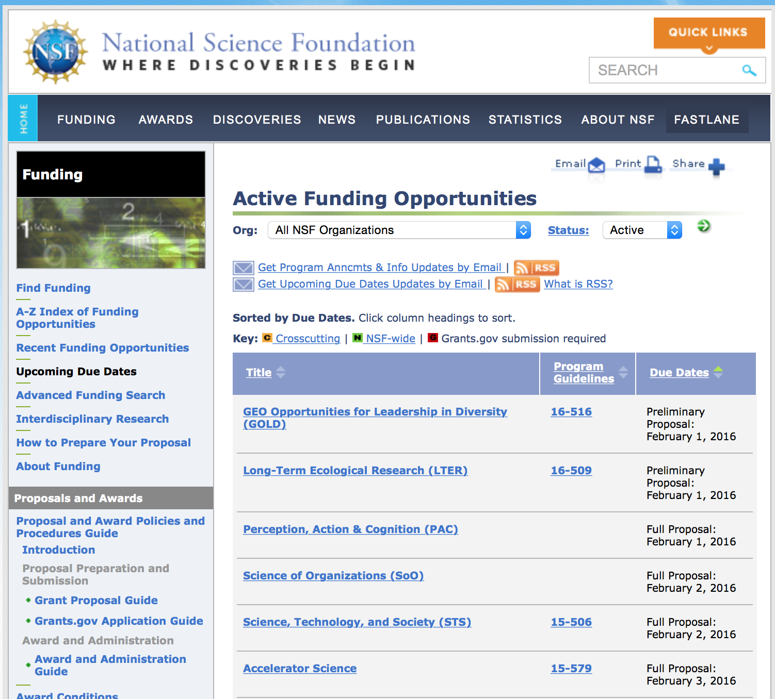

Research and Program Grants:

Campus Cyberinfrastructure Grant
http://www.grants.gov/web/grants/view-opportunity.html?oppId=284102

Centers for Chemical Innovation Grant
http://www.grants.gov/web/grants/view-opportunity.html?oppId=284152

Computer and Information Science and Engineering (CISE) Research Initiation Initiative
Grant
http://www.grants.gov/web/grants/view-opportunity.html?oppId=283810

Curatorial Stewardship of a National Collection of Geological Rock & Sediment Cores from Antarctica and the Southern Ocean Grant
http://www.grants.gov/web/grants/view-opportunity.html?oppId=283603

Division of Physics: Investigator-Initiated Research Projects Grant
http://www.grants.gov/web/grants/view-opportunity.html?oppId=283841

Next Generation Networks For Neuroscience Grant
http://www.grants.gov/web/grants/view-opportunity.html?oppId=284197

NSF/DOE Partnership in Basic Plasma Science and Engineering Grant
http://www.grants.gov/web/grants/view-opportunity.html?oppId=283674

Physics Frontiers Centers Grant
http://www.grants.gov/web/grants/view-opportunity.html?oppId=283480

Prediction of and Resilience against Extreme Events Grant
http://www.grants.gov/web/grants/view-opportunity.html?oppId=283606

Modifications:

Reminders:

Nuclear Regulatory Commission

Reminders:



Small Business Administration

General Overview Finding Loans & Grants

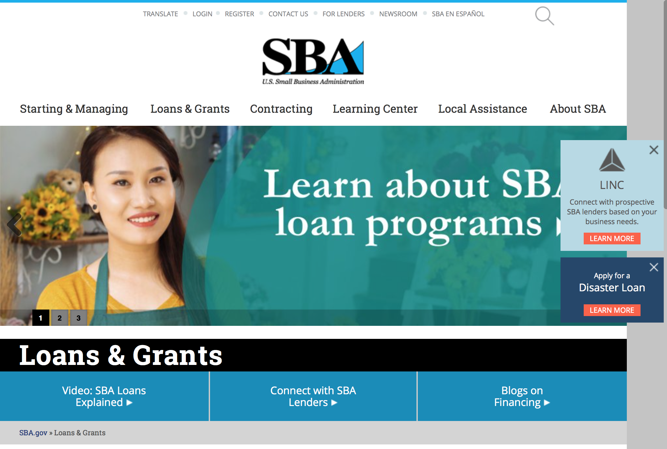
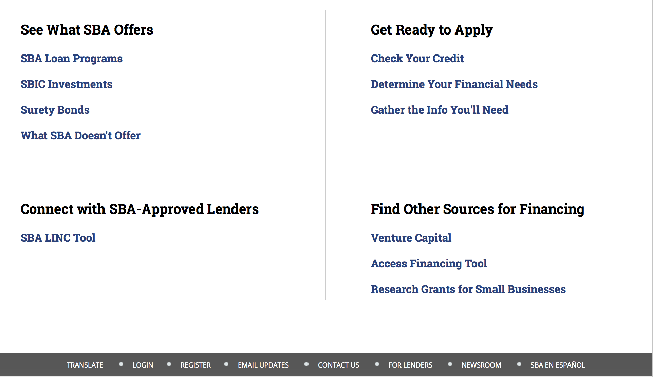

https://www.sba.gov/category/navigation-structure/loans-grants
Federal, state and local governments offer a wide range of financing programs to help small businesses start and grow their operations. These programs include low-interest loans, venture capital, and scientific and economic development grants.

Use SBA.gov's Loans and Grants Search Tool to get a list of financing programs for which you may qualify, or visit the resources below to learn more about small business financing programs. 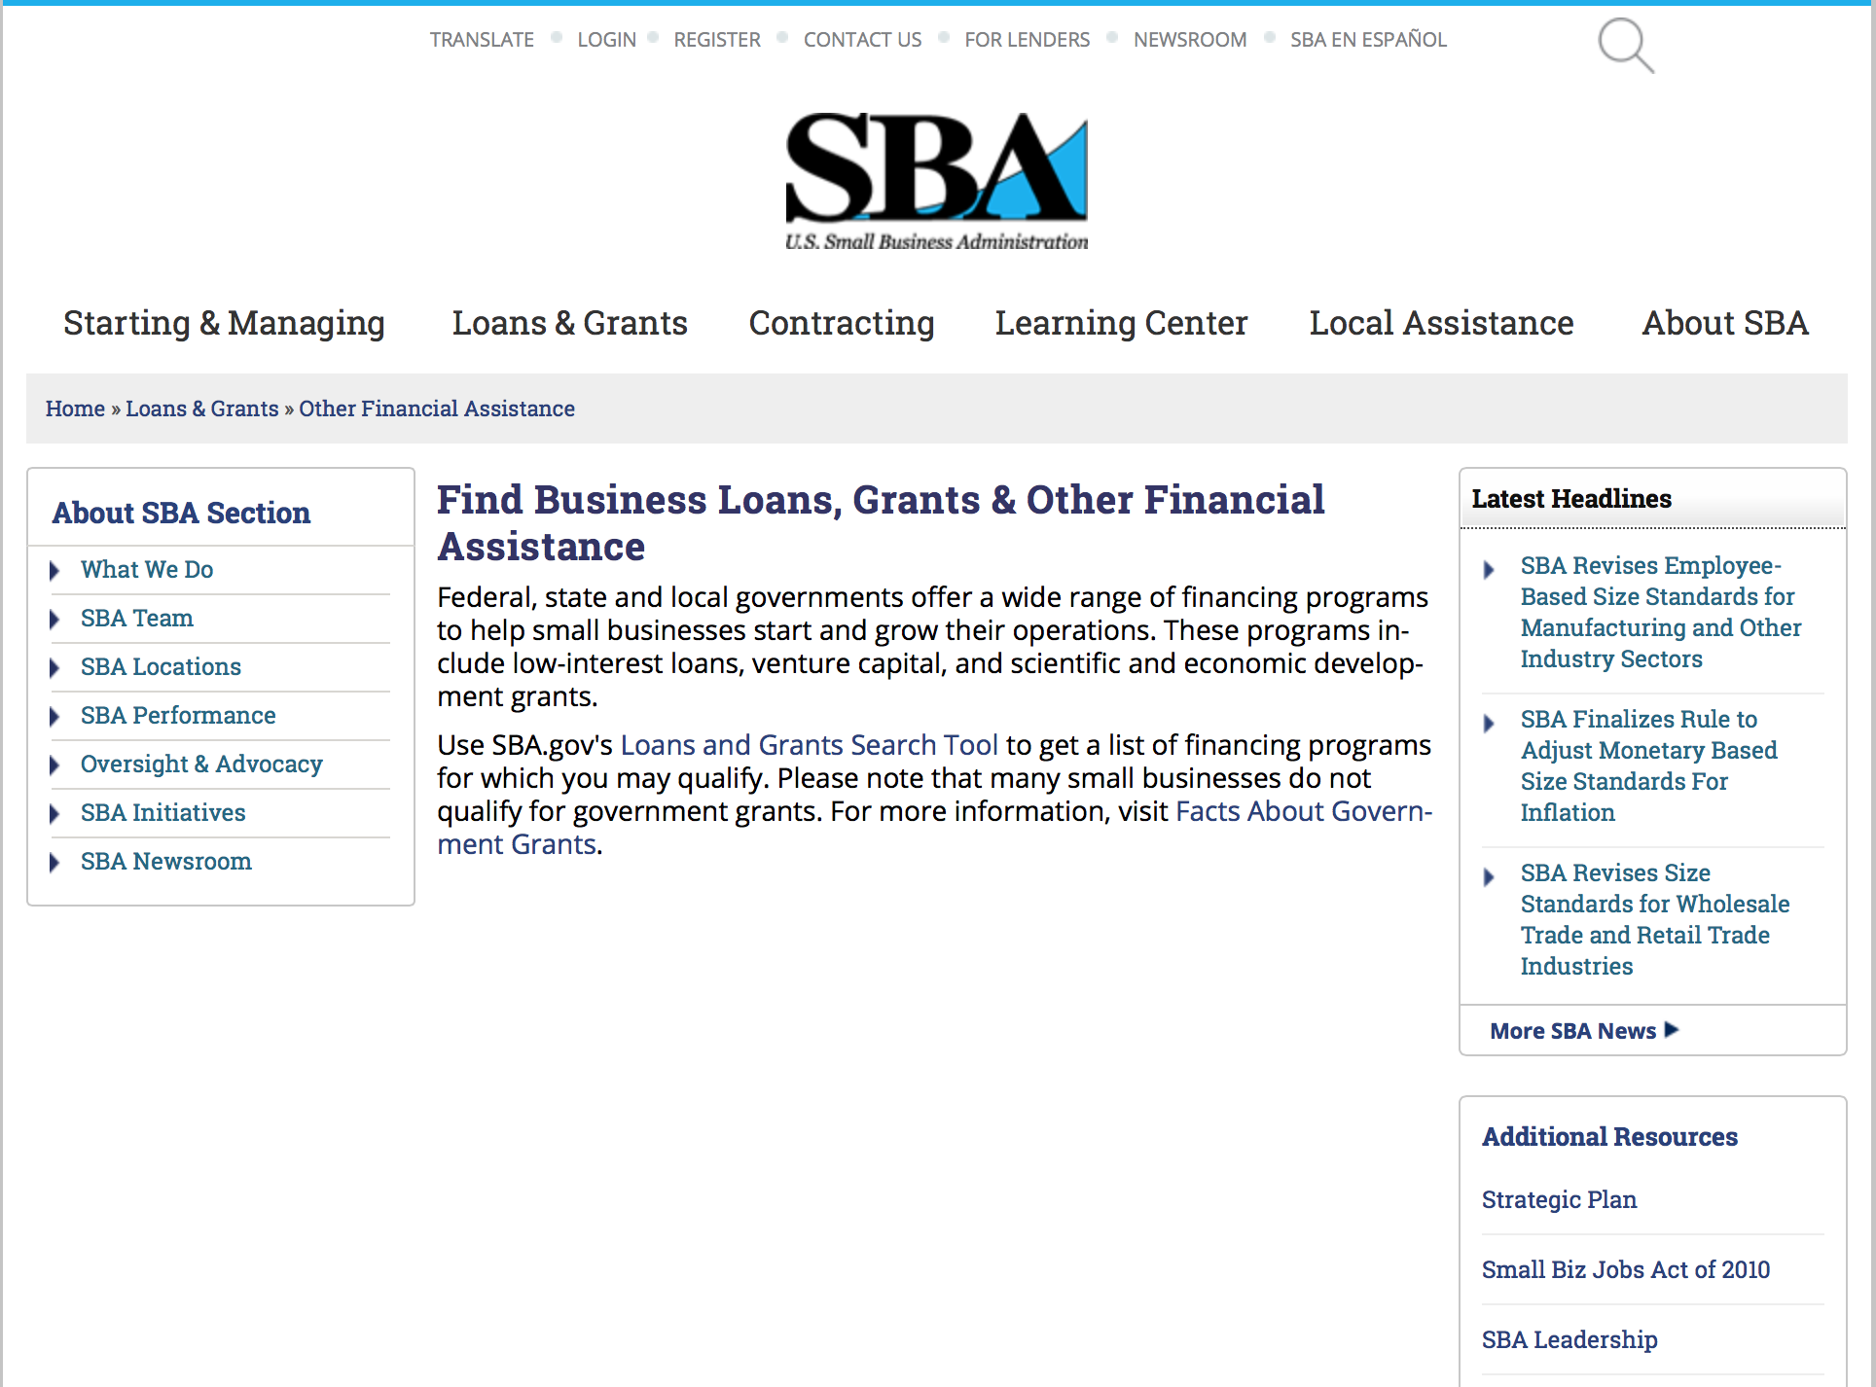
To get to the main SBA.gov funding page click here
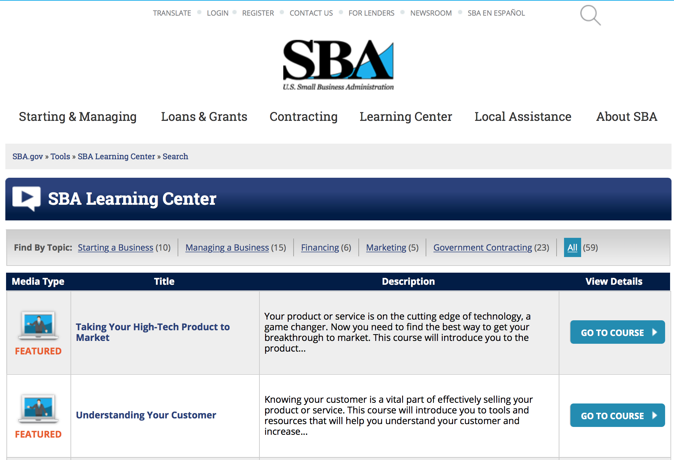
https://www.sba.gov/tools/sba-learning-center/search/training
Programs:

Service-Disabled Veteran Entrepreneurship Training Program Grant

Document Type: | Grants Notice
Funding Opportunity Number: | SDVETP-2016-01
Funding Opportunity Title: | Service-Disabled Veteran Entrepreneurship Training Program
Opportunity Category: | Discretionary
Opportunity Category Explanation:
Funding Instrument Type: | Cooperative Agreement
Category of Funding Activity: | Business and Commerce
Category Explanation:
Expected Number of Awards: | 6
CFDA Number(s): | 59.044 -- Veterans Outreach Program
Cost Sharing or Matching Requirement: | No
Posted Date: | May 19, 2016
Last Updated Date: | May 18, 2016
Original Closing Date for Applications: | Jun 19, 2016 The closing date is 06/19/2016
Current Closing Date for Applications: | Jun 19, 2016 The closing date is 06/19/2016
Archive Date: | Jun 22, 2016
Estimated Total Program Funding: | $300,000
Award Ceiling: | $150,000
Award Floor: | $50,000
Eligible Applicants: | Others (see text field entitled "Additional Information on Eligibility" for clarification)
Additional Information on Eligibility: | See Synopsis
Agency Name: | Small Business Administration
Description: | The purpose of this Program Announcement is to invite proposals for funding from eligible non-profit organizations, local and state agencies and institutions of higher learning to further build their capacity to market and deliver their existing entrepreneurship training program(s) to service-disabled veteran, veteran entrepreneurs and Reserve Component members who aspire to be small business owners or currently own a small business. This
Link to Additional Information: | Link to full announcement
Contact Information: | If you have difficulty accessing the full announcement electronically, please contact:  Janet Moorman Office of Veterans Business Development  Janet.Moorman@SBA.gov

http://www.grants.gov/web/grants/view-opportunity.html?oppId=283959

Reminders:

SBA Trainings

Contracting Opportunities for Veteran Entrepreneurs
This self-paced training exercise is an introduction to Federal contracting opportunities for Veterans.
Topics include basic information about Veteran-owned businesses and opportunities, services available to small Veteran-owned businesses, small business incentives, and government procurement methods.
Duration: 00:30:00

http://www.sba.gov/tools/sba-learning-center/training/contracting-opportunities-veteran-entrepreneurs

Interested in Exporting? These Four Resources Can Help
Did you know that two-thirds of the world’s purchasing power is in foreign countries? As the numbers show, the international marketplace is a big one. So if you’re interested in exploring the world of exporting – or have gotten started but could use some guidance – check out these resources to help.
- Read more

Upcoming Trainings: Check out SBA's Online Training!
- Financing Options for Small Businesses
How to Prepare Government Contract Proposals
Getting Started With Exporting: Training and Educational Resources
Exporting represents a big opportunity to tap in to new markets, expand your customer base and grow your business. But getting started with exporting can sometimes feel like a maze of regulations, policies, and other barriers. Here are some free training and educational resources to help.
- Read more

For Specific Information in Hawaii see the following links:
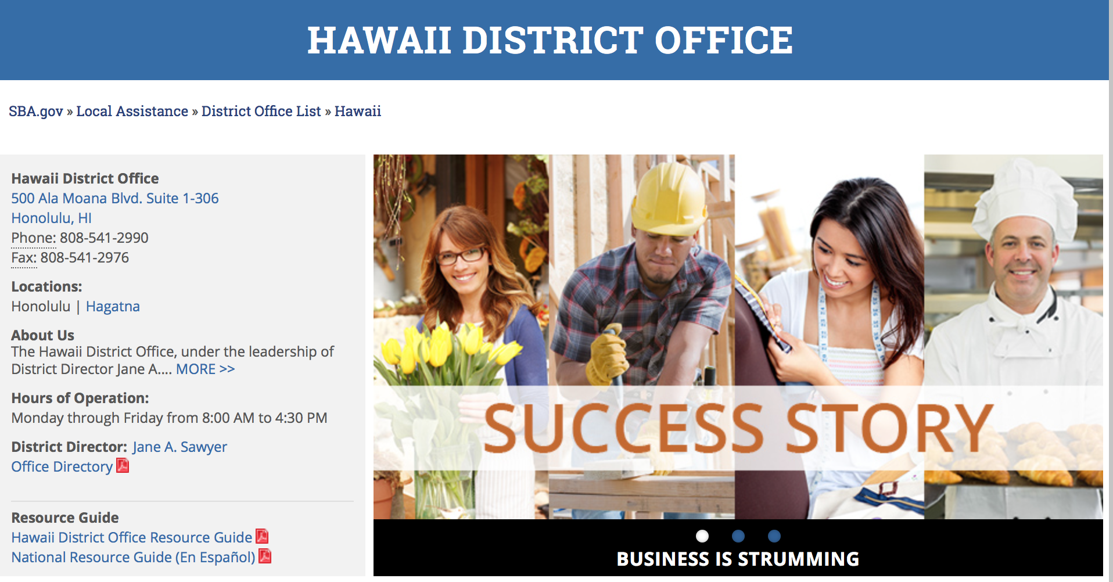

https://www.sba.gov/offices/district/hi/Honolulu

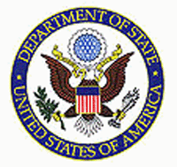

State Department General Overview and Resources for Program Administrators

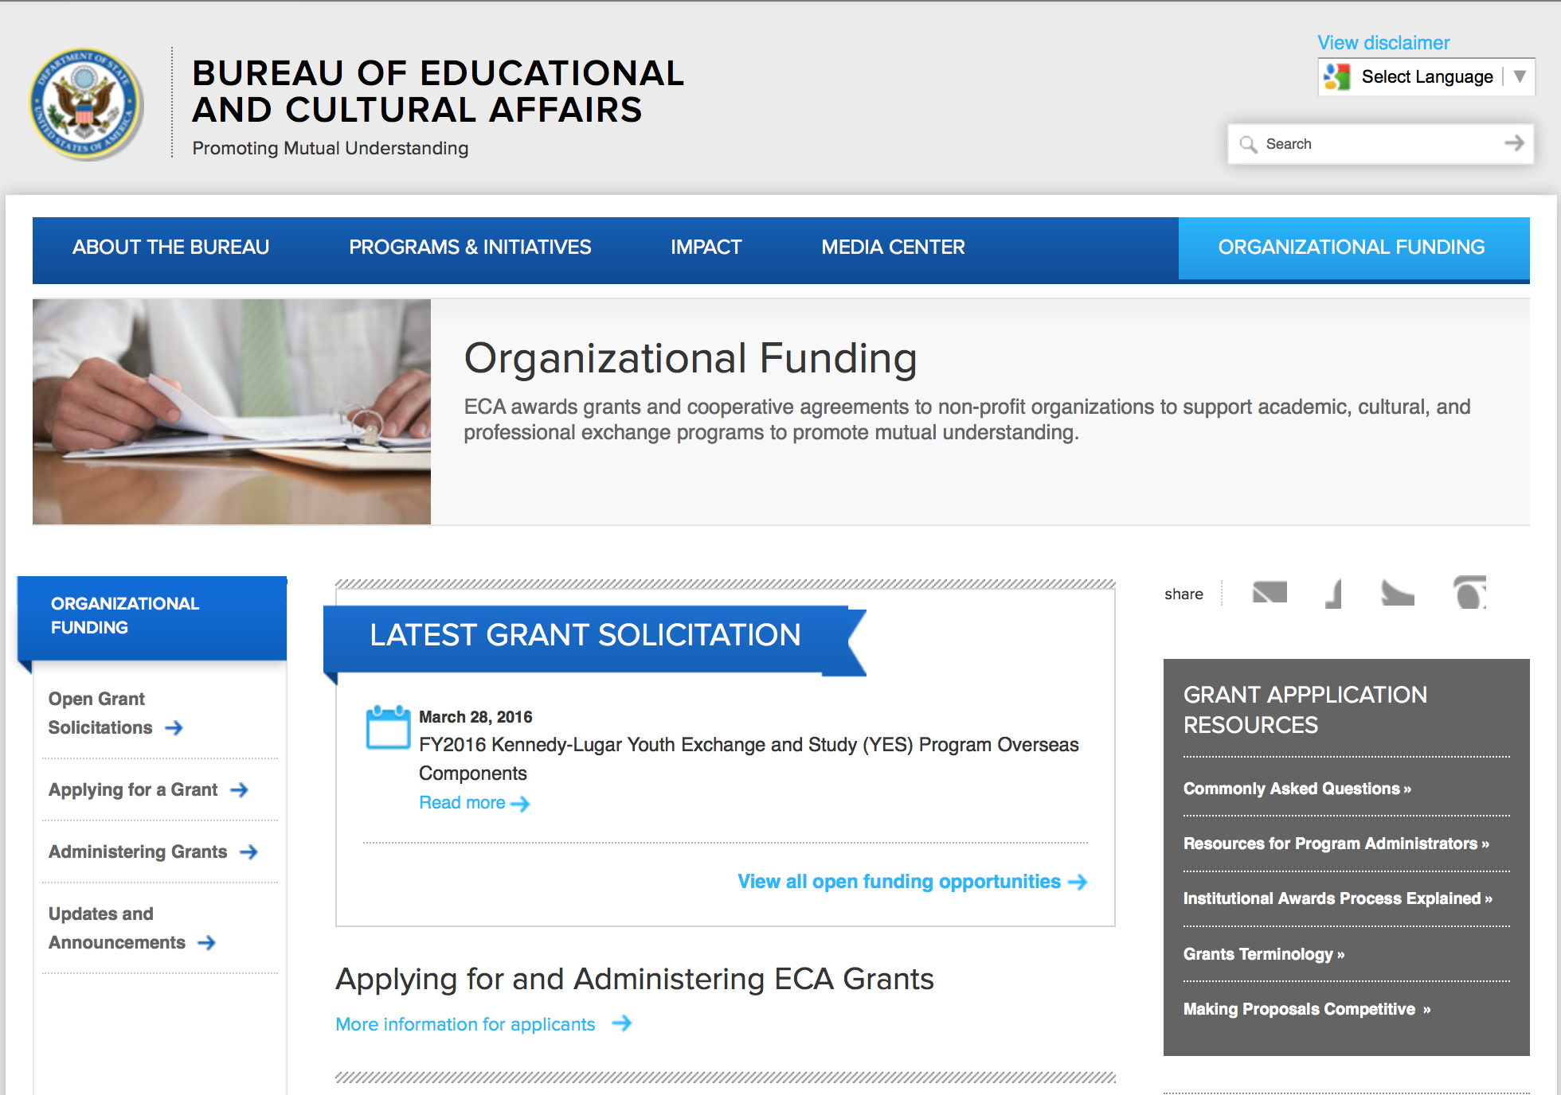
http://eca.state.gov/search/solr/grants?search_referrer=node/237
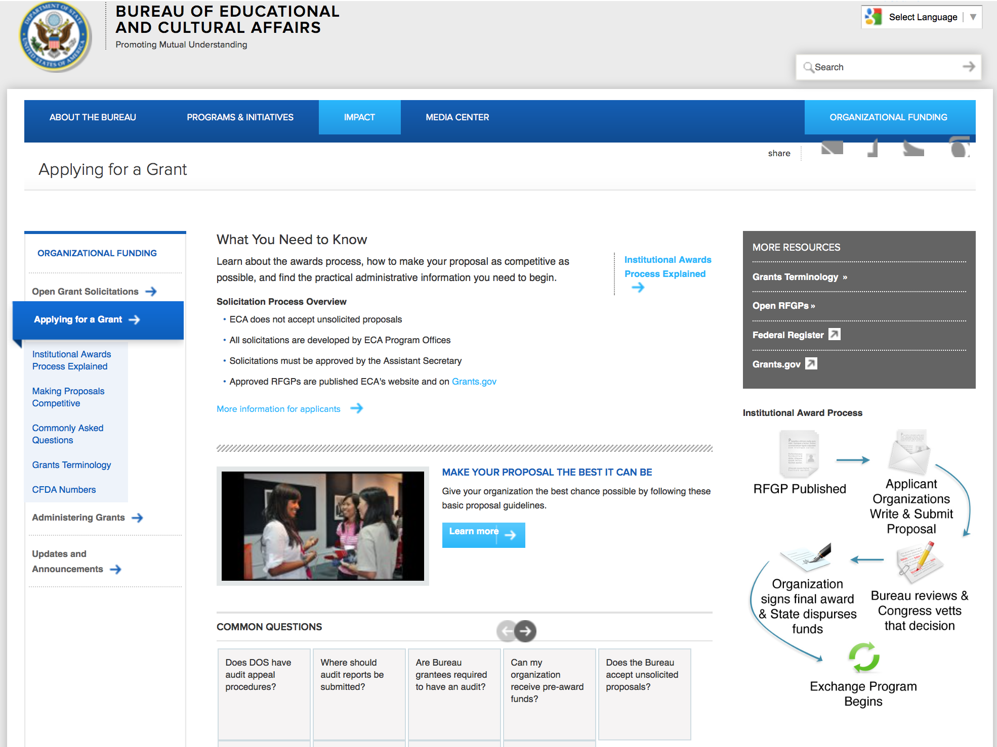

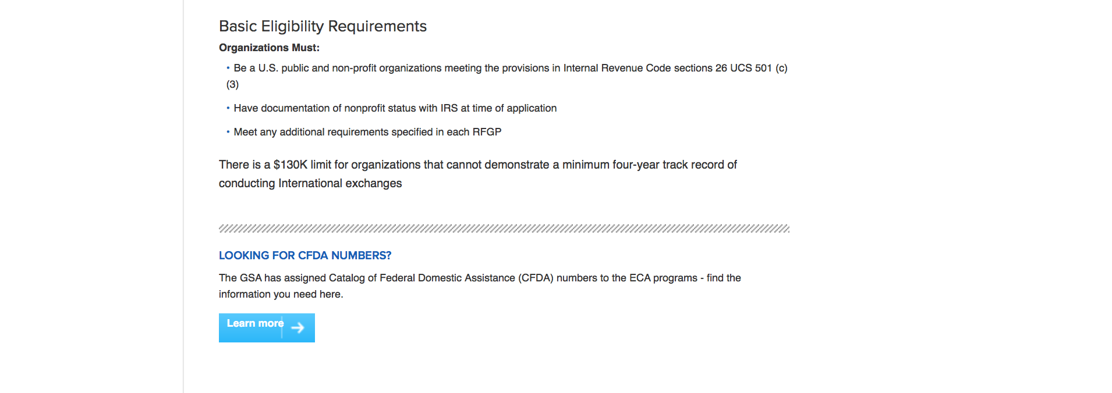
http://eca.state.gov/organizational-funding/applying-grant

General Information:
- Bureau of Educational and Cultural Affairs Grants Division
- Open Grant Opportunities (Requests for Grant Proposals)

For General Information click here

Program Grants:

Bureau of Counterterrorism
Countering Violent Extremism Notice of Funding Opportunity Grant
http://www.grants.gov/web/grants/view-opportunity.html?oppId=283881

Bureau of Democracy, Human Rights and Labor
Financial Management Capacity Building for Implementing Partners WHA FY16
Grant
http://www.grants.gov/web/grants/view-opportunity.html?oppId=284173

Bureau Of Educational and Cultural Affairs
FY 2017 International Visitor Leadership Program Collaborative Services Award Grant
http://www.grants.gov/web/grants/view-opportunity.html?oppId=283955

S Bureau Grants Offices
Office of the Coordinator for Counter Terrorism
Countering Violent Extremism Grant
http://www.grants.gov/web/grants/view-opportunity.html?oppId=283882

Bureau of International Security and Nonproliferat
U.S.-Oman Senior Policy Exchange and U.S.-GCC Counter proliferation Workshop Support Grant
http://www.grants.gov/web/grants/view-opportunity.html?oppId=284112

U.S. Mission to Bosnia and Herzegovina
EDUCATIONUSA COUNTRY COORDINATING AND STUDENT ADVISING – SARAJEVO
Grant
http://www.grants.gov/web/grants/view-opportunity.html?oppId=284178

U.S. Mission to Bosnia and Herzegovina
EDUCATIONUSA STUDENT ADVISING – BANJA LUKA
Grant
http://www.grants.gov/web/grants/view-opportunity.html?oppId=284179

U.S. Mission to Bosnia and Herzegovina
EDUCATIONUSA STUDENT ADVISING – TUZLA
Grant
http://www.grants.gov/web/grants/view-opportunity.html?oppId=284180

International Narcotics and Law Enforcement Affair
Prevention of Domestic Violence and Improved Victims' Services in Nicaragua
Grant
http://www.grants.gov/web/grants/view-opportunity.html?oppId=284199

International Narcotics and Law Enforcement Affair
Combating Wildlife Trafficking in Tanzania Grant
http://www.grants.gov/web/grants/view-opportunity.html?oppId=283962

International Narcotics and Law Enforcement Affair
Promote Literacy for Youth in Conflict Grant
http://www.grants.gov/web/grants/view-opportunity.html?oppId=283478

International Narcotics and Law Enforcement Affair
Evaluation of Colombian National Police’s DARE Drug Prevention Education Campaign
Grant
http://www.grants.gov/web/grants/view-opportunity.html?oppId=283787

U.S. Mission to China
New American Cultural Centers and Cultural Programming in the People’s Republic of China
Grant
http://www.grants.gov/web/grants/view-opportunity.html?oppId=283864

U.S. Mission to Pakistan
English for Workforce Development in Pakistan Grant
http://www.grants.gov/web/grants/view-opportunity.html?oppId=283767

U.S. Mission to Bosnia and Herzegovina
Anti-Corruption In-School Education Program Grant
http://www.grants.gov/web/grants/view-opportunity.html?oppId=284130

Modifications:

Bureau of Population, Refugees and Migration
FY 2016 Notice of Funding Opportunity for NGO programs benefiting displaced and conflict-affected persons in Armenia and Georgia
Modification 1
http://www.grants.gov/web/grants/view-opportunity.html?oppId=283678

Havana Large Grants Opportunity
Modification 1
http://www.grants.gov/web/grants/view-opportunity.html?oppId=282982

Ocean and International Environmental Scientific
A Program on International Water Cooperation
Modifications 3 & 5
http://www.grants.gov/web/grants/view-opportunity.html?oppId=283155

Bureau of Democracy, Human Rights and Labor
Enhancing Judicial Accountability in Tanzania
Modification 3
http://www.grants.gov/web/grants/view-opportunity.html?oppId=284264

Ocean and International Environmental Scientific
Low Emission Accelerator Partnership (LEAP)
Modification 2
http://www.grants.gov/web/grants/view-opportunity.html?oppId=283644

Public Diplomacy Grants program - Notice of Funding Opportunity
Modification 2
http://www.grants.gov/web/grants/view-opportunity.html?oppId=284079

U. S. Mission to Argentina
Friends of Fulbright Undergraduate Student Exchange Program
And Modification 2
http://www.grants.gov/web/grants/view-opportunity.html?oppId=283943

Reminders:

Department of Transportation

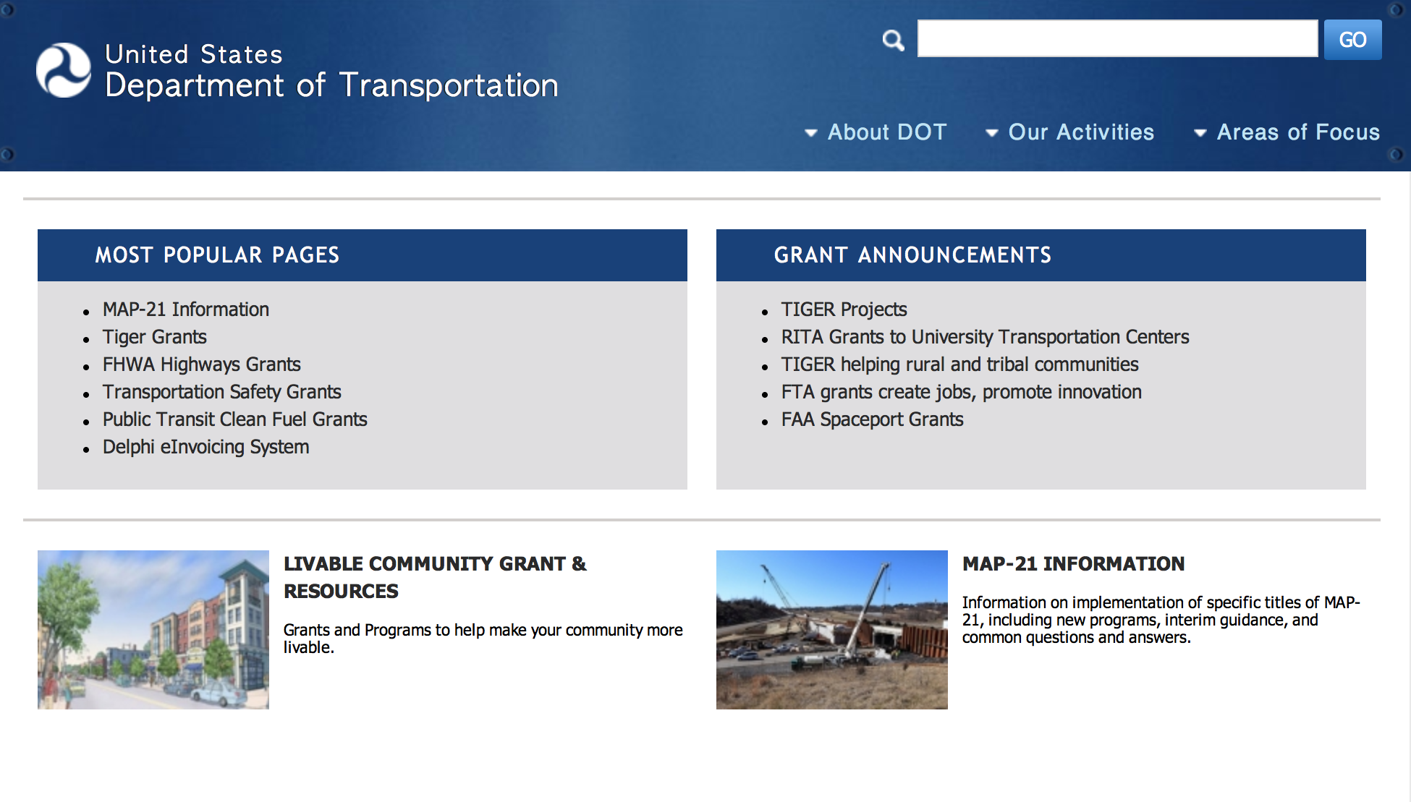
General Grant Program Overview https://www.transportation.gov/grants

Programs:

DOT/Federal Transit Administration
Mobility on Demand (MOD) Sandbox Program Grant

Document Type: | Grants Notice
Funding Opportunity Number: | FTA-2016-006-TRI
Funding Opportunity Title: | Mobility on Demand (MOD) Sandbox Program
Opportunity Category: | Discretionary
Opportunity Category Explanation:
Funding Instrument Type: | Cooperative Agreement
Category of Funding Activity: | Transportation
Category Explanation:
Expected Number of Awards: | 10
CFDA Number(s): | 20.514 -- Public Transportation Research, Technical Assistance, and Training
Cost Sharing or Matching Requirement: | Yes
Posted Date: | May 03, 2016
Last Updated Date: | May 04, 2016
Original Closing Date for Applications: | Jul 05, 2016
Current Closing Date for Applications: | Jul 05, 2016
Archive Date: | Aug 04, 2016
Estimated Total Program Funding: | $8,000,000
Eligible Applicants: | Others (see text field entitled "Additional Information on Eligibility" for clarification)
Additional Information on Eligibility: | Eligible applicants under this notice are providers of public transportation, including public transit agencies, state/local government DOTs, and federally recognized Indian tribes,
Agency Name: | DOT/Federal Transit Administration
Description: | The MOD Sandbox Demonstration Program is part of a larger MOD research effort at FTA and the U.S. Department of Transportation (DOT) that seeks to support transit agencies and communities as they navigate the dynamic, evolving landscape of personal mobility and integrated multimodal transportation networks. FTA is interested in conducting research on new service options in combination with available technologies that enable a traveler-centric approach to transportation, and provide better mobility options for everyone. FTA’s MOD Sandbox Demonstration Program will provide a platform where integrated MOD concepts and solutions – supported through local partnerships – can be demonstrated in real-world settings. FTA seeks to fund project teams to innovate, explore partnerships, develop new business models, integrate transit and MOD solutions, and investigate new, enabling technical capabilities such as integrated payment systems, decision support, and incentives for traveler choices. FTA intends to conduct evaluations of each of the demonstration efforts to measure the program impacts and assess how existing FTA policies and regulations may support or impede these new mobility service models.
Link to Additional Information: | Notices of Funding Opportunity
Contact Information: | If you have difficulty accessing the full announcement electronically, please contact:  Christina Gikakis MOD Program Manager Office of Research, Demonstration and Innovation Christina.gikakis@dot.gov or email MODsandbox@dot.gov  MOD Program Manager

http://www.grants.gov/web/grants/view-opportunity.html?oppId=283490

DOT Federal Highway Administration
2016 Work Zone and Guardrail Safety Training Grants

Document Type: | Grants Notice
Funding Opportunity Number: | DTFH6116RA00018
Funding Opportunity Title: | 2016 Work Zone and Guardrail Safety Training Grants
Opportunity Category: | Discretionary
Opportunity Category Explanation:
Funding Instrument Type: | Cooperative Agreement
Category of Funding Activity: | Transportation
Category Explanation:
Expected Number of Awards: | 12
CFDA Number(s): | 20.215 -- Highway Training and Education
Cost Sharing or Matching Requirement: | Yes
Posted Date: | May 11, 2016
Last Updated Date: | May 11, 2016
Original Closing Date for Applications: | Jul 05, 2016 Application Due Date/Time is no later than July 5, 2016 at 2:00 pm Eastern Time
Current Closing Date for Applications: | Jul 05, 2016 Application Due Date/Time is no later than July 5, 2016 at 2:00 pm Eastern Time
Archive Date: | Oct 01, 2016
Estimated Total Program Funding: | $11,200,000
Award Ceiling: | $2,500,000
Award Floor: | $250,000
Eligible Applicants: | Others (see text field entitled "Additional Information on Eligibility" for clarification)
Additional Information on Eligibility: | In accordance with Section 1409 of SAFETEA-LU, Public Law 109-59, competition is restricted to nonprofit and not-for-profit organizations (e.g., trade associations, universities, etc.) for the prime recipient(s). State and local Governments are not eligible for this award as primary recipients but are eligible as sub-awardees/sub-contractors.
Agency Name: | DOT Federal Highway Administration
Description: | The FHWA hereby requests applications for assistance to result in the award of Work Zone and Guardrail Safety Training Grant cooperative agreements that would build on work already completed under the Work Zone Safety Grants Program. The purpose of this program is to award funding to qualified applicants to conduct training nationally for a wide range of workers on the prevention of injuries and fatalities in highway and roadway work zones; develop guidelines on work zone safety, operational issues, and best practices that will assist State and local government transportation agencies and other entities in improving work zone safety; and to provide training based on these guidelines.
Link to Additional Information:
Contact Information: | If you have difficulty accessing the full announcement electronically, please contact:  Rick Murray Agreement Officer Phone 202-366-4250  rick.murray@dot.gov

http://www.grants.gov/web/grants/view-opportunity.html?oppId=283752

Modifications:

Reminders:

Pipeline &Hazardous Material Safety Administration
Pipeline Safety Research Competitive Academic Agreement Program (CAAP) 2016 Grant
And Modification 1

Document Type: | Grants Notice
Funding Opportunity Number: | DTPH5616SN000002
Funding Opportunity Title: | Pipeline Safety Research Competitive Academic Agreement Program (CAAP) 2016
Opportunity Category: | Discretionary
Opportunity Category Explanation:
Funding Instrument Type: | Cooperative Agreement
Category of Funding Activity: | Other (see text field entitled "Explanation of Other Category of Funding Activity" for clarification)
Category Explanation: | Pipeline Safety Research Competitive Academic Agreement Program (CAAP) – FY 2016
Expected Number of Awards: | 20
CFDA Number(s): | 20.724 -- Pipeline Safety Research Competitive Academic Agreement Program (CAAP)
Cost Sharing or Matching Requirement: | Yes
Posted Date: | Apr 25, 2016
Last Updated Date: | Apr 27, 2016
Original Closing Date for Applications: | Jun 09, 2016
Current Closing Date for Applications: | Jun 09, 2016
Archive Date: | Jul 09, 2016
Estimated Total Program Funding:
Award Ceiling: | $300,000
Eligible Applicants: | Others (see text field entitled "Additional Information on Eligibility" for clarification)
Additional Information on Eligibility: | Applicants must be non-profit institutions of higher education located in the United States or a U.S. territory or possession.
Agency Name: | Pipeline &Hazardous Material Safety Administration
Description: | Article I. Funding Opportunity Description Section 1.01 Statement of Purpose The Pipeline and Hazardous Materials Safety Administration (PHMSA), through the U.S. DOT, hereby requests applications from non-profit institutions of higher education to obtain funding to research innovative solutions to pipeline corrosion and other known pipeline integrity challenges. Section 1.02 Program Authority The authority for PHMSA’s Pipeline Safety Research and Development Program comes from the Pipeline Safety Improvement Act of 2002 (P. L. 107-355). Further, the authority to enter into cooperative agreements under the CAAP initiative is codified at 49 U.S.C. 60117(k).Section 1.03 Background Section 1.03-1 Background on Pipelines and PHMSA’s Pipeline R&D Program The intent of the CAAP program is to award approximately five (5) research agreements per year to non-profit institutions of higher education in the U.S. or U.S. territories or possessions with a total federal amount not to exceed $300,000 per award. The research to be conducted under the agreements will seek a wide set of solutions for corrosion and other pipeline integrity challenges. PHMSA anticipates the period of performance of each award to be no less than 24 months, while not exceeding 36 months. The pipeline infrastructure in the United States (U.S.) is the primary means of transporting natural gas and the majority of hazardous liquids from production basins and ports to areas of consumption. The importance of energy pipelines to the U.S. economy, our standard of living, and potential for safety and environmental impacts requires that these assets be safely maintained and appropriately expanded to sustain demand. Research must play a larger role in finding the solutions to national, regional and local pipeline operational safety and environmental challenges. Some of these challenges involve operators having the best technology to efficiently and effectively meet or exceed federal and state regulatory requirements on the safety and integrity of pipelines. Other challenges include keeping critical industry consensus standards fresh with the latest knowledge so that people, property and the environment are protected. PHMSA’s core pipeline research program involves all stakeholders in a time-tested process for generating success. Since 2002, this program has been focused on the near-term with demonstrating and deploying technology development and commercialization. Additional information on the existing Pipeline Safety Research and Development (R&D) Program is available at: https://primis.phmsa.dot.gov/rd/index.htm.This research enterprise continues to have a tangible impact toward developing technology, strengthening consensus standards and creating and promoting general knowledge to decision makers. More performance details are available at PHMSA's Pipeline Safety Research website http://primis.phmsa.dot.gov/rd/performance.htm. Section 1.03-2 Background on the CAAP Initiative PHMSA’s Pipeline Safety R&D Program was congressionally mandated by the Pipeline Safety Improvement act of 2002, which tasked DOT and other designated federal agencies to “carry out a program of research, development, demonstration and standardization to ensure the integrity of pipeline facilities.” Specifically, the program’s mission is to sponsor research and development projects focused on providing near-term solutions that will improve the safety, reduce the environmental impact, and enhance the reliability of the Nation’s pipeline transportation system. The goals and objectives of the CAAP initiative, as discussed below, directly support both the mission and the congressional mandate of PHMSA’s Pipeline Safety R&D Program. The CAAP initiative is intended to spur innovation by enabling academic research focused on high-risk and high pay-off solutions for the many pipeline safety challenges. It will potentially deliver solutions that can be “handed-off” to PHMSA’s core research program for demonstration and deployment. The goal is to validate proof of concept of a thesis or theory all the way to commercial implementation into the market. The pipeline industry and federal/state regulators are experiencing low numbers of applicants to entry level positions that are technically focused. Consequently, another goal of the CAAP program is to expose and engage graduate and PhD research students to participate in subject matter task(s) that are common to pipeline safety challenges and to illustrate how their engineering or technical disciplines are highly needed in the field. The ultimate benefit would be to cultivate new talent in all aspects of the pipeline industry, similar to how programs at other Federal Agencies and non-profit organizations have encouraged talent to consider a career in a certain field. The CAAP program intends to award approximately five (5) research agreements per year to non-profit institutions of higher education in the U.S. or U.S. territories or possessions with a total federal amount not to exceed $300,000 per award. The research to be conducted under the agreements will include a wide set of solutions for corrosion and other pipeline integrity challenges. PHMSA anticipates the period of performance of each award to be at least 24 months, while not exceeding 36 months See FOA for full details.
Link to Additional Information:
Contact Information: | If you have difficulty accessing the full announcement electronically, please contact:  Saurabh Vasudeva Agreement Specialist Phone 2025274195  saurabh.vasudeva@dot.gov

http://www.grants.gov/web/grants/view-opportunity.html?oppId=283272

DOT Federal Aviation Administration
DOT - FAA Aviation Research Grants
FAA Aviation Research and Development Grants
Modification 3

Document Type: | Grants Notice
Funding Opportunity Number: | 12-01
Funding Opportunity Title: | FAA Aviation Research and Development Grants
Opportunity Category: | Discretionary
Funding Instrument Type: | Grant
Category of Funding Activity: | Transportation
Category Explanation:
Expected Number of Awards:
CFDA Number(s): | 20.108 -- Aviation Research Grants
Cost Sharing or Matching Requirement: | No
Posted Date: | Jan 1, 2012
Creation Date: | Dec 9, 2015
Original Closing Date for Applications: | Dec 31, 2019
Current Closing Date for Applications: | Dec 31, 2019
Archive Date: | Jan 30, 2020
Estimated Total Program Funding:
Award Ceiling: | $5,000,000
Eligible Applicants: | Private institutions of higher education  Nonprofits having a 501(c)(3) status with the IRS, other than institutions of higher education  Public and State controlled institutions of higher education
Agency Name: | DOT - FAA Aviation Research Grants
Description: | The FAA is soliciting proposals for research grants and cooperative agreements to pursue the long-term growth and short-term technical needs of civil aviation. In order to streamline the application process, it is recommended that all prospective grantees submit a white paper (letter of intent) for agency technical review before complete proposal submission. Please be sure to identify the specific area of interest (Solicitation FAA-12-01 – Chapter I. FAA Research Grants Program, Technical Areas of Research #1-#9). The white paper shall be no longer than three (3) pages and shall detail overall research objectives.
Link to Additional Information:
Contact Information: | If you have difficulty accessing the full announcement electronically, please contact:  Robert Boggi Grants Specialist Phone 609-485-6911  business

http://www.grants.gov/web/grants/view-opportunity.html?oppId=134953

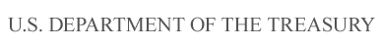

Department of the Treasury

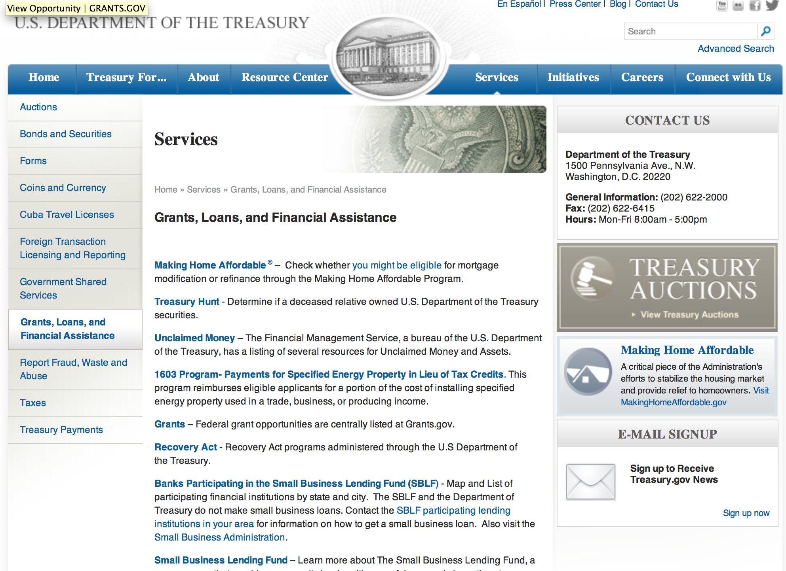

http://www.treasury.gov/services/Pages/Grants-Loans-and-Financial-Assistance.aspx

Programs:

Modifications:

Reminders:

Low Income Taxpayer Clinic (LITC)
Modification 2

Document Type: | Grants Notice
Funding Opportunity Number: | TREAS-GRANTS-052017-001
Funding Opportunity Title: | Low Income Taxpayer Clinic
Opportunity Category: | Discretionary
Opportunity Category Explanation:
Funding Instrument Type: | Grant
Category of Funding Activity: | Law, Justice and Legal Services
Category Explanation:
Expected Number of Awards: | 150
CFDA Number(s): | 21.008 -- Low Income Taxpayer Clinics
Cost Sharing or Matching Requirement: | Yes
Posted Date: | May 02, 2016
Last Updated Date: | May 02, 2016
Original Closing Date for Applications: | Jun 20, 2016 No Explanation
Current Closing Date for Applications: | Jun 20, 2016
Archive Date: | Jul 20, 2016
Estimated Total Program Funding: | $12,000,000
Award Ceiling: | $100,000
Award Floor: | $0
Eligible Applicants: | Private institutions of higher education  Nonprofits having a 501(c)(3) status with the IRS, other than institutions of higher education  Public and State controlled institutions of higher education
Agency Name: | Low Income Taxpayer Clinic (LITC)
Description: | The Low Income Taxpayer Clinic (LITC) program is a matching grant program that provides Federal funds to organizations so they in turn can provide LITC services to taxpayers who are low income or who speak English as a second language (ESL). Clinics participating in the LITC program provide: Representation for individuals in disputes with the Internal Revenue Service (IRS), including audits, appeals, collection matters, and federal tax litigation. LITCs can also help taxpayers respond to IRS notices and correct account problems; Education about taxpayer rights and responsibilities; and Advocacy on behalf of low income and ESL taxpayers. LITC services are free or low cost for eligible taxpayers. LITCs are independent from the IRS but receive some of their funding from the IRS through the LITC grant program. Each clinic determines whether prospective clients meet income guidelines and other criteria before agreeing to represent them.
Link to Additional Information: | Publication 3319
Contact Information: | If you have difficulty accessing the full announcement electronically, please contact:  Grants.gov Contact Center Phone Number: 1-800-518-4726 Hours of operation are 24 hours a day, 7 days a week. The contact center is closed on federal holidays. support@grants.gov  Grants.gov Customer Support

http://www.grants.gov/web/grants/view-opportunity.html?oppId=283393

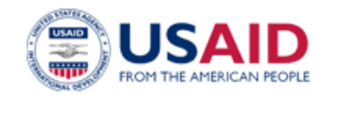

U.S. Agency for International Development

www.usaid.gov

General Overview Funding Opportunities

USAID has working relationships with thousands of American companies and hundreds of U.S.-based private voluntary organizations. For more information on our business and procurement opportunities, please visit our Business section.

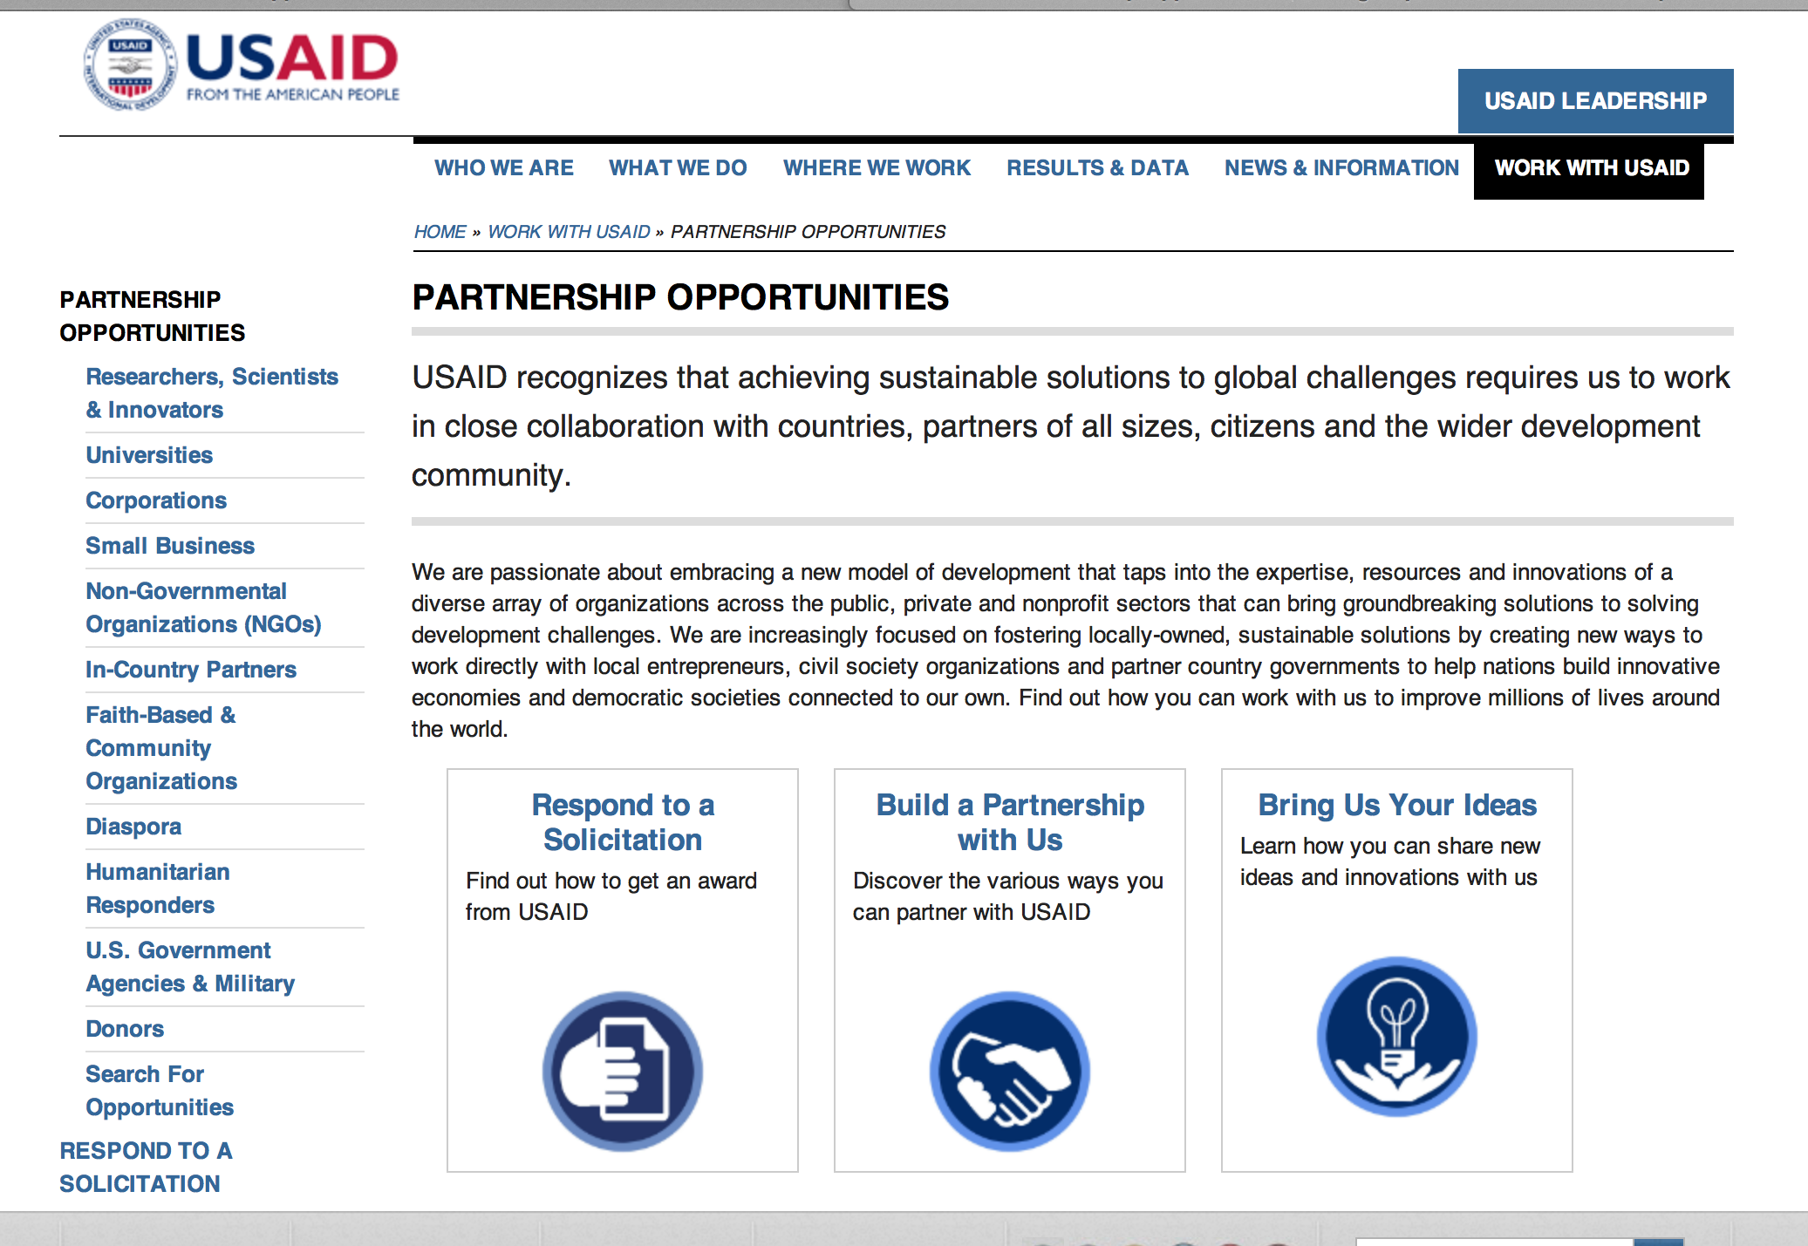
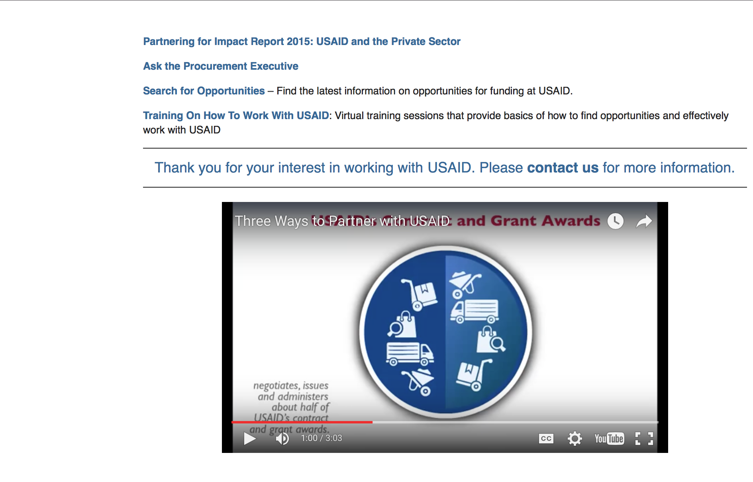

http://www.usaid.gov/partnerships

Programs:

USAID and the Private Sector: Partnering For Impact Grant
http://www.grants.gov/web/grants/view-opportunity.html?oppId=283897

Bosnia USAID-Herzegovina
USAID/Enhancing and Advancing Basic Learning and Education in Bosnia-Herzegovina (ENABLE-BiH) Grant
http://www.grants.gov/web/grants/view-opportunity.html?oppId=284048

Modifications:

Agency for International Development
Promoting Rights and Accountability through Responsible Business Conduct
Modification 1
http://www.grants.gov/web/grants/view-opportunity.html?oppId=284208

USAID and the PRIVATE SECTOR: PARTNERING FOR IMPACT
Modification 1
http://www.grants.gov/web/grants/view-opportunity.html?oppId=283897

Developing Next Generation of Humanitarian Leaders
Modification 1
http://www.grants.gov/web/grants/view-opportunity.html?oppId=284148

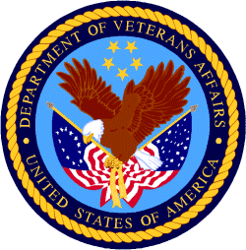

Department of Veterans Affairs

Homeless Providers Grant and Per Diem Program
VA Grant and Per Diem Program Special Need Renewal Grant

Document Type: | Grants Notice
Funding Opportunity Number: | VA-GPD-2016-SN
Funding Opportunity Title: | VA Grant and Per Diem Program Special Need Renewal
Opportunity Category: | Discretionary
Opportunity Category Explanation: | Category Explanation
Funding Instrument Type: | Grant
Category of Funding Activity: | Housing
Category Explanation:
Expected Number of Awards: | 21
CFDA Number(s): | 64.024 -- VA Homeless Providers Grant and Per Diem Program
Cost Sharing or Matching Requirement: | No
Posted Date: | May 20, 2016
Last Updated Date: | May 20, 2016
Original Closing Date for Applications: | Jun 27, 2016
Current Closing Date for Applications: | Jun 27, 2016
Archive Date: | Jun 28, 2016
Estimated Total Program Funding: | $4,100,000
Eligible Applicants: | Native American tribal governments (Federally recognized)  Public housing authorities/Indian housing authorities  County governments  State governments  Nonprofits having a 501(c)(3) status with the IRS, other than institutions of higher education  City or township governments
Additional Information on Eligibility: | In order to be eligible, an applicant must be a current operational FY 2015 VA GPD Special Need Grant Recipient.
Agency Name: | Homeless Providers Grant and Per Diem Program
Description: | The Department of Veterans Affairs (VA) is announcing the availability of 1-year funding for the 21 currently operational fiscal year (FY) 2015 VA Homeless Providers Grant and Per Diem (GPD) Special Need Grant Recipients and their collaborative VA Special Need partners (as applicable) to submit renewal applications for assistance under the Special Need Grant component of VA’s Homeless Providers GPD Program. The focus of this NOFA is to encourage applicants to continue to deliver services to the homeless special need Veteran population. The NOFA published in the Federal Register and the GPD Program Website contains information concerning the program, application process, and amount of funding available.
Link to Additional Information: | VA's GPD Program Website
Contact Information: | If you have difficulty accessing the full announcement electronically, please contact:  Chelsea Watson Deputy Director Phone 813-979-3570  Chelsea Watson

http://www.grants.gov/web/grants/view-opportunity.html?oppId=283998

